No. 76 2931

THE SOUTH AUSTRALIAN

GOVERNMENT GAZETTE
www.governmentgazette.sa.gov.au

PUBLISHED BY AUTHORITY

ALL PUBLIC ACTS appearing in this GAZETTE are to be considered official, and obeyed as such

ADELAIDE, THURSDAY, 4 AUGUST 2005

CONTENTS

Page
Appointments, Resignations, Etc. 2932
Brands Act 1933—Notices 2933
Constitution Act 1934—Notice 2932
Corporations and District Councils—Notices 2982
Crown Lands Act 1929—Notices 2952
Dangerous Substances Act 1979—Notice 2932
Development Act 1993—Notices 2952
Fair Work Act 1994—Notice 2932
Fisheries Act 1982—Notices 2957
Geographical Names Act 1991—Corrigendum 2959
Land and Business (Sale and Conveyancing) Act 1994—
Notices 2960
Liquor Licensing Act 1997—Notices 2960
Mining Act 1971—Notices 2963

Page
Occupational Health, Safety and Welfare Act 1986—
Notice 2964
Petroleum Products Regulation Act 1995—Notice 2964
Public Trustee Office—Administration of Estates 2985

REGULATION
Liquor Licensing Act 1997 (No. 176 of 2005) 2979
Renmark Irrigation Trust, The—Notice 2964
Roads (Opening and Closing) Act 1991—Notices 2964
South Australian Local Government Grants Commission
Act 1992—Notice 2965
Treasury—Quarterly Statement 2969
Training and Skills Development Act 2003—Notices 2966
Water Mains and Sewers—Mains Laid, Replaced, Etc. 2976

GOVERNMENT GAZETTE NOTICES
ALL poundkeepers’ and private advertisements forwarded for publication in the South Australian Government Gazette must be PAID FOR PRIOR TO INSERTION; and all notices, from whatever source, should be legibly written on one side of the paper only and sent to Government Publishing SA so as to be received no later
than 4 p.m. on the Tuesday preceding the day of publication. Phone 8207 1045 or Fax 8207 1040. E-mail: governmentgazette@saugov.sa.gov.au. Send as attachments in Word format and please confirm your transmission with a faxed copy of your document, including the date the notice is to be published and to whom the notice will be charged. The Government Gazette is available online at: www.governmentgazette.sa.gov.au

Department of the Premier and Cabinet
Adelaide, 4 August 2005
HER Excellency the Governor in Executive Council has been pleased to appoint the undermentioned to the Equal Opportunity Tribunal, pursuant to the provisions of the Equal Opportunity Act 1984:
Panel Member: (from 8 August 2005 until 7 August 2008)
Elizabeth Anne Bachmann
By command,
C. Zollo, for Premier
AGO 0266/02CS

Department of the Premier and Cabinet
Adelaide, 4 August 2005
HER Excellency the Governor in Executive Council has been pleased to appoint the undermentioned to the Remuneration Tribunal, pursuant to the provisions of the Remuneration Act 1990:
Member: (from 8 August 2005 until 7 August 2008)
Hedley Raymond Bachmann
President: (from 8 August 2005 until 7 August 2008)
Hedley Raymond Bachmann
By command,
C. Zollo, for Premier
DPC 027/02CS

Department of the Premier and Cabinet
Adelaide, 4 August 2005
HER Excellency the Governor in Executive Council has been pleased to appoint the Honourable Kevin Owen Foley, MP, Deputy Premier, Treasurer, Minister Assisting the Premier in Economic Development, Minister for Police and Minister for Federal/State Relations to be also Acting Premier, Acting Minister for Economic Development, Acting Minister for Social Inclusion, Acting Minister for the Arts and Acting Minister for Volunteers for the period 6 August 2005 to 10 August 2005 inclusive, during the absence of the Honourable Michael David Rann, MP.
By command,
C. Zollo, for Premier
DPC 082/94PT3 CS

Department of the Premier and Cabinet
Adelaide, 4 August 2005
HER Excellency the Governor in Executive Council has been pleased to appoint the Honourable John David Hill, MP, Minister for Environment and Conservation, Minister for the Southern Suburbs and Minister Assisting the Premier in the Arts to be also Acting Minister for the River Murray for the period 8 August 2005 to 21 August 2005 inclusive, during the absence of the Honourable Karlene Ann Maywald, MP.
By command,
C. Zollo, for Premier
CS 05MINRM0001

Department of the Premier and Cabinet
Adelaide, 4 August 2005
HER Excellency the Governor in Executive Council has been pleased to appoint the Honourable Michael John Atkinson, MP, Attorney-General, Minister for Justice and Minister for Multicultural Affairs to be also Acting Minister for Consumer Affairs for the period 8 August 2005 to 21 August 2005 inclusive, during the absence of the Honourable Karlene Ann Maywald, MP.
By command,
C. Zollo, for Premier
CS 05MINRM0001

Department of the Premier and Cabinet
Adelaide, 4 August 2005
HER Excellency the Governor in Executive Council has been pleased to appoint the Honourable Stephanie Wendy Key, MP, Minister for Employment, Training and Further Education, Minister for Youth and Minister for the Status of Women to be also Acting Minister for Regional Development, Acting Minister for Small Business and Acting Minister for Science and Information Economy for the period 8 August 2005 to 21 August 2005 inclusive, during the absence of the Honourable Karlene Ann Maywald, MP.
By command,
C. Zollo, for Premier
CS 05MINRM0001

Department of the Premier and Cabinet
Adelaide, 4 August 2005
HER Excellency the Governor in Executive Council has been pleased, on a recommendation made on 6 July 2005 by resolution of both Houses of Parliament, to appoint Kay Marie Mousley to be the Electoral Commissioner commencing on 29 August 2005, pursuant to the Electoral Act 1985.
By command,
C. Zollo, for Premier
AGO 0008/05CS

CONSTITUTION ACT 1934
Appointment of Chairman of the Electoral Districts
Boundaries Commission
IN exercise of the powers conferred on me by section 78 (1) (a) of the Constitution Act 1934, I hereby appoint John William Perry, a Judge of the Supreme Court of South Australia, to be Chairman of the Electoral Districts Boundaries Commission, the appointment to take effect from this day.
Dated 20 July 2005.
The Hon. John Doyle, AC, Chief Justice of the Supreme Court

DANGEROUS SUBSTANCES ACT 1979
Appointments
I, MICHAEL JOHN WRIGHT, Minister for Industrial Relations in and for the State of South Australia, hereby appoint each of the following persons as an Authorised Officer for the purposes of the Dangerous Substances Act 1979, pursuant to section 7 (1) of the Dangerous Substances Act 1979:
Sylvia Kette Blagdanic
Tracy Lee Heidrich
Prabhu Tumkar Mallikarjuniah Shankar
Margaret Rose Thomas
Cassandra White
Dated 27 July 2005.
Michael Wright, Minister for Industrial Relations

FAIR WORK ACT 1994
Appointments
I, MICHAEL JOHN WRIGHT, Minister for Industrial Relations in and for the State of South Australia, hereby appoint each of the following persons to be an Inspector for the purposes of the Fair Work Act 1994, pursuant to section 64 (1) (b) of the Fair Work Act 1994:
Sylvia Kette Blagdanic
Tracy Lee Heidrich
Prabhu Tumkar Mallikarjuniah Shankar
Margaret Rose Thomas
Cassandra White
Dated 27 July 2005.
Michael Wright, Minister for Industrial Relations


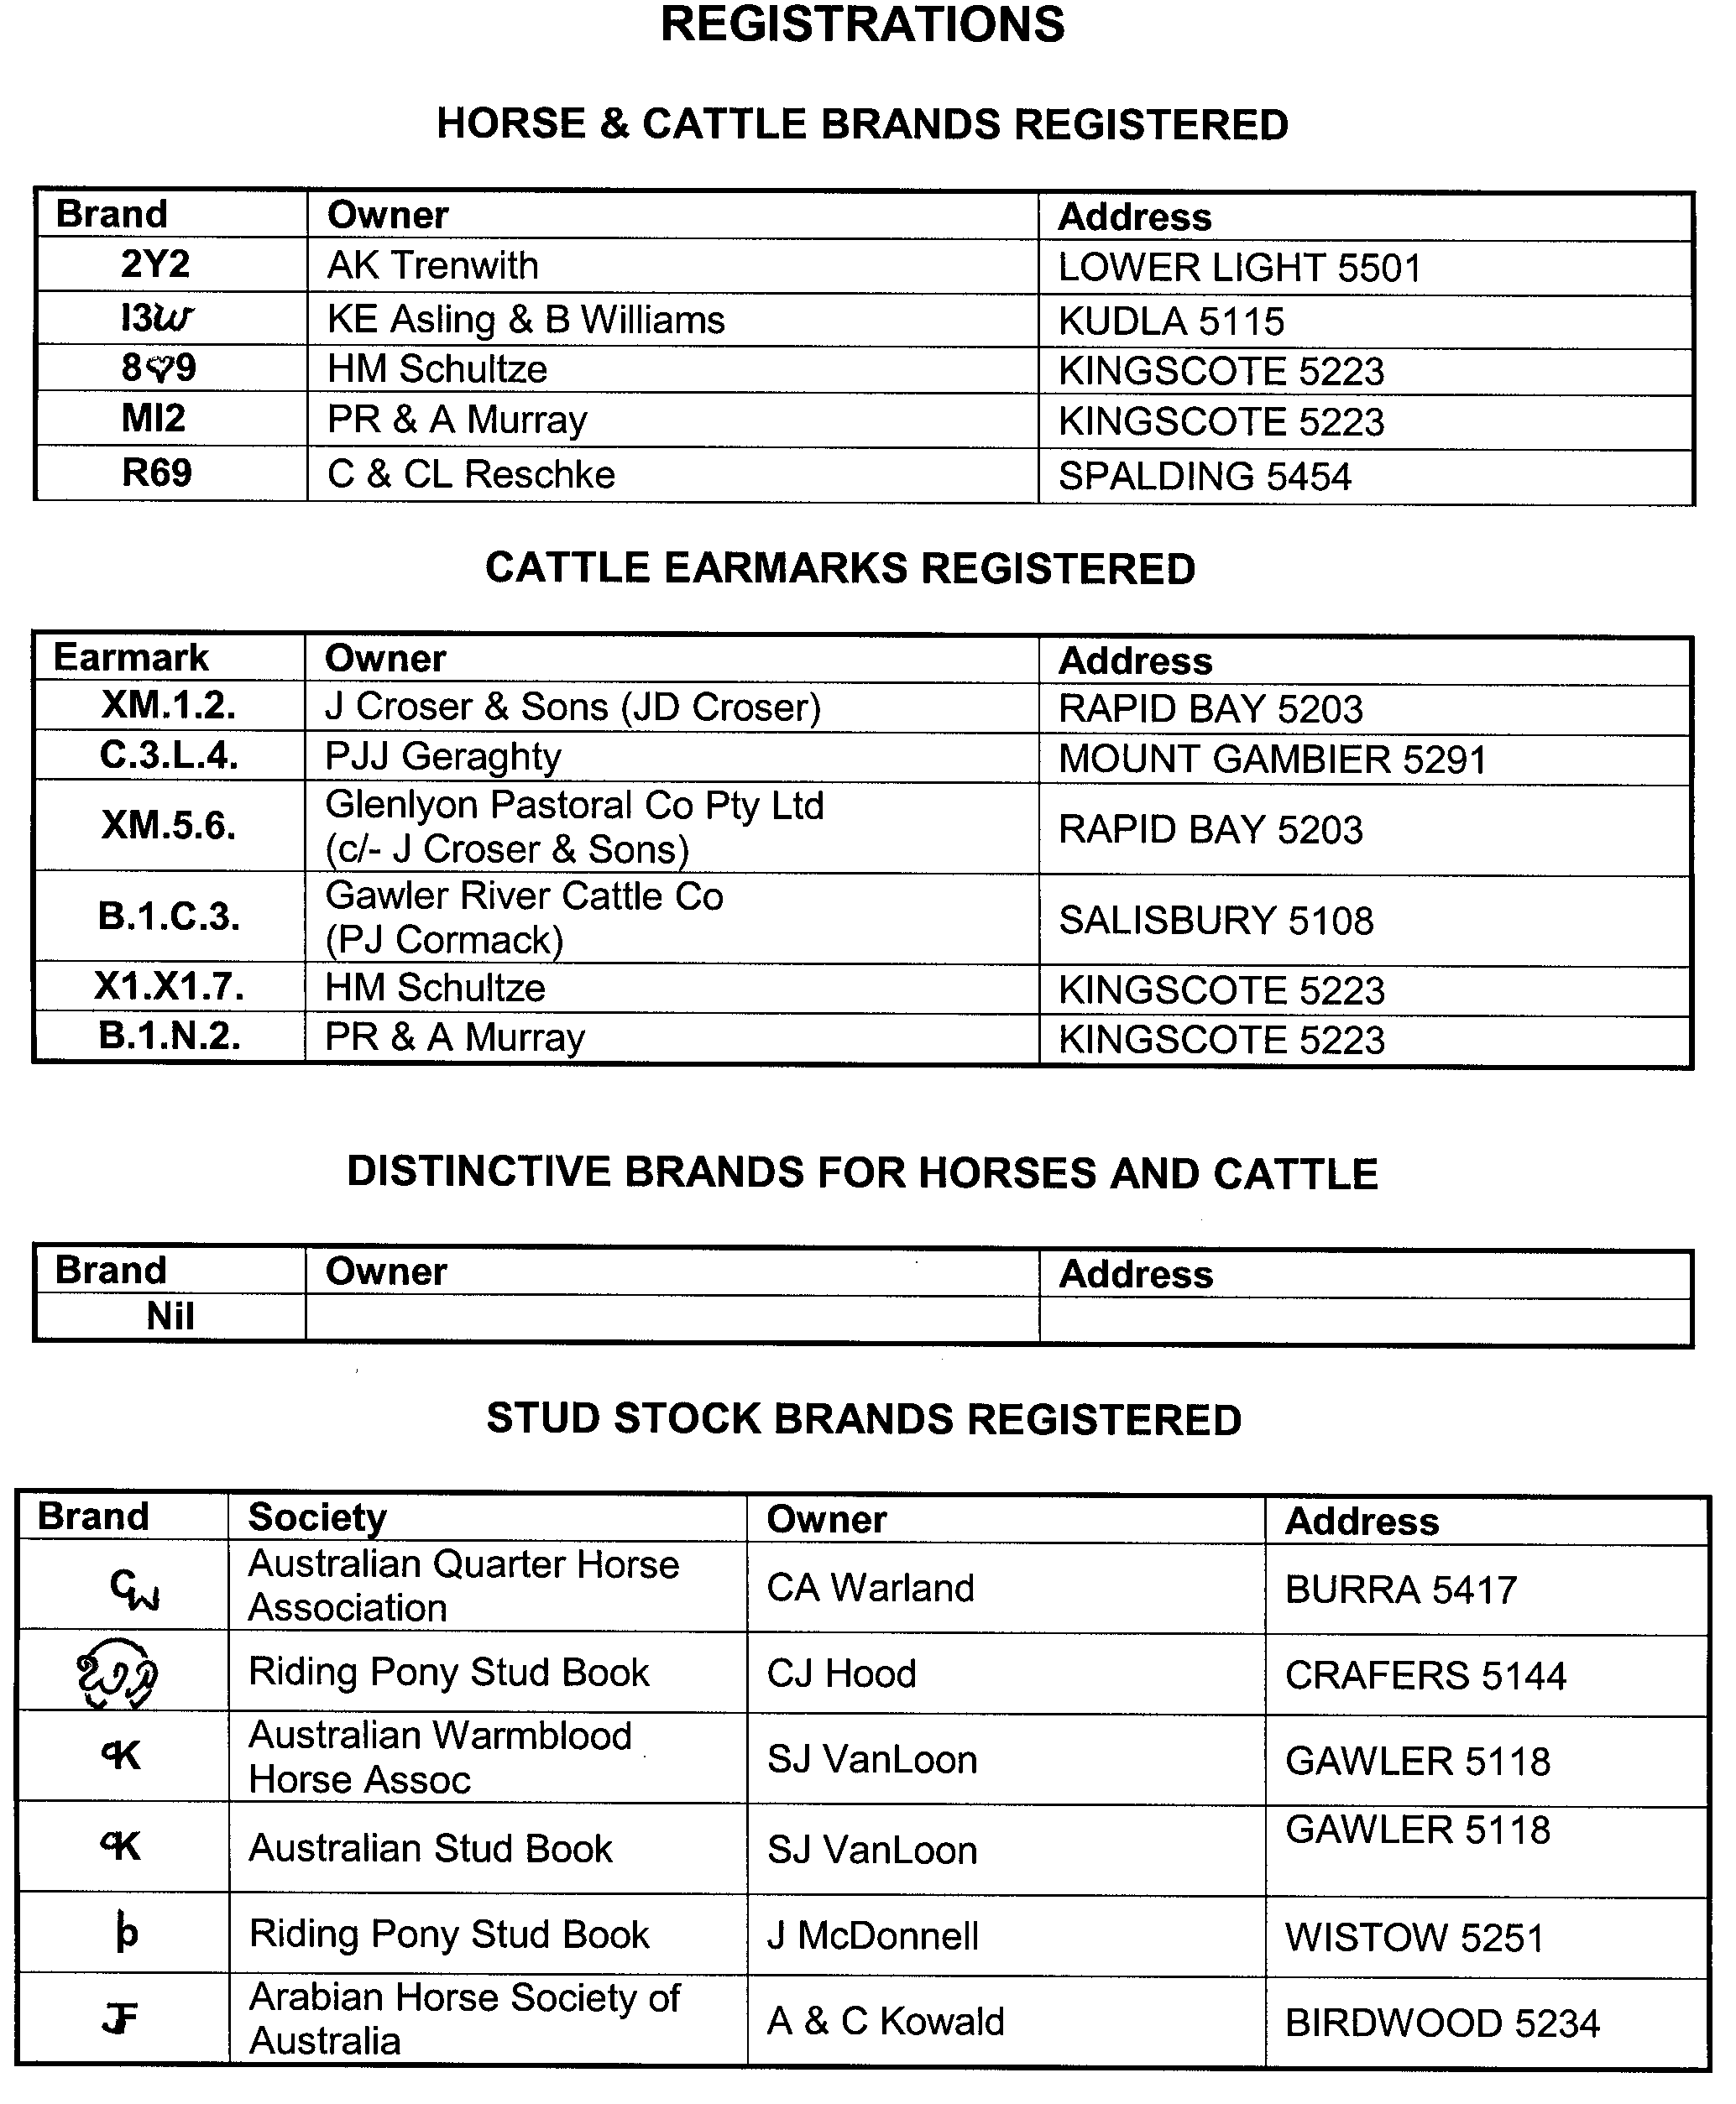
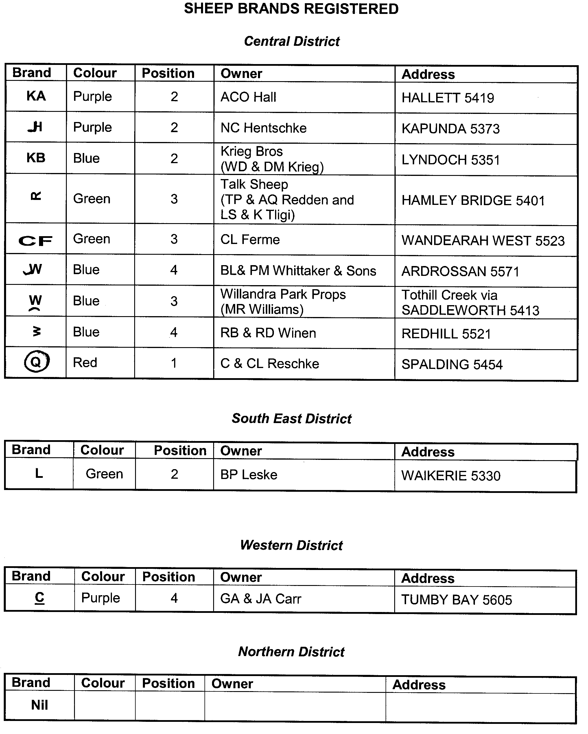
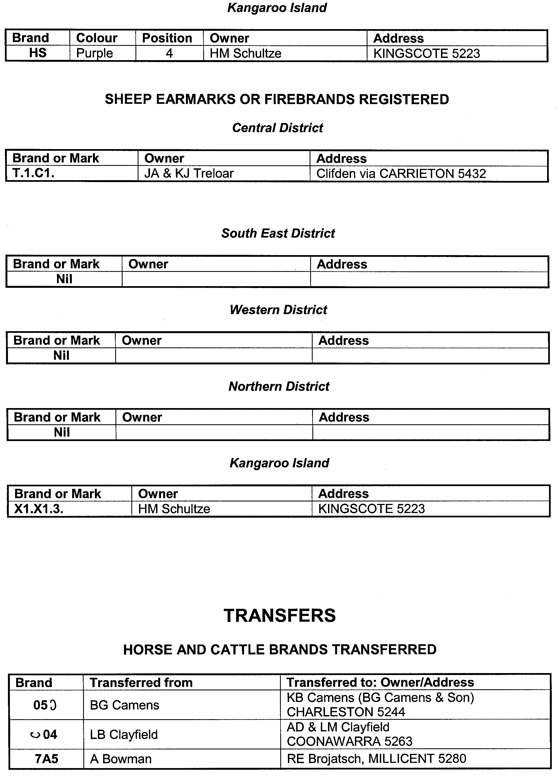
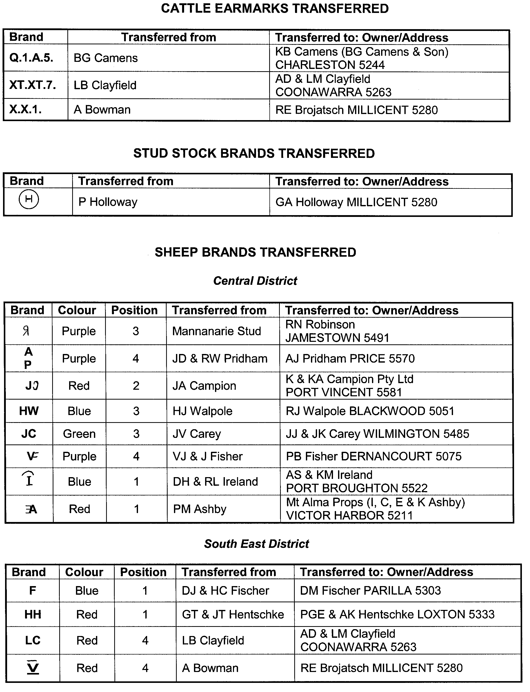
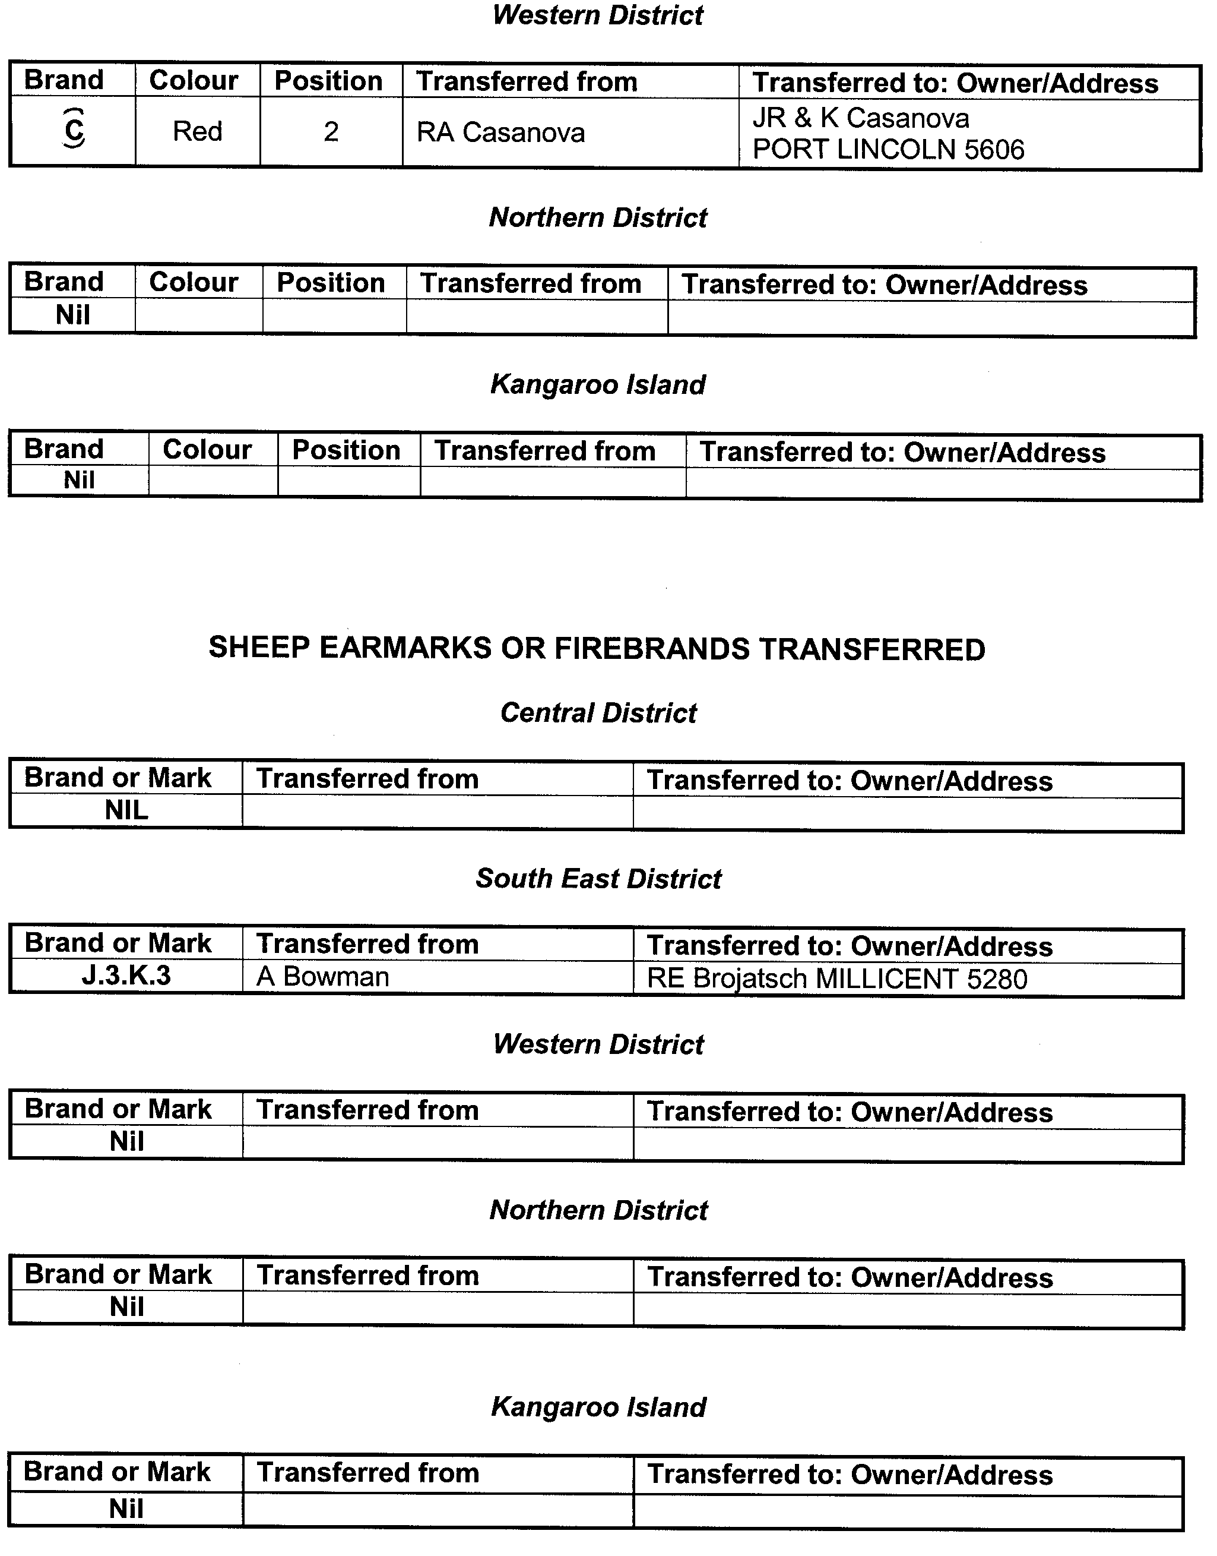
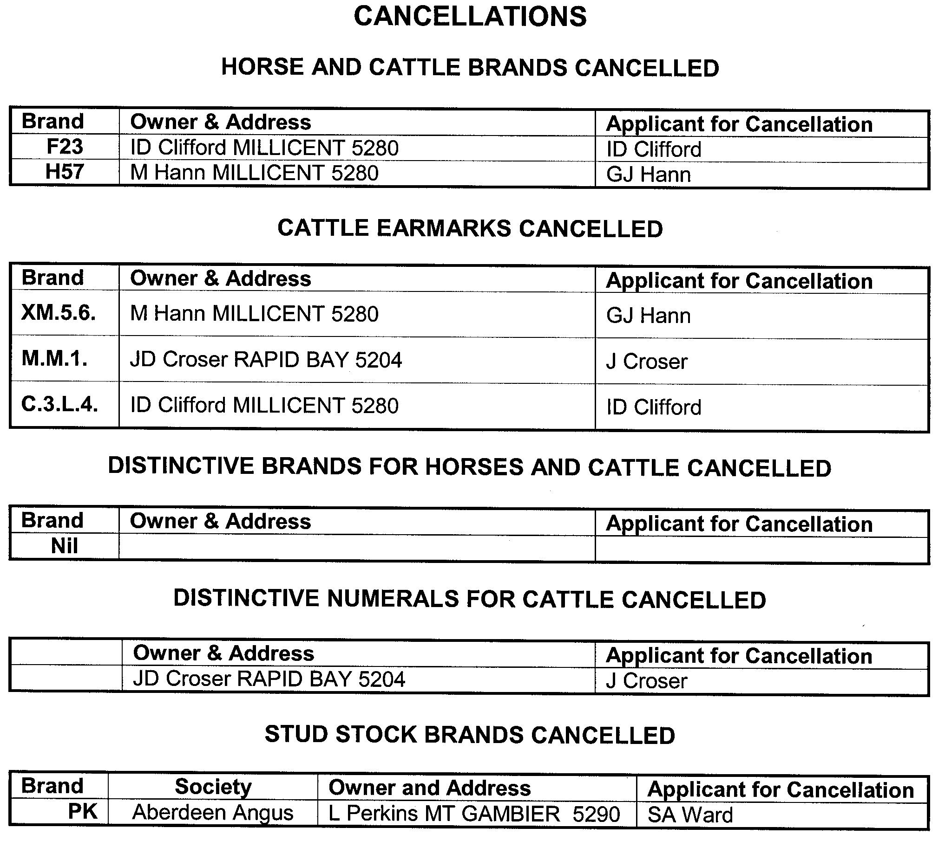
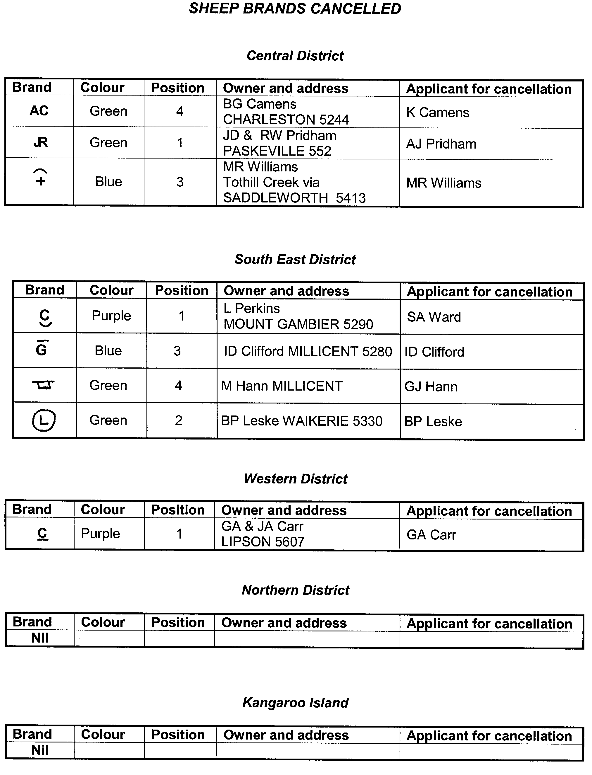
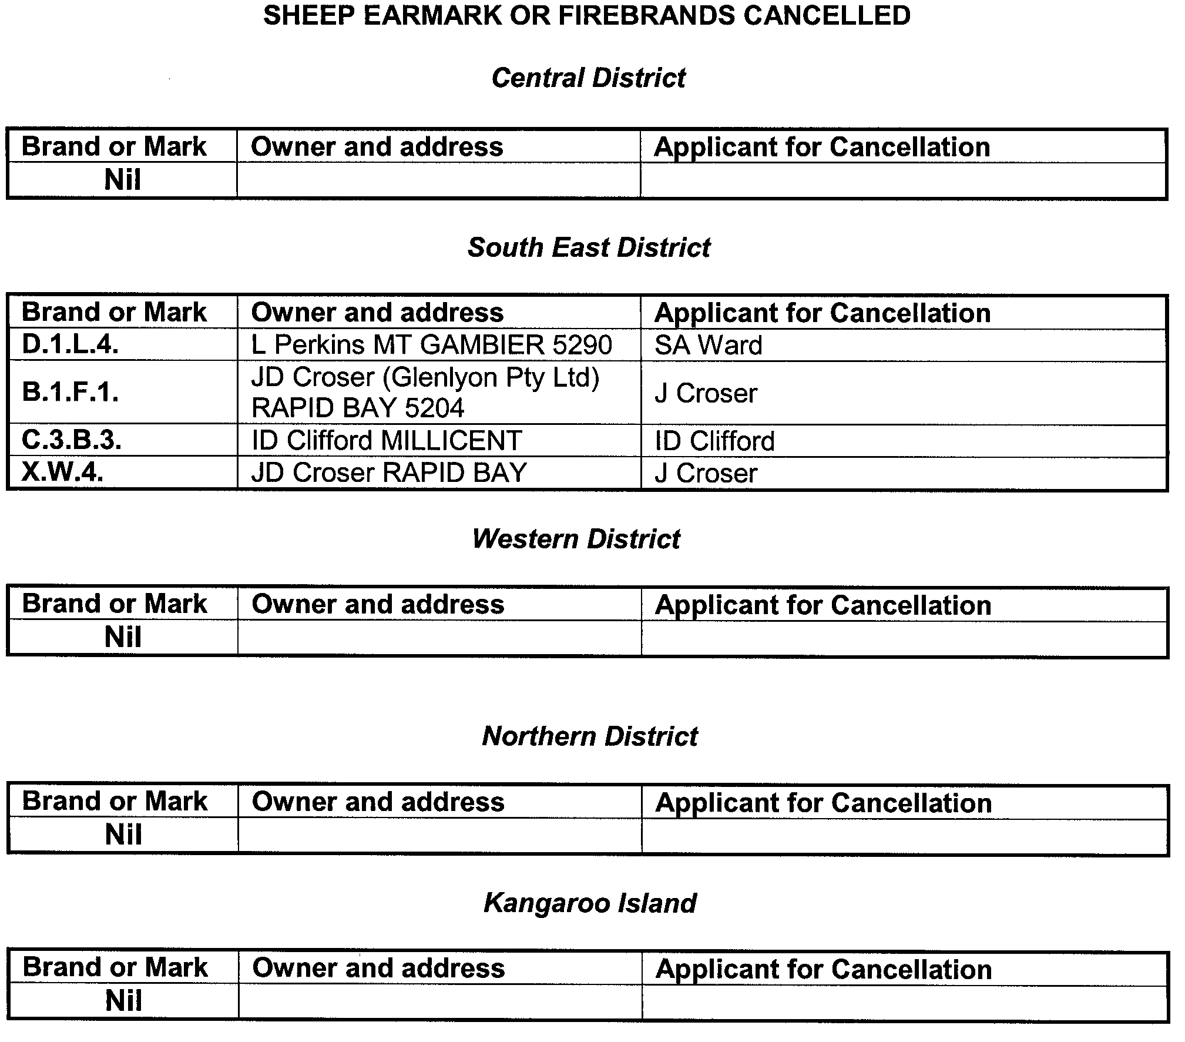

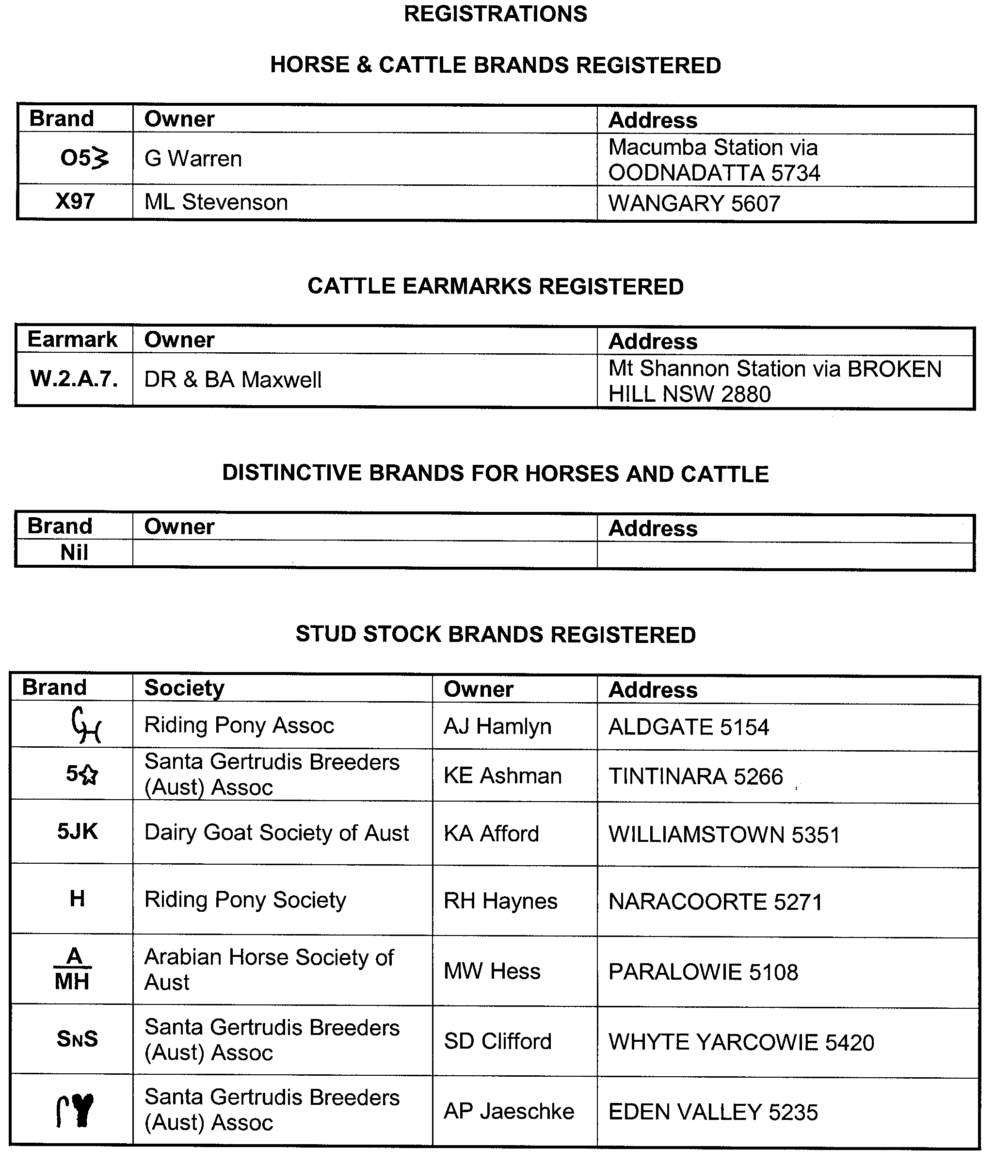
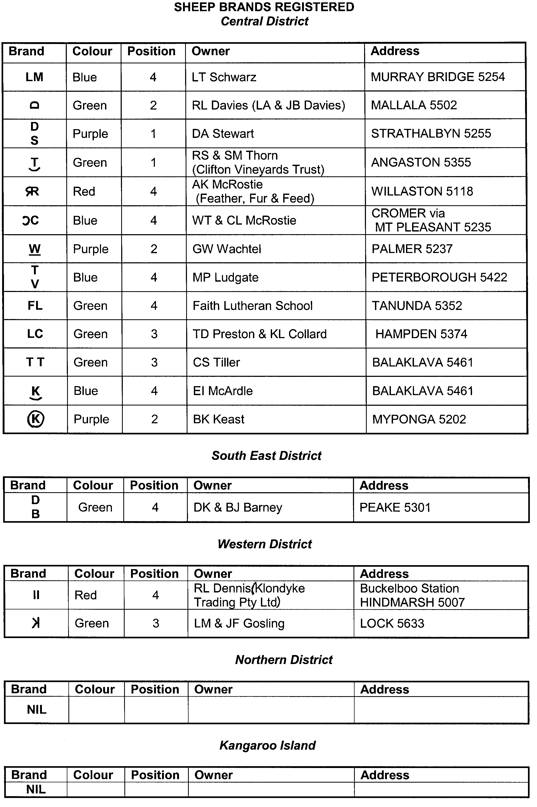
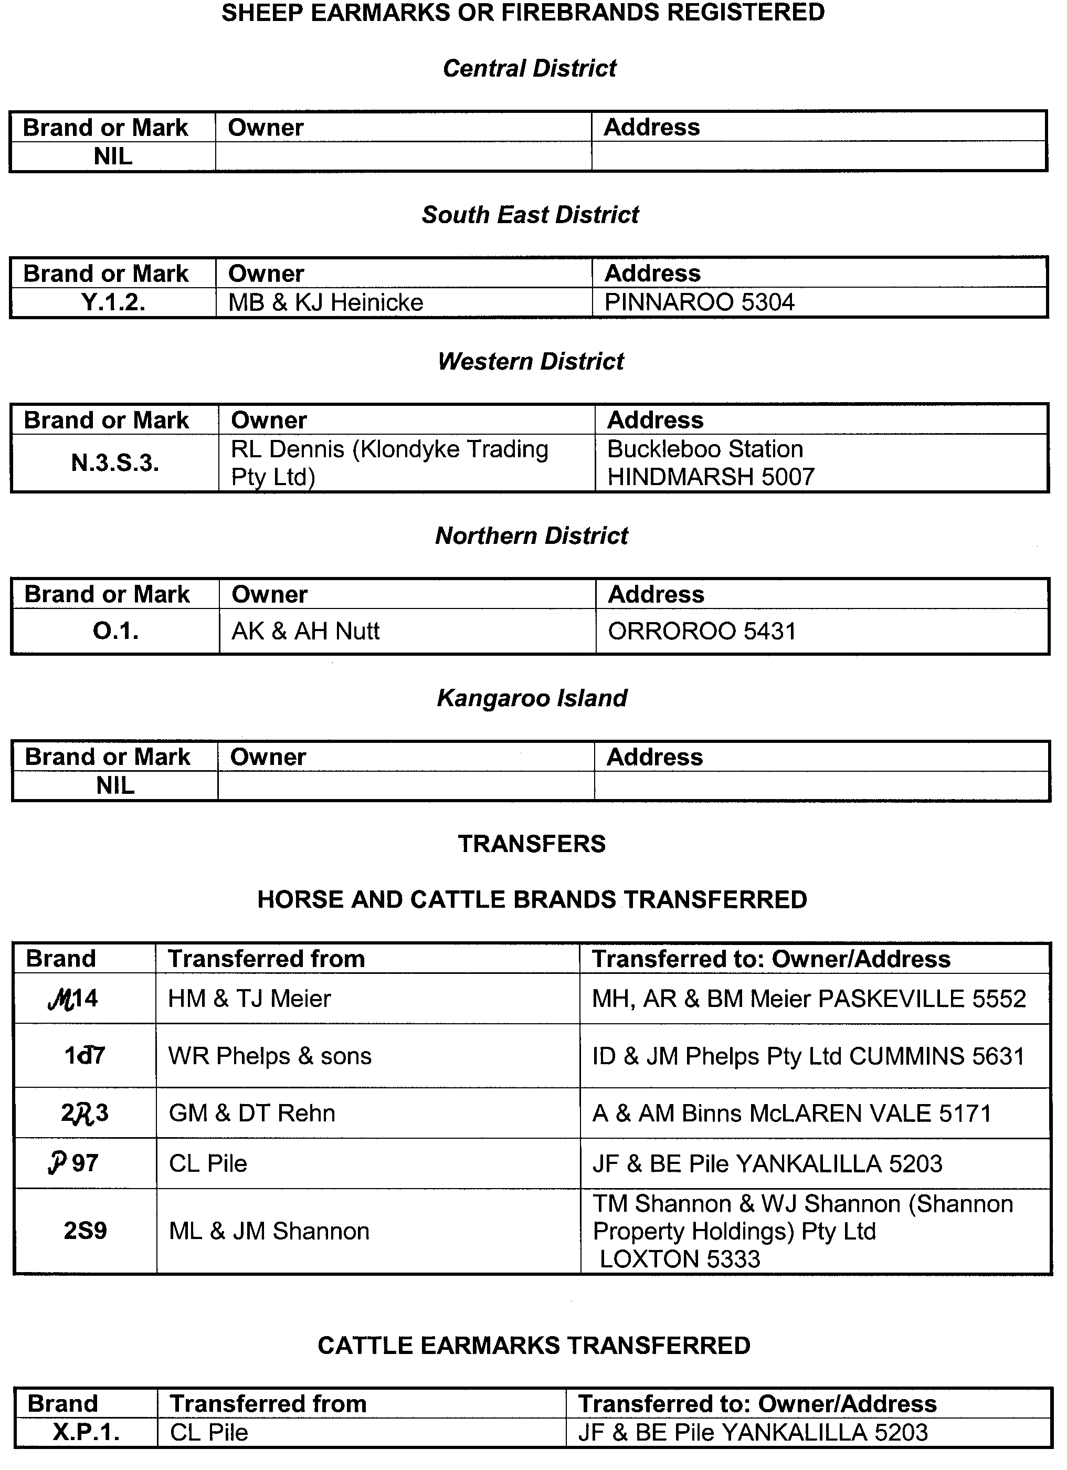
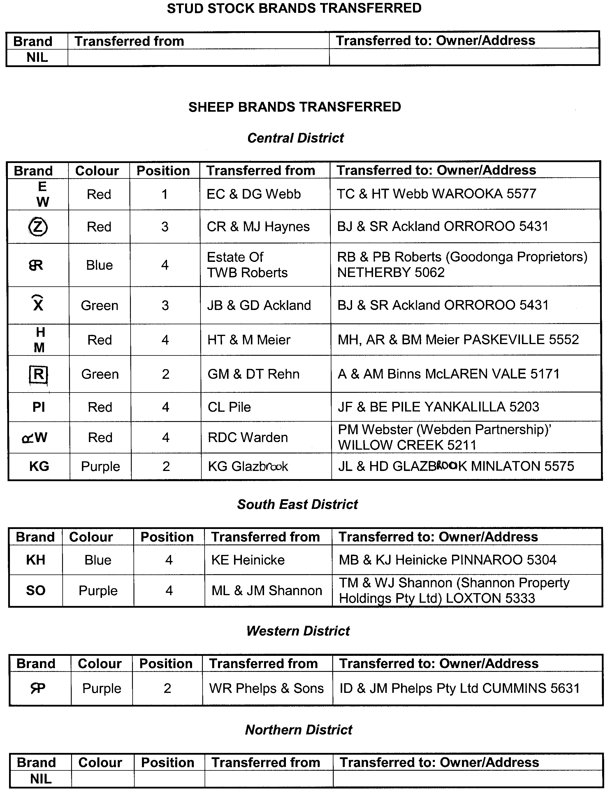
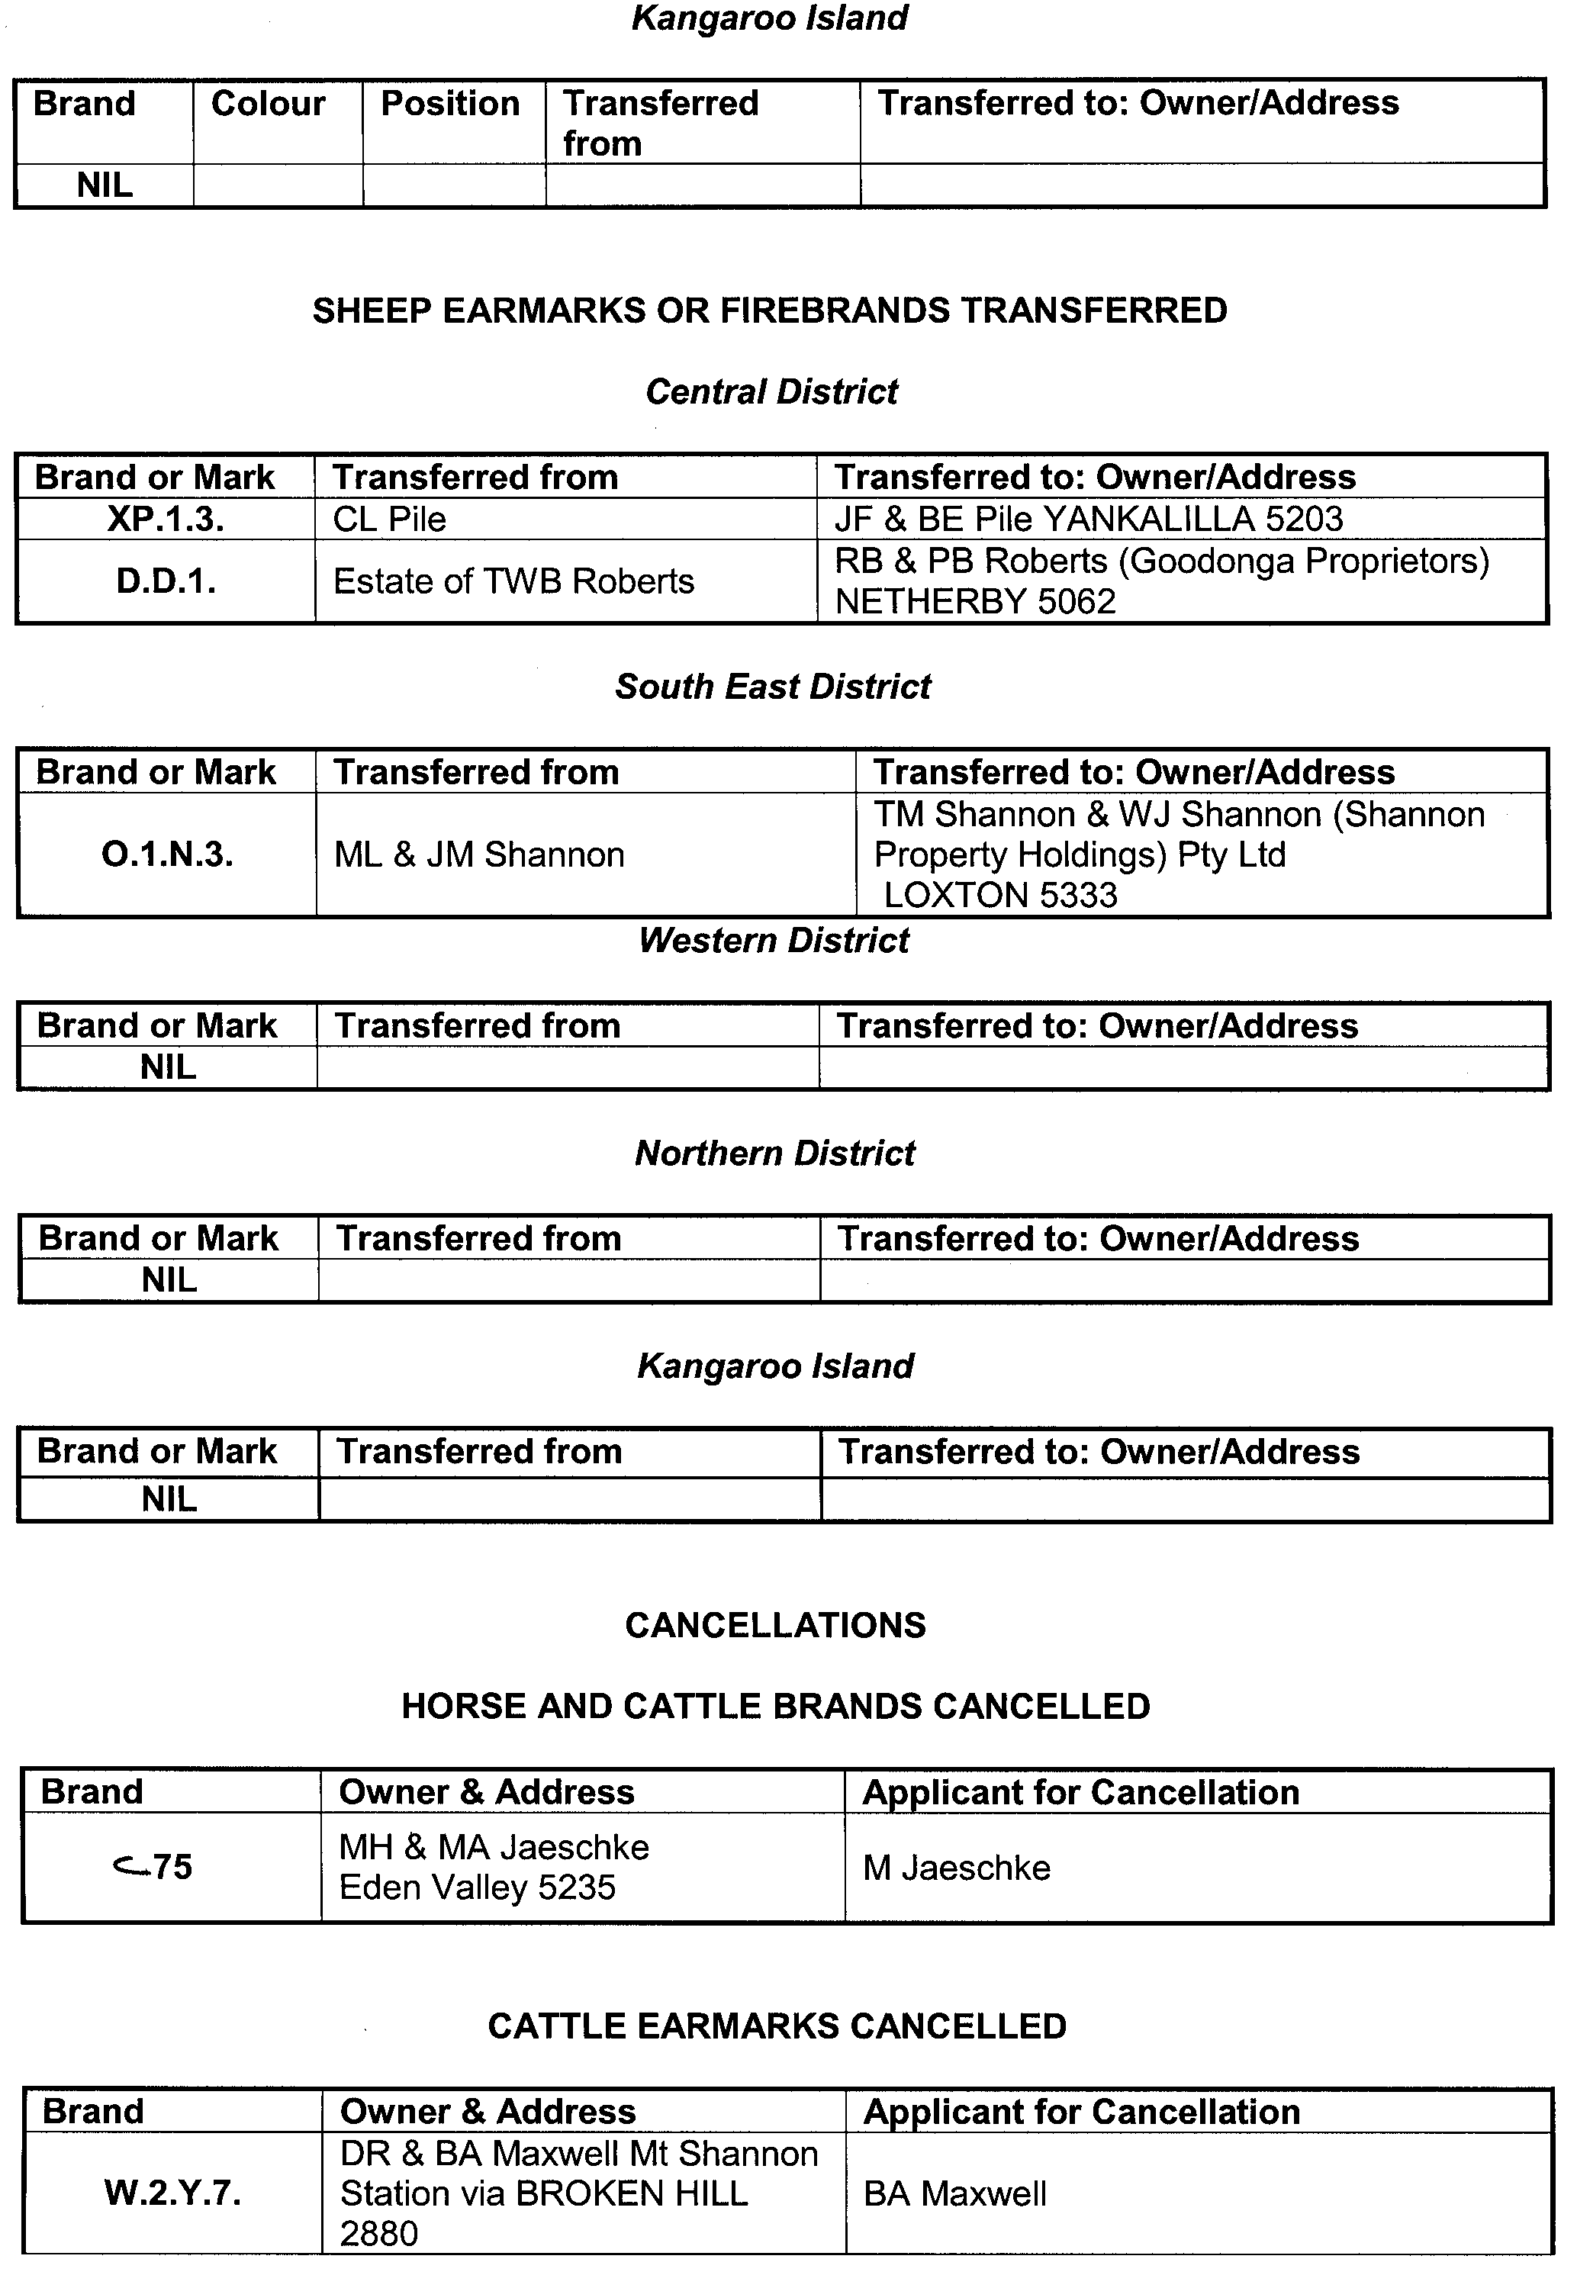
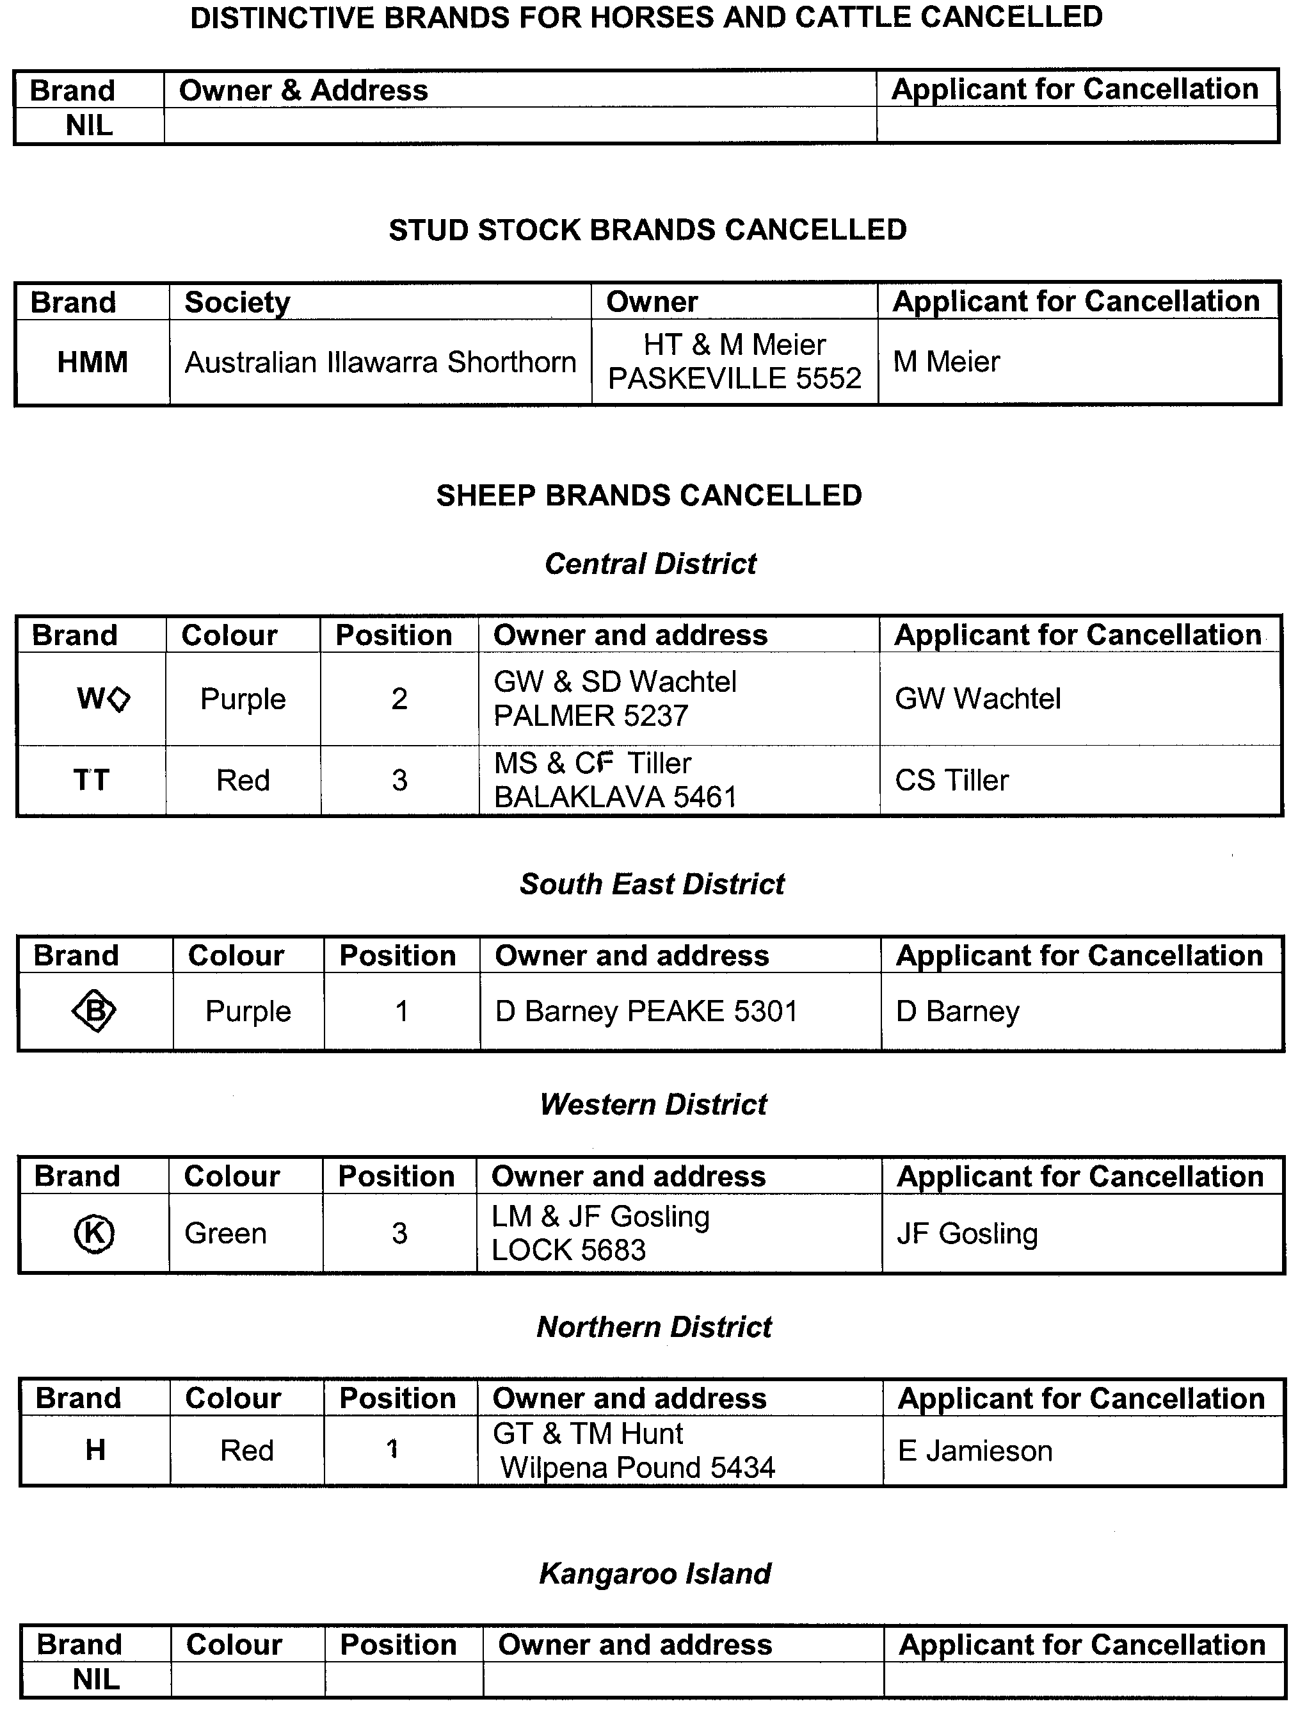

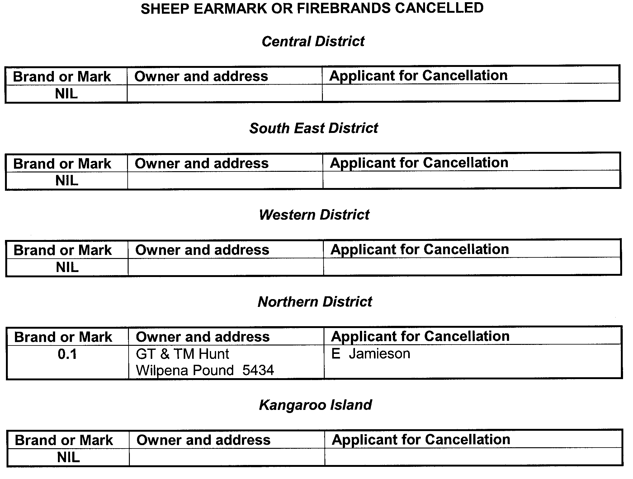

GOVERNMENT GAZETTE ADVERTISEMENT RATES

To apply from 1 July 2005

$  Agents, Ceasing to Act as 36.50  Associations:  Incorporation 18.60  Intention of Incorporation 46.00  Transfer of Properties 46.00  Attorney, Appointment of 36.50  Bailiff’s Sale 46.00  Cemetery Curator Appointed 27.25  Companies:  Alteration to Constitution 36.50  Capital, Increase or Decrease of 46.00  Ceasing to Carry on Business 27.25  Declaration of Dividend 27.25  Incorporation 36.50  Lost Share Certificates:  First Name 27.25  Each Subsequent Name 9.35  Meeting Final 30.50  Meeting Final Regarding Liquidator’s Report on  Conduct of Winding Up (equivalent to ‘Final  Meeting’)  First Name 36.50  Each Subsequent Name 9.35  Notices:  Call 46.00  Change of Name 18.60  Creditors 36.50  Creditors Compromise of Arrangement 36.50  Creditors (extraordinary resolution that ‘the Com-pany be wound up voluntarily and that a liquidator be appointed’) 46.00  Release of Liquidator⎯Application⎯Large Ad. 72.50  ⎯Release Granted 46.00  Receiver and Manager Appointed 42.50  Receiver and Manager Ceasing to Act 36.50  Restored Name 34.50  Petition to Supreme Court for Winding Up 64.00  Summons in Action 54.50  Order of Supreme Court for Winding Up Action 36.50  Register of Interests⎯Section 84 (1) Exempt 82.50  Removal of Office 18.60  Proof of Debts 36.50  Sales of Shares and Forfeiture 36.50  Estates:  Assigned 27.25  Deceased Persons⎯Notice to Creditors, etc. 46.00  Each Subsequent Name 9.35  Deceased Persons⎯Closed Estates 27.25  Each Subsequent Estate 1.20  Probate, Selling of 36.50  Public Trustee, each Estate 9.35 |  | $  Firms:  Ceasing to Carry on Business (each insertion) 24.30  Discontinuance Place of Business 24.30  Land⎯Real Property Act:  Intention to Sell, Notice of 46.00  Lost Certificate of Title Notices 46.00  Cancellation, Notice of (Strata Plan) 46.00  Mortgages:  Caveat Lodgment 18.60  Discharge of 19.50  Foreclosures 18.60  Transfer of 18.60  Sublet 9.35  Leases⎯Application for Transfer (2 insertions) each 9.35  Lost Treasury Receipts (3 insertions) each 27.25  Licensing 54.50  Municipal or District Councils:  Annual Financial Statement⎯Forms 1 and 2 513.00  Electricity Supply⎯Forms 19 and 20 364.00  Default in Payment of Rates:  First Name 72.50  Each Subsequent Name 9.35  Noxious Trade 27.25  Partnership, Dissolution of 27.25  Petitions (small) 18.60  Registered Building Societies (from Registrar-  General) 18.60  Register of Unclaimed Moneys⎯First Name 27.25  Each Subsequent Name 9.35  Registers of Members⎯Three pages and over:  Rate per page (in 8pt) 233.00  Rate per page (in 6pt) 308.00  Sale of Land by Public Auction 46.50  Advertisements 2.60  ¼ page advertisement 109.00  ½ page advertisement 218.00  Full page advertisement 427.00  Advertisements, other than those listed are charged at $2.60 per column line, tabular one-third extra.  Notices by Colleges, Universities, Corporations and District Councils to be charged at $2.60 per line.  Where the notice inserted varies significantly in length from that which is usually published a charge of $2.60 per column line will be applied in lieu of advertisement rates listed.  South Australian Government publications are sold on the condition that they will not be reproduced without prior permission from the Government Printer.
All the above prices include GST

GOVERNMENT GAZETTE NOTICES
ALL private advertisements forwarded for publication in the South Australian Government Gazette must be PAID FOR PRIOR TO INSERTION; and all notices, from whatever source, should be legibly written on one side of the paper only and sent to Government Publishing SA so as to be received no later than 4 p.m. Tuesday preceding the day of publication. Phone 8207 1045 or Fax 8207 1040. E-mail: governmentgazette@saugov.sa.gov.au. Send as attachments in Word format. Please include date the notice is to be published and to whom the notice will be charged. The Government Gazette is available online at: www.governmentgazette.sa.gov.au.

MISCELLANEOUS LEGISLATION AND GOVERNMENT PUBLICATIONS PRICES AS FROM 1 JULY 2005

Acts, Bills, Rules, Parliamentary Papers and Regulations
Pages | Main | Amends | Pages | Main | Amends

1-16 | 2.20 | 1.00 | 497-512 | 31.00 | 30.00
17-32 | 3.00 | 1.85 | 513-528 | 32.00 | 30.75
33-48 | 3.90 | 2.80 | 529-544 | 33.00 | 32.00
49-64 | 4.90 | 3.75 | 545-560 | 34.00 | 33.00
65-80 | 5.75 | 4.75 | 561-576 | 34.75 | 34.00
81-96 | 6.70 | 5.55 | 577-592 | 35.75 | 34.50
97-112 | 7.60 | 6.50 | 593-608 | 36.75 | 35.50
113-128 | 8.55 | 7.45 | 609-624 | 37.50 | 36.50
129-144 | 9.60 | 8.50 | 625-640 | 38.50 | 37.00
145-160 | 10.50 | 9.35 | 641-656 | 39.50 | 38.50
161-176 | 11.50 | 10.30 | 657-672 | 40.00 | 39.00
177-192 | 12.40 | 11.30 | 673-688 | 41.75 | 40.00
193-208 | 13.40 | 12.30 | 689-704 | 42.50 | 41.00
209-224 | 14.20 | 13.10 | 705-720 | 43.00 | 42.00
225-240 | 15.10 | 14.00 | 721-736 | 44.75 | 43.00
241-257 | 16.20 | 14.70 | 737-752 | 45.25 | 44.00
258-272 | 17.10 | 15.70 | 753-768 | 46.25 | 44.50
273-288 | 18.00 | 16.90 | 769-784 | 46.75 | 46.00
289-304 | 18.80 | 17.70 | 785-800 | 47.75 | 47.00
305-320 | 19.90 | 18.70 | 801-816 | 48.50 | 47.50
321-336 | 20.70 | 19.60 | 817-832 | 49.75 | 48.50
337-352 | 21.80 | 20.60 | 833-848 | 50.75 | 49.50
353-368 | 22.60 | 21.60 | 849-864 | 51.50 | 50.00
369-384 | 23.60 | 22.50 | 865-880 | 52.50 | 51.50
385-400 | 24.50 | 23.40 | 881-896 | 53.00 | 52.00
401-416 | 25.50 | 24.20 | 897-912 | 54.50 | 53.00
417-432 | 26.50 | 25.25 | 913-928 | 55.00 | 54.50
433-448 | 27.50 | 26.25 | 929-944 | 56.00 | 55.00
449-464 | 28.25 | 27.00 | 945-960 | 57.00 | 55.50
465-480 | 28.75 | 28.00 | 961-976 | 58.25 | 56.50
481-496 | 30.00 | 28.75 | 977-992 | 59.25 | 57.00

Legislation—Acts, Regulations, etc: $
Subscriptions:
Acts 192.00
All Bills as Laid 460.00
Rules and Regulations 460.00
Parliamentary Papers 460.00
Bound Acts 213.00
Index 106.00
Government Gazette
Copy 5.00
Subscription 254.00
Hansard
Copy 14.00
Subscription—per session (issued weekly) 399.00
Cloth bound—per volume 172.00
Subscription—per session (issued daily) 399.00
Legislation on Disk
Whole Database 2 951.00
Annual Subscription for fortnightly updates 907.00
Individual Act(s) including updates POA
Compendium
Subscriptions:
Subscriptions 1 749.00
Updates 617.00
(All the above prices include GST)

All Legislation, Government Gazette, Hansard and Legislation on disk are available from:
Counter Sales Service SA, Government Legislation⁺ Outlet
and Mail Orders: Lands Titles Office, 101 Grenfell Street, Adelaide, S.A. 5000
Phone: 13 23 24 (local call cost), Fax: (08) 8204 1909
Postal: G.P.O. Box 1707, Adelaide, S.A. 5001

Online Shop: www.shop.service.sa.gov.au

Subscriptions and Government Publishing SA
Standing Orders: Box 9, Plaza Level, Riverside Centre, North Terrace, Adelaide, S.A. 5000
Phone: (08) 8207 0908, (08) 8207 0910, Fax: (08) 8207 1040

CROWN LANDS ACT 1929: SECTION 5
TAKE notice that pursuant to the Crown Lands Act 1929, I, JOHN HILL, Minister for Environment and Conservation, Minister of the Crown to whom the administration of the Crown Lands Act 1929 is committed DO HEREBY:
1. Resume the land defined in The First Schedule.
2. Dedicate the Crown Land defined in The Second Schedule as Public Road.
The First Schedule
Portion of Reserve for Drainage Purposes, Section 387, Hundred of Waterhouse, the Proclamation of which, together with other land was published in the Government Gazette of 12 August 1926 at page 371, being portion of the land comprised in Crown Record Volume 5725 Folio 858.
The Second Schedule
Section 387, Hundred of Waterhouse, County of Robe, being within the District of Robe.
Dated 4 August 2005.
J. Hill, Minister for Environment and Conservation
DL 2693/1985

CROWN LANDS ACT 1929: SECTION 5
TAKE notice that pursuant to the Crown Lands Act 1929, I, JOHN HILL, Minister for Environment and Conservation, Minister of the Crown to whom the administration of the Crown Lands Act 1929 is committed DO HEREBY dedicate the Crown Land defined in The Schedule as a Radio Communications Reserve and declare that such land shall be under the care, control and management of Telstra Corporation Limited.
The Schedule
Allotment 1 of Deposited Plan 24330, Hundred of Yanyarrie, County of Granville, exclusive of all necessary roads, together with a right of way over those portions of Allotment 2 of Deposited Plan 24330, Section 371 and Section 372, Hundred of Yanyarrie marked P on Deposited Plan 24330 and appurtenant to Allotment 1 of Deposited Plan 24330.
Dated 4 August 2005.
J. Hill, Minister for Environment and Conservation
DL 4762/1987

CROWN LANDS ACT 1929: SECTION 5
TAKE notice that pursuant to the Crown Lands Act 1929, I, JOHN HILL, Minister for Environment and Conservation, Minister of the Crown to whom the administration of the Crown Lands Act 1929 is committed DO HEREBY dedicate the Crown Land defined in The Schedule as Public Road.
The Schedule
Allotment 199 of Deposited Plan 65637, Hundred of Skurray, County of Eyre, being within the District of Mid Murray.
Dated 4 August 2005.
J. Hill, Minister for Environment and Conservation
DEH 11/1561

DEVELOPMENT ACT 1993, SECTION 48: DECISION BY THE DEVELOPMENT ASSESSMENT COMMISSION AS DELEGATE OF THE GOVERNOR
Preamble
1. The decision of the Governor under section 48 of the Development Act 1993, to approve the development of the Myponga/Sellicks Hill Wind Farm located on the Sellicks Hill Range near Myponga was published in the Gazette on 20 November 2003.
2. The development was the subject of a Public Environmental Report and an Assessment Report under sections 46 and 46C of the Development Act 1993.
3. An amendment to the proposal for the erection of two 50 m high anemometer (wind monitoring) towers for two years (temporary use) was subsequently considered and approved by the Development Assessment Commission and published in the Gazette on 18 November 2004.
4. A further amendment to the proposal for a variation of Condition 17 attached to the development authorisation to enable substantial work to commence on the site within three years of the date of the original authorisation was subsequently considered and approved by the Development Assessment Commission and published in the Gazette on 5 May 2005.
5. Application has now been made by TrustPower Australia Holdings Pty Ltd to the Development Assessment Commission as delegate of the Governor under section 48 of the Development Act 1993, for further variations to the proposed development.
6. The proposed variations are:
• Revised turbine layout and final turbine model.
• Changes to Operations and Maintenance compound (deletion of substation).
• Replacement of three temporary wind monitoring masts with two permanent masts.
• Consequent minor variations to electrical connections, access tracks and land division associated with leases for the turbine sites.
• Confirmation of turbine foundations.
7. The application for variation is contained in the document titled ‘Proposed Myponga/Sellicks Hill Wind Farm Develop-ment—Variation to Development Authorisation’ dated 28 June 2005.
8. The Development Assessment Commission has, in con-sidering the application for variation, had regard to all relevant matters under section 48 (5) of the Development Act 1993.
9. The Development Assessment Commission is satisfied that the variations do not significantly affect the substance of the development and do not require the preparation of a further or amended Public Environmental Report.
Decision
PURSUANT to section 48 of the Development Act 1993, the Development Assessment Commission, as delegate of the Governor, grants development plan authorisation to the amendment, subject to the following varied conditions and notes:
1. The Myponga/Sellicks Hill Wind Farm shall be developed in accordance with:
• The Site Layout Plan.
• The Access Route Plan.
• The Electrical Layout and Connection Routes Plan,
as provided for Appendix D of the Response Document and Amendment to the Proposal dated 14 July 2003:
• The proposed locations for new 50 m Anemometer Towers Plan.
• The proposed anemometer location on St Vincent Property Plan.
• The proposed anemometer location on Koraleigh Property Plan,
as provided with the request for minor variation letter dated
6 October 2004, except as varied by the application for variation to development authorisation by TrustPower Australia Holdings Pty Ltd dated 28 June 2005.
2. Construction must not be commenced until:
(a) an Environmental Management and Monitoring Plan (EMMP) has been developed to the satisfaction of the Environment Protection Authority. The EMMP must include those additional matters set out in section 7 of the Assessment Report;
(b) a private certifier or the District Council of Yankalilla has certified to the Development Assessment Com-mission that all work that constitutes building work under the Development Act 1993, complies with the Building Rules.
3. Clearance of remnant native vegetation on the site or adjacent public roads for access during construction shall be minimised and be in accordance with the Native Vegetation Council requirements.
4. A Compliance Officer whose sole responsibility is verification of compliance shall be on-site at all times during construction to ensure all environmental management and monitoring is being conducted in accordance with the approved Environmental Management and Monitoring Plan and provide reports on any issue or variance with the prescribed requirements, to the Environment Protection Authority.
5. Compliance checking of noise levels shall be carried out by a specialist noise consultant in accordance with the EPA Wind Farms Guidelines in force at the time of testing to confirm the data within the Bassett Acoustics report AA0651 dated 24 June 2005 and to confirm noise levels associated with the substation installation is free of low frequency tones or excessive noise.
6. Analysis of any variations to the assessed turbine layout, or turbine model, that occurs during the detailed design or construction phase of the project shall be carried out by a specialist noise consultant and shall be confirmed as being in accordance with the EPA Wind Farms Environmental Noise Guidelines prior to any construction of the affected turbines taking place. Any variations require further approval.
7. A public viewing platform with associated car parking and landscaping shall be established on Reservoir Road in accordance with the plan shown in the Public Environmental Report dated 10 March 2003, Appendix I, subject to the approval of the District Council of Yankalilla and Transport SA as land owners, with all costs borne by the proponent.
8. Screen planting shall be established on the Main South Road verge in accordance with Figures B and D in Appendix F of the Response Document and on the northern edge of Reservoir Road up to the end of the first left hand bend from the Main South Road intersection. The screen planting shall commence prior to the operation of the project and in consultation with the District Council of Yankalilla and Transport SA, with costs borne by the proponent.
9. Any costs associated with changes to the overtaking lane on Main South Road (heading south) that may be required by Transport SA, following its proposed review of the operation of the overtaking lane, shall be borne by the proponent.
10. Any additional measures required by Transport SA to minimise the potential for driver distraction shall be implemented to the satisfaction of the District Council of Yankalilla and Transport SA with all costs being borne by the proponent.
11. Signs directing traffic to the proposed viewing platform shall be erected on Main South Road and Reservoir Road in consultation with Transport SA with all installation and on-going maintenance costs being borne by the proponent. All signs shall be in accordance with Australian Standards for Tourist Signing and the South Australian Tourist Sign Posting Policy.
12. All access points used during construction and maintenance shall be designed and constructed to Transport SA standards, with all costs being borne by the proponent.
13. The wind turbines shall be painted matt off-white/grey to minimise the visual impact and any potential for glare or reflection and shall not display any signs, logos or other advertising displays.
14. The wind turbines and associated infrastructure and site shall be kept clean and tidy and serviced regularly with any graffiti being removed and with all repairs to rectify breakdown or damage being effected as soon as is practicable.
15. Any new stobie poles for transmission lines shall be colour treated to reduce their visual impact and, where possible, new lines shall use a flat line configuration.
16. Upon decommissioning of the wind farm, the site shall be returned, as far as is possible, to its condition prior to the commencement of the development, with the turbines and all above ground electrical infrastructure no longer required for electricity transmission being removed.
17. If development is not commenced by substantial work on the site within three years of the date of the original authorisation, the Governor may cancel the authorisation by written notice.
18. A landscaping and revegetation plan will be required for the construction and operational stages. Pest plant and animal control aspects will need to be addressed. The plan should be prepared in consultation with the Department for Environment and Heritage and the Native Vegetation Council, and shall be incorporated into the Environmental Management and Moni-toring Plan.
19. The two temporary 50 m anemometer (wind monitoring) towers shall be removed within two years of their erection.
20. The two temporary 50 m anemometer (wind monitoring) towers and supporting guys shall be contained entirely within the site and shall not encroach over any public road reserve.
21. The wind farm operator shall undertake wind speed monitoring at the permanent tower with the greatest wind speed exposure at 10 minute intervals simultaneously at both hub height and at a height of 10 m above ground level. The data shall be recorded in a format to enable desktop analysis.
22. The wind farm operator shall maintain sufficient data indicating the relationship between the wind speeds at 10 minute intervals between the temporary wind towers and the permanent towers. The data shall be recorded in a format to enable desktop analysis.
Notes
• The applicant is reminded of its general environmental duty, as required by section 25 of the Environment Protection Act 1993, to take all reasonable and practical measures to ensure that its activities on the whole site, including during construction, do not pollute the environment in a way which causes or which may cause environmental harm. In particular, an appropriate soil erosion and drainage management plan, prepared in accordance with the Environment Protection Authority Stormwater Pollution Prevention Code of Practice for the Building and Construction Industry, will be required to be submitted and approved before construction commences (as part of the Environmental Management and Monitoring Plan).
• The applicant shall liaise with Transport SA’s Murray Bridge Office Customer Liaison and Safety Officer (presently Alison Allen, (08) 8532 8122) prior to any works being undertaken on or adjacent to Main South Road and Reservoir Road.
• The Environmental Management and Monitoring Plan requires further work before it will receive approval, by the addition of those matters outlined in section 7 of the Assessment Report dated November 2003.
• The development shall proceed in accordance with all relevant State and Commonwealth law (as amended from time to time).
• If, during construction or operation of the development, the proponent discovers evidence of an Aboriginal site or any Aboriginal objects or remains, the proponent is required, pursuant to the Aboriginal Heritage Act 1988, to report particulars of to such discovery to the Minister for Aboriginal Affairs and Reconciliation and thereafter comply with any directions given by the Minister for Aboriginal Affairs and Reconciliation.
• The proponent shall negotiate with the District Council of Yankalilla and the City of Onkaparinga on any matters arising from the development where the Councils have responsibilities under the Local Government Act 1999, and Roads (Opening and Closing) Act 1991.
• The requirement for an Environmental Management and Monitoring Plan (EMMP) prior to the commencement of construction does not include the two temporary anemometer towers hereby approved.
• For the purposes of Conditions 5 and 6 a specialist noise consultant is taken to be one eligible for membership of both the Institution of Engineers Australia and the Australian Acoustical Society.
A. Houghton, Secretary, Development Assessment Commission

DEVELOPMENT ACT 1993: SECTION 48
Decision by the Governor
Preamble
1. A proposal for a certain major development has been under consideration under Division 2 of Part 4 of the Development Act 1993.
2. The proposal is submitted by Grenfell East Pty Ltd and is for an apartment complex located at 41-51 Hindmarsh Square and 131-139 Grenfell Street (RAA Corner), Adelaide, incorporating environmentally sustainable development features and comprising:
• the construction of a 19 level residential apartment tower and podium (10 storeys high) containing 127 apartments, with ground and part first floor retail and office use;
• renovation of the adjacent two-storey State Heritage listed YWCA building (incorporating a cafe, gymnasium, function room, lounges and wine storage areas);
• redevelopment of the roadway on the western side of Hindmarsh Square in front of the apartment allotment; and
• a three-level basement car park extending 30 m under the Hindmarsh Square roadway (for the width of the development site only), with provision for 158 car spaces, 27 bicycle spaces, storage, plant rooms and water storage tank,
which proposal is hereafter referred to as ‘the proposed major development’.
3. The proposed major development was the subject of an application lodged on 26 May 2003, but has been amended and expanded upon by the applicant’s Development Report dated
5 November 2003, the applicant’s Response to Submissions dated 18 December 2003 and certain correspondence between 18 March 2004 to 30 April 2004, including the final amended application dated 30 April 2004 (and accompanying plans), which is referred to below in the Conditions.
4. The proposed major development has been the subject of a Development Report and an Assessment Report under sections 46 and 46D of the Development Act 1993.
5. Application has now been made to the Governor under section 48 for a development authorisation for the proposed major development.
6. Pursuant to section 48 (6), it has been decided to grant a provisional development authorisation and to reserve a decision on specified matters.
Decision
PURSUANT to section 48 of the Development Act 1993 and with the advice and consent of the Executive Council, and having due regard to the matters set out in section 48 (5) and all other relevant matters, I:
(a) grant a provisional development authorisation in relation to the proposed major development, subject to the conditions and notes to the applicant below;
(b) pursuant to section 48 (6) reserve my decision on the following matters:
(i) Compliance with the Building Rules in relation to all aspects of the proposed major development.
(ii) Final design of the apartment complex roof line and the design of the top storey (Level 18), in accord-ance with the request from the applicant dated
30 April 2004.
(iii) Final facade of the apartment complex development (colours, materials, finishes and configuration of facade elements) resulting from further sustain-ability modelling by the applicant, noted as a reserved item in the amended application dated
30 April 2004.
(iv) Materials, finishes, colour schedules and any other works or activities affecting the adjacent two-storey YWCA State Heritage listed building (to be developed in consultation with, and to the approval of, the Heritage Branch, Department for Environ-ment and Heritage).
(v) Final design of the pedestrian entrance canopy of the apartment complex to enhance compatibility with the adjacent State Heritage listed YWCA building, noted as a reserved item in the amended application dated 30 April 2004.
(vi) Final selection of detailed environmentally sustainable feature options and plant and equipment for the apartment complex development referred to in the Development Report, to be undertaken in accordance with agreed targets and pending further sustainability modelling by the applicant, in consul-tation with Planning SA and the Working Party referred to in the Development Report, and noted as a reserved item in the amended application dated 30 April 2004.
(vii) Any other external advertising signage.
(c) specify all matters relating to this provisional develop-ment authorisation as matters in respect of which conditions of this authorisation may be varied or revoked, or new conditions attached;
(d) specify for the purposes of section 48 (11) (b) the period of two years from the date hereof as the time within which substantial work must be commenced on site failing which I may cancel this authorisation.
Conditions of Approval
1. Except where minor amendments may be required by other legislation, or by conditions imposed herein, the proposed major development shall be undertaken in strict accordance with:
(a) the following drawings contained within the letter from Connor Holmes Pty Ltd (for Grenfell East Pty Ltd) to Planning SA dated 30 April 2004, outlining the final, amended application:
• Drawing Titled: ‘Location Plan’ 1:500; Drawing Number: 503225 A000 C; dated 16 April 2004.
• Drawing Titled: ‘Plan B01’; 1:100; Drawing Number: 503225 A109 F; dated 16 April 2004.
• Drawing Titled: ‘Plan B02’; 1:100; Drawing Number: 503225 A110 G; dated 16 April 2004.
• Drawing Titled: ‘Plan B03’; 1:100; Drawing Number: 503225 A111 A; dated 16 April 2004 (new drawing).
• Drawing Titled: ‘Plan L00’ 1:100; Drawing Number: 503225 A100 C; dated 16 April 2004.
• Drawing Titled: ‘Plan L01’; 1:100; Drawing Number: 503225 A101 C; dated 16 April 2004.
• Drawing Titled: ‘Plan L02’; 1:100; Drawing Number: 503225 A102 C; dated 16 April 2004.
• Drawing Titled: ‘Plan L03-L09’ 1:100; Drawing Number: 503225 A103 C; dated 16 April 2004.
• Drawing Titled: ‘Plan L10’; 1:100; Drawing Number: 503225 A104 C; dated 16 April 2004.
• Drawing Titled: ‘Plan L11-L18’; 1:100; Drawing Number: 503225 A105 C; dated 16 April 2004 (except to the extent that they may be varied by a document in paragraph (b), dated 30 April 2004).
• Drawing Titled: ‘Plan Roof’; 1:100; Drawing Number: 503225 A108 C; dated 16 April 2004 (except to the extent that they may be varied by a document in paragraph (b), dated 30 April 2004).
• Drawing Titled: ‘North Elevation’; 1:200; Drawing Number: 503225 A200 C; dated 16 April 2004.
• Drawing Titled: ‘East Elevation’; 1:200; Drawing Number: 503225 A201 C; dated 16 April 2004.
• Drawing Titled: ‘West Elevation/South Elevation’; 1:200; Drawing Number: 503225 A202 C; dated 16 April 2004.
• Drawing Titled: ‘Sections’; 1:200; Drawing Number: 503225 A203 C; dated 16 April 2004.
and
(b) the following documents:
• Development application, ‘Residential apartment building with retailing and offices and basement car parking at 131-139 Grenfell Street and 41-51 Hindmarsh Square, Adelaide’, prepared by Connor Holmes Pty Ltd (for Grenfell East Pty Ltd) dated 26 May 2003 (except to the extent that it may be varied by a subsequent document in this paragraph).
• Development Report, Hindmarsh Square Apartment Complex, prepared by Connor Holmes Pty Ltd (for Grenfell East Pty Ltd) dated 5 November 2003 (except to the extent that it may be varied by a subsequent document in this paragraph).
• Response to Submissions Document, Hindmarsh Square Apartment Complex, prepared by Connor Holmes Pty Ltd (for Grenfell East Pty Ltd) dated 18 December 2003 (contained within an appendix to the Assessment Report noted below) (except to the extent that it may be varied by a subsequent document in this paragraph).
• Assessment Report prepared by the Minister for Urban Development and Planning and released 8 March 2004 (except to the extent that it may be varied by a subsequent document in this paragraph).
• Letter from Connor Holmes Pty Ltd (for Grenfell East Pty Ltd) to the Minister for Urban Development and Planning dated 18 March 2004, outlining the applicant’s response to the Assessment Report (except to the extent that it may be varied by a subsequent document in this paragraph).
• Letter from Grenfell East Pty Ltd to the Minister for Urban Development and Planning dated 24 March 2004, proposing amendments to the proposal (except to the extent that it may be varied by a subsequent document in this paragraph).
• Letter from Grenfell East Pty Ltd to the Minister for Urban Development and Planning dated 22 April 2004, outlining additional transport initiatives (except to the extent that it may be varied by a subsequent document in this paragraph).
• Letter from Connor Holmes Pty Ltd (for Grenfell East Pty Ltd) to Planning SA dated 30 April 2004, outlining a final, amended application and accompanying plans, including reduction of the apartment tower height by two levels; reduction of the extent of the three-level basement car park (located under the apartment complex and adjacent roadway and footpath) with no encroachment in front of the adjacent property to the south; and a list of reserved matters for further application and decision-making (except to the extent that it may be varied by a subsequent document in this paragraph).
• Correspondence from Jack Hines (for Grenfell East Pty Ltd) to Planning SA dated 30 April 2004, listing final design of the apartment complex roof line and Level 18 of the complex as reserved matters for later decision-making subject to further application.
• Letter from Conservatory on Hindmarsh Square dated 16 June 2005 and email from James Hines dated 27 July 2005 outlining the proposed advertising signage.
2. The applicant shall submit further information and application(s) in relation to the matters that have been reserved.
3. No building works on any part of the development may commence until a favourable decision has been notified to the applicant by the Governor or the Governor’s delegate in respect of those reserved matters referred to in subparagraphs (ii) to (vii) in paragraph (b) of the Decision section (above).
4. No building works on any part of the development may commence until it has been demonstrated to the satisfaction of the Minister for Urban Development and Planning that a 42-year lease by the Adelaide City Council has been secured for use of land for the basement car parking area for community lot owners in the apartment complex.
5. No works on the basement car park shall commence until a detailed survey plan has been submitted to the Minister for Urban Development and Planning, showing the extent of the 42-year lease for a portion of the roadway abutting Hindmarsh Square.
6. Subject to conditions 3, 4, 5 and 9, the applicant may stage building works, and, if so, may commence a stage before receiving the Governor’s decision concerning building rules compliance for other stages (refer reserved matter (i) in paragraph (b) of the Decision section (above)). No building works shall commence on a stage of the development, however, until a favourable decision in relation to building rules compliance in respect of that stage has been notified in writing to the applicant by the Governor or the Governor’s delegate.
7. A decision on building rules compliance (refer reserved matter (i) in paragraph (b) of the Decision section (above)) will only be made after a Building Rules assessment and certification has been undertaken and issued by the Adelaide City Council, or a private certifier, in accordance with the provisions of the Develop-ment Act 1993, and after the Minister for Urban Development and Planning receives a copy of all relevant certification docu-mentation, as outlined in Regulation 64 of the Development Regulations 1993 (refer to ‘Notes to Applicant’ (below) for further information).
8. Further sustainability modelling, for the selection of materials and finishes and sustainability features of the apartment complex (listed as reserved matters), shall be undertaken in consultation with Planning SA, and the Working Party referred to in the applicant’s Development Report, dated 5 November 2003.
9. Before any works commence, a Construction Environmental Management Plan (CEMP) shall be prepared in consultation with and approved by the Environment Protection Authority, Planning SA and the Adelaide City Council, to address management issues during construction and to be lodged with the Minister for Urban Development and Planning. An Environmental Auditor shall be engaged to audit the management plan in accordance with commitments made by the applicant in the Response to Sub-missions dated 18 December 2003. Matters to be addressed in the CEMP must include (but shall not be limited to):
• Reference to, and methods of adherence to, all relevant Environment Protection Authority (EPA) policies and codes of practice for construction sites, including the inclusion of a copy of Schedule 1 of the Environment Protection Act 1993 as an Appendix to the Construction Environmental Management Plan to ensure contractors are aware of EPA requirements, in accordance with commit-ments made in the applicant’s Response to Submissions, dated 18 December 2003;
• timing, staging and methodology of the construction process and working hours (refer also to condition outlining working hours);
• a Risk Assessment relating to the potential impacts of construction activities;
• a Heritage Protection Plan to maintain the integrity of the YWCA State Heritage listed building;
• traffic management strategies during construction of both the basement car park and apartment complex, including transport beyond the development site;
• management of infrastructure services during construction and/or relocation and re-establishment of local amenity and landscaping;
• control and management of construction noise, vibration, dust and mud;
• engineering and structural issues associated with con-struction of the underground car park and overhead landscaping in the redevelopment of the roadway on the western side of Hindmarsh Square;
• stormwater and groundwater management during construction;
• identification and management of contaminated soils and groundwater, should these be encountered;
• site security, fencing and safety and management of impacts on local amenity for residents, traffic and pedestrians;
• disposal of construction waste and refuse in an appropriate manner according to the nature of the waste;
• protection and cleaning of roads and pathways;
• overall site clean up.
10. Normal operating hours for construction activities and truck movements to and from the site shall be from 7 a.m. to 7 p.m., Monday to Saturday inclusive. If it is considered necessary for construction works to also be undertaken on Sundays, construction hours shall be from 9 a.m. to 6 p.m. on Sundays (refer ‘Notes to Applicant’ relating to EPA noise emission policies).
11. Any collected groundwater or stormwater shall only be discharged to the stormwater system if it meets quality control criteria specified in Environment Protection Authority require-ments to avoid sedimentation of local pipes and pollution of the Torrens Lake (refer ‘Notes to the Applicant’ for relevant requirements).
12. All drainage, finished floor levels, construction of the basement car park, landscaping, and public works associated with the development, including the disposal of stormwater and earthworks, are to be carried out in accordance with accepted engineering standards and to the reasonable satisfaction of the Adelaide City Council.
13. Any hazardous substances (e.g. fuels, compressed gases, solvents, paints, asbestos, polychlorinated biphenyls (PCBs) and other construction-related substances), shall be removed and disposed of in accordance with Environment Protection Authority requirements.
14. Any landscaping associated with the redevelopment of the roadway on the western side of Hindmarsh Square following construction of the basement car park, shall be effected in accordance with plans approved by the Adelaide City Council and vegetation shall be maintained and nurtured, with any diseased or dying plants being replaced.
15. The basement car park shall not encroach along the front of the adjacent building to the south of the development.
16. The basement car parking areas shall be designed in accordance with Australian Standards 2890.1-1993 and line markings shall be maintained in good and substantial condition at all times.
17. Provision shall be made for 27 bicycle parking spaces in the basement car park of the apartment complex, in addition to the provision of bicycle racks for use by RAA staff (the location of which is to be determined in consultation with Planning SA and the Adelaide City Council).
18. The apartment complex and basement car park shall be maintained in a serviceable condition and operated in an orderly, tidy, safe and healthy manner at all times.
19. The waste and general storage and service/operational areas of the apartment complex building and basement car parking area shall be kept in a neat, tidy, safe and healthy condition at all times and the service area access door shall remain closed at all times other than when loading or unloading is taking place.
20. Any machinery, plant operating equipment, lighting, building facade designs, or sound devices associated with the apartment complex development shall not impair or impinge upon the enjoyment or safety of residents of the apartment complex, adjoining properties (or occupiers thereof), or the local traffic and pedestrian environment.
Notes to Applicant
• Pursuant to Development Regulation 64, the applicant is advised that the Adelaide City Council or private certifier conducting a Building Rules assessment must:
(a) provide to the Minister a certification in the form set out in Schedule 12A of the Development Regulations 1993 in relation to the building works in question; and
(b) to the extent that may be relevant and appropriate:
(i) issue a schedule of essential safety provisions under Division 4 of Part 12;
(ii) assign a classification of the building under these regulations; and
(iii) ensure that the appropriate levy has been paid under the Construction Industry Training Fund 1993.
Regulation 64 of the Development Regulations 1993 provides further information about the type and quantity of all Building Rules certification documentation for Major Developments required for referral to the Minister for Urban Development and Planning.
• The Adelaide City Council or private certifier undertaking Building Rules assessment and certification must ensure that the assessment and certification are consistent with this provisional development authorisation (including any conditions or notes that apply in relation to this provisional development authorisation).
• While it approves provisionally the land division comprising the 42-year lease for the basement car park adjacent to Hindmarsh Square (subject to the submission of a detailed survey plan), the provisional authorisation does not approve the creation of any allotments for individual apartments or for car parking spaces. Any such division will require a new application and new assessment. The applicant’s attention is also drawn to the requirements of Section 50 of the Development Act 1993 in regard to the open space contribution system.
• This provisional development authorisation does not extend to the provision of any wind turbines, as indicated in the letter from Grenfell East Pty Ltd to the Minister for Urban Development and Planning dated 24 March 2004. Any such turbines, if subsequently proposed, will require a new application under the appropriate assessment process.
• Should the applicant wish to vary the development or any of the components of the development in relation to which a decision has been reserved, an application may be submitted, pursuant to section 48B of the Development Act 1993, provided that the development application variation remains within the ambit of the Development Report and Assessment Report referred to in this provisional development authorisation. If an application variation involves substantial changes to the proposal, pursuant to section 47 of the Development Act 1993, the applicant may be required to prepare an amended Development Report for public inspection and purchase. An amended Assessment Report may also be required to assess any new issues not covered by the original Assessment Report and a decision made by the Governor pursuant to section 48 of the Development Act 1993.
• If the development is not substantially commenced within two years of the date of the decision on the last of the reserved matters, the Governor may cancel this development authorisation.
• The applicant is reminded that the Heritage Branch of the Department for Environment and Heritage (DEH) shall be consulted in regard to any physical intervention to the structures on the adjacent YWCA State Heritage listed building, which is listed as a reserved matter for further decision-making in this provisional development authori-sation. Any such work must be executed in accordance with requirements notified to it by the DEH and must be consistent with the decision by the Governor (or her delegate) on the reserved matter (e.g. materials, finishes and colour schedules).
• The proponent is advised of the General Environmental Duty under section 25 of the Environment Protection Act 1993, which requires that a person must not undertake any activity, which pollutes, or may pollute; without taking all reasonable and practical measures to prevent or minimise harm to the environment.
• The applicant is advised of the requirement to comply with the Environment Protection Authority’s (EPA) ‘Stormwater Pollution Prevention Code of Practice for the Building and Construction Industry’ during demolition and construction of the development.
• The applicant is advised that noise emissions from the apartment complex development will be subject to the Environment Protection (Industrial Noise) Policy 1994, Environment Protection Authority Guidelines and Information Sheet Number 7 (‘Construction Noise’, July 2002) and the Environment Protection Act 1993.
• It is recommended that the applicant consult with the Office of Public Transport, an agency within the Depart-ment of Transport and Urban Planning, and the Adelaide City Council about any proposed transport initiatives for the apartment complex development on Hindmarsh Square, Adelaide.
• It is recommended that the applicant consult with the Adelaide City Council about the type, nature and ongoing maintenance of any landscaping undertaken in relation to the apartment complex, including construction of the basement car park, redevelopment of the roadway on the western side of Hindmarsh Square and related works, in accordance with commitments made by the applicant in the Response to Submissions document, dated 18 December 2003.
• The applicant is advised that the Development Act 1993 outlines the roles and responsibilities of the applicant and the Adelaide City Council for matters relating to building works during and after construction of the apartment complex development and associated works.
• It is recommended that the applicant consult with Planning SA when applying to the Adelaide City Council for a ‘Certificate of Occupancy’, to ascertain that all conditions of this provisional development authorisation and decisions on reserved matters have been complied with in an appropriate manner, including those relating to Building Rules assessment and certification requirements.
• It is recommended that the applicant conduct monitoring of the effectiveness of attaining the agreed post-construction sustainability targets and regularly lodge documented outcomes, where the information is available, with Planning SA, the Department for Environment and Heritage (Office of Sustainability) and the Working Party, in accordance with commitments made in the letter from the applicant dated 30 April 2004.
• The Minister has a specific power to require testing, monitoring and auditing under section 48C of the Development Act 1993.
Dated 4 August 2005.
A. Houghton, Secretary, Development Assessment Commission

FISHERIES ACT 1982: SECTION 59
TAKE notice that pursuant to section 59 of the Fisheries Act 1982, Kym Peters, Lot 34, Leake Street, South End, S.A. 5280 (the ‘exemption holder’) is exempt from the determination made under section 43 of the Fisheries Act 1982, prohibiting the taking of fish in Lake George, but only insofar as the exemption holder may take fish using mesh nets or gill nets from the waters of Lake George (the ‘exempted activity’), subject to the conditions set out in the Schedule, from 2 August 2005 until 5 August 2005, unless varied or revoked earlier.
Schedule
1. The exemption holder may only conduct fishing activities pursuant to this notice whilst participating in the scientific survey being conducted by the South Australian Research and Development Institute (SARDI) and must fish according to directions provided by an officer from SARDI.
2. Fish taken pursuant to this notice must not be sold.
3. All fish taken pursuant to this notice must be consigned to an officer from SARDI in good condition, as soon as possible.
4. Catches from each net for each night must be kept in separate plastic bags and labelled with:
• the fisher’s name;
• the date fish were removed from the net; and
• the block number where the nets were set.
If a net is set and does not catch any fish, an officer from SARDI should be notified so this can be recorded with the rest of the samples.
5. The exemption holder must not use more than 10 mullet nets and five flounder nets at any one time whilst conducting the exempted activity.
6. The exemption holder must provide a written report setting out all information required to satisfy the data requirements specified by SARDI.
7. While engaged in the exempted activity the exemption holder must have in his possession a copy of this notice and such notice must be produced to a PIRSA Fisheries Compliance Officer if requested.
8. The exemption holder must not contravene or fail to comply with the Fisheries Act 1982, or any regulations made under that Act or any condition of this notice, except where specifically exempted by this notice.
Dated 1 August 2005.
W. Zacharin, Director of Fisheries

FISHERIES ACT 1982: SECTION 59
TAKE notice that pursuant to section 59 of the Fisheries Act 1982, University of Melbourne, Department of Zoology, Royal Parade, Parkville, Vic. 3010, (the ‘exemption holder’) or a person acting as an agent, is exempt from the provision of section 41 of the Fisheries Act 1982 and the Fisheries (General) Regulations 2000, insofar as they may engage in the collection of fish (the ‘exempted activity’) from the waters described in Schedule 1, using the gear specified in Schedule 2, subject to the conditions set out in Schedule 3 from 4 August 2005 until 30 April 2006, unless varied or revoked earlier.
Schedule 1
The waterways and tributaries of the Adelaide Plains and Adelaide Hills Catchments.
Schedule 2
• Bait traps
• Dip nets
Schedule 3
1. The specimens collected by the exemption holders are for scientific and research purposes only and must not be sold.
2. All native fish taken pursuant to the exempted activity must be immediately returned to the water.
3. The exempted activity may only be conducted by Renae Ayres, Joanne Kearns and Renee Cox.
4. Before conducting the exempted activity, the exemption holder must contact the PIRSA Fisheries Compliance Unit on 1800 065 522 and answer a series of questions about the exempted activity. You will need to have a copy of your exemption with you at the time of making the call, and be able to provide information about the area and time of the exempted activity, the vehicles and/or boats involved, the number of agents undertaking the exempted activity and other related issues.
5. While engaged in the exempted activity, the exemption holder must be in possession of a copy of this notice. Such notice must be produced to a PIRSA Fisheries Compliance Officer if requested.
6. The exemption holder must not contravene or fail to comply with the Fisheries Act 1982, or any regulations made under that Act, except where specifically exempted by this notice.
Dated 31 July 2005.
W. Zacharin, Director of Fisheries

FISHERIES ACT 1982: SECTION 59
TAKE notice that pursuant to section 59 of the Fisheries Act 1982, the class of persons described in Schedule 1 (the ‘exemption holders’) are exempted from the provisions of clause 123 of Schedule 1 of the Fisheries (General) Regulations 2000 in that an exemption holder shall not be guilty of an offence when using a registered boat that is endorsed on the licence to undertake fishing activity for purposes other than trade or business (the ‘exempted activity’), subject to the conditions specified in Schedule 2, from 1 August 2005 until 30 June 2006, unless this notice is varied or revoked earlier.
Schedule 1
The holder of a licence issued pursuant to the Fisheries (Scheme of Management—Marine Scalefish Fisheries) Regulations 1991, the Fisheries (Scheme of Management—Miscellaneous Fishery) Regulations 2000, the Fisheries (Scheme of Management—Blue Crab Fishery) Regulations 1998, the Fisheries (Scheme of Management—Prawn Fisheries) Regulations 1991, the Fisheries (Scheme of Management—Abalone Fisheries) Regulations 1991, the Fisheries (Scheme of Management—River Fishery) Regulations 1991, the Fisheries (Scheme of Management—Lakes and Coorong Fishery) Regulations 1991, the Fisheries (Scheme of Management—Charter Boat Fishery) Regulations 2005 and the Fisheries (Scheme of Management—Rock Lobster Fisheries) Regulations 1991.
Schedule 2
1. The exempted activity may only be undertaken if the registered boat is also registered for recreational use in accordance with regulations made under the Harbours and Navigation Act 1993.
2. An exemption holder must ensure that the commercial fishery boat registration number marked on a boat is covered over during the exempted activity, and any recreational registration numbers are displayed as required by regulations made under the Harbours and Navigation Act 1993.
3. The exemption holder must notify PIRSA Fisheries by calling 1800 065 522 prior to engaging in the exempted activity and providing the following information:
• the name of the licence holder making the call;
• the fishery licence number(s) of the licence(s) on which the registered boat is endorsed;
• the name of the boat and the commercial boat registration number;
• the recreational boat registration number of the boat;
• registration numbers of recreational devices (rock lobster pots or nets) that will be on board the boat;
• the time and date the exempted activity will commence; and
• the time and date the exempted activity will cease.
4. At any time during the exempted activity, an exemption holder must not have on board the registered boat any registered fishing device that is endorsed on the fishery licence on which the registered boat is also endorsed.
5. An exemption holder who is the holder of a licence issued pursuant to the Fisheries (Scheme of Management—Rock Lobster Fisheries) Regulations 1991 must ensure that no recreational rock lobster pots are on board a registered boat that is endorsed on a rock lobster fishery licence at any time during the exempted activity.
6. An exemption holder who is the holder of a licence issued pursuant to the Fisheries (Scheme of Management—Rock Lobster Fisheries) Regulations 1991 must not take or have on board the registered boat any rock lobster during the exempted activity.
7. All fish taken in the course of the exempted activity must be removed from the boat at the end of the exempted activity.
8. An exemption holder must not contravene or fail to comply with the Fisheries Act 1982, or any other regulations made under that Act, except where specifically exempted by this notice.
Dated 1 August 2005.
W. Zacharin, Director of Fisheries

FISHERIES ACT 1982: SECTION 59
TAKE note that the notice made under section 59 of the Fisheries Act 1982, and published in the South Australian Government Gazette on page number 1269, dated 13 May 2005, being the fourth notice on that page, referring to holders of commercial licences and being for the exemption to use commercially registered boats for recreational purposes, is hereby revoked.
Dated 1 August 2005.
W. Zacharin, Director of Fisheries

FISHERIES ACT 1982: SECTION 59
TAKE notice that pursuant to section 59 of the Fisheries Act 1982, Phil Bowey, and Fleurieu Star Marine Adventures, Lot 7 Flinders Drive, Cape Jervis, S.A. 5204 (the ‘principal exemption holder’), is exempt from section 34 of the Fisheries Act 1982 and Regulation 4 of the Fisheries (Scheme of Management—Charter Boat Fishery) Regulations 2005, insofar as he may undertake charter boat fishing for the purposes of trade or business without holding a licence issued by the Director of Fisheries.
Take notice that pursuant to section 59 of the Fisheries Act 1982, the principal exemption holder and the class of persons specified in Schedule 1 (the ‘other exemption holders’), are exempt from Clause 66 of Schedule 1 of the Fisheries (General) Regulations 2000, but only insofar as the exemption holders may exceed the prescribed boat limits during a chartered fishing trip on the Fleurieu Star or Starfish in accordance with the allowable limits specified in Schedule 2 (the ‘exempted activity’), subject to the conditions specified in Schedule 3, from 1 August 2005 until 22 August 2005, unless varied or revoked earlier.
Schedule 1
Any person or persons who charter the boat Fleurieu Star or Starfish from Phil Bowey for the purpose of recreational fishing.
Schedule 2
1. Where the number of ‘other exemption holders’ exceeds six, all of the ‘other exemption holders’ on board the boat are each restricted to taking no more than one half of the daily bag limit (rounded up to the nearest whole number if necessary) for those species of Scalefish (except King George whiting) subject to a limit as specified in the Fisheries (General) Regulations 2000, in any one day.
2. Where the number of ‘other exemption holders’ exceeds three, all of the ‘other exemption holders’ on board the boat are each restricted to taking no more than 10 King George whiting in any one day.
3. Where the number of ‘other exemption holders’ exceeds six, all of the ‘other exemption holders’ on board the boat are each restricted to taking no more than eight cuttlefish or eight calamary or eight cuttlefish and/or calamary in combination, in any one day.
4. Where the number of ‘other exemption holders’ exceeds six, all of the ‘other exemption holders’ on board the boat are each restricted to taking either one gummy shark or one school shark in any one day.
Schedule 3
1. The principal exemption holder, its employees or agents must not take any fish during the chartered fishing trip.
2. The principal exemption holder must not use any boat other than the Fleurieu Star or Starfish for the purpose of engaging in the exempted activity.
3. Neither the principal exemption holder nor the other exemption holders may sell any fish taken pursuant to this notice.
4. The principal exemption holder must not accept any fish taken by the other exemption holders as all or part of the consideration for the charter agreement.
5. The principal exemption holder must contact PIRSA Fishwatch on 1800 065 522 at least two hours prior to commencing the exempted activity and advise the time and date of departure of the Fleurieu Star or Starfish and the estimated time of return to port.
6. While engaged in the exempted activity the principal exemption holder must have in their possession a copy of this notice. Such notice must be produced to a PIRSA Fisheries Officer if requested.
7. The exemption holders must not contravene or fail to comply with the Fisheries Act 1982, or any regulations made under that Act except where specifically exempted by this notice.
Dated 2 August 2005.
W. Zacharin, Director of Fisheries

FISHERIES ACT 1982: SECTION 43
TAKE notice that it is hereby declared that it shall be unlawful for any person to engage in the class of fishing activity specified in Schedule 1 during the periods specified in Schedule 2.
Schedule 1
The act of taking or the act preparatory to or involved in the taking of western king prawn (Penaeus latisulcatus) in all waters of the West Coast prawn fishery.
Schedule 2
From 0700 hours on 9 July 2005 to 2359 hours on 31 December 2005.
Dated 1 July 2005.
J. Presser, Principal Fisheries Manager
D012-05

FISHERIES ACT 1982: SECTION 43
TAKE notice that it is hereby declared that it shall be unlawful for any person to engage in the class of fishing activity specified in Schedule 1 during the periods specified in Schedule 2.
Schedule 1
The act of taking or the preparatory act to or involved in the taking of western king prawn (Penaeus latisulcatus) in all waters of the West Coast north of the line of latitude 33°09.00′S.
Schedule 2
From 1800 hours on 3 August 2005 to 0700 hours on 13 August 2005.
Dated 2 August 2005.
J. Presser, Principal Fisheries Manager
D013-05

FISHERIES ACT 1982: SECTION 43
TAKE notice that it is hereby declared that it shall be unlawful for any person to engage in the class of fishing activity specified in Schedule 1 during the periods specified in Schedule 2.
Schedule 1
The act of taking or the preparatory act to or involved in the taking of western king prawn (Penaeus latisulcatus) in all waters of the West Coast south of the line of latitude 33°34.00′S.
Schedule 2
From 1800 hours on 3 August 2005 to 0700 hours on 13 August 2005.
J. Presser, Principal Fisheries Manager
D014-05

FISHERIES ACT 1982: SECTION 43
TAKE notice that it is hereby declared that it shall be unlawful for any person to engage in the class of fishing activity specified in Schedule 1 during the periods specified in Schedule 2.
Schedule 1
The act of taking or the preparatory act to or involved in the taking of western king prawn (Penaeus latisulcatus) in all waters of the West Coast east of a line from position latitude 33°09.00′S, longitude 134°25.00′E, then to position latitude 33°22.00′S, longitude 143°44.00′E, then to position latitude 33°36.00′S, longitude 134°48.50′E.
Schedule 2
From 1800 hours on 3 August 2005 to 0700 hours on 13 August 2005.
Dated 2 August 2005.
J. Presser, Principal Fisheries Manager
D015-05

FISHERIES ACT 1982: SECTION 43
TAKE notice that it is hereby declared that it shall be unlawful for any person to engage in the class of fishing activity specified in Schedule 1 during the periods specified in Schedule 2.
Schedule 1
The act of taking or the act preparatory to or involved in the taking of western king prawn (Penaeus latisulcatus) in all waters of the West Coast prawn fishery.
Schedule 2
Between 0700 hours and 1800 hours between and including
4 August 2005 to 12 August 2005
Dated 2 August 2005.
J. Presser, Principal Fisheries Manager
D016-05

FISHERIES ACT 1982: SECTION 43
TAKE notice that it is hereby declared that it shall be unlawful for any person to engage in the class of fishing activity specified in Schedule 1 during the periods specified in Schedule 2.
Schedule 1
The act of taking or the act preparatory to or involved in the taking of western king prawn (Penaeus latisulcatus) in all waters of the West Coast prawn fishery.
Schedule 2
From 0700 hours on 13 August 2005 to 2359 hours on
31 December 2005.
Dated 2 August 2005.
J. Presser, Principal Fisheries Manager
D017-05

FISHERIES ACT 1982: SECTION 43
TAKE note that the notice number D008/05 made under section 43 of the Fisheries Act 1982, and published in the South Australian Government Gazette, page 2288, dated 7 July 2005 being the sixth notice on that page, referring to the West Coast Prawn Fishery, is hereby revoked as of 1800 hours on 3 August 2005.
Dated 2 August 2005.
J. Presser, Principal Fisheries Manager
R012-05

GEOGRAPHICAL NAMES ACT 1991
Notice of Declaration of Names of Places
Corrigendum
IN the Government Gazette of 28 July 2005, page 2504 the second notice appearing, the following alterations should be made:
1:50 000 Mapsheet 5928-1 (Wangary)
Mount Dutton Cove should be Mount Dutton Head.
Mutton Cove Head be removed as the feature does not exist.
Dated 1 August 2005.
P. M. Kentish, Surveyor-General
DAIS 04/0455

LAND AND BUSINESS (SALE AND CONVEYANCING)
ACT 1994
Exemption
TAKE notice that pursuant to section 23 (3) of the Land and Business (Sale and Conveyancing) Act 1994, I, Karlene Maywald, Minister for Consumer Affairs, do hereby exempt the person named in Schedule 1 from the application of section 23 (2) of the Act in relation to the purchase of the land specified in Schedule 2.
Schedule 1
Janette Anne Mort an employee of Neil Ottoson first National Robe Pty Ltd.
Schedule 2
The whole of the land described in certificate of title register book volume 5321, folio 562, situated at Section 608, Flint Street, Robe, S.A. 5276.
Dated 4 August 2005.
Signed for and on behalf of the Minister for Consumer Affairs by the Commissioner for Consumer Affairs:
M. Bodycoat, Commissioner

LAND AND BUSINESS (SALE AND CONVEYANCING)
ACT 1994
Exemption
TAKE notice that pursuant to section 23 (3) of the Land and Business (Sale and Conveyancing) Act 1994, I, Karlene Maywald, Minister for Consumer Affairs, do hereby exempt the person named in Schedule 1 from the application of section 23 (2) of the Act in relation to the purchase of the land specified in Schedule 2.
Schedule 1
Shirley Frances Morgan, an employee of Mazzeo Real Estate Pty Ltd.
Schedule 2
The whole of the land described in certificate of title register book volume 5700, folio 677, situated at 10 Tisbury Street, Elizabeth North, S.A. 5113.
Dated 4 August 2005.
Signed for and on behalf of the Minister for Consumer Affairs by the Commissioner for Consumer Affairs:
M. Bodycoat, Commissioner

LAND AND BUSINESS (SALE AND CONVEYANCING)
ACT 1994
Exemption
TAKE notice that pursuant to section 23 (3) of the Land and Business (Sale and Conveyancing) Act 1994, I, Karlene Maywald, Minister for Consumer Affairs, do hereby exempt the person named in Schedule 1 from the application of section 23 (2) of the Act in relation to the purchase of the land specified in Schedule 2.
Schedule 1
Daniel Harris, an employee of Daper Pty Ltd.
Schedule 2
The whole of the land described in certificate of title register book volume 5850, folio 744, situated at 18 Jellicoe Street, Port Pirie, S.A. 5540.
Dated 4 August 2005.
Signed for and on behalf of the Minister for Consumer Affairs by the Commissioner for Consumer Affairs:
M. Bodycoat, Commissioner

LIQUOR LICENSING ACT 1997
Notice of Application
NOTICE is hereby given, pursuant to section 52 (2) (b) of the Liquor Licensing Act 1997, that Ian Murray and Shirley Thomson have applied to the Licensing Authority for the transfer of a Residential Licence in respect of premises situated at Main North Road, Auburn, S.A. 5451 and known as Auburn Shiraz Motel.
The application has been set down for hearing on 6 September 2005 at 11 a.m.
Any person may object to the application by lodging a notice of objection in the prescribed form with the Liquor and Gambling Commissioner, and serving a copy of the notice on the applicants at the applicants’ address given above, at least seven days before the hearing date (viz: 29 August 2005).
The applicants’ address for service is c/o Kylie Mildwaters, Germein Reed Mildwaters Lawyers, Box 12, Kadina, S.A. 5554.
Plans in respect of the premises the subject of the application are open to public inspection without fee at the Office of the Liquor and Gambling Commissioner, 9th Floor, East Wing, 50 Grenfell Street, Adelaide, S.A. 5000. Phone 8226 8410, Fax:
8226 8512. Email: olgc@agd.sa.gov.au.
Dated 29 July 2005.
Applicants

LIQUOR LICENSING ACT 1997
Notice of Application
NOTICE is hereby given, pursuant to section 52 (2) (b) of the Liquor Licensing Act 1997, that Nano # Pty Ltd has applied to the Licensing Authority for the transfer of a Restaurant Licence in respect of premises situated at 172A Hutt Street, Adelaide, S.A. 5000, known as Lizard Supper House and to be known as Nano # Ready 2 Go.
The application has been set down for hearing on 5 September 2005 at 11 a.m.
Any person may object to the application by lodging a notice of objection in the prescribed form with the Liquor and Gambling Commissioner, and serving a copy of the notice on the applicant at the applicant’s address given above, at least seven days before the hearing date (viz: 26 August 2005).
The applicant’s address for service is c/o Rinaldo D’Aloia, Clelands Lawyers, 208 Carrington Street, Adelaide, S.A. 5000.
Plans in respect of the premises the subject of the application are open to public inspection without fee at the Office of the Liquor and Gambling Commissioner, 9th Floor, East Wing, 50 Grenfell Street, Adelaide, S.A. 5000. Phone 8226 8410, Fax:
8226 8512. Email: olgc@agd.sa.gov.au.
Dated 25 July 2005.
Applicant

LIQUOR LICENSING ACT 1997
Notice of Application
NOTICE is hereby given, pursuant to section 52 (2) (b) of the Liquor Licensing Act 1997, that Datta Holdings Pty Ltd has applied to the Licensing Authority for the transfer of a Restaurant Licence in respect of premises situated at 127 Henley Beach Road, Mile End, S.A. 5031 known as Icons on Henley and to be known as Urban India.
The application has been set down for hearing on 5 September 2005 at 10.30 a.m.
Any person may object to the application by lodging a notice of objection in the prescribed form with the Liquor and Gambling Commissioner, and serving a copy of the notice on the applicant at the applicant’s address given above, at least seven days before the hearing date (viz: 26 August 2005).
The applicant’s address for service is c/o Rupen Kumar Datta, 4/138 Avenue Road, Clarence Gardens, S.A. 5039.
Plans in respect of the premises the subject of the application are open to public inspection without fee at the Office of the Liquor and Gambling Commissioner, 9th Floor, East Wing, 50 Grenfell Street, Adelaide, S.A. 5000. Phone 8226 8410, Fax:
8226 8512. Email: olgc@agd.sa.gov.au.
Dated 28 July 2005.
Applicant

LIQUOR LICENSING ACT 1997
Notice of Application
NOTICE is hereby given, pursuant to section 52 (2) (b) of the Liquor Licensing Act 1997, that Angelo Benardo de Fazio has applied to the Licensing Authority for a Producer’s Licence in respect of premises situated at 26 Dover Street, Malvern, S.A. 5061 and known as Zitta Wines.
The application has been set down for hearing on 2 September 2005 at 9 a.m.
Any person may object to the application by lodging a notice of objection in the prescribed form with the Liquor and Gambling Commissioner, and serving a copy of the notice on the applicant at the applicant’s address given above, at least seven days before the hearing date (viz: 25 August 2005).
The applicant’s address for service is c/o Angelo Benardo de Fazio, 26 Dover Street, Malvern, S.A. 5061.
Plans in respect of the premises the subject of the application are open to public inspection without fee at the Office of the Liquor and Gambling Commissioner, 9th Floor, East Wing, 50 Grenfell Street, Adelaide, S.A. 5000. Phone 8226 8410, Fax:
8226 8512. Email: olgc@agd.sa.gov.au.
Dated 27 July 2005.
Applicant

LIQUOR LICENSING ACT 1997
Notice of Application
NOTICE is hereby given, pursuant to section 52 (2) (b) of the Liquor Licensing Act 1997, that Paxton Wines Pty Ltd has applied to the Licensing Authority for the removal of a Producer’s Licence in respect of premises situated at Sand Road, McLaren Vale, S.A. 5171 and to be situated at Lot 100, Wheaton Road, McLaren Vale, S.A. 5171 and known as Paxton Vineyards.
The application has been set down for hearing on 2 September 2005 at 9 a.m.
Any person may object to the application by lodging a notice of objection in the prescribed form with the Licensing Authority, and serving a copy of the notice on the applicant at the applicant’s address given above, at least seven days before the hearing date (viz: 25 August 2005).
The applicant’s address for service is c/o David Paxton, P.O. Box 18, McLaren Vale, S.A. 5171.
Plans in respect of the premises the subject of the application are open to public inspection without fee at the Office of the Liquor and Gambling Commissioner, 9th Floor, East Wing, 50 Grenfell Street, Adelaide, S.A. 5000. Phone 8226 8410, Fax:
8226 8512. Email: olgc@agd.sa.gov.au.
Dated 27 July 2005.
Applicant

LIQUOR LICENSING ACT 1997
Notice of Application
NOTICE is hereby given, pursuant to section 52 (2) (b) of the Liquor Licensing Act 1997, that T. J. V. Wine Co. Pty Ltd has applied to the Licensing Authority for a Producer’s Licence in respect of premises situated at 151 Main Road, McLaren Vale, S.A. 5171 and known as the McLaren Vale Wild Colonial Estate.
The application has been set down for hearing on 2 September 2005 at 9 a.m.
Any person may object to the application by lodging a notice of objection in the prescribed form with the Licensing Authority, and serving a copy of the notice on the applicant at the applicant’s address given above, at least seven days before the hearing date (viz: 25 August 2005).
The applicant’s address for service is c/o Bryne Nickolls, P.O. Box 235, McLaren Vale, S.A. 5171.
Plans in respect of the premises the subject of the application are open to public inspection without fee at the Office of the Liquor and Gambling Commissioner, 9th Floor, East Wing, 50 Grenfell Street, Adelaide, S.A. 5000. Phone 8226 8410, Fax:
8226 8512. Email: olgc@agd.sa.gov.au.
Dated 28 July 2005.
Applicant

LIQUOR LICENSING ACT 1997
Notice of Application
NOTICE is hereby given, pursuant to section 52 (2) (b) of the Liquor Licensing Act 1997, that Barossa Vintage Pty Ltd as trustee for Milton Park Trust has applied to the Licensing Authority for a Wholesale Liquor Merchant’s Licence in respect of premises situated at Gawler Park Road, Angaston, S.A. 5353 and to be known as Thorn-Clarke Wines.
The application has been set down for hearing on 2 September 2005 at 9 a.m..
Any person may object to the application by lodging a notice of objection in the prescribed form with the Licensing Authority, and serving a copy of the notice on the applicant at the applicant’s address given above, at least seven days before the hearing date (viz: 25 August 2005).
The applicant’s address for service is c/o Kate Neldner, P.O. Box 402, Angaston, S.A. 5353.
Plans in respect of the premises the subject of the application are open to public inspection without fee at the Office of the Liquor and Gambling Commissioner, 9th Floor, East Wing, 50 Grenfell Street, Adelaide, S.A. 5000. Phone 8226 8410, Fax:
8226 8512. Email: olgc@agd.sa.gov.au.
Dated 28 July 2005.
Applicant

LIQUOR LICENSING ACT 1997
Notice of Application
NOTICE is hereby given, pursuant to section 52 (2) (b) of the Liquor Licensing Act 1997, that In The City (S.A.) Pty Ltd has applied to the Licensing Authority for the transfer of a Special Circumstances Licence in respect of premises situated at 1 North Terrace, Adelaide, S.A. 5000 and known as Newmarket Hotel.
The application has been set down for hearing on 22 August 2005 at 10.30 a.m.
Any person may object to the application by lodging a notice of objection in the prescribed form with the Licensing Authority, and serving a copy of the notice on the applicant at the applicant’s address given above, at least seven days before the hearing date (viz: 19 August 2005).
The applicant’s address for service is c/o Wallmans Lawyers, 173 Wakefield Street, Adelaide, S.A. 5000 (contact: Peter Hoban or Ben Allen).
Plans in respect of the premises the subject of the application are open to public inspection without fee at the Office of the Liquor and Gambling Commissioner, 9th Floor, East Wing, 50 Grenfell Street, Adelaide, S.A. 5000. Phone 8226 8410, Fax:
8226 8512. Email: olgc@agd.sa.gov.au.
Dated 1 August 2005.
Applicant

LIQUOR LICENSING ACT 1997
Notice of Application
NOTICE is hereby given, pursuant to section 52 (2) (b) of the Liquor Licensing Act 1997, that Christopher Yeates and Rosslyn Mary Schofield as trustee for C. Y. & R. M. Schofield Trust have applied to the Licensing Authority for the transfer of a Residential Licence in respect of premises situated at Government Road, American River, Kangaroo Island, S.A. 5221 known as Wanderer’s Rest Motel and to be known as Wanderer’s Rest of Kangaroo Island.
The application has been set down for hearing on 7 September 2005 at 9.30 a.m.
Any person may object to the application by lodging a notice of objection in the prescribed form with the Liquor and Gambling Commissioner, and serving a copy of the notice on the applicants at the applicants’ address given above, at least seven days before the hearing date (viz: 30 August 2005).
The applicants’ address for service is c/o Chris Schofield, P.O. Box 433, Greenacres, S.A. 5086.
Plans in respect of the premises the subject of the application are open to public inspection without fee at the Office of the Liquor and Gambling Commissioner, 9th Floor, East Wing, 50 Grenfell Street, Adelaide, S.A. 5000. Phone 8226 8410, Fax:
8226 8512. Email: olgc@agd.sa.gov.au.
Dated 28 July 2005.
Applicants

LIQUOR LICENSING ACT 1997
Notice of Application
NOTICE is hereby given, pursuant to section 52 (2) (b) of the Liquor Licensing Act 1997, that Cardinham Wines Pty Ltd has applied to the Licensing Authority for the transfer of a Producer’s Licence with Redefinition of the Licensed Premises in respect of the premises situated at Main North Road, Clare, S.A. 5453 known as Cardinham Estate and to be known as Cardinham Wines.
The application has been set down for hearing on 5 September 2005 at 9.30 a.m.
Conditions
The following licence condition is sought:
• Redefinition of the Licensed Premises to include new cellar door and tasting areas as per plans lodged with this office.
Any person may object to the application by lodging a notice of objection in the prescribed form with the Licensing Authority, and serving a copy of the notice on the applicant at the applicant’s address given above, at least seven days before the hearing date (viz: 26 August 2005).
The applicant’s address for service is c/o Shane Smith, P.O. Box 534, Clare, S.A. 5453.
Plans in respect of the premises the subject of the application are open to public inspection without fee at the Office of the Liquor and Gambling Commissioner, 9th Floor, East Wing, 50 Grenfell Street, Adelaide, S.A. 5000. Phone 8226 8410, Fax:
8226 8512. Email: olgc@agd.sa.gov.au.
Dated 25 July 2005.
Applicant

LIQUOR LICENSING ACT 1997
Notice of Application
NOTICE is hereby given, pursuant to section 52 (2) (b) of the Liquor Licensing Act 1997, that GDG Hotels Pty Ltd has applied to the Licensing Authority for the variation of an Extended Trading Authorisation and Entertainment Consent in respect of premises situated at 63 Melbourne Street, North Adelaide, S.A. 5006 and known as Lord Melbourne Hotel.
The application has been set down for hearing on 2 September 2005 at 9 a.m.
Conditions
The following licence conditions are sought:
Sunday: 9 a.m. to 11 a.m. and 8 p.m. to midnight.
• Entertainment Consent is to apply to the hours above.
Any person may object to the application by lodging a notice of objection in the prescribed form with the Licensing Authority, and serving a copy of the notice on the applicant at the applicant’s address given above, at least seven days before the hearing date (viz: 25 August 2005).
The applicant’s address for service is c/o Gregory David Peake, 63 Melbourne Street, North Adelaide, S.A. 5006.
Plans in respect of the premises the subject of the application are open to public inspection without fee at the Office of the Liquor and Gambling Commissioner, 9th Floor, East Wing, 50 Grenfell Street, Adelaide, S.A. 5000. Phone 8226 8410, Fax:
8226 8512. Email: olgc@agd.sa.gov.au.
Dated 25 July 2005.
Applicant

LIQUOR LICENSING ACT 1997
Notice of Application
NOTICE is hereby given, pursuant to section 52 (2) (b) of the Liquor Licensing Act 1997, that Roadrunner Cafe Pty Ltd as trustee for M. W. Family Trust and Eddie Tang Family Trust has applied to the Licensing Authority for a Restaurant Licence, Extended Trading Authorisation and Entertainment Consent in respect of premises situated at Shop 2, 31-39 Gouger Street, Adelaide, S.A. 5000 and to be known as Red Hot Charcoal Grill.
The application has been set down for hearing on 2 September 2005 at 9 a.m.
Conditions
The following licence conditions are sought:
• Approval under section 34 (1) (c) to sell liquor for consumption on the licensed premises by persons:
(a) seated at a table; or
(b) attending a function at which food is provided.
• Extended Trading Authorisation:
Thursday to Saturday: midnight to 2 a.m. the following day;
Sunday: 9 a.m. to 11 a.m. and 8 p.m. to 2 a.m. the following day;
Christmas Day: midnight to 2 a.m. the following day;
Sunday Christmas Eve: 8 p.m. to 2 a.m. the following day;
Days preceding other public holidays: midnight to 2 a.m. the following day;
Sundays preceding other public holidays: 8 p.m. to 2 a.m. the following day.
• Entertainment Consent:
Monday to Wednesday: 6 p.m. to 9 p.m.;
Thursday: 6 p.m. to 10 p.m.;
Friday and Saturday: 6 p.m. to midnight;
Sunday: 6 p.m. to 10 p.m.;
Christmas Eve: 6 p.m. to midnight;
Sunday Christmas Eve: 6 p.m. to midnight;
New Year’s Eve: 6 p.m. to 2 a.m. the following day;
Days preceding other public holidays: 6 p.m. to midnight;
Sundays preceding public holidays: 6 p.m. to 10 p.m.
• Extended Trading Authorisation and Entertainment Consent sought for the areas shown on the plan lodged with this office.
Any person may object to the application by lodging a notice of objection in the prescribed form with the Licensing Authority, and serving a copy of the notice on the applicant at the applicant’s address given above, at least seven days before the hearing date (viz: 28 August 2005).
The applicant’s address for service is c/o Jackie Su, Phillips Fox, Level 14, 100 King William Street, Adelaide, S.A. 5000.
Plans in respect of the premises the subject of the application are open to public inspection without fee at the Office of the Liquor and Gambling Commissioner, 9th Floor, East Wing, 50 Grenfell Street, Adelaide, S.A. 5000. Phone 8226 8410, Fax:
8226 8512. Email: olgc@agd.sa.gov.au.
Dated 25 July 2005.
Applicant

LIQUOR LICENSING ACT 1997
Notice of Application
NOTICE is hereby given, pursuant to section 52 (2) (b) of the Liquor Licensing Act 1997, that Jun Yu & Sons Pty Ltd has applied to the Licensing Authority for a Special Circumstances Licence in respect of premises situated at 114 Grote Street, Adelaide, S.A. 5000 and known as Woo-Ri Grocery.
The application has been set down for hearing on 2 September 2005 at 9 a.m.
Conditions
The following Licence Conditions are sought:
To sell Korean made wine and beer for consumption off the licensed premises at the following times:
Monday to Thursday: 9.30 a.m. to 7 p.m.
Friday: 9.30 a.m. to 9 p.m.
Saturday: 9.30 a.m. to 7 p.m.
Sunday: 11 a.m. to 6 p.m.
Any person may object to the application by lodging a notice of objection in the prescribed form with the Licensing Authority, and serving a copy of the notice on the applicant at the applicant’s address given above, at least seven days before the hearing date (viz: 25 August 2005).
The applicant’s address for service is c/o Wallmans Lawyers, 173 Wakefield Street, Adelaide, S.A. 5000 (contact: Peter Hoban or Ben Allen).
Plans in respect of the premises the subject of the application are open to public inspection without fee at the Office of the Liquor and Gambling Commissioner, 9th Floor, East Wing, 50 Grenfell Street, Adelaide, S.A. 5000. Phone 8226 8410, Fax:
8226 8512. Email: olgc@agd.sa.gov.au.
Dated 29 July 2005.
Applicant

LIQUOR LICENSING ACT 1997 AND GAMING MACHINES ACT 1992
Notice of Application
NOTICE is hereby given, pursuant to section 52 of the Liquor Licensing Act 1997 and section 29 of the Gaming Machines Act 1992, that Encore Hotels Pty Ltd as trustee for Hackney Hotel Trust and Azif Pty Ltd as trustee for Anthony Smith Family Trust No. 2 have applied to the Liquor and Gaming Commissioner for the transfer of a Hotel Licence and a Gaming Machine Licence in respect of premises situated at 95 Hackney Road, Hackney, S.A. 5069 and known as Hackney Hotel.
The applications have been set down for hearing on 5 September 2005 at 10 a.m.
Any person may object to the application by lodging a notice of objection in the prescribed form with the Licensing Authority, and serving a copy of the notice on the applicants at the applicants’ address given above, at least seven days before the hearing date (viz: 26 August 2005).
The applicants’ address for service is c/o Fisher Jeffries Solicitors, Level 15, 211 Victoria Square, Adelaide, S.A. 5000.
Plans in respect of the premises the subject of the application are open to public inspection without fee at the Office of the Liquor and Gambling Commissioner, 9th Floor, East Wing, 50 Grenfell Street, Adelaide, S.A. 5000. Phone 8226 8410, Fax:
8226 8512. Email: olgc@agd.sa.gov.au.
Dated 28 July 2005.
Applicants

MINING ACT 1971
NOTICE is hereby given in accordance with section 28 (5) of the Mining Act 1971, that the Minister for Mineral Resources Development proposes to grant an Exploration Licence over the undermentioned area:
Applicant: Centrex Metals Ltd
Location: Dutton Bay Area—Approximately 90 km south of Kimba.
Term: 1 year
Area in km²: 90
Ref: 2005/00034
Plan and co-ordinates can be found on the PIRSA Sarig website: http://www.minerals.pir.sa.gov.au/sarig or by phoning Mineral Tenements on (08) 8463 3103.
H. Tyrteos, Mining Registrar

MINING ACT 1971
Notice is hereby given in accordance with section 28 (5) of the Mining Act 1971, that the Minister for Mineral Resources Development proposes to grant an Exploration Licence over the undermentioned area:
Applicant: Southern Cross Resources Australia Pty Ltd
Location: Kangaroo Bluff area—Approximately 90 km south-west of Woomera.
Term: 1 year
Area in km²: 731
Ref: 2005/00083
Plan and co-ordinates can be found on the PIRSA Sarig website: http://www.minerals.pir.sa.gov.au/sarig or by phoning Mineral Tenements on (08) 8463 3103.
H. Tyrteos, Mining Registrar

MINING ACT 1971
NOTICE is hereby given in accordance with section 28 (5) of the Mining Act 1971, that the Minister for Mineral Resources Development proposes to grant an Exploration Licence over the undermentioned area:
Applicant: Sedex Minerals Pty Ltd
Location: Frankton Area—Approximately 110 km north-east of Adelaide.
Term: 1 year
Area in km²: 267
Ref: 2005/00198
Plan and co-ordinates can be found on the PIRSA Sarig website: http://www.minerals.pir.sa.gov.au/sarig or by phoning Mineral Tenements on (08) 8463 3103.
H. Tyrteos, Mining Registrar

MINING ACT 1971
NOTICE is hereby given in accordance with section 28 (5) of the Mining Act 1971, that the Minister for Mineral Resources Development proposes to grant an Exploration Licence over the undermentioned area:
Applicant: Red Metal Ltd
Location: Edward Creek Area—Approximately 110 km south-south-east of Oodnadatta.
Term: 1 year
Area in km²: 960
Ref: 2005/00229
Plan and co-ordinates can be found on the PIRSA Sarig website: http://www.minerals.pir.sa.gov.au/sarig or by phoning Mineral Tenements on (08) 8463 3103.
H. Tyrteos, Mining Registrar

MINING ACT 1971
NOTICE is hereby given in accordance with Section 28 (5) of the Mining Act 1971, that the Minister for Mineral Resources Development proposes to grant an Exploration Licence over the undermentioned area:
Applicant: Red Metal Ltd
Location: Peake Creek Area—Approximately 70 km south-south-east of Oodnadatta.
Term: 1 year
Area in km²: 960
Ref: 2005/00227
Plan and co-ordinates can be found on the PIRSA Sarig website: http://www.minerals.pir.sa.gov.au/sarig or by phoning Mineral Tenements on (08) 8463 3103.
H. Tyrteos, Mining Registrar

MINING ACT 1971
NOTICE is hereby given in accordance with section 28 (5) of the Mining Act 1971, that the Minister for Mineral Resources Development proposes to grant an Exploration Licence over the undermentioned area:
Applicant: Red Metal Ltd
Location: Weetulta Area—Approximately 20 km south of Moonta.
Term: 1 year
Area in km²: 385
Ref: 2004/00892
Plan and co-ordinates can be found on the PIRSA Sarig website: http://www.minerals.pir.sa.gov.au/sarig or by phoning Mineral Tenements on (08) 8463 3103.
H. Tyrteos, Mining Registrar

MINING ACT 1971
NOTICE is hereby given in accordance with Section 35A (1) of the Mining Act 1971, that an application for a mining lease over the undermentioned mineral claim has been received. Details of the proposal may be inspected at the Department of Primary Industries and Resources, Mineral Resources Group, Level 5, 101 Grenfell Street, Adelaide, S.A. 5000:
Applicant: Gambier Earth Movers Pty Ltd
Claim Number: 3479
Location: Allotment 3, DP12057, Hundred of Gambier Approximately 7 km south-east of Mount Gambier.
Area: 31.9 hectares
Purpose: Recovery of Sand
Reference: T02454
A copy of the proposal has been provided to the District Council of Grant.
Written submissions in relation to the granting of the mining lease are invited to be received at the Department of Primary Industries and Resources, Mineral Resources Group, Level 5, 101 Grenfell Street, Adelaide, S.A. 5000 or G.P.O. Box 1671, Adelaide, S.A. 5001 no later than 15 August 2005.
H. Tyrteos, Mining Registrar

OCCUPATIONAL HEALTH, SAFETY AND WELFARE
ACT 1986
Appointments
I, MICHAEL JOHN WRIGHT, Minister for Industrial Relations in and for the State of South Australia, hereby authorise under the Occupational Health, Safety and Welfare Act 1986, the following public service employees to exercise the powers of an Inspector, pursuant to the Occupational Health, Safety and Welfare Act 1986:
Sylvia Kette Blagdanic
Tracy Lee Heidrich
Prabhu Tumkar Mallikarjuniah Shankar
Margaret Rose Thomas
Cassandra White
Dated 27 July 2005.
Michael Wright, Minister for Industrial Relations

PETROLEUM PRODUCTS REGULATION ACT 1995
Appointments
I, MICHAEL JOHN WRIGHT, Minister for Industrial Relations in and for the State of South Australia, hereby appoint each of the following persons as an Authorised Officer for the purposes of the Petroleum Products Regulation Act 1995, in accordance with my delegated authority under section 49 of the Petroleum Products Regulation Act 1995:
Sylvia Kette Blagdanic
David William Fitzgerald
Tracy Lee Heidrich
Prabhu Tumkar Mallikarjuniah Shankar
Margaret Rose Thomas
Cassandra White
Dated 27 July 2005.
Michael Wright, Minister for Industrial Relations

THE RENMARK IRRIGATION TRUST
Notice of Assessment by Adoption of a Previous Assessment
THE RENMARK IRRIGATION TRUST has caused to be made an Assessment of the rateable land within the District by adopting the previous assessment with, and subject to, certain alterations and additions.
Copies of the assessment are deposited at the office of the Trust and are open for inspection at all reasonable times.
Any person intending to appeal against the assessment may do so in the manner required by the Renmark Irrigation Trust Act 1936-2000 within 21 days from the publication of this notice.
Dated 26 July 2005.
W. D. Morris, Chief Executive Officer

ROADS (OPENING AND CLOSING) ACT 1991:
SECTION 34
ORDER BY THE MINISTER TO CLOSE ROAD
Road Closure—Wahgunyah Conservation Park
BY an Order made on 17 February 2005 under sections 6 and 34 of the Roads (Opening and Closing) Act 1991, the Minister for Administrative Services ordered that the whole of the public roads adjacent to sections 35, 36, 37, 46, 47, 49 to 53, 69, 70, 77 and 86 in the Hundred of Wookata be closed.
Vest in the Crown the whole of the land subject to closure.
On 17 February 2005 that order was confirmed by the Minister for Administrative Services conditionally upon the deposit by the Registrar-General of Deposited Plan 67102 being the authority for the new boundaries.
Notice of the Order is hereby published in accordance with section 34 (7) of the said Act.
Dated 4 August 2005.
P. M. Kentish, Surveyor-General
DAIS 04/0028

ROADS (OPENING AND CLOSING) ACT, 1991:
SECTION 24
NOTICE OF CONFIRMATION OF ROAD
PROCESS ORDER
Road Closure
Walkway—Windsor Gardens
BY Road Process Order made on 10 November 2004, the City of Port Adelaide Enfield ordered that:
1. The whole of the walkway (allotment 274 in Deposited Plan 6701) between Greenback Drive and Beaverdale Avenue more particularly lettered ‘A’ and ‘B’ on Preliminary Plan No. 04/0064 be closed.
2. The whole of the land subject to closure lettered ‘A’ be transferred to Paul and Silvana Lucianna Segat in accordance with agreement for transfer dated 24 May 2004 entered into between the City of Port Adelaide Enfield and P. and S. L. Segat.
3. The whole of the land subject to closure lettered ‘B’ be transferred to Shane and Melissa Narelle Strudwick in accordance with agreement for transfer dated 24 May 2004 entered into between the City of Port Adelaide Enfield and S. and M. N. Strudwick.
4. The following easement be granted over portion of the land subject to that closure:
Grant to the South Australian Water Corporation an easement for sewerage purposes.
On 6 May 2005 that order was confirmed by the Minister for Administrative Services conditionally upon the deposit by the Registrar-General of Deposited Plan 67018 being the authority for the new boundaries.
Pursuant to section 24 (5) of the Roads (Opening and Closing) Act 1991, NOTICE of the order referred to above and its confirmation is hereby given.
Dated 4 August 2005.
P. M. Kentish, Surveyor-General

SOUTH AUSTRALIAN LOCAL GOVERNMENT
GRANTS COMMISSION ACT 1992
Payment of Grants
I, RORY McEWEN, Minister for Agriculture, Food and Fisheries, Minister for State/Local Government Relations, Minister for Forests being the Minister responsible for the administration of the South Australian Local Government Grants Commission Act 1992, hereby state pursuant to section 6 of the Act that:
(a) the total amount available for payment of grants pursuant to this Act for 2005-2006 is $112 458 665;
(b) the amount available for payment of general purpose financial assistance grants within the total amount for 2005-2006 is $85 148 976;
(c) the amount available for payment of identified local road grants within the total amount for 2005-2006 is $27 309 689; and
(d) an amount of $517 242 relating to the underpayment of grants for 2004-2005 (following adjustment for actual CPI, in accordance with Commonwealth legislation). This will be deducted from the funds to be paid to councils during 2005-2006, using the grant relativities applied in 2004-2005.
Dated 2 August 2005.
Rory McEwen, Minister for Agriculture, Food and Fisheries, Minister for State/Local Government Relations and Minister for Forests

TRAINING AND SKILLS DEVELOPMENT ACT 2003

Part 4 – Apprenticeships/Traineeships

Pursuant to the provision of the Training and Skills Development Act 2003, the Training and Skills Commission (TaSC) gives notice that determines the following:
Trades, Declared Vocations or Other Occupations
The following schedule is additional to the gazettals of:

- 5 February 2004 | - 19 February 2004 | - 11 March 2004 | - 1 April 2004
- 1 July 2004 | - 15 July 2004 | - 22 July 2004 | - 30 September 2004
- 16 December 2004 | - 27 January 2005 | - 3 February 2005 | - 10 February 2005
- 10 March 2005 | - 24 March 2005 | - 5 May 2005 | - 12 May 2005
- 2 June 2005 | - 16 June 2005 | - 7 July 2005

which set out the Trades, Declared Vocations or Other Occupations and the terms and conditions applicable to the Trades, Declared Vocations or other Occupations.

Trades, Declared Vocations or Other Occupations, required Qualifications and Contract of Training Conditions for the
Seafood Training Package (SFI04)
*Trade/  #Declared Vocation/  Other Occupation | National Code | Qualification | Nominal Term of Contract of Training | Probationary Period
#Fisheries Compliance Officer | SFI20404 | Certificate II in Seafood Industry (Fisheries Compliance Support) | 12 months | 1 month

Errata
Government Gazette issue number 8 of 27 January 2005 page 301 relating to the Seafood Industry Training Package SFI04:
Error in qualification codes for Certificate III in Seafood Industry (Fisheries Compliance); Certificate IV in Seafood Industry (Fisheries Compliance); and Diploma of Seafood Industry (Fisheries Compliance). Changes in bold.
*Trade/  #Declared Vocation/  Other Occupation | National Code | Qualification | Nominal Term of Contract of Training | Probationary Period
#Fisheries Compliance Officer | SFI30404 | Certificate III in Seafood Industry (Fisheries Compliance) | 12 months | 1 month
 | SFI40404 | Certificate IV in Seafood Industry (Fisheries Compliance) | 24 months | 2 months
 | SFI50404 | Diploma of Seafood Industry (Fisheries Compliance) | 24 months | 3 months
TRAINING AND SKILLS DEVELOPMENT ACT 2003

Part 4 – Apprenticeships/Traineeships

Pursuant to the provision of the Training and Skills Development Act 2003, the Training and Skills Commission (TaSC) gives notice that determines the following:
Trades, Declared Vocations or Other Occupations

The following schedule is additional to the gazettals of:

- 5 February 2004 | - 19 February 2004 | - 11 March 2004 | - 1 April 2004
- 1 July 2004 | - 15 July 2004 | - 22 July 2004 | - 30 September 2004
- 16 December 2004 | - 27 January 2005 | - 3 February 2005 | - 10 February 2005
- 10 March 2005 | - 24 March 2005 | - 5 May 2005 | - 12 May 2005
- 2 June 2005 | - 16 June 2005 | - 7 July 2005

which set out the Trades, Declared Vocations or Other Occupations and the terms and conditions applicable to the Trades, Declared Vocations or other Occupations.

Trades, Declared Vocations or Other Occupations, required Qualifications and Contract of Training Conditions for the
Animal Care and Management Training Package (RUV04)

*Trade/  #Declared Vocation/  Other Occupation | National Code | Qualification | Nominal Term  of Contract of Training | Probationary Period
#Animal Attendant | RUV30204 | Certificate III in Captive Animals | 12 months | 1 month
 | RUV30304 | Certificate III in Companion Animal Services | 12 months | 1 month
 | RUV40204 | Certificate IV in Captive Animals | 12 months | 1 month
 | RUV40304 | Certificate IV in Companion Animal Services | 12 months | 1 month
#Animal Management Officer | RUV40104 | Certificate IV in Animal Control and Regulation | 18 months | 6 weeks
#Animal Technician | RUV30104 | Certificate III in Animal Technology | 12 months | 1 month
 | RUV50104 | Diploma of Animal Technology | 12 months | 1 month

TRAINING AND SKILLS DEVELOPMENT ACT 2003

Part 4—Apprenticeships/Traineeships

Pursuant to the provision of the Training and Skills Development Act 2003, the Training and Skills Commission (TaSC) gives notice that determines the following:
Trades, Declared Vocations or Other Occupations
The following schedule is additional to the gazettals of:

- 5 February 2004 | - 19 February 2004 | - 11 March 2004 | - 1 April 2004
- 1 July 2004 | - 15 July 2004 | - 22 July 2004 | - 30 September 2004
- 16 December 2004 | - 27 January 2005 | - 3 February 2005 | - 10 February 2005
- 10 March 2005 | - 24 March 2005 | - 5 May 2005 | - 12 May 2005
- 2 June 2005 | - 16 June 2005 | - 7 July 2005

which set out the Trades, Declared Vocations or Other Occupations and the terms and conditions applicable to the Trades, Declared Vocations or other Occupations.

Trades, Declared Vocations or Other Occupations, required Qualifications and Contract of Training Conditions for the
Rural Production Training Package (RTE03)

*Trade/  #Declared Vocation/  Other Occupation | National Code | Qualification | Nominal Term  of Contract of Training | Probationary Period
#Farm Operation | RTE10103 | Certificate I in Rural Operations | 12 months | 1 month
#Farming | RTE20203 | Certificate II in Irrigation | 12 months | 1 month
 | RTE31303 | Certificate III in Irrigation | 12 months | 1 month
 | RTE31703 | Certificate III in Rural Business | 12 months | 1 month
 | RTE32003 | Certificate III in Advanced Wool Handling | 12 months | 1 month
 | RTE40203 | Certificate IV in Irrigation | 12 months | 1 month

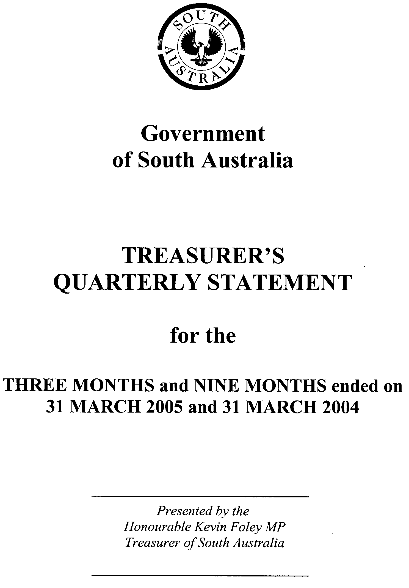
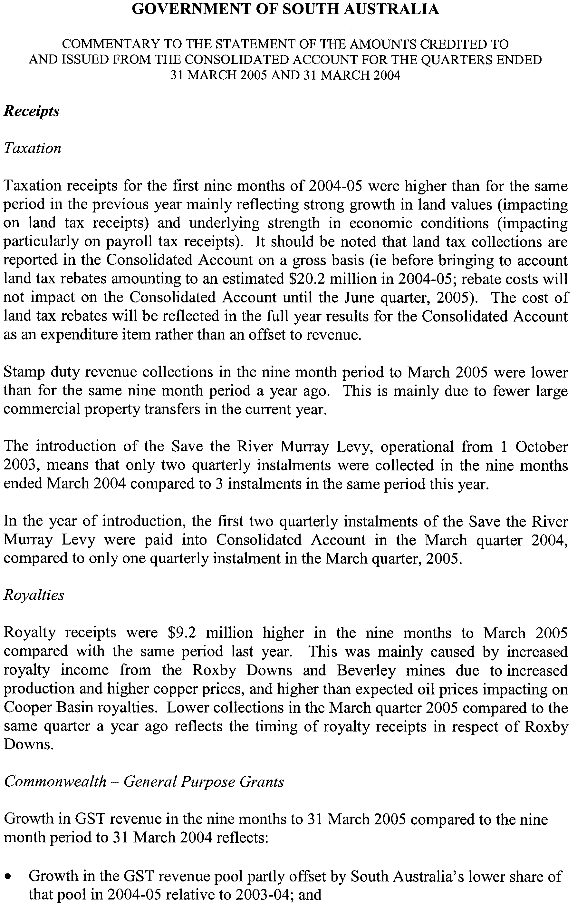
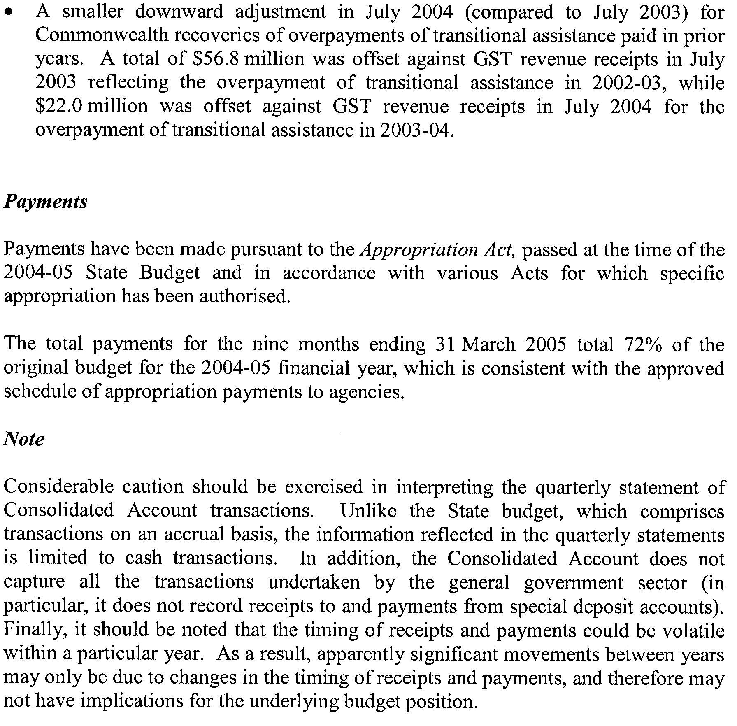
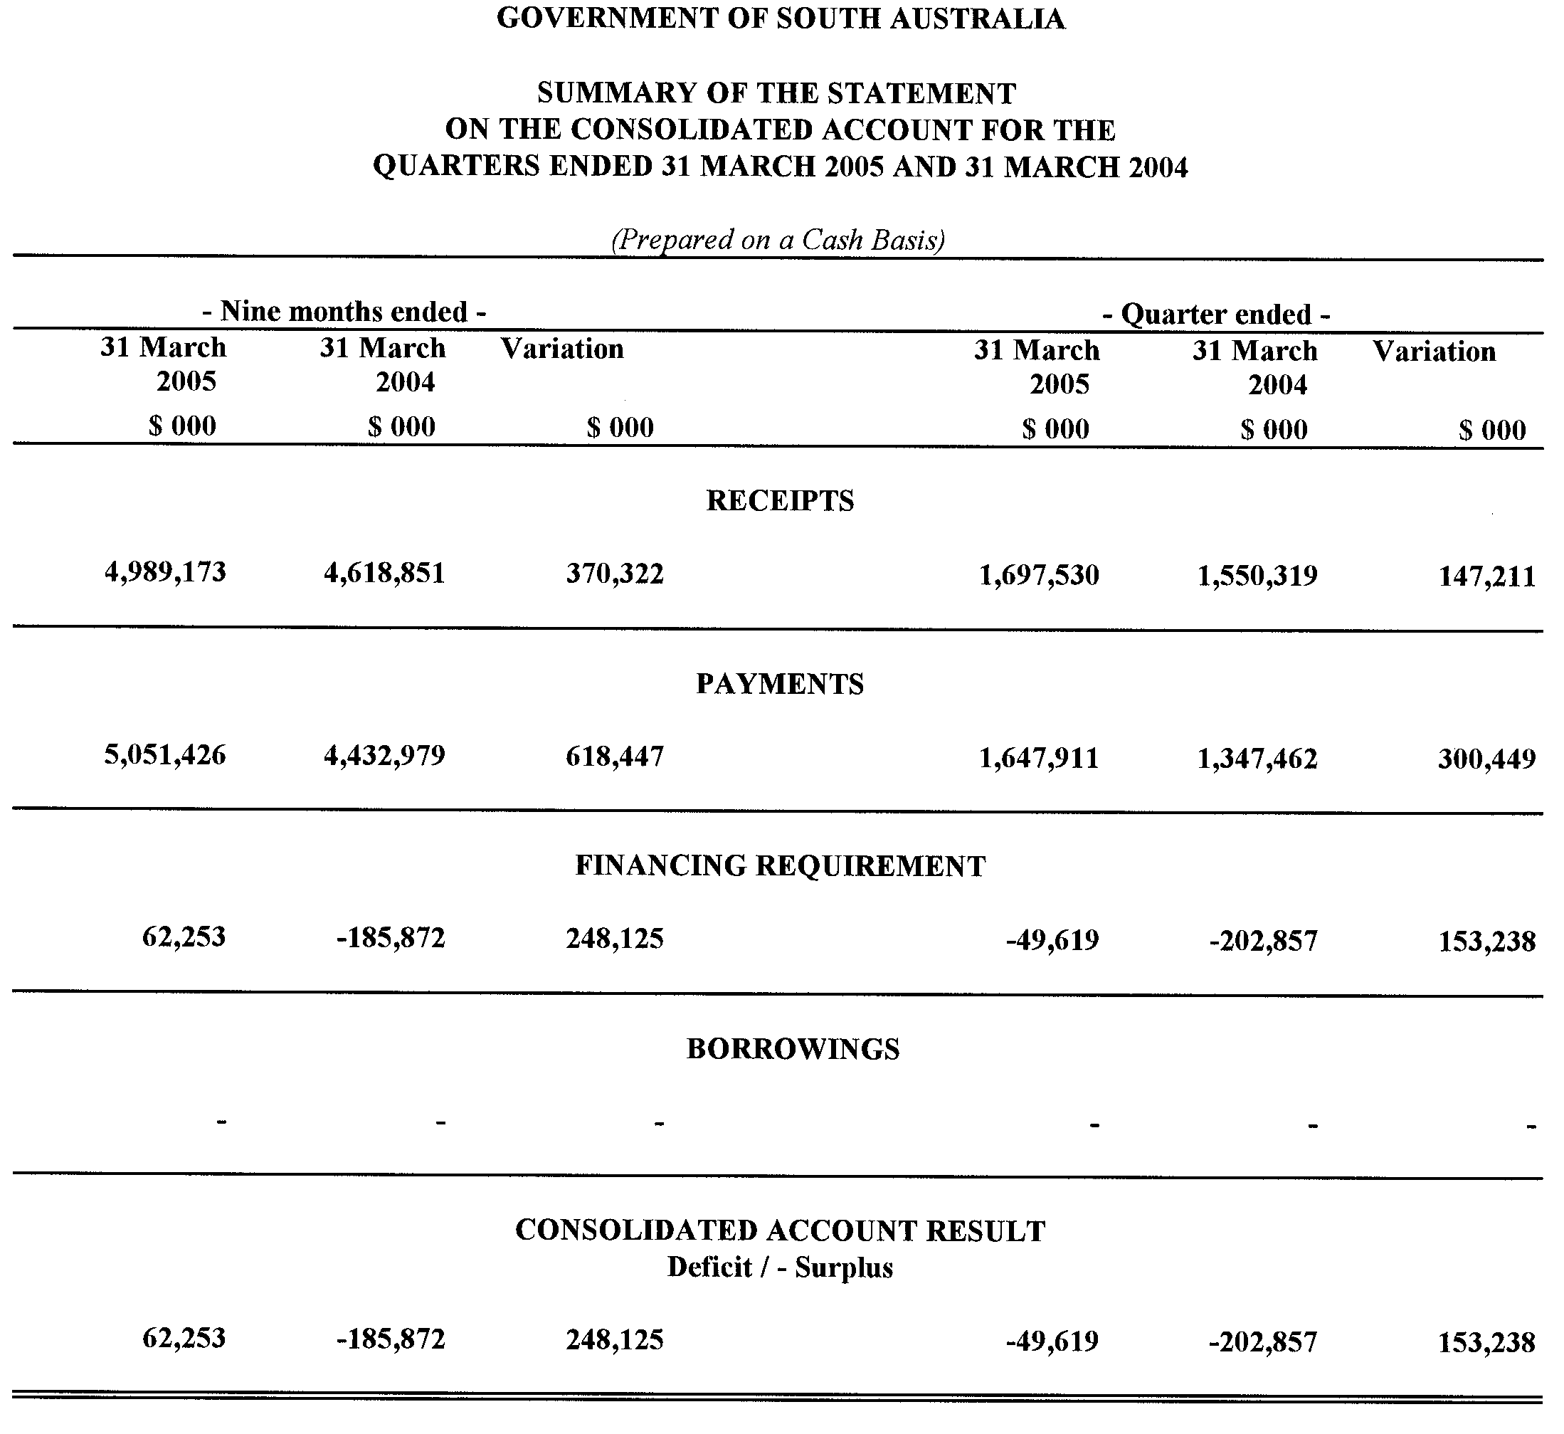
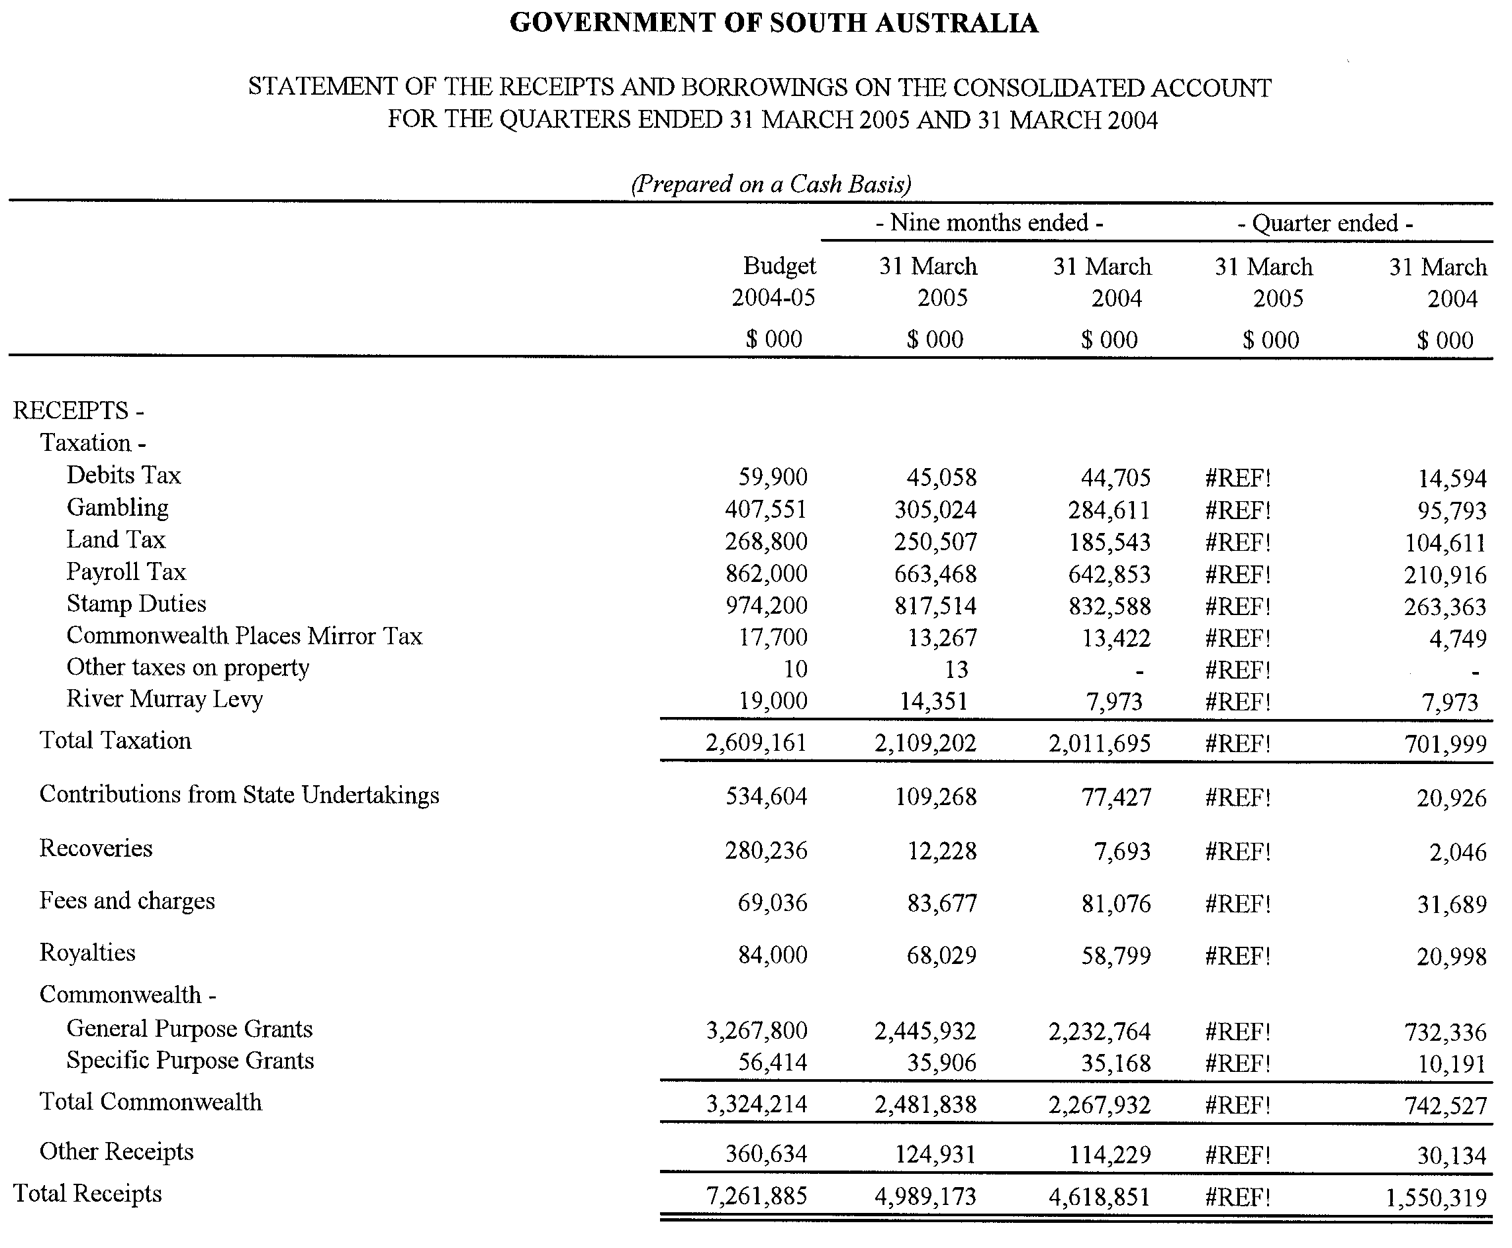
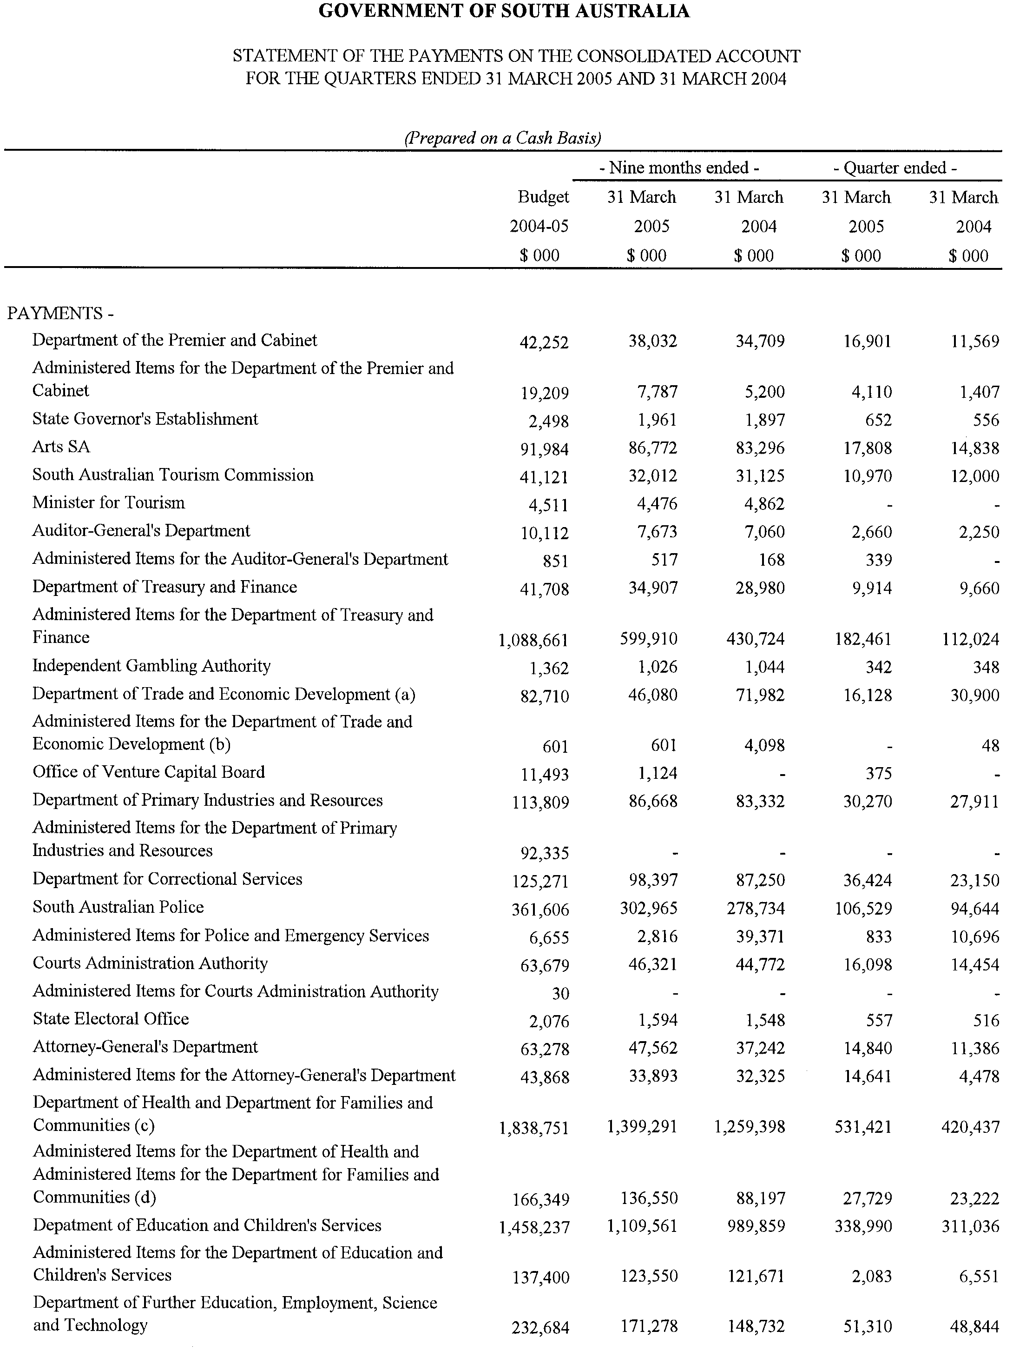

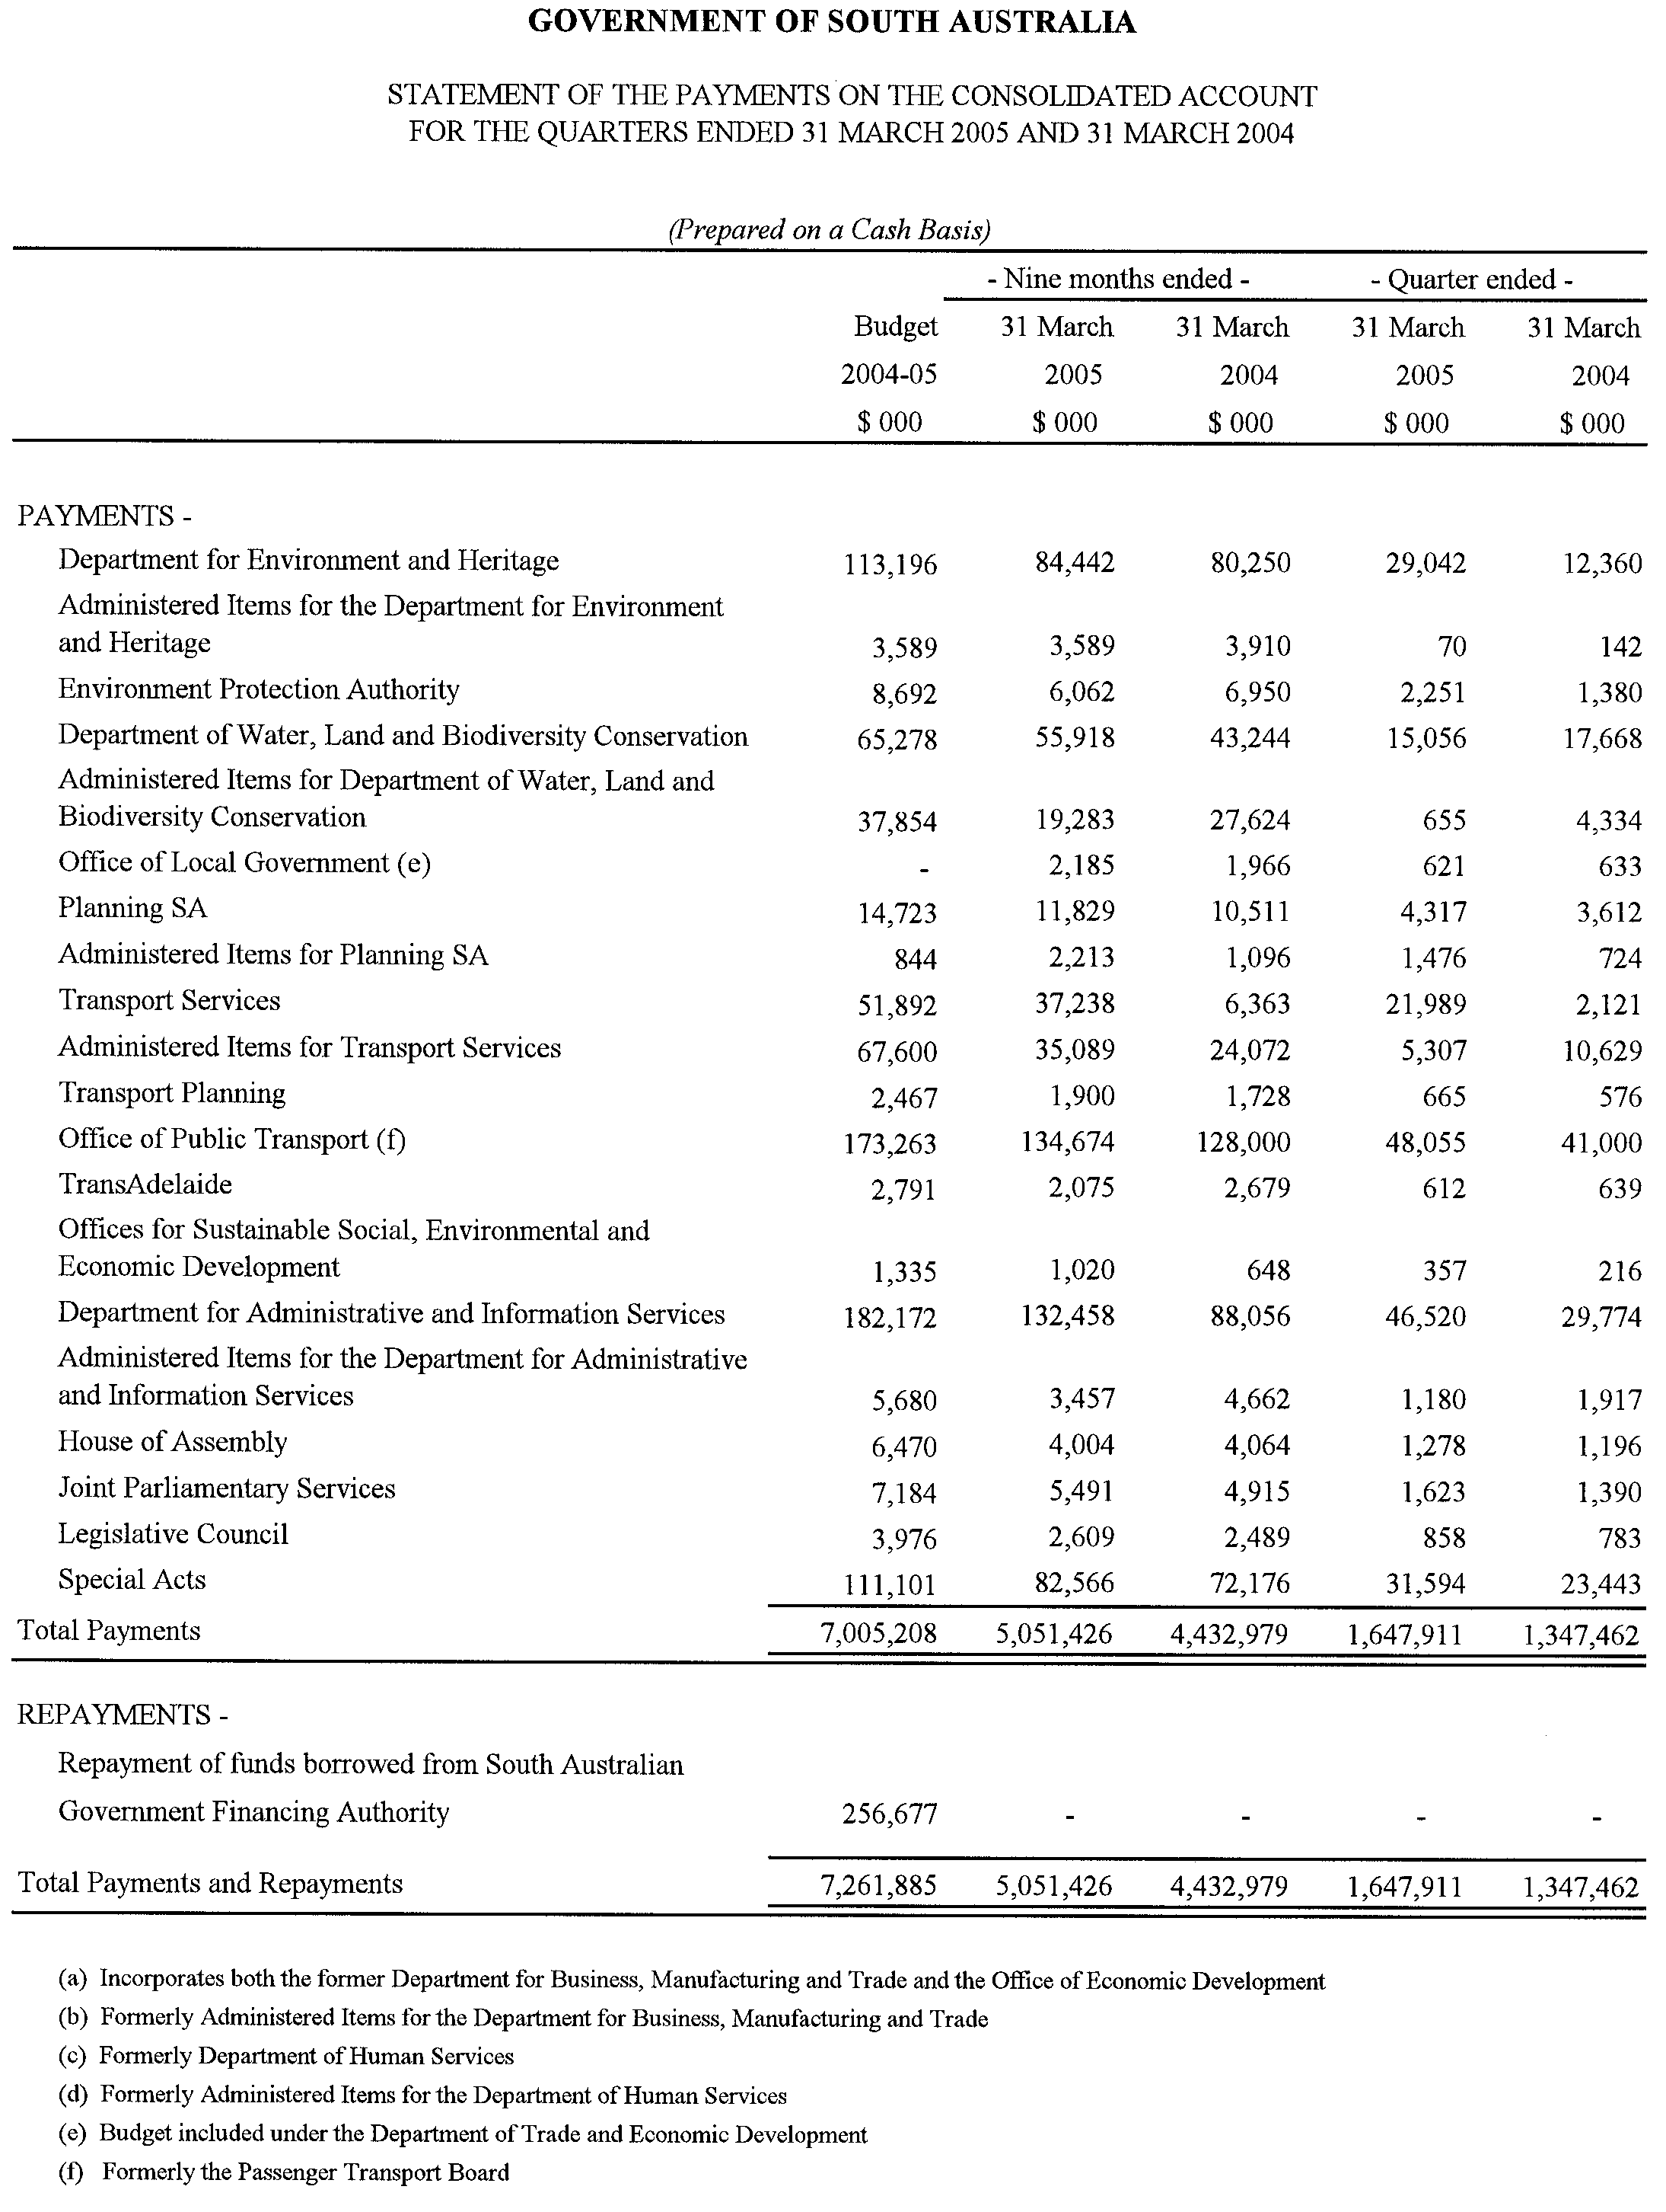

WATER MAINS AND SEWERS

Office of the South Australian Water Corporation
Adelaide, 4 August 2005

WATER MAINS LAID

Notice is hereby given that the following main pipes or parts of main pipes have been laid down by the South Australian Water Corporation in or near the undermentioned water districts and are now available for a constant supply of water to adjacent land.

ADELAIDE WATER DISTRICT

BAROSSA COUNCIL
Meadow Road, Kalbeeba. p63

CITY OF PORT ADELAIDE ENFIELD
Scone Road, Windsor Gardens. p55

CITY OF SALISBURY
Across Cross Keys Road, Mawson Lakes. p2
Easement in reserve (lot 901 in LTRO DP 64909), Grenada Court, Mawson Lakes. p2
Grenada Court, Mawson Lakes. p2 and 4
Reunion Lane, Mawson Lakes. p2
Andros Street, Mawson Lakes. p2 and 4
St Kitts Place, Mawson Lakes. p2 and 4
The Drive, Mawson Lakes. p2 and 3
Public road (lot 803 in LTRO DP 64256), Mawson Lakes. p2
Isla Circuit, Mawson Lakes. p3 and 4
Azores Court, Mawson Lakes. p3
Antigua Court, Mawson Lakes. p3
Santorini Walk, Mawson Lakes. p3
Atiu Street, Mawson Lakes. p4

BAROSSA COUNTRY LANDS WATER DISTRICT

BAROSSA COUNCIL
Davies Road, Sandy Creek. p61 and 62

BEETALOO COUNTRY LANDS WATER DISTRICT

DISTRICT COUNCIL OF BARUNGA WEST
North Gully Road, Tickera. p12
Gulfview Drive, Tickera. p12
Harry Street, Tickera. p12
Stephen Crescent, Tickera. p12

DISTRICT COUNCIL OF THE COPPER COAST
Easements in section 1802, hundred of Wallaroo, Wallaroo. p13 and 14

FARRELL FLAT WATER DISTRICT

REGIONAL COUNCIL OF GOYDER
South Terrace, Farrell Flat. p65
Love Street, Farrell Flat. p65

KAPUNDA WATER DISTRICT

LIGHT REGIONAL COUNCIL
North Street, Kapunda. p64

MOONTA WATER DISTRICT

DISTRICT COUNCIL OF THE COPPER COAST
Chapman Road, Moonta Bay. p56
Ritter Street, Moonta Bay. p56

MURRAY BRIDGE WATER DISTRICT

THE RURAL CITY OF MURRAY BRIDGE
Thelda Street, Murray Bridge. p60

PORT AUGUSTA WATER DISTRICT

CITY OF PORT AUGUSTA
Across and in Cole Crescent, Port Augusta West. p5
Inglis Court, Port Augusta West. p5
In and across Francis James Court, Port Augusta West. p5

PORT ELLIOT WATER DISTRICT

ALEXANDRINA COUNCIL
Watson Crescent, Port Elliot. p6

PORT LINCOLN WATER DISTRICT

CITY OF PORT LINCOLN
Windamere Crescent, Port Lincoln. p7
Apollo Court, Port Lincoln. p7
Eagle Court, Port Lincoln. p7
Egret Court, Port Lincoln. p7

PORT VICTOR WATER DISTRICT

CITY OF VICTOR HARBOR
In and across Victor Avenue, Encounter Bay. p1
Sweetman Avenue, Encounter Bay. p1
Easements in lot 2004 in LTRO DP 66587, Victor Avenue, Encounter Bay. p1
Robb Street, Encounter Bay. p1

PORT VICTORIA WATER DISTRICT

DISTRICT COUNCIL OF YORKE PENINSULA
Bowsprit Way, Port Victoria. This main is available to lot 10 in LTRO DP 60194 by application only. p8
Anchor Avenue, Port Victoria. p8
Ketch Street, Port Victoria. p8
Across and in Davies Terrace, Port Victoria. This main is available to sections 295 and 271, hundred of Wauraltee, by application only. p8-10
Kuhn Terrace, Port Victoria. p10 and 11
Wilson Terrace, Port Victoria. p11

WALLAROO WATER DISTRICT

DISTRICT COUNCIL OF THE COPPER COAST
Easements in lot 15 in LTRO DP 66091, Errington Street, Wallaroo. p13
Lady McDonald Drive, Wallaroo. p14
In and across Cutter Drive, Wallaroo. p14 and 16
Easement in lot 2 in LTRO DP 64393, Cutter Drive, Wallaroo. p14
Oriental Court, Wallaroo. p15 and 33
Easements in walkway (lot 619 in LTRO DP 53158), Oriental Court, and lot 675 in LTRO DP 59588, Heritage Drive, Wallaroo. p15 and 33
Gilmore Crescent, Wallaroo. p15-18
In and across Schooner Avenue, Wallaroo. p17 and 19
Easements in reserve (lot 668 in LTRO DP 59942), Pommern Way, Wallaroo. p19
Across and in Pommern Way, Wallaroo. p19-21, 27 and 28
Ketch Place, Wallaroo. p19
Stately Way, Wallaroo. p20-25
Spinnaker Court, Wallaroo. p21, 26 and 27
Easement in reserve (lot 640 in LTRO DP 53158), Genoa Place, Wallaroo. p28
Across and in Genoa Place, Wallaroo. p28-30
In and across Pamir Court, Wallaroo. p28-30
Otago Road, Wallaroo. p28
In and across Windjammer Lane, Wallaroo. p30 and 31
In and across North Beach Road, Wallaroo. p31 and 34
Easements in reserve (lot 657 in LTRO DP 54127), North Beach Road, lots 1003, 1001, and 1000 in LTRO DP 56470, and lot 679 in LTRO DP 66451, Heritage Drive, Wallaroo. p31, 32 and 34
Heritage Drive, Wallaroo. p32
Albatross Street, Wallaroo. p36
Seabird Court, Wallaroo. p36

WHYALLA WATER DISTRICT

THE CORPORATION OF THE CITY OF WHYALLA
Billabong Road, Whyalla Jenkins. p37 and 38
Swagman Court, Whyalla Jenkins. p37
Coolibah Place, Whyalla Jenkins. p38
Drovers Way, Whyalla Jenkins. p37

WATER MAINS ABANDONED

Notice is hereby given that the undermentioned water mains have been abandoned by the South Australian Water Corporation.

ADELAIDE WATER DISTRICT

CITY OF ONKAPARINGA
Easements in lot 21 in LTRO DP 26236, Panalatinga Road, Onkaparinga Hills. p39, 41-43 and 46
Across Panalatinga Road, Onkaparinga Hills. p46

CITY OF SALISBURY
Public road (lot 803 in LTRO DP 64256), Mawson Lakes. p2

OUTSIDE ADELAIDE WATER DISTRICT

CITY OF ONKAPARINGA
Easements in lot 21 in LTRO DP 26236, Panalatinga Road, Onkaparinga Hills. p43-45

BEETALOO COUNTRY LANDS WATER DISTRICT

DISTRICT COUNCIL OF BARUNGA WEST
North Gully Road, Tickera. p12

FARRELL FLAT WATER DISTRICT

REGIONAL COUNCIL OF GOYDER
South Terrace, Farrell Flat. p65

WALLAROO WATER DISTRICT

DISTRICT COUNCIL OF THE COPPER COAST
Otago Road, Wallaroo. p28
Easement in lot 12 in LTRO DP 20035, Windjammer Lane, Wallaroo. p31 and 35
Across Windjammer Lane, Wallaroo. p31 and 35
North Beach Road, Wallaroo. p31 and 35
Easements in lot 801 in LTRO DP 55334, lot 657 in LTRO DP 54127, North Beach Road, lot 675 in LTRO DP 59588, and lot 679 in LTRO DP 66451, Heritage Drive, Wallaroo. p35
Heritage Drive, Wallaroo. p35

WATER MAINS LAID

Notice is hereby given that the undermentioned water mains have been laid down by the South Australian Water Corporation and are not available for a constant supply of water to adjacent land.

ADELAIDE WATER DISTRICT

CITY OF ONKAPARINGA
Waterworks land (lot 67 in LTRO FP 153053), Onkaparinga Hills—800 mm MSCL pumping main. p39-41
Waterworks land (lot 67 in LTRO FP 153053), Onkaparinga Hills. p39-43
Easements in lot 21 in LTRO DP 26236, Panalatinga Road, Onkaparinga Hills. p39, 41-43 and 46
Across and in Panalatinga Road, Onkaparinga Hills. p46

OUTSIDE ADELAIDE WATER DISTRICT

CITY OF ONKAPARINGA
Easements in lot 21 in LTRO DP 26236, Panalatinga Road, Onkaparinga Hills. p43 and 44
Waterworks land (lot 4 in LTRO DP 27144, and lot 5 in LTRO DP 54640), Onkaparinga Hills. p44 and 45

MOOROOK COUNTRY LANDS WATER DISTRICT

MID MURRAY COUNCIL
Gordon Road, Cadell. p57-59
Boden Road, Cadell. p59

SEWERS LAID

Notice is hereby given that the following sewers have been laid down by the South Australian Water Corporation in the undermentioned drainage areas and are now available for house connections.

ADELAIDE DRAINAGE AREA

CAMPBELLTOWN CITY COUNCIL
Melinda Crescent, Paradise. FB 1135 p50
Telopea Drive, Athelstone. FB 1139 p45
Parmentier Street, Magill. FB 1139 p49

CITY OF ONKAPARINGA
In and across Allanton Avenue, Port Noarlunga. FB 1139 p46
Easement in lots 1 and 2, Marr Street, Port Noarlunga. FB 1139 p46

CITY OF SALISBURY
Isla Circuit, Mawson Lakes. FB 1138 p44-52
Santorini Walk, Mawson Lakes. FB 1138 p44, 45 and 47
Antigua Court, Mawson Lakes. FB 1138 p44, 45 and 47
Azores Court, Mawson Lakes. FB 1138 p44-46
The Drive, Mawson Lakes. FB 1138 p44-46
St Kitts Place, Mawson Lakes. FB 1138 p44-46, 48, 50 and 51
Easements in lot 606 in LTRO DP 66459, Santorini Walk, and lot 704 in LTRO DP 67428, Goodall Parade, Mawson Lakes. FB 1138 p48-52
Atiu Street, Mawson Lakes. FB 1138 p48, 50 and 52
Andros Street, Mawson Lakes. FB 1138 p48, 50 and 52
Reunion Lane, Mawson Lakes. FB 1138 p48, 50 and 52
Grenada Court, Mawson Lakes. FB 1138 p48, 50 and 52
Easement in lot 603 in LTRO DP 64909, The Drive, Mawson Lakes. FB 1138 p48, 50 and 51
York Terrace, Salisbury. FB 1139 p47

CITY OF TEA TREE GULLY
Malbec Avenue, Hope Valley. FB 1139 p48

MURRAY BRIDGE COUNTRY DRAINAGE AREA

THE RURAL CITY OF MURRAY BRIDGE
Myall Avenue, Murray Bridge. FB 1135 p51

PORT LINCOLN COUNTRY DRAINAGE AREA

CITY OF PORT LINCOLN
Eagle Court, Port Lincoln. FB 1138 p54, 55 and 57
Egret Court, Port Lincoln. FB 1138 p54, 55 and 57
Sewerage land (lot 1002 in LTRO DP 50702), Laguna Drive, Port Lincoln. FB 1138 p54, 56 and 57
Easements in lots 95, 85 and 84, Apollo Court, Port Lincoln. FB 1138 p54, and 56-58
Across and in Apollo Court, Port Lincoln. FB 1138 p54, 56 and 57
Easements in lots 45 and 46, Windamere Crescent, Port Lincoln. FB 1138 p54, 56 and 57
Windamere Court, Port Lincoln. FB 1138 p54, 56 and 58

VICTOR HARBOR COUNTRY DRAINAGE AREA

CITY OF VICTOR HARBOR
Victor Avenue, Encounter Bay. FB 1138 p42 and 43
Sweetman Avenue, Encounter Bay. FB 1138 p42 and 43
Easement in lot 23, Victor Avenue, and lot 27, Robb Street, Encounter Bay. FB 1138 p42 and 43
Robb Street, Encounter Bay. FB 1138 p42 and 43

A. Howe, Chief Executive Officer South Australian Water Corporation

South Australia
Liquor Licensing (Dry Areas—Long Term) Variation Regulations 2005
under the Liquor Licensing Act 1997

Contents
Part 1—Preliminary
1 Short title
2 Commencement
3 Variation provisions
Part 2—Variation of Liquor Licensing (Dry Areas—Long Term) Regulations 1997
4 Variation of Schedule 1—Long term dry areas

Part 1—Preliminary
1—Short title
These regulations may be cited as the Liquor Licensing (Dry Areas—Long Term) Variation Regulations 2005.
2—Commencement
These regulations come into operation on the day on which they are made.
3—Variation provisions
In these regulations, a provision under a heading referring to the variation of specified regulations varies the regulations so specified.
Part 2—Variation of Liquor Licensing (Dry Areas—Long Term) Regulations 1997
4—Variation of Schedule 1—Long term dry areas
Schedule 1, item headed "Mount Gambier—Area 5", column headed "Period"—delete "10 June 2005" and substitute:
7 November 2007
Note—
As required by section 10AA(2) of the Subordinate Legislation Act 1978, the Minister has certified that, in the Minister's opinion, it is necessary or appropriate that these regulations come into operation as set out in these regulations.
Made by the Governor
with the advice and consent of the Executive Council
on 4 August 2005
No 176 of 2005
OLGC0400/97P2

FAXING COPY?
IF you fax copy to Government Publishing SA for inclusion in the Government Gazette, there is no need to send a Confirmation Copy to us as well.
This creates confusion and may well result in your notice being printed twice.
Please use the following fax number:
Fax transmission: (08) 8207 1040
Phone Inquiries: (08) 8207 1045
Please include a contact person, phone number and order number so that we can phone back with any queries we may have regarding the fax copy.
NOTE: Closing time for lodging new copy (fax, hard copy or email) is 4 p.m. on Tuesday preceding the day of publication.

Government Gazette notices can be E-mailed.
The address is:
governmentgazette@saugov.sa.gov.au
Documents should be sent as attachments in Word format.
When sending a document via E-mail, please confirm your transmission with a faxed copy of your document, including the date the notice is to be published.
Fax transmission: (08) 8207 1040
Enquiries: (08) 8207 1045
NOTE: Closing time for lodging new copy (fax, hard copy or email) is 4 p.m. on Tuesday preceding the day of publication.

CITY OF ADELAIDE
Adoption of Valuation and Declaration of Rates
NOTICE is hereby given that the Council of the Corporation of the City of Adelaide at its meeting held on 14 July 2005:
Adoption of Valuation
Resolved that pursuant to section 167 (2) (b) of the Local Government Act 1999, the valuations for the 2005-2006 financial year, (prepared on the basis of annual value) comprised within the Assessment Record, amounting to $517 986 770, made by valuers employed by Council, be adopted as applying to the land within the area of the Corporation of the City of Adelaide for rating purposes. The Assessment Record includes assessments of value for rateable and exempt land. The total assessed annual value of rateable land, which the council adopts for rating purposes, is $431 875 260. The total assessed annual value of land exempt from council rates is $86 111 510.
Adoption of Rating Policy
Adopted in accordance with section 32 of the City of Adelaide Act 1998, the rating policy for the 2005-2006 financial year contained in Attachment B to Item No. 6 on the agenda for the special meeting of the City of Adelaide held on 14 July 2005, and that the rating policy be made available free of charge.
Declaration of Rates
Declared a Differential General Rate in the dollar of 0.133 for all land uses other than residential within the City of Adelaide for the financial year ending 30 June 2006. Declared a Differential General Rate in the dollar of 0.115 for all land with a residential land use within the City of Adelaide for the financial year ending 30 June 2006.
Declared separate rates pursuant to section 154 of the Local Government Act 1999 in accordance with the requirements of section 138 of the Water Resources Act 1997. A separate rate in the dollar of 0.001234 applies to all rateable land within the Council area falling within the catchment area of the Torrens Catchment Water Management Board. A separate rate in the dollar of 0.001269 applies to all rateable land within the Council area falling within the catchment area of the Patawalonga Catchment Water Management Board.
Declared pursuant to section 154 (1) of the Local Government Act 1999 a differential separate rate in the dollar of 0.0264 (to be known as the Rundle Mall Environs Separate Rate) for the financial year ending 30 June 2006. The Rundle Mall Environs Separate Rate applies to all rateable land (except land which has a residential land use) within the Rundle Mall Environs for the purposes of marketing the Rundle Mall Environs.
Determined that all Council rates be payable in four instalments due on or before the first working days of September 2005, December 2005, March 2006 and June 2006 respectively.
M. Hemmerling, Chief Executive Officer

CITY OF PORT AUGUSTA
Appointment of Authorised Officer
NOTICE is hereby given that at its meeting held on 25 July 2005, the Corporation of the City of Port Augusta appointed the officer listed below as an Authorised Officer within the following area:
Environment Protection Act 1993 in consultation with the Authority:
Wayne Kristen McKerlie
Dated 2 August 2005.
J. G. Stephens, City Manager

CITY OF PORT AUGUSTA
Land Excluded from Classification of Community Land
NOTICE is hereby given that Council at its meeting held on 25 July 2005, resolved that Lot 119, Hundred of Davenport (CT 5566/272), be transferred from the ownership of Mario Righetti to the City of Port Augusta at Mr Righetti’s request and that the land be not classified as community land pursuant to section 193 (4) of the Local Government Act 1999, as it is proposed to be sold for recovery of outstanding rates.
J. G. Stephens, City Manager

TOWN OF GAWLER
Periodical Review of Elector Representation
NOTICE is hereby given that the Town of Gawler has completed a review to determine whether a change of arrangements in respect to elector representation would result in the electors of the Council area being more adequately and fairly represented.
Council has prepared a report that details the review process, the public consultation undertaken, and the proposal that it considers should be implemented. Copies of this report are available at www.gawler.sa.gov.au, at the Town Hall, 89 Murray Street, Gawler, or by contacting Janet Done, Executive Assistant, telephone 8522 9226.
Pursuant to the provisions of section 12 (9) (b) (ii) of the Local Government Act 1999, interested persons are invited to make written submissions in respect to the report. These should be directed to the Chief Executive Officer, Town of Gawler, P.O. Box 130, Gawler, S.A. 5118, by the close of business on Friday, 26 August 2005.
Any person who makes a written submission will be afforded an opportunity to appear before Council, or a committee thereof, to be heard in respect to their submission.
N. Jacobs, Chief Executive Officer

ALEXANDRINA COUNCIL
Roads (Opening and Closing) Act 1991
Williams Road, Currency Creek
NOTICE is hereby given, pursuant to section 10 of the Roads (Opening and Closing) Act 1991, that the Alexandrina Council proposes to make a Road Process Order to:
(i) open as road portion of allotment 116 in Filed Plan 166490, more particularly delineated and numbered ‘1’ on Preliminary Plan No. 05/0040; and
(ii) to close and transfer to G. L. M. Thomas portion of the public road adjoining allotment 116 in Filed Plan 166490 in exchange for land taken for new road ‘1’ (above), more particularly delineated and lettered ‘A’ in Preliminary Plan No. 05/0040.
A copy of the plan and a statement of persons affected are available for public inspection at the offices of the Council, 16 Dawson Street, Goolwa, S.A. 5214 and the Adelaide office of the Surveyor-General during normal office hours.
Any application for easement or objection must set out the full name, address and details of the submission and must be fully supported by reasons.
The application for easement or objection must be made in writing to the Council, P.O. Box 21, Goolwa, S.A. 5214 within 28 days of this notice and a copy must be forwarded to the Surveyor-General, G.P.O. Box 1354, Adelaide, S.A. 5001. Where a submission is made, the Council will give notification of a meeting at which the matter will be considered.
J. L. Coombe, Chief Executive Officer

DISTRICT COUNCIL OF ELLISTON
Adoption of Valuation and Declaration of Rates
NOTICE is hereby given that on 15 July 2005, the District Council of Elliston, pursuant to the provisions of the Local Government Act 1999 and for the year ending 30 June 2006:
1. Adopted the capital valuation that is to apply to rateable land within its area for rating purposes supplied by the Valuer-General totalling $223 546 980.
2. Declared a general rate of 0.4343 cents in the dollar.
3. Imposed a fixed charge of $320 for each assessment.
4. In order to reimburse the Council the amount contributed to the Eyre Peninsula Catchment Water Management Board, declared a separate rate of $32.60 on all rateable land in the Council area.
5. Imposed the following service charges:
(1) Water supply:
Domestic
0-138 kL $1.50 per kL
Above 138 kL $5.00 per kL
Commercial
0-249 kL $1.50 per kL
150-350 kL $2.00 per kL
Above 350 kL $5.00 per kL
(2) Television transmission $50.
(3) STEDS $125.
R. Gregor, Chief Executive Office

THE FLINDERS RANGES COUNCIL
Adoption of Valuation, Budget and Declaration of Rates
NOTICE is hereby given that at a Special Meeting of Council held on 25 July 2005:
Adoption of Valuation
1. The Council, in accordance with section 167 (2) (a) of the Local Government Act 1999, adopted the most recent valuation of the Valuer-General available to the Council for the year ending 30 June 2006 of the capital value of land within the Council’s area totalling $127 786 860.
Adoption of 2005-2006 Budget
2. The Council adopted the budget for the year ending 30 June 2006 involving:
(a) total estimated expenditure of $3 650 481;
(b) total estimated income from sources other than rates of $1 843 079; and
(c) total estimated amount required to be raised from rates of $760 466.
Differential General Rates and Minimum Payable—Declaration
3. (1) That in exercise of the powers contained in section 153 (1) (b) of the Local Government Act 1999, the Council declared differential general rates according to land use in accordance with Regulation 10 of the Local Government (General) Regulations 1999 for the year ending 30 June 2006 as follows:
(a) 0.7689 cents in the dollar on rateable land in the Council’s area of Category 1 (Residential) use;
(b) 0.8913 cents in the dollar on rateable land in the Council’s area of Categories 2, 3 or 4 (Commercial) use;
(c) 0.5235 cents in the dollar on rateable land in the Council’s area of Category 7 (Primary Production) use;
(d) 0.8913 cents in the dollar on rateable land in the Council’s area of Category 5 (Industry—Light) use;
(e) 0.7689 cents in the dollar on rateable land in the Council’s area of Category 8 (Vacant Land) use;
(f) 0.8913 cents in the dollar on rateable land in the Council’s area of Category 6 (Industry—Other) use.
(2) The Council, pursuant to section 158 (1) of the Local Government Act 1999, declared the following as the minimum amount of $365 payable by way of rates for the year ending 30 June 2006.
(3) Pursuant to section 166 (1) (l) (ii) of the Local Government Act 1999, and to provide relief against what would otherwise amount to a substantial change in rates payable by a ratepayer due to rapid changes in valuations, Council will grant a rebate of general rates to the principal ratepayer of Categories 1, 2, 3, 4, 5, 6, 7 and 8 land uses, to cap any increase in general rates payable to that paid in the previous year plus 10% where the increase in valuation is not a result of:
a change of ownership of the rateable property since 1 July 2004; or
any such increase is due in full or in part to the use of the land being different for rating purposes on the date the Council declared its general rates for the 2005-2006 financial year than on the date Council declared its general rates for the 2004-2005 year.
(4) Pursuant to section 181 (1) (c) of the Local Government Act 1999, the rates be paid by quarterly instalments payable on 20 September 2005, 20 December 2005, 20 March 2006 and 20 June 2006.
Service Charges
4. (1) That Council, pursuant to section 155 (2) of the Local Government Act 1999, declares the method of recovery of Septic Tank Effluent Drainage and Disposal costs is by an annual service charge of:
Hawker Scheme
(a) Occupied unit $150;
(b) Unoccupied unit $110.
Quorn Scheme
(a) Occupied unit $390;
(b) Unoccupied unit $360.
(2) that Council declares the following charges for the management of refuse, Annual Service Charge, section 155 (2), for the year ending 30 June 2006:
(a) Hawker Hospital $480.
(b) Hawker Area School $480.
(c) Quorn Hospital $720.
(d) Quorn Area School $720.
(3) Pursuant to section 155 of the Local Government Act 1999 council fix an annual service charge for refuse collection and disposal for the year ending 30 June 2006 as follows in respect of the occupied residential properties in the townships of Hawker and Quorn $75, in respect of the occupied commercial properties in the townships of Hawker and Quorn $110.
(4) Any one who wishes to use the dumps from outside the townships under section 188 of the Local Government Act 1999 a charge of $40 and out of hours Clean Fill Dump use $16.50 or annual charge of $110 for building contractors etc., GST inclusive, will apply. These charges to be paid by the due date of the first rate instalment.
L. Connors, Chief Executive Officer

DISTRICT COUNCIL OF GRANT
Declaration of Public Road
NOTICE is hereby given that Council, pursuant to section 208 of the Local Government Act 1999, declares that the land transferred to the District Council of Grant from William James and Elsie Matilda Klieve described as being the whole of allotment 12, in Deposited Plan 68648 being portion of the land comprised in Certificate of Title of Public Register Book Volume 5720, Folio 105, Hundred of Blanche, be declared as a public road and to be known as part of Kilsby Road.
Dated 1 August 2005.
R. J. Peate, Chief Executive Officer

KINGSTON DISTRICT COUNCIL
Adoption of Valuation and Declaration of Rates
NOTICE is hereby given that in accordance with section 167 of the Local Government Act 1999, the Kingston District Council hereby adopts, for the year ending 30 June 2006 the capital values made by the Valuer-General totalling $590 353 120 of which $578 022 820 is in respect to rateable land, and that 22 July 2005 shall be the day as and from when such valuations shall become the valuation of the Council.
Declaration of Rates
That pursuant to section 153 (1) (b) of the Local Government Act 1999, the Kingston District Council hereby declares, for the year ending 30 June 2006, the following differential rates based upon locality on all rateable land within the area, in accordance with the provisions of section 156 (1) (b) of the said Act:
(a) a differential rate of $0.4375 cents in the dollar (Urban Rate) on the capital value of all rateable property within the townships of Kingston, Rosetown and Cape Jaffa;
(b) a differential rate of $0.3775 cents in the dollar (Rural Living Rate) on the capital value of all rateable property within the Rural Living Zone (RuL) abutting the township of Kingston, as in accordance with Maps King/24, King/26, King/27, King/30 and King/31 of Council’s Development Plan;
(c) a differential rate of $0.3562 cents in the dollar (Rural Rate) on the capital value of all rateable property within the remainder of the Council district.
Declaration of Minimum Rate
That pursuant to section 158 of the Local Government Act 1999, the Kingston District Council hereby fixes, in respect to the year ending 30 June 2006, a minimum rate of $370.
Declaration of Separate Rate—Water Catchment Levy
That in exercise of the powers contained in section 138 of the Water Resources Act 1997 and section 154 of the Local Government Act 1999, in order to reimburse to the Council the amount contributed to the South East Catchment Water Management Board, a separate rate of $14.40 be declared on all rateable land in the Council’s area in the catchment area of the Board in respect to the year ending 30 June 2006 based on a fixed levy of the same amount on all rateable land.
Declaration of Service Charges—Kingston STED (Effluent Disposal) Scheme
That pursuant to section 155 of the Local Government Act 1999, the Kingston District Council hereby fixes, in respect to the year ending 30 June 2006, an annual service charge for the Kingston STED (Effluent Disposal) Scheme as follows:
$280 per unit on each occupied allotment;
$189 per unit on each vacant allotment,
being charged in accordance with the Septic Tank Effluent Disposal Scheme’s Guidelines for establishing property units relating to service charges for Septic Tank Effluent Disposal Schemes representative of the level of usage of the service.
Declaration of Service Charge—Mobile Garbage Bin Collection and Disposal Service
That pursuant to section 155 of the Local Government Act 1999, the Kingston District Council hereby fixes, in respect to the year ending 30 June 2006, an annual service charge for the Mobile Garbage Collection and Disposal Service as follows:
$80 per 240 litre mobile garbage bin collected from each allotment,
being charged in accordance with Council’s Mobile Garbage Bin Collection and Disposal Policy using each 240 litre mobile garbage bin as representative of the level of usage of the service.
Payment Of Rates
That pursuant to section 181 (1) (a) of the Local Government Act 1999, the Kingston District Council hereby declares that rates for the year ending 30 June 2006 will fall due in four equal or approximately equal instalments that fall due on the following dates:
1 September 2005
1 December 2005
1 March 2006
1 June 2006.
M. R. McCarthy, Chief Executive Officer

DISTRICT COUNCIL OF ORROROO CARRIETON
Adoption of Valuation and Declaration of Rates
NOTICE is hereby given that the District Council of Orroroo Carrieton at its meeting held on 19 July 2005, resolved the following:
Adoption of Valuation
1. That in accordance with the provisions of section 167 (2) (a) of the Local Government Act 1999, the Council adopts for rating purposes for the year ending 30 June 2006, the most recent capital valuation determined by the Valuer-General and applicable to land within the area of the Council totalling $134 097 500.
Declaration of Rates
2. Pursuant to sections 152 (1) (c) and 153 (1) (a) of the Local Government Act 1999, the Council declared a general rate within the area of the Council for the financial year ending 30 June 2006 based on two components, as follows:
(i) a rate based on the value of land of 0.00261 cents in the dollar; and
(ii) a fixed charge of $150.
Refuse Collection
3. Pursuant to section 155 of the Local Government Act 1999, the Council fixed an annual service charge of $130 for the year ending 30 June 2006 on all land within the area of the Council to which the refuse collection service is provided.
Payment of Rate
4. Pursuant to section 181 (2) (a) of the Local Government Act 1999, the payment of all rates and charges which have been declared or imposed by the Council for the financial year ending 30 June 2006 shall be payable in four equal instalments with instalments falling due on 2 September 2005, 9 December 2005, 10 March 2006 and 30 June 2006.
A. J. Renshaw, Chief Executive Officer

DISTRICT COUNCIL OF STREAKY BAY
Adoption of Budget, Adoption of Valuation and
Declaration of Rates
NOTICE is hereby given that the District Council of Streaky Bay at the meeting held on 20 July 2005 resolved that in exercise of the powers contained in Chapter 10 of the Local Government Act 1999, (the ‘Act’) and in respect of the financial year ending 30 June 2006:
Adoption of Budget
The budget for that year as laid before the Council at this meeting, which consists of:
• the budgeted operating statement;
• the budgeted statement of financial position;
• the budgeted statement of changes in equity;
• the budgeted cash flow statement; and
• the budgeted statement as to the basis for the determination of rates; be adopted, involving:
(1) a total estimated expenditure of $6 019 139;
(2) a total estimated income from sources other than rates of $4 456 039; and
(3) a total amount required to be raised from rates of $1 564 071.
Adoption of Valuation
The most recent valuation of the Valuer-General available to the Council of the site value of land within the Council’s area be adopted for rating purposes, totalling $132 419 640 for rateable land and $7 100 880 for non-rateable land.
Attribution of Land Uses
1. The numbers indicated against the various categories of land use prescribed by the Local Government (General) Regulations 1999 (the ‘Regulations’) be used to designate land uses in the Assessment Book.
2. The use indicated by those numbers in respect of each separate assessment of land described in the Assessment Book on this date be attributed to each such assessment respectively.
3. Reference in this resolution to land being of a certain category use means the use indicated by that category number in the Regulations.
Declaration of Rates
In order to raise the amount of $1 564 071 as indicated above that is required to be raised from rates the Council declares differential rates on the basis of locality and land use as follows:
1. In the townships of Sceale Bay, Baird Bay, Haslam, Wirrulla, Poochera and Cungena, 0.7 cents in the dollar of the site value of rateable land.
2. In the township of Streaky Bay:
(1) 0.875 cents in the dollar of the site value of rateable land of Categories 1, 8 and 9 use;
(2) 1.8 cents in the dollar of the site value of rateable land of Categories 2, 3 and 4 use;
(3) 1.7 cents in the dollar of site value of rateable land of Categories 5 and 6 use;
(4) 0.719 cents in the dollar of the site value of rateable land of Category 7 use.
3. In respect of Settlement Zone as identified in Council’s Development Plan:
(1) 0.7 cents in the dollar of the site value of rateable land of Categories 1 and 9 use.
4. In respect of the Commercial (Bulk Handling) Zone as identified in Council’s Development Plan:
(1) 29.0 cents in the dollar of the site value of rateable land of Category 4 use.
5. In respect of all other land for the Council area:
(1) 0.7 cents in the dollar of the site value of rateable land of Category 1 use;
(2) 1.8 cents in the dollar of the site value of rateable land of Category 4 use;
(3) 0.719 cents in the dollar of the site value of rateable land of Category 7 use,
including Light Industry (Aquaculture) Zone, as identified in Council’s Development Plan:
(4) 0.7 cents in the dollar of the site value of rateable land of other category uses.
Fixed Charge
A fixed charge component of the general rate of $360 be imposed in relation to each assessment of rateable land in the area in accordance with section 152 of the Act.
Service Charges
Council declares service charges for the 2005-2006 financial year as follows:
The Council provides a Septic Tank Effluent Disposal Scheme to all residential and commercial properties in Streaky Bay township. The full cost of operating, maintaining and debt servicing this scheme is budgeted to be $133 747. Council will recover the majority of costs through the imposition of the following service charges for each property unit:
(1) $151 per unit (contribution to capital costs of the scheme).
(2) An additional annual charge of $59 for vacant allotments and $79 per unit (contribution to ongoing maintenance due to level of usage) for occupied allotments apply in respect of all land benefiting from the STEDS.
Payment of Rates
Pursuant to section 181 of the Local Government Act 1999 rates will be payable in four equal or approximately equal instalments and that the due date for those instalments will be 6 September 2005, 6 December 2005, 6 March 2006 and 6 June 2006.
Eyre Peninsula Catchment Water Management Board Levy
Notice is hereby given that pursuant to section 138 of the Water Resources Act 1997 and section 154 of the Local Government Act 1999 the District Council of Streaky Bay declares a separate rate of $31.50 per separate assessment of rateable land in the Council area in order to recoup the amount of $42 445, being Council’s contribution to the Eyre Peninsula Catchment Board for the period ending 30 June 2006.
J. Rumbelow, Chief Executive Officer

Appointment of Acting Chief Executive Officer
NOTICE is hereby given that Fiona Boxer has been appointed Acting Chief Executive Officer for the period 1 August 2005 to 2 September 2005, both dates inclusive.
J. Rumbelow, Chief Executive Officer

IN the matter of the estates of the undermentioned deceased persons:
Birch, Lilian Clemence, late of 2 Parkwood Grove, Klemzig, home duties, who died on 7 June 2005.
Chaplin, Melva Olive, late of 200 Fosters Road, Oakden, of no occupation, who died on 30 July 2003.
Charles, Violet Gladys Valentine, late of 29 Austral Terrace, Morphettville, of no occupation, who died on 24 June 2005.
Collins, Allan William, late of 51 John Lewis Drive, Port Broughton, retired boilermaker, who died on 15 May 2005.
Collins, Dorothy Vera, late of 22 Avoca Street, Goolwa, retired cashier and property letting agent, who died on 10 May 2005.
Craddock, Robert Ernest, late of 1215 Grand Junction Road, Hope Valley, retired driver, who died on 13 April 2005.
Crump, Dulcie Evelyn Ada, late of 21 Doncaster Avenue, Novar Gardens, retired milliner, who died on 12 May 2005.
Dawes, Walter Ernest, late of 199 Frederick Road, Seaton, retired school principal, who died on 22 May 2005.
Dunn, Margaret Jean, late of 285 Goodwood Road, Kings Park, widow, who died on 30 April 2005.

Finch, Lionel Herbert, late of 6 Ellis Street, Enfield, retired handyman, who died on 29 April 2005.
Matters, Melva Mary Grace, late of 27 Afton Street, Port Pirie South, widow, who died on 28 May 2005.
Mills, Delcie Lorraine, late of 470 Churchill Road, Kilburn, of no occupation, who died on 1 June 2005.
Parker, Mary, late of 18 Hurstfield Terrace, Findon, retired cleaner, who died on 25 June 2004.
Plozza, Collis William, late of 27 Lansdowne Terrace, Vale Park, retired painter and decorator, who died on 18 May 2005.
Potter, Dawn Clarissa, late of 336 Kensington Road, Leabrook, widow, who died on 14 June 2005.
Randall, Elsie May Gwendoline, late of 6 Ellis Street, Enfield, of no occupation, who died on 8 May 2005.
Notice is hereby given pursuant to the Trustee Act 1936, as amended, the Inheritance (Family Provision) Act 1972, and the Family Relationships Act 1975, that all creditors, beneficiaries, and other persons having claims against the said estates are required to send, in writing, to the Public Trustee, 25 Franklin Street, Adelaide, S.A. 5000, full particulars and proof of such claims, on or before 2 September 2005, otherwise they will be excluded from the distribution of the said estate; and notice is also hereby given that all persons who are indebted to the said estates are required to pay the amount of their debts to the Public Trustee or proceedings will be taken for the recovery thereof; and all persons having any property belonging to the said estates are forthwith to deliver the same to the Public Trustee.
Dated 4 August 2005.
C. J. O’Loughlin, Public Trustee

ATTENTION

CUSTOMERS requiring a proof of their notice for inclusion in the Government Gazette, please note that the onus is on you to inform Government Publishing SA of any subsequent corrections by 10 a.m. on Thursday, which is our publication deadline.

For any corrections to your notice please phone 8207 1045 or Fax 8207 1040 before 10 a.m. on Thursday.

If we do not receive any communication by 10 a.m. on Thursday (day of publication) we will presume the notice is correct and will print it as it is.

Remember—the onus is on you to inform us of any corrections necessary to your notice.

NOTE: Closing time for lodging new copy (electronically, fax or hard copy) is 4 p.m. on Tuesday preceding the day of publication. Phone 8207 1045—Fax 8207 1040.
Email: governmentgazette@saugov.sa.gov.au

Printed and published by authority every Thursday by J. D. FERGUSON, Government Printer, South Australia
Price: $5.00, plus postage; to subscribers, $254.00 per annum.
(The above prices are inclusive of GST)

