No. 3 25

THE SOUTH AUSTRALIAN

GOVERNMENT GAZETTE
www.governmentgazette.sa.gov.au

PUBLISHED BY AUTHORITY

ALL PUBLIC ACTS appearing in this GAZETTE are to be considered official, and obeyed as such

ADELAIDE, THURSDAY, 13 JANUARY 2005

CONTENTS

Page
Appointments, Resignations, Etc. 26
Aquaculture Act 2001—Notice 28
Associations Incorporation Act 1985—Notice 28
Corporations and District Councils—Notices 83
Development Act 1993—Notices 29
Fisheries Act 1982—Notices 33
House of Assembly—Resolution 28
Land and Business (Sale and Conveyancing) Act 1994—
Notice 35
Liquor Licensing Act 1997—Notices 35
Local Government Act 1999—Erratum 38
Mining Act 1971—Notices 37
Petroleum Act 2000—Notices 42
Private Advertisements 90
Proclamations 67

Page
Public Trustee Office—Administration of Estates 90
REGULATIONS
Superannuation Act 1988—
(No. 1 of 2005) 72
(No. 2 of 2005) 77
Police Superannuation Act 1990 (No. 3 of 2005) 80
Road Traffic Act 1961—Notice 43
Rules of Court 44
Security and Investigation Agents Act 1995—
Notice 43
South Eastern Water Conservation and Drainage Act 1992—
Notice 43
Survey Act 1992—Notice 43
Treasury—Quarterly Statement 60
Unclaimed Moneys Act 1891—Notice 91

GOVERNMENT GAZETTE NOTICES
ALL poundkeepers’ and private advertisements forwarded for publication in the South Australian Government Gazette must be PAID FOR PRIOR TO INSERTION; and all notices, from whatever source, should be legibly written on one side of the paper only and sent to Government Publishing SA so as to be received no later
than 4 p.m. on the Tuesday preceding the day of publication. Phone 8207 1045 or Fax 8207 1040. E-mail: governmentgazette@saugov.sa.gov.au. Send as attachments in Word format and please confirm your transmission with a faxed copy of your document, including the date the notice is to be published and to whom the notice will be charged. The Government Gazette is available online at: www.governmentgazette.sa.gov.au

Department of the Premier and Cabinet
Adelaide, 13 January 2005
HIS Excellency the Governor’s Deputy in Executive Council has revoked the appointment of Margi Prideaux as a Member of the Aquaculture Advisory Committee, effective from 13 January 2005, pursuant to the Aquaculture Act 2001 and the Acts Interpretation Act 1915.
By command,
Stephanie Key, for Premier
MAFF 0042/04CS

Department of the Premier and Cabinet
Adelaide, 13 January 2005
HIS Excellency the Governor’s Deputy in Executive Council has been pleased to appoint the undermentioned to the Training Centre Review Board, pursuant to the provisions of the Young Offenders Act 1993:
Member: (from 13 January 2005 until 21 January 2007)
Cinzia Aglieco
By command,
Stephanie Key, for Premier
ATTG 0428/02TC1CS

Department of the Premier and Cabinet
Adelaide, 13 January 2005
HIS Excellency the Governor’s Deputy in Executive Council has been pleased to appoint the undermentioned to the Legal Services Commission, pursuant to the provisions of the Legal Services Commission Act 1977:
Member: (from 13 January 2005 until 12 January 2008)
Phuong My Chau
By command,
Stephanie Key, for Premier
ATTG 0249/02CS

Department of the Premier and Cabinet
Adelaide, 13 January 2005
HIS Excellency the Governor’s Deputy in Executive Council has been pleased to appoint the undermentioned to the Guardianship Board, pursuant to the provisions of the Guardianship and Administration Act 1993:
Deputy President: (from 13 January 2005 until 12 January 2010)
Janet Ethel Howell
Karen Peta O’Keefe
Panel Member: (from 13 January 2005 until 12 January 2008)
David Coyte
Martha Louise Kent
Helen Rebecca Mares
Elizabeth Salna
Gerard Noel Twohig
By command,
Stephanie Key, for Premier
ATTG 0217/04CS

Department of the Premier and Cabinet
Adelaide, 13 January 2005
HIS Excellency the Governor’s Deputy in Executive Council has been pleased to appoint the undermentioned to the Aquaculture Advisory Committee, pursuant to the provisions of the Aquaculture Act 2001:
Member: (from 13 January 2005 until 22 May 2005)
Susan Mary Carthew
By command,
Stephanie Key, for Premier
MAFF 0042/04CS

Department of the Premier and Cabinet
Adelaide, 13 January 2005
HIS Excellency the Governor’s Deputy in Executive Council has been pleased to appoint the undermentioned to the Dairy Authority of South Australia, pursuant to the provisions of the Dairy Industry Act 1992:
Member: (from 13 January 2005 until 30 June 2005)
Kenneth Smith
Valerie Anne Monaghan
Brian Griggs
Chair: (from 13 January 2005 until 30 June 2005)
Kenneth Smith
By command,
Stephanie Key, for Premier
MAFF 0039/04CS

Department of the Premier and Cabinet
Adelaide, 13 January 2005
HIS Excellency the Governor’s Deputy in Executive Council has been pleased to appoint the undermentioned to the Optical Dispensers Registration Committee, pursuant to the provisions of the Optometrists Act 1920:
Member: (from 13 January 2005 until 16 June 2006)
John Henry Pellew
Tracey Maree Hull
Leigh James Holding
Werner Hubert Lausberg
By command,
Stephanie Key, for Premier
MHEA-MGR 0058CS

Department of the Premier and Cabinet
Adelaide, 13 January 2005
HIS Excellency the Governor’s Deputy in Executive Council has been pleased to appoint the undermentioned to the Institute of Medical and Veterinary Science Council, pursuant to the provisions of the Institute of Medical and Veterinary Science Act 1982:
Member: (from 15 January 2005 until 14 January 2009)
Jennifer Richter
By command,
Stephanie Key, for Premier
MHEA-MGR 0025CS

Department of the Premier and Cabinet
Adelaide, 13 January 2005
HIS Excellency the Governor’s Deputy in Executive Council has been pleased to appoint the undermentioned to the Boundary Adjustment Facilitation Panel, pursuant to the provisions of the Local Government Act 1999:
Member: (from 13 January 2005 until 31 December 2006)
Rosemary Clancy
Leslie Birch
John Legoe
Ann Irving
Chair: (from 13 January 2005 until 31 December 2006)
Rosemary Clancy
By command,
Stephanie Key, for Premier
OLG 0012/2004CS

Department of the Premier and Cabinet
Adelaide, 13 January 2005
HIS Excellency the Governor’s Deputy in Executive Council has been pleased to appoint the undermentioned to the South Australian Housing Trust Board of Management, pursuant to the provisions of the South Australian Housing Trust Act 1995:
Member: (from 14 January 2005 until 13 January 2006)
Jay Brendan Hogan
Presiding Member: (from 14 January 2005 until 13 January 2006)
Jay Brendan Hogan
By command,
Stephanie Key, for Premier
MFC 0021/04CS

Department of the Premier and Cabinet
Adelaide, 13 January 2005
HIS Excellency the Governor’s Deputy in Executive Council
has been pleased to appoint the Honourable Terance Gerald Roberts, MLC, Minister for Aboriginal Affairs and Recon-ciliation, Minister for Correctional Services and Minister Assisting the Minister for Environment and Conservation to be also Acting Minister for Environment and Conservation, Acting Minister for the Southern Suburbs and Acting Minister Assisting the Premier in the Arts for the period 18 January 2005 to 30 January 2005 inclusive, during the absence of the Honourable John David Hill, MP.
By command,
Stephanie Key, for Premier
DPC 082/94PT1CS

Department of the Premier and Cabinet
Adelaide, 13 January 2005
HIS Excellency the Governor’s Deputy in Executive Council has been pleased to appoint the Honourable Lea Stevens, MP, Minister for Health and Minister Assisting the Premier in Social Inclusion to be also Acting Minister for Industry and Trade and Acting Minister for Mineral Resources Development for the period 14 January 2005 to 23 January 2005 inclusive, during the absence of the Honourable Paul Holloway, MLC.
By command,
Stephanie Key, for Premier
MIT 001/05CS

Department of the Premier and Cabinet
Adelaide, 13 January 2005
HIS Excellency the Governor’s Deputy in Executive Council has revoked the appointment of the Honourable Karlene Ann Maywald, MP, Minister for the River Murray, Minister for Regional Development, Minister for Small Business and Minister for Consumer Affairs to be also Acting Premier, Acting Minister for Economic Development, Acting Minister for Social Inclusion, Acting Minister for the Arts and Acting Minister for Volunteers for the period 15 January 2005 to 16 January 2005 inclusive, during the absence of the Honourable Michael David Rann, MP.
By command,
Stephanie Key, for Premier
DPC 082/94PT3CS

Department of the Premier and Cabinet
Adelaide, 13 January 2005
HIS Excellency the Governor’s Deputy in Executive Council has been pleased to appoint David Cyril Gurry to act as a Judge of the District Court of South Australia for a period commencing on 13 January 2005 and ending on 31 May 2005, pursuant to section 12 (3) of the District Court Act 1991.
By command,
Stephanie Key, for Premier
ATTG 0310/04CS

Department of the Premier and Cabinet
Adelaide, 13 January 2005
HIS Excellency the Governor’s Deputy in Executive Council has been pleased to appoint Judge Peter Dennis Hannon as a Deputy President of the Industrial Relations Commission of South Australia for a period of six years commencing on 13 January 2005, pursuant to the provisions of the Industrial and Employee Relations Act 1994.
By command,
Stephanie Key, for Premier
MIR-WPS 025/04CS

Department of the Premier and Cabinet
Adelaide, 13 January 2005
HIS Excellency the Governor’s Deputy in Executive Council has been pleased to appoint Judge Michael Thomas Boylan and Master Anne Bampton as Deputy Presiding Officers of the Equal Opportunity Tribunal for a term of three years commencing on 13 January 2005, pursuant to section 18 of the Equal Opportunity Act 1984.
By command,
Stephanie Key, for Premier
ATTG 0083/03CS

Department of the Premier and Cabinet
Adelaide, 13 January 2005
HIS Excellency the Governor’s Deputy in Executive Council has been pleased to designate Judge Michael Thomas Boylan as a Judge of the Environment, Resources and Development Court of South Australia from 13 January 2005, pursuant to section 8 (6) of the Environment, Resources and Development Court Act 1993.
By command,
Stephanie Key, for Premier
ATTG 0083/03CS

Department of the Premier and Cabinet
Adelaide, 13 January 2005
HIS Excellency the Governor’s Deputy in Executive Council has been pleased to designate Master Anne Bampton as a Master of the Environment, Resources and Development Court of South Australia from 13 January 2005, pursuant to section 11 of the Environment, Resources and Development Court Act 1993.
By command,
Stephanie Key, for Premier
ATTG 0083/03CS

Department of the Premier and Cabinet
Adelaide, 13 January 2005
HIS Excellency the Governor’s Deputy in Executive Council has been pleased to appoint Wendy Wakefield as a Conciliation and Arbitration Officer of the Workers Compensation Tribunal for a period of five years commencing on 3 February 2005, pursuant to section 81 of the Workers Rehabilitation and Compensation Act 1986.
By command,
Stephanie Key, for Premier
MADM 027/04CS

Department of the Premier and Cabinet
Adelaide, 13 January 2005
HIS Excellency the Governor’s Deputy in Executive Council has been pleased to appoint the people listed as Justices of the Peace for South Australia, pursuant to section 4 of the Justices of the Peace Act 1991:
Maryanne Childs
John Mark Dnistriansky
Beverley Joyce Donaldson
Elle-Mae Theresa Donn
Monica Eileen Edwards
Stacey Louise Elliott
David Edwin Fewster
Maureen Golborn
Graeme Allan Hicks
Janina Hiziak
Robert Kennion Marshall
Helen Michelle McCann
Colin Peter Smith
By command,
Stephanie Key, for Premier
ATTG 0082/03CS

Department of the Premier and Cabinet
Adelaide, 13 January 2005
HIS Excellency the Governor’s Deputy in Executive Council has amended the instrument of appointment of Charles Ronald Jackson as Presiding Member of the Alintjara Wilurara Natural Resources Management Board signed on 16 December 2004 and the Minutes of the Executive Council meeting held on 16 December 2004 by changing the name of the Board from Alintjara Wilurara to Alinytjara Wilurara.
By command,
Stephanie Key, for Premier
MEC 0094/04CS

Department of the Premier and Cabinet
Adelaide, 13 January 2005
HIS Excellency the Governor’s Deputy in Executive Council has amended the instrument of appointment for the Chairman, Members and Deputy Members of the Outback Areas Community Development Trust signed on 16 December 2004 and the Minutes of the Executive Council meeting held on 16 December 2004 by changing the commencement date of appointments from 1 February 2005 to 1 January 2005.
By command,
Stephanie Key, for Premier
OLG 0017/2004CS

Department of the Premier and Cabinet
Adelaide, 13 January 2005
HIS Excellency the Governor’s Deputy in Executive Council has revoked the appointment of Graham Foreman as a Member of the South Australian Housing Trust Board of Management for the period from 3 January 2005 until 13 January 2005, made in the Executive Council meeting of 16 December 2004, pursuant to the South Australian Housing Trust Act 1995 and the Acts Interpretation Act 1915.
By command,
Stephanie Key, for Premier
MFC 0020/04CS

House of Assembly Office, 8 December 2004
FORWARDED to the Honourable the Premier the following Resolution, passed by the House of Assembly on 8 December 2004.
That the Regulations under the Plumbers, Gas Fitters and Electricians Act 1995 entitled Apprentices, made on 9 Sept-ember 2004, and laid on the table of this house on 15 September 2004, be disallowed.
D. A. Bridges, Clerk

ASSOCIATIONS INCORPORATION ACT 1985
Deregistration of Associations
NOTICE is hereby given that the Corporate Affairs Commission approves the applications for deregistration received from the associations named below, pursuant to section 43A of the Associations Incorporation Act 1985. Deregistration takes effect on the date of publication of this notice:
Adelaide Swim Club Incorporated
El Bethel Apostolic Network Incorporated
Lions Club of Flagstaff Hill Incorporated
Lions Club of Coromandel Valley Incorporated
Minlaton Traders & Tourism Association Incorporated
P.A. New Life Ministries Incorporated
Steamtown Peterborough Railway Preservation Society Incor-porated
The Mount Pleasant District Hospital Incorporated
Given at Adelaide, 10 January 2005.
B. Colquist, A Delegate of the Corporate Affairs Commission

AQUACULTURE ACT 2001
Commencement of Streaky Bay Aquaculture Management Policy
PURSUANT to the provisions of sections 12 and 13 of the Aquaculture Act 2001, I, Rory McEwen, Minister for Agriculture, Food and Fisheries, hereby approve the Streaky Bay Aquaculture Management Policy.
The Streaky Bay Aquaculture Management Policy will come into operation from the date it is published in the South Australian Government Gazette.
R. McEwen, Minister for Agriculture, Food and Fisheries

DEVELOPMENT ACT 1993, SECTION 28 (1): DECLAR-ATION OF INTERIM OPERATION OF DISTRICT COUNCIL OF MOUNT BARKER—MOUNT BARKER REGIONAL TOWN CENTRE—CAR PARKING AND URBAN DESIGN PLAN AMENDMENT
Notice
PURSUANT to section 28 (1) of the Development Act 1993, I, the Governor, with the advice and consent of the Executive Council, being of the opinion that it is necessary in the interest of the orderly and proper development of the area affected by the ‘District Council of Mount Barker—Mount Barker Regional Town Centre—Car Parking and Urban Design Plan Amendment’ that the Plan Amendment should come into operation without delay, declare that the Plan Amendment will come into operation on an interim basis on 13 January 2005.
Given under my hand at Adelaide, 16 December 2004.
Marjorie Jackson-Nelson, Governor
MUDP 28/04CS

DEVELOPMENT ACT 1993, SECTION 48: DECISION BY THE DEVELOPMENT ASSESSMENT COMMISSION AS DELEGATE OF THE GOVERNOR
Preamble
1. The decision by the Governor under section 48 of the Development Act 1993, to approve the development of an Organics Waste Treatment and Recycling Research Facility at Buckland Park was published in the Gazette on 5 December 2003.
2. The development was the subject of a Public Environmental Report and an Assessment Report under sections 46 and 46C of the Development Act 1993.
3. Amendments to the development approval were subsequently considered and approved by the Development Assessment Commission as delegate of the Governor, and published in the Government Gazette on 29 April 2004, 6 May 2004, 27 May 2004 and 22 July 2004.
4. A further amendment to the development approval has been under consideration by the Development Assessment Commission as delegate of the Governor under Division 2 of Part 4 of the Development Act.
5. The proposed amendment is contained in a letter from the Jeffries Group dated 25 August 2004 and relates to a variation
to the procedure for washing of vehicle transporting primary processed organic material from the Jeffries Group Cormack Road site at Wingfield to the Buckland Park composting facility.
6. The Development Assessment Commission is satisfied that the amendments do not require the preparation of a further or amended Public Environmental Report.
7. The Development Assessment Commission has, in con-sidering the matter, had regard to all relevant matters under section 48 (5) of the Development Act 1993.
Decision
PURSUANT to section 48 of the Development Act 1993, the Development Assessment Commission, as delegate of the Governor, grants development approval to the amended Organics Waste Treatment and Recycling Research Facility at Buckland Park, subject to conditions.
Conditions of approval
1. The Organics Waste Treatment and Recycling Research Facility, Buckland Park shall be undertaken in accordance with:
(a) the following documents and drawings as they relate to the Organics Waste Treatment and Recycling Research Facility, Buckland Park:
Documents
(i) the Public Environmental Report prepared by Jeffries Garden Soils dated January 2003;
(ii) the Response Document prepared by Jeffries Garden Soils dated May 2003;
(iii) Environmental Management Plan for a Resource Organics Resource Centre at Buckland Park, prepared by Rodenburg Davey & Associates Pty Ltd, dated 6 August 2003, Revision 1 (enclosing final drawings);
(iv) the letter from Finlaysons Lawyers, titled Jeffries Organics Recycling Facility Proposal—Final Development Application, dated 26 September 2003;
(v) the Assessment Report prepared by the Minister for Urban Development and Planning dated November 2003;
(vi) the letter from Jeffries Garden Soils dated 21 March 2004;
(vii) the letter from Jeffries Garden Soils dated 5 April 2004;
(viii) the letter from Rodenburg Davey & Associates Pty Ltd dated 14 April 2004;
(ix) the letter from Rodenburg Davey & Associates Pty Ltd dated 15 April 2004;
(x) the letter from Rodenburg Davey & Associates Pty Ltd dated 28 April 2004;
(xi) the letter from Lachlan Jeffries of Jeffries Group dated 4 March 2004;
(xii) the letter from Lachlan Jeffries of Jeffries Group dated 24 May 2004;
(xiii) the email from Rob Rodenburg of 1 July 2004 (enclosing revised EMP 27 May 2004, revision 2);
(xiv) the letter from the Jeffries Group dated 25 August 2004.
Drawings:
(i) Drawing Titled: Jeffries Group Recycled Organics Resource Centre at Buckland Park, SA, Drawing Number: AEV318-C-SK-008 (dated 26 September 2003).
(ii) Drawing Titled: Jeffries Group Recycled Organics Resource Centre at Buckland Park, Overall Layout Plan, Drawing Number: AEV402-C-DWG-050 (dated 20 May 2004).
2. The quantity of feedstock to be received or processed at the site shall not exceed 150 000 tonnes per annum.
3. The raw materials for composting shall comprise green organics (foliage, grass cuttings, prunings and branches), saw dust, timber (pallets, boxes), and wet organics (processed grease trap residue, street sweepings).
4. All incoming feedstock material shall be unloaded, stored and processed (screened and shredded) at Jeffries Cormack Road site before being transferred to Buckland Park by covered truck in stage 1.
5. All incoming feedstock material shall be unloaded, stored and processed (screened and shredded) in the receival shed at Buckland Park in stage 2 within 24 hours of being received.
6. The construction of the processing areas (windrowing and final product), wheel wash bay area and surface water storage area shall be to the specifications listed in the ‘Environmental Manage-ment Plan for a Recycled Organics Resource Centre at Buckland Park, dated 6 August 2003, Revision 1’.
7. Construction of all stages for the windrowing areas and wastewater areas shall be to Level 1 Supervision as set out in Australian Standard 3798-1996. Daily logs and final supervision report shall be forwarded to the Environment Protection Authority.
8. A minimum of 1 m separation distance shall be maintained between the groundwater level and the underside of all liners on the site.
9. The location and decommission status of old wells located on the site shall be confirmed and the operational wells decom-missioned in accordance with the requirements of the Water Resources Act 1997.
10. Work constituting building work under the Development Act 1993, shall be certified by a private certifier as complying with the Building Rules, prior to any building work commencing.
11. Design specifications of the receival shed shall be forwarded to the Environment Protection Authority prior to construction and approved by the Development Assessment Commission prior to its construction. The receival shed shall be fully enclosed and have a concrete floor.
12. The design and construction of the road access junction to the site from Port Wakefield Road shall be to the reasonable satisfaction of Transport SA, and at the cost of the proponent.
13. Prior to commencing operation at the site McEvoy Road must be sealed to the standard agreed between the proponent and the City of Playford, and at the cost of the proponent.
14. The proponent must install a meteorological monitoring station in accordance with ‘Meteorological Monitoring Guidance for Regulatory Modelling Applications, US EPA, February 2000’, and be operational before operations at the site commence. It shall be to such a standard that it produces data suitable for air pollution modelling and complaint resolution. Note: The parameters that should be recorded are wind speed and direction at 10 m height, standard deviation of wind direction, temperature at 2 m and 10 m heights, solar radiation and rainfall.
Unless varied by the following conditions:
15. The mounds constructed up to 15 March 2004 with compost material contaminated with plastics shall be covered with a minimum of 300 mm of topsoil and maintained to ensure no plastic material is exposed.
16. Compost material used for the construction of the mounds or used on site may only contain an incidental amount of plastic fragments or other contaminants after processing with the Hurrikan, with the exception of mounds constructed up to 15 March 2004.
17. The compost material containing plastics, currently located at the Jeffries Wingfield facility shall be allowed to be stockpiled adjacent to the proposed Primary Processing Building at the Jeffries Buckland Park site to enable future processing with the Hurrikan to remove the plastic and other contaminants prior to use on the site in future mound construction.
18. A topsoil cover of a minimum of 300 mm shall be maintained over the stockpile to ensure there is no litter.
19. The ‘Calgrit 50’ and ‘Grit’ shall be maintained at a moisture content that will minimise the potential for generation of dust at stockpile areas, during stockpiling, construction and operation of the windrows.
20. The water quality in the surface water storage ponds shall be monitored in accordance with the relevant provisions of the Environmental Management Plan.
21. The surface and side slopes of the ‘Calgrit 50’ and ‘Grit’ capping layer and the surface water drainage system will be inspected on a monthly basis and after prolonged rain to ensure their integrity, and shall be maintained to ensure effective operation.
22. Unprocessed organic material shall not be received at the Jeffries Organic Waste Treatment and Recycling Research Facility, Buckland Park until the primary processing facility proposed at the site is established.
23. All vehicles transporting primary processed material to Buckland Park shall have the following features:
• vehicles will be fully enclosed, i.e. solid floor and sides and a canvas or synthetic top cover that is attached to the sides in a manner that does not allow the escape of material;
• vehicles will consist of either semi-trailers or truck and trailer combination.
24. A combined wheel wash and wash bay shall be installed within the Buckland Park facility for vehicles transporting materials and products to and from the facility and for the wash down of mobile plant within the facility.
25. All vehicles used solely for the transportation of primary processed organics to the Buckland Park site shall be required to be washed down externally before leaving the site empty, provided the vehicle body remains fully enclosed. The vehicles shall be washed externally and internally if used to transport compost or other materials from the Buckland Park site.
26. All mobile plant moving from one activity area to another shall be washed down at the wash bay before entering the new activity area.
27. Construction for the variations shall occur as per the specifications supplied in the Jeffries’ letter dated 24 May 2004 and email from Robert Rodenburg dated 1 July 2004.
28. Feedstock for composting or finished compost shall not be placed on the Hard Stand at any time.
Notes:
1. The proponent has an obligation under the Aboriginal Heritage Act 1988, whereby any ‘clearance’ work, which may require permission to disturb, damage or destroy Aboriginal Sites, must be undertaken with the full authorisation of the Minister for Aboriginal Affairs, according to section 23 of the Aboriginal Heritage Act.
2. An environmental authorisation granted by the Environment Protection Authority will include conditions requiring compliance with the standards of site preparation, management and main-tenance detailed in the Environmental Management Plan, dated 6 August 2003 and the following requirements:
• The monitoring of the separation distance between ground-water and underside of the clay liner. Measures will be required to put in place to ensure corrective actions being activated prior to the separation distance being at, or less than 1 m. It is proposed to set a trigger level at 1.10 m separation distance for more frequent level monitoring (minimum daily) and a second one at 1.05 m separation distance to activate corrective actions. The Environment Protection Authority licence condition will require water levels to be measured weekly and assessed and reported monthly to the Environment Protection Authority for the first year of operation.
• Maintenance of all drains and ponds.
• The specific nature and quantities of wastes to be com-posted on the site, including composting trials.
3. The Minister has a specific power to require testing, moni-toring and auditing under section 48C of the Development Act 1993.
Dated 13 January 2005.
P. Cockrum, Secretary, Development Assessment Commission.

DEVELOPMENT ACT 1993: SECTION 48: DECISION BY THE DEVELOPMENT ASSESSMENT COMMISSION AS DELEGATE OF THE GOVERNOR
Preamble
1. The decision of the Governor under section 48 of the Development Act 1993, to grant provisional development authorisation of the Beringer Blass Wine Bottling and Storage Facility at Nuriootpa was published in the Gazette on 23 September 2004.
2. Pursuant to section 48 of the Development Act 1993 and Regulation 64 (1) of the Development Regulations 1993, the Governor reserved certain matters for further decision-making.
3. Amendments to the development were granted by the Development Assessment Commission as delegate of the Governor on 14 October 2004 and 16 December 2004.
4. A further application has been made to the Development Assessment Commission, as delegate of the Governor, for a further decision regarding the reserved matter of Building Rules Certification for a portion of Stage 1 (footings and steelworks for the warehouse and bottling hall) of the development.
5. The Development Assessment Commission has, in con-sidering the application, had regard to all relevant matters under section 48 (5) of the Development Act 1993.
6. The Development Assessment Commission is satisfied that the amendments as a result of Building Rules Certification do not require the preparation of a further or amended Development Report.
Decision
PURSUANT to section 48 of the Development Act 1993, the Development Assessment Commission, as delegate of the Governor, grants development authorisation to the amended Beringer Blass Wine Bottling and Storage Facility subject to the Conditions and Notes to the applicant below:
(a) reserve a decision on the following matters (upon application of further information) pursuant to section 48 (6) and Regulation 64 (1):
(i) Further assessment and certification in respect of the Building Rules, for additional packages for Stage 1 and Stage 2 of the development (refer to Conditions and Notes to Applicant below);
(b) specify all matters relating to this provisional development authorisation as matters in respect of which conditions of this authorisation may be varied or revoked, or new conditions attached;
(c) specify, for the purposes of section 48 (11) (b) of the Development Act 1993, the period of two years from the date hereof, as the time within which substantial work must be commenced on site, failing which I may cancel this authorisation.
Conditions of Approval
1. Except where minor amendments may be required by other legislation, or by conditions imposed herein, the proposed Major Development shall be undertaken in strict accordance with:
(a) the following drawings contained within the Development Report, ‘Proposed Wine Bottling and Storage Facility, Light Pass Road/Pipeline Road, Barossa Valley’, lodged by Beringer Blass Wine Estates, dated May 2004:
• Drawing Titled: ‘Proposed Bottling Facility, Landscape Plan’; Drawing Number: N080-SK01 A.
• Drawing Titled: ‘Proposed Bottling Facility, Elevations’; Drawing Number: N080-SK02 A.
(b) the following drawings contained within the letter from Nolan Rumsby Planners dated 11 November 2004 insofar as they are varied by the drawings indicated in paragraph (d):
• Drawing Titled: ‘Wine Bottling and Storage Facility, Development Consent Amendment, Proposed Bottling, Storage and Winery Facility, Final Development Site Plan’; Drawing Number: WLF04-000-0265 B.
• Drawing Titled: ‘Wine Bottling and Storage Facility, Development Consent Amendment, Proposed Bottling and Storage Facility Stage 1A Development Plan (2 Bottling Lines)’; Drawing Number: WLF04-000-0260 C.
• Drawing Titled: ‘Wine Bottling and Storage Facility, Development Consent Amendment, Proposed Bottling and Storage Facility Stage 1B Development Plan (4 Bottling Lines)’; Drawing Number: WLF04-000-0262 B.
• Drawing Titled: ‘Wine Bottling and Storage Facility, Development Consent Amendment, Proposed Bottling and Storage Facility Final Development Plan (8 Bottling Lines)’; Drawing Number: WLF04-000-0263 B.
• Drawing Titled: ‘Wine Bottling and Storage Facility, Development Consent Amendment, Proposed Bottling and Storage Facility Final Development Plans Overlayed’; Drawing Number: WLF04-000-0266 B.
• Drawing Titled: ‘Wine Bottling and Storage Facility, Development Consent Amendment, Proposed Bottling and Storage Facility Stages 1A and 1B Development Elevations’; Drawing Number: WLF04-000-0261 A.
• Drawing Titled: ‘Wine Bottling and Storage Facility, Development Consent Amendment, Proposed Bottling and Storage Facility Final Development Elevations’; Drawing Number: WLF04-000-0264 A.
• Drawing Titled: ‘Wine Bottling and Storage Facility, Development Consent Amendment, Proposed Bottling and Storage Facility Final Development Elevations Overlayed’; Drawing Number: WLF04-000-0267 A.
(c) the following documents insofar as they are varied by the document indicated in paragraphs (e), (f), (g) and (h):
• Development application, ‘Proposed Wine Bottling and Storage Facility (in association with the existing Beringer Blass Winery Sturt Highway, Light Pass Road/Pipeline Road) at Light Pass Road/Pipeline Road, Barossa Valley’, prepared by Nolan Rumsby Planners (for Beringer Blass Wine Estates), dated 3 December 2003 (except to the extent that it may be varied by a subsequent document in this paragraph).
• Development Report, ‘Proposed Wine Bottling and Storage Facility, Light Pass Road/Pipeline Road, Barossa Valley’, lodged by Beringer Blass Wine Estates, dated May 2004 (except to the extent that it may be varied by a subsequent document in this paragraph).
• Response to Submissions, ‘Response Document: Proposed Wine Bottling and Storage Facility, Light Pass Road/Pipeline Road, Barossa Valley’, lodged by Beringer Blass Wine Estates, dated July 2004 (contained within an appendix to the Assessment Report noted below) (except to the extent that it may be varied by a subsequent document in this paragraph).
• Correspondence from Nolan Rumsby Planners (for Beringer Blass Wine Estates) to Planning SA, dated 13 August 2004, confirming the storage volumes for the stormwater dam.
• Correspondence from Nolan Rumsby Planners (for Beringer Blass Wine Estates) to Planning SA, dated 19 August 2004, confirming details relating to finishing colour selections, landscaping, building layouts, and the establishment of a frost fan (except to the extent that it may be varied by a subsequent document in this paragraph).
• Correspondence from Nolan Rumsby Planners (for Beringer Blass Wine Estates) to Planning SA, dated 31 August 2004, confirming the relevant and revised plans for assessment and consideration by the Governor (except to the extent that it may be varied by a subsequent document in this paragraph).
• Assessment Report prepared by the Minister for Urban Development and Planning dated September 2004.
(d) the following drawings:
• Drawing Titled: ‘Wolf Blass Packaging Facility, Architectural Site Plan, Drawing Number: WLF05-200-1001, 250401-00-1-101 Rev 0C.
• Drawing Titled: ‘Wolf Blass Packaging Facility, Architectural General Arrangement, Drawing Number: WLF05-200-1002, 250401-00-1-102 Rev 0E.
• Drawing Titled: ‘Wolf Blass Packaging Facility, Architectural Elevations, Drawing Number: WLF05-200-1003, 250401-00-1-103 Rev D.
• Drawing Titled: ‘Wolf Blass Packaging Facility, Concrete Footing Plan, Drawing Number: WLF05-200-3000, 250401-00-3-300 Rev A.
• Drawing Titled: ‘Wolf Blass Packaging Facility, Footing Detail Sheet, Drawing Number: WLF05-200-3005, 250401-00-3-305 Rev A.
(e) The Environmental Management and Monitoring Plan prepared by Parsons Brinckerhoff on behalf of Beringer Blass Wine Estates Limited (Report No. 2102542A-04-0600-02) dated October 2004 and as amended by the letter from Nolan Rumsby Planners dated 23 November 2004.
(f) The letters from Nolan Rumsby Planners dated 11 November 2004 and 23 November 2004.
(g) The letter from Nolan Rumsby Planners dated 13 December 2004, including Building Rules Certification by McKenzie Group Consulting.
(h) The correspondence and plans from McKenzie Group Consulting dated 22 December 2004, including Building Rules Certification and plans, with the exception of the layout for the car park and administration building indicated on the plans.
2. The applicant shall submit further information and application(s) in relation to the matters that have been reserved for further decision-making.
3. No works on any part of the proposed Major Development shall commence until a favourable decision has been notified to the applicant by me or my delegate in respect of the reserved matter referred to in subparagraph (i) in paragraph (a) of the Decision section above (refer also to Condition 7).
4. No construction activities or building works shall commence until a heritage survey has been completed to identify any Aboriginal Sites, Objects or Remains in the site area, and monitoring shall be undertaken during construction to enable the development to proceed without a breach of the Aboriginal Heritage Act 1988. Details of the applicant’s Heritage Agreement and consultation with the Ngadjuri Heritage Association shall also be provided to the Development Assessment Commission and the Department of Aboriginal Affairs and Reconciliation prior to construction commencing.
5. Subject to conditions 3, 4, and 7, the applicant may stage building works, and, if so, may commence an approved stage before receiving my decision concerning building rules compliance for other stages (refer reserved matter (i) in paragraph (a) of the Decision section above). No building works shall commence on a stage of the development, however, until a favourable decision in relation to building rules compliance in respect of that stage has been notified in writing to the applicant by me or my delegate.
6. A decision on building rules compliance will only be made after a Building Rules assessment and certification has been undertaken and issued by the Barossa Council, or a private certifier, in accordance with the provisions of the Development Act 1993, and after the Minister for Urban Development and Planning receives a copy of all relevant certification documentation, as outlined in Regulation 64 of the Development Regulations 1993 (refer to ‘Notes to Applicant’ below for further information).
7. The management and monitoring of the pre-construction, construction and operational phases of the wine bottling and storage facility shall be undertaken in accordance with the Environmental Management and Monitoring Plan, prepared by Parsons Brinckerhoff on behalf of Beringer Blass Wine Estates Limited (Report No. 2102542A-04-0600-02), dated October 2004, and as amended by the letter from Nolan Rumsby Planners dated 23 November 2004.
8. The wastewater collection and treatment system shall be designed to ensure that the general obligations of the Environment Protection (Water Quality) Policy 2003 are met, and to ensure that effluent does not overflow or escape from drains, pipes, sumps, tanks, storage/treatment basins into any watercourse, or into stormwater drains which do not drain into the effluent collection, treatment and disposal system, except where the effluent complies with criteria in the above Policy.
9. In accordance with commitments by the applicant, wastewater shall not be stored in open storage ponds until it is first treated to reduce the potential for odours to occur.
10. The applicant shall ensure that stormwater, which does not comply with the Environment Protection (Water Quality) Policy 2003 criteria, is not discharged from the site without prior effective treatment.
11. Noise from the development shall be in accordance with the following:
Construction Activities – Mondays to Saturdays
(a) not exceed 52 dB (A) between the hours of 7 a.m. and 10 p.m. measured and adjusted at the nearest existing residential property;
(b) not exceed 45 dB (A) between the hours of 6 a.m. and 7 a.m. measured and adjusted at the nearest existing residential property;
(c) shall be in accordance with the Environment Protection (Industrial Noise) Policy 1994;
(d) site deliveries and other noisier construction activities shall be scheduled to minimise noise impacts;
(e) all other aspects of construction activities shall be undertaken in accordance with the Environmental Management and Monitoring Plan.
Operation of the development
(a) shall not exceed 52 dB (A) between the hours of 7 a.m. and 10 p.m. measured and adjusted at the nearest existing residential property in accordance with the Environment Protection (Industrial Noise) Policy 1994;
(b) shall not exceed 45 dB (A) between the hours of 10 p.m. and 7 a.m. measured and adjusted at the nearest existing residential property in accordance with the Environment Protection (Industrial Noise) Policy 1994;
(c) a short term typical maximum noise level of 60 dB (A) when measured at the nearest existing residential property.
12. The proponent shall, subject to obtaining the landowner’s consent in relation thereto, install, operate and maintain frost fans on the property located north of the proposed development site either in accordance with the recommendations in the Development Report and assessed in the Acoustic report on frost fan impacts and in accordance with the Environment Protection Authority’s standards for their operation, siting and distance from potential receptors, or in accordance with any alternative arrangement negotiated with the landowner. If the landowner refuses consent for the establishment of frost fans on the property located to the north of the proposed development, the proponent is excused from compliance with this condition.
13. Landscaping of the site shall commence prior to construction of the proposed Major Development, and when established must be maintained in good health and condition at all times. A plant must be replaced if or when it dies or becomes seriously diseased within the first growing season after the plant dies or becomes seriously diseased.
14. In accordance with commitments by the applicant, building walls up to 3 m shall be clad in colorbond ‘ironstone’ (or similar), and walls above 3 m shall be clad in colorbond ‘paperbark’ (or similar).
15. All lighting must be directed and shielded in such a way as to prevent glare from the site, and any lighting that is not in use for operational or security reasons must be switched off.
16. In accordance with EPA recommendations, no trucks or heavy vehicles shall access the site from the portion of Light Pass Road, south of the access point for the proposed Major Development.
Notes to Applicant
• Pursuant to Development Regulation 64, the applicant is advised that the Barossa Council or private certifier conducting a Building Rules assessment must:
(a) provide to the Minister a certification in the form set out in Schedule 12A of the Development Regulations 1993 in relation to the building works in question;
(b) to the extent that may be relevant and appropriate:
(i) issue a Schedule of Essential Safety Provisions under Division 4 of Part 12;
(ii) assign a classification of the building under these regulations; and
(iii) ensure that the appropriate levy has been paid under the Construction Industry Training Fund 1993.
• Regulation 64 of the Development Regulations 1993 provides further information about the type and quantity of all Building Rules certification documentation for Major Developments required for referral to the Minister for Urban Development and Planning.
• The Barossa Council or private certifier undertaking Building Rules assessments must ensure that the assessment and certification are consistent with this provisional development authorisation (including any Conditions or Notes that apply in relation to this provisional development authorisation).
• Should the applicant wish to vary the Major Development or any of the components of the Major Development, an application may be submitted, provided that the development application variation remains within the ambit of the Development Report and Assessment Report referred to in this provisional development authorisation. If an application variation involves substantial changes to the proposal, pursuant to Section 47 of the Development Act 1993, the applicant may be required to prepare an amended Development Report for public inspection and purchase. An amended Assessment Report may also be required to assess any new issues not covered by the original Assessment Report and a decision made by the Governor pursuant to Section 48 of the Development Act 1993.
• It is recommended that the applicant finalise the required water licence arrangements pursuant to
the Water Resources Act 1997, for the construction of the proposed water storage dam and subsequent re-use of water, prior to construction of the proposed Major Development (in order for operations to proceed). The applicant is also advised to submit information on the water licence arrangements to Planning SA, together with final details on the design of the stormwater dam and associated release mechanism(s) and infrastructure.
• The proponent is advised of the General Environmental Duty under section 25 of the Environment Protection Act 1993, which requires that a person must not undertake any activity, which pollutes, or may pollute without taking all reasonable and practical measures to prevent or minimise harm to the environment.
• The applicant’s EMMP should be prepared taking into consideration, and with explicit reference to, relevant EPA policies and guideline documents, including, but not limited to the Environment Protection (Air Quality) Policy 1994, the Environment Protection (Water Quality) Policy 2003, the Occupational Health and Safety Regulations, EPA Guidelines on Odour Assessment, using odour source modelling 2003, EPA Handbook for Pollution Avoidance on Commercial and Residential Building Sites 2004, and the EPA Stormwater Pollution Prevention Code of Practice for the Building and Construction Industry, in addition to other legislative requirements and Guidelines/ Australian Standards requiring compliance.
• The applicant is reminded of its obligations under the Aboriginal Heritage Act 1988 whereby any ‘clearance’ work, which may require permission to disturb damage or destroy Aboriginal Sites, must be undertaken with the full authorisation of the Minister for Aboriginal Affairs and Reconciliation, according to Section 23 of the Aboriginal Heritage Act 1988.
• It is recommended that the applicant ensure there are measures in place to promote staff vehicle access to the site from the northern end of Light Pass Road.
• The applicant is advised that a further development application and authorisation will be required pursuant to Part 4, Division 2 of the Development Act 1993, for the following matters:
—prior to commencement of Stage 2, if the applicant proposes to treat wastewater at the existing Wolf Blass winery wastewater treatment system
—for the establishment of any additional frost fans that may be required as part of Stage 2.
—if the external advertising signage is amended from that indicated in the Development Report, or additional advertising signage is proposed.
• The applicant is advised that any construction activities proposed to be undertaken on Sundays shall be subject to EPA requirements and further approval.
• The Minister has a specific power to require testing, monitoring and auditing under Section 48C of the Development Act 1993.
Dated 13 January 2005.
P. Cockrum, Secretary Development Assessment Commission

FISHERIES ACT 1982: SECTION 59
TAKE notice that pursuant to section 59 of the Fisheries Act 1982, Dean Hutchinson and Hutchy’s Charters of Lot 50, Moonta Road, Moonta, S.A. 5558 (the ‘principal exemption holder’), and the class of persons specified in Schedule 1 (the ‘other exemption holders’), are exempt from clauses 66, 77A, 77B, and 77C of Schedule 1 of the Fisheries (General) Regulations 2000, but only insofar as the exemption holders may exceed the prescribed boat limits during a chartered fishing trip on the Bluefin Charter in accordance with the allowable limits specified in Schedule 2 (the ‘exempted activity’), subject to the conditions specified in Schedule 3, from the date of gazettal of this notice until 30 June 2005, unless varied or revoked earlier.
Schedule 1
Any person or persons who charter the boat Bluefin Charter from Dean Hutchinson or Hutchy’s Charters for the purpose of recreational fishing.
Schedule 2
1. Where the number of ‘other exemption holders’ exceeds six, all of the ‘other exemption holders’ on board the boat are each restricted to taking no more than one half of the daily bag limit (rounded up to the nearest whole number if necessary) for those species of the scalefish (except King George whiting) subject to a limit as specified in the Fisheries (General) Regulations 2000, in any one day.
2. Where the number of ‘other exemption holders’ exceeds three, all of the ‘other exemption holders’ on board the boat are each restricted to taking no more than 10 King George whiting in any one day.
3. Where the number of ‘other exemption holders’ exceeds six, all of the ‘other exemption holders’ on board the boat are each restricted to taking no more than eight cuttlefish or eight calamary or eight cuttlefish and/or calamary in combination, in any one day.
4. Where the number of ‘other exemption holders’ exceeds six, each ‘other exemption holder’ may take no more than a combined total of 20 blue crabs and sand crabs each in any one day.
5. Where the number of ‘other exemption holders’ exceeds six, all of the ‘other exemption holders’ on board the boat are each restricted to taking either one gummy shark or one school shark in any one day.
Schedule 3
1. The principal exemption holder, its employees or agents must not take any fish during the chartered fishing trip.
2. The principal exemption holder must not use any boat other than the Bluefin Charter for the purpose of engaging in the exempted activity.
3. Neither the principal exemption holder nor the other exemption holders may sell any fish taken pursuant to this notice.
4. The principal exemption holder must not accept any fish taken by the other exemption holders as all or part of the consideration for the charter agreement.
5. The principal exemption holder must contact PIRSA Fishwatch on 1800 065 522 at least 24 hours prior to commencing the exempted activity and advise of the time and date of departure of the Bluefin Charter and the estimated time of return to port.
6. Whilst engaged in the exempted activity the principal exemption holder must have in their possession a copy of this notice. Such notice must be produced to a PIRSA Fisheries Officer if requested.
7. The exemption holders must not contravene or fail to comply with the Fisheries Act 1982, or any regulations made under that Act except where specifically exempted by this notice.
Dated 11 January 2005.
W. Zacharin, Director of Fisheries

FISHERIES ACT 1982: SECTION 59
TAKE notice that pursuant to section 59 of the Fisheries Act 1982, Rodger Long, holder of Southern Zone Rock Lobster Fishery Licence No. S027, (the ‘exemption holder’), is exempt from subsection 34 (2) of the Fisheries Act 1982, but only insofar as he may undertake the activity described in Schedule 1 (the ‘exempted activity’) subject to the conditions in Schedule 2, during the period commencing on 10 January 2005 and ending on 17 January 2005, unless varied or revoked earlier.
Schedule 1
The exemption holder may permit the use of a boat that is not registered and endorsed on Licence No. S027 to undertake fishing activity pursuant to that licence, and that boat may be in the charge of a person (a registered master) who is not endorsed on Licence No. S027.
Schedule 2
1. The exemption holder may only permit the registered vessel that is endorsed on Licence No. S200 to undertake fishing activity pursuant to Licence No. S027.
2. Only a registered master who is endorsed on Licence No. S200 may be in charge of the boat during the exempted activity.
3. The registered master conducting the exempted activity must ensure that any fish caught for licence holder S027 will be kept in separate marked bins and the fish will be weighed and sold separately from the catch of S200. Separate CDR forms must be completed for the catch from pots S027 and S200.
4. Whilst engaged in the exempted activity the exemption holder must have in their possession a copy of this notice and produce a copy of the notice if required by a PIRSA Fisheries Compliance Officer.
5. An exemption holder must not contravene or fail to comply with the Fisheries Act 1982, or any other regulations made under that Act except where specifically exempted by this notice.
Dated 11 January 2005.
W. Zacharin, Director of Fisheries

FISHERIES ACT 1982: SECTION 59
TAKE notice that pursuant to section 59 of the Fisheries Act 1982, Damien J. Wilksch, P.O. Box 174, Cadell, S.A. 5321, (the ‘exemption holder’) or his agent, is exempt from clause 22 of Schedule 1 of the Fisheries (General) Regulations 2000 but only insofar as he may use the devices described in Schedule 1 to take Murray cod (Maccullochella peelii peelii) and callop (Macquaria ambigua) from the waters of the River Murray, subject to the conditions set out in Schedule 2, from 13 January 2005 until 31 December 2005, unless varied or revoked earlier.
Schedule 1
10 small mesh drum nets
4 multi-panel mesh nets
Schedule 2
1. The exemption holder may only engage in the exempted activity in accordance with instructions from Dr Qifeng Ye, Senior Research Scientist Inland Waters, SARDI Aquatic Sciences.
2. The exemption holder may only engage in the exempted activity when fishing pursuant to River Fishery Licence No. R03, and may only use a boat to engage in the exempted activity if that boat is registered by endorsement on River Fishery Licence No. R03.
3. The exemption holder must not cause or permit a person to act as his agent when engaging in the exempted activity unless that person may lawfully act as an agent for the exemption holder in relation to River Fishery Licence No. R03.
4. All native fish (excluding bony bream (Nematalosa erebi) and any callop (Macquaria ambigua) and Murray cod (Maccullochella peelii peelii) collected for scientific purposes) taken in the course of the exempted activity must be immediately returned to the water.
5. All non-native fish and bony bream (Nematalosa erebi) taken in the course of the exempted activity may be retained by the exemption holder and used for the purposes of trade or business.
6. All callop (Macquaria ambigua) and Murray cod (Maccullochella peelii peelii) retained for research purposes taken pursuant to the exempted activity must be delivered to SARDI Aquatic Sciences, 2 Hamra Avenue, West Beach in accordance with instructions from the Senior Research Scientist, Inland Waters.
7. Immediately prior to commencing the exempted activity, the exemption holder must advise the PIRSA Fisheries Compliance Unit on 1800 065 522 with the following details:
• The licence number and person(s) conducting the activity.
• The exact location(s) of where the exempted activity will be undertaken.
8. The exemption holder must ensure that all fishing equipment used pursuant to this exemption notice is checked and all fish removed at least once during each 24-hour period.
9. While engaged in the exempted activity, the exemption holders must be in possession of a copy of this notice and instructions issued by the Senior Research Scientist, Inland Waters SARDI Aquatic Sciences. Such notices must be produced to a PIRSA Fisheries Compliance Officer as requested.
10. The exemption holder must not contravene or fail to comply with the Fisheries Act 1982 or any regulations made under that Act, except where specifically exempted by this notice.
Dated 7 January 2005.
W. Zacharin, Director of Fisheries

FISHERIES ACT 1982: SECTION 59
TAKE notice that pursuant to section 59 of the Fisheries Act 1982, Antony Smith, P.O. Box 1375, Berri, S.A. 5343, (the ‘exemption holder’) or his agent, is exempt from clause 22 of Schedule 1 of the Fisheries (General) Regulations 2000 but only insofar as he may use the devices described in Schedule 1 to take Murray cod (Maccullochella peelii peelii) and callop (Macquaria ambigua) from the waters of the River Murray, subject to the conditions set out in Schedule 2, from 13 January 2005 until 31 December 2005, unless varied or revoked earlier.
Schedule 1
10 small mesh drum nets
4 multi-panel mesh nets
Schedule 2
1. The exemption holder may only engage in the exempted activity in accordance with instructions from Dr Qifeng Ye, Senior Research Scientist Inland Waters, SARDI Aquatic Sciences.
2. The exemption holder may only engage in the exempted activity when fishing pursuant to River Fishery Licence No. R54, and may only use a boat to engage in the exempted activity if that boat is registered by endorsement on River Fishery Licence No. R54.
3. The exemption holder must not cause or permit a person to act as his agent when engaging in the exempted activity unless that person may lawfully act as an agent for the exemption holder in relation to River Fishery Licence No. R54.
4. All native fish (excluding bony bream (Nematalosa erebi) and any callop (Macquaria ambigua) and Murray cod (Maccullochella peelii peelii) collected for scientific purposes) taken in the course of the exempted activity must be immediately returned to the water.
5. All non-native fish and bony bream (Nematalosa erebi) taken in the course of the exempted activity may be retained by the exemption holder and used for the purposes of trade or business.
6. All callop (Macquaria ambigua) and Murray cod (Maccullochella peelii peelii) retained for research purposes pursuant to the exempted activity must be delivered to SARDI Aquatic Sciences, 2 Hamra Avenue, West Beach in accordance with instructions from the Senior Research Scientist, Inland Waters.
7. Immediately prior to commencing the exempted activity, the exemption holder must advise the PIRSA Fisheries Compliance Unit on 1800 065 522 with the following details:
• The licence number and person(s) conducting the activity.
• The exact location(s) of where the exempted activity will be undertaken.
8. The exemption holder must ensure that all fishing equipment used pursuant to this exemption notice is checked and all fish removed at least once during each 24-hour period.
9. While engaged in the exempted activity, the exemption holders must be in possession of a copy of this notice and instructions issued by the Senior Research Scientist, Inland Waters SARDI Aquatic Sciences. Such notices must be produced to a PIRSA Fisheries Compliance Officer as requested.
10. The exemption holder must not contravene or fail to comply with the Fisheries Act 1982 or any regulations made under that Act, except where specifically exempted by this notice.
Dated 7 January 2005.
W. Zacharin, Director of Fisheries

FISHERIES ACT 1982: SECTION 43
TAKE notice that it is hereby declared that it shall be unlawful for any person to take any species of fish or aquatic organism, including an act preparatory to or involved in, the taking of any species from the waters described in Schedule 1 during the period commencing on the date of gazettal of this notice and ending on 31 December 2005.
Schedule 1
All waters of Lake George situated in the Hundreds of Lake George and Rivoli Bay.
Dated 11 January 2005.
W. Zacharin, Director of Fisheries

LAND AND BUSINESS (SALE AND CONVEYANCING)
ACT 1994
Exemption
TAKE notice that, pursuant to section 23 (3) of the Land and Business (Sale and Conveyancing) Act 1994, I, Karlene Maywald, Minister for Consumer Affairs, do hereby exempt the person named in Schedule 1 from the application of section 23 (2) of the Act in relation to the purchase of the land specified in Schedule 2.
Schedule 1
Anthony Thomas Ward, an officer of North-eastern Real Estate Pty Ltd.
Schedule 2
The whole of the land described in certificate of title register book volume 5745, folio 136, situated at 36 Baudin Avenue, Fairview Park, S.A. 5126.
Dated 13 January 2005.
Signed for and on behalf of the Minister for Consumer Affairs by the Deputy Commissioner for Consumer Affairs:
M. Bodycoat, Commissioner

LIQUOR LICENSING ACT 1997 AND GAMING MACHINES ACT 1992
Notice of Application
NOTICE is hereby given, pursuant to section 52 of the Liquor Licensing Act 1997 and section 29 of the Gaming Machines Act 1992, that Raglans Hotel Pty Ltd has applied to the Licensing Authority for the transfer of a Hotel Licence and Gaming Machine Licence in respect of premises situated at 109 Waymouth Street, Adelaide, S.A. 5000 and known as Raglan’s Hotel.
The application has been set down for hearing on 14 February 2005 at 9 a.m.
Any person may object to the application by lodging a notice of objection in the prescribed form with the Licensing Authority, and serving a copy of the notice on the applicant at the applicant’s address given above, at least seven days before the hearing date (viz: 6 February 2005).
The applicant’s address for service is c/o Fisher Jeffries, Level 15, 211 Victoria Square, Adelaide, S.A. 5000. Attention: Craig Vozzo/Adrian Battiston.
Plans in respect of the premises the subject of the application are open to public inspection without fee at the Office of the Liquor and Gaming Commissioner, 9th Floor, East Wing, 50 Grenfell Street, Adelaide, S.A. 5000. Phone 8226 8410, Fax: 8226 8512. Email: olgc@agd.sa.gov.au.
Dated 6 January 2005.
Applicant

LIQUOR LICENSING ACT 1997
Notice of Application
NOTICE is hereby given, pursuant to section 52 (2) (b) of the Liquor Licensing Act 1997, that Penola Investments Pty Ltd has applied to the Licensing Authority for a Residential Licence and Entertainment Consent in respect of premises situated at 23-25 Church Street, Penola, S.A. 5277 and to be known as Alexander Cameron Motel & Apartments.
The application has been set down for hearing on 11 February 2005 at 9 a.m.
Conditions
The following licence conditions are sought:
• Approval under section 33 (1) (b) to sell liquor for consumption on the licensed premises by persons:
(a) seated at a table; or
(b) attending a function at which food is provided.
• Entertainment consent is sought in the area shown on the plan lodged with this office and marked BBQ Area.
Any person may object to the application by lodging a notice of objection in the prescribed form with the Licensing Authority, and serving a copy of the notice on the applicant at the applicant’s address given above, at least seven days before the hearing date (viz: 3 February 2005).
The applicant’s address for service is c/o Fisher Jeffries, Level 15, 211 Victoria Square, Adelaide, S.A. 5000.
Plans in respect of the premises the subject of the application are open to public inspection without fee at the Office of the Liquor and Gambling Commissioner, 9th Floor, East Wing, 50 Grenfell Street, Adelaide, S.A. 5000. Phone 8226 8410, Fax:
8226 8512. Email: olgc@agd.sa.gov.au.
Dated 21 December 2004.
Applicant

LIQUOR LICENSING ACT 1997
Notice of Application
NOTICE is hereby given, pursuant to section 52 (2) (b) of the Liquor Licensing Act 1997, that Azarea Dzinic has applied to the Licensing Authority for a Restaurant Licence in respect of premises situated at 3/7 West Beach Road, West Beach, S.A. 5024 and known as Fresh Mex.
The application has been set down for hearing on 11 February 2005 at 9 a.m.
Any person may object to the application by lodging a notice of objection in the prescribed form with the Licensing Authority, and serving a copy of the notice on the applicant at the applicant’s address given above, at least seven days before the hearing date (viz: 3 February 2005).
The applicant’s address for service is c/o Azarea Dzinic, 3/7 West Beach Road, West Beach, S.A. 5024.
Plans in respect of the premises the subject of the application are open to public inspection without fee at the Office of the Liquor and Gambling Commissioner, 9th Floor, East Wing, 50 Grenfell Street, Adelaide, S.A. 5000. Phone 8226 8410, Fax:
8226 8512. Email: olgc@agd.sa.gov.au.
Dated 4 January 2005.
Applicant

LIQUOR LICENSING ACT 1997
Notice of Application
NOTICE is hereby given, pursuant to section 52 (2) (b) of the Liquor Licensing Act 1997, that Global Investment Corporation has applied to the Licensing Authority for the transfer of a Special Circumstances Licence and Extension of Trading Area in respect of premises situated at 285 Rundle Street, Adelaide, S.A. 5000 and known as Universal Wine Bar.
The application has been set down for hearing on 11 February 2005 at 9 a.m.
Condition
The following licence condition is sought:
Extension of Trading Area to include outdoor dining in the lane adjacent to the building as per plans lodged with this office.
Any person may object to the application by lodging a notice of objection in the prescribed form with the Licensing Authority, and serving a copy of the notice on the applicant at the applicant’s address given above, at least seven days before the hearing date (viz: 3 February 2005).
The applicant’s address for service is c/o Tania Kelly, P.O. Box 510, Goodwood, S.A. 5034.
Plans in respect of the premises the subject of the application are open to public inspection without fee at the Office of the Liquor and Gambling Commissioner, 9th Floor, East Wing, 50 Grenfell Street, Adelaide, S.A. 5000. Phone 8226 8410, Fax:
8226 8512. Email: olgc@agd.sa.gov.au.
Dated 4 January 2005.
Applicant

LIQUOR LICENSING ACT 1997
Notice of Application
NOTICE is hereby given, pursuant to section 52 (2) (b) of the Liquor Licensing Act 1997, that Casnat Pty Ltd has applied to the Licensing Authority for a Direct Sales Licence in respect of premises situated at 350 Marion Road, North Plympton, S.A. 5037 and to be known as Casnat Pty Ltd.
The application has been set down for hearing on 11 February 2005 at 9 a.m.
Any person may object to the application by lodging a notice of objection in the prescribed form with the Licensing Authority, and serving a copy of the notice on the applicant at the applicant’s address given above, at least seven days before the hearing date (viz: 3 February 2005).
The applicant’s address for service is c/o Trevor McPeake, 350 Marion Road, North Plympton, S.A. 5037.
Plans in respect of the premises the subject of the application are open to public inspection without fee at the Office of the Liquor and Gambling Commissioner, 9th Floor, East Wing, 50 Grenfell Street, Adelaide, S.A. 5000. Phone 8226 8410, Fax:
8226 8512. Email: olgc@agd.sa.gov.au.
Dated 4 January 2005.
Applicant

LIQUOR LICENSING ACT 1997
Notice of Application
NOTICE is hereby given, pursuant to section 52 (2) (b) of the Liquor Licensing Act 1997, that Colvorez Group Pty Ltd has applied to the Licensing Authority for a variation to Licence Conditions in respect of premises situated at Main Street, Hahndorf, S.A. 5245 and known as German Arms.
The application has been set down for hearing on 11 February 2005 at 9 a.m.
Conditions
The following licence conditions are sought:
To have the current Extended Trading Authorisation to apply to Area 5 (outdoor bench area):
Monday to Saturday, midnight to 3 a.m. the following day;
Sunday, 8 a.m. to 11 a.m. and 8 p.m. to 3 a.m. the following day.
Any person may object to the application by lodging a notice of objection in the prescribed form with the Licensing Authority, and serving a copy of the notice on the applicant at the applicant’s address given above, at least seven days before the hearing date (viz: 3 February 2005).
The applicant’s address for service is c/o Peter Colotti, Main Street, Hahndorf, S.A. 5245.
Plans in respect of the premises the subject of the application are open to public inspection without fee at the Office of the Liquor and Gambling Commissioner, 9th Floor, East Wing, 50 Grenfell Street, Adelaide, S.A. 5000. Phone 8226 8410, Fax:
8226 8512. Email: olgc@agd.sa.gov.au.
Dated 4 January 2005.
Applicant

LIQUOR LICENSING ACT 1997
Notice of Application
NOTICE is hereby given, pursuant to section 52 (2) (b) of the Liquor Licensing Act 1997, that Kingscote Ozone Hotel Pty Ltd has applied to the Licensing Authority for a Variation to Extended Trading Authorisation and Variation to Entertainment Consent in respect of premises situated at Commercial Street, Kingscote, S.A. 5223 and known as Ozone Hotel Motel.
The application has been set down for hearing on 11 February 2005 at 9 a.m.
Conditions
The following licence conditions are sought:
• Variation to Extended Trading Authorisation:
Thursday—Midnight to 2 a.m. the following day;
Good Friday—Midnight to 2 a.m.
• Variation to Entertainment Consent to apply to the above-mentioned hours.
Any person may object to the application by lodging a notice of objection in the prescribed form with the Licensing Authority, and serving a copy of the notice on the applicant at the applicant’s address given above, at least seven days before the hearing date (viz: 4 February 2005).
The applicant’s address for service is c/o Christopher Schumann, P.O. Box 145, Kingscote, S.A. 5223.
Plans in respect of the premises the subject of the application are open to public inspection without fee at the Office of the Liquor and Gambling Commissioner, 9th Floor, East Wing, 50 Grenfell Street, Adelaide, S.A. 5000. Phone 8226 8410, Fax:
8226 8512. Email: olgc@agd.sa.gov.au.
Dated 6 January 2005.
Applicant

LIQUOR LICENSING ACT 1997
Notice of Application
NOTICE is hereby given, pursuant to section 52 (2) (b) of the Liquor Licensing Act 1997, that The Odd Whisky Coy Pty Ltd has applied to the Licensing Authority for a Direct Sales Licence in respect of premises situated at 33 Sunbeam Road, Glynde, S.A. 5070 and known as The Odd Whisky Coy.
The application has been set down for hearing on 11 February 2005 at 9 a.m.
Any person may object to the application by lodging a notice of objection in the prescribed form with the Licensing Authority, and serving a copy of the notice on the applicant at the applicant’s address given above, at least seven days before the hearing date (viz: 3 February 2005).
The applicant’s address for service is c/o Wallmans Lawyers, 173 Wakefield Street, Adelaide, S.A. 5000. Contact: Peter Hoban or Ben Allen.
Plans in respect of the premises the subject of the application are open to public inspection without fee at the Office of the Liquor and Gambling Commissioner, 9th Floor, East Wing, 50 Grenfell Street, Adelaide, S.A. 5000. Phone 8226 8410, Fax:
8226 8512. Email: olgc@agd.sa.gov.au.
Dated 6 January 2005.
Applicant

LIQUOR LICENSING ACT 1997
Notice of Application
NOTICE is hereby given, pursuant to section 52 (2) (b) of the Liquor Licensing Act 1997, that Ross Reginald and Alexandra Watson Ling have applied to the Licensing Authority for the transfer of a Hotel Licence in respect of premises situated at Railway Terrace, Gulnare, S.A. 5471 and known as Gulnare Hotel.
The application has been set down for hearing on 14 February 2005 at 9.30 a.m.
Any person may object to the application by lodging a notice of objection in the prescribed form with the Licensing Authority, and serving a copy of the notice on the applicants at the applicants’ address given above, at least seven days before the hearing date (viz: 6 February 2005).
The applicants’ address for service is c/o Jeff Stevens and Associates, Level 1, 86 Pirie Street, Adelaide, S.A. 5000.
Plans in respect of the premises the subject of the application are open to public inspection without fee at the Office of the Liquor and Gambling Commissioner, 9th Floor, East Wing, 50 Grenfell Street, Adelaide, S.A. 5000. Phone 8226 8410, Fax:
8226 8512. Email: olgc@agd.sa.gov.au.
Dated 7 January 2005.
Applicants

LIQUOR LICENSING ACT 1997
Notice of Application
NOTICE is hereby given, pursuant to section 52 (2) (b) of the Liquor Licensing Act 1997, that Stevens Nominees Pty Ltd as trustee for Parletta SA Trust has applied to the Licensing Authority for the transfer of a Restaurant Licence in respect of premises situated at 68-70 Belair Road, Hawthorn, S.A. 5062, known as Tigers Tail and to be known as the Original Monte-zuma’s Hawthorn.
The application has been set down for hearing on 15 February 2005 at 9 a.m.
Any person may object to the application by lodging a notice of objection in the prescribed form with the Licensing Authority, and serving a copy of the notice on the applicant at the applicant’s address given above, at least seven days before the hearing date (viz: 7 February 2005).
The applicant’s address for service is c/o Tony Parletta, P.O. Box 1122, Unley, S.A. 5061.
Plans in respect of the premises the subject of the application are open to public inspection without fee at the Office of the Liquor and Gambling Commissioner, 9th Floor, East Wing, 50 Grenfell Street, Adelaide, S.A. 5000. Phone 8226 8410, Fax:
8226 8512. Email: olgc@agd.sa.gov.au.
Dated 4 January 2005.
Applicant

LIQUOR LICENSING ACT 1997
Notice of Application
NOTICE is hereby given, pursuant to section 52 (2) (b) of the Liquor Licensing Act 1997, that Zhixiong Liu has applied to the Licensing Authority for the transfer of a Restaurant Licence in respect of premises situated at 21-23 Hindley Street, Adelaide, S.A. 5000 and known as Adelaide Hotpot Restaurant.
The application has been set down for hearing on 16 February 2005 at 9 a.m.
Any person may object to the application by lodging a notice of objection in the prescribed form with the Licensing Authority, and serving a copy of the notice on the applicant at the applicant’s address given above, at least seven days before the hearing date (viz: 8 February 2005).
The applicant’s address for service is c/o Zhixiong Liu, 21 Hindley Street, Adelaide, S.A. 5000.
Plans in respect of the premises the subject of the application are open to public inspection without fee at the Office of the Liquor and Gambling Commissioner, 9th Floor, East Wing, 50 Grenfell Street, Adelaide, S.A. 5000. Phone 8226 8410, Fax:
8226 8512. Email: olgc@agd.sa.gov.au.
Dated 4 January 2005.
Applicant

MINING ACT 1971
NOTICE is hereby given in accordance with section 28 (5) of the Mining Act 1971, that the Minister for Mineral Resources Development proposes to grant an Exploration Licence over the undermentioned area:
Applicant: Hiltaba Gold Pty Ltd
Location: Robin Rise area⎯Approximately 40 km south-west of Coober Pedy.
Term: 1 year
Area in km²: 818
Ref.: 2004/00721
Plan and co-ordinates can be found on the PIRSA Sarig website: http://www.minerals.pir.sa.gov.au/sarig or by phoning Mineral Tenements on (08) 8463 3103.
Dated 13 January 2005.
H. Tyrteos, Mining Registrar

MINING ACT 1971
NOTICE is hereby given in accordance with section 35A (1) of the Mining Act 1971, that an application for an Extractive Mineral lease over the undermentioned mineral claim has been received. Details of the proposal may be inspected at the Department of Primary Industries and Resources, Mineral Resources Group, Level 5, 101 Grenfell Street, Adelaide, S.A. 5000:
Applicant: Salisbury Brick Pty Ltd
Claim No.: 3442
Location: Allotment 110 of DP 25321, Hundred of Munno Para—approximately 12 km south of Gawler.
Area: 33.7 ha
Purpose: Recover shale.
Ref.: T2427
A copy of the proposal has been provided to the City of Playford.
Written submissions in relation to the granting of the Extractive Mineral lease are invited to be received at the Department of Primary Industries and Resources, Mineral Resources Group, Level 5, 101 Grenfell Street, Adelaide, S.A. 5000 or G.P.O. Box 1671, Adelaide, S.A. 5001 no later than Friday, 28 January 2005.
H. Tyrteos, Mining Registrar

LOCAL GOVERNMENT ACT 1999
Eastern Waste Management Authority Regional Subsidiary
Amended Charter
Erratum
CLAUSES 2.2.1, 2.2.2 and 2.2.6 of the Amended Charter published in the Government Gazette on 23 December 2004 on page 4649 are hereby corrected to read:
2.2.1 The Board shall consist of up to 8 members appointed as follows:
2.2.1.1 One (1) person appointed by each Constituent Council;
2.2.1.2 Two (2) persons appointed jointly by the Constituent Councils who are not members or officers of the Constituent Councils but who, in the opinion of the Constituent Councils, have expertise in waste, collection and disposal and/or economics or accounting and/or business and commerce.
2.2.2 A Board member shall, subject to this Charter, be appointed for a term not exceeding three (3) years specified in the instrument of appointment and at the expiration of the term of office will be eligible for re-appointment.
2.2.6 The Board may by a two-thirds majority vote of the members present (excluding the member subject to this Clause 2.2.6) make a recommendation to the Constituent Councils seeking the Councils’ approval to terminate the appointment of the member in the event of:
2.2.6.1 any behaviour of the member which in the opinion of the Board amounts to impropriety;
2.2.6.2 serious neglect of duty in attending to the responsibilities of a member of the Board;
2.2.6.3 breach of fiduciary duty to the Board or the Constituent Council(s);
2.2.6.4 breach of the duty of confidentiality to the Board and/or the Constituent Council(s);
2.2.6.5 breach of the conflict of interest rules of the Board; or
2.2.6.6 any other behaviour which may discredit the Board.

IMPORTANT NOTICE
Government Gazette Publication

********************

Australia Day Holiday Week Publishing Information

Government Gazette Notices
Publishing Date: Thursday, 27 January 2005

Closing date for notices for publication will be
4 p.m. Monday, 24 January 2005

********************

GOVERNMENT GAZETTE ADVERTISEMENT RATES

To apply from 1 July 2004

$  Agents, Ceasing to Act as 35.50  Associations:  Incorporation 18.10  Intention of Incorporation 44.75  Transfer of Properties 44.75  Attorney, Appointment of 35.50  Bailiff’s Sale 44.75  Cemetery Curator Appointed 26.50  Companies:  Alteration to Constitution 35.50  Capital, Increase or Decrease of 44.75  Ceasing to Carry on Business 26.50  Declaration of Dividend 26.50  Incorporation 35.50  Lost Share Certificates:  First Name 26.50  Each Subsequent Name 9.10  Meeting Final 29.75  Meeting Final Regarding Liquidator’s Report on  Conduct of Winding Up (equivalent to ‘Final  Meeting’)  First Name 35.50  Each Subsequent Name 9.10  Notices:  Call 44.75  Change of Name 18.10  Creditors 35.50  Creditors Compromise of Arrangement 35.50  Creditors (extraordinary resolution that ‘the Com-pany be wound up voluntarily and that a liquidator be appointed’) 44.75  Release of Liquidator⎯Application⎯Large Ad. 70.50  ⎯Release Granted 44.75  Receiver and Manager Appointed 41.25  Receiver and Manager Ceasing to Act 35.50  Restored Name 33.50  Petition to Supreme Court for Winding Up 62.00  Summons in Action 53.00  Order of Supreme Court for Winding Up Action 35.50  Register of Interests⎯Section 84 (1) Exempt 80.00  Removal of Office 18.10  Proof of Debts 35.50  Sales of Shares and Forfeiture 35.50  Estates:  Assigned 26.50  Deceased Persons⎯Notice to Creditors, etc. 44.75  Each Subsequent Name 9.10  Deceased Persons⎯Closed Estates 26.50  Each Subsequent Estate 1.15  Probate, Selling of 35.50  Public Trustee, each Estate 9.10 |  | $  Firms:  Ceasing to Carry on Business (each insertion) 23.60  Discontinuance Place of Business 23.60  Land⎯Real Property Act:  Intention to Sell, Notice of 44.75  Lost Certificate of Title Notices 44.75  Cancellation, Notice of (Strata Plan) 44.75  Mortgages:  Caveat Lodgment 18.10  Discharge of 19.00  Foreclosures 18.10  Transfer of 18.10  Sublet 9.10  Leases⎯Application for Transfer (2 insertions) each 9.10  Lost Treasury Receipts (3 insertions) each 26.50  Licensing 53.00  Municipal or District Councils:  Annual Financial Statement⎯Forms 1 and 2 499.00  Electricity Supply⎯Forms 19 and 20 354.00  Default in Payment of Rates:  First Name 70.50  Each Subsequent Name 9.10  Noxious Trade 26.50  Partnership, Dissolution of 26.50  Petitions (small) 18.10  Registered Building Societies (from Registrar-  General) 18.10  Register of Unclaimed Moneys⎯First Name 26.50  Each Subsequent Name 9.10  Registers of Members⎯Three pages and over:  Rate per page (in 8pt) 226.00  Rate per page (in 6pt) 299.00  Sale of Land by Public Auction 45.25  Advertisements 2.50  Advertisements, other than those listed are charged at $2.50 per column line, tabular one-third extra.  Notices by Colleges, Universities, Corporations and District Councils to be charged at $2.50 per line.  Where the notice inserted varies significantly in length from that which is usually published a charge of $2.50 per column line will be applied in lieu of advertisement rates listed.  South Australian Government publications are sold on the condition that they will not be reproduced without prior permission from the Government Printer.
All the above prices include GST

GOVERNMENT GAZETTE NOTICES
ALL private advertisements forwarded for publication in the South Australian Government Gazette must be PAID FOR PRIOR TO INSERTION; and all notices, from whatever source, should be legibly written on one side of the paper only and sent to Government Publishing SA so as to be received no later than 4 p.m. Tuesday preceding the day of publication. Phone 8207 1045 or Fax 8207 1040. E-mail: governmentgazette@saugov.sa.gov.au. Send as attachments in Word format. Please include date the notice is to be published and to whom the notice will be charged. The Government Gazette is available online at: www.governmentgazette.sa.gov.au.

MISCELLANEOUS LEGISLATION AND GOVERNMENT PUBLICATIONS PRICES AS FROM 1 JULY 2004

Acts, Bills, Rules, Parliamentary Papers and Regulations
Pages | Main | Amends | Pages | Main | Amends

1-16 | 2.15 | 0.95 | 497-512 | 30.25 | 29.00
17-32 | 2.90 | 1.80 | 513-528 | 31.25 | 29.90
33-48 | 3.80 | 2.70 | 529-544 | 32.00 | 31.00
49-64 | 4.75 | 3.65 | 545-560 | 33.00 | 32.00
65-80 | 5.60 | 4.60 | 561-576 | 33.75 | 33.00
81-96 | 6.50 | 5.40 | 577-592 | 34.75 | 33.50
97-112 | 7.40 | 6.30 | 593-608 | 35.75 | 34.50
113-128 | 8.30 | 7.25 | 609-624 | 36.50 | 35.50
129-144 | 9.35 | 8.25 | 625-640 | 37.25 | 36.10
145-160 | 10.20 | 9.10 | 641-656 | 38.25 | 37.20
161-176 | 11.20 | 10.00 | 657-672 | 38.75 | 38.00
177-192 | 12.00 | 11.00 | 673-688 | 40.50 | 38.80
193-208 | 13.00 | 11.90 | 689-704 | 41.25 | 39.90
209-224 | 13.80 | 12.70 | 705-720 | 41.75 | 41.00
225-240 | 14.70 | 13.60 | 721-736 | 43.50 | 41.50
241-257 | 15.70 | 14.30 | 737-752 | 44.00 | 42.90
258-272 | 16.60 | 15.30 | 753-768 | 45.00 | 43.40
273-288 | 17.50 | 16.40 | 769-784 | 45.50 | 44.70
289-304 | 18.30 | 17.20 | 785-800 | 46.50 | 45.60
305-320 | 19.30 | 18.20 | 801-816 | 47.25 | 46.00
321-336 | 20.10 | 19.00 | 817-832 | 48.25 | 47.25
337-352 | 21.20 | 20.00 | 833-848 | 49.25 | 48.00
353-368 | 22.00 | 21.00 | 849-864 | 50.00 | 48.80
369-384 | 22.90 | 21.90 | 865-880 | 51.00 | 50.00
385-400 | 23.80 | 22.70 | 881-896 | 51.50 | 50.50
401-416 | 23.70 | 23.50 | 897-912 | 53.00 | 51.50
417-432 | 25.75 | 24.50 | 913-928 | 53.50 | 53.00
433-448 | 26.60 | 25.50 | 929-944 | 54.50 | 53.50
449-464 | 27.50 | 26.25 | 945-960 | 55.50 | 54.00
465-480 | 28.00 | 27.25 | 961-976 | 56.50 | 55.00
481-496 | 29.25 | 28.00 | 977-992 | 57.50 | 56.00

Legislation—Acts, Regulations, etc: $
Subscriptions:
Acts 187.00
All Bills as Laid 447.00
Rules and Regulations 447.00
Parliamentary Papers 447.00
Bound Acts 207.00
Index 103.00
Government Gazette
Copy 4.85
Subscription 247.00
Hansard
Copy 13.50
Subscription—per session (issued weekly) 388.00
Cloth bound—per volume 167.00
Subscription—per session (issued daily) 388.00
Legislation on Disk
Whole Database 2 868.00
Annual Subscription for fortnightly updates 881.00
Individual Act(s) including updates POA
Compendium
Subscriptions:
New Subs 1 700.00
Updates 600.00
(All the above prices include GST)

All Legislation, Government Gazette, Hansard and Legislation on disk are available from:
Counter Sales Service SA, Government Legislation⁺ Outlet
and Mail Orders: Lands Titles Office, 101 Grenfell Street, Adelaide
Phone: 13 23 24 (local call cost), Fax: (08) 8204 1909
Postal: G.P.O. Box 1707, Adelaide, S.A. 5001

Online Shop: www.shop.service.sa.gov.au

Subscriptions and Government Publishing SA
Standing Orders: Box 9, Plaza Level, Riverside Centre, North Terrace, Adelaide, S.A. 5000
Phone: (08) 8207 0908, (08) 8207 0910, Fax: (08) 8207 1040

PETROLEUM ACT 2000
Surrender of Geothermal Exploration Licence—GEL 177 dated 7 September 2004
Grant of Geothermal Exploration Licence—GEL 177, effective from 10 January 2005
NOTICE is hereby given that the undermentioned Geothermal Exploration Licence has been granted under the provisions of the Petroleum Act 2000, pursuant to delegated powers dated 28 March 2002, Gazetted 11 April 2002, page 1573. This licence supersedes those of the same designation, granted on 7 September 2004, and Gazetted 9 September 2004, page 3605, which has been surrendered concurrently with the grant of the undermentioned Geothermal Exploration Licence, effective from 10 January 2005.

No. of Licence | Licensees | Locality | Area in  km² | Reference
GEL 177 | Eden Energy Pty Ltd | Eromanga Basin of South Australia | 497 | 27/02/300

Description of Area—GEL 177
All that part of the State of South Australia, bounded as follows: Commencing at a point being the intersection of latitude 27°45′00″S GDA94 and longitude 138°24′00″E GDA94, thence east to longitude 138°29′00″E GDA94, south to latitude 27°46′00″S GDA94, east to longitude 138°30′00″E GDA94, south to latitude 27°48′00″S GDA94, east to longitude 138°33′00″E GDA94, south to latitude 27°49′00″S GDA94, east to longitude 138°34′00″E GDA94, south to latitude 27°50′00″S GDA94, east to longitude 138°40′00″E GDA94, south to latitude 27°51′00″S GDA94, east to longitude 138°41′00″E GDA94, south to latitude 27°55′00″S GDA94, east to longitude 138°44′00″E GDA94, south to latitude 27°56′00″S GDA94, east to longitude 138°45′00″E GDA94, south to latitude 27°59′00″S GDA94, west to longitude 138°44′00″E GDA94, south to latitude 28°00′00″S GDA94, west to longitude 138°37′00″E GDA94, north to latitude 27°59′00″S GDA94, west to longitude 138°36′00″E GDA94, north to latitude 27°58′00″S GDA94, west to longitude 138°34′00″E GDA94, north to latitude 27°57′00″S GDA94, west to longitude 138°30′00″E GDA94, north to latitude 27°56′00″S GDA94, west to longitude 138°29′00″E GDA94, north to latitude 27°55′00″S GDA94, west to longitude 138°28′00″E GDA94, north to latitude 27°54′00″S GDA94, west to longitude 138°27′00″E GDA94, north to latitude 27°53′00″S GDA94, west to longitude 138°26′00″E GDA94, north to latitude 27°52′00″S GDA94, west to longitude 138°25′00″E GDA94, north to latitude 27°48′00″S GDA94, west to longitude 138°24′00″E GDA94, and north to the point of commencement.
Area: 497 km² approximately.
Dated 10 January 2005.
B. A. Goldstein, Director Petroleum
Minerals and Energy Division
Primary Industries and Resources SA
Delegate of the Minister for Mineral Resources Development

PETROLEUM ACT 2000
Grant of Petroleum Retention Licence PRL 1
PURSUANT to section 92 (1) of the Petroleum Act 2000, notice is hereby given that the undermentioned Petroleum Production Licence has been granted under the provisions of the Petroleum Act 2000, pursuant to delegated powers dated 28 March 2002, Gazetted 11 April 2002, page 1573.
Description of Area

No. of Licence | Licensee | Locality | Area in  km² | Reference
PRL 1 | Origin Energy Resources Ltd  SAGASCO Southeast Inc | Otway Basin of South Australia | 3.7 | 27/2/309

All that part of the State of South Australia, bounded as follows: Commencing at a point being the intersection of latitude 37°24′09″S GDA94 and longitude 140°51′55″E GDA94, thence east to longitude 140°52′20″E GDA94, south to latitude 37°24′14″S GDA94, east to longitude 140°53′05″E GDA94, south to latitude 37°24′19″S GDA94, east to longitude 140°53′10″E GDA94, south to latitude 37°24′24″S GDA94, east to longitude 140°53′25″E GDA94, south to latitude 37°24′29″S GDA94, east to longitude 140°53′35″E GDA94, south to latitude 37°24′34″S GDA94, east to longitude 140°53′40″E GDA94, south to latitude 37°24′49″S GDA94, west to longitude 140°53′35″E GDA94, south to latitude 37°25′09″S GDA94, west to longitude 140°52′45″E GDA94, north to latitude 37°25′04″S GDA94, west to longitude 140°52′40″E GDA94, north to latitude 37°24′59″S GDA94, west to longitude 140°52′15″E GDA94, north to latitude 37°24′54″S GDA94, west to longitude 140°52′00″E GDA94, north to latitude 37°24′49″S GDA94, west to longitude 140°51′55″E GDA94, north to latitude 37°24′44″S GDA94, west to longitude 140°51′50″E GDA94, north to latitude 37°24′14″S GDA94, east to longitude 140°51′55″E GDA94, and north to the point of commencement.
Area: 3.7 km² approximately.
Dated:10 January 2005.
B. A. Goldstein, Director Petroleum
Minerals and Energy Division
Primary Industries and Resources SA
Delegate of the Minister for Mineral Resources Development

ROAD TRAFFIC ACT 1961
Exemption for Remote Area and Rural Construction Operations
UNDER Regulation 5 (4) of the Road Traffic (Driving Hours) Regulations 1999, I exempt an employee and their employer or a self-employed person driving a heavy truck or commercial bus that is owned by, or operating under the direction of an authorised officer of Transport SA from the following requirements of the Road Traffic (Driving Hours) Regulations 1999, under:
• Regulation 21 (c) Regulated Hours—required minimum rest times, only in respect of relevant period 3 as defined in Regulation 18.
Subject to the following condition:
This exemption applies when engaged in remote area operations, on the condition that drivers are working in accordance with their obligations under the Occupational Health, Safety and Welfare Act 1986 and associated Regulations.
This exemption will expire at midnight on 31 December 2006.
This notice has effect only for travel entirely within South Australia.
Executive Director, Transport SA

SECURITY AND INVESTIGATION AGENTS ACT 1995
Notice of Exemption
I, MICHAEL ATKINSON, Attorney-General in the State of South Australia, pursuant to section 33 of the Security and Investigation Agents Act 1995, exempt the person named in Schedule 1 of this notice, from the requirements of the Security and Investigation Agents Regulations 1996, stated in Schedule 2 of this notice, on condition that the requirements in Schedule 3 of this notice are complied with.
Note that this exemption applies only for security persons employed for the event to be known as the ‘Big Day Out 2005’ and for security persons employed during the period 3 February 2005 to 5 February 2005, inclusive.
Schedule 1
Weslo Staff Pty Ltd (ACN 070 363 352)
Schedule 2
Identification of Crowd Controllers
Duty of a person who carries on a business or promotes an event to provide crowd controllers with an identification card and to keep a register.
11. (2) The identification card:
(a) must legibly display in black characters on a white background:
(i) a one or two digit number not less than 4 cm in height and comprised of lines not less than 5 mm in thickness; and
(ii) the word ‘security’ in letters not less than 5 mm in height; and
(iii) the name of the place or the event in respect of which the card is issued in letters not less than 5 mm in height.
Schedule 3
Identification of Crowd Controllers
Duty of a person who carries on a business or promotes an event to provide crowd controllers with an identification card and to keep a register.
The identification card must legibly display in black characters on a white background:
(i) a one, two or three digit number not less than 4 cm in height and comprised of lines not less than 5 mm in thickness; and
(ii) the word ‘security’ in letters not less than 5 mm in height; and
(iii) the name of the place or the event in respect of which the card is issued in letters not less than 5 mm in height.
Dated 5 January 2005.
M. Atkinson, Attorney-General

SOUTH EASTERN WATER CONSERVATION AND DRAINAGE ACT 1992
Committee Members
I, JOHN DAVID HILL, Minister for Environment and Conser-vation in the State of South Australia to whom the administration of the South Eastern Water Conservation and Drainage Act 1992 has been committed, do hereby appoint the following people as members of the Eight Mile Creek Water Conservation and Drainage Advisory Committee, pursuant to sections 29 and 32 of the Act until 30 September 2008:
Jodie Anne Berkefeld
Norman John Crawford Gilmore
John Karl Cleaver
Mostyn Allan Telford
Helen King
Dated 6 January 2005.
John Hill, Minister for Environment and Conservation

SURVEY ACT 1992
Declaration of Confused Boundary Area
NOTICE is hereby given that pursuant to section 50 of the Survey Act 1992, a Confused Boundary Area is declared for the area bounded by Eleventh Street, Cowra Street, Tenth Street and Allotment 437 in Deposited Plan 1467 in the area of Renmark.
Dated 13 January 2005.
P. M. Kentish, Surveyor-General
REF: LTO 86/2004

THE MAGISTRATES COURT OF SOUTH AUSTRALIA
Amendment No. 23 to the Magistrates Court (Civil) Rules 1992
PURSUANT to section 49 of the Magistrates Court Act 1991 and all other enabling powers, we the undersigned do make the following amendments to the Magistrates Court (Civil) Rules 1992:

Rule 45 is included as follows:

45. A copy of a claim for damages for personal injuries caused by, or arising out of, the use of a motor vehicle must be served by the Registrar on Allianz Australia SA-CTP.

Rule 64 is deleted and replaced with the following:

64. (1) Except where otherwise provided, an application to the Court must be in Form 21 and accompanied by an affidavit in support of it.

(2) On an application being filed, the Registrar will fix a date, time and place for the hearing of it and such hearing must be conducted in Chambers unless the Court orders otherwise.

(3) An application that is required to be served must be served not less than four clear days before the date fixed for the hearing of it.

(4) The Registrar may, where proper cause is established at the time of the filing of an application, make the application returnable at such date, time and place as he or she thinks fit and the time for service of the application is abridged accordingly.

(5) On an application a fact may be proved by affidavit or an electronic copy of the contents of an affidavit in an application dealt with by electronic means.

(6) Applications may be dealt with by electronic means in classes of matters and in the manner designated by practice direction.

Rule 125 (8) is deleted and replaced with the following:

(8) The Court at an Investigation or Examination hearing on its own motion may make any appropriate order for payment, for imprisonment, an order for the judgment debtor to execute or endorse a direct debit arrangement or any other document or authorising an officer of the Court to do so on behalf of the judgment debtor, the issue of a warrant of sale and that it not be first executed against personal property, a charging order, an order appointing a receiver, a garnishee order and any other order for or to assist the enforcement of a judgment.

The First Schedule is deleted and replaced with the following:

First Schedule

CONSTITUTION OF THE COURT

1. Subject to the Act and this Schedule the Court must be constituted by a Magistrate and in deciding whether a Magistrate is available for the purposes for section 7A (2) of the Act preference must be given to a Magistrate hearing the matter by phone or video link, or adjourning the matter to an occasion when a Magistrate is available before any alternative.

2. For the purposes of the Enforcement of Judgments Act 1991 and these Rules the Court may be constituted by a Registrar or a Deputy Registrar to deal with matters under the following provisions:

(i) The Enforcement of Judgments Act 1991:
Sections 4, 5, 6, 7, 8, 9, 11, 12, 13, 14 and 17;

(ii) The Rules:
Rules 120, 125, 126, 128, 129, 130, 131, 132, 133 (2), 133 (4), 136, 137 (6), 138, 139 (4), 139 (5) and 139 (6).

The Second Schedule is amended by deleting forms 2, 3, 4, 5, 6 and 25 and replacing them with the following:

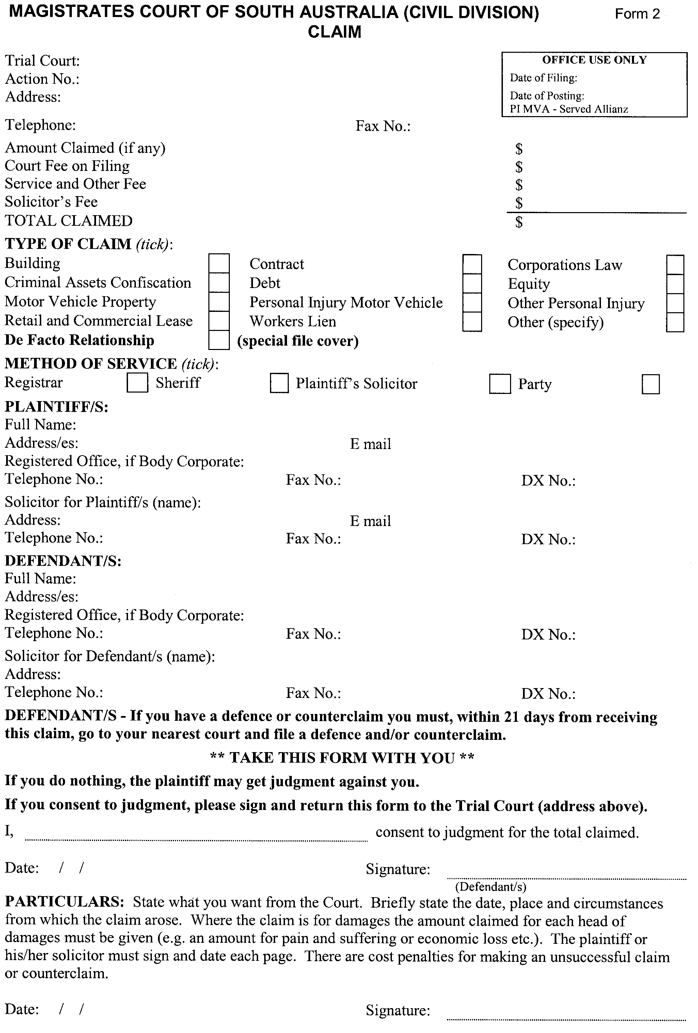
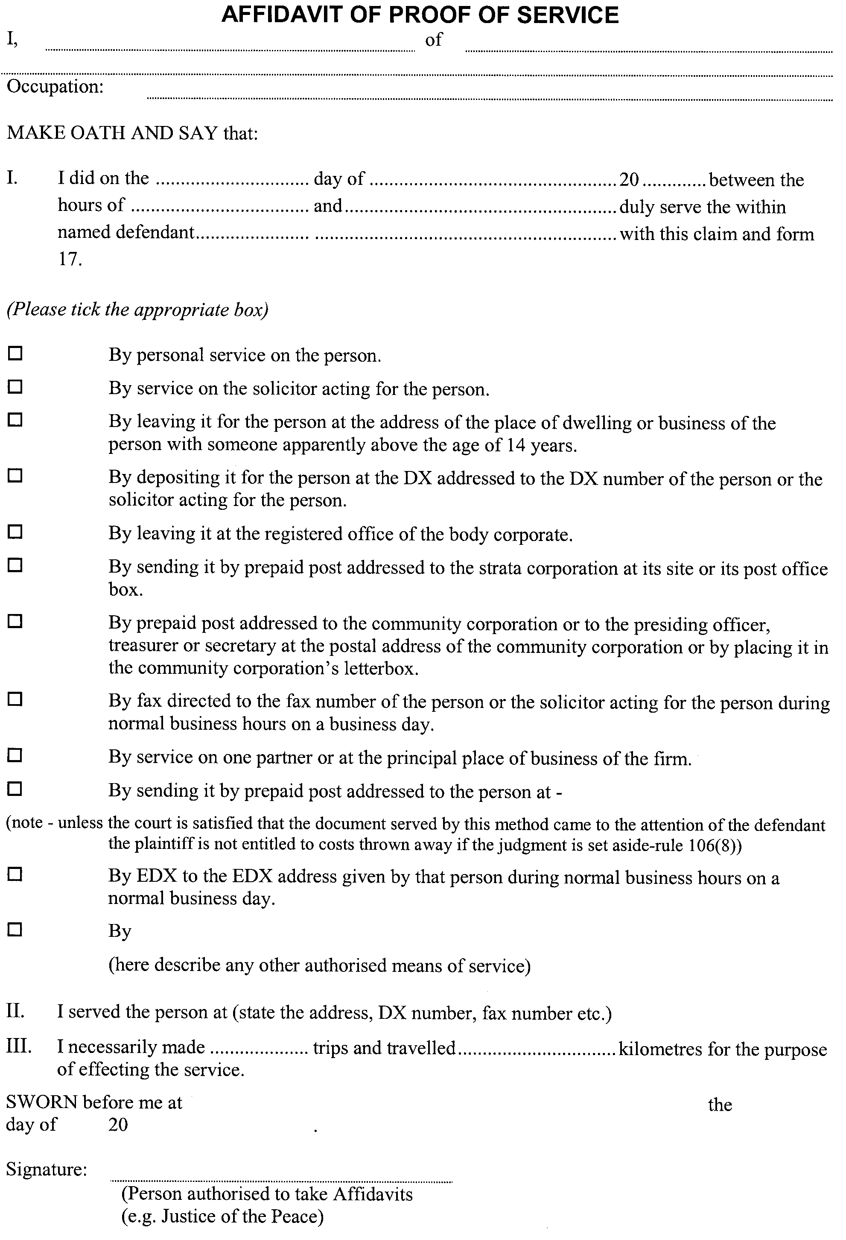

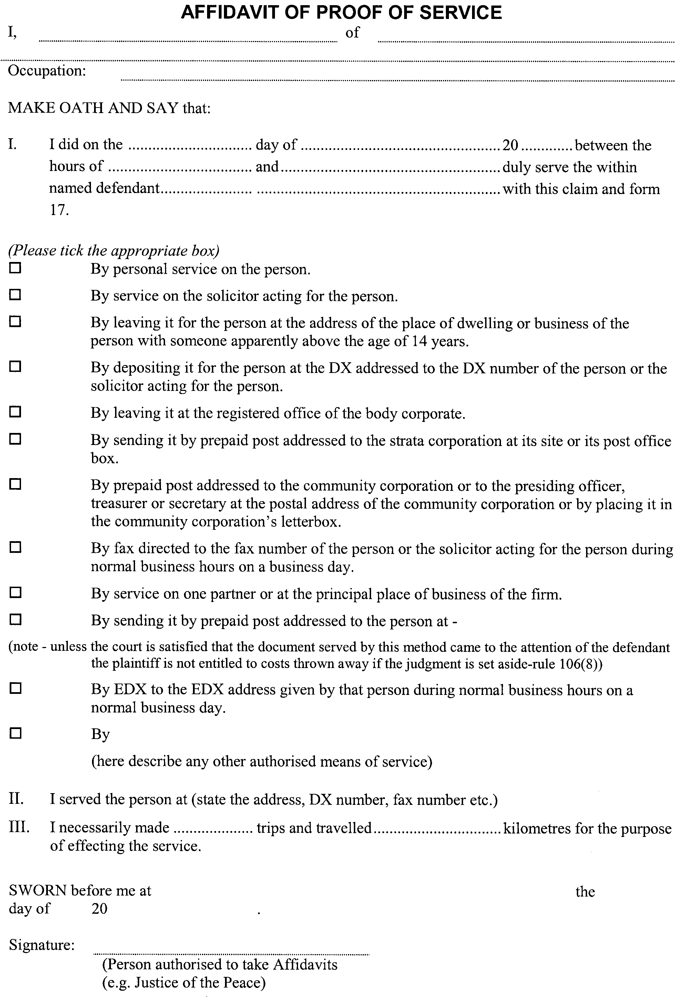
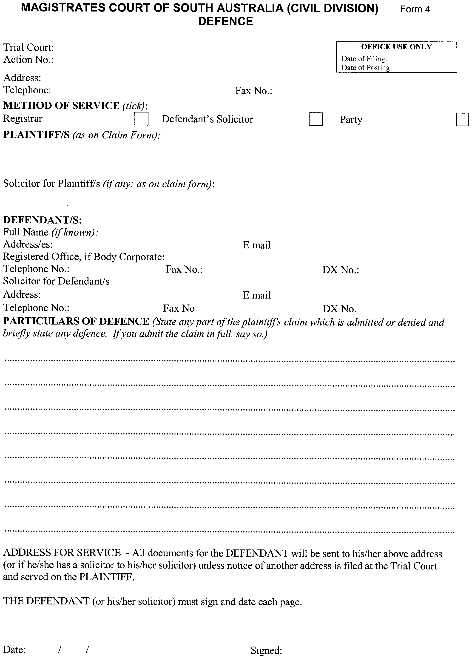
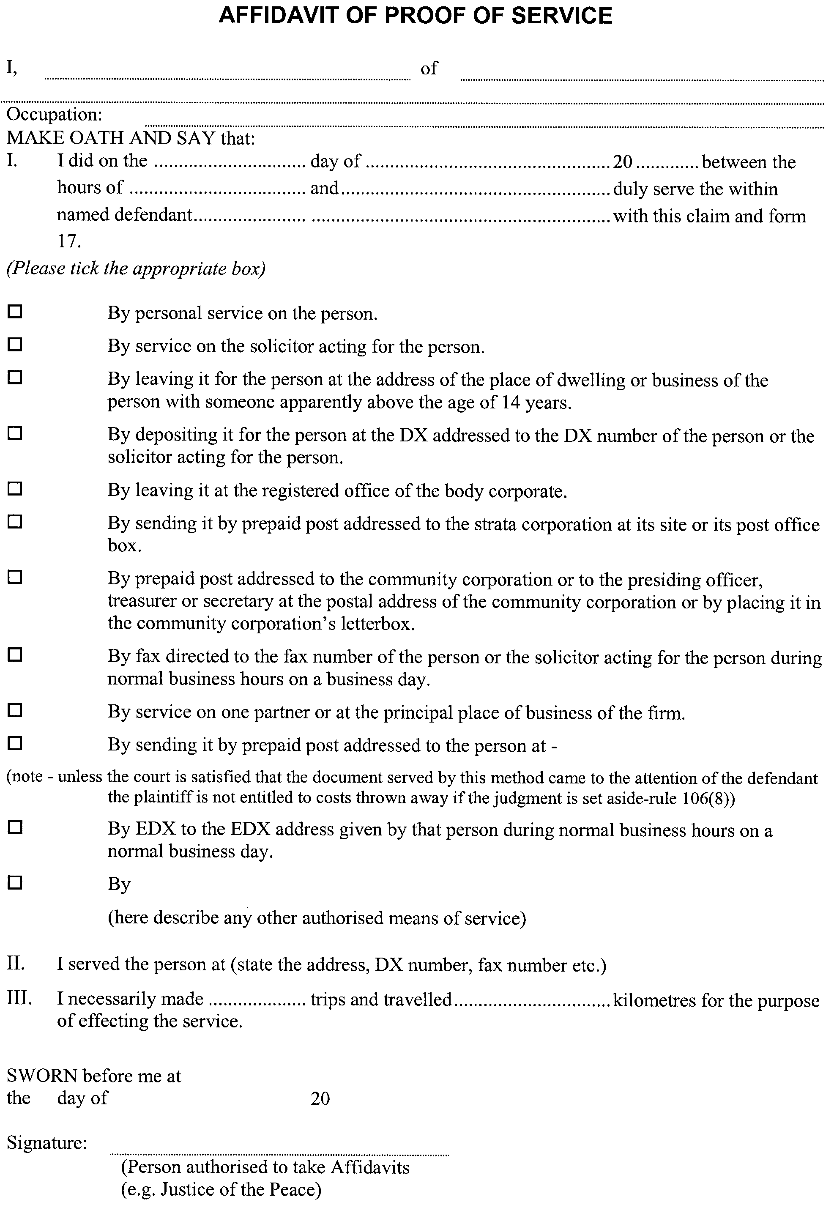
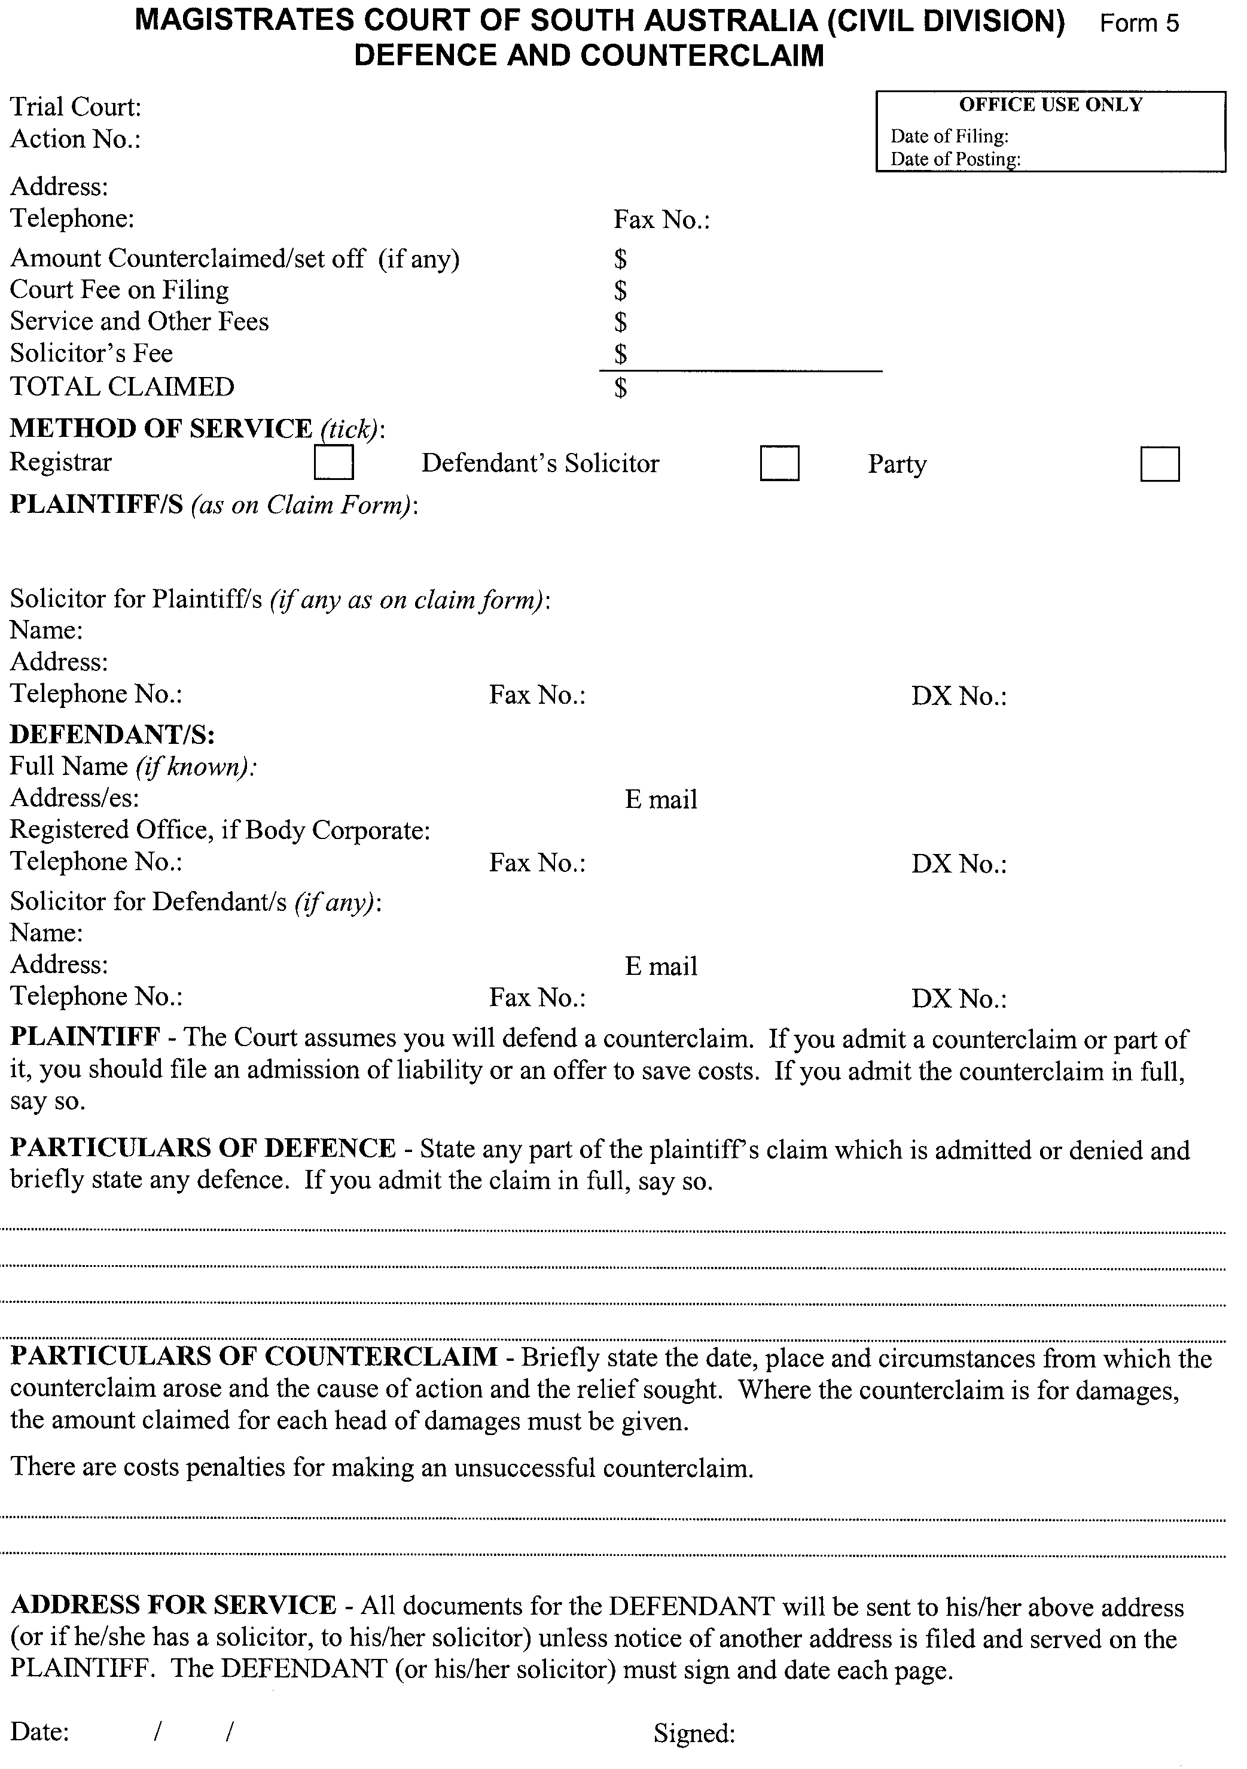

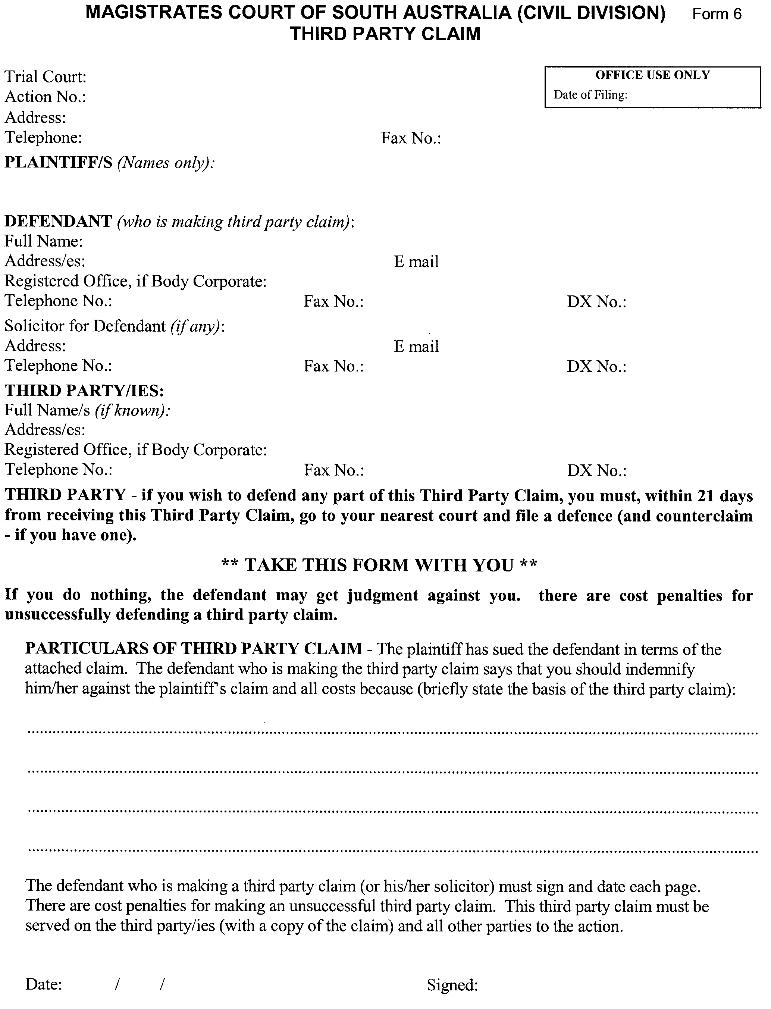
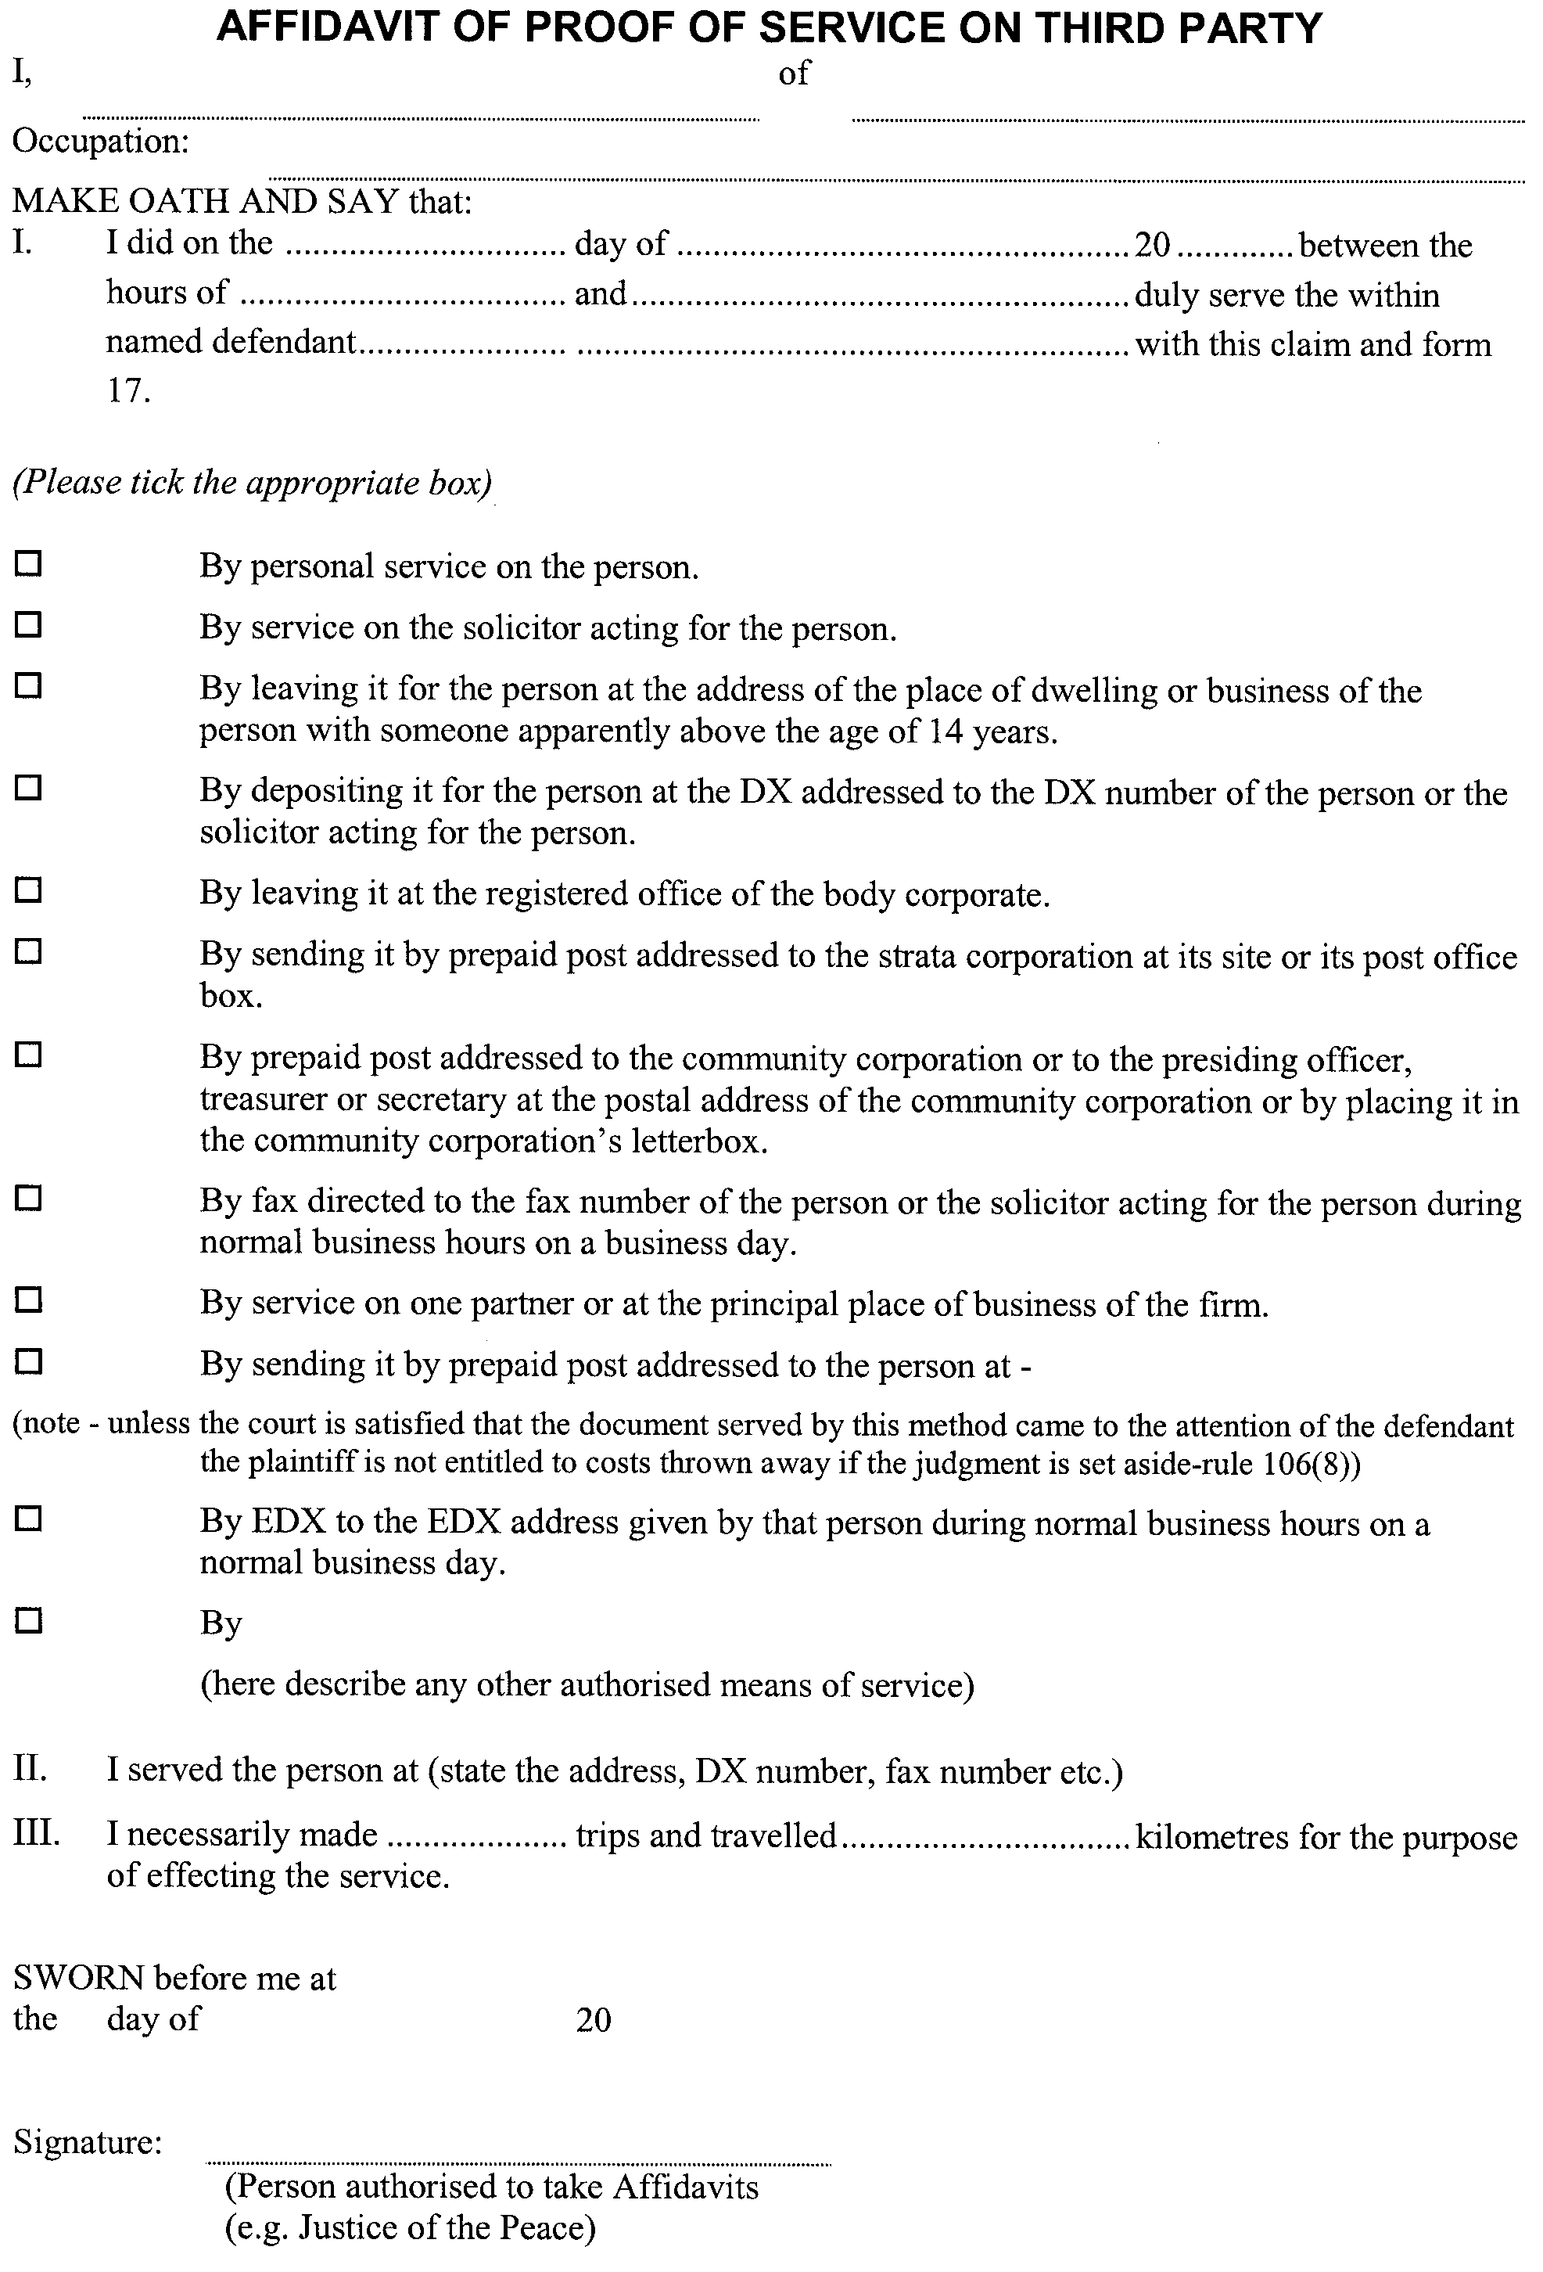
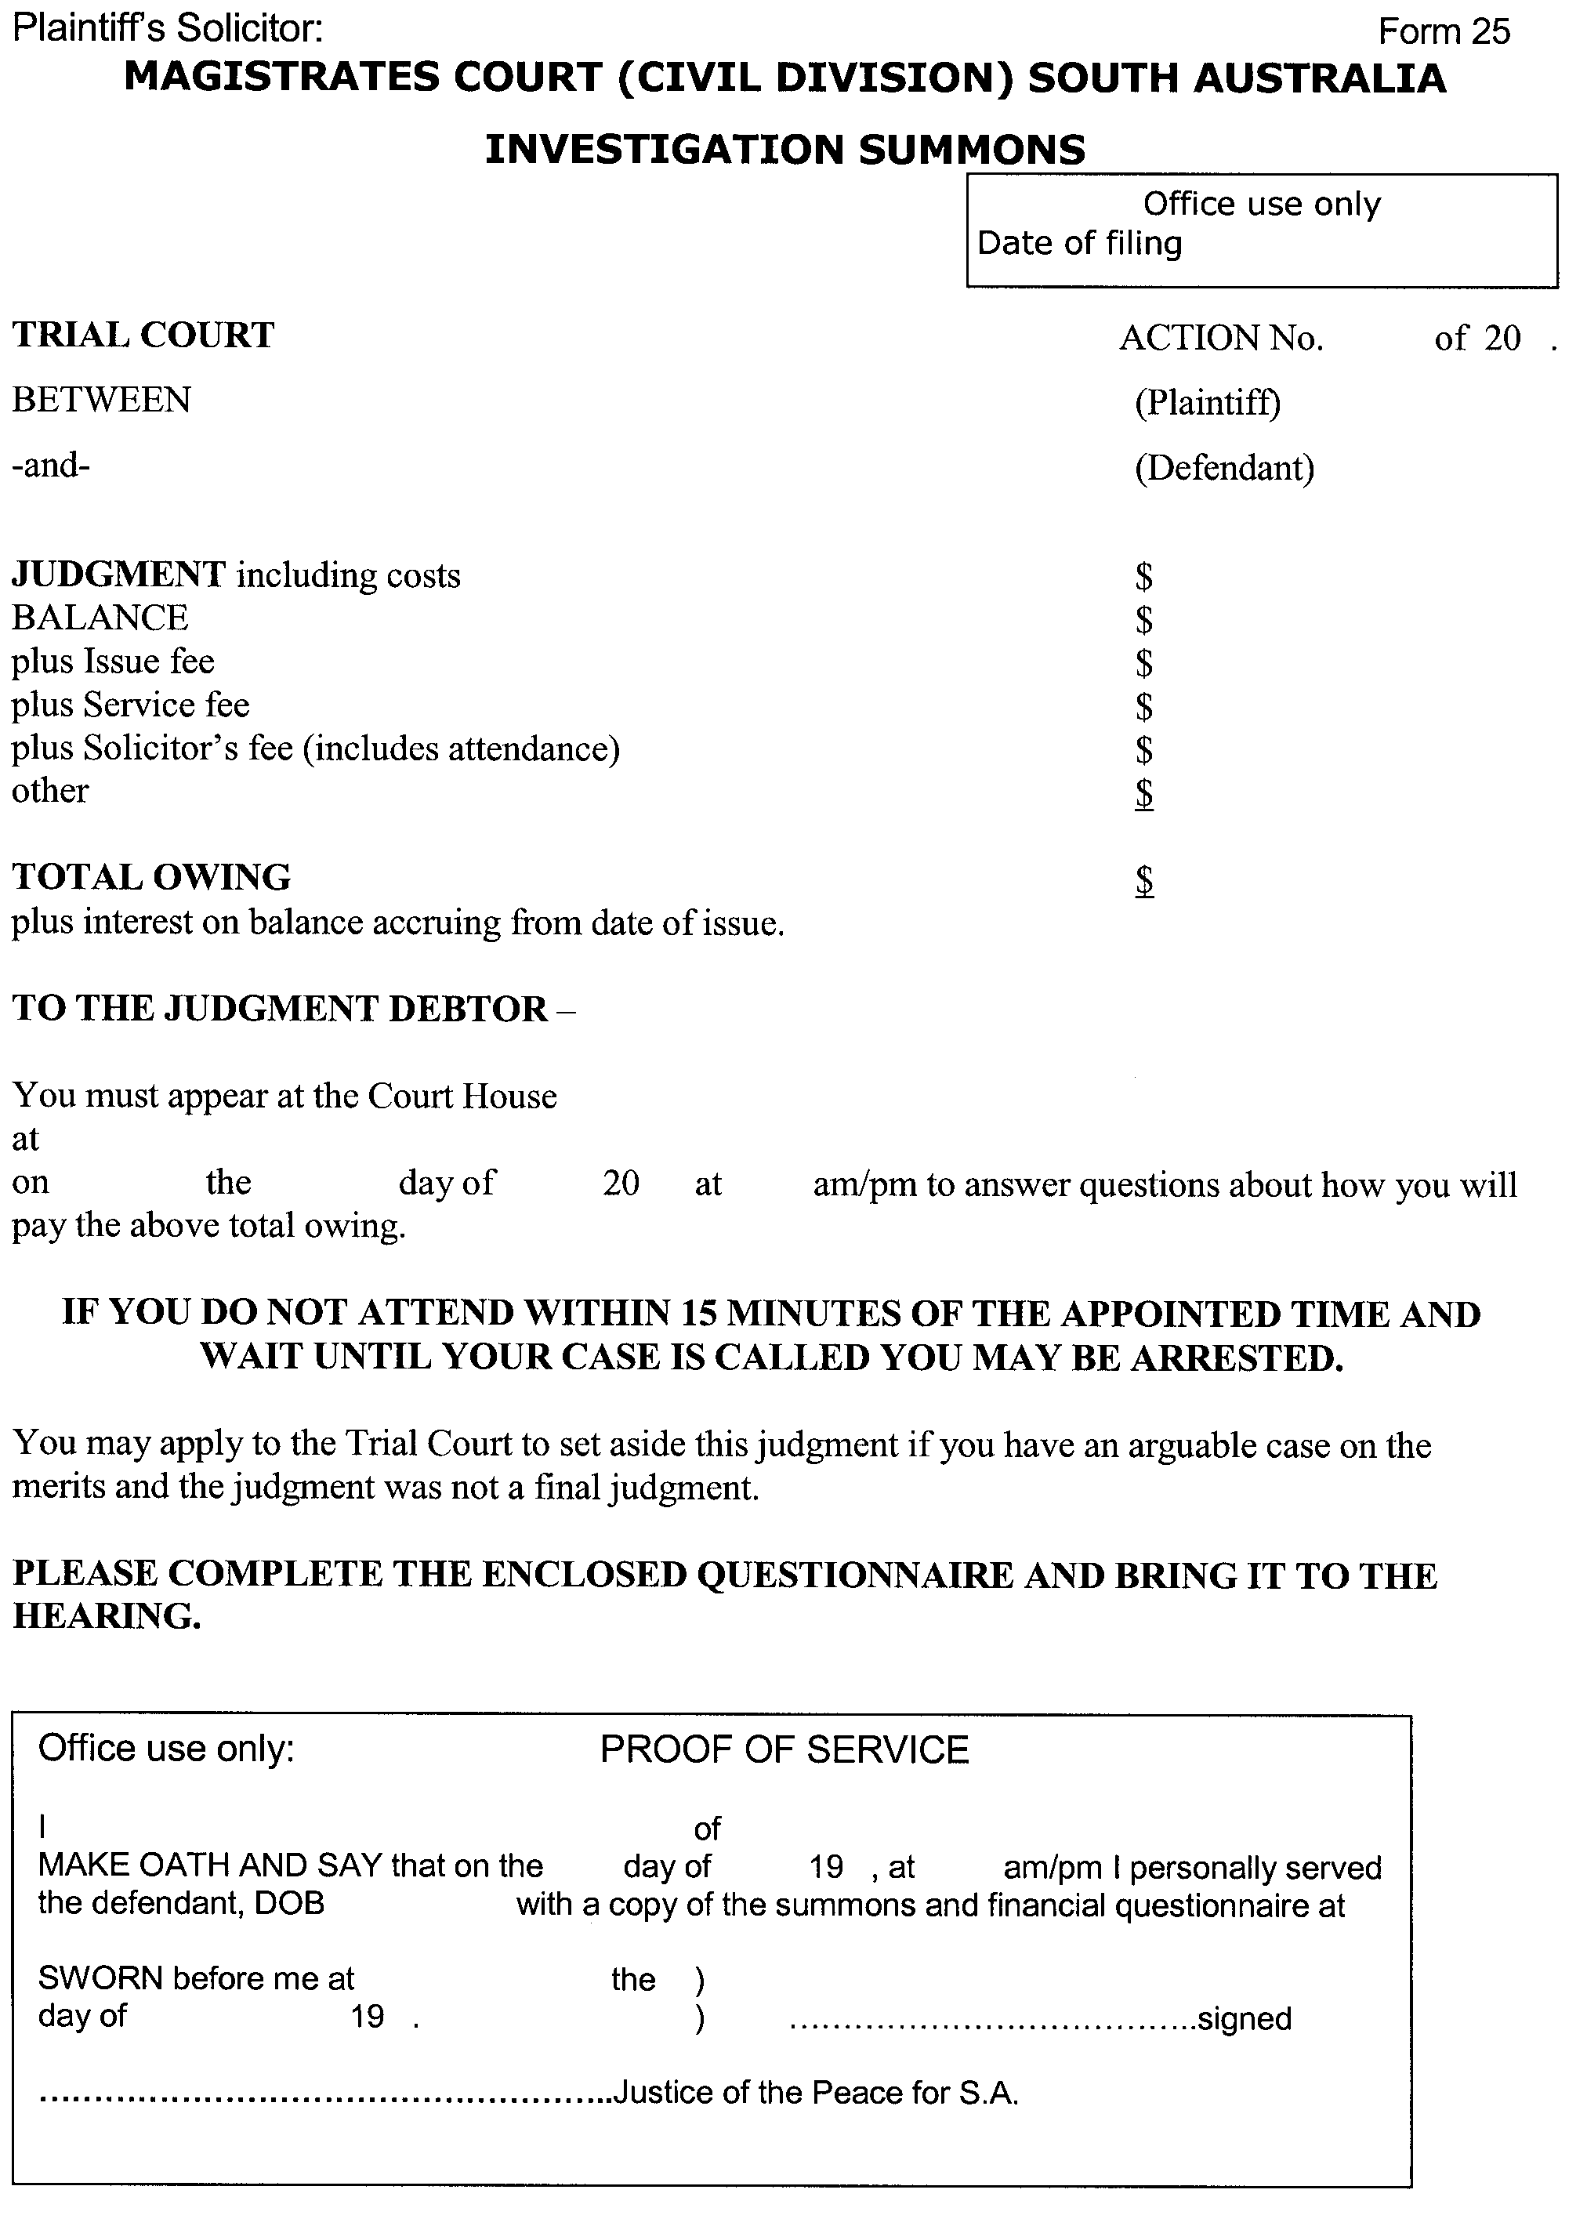
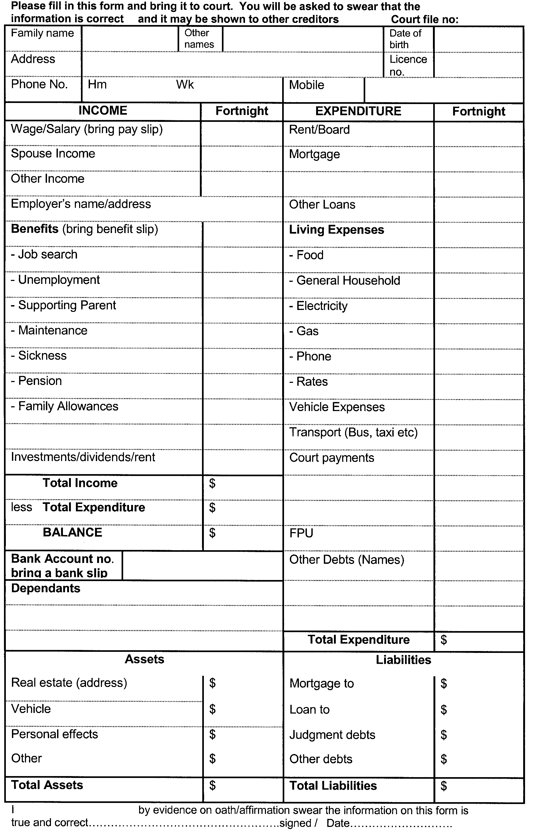


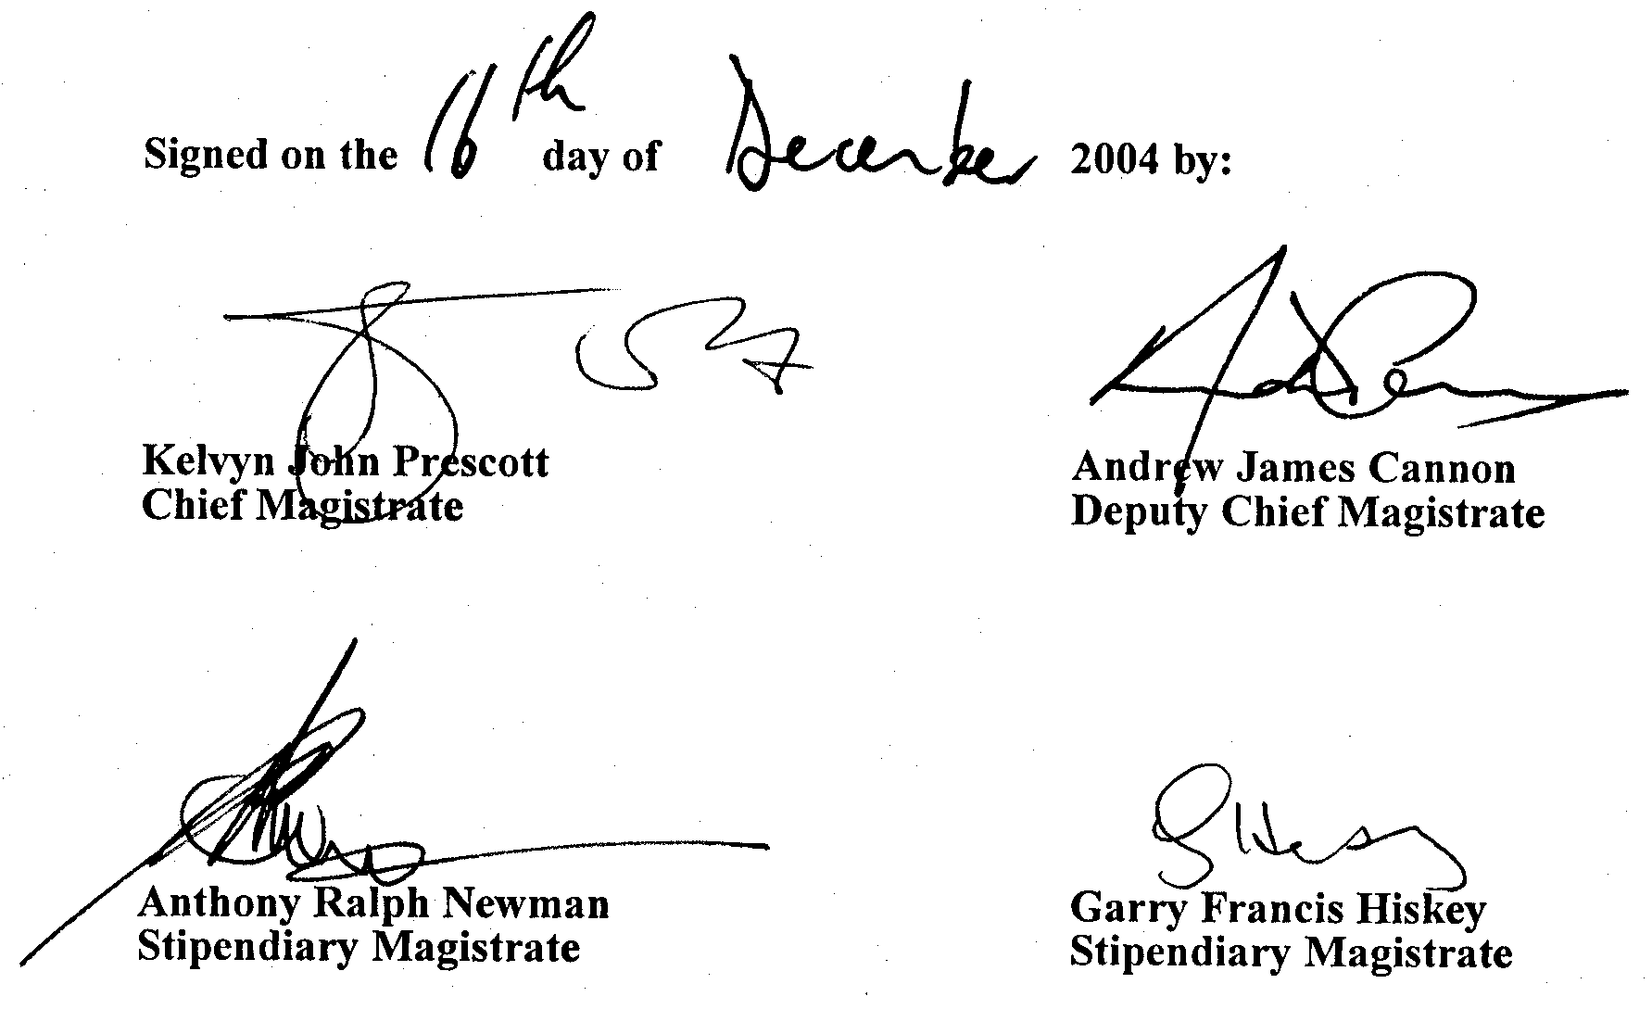

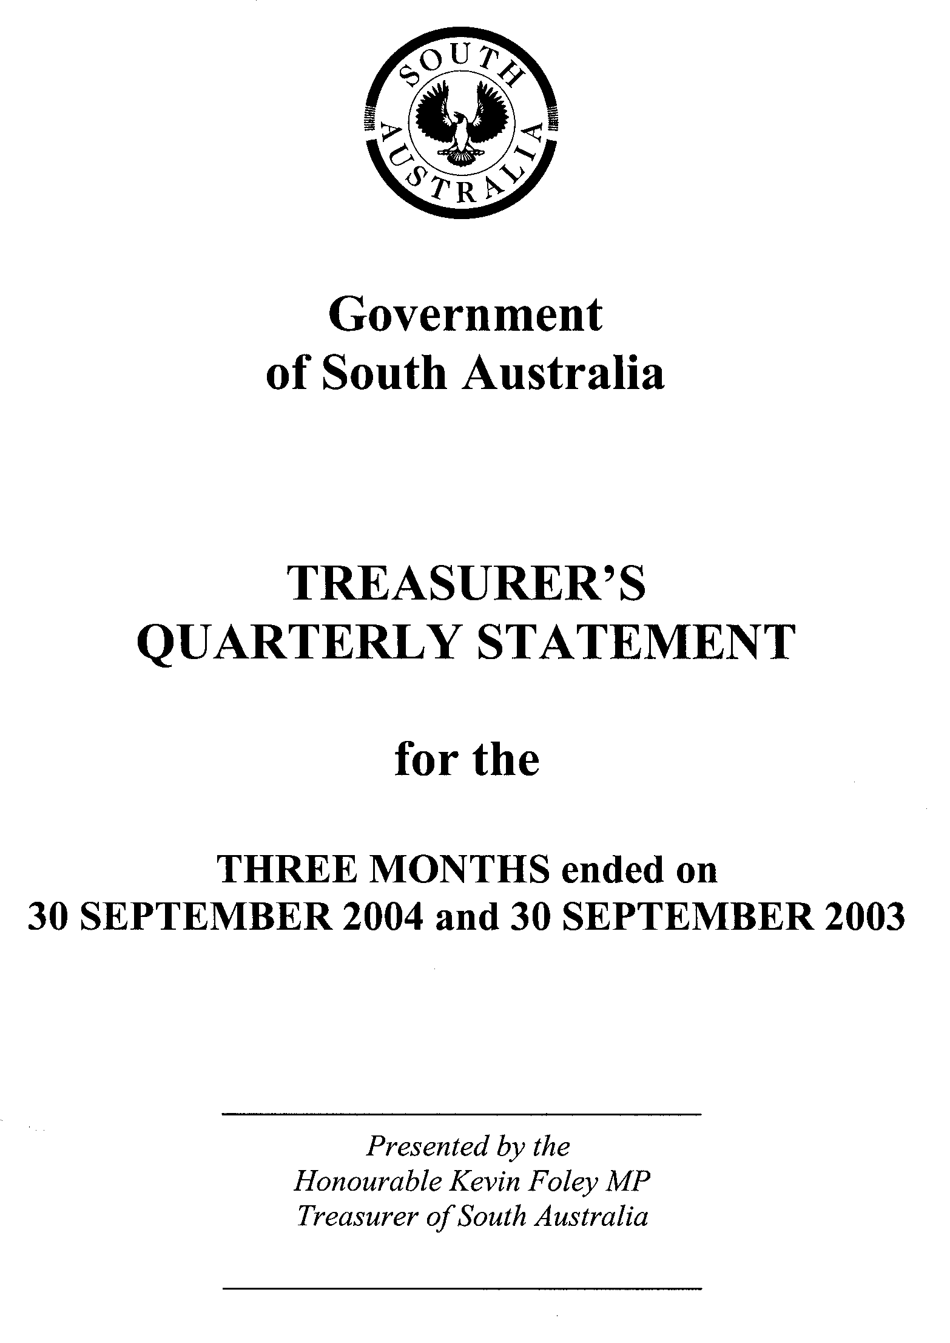

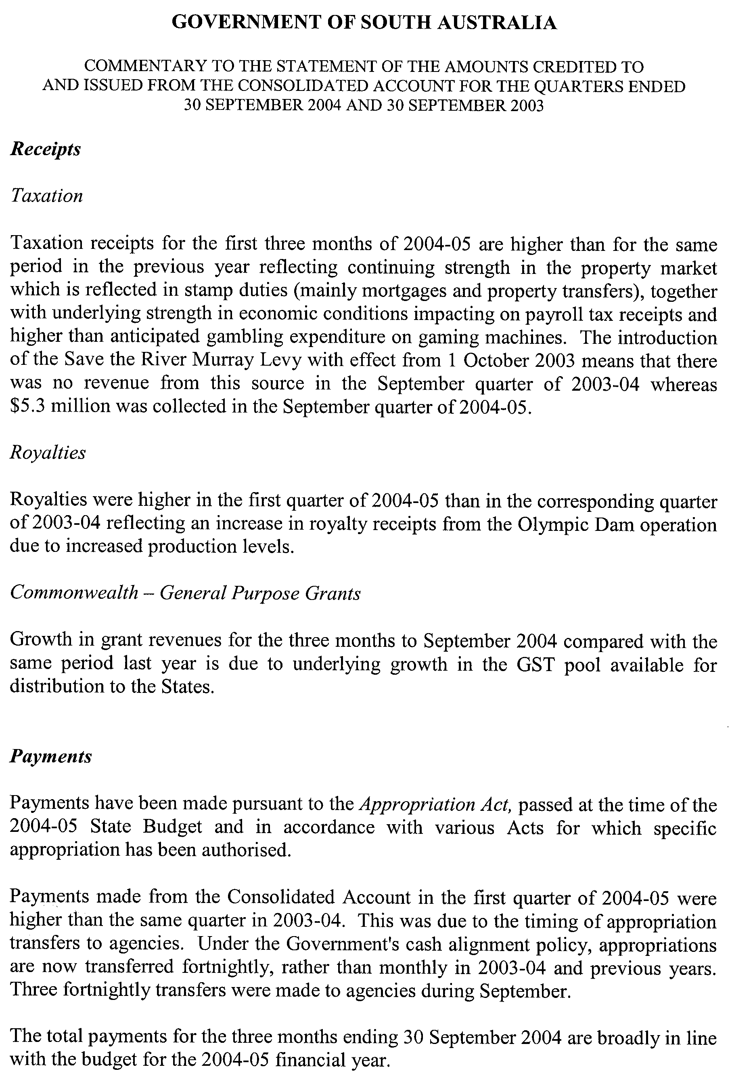

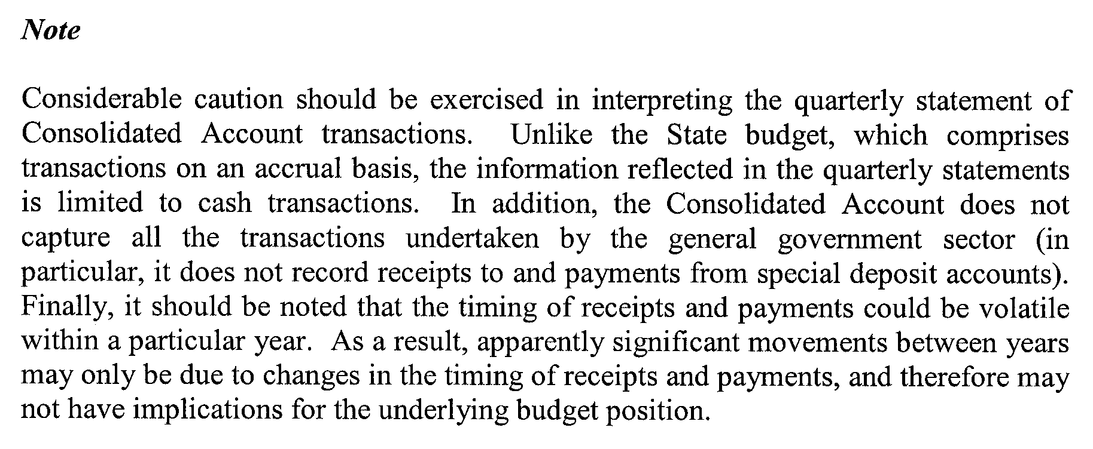

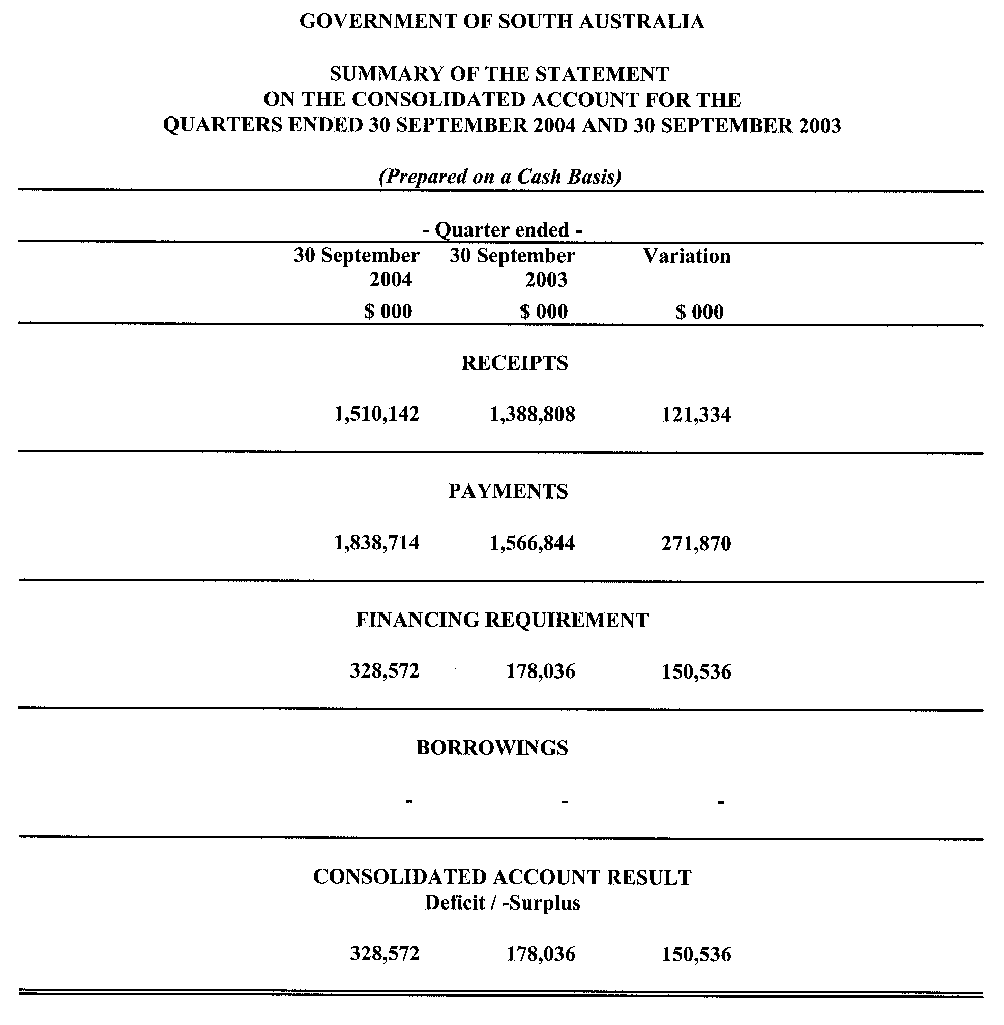

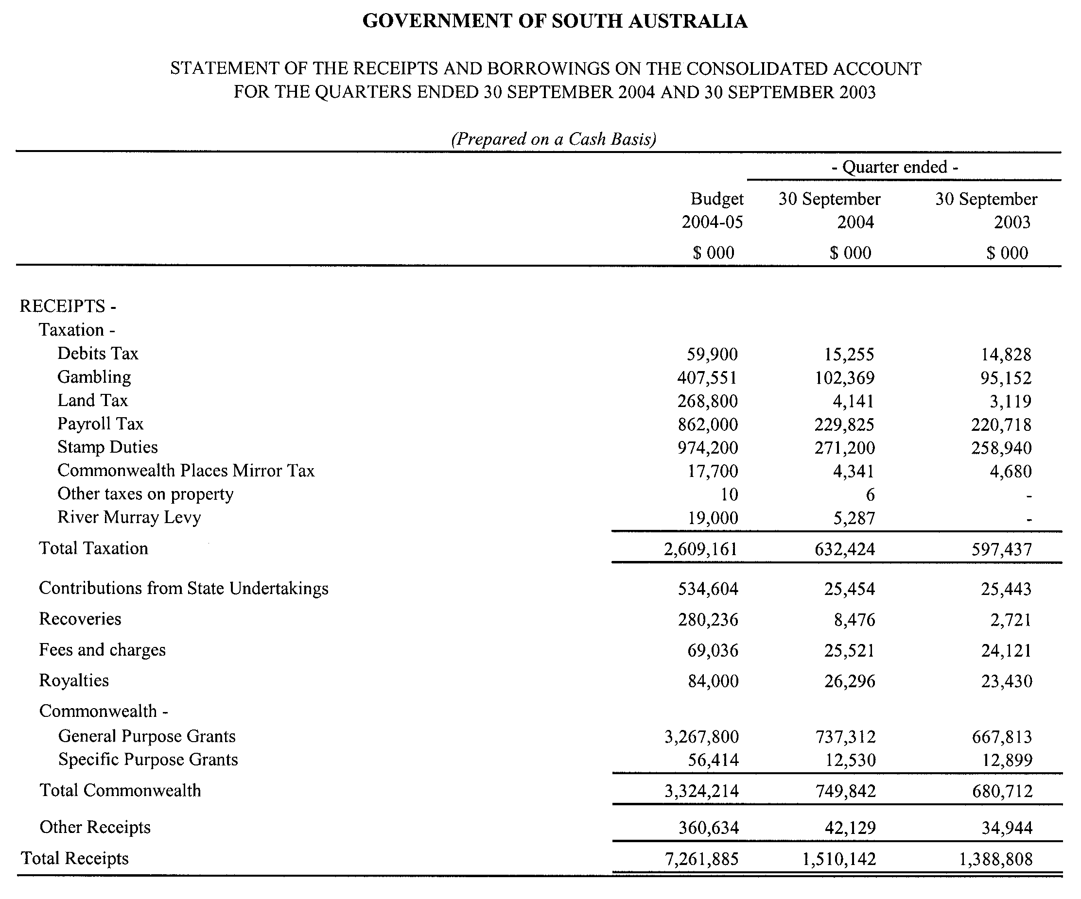

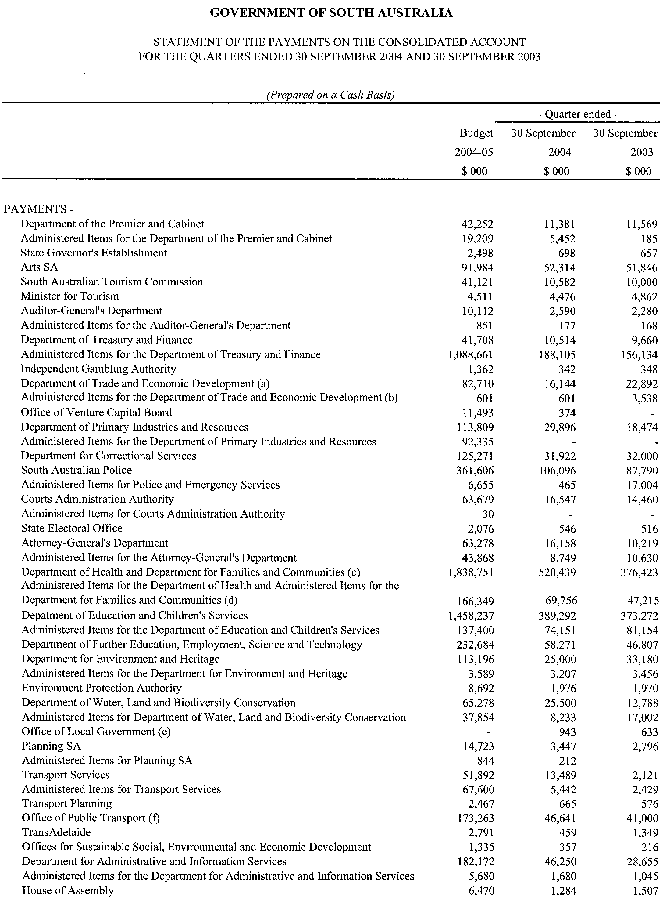
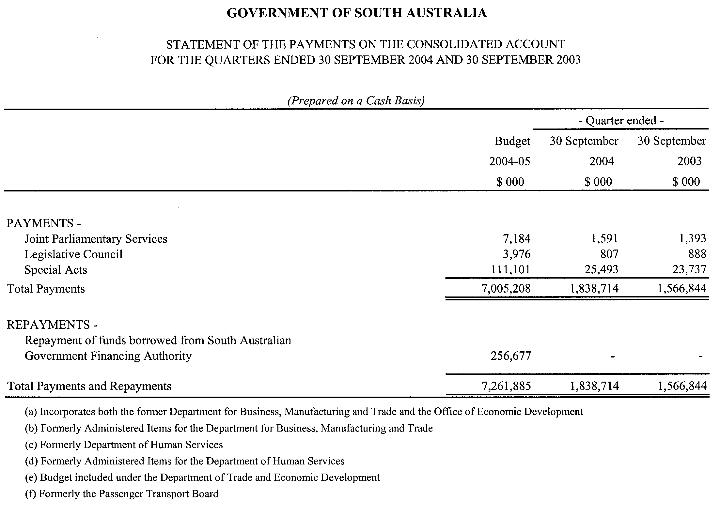

South Australia
Criminal Law Consolidation (Child Pornography) Amendment Act (Commencement) Proclamation 2005
1—Short title
This proclamation may be cited as the Criminal Law Consolidation (Child Pornography) Amendment Act (Commencement) Proclamation 2005.
2—Commencement of Act
The Criminal Law Consolidation (Child Pornography) Amendment Act 2004 (No 52 of 2004) will come into operation on 30 January 2005.
Made by the Governor’s Deputy
with the advice and consent of the Executive Council
on 13 January 2005.
AGO0264/04CS

South Australia
Gaming Machines (Miscellaneous) Amendment Act (Commencement) Proclamation 2005
1—Short title
This proclamation may be cited as the Gaming Machines (Miscellaneous) Amendment Act (Commencement) Proclamation 2005.
2—Commencement of Act and suspension of certain provisions
(1) The Gaming Machines (Miscellaneous) Amendment Act 2004 (No 46 of 2004) will come into operation on 1 February 2005.
Note—
Part 2 and section 47 came into operation on the date of assent (9 December 2004).
(2) The operation of—
(a) sections 9, 19, 22, 24, 30, 31, 35, 43 and 46(2) of the Act; and
(b) section 34 but only insofar as it proposes the insertion of section 50 in the Gaming Machines Act 1992,
is suspended until a day to be fixed by subsequent proclamation.
Made by the Governor’s Deputy
with the advice and consent of the Executive Council
on 13 January 2005.
T&F04/097CS

South Australia
Statutes Amendment (Legal Assistance Costs) Act (Commencement) Proclamation 2005
1—Short title
This proclamation may be cited as the Statutes Amendment (Legal Assistance Costs) Act (Commencement) Proclamation 2005.
2—Commencement of Act
The Statutes Amendment (Legal Assistance Costs) Act 2004 (No 55 of 2004) will come into operation on 13 January 2005.
Made by the Governor’s Deputy
with the advice and consent of the Executive Council
on 13 January 2005.
AGO0332/04CS

South Australia
Statutes Amendment (Miscellaneous Superannuation Measures No 2) Act (Commencement) Proclamation 2005
1—Short title
This proclamation may be cited as the Statutes Amendment (Miscellaneous Superannuation Measures No 2) Act (Commencement) Proclamation 2005.
2—Commencement of Act
The Statutes Amendment (Miscellaneous Superannuation Measures No 2) Act 2004 (No 51 of 2004), other than—
(a) section 10(3) and (4) (which came into operation, by virtue of section 2(2) of that Act, on 1 July 1999); and
(b) sections 19, 39 and 46 (which came into operation, by virtue of section 2(3) of that Act, on 3 July 2003),
will come into operation on 13 January 2005.
Made by the Governor’s Deputy
with the advice and consent of the Executive Council
on 13 January 2005.
T&F04/055CS

South Australia
Liquor Licensing (Designation of Acting District Court Judge as Licensing Court Judge) Proclamation 2005
under section 15 of the Liquor Licensing Act 1997
1—Short title
This proclamation may be cited as the Liquor Licensing (Designation of Acting District Court Judge as Licensing Court Judge) Proclamation 2005.
2—Commencement
This proclamation comes into operation on the day on which it is made.
3—Designation of Acting District Court Judge as Licensing Court Judge
The Acting District Court Judge named in Schedule 1 is designated as the Licensing Court Judge.
4—Expiry of proclamation
This proclamation lapses on 31 May 2005.
Schedule 1—Acting District Court Judge designated as Licensing Court Judge
His Honour David Cyril Gurry
Made by the Governor’s Deputy
with the advice and consent of the Executive Council
on 13 January 2005.
AGO0310/04CS

South Australia
Mining (Variation of Private Mine) Proclamation 2005
under section 73N of the Mining Act 1971

Preamble
1 The following area was declared to be a private mine by proclamation on 1 August 1974 (Gazette 1.8.1974 p810):
Sections 1999 and 503, Hundred of Kanmantoo, County of Sturt.
2 The Warden's Court has declared (on 18 August 2004 in Action No 344 of 2004) that proper grounds exist for varying the declaration referred to in clause 1 by excising the following area from the area of the private mine:
Section 503, Hundred of Kanmantoo, being the land comprised in Certificate of Title Register Book Volume 1908 Folio 20.

1—Short title
This proclamation may be cited as the Mining (Variation of Private Mine) Proclamation 2005.
2—Commencement
This proclamation comes into operation on the day on which it is made.
3—Variation of private mine
The declaration referred to in clause 1 of the preamble is varied by excising from the area of the private mine the land described in clause 2 of the preamble.
Made by the Governor’s Deputy
on the basis of the declaration referred to in clause 2 of the preamble and with the advice and consent of the Executive Council
on 13 January 2005.
AGO0047/02CS

South Australia
Superannuation Variation Regulations 2005
under the Superannuation Act 1988

Contents
Part 1—Preliminary
1 Short title
2 Commencement
3 Variation provisions
Part 2—Variation of Superannuation Regulations 2001
4 Variation of regulation 19—Right to apply for commutation
5 Variation of regulation 20—Commutation factors
6 Variation of regulation 25—Exclusion of certain remuneration from salary
7 Variation of regulation 29A—Special provision relating to certain TEC contracts without tenure
8 Insertion of regulation 29B
29B Special provision relating to certain transferred contributors

Part 1—Preliminary
1—Short title
These regulations may be cited as the Superannuation Variation Regulations 2005.
2—Commencement
These regulations come into operation on the day on which they are made.
3—Variation provisions
In these regulations, a provision under a heading referring to the variation of specified regulations varies the regulations so specified.
Part 2—Variation of Superannuation Regulations 2001
4—Variation of regulation 19—Right to apply for commutation
(1) Regulation 19(1), table, row 2, column 1—after "invalidity pension" insert:
(subject to subregulation (1a))
(2) Regulation 19—after subregulation (1) insert:
(1a) A pensioner in receipt of an invalidity pension may apply to the Board to commute up to 20 per cent of the pension in accordance with this Division at any time before he or she reaches the age of retirement.
(3) Regulation 19(2)—after "part of the pension" insert:
in accordance with this Division
(4) Regulation 19(4)(a)—after "section 45" insert:
of the Act
(5) Regulation 19—after subregulation (6) insert:
(7) A person who has applied successfully to the Board for commutation of part of a pension under a preceding subregulation may not apply to the Board for a further commutation in relation to the pension under that subregulation.
5—Variation of regulation 20—Commutation factors
(1) Regulation 20(1)(c)(ii)—after "section 43AO(7)" insert:
of the Act
(2) Regulation 20(1)—after paragraph (c) insert:
(d) in the case of an invalid pensioner who elects under regulation 19(1a) to commute up to 20 per cent of his or her pension to a lump sum prior to reaching the age of retirement—

Age at date of commutation | Amount of lump sum for each dollar of annual pension commuted
less than 50 | $7.70
50 - 55 | $7.70 - $7.30
55 - 60 | $7.30 - $6.50
6—Variation of regulation 25—Exclusion of certain remuneration from salary
Regulation 25(1)—delete "construction or industry allowances;" and substitute:
construction or industry allowances not being those paid on an annual basis;
on call allowances not being those paid on an annual basis;
7—Variation of regulation 29A—Special provision relating to certain TEC contracts without tenure
Regulation 29A(1)—after "any other regulation" insert:
(and despite any provision to the contrary in the Act)
8—Insertion of regulation 29B
After regulation 29A insert:
29B—Special provision relating to certain transferred contributors
(1) Subregulation (2) applies to a contributor who—
(a) is employed by a relevant entity; and
(b) is, while retaining his or her position with the entity (the substantive position), occupying an alternative position whereby he or she is working within or for an administrative unit (the alternative position).
(2) Despite any other regulation (and despite any provision to the contrary in the Act), the salary of a contributor to whom this subregulation applies will, for the purpose of determining contributions and benefits, be taken to be—
(a) if the contributor has occupied the alternative position for less than 12 months—the salary received by the contributor in respect of the substantive position immediately before beginning to occupy the alternative position; and
(b) if—
(i) the contributor has occupied the alternative position for 12 months or more; and
(ii) the contributor's remuneration in respect of that position is the same as, or less than 25 per cent higher than, his or her remuneration in respect of the substantive position immediately before beginning to occupy the alternative position,
the salary received by the contributor in respect of the alternative position; and
(c) if—
(i) the contributor has occupied the alternative position for 12 months or more; and
(ii) the contributor's remuneration in respect of that position is at least 25 per cent higher than his or her remuneration in respect of the substantive position immediately before beginning to occupy the alternative position,
as follows:
(iii) for the purpose of determining contributions—the salary received by the contributor in respect of the alternative position;
(iv) for the purpose of determining benefits—salary calculated in accordance with subregulation (4).
(3) Despite any other regulation (and despite any provision to the contrary in the Act), the salary of a contributor who transfers from employment with a relevant entity to employment with an administrative unit, and whose employment with the entity ceases on or following the transfer, will be taken to be—
(a) for the purpose of determining contributions—the salary received by the contributor in respect of his or her employment with the administrative unit; and
(b) for the purpose of determining benefits—
(i) if the contributor's remuneration in respect of employment with the administrative unit is the same as, or less than 25 per cent higher than, his or her remuneration in respect of employment with the entity immediately before his or her transfer to the administrative unit—the salary received by the contributor in respect of his or her employment with the administrative unit; and
(ii) if the contributor's remuneration in respect of employment with the administrative unit is at least 25 per cent higher than his or her remuneration in respect of employment with the entity immediately before his or her transfer to the administrative unit—salary determined in accordance with subregulation (4).
(4) Salary for the purposes of determining benefits under subregulation (2)(c)(iv) and (3)(b)(ii) is to be determined in accordance with the following formula:
Where—
S is the salary
S1 is the highest level of salary received by the contributor while employed by, and undertaking duties for, the relevant entity, adjusted to reflect movement in salaries for the same classification with that employer
CM is the number of contribution months in the contributor's contribution period
X is the number of contribution months in the contributor's contribution period occurring while working within or for the administrative unit
S2 is the amount that would, but for this regulation, have been the contributor's salary for the purpose of determining benefits.
(5) In this regulation—
administrative unit means an administrative unit under the Public Sector Management Act 1995;
relevant entity means an entity that has entered into an arrangement with the Board under section 5 of the Act.
Note—
As required by section 10AA(2) of the Subordinate Legislation Act 1978, the Minister has certified that, in the Minister's opinion, it is necessary or appropriate that these regulations come into operation as set out in these regulations.
Made by the Governor’s Deputy
with the advice and consent of the Executive Council
on 13 January 2005
No 1 of 2005
T&F04/090CS

South Australia
Superannuation (Julia Farr Services Employees) Variation Regulations 2005
under the Superannuation Act 1988

Contents
Part 1—Preliminary
1 Short title
2 Commencement
3 Variation provisions
Part 2—Variation of Superannuation (Julia Farr Services Employees) Regulations 2003
4 Variation of regulation 11—Substitution of sections 27, 28, 28A, 28B, 28C and 29
5 Variation of regulation 13—Substitution of sections 31 and 32

Part 1—Preliminary
1—Short title
These regulations may be cited as the Superannuation (Julia Farr Services Employees) Variation Regulations 2005.
2—Commencement
These regulations come into operation on the day on which they are made.
3—Variation provisions
In these regulations, a provision under a heading referring to the variation of specified regulations varies the regulations so specified.
Part 2—Variation of Superannuation (Julia Farr Services Employees) Regulations 2003
4—Variation of regulation 11—Substitution of sections 27, 28, 28A, 28B, 28C and 29
(1) Regulation 11—delete the formula appearing in substituted section 27(1) and substitute:
(2) Regulation 11—after the definition of FS appearing in substituted section 27(1) insert:
Pn is—
(a) in the case of a contributor whose employment with Julia Farr Services Incorporated is full time for the whole of the period of that employment—1; and
(b) in any other case—the numerical value arrived at by expressing the contributor's employment, while a member of the Plan, or as a contributor in prescribed employment, to the date of ceasing service (in completed months) as a proportion of full-time employment
(3) Regulation 11—delete the formula appearing in substituted section 27(2) and substitute:
(4) Regulation 11—after the definition of FS appearing in substituted section 27(2) insert:
Pn is—
(a) in the case of a contributor whose employment with Julia Farr Services Incorporated is full time for the whole of the period of that employment—1; and
(b) in any other case—the numerical value arrived at by expressing the contributor's employment, while a member of the Plan, or as a contributor in prescribed employment, to the date of ceasing service (in completed months) as a proportion of full-time employment
5—Variation of regulation 13—Substitution of sections 31 and 32
(1) Regulation 13—delete the formula appearing in substituted section 31 and substitute:
(2) Regulation 13—after the definition of FS appearing in substituted section 31 insert:
Pn is—
(a) in the case of a contributor whose employment with Julia Farr Services Incorporated is full time for the whole of the period of that employment—1; and
(b) in any other case—the numerical value arrived at by expressing the contributor's employment, while a member of the Plan, or as a contributor in prescribed employment, to the date of ceasing service (in completed months) as a proportion of full-time employment
(3) Regulation 13—delete the formula appearing in substituted section 32(2) and substitute:
(4) Regulation 13—after the definition of FS appearing in substituted section 32(2) insert:
Pn is—
(a) in the case of a contributor whose employment with Julia Farr Services Incorporated is full time for the whole of the period of that employment—1; and
(b) in any other case—the numerical value arrived at by expressing the contributor's employment, while a member of the Plan, or as a contributor in prescribed employment, to the date of ceasing service (in completed months) as a proportion of full-time employment
Note—
As required by section 10AA(2) of the Subordinate Legislation Act 1978, the Minister has certified that, in the Minister's opinion, it is necessary or appropriate that these regulations come into operation as set out in these regulations.
Made by the Governor’s Deputy
with the advice and consent of the Executive Council
on 13 January 2005
No 2 of 2005
T&F04/090CS

South Australia
Police Superannuation Variation Regulations 2005
under the Police Superannuation Act 1990

Contents
Part 1—Preliminary
1 Short title
2 Commencement
3 Variation provisions
Part 2—Variation of Police Superannuation Regulations 2002
4 Variation of regulation 8—Commutation factors
5 Variation of regulation 12—Salary
6 Insertion of regulation 12AA
12AA Salary (contract under section 13 or 16 of Police Act 1998)

Part 1—Preliminary
1—Short title
These regulations may be cited as the Police Superannuation Variation Regulations 2005.
2—Commencement
(1) Subject to subregulation (2), these regulations will come into operation on the day on which the Statutes Amendment (Miscellaneous Superannuation Measures No 2) Act 2004 comes into operation.
(2) Pursuant to Schedule 1, clause 1 of the Statutes Amendment (Miscellaneous Superannuation Measures No 2) Act 2004, regulation 6 will be taken to have come into operation on 1 July 1999.
3—Variation provisions
In these regulations, a provision under a heading referring to the variation of specified regulations varies the regulations so specified.
Part 2—Variation of Police Superannuation Regulations 2002
4—Variation of regulation 8—Commutation factors
Regulation 8(1)(d)(ii)—after "section 38S(7)" insert:
of the Act
5—Variation of regulation 12—Salary
Regulation 12—after subregulation (4) insert:
(5) In this regulation—
salary means salary as defined by the second definition of salary in section 4(1) of the Act.
6—Insertion of regulation 12AA
After regulation 12 insert:
12AA—Salary (contract under section 13 or 16 of Police Act 1998)
The proportion of the total remuneration package specified in a contract under section 13 or 16 of the Police Act 1998 for the purposes of the first definition of salary in section 4(1) of the Act is—
(a) in respect of an old scheme contributor—86.6 per cent; and
(b) in respect of a new scheme contributor—90.6 per cent.
Note—
As required by section 10AA(2) of the Subordinate Legislation Act 1978, the Minister has certified that, in the Minister's opinion, it is necessary or appropriate that these regulations come into operation as set out in these regulations.
Made by the Governor’s Deputy
with the advice and consent of the Executive Council
on 13 January 2005
No 3 of 2005
T&F04/055CS

FAXING COPY?
IF you fax copy to Government Publishing SA for inclusion in the Government Gazette, there is no need to send a Confirmation Copy to us as well.
This creates confusion and may well result in your notice being printed twice.
Please use the following fax number:
Fax transmission: (08) 8207 1040
Phone Inquiries: (08) 8207 1045
Please include a contact person, phone number and order number so that we can phone back with any queries we may have regarding the fax copy.
NOTE: Closing time for lodging new copy (fax, hard copy or email) is 4 p.m. on Tuesday preceding the day of publication.

Government Gazette notices can be E-mailed.
The address is:
governmentgazette@saugov.sa.gov.au
Documents should be sent as attachments in Word format.
When sending a document via E-mail, please confirm your transmission with a faxed copy of your document, including the date the notice is to be published.
Fax transmission: (08) 8207 1040
Enquiries: (08) 8207 1045
NOTE: Closing time for lodging new copy (fax, hard copy or email) is 4 p.m. on Tuesday preceding the day of publication.

CITY OF CHARLES STURT
Roads (Opening and Closing) Act 1991
Road Closure, portion of West Street, Brompton
NOTICE is hereby given pursuant to section 10 of the Roads (Opening and Closing) Act 1991, that council proposes to make a Road Process Order to close and vest in the Crown, a 5 m strip (approximately) of West Street adjoining allotment 102 in Deposited Plan 17000 and allotment 4 in Filed Plan 121454 shown as ‘A’ and ‘B’ on Preliminary Plan No. 04/0077.
A copy of the plan and statement of persons affected are available for public inspection at the Council’s Office, 72 Woodville Road, Woodville and the office of the Surveyor-General, 101 Grenfell Street, Adelaide during normal office hours.
Any application for easement or objections must be made in writing within 28 days from 13 January 2005, to the Council, P.O. Box 1, Woodville, S.A. 5011 and the Surveyor-General, G.P.O. Box 1354, Adelaide, S.A. 5001, setting out full details.
Where a submission is made, council will give notification of a meeting to deal with the matter.
P. Lockett, Chief Executive Officer

CITY OF CHARLES STURT
Roads (Opening and Closing) Act 1991
Road closure, portion of Leason Street, Grange
NOTICE is hereby given pursuant to section 10 of the said Act, that council proposes to make a Road Process Order to close and retain the piece of Leason Street, generally situate between Judith Place and Dianne Place shown as ‘A’ on Preliminary Plan No. 04/0108.
A copy of the plan and statement of persons affected are available for public inspection at the Council office, 72 Woodville Road, Woodville and the office of the Surveyor-General, 101 Grenfell Street, Adelaide during normal office hours.
Any application for easement or objections must be made in writing within 28 days from 13 January 2005, to the Council, P.O. Box 1 Woodville, S.A. 5011 and the Surveyor-General, G.P.O. Box 1354, Adelaide, S.A. 5001, setting out full details.
Where a submission is made, council will give notification of a meeting to deal with the matter.
P. Lockett, Chief Executive Officer

CITY OF PORT ADELAIDE ENFIELD
Roads (Opening and Closing) Act 1991
NOTICE is hereby given, pursuant to section 10 of the Roads (Opening and Closing) Act 1991, that the City of Port Adelaide Enfield proposes to make a Road Process Order to close portion of Wingfield Road, Wingfield and merge with allotment 50 in Deposited Plan 31336 and allotment 20 in Deposited Plan 38875 as delineated on Preliminary Plan No. 04/0132.
A copy of the plan and a statement of persons affected are available for public inspection at the Civic Centre, 163 St Vincent Street, Port Adelaide, S.A. 5015, the Council offices situated in the Enfield, Greenacres and Parks Libraries and the Adelaide office of the Surveyor-General during normal office hours.
Any application for easement or objection must be made in writing to the Council, P.O. Box 110, Port Adelaide, S.A. 5015 within 28 days of this notice and a copy must be forwarded to the Surveyor-General, G.P.O. Box 1354, Adelaide, S.A. 5001. Where a submission is made, the council will give notification of a meeting at which the matter will be considered.
Dated 12 January 2005.
H. J. Wierda, City Manager

CITY OF SALISBURY
Roads (Opening and Closing) Act 1991
Road re-alignment Wyatt Road, Direk
NOTICE is hereby given pursuant to section 10 of the Roads (Opening and Closing) Act 1991, that council proposes to make Road Process Orders to open as road:
(i) A triangularly-shaped portion (adjoining the northern corner) of allotment 21 in Filed Plan 18218 shown as ‘1’ on Preliminary Plan No. 04/0110.
(ii) An irregularly-shaped portion (adjoining the northern boundaries) of allotment 20 in Filed Plan 18218 shown as ‘2’ on Preliminary Plan No. 04/0111.
(iii) An irregularly-shaped portion (intersecting) allotment 152 in Deposited Plan 49880 shown as ‘6’ on Preliminary Plan No. 04/0115.
(iv) An irregularly-shaped portion (intersecting) allotment 150 in Deposited Plan 49880 shown as ‘7’ on Preliminary Plan No. 04/0116.
(v) An irregularly-shaped strip (adjoining Wyatt Road) of allotment 151 in Deposited Plan 49880 shown as ‘8’ on Preliminary Plan No. 04/0117.
(vi) An irregularly-shaped portion (adjoining Wyatt and Heaslip Roads) of allotment 2 in Filed Plan 106788 shown as ‘16’ on Preliminary Plan No. 04/0124.
(vii) An irregularly-shaped strip (adjoining Wyatt Road) of allotment 5 in Filed Plan 4977 shown as ‘13’ on Preliminary Plan No. 04/0122.
A copy of the plans and statements of persons affected are available for public inspection at the Council Office, 12 James Street, Salisbury and at the office of the Surveyor-General, 101 Grenfell Street, Adelaide during normal office hours.
Any objections must set out the full name, address and details of the submission and must be fully supported by reasons.
The objections must be made in writing within 28 days of this notice to the Council, P.O. Box 8, Salisbury, S.A. 5108 and the Surveyor-General, G.P.O. Box 1354, Adelaide, S.A. 5001, setting out full details.
Where a submission is made, council will give notification of a meeting at which the matter will be considered.
Enquiries relating to this matter may be directed to Milan Millison on 8406 8216 or Julie Bond on 8406 8306
Dated 13 January 2005.
S. Hains, City Manager

CITY OF VICTOR HARBOR
By-law Made Under the Local Government Act 1999
By-Law No. 2—Moveable Signs
TO protect visual amenity and public safety on roads and footpaths by setting standards for moveable signs and regulating their placement in a manner which recognises the advertising needs of businesses to maximise economic viability.
1. Definitions
In this by-law:
1.1 ‘footpath area’ means that part of a street or road between the property boundary of the street or road and the edge of the carriageway on the same side as that boundary;
1.2 ‘moveable sign’ has the same meaning as in the Local Government Act 1999;
1.3 ‘authorised person’ means a person appointed as an authorised person, pursuant to section 260 of the Local Government Act 1999;
1.4 ‘business premises’ means the premises from which a business, trade or calling is conducted;
1.5 ‘road’ means public streets and public roads.
2. Construction and design
A moveable sign displayed on a public street or road shall:
2.1 be of a kind known as an ‘A’ Frame or Sandwich Board sign, an ‘inverted T’ sign, or a flat sign;
2.2 be well constructed and maintained in good condition so as not to present a hazard to any member of the public using the footpath upon which the moveable sign has been placed;
2.3 be of strong construction so as to be stable when in position and to be able to keep its position in adverse weather conditions;
2.4 not contain sharp or jagged edges or corners;
2.5 not be unsightly or offensive in appearance or content;
2.6 not contain flashing parts;
2.7 be constructed of timber, metal, plastic or plastic coated cardboard, or a mixture of such materials;
2.8 not exceed 900 mm in perpendicular height, or have a base with any side exceeding 600 mm in length;
2.9 not have a display area exceeding 1 m² in total or, if the sign is two-sided, 1 m² on each side;
2.10 in the case of an ‘A’ Frame or Sandwich Board sign:
2.10.1 be hinged or joined at the top;
2.10.2 be of such construction that its sides shall be securely fixed or locked in position when erected;
2.11 in the case of an ‘inverted T’ sign, contain no struts or supports that run between the display area and the base of the sign.
3. Placement
A moveable sign shall only be positioned on a public street or road subject to satisfaction of all the following conditions. The moveable sign:
3.1 must be placed on the footpath area;
3.2 must be placed directly between the frontage of the business to which it relates and the nearest kerb;
3.3 must be placed so that it is not less than 400 mm from the face of the nearest kerb, or where there is no kerb to define the footpath, not less than 400 mm from the edge of the carriageway;
3.4 must be placed, where the sealed part of the footpath allows, so as to leave a clear path between any part of the moveable sign and the nearest building of at least 1.8 m, or 2.4 m in Ocean Street;
3.5 not withstanding clause 3.4, must not be placed on a sealed part of any footpath area, unless the sealed part is wide enough to contain the sign and still leave a clear thoroughfare at least 1.2 m wide;
3.6 must be placed no less than 1.8 m away from any structure, fixed object, tree, bush or plant (including another moveable sign);
3.7 must not, without council’s permission, be fixed, tied or chained to or, leaned against any other structure, fixed object, tree, bush or plant (including another moveable sign);
3.8 must be placed no less than 1.8 m from the corner of a street, road, or driveway, and placed so as not to obstruct the vision of a driver or pedestrian at an intersection or junction;
3.9 must not be placed on a landscaped area;
3.10 in the case of a flat sign, must be in line with and against the property boundary of the street or road;
3.11 must not unreasonably restrict the use of the footpath or road or endanger the safety of members of the public.
4. Restrictions
A moveable sign displayed on a public street or road shall:
4.1 display material which advertises a business being con-ducted on commercial premises adjacent to the sign, or the products available from that business;
4.2 be limited to one per business premises;
4.3 only be displayed when the business is open to the public;
4.4 not be displayed during the hours of darkness unless it is clearly visible;
5. Exemptions
5.1 Paragraph 3.2 and paragraph 4.1 do not apply to a move-able sign which is used:
5.1.1 to advertise a garage sale taking place from residential premises;
5.1.2 as a directional sign to an event run by an incor-porated association or a charitable body;
5.1.3 with permission.
5.2 Paragraphs 4.1 and 4.2 do not apply to a flat sign, the message of which only contains newspaper headlines and the name of a newspaper.
5.3 This by-law does not apply to:
5.3.1 a moveable sign that is placed on a public street or road pursuant to an authorisation under another Act; or
5.3.2 a moveable sign that is designed to direct people to the open inspection of any land or building that is available for purchase or lease; or
5.3.3 a moveable sign that is related to a State or Commonwealth election and is displayed during the period commencing on the issue of the writ or writs for the election and ending at the close of polls on polling days.
6. Removal of unauthorised moveable signs
6.1 If a moveable sign has been placed on any public street, road or footpath in contravention of this by-law or of section 226 of the Local Government Act 1999, an authorised person may direct the owner of the sign to remove the moveable sign from the street, road or footpath.
6.2 If the authorised person cannot find the owner, or the owner fails to comply immediately with the order, the authorised person may remove the sign.
6.3 If a moveable sign that is removed is not claimed within 30 days of such removal, the authorised person may sell, destroy or otherwise dispose of the moveable sign as the authorised person thinks fit.
6.4 Any person who displays an unauthorised moveable sign or who is the owner of an unauthorised moveable sign which has been removed must pay the council any reasonable costs incurred in removing, storing or attempting to dispose of the moveable sign before being entitled to recover the moveable sign.
7. Removal of authorised moveable sign
7.1 A moveable sign must be removed or relocated by the person who placed the moveable sign on a street, road or footpath or the owner of the moveable sign, at the request of an authorised officer if, in the opinion of the authorised person, and notwith-standing compliance with this by-law, there is any hazard or obstruction or there is likely to be a hazard or obstruction arising out of the location of the moveable sign.
7.2 A moveable sign must be removed or relocated by the person who placed the moveable sign on a street, road or public place or the owner of the sign, at the request of an authorised person if so required by the authorised person for the purpose of special events, parades, road or footpath works or any other circumstances which, in the opinion of the authorised person, requires relocation of the moveable sign.
The foregoing by-law was duly made and passed at a meeting of the City of Victor Harbor held on 13 December 2004 by an absolute majority of the members for the time being constituting the council, there being at least two-thirds of the members present.
G. Maxwell, City Manager

CITY OF VICTOR HARBOR
By-law Made Under the Local Government Act 1999
By-Law No. 3—Local Government Land
FOR the management and regulation of the use of and access to local government land vested in or under the control of council, including the prohibition and regulation of particular activities on local government land.
1. Definitions
In this by-law:
1.1 ‘local government land’ means land owned by the Council or under the Council’s care, control and manage-ment;
1.2 ‘foreshore’ means the area between the low water mark on the seashore and the nearest boundary of:
1.2.1 a road;
1.2.2 a section;
1.2.3 a public reserve; or
1.2.4 land comprised in a land grant, Crown Land or Crown Licence;
1.3 ‘low water mark’ means the lowest meteorological tide;
1.4 ‘liquor’ has the same meaning as defined in the Liquor Licensing Act 1997;
1.5 ‘sand dune’ and ‘coastal slope or cliff’ means the sand dunes, coastal slopes, cliffs and other geomorphological coastal forms under the care, control and management of the Council;
1.6 ‘open container’ means a container which:
1.6.1 after the contents thereof have been sealed at the time of manufacture and:
(a) being a bottle, has had its cap, cork or top removed (whether or not it has since been replaced);
(b) being a can, it has been opened or punctured;
(c) being a cask, has had its tap placed in a position to allow it to be used;
(d) being any form of container, it has been opened, broken, punctured or manipulated in such a way as to allow access to the contents thereof; or
1.6.2 is a flask, glass or mug or other container used for drinking purposes;
1.7 ‘electoral matter’ has the same meaning as in the Electoral Act 1985 provided that such electoral matter is not capable of causing physical damage or injury to any person within its immediate vicinity;
1.8 ‘camping’ means the occupation of a sleeping bag, tent, vehicle, caravan or other makeshift structure as tem-porary accommodation, but does not include a situation where a person is resting in a vehicle during a journey;
1.9 ‘authorised person’ means a person appointed an authorised person pursuant to section 260 of the Local Government Act 1999;
1.10 ‘public place’ means a place (including a place on private land) to which the public has access (except a street or road) but does not include any part of a community parcel divided by a plan of community division under the Community Titles Act 1996;
1.11 ‘park’ means community land reserved or delineated as a park or designated by the Council as a park;
1.12 ‘reserve’ means community land reserved or dedicated as a reserve or designated by the Council as a reserve.
2. Activities requiring permission
No person shall without permission on any local government land:
2.1 Working on vehicles
perform the work of repairing, washing, painting, panel beating or other work of any nature on or to any vehicle, except for running repairs in the case of breakdown;
2.2 Entertaining
sing, busk or play a musical instrument for the purpose of, or so as to appear to be for the purpose of entertaining others whether or not receiving money;
2.3 Preaching
preach or harangue;
2.4 Horses, cattle, etc.
ride, lead or drive any horse, cattle, sheep and other like animal except where the Council has set aside a track or other area for use by or in connection with the animal of that kind;
2.5 Donations
ask for or receive or indicate that he or she desires a donation of money or any other valuable item or thing;
2.6 Amplification
use an amplifier or other device whether mechanical or electrical for the purpose of amplifying sound;
2.7 Distributing
give out or distribute to any bystander or passer-by any handbill, book, notice, or other printed matter, provided that this restriction shall not apply to any handbill or leaflet given out or distributed by or with the authority of a candidate during the course of a Federal, State or Local Government election or to a handbill or leaflet given out or distributed during the course and for the purpose of a Referendum;
2.8 Handbills on cars
place or put on any vehicle any handbill, advertisement, notice or printed matter except for any electoral matter posted on a vehicle with the authority of a candidate during the course of a Federal, State or Local Govern-ment election or Referendum;
2.9 Canvassing
convey any advertising, religious or other message to any bystander, passer-by or person except for any electoral matter conveyed with authority of a candidate during the course of a Federal, State or Local Government election or Referendum;
2.10 Advertising
display any sign for the purpose of commercial adver-tising, other than a moveable sign which is displayed in accordance with Council’s moveable sign by-law;
2.11 Fires
light any fires except:
2.11.1 in a place provided by the Council for that purpose; or
2.11.2 in a portable barbeque, as long as the barbeque is used in an area that is clear of flammable material; and
2.11.3 in accordance with the provision of the Country Fires Act 1989;
2.12 Fireworks
ignite, discharge or use any fireworks thereon;
2.13 Attachments to trees
attach, hang or fix any rug, blanket, sheet, rope or other material to any tree, shrub, plant, tree guard, notice board, seat, fence, post or other item or structure which is the property of the Council except for any electoral matter posted on a structure with the authority of a candidate during the course of a Federal, State or Local Government election or Referendum;
2.14 Overhanging articles
suspend or hang any article or thing from any building, verandah, pergola, post or other structure where it might present a nuisance or danger to any person using local government land;
2.15 Removing soil
carry away or remove any soil, sand, timber, stones, pebbles, other organic or inorganic materials or any part of the land;
2.16 Picking fruit
pick fruit, nuts or berries from any trees or bushes;
2.17 Flora and fauna
subject to the Native Vegetation Act 1991 and the National Parks and Wildlife Act 1972:
2.17.1 damage, pick, or interfere with any plant or flower thereon; or
2.17.2 tease, or cause harm to any animal, bird or marine creature;
2.18 Games
2.18.1 participate in any game, recreation or amuse-ment which involves the use of a ball, missile or other object which by the use thereof may cause or be likely to cause injury or discomfort to any person being on or in the vicinity of that land or detract from or be likely to detract from another person’s lawful use and enjoyment of that land;
2.18.2 fly any model aircraft or operate any power model boat from or on any local government land;
2.19 Athletic and ball sports
2.19.1 promote, organise or take part in any organised athletic sport;
2.19.2 play any organised competition sport, as distinct from organised social play;
2.19.3 play or practice the game of golf;
2.20 No liquor
2.20.1 consume, carry or be in possession or charge of any liquor between the hours of 10 p.m. on any day and 8 a.m. on the day immediately follow-ing (provided the land constitutes a park or reserve) save and except on premises in respect of which a licence is in force pursuant to the Liquor Licensing Act 1997;
2.20.2 excepting sealed containers, consume, carry, be in possession or charge of any liquor in an open container between the hours of 10 p.m. on any day and 8 a.m. on the day immediately follow-ing (provided the land constitutes a park or reserve) save and except on premises in respect of which a licence is in force pursuant to the Liquor Licensing Act 1997;
2.21 Weddings
conduct or participate in a marriage ceremony;
2.22 Encroachment
erect or place any fencing, posts or other structures or any other items or substance such as to encroach onto the land;
2.23 Closed lands
enter or remain on any part of local government land:
2.23.1 at any time during which the Council has declared that it shall be closed to the public and which is indicated by a sign to that effect;
2.23.2 where land is enclosed with fences and/or walls and gates, at any time when the gates have been closed and locked; or
2.23.3 where admission charges are payable, to enter without paying those charges;
2.24 Rubbish and rubbish dumps
2.24.1 interfere with, remove or take away any rubbish that has been discarded at any rubbish dump on local government land;
2.24.2 remove, disperse or interfere with any rubbish (including bottles, newspapers, cans, containers or packaging) that has been discarded in a Council rubbish bin on local government land;
2.25 Cemeteries
comprising a cemetery:
2.25.1 bury or inter any human or animal remains;
2.25.2 erect any memorial;
2.25.3 drive or propel any vehicle except on paths or roads constructed and set aside for that purpose and in compliance with any signs that have been erected;
2.26 Camping and tents
camp or stay overnight or erect any tent, booth, marquee or other structure (except entities authorised to do so under section 209 of the Act);
2.27 Smoking
smoke tobacco or any other substance in any building or part of any building;
2.28 Toilets
in any public convenience:
2.28.1 urinate other than in a urinal or pan or defecate other than in a pan set apart for that purpose;
2.28.2 smoke tobacco or any other substance;
2.28.3 deposit anything in a pan, urinal or drain which is likely to cause a blockage;
2.28.4 use it for a purpose for which it was not designed or constructed;
2.28.5 enter any toilet that is set aside for use of the opposite sex except where:
(a) a child under the age of five years accom-panied by an adult person of that other sex; and/or
(b) to provide assistance to a disabled person;
2.29 Swimming and aquatic activity
enter, swim or engage in any aquatic activity in or on any body of water except:
2.29.1 a body of water that the Council has set aside for that purpose;
2.29.2 in an area where a nearby sign states that such activity is allowed and, in accordance with any conditions stated on the sign;
2.29.3 the Southern Ocean; or
2.29.4 Encounter Bay;
2.30 Mooring
2.30.1 moor any boat, house boat, raft or other water craft on or to local government land or in any area that the Council has not set aside for the mooring of any boat, raft or other water craft; or
2.30.2 obstruct any boat, raft or other water craft or any mooring place, or any access to any boat, raft, object (either floating or sunk) whether that access is by water or by land;
2.31 Use of boats and boat ramps
2.31.1 use or launch a boat or other object in any body of water except:
(a) a body of water that the Council has set aside for that purpose; or
(b) in an area where a nearby sign states that such activity is allowed and, in accordance with any conditions stated on the sign;
2.31.2 launch or retrieve a boat other than from a boat ramp constructed for that purpose;
2.31.3 hire out a boat on or from any part of a body of water;
2.32 Foreshore
2.32.1 launch or retrieve a boat other than from a boat ramp constructed for that purpose;
2.32.2 hire out a boat on or from any part of the foreshore;
2.32.3 lead or drive any horse, cattle, sheep and other like animal on the foreshore except where the Council has set aside a track or other area for use by or in connection with the animal of that kind;
3. Posting of bills, etc.
No person shall without the Council’s permission post any bills, advertisements or other papers or items on a building or structure on local government land or other public place except for any electoral matter posted on a building or structure with the authority of a candidate during the course of a Federal, State or Local Government election or Referendum.
4. Prohibited activities
No person shall on local government land:
4.1 Use of equipment
use any item of equipment and/or facilities or other council property:
4.1.1 other than in the manner and for the purpose for which it was designed or set aside; and
4.1.2 where any nearby sign states the conditions of use, except in accordance with such conditions;
4.2 Annoyances
4.2.1 annoy, commit any nuisance or unreasonably interfere with any other person’s use of local government land by making a noise or by creating a disturbance that has not been authorised by the Council;
4.2.2 spit, urinate or defecate other than in toilets provided on any local government land;
4.3 Interference with permitted use
interrupt or disrupt or interfere with any person’s use of parks or reserves for which permission has been granted;
4.4 Obstruction
obstruct:
4.4.1 any path in or on any local government land;
4.4.2 any door, entrance, stairway or aisle in any build-ing in or on any local government land; or
4.4.3 any gate or entrance to, in or on local government land;
4.5 Interference with land
4.5.1 interfere with the land such as levelling or flattening sand hills, planting grass, lawn or other vegetation, paving the land, or otherwise use the land in a manner contrary to the purpose for which the land was designed to be used; or
4.5.2 destroy, damage or deface or cause or permit to be destroyed, damaged or defaced any article, struc-ture, building or thing fixed to local government land;
4.6 Defacing land
deface, paint, write, make marks on or fix bills or advertisements to any tree, rock, gate, fence, building, sign or other property except for any electoral matter posted on a building or structure with the authority of a candidate during the course of a Federal, State or Local Government election or Referendum;
4.7 Sand dunes
4.7.1 use a sand board or other item to slide down a sand dune, coastal slope or cliff;
4.7.2 destabilise sand on a sand dune, coastal slope or cliff so as to cause it to unnecessarily mass waste down slope;
4.7.3 destroy, remove or cause interference to live or dead vegetation within a sand dune, coastal slope or coastal cliff;
4.7.4 light or cause to be lit or permit to remain alight any fire within a sand dune or on a coastal slope or coastal cliff;
4.7.5 introduce non-indigenous flora and fauna or dump any material in the sand dunes or down coastal slopes or coastal cliffs;
4.7.6 carry out other activity which may threaten the integrity of sand dunes, coastal slopes and cliffs in the area;
4.8 Missiles
throw, roll or discharge any stone, substance or missile to the danger of any person or animal therein;
4.9 Glass
wilfully break any glass, china or other brittle material;
5. Removal of encroachment or interference
Any person who encroaches onto or interferes with local government land contrary to this by-law must at the request in writing of an authorised person, cease the encroachment or inter-ference and remove the source of the encroachment or interference and reinstate the land to the same standard as the state of the land prior to the encroachment or interference.
6. Council may do work
If a person fails to remove an encroachment or interference on local government land in accordance with a request of an authorised officer pursuant to Clause 5 of this by-law, then the Council may:
6.1 undertake the work itself; and
6.2 recover the cost of doing so from that person.
7. Directions
Any person on local government land must comply with any reasonable direction or request from an authorised person relating to:
7.1 that person’s use of the land;
7.2 that person’s conduct and behaviour on the land;
7.3 that person’s safety on the land;
7.4 the safety and enjoyment of the land by other persons.
8. Removal of animals and persons
8.1 If any animal is found on local government land in breach of a by-law:
8.1.1 any person in charge of the animal shall remove it on the request of an authorised person; and
8.1.2 an authorised person may remove the animal if a person fails to comply with the request, or if no person is in charge of the animal.
8.2 An authorised person may direct any person found committing a breach of these by-laws to cease the action or to take specified action to remedy the breach.
9. Exemptions
9.1 The restrictions in this by-law do not apply to any Police Officer, Council Officer or employee acting in the course and within the scope of that person’s normal duties, or to a contractor or volunteer while performing work for the Council and while acting under the supervision of a Council Officer.
9.2 Paragraphs 2.19 and 2.29 of this by-law shall apply only in such portion or portions of the area as the Council
may by resolution direct in accordance with section 246 (3) (e) of the Local Government Act 1999.
The foregoing by-law was duly made and passed at a meeting of the City of Victor Harbor held on 13 December 2004, by an absolute majority of the members for the time being constituting the Council, there being at least two-thirds of the members present.
G. Maxwell, City Manager

CITY OF VICTOR HARBOR
By-law Made Under the Local Government Act 1999
By-Law No. 4—Roads
FOR the management, control and regulation of activities on roads.
1. Definitions
In this by-law:
1.1 ‘road’ has the same meaning as in the Local Government Act 1999;
1.2 ‘authorised person’ means a person appointed an authorised person pursuant to section 260 of the Local Government Act 1999;
1.3 ‘electoral matter’ has the same meaning as in the Electoral Act 1995, provided that such electoral matter is not capable of causing physical damage or injury to any person within its immediate vicinity;
1.4 ‘camping’ means the occupation of a sleeping bag, tent, vehicle, caravan or other makeshift structure as tem-porary accommodation, but does not include a situation where a person is resting in a vehicle during a journey.
2. Activities requiring permission
No person shall without permission on any road:
2.1 Working on vehicles
perform the work of repairing, washing, painting, panel beating or other work of any nature on or to any vehicle, except for running repairs in the case of breakdown;
2.2 Preaching
preach or harangue;
2.3 Horses, cattle, etc.
2.3.1 ride, lead or drive any horse, cattle, sheep and other like animal, except where the Council has set aside a track or other area for use by or in connection with the animal of that kind;
2.3.2 stand, draw up or allow to remain stationary any horse, cattle, sheep and other like animal whether attached to a vehicle or not;
2.4 Donations
ask for or receive or indicate that he or she desires a donation of money or any other thing;
2.5 Amplification
use an amplifier or other device whether mechanical or electrical for the purpose of amplifying sound or broad-casting announcements or advertisements;
2.6 Canvassing
convey any advertising, religious or other message to any bystander, passer-by or other person except for any electoral matter conveyed with authority of a candidate during the course of a Federal, State or Local Govern-ment election or Referendum;
2.7 Advertising
display any sign for the purpose of commercial adver-tising, other than a moveable sign which is displayed on a public road in accordance with Council’s moveable signs by-law;
2.8 Camping
camp or remain overnight;
2.9 Exhibition or display
conduct any public exhibition or display.
3. Posting of bills, etc.
No person shall, without the Council’s permission, post any bills, advertisements or other papers or items on a building or structure on a road except for any electoral matter posted on a building or structure with the authority of a candidate during the course of a Federal, State or Local Government election or Referendum.
4. Removal of animals and persons
4.1 If any animal is found on a road in breach of a by-law:
4.1.1 any person in charge of the animal shall remove it on the request of an authorised person; and
4.1.2 an authorised person may remove the animal if a person fails to comply with the request, or if no person is in charge of the animal.
4.2 An authorised person may direct any person found committing a breach of these by-laws to cease the action or to take specified action to remedy the breach.
5. Exemptions
5.1 The Restrictions in this by-law do not apply to any Police Officer, Council Officer or employee acting in the course and within the scope of that person’s normal duties, or to a contractor while performing work for the Council and while acting under the supervision of a Council Officer, or to the driver of an emergency vehicle (within the meaning of the Australian Road Rules 1999 and the Road Traffic (Road Rules—Ancillary and Miscellaneous Provisions) Regulations 1999) while driving that vehicle in relation to an emergency;
5.2 Paragraph 2.3 of this by-law shall apply only in such portion or portions of the area as the Council may by resolution direct in accordance with section 246 (3) (e) of the Local Government Act 1999.
The foregoing by-law was duly made and passed at a meeting of the City of Victor Harbor held on 13 December 2004, by an absolute majority of the members for the time being constituting the Council, there being at least two-thirds of the members present.
G. Maxwell, City Manager

ALEXANDRINA COUNCIL
Roads (Opening and Closing) Act 1991
Barton Street/Channon Street and Thoroughfare, Port Elliot
NOTICE is hereby given pursuant to section 10 of the said Act, that the council proposes to make a Road Process Order to close and sell to G. J. and E. A. Hodge an irregularly-shaped strip of Barton and Channon Streets and portion of the Thoroughfare adjoining allotment 274 in DP 7881 shown as ‘A’ on Preliminary Plan No. 04/0133.
A copy of the plan and statement of persons affected are available for public inspection at Council’s Office, 11 Cadell Street, Goolwa and the office of the Surveyor-General, 101 Grenfell Street, Adelaide during normal office hours.
Any application for easement or objection must be made in writing within 28 days from 13 January 2005, to the Council, P.O. Box 21, Goolwa, S.A. 5214 and the Surveyor-General, G.P.O. Box 1354, Adelaide, S.A. 5001, setting out full details.
Where a submission is made, council will give notification of a meeting to deal with the matter.
J. Coombe, Chief Executive Officer

COORONG DISTRICT COUNCIL
Roads (Opening and Closing) Act 1991
Road Process Order
NOTICE is hereby given that in accordance with section 10 of the Roads (Opening and Closing) Act 1991, the Coorong District Council proposes to make a Road Process Order to close the following road in the Hundred of Coneybeer, being a strip of Government Road generally situate dividing allotments 101 and 102 in Deposited Plan 51775 from section 141 and marked ‘A’ on Preliminary Plan No. 04/0109.
It is proposed that the road to be closed marked ‘A’ be transferred to Ausbulk Ltd and merged with said allotment 102 in Deposited Plan 51775 subject to a free and unrestricted right of way over the portion marked ‘N’ on Preliminary Plan No. 04/0109 appurtenant to said allotment 101 in Deposited Plan 51775.
A preliminary plan of the proposal and a statement, are available for public inspection at the Coorong District Council Office, 49 Princes Highway, Meningie, S.A. 5264, between the hours of 8.30 a.m. and 5 p.m., Monday to Friday or at the Adelaide Office of the Surveyor-General, during normal office hours.
Any person may object to the proposal (and any adjoining landowner or other person substantially affected by the proposed road closure may apply for an easement relative to the closure). Such objection (or application for an easement) must be made in writing to the Coorong District Council within 28 days of the date of this notice. If a submission is made, the Coorong District Council is required to give notice of the time and place at which a meeting will be held to consider the matter, so that the person making the submission (or a representative) may attend to support the submission, if desired. Any submission must set out the full name and address of the person making the submission and must be fully supported by reasons (and any application for the grant of easement must give full particulars of the nature and location of the easement and, where made by a person as the owner of adjoining or nearby land, specify the land to which the easement is to be annexed). A copy of the submission must be forwarded to the Surveyor-General at Adelaide.
Dated 13 January 2005.
B. Paterson, Chief Executive Officer

MID MURRAY COUNCIL
Roads (Opening and Closing) Act 1991
Road Process Order
NOTICE is hereby given that in accordance with section 10 of the Roads (Opening and Closing) Act 1991, the Mid Murray Council proposes to make a Road Process Order to open the following road in the Hundred of Jellicoe, Town of Truro, being a triangularly-shaped portion of allotment 203 in Deposited Plan 24759 situate in and adjoining the south-eastern corner of the said allotment 203 and numbered ‘1’ on Preliminary Plan No. 04/0127 and to close the following road in the Hundred of Jellicoe, Town of Truro, being firstly, an irregularly-shaped strip of Moorundie Street, situate adjoining the southern boundaries of allotments 163 and 164 in Deposited Plan 15348 and allotments 200 to 203 in Deposited Plan 24759 and secondly, an irregularly-shaped portion of Moorundie Street, situate adjoining the south-eastern boundary of said allotment 203 in Deposited Plan 24759 and together marked ‘A’ to ‘G’ on Preliminary Plan No. 04/0127.
It is proposed that the road to be closed marked ‘A’ be transferred to R. J. and J. M. Alderslade and merged with said allotment 164 in Deposited Plan 15348; the road to be closed marked ‘B’ be transferred to K. M. and M. K. Steinert and merged with said allotment 163 in Deposited Plan 15348; the road to be closed marked ‘C’ be transferred to S. W. Rohde and C. R. Brady-Rohde and merged with said Allotment 200 in Deposited Plan 24759; the road to be closed marked ‘D’ be retained by Mid Murray Council and merged with said allotment 201 in Deposited Plan 24759; the road to be closed marked ‘E’ be transferred to The Immanuel Lutheran Church Truro Inc. and merged with said allotment 202 in Deposited Plan 24759 and the road to be closed marked ‘F’ and ‘G’ be exchanged for the road to be opened numbered ‘1’ and transferred to The Immanuel Lutheran Church Truro Inc. and merged with said allotment 203 in Deposited Plan 24759.
A preliminary plan of the proposal and a statement, are available for public inspection at the Mid Murray Council Office, 49 Adelaide Road, Mannum, S.A. 5238, between the hours of 9 a.m. and 5 p.m., Monday to Friday or at the Adelaide Office of the Surveyor-General, during normal office hours.
Any person may object to the proposal (and any adjoining landowner or other person substantially affected by the proposed road closure may apply for an easement relative to the closure). Such objection (or application for an easement) must be made in writing to the Mid Murray Council within 28 days of the date of this notice. If a submission is made, the Mid Murray Council is required to give notice of the time and place at which a meeting will be held to consider the matter, so that the person making the submission (or a representative) may attend to support the submission, if desired. Any submission must set out the full name and address of the person making the submission and must be fully supported by reasons (and any application for the grant of an easement must give full particulars of the nature and location of the easement and, where made by a person as the owner of adjoining or nearby land, specify the land to which the easement is to be annexed). A copy of the submission must be forwarded to the Surveyor-General at Adelaide.
Dated 13 January 2005.
G. Brus, Chief Executive Officer

MID MURRAY COUNCIL
Appointment of Acting Chief Executive Officer
NOTICE is hereby given that at its meeting held on 10 January 2005, the Mid Murray Council appointed Kelvin Leigh Goldstone as Acting Chief Executive Officer for the period from 16 January 2005 to 23 January 2005, vide Dean Gollan on annual leave.
Dated 13 January 2005.
R. S. Bourne, Acting Chief Executive Officer

DISTRICT COUNCIL OF MOUNT BARKER
Development Act 1993
Mount Barker Regional Town Centre Car Parking Fund
NOTICE is hereby given that the Minister for Urban Planning and Development has approved the establishment of a Car Parking Fund by the District Council of Mount Barker, pursuant to section 50A of the Development Act 1993.
The car parking fund applies to the area of Mount Barker comprised in Policy Area 8 (Core Area) of the Regional Town Centre Zone as designated on Figure RTCe/1 of the Mount Barker (DC) Development Plan. The fund shall be known as the Mount Barker Regional Town Centre Car Parking Contributions Fund. The Council has determined that the contribution rate will be $7 500 per space for applications for development approval providing cash payment in lieu of car parking spaces. The rate may be varied by further determination, notice of which will be published in the Government Gazette.
Pursuant to section 50A of the Development Act 1993, the Car Parking Fund will come into operation from the date of pub-lication.
Dated 13 January 2005.
A. Stuart, Chief Executive Officer

DISTRICT COUNCIL OF ROBE
Draft Community Land Management Plans
NOTICE is hereby given that the District Council of Robe proposes to adopt Community Land Management Plans for land classified as Community Land.
In accordance with the Local Government Act 1999, council has made available copies of the draft Management Plans for public comment and invites written submissions on the content of these plans.
The plans may be inspected at Council’s Principal Office or purchased for $10 plus postage.
Any questions relating to the Management Plans can be directed to Rob Kay or Paula Bigmore on 8768 2003.
Deadline for submissions is 5 p.m. on Friday, 18 February 2005, and are to be addressed to the Chief Executive Officer, District Council of Robe, P.O. Box 1, Robe, S.A. 5276.
R. Kay, Chief Executive Officer

DISTRICT COUNCIL OF STREAKY BAY
Assignment of Road Name
NOTICE is hereby given that council resolved at its meeting held 15 December 2004 to name the public road, being the entrance road into Perlubie Landing from the Flinders Highway to section 6, Hundred of Finlayson, Woolamai Way.
J. Rumbelow, Chief Executive Officer

Revocation of Community Land Classification
Notice is hereby given that council resolved the following at its meeting held 15 December 2004:
That pursuant to section 194 of the Local Government Act 1999, council, having complied with all requirements of that section and having received approval from the Minister hereby resolves to revoke the Community Land Classification for the following six properties:
Property Nos | Common  Name | Street | Town | Certificate  of Title
128 | Haslam Special Rural School and Museum | Government Road | Haslam | CR 5755/887
1029 | Haslam Com-munity Hall | South Terrace | Haslam | CR 5755/892
1030 | Haslam CFS | South Terrace | Haslam | CR 5755/893
1102 | Cungena CFS | Railway Terrace | Cungena | CR 5755/902
562 | Poochera Rubbish Dump | Franceys Road | Poochera | CR 5755/905
676 | Streaky Bay Caravan Park | Wells Street | Streaky Bay | CR 5755/915

J. Rumbelow, Chief Executive Officer

IN the matter of the estates of the undermentioned deceased persons:
Albrecht, Maureen Veronica, late of Hawdon Street, Barmera, of no occupation, who died on 30 September 2004.
Barszczewski, Edna May, late of 17 Hill Street, Kingswood, of no occupation, who died on 4 November 2004.
Bywaters, Gabriel Alexander, late of Everard Street, Largs Bay, retired legislator, who died on 3 November 2004.
Clark, Laurel Jean, late of 2 Jean Street, Oaklands Park, of no occupation, who died on 9 September 2004.
Copeland, Lilian Mabel, late of 122 Reid Avenue, Magill, of no occupation, who died on 21 September 2004.
Fluris, Vincent, late of Ral Ral Avenue, Renmark, retired fruit grower, who died on 21 August 2004.
Foster, Amelia Jane, late of 2 Malken Way, Findon, of no occupation, who died on 2 October 2004.
Haase, Lucy Esther Hedwig, late of 18 Collins Street, Enfield, home duties, who died on 28 September 2004.
Harvey, Howard Gwynn, late of 33 Elgin Avenue, Christies Beach, retired mechanical fitter, who died on 27 October 2004.
Hutchinson, Albert James, late of 39 Finniss Street, Marion, retired farm hand, who died on 9 November 2004.
Kelly, Cyril William, late of 19 Dawkins Avenue, Willaston, of no occupation, who died on 1 December 2004.
Koszarski, Richard, late of 22 Norrie Avenue, Clovelly Park, retired inspector, who died on 14 September 2004.
Livaditis, Ilias, late of 28 Ormond Avenue, Daw Park, of no occupation, who died on 3 September 2004.
Longford, Mervyn Donald, late of 64 Barbados Drive, Seaford Rise, telecommunications officer, who died on 15 August 2004.
O’Neil, Raymond, late of 25 Wattle Street, Renmark, retired boilermaker, who died on 24 October 2004.
Pimlott, Steven John, late of 7 McKay Street, Dover Gardens, retired toolmaker, who died on 10 October 2004.
Rohrlach, Jean Ethel, late of 14 Alawoona Avenue, Mitchell Park, home duties, who died on 22 October 2004.
Rosati, Giovanni, late of 15 Hardys Road, Underdale, retired welder, who died on 22 September 2004.
Rossi, Cristina, late of 276 Portrush Road, Beaulah Park, widow, who died on 25 June 2004.
Schick, Rex Lionel, late of Memorial Drive, Elliston, retired maintenance planner, who died on 16 September 2004.
Smith, Nathan Gerald, late of 3 Evans Place, Port Augusta, retired signalman, who died on 16 August 2004.
Smyth, John Edward, late of 17 Oceanview Road, Christies Beach, retired bricklayer, who died on 31 October 2004.
Thomas, Kenneth Roger, late of 17 Bourlang Avenue, Camden Park, retired production supervisor, who died on 19 November 2004.
Thompson, Jean, late of 15 Elizabeth Street, Wallaroo, widow, who died on 27 October 2004.
Trenerry, Margaret Helen, late of 46 Carlton Parade, Torrens-ville, of no occupation, who died on 7 October 2004.
van den Bos, Jacobus, late of 29 Austral Terrace, Morphettville, retired bricklayer, who died on 1 August 2004.
Walker, Alan David, late of 11 Runyon Court, Reynella, retired postmaster, who died on 16 October 2004.
Wildy, Joan Esme, late of 8 Mayfair Drive, West Beach, home duties, who died on 22 September 2004.
Williams, Doreen Annie, late of 15-19 Woodville Road, Wood-ville South, of no occupation, who died on 28 October 2004.
Zuringer, Gyula Gyorgy, late of 39 Finniss Street, Marion, retired bus operator, who died on 17 November 2004.
Notice is hereby given pursuant to the Trustee Act 1936, as amended, the Inheritance (Family Provision) Act 1972, and the Family Relationships Act 1975, that all creditors, beneficiaries, and other persons having claims against the said estates are required to send, in writing, to the Public Trustee, 25 Franklin Street, Adelaide, S.A. 5000, full particulars and proof of such claims, on or before 11 February 2005, otherwise they will be excluded from the distribution of the said estate; and notice is also hereby given that all persons who are indebted to the said estates are required to pay the amount of their debts to the Public Trustee or proceedings will be taken for the recovery thereof; and all persons having any property belonging to the said estates are forthwith to deliver the same to the Public Trustee.
Dated 13 January 2005.
C. J. O’Loughlin, Public Trustee

SOUTH AUSTRALIA—In the Supreme Court No. 1508 of 2003. In the matter of Etablere Pty Ltd (in liquidation) (ACN 052 418 710) and in the matter of the Corporations Law.
Notice by a Liquidator of His Intention to Seek His Release and Dissolution of the Company
Take notice that I, Ian Russell Lock, Level 8, 26 Flinders Street, Adelaide, S.A. 5000, the liquidator of the abovenamed company, intend to make application to the Supreme Court of South Australia for my release as the liquidator and dissolution of the abovenamed company.
And take further notice that if you have any objection to the granting of my release and dissolution of the company you must file at the Supreme Court and also forward to me within 21 days of the publication in the Gazette of the notice of my intention to apply for a release and dissolution of the company a notice of objection in the form laid down by the Corporations (South Australia) Rules 1993.
Dated 5 January 2005.
I. Lock, Liquidator
Note: Section 481 of the Corporations Act 2001 enacts that an order of the Court releasing a Liquidator shall discharge him/her in the administration of the affairs of the company, or otherwise in relation to his or her conduct as Liquidator, but any such order may be revoked on proof that it was obtained by fraud or by suppression or by concealment of any material fact.

UNCLAIMED MONEYS ACT 1891
Register of Unclaimed Moneys held by Austereo Pty Ltd—NAB Dividend Account. Unpresented Cheque Listing
as at 31 December 2004

Name of Owner  on Books | Cheque No. | Amount  Due  $ | Description  of Moneys | Date of Last  Claim
Aldbury Investments Pty Ltd | 002338 | 2.60 | Dividend Payment | 31.10.96
Aldbury Investments Pty Ltd | 003310 | 2.60 | Dividend Payment | 27.3.97
Atkinson, Michael and Young, Christine | 000033 | 70.00 | Dividend Payment | 10.4.95
Bain, Alexandra Jane | 000900 | 3.10 | Dividend Payment | 9.4.96
Bain, Alexandra Jane | 002362 | 3.10 | Dividend Payment | 31.10.96
Bain, Alexandra Jane | 003335 | 3.10 | Dividend Payment | 27.3.97
Best, Rosa and Daryl | 003362 | 63.36 | Dividend Payment | 27.3.97
Bradley, John Michael | 003391 | 80.00 | Dividend Payment | 27.3.97
Buckingham, Lesley Karen | 000103 | 1.88 | Dividend Payment | 10.4.95
Buckingham, Lesley Karen | 001575 | 2.25 | Dividend Payment | 20.11.95
Burrows, James | 000111 | 10.00 | Dividend Payment | 10.4.95
Burrows, James | 001581 | 12.00 | Dividend Payment | 20.11.95
Burrows, James | 000954 | 16.00 | Dividend Payment | 9.4.96
Cameron, Grant Thomas | 000958 | 3.00 | Dividend Payment | 9.4.96
Cameron, Grant Thomas | 002451 | 3.00 | Dividend Payment | 31.10.96
Cameron, Grant Thomas | 003429 | 3.00 | Dividend Payment | 27.3.97
Cooper, Matthew Simon | 001627 | 54.00 | Dividend Payment | 20.11.95
Cox, Jeremy James | 003505 | 40.00 | Dividend Payment | 27.3.97
Day, David John | 002542 | 4.74 | Dividend Payment | 31.10.96
Della, Mark | 002548 | 0.40 | Dividend Payment | 31.10.96
Della, Mark | 003534 | 0.40 | Dividend Payment | 27.3.97
Diamanti, Barbara | 001666 | 3.00 | Dividend Payment | 20.11.95
Grimes, Mark Baily | 000319 | 4.03 | Dividend Payment | 10.4.95
Grimes, Mark Baily | 001757 | 4.83 | Dividend Payment | 20.11.95
Grimes, Mark Baily | 001125 | 3.54 | Dividend Payment | 9.4.96
Guest, Adrian | 001758 | 3.00 | Dividend Payment | 20.11.95
Guest, Adrian | 001126 | 4.00 | Dividend Payment | 9.4.96
Guest, Adrian | 003654 | 4.00 | Dividend Payment | 27.3.97
Hodyl, Alicja Maria | 000363 | 6.68 | Dividend Payment | 10.4.95
Hodyl, Alicja Maria | 001158 | 5.83 | Dividend Payment | 9.4.96
Hodyl, Alicja Maria | 002707 | 5.83 | Dividend Payment | 31.10.96
Hodyl, Alicja Maria | 003697 | 5.83 | Dividend Payment | 27.3.97
Holdsworth, Sarah Emily | 001795 | 86.40 | Dividend Payment | 20.11.95
Jones, Richard Forrester | 001833 | 2.25 | Dividend Payment | 20.11.95
Jones, Richard Forrester | 003758 | 1.55 | Dividend Payment | 27.3.97
Kestles, David Ross | 000419 | 7.55 | Dividend Payment | 10.4.95
Lang, Marianne Jane | 000433 | 8.55 | Dividend Payment | 10.4.95
Lee, Carolyn Jennifer | 002812 | 12.04 | Dividend Payment | 31.10.96
Long, Christopher Michael | 000469 | 50.00 | Dividend Payment | 10.4.95
Long, Christopher Michael | 003834 | 80.00 | Dividend Payment | 27.3.97
McClure, Anna Forde | 001294 | 6.84 | Dividend Payment | 9.4.96
McClure, James Thomas | 000515 | 4.28 | Dividend Payment | 10.4.95
McClure, James Thomas | 002875 | 6.84 | Dividend Payment | 31.10.96
McClure, James Thomas | 003872 | 6.84 | Dividend Payment | 27.3.97
McClure, Katherine Patricia | 000516 | 4.28 | Dividend Payment | 10.4.95
McClure, Katherine Patricia | 001929 | 5.14 | Dividend Payment | 20.11.95
McClure, Samual James | 001930 | 5.14 | Dividend Payment | 20.11.95
McClure, Samual James | 001298 | 6.84 | Dividend Payment | 9.4.96
McClure, Samual James | 002877 | 6.84 | Dividend Payment | 31.10.96
Meads, Leonie June | 003891 | 52.00 | Dividend Payment | 27.3.97
Meyer, Gregory Peter | 003901 | 4.00 | Dividend Payment | 27.3.97
Munns, Bradley Douglas | 000871 | 40.00 | Dividend Payment | 10.4.95
Noble, Susan Margaret | 003950 | 24.00 | Dividend Payment | 27.3.97
Nosworthy, Janet Mary | 001361 | 400.00 | Dividend Payment | 9.4.96
O’Connell, Francis Patrick | 002965 | 0.08 | Dividend Payment | 31.10.96
O’Connell, Francis Patrick | 003959 | 0.08 | Dividend Payment | 27.3.97
O’Connor, Catherine | 000585 | 50.00 | Dividend Payment | 10.4.95
Perso, Michael John | 001381 | 24.00 | Dividend Payment | 9.4.96
Rezzonico Pty Ltd | 000657 | 500.00 | Dividend Payment | 10.4.95
Rezzonico Pty Ltd | 002051 | 547.60 | Dividend Payment | 20.11.95
Sharpe, Lyndell Merle | 000717 | 2.18 | Dividend Payment | 10.4.95
Simons, Anthony and Graham | 001483 | 64.00 | Dividend Payment | 9.4.96
Sweetman, Marion | 003158 | 100.00 | Dividend Payment | 31.10.96
Sweetman, Marion | 004168 | 100.00 | Dividend Payment | 27.3.97
Ung, Lee Yong | 002258 | 98.90 | Dividend Payment | 9.4.96
Worthington, Gregory Gerard | 002301 | 2.85 | Dividend Payment | 9.4.96
Worthington, Gregory Gerard | 003272 | 2.85 | Dividend Payment | 31.10.96
Worthington, Gregory Gerard | 004290 | 2.85 | Dividend Payment | 27.3.97
 | Total | 2 745.87

ATTENTION

CUSTOMERS requiring a proof of their notice for inclusion in the Government Gazette, please note that the onus is on you to inform Government Publishing SA of any subsequent corrections by 10 a.m. on Thursday, which is our publication deadline.

For any corrections to your notice please phone 8207 1045 or Fax 8207 1040 before 10 a.m. on Thursday.

If we do not receive any communication by 10 a.m. on Thursday (day of publication) we will presume the notice is correct and will print it as it is.

Remember—the onus is on you to inform us of any corrections necessary to your notice.

NOTE: Closing time for lodging new copy (electronically, fax or hard copy) is 4 p.m. on Tuesday preceding the day of publication. Phone 8207 1045—Fax 8207 1040.
Email: governmentgazette@saugov.sa.gov.au

Printed and published by authority every Thursday by J. D. FERGUSON, Government Printer, South Australia
Price: $4.85, plus postage; to subscribers, $247.00 per annum.
(The above prices are inclusive of GST)

