No. 6 239

THE SOUTH AUSTRALIAN

GOVERNMENT GAZETTE
www.governmentgazette.sa.gov.au

PUBLISHED BY AUTHORITY

ALL PUBLIC ACTS appearing in this GAZETTE are to be considered official, and obeyed as such

ADELAIDE, THURSDAY, 20 JANUARY 2005

CONTENTS

Page
Agricultural and Veterinary Products (Control of Use)
Regulations 2004—Notice 243
Animal and Plant Control (Agricultural Protection and
Other Purposes) Act 1986—Notice 242
Appointments, Resignations, Etc. 240
Corporations and District Councils—Notices 268
Explosives Act 1936-1982—Notice 244
Fisheries Act 1982—Notice 250
Land and Business (Sale and Conveyancing) Act 1994—
Notices 250
Liquor Licensing Act 1997—Notices 250
Local Government Act 1999—Notice 253
Mining Act 1971—Notices 252
National Electricity (South Australia) Act 1996—Notice 253
Opal Mining Act 1995—Notice 255
Page
Petroleum Act 2000—Notice 256
Port Augusta Circuit Court 240
Private Advertisement 271
Proclamations 260
Public Trustee Office—Administration of Estates 270
Radiation Protection and Control Act 1982—Notice 256
REGULATIONS
Environment Protection Act 1993 (No. 4 of 2005) 261
Teachers Registration and Standards Act 2004
(No. 5 of 2005) 263
Education Act 1972 (No. 6 of 2005) 265
Roads (Opening and Closing) Act 1991—Notice 256
South Australian Community Housing Authority—Notice 256
Unclaimed Moneys Act 1891—Notices 271
Water Mains and Sewers—Mains Laid, Replaced, Etc. 256

GOVERNMENT GAZETTE NOTICES
ALL poundkeepers’ and private advertisements forwarded for publication in the South Australian Government Gazette must be PAID FOR PRIOR TO INSERTION; and all notices, from whatever source, should be legibly written on one side of the paper only and sent to Government Publishing SA so as to be received no later
than 4 p.m. on the Tuesday preceding the day of publication. Phone 8207 1045 or Fax 8207 1040. E-mail: governmentgazette@saugov.sa.gov.au. Send as attachments in Word format and please confirm your transmission with a faxed copy of your document, including the date the notice is to be published and to whom the notice will be charged. The Government Gazette is available online at: www.governmentgazette.sa.gov.au

Department of the Premier and Cabinet
Adelaide, 20 January 2005
HIS Excellency the Governor’s Deputy in Executive Council has been pleased to appoint the undermentioned to the Legal Practitioners Disciplinary Tribunal, pursuant to the provisions of the Legal Practitioners Act 1981:
Member: (from 20 January 2005 until 19 January 2008)
Brian Hayes
Leonie Evans Millard
Deputy Presiding Member: (from 20 January 2005 until 19 January 2008)
Brian Hayes
By command,
Bruno Krumins, Governor’s Deputy
ATTG 0410/02CS

Department of the Premier and Cabinet
Adelaide, 20 January 2005
HIS Excellency the Governor’s Deputy in Executive Council has been pleased to appoint the undermentioned to the Legal Services Commission, pursuant to the provisions of the Legal Services Commission Act 1977:
Member: (from 8 August 2005 until 19 January 2008)
Dymphna Julienne Eszenyi
Chair: (from 20 January 2005 until 19 January 2008)
Dymphna Julienne Eszenyi
By command,
Bruno Krumins, Governor’s Deputy
ATTG 0249/02TC1CS

Department of the Premier and Cabinet
Adelaide, 20 January 2005
HIS Excellency the Governor’s Deputy in Executive Council has been pleased to appoint the undermentioned to the Outback Areas Community Development Trust, pursuant to the provisions of the Outback Areas Community Development Trust Act 1978:
Member: (from 1 February 2007 until 31 December 2007)
William Raymond McIntosh
Nancy Joy Baluch
Gary Colin Fuller
Allan Wilson
Bernadette Elizabeth Giles
Deputy Member: (from 1 February 2007 until 31 December 2007)
Stuart Knox (Deputy to McIntosh, Wilson and Fuller)
Patricia Leila Katnich (Deputy to Baluch and Giles)
Chairman: (from 1 February 2007 until 31 December 2007)
William Raymond McIntosh
By command,
Bruno Krumins, Governor’s Deputy
OLG 0017/2004CS

Department of the Premier and Cabinet
Adelaide, 20 January 2005
HIS Excellency the Governor’s Deputy in Executive Council has been pleased to appoint Alfred Huang as the Premier’s Honorary Adviser on China for a term of three years commencing on 20 January 2005, pursuant to section 68 of the Constitution Act 1934.
By command,
Bruno Krumins, Governor’s Deputy
DPC 013/04CS

THE DISTRICT COURT OF SOUTH AUSTRALIA
PORT AUGUSTA CIRCUIT COURT
Sheriff’s Office, Adelaide, 11 January 2005
IN pursuance of a precept from the District Court of South Australia to me directed, I do hereby give notice that the said court will sit as a Court of Oyer and Terminer and General Gaol Delivery at the Courthouse at Port Augusta on the day and time undermentioned and all parties bound to prosecute and give evidence and all jurors summoned and all others having business at the said Court are required to attend the sittings thereof and the order of such business will be unless a Judge otherwise orders as follows:
Monday, 31 January 2005, at 10 a.m. on the first day of the sittings the only business taken will be the arraignment of prisoners in gaol and the passing of sentences on prisoners in gaol committed for sentence; the surrender of prisoners on bail committed for sentence; the surrender of persons in response to ex officio informations or of persons on bail and committed for trial who have signified their intentions to plead guilty and the passing of sentences.
Juries will be summoned for Tuesday, 1 February 2005, and persons will be tried on this and subsequent days of the sittings.
Prisoners in HM Gaol and on bail for sentence and for trial at the sittings of the Port Augusta Courthouse, commencing on Monday, 31 January 2005.
Dickenson, Leon Kenneth |  | Trespass in place of residence knowing another present; common assault on person other than family member | On bail
Alchin, Peter William |  | Rape (3); indecent assault (3) | On bail
Beare, Brenton Andrew |  | Possess methamphetamine for sale; possessing cannabis for sale; producing cannabis; unlawful possession | On bail
Brady, Yvonne Jane |  | Aggravated serious criminal trespass—residence occupied; common assault on person other than family member | On bail
Oldfield, Aaron Martin |  | Aggravated serious criminal trespass—residence occupied; common assault on person other than family member | On bail
Brady, Martin Rodney |  | Aggravated serious criminal trespass—residence occupied; common assault on person other than family member | On bail
Brady, Anthony John |  | Aggravated serious criminal trespass—residence occupied; common assault on person other than family member | In gaol
Brown, Kenneth John |  | Rape | On bail
Brown, Tony Anthony |  | Non-aggravated serious criminal trespass (place of residence); rape; fail to comply with restraining or foreign restraining order; common assault on person other than family member | In gaol
Dyer, Janet |  | Forgery (19); uttering (19) | On bail
Gurr, Shayne John |  | Escape from custody | In gaol
Harris, Michael Brian |  | Threatening to cause harm | On bail
Jackson, Ricky Owen |  | Assault occasioning actual bodily harm | On bail
Johncock, Trevor |  | Possessing cannabis for sale or supply; taking part in the manufacture of cannabis | On bail
Kropinyeri, Craig Matthew |  | Possessing cannabis for sale or supply; taking part in the manufacture of cannabis | On bail
Johns, Stuart Anthony |  | Assault occasioning actual bodily harm (2); causing grievous bodily harm with intent to do such harm | On bail
Kalmar, Jozsef |  | Possess a firearm without a licence | On bail
Kalmar, Christopher Luke |  | Possess a firearm without a licence | On bail
Kapac, Stephen |  | Possessing a controlled substance for sale; Supplying a controlled substance (2); selling a controlled substance; unlawful possession | On bail
Knaggs, Barbara Kaye |  | Possess amphetamine for sale; possessing a controlled substance for sale | On bail
Langford, Darren Scott |  | Aggravated serious criminal trespass in a place of residence; common assault (2); larceny | In gaol
Lee, Julie Ann |  | Taking part in the sale of a controlled substance (26); possessing a controlled substance for sale; unlawful possession; selling a controlled substance (4) | On bail
Lee, Sarah Jane |  | Taking part in the sale of a controlled substance (26); possessing a controlled substance for sale; unlawful possession; selling a controlled substance (4) | On bail
Lowah, Harold John |  | False imprisonment; unlawful wounding | On bail
Marks, Adam Troy |  | Escape from custody | In gaol
Montgomery, Shane Thomas |  | Unlawful sexual intercourse with a person under 12; gross indecency | On bail
Muscat, Jerone Lucas |  | Aggravated serious criminal trespass (non-residential); theft; drive or use motor vehicle without consent; damaging property | In gaol
Bessell, Matthew |  | Aggravated serious criminal trespass (non-residential); theft; drive or use motor vehicle without consent; damaging property | On bail
Chamberlain, Leigh |  | Aggravated serious criminal trespass (non-residential); theft; drive or use motor vehicle without consent; damaging property | On bail
Norton-St Clair, Nicola |  | Taking part in the manufacture of a drug of dependence; taking part in the manufacture of a prohibited substance | On bail
Patterson, Azeem Garth |  | Rape | In gaol
Poolen, David John |  | Endangering life | On bail
Riddle, Allan Edwin |  | Taking part in the production of a controlled substance | On bail
Russell, Geoffrey Gordon |  | Unlawful sexual intercourse with a person under 12 (2) | On bail
Ryder, Valentine Paul |  | Causing bodily harm with intent to do such harm | In gaol
Sherlock, Sandra |  | Possessing a controlled substance for sale; unlawful possession | On bail
S |  | Indecent assault (3); procuring an act of gross indecency; unlawful sexual intercourse (2) | On bail
Treloar, Fabian Kevin |  | Aggravated serious criminal trespass—residence occupied; dishonestly take property without owner’s consent | On bail
Turner, John Michael |  | Aggravated serious criminal trespass (non-residential); threatening life; common assault on person other than family member; carry offensive weapon | On bail
Warner, Gregory Arthur |  | Possessing a controlled substance for sale | On bail
Waters, Scott David |  | Endangering life (9) | On bail
Whitehead, Deanna |  | Threatening life; possess object with intent to kill or endanger life; aggravated serious criminal trespass—residence occupied; common assault on person other than family member; damaging property | In gaol
Whitehead, Deanne Margaret |  | Threatening life; Arson | In gaol
Smart, Lionel David |  | Aggravated serious criminal trespass—residence occupied; assault occasioning actual bodily harm; common assault on person other than family member; interfere with motor vehicle without consent; carry offensive weapon | In gaol
Jack, Marianne |  | Aggravated serious criminal trespass—residence occupied; assault occasioning actual bodily harm; common assault on person other than family member; interfere with motor vehicle without consent; Carry offensive weapon | In gaol
Pepper, Terrence Arthur |  | Aggravated serious criminal trespass—residence occupied; assault occasioning actual bodily harm; common assault on person other than family member; carry offensive weapon | On bail
Storic, Norman Milenko |  | Attempted aggravated serious criminal trespass (non-residential) | On bail
Thurston, Garry John James |  | Prevent person from attending as a witness | On bail
Prisoners on bail must surrender at 10 a.m. of the day appointed for their respective trials. If they do not appear when called upon their recognizances and those of their bail will be estreated and a bench warrant will be issued forthwith.
By order of the Court,
M. A. Stokes, Sheriff

ANIMAL AND PLANT CONTROL (AGRICULTURAL PROTECTION AND OTHER PURPOSES) ACT 1986
Contribution by Constituent Councils
NOTICE is hereby given that the Animal and Plant Control Commission has determined pursuant to section 36 (2) of the Animal and Plant Control (Agricultural Protection and Other Purposes) Act 1986, that contributions by constituent councils to Animal and Plant Control Boards for the 2005 Board year shall be as follows:
Animal and Plant Control Board | Council | $

Adelaide Plains |  | Corporation of the Town of Gawler | 17 677
 |  | District Council of Mallala | 53 028
 |  | City of Playford | 53 028
Barossa Ranges |  | The Barossa Council | 61 133
Coorong |  | Coorong District Council | 115 495
Eastern Eyre |  | District Council of Franklin Harbor | 21 960
 |  | Corporation of the City of Whyalla | 21 892
 |  | District Council of Cleve | 43 117
 |  | District Council of Kimba | 24 379
Elliston Le Hunte |  | District Council of Elliston | 30 117
 |  | District Council of Le Hunte | 28 838
Fleurieu |  | Alexandrina Council | 105 518
 |  | City of Onkaparinga | 91 755
 |  | District Council of Victor Harbor | 32 115
 |  | District Council of Yankalilla | 45 877
Goyder |  | The Regional Council of Goyder | 82 567
Grant |  | District Council of Grant | 95 533
Kangaroo Island |  | Kangaroo Island Council | 42 534
Lacepede Tatiara Robe |  | Kingston District Council | 46 604
 |  | District Council of Robe | 32 396
 |  | District Council of Tatiara | 142 200
Lower Flinders |  | District Council of Mount Remarkable | 40 205
 |  | Port Pirie Regional Council | 48 033
Lower North |  | Clare and Gilbert Valleys Council | 57 889
 |  | Light Regional Council | 57 889
 |  | Wakefield Regional Council | 57 889
Loxton Waikerie |  | District Council of Loxton Waikerie | 129 333
Lucindale Naracoorte |  | District Council of Naracoorte Lucindale | 99 867
Mid Murray |  | Mid Murray Council | 113 867
Mount Lofty Ranges |  | Adelaide Hills Council | 151 573
 |  | District Council of Mount Barker | 64 960
Murray Bridge |  | Rural City of Murray Bridge | 87 600
Murraylands |  | District Council of Karoonda East Murray | 26 047
Northern |  | Corporation of the City of Port Augusta | 8 936
 |  | Northern Areas Council | 67 659
Northern Yorke Peninsula |  | District Council of Copper Coast | 22 334
 |  | District Council of Barunga West | 22 333
Riverland |  | Berri Barmera Council | 50 467
 |  | District Council of Renmark Paringa | 50 467
Southern Eyre |  | District Council of Lower Eyre Peninsula | 49 888
 |  | City of Port Lincoln | 11 657
 |  | District Council of Tumby Bay | 43 122
Southern Mallee |  | Southern Mallee District Council | 64 851
Upper North |  | The Flinders Ranges Council | 16 012
 |  | District Council of Orroroo/Carrieton | 15 226
 |  | District Council of Peterborough | 10 794
Wattle Range |  | Wattle Range Council | 98 000
Western |  | District Council of Ceduna | 36 114
 |  | District Council of Streaky Bay | 32 692
Yorke Peninsula |  | District Council of Yorke Peninsula | 102 733
Charles Sturt |  | City of Charles Sturt | 7 200
Mitcham |  | City of Mitcham | 7 200
Mount Gambier |  | City of Mount Gambier | 3 600
Salisbury |  | City of Salisbury | 25 200
Tea Tree Gully |  | City of Tea Tree Gully | 7 200

By direction of the Animal and Plant Control Commission.
Dated 15 December 2004.
R. B. Wickes, Presiding Officer, Animal and Plant Control Commission

AGRICULTURAL AND VETERINARY PRODUCTS (CONTROL OF USE) REGULATIONS 2004
Approval of Quality Assurance Schemes
NOTICE is hereby given that pursuant to Regulation 7 (2) of the Agricultural and Veterinary Products (Control of Use) Regulations 2004, the quality assurance schemes listed in Column A are approved by the Minister for Agriculture, Food and Fisheries for the specified crops listed opposite in Column B. A person is an accredited participant of a particular scheme only if he or she satisfies the requirements specified in Column C.

Column A | Column B | Column C
A scheme established by the Freshcare Code of Practice On-farm Food Safety Program for Fresh Produce, Based on HACCP Principles, published by Freshcare Ltd, NSW, Australia. | capsicum | A current certification of Freshcare for the supply of a crop of a kind for which the scheme is approved, issued by Freshcare Ltd (ABN 4509 287 9082).
A scheme established by the SQF 2000 Code, A HACCP Supplier Assurance Code for the Food Industry, 5th edition, published by Food Marketing Institute, Washington DC, USA. | capsicum | A current certification (to Levels 1, 2 or 3) of an SQF 2000 system for the supply of a crop of a kind for which the scheme is approved, issued in accordance with the SQF 2000 Code.
A scheme established by the Recommended International Code of Practice General Principles of Food Hygiene CAC/RCP 1-1969 including Annex on Hazard Analysis and Critical Control Point (HACCP) System and Guidelines for its Application, as adopted by the Codex Alimentarius Commission in 1997. | capsicum | A current certification meeting the requirements of Codex Alimentarius Alinorm: 97/13A for the supply of a crop of a kind for which the scheme is approved.

Dated 17 January 2005.
Peter Carr, Acting Executive Director Agriculture and Wine for and on behalf of Rory McEwen, Minister for Agriculture, Food and Fisheries.

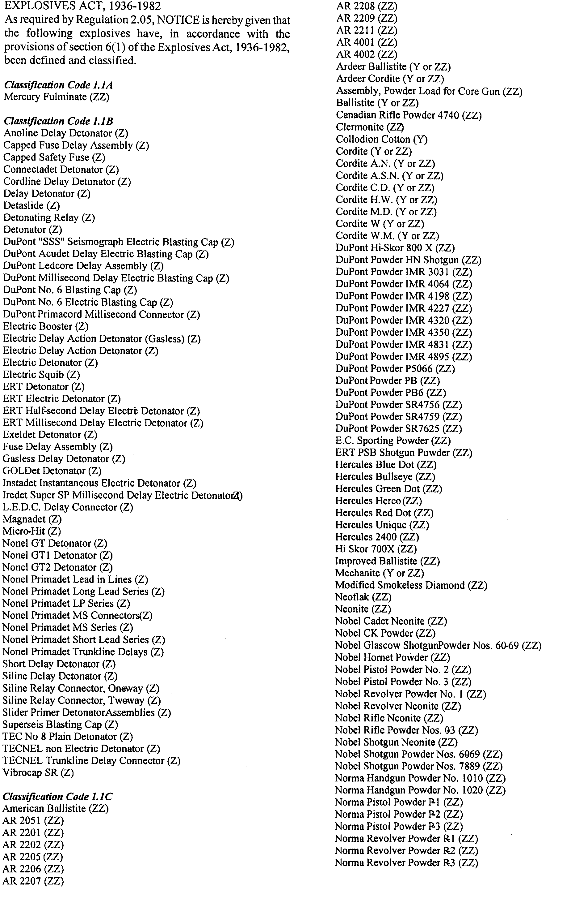
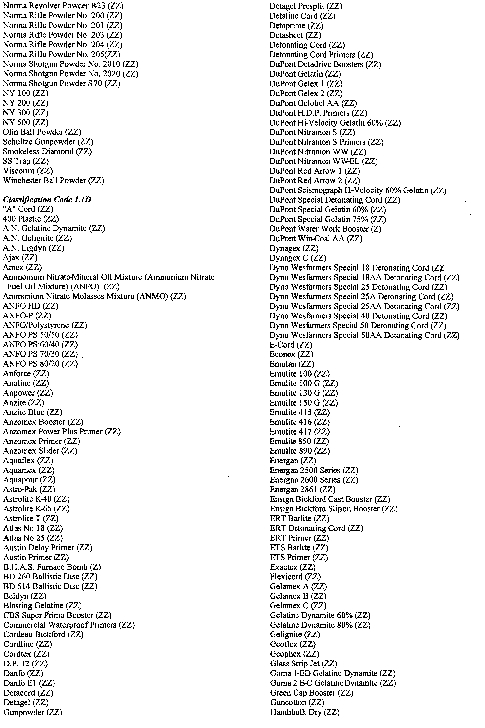
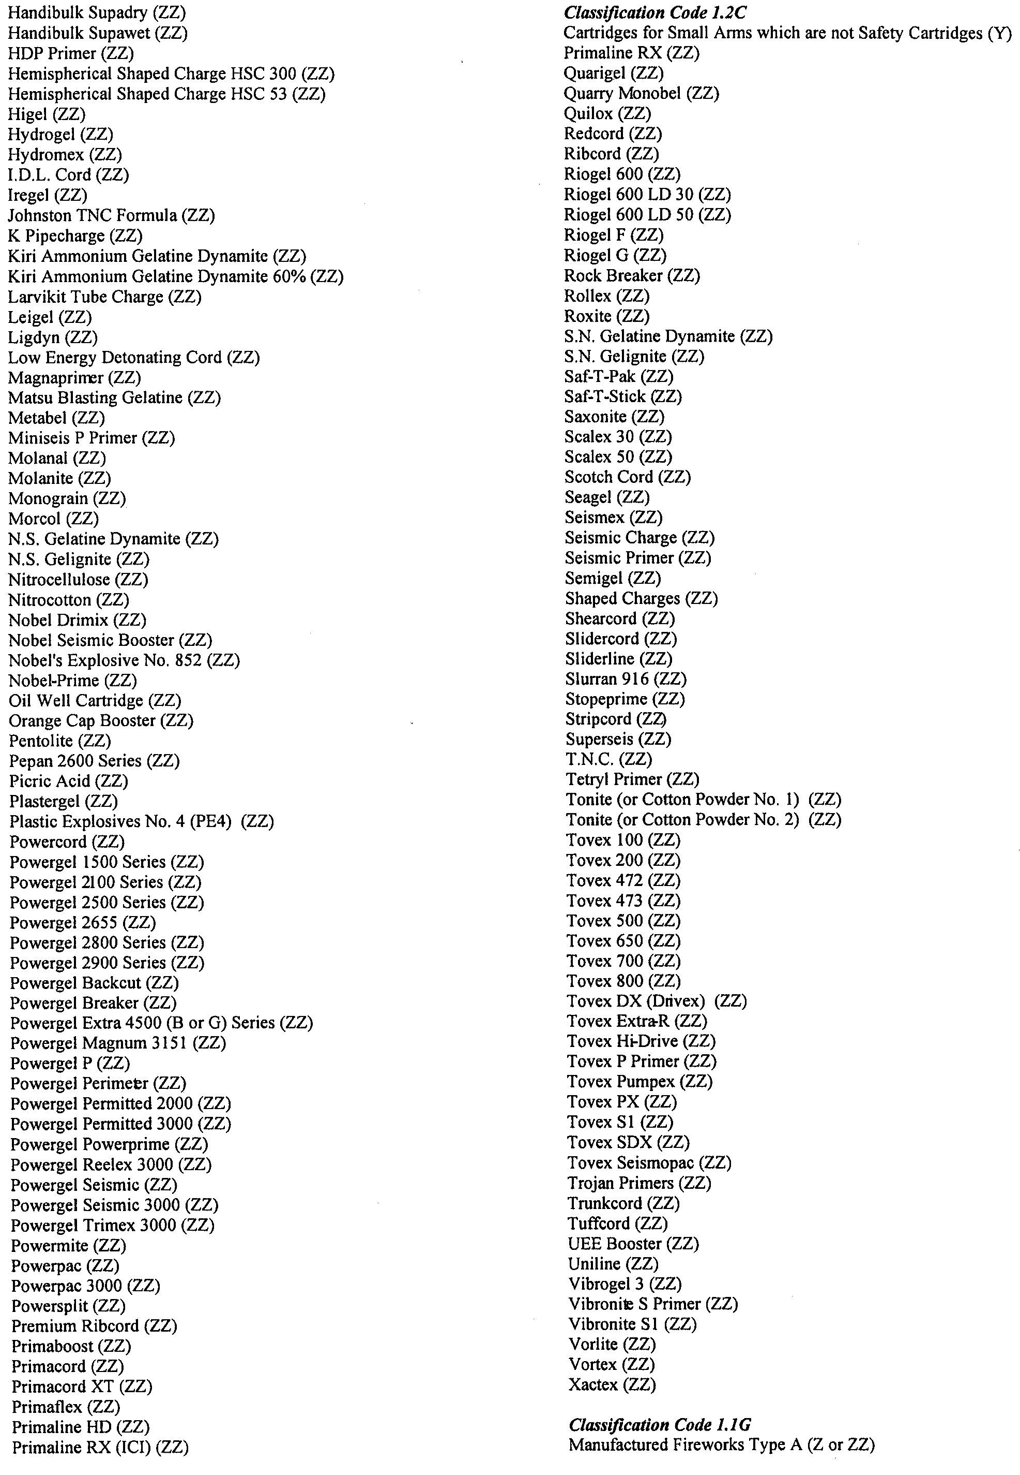
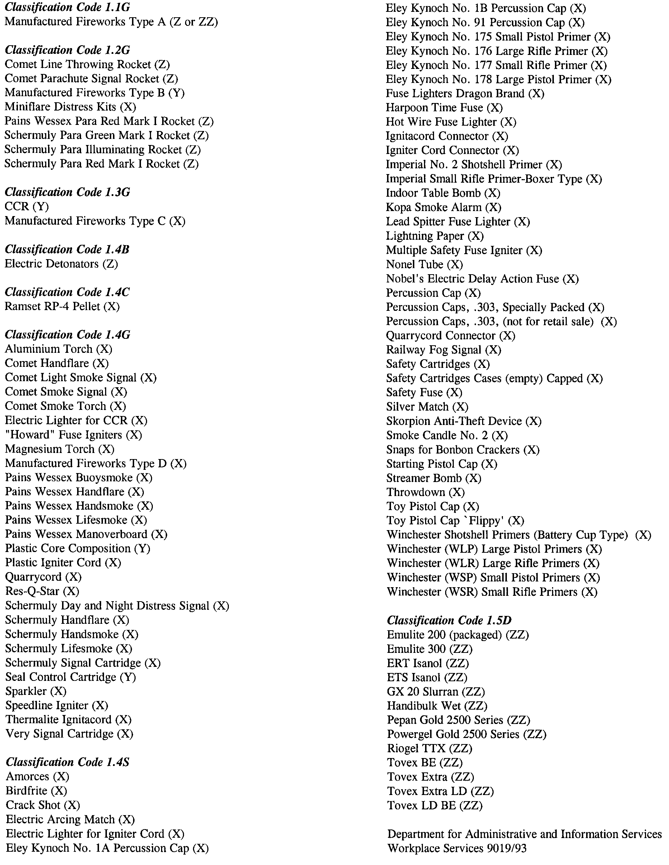

GOVERNMENT GAZETTE ADVERTISEMENT RATES

To apply from 1 July 2004

$  Agents, Ceasing to Act as 35.50  Associations:  Incorporation 18.10  Intention of Incorporation 44.75  Transfer of Properties 44.75  Attorney, Appointment of 35.50  Bailiff’s Sale 44.75  Cemetery Curator Appointed 26.50  Companies:  Alteration to Constitution 35.50  Capital, Increase or Decrease of 44.75  Ceasing to Carry on Business 26.50  Declaration of Dividend 26.50  Incorporation 35.50  Lost Share Certificates:  First Name 26.50  Each Subsequent Name 9.10  Meeting Final 29.75  Meeting Final Regarding Liquidator’s Report on  Conduct of Winding Up (equivalent to ‘Final  Meeting’)  First Name 35.50  Each Subsequent Name 9.10  Notices:  Call 44.75  Change of Name 18.10  Creditors 35.50  Creditors Compromise of Arrangement 35.50  Creditors (extraordinary resolution that ‘the Com-pany be wound up voluntarily and that a liquidator be appointed’) 44.75  Release of Liquidator⎯Application⎯Large Ad. 70.50  ⎯Release Granted 44.75  Receiver and Manager Appointed 41.25  Receiver and Manager Ceasing to Act 35.50  Restored Name 33.50  Petition to Supreme Court for Winding Up 62.00  Summons in Action 53.00  Order of Supreme Court for Winding Up Action 35.50  Register of Interests⎯Section 84 (1) Exempt 80.00  Removal of Office 18.10  Proof of Debts 35.50  Sales of Shares and Forfeiture 35.50  Estates:  Assigned 26.50  Deceased Persons⎯Notice to Creditors, etc. 44.75  Each Subsequent Name 9.10  Deceased Persons⎯Closed Estates 26.50  Each Subsequent Estate 1.15  Probate, Selling of 35.50  Public Trustee, each Estate 9.10 |  | $  Firms:  Ceasing to Carry on Business (each insertion) 23.60  Discontinuance Place of Business 23.60  Land⎯Real Property Act:  Intention to Sell, Notice of 44.75  Lost Certificate of Title Notices 44.75  Cancellation, Notice of (Strata Plan) 44.75  Mortgages:  Caveat Lodgment 18.10  Discharge of 19.00  Foreclosures 18.10  Transfer of 18.10  Sublet 9.10  Leases⎯Application for Transfer (2 insertions) each 9.10  Lost Treasury Receipts (3 insertions) each 26.50  Licensing 53.00  Municipal or District Councils:  Annual Financial Statement⎯Forms 1 and 2 499.00  Electricity Supply⎯Forms 19 and 20 354.00  Default in Payment of Rates:  First Name 70.50  Each Subsequent Name 9.10  Noxious Trade 26.50  Partnership, Dissolution of 26.50  Petitions (small) 18.10  Registered Building Societies (from Registrar-  General) 18.10  Register of Unclaimed Moneys⎯First Name 26.50  Each Subsequent Name 9.10  Registers of Members⎯Three pages and over:  Rate per page (in 8pt) 226.00  Rate per page (in 6pt) 299.00  Sale of Land by Public Auction 45.25  Advertisements 2.50  Advertisements, other than those listed are charged at $2.50 per column line, tabular one-third extra.  Notices by Colleges, Universities, Corporations and District Councils to be charged at $2.50 per line.  Where the notice inserted varies significantly in length from that which is usually published a charge of $2.50 per column line will be applied in lieu of advertisement rates listed.  South Australian Government publications are sold on the condition that they will not be reproduced without prior permission from the Government Printer.
All the above prices include GST

GOVERNMENT GAZETTE NOTICES
ALL private advertisements forwarded for publication in the South Australian Government Gazette must be PAID FOR PRIOR TO INSERTION; and all notices, from whatever source, should be legibly written on one side of the paper only and sent to Government Publishing SA so as to be received no later than 4 p.m. Tuesday preceding the day of publication. Phone 8207 1045 or Fax 8207 1040. E-mail: governmentgazette@saugov.sa.gov.au. Send as attachments in Word format. Please include date the notice is to be published and to whom the notice will be charged. The Government Gazette is available online at: www.governmentgazette.sa.gov.au.

MISCELLANEOUS LEGISLATION AND GOVERNMENT PUBLICATIONS PRICES AS FROM 1 JULY 2004

Acts, Bills, Rules, Parliamentary Papers and Regulations
Pages | Main | Amends | Pages | Main | Amends

1-16 | 2.15 | 0.95 | 497-512 | 30.25 | 29.00
17-32 | 2.90 | 1.80 | 513-528 | 31.25 | 29.90
33-48 | 3.80 | 2.70 | 529-544 | 32.00 | 31.00
49-64 | 4.75 | 3.65 | 545-560 | 33.00 | 32.00
65-80 | 5.60 | 4.60 | 561-576 | 33.75 | 33.00
81-96 | 6.50 | 5.40 | 577-592 | 34.75 | 33.50
97-112 | 7.40 | 6.30 | 593-608 | 35.75 | 34.50
113-128 | 8.30 | 7.25 | 609-624 | 36.50 | 35.50
129-144 | 9.35 | 8.25 | 625-640 | 37.25 | 36.10
145-160 | 10.20 | 9.10 | 641-656 | 38.25 | 37.20
161-176 | 11.20 | 10.00 | 657-672 | 38.75 | 38.00
177-192 | 12.00 | 11.00 | 673-688 | 40.50 | 38.80
193-208 | 13.00 | 11.90 | 689-704 | 41.25 | 39.90
209-224 | 13.80 | 12.70 | 705-720 | 41.75 | 41.00
225-240 | 14.70 | 13.60 | 721-736 | 43.50 | 41.50
241-257 | 15.70 | 14.30 | 737-752 | 44.00 | 42.90
258-272 | 16.60 | 15.30 | 753-768 | 45.00 | 43.40
273-288 | 17.50 | 16.40 | 769-784 | 45.50 | 44.70
289-304 | 18.30 | 17.20 | 785-800 | 46.50 | 45.60
305-320 | 19.30 | 18.20 | 801-816 | 47.25 | 46.00
321-336 | 20.10 | 19.00 | 817-832 | 48.25 | 47.25
337-352 | 21.20 | 20.00 | 833-848 | 49.25 | 48.00
353-368 | 22.00 | 21.00 | 849-864 | 50.00 | 48.80
369-384 | 22.90 | 21.90 | 865-880 | 51.00 | 50.00
385-400 | 23.80 | 22.70 | 881-896 | 51.50 | 50.50
401-416 | 23.70 | 23.50 | 897-912 | 53.00 | 51.50
417-432 | 25.75 | 24.50 | 913-928 | 53.50 | 53.00
433-448 | 26.60 | 25.50 | 929-944 | 54.50 | 53.50
449-464 | 27.50 | 26.25 | 945-960 | 55.50 | 54.00
465-480 | 28.00 | 27.25 | 961-976 | 56.50 | 55.00
481-496 | 29.25 | 28.00 | 977-992 | 57.50 | 56.00

Legislation—Acts, Regulations, etc: $
Subscriptions:
Acts 187.00
All Bills as Laid 447.00
Rules and Regulations 447.00
Parliamentary Papers 447.00
Bound Acts 207.00
Index 103.00
Government Gazette
Copy 4.85
Subscription 247.00
Hansard
Copy 13.50
Subscription—per session (issued weekly) 388.00
Cloth bound—per volume 167.00
Subscription—per session (issued daily) 388.00
Legislation on Disk
Whole Database 2 868.00
Annual Subscription for fortnightly updates 881.00
Individual Act(s) including updates POA
Compendium
Subscriptions:
New Subs 1 700.00
Updates 600.00
(All the above prices include GST)

All Legislation, Government Gazette, Hansard and Legislation on disk are available from:
Counter Sales Service SA, Government Legislation⁺ Outlet
and Mail Orders: Lands Titles Office, 101 Grenfell Street, Adelaide
Phone: 13 23 24 (local call cost), Fax: (08) 8204 1909
Postal: G.P.O. Box 1707, Adelaide, S.A. 5001

Online Shop: www.shop.service.sa.gov.au

Subscriptions and Government Publishing SA
Standing Orders: Box 9, Plaza Level, Riverside Centre, North Terrace, Adelaide, S.A. 5000
Phone: (08) 8207 0908, (08) 8207 0910, Fax: (08) 8207 1040

FISHERIES ACT 1982: SECTION 59
TAKE notice that pursuant to section 59 of the Fisheries Act 1982, Dr Sean Connell from the Faculty of Science, School of Earth and Environmental Sciences, The University of Adelaide, Adelaide, S.A. 5005 (the ‘exemption holder’), or a person acting as his agent, is exempt from the Fisheries (General) Regulations 2000 and the Fisheries (Aquatic Reserves) Regulations 1989, but only insofar as he or she may engage in the collection of marine flora from the waters listed in Schedule 1 using the gear specified in Schedule 2 (the ‘exempted activity’), subject to the conditions set out in Schedule 3, from 19 January 2005 until 4 February 2005, unless varied or revoked earlier.
Schedule 1
The waters of the Aldinga Reef Aquatic Reserve.
Schedule 2
• Dive knife.
• Mesh bags to be attached to holdfasts of seaweed.
Schedule 3
1. The specimens collected pursuant to this notice may be used for scientific research purposes only and must not be sold.
2. Before undertaking the exempted activity, the exemption holder must advise the PIRSA Fisheries Compliance Unit on 1800 065 522, at least 24 hours prior to undertaking the exempted activity, with details of the persons undertaking the exempted activity, proposed locations and the dates on which the collections are to be made.
3. The exemption holder or his agents must not conduct any other fishing activity including recreational fishing whilst undertaking the exempted activity.
4. While engaged in the exempted activity, the exemption holder or his agents must be in possession of a copy of this notice. The exemption holder must also provide each of the agents with a short letter confirming that they may act as his agents. A copy of this notice and such a letter must be produced to a PIRSA Fisheries Compliance Officer if such an officer requests that it be produced.
5. The exemption holder must provide a report in writing detailing the outcomes of the research pursuant to this notice to the Director of Fisheries, (G.P.O. Box 1625, Adelaide, S.A. 5001) within three months of the expiry of this notice.
6. The exemption holder must not contravene or fail to comply with the Fisheries Act 1982, or any regulations made under that Act, except where specifically exempted by this notice.
Dated 14 January 2005.
W. Zacharin, Director of Fisheries

LAND AND BUSINESS (SALE AND CONVEYANCING)
ACT 1994
Exemption
TAKE notice that, pursuant to section 23 (3) of the Land and Business (Sale and Conveyancing) Act 1994, I, Karlene Maywald, Minister for Consumer Affairs, do hereby exempt the person named in Schedule 1 from the application of section 23 (2) of the Act in relation to the purchase of the land specified in Schedule 2.
Schedule 1
Graham Stanley Gray, an employee of Neil Ottoson First National Robe Pty Ltd.
Schedule 2
The whole of the land described in certificate of title register book volume 5434, folio 166, situated at Lot 1, Number 3, Denton Drive, Robe, S.A. 5276.
Dated 20 January 2005.
Signed for and on behalf of the Minister for Consumer Affairs by the Commissioner for Consumer Affairs:
M. Bodycoat, Commissioner

LAND AND BUSINESS (SALE AND CONVEYANCING)
ACT 1994
Exemption
TAKE notice that, pursuant to section 23 (3) of the Land and Business (Sale and Conveyancing) Act 1994, I, Karlene Maywald, Minister for Consumer Affairs, do hereby exempt the persons named in Schedule 1 from the application of section 23 (2) of the Act in relation to the purchase of the land specified in Schedule 2.
Schedule 1
Anthony Charles Earl and Sylvia Helen Toop, an officer and an employee respectively of Toop Real Estate Group Pty Ltd.
Schedule 2
The whole of the land described in certificate of title register book volume 5897, folios 552 and 553, situated at 2-4 Friendship Crescent, Wynn Vale, S.A. 5127.
Dated 20 January 2005.
Signed for and on behalf of the Minister for Consumer Affairs by the Commissioner for Consumer Affairs:
M. Bodycoat, Commissioner

LIQUOR LICENSING ACT 1997 AND GAMING MACHINES ACT 1992
Notice of Application
NOTICE is hereby given, pursuant to section 52 of the Liquor Licensing Act 1997 and section 29 of the Gaming Machines Act 1992, that Suavis Pty Ltd has applied to the Licensing Authority for the transfer of a Hotel Licence and Gaming Machine Licence in respect of premises situated at 126 Port Road, Hindmarsh, S.A. 5007 and known as The Territorian Pub.
The application has been set down for hearing on 22 February 2005 at 9 a.m.
Any person may object to the application by lodging a notice of objection in the prescribed form with the Licensing Authority, and serving a copy of the notice on the applicant at the applicant’s address given above, at least seven days before the hearing date (viz: 14 February 2005).
The applicant’s address for service is c/o Jeff Stevens and Associates, Level 1, 86 Pirie Street, Adelaide, S.A. 5000.
Plans in respect of the premises the subject of the application are open to public inspection without fee at the Office of the Liquor and Gaming Commissioner, 9th Floor, East Wing, 50 Grenfell Street, Adelaide, S.A. 5000. Phone 8226 8410, Fax: 8226 8512. Email: olgc@agd.sa.gov.au.
Dated 7 January 2005.
Applicant

LIQUOR LICENSING ACT 1997
Notice of Application
NOTICE is hereby given, pursuant to section 52 (2) (b) of the Liquor Licensing Act 1997, that Clarke McGee Hotels and Entertainment Pty Ltd have applied to the Licensing Authority for a variation to Extended Trading Authorisation and Entertainment Consent, Alterations, Redefinition, Increase in Capacities and Exemption from the requirement to provide meals in respect of premises situated at Murray Street, Gawler, S.A. 5118 and known as Exchange Hotel.
The application has been set down for hearing on 18 February 2005 at 9 a.m.
Conditions
The following licence conditions are sought:
• Extension of trading area to include the area adjacent to the toilets as shown on the plans lodged.
• Extended trading authorisation and entertainment consent to include the extended trading area.
• Increase in capacities from 70 to 200 persons.
• Variation to Extended Trading Authorisation and Entertain-ment Consent to include the whole of the premises:
Good Friday—midnight to 2 a.m.
New Years Day—2 a.m. to 3 a.m.
Any person may object to the application by lodging a notice of objection in the prescribed form with the Licensing Authority, and serving a copy of the notice on the applicants at the applicants’ address given above, at least seven days before the hearing date (viz: 3 February 2005).
The applicants’ address for service is c/o Jarrod Ryan, Kelly and Co., Santos House, Level 17, 91 King William Street, Adelaide, S.A. 5000.
Plans in respect of the premises the subject of the application are open to public inspection without fee at the Office of the Liquor and Gambling Commissioner, 9th Floor, East Wing, 50 Grenfell Street, Adelaide, S.A. 5000. Phone 8226 8410, Fax:
8226 8512. Email: olgc@agd.sa.gov.au.
Dated 17 January 2005.
Applicants

LIQUOR LICENSING ACT 1997
Notice of Application
NOTICE is hereby given, pursuant to section 52 (2) (b) of the Liquor Licensing Act 1997, that Red Orchid Pty Ltd, c/o Wallmans Lawyers has applied to the Licensing Authority for alterations to the licence in respect of premises situated at 304-306 Glen Osmond Road, Fullarton, S.A. 5063 and known as Red Rock Noodle Bar & Restaurant—Glen Osmond.
The application has been set down for hearing on 18 February 2005 at 9 a.m.
Condition
The following licence condition is sought:
Alterations to licensed premises to include sheltered entry and dining area at rear of premises as per plans lodged with this office.
Any person may object to the application by lodging a notice of objection in the prescribed form with the Licensing Authority, and serving a copy of the notice on the applicant at the applicant’s address given above, at least seven days before the hearing date (viz: 10 February 2005).
The applicant’s address for service is c/o Wallmans Lawyers, 173 Wakefield Street, Adelaide, S.A. 5000. Attention: Ben Allen.
Plans in respect of the premises the subject of the application are open to public inspection without fee at the Office of the Liquor and Gambling Commissioner, 9th Floor, East Wing, 50 Grenfell Street, Adelaide, S.A. 5000. Phone 8226 8410, Fax:
8226 8512. Email: olgc@agd.sa.gov.au.
Dated 10 January 2005.
Applicant

LIQUOR LICENSING ACT 1997
Notice of Application
NOTICE is hereby given, pursuant to section 52 (2) (b) of the Liquor Licensing Act 1997, that Torambre Pty Ltd has applied to the Licensing Authority for a Wholesale Liquor Merchant’s Licence in respect of premises situated at Lot 2, Section 477, Balfour Ogilvy Avenue, Loxton North, S.A. 5333 and to be known as Torambre Wines.
The application has been set down for hearing on 18 February 2005 at 9 a.m.
Any person may object to the application by lodging a notice of objection in the prescribed form with the Licensing Authority, and serving a copy of the notice on the applicant at the applicant’s address given above, at least seven days before the hearing date (viz: 10 February 2005).
The applicant’s address for service is c/o Anthony Saunders, Post Office, Loxton North, S.A. 5333.
Plans in respect of the premises the subject of the application are open to public inspection without fee at the Office of the Liquor and Gambling Commissioner, 9th Floor, East Wing, 50 Grenfell Street, Adelaide, S.A. 5000. Phone 8226 8410, Fax:
8226 8512. Email: olgc@agd.sa.gov.au.
Dated 11 January 2005.
Applicant

LIQUOR LICENSING ACT 1997
Notice of Application
NOTICE is hereby given, pursuant to section 52 (2) (b) of the Liquor Licensing Act 1997, that Strathalbyn Racing Club Inc. has applied to the Licensing Authority for a Club Licence in respect of premises situated at Milne Road, Strathalbyn, S.A. 5255 and to be known as Strathalbyn Racing Club Inc.
The application has been set down for hearing on 18 February 2005 at 9 a.m.
Any person may object to the application by lodging a notice of objection in the prescribed form with the Licensing Authority, and serving a copy of the notice on the applicant at the applicant’s address given above, at least seven days before the hearing date (viz: 10 February 2005).
The applicant’s address for service is c/o Piper Alderman, 167 Flinders Street, Adelaide, S.A. 5000 (Attention: Geoff Forbes/ Ashley Thompson, phone (08) 8205 3333).
Plans in respect of the premises the subject of the application are open to public inspection without fee at the Office of the Liquor and Gambling Commissioner, 9th Floor, East Wing, 50 Grenfell Street, Adelaide, S.A. 5000. Phone 8226 8410, Fax:
8226 8512. Email: olgc@agd.sa.gov.au.
Dated 13 January 2005.
Applicant

LIQUOR LICENSING ACT 1997
Notice of Application
NOTICE is hereby given, pursuant to section 52 (2) (b) of the Liquor Licensing Act 1997, that Casnat Pty Ltd has applied to the Licensing Authority for a Direct Sales Licence in respect of premises situated at 350 Marion Road, North Plympton, S.A. 5037 and to be known as Casnat Pty Ltd.
The application has been set down for hearing on 18 February 2005 at 9 a.m.
Any person may object to the application by lodging a notice of objection in the prescribed form with the Licensing Authority, and serving a copy of the notice on the applicant at the applicant’s address given above, at least seven days before the hearing date (viz: 10 February 2005).
The applicant’s address for service is c/o Trevor McPeake, 350 Marion Road, North Plympton, S.A. 5037.
Plans in respect of the premises the subject of the application are open to public inspection without fee at the Office of the Liquor and Gambling Commissioner, 9th Floor, East Wing, 50 Grenfell Street, Adelaide, S.A. 5000. Phone 8226 8410, Fax:
8226 8512. Email: olgc@agd.sa.gov.au.
Dated 14 January 2005.
Applicant

LIQUOR LICENSING ACT 1997
Notice of Application
NOTICE is hereby given, pursuant to section 52 (2) (b) of the Liquor Licensing Act 1997, that Bejay Becky Garlick and Dean Eric Garlick have applied to the Licensing Authority for the transfer of a Restaurant Licence in respect of premises situated at Shops 6 and 7, Topham Mall, Waymouth Street, Adelaide, S.A. 5000 and known as Cafe Elate.
The application has been set down for hearing on 21 February 2005 at 9 a.m.
Any person may object to the application by lodging a notice of objection in the prescribed form with the Licensing Authority, and serving a copy of the notice on the applicants at the applicants’ address given above, at least seven days before the hearing date (viz: 13 February 2005).
The applicants’ address for service is c/o Dean Eric Garlick, P.O. Box 795, Blackwood, S.A. 5051.
Plans in respect of the premises the subject of the application are open to public inspection without fee at the Office of the Liquor and Gambling Commissioner, 9th Floor, East Wing, 50 Grenfell Street, Adelaide, S.A. 5000. Phone 8226 8410, Fax:
8226 8512. Email: olgc@agd.sa.gov.au.
Dated 7 January 2005.
Applicants

LIQUOR LICENSING ACT 1997
Notice of Application
NOTICE is hereby given, pursuant to section 52 (2) (b) of the Liquor Licensing Act 1997, that Jeffrey Reed Hughes has applied to the Licensing Authority for a Restaurant Licence with extended trading authorisation and section 34 (1) (c) authorisation in respect of premises situated at Adelaide Festival Centre, King William Road, Adelaide, S.A. 5000 and to be known as Elder Park Café.
The application has been set down for hearing on 18 February 2005 at 9 a.m.
Conditions
The following licence conditions are sought:
• Approval under section 34 (1) (c) to sell liquor for consumption on the licensed premises by persons seated at a table or attending a function at which food is provided.
• Extended trading authorisation is sought for the following hours: Sunday—8 a.m. to 11 a.m. and 8 p.m. to midnight.
Any person may object to the application by lodging a notice of objection in the prescribed form with the Licensing Authority, and serving a copy of the notice on the applicant at the applicant’s address given above, at least seven days before the hearing date (viz: 10 February 2005).
The applicant’s address for service is c/o Wallmans Lawyers, 173 Wakefield Street, Adelaide, S.A. 5000. Attention: Ben Allen.
Plans in respect of the premises the subject of the application are open to public inspection without fee at the Office of the Liquor and Gambling Commissioner, 9th Floor, East Wing, 50 Grenfell Street, Adelaide, S.A. 5000. Phone 8226 8410, Fax:
8226 8512. Email: olgc@agd.sa.gov.au.
Dated 14 January 2005.
Applicant

LIQUOR LICENSING ACT 1997
Notice of Application
NOTICE is hereby given, pursuant to section 52 (2) (b) of the Liquor Licensing Act 1997, that Prospect Petanque Club Inc. has applied to the Licensing Authority for a variation to Trading Hours in respect of premises situated at Buchanan Street, Nailsworth, S.A. 5083 and known as Prospect Petanque Club Inc.
The application has been set down for hearing on 21 February 2005 at 9.30 a.m.
Condition
The following licence condition is sought:
• Variation to trading hours to include: Friday—11 a.m. to 10 p.m.
Any person may object to the application by lodging a notice of objection in the prescribed form with the Licensing Authority, and serving a copy of the notice on the applicant at the applicant’s address given above, at least seven days before the hearing date (viz: 13 February 2005).
The applicant’s address for service is c/o Mike Mulvihill, 13 Hutton Street, Vale Park, S.A. 5081.
Plans in respect of the premises the subject of the application are open to public inspection without fee at the Office of the Liquor and Gambling Commissioner, 9th Floor, East Wing, 50 Grenfell Street, Adelaide, S.A. 5000. Phone 8226 8410, Fax:
8226 8512. Email: olgc@agd.sa.gov.au.
Dated 12 January 2005.
Applicant

LIQUOR LICENSING ACT 1997
Notice of Application
NOTICE is hereby given, pursuant to section 52 (2) (b) of the Liquor Licensing Act 1997, that Globcorp Pty Ltd has applied to the Licensing Authority for the transfer of a Special Circumstances Licence in respect of premises situated at 273 Rundle Street, Adelaide, S.A. 5000 and known as Bin 273.
The application has been set down for hearing on 23 February 2005 at 9 a.m.
Any person may object to the application by lodging a notice of objection in the prescribed form with the Licensing Authority, and serving a copy of the notice on the applicant at the applicant’s address given above, at least seven days before the hearing date (viz: 15 February 2005).
The applicant’s address for service is c/o David Watts and Associates, 1 Cator Street, Glenside, S.A. 5065.
Plans in respect of the premises the subject of the application are open to public inspection without fee at the Office of the Liquor and Gambling Commissioner, 9th Floor, East Wing, 50 Grenfell Street, Adelaide, S.A. 5000. Phone 8226 8410, Fax:
8226 8512. Email: olgc@agd.sa.gov.au.
Dated 14 January 2005.
Applicant

MINING ACT 1971
NOTICE is hereby given in accordance with section 28 (5) of the Mining Act 1971, that the Minister for Mineral Resources Development proposes to grant an Exploration Licence over the undermentioned area:
Applicant: Hiltaba Gold Pty Ltd
Location: Carnding area⎯Approximately 20 km west-north-west of Tarcoola.
Term: 1 year
Area in km²: 268 (Appproximately)
Ref.: 2004/00905
Plan and co-ordinates can be found on the PIRSA Sarig website: http://www.minerals.pir.sa.gov.au/sarig or by phoning Mineral Tenements on (08) 8463 3103.
Dated 20 January 2005.
H. Tyrteos, Mining Registrar

MINING ACT 1971
PURSUANT to section 15 (5) of the Mining Act 1971 (‘Act’), I advise that the Minerals and Energy Division of Primary Industries and Resources SA, will be undertaking geoscientific investigations over an area of 153 km² in the Mann Region. The investigations commenced on 12 December 2003 and the expected completion date has been extended to 11 December 2005.
Pursuant to section 15 (7) of the Act, I hereby advise that no applications for mining tenements will be received and or considered in respect of the land described above until the completion date of 11 December 2005.
Please note that the completion date may be extended by further notice in the Gazette. Copies of the plan are available by phoning the Mining Registrar on telephone (08) 8463 3097.
Reference: T02422.
H. Tyrteos, Mining Registrar

MINING ACT 1971
PURSUANT to section 15 (5) of the Mining Act 1971 (‘Act’), I advise that the Minerals and Energy Division of Primary Industries and Resources SA, will be undertaking geoscientific investigations over an area of 129 km² in the Mann, Woodroffe Region. The investigations commenced on 12 December 2003 and the expected completion date has been extended to 11 December 2005.
Pursuant to section 15 (7) of the Act, I hereby advise that no applications for mining tenements will be received and or considered in respect of the land described above until the completion date of 11 December 2005.
Please note that the completion date may be extended by further notice in the Gazette. Copies of the plan are available by phoning the Mining Registrar on telephone (08) 8463 3097.
Reference: T02423.
H. Tyrteos, Mining Registrar

LOCAL GOVERNMENT ACT 1999
Regulations by the Local Government Superannuation Board
THE Local Government Superannuation Board makes the follow-ing regulations pursuant to Part 2 of Schedule 1 of the Local Government Act 1999.
The rules constituting the Local Government Superannuation Scheme known as Local Super are amended with effect from 1 January 2005 as follows:
1. Rule 2 (a) is amended by inserting a definition of ‘Term Allocated Pension’ immediately after the definition of ‘Sustain-able Shares Portfolio’ as follows:
‘Term Allocated Pension means a pension which satisfies the pension standards set out under Regulation 1.06 (8) of the Superannuation Industry (Supervision) Regulations 1994.’.
2. Rule 75 is amended by:
2.1 inserting a new Rule 75 (b) (iv) immediately after Rule 75 (b) (iii) as follows:
‘(iv) a Term Allocated Pension;’;
2.2 inserting a new Rule 75 (da) immediately after Rule 75 (d) as follows:
‘(da) A Member who is entitled to a Term Allocated Pension may elect by notice in writing to the Board, in a form approved by the Board, to have the Member’s pension payments made by cancellation of Units in one or more of the Investment Portfolios to which the Member’s Term Allocated Pension benefit is applied in the proportion selected by the Member. The Board must give effect to a Member’s election made pursuant to this Rule 75 (da) as soon as is reasonably prac-ticable after written notice of the election has been received. If a Member does not make an election pursuant to this Rule 75 (da) or if at any time the Board is unable to implement the Member’s election the pension payments will be made by cancellation of Units in one or more of the Investment Portfolios to which the Member’s Term Allocated Pension Benefit is applied in proportions determined by the Board.’.
3. Rule 87 is amended by:
3.1 inserting the following words immediately after the words ‘Allocated Pension’ in Rule 87 (a) (i):
‘or Term Allocated Pension’;
3.2 deleting Rule 87 (e) (ii) and replacing it with the following:
‘(ii) a pension (other than an Allocated Pension or Term Allocated Pension); or’.
Dated 18 January 2005.
C. Parkin, Executive Officer

NATIONAL ELECTRICITY (SOUTH AUSTRALIA) ACT 1996
Notice under Section 6 (2) of the National Electricity Law and National Electricity Code
Publication date of the Statement of Opportunities
NOTICE is hereby given pursuant to section 6 (2) of the National Electricity Law, which forms the Schedule to the National Electricity (South Australia) Act 1996 and clause 8.3.9 (d) of the National Electricity Code approved under section 6 of the National Electricity Law, that a new Part 10, Statement of Opportunities, is inserted in Chapter 8 of the National Electricity Code. These amendments to the National Electricity Code commence on 20 January 2005.
As required by clause 8.3.9 (d) of the National Electricity Code, a copy of the ACCC’s letter approving a minor variation of the National Electricity Code authorisations dated 12 January 2005 is set out below.
The amendments referred to above and a copy of the ACCC’s letter dated 12 January 2005 can be viewed on the Internet website of National Electricity Code Administrator Limited (ACN 073 942 775) (‘NECA’) at www.neca.com.au under ‘The Code—Gazette notices’ section of that website.
The National Electricity Code can be viewed on the NECA Internet website at www.neca.com.au and at the offices of NECA and National Electricity Market Management Company Limited (ACN 072 010 327). A list of addresses where the Code can be viewed is available on the NECA website.
Dated 20 January 2005.

ACCC Letter of Authorisation
12 January 2005
John Eastham
Director
National Electricity Code Administrator
Level 5, 41 Currie Street
ADELAIDE, S.A. 5000
Dear John
Determination—Minor variation of the National Electricity Code authorisations: publication date of the Statement of Opportunities
On 17 December 2004, the Australian Competition and Consumer Commission (ACCC) received an application under section 91A of the Trade Practices Act 1974 for minor variations to the existing authorisations (Nos A40074, A40075, A40076, as amended) in respect of the National Electricity Code.
Please find attached a copy of the ACCC’s determination, outlining the ACCC’s analysis and views in respect of the minor variation. The ACCC has approved the minor variation of the authorisations.
A person dissatisfied with the determination may apply to the Australian Competition Tribunal for its review. A copy of this letter together with the determination will be placed on the Public Register kept by the ACCC.
If you have any queries or require further information please call Eloise Campbell on (03) 9290 1968.
Yours sincerely,
S. Roberts, General Manager, Regulatory Affairs—Electricity.

IMPORTANT NOTICE
Government Gazette Publication

********************

Australia Day Holiday Week Publishing Information

Government Gazette Notices
Publishing Date: Thursday, 27 January 2005

Closing date for notices for publication will be
4 p.m. Monday, 24 January 2005

********************

OPAL MINING ACT 1995
Declaration of Exclusion Zone
PURSUANT to Part 5 of the Opal Mining Act 1995 (‘the Act’), I declare the following area, being a portion of that which was declared by notice in the Government Gazette on 24 July 1997 and renewed by notice published in the Government Gazette on 20 July 1999, shall be renewed as an Exclusion Zone. With reference to the Declaration of Exclusion Zone, which appeared on page 442 of the Government Gazette, dated 20 January 2000, I advise that the description and accompanying plan of the said Exclusion Zone should have appeared as follows:
Description of Area
Commencing at a point being the intersection of latitude 26°57′S and longitude 134°01′E, thence east to longitude 134°10′E, south to latitude 26°58′S, east to longitude 134°17′E, south to latitude 27°24′S, east to longitude 134°21′E, south to latitude 27°27′S, west to longitude 133°52′E, north to latitude 27°13′S, west to longitude 133°46′E, north to latitude 26°58′S, east to longitude 134°01′E, and north to the point of commencement, all the within latitudes and longitudes being geodetic and expressed in terms of the Australian Geodetic Datum as defined on p. 4984 of Commonwealth Gazette number 84 dated 6 October 1966 (AGD66).
Area: 2 549 km² approximately.
Terms
This ‘exclusion zone’ is subject to the following:
1. Nothing in this notice is intended to authorise any operations, which would have an effect on native title or have any effect on the operation of the provision of Part 7 of the Act within the area of the exclusion zone.
2. Exploration Licences for minerals other than opal may be granted within the area of the exclusion zone, but no other tenements under the Mining Act 1971, may be issued to any party other than the exploration licensee.
3. Pursuant to section 79 of the Act, holders of Precious Stones Prospecting Permits are exempted from the obligation to comply with sections 92 and 93 (2) (a) of the Act for the carrying out of prospecting and mining operations within the exclusion zone.
4. This exclusion zone will be current for a term of five years from 24 January 2005 to 23 January 2010 and, at the Minister’s discretion, may be renewed and/or varied for a further term.
Plan
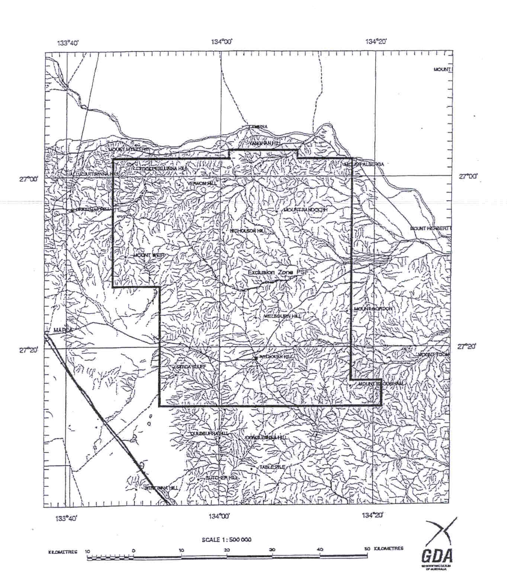
H. Tyrteos, Mining Registrar

PETROLEUM ACT 2000
Suspension of Exploration Licence PEL 114
PURSUANT to section 90 of the Petroleum Act 2000, notice is hereby given that the abovementioned Exploration Licence has been suspended under the provisions of the Petroleum Act 2000, from and including 21 January 2005 to 20 March 2005, pursuant to delegated powers dated 28 March 2002, Gazetted 11 April 2002, page 1573.
The expiry date of Exploration Licence PEL 114 is now determined to be 21 July 2008.
Dated 14 January 2005.
B. A. Goldstein, Director Petroleum
Minerals and Energy Division
Primary Industries and Resources SA
Delegate of the Minister for Mineral
Resources Development

RADIATION PROTECTION AND CONTROL ACT 1982
Notice by Delegate of the Minister for Environment and Conservation
PURSUANT to section 44 of the Radiation Protection and Control Act 1982, I, Keith Baldry Director of the Radiation Protection Division of the Environment Protection Authority, being a person to whom the powers of the Minister under that section have been delegated under the Act, exempt the specified employer, Aquaspex Water Testing Products from the requirements of Regulation 18
of the Radiation Protection and Control (Ionising Radiation) Regulations 2000, subject to the following conditions:
(1) the radiation worker handles only unsealed radioactive thorium-232 in Type C premises; and
(2) the specified employer issues a personal monitoring device to a radiation worker if directed in writing by the Radiation Protection Division of the Environment Protection Authority to do so.
Dated 17 January 2005.
K. Baldry, Delegate of the Minister for Environment and Conservation

ROADS (OPENING AND CLOSING) ACT 1991:
SECTION 24
NOTICE OF CONFIRMATION OF ROAD
PROCESS ORDER
Walkway—Magor Street/Sullivan Road, Elizabeth Park
Deposited Plan 64669
BY Road Process Order made on 16 March 2004, the City of Playford ordered that:
1. The whole of the walkway between Magor Street and Sullivan Road adjoining allotments 477 and 488 in Deposited Plan 6709 more particularly lettered ‘A’ and ‘B’ in Preliminary Plan No. 03/0090 be closed.
2. The whole of the land subject to closure lettered ‘A’ be transferred to Denis Keith Vickery in accordance with agreement for transfer dated 14 November 2003 entered into between the City of Playford and D. K. Vickery.
3. The whole of the land subject to closure lettered ‘B’ be transferred to the South Australian Housing Trust in accordance with agreement for transfer dated 16 March 2004 entered into between the City of Playford and South Australian Housing Trust.
. 4. The following easements are granted over portion of the land subject to that closure:
Grant to the Distribution Lessor Corporation an easement for underground electricity supply purposes.
Grant to the South Australian Water Corporation an easement for sewerage purposes.
On 21 October 2004 that order was confirmed by the Minister for Administrative Services conditionally on approval and deposit of the survey plan by the Registrar-General. The condition has now been fulfilled.
Pursuant to section 24 (5) of the Roads (Opening and Closing) Act 1991, notice of the order referred to above and its confirmation is hereby given.
Dated 20 January 2005.
P. M. Kentish, Surveyor-General

SOUTH AUSTRALIAN COMMUNITY HOUSING AUTHORITY
Election Results
PURSUANT to Regulation 15, Section 2 of the South Australian Co-operative and Community Housing (Electoral Procedures) Regulations 1992, I hereby give notice of the election of two housing co-operative representatives to the Board of the South Australian Community Housing Authority.
At the close of nominations at 10 a.m. on Wednesday, 17 November 2004 a total of four nominations were received for the two vacancies. A ballot was required and opened on 1 December 2004 and closed at 10 a.m. on Monday, 20 December 2004.
The result of the ballot is as follows:
Candidate |  | No.  of votes
Heanes, Debra 29
Gow, Graeme 39 * Elected
McCarthy, Elizabeth 60 * Elected
Jones, Denis 20

Total 148

Therefore I hereby give notice that Elizabeth McCarthy and Graeme Gow have been elected to the Board of the South Australian Community Housing Authority for a term beginning upon the date of publication in the South Australian Government Gazette and expiring on 30 June 2006.
Dated 19 January 2005.
J. Sundberg, Acting General Manager

WATER MAINS AND SEWERS

Office of the South Australian Water Corporation
Adelaide, 20 January 2005

WATER MAINS LAID

Notice is hereby given that the following main pipes or parts of main pipes have been laid down by the South Australian Water Corporation in or near the undermentioned water districts and are now available for a constant supply of water to adjacent land.

ADELAIDE WATER DISTRICT

CITY OF PLAYFORD
Harradine Court, Angle Vale. p186

CITY OF TEA TREE GULLY
Xavier Street, Highbury. p188
Beckman Avenue, Highbury. p188
Nobel Court, Highbury. p188

CITY OF WEST TORRENS
Lew Street, Adelaide Airport. p211

BEACHPORT WATER DISTRICT

WATTLE RANGE COUNCIL
North West Terrace, Beachport. p197

BEETALOO COUNTRY LANDS WATER DISTRICT

DISTRICT COUNCIL OF THE COPPER COAST
In and across Kadina Road, Wallaroo. p216 and 217
Easements in sections 768 and 779, hundred of Wallaroo. p216 and 217
Easements in section 731, hundred of Wallaroo. p216
In and across Sharples Road, Wallaroo. p216
Across and in Skinner Road, East Moonta. p237 and 238
Collins Road, East Moonta. p238

CLINTON WATER DISTRICT

DISTRICT COUNCIL OF YORKE PENINSULA
Yoolamardy Parade, Clinton. p228

COOBOWIE WATER DISTRICT

DISTRICT COUNCIL OF YORKE PENINSULA
Parrington Street, Coobowie. This main is available on the north side by application only. p235
Public road east of lot 344 in LTRO FP 195766, Coobowie. p235

FARRELL FLAT WATER DISTRICT

REGIONAL COUNCIL OF GOYDER
Levi Street, Farrell Flat. p203

KINGSTON SE WATER DISTRICT

KINGSTON DISTRICT COUNCIL
Marine Parade, Kingston S.E. This main is available on the west side by application only. p198

MOONTA WATER DISTRICT

DISTRICT COUNCIL OF THE COPPER COAST
Carlisle Street, Moonta Bay. p234

MOUNT GAMBIER WATER DISTRICT

CITY OF MOUNT GAMBIER
Mitchell Street, Mount Gambier. p208
Percy Street, Mount Gambier. p208

PORT AUGUSTA WATER DISTRICT

CITY OF PORT AUGUSTA
Finlay Street, Stirling North. p229
Woolundunga Avenue, Stirling North. This main is available on the east side by application only. p229

PORT GERMEIN WATER DISTRICT

DISTRICT COUNCIL OF MOUNT REMARKABLE
First Street, Port Germein. p202
West Terrace, Port Germein. p202

PORT VICTOR WATER DISTRICT

CITY OF VICTOR HARBOR
Neighbour Street, Encounter Bay. p187
White Close, Encounter Bay. p187

RENMARK WATER DISTRICT

RENMARK PARINGA COUNCIL
Orchard Drive, Renmark. p251
Easements in lot 2002 in LTRO DP 65254, Orchard Drive, Renmark. p251 and 252
Across Jane Eliza Avenue, Renmark. p251
Easements in lot 2003 in LTRO DP 65254, Jane Eliza Avenue, Renmark. p251
Easements in lot 2001 in LTRO DP 56295, Ian Showell Drive, Renmark. p252

STREAKY BAY COUNTRY LANDS WATER DISTRICT

DISTRICT COUNCIL OF STREAKY BAY
Easement in lot 51 in LTRO DP 61097, Flinders Highway, Streaky Bay. This main is available on application only. p184 and 185

TOD RIVER COUNTRY LANDS WATER DISTRICT

DISTRICT COUNCIL OF STREAKY BAY
Streaky Bay Highway, Poochera, Chandada, Piednippie and Streaky Bay. This main is available on application only. p1-165
In and across Flinders Highway, Streaky Bay. This main is available on application only. p165-181
Easement in lot 52 in LTRO DP 61097, Flinders Highway, Streaky Bay. This main is available on application only. p182-184

TWO WELLS WATER DISTRICT

DISTRICT COUNCIL OF MALLALA
St George Boulevard, Lewiston. p189 and 191
Sophia Court, Lewiston. p189 and 190
Constance Court, Lewiston. p191 and 192

WARREN COUNTRY LANDS WATER DISTRICT

BAROSSA COUNCIL
Sturt Highway, Nuriootpa. p194 and 195

WHYALLA WATER DISTRICT

THE CORPORATION OF THE CITY OF WHYALLA
Dow Street, Whyalla Norrie. p201

WOOL BAY WATER DISTRICT

DISTRICT COUNCIL OF YORKE PENINSULA
Esplanade, Wool Bay. p236

YORKETOWN WATER DISTRICT

DISTRICT COUNCIL OF YORKE PENINSULA
Yorke Terrace, Yorketown. This main is available on the west side by application only. p204

WATER MAINS ABANDONED

Notice is hereby given that the undermentioned water mains have been abandoned by the South Australian Water Corporation.

ADELAIDE WATER DISTRICT

CITY OF WEST TORRENS
Lew Street, Adelaide Airport. p211

BEETALOO COUNTRY LANDS WATER DISTRICT

DISTRICT COUNCIL OF THE COPPER COAST
Kadina Road, Wallaroo. p216
Skinner Road, East Moonta. p237 and 238

MOUNT GAMBIER WATER DISTRICT

CITY OF MOUNT GAMBIER
Mitchell Street, Mount Gambier. p208
Percy Street, Mount Gambier. p208

WATER MAINS LAID

Notice is hereby given that the undermentioned water mains have been laid down by the South Australian Water Corporation and are not available for a constant supply of water to adjacent land.

ADELAIDE WATER DISTRICT

CAMPBELLTOWN CITY COUNCIL
Waterworks land (lot 78 in LTRO FP 130432), Rostrevor. p212-215
Easements in lot 2 in LTRO DP 63796, Orbona Street, Rostrevor. p212-215

CITY OF MARION
Waterworks land (lot 4 in LTRO FP 997), Clubhouse Road, Seacliff Park. p206 and 207
Waterworks land (lot 5 in LTRO FP 9375), Wandana Street, Seaview Downs. p241-247

CITY OF MITCHAM
Waterworks land (lots 3-6 in LTRO DP 3095), Sheoak Road, Belair. p218-220
Across Sheoak Road, Belair. p218 and 219

BEETALOO COUNTRY LANDS WATER DISTRICT

DISTRICT COUNCIL OF THE COPPER COAST
Waterworks land (lot 1 in LTRO FP 1527), Moonta-Thrington Road, Boors Plain. p239
Across Moonta-Thrington Road, Boors Plain. p240

WARREN COUNTRY LANDS WATER DISTRICT

LIGHT REGIONAL COUNCIL
Across Seven Hills Road, St Johns. p199 and 200
Across Pipeline Road, Ebenezer. p230-232
Waterworks land (lot 30 in LTRO DP 47628), Pipeline Road, Ebenezer. p230-232

CORRECTIONS

Correction to notices in “Government Gazette” of 9 December 2004.

“WATER MAINS LAID”

“Notice is hereby given that the following main pipes or parts of main pipes have been laid down by the South Australian Water Corporation in or near the undermentioned water districts and are now available for a constant supply of water to adjacent land.”

“PORT VINCENT WATER DISTRICT”

“DISTRICT COUNCIL OF YORKE PENINSULA”

“In and across Ventnor Street, Port Vincent. This main is available to lot 106 in LTRO DP 19127, lot 202 in LTRO DP 62958, and lot 162 in LTRO DP 60298 by application only. p46 and 47”.

For “This main is available to lot 106 in LTRO DP 19127, lot 202 in LTRO DP 62958, and lot 162 in LTRO DP 60298 by application only.” read “This main is available on the south side by application only from chainage 302.4 m to chainage 323.25 m, and for the last 2 metres by application only.”

“Cameron Street, Port Vincent. This main is available to lot 106 in LTRO DP 19127 by application only. p47”

For “This main is available to lot 106 in LTRO DP 19127 by application only.” read “This main is available on application only for the last 3.5 m.”

SEWERS LAID

Notice is hereby given that the following sewers have been laid down by the South Australian Water Corporation in the under-mentioned drainage areas and are now available for house connections.

ADELAIDE DRAINAGE AREA

CITY OF BURNSIDE
Hood Street, Linden Park. FB 1131 p13
Dunstan Avenue, Kensington Park. FB 1131 p14
Glynburn Road, Hazelwood Park. FB 1132 p57

CAMPBELLTOWN CITY COUNCIL
Leabrook Drive, Rostrevor. FB 1132 p56

CITY OF MARION
Branksome Terrace, Dover Gardens. FB 1128 p51

CITY OF NORWOOD PAYNEHAM & ST PETERS
Caleb Street, Marden. FB 1123 p27
Sullivan Street, Firle. FB 1131 p15

CITY OF PLAYFORD
Wiley Street, Elizabeth South. FB 1128 p55

CITY OF PORT ADELAIDE ENFIELD
Moresby Avenue, Broadview. FB 1131 p11
Lae Avenue, Broadview. FB 1131 p12

CITY OF SALISBURY
Coonong Avenue, Pooraka. FB 1128 p56

CITY OF TEA TREE GULLY
Xavier Street, Highbury. FB 1132 p6 and 7
Nobel Court, Highbury. FB 1132 p6 and 7
Easements in lot 10 in LTRO DP 1388, and lot 2 in LTRO CP 22254, Rednall Street, Tea Tree Gully. FB 1128 p53
Bowmore Court, Greenwith. FB 1128 p54
Easement in reserve (lot 88), Target Hill Road, Greenwith. FB 1128 p54
Across and in Green Valley Drive, Greenwith and Salisbury Heights. FB 1128 p54
Easement in lot 2, Target Hill Road, Salisbury Heights. FB 1128 p54

CORPORATION OF THE TOWN OF WALKERVILLE
Waterman Street, Vale Park. FB 1128 p58

ALDINGA DRAINAGE AREA

CITY OF ONKAPARINGA
Thomas Street, Aldinga Beach. FB 1133 p57 and 58
Whinnerah Avenue, Aldinga Beach. FB 1133 p57 and 58
Easements in lot 8, Whinnerah Avenue, and lots 5 and 4, Ocean Street, Aldinga Beach. FB 1133 p57 and 58

NARACOORTE COUNTRY DRAINAGE AREA

NARACOORTE LUCINDALE COUNCIL
Wheeler Court, Naracoorte. FB 1114 p33

VICTOR HARBOR COUNTRY DRAINAGE AREA

CITY OF VICTOR HARBOR
Neighbour Street, Encounter Bay. FB 1133 p59 and 60
White Close, Encounter Bay. FB 1133 p59 and 60
Easements in reserve (lot 76), and lots 64-73, White Close, Encounter Bay. FB 1133 p59 and 60
Leworthy Street, Victor Harbor. FB 1128 p50
Sinclair Street, Hayborough. FB 1128 p57

WHYALLA COUNTRY DRAINAGE AREA

THE CORPORATION OF THE CITY OF WHYALLA
Public utility reserve (lot 6926), south of lots 71 and 70, Miller Street, Whyalla Norrie. FB 1131 p9
Easement in lots 75-73, Dow Street, Whyalla Norrie. FB 1131 p10

SEWERS ABANDONED

Notice is hereby given that the undermentioned sewers have been abandoned by the South Australian Water Corporation.

ADELAIDE DRAINAGE AREA

CAMPBELLTOWN CITY COUNCIL
Leabrook Drive, Rostrevor. FB 1132 p56

CITY OF MITCHAM
Southern Avenue, St Marys. FB 1131 p29
Across and in Sturt Avenue, Hawthorndene—100 mm temporary pumping main. FB 1131 p35

SEWERS LAID

Notice is hereby given that the undermentioned sewers have been laid down by the South Australian Water Corporation and are not available for house connections.

ADELAIDE DRAINAGE AREA

CITY OF PORT ADELAIDE ENFIELD
Across Wandilla Street, Largs North. FB 1131 p18
Sewerage land (section 573, hundred of Port Adelaide), Wandilla Street, Largs North. FB 1131 p18

A. Howe, Chief Executive Officer, South Australian Water Corporation

South Australia
Teachers Registration and Standards Act (Commencement) Proclamation 2005
1—Short title
This proclamation may be cited as the Teachers Registration and Standards Act (Commencement) Proclamation 2005.
2—Commencement of certain provisions of Act
Parts 1 and 3 and section 61 of the Teachers Registration and Standards Act 2004 (No 57 of 2004) will come into operation on 20 January 2005.
Made by the Governor’s Deputy
with the advice and consent of the Executive Council
on 20 January 2005
MECS05/001CS

South Australia
Statutes Amendment (Misuse of Motor Vehicles) Act (Commencement) Proclamation 2005
1—Short title
This proclamation may be cited as the Statutes Amendment (Misuse of Motor Vehicles) Act (Commencement) Proclamation 2005.
2—Commencement of Act
(1) The Statutes Amendment (Misuse of Motor Vehicles) Act 2004 (No 56 of 2004) (the Amendment Act), except for section 7, will come into operation on 7 February 2005.
(2) Section 7 of the Amendment Act will come into operation on 2 May 2005.
Made by the Governor’s Deputy
with the advice and consent of the Executive Council
on 20 January 2005
AGO 0171/04 CS

South Australia
Environment Protection (Fees and Levy) Variation Regulations 2005
under the Environment Protection Act 1993

Contents
Part 1—Preliminary
1 Short title
2 Commencement
3 Variation provisions
Part 2—Variation of Environment Protection (Fees and Levy) Regulations 1994
4 Variation of regulation 14—Waste depot levy (section 113)
5 Variation of regulation 15—Reporting of mass or volume of waste received at depots

Part 1—Preliminary
1—Short title
These regulations may be cited as the Environment Protection (Fees and Levy) Variation Regulations 2005.
2—Commencement
These regulations will come into operation on 1 February 2005.
3—Variation provisions
In these regulations, a provision under a heading referring to the variation of specified regulations varies the regulations so specified.
Part 2—Variation of Environment Protection (Fees and Levy) Regulations 1994
4—Variation of regulation 14—Waste depot levy (section 113)
Regulation 14(1)(a)—after subparagraph (i) insert:
(ia) if the depot is situated in Metropolitan Adelaide and the waste has been brought to the depot by or on behalf of a council the area of which lies wholly outside of Metropolitan Adelaide—1 fee unit;
5—Variation of regulation 15—Reporting of mass or volume of waste received at depots
Regulation 15(2)(a)—after subparagraph (ii) insert:
(iia) if the depot is situated in Metropolitan Adelaide—the total mass (in tonnes) of waste brought to the depot by or on behalf of a council the area of which lies wholly outside of Metropolitan Adelaide during the whole of that month; and
Note—
As required by section 10AA(2) of the Subordinate Legislation Act 1978, the Minister has certified that, in the Minister's opinion, it is necessary or appropriate that these regulations come into operation as set out in these regulations.
Made by the Governor’s Deputy
with the advice and consent of the Executive Council
on 20 January 2005.
No 4 of 2005.
EC04/0089CS

South Australia
Teachers Registration and Standards (Elections for Board) Regulations 2005
under the Teachers Registration and Standards Act 2004

Contents
1 Short title
2 Commencement
3 Interpretation
4 Nomination of teachers to Teachers Registration Board

1—Short title
These regulations may be cited as the Teachers Registration and Standards (Elections for Board) Regulations 2005.
2—Commencement
These regulations will come into operation on 20 January 2005.
3—Interpretation
In these regulations, unless the contrary intention appears—
Act means the Teachers Registration and Standards Act 2004.
4—Nomination of teachers to Teachers Registration Board
(1) Elections must be held in accordance with this regulation whenever there is a vacancy in the office of a member of the Teachers Registration Board required to be appointed by the Governor on the nomination of the AEU under section 9(1)(c) of the Act or the IEU under section 9(1)(f) of the Act.
(2) The returning officer of the relevant organisation must publish in a publication that is circulated to members of the relevant organisation a notice specifying—
(a) the number of vacancies to be filled; and
(b) the requirements to be satisfied in order for candidates to be eligible for nomination in respect of the vacant offices; and
Note—
Section 9(1)(c) of the Act provides that the 5 persons nominated by the AEU must be registered teachers, including at least 4 practising teachers.
Section 9(1)(f) of the Act provides that the 2 persons nominated by the IEU must be registered teachers, including at least 1 practising teacher.
(c) the date (being not less than 21 days after the date of the notice) and the hour by which nominations for candidates for election in respect of those vacant offices must be received by the returning officer; and
(d) such other information as the returning officer thinks fit.
(3) A nomination of a candidate for election must—
(a) be in writing; and
(b) set out whether the candidate is a registered teacher or a practising registered teacher; and
(c) be signed by the candidate; and
(d) be signed by 1 other member of the relevant organisation; and
(e) be lodged with the returning officer of the relevant organisation not later than the time fixed in the notice for the closure of nominations.
(4) If the number of candidates duly nominated is the same as or less than the number of vacancies to be filled, the returning officer must, if the candidates satisfy the requirements of section 9(1)(c) or (f) (as the case may be), declare those candidates to be duly elected.
(5) If the number of candidates duly nominated who satisfy the requirements of section 9(1)(c) or (f) (as the case may be) is greater than the number of vacancies to be filled, an election must be held by the relevant organisation at a meeting of the relevant organisation.
(6) If an election is held under subregulation (5), the returning officer must declare those candidates who receive the highest number of votes who also satisfy the requirements of section 9(1)(c) or (f) (as the case may be) to be duly elected.
(7) In this regulation—
AEU means the Australian Education Union (SA Branch);
IEU means the Independent Education Union (SA Branch);
relevant organisation means—
(a) in relation to a vacancy in the office of a member of the Teachers Registration Board appointed by the Governor under section 9(1)(c) of the Act—the AEU;
(b) in relation to a vacancy in the office of a member of the Teachers Registration Board appointed by the Governor under section 9(1)(f) of the Act—the IEU;
returning officer, in relation to a relevant organisation, means a person appointed by the relevant organisation to be the returning officer.
Note—
As required by section 10AA(2) of the Subordinate Legislation Act 1978, the Minister has certified that, in the Minister's opinion, it is necessary or appropriate that these regulations come into operation as set out in these regulations.
Made by the Governor’s Deputy
with the advice and consent of the Executive Council
on 20 January 2005
No 5 of 2005
MECS05/001CS

South Australia
Education Variation Regulations 2005
under the Education Act 1972

Contents
Part 1—Preliminary
1 Short title
2 Commencement
3 Variation provisions
Part 2—Variation of Education Regulations 1997
4 Variation of regulation 111—Nomination of teachers to various boards

Part 1—Preliminary
1—Short title
These regulations may be cited as the Education Variation Regulations 2005.
2—Commencement
These regulations will come into operation on 20 January 2005.
3—Variation provisions
In these regulations, a provision under a heading referring to the variation of specified regulations varies the regulations so specified.
Part 2—Variation of Education Regulations 1997
4—Variation of regulation 111—Nomination of teachers to various boards
(1) Regulation 111(1)—delete subregulation (1) and substitute:
(1) Elections must be held in accordance with this regulation whenever there is a vacancy in the office of a member of the Appeal Board appointed by the Governor on the nomination of the AEU under section 45(2)(c) or (e) of the Act.
(2) Regulation 111(2)—delete "returning officer of the relevant organisation" and substitute:
Branch Returning Officer of the AEU
(3) Regulation 111(2)—delete "relevant organisation" second occurring and substitute:
AEU
(4) Regulation 111(2)(b)—delete "officer of the relevant organisation specified in the notice" and substitute:
Branch Returning Officer
(5) Regulation 111(2)(c)—delete "returning officer" and substitute:
Branch Returning Officer
(6) Regulation 111(3)(c)—delete "relevant organisation" and substitute:
AEU
(7) Regulation 111(3)(d)—delete "returning officer of the relevant organisation" and substitute:
Branch Returning Officer of the AEU
(8) Regulation 111(4)—delete "pursuant to these regulations, the returning officer of the relevant organisation" and substitute:
, the Branch Returning Officer of the AEU
(9) Regulation 111(5) and (6)—delete subregulations (5) and (6) and substitute::
(5) If the number of candidates duly nominated is greater than the number of vacancies to be filled, an election must be held at a meeting of the Branch Council of the AEU.
(6) In this regulation—
AEU means the Australian Education Union (SA Branch) (the organisation formerly known as the Institute of Teachers as referred to in section 45 of the Act).
Note—
As required by section 10AA(2) of the Subordinate Legislation Act 1978, the Minister has certified that, in the Minister's opinion, it is necessary or appropriate that these regulations come into operation as set out in these regulations.
Made by the Governor’s Deputy
with the advice and consent of the Executive Council
on 20 January 2005
No 6 of 2005
MECS05/001CS

FAXING COPY?
IF you fax copy to Government Publishing SA for inclusion in the Government Gazette, there is no need to send a Confirmation Copy to us as well.
This creates confusion and may well result in your notice being printed twice.
Please use the following fax number:
Fax transmission: (08) 8207 1040
Phone Inquiries: (08) 8207 1045
Please include a contact person, phone number and order number so that we can phone back with any queries we may have regarding the fax copy.
NOTE: Closing time for lodging new copy (fax, hard copy or email) is 4 p.m. on Tuesday preceding the day of publication.

Government Gazette notices can be E-mailed.
The address is:
governmentgazette@saugov.sa.gov.au
Documents should be sent as attachments in Word format.
When sending a document via E-mail, please confirm your transmission with a faxed copy of your document, including the date the notice is to be published.
Fax transmission: (08) 8207 1040
Enquiries: (08) 8207 1045
NOTE: Closing time for lodging new copy (fax, hard copy or email) is 4 p.m. on Tuesday preceding the day of publication.

CITY OF ONKAPARINGA
Roads (Opening and Closing) Act 1991
NOTICE is hereby given pursuant to section 10 of the Roads (Opening and Closing) Act 1991, that the City of Onkaparinga proposes to make a Road Process Order to close and transfer that portion of Public Road marked ‘A’ on Preliminary Plan No. 04/0135.
Issue a Certificate of Title to the City of Onkaparinga for ‘A’ which land is being retained by the council for public purposes.
A statement of persons affected by the proposed road process together with a copy of the Preliminary Plan is available for inspection at the offices of the City of Onkaparinga, Ramsay Place, Noarlunga Centre, during normal office hours. Copies may also be inspected at the Adelaide office of the Surveyor-General, 101 Grenfell Street, Adelaide, during normal office hours.
Any person is entitled to object to the proposed road process, or any person affected by the proposed closure is entitled to apply for an easement to be granted in that person’s favour over the land subject to the proposed closure. Such objection or application for an easement must set out the full name and address of the person making the objection or application and must be fully supported by reasons. Any application for an easement must give full particulars of the nature and location of the easement land and where made by a person as the owner of adjoining or nearby land, specify the land to which the easement is to be annexed.
The objection or application for easement must be made in writing to the City of Onkaparinga, P.O. Box 1, Noarlunga Centre, S.A. 5168, within 28 days of this notice, and a copy shall be forwarded to the Adelaide office of the Surveyor-General, G.P.O. Box 1354, Adelaide, S.A. 5001. Where a submission is made, the City of Onkaparinga will give notification of a meeting at which the matter will be considered, so that the person making the submission or a representative may attend, if desired.
Dated 20 January 2005.
J. Tate, City Manager

CITY OF ONKAPARINGA
Roads (Opening and Closing) Act 1991
Portions of Public Road West of Allotment 4 in DP 12166, North of Cut Hill Road, Hundred of Kuitpo, Kangarilla
NOTICE is hereby given, pursuant to section 10 of the Roads (Opening and Closing) Act 1991, that the City of Onkaparinga proposes to make a Road Process Order to:
(i) open as road portion of allotment 4 in Deposited Plan 12166 more particularly delineated and numbered ‘1’, on Preliminary Plan No. 04/0136, forming a re-alignment of the adjoining Cut Hill Road; and
(ii) close and transfer to D. F. and V. J. Blows portion of the public road adjoining Allotment 4 in Deposited Plan 12166, Hundred of Kuitpo, more particularly delineated and lettered ‘A’ on Preliminary Plan No. 04/0136, as an equal in exchange;
(iii) close and retain that portion of public road adjoining Allotment 4 in Deposited Plan 12166, Hundred of Kuitpo, more particularly delineated and lettered ‘B’ on Preliminary Plan No. 04/0136 as a Certificate of Title, for council purposes.
A statement of persons affected by the proposed road process together with a copy of the Preliminary Plan is available for inspection at the offices of the City of Onkaparinga, Ramsay Place, Noarlunga Centre, during normal office hours. Copies may also be inspected at the Adelaide office of the Surveyor-General, 101 Grenfell Street, Adelaide, during normal office hours.
Any person is entitled to object to the proposed road process, or any person affected by the proposed closure is entitled to apply for an easement to be granted in that person’s favour over the land subject to the proposed closure. Such objection or application for an easement must set out the full name and address of the person making the objection or application and must be fully supported by reasons. Any application for an easement must give full particulars of the nature and location of the easement land, where made by a person as the owner of adjoining or nearby land, specify the land to which the easement is to be annexed.
The objection or application for an easement must be made in writing to the City of Onkaparinga, P.O. Box 1, Noarlunga Centre, S.A. 5168, within 28 days of this notice, and a copy shall be forwarded to the Adelaide office of the Surveyor-General, G.P.O. Box 1354, Adelaide, S.A. 5001. Where a submission is made, the City of Onkaparinga will give notification of a meeting at which the matter will be considered, so that the person making the submission or a representative may attend, if desired.
Dated 20 January 2005.
J. Tate, City Manager

CITY OF WEST TORRENS
Community Land Classification
NOTICE is hereby given that at its meeting of 21 December 2004, the City of West Torrens resolved that pursuant to Division 3, section 193 (4) of the Local Government Act 1999, the land at
77 and 79 Davenport Terrace, Hilton be excluded from the classification as community land.
Details of the land are as follows:
77 Davenport Terrace, Hilton. Described as Allotment 16, Plan D1902, Certificate of Title reference CT 5200/61.
79 Davenport Terrace, Hilton. Described as Allotment 17, Plan D1902, Certificate of Title reference CT 5507/986.
T. Starr, Chief Executive Officer

CITY OF WEST TORRENS
Load Limit on Bristol Avenue
NOTICE is hereby given that at its meeting of 7 December 2004, the City of West Torrens resolved, pursuant to section 359 of the Local Government Act 1934, as amended, to enforce a load limit of 8 tonnes on Bristol Avenue, Camden Park from its junction with Penong Avenue to its junction with Deeds Road, with exemption for emergency and local service vehicles.
T. Starr, Chief Executive Officer

DISTRICT COUNCIL OF BARUNGA WEST
Change of Meeting Date
NOTICE is hereby given that the council meeting scheduled for
8 February 2005, has been rescheduled for Tuesday, 15 February 2005, commencing at 7 p.m. at the Council Chambers located at the Bute Office.
N. Hand, District Manager

DISTRICT COUNCIL OF CEDUNA
Adoption of Community Land Management Plans
NOTICE, is hereby given that pursuant to section 197 (3) of the Local Government Act 1999, council at its meeting held on 15 December 2004, adopted the following Community Land Manage-ment Plans:
Community Land Management Plan 1—Soldiers Memorial Park Reserve
Community Land Management Plan 2—Reserves
Community Land Management Plan 3—Median Strips
Community Land Management Plan 4—Recreation Facilities
Community Land Management Plan 5—Emergency Services Facilities
Community Land Management Plan 6—Ceduna Memorial Hall
T. Irvine, Chief Executive Officer

THE FLINDERS RANGES COUNCIL
Elector Representation Review
NOTICE is given that pursuant to section 12 (4) of the Local Government Act 1999, the Flinders Ranges Council is undertaking a review as to the number of councillors and the electoral structure that provides fair and equitable representation for the voters of the council area.
Interested persons are invited to obtain a copy of a discussion paper on the matter from the Council Office, Quorn. Written submissions on the review must be lodged with the Chief Executive Officer, P.O. Box 43, Quorn, S.A. 5433 by Friday, 11 March 2005.
Persons making written submissions will be given an opportunity to appear personally or by representative before the council, to be heard in respect of their submission.
L. E. Connors, Chief Executive Officer

REGIONAL COUNCIL OF GOYDER
Adoption of Community Lands Management Plans
NOTICE is hereby given that pursuant to section 197 (3) of the Local Government Act 1999, the Regional Council of Goyder at its meeting held on 21 December 2004, adopted Management Plans for the following Community Land:
Cemetery land
Effluent Disposal land
Emergency Services land
General Community Use land
Heritage land
Parks
Sports grounds
Vacant land
Waste Disposal land
S. Kerrigan, Chief Executive Officer

KANGAROO ISLAND COUNCIL
Airport Fees
NOTICE is hereby given that, pursuant to section 6 of the Aerodrome Fees Act 1998, the council has determined the following increased charges for the Kingscote, Kangaroo Island Airport to take effect from 1 April 2005.
Schedule of Charges
Weight based charges per movement calculated on certified maximum take-off weight of the aircraft with a movement defined as a departure:
From $8 to $8.70 per 1 000 kg pro rata, with a minimum charge from $8 to $8.70 plus GST.
From $13.50 to $14.70 plus GST for all helicopters.
Passenger levy based charges for regular passenger transport and tourist charter operations:
Adults—from $5.50 to $6 per head per each way passenger movement plus GST.
Children—from $2.75 to $3 per head per each way passenger movement plus GST.
Training flights—by prior arrangement.
Non-regular passenger transport aircraft apron parking on sealed apron by prior arrangement only or a parking fee remaining at $200 per day or part thereof may be incurred.
M. Dilena, Acting Chief Executive Officer

DISTRICT COUNCIL OF MOUNT BARKER
Development Act 1993
Mount Barker District-wide Industry Plan Amendment Report—Draft for Public Consultation
NOTICE is hereby given that the District Council of Mount Barker has, pursuant to sections 24 and 25 of the Development Act 1993, prepared a District Wide Industry Plan Amendment Report for the purpose of updating current provisions relating to industrial development and addressing industrial land supply issues in the district.
The major policy changes that will result from the District Wide Industry Plan Amendment Report include:
• The introduction of two new industry zones: Industry (Interface) Zone and Industry (Core) Zone and the con-solidation of all existing industry zones into one of these with policy area overlays where appropriate;
• The inclusion of ‘desired future character’ statements for zones and policy areas to guide the re-development of existing industrial land and the development of ‘green-fields’ land;
• The provision of three areas of additional industry zoned land (currently zoned Rural Mount Barker, Rural Kanmantoo, Industrial/Commercial or Residential), identi-fied having regard to relevant land use, topographic and infrastructure related constraints and opportunities to accommodate projected demand over a ten year period;
• Improved design requirements for industrial and ancillary development including new parameters regarding the out-door storage of materials, energy efficiency, built form, car parking areas, loading and unloading areas, driveway entry and exit points, landscaping, vegetated buffers, public open space, fencing, lighting, hours of operation and the management of wastes and stormwater;
• The introduction of new provisions to ensure necessary off-site infrastructure is provided for new industrial develop-ment; and
• The inclusion of policies to address site specific issues including, where necessary, the introduction of concept plans and figures.
The Plan Amendment Report will be available for public inspection during normal office hours at the District Council of Mount Barker Local Government Centre, 23 Mann Street, Mount Barker and at the Mount Barker Community Library, 5 Dumas Street, Mount Barker, from Thursday, 20 January 2005 until Thursday, 14 April 2005. Copies of the Plan Amendment Report can be viewed or purchased from the Local Government Centre at a cost of $15 each or borrowed on a short-term loan basis from the Mount Barker Community Library.
Written submissions regarding the Plan Amendment Report will be accepted by the District Council of Mount Barker until 5 p.m., Thursday, 14 April 2005. All written submissions should be addressed to the Chief Executive Officer, District Council of Mount Barker, P.O. Box 54, Mount Barker, S.A. 5251 and should clearly indicate whether you wish to be heard in support of your submission at the public hearing.
Copies of all written submissions received will be available for inspection for all interested persons at the Local Government Centre after Thursday, 14 April 2005 until the conclusion of the public hearing.
A public hearing will be held commencing at 7 p.m. on Wednesday, 4 May 2005 at the Mount Barker Bowling Club, 25-27 Mann Street, Mount Barker, at which time interested parties may appear and be heard in relation to the Plan Amendment Report and Submissions. The public hearing will not be held if no submissions are received or if no submission makes a request to be heard.
Dated 20 January 2005.
A. Stuart, Chief Executive Officer

DISTRICT COUNCIL OF MOUNT BARKER
Development Act 1993
Mount Barker District-wide Residential Plan Amendment Report—Draft for Public Consultation
NOTICE is hereby given that the District Council of Mount Barker has, pursuant to sections 24 and 25 of the Development Act 1993, prepared a District Wide Residential Plan Amendment Report for the purpose of updating current provisions relating to residential development and addressing residential land supply issues in the district.
The major policy changes that will result from the District Wide Residential Plan Amendment Report include:
• The inclusion of ‘desired future character’ statements for zones and policy areas to guide redevelopment of existing residential land and the development of ‘greenfields’ land;
• Improved design requirements for new housing and ancillary development including new parameters regarding energy efficiency, built form, car parking, landscaping, open space, stormwater management and the provision of rainwater tanks;
• The provision of areas of additional residential zoned land (currently zoned Deferred Urban, Rural Living, Rural Mount Barker or Industry/Commercial), identified having regard to relevant land use, topographic and infrastructure related constraints, to accommodate the projected demand for residential development over a ten year period;
• The promotion of low density detached dwellings on individual allotments as the desired form of residential development over the majority of residential zoned land to preserve and promote the predominantly rural character of the district;
• The promotion of medium density residential development and mixed housing types as the desired form of residential development only on residential zoned land located in close vicinity to large public open space reserves and regional centre, neighbourhood centre and local centre zones, providing that identified parameters can be satisfied;
• Restricting the development of housing in local centre and neighbourhood centre zones;
• Rezoning some areas of Deferred Urban zoned land to reflect the current educational or recreational use;
• The introduction of new provisions to ensure necessary off-site infrastructure is provided for new residential development;
• The introduction of parameters for the development of residential land located in flood plains; and
• The inclusion of policies to address site specific issues including, where necessary, the introduction of concept plans and figures.
The Plan Amendment Report will be available for public inspection during normal office hours at the District Council of Mount Barker Local Government Centre, 23 Mann Street, Mount Barker and at the Mount Barker Community Library, 5 Dumas Street, Mount Barker, from Thursday, 20 January 2005 until Thursday, 14 April 2005. Copies of the Plan Amendment Report can be viewed or purchased from the Local Government Centre at a cost of $15 each or borrowed on a short-term loan basis from the Mount Barker Community Library.
Written submissions regarding the Plan Amendment Report will be accepted by the District Council of Mount Barker until 5 p.m., Thursday, 14 April 2005. All written submissions should be addressed to the Chief Executive Officer, District Council of Mount Barker, P.O. Box 54, Mount Barker, S.A. 5251 and should clearly indicate whether you wish to be heard in support of your submission at the public hearing.
Copies of all written submissions received will be available for inspection for all interested persons at the Local Government Centre after Thursday, 14 April 2005 until the conclusion of the public hearing.
A public hearing will be held commencing at 7 p.m. on Wednesday, 27 April 2005 at the Mount Barker Bowling Club, 25-27 Mann Street, Mount Barker, at which time interested parties may appear and be heard in relation to the Plan Amendment Report and Submissions. The public hearing will not be held if no submissions are received or if no submission makes a request to be heard.
Dated 20 January 2005.
A. Stuart, Chief Executive Officer

DISTRICT COUNCIL OF TATIARA
Periodical Review of Elector Representation
NOTICE is hereby given that pursuant to the provisions of section 12 (5) of the Local Government Act 1999, the District Council of Tatiara is to carry out a review to determine whether a change of arrangements in respect to elector representation, including ward boundaries and the composition of council, will result in the electors of the council being more adequately and fairly represented.
Information regarding the nature of the periodical review is available from the Council Office, Woolshed Street, Bordertown, the Keith Office, Hender Street, Keith, the council website www.tatiara.sa.gov.au, or by contacting Robert Harkness on (08) 8752 1044.
Interested persons are invited to make a written submission to the Chief Executive Officer, P.O. Box 346, Bordertown, S.A. 5268, to be received by noon on Monday, 7 March 2005.
Any person who makes a written submission will be afforded an opportunity to appear before council to be heard in respect to their submission, if so requested in their submission.
R. J. Harkness, Chief Executive Officer

IN the matter of the estates of the undermentioned deceased persons:
Alyward, Bebee Desaree, late of 116 Marmion Avenue, Kilburn, home duties, who died on 30 October 2004.
Bowen, Hettie, late of 25 Mumford Avenue, St. Agnes, home duties, who died on 27 November 2004.
Brinkman, Maria Margrietha, late of Moore Street, Pasadena, widow, who died on 30 October 2004.
Bruhn, Thelma Joyce, late of 24-34 Avenue Road, Glynde, retired carer, who died on 29 August 2004.
Carroll, Edward Verdun, late of 285 Goodwood Road, Kings Park, retired supervisor, who died on 22 November 2004.
Dunstan, Ronald Lloyd, late of 32 Cross Road, Myrtle Bank, retired barman, who died on 12 October 2004.
Gregory, Barbara Elizabeth, late of 5 Mitchell Street, Hyde Park, of no occupation, who died on 24 November 2004.
Haskard, Peter, late of 6 Ringarooma Avenue Myrtle Bank, retired accountant, who died on 22 July 2004.
Hunter, Robert Newton, late of 1A Mount Barker Road, Hahndorf, retired truck yard foreman, who died on 7 September 2004.
London, Jack Warfield, late of 17 Alexander Avenue, Grange, retired mechanical engineer, who died on 22 November 2004.
Masters, Bryan Melville, late of 35 Warwick Avenue, Kurralta Park, of no occupation, who died on 9 October 2004.
Matjanow, Tatiana, late of 74 Princes Highway, Tailem Bend, of no occupation, who died on 13 October 2004.
McCormack, Rodger James, late of 10 First Street, Brompton, retired landscape officer, who died on 24 October 2004.
Morris, Betty Joan, late of 5 Marlborough Avenue, Victor Harbor, retired sales assistant, who died on 25 October 2004.
Muir, Kathleen Josephine, late of 10 Paterson Crescent, Morphettville, home duties, who died on 15 October 2004.
Rogers, Jean Elsie, late of 57 Hill Street, Campbelltown, widow, who died on 18 November 2004.
Rose, Iris Jane, late of 199 Frederick Road, Seaton, of no occupation, who died on 10 November 2004.
Saunders, Dorothea Margaret, late of 56 High Street, Grange, of no occupation, who died on 30 October 2004.
St George, Amy, late of 46 Mary Street, Glenelg North, home duties, who died on 27 November 2004.
Taylor, Ervin Scott, late of 55-59 Ferguson Avenue, Myrtle Bank, retired customs officer who died on 30 October 2004.
Venke, Helen, late of 23 Carter Street, Magill, of no occupation, who died on 27 October 2004.
Westbrook, Clarence Rex, late of 9 Wodonga Avenue, Loxton, retired farmer, who died on 16 September 2004.
Notice is hereby given pursuant to the Trustee Act 1936, as amended, the Inheritance (Family Provision) Act 1972, and the Family Relationships Act 1975, that all creditors, beneficiaries, and other persons having claims against the said estates are required to send, in writing, to the Public Trustee, 25 Franklin Street, Adelaide, S.A. 5000, full particulars and proof of such claims, on or before 18 February 2005, otherwise they will be excluded from the distribution of the said estate; and notice is also hereby given that all persons who are indebted to the said estates are required to pay the amount of their debts to the Public Trustee or proceedings will be taken for the recovery thereof; and all persons having any property belonging to the said estates are forthwith to deliver the same to the Public Trustee.
Dated 20 January 2005.
C. J. O’Loughlin, Public Trustee

W F INVESTMENTS PROPRIETARY LTD
(IN LIQUIDATION) (ACN 007 542 789)
Notice Inviting Formal Proof of Debt or Claim
TAKE notice that creditors of the company, whose debts or claims have not already been admitted, are required on or before 11 February 2005 to prove their debts or claims and to establish any title they may have to priority by delivering or sending through the post to me at my address a formal proof of debt or claim in accordance with Form 535 or Form 536 containing their respective debts or claims.
In default they will be excluded from the benefit of any distribution made before their debts or claims are proved or their priority is established and from objecting to the distribution.
Form of proof may be obtained from this office.
Dated 20 January 2005.
D. B. Spencer, Liquidator, MSI Tilley Murphy Hughes, 253 Sturt Street, Adelaide, S.A. 5000

UNCLAIMED MONEYS ACT 1891
Register of Unclaimed Moneys held by Australian Hotel Fund over $10—1997 Dividend and Interest
Name and Address of Owner | Amount  $ | Description | Date
Ronald J. Cropper, 19 Victoria Street, New Lambton, Newcastle, N.S.W. 2305 | 51.60  42.00 | Cheque  Cheque | 29.8.97  28.11.97
Top Knotch Pty Ltd, 5 Elliott Avenue, East Ryde, N.S.W. 2113 | 77.40  87.00 | Cheque  Cheque | 29.8.97  20.5.97

UNCLAIMED MONEYS ACT 1891
Register of Unclaimed Moneys held by Australian Hotel Fund over $10—1998 Dividend and Interest
Name and Address of Owner | Amount  $ | Description | Date
Charles Bezzina, 78 Adler Parade, Greystanes, N.S.W. 2145 | 230.00 | Cheque | 27.2.98
Ian Lindsay and Coralie May Budge <Tymload Super Fund A/C>, 7 Jackson Crescent, Pennant Hills, N.S.W. 2120 | 130.00 | Cheque | 30.11.98
Ronald James Cropper, 19 Victoria Street, New Lambton, Newcastle, N.S.W. 2305 | 50.00  46.00  44.00  26.00 | Cheque  Cheque  Cheque  Cheque | 31.8.98  27.2.98  29.5.98  30.11.98
Edmonds Property Services Pty Limited ‘Camry Allyn North’, East Gresford, N.S.W. 2311 | 46.00 | Cheque | 27.2.98
Terry and Marion Keaveny, 49D Seabird Lane, Discovery Bay, Lantau Island, Hong Kong | 58.20  30.35 | Cheque  Cheque | 31.8.98  30.11.98
Stephen and Adrian Roach, P.O. Box 344, East Maitland, N.S.W. 2323  Savgas Pty Ltd, P.O. Box 459, Woollahra, N.S.W. 2025 | 92.00  12.85 | Cheque  Cheque | 27.2.98  31.8.98

UNCLAIMED MONEYS ACT 1891
Register of Unclaimed Moneys held by McGuigan Simeon Wines Ltd—1997 Dividend and Interest
Name and Address of Owner | Amount  $ | Date
Kate Dumas, 7/48 Dalgety Street, St Kilda, Vic. 3182 | 100.00 | 31.12.97
Brian Richard Hawgood, 2/3 Herbert Court, Moranbah, Qld 4744 | 100.00 | 31.12.97
Patricia Diane Robinson, 3 Lebanon Avenue, Glenunga, S.A. 5064 | 51.50 | 31.12.97

UNCLAIMED MONEYS ACT 1891
Register of Unclaimed Moneys held by McGuigan Simeon Wines Ltd—1998 Dividend and Interest
Name and Address of Owner | Amount  $ | Date
Margaret May Goldston, 11B/10 Hilltop Crescent, Fairlight, N.S.W. 2094 | 100.00 | 30.6.98
Grassmere Nominees Pty Ltd, 2 St Andrews Street, Walkerville, S.A. 5081 | 250.00 | 30.6.98
Winsland Dorothy Highfield, c/o Mellor Olsson, G.P.O. Box 74, Adelaide, S.A. 5001 | 750.00 | 30.6.98
Rosario and Catarina Pediglieri, P.O. Box 9 Merbein South, Vic. 3505 | 400.00 | 30.6.98
Patricia Diane Robinson, 3 Lebanon Avenue, Glenunga, S.A. 5064 | 51.50 | 30.6.98
Doug Fairman, Pinestows, Sandy Way, Cobham, Surrey KT11 2EY, U.K. | 90.00 | 30.6.98
Jan Charles Wichtowski, Hillview, Hound House Road, Shere, Surrey GU5 9JQ, U.K. | 90.00 | 30.6.98

UNCLAIMED MONEYS ACT 1891
District Council of Tatiara
Register of Unclaimed Moneys over $10 held by the District Council of Tatiara
NOTICE is hereby given, pursuant to section 184 (12) of the Local Government Act 1999 and having complied with the provisions of section 184, that the District Council of Tatiara holds unclaimed money from the sale of land for non-payment of rates:
Name of Owner and  Last Known Address | Certificate of  Title | Total  Amount  Due to  Owner | Description of Unclaimed  Money
Button, Laurie Rex, 26 March Street, Keith, S.A. 5267 | Volume 5723,  Folio 861 | $10 209.23 | Sale of land at 26 March Street, Keith for non-payment of rates.

R. J. Harkness, Chief Executive Officer

ATTENTION

CUSTOMERS requiring a proof of their notice for inclusion in the Government Gazette, please note that the onus is on you to inform Government Publishing SA of any subsequent corrections by 10 a.m. on Thursday, which is our publication deadline.

For any corrections to your notice please phone 8207 1045 or Fax 8207 1040 before 10 a.m. on Thursday.

If we do not receive any communication by 10 a.m. on Thursday (day of publication) we will presume the notice is correct and will print it as it is.

Remember—the onus is on you to inform us of any corrections necessary to your notice.

NOTE: Closing time for lodging new copy (electronically, fax or hard copy) is 4 p.m. on Tuesday preceding the day of publication. Phone 8207 1045—Fax 8207 1040.
Email: governmentgazette@saugov.sa.gov.au

Printed and published by authority every Thursday by J. D. FERGUSON, Government Printer, South Australia
Price: $4.85, plus postage; to subscribers, $247.00 per annum.
(The above prices are inclusive of GST)

