EXTRAORDINARY GAZETTE



THE SOUTH AUSTRALIAN

GOVERNMENT GAZETTE
www.governmentgazette.sa.gov.au

PUBLISHED BY AUTHORITY

ALL PUBLIC ACTS appearing in this GAZETTE are to be considered official, and obeyed as such

ADELAIDE, THURSDAY, 7 JULY 2005

Page
REGULATION
Harbors and Navigation Act 1993
(No. 163 of 2005) 2338

South Australia
Harbors and Navigation (Control of Caulerpa Taxifolia) Variation Regulations 2005
under the Harbors and Navigation Act 1993

Contents
Part 1—Preliminary
1 Short title
2 Commencement
3 Variation provisions
Part 2—Variation of Harbors and Navigation (Control of Caulerpa Taxifolia) Regulations 2002
4 Insertion of regulation 3A
3A Application of regulations
5 Variation of regulation 4—Restricted waters: s. 27
6 Variation of regulation 5—Offences
7 Substitution of Schedule
Schedule 1—Restricted waters

Part 1—Preliminary
1—Short title
These regulations may be cited as the Harbors and Navigation (Control of Caulerpa Taxifolia) Variation Regulations 2005.
2—Commencement
These regulations come into operation on the day on which they are made.
3—Variation provisions
In these regulations, a provision under a heading referring to the variation of specified regulations varies the regulations so specified.
Part 2—Variation of Harbors and Navigation (Control of Caulerpa Taxifolia) Regulations 2002
4—Insertion of regulation 3A
After regulation 3 insert:
3A—Application of regulations
These regulations are in addition to, and do not derogate from, any other law.
5—Variation of regulation 4—Restricted waters: s. 27
Regulation 4—delete "during the periods specified in that entry"
6—Variation of regulation 5—Offences
Regulation 5(3)—delete subregulation (3) and substitute:
(3) A prohibition applying in restricted waters according to the Schedule does not apply in relation to—
(a) if the restricted waters are within a port—the port operator, or a person authorised by the port operator, in carrying out activities necessary for the operation and maintenance of the port; or
(b) in any case—an authorised person in the exercise of powers under the Act or regulations under the Act.
7—Substitution of Schedule
Schedule—delete the Schedule and substitute:
Schedule 1—Restricted waters
Note—
The map in this Schedule is provided for convenience of reference only.

Waters | Prohibited activities
All waters of the Port River south of an east west line from Snapper Point to Torrens Island and all waters of the North Arm, Eastern Passage, Angas Inlet, Torrens Reach and Barker Inlet south of a east west line passing through Middleground Beacon. | The anchoring of a vessel in the waters
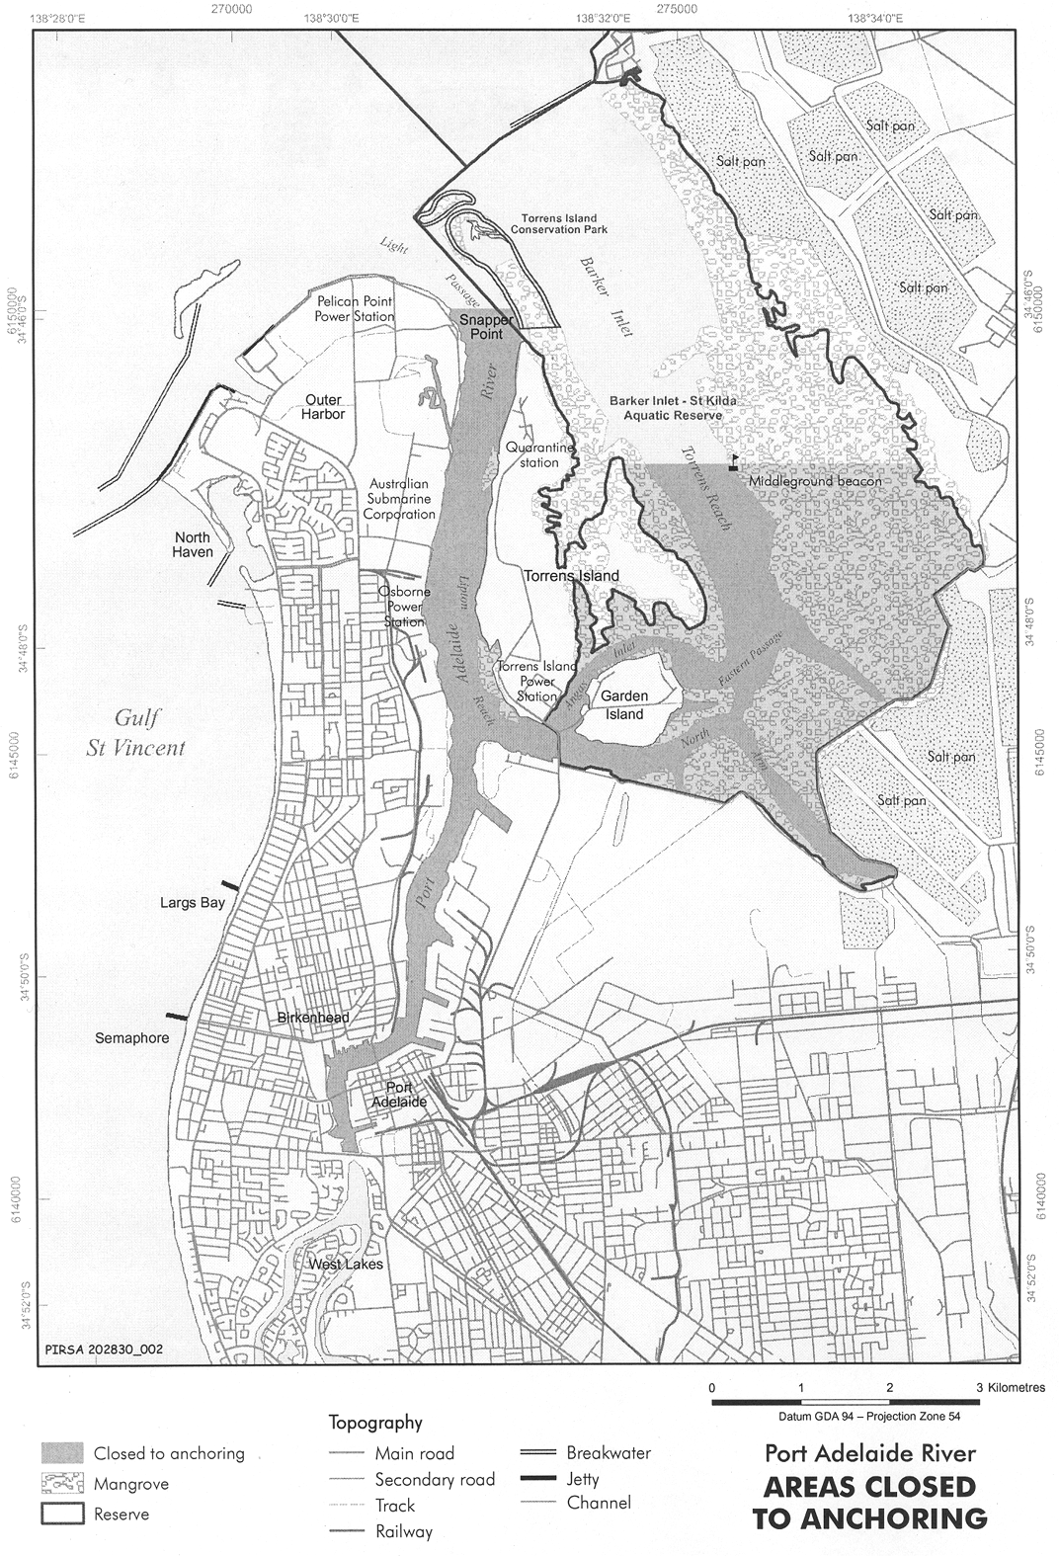
Note—
As required by section 10AA(2) of the Subordinate Legislation Act 1978, the Minister has certified that, in the Minister's opinion, it is necessary or appropriate that these regulations come into operation as set out in these regulations.
Made by the Governor
with the consent of the port operator and with the advice and consent of the Executive Council
on 7 July 2005
No 163 of 2005
MTR05/043CS

J. D. FERGUSON, Government Printer, South Australia

