No. 70 2415

THE SOUTH AUSTRALIAN

GOVERNMENT GAZETTE
www.governmentgazette.sa.gov.au

PUBLISHED BY AUTHORITY

ALL PUBLIC ACTS appearing in this GAZETTE are to be considered official, and obeyed as such

ADELAIDE, THURSDAY, 21 JULY 2005

CONTENTS

Page
Acts Assented To 2416
Administrative Arrangements Act 1994—Notice 2417
Appointments, Resignations, Etc. 2416
Corporations and District Councils—Notices 2484
Crown Lands Act 1929—Notices 2417
Electricity Act 1996—Notice 2420
Environment Protection Act 1993—Notice 2418
Environment Protection (Amendment of Environment
Protection Policies)—Notice 2419
Fisheries Act 1982—Notice 2420
Gas Act 1997—Notice 2420
House of Assembly—Disallowance 2420
Land and Business (Sale and Conveyancing) Act 1994—
Notices 2421
Liquor Licensing Act 1997—Notices 2421
Mining Act 1971—Notices 2424
National Parks Regulations 2001—Notice 2426

Page
Petroleum Act 2000—Notices 2425
Port Augusta Circuit Court—Notice 2426
Private Advertisement 2492
Proclamations 2465
Public Trustee Office—Administration of Estates 2492

REGULATIONS
Fisheries Act 1982 (No. 168 of 2005) 2467
Valuation of Land Act 1971 (No. 169 of 2005) 2474
Reproductive Technology (Clinical Practices)
Act 1988 (No. 170 of 2005) 2481
Roads (Opening and Closing) Act 1991—Notice 2431
Road Traffic Act 1961—Notice 2430
Transport, Department of—Notices to Mariners 2431
Water Mains and Sewers—Mains Laid, Replaced, Etc. 2431
Workers Rehabilitation and Compensation Act
1986—Rules 2434

GOVERNMENT GAZETTE NOTICES
ALL poundkeepers’ and private advertisements forwarded for publication in the South Australian Government Gazette must be PAID FOR PRIOR TO INSERTION; and all notices, from whatever source, should be legibly written on one side of the paper only and sent to Government Publishing SA so as to be received no later
than 4 p.m. on the Tuesday preceding the day of publication. Phone 8207 1045 or Fax 8207 1040. E-mail: governmentgazette@saugov.sa.gov.au. Send as attachments in Word format and please confirm your transmission with a faxed copy of your document, including the date the notice is to be published and to whom the notice will be charged. The Government Gazette is available online at: www.governmentgazette.sa.gov.au

Department of the Premier and Cabinet
Adelaide, 21 July 2005
HER Excellency the Governor directs it to be notified for general information that she has in the name and on behalf of Her Majesty The Queen, this day assented to the undermentioned Acts passed by the Legislative Council and House of Assembly in Parliament assembled, viz.:
No. 42 of 2005—Citrus Industry Act 2005. An Act to provide for the South Australian Citrus Industry Development Board and for administration by the Board of a fund for citrus industry purposes; to repeal the Citrus Industry Act 1991; and for other purposes.
No. 43 of 2005—Parliamentary Superannuation (Scheme for New Members) Amendment Act 2005. An Act to amend the Parliamentary Superannuation Act 1974 and to make related amendments to the Parliamentary Remuneration Act 1990.
By command,
S. W. Key, for Premier
DPC 02/0586

Department of the Premier and Cabinet
Adelaide, 21 July 2005
HER Excellency the Governor in Executive Council has been pleased to appoint the undermentioned to the State Crewing Committee, pursuant to the provisions of the Harbors and Navigation Act 1993:
Member: (from 21 July 2005 until 30 June 2007)
Walter Ferrao
Debby Belinda Barton
Ian Woollard
Donald William Sleath
Jamie Newlyn
Proxy Member: (from 21 July 2005 until 30 June 2007)
Walter James Stuart (Proxy to Ferrao)
William Robert La Vars (Proxy to Woollard)
Sue Mattsson (Proxy to Barton)
Martin Price (Proxy to Sleath)
By command,
S. W. Key, for Premier
MTR 05/041CS

Department of the Premier and Cabinet
Adelaide, 21 July 2005
HER Excellency the Governor in Executive Council has been pleased to appoint the undermentioned to the Guardianship Board, pursuant to the provisions of the Guardianship and Administration Act 1993:
Section 8 (1) Panel Member: (from 21 July 2005 until 20 July 2008)
Lothar Clemens Hoff
George Rawson
Elaine Skinner
By command,
S. W. Key, for Premier
AGO 0217/04CS

Department of the Premier and Cabinet
Adelaide, 21 July 2005
HER Excellency the Governor in Executive Council has been pleased to appoint the undermentioned to the Legal Practitioners Disciplinary Tribunal, pursuant to the provisions of the Legal Practitioners Act 1981:
Member: (from 21 July 2005 until 20 July 2008)
Elizabeth Ann Sheppard
By command,
S. W. Key, for Premier
AGO 0410/02CS

Department of the Premier and Cabinet
Adelaide, 21 July 2005
HER Excellency the Governor in Executive Council has been pleased to appoint the undermentioned to the Legal Practitioners Conduct Board, pursuant to the provisions of the Legal Practitioners Act 1981:
Member: (from 21 July 2005 until 23 April 2006)
Catherine Margaret Parsonage
By command,
S. W. Key, for Premier
AGO 0068/03CS

Department of the Premier and Cabinet
Adelaide, 21 July 2005
HER Excellency the Governor in Executive Council has been pleased to appoint the undermentioned to the Legal Services Commission, pursuant to the provisions of the Legal Services Commission Act 1977:
Member: (from 21 July 2005 until 20 July 2008)
Rosemary Davey
By command,
S. W. Key, for Premier
AGO 0249/02CS

Department of the Premier and Cabinet
Adelaide, 21 July 2005
HER Excellency the Governor in Executive Council has been pleased to appoint the undermentioned to the Construction Industry Training Board, pursuant to the provisions of the Construction Industry Training Fund Act 1993:
Member: (from 21 July 2005 until 31 October 2005)
Robert Norman Stewart
Steven Brenton Hall
Brenton Paul Gardner
Robert John Geraghty
Wayne Thomas Hanson
Deputy Member: (from 21 July 2005 until 31 October 2005)
Christine Harrison (Deputy to O’Connor)
David Milton Callan (Deputy to Stewart)
Laurence John Moore (Deputy to Hall)
Robert Harding (Deputy to Gardner)
Douglas Buchanan (Deputy to Geraghty)
Christopher Nessbit (Deputy to Hanson)
By command,
S. W. Key for Premier
METAFE 28/05CS

Department of the Premier and Cabinet
Adelaide, 21 July 2005
HER Excellency the Governor in Executive Council has been pleased to appoint the undermentioned to the Training and Skills Commission, pursuant to the provisions of the Training and Skills Development Act 2003:
Member: (from 21 July 2005 until 30 September 2005)
Anne Dunn
Member: (from 21 July 2005 until 30 June 2007)
Jan Andrews
Ian Curry
David Frith
Adrian Lee Smith
Sally MacDonald-Taylor
Hilary Patience Mary Winchester
Patrick Wright
Brian Mowbray
Deputy Member: (from 21 July 2005 until 30 June 2007)
Robyn Lee Buckler (Deputy to Curry)
Stephen Kenseley Myatt (Deputy to Frith)
Kate Thiele (Deputy to Smith)
Sylvia Healy (Deputy to MacDonald-Taylor)
Faith Helen Elly Trent AM (Deputy to Winchester)
Gayle Peak (Deputy to Wright)
Douglas Donald Strain (Deputy to Mowbray)
Chair: (from 21 July 2005 until 30 September 2005)
Anne Dunn
By command,
S. W. Key, for Premier
METAFE 27/05CS

Department of the Premier and Cabinet
Adelaide, 21 July 2005
HER Excellency the Governor in Executive Council has been pleased to appoint the undermentioned to the Citrus Board of South Australia, pursuant to the provisions of the Citrus Industry Act 1991:
Member: (from 21 July 2005 until 31 December 2005 or until the repeal of the Citrus Industry Act 1991)
Bernard Lawry Lange
Kent Andrew
John Cox
Bill Ekonomopoulos
Carole Joan Walker
Joel Christopher Sheehan
Leon Spehr
Amos Andrew Weigall
Presiding Member: (from 21 July 2005 until 31 December 2005 or until the repeal of the Citrus Industry Act 1991)
Bernard Lawry Lange
By command,
S. W. Key, for Premier
MAFF 05/0023CS

Department of the Premier and Cabinet
Adelaide, 21 July 2005
HER Excellency the Governor in Executive Council has been pleased to appoint the Honourable Michael John Wright MP, Minister for Administrative Services, Minister for Industrial Relations, Minister for Recreation, Sport and Racing and Minister for Gambling to be also Acting Deputy Premier, Acting Treasurer, Acting Minister Assisting the Premier in Economic Development, Acting Minister for Police and Acting Minister for Federal/State Relations for the period 25 July 2005 to 31 July 2005 inclusive, during the absence of the Honourable Kevin Owen Foley, MP.
By command,
S. W. Key, for Premier
T&F 05/070CS

Department of the Premier and Cabinet
Adelaide, 21 July 2005
HER Excellency the Governor in Executive Council has been pleased to appoint Warren John McCann to the position of Chief Executive, Department of the Premier and Cabinet, for a term of three years, commencing on 16 October 2005 and expiring on 15 October 2008, pursuant to Part 4 of the Public Sector Management Act 1995.
By command,
S. W. Key, for Premier
DPC 022/00Pt2CS

Department of the Premier and Cabinet
Adelaide, 21 July 2005
HER Excellency the Governor in Executive Council has been pleased to appoint Allan Holmes to the position of Chief Executive, Department for Environment and Heritage, for a term of three years, commencing on 31 July 2005 and expiring on 30 July 2008, pursuant to Part 4 of the Public Sector Management Act 1995.
By command,
S. W. Key, for Premier
DPC 022/00Pt3CS

Department of the Premier and Cabinet
Adelaide, 21 July 2005
HER Excellency the Governor in Executive Council has been pleased to appoint Christina Pauline Melvin as a Deputy Registrar of Motor Vehicles, pursuant to Section 7 of the Motor Vehicles Act 1959.
By command,
S. W. Key, for Premier
MTR 05/042CS

ADMINISTRATIVE ARRANGEMENTS ACT 1994
Instrument of Delegation
I, PAUL HOLLOWAY, MLC, Minister for Mineral Resources Development, pursuant to section 9 of the Administrative Arrangements Act 1994, hereby delegate my functions, express and implied, under section 8 of the Natural Gas Authority Act 1967, to the Minister for Energy.
Paul Holloway, Minister for Mineral Resources Development
D05/03387

CROWN LANDS ACT 1929: SECTION 5
TAKE NOTICE that pursuant to the Crown Lands Act 1929, I, JOHN HILL, Minister for Environment and Conservation, Minister of the Crown to whom the administration of the Crown Lands Act 1929 is committed DO HEREBY resume the land defined in The Schedule.
The Schedule
Point Bell Conservation Reserve, Allotment 100 of Deposited Plan 38294, Hundred of Keith, County of Kintore, the notice of which was published in the Government Gazette of 11 November 1993 at pages 2438, 2439 and 2440, The Thirty Third Schedule, and amended by corrigendum published in the Government Gazette of 9 December 1993 at page 2887, being the whole of the land comprised in Crown Record Volume 5772 Folio 810.
Dated 21 July 2005.
J. Hill, Minister for Environment and Conservation
DEH 13/1028

CROWN LANDS ACT 1929: SECTION 5
TAKE NOTICE that pursuant to the Crown Lands Act 1929, I, JOHN HILL, Minister for Environment and Conservation, Minister of the Crown to whom the administration of the Crown Lands Act 1929 is committed DO HEREBY resume the land defined in The Schedule.
The Schedule
1. Fowlers Bay Conservation Reserve, Allotment 62 of Deposited Plan 35363, Hundred of Caldwell and Allotments 100 and 101 of Deposited Plan 35535, Hundreds of Caldwell and Sturdee, County of Hopetoun, the notice of which was published in the Government Gazette of 11 November 1993 at pages 2438, 2439 and 2440, The Sixteenth Schedule, and amended by corrigendum published in the Government Gazette of 9 December 1993 at page 2887, being the whole of the land comprised in Crown Record Volume 5772 Folio 806.
2. Reserve for Conservation Purposes, Allotment 64 of Deposited Plan 35363, Hundred of Caldwell, County of Hopetoun, the notice of which was published in the Government Gazette of 18 February 1993 at page 682, The First Schedule, being the whole of the land comprised in Crown Record Volume 5772 Folio 949.
Dated 21 July 2005.
J. Hill, Minister for Environment and Conservation
DEH 13/1026

ENVIRONMENT PROTECTION ACT 1993
Variation to Existing Approval of Collection Depot
I, STEPHEN RICHARD SMITH, Senior Adviser, Container Deposit Legislation and Delegate of the Environment Protection Authority (‘the Authority’), pursuant to section 69 of the Environment Protection Act 1993 (SA) (‘the Act’) hereby:
Variation to Existing Approval of Collection Depot
Vary the approval of the collection depot, listed at Schedule 1 of this notice, that was granted under the Act prior to the date of this notice and impose the conditions of this approval to be as follows:
Approval of Collection Depot
The collection depot identified by reference to the following matters is approved:
(a) the name of the collection depot described in Column 1 of Schedule 1 of this notice;
(b) the name of the proprietor of the depot identified in Column 3 of Schedule 1 of this notice;
(c) the location of the depot described in Columns 4 and 5 of Schedule 1 of this notice; and
(d) the collection area in relation to which the collection depot is approved referred to in Column 6 of Schedule 1 of this notice.
The collection depot listed at Schedule 1 of this notice is approved in relation to all classes of containers which were approved under the Act, at or subsequent to the date of this notice, as Category B Containers.
Conditions of Approval
Impose the following conditions on this approval:
(a) The person in charge of a collection depot shall ensure the depot premises complies with Council Planning Regulations and shall be kept in an orderly condition.
(b) The person in charge of the collection depot who wishes to transfer the operation of a depot to another person or intends to change the location of a depot shall notify the Authority in writing within one month of the change occurring.
(c) The person in charge of a collection depot who wishes to cease operation of that depot shall give notice in writing to the Authority.
(d) The person in charge of a collection depot shall take such measures as are necessary in the operation and maintenance of the depot to prevent or control:
(i) A nuisance or offensive condition.
(ii) A risk to health or safety.
(iii) Damage to the environment.
(e) The person in charge of a collection depot is reminded of the general environmental duty, as required by section 25 of the Environment Protection Act, to take all reasonable and practical measures to ensure that the activities on the whole site, do not pollute the environment in a way which causes or may cause environmental harm.
Schedule 1
Variation to Approved Collection Depot

Column 1 | Column 2 | Column 3 | Column 4 | Column 5 | Column 6 | Column 7
Depot Name | Company/  Trading Name | Proprietors | Depot Location  Street | Depot Location Suburb | Certificate of  Title No. | Collection Area
Port Broughton Recycling Depot | Port Broughton Recycling Depot | Philip John and Sharon Kay Clark | Allotment 6/160 Casey Road | Port Broughton | 5930/477 | Southern

South Australia
Environment Protection (Amendment of Environment Protection Policies) Notice 2005
under Schedule 1, clause 3 of the Environment Protection (Miscellaneous) Amendment Act 2005
1—Short title
This notice may be cited as the Environment Protection (Amendment of Environment Protection Policies) Notice 2005.
2—Commencement
This notice comes into operation on the day on which it is made.
3—Amendment of environment protection policies
The environment protection policies listed in the table in Schedule 1 are amended as set out in that table.
Schedule 1—Amendment of Environment Protection Policies
Amendment of Environment Protection (Burning) Policy 1994
Clause 5(1), (2), (3) and (4) | Delete “Category C offence” wherever occurring and substitute:  Category D offence
Amendment of Environment Protection (Machine Noise) Policy 1994
Clause 5(1) | Delete “Category C offence” and substitute:  Category D offence
Amendment of Environment Protection (Waste Management) Policy 1994
Clause 4(2) | Delete “Category C offence” and substitute:  Category D offence
Clause 5(2) | Delete “Category C offence” and substitute:  Category D offence
Clause 6 | Delete “Category C offence” and substitute:  Category D offence

Dated 14 July 2005

JOHN HILL
MINISTER FOR ENVIRONMENT AND CONSERVATION

House of Assembly, 6 July 2005
FORWARDED to the Honourable the Premier the following Resolution, passed by the House of Assembly on 6 July 2005:
That the By-law No. 5, made by the Kangaroo Island Council under the Local Government Act 1999 entitled Dogs, laid on the table of this House on 3 May 2005, be disallowed.
D. A. Bridges, Clerk

ELECTRICITY ACT 1996
Prices for Electricity Customers on Default Contracts
ORIGIN ENERGY ELECTRICITY LTD (ABN 33 071 052 287) (‘Origin Energy’) hereby gives notice pursuant to section 36AB of the Electricity Act 1996, that it has fixed new prices for the sale of electricity to small customers who are purchasing electricity under Origin Energy’s default contract terms and conditions.
A full list of default contract prices can be found at www.originenergy.com.au or by calling 13 2114. The default contract prices take effect on and from the end of 28 days from the date of publication of this notice.
The default contract prices are the same as some of Origin Energy’s market contract prices. The default contract prices have been fixed by Origin Energy in accordance with Electricity Industry Guideline No. 10 (December 2003) published by the Essential Services Commission.
Phil Craig, General Manager, Sales and Marketing

FISHERIES ACT 1982: SECTION 59
TAKE notice that pursuant to section 59 of the Fisheries Act 1982, Damien John Wilksch (the ‘exemption holder’) is exempt from clause 22 of Schedule 1 of the Fisheries (General) Regulations 2000, but only insofar as he may use the device described in Schedule 1 to take carp, bony bream and other non-native species in the areas specified in Schedule 2 for the purpose of trade or business (the ‘exempted activity’), subject to the conditions set out in Schedule 3, from 21 July 2005 until 30 June 2006, unless varied or revoked earlier.
Schedule 1
‘Carp net’—a gill net with a ply greater than 5, having a maximum length of 50 m and a minimum mesh size of 10 cm and a maximum mesh size not exceeding 18 cm.
Schedule 2
(1) Subject to paragraph (2), the licence holder may conduct fishing activities pursuant to this licence in all backwaters of the River Murray excluding the following areas during the corresponding period set out in the following table:
Area Excluded | Period of Closure
Lake Littra and outflow channel | Permanent—all year
Clover Lake | Permanent—all year
Coombool Swamp | Permanent—all year
Lake Limbra and outflow channel | Permanent—all year
Lake Woolpolool | Permanent—all year
Ral Ral Creek below Chaffey Pump and entrance waters to Lake Merreti | Permanent—all year
Katarapko Creek and Eckert Creek, including The Splash | Permanent—all year
Bulyong Creek | Permanent—all year
Pilby Creek | Permanent—all year
Hancock Creek | Permanent—all year
Mundic Creek | Permanent—all year
Pike Creek | Permanent—all year
Punkah Creek | Permanent—all year
Slaney Creek | Permanent—all year
Loch Luna | Permanent—all year
Cobdogla Swamp | 1 August to 30 April (inclusive)
Loveday Swamp/Mussel Lagoons | 1 August to 30 April (inclusive)
Lake Merreti | 1 August to 31 January (inclusive)
(2) The licence holder may conduct fishing operations within the closure areas and periods listed above if given written approval by the Director of Fisheries to undertake specified carp eradication work in a specified area for a specified period.
Schedule 3
1. The exemption holder must not use more than 30 carp nets at any one time in permitted backwaters of the River Murray.
2. The exemption holder must not have more than 30 carp nets in his possession at any time when he is deploying carp nets in the backwaters of the River Fishery.
3. The exemption holder may only engage in the exempted activity when also fishing pursuant to River Fishery Licence No. R03, and may only use a boat to engage in the exempted activity if that boat is registered by endorsement on River Fishery Licence No. R03.
4. The exemption holder must not cause or permit a person to act as his agent when engaging in the exempted activity unless that person may lawfully act as an agent for the exemption holder in relation to River Fishery Licence No. R03.
5. All native fish (excluding bony bream) taken in the course of the exempted activity must be immediately returned to the water.
6. Immediately prior to commencing the exempted activity, the exemption holder must advise the PIRSA Fisheries Compliance Unit on 1800 065 522 with the following details:
• The licence number and person(s) conducting the activity.
• The exact location(s) of the fishing activities.
• The number of carp nets being used.
7. The exemption holder must ensure that the carp nets are checked and all fish removed at least once during each 24 hour period.
8. When the exemption holder moves the carp nets more than 3 km from the reported location of the nets under condition 6, or removes the nets from the River completely, the exemption holder must again report to the PIRSA Fisheries Compliance Unit on 1800 065 522 and provide either details, as required under con-dition 6 of this exemption, or report that fishing with carp nets has ceased.
9. While engaged in the exempted activity, the exemption holders must be in possession of a copy of this notice. Such notice must be produced to a PIRSA Fisheries Compliance Officer as requested.
10. The exemption holder must not contravene or fail to comply with the Fisheries Act 1982, or any regulations made under that Act, except where specifically exempted by this notice.
Dated 14 July 2005.
J. Presser, Director of Fisheries

GAS ACT 1997
Prices for Natural Gas Customers on Default Contracts
ORIGIN ENERGY RETAIL LTD (ABN 22 078 868 425) (‘Origin Energy’) hereby gives notice pursuant to section 34B of the Gas Act 1997, that it has fixed new prices for the sale and supply of natural gas to small customers who are purchasing gas under Origin Energy’s default contract terms and conditions.
A full list of default contract prices can be found at www.originenergy.com.au or by calling 13 2461. The default contract prices take effect on and from the end of 28 days from the date of publication of this notice.
The default contract prices are the same as the standing contract prices fixed by the Essential Services Commission pursuant to the Essential Services Commission Act 2002 in the Gas Standing Contract Price Path Final Inquiry Report and Final Price Determination dated 28 June 2005 (‘Price Determination’). The justification for these prices is set out in the Statement of Reasons included in the Price Determination.
Phil Craig, General Manager, Sales and Marketing

LAND AND BUSINESS (SALE AND CONVEYANCING)
ACT 1994
Exemption
TAKE notice that pursuant to section 23 (3) of the Land and Business (Sale and Conveyancing) Act 1994, I, Karlene Maywald, Minister for Consumer Affairs, do hereby exempt the person named in Schedule 1 from the application of section 23 (2) of the Act in relation to the purchase of the land specified in Schedule 2.
Schedule 1
Denise Mary Borrillo an employee of Van Voorst Black Real Estate Pty Ltd.
Schedule 2
The whole of the land described in certificate of title register book volume 5129, folio 448, situated at 18 Eighth Street, Bordertown, S.A. 5268.
Dated 21 July 2005.
Signed for and on behalf of the Minister for Consumer Affairs by the Commissioner for Consumer Affairs:
M. Bodycoat, Commissioner

LAND AND BUSINESS (SALE AND CONVEYANCING)
ACT 1994
Exemption
TAKE notice that pursuant to section 23 (3) of the Land and Business (Sale and Conveyancing) Act 1994, I, Karlene Maywald, Minister for Consumer Affairs, do hereby exempt the person named in Schedule 1 from the application of section 23 (2) of the Act in relation to the purchase of the land specified in Schedule 2.
Schedule 1
Ian George Harvy an employee of Kosten Pty Ltd.
Schedule 2
The whole of the land described in certificate of title register book volume 5042, folio 865, situated at 9/1 Howard Close, Mount Barker, S.A. 5251.
Dated 21 July 2005.
Signed for and on behalf of the Minister for Consumer Affairs by the Commissioner for Consumer Affairs:
M. Bodycoat, Commissioner

LIQUOR LICENSING ACT 1997 AND GAMING MACHINES ACT 1992
Notice of Application
NOTICE is hereby given, pursuant to section 52 of the Liquor Licensing Act 1997 and section 29 of the Gaming Machines Act 1992, that Barrie William and Janice Maude Heard, c/o Fisher Jeffries, Level 15, 211 Victoria Square, Adelaide, S.A. 5000 have applied to the Liquor and Gaming Commissioner for the transfer of a Hotel Licence and a Gaming Machine Licence in respect of premises situated at Main Road, Lochiel, S.A. 5510 and known as Lochiel Lakeview Hotel.
The applications have been set down for hearing on 23 August 2005 at 9.30 a.m.
Any person may object to the application by lodging a notice of objection in the prescribed form with the Licensing Authority, and serving a copy of the notice on the applicants at the applicants’ address given above, at least seven days before the hearing date (viz: 15 August 2005).
The applicants’ address for service is c/o Fisher Jeffries, Level 15, 211 Victoria Square, Adelaide, S.A. 5000 (Attention: Craig Vozzo/Adrian Battiston).
Plans in respect of the premises the subject of the application are open to public inspection without fee at the Office of the Liquor and Gambling Commissioner, 9th Floor, East Wing, 50 Grenfell Street, Adelaide, S.A. 5000. Phone 8226 8410, Fax:
8226 8512. Email: olgc@agd.sa.gov.au.
Dated 15 July 2005.
Applicants

LIQUOR LICENSING ACT 1997
Notice of Application
NOTICE is hereby given, pursuant to section 52 (2) (b) of the Liquor Licensing Act 1997, that Scottie Phuong Minh Tang has applied to the Licensing Authority for the transfer of a Restaurant Licence in respect of premises situated at the corner Warren Road and Alva Street, Para Vista, S.A. 5093 and known as Kwan Yen Restaurant.
The application has been set down for hearing on 24 August 2005 at 9.30 a.m.
Any person may object to the application by lodging a notice of objection in the prescribed form with the Licensing Authority, and serving a copy of the notice on the applicant at the applicant’s address given above, at least seven days before the hearing date (viz: 16 August 2005).
The applicant’s address for service is c/o Gordon Cheng, Barristers & Solicitors, 1st Floor, Pulteney Centre, 186 Pulteney Street, Adelaide, S.A. 5000.
Plans in respect of the premises the subject of the application are open to public inspection without fee at the Office of the Liquor and Gambling Commissioner, 9th Floor, East Wing, 50 Grenfell Street, Adelaide, S.A. 5000. Phone 8226 8410, Fax:
8226 8512. Email: olgc@agd.sa.gov.au.
Dated 14 July 2005.
Applicant

LIQUOR LICENSING ACT 1997
Notice of Application
NOTICE is hereby given, pursuant to section 52 (2) (b) of the Liquor Licensing Act 1997, that Harbour Rural Pty Ltd has applied to the Licensing Authority for the transfer of a Residential Licence in respect of premises situated at Murray Street, Tanunda, S.A. 5352 and known as Barossa Motor Lodge.
The application has been set down for hearing on 24 August 2005 at 10.30 a.m.
Any person may object to the application by lodging a notice of objection in the prescribed form with the Licensing Authority, and serving a copy of the notice on the applicant at the applicant’s address given above, at least seven days before the hearing date (viz: 16 August 2005).
The applicant’s address for service is c/o Foreman Legal, 69 Mount Barker Road, Stirling, S.A. 5152.
Plans in respect of the premises the subject of the application are open to public inspection without fee at the Office of the Liquor and Gambling Commissioner, 9th Floor, East Wing, 50 Grenfell Street, Adelaide, S.A. 5000. Phone 8226 8410, Fax:
8226 8512. Email: olgc@agd.sa.gov.au.
Dated 15 July 2005.
Applicant

LIQUOR LICENSING ACT 1997
Notice of Application
NOTICE is hereby given, pursuant to section 52 (2) (b) of the Liquor Licensing Act 1997, that Papaya Thai Pty Ltd as trustee for the Luu Family Trust has applied to the Licensing Authority for the transfer of a Restaurant Licence in respect of premises situated at 268-270 Torrens Road, Croydon Park, S.A. 5008 and known as Papaya Thai Cuisine.
The application has been set down for hearing on 23 August 2005 at 10 a.m.
Any person may object to the application by lodging a notice of objection in the prescribed form with the Licensing Authority, and serving a copy of the notice on the applicant at the applicant’s address given above, at least seven days before the hearing date (viz: 15 August 2005).
The applicant’s address for service is c/o Nheen Luu, 268 Torrens Road, Croydon Park, S.A. 5008.
Plans in respect of the premises the subject of the application are open to public inspection without fee at the Office of the Liquor and Gambling Commissioner, 9th Floor, East Wing, 50 Grenfell Street, Adelaide, S.A. 5000. Phone 8226 8410, Fax:
8226 8512. Email: olgc@agd.sa.gov.au.
Dated 14 July 2005.
Applicant

LIQUOR LICENSING ACT 1997
Notice of Application
NOTICE is hereby given, pursuant to section 52 (2) (b) of the Liquor Licensing Act 1997, that Flight Training Adelaide Pty Ltd has applied to the Licensing Authority for the transfer of a Special Circumstances Licence in respect of premises situated at Hangar 54, Kitty Hawk Lane, Parafield Airport, S.A. 5107 known as BAE Systems and to be known as Flight Training Adelaide Pty Ltd.
The application has been set down for hearing on 23 August 2005 at 9 a.m.
Any person may object to the application by lodging a notice of objection in the prescribed form with the Licensing Authority, and serving a copy of the notice on the applicant at the applicant’s address given above, at least seven days before the hearing date (viz: 15 August 2005).
The applicant’s address for service is c/o Steve Holden, Hangar 54, Kitty Hawk Lane, Parafield Airport, S.A. 5106.
Plans in respect of the premises the subject of the application are open to public inspection without fee at the Office of the Liquor and Gambling Commissioner, 9th Floor, East Wing, 50 Grenfell Street, Adelaide, S.A. 5000. Phone 8226 8410, Fax:
8226 8512. Email: olgc@agd.sa.gov.au.
Dated 13 July 2005.
Applicant

LIQUOR LICENSING ACT 1997
Notice of Application
NOTICE is hereby given, pursuant to section 52 (2) (b) of the Liquor Licensing Act 1997, that Kopi Tim Restaurant Pty Ltd as trustee for the Lai Family Trust has applied to the Licensing Authority for the transfer of a Restaurant Licence in respect of premises situated at 168 Gouger Street, Adelaide, S.A. 5000 and known as Dack Kee Hong Kong Restaurant to be known as Kopi Tim Restaurant.
The application has been set down for hearing on 22 August 2005 at 11 a.m.
Any person may object to the application by lodging a notice of objection in the prescribed form with the Licensing Authority, and serving a copy of the notice on the applicant at the applicant’s address given above, at least seven days before the hearing date (viz: 12 August 2005).
The applicant’s address for service is c/o Civil & Commercial Barristers and Solicitors, 311 Unley Road, Malvern, S.A. 5061.
Plans in respect of the premises the subject of the application are open to public inspection without fee at the Office of the Liquor and Gambling Commissioner, 9th Floor, East Wing, 50 Grenfell Street, Adelaide, S.A. 5000. Phone 8226 8410, Fax:
8226 8512. Email: olgc@agd.sa.gov.au.
Dated 11 July 2005.
Applicant

LIQUOR LICENSING ACT 1997
Notice of Application
NOTICE is hereby given, pursuant to section 52 (2) (b) of the Liquor Licensing Act 1997, that Food & Wine Connection Pty Ltd has applied to the Licensing Authority for the removal of a Wholesale Liquor Merchant’s Licence in respect of premises situated at 669 Magill Road, Magill, S.A. 5072 and to be situated at 22 Famechon Crescent, Modbury North, S.A. 5092 and known as Food and Wine Connection.
The application has been set down for hearing on 19 August 2005 at 9 a.m.
Any person may object to the application by lodging a notice of objection in the prescribed form with the Licensing Authority, and serving a copy of the notice on the applicant at the applicant’s address given above, at least seven days before the hearing date (viz: 11 August 2005).
The applicant’s address for service is c/o Connie Confalone, 669 Magill Road, Magill, S.A. 5072.
Plans in respect of the premises the subject of the application are open to public inspection without fee at the Office of the Liquor and Gambling Commissioner, 9th Floor, East Wing, 50 Grenfell Street, Adelaide, S.A. 5000. Phone 8226 8410, Fax:
8226 8512. Email: olgc@agd.sa.gov.au.
Dated 14 July 2005.
Applicant

LIQUOR LICENSING ACT 1997
Notice of Application
NOTICE is hereby given, pursuant to section 52 (2) (b) of the Liquor Licensing Act 1997, that General Havelock Pty Ltd and General Havelock on Hutt Pty Ltd have applied to the Licensing Authority for a variation to the Extended Trading Authorisation in respect of premises situated at 162 Hutt Street, Adelaide, S.A. 5000 and known as General Havelock Hotel.
The application has been set down for hearing on 19 August 2005 at 9 a.m.
Condition
The following licence condition is sought:
• Extended Trading Authorisation—
Friday and Saturday—Midnight to 1 a.m. the following day.
Any person may object to the application by lodging a notice of objection in the prescribed form with the Licensing Authority, and serving a copy of the notice on the applicants at the applicants’ address given above, at least seven days before the hearing date (viz: 11 August 2005).
The applicants’ address for service is c/o Kelly & Co., Level 17, 91 King William Street, Adelaide, S.A. 5000.
Plans in respect of the premises the subject of the application are open to public inspection without fee at the Office of the Liquor and Gambling Commissioner, 9th Floor, East Wing, 50 Grenfell Street, Adelaide, S.A. 5000. Phone 8226 8410, Fax:
8226 8512. Email: olgc@agd.sa.gov.au.
Dated 14 July 2005.
Applicants

LIQUOR LICENSING ACT 1997
Notice of Application
NOTICE is hereby given, pursuant to section 52 (2) (b) of the Liquor Licensing Act 1997, that Neil William Lowrie has applied to the Licensing Authority for a Producer’s Licence in respect of premises situated at 1 Douglas Street, Millswood, S.A. 5034 and to be known as Larry Dooley Vineyard.
The application has been set down for hearing on 19 August 2005 at 9 a.m.
Any person may object to the application by lodging a notice of objection in the prescribed form with the Licensing Authority, and serving a copy of the notice on the applicant at the applicant’s address given above, at least seven days before the hearing date (viz: 11 August 2005).
The applicant’s address for service is c/o Leon McEvoy, 208 Carrington Street, Adelaide, S.A. 5000.
Plans in respect of the premises the subject of the application are open to public inspection without fee at the Office of the Liquor and Gambling Commissioner, 9th Floor, East Wing, 50 Grenfell Street, Adelaide, S.A. 5000. Phone 8226 8410, Fax:
8226 8512. Email: olgc@agd.sa.gov.au.
Dated 8 July 2005.
Applicant

LIQUOR LICENSING ACT 1997
Notice of Application
NOTICE is hereby given, pursuant to section 52 (2) (b) of the Liquor Licensing Act 1997, that Jasgarp Pty Ltd as trustee for the Rensal Trust, Rattler Trust, Group 1 Trust and JA Trust has applied to the Licensing Authority for the transfer of a Hotel and Gaming Licence and variation to conditions in respect of premises situated at 50-52 Causeway Road, Glanville, S.A. 5015 and known as the Glanville Wharf Hotel.
The application has been set down for hearing on 19 August 2005 at 9 a.m.
Condition
The following licence conditions is sought:
The applicant has applied to delete Live Entertainment is limited in all areas to traditional Irish Folk Music as a condition.
Any person may object to the application by lodging a notice of objection in the prescribed form with the Licensing Authority, and serving a copy of the notice on the applicant at the applicant’s address given above, at least seven days before the hearing date (viz: 11 August 2005).
The applicant’s address for service is c/o Geoff Forbes, Piper Alderman, G.P.O. Box 65, Adelaide, S.A. 5001.
Plans in respect of the premises the subject of the application are open to public inspection without fee at the Office of the Liquor and Gambling Commissioner, 9th Floor, East Wing, 50 Grenfell Street, Adelaide, S.A. 5000. Phone 8226 8410, Fax:
8226 8512. Email: olgc@agd.sa.gov.au.
Dated 15 July 2005.
Applicant

LIQUOR LICENSING ACT 1997
Notice of Application
NOTICE is hereby given, pursuant to section 52 (2) (b) of the Liquor Licensing Act 1997, that Hotel Windsor Pty Ltd has applied to the Licensing Authority for the transfer of a Hotel and Gaming Licence, variation to Extended Trading Authorisation, variation to Entertainment Consent in respect of premises situated at 410 North East Road, Windsor Gardens, S.A. 5087 and known as Windsor Hotel.
The application has been set down for hearing on 19 August 2005 at 9 a.m.
Conditions
The following licence conditions are sought:
• Variation to Extended Trading Authorisation (including Entertainment Consent) to apply to Areas 1 to 4 and 6 to include Sunday from midnight to 3 a.m. the following day and Good Friday from midnight to 2 a.m.
• Variation to Entertainment Consent to include Areas 3
and 4.
Any person may object to the application by lodging a notice of objection in the prescribed form with the Licensing Authority, and serving a copy of the notice on the applicant at the applicant’s address given above, at least seven days before the hearing date (viz: 11 August 2005).
The applicant’s address for service is c/o Ben Allen, Wallmans Lawyers, 173 Wakefield Street, Adelaide, S.A. 5000.
Plans in respect of the premises the subject of the application are open to public inspection without fee at the Office of the Liquor and Gambling Commissioner, 9th Floor, East Wing, 50 Grenfell Street, Adelaide, S.A. 5000. Phone 8226 8410, Fax:
8226 8512. Email: olgc@agd.sa.gov.au.
Dated 15 July 2005.
Applicant

LIQUOR LICENSING ACT 1997
Notice of Application
NOTICE is hereby given, pursuant to section 52 (2) (b) of the Liquor Licensing Act 1997, that The Hamilton Wine Group Pty Ltd has applied to the Licensing Authority for a Producer’s Licence, Entertainment Consent and Extended Trading Area in respect of premises situated at Section 177, Main Road, McLaren Vale, S.A. 5171 and to be known as Leconfield Wines.
The application has been set down for hearing on 19 August 2005 at 9 a.m.
Conditions
The following licence conditions are sought:
• Entertainment Consent is sought for the areas shown on the plan lodged with this office including the Extended Trading Area:
Saturday: 11 a.m. to 5 p.m.;
Sunday: 11 a.m. to 5 p.m.;
Days preceding Public Holidays: 11 a.m. to 5 p.m.
• Extended Trading Area is sought to licence an outdoor verandah and grassed area as shown on the plans lodged with this office.
Any person may object to the application by lodging a notice of objection in the prescribed form with the Licensing Authority, and serving a copy of the notice on the applicant at the applicant’s address given above, at least seven days before the hearing date (viz: 11 August 2005).
The applicant’s address for service is c/o Mellor Olsson Solicitors, Level 5, 80 King William Street, Adelaide, S.A. 5000.
Plans in respect of the premises the subject of the application are open to public inspection without fee at the Office of the Liquor and Gambling Commissioner, 9th Floor, East Wing, 50 Grenfell Street, Adelaide, S.A. 5000. Phone 8226 8410, Fax:
8226 8512. Email: olgc@agd.sa.gov.au.
Dated 18 July 2005.
Applicant

LIQUOR LICENSING ACT 1997
Notice of Application
NOTICE is hereby given, pursuant to section 52 (2) (b) of the Liquor Licensing Act 1997, that Cottage Box Chocolates Pty Ltd has applied to the Licensing Authority for a Restaurant Licence with Extended Trading Authorisation and Entertainment Consent in respect of premises situated at Lot 1, Wharf Road, Murray Bridge, S.A. 5253 and to be known as Pomberuk Bush Tucker Bistro.
The application has been set down for hearing on 19 August 2005 at 9 a.m.
Conditions
The following licence conditions are sought:
• Extended Trading Authorisation:
Monday to Saturday: Midnight to 2 a.m. the following day;
Sunday: 8 a.m. to 11 a.m. and 8 p.m. to midnight;
Good Friday: Midnight to 2 a.m. the following day;
Christmas Eve: Midnight to 2 a.m. the following day;
Sunday Christmas Eve: Midnight to 2 a.m. the following day;
Days preceding other Public Holidays: Midnight to 2 a.m. the following day;
Sundays preceding Public Holidays: Midnight to 2 a.m. the following day.
• Entertainment Consent is to apply to the hours above.
• Approval under section 34 (1) (c) to sell liquor for con-sumption on the licensed premises by persons:
(a) seated at a table; or
(b) attending a function at which food is provided.
Any person may object to the application by lodging a notice of objection in the prescribed form with the Licensing Authority, and serving a copy of the notice on the applicant at the applicant’s address given above, at least seven days before the hearing date (viz: 11 August 2005).
The applicant’s address for service is c/o Amanda Warley, Camatta Lempens, Level 1, 345 King William Street, Adelaide, S.A. 5000.
Plans in respect of the premises the subject of the application are open to public inspection without fee at the Office of the Liquor and Gambling Commissioner, 9th Floor, East Wing, 50 Grenfell Street, Adelaide, S.A. 5000. Phone 8226 8410, Fax:
8226 8512. Email: olgc@agd.sa.gov.au.
Dated 14 July 2005.
Applicant

LIQUOR LICENSING ACT 1997
Notice of Application
NOTICE is hereby given, pursuant to section 52 (2) (b) of the Liquor Licensing Act 1997, that Shiralee Limousines Pty Ltd has applied to the Licensing Authority for a Special Circumstances Licence in respect of premises situated at 24 Sierra Avenue, Grange, S.A. 5022 and to be known as Shiralee Limousines.
The application has been set down for hearing on 19 August 2005 at 9 a.m.
Conditions
The following licence conditions are sought:
• To sell liquor in accordance with section 40 of the Liquor Licensing Act 1997 and any other conditions of this licence:
For consumption on or adjacent to the licensed premises (provided that the passengers are always under the supervision and control of the driver of the subject vehicles) on any day at any time (except Good Friday).
Any person may object to the application by lodging a notice of objection in the prescribed form with the Licensing Authority, and serving a copy of the notice on the applicant at the applicant’s address given above, at least seven days before the hearing date (viz: 11 August 2005).
The applicant’s address for service is c/o Alan Kohler, 24 Sierra Avenue, Grange, S.A. 5022.
Plans in respect of the premises the subject of the application are open to public inspection without fee at the Office of the Liquor and Gambling Commissioner, 9th Floor, East Wing, 50 Grenfell Street, Adelaide, S.A. 5000. Phone 8226 8410, Fax:
8226 8512. Email: olgc@agd.sa.gov.au.
Dated 13 July 2005.
Applicant

MINING ACT 1971
NOTICE is hereby given in accordance with section 28 (5) of the Mining Act 1971, that the Minister for Mineral Resources Development proposes to grant an Exploration Licence over the undermentioned area:
Applicant: Minotaur Operations NL
Location: Pandurra area—Approximately 50 km west of Port Augusta.
Term: 1 year
Area in km²: 980
Ref: 2005/00047
Plan and co-ordinates can be found on the PIRSA Sarig website: http://www.minerals.pir.sa.gov.au/sarig or by phoning Mineral Tenements on (08) 8463 3103.
H. Tyrteos, Mining Registrar

MINING ACT 1971
NOTICE is hereby given in accordance with section 28 (5) of the Mining Act 1971, that the Minister for Mineral Resources Development proposes to grant an Exploration Licence over the undermentioned area:
Applicant: Avoca Resources NL
Location: Kooralla area—Approximately 15 km east of Cowell.
Term: 1 year
Area in km²: 85
Ref: 2005/00048
Plan and co-ordinates can be found on the PIRSA Sarig website: http://www.minerals.pir.sa.gov.au/sarig or by phoning Mineral Tenements on (08) 8463 3103.
H. Tyrteos, Mining Registrar

MINING ACT 1971
NOTICE is hereby given in accordance with section 28 (5) of the Mining Act 1971, that the Minister for Mineral Resources Development proposes to grant an Exploration Licence over the undermentioned area:
Applicant: Havilah Resources NL
Location: Bonython Hill area—Approximately 35 km north of Olary.
Term: 1 year
Area in km²: 20
Ref: 2005/00057
Plan and co-ordinates can be found on the PIRSA Sarig website: http://www.minerals.pir.sa.gov.au/sarig or by phoning Mineral Tenements on (08) 8463 3103.
H. Tyrteos, Mining Registrar

MINING ACT 1971
NOTICE is hereby given in accordance with section 28 (5) of the Mining Act 1971, that the Minister for Mineral Resources Development proposes to grant an Exploration Licence over the undermentioned area:
Applicant: Havilah Resources NL
Location: Mulyungarie area—Approximately 100 km north-east of Olary.
Term: 1 year
Area in km²: 1 139
Ref: 2005/00234
Plan and co-ordinates can be found on the PIRSA Sarig website: http://www.minerals.pir.sa.gov.au/sarig or by phoning Mineral Tenements on (08) 8463 3103.
H. Tyrteos, Mining Registrar

PETROLEUM ACT 2000
Grant of Geothermal Exploration Licence—GEL 167
NOTICE is hereby given that the undermentioned Geothermal Exploration Licence has been granted under the provisions of the Petroleum Act 2000, pursuant to delegated powers dated 28 March 2002, Gazetted 11 April 2002, page 1573.
No. of Licence | Licensee | Locality | Area in  km² | Reference
GEL 167 | Eden Energy Ltd | Cooper Basin of South Australia | 498 | 27/2/290
Description of Area—GEL 167
All that part of the State of South Australia, bounded as follows: Commencing at a point being the intersection of latitude 30°25′00″S GDA94 and longitude 137°35′00″E GDA94, thence east to longitude 137°41′00″E GDA94, south to latitude 30°26′00″S GDA94, east to longitude 137°42′00″E GDA94, south to latitude 30°26′55″S GDA94, east to longitude 137°43′05″E GDA94, south to latitude 30°28′00″S GDA94, east to longitude 137°44′00″E GDA94, south to latitude 30°29′00″S GDA94, east to longitude 137°46′00″E GDA94, south to latitude 30°30′00″S GDA94, east to longitude 137°47′00″E GDA94, south to latitude 30°31′00″S GDA94, east to longitude 137°48′00″E GDA94, south to latitude 30°32′00″S GDA94, east to longitude 137°49′00″E GDA94, north to latitude 30°30′00″S GDA94, east to longitude 137°50′00″E GDA94, south to latitude 30°30′55″S GDA94, east to longitude 137°51′05″E GDA94, south to latitude 30°32′00″S GDA94, west to longitude 137°50′00″E GDA94, south to latitude 30°33′00″S GDA94, west to longitude 137°49′00″E GDA94, south to latitude 30°34′00″S GDA94, west to longitude 137°48′00″E GDA94, south to latitude 30°35′00″S GDA94, west to longitude 137°47′00″E GDA94, south to latitude 30°36′00″S GDA94, west to longitude 137°46′00″E GDA94, south to latitude 30°37′00″S GDA94, west to longitude 137°45′00″E GDA94, south to latitude 30°38′00″S GDA94, west to longitude 137°37′00″E GDA94, south to latitude 30°39′00″S GDA94, west to longitude 137°33′00″E GDA94, north to latitude 30°36′00″S GDA94, west to longitude 137°32′00″E GDA94, north to latitude 30°33′00″S GDA94, east to longitude 137°33′00″E GDA94, north to latitude 30°31′00″S GDA94, east to longitude 137°34′00″E GDA94, north to latitude 30°28′00″S GDA94, east to longitude 137°35′00″E GDA94, and north to the point of commencement.
Area: 498 km² approximately.
Dated 13 July 2005.
B. A. Goldstein, Director Petroleum
Minerals and Energy Division
Primary Industries and Resources SA
Delegate of the Minister for Mineral Resources Development

PETROLEUM ACT 2000
Grant of Geothermal Exploration Licence—GEL 207
NOTICE is hereby given that the undermentioned Geothermal Exploration Licence has been granted under the provisions of the Petroleum Act 2000, pursuant to delegated powers dated 28 March 2002, Gazetted 11 April 2002, page 1573.
No. of Licence | Licensee | Locality | Area in  km² | Reference
GEL 207 | Proactive Energy Developments Ltd | Near Roxby Downs, South Australia | 386 | 27/02/336
Description of Area—GEL 207
All that part of the State of South Australia, bounded as follows: Commencing at a point being the intersection of latitude 30°36′00″S GDA94 and longitude 136°35′00″E GDA94, thence east to longitude 136°41′06″E GDA94, south to latitude 30°41′30″S GDA94, east to longitude 136°50′00″E GDA94, south to latitude 30°48′00″S GDA94, west to longitude 136°35′00″E GDA94, and north to the point of commencement.
Area: 386 km² approximately.
Dated 19 July 2005.
B. A. Goldstein, Director Petroleum
Minerals and Energy Division
Primary Industries and Resources SA
Delegate of the Minister for Mineral Resources Development

PETROLEUM ACT 2000
Cessation of Suspension of Exploration Licence—PEL 101
PURSUANT to section 90 of the Petroleum Act 2000, notice is hereby given that the suspension dated 22 June 2005 of the abovementioned Exploration Licence has been ceased under the provisions of the Petroleum Act 2000, from and including 14 July 2005, pursuant to delegated powers dated 28 March 2002, Gazetted 11 April 2002, page 1573.
The expiry date of PEL 101 is now 10 September 2008.
Dated 14 July 2005.
B. A. Goldstein, Director Petroleum
Minerals and Energy Division
Primary Industries and Resources SA
Delegate of the Minister for Mineral
Resources Development

PETROLEUM ACT 2000
Suspension of Geothermal Exploration Licences—
GEL 166 and GEL 168
PURSUANT to section 90 of the Petroleum Act 2000, notice is hereby given that the abovementioned Exploration Licences have been suspended under the provisions of the Petroleum Act 2000, from and including 8 September 2004 to 13 July 2005, pursuant to delegated powers dated 28 March 2002, Gazetted 11 April 2002, page 1573.
The expiry date of Exploration Licences GEL 166 and GEL 168 is now determined to be 12 July 2010.
Dated 13 July 2005.
B. A. Goldstein, Director Petroleum
Minerals and Energy Division
Primary Industries and Resources SA
Delegate of the Minister for Mineral
Resources Development

NATIONAL PARKS REGULATIONS 2001
Closure of Gawler Ranges National Park
PURSUANT to Regulation 8 (3) (d) of the National Parks Regulations 2001, I, Edward Gregory Leaman, the Director of National Parks and Wildlife, close to the public the Gawler Ranges National Park from 6 a.m. on Monday, 15 August 2005 until 6 p.m. on Friday, 19 August 2005.
The purpose of the closure is to ensure the safety of the public during a pest control and monitoring program within the reserve during the period indicated.
Dated 13 July 2005.
E. G. Leaman, Director of National Parks and Wildlife

DISTRICT COURT OF SOUTH AUSTRALIA
PORT AUGUSTA CIRCUIT COURT
Sheriff’s Office, Adelaide, 18 July 2005
IN pursuance of a precept from the District Court of South Australia to me directed, I do hereby give notice that the said court will sit as a Court of Oyer and Terminer and General Gaol Delivery at the Courthouse at Port Augusta on the day and time undermentioned and all parties bound to prosecute and give evidence and all jurors summoned and all others having business at the said Court are required to attend the sittings thereof and the order of such business will be unless a Judge otherwise orders as follows:
Monday, 1 August 2005 at 10 a.m. on the first day of the sittings the only business taken will be the arraignment of prisoners in gaol and the passing of sentences on prisoners in gaol committed for sentence; the surrender of prisoners on bail committed for sentence; the surrender of persons in response to ex officio informations or of persons on bail and committed for trial who have signified their intentions to plead guilty and the passing of sentences.
Juries will be summoned for Tuesday, 2 August 2005 and persons will be tried on this and subsequent days of the sittings.
Prisoners in H M Gaol and on bail for sentence and for trial at the sittings of the Port Augusta Courthouse, commencing Monday, 1 August 2005
Minus, Simon Clifford |  | Non-aggravated serious criminal trespass (non-residential); dishonestly  take property without owner’s consent | In gaol
Minus, Simon Clifford |  | Disorderly behaviour;  resist police | In gaol
Tyrrell, Roger Charles |  | Possess prescription drug | On bail
Warren, Jeremiah Angus |  | Interfere with motor vehicle without consent | On bail
Anderson, Francis Irene |  | Application for enforcement of a breached bond; unlawful wounding (2) | On bail
Bartholomaeus, Simon |  | Endangering life; drive at a dangerous speed; refuse name and address | In gaol
Beare, Brenton Andrew |  | Possess methamphetamine for sale; possessing cannabis for sale; producing cannabis; unlawful possession | On bail
Bloemen, Paul Anthony |  | Murder attempted | In gaol
Brady, Yvonne Jane |  | Aggravated serious criminal trespass—residence occupied; assault occasioning actual  bodily harm | On bail
Oldfield, Aaron Martin |  | Aggravated serious criminal trespass—residence occupied; assault occasioning actual  bodily harm | On bail
Brady, Martin Rodney |  | Aggravated serious criminal trespass—residence occupied; assault occasioning actual  bodily harm | On bail
Brady, Anthony John |  | Aggravated serious criminal trespass—residence occupied; assault occasioning actual  bodily harm | On bail
Cardassis, Andrew Paul |  | Unlawful sexual intercourse (6); indecent assault | On bail
Christian, Sheree Nadine |  | Aggravated serious criminal trespass—residence not occupied (4); drive or use motor vehicle without consent; dishonestly manipulate machine for benefit; non-aggravated serious criminal trespass (non-residential) | In gaol
Deblasio, Vincenzo |  | Aggravated serious criminal trespass (non-residential); dishonestly take property without owner’s consent; unlawful possession | On bail
Donnellan, Steven John |  | Rape (2) | On bail
Erskine, Alison |  | Taking part in the manufacture of methylamphetamine | On bail
Franks, Shane Deon |  | Causing death by dangerous driving | On bail
Gloede, Anthony Albion |  | Possess a firearm without a licence; fail to keep class A or B firearm secured; fail to store ammunition in locked container; threatening a person with a firearm (2); discharging a firearm so as to frighten another | On bail
Greaves, Steven Sydney |  | Aggravated robbery in company; dishonestly take property without owner’s consent; common assault  on person other than  family member | On bail
Hamilton, Gregory James |  | Aggravated serious criminal trespass in a place of residence; common assault (2); theft | On bail
Henderson, Ross Tweedle |  | Threatening life | On bail
Kalmar, Jozsef |  | Possess a firearm without a licence authorising possession; failing to properly secure a firearm (3); failing to properly store ammunition (3); possessing firearm without a licence authorising possession | On bail
Kelly, Clarence Thomas |  | Murder attempted; wounding with intent to do grievous bodily harm; threatening life | In gaol
Kennedy, Tracey Maree |  | Aggravated serious criminal trespass (non-residential) | On bail
Kerrison, John Harold |  | Assault occasioning actual bodily harm; rape (2) | In gaol
Kokotis, Matthew |  | Taking part in the sale of a drug of dependence (4) | On bail
Lester, Danika Val Denise |  | Sacrilege; dishonestly take property without owner’s consent | On bail
Abrahamson, Francis |  | Sacrilege; dishonestly take property without owner’s consent | In gaol
Mason, Rhiannon Dann |  | Arson | On bail
Mattner, Stuart Courtney |  | Aggravated serious criminal trespass in a place of residence; theft;  common assault | On bail
McLoughney, Kate Margaret |  | Aggravated serious criminal trespass in a place of residence; assault occasioning actual bodily harm (2) | On bail
Strugnell, Rebecca Leigh |  | Aggravated serious criminal trespass in a place of residence; assault occasioning actual bodily harm (2) | On bail
Faulkner, Zachary Wade |  | Aggravated serious criminal trespass in a place of residence; assault occasioning actual bodily harm (2) | On bail
Mills, Kyron Brougham |  | Producing a controlled substance | On bail
Erskine, Alison |  | Producing a controlled substance | On bail
Minus, Simon |  | Break and enter building and commit offence; aggravated serious criminal trespass—residence occupied; larceny; non-aggravated serious criminal trespass (place of residence) (2) | In gaol
Minus, Simon Clifford |  | Aggravated serious criminal trespass (non-residential); aggravated serious criminal trespass—residence occupied; dishonestly take property without owner’s consent | In gaol
Modra, Troy Stefan |  | Causing grievous bodily harm with intent to do such harm; discharge firearm to cause injury or damage  to property | In gaol
Muscat, Jerone Lucas |  | Aggravated serious criminal trespass (non-residential); theft; illegal use of a motor vehicle; damaging  property | In gaol
Bessell, Matthew |  | Aggravated serious criminal trespass (non-residential); theft; illegal use of a motor vehicle; damaging  property | On bail
Chamberlain, Leigh |  | Aggravated serious criminal trespass (non-residential); theft; illegal use of a motor vehicle; damaging  property | On bail
Nelson, Maitland Frederick |  | Criminal trespass in a place of residence; false imprisonment; rape; attempted rape; common assault; using a motor vehicle without consent | In gaol
Nixon, David James |  | Causing bodily harm by dangerous driving (2); failing to stop and render assistance | On bail
Novakovich, Nikola |  | Rape | On bail
Pym, Howard Ross |  | Indecent assault (2); unlawful sexual intercourse with a person under 12 (2) | In gaol
Raymond, Randal |  | Rape | On bail
Sam, Rex |  | Wounding with intent to do grievous bodily harm | In gaol
Sharpe, Adam Tony |  | Possess an object with intent to cause harm (2); threatening life (2); act likely to cause harm (2); assault occasioning actual bodily harm (2); damaging property (2); drive under disqualification | In gaol
Sharpe, Adam Tony |  | Threatening life; assault occasioning actual bodily harm; assault | In gaol
Sherlock, Sandra |  | Selling cannabis to a child (3); selling cannabis (5) | On bail
Warner, Gregory Aurther |  | Selling cannabis to a child (3); selling cannabis (5) | On bail
S |  | Indecent assault (3); procuring an act of gross indecency; unlawful sexual intercourse (2) | On bail
Storic, Norman Milenko |  | Attempted aggravated serious criminal trespass (non-residential) | In gaol
Tennant, Derek Anthony |  | Aggravated serious criminal trespass—residence occupied; prevent person from attending as a witness; common assault on person other than family  member | On bail
Walker, Dwayne Dennis |  | Aggravated serious criminal trespass in a place of residence; theft | In gaol
White, David Gregory |  | Attempted rape | On bail
Zimmermann, Shane Elliott |  | Damaging property (4); assault occasioning actual bodily harm; assault police; threatening life (2) | On bail

Prisoners on bail must surrender at 10 a.m. of the day appointed for the respective trials. If they do not appear when called upon their recognizances and those of their bail will be estreated and a bench warrant issued forthwith.
By Order of the Court,
M. A. Stokes, Sheriff

GOVERNMENT GAZETTE ADVERTISEMENT RATES

To apply from 1 July 2005

$  Agents, Ceasing to Act as 36.50  Associations:  Incorporation 18.60  Intention of Incorporation 46.00  Transfer of Properties 46.00  Attorney, Appointment of 36.50  Bailiff’s Sale 46.00  Cemetery Curator Appointed 27.25  Companies:  Alteration to Constitution 36.50  Capital, Increase or Decrease of 46.00  Ceasing to Carry on Business 27.25  Declaration of Dividend 27.25  Incorporation 36.50  Lost Share Certificates:  First Name 27.25  Each Subsequent Name 9.35  Meeting Final 30.50  Meeting Final Regarding Liquidator’s Report on  Conduct of Winding Up (equivalent to ‘Final  Meeting’)  First Name 36.50  Each Subsequent Name 9.35  Notices:  Call 46.00  Change of Name 18.60  Creditors 36.50  Creditors Compromise of Arrangement 36.50  Creditors (extraordinary resolution that ‘the Com-pany be wound up voluntarily and that a liquidator be appointed’) 46.00  Release of Liquidator⎯Application⎯Large Ad. 72.50  ⎯Release Granted 46.00  Receiver and Manager Appointed 42.50  Receiver and Manager Ceasing to Act 36.50  Restored Name 34.50  Petition to Supreme Court for Winding Up 64.00  Summons in Action 54.50  Order of Supreme Court for Winding Up Action 36.50  Register of Interests⎯Section 84 (1) Exempt 82.50  Removal of Office 18.60  Proof of Debts 36.50  Sales of Shares and Forfeiture 36.50  Estates:  Assigned 27.25  Deceased Persons⎯Notice to Creditors, etc. 46.00  Each Subsequent Name 9.35  Deceased Persons⎯Closed Estates 27.25  Each Subsequent Estate 1.20  Probate, Selling of 36.50  Public Trustee, each Estate 9.35 |  | $  Firms:  Ceasing to Carry on Business (each insertion) 24.30  Discontinuance Place of Business 24.30  Land⎯Real Property Act:  Intention to Sell, Notice of 46.00  Lost Certificate of Title Notices 46.00  Cancellation, Notice of (Strata Plan) 46.00  Mortgages:  Caveat Lodgment 18.60  Discharge of 19.50  Foreclosures 18.60  Transfer of 18.60  Sublet 9.35  Leases⎯Application for Transfer (2 insertions) each 9.35  Lost Treasury Receipts (3 insertions) each 27.25  Licensing 54.50  Municipal or District Councils:  Annual Financial Statement⎯Forms 1 and 2 513.00  Electricity Supply⎯Forms 19 and 20 364.00  Default in Payment of Rates:  First Name 72.50  Each Subsequent Name 9.35  Noxious Trade 27.25  Partnership, Dissolution of 27.25  Petitions (small) 18.60  Registered Building Societies (from Registrar-  General) 18.60  Register of Unclaimed Moneys⎯First Name 27.25  Each Subsequent Name 9.35  Registers of Members⎯Three pages and over:  Rate per page (in 8pt) 233.00  Rate per page (in 6pt) 308.00  Sale of Land by Public Auction 46.50  Advertisements 2.60  ¼ page advertisement 109.00  ½ page advertisement 218.00  Full page advertisement 427.00  Advertisements, other than those listed are charged at $2.60 per column line, tabular one-third extra.  Notices by Colleges, Universities, Corporations and District Councils to be charged at $2.60 per line.  Where the notice inserted varies significantly in length from that which is usually published a charge of $2.60 per column line will be applied in lieu of advertisement rates listed.  South Australian Government publications are sold on the condition that they will not be reproduced without prior permission from the Government Printer.
All the above prices include GST

GOVERNMENT GAZETTE NOTICES
ALL private advertisements forwarded for publication in the South Australian Government Gazette must be PAID FOR PRIOR TO INSERTION; and all notices, from whatever source, should be legibly written on one side of the paper only and sent to Government Publishing SA so as to be received no later than 4 p.m. Tuesday preceding the day of publication. Phone 8207 1045 or Fax 8207 1040. E-mail: governmentgazette@saugov.sa.gov.au. Send as attachments in Word format. Please include date the notice is to be published and to whom the notice will be charged. The Government Gazette is available online at: www.governmentgazette.sa.gov.au.

MISCELLANEOUS LEGISLATION AND GOVERNMENT PUBLICATIONS PRICES AS FROM 1 JULY 2005

Acts, Bills, Rules, Parliamentary Papers and Regulations
Pages | Main | Amends | Pages | Main | Amends

1-16 | 2.20 | 1.00 | 497-512 | 31.00 | 30.00
17-32 | 3.00 | 1.85 | 513-528 | 32.00 | 30.75
33-48 | 3.90 | 2.80 | 529-544 | 33.00 | 32.00
49-64 | 4.90 | 3.75 | 545-560 | 34.00 | 33.00
65-80 | 5.75 | 4.75 | 561-576 | 34.75 | 34.00
81-96 | 6.70 | 5.55 | 577-592 | 35.75 | 34.50
97-112 | 7.60 | 6.50 | 593-608 | 36.75 | 35.50
113-128 | 8.55 | 7.45 | 609-624 | 37.50 | 36.50
129-144 | 9.60 | 8.50 | 625-640 | 38.50 | 37.00
145-160 | 10.50 | 9.35 | 641-656 | 39.50 | 38.50
161-176 | 11.50 | 10.30 | 657-672 | 40.00 | 39.00
177-192 | 12.40 | 11.30 | 673-688 | 41.75 | 40.00
193-208 | 13.40 | 12.30 | 689-704 | 42.50 | 41.00
209-224 | 14.20 | 13.10 | 705-720 | 43.00 | 42.00
225-240 | 15.10 | 14.00 | 721-736 | 44.75 | 43.00
241-257 | 16.20 | 14.70 | 737-752 | 45.25 | 44.00
258-272 | 17.10 | 15.70 | 753-768 | 46.25 | 44.50
273-288 | 18.00 | 16.90 | 769-784 | 46.75 | 46.00
289-304 | 18.80 | 17.70 | 785-800 | 47.75 | 47.00
305-320 | 19.90 | 18.70 | 801-816 | 48.50 | 47.50
321-336 | 20.70 | 19.60 | 817-832 | 49.75 | 48.50
337-352 | 21.80 | 20.60 | 833-848 | 50.75 | 49.50
353-368 | 22.60 | 21.60 | 849-864 | 51.50 | 50.00
369-384 | 23.60 | 22.50 | 865-880 | 52.50 | 51.50
385-400 | 24.50 | 23.40 | 881-896 | 53.00 | 52.00
401-416 | 25.50 | 24.20 | 897-912 | 54.50 | 53.00
417-432 | 26.50 | 25.25 | 913-928 | 55.00 | 54.50
433-448 | 27.50 | 26.25 | 929-944 | 56.00 | 55.00
449-464 | 28.25 | 27.00 | 945-960 | 57.00 | 55.50
465-480 | 28.75 | 28.00 | 961-976 | 58.25 | 56.50
481-496 | 30.00 | 28.75 | 977-992 | 59.25 | 57.00

Legislation—Acts, Regulations, etc: $
Subscriptions:
Acts 192.00
All Bills as Laid 460.00
Rules and Regulations 460.00
Parliamentary Papers 460.00
Bound Acts 213.00
Index 106.00
Government Gazette
Copy 5.00
Subscription 254.00
Hansard
Copy 14.00
Subscription—per session (issued weekly) 399.00
Cloth bound—per volume 172.00
Subscription—per session (issued daily) 399.00
Legislation on Disk
Whole Database 2 951.00
Annual Subscription for fortnightly updates 907.00
Individual Act(s) including updates POA
Compendium
Subscriptions:
Subscriptions 1 749.00
Updates 617.00
(All the above prices include GST)

All Legislation, Government Gazette, Hansard and Legislation on disk are available from:
Counter Sales Service SA, Government Legislation⁺ Outlet
and Mail Orders: Lands Titles Office, 101 Grenfell Street, Adelaide, S.A. 5000
Phone: 13 23 24 (local call cost), Fax: (08) 8204 1909
Postal: G.P.O. Box 1707, Adelaide, S.A. 5001

Online Shop: www.shop.service.sa.gov.au

Subscriptions and Government Publishing SA
Standing Orders: Box 9, Plaza Level, Riverside Centre, North Terrace, Adelaide, S.A. 5000
Phone: (08) 8207 0908, (08) 8207 0910, Fax: (08) 8207 1040

South Australia
Road Traffic (Apparatus for Conducting Alcotests) Notice 2005
under section 47H(1)(b) of the Road Traffic Act 1961
1—Short title
This notice may be cited as the Road Traffic (Apparatus for Conducting Alcotests) Notice 2005.
2—Approval of apparatuses for purpose of conducting alcotests
Apparatuses of the following kind are approved for the purpose of conducting alcotests:
lion alcolmeter 500
Made by the Governor
with the advice and consent of the Executive Council
on 21 July 2005
TSA 2000/04377

ROADS (OPENING AND CLOSING) ACT 1991:
SECTION 24
NOTICE OF CONFIRMATION OF ROAD
PROCESS ORDER
Road Closure
Albert Street, Glenelg North
BY Road Process Order made on 8 December 2003, the City of Holdfast Bay ordered that:
1. The whole of Albert Street (allotment 133 in Filed Plan 1437) between Mary Street and Old Tapleys Hill Road more particularly delineated and lettered ‘A’ and ‘B’ in Preliminary Plan No. 03/0055 be closed.
2. The whole of the land subject to closure be transferred to Paul Clemens and Susan Natasha Backen in accordance with agreement for transfer dated 28 November 2003 entered into between the City of Holdfast Bay and P. C. and S. N. Backen.
3. The following easements are granted over portions of the land subject to that closure:
Grant to the South Australian Water Corporation an easement for sewerage purposes.
Grant a free and unrestricted right of way appurtenant to Certificate of Title Volume 5266 Folio 292, Certificate of Title Volume 5867 Folio 406, Certificate of Title Volume 5087 Folio 315, Certificate of Title Volume 5285 Folio 587, Certificate of Title Volume 5891 Folio 786, Certificate of Title Volume 5443 Folio 303, Certificate of Title Volume 5033 Folio 697, Certificate of Title Volume 5033 Folio 698 and Certificate of Title Volume 5033 Folio 699.
On 21 April 2004 that order was confirmed by the Minister for Administrative Services conditionally upon the deposit by the Registrar-General of Deposited Plan 63953 being the authority for the new boundaries.
Pursuant to section 24 (5) of the Roads (Opening and Closing) Act 1991, NOTICE of the order referred to above and its confirmation is hereby given.
Dated 21 July 2005.
P. M. Kentish, Surveyor-General

NOTICE TO MARINERS
No. 25 of 2005
Formerly Notice No. 22 of 2005
South Australia—Edithburgh—Sultana Passage South—Damaged Beacon Replaced
MARINERS are advised that the damaged starboard hand beacon in position latitude 35°07.763′S, longitude 137°45.683′E has been replaced in the above position.
Chart affected: Aus. 139.
Adelaide, 13 July 2005.
P. Conlon, Minister for Transport
TSA 2005/00419

NOTICE TO MARINERS
No. 26 of 2005
South Australia—Spencer Gulf—Port Lincoln—Proper Bay (Billy Lights Point)—No. 2 Port Hand Beacon Damaged
MARINERS are advised that the No. 2 Port hand pile beacon, FR Vol. K 1881.4 in position latitude 34°45.1′S, longitude 135°53.9′E off Billy Lights Point, in Proper Bay, has been damaged and the light may not be working.
Mariners are further advised to use extreme caution when navigating in the vicinity of this beacon.
Admiralty chart affected: Aus. 134.
Publication affected: Australian Pilot, Volume 1 (Seventh Edition, 1992) page 89, Vol. K. No. 1881.4 2005 edition, page 85.
Adelaide, 13 July 2005.
P. Conlon, Minister for Transport
TSA 2005/00419

WATER MAINS AND SEWERS

Office of the South Australian Water Corporation
Adelaide, 21 July 2005

WATER MAINS LAID

Notice is hereby given that the following main pipes or parts of main pipes have been laid down by the South Australian Water Corporation in or near the undermentioned water districts and are now available for a constant supply of water to adjacent land.

ADELAIDE WATER DISTRICT

CITY OF CHARLES STURT
Elizabeth Street, Findon. p44

TOWN OF GAWLER
Easements in lot 100 in LTRO DP 64274, East Terrace, Gawler East. p70

THE DISTRICT COUNCIL OF MOUNT BARKER
Rachel Circuit, Nairne. p4
Easements in allotment piece 1062 in LTRO DP 67626, Nixon Street, Nairne. p4
Margaret Court, Nairne. p4

CITY OF NORWOOD PAYNEHAM & ST PETERS
Hill Street, Kensington. p49

CITY OF ONKAPARINGA
Francis Street, Sellicks Beach. p39
Arcadia Crescent, Sellicks Beach. p39-41
Bluewater Boulevard, Sellicks Beach. p41 and 40
Aurora Terrace, Sellicks Beach. p39
Arion Way, Sellicks Beach. p40
Astor Close, Sellicks Beach. p40
Oriana Drive, Sellicks Beach. p40
Star Princess Court, Sellicks Beach. p40
Sellicks Beach Road, Sellicks Beach. p41 and 42

CITY OF PLAYFORD
Ponderosa Road, Munno Para West. p3
Librandi Street, Munno Para West. p3
Vincent Court, Munno Para West. p3
Maria Court, Munno Para West. p3

CITY OF PORT ADELAIDE ENFIELD
Sevenhill Way, Northgate. p5
Brookfield Circuit, Northgate. p5
Meadowbank Terrace, Northgate. p5
Shiers Avenue, Northgate. p5

ARTHURTON WATER DISTRICT

DISTRICT COUNCIL OF YORKE PENINSULA
Fourth Street, Arthurton. p54
South Terrace, Arthurton. p54
West Terrace, Arthurton. p54

BAROSSA COUNTRY LANDS WATER DISTRICT

LIGHT REGIONAL COUNCIL
Fyfe Road, Hamley Bridge. p68

BRINKLEY COUNTRY LANDS WATER DISTRICT

THE RURAL CITY OF MURRAY BRIDGE
Humphrey Lane, Brinkley and Mulgundawa. p55

BUNDALEER COUNTRY LANDS WATER DISTRICT

WAKEFIELD REGIONAL COUNCIL
Haynes Road, Beaufort. p62-65
Government road east of sections 507 and 512, hundred of Goyder, Beaufort. p62 and 65-67
Across Kadina-Whitwarta Road, Beaufort. p62 and 67
Beaufort Cemetery Road, Beaufort. p62 and 67

CEDUNA WATER DISTRICT

DISTRICT COUNCIL OF CEDUNA
Bergmann Drive, Thevenard. p60

KADINA WATER DISTRICT

DISTRICT COUNCIL OF THE COPPER COAST
South Terrace, Kadina. p46

KINGSTON SE WATER DISTRICT

KINGSTON DISTRICT COUNCIL
Dowdy Street, Rosetown. This main is available on the north side by application only. p45

MOONTA WATER DISTRICT

DISTRICT COUNCIL OF THE COPPER COAST
Andrew Street, Moonta Bay. p47
Moonta Road, Moonta Bay. p48
Haylock Road, North Moonta. p50 and 51
Hills Road, North Moonta. p51
Second Street, North Moonta. p51
James Place, North Moonta. p52

PARILLA WATER DISTRICT

SOUTHERN MALLEE DISTRICT COUNCIL
Across Railway Terrace, Parilla. p58

PORT ELLIOT WATER DISTRICT

CITY OF VICTOR HARBOR
Lincoln Drive, Hindmarsh Valley. p2

RENMARK WATER DISTRICT

RENMARK PARINGA COUNCIL
Public road south-west of lots 105 and 106 in LTRO FP 208047, Renmark. p53

WARREN COUNTRY LANDS WATER DISTRICT

CLARE AND GILBERT VALLEYS COUNCIL
Ponderosa Road, Auburn. p1
Across Baum Road, Auburn. p6, 7 and 9
Easements in lot 5 in LTRO FP 11566, Auburn-Balaklava Road, Auburn. p6, 7, and 9-15
Across Gardiner Road, Auburn. p6, 7 and 15
Easements in section 505, hundred of Upper Wakefield, Auburn. p6, 7, and 15-17
Across government road north of lot 501 in LTRO DP 55555, Auburn. p6, 7, and 17
Easements in lot 501 in LTRO DP 55555, Auburn-Balaklava Road, Auburn. p6-8 and 17-20
Auburn-Balaklava Road, Auburn. p6-8, 18-26, 30 and 31
Government road west of lot 501 in LTRO DP 55555, Auburn-Balaklava Road, Auburn. p6, 8, and 20
Easements in lot 200 in LTRO DP 44915, Auburn-Balaklava Road, Auburn. p6, 8, 24-27, and 32
Waterworks land (lot 754 in LTRO FP 168883), Auburn-Balaklava Road, Auburn. p27 and 32-38
Easements in lot 201 in LTRO DP 44915, Auburn-Balaklava Road, Auburn. p27-30 and 32
Easement in lot 16 in LTRO FP 111810, Auburn-Balaklava Road, Auburn. p31

WATER MAINS ABANDONED

Notice is hereby given that the undermentioned water mains have been abandoned by the South Australian Water Corporation.

ARTHURTON WATER DISTRICT

DISTRICT COUNCIL OF YORKE PENINSULA
South Terrace, Arthurton. p54
West Terrace, Arthurton. p54

BAROSSA COUNTRY LANDS WATER DISTRICT

LIGHT REGIONAL COUNCIL
Fyfe Road, Hamley Bridge. p68

BRINKLEY COUNTRY LANDS WATER DISTRICT

THE RURAL CITY OF MURRAY BRIDGE

Humphrey Lane, Brinkley and Mulgundawa. p55
Easement in lot 3 in LTRO FP 3172, Brinkley Road, Mulgundawa. p55

BUNDALEER COUNTRY LANDS WATER DISTRICT

WAKEFIELD REGIONAL COUNCIL
Haynes Road, Beaufort. p62-65
Government road east of sections 507 and 512, hundred of Goyder, Beaufort. p62 and 65-67
Across Kadina-Whitwarta Road, Beaufort. p62 and 67
Beaufort Cemetery Road, Beaufort. p62 and 67

CEDUNA WATER DISTRICT

DISTRICT COUNCIL OF CEDUNA
Bergmann Drive, Thevenard. p60

MOONTA WATER DISTRICT

DISTRICT COUNCIL OF THE COPPER COAST
In and across Haylock Road, North Moonta. p50 and 51

PARILLA WATER DISTRICT

SOUTHERN MALLEE DISTRICT COUNCIL
Across Railway Terrace, Parilla. p58

OUTSIDE WATER DISTRICTS

ADELAIDE HILLS COUNCIL
Across and in Lower North East Road, Houghton. p71

WATER MAINS LAID

Notice is hereby given that the undermentioned water mains have been laid down by the South Australian Water Corporation and are not available for a constant supply of water to adjacent land.

WARREN COUNTRY LANDS WATER DISTRICT

LIGHT REGIONAL COUNCIL
Easement in lot 2 in LTRO FP 4531, Greenock Road, Nuriootpa. p56
Waterworks land (lot 1 in LTRO FP 4531), Nuriootpa. p56

SEWERS LAID

Notice is hereby given that the following sewers have been laid down by the South Australian Water Corporation in the undermentioned drainage areas and are now available for house connections.

ADELAIDE DRAINAGE AREA

CITY OF CHARLES STURT
Elizabeth Street, Findon. FB 1139 p26

TOWN OF GAWLER
Easements in lot 100 in LTRO DP 64274, East Terrace, Gawler East. FB 1138 p35

CITY OF MARION
Blackler Avenue, Plympton Park. FB 1139 p27

CITY OF ONKAPARINGA
Seaford Road, Old Noarlunga. FB 1139 p43

CITY OF PLAYFORD
Ponderosa Road, Munno Para West. FB 1138 p37 and 38
Librandi Street, Munno Para West. FB 1138 p37 and 38
Vincent Court, Munno Para West. FB 1138 p37 and 38
Maria Court, Munno Para West. FB 1138 p37 and 38

CITY OF PORT ADELAIDE ENFIELD
Sevenhill Way, Northgate. FB 1138 p39-41
Brookfield Circuit, Northgate. FB 1138 p39-41
Shiers Avenue, Northgate. FB 1138 p39-41
Levi Street, Birkenhead. FB 1139 p25
Manunda Avenue, Windsor Gardens. FB 1139 p28

MURRAY BRIDGE COUNTRY DRAINAGE AREA

THE RURAL CITY OF MURRAY BRIDGE
Rayson Street, Murray Bridge. FB 1135 p45

SEWERS ABANDONED

Notice is hereby given that the undermentioned sewer has been abandoned by the South Australian Water Corporation.

PORT AUGUSTA COUNTRY DRAINAGE AREA

CITY OF PORT AUGUSTA
Easement in lot 52 in LTRO DP 61418, El Alamein Road, Port Augusta. FB 1122 p20
A. Howe, Chief Executive Officer South Australian Water Corporation

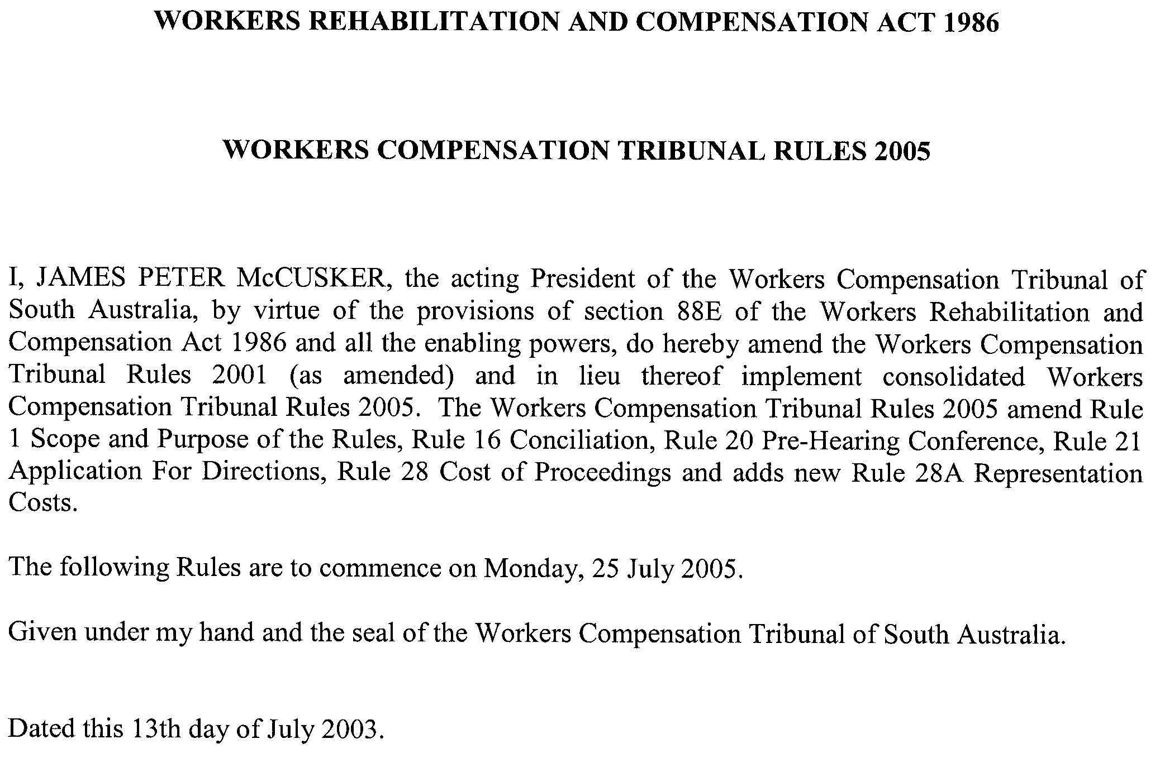


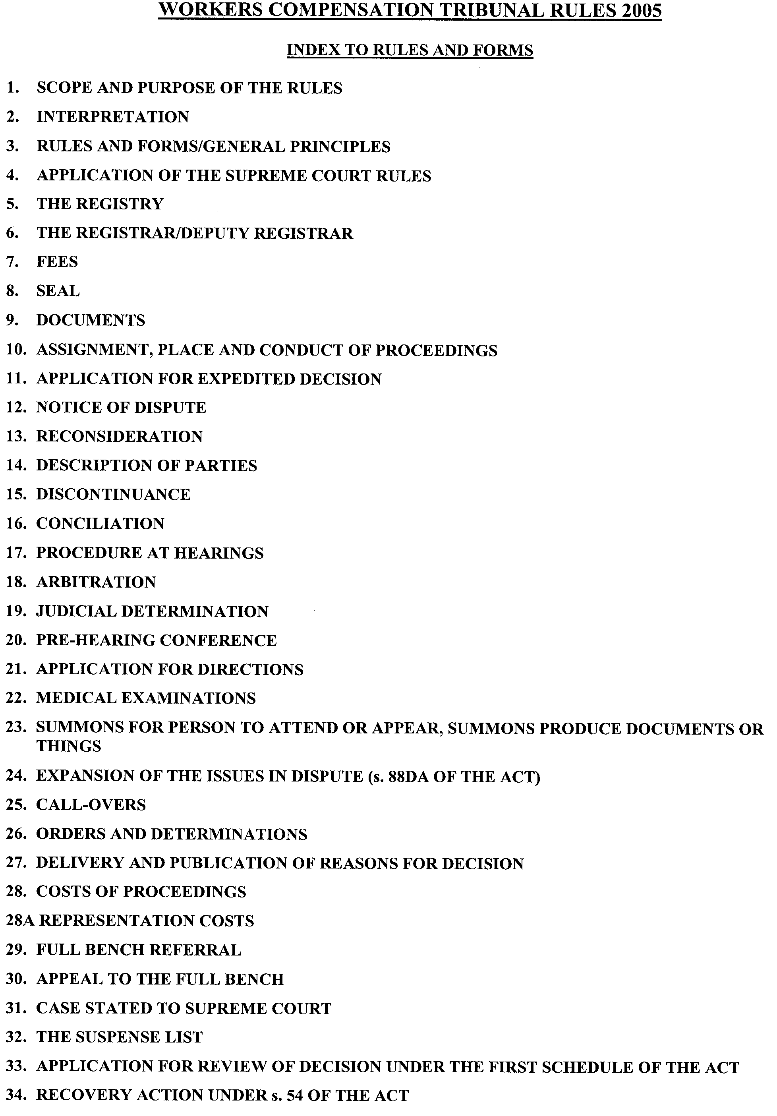
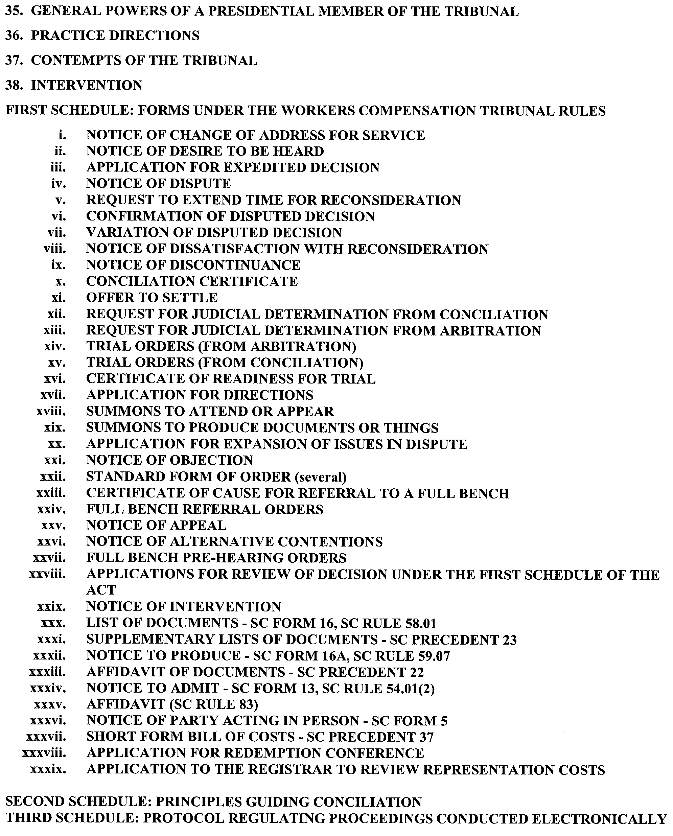
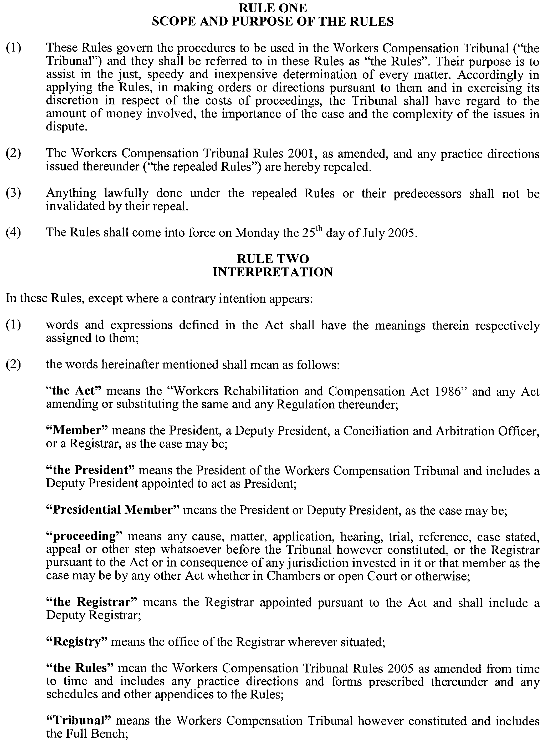
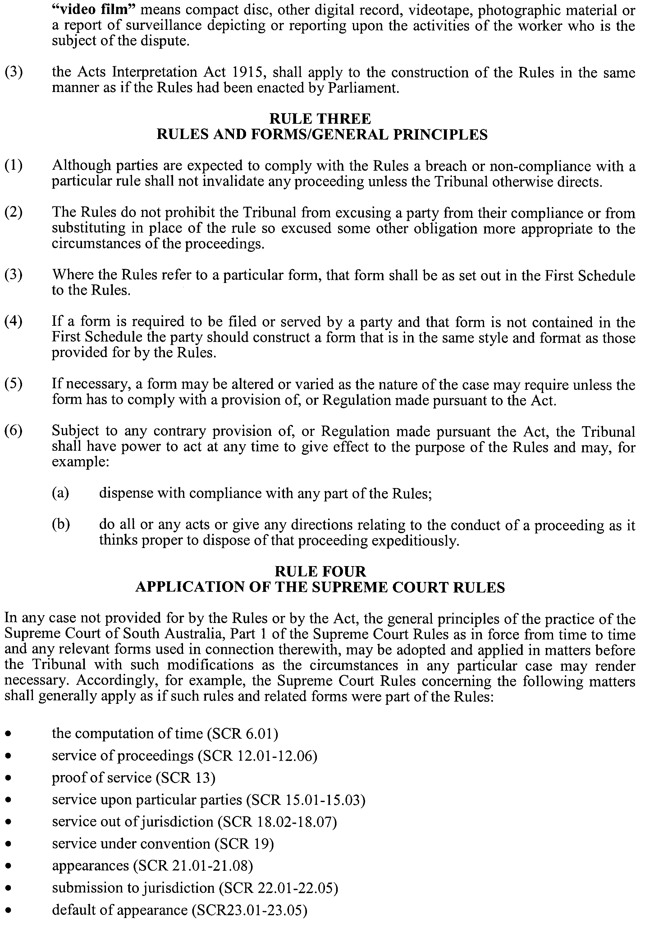
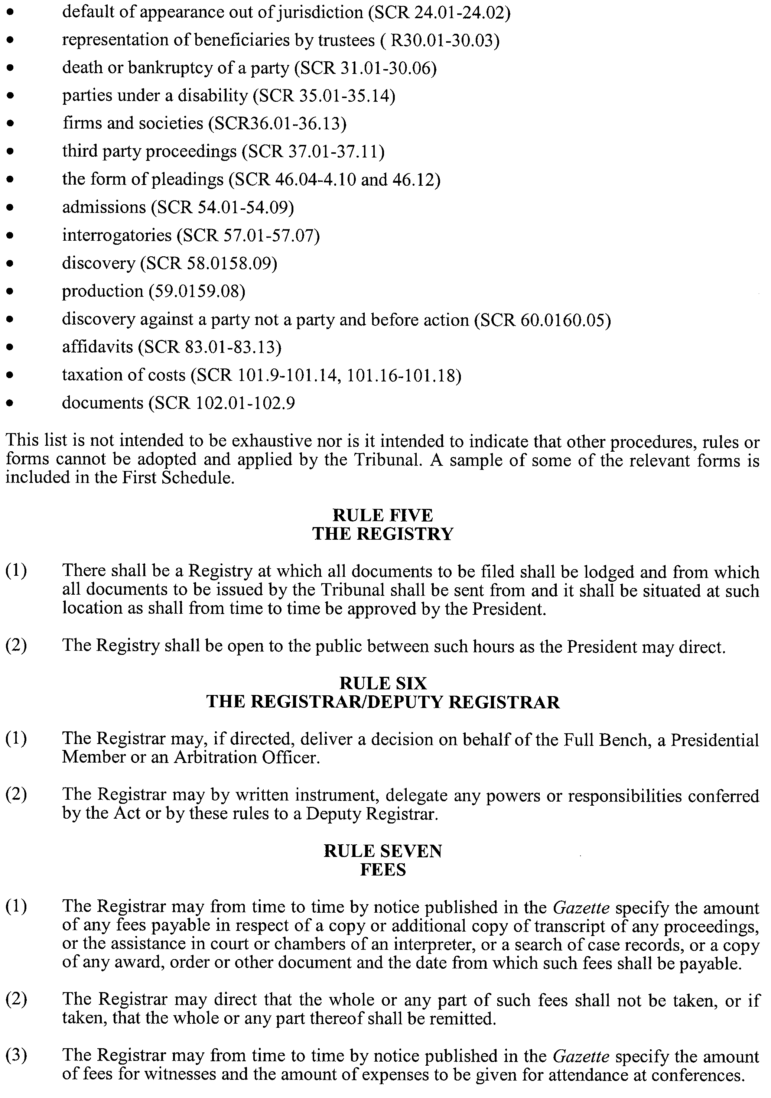
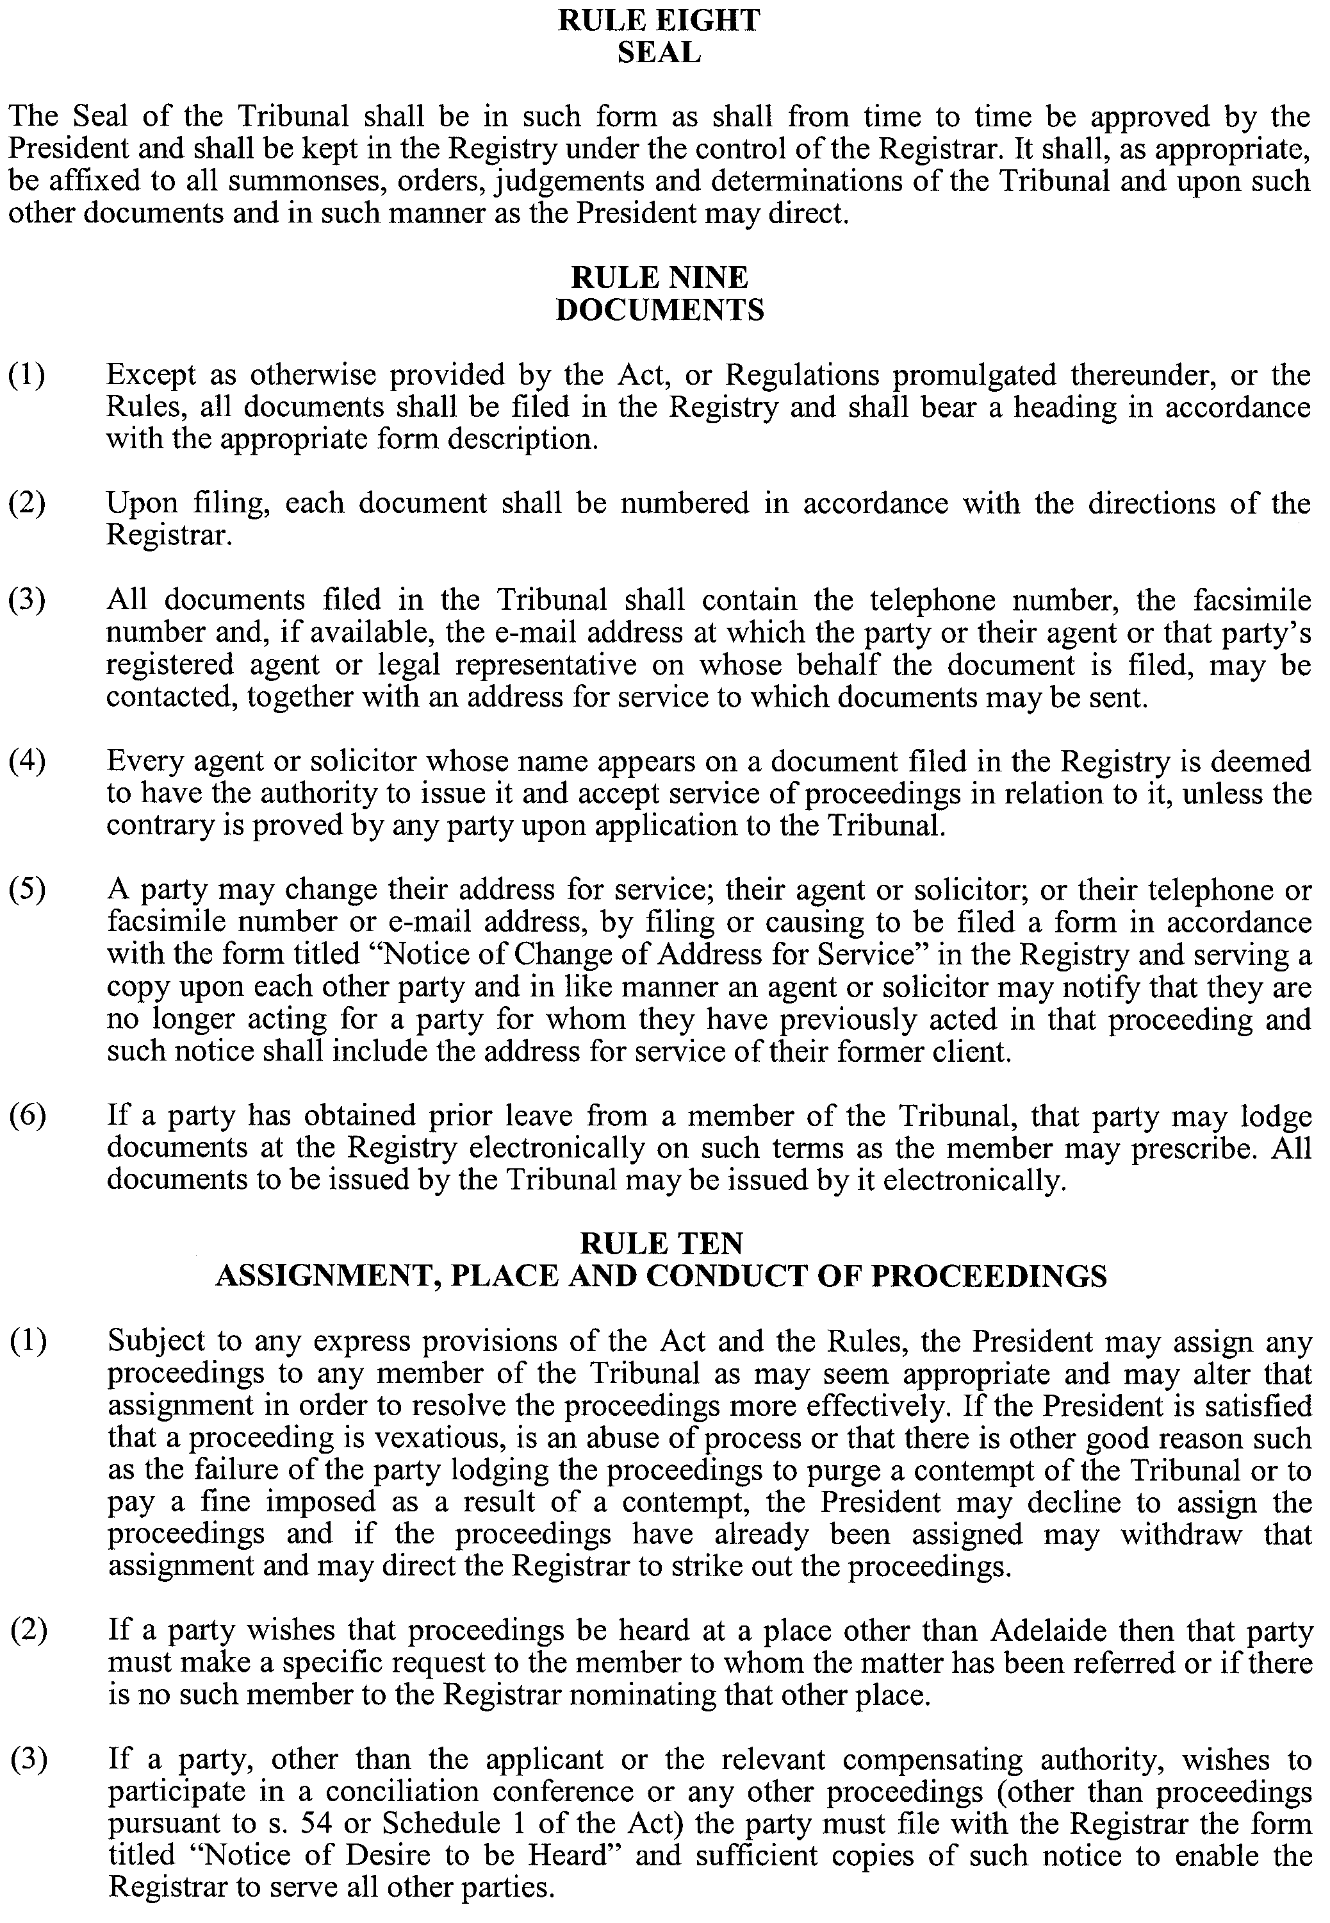
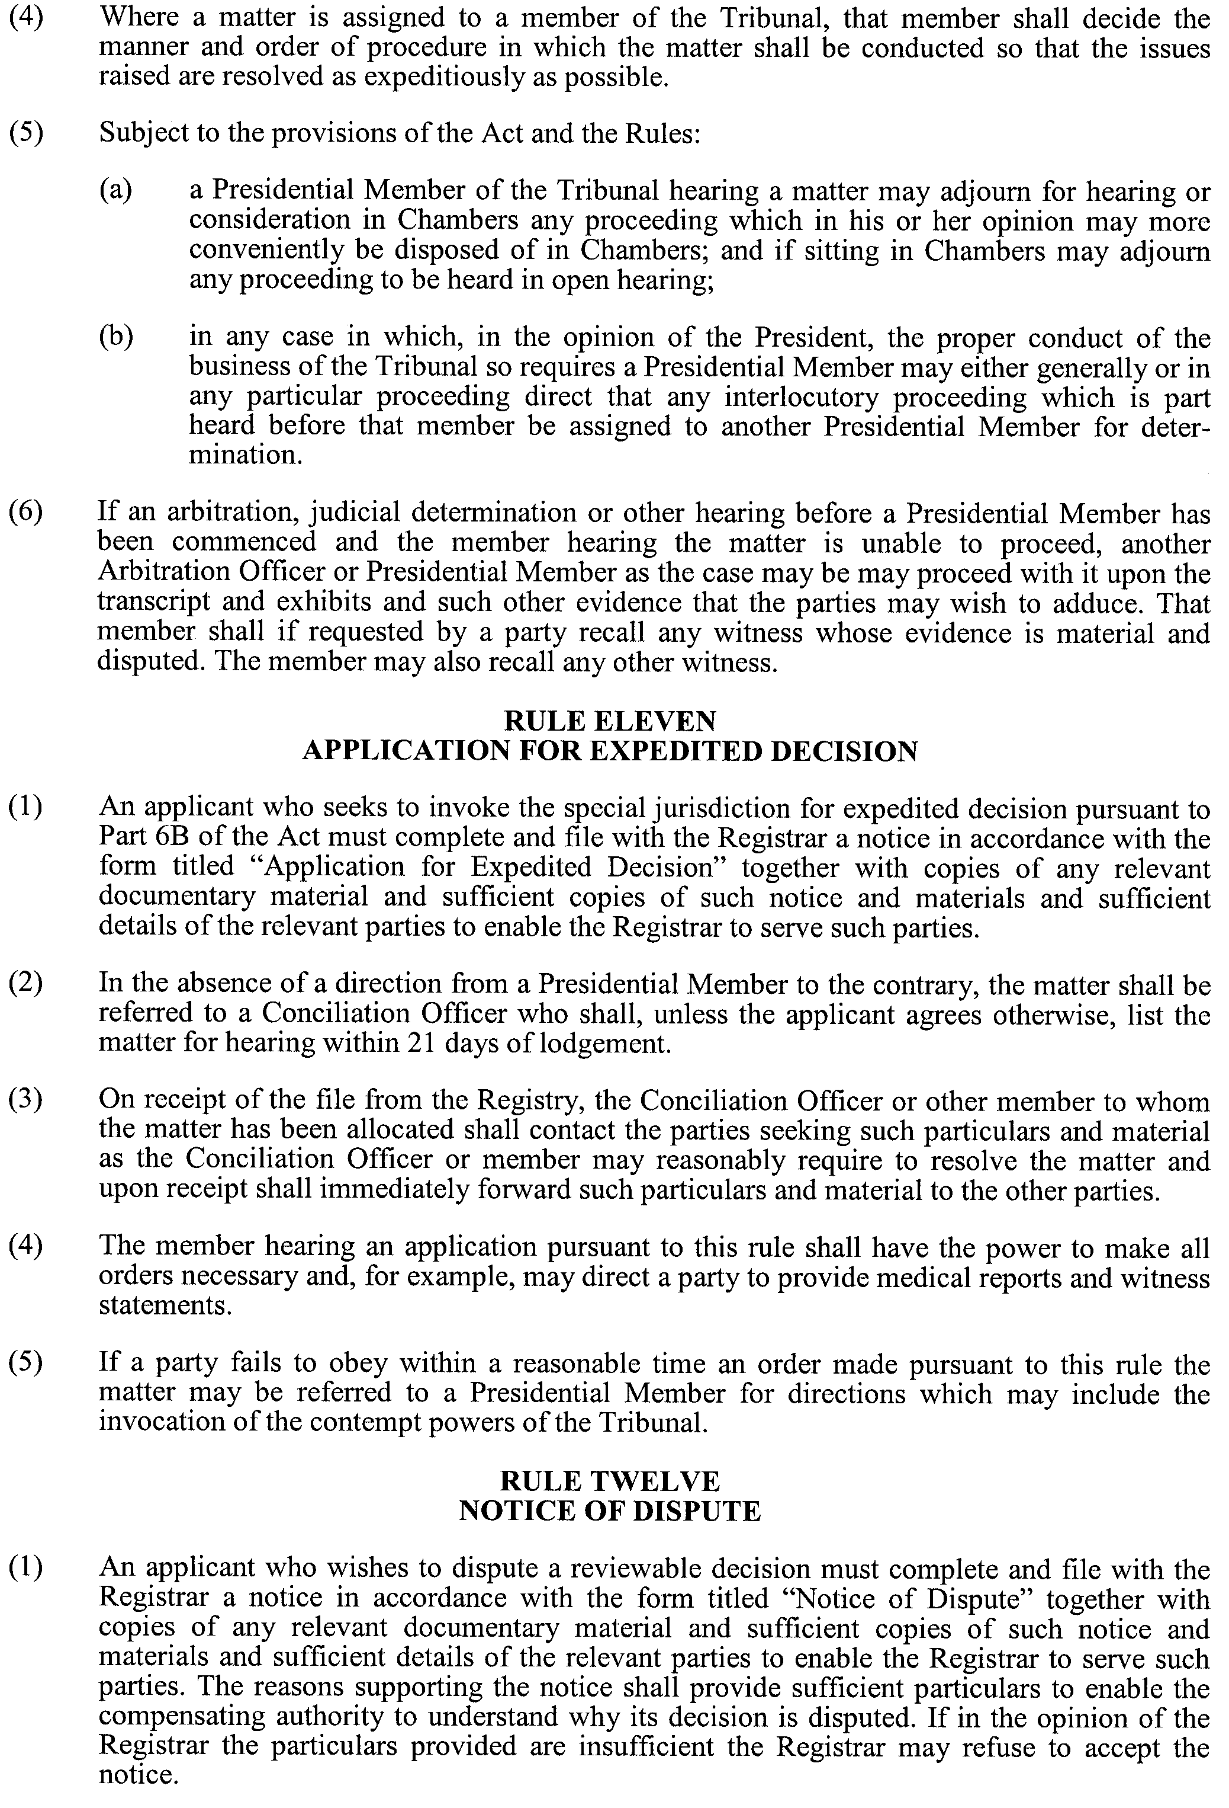
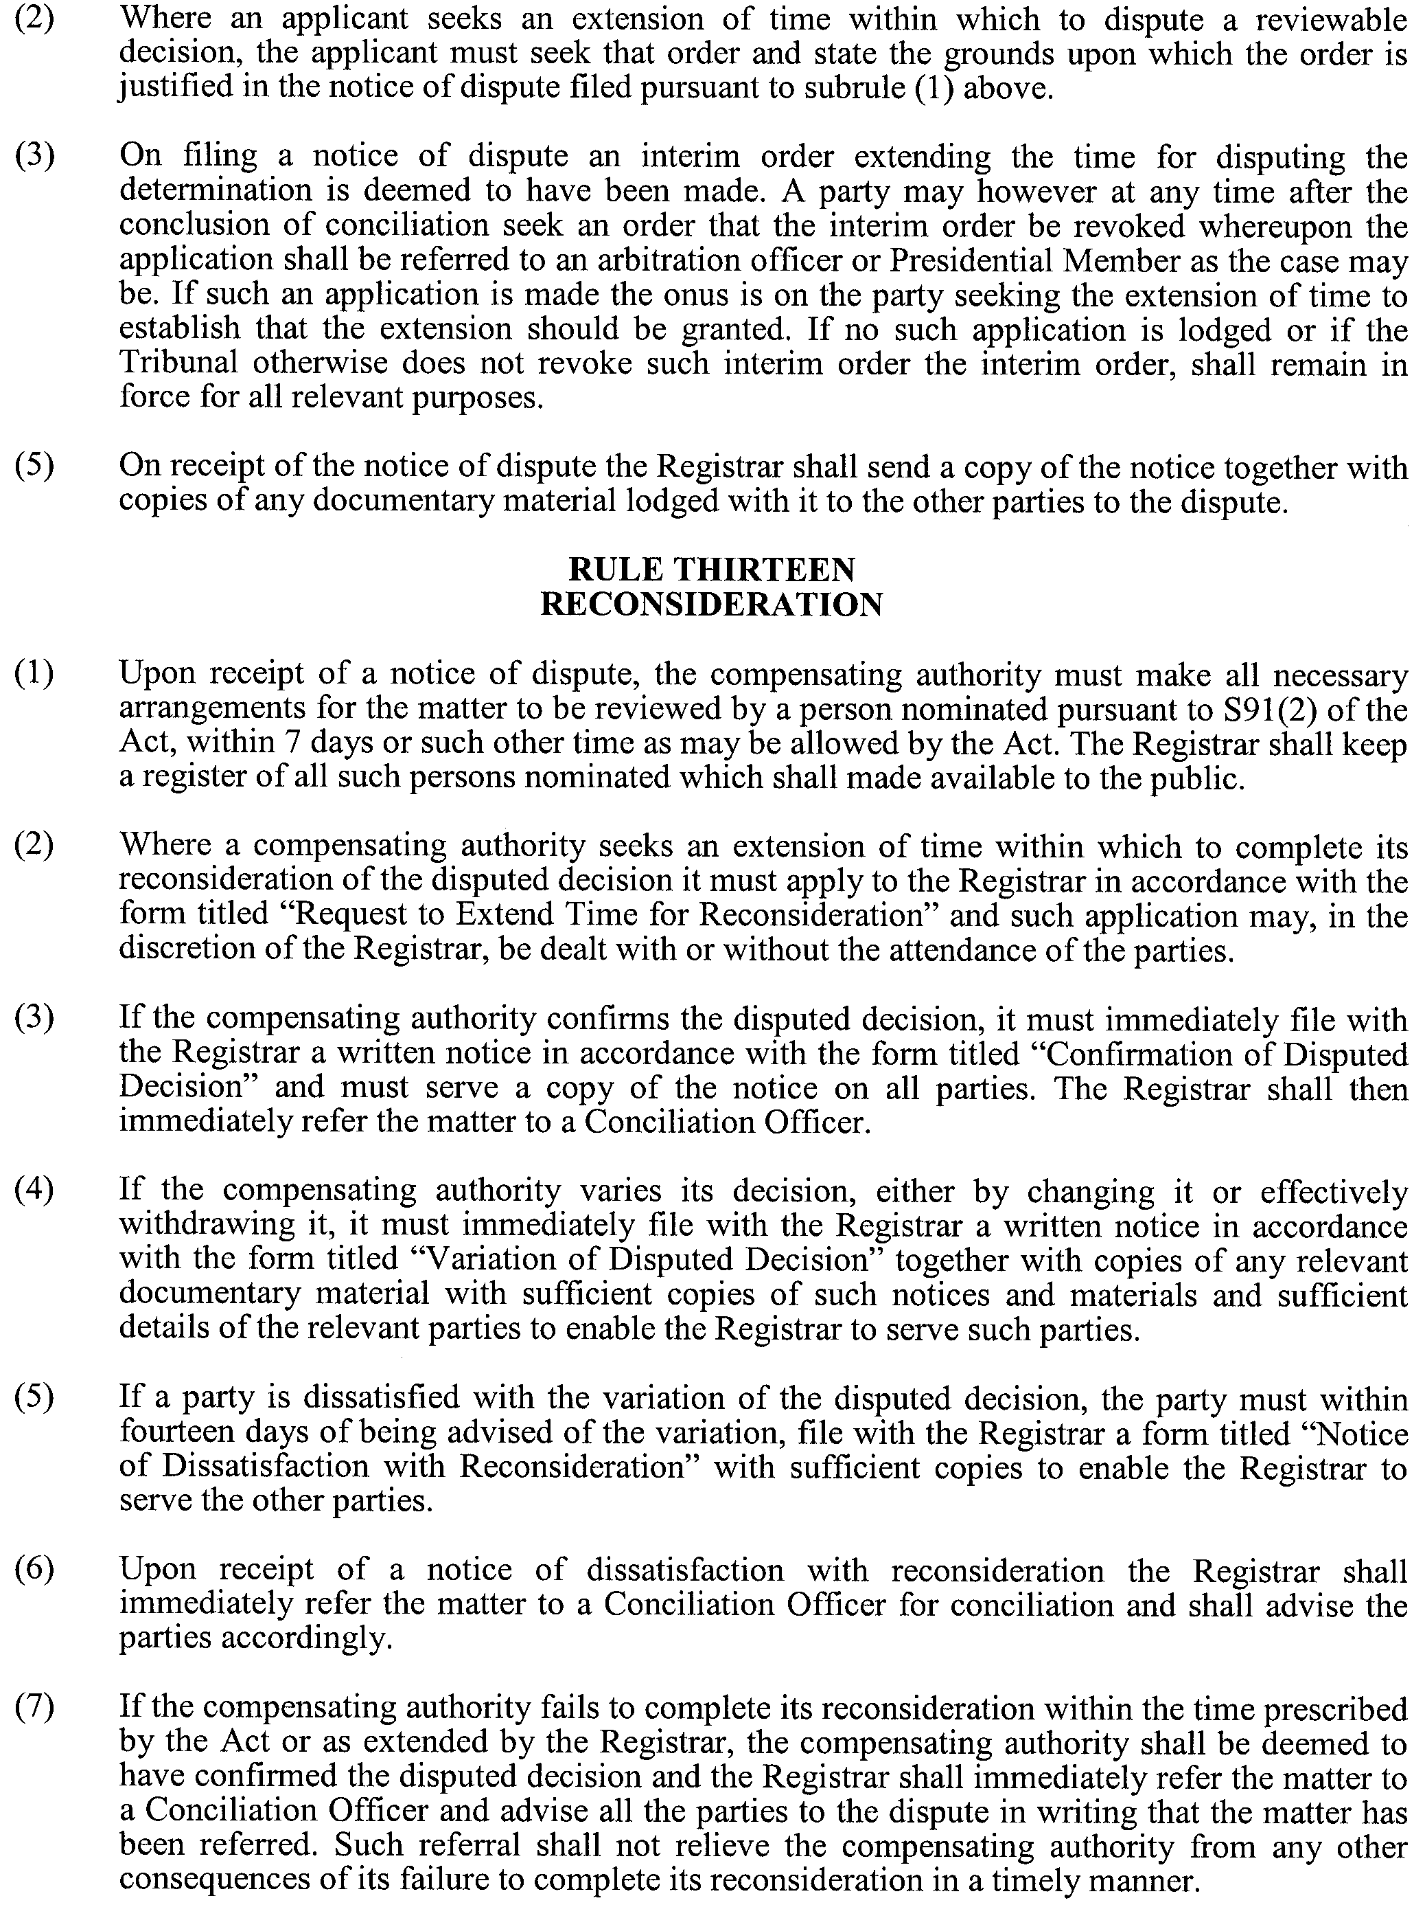
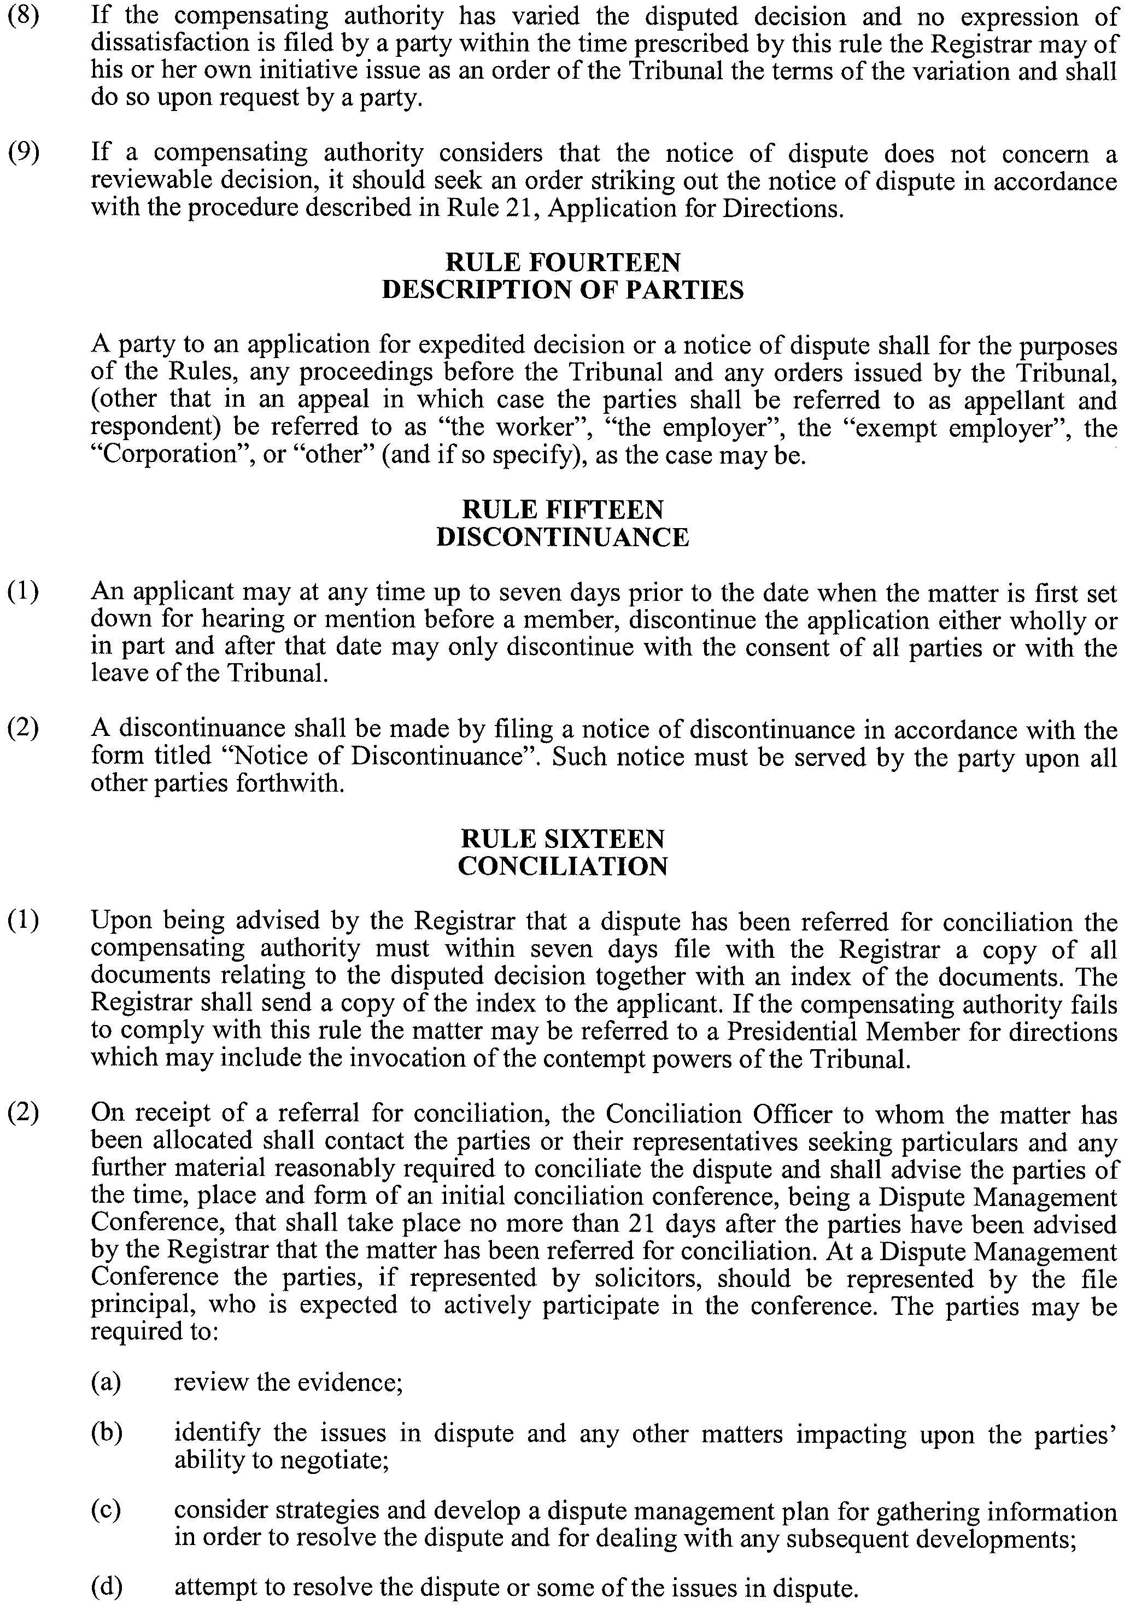
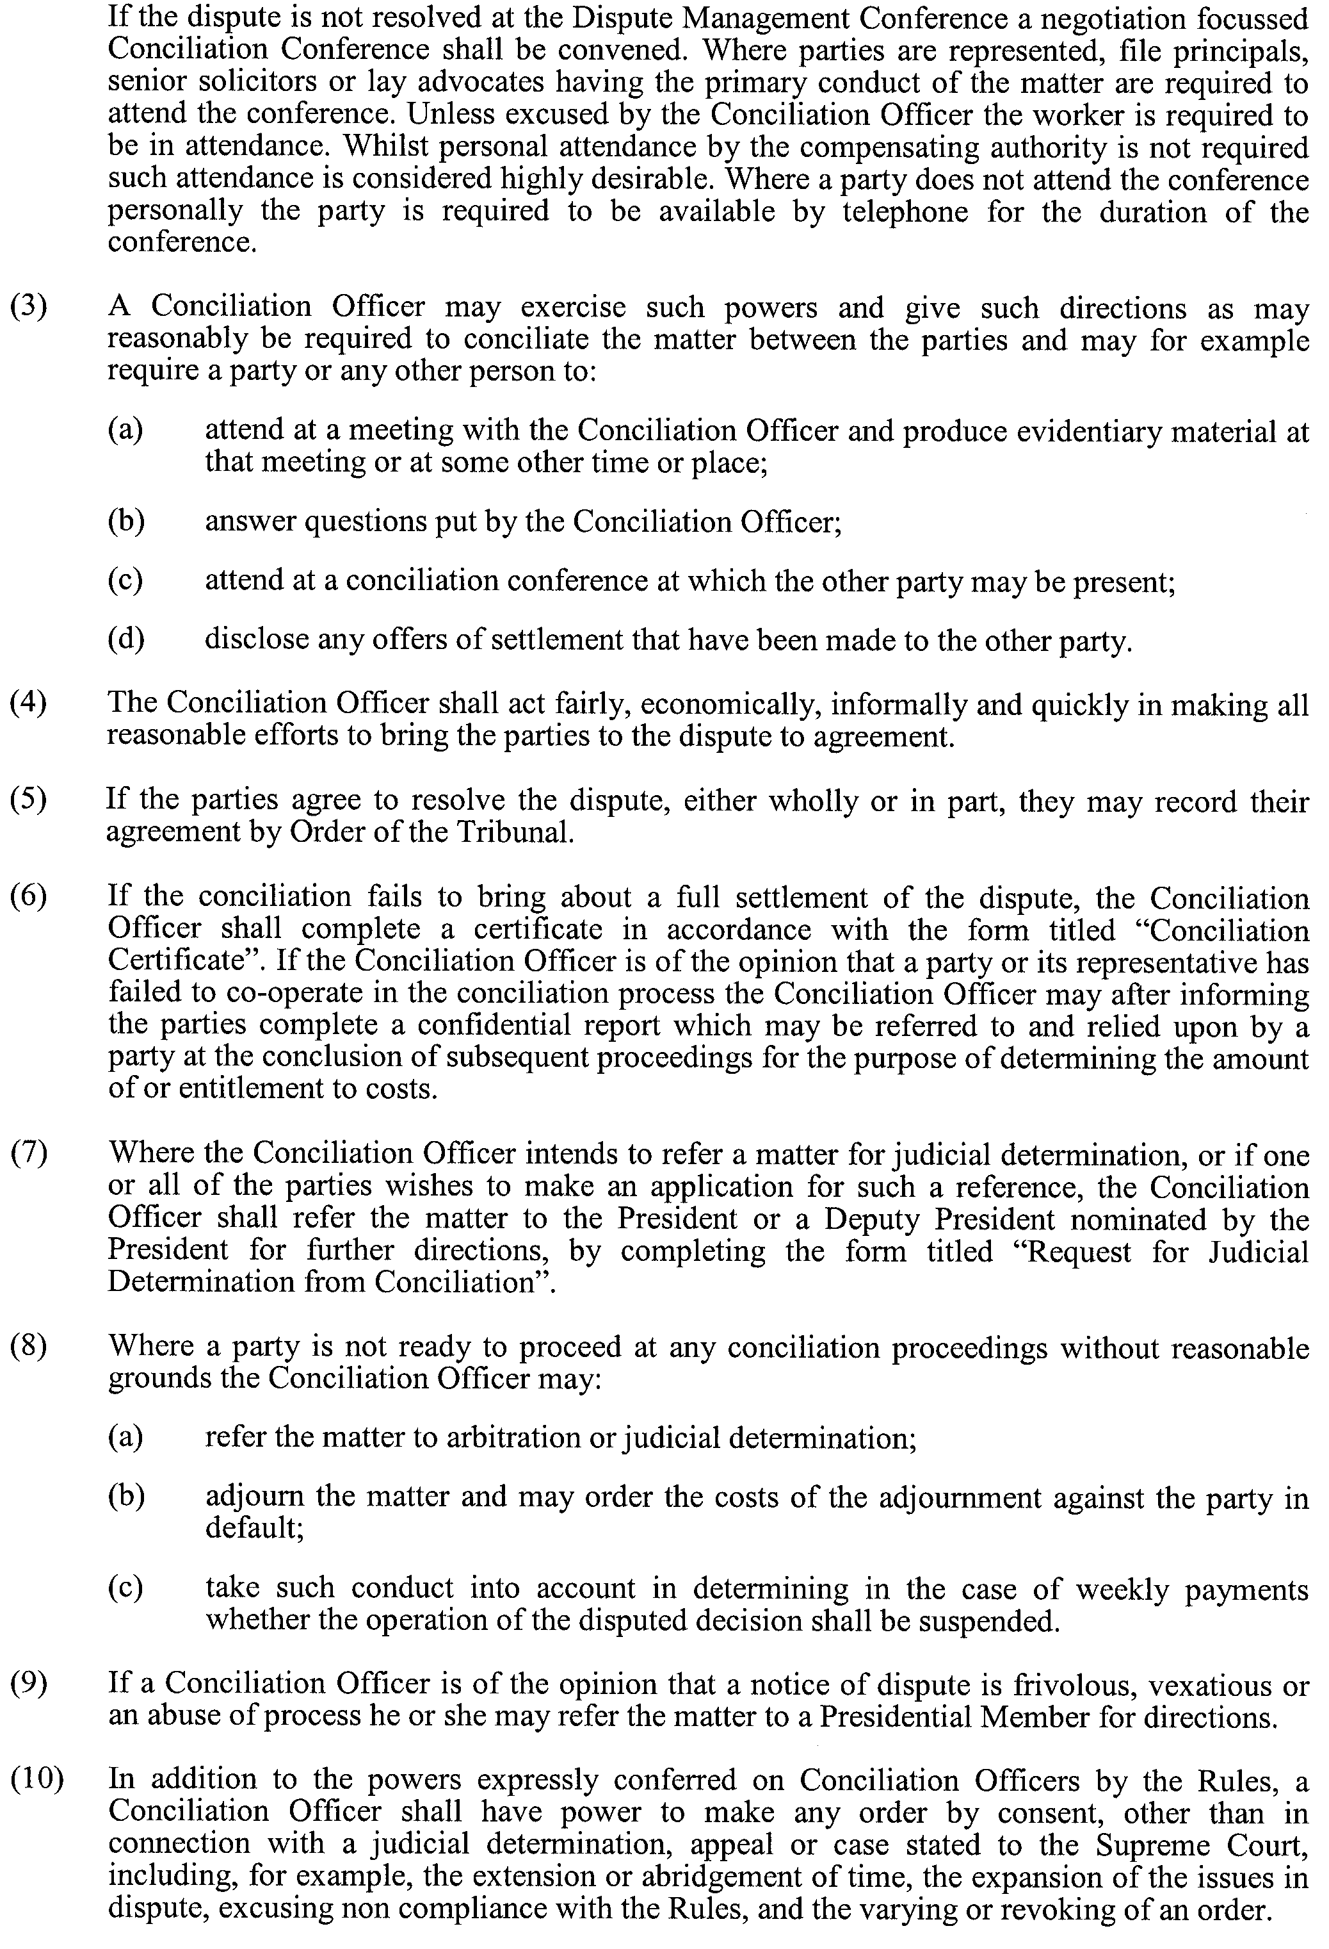
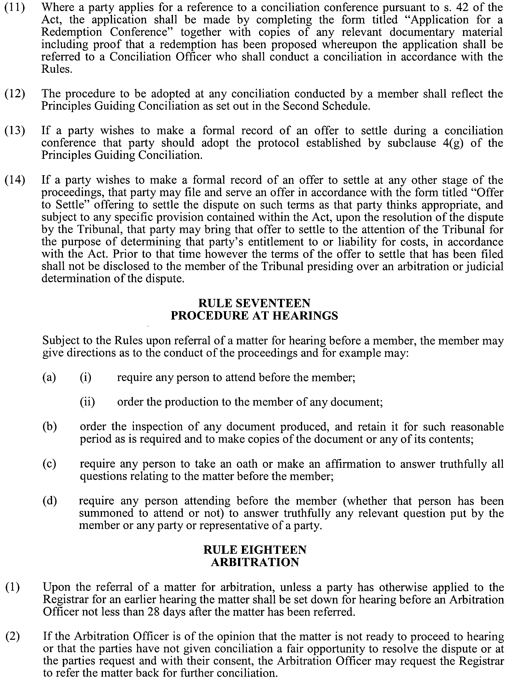
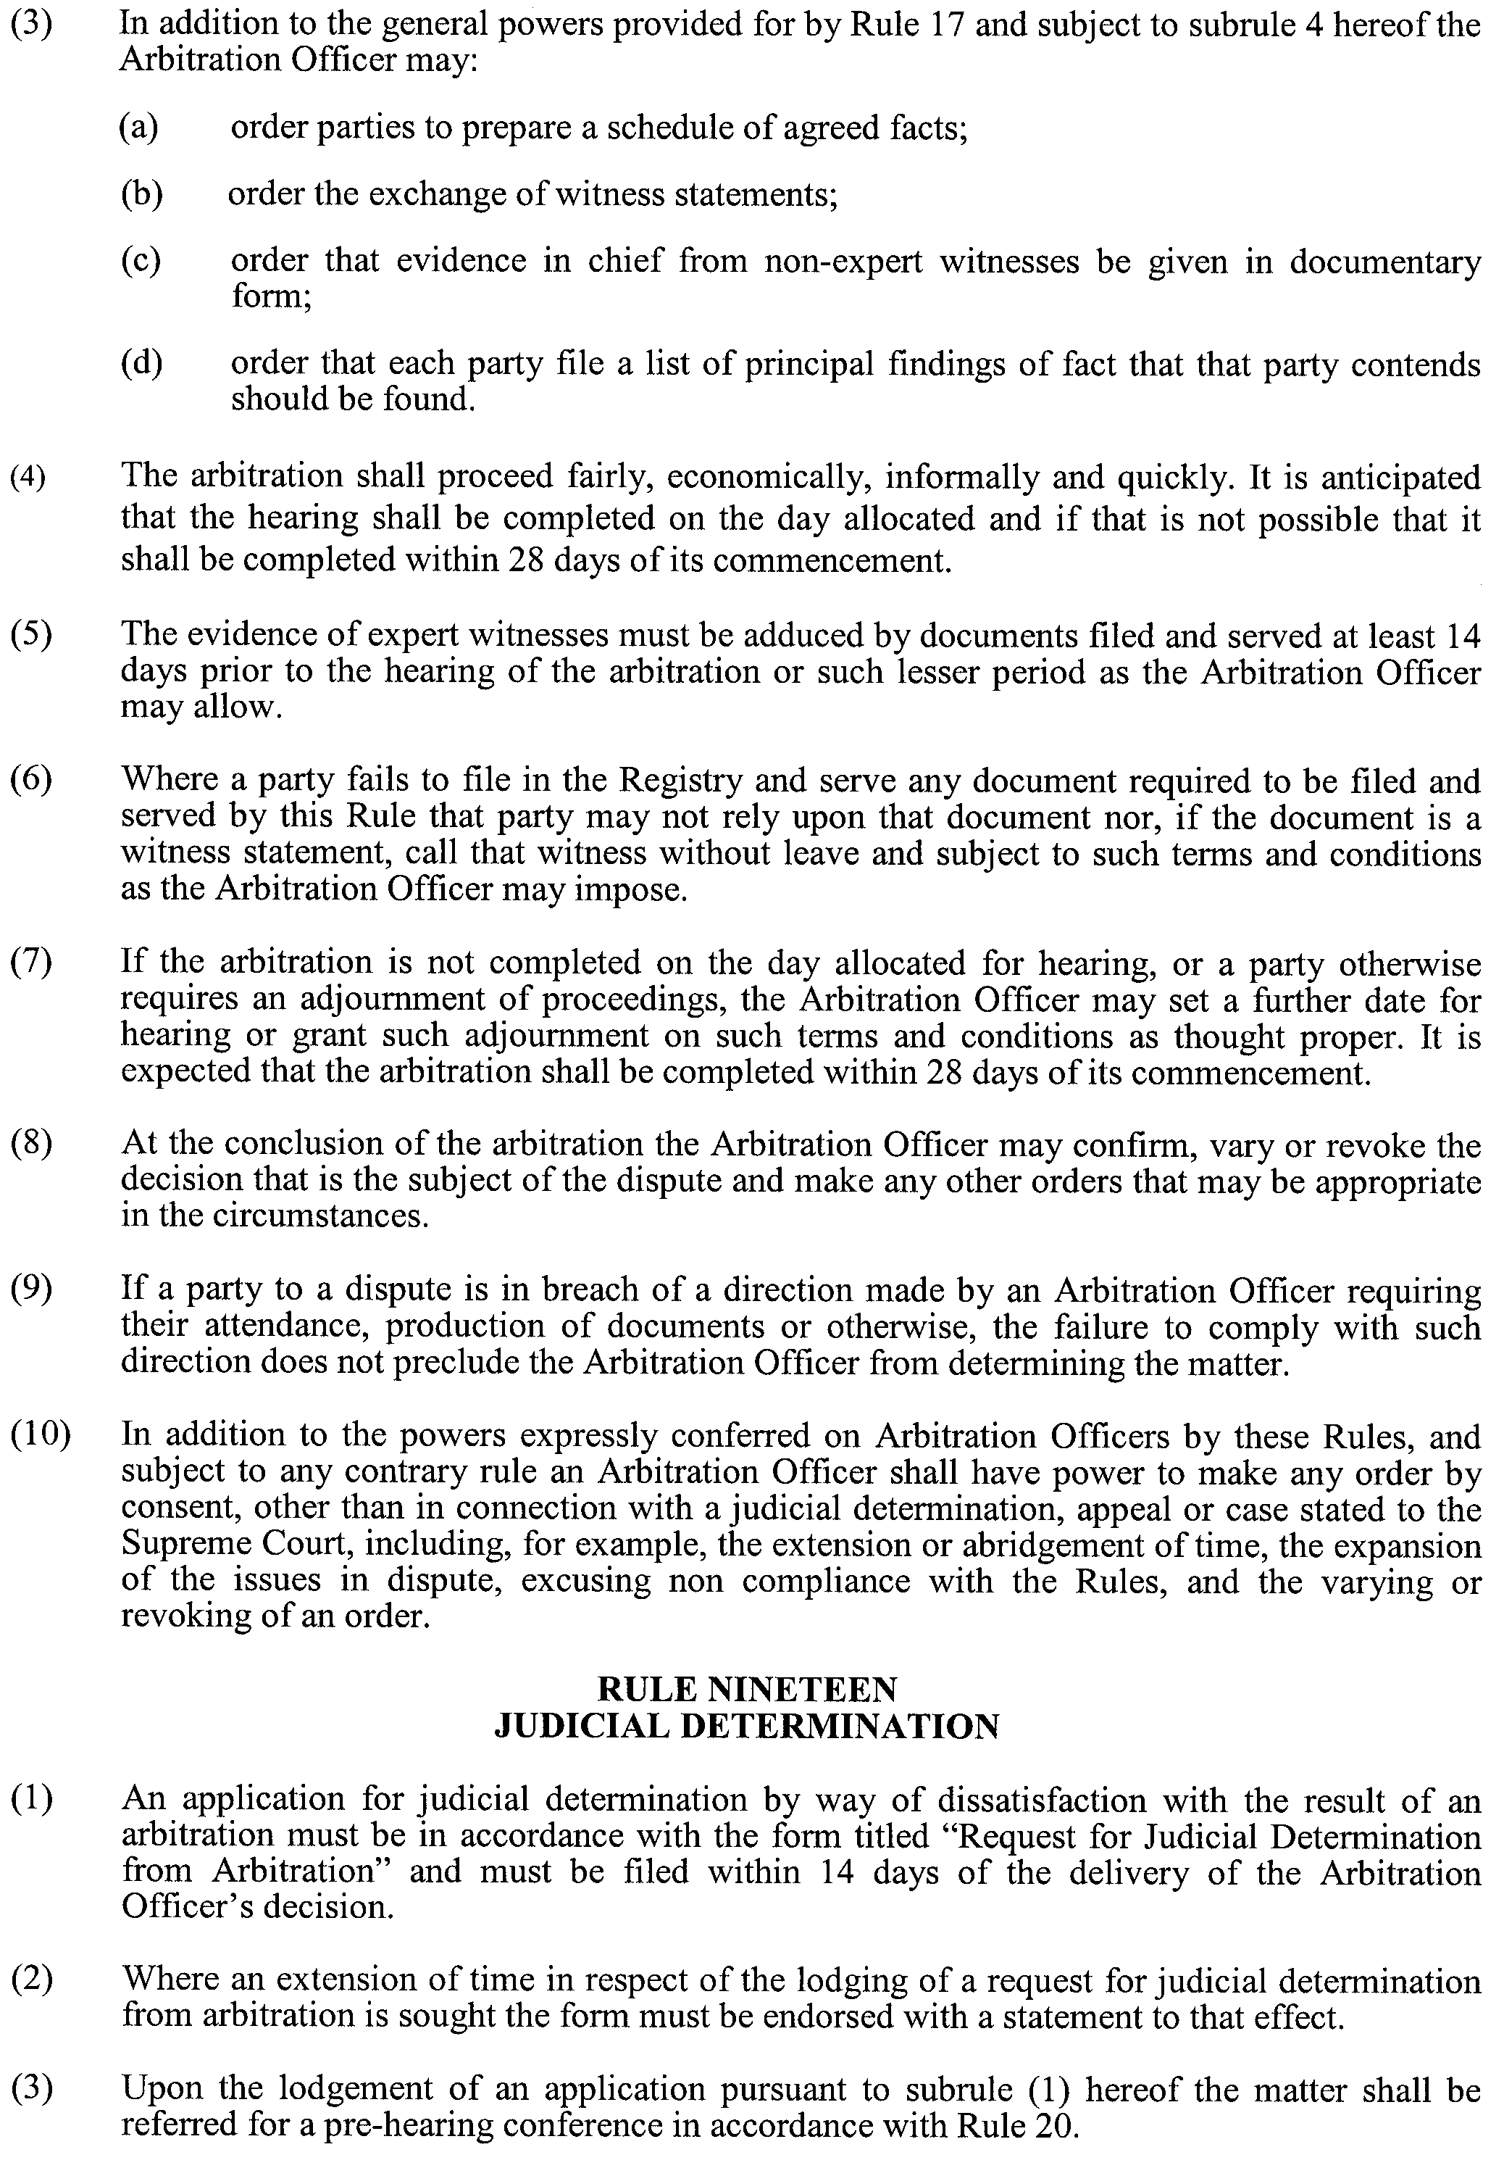
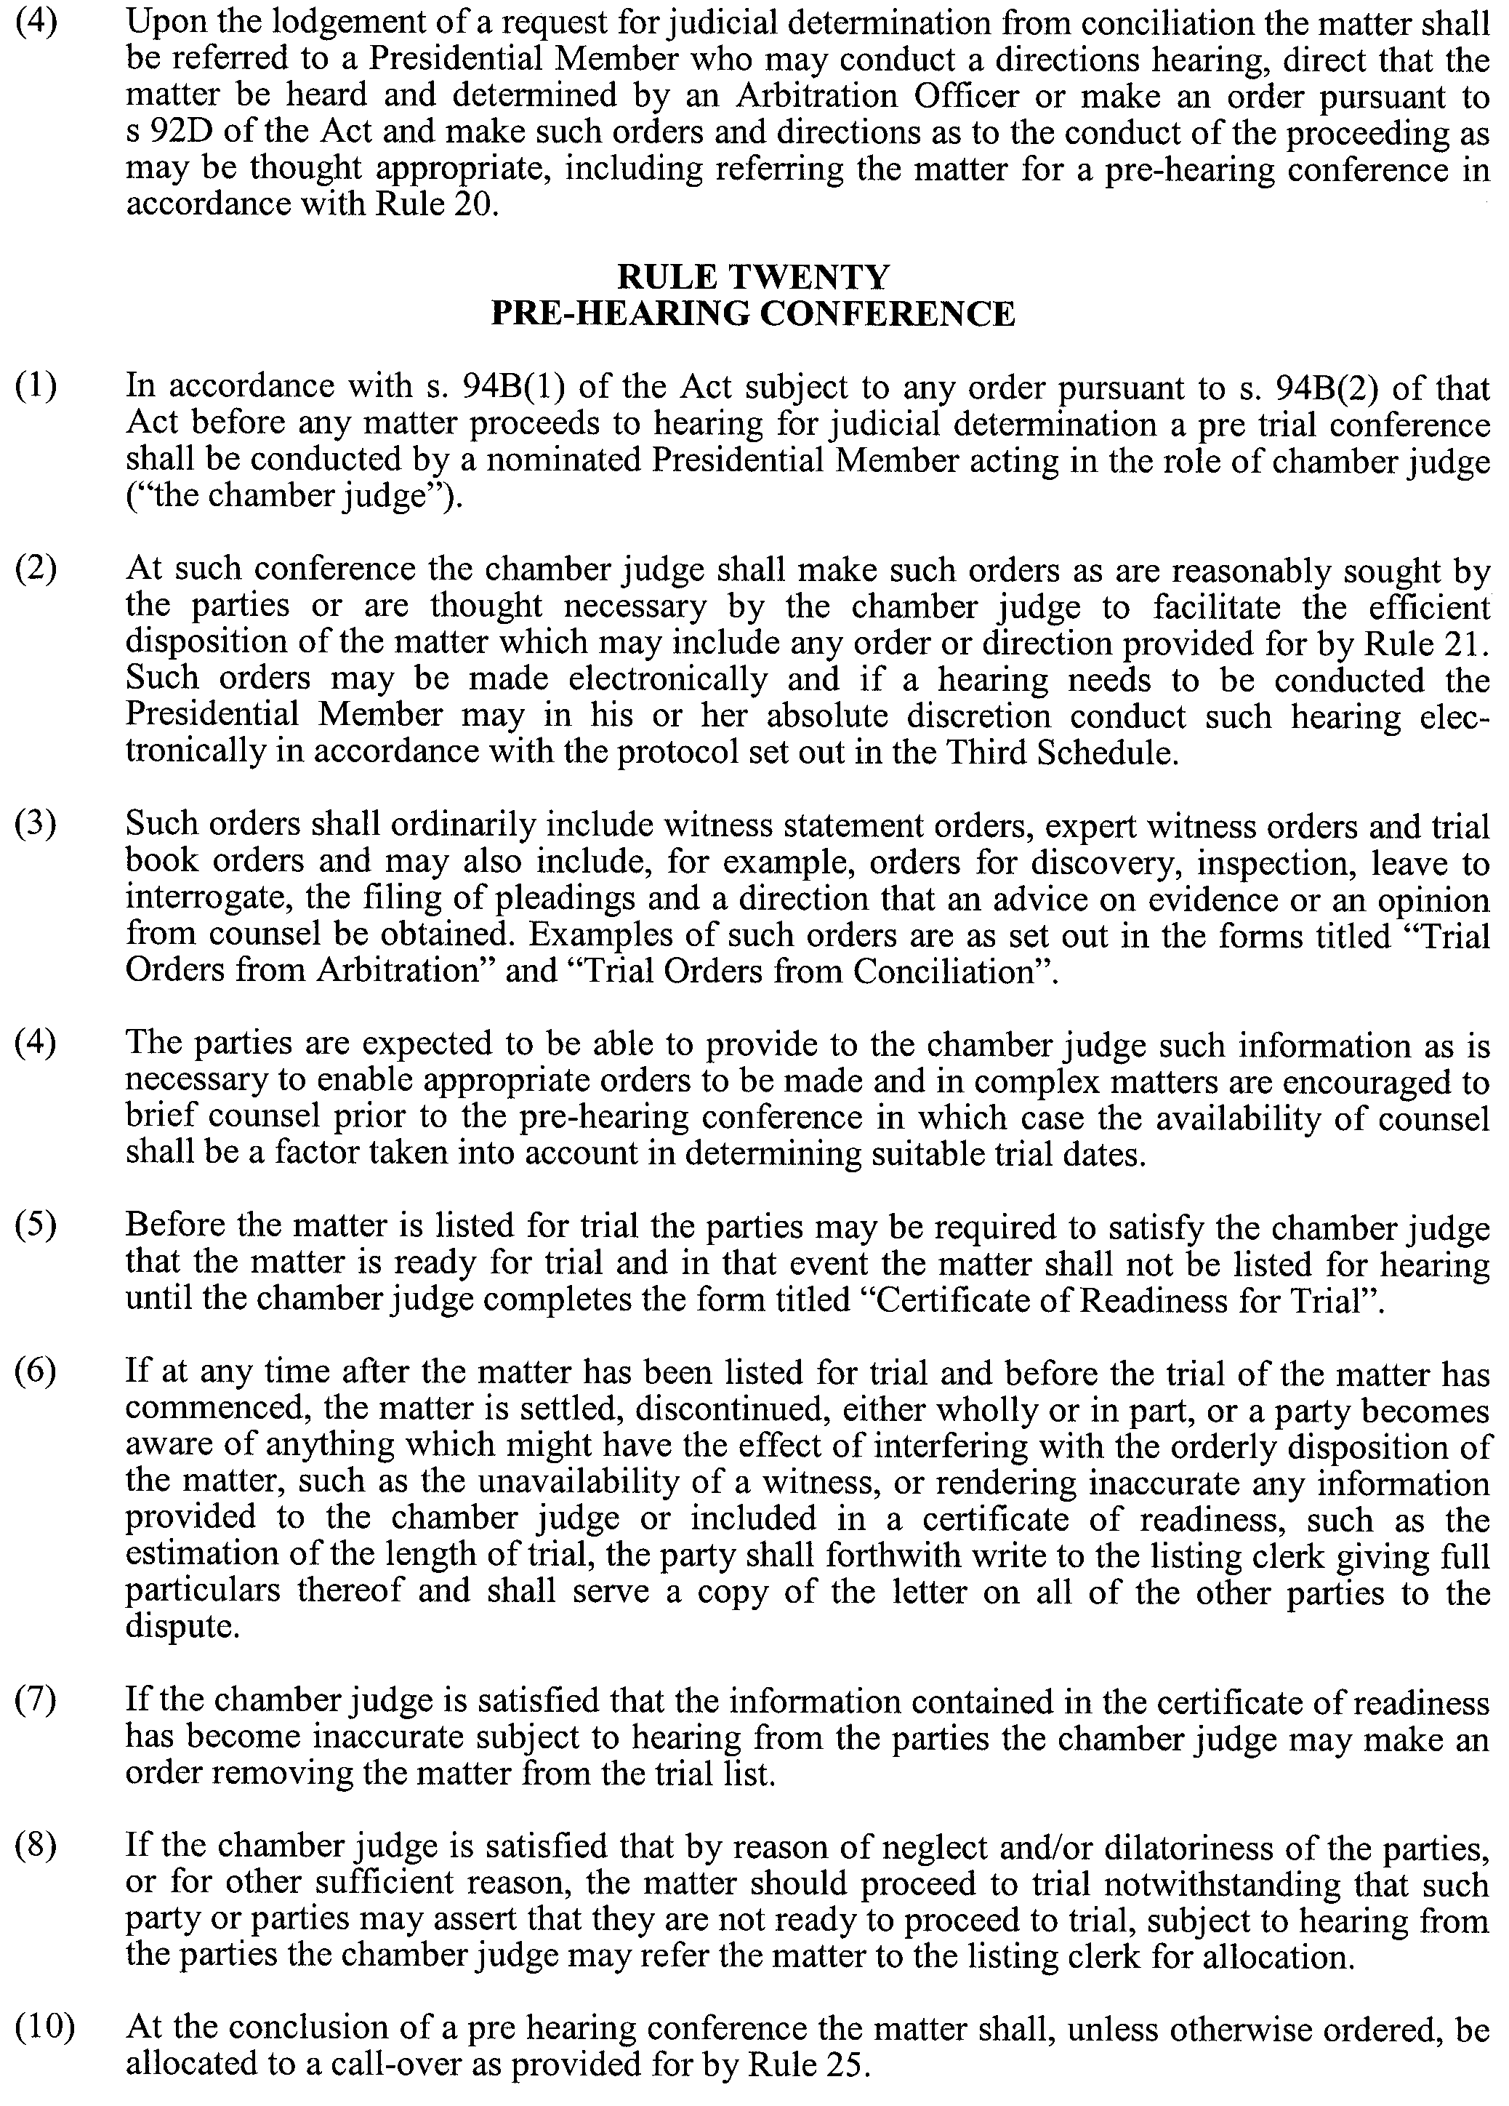
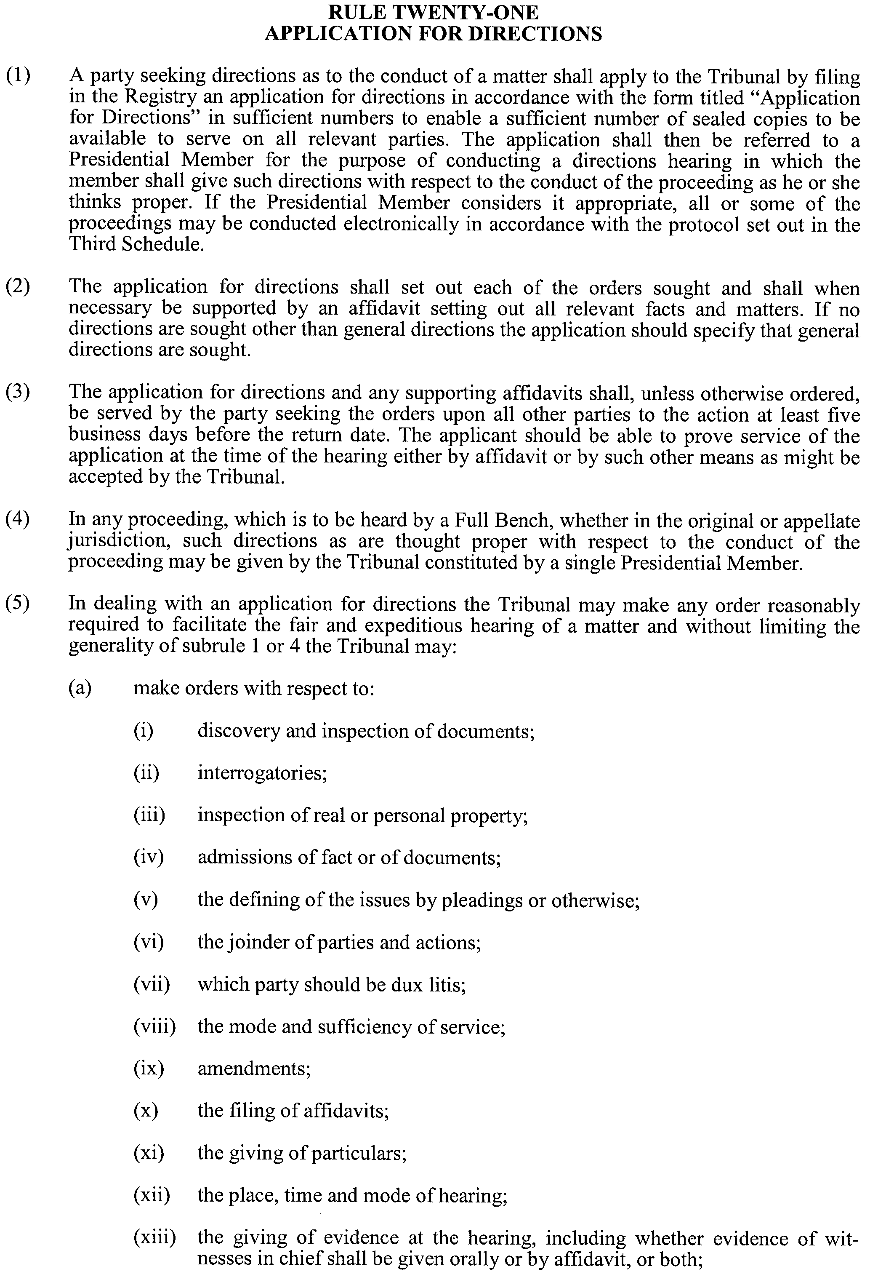
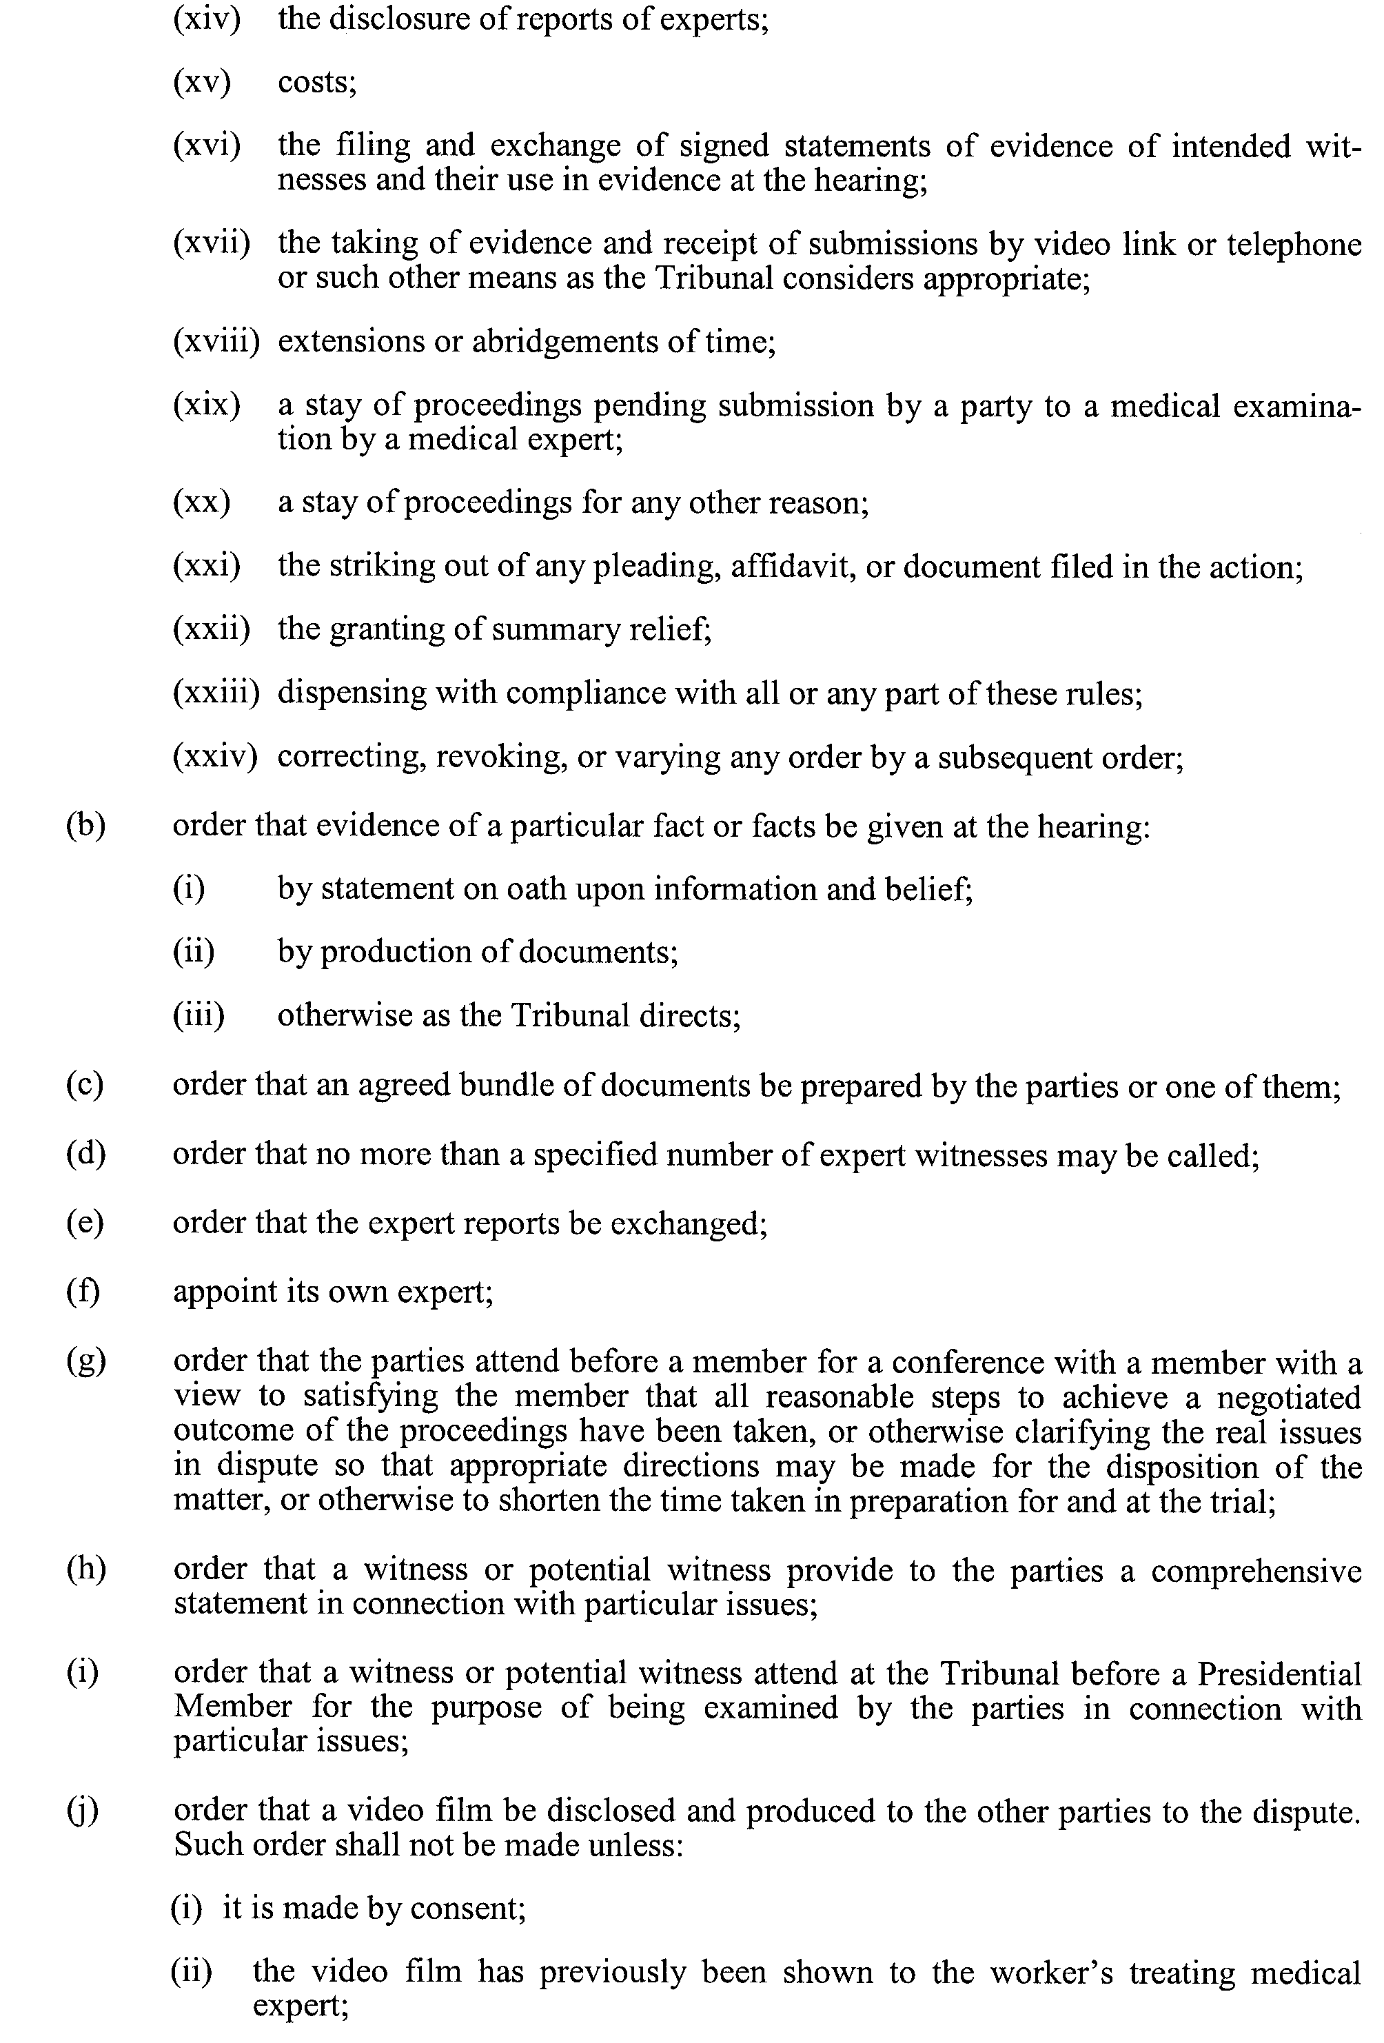
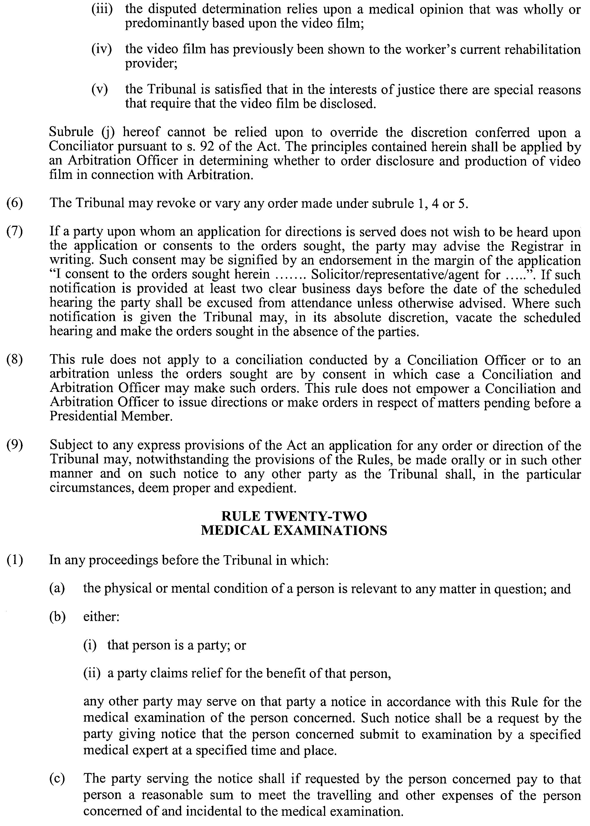
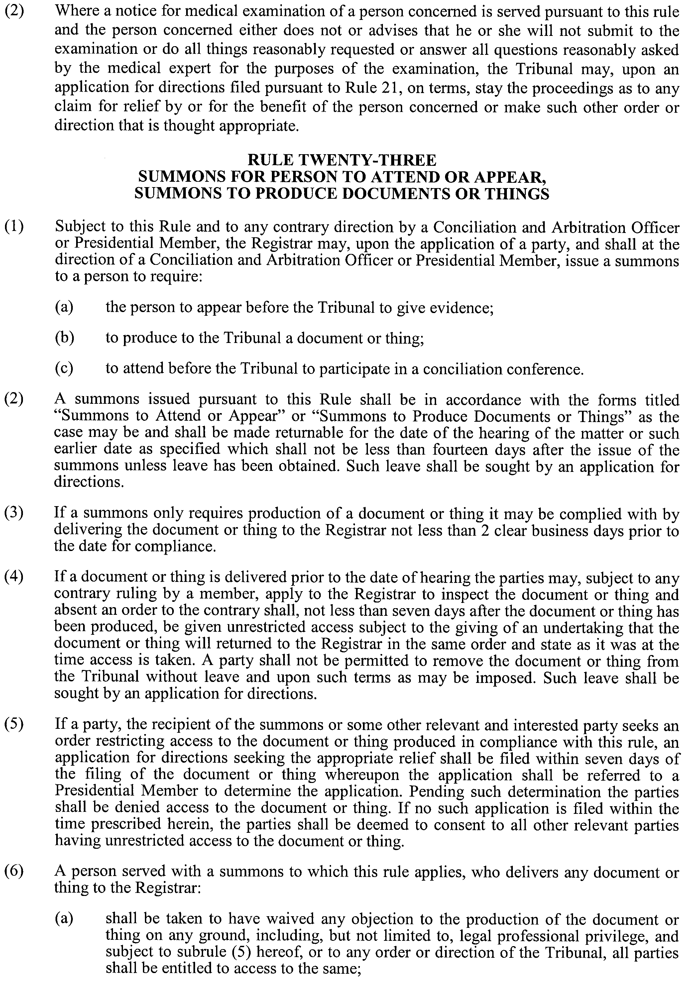
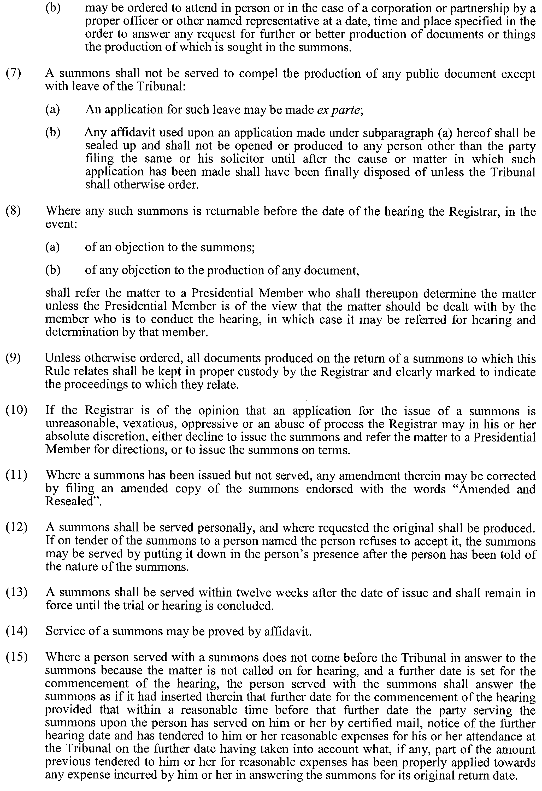
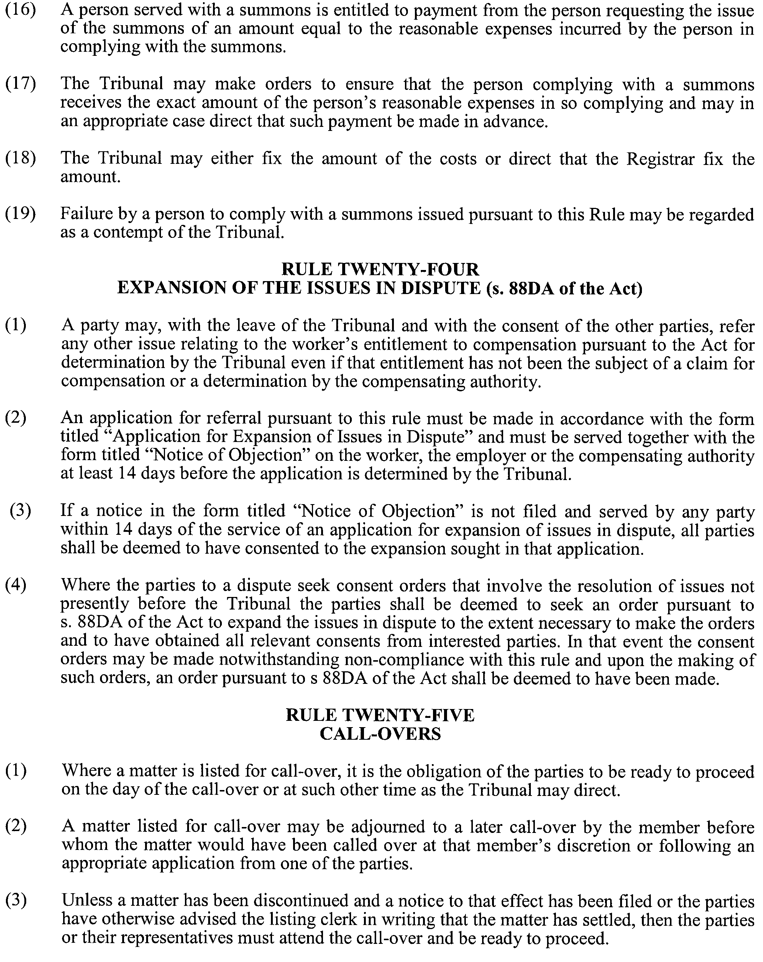
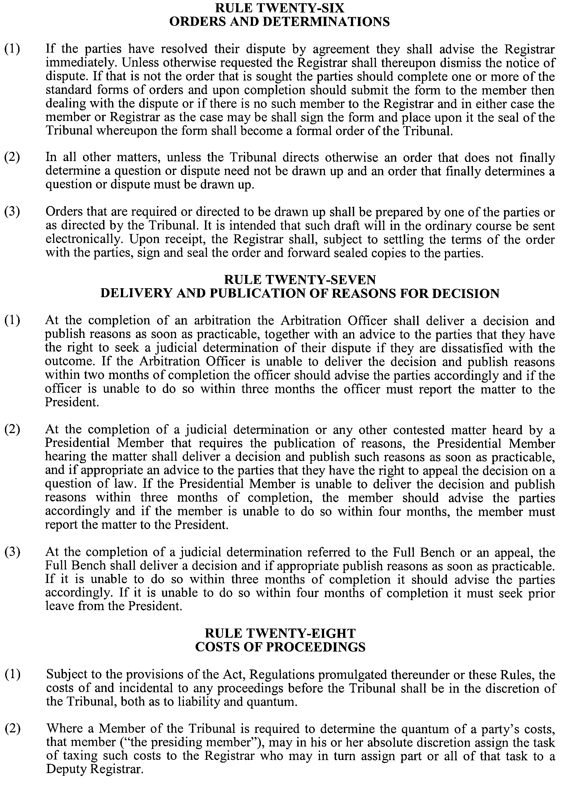
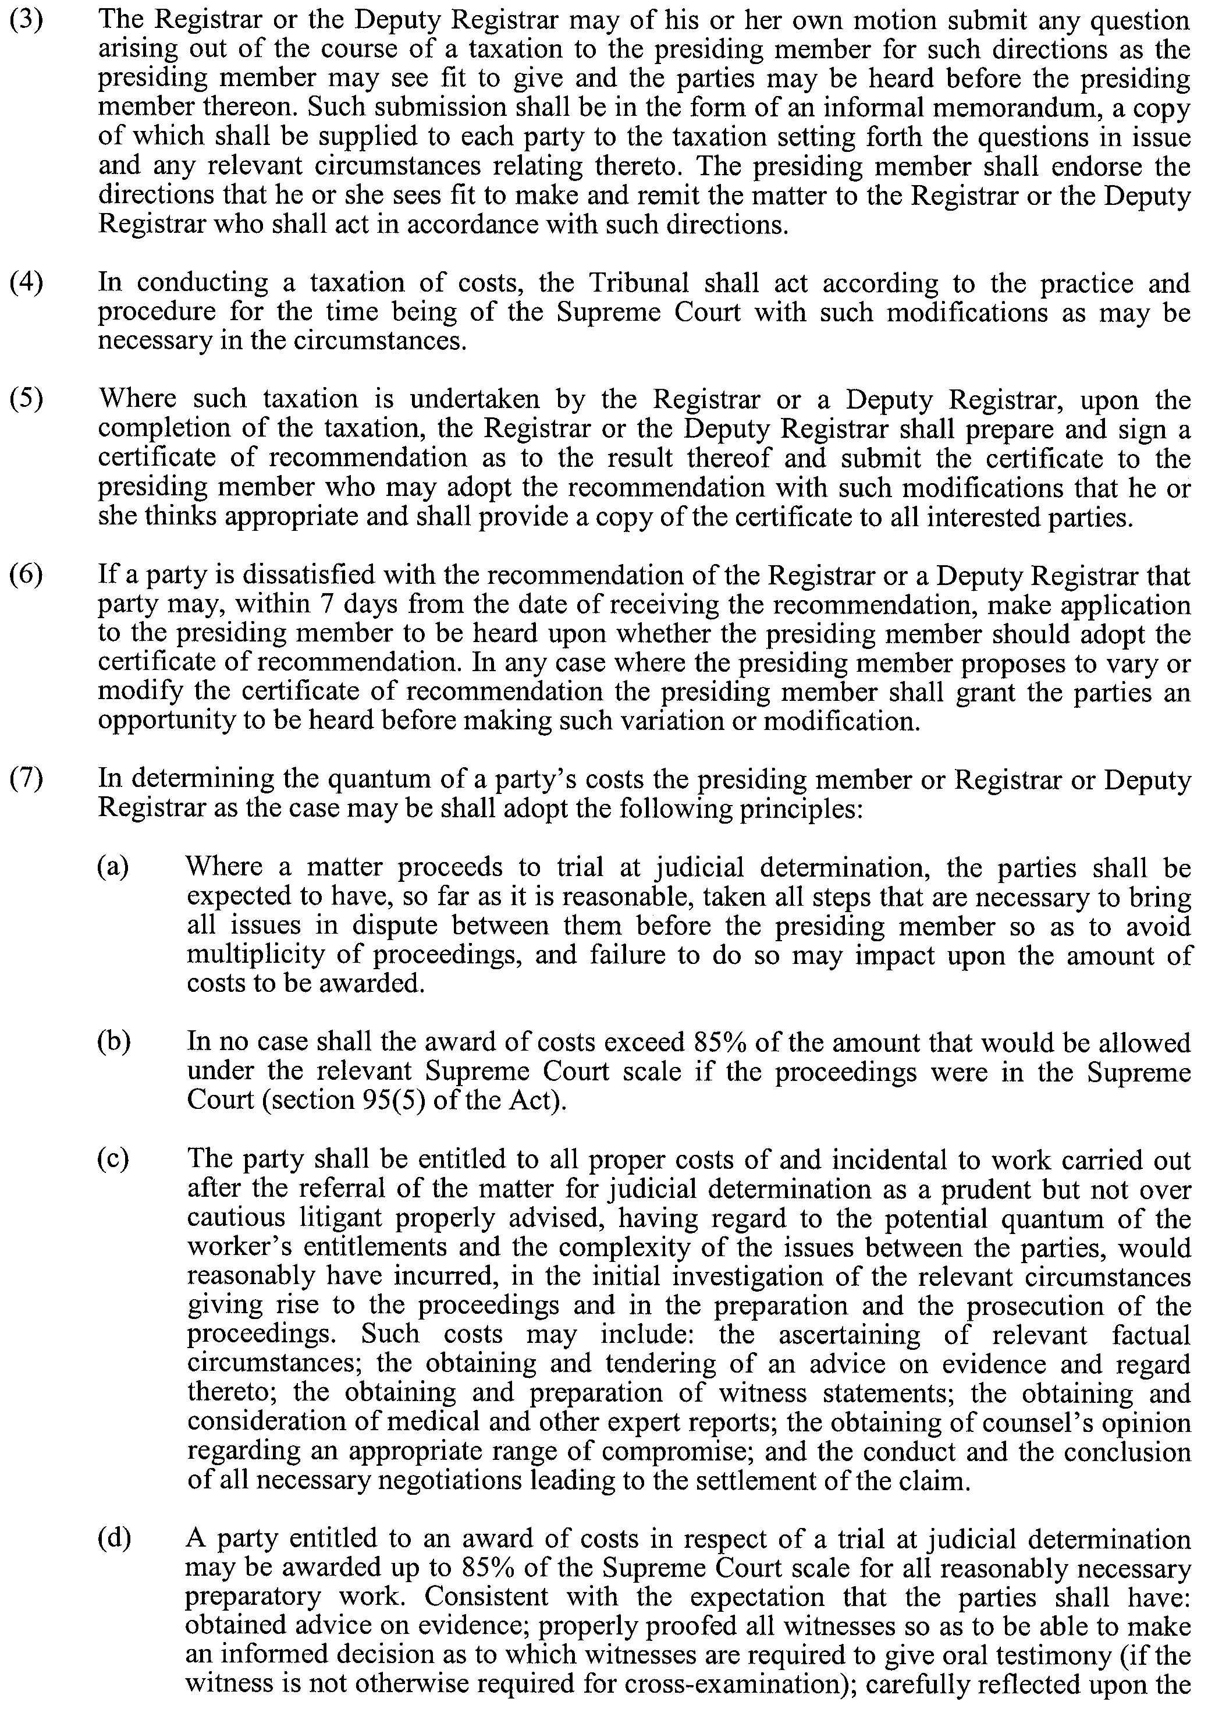
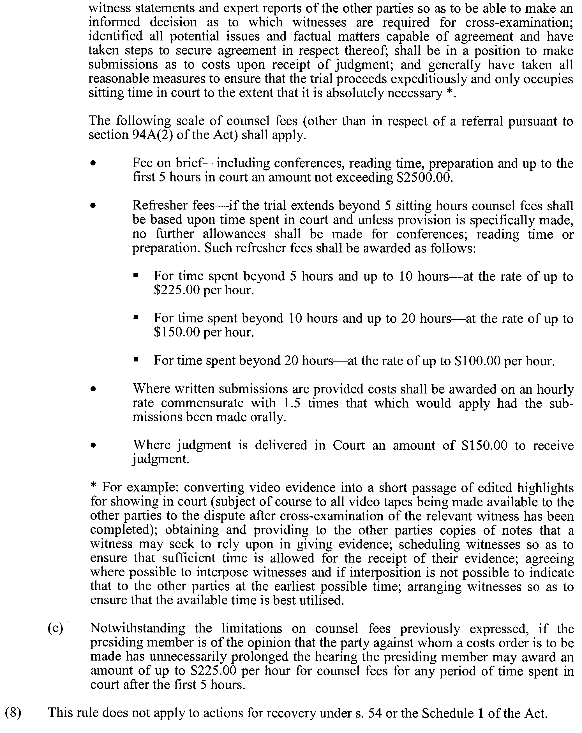
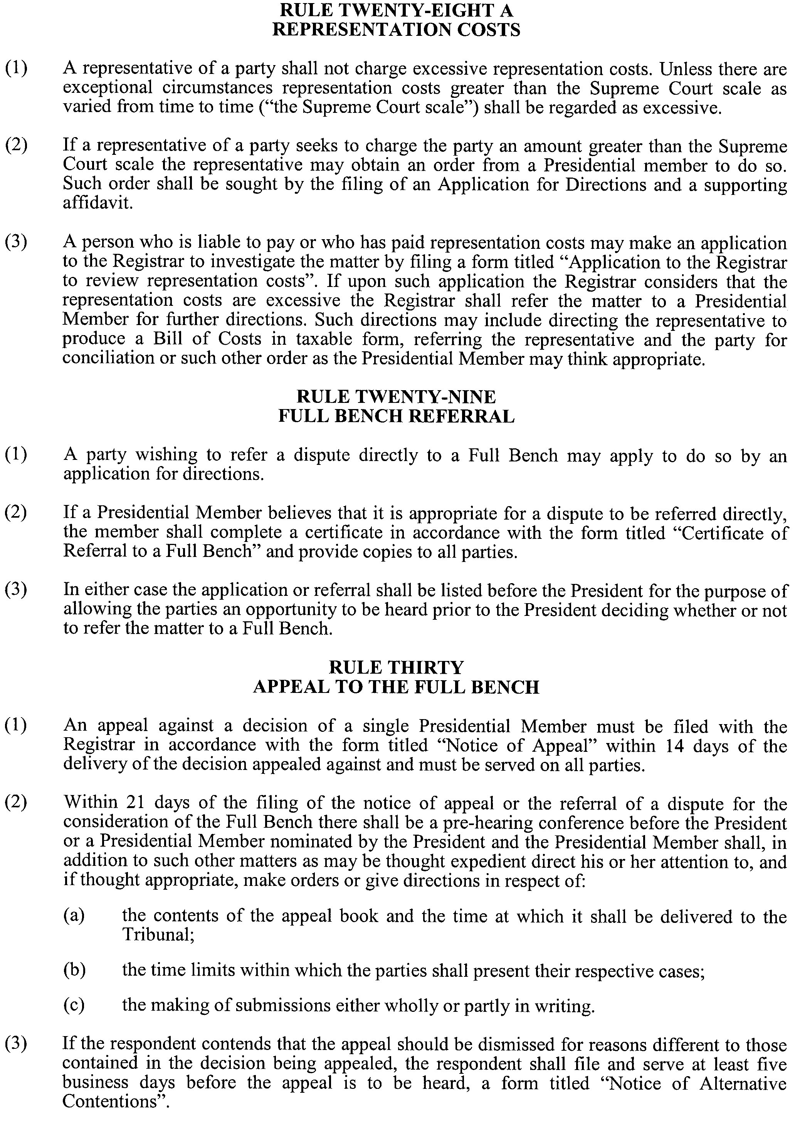

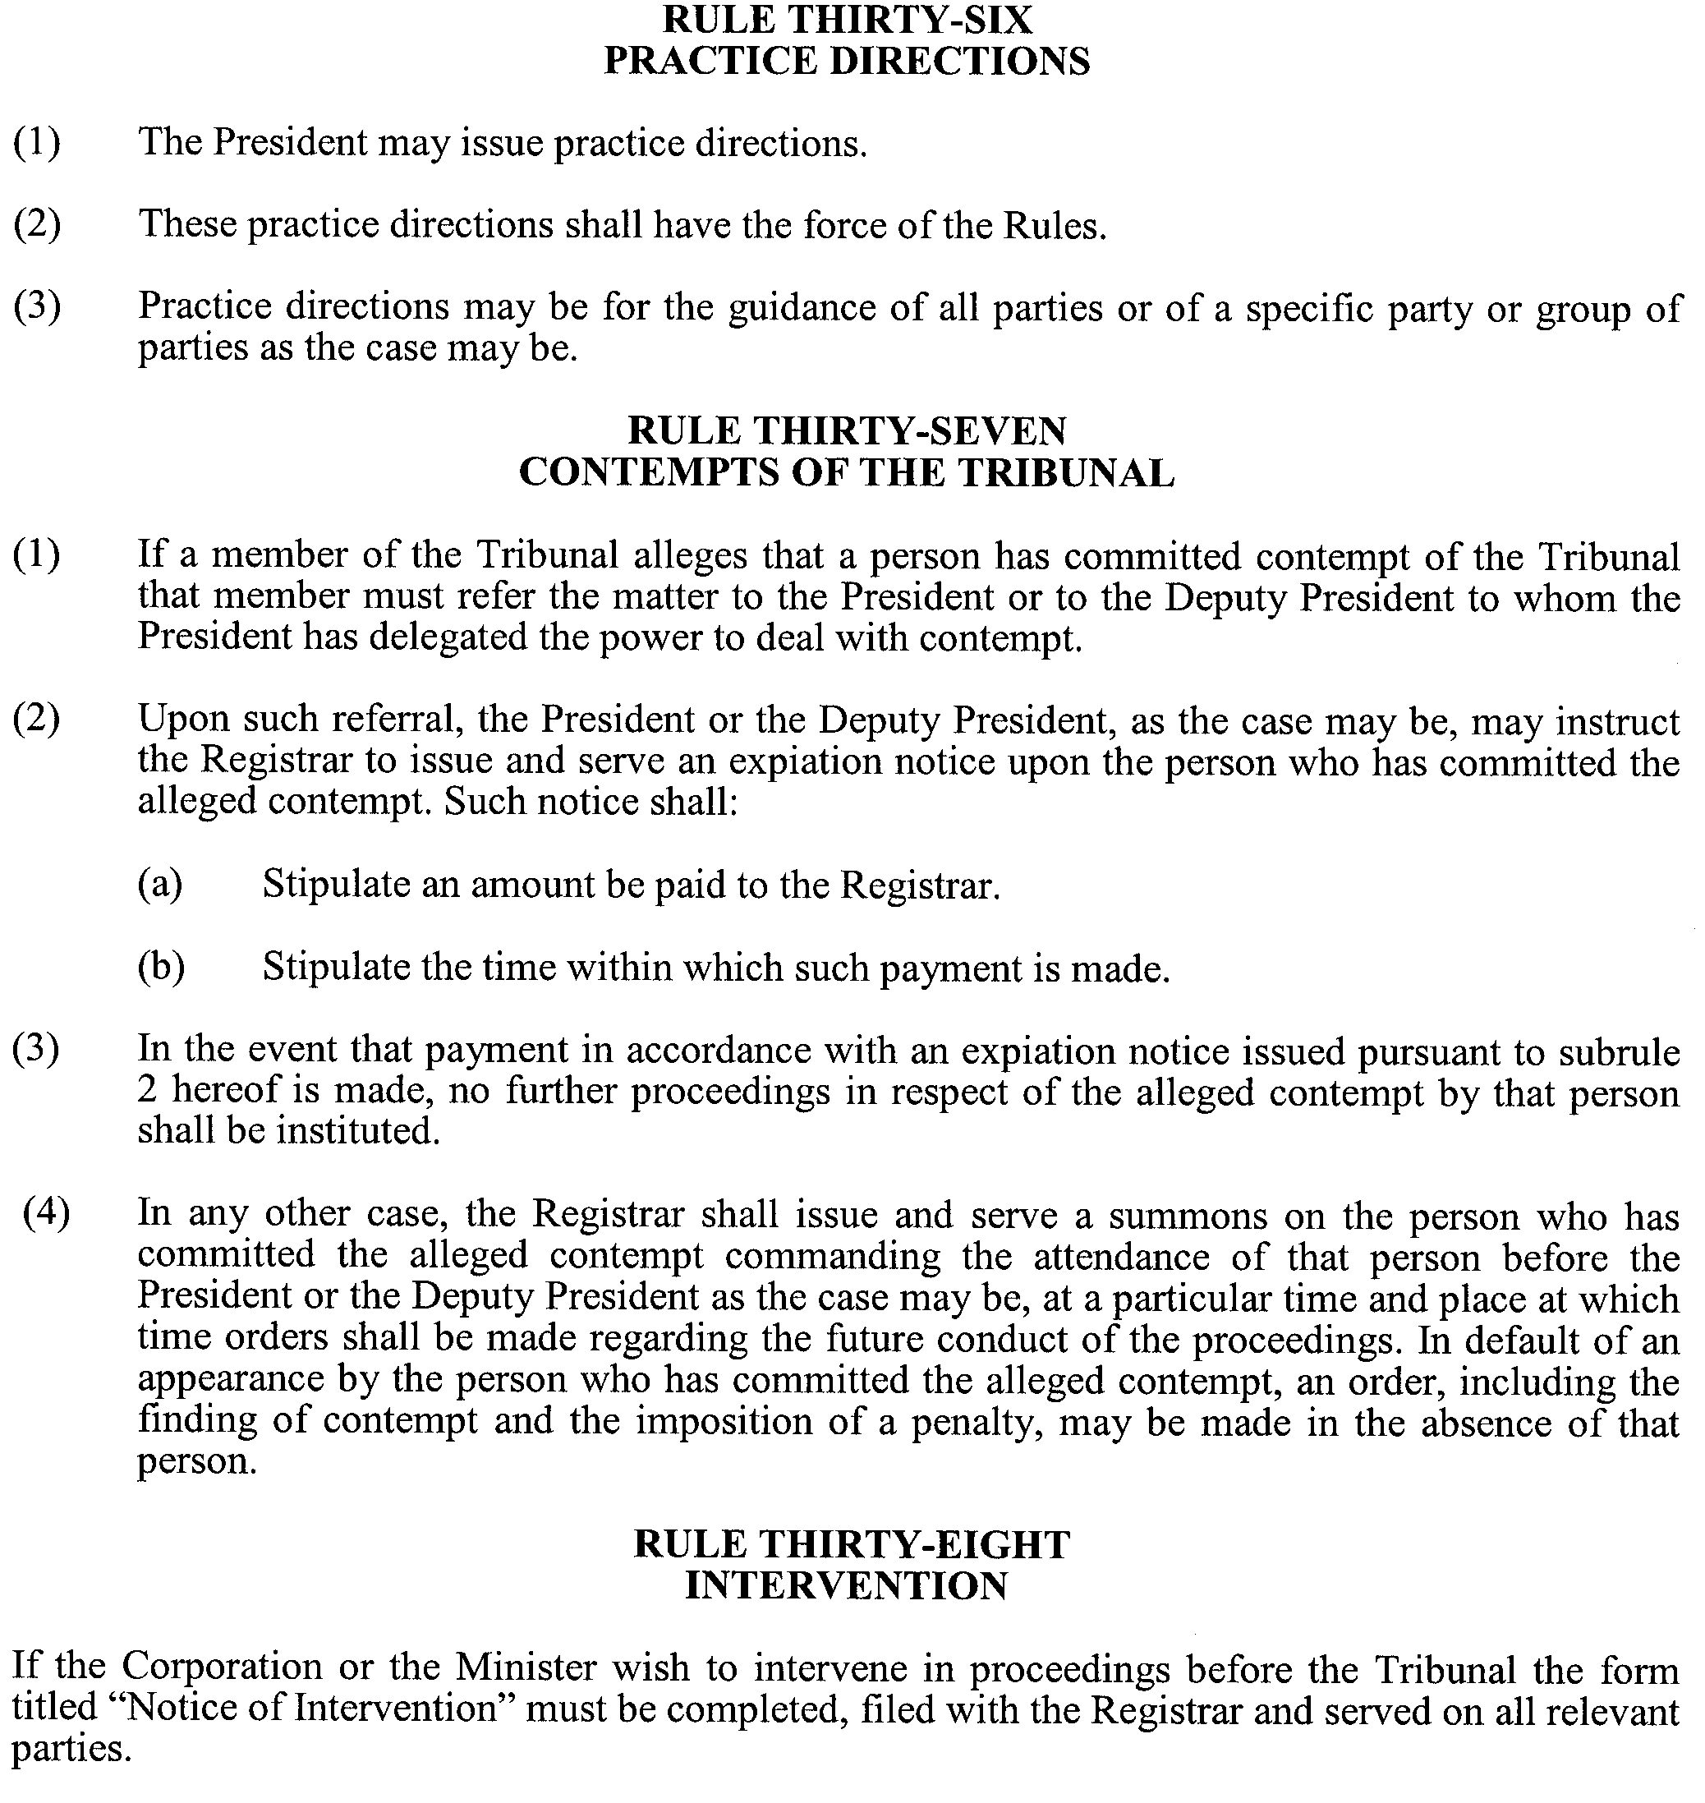
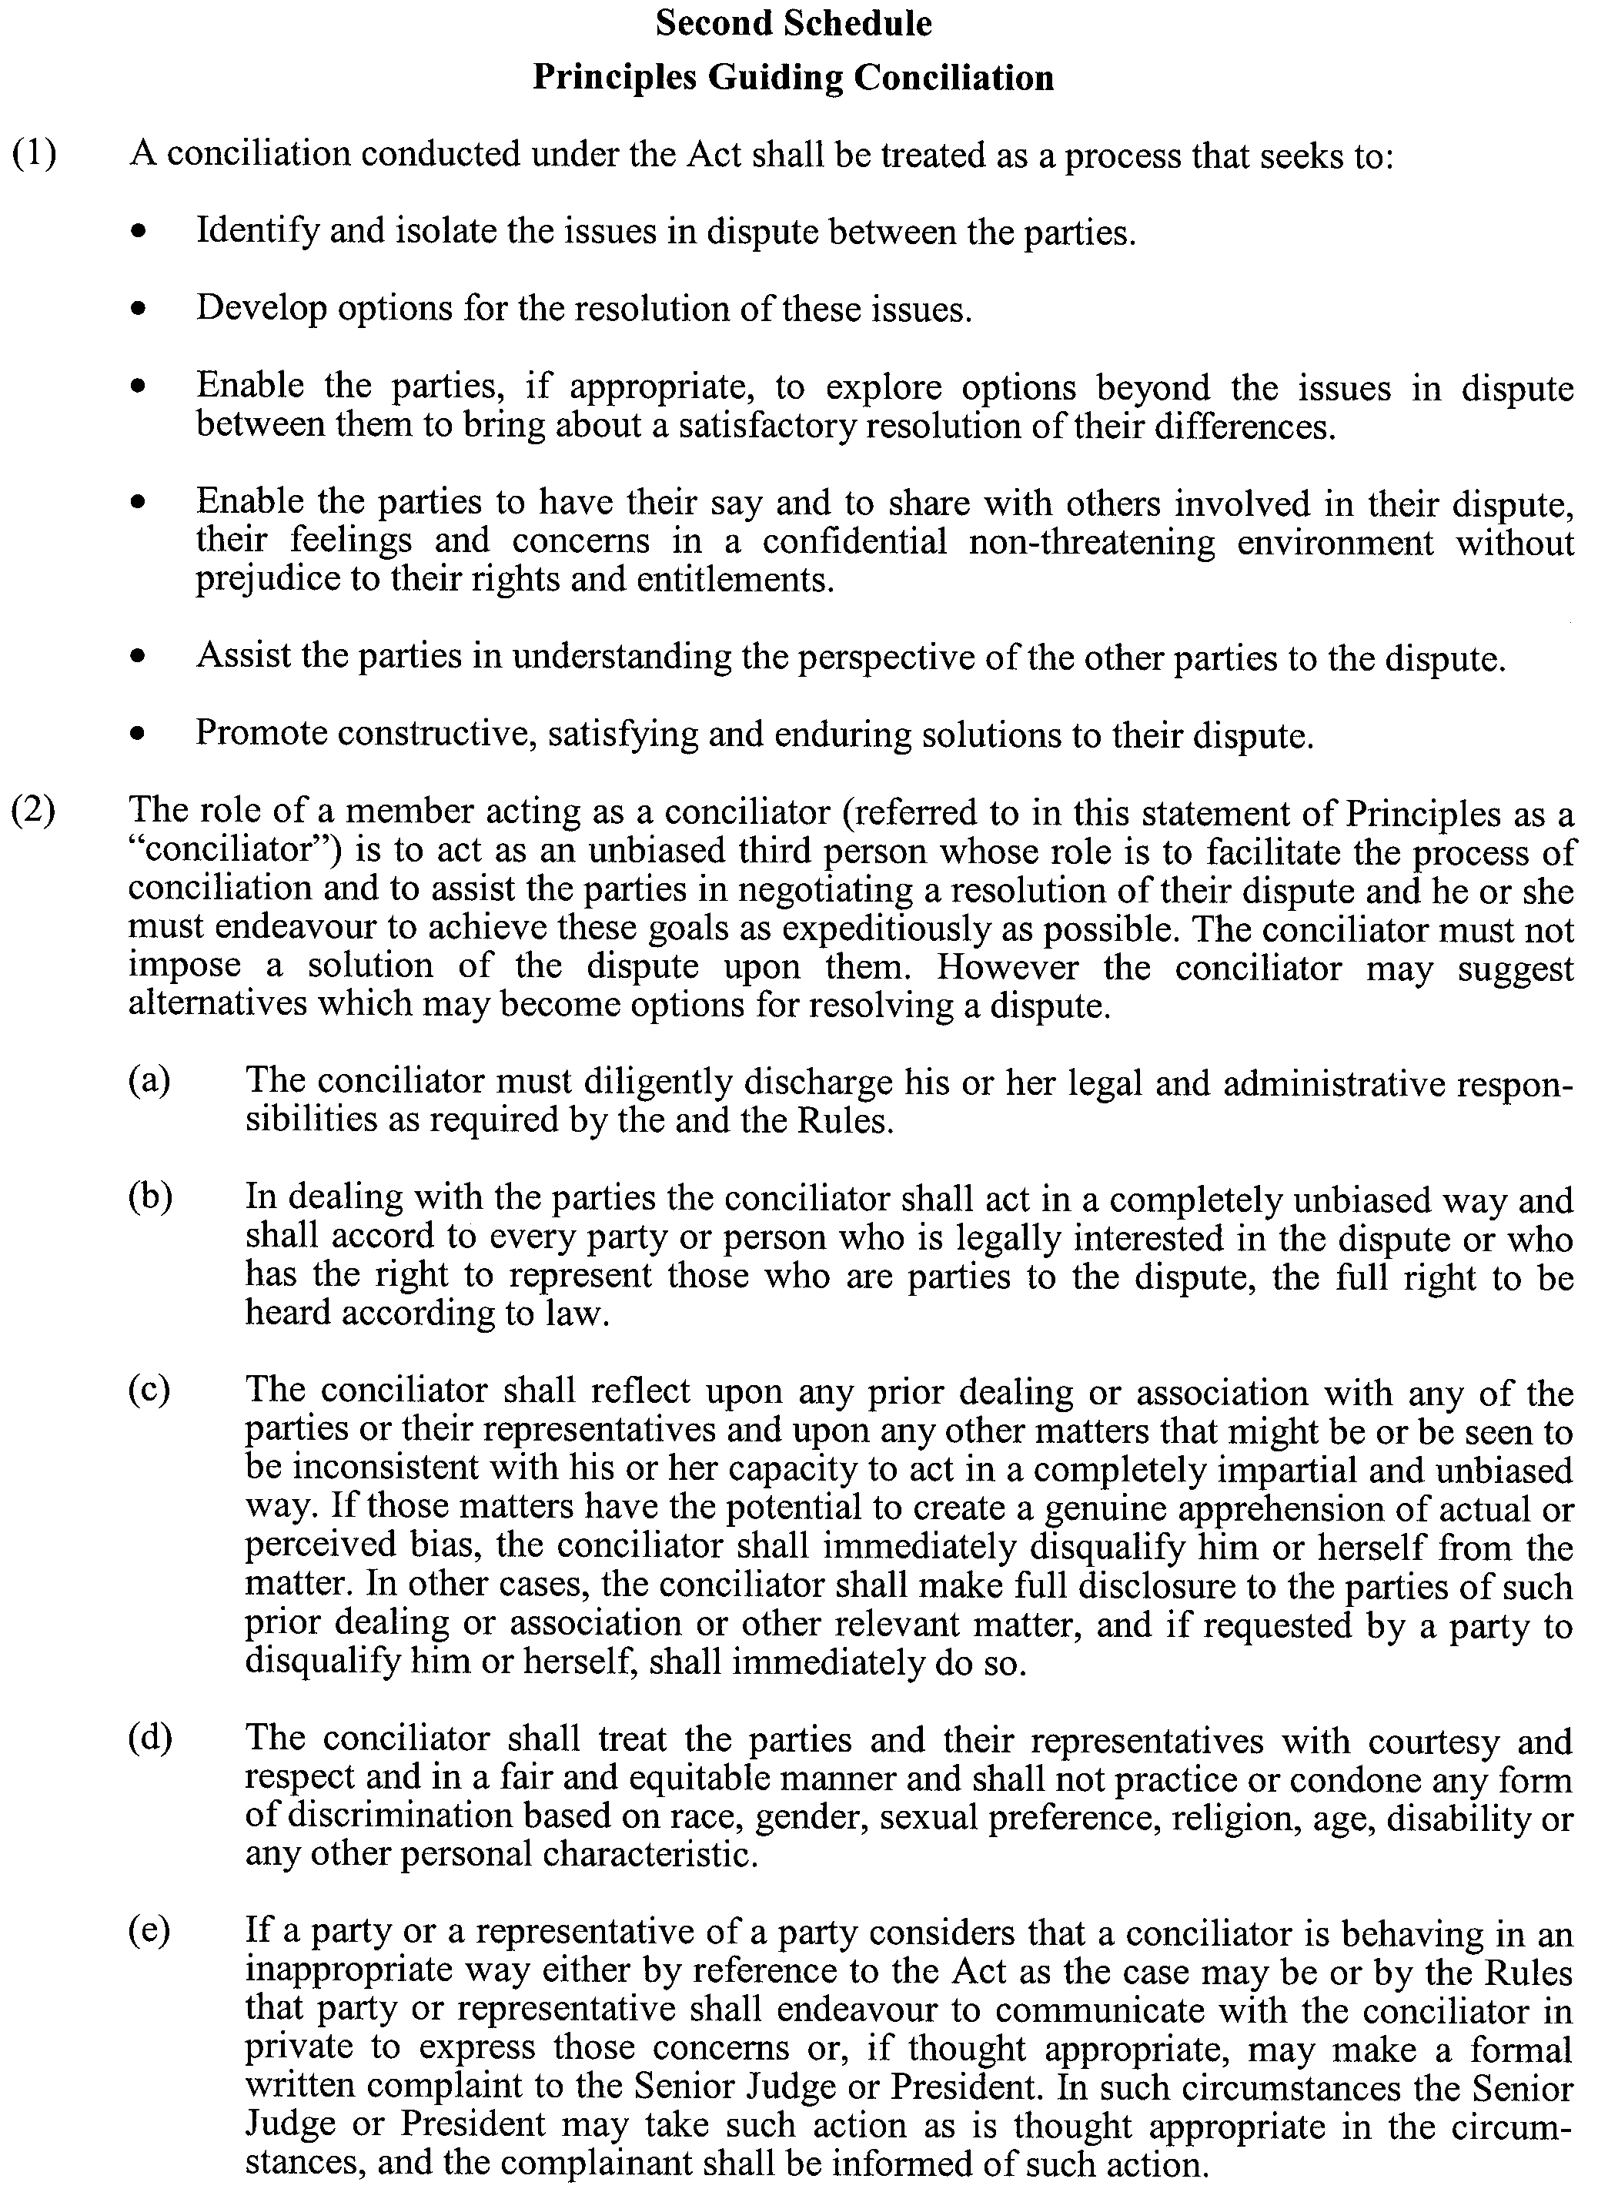
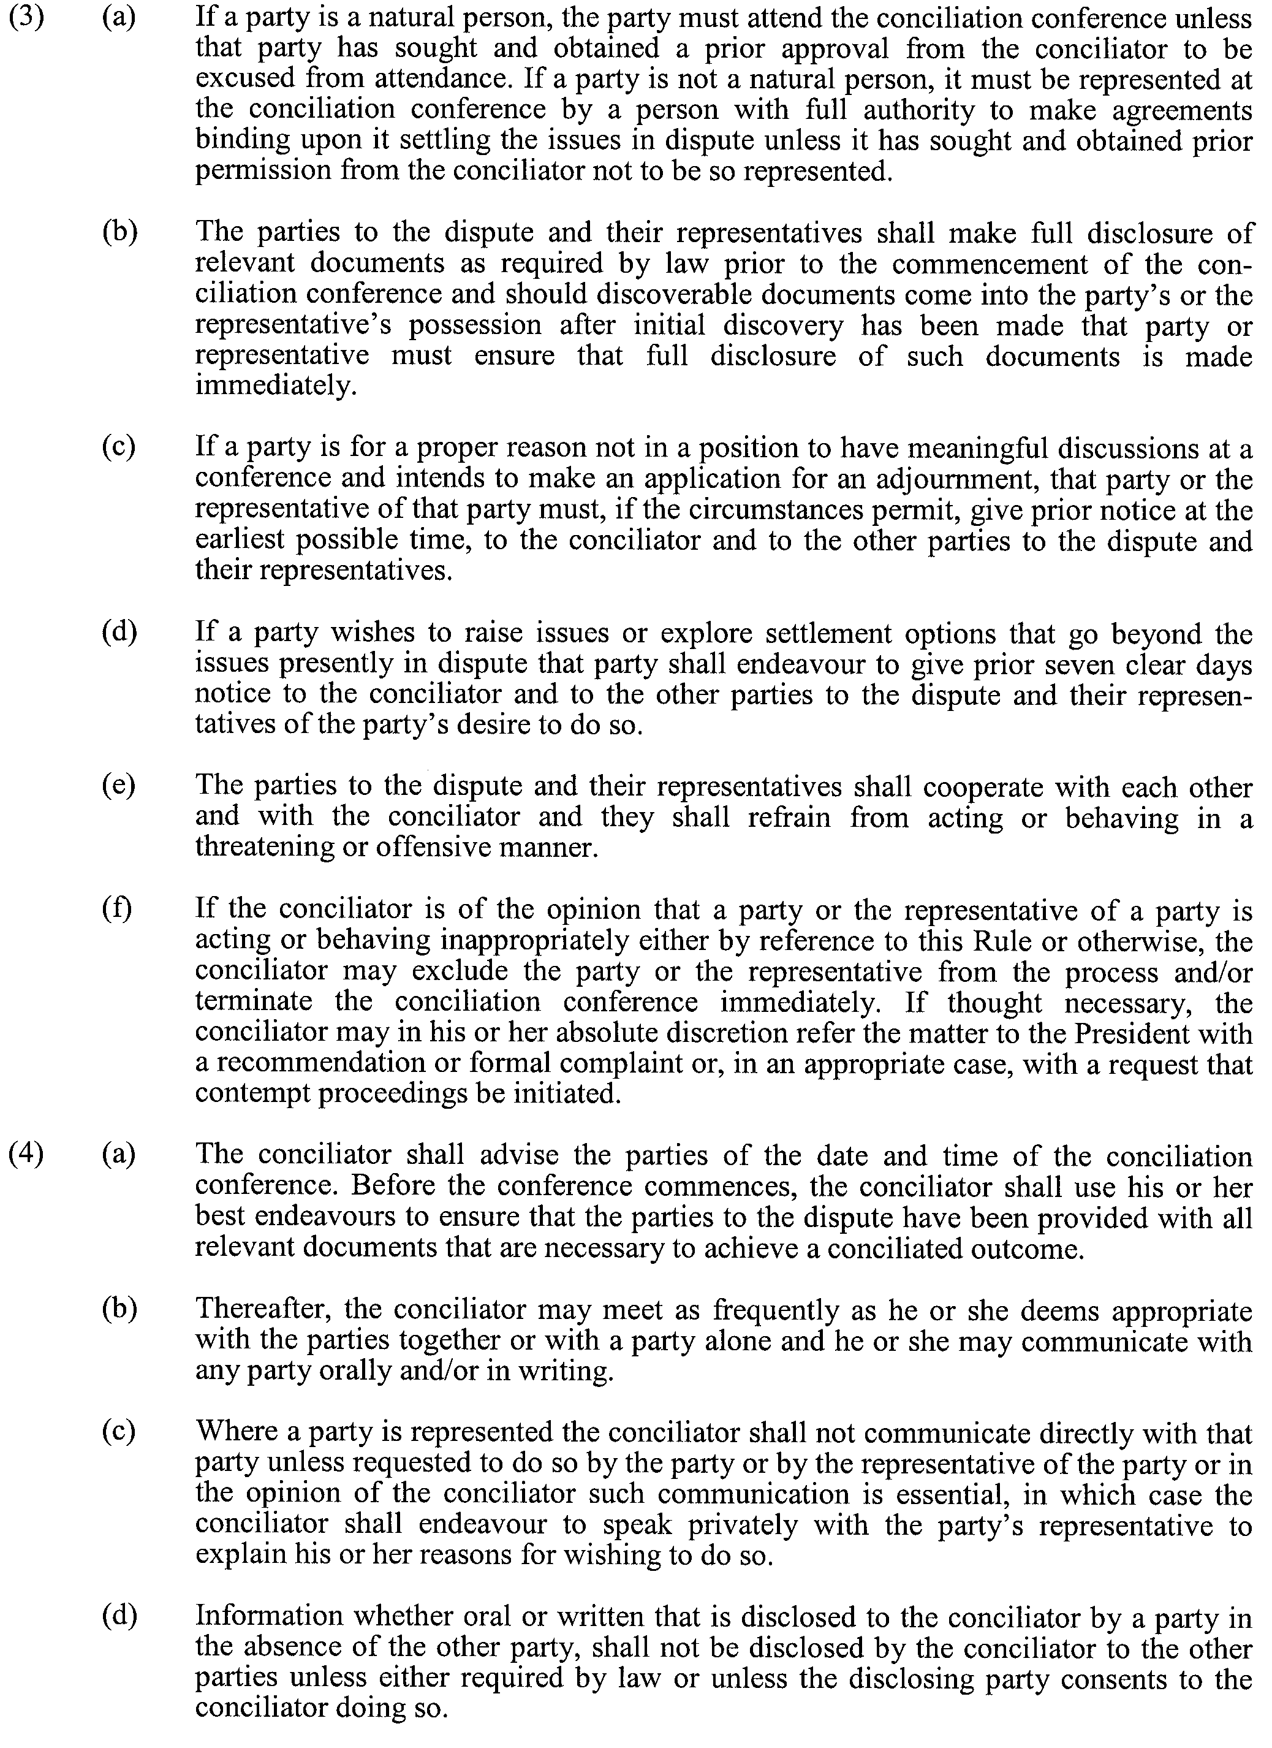
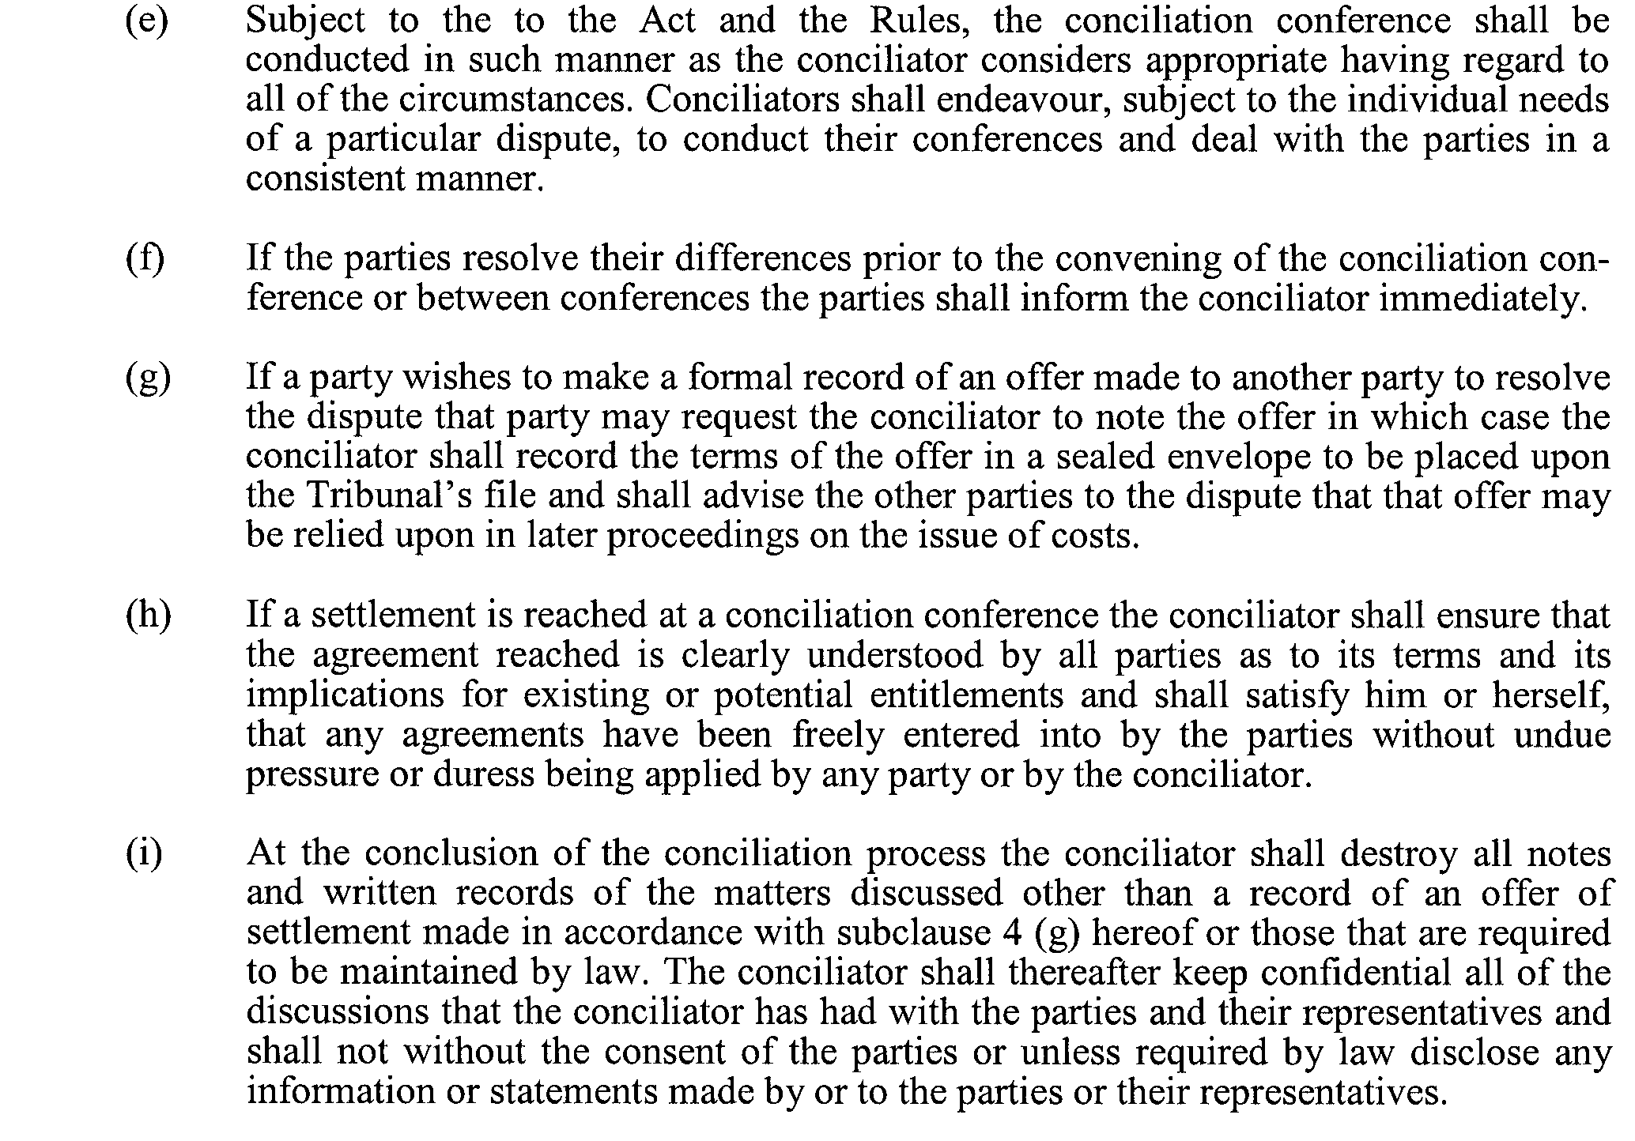
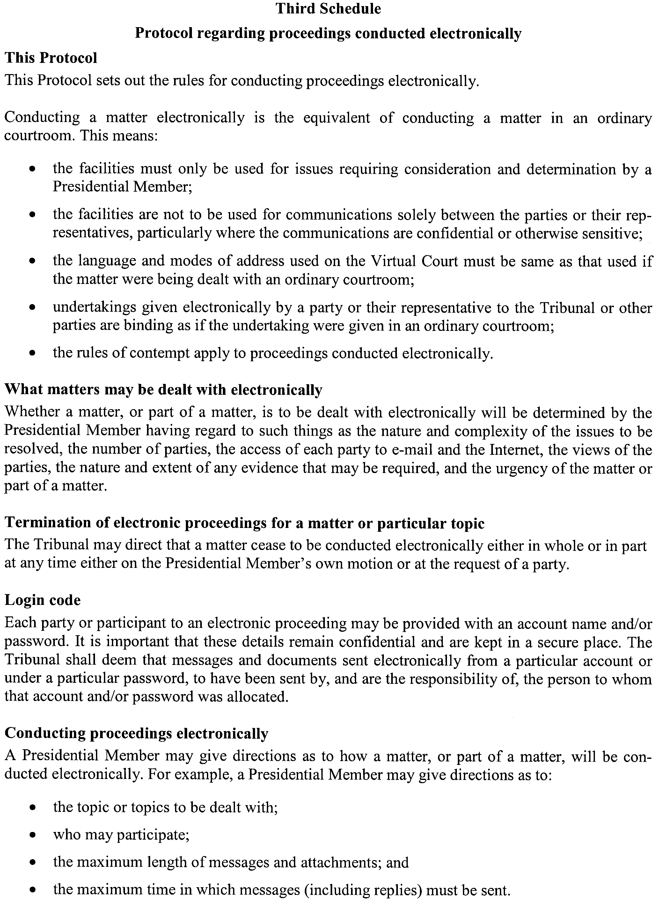

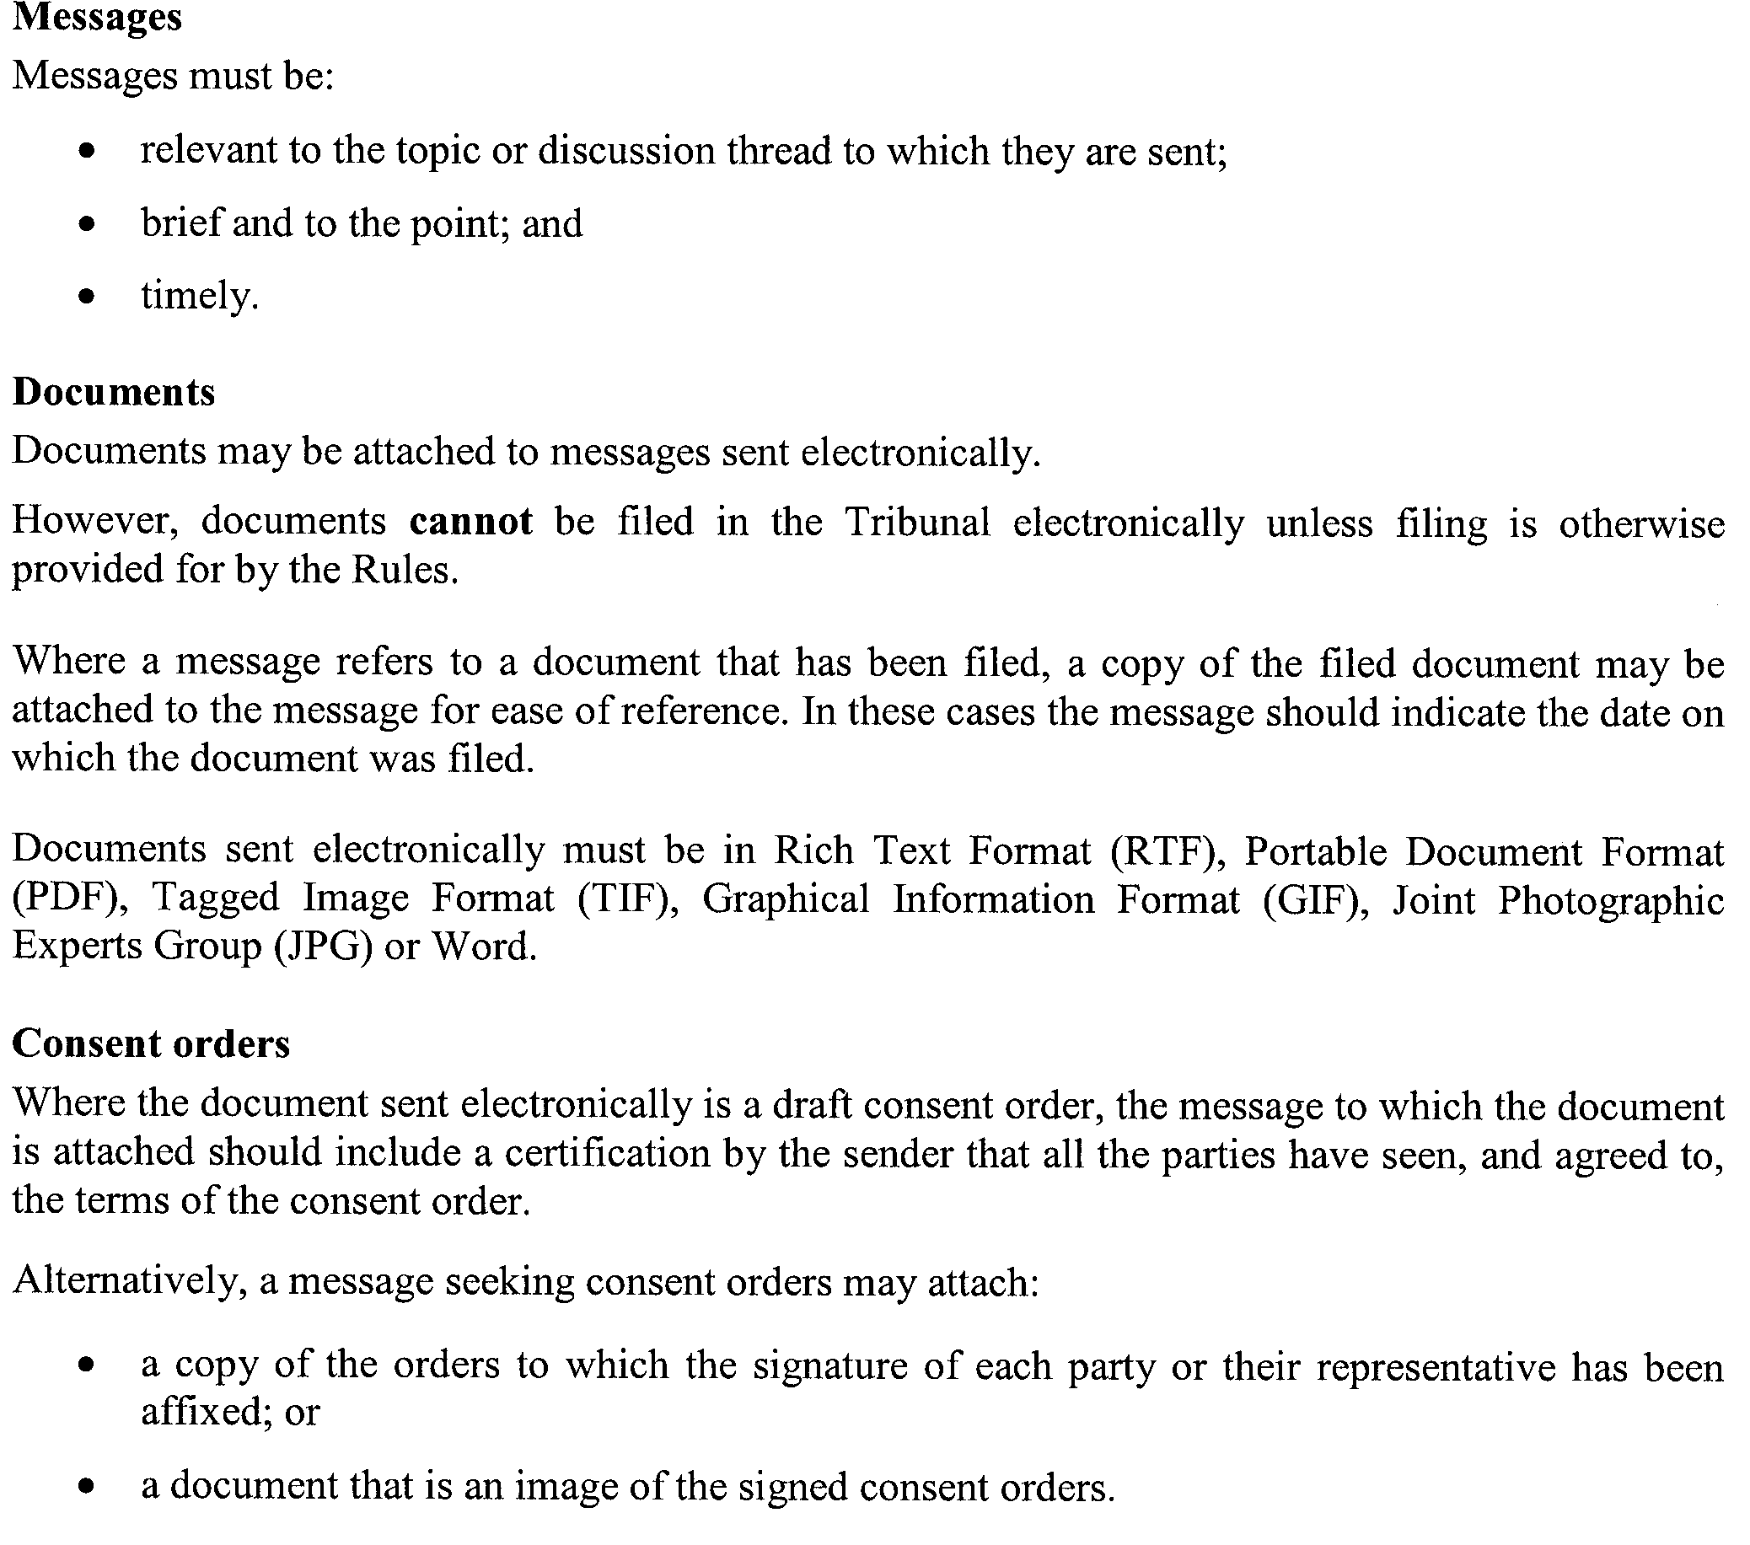

South Australia
Acts Interpretation (Gender Balance) Amendment Act (Commencement) Proclamation 2005
1—Short title
This proclamation may be cited as the Acts Interpretation (Gender Balance) Amendment Act (Commencement) Proclamation 2005.
2—Commencement of Act
The Acts Interpretation (Gender Balance) Amendment Act 2005 (No 7 of 2005) will come into operation on 21 July 2005.
Made by the Governor
with the advice and consent of the Executive Council
on 21 July 2005
MSW04/05CS

South Australia
National Parks and Wildlife (Geegeela Conservation Park) Proclamation 2005
under section 30(1) of the National Parks and Wildlife Act 1972
1—Short title
This proclamation may be cited as the National Parks and Wildlife (Geegeela Conservation Park) Proclamation 2005.
2—Commencement
This proclamation comes into operation on the day on which it is made.
3—Constitution of Geegeela Conservation Park
The following Crown land is constituted as a conservation park and assigned the name Geegeela Conservation Park:
Sections 22 and 25, Hundred of Geegeela, County of MacDonnell, being the whole of the land comprised in Crown Record Volume 5896 Folio 819.
Made by the Governor
being of the opinion that the specified Crown land should be protected or preserved for the purpose of conserving any wildlife or the natural or historic features of the land and with the advice and consent of the Executive Council
on 21 July 2005
EC05/0053CS

South Australia
Fisheries (Scheme of Management—Charter Boat Fishery) Regulations 2005
under the Fisheries Act 1982

Contents
1 Short title
2 Commencement
3 Interpretation
4 Constitution of fishery
5 Issue of licences
6 Expiry of licences
7 Renewal of licences
8 Refund on surrender of licence
9 Transfer of licence
10 Registration of boats
11 Registration as master
12 Revocation of registration
13 Conditions limiting number of boats that may be used etc
14 Furnishing of returns
15 Copies of returns must be made
16 Fees
Schedule 1—Fees

1—Short title
These regulations may be cited as the Fisheries (Scheme of Management—Charter Boat Fishery) Regulations 2005.
2—Commencement
These regulations will come into operation on 1 August 2005.
3—Interpretation
(1) In these regulations, unless the contrary intention appears—
Aboriginal corporation has the same meaning as in the Aboriginal Councils and Associations Act 1976 of the Commonwealth;
Act means the Fisheries Act 1982;
charter boat means a boat that is used for recreational fishing under charter boat fishing agreements;
charter boat fishing agreement means an agreement made by a person in the course of a business under which the person agrees, for money or other consideration, to facilitate recreational fishing by persons by the provision of charter boat fishing services to the persons;
charter boat fishing business means the business of facilitating recreational fishing by persons by the provision of charter boat fishing services to the persons under charter boat fishing agreements;
charter boat fishing services means carrying persons as passengers on a boat and otherwise assisting or enabling the persons to engage in recreational fishing from the boat;
eligible person means—
(a) a natural person or company carrying on a charter boat fishing business that was established on or before 28 November 2003; or
(b) a natural person or company carrying on a charter boat fishing business that was in the process of being established on 28 November 2003; or
(c) an Aboriginal corporation that—
(i) has a business plan for a charter boat fishing business; and
(ii) is a party to an indigenous land use agreement with the State under which it is agreed that a licence in respect of the fishery will be issued to the corporation; or
(d) an Aboriginal corporation or incorporated association that—
(i) has a business plan for a charter boat fishing business; and
(ii) has been established by a native title group for the purpose of implementing an indigenous land use agreement with the State under which it is agreed that a licence in respect of the fishery will be issued to the corporation or association;
fishery means the Charter Boat Fishery constituted by these regulations;
incorporated association has the same meaning as in the Associations Incorporation Act 1985;
indigenous land use agreement means an indigenous land use agreement registered under Part 2 Division 3 of the Native Title Act 1993 of the Commonwealth;
licence period means the period of 12 months commencing on 1 July in any year;
policy of insurance includes a cover note that is binding on the insurer;
recreational fishing means the taking of fish in waters other than inland waters for a purpose other than trade or business;
SARDI means the South Australian Research and Development Institute.
(2) In these regulations, a reference to the taking of fish includes a reference to an act preparatory to, or involved in, the taking of the fish.
4—Constitution of fishery
(1) The Charter Boat Fishery is constituted.
(2) The Charter Boat Fishery consists of facilitating recreational fishing by persons by the provision of charter boat fishing services to the persons under charter boat fishing agreements.
5—Issue of licences
(1) The Director may issue licences in respect of the fishery.
(2) An application for a licence in respect of the fishery must—
(a) be made in writing in a form approved by the Director; and
(b) be completed in accordance with the instructions contained in the form; and
(c) be signed by the applicant; and
(d) be accompanied by the documents required by the instructions contained in the form; and
(e) be verified by statutory declaration.
(3) Before granting a licence in respect of the fishery the Director must be satisfied that—
(a) the applicant is an eligible person; and
(b) there is in force a policy of public liability insurance under which the applicant is indemnified in an amount of at least $10 000 000 in relation to death, bodily injury or property damage caused by or arising out of the use of any charter boat operated by the applicant; and
(c) no conviction for an offence involving a breach of any legislation relating to fishing has, within the period of 3 years preceding the date of the application, been recorded in the State or elsewhere in Australia against the applicant, or, where the applicant is a body corporate, against a member of the governing body of the body corporate; and
(d) no proceedings alleging an offence involving a breach of any legislation relating to fishing are pending or likely to be commenced in the State or elsewhere in Australia against the applicant, or, where the applicant is a body corporate, against a member of the governing body of the body corporate.
(4) The Director may not grant a licence in respect of the fishery unless the applicant has paid—
(a) the licence fee specified in Schedule 1; or
(b) the first instalment of the licence fee specified in Schedule 1, in accordance with subregulation (5).
(5) A licence fee may be paid by instalments as follows:
(a) in the case of a licence issued for the term of a licence period—by 4 instalments of 25 per cent payable on or before the date of the grant of the licence and 1 October, 1 January and 1 April following the date of the grant of the licence;
(b) in any other case—by instalments of such amounts, and payable on such dates, as are fixed by the Director.
(6) If an instalment of a licence fee is not paid in full within 21 days after the due date for payment, an additional amount equal to 10 per cent of the amount of the instalment is payable.
(7) If—
(a) an instalment of a licence fee is not paid in full on or before the due date; or
(b) an additional fee is required to be paid for late payment of an instalment of a licence fee,
the amount unpaid may be recovered from the holder of the licence as a debt due to the Crown.
(8) The Director must return any licence fee that accompanied the application if the application is not successful.
6—Expiry of licences
A licence in respect of the fishery expires on 30 June following the date of issue or its last renewal.
7—Renewal of licences
(1) A licence in respect of the fishery may be renewed by the Director on application made before the expiry of the licence or before the end of the licence period following the expiry of the licence.
(2) An application to renew a licence in respect of the fishery must—
(a) be made by the holder of the licence or, if the licence has expired, by the person who last held the licence; and
(b) be made in writing in a form approved by the Director; and
(c) be completed in accordance with the instructions contained in the form; and
(d) be signed by the applicant; and
(e) be accompanied by the documents required by the instructions contained in the form.
(3) Where an application to renew a licence is made before the expiry of the licence, the renewal of the licence takes effect from the expiry of the licence.
(4) Where an application to renew a licence is made after the expiry of the licence, the renewal of the licence takes effect from the date on which the application is granted.
(5) Before renewing a licence in respect of the fishery the Director must be satisfied that there is in force a policy of public liability insurance under which the applicant is indemnified in an amount of at least $10 000 000 in relation to death, bodily injury or property damage caused by or arising out of the use of any charter boat operated by the applicant.
(6) The Director may not renew a licence unless the applicant has paid—
(a) —
(i) the renewal fee specified in Schedule 1; or
(ii) the first instalment of the renewal fee specified in Schedule 1, in accordance with subregulation (7); and
(b) the amount of any previous renewal fee remaining payable in respect of the licence, together with any additional amount payable for late payment of an instalment of the renewal fee.
(7) Where an application to renew a licence is made before or within 3 months after the expiry of the licence, the renewal fee may be paid by 4 instalments of 25 per cent payable on or before the date of renewal of the licence and 1 October, 1 January and 1 April following the date of renewal.
(8) If an instalment of a renewal fee is not paid in full within 21 days after the due date for payment, an additional amount equal to 10 per cent of the amount of the instalment is payable.
(9) Where—
(a) an instalment of a renewal fee for a licence is not paid in full on or before the due date; or
(b) an additional amount is required to be paid for late payment of an instalment of a renewal fee,
the amount unpaid may be recovered from the holder of the licence or the person who last held the licence as a debt due to the Crown.
8—Refund on surrender of licence
Where a licence in respect of the fishery is surrendered, the Director must, on application by the former licensee, refund an amount that bears to the renewal fee last paid in respect of the licence the same proportion as the number of complete months from the date of surrender to the day on which the following licence period commences bears to the number of months in the licence period during which the licence was surrendered.
9—Transfer of licence
(1) A licence in respect of the fishery may be transferred with the consent of the Director.
(2) An application for consent to the transfer of a licence must be a joint application made by the holder of the licence and the transferee.
(3) An application for consent to the transfer of a licence must—
(a) be made in writing in a form approved by the Director; and
(b) be completed in accordance with the instructions contained in the form; and
(c) contain a nomination by the holder of the licence of the person to whom the licence is to be transferred; and
(d) be accompanied by the documents required by the instructions contained in the form; and
(e) be verified by statutory declaration.
(4) The application must be lodged with the Director together with—
(a) the licence to be transferred; and
(b) a form of return as required by these regulations completed by the holder of the licence up to the date of application; and
(c) the application fee specified in Schedule 1.
(5) Before consenting to the transfer of a licence, the Director must be satisfied that—
(a) the licence to be transferred has not been suspended; and
(b) no proceedings alleging an offence under the Act are pending or likely to be commenced in the State against the holder of the licence; and
(c) there is in force a policy of public liability insurance under which the transferee is indemnified in an amount of at least $10 000 000 in relation to death, bodily injury or property damage caused by or arising out of use of any charter boat operated by the applicant; and
(d) no conviction for an offence involving a breach of any legislation relating to fishing has, within the period of 3 years preceding the date of the application, been recorded in the State or elsewhere in Australia against the transferee, or, where the transferee is a body corporate, against a member of the governing body of the body corporate; and
(e) no proceedings alleging an offence involving a breach of any legislation relating to fishing are pending or likely to be commenced in the State or elsewhere in Australia against the transferee, or, where the transferee is a body corporate, against a member of the governing body of the body corporate.
10—Registration of boats
(1) An application to register a boat to be used pursuant to a licence in respect of the fishery must be made in writing in a form approved by the Director and be accompanied by the applicant's licence in respect of the fishery.
(2) Before granting an application for the registration of a boat the Director must be satisfied that the applicant is the holder of a licence in respect of the fishery.
11—Registration as master
An application for registration of a person as the master of a boat to be used pursuant to a licence in respect of the fishery must be made in writing in a form approved by the Director and be accompanied by the applicant's licence in respect of the fishery.
12—Revocation of registration
(1) The Director may, on application by the holder of a licence in respect of the fishery, revoke any registration effected by endorsement of the licence.
(2) An application for revocation of any registration must be made in writing in a form approved by the Director and be accompanied by the licence on which the registration is endorsed.
13—Conditions limiting number of boats that may be used etc
The Director may impose conditions on a licence in respect of the fishery—
(a) limiting the number of boats registered by endorsement of the licence that may be used pursuant to the licence at any 1 time;
(b) limiting the number of devices that may be carried on boats registered by endorsement of the licence and otherwise regulating the carrying of devices on such boats;
(c) limiting the area of waters within which boats registered by endorsement of the licence may be used pursuant to the licence.
14—Furnishing of returns
(1) The holder of a licence in respect of the fishery must—
(a) fill out a return in a form determined by the Minister, in respect of each calendar month during the currency of the licence; and
(b) include in the return such information as the Chief Executive Officer of SARDI, with the approval of the Minister, requires; and
(c) date and sign the return and certify that the information contained in the return is complete and accurate, and post or deliver the return to the office of the Chief Executive Officer of SARDI within 15 days of the end of the month to which it relates.
Penalty: Division 6 fine.
Expiation fee: Division 9 fee.
(2) If no fish is taken by use of a boat registered by endorsement of the licence during a particular calendar month, the holder of the licence is required by subregulation (1) to furnish a return in respect of that period indicating that no fish were taken.
15—Copies of returns must be made
The holder of a licence in respect of the fishery must—
(a) make a copy of each return that he or she fills out pursuant to these regulations before the return is sent or delivered to the Chief Executive Officer of SARDI; and
(b) retain the copy for the period of one year from the last day of the month to which the return relates.
Maximum penalty: $2 500.
16—Fees
The fees set out in Schedule 1 are prescribed for the purposes of the Act and these regulations.
Schedule 1—Fees

1 | On application for the issue or renewal of a licence in respect of the fishery | $1000
2 | On application for the registration of a boat to be used pursuant to a licence in respect of the fishery—
 | (a) if the certificate of survey in force in respect of the boat specifies that the boat may carry up to unberthed 6 passengers | $250
 | (b) if the certificate of survey in force in respect of the boat specifies that the boat may carry up to unberthed 12 passengers | $500
 | (c) if the certificate of survey in force in respect of the boat specifies that the boat may carry more than unberthed 12 passengers | $1000
3 | On application for the transfer of a licence in respect of the fishery | $300
Note—
As required by section 10AA(2) of the Subordinate Legislation Act 1978, the Minister has certified that, in the Minister's opinion, it is necessary or appropriate that these regulations come into operation as set out in these regulations.
Made by the Governor
with the advice and consent of the Executive Council
on 21 July 2005
No 168 of 2005
MAFF05/0015CS

South Australia
Valuation of Land Regulations 2005
under the Valuation of Land Act 1971

Contents
1 Short title
2 Commencement
3 Interpretation
4 Definition of annual value
5 Land to be treated as forming part of the State Heritage
6 Certain notices not to constitute notice of valuation unless objection period specified
7 Panels of land valuers—manner and form of nomination for appointment
8 Review of valuation—manner and form of application
9 Review of valuation—selection of valuer to conduct review
10 Notice of sale or transfer of title to land—particulars and form
11 Fixtures and improvements not to be included in valuations
12 Prescribed fees and allowances
Schedule 1—Forms
Schedule 2—Fees and Allowances
Schedule 3—Revocation of regulations
1 Revocation of regulations

1—Short title
These regulations may be cited as the Valuation of Land Regulations 2005.
2—Commencement
These regulations will come into operation on 29 August 2005.
3—Interpretation
In these regulations, unless the contrary intention appears—
Act means the Valuation of Land Act 1971;
premises includes a part of premises.
4—Definition of annual value
For the purposes of paragraph (c) of the definition of annual value in section 5(1) of the Act, the following machinery, plant and equipment are prescribed:
(a) all machinery, plant and equipment used exclusively or mainly for the heating, cooling or ventilating of premises or for protecting premises from fire;
(b) all elevators, lifts and escalators that are mainly or usually used in premises for the carrying of passengers and are fixed to the premises in such a manner as to be incapable of being removed without structural damage (other than minor or trivial structural damage) to the premises.
5—Land to be treated as forming part of the State Heritage
Pursuant to section 22B(6)(c) of the Act, land is to be treated as forming part of the State heritage for the purposes of section 22B of the Act if the land is an item listed in the register of City of Adelaide Heritage Items as set out from time to time in the Development Plan under the Development Act 1993 that relates to the area of The Corporation of the City of Adelaide.
6—Certain notices not to constitute notice of valuation unless objection period specified
Pursuant to section 23(2) of the Act, an account, assessment or notice for rates, land tax or some other impost that contains particulars of a valuation does not constitute notice of the valuation for the purposes of section 23(1) unless the document contains the following statement:
You may object to the valuation referred to in this notice by writing served personally or by post on the Valuer-General within 60 days after the date of service of this notice.
BUT NOTE:
(a) if you have previously received a notice or notices under the [here state the Act or Acts under which this account, assessment or notice is served] referring to the valuation and informing you of a 60-day objection period, the objection period is 60 days after service of the first such notice;
(b) you may not object to the valuation if the Valuer-General has already considered an objection by you to that valuation.
7—Panels of land valuers—manner and form of nomination for appointment
(1) For the purposes of section 25A(4)(a) of the Act, a nomination for appointment to a panel of land valuers may not be made except on an application to the Real Estate Institute of South Australia Incorporated or the Australian Property Institute Incorporated by the land valuer seeking appointment.
(2) An application under subregulation (1) must be in writing and must set out—
(a) the applicant's full name and business address; and
(b) the applicant's qualifications and his or her experience generally; and
(c) the applicant's experience in valuing land in the region in relation to which the panel to which he or she is seeking appointment is established.
(3) A body to which an application for nomination under this regulation is made must, if satisfied that there is no reason why the applicant should not be nominated, nominate the applicant for appointment to the panel by completing the form set out in Form 1 of Schedule 1 and sending it to the Minister.
8—Review of valuation—manner and form of application
For the purposes of section 25B(2)(a) of the Act, an application for review of a valuation must be in the form set out in Form 2 of Schedule 1.
9—Review of valuation—selection of valuer to conduct review
(1) Pursuant to section 25B(4) of the Act, where due application for review of a valuation is made under section 25B of the Act, the valuer to conduct the review will be selected by the owner of the land the valuation of which is subject to the review.
(2) The Valuer-General must, for the purposes of subregulation (1), supply the owner with a list of the land valuers appointed to the appropriate panel.
(3) The owner must advise the Valuer-General by notice in writing of the valuer selected by the owner for the purposes of the review.
10—Notice of sale or transfer of title to land—particulars and form
For the purposes of section 29(1) of the Act—
(a) the particulars required in Form 3 of Schedule 1 are prescribed; and
(b) a notice under that section must be in that form.
11—Fixtures and improvements not to be included in valuations
(1) Pursuant to section 34(ab) of the Act, the following fixtures and improvements must not be taken into account in determining or assessing the annual value or capital value of land where the determination or assessment is to be used for the purpose of raising, levying or imposing any rate, tax or impost:
(a) any item of machinery, plant or equipment that is used in connection with a trade, business or manufactory and is not fixed to the land or premises or is fixed to the land or premises so as to be capable of being removed without structural damage (other than minor or trivial structural damage) to the land or premises;
(b) any main, pole, transformer, wire, pipe, machinery, plant or equipment that is used in connection with the generation and supply of electricity, the supply of gas or water or the provision of sewerage and is erected on land occupied by a public utility undertaking (whether or not an agency or instrumentality of the Crown) related to the supply or provision of such services;
(c) trees planted—
(i) for the primary purpose of—
(A) the commercial production of timber; or
(B) the prevention or amelioration of degradation of land; or
(C) the disposal of effluent; or
(D) the provision of a habitat for wildlife; or
(ii) for any two or more of the purposes specified in subparagraph (i).
(2) Despite subregulation (1), electricity generating plant, and substations for converting, transforming or controlling electricity, that—
(a) are used by a body specified by proclamation under clause 3(2) of Schedule 1 of the Electricity Corporations (Restructuring and Disposal) Act 1999; and
(b) are situated on land to which a proclamation under clause 3(3) of that Schedule applies,
are to be taken into account in determining or assessing the annual value or capital value of land for the purpose of raising, levying or imposing rates under the Local Government Act 1999.
12—Prescribed fees and allowances
The fees and allowances payable for the purposes of the Act are set out in Schedule 2.
Schedule 1—Forms
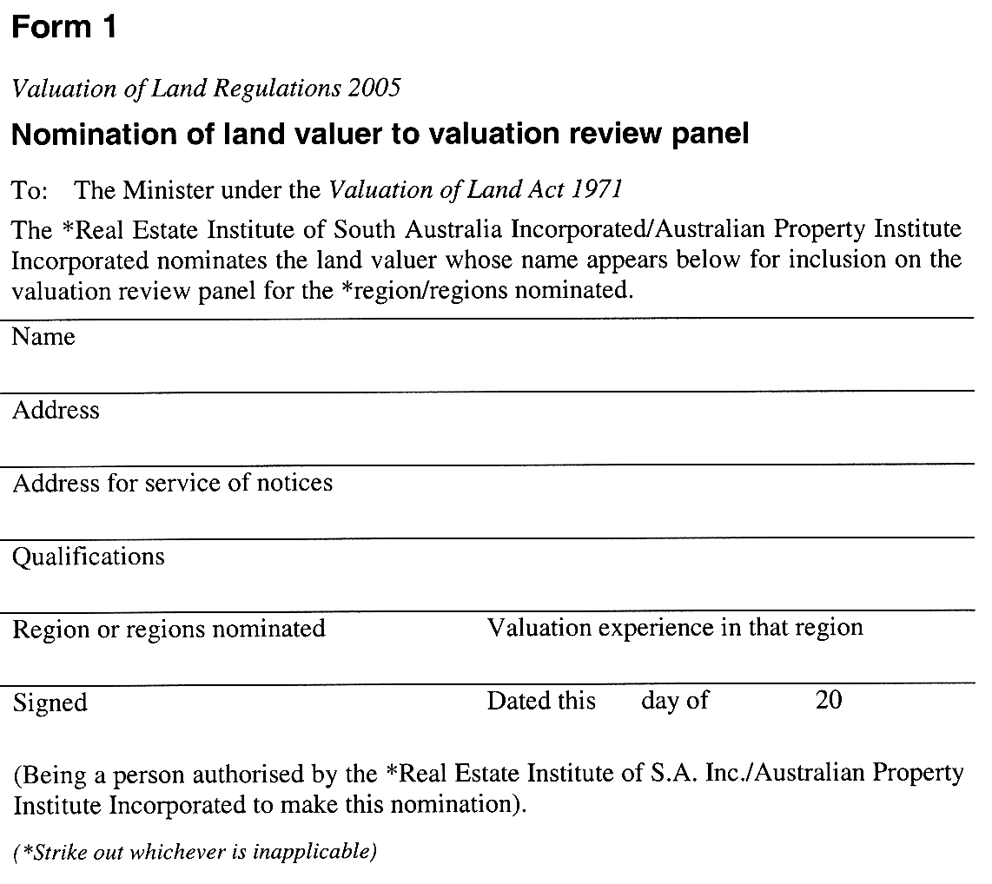
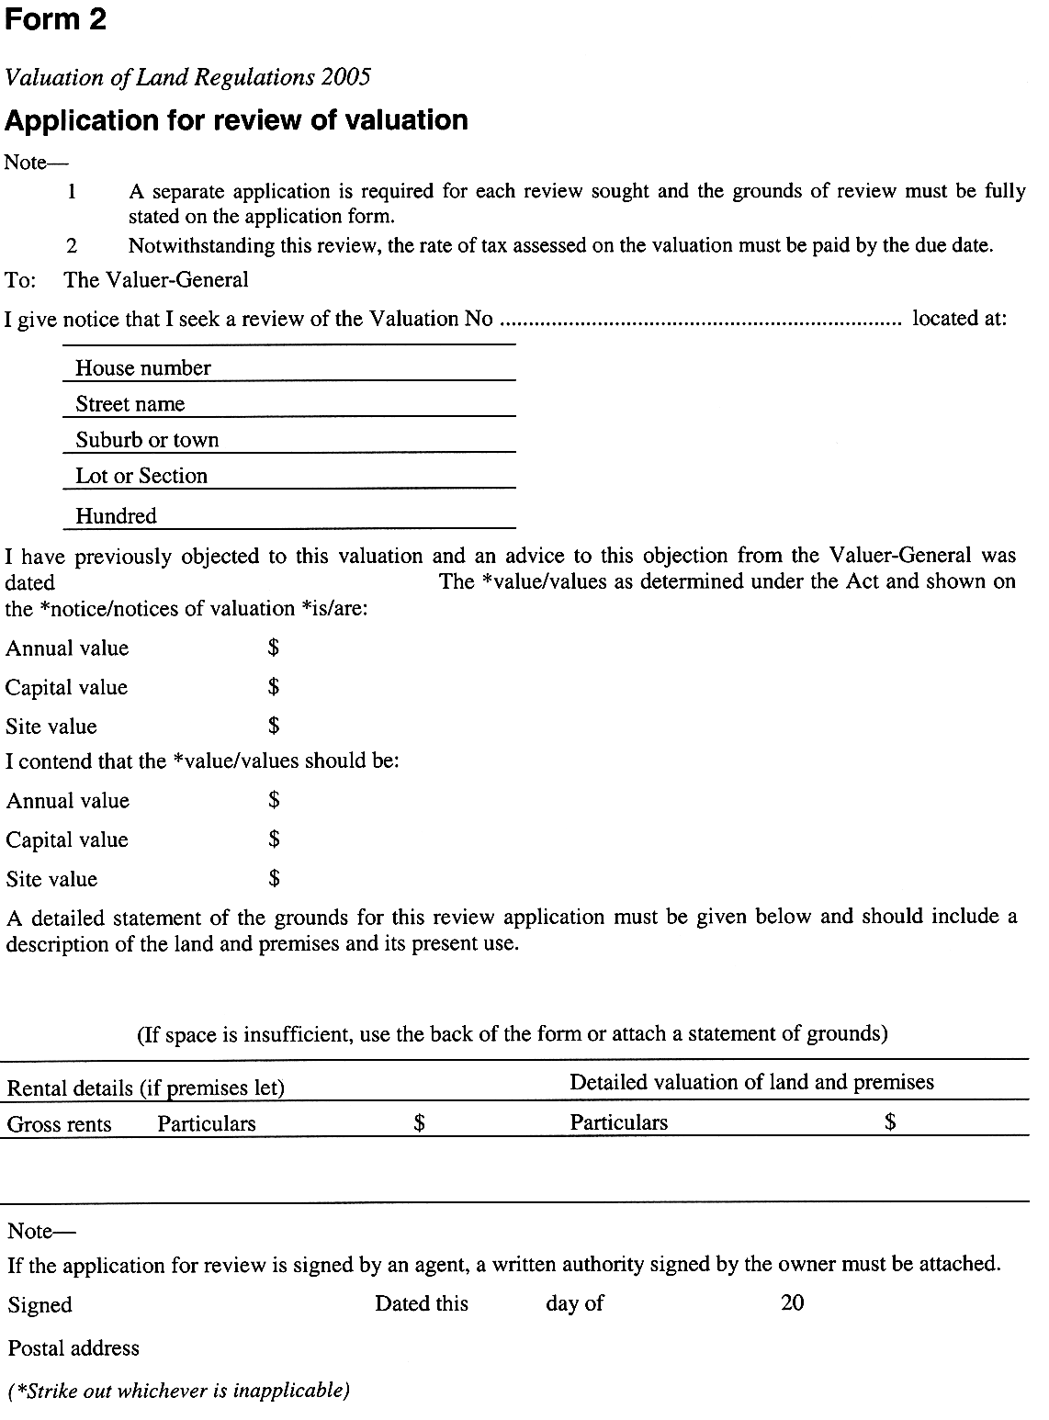
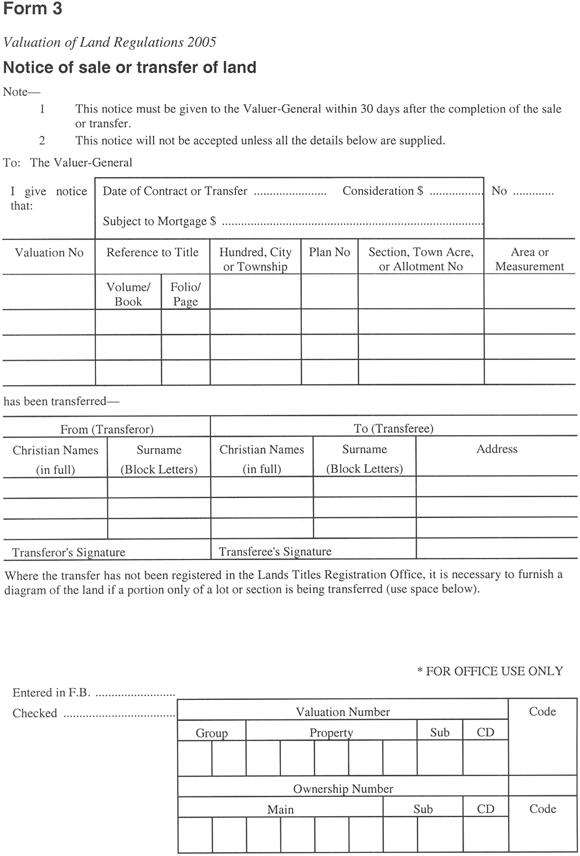

Schedule 2—Fees and Allowances

1—Fees
(1) | For a copy of the valuation roll containing valuations to be adopted for rating or taxing purposes (section 21 of the Act)—per $10 000 of capital value (even if the request under that section is made for rating or taxing purposes based on some other value)  However, if a fee payable by a council for the 2005/2006 financial year would, in that financial year, amount to an increase exceeding 10 per cent of the fee payable by that council under section 21 of the Act for the immediately preceding financial year, the fee payable by the council will be reduced so that the council only pays the fee payable by that council for that immediately preceding financial year plus 10 per cent. | 16.58 cents
(2) | On an application for review of a valuation (section 25B(2)(c) of the Act)—
 | • of land used by the applicant solely as his or her principal place of residence | $73.00
 | • of any other land | $180.00
(3) | For a certified copy of, or extract from, any entry in a valuation roll | $27.50
2—Allowances under section 25A(8) of the Act
(1) | For a review of a valuation of land used by the applicant solely as his or her principal place of residence | $161.00
(2) | For a review of a valuation of any other land | $197.00
Schedule 3—Revocation of regulations
1—Revocation of regulations
The Valuation of Land Regulations 1991 are revoked.
Note—
As required by section 10AA(2) of the Subordinate Legislation Act 1978, the Minister has certified that, in the Minister's opinion, it is necessary or appropriate that these regulations come into operation as set out in these regulations.
Made by the Governor
with the advice and consent of the Executive Council
on 21 July 2005
No 169 of 2005
MAS05/007CS

South Australia
Reproductive Technology (Code of Ethical Clinical Practice) Variation Regulations 2005
under the Reproductive Technology (Clinical Practices) Act 1988

Contents
Part 1—Preliminary
1 Short title
2 Commencement
3 Variation provisions
Part 2—Variation of Reproductive Technology (Code of Ethical Clinical Practice) Regulations 1995
4 Variation of regulation 14A—The review panel

Part 1—Preliminary
1—Short title
These regulations may be cited as the Reproductive Technology (Code of Ethical Clinical Practice) Variation Regulations 2005.
2—Commencement
These regulations will come into operation in accordance with section 20(4) of the Reproductive Technology (Clinical Practices) Act 1988.
3—Variation provisions
In these regulations, a provision under a heading referring to the variation of specified regulations varies the regulations so specified.
Part 2—Variation of Reproductive Technology (Code of Ethical Clinical Practice) Regulations 1995
4—Variation of regulation 14A—The review panel
Regulation 14A—after subregulation (2) insert:
(2A) The Minister may appoint a suitable person to be a deputy of a member of the panel and the deputy may act as a member of the panel in the absence or during a temporary vacancy in the office of that member.
Made by the Governor
with the advice and consent of the Executive Council
on 21 July 2005
No 170 of 2005
HEACS/05/042

FAXING COPY?
IF you fax copy to Government Publishing SA for inclusion in the Government Gazette, there is no need to send a Confirmation Copy to us as well.
This creates confusion and may well result in your notice being printed twice.
Please use the following fax number:
Fax transmission: (08) 8207 1040
Phone Inquiries: (08) 8207 1045
Please include a contact person, phone number and order number so that we can phone back with any queries we may have regarding the fax copy.
NOTE: Closing time for lodging new copy (fax, hard copy or email) is 4 p.m. on Tuesday preceding the day of publication.

Government Gazette notices can be E-mailed.
The address is:
governmentgazette@saugov.sa.gov.au
Documents should be sent as attachments in Word format.
When sending a document via E-mail, please confirm your transmission with a faxed copy of your document, including the date the notice is to be published.
Fax transmission: (08) 8207 1040
Enquiries: (08) 8207 1045
NOTE: Closing time for lodging new copy (fax, hard copy or email) is 4 p.m. on Tuesday preceding the day of publication.

CITY OF ADELAIDE
Declaration as Public Road
NOTICE is hereby given, that at its meeting held on 14 July 2003, Council declared the following:
In exercise of its powers in section 210 of the Local Govern-ment Act 1999, the Council of the Corporation of the City of Adelaide declares the following roads to be Public Roads:
Advertiser Place, Post Office Lane and Post Office Place in Town Acres 201 and 202, delineated as the said named roads plus road marked X on LTO plan FP35790 with the road marked X to be limited to a height of 4.27 m above the level of the footpath in Waymouth Street.
M. Hemmerling, Chief Executive Officer

CITY OF NORWOOD, PAYNEHAM & ST PETERS
Adoption of Valuation
NOTICE is hereby given that the Council of the Corporation of the City of Norwood, Payneham & St Peters at a meeting held on Monday, 4 July 2005, by virtue of the powers contained in section 167 (2) (a) of the Local Government Act 1999, resolved to adopt for rating purposes, the Valuer-General’s valuation of capital values applicable to the land within the area of the Council for the 2005-2006 financial year being $6 820 267 100 and that 1 July 2005 is specified as the date on which such valuation shall become and be the valuation of the Council. The valuation is deposited in the Municipal Offices, 175 The Parade, Norwood, and may be inspected by any persons interested therein between the hours of 8.30 a.m. and 5 p.m. Monday to Friday.
Declaration of Rates
Notice is hereby given that in exercise of the powers contained in section 153 (1) (b) of the Local Government Act 1999 and pursuant to section 156 (1) (a), the Council of the Corporation of the City of Norwood, Payneham & St Peters, after considering and adopting the financial estimates for the financial year ending 30 June 2006 and adopting valuations that are to apply to land within the Municipality of Norwood, Payneham & St Peters, resolve to declare differential general rates as follows:
(a) In respect of rateable property which is used for Com-mercial—Shop, Commercial—Office, Commercial—Other, Industrial—Light, Industrial—Other, Vacant Land and Other land uses and classified as such in the assessment records of the Council at the date of this declaration, a Differential General Rate of 0.00310558 rate in the dollar for the assessed capital value of such property.
(b) In respect of rateable property which is used for Residential land use and classified as such in the assessment records of the Council at the date of this declaration, a Differential General Rate of 0.00258799 rate in the dollar for the assessed capital value of such property.
Minimum Rate
Notice is hereby given that pursuant to the provisions of section 158 (1) (a) of the Local Government Act 1999, the Council of the Corporation of the City of Norwood, Payneham & St Peters, hereby fixes the amount of $535 as a minimum amount by way of rates in respect to rateable land throughout the whole of the Municipality.
Declaration of Separate Rate
Notice is hereby given that pursuant to the provisions of section 154 (1) of the Local Government Act 1999 and section 138 of the Water Resources Act 1997, in order to reimburse to the Council the amount contributed to the River Torrens Water Catchment Management Board, the Council of the Corporation of the City of Norwood, Payneham & St Peters, declares a separate rate of 0.00007011 (rate in the dollar) on the adopted capital value of rateable land within the municipality for the financial year ending 30 June 2006.
Payment of Rates
Notice is hereby given that pursuant to section 181 of the Local Government Act 1999, the Council of the Corporation of the City of Norwood, Payneham & St Peters, hereby declares that all rates, including charges which have been imposed, for the financial year ending 30 June 2006, shall be payable in four equal instalments, with instalments falling due on 1 September 2005, 1 December 2005, 1 March 2006 and 1 June 2006, provided that in cases where the account requiring payment of rates is not sent out at least 30 days prior to the due date for payment, the authority to fix the date by which rates must be paid in respect to those assessments, be determined by the Chief Executive Officer.
M. Barone, Chief Executive Officer

CITY OF PORT ADELAIDE ENFIELD
Conversion of Private Roads to Public Roads
Local Government Act 1999
NOTICE is hereby given pursuant to section 210 (5) of the above-mentioned Act, Council resolved at its meeting held on the
5 July 2005:
That pursuant to the provisions contained within section 210 of the Local Government Act 1999, the City of Port Adelaide Enfield hereby declares:
1. Lady Gowrie Drive, Taperoo, being allotment 225 in Deposited Plan 2413 contained within certificate of title volume 2106, folio 134 to be a public road.
2. Ventura Avenue, Taperoo, being allotment 232 in Deposited Plan 2413 contained within certificate of title volume 2106, folio 134 to be a public road.
3. Wandana Terrace, Taperoo, being allotment 228 in Deposited Plan 2413 contained within certificate of title volume 2106, folio 134 to be a public road.
Dated 21 July 2005.
H. J. Wierda, City Manager

CITY OF TEA TREE GULLY
Close of Roll for Supplementary Election
NOTICE is hereby given that due to the resignation of a member of the Council, a supplementary election will be necessary to fill the vacancy of Councillor for Hillcott Ward.
The voters roll to conduct this supplementary election will close at 5 p.m. on Friday, 29 July 2005.
Nominations to fill the vacancies will open on Thursday, 25 August 2005 and will be received up until noon on Thursday, 15 September 2005.
The election will be conducted entirely by post with the return of ballot material to reach the Returning Officer no later than 12 noon on Monday, 17 October 2005.
D. Gully, Returning Officer

CITY OF TEA TREE GULLY
Resignation of Ward Councillor
NOTICE is hereby given in accordance with section 54 (6) of the Local Government Act 1999, that one vacancy has occurred in the office of Hillcott Ward Councillor, due to the resignation of councillor Vicki Hudson on 12 July 2005.
G. J. Perkin, Chief Executive Officer

THE BAROSSA COUNCIL
Naming of Government Road
NOTICE is hereby given that pursuant to section 219 of the Local Government Act 1999, Council on 21 June 2005, resolved to name the unnamed Government Road off Goldsfields Road, Cockatoo Valley. The road is located between sections 209 and 210, Hundred of Barossa for a length of approximately 450 m from Goldsfields Road and is to be named Sim’s Rush Lane.
J. G. Jones, Chief Executive Officer

THE BERRI BARMERA COUNCIL
Roads (Opening and Closing) Act 1991
Road Closure—Brand Road, Cobdogla
NOTICE is hereby given pursuant to section 10 of the said Act, that the Council proposes to make a Road Process Order to close, sell to the adjoining owners a strip of Brand Road extending from Sturt Highway to Morgan Road more particularly delineated ‘A’ to ‘H’ and ‘J’ to ‘L’ (inclusive) on Preliminary Plan No. 05/0010.
A copy of the plan and statement of persons affected are available for public inspection at Council’s Office, 19 Wilson Street, Berri and the office of the Surveyor-General, 101 Grenfell Street, Adelaide during normal office hours.
Any application for easement or objections must be made in writing within 28 days from 22 July 2005, to the Council, P.O. Box 229, Berri, S.A. 5343 and the Surveyor-General, G.P.O. Box 1354, Adelaide, S.A. 5001, setting out full details. Where a submission is made, Council will give notification of a meeting to deal with the matter.
Dated 22 July 2005.
S. Rufus, Chief Executive Officer

DISTRICT COUNCIL OF CEDUNA
Development Act 1993
Development Plan—Smoky Bay Plan Amendment Report—
Draft for Public Consultation
NOTICE is hereby given that the District Council of Ceduna has prepared a draft Plan Amendment Report to amend the Ceduna (DC) Development Plan as it affects the township of Smoky Bay.
The Plan Amendment Report will amend the Ceduna (DC) Development Plan by introducing policies to:
• an expansion of the township boundary towards the north in order to accommodate residential expansion via the rezoning of a portion of the Coastal Zone and the Rural Zone to Residential (Coastal Living) Zone;
• an expansion of the existing Commercial Zone and Policy Area 14;
• the introduction of a Coastal Aquaculture Facility (Smoky Bay) Zone;
• an adjustment of the Residential Zone and Urban Coastal Zone boundary amendment and addition to the desired future character statement for Residential Zone Policy Area 6 Smoky Bay; and
• the introduction of a Structure Plan for the township of Smoky Bay.
The draft Plan Amendment Report and statement will be available for public inspection and purchase during normal office hours at the Council Offices, 44 O’Loughlin Terrace, Ceduna or is available from Council’s website at http://www.ceduna.net from 21 July 2005 to 23 September 2005.
A copy of the Plan Amendment Report can be purchased from the Council at $25 each.
Written submissions regarding the draft amendment will be accepted by the District Council of Ceduna until 23 September 2005. The written submission should also clearly indicate whether you wish to speak at the public hearing on your submission. All submissions should be addressed to the Chief Executive Officer, District Council of Ceduna, P.O. Box 175, Ceduna, S.A. 5690.
Copies of all submissions received will be available for inspection by interested persons at the Council offices outlined above from 24 September 2005, until the date of the public hearing. A public hearing will be held at 7.30 p.m. at the Council Chamber, 44 O’Loughlin Terrace, Ceduna on 6 October 2005.
The public hearing may not be held if no submission indicates an interest in speaking at the public hearing.
Dated 14 July 2005.
T. Irvine, Chief Executive Officer

CLARE AND GILBERT VALLEYS COUNCIL
Adoption of Valuation and Declaration of Rates
NOTICE is hereby given that the Clare and Gilbert Valleys Council at its special meeting held on 12 July 2005, resolved that for the financial year ending on 30 June 2006, and in exercise of the powers contained in Chapter 10 of the Local Government Act 1999, as follows:
Adoption of Valuations
1. Pursuant to section 167 of the Local Government Act 1999, Council adopted the most recent capital valuation of the Valuer-General in relation to the whole of the area of the Council and specified that the total of the values that are to apply within the area is $1 720 035 860.
Declaration of Differential General Rates
2. Pursuant to section 153 of the Local Government Act 1999, the following differential general rates for the year ending 30 June 2006, be declared with reference to land use category:
(1) on rateable land with the land use of Category 1 (Residential) and Category 9 (Other), a rate of 0.3505 cents in the dollar of the capital value of such land;
(2) on rateable land with the land use of Category 2 (Commercial—Shop), Category 3 (Commercial—Office) and Category 4 (Commercial—Other) a rate of 0.4557 cents in the dollar of the capital value of such land;
(3) on rateable land with the land use of Category 5 (Industrial—Light) and Category 6 (Industrial—Other) a rate of 0.4557 cents in the dollar of the capital value of such land;
(4) on rateable land with the land use of Category 7 (Primary Production) a rate of 0.2804 cents in the dollar of the capital value of such land; and
(5) on rateable land with the land use of Category 8 (Vacant Land) a rate of 1.0515 cents in the dollar of the capital value of such land.
Declaration of Minimum Rate
3. Pursuant to section 158 (1) of the Local Government Act 1999, Council declared a minimum amount that shall be payable by way of rates on rateable properties of $445.50.
Septic Tank Effluent Disposal Scheme Charges
4. Pursuant to section 155 of the Local Government Act 1999, Council imposed the following annual service charges for the year ending 30 June 2006 on all properties in the following townships to which it provides, or makes available, a Septic Tank Effluent Disposal Scheme:
Clare
$
Occupied Land 182.20
Vacant Land 182.20
Riverton
Occupied Land 182.20
Vacant Land 182.20
Saddleworth
Occupied Land 182.20
Vacant Land 182.20
Waste Collection
5. Pursuant to section 155 of the Local Government Act 1999, Council fixed the following annual service charges for the year ending 30 June 2006:
(a) on each property to which it provides, or makes avail-able the waste collection service within the towns of Clare, Riverton, Saddleworth, Mintaro, Seven-hill, Auburn, Watervale, Manoora, Rhynie, Marrabel, Stockport, Tarlee and Waterloo an annual service charge of $140; and
(b) for all properties outside of the above townships that have made applications and have access along the route to the waste collection service, (exclusive of recyclable collection) an annual service charge of $140.
Waste Management Charge Rebate
6. Pursuant to section 166 (1) (l) (i) of the Local Government Act 1999, to provide relief against what would otherwise amount to a substantial change in rates payable by a ratepayer due to a redistribution of the rates burden within the community arising from a change to the basis or structure of the Council rates, Council grants a discretionary rebate of the full amount of the Waste Management Charge imposed for the 2005-2006 financial year where the following criteria are met:
(a) the property must not be used for residential, com-mercial or industrial purposes;
(b) the property must be contiguous to another piece of land that is either owned or occupied by the same person;
(c) the property must not be receiving the waste collection service.
Pursuant to section 44 of the Local Government Act 1999 the Chief Executive Officer be delegated authority to approve the grant of rebates in accordance with the powers contained in section 166 (1) (l) (i) either on his own initiative where the Chief Executive Officer is in possession of sufficient infor-mation to determine the entitlement of the rebate or otherwise upon application.
Payment of Rates
7. Pursuant to section 181 (2) (a) of the Local Government Act 1999, the payment of rates will be made by four approxi-mately equal instalments, the first of which shall be due on
2 September 2005, the second on 2 December 2005, the third on 3 March 2006 and the fourth on 2 June 2006.
Discount on Rates
8. Pursuant to section 181 (11) of the Local Government Act 1999, Council grants a discount of 2.25% for the full payment of rates by one single instalment on or before 2 September 2005.
Payment of Charges
9. The payment of annual service charges are to be made by four approximately equal instalments, the first of which shall be due on 2 September 2005, the second on 2 December 2005, the third on 3 March 2006 and the fourth on 2 June 2006.
M. A. Goldstone, Chief Executive Officer

DISTRICT COUNCIL OF THE COPPER COAST
Adoption of Valuation and Declaration of Rates
NOTICE is hereby given that the District Council of the Copper Coast, at its Special Meeting of Council, held on Wednesday, 13 July 2005, resolved as follows:
Adoption of Valuations
The most recent valuation of the Valuer-General available to the Council, of the capital value of land within the Council’s area, be adopted for rating purposes for the year ending 30 June 2006, totalling $1 794 988 200.
Adoption of Rates
1. That pursuant to section 152 (1) (c) of the Local Government Act 1999, the general rate within the area of the Council be declared for the financial year ending 30 June 2006 be based on two components:
(i) one being the value of the rateable land; and
(ii) the other being the fixed charge applicable to the rateable land and that for the purposes of (i) the Council declare differential general rates according to the locality of the land and its use in accordance with section 156 (1) (c) of the Act.
2. That an amount of $218 be a fixed charge on each separate piece of rateable land in the area of the Council for the purposes of rates pursuant to section 152 of the Local Government Act 1999, for the year ending 30 June 2006.
3. That the amounts of the differential general rates are as follows:
3.1 for all rateable land within the area of the Council which has a land use designated as Residential a rate of 0.2388 cents in the dollar;
3.2 for all rateable land within the area of the Council which has a land use designated as Commercial—(Shop) or Commercial—(Office) or Commercial—(Other), but not being land comprised within the Town Centre Kadina Zone or the Town Centre (Moonta Historic Conservation) Zone a rate of 0.43 cents in the dollar;
3.3 for all rateable land within the area of the council which has a land use designated as Industry—(Light) or Industry—(Other), but not being land comprised within the Town Centre Kadina Zone or the Town Centre (Moonta Historic Conservation) Zone, a rate of 0.46 cents in the dollar;
3.4 for all rateable land within the area of the Council which has a land use designated as Primary Production a rate of 0.155 cents in the dollar;
3.5 for all rateable land within the area of the Council which has a land use designated as Vacant Land a rate of 0.34 cents in the dollar;
3.6 for all rateable land within the area of the Town Centre Kadina Zone as defined in the township of Kadina in the Council Development Plan, (maps CoCo/15 and 16 and Fig TCe(K)/1), but not land which has a land use designated as Residential be fixed and rated at 0.46 cents in the dollar; and
3.7 for all rateable land within the area of the Town Centre: (Moonta Historic Conservation) Zone as defined in the township of Moonta in the Council Development Plan, (maps CoCo 21, 24, 25 and 26 and Fig TCe(M)(HC)/1), but not land which has a land use designated as Residential be fixed and rated at 0.46 cents in the dollar.
Adoption of Septic Tank Effluent Disposal Annual
Service Charge
That pursuant to section 155 of the Local Government Act 1999, that a Septic Tank Effluent Disposal Annual Service Charge be declared, and imposed separately for the year ending 30 June 2006, as follows:
1. $98 on each vacant allotment and $138 on each building unit or building effluent unit served by the Kadina Septic Tank Effluent Disposal Scheme (S.T.E.D. Scheme);
2. $107 on each building unit serviced by the Wallaroo Septic Tank Disposal Scheme 1, Wallaroo Hospital Section;
3. $107 on each building unit serviced by the Wallaroo Septic Tank Disposal Scheme 2, Wallaroo Owen Terrace Extension;
4. $107 on each building unit serviced by the Wallaroo Septic Tank Disposal Scheme 3, Wallaroo Church Street Extension;
5. $107 on each building unit serviced by the Wallaroo Septic Tank Disposal Scheme, Wallaroo Section 1808 Subdivision (Allotments 327-383) Extension;
6. $107 on each building unit serviced by the Wallaroo Septic Tank Disposal Scheme, Wallaroo Section 500 Subdivision (Marina and Hospital) Extension;
7. $204 on each vacant allotment and $208 on each building unit or building effluent unit served by the Wallaroo Septic Tank Effluent Disposal Scheme (S.T.E.D. Scheme).
Payment of Rates
That the requirements for the payment of rates be as follows:
(a) Rates (i.e. Differential General Rate plus Fixed Charge and Annual Service Charge) declared by Council for the financial year ending 30 June 2006 will fall due in four equal or approximately equal instalments.
(b) The said four instalments shall be payable on or before the first day in the months of September 2005, December 2005, March 2006 and June 2006, failing which the said rates shall be regarded as being in arrears and subject to the imposition of fines, as prescribed.
P. Dinning, Chief Executive Officer

DISTRICT COUNCIL OF GRANT
Roads (Opening and Closing) Act 1991
Road Closure—Croyle Road adjacent Mount Gambier Airport
Wandilo and Suttontown
NOTICE is hereby given pursuant to section 10 of the said Act, that Council proposes to make a Road Process Order to close a portion of Croyle Road adjoining the southern boundaries of the Mount Gambier Airport more particularly delineated ‘A’ and ‘B’ on Preliminary Plan No. 05/0023.
Closed road ‘A’ to be retained by Council and closed road ‘B’ to be sold to D. M. and V. M. Anderson.
A copy of the plan and statement of persons affected are avail-able for public inspection at Council’s Office, 324 Commercial Street West, Mount Gambier and the office of the Surveyor-General, 101 Grenfell Street, Adelaide during normal office hours.
Any application for easement or objections must set out the full name, address and details of the submission with fully supported reasons.
Any submissions must be in writing within 28 days from 21 July 2005 to the Council, P.O. Box 724, Mount Gambier, S.A. 5290 and the Surveyor-General, G.P.O. Box 1354, Adelaide, S.A. 5001, setting out full details.
Where a submission is made, Council will give notification of a meeting at which the matter will be considered.
Dated 21 July 2005.
R. Peate, Chief Executive Officer

DISTRICT COUNCIL OF GRANT
Adoption of Valuation and Declaration of Rates
NOTICE is hereby given that at its meeting held on 18 July 2005, Council in exercise of the powers contained in Part 1 of Chapter 10 of the Local Government Act 1999:
1. Adopted the valuation that is to apply in its area for rating purposes for the 2005-2006 financial year, being the capital valuation of the Valuer-General, totalling $1 673 923 360.
2. Declared a general rate on all rateable land within its area of 0.260 cents in the dollar on the capital value of rateable land, for the year ending 30 June 2006.
3. Declared a minimum amount payable by way of general rates on rateable land in its area of $382 for the year ending
30 June 2006.
4. Declared an annual service charge of $108 for the year ending 30 June 2006, for the collection and disposal (including recycling) of domestic waste (Mobile Garbage Bins) on each rateable occupied property as follows:
(a) in the townships of Port MacDonnell, Racecourse Bay, Donovans, Caveton, Carpenter Rocks, Blackfellows Caves, Nene Valley, Kongorong, Allendale East and the Pelican Point/Carpenter Rocks Shacks area;
(b) in the following streets and roads at Moorak: Kilsby Road, Orchard Road, Florence Street, Berkefeld Road, Johnston Road, Northumberland Avenue and Bay Road (from the boundary of the City of Mount Gambier to Tarrant Road);
(c) in the following street and roads at Yahl: Brim Brim Road, Church Street, Yahl Road (from Square Mile Road to Yahl Hall Road), Yahl Hall Road (from Brim Brim Road to Yahl Road), Lange Road (from Yahl Road to the eastern boundary of property A5325,
Lot 1, FP9406);
(d) in the following streets and roads at Tarpeena bounded by: McEncroe Road (from Riddoch Highway to Bailey Road), Bailey Road (from McEncroe Road to Clezy Road), Clezy Road (from Bailey Road to Quarry Road), Quarry Road (from Clezy Road to Medhurst Road), Medhurst Road (from Quarry Road to Riddoch Highway), Riddoch Highway (from Medhurst Road to Albinia Terrace West), Albinia Terrace West (from Riddoch Highway to Marion Terrace), Marion Terrace (from Albinia Terrace West to Boully Road), and Boully Road (from Marion Terrace to Riddoch Highway); and
(e) in the following streets and roads at Worrolong, bounded by: Hawkins Road (from Worrolong Road to Buchanan Road), Buchanan Road (from Hawkins Road to Triangle Road), Triangle Road (from Buchanan Road to Worrolong Road), Worrolong Road (from Triangle Road to Hawkins Road), including Williams Road, Kavanagh Road, Cutting Court, Billings Road, McMahon Road, Leggett Road, and O’Neil Road (from Triangle Road to Worrolong Road), and including properties on the southern side of Worrolong Road from Hawkins Road to O’Neil Road.
5. Declared a separate rate (Water Catchment Levy) of $13.85, in respect of the financial year ending 30 June 2006, on all rateable land in Council’s area in the Catchment Area of the Board, based on a fixed levy of the same amount payable on all rateable land, excluding those properties paying a water based levy.
6. Declared for the financial year ending 30 June 2006:
(a) a service charge of:
$117 per annum on all vacant allotments; and
$320 per annum on all occupied allotments in that part of the township of Port MacDonnell served by the Septic Tank Effluent Drainage Scheme,
(b) a service charge of:
$110 per annum on all vacant allotments; and
$173 per annum on all occupied allotments in that part of the township of Tarpeena served by the Common Effluent Drainage Scheme,
(c) a service charge of:
$1 370 per annum on all occupied allotments in that part of the Pelican Point area from Sections 690 to 700, Sections 702 to 726 Hundred of Kongorong,
Lot 8, (DP5111) Newton Road, and Lot 651, Newton Road, served by the Septic Tank Effluent Drainage Scheme.
7. Declared that all rates in respect of the financial year ending 30 June 2006, are payable in four equal or approximately equal instalments with the first instalment payable on or
before 9 September 2005, the second instalment payable on
or before 9 December 2005, the third instalment payable
on or before 10 March 2006 and the fourth instalment payable on or before 9 June 2006.
R. J. Peate, Chief Executive Officer

DISTRICT COUNCIL OF GRANT
Development Act 1993
Draft for Public Consultation
NOTICE is hereby given that the District Council of Grant has prepared two draft Plan Amendment Reports to amend the District Council of Grant Development Plan as it affects Rural and Country Living and Country Township Expansion.
The Plan Amendment Reports will amend the Development Plan by introducing new zones for rural living and country living near Mount Gambier, and areas for expansion of coastal townships.
The draft Plan Amendment Reports and statements will be available for public inspection and purchase during normal office hours at the District Council of Grant Offices, 324 Commercial Street West, Mount Gambier, or 5 Charles Street, Port MacDonnell or are available on the Council’s website at www.dcgrant.sa.gov.au from Thursday, 21 July 2005 until 5 p.m. on Friday, 23 September 2005. A copy of the Plan Amendment Reports can be purchased from Council’s offices for $5 each.
Written submissions regarding the draft amendment will be accepted by the District Council of Grant until 5 p.m. on Friday, 23 September 2005. The written submission should also clearly indicate whether you wish to speak at the public hearing on your submission. All submissions should be addressed to the Chief Executive Officer, District Council of Grant, P.O. Box 724, Mount Gambier S.A. 5290.
Copies of all submissions received will be available for inspection by interested persons at Council’s Offices, 324 Commercial Street West, Mount Gambier S.A. or 5 Charles Street, Port MacDonnell, S.A. from Monday, 26 September 2005 until the date of the public hearing. A public hearing will be held at 5.30 p.m. at the Presidential Motel, Jubilee Highway West, Mount Gambier on Tuesday, 4 October 2005.
The public hearing may not be held if no submission indicates an interest in speaking at the public hearing.
Dated 21 July 2005.
R. J. Peate, Chief Executive Officer

KANGAROO ISLAND COUNCIL
Adoption of Valuation and Declaration of Rates
NOTICE is hereby given that at a special meeting held on 14 July 2005, the Kangaroo Island Council, in exercise of the powers contained in Chapter 10 of the Local Government Act 1999 passed the following resolutions for the financial year ending 30 June 2006:
Adoption of Valuation
1. Pursuant to section 167 (2) (a) of the Act adopted for rating purposes for the year ending 30 June 2006, the Valuer-General’s valuation of capital values for all property constituting the area of the Council totalling $862 225 860.
Fixed Charge
2. Pursuant to section 152 (1) (c) of the Act imposed a fixed charge of $275 in respect of each separate piece of rateable land in its area.
Differential General Rates
3. Pursuant to section 153 (1) (b) of the Act declared Differential General Rates in the area, in accordance with the use of the land as follows:
Residential—0.25 cents in the dollar
Commercial—Shop—0.37 cents in the dollar
Commercial—Office—0.40 cents in the dollar
Commercial—Other—0.35 cents in the dollar
Industry—Light—0.40 cents in the dollar
Industry—Other—0.40 cents in the dollar
Primary Production—0.33 cents in the dollar
Vacant Land—0.62 cents in the dollar
Other Rateable Land—0.40 cents in the dollar
Service Charges
4. Waste Management Charge:
Pursuant to section 155 (1) (b) and section 155 (2) of the Local Government Act 1999, Council resolves to impose a service rate and charge in respect of the collection, treatment or disposal (including by recycling) of waste. The Council declares an Annual Service Charge (Waste Management Charge) in respect of all rateable and non-rateable land of $185 in respect of rateable land otherwise deemed to be contiguous land for the purposes of rating, only one Annual Service Charge will be imposed.
5. Waste Services Charge:
Pursuant to section 155 (1) (b) and section 155 (2) of the Local Government Act 1999, Council resolves to impose a service rate and charge in respect of the collection of waste. The Waste Services Charge in respect of the actual provision of waste collection services where such a service is available shall be set at $100 per rateable property. In respect of this charge, rateable land otherwise deemed to be contiguous vacant land adjoining a residential property shall be exempt from this charge.
6. STEDS Service Charge:
Pursuant to sections 155 (1) (b) and 155 (2) (b) of the Local Government Act 1999, Council resolves to impose an annual service charge in respect of effluent disposal within the townships of Kingscote and Parndana and within the extent of the STEDS schemes within these and adjacent areas, and that such charge be set at $375 per applicable assessment.
Charges to be applied as follows:
(1) within the townships of Kingscote and Brownlow:
Scheme 1 (as defined): $
Vacant Land 375
Occupied Land 375
Scheme 2 (as defined):
Vacant Land 375
Occupied Land 375
(2) within the township of Parndana:
Scheme 1 (as defined):
Vacant Land 375
Occupied Land 375
Scheme 2 (as defined):
Vacant Land 375
Occupied Land 375
Scheme 3 (as defined):
Vacant Land 375
Occupied Land 375
Scheme 4 (as defined):
Vacant Land 375
Occupied Land 375
Payment of rates
7. That pursuant to section 181 (1) (a) of the Act determined that rates for the year ending 30 June 2006, are payable in four equal quarterly instalments due on 2 September 2005,
2 December 2005, 2 March 2006 and 2 June 2006, respectively.
Rebates (capping)
8. That pursuant to section 166 (1) (l) and section 166 (3a) of the Act Council will offer ratepayers a rebate of rates to provide relief against what would otherwise amount to a substantial change in rates payable by a ratepayer due to rapid changes in valuations or anomalies in valuations.
Council has therefore decided to continue rate rebates (capping) in 2005-2006. Rebates will be available as specified below:
• Residential properties on which the principal ratepayer receives a State Pensioner rebate (as approved by SA Water)—a Council rebate of the amount by which the variable component of the general rates payable exceeds the 2004-2005 variable component of the general rates payable by 115 per cent.
• Residential properties—A Council rebate of the amount by which the variable component of the general rates payable exceeds the 2004-2005 variable component of the general rates payable by 120 per cent.
• Commercial and Industrial properties—A Council rebate of the amount by which the variable component of the general rates payable exceeds the 2004-2005 variable component of the general rates payable by 120 per cent.
• Primary Production properties—A Council rebate of the amount by which the variable component of the general rates payable exceeds the 2004-2005 variable component of the general rates payable by 120 per cent.
• Vacant Land—A Council rebate of the amount by which the variable component of the general rates payable exceeds the 2004-2005 variable component of the general rates payable by 130 per cent.
• Vacant Land—where the general rates payable exceeds the general rates payable on a similarly valued occupied (developed) parcel of land.
Rebates will not apply where:
• The property has been acquired by the ratepayer or has become the principal place of residence after 1 July 2004.
• The increase in general rate payable is due in whole or in part to an increase in valuation of the property attributable to improvements made to it in excess of $10 000.
• The increase in general rate payable is due in whole or in part to an increase in the valuation of the property attributable to a change in the zoning of the land under the Development Act 1993.
N. Brown, Chief Executive Officer

DISTRICT COUNCIL OF KIMBA
Adoption of Valuation
NOTICE is hereby given that the District Council of Kimba at a meeting held on 13 July 2005, by virtue of the powers contained in section 167 (2) (a) of the Local Government Act 1999, the Council resolved to adopt, for rating purposes for the financial year ending on 30 June 2006, the Valuer-General’s valuation of site values applicable to land within the area of the Council, totalling $95 834 800 and that 13 July 2005, is specified as the date on which such values are adopted.
Declaration of Rates
Notice is hereby given that in the exercise of the powers contained in section 153 (1) (b) of the Local Government Act 1999, the District Council of Kimba at a meeting held on 13 July 2005, after considering and adopting the budget, financial estimates and statements for the financial year ending on 30 June 2006 and adopting valuations that are to apply to land within the Council’s area, resolved to declare the following rates for the financial year ending on 30 June 2006:
• A differential general rate of 9.25 cents in the dollar on the site value of all rateable land situated within the Kimba township area.
• A differential general rate of 0.6560 cents in the dollar on the site value of all rateable land situated outside of the Kimba township area.
Declaration of Service Charge
Pursuant to the provisions of section 155 of the Local Govern-ment Act 1999, the District Council of Kimba declares the following annual service charge for the year ending on 30 June 2006:
In the areas covered by the Kimba township Septic Tank Effluent Disposal Scheme, an annual service charge of $75 on each vacant allotment and an annual service charge of $115 on each occupied allotment.
Declaration of Minimum Rate
Pursuant to the provisions of section 158 of the Local Govern-ment Act 1999, the District Council of Kimba fixes the minimum amount payable by way of rates at $125 in respect of all rateable land in the Council’s area in respect of the year ending on 30 June 2006.
Declaration of Separate Rate—Water Catchment Levy
Notice is hereby given that in exercise of the powers contained in section 138 of the Water Resources Act 1997 and section 154 of the Local Government Act 1999, the District Council of Kimba at a meeting held on 13 July 2005, declared a separate rate, being a fixed water levy of $32.20 upon all rateable property in the Council area. The fixed water levy was declared in order to reimburse the Council the amount of $21 412 which Council is
required to contribute towards the cost of operating the Eyre Peninsula Catchment Water Management Board for the 2005-2006 financial year.
Payment of Rates
Notice is hereby given that pursuant to section 181 of the Local Government Act 1999, the District Council of Kimba declares that the rates and charges payable in respect of the financial year ending on 30 June 2006, are payable in four equal (or approximately equal) instalments falling due on the following dates:
22 September 2005
22 December 2005
23 March 2006
22 June 2006
Early Payment Discount
Notice is hereby given that pursuant to section 181 (11) of the Local Government Act 1999, all rates and service charges in respect of the financial year ending on 30 June 2006 paid in full on or before 22 September 2005 will attract a 2.5% discount as an incentive for early payment.
D. A. Cearns, Chief Executive Officer

LIGHT REGIONAL COUNCIL
Periodical Elector Representation Review
NOTICE is hereby given that the Light Regional Council, in accordance with section 12 of the Local Government Act 1999, has commenced a review to determine whether current arrange-ments for elected representation are adequate in fairly representing the electors of the district. Issues examined during the review are:
• Retainment of the current ward structure or should members be elected to represent the whole area.
• Examination of the number of wards if the ward structure is retained and will the ward quotas be within acceptable limits.
• The number of elected members required to adequately represent the community.
• The consideration of new ward names.
• Whether the Principal Member of Council should be popularly elected or elected from within the Council.
Any person wishing to contribute to the review is invited to become familiar with the issues and options available to the Council concerning the current ward structures and elector representations. A background paper is available from the Council Offices, Kapunda and Freeling, and from Council’s Libraries, Kapunda, Freeling, Greenock and Wasleys. The paper is also available on Council’s website www.light.sa.gov.au.
Further information can be obtained from Council’s Director, Corporate Services, Richard Michael by telephoning (08) 8525 3200 or by email to Light@light.sa.gov.au.
A public meeting will be conducted on the matter on Monday,
8 August 2005 at the Freeling Recreation Park, commencing at 7.30 p.m.
Written submissions will be received until 5 p.m. on Friday,
2 September 2005, and an opportunity will be given to any person making a written submission to appear before Council for further explanation.
P. Beare, Chief Executive Officer

DISTRICT COUNCIL OF ORROROO CARRIETON
Adoption of Community Land Management Plans
NOTICE is hereby given, pursuant to section 197 (3) of the Local Government Act 1999, that the District Council of Orroroo Carrieton at its meeting held on 19 July 2005, adopted the Orroroo Carrieton Management Plans for the following Community Land:
Recreation Reserves
Cemeteries
Council Houses
Refuse Depots
Vacant/Undeveloped Land
A. J. Renshaw, Chief Executive Officer

DISTRICT COUNCIL OF PETERBOROUGH
Adoption of Valuation and Declaration of Rates
NOTICE is hereby given that the District Council of Peterborough at its meeting held on 11 July 2005, resolved as follows:
Adoption of Valuations
The District Council of Peterborough, in accordance with section 167 (2) (a) of the Local Government Act 1999, adopts for the year ending 30 June 2006 for rating purposes, the valuations of the Valuer-General of capital values in relation to the area of the Council, and hereby specifies 8 July 2005 as the day as and from which such valuations shall become and be the valuations of the Council with the total of the valuations being $124 762 240, comprising $119 684 620 in respect of rateable land and $5 077 620 in respect of non-rateable land before alteration.
Adoption of 2005-2006 Budget and Annual Statement
Pursuant to section 123 of the Local Government Act 1999, and Regulation 5 of the Local Government (Financial Manage-ment) Regulations 1999, the District Council of Peterborough adopt the 2005-2006 Budget and Annual Statement which reflects:
(a) total estimated expenditure as $2 431 500;
(b) total estimated income from service other than rates of $1 681 500; and
(c) total amount of income by way of rates of $729 000.
Differential General Rates
Pursuant to sections 152 (1) (c), 153 and 156 (1) (b) of the Local Government Act 1999, the District Council of Peter-borough declare the following differential general rates on the assessed capital values of all rateable properties within the Council area for the year ending 30 June 2006, the said differential general rates to vary by reference to locality in which the rateable land is situated. The said differential general rates declared are as follows:
Peterborough township 0.5750 cents in the dollar
Oodlawirra township 0.4400 cents in the dollar
Yongala township 0.2400 cents in the dollar
Rural property 0.2400 cents in the dollar
Service Charge
Pursuant to section 155 (1) (b) of the Local Government Act 1999, the District Council of Peterborough declare an annual Service Charge of $52 per Mobile Garbage Bin (Wheelie Bin) for the year ending 30 June 2006 upon the land to which it provides the service of the collection and disposal of domestic and commercial waste in the Peterborough township only.
Fixed Charge
Pursuant to sections 151 (1) (b) and 152 (c) (ii) of the Local Government Act 1999, the District Council of Peterborough declare a fixed charge of $230 on each separate assessed rateable property for the financial year ending 30 June 2006.
Payment of Rates
Pursuant to section 181 of the Local Government Act 1999, the District Council of Peterborough declare that all rates be payable by four instalments, with the first instalment payable on 1 September 2005, second instalment payable on 1 December 2005, third instalment payable on 1 March 2006 and fourth instalment payable on 1 June 2006.
Rate Capping Rebate
Pursuant to section 166 (l) of the Local Government Act 1999 and to provide relief against what would otherwise amount to a substantial change in rates payable by a ratepayer due to rapid changes in valuations, the Council adopts a capping rebate for the 2005-2006 financial year which will be available on application by the owner/principal ratepayer being a rebate of the amount of the difference between the amount of general rates imposed for the 2005-2006 financial year and the amount of general rates imposed for the 2004-2005 financial year plus 20% of those rates and provided the owner/principal ratepayer meets the following conditions:
(a) application is made for the rate capping rebate before
1 September 2005 on the appropriate form;
(b) the owner’s/principal ratepayer’s principal place of residence is within the District Council of Peterborough boundaries;
(c) the owner/principal ratepayer has owned/occupied the property prior to 1 January 2004; and
(d) the owner/principal ratepayer must not have made improvements to the property valued at more than $10 000 since 1 July 2004.
T. D. Barnes, Chief Executive Officer

DISTRICT COUNCIL OF TATIARA
Adoption of Valuation
NOTICE is hereby given that the Council at its meeting held on 12 July 2005, resolved that in accordance with the provisions of section 167 (2) (a) of the Local Government Act 1999, Council adopted for rating purposes for the year ending 30 June 2006, the Valuer-General’s valuations of the capital values applicable to land within the area of the Council, totalling $1 559 370 820 and that the date of adoption of the valuations be 12 July 2005.
Adoption of Budget
Pursuant to section 123 (2) (b) of the Local Government Act 1999, Council adopted the budget for the financial year ending 30 June 2006, comprising the following documents:
• Budgeted operating statement.
• Budgeted statement of financial position.
• Budgeted statement of changes in equity.
• Budgeted statement of cash flows.
• Rates determination.
Declaration of Rates
Pursuant to section 156 (1) (b) of the Local Government Act 1999, council declared the following differential general rates for the 2005-2006 financial year, on rateable land within the area, by reference to the locality of the land:
• 0.552 cents in the dollar within the townships of Border-town, Keith, Mundulla, Padthaway and Wolseley;
• 0.360 cents in the dollar in the area outside the townships of Bordertown, Keith, Mundulla, Padthaway and Wolseley.
Rate Rebates
Pursuant to section 166 (1) (l) of the Local Government Act 1999, that council for the purpose of providing relief against what would otherwise amount to a substantial change in rates payable by a ratepayer due to a rapid change in valuations, provide a rebate on the general rate on any one assessment so that the maximum general rate paid is not greater than 20% more than applicable in the previous year. The rebate will not apply where:
(1) The property has been acquired by the ratepayer after 1 June 2003.
(2) The increase in the general rate payable is due in whole or in part to an increase in the valuation of the property attributable to improvements made to it valued in excess of $10 000.
(3) The increase in the general rate payable is due in whole or in part to an increase in the valuation of the property attributable to a change in the zoning of the land under the Development Act 1993.
The rebate will be automatically calculated by council and recorded on the 2005-2006 rate notice.
Declaration of Minimum Rate
Pursuant to section 158 (1) (a) of the Local Government Act 1999, the council hereby fixes, in respect of the year ending 30 June 2006, a minimum amount of $220 that shall be payable by way of general rate on rateable land within the townships of Bordertown, Keith, Mundulla, Padthaway and Wolseley.
Service Charges
Pursuant to section 155 (8) of the Local Government Act 1999, in respect of the year ending 30 June 2006 the council imposes:
• An annual service charge, based on property units, on rateable and non-rateable land within its area, which is serviced by Septic Tank Effluent Disposal Schemes.
• In the area covered by the Bordertown Septic Tank Effluent Drainage Scheme an annual service charge of $120 on each vacant allotment and an annual service charge of $180 on all other assessed properties.
• In the area covered by the Keith Septic Tank Effluent Drainage Scheme an annual service charge of $120 on each vacant allotment and an annual service charge of $180 on all other assessed properties.
• In the area covered by the Mundulla Septic Tank Effluent Drainage Scheme an annual service charge of $120 on each vacant allotment and an annual service charge of $160 on all other assessed properties.
• In the area covered by the Wolseley Septic Tank Effluent Drainage Scheme an annual service charge of $150 on each vacant allotment and an annual service charge of $210 on all other assessed properties.
Declaration of Separate Rate
Pursuant to section 154 of the Local Government Act 1999, Council declared a separate rate of $20.33 for the 2005-2006 financial year on rateable properties in the East Ward and a separate rate of $26.33 for the 2005-2006 financial year on rateable properties in the West Ward. Pensioner concessions will be granted in accordance with pensioner concessions for the general rate. The East Ward Separate Rate and the West Ward Separate Rate are for the purpose of funding the redevelopment of the Bordertown Memorial Hospital Inc. and the Keith & District Hospital Inc. for aged care facilities. The East Ward Separate Rate and the West Ward Separate Rate will be payable in four equal instalments in conjunction with the general rate.
Declaration of Separate Rate
In exercise of the powers contained in section 138 of the Water Resources Act 1997 and section 154 (1) of the Local Government Act 1999, in order to reimburse to the Council the amount contributed to the South East Catchment Water Management Board, the Council declared a separate rate of $14.29 on all rateable land in the Council’s area in the catchment area of the Board, based on a fixed levy of the same amount on all rateable land.
Payment of Rates
Pursuant to section 181 (1) (a) of the Local Government Act 1999, the Council declared that the rates and charges payable in respect of the 2005-2006 financial year, are payable in four instalments due on:
1 September 2005
1 December 2005
1 March 2006
1 June 2006
R. J. Harkness, Chief Executive Officer

DISTRICT COUNCIL OF TUMBY BAY
Adoption of Valuations and Declaration of Rates
NOTICE is hereby given that the District Council of Tumby Bay at its meeting held on 11 July 2005 passed the following recommendations:
Adoption of Valuations
That the District Council of Tumby Bay in accordance with section 167 (2) (a) of the Local Government Act 1999, at a meeting of council held on 11 July 2005, adopts for the year ending 30 June 2006, the site valuations made by the Valuer-General in relation to the area of council and hereby specifies 11 July 2005 as the day from which such valuation shall become and be the valuation of the Council. The total site value valuations being $313 909 580.
Declaration of Rates
General Rate
That the Council for the District Council of Tumby Bay exercising the powers under section 152 (1) (c) of the Local Government Act 1999, hereby declares that the general rate will be a rate that consists of two components as follows:
(i) one being based on the value of the land subject to the rate; and
(ii) the other being a fixed charge.
Differential General Rate
That the Council for the District Council of Tumby Bay exercising the powers under sections 153 and 156 (1) (b) of the Local Government Act 1999, hereby declares a Differential General Rate according to the locality of the land as follows:
• 0.467630 cents in the dollar for land within the defined townships of Tumby Bay, Port Neill, Lipson and Ungarra except for the Commercial Bulk Handling Zone within the Ungarra Township.
• 8.653723 cents in the dollar for land within the Commercial Bulk Handling Zone as defined in the Council’s Development Plan in the Ungarra Township, Hundreds of Hutchison and Dixson.
• 0.416748 cents in the dollar for all other land within the Council area.
Fixed Charge
That the Council for the District Council of Tumby Bay exercising the powers under section 152 of the Local Government Act 1999, hereby declares a fixed charge of $280 to apply to all rateable land in the Council area.
Separate Rate
That the Council for the District Council of Tumby Bay exercising the powers under section 154 of the Local Government Act 1999, hereby declares a separate rate on rateable land in the following areas and for the purposes outlined:
(a) Contribution to Port Neill Soldiers’ Memorial Hall Incorporated:
Port Neill Township—0.040205 cents in the dollar;
Hundred of Dixson—0.017861 cents in the dollar.
(b) Contribution to Tumby Bay Oval Committee for Oval Maintenance:
Tumby Bay Township—0.005944 cents in the dollar;
Hundreds of Hutchison and Louth—0.002134 cents in the dollar.
Eyre Peninsula Water Levy
That pursuant to sections 135 and 138 of the Water Resources Act 1997 and section 154 of the Local Government Act 1999, the following separate rate be declared on all rateable land in the Council area in order to reimburse the Council the amount con-tributed to the Eyre Peninsula Catchment Water Management Board for the year ending 30 June 2006—$31.60 per fixed charge.
Service Rate—Refuse Collection and Disposal
That pursuant to the provision of section 155 of the Local Government Act 1999, there be declared a service rate for the collection and disposal of waste in the townships of Tumby Bay, Port Neill, Lipson and Ungarra of $105 per allotment for the year ending 30 June 2006.
Service Rate—Tumby Bay STEDS
That pursuant to the provision of section 155 of the Local Government Act 1999, there be declared a service rate for the Tumby Bay Common Effluent Drainage Scheme of $271 per unit (as defined by Local Government Bulletin No. 114) for the year ending 30 June 2006.
E. A. Roberts, District Clerk

WAKEFIELD REGIONAL COUNCIL
Appointment
NOTICE is hereby given that at a meeting of the Council held on 13 July 2005, Jimmy Huynh was appointed as an Authorised Officer pursuant to the Public and Environmental Health Act 1987 (section 7 (1)), Food Act 2001 (section 94), Dog and Cat Management Act 1995 (section 27), Local Government Act 1999 (section 260), Environment Protection Act 1993 (Burning Policy) and Development Act 1993 (section 18).
P. Barry, Chief Executive Officer

IN the matter of the estates of the undermentioned deceased persons:
Brook, Michael John, late of 55 Romney Street, Hervey Bay, Queensland, retired technical representative, who died on 25 March 2002.
Clarkson, Lorna Cecilia, late of 52 Esplanade, Semaphore, retired dance instructor, who died on 23 April 2005.
Coin, Ruby Esther, late of 12 Chapman Street, Blackwood, home duties, who died on 29 May 2005.
Damjanovic, Moidrag, late of Andamooka, opal miner, who died on 9 April 2005.
Fewings, Maureen Violet, late of 72 Close Street, Birkenhead, home duties, who died on 4 April 2005.
Gale, Pearl Doreen, late of 98 Newton Road, Campbelltown, of no occupation, who died on 12 May 2005.
Graham, James Herbert, late of 2 Franciscan Avenue, Lockleys, retired component maker, who died on 25 May 2005.
Haupt, Eric Charles, late of 2 Jelley Street, Woodville, of no occupation, who died on 19 June 2003.
Kutyna, Leslie Anthony, late of 10 Seavista Court, Wynn Vale, accountant, who died on 30 September 2003.
Luke, Rose, late of 160 Walkerville Terrace, Walkerville, of no occupation, who died on 13 April 2005.
Meaker, Barrie Dennis, late of 6 Allambee Avenue, Edwardstown, retired courier, who died on 31 March 2005.
Nelson, Lawrie Vivian, late of 200 Fosters Road, Oakden, of no occupation, who died on 15 November 2004.
Rowan, Andrew, late of Brownhill Creek Road, Mitcham, retired electronic security system installer, who died on 27 May 2005.
Shepherd, Jane, late of 17 Abbotshall Road, Hawthorn, retired ledger machinist, who died on 3 June 2005.
Symonds, Victor Hetherington, late of 59 Ferguson Avenue, Myrtle Bank, retired salesman, who died on 27 April 2005.
Waterman, Jessie Elizabeth, late of 200-208 Adams Road, Craigmore, of no occupation, who died on 25 March 2005.
Notice is hereby given pursuant to the Trustee Act 1936, as amended, the Inheritance (Family Provision) Act 1972, and the Family Relationships Act 1975, that all creditors, beneficiaries, and other persons having claims against the said estates are required to send, in writing, to the Public Trustee, 25 Franklin Street, Adelaide, S.A. 5000, full particulars and proof of such claims, on or before 19 August 2005, otherwise they will be excluded from the distribution of the said estate; and notice is also hereby given that all persons who are indebted to the said estates are required to pay the amount of their debts to the Public Trustee or proceedings will be taken for the recovery thereof; and all persons having any property belonging to the said estates are forthwith to deliver the same to the Public Trustee.
Dated 21 July 2005.
C. J. O’Loughlin, Public Trustee

IN the matter of the estate of the undermentioned deceased person:
Coats, Clifford Ross, late of 1 Lovers Lane, Murray Bridge, retired farm manager, who died on 7 April 2005.
Notice is hereby given pursuant to the Trustee Act 1936, as amended, the Inheritance (Family Provision) Act 1972, and the Family Relationships Act 1975, that all creditors, beneficiaries, and other persons having claims against the above estate are directed to send full particulars and evidence of such claims to the undersigned on or before 19 August 2005, otherwise they will be excluded from the distribution of the said estate; and notice is also hereby given that all persons who are indebted to the above estate are required to pay the amount of their debts to the undersigned or proceedings will be taken for the recovery thereof; and all persons having any property belonging to the said estate are forthwith to deliver the same to the undersigned.
Dated 21 July 2005.
ANZ Executors & Trustee Company Limited (ACN 006 132 332), 530 Collins Street, Melbourne, Vic. 3000.

ATTENTION

CUSTOMERS requiring a proof of their notice for inclusion in the Government Gazette, please note that the onus is on you to inform Government Publishing SA of any subsequent corrections by 10 a.m. on Thursday, which is our publication deadline.

For any corrections to your notice please phone 8207 1045 or Fax 8207 1040 before 10 a.m. on Thursday.

If we do not receive any communication by 10 a.m. on Thursday (day of publication) we will presume the notice is correct and will print it as it is.

Remember—the onus is on you to inform us of any corrections necessary to your notice.

NOTE: Closing time for lodging new copy (electronically, fax or hard copy) is 4 p.m. on Tuesday preceding the day of publication. Phone 8207 1045—Fax 8207 1040.
Email: governmentgazette@saugov.sa.gov.au

Printed and published by authority every Thursday by J. D. FERGUSON, Government Printer, South Australia
Price: $5.00, plus postage; to subscribers, $254.00 per annum.
(The above prices are inclusive of GST)

