No. 52 1647

THE SOUTH AUSTRALIAN

GOVERNMENT GAZETTE
www.governmentgazette.sa.gov.au

PUBLISHED BY AUTHORITY

ALL PUBLIC ACTS appearing in this GAZETTE are to be considered official, and obeyed as such

ADELAIDE, THURSDAY, 2 JUNE 2005

CONTENTS

Page
Acts Assented To 1648
Appointments, Resignations, Etc. 1648
Authorised Betting Operations Act 2000—Notice 1650
Building Work Contractors Act 1995—Notices 1650
Corporations and District Councils—Notices 1700
Development Act 1993—Notices 1651
Electoral Act 1985—Notice 1653
Fisheries Act 1982—Notices 1653
Fruit and Plant Protection Act 1992—Notice 1654
Harbors and Navigation Act 1993—Notices 1654
Housing Improvement Act 1940—[Republished] 1664
Land and Business (Sale and Conveyancing) Act 1994—
Notices 1655
Liquor Licensing Act 1997—Notices 1655
National Electricity (South Australia) Act 1996—Notice 1666
Petroleum Act 2000—Notices 1665

Page
Private Advertisement 1701
Proclamations 1684
Public Trustee Office—Administration of Estates 1700

REGULATIONS
Controlled Substances Act 1984 (No. 132 of 2005) 1690
Land Tax Act 1936 (No. 133 of 2005) 1692
Adelaide Dolphin Sanctuary Act 2005 (No. 134 of 2005) 1694
Legal Practitioners Act 1981 (No. 135 of 2005) 1697
Retention of Title 1650
Training and Skills Development Act 2003—Notice 1667
Transport, Department of—Notice to Mariners 1661
Unclaimed Moneys Act 1891—Notice 1701
Waterworks Act 1932—Notices. 1668
Workers Rehabilitation and Compensation Act 1986—
Notices 1671

GOVERNMENT GAZETTE NOTICES
ALL poundkeepers’ and private advertisements forwarded for publication in the South Australian Government Gazette must be PAID FOR PRIOR TO INSERTION; and all notices, from whatever source, should be legibly written on one side of the paper only and sent to Government Publishing SA so as to be received no later
than 4 p.m. on the Tuesday preceding the day of publication. Phone 8207 1045 or Fax 8207 1040. E-mail: governmentgazette@saugov.sa.gov.au. Send as attachments in Word format and please confirm your transmission with a faxed copy of your document, including the date the notice is to be published and to whom the notice will be charged. The Government Gazette is available online at: www.governmentgazette.sa.gov.au

Department of the Premier and Cabinet
Adelaide, 2 June 2005
HER Excellency the Governor directs it to be notified for general information that she has in the name and on behalf of Her Majesty The Queen, this day assented to the undermentioned Acts passed by the Legislative Council and House of Assembly in Parliament assembled, viz.:
Act No. 17 of 2005—Mining (Royalty) Amendment Act 2005. An Act to amend the Mining Act 1971.
Act No. 18 of 2005—Naracoorte Town Square Act 2005. An Act to alter the trusts applicable to the Naracoorte Town Square to enable certain works to be undertaken; and for other purposes.
By command,
C. Zollo, for Premier
DPC 02/0586

Department of the Premier and Cabinet
Adelaide, 2 June 2005
HER Excellency the Governor in Executive Council has been pleased to appoint the undermentioned to the State Emergency Management Committee, pursuant to the provisions of the Emergency Management Act 2004:
Member: (from 2 June 2005 until 1 June 2008)
Suzanne Sharon Vardon
Brett Gregory Rowse
James Birch
Stephen Hains
Deputy Member: (from 2 June 2005 until 1 June 2008)
Peter Smith (Deputy to Vardon)
Gregory Stephen Fenn (Deputy to Rowse)
Brendon John Kearney (Deputy to Birch)
John Coombe (Deputy to Hains)
By command,
C. Zollo, for Premier
DPC 038/04 CS

Department of the Premier and Cabinet
Adelaide, 2 June 2005
HER Excellency the Governor in Executive Council has been pleased to appoint the undermentioned to the Children’s Services Consultative Committee, pursuant to the provisions of the Children’s Services Act 1985:
Member: (from 2 June 2005 until 31 May 2007)
Debbie Bond
Pauline Cargill
Anne Clark
Kaye Colmer
Anne Glover
Teresa Harnett
Rebecca Heath
Victoria Hughes
Colin Kettle
Peter Lang
Annette Mazzeo
Maureen McGuire
Vicki McLean
Anne-Marie Milte
Lynette Nagel
Liz Pierce
Kerry Presser
Dianne Rankine
Glenn Rappensberg
Lynne Ann Rutherford
Margaret Smith
Deputy Member: (from 2 June 2005 until 31 May 2007)
Merrilyn Hannaford (Deputy to Cargill)
Kay Cleggett (Deputy to Clark)
Rebecca Heath (Deputy to Colmer)
Christy Ward (Deputy to Glover)
Ynyr Foster (Deputy to Hughes)
Donna Marie Young (Deputy to Kettle)
Jillian Bosanquet (Deputy to Lang)
Beverly Pope (Deputy to McGuire)
Kate Alder (Deputy to Pierce)
Linda Weber (Deputy to Rankine)
Wendy Wake-Dyster (Deputy to Rappensberg)
Debbie Grose (Deputy to Rutherford)
Adriana Beltrame (Deputy to Smith)
Chairperson: (from 2 June 2005 until 31 May 2007)
Anne Glover
By command,
C. Zollo, for Premier
MECS 016/05 CS

Department of the Premier and Cabinet
Adelaide, 2 June 2005
HER Excellency the Governor in Executive Council has been pleased to appoint the Honourable Michael John Atkinson, MP, Attorney-General, Minister for Justice and Minister for Multicultural Affairs to be also Acting Minister for Correctional Services for the period 3 June 2005 to 19 June 2005 inclusive, during the absence of the Honourable Terance Gerald Roberts, MLC.
By command,
C. Zollo for Premier
MCS 0007/05CS

Department of the Premier and Cabinet
Adelaide, 2 June 2005
HER Excellency the Governor in Executive Council has been pleased to appoint the Honourable Jay Wilson Weatherill, MP, Minister for Families and Communities, Minister for Housing, Minister for Ageing and Minister for Disability to be also Acting Minister for Aboriginal Affairs and Reconciliation for the period
3 June 2005 to 19 June 2005 inclusive, during the absence of the Honourable Terance Gerald Roberts, MLC.
By command,
C. Zollo, for Premier
MCS 0007/05CS

Department of the Premier and Cabinet
Adelaide, 2 June 2005
HER Excellency the Governor in Executive Council has been pleased to appoint judicial officers to the auxiliary pool for the period 1 July 2005 until 30 June 2006—as listed—it being a condition of appointment that the powers and jurisdictions of office should only be exercised during the time or times the actual duties are being undertaken, but at no other time throughout the period of appointment, pursuant to the provisions of the Judicial Administration (Auxiliary Appointments and Powers) Act 1988:
Roderick Grant Matheson AM QC to the office of Puisne Judge of the Supreme Court of South Australia on an auxiliary basis;
Leslie Trevor Olsson MBE RFD ED to the office of Puisne Judge of the Supreme Court of South Australia and to the office of Judge of the Industrial Relations Court of South Australia both on an auxiliary basis;
Peter Bowen Pain AM to the office of Master of the Supreme Court of South Australia on an auxiliary basis;
Barrie Kitchen to the office of Judge of the District Court of South Australia on an auxiliary basis;
Andrew Bray Cameron Wilson to the office of Judge of the District Court of South Australia and to the office of Judge of the Environment, Resources and Development Court of South Australia both on an auxiliary basis;
Michael Lester Wheatley Bowering to the office of Judge of the District Court of South Australia and to the office of Judge of the Environment, Resources and Development Court of South Australia both on an auxiliary basis;
Brendan Michael Burley to the office of Master of the Supreme Court of South Australia and to the office of Judge of the District Court of South Australia both on an auxiliary basis;
Peter Maurice St Leger Kelly to the office of Master of the District Court of South Australia on an auxiliary basis;
Charles Graham Eardley to the office of Magistrate on an auxiliary basis;
William John Ackland to the office of Magistrate on an auxiliary basis;
John Antoine Kiosoglous to the office of Magistrate on an auxiliary basis;
Jacynth Elizabeth Sanders to the office of Magistrate on an auxiliary basis;
David Allan Swain to the office of Magistrate on an auxiliary basis;
David Cyril Gurry to the office of Magistrate on an auxiliary basis.
By command,
C. Zollo, for Premier
ATTG 00005/03TC1CS

Department of the Premier and Cabinet
Adelaide, 2 June 2005
HER Excellency the Governor in Executive Council has been pleased to appoint John Cameron Tamblyn as a Commissioner and the Chairperson of the Australian Energy Market Commission for a term of five years commencing on 2 June 2005 and expiring on 1 June 2010, pursuant to the Australian Energy Market Commission Establishment Act 2004 (South Australia).
By command,
C. Zollo, for Premier
MENE 014/05CS

Department of the Premier and Cabinet
Adelaide, 2 June 2005
HER Excellency the Governor in Executive Council has been pleased to appoint Liza Carver as a part-time Commissioner of the Australian Energy Market Commission for a term of five years commencing on 2 June 2005 and expiring on 1 June 2010, pursuant to the Australian Energy Market Commission Establishment Act 2004 (South Australia).
By command,
C. Zollo, for Premier
MENE 015/05CS

Department of the Premier and Cabinet
Adelaide, 2 June 2005
HER Excellency the Governor in Executive Council has been pleased to appoint Ian Woodward as a part-time Commissioner of the Australian Energy Market Commission for a term of five years commencing on 20 June 2005 and expiring on 19 June 2010, pursuant to the Australian Energy Market Commission Establishment Act 2004 (South Australia).
By command,
C. Zollo, for Premier
MENE 015/05CS

Department of the Premier and Cabinet
Adelaide, 2 June 2005
HER Excellency the Governor in Executive Council has revoked the appointment of Jack Norman, Morton Menz and Gillian Aldridge as Visiting Inspectors for the purposes of the Correctional Services Act 1982, pursuant to Section 20 of the Correctional Services Act 1982 and Section 36 of the Acts Interpretation Act 1915.
By command,
C. Zollo, for Premier
CS 0005/05CS

Department of the Premier and Cabinet
Adelaide, 2 June 2005
HER Excellency the Governor in Executive Council has been pleased to appoint Ronald Vincent Carey and Sydney Raymond Sparrow as Visiting Inspectors for the purposes of the Correctional Services Act 1982, pursuant to Section 20 of the Correctional Services Act 1982.
By command,
C. Zollo, for Premier
CS 0005/05CS

Department of the Premier and Cabinet
Adelaide, 2 June 2005
HER Excellency the Governor in Executive Council has accepted the resignation of His Honour Judge Peter Thomas Allan from the Offices of Judge of the District Court of South Australia, Judge of the Environment, Resources and Development Court of South Australia, Judge of the Industrial Court and Commission of South Australia and as Deputy Presiding Officer of the Equal Opportunity Tribunal of South Australia, with effect from 1 July 2005.
By command,
C. Zollo, for Premier
ATTG 0098/05CS

Department of the Premier and Cabinet
Adelaide, 2 June 2005
HER Excellency the Governor in Executive Council has accepted the resignation of His Honour Judge Anthony Ralph Bishop from the Offices of Judge of the District Court of South Australia, Judge of the Environment, Resources and Development Court of South Australia and as Deputy Presiding Officer of the Equal Opportunity Tribunal of South Australia, with effect from 30 June 2005.
By command,
C. Zollo, for Premier
ATTG 0098/05CS

Department of the Premier and Cabinet
Adelaide, 2 June 2005
HER Excellency the Governor in Executive Council has accepted the resignation of His Honour Judge David Flaxman Bright from the Offices of Judge of the District Court of South Australia, Judge of the Environment, Resources and Development Court of South Australia, Judge of the Industrial Court of South Australia and as Deputy Presiding Officer of the Equal Opportunity Tribunal of South Australia, with effect from 30 June 2005.
By command,
C. Zollo, for Premier
ATTG 0112/02CS

Department of the Premier and Cabinet
Adelaide, 25 May 2005
HER Excellency the Governor directs it to be notified that she has been pleased to approve retention of the title Honourable by the Honourable Patricia (Trish) White MP.
By command,
M. D. Rann, Premier

AUTHORISED BETTING OPERATIONS ACT 2000
Section 4 (1) (b)
Notice of Approval of Contingencies
No. 3 of 2005
INDEPENDENT GAMBLING AUTHORITY, by this notice, approves contingencies relating to sporting or other events within Australia:
1. Citation
This notice may be cited as the Approved Contingencies (Marree Picnic Races—Galloping) Notice 2005.
2. Approval
(1) The contingencies listed in the table are approved in respect of fixed odds betting by licensed bookmakers.
(2) This approval is subject to the provisions of the Authorised Betting Operations Act 2000 (‘Act’), the Bookmakers Licensing Rules 2000, any other rules made under section 62 of the Act, and the conditions to which a licence or permit are subject.
(3) This approval of contingencies may be amended or revoked by further notice.
3. Definitions
In this notice—
‘Event’—
(a) means a race on the flat for horses where each animal is ridden by a person;
(b) includes, in relation to an event mentioned in paragraph (a) for which there were more accepters than places, a division of that event offering the same prize as the event.
‘Place’ means the contingency that a specified Entrant will place either first, second or third (or, if applicable, fourth) in a specified Event (including where different odds are offered by a bookmaker for first place vis-a-vis any of second, third or, if applicable, fourth place).
‘Race’, with respect to horses, includes—
(a) a race conducted by a licensed racing club; and
(b) a race at a picnic race meeting or a gymkhana.
‘Win’ means the contingency that a specified Entrant will place first in or win a specified Event.
Table
Picnic race meeting conducted by or on behalf of the Marree Picnic Race Club at the Marree Racecourse on 11 June 2005 and such later date to which the meeting may be adjourned
No. | Description of Event | Prizes | Approved  Contingencies
1. | Open sprint over 400 metres for horses | First—$400  Second—$200  Third—$100 | Win, place or derivative
2. | Open race over 1 000 metres for horses | First—$1 000  and Bracelet  Second—$500  Third—$300 | Win, place or derivative
3. | District bred race over 600 metres for horses—open only to horses bred in the district | First—$250 and Cup  Second—$150  Third—$75 | Win, place or derivative
4. | Open sprint over 400 metres for horses | First—$400  Second—$200  Third—$100 | Win, place or derivative
5. | Open race over 1 600 metres for horses | First—$1 500  and Cup  Second—$500  Third—$300 | Win, place or derivative
6. | District bred race over 1 400 metres for horses—open only to horses bred in the district | First—$400 and Cup  Second—$200  Third—$100 | Win, place or derivative
7. | Open race over 1 400 metres for horses | First—$800  Second—$500  Third—$300 | Win, place or derivative
8. | Consolation race over 600 metres for horses—open to horses which have started, but not won, on the day | First—$400  Second—$200  Third—$100 | Win, place or derivative
Dated 2 June 2005.
R. C. J. Chappell, Secretary to the Independent Gambling Authority

BUILDING WORK CONTRACTORS ACT 1995
Exemption
TAKE notice that, pursuant to section 45 of the Building Work Contractors Act 1995, I, Karlene Maywald, Minister for Consumer Affairs, do hereby exempt the licensee named in Schedule 1 from the application of Division 3 of Part 5 of the Act in relation to domestic building work described in Schedule 2 and subject to the conditions specified in Schedule 3.
Schedule 1
David Rice, BLD 182035.
Schedule 2
Domestic building work performed by the licensee for the construction of a two-bedroom single storey unit for the licensee’s personal residence on property owned by the licensee at Lot 1, Wiseman Court, 74A Happy Valley Road, Port Lincoln.
Schedule 3
1. That the licensee does not transfer his interest in the land prior to five years from the date of completion of the building work, the subject of this exemption, without the authorisation of the Commissioner for Consumer Affairs.
2. That the licensee ensures that any builder contracting to him for the performance of domestic building work over $12 000 in relation to the construction of this dwelling will obtain building indemnity insurance in their own right.
Dated 17 May 2005.
K. Maywald, Minister for Consumer Affairs
Ref: 610/05-00016

BUILDING WORK CONTRACTORS ACT 1995
Exemption
TAKE notice that, pursuant to section 45 of the Building Work Contractors Act 1995, I, Karlene Maywald, Minister for Consumer Affairs, do hereby exempt the licensee named in Schedule 1 from the application of Division 3 of Part 5 of the Act in relation to domestic building work described in Schedule 2 and subject to the conditions specified in Schedule 3.
Schedule 1
Stevens Constructions Pty Ltd, BLD 52303.
Schedule 2
Domestic building work performed by the licensee for the construction of a multi-storey building comprising three levels of apartments and a fourth level roof-top garden at 10-14 Hocking Place, Adelaide, under a building work contract with the South Australian Community Housing Authority (SACHA).
Schedule 3
1. That the licensee must effect an amendment to the contracts between the building company and the property owner(s) such that the licensee must provide a money retention clause worth $110 000 (5%) of the contract sum and a further bank guarantee of $80 000 to be held for a minimum of 12 months after practical completion or until the end of the defects period, whichever is greater.
2. That the licensee must, within one month of delivery of this exemption certificate, provide a copy of amended contracts between the building company and the property owner(s) such that they abide by these exemption conditions for each project to the Commissioner for Consumer Affairs.
Dated 17 May 2005.
K. Maywald, Minister for Consumer Affairs
Ref: 610/05-00025

DEVELOPMENT ACT 1993, SECTION 48: DECISION BY THE DEVELOPMENT ASSESSMENT COMMISSION AS DELEGATE OF THE GOVERNOR
Preamble
1. The decision by the Governor under section 48 of the Development Act 1993, to approve the development of an Organics Waste Treatment and Recycling Research Facility at Buckland Park was published in the Gazette on 5 December 2003.
2. The development was the subject of a Public Environmental Report and an Assessment Report under sections 46 and 46C of the Development Act 1993.
3. Four Amendments to the development approval were subsequently considered and approved by the Development Assessment Commission as delegate of the Governor, and published in the Government Gazette on 29 April 2004, 6 May 2004, 27 May 2004 and 13 January 2005.
4. A further amendment to the development approval has been under consideration by the Development Assessment Commission as delegate of the Governor under Division 2 of Part 4 of the Development Act.
5. The proposed amendment includes amendment to the wording of condition 3 relating to the types of green waste that can be accepted at Buckland Park to include those prescribed under the provisions of an Environmental Management Plan prepared and amended (as approved by the EPA).
6. The amendments to the development are contained in a letter 12 May 2005 from Lachlan Jeffries of the Jeffries Group.
7. The Development Assessment Commission is satisfied that the amendments do not require the preparation of a further or amended Public Environmental Report.
8. The Development Assessment Commission has, in con-sidering the matter, had regard to all relevant matters under section 48 (5) of the Development Act 1993.
Decision
PURSUANT to section 48 of the Development Act 1993, the Development Assessment Commission, as delegate of the Governor, grants development approval to the amended Organics Waste Treatment and Recycling Research Facility at Buckland Park, subject to conditions.
Conditions of approval
1. The Organics Waste Treatment and Recycling Research Facility, Buckland Park shall be undertaken in accordance with:
(a) the following documents and drawings as they relate to the Organics Waste Treatment and Recycling Research Facility, Buckland Park:
Documents
(i) the Public Environmental Report prepared by Jeffries Garden Soils dated January 2003;
(ii) the Response Document prepared by Jeffries Garden Soils dated May 2003;
(iii) Environmental Management Plan for a Resource Organics Resource Centre at Buckland Park, prepared by Rodenburg Davey & Associates Pty Ltd, dated 6 August 2003, Revision 1 (enclosing final drawings);
(iv) the letter from Finlaysons Lawyers, titled Jeffries Organics Recycling Facility Proposal—Final Development Application, dated 26 September 2003;
(v) the Assessment Report prepared by the Minister for Urban Development and Planning dated November 2003;
(vi) the letter from Jeffries Garden Soils dated 21 March 2004;
(vii) the letter from Jeffries Garden Soils dated 5 April 2004;
(viii) the letter from Rodenburg Davey & Associates Pty Ltd dated 14 April 2004;
(ix) the letter from Rodenburg Davey & Associates Pty Ltd dated 15 April 2004;
(x) the letter from Rodenburg Davey & Associates Pty Ltd dated 28 April 2004;
(xi) the letter from Lachlan Jeffries of Jeffries Group dated 4 March 2004;
(xii) the letter from Lachlan Jeffries of Jeffries Group dated 24 May 2004;
(xiii) the email from Rob Rodenburg of 1 July 2004 (enclosing revised EMP 27 May 2004, revision 2);
(xiv) the letter from Lachlan Jeffries of Jeffries Group dated 12 May 2005.
Drawings:
(i) Drawing Titled: Jeffries Group Recycled Organics Resource Centre at Buckland Park, SA, Drawing Number: AEV318-C-SK-008 (dated 26 September 2003).
(ii) Drawing Titled: Jeffries Group Recycled Organics Resource Centre at Buckland Park, Overall Layout Plan, Drawing Number: AEV402-C-DWG-050 (dated 20 May 2004).
2. The quantity of feedstock to be received or processed at the site shall not exceed 150 000 tonnes per annum.
3. The raw materials for composting shall comprise green organics (foliage, grass cuttings, prunings and branches), saw dust, timber (pallets, boxes), and wet organics (processed grease trap residue, street sweepings) unless otherwise prescribed under the provisions of an Environmental Management Plan prepared and amended (as approved by EPA) pursuant to this development approval.
4. All incoming feedstock material shall be unloaded, stored and processed (screened and shredded) at Jeffries Cormack Road site before being transferred to Buckland Park by covered truck in stage 1.
5. All incoming feedstock material shall be unloaded, stored and processed (screened and shredded) in the receival shed at Buckland Park in stage 2 within 24 hours of being received.
6. The construction of the processing areas (windrowing and final product), wheel wash bay area and surface water storage area shall be to the specifications listed in the ‘Environmental Manage-ment Plan for a Recycled Organics Resource Centre at Buckland Park, dated 21 August 2003, Revision 2’.
7. Construction of all stages for the windrowing areas and wastewater areas shall be to Level 1 Supervision as set out in Australian Standard 3798-1996. Daily logs and final supervision report shall be forwarded to the Environment Protection Authority.
8. A minimum of 1 m separation distance shall be maintained between the groundwater level and the underside of all liners on the site.
9. The location and decommission status of old wells located on the site shall be confirmed and the operational wells decom-missioned in accordance with the requirements of the Water Resources Act 1997.
10. Work constituting building work under the Development Act 1993, shall be certified by a private certifier as complying with the Building Rules, prior to any building work commencing.
11. Design specifications of the receival shed shall be forwarded to the Environment Protection Authority prior to construction and approved by the Development Assessment Commission prior to its construction. The receival shed shall be fully enclosed and have a concrete floor.
12. The design and construction of the road access junction to the site from Port Wakefield Road shall be to the reasonable satisfaction of Transport SA, and at the cost of the proponent.
13. Prior to commencing operation at the site McEvoy Road must be sealed to the standard agreed between the proponent and the City of Playford, and at the cost of the proponent.
14. The proponent must install a meteorological monitoring station in accordance with ‘Meteorological Monitoring Guidance for Regulatory Modelling Applications, US EPA, February 2000’, and be operational before operations at the site commence. It shall be to such a standard that it produces data suitable for air pollution modelling and complaint resolution. Note: The parameters that should be recorded are wind speed and direction at 10 m height, standard deviation of wind direction, temperature at 2 m and 10 m heights, solar radiation and rainfall.
Unless varied by the following conditions:
15. The mounds constructed up to 15 March 2004 with compost material contaminated with plastics shall be covered with a minimum of 300 mm of topsoil and maintained to ensure no plastic material is exposed.
16. Compost material used for the construction of the mounds or used on site may only contain an incidental amount of plastic fragments or other contaminants after processing with the Hurrikan, with the exception of mounds constructed up to 15 March 2004.
17. The compost material containing plastics, currently located at the Jeffries Wingfield facility shall be allowed to be stockpiled adjacent to the proposed Primary Processing Building at the Jeffries Buckland Park site to enable future processing with the Hurrikan to remove the plastic and other contaminants prior to use on the site in future mound construction.
18. A topsoil cover of a minimum of 300 mm shall be maintained over the stockpile to ensure there is no litter.
19. The ‘Calgrit 50’ and ‘Grit’ shall be maintained at a moisture content that will minimise the potential for generation of dust at stockpile areas, during stockpiling, construction and operation of the windrows.
20. The water quality in the surface water storage ponds shall be monitored in accordance with the relevant provisions of the Environmental Management Plan.
21. The surface and side slopes of the ‘Calgrit 50’ and ‘Grit’ capping layer and the surface water drainage system will be inspected on a monthly basis and after prolonged rain to ensure their integrity, and shall be maintained to ensure effective operation.
22. Unprocessed organic material shall not be received at the Jeffries Organic Waste Treatment and Recycling Research Facility, Buckland Park until the primary processing facility proposed at the site is established.
23. All vehicles transporting primary processed material to Buckland Park shall have the following features:
• vehicles will be fully enclosed, i.e. solid floor and sides and a canvas or synthetic top cover that is attached to the sides in a manner that does not allow the escape of material;
• vehicles will consist of either semi-trailers or truck and trailer combination.
24. A combined wheel wash and wash bay shall be installed within the Buckland Park facility for vehicles transporting materials and products to and from the facility and for the wash down of mobile plant within the facility.
25. All vehicles used solely for the transportation of primary processed organics to the Buckland Park site shall be required to be washed down externally before leaving the site empty, provided the vehicle body remains fully enclosed. The vehicles shall be washed externally and internally if used to transport compost or other materials from the Buckland Park site.
26. All mobile plant moving from one activity area to another shall be washed down at the wash bay before entering the new activity area.
27. Construction for the variations shall occur as per the specifications supplied in the Jeffries’ letter dated 24 May 2004 and email from Robert Rodenburg dated 1 July 2004.
28. Feedstock for composting or finished compost shall not be placed on the Hard Stand at any time.
Notes:
1. The proponent has an obligation under the Aboriginal Heritage Act 1988, whereby any ‘clearance’ work, which may require permission to disturb, damage or destroy Aboriginal Sites, must be undertaken with the full authorisation of the Minister for Aboriginal Affairs, according to section 23 of the Aboriginal Heritage Act.
2. An environmental authorisation granted by the Environment Protection Authority will include conditions requiring compliance with the standards of site preparation, management and main-tenance detailed in the Environmental Management Plan, dated 21 August 2003, Revision 2 and the following requirements:
• The monitoring of the separation distance between ground-water and underside of the clay liner. Measures will be required to put in place to ensure corrective actions being activated prior to the separation distance being at, or less than 1 m. It is proposed to set a trigger level at 1.10 m separation distance for more frequent level monitoring (minimum daily) and a second one at 1.05 m separation distance to activate corrective actions. The Environment Protection Authority licence condition will require water levels to be measured weekly and assessed and reported monthly to the Environment Protection Authority for the first year of operation.
• Maintenance of all drains and ponds.
• The specific nature and quantities of wastes to be com-posted on the site, including composting trials.
3. The Minister has a specific power to require testing, moni-toring and auditing under section 48C of the Development Act 1993.
Dated 2 June 2005.
A. Houghton, Secretary, Development Assessment Commission.

DEVELOPMENT ACT 1993, SECTION 25 (17): THE BAROSSA COUNCIL—MINOR AMENDMENTS PLAN AMENDMENT
Preamble
1. The Development Plan amendment entitled ‘The Barossa Council—Minor Amendments Plan Amendment’ (the Plan Amendment) has been finalised in accordance with the provisions of the Development Act 1993.
2. The Minister for Urban Development and Planning has decided to approve the Plan Amendment.
Notice
PURSUANT to section 25 of the Development Act 1993, I—
(a) approve the Plan Amendment; and
(b) fix the day on which this notice is published in the Gazette as the day on which the Plan Amendment will come into operation.
Dated 1 June 2005.
P. Holloway, Minister for Urban Development and Planning
PLN/04/0044

DEVELOPMENT ACT 1993, SECTION 25 (17): DISTRICT COUNCIL OF KAROONDA EAST MURRAY—GENERAL PLAN AMENDMENT
Preamble
1. The Development Plan amendment entitled ‘District Council of Karoonda East Murray—General Plan Amendment’ (the Plan Amendment) has been finalised in accordance with the provisions of the Development Act 1993.
2. The Minister for Urban Development and Planning has decided to approve the Plan Amendment.
Notice
PURSUANT to section 25 of the Development Act 1993, I—
(a) approve the Plan Amendment; and
(b) fix the day on which this notice is published in the Gazette as the day on which the Plan Amendment will come into operation.
Dated 1 June 2005.
P. Holloway, Minister for Urban Development and Planning
PLN/02/0405

ELECTORAL ACT 1985
Part 6—Registration of Political Parties
NOTICE is hereby given that the following application for change of party name under the provisions of Part 6 of the Electoral Act 1985, has been received:
Name of Existing Party: Pauline Hanson’s One Nation.
Name of Party: One Nation S.A. Division.
Abbreviation of Party Name: One Nation.
Name of Applicant: Stanley Lennard Basil Batten.
Any elector who believes that the new party name should not be registered:
• because the party does not have as a purpose, the promotion of the election to the State Parliament of its endorsed candidate(s); or
• because the application does not fulfil the technical requirements specified in the Act; or
• because the party’s name is likely to be confused with that of another registered party, parliamentary party or prominent public body,
can formally object in writing to the Electoral Commissioner, 134 Fullarton Road, Rose Park, S.A. 5067 by the close of business on 4 July 2005. Objections must contain the postal address and signature of the objector.
Dated 2 June 2005.
D. N. Gully, Acting Electoral Commissioner
SEO 129H/03

FISHERIES ACT 1982: SECTION 59
TAKE notice that pursuant to section 59 of the Fisheries Act 1982, the holder of a prawn fishery licence issued pursuant to the Fisheries (Scheme of Management—Prawn Fisheries) Regulations 1991, for the Spencer Gulf Prawn Fishery listed in Schedule 1 (the ‘exemption holders’) or their registered master are exempt from the notices made under section 43 of the Fisheries Act 1982, prohibiting the taking of western king prawns (Melicertus latisulcatus), in that the exemption holders shall not be guilty of an offence when using prawn trawl nets in accordance with the conditions of their fishery licence for the purpose of stock assessment survey (the ‘exempted activity’) subject to the conditions contained in Schedule 2.
Schedule 1
Schedule 2
Licence  Number | Licence Holder | Boat Name
P28 | Eugene Montgomery | Roslyn Ann
P29 | Mareo Ricov | Miss Rylee
P31 | Barry Bowyer | Evelyn-L
P33 | Wellmet Pty Ltd | Beauie J
1. The exemption is valid from 1800 hours on 7 June 2005 until 1100 hours on 8 June 2005, when all fish is off loaded at Wallaroo. All trawling activity is to be completed by 0700 hours with nets out of the water.
2. The exemption holder must comply with the instructions from the Committee at Sea and work in the allotted trawl station.
3. All fish, other than prawns, southern calamari and slipper lobster taken during the exempted activity for stock assessment purposes, are to be returned to the water immediately after capture.
4. All fish taken pursuant to the exempted activity are to be processed in accordance with the instructions of the Committee at Sea.
5. All fish taken pursuant to the exempted activity must be removed from the vessel prior to that vessel undertaking normal fishing activity.
6. Prawns, southern calamari and slipper lobster taken pursuant to the exempted activity must not be retained by the exemption holder, his agent, crew or any other person.
7. The exemption holder must return to Wallaroo (the designated port of landing) by 1100 hours by the last day of the survey and off load any survey fish.
8. While engaged in the exempted activity or unloading of the survey catch, the exemption holder must have on board his boat or near his person a copy of this notice. Such notice must be produced to a PIRSA Fisheries Compliance Officer if requested.
9. The exemption holder must not contravene or fail to comply with Fisheries Act 1982, or any other regulations made under that Act except where specifically exempted by this notice.
Dated 31 May 2005.
J. Presser, Principal Fisheries Manager

FISHERIES ACT 1982: SECTION 59
TAKE notice that pursuant to section 59 of the Fisheries Act 1982, the holder of a prawn fishery licence issued pursuant to the Fisheries (Scheme of Management—Prawn Fisheries) Regulations 1991 for the Gulf St Vincent Prawn Fishery listed in Schedule 1 (the ‘exemption holders’) or their registered master are exempt from the notices made under section 43 of the Fisheries Act 1982, prohibiting the taking of western king prawns (Melicertus latisulcatus), in that the exemption holders shall not be guilty of an offence when using prawn trawl nets in accordance with the conditions of their fishery licence for the purpose of stock assessment survey (the ‘exempted activity’) subject to the conditions contained in Schedule 2.
Schedule 1
Schedule 2
Licence  Number | Licence Holder | Boat Name
V02 | St Vincent Gulf Fisheries & Investments Pty Ltd | Angela Kaye
V03 | Brzic Fisheries Pty Ltd | Cavalier
V06 | Todreel Pty Ltd | Anna Pearl
V09 | Hamid Huseljic | Candice K
V14 | S V Gulf Fisheries Pty Ltd | Zadar
1. The exemption is valid from 1800 hours on 1 June 2005 until 1100 hours on 2 June 2005, when all fish are off loaded at Port Adelaide or Warinna. All trawling activity is to be completed by 0700 hours with nets out of the water.
2. The exemption holder must comply with the instructions from the Stock Assessment Coordinator and work in the allotted trawl station.
3. All fish, other than prawns, southern calamari and slipper lobster taken during the exempted activity for stock assessment purposes, are to be returned to the water immediately after capture.
4. All fish taken pursuant to the exempted activity are to be processed in accordance with the instructions of the Stock Assessment Coordinator.
5. All fish taken pursuant to the exempted activity must be removed from the vessel prior to that vessel undertaking normal fishing activity.
6. Prawns, southern calamari and slipper lobster taken pursuant to the exempted activity must not be retained by the exemption holder, his agent, crew or any other person.
7. The exemption holder must return to Port Adelaide or Warinna (the designated ports of landing) by 1100 hours by the last day of the survey and off load any survey fish.
8. While engaged in the exempted activity or unloading of the survey catch, the exemption holder must have on board his boat or near his person a copy of this notice. Such notice must be produced to a PIRSA Fisheries Compliance Officer if requested.
9. The exemption holder must not contravene or fail to comply with Fisheries Act 1982, or any other regulations made under that Act except where specifically exempted by this notice.
Dated 31 May 2005.
J. Presser, Principal Fisheries Manager

FRUIT AND PLANT PROTECTION ACT 1992
Notice Concerning Currant Lettuce Aphid
PURSUANT to section 4 of the Fruit and Plant Protection Act 1992, I, Rory McEwen, Minister for Agriculture, Food and Fisheries hereby declare the following to be a disease for the purposes of the Act:
Common Name Scientific Name
Currant Lettuce Aphid Nasonovia ribis-nigri
Dated 31 May 2005.
R. McEwen, Minister for Agriculture, Food and Fisheries

HARBORS AND NAVIGATION ACT 1993
Determination of the State Crewing Committee
THE following determination made by the State Crewing Committee pursuant to part 6, section 45 of the Harbors and Navigation Act 1993, was convened on 2 December 2004.
P. Conlon, Minister for Transport
TSA V10171

HARBORS AND NAVIGATION ACT 1993
Determination of the State Crewing Committee in respect of the
M.V. ‘Barrangul’
THE following determination is made by the State Crewing Committee pursuant to part 6, section 45 of the Harbors and Navigation Act 1993, in respect of the Barrangul whilst operating within the following limits:
Operational Limits
Smooth Waters—The River Murray north of Wellington, Lake Bonney, the Goolwa channel and the Coorong.
Minimum complement
1-50 Passengers
4 persons—Master, Mate, two General Purpose Persons.
51-65 Passengers
5 persons—Master, Mate, three General Purpose Persons.
Minimum Qualifications of Crew
Master—Certificate of Competency as a Master Class V River Murray and Inland Waters.
Mate—Certificate of Competency as a Coxswain River Murray and Inland Waters and has successfully completed an Occupational Health and Safety at Sea Course.
GP—General Purpose Person, an able-bodied person not less than 16 years of age with not less than three months experience and has successfully completed an approved Occupational Health and Safety at Sea Course.
Capt. W. Ferrao, Presiding Member, State Crewing Committee

HARBORS AND NAVIGATION ACT 1993
Determination of the State Crewing Committee
THE following determination made by the State Crewing Committee pursuant to part 6, section 45 of the Harbors and Navigation Act 1993, was convened on 28 April 2005.
P. Conlon, Minister for Transport
TSA V28894

HARBORS AND NAVIGATION ACT 1993
Determination of the State Crewing Committee in respect of the
M.V. ‘Rudi Marie’
THE following determination is made by the State Crewing Committee pursuant to part 6, section 45 of the Harbors and Navigation Act 1993, in respect of the Rudi Marie whilst operating within 30 nautical miles of the coast of South Australia.
Minimum complement
Day Trips
2 persons—Master, GP (General Purpose Person).
Voyages greater than 12 hours
2 persons—Master.
Minimum Qualifications of Crew
Master—Certificate of Competency as a Master Class V.
GP—General Purpose Person, an able-bodied person not less than 16 years of age with not less than three months experience and has successfully completed an approved Occupational Health and Safety at Sea Course.
Please note: Either the Master Class V or the General Purpose Person to hold a Certificate of Competency as a Marine Engine Driver Grade II.
Capt. W. Ferrao, Presiding Member, State Crewing Committee

HARBORS AND NAVIGATION ACT 1993
Determination of the State Crewing Committee
THE following determination made by the State Crewing Committee pursuant to part 6, section 45 of the Harbors and Navigation Act 1993, was convened on 28 April 2005.
P. Conlon, Minister for Transport
TSA V27995

HARBORS AND NAVIGATION ACT 1993
Determination of the State Crewing Committee in respect of the
M.V. ‘Sanity’
THE following determination is made by the State Crewing Committee pursuant to part 6, section 45 of the Harbors and Navigation Act 1993, in respect of the Sanity whilst operating within 15 nautical miles of the coast of South Australia.
Minimum complement
Day Operations
Master, GP (General Purpose Person).
Voyages greater than 12 hours
Two Masters.
Minimum Qualifications of Crew
Master—Certificate of Competency as a Coxswain and has successfully completed an Occupational Health and Safety at Sea Course.
GP—General Purpose Person, an able-bodied person not less than 16 years of age with not less than three months experience and has successfully completed an approved Occupational Health and Safety at Sea Course.
Capt. W. Ferrao, Presiding Member, State Crewing Committee

LAND AND BUSINESS (SALE AND CONVEYANCING)
ACT 1994
Exemption
TAKE notice that pursuant to section 23 (3) of the Land and Business (Sale and Conveyancing) Act 1994, I, Karlene Maywald, Minister for Consumer Affairs, do hereby exempt the person named in Schedule 1 from the application of section 23 (2) of the Act in relation to the purchase of the land specified in Schedule 2.
Schedule 1
Ashleigh Louise Broome, an employee for Delfin Realty Pty Ltd.
Schedule 2
The whole of the land described in certificate of title register book volume 5932, folio 730 situated at Lot 260 Anguilla Court, Mawson Lakes, S.A. 5095.
Dated 2 June 2005.
Signed for and on behalf of the Minister for Consumer Affairs by the Commissioner for Consumer Affairs:
M. Bodycoat, Commissioner

LAND AND BUSINESS (SALE AND CONVEYANCING)
ACT 1994
Exemption
TAKE notice that pursuant to section 23 (3) of the Land and Business (Sale and Conveyancing) Act 1994, I, Karlene Maywald, Minister for Consumer Affairs, do hereby exempt the person named in Schedule 1 from the application of section 23 (2) of the Act in relation to the purchase of the land specified in Schedule 2.
Schedule 1
Alan Donald Miller, an employee of Delfin Realty Pty Ltd.
Schedule 2
The whole of the land described in certificate of title register book volume 5914, folio 353 situated at Lot 41, The Strand, Mawson Lakes, S.A. 5095.
Dated 2 June 2005.
Signed for and on behalf of the Minister for Consumer Affairs by the Commissioner for Consumer Affairs:
M. Bodycoat, Commissioner

LIQUOR LICENSING ACT 1997
Notice of Application
NOTICE is hereby given, pursuant to section 52 (2) (b) of the Liquor Licensing Act 1997, that Purdie Hotels Pty Ltd has applied to the Licensing Authority for a variation to the Extended Trading Authorisation and variation to the Entertainment Consent in respect of premises situated at 77 Port Road, Thebarton, S.A. 5031 and known as Southwark Hotel.
The application has been set down for hearing on 24 June 2005 at 9 a.m.
Conditions
The following licence conditions are sought:
1. That entertainment comprising karaoke, DJs and live bands be permitted in the areas referred to on the plan held in the Liquor and Gambling Commission as areas 5 and 6.
2. That adult entertainment be permitted to be conducted until 9 p.m. in lieu of 7.30 p.m.
3. That the licensee be permitted to sell liquor for consumption on the licensed premises each Monday, Tuesday and Wednesday from midnight to 5 a.m. the following day, and Good Friday from midnight to 2 a.m.
4. That the Extended Trading Authorisation shall apply to the whole of the licensed premises, which are currently authorised for extended trading, during the days and times sought in this application and all other days and times previously authorised for extended trading.
Any person may object to the application by lodging a notice of objection in the prescribed form with the Licensing Authority, and serving a copy of the notice on the applicant at the applicant’s address given above, at least seven days before the hearing date (viz: 16 June 2005).
The applicant’s address for service is c/o The Australian Hotels Association, (SA Branch), 4th Floor, 60 Hindmarsh Square, Adelaide, S.A. 5000.
Plans in respect of the premises the subject of the application are open to public inspection without fee at the Office of the Liquor and Gambling Commissioner, 9th Floor, East Wing, 50 Grenfell Street, Adelaide, S.A. 5000. Phone 8226 8410, Fax:
8226 8512. Email: olgc@agd.sa.gov.au.
Dated 25 May 2005.
Applicant

LIQUOR LICENSING ACT 1997
Notice of Application
NOTICE is hereby given, pursuant to section 52 (2) (b) of the Liquor Licensing Act 1997, that Kenneth Charles and Patricia Joyce Henson have applied to the Licensing Authority for the transfer of a Hotel Licence in respect of premises situated at Terminus Street, Hoyleton, S.A. 5463 and known as Hoyleton Hotel.
The application has been set down for hearing on 27 June 2005 at 11.30 a.m.
Any person may object to the application by lodging a notice of objection in the prescribed form with the Licensing Authority, and serving a copy of the notice on the applicants at the applicants’ address given above, at least seven days before the hearing date (viz: 23 June 2005).
The applicants’ address for service is c/o Jeff Stevens, Level 1, 86 Pirie Street, Adelaide, S.A. 5000.
Plans in respect of the premises the subject of the application are open to public inspection without fee at the Office of the Liquor and Gambling Commissioner, 9th Floor, East Wing, 50 Grenfell Street, Adelaide, S.A. 5000. Phone 8226 8410, Fax:
8226 8512. Email: olgc@agd.sa.gov.au.
Dated 26 May 2005.
Applicants

LIQUOR LICENSING ACT 1997
Notice of Application
NOTICE is hereby given, pursuant to section 52 (2) (b) of the Liquor Licensing Act 1997, that Clem J. Humphries Pty Ltd as trustee for the Brenton Bills Family Trust has applied to the Licensing Authority for a Producer’s Licence in respect of premises situated at 18 Snead Crescent, Fairview Park, S.A. 5126 and to be known as Bockmann Premium Wines.
The application has been set down for hearing on 1 July 2005 at 9 a.m.
Any person may object to the application by lodging a notice of objection in the prescribed form with the Licensing Authority, and serving a copy of the notice on the applicant at the applicant’s address given above, at least seven days before the hearing date (viz: 23 June 2005).
The applicant’s address for service is c/o Brenton Bills, 18 Snead Crescent, Fairview Park, S.A. 5126.
Plans in respect of the premises the subject of the application are open to public inspection without fee at the Office of the Liquor and Gambling Commissioner, 9th Floor, East Wing, 50 Grenfell Street, Adelaide, S.A. 5000. Phone 8226 8410, Fax:
8226 8512. Email: olgc@agd.sa.gov.au.
Dated 24 May 2005.
Applicant

LIQUOR LICENSING ACT 1997
Notice of Application
NOTICE is hereby given, pursuant to section 52 (2) (b) of the Liquor Licensing Act 1997, that David Thomas Quill has applied to the Licensing Authority for a Producer’s Licence in respect of premises situated at Lewis Avenue, Mount Gambier, S.A. 5290 and to be known as Eumeralla Vineyard.
The application has been set down for hearing on 1 July 2005 at 9 a.m.
Any person may object to the application by lodging a notice of objection in the prescribed form with the Licensing Authority, and serving a copy of the notice on the applicant at the applicant’s address given above, at least seven days before the hearing date (viz: 23 June 2005).
The applicant’s address for service is c/o David Thomas Quill, P.O. Box 2726, Mount Gambier, S.A. 5290.
Plans in respect of the premises the subject of the application are open to public inspection without fee at the Office of the Liquor and Gambling Commissioner, 9th Floor, East Wing, 50 Grenfell Street, Adelaide, S.A. 5000. Phone 8226 8410, Fax:
8226 8512. Email: olgc@agd.sa.gov.au.
Dated 24 May 2005.
Applicant

LIQUOR LICENSING ACT 1997
Notice of Application
NOTICE is hereby given, pursuant to section 52 (2) (b) of the Liquor Licensing Act 1997, that David and Sharon Jayne Bailey have applied to the Licensing Authority for a Special Circumstances Licence in respect of premises situated at 1 Leane Court, Salisbury East, S.A. 5109 and to be known as Bailey’s Limousines.
The application has been set down for hearing on 1 July 2005 at 9 a.m.
Conditions
The following licence conditions are sought:
• To sell liquor in accordance with section 40 of the Liquor Licensing Act 1997 and any other conditions of this licence:
For consumption on or adjacent to the licensed premises (provided that the passengers are always under the supervision and control of the driver of the subject vehicles) on any day at anytime including Extended Trading Authorisation except Good Friday.
Any person may object to the application by lodging a notice of objection in the prescribed form with the Licensing Authority, and serving a copy of the notice on the applicants at the applicants’ address given above, at least seven days before the hearing date (viz: 23 June 2005).
The applicants’ address for service is c/o Sharon Bailey,
1 Leane Court, Salisbury East, S.A. 5109.
Plans in respect of the premises the subject of the application are open to public inspection without fee at the Office of the Liquor and Gambling Commissioner, 9th Floor, East Wing, 50 Grenfell Street, Adelaide, S.A. 5000. Phone 8226 8410, Fax:
8226 8512. Email: olgc@agd.sa.gov.au.
Dated 24 May 2005.
Applicants

LIQUOR LICENSING ACT 1997
Notice of Application
NOTICE is hereby given, pursuant to section 52 (2) (b) of the Liquor Licensing Act 1997, that Higher Ground Inc. has applied to the Licensing Authority for an Entertainment Venue Licence and Extended Trading Authorisation in respect of premises situated at 274 Rundle Street, Adelaide, S.A. 5000 and to be known as Higher Ground Inc.
The application has been set down for hearing on 1 July 2005 at 9 a.m.
Conditions
The following licence conditions are sought:
• Approval under section 35 (1) (c) to sell liquor for consumption on the licensed premises by persons:
(a) seated at a table; or
- attending a function at which food is provided.
• Extended Trading Authorisation:
Monday to Saturday—Midnight to 5 a.m. the following day;
Sunday—8 p.m. to 5 a.m. the following day;
Good Friday—Midnight to 2 a.m.;
Christmas Day—Midnight to 2 a.m.;
Sunday Christmas Eve—8 p.m. to 2 a.m. the following day;
New Year’s Eve—2 a.m. the following day to 5 a.m. the following day;
Days preceding other Public Holidays—Midnight to 5 a.m. the following day;
Sundays preceding Public Holidays—8 p.m. to 5 a.m. the following day.
Any person may object to the application by lodging a notice of objection in the prescribed form with the Licensing Authority, and serving a copy of the notice on the applicant at the applicant’s address given above, at least seven days before the hearing date (viz: 23 June 2005).
The applicant’s address for service is c/o Dushyant Kumar 4/4 Vine Street, Prospect, S.A. 5082.
Plans in respect of the premises the subject of the application are open to public inspection without fee at the Office of the Liquor and Gambling Commissioner, 9th Floor, East Wing, 50 Grenfell Street, Adelaide, S.A. 5000. Phone 8226 8410, Fax:
8226 8512. Email: olgc@agd.sa.gov.au.
Dated 25 May 2005.
Applicant

LIQUOR LICENSING ACT 1997
Notice of Application
NOTICE is hereby given, pursuant to section 52 (2) (b) of the Liquor Licensing Act 1997, that Jorgen Andersen has applied to the Licensing Authority for a Producer’s Licence in respect of premises situated at Lot 5, Deep Creek Road, Currency Creek, S.A. 5214 and to be known as Deep Creek Wines.
The application has been set down for hearing on 1 July 2005 at 9 a.m.
Any person may object to the application by lodging a notice of objection in the prescribed form with the Licensing Authority, and serving a copy of the notice on the applicant at the applicant’s address given above, at least seven days before the hearing date (viz: 23 June 2005).
The applicant’s address for service is c/o Jorgen Andersen, P.O. Box 351, Mount Compass, S.A. 5210.
Plans in respect of the premises the subject of the application are open to public inspection without fee at the Office of the Liquor and Gambling Commissioner, 9th Floor, East Wing, 50 Grenfell Street, Adelaide, S.A. 5000. Phone 8226 8410, Fax:
8226 8512. Email: olgc@agd.sa.gov.au.
Dated 26 May 2005.
Applicant

LIQUOR LICENSING ACT 1997
Notice of Application
NOTICE is hereby given, pursuant to section 52 (2) (b) of the Liquor Licensing Act 1997, that James and Diane De’ath have applied to the Licensing Authority for a Producer’s Licence in respect of premises situated at 68 Orontes Avenue, Bridgewater, S.A. 5155 and to be known as Tiersman Viticulture.
The application has been set down for hearing on 1 July 2005 at 9 a.m.
Any person may object to the application by lodging a notice of objection in the prescribed form with the Licensing Authority, and serving a copy of the notice on the applicants at the applicants’ address given above, at least seven days before the hearing date (viz: 23 June 2005).
The applicants’ address for service is c/o David Watts, 1 Cator Street, Glenside, S.A. 5065.
Plans in respect of the premises the subject of the application are open to public inspection without fee at the Office of the Liquor and Gambling Commissioner, 9th Floor, East Wing, 50 Grenfell Street, Adelaide, S.A. 5000. Phone 8226 8410, Fax:
8226 8512. Email: olgc@agd.sa.gov.au.
Dated 26 May 2005.
Applicants

LIQUOR LICENSING ACT 1997
Notice of Application
NOTICE is hereby given, pursuant to section 52 (2) (b) of the Liquor Licensing Act 1997, that Kappy’s and Wright Pty Ltd have applied to the Licensing Authority for the removal of a Restaurant Licence and Entertainment Consent in respect of premises situated at 58 Flinders Street, Adelaide, S.A. 5000 and to be situated at 57 Flinders Street, Adelaide S.A. 5000 and known as Kappy’s Cafe Tea and Coffee House.
The application has been set down for hearing on 1 July 2005 at 9 a.m.
Conditions
The following licence conditions are sought:
• Entertainment Consent:
Monday to Thursday—7 p.m. to midnight;
Friday—7 p.m. to 2 a.m. the following day;
Saturday—7 p.m. to 2 a.m. the following day;
Sunday—7 p.m. to midnight;
Maundy Thursday—7 p.m. to 2 a.m. the following day;
Christmas Eve—7 p.m. to 2 a.m. the following day;
Sunday Christmas Eve—7 p.m. to 2 a.m. the following day;
New Year’s Eve—7 p.m. to 2 a.m. the following day;
Days preceding other Public Holidays—7 p.m. to 2 a.m. the following day;
Sundays preceding Public Holidays—7 p.m. to 2 a.m. the following day.
Any person may object to the application by lodging a notice of objection in the prescribed form with the Licensing Authority, and serving a copy of the notice on the applicants at the applicants’ address given above, at least seven days before the hearing date (viz: 23 June 2005).
The applicants’ address for service is c/o David Watts and Associates, 1 Cator Street, Glenside, S.A. 5065.
Plans in respect of the premises the subject of the application are open to public inspection without fee at the Office of the Liquor and Gambling Commissioner, 9th Floor, East Wing, 50 Grenfell Street, Adelaide, S.A. 5000. Phone 8226 8410, Fax:
8226 8512. Email: olgc@agd.sa.gov.au.
Dated 31 May 2005.
Applicants

LIQUOR LICENSING ACT 1997
Notice of Application
NOTICE is hereby given, pursuant to section 52 (2) (b) of the Liquor Licensing Act 1997, that Murdock Wines Pty Ltd as trustee for David Murdock Trust, Jenkins Wine Trust and JJ & BA Family Trust has applied to the Licensing Authority for a Producer’s Licence in respect of premises situated at corner Magnolia and Light Pass Roads, Vine Vale via Tanunda, S.A. 5352 and to be known as Murdock Wines.
The application has been set down for hearing on 1 July 2005 at 9 a.m.
Any person may object to the application by lodging a notice of objection in the prescribed form with the Licensing Authority, and serving a copy of the notice on the applicant at the applicant’s address given above, at least seven days before the hearing date (viz: 23 June 2005).
The applicant’s address for service is c/o David Murdock, P.O. Box 344, Angaston, S.A. 5353.
Plans in respect of the premises the subject of the application are open to public inspection without fee at the Office of the Liquor and Gambling Commissioner, 9th Floor, East Wing, 50 Grenfell Street, Adelaide, S.A. 5000. Phone 8226 8410, Fax:
8226 8512. Email: olgc@agd.sa.gov.au.
Dated 26 May 2005.
Applicant

LIQUOR LICENSING ACT 1997
Notice of Application
NOTICE is hereby given, pursuant to section 52 (2) (b) of the Liquor Licensing Act 1997, that Murdock Wines Pty Ltd as trustee for David Murdock Trust, Jenkins Wine Trust and JJ & BA Family Trust has applied to the Licensing Authority for a Restaurant Licence and Entertainment Consent in respect of premises situated at corner Magnolia and Light Pass Roads, Vine Vale via Tanunda, S.A. 5352 and to be known as Murdock Wines.
The application has been set down for hearing on 1 July 2005 at 9 a.m.
Conditions
The following licence conditions are sought:
• Approval under section 34 (1) (c) to sell liquor for consumption on the licensed premises by persons:
(a) seated at a table; or
- attending a function at which food is provided.
• Entertainment Consent:
Monday to Thursday—5 p.m. to 10 p.m.;
Friday—5 p.m. to midnight;
Saturday—5 p.m. to midnight;
Sunday—11 p.m. to 8 p.m.;
New Year’s Eve—5 p.m. to 2 a.m.
Any person may object to the application by lodging a notice of objection in the prescribed form with the Licensing Authority, and serving a copy of the notice on the applicant at the applicant’s address given above, at least seven days before the hearing date (viz: 23 June 2005).
The applicant’s address for service is c/o David Murdock corner Magnolia and Light Pass Roads, Vine Vale via Tanunda, S.A. 5352.
Plans in respect of the premises the subject of the application are open to public inspection without fee at the Office of the Liquor and Gambling Commissioner, 9th Floor, East Wing, 50 Grenfell Street, Adelaide, S.A. 5000. Phone 8226 8410, Fax:
8226 8512. Email: olgc@agd.sa.gov.au.
Dated 26 May 2005.
Applicant

LIQUOR LICENSING ACT 1997
Notice of Application
NOTICE is hereby given, pursuant to section 52 (2) (b) of the Liquor Licensing Act 1997, that Fox Gordon Pty Ltd has applied to the Licensing Authority for the removal of a Wholesale Liquor Merchant’s Licence in respect of premises situated at 3 Yettie Road, Williamstown, S.A. 5351 and to be situated at Lot 57, Yettie Road, Williamstown, S.A. 5351and known as Fox Gordon.
The application has been set down for hearing on 1 July 2005 at 9 a.m.
Any person may object to the application by lodging a notice of objection in the prescribed form with the Licensing Authority, and serving a copy of the notice on the applicant at the applicant’s address given above, at least seven days before the hearing date (viz: 23 June 2005).
The applicant’s address for service is c/o Rebecca Prisk, 8 Peekarra Street, Regency Park, S.A. 5010.
Plans in respect of the premises the subject of the application are open to public inspection without fee at the Office of the Liquor and Gambling Commissioner, 9th Floor, East Wing, 50 Grenfell Street, Adelaide, S.A. 5000. Phone 8226 8410, Fax:
8226 8512. Email: olgc@agd.sa.gov.au.
Dated 26 May 2005.
Applicant

LIQUOR LICENSING ACT 1997
Notice of Application
NOTICE is hereby given, pursuant to section 52 (2) (b) of the Liquor Licensing Act 1997, that Goodearth Hotels (Boston) Pty Ltd has applied to the Licensing Authority for variation to an Extended Trading Authorisation and Entertainment Consent in respect of premises situated at 19-21 King Street, Port Lincoln, S.A. 5606 and known as Hotel Boston.
The application has been set down for hearing on 1 July 2005 at 9 a.m.
Conditions
The following licence conditions are sought:
• Extended Trading Authorisation:
Monday to Thursday—Midnight to 2 a.m. the following day;
Sunday—8 a.m. to 2 a.m. the following day;
Maundy Thursday—Midnight to 2 a.m. the following day;
Christmas Eve—Midnight to 2 a.m. the following day;
Sunday Christmas Eve—8 p.m. to 2 a.m. the following day;
Days preceding other Public Holidays—Midnight to 2 a.m. the following day;
Sundays preceding Public Holidays—8 p.m. to 2 a.m. the following day
• Consumption off the licensed premises:
Sundays—8 p.m. to 9 p.m.
• Entertainment Consent is to apply to the hours above.
Any person may object to the application by lodging a notice of objection in the prescribed form with the Licensing Authority, and serving a copy of the notice on the applicant at the applicant’s address given above, at least seven days before the hearing date (viz: 23 June 2005).
The applicant’s address for service is c/o William Kieboom, 414 Prospect Road, Kilburn, S.A. 5084.
Plans in respect of the premises the subject of the application are open to public inspection without fee at the Office of the Liquor and Gambling Commissioner, 9th Floor, East Wing, 50 Grenfell Street, Adelaide, S.A. 5000. Phone 8226 8410, Fax:
8226 8512. Email: olgc@agd.sa.gov.au.
Dated 26 May 2005.
Applicant

LIQUOR LICENSING ACT 1997
Notice of Application
NOTICE is hereby given, pursuant to section 52 (2) (b) of the Liquor Licensing Act 1997, that The Heysen Court Village Residents Association Incorporated has applied to the Licensing Authority for a Limited Club Licence with Entertainment Consent in respect of premises situated at 18-30 Heysen Avenue, Hope Valley, S.A. 5090 and to be known as The Heysen Court Village Residents Association Incorporated.
The application has been set down for hearing on 1 July 2005 at 9 a.m.
Conditions
The following licence conditions are sought:
• Entertainment Consent:
Friday to Sunday—5 p.m. to midnight;
Maundy Thursday—5 p.m. to midnight;
Christmas Eve—5 p.m. to midnight;
Sunday Christmas Eve—5 p.m. to midnight;
New Year’s Eve—5 p.m. to midnight.
Any person may object to the application by lodging a notice of objection in the prescribed form with the Licensing Authority, and serving a copy of the notice on the applicant at the applicant’s address given above, at least seven days before the hearing date (viz: 23 June 2005).
The applicant’s address for service is c/o Keith Taylor, 33/18-30 Heysen Avenue, Hope Valley, S.A. 5090.
Plans in respect of the premises the subject of the application are open to public inspection without fee at the Office of the Liquor and Gambling Commissioner, 9th Floor, East Wing, 50 Grenfell Street, Adelaide, S.A. 5000. Phone 8226 8410, Fax:
8226 8512. Email: olgc@agd.sa.gov.au.
Dated 27 May 2005.
Applicant

LIQUOR LICENSING ACT 1997
Notice of Application
NOTICE is hereby given, pursuant to section 52 (2) (b) of the Liquor Licensing Act 1997, that Wayne Bruce Lindsay and Huia Terangi have applied to the Licensing Authority for the transfer of a Restaurant Licence in respect of premises situated at 220 Mount Barker Road, Aldgate, S.A. 5154 known as Cheers Cafe and to be known as Tango’s Cafe.
The application has been set down for hearing on 4 July 2005 at 9 a.m.
Any person may object to the application by lodging a notice of objection in the prescribed form with the Licensing Authority, and serving a copy of the notice on the applicants at the applicants’ address given above, at least seven days before the hearing date (viz: 26 June 2005).
The applicants’ address for service is c/o Wayne Lindsay, P.O. Box 531, Nairne, S.A. 5252.
Plans in respect of the premises the subject of the application are open to public inspection without fee at the Office of the Liquor and Gambling Commissioner, 9th Floor, East Wing, 50 Grenfell Street, Adelaide, S.A. 5000. Phone 8226 8410, Fax:
8226 8512. Email: olgc@agd.sa.gov.au.
Dated 24 May 2005.
Applicants

LIQUOR LICENSING ACT 1997
Notice of Application
NOTICE is hereby given, pursuant to section 52 (2) (b) of the Liquor Licensing Act 1997, that LLM Total Agreement Pty Ltd as trustee for LLANJ Investments has applied to the Licensing Authority for the transfer of a Restaurant Licence in respect of premises situated at Shop 149, Westfield Shoppingtown, Tea Tree Plaza, S.A. 5091 and known as Billy Baxter’s Cafe—Tea Tree Plaza.
The application has been set down for hearing on 4 July 2005 at 10 a.m.
Any person may object to the application by lodging a notice of objection in the prescribed form with the Licensing Authority, and serving a copy of the notice on the applicant at the applicant’s address given above, at least seven days before the hearing date (viz: 24 June 2005).
The applicant’s address for service is c/o Luca and Lillian Mercorella, 64 Rawlings Road, Modbury North, S.A. 5092.
Plans in respect of the premises the subject of the application are open to public inspection without fee at the Office of the Liquor and Gambling Commissioner, 9th Floor, East Wing, 50 Grenfell Street, Adelaide, S.A. 5000. Phone 8226 8410, Fax:
8226 8512. Email: olgc@agd.sa.gov.au.
Dated 25 May 2005.
Applicant

LIQUOR LICENSING ACT 1997
Notice of Application
NOTICE is hereby given, pursuant to section 52 (2) (b) of the Liquor Licensing Act 1997, that Buckenhorse Pty Ltd as trustee for E. K. & W. A. Schutz Family Trust has applied to the Licensing Authority for the transfer of a Hotel Licence in respect of premises situated at Main Road, Marrabel, S.A. 5413 and known as Marrabel Hotel.
The application has been set down for hearing on 4 July 2005 at 10.30 a.m.
Any person may object to the application by lodging a notice of objection in the prescribed form with the Licensing Authority, and serving a copy of the notice on the applicant at the applicant’s address given above, at least seven days before the hearing date (viz: 24 June 2005).
The applicant’s address for service is c/o Teusner & Co., 4 Elizabeth Street, Tanunda, S.A. 5352 (Attention: Sonya Miegel).
Plans in respect of the premises the subject of the application are open to public inspection without fee at the Office of the Liquor and Gambling Commissioner, 9th Floor, East Wing, 50 Grenfell Street, Adelaide, S.A. 5000. Phone 8226 8410, Fax:
8226 8512. Email: olgc@agd.sa.gov.au.
Dated 30 May 2005.
Applicant

LIQUOR LICENSING ACT 1997
Notice of Application
NOTICE is hereby given, pursuant to section 52 (2) (b) of the Liquor Licensing Act 1997, that Diodoro Cocca and Paolo Mascia have applied to the Licensing Authority for the transfer of a Restaurant Licence in respect of premises situated at 116A Prospect Road, Prospect, S.A. 5082 and known as Cafe Di Roma.
The application has been set down for hearing on 4 July 2005 at 9 a.m.
Any person may object to the application by lodging a notice of objection in the prescribed form with the Licensing Authority, and serving a copy of the notice on the applicants at the applicants’ address given above, at least seven days before the hearing date (viz: 24 June 2005).
The applicants’ address for service is c/o Wayne Abbott Pty Ltd, Level 10, 50 Pirie Street, Adelaide, S.A. 5000.
Plans in respect of the premises the subject of the application are open to public inspection without fee at the Office of the Liquor and Gambling Commissioner, 9th Floor, East Wing, 50 Grenfell Street, Adelaide, S.A. 5000. Phone 8226 8410, Fax:
8226 8512. Email: olgc@agd.sa.gov.au.
Dated 26 May 2005.
Applicants

LIQUOR LICENSING ACT 1997
Notice of Application
NOTICE is hereby given, pursuant to section 52 (2) (b) of the Liquor Licensing Act 1997, that Devinder Singh Raina has applied to the Licensing Authority for the transfer of a Restaurant Licence in respect of premises situated at 253 Seaview Road, Henley Beach, S.A. 5022 known as Coral Sea Cafe and to be known as Bhaji on the Beach.
The application has been set down for hearing on 5 July 2005 at 9.30 a.m.
Any person may object to the application by lodging a notice of objection in the prescribed form with the Licensing Authority, and serving a copy of the notice on the applicant at the applicant’s address given above, at least seven days before the hearing date (viz: 27 June 2005).
The applicant’s address for service is c/o Paul Edwards, P.O. Box 6193, Halifax Street, Adelaide, S.A. 5000.
Plans in respect of the premises the subject of the application are open to public inspection without fee at the Office of the Liquor and Gambling Commissioner, 9th Floor, East Wing, 50 Grenfell Street, Adelaide, S.A. 5000. Phone 8226 8410, Fax:
8226 8512. Email: olgc@agd.sa.gov.au.
Dated 24 May 2005.
Applicant

LIQUOR LICENSING ACT 1997
Notice of Application
NOTICE is hereby given, pursuant to section 52 (2) (b) of the Liquor Licensing Act 1997, that Glenelg Tourism Pty Ltd as trustee for the Waites Family Trust has applied to the Licensing Authority for the transfer of a Restaurant Licence in respect of premises situated at Glenelg Tourist Centre, Glenelg Foreshore, Glenelg, S.A. 5045 and known as Sandbank Coffee Shop.
The application has been set down for hearing on 5 July 2005 at 10.30 a.m.
Any person may object to the application by lodging a notice of objection in the prescribed form with the Licensing Authority, and serving a copy of the notice on the applicant at the applicant’s address given above, at least seven days before the hearing date (viz: 27 June 2005).
The applicant’s address for service is c/o Karen Waites, 40 Hughes Avenue, Henley Beach, S.A. 5022.
Plans in respect of the premises the subject of the application are open to public inspection without fee at the Office of the Liquor and Gambling Commissioner, 9th Floor, East Wing, 50 Grenfell Street, Adelaide, S.A. 5000. Phone 8226 8410, Fax:
8226 8512. Email: olgc@agd.sa.gov.au.
Dated 24 May 2005.
Applicant

LIQUOR LICENSING ACT 1997
Notice of Application
NOTICE is hereby given, pursuant to section 52 (2) (b) of the Liquor Licensing Act 1997, that Henry and Rosy Lockwood have applied to the Licensing Authority for the transfer of a Residential Licence in respect of premises situated at 49 McKenzie Street, Ceduna, S.A. 5690 and known as Ceduna Motor Inn.
The application has been set down for hearing on 5 July 2005 at 10 a.m.
Any person may object to the application by lodging a notice of objection in the prescribed form with the Licensing Authority, and serving a copy of the notice on the applicants at the applicants’ address given above, at least seven days before the hearing date (viz: 27 June 2005).
The applicants’ address for service is c/o Henry Lockwood, 49 McKenzie Street, Ceduna, S.A. 5690.
Plans in respect of the premises the subject of the application are open to public inspection without fee at the Office of the Liquor and Gambling Commissioner, 9th Floor, East Wing, 50 Grenfell Street, Adelaide, S.A. 5000. Phone 8226 8410, Fax:
8226 8512. Email: olgc@agd.sa.gov.au.
Dated 26 May 2005.
Applicants

LIQUOR LICENSING ACT 1997
Notice of Application
NOTICE is hereby given, pursuant to section 52 (2) (b) of the Liquor Licensing Act 1997, that Ronald Hawson Barry has applied to the Licensing Authority for the transfer of a Producer’s Licence in respect of premises situated at Lot 12, Tippett Road, Cudlee Creek, S.A. 5232 and known as Cudlee Creek Estate.
The application has been set down for hearing on 6 July 2005 at 9 a.m.
Any person may object to the application by lodging a notice of objection in the prescribed form with the Licensing Authority, and serving a copy of the notice on the applicant at the applicant’s address given above, at least seven days before the hearing date (viz: 28 June 2005).
The applicant’s address for service is c/o Ronald Hawson Barry, Lot 12, Tippett Road, Cudlee Creek, S.A. 5232.
Plans in respect of the premises the subject of the application are open to public inspection without fee at the Office of the Liquor and Gambling Commissioner, 9th Floor, East Wing, 50 Grenfell Street, Adelaide, S.A. 5000. Phone 8226 8410, Fax:
8226 8512. Email: olgc@agd.sa.gov.au.
Dated 26 May 2005.
Applicant

LIQUOR LICENSING ACT 1997
Notice of Application
NOTICE is hereby given, pursuant to section 52 (2) (b) of the Liquor Licensing Act 1997, that Sterlong Pty Ltd has applied to the Licensing Authority for the transfer of a Restaurant Licence in respect of premises situated at 127 The Parade, Norwood, S.A. 5067 and known as Manny’s—The Great Aussie Fish Cafe.
The application has been set down for hearing on 6 July 2005 at 9.30 a.m.
Any person may object to the application by lodging a notice of objection in the prescribed form with the Licensing Authority, and serving a copy of the notice on the applicant at the applicant’s address given above, at least seven days before the hearing date (viz: 28 June 2005).
The applicant’s address for service is c/o Paul Sterck, 127 The Parade, Norwood, S.A. 5067.
Plans in respect of the premises the subject of the application are open to public inspection without fee at the Office of the Liquor and Gambling Commissioner, 9th Floor, East Wing, 50 Grenfell Street, Adelaide, S.A. 5000. Phone 8226 8410, Fax:
8226 8512. Email: olgc@agd.sa.gov.au.
Dated 26 May 2005.
Applicant

LIQUOR LICENSING ACT 1997
Notice of Application
NOTICE is hereby given, pursuant to section 52 (2) (b) of the Liquor Licensing Act 1997, that Nathalie Jeanne Hope Conte has applied to the Licensing Authority for the transfer of a Restaurant Licence in respect of premises situated at 17 Mount Barker Road, Hahndorf, S.A. 5245 known as Anderson’s Restaurant and to be known as Mediterranean Twist.
The application has been set down for hearing on 7 July 2005 at 9.30 a.m.
Any person may object to the application by lodging a notice of objection in the prescribed form with the Licensing Authority, and serving a copy of the notice on the applicant at the applicant’s address given above, at least seven days before the hearing date (viz: 29 June 2005).
The applicant’s address for service is c/o Nathalie Jeanne Hope Conte, 6 Kurrajong Road, Gould Creek, S.A. 5114.
Plans in respect of the premises the subject of the application are open to public inspection without fee at the Office of the Liquor and Gambling Commissioner, 9th Floor, East Wing, 50 Grenfell Street, Adelaide, S.A. 5000. Phone 8226 8410, Fax:
8226 8512. Email: olgc@agd.sa.gov.au.
Dated 27 May 2005.
Applicant

LIQUOR LICENSING ACT 1997
Notice of Application
NOTICE is hereby given, pursuant to section 52 (2) (b) of the Liquor Licensing Act 1997, that Abbey Rock Wines Pty Ltd as trustee for the Abbey Rock Wines Unit Trust has applied to the Licensing Authority for the transfer of a Producer’s Licence and a Wholesale Liquor Merchant’s Licence in respect of premises situated at 67 Payneham Road, College Park, S.A. 5069 and known as Abbey Rock Wines.
The application has been set down for hearing on 7 July 2005 at 9 a.m.
Any person may object to the application by lodging a notice of objection in the prescribed form with the Licensing Authority, and serving a copy of the notice on the applicant at the applicant’s address given above, at least seven days before the hearing date (viz: 29 June 2005).
The applicant’s address for service is c/o Les Sampson, 67 Payneham Road, College Park, S.A. 5069.
Plans in respect of the premises the subject of the application are open to public inspection without fee at the Office of the Liquor and Gambling Commissioner, 9th Floor, East Wing, 50 Grenfell Street, Adelaide, S.A. 5000. Phone 8226 8410, Fax:
8226 8512. Email: olgc@agd.sa.gov.au.
Dated 26 May 2005.
Applicant

LIQUOR LICENSING ACT 1997
Notice of Application
NOTICE is hereby given, pursuant to section 52 (2) (b) of the Liquor Licensing Act 1997, that Jackson Wine Estates Australia Pty Ltd has applied to the Licensing Authority for a Producer’s Licence in respect of premises situated at Kangarilla Road, Kangarilla, S.A. 5157 and to be known as Jackson Wine Estates Australia.
The application has been set down for hearing on 8 July 2005 at 9 a.m.
Any person may object to the application by lodging a notice of objection in the prescribed form with the Licensing Authority, and serving a copy of the notice on the applicant at the applicant’s address given above, at least seven days before the hearing date (viz: 30 June 2005).
The applicant’s address for service is c/o Peter Fraser, P.O. Box 222, Clarendon, S.A. 5157.
Plans in respect of the premises the subject of the application are open to public inspection without fee at the Office of the Liquor and Gambling Commissioner, 9th Floor, East Wing, 50 Grenfell Street, Adelaide, S.A. 5000. Phone 8226 8410, Fax:
8226 8512. Email: olgc@agd.sa.gov.au.
Dated 30 May 2005.
Applicant

LIQUOR LICENSING ACT 1997
Notice of Application
NOTICE is hereby given, pursuant to section 52 (2) (b) of the Liquor Licensing Act 1997, that Marco Angelo and Dianne Mariette Litterini have applied to the Licensing Authority for a Producer’s Licence in respect of premises situated at Lot 103, Mengler Hill Road, Vine Vale, S.A. 5352 and to be known as Barossa Ridge Wine Estates.
The application has been set down for hearing on 1 July 2005 at 9 a.m.
Any person may object to the application by lodging a notice of objection in the prescribed form with the Licensing Authority, and serving a copy of the notice on the applicants at the applicants’ address given above, at least seven days before the hearing date (viz: 23 June 2005).
The applicants’ address for service is c/o Heuzenroeder & Heuzenroeder Solicitors, Julia Woithe, 49 Murray Street, Tanunda, S.A. 5352.
Plans in respect of the premises the subject of the application are open to public inspection without fee at the Office of the Liquor and Gambling Commissioner, 9th Floor, East Wing, 50 Grenfell Street, Adelaide, S.A. 5000. Phone 8226 8410, Fax:
8226 8512. Email: olgc@agd.sa.gov.au.
Dated 31 May 2005.
Applicants

NOTICE TO MARINERS
No. 16 of 2005
Formerly No. 33 of 2004
South Australia—Port River—Birkenhead—Wharves D, E,
and F—Exclusion Zone
MARINERS are advised that an exclusion zone, supporting an Aquatic Activity Licence, prohibiting all unauthorised marine activity within the zone, which came into force on 1 November 2004 has been extended until 31 June 2005. Whilst works in support of the Port River Expressway are carried out on wharves D, E and F.
The zone extends 20 m from the wharf face of the aforementioned wharves, as set out in the area bounded by the following WGS 84 co-ordinates:
Position: (A) Latitude 34° 50′.30 S, Longitude 138° 30′.28 E
(B) Latitude 34° 50′.34 S, Longitude 138° 30′.36 E
(C) Latitude 34° 50′.10 S, Longitude 138° 30′.38 E
(D) Latitude 34° 50′.08 S, Longitude 138° 30′.36 E
Navy Chart affected: Aus 137.
Adelaide, 25 May 2005.
P. Conlon, Minister for Transport
TSA 2005/00419

GOVERNMENT GAZETTE ADVERTISEMENT RATES

To apply from 1 July 2004

$  Agents, Ceasing to Act as 35.50  Associations:  Incorporation 18.10  Intention of Incorporation 44.75  Transfer of Properties 44.75  Attorney, Appointment of 35.50  Bailiff’s Sale 44.75  Cemetery Curator Appointed 26.50  Companies:  Alteration to Constitution 35.50  Capital, Increase or Decrease of 44.75  Ceasing to Carry on Business 26.50  Declaration of Dividend 26.50  Incorporation 35.50  Lost Share Certificates:  First Name 26.50  Each Subsequent Name 9.10  Meeting Final 29.75  Meeting Final Regarding Liquidator’s Report on  Conduct of Winding Up (equivalent to ‘Final  Meeting’)  First Name 35.50  Each Subsequent Name 9.10  Notices:  Call 44.75  Change of Name 18.10  Creditors 35.50  Creditors Compromise of Arrangement 35.50  Creditors (extraordinary resolution that ‘the Com-pany be wound up voluntarily and that a liquidator be appointed’) 44.75  Release of Liquidator⎯Application⎯Large Ad. 70.50  ⎯Release Granted 44.75  Receiver and Manager Appointed 41.25  Receiver and Manager Ceasing to Act 35.50  Restored Name 33.50  Petition to Supreme Court for Winding Up 62.00  Summons in Action 53.00  Order of Supreme Court for Winding Up Action 35.50  Register of Interests⎯Section 84 (1) Exempt 80.00  Removal of Office 18.10  Proof of Debts 35.50  Sales of Shares and Forfeiture 35.50  Estates:  Assigned 26.50  Deceased Persons⎯Notice to Creditors, etc. 44.75  Each Subsequent Name 9.10  Deceased Persons⎯Closed Estates 26.50  Each Subsequent Estate 1.15  Probate, Selling of 35.50  Public Trustee, each Estate 9.10 |  | $  Firms:  Ceasing to Carry on Business (each insertion) 23.60  Discontinuance Place of Business 23.60  Land⎯Real Property Act:  Intention to Sell, Notice of 44.75  Lost Certificate of Title Notices 44.75  Cancellation, Notice of (Strata Plan) 44.75  Mortgages:  Caveat Lodgment 18.10  Discharge of 19.00  Foreclosures 18.10  Transfer of 18.10  Sublet 9.10  Leases⎯Application for Transfer (2 insertions) each 9.10  Lost Treasury Receipts (3 insertions) each 26.50  Licensing 53.00  Municipal or District Councils:  Annual Financial Statement⎯Forms 1 and 2 499.00  Electricity Supply⎯Forms 19 and 20 354.00  Default in Payment of Rates:  First Name 70.50  Each Subsequent Name 9.10  Noxious Trade 26.50  Partnership, Dissolution of 26.50  Petitions (small) 18.10  Registered Building Societies (from Registrar-  General) 18.10  Register of Unclaimed Moneys⎯First Name 26.50  Each Subsequent Name 9.10  Registers of Members⎯Three pages and over:  Rate per page (in 8pt) 226.00  Rate per page (in 6pt) 299.00  Sale of Land by Public Auction 45.25  Advertisements 2.50  Advertisements, other than those listed are charged at $2.50 per column line, tabular one-third extra.  Notices by Colleges, Universities, Corporations and District Councils to be charged at $2.50 per line.  Where the notice inserted varies significantly in length from that which is usually published a charge of $2.50 per column line will be applied in lieu of advertisement rates listed.  South Australian Government publications are sold on the condition that they will not be reproduced without prior permission from the Government Printer.
All the above prices include GST

GOVERNMENT GAZETTE NOTICES
ALL private advertisements forwarded for publication in the South Australian Government Gazette must be PAID FOR PRIOR TO INSERTION; and all notices, from whatever source, should be legibly written on one side of the paper only and sent to Government Publishing SA so as to be received no later than 4 p.m. Tuesday preceding the day of publication. Phone 8207 1045 or Fax 8207 1040. E-mail: governmentgazette@saugov.sa.gov.au. Send as attachments in Word format. Please include date the notice is to be published and to whom the notice will be charged. The Government Gazette is available online at: www.governmentgazette.sa.gov.au.

MISCELLANEOUS LEGISLATION AND GOVERNMENT PUBLICATIONS PRICES AS FROM 1 JULY 2004

Acts, Bills, Rules, Parliamentary Papers and Regulations
Pages | Main | Amends | Pages | Main | Amends

1-16 | 2.15 | 0.95 | 497-512 | 30.25 | 29.00
17-32 | 2.90 | 1.80 | 513-528 | 31.25 | 29.90
33-48 | 3.80 | 2.70 | 529-544 | 32.00 | 31.00
49-64 | 4.75 | 3.65 | 545-560 | 33.00 | 32.00
65-80 | 5.60 | 4.60 | 561-576 | 33.75 | 33.00
81-96 | 6.50 | 5.40 | 577-592 | 34.75 | 33.50
97-112 | 7.40 | 6.30 | 593-608 | 35.75 | 34.50
113-128 | 8.30 | 7.25 | 609-624 | 36.50 | 35.50
129-144 | 9.35 | 8.25 | 625-640 | 37.25 | 36.10
145-160 | 10.20 | 9.10 | 641-656 | 38.25 | 37.20
161-176 | 11.20 | 10.00 | 657-672 | 38.75 | 38.00
177-192 | 12.00 | 11.00 | 673-688 | 40.50 | 38.80
193-208 | 13.00 | 11.90 | 689-704 | 41.25 | 39.90
209-224 | 13.80 | 12.70 | 705-720 | 41.75 | 41.00
225-240 | 14.70 | 13.60 | 721-736 | 43.50 | 41.50
241-257 | 15.70 | 14.30 | 737-752 | 44.00 | 42.90
258-272 | 16.60 | 15.30 | 753-768 | 45.00 | 43.40
273-288 | 17.50 | 16.40 | 769-784 | 45.50 | 44.70
289-304 | 18.30 | 17.20 | 785-800 | 46.50 | 45.60
305-320 | 19.30 | 18.20 | 801-816 | 47.25 | 46.00
321-336 | 20.10 | 19.00 | 817-832 | 48.25 | 47.25
337-352 | 21.20 | 20.00 | 833-848 | 49.25 | 48.00
353-368 | 22.00 | 21.00 | 849-864 | 50.00 | 48.80
369-384 | 22.90 | 21.90 | 865-880 | 51.00 | 50.00
385-400 | 23.80 | 22.70 | 881-896 | 51.50 | 50.50
401-416 | 23.70 | 23.50 | 897-912 | 53.00 | 51.50
417-432 | 25.75 | 24.50 | 913-928 | 53.50 | 53.00
433-448 | 26.60 | 25.50 | 929-944 | 54.50 | 53.50
449-464 | 27.50 | 26.25 | 945-960 | 55.50 | 54.00
465-480 | 28.00 | 27.25 | 961-976 | 56.50 | 55.00
481-496 | 29.25 | 28.00 | 977-992 | 57.50 | 56.00

Legislation—Acts, Regulations, etc: $
Subscriptions:
Acts 187.00
All Bills as Laid 447.00
Rules and Regulations 447.00
Parliamentary Papers 447.00
Bound Acts 207.00
Index 103.00
Government Gazette
Copy 4.85
Subscription 247.00
Hansard
Copy 13.50
Subscription—per session (issued weekly) 388.00
Cloth bound—per volume 167.00
Subscription—per session (issued daily) 388.00
Legislation on Disk
Whole Database 2 868.00
Annual Subscription for fortnightly updates 881.00
Individual Act(s) including updates POA
Compendium
Subscriptions:
New Subs 1 700.00
Updates 600.00
(All the above prices include GST)

All Legislation, Government Gazette, Hansard and Legislation on disk are available from:
Counter Sales Service SA, Government Legislation⁺ Outlet
and Mail Orders: Lands Titles Office, 101 Grenfell Street, Adelaide
Phone: 13 23 24 (local call cost), Fax: (08) 8204 1909
Postal: G.P.O. Box 1707, Adelaide, S.A. 5001

Online Shop: www.shop.service.sa.gov.au

Subscriptions and Government Publishing SA
Standing Orders: Box 9, Plaza Level, Riverside Centre, North Terrace, Adelaide, S.A. 5000
Phone: (08) 8207 0908, (08) 8207 0910, Fax: (08) 8207 1040

[Republished]
HOUSING IMPROVEMENT ACT 1940
WHEREAS by notice published in the Government Gazette on the dates mentioned in the following table the South Australian Housing Trust did declare the houses described in the said table to be substandard for the purposes of Part 7 of the Housing Improvement Act 1940, the South Australian Housing Trust in the exercise of the powers conferred by the said Part, does hereby fix as the maximum rental per week which shall be payable subject to section 55 of the Residential Tenancies Act 1995, in respect of each house described in the following table the amount shown in the said table opposite the description of such house and this notice shall come into force on the date of this publication in the Gazette.
Address of House | Allotment, Section, etc. | Certificate of Title  Volume Folio | Date and page of Government Gazette in which notice declaring house to be substandard published | Maximum rental per week payable in respect of each house  $

37 Port Road, Auburn |  | Allotment 793 in Filed Plan 168922, Hundred of Upper Wakefield | 5424 | 559 |  | 3.2.00, page 714 | 162.00
Lot 32, March Street, Bowmans (Balaklava) |  | Allotment 32 in Deposited Plan 3870, Hundred of Inkerman | 5594 | 134 |  | 27.1.05, page 293 | 62.00
64 Coglin Street, Brompton |  | Allotment 31 of portion of Section 370 in Deposited Plan 795, Hundred of Yatala | 5294 | 57 |  | 13.4.67, page 1281 | 145.00
Lot 2, Onkaparinga Valley Road, Charleston (left hand dwelling) (also known as Mount Torrens Road) |  | Allotment 2 in Filed Plan 125916, Hundred of Onkaparinga | 5228 | 156 |  | 24.3.05, page 698 | 140.00
Lot 30, Angle Vale Road, Evanston Gardens |  | Section 30, Hundred of Munno in the area named Kudla | 5703 | 754 |  | 28.8.80, page 730 | 140.00
2 Seventeenth Street, Gawler South |  | Allotment 9 in Filed Plan 27690, Hundred of Mudla Wirra | 5808 | 505 |  | 12.11.87, page 1609 | 84.00
Unit 1, 22 Weller Street, Goodwood |  | Unit 1 of Strata Plan 4932, Hundred of Adelaide | 5025 | 407 |  | 24.2.05, page 523 | 263.00
174 Melrose Street, Mount Pleasant |  | Allotment 8 in Deposited Plan 235, Hundred of Talunga | 5416 | 872 |  | 16.4.81, page 1180 | 100.00
165 Piper Street, Kadina (Wallaroo Mines) |  | Section 2446, Hundred 211100, Hundred of Wallaroo | 5464 | 756 |  | 30.7.92, page 759 | 105.00
2 Springhead Road, Mount Torrens |  | Allotment 315 in Filed Plan 211911, Hundred of Talunga | 5781 | 414 |  | 24.2.05, page 523 | 115.00
Colonial Drive, Norton Summit ‘Wallmans Cottage’ |  | Allotment of Piece 2 in Deposited Plan 28258, Hundred of Adelaide | Cro  5779 | wn Lease  764 |  | 24.5.90, page 1430 | 110.00
167 Moscow Street, Peterborough |  | Allotment 1 in Filed Plan 14706, Hundred of Yongala | 5478 | 979 |  | 27.11.80, page 1995 | 90.00
33 Seventh Street, Port Pirie West |  | Allotment 188 in Deposited Plan 622, Hundred of Pirie | 5099 | 286 |  | 28.4.05, page 1012 | 92.00
43 Seventh Street, Port Pirie West |  | Allotment 183 in Deposited Plan 622, Hundred of Pirie | 5711 | 762 |  | 25.11.04, page 4390 | 50.00
3 Branford Street, Port Pirie (Solomontown) |  | Allotment 19 in Deposited Plan 854, Hundred of Pirie | 5895 | 247 |  | 20.7.78, page 254 | 105.00
10 King Street, Port Pirie (Solomontown)  Lots 29-30, Hope Street, Redhill |  | Allotment 4 in Filed Plan 104649, Hundred of Pirie  Allotment 33, Hundred of Redhill  Allotment 32, Hundred of Redhill  Allotment 279 of portion of Section 29, Hundred of Redhill | 5148  5532  5532  5532 | 341  120  121  122 |  | 19.1.78, page 342  26.2.98, page 1010 | 85.00  80.00
12 Karrawirra Avenue, Rostrevor |  | Allotment 89 in Filed Plan 133079, Hundred of Adelaide | 5369 | 946 |  | 23.6.77, page 1807 | 90.00
9 Stirrup Street, Saddleworth |  | Allotment 481 in Filed Plan 168610, Hundred of Saddleworth  Allotment 482 in Filed Plan 168611, Hundred of Saddleworth | 5545  5545 | 812  813 |  | 30.10.03, page 3902 | 100.00
22 Parks Street, Solomontown, (Port Pirie) |  | Allotment 359 in Filed Plan 184441, Hundred of Pirie | 5858 | 509 |  | 24.2.05, page 523 | 66.00
62 Russell Terrace, Woodville Park |  | Allotment 6 in Deposited Plan 1600, Hundred of Yatala | 5185 | 701 |  | 30.9.04, page 3763 | 138.00

Dated at Adelaide, 28 April 2005. M. Downie, General Manager, Housing Trust

PETROLEUM ACT 2000
Grant of Petroleum Production Licence PPL 209
PURSUANT to section 92 (1) of the Petroleum Act 2000, notice is hereby given that the undermentioned Petroleum Production Licence has been granted under the provisions of the Petroleum Act 2000, pursuant to delegated powers dated 28 March 2002, Gazetted 11 April 2002, page 1573.

No of Licence | Licensee | Locality | Area in km² | Reference
PPL 209 | Stuart Petroleum Limited  Beach Oil & Gas Pty Ltd | Cooper Basin of South Australia | 3.57 | 28/01/381

Description of Area
All that part of the State of South Australia, bounded as follows: Commencing at a point being the intersection of latitude 28°36′39″S GDA94 and longitude 140°06′40″E GDA94, thence east to longitude 140°07′44″E GDA94, south to latitude 28°36′55″S GDA94, west to longitude 140°07′40″E GDA94, south to latitude 28°36′57″S GDA94, west to longitude 140°07′35″E GDA94, south to latitude 28°37′00″S GDA94, west to longitude 140°07′32″E GDA94, south to latitude 28°37′02″S GDA94, west to longitude 140°07′30″E GDA94, south to latitude 28°37′15″S GDA94, west to longitude 140°07′27″E GDA94, south to latitude 28°37′40″S GDA94, west to longitude 140°06′22″E GDA94, north to latitude 28°37′10″S GDA94, west to longitude 140°06′20″E GDA94, north to latitude 28°36′50″S GDA94, east to longitude 140°06′25″E GDA94, north to latitude 28°36°45″S GDA94, east to longitude 140°06′35″E GDA94, north to latitude 28°36′40″S GDA94, east to longitude 140°06′40″E GDA94, and north to the point of commencement.
Area: 3.57 km² approximately.
Dated 25 May 2005.
B. A. Goldstein, Director Petroleum
Minerals and Energy Division
Primary Industries and Resources SA
Delegate of the Minister for Mineral Resources Development

PETROLEUM ACT 2000
Variation of Petroleum Exploration Licence—PEL 91
NOTICE is hereby given that under the provisions of the Petroleum Act 2000, pursuant to delegated powers dated 28 March 2002, Gazetted 11 April 2002, page 1573, the conditions of
the abovementioned Exploration Licence have been varied, as follows:
Condition 1 of the licence is omitted and the following substituted:
‘1. During the term of the licence, the Licensee shall carry out or cause to be carried out exploratory operations on the area comprised in the licence in accordance with such work programs as are approved by the Minister from time to time. Years one to five exploratory operations are guaranteed. These exploratory operations shall include but not necessarily be limited to:

Year of Term of Licence | Minimum Work Requirements
One to  Three | Geological and Geophysical studies; Drill 1 well to basement; Acquire 401 km 2D seismic data; Reprocess 750 km seismic data.
Four | Geological and Geophysical studies.
Five | Drill 1 exploration well; plus Drill 2 exploration or appraisal wells.

The revised work requirements as a result of this variation would not have altered the outcome of the original competitive tender process.’
Dated 25 March 2005.
B. A. Goldstein, Director Petroleum
Minerals and Energy Division
Primary Industries and Resources SA
Delegate of the Minister for Mineral
Resources Development

PETROLEUM ACT 2000
Suspension of Petroleum Exploration Licence PEL 72
NOTICE is hereby given that the abovementioned Petroleum Exploration Licence has been suspended under the provisions of the Petroleum Act 2000, from and including 23 January 2005 to 22 July 2005, pursuant to delegated powers dated 28 March 2002, Gazetted 11 April 2002, page 1573.
The expiry date of PEL 72 is now determined to be 25 July 2008.
Dated 23 May 2005.
B. A. Goldstein
Director Petroleum
Minerals and Energy Division
Primary Industries and Resources SA
Delegate of the Minister for Mineral
Resources Development

NATIONAL ELECTRICITY (SOUTH AUSTRALIA) ACT 1996
Notice Under Section 6 (2) of the National
Electricity Law
Australian Capital Territory Derogation Relating to Full
Retail Competition Metering
NOTICE is hereby given pursuant to section 6 (2) of the National Electricity Law, which forms the Schedule to the National Electricity (South Australia) Act 1996, that Chapter 9, Part C (‘Transitional Arrangements for the Australian Capital Territory’) of the National Electricity Code approved under section 6 of the National Electricity Law is amended.
These Code changes relate principally to the Full Retail Competition metering arrangements in the Australian Capital Territory. Amendments have been made to clause 9.24A.
These amendments have effect from the beginning of 2 June 2005.
A copy of the ACCC’s letter dated 12 May 2005 to the National Electricity Code Administrator (‘NECA’) (ACN 073 942 775) providing interim authorisation for these amendments is set out below.
Both the amendments and a copy of the ACCC’s letter dated 12 May 2005 can be viewed in full in the document entitled ‘Australian Capital Territory Full Retail Competition metering derogation’ on the Internet website of NECA at www.neca.com.au under ‘The Code’—‘Gazette notices’ section of that website.
The National Electricity Code can be viewed on the NECA Internet website at www.neca.com.au and at the offices of NECA and the National Electricity Market Management Company Limited (ACN 072 010 327). A list of addresses where the Code can be viewed is available on the NECA website.
Dated 2 June 2005.

12 May 2005
Mr John Eastham
Director
National Electricity Code Administrator
Level 5, 41 Currie Street
Adelaide, S.A. 5000
Dear John,
Draft Determination and Interim Authorisation of Australian Capital Territory Metering Derogations
On 22 March 2005, the Australian Competition and Consumer Commission (ACCC) received applications for authorisation (Nos A40100, A40101 and A40102) of derogations to Chapter 7 of the National Electricity Code (code). The applications were made by
the National Electricity Code Administrator (NECA) on behalf of the Australian Capital Territory Government, under Part VII of the Trade Practices Act 1974 (TPA). The stated purpose of the applications includes reinstating and extending current jurisdictional derogations in the short term to provide sufficient time for the code changes recommended by the jurisdictional regulators to be pursued through the usual code consultation process.
I also note that the Australian Capital Territory Government requested interim authorisation. The ACCC has considered this request and has decided, pursuant to section 91 (2) of the TPA to grant interim authorisation to the applications. The interim authorisation becomes effective from 12 May 2005 and will lapse when the ACCC’s final determination in regard to each application comes into force, unless this interim authorisation is revoked before this date. Please note that under subsection 91 (2) of the TPA, the ACCC may revoke an interim authorisation at any time.
The ACCC has also made a draft determination on the applications for authorisation. The draft determination outlines the ACCC’s proposal to grant authorisation of the derogations. A copy of the draft determination is enclosed
Written submissions on the draft determination are to be received by 10 June 2005. Further, the ACCC invites NECA and other interested parties to notify it by 26 May 2005 if they wish the ACCC to hold a pre-determination conference (PDC). If notified, the ACCC will hold a PDC in Canberra on 6 June 2005 at a time and venue to be notified.
The applicant and interested parties who receive a copy of the draft determination, and any other interested parties whose presence the ACCC considers appropriate are entitled to participate in any such PDC. Following the PDC, the ACCC will take into account issues raised at the PDC and any related submissions, and will issue a final determination.
If no PDC is called, or written submissions received, then the draft determination will form the basis of the final determination.
If you have any queries about any issue raised in this letter, please contact me on (03) 9290 1435 or Owen Seadon on (03) 9290 1445.
Yours sincerely,
Sebastian Roberts, General Manager, ACCC Electricity

Training and Skills Development Act 2003

Part 4 – Apprenticeships/Traineeships

Pursuant to the provision of the Training and Skills Development Act 2003, the Training and Skills Commission (TaSC) gives notice that determines the following:
Trades, Declared Vocations or Other Occupations

The following schedule is additional to the gazettals of:

- 5 February 2004 | - 19 February 2004 | - 11 March 2004
- 1 April 2004 | - 1 July 2004 | - 15 July 2004
- 22 July 2004 | - 30 September 2004 | - 16 December 2004
- 27 January 2005 | - 3 February 2005 | - 10 February 2005
- 10 March 2005 | - 24 March 2005 | - 5 May 2005
- 12 May 2005

which set out the Trades, Declared Vocations or Other Occupations and the terms and conditions applicable to the Trades, Declared Vocations or other Occupations.

________________________________

Trades, Declared Vocations or Other Occupations, required Qualifications and Contract of Training Conditions for the
Asset Maintenance Training Package (PRM04)

*Trade/  #Declared Vocation/Other Occupation | National Code | Qualification | Nominal  Term of Contract of Training | Probationary Period
# Asset  Maintenance | PRM30204 | Certificate III in Asset Maintenance (Pest Management - Technical) | 24 months | 2 months

Changes in bold

WATERWORKS ACT 1932
Removal of Land from Beetaloo Country Lands Water District and Addition to Crystal Brook Water District
PURSUANT to section 6 of the Waterworks Act 1932, the South Australian Water Corporation:
(a) removes from the Beetaloo Country Lands Water District and adds to the Crystal Brook Water District the land shown on the plan in the schedule; and
(b) declares that this notice will have effect from 1 July 2005.
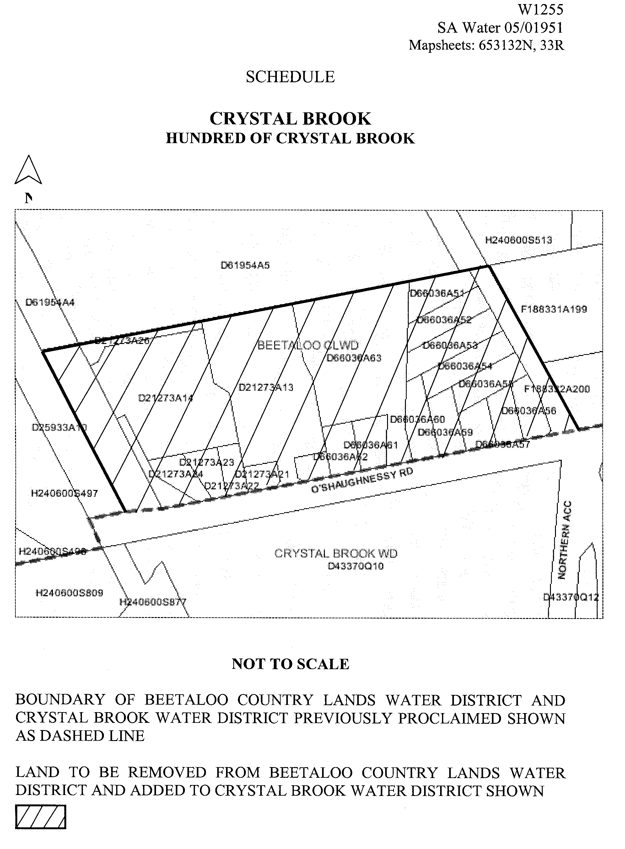

Dated 24 May 2005.
Signed for and on behalf of the South Australian Water Corporation by a person duly authorised so to do:
A. Popplewell, General Manager Shared Services
In the presence of:
C. J. McNamara, Billing Manager
SAWATER 05/01951 W1255

WATERWORKS ACT 1932
Removal of Land from Yorke Peninsula Country Lands Water District and Addition to Edithburgh Water District
PURSUANT to section 6 of the Waterworks Act 1932, the South Australian Water Corporation:
(a) removes from the Yorke Peninsula Country Lands Water District and adds to the Edithburgh Water District all the land contained in:
(i) allotments 300 to 302 inclusive in Deposited Plan 65508; and
(ii) allotment 303 in Deposited Plan 65508 (except the portion of that land already in the Edithburgh Water District); and
(b) declares that this notice will have effect from 1 July 2005.
Dated 24 May 2005.
Signed for and on behalf of the South Australian Water Corporation by a person duly authorised so to do:
A. Popplewell, General Manager Shared Services
In the presence of:
C. J. McNamara, Billing Manager
SAWATER 05/01954 W1235

WATERWORKS ACT 1932
Removal of Land from Barossa Country Lands Water District and Addition to Wasley Water District
PURSUANT to section 6 of the Waterworks Act 1932, the South Australian Water Corporation:
(a) removes from the Barossa Country Lands Water District and adds to the Wasley Water District all the land contained in allotment 26 in Deposited Plan 21531; and
(b) declares that this notice will have effect from 1 July 2005.
Dated 24 May 2005.
Signed for and on behalf of the South Australian Water Corporation by a person duly authorised so to do:
A. Popplewell, General Manager Shared Services
In the presence of:
C. J. McNamara, Billing Manager
SAWATER 05/01952 W1256

WATERWORKS ACT 1932
Removal of Land from Kanmantoo Country Lands Water District and Addition to Kanmantoo Water District
PURSUANT to section 6 of the Waterworks Act 1932, the South Australian Water Corporation:
(a) removes from the Kanmantoo Country Lands Water District and adds to the Kanmantoo Water District all the land contained in:
(i) allotment 15 in Deposited Plan 65353; and
(ii) allotment 14 in Deposited Plan 65353 (except the portion of that land already in the Kanmantoo Water District); and
(b) declares that this notice will have effect from 1 July 2005.
Dated 24 May 2005.
Signed for and on behalf of the South Australian Water Corporation by a person duly authorised so to do:
A. Popplewell, General Manager Shared Services
In the presence of:
C. J. McNamara, Billing Manager
SAWATER 05/01956 W1258

WATERWORKS ACT 1932
Removal of Land from Yorke Peninsula Country Lands Water District and Addition to Minlaton Water District
PURSUANT to section 6 of the Waterworks Act 1932, the South Australian Water Corporation:
(a) removes from the Yorke Peninsula Country Lands Water District and adds to the Minlaton Water District all the land contained in allotment 22 in Filed Plan 102154; and
(b) declares that this notice will have effect from 1 July 2005.
Dated 24 May 2005.
Signed for and on behalf of the South Australian Water Corporation by a person duly authorised so to do:
A. Popplewell, General Manager Shared Services
In the presence of:
C. J. McNamara, Billing Manager
SAWATER 05/02382 W1261

WATERWORKS ACT 1932
Addition of Land to Paringa Township Water District
PURSUANT to section 6 of the Waterworks Act 1932, the South Australian Water Corporation:
(a) adds to the Paringa Township Water District all the land contained in:
(i) allotments 1 to 3 inclusive in Deposited Plan 32739;
(ii) allotments 11 to 23 inclusive and 30 (road) in Deposited Plan 65572; and
(b) declares that this notice will have effect from 1 July 2005.
Dated 24 May 2005.
Signed for and on behalf of the South Australian Water Corporation by a person duly authorised so to do:
A. Popplewell, General Manager Shared Services
In the presence of:
C. J. McNamara, Billing Manager
SAWATER 05/02285 W1266

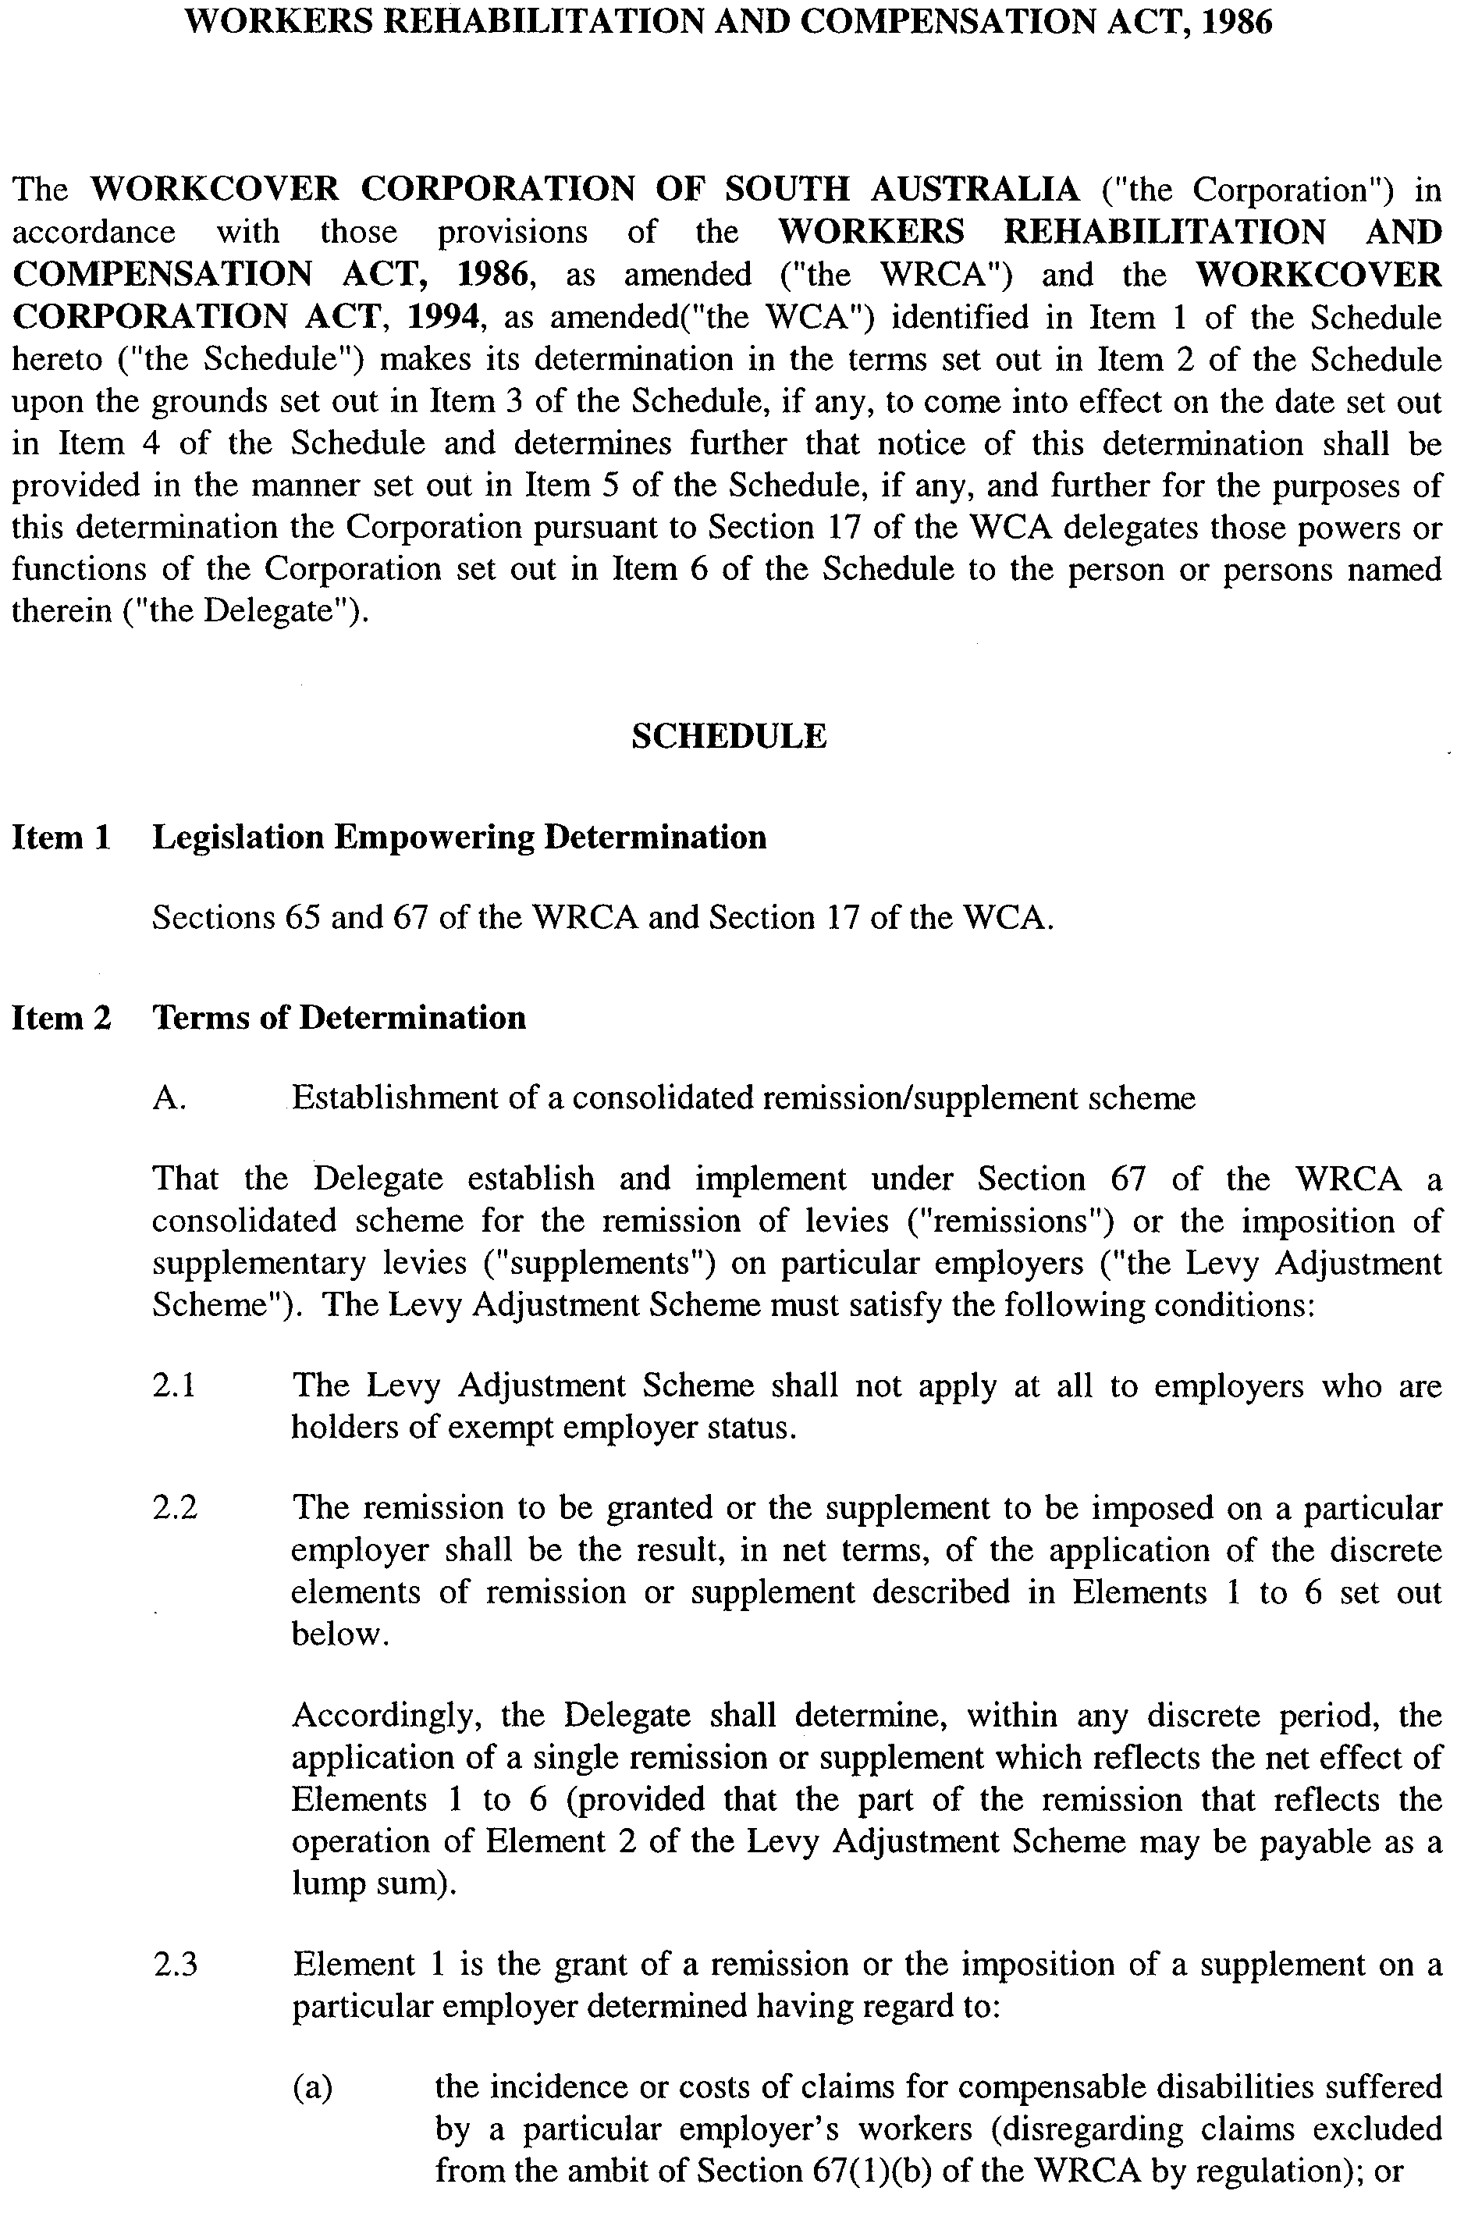
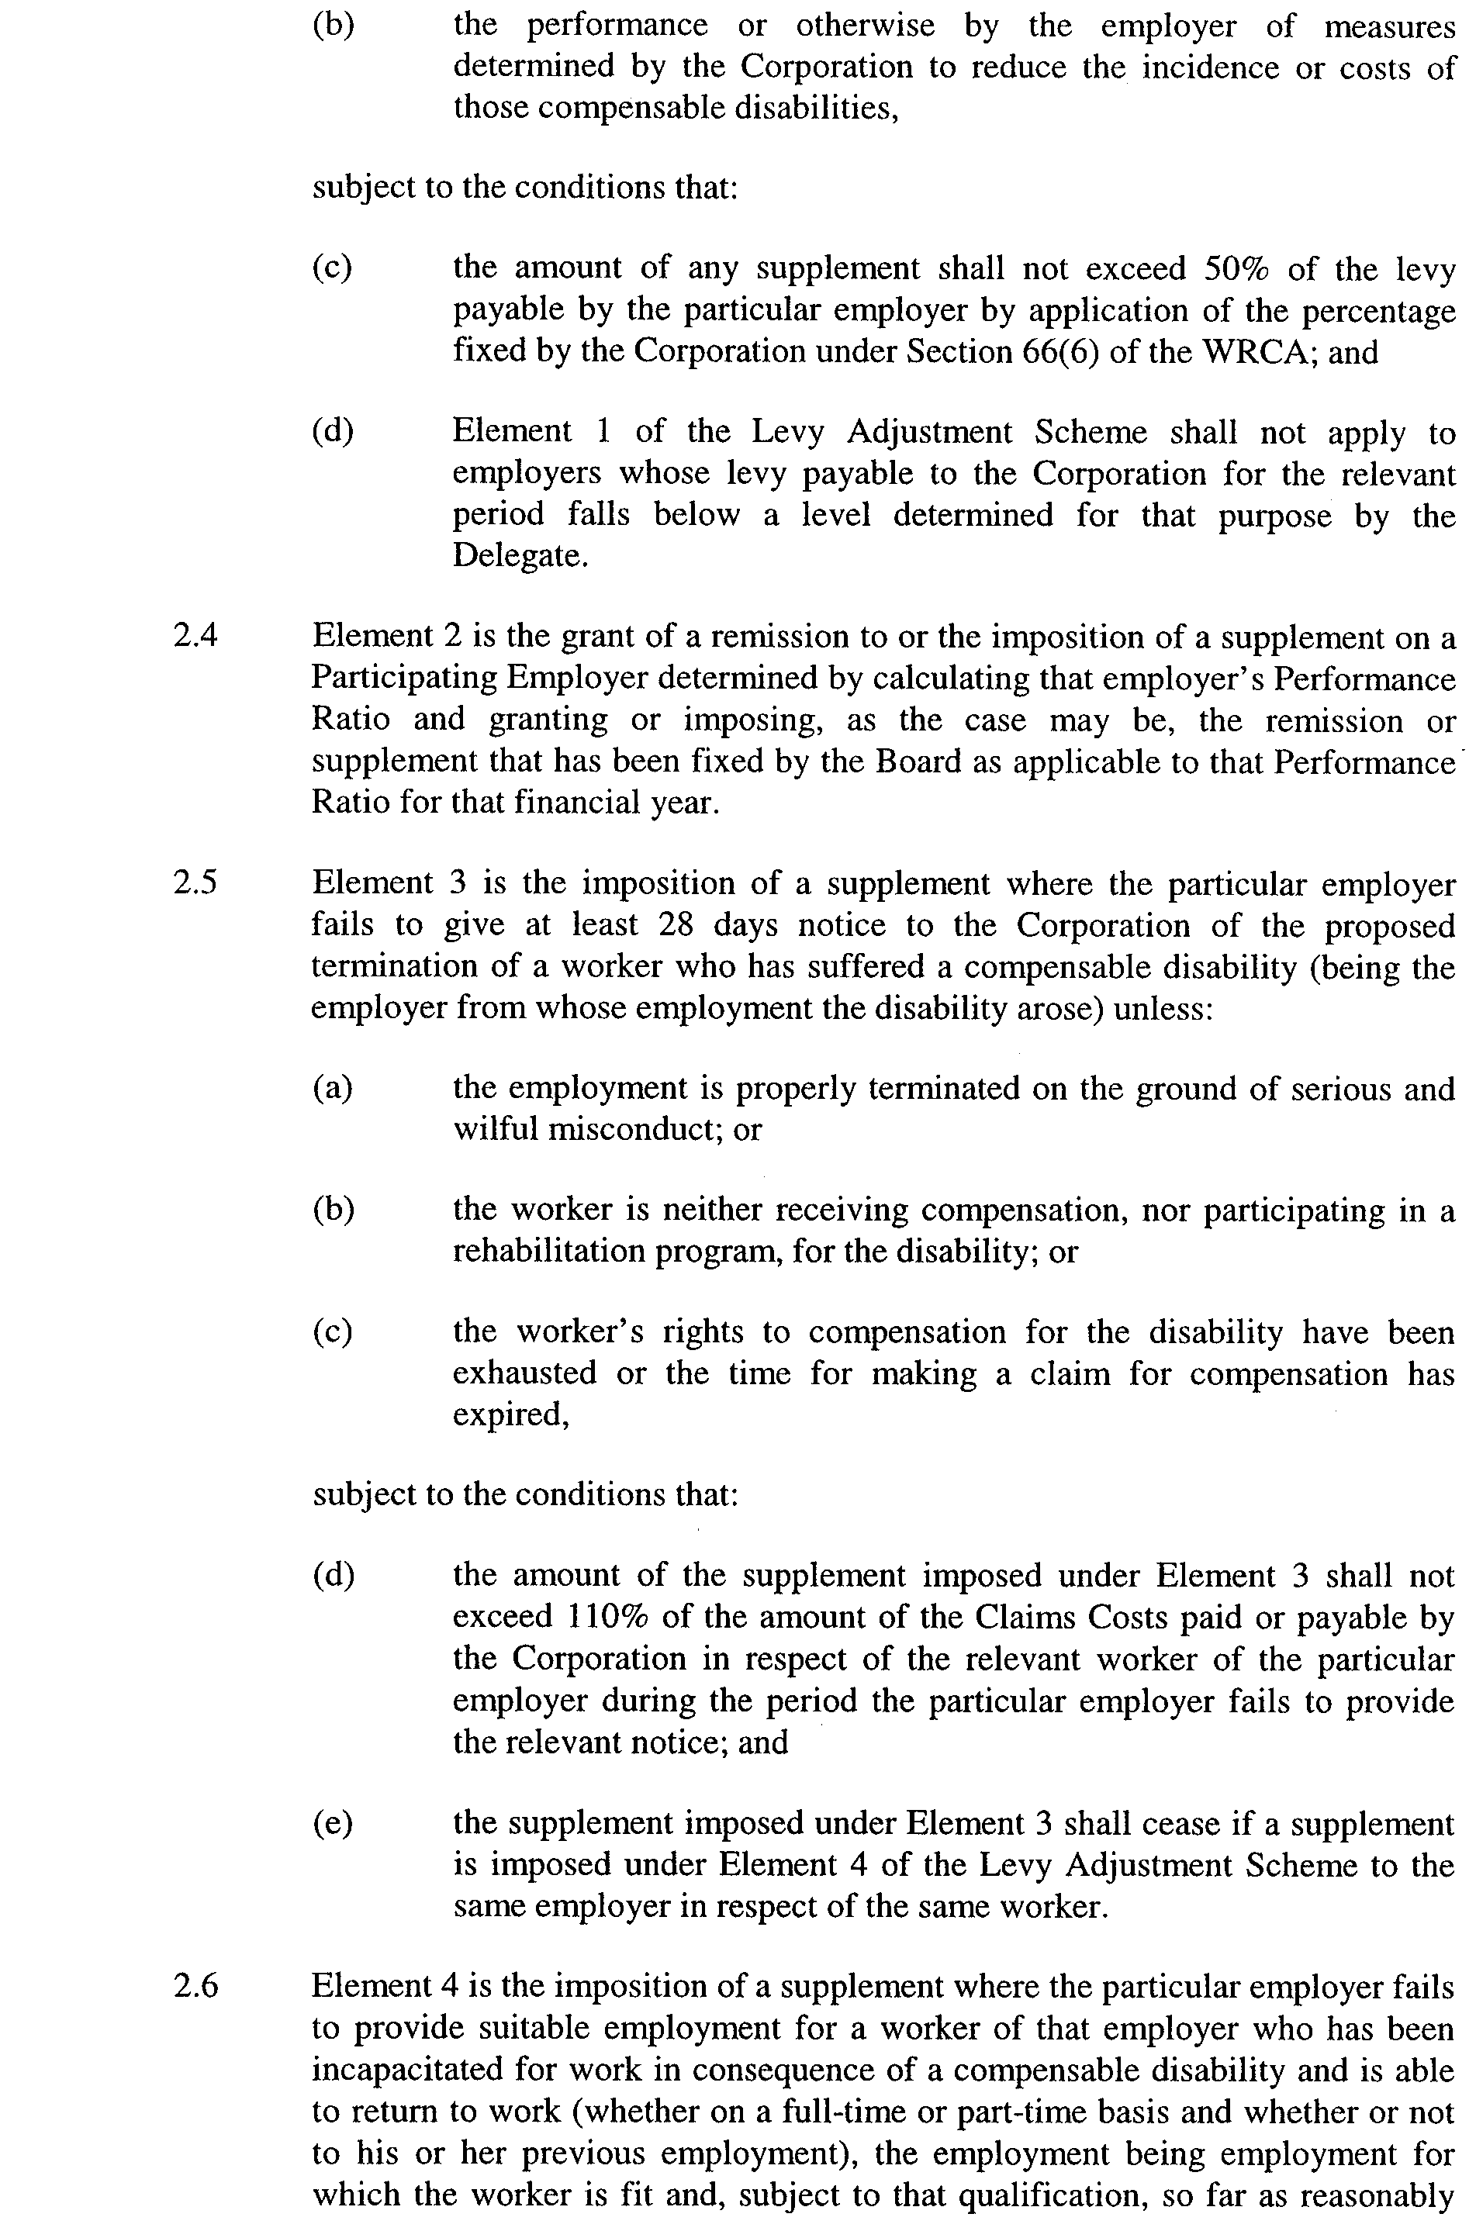
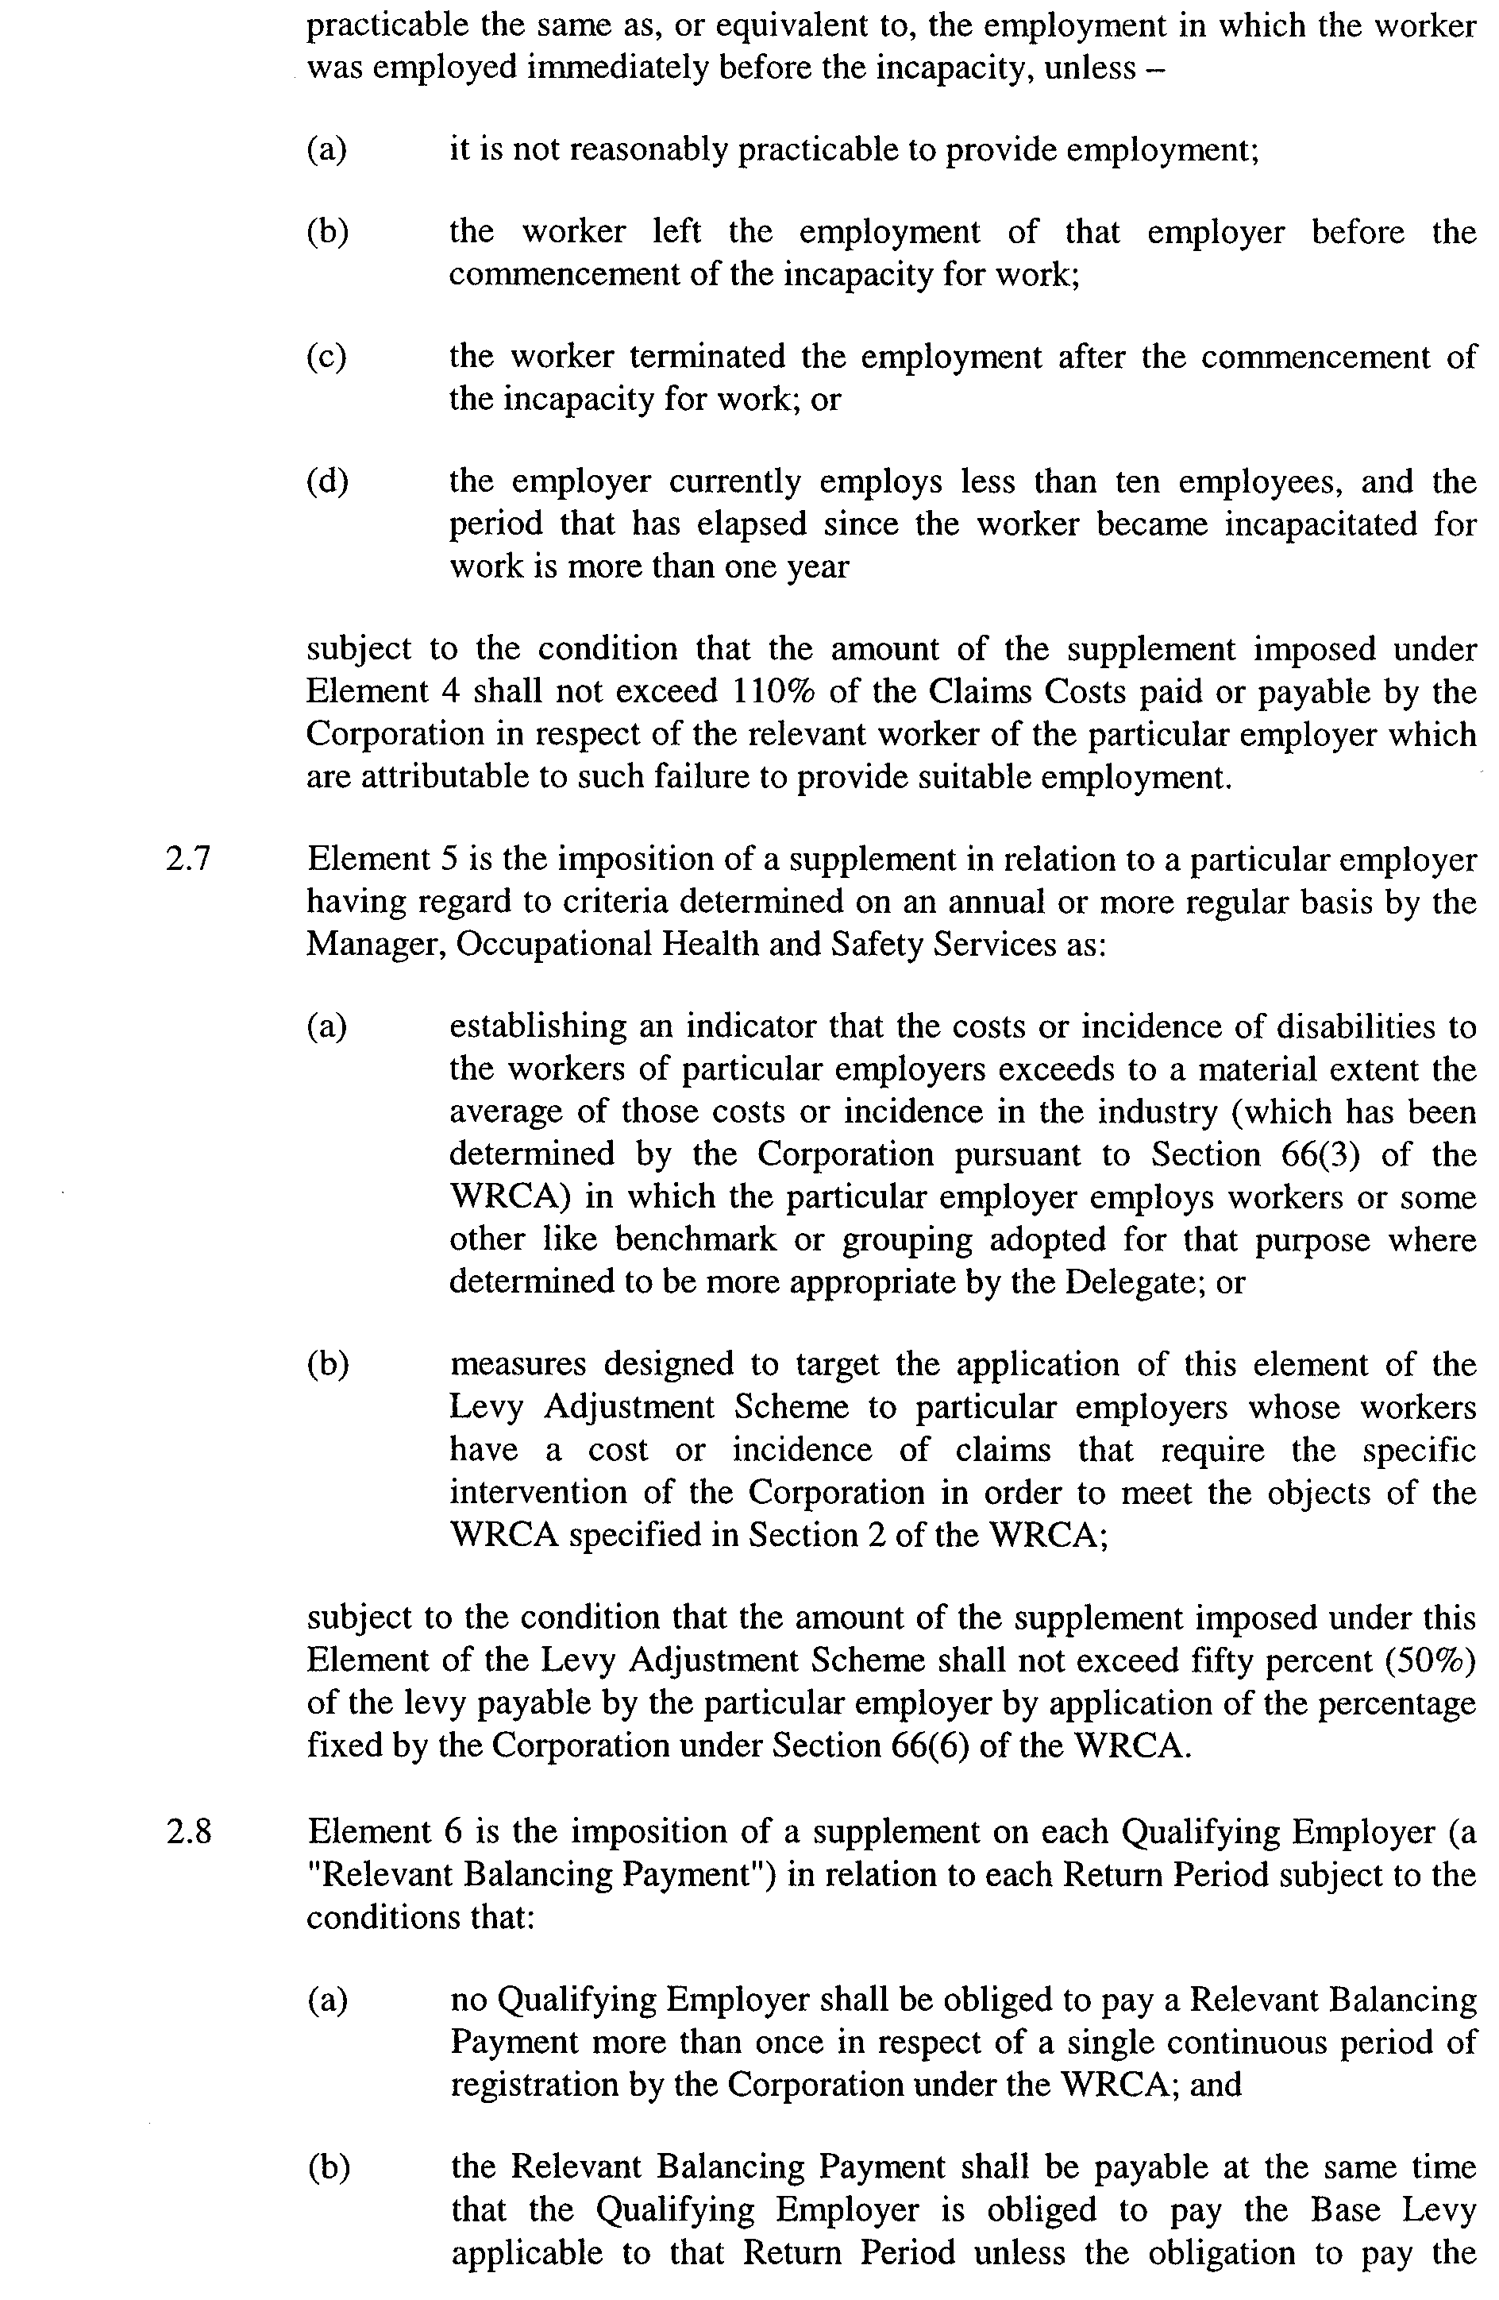
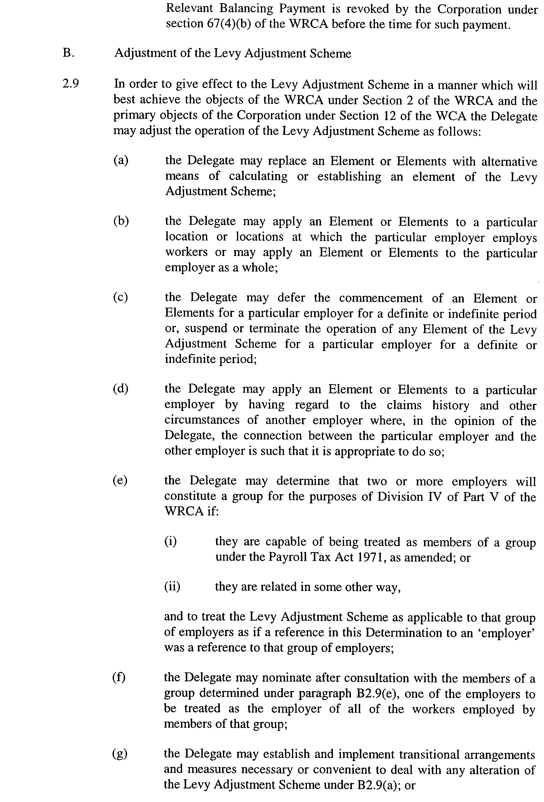
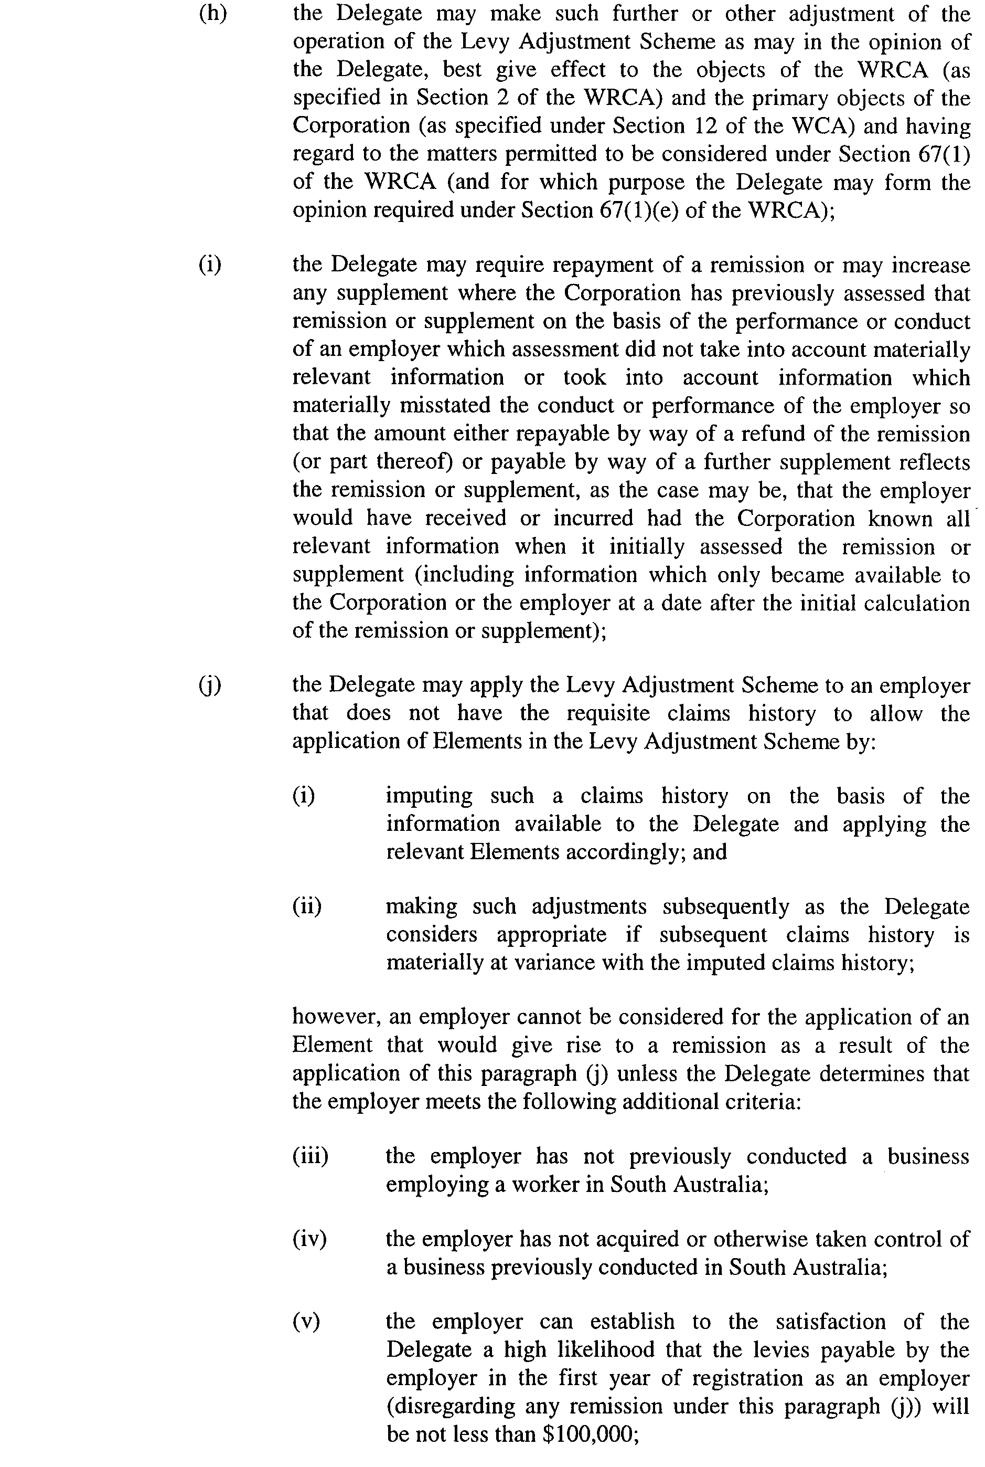
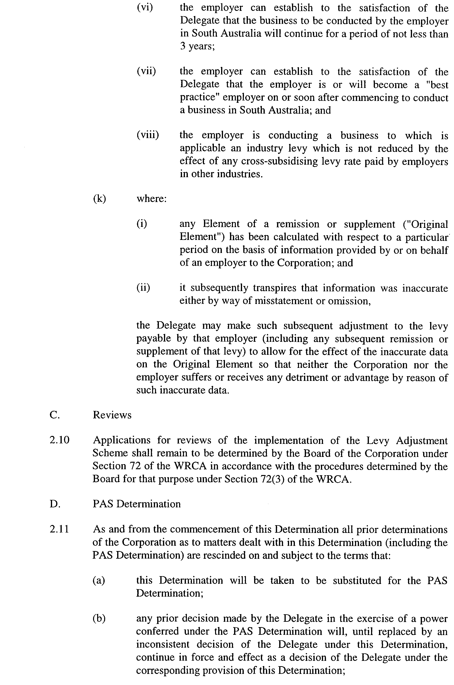
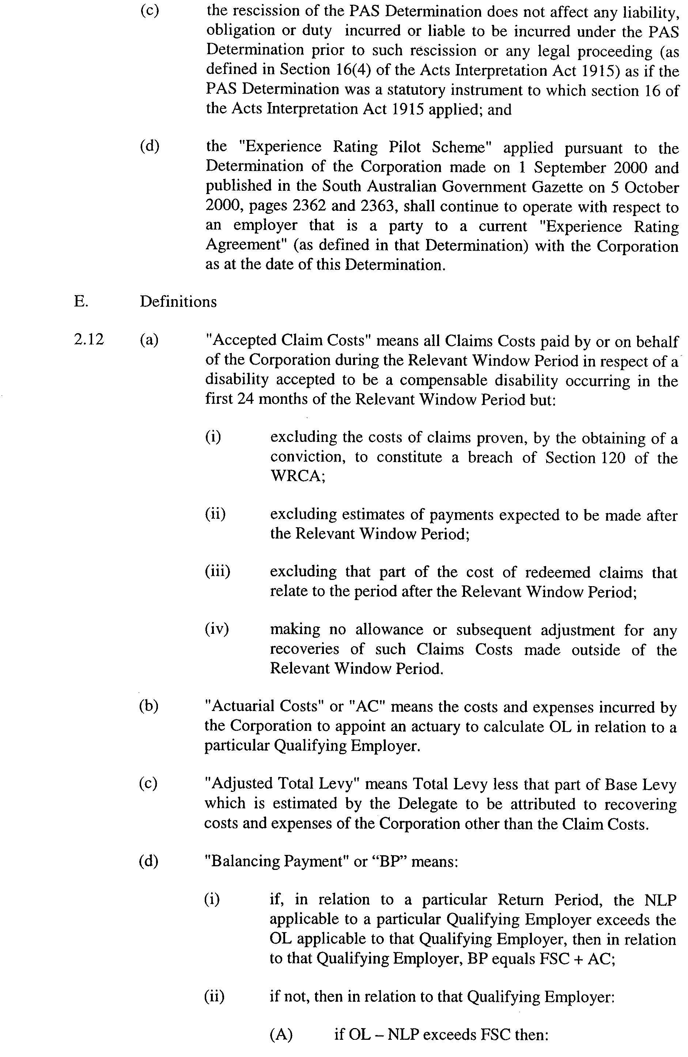
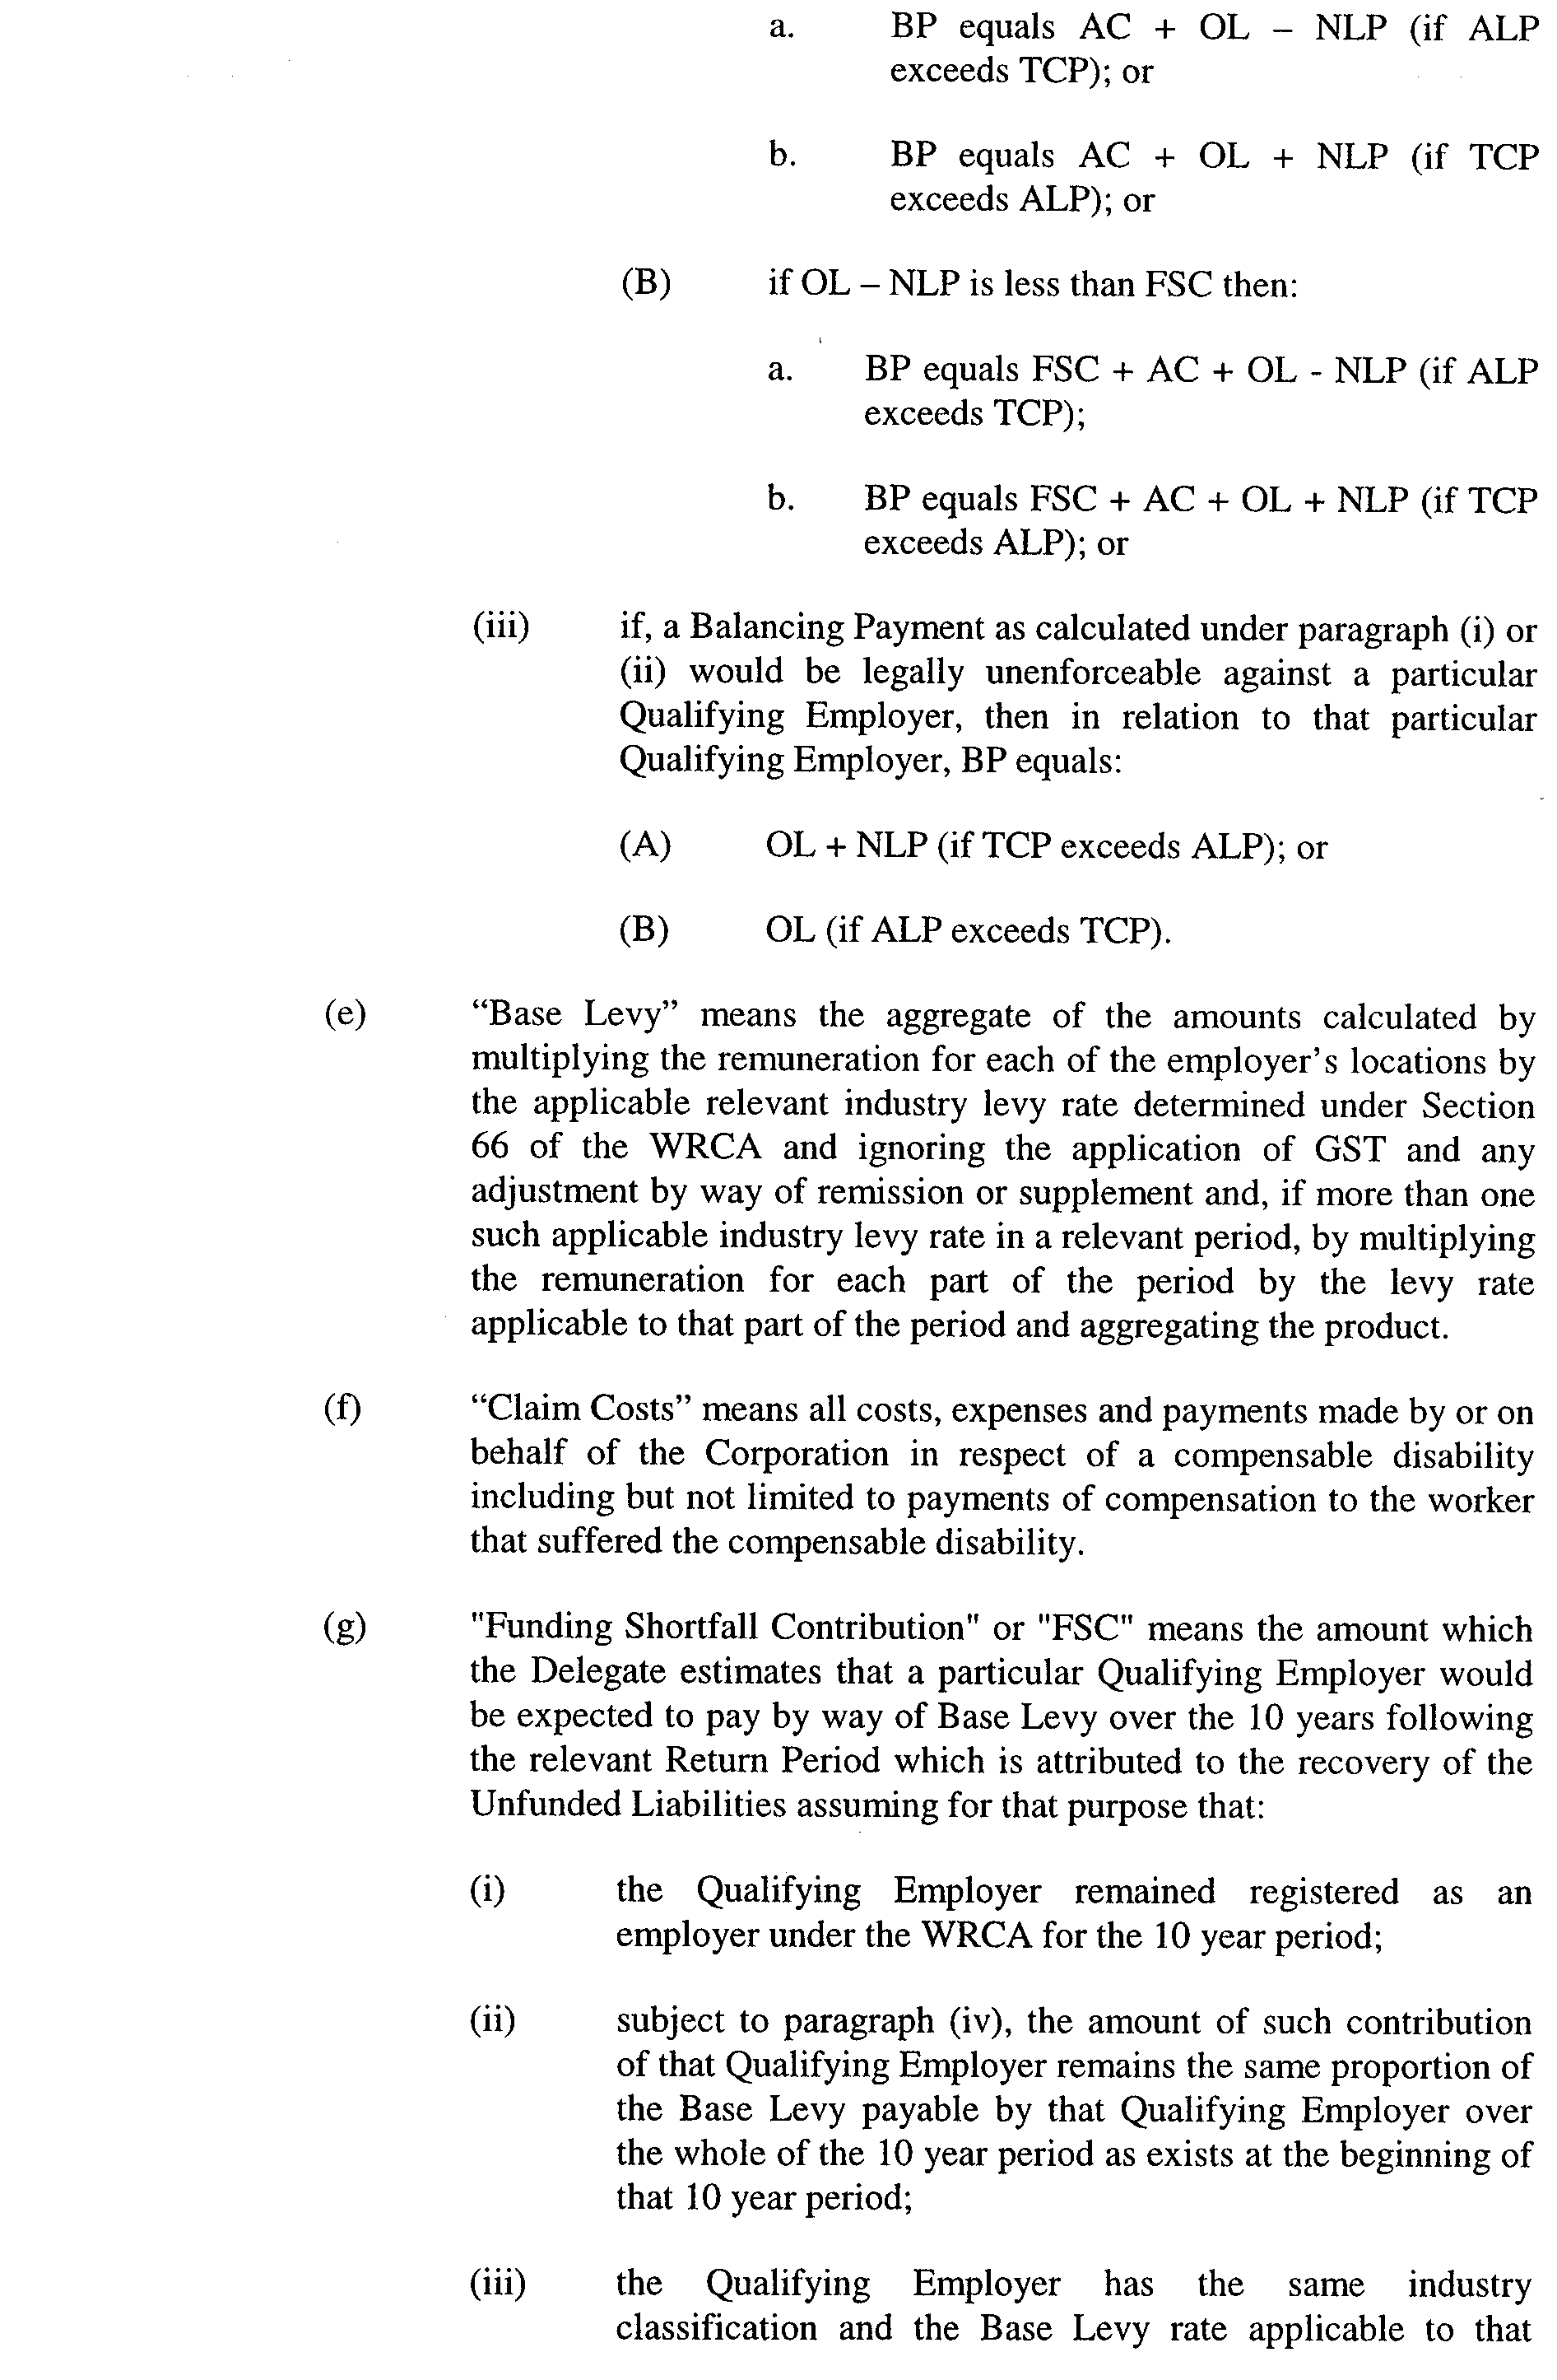
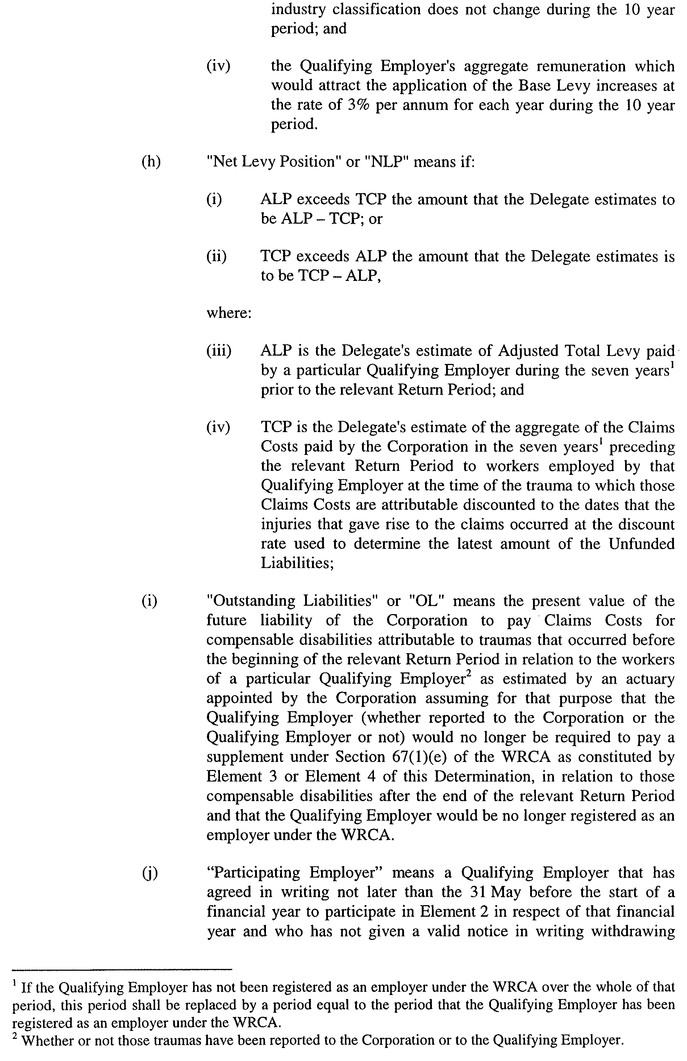
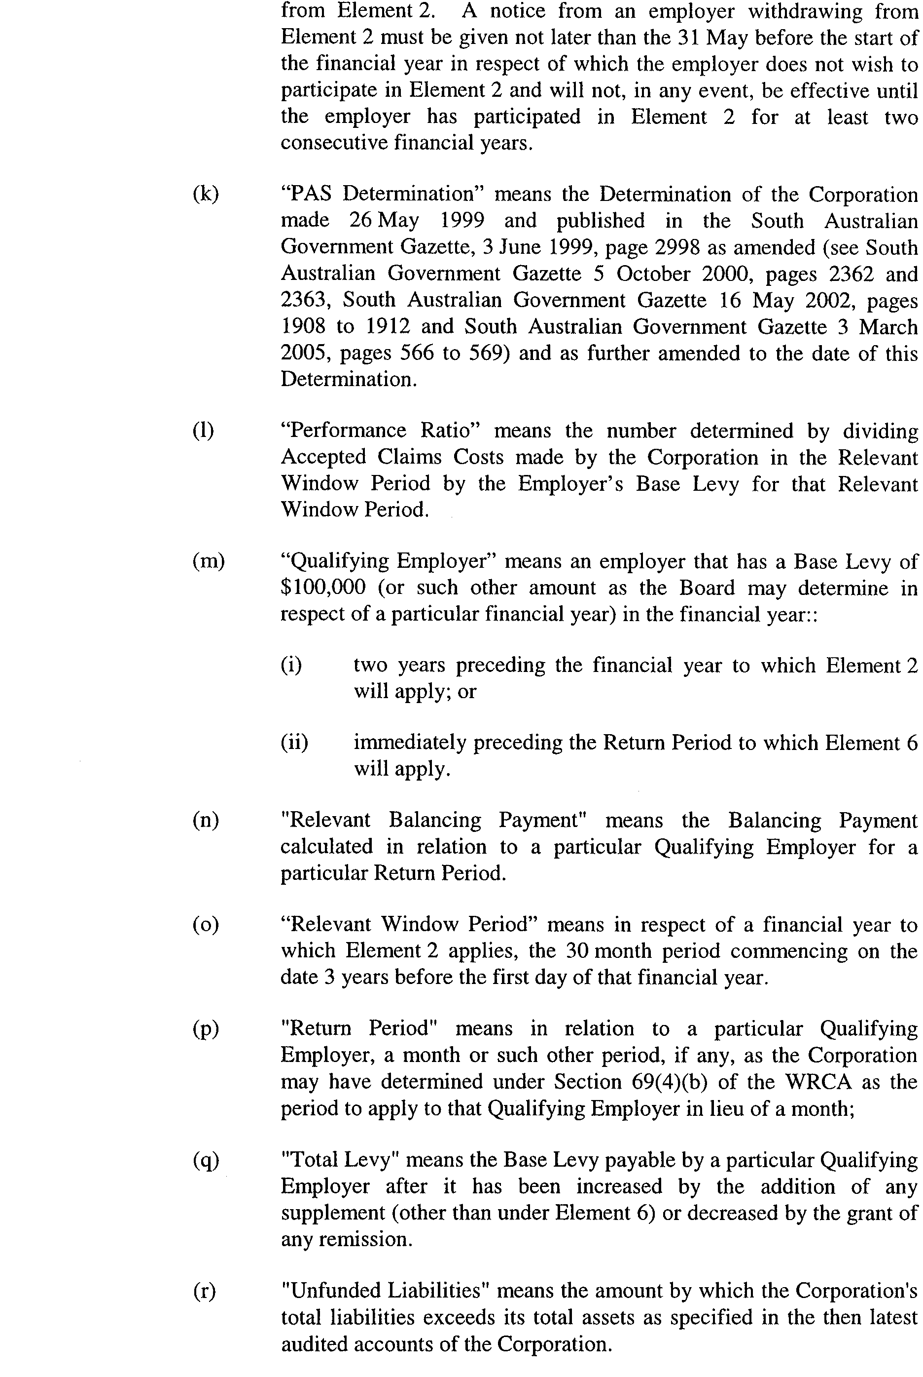
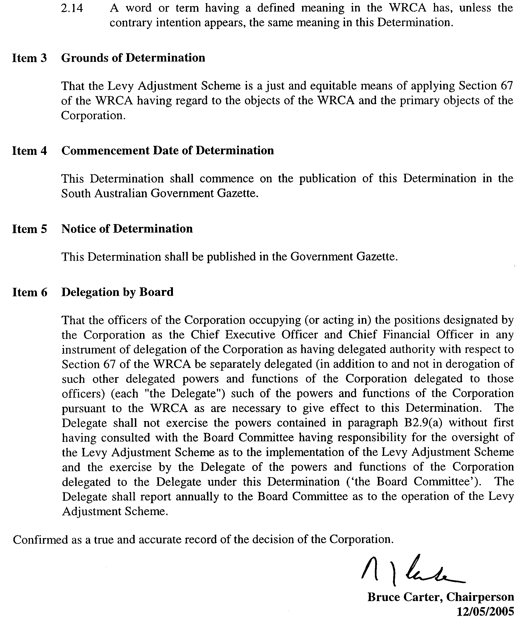
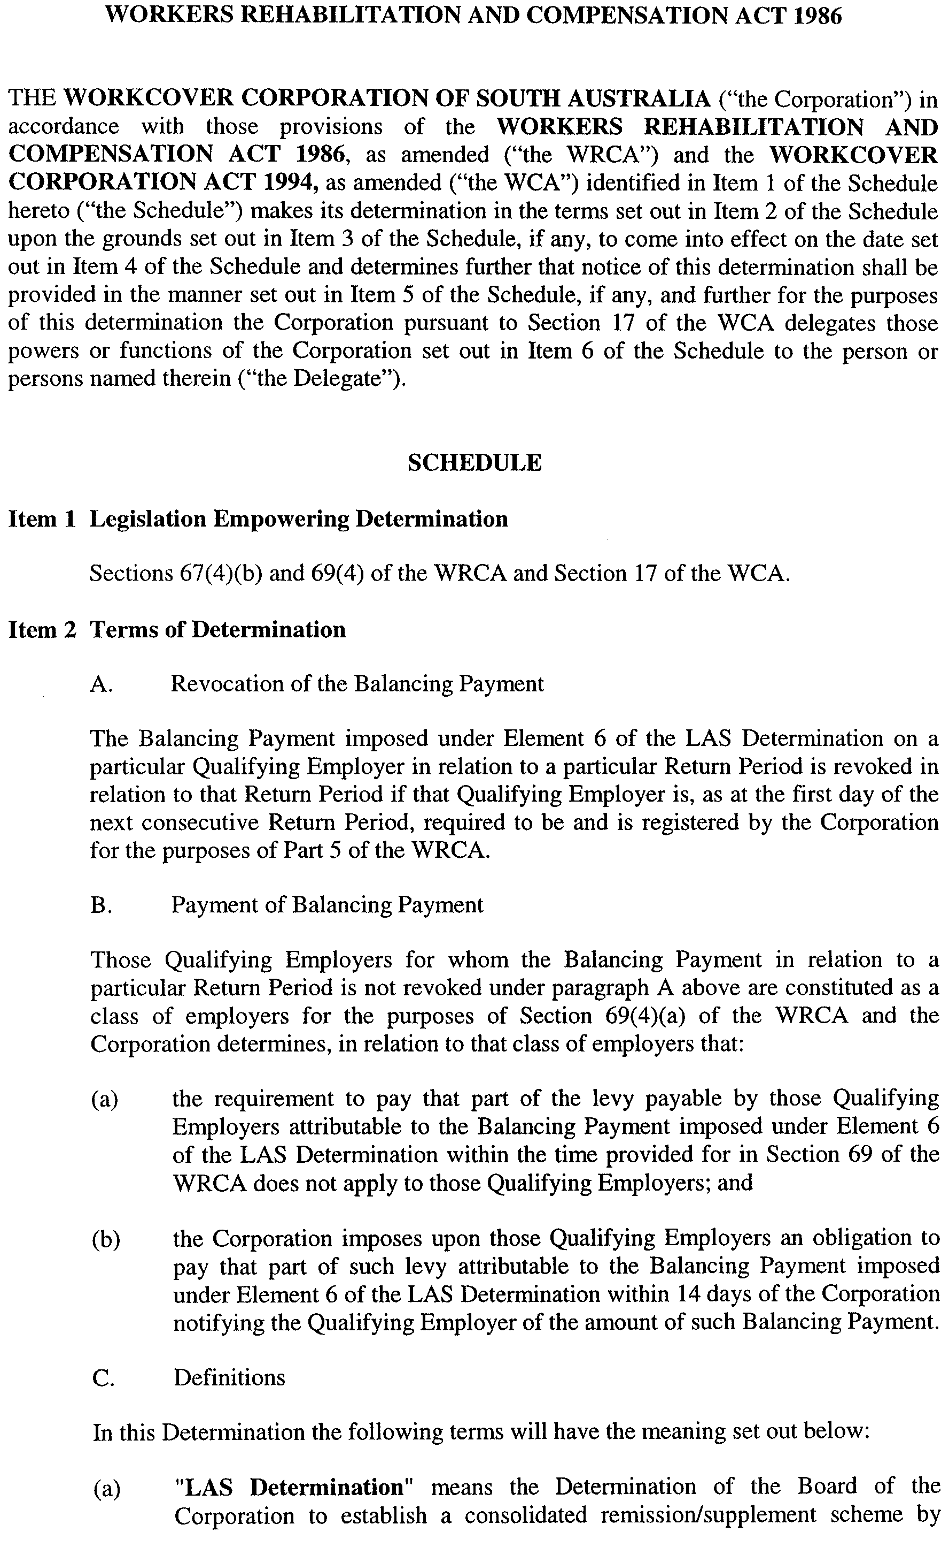
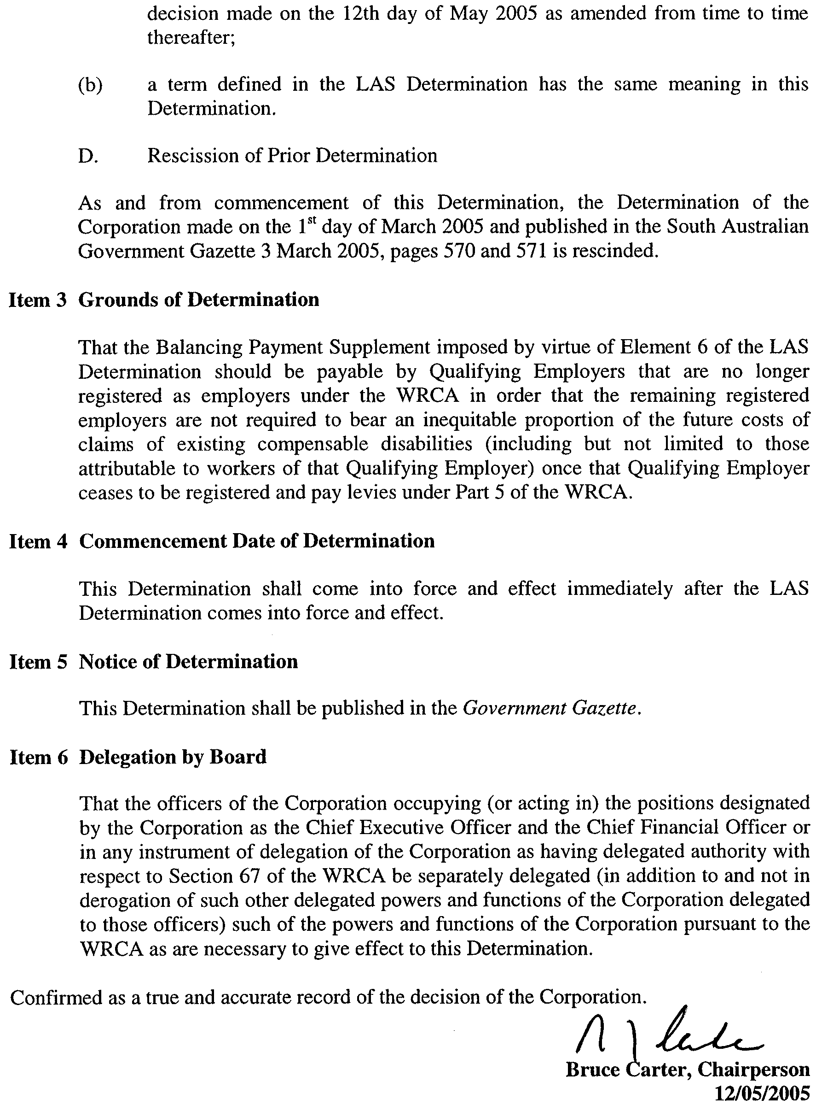

South Australia
Adelaide Dolphin Sanctuary Act (Commencement) Proclamation 2005
1—Short title
This proclamation may be cited as the Adelaide Dolphin Sanctuary Act (Commencement) Proclamation 2005.
2—Commencement of Act and suspension of certain provisions
(1) Subject to subclauses (2) and (3), the Adelaide Dolphin Sanctuary Act 2005 (No 5 of 2005) will come into operation on 4 June 2005.
(2) The following provisions of Schedule 2 of the Act will come into operation on 1 July 2005:
(a) clauses 2 to 20 (inclusive);
(b) clauses 22 to 41 (inclusive);
(c) clause 43;
(d) clauses 48 to 53 (inclusive).
(3) The operation of the following provisions of the Act is suspended until a day to be fixed by subsequent proclamation :
(a) section 12, other than subsection (4);
(b) sections 13 to 21 (inclusive).
Made by the Governor
with the advice and consent of the Executive Council
on 2 June 2005
EC05/0031CS

South Australia
Administrative Arrangements (Administration of Adelaide Dolphin Sanctuary Act) Proclamation 2005
under section 5 of the Administrative Arrangements Act 1994
1—Short title
This proclamation may be cited as the Administrative Arrangements (Administration of Adelaide Dolphin Sanctuary Act) Proclamation 2005.
2—Commencement
This proclamation comes into operation on the day on which it is made.
3—Administration of Act committed to Minister for Environment and Conservation
The administration of the Adelaide Dolphin Sanctuary Act 2005 is committed to the Minister for Environment and Conservation.
Made by the Governor
with the advice and consent of the Executive Council
on 2 June 2005
EC05/0031CS

South Australia
Highways (Road Closure—Elder Road, Martin Street and Walker Street, Birkenhead) Proclamation 2005
under section 27AA of the Highways Act 1926
1—Short title
This proclamation may be cited as the Highways (Road Closure—Elder Road, Martin Street and Walker Street, Birkenhead) Proclamation 2005.
2—Commencement
This proclamation comes into operation on the day on which it is made.
3—Road closure
The portion of Elder Road, Martin Street and Walker Street delineated as allotments 1, 2, 3, 4, 5, 6 and 7 in Plan No FP 45863 lodged in the Lands Titles Registration Office is closed subject to—
(a) an easement for sewerage purposes to the South Australian Water Corporation over allotments 1 to 7 (inclusive); and
(b) an easement for water supply purposes to the South Australian Water Corporation over allotments 1 to 7 (inclusive); and
(c) an easement for gas supply purposes to Envestra (SA) Limited over allotment 1; and
(d) an easement for electricity supply purposes to Distribution Lessor Corporation, subject to lease 8890000, over allotments 1 to 7 (inclusive).
Made by the Governor
on the recommendation of the Commissioner of Highways and with the advice and consent of the Executive Council
on 2 June 2005
MTR05/032CS

South Australia
Liquor Licensing (Revocation of Designation) Proclamation 2005
under section 15(1)(c) of the Liquor Licensing Act 1997

Preamble
1 His Honour Gordon Fraser Barrett was designated as the Licensing Court Judge by proclamation on 19 May 2005 (Gazette 19.5.2005 p1294).
2 It has now been decided to revoke this designation.

1—Short title
This proclamation may be cited as the Liquor Licensing (Revocation of Designation) Proclamation 2005.
2—Commencement
This proclamation comes into operation on the day on which it is made.
3—Revocation
The proclamation referred to in clause 1 of the preamble is revoked.
Made by the Governor
with the advice and consent of the Executive Council
on 2 June 2005
AGO0310/04CS

South Australia
National Parks and Wildlife (Mowantjie Willauwar Conservation Park) Proclamation 2005
under section 30(1) of the National Parks and Wildlife Act 1972
1—Short title
This proclamation may be cited as the National Parks and Wildlife (Mowantjie Willauwar Conservation Park) Proclamation 2005.
2—Commencement
This proclamation comes into operation on the day on which it is made.
3—Constitution of Mowantjie Willauwar Conservation Park
The following Crown land is constituted as a conservation park and assigned the name Mowantjie Willauwar Conservation Park:
Allotments 50, 51, 52, 53 and 54 of FP 33930, Hundred of Seymour, County of Russell.
Sections 513, 514, 515, 516, 517 and 518, Hundred of Seymour, County of Russell.
Made by the Governor
being of the opinion that the Crown land described in clause 3 should be protected and preserved for the purpose of conserving any wildlife and the natural and historic features of the land and with the advice and consent of the Executive Council
on 2 June 2005
EC05/0038CS

South Australia
Public Sector Management (Transfer of Employees—Department for Transport, Energy and Infrastructure) Proclamation 2005
under section 7 of the Public Sector Management Act 1995
1—Short title
This proclamation may be cited as the Public Sector Management (Transfer of Employees—Department for Transport, Energy and Infrastructure) Proclamation 2005.
2—Commencement
This proclamation will come into operation on 1 July 2005.
3—Transfer of employees
The employees of the Department for Transport, Energy and Infrastructure who, immediately before the commencement of this proclamation, hold a position in—
(a) a Transport SA Customer Service Centre at—
(i) Mount Gambier (including Naracoorte); or
(ii) Berri; or
(iii) Kadina; or
(iv) Murray Bridge; or
(v) Port Pirie; or
(vi) Adelaide; or
(b) the Transport SA Call Centre at Roma Mitchell House in Adelaide,
are transferred to the Department for Administrative and Information Services.
Made by the Governor
with the advice and consent of the Executive Council
on 2 June 2005
MAS04/004CS

South Australia
Controlled Substances (Poisons) Variation Regulations 2005
under the Controlled Substances Act 1984

Contents
Part 1—Preliminary
1 Short title
2 Commencement
3 Variation provisions
Part 2—Variation of Controlled Substances (Poisons) Regulations 1996
4 Variation of regulation 28—Prescribed professions (section 18(1))

Part 1—Preliminary
1—Short title
These regulations may be cited as the Controlled Substances (Poisons) Variation Regulations 2005.
2—Commencement
These regulations come into operation on the day on which they are made.
3—Variation provisions
In these regulations, a provision under a heading referring to the variation of a specified regulation varies the regulation so specified.
Part 2—Variation of Controlled Substances (Poisons) Regulations 1996
4—Variation of regulation 28—Prescribed professions (section 18(1))
Regulation 28—delete subregulation (1) and substitute:
(1) Subject to the limitations set out in this regulation, the following professions are prescribed for the purposes of section 18(1)(b) of the Act:
(a) chiropody;
(b) dental therapy;
(c) optometry.
(1a) The profession of nursing is prescribed for the purposes of section 18(1)(c) of the Act.

Note—
As required by section 10AA(2) of the Subordinate Legislation Act 1978, the Minister has certified that, in the Minister's opinion, it is necessary or appropriate that these regulations come into operation as set out in these regulations.
Made by the Governor
after consultation by the Minister with the Controlled Substances Advisory Council and with the advice and consent of the Executive Council
on 2 June 2005
No 132 of 2005
DHSCS04/25

South Australia
Land Tax Variation Regulations 2005
under the Land Tax Act 1936

Contents
Part 1—Preliminary
1 Short title
2 Commencement
3 Variation provisions
Part 2—Variation of Land Tax Regulations 1999
4 Substitution of regulation 8
8 Prescribed associations (section 4)

Part 1—Preliminary
1—Short title
These regulations may be cited as the Land Tax Variation Regulations 2005.
2—Commencement
These regulations will come into operation at midnight on 30 June 2005.
3—Variation provisions
In these regulations, a provision under a heading referring to the variation of specified regulations varies the regulations so specified.
Part 2—Variation of Land Tax Regulations 1999
4—Substitution of regulation 8
Regulation 8—delete the regulation and substitute:
8—Prescribed associations (section 4)
For the purposes of section 4(1)(k)(viii) of the Act, the following associations are prescribed:
(a) Lakeside Villages Incorporated;
(b) Pineview Village Incorporated;
(c) The Retirement Homes Association of Australia Incorporated.

Note—
As required by section 10AA(2) of the Subordinate Legislation Act 1978, the Minister has certified that, in the Minister's opinion, it is necessary or appropriate that these regulations come into operation as set out in these regulations.
Made by the Governor
with the advice and consent of the Executive Council
on 2 June 2005
No 133 of 2005
T&F05/006CS

South Australia
Adelaide Dolphin Sanctuary Regulations 2005
under the Adelaide Dolphin Sanctuary Act 2005

Contents
1 Short title
2 Commencement
3 Interpretation
4 ADS Management Plan—prescribed bodies (section 11(5)(b) and (7)(a) of Act)
5 Applications for warrants (section 29(6) of Act)
6 General duty of care—prescribed circumstances (section 32(3) of Act)
7 Action on non-compliance with order etc—prescribed rate of interest (sections 34, 36 and 37 of Act)
Schedule 1—ADS Management Plan—prescribed bodies

1—Short title
These regulations may be cited as the Adelaide Dolphin Sanctuary Regulations 2005.
2—Commencement
These regulations will come into operation on the day on which the Adelaide Dolphin Sanctuary Act 2005 comes into operation.
3—Interpretation
In these regulations, unless the contrary intention appears—
Act means the Adelaide Dolphin Sanctuary Act 2005.
4—ADS Management Plan—prescribed bodies (section 11(5)(b) and (7)(a) of Act)
For the purposes of section 11(5)(b) and (7)(a) of the Act, the bodies specified in Schedule 1 are prescribed.
5—Applications for warrants (section 29(6) of Act)
(1) The grounds of an application for a warrant under section 29 of the Act made personally must be verified by affidavit.
(2) If an application for a warrant is made by telephone—
(a) the applicant must inform the magistrate of the applicant's name and identify the position that he or she holds for the purposes of the Act, and the magistrate, on receiving that information, is entitled to assume, without further inquiry, that the applicant holds that position; and
(b) the applicant must inform the magistrate of the purpose for which the warrant is required and the grounds on which it is sought; and
(c) if it appears to the magistrate from the information given by the applicant that there are proper grounds to issue a warrant, the magistrate must inform the applicant of the facts that justify, in the magistrate's opinion, the issue of the warrant, and must not proceed to issue the warrant unless the applicant undertakes to make an affidavit verifying those facts; and
(d) if the applicant gives such an undertaking, the magistrate may then make out and sign a warrant, noting on the warrant the facts that justify, in the magistrate's opinion, the issue of the warrant; and
(e) the warrant is taken to have been issued, and comes into force, when signed by the magistrate; and
(f) the magistrate must inform the applicant of the terms of the warrant; and
(g) the applicant must, as soon as practicable after the issue of the warrant, forward to the magistrate an affidavit verifying the facts referred to in paragraph (c).
(3) A magistrate by whom a warrant is issued must file the warrant, or a copy of the warrant, and the affidavit verifying the grounds on which the application for the warrant was made, in the Magistrates Court.
6—General duty of care—prescribed circumstances (section 32(3) of Act)
For the purposes of section 32(3) of the Act, any circumstance involving the exercise of a statutory power by a public authority in an emergency situation is prescribed.
7—Action on non-compliance with order etc—prescribed rate of interest (sections 34, 36 and 37 of Act)
(1) For the purposes of sections 34(5)(a), 36(5)(a) and 37(8)(a) of the Act, the prescribed rate of interest per annum on an unpaid amount will be the prime bank rate for any financial year for which the amount remains unpaid.
(2) In this regulation—
prime bank rate for a particular financial year means the corporate loan reference rate applied by the Commonwealth Bank of Australia for corporate lending on the first trading day of the Bank in that financial year.
Schedule 1—ADS Management Plan—prescribed bodies
Aboriginal Legal Rights Movement Incorporated
Adelaide and Mount Lofty Ranges Natural Resources Management Board
Boating Industry Association of South Australia Incorporated
City of Port Adelaide Enfield
City of Salisbury
Conservation Council of South Australia Incorporated
Flinders Ports Pty Limited
South Australian Employers' Chamber of Commerce and Industry Incorporated
South Australian Fishing Industry Council Incorporated
South Australian Recreational Fishing Advisory Council Incorporated
Note—
As required by section 10AA(2) of the Subordinate Legislation Act 1978, the Minister has certified that, in the Minister's opinion, it is necessary or appropriate that these regulations come into operation as set out in these regulations.
Made by the Governor
with the advice and consent of the Executive Council
on 2 June 2005
No 134 of 2005
EC05/0031CS

South Australia
Legal Practitioners Variation Regulations 2005
under the Legal Practitioners Act 1981

Contents
Part 1—Preliminary
1 Short title
2 Commencement
3 Variation provisions
Part 2—Variation of Legal Practitioners Regulations 1994
4 Substitution of Schedule 2
Schedule 2—Fees

Part 1—Preliminary
1—Short title
These regulations may be cited as the Legal Practitioners Variation Regulations 2005.
2—Commencement
These regulations come into operation on the day on which they are made.
3—Variation provisions
In these regulations, a provision under a heading referring to the variation of specified regulations varies the regulations so specified.
Part 2—Variation of Legal Practitioners Regulations 1994
4—Substitution of Schedule 2
Schedule 2—delete the schedule and substitute:
Schedule 2—Fees

1 | For the issue or renewal of a practising certificate—
 | (a) for more than 6 months | $291 fee  $75 levy
 | (b) for 6 months or less | $171 fee  $38 levy
2 | Fee to accompany an annual return lodged under section 24 of the Act | $30
Note—
As required by section 10AA(2) of the Subordinate Legislation Act 1978, the Minister has certified that, in the Minister's opinion, it is necessary or appropriate that these regulations come into operation as set out in these regulations.
Made by the Governor
with the advice and consent of the Executive Council
on 2 June 2005
No 135 of 2005
AGO0151/04CS

FAXING COPY?
IF you fax copy to Government Publishing SA for inclusion in the Government Gazette, there is no need to send a Confirmation Copy to us as well.
This creates confusion and may well result in your notice being printed twice.
Please use the following fax number:
Fax transmission: (08) 8207 1040
Phone Inquiries: (08) 8207 1045
Please include a contact person, phone number and order number so that we can phone back with any queries we may have regarding the fax copy.
NOTE: Closing time for lodging new copy (fax, hard copy or email) is 4 p.m. on Tuesday preceding the day of publication.

Government Gazette notices can be E-mailed.
The address is:
governmentgazette@saugov.sa.gov.au
Documents should be sent as attachments in Word format.
When sending a document via E-mail, please confirm your transmission with a faxed copy of your document, including the date the notice is to be published.
Fax transmission: (08) 8207 1040
Enquiries: (08) 8207 1045
NOTE: Closing time for lodging new copy (fax, hard copy or email) is 4 p.m. on Tuesday preceding the day of publication.

TOWN OF GAWLER
Supplementary Election
RESULT of Supplementary Election for two area councillors conducted on Tuesday, 17 May 2005.
Formal Ballot Papers: 3 486 Quota: 1 163
Informal Ballot Papers: 60
Candidates | First  Preference  Votes |  | Result after Distribution of  Preferences
Baxendale, Bill | 463
Fischer, Kevin | 764 |  | Elected
Kelson, Dawn | 331
Morris, Greg | 767 |  | Elected
Carmody, Kylee J. | 172
Spencer, Scott | 367
Willis, Marie | 622
Informal | 60
Total | 3 486
D. Gully, Returning Officer

ALEXANDRINA COUNCIL
Roads (Opening and Closing) Act 1991
Ian Avenue and Gawler Avenue, Middleton
NOTICE is hereby given pursuant to section 10 of the said Act, that council proposes to make a Road Process Order to close and sell by public auction or tender the whole of the public roads Ian Avenue and Gawler Avenue in DP 6158 shown as ‘A’ and ‘B’ (respectively) on Preliminary Plan No. 05/0024.
A copy of the plan and statement of persons affected are available for public inspection at Council’s office, 11 Cadell Street Goolwa and the office of the Surveyor-General, 101 Grenfell Street, Adelaide during normal office hours.
Any application for easement or objection must be made in writing within 28 days from 2 June 2005, to the Council, P.O. Box 21, Goolwa, S.A. 5214 and the Surveyor-General, G.P.O. Box 1354, Adelaide, S.A. 5001, setting out full details.
Where a submission is made, council will give notification of a meeting to deal with the matter.
J. Coombe, Chief Executive Officer

THE BAROSSA COUNCIL
Roads (Opening and Closing) Act 1991
Road Closure—Rattei Road, Mount Crawford/Flaxmans Valley
NOTICE is hereby given, pursuant to section 10 of the Roads (Opening and Closing) Act 1991, that The Barossa Council proposes to make a Road Process Order to close and transfer to Adelaide Blue Gum Pty Ltd the whole of the public road (western end of Rattei Road) adjoining the northern boundary of section 660 in the Hundred of Para Wirra, shown more particularly delineated and lettered ‘A’ on Preliminary Plan No. 05/0021.
A copy of the plan and a statement of persons affected are available for public inspection at the offices of the Council, 1 Washington Street, Angaston and the Adelaide office of the Surveyor-General during normal office hours.
Any application for easement or objection must set out the full name, address and details of the submission and must be fully supported by reasons.
The application for easement or objection must be made in writing to the Council, P.O. Box 295, Angaston, S.A. 5353, within 28 days of this notice and a copy must be forwarded to the Surveyor-General, G.P.O. Box 1354, Adelaide, S.A. 5001. Where a submission is made, the Council will give notification of a meeting at which the matter will be considered.
Dated 2 June 2005.
J. Jones, Chief Executive Officer

IN the matter of the estates of the undermentioned deceased persons:
Ambridge, Florence Ida, late of 39 Finniss Street, Marion, of no occupation, who died on 2 February 2005.
Appels, Louise, late of 13 Moseley Street, Glenelg, widow, who died on 1 March 2005.
Banwell, Maureen Dulcie, late of 2 Falie Drive, North Haven, home duties, who died on 31 March 2005.
Bennett, Thelma Dorothy, late of Edmund Terrace, Crystal Brook, retired registered nurse, who died on 25 November 2004.
Boyd, Betty Fay, late of 700 Goodwood Road, Daw Park, of no occupation, who died on 12 December 2004.
Brewster-Jones, Marian Ellie, late of 34 Molesworth Street, North Adelaide, of no occupation, who died on 29 March 2005.
Callaghan, Diane Robyn, late of 21 Parkview Rise, Hackham, school services officer, who died on 11 February 2005.
Cox, Charmian, late of 51 Eve Road, Belleview Heights, of no occupation, who died on 27 March 2005.
Errington, Jean Dawn, late of 29 Austral Terrace, Morphettville, of no occupation, who died on 18 April 2005.
Green, David Robert, late of 29 Hartley Grove, Windsor Gardens, of no occupation, who died on 6 June 2003.
Habel, Glen Raymond, late of Hawdon Street, Barmera, retired cellar hand, who died on 7 May 2005.
Hackett, Brian Guilford, late of Blamey Road, Elizabeth East, retired technician, who died on 6 December 2004.
Hanson, Kathleen June, late of 33 Eighth Street, Gawler South, of no occupation, who died on 26 March 2005.
Hazelwood, Audrey Jean, late of 7 Lancelot Drive, Daw Park, of no occupation, who died on 30 January 2005.
Hutchins, Mary Margaret, late of 14 Frew Street, Fullarton, of no occupation, who died on 11 April 2005.
James, Lawrence John, late of 4 Farrant Street, Prospect, of no occupation, who died on 25 March 2003.
King, Florance Rose, late of 25 Burns Street, Whyalla Norrie, home duties, who died on 1 January 2005.
Kirk, Kathleen Mary, late of 39 Finniss Street, Marion, of no occupation, who died on 8 March 2005.
Koerner, John, late of 5 Marcian Street, Christie Downs, retired secondary school teacher, who died on 5 March 2005.
Libiseller, Josef, late of 26 Cliff Street, Glenelg East, retired builder, who died on 21 January 2005.
Martin, Phyllis Mary, late of 103 Fisher Street, Fullarton, widow, who died on 1 May 2005.
McInnes, Eileen, late of 14 Strangways Street, Mount Gambier, of no occupation, who died on 20 February 2005.
Possingham, Frederick Arthur, late of Webb Street, Clare, of no occupation, who died on 13 September 2002.
Sanders, John Russell, late of 18 Butler Crescent, Glengowrie, retired quantity surveyor, who died on 6 January 2005.
Seagrim, Allen Earling Conrad, late of 17 Moore Street, Goolwa, retired groundsman, who died on 18 April 2005.
Smith, Thelma Alice, late of 84 Reservoir Road, Modbury, of no occupation, who died on 19 February 2005.
Stevens, Georgina Vivienne, late of 81-93 Regency Road, Croydon Park, of no occupation, who died on 12 April 2005.

Terrell, Miriam, late of 156 Main North Road, Prospect, of no occupation, who died on 8 January 2005.
Thompson, Carlyle Garfield, late of 8 Fletcher Road, Mount Barker, retired baker, who died on 19 January 2005.
Watson, Enid Myra, late of 164 O.G. Road, Felixstow, of no occupation, who died on 17 April 2005.
Notice is hereby given pursuant to the Trustee Act 1936, as amended, the Inheritance (Family Provision) Act 1972, and the Family Relationships Act 1975, that all creditors, beneficiaries, and other persons having claims against the said estates are required to send, in writing, to the Public Trustee, 25 Franklin Street, Adelaide, S.A. 5000, full particulars and proof of such claims, on or before 1 July 2005, otherwise they will be excluded from the distribution of the said estate; and notice is also hereby given that all persons who are indebted to the said estates are required to pay the amount of their debts to the Public Trustee or proceedings will be taken for the recovery thereof; and all persons having any property belonging to the said estates are forthwith to deliver the same to the Public Trustee.
Dated 2 June 2005.
C. J. O’Loughlin, Public Trustee

SOUTH AUSTRALIA—In the Supreme Court No. 1089 of 2001. In the matter of Derer Holdings Pty Limited (ACN 084 655 890) and in the matter of the Corporations Act 2001.
Notice by a Liquidator of His Intention to Seek His Release
Take notice that I, Barrie Malcolm Mansom of 1st Floor, Menai House, 17 Bagot Street, North Adelaide, the liquidator of the abovenamed company, intend to make application to the Supreme Court of South Australia for my release as the liquidator of the abovenamed company.
And take further notice that if you have any objection to the granting of my release you must file at the Supreme Court and also forward to me within 21 days of the publication in the Gazette of the notice of my intention to apply for a release a notice of objection in the form laid down by the Corporations (South Australia) Rules 1993.
Dated 27 May 2005.
B. M. Mansom, Liquidator
Note: Section 481 of the Corporations Law enacts that an order of the Court releasing a Liquidator shall discharge him/her in the administration of the affairs of the company, or otherwise in relation to his or her conduct as Liquidator, but any such order may be revoked on proof that it was obtained by fraud or by suppression or by concealment of any material fact.

UNCLAIMED MONEYS ACT 1891
Register of Unclaimed Moneys held by Wesfarmers Federation Insurance Limited

Name | Address |  | Amount  $
Altamura, G.. | 40 Wallis Street, Parkside, S.A. 5063 | 11.00
Jagger, J. N. | 11 Liston Street, Parkside, S.A. 5063 | 15.00
Cirocco, C.. | 56 St Alfreds Drive, Parafield Gardens, S.A. 5093 | 17.83
Gardner, P. J. and S. L. | RMD 420 Grange Road, Victor Harbor, S.A. 5211 | 110.00
Roe, D. J. and J. B. | P.O. Box 177, Aldinga Beach, S.A. 5173 | 252.12
Doug Mildren Computing | 73 Commercial Road, Port Adelaide, S.A. 5015 | 254.00
Taylor, P. W. | 134 Conyngham Street, Glenunga, S.A. 5064 | 668.00

T. Perkins, Finance and Administration Manager

ATTENTION

CUSTOMERS requiring a proof of their notice for inclusion in the Government Gazette, please note that the onus is on you to inform Government Publishing SA of any subsequent corrections by 10 a.m. on Thursday, which is our publication deadline.

For any corrections to your notice please phone 8207 1045 or Fax 8207 1040 before 10 a.m. on Thursday.

If we do not receive any communication by 10 a.m. on Thursday (day of publication) we will presume the notice is correct and will print it as it is.

Remember—the onus is on you to inform us of any corrections necessary to your notice.

NOTE: Closing time for lodging new copy (electronically, fax or hard copy) is 4 p.m. on Tuesday preceding the day of publication. Phone 8207 1045—Fax 8207 1040.
Email: governmentgazette@saugov.sa.gov.au

Printed and published by authority every Thursday by J. D. FERGUSON, Government Printer, South Australia
Price: $4.85, plus postage; to subscribers, $247.00 per annum.
(The above prices are inclusive of GST)

