No. 20 543

THE SOUTH AUSTRALIAN

GOVERNMENT GAZETTE
www.governmentgazette.sa.gov.au

PUBLISHED BY AUTHORITY

ALL PUBLIC ACTS appearing in this GAZETTE are to be considered official, and obeyed as such

ADELAIDE, THURSDAY, 3 MARCH 2005

CONTENTS

Page
Appointments, Resignations, Etc. 544
Building Work Contractors Act 1995—Notices 544
Corporations and District Councils—Notices 580
Crown Lands Act 1929—Notices 545
Development Act 1993—Notices 545
Environment Protection Act 1993—Notice 549
Fisheries Act 1982—Notices 550
Land and Business (Sale and Conveyancing) Act 1994—
Notice 551
Liquor Licensing Act 1997—Notices 551
Mining Act 1971—Notices 552
Motor Vehicles Act 1959—Notice 552
National Parks Regulations 2001—Notice 554
Petroleum Act 2000—Notices 553
Port Augusta Circuit Court—Notice 555

Page
Proclamations 573
Public Trustee Office—Administration of Estates 581
Rail Safety Act 1996—Notice 559
REGULATION
Liquor Licensing Act 1997 (No. 11 of 2005) 577
Renmark Irrigation Trust, The—Notice 555
Roads (Opening and Closing) Act 1991—Notices 555
Sewerage Act 1929—Notices 558
Transport, Department of—Notices to Mariners 554
Water Mains and Sewers—Mains Laid, Replaced, Etc. 559
Water Resources Act 1997—Notice 564
Waterworks Act 1932—Notice 563
Wilderness Protection Act 1992—Notice 572
Workers Rehabilitation and Compensation Act 1986—
Determinations 566

GOVERNMENT GAZETTE NOTICES
ALL poundkeepers’ and private advertisements forwarded for publication in the South Australian Government Gazette must be PAID FOR PRIOR TO INSERTION; and all notices, from whatever source, should be legibly written on one side of the paper only and sent to Government Publishing SA so as to be received no later
than 4 p.m. on the Tuesday preceding the day of publication. Phone 8207 1045 or Fax 8207 1040. E-mail: governmentgazette@saugov.sa.gov.au. Send as attachments in Word format and please confirm your transmission with a faxed copy of your document, including the date the notice is to be published and to whom the notice will be charged. The Government Gazette is available online at: www.governmentgazette.sa.gov.au

Department of the Premier and Cabinet
Adelaide, 3 March 2005
HIS Excellency the Governor’s Deputy in Executive Council has been pleased to appoint the undermentioned to the Eyre Peninsula Catchment Water Management Board, pursuant to the provisions of the Water Resources Act 1997:
Member: (from 8 March 2005 until 7 March 2009)
Peter James Duffy
Jeffrey William Pearson
David John Lane
Martin John Daintith
By command,
J. D. Lomax-Smith, for Premier
MEC 0011/05CS

Department of the Premier and Cabinet
Adelaide, 3 March 2005
HIS Excellency the Governor’s Deputy in Executive Council has been pleased to appoint Andrew William Daniels to the position of Chief Executive, South Australian Motor Sport Board, for a term of three years commencing on 3 March 2005, pursuant to Section 13 of the South Australian Motor Sport Act 1984.
By command,
J. D. Lomax-Smith, for Premier
DTF 078/04CS

Department of the Premier and Cabinet
Adelaide, 3 March 2005
HIS Excellency the Governor’s Deputy in Executive Council has revoked the appointment of the Honourable Terance Gerald Roberts, MLC, Minister for Aboriginal Affairs and Reconciliation, Minister for Correctional Services and Minister Assisting the Minister for Environment and Conservation to be also Acting Minister for Environment and Conservation, Acting Minister for the Southern Suburbs and Acting Minister Assisting the Premier in the Arts for the period 13 March 2005 to 31 March 2005 inclusive, during the absence of the Honourable John David Hill, MP.
By command,
J. D. Lomax-Smith, for Premier
MEC 0085/04CS

Department of the Premier and Cabinet
Adelaide, 3 March 2005
HIS Excellency the Governor’s Deputy in Executive Council has been pleased to appoint the Honourable Jane Diane Lomax-Smith, MP, Minister for Education and Children’s Services and Minister for Tourism to be also Acting Minister for Environment and Conservation, Acting Minister for the Southern Suburbs and Acting Minister Assisting the Premier in the Arts for the period
13 March 2005 to 31 March 2005 inclusive, during the absence of the Honourable John David Hill, MP.
By command,
J. D. Lomax-Smith, for Premier
MEC 0085/04CS

Department of the Premier and Cabinet
Adelaide, 3 March 2005
HIS Excellency the Governor’s Deputy in Executive Council has been pleased to appoint the Honourable Karlene Ann Maywald, MP, Minister for the River Murray, Minister for Regional Development, Minister for Small Business and Minister for Consumer Affairs to be also Acting Minister for Agriculture, Food and Fisheries, Acting Minister for State/Local Government Relations and Acting Minister for Forests for the period 11 March 2005 to 15 March 2005 inclusive, during the absence of the Honourable Rory John McEwen, MP.
By command,
J. D. Lomax-Smith, for Premier
MAFF 0001/05CS

Department of the Premier and Cabinet
Adelaide, 3 March 2005
HIS Excellency the Governor’s Deputy in Executive Council has been pleased to appoint the Honourable Paul Holloway, MLC, Minister for Industry and Trade and Minister for Mineral Resources Development to be also Acting Minister for Agriculture, Food and Fisheries, Acting Minister for State/Local Government Relations and Acting Minister for Forests for the period 16 March 2005 to 28 March 2005 inclusive, during the absence of the Honourable Rory John McEwen, MP.
By command,
J. D. Lomax-Smith, for Premier
MAFF 0001/05CS

BUILDING WORK CONTRACTORS ACT 1995
Exemption
TAKE notice that, pursuant to section 45 of the Building Work Contractors Act 1995, I, Karlene Maywald, Minister for Consumer Affairs, do hereby exempt the licensee named in Schedule 1 from the application of Division 3 of Part 5 of the Act in relation to domestic building work described in Schedule 2 and subject to the conditions specified in Schedule 3.
Schedule 1
Peter Claver Smedley, BLD 104754.
Schedule 2
Domestic building work performed by the licensee for the construction of a small garage, verandah and portico for the licensee’s existing family residence, 8 Camille Street, Hallett Cove.
Schedule 3
That the licensee does not transfer his interest in the land prior to five years from the date of completion of the building work, the subject of this exemption, without the authorisation of the Commissioner for Consumer Affairs.
Dated 22 February 2005.
K. Maywald, Minister for Consumer Affairs
Ref: 610/04-00472

BUILDING WORK CONTRACTORS ACT 1995
Exemption
TAKE notice that, pursuant to section 45 of the Building Work Contractors Act 1995, I, Karlene Maywald, Minister for Consumer Affairs, do hereby exempt the licensee named in Schedule 1 from the application of Division 3 of Part 5 of the Act in relation to domestic building work described in Schedule 2 and subject to the conditions specified in Schedule 3.
Schedule 1
Mirko Maric, BLD 182103.
Schedule 2
Domestic building work performed by the licensee for the construction of a three bedroom single storey detached dwelling with double garage for the licensee’s new family residence, 20 Hill Street, Plympton Park.
Schedule 3
That the licensee does not transfer his interest in the land prior to five years from the date of completion of the building work, the subject of this exemption, without the authorisation of the Commissioner for Consumer Affairs.
Dated 22 February 2005.
K. Maywald, Minister for Consumer Affairs
Ref: 610/04-01044

CROWN LANDS ACT 1929: SECTION 5
TAKE NOTICE that pursuant to the Crown Lands Act 1929, I, JOHN HILL, Minister for Environment and Conservation, Minister of the Crown to whom the administration of the Crown Lands Act 1929 is committed DO HEREBY resume the land defined in The Schedule.
The Schedule
Reserve for Recreation Purposes, Section 1533, Hundred of Noarlunga, the proclamation of which was published in the Government Gazette of 16 May 1963 at page 1270, The Second Schedule, being the whole of the land comprised in Crown Record Volume 5753 Folio 717.
Dated 3 March 2005.
J. Hill, Minister for Environment and Conservation
DL 1639/1985

CROWN LANDS ACT 1929: SECTION 5
TAKE NOTICE that pursuant to the Crown Lands Act 1929, I, JOHN HILL, Minister for Environment and Conservation, Minister of the Crown to whom the administration of the Crown Lands Act 1929 is committed DO HEREBY:
1. Resume the land defined in The First Schedule.
2. Dedicate the Crown Land defined in The Second Schedule as an Emergency Services Reserve and declare that such land shall be under the care, control and management of the Minister for Emergency Services.
3. Dedicate the Crown Land defined in The Third Schedule as a Reserve for District Council and Scouts Purposes and declare that such land shall be under the care, control and management of the Alexandrina Council.
The First Schedule
District Council Reserve, Section 2547, Hundred of Bremer, County of Hindmarsh, the notice of which was published in the Government Gazette of 16 June 1988 at page 1957, The Second Schedule, being the whole of the land comprised in Crown Record Volume 5754 Folio 600.
The Second Schedule
Allotment 1000 of Deposited Plan 66439, Hundred of Bremer, County of Hindmarsh, exclusive of all necessary roads.
The Third Schedule
Allotment 1001 of Deposited Plan 66439, Hundred of Bremer, County of Hindmarsh, exclusive of all necessary roads.
Dated 3 March 2005.
J. Hill, Minister for Environment and Conservation
DL 3731/1987

DEVELOPMENT ACT 1993, SECTION 48: DECISION BY THE DEVELOPMENT ASSESSMENT COMMISSION AS DELEGATE OF THE GOVERNOR
Preamble
1. The decision of the Governor under section 48 of the Development Act 1993, to grant provisional development authori-sation of the Beringer Blass Wine Bottling and Storage Facility at Nuriootpa was published in the Gazette on 23 September 2004.
2. Pursuant to section 48 of the Development Act 1993 and Regulation 64 (1) of the Development Regulations 1993, the Governor reserved certain matters for further decision-making.
3. Amendments to the development were granted by the Development Assessment Commission as delegate of the Governor on 14 October 2004 and 16 December 2004.
4. A further application has been made to the Development Assessment Commission, as delegate of the Governor, to amend the layout of the administration building and adjacent car park area for the development.
5. The Development Assessment Commission has, in con-sidering the application, had regard to all relevant matters under section 48 (5) of the Development Act 1993.
6. The Development Assessment Commission is satisfied that the amendments do not require the preparation of a further or amended Development Report.
Decision
PURSUANT to section 48 of the Development Act 1993, the Development Assessment Commission, as delegate of the Governor, grants provisional development authorisation to the amended Beringer Blass Wine Bottling and Storage Facility subject to the Conditions and Notes to the applicant below:
(a) reserve a decision on the following matters (upon application of further information) pursuant to section 48 (6) and Regulation 64 (1):
(i) further assessment and certification in respect of the Building Rules, for additional packages for Stage 1 and Stage 2 of the development (refer to Conditions and Notes to Applicant below);
(b) specify all matters relating to this provisional develop-ment authorisation as matters in respect of which con-ditions of this authorisation may be varied or revoked, or new conditions attached;
(c) specify, for the purposes of section 48 (11) (b) of the Development Act 1993, the period of two years from the date hereof, as the time within which substantial work must be commenced on site, failing which I may cancel this authorisation.
Conditions of Approval
1. Except where minor amendments may be required by other legislation, or by conditions imposed herein, the proposed Major Development shall be undertaken in strict accordance with:
(a) the following drawings contained within the Develop-ment Report, ‘Proposed Wine Bottling and Storage Facility, Light Pass Road/Pipeline Road, Barossa Valley’, lodged by Beringer Blass Wine Estates, dated May 2004:
• Drawing Titled: ‘Proposed Bottling Facility, Land-scape Plan’; Drawing Number: N080-SK01 A.
• Drawing Titled: ‘Proposed Bottling Facility, Eleva-tions’; Drawing Number: N080-SK02 A.
(b) the following drawings contained within the letter from Nolan Rumsby Planners dated 11 November 2004, insofar as they are varied by the drawings indicated in paragraph (d):
• Drawing Titled: ‘Wine Bottling and Storage Facility, Development Consent Amendment, Proposed Bottling, Storage and Winery Facility, Final Development Site Plan’; Drawing Number: WLF04-000-0265 B.
• Drawing Titled: ‘Wine Bottling and Storage Facility, Development Consent Amendment, Proposed Bottling and Storage Facility Stage 1A Development Plan (2 Bottling Lines)’; Drawing Number: WLF04-000-0260 C.
• Drawing Titled: ‘Wine Bottling and Storage Facility, Development Consent Amendment, Proposed Bottling and Storage Facility Stage 1B Development Plan (4 Bottling Lines)’; Drawing Number: WLF04-000-0262 B.
• Drawing Titled: ‘Wine Bottling and Storage Facility, Development Consent Amendment, Proposed Bottling and Storage Facility Final Development Plan (8 Bottling Lines)’; Drawing Number: WLF04-000-0263 B.
• Drawing Titled: ‘Wine Bottling and Storage Facility, Development Consent Amendment, Proposed Bottling and Storage Facility Final Development Plans Over-layed’; Drawing Number: WLF04-000-0266 B.
• Drawing Titled: ‘Wine Bottling and Storage Facility, Development Consent Amendment, Proposed Bottling and Storage Facility Stages 1A and 1B Development Elevations’; Drawing Number: WLF04-000-0261 A.
• Drawing Titled: ‘Wine Bottling and Storage Facility, Development Consent Amendment, Proposed Bottling and Storage Facility Final Development Elevations’; Drawing Number: WLF04-000-0264 A.
• Drawing Titled: ‘Wine Bottling and Storage Facility, Development Consent Amendment, Proposed Bottling and Storage Facility Final Development Elevations Overlayed’; Drawing Number: WLF04-000-0267 A.
(c) the following documents insofar as they are varied by the document indicated in paragraphs (e), (f), (g), (h) and (i):
• Development Application: ‘Proposed Wine Bottling and Storage Facility (in association with the existing Beringer Blass Winery Sturt Highway, Light Pass Road/Pipeline Road) at Light Pass Road/Pipeline Road, Barossa Valley’, prepared by Nolan Rumsby Planners (for Beringer Blass Wine Estates), dated 3 December 2003 (except to the extent that it may be varied by a subsequent document in this paragraph).
• Development Report: ‘Proposed Wine Bottling and Storage Facility, Light Pass Road/Pipeline Road, Barossa Valley’, lodged by Beringer Blass Wine Estates, dated May 2004 (except to the extent that it may be varied by a subsequent document in this paragraph).
• Response to Submissions: ‘Response Document: Proposed Wine Bottling and Storage Facility, Light Pass Road/Pipeline Road, Barossa Valley’, lodged by Beringer Blass Wine Estates, dated July 2004 (con-tained within an Appendix to the Assessment Report noted below) (except to the extent that it may be varied by a subsequent document in this paragraph).
• Correspondence from Nolan Rumsby Planners (for Beringer Blass Wine Estates) to Planning SA, dated 13 August 2004, confirming the storage volumes for the stormwater dam.
• Correspondence from Nolan Rumsby Planners (for Beringer Blass Wine Estates) to Planning SA, dated 19 August 2004, confirming details relating to finishing colour selections, landscaping, building layouts, and the establishment of a frost fan (except to the extent that it may be varied by a subsequent document in this paragraph).
• Correspondence from Nolan Rumsby Planners (for Beringer Blass Wine Estates) to Planning SA, dated 31 August 2004, confirming the relevant and revised plans for assessment and consideration by the Governor (except to the extent that it may be varied by a subsequent document in this paragraph).
• Assessment Report prepared by the Minister for Urban Development and Planning dated September 2004.
(d) the following drawings:
• Drawing Titled: ‘Wolf Blass Packaging Facility, Architectural Site Plan’; Drawing Number: WLF05-200-1001, 250401-00-1-101 Rev 0C.
• Drawing Titled: ‘Wolf Blass Packaging Facility, Architectural General Arrangement’; Drawing Number: WLF05-200-1002, 250401-00-1-102 Rev 0E.
• Drawing Titled: ‘Wolf Blass Packaging Facility, Architectural Elevations’; Drawing Number: WLF05-200-1003, 250401-00-1-103 Rev D.
• Drawing Titled: ‘Wolf Blass Packaging Facility, Concrete Footing Plan’; Drawing Number: WLF05-200-3000, 250401-00-3-300 Rev A.
• Drawing Titled: ‘Wolf Blass Packaging Facility, Footing Detail Sheet’; Drawing Number: WLF05-200-3005, 250401-00-3-305 Rev A.
(e) The Environmental Management and Monitoring Plan prepared by Parsons Brinckerhoff on behalf of Beringer Blass Wine Estates Limited (Report No. 2102542A-04-0600-02) dated October 2004 and as amended by the letter from Nolan Rumsby Planners dated 23 November 2004.
(f) The letters from Nolan Rumsby Planners dated 11 November 2004 and 23 November 2004.
(g) The letter from Nolan Rumsby Planners dated 13 December 2004, including Building Rules Certification by McKenzie Group Consulting.
(h) The correspondence and plans from McKenzie Group Consulting dated 22 December 2004, including Building Rules Certification and plans, with the exception of the layout for the car park and administration building indicated on the plans.
(i) The correspondence and plans from Nolan Rumsby Planners dated 7 February 2005.
2. The applicant shall submit further information and application(s) in relation to the matters that have been reserved for further decision-making.
3. No works on any part of the proposed Major Development shall commence until a favourable decision has been notified to the applicant by me or my delegate in respect of the reserved matter referred to in subparagraph (i) in paragraph (a) of the Decision section above (refer also to Condition 6).
4. No construction activities or building works shall commence until a heritage survey has been completed to identify any Aboriginal Sites, Objects or Remains in the site area, and monitoring shall be undertaken during construction to enable the development to proceed without a breach of the Aboriginal Heritage Act 1988. Details of the applicant’s Heritage Agreement and consultation with the Ngadjuri Heritage Association shall also be provided to the Development Assessment Commission and the Department of Aboriginal Affairs and Reconciliation prior to construction commencing.
5. Subject to conditions 3, 4 and 6, the applicant may stage building works, and, if so, may commence an approved stage before receiving my decision concerning building rules compliance for other stages (refer reserved matter (i) in paragraph (b) of the Decision section above). No building works shall commence on a stage of the development, however, until a favourable decision in relation to building rules compliance in respect of that stage has been notified in writing to the applicant by me or my delegate.
6. A decision on building rules compliance will only be made after a Building Rules assessment and certification has been undertaken and issued by the Barossa Council, or a private certifier, in accordance with the provisions of the Development Act 1993, and after the Minister for Urban Development and Planning receives a copy of all relevant certification documen-tation, as outlined in Regulation 64 of the Development Regulations 1993 (refer to ‘Notes to Applicant’ below for further information).
7. The management and monitoring of the pre-construction, construction and operational phases of the wine bottling and storage facility shall be undertaken in accordance with the Environmental Management and Monitoring Plan, prepared by Parsons Brinckerhoff on behalf of Beringer Blass Wine Estates Limited (Report No. 2102542A-04-0600-02), dated October 2004, and as amended by the letter from Nolan Rumsby Planners dated 23 November 2004.
8. The wastewater collection and treatment system shall be designed to ensure that the general obligations of the Environment Protection (Water Quality) Policy 2003 are met, and to ensure that effluent does not overflow or escape from drains, pipes, sumps, tanks, storage/treatment basins into any watercourse, or into stormwater drains which do not drain into the effluent collection, treatment and disposal system, except where the effluent complies with criteria in the above Policy.
9. In accordance with commitments by the applicant, waste-water shall not be stored in open storage ponds until it is first treated to reduce the potential for odours to occur.
10. The applicant shall ensure that stormwater, which does not comply with the Environment Protection (Water Quality) Policy 2003 criteria, is not discharged from the site without prior effective treatment.
11. Noise from the development shall be in accordance with the following:
Construction Activities—Mondays to Saturdays:
(a) not exceed 52dB(A) between the hours of 7 a.m. and 10 p.m. measured and adjusted at the nearest existing residential property;
(b) not exceed 45dB(A) between the hours of 6 a.m. and 7 a.m. measured and adjusted at the nearest existing residential property;
(c) shall be in accordance with the Environment Protection (Industrial Noise) Policy 1994;
(d) site deliveries and other noisier construction activities shall be scheduled to minimise noise impacts; and
(e) all other aspects of construction activities shall be under-taken in accordance with the Environmental Manage-ment and Monitoring Plan.
Operation of the development:
(a) shall not exceed 52dB(A) between the hours of 7 a.m. and 10 p.m. measured and adjusted at the nearest existing residential property in accordance with the Environment Protection (Industrial Noise) Policy 1994;
(b) shall not exceed 45dB(A) between the hours of 10 p.m. and 7 a.m. measured and adjusted at the nearest existing residential property in accordance with the Environment Protection (Industrial Noise) Policy 1994; and
(c) a short term typical maximum noise level of 60dB(A) when measured at the nearest existing residential property.
12. The proponent shall, subject to obtaining the landowner’s consent in relation thereto, install, operate and maintain frost fans on the property located north of the proposed development site either in accordance with the recommendations in the Develop-ment Report and assessed in the Acoustic report on frost fan impacts and in accordance with the Environment Protection Authority’s standards for their operation, siting and distance from potential receptors, or in accordance with any alternative arrange-ment negotiated with the landowner. If the landowner refuses consent for the establishment of frost fans on the property located to the north of the proposed development, the proponent is excused from compliance with this condition.
13. Landscaping of the site shall commence prior to construc-tion of the proposed Major Development, and when established must be maintained in good health and condition at all times. A plant must be replaced if or when it dies or becomes seriously diseased within the first growing season after the plant dies or becomes seriously diseased.
14. In accordance with commitments by the applicant, building walls up to 3 m shall be clad in colorbond ‘ironstone’ (or similar), and walls above 3 m shall be clad in colorbond ‘paperbark’ (or similar).
15. All lighting shall be directed and shielded in such a way as to prevent glare from the site, and any lighting that is not in use for operational or security reasons shall be switched off.
16. In accordance with EPA recommendations, no trucks or heavy vehicles shall access the site from the portion of Light Pass Road, south of the access point for the proposed Major Development.
Notes to Applicant
• Pursuant to Development Regulation 64, the applicant is advised that the Barossa Council or private certifier con-ducting a Building Rules assessment must:
(a) provide to the Minister a certification in the form set out in Schedule 12A of the Development Regulations 1993, in relation to the building works in question; and
(b) to the extent that may be relevant and appropriate:
(i) issue a Schedule of Essential Safety Provisions under Division 4 of Part 12;
(ii) assign a classification of the building under these regulations; and
(iii) ensure that the appropriate levy has been paid under the Construction Industry Training Fund 1993.
Regulation 64 of the Development Regulations 1993 provides further information about the type and quantity of all Building Rules certification documentation for Major Developments required for referral to the Minister for Urban Development and Planning.
• The Barossa Council or private certifier undertaking Building Rules assessments must ensure that the assessment and certification are consistent with this provisional development authorisation (including any Conditions or Notes that apply in relation to this provisional development authorisation).
• Should the applicant wish to vary the Major Development or any of the components of the Major Development, an application may be submitted, provided that the development application variation remains within the ambit of the Development Report and Assessment Report referred to in this provisional development authorisation. If an application variation involves substantial changes to the proposal, pursuant to section 47 of the Development Act 1993, the applicant may be required to prepare an amended Develop-ment Report for public inspection and purchase. An amended Assessment Report may also be required to assess any new issues not covered by the original Assessment Report and a decision made by the Governor pursuant to section 48 of the Development Act 1993.
• It is recommended that the applicant finalise the required water licence arrangements pursuant to the Water Resources Act 1997, for the construction of the proposed water storage dam and subsequent reuse of water, prior to construction of the proposed Major Development (in order for operations to proceed). The applicant is also advised to submit information on the water licence arrangements to Planning SA, together with final details on the design of the stormwater dam and associated release mechanism(s) and infrastructure.
• The proponent is advised of the General Environmental Duty under section 25 of the Environment Protection Act 1993, which requires that a person must not undertake any activity, which pollutes, or may pollute without taking all reasonable and practical measures to prevent or minimise harm to the environment.
• The applicant’s EMMP should be prepared taking into consideration, and with explicit reference to, relevant EPA policies and guideline documents, including, but not limited to the Environment Protection (Air Quality) Policy 1994, the Environment Protection (Water Quality) Policy 2003, the Occupational Health and Safety Regulations, EPA Guidelines on Odour Assessment, using odour source modelling 2003, EPA Handbook for Pollution Avoidance on Commercial and Residential Building Sites 2004 and the EPA Stormwater Pollution Prevention Code of Practice for the Building and Construction Industry, in addition to other legislative requirements and Guidelines/Australian Standards requiring compliance.
• The applicant is reminded of its obligations under the Aboriginal Heritage Act 1988, whereby any ‘clearance’ work, which may require permission to disturb, damage or destroy Aboriginal Sites, must be undertaken with the full authorisation of the Minister for Aboriginal Affairs and Reconciliation, according to section 23 of the Aboriginal Heritage Act 1988.
• It is recommended that the applicant ensure there are measures in place to promote staff vehicle access to the site from the northern end of Light Pass Road.
• The applicant is advised that a further development appli-cation and authorisation will be required pursuant to Part 4, Division 2 of the Development Act 1993, for the following matters:
– prior to commencement of Stage 2, if the applicant proposes to treat wastewater at the existing Wolf Blass winery wastewater treatment system;
– for the establishment of any additional frost fans that may be required as part of Stage 2;
– if the external advertising signage is amended from that indicated in the Development Report, or additional adver-tising signage is proposed.
• The applicant is advised that any construction activities proposed to be undertaken on Sundays shall be subject to EPA requirements and further approval.
• The Minister has a specific power to require testing, moni-toring and auditing under section 48C of the Development Act 1993.
Dated 3 March 2005.
C. Birch, Acting Secretary Development Assessment Commission

DEVELOPMENT ACT 1993, SECTION 28 (1): DECLARATION OF INTERIM OPERATION OF CITY OF ONKAPARINGA—COROMANDEL VALLEY—DESIRED CHARACTER PLAN AMENDMENT
Notice
PURSUANT to section 28 (1) of the Development Act 1993, I, the Governor’s Deputy, with the advice and consent of the Executive Council, being of the opinion that it is necessary in the interest of the orderly and proper development of the area affected by the ‘City of Onkaparinga—Coromandel Valley—Desired Character Plan Amendment’ that the Plan Amendment should come into operation without delay, declare that the Plan Amendment will come into operation on an interim basis on 3 March 2005.
Given under my hand at Adelaide, 24 February 2005.
Bruno Krumins, Governor’s Deputy
MUDP 04/05 CS

ENVIRONMENT PROTECTION ACT 1993
Variation to Existing Approval of Collection Depot
I, STEPHEN RICHARD SMITH, Senior Adviser, Container Deposit Legislation and Delegate of the Environment Protection Authority (‘the Authority’), pursuant to section 69 of the Environment Protection Act 1993 (SA) (‘the Act’) hereby:
Variation to Existing Approval of Collection Depot
Vary the approval of the collection depot, listed at Schedule 1 of this notice, that was granted under the Act prior to the date of this notice and impose the conditions of this approval to be as follows:
Approval of Collection Depot
The collection depot identified by reference to the following matters is approved:
(a) the name of the collection depot described in Column 1 of Schedule 1 of this notice;
(b) the name of the proprietor of the depot identified in Column 3 of Schedule 1 of this notice;
(c) the location of the depot described in Columns 4 and 5 of Schedule 2 of this notice; and
(d) the collection area in relation to which the collection depot is approved referred to in Column 6 of Schedule 2 of this notice.
The collection depot listed at Schedule 1 of this notice is approved in relation to all classes of containers which were approved under the Act, at or subsequent to the date of this notice, as Category B Containers.
Conditions of Approval
Impose the following conditions on this approval:
(a) The person in charge of a collection depot shall ensure the depot premises complies with Council Planning Regulations and shall be kept in an orderly condition.
(b) The person in charge of the collection depot who wishes to transfer the operation of a depot to another person or intends to change the location of a depot shall notify the Authority in writing within one month of the change occurring.
(c) The person in charge of a collection depot who wishes to cease operation of that depot shall give notice in writing to the Authority.
(d) The person in charge of a collection depot shall take such measures as are necessary in the operation and maintenance of the depot to prevent or control:
(i) A nuisance or offensive condition.
(ii) A risk to health or safety.
(iii) Damage to the environment.
(e) The person in charge of a collection depot is reminded of the general environmental duty, as required by section 25 of the Environment Protection Act, to take all reasonable and practical measures to ensure that the activities on the whole site, do not pollute the environment in a way which causes or may cause environmental harm.
Schedule 1
Variation to Approved Collection Depot

Column 1 | Column 2 | Column 3 | Column 4 | Column 5 | Column 6 | Column 7
Depot Name | Company/  Trading Name | Proprietors | Depot Location  Street | Depot Location Suburb | Certificate of  Title No. | Collection Area
Coastal Recycling | Aistrope Unit Trust, trading as Coastal Recycling | Michael Aistrope | Lot 8, Bartlett Place | Yankalilla | n/a | Southern

FISHERIES ACT 1982: SECTION 59
TAKE notice that pursuant to section 59 of the Fisheries Act 1982, E. F. Hendry Pty Ltd, or its registered masters, (the ‘exemption holder’), c/o P.O. Box 1, Warooka, S.A. 5577, is exempt from Clause 30 of Schedule 1 of the Fisheries (General) Regulations 2000, but only insofar as the exemption holder may use a fish net endorsed on its Marine Scalefish Fishery Licence in the waters specified in Schedule 1 to fish for Australian Salmon (Arripis truttaceus) for the purposes of trade or business (the ‘exempted activity’), subject to the conditions set out in Schedule 2, from 3 March 2005 until 28 February 2006, unless varied or revoked earlier.
Schedule 1
The waters of Spencer Gulf bounded as follows:
Commencing at a point at high water mark at the most western point of Wedge Island, latitude 35°09.05′S and longitude 136°26.33′E, then along the geodesic (031°T), to a point at high water mark on the most western point of North Islet, latitude 35°07.13′S and longitude 136°27.75′E, then following the line of high water mark south-easterly and then north-westerly to a point at high water mark on the most south-easterly point of North Islet, latitude 35°07.28′S and longitude 136°28.66′E, then along the geodesic (164°T), to a point at high water mark on the most north-easterly point of Wedge Island, latitude 35°09.90′S and longitude 136°29.55′E, then following the line of high water mark generally north-westerly, southerly and westerly to the point of commencement (the ‘permitted area’).
Schedule 2
1. The exempted activity must only be conducted from a boat registered on Marine Scalefish Fishery Licence No. M210.
2. The exemption holder must return to the water all species of fish other than Australian Salmon (Arripis truttaceus) that are taken when conducting the exempted activity.
3. The exemption holder may fish for a maximum of five days in the area specified in Schedule 1 during the period that this notice is in force.
4. At least two hours prior to conducting the exempted activity the exemption holder must advise the PIRSA Fisheries Compliance Unit on 1800 065 522 that they will be undertaking the exempted activity.
5. Whilst engaged in the exempted activity the exemption holder must have in his possession a copy of this notice and produce a copy of the notice if required by a PIRSA Fisheries Compliance Officer.
6. The exemption holder must not contravene or fail to comply with the Fisheries Act 1982, or any regulations made under that Act, except where specifically exempted by this notice.
Dated 28 February 2005.
W. Zacharin, Director of Fisheries

FISHERIES ACT 1982: SECTION 43
TAKE note that the notice number P091/04 made under section 43 of the Fisheries Act 1982, and published in the South Australian Government Gazette, page 4519, dated 15 December 2004 being the sixth notice on that page, referring to the Spencer Gulf prawn fishery, is hereby revoked as of 2030 hours on 6 March 2005.
Dated 1 March 2005.
J. Presser, Principal Fisheries Manager
R001-05

FISHERIES ACT 1982: SECTION 43
TAKE notice that it is hereby declared that it shall be unlawful for any person to engage in the class of fishing activity specified in Schedule 1 during the periods specified in Schedule 2.
Schedule 1
The act of taking or the act preparatory to or involved in the taking of western king prawn (Penaeus latisulcatus) in waters of Spencer Gulf north and east of the line commencing at position latitude 33°52.00′S, longitude 136°41.00′E, then to position latitude 34°00.00′S, longitude 136°50.00′E, then to position latitude 33°56.00′S, longitude 136°59.00′E, then to position latitude 34°19.00′S, longitude 137°20.00′E, then to position latitude 34°23.00′S, longitude 137°15.00′E, then to position latitude 34°54.00′S, longitude 137°15.00′E.
Schedule 2
From 2030 hours on 6 March 2005 to 0700 hours on 10 March 2005.
Dated 1 March 2005.
J. Presser, Principal Fisheries Manager
P001-05

FISHERIES ACT 1982: SECTION 43
TAKE notice that it is hereby declared that it shall be unlawful for any person to engage in the class of fishing activity specified in Schedule 1 during the periods specified in Schedule 2.
Schedule 1
The act of taking or the act preparatory to or involved in the taking of western king prawn (Penaeus latisulcatus) in all waters of Spencer Gulf.
Schedule 2
From 0700 hours to 2030 hours from 7 March 2005 to 9 March 2005.
Dated 1 March 2005.
J. Presser, Principal Fisheries Manager
P002-05

FISHERIES ACT 1982: SECTION 43
TAKE notice that it is hereby declared that it shall be unlawful for any person to engage in the class of fishing activity specified in Schedule 1 during the periods specified in Schedule 2.
Schedule 1
The act of taking or the act preparatory to or involved in the taking of western king prawn (Penaeus latisulcatus) in all waters of Spencer Gulf.
Schedule 2
From 0700 hours on 10 March 2005 to 2030 hours on 12 March 2005.
Dated 1 March 2005.
J. Presser, Principal Fisheries Manager
P003-05

LAND AND BUSINESS (SALE AND CONVEYANCING)
ACT 1994
Exemption
TAKE notice that, pursuant to section 23 (3) of the Land and Business (Sale and Conveyancing) Act 1994, I, Karlene Maywald, Minister for Consumer Affairs, do hereby exempt the person named in Schedule 1 from the application of section 23 (2) of the Act in relation to the purchase of the land specified in Schedule 2.
Schedule 1
Garry Wayne Foot, an employee of Mount Barker Property Services Pty Ltd.
Schedule 2
The land described in certificate of title register book volume 5170, folio 772, situated at Lot 93, Summit Road, Nairne, S.A. 5252.
Dated 3 March 2005.
Signed for and on behalf of the Minister for Consumer Affairs by the Commissioner for Consumer Affairs:
M. Bodycoat, Commissioner

LIQUOR LICENSING ACT 1997
Notice of Application
NOTICE is hereby given, pursuant to section 52 (2) (b) of the Liquor Licensing Act 1997, that Kaligro Vineyards Pty Ltd has applied to the Licensing Authority for the removal of a Producer’s Licence in respect of premises situated at 12 Harrow Road, College Park, S.A. 5069 and to be situated at 127 Edward Street, Norwood, S.A. 5067 and known as Kaligro Vineyards.
The application has been set down for hearing on 1 April 2005 at 9 a.m.
Any person may object to the application by lodging a notice of objection in the prescribed form with the Licensing Authority, and serving a copy of the notice on the applicant at the applicant’s address given above, at least seven days before the hearing date (viz: 24 March 2005).
The applicant’s address for service is c/o Fanis Katsarelias, P.O. Box 2734, Kent Town, S.A. 5069.
Plans in respect of the premises the subject of the application are open to public inspection without fee at the Office of the Liquor and Gambling Commissioner, 9th Floor, East Wing, 50 Grenfell Street, Adelaide, S.A. 5000. Phone 8226 8410, Fax:
8226 8512. Email: olgc@agd.sa.gov.au.
Dated 24 February 2005.
Applicant

LIQUOR LICENSING ACT 1997
Notice of Application
NOTICE is hereby given, pursuant to section 52 (2) (b) of the Liquor Licensing Act 1997, that Chapati Investments Pty Ltd has applied to the Licensing Authority for an Extended Trading Authorisation in respect of premises situated at 96 Ellen Street, Port Pirie, S.A. 5540 and known as Portside Tavern.
The application has been set down for hearing on 1 April 2005 at 9 a.m.
Conditions
The following licence conditions are sought:
Extended Trading Authorisation:
Monday to Thursday: Midnight to 3 a.m. the following day;
Friday and Saturday: Midnight to 4 a.m. the following day;
Maundy Thursday: Midnight to 2 a.m. the following day;
Christmas Eve: Midnight to 2 a.m. the following day;
Sunday Christmas Eve: Midnight to 2 a.m. the following day;
New Year’s Eve: 2 a.m. the following day to 4 a.m. the following day;
Days preceding other Public Holidays: Midnight to 3 a.m. the following day;
Sundays preceding Public Holidays: 8 p.m. to 3 a.m. the following day;
Consumption off the premises (carry-off):
Sundays: 8 p.m. to 9 p.m.
Any person may object to the application by lodging a notice of objection in the prescribed form with the Licensing Authority, and serving a copy of the notice on the applicant at the applicant’s address given above, at least seven days before the hearing date (viz: 24 March 2005).
The applicant’s address for service is c/o John Cyril Allen, P.O. Box 434, Port Pirie, S.A. 5540.
Plans in respect of the premises the subject of the application are open to public inspection without fee at the Office of the Liquor and Gambling Commissioner, 9th Floor, East Wing, 50 Grenfell Street, Adelaide, S.A. 5000. Phone 8226 8410, Fax:
8226 8512. Email: olgc@agd.sa.gov.au.
Dated 24 February 2005.
Applicant

LIQUOR LICENSING ACT 1997
Notice of Application
NOTICE is hereby given, pursuant to section 52 (2) (b) of the Liquor Licensing Act 1997, that Scott Bruce McIntyre has applied to the Licensing Authority for an Entertainment Venue Licence with Section 35 (1) (c) in respect of premises situated at 2/16 Commercial Street West, Mount Gambier, S.A. 5290 and to be known as the Funk Lounge.
The application has been set down for hearing on 1 April 2005 at 9 a.m.
Conditions
The following licence conditions are sought:
• Approval under Section 35 (1) (c) to sell liquor for consumption on the licensed premises by persons:
(a) seated at a table; or
(b) attending a function at which food is provided.
• Extended Trading Authorisation:
Thursday to Saturday: Midnight to 2 a.m. the following day;
Sunday: 8 p.m. to midnight;
Good Friday: Midnight to 2 a.m.;
Christmas Day: Midnight to 2 a.m.;
Sunday Christmas Eve: 8 p.m. to 2 a.m. the following day;
New Year’s Day: Midnight to 4 a.m.;
Sundays preceding Public Holidays: 8 p.m. to 2 a.m. the following day.
Any person may object to the application by lodging a notice of objection in the prescribed form with the Licensing Authority, and serving a copy of the notice on the applicant at the applicant’s address given above, at least seven days before the hearing date (viz: 24 March 2005).
The applicant’s address for service is c/o Scott McIntyre, P.O. Box 1236, Mount Gambier, S.A. 5290.
Plans in respect of the premises the subject of the application are open to public inspection without fee at the Office of the Liquor and Gambling Commissioner, 9th Floor, East Wing, 50 Grenfell Street, Adelaide, S.A. 5000. Phone 8226 8410, Fax:
8226 8512. Email: olgc@agd.sa.gov.au.
Dated 24 February 2005.
Applicant

LIQUOR LICENSING ACT 1997
Notice of Application
NOTICE is hereby given, pursuant to section 52 (2) (b) of the Liquor Licensing Act 1997, that Princhee Group Pty Ltd, Petnab Investments Pty Ltd and Bettad Pty Ltd as trustees for the Princi Trust, the De Marco Family Trust No. 2 and the Swanson Family Trust No. 2 have applied to the Licensing Authority for the transfer of a Restaurant Licence in respect of premises situated at R13/14 Marina Pier, Holdfast Shores, Glenelg, S.A. 5045, and known as Marina Bistro and to be known as Esca Restaurant.
The application has been set down for hearing on 4 April 2005 at 10 a.m.
Any person may object to the application by lodging a notice of objection in the prescribed form with the Licensing Authority, and serving a copy of the notice on the applicants at the applicants’ address given above, at least seven days before the hearing date (viz: 28 March 2005).
The applicants’ address for service is c/o Ian Edgley, G.P.O. Box 468, Adelaide, S.A. 5000.
Plans in respect of the premises the subject of the application are open to public inspection without fee at the Office of the Liquor and Gambling Commissioner, 9th Floor, East Wing, 50 Grenfell Street, Adelaide, S.A. 5000. Phone 8226 8410, Fax:
8226 8512. Email: olgc@agd.sa.gov.au.
Dated 25 February 2005.
Applicants

LIQUOR LICENSING ACT 1997
Notice of Application
NOTICE is hereby given, pursuant to section 52 (2) (b) of the Liquor Licensing Act 1997, that Gerard Centres Pty Ltd (ACN 105 201 287) has applied to the Licensing Authority for the transfer of a Special Circumstances Licence in respect of premises situated at Park Terrace, Bowden, S.A. 5007 and known as The Works @ 18 Park.
The application has been set down for hearing on 5 April 2005 at 9.30 a.m.
Any person may object to the application by lodging a notice of objection in the prescribed form with the Licensing Authority, and serving a copy of the notice on the applicant at the applicant’s address given above, at least seven days before the hearing date (viz: 28 March 2005).
The applicant’s address for service is c/o Simon Nuttall, Level 15, 45 Pirie Street, Adelaide, S.A. 5000.
Plans in respect of the premises the subject of the application are open to public inspection without fee at the Office of the Liquor and Gambling Commissioner, 9th Floor, East Wing, 50 Grenfell Street, Adelaide, S.A. 5000. Phone 8226 8410, Fax:
8226 8512. Email: olgc@agd.sa.gov.au.
Dated 23 February 2005.
Applicant

MINING ACT 1971
NOTICE is hereby given in accordance with section 53 (2) of the Mining Act 1971, that an application for a miscellaneous purposes licence has been received. Details of the proposal may be inspected at the Department of Primary Industries and Resources, Mineral Resources Group, Level 5, 101 Grenfell Street, Adelaide, S.A. 5000:
Applicant: G & T Traeger Pty Ltd
Location: Allotments 3 and 4 in DP46150, Hundred of Goolwa—approximately 4 km west of Goolwa
Area: 3.4 hectares
Purpose: Development of a concrete batching plant over EML 6135
Reference: T02476.
A copy of the proposal has been provided to the District Council of Alexandrina.
Written submissions in relation to the granting of the miscellaneous purposes licence are invited to be received at the Department of Primary Industries and Resources, Mineral Resources Group, Level 5, 101 Grenfell Street, Adelaide, S.A. 5000 or G.P.O. Box 1671, Adelaide, S.A. 5001 no later than Friday, 18 March 2005.
H. Tyrteos, Mining Registrar

MINING ACT 1971
NOTICE is hereby given in accordance with section 28 (5) of the Mining Act 1971, that the Minister for Mineral Resources Development proposes to grant Exploration Licences over the undermentioned areas.
Applicant: Sapex Pty Ltd
Location: Williams Bore area—approximately 90 km north-east of Coober Pedy
Term: 1 year
Area in km²: 304
Ref: 2004/00793.
Applicant: Sapex Pty Ltd
Location: Arckaringa area—approximately 130 km north-east of Coober Pedy
Term: 1 year
Area in km²: 185
Ref: 2004/00792
Plans and co-ordinates can be found on the PIRSA Sarig website: http://www.minerals.pir.sa.gov.au/sarig or by phoning Mineral Tenements on (08) 8463 3103.
H. Tyrteos, Mining Registrar

MINING ACT 1971
PURSUANT to section 15 of the Mining Act 1971 (‘Act’), I advise that the South Australian Department of Environment and Heritage, will be undertaking geological investigations over an area of 42 km² in the Mount Compass area, approximately 50 km south of Adelaide. The investigations will commence on or after 3 March 2005, and the expected completion date will be 3 March 2006.
Pursuant to section 15 (7) of the Act, I hereby advise that applications for mining tenements may not be received or considered in respect of the land described above until the completion date of 3 March 2006.
Please note that the completion date may be extended by further notice in the Gazette. Copies of the plan are available by phoning the Mining Registrar on telephone (08) 8463 3097.
Reference: T02499.
H. Tyrteos, Mining Registrar

MOTOR VEHICLES ACT 1959
Revocation of Historic Motor Vehicle Clubs
PURSUANT to Schedule 1, clause 3 (3) (b) of the Motor Vehicles Regulations 1996, for the purposes of section 25 of the Motor Vehicles Act 1959, I hereby give notice that the undermentioned clubs will no longer be recognised as historic motor vehicle clubs, effective from 1 April 2005:
The SA Museum of Firefighting Inc
Springfield Early Motoring Club
Pre-80 Hold onto Holden Club
Flinders University Historic and Exotic Vehicles Club
Dated 22 February 2005.
R. J. Frisby, Registrar of Motor Vehicles

PETROLEUM ACT 2000
Grant of Pipeline Licence
NOTICE is hereby given that the undermentioned Pipeline Licence has been granted under the provisions of the Petroleum Act 2000, pursuant to delegated powers dated 28 March 2002, Gazetted 11 April 2002, page 1573.

No. of  Licence | Licensee | Locality | Date of  Expiry | Length  of  Pipeline | Reference
16 | Origin Energy Retail  Limited | Commencing at the South Australia/Victoria border and terminating at either the Katnook Gas Processing Plant or upstream from the Ladbroke Grove Power Station | 22 February 2026 | 22.7 km  or  23.2 km | 28/1/383

General Description of the Licence Area
The Pipeline is to be constructed along the route shown on the following map:

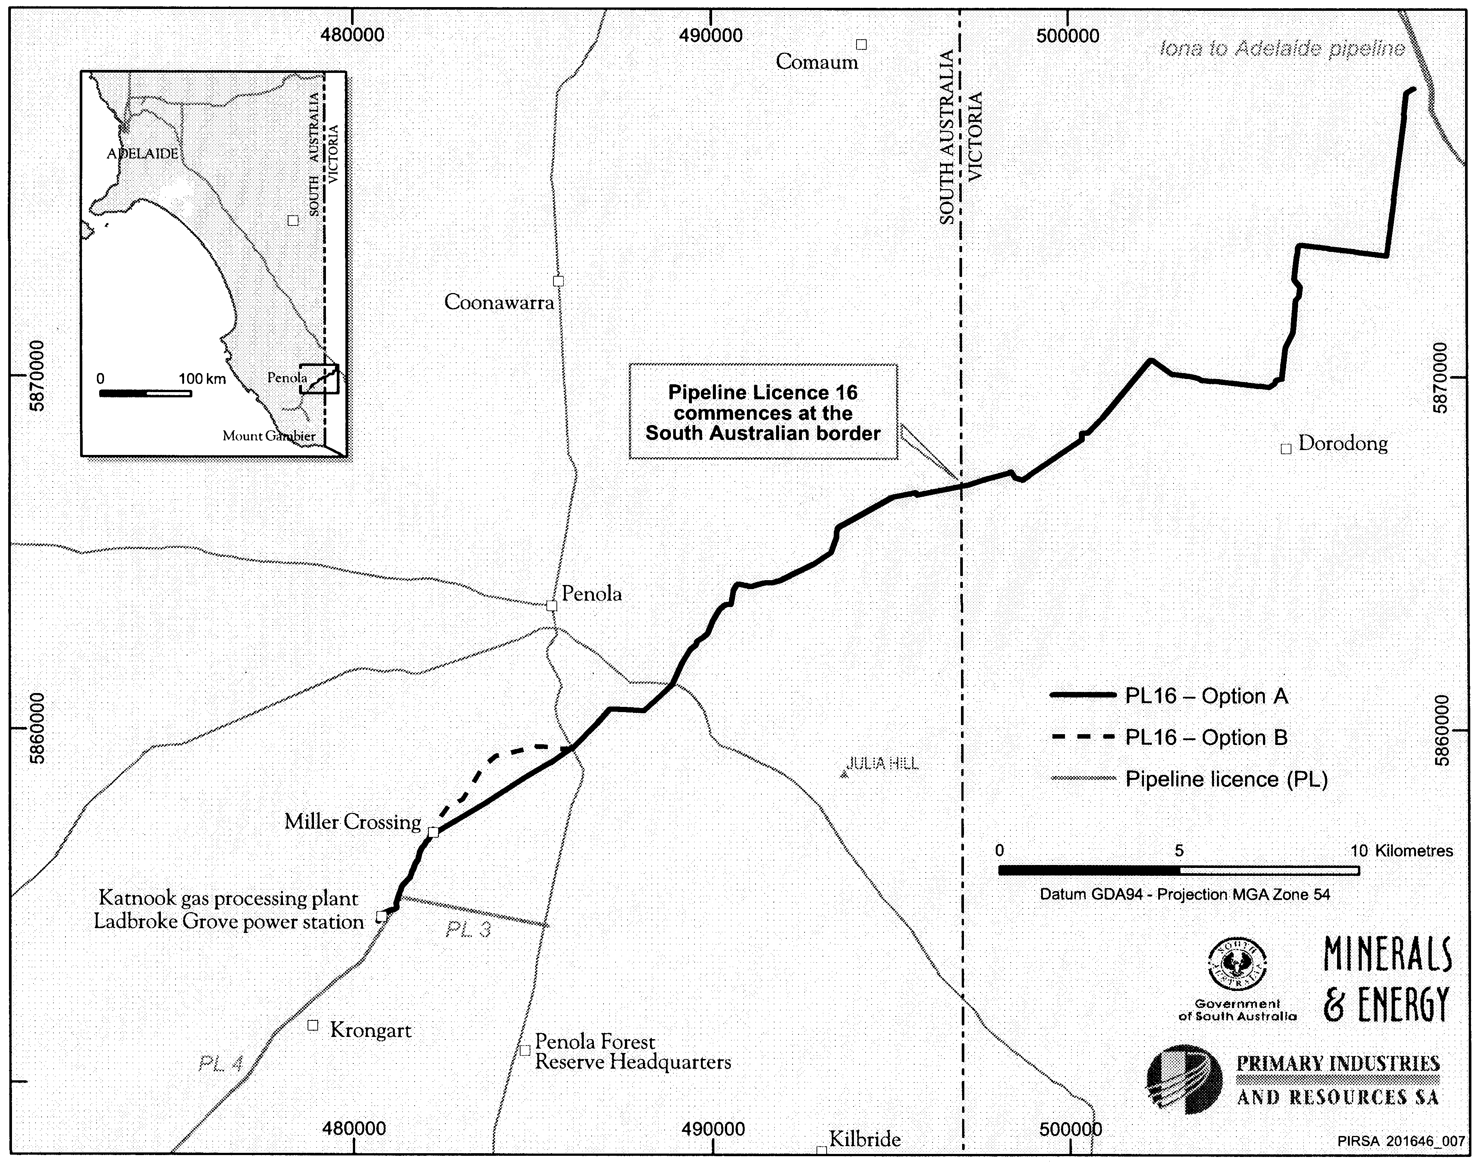

Dated 23 February 2005.
B. A. Goldstein, Director Petroleum
Minerals and Energy Division
Primary Industries and Resources SA
Delegate of the Minister for Mineral Resources Development

PETROLEUM ACT 2000
Application for Grant of an Associated Facilities Licence AFL 17
PURSUANT to section 65 (6) of the Petroleum Act 2000 (the Act) and Delegation dated 28 March 2002, Gazetted 11 April 2002, page 1573, notice is hereby given that an application for the grant of an Associated Facilities Licence over the area described below has been received from Beach Petroleum Limited.
Description of Application Area
All that part of the State of South Australia, bounded as follows: Commencing at a point being the intersection of latitude 28°10′13.34″S GDA94 and longitude 139°36′32.86″E GDA94, thence north-easterly to latitude 28°10′12.25″S GDA94 and longitude 139°36′35.18″E GDA94, thence south-easterly to latitude 28°10′12.78″S GDA94 and longitude 139°36′35.50″E GDA94, thence south-westerly to latitude 28°10′13.22″S GDA94 and longitude 139°36′34.58″E, thence south-easterly to latitude 28°10′13.81″S GDA94 and longitude 139°36′34.94″E GDA94, thence south-westerly to latitude 28°10′14.07″S GDA94 and longitude 139°36′34.39″E GDA94, thence north-westerly to latitude 28°10′13.64″S GDA94 and longitude 139°36′34.17″E GDA94, thence south-westerly to latitude 28°10′14.05″S GDA94 and longitude 139°36′33.25″E GDA94, and north-westerly to the point of commencement.
Area: 0.002 km² approximately.
Dated 1 March 2005.
B. A. Goldstein, Director Petroleum
Minerals and Energy Division
Primary Industries and Resources SA
Delegate of the Minister for Mineral
Resources Development

PETROLEUM ACT 2000
Application for Grant of an Associated Facilities Licence AFL 18
PURSUANT to section 65 (6) of the Petroleum Act 2000 (the Act) and Delegation dated 28 March 2002, Gazetted 11 April 2002, page 1573, notice is hereby given that an application for the grant of an Associated Facilities Licence over the area described below has been received from Beach Petroleum Limited.
Description of Application Area
All that part of the State of South Australia, bounded as follows: Commencing at a point being the intersection of latitude 27°58′30″S GDA94 and longitude 139°22′55″E GDA94, thence east to longitude 139°23′15″E GDA94, south to latitude 27°59′15″S GDA94, west to longitude 139°23′10″E GDA94, south to latitude 28°00′25″S GDA94, west to longitude 139°22′50″E GDA94, north to latitude 27°59′35″S GDA94, west to longitude 139°22′40″E GDA94, north to latitude 27°59′25″S GDA94, west to longitude 139°22′30″E GDA94, north to latitude 27°59′15″S GDA94, east to longitude 139°22′50″E GDA94, north to latitude 27°59′05″S GDA94, east to longitude 139°23′00″E GDA94, north to latitude 27°58′35″S GDA94, west to longitude 139°22′55″E GDA94, and north to the point of commencement.
Area: 2.1 km² approximately.
Dated 1 March 2005.
B. A. Goldstein, Director Petroleum
Minerals and Energy Division
Primary Industries and Resources SA
Delegate of the Minister for Mineral
Resources Development

NATIONAL PARKS REGULATIONS 2001
Closure of the Coffin Bay National Park
PURSUANT to Regulation 8 (3) (d) of the National Parks Regulations 2001, I, Edward Gregory Leaman, the Director of National Parks and Wildlife, close to the public part of Coffin Bay National Park from 6 p.m. on Sunday, 6 March 2005 until 11 a.m. on Saturday, 12 March 2005.
The closure of the Coffin Bay National Park applies to the area encompassing all of the park area to the north and west of Yangie Bay.
The remainder of the Coffin Bay National Park will remain open to the public during this period.
The purpose of the closure is to ensure the safety of the public during an animal-culling program being conducted within the Coffin Bay National Park during the abovementioned period.
Dated 1 March 2005.
E. G. Leaman, Director, National Parks and Wildlife

NOTICE TO MARINERS
No. 3 of 2005
South Australia—Thevenard—Yatala Channel—Buoy Damaged
Former Notice No. 20 of 2004
MARINERS are advised that the lit buoy referred to in the previous notice marking the edge of the northern turning basin has been damaged and is no longer on station.
This buoy will be replaced in the near future.
Mariners are advised to exercise caution in the vicinity.
Chart affected: Aus 120
Publication affected: Australian Pilot, Volume 1 (Seventh Edition, 1992) pages 72-74.
Adelaide, 23 February 2005.
Trish White, Minister for Transport
FP 2001/1439
TSA 2004/00541

NOTICE TO MARINERS
No. 4 of 2005 (Formerly Notice No. 2 of 2005)
South Australia—Spencer Gulf—Arno Bay—Isolated Danger Mark and Beacon Replaced
MARINERS are advised that the Isolated Danger Mark Fl(2) W 10s Volume K, No. 1898 in position latitude 33°54.825′S, longitude 136°35.300′E has been re-established.
Chart affected: Aus 777
Publication affected: Australian Pilot, Volume 1 (Seventh Edition, 1992) page 92, Volume K, (2004-05 Edition) page 86, No. 1898.
Adelaide, Tuesday, 22 February 2005.
Trish White, Minister for Transport
TSA 2005/00419

PORT AUGUSTA CIRCUIT COURT
SUPREME COURT OF SOUTH AUSTRALIA
Sheriff’s Office, Adelaide, 24 February 2005
IN pursuance of a precept from the Supreme Court of South Australia to me directed, I do hereby give notice that the said Court will sit as a Court of Oyer and Terminer and General Gaol Delivery at the Courthouse at Port Augusta on the day and time undermentioned and all parties bound to prosecute and give evidence and all jurors summoned and all others having business at the said Court are required to attend the sittings thereof and the order of such business will be unless a Judge otherwise orders, as follows:
Monday, 7 March 2005 at 10 a.m. on the first day of the sittings the only business taken will be the arraignment of prisoners in gaol and the passing of sentences on prisoners in gaol committed for sentence; the surrender of prisoners on bail committed for sentence; the surrender of persons in response to ex officio informations or of persons on bail and committed for trial who have signified their intention to plead guilty and the passing of sentences.
Juries will be summoned for Monday, 7 March 2005 and persons will be tried on this and subsequent days of the sittings.
Prisoners in H.M. Gaol and on Bail for Sentence and for Trial at the Sittings of the Port Augusta Courthouse, commencing Monday, 7 March 2005.
Miller, Leonard Gordon |  | Murder attempted; assault occasioning actual bodily harm; common assault on person other than family member | In gaol
Rodd, Isaac John |  | Dishonestly take property without owner’s consent | In gaol
Prisoners on bail must surrender at 10 a.m. of the day appointed for their respective trials. If they do not appear when called upon their recognizances and those of their bail will be estreated and a bench warrant will be issued forthwith.
By order of the Court,
M. A. Stokes, Sheriff

ROADS (OPENING AND CLOSING) ACT 1991:
SECTION 24
NOTICE OF CONFIRMATION OF ROAD
PROCESS ORDER
Nelson Road, Angle Park
Deposited Plan 67041
BY Road Process Order made on 19 January 2005, the Develop-ment Assessment Commission ordered that:
1. Portion of Nelson Road south of Hilton Street and between allotment 88 (reserve) in Deposited Plan 6149 and allotment 106 in Deposited Plan 43817, more particularly delineated and lettered ‘A’ in the Preliminary Plan No. 04/0072 be closed.
2. Issue a Certificate of Title to the City of Port Adelaide Enfield for the whole of the land subject to closure, which land is being retained by Council for merging with the adjoining Council reserve.
3. The following easements are granted over the whole of the land subject to that closure:
Grant to the South Australian Water Corporation easements for water supply and sewerage purposes.
Grant to Distribution Lessor Corporation an easement for overhead electricity supply purposes.
Grant to Envestra (SA) Limited an easement for gas supply purposes.
On 17 February 2005 that order was confirmed by the Minister for Administrative Services, conditionally on approval and deposit of the survey plan by the Registrar-General. The condition has now been fulfilled.
Pursuant to section 24 (5) of the Roads (Opening and Closing) Act 1991, NOTICE of the order referred to above and its confirmation is hereby given.
Dated 3 March 2005.
P. M. Kentish, Surveyor-General

ROADS (OPENING AND CLOSING) ACT 1991:
SECTION 24
NOTICE OF CONFIRMATION OF ROAD
PROCESS ORDER
Tingara Road, Evanston Park
Deposited Plan 66528
BY Road Process Order made on 29 November 2004, The Corporation of the Town of Gawler ordered that:
1. Portion of Tingara Road adjoining Bentley Road and the southern boundary of allotment 2 in Filed Plan 11844 more particularly lettered ‘A’ in the Preliminary Plan No. 04/0031 be closed.
2. The whole of the land subject to closure be transferred to John Brian Ambler and Rita Ambler in accordance with agreement for transfer dated 24 August 2004, entered into between The Corporation of the Town of Gawler and J. B. and R. Ambler.
3. The following easement be granted over portion of the land subject to that closure:
Grant to the South Australian Water Corporation easements for water supply and sewerage purposes.
On 7 January 2005 that order was confirmed by the Minister for Administrative Services conditionally on approval and deposit of the survey plan by the Registrar-General. The condition has now been fulfilled.
Pursuant to section 24 (5) of the Roads (Opening and Closing) Act 1991, NOTICE of the order referred to above and its confirmation is hereby given.
Dated 3 March 2005.
P. M. Kentish, Surveyor-General

THE RENMARK IRRIGATION TRUST
Poll of Ratepayers
NOTICE is hereby given that the following is the result of the Poll of Ratepayers held on Friday, 18 February 2005 at The Renmark Irrigation Trust Office:
For the Proposal 78
Against the Proposal 16
Informal 1
Total Votes Cast 95
I, William David Morris, Returning Officer for this Poll of The Renmark Irrigation Trust ratepayers, declare the Proposal carried as required under section 154, clause (U), subclause (V) of the Renmark Irrigation Trust Act 1936.
W. D. Morris, Returning Officer

GOVERNMENT GAZETTE ADVERTISEMENT RATES

To apply from 1 July 2004

$  Agents, Ceasing to Act as 35.50  Associations:  Incorporation 18.10  Intention of Incorporation 44.75  Transfer of Properties 44.75  Attorney, Appointment of 35.50  Bailiff’s Sale 44.75  Cemetery Curator Appointed 26.50  Companies:  Alteration to Constitution 35.50  Capital, Increase or Decrease of 44.75  Ceasing to Carry on Business 26.50  Declaration of Dividend 26.50  Incorporation 35.50  Lost Share Certificates:  First Name 26.50  Each Subsequent Name 9.10  Meeting Final 29.75  Meeting Final Regarding Liquidator’s Report on  Conduct of Winding Up (equivalent to ‘Final  Meeting’)  First Name 35.50  Each Subsequent Name 9.10  Notices:  Call 44.75  Change of Name 18.10  Creditors 35.50  Creditors Compromise of Arrangement 35.50  Creditors (extraordinary resolution that ‘the Com-pany be wound up voluntarily and that a liquidator be appointed’) 44.75  Release of Liquidator⎯Application⎯Large Ad. 70.50  ⎯Release Granted 44.75  Receiver and Manager Appointed 41.25  Receiver and Manager Ceasing to Act 35.50  Restored Name 33.50  Petition to Supreme Court for Winding Up 62.00  Summons in Action 53.00  Order of Supreme Court for Winding Up Action 35.50  Register of Interests⎯Section 84 (1) Exempt 80.00  Removal of Office 18.10  Proof of Debts 35.50  Sales of Shares and Forfeiture 35.50  Estates:  Assigned 26.50  Deceased Persons⎯Notice to Creditors, etc. 44.75  Each Subsequent Name 9.10  Deceased Persons⎯Closed Estates 26.50  Each Subsequent Estate 1.15  Probate, Selling of 35.50  Public Trustee, each Estate 9.10 |  | $  Firms:  Ceasing to Carry on Business (each insertion) 23.60  Discontinuance Place of Business 23.60  Land⎯Real Property Act:  Intention to Sell, Notice of 44.75  Lost Certificate of Title Notices 44.75  Cancellation, Notice of (Strata Plan) 44.75  Mortgages:  Caveat Lodgment 18.10  Discharge of 19.00  Foreclosures 18.10  Transfer of 18.10  Sublet 9.10  Leases⎯Application for Transfer (2 insertions) each 9.10  Lost Treasury Receipts (3 insertions) each 26.50  Licensing 53.00  Municipal or District Councils:  Annual Financial Statement⎯Forms 1 and 2 499.00  Electricity Supply⎯Forms 19 and 20 354.00  Default in Payment of Rates:  First Name 70.50  Each Subsequent Name 9.10  Noxious Trade 26.50  Partnership, Dissolution of 26.50  Petitions (small) 18.10  Registered Building Societies (from Registrar-  General) 18.10  Register of Unclaimed Moneys⎯First Name 26.50  Each Subsequent Name 9.10  Registers of Members⎯Three pages and over:  Rate per page (in 8pt) 226.00  Rate per page (in 6pt) 299.00  Sale of Land by Public Auction 45.25  Advertisements 2.50  Advertisements, other than those listed are charged at $2.50 per column line, tabular one-third extra.  Notices by Colleges, Universities, Corporations and District Councils to be charged at $2.50 per line.  Where the notice inserted varies significantly in length from that which is usually published a charge of $2.50 per column line will be applied in lieu of advertisement rates listed.  South Australian Government publications are sold on the condition that they will not be reproduced without prior permission from the Government Printer.
All the above prices include GST

GOVERNMENT GAZETTE NOTICES
ALL private advertisements forwarded for publication in the South Australian Government Gazette must be PAID FOR PRIOR TO INSERTION; and all notices, from whatever source, should be legibly written on one side of the paper only and sent to Government Publishing SA so as to be received no later than 4 p.m. Tuesday preceding the day of publication. Phone 8207 1045 or Fax 8207 1040. E-mail: governmentgazette@saugov.sa.gov.au. Send as attachments in Word format. Please include date the notice is to be published and to whom the notice will be charged. The Government Gazette is available online at: www.governmentgazette.sa.gov.au.

MISCELLANEOUS LEGISLATION AND GOVERNMENT PUBLICATIONS PRICES AS FROM 1 JULY 2004

Acts, Bills, Rules, Parliamentary Papers and Regulations
Pages | Main | Amends | Pages | Main | Amends

1-16 | 2.15 | 0.95 | 497-512 | 30.25 | 29.00
17-32 | 2.90 | 1.80 | 513-528 | 31.25 | 29.90
33-48 | 3.80 | 2.70 | 529-544 | 32.00 | 31.00
49-64 | 4.75 | 3.65 | 545-560 | 33.00 | 32.00
65-80 | 5.60 | 4.60 | 561-576 | 33.75 | 33.00
81-96 | 6.50 | 5.40 | 577-592 | 34.75 | 33.50
97-112 | 7.40 | 6.30 | 593-608 | 35.75 | 34.50
113-128 | 8.30 | 7.25 | 609-624 | 36.50 | 35.50
129-144 | 9.35 | 8.25 | 625-640 | 37.25 | 36.10
145-160 | 10.20 | 9.10 | 641-656 | 38.25 | 37.20
161-176 | 11.20 | 10.00 | 657-672 | 38.75 | 38.00
177-192 | 12.00 | 11.00 | 673-688 | 40.50 | 38.80
193-208 | 13.00 | 11.90 | 689-704 | 41.25 | 39.90
209-224 | 13.80 | 12.70 | 705-720 | 41.75 | 41.00
225-240 | 14.70 | 13.60 | 721-736 | 43.50 | 41.50
241-257 | 15.70 | 14.30 | 737-752 | 44.00 | 42.90
258-272 | 16.60 | 15.30 | 753-768 | 45.00 | 43.40
273-288 | 17.50 | 16.40 | 769-784 | 45.50 | 44.70
289-304 | 18.30 | 17.20 | 785-800 | 46.50 | 45.60
305-320 | 19.30 | 18.20 | 801-816 | 47.25 | 46.00
321-336 | 20.10 | 19.00 | 817-832 | 48.25 | 47.25
337-352 | 21.20 | 20.00 | 833-848 | 49.25 | 48.00
353-368 | 22.00 | 21.00 | 849-864 | 50.00 | 48.80
369-384 | 22.90 | 21.90 | 865-880 | 51.00 | 50.00
385-400 | 23.80 | 22.70 | 881-896 | 51.50 | 50.50
401-416 | 23.70 | 23.50 | 897-912 | 53.00 | 51.50
417-432 | 25.75 | 24.50 | 913-928 | 53.50 | 53.00
433-448 | 26.60 | 25.50 | 929-944 | 54.50 | 53.50
449-464 | 27.50 | 26.25 | 945-960 | 55.50 | 54.00
465-480 | 28.00 | 27.25 | 961-976 | 56.50 | 55.00
481-496 | 29.25 | 28.00 | 977-992 | 57.50 | 56.00

Legislation—Acts, Regulations, etc: $
Subscriptions:
Acts 187.00
All Bills as Laid 447.00
Rules and Regulations 447.00
Parliamentary Papers 447.00
Bound Acts 207.00
Index 103.00
Government Gazette
Copy 4.85
Subscription 247.00
Hansard
Copy 13.50
Subscription—per session (issued weekly) 388.00
Cloth bound—per volume 167.00
Subscription—per session (issued daily) 388.00
Legislation on Disk
Whole Database 2 868.00
Annual Subscription for fortnightly updates 881.00
Individual Act(s) including updates POA
Compendium
Subscriptions:
New Subs 1 700.00
Updates 600.00
(All the above prices include GST)

All Legislation, Government Gazette, Hansard and Legislation on disk are available from:
Counter Sales Service SA, Government Legislation⁺ Outlet
and Mail Orders: Lands Titles Office, 101 Grenfell Street, Adelaide
Phone: 13 23 24 (local call cost), Fax: (08) 8204 1909
Postal: G.P.O. Box 1707, Adelaide, S.A. 5001

Online Shop: www.shop.service.sa.gov.au

Subscriptions and Government Publishing SA
Standing Orders: Box 9, Plaza Level, Riverside Centre, North Terrace, Adelaide, S.A. 5000
Phone: (08) 8207 0908, (08) 8207 0910, Fax: (08) 8207 1040

SEWERAGE ACT 1929
Removal of Land from Hahndorf Country Drainage Area
PURSUANT to section 18 of the Sewerage Act 1929, the South Australian Water Corporation:
(a) removes from the Hahndorf Country Drainage Area the land shown on the plan in the Schedule; and
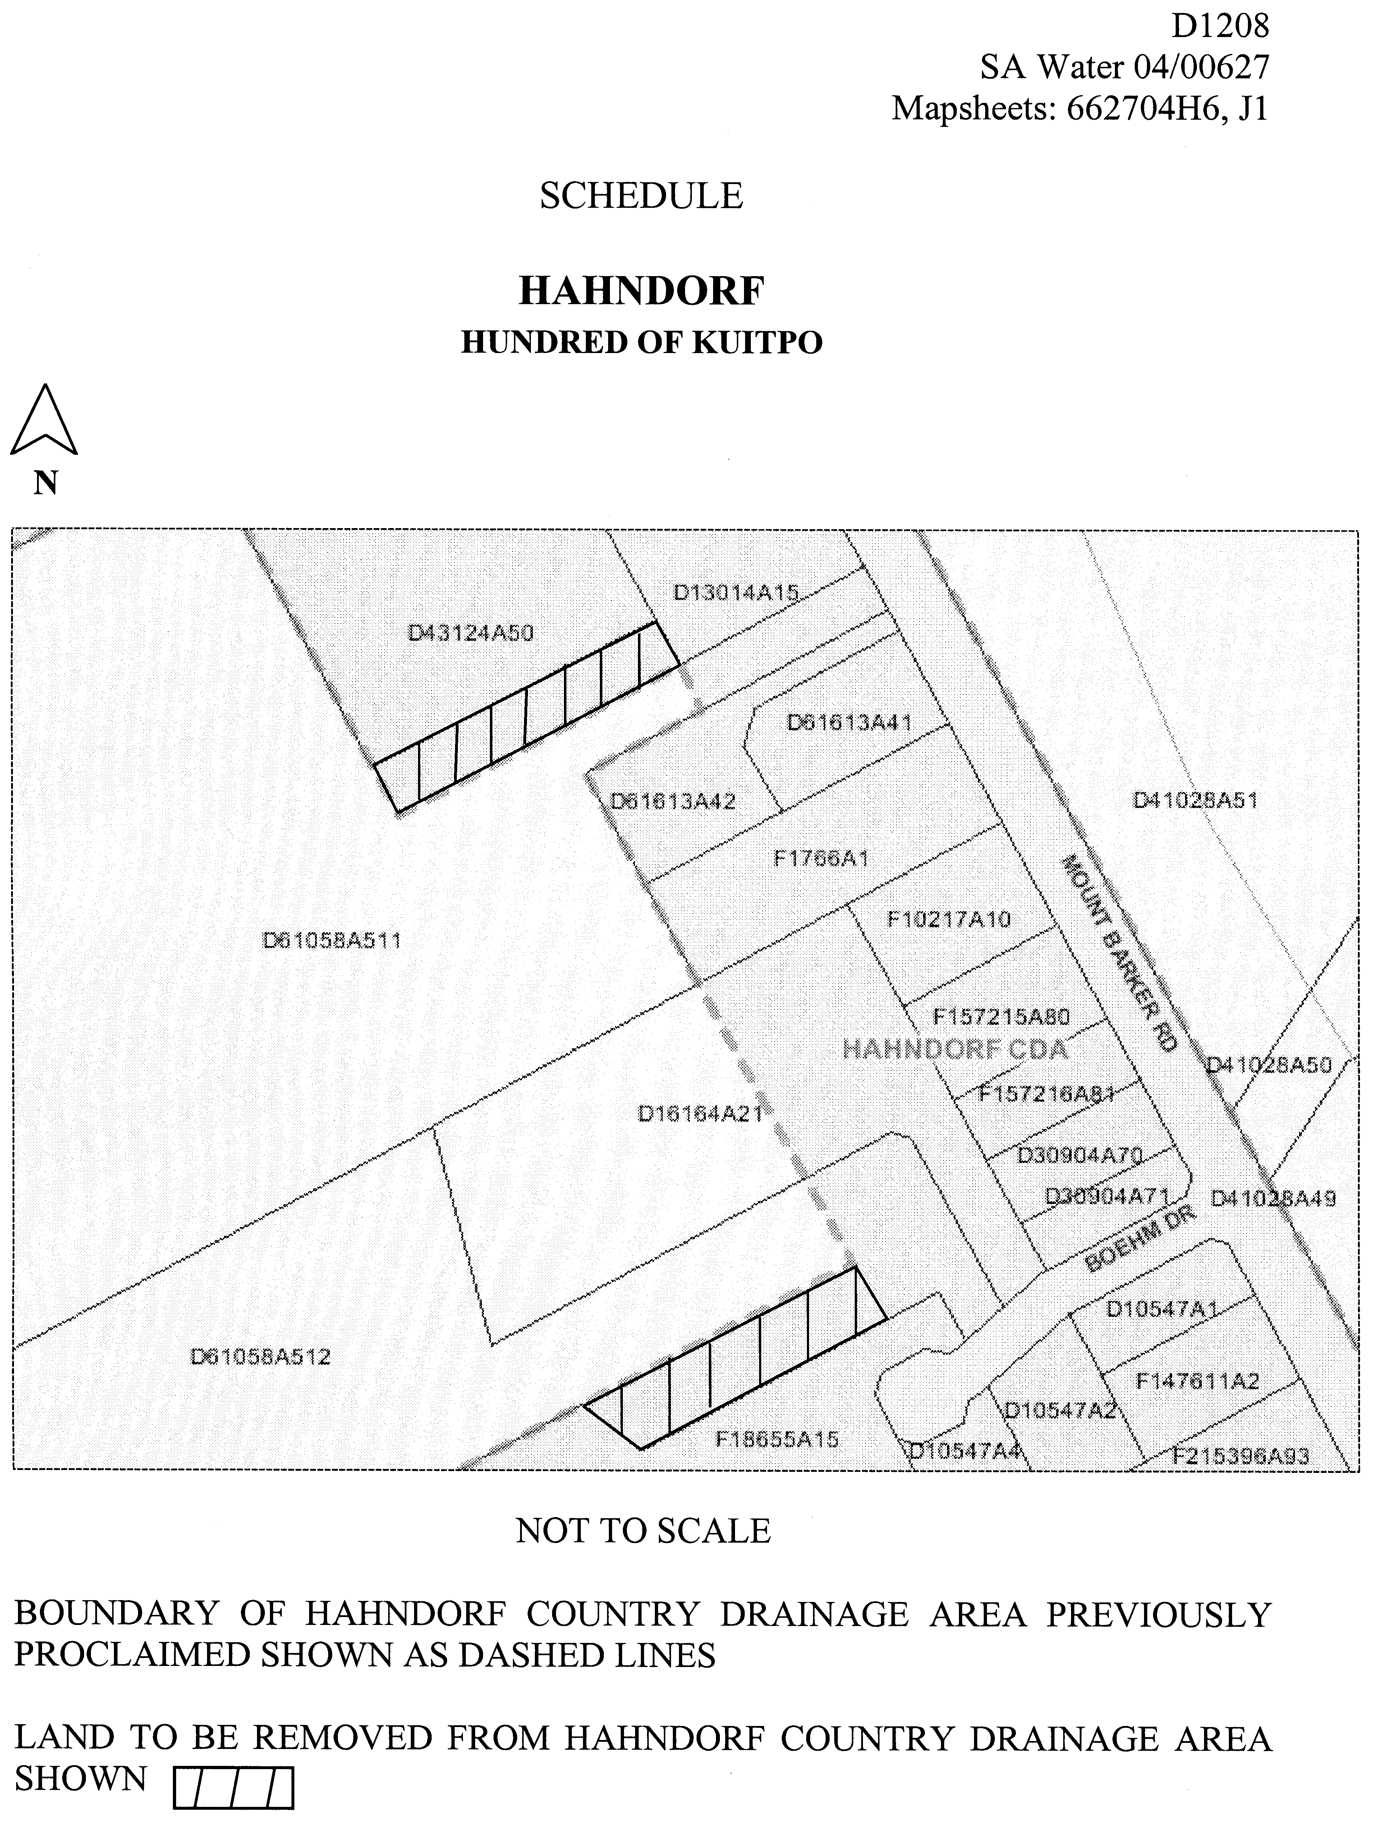
(b) declares that this notice has effect from the commencement of the financial year in which it is published in the Gazette.

Dated 28 February 2005.
Signed for and on behalf of the South Australian Water Corporation by a person duly authorised so to do:
A. Popplewell, General Manager Shared Services
In the presence of:
C. J. McNamara, Billing Manager
SAWATER 04/00627 D1208

SEWERAGE ACT 1929
Addition of Land to Myponga Country Drainage Area
PURSUANT to section 18 of the Sewerage Act 1929, the South Australian Water Corporation:
(a) adds to the Myponga Country Drainage Area all the land contained in allotment 106 in Filed Plan 164825; and
(b) declares that this notice has effect from the commence-ment of the financial year in which it is published in the Gazette.
Dated 28 February 2005.
Signed for and on behalf of the South Australian Water Corporation by a person duly authorised so to do:
A. Popplewell, General Manager Shared Services
In the presence of:
C. J. McNamara, Billing Manager
SAWATER 05/02386 D1262

RAIL SAFETY ACT 1996
Appointment
I, TRISH WHITE, Minister for Transport, in accordance with the powers contained in Section 45 of the Act hereby appoint the person referred to in the Schedule to be an Authorised Officer for the purposes of the Act subject to the following conditions:
1. The appointment of the person referred to in the Schedule as Authorised Officer, pursuant to this notice shall be automatically revoked without the necessity for a further notice in the event that the person ceases to hold a position in the Rail Services Section (RSS) or any succeeding section or unit performing similar functions to the RSS.
The within appointment of the person referred to in the Schedule may be revoked or varied by the Minister by further notice in writing.
Schedule
Peter Thomas.
Dated 23 February 2005.
Trish White, Minister for Transport

WATER MAINS AND SEWERS

Office of the South Australian Water Corporation
Adelaide, 3 March 2005

WATER MAINS LAID

Notice is hereby given that the following main pipes or parts of main pipes have been laid down by the South Australian Water Corporation in or near the undermentioned water districts and are now available for a constant supply of water to adjacent land.

ADELAIDE WATER DISTRICT

CITY OF HOLDFAST BAY
Elgar Road, Somerton Park. p15

CITY OF PORT ADELAIDE ENFIELD
Orlando Avenue, Hampstead Gardens. p1
Lawson Avenue, Clearview. p11

CITY OF WEST TORRENS
Norwich Street, West Richmond. p10
Urrbrae Terrace, Plympton. p17

BAROSSA COUNTRY LANDS WATER DISTRICT

BAROSSA COUNCIL
Waterworks land (lot 3 in LTRO FP 100268), Whispering Wall Road, Williamstown. This main is available on application only. p31 and 32
Waterworks land (section 1, hundred of Barossa), Williamstown. This main is available on application only. p32

BORDERTOWN WATER DISTRICT

TATIARA DISTRICT COUNCIL
Scott Street, Bordertown. p4
Jervois Street, Bordertown. p7

GOOLWA WATER DISTRICT

ALEXANDRINA COUNCIL
Sidmouth Street, Goolwa. p8

KINGSCOTE WATER DISTRICT

KANGAROO ISLAND COUNCIL
Juniper Road, Brownlow K.I. p13

LAMEROO WATER DISTRICT

SOUTHERN MALLEE COUNCIL
Vardon Terrace, Lameroo. p33
Chandos Terrace, Lameroo. p33

MIDDLETON WATER DISTRICT

ALEXANDRINA COUNCIL
William Street, Middleton. p16

NARACOORTE WATER DISTRICT

NARACOORTE LUCINDALE COUNCIL
Smith Street, Naracoorte. p9
In and across Jenkins Terrace, Naracoorte. p22 and 23
In and across Arthur Street, Naracoorte. p22 and 23
Easement in section 1163, hundred of Naracoorte. p22 and 23
Across Old Caves Road, Naracoorte. p22 and 23

PINNAROO WATER DISTRICT

SOUTHERN MALLEE DISTRICT COUNCIL
Homburg Terrace, Pinnaroo. p35

PORT ELLIOT WATER DISTRICT

ALEXANDRINA COUNCIL
Oxford Street, Port Elliot. p12

PORT VICTOR WATER DISTRICT

CITY OF VICTOR HARBOR
Battye Road, Encounter Bay. This main is available on the west side by application only. p14

ROBE WATER DISTRICT

DISTRICT COUNCIL OF ROBE
McFarlane Street, Robe. p6

SPRINGTON WATER DISTRICT

BAROSSA COUNCIL
Edward Street, Springton. p5

TWO WELLS WATER DISTRICT

DISTRICT COUNCIL OF MALLALA
Gawler Road, Lewiston. p18 and 19

WARREN COUNTRY LANDS WATER DISTRICT

Waterworks land (lot 5 in LTRO FP 100276), Whispering Wall Road, Williamstown. This main is available on application only. p32

WATER MAINS ABANDONED

Notice is hereby given that the undermentioned water mains have been abandoned by the South Australian Water Corporation.

ADELAIDE WATER DISTRICT

CITY OF MARION
Easement in lot 802 in LTRO DP 57017, Laffer Drive, Bedford Park. p24

CITY OF PORT ADELAIDE ENFIELD
Across Miranda Avenue, Kilburn. p27
Easements in reserve (lot 501 in LTRO DP 64800), Miranda Avenue, Kilburn. p27
Across Leader Avenue, Kilburn. p27

BORDERTOWN WATER DISTRICT

TATIARA DISTRICT COUNCIL
Scott Street, Bordertown. p4

LAMEROO WATER DISTRICT

SOUTHERN MALLEE COUNCIL
Vardon Terrace, Lameroo. p33
Chandos Terrace, Lameroo. p33

NARACOORTE WATER DISTRICT

NARACOORTE LUCINDALE COUNCIL
Smith Street, Naracoorte. p9
Butler Terrace, Naracoorte. p9
Easement in lot 91 in LTRO FP 217809, Graham Street, Naracoorte. p9
Across Graham Street, Naracoorte. p9
Lucindale Road, Naracoorte. p9
Jenkins Terrace, Naracoorte. p22
Arthur Street, Naracoorte. p22
Old Caves Road, Naracoorte. p22

PINNAROO WATER DISTRICT

SOUTHERN MALLEE DISTRICT COUNCIL
Homburg Terrace, Pinnaroo. p35

PORT AUGUSTA WATER DISTRICT

CITY OF PORT AUGUSTA
Caroona Road, Port Augusta West. p26

TWO WELLS WATER DISTRICT

DISTRICT COUNCIL OF MALLALA
Gawler Road, Lewiston. p18
WATER MAINS LAID

Notice is hereby given that the undermentioned water mains have been laid down by the South Australian Water Corporation and are not available for a constant supply of water to adjacent land.

ADELAIDE WATER DISTRICT

CAMPBELLTOWN CITY COUNCIL
Waterworks land (lot 142 in LTRO DP 9313), Addison Avenue, Athelstone. p36, 38, 39 and 41-46

CITY OF ONKAPARINGA
Waterworks land (lot 118 in LTRO FP 215236), Windebanks Road, Happy Valley. p61-64 and 66-72

BEETALOO COUNTRY LANDS WATER DISTRICT

DISTRICT COUNCIL OF YORKE PENINSULA
Waterworks land (lot 1 in LTRO DP 12824), Kulpara Road, Kainton. p48-55

LAMEROO WATER DISTRICT

SOUTHERN MALLEE COUNCIL
Waterworks land (section 203, hundred of Bews), Vardon Terrace, Lameroo. p33
Across and in Vardon Terrace, Lameroo. p33
Waterworks land (section 210, hundred of Bews), Vardon Terrace, Lameroo. p33

TWO WELLS WATER DISTRICT

DISTRICT COUNCIL OF MALLALA
Across Gawler Road, Lewiston. p18 and 19
Easements in lot 29 in LTRO DP 17602, Gawler Road, Lewiston. p18 and 19

SEWERS LAID

Notice is hereby given that the following sewers have been laid down by the South Australian Water Corporation in the under-mentioned drainage areas and are now available for house connections.

ADELAIDE DRAINAGE AREA

CITY OF CHARLES STURT
Easement in lot 77, West Street, Hindmarsh. FB 1131 p49
Easement in lots 175 and 50, Burnley Street, Henley Beach South. FB 1131 p55

CITY OF HOLDFAST BAY
Marine Parade, Seacliff. FB 1135 p1

CITY OF MARION
Rotorua Avenue, Park Holme. FB 1135 p9
Drury Terrace, Clovelly Park. FB 1135 p12
Regan Avenue, Morphettville. FB 1135 p13
Ballara Avenue, Warradale. FB 1135 p16

CITY OF MITCHAM
Across Neweys Road, Mitcham. FB 1131 p50
Easements in lot 1 in LTRO DP 62256, Blythewood Road, Mitcham. FB 1131 p50

CITY OF NORWOOD PAYNEHAM AND ST PETERS
Luhrs Road, Firle. FB 1131 p56
Payne Street, Payneham. FB 1131 p57

CITY OF PORT ADELAIDE ENFIELD
Macedonia Street, North Haven. FB 1131 p54
Lines Street, Enfield. FB 1131 p59
Fisher Street, Blair Athol. FB 1135 p3
Easement in lot 204, Tudor Street, Blair Athol. FB 1135 p4
Tudor Street, Blair Athol. FB 1135 p5
Easement in lot 207, Tudor Street, Blair Athol. FB 1135 p6
Orlando Avenue, Hampstead Gardens. FB 1135 p7
Henry Street, Manningham. FB 1135 p8
Lawson Avenue, Clearview. FB 1135 p14
May Terrace, Ottoway. FB 1135 p15

CITY OF TEA TREE GULLY
Golden Grove Road, Surrey Downs. FB 1131 p52

CITY OF WEST TORRENS
Easement in lot 3, Charles Veale Drive, West Beach. FB 1131 p53
Capper Street, Camden Park. FB 1135 p2
Creslin Terrace, Camden Park. FB 1135 p2
Norwich Street, West Richmond. FB 1135 p10
Henry Street, Plympton. FB 1135 p11
Urrbrae Terrace, Plympton. FB 1135 p17

MILLICENT COUNTRY DRAINAGE AREA

WATTLE RANGE COUNCIL
Public road (lot 56 in LTRO FP 15402), Millicent. FB 1130 p3

MOUNT GAMBIER COUNTRY DRAINAGE AREA

CITY OF MOUNT GAMBIER
Eglington Terrace, Mount Gambier. FB 1114 p30

NARACOORTE COUNTRY DRAINAGE AREA

NARACOORTE LUCINDALE COUNCIL
Easement in lots 138 and 3, Loveday Street, Naracoorte. FB 1130 p2

STIRLING COUNTRY DRAINAGE AREA

ADELAIDE HILLS COUNCIL
Banksia Drive, Bridgewater. FB 1134 p13 and 14
Easement in lots 319-321, Obliqua Crescent, Bridgewater. FB 1134 p13 and 14
Sewerage land (section 1635, hundred of Noarlunga), Bridge-water. FB 626 p41 and FB 1135 p22 and 23
Easement in section 1450, hundred of Noarlunga, Mount Barker Road, Bridgewater. FB 1135 p22 and 23

SEWERS LAID

Notice is hereby given that the undermentioned sewers have been laid down by the South Australian Water Corporation and are not available for house connections.

ADELAIDE DRAINAGE AREA

CITY OF CHARLES STURT
Sewerage land (section 934, hundred of Yatala), Frederick Road, West Lakes—900 mm MSCL high salinity transfer pumping main. FB 1133 p1, 4 and 5
Across and in Frederick Road, West Lakes and Royal Park—900 mm MSCL high salinity transfer pumping main. FB 1133 p1, 5 and 6
Across Old Port Road, Royal Park—900 mm MSCL high salinity transfer pumping main. FB 1133 p1 and 6

CITY OF PORT ADELAIDE ENFIELD
Across Old Port Road, Queenstown—900 mm MSCL high salinity transfer pumping main. FB 1133 p1 and 6
Webb Street, Queenstown and Port Adelaide—900 mm MSCL high salinity transfer pumping main. FB 1133 p1 and 6-9
Across Port Road, Queenstown and Alberton—900 mm MSCL high salinity transfer pumping main. FB 1133 p1 and 9
Alfred Street, Alberton—900 mm MSCL high salinity transfer pumping main. FB 1133 p1 and 9
Coburg Street, Alberton—900 mm MSCL high salinity transfer pumping main. FB 1133 p1, 9 and 10
Across and in Grand Junction Road, Port Adelaide and Rosewater—900 mm MSCL high salinity transfer pumping main. FB 1133 p1, 10 and 11
Easement in allotment piece 102 in LTRO DP 27378, Grand Junction Road, Port Adelaide—900 mm MSCL high salinity transfer pumping main. FB 1133 p1 and 10
Henry Street, Rosewater—900 mm MSCL high salinity transfer pumping main. FB 1133 p1, 11 and 12
Lee Terrace, Rosewater, Port Adelaide and Gillman—900 mm MSCL high salinity transfer pumping main. FB 1133 p1, 12 and 13
Easements in lot 66 in LTRO FP 218557, Lee Terrace, Gillman—900 mm MSCL high salinity transfer pumping main. FB 1133 p1 and 13
Rutland Street, Gillman—900 mm MSCL high salinity transfer pumping main. FB 1133 p1 and 13
Bedford Street, Gillman—900 mm MSCL high salinity transfer pumping main. FB 1133 p1 and 14-19

CITY OF SALISBURY
Across Globe Derby Drive, Dry Creek and Globe Derby Park—900 mm MSCL high salinity transfer pumping main. FB 1133 p3 and 49
Easement in lot 200, Globe Derby Drive, Globe Derby Park—900 mm MSCL high salinity transfer pumping main. FB 1133 p3 and 49
Sewerage land (lot 24 in LTRO FP 114585), Globe Derby Drive, Globe Derby Park—900 mm MSCL high salinity transfer pumping main. FB 1133 p3 and 49-51
Across Whites Road, Globe Derby Park—900 mm MSCL high salinity transfer pumping main. FB 1133 p3 and 51

STIRLING COUNTRY DRAINAGE AREA

ADELAIDE HILLS COUNCIL
Sewerage land (section 1635, hundred of Noarlunga), Bridge-water—250 mm MSCL pumping main. FB 1135 p22
Easements in section 1450, hundred of Noarlunga, lot 111 in LTRO FP 170921, lot 67 in LTRO DP 4799, and lot 124 in LTRO FP 170938, Bridgewater—200 mm MSCL pumping main. FB 1135 p23
Ayr Street, Bridgewater—200 mm MSCL pumping main. FB 1135 p24
Easements in lot 1 in LTRO DP 33531, Ayr Street, and lot 121 in LTRO DP 15261, Cave Avenue, Bridgewater—200 mm MSCL pumping main. FB 1135 p24
Sewerage land (lot 120 in LTRO DP 15261), Bridgewater—200 mm MSCL pumping main. FB 1135 p24

OUTSIDE DRAINAGE AREA

CITY OF PORT ADELAIDE ENFIELD
Bedford Street, Gillman—900 mm MSCL high salinity transfer pumping main. FB 1133 p1 and 19
Easements in lot 1001 in LTRO DP 50514, and lot 62 in LTRO FP 12250, North Arm Road, Gillman—900 mm MSCL high salinity transfer pumping main. FB 1133 p2 and 20
Across North Arm Road, Gillman and Wingfield—900 mm MSCL high salinity transfer pumping main. FB 1133 p2, 20 and 21
Easements in lot 28 in LTRO FP 9381, North Arm Road, and allotment piece 43 in LTRO FP 218405, Wilkins Road, Wingfield—900 mm MSCL high salinity transfer pumping main. FB 1133 p2, 21 and 22
Easements in lots 505, 507, 510 and 512 in LTRO DP 59780, Wingfield—900 mm MSCL high salinity transfer pumping main. FB 1133 p2, 22-24
Across Hanson Road, Wingfield—900 mm MSCL high salinity transfer pumping main. FB 1133 p2 and 24
Easements in part sections 249, 237 and 238, hundred of Port Adelaide—900 mm MSCL high salinity transfer pumping main. FB 1133 p2, and 24-26
Public road south of lot 2 in LTRO DP 18683, Wingfield—900 mm MSCL high salinity transfer pumping main. FB 1133 p2 and 26-28
Easements in lots 10 and 11 in LTRO FP 218946, Wingfield—900 mm MSCL high salinity transfer pumping main. FB 1133 p2, 29 and 30
Across Salisbury Highway, Wingfield—900 mm MSCL high salinity transfer pumping main. FB 1133 p2 and 30
Easements in lot 210 in LTRO DP 34041, and section 7645, hundred of Port Adelaide, Salisbury Highway, Wingfield—900 mm MSCL high salinity transfer pumping main. FB 1133 p2, 30 and 31
Salisbury Highway, Wingfield and Dry Creek—900 mm MSCL high salinity transfer pumping main. FB 1133 p3 and 32-36

CITY OF SALISBURY
In and across Salisbury Highway, Dry Creek—900 mm MSCL high salinity transfer pumping main. FB 1133 p3 and 36-40
Easements in lot 2 in LTRO DP 63323, and lot 300 in LTRO DP 41507, Dry Creek—900 mm MSCL high salinity transfer pumping main. FB 1133 p3, 40 and 41
Sewerage land (allotment piece 17 in LTRO DP 41401), Salisbury Highway, Dry Creek—900 mm MSCL high salinity transfer pumping main. FB 1133 p3 and 41-43
Across public road (between allotment piece 17 and lot 21 in LTRO DP 41401), Dry Creek—900 mm MSCL high salinity transfer pumping main. FB 1133 p3 and 43
Sewerage land (lot 21 in LTRO DP 41401), Dry Creek—900 mm MSCL high salinity transfer pumping main. FB 1133 p3 and 43-48
Easements in lot 100 in LTRO FP 6430, Port Wakefield Road, Dry Creek—900 mm MSCL high salinity transfer pumping main. FB 1133 p3 and 49
Sewerage land (lot 10 in LTRO FP 142336, allotment piece 1 in LTRO FP 114988, and lot 94 in LTRO FP 207067), Globe Derby Park—900 mm MSCL high salinity transfer pumping main. FB 1133 p3 and 51-53
Sewerage land (lot 94 in LTRO FP 207067, allotment piece 2 in LTRO FP 114988, lot 2 in LTRO FP 115107, section 3065, hundred of Port Adelaide, and lots 22, 24 and 23 in LTRO DP 56718—900 mm MSCL high salinity transfer pumping main. FB 1133 p3 and 53-56

A. Howe, Chief Executive Officer, South Australian Water Corporation.

WATERWORKS ACT 1932
Addition of Land to Paringa Township Water District
PURSUANT to section 6 of the Waterworks Act 1932, the South Australian Water Corporation:
(a) adds to the Paringa Township Water District the land shown on the plan in the schedule; and
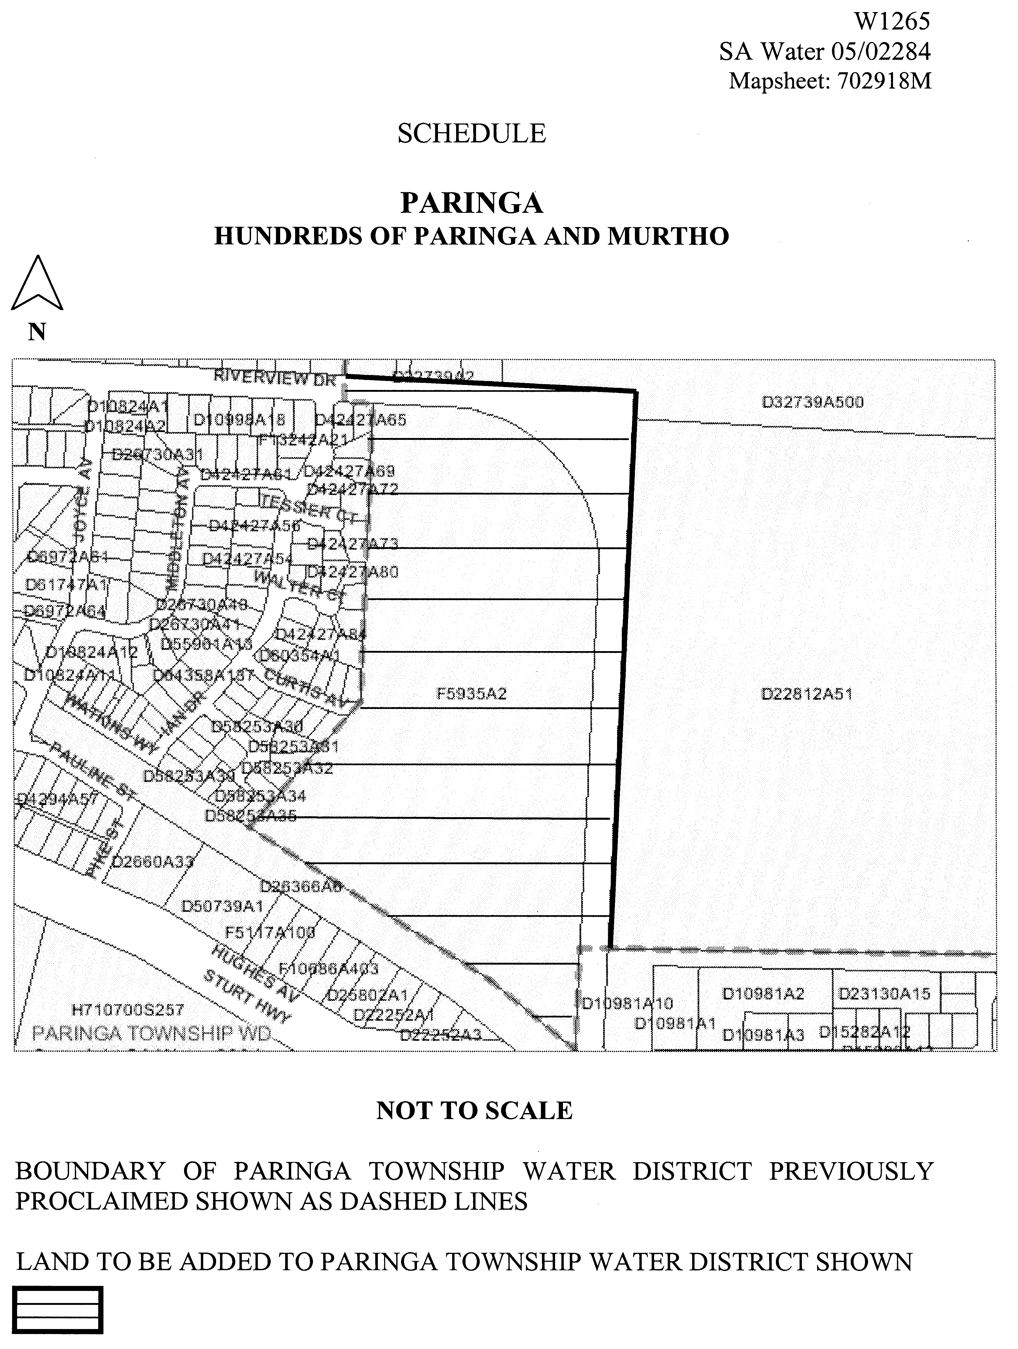
(b) declares that this notice has effect from the commencement of the financial year in which it is published in the Gazette.

Dated 28 February 2005.
Signed for and on behalf of the South Australian Water Corporation by a person duly authorised so to do:
A. Popplewell, General Manager Shared Services
In the presence of:
C. J. McNamara, Billing Manager
SAWATER 05/02284 W1265

WATER RESOURCES ACT 1997
Notice of Prohibition on Taking Water from Wells in the Hundreds of Roby, Sherlock, Bandon, Wilson, Marmon Jabuk, Vincent and Hooper and ‘Area A’
PURSUANT to section 16 (1) of the Water Resources Act 1997 (‘the Act’), I, John David Hill, Minister for Environment and Conservation in the State of South Australia, and Minister to whom the administration of the Water Resources Act 1997 is committed, being of the opinion that the rate at which water is being taken from wells in:
1. the Hundreds of Roby, Sherlock, Bandon, Wilson, Marmon Jabuk, Vincent and Hooper; and
2. the shaded area shown in GRO Plan No 52/05 (Area A).
is such that there is a risk that the available water will not be sufficient to meet future demand, hereby prohibit the taking of water from wells in the Hundreds of Roby, Sherlock, Bandon, Wilson, Marmon Jabuk, Vincent, Hooper and Area A, except in the circumstances specified in Schedule 1.
Schedule 1
1. A person may take water from a well in the Hundreds of Roby, Sherlock, Bandon, Wilson, Marmon Jabuk, Vincent, Hooper or Area A in accordance with the terms of a written authorisation granted under this Notice by me or my authorised agent.
2. An authorisation under this Notice may be granted to:
(a) A person (‘a Current User’), who has been taking water from a well in the Hundreds of Roby, Sherlock, Bandon, Wilson, Marmon Jabuk, Vincent, Hooper or Area A during the period 1 July 2001 to 3 March 2005 inclusive (‘the Relevant Period’), entitling that person to take, from the source specified in the authorisation:
• where the water taken during the Relevant Period was to water a crop or crops, the amount of water reasonably necessary, in my opinion, to water that crop or those crops, the amount being determined taking into account the maximum area of each crop or crops grown, the water requirements of the respective crop or crops and the irrigation capacity of the irrigation equipment used to water the crop or crops; or
• where the water was taken during the Relevant Period for any other purpose, the amount of water which, in my opinion, is reasonably necessary to continue that purpose in the manner in which it had been undertaken during the Relevant Period.
The source specified will be the resource or resources where water was taken during the Relevant Period.
(b) The transferee under a contract for the sale or other transfer of land where the transferor of the land is the holder of an authorisation under this notice, entitling that person to take the same amount of water from the same source as the transferor was authorised to take.
(c) Subject to clause 3, a person (‘a Prospective User’) who did not take any water from a well in the Hundreds of Roby, Sherlock, Bandon, Wilson, Marmon Jabuk, Vincent, Hooper or Area A, but who needs water for a development, project or undertaking:
• to which that person was legally committed during the Relevant Period; or
• in respect of which that person had, in my opinion, committed significant financial or other resources during the Relevant Period;
entitling that person to take the amount of water from a well in the Hundreds of Roby, Sherlock, Bandon, Wilson, Marmon Jabuk, Vincent, Hooper or Area A, which in my opinion, is reasonably necessary to undertake the development, project or undertaking to which that person was committed.
3. A Prospective User may not be granted an authorisation or may only be granted an authorisation subject to conditions relating to the manner of taking water where, in my opinion:
(a) the taking of water from wells will detrimentally affect the ability of other persons to take water from any well for domestic purposes or for watering of stock (other than stock being intensively farmed); or
(b) the taking of water from wells will detrimentally affect the capacity of any well to meet the current or future demand, including the demands of ecosystems dependent on that water resource.
4. Until authorised under this Notice, a Current User may continue to take an amount of water equivalent to the maximum amount taken in any one financial year during the relevant period, from the same sources and for the same purpose or purposes as that person took during the Relevant Period without a written authorisation.
5. This Notice does not apply:
(a) to the taking of water directly from a well pursuant to section 7 (5) of the Act for domestic purposes or for watering of stock (other than stock being intensively farmed); or
(b) to the taking of water for fire fighting purposes or public road making purposes; or
(c) to the taking of water for the purpose of chemical application on crops.
In this notice:
‘Maximum area’ for a particular crop means the maximum areas of land planted to a particular crop in any one financial year during the relevant period.
‘Water requirement’ of a crop means the reasonable rate of irrigation (expressed as a volume of water per hectare) to properly produce that crop.
‘Irrigation capacity’ of irrigation equipment means the amount of water that can be applied by the usual operation of that equipment in its condition at 3 March 2005 under usual pumping rates, hours of operation and seasonal fluctuations.
This notice will remain in effect for two years unless earlier varied or revoked.
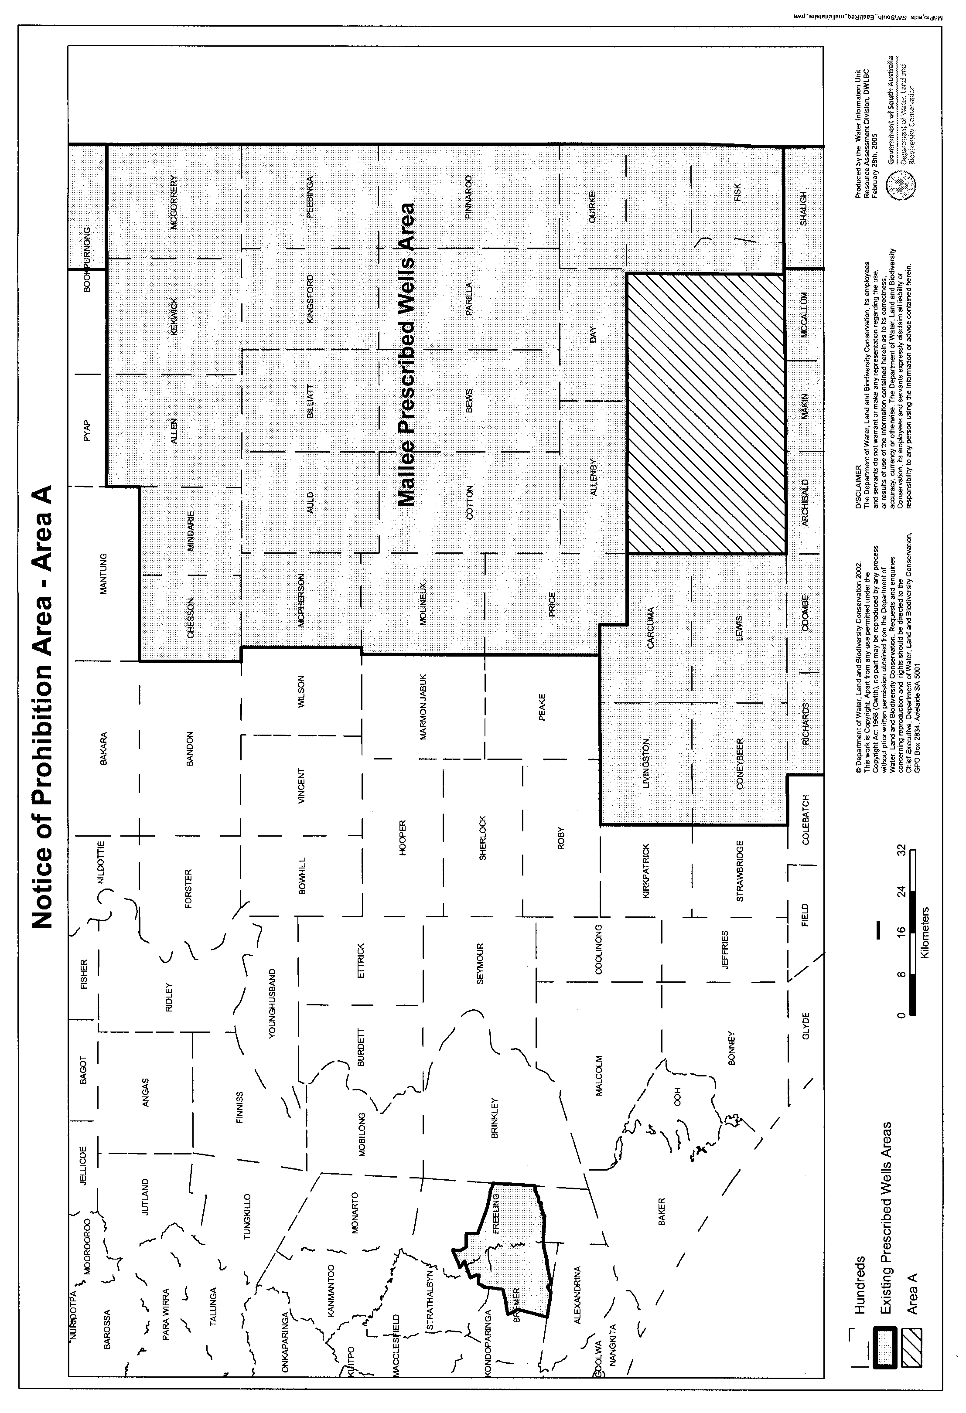
Dated 26 February 2005.
John David Hill, Minister for Environment and Conservation

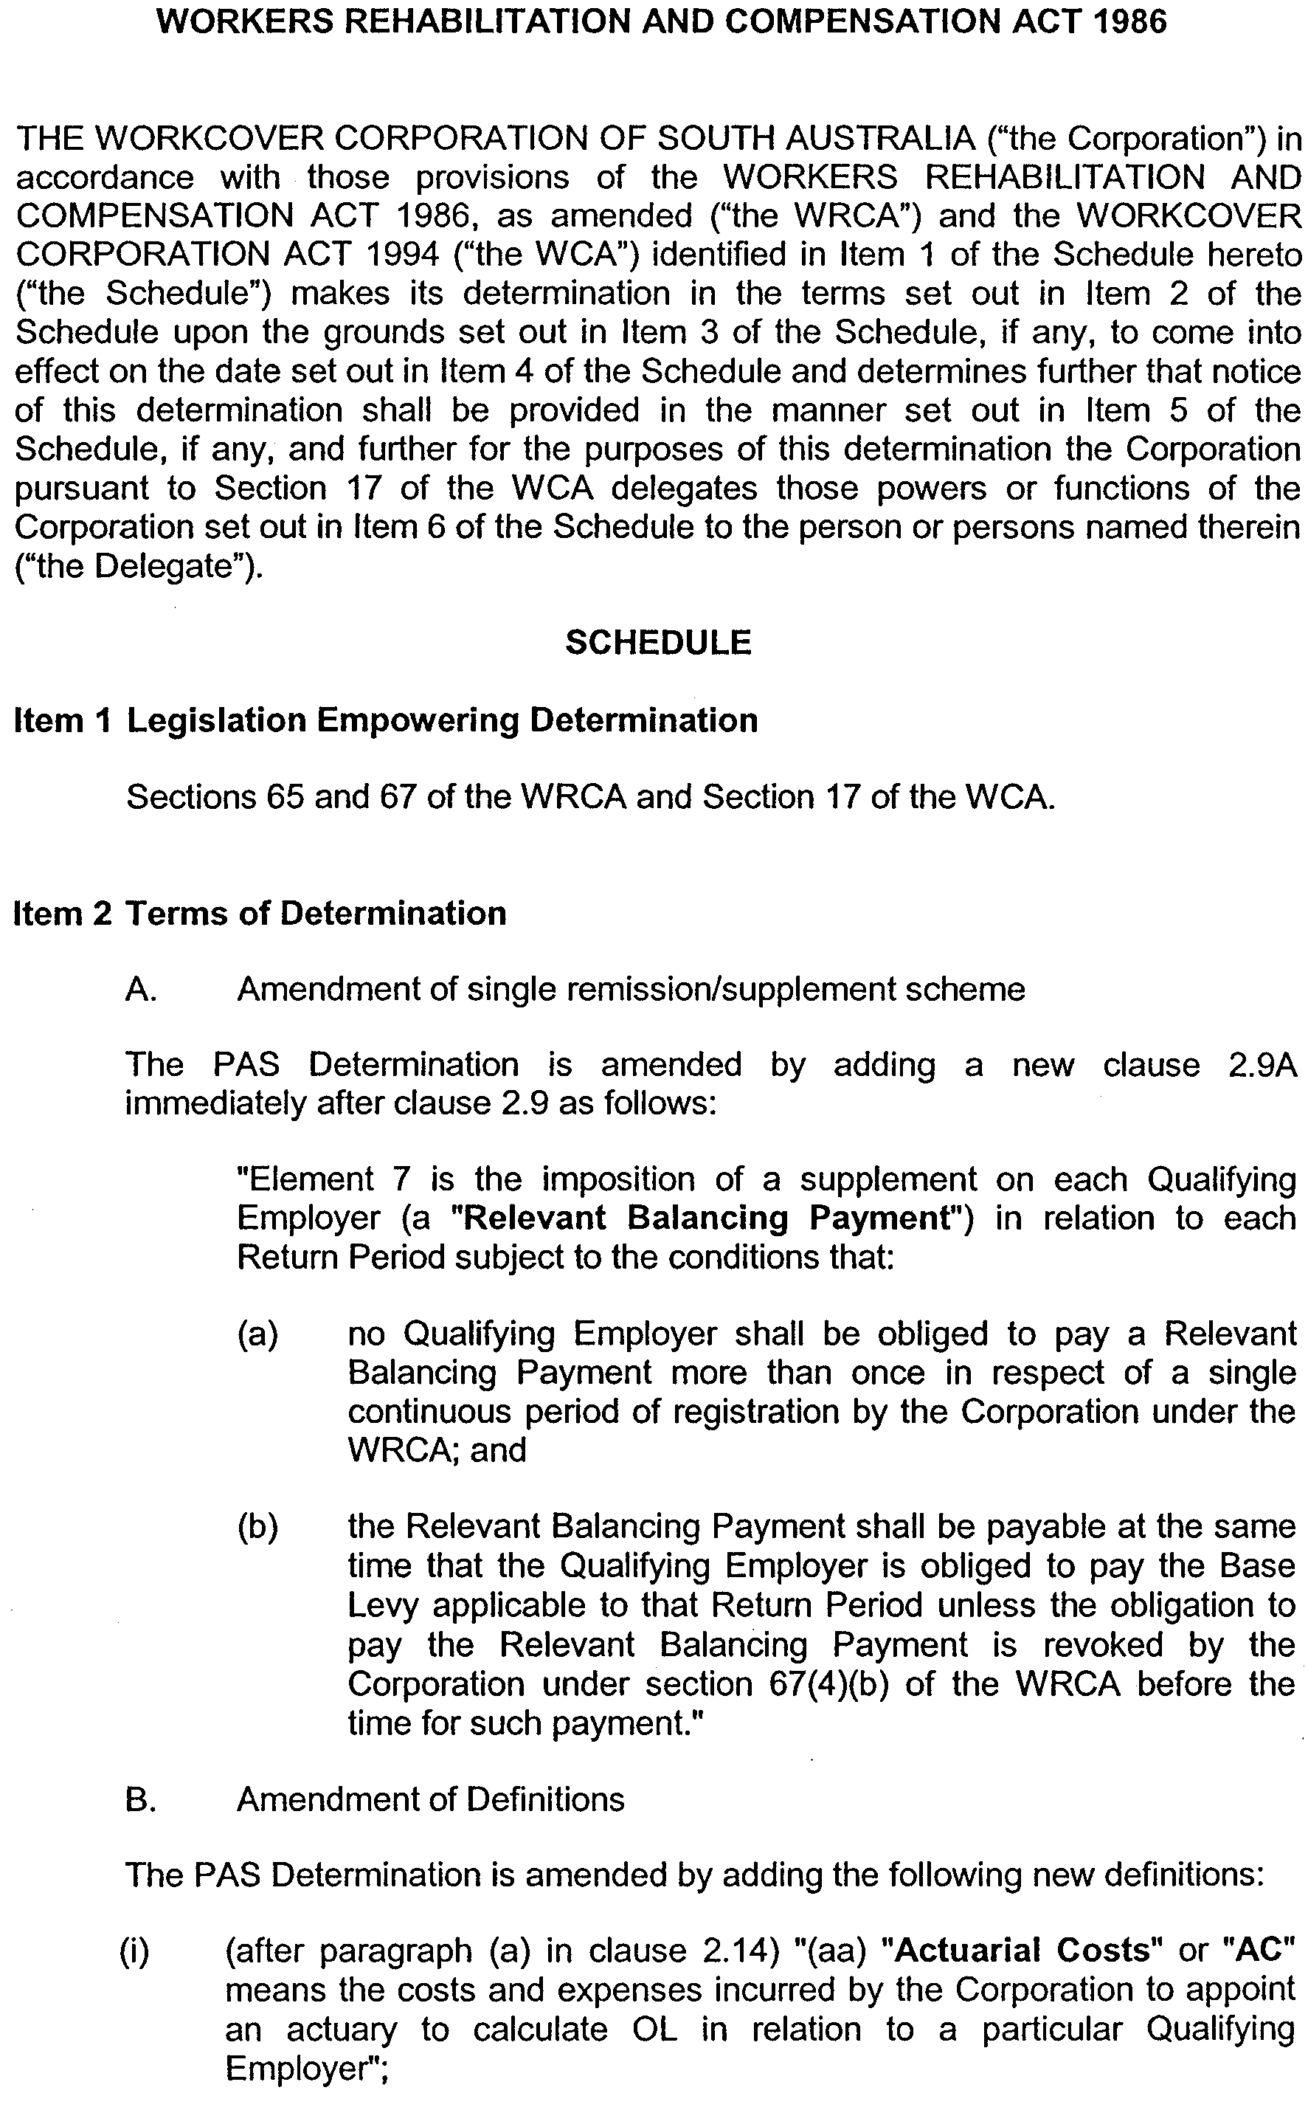
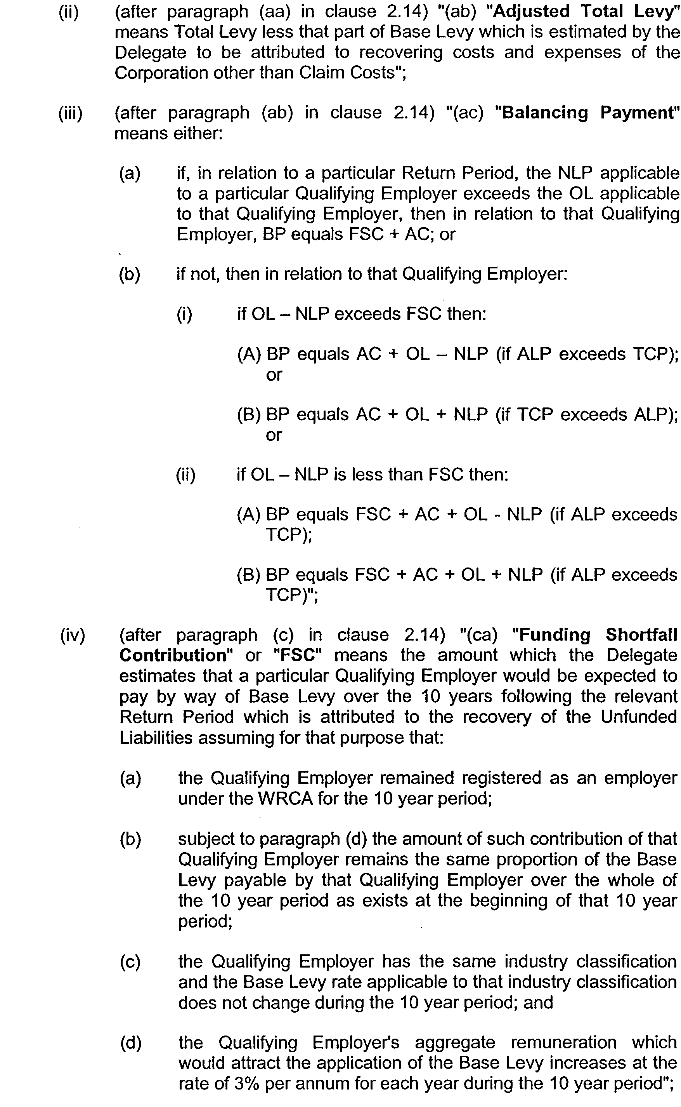
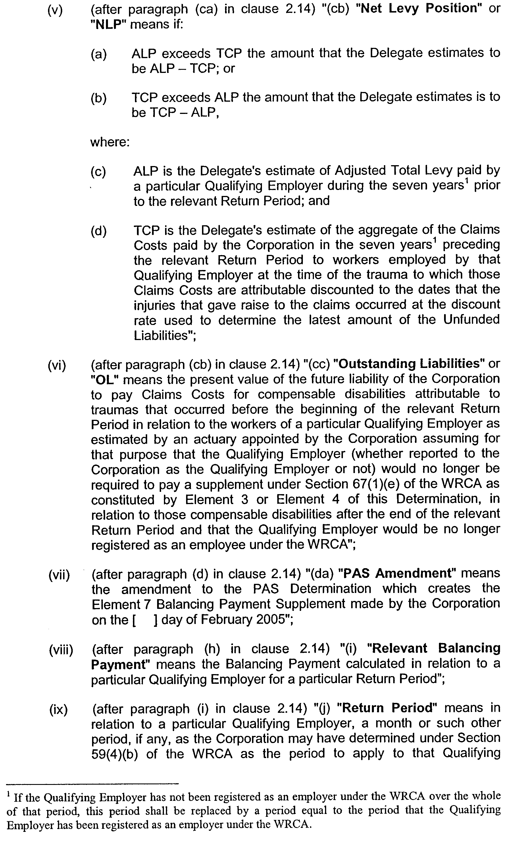
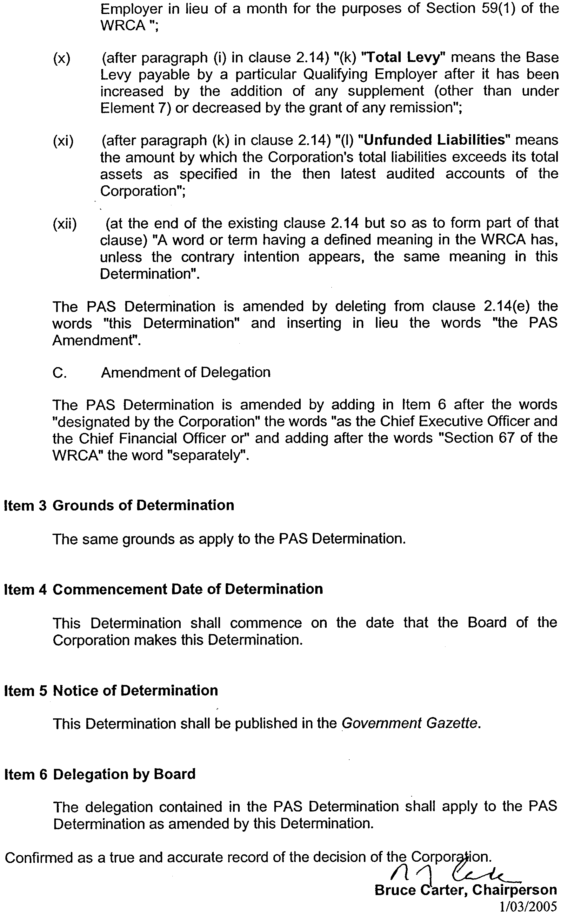
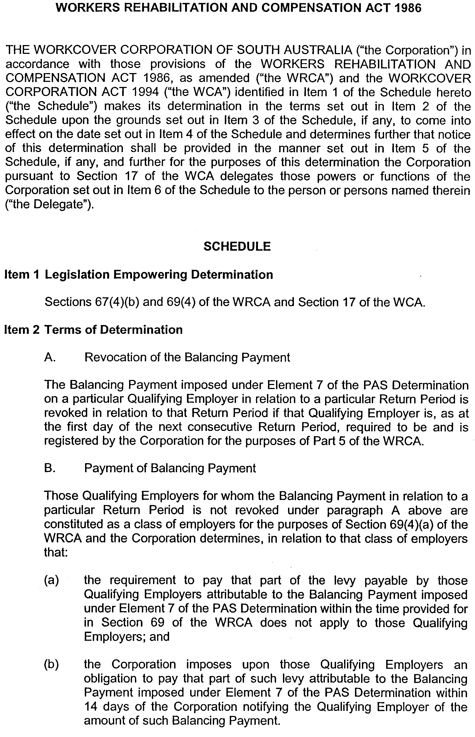
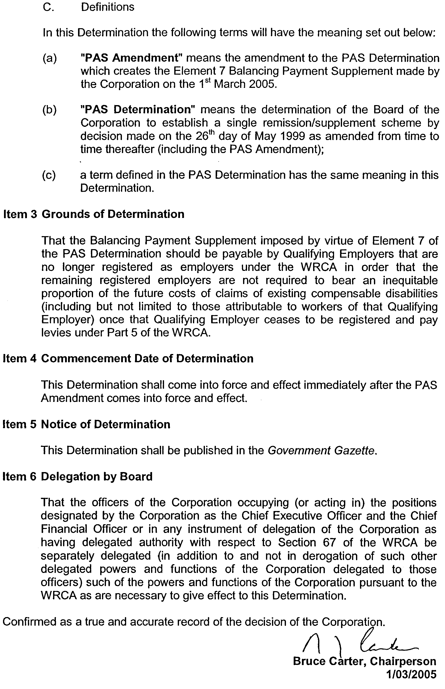

WILDERNESS PROTECTION ACT 1992
Memory Cove Wilderness Protection Area—Draft Management Plan
I, GREG LEAMAN, Director of National Parks and Wildlife, hereby give notice under the provisions of section 31 of the Wilderness Protection Act 1992, that a draft management plan has been prepared for the Memory Cove Wilderness Protection Area.
Copies of the plan may be inspected at or obtained from
the offices of the Department for Environment and Heritage,
1 Richmond Road, Keswick, S.A. 5035 (G.P.O. Box 1047, Adelaide, S.A. 5001), telephone (08) 8124 4970 or at 75 Liverpool Street, Port Lincoln, S.A. 5606 (P.O. Box 22, Port Lincoln, S.A. 5607), telephone (08) 8688 3110, or on the internet at:
http://www.environment.sa.gov.au/parks/management_plans.html
Any person may make representations in connection with the draft management plan during the period up to and including Friday, 3 June 2005.
Written comments should be forwarded to the Manager, Policy and Planning, G.P.O. Box 1047, Adelaide, S.A. 5001, or e-mailed to irving.jason@saugov.sa.gov.au.
Greg Leaman, Director of National Parks and Wildlife, Delegate of the Minister for Environment and Conservation

South Australia
National Parks and Wildlife (Torrens Island Conservation Park) Proclamation 2005
under section 29(3) of the National Parks and Wildlife Act 1972
1—Short title
This proclamation may be cited as the National Parks and Wildlife (Torrens Island Conservation Park) Proclamation 2005.
2—Commencement
This proclamation comes into operation on the day on which it is made.
3—Alteration of boundaries of Torrens Island Conservation Park
The boundaries of the Torrens Island Conservation Park are altered by adding to the Park the following Crown land:
Allotment 12 of DP 55734, Hundred of Port Adelaide, County of Adelaide;
Pieces 306 and 406 of DP 55734, Hundred of Port Adelaide, County of Adelaide.
Made by the Governor’s Deputy
with the advice and consent of the Executive Council
on 3 March 2005
EC05/0005CS

South Australia
National Parks and Wildlife (Torrens Island Conservation Park—Preservation of Rights) Proclamation 2005
under section 43 of the National Parks and Wildlife Act 1972

Preamble
1 The Crown land described in Schedule 1 is, by another proclamation made on this day, added to the Torrens Island Conservation Park under section 29(3) of the National Parks and Wildlife Act 1972.
2 It is intended that, by this proclamation, certain existing and future pipeline rights and related rights of entry be preserved in relation to the land added to the conservation park.

1—Short title
This proclamation may be cited as the National Parks and Wildlife (Torrens Island Conservation Park—Preservation of Rights) Proclamation 2005.
2—Commencement
This proclamation comes into operation on the day on which it is made.
3—Interpretation
In this proclamation—
Environment Minister means the Minister to whom the administration of the National Parks and Wildlife Act 1972 is committed;
Mining Minister means the Minister to whom the administration of the Petroleum Act 2000 is committed;
work includes the operation of a transmission pipeline.
4—Existing rights to continue
Subject to clause 6, existing rights relating to the construction or operation of a transmission pipeline, together with rights of entry for that purpose, under the Petroleum Act 2000 may continue to be exercised in respect of the land described in Schedule 1.
5—New rights may be acquired
Rights relating to the construction or operation of a transmission pipeline, together with rights of entry for that purpose, may, with the approval of the Mining Minister and the Environment Minister, be acquired pursuant to the Petroleum Act 2000 in respect of the land described in Schedule 1, and may, subject to clause 6, be exercised in respect of that land.
6—Conditions for exercise of rights
A person in whom rights referred to in clause 4 or 5 are vested pursuant to the Petroleum Act 2000 (whether those rights were acquired before or after the making of this proclamation) must not exercise those rights in respect of the land described in Schedule 1 unless the person complies with the following conditions:
(a) if work to be carried out in relation to the land in the exercise of those rights is a regulated activity within the meaning of the Petroleum Act 2000, the person must ensure that—
(i) the work is not carried out until a statement of environmental objectives in relation to the activity that has been approved under that Act has also been approved by the Environment Minister; and
(ii) the work is carried out in accordance with the statement so approved;
(b) if work to be carried out in relation to the land in the exercise of those rights has not previously been authorised, the person must give at least 3 months notice of that proposed work to the Mining Minister and the Environment Minister and must supply each Minister with such information relating to the proposed work as the Minister may require;
(c) if directions are agreed between the Mining Minister and the Environment Minister and given to the person in writing in relation to—
(i) carrying out work in relation to the land in a manner that minimises damage to the land (including the land's vegetation and wildlife) and the environment generally; or
(ii) preserving objects, structures or sites of historical, scientific or cultural interest; or
(iii) rehabilitating the land (including the land's vegetation and wildlife) on completion of the work; or
(iv) (where the work is being carried out in the exercise of rights acquired after the making of this proclamation) prohibiting or restricting access to any specified area of the land that the Ministers believe would suffer significant detriment as a result of carrying out the work,
(being directions that do not reduce or otherwise detract from any requirement in respect of any of those matters contained in an approved statement of environmental objectives referred to in paragraph (a)), the person must comply with those directions in carrying out the work;
(d) if a plan of management is in operation under section 38 of the National Parks and Wildlife Act 1972 in respect of the land, the person must have regard to the provisions of the plan of management;
(e) in addition to complying with the other requirements of this proclamation, the person—
(i) must take such steps as are reasonably necessary to ensure that objects, structures and sites of historical, scientific or cultural interest and the land's vegetation and wildlife are not unduly affected by any work; and
(ii) must maintain all work areas in a clean and tidy condition; and
(iii) must, on the completion of any work, obliterate or remove all installations and structures (other than installations and structures designated by the Mining Minister and the Environment Minister as suitable for retention) used exclusively for the purposes of the work;
(f) if no direction has been given by the Mining Minister and the Environment Minister under paragraph (c)(iii), the person must (in addition to complying with any approved statement of environmental objectives referred to in paragraph (a)) rehabilitate the land (including the land's vegetation and wildlife) on completion of the work to the satisfaction of the Environment Minister.
7—Governor may give approvals, directions
If—
(a) the Mining Minister and the Environment Minister cannot agree as to whether—
(i) approval should be granted or refused under clause 5; or
(ii) a direction should be given under clause 6(c); or
(b) the Environment Minister does not approve a statement of environmental objectives referred to in clause 6(a),
the Governor may, with the advice and consent of the Executive Council—
(c) grant or refuse the necessary approval under clause 5 or clause 6(a); or
(d) give a direction in writing under clause 6(c).
Schedule 1—Description of land
Allotment 12 of DP 55734, Hundred of Port Adelaide, County of Adelaide;
Pieces 306 and 406 of DP 55734, Hundred of Port Adelaide, County of Adelaide.
Made by the Governor’s Deputy
with the advice and consent of the Executive Council
on 3 March 2005
EC05/0005CS

South Australia
Liquor Licensing (Dry Areas—Long Term) Variation Regulations 2005
under the Liquor Licensing Act 1997

Contents
Part 1—Preliminary
1 Short title
2 Commencement
3 Variation provisions
Part 2—Variation of Liquor Licensing (Dry Areas—Long Term) Regulations 1997
4 Variation of Schedule 1—Long term dry areas

Part 1—Preliminary
1—Short title
These regulations may be cited as the Liquor Licensing (Dry Areas—Long Term) Variation Regulations 2005.
2—Commencement
These regulations come into operation on the day on which they are made.
3—Variation provisions
In these regulations, a provision under a heading referring to the variation of specified regulations varies the regulations so specified.
Part 2—Variation of Liquor Licensing (Dry Areas—Long Term) Regulations 1997
4—Variation of Schedule 1—Long term dry areas
Schedule 1, item headed "Millicent—Area 1", column headed "Period"—delete "Continuous until 4 December 2004." and substitute:
Continuous until 1 March 2007, but excluding any day or portion of a day during which—
(a) an event of historic, traditional, cultural or major community significance is held within the area; and
(b) the consumption and possession of liquor within the area are authorised for the purposes of this regulation by the Wattle Range Council.
Note—
As required by section 10AA(2) of the Subordinate Legislation Act 1978, the Minister has certified that, in the Minister's opinion, it is necessary or appropriate that these regulations come into operation as set out in these regulations.
Made by the Governor’s Deputy
with the advice and consent of the Executive Council
on 3 March 2005
No 11 of 2005
OLGC0104/03

FAXING COPY?
IF you fax copy to Government Publishing SA for inclusion in the Government Gazette, there is no need to send a Confirmation Copy to us as well.
This creates confusion and may well result in your notice being printed twice.
Please use the following fax number:
Fax transmission: (08) 8207 1040
Phone Inquiries: (08) 8207 1045
Please include a contact person, phone number and order number so that we can phone back with any queries we may have regarding the fax copy.
NOTE: Closing time for lodging new copy (fax, hard copy or email) is 4 p.m. on Tuesday preceding the day of publication.

Government Gazette notices can be E-mailed.
The address is:
governmentgazette@saugov.sa.gov.au
Documents should be sent as attachments in Word format.
When sending a document via E-mail, please confirm your transmission with a faxed copy of your document, including the date the notice is to be published.
Fax transmission: (08) 8207 1040
Enquiries: (08) 8207 1045
NOTE: Closing time for lodging new copy (fax, hard copy or email) is 4 p.m. on Tuesday preceding the day of publication.

CITY OF ONKAPARINGA
Development Act 1993
Coromandel Valley Desired Character Plan Amendment Report—Draft for Public Consultation and Interim Operation
NOTICE is hereby given that the City of Onkaparinga has prepared a Coromandel Valley Desired Character Plan Amend-ment Report (PAR) for the purpose of increasing minimum lot sizes to take into account the sensitive nature of the area as a temporary measure until long-term urban design and character policies can be more fully investigated, developed, consulted on and implemented.
The policy changes that will result from the Coromandel Valley Desired Character PAR include:
• Temporarily making land division creating allotments under 900 m² in area a non-complying form of develop-ment, except where creating a public reserve.
• Discouraging development resulting in dwellings and/or allotments with site areas less than 900 m², except for Aged Persons’ Homes, a single dwelling on an existing allotment, or a land division comprising a minor boundary realign-ment only.
In order to prevent inappropriate development and promote orderly planning, the draft PAR has been granted ‘interim authorisation’ by the State Government, giving the amendments immediate effect.
The PAR will be available for public inspection during normal office hours at the City of Onkaparinga Offices, Noarlunga Centre, Aberfoyle Hub and Willunga, from Thursday, 3 March 2005 until Friday, 6 May 2005. Copies of the PAR can be purchased at a
cost of $2 each and are also available via Council’s website at www.onkaparingacity.com.
Written submissions regarding the PAR will be accepted by the City of Onkaparinga until 5 p.m. on Friday, 6 May 2005. All written submissions should be addressed to the Chief Executive Officer, City of Onkaparinga, P.O. Box 1, Noarlunga Centre, S.A. 5168, (Attention: Ben Victory, Development Policy Officer).
Copies of all written submissions received will be available for inspection for all interested persons at the Council office after Monday, 9 May 2005 until the date of the public hearing.
A public hearing will be held commencing at 7 p.m. on Wednesday, 1 June 2005 at the Coromandel Community Centre, Weymouth Oval, 442B Main Road, Coromandel Valley, at which time interested parties may appear and be heard in relation to the PAR and submissions.
Dated 3 March 2005.
J. Tate, Chief Executive Officer

[Republished]
BERRI BARMERA COUNCIL
Roads (Opening and Closing) Act 1991
Old Sturt Highway, adjacent Greek Orthodox Church, Berri
NOTICE is hereby given pursuant to section 10 of the Act, that the Berri Barmera Council proposes to make a Road Process Order to close, sell and transfer to the Greek Orthodox Community of Berri the portion of Sturt Highway adjoining allotment 100 in Deposited Plan 32427, shown marked ‘B’ on Preliminary Plan No. 02/0027.
A copy of the plan and statement of persons affected are available for public inspection at Council’s Office, 19 Wilson Street, Berri and the office of the Surveyor-General, 101 Grenfell Street, Adelaide during normal office hours.
Any application for easement or objections must be made in writing within 28 days from 4 March 2005, to the Council, P.O. Box 229, Berri, S.A. 5343 and the Surveyor-General, G.P.O. Box 1354, Adelaide, S.A. 5001, setting out full details. Where a submission is made, council will give notification of a meeting to deal with the matter.
Dated 3 March 2005.
S. Rufus, Chief Executive Officer

THE COORONG DISTRICT COUNCIL
Periodical Review of Elector Representation—
Extension of Time for Comment
PURSUANT to section 12 of the Local Government Act 1999, notice is hereby given that The Coorong District Council is carrying out a review to ensure that all aspects of the composition of the council, and the issue of the division, or potential division of the area of the council into wards is comprehensively reviewed.
Information regarding the nature of the periodical review is available from the offices of the council situated at:
49 Princes Highway, Meningie;
95 Railway Terrace, Tailem Bend;
37 Becker Terrace, Tintinara,
during normal opening hours.
Interested persons are invited to make written submissions to the council on the subject of the review. Submissions should be directed to The Chief Executive Officer, P.O. Box 28, Meningie, S.A. 5264, (marked ‘Periodical Review’) to be received by 5 p.m. on Friday, 15 April 2005. All submissions already received are to be considered in the review.
W. R. Paterson, Chief Executive Officer

KINGSTON DISTRICT COUNCIL
Appointment
NOTICE is hereby given that at a meeting of the Council held on 21 January 2005, Jimmy Huynh was appointed as an Authorised Officer, pursuant to sections 7 and 8 of the Food Act 1985, sections 6 and 7 of the Public and Environmental Health Act 1987, sections 9 and 21 of the Supported Residential Facilities Act 1992, section 260 of the Local Government Act 1999, Regulation 77 (3) (b) of the Development Regulations and section 23 (1), (2) and (5) of the Housing Improvement Act 1940.
M. McCarthy, Chief Executive Officer

DISTRICT COUNCIL OF LE HUNTE
District Road Name Change—Allen Road
NOTICE is hereby given in accordance with section 219 of the Local Government Act 1999, that the Council has renamed a portion of the Wudinna East Road to Allen Road. That portion of Wudinna East Road between the intersections of Standley, Shepherdson and Bedford Roads to the intersection of Buckleboo Stock Route and Wudinna East Road.
A. F. McGuire, Chief Executive Officer

DISTRICT COUNCIL OF TUMBY BAY
Adoption of Community Lands Management Plans
NOTICE is hereby given that pursuant to section 197 (3) of the Local Government Act 1999, the District Council of Tumby Bay at its meeting held on 14 February 2005, adopted Management Plans for the community land within their area.
E. A. Roberts, District Clerk

DISTRICT COUNCIL OF YANKALILLA
Naming of Public Road
NOTICE is hereby given that the District Council of Yankalilla at its meeting held on 17 February 2005, resolved that pursuant to section 219 (1) of the Local Government Act 1999, that the public road, between lots 24 and 25 in Deposited Plan 56434, and lot 23 in Deposited Plan 56434, be named Simpson Road, Mount Compass.
R. D. Sweetman, Chief Executive Officer

IN the matter of the estates of the undermentioned deceased persons:
Alletson, Stanley, late of 50 Second Avenue, Klemzig, retired purchasing officer, who died on 18 December 2004.
Butler, Darren David Sean, late of 19 Brisbane Hill Road, Warburton, Victoria, gardener, who died on 19 July 2003.
Denton, Cynthia, late of 30 Sussex Terrace, Westbourne Park, retired secretary, who died on 22 December 2004.
Dixon, Ronald, late of 2 Tummell Street, Port Pirie West, retired crane driver, who died on 27 September 2004.
Hodder, Joyce Maureen, late of 17 Radstock Street, Morphettville, home duties, who died on 17 January 2005.
Jones, Maisie, late of 21 Inverness Street, Clarinda, Victoria, of no occupation, who died on 3 December 2004.
Morgan, Ellen Joan, late of Grainger Road, Somerton Park, of no occupation, who died on 2 January 2005.
Rodriguez, Natividad, late of 65 Byards Road, Happy Valley, widow, who died on 17 December 2004.
Stolz, Crissie Edna May, late of 9 Brenchley Grove, Kingswood, of no occupation, who died on 6 December 2004.
Sutherland, George Thomas, late of 342 Marion Road, North Plympton, retired public servant, who died on 1 December 2004.
Notice is hereby given pursuant to the Trustee Act 1936, as amended, the Inheritance (Family Provision) Act 1972, and the Family Relationships Act 1975, that all creditors, beneficiaries, and other persons having claims against the said estates are required to send, in writing, to the Public Trustee, 25 Franklin Street, Adelaide, S.A. 5000, full particulars and proof of such claims, on or before 1 April 2005, otherwise they will be excluded from the distribution of the said estate; and notice is also hereby given that all persons who are indebted to the said estates are required to pay the amount of their debts to the Public Trustee or proceedings will be taken for the recovery thereof; and all persons having any property belonging to the said estates are forthwith to deliver the same to the Public Trustee.
Dated 3 March 2005.
C. J. O’Loughlin, Public Trustee

ATTENTION

CUSTOMERS requiring a proof of their notice for inclusion in the Government Gazette, please note that the onus is on you to inform Government Publishing SA of any subsequent corrections by 10 a.m. on Thursday, which is our publication deadline.

For any corrections to your notice please phone 8207 1045 or Fax 8207 1040 before 10 a.m. on Thursday.

If we do not receive any communication by 10 a.m. on Thursday (day of publication) we will presume the notice is correct and will print it as it is.

Remember—the onus is on you to inform us of any corrections necessary to your notice.

NOTE: Closing time for lodging new copy (electronically, fax or hard copy) is 4 p.m. on Tuesday preceding the day of publication. Phone 8207 1045—Fax 8207 1040.
Email: governmentgazette@saugov.sa.gov.au

Printed and published by authority every Thursday by J. D. FERGUSON, Government Printer, South Australia
Price: $4.85, plus postage; to subscribers, $247.00 per annum.
(The above prices are inclusive of GST)

