No. 22 585

THE SOUTH AUSTRALIAN

GOVERNMENT GAZETTE
www.governmentgazette.sa.gov.au

PUBLISHED BY AUTHORITY

ALL PUBLIC ACTS appearing in this GAZETTE are to be considered official, and obeyed as such

ADELAIDE, THURSDAY, 10 MARCH 2005

CONTENTS

Page
Act Assented To 586
Appointments, Resignations, Etc. 586
Controlled Substances Act 1984—Notice 587
Corporations and District Councils—Notices 621
Crown Lands Act 1929—Notices 586
Development Act 1993—Notices 587
Environment Protection Act 1993—Notices 590
Fisheries Act 1982—Notices 593
Geographical Names Act 1991—Notices 595
Land and Business (Sale and Conveyancing) Act 1994—
Notices 595
Liquor Licensing Act 1997—Notices 596
Mining Act 1971—Notices 599

Page
National Parks and Wildlife Act 1972—Notice 602
Petroleum Act 2000—Notices 604
Prevention of Cruelty to Animals Act 1985—Notice 606
Private Advertisements 622
Public Trustee Office—Administration of Estates 622
REGULATIONS
Community Titles Act 1996 (No. 12 of 2005) 617
Real Property Act 1886 (No. 13 of 2005) 618
Roads (Opening and Closing) Act 1991—Notices 606
Trade Standards Act 1979—Notice 606
Training and Skills Development Act 2003—
Contracts of Training 607
Trans-Tasman Mutual Recognition Act 1997—Notice 614

GOVERNMENT GAZETTE NOTICES
ALL poundkeepers’ and private advertisements forwarded for publication in the South Australian Government Gazette must be PAID FOR PRIOR TO INSERTION; and all notices, from whatever source, should be legibly written on one side of the paper only and sent to Government Publishing SA so as to be received no later
than 4 p.m. on the Tuesday preceding the day of publication. Phone 8207 1045 or Fax 8207 1040. E-mail: governmentgazette@saugov.sa.gov.au. Send as attachments in Word format and please confirm your transmission with a faxed copy of your document, including the date the notice is to be published and to whom the notice will be charged. The Government Gazette is available online at: www.governmentgazette.sa.gov.au

Department of the Premier and Cabinet
Adelaide, 10 March 2005
HIS Excellency the Governor’s Deputy directs it to be notified for general information that he has in the name and on behalf of Her Majesty The Queen, this day assented to the undermentioned Act passed by the Legislative Council and House of Assembly in Parliament assembled, viz.:
No. 2 of 2005—Classification (Publications, Films and Computer Games) (Types of Classifications) Amendment Act 2005. An Act to amend the Classification (Publications, Films and Computer Games) Act 1995.
By command,
J. D. Lomax-Smith, for Premier
DPC 02/0586

Department of the Premier and Cabinet
Adelaide, 10 March 2005
HIS Excellency the Governor’s Deputy in Executive Council has been pleased to appoint the undermentioned to the RESI Corporation Board, pursuant to the provisions of the Electricity Corporations Act 1994:
Director: (from 10 March 2005 until 9 March 2008)
Linda Hart
By command,
J. D. Lomax-Smith, for Premier
DTF 011/05 CS

Department of the Premier and Cabinet
Adelaide, 10 March 2005
HIS Excellency the Governor’s Deputy in Executive Council has been pleased to appoint the undermentioned to the Local Government Superannuation Board, pursuant to the provisions of the Local Government Act 1999:
Member: (from 1 July 2007)
Graham McLennan Scott
By command,
J. D. Lomax-Smith, for Premier
OLG 0007/2004 CS

Department of the Premier and Cabinet
Adelaide, 10 March 2005
HIS Excellency the Governor’s Deputy in Executive Council has been pleased to appoint the Honourable Jay Wilson Weatherill, MP, Minister for Families and Communities, Minister for Housing, Minister for Ageing and Minister for Disability to be also Acting Minister for Aboriginal Affairs and Reconciliation for the period 10 March 2005 to 17 April 2005 inclusive, during the absence of the Honourable Terance Gerald Roberts, MLC.
By command,
J. D. Lomax-Smith, for Premier
MAA 0007/05 CS

Department of the Premier and Cabinet
Adelaide, 10 March 2005
HIS Excellency the Governor’s Deputy in Executive Council has been pleased to appoint the Honourable Michael John Atkinson, MP, Attorney-General, Minister for Justice and Minister for Multicultural Affairs to be also Acting Minister for Correctional Services for the period 10 March 2005 to 17 April 2005 inclusive, during the absence of the Honourable Terance Gerald Roberts, MLC.
By command,
J. D. Lomax-Smith, for Premier
MAA 0007/05 CS

Department of the Premier and Cabinet
Adelaide, 10 March 2005
HIS Excellency the Governor’s Deputy in Executive Council has been pleased to appoint the Honourable Michael John Atkinson, MP, Attorney-General, Minister for Justice and Minister for Multicultural Affairs to be also Acting Minister for Adminis-trative Services, Acting Minister for Industrial Relations, Acting Minister for Recreation, Sport and Racing and Acting Minister for Gambling for the period 16 March 2005 to 18 March 2005 inclusive, during the absence of the Honourable Michael John Wright, MP.
By command,
J. D. Lomax-Smith, for Premier
MA 001/2005 CS

Department of the Premier and Cabinet
Adelaide, 10 March 2005
HIS Excellency the Governor’s Deputy in Executive Council has been pleased to appoint His Honour Judge Brendan Michael Burley to the office of Judge of the District Court of South Australia on an auxiliary basis from 10 March 2005 to 30 June 2005, it being a condition of appointment that the powers and jurisdictions of office should only be exercised during the time or times the actual duties are being undertaken, but at no other time throughout the period of appointment, pursuant to the provisions of the Judicial Administration (Auxiliary Appointments and Powers) Act 1988.
By command,
J. D. Lomax-Smith, for Premier
ATTG 0122/03 CS

Department of the Premier and Cabinet
Adelaide, 10 March 2005
HIS Excellency the Governor’s Deputy in Executive Council has been pleased to appoint Barry Francis Beazley Q.C. as a Judge of the District Court of South Australia from 10 March 2005, pursuant to section 12 of the District Court Act 1991.
By command,
J. D. Lomax-Smith, for Premier
ATTG 0071/03 CS

CROWN LANDS ACT 1929: SECTION 5
TAKE NOTICE that pursuant to the Crown Lands Act 1929, I, JOHN HILL, Minister for Environment and Conservation, Minister of the Crown to whom the administration of the Crown Lands Act 1929 is committed DO HEREBY dedicate the Crown Land defined in The Schedule as a Reserve for Cemetery Purposes and declare that such land shall be under the care, control and management of the District Council of Loxton Waikerie.
The Schedule
Section 809, Hundred of Waikerie, County of Albert, exclusive of all necessary roads, being the whole of the land comprised in Crown Record Volume 5764 Folio 277.
Dated 10 March 2005.
J. Hill, Minister for Environment and Conservation
DEH 11/3050

CROWN LANDS ACT 1929: SECTION 5
TAKE NOTICE that pursuant to the Crown Lands Act 1929, I, JOHN HILL, Minister for Environment and Conservation, Minister of the Crown to whom the administration of the Crown Lands Act 1929 is committed DO HEREBY:
1. Vary the notice as described in The First Schedule by declaring that the Reserve for the Purposes of the Minister of Public Infrastructure as defined in The First Schedule shall cease to be under the care, control and management of the Minister for Infrastructure (formerly the Minister of Public Infrastructure) and by further declaring that the said Reserve
for the Purposes of the Minister of Public Infrastructure shall be under the care, control and management of the Minister for Administrative Services.
2. Vary the notice as described in The Second Schedule by declaring that the River Torrens Linear Park Reserve as defined in The Second Schedule shall cease to be under the care, control and management of the Minister for Infra-structure (formerly the Minister of Water Resources) and by further declaring that the said River Torrens Linear Park Reserve shall be under the care, control and management of the Minister for Administrative Services.
3. Vary the proclamation as described in The Third Schedule by declaring that the Reserve for Metropolitan Drainage Purposes as defined in The Third Schedule shall be under the care, control and management of the Minister for Adminis-trative Services.
4. Vary the proclamation as described in The Fourth Schedule by declaring that the Reserve for the Purpose of Metropolitan Drainage Works as defined in The Fourth Schedule shall be under the care, control and management of the Minister for Administrative Services.
The First Schedule
Reserve for the Purposes of the Minister of Public Infrastructure, Allotment A of Deposited Plan 34052, now identified as Allotment 5 of Deposited Plan 34052, Hundred of Yatala, County of Adelaide, the notice of which was published in the Government Gazette of 8 July 1993 at page 495, being the whole of the land comprised in Crown Record Volume 5778 Folio 31.
The Second Schedule
River Torrens Linear Park Reserve, Sections 760 and 777, Hundred of Adelaide, County of Adelaide, the notice of which was published in the Government Gazette of 7 April 1988 at page 866, being the whole of the land comprised in Crown Record Volume 5757 Folio 778.
The Third Schedule
Reserve for Metropolitan Drainage Purposes, Section 787, Hundred of Yatala, the proclamation of which was published in the Government Gazette of 9 April 1942 at page 523, being the whole of the land comprised in Crown Record Volume 5757 Folio 826.
The Fourth Schedule
Reserve for the Purpose of Metropolitan Drainage Works, Section 794, Hundred of Yatala, the proclamation of which was published in the Government Gazette of 9 March 1944 at page 273, being the whole of the land comprised in Crown Record Volume 5757 Folio 827.
Dated 10 March 2005.
J. Hill, Minister for Environment and Conservation
DEH 17/1647

CONTROLLED SUBSTANCES ACT 1984
Prohibition
TAKE notice that on 2 March 2005 the Minister for Health made an order pursuant to section 57 (1) of the Controlled Substances Act 1984 in respect of:
Dr Donald Stevenson Smith
49 Glen Osmond Road
Eastwood, S.A. 5063
prohibiting him from supplying, prescribing, administering or having possession of any prescription drug being of the benzodiazepine class.
This order does not apply to any drug lawfully supplied or prescribed for the treatment of Dr Smith by another medical practitioner or dentist or by a veterinary surgeon for the treatment of an animal in his care. This order remains in force until revoked by the Minister for Health.
K. Evans, operating under delegated authority pursuant to the Controlled Substances Act 1984, acting for and on behalf of the Minister for Health

DEVELOPMENT ACT 1993, SECTION 25 (17): PORT PIRIE REGIONAL COUNCIL—HERITAGE PLAN AMEND-MENT
Preamble
1. The Development Plan amendment entitled ‘Port Pirie Regional Council—Heritage Plan Amendment’ (the Plan Amend-ment) has been finalised in accordance with the provisions of the Development Act 1993.
2. The Minister for Urban Development and Planning has decided to approve the Plan Amendment.
Notice
PURSUANT to section 25 of the Development Act 1993, I—
(a) approve the Plan Amendment; and
(b) fix the day on which this notice is published in the Gazette as the day on which the Plan Amendment will come into operation.
Dated 10 March 2005.
Trish White, Minister for Urban Development and Planning
PLN 01/0082

DEVELOPMENT ACT 1993, SECTION 48: DECISION BY THE DEVELOPMENT ASSESSMENT COMMISSION AS DELEGATE OF THE GOVERNOR
Preamble
1. The decision of the Governor under section 48 of the Development Act 1993, to grant provisional development authori-sation of an Irish-themed Pub at 11 Moseley Square, Glenelg was published in the Gazette on 19 February 2004.
2. The development was the subject of a Development Report and an Assessment Report under sections 46 and 46D of the Development Act 1993.
3. Pursuant to section 48 of the Development Act 1993 and Regulation 64 (1) of the Development Regulations 1993, the Governor reserved certain matters for further decision-making.
4. An application has now been made to the Development Assessment Commission as delegate of the Governor under section 48 of the Development Act 1993 for a further decision in relation to the reserved matter of the building rules certification and for an amendment proposing variations to the floor plan.
5. The amendments to the development are contained in the letter received by MasterPlan dated 22 November 2004. The letter received by KBS Consultants dated 15 December 2004, contains accompanying building rules documentation and the signed approval of the Building Rules Certificate, whilst the letter received by KBS Consultants dated 13 January 2005, contains information that addresses the condition associated with the building rules consent submitted on 15 December 2004.
6. The Development Assessment Commission has, in con-sidering the application, had regard to all relevant matters under section 48 (5) of the Development Act 1993.
7. The Development Assessment Commission is satisfied that the amendments do not require the preparation of a further or amended Development Report.
Decision
PURSUANT to section 48 of the Development Act 1993, the Development Assessment Commission as delegate of the Governor in relation to a proposal submitted by J. Upham to develop an Irish-themed Pub at 11 Moseley Square, Glenelg:
(a) grant provisional development authorisation for the Irish-themed Pub development at Glenelg subject to the con-ditions and notes to the applicant below;
(b) grant development authorisation for Building Rules Certification for the Irish-themed Pub development;
(c) grant provisional development authorisation for the variations to the floor plan of the Irish-themed Pub development;
(d) specify all matters relating to this provisional develop-ment authorisation as matters in respect of which con-ditions of this authorisation may be varied or revoked, or new conditions attached;
(e) pursuant to section 48 of the Development Act 1993 and Regulation 64 (1) of the Development Regulations 1993, and as referred to in the Preamble of this authorisation, reserve the following matters for further decision-making at a later stage (refer ‘Notes to Applicant’):
(i) external signage;
(ii) materials, finishes and colour schedules (to be developed in consultation with, and to the approval of, the Heritage Branch, Department for Environ-ment and Heritage);
(iii) balustrade and side fence details (to be developed in consultation with, and to the approval of, the Heritage Branch, Department for Environment and Heritage).
Conditions of Approval
1. Except where minor amendments may be required by other Acts and/or legislation or by conditions imposed herein, the Irish-themed Pub development shall be undertaken in strict accordance with:
(a) the following plans contained in the Development Report dated August 2003, except to the extent that they are varied by the plans described in paragraph 1 (b).
• Drawing Titled: ‘View from Moseley Square’; by Matthews Architects; Drawing Number: 9900050 SK03 (no page number).
• Drawing Titled: ‘Floor Plan’; by Matthews Architects; Drawing Number: 9900050 SK01 (no page number).
• Drawing Titled: ‘Elevations’; by Matthews Architects; Drawing Number: 9900050 SK05 (no page number).
• Drawing Titled: ‘Longitudinal Section’; by Matthews Architects; Drawing Number: 99000050 SK02 (no page number).
• Drawing Titled: ‘View from Hope Street’; by Matthews Architects; Drawing Number: 9900050 SK04 (no page number).
(b) the following plans lodged with Planning SA on 26 November 2003:
• Drawing Titled: ‘First Floor Plan’ 1:100; Drawing Number: 99000 SK01 A (revised), submitted 26 November 2003.
• Drawing Titled: ‘Ground Floor Plan’ 1:100; Drawing Number: 99000 SK01 A (revised), submitted 26 November 2003.
• Drawing Titled: ‘View from Moseley Square’; Drawing Number: 9900050 SK03 A (revised), sub-mitted 26 November 2003.
• Drawing Titled: ‘Elevations’; Drawing Number: 9900050 SK05 A (revised), submitted 26 November 2003.
(c) the following plan lodged with Planning SA on 22 November 2004:
• Drawing Titled: ‘Ground Floor Plan-First Floor Plan’ 1:100; Drawing Number: MOS-509/TP01, submitted 26 November 2004.
(d) the following documents:
• Development Application, proposed Irish-themed Pub, by J. Upham, dated 19 December 2002 (except to the extent that it may be varied by a subsequent document in this paragraph).
• Development Report, proposed Irish-themed Pub, prepared by Master Plan SA Pty Ltd (for J. Upham), dated August 2003 (except to the extent that it may be varied by a subsequent document in this paragraph).
• Response Document, proposed Irish-themed Pub, prepared by Master Plan SA Pty Ltd (for J. Upham), dated 3 November 2003 (contained within an appendix to the Assessment Report noted below) (except to the extent that it may be varied by a subsequent document in this paragraph).
• Letter from Master Plan SA Pty Ltd (for J. Upham), Irish-themed Pub, dated 26 November 2003, outlining amendments to the projecting balcony (and accom-panying plans).
• Assessment Report prepared by the Minister and Urban Development and Planning, dated January 2004 (except to the extent that it may be varied by a subsequent document in this paragraph).
• Letter from Master Plan SA Pty Ltd (for J. Upham), Irish-themed Pub, 11 Moseley Square, Glenelg dated 22 November 2004, outlining amendments to the floor plan (and accompanying plans).
• Letter from KBS Consultants, Class 6 building for John Upham Holdings Pty Ltd, c/o TM Design Group at Irish-themed Pub, 11 Moseley Square, Glenelg dated 15 December 2004 (and accompanying building rules certification and certified plans and documents).
• Letter from KBS Consultants, Class 6 building for John Upham Holdings Pty Ltd at Irish-themed Pub, 11 Moseley Square, Glenelg dated 13 January 2005 (and accompanying information that addresses the con-dition associated with the building rules certification submitted 15 December 2004).
2. The applicant shall submit further information and applica-tion in relation to the matters that have been reserved for further decision-making by the Governor (or her delegate as referred to in the Preamble and the Decision of this provisional development authorisation).
3. No building works shall proceed until a decision has been made by the Governor (or her delegate), involving the reserved matters that are subject to further development application.
4. The public walkway on the eastern side of the building shall remain open to the general public until midnight on any day.
5. The site and development shall be maintained in a serviceable condition and operated in an orderly and tidy manner at all times.
6. The waste storage and service area at the rear of the building shall be kept in a neat, tidy and healthy condition at all times and the service area access door shall remain closed at all times other than when loading or unloading is taking place.
7. Machinery, plant operating equipment, lighting or sound devices shall not impair or impinge upon the enjoyment of adjoining properties or occupiers thereof.
8. All drainage, finished floor levels and public works associated with the development, including the disposal of storm-water, are to be carried out in accordance with accepted engineer-ing standards and to the reasonable satisfaction of the City of Holdfast Bay.
9. Spillage of any hydraulic fluids or oils that enter the lift over-run shall be directed to the sewer through appropriate trade waste fixtures.
Notes to the Applicant
• A decision on reserved matters relating to Building Rules assessment and certification requirements will only be made by the Governor (or her delegate) after a Building Rules assessment and certification has been undertaken and issued by the City of Holdfast Bay, or a private certifier, as required by the Development Act 1993, and after the Minister for Urban Development and Planning receives a copy of all relevant certification documentation, as outlined in Regulation 64 of the Development Regulations 1993.
• If the Building Rules assessment process demonstrates that the Irish-themed Pub (or parts of the Irish-themed Pub) complies with the Building Rules pursuant to the Develop-ment Act 1993 and Development Regulations 1993, the City of Holdfast Bay, or private certifier conducting the Building Rules assessment, must:
(a) provide to the Minister the certification in the form set out in Schedule 12A of the Development Regulations 1993; and
(b) to the extent that may be relevant and appropriate:
(i) issue a schedule of essential safety provisions under Division 4 of Part 12;
(ii) assign a classification of the building under these regulations; and
(iii) ensure that the appropriate levy has been paid under the Construction Industry Training Fund 1993.
Regulation 64 of the Development Regulations 1993 provides further information about the type and quantity of all building certification documentation required for referral to the Minister.
• The City of Holdfast Bay, or private certifier undertaking the Building Rules assessment and certification for the Irish-themed Pub (or parts of the Irish-themed Pub) must ensure that any assessment and certification is consistent with this provisional development authorisation (including any conditions or notes that apply in relation to this provisional development authorisation).
• Should the applicant wish to vary the application, as outlined in this provisional development authorisation, a variation to the application may be submitted, pursuant to section 48B of the Development Act 1993, provided that the development application variation remains within the ambit of the Amended Development Report and Amend-ment Assessment Report referred to in this provisional development authorisation.
• The Heritage Branch of the Department for Environment and Heritage should be consulted if there is to be any physical intervention to the structures on the adjacent State Heritage place (former dwelling). Any such work must be executed in accordance with advice arising from such consultation.
• The applicant is advised of the requirement to comply with the Environment Protection Authority’s (EPA) ‘Stormwater Pollution Prevention Code of Practice for the Building and Construction Industry’ during demolition and construction of the development.
• If the Irish-themed Pub development is not substantially commenced within two years of the date of any reserved matter decisions, the Governor may cancel this provisional development authorisation and any subsequent decisions on reserved matters (where relevant).
• The Minister has a specific power to require testing, moni-toring and auditing under section 48C of the Development Act 1993.
• If an excavation penetrates a plane inclined downwards at a slope of 1 vertical to 2 horizontal from a point 600 mm below the surface at the boundary, the owner must notify the adjoining owner in accordance with section 60 of the Development Act 1993.
• If fill exceeds 200 mm within 600 mm of the boundary, the owner must notify the adjoining owner in accordance with section 60 of the Development Act 1993.
• Stormwater should be disposed of in such a manner that it does not flow or discharge onto land of adjoining owners or lie against any building or create insanitary conditions. It is recommended where possible to drain stormwater from the building and adjoining land to the street watertable.
• During the period that the development is being undertaken care should be taken to ensure all paper, plastic, rubbish and other waste material associated with the building work is secured and contained within the subject land.
• You are advised to contact the appropriate authorities such as SA Water, ETSA, Telstra, Transport SA, Gas Co. and Australia Post regarding their requirements before con-struction is commenced.
Dated 10 March 2005.
C. Birch, Acting Secretary, Development Assessment Commission.

ENVIRONMENT PROTECTION ACT 1993
Approval of Category A Containers
I, STEPHEN RICHARD SMITH, Senior Adviser, Container Deposit Legislation and Delegate of the Environment Protection Authority (‘the Authority’), pursuant to section 69 of the Environment Protection Act 1993 (SA) (‘the Act’) hereby:
Approval of Category A Containers:
Approve as Category A Containers, as identified in Column 5 of the Schedule, subject to the conditions in subclauses (i) and (ii) below, each of the classes of containers identified by reference to the following matters described in the first 4 columns of Schedule 1 of this notice which are sold in South Australia:
(a) the product which each class of containers shall contain;
(b) the size of the containers;
(c) the type of containers;
(d) the name of the holders of these approvals.
(i) Subsection 69 (3) Arrangements:
The holders of these approvals must ensure that the empty containers which belong to their respective class of containers hereby approved as Category A Containers are collected from the retailers that sell them, and recycled in an appropriate manner. Disposal at landfill is not considered an appropriate method of disposal.
(ii) Approved Refund Markings:
(a) The holders of these approvals must ensure that each container which belongs to their respective class of containers hereby approved as Category A Containers bears the refund marking approved by the Authority in respect of that class of containers.
(b) The refund marking that appears on each container that belongs to the class of containers hereby approved, must be a minimum 1.5 mm for the smallest letter in the statement and a minimum 3 mm for the numeric (‘5’) in the statement.

Column 1 | Column 2 | Column 3 | Column 4 | Column 5
Product Name | Container  Size (mL) | Container Type | Approval Holder | Collection  Arrangements
Cider Mineral Water | 340 | Glass (Sticker) | Byong Kil Chai, trading as Seoul Grocery | Return at Point of Sale
Sunny 10 Grape | 250 | Can—Aluminium (Sticker) | Byong Kil Chai, trading as Seoul Grocery | Return at Point of Sale
Mc Col Barley Flavoured Soda | 250 | Can—Aluminium (Sticker) | Byong Kil Chai, trading as Seoul Grocery | Return at Point of Sale
Bonbon Grape | 238 | Can—Aluminium (Sticker) | Byong Kil Chai, trading as Seoul Grocery | Return at Point of Sale
Nostalgia Drink Soojeonggwa | 238 | Can —Aluminium (Sticker) | Byong Kil Chai, trading as Seoul Grocery | Return at Point of Sale
Ohen Crushed Pear Juice | 238 | Can—Aluminium (Sticker) | Byong Kil Chai, trading as Seoul Grocery | Return at Point of Sale
Wang Carbonated Soft Drink | 250 | Can—Aluminium (Sticker) | Byong Kil Chai, trading as Seoul Grocery | Return at Point of Sale
Korean Original Ginseng Drink | 120 | Glass (Sticker) | Byong Kil Chai, trading as Seoul Grocery | Return at Point of Sale
Bacchus F. Soln | 100 | Glass (Sticker) | Byong Kil Chai, trading as Seoul Grocery | Return at Point of Sale
Wonbi D. | 100 | Glass (Sticker) | Byong Kil Chai, trading as Seoul Grocery | Return at Point of Sale
Maxwell House Coffee Original | 180 | Can—Steel (Sticker) | Byong Kil Chai, trading as Seoul Grocery | Return at Point of Sale
Cappuccino Regular | 175 | Can—Steel (Sticker) | Byong Kil Chai, trading as Seoul Grocery | Return at Point of Sale
OKF Aloe Vera Juice | 500 | PET (Sticker) | Byong Kil Chai, trading as Seoul Grocery | Return at Point of Sale
Lotte Lets Be Mild Coffee | 175 | Can—Steel (Sticker) | Byong Kil Chai, trading as Seoul Grocery | Return at Point of Sale

ENVIRONMENT PROTECTION ACT 1993
Approval of Category B Containers
I, STEPHEN RICHARD SMITH, Senior Adviser, Container Deposit Legislation and Delegate of the Environment Protection Authority (‘the Authority’), pursuant to section 69 of the Environment Protection Act 1993 (SA) (‘the Act’) hereby:
Approval of Category B Containers:
Approve as Category B Containers, subject to the conditions in subclauses (i) and (ii) below, each of the classes of containers identified by reference to the following matters described in the first 4 columns of Schedule 1 of this notice which are sold in South Australia:
(a) the product which each class of containers shall contain;
(b) the size of the containers;
(c) the type of containers;
(d) the name of the holders of these approvals.
(i) Subsection 69 (3) Arrangements:
The holders of these approvals must ensure that the empty containers which belong to their respective class of containers hereby approved as Category B Containers are collected from collection depots approved under section 69 of the Act by the party named in Column 5 of Schedule 1 of this notice; and
(ii) Approved Refund Markings:
(a) The holders of these approvals must ensure that each container which belongs to their respective class of containers hereby approved as Category B Containers bears the refund marking approved by the Authority in respect of that class of containers.
(b) The refund marking that appears on each container that belongs to the class of containers hereby approved, must be a minimum 1.5 mm for the smallest letter in the statement and a minimum 3 mm for the numeric (‘5’) in the statement.

Column 1 | Column 2 | Column 3 | Column 4 | Column 5
Product Name | Container  Size (mL) | Container Type | Approval Holder | Collection  Arrangements
Kirin Ichiban | 330 | Glass with Paper Label | South Australian Brewing Company Pty Ltd | Marine Stores Ltd
Pilsner Urquell | 330 | Glass with Paper Label | South Australian Brewing Company Pty Ltd | Marine Stores Ltd
Berri Muti V Breakfast Juice with Folate Vitamin A and C | 400 | PET with Paper Label | Berri Limited | Statewide Recycling
Berri Muti V Apple and Mango Juice with Antioxidants Vitamin A, C and E | 400 | PET with Paper Label | Berri Limited | Statewide Recycling
Berri Muti V Apple Juice with Fibre Vitamin C and E and Folate | 400 | PET with Paper Label | Berri Limited | Statewide Recycling
Chin Chin Grass Jelly S | 320 | Can—Steel | New World Trading Company Pty Ltd | Statewide Recycling
Pikes New Oakbank Beer | 330 | Glass with Paper Label | Tucker Seabrook (Aust) Pty Ltd | Statewide Recycling
Schweppes Dry Ginger Ale Diet | 315 | Glass with Paper Label | Cadbury Schweppes Pty Ltd | Statewide Recycling
Schweppes Indian Tonic Water Diet | 315 | Glass with Paper Label | Cadbury Schweppes Pty Ltd | Statewide Recycling
Chin Chin Aloe Vera Juice | 250 | Can—Steel | New World Trading Company Pty Ltd | Statewide Recycling
Chin Chin Sterlhia with Basil Seed | 350 | Can—Steel | New World Trading Company Pty Ltd | Statewide Recycling
Chin Chin Grass Jelly Coconut | 320 | Can—Steel | New World Trading Company Pty Ltd | Statewide Recycling
Chin Chin Grass Jelly Lychee | 320 | Can—Steel | New World Trading Company Pty Ltd | Statewide Recycling
Chin Chin Green Tea | 340 | Can—Steel | New World Trading Company Pty Ltd | Statewide Recycling
Chin Chin Green Tea | 500 | PET | New World Trading Company Pty Ltd | Statewide Recycling
Chin Chin Genesis Coffee | 350 | Can—Steel | New World Trading Company Pty Ltd | Statewide Recycling
Wonderfarm Tamerind Drink | 325 | Can—Steel | New World Trading Company Pty Ltd | Statewide Recycling
Yida Almond Juice | 240 | Can—Steel | New World Trading Company Pty Ltd | Statewide Recycling
Sagiko Chrysanthemum Drink | 320 | Can—Steel | New World Trading Company Pty Ltd | Statewide Recycling
Sagiko Soursop Juice Drink | 320 | Can—Steel | New World Trading Company Pty Ltd | Statewide Recycling
Nekta Liquid Kiwi Fruit | 1 000 | PET with Paper Label | Kevron Australia Pty Ltd | Marine Stores Ltd
Nekta Liquid Kiwi Fruit | 375 | PET with Paper Label | Kevron Australia Pty Ltd | Marine Stores Ltd
Powerade Green and Gold Spirit Flat Cap | 600 | PET with Polyethylene Label | Coca Cola Amatil (Aust) Pty Ltd | Statewide Recycling
Powerade Green and Gold Spirit Sipper Cap | 600 | PET with Polyethylene Label | Coca Cola Amatil (Aust) Pty Ltd | Statewide Recycling
Diet Coke with Lime Flavour | 600 | PET with Polyethylene Label | Coca Cola Amatil (Aust) Pty Ltd | Statewide Recycling
Diet Coke with Lime Flavour | 390 | PET with Polyethylene Label | Coca Cola Amatil (Aust) Pty Ltd | Statewide Recycling
Diet Coke with Lime Flavour | 1 250 | PET with Polyethylene Label | Coca Cola Amatil (Aust) Pty Ltd | Statewide Recycling
Diet Coke with Lime Flavour | 2 000 | PET with Polyethylene Label | Coca Cola Amatil (Aust) Pty Ltd | Statewide Recycling
Kirks Cream and Soda | 2 000 | PET with Polyethylene Label | Coca Cola Amatil (Aust) Pty Ltd | Statewide Recycling
Kirks Pasito Passion Fruit Flavour | 2 000 | PET with Polyethylene Label | Coca Cola Amatil (Aust) Pty Ltd | Statewide Recycling
Deep Spring Natural Mineral Water | 600 | PET with Polyethylene Label | Coca Cola Amatil (Aust) Pty Ltd | Statewide Recycling
Deep Spring Orange and Passionfruit Natural Mineral Water | 600 | PET with Polyethylene Label | Coca Cola Amatil (Aust) Pty Ltd | Statewide Recycling
Deep Spring Orange and Mango Natural Mineral Water | 600 | PET with Polyethylene Label | Coca Cola Amatil (Aust) Pty Ltd | Statewide Recycling
Deep Spring Lemon Natural Mineral Water | 600 | PET with Polyethylene Label | Coca Cola Amatil (Aust) Pty Ltd | Statewide Recycling
Deep Spring Lemon Natural Mineral Water | 1 250 | PET with Polyethylene Label | Coca Cola Amatil (Aust) Pty Ltd | Statewide Recycling
Lift 5% Lemon Juice | 250 | Glass Ink Jetted | Coca Cola Amatil (Aust) Pty Ltd | Statewide Recycling
Black and Gold Lemonade Flavoured Soft Drink | 350 | PET with Polypropylene Label | Chandru International Pty Ltd | Visy CDL Recycling Services
Black and Gold Pineapple Flavoured Soft Drink | 350 | PET with Polypropylene Label | Chandru International Pty Ltd | Visy CDL Recycling Services
Black and Gold Orange Flavoured Soft Drink | 350 | PET with Polypropylene Label | Chandru International Pty Ltd | Visy CDL Recycling Services
Black and Gold Lime Flavoured Soft Drink | 350 | PET with Polypropylene Label | Chandru International Pty Ltd | Visy CDL Recycling Services
Black and Gold Raspberry Flavoured Soft Drink | 350 | PET with Polypropylene Label | Chandru International Pty Ltd | Visy CDL Recycling Services
Black and Gold Cola Flavoured Soft Drink | 350 | PET with Polypropylene Label | Chandru International Pty Ltd | Visy CDL Recycling Services
Brownes Coffee Strong Percolated Iced Coffee Blast | 750 | LPB—Gable Top | PB Foods Ltd | Statewide Recycling
Brownes Lite Coffee No Added Sugar Blast | 750 | LPB—Gable Top | PB Foods Ltd | Statewide Recycling
Brownes Mocha Real Choc Coffee Taste Blast | 750 | LPB—Gable Top | PB Foods Ltd | Statewide Recycling
Bacos Apple Tree Apple and Banana Juice | 375 | Glass with Paper Label | Baco Pty Ltd | Visy CDL Recycling Services
Wild Potion Wort Organic Berry and Ginger | 300 | PET with Paper Label | Wort Organic Pty Ltd | Marine Stores Ltd
Wort Organic Traveleasy Peppermint and Ginger | 330 | Glass with Paper Label | Wort Organic Pty Ltd | Marine Stores Ltd
Bacos Apple Tree Apple and Blackcurrant Juice | 375 | Glass with Paper Label | Baco Pty Ltd | Visy CDL Recycling Services
Bacos Apple Tree Apple and Mango Juice | 375 | Glass with Paper Label | Baco Pty Ltd | Visy CDL Recycling Services
Bacos Apple Tree Apple and Passionfruit Juice | 375 | Glass with Paper Label | Baco Pty Ltd | Visy CDL Recycling Services
Wort Organic Lemon and Ginger Wort | 330 | Glass with Paper Label | Wort Organic Pty Ltd | Marine Stores Ltd
Bacos Apple Tree Apple and Pineapple Juice | 375 | Glass with Paper Label | Baco Pty Ltd | Visy CDL Recycling Services
Bacos Apple Tree Apple and Tropical Juice | 375 | Glass with Paper Label | Baco Pty Ltd | Visy CDL Recycling Services

FISHERIES ACT 1982: SECTION 59
TAKE notice that pursuant to section 59 of the Fisheries Act 1982, the holder of a prawn fishery licence issued pursuant to the Fisheries (Scheme of Management—Prawn Fisheries) Regulations 1991 for the Spencer Gulf Prawn Fishery listed in Schedule 1 (the ‘exemption holders’) or their registered master are exempt from the notices made under section 43 of the Fisheries Act 1982, prohibiting the taking of western king prawns (Melicertus latisulcatus), in that the exemption holders shall not be guilty of an offence when using prawn trawl nets in accordance with the conditions of their fishery licence for the purpose of stock assessment survey (the ‘exempted activity’) subject to the conditions contained in Schedule 2.
Schedule 1
Licence No. | Licence Holder | Boat Name
P18 | S. & M. Letenic Nominees | Marija-L
P31 | Barry Bower | Evelyn-L
P16 | Barry Evans | Night Stalker
Schedule 2
1. The exemption is valid from 2030 hours on 10 March 2005 until 0700 hours on 11 March 2005, unless varied or revoked.
2. The exemption holder must comply with the instructions from the Committee at Sea and work in the allotted trawl station.
3. All fish, other than prawns, southern calamari and slipper lobster taken during the exempted activity for stock assessment purposes, or fish retained for other research purposes, are to be returned to the water immediately after capture.
4. All fish taken pursuant to the exempted activity are to be processed in accordance with the instructions of the Committee at Sea.
5. All fish taken pursuant to the exempted activity must be removed from the vessel in accordance with the instructions of the Committee at Sea prior to that vessel undertaking normal fishing activity.
6. Prawns, southern calamari and slipper lobster taken pursuant to the exempted activity must not be retained by the exemption holder, his agent or crew.
7. The exemption holder must return to Wallaroo (the designated port of landing) by 1000 hours by the last day of the survey.
8. While engaged in the exempted activity the exemption holder must carry or have about or near their person a copy of this notice. Such notice must be produced to a PIRSA Fisheries Compliance Officer if requested.
9. The exemption holder must not contravene or fail to comply with Fisheries Act 1982, or any other regulations made under that Act except where specifically exempted by this notice.
Dated 8 March 2005.
J. Presser, Principal Fisheries Manager

FISHERIES ACT 1982: SECTION 59
TAKE notice that pursuant to section 59 of the Fisheries Act 1982, the holder of a prawn fishery licence issued pursuant to the Scheme of Management (Prawn Fisheries) Regulations 1991 for the Gulf St Vincent Prawn Fishery listed in Schedule 1 (the ‘exemption holders’), or their agent, are exempt from the notices made under section 43 of the Fisheries Act 1982, prohibiting the taking of western king prawns (Melicertus latisulcatus), in that the exemption holders shall not be guilty of an offence when using prawn trawl nets in accordance with the conditions of their fishery licence for the purpose of stock assessment survey (the ‘exempted activity’) subject to the conditions contained in Schedule 2.
Schedule 1
Licence No. | Licence Holder | Boat Name
V01 | Ganelon Pty Ltd | Falcon
V02 | St Vincent Gulf Fisheries & Investments Pty Ltd | Angela Kaye
V03 | Brzic Fisheries Pty Ltd | Cavalier
V04 | Ledo Pty Ltd | Miss Venus
V05 | Maurice J. Corigliano | Frank Cori
V06 | Todreel Pty Ltd | Anna Pearl
V08 | Haralambos Paleologoudias | Sheandoah II
V09 | Hamid Huseljic | Candice K
V10 | N. Wayne Justice | Viking
V14 | S. V. Gulf Fisheries Pty Ltd | Zadar
Schedule 2
1. The exemption is valid from 2000 hours on 6 March 2005 until 0700 hours on 8 March 2005, unless varied or revoked.
2. The exemption holder must comply with the instructions from the Stock Assessment Coordinator and work in the allotted trawl station.
3. All fish, other than prawns, calamari and slipper lobster taken during the exempted activity for stock assessment purposes, or fish retained for other research purposes, are to be returned to the water immediately after capture.
4. All prawns taken during the exempted activity are to be processed in accordance with the instructions of the Stock Assessment Coordinator.
5. All prawns, calamari and slipper lobster taken during the exempted activity must be removed from the vessel in accordance with the instructions of the Stock Assessment Coordinator prior to that vessel undertaking normal fishing activity.
6. Prawns, calamari and slipper lobster taken pursuant to the exempted activity are not permitted to be retained by the exemption holder, agent or crew.
7. The exemption holder must not contravene or fail to comply with Fisheries Act 1982, or any other regulations made under that Act except where specifically exempted by this notice.
Dated 3 March 2005.
J. Presser, Principal Fisheries Manager

FISHERIES ACT 1982: SECTION 59
TAKE notice that pursuant to section 59 of the Fisheries Act 1982, Peter Wayne Hutchinson, Copper Triangle Charters, P.O. Box 219, Moonta, S.A. 5558 (the ‘principal exemption holder’), and the class of persons specified in Schedule 1 (the ‘other exemption holders’), are exempt from clause 66 of Schedule 1 of the Fisheries (General) Regulations 2000, but only insofar as the exemption holders may exceed the prescribed boat limits during a chartered fishing trip on the Copper Triangle Charter in accordance with the allowable limits specified in Schedule 2 (the ‘exempted activity’), subject to the conditions specified in Schedule 3, from 10 March 2005 until 30 June 2005, unless varied or revoked earlier.
Schedule 1
Any person or persons who charter the boat Tsunami from Peter Hutchinson for the purpose of recreational fishing.
Schedule 2
1. Where the number of ‘other exemption holders’ exceeds six, all of the ‘other exemption holders’ on board the boat are each restricted to taking no more than one half of the daily bag limit (rounded up to the nearest whole number if necessary) for those species of scalefish (except King George whiting) subject to a limit as specified in the Fisheries (General) Regulations 2000, in any one day.
2. Where the number of ‘other exemption holders’ exceeds three, all of the ‘other exemption holders’ on board the boat are each restricted to taking no more than 10 King George whiting in any one day.
Schedule 3
1. The principal exemption holder, its employees or agents must not take any fish during the chartered fishing trip.
2. The principal exemption holder must not use any boat other than the Tsunami for the purpose of engaging in the exempted activity.
3. Neither the principal exemption holder nor the other exemption holders may sell any fish taken pursuant to this notice.
4. The principal exemption holder must not accept any fish taken by the other exemption holders as all or part of the consideration for the charter agreement.
5. The principal exemption holder must contact PIRSA Fishwatch on 1800 065 522 at least 24 hours prior to commencing the exempted activity and advise the time and date of departure of the Tsunami and the estimated time of return to port.
6. While engaged in the exempted activity the principal exemption holder must have in their possession a copy of this notice. Such notice must be produced to a PIRSA Fisheries Officer if requested.
7. The exemption holders must not contravene or fail to comply with the Fisheries Act 1982, or any regulations made under that Act except where specifically exempted by this notice.
Dated 9 March 2005.
W. Zacharin, Director of Fisheries

FISHERIES ACT 1982: SECTION 59
TAKE notice that pursuant to section 59 of the Fisheries Act 1982, Professor Stephen Donnellan, of the SA Museum, North Terrace, Adelaide, S.A. 5000 (the ‘exemption holder’), or a person acting as his agent, is exempt from Clause 65 of Schedule 1 of the Fisheries (General) Regulations 2000, insofar as they may engage in the activities specified in Schedule 1 (the ‘exempted activity’), using gear listed in Schedule 2, subject to the conditions set out in Schedule 3, from 10 March 2005 until 31 December 2005, unless this notice is varied or revoked earlier.
Schedule 1
The collection of marine fish, shark, ray and chimaera from South Australian coastal waters (including intertidal rocky reefs) for DNA analysis.
Schedule 2
• 1 fishing rod per person;
• 1 dab net per person;
• 1 seine net (maximum length 5 m and minimum mesh size of 2 mm);
• 1 barrier net (maximum length 8 m and minimum mesh size of 5 mm);
• 1 hand spear per person;
• 1 spear gun per person;
• 5 shrimp traps;
• use of clove oil as an anaesthetic.
Schedule 3
1. Specimens collected by the exemption holder pursuant to this notice must not be sold.
2. The exemption holder or a person acting as his agent must not collect any protected species pursuant to this exemption.
3. A maximum of 10 specimens from each species collected may be collected for tissue sampling, all other specimens must be returned to the water immediately.
4. A maximum of two specimens from each species may be collected from the following five geographical areas:
• West Coast;
• Spencer Gulf;
• Kangaroo Island;
• Gulf St Vincent;
• South-East.
5. Any species collected that are not returned to the water must be lodged as voucher specimens with the South Australian Museum.
6. The exemption holder must notify PIRSA Fishwatch on 1800 065 522 at least two hours prior to conducting the exempted activity and answer a series of questions about the exempted activity. The exemption holder will need to have a copy of the exemption at the time of making the call, and be able to provide information about the area and time of the exempted activity, the vehicles and boats involved, the number of agents undertaking the exempted activity and other related questions.
7. The exempted activity may only be conducted on the exemption holder’s behalf by Dr Terry Bertozzi.
8. A final report upon completion of the sampling and collecting must be forwarded to the Director of Fisheries marked Attention: (Alex Chalupa, G.P.O. Box 1625, Adelaide, S.A. 5001).
9. While engaging in the exempted activity, the exemption holder or an agent of the exemption holder must be in possession of a copy of this notice. Such notice must be produced to a PIRSA Fisheries Officer upon request.
10. A person undertaking the exempted activity must not contravene or fail to comply with the Fisheries Act 1982, or any regulations made under that Act, except where specifically exempted by this notice.
Dated 2 March 2005.
W. Zacharin, Director of Fisheries

FISHERIES ACT 1982: SECTION 59
TAKE notice that pursuant to section 59 of the Fisheries Act 1982, Darren Hicks, Hodgson Road, Bolivar, S.A. 5110 (the ‘exemption holder’) or a person acting as his agent, is exempt from section 41 of the Fisheries Act 1982 and the Fisheries (General) Regulations 2000, but only insofar as he may collect fish from the waters described in Schedule 1 (the ‘exempted activity’), using gear listed in Schedule 2, subject to the conditions set out in Schedule 3, from 10 March 2005 until 31 December 2005, unless varied or revoked earlier.
Schedule 1
• Torrens River water catchment.
Schedule 2
• Up to 40 collapsable Gansel fish bait traps, 40 cm x 25 cm with a maximum opening of 3 cm.
• Fine mesh dip nets (one per person).
• Fine mesh seine nets:
• 25 m x 2.7 m with 15 mm mesh;
• 3.5 m x 2 m with 8 mm mesh;
• 6 m x 2 m with 12 mm mesh.
Schedule 3
1. The specimens collected by the exemption holder may be used for scientific and research purposes only and must not be sold.
2. All native fish taken pursuant to the exempted activity must be returned alive to the water as soon as possible.
3. All non-native species must not be returned to the water and must be disposed of.
4. The exemption holder may only engage Paul McEvoy, Sally Maxwell, Susan Grey, Sonia Barter or Scott Howell to undertake the exempted activity on his behalf as his agent.
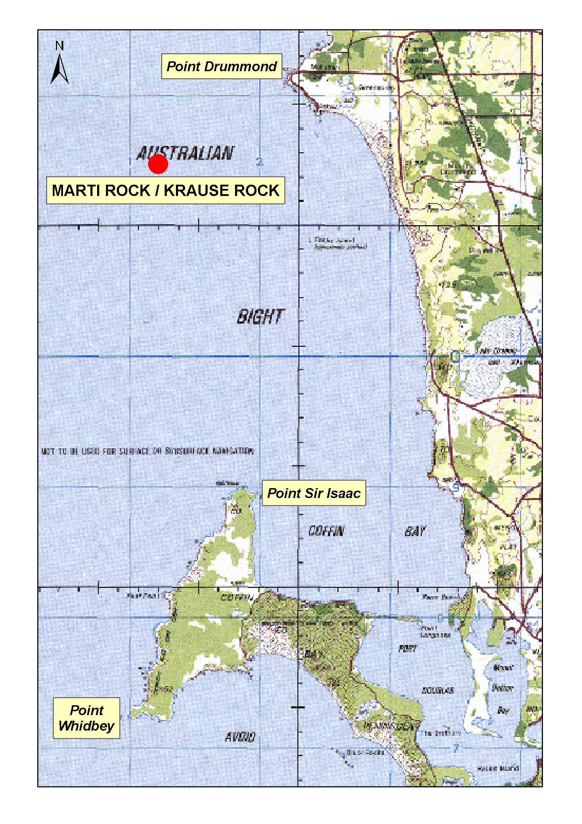
5. The exemption holder must notify PIRSA Fishwatch on 1800 065 522 at least two hours prior to conducting the exempted activity and answer a series of questions about the exempted activity. The exemption holder will need to have a copy of the exemption at the time of making the call, and be able to provide information about the area and time of the exempted activity, the vehicles and boats involved, the number of agents undertaking the exempted activity and other related questions.
6. The exemption holder must provide a report in writing detailing the outcomes of the research and the collection of organisms pursuant to this notice to the Director of Fisheries, (Attention: Alex Chalupa, G.P.O. Box 1625, Adelaide, S.A. 5001) within three months of the expiry of this notice, giving the following details:
• the date, time and location of collection;
• the description of all species collected; and
• the number of each species collected.
7. While engaged in the exempted activity, the exemption holder must be in possession of a copy of this notice. Such notice must be produced to a PIRSA Fisheries Compliance Officer if requested.
8. The exemption holder must not contravene or fail to comply with the Fisheries Act 1982, or any regulations made under that Act, except where specifically exempted by this notice.
Dated 8 March 2005.
W. Zacharin, Director of Fisheries

GEOGRAPHICAL NAMES ACT 1991
Notice to Assign a Name to a Place
NOTICE is hereby given pursuant to the provisions of the above Act that I, PETER MACLAREN KENTISH, Surveyor-General and Delegate appointed by Michael Wright, Minister for Administrative Services, Minister of the Crown to whom the administration of the Geographical Names Act 1991 is committed DO HEREBY assign the name CHARLESTON CREEK to the un-named creek located on the 1:50 000 Onkaparinga Mapsheet (6628-2) as shown on the plan below:
The Plan
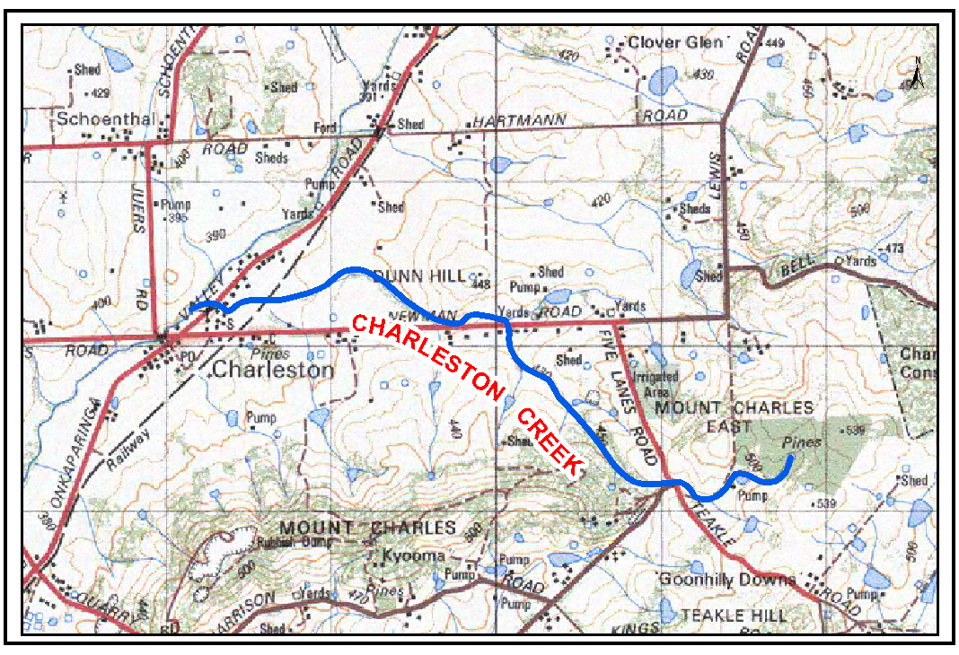
Dated 7 March 2005.
P. M. Kentish, Surveyor-General, Department for Administrative and Information Services
DAIS.22-413/04/0023

GEOGRAPHICAL NAMES ACT 1991
Notice to Assign a Dual Name to a Place
NOTICE is hereby given pursuant to the provisions of the above Act that I, PETER MACLAREN KENTISH, Surveyor-General and Delegate appointed by Michael Wright, Minister for Administrative Services, Minister of the Crown to whom the administration of the Geographical Names Act 1991 is committed DO HEREBY assign the name MARTI ROCK/KRAUSE ROCK to that feature currently identified as MARTI ROCK located on the 1:250 000 Lincoln Mapsheet and shown on the plan below:
The Plan
Dated 7 March 2005.
P. M. Kentish, Surveyor-General, Department for Administrative and Information Services
DAIS.22-413/02/0055

GEOGRAPHICAL NAMES ACT 1991
Notice of Intention to Alter the Name of a Place
NOTICE is hereby given pursuant to the provisions of the above Act, that the Minister for Administrative Services seeks public comment on a proposal to assign the name MAGNER HILL to that feature currently identified as MAGNUS HILL, located on the 1:50 000 Booleroo Mapsheet (6532-2) at GDA94 co-ordinates 277389 East and 6354652 North.
Submissions in writing regarding this proposal may be lodged with the Secretary, Geographical Names Advisory Committee, G.P.O. Box 1354, Adelaide, S.A. 5001, within one month of the publication of this notice.
Dated 28 February 2005.
P. M. Kentish, Surveyor-General, Department for Administrative and Information Services
DAIS 22-413/04/0027

LAND AND BUSINESS (SALE AND CONVEYANCING)
ACT 1994
Exemption
TAKE notice that, pursuant to section 23 (3) of the Land and Business (Sale and Conveyancing) Act 1994, I, Karlene Maywald, Minister for Consumer Affairs, do hereby exempt the person named in Schedule 1 from the application of section 23 (2) of the Act in relation to the purchase of the land specified in Schedule 2.
Schedule 1
Craig Douglas Hobby, an employee of Elders Ltd.
Schedule 2
The whole of the land described in certificate of title register book volume 5795, folio 140, situated at 13 New Landing Way, Renmark, S.A. 5341.
Dated 10 March 2005.
Signed for and on behalf of the Minister for Consumer Affairs by the Commissioner for Consumer Affairs:
M. Bodycoat, Commissioner

LAND AND BUSINESS (SALE AND CONVEYANCING)
ACT 1994
Exemption
TAKE notice that, pursuant to section 23 (3) of the Land and Business (Sale and Conveyancing) Act 1994, I, Karlene Maywald, Minister for Consumer Affairs, do hereby exempt the person named in Schedule 1 from the application of section 23 (2) of the Act in relation to the purchase of the land specified in Schedule 2.
Schedule 1
Timothy Reichstein, an employee of Landmark Operations Ltd.
Schedule 2
The whole of the land described in certificate of title register book volume 5531, folio 857, situated at 73 Brandis Street, Crystal Brook, S.A. 5523.
Dated 10 March 2005.
Signed for and on behalf of the Minister for Consumer Affairs by the Commissioner for Consumer Affairs:
M. Bodycoat, Commissioner

LIQUOR LICENSING ACT 1997 AND GAMING MACHINES ACT 1992
Notice of Application
NOTICE is hereby given, pursuant to section 52 of the Liquor Licensing Act 1997 and section 29 of the Gaming Machines Act 1992, that Matrix Hotels Pty Ltd as trustee for Matrix Hotels Trust has applied to the Licensing Authority for the transfer of a Hotel and Gaming Machine Licence in respect of premises situated at 1 George Street, Moonta, S.A. 5558 and known as Moonta Hotel.
The applications have been set down for hearing on 12 April 2005 at 9 a.m.
Any person may object to the application by lodging a notice of objection in the prescribed form with the Licensing Authority, and serving a copy of the notice on the applicant at the applicant’s address given above, at least seven days before the hearing date (viz: 4 April 2005).
The applicant’s address for service is c/o Philip Foreman, 69 Mount Barker Road, Stirling, S.A. 5152.
Plans in respect of the premises the subject of the application are open to public inspection without fee at the Office of the Liquor and Gambling Commissioner, 9th Floor, East Wing, 50 Grenfell Street, Adelaide, S.A. 5000. Phone 8226 8410, Fax:
8226 8512. Email: olgc@agd.sa.gov.au.
Dated 1 March 2005.
Applicant

LIQUOR LICENSING ACT 1997
Notice of Application
NOTICE is hereby given, pursuant to section 52 (2) (b) of the Liquor Licensing Act 1997, that Henrys Drive Vignerons Pty Ltd has applied to the Licensing Authority for the removal of a Licence in respect of premises situated at section 110, Hundred of Glenroy, Riddoch Highway, Padthaway, S.A. 5271 and to be situated at Hodgsons Road, Padthaway, S.A. 5271 and known as Henrys Drive Vignerons.
The application has been set down for hearing on 1 April 2005 at 9 a.m.
Any person may object to the application by lodging a notice of objection in the prescribed form with the Licensing Authority, and serving a copy of the notice on the applicant at the applicant’s address given above, at least seven days before the hearing date (viz: 31 March 2005).
The applicant’s address for service is c/o Karen Proud, P.O. Box 9, Padthaway, S.A. 5271.
Plans in respect of the premises the subject of the application are open to public inspection without fee at the Office of the Liquor and Gambling Commissioner, 9th Floor, East Wing, 50 Grenfell Street, Adelaide, S.A. 5000. Phone 8226 8410, Fax:
8226 8512. Email: olgc@agd.sa.gov.au.
Dated 3 March 2005.
Applicant

LIQUOR LICENSING ACT 1997
Notice of Application
NOTICE is hereby given, pursuant to section 52 (2) (b) of the Liquor Licensing Act 1997, that Henrys Drive Vignerons Pty Ltd has applied to the Licensing Authority for the removal of a Licence and a variation of conditions in respect of premises situated at section 110, Hundred of Glenroy, Riddoch Highway, Padthaway, S.A. 5271 and known as Henrys Drive Vignerons.
The application has been set down for hearing on 1 April 2005 at 9 a.m.
Condition
The following licence conditions are sought:
Variation of conditions to include cellar door sales and sampling.
Any person may object to the application by lodging a notice of objection in the prescribed form with the Licensing Authority, and serving a copy of the notice on the applicant at the applicant’s address given above, at least seven days before the hearing date (viz: 31 March 2005).
The applicant’s address for service is c/o Karen Proud, P.O. Box 9, Padthaway, S.A. 5271.
Plans in respect of the premises the subject of the application are open to public inspection without fee at the Office of the Liquor and Gambling Commissioner, 9th Floor, East Wing, 50 Grenfell Street, Adelaide, S.A. 5000. Phone 8226 8410, Fax:
8226 8512. Email: olgc@agd.sa.gov.au.
Dated 7 March 2005.
Applicant

LIQUOR LICENSING ACT 1997
Notice of Application
NOTICE is hereby given, pursuant to section 52 (2) (b) of the Liquor Licensing Act 1997, that Warren John Elliot and Theresia Herlina Dickins as trustees for the HC West Lakes Trust have applied to the Licensing Authority for a Restaurant Licence, Extended Trading Authorisation, Entertainment Consent and Extended Trading Area in respect of premises situated at Shop 27, 111 West Lakes Boulevard, West Lakes, S.A. 5021 and to be known as Hans Cafe West Lakes.
The application has been set down for hearing on 8 April 2005 at 9 a.m.
Conditions
The following licence conditions are sought:
• Approval under Section 34 (1) (c) to sell liquor for con-sumption on the licensed premises by persons:
(a) seated at a table; or
(b) attending a function at which food is provided.
• Extended Trading Authorisation:
Sunday: 8 a.m. to 11 a.m. and 8 p.m. to midnight.
• Entertainment Consent is sought in the areas shown on the plan lodged with this office including the Extended Trading Area.
• Extended Trading Area to include the outdoor area as shown on the plan lodged with this office.
Any person may object to the application by lodging a notice of objection in the prescribed form with the Licensing Authority, and serving a copy of the notice on the applicants at the applicants’ address given above, at least seven days before the hearing date (viz: 31 March 2005).
The applicants’ address for service is c/o Kelly & Co., Lawyers, Level 17, 91 King William Street, Adelaide, S.A. 5000.
Plans in respect of the premises the subject of the application are open to public inspection without fee at the Office of the Liquor and Gambling Commissioner, 9th Floor, East Wing, 50 Grenfell Street, Adelaide, S.A. 5000. Phone 8226 8410, Fax:
8226 8512. Email: olgc@agd.sa.gov.au.
Dated 25 February 2005.
Applicants

LIQUOR LICENSING ACT 1997
Notice of Application
NOTICE is hereby given, pursuant to section 52 (2) (b) of the Liquor Licensing Act 1997, that Rodi Beer Australia Pty Ltd has applied to the Licensing Authority for a Producer’s Licence in respect of premises situated at 13 Elberry Close, Moana South, S.A. 5169 and to be known as Rodi Beer.
The application has been set down for hearing on 8 April 2005 at 9 a.m.
Any person may object to the application by lodging a notice of objection in the prescribed form with the Licensing Authority, and serving a copy of the notice on the applicant at the applicant’s address given above, at least seven days before the hearing date (viz: 31 March 2005).
The applicant’s address for service is c/o Southern Vales Legal, 169 Main Road, McLaren Vale, S.A. 5171.
Plans in respect of the premises the subject of the application are open to public inspection without fee at the Office of the Liquor and Gambling Commissioner, 9th Floor, East Wing, 50 Grenfell Street, Adelaide, S.A. 5000. Phone 8226 8410, Fax:
8226 8512. Email: olgc@agd.sa.gov.au.
Dated 3 March 2005.
Applicant

LIQUOR LICENSING ACT 1997
Notice of Application
NOTICE is hereby given, pursuant to section 52 (2) (b) of the Liquor Licensing Act 1997, that Eleftheria Adamopoulos has applied to the Licensing Authority for a Producer’s Licence in respect of premises situated at 50 Vine Street, McLaren Vale, S.A. 5171 and to be known as J. & E. Adamopoulous.
The application has been set down for hearing on 8 April 2005 at 9 a.m.
Any person may object to the application by lodging a notice of objection in the prescribed form with the Licensing Authority, and serving a copy of the notice on the applicant at the applicant’s address given above, at least seven days before the hearing date (viz: 31 March 2005).
The applicant’s address for service is c/o Eleftheria Adamopoulos, 50 Vine Street, McLaren Vale, S.A. 5171.
Plans in respect of the premises the subject of the application are open to public inspection without fee at the Office of the Liquor and Gambling Commissioner, 9th Floor, East Wing, 50 Grenfell Street, Adelaide, S.A. 5000. Phone 8226 8410, Fax:
8226 8512. Email: olgc@agd.sa.gov.au.
Dated 7 March 2005.
Applicant

LIQUOR LICENSING ACT 1997
Notice of Application
NOTICE is hereby given, pursuant to section 52 (2) (b) of the Liquor Licensing Act 1997, that Peter Fitzsimons has applied to the Licensing Authority for a Producer’s Licence in respect of premises situated at 8 Karkoo Street, Seaview Downs, S.A. 5049 and to be known as Gulf Brewery.
The application has been set down for hearing on 8 April 2005 at 9 a.m.
Any person may object to the application by lodging a notice of objection in the prescribed form with the Licensing Authority, and serving a copy of the notice on the applicant at the applicant’s address given above, at least seven days before the hearing date (viz: 31 March 2005).
The applicant’s address for service is c/o Peter Fitzsimons,
8 Karkoo Street, Seaview Downs, S.A. 5049.
Plans in respect of the premises the subject of the application are open to public inspection without fee at the Office of the Liquor and Gambling Commissioner, 9th Floor, East Wing, 50 Grenfell Street, Adelaide, S.A. 5000. Phone 8226 8410, Fax:
8226 8512. Email: olgc@agd.sa.gov.au.
Dated 1 March 2005.
Applicant

LIQUOR LICENSING ACT 1997
Notice of Application
NOTICE is hereby given, pursuant to section 52 (2) (b) of the Liquor Licensing Act 1997, that Roger James and Leanne Gail O’Brien have applied to the Licensing Authority for a Retail Liquor Merchant’s Licence in respect of premises situated at
1 Progress Road, Hardwicke Bay, S.A. 5575 and known as Hardwicke Bay General Store.
The application has been set down for hearing on 8 April 2005 at 9 a.m.
Any person may object to the application by lodging a notice of objection in the prescribed form with the Licensing Authority, and serving a copy of the notice on the applicants at the applicants’ address given above, at least seven days before the hearing date (viz: 31 March 2005).
The applicants’ address for service is c/o Roger James O’Brien, 1 Progress Road, Hardwicke Bay, S.A. 5575.
Plans in respect of the premises the subject of the application are open to public inspection without fee at the Office of the Liquor and Gambling Commissioner, 9th Floor, East Wing, 50 Grenfell Street, Adelaide, S.A. 5000. Phone 8226 8410, Fax:
8226 8512. Email: olgc@agd.sa.gov.au.
Dated 3 March 2005.
Applicants

LIQUOR LICENSING ACT 1997
Notice of Application
NOTICE is hereby given, pursuant to section 52 (2) (b) of the Liquor Licensing Act 1997, that Prioak Pty Ltd has applied to the Licensing Authority for a Residential Licence in respect of premises situated at 115 Penola Road, Mount Gambier, S.A. 5290 and to be known as Motel Mount Gambier.
The application has been set down for hearing on 8 April 2005 at 9 a.m.
Conditions
The following licence conditions are sought:
• Approval under section 33 (1) (b) to sell liquor for consumption on the licensed premises by persons:
(a) seated at a table; or
(b) attending a function at which food is provided.
Any person may object to the application by lodging a notice of objection in the prescribed form with the Licensing Authority, and serving a copy of the notice on the applicant at the applicant’s address given above, at least seven days before the hearing date (viz: 31 March 2005).
The applicant’s address for service is c/o Nathan Abrahams, Hamilton Watts & Co., P.O. Box 175, Mount Gambier, S.A. 5290.
Plans in respect of the premises the subject of the application are open to public inspection without fee at the Office of the Liquor and Gambling Commissioner, 9th Floor, East Wing, 50 Grenfell Street, Adelaide, S.A. 5000. Phone 8226 8410, Fax:
8226 8512. Email: olgc@agd.sa.gov.au.
Dated 28 February 2005.
Applicant

LIQUOR LICENSING ACT 1997
Notice of Application
NOTICE is hereby given, pursuant to section 52 (2) (b) of the Liquor Licensing Act 1997, that MK Cev Pty Ltd as trustee for MK Cev Family Trust has applied to the Licensing Authority for the transfer of a Restaurant Licence in respect of premises situated at 703 Burbridge Road, West Beach, S.A. 5024, known as Tropix Cafe and to be known as Cafe Strada.
The application has been set down for hearing on 11 April 2005 at 10 a.m.
Any person may object to the application by lodging a notice of objection in the prescribed form with the Licensing Authority, and serving a copy of the notice on the applicant at the applicant’s address given above, at least seven days before the hearing date (viz: 4 April 2005).
The applicant’s address for service is c/o Paul Edwards, 100 Carrington Street, Adelaide, S.A. 5000.
Plans in respect of the premises the subject of the application are open to public inspection without fee at the Office of the Liquor and Gambling Commissioner, 9th Floor, East Wing, 50 Grenfell Street, Adelaide, S.A. 5000. Phone 8226 8410, Fax:
8226 8512. Email: olgc@agd.sa.gov.au.
Dated 1 March 2005.
Applicant

LIQUOR LICENSING ACT 1997
Notice of Application
NOTICE is hereby given, pursuant to section 52 (2) (b) of the Liquor Licensing Act 1997, that Grand Allusions Pty Ltd as trustee for Allusions Unit Trust has applied to the Licensing Authority for the transfer of a Producer’s Licence in respect of premises situated at Lot 102, Smith Hill Road, Yankalilla, S.A. 5203 and known as Allusion Wines.
The application has been set down for hearing on 11 April 2005 at 9 a.m.
Any person may object to the application by lodging a notice of objection in the prescribed form with the Licensing Authority, and serving a copy of the notice on the applicant at the applicant’s address given above, at least seven days before the hearing date (viz: 3 April 2005).
The applicant’s address for service is c/o Warmings Barristers and Solicitors, Ground Floor, 459 Morphett Street, Adelaide, S.A. 5000.
Plans in respect of the premises the subject of the application are open to public inspection without fee at the Office of the Liquor and Gambling Commissioner, 9th Floor, East Wing, 50 Grenfell Street, Adelaide, S.A. 5000. Phone 8226 8410, Fax:
8226 8512. Email: olgc@agd.sa.gov.au.
Dated 25 February 2005.
Applicant

LIQUOR LICENSING ACT 1997
Notice of Application
NOTICE is hereby given, pursuant to section 52 (2) (b) of the Liquor Licensing Act 1997, that Big Deal Leisure as trustee for the L. & S. Brown Family Trust has applied to the Licensing Authority for the transfer of a Special Circumstances Licence in respect of premises situated at 182 Hindley Street West, Adelaide, S.A. 5000.
The application has been set down for hearing on 11 April 2005 at 9.30 a.m.
Any person may object to the application by lodging a notice of objection in the prescribed form with the Licensing Authority, and serving a copy of the notice on the applicant at the applicant’s address given above, at least seven days before the hearing date (viz: 3 April 2005).
The applicant’s address for service is c/o Leigh Brown, 25 Hilltop Drive, Oakden, S.A. 5086.
Plans in respect of the premises the subject of the application are open to public inspection without fee at the Office of the Liquor and Gambling Commissioner, 9th Floor, East Wing, 50 Grenfell Street, Adelaide, S.A. 5000. Phone 8226 8410, Fax:
8226 8512. Email: olgc@agd.sa.gov.au.
Dated 2 March 2005.
Applicant

LIQUOR LICENSING ACT 1997
Notice of Application
NOTICE is hereby given, pursuant to section 52 (2) (b) of the Liquor Licensing Act 1997, that Shanghai House Restaurant Pty Ltd has applied to the Licensing Authority for the transfer of a Restaurant Licence in respect of premises situated at 128 O’Connell Street, North Adelaide, S.A. 5006 and known as Great River Korean BBQ City.
The application has been set down for hearing on 12 April 2005 at 9.30 a.m.
Any person may object to the application by lodging a notice of objection in the prescribed form with the Licensing Authority, and serving a copy of the notice on the applicant at the applicant’s address given above, at least seven days before the hearing date (viz: 4 April 2005).
The applicant’s address for service is c/o Claudia Cream & Co., 19 Wright Court, Adelaide, S.A. 5000.
Plans in respect of the premises the subject of the application are open to public inspection without fee at the Office of the Liquor and Gambling Commissioner, 9th Floor, East Wing, 50 Grenfell Street, Adelaide, S.A. 5000. Phone 8226 8410, Fax:
8226 8512. Email: olgc@agd.sa.gov.au.
Dated 2 March 2005.
Applicant

LIQUOR LICENSING ACT 1997
Notice of Application
NOTICE is hereby given, pursuant to section 52 (2) (b) of the Liquor Licensing Act 1997, that Lap Chung Chow and Juad Leng Karlsen have applied to the Licensing Authority for the transfer of a Restaurant Licence in respect of premises situated at 297 Montacute Road, Newton, S.A. 5074 and known as Chinese Garden Restaurant.
The application has been set down for hearing on 13 April 2005 at 9 a.m.
Any person may object to the application by lodging a notice of objection in the prescribed form with the Licensing Authority, and serving a copy of the notice on the applicants at the applicants’ address given above, at least seven days before the hearing date (viz: 5 April 2005).
The applicants’ address for service is c/o Lap Chung Chow, 297 Montacute Road, Newton, S.A. 5074.
Plans in respect of the premises the subject of the application are open to public inspection without fee at the Office of the Liquor and Gambling Commissioner, 9th Floor, East Wing, 50 Grenfell Street, Adelaide, S.A. 5000. Phone 8226 8410, Fax:
8226 8512. Email: olgc@agd.sa.gov.au.
Dated 3 March 2005.
Applicants

LIQUOR LICENSING ACT 1997
Notice of Application
NOTICE is hereby given, pursuant to section 52 (2) (b) of the Liquor Licensing Act 1997, that Amici Bros. Pty Ltd as trustee for the Martini Trust has applied to the Licensing Authority for the transfer of a Restaurant Licence in respect of premises situated at 53-59 The Parade, Norwood, S.A. 5067 and known as Martini Cafe.
The application has been set down for hearing on 13 April 2005 at 10.30 a.m.
Any person may object to the application by lodging a notice of objection in the prescribed form with the Licensing Authority, and serving a copy of the notice on the applicant at the applicant’s address given above, at least seven days before the hearing date (viz: 5 April 2005).
The applicant’s address for service is c/o Joshua Ingham,
2 Lyons Parade, Forestville, S.A. 5035.
Plans in respect of the premises the subject of the application are open to public inspection without fee at the Office of the Liquor and Gambling Commissioner, 9th Floor, East Wing, 50 Grenfell Street, Adelaide, S.A. 5000. Phone 8226 8410, Fax:
8226 8512. Email: olgc@agd.sa.gov.au.
Dated 2 March 2005.
Applicant

LIQUOR LICENSING ACT 1997
Notice of Application
NOTICE is hereby given, pursuant to section 52 (2) (b) of the Liquor Licensing Act 1997, that Shaun, Kristina and Beverly Clarke have applied to the Licensing Authority for the transfer of a Liquor and Gaming Licence in respect of premises situated at Blanche Street, Edithburgh, S.A. 5583 and known as Troubridge Hotel.
The application has been set down for hearing on 14 April 2005 at 10 a.m.
Any person may object to the application by lodging a notice of objection in the prescribed form with the Licensing Authority, and serving a copy of the notice on the applicant at the applicants’ address given above, at least seven days before the hearing date (viz: 6 April 2005).
The applicants’ address for service is c/o Duncan Basheer Hannon, Barristers and Solicitors, G.P.O. Box 2, Adelaide, S.A. 5001 (Attention: Max Basheer/David Tillett).
Plans in respect of the premises the subject of the application are open to public inspection without fee at the Office of the Liquor and Gambling Commissioner, 9th Floor, East Wing, 50 Grenfell Street, Adelaide, S.A. 5000. Phone 8226 8410, Fax:
8226 8512. Email: olgc@agd.sa.gov.au.
Dated 3 March 2005.
Applicants

MINING ACT 1971
NOTICE is hereby given in accordance with section 28 (5) of the Mining Act 1971, that the Minister for Mineral Resources Development proposes to grant an Exploration Licence over the undermentioned area:
Applicant: Cameco Pty Ltd
Location: Verran area⎯Approximately 110 km north-north-east of Port Lincoln.
Term: 1 year
Area in km²: 944
Ref.: 2004/00884
Plans and co-ordinates can be found on the PIRSA Sarig website: http://www.minerals.pir.sa.gov.au/sarig or by phoning Mineral Tenements on (08) 8463 3103.
Dated 10 March 2005.
H. Tyrteos, Mining Registrar

MINING ACT 1971
NOTICE is hereby given in accordance with section 28 (5) of the Mining Act 1971, that the Minister for Mineral Resources Development proposes to grant an Exploration Licence over the undermentioned area:
Applicant: Cameco Pty Ltd
Location: Fair View area⎯Approximately 120 km north-east of Port Lincoln.
Term: 1 year
Area in km²: 812
Ref.: 2004/00901
Plans and co-ordinates can be found on the PIRSA Sarig website: http://www.minerals.pir.sa.gov.au/sarig or by phoning Mineral Tenements on (08) 8463 3103.
Dated 10 March 2005.
H. Tyrteos, Mining Registrar

MINING ACT 1971
NOTICE is hereby given in accordance with section 28 (5) of the Mining Act 1971, that the Minister for Mineral Resources Development proposes to grant an Exploration Licence over the undermentioned area:
Applicant: Helix Resources Limited
Location: Yellabinna area⎯Approximately 110 km north-east of Ceduna.
Term: 1 year
Area in km²: 355
Ref.: 2004/00180
Plans and co-ordinates can be found on the PIRSA Sarig website: http://www.minerals.pir.sa.gov.au/sarig or by phoning Mineral Tenements on (08) 8463 3103.
Dated 10 March 2005.
H. Tyrteos, Mining Registrar

GOVERNMENT GAZETTE ADVERTISEMENT RATES

To apply from 1 July 2004

$  Agents, Ceasing to Act as 35.50  Associations:  Incorporation 18.10  Intention of Incorporation 44.75  Transfer of Properties 44.75  Attorney, Appointment of 35.50  Bailiff’s Sale 44.75  Cemetery Curator Appointed 26.50  Companies:  Alteration to Constitution 35.50  Capital, Increase or Decrease of 44.75  Ceasing to Carry on Business 26.50  Declaration of Dividend 26.50  Incorporation 35.50  Lost Share Certificates:  First Name 26.50  Each Subsequent Name 9.10  Meeting Final 29.75  Meeting Final Regarding Liquidator’s Report on  Conduct of Winding Up (equivalent to ‘Final  Meeting’)  First Name 35.50  Each Subsequent Name 9.10  Notices:  Call 44.75  Change of Name 18.10  Creditors 35.50  Creditors Compromise of Arrangement 35.50  Creditors (extraordinary resolution that ‘the Com-pany be wound up voluntarily and that a liquidator be appointed’) 44.75  Release of Liquidator⎯Application⎯Large Ad. 70.50  ⎯Release Granted 44.75  Receiver and Manager Appointed 41.25  Receiver and Manager Ceasing to Act 35.50  Restored Name 33.50  Petition to Supreme Court for Winding Up 62.00  Summons in Action 53.00  Order of Supreme Court for Winding Up Action 35.50  Register of Interests⎯Section 84 (1) Exempt 80.00  Removal of Office 18.10  Proof of Debts 35.50  Sales of Shares and Forfeiture 35.50  Estates:  Assigned 26.50  Deceased Persons⎯Notice to Creditors, etc. 44.75  Each Subsequent Name 9.10  Deceased Persons⎯Closed Estates 26.50  Each Subsequent Estate 1.15  Probate, Selling of 35.50  Public Trustee, each Estate 9.10 |  | $  Firms:  Ceasing to Carry on Business (each insertion) 23.60  Discontinuance Place of Business 23.60  Land⎯Real Property Act:  Intention to Sell, Notice of 44.75  Lost Certificate of Title Notices 44.75  Cancellation, Notice of (Strata Plan) 44.75  Mortgages:  Caveat Lodgment 18.10  Discharge of 19.00  Foreclosures 18.10  Transfer of 18.10  Sublet 9.10  Leases⎯Application for Transfer (2 insertions) each 9.10  Lost Treasury Receipts (3 insertions) each 26.50  Licensing 53.00  Municipal or District Councils:  Annual Financial Statement⎯Forms 1 and 2 499.00  Electricity Supply⎯Forms 19 and 20 354.00  Default in Payment of Rates:  First Name 70.50  Each Subsequent Name 9.10  Noxious Trade 26.50  Partnership, Dissolution of 26.50  Petitions (small) 18.10  Registered Building Societies (from Registrar-  General) 18.10  Register of Unclaimed Moneys⎯First Name 26.50  Each Subsequent Name 9.10  Registers of Members⎯Three pages and over:  Rate per page (in 8pt) 226.00  Rate per page (in 6pt) 299.00  Sale of Land by Public Auction 45.25  Advertisements 2.50  Advertisements, other than those listed are charged at $2.50 per column line, tabular one-third extra.  Notices by Colleges, Universities, Corporations and District Councils to be charged at $2.50 per line.  Where the notice inserted varies significantly in length from that which is usually published a charge of $2.50 per column line will be applied in lieu of advertisement rates listed.  South Australian Government publications are sold on the condition that they will not be reproduced without prior permission from the Government Printer.
All the above prices include GST

GOVERNMENT GAZETTE NOTICES
ALL private advertisements forwarded for publication in the South Australian Government Gazette must be PAID FOR PRIOR TO INSERTION; and all notices, from whatever source, should be legibly written on one side of the paper only and sent to Government Publishing SA so as to be received no later than 4 p.m. Tuesday preceding the day of publication. Phone 8207 1045 or Fax 8207 1040. E-mail: governmentgazette@saugov.sa.gov.au. Send as attachments in Word format. Please include date the notice is to be published and to whom the notice will be charged. The Government Gazette is available online at: www.governmentgazette.sa.gov.au.

MISCELLANEOUS LEGISLATION AND GOVERNMENT PUBLICATIONS PRICES AS FROM 1 JULY 2004

Acts, Bills, Rules, Parliamentary Papers and Regulations
Pages | Main | Amends | Pages | Main | Amends

1-16 | 2.15 | 0.95 | 497-512 | 30.25 | 29.00
17-32 | 2.90 | 1.80 | 513-528 | 31.25 | 29.90
33-48 | 3.80 | 2.70 | 529-544 | 32.00 | 31.00
49-64 | 4.75 | 3.65 | 545-560 | 33.00 | 32.00
65-80 | 5.60 | 4.60 | 561-576 | 33.75 | 33.00
81-96 | 6.50 | 5.40 | 577-592 | 34.75 | 33.50
97-112 | 7.40 | 6.30 | 593-608 | 35.75 | 34.50
113-128 | 8.30 | 7.25 | 609-624 | 36.50 | 35.50
129-144 | 9.35 | 8.25 | 625-640 | 37.25 | 36.10
145-160 | 10.20 | 9.10 | 641-656 | 38.25 | 37.20
161-176 | 11.20 | 10.00 | 657-672 | 38.75 | 38.00
177-192 | 12.00 | 11.00 | 673-688 | 40.50 | 38.80
193-208 | 13.00 | 11.90 | 689-704 | 41.25 | 39.90
209-224 | 13.80 | 12.70 | 705-720 | 41.75 | 41.00
225-240 | 14.70 | 13.60 | 721-736 | 43.50 | 41.50
241-257 | 15.70 | 14.30 | 737-752 | 44.00 | 42.90
258-272 | 16.60 | 15.30 | 753-768 | 45.00 | 43.40
273-288 | 17.50 | 16.40 | 769-784 | 45.50 | 44.70
289-304 | 18.30 | 17.20 | 785-800 | 46.50 | 45.60
305-320 | 19.30 | 18.20 | 801-816 | 47.25 | 46.00
321-336 | 20.10 | 19.00 | 817-832 | 48.25 | 47.25
337-352 | 21.20 | 20.00 | 833-848 | 49.25 | 48.00
353-368 | 22.00 | 21.00 | 849-864 | 50.00 | 48.80
369-384 | 22.90 | 21.90 | 865-880 | 51.00 | 50.00
385-400 | 23.80 | 22.70 | 881-896 | 51.50 | 50.50
401-416 | 23.70 | 23.50 | 897-912 | 53.00 | 51.50
417-432 | 25.75 | 24.50 | 913-928 | 53.50 | 53.00
433-448 | 26.60 | 25.50 | 929-944 | 54.50 | 53.50
449-464 | 27.50 | 26.25 | 945-960 | 55.50 | 54.00
465-480 | 28.00 | 27.25 | 961-976 | 56.50 | 55.00
481-496 | 29.25 | 28.00 | 977-992 | 57.50 | 56.00

Legislation—Acts, Regulations, etc: $
Subscriptions:
Acts 187.00
All Bills as Laid 447.00
Rules and Regulations 447.00
Parliamentary Papers 447.00
Bound Acts 207.00
Index 103.00
Government Gazette
Copy 4.85
Subscription 247.00
Hansard
Copy 13.50
Subscription—per session (issued weekly) 388.00
Cloth bound—per volume 167.00
Subscription—per session (issued daily) 388.00
Legislation on Disk
Whole Database 2 868.00
Annual Subscription for fortnightly updates 881.00
Individual Act(s) including updates POA
Compendium
Subscriptions:
New Subs 1 700.00
Updates 600.00
(All the above prices include GST)

All Legislation, Government Gazette, Hansard and Legislation on disk are available from:
Counter Sales Service SA, Government Legislation⁺ Outlet
and Mail Orders: Lands Titles Office, 101 Grenfell Street, Adelaide
Phone: 13 23 24 (local call cost), Fax: (08) 8204 1909
Postal: G.P.O. Box 1707, Adelaide, S.A. 5001

Online Shop: www.shop.service.sa.gov.au

Subscriptions and Government Publishing SA
Standing Orders: Box 9, Plaza Level, Riverside Centre, North Terrace, Adelaide, S.A. 5000
Phone: (08) 8207 0908, (08) 8207 0910, Fax: (08) 8207 1040

NATIONAL PARKS AND WILDLIFE ACT 1972
Open Season for the Taking of Protected Animals at Bool Lagoon Game Reserve
Open Season for Ducks
PURSUANT to section 52 of the National Parks and Wildlife Act 1972, I, John Hill, Minister for Environment and Conservation, being the Minister for the Crown to whom the administration of the National Parks and Wildlife Act is for the time being committed, declare an open season for the taking of protected animals as set out in this notice.
1. General Open Season
1.1 Area of the State
1.1.1 The open season applies to those species of protected animals listed in clause 1.1.2 over the whole of the State, excluding any reserves constituted under the National Parks and Wildlife Act 1972 or any wilderness protection area or any wilderness protection zone constituted under the Wilderness Protection Act 1992, other that the game reserves listed in Clause 2 of this notice.
1.1.2 Grey Teal (Anas gracilis)
Chestnut Teal (Anas castanea)
Pacific Black Duck (Anas superciliosa)
Australian Wood Duck (Maned Duck) (Chenonetta jubata)
Australian Shelduck (Mountain Duck) (Tadorna tadornoides)
Pink-eared Duck (Malacorhynchus membranaceus)
Hardhead (Aythya australis)
2. Open Season in Game Reserves
The open season for the taking of the abovementioned species of duck in game reserves is as follows:
2.1 Bool Lagoon Game Reserve
2.1.1 Area
The open season applies to all the Reserve, other than, for safety and conservation reasons, the Exclusion Zone as indicated on the map following. The Exclusion Zone applies to all users of Bool Lagoon Game Reserve during the open period.
2.1.2 Period
The period of the open season for the Bool Lagoon Game Reserve is:
Tuesday, 15 March 2005 until Friday, 18 March 2005, from 6.55 a.m. to 10 a.m.; Monday, 21 March 2005 until Thursday, 24 March 2005, from 7 a.m. to 10 a.m.; Tuesday, 29 March 2005 until Saturday, 2 April 2005, from 6.30 a.m. to 10 a.m. and Saturday, 9 April 2005, from 6.30 a.m. to 10 a.m.
3. Prohibition Against Taking Eggs
3.1 A person shall not take duck eggs during the open season.
4. Bag Limit
4.1 For the abovementioned open season, there is no bag limit on Australian Wood Duck (Maned Duck) (Chenonetta jubata).
4.2 On any day of the open season, a person shall not take more than 10 protected animals of the following species:
Grey Teal (Anas gracilis)
Chestnut Teal (Anas castanea)
Pacific Black Duck (Anas superciliosa)
Australian Shelduck (Mountain Duck) (Tadorna tadornoides)
Pink-eared Duck (Malacorhynchus membranaceus)
Hardhead (Aythya australis)

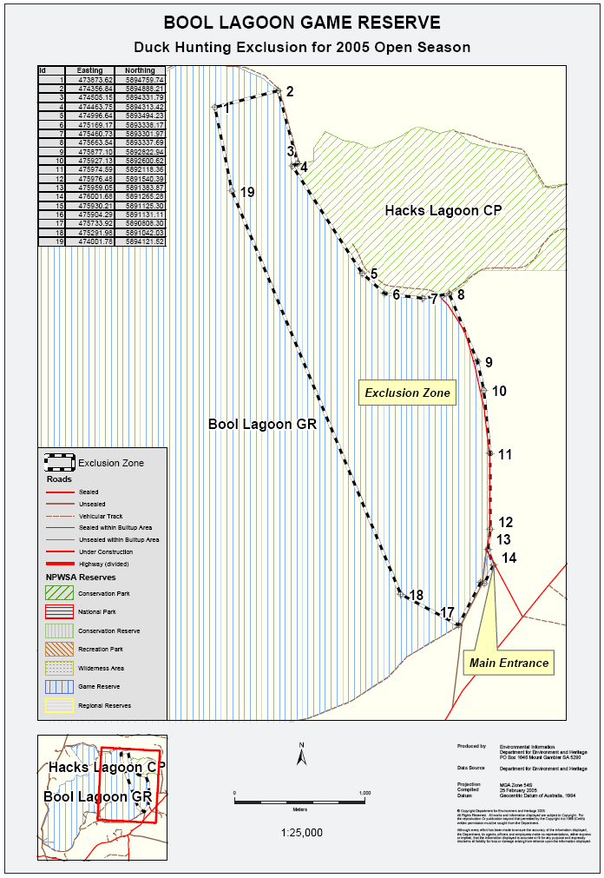
Dated 6 March 2005.
John Hill, Minister for Environment and Conservation

PETROLEUM ACT 2000
Surrender of Associated Facilities Licences—AFL 5 and AFL 6
NOTICE is hereby given that I have accepted surrender of the abovementioned Associated Facilities Licences with effect from 27 March 2005, under the provisions of the Petroleum Act 2000, pursuant to delegated powers dated 28 March 2002, Gazetted 11 April 2002, page 1573.
No. of Licence | Licensee | Locality | Area in km² | Reference
AFL 5 | Victoria Petroleum NL  Permian Oil Pty Ltd  Springfield Oil and Gas Pty Ltd  Lion Energy Ltd  Tacnas Pty Ltd  Elcos Pty Ltd | Cooper Basin of South Australia | 2.50 | 27/2/271
AFL 6 | Victoria Petroleum NL  Permian Oil Pty Ltd  Springfield Oil and Gas Pty Ltd  Lion Energy Ltd  Tacnas Pty Ltd  Elcos Pty Ltd | Cooper Basin of South Australia | 4.50 | 27/2/272
Description of Area—AFL 5
All that part of the State of South Australia, bounded by the following polygon description, adjacent to Petroleum Exploration Licence PEL 104:
Polygon 1
Commencing at a point being the intersection of latitude -27.500000 AGD66 and longitude 139.614766 GDA94, thence west to the intersection of latitude -27.500000 AGD66 and longitude 139.613451 GDA94, thence north-westerly to the intersection of latitude -27.4772650 GDA94 and longitude 139.5936358 GDA94, thence north-westerly to the intersection of latitude -27.4765681 GDA94 and longitude 139.5929886 GDA94, thence north-westerly to the intersection of latitude -27.4657142 GDA94 and longitude 139.5829075 GDA94, thence north-westerly to the intersection of latitude -27.4650186 GDA94 and longitude 139.5822617 GDA94, thence north-westerly to the intersection of latitude -27.445012 GDA94 and longitude 139.563687 GDA94, thence north-easterly to the intersection of latitude -27.444436 GDA94 and longitude 139.564466 GDA94, thence south-easterly to the intersection of latitude -27.464418 GDA94 and longitude 139.583018 GDA94, thence north-easterly to the intersection of latitude -27.408584 GDA94 and longitude 139.653322 GDA94, thence south-easterly to the intersection of latitude -27.409259 GDA94 and longitude 139.653995 GDA94, thence south-westerly to the intersection of latitude -27.465114 GDA94 and longitude 139.583664 GDA94, thence south-easterly to the intersection of latitude -27.475941 GDA94 and longitude 139.593720 GDA94, thence north-easterly to the intersection of latitude -27.428891 GDA94 and longitude 139.648622 GDA94, thence south-easterly to the intersection of latitude -27.429547 GDA94 and longitude 139.649322 GDA94, thence south-westerly to the intersection of latitude -27.476638 GDA94 and longitude 139.594368 GDA94 and south-easterly to the point of commencement.
Polygon 2
Commencing at a point being the intersection of latitude -27.500000 AGD66 and longitude 139.627655 GDA94, thence north-easterly to the intersection of latitude -27.490346 GDA94 and longitude 139.638393 GDA94, thence south-easterly to the intersection of latitude -27.491029 GDA94 and longitude 139.639054 GDA94, thence south-westerly to the intersection of latitude
-27.500000 AGD66 and longitude 139.629259 GDA94 and west to the point of commencement.
Area: 2.50 km² approximately.
Description of Area—AFL 6
All that part of the State of South Australia, bounded by the following polygon description, adjacent to Petroleum Exploration Licence PEL 104:
Polygon 1
Commencing at a point being the intersection of latitude -27.500000 AGD66 and longitude 139.532481 GDA94, thence west to the intersection of latitude -27.500000 AGD66 and longitude 139.531230 GDA94, thence north-westerly to the intersection of latitude -27.4875911 GDA94 and longitude 139.5223433 GDA94, thence south-westerly to the intersection of latitude -27.500000 AGD66 and longitude 139.508426 GDA94, thence west to the intersection of latitude -27.500000 AGD66 and longitude 139.506897 GDA94, thence north-easterly to the intersection of latitude -27.4868567 GDA94 and longitude 139.5217469 GDA94, thence north-westerly to the intersection of latitude -27.4640314 GDA94 and longitude 139.5032189 GDA94, thence south-westerly to the intersection of latitude -27.4673772 GDA94 and longitude 139.4988997 GDA94, thence north-westerly to the intersection of latitude -27.4666958 GDA94 and longitude 139.4982361 GDA94, thence north-easterly to the intersection of latitude -27.4632975 GDA94 and longitude 139.5026233 GDA94, thence north-westerly to the intersection of latitude -27.4575647 GDA94 and longitude 139.4979714 GDA94, thence north-easterly to the intersection of latitude -27.4570353 GDA94 and longitude 139.4987908 GDA94, thence south-easterly to the intersection of latitude -27.4627033 GDA94 and longitude 139.5033903 GDA94, thence north-easterly to the intersection of latitude -27.4383650 GDA94 and longitude 139.5347961 GDA94, thence north-westerly to the intersection of latitude -27.4316344 GDA94 and longitude 139.5288694 GDA94, thence north-easterly to the intersection of latitude -27.4310769 GDA94 and longitude 139.5296650 GDA94, thence south-easterly to the intersection of latitude -27.4377722 GDA94 and longitude 139.5355608 GDA94, thence north-easterly to the intersection of latitude -27.4304419 GDA94 and longitude 139.5450147 GDA94, thence south-easterly to the intersection of latitude -27.4311233 GDA94 and longitude 139.5456783 GDA94, thence south-westerly to the intersection of latitude -27.4384828 GDA94 and longitude 139.5361864 GDA94, thence south-easterly to the intersection of latitude -27.4603778 GDA94 and longitude 139.5554736 GDA94, thence north-easterly to the intersection of latitude -27.4547878 GDA94 and longitude 139.5625903 GDA94, thence south-easterly to the intersection of latitude -27.4554653 GDA94 and longitude 139.5632589 GDA94, thence south-westerly to the intersection of latitude -27.4610886 GDA94 and longitude 139.5561000 GDA94, thence south-easterly to the intersection of latitude -27.4756167 GDA94 and longitude 139.5689033 GDA94, thence north-easterly to the intersection of latitude -27.4650186 GDA94 and longitude 139.5822617 GDA94, thence south-easterly to the intersection of latitude -27.4657142 GDA94 and longitude 139.5829075 GDA94, thence south-westerly to the intersection of latitude -27.4763275 GDA94 and longitude 139.5695297 GDA94, thence south-easterly to the intersection of latitude -27.4879114 GDA94 and longitude 139.5797414 GDA94, thence north-easterly to the intersection of latitude -27.4765681 GDA94 and longitude 139.5929886 GDA94, thence south-easterly to the intersection of latitude -27.4772650 GDA94 and longitude 139.5936358 GDA94, thence south-westerly to the intersection of latitude -27.4886242 GDA94 and longitude 139.5803700 GDA94, thence south-easterly to the intersection of latitude -27.500000 AGD66 and longitude 139.589148 GDA94, thence west to the intersection of latitude -27.500000 AGD66 and longitude 139.587860 GDA94, thence north-westerly to the intersection of latitude -27.4892525 GDA94 and longitude 139.5796364 GDA94, thence south-westerly to the intersection of latitude -27.500000 AGD66 and longitude 139.568756 GDA94, thence west to the intersection of latitude -27.500000 AGD66 and longitude 139.567295 GDA94, thence north-easterly to the intersection of latitude -27.4885394 GDA94 and longitude 139.5790078 GDA94, thence north-westerly to the intersection of latitude -27.4769283 GDA94 and longitude 139.5687722 GDA94, thence south-westerly to the intersection of latitude -27.500000 AGD66 and longitude 139.541512 GDA94, thence west to the intersection of latitude -27.500000 AGD66 and longitude 139.539990 GDA94, thence north-easterly to the intersection of latitude -27.4762175 GDA94 and longitude 139.5681456 GDA94, thence north-westerly to the intersection of latitude -27.4616858 GDA94 and longitude 139.5553394 GDA94, thence south-westerly to the intersection of latitude -27.4869922 GDA94 and longitude 139.5231064 GDA94, thence north-westerly to the intersection of latitude -27.4862578 GDA94 and longitude 139.5225103 GDA94, thence north-easterly to the intersection of latitude -27.460975 GDA94 and longitude 139.5547131 GDA94, thence north-westerly to the intersection of latitude -27.4390756 GDA94 and longitude 139.5354219 GDA94, thence south-westerly to the intersection of latitude -27.4634372 GDA94 and longitude 139.5039858 GDA94 and south-easterly to the point of commencement.
Polygon 2
Commencing at a point being the intersection of latitude -27.555040 GDA94 and longitude 139.500000 AGD66, thence south to the intersection of latitude -27.556291 GDA94 and longitude 139.500000 AGD66, thence south-westerly to the intersection of latitude -27.571249 GDA94 and longitude 139.483749 GDA94, thence north-westerly to the intersection of latitude -27.570597 GDA94 and longitude 139.483048 GDA94 and north-easterly to the point of commencement.
Polygon 3
Commencing at a point being the intersection of latitude 27°35′00″S AGD66 and longitude 139.519269 GDA94, thence east to the intersection of latitude 27°35′00″S AGD66 and longitude 139.520821 GDA94, thence south-westerly to the intersection of latitude -27.598261 GDA94 and longitude 139.499406 GDA94, thence north-westerly to the intersection of latitude -27.597577 GDA94 and longitude 139.498746 GDA94 and north-easterly to the point of commencement.
Polygon 4
Commencing at a point being the intersection of latitude 27°40′00″S AGD66 and longitude 139.674642 GDA94, thence east to the intersection of latitude 27°40′00″S AGD66 and longitude 139.676191 GDA94, thence south-easterly to the intersection of latitude -27.672219 GDA94 and longitude 139.685337 GDA94, thence south-westerly to the intersection of latitude -27.672901 GDA94 and longitude 139.684673 GDA94 and north-westerly to the point of commencement.
Polygon 5
Commencing at a point being the intersection of latitude -27.630398 GDA94 and longitude 139.900000 Clarke1858, thence north to the intersection of latitude -27.629023 GDA94 and longitude 139.900000 Clarke1858, thence south-easterly to the intersection of latitude -27.637126 GDA94 and longitude 139.906916 GDA94, thence south-westerly to the intersection of latitude
-27.637719 GDA94 and longitude 139.906151 GDA94 and north-westerly to the point of commencement.
Area: 4.50 km² approximately.
Dated 2 March 2005.
B. A. Goldstein, Director Petroleum
Minerals and Energy Division
Primary Industries and Resources SA
Delegate of the Minister for Mineral Resources Development

PETROLEUM ACT 2000
Temporary Cessation of Suspension of
Exploration Licence PEL 27
PURSUANT to section 90 of the Petroleum Act 2000, notice is hereby given that the suspension dated 11 February 2005 of the abovementioned Exploration Licence has been temporarily ceased under the provisions of the Petroleum Act 2000, from and including 1 March 2005 to 31 March 2005, pursuant to delegated powers dated 28 March 2002, Gazetted 11 April 2002, page 1573.
The suspension dated 11 February 2005 will resume with effect from 1 April 2005 until 9 December 2005.
Dated 1 March 2005.
B. A. Goldstein, Director Petroleum
Minerals and Energy Division
Primary Industries and Resources SA
Delegate of the Minister for Mineral
Resources Development

PREVENTION OF CRUELTY TO ANIMALS ACT 1985
Appointments
PURSUANT to section 28 of the Prevention of Cruelty to Animals Act 1985, I, John Hill, Minister for Environment and Conser-vation, appoint the following persons nominated by the Royal Society for the Prevention of Cruelty to Animals South Australia Incorporated to be inspectors for the purposes of the Act:
• Kingsley Mark Cotter
• Erin Louise Hutchings
Dated 6 March 2005.
John Hill, Minister for Environment and Conservation

REGULATIONS UNDER THE TRADE STANDARDS
ACT 1979
Exemption
TAKE notice that, pursuant to Clause 3 in Schedule 1 of the Regulations under the Trade Standards Act 1979, I, Mark Ian Bodycoat, Commissioner for Consumer Affairs, do hereby exempt the article named in Schedule 1 from the application of those sections of the Regulations in relation to the trapping space described in Schedule 2.
Schedule 1
TGA Unlimited Pty Ltd, children’s folding chair sold in Getaway Camping Set, Item No. #1433.
Schedule 2
Exemption from complying with the provisions of Clause 2 (1). A children’s folding chair must be so constructed that the minimum distance between components forming a trapping space is 5 mm.
Dated 23 February 2005.
M. Bodycoat, Commissioner for Consumer Affairs
Ref: PS 118/86

ROADS (OPENING AND CLOSING) ACT 1991:
SECTION 24
NOTICE OF CONFIRMATION OF ROAD
PROCESS ORDER
Yuda Street, Port Augusta
Deposited Plan 61418
BY Road Process Order made on 25 February 2005, the Development Assessment Commission ordered that:
1. Portion of the public road (Yuda Street) adjoining allotment 3 in Deposited Plan 21216 and closed road A in Road Plan 6811, more particularly delineated and lettered ‘B’ in Preliminary Plan No. 02/0087 be closed.
2. The whole of the land subject to closure be transferred to Penroth Pty Ltd in accordance with agreement for transfer dated 21 February 2005 entered into between The Corporation of the City of Port Augusta and Penroth Pty Ltd.
On 2 March 2005 that order was confirmed by the Minister for Administrative Services conditionally on approval and deposit of the survey plan by the Registrar-General. The condition has now been fulfilled.
Pursuant to section 24 (5) of the Roads (Opening and Closing) Act 1991, NOTICE of the order referred to above and its confirmation is hereby given.
Dated 10 March 2005.
P. M. Kentish, Surveyor-General

ROADS (OPENING AND CLOSING) ACT 1991:
SECTION 24
NOTICE OF CONFIRMATION OF ROAD
PROCESS ORDER
Public Road, Arno Bay
Deposited Plan 64341
BY Road Process Order made on 13 February 2004, The District Council of Cleve ordered that:
1. The whole of the unnamed public road adjoining pieces 104, 103 and 105 in Deposited Plan 53065 more particularly lettered ‘A’, ‘B’ and ‘C’ (respectively) in Preliminary Plan No. 03/0102 be closed.
2. The whole of the land subject to closure lettered ‘A’ and ‘C’ be transferred to Neil Desmond Ramsey and Wendy Patricia Ramsey in accordance with agreement for transfer dated 21 October 2003 entered into between The District Council of Cleve and N. D. and W. P. Ramsey.
3. The whole of the land subject to closure lettered ‘B’ be transferred to Clean Seas Aquaculture Hatchery Pty. Ltd in accordance with agreement for transfer dated 21 October 2003 entered into between The District Council of Cleve and Clean Seas Aquaculture Hatchery Pty Ltd.
On 16 March 2004 that order was confirmed by the Minister for Administrative Services conditionally on approval and deposit of the survey plan by the Registrar-General. The condition has now been fulfilled.
Pursuant to section 24 (5) of the Roads (Opening and Closing) Act 1991, NOTICE of the order referred to above and its confirmation is hereby given.
Dated 10 March 2005.
P. M. Kentish, Surveyor-General

ROADS (OPENING AND CLOSING) ACT 1991:
SECTION 24
NOTICE OF CONFIRMATION OF ROAD
PROCESS ORDER
Kurramin Court, Port Elliot
Deposited Plan 67161
BY Road Process Order made on 19 January 2005, the Alexandrina Council ordered that:
1. Portion of the public road (Kurramin Court) adjoining section 276 in the Hundred of Goolwa more particularly lettered ‘A’ in Preliminary Plan No. 04/0091 be closed.
2. Vest the whole of the land subject to closure in the Crown.
On 7 March 2005 that order was confirmed by the Minister for Administrative Services conditionally on approval and deposit of the survey plan by the Registrar-General. The condition has now been fulfilled.
Pursuant to section 24 (5) of the Roads (Opening and Closing) Act 1991, NOTICE of the order referred to above and its confirmation is hereby given.
Dated 10 March 2005.
P. M. Kentish, Surveyor-General

Training and Skills Development Act 2003

Part 4 – Apprenticeships/Traineeships

Pursuant to the provision of the Training and Skills Development Act 2003, the Training and Skills Commission (TaSC) gives notice that determines the following:
Trades, Declared Vocations or Other Occupations

The following schedule is additional to the gazettals of:

- 5 February 2004 | - 19 February 2004 | - 11 March 2004
- 1 April 2004 | - 1 July 2004 | - 15 July 2004
- 22 July 2004 | - 30 September 2004 | - 16 December 2004
- 27 January 2005 | 11. 3 February 2005 | 12. 10 February 2005

which set out the Trades, Declared Vocations or Other Occupations and the terms and conditions applicable to the Trades, Declared Vocations or other Occupations.

Trades, Declared Vocations or Other Occupations, required Qualifications and Contract of Training Conditions

*Trade/ #Declared Vocation/Other Occupation | National  Code | Qualification | Nominal Term of Contract of Training | Probationary Period
 | WRB20104 | Certificate II in Nail Technology | 12 months | 1 month
#Personal Servicing (Beauty) | WRB20204 | Certificate II in Make-up Services | 12 months | 1 month
#Personal Servicing (Beauty) | WRB20304 | Certificate II in Retail Cosmetic Services | 12 months | 1 month
#Personal Servicing (Beauty) | WRB30104 | Certificate III in Beauty Services | 24 months | 2 months
#Personal Servicing (Beauty) | WRB30204 | Certificate III in Nail Technology | 24 months | 2 months

Training and Skills Development Act 2003

Part 4 – Apprenticeships/Traineeships

Pursuant to the provision of the Training and Skills Development Act 2003, the Training and Skills Commission (TaSC) gives notice that determines the following:
Trades, Declared Vocations or Other Occupations

The following schedule is additional to the gazettals of:

- 5 February 2004 | - 19 February 2004 | - 11 March 2004
- 1 April 2004 | - 1 July 2004 | - 15 July 2004
- 22 July 2004 | - 30 September 2004 | - 16 December 2004
- 27 January 2005 | 11. 3 February 2005 | 12. 10 February 2005

which set out the Trades, Declared Vocations or Other Occupations and the terms and conditions applicable to the Trades, Declared Vocations or other Occupations.

Trades, Declared Vocations or Other Occupations, required Qualifications and Contract of Training Conditions

Electricity Supply Industry – Transmission and Distribution Training Package (UTT98)

*Trade/  # Declared Vocation/Other Occupation | National Code | Qualification | Nominal  Term of  Contract of Training | Probationary Period
*Electrical Tradesperson  (Powerline) | UTT30101 | Certificate III in ESI- Distribution (Powerline) | 48 months | 3 months

Training and Skills Development Act 2003

Part 4 – Apprenticeships/Traineeships

Pursuant to the provision of the Training and Skills Development Act 2003, the Training and Skills Commission (TaSC) gives notice that determines the following:
Trades, Declared Vocations or Other Occupations

The following schedule is additional to the gazettals of:

- 5 February 2004 | - 19 February 2004 | - 11 March 2004
- 1 April 2004 | - 1 July 2004 | - 15 July 2004
- 22 July 2004 | - 30 September 2004 | - 16 December 2004
- 27 January 2005 | 11. 3 February 2005 | 12. 10 February 2005

which set out the Trades, Declared Vocations or Other Occupations and the terms and conditions applicable to the Trades, Declared Vocations or other Occupations.

Trades, Declared Vocations or Other Occupations, required Qualifications and Contract of Training Conditions

*Trade/  #Declared Vocation/Other Occupation | National Code | Qualification | Nominal  Term of Contract of Training | Probationary Period
#Customer Servicing (General Retail) | WRF20104 | Certificate II in Floristry | 12 months | 1 month
 | WRF30104 | Certificate III in Floristry | 36 months | 3 months

Training and Skills Development Act 2003

Part 4 – Apprenticeships/Traineeships

Pursuant to the provision of the Training and Skills Development Act 2003, the Training and Skills Commission (TaSC) gives notice that determines the following:
Trades, Declared Vocations or Other Occupations

The following schedule is additional to the gazettals of:

- 5 February 2004 | - 19 February 2004 | - 11 March 2004
- 1 April 2004 | - 1 July 2004 | - 15 July 2004
- 22 July 2004 | - 30 September 2004 | - 16 December 2004
- 27 January 2005 | 11. 3 February 2005 | 12. 10 February 2005

which set out the Trades, Declared Vocations or Other Occupations and the terms and conditions applicable to the Trades, Declared Vocations or other Occupations.

Trades, Declared Vocations or Other Occupations, required Qualifications and Contract of Training Conditions

Caravan Industry Training Package

*Trade/ #Declared Vocation/Other Occupation | National  Code | Qualification | Nominal Term of Contract of Training | Probationary Period
#Caravan Park Operations | THC20404 | Certificate II in Caravan Park Operations | 12 months | 1 month
 | THC30404 | Certificate III in Caravan Park Operations | 24 months | 2 months
 | THC40404 | Certificate IV in Caravan Park Supervision | 36 months | 3 months
 | THC50404 | Diploma of Caravan Park Management | 48 months | 3 months

Continued overleaf

*Trade/ #Declared Vocation/Other Occupation | National  Code | Qualification | Nominal Term of Contract of Training | Probationary Period
#Recreational Vehicle Manufacturing Service and Sales | THC20304 | Certificate II in Recreational Vehicle and Accessories Retailing | 12 months | 1 month
#Recreational Vehicle Manufacturing Service and Sales | THC30304 | Certificate III in Recreational Vehicle and Accessories Retailing | 24 months | 2 months
#Recreational Vehicle Manufacturing Service and Sales | THC40304 | Certificate IV in Recreational Vehicle and Accessories Retailing | 36 months | 3 months
#Recreational Vehicle Manufacturing Service and Sales | THC20104 | Certificate II in Recreational Vehicle Manufacturing | 12 months | 1 month
#Recreational Vehicle Manufacturing Service and Sales | THC30104 | Certificate III in Recreational Vehicle Manufacturing | 24 months | 2 months
#Recreational Vehicle Manufacturing Service and Sales | THC40104 | Certificate IV in Recreational Vehicle Manufacturing | 36 months | 3 months
#Recreational Vehicle Manufacturing Service and Sales | THC20204 | Certificate II in Recreational Vehicle Servicing | 12 months | 1 month
#Recreational Vehicle Manufacturing Service and Sales | THC30204 | Certificate III in Recreational Vehicle Servicing | 24 months | 2 months
#Recreational Vehicle Manufacturing Service and Sales | THC40204 | Certificate IV in Recreational Vehicle Servicing | 36 months | 3 months

TRAINING AND SKILLS DEVELOPMENT ACT 2003

Part 4 – Apprenticeships/Traineeships

Pursuant to the provision of the Training and Skills Development Act 2003, the Training and Skills Commission (TaSC) gives notice that determines the following:

Trades, Declared Vocations or Other Occupations

The following schedule is additional to the gazettals of:

- 5 February 2004 | - 19 February 2004 | - 11 March 2004
- 1 April 2004 | - 1 July 2004 | - 15 July 2004
- 22 July 2004 | - 30 September 2004 | - 16 December 2004
- 27 January 2005 | 11. 3 February 2005 | 12. 10 February 2005

which set out the Trades, Declared Vocations or Other Occupations and the terms and conditions applicable to the Trades, Declared Vocations or other Occupations.

Trades, Declared Vocations or Other Occupations, required Qualifications and Contract of Training Conditions for the Plumbing and Services Training Package (BCP03)

Errata

In the government Gazette of 3 February 2005, the notices appearing on page 362 related to the Trade occupation of Plumbing and/or Gas Fitting showed Certificate III in Fire Protection.

Correction: Certificate III in Fire Protection should appear under the Trade occupation of Sprinkler Fitting

*Trade/  # Declared Vocation/Other Occupation | National Code | Qualification | Nominal Term of Contract of Training | Probationary Period
* Plumbing and/or  Gas Fitting | BCP30103 | Certificate III in Plumbing | 48 months | 3 months
* Roof  Plumbing | BCP30303 | Certificate III in Roof Plumbing | 48 months | 3 months
* Sprinkler  Fitting | BCP30503 | Certificate III in Fire Protection | 48 months | 3 months

Training and Skills Development Act 2003

Part 4 – Apprenticeships/Traineeships

Pursuant to the provision of the Training and Skills Development Act 2003, the Training and Skills Commission (TaSC) gives notice that determines the following:
Trades, Declared Vocations or Other Occupations

The following schedule is additional to the gazettals of:

- 5 February 2004 | - 19 February 2004 | - 11 March 2004
- 1 April 2004 | - 1 July 2004 | - 15 July 2004
- 22 July 2004 | - 30 September 2004 | - 16 December 2004
- 27 January 2005 | 11. 3 February 2005 | 12. 10 February 2005

which set out the Trades, Declared Vocations or Other Occupations and the terms and conditions applicable to the Trades, Declared Vocations or other Occupations.

Trades, Declared Vocations or Other Occupations, required Qualifications and Contract of Training Conditions

Manufactured Mineral Products Industry Training Package (PMC04)

Declared #Vocation/  *Trade  Occupation | Title | Code | Nominal Term of Contract of Training | Probationary Period
#Manufactured Mineral Products Worker | Certificate I in Manufactured Mineral Products | PMC10104 | 12 months | 1 month
 | Certificate II in Manufactured Mineral Products | PMC20104 | 24 months | 2 months
 | Certificate III in Manufactured Mineral Products | PMC30104 | 36 months | 3 months
 | Certificate IV in Manufactured Mineral Products | PMC40104 | 48 months | 3 months

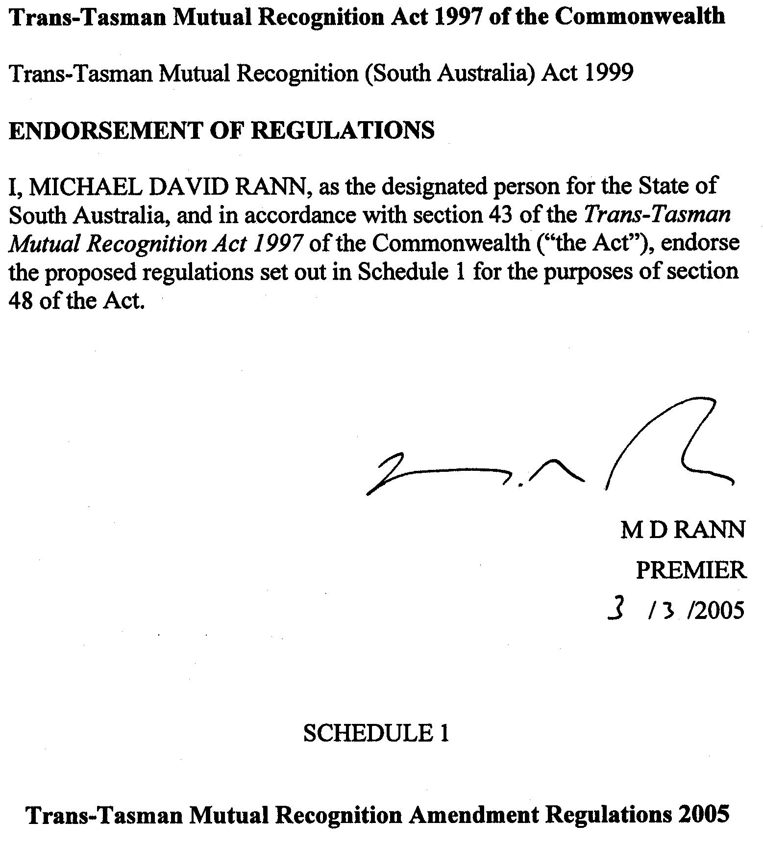
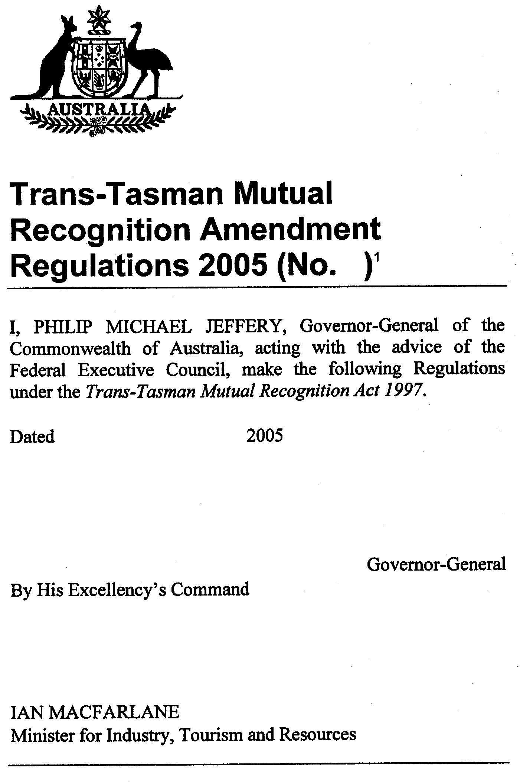

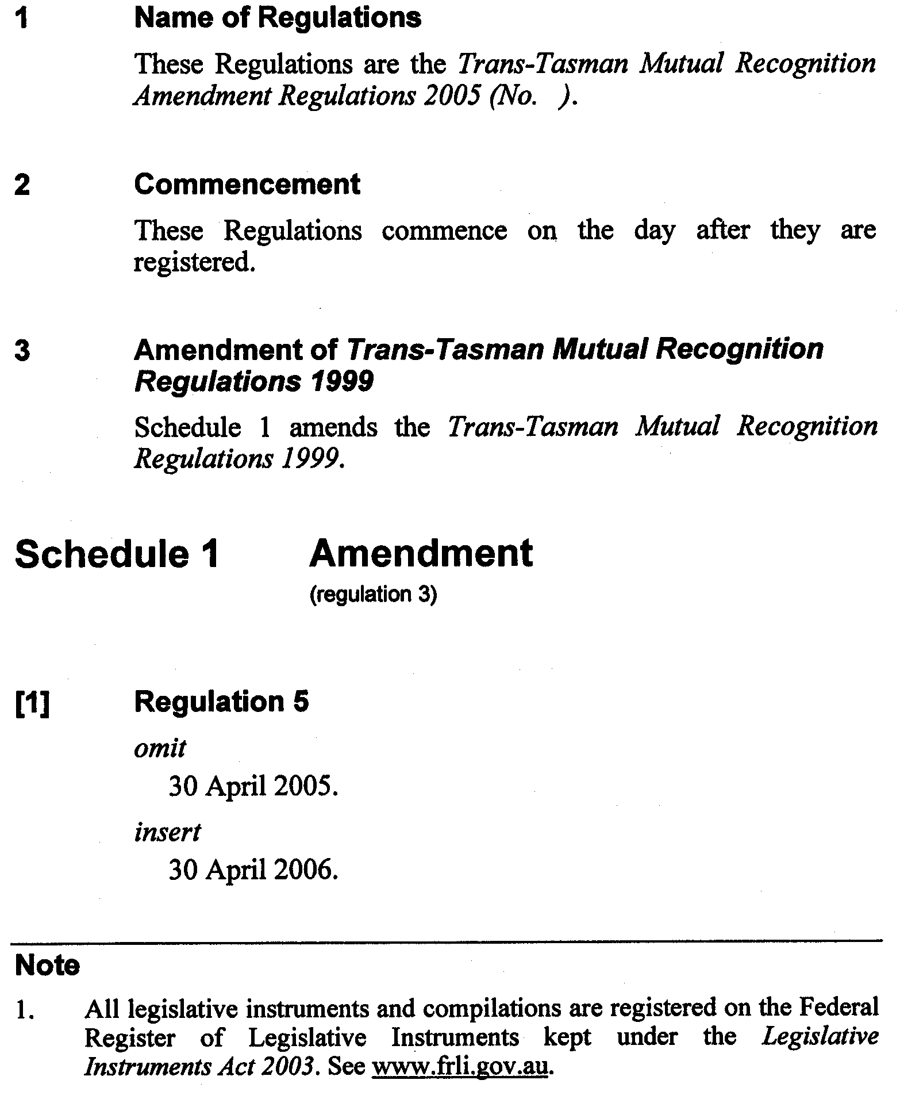

South Australia
Community Titles Variation Regulations 2005
under the Community Titles Act 1996

Contents
Part 1—Preliminary
1 Short title
2 Commencement
3 Variation provisions
Part 2—Variation of Community Titles Regulations 1996
4 Revocation of regulation 14

Part 1—Preliminary
1—Short title
These regulations may be cited as the Community Titles Variation Regulations 2005.
2—Commencement
These regulations will come into operation four months after the day on which they are made (see Subordinate Legislation Act 1978 section 10AA).
3—Variation provisions
In these regulations, a provision under a heading referring to the variation of specified regulations varies the regulations so specified.
Part 2—Variation of Community Titles Regulations 1996
4—Revocation of regulation 14
Regulation 14—delete the regulation
Made by the Governor’s Deputy
with the advice and consent of the Executive Council
on 10 March 2005
No 12 of 2005
AGO0237/04CS

South Australia
Real Property (Land Division) Variation Regulations 2005
under the Real Property Act 1886

Contents
Part 1—Preliminary
1 Short title
2 Commencement
3 Variation provisions
Part 2—Variation of Real Property (Land Division) Regulations 1995
4 Variation of regulation 4—Interpretation
5 Revocation of regulation 6
6 Revocation of regulation 15
7 Revocation of regulation 21
8 Revocation of regulations 23 to 26
9 Revocation of regulation 28
10 Revocation of Schedule 2

Part 1—Preliminary
1—Short title
These regulations may be cited as the Real Property (Land Division) Variation Regulations 2005.
2—Commencement
These regulations will come into operation four months after the day on which they are made (see Subordinate Legislation Act 1978 section 10AA).
3—Variation provisions
In these regulations, a provision under a heading referring to the variation of specified regulations varies the regulations so specified.
Part 2—Variation of Real Property (Land Division) Regulations 1995
4—Variation of regulation 4—Interpretation
Regulation 4, definition of outer boundary survey plan—delete "in conformity with Part 4"
5—Revocation of regulation 6
Regulation 6—delete the regulation
6—Revocation of regulation 15
Regulation 15—delete the regulation
7—Revocation of regulation 21
Regulation 21—delete the regulation
8—Revocation of regulations 23 to 26
Regulations 23 to 26 (inclusive)—delete the regulations
9—Revocation of regulation 28
Regulation 28—delete the regulation
10—Revocation of Schedule 2
Schedule 2—delete the Schedule
Made by the Governor’s Deputy
with the advice and consent of the Executive Council
on 10 March 2005
No 13 of 2005
AGO0237/04CS

FAXING COPY?
IF you fax copy to Government Publishing SA for inclusion in the Government Gazette, there is no need to send a Confirmation Copy to us as well.
This creates confusion and may well result in your notice being printed twice.
Please use the following fax number:
Fax transmission: (08) 8207 1040
Phone Inquiries: (08) 8207 1045
Please include a contact person, phone number and order number so that we can phone back with any queries we may have regarding the fax copy.
NOTE: Closing time for lodging new copy (fax, hard copy or email) is 4 p.m. on Tuesday preceding the day of publication.

Government Gazette notices can be E-mailed.
The address is:
governmentgazette@saugov.sa.gov.au
Documents should be sent as attachments in Word format.
When sending a document via E-mail, please confirm your transmission with a faxed copy of your document, including the date the notice is to be published.
Fax transmission: (08) 8207 1040
Enquiries: (08) 8207 1045
NOTE: Closing time for lodging new copy (fax, hard copy or email) is 4 p.m. on Tuesday preceding the day of publication.

CITY OF PORT ADELAIDE ENFIELD
Roads (Opening and Closing) Act 1991
Road Closure—Westbrook Terrace, Northgate
NOTICE is hereby given pursuant to section 10 of the Roads (Opening and Closing) Act 1991, that the City of Port Adelaide Enfield proposes to make a Road Process Order to close the whole of Westbrook Terrace between Grand Junction Road and Leopold Avenue and merge with the adjoining allotment 4006 (Reserve) in Deposited Plan 62926 as delineated and lettered ‘A’ on Preliminary Plan No. 05/0008.
A copy of the plan and a statement of persons affected are available for public inspection at the Civic Centre, 163 St Vincent Street, Port Adelaide, S.A. 5015, the council offices situated in the Enfield, Greenacres and Parks Libraries and the Adelaide office of the Surveyor-General during normal office hours.
Any application for easement or objection must set out the full name, address and details of the submission and must be fully supported by reasons.
The application for easement or objection must be made in writing to the Council, P.O. Box 110, Port Adelaide, S.A. 5015 within 28 days of this notice and a copy must be forwarded to the Surveyor-General, G.P.O. Box 1354, Adelaide, S.A. 5001. Where a submission is made, the council will give notification of a meeting at which the matter will be considered.
Dated 10 March 2005.
H. J. Wierda, City Manager

CITY OF UNLEY
Periodical Review of Elector Representation
NOTICE is hereby given that the City of Unley, in accordance with the requirements of section 12 of the Local Government Act 1999, has commenced a review to determine whether current arrangements for elected representation are adequate in fairly representing the electors in the City. Issues examined during this review are:
• the retainment of the current ward structure or should all members represent the whole area;
• the examination of the number of wards if the ward structure is retained and will the ward quotas be within acceptable limits;
• the number of elected members required to adequately represent the community and whether the Principal Member should be popularly elected or elected within the Council;
• the consideration for new ward names.
Any person wishing to contribute to this review is invited to become familiar with the issues concerning the current ward structures and elector representations through further information to be obtained from the Civic Centre Offices, 181 Unley Road, Unley, telephone 8372 5111, email to pobox1@unley.sa.gov.au, or access Council’s website www.unley.sa.gov.au.
Written submissions will be received until 5 p.m. on Friday, 29 April 2005 and an opportunity will be given to any person making written submissions to appear before the Council’s Committee for further explanation.
M. Withers, Chief Executive Officer

TOWN OF GAWLER
Supplementary Election for Two Area Councillors
NOMINATIONS are hereby invited and will be received at the Town of Gawler located at 89 Murray Street, Gawler, from Thursday, 24 March 2005 until 12 noon on Thursday, 14 April 2005, from any person eligible to be a candidate for election to the vacancies.
Nomination forms and candidate handbooks are available from 89 Murray Street, Gawler.
A candidate must submit a profile of not more than 150 words with the nomination form.
A candidate photograph of predominantly the head and shoulders, taken within the preceding 12 months, may also be submitted.
A briefing session for prospective candidates will be conducted at 6.30 p.m. on Tuesday, 29 March 2005 at the Council Chambers, 89 Murray Street, Gawler.
If more than the required number of nominations are received for the vacancies, an election will be conducted entirely by postal ballot with the return of the completed ballot papers to reach the Returning Officer no later than 12 noon on Monday, 16 May 2005.
D. Gully, Returning Officer

KINGSTON DISTRICT COUNCIL
Adoption of Community Land Management Plans
NOTICE is hereby given pursuant to section 197 (3) of the Local Government Act 1999 and having complied with the provisions of section 197 (1) (a) and (b) that Kingston District Council at its meeting held on 18 February 2005, adopted the Community Land Management Plans relating to Community Land held in its ownership and land under its care, control and management.
M. R. McCarthy, Chief Executive Officer

DISTRICT COUNCIL OF LE HUNTE
Supplementary Election—Area Councillor
NOMINATIONS are hereby invited and will be received at the District Council office located at Burton Terrace, Wudinna, from Thursday, 24 March 2005, until 12 noon on Thursday, 14 April 2005, from any person eligible to be a candidate for election to the vacancy of:
Area Councillor (1 vacancy)
Nomination forms and candidate handbooks are available from the District Council Office, Burton Terrace, P.O. Box 6, Wudinna, S.A. 5652.
A candidate must submit a profile of not more than 150 words with the nomination form. A candidate photograph of pre-dominantly the head and shoulders, taken within the preceding 12 months, may also be submitted.
A briefing for prospective candidates will be conducted at 8 p.m. on Monday, 4 April 2005, in the District Council Chambers, Wudinna.
If more than the required number of nominations are received for the vacancy, an election will be conducted entirely by postal ballot, with the return of the completed ballot papers to reach the Deputy Returning Officer no later than 12 noon on Tuesday, 17 May 2005.
D. Gully, Returning Officer

RENMARK PARINGA COUNCIL
Development Act 1993
Town Centre Expansion Plan Amendment Report
(PAR)—Draft for Public Consultation
NOTICE is hereby given that the Renmark Paringa Council has prepared a draft Plan Amendment Report to amend the Renmark Paringa (DC) Development Plan.
The Plan Amendment Report will amend the Development Plan by implementing changes investigated within the Development Plan Review undertaken in 2003. The proposed changes will extend the existing Town Centre Zone to include the site known as the Rivergrowers on Renmark Avenue. The expansion on to the Rivergrowers site will enable large scale retailing to be developed, primarily comprising comparison goods retailing.
The draft Plan Amendment Report will be available for public inspection at the Council Offices, 8 Ral Ral Avenue, Renmark from 10 March 2005 to 13 May 2005. Copies of the Plan Amendment Report can be purchased at the council office for $11 each.
Written submissions regarding the draft amendment will be accepted by the Renmark Paringa Council until 5 p.m. on 13 May 2005. All submissions should be addressed to David Case, Town Planner, P.O. Box 730, Renmark, S.A. 5341. Copies of all written submissions received will be available for inspection by interested persons at the council offices from 9 a.m. on 17 May to 5 p.m. on 19 May.
A public hearing will be held on 19 May 2005 from 7 p.m. at the Council Chamber Room, 8 Ral Ral Avenue, Renmark, S.A. 5341, to enable people to speak to council in relation to the PAR and submissions.
For further information, contact David Case, Town Planner, on 8586 6609.
B. Hurst, Chief Executive Officer

IN the matter of the estates of the undermentioned deceased persons:
Bignall, Clifford George, late of 25 Union Street, Stepney, retired teacher’s aide, who died on 29 August 2002.
Biro, Janos, late of 226 Fullarton Road, Glenside, of no occupation, who died on 31 May 2004.
Burnell, Hilda May, late of First Street, Minlaton, of no occupation, who died on 28 November 2004.
Candy, Donald Frank, late of Andrews Road, Penfield, retired field engineer, who died on 20 October 2004.
Carter, Gladys Mary, late of 81 Tapleys Hill Road, Hendon, of no occupation, who died on 26 December 2004.
Cooper, Eric Ronald, late of 80 Moseley Street, Glenelg South, retired fencing contractor, who died on 18 December 2004.
Florence, Stuart Peter, late of 26 Byron Street, Glenelg, retired contractor, who died on 21 June 1991.
Fry, Linda Dora, late of 7 Lancelot Drive, Daw Park, of no occupation who died on 27 January 2005.
Kaehne, Donald Keith, late of 97 Thevenard Road, Thevenard, retired wharf and jetty builder, who died on 14 August 2004.
Kelemen, Samu, late of 7 Raymond Grove, Glenelg, retired labourer, who died on 28 December 2004.
Matheson, Audrey Helen, late of 34 Hall Street, Semaphore, widow, who died on 26 November 2004.
Milne, Robert Richie, late of 586 Cross Road, South Plympton, of no occupation, who died on 12 November 2004.
Page, Kathleen Yvonne, late of 9 Rowell Avenue, Glenunga, home duties, who died on 21 December 2004.
Pietraszuk, Ella, late of 21 Pitcairn Avenue, Kidman Park, home duties, who died on 31 December 2004.
Taylor, Frederick, late of 38 Nairne Road, Woodside, retired tool fitter, who died on 26 January 2005.
Thomas, Ian Robert, late of 13 Wooltana Avenue, Myrtle Bank, retired public servant, who died on 8 January 2005.
Tumbers, Freda, late of 336 Kensington Road, Leabrook, of no occupation, who died on 1 August 2004.
Walters, Douglas William Haig, late of 54 Woodcroft Drive, Morphett Vale, retired waterside worker, who died on 28 December 2004.
Notice is hereby given pursuant to the Trustee Act 1936, as amended, the Inheritance (Family Provision) Act 1972, and the Family Relationships Act 1975, that all creditors, beneficiaries, and other persons having claims against the said estates are required to send, in writing, to the Public Trustee, 25 Franklin Street, Adelaide, S.A. 5000, full particulars and proof of such claims, on or before 8 April 2005, otherwise they will be excluded from the distribution of the said estate; and notice is also hereby given that all persons who are indebted to the said estates are required to pay the amount of their debts to the Public Trustee or proceedings will be taken for the recovery thereof; and all persons having any property belonging to the said estates are forthwith to deliver the same to the Public Trustee.
Dated 10 March 2005.
C. J. O’Loughlin, Public Trustee

IN the matter of the estate of the undermentioned deceased person:
Treasure, Margaret Lawrie, late of Matthew Flinders Home, 61 Oxford Terrace, Port Lincoln, widow, who died on 3 November 2004.
Notice is hereby given pursuant to the Trustee Act 1936, as amended, the Inheritance (Family Provision) Act 1972-1975 and the Family Relationships Act 1975, that all creditors, beneficiaries, and other persons having claims against the abovenamed estate are directed to send full particulars of such claims to the undersigned on or before 8 April 2005, otherwise they will be excluded from the distribution of the said estate; and notice is also hereby given that all persons who are indebted to the above estate are required to pay the amount of their debt to the undersigned or proceedings will be taken for the recovery thereof; and all persons having any property belonging to either of the said estate are forthwith to deliver the same to the undersigned.
Dated 10 March 2005.
ANZ Executors & Trustee Company Limited (ACN 006 132 332), 530 Collins Street, Melbourne, Vic. 3000.

ATTENTION

CUSTOMERS requiring a proof of their notice for inclusion in the Government Gazette, please note that the onus is on you to inform Government Publishing SA of any subsequent corrections by 10 a.m. on Thursday, which is our publication deadline.

For any corrections to your notice please phone 8207 1045 or Fax 8207 1040 before 10 a.m. on Thursday.

If we do not receive any communication by 10 a.m. on Thursday (day of publication) we will presume the notice is correct and will print it as it is.

Remember—the onus is on you to inform us of any corrections necessary to your notice.

NOTE: Closing time for lodging new copy (electronically, fax or hard copy) is 4 p.m. on Tuesday preceding the day of publication. Phone 8207 1045—Fax 8207 1040.
Email: governmentgazette@saugov.sa.gov.au

Printed and published by authority every Thursday by J. D. FERGUSON, Government Printer, South Australia
Price: $4.85, plus postage; to subscribers, $247.00 per annum.
(The above prices are inclusive of GST)

