No. 25 631

THE SOUTH AUSTRALIAN

GOVERNMENT GAZETTE
www.governmentgazette.sa.gov.au

PUBLISHED BY AUTHORITY

ALL PUBLIC ACTS appearing in this GAZETTE are to be considered official, and obeyed as such

ADELAIDE, THURSDAY, 17 MARCH 2005

CONTENTS

Page
Agricultural and Veterinary Products (Control of Use)
Regulations 2004—Notice 633
Appointments, Resignations, Etc. 632
Architects Act 1939—Notice 633
Associations Incorporation Act 1985—Notice 633
Building Work Contractors Act 1995—Notice 633
Corporations and District Councils—Notices 660
Crown Lands Act 1929—Notices 634
Development Act 1993—Notices 634
Dog Fence Act 1946—Notice 635
Electricity Act 1996—Notice 636
Fisheries Act 1982—Notices 645
Liquor Licensing Act 1997—Notices 645
National Electricity (South Australia) Act 1996—
Notice 649

Page
National Parks Regulations 2001—Notice 649
Petroleum Act 2000—Notices 650
Phylloxera and Grape Industry Act 1995—Notice 649
Primary Industries and Resources South Australia—
Notice 650
Proclamations 655
Public Trustee Office—Administration of Estates 660

REGULATION
Sexual Reassignment Act 1988 (No. 14 of 2005) 657
Roads (Opening and Closing) Act 1991—Notice 650
Transport, Department of—Notice to Mariners 652
Unclaimed Moneys Act 1891—Notices 661
Water Conservation Act 1936—Notice 651
Water Mains and Sewers—Mains Laid, Replaced, Etc. 653

GOVERNMENT GAZETTE NOTICES
ALL poundkeepers’ and private advertisements forwarded for publication in the South Australian Government Gazette must be PAID FOR PRIOR TO INSERTION; and all notices, from whatever source, should be legibly written on one side of the paper only and sent to Government Publishing SA so as to be received no later
than 4 p.m. on the Tuesday preceding the day of publication. Phone 8207 1045 or Fax 8207 1040. E-mail: governmentgazette@saugov.sa.gov.au. Send as attachments in Word format and please confirm your transmission with a faxed copy of your document, including the date the notice is to be published and to whom the notice will be charged. The Government Gazette is available online at: www.governmentgazette.sa.gov.au

Department of the Premier and Cabinet
Adelaide, 17 March 2005
HIS Excellency the Governor’s Deputy in Executive Council has revoked the appointment of John Robert Wright as a Deputy Member to Paul Grimes of the South Australian Superannuation Board, effective from 17 March 2005, pursuant to the Superannuation Act 1988 and the Acts Interpretation Act 1915.
By command,
Trish White, for Premier
DTF 008/05CS

Department of the Premier and Cabinet
Adelaide, 17 March 2005
HIS Excellency the Governor’s Deputy in Executive Council has been pleased to appoint the undermentioned to the South Australian Superannuation Board, pursuant to the provisions of the Superannuation Act 1988.
Member: (from 17 March 2005 until 30 June 2006)
Kevin Michael Cantley
Deputy Member: (from 17 March 2005 until 30 June 2006)
John Robert Wright (Deputy to Cantley)
By command,
Trish White, for Premier
DTF 008/05CS

Department of the Premier and Cabinet
Adelaide, 17 March 2005
HIS Excellency the Governor’s Deputy in Executive Council has been pleased to appoint the undermentioned to the South Australian Bushfire Prevention Advisory Committee, pursuant to the provisions of the Country Fires Act 1989:
Deputy Member: (from 17 March 2005 until 26 September 2007)
Sandra Brown (Deputy to Roocke)
By command,
Trish White, for Premier
MES 001/05CS

Department of the Premier and Cabinet
Adelaide, 17 March 2005
HIS Excellency the Governor’s Deputy in Executive Council has been pleased to appoint Leonie Farrell to the offices of Magistrate and Industrial Magistrate, both on an auxiliary basis, for a period commencing on 21 March 2005, for a period of six months it being a condition of appointment that the powers and jurisdictions of the offices should only be exercised during the time or times the actual duties are being undertaken, but at no other time throughout the period of appointment, pursuant to the Judicial Administration (Auxiliary Appointments and Powers) Act 1988.
By command,
Trish White, for Premier
ATTG0203/02PT2CS

Department of the Premier and Cabinet
Adelaide, 17 March 2005
HIS Excellency the Governor’s Deputy in Executive Council has been pleased to appoint the people listed as Justices of the Peace for South Australia, pursuant to Section 4 of the Justices of the Peace Act 1991:
Michelle Gai Branson
Gaynor Lynn Bryant
Peter John Crompton
Deborah Ann Hearnden
Sky Laris
Graham Nicol
Dimitria Patrinos
Michelle Pritchard
Margaret Suzanne Stevens
Amy Louise Wilding
By command,
Trish White, for Premier
ATTG0082/03CS

Department of the Premier and Cabinet
Adelaide, 17 March 2005
HIS Excellency the Governor’s Deputy in Executive Council has been pleased to appoint the Honourable Lea Stevens, MP, Minister for Health and Minister Assisting the Premier in Social Inclusion to be also Acting Minister for Families and Communities, Acting Minister for Housing, Acting Minister for Ageing and Acting Minister for Disability on 24 March 2005, during the absence of the Honourable Jay Wilson Weatherill, MP.
By command,
Trish White, for Premier
MFC0003/05CS

Department of the Premier and Cabinet
Adelaide, 17 March 2005
HIS Excellency the Governor’s Deputy in Executive Council has been pleased to appoint the Honourable Lea Stevens, MP, Minister for Health and Minister Assisting the Premier in Social Inclusion to be also Acting Minister for Families and Communities, Acting Minister for Housing, Acting Minister for Ageing and Acting Minister for Disability for the period 25 June 2005 to 2 July 2005 inclusive, during the absence of the Honourable Jay Wilson Weatherill, MP.
By command,
Trish White, for Premier
MFC0003/05CS

AGRICULTURAL AND VETERINARY PRODUCTS (CONTROL OF USE) REGULATIONS 2004
Approval of Quality Assurance Schemes
NOTICE is hereby given that pursuant to Regulation 7 (2) of the Agricultural and Veterinary Products (Control of Use) Regulations 2004, the quality assurance schemes listed in Column A are approved by the Minister for Agriculture, Food and Fisheries for the specified crops listed opposite in Column B. A person is an accredited participant of a particular scheme only if he or she satisfies the requirements specified in Column C.

Column A | Column B | Column C
A scheme established by the SQF 2000 Code, A HACCP Supplier Assurance Code for the Food Industry, 5th edition, published by Food Marketing Institute, Washington DC, USA. | beetroot, bok choy, chicory, endive, radish, silverbeet, spinach, spring onion | A current certification (to Levels 1, 2 or 3) of an SQF 2000 system for the supply of a crop of a kind for which the scheme is approved, issued in accordance with the SQF 2000 Code.
A scheme established by the Woolworths Vendor Quality Management Standard (WVQMS) Version 10; or  Woolworths Quality Assurance (WQA) Standard Version 1; published by Woolworths Supermarkets. | beetroot, bok choy, chicory, endive, radish, silverbeet, spinach, spring onion | A current certification of WVQMS Version 10 or WQA Version 1 for the supply of a crop of a kind for which the scheme is approved, issued in accordance with the relevant Standard.
A scheme established by the Recommended International Code of Practice General Principles of Food Hygiene CAC/RCP 1-1969 including Annex on Hazard Analysis and Critical Control Point (HACCP) System and Guidelines for its Application, as adopted by the Codex Alimentarius Commission in 1997. | basil, beetroot, bok choy, chicory, coriander, endive, mint, parsley, radish, silverbeet, spinach, spring onion | A current certification meeting the requirements of Codex Alimentarius Alinorm: 97/13A for the supply of a crop of a kind for which the scheme is approved.

Dated 9 March 2005.
D. Plowman, Executive Director, Agriculture and Wine,
for and on behalf of Rory McEwen, Minister for Agriculture, Food and Fisheries

ARCHITECTS ACT 1939
(Section 8)
The Architects Board of South Australia
Notice of Election
TAKE notice that, following the close of nominations on 9 February 2005, the persons listed below were duly elected as members of The Architects Board of South Australia:
Andrew Laurence Sheppard Davies
David Colin Hassell
Dated 16 March 2005.
R. Dennis, Clerk of Executive Council

ASSOCIATIONS INCORPORATION ACT 1985
Deregistration of Associations
NOTICE is hereby given that the Corporate Affairs Commission approves the applications for deregistration received from the associations named below pursuant to section 43A of the Associations Incorporation Act 1985. Deregistration takes effect on the date of publication of this notice:
Adelaide International Motoring Festival Incorporated
Adelaide Property Owners’ Association Incorporated
City of Onkaparinga Community Information Centre Incorporated
Humambo Children Incorporated
Soroptomist International of Tea Tree Gully Incorporated
Returned & Services League (Burnside) Sub-branch Incorporated
South Australian Farm & Country Holidays Incorporated
South East Porcelain Painters Club Incorporated
Southern Stars Gymnastics Academy Incorporated
The Horace Dinham Memorial Trust Incorporated
The Wireless Institute of Australia SA & NT Division Incorporated
Given at Adelaide, 14 March 2005.
B. Colquist, a delegate of the Corporate Affairs Commission

BUILDING WORK CONTRACTORS ACT 1995
Exemption
TAKE notice that, pursuant to section 45 of the Building Work Contractors Act 1995, I, Karlene Maywald, Minister for Consumer Affairs, do hereby exempt the licensee named in Schedule 1 from the application of Division 3 of Part 5 of the Act in relation to domestic building work described in Schedule 2 and subject to the conditions specified in Schedule 3.
Schedule 1
Desmond J. Harte, BLD 152584.
Schedule 2
Domestic building work performed by the licensee for the construction of interior and exterior renovations, a rear extension including an en-suite, bedroom, office, kitchen and laundry, as well as re-roofing of the licensee’s personal residence at 57 Torrens Road, Riverton.
Schedule 3
That the licensee does not transfer his interest in the land prior to five years from the date of completion of the building work, the subject of this exemption, without the authorisation of the Commissioner for Consumer Affairs.
Dated 25 February 2005.
Karlene Maywald, Minister for Consumer Affairs
Ref: 610/04-00566

CROWN LANDS ACT 1929: SECTION 5
TAKE NOTICE that pursuant to the Crown Lands Act 1929, I, JOHN HILL, Minister for Environment and Conservation, Minister of the Crown to whom the administration of the Crown Lands Act 1929 is committed DO HEREBY:
1. Resume the land defined in The First Schedule.
2. Dedicate the Crown Land defined in The Second Schedule as a Reserve for Car Park, Boat Ramp, Recreation, Public Jetty and Access Purposes and declare that such land shall be under the care, control and management of the District Council of Yorke Peninsula, subject to the same terms and conditions as are contained in Memorandum of Lease 8906110.
The First Schedule
Car Park, Boat Ramp and Recreation Reserve, Allotment 104 of Deposited Plan 32852, Hundred of Para Wurlie, County of Fergusson, the notice of which was published in the Government Gazette of 17 July 1997 at page 106, The Second Schedule, being the whole of the land comprised in Crown Record Volume 5425 Folio 596.
The Second Schedule
Allotment 104 of Deposited Plan 32852, Hundred of Para Wurlie, County of Fergusson, exclusive of all necessary roads, being the whole of the land comprised in Crown Record Volume 5425 Folio 596.
Dated 17 March 2005.
J. Hill, Minister for Environment and Conservation
DEHAA 10/0889

CROWN LANDS ACT 1929: SECTION 5
TAKE NOTICE that pursuant to the Crown Lands Act 1929, I, JOHN HILL, Minister for Environment and Conservation, Minister of the Crown to whom the administration of the Crown Lands Act 1929 is committed DO HEREBY dedicate the Crown Land defined in The Schedule as a Reserve for Storm Water Detention Purposes and declare that such land shall be under the care, control and management of The Rural City of Murray Bridge.
The Schedule
Allotment 2 of Deposited Plan 40109, Hundred of Mobilong, County of Sturt, exclusive of all necessary roads, subject nevertheless to an existing easement to The Rural City of Murray Bridge for drainage purposes (RE 7856743) over that portion of Allotment 2 marked A on Deposited Plan 40109, being the whole of the land comprised in Crown Record Volume 5295 Folio 844.
Dated 17 March 2005.
J. Hill, Minister for Environment and Conservation
DEH 11/3038

DEVELOPMENT ACT 1993, SECTION 26 (8): SOUTHERN METROPOLITAN GROWTH MANAGEMENT PLAN AMENDMENT
Preamble
1. The Development Plan Amendment entitled ‘Southern Metropolitan Growth Management Plan Amendment’ (the Plan Amendment) has been finalised in accordance with the provisions of the Development Act 1993.
2. The Minister for Urban Development and Planning has decided to approve the Plan Amendment.
Notice
PURSUANT to section 26 of the Development Act 1993, I—
(a) approve the Plan Amendment; and
(b) fix the day on which this notice is published in the Government Gazette as the day on which the Plan Amendment will come into operation.
Dated 17 March 2005.
Trish White, Minister for Urban Development and Planning
PLN 04/0068

DEVELOPMENT ACT 1993, SECTION 25 (17): CITY OF CHARLES STURT—UNDERDALE CAMPUS MASTER PLAN DESIGN PLAN AMENDMENT
Preamble
1. The Development Plan Amendment entitled ‘City of Charles Sturt—Underdale Campus Master Plan Design Plan Amendment’ (the Plan Amendment) has been finalised in accordance with the provisions of the Development Act 1993.
2. The Minister for Urban Development and Planning has decided to approve the Plan Amendment.
Notice
PURSUANT to section 25 of the Development Act 1993, I—
(a) approve the Plan Amendment; and
(b) fix the day on which this notice is published in the Government Gazette as the day on which the Plan Amendment will come into operation.
Dated 17 March 2005.
Trish White, Minister for Urban Development and Planning
PLN 04/0050

DEVELOPMENT ACT 1993, PORT ADELAIDE ENFIELD (CITY)—NORTHFIELD (STAGE 3) PLAN AMENDMENT REPORT PREPARED BY THE MINISTER—DRAFT FOR PUBLIC CONSULTATION
NOTICE is hereby given that the Minister for Urban Development and Planning has, pursuant to sections 24 and 26 of the Development Act 1993, prepared a draft Plan Amendment Report (PAR) to amend the Port Adelaide Enfield (City) Development Plan.
The draft PAR proposes to amend the Development Plan by revising the Residential Zone provisions and introducing a new Policy Area, with associated objectives and principles of development control, to guide future residential development within the Northfield Stage 3 development area, located generally between Folland Avenue and Redward Avenue, Northgate. The amendments are expected to support a wide diversity of housing on a range of allotment sizes.
The draft PAR will be on public consultation from 17 March 2005 to 17 May 2005.
Copies of the draft PAR are available during normal office hours at the Department for Transport and Urban Planning (Planning SA), Level 5, 136 North Terrace, Adelaide, or can be viewed on the Internet at:
www.planning.sa.gov.au/northfieldstage3.
Alternatively the draft PAR can be viewed during normal office hours at the Port Adelaide Enfield Council offices located at 163 St Vincent Street, Port Adelaide.
Written submissions regarding the draft PAR should be submitted no later than 5 p.m. on 17 May 2005. All submissions should be addressed to the Presiding Member, Development Policy Advisory Committee, c/o Steven Copus, G.P.O. Box 1815, Adelaide, S.A. 5001 and should clearly indicate whether you wish to be heard in support of your submission at the public hearing. If you wish to lodge your submission electronically, please email it to the Presiding Member, Development Policy Advisory Committee, c/o copus.steven@saugov.sa.gov.au.
Copies of all submissions will be available for inspection by interested persons at Planning SA, Level 5, 136 North Terrace, Adelaide, or can be viewed on the Internet at:
www.planning.sa.gov.au/northfieldstage3,
from 18 May 2005 until the conclusion of the public hearing.
A public hearing will be held on 25 May 2005 at 7.30 p.m. at the Hillcrest Community Centre Hall, 27-31 Queensborough Avenue, Hillcrest, at which time interested persons may appear to be heard in relation to the draft PAR and the submissions. The public hearing will not be held if no submissions are received or if no submission makes a request to be heard.
If you would like further information about the draft PAR, contact Steven Copus of Planning SA on telephone 8303 0659 or via email at copus.steven@saugov.sa.gov.au.
A. Houghton, Secretary, Development Policy Advisory Committee

DEVELOPMENT ACT 1993—SOUTHERN METROPOLITAN GROWTH MANAGEMENT—STAGE II PLAN AMEND-MENT REPORT PREPARED BY THE MINISTER—DRAFT FOR PUBLIC CONSULTATION
NOTICE is hereby given that the Minister for Urban Development and Planning has, pursuant to sections 24 and 26 of the Develop-ment Act 1993, prepared a draft Plan Amendment Report (PAR) to amend the Development Plan for the City of Onkaparinga.
The draft PAR proposes to amend development policy by:
• Incorporating a residential sequencing plan into the Urban Zone that describes an appropriate order of land development.
• Amending the commentary within the Urban Zone to clearly articulate the Government’s intention to rezone land to residential, in order of the ‘development sequence’, once suitable infrastructure is in place or planned to be provided.
• Rezoning allotment 51 Deposited Plan 56987 (land adjoining the Aldinga District Centre) from Urban to Residential.
• Amending Map Onka/1 (Overlay 1) ENLARGEMENTS
O and J to identify appropriate locations for services and facilities.
The draft PAR will be on public consultation from Thursday, 17 March 2005 to Tuesday, 17 May 2005.
Copies of the draft PAR are available during normal office hours at the Department for Transport and Urban Planning (Planning SA), Level 5, 136 North Terrace, Adelaide, or can be viewed on the Internet at
www.planning.sa.gov.au/sthmetro_growth.
Alternatively the draft PAR is available for viewing during normal office hours at the Onkaparinga Council Offices.
Written submissions regarding the draft PAR should be submitted no later than 5 p.m. on 17 May 2005. All submissions should be addressed to the Presiding Member, Development Policy Advisory Committee, c/o Anita Harmer, G.P.O. Box 1815,
Adelaide, S.A. 5001 and should clearly indicate whether you wish to be heard in support of your submission at the public hearing. If you wish to lodge your submission electronically, please email it to the Presiding Member, Development Policy Advisory Committee at harmer.anita@saugov.sa.gov.au.
Copies of all submissions will be available for inspection by interested persons at Planning SA, Level 5, 136 North Terrace, Adelaide, from 18 May 2004 until the conclusion of the public hearing.
A public hearing will be held on Wednesday, 1 June 2005 at 7.30 p.m. at the Aldinga Community Centre, Butterworth Road, Aldinga Beach, at which time interested persons may be heard in relation to the draft PAR and the submissions. The public hearing will not be held if no submissions are received or if no submission makes a request to be heard.
If you would like further information about the draft PAR, contact Anita Harmer of Planning SA on telephone 8303 0673 or via email at harmer.anita@saugov.sa.gov.au.
A. Houghton, Secretary, Development Policy Advisory Committee

DOG FENCE ACT 1946
Declaration of Rate
PURSUANT to the provision of section 25 of the Dog Fence Act 1946, the Dog Fence Board, with the approval of the Minister for Environment and Conservation, hereby declares that for the financial year ending 30 June 2006 the dog fence rate shall be 98 cents per km² and the minimum amount payable $68 for all separate holdings of more than 10 km² of land situated inside the dog fence.
Excluding:
1. For all the land in:
(a) The whole of the Counties of Musgrave, Flinders, Jervois, Frome, Victoria, Daly, Stanley, Gawler, Fergusson, Light, Eyre, Albert, Alfred, Adelaide, Sturt, Hindmarsh, Russell, Buccleuch, Chandos, Cardwell, Buckingham, MacDonnell, Robe, Grey and Carnarvon.
(b) The whole of the Hundreds of Finlayson, Tarlton, Cungena, Kaldoonera, Scott, Murray, Chandada, Karcultaby, Condada, Pildappa, Ripon, Forrest, Campbell, Inkster, Moorkitabie, Carina, Minnipa, Pinbong, Wrenfordsley, Rounsevell, Witera, Addison, Travers, Yaninee, Pygery, Wudinna, Hill, Peella, Pordia, Palabie, Wannamanna, Mamblin, Kongawa, Pinkawillinie, Cortlinye, Moseley, Wright, Downer, Wallis, Cocata, Kappakoola, Warramboo, Cootra, Caralue, Solomon, Kelly, Barna, Yalanda, Panitya, Coomooroo, Walloway, Pekina, Black Rock Plain, Tarcowie, Mannanarie, Yongala, Terowie, Hallett, Kingston, Mongolata, Kooringa, Baldina, Apoinga and Bright.
Where this contribution from holdings in 1 (a) and 1 (b) is paid via the Sheep Advisory Group.
2. Lake Torrens National Park and Lake Gairdner National Park, which are exempted from, dog fence rates.
3. All the islands along the seacoast.
M. J. Balharry, Manager, Dog Fence Administration, Department of Water, Land and Biodiversity Conservation

ELECTRICITY ACT 1996
Default Contract Prices for Small Customers
Notice under the Electricity Act 1996 of AGL South Australia Pty Ltd (AGLSA) ABN 49 091 105 092 of Default Contract Prices for Small Customers
PURSUANT to Section 36AB of the Electricity Act 1996 notice is hereby given by AGLSA of its default contract prices for customers who are consuming less than 160 MWh per annum of electricity (“small customers”) and who are purchasing electricity under AGLSA’s default contract terms and conditions. The default contract prices are set out below in this notice and will apply from 17 April 2005.
Justification Statement
The default contract prices set out in this notice are the same as AGLSA’s standing contract prices as fixed by the Essential Services Commission of South Australia (ESCOSA) by its Electricity Standing Contract Price Determination made on 17 December 2004. The setting by AGLSA of these default contract prices is in accordance with ESCOSA’s Electricity Retail Price Justification Guideline of December 2003.
For further information please call AGL on 131 245.
M. Fraser, Director, AGL South Australia Pty Limited
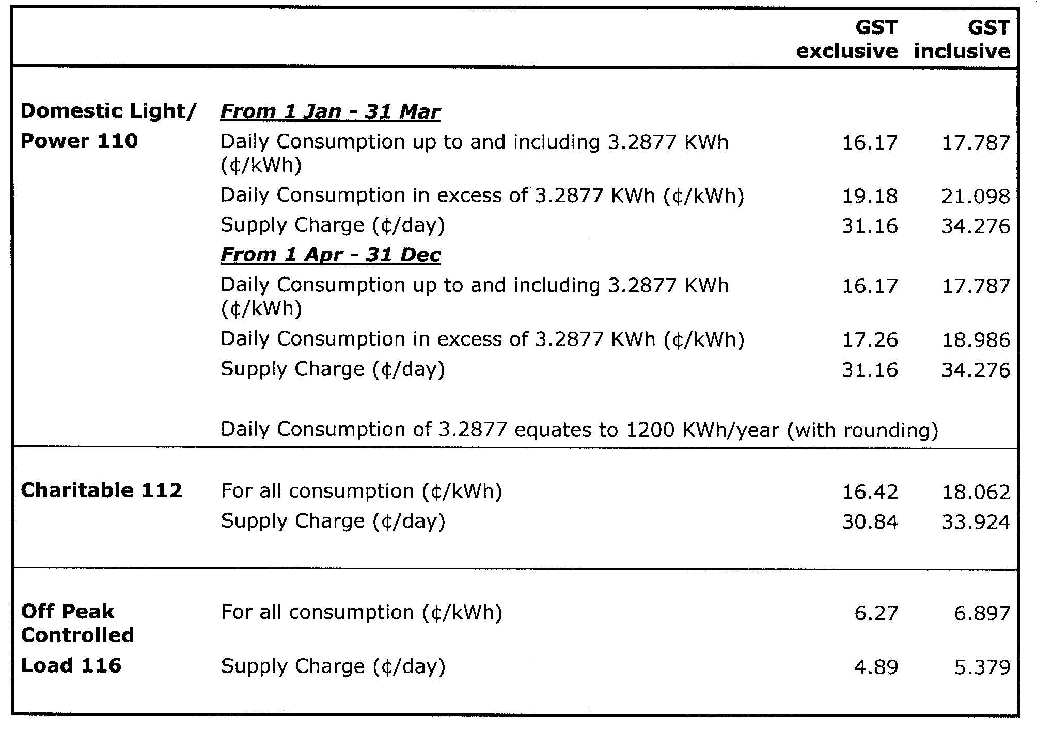

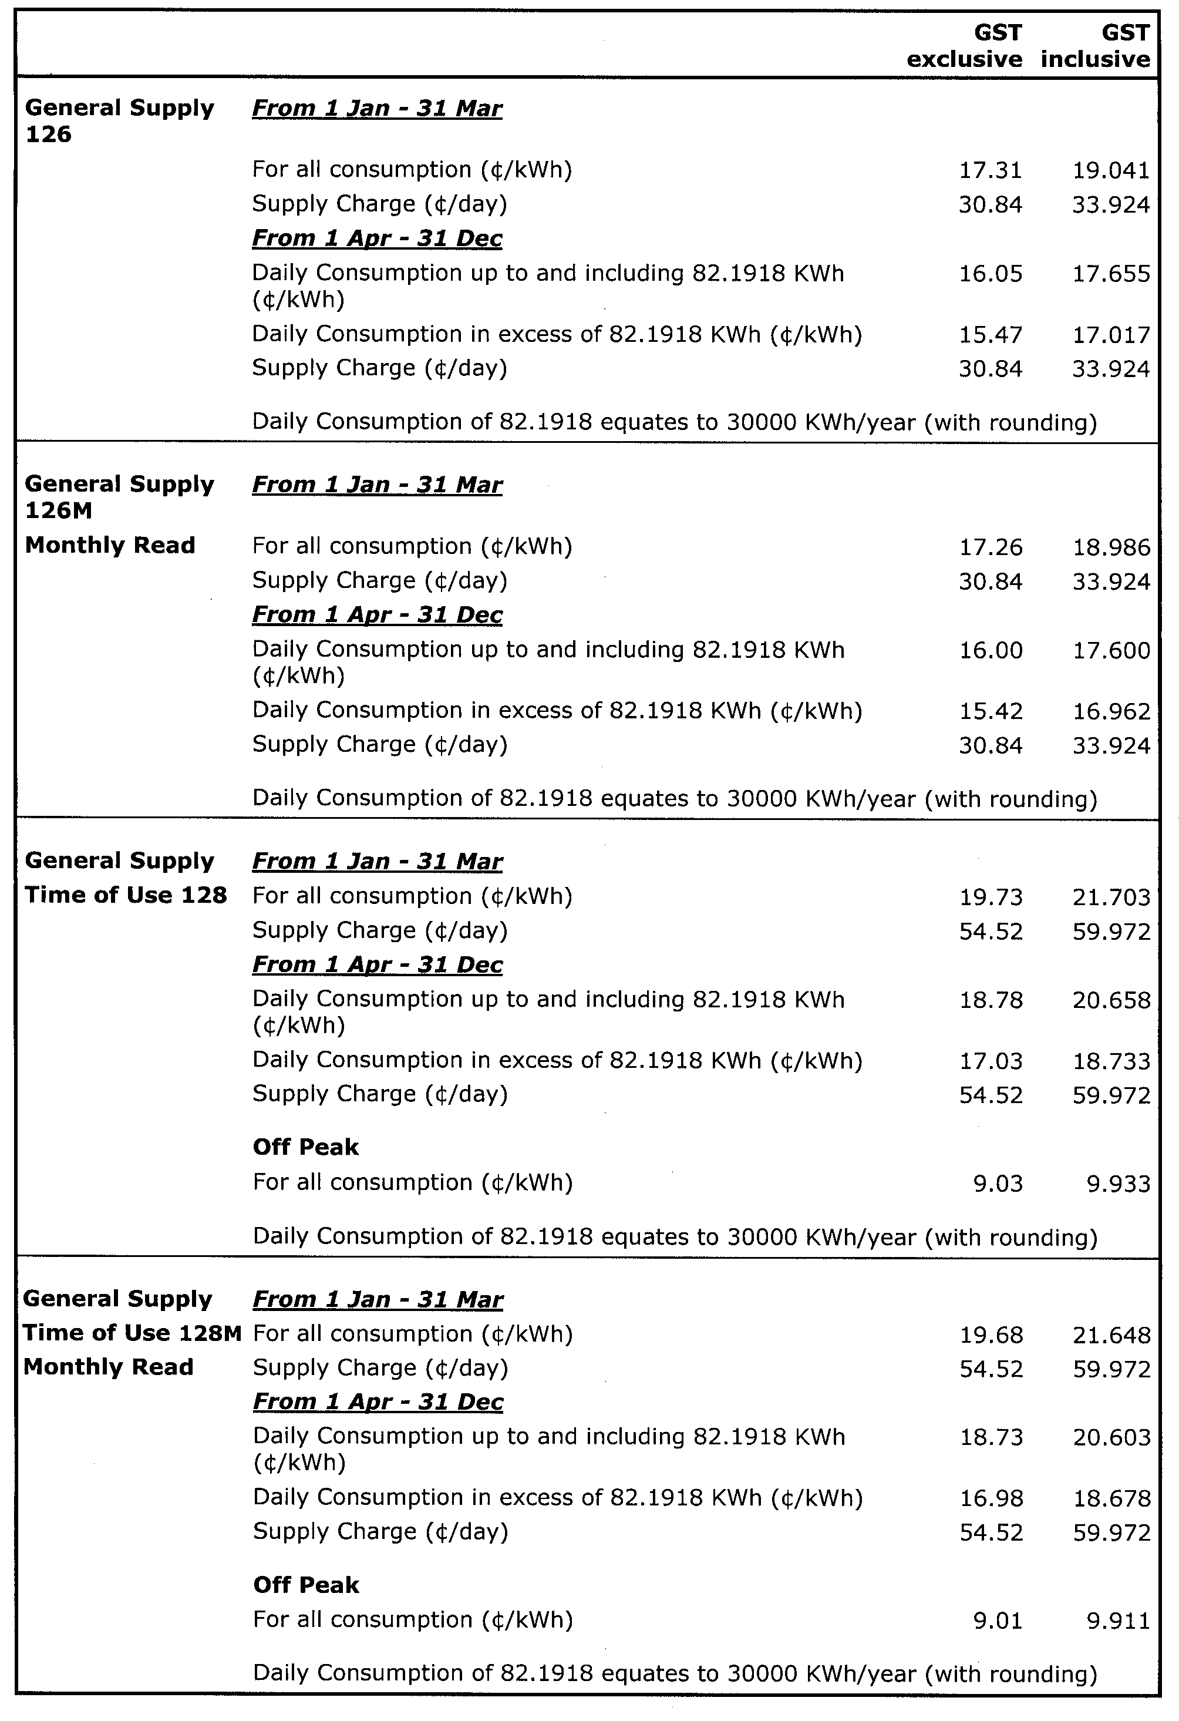
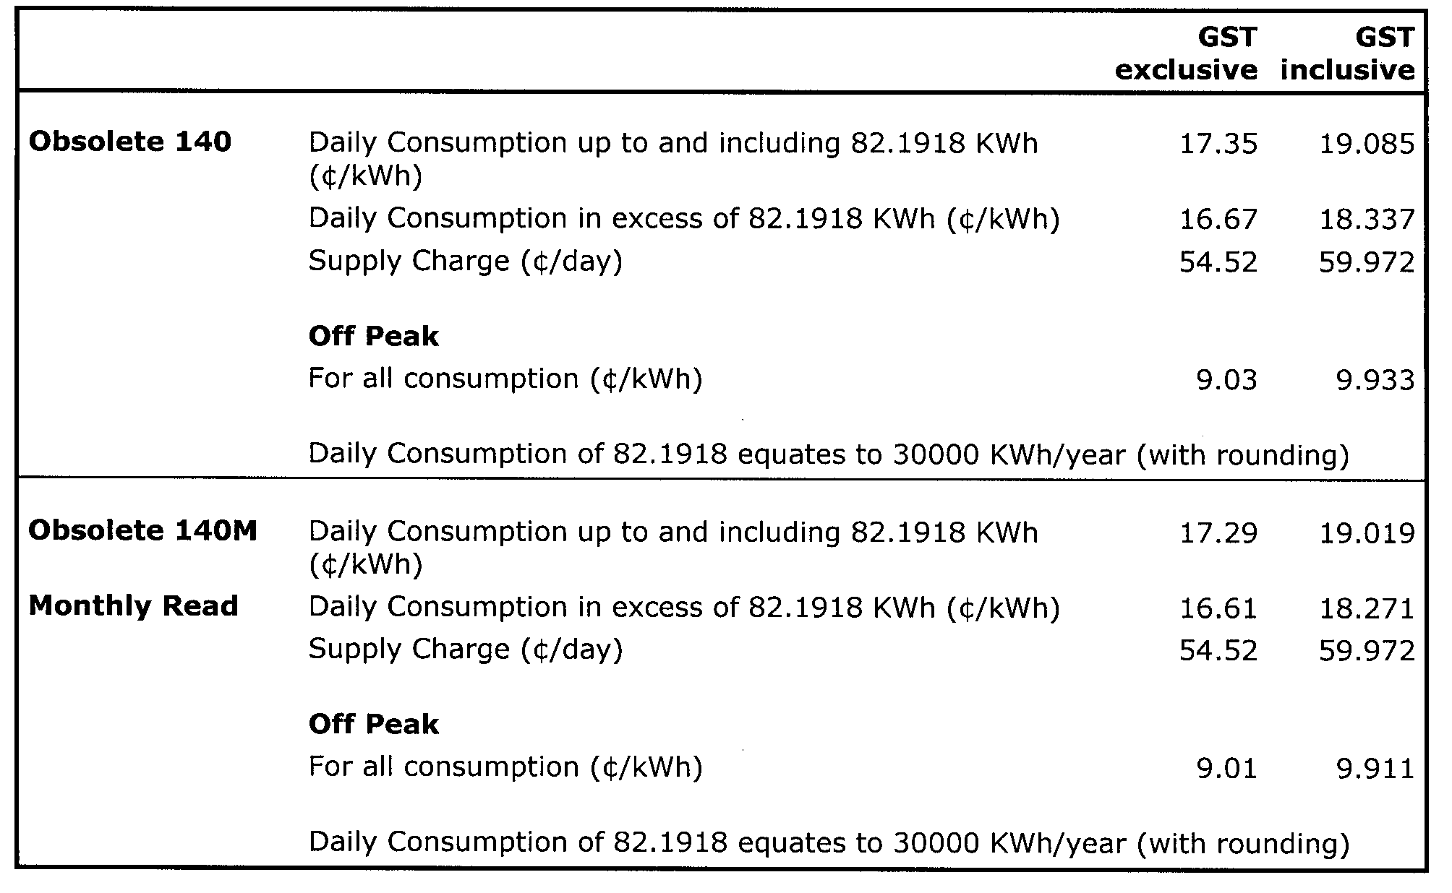
Explanatory Notes:
1. AGLSA’s default contract prices are inclusive of the GST.
2. Default contract price categories will only apply to small customers (that is, those customers who consume less than 160 MWh of electricity per annum) who are purchasing electricity under AGLSA’s default contract terms and conditions. Default contract prices apply in accordance with the following principles:
(a) “Daily Consumption” is the total electricity consumption for the period to which the customer’s bill relates, divided by the number of days in that period.
(b) Domestic Light/Power 110:
• applicable to all residential consumption (excluding Off-Peak Controlled Load Tariff 116) in premises used wholly or principally as private residences.
(c) Charitable Institutions 112:
• available to charitable institutions that have been endorsed by the Australian Taxation Office as an income tax exempt Charitable Entity under Subdivision 50-B of the Income Tax Assessment Act 1997.
(d) Controlled Load 116:
• for electricity used in permanently installed storage water heaters with a rated delivery of not less than 125 litres, storage space heaters and other approved thermal storage applications; the hours of application are fixed from time to time by AGL SA with control by time switch or other means. This price does not apply to electricity used outside those hours;
• customers who were taking supply under this tariff, or who had applied to do so, as at 30 June 2003 are subject to the conditions which were applicable at that date;
• this price is only available in conjunction with tariffs 110, 112, 126, 126M, 128, 128M , 140 or 140M.
(e) General Supply 126:
• available only to non-residential customers.
(f) General Supply 126M (Monthly Meter Reading):
• available only to non-residential customers;
• applies to customers whose meters are scheduled to be read monthly, and who are billed monthly;
• a monthly meter reading fee applies to this tariff in addition to the above prices.
(g) General Supply Time of Use 128:
• available only to non-residential customers with appropriate metering;
• includes customers previously on tariffs 120 + 121 and 130 + 131 who were taking supply under those tariffs, or who had applied to do so, as at 30 June 1997. Those customers are subject to the conditions which were applicable to those tariffs at that date, in addition to the current conditions.
(h) General Supply Time of Use 128M (Monthly Meter Reading):
• available only to non-residential customers with appropriate metering;
• includes customers previously on tariffs 120 + 121 and 130 + 131 who were taking supply under those tariffs, or who had applied to do so, as at 30 June 1997. Those customers are subject to the conditions which were applicable to those tariffs at that date, in addition to the current conditions;
• applies to customers whose meters are scheduled to be read monthly, and who are billed monthly;
• a monthly meter reading fee applies to this tariff in addition to the above prices.
(i) Obsolete Tariff 140 (formerly Farm Tariff 140):
• applies only to small customers that were taking supply under Obsolete Tariff 140, or who had applied to do so, as at 30 June 1997. Conditions applicable at that date apply, in addition to the current conditions.
(j) Obsolete Tariff 140M (Monthly Meter Reading):
• applies only to small customers that were taking supply;
• under Obsolete Tariff 140, or who had applied to do so, as at 30 June 1997. Conditions applicable at that date apply, in addition to the current conditions;
• applies to customers whose meters are scheduled to be read monthly, and who are billed monthly;
• a monthly meter reading fee applies to this tariff in addition to the above prices.
3. Peak period is 0700 hours to 2100 hours from Monday to Friday (Central Standard Time) for all tariffs other than tariff 110 except where the network meters do not recognise specific tariff days. In these situations peak period is 0700 hours to 2100 hours (Central Standard Time) each day for tariffs other than tariff 110.
4. Off peak period is all times other than peak period.
5. Where prices change during a billing cycle the bill for that billing cycle will be calculated on a pro-rata basis using:
(a) the old price up to and including the date of change; and
(b) the new price from the date of change to the end of the billing cycle.

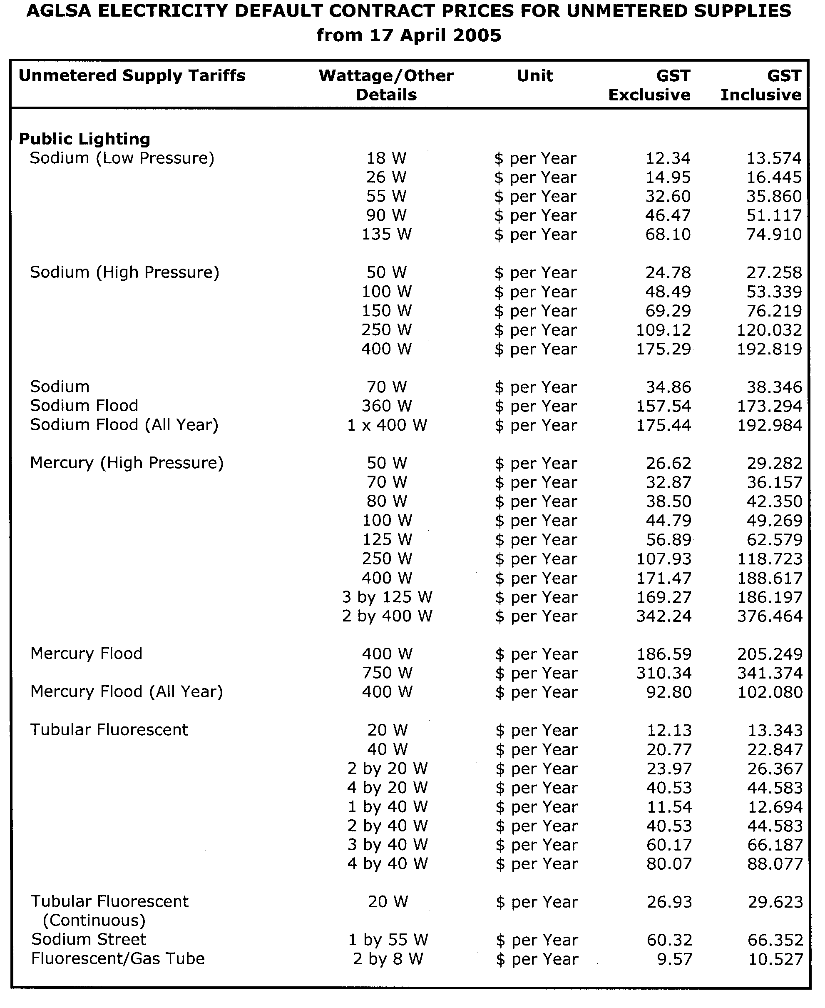
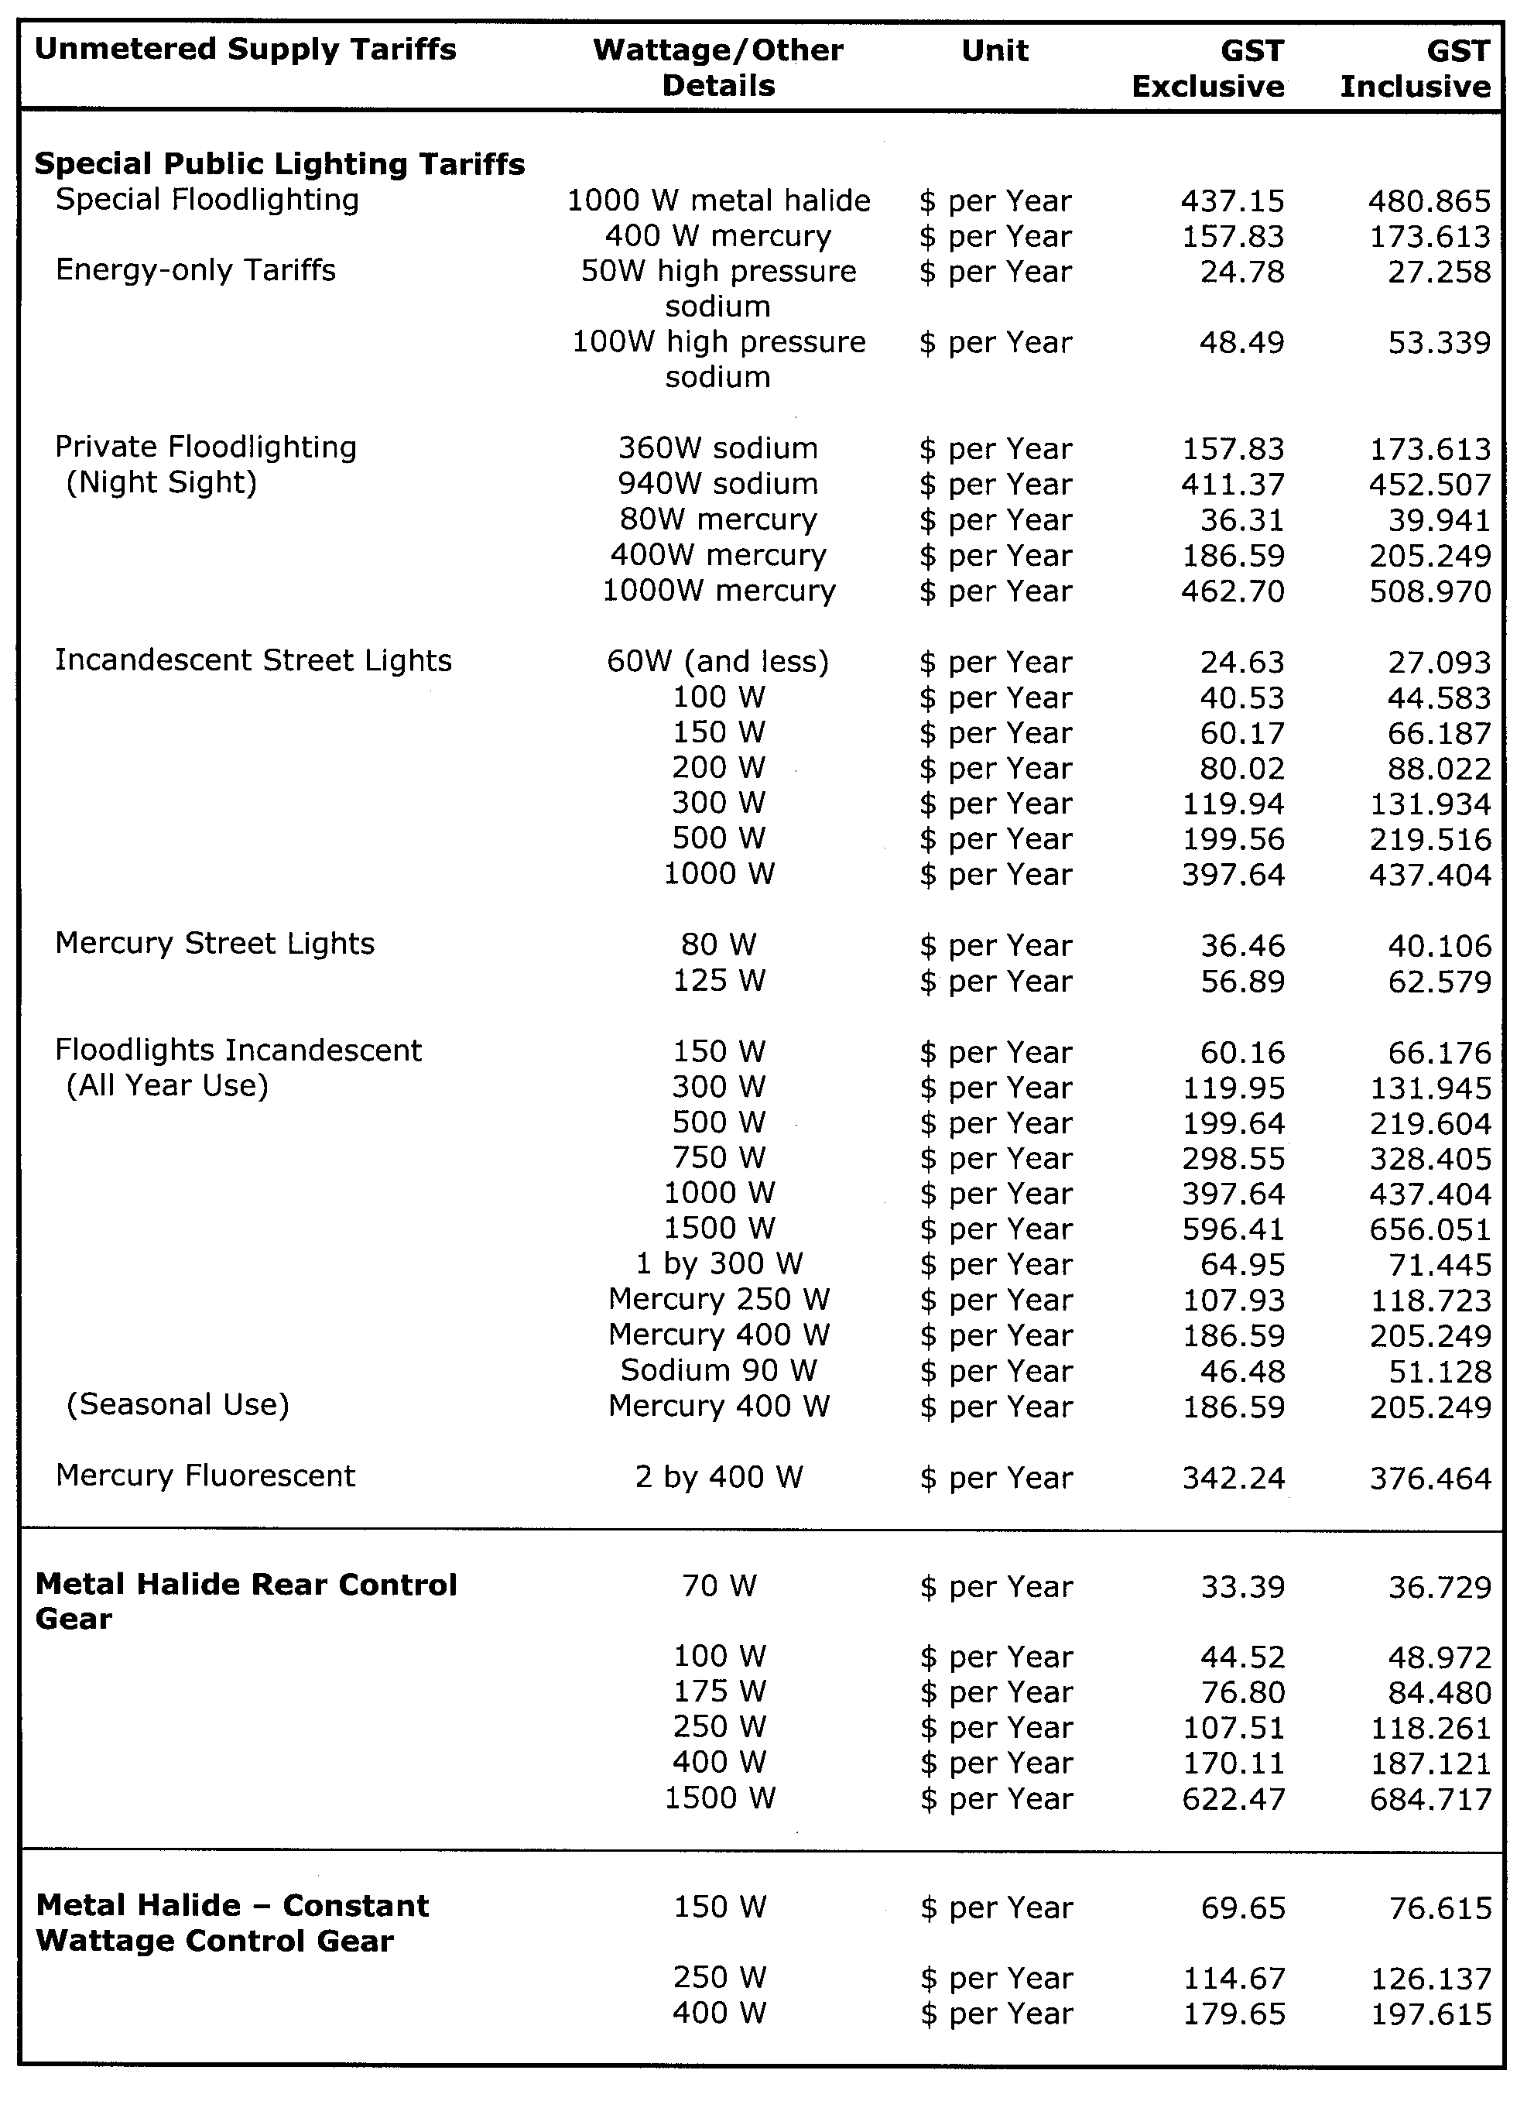
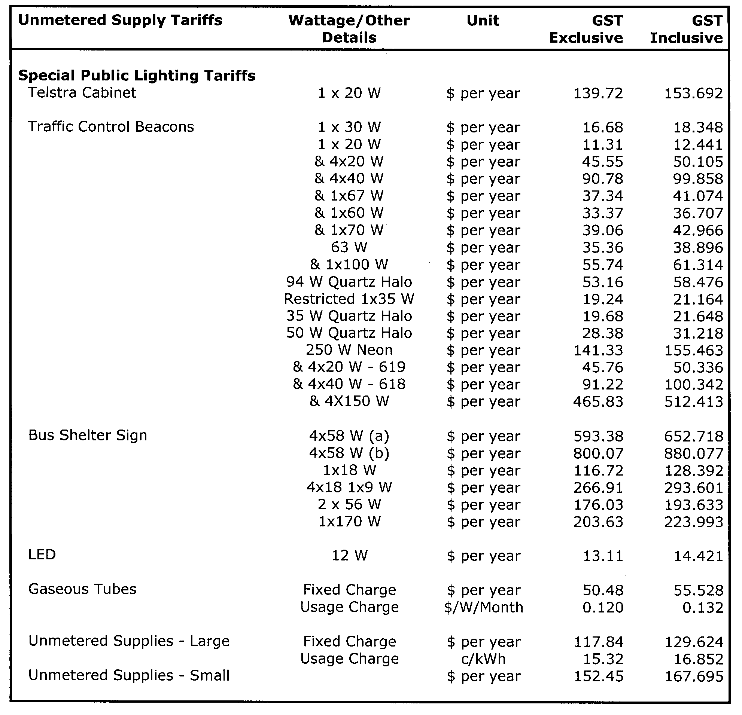

GOVERNMENT GAZETTE ADVERTISEMENT RATES

To apply from 1 July 2004

$  Agents, Ceasing to Act as 35.50  Associations:  Incorporation 18.10  Intention of Incorporation 44.75  Transfer of Properties 44.75  Attorney, Appointment of 35.50  Bailiff’s Sale 44.75  Cemetery Curator Appointed 26.50  Companies:  Alteration to Constitution 35.50  Capital, Increase or Decrease of 44.75  Ceasing to Carry on Business 26.50  Declaration of Dividend 26.50  Incorporation 35.50  Lost Share Certificates:  First Name 26.50  Each Subsequent Name 9.10  Meeting Final 29.75  Meeting Final Regarding Liquidator’s Report on  Conduct of Winding Up (equivalent to ‘Final  Meeting’)  First Name 35.50  Each Subsequent Name 9.10  Notices:  Call 44.75  Change of Name 18.10  Creditors 35.50  Creditors Compromise of Arrangement 35.50  Creditors (extraordinary resolution that ‘the Com-pany be wound up voluntarily and that a liquidator be appointed’) 44.75  Release of Liquidator⎯Application⎯Large Ad. 70.50  ⎯Release Granted 44.75  Receiver and Manager Appointed 41.25  Receiver and Manager Ceasing to Act 35.50  Restored Name 33.50  Petition to Supreme Court for Winding Up 62.00  Summons in Action 53.00  Order of Supreme Court for Winding Up Action 35.50  Register of Interests⎯Section 84 (1) Exempt 80.00  Removal of Office 18.10  Proof of Debts 35.50  Sales of Shares and Forfeiture 35.50  Estates:  Assigned 26.50  Deceased Persons⎯Notice to Creditors, etc. 44.75  Each Subsequent Name 9.10  Deceased Persons⎯Closed Estates 26.50  Each Subsequent Estate 1.15  Probate, Selling of 35.50  Public Trustee, each Estate 9.10 |  | $  Firms:  Ceasing to Carry on Business (each insertion) 23.60  Discontinuance Place of Business 23.60  Land⎯Real Property Act:  Intention to Sell, Notice of 44.75  Lost Certificate of Title Notices 44.75  Cancellation, Notice of (Strata Plan) 44.75  Mortgages:  Caveat Lodgment 18.10  Discharge of 19.00  Foreclosures 18.10  Transfer of 18.10  Sublet 9.10  Leases⎯Application for Transfer (2 insertions) each 9.10  Lost Treasury Receipts (3 insertions) each 26.50  Licensing 53.00  Municipal or District Councils:  Annual Financial Statement⎯Forms 1 and 2 499.00  Electricity Supply⎯Forms 19 and 20 354.00  Default in Payment of Rates:  First Name 70.50  Each Subsequent Name 9.10  Noxious Trade 26.50  Partnership, Dissolution of 26.50  Petitions (small) 18.10  Registered Building Societies (from Registrar-  General) 18.10  Register of Unclaimed Moneys⎯First Name 26.50  Each Subsequent Name 9.10  Registers of Members⎯Three pages and over:  Rate per page (in 8pt) 226.00  Rate per page (in 6pt) 299.00  Sale of Land by Public Auction 45.25  Advertisements 2.50  Advertisements, other than those listed are charged at $2.50 per column line, tabular one-third extra.  Notices by Colleges, Universities, Corporations and District Councils to be charged at $2.50 per line.  Where the notice inserted varies significantly in length from that which is usually published a charge of $2.50 per column line will be applied in lieu of advertisement rates listed.  South Australian Government publications are sold on the condition that they will not be reproduced without prior permission from the Government Printer.
All the above prices include GST

GOVERNMENT GAZETTE NOTICES
ALL private advertisements forwarded for publication in the South Australian Government Gazette must be PAID FOR PRIOR TO INSERTION; and all notices, from whatever source, should be legibly written on one side of the paper only and sent to Government Publishing SA so as to be received no later than 4 p.m. Tuesday preceding the day of publication. Phone 8207 1045 or Fax 8207 1040. E-mail: governmentgazette@saugov.sa.gov.au. Send as attachments in Word format. Please include date the notice is to be published and to whom the notice will be charged. The Government Gazette is available online at: www.governmentgazette.sa.gov.au.

MISCELLANEOUS LEGISLATION AND GOVERNMENT PUBLICATIONS PRICES AS FROM 1 JULY 2004

Acts, Bills, Rules, Parliamentary Papers and Regulations
Pages | Main | Amends | Pages | Main | Amends

1-16 | 2.15 | 0.95 | 497-512 | 30.25 | 29.00
17-32 | 2.90 | 1.80 | 513-528 | 31.25 | 29.90
33-48 | 3.80 | 2.70 | 529-544 | 32.00 | 31.00
49-64 | 4.75 | 3.65 | 545-560 | 33.00 | 32.00
65-80 | 5.60 | 4.60 | 561-576 | 33.75 | 33.00
81-96 | 6.50 | 5.40 | 577-592 | 34.75 | 33.50
97-112 | 7.40 | 6.30 | 593-608 | 35.75 | 34.50
113-128 | 8.30 | 7.25 | 609-624 | 36.50 | 35.50
129-144 | 9.35 | 8.25 | 625-640 | 37.25 | 36.10
145-160 | 10.20 | 9.10 | 641-656 | 38.25 | 37.20
161-176 | 11.20 | 10.00 | 657-672 | 38.75 | 38.00
177-192 | 12.00 | 11.00 | 673-688 | 40.50 | 38.80
193-208 | 13.00 | 11.90 | 689-704 | 41.25 | 39.90
209-224 | 13.80 | 12.70 | 705-720 | 41.75 | 41.00
225-240 | 14.70 | 13.60 | 721-736 | 43.50 | 41.50
241-257 | 15.70 | 14.30 | 737-752 | 44.00 | 42.90
258-272 | 16.60 | 15.30 | 753-768 | 45.00 | 43.40
273-288 | 17.50 | 16.40 | 769-784 | 45.50 | 44.70
289-304 | 18.30 | 17.20 | 785-800 | 46.50 | 45.60
305-320 | 19.30 | 18.20 | 801-816 | 47.25 | 46.00
321-336 | 20.10 | 19.00 | 817-832 | 48.25 | 47.25
337-352 | 21.20 | 20.00 | 833-848 | 49.25 | 48.00
353-368 | 22.00 | 21.00 | 849-864 | 50.00 | 48.80
369-384 | 22.90 | 21.90 | 865-880 | 51.00 | 50.00
385-400 | 23.80 | 22.70 | 881-896 | 51.50 | 50.50
401-416 | 23.70 | 23.50 | 897-912 | 53.00 | 51.50
417-432 | 25.75 | 24.50 | 913-928 | 53.50 | 53.00
433-448 | 26.60 | 25.50 | 929-944 | 54.50 | 53.50
449-464 | 27.50 | 26.25 | 945-960 | 55.50 | 54.00
465-480 | 28.00 | 27.25 | 961-976 | 56.50 | 55.00
481-496 | 29.25 | 28.00 | 977-992 | 57.50 | 56.00

Legislation—Acts, Regulations, etc: $
Subscriptions:
Acts 187.00
All Bills as Laid 447.00
Rules and Regulations 447.00
Parliamentary Papers 447.00
Bound Acts 207.00
Index 103.00
Government Gazette
Copy 4.85
Subscription 247.00
Hansard
Copy 13.50
Subscription—per session (issued weekly) 388.00
Cloth bound—per volume 167.00
Subscription—per session (issued daily) 388.00
Legislation on Disk
Whole Database 2 868.00
Annual Subscription for fortnightly updates 881.00
Individual Act(s) including updates POA
Compendium
Subscriptions:
New Subs 1 700.00
Updates 600.00
(All the above prices include GST)

All Legislation, Government Gazette, Hansard and Legislation on disk are available from:
Counter Sales Service SA, Government Legislation⁺ Outlet
and Mail Orders: Lands Titles Office, 101 Grenfell Street, Adelaide
Phone: 13 23 24 (local call cost), Fax: (08) 8204 1909
Postal: G.P.O. Box 1707, Adelaide, S.A. 5001

Online Shop: www.shop.service.sa.gov.au

Subscriptions and Government Publishing SA
Standing Orders: Box 9, Plaza Level, Riverside Centre, North Terrace, Adelaide, S.A. 5000
Phone: (08) 8207 0908, (08) 8207 0910, Fax: (08) 8207 1040

FISHERIES ACT 1982 : SECTION 59
TAKE notice that pursuant to section 59 of the Fisheries Act 1982, Mark Short, Port Vincent Primary School and Aquatic Centre (the ‘exemption holder’), or a person acting as his agent, P.O. Box 116, Port Vincent, S.A. 5581 is exempt from the Fisheries (General) Regulations 2000 in that the exemption holder shall not be guilty of an offence when engaging in the activity specified in Schedule 1, in the waters specified in Schedule 2, subject to the conditions specified in Schedule 3, from 17 February 2005 until 16 December 2005.
Schedule 1
Activities involving the taking, possessing and subsequent release of aquatic organisms (not including species protected pursuant to section 42 of the Fisheries Act 1982) from the waters specified in schedule 2 for education purposes at the Port Vincent Primary School and Aquatic Centre (the ‘exempted activity’).
Schedule 2
South Australian marine coastal waters of Gulf St Vincent, including intertidal ‘rocky’ reef areas.
Schedule 3
1. All organisms taken by the exemption holder are for display purposes only and must not be sold.
2. An employee of the Port Vincent Primary School and Aquatic Centre must be present at all times whilst conducting the exempted activity.
3. No more than five of any species may be taken or possessed at any one time.
4. The exemption holder must ensure that organisms taken pursuant to this notice are kept only with specimens taken from the same location.
5. All organisms released pursuant to this notice must be released as near as practicable to the point of capture.
6. Within 14 days of the collection of organisms pursuant to this notice, the exemption holder must provide a report in writing to the Director of Fisheries (Attention: Alex Chalupa, G.P.O. Box 1625, Adelaide, S.A. 5001) giving the following details:
• the date and time of collection;
• the name and number of each species taken, including any mortalities resulting from collecting; and
• details of any organisms released.
7. The exemption holder must notify PIRSA Fishwatch on 1800 065 522 at least two hours prior to conducting the exempted activity and answer a series of questions about the exempted activity. The exemption holder will need to have a copy of the exemption at the time of making the call, and be able to provide information about the area and time of the exempted activity, the vehicles and boats involved, the number of agents undertaking the exempted activity and other related questions.
8. The exempted activity must be undertaken in a manner that ensures minimal disturbance of the reef.
9. Whilst engaged in the exempted activity, the exemption holder must have in their possession a copy of this notice and produce a copy of the notice if required by a PIRSA Fisheries Compliance Officer.
10. The exemption holder shall not contravene or fail to comply with the Fisheries Act 1982 or any regulations made under that Act, except where specifically exempted by the notice.
Dated 8 March 2005.
W. Zacharin, Director of Fisheries

FISHERIES ACT 1982: SECTION 59
TAKE notice that pursuant to section 59 of the Fisheries Act 1982, Stuart Robb, Stuie’s Charter and Fishing, P.O. Box 251, Blackwood, S.A. 5051 (the ‘principal exemption holder’) and the class of persons specified in Schedule 1 (the ‘other exemption holders’) are exempt from clause 66 of Schedule 1 of the Fisheries (General) Regulations 2000, but only insofar as the exemption holders may exceed the prescribed boat limits during a chartered fishing trip on the NOK in accordance with the allowable limits
specified in Schedule 2 (the ‘exempted activity’), subject to the conditions specified in Schedule 3, from 17 March 2005 until 30 June 2005, unless varied or revoked earlier.
Schedule 1
Any person or persons who charter the boat NOK from Stuart Robb and Stuie’s Charter and Fishing for the purpose of recreational fishing.
Schedule 2
1. Where the number of ‘other exemption holders’ exceeds six, all of the ‘other exemption holders’ on board the boat are each restricted to taking no more than one half of the daily bag limit (rounded up to the nearest whole number if necessary) for those species of scalefish (except King George whiting) subject to a limit as specified in the Fisheries (General) Regulations 2000 in any one day.
2. Where the number of ‘other exemption holders’ exceeds three, all of the ‘other exemption holders’ on board the boat are each restricted to taking no more than 10 King George whiting in any one day.
Schedule 3
1. The principal exemption holder, its employees or agents must not take any fish during the chartered fishing trip.
2. The principal exemption holder must not use any boat other than the NOK for the purpose of engaging in the exempted activity.
3. Neither the principal exemption holder nor the other exemption holders may sell any fish taken pursuant to this notice.
4. The principal exemption holder must not accept any fish taken by the other exemption holders as all or part of the consideration for the charter agreement.
5. The principal exemption holder must contact PIRSA Fishwatch on 1800 065 522 at least 24 hours prior to commencing the exempted activity and advise the time and date of departure of the NOK and the estimated time of return to port.
6. While engaged in the exempted activity the principal exemption holder must have in their possession a copy of this notice. Such notice must be produced to a PIRSA Fisheries Officer if requested.
7. The exemption holders must not contravene or fail to comply with the Fisheries Act 1982, or any regulations made under that Act except where specifically exempted by this notice.
Dated 16 March 2005.
W. Zacharin, Director of Fisheries

LIQUOR LICENSING ACT 1997 AND GAMING MACHINES ACT 1992
Notice of Application
NOTICE is hereby given, pursuant to section 52 of the Liquor Licensing Act 1997 and section 29 of the Gaming Machines Act 1992, that Alistian Pty Ltd has applied to the Licensing Authority for the transfer of a Hotel and Gaming Machine Licence in respect of premises situated at 26 Alexander Street, Wallaroo, S.A. 5556 and known as Wallaroo Hotel.
The applications have been set down for hearing on 20 April 2005 at 10 a.m.
Any person may object to the application by lodging a notice of objection in the prescribed form with the Licensing Authority, and serving a copy of the notice on the applicant at the applicant’s address given above, at least seven days before the hearing date (viz: 12 April 2005).
The applicant’s address for service is c/o Craig Vozzo, SGIC Building, Level 15, 211 Victoria Square, Adelaide, S.A. 5000.
Plans in respect of the premises the subject of the application are open to public inspection without fee at the Office of the Liquor and Gambling Commissioner, 9th Floor, East Wing, 50 Grenfell Street, Adelaide, S.A. 5000. Phone 8226 8410, Fax:
8226 8512. Email: olgc@agd.sa.gov.au.
Dated 11 March 2005.
Applicant

LIQUOR LICENSING ACT 1997 AND GAMING MACHINES ACT 1992
Notice of Application
NOTICE is hereby given, pursuant to section 52 of the Liquor Licensing Act 1997 and section 29 of the Gaming Machines Act 1992, that CKB Pty Ltd as trustee for Christopher Beston Family Trust, Flaming Guitar as trustee for Robert Beston Family Trust and Emnoli Pty Ltd as trustee for Jacquelyn Baryczka Family Trust have applied to the Licensing Authority for the transfer of a Hotel and Gaming Machine Licence in respect of premises situated at Stuart Street, Melrose, S.A. 5483 and known as Mount Remarkable Hotel.
The applications have been set down for hearing on 20 April 2005 at 9 a.m.
Any person may object to the application by lodging a notice of objection in the prescribed form with the Licensing Authority, and serving a copy of the notice on the applicants at the applicants’ address given above, at least seven days before the hearing date (viz: 12 April 2005).
The applicants’ address for service is c/o Geoff Forbes, 167 Flinders Street, Adelaide, S.A. 5000.
Plans in respect of the premises the subject of the application are open to public inspection without fee at the Office of the Liquor and Gambling Commissioner, 9th Floor, East Wing, 50 Grenfell Street, Adelaide, S.A. 5000. Phone 8226 8410, Fax:
8226 8512. Email: olgc@agd.sa.gov.au.
Dated 11 March 2005.
Applicants

LIQUOR LICENSING ACT 1997
Notice of Application
NOTICE is hereby given, pursuant to section 52 (2) (b) of the Liquor Licensing Act 1997, that Tarparee Pty Ltd has applied to the Licensing Authority for a variation to an Extended Trading Authorisation and Entertainment Consent in respect of premises situated at Princes Highway, Meningie, S.A. 5264 and known as Meningie Hotel.
The application has been set down for hearing on 15 April 2005 at 9 a.m.
Conditions
The following licence conditions are sought:
• Variation to Extended Trading Authorisation in Areas 1 to 4 (inclusive) to include the following hours:
Friday, Saturday and any other day preceding a Public Holiday: Midnight to 2.30 a.m. the following day;
Good Friday: Midnight to 2 a.m. the following day;
Sunday: 8 a.m. to 11 a.m.
• Variation to Entertainment Consent to include Area 4 and additional trading hours to 2 a.m. the following day on Friday, Saturday and any other day preceding a Public Holiday in Areas 1, 2 and 4.
Any person may object to the application by lodging a notice of objection in the prescribed form with the Licensing Authority, and serving a copy of the notice on the applicant at the applicant’s address given above, at least seven days before the hearing date (viz: 7 April 2005).
The applicant’s address for service is c/o Craig Vozzo, SGIC Building, Level 15, 211 Victoria Square, Adelaide, S.A. 5000.
Plans in respect of the premises the subject of the application are open to public inspection without fee at the Office of the Liquor and Gambling Commissioner, 9th Floor, East Wing, 50 Grenfell Street, Adelaide, S.A. 5000. Phone 8226 8410, Fax:
8226 8512. Email: olgc@agd.sa.gov.au.
Dated 11 March 2005.
Applicant

LIQUOR LICENSING ACT 1997
Notice of Application
NOTICE is hereby given, pursuant to section 52 (2) (b) of the Liquor Licensing Act 1997, that The Organik Store Pty Ltd has applied to the Licensing Authority for a Retail Liquor Merchant’s Licence in respect of premises situated at 37 Broadway, Glenelg South, S.A. 5045 and to be known as The Organik Store.
The application has been set down for hearing on 15 April 2005 at 9 a.m.
Condition
The following licence condition is sought:
• Liquor sold pursuant to the licence shall be liquor produced in accordance with The National Standard for Organic and Biodynamic Produce.
Any person may object to the application by lodging a notice of objection in the prescribed form with the Licensing Authority, and serving a copy of the notice on the applicant at the applicant’s address given above, at least seven days before the hearing date (viz: 7 April 2005).
The applicant’s address for service is c/o Susanne McCallum, 37 Broadway, Glenelg South, S.A. 5045.
Plans in respect of the premises the subject of the application are open to public inspection without fee at the Office of the Liquor and Gambling Commissioner, 9th Floor, East Wing, 50 Grenfell Street, Adelaide, S.A. 5000. Phone 8226 8410, Fax:
8226 8512. Email: olgc@agd.sa.gov.au.
Dated 9 March 2005.
Applicant

LIQUOR LICENSING ACT 1997
Notice of Application
NOTICE is hereby given, pursuant to section 52 (2) (b) of the Liquor Licensing Act 1997, that Evian Management (Aust) Pty Ltd has applied to the Licensing Authority for a variation to the Extended Trading Authorisation, in respect of premises situated at 1572 Main North Road, Brahma Lodge, S.A. 5109 and known as Brahma Lodge Hotel.
The application has been set down for hearing on 15 April 2005 at 9 a.m.
Conditions
The following licence conditions are sought:
Monday to Thursday: Midnight to 2 a.m. the following day.
Good Friday: Midnight to 2 a.m. the following day.
Any person may object to the application by lodging a notice of objection in the prescribed form with the Licensing Authority, and serving a copy of the notice on the applicant at the applicant’s address given above, at least seven days before the hearing date (viz: 7 April 2005).
The applicant’s address for service is c/o Bill Moody, 7th Floor, 185 Victoria Square, Adelaide, S.A. 5000.
Plans in respect of the premises the subject of the application are open to public inspection without fee at the Office of the Liquor and Gambling Commissioner, 9th Floor, East Wing, 50 Grenfell Street, Adelaide, S.A. 5000. Phone 8226 8410, Fax:
8226 8512. Email: olgc@agd.sa.gov.au.
Dated 8 March 2005.
Applicant

LIQUOR LICENSING ACT 1997
Notice of Application
NOTICE is hereby given, pursuant to section 52 (2) (b) of the Liquor Licensing Act 1997, that Australian Wine & Liquor Wholesalers Pty Ltd has applied to the Licensing Authority for the variation to conditions of licence, in respect of premises situated at 578 The Parade, Auldana, S.A. 5072 and known as Skye Cellars.
The application has been set down for hearing on 15 April 2005 at 9 a.m.
Conditions
The following licence conditions are sought:
• To delete Conditions 1 and 2 of the licence as follows:
(a) liquor must be sold to a purchaser in an aggregate quantity of not less than 4.5 litres; or
(b) at least 30% of the licensee’s gross turnover from the sale of liquor in each assessment period must be derived from the sale of liquor to liquor merchants.
• Variation to the hours of operation to permit trading from 8 a.m. to 9 p.m., Monday to Sunday.
Any person may object to the application by lodging a notice of objection in the prescribed form with the Licensing Authority, and serving a copy of the notice on the applicant at the applicant’s address given above, at least seven days before the hearing date (viz: 7 April 2005).
The applicant’s address for service is c/o Ben Allen, 173 Wakefield Street, Adelaide, S.A. 5000.
Plans in respect of the premises the subject of the application are open to public inspection without fee at the Office of the Liquor and Gambling Commissioner, 9th Floor, East Wing, 50 Grenfell Street, Adelaide, S.A. 5000. Phone 8226 8410, Fax:
8226 8512. Email: olgc@agd.sa.gov.au.
Dated 15 March 2005.
Applicant

LIQUOR LICENSING ACT 1997
Notice of Application
NOTICE is hereby given, pursuant to section 52 (2) (b) of the Liquor Licensing Act 1997, that Fast Food Concepts Pty Ltd has applied to the Licensing Authority for a Special Circumstances Licence in respect of premises situated at City Cross, 32 Grenfell Street, Adelaide, S.A. 5000 and to be known as Hungry George’s.
The application has been set down for hearing on 15 April 2005 at 9 a.m.
Any person may object to the application by lodging a notice of objection in the prescribed form with the Licensing Authority, and serving a copy of the notice on the applicant at the applicant’s address given above, at least seven days before the hearing date (viz: 7 April 2005).
The applicant’s address for service is c/o Jim Apostolakos, 203-205 Hanson Road, Athol Park, S.A. 5012.
Plans in respect of the premises the subject of the application are open to public inspection without fee at the Office of the Liquor and Gambling Commissioner, 9th Floor, East Wing, 50 Grenfell Street, Adelaide, S.A. 5000. Phone 8226 8410, Fax:
8226 8512. Email: olgc@agd.sa.gov.au.
Dated 8 March 2005.
Applicant

LIQUOR LICENSING ACT 1997
Notice of Application
NOTICE is hereby given, pursuant to section 52 (2) (b) of the Liquor Licensing Act 1997, that Brian and Michelle Dominic have applied to the Licensing Authority for a Wholesale Liquor Merchant’s Licence and a Producer’s Licence in respect of premises situated at Section 1547, Winkie Road, Berri, S.A. 5343 and also known as Dominic Wines.
The application has been set down for hearing on 15 April 2005 at 9 a.m.
Any person may object to the application by lodging a notice of objection in the prescribed form with the Licensing Authority, and serving a copy of the notice on the applicants at the applicants’ address given above, at least seven days before the hearing date (viz: 7 April 2005).
The applicants’ address for service is c/o Brian Dominic, P.O. Box 801, Berri, S.A. 5354.
Plans in respect of the premises the subject of the application are open to public inspection without fee at the Office of the Liquor and Gambling Commissioner, 9th Floor, East Wing, 50 Grenfell Street, Adelaide, S.A. 5000. Phone 8226 8410, Fax:
8226 8512. Email: olgc@agd.sa.gov.au.
Dated 10 March 2005.
Applicants

LIQUOR LICENSING ACT 1997
Notice of Application
NOTICE is hereby given, pursuant to section 52 (2) (b) of the Liquor Licensing Act 1997, that Barnale Pty Ltd has applied to the Licensing Authority for the transfer of the Retail Liquor Merchant’s Licence and the Producer’s Licence in respect of premises situated at 24-26 Kangarilla Road, McLaren Vale, S.A. 5171 and known as Beresford Wines.
The application has been set down for hearing on 18 April 2005 at 9 a.m.
Any person may object to the application by lodging a notice of objection in the prescribed form with the Licensing Authority, and serving a copy of the notice on the applicant at the applicant’s address given above, at least seven days before the hearing date (viz: 10 April 2005).
The applicant’s address for service is c/o Neil MacKenzie, 24-26 Kangarilla Road, McLaren Vale, S.A. 5171.
Plans in respect of the premises the subject of the application are open to public inspection without fee at the Office of the Liquor and Gambling Commissioner, 9th Floor, East Wing, 50 Grenfell Street, Adelaide, S.A. 5000. Phone 8226 8410, Fax:
8226 8512. Email: olgc@agd.sa.gov.au.
Dated 4 March 2005.
Applicant

LIQUOR LICENSING ACT 1997
Notice of Application
NOTICE is hereby given, pursuant to section 52 (2) (b) of the Liquor Licensing Act 1997, that Katrina Emmerson and Gino Sbriz have applied to the Licensing Authority for the transfer of a Hotel Licence in respect of premises situated at Railway Terrace, Parilla, S.A. 5303 and known as Parilla Hotel.
The application has been set down for hearing on 18 April 2005 at 9.30 a.m.
Any person may object to the application by lodging a notice of objection in the prescribed form with the Licensing Authority, and serving a copy of the notice on the applicants at the applicants’ address given above, at least seven days before the hearing date (viz: 10 April 2005).
The applicants’ address for service is c/o Katrina Emmerson, 570 Railway Terrace, Parilla, S.A. 5303.
Plans in respect of the premises the subject of the application are open to public inspection without fee at the Office of the Liquor and Gambling Commissioner, 9th Floor, East Wing, 50 Grenfell Street, Adelaide, S.A. 5000. Phone 8226 8410, Fax:
8226 8512. Email: olgc@agd.sa.gov.au.
Dated 8 March 2005.
Applicants

LIQUOR LICENSING ACT 1997
Notice of Application
NOTICE is hereby given, pursuant to section 52 (2) (b) of the Liquor Licensing Act 1997, that Nauvarat Pacific Pty Ltd as trustee for N. C. J. Family Trust has applied to the Licensing Authority for the transfer of a Restaurant Licence in respect of premises situated at 199-201 Waymouth Street, Adelaide, S.A. 5000 known as Naschen Bistro and to be known as Bangkok Thai Restaurant.
The application has been set down for hearing on 18 April 2005 at 10 a.m.
Any person may object to the application by lodging a notice of objection in the prescribed form with the Licensing Authority, and serving a copy of the notice on the applicant at the applicant’s address given above, at least seven days before the hearing date (viz: 11 April 2005).
The applicant’s address for service is c/o Judy Koh, 23A Payneham Road, College Park, S.A. 5069.
Plans in respect of the premises the subject of the application are open to public inspection without fee at the Office of the Liquor and Gambling Commissioner, 9th Floor, East Wing, 50 Grenfell Street, Adelaide, S.A. 5000. Phone 8226 8410, Fax:
8226 8512. Email: olgc@agd.sa.gov.au.
Dated 9 March 2005.
Applicant

LIQUOR LICENSING ACT 1997
Notice of Application
NOTICE is hereby given, pursuant to section 52 (2) (b) of the Liquor Licensing Act 1997, that Port Augusta Tennis Association Incorporated has applied to the Licensing Authority for a Limited Club Licence in respect of premises situated at 8 Augusta Terrace, Port Augusta, S.A. 5700 and to be known as Port Augusta Tennis Association Incorporated.
The application has been set down for hearing on 15 April 2005 at 9 a.m.
Any person may object to the application by lodging a notice of objection in the prescribed form with the Licensing Authority, and serving a copy of the notice on the applicant at the applicant’s address given above, at least seven days before the hearing date (viz: 7 April 2005).
The applicant’s address for service is c/o Terry Riordan, 13 Flinders Street, Port Augusta, S.A. 5700.
Plans in respect of the premises the subject of the application are open to public inspection without fee at the Office of the Liquor and Gambling Commissioner, 9th Floor, East Wing, 50 Grenfell Street, Adelaide, S.A. 5000. Phone 8226 8410, Fax:
8226 8512. Email: olgc@agd.sa.gov.au.
Dated 9 March 2005.
Applicant

LIQUOR LICENSING ACT 1997
Notice of Application
NOTICE is hereby given, pursuant to section 52 (2) (b) of the Liquor Licensing Act 1997, that Giovanni Battista and Concetta Anne Ciccocioppo have applied to the Licensing Authority for a Producer’s Licence in respect of premises situated at Allotment 899, Koop Creek Road, Springton, S.A. 5235 and to be known as Springton Hills Wines.
The application has been set down for hearing on 15 April 2005 at 9 a.m.
Any person may object to the application by lodging a notice of objection in the prescribed form with the Licensing Authority, and serving a copy of the notice on the applicants at the applicants’ address given above, at least seven days before the hearing date (viz: 7 April 2005).
The applicants’ address for service is c/o Grant S. Schuyler, Heuzenroeder & Heuzenroeder, P.O. Box 60, Tanunda, S.A. 5352.
Plans in respect of the premises the subject of the application are open to public inspection without fee at the Office of the Liquor and Gambling Commissioner, 9th Floor, East Wing, 50 Grenfell Street, Adelaide, S.A. 5000. Phone 8226 8410, Fax:
8226 8512. Email: olgc@agd.sa.gov.au.
Dated 10 March 2005.
Applicants

LIQUOR LICENSING ACT 1997
Notice of Application
NOTICE is hereby given, pursuant to section 52 (2) (b) of the Liquor Licensing Act 1997, that A. J. Southern Vineyards Pty Ltd has applied to the Licensing Authority for a Producer’s Licence in respect of premises situated at Moppa Springs Road, Greenock, S.A. 5360 and to be known as Epsilon Wines.
The application has been set down for hearing on 15 April 2005 at 9 a.m.
Any person may object to the application by lodging a notice of objection in the prescribed form with the Licensing Authority, and serving a copy of the notice on the applicant at the applicant’s address given above, at least seven days before the hearing date (viz: 7 April 2005).
The applicant’s address for service is c/o Julia Woithe, P.O. Box 60, Tanunda, S.A. 5352.
Plans in respect of the premises the subject of the application are open to public inspection without fee at the Office of the Liquor and Gambling Commissioner, 9th Floor, East Wing, 50 Grenfell Street, Adelaide, S.A. 5000. Phone 8226 8410, Fax:
8226 8512. Email: olgc@agd.sa.gov.au.
Dated 10 April 2005.
Applicant

LIQUOR LICENSING ACT 1997
Notice of Application
NOTICE is hereby given, pursuant to section 52 (2) (b) of the Liquor Licensing Act 1997, that Australian Wine & Liquor Wholesalers Pty Ltd has applied to the Licensing Authority for a Retail Liquor Merchant’s Licence in respect of premises situated at 578 The Parade, Auldana, S.A. 5072 and to be known as Skye Cellars.
The application has been set down for hearing on 15 April 2005 at 9 a.m.
Any person may object to the application by lodging a notice of objection in the prescribed form with the Licensing Authority, and serving a copy of the notice on the applicant at the applicant’s address given above, at least seven days before the hearing date (viz: 7 April 2005).
The applicant’s address for service is c/o Wallmans Lawyers, 173 Wakefield Street, Adelaide, S.A. 5000.
Plans in respect of the premises the subject of the application are open to public inspection without fee at the Office of the Liquor and Gambling Commissioner, 9th Floor, East Wing, 50 Grenfell Street, Adelaide, S.A. 5000. Phone 8226 8410, Fax:
8226 8512. Email: olgc@agd.sa.gov.au.
Dated 15 March 2005.
Applicant

LIQUOR LICENSING ACT 1997
Notice of Application
NOTICE is hereby given, pursuant to section 52 (2) (b) of the Liquor Licensing Act 1997, that Tony Robert and Sharon Lynette Waterman have applied to the Licensing Authority for the transfer of a Residential Licence in respect of premises situated at Berryman Street, Tumby Bay, S.A. 5605 and known as Tumby Bay Motel.
The application has been set down for hearing on 20 April 2005 at 11 a.m.
Any person may object to the application by lodging a notice of objection in the prescribed form with the Licensing Authority, and serving a copy of the notice on the applicants at the applicants’ address given above, at least seven days before the hearing date (viz: 12 April 2005).
The applicants’ address for service is c/o Nicholls Gervasi, 231 The Parade, Norwood, S.A. 5067.
Plans in respect of the premises the subject of the application are open to public inspection without fee at the Office of the Liquor and Gambling Commissioner, 9th Floor, East Wing, 50 Grenfell Street, Adelaide, S.A. 5000. Phone 8226 8410, Fax:
8226 8512. Email: olgc@agd.sa.gov.au.
Dated 15 March 2005.
Applicants

NATIONAL ELECTRICITY (SOUTH AUSTRALIA)
ACT 1996
Notice Under Section 6 (2) of The National Electricity Law and National Electricity Code
Transitional Arrangement for Market Ancillary Services for
Tasmanian Entry
NOTICE is hereby given pursuant to section 6 (2) of the National Electricity Law, which forms the Schedule to the National Electricity (South Australia) Act 1996 and clause 8.3.9 (d) of the National Electricity Code approved under section 6 of the National Electricity Law, that a new Part 11—NEMMCO Derogation—Transitional Arrangement for Market Ancillary Services for Tasmanian Entry, is inserted in Chapter 8 of the National Electricity Code. These amendments to the National Electricity Code commence on 17 March 2005.
As required by clause 8.3.9 (d) of the National Electricity Code, a copy of the ACCC’s letter granting authorisation dated 9 March 2005 is set out below.
The amendments referred to above and a copy of the ACCC’s letter dated 9 March 2005 can be viewed on the Internet website of National Electricity Code Administrator Limited (ACN 073 942 775) (‘NECA’) at www.neca.com.au under ‘The Code—Gazette notices’ section of that website.
The National Electricity Code can be viewed on the NECA Internet website at www.neca.com.au and at the offices of NECA and National Electricity Market Management Company Limited (ACN 072 010 327). A list of addresses where the Code can be viewed is available on the NECA website.
Dated 17 March 2005.

9 March 2005
Mr John Eastham
Managing Director
NECA
Level 5, 41 Currie Street
Adelaide, S.A. 5000
Dear Mr Eastham
Determination—Tasmanian Ancillary Services—Chapter 8
Derogation
On 22 December 2005, the Australian Competition and Consumer Commission (ACCC) received applications for authorisation (Nos 90948, 90949 and 90950) of amendments to the National Electricity Code (code). The applications were submitted under Part VII of the Trade Practices Act 1974. The code changes relate to limited regional recovery of costs associated with regulation ancillary services following Tasmania’s entry to the National Electricity Market.
Please find attached a copy of the ACCC’s determination in respect of the applications.
The ACCC’s determination outlines its analysis and views on the proposed derogations. The ACCC has authorised the derogations.
A person dissatisfied with the determination may apply to the Australian Competition Tribunal for its review. A copy of this letter together with the determination will be placed on the Public Register kept by the ACCC.
If you have any queries or require further information please call Raif Sarcich on (02) 9131 9183.
Yours sincerely,
Sebastian Roberts,
General Manager,
Regulatory Affairs—Electricity

NATIONAL PARKS REGULATIONS 2001
Permission to Enter the Murray River Mouth area within the
Coorong National Park
PURSUANT to Regulations 14 and 41 of the National Parks Regulations 2001, I, Leanne Burch, Acting Director of National Parks and Wildlife, hereby grant permission for members of the public, to enter the closed areas of Coorong National Park as defined by notice on page 3588 of the South Australian Government Gazette dated Thursday, 3 October 2002.
This permission is subject to the following conditions:
1. That any direction given by the Marine Safety Section, Transport SA be adhered to.
2. The permission shall commence at 8 a.m. on Saturday, 26 March 2005 and continue until 5.30 p.m. on Monday, 28 March 2005.
Dated 15 March 2005.
L. Burch, Acting Director of National Parks and Wildlife

PHYLLOXERA AND GRAPE INDUSTRY ACT 1995
Contributions towards Primary Functions Under the Act for
Year, 2004-2005
PURSUANT to section 23 of the above Act, the Phylloxera and Grape Industry Board gives notice that registered persons (being persons who are recorded in the Register established by the Board as owners of 0.5 hectares, or more of planted vines) must contribute to the costs of the Board’s primary functions for the year ending 30 April 2005.
The rules of calculation of such contributions are as follows:
(1) Calculations will be based on the area of vines recorded in the Register as being owned by each person.
(2) The rate per hectare of vines will be $9.50 with a minimum contribution of $50.
(3) Any fee for default or delay in contribution payment will be calculated on a per hectare basis.
(4) The levy will be collected or recovered by the Commis-sioner of Land Tax on behalf of the Board as if the contribution were land tax, and will be subject to the same penalties for delay or default in payment (section 23 (3) of the Act).
Notices of contributions will be forwarded by post to registered persons.
P. Hackworth, Executive Officer

PRIMARY INDUSTRIES AND RESOURCES SOUTH AUSTRALIA
Eastern Spencer Gulf Draft
Aquaculture Management Policy
Wood Point Prospective Aquaculture Zone
Port Broughton Aquaculture Zone
Tickera Inner and Outer Aquaculture Zones
Wallaroo Shellfish Aquaculture Zone
Point Pearce Prospective Aquaculture Zone
Hardwicke Bay Inner, Middle and Outer Aquaculture Zones
Eastern Spencer Gulf Aquaculture Exclusion Zone
Cape D’Estrees Draft
Aquaculture Management Policy
Cape D’Estrees Inner Aquaculture Zone
Cape D’Estrees Middle Aquaculture Zone
Cape D’Estrees Outer Aquaculture Zone
Laura Bay Exclusion Aquaculture Zone
PURSUANT to section 12 of the Aquaculture Act 2001 notice is hereby given that the Minister for Agriculture, Food and Fisheries has released draft aquaculture policies for the Eastern Spencer Gulf and Cape D’Estrees for public consultation.
The Eastern Spencer Gulf Draft Aquaculture Management Policy will establish the Wood Point Prospective Aquaculture Zone, Port Broughton Aquaculture Zone, Tickera Inner and Outer Aquaculture Zones, Wallaroo Shellfish Aquaculture Zone, Point Pearce Prospective Aquaculture Zone, Hardwicke Bay Inner, Middle and Outer Aquaculture Zones and the Eastern Spencer Gulf Aquaculture Exclusion Zone.
The Cape D’Estrees Aquaculture Management Policy will establish the Cape D’Estrees Inner Aquaculture Zone, Cape D’Estrees Middle Aquaculture Zone, Cape D’Estrees Outer Aquaculture Zone and the Laura Bay Aquaculture Exclusion Zone.
Copies of the policies are available from PIRSA Aquaculture, 14th Floor, 25 Grenfell Street (G.P.O. Box 1625), Adelaide, S.A. 5001, on the internet at www.pir.sa.gov.au/aquaculture, then go to Policy. Or by telephoning (08) 8226 0314 or faxing (08) 8226 0330. Public meetings will be held at Ceduna Sailing Club on 21 April 2005 at 4 p.m. and at Port Broughton Town Hall on 27 April 2005 at 4 p.m.
Written submissions in relation to the draft policy are invited from the public and should be made to Carina Cartwright, PIRSA Aquaculture, G.P.O. Box 1625, Adelaide, S.A. 5001. Submissions must be received by 5 p.m. on 17 May 2005.
Dated 17 March 2005.
Rory McEwen, Minister for Agriculture, Food and Fisheries

ROADS (OPENING AND CLOSING) ACT 1991:
SECTION 24
NOTICE OF CONFIRMATION OF ROAD
PROCESS ORDER
Vaughan Place, Adelaide
Deposited Plan 65118
BY Road Process Order made on 10 May 2004, The Corporation of the City of Adelaide ordered that:
1. A strip of allotment 240 in Filed Plan 181892 (adjoining the southern portion) forming a widening of Vaughan Place, more particularly delineated and numbered ‘1’ in Preliminary Plan No. 03/0061 be opened as road, portion of which is to be subject to a height limitation.
2. A narrow strip of Vaughan Place adjoining Frome Road, allotments 10 and 12 in Deposited Plan 2735 and allotment 97 in Filed Plan 215589 more particularly lettered ‘A’ in Preliminary Plan No. 03/0061 be closed.
3. Transfer the whole of the land subject to closure to Kyren Pty Ltd in accordance with agreement for exchange dated 10 May 2004 entered into between The Corporation of the City of Adelaide and Kyren Pty Ltd.
On 25 November 2004 that order was confirmed by the Minister for Administrative Services conditionally on approval and deposit of the survey plan by the Registrar-General. The condition has now been fulfilled.
Pursuant to section 24 (5) of the Roads (Opening and Closing) Act 1991, NOTICE of the order referred to above and its confirmation is hereby given.
Dated 17 March 2005.
P. M. Kentish, Surveyor-General

PETROLEUM ACT 2000
Section 25 (5) (b)
Variation of Petroleum Exploration Licence—PEL 107
NOTICE is hereby given that under the provisions of the Petroleum Act 2000, pursuant to delegated powers dated 28 March 2002, Gazetted 11 April 2002, page 1573, the conditions of
the abovementioned Exploration Licence have been varied, as follows:
Condition 1 of the licence is omitted and the following substituted:
‘1. During the term of the licence, the Licensee shall carry out or cause to be carried out exploratory operations on the area comprised in the licence in accordance with such work programs as are approved by the Minister from time to time. Years one to three exploratory operations are guaranteed and any subsequent licence year work program becomes guaran-teed upon entry into that licence year. These exploratory operations shall include but not necessarily be limited to:

Year of Term of Licence |  | Minimum Work Requirements
One |  | 1 well; 50 km 2D Seismic; Seismic Reprocessing; Geological and Geophysical Review
Two |  | 1 well; 50 km 2D Seismic or detailed 3D Seismic Program
Three |  | 4 wells; 50 km 2D Seismic or detailed 3D Seismic Program
Four |  | 2 wells
Five |  | 2 wells
 |  |  | ’
This variation provides for two wells originally programmed for Year 2 to be drilled in Year 3. The revised work requirements as a result of this variation would not have altered the outcome of the original competitive tender process.
Dated 14 March 2005.
B. A. Goldstein, Director Petroleum
Minerals and Energy Division
Primary Industries and Resources SA
Delegate of the Minister for Mineral
Resources Development

PETROLEUM ACT 2000
Renewal of Preliminary Survey Licence—PSL 12
NOTICE is hereby given that the undermentioned Preliminary Survey Licence has been renewed under the provisions of the Petroleum Act 2000, pursuant to delegated powers dated 28 March 2002, Gazetted 11 April 2002, page 1573.
No. of  Licence | Licensee | Locality | Date of  Expiry | Approx.  Area in  km² | Reference

PSL 12 | WMC (Olympic Dam  Corporation) Pty Ltd |  | Olympic Dam to the Moomba  to Adelaide gas pipeline | 14 March 2006 | 29 586 | 27/2/278

General Description of Preliminary Survey Licence Area
Pipeline preliminary survey activities are authorised in an area of approximately 29 586 km².
The eastern boundary of the licence area being Pipeline Licence No. 1.
The southern boundary of the licence area being 6675000 mN (GDA94, Zone 54).
The western boundary of the licence area being 223000 mE (GDA94, Zone 54).
The northern boundary being a line offset 2.5 km to the north-west of a line joining the point latitude 28°06′33.44″S, GDA94 and longitude 140°12′07.64″E, GDA94 to the point latitude 29°05′12.35″S, GDA94 and longitude 138°10′09.14″E, GDA94. The north-eastern corner boundary being an arc of 2.5 km radius centred on the point latitude 28°06′33.44″S, GDA94 and longitude 140°12′07.64″E, GDA94. The south-western portion of the licence area consists of a corridor 5 km wide and approximately 203 km long centred on the existing water pipeline easement from Olympic Dam to Borefield B (latitude 29°05′12.35″S, GDA94 and longitude 138°10′09.14″E, GDA94) which is within the Muloorina Prescribed Wells Area, terminating at latitude 30°25′43.13″S, GDA94 and longitude 136°52′32.22″E, GDA94.
Dated 7 March 2005.
B. A. Goldstein, Director Petroleum,
Minerals and Energy Division,
Primary Industries and Resources SA
Delegate of the Minister for Mineral Resources Development

WATER CONSERVATION ACT 1936
Rates for Supply by Agreement
IN relation to agreements for the supply of water pursuant to section 19 of the Water Conservation Act 1936, I fix the rates payable in respect of the 2005-2006 financial year under agreements to which that section applies as set out in the Schedule.
Schedule

Quarterly rate payable $72.50
and
Additional water rates payable for water supplied to or in relation to land and
standpipes during the consumption year ending in the 2005-2006 financial year:
(i) for each kilolitre supplied up to and including 125 kilolitres 0.92 per kilolitre
(ii) for each kilolitre supplied over 125 kilolitres $4.24 per kilolitre

Dated 11 March 2005.
J. D. Hill, Minister for Environment and Conservation
SAW 05/00301

NOTICE TO MARINERS
No. 6 of 2005
South Australia—Spencer Gulf—Thistle Island—Activation of Defence Practice Area R246—Defence Works in Progress
MARINERS are advised that Defence Practice Area R246 will be activated from 0001 hours on Monday, 21 March 2005 until 2359 hours on Monday, 28 March 2005. Defence Department vessels will be operating within the restricted area.
All unauthorised vessels are prohibited from entering this Defence Practice Area during the stated period above.
Defence Practice Area R246 description is as follows:
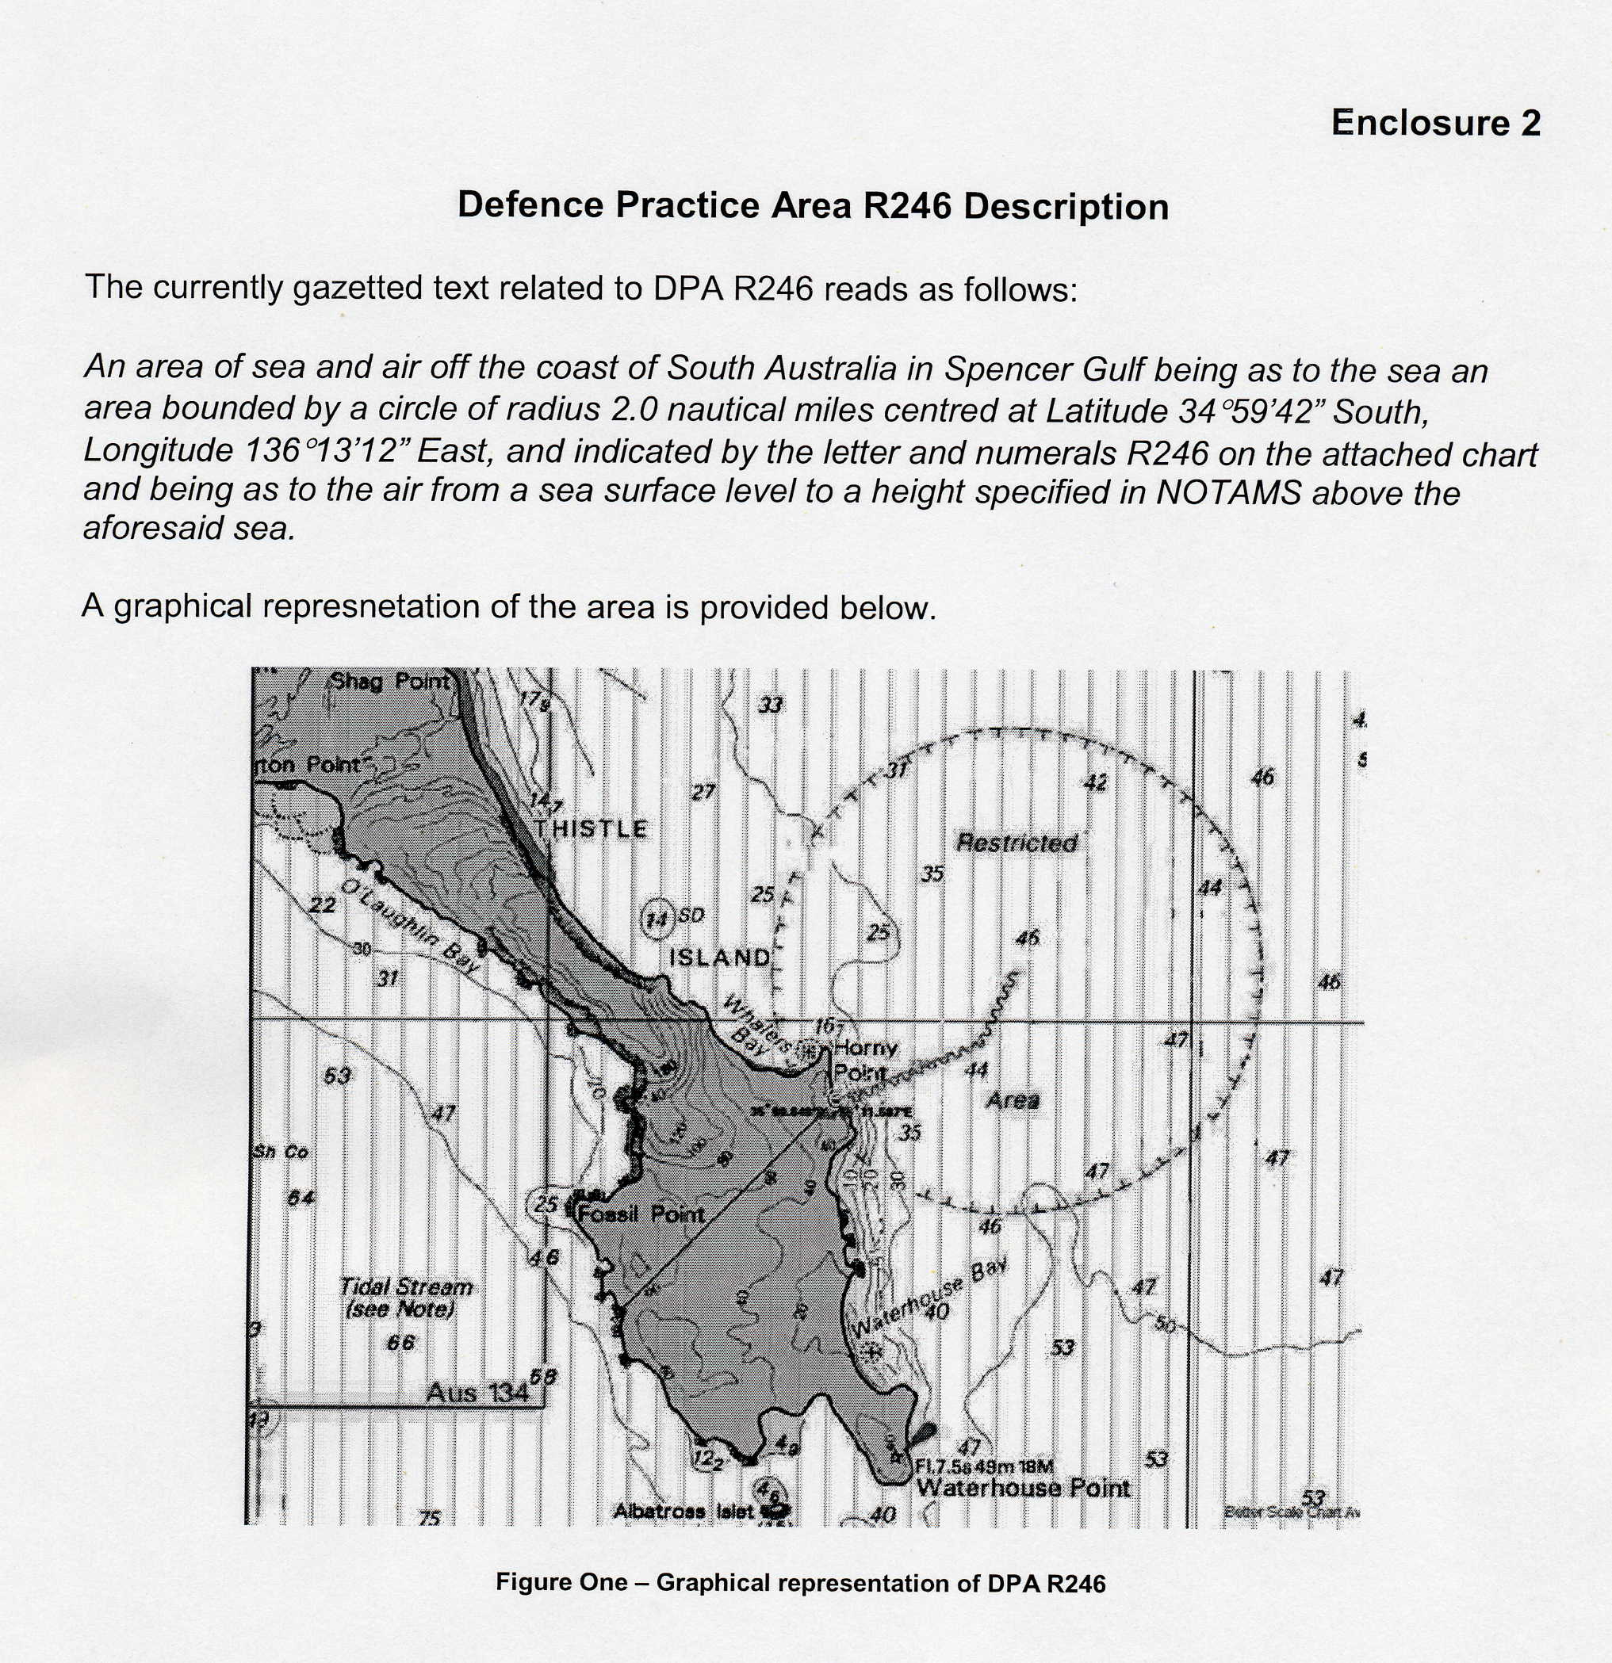
Charts affected: Aus 345 and 776.
Publication affected: Australian Pilot, Volume 1, Seventh Edition 1992, page 86.
Adelaide, Friday, 11 March 2005.
Trish White, Minister for Transport

WATER MAINS AND SEWERS

Office of the South Australian Water Corporation
Adelaide, 17 March 2005

WATER MAINS LAID

Notice is hereby given that the following main pipes or parts of main pipes have been laid down by the South Australian Water Corporation in or near the undermentioned water districts and are now available for a constant supply of water to adjacent land.

ADELAIDE WATER DISTRICT

LIGHT REGIONAL COUNCIL
Cormorant Drive, Hewett. p27 and 28
Whistler Grove, Hewett. p28
Swallow Drive, Hewett. p28

CITY OF ONKAPARINGA
In and across Pridham Boulevard, Aldinga Beach. p1
Easements in lot 411 in LTRO DP 65941, Pridham Boulevard, Aldinga Beach. p1
Barramundi Way, Aldinga Beach. p1
Urchin Crescent, Aldinga Beach. p1
Dover Street, Aldinga Beach. p2
Nicholl Avenue, Aldinga Beach. p2 and 3
Easements in lot 2001 in LTRO DP 66925, Aldinga Beach Road, Aldinga Beach. p2 and 3
Kipsy Street, Aldinga Beach. p3
Basin Street, Aldinga Beach. p3
Sedge Street, Aldinga Beach. p3
Sunday Boulevard, Aldinga Beach. p2
Sedge Walk, Aldinga Beach. p2
Seagull Street, Aldinga Beach. p2
Lacy Coral Avenue, Aldinga Beach. p2
Scrub Avenue, Aldinga Beach. p2

CITY OF PLAYFORD
President Avenue, Andrews Farm. p4 and 5
Easement in lot 2000 in LTRO DP 66799, Andrews Road, Andrews Farm. p5
Trinity Court, Andrews Farm. p5
Easements in lot 2001 in LTRO DP 66799, Davoren Road, Andrews Farm. p4 and 5
Easements in lot 23 in LTRO FP 20570, Elizabeth Way, Elizabeth. p15-17
Easements in lot 30 in LTRO DP 33750, Oxenham Street, Elizabeth. p15 and 18
Easement in lot 9 in LTRO FP 101699, Oxenham Street, Elizabeth. p15 and 19
Beckham Rise, Craigmore. p21
Manchester Circuit, Craigmore. p21
Easements in lot 1003 in LTRO DP 65833, Craigmore Road, Craigmore. p21
Newhaven Drive, Craigmore. p21
Hampshire Drive, Craigmore. p21
Chelmsford Street, Craigmore. p21
Easement in lot 1002 in LTRO DP 65833, Vivian Road, Craigmore. p21
Norfolk Street, Craigmore. p21
Ponderosa Road, Andrews Farm and Munno Para West. p29
Gemini Drive, Munno Para West. p29
Dylan Close, Munno Para West. p29
Jake Court, Munno Para West. p29

TOWNSHIP OF CLARE WATER DISTRICT

CLARE AND GILBERT VALLEYS COUNCIL
Square Mile Road, Clare. This main is available on the west side by application only. p6 and 7
Across Square Mile Road, Clare. p7 and 12
Waterworks land (lot 503 in LTRO DP 64306), Square Mile Road, Clare. p7 and 12
Norman Drive, Clare and Stanley Flat. p7-10
Woods Court, Stanley Flat. p8
Easements in lot 40, Woods Court, and lots 41, 420, 550 and 530, White Hut Road, Stanley Flat. p8 and 11
Allenby Court, Stanley Flat. p9
Nicklaus Court, Stanley Flat. p10
Across Pascoe Court, Clare. p13
Easements in lots 19 and 20, Jarman Crescent, Clare. p13
Across Hentsche Road, Clare. p20
Easements in lot 205 in LTRO FP 190767, Hentsche Road, Clare. p20

CUMMINS WATER DISTRICT

DISTRICT COUNCIL OF LOWER EYRE PENINSULA
Across and in Bratten Way, Cummins. This main is available on application only. p22

MORGAN-WHYALLA COUNTRY LANDS WATER DISTRICT

CLARE AND GILBERT VALLEYS COUNCIL
Easements in lot 105 in LTRO FP 206758, and allotment piece 94 in LTRO FP 199962, Slaughterhouse Road, Clare and Spring Farm. p13
Slaughterhouse Road, Spring Farm. p14

PORT VICTOR WATER DISTRICT

CITY OF VICTOR HARBOR
Rymill Avenue, Encounter Bay. p23-26
Wishart Crescent, Encounter Bay. p24
Easements in lot 301 in LTRO DP 65722, Prime Boulevard, Encounter Bay. p23 and 24
Prime Boulevard, Encounter Bay. p23-25
Across and in Mill Road, Encounter Bay. p24 and 25
Easement in lot 207 in LTRO DP 65019, Prime Boulevard, Encounter Bay. p25
Tripp Street, Encounter Bay. p23

WATER MAINS ABANDONED

Notice is hereby given that the undermentioned water mains have been abandoned by the South Australian Water Corporation.

ADELAIDE WATER DISTRICT

CITY OF PLAYFORD
Easements in lot 23 in LTRO FP 20570, Elizabeth Way, Elizabeth. p15-17
Easements in lot 22 in LTRO FP 20570, Elizabeth Way, Elizabeth. p15-18
Easements in lot 28 in LTRO DP 18478, Elizabeth Way, and lot 31 in LTRO DP 18664, Elizabeth. p15-17
Easements in lot 30 in LTRO DP 33750, Oxenham Street, Elizabeth. p15 and 18
Easement in lot 9 in LTRO FP 101699, Elizabeth. p15 and 19

SEWERS LAID

Notice is hereby given that the following sewers have been laid down by the South Australian Water Corporation in the under-mentioned drainage areas and are now available for house connections.

ADELAIDE DRAINAGE AREA

LIGHT REGIONAL COUNCIL
Swallow Drive, Hewett. FB 1136 p23, 24, 26 and 27
Easements in lot 3005 in LTRO DP 66637, Swallow Drive, Hewett. FB 1136 p23, 24 and 26
Whistler Grove, Hewett. FB 1136 p23, 24, 26 and 27
Cormorant Drive, Hewett. FB 1136 p23-27
Easements in lots 132-125, Swallow Drive, Hewett. FB 1136 p23, 24, 26 and 27
CITY OF PLAYFORD
Beckham Rise, Craigmore. FB 1136 p13-15
Manchester Circuit, Craigmore. FB 1136 p13-15
Easements in lot 1003 in LTRO DP 65833, Craigmore Road, Craigmore. FB 1136 p13-15
Hampshire Drive, Craigmore. FB 1136 p13-15
Chelmsford Street, Craigmore. FB 1136 p13, 14 and 16
Easement in lots 228 and 227, Manchester Circuit, Craigmore. FB 1136 p13, 14 and 16
Norfolk Street, Craigmore. FB 1136 p13-15
Easement in lot 1002 in LTRO DP 65833, Vivian Road, Craigmore. FB 1136 p13-15
Easement in lots 324 and 325, Beckham Rise, Craigmore. FB 1136 p13, 14 and 16
Across Newhaven Drive, Craigmore. FB 1136 p13, 14 and 16
Easement in lots 330 and 331, Beckham Rise, Craigmore. FB 1136 p13, 14 and 16
Easements in lot 101 in LTRO FP 31909, Davoren Road, allotment piece 23 in LTRO DP 37847, Andrews Road, and lot 2001 in LTRO DP 66799, Davoren Road, Andrews Farm. FB 1134 p54-57
Trinity Court, Andrews Farm. FB 1134 p54-57
President Avenue, Andrews Farm. FB 1134 p54-57
Easements in lot 2000 in LTRO DP 66799, Andrews Road, Andrews Farm. FB 1134 p54-57
Easement in lot 53, President Avenue, Andrews Farm. FB 1134 p54-56
Across Curtis Road, Munno Para West. FB 1134 p58 and 59
Easement in lot 18, Gemini Drive, Munno Para West. FB 1134 p58 and 59
Gemini Drive, Munno Para West. FB 1134 p58 and 59
Jake Court, Munno Para West. FB 1134 p58 and 59
Dylan Close, Munno Para West. FB 1134 p58 and 59
Ponderosa Road, Munno Para West. FB 1134 p58 and 59

ALDINGA DRAINAGE AREA

CITY OF ONKAPARINGA
Seaview Street, Aldinga Beach. FB 1136 p1 and 5
Dover Street, Aldinga Beach. FB 1136 p1-5 and 8
Seagull Lane, Aldinga Beach. FB 1136 p1, 4 and 6
Across and in Seagull Street, Aldinga Beach. FB 1136 p1, 4 and 6
Goshawk Street, Aldinga Beach. FB 1136 p1, 2 and 8
Kipsy Street, Aldinga Beach. FB 1136 p1-3, 6 and 8
Easements in lot 2001 in LTRO DP 66925, Aldinga Beach Road, Aldinga Beach. FB 1136 p1-4, 6 and 8
Basin Street, Aldinga Beach. FB 1136 p1, 3 and 6
Sedge Street, Aldinga Beach. FB 1136 p1, 3 and 8
Dover Lane, Aldinga Beach. FB 1136 p1, 3 and 6
Nicholl Avenue, Aldinga Beach. FB 1136 p1, 3, 4, 6 and 7
Sunday Lane, Aldinga Beach. FB 1136 p1, 3, 4 and 7
Sunday Boulevard, Aldinga Beach. FB 1136 p1, 4 and 7

VICTOR HARBOR COUNTRY DRAINAGE AREA

CITY OF VICTOR HARBOR
Marlin Terrace, Encounter Bay. FB 1136 p17, 19 and 20
Easements in reserve (lot 59 in LTRO DP 20083), Marlin Terrace, Encounter Bay. FB 1136 p17, 19 and 20
Across and in Mill Road, Encounter Bay. FB 1136 p17, 19 and 20
Prime Boulevard, Encounter Bay. FB 1136 p17-20 and 22
Easements in lots 15-13, Prime Boulevard, and lots 18-20, Rymill Avenue, Encounter Bay. FB 1136 p17-19 and 22
Wishart Crescent, Encounter Bay. FB 1136 p17, 19 and 22
Easements in lot 301 in LTRO DP 65722, Prime Boulevard, Encounter Bay. FB 1136 p17-21
Rymill Avenue, Encounter Bay. FB 1136 p17-19 and 22
Tripp Street, Encounter Bay. FB 1136 p18, 19 and 21
Easement in lot 99, Prime Boulevard, Encounter Bay. FB 1136 p18, 19 and 21
Easement in lot 41, Prime Boulevard, Encounter Bay. FB 1136 p18, 19 and 22

SEWERS LAID

Notice is hereby given that the undermentioned sewer has been laid down by the South Australian Water Corporation and is not available for house connections.

VICTOR HARBOR COUNTRY DRAINAGE AREA

CITY OF VICTOR HARBOR
Easement in lot 42, Mill Road, Encounter Bay. FB 1136 p17 and 20

A. Howe, Chief Executive Officer, South Australian Water Corporation.

South Australia
Teachers Registration and Standards Act (Commencement) Proclamation 2005
1—Short title
This proclamation may be cited as the Teachers Registration and Standards Act (Commencement) Proclamation 2005.
2—Commencement of remaining provisions
The remaining provisions of the Teachers Registration and Standards Act 2004 will come into operation on 31 March 2005.
Note—
Parts 1 and 3 and section 61 of the Teachers Registration and Standards Act 2004 were brought into operation on 20 January 2005 (see Gazette 20.1.2005 p260).
Made by the Governor’s Deputy
with the advice and consent of the Executive Council
on 17 March 2005
MECS05/004CS

South Australia
Administrative Arrangements (Committal of Teachers Registration and Standards Act) Proclamation 2005
under the Administrative Arrangements Act 1994
1—Short title
This proclamation may be cited as the Administrative Arrangements (Committal of Teachers Registration and Standards Act) Proclamation 2005.
2—Commencement
This proclamation comes into operation on the day on which it is made.
3—Administration of Act committed to Minister for Education and Children's Services
The administration of the Teachers Registration and Standards Act 2004 is committed to the Minister for Education and Children's Services.
Made by the Governor’s Deputy
with the advice and consent of the Executive Council
on 17 March 2005
MECS05/004CS

South Australia
Sexual Reassignment Variation Regulations 2005
under the Sexual Reassignment Act 1988

Contents
Part 1—Preliminary
1 Short title
2 Commencement
3 Variation provisions
Part 2—Variation of Sexual Reassignment Regulations 2000
4 Variation of regulation 5—Corresponding laws

Part 1—Preliminary
1—Short title
These regulations may be cited as the Sexual Reassignment Variation Regulations 2005.
2—Commencement
These regulations come into operation on the day on which they are made.
3—Variation provisions
In these regulations, a provision under a heading referring to the variation of specified regulations varies the regulations so specified.
Part 2—Variation of Sexual Reassignment Regulations 2000
4—Variation of regulation 5—Corresponding laws
Regulation 5—after paragraph (c) insert:
(d) Births, Deaths and Marriages Registration Act 2003 of Queensland;
(e) Births, Deaths and Marriages Registration Act 1996 of Victoria;
(f) Births, Deaths and Marriages Registration Act 1999 of Tasmania;
(g) Gender Reassignment Act 2000 of Western Australia.
Note—
As required by section 10AA(2) of the Subordinate Legislation Act 1978, the Minister has certified that, in the Minister's opinion, it is necessary or appropriate that these regulations come into operation as set out in these regulations.
Made by the Governor’s Deputy
with the advice and consent of the Executive Council
on 17 March 2005
No 14 of 2005
AGO0028/05CS

FAXING COPY?
IF you fax copy to Government Publishing SA for inclusion in the Government Gazette, there is no need to send a Confirmation Copy to us as well.
This creates confusion and may well result in your notice being printed twice.
Please use the following fax number:
Fax transmission: (08) 8207 1040
Phone Inquiries: (08) 8207 1045
Please include a contact person, phone number and order number so that we can phone back with any queries we may have regarding the fax copy.
NOTE: Closing time for lodging new copy (fax, hard copy or email) is 4 p.m. on Tuesday preceding the day of publication.

Government Gazette notices can be E-mailed.
The address is:
governmentgazette@saugov.sa.gov.au
Documents should be sent as attachments in Word format.
When sending a document via E-mail, please confirm your transmission with a faxed copy of your document, including the date the notice is to be published.
Fax transmission: (08) 8207 1040
Enquiries: (08) 8207 1045
NOTE: Closing time for lodging new copy (fax, hard copy or email) is 4 p.m. on Tuesday preceding the day of publication.

CITY OF ADELAIDE
Revocation of Community Land Classification—Hindley Street, Adelaide
NOTICE is hereby given that at the meeting of the Adelaide City Council held on 14 February 2005 council approved the revocation from the classification as community land, pursuant to section 194 of the Local Government Act 1999, of the Hindley Street Public Conveniences comprised in the following Certificate of Title:
• Allotment 102, in Deposited Plan 31404, Certificate of Title Volume 5827, folio 547.
M. Hemmerling, Chief Executive Officer

CITY OF PORT ADELAIDE ENFIELD
Conversion of Private Roads to Public Roads
NOTICE is hereby given pursuant to Section 210 (2) (b) of the abovementioned Act, that the City of Port Adelaide Enfield intends to declare the following private roads:
Lady Gowrie Drive, Taperoo
The private road known as Lady Gowrie Drive, Taperoo being allotment 225 in Deposited Plan 2413;
Ventura Avenue, Taperoo
The private road known as Ventura Avenue, Taperoo being allotment 232 in Deposited Plan 2413;
Wandana Terrace, Taperoo
The private road known as Wandana Terrace, Taperoo being allotment 228 in Deposited Plan 2413,
to be public roads.
A copy of the plan indicating the location of the private roads is on display in the Civic Centre, 163 St Vincent Street, Port Adelaide and at the Regional Offices situated in the Enfield, Greenacres and Parks Libraries.
Residents may obtain further information and request that a copy of the plan be posted to them by contacting Gary Baron on Telephone: (08) 8405 6852, Fax: (08) 8405 6666 or Email gbaron@portenf.sa.gov.au.
H. J. Wierda, City Manager

DISTRICT COUNCIL OF THE COPPER COAST
Revocation of Land from Community Land Classification
TAKE notice that on Wednesday, 2 March 2005 the District Council of the Copper Coast resolved pursuant to Section 194 (1) of the Local Government Act 1999, to revoke the Classification as Community Land for the following land:
The whole of the land comprised in Certificate of Title volume 5212 folio 550 described as Allotment 11 in Deposited Plan 30868, Hundred of Wallaroo, known as North Terrace, Moonta Bay.
P. Dinning, Chief Executive Officer

NORTHERN AREAS COUNCIL
Declaration of Public Road
NOTICE is hereby given pursuant to section 210 of the Local Government Act 1999, that the Northern Areas Council at its meeting held on 8 March 2005, declared Allotments 15 and 16 in Deposited Plan 441, being that portion of the land comprised in Certificate of Title Register Book volume 214, folio 189, to be a public road.
P. McInerney, Chief Executive Officer

PORT PIRIE REGIONAL COUNCIL
Re-classification of Magor Park, Port Pirie to Community Land
NOTICE is hereby given that at the ordinary meeting of council held on 23 February 2005, council resolved that in accordance with section 193 (5) of the Local Government Act 1999, the land known as Magor Park, being all the land comprised in Certificate of Title Register Book Volume 5424, Folio 153, which on 18 December 2002, the council excluded from the community land classification, be classified as community land.
Dated 10 March 2005.
I. Burfitt, Chief Executive Officer

IN the matter of the estates of the undermentioned deceased persons:
Burditt, Daisy, late of 54 Cromer Street, Camden Park, home duties, who died on 12 January 2005.
Clyde, Laurence Arthur, late of Murdinga-Morlong Road, Murdinga, primary producer and bus driver, who died on 15 October 2004.
Eyre, Douglas Michell, late of 24D Ayr Avenue, Torrens Park, retired United Nations officer, who died on 3 January 2005.
Fewings, Harold Stanley, late of 30 Sussex Terrace, Westbourne Park, retired company director, who died on 26 January 2005.
Fewings, Jean Ottilie, late of 24 Heather Drive, Ridgehaven, retired typist, who died on 12 November 2004.
Fraser, Lorna, late of 181-193 Days Road, Regency Park, of no occupation, who died on 29 December 2004.
Glastonbury, Jill Marie, late of 44 Cliff Street, Glenelg East, company director, who died on 22 October 2004.
Harvey, Shirley Evelyn, late of 122 Esplanade, Semaphore, of no occupation, who died on 11 January 2005.
Hausmann, Joan Alison, late of 76 Fourth Avenue, St Peters, retired nursing sister, who died on 4 February 2005.
Johns, Ruby Agnes, late of 360 Senate Road, Risdon Park, Port Pirie, widow, who died on 16 December 2004.
Lennie, Olive May, late of 34 Norman Terrace, Everard Park, of no occupation, who died on 13 February 2005.
Martin, Maxwell Claude, late of 14-22 King William Road, Wayville, retired bank officer, who died on 29 January 2005.
Moran, Winifred, late of 147 Frost Road, Salisbury South, widow, who died on 4 January 2005.
Rains, Leroy Charles, late of 147 Frost Road, Salisbury South, retired seaman, who died on 8 January 2005.
Reiter, Donaldson Clemens, late of Ral Ral Avenue, Renmark, retired council worker, who died on 4 January 2005.
Snigg, Patrick Joseph, late of 40 Doctors Road, Hackham, retired clerk, who died on 2 February 2005.
Symonds, Antonia Sylvia, late of 59 George Street, Paradise, retired house mistress, who died on 29 December 2004.
Zadow, Colin Robert, late of 12 Phoebe Avenue, Modbury Heights, retired police officer, who died on 2 November 2004.
Notice is hereby given pursuant to the Trustee Act 1936, as amended, the Inheritance (Family Provision) Act 1972, and the Family Relationships Act 1975, that all creditors, beneficiaries, and other persons having claims against the said estates are required to send, in writing, to the Public Trustee, 25 Franklin Street, Adelaide, S.A. 5000, full particulars and proof of such claims, on or before 15 April 2005, otherwise they will be excluded from the distribution of the said estate; and notice is also hereby given that all persons who are indebted to the said estates are required to pay the amount of their debts to the Public Trustee or proceedings will be taken for the recovery thereof; and all persons having any property belonging to the said estates are forthwith to deliver the same to the Public Trustee.
Dated 17 March 2005.
C. J. O’Loughlin, Public Trustee

UNCLAIMED MONEYS ACT 1891
Register of Unclaimed Moneys Held by Esanda Finance Corporation Limited

Name and Address of Owner  on Books | Total Amount  Due to  Owner  $ | Description of  Unclaimed Moneys | Date of  Cheque
A. J. Lovell, 33 Dew Street, Thebarton, S.A. 5031 | 21.99 | Refund | 9.12.97
Notified Pty Ltd, 20 Wilkinson Street, Alice Springs, NT 0870 | 589.94 | Refund | 16.12.97
Total | $611.93

UNCLAIMED MONEYS ACT 1891
Register of Unclaimed Moneys Held by Esanda Finance Corporation Limited

Name and Address of Owner  on Books |  | Total Amount  Due to  Owner  $ |  | Description of  Unclaimed Moneys |  | Date of  Cheque
P. J. Privopoulos, 1 Stonyfell Road, Stonyfell, S.A. 5066 | 10.19 |  | Refund |  | 22.12.98
A. J. Greyling, 23 Sandpiper Place, West Lakes Shore, S.A. 5020 | 13.71 |  | Refund |  | 12.5.98
S. G. Drescher, 105 Coral Road, Humpty Doo, N.T. 0836 | 15.12 |  | Refund |  | 10.11.98
R. L. Dadd, 33 Karinya Close, Werribee, Vic. 3030 | 17.32 |  | Refund |  | 11.9.98
P. J. Whelan and S. M. Clark, 7 Fisher Street, Magill, S.A. 5072 | 21.77 |  | Refund |  | 7.4.98
O. D. Goncalves, 50 Kookaburra Street, Howard Springs, N.T. 0835 | 25.71 |  | Refund |  | 15.9.98
T. E. Page, Lot 2101, Redcliffe, Humpty Doo, N.T. 0836 | 27.29 |  | Refund |  | 22.7.98
N. L. and S. H. Francis, 4 Cahill Crescent, Nakara, N.T. 0812 | 34.56 |  | Refund |  | 3.2.98
T. L. Nicholas, 39 McDonnell Street, Alice Springs, N.T. 0870 | 36.98 |  | Refund |  | 3.4.98
N. M. Loughhead, 2/16 Houston Street, Larrakeyah, N.T. 0820 | 53.06 |  | Refund |  | 17.2.98
D. E. Murphy, 1042 Carbeen Street, Kunnanurra, W.A. 6743 | 60.14 |  | Refund |  | 15.12.98
S. J. Fitzpatrick, 48 Kennington Road, Hope Valley, S.A. 5090 | 64.18 |  | Refund |  | 23.6.98
K. M. O’Neill and V. L. Marinelli, c/o Post Office, Pine Creek, N.T. 0847 | 86.82 |  | Refund |  | 2.3.98
M. J. Braham and J. M. Clarke, Lot 1, Angas Valley, Cambrai, S.A. 5353 | 110.48 |  | Refund |  | 10.12.98
D. J. Roberts, c/o Sergeants Mess, RAAF Base, Edinburgh, S.A. 5111 | 159.15 |  | Refund |  | 20.8.98
B & B Bobcat & Brickpaving Services, 6 Manning Road, Aberfoyle Park, S.A. 5159 | 186.00 |  | Refund |  | 17.8.98
B. E. Foster, 274 Avoca Road, Bundaberg, Qld 4670 | 199.99 |  | Refund |  | 12.5.98
K. S. and R. Arnold, Hillview, Chetwynd, Vic. 3312 | 214.51 |  | Refund |  | 29.7.98
Northern Territory of Australia, G.P.O. Box 4621, Darwin, N.T. 0801 | 219.22 |  | Refund |  | 11.8.98
Colmex Pty Ltd, 15 Carambola Street, Bees Creek, N.T. 0830 | 222.10 |  | Refund |  | 11.11.98
S. J. Purdie, 17 Canna Road, Ingle Farm, S.A. 5098 | 231.22 |  | Refund |  | 14.12.98
B. D. Taylor, 301 Halifax Street, Adelaide, S.A. 5000 | 231.93 |  | Refund |  | 10.7.98
G. T. Kelly, Cox Peninsula Road, Berry Springs, N.T. 0837 | 235.00 |  | Refund |  | 12.5.98
T. M. Agnew, 2/1 Shaddock Street, Berri, S.A. 5343 | 238.41 |  | Refund |  | 11.8.98
K. D. Phan and H. T. T. Nguyen, 44/6 Loades Street, Salisbury, S.A. 5108 | 249.01 |  | Refund |  | 13.8.98
A. D. and J. A. Nobes, Mingbool Road, Mil Lel, S.A. 5291 | 254.04 |  | Refund |  | 10.3.98
G. S. Compton and R. Whitford, 1 Borroloola Police Road, Borroloola, N.T. 0828 | 262.80 |  | Refund |  | 27.5.98
S. N. and P. L. Innes, 1627 Coonawarra Road, Winnellie, N.T. 0830 | 277.94 |  | Refund |  | 24.6.98
J. M. Ludbrook, 3/2 Dorknoch Court, Marira, N.T. 0812 | 351.74 |  | Refund |  | 19.3.98
Network Security Services, 11 Frontier Motor Inn, Stuart Highway, Katherine, N.T. 0850 | 356.00 |  | Refund |  | 18.3.98
T. N. Arnold, 4/164 Smith Street, Darwin, N.T. 0801 | 360.00 |  | Refund |  | 2.10.98
L. A. Atkins, c/o Victoria Highway, Katherine, N.T. 0860 | 403.50 |  | Refund |  | 2.11.98
R. G. White, 1 Pheasant Drive, McMinns Lagoon, N.T. 0800 | 566.00 |  | Refund |  | 10.9.98
NT Furnishing Co. Pty Ltd, 2206 Osbeck Road, Virginia, N.T. 0835 | 733.10 |  | Refund |  | 16.4.98
Findon Liquor Kidman Park Pty Ltd, 374 Grange Road, Kidman Park, S.A. 5024 | 1 346.05 |  | Refund |  | 16.11.98
Critical Care Pty Ltd, 253 Sturt Street, Adelaide, S.A. 5000 | 3 173.90 |  | Refund |  | 23.12.98
Total | $11 049.03

ATTENTION

CUSTOMERS requiring a proof of their notice for inclusion in the Government Gazette, please note that the onus is on you to inform Government Publishing SA of any subsequent corrections by 10 a.m. on Thursday, which is our publication deadline.

For any corrections to your notice please phone 8207 1045 or Fax 8207 1040 before 10 a.m. on Thursday.

If we do not receive any communication by 10 a.m. on Thursday (day of publication) we will presume the notice is correct and will print it as it is.

Remember—the onus is on you to inform us of any corrections necessary to your notice.

NOTE: Closing time for lodging new copy (electronically, fax or hard copy) is 4 p.m. on Tuesday preceding the day of publication. Phone 8207 1045—Fax 8207 1040.
Email: governmentgazette@saugov.sa.gov.au

Printed and published by authority every Thursday by J. D. FERGUSON, Government Printer, South Australia
Price: $4.85, plus postage; to subscribers, $247.00 per annum.
(The above prices are inclusive of GST)

