No. 46 1271

THE SOUTH AUSTRALIAN

GOVERNMENT GAZETTE
www.governmentgazette.sa.gov.au

PUBLISHED BY AUTHORITY

ALL PUBLIC ACTS appearing in this GAZETTE are to be considered official, and obeyed as such

ADELAIDE, THURSDAY, 19 MAY 2005

CONTENTS

Page
Appointments, Resignations, Etc. 1272
Aquaculture Act 2001—Notice 1272
Corporations and District Councils—Notices 1323
Development Act 1993—Notice 1272
Essential Services Commission Act 2002—Notice 1279
Further Education, Employment, Science and
Technology—Notice 1279
Land and Business (Sale and Conveyancing) Act 1994—
Notices 1279
Liquor Licensing Act 1997—Notices 1280
Mining Act 1971—Notice 1290
National Electricity (South Australia) Act 1996—Notice 1290
Petroleum Act 2000—Notice 1286
Prevention of Cruelty to Animals Act 1985—Notice 1290
Private Advertisements 1325
Proclamations 1293
Public Trustee Office—Administration of Estates 1324

Page
Port Augusta Circuit Court 1278
Real Property Act 1886—Notices 1287

REGULATIONS
Water Resources Act 1997 (No. 34 of 2005) 1295
Aquaculture Act 2001 (No. 35 of 2005) 1298
Liquor Licensing Act 1997—
(No. 36 of 2005) 1302
(No. 38 of 2005) 1315
(No. 39 of 2005) 1317
Public Corporations Act 1993 (No. 37 of 2005) 1312
Primary Industry Funding Schemes Act 1998
(No. 40 of 2005) 1319
River Murray Act 2003—Notice 1290
Roads (Opening and Closing) Act 1991—Notice 1291
Road Traffic Act 1961—Notices 1288
Wheat Marketing Act 1989—Notices 1292

GOVERNMENT GAZETTE NOTICES
ALL poundkeepers’ and private advertisements forwarded for publication in the South Australian Government Gazette must be PAID FOR PRIOR TO INSERTION; and all notices, from whatever source, should be legibly written on one side of the paper only and sent to Government Publishing SA so as to be received no later
than 4 p.m. on the Tuesday preceding the day of publication. Phone 8207 1045 or Fax 8207 1040. E-mail: governmentgazette@saugov.sa.gov.au. Send as attachments in Word format and please confirm your transmission with a faxed copy of your document, including the date the notice is to be published and to whom the notice will be charged. The Government Gazette is available online at: www.governmentgazette.sa.gov.au

Department of the Premier and Cabinet
Adelaide, 19 May 2005
HER Excellency the Governor in Executive Council has been pleased to appoint the undermentioned to the Administrative and Disciplinary Division of the District Court, pursuant to the provisions of the Guardianship and Administration Act 1993:
Section 66 (3) Panel Assessor: (from 19 May 2005 until 18 May 2008)
Samantha Jane Battams
By command,
J. W. Weatherill, for Acting Premier
ATTG 0320/04CS

Department of the Premier and Cabinet
Adelaide, 19 May 2005
HER Excellency the Governor in Executive Council has been pleased to appoint the undermentioned to the Board of Zero Waste SA, pursuant to the provisions of the Zero Waste SA Act 2004:
Member: (from 19 May 2005 until 6 May 2007)
Allan Norman Holmes
Stephen Hains
Katherine Wells
Michael Haywood
Donny Walford
Jeffrey Stephen Tate
Judith Jones
Jennifer Anne Pickles
Lachlan Jeffries
Presiding Member: (from 19 May 2005 until 6 May 2007)
Allan Norman Holmes
By command,
J. W. Weatherill, for Acting Premier
MEC 0025/05CS

Department of the Premier and Cabinet
Adelaide, 19 May 2005
HER Excellency the Governor in Executive Council has been pleased to appoint Gordon Fraser Barrett Q.C. as a Judge of the District Court of South Australia from 19 May 2005 pursuant to Section 12 of the District Court Act 1991.
By command,
J. W. Weatherill, for Acting Premier
ATTG 0071/03CS

Department of the Premier and Cabinet
Adelaide, 19 May 2005
HER Excellency the Governor in Executive Council has been pleased to appoint designate Gordon Fraser Barrett Q.C. as a Judge of the Environment, Resources and Development Court of South Australia from 19 May 2005 pursuant to Section 8 (6) of the Environment, Resources and Development Court Act 1993.
By command,
J. W. Weatherill, for Acting Premier
ATTG 0071/03CS

Department of the Premier and Cabinet
Adelaide, 19 May 2005
HER Excellency the Governor in Executive Council has been pleased to appoint Gordon Fraser Barrett Q.C. as a Deputy Presiding Officer of the Equal Opportunity Tribunal for a term of three years commencing on 19 May 2005 pursuant to Section 18 of the Equal Opportunity Act 1984.
By command,
J. W. Weatherill, for Acting Premier
ATTG 0071/03CS

AQUACULTURE ACT 2001
Commencement of Arno Bay Aquaculture Management Policy
PURSUANT to the provisions of sections 12 and 13 of the Aquaculture Act 2001, I, Rory McEwen, Minister for Agriculture, Food and Fisheries, hereby approve the Arno Bay Aquaculture Management Policy.
The Arno Bay Aquaculture Management Policy will come into operation from the date it is published in the South Australian Government Gazette.
R. McEwen, Minister for Agriculture, Food and Fisheries

DEVELOPMENT ACT 1993, SECTION 48: DECISION BY THE DEVELOPMENT ASSESSMENT COMMISSION AS DELEGATE OF THE GOVERNOR
Preamble
1. The decision of the Governor under section 48 of the Development Act 1993, to approve the development of Holdfast Shores Stage 2B development located adjacent to Colley Terrace, Glenelg was published in the Gazette on 19 February 2004.
2. On 3 October 1997, and pursuant to section 48 of the Development Act 1993, the Governor granted development approval for the new marina, marina pier building platform, offshore reef structure for sand trapping and other works in the area of the Glenelg Foreshore and Environs. The development was subject to an Environmental Impact Statement and Assessment Report, pursuant to sections 46 and 46B of the Development Act 1993 (and as officially recognised under the Planning Act 1982).
3. On 8 June 2000 and pursuant to section 48 of the Development Act 1993, the Governor granted a development approval for the Holdfast Shores 2A development, comprising a hotel, car parking, landscaping and associated works, adjacent to Chappell Drive, Glenelg. The development was subject to a Development Report and an Assessment Report, pursuant to section 46 of the Development Act 1993. Amendments to the Holdfast Shores Stage 2A proposal relating primarily to design, car parking, land division, signage issues and Building Rules, were subsequently granted approval by the Development Assessment Commission (as the Governor’s delegate) on 7 December 2000; 1 March 2001; 17 May 2001; 28 February 2002; 3 October 2002; 20 March 2003, and Stage 2B amendments dated 4 March 2004; 15 July 2004 and 26 August 2004.
4. A proposal for the development of the Holdfast Shores 2B proposal at Glenelg, comprising the construction of the Glenelg Surf Life Saving Club, demolition of the existing GSLSC building; the Magic Mountain building and the construction of a rock seawall, an apartment building, and an entertainment and retail precinct, has been considered under Division 2, Part 4 of the Development Act 1993.
5. Application was made to the Governor under section 48 of the Development Act 1993, for a development authorisation for the proposed Holdfast Shores Stage 2B development at Glenelg. The development application, as it relates to the Holdfast Shores Stage 2B development was amended and expanded upon by the amended Development Report, dated 18 September 2003, the Applicant’s Response to submissions, dated 17 December 2003 and the following updated documents and drawings:
Documents
• Letter from Woodhead International to Planning SA, titled Package 7 Building Rules Certification, dated 6 May 2005.
• Letter from Woodhead International to Planning SA, titled Holdfast Shores Stage 2B, Glenelg Town Hall Egress, dated 8 March 2005.
• Letter from Woodhead International to Planning SA, titled Amendment No. 3 to Development Authorisation—Tem-porary Walkway, dated 24 January 2005.
• Letter from Woodhead International to Planning SA, Amendment No. 3 to Provisional Development Authori-sation, dated 11 January 2005.
• Letter from Woodhead International to Planning SA, titled Packages 5 and 6 Building Rules Certification, dated 4 January 2005.
• Letter from Woodhead International to Planning SA, Amendment No. 2 of Provisional Development Authori-sation, dated 27 October 2004.
• Letter from Woodhead International to Planning SA, titled Packages 3 and 4 Building Rules Certification, dated 28 September 2004.
• Letter from Woodhead International to Planning SA, Amendment No. 2 to Provisional Development Authori-sation, dated 17 August 2004.
• Letter from Woodhead International to Planning SA, Amendment No. 1 to Provisional Development Authori-sation, dated 1 June 2004.
• Letter from Woodhead International to Planning SA titled Early Works Package 2B Building Rules Certification, dated 15 July 2004.
• Letter from Woodhead International to Planning SA titled Packages 1 and 2A Building Rules Certification, dated 21 June 2004.
• The letter from Woodhead International to Planning SA titled Further Information and Clarification, dated 22 January 2004 and accompanying documents.
Drawings
• Drawing Titled: ‘Alterations to Glenelg Town Hall’ Drawing No. 02047301AR W308G-revision G.
• Drawing Titled: ‘Stage 2B Entertainment Building Level 1’ Supplementary Plan Number: 115 rev E.
• Drawing Titled: ‘Stage 2B Entertainment Building Level 2’ Supplementary Plan Number: 116 rev D.
• Drawing Titled: ‘Stage 2B Entertainment Building Levels 3, 4 and 5’ Supplementary Plan Number: 117 rev D.
• Drawing Titled: ‘Stage 2B Entertainment Building Elevations’ Supplementary Plan Number: 118 rev D.
• Drawing Titled: ‘Stage 2B Entertainment Building Elevations’ Supplementary Plan Number: 119 rev D.
• Drawing Titled: ‘Stage 2B Entertainment Building Sections’ Supplementary Plan Number: 120 rev D.
• Drawing Titled: ‘Stage 2B Entertainment Building Basement Carpark’ Supplementary Plan Number: 187.
• Drawing Titled: ‘GSLSC Beach Tower’; Supplementary Plan Number: 186.
• Drawing Titled: ‘Car Park Ventilation Supplementary Plan’ Drawing Number: 155.
• Drawing Titled: ‘Civil Stormwater Supplementary Plan’ Drawing Number: 156.
• Drawing Titled: ‘Civil Stormwater Supplementary Plan’ Drawing Number: 157.
• Drawing Titled: ‘Oil Pipeline Supplementary Plan’ Drawing Number: 158.
6. The Governor was satisfied that an appropriate Amended Development Report and an Amended Assessment Report have been prepared in relation to the development, in accordance with the requirements of Division 2 of Part 4 of the Development Act 1993.
7. The Governor had, in considering the application, regard to all relevant matters under section 48 (5) of the Development Act 1993.
8. Pursuant to section 48 of the Development Act 1993 and Regulation 64 (1) of the Development Regulations 1993, the Governor has the right to reserve matters for further decision-making. The Governor decided to grant a provisional development authorisation, with a view to certain matters being considered for further decision-making.
9. Application was made to the Governor under section 48 of the Development Act 1993 to give an approval for the reserved matters for the roofline of the Platinum Apartments and the balconies fronting Moseley Square.
10. The amendments to the development are contained in a letter received from Woodhead International on 1 June 2004.
11. The Governor has, in considering the application, had regard to all relevant matters under section 48 (5) of the Development Act 1993.
12. The Governor was satisfied that the amendments do not require the preparation of a further or amended Development Report and granted provisional development authorisation on 28 October 2004.
13. Application was made to the Development Assessment Commission as delegate of the Governor under section 48 of the Development Act 1993 to give an approval for the Building Rules Certification for Packages 3 and 4, and underground extension to the car park and the construction of a beach hut/observation tower.
14. The amendments to the development were contained in the letters received by Woodhead International dated 17 August 2004 and 28 September 2004. The letter of 28 September 2004 contains accompanying Building Rules documentation from Katnich Dodd. The letter contains the signed approval by Katnich Dodd of the Building Rules Certification for Packages 3 and 4.
15. Application has now been made to the Development Assessment Commission as delegate of the Governor under Section 48 of the Development Act 1993 to give an approval for the Building Rules Certification for Packages 5 and 6 and the temporary walkway and modifications to the Entertainment Building.
16. The amendments to the development are contained in the letters received by Woodhead International dated 27 October 2004 and 11 January 2005. The letters dated 4 January 2005 and 24 January 2005 contain accompanying Building Rules documentation from Katnich Dodd. The letter contains the signed approval by Katnich Dodd of the Building Rules Certification for Packages 5 and 6 and the temporary walkway.
17. Application has now been made to the Development Assessment Commission as delegate of the Governor under Section 48 of the Development Act 1993 to grant an approval for the Building Rules Certification for Package 7 and modifications to the Glenelg Town Hall egress.
18. The amendments to the development are contained in the letter received by Woodhead International dated 8 March 2005. The letter dated 6 May 2005 contains accompanying Building Rules documentation from Katnich Dodd. The letter contains the signed approval by Katnich Dodd of the Building Rules Certification for Package 7.
19. The Development Assessment Commission has in considering the application had regard to all relevant matters under section 48 (5) of the Development Act 1993.
20. The Development Assessment Commission is satisfied that the variations do not require the preparation of a further amended Development Report.
Decision
PURSUANT to section 48 of the Development Act 1993, the Development Assessment Commission as delegate of the Governor, in relation to a proposal submitted by Holdfast Shores Consortium to develop the Holdfast Shores Stage 2B at Glenelg:
(a) grant provisional development authorisation for the Holdfast Shores Stage 2B development at Glenelg, subject to the conditions and notes to the applicant below;
(b) grant development authorisation for Building Rules Certification for the demolition of Magic Mountain and the use of the Police Station building by the Glenelg Surf Life Saving Club;
(c) grant development authorisation for Building Rules Certification for Early Works Package 2B of the development. These apply to bulk excavation, piling, footings, retaining walls, stormwater disposal system, rock seawall extension, base for site paving, car park entry and Hope Street entry, oil pipeline diversion around the basement car park and site utilities infrastructure;
(d) grant development authorisation for Building Rules Certification for Packages 3 and 4 of the development. These apply to early works for the Apartment Building and for the Entertainment and Retail Building, including excavation, piling, retaining walls, columns and in-ground services;
(e) grant development authorisation for Building Rules Certification for Packages 5 and 6 of the development, which applies to the Platinum Apartments Superstructure, parts of the Entertainment Precinct Superstructure and for the temporary walkway;
(f) grant development authorisation for Building Rules Certification for Package 7 of the development, which applies to the Superstructure for the Entertainment Building and Surf Life Saving Club.
(g) grant provisional development authorisation for the variation relating to an additional underground carpark in the Entertainment Building;
(h) grant provisional development authorisation for the variation relating to modifications to the Entertainment Building;
(i) grant provisional development authorisation for the variation relating to a beach observation tower for the Glenelg Surf Life Saving Club;
(j) grant provisional development authorisation for the variation relating to modifications to the Glenelg Town Hall;
(k) specify all matters relating to this development plan authorisation as matters in respect of which conditions of this authorisation may be varied or revoked, or new conditions attached;
(l) pursuant to section 48 and Regulation 64 (1) of the Development Act 1993, reserve the following matters for further decision-making at a later stage (refer ‘notes to the applicant’):
(i) further assessment and certification in respect of the Building Rules for components of the proposed development;
(ii) any external advertising signage.
(m) approve the land division application 110/D012/04, lodged on 4 February 2004.
Conditions of Approval
1. Except where minor amendments may be required by other Acts and/or legislation or by conditions imposed herein, the Holdfast Shores 2B development shall be undertaken in strict accordance with:
(a) The following drawings contained in the Amended Development Report for Holdfast Shores Stage 2B, dated September 2003, except to the extent that they are varied by the plans described in paragraph 1 (b):
• Drawing Titled: ‘Site plan level B2’; Drawing Number: 111.
• Drawing Titled: ‘Site plan level 1’; Drawing Number: 112.
• Drawing Titled: ‘Site plan level 2’; Drawing Number: 113.
• Drawing Titled: ‘Entertainment building basement’; Drawing Number: 114.
• Drawing Titled: ‘Entertainment building level 1’; Drawing Number: 115.
• Drawing Titled: ‘Entertainment building level 2’; Drawing Number: 116.
• Drawing Titled: ‘Entertainment building levels 3 and 4’; Drawing Number: 117.
• Drawing Titled: ‘Entertainment building elevations’; Drawing Number: 118.
• Drawing Titled: ‘Entertainment building elevations’; Drawing Number: 119.
• Drawing Titled: ‘Entertainment building sections’; Drawing Number: 120.
• Drawing Titled: ‘Apartment Plans B2 and B1’; Drawing Number: 121.
• Drawing Titled: ‘Apartment Plans L1, L2, L3-4 and L5’; Drawing Number: 122.
• Drawing Titled: ‘Apartment Plans L6-8 and L9, roof plan’; Drawing Number: 123.
• Drawing Titled: ‘Apartment elevations—north and east’; Drawing Number: 124.
• Drawing Titled: ‘Apartment elevations—west and south’; Drawing Titled: 125.
• Drawing Titled: ‘Apartment sections’; Drawing Number: 126.
• Drawing Titled: ‘Land use’; Drawing Number: 127.
• Drawing Titled: ‘Built form’; Drawing Number: 128.
• Drawing Titled: ‘Urban spaces’; Drawing Number: 129.
• Drawing Titled: ‘Open space/vegetation’; Drawing Number: 130.
• Drawing Titled: ‘View corridor’; Drawing Number: 131.
• Drawing Titled: ‘Climate’; Drawing Number: 132.
• Drawing Titled: ‘Microclimate’; Drawing Number: 133.
• Drawing Titled: ‘Links to surrounding areas’; Drawing Number: 134.
• Drawing Titled: ‘Pedestrian movement’; Drawing Number: 135.
• Drawing Titled: ‘Vehicle movement’; Drawing Number: 136.
• Drawing Titled: ‘Concourse study—pedestrian movement’; Drawing Number: 137.
• Drawing Titled: ‘Concourse study—vehicle movement’; Drawing Number: 138.
• Drawing Titled: ‘Moseley Square study’; Drawing Number: 139.
• Drawing Titled: ‘Town Hall opportunities’; Drawing Number: 140.
• Drawing Titled: ‘Foreshore open space study’; Drawing Number: 141.
• Drawing Titled: ‘Apartment building study’; Drawing Number: 142.
• Drawing Titled: ‘Entertainment precinct—east plaza study’; Drawing Number: 143.
• Drawing Titled: ‘Sun diagrams summer’; Drawing Number: 144.
• Drawing Titled: ‘Sun diagrams winter’; Drawing Number: 145.
• Drawing Titled: ‘Landscaping’; Drawing Number: 146.
• Drawing Titled: ‘Construction Stage 1’; Drawing Number: 147.
• Drawing Titled: ‘Construction Stage 2’; Drawing Number: 148.
• Drawing Titled: ‘Construction Stage 3’; Drawing Number: 149.
• Drawing Titled: ‘Construction Stage 4’; Drawing Number: 150.
(b) The following drawings accompanying the Response by proponent to submissions, 3. City of Holdfast Bay Submission, dated 17 December 2003 as they relate to the proposal for Holdfast Shores Stage 2B, except to the extent that they are varied by the plans as described in paragraph (c):
• Drawing Titled: ‘Sun diagrams summer’; Drawing Number: 144 rev. A.
• Drawing Titled: ‘Sun diagrams winter’; Drawing Number: 145 rev. A.
• Drawing Titled: ‘Entertainment building basement supplementary plan’; Drawing Number: 151 rev. A.
• Drawing Titled: ‘Entertainment building level 1 supplementary plan’; Drawing Number: 152 rev. A.
• Drawing Titled: ‘Entertainment building level 2 supplementary plan’; Drawing Number: 153 rev. A.
• Drawing Titled: ‘Entertainment building levels 3 and 4 supplementary plan’; Drawing Number 154.
• Drawing Titled: ‘Entertainment building levels 3 and 4 supplementary plan’; Drawing Number: 154 rev. A.
(c) The following drawings accompanying the further information and clarification letter dated 22 January 2004 as they relate to the proposal for Holdfast Shores Stage 2B:
• Drawing Titled: ‘Car park ventilation supplementary plan’; Drawing Number: 155.
• Drawing Titled: ‘Civil stormwater supplementary plan’; Drawing Number: 156.
• Drawing Titled: ‘Civil stormwater supplementary plan’; Drawing Number: 157.
• Drawing Titled: ‘Oil pipeline supplementary plan’; Drawing Number: 158.
(d) The land division plan lodged with the Development Assessment Commission on 4 February 2004: Application number 110/D012/04.
(e) The following documents, except to the extent that they are varied by the plans described in paragraphs (a) and (c):
• Amended Development Report for Stage 2B, Volumes 1 and 2 by the Holdfast Shores Consortium, dated 18 September 2003 (except to the extent that it may be varied by a subsequent document in this paragraph).
• The letter from Woodhead International to Planning SA, titled Response by proponent to submissions, 3. City of Holdfast Bay submission, dated 17 December 2003 (except to the extent that it may be varied by a subsequent document in this paragraph).
• The Amended Assessment Report prepared by the Minister for Aboriginal Affairs and Reconciliation (as delegate Minister for the Minister for Urban Development and Planning), for the Holdfast Shores 2B development, dated February 2004 (except to the extent that it may be varied by a subsequent document in this paragraph).
• The letter from Woodhead International to Planning SA, titled Further Information and Clarification, dated 22 January 2004.
• The letter from Woodhead International to Planning SA, titled Packages 1 and 2A Building Rules Certification, dated 21 June 2004.
• The letter from Woodhead International to Planning SA, titled Early Works Package 2B Building Rules Certification, dated 15 July 2004.
• The letter from Woodhead International to Planning SA, titled Amendment Number 1 to Provisional Development Authorisation (reserved matters), dated 1 June 2004.
• The letter from Woodhead International to Planning SA, titled Amendment Number 2 to Provisional Development Authorisation (reserved matters), dated 17 August 2004.
• The letter from Woodhead International to Planning SA, titled Building Rules Certification for Packages 3 and 4, dated 28 September 2004.
• The letter from Woodhead International to Planning SA, titled Amendment Number 3 to Development Authorisation—Temporary Walkway, dated 24 January 2005.
• The letter from Woodhead International to Planning SA, Amendment Number 3 to Provisional Development Authorisation, dated 11 January 2005.
• The letter from Woodhead International to Planning SA, titled Packages 5 and 6 Building Rules Certification, dated 4 January 2005.
• The letter from Woodhead International to Planning SA, Amendment Number 2 of Provisional Development Authorisation, dated 27 October 2004.
• Letter from Woodhead International to Planning SA, titled Package 7 Building Rules Certification, dated 6 May 2005.
• Letter from Woodhead International to Planning SA, Holdfast Shores Stage 2B, Glenelg Town Hall Egress, dated 8 March 2005.
2. A Construction Environmental Management Plan (CEMP) shall be prepared, in consultation with the Environment Protection Authority, Coast Protection Board and the City of Holdfast Bay, to address the management issues during construction. Matters to be addressed in the CEMP must include:
• Traffic management during construction, including transport beyond the site;
• Control and management of construction noise;
• Dust and mud control;
• Working hours;
• Stormwater and groundwater management during construction;
• Site security and fencing;
• Disposal of building waste and refuse;
• Protection and cleaning of roads and pathways;
• Site clean-up;
• Adherence to all relevant Environment Protection Authority policies and codes of practice for construction sites;
• Identification and management of potential and actual acid sulphate soils (should these be encountered); and
• Identification and management of contaminated soils and groundwater (should these be encountered).
3. The applicant shall submit further information and application(s) in relation to the matters that have been reserved for further decision-making by the Governor (or her delegate).
4. No building works shall commence on subsequent stages of the development until a decision has been made by the Governor (or her delegate), involving matters relating to the Building Rules assessment and certification requirements and any other reserved matters that are subject to further development application.
5. No works shall commence unless, and until, legal rights to develop the Magic Mountain site have been secured.
6. The car parking areas shall be designed in accordance with Australian Standards 2890 1-1993 and line markings shall be maintained in good and substantial condition at all times.
7. Access for service deliveries and waste disposal vehicles at the Holdfast Promenade shall only be allowed between 7 a.m. and 10 a.m. daily.
8. Stormwater from the Holdfast Shores Stage 2B site shall not be disposed of by way of a pipe or similar structure that conveys the stormwater to the beach.
9. Site works, construction work and truck movements to and from the site shall only be carried out between 7 a.m. and 6 p.m., Monday to Saturday, inclusive.
10. Pedestrian access ways, from Moseley Square to the Entertainment plaza and from Hope Street through the ‘air lock’, shall remain open to the public at all times.
11. Landscaping shall be provided in accordance with the authorised plans and shall be maintained and nurtured, with any diseased or dying plants being replaced.
12. The waste storage and service area at the rear of the buildings shall be kept in a neat, tidy and healthy condition at all times and the service area access door shall remain closed at all times, other than when loading or unloading is taking place.
13. Machinery, plant operating equipment, lighting or sound devices shall not impair or impinge upon the enjoyment of adjoining properties or occupiers thereof.
14. All drainage, finished floor levels, and public works associated with the development, including the disposal of stormwater, shall be carried out in accordance with accepted engineering standards and to the reasonable satisfaction of the City of Holdfast Bay.
15. The period of time for which the building (the Police Station building) shall be used as clubrooms shall be 18 months from the date of Development Authorisation of 15 July 2004 after which period the building shall be vacated.
16. The clubrooms (in the Police Station building) will not be used as a nightclub or discotheque or the like.
17. The door to the accessible male toilet (in the Police Station building) shall be handed to provide latch side clearance in accordance with Fig 12 of AS1428.1. BCA-Part D3.2.
18. The levels of any openings to the basement car park, including ventilation outlets, inlets and the like shall be in accord with those previously proposed in Section 4.1Q of the Amended Development Report for Stage 2B dated 18 September 2003.
19. The fit-out of the public toilets shall be to the reasonable satisfaction of the City of Holdfast Bay.
20. Service plant/machinery associated with the Entertainment Building shall be appropriately concealed from public view.
21. The proposed transformer located on the southern elevation of the Entertainment Building shall be appropriately screened to minimise its visual impact on the public realm.
22. The applicant shall place outdoor showers along the back of the beach to the reasonable satisfaction of the City of Holdfast Bay.
23. The southern most waterslide shall not project over the walkway space located between the Town Hall and Entertainment Building and in any event, should not be located within 5 m of the Town Hall.
24. Structures or ornaments in the mini-golf course shall be arranged and sited to ensure that:
(a) no individual structure or ornament exceeds a height of 1.5 m within the southern section of the mini-golf course so as to obscure western and north-western views from the Town Hall; and
(b) structures or ornaments are not grouped in a manner that creates visual bulk to the southern or western elevations of the Entertainment Building or obscures western and north-western views from the Town Hall.
25. The modifications to the Glenelg Town Hall access shall be executed with minimum intervention to the historic fabric of the building.
Notes on Building Rules Certification (for demolition of Magic Mountain and use of the Police Station Building by GSLSC).
The Early Fire Hazard Indices of wall, floor and ceiling linings, and air-handling ductwork shall comply with Clause C1.10 of the BCA.
Notes on Building Rules Certification (for the Platinum Apartments Basement and Entertainment Precinct Basement).
The application does not include the superstructure works which shall be the subject of a separate application.
This consent is issued on the understanding that the proprietary type materials and products as specified either on the architectural plans or specifications are to be selected and installed in accordance with the manufacturers’ recommendations and relevant standards.
Fire precautions must be taken during construction in accordance with BCA-E1.9. The builder must also ensure, once the method of construction has been determined, that the design of the building/structure adequately accommodates the anticipated construction activity actions.
The person proposing to undertake building work on land (or who is in charge of such work) is warned of their obligation to give Council notice at stages prescribed in Regulation 74.
Notes on Building Rules Certification (for the Platinum Apartments Superstructure and parts of the Entertainment Precinct Superstructure).
This application does not include the Entertainment Building superstructure which shall be the subject of a separate application.
The certified drawings/documents will be issued by the Council with the notification of development approval.
The drawings are stamped ‘Preliminary’. Future changes may require separate approval.
The propriety type materials and products as specified either on the architectural plans or specifications are to be selected and installed in accordance with the manufacturers’ recommendation and relevant standards.
Fire precautions must be taken during construction in accordance with BCA-E1.9. The builder must ensure once the method of construction has been determined, that the design of the building/structure adequately accommodates the anticipated construction activity actions.
The person proposing to undertake building work on land (or who is in charge of such work) is warned of their obligation to give the Council notice at stages prescribed in Regulation 74.
Notes on Building Rules Certification (for the Entertainment Building Superstructure and Surf Life Saving Club).
The certified drawings/documents will be issued by the Council with the notification of development approval.
The proprietary type materials and products as specified either on the architectural plans or specifications are to be selected and installed in accordance with the manufacturer’s recommendations and relevant standards.
Fire precautions must be taken during construction in accordance with BCA-E1.9. The builder must also ensure, once the method of construction has been determined, that the design of the building/structure adequately accommodates the anticipated construction activity actions.
The person proposing to undertake building work on land (or who is in charge of such work) is warned of their obligation to give the Council notice at stages prescribed in Regulation 74.
SCHEDULE OF ESSENTIAL SAFETY PROVISIONS: Regulation 76 requires that the relevant authority on granting provisional building rules consent, issue a schedule that specifies the essential safety provisions for the building and the standards or requirements for the maintenance and testing in respect of each of those essential safety provisions set out in Minister’s Specification SA 76. The items to be inspected or tested will be detailed on a schedule attached to the Building Rules Consent for the superstructures.
For building work prescribed in Regulation 75, the building owner must, at least 28 days before the building work is commenced cause to be served on the owner of the affected land or premises a notice of intention to perform the building work and the nature of that work as required by section 60.
Pursuant to section 53A of the Development Act 1993 the relevant authority must form an opinion as to whether the existing building is unsafe or structurally unsound. It is considered that although there are/may be items or matters that are not in strict conformity with the Building Rules, or other matters of non-compliance that cannot be identified from the information supplied by the applicant, that the proposed upgrading measures will render the building safe.
Wet areas details including floor grades, set-downs and impervious surfaces shall comply with Minister’s specification SA F1.7; including provision of drainage flanges.
Existing glass in doors, side panels and other human impact areas shall be assessed by the glazier for compliance with Section 5 of AS 1288-1994 Glass in Buildings. The applicant is advised that to comply with the Occupational Health, Safety and Welfare Act 1986 any glass that does not meet current requirements should be replaced.
IMPORTANT: The Building Rules Certification does not imply compliance with the Electricity Act 1996 (building within prescribed distances of adjacent power lines) or Occupational Health, Safety and Welfare Act 1986, the (State) Equal Opportunity Act 1984, or with the Commonwealth Disability Discrimination Act as amended or any of the regulations under those Acts. It is the responsibility of the owner and the person erecting the building to ensure compliance with same.
Proof of maintenance must be provided to Council each calendar year by the building owner.
CERTIFICATE OF OCCUPANCY: A new Certificate of Occupancy is required to be issued in relation to the proposed development. Katnich Dodd, will before granting a certificate of occupancy, require:
1. a Statement of Compliance from the licensed building work contractor who carried out the relevant work or who was in charge of carrying out the relevant work; or if there is no such licensed building work contractor-from a registered building work supervisor or private certifier all in accordance with the proforma attached to the building rules consent for Packages 5 and 6 which must also be signed by the owner of the relevant land, or by someone acting on his or her behalf; and
2. a certificate of compliance for each essential provision, in the appropriate form under Schedule 16, signed by the installer of the safety provision, or where the installer is a company, signed by the manager responsible for the installation work; and
3. where a building is required by the Building Rules to be equipped with a booster assembly for use by fire fighters; or to have installed a fire alarm that transmits a signal to a fire station; and facilities for fire detection, fire fighting or the control of smoke must be installed in the building pursuant to an approval under the Act, the ‘wet’ and/or ‘dry’ report(s) from the fire authority as to whether those facilities have been installed and operate satisfactorily.
Storey | Portion | Classification | Area  m² | Max.  Occupants
Basement | All | 7a | — | —
Level 01  (Ground) | Tenancies  Entertainment  Boat store  Gymnasium | 5 and 6  (dual classification)  9b  7b  9b | —  — | —  900 persons  —
Level 02  (First) | Tenancies  Games  Functions | 5 and 6  (dual classification)  9b  9b | —  660  390 | —  660 persons  390 persons
Level 03  (Second) | Conference  Centre | 9b | 300 | 240 persons
Level 04  (Third) | Offices | 5 | 175 | 18 persons
Level 05  (Fourth) | Waterslide  Deck | 9b | 175 | 175 persons

For building work prescribed in regulation 75, the building owner, must, at least 28 days before the building work is commenced cause to be served on the owner of the affected land or premises a notice of intention to perform the building work and the nature of that work, as required by Section 60.
Pursuant to the Local Government Act, the builder may be required to erect and maintain hoardings and platforms for the protection of the public on adjoining streets and footpaths as directed by the City of Holdfast Bay.
Wet area details including floor grades, set downs, and water resistant surfaces shall comply with Minister’s Specification SA F1.7-2004 and AS3740 Waterproofing of wet areas within residential buildings; including provision of drainage flanges.
A person must not fill the pool with water unless the pool is enclosed by a fence that complies with Part 3.9.3 of the BCA.
IMPORTANT: The Building Rules Certification for Packages 5, 6 and 7 is for compliance with the Development Act 1993 and does not imply compliance with the Swimming Pools (Safety) Act 1972 as amended or any of the regulations under this Act. It is the responsibility of the owner and the person erecting the building/structure to ensure compliance with same.
Notes to Applicant
• A decision on the reserved matters relating to Building Rules assessment and certification requirements for further stages will only be made by the Governor (or her delegate) after a Building Rules assessment and certification has been undertaken and issued by the City of Holdfast Bay, or a private certifier, as required by the Development Act 1993 and after the Minister for Urban Development and Planning receives a copy of all relevant certification documentation, as outlined in Regulation 64 of the Development Regulations 1993.
• If the Building Rules assessment process demonstrates that the Holdfast Shores Stage 2B development complies with the Building Rules pursuant to the Development Act 1993 and Development Regulations 1993, the City of Holdfast Bay, or a private certifier conducting the Building Rules assessment, must:
(a) provide to the Minister the certification in the form set out in Schedule 12A of the Development Regulations 1993; and
(b) to the extent that may be relevant and appropriate:
(i) issue a schedule of essential safety provisions under Division 4 of Part 12;
(ii) assign a classification of the building under these regulations; and
(iii) ensure that the appropriate levy has been paid under the Construction Industry Training Fund 1993.
Regulation 64 of the Development Regulations 1993 provides further information about the type and quantity of all building certification documentation required for referral to the Minister:
• The City of Holdfast Bay, or a private certifier undertaking the Building Rules assessment and certification for the Holdfast Shores Stage 2B development, must ensure that any assessment and certification is consistent with this provisional development authorisation (including any conditions or notes that apply in relation to this provisional development authorisation).
• Should the applicant wish to vary the application or the staging of any reserved matters, as outlined in this provisional development authorisation, a variation to the application may be submitted, pursuant to section 48B of the Development Act 1993, provided that the development application variation remains within the ambit of the Amended Development Report and Amendment Assessment Report referred to in this provisional development authorisation.
• The applicant is advised of the requirement to comply with the Environment Protection Authority’s (EPA) ‘Stormwater Pollution Prevention Code of Practice for the Building and Construction Industry’ during demolition and construction of the development.
• Noise emissions from the Holdfast Shores Stage 2B development will be subject to the Environment Protection (Industrial Noise) Policy 1994 and the Environment Protection Authority (EPA) Guidelines and the Environment Protection Act 1993.
• Prior to any construction, the applicant should consult with Adelaide Airport Ltd, about crane operations.
• The Heritage Branch of the Department for Environment and Heritage, should be consulted if there is to be any physical intervention to the structures on the adjacent State Heritage place (Glenelg Town Hall). Any such work must be executed in accordance with advice arising from such consultation.
• The proponent is reminded of the General Environmental Duty under section 25 of the Environment Protection Act 1993, which requires that a person must not undertake any activity, which pollutes, or may pollute, without taking all reasonable and practical measures to prevent or minimise harm to the environment.
• If the Holdfast Shores 2B development is not substantially commenced within two years of the date of any reserved matter decisions, the Governor may cancel this provisional development authorisation and any subsequent decisions on reserved matters (where relevant).
• The Minister has a specific power to require testing, monitoring and auditing under section 48 C of the Development Act 1993.
• Final details on the size and construction of the beach tower and confirmation that ownership and maintenance is to be by the Surf Life Saving Club to be provided to the satisfaction of the City of Holdfast Bay.
• The precise location of the beach tower needs to allow for future volleyball courts and be to the satisfaction of Council’s Holdfast Shores Stage 2B Project Board Steering Committee.
• Visually attractive options, such as the incorporation of public art, should be considered for the screening of the proposed transformer located on the southern elevation of the Entertainment Building.
• Further details shall be provided to the City of Holdfast Bay regarding the waterslides and their support structures to ensure that:
(a) the proposed support structures do not dominate the built form and western and south-western face of the Entertainment Building; and
(b) adequate visual permeability is retained between the waterslide tubes.
Dated 19 May 2005.
A. Houghton, Secretary, Development Assessment Commission

DISTRICT COURT OF SOUTH AUSTRALIA
PORT AUGUSTA CIRCUIT COURT
Sheriff’s Office, Adelaide, 12 May 2005
IN pursuance of a precept from the District Court of South Australia to me directed, I do hereby give notice that the said court will sit as a Court of Oyer and Terminer and General Gaol Delivery at the Courthouse at Port Augusta on the day and time undermentioned and all parties bound to prosecute and give evidence and all jurors summoned and all others having business at the said Court are required to attend the sittings thereof and the order of such business will be unless a Judge otherwise orders as follows:
Monday, 6 June 2005 at 10 a.m. on the first day of the sittings the only business taken will be the arraignment of prisoners in gaol and the passing of sentences on prisoners in gaol committed for sentence; the surrender of prisoners on bail committed for sentence; the surrender of persons in response to ex officio informations or of persons on bail and committed for trial who have signified their intentions to plead guilty and the passing of sentences.
Juries will be summoned for Wednesday, 8 June 2005 and persons will be tried on this and subsequent days of the sittings.
Prisoners in H M Gaol and on bail for sentence and for trial at the sittings of the Port Augusta Courthouse, commencing Monday, 6 June 2005
Johnson, Joanne Karen |  | Damaging property | On bail
R. |  | Indecent assault (3); gross indecency | On bail
Anderson, Francis Irene |  | Application for enforcement of a breached bond; unlawful wounding (2) | On bail
Barber, David Maxwell |  | Unlawful sexual intercourse | On bail
Bastian, Nicole Alana |  | Induce witness involved in judicial proceedings | On bail
Beare, Brenton Andrew |  | Possess methamphetamine for sale; producing cannabis for sale; producing cannabis; unlawful possesion | On bail
Christian, Sheree Nadine |  | Aggravated serious criminal trespass—residence not occupied (4); drive or use motor vehicle without consent; dishonestly manipulate machine for benefit; non-aggravated serious criminal trespass (non-residential) | In gaol
Davidson, Christopher |  | Rape; indecent assault | On bail
Everett, Robert William |  | False pretences (5); dishonestly exploit position of advantage for benefit (109); deceive another to benefit self or third person (6); dishonest dealings with documents | On bail
Famiglietti, Roberto Natalino |  | Possessing a controlled substance for sale | On bail
Finlay, Matthew Gary |  | Threatening life; possess an object with intent to cause harm | On bail
Franks, Shane Deon |  | Causing death by dangerous driving | On bail
Gibson, Justin Lee |  | Aggravated serious trespass in a place of residence; common assault | On bail
Dodger, Dale Franklin |  | Aggravated serious trespass in a place of residence; common assault | On bail
Grantham, John Bruce |  | Aggravated serious trespass in a place of residence; common assault | On bail
Gloede, John Bruce |  | Threatening life (2); damaging property (2); possess a firearm without a licence; fail to store ammunition in locked container | On bail
Lee, Julie Ann |  | Taking part in the sale of a drug of dependence (10); taking part in the sale of a prohibited substance; taking part in the sale of a controlled substance; unlawful possession; possessing amphetamine for sale | On bail
Lee, Sarah Jane |  | Taking part in the sale of a drug of dependence (5); selling amphetamine (3); selling cannabis; possessing amphetamine for sale | On bail
Kokotis, Matthew |  | Taking part in the sale of a drug of dependence (2) | On bail
Clinton, Richard James |  | Taking part in the sale of a drug of dependence (4) | On bail
McLoughney, Kate Margaret |  | Aggravated serious criminal trespass in a place of residence; assault occasioning actual bodily harm (2) | On bail
Muscat, Jerone Lucas |  | Aggravated serious criminal trespass (non-residential); theft; illegal use of a motor vehicle; damaging property | In gaol
Bessell, Matthew |  | Aggravated serious criminal trespass (non-residential); theft, illegal use of a motor vehicle; damaging property | On bail
Chamberlain, Leigh Derrence |  | Aggravated serious criminal trespass (non-residential); theft; illegal use of a motor vehicle; damaging property | On bail
Nelson, Maitland Frederick |  | Criminal trespass in a place of residence; false imprisonment; rape; attempted rape; common assault; using a motor vehicle without consent | In gaol
Novakovich, Nikola |  | Rape | On bail
Parker, Ryan Douglas |  | Possess cannabis for sale | On bail
Puckridge, Simon Peter |  | Possessing methylamphetamine for sale (3); possessing 3,4 Methylenedioxymetham-phetamine for sale (2) | On bail
Rincon, Christian Francois |  | Aggravated serious criminal trespass in a place of residence; theft; threatening to cause harm; common assault | In gaol
Young, Lisa Michelle |  | Aggravated serious criminal trespass in a place of residence; theft; threatening to cause harm | On bail
Mattner, Stuart Courtney |  | Aggravated serious criminal trespass in a place of residence; theft; common assault | In gaol
R. |  | Unlawful sexual intercourse with a person under 12 years; unlawful sexual intercourse; indecent assault (3) | In gaol
S. |  | Indecent assault (3); procuring an act of gross indecency; unlawful sexual intercourse (2) | On bail
Smart, Lionel David |  | Aggravated serious criminal trespass in a place of residence; assault occasioning actual bodily harm | In gaol
Jack, Marianne |  | Aggravated serious criminal trespass in a place of residence; assault occasioning actual bodily harm | In gaol
McLoughney, Kate Margaret |  | Aggravated serious criminal trespass in a place of residence; assault occasioning actual bodily harm (2) | On bail
Strugnell, Rebecca Leigh |  | Aggravated serious criminal trespass in a place of residence; assault occasioning actual bodily harm (2) | On bail
Faulkner, Zachary Wade |  | Aggravated serious criminal trespass in a place of residence; assault occasioning actual bodily harm (2) | On bail
Sweetland, Charles James |  | Attempted robbery | On bail
Walker, Dwayne Dennis |  | Aggravated serious criminal trespass in a place of residence; theft | On bail
White, David Gregory |  | Rape | On bail
Wingfield, Luke Dwayne |  | Dishonestly take property without owner’s consent | On bail
Wollaston, Brett Anthony |  | Common assault on person other than family member; unlawfully on premises; damaging property | On bail

Prisoners on bail must surrender at 10 a.m. of the day appointed for the respective trials. If they do not appear when called upon their recognizances and those of their bail will be estreated and a bench warrant issued forthwith.
By Order of the Court,
M. A. Stokes, Sheriff

ESSENTIAL SERVICES COMMISSION ACT 2002
Prepayment Meter System Code
NOTICE is hereby given that:
1. Pursuant to section 28 (1) of the Essential Services Commission Act 2002, the Essential Services Commission has made the Prepayment Meter System Code to apply to the South Australian gas and electricity supply industries, regulated industries under the Gas Act 1997 and the Electricity Act 1996 respectively, to have effect on and from 19 May 2005.
2. The Prepayment Meter System Code regulates the terms and conditions on which gas and electricity retailers may offer prepayment meter systems to customers.
3. A copy of the Prepayment Meter System Code may be inspected or obtained from the Essential Services Commission, Eighth Floor, 50 Pirie Street, Adelaide and is also available at: http://www.escosa.sa.gov.au/.
4. Queries in relation to the Prepayment Meter System Code may be directed to the Essential Services Commission, Eighth Floor, 50 Pirie Street, Adelaide. Telephone (08) 8463 4444 or Freecall 1800 633 592.
Execution:
The seal of the Essential Services Commission was affixed with due authority by the Chairperson of the Essential Services Commission.
Dated 19 May 2005.
P. Walsh, Acting Chairperson, Essential Services Commission

DEPARTMENT OF FURTHER EDUCATION, EMPLOYMENT, SCIENCE AND TECHNOLOGY
Employment and Skills Formation
Government Youth Traineeship Program (National
Trainee Wage) 2003-04 Intake
THE arrangements for claiming outstanding incentives payments for this intake are as follows:
For 2003-04 trainees who completed their traineeship prior to 13 May 2005, all claims must be lodged with the program by 17 June 2005. No further payments for these trainees will be made after this date.
For 2003-04 trainees who will complete their traineeship after 13 May 2005, all claims must be lodged with the program by 31 August 2005. No further payments for these trainees will be made after this date, unless the trainee has not completed their traineeship by 31 August 2005 due to a suspended contract of training.
All invoices must be made out to DFEEST and be inclusive of GST.
T. Downing, Employment and Skills Formation

LAND AND BUSINESS (SALE AND CONVEYANCING)
ACT 1994
Exemption
TAKE notice that pursuant to section 32 (1) of the Land and Business (Sale and Conveyancing) Act 1994, I, Karlene Maywald, Minister for Consumer Affairs, do hereby exempt the company named in Schedule 1 from the application of section 23 (1) of the Act in relation to the purchase of the land specified in Schedule 2.
Schedule 1
D. & L. Morris Real Estate Pty Ltd.
Schedule 2
A portion of the land described in certificate of title register book volume 5169, folio 398 situated at 11 Bermudez Crescent. Paralowie, S.A. 5108.
Dated 19 May 2005.
Signed for and on behalf of the Minister for Consumer Affairs by the Commissioner for Consumer Affairs:
M. Bodycoat, Commissioner

LAND AND BUSINESS (SALE AND CONVEYANCING)
ACT 1994
Exemption
TAKE notice that pursuant to section 32 (1) of the Land and Business (Sale and Conveyancing) Act 1994, I, Karlene Maywald, Minister for Consumer Affairs, do hereby exempt the company named in Schedule 1 from the application of section 23 (1) of the Act in relation to the purchase of the land specified in Schedule 2.
Schedule 1
D. & L. Morris Real Estate Pty Ltd.
Schedule 2
A portion of the land described in certificate of title register book volume 5039, folio 204 situated at 16/66 Festival Court, Salisbury, S.A. 5108.
Dated 19 May 2005.
Signed for and on behalf of the Minister for Consumer Affairs by the Commissioner for Consumer Affairs:
M. Bodycoat, Commissioner

LIQUOR LICENSING ACT 1997 AND GAMING MACHINES ACT 1992
Notice of Application
NOTICE is hereby given, pursuant to section 52 of the Liquor Licensing Act 1997 and section 29 of the Gaming Machines Act 1992, that J. A. Cameron Nominees Pty Ltd as trustee for the Cameron Family Trust has applied to the Licensing Authority for the transfer of a Hotel Licence and Gaming Machine Licence in respect of premises situated at Main Street, Curramulka, S.A. 5580 and known as Curramulka Hotel.
The applications have been set down for hearing on 23 June 2005 at 9.30 a.m.
Any person may object to the application by lodging a notice of objection in the prescribed form with the Licensing Authority, and serving a copy of the notice on the applicant at the applicant’s address given above, at least seven days before the hearing date (viz: 15 June 2005).
The applicant’s address for service is c/o Geoff Forbes, 167 Flinders Street, Adelaide, S.A. 5000.
Plans in respect of the premises the subject of the application are open to public inspection without fee at the Office of the Liquor and Gaming Commissioner, 9th Floor, East Wing, 50 Grenfell Street, Adelaide, S.A. 5000. Phone 8226 8410, Fax: 8226 8512. Email: olgc@agd.sa.gov.au.
Dated 12 May 2005.
Applicant

LIQUOR LICENSING ACT 1997 AND GAMING MACHINES ACT 1992
Notice of Application
NOTICE is hereby given, pursuant to section 52 of the Liquor Licensing Act 1997 and section 29 of the Gaming Machines Act 1992, that Ezio de Angelis has applied to the Licensing Authority for the transfer of a Hotel Licence and Gaming Machine Licence in respect of premises situated at 144 St Vincent Street, Port Adelaide, S.A. 5015 and known as Golden Port Tavern.
The applications have been set down for hearing on 22 June 2005 at 9 a.m.
Any person may object to the application by lodging a notice of objection in the prescribed form with the Licensing Authority, and serving a copy of the notice on the applicant at the applicant’s address given above, at least seven days before the hearing date (viz: 14 June 2005).
The applicant’s address for service is c/o Ezio de Angelis, 22
Le Fevre Terrace, North Adelaide, S.A. 5006.
Plans in respect of the premises the subject of the application are open to public inspection without fee at the Office of the Liquor and Gaming Commissioner, 9th Floor, East Wing, 50 Grenfell Street, Adelaide, S.A. 5000. Phone 8226 8410, Fax: 8226 8512. Email: olgc@agd.sa.gov.au.
Dated 11 May 2005.
Applicant

LIQUOR LICENSING ACT 1997 AND GAMING MACHINES ACT 1992
Notice of Application
NOTICE is hereby given, pursuant to section 52 of the Liquor Licensing Act 1997 and section 29 of the Gaming Machines Act 1992, that B. J. Thommo Pty Ltd has applied to the Licensing Authority for the transfer of a Hotel Licence and Gaming Machine Licence in respect of premises situated at 1 Minlaton Road, Yorketown, S.A. 5576 and known as Melville Hotel.
The applications have been set down for hearing on 21 June 2005 at 9.30 a.m.
Any person may object to the application by lodging a notice of objection in the prescribed form with the Licensing Authority, and serving a copy of the notice on the applicant at the applicant’s address given above, at least seven days before the hearing date (viz: 13 June 2005).
The applicant’s address for service is c/o Foreman Legal, 69 Mount Barker Road, Stirling, S.A. 5152.
Plans in respect of the premises the subject of the application are open to public inspection without fee at the Office of the Liquor and Gaming Commissioner, 9th Floor, East Wing, 50 Grenfell Street, Adelaide, S.A. 5000. Phone 8226 8410, Fax: 8226 8512. Email: olgc@agd.sa.gov.au.
Dated 12 May 2005.
Applicant

LIQUOR LICENSING ACT 1997
Notice of Application
NOTICE is hereby given, pursuant to section 52 (2) (b) of the Liquor Licensing Act 1997, that Logan John Shipley and Rachel Lynette Ryan have applied to the Licensing Authority for the transfer of a Restaurant Licence in respect of premises situated at 81 Main Street, Hahndorf, S.A. 5245 and known as Cafe Bamberg and to be known as Logans.
The application has been set down for hearing on 23 June 2005 at 9 a.m.
Any person may object to the application by lodging a notice of objection in the prescribed form with the Licensing Authority, and serving a copy of the notice on the applicants at the applicants’ address given above, at least seven days before the hearing date (viz: 15 June 2005).
The applicants’ address for service is c/o Mead Robson Steele Lawyers, P.O. Box 362, Mount Barker, S.A. 5251 (Attention: Tom Mead).
Plans in respect of the premises the subject of the application are open to public inspection without fee at the Office of the Liquor and Gambling Commissioner, 9th Floor, East Wing, 50 Grenfell Street, Adelaide, S.A. 5000. Phone 8226 8410, Fax:
8226 8512. Email: olgc@agd.sa.gov.au.
Dated 13 May 2005.
Applicants

LIQUOR LICENSING ACT 1997
Notice of Application
NOTICE is hereby given, pursuant to section 52 (2) (b) of the Liquor Licensing Act 1997, that Max Consulting Pty Ltd has applied to the Licensing Authority for the transfer of a Restaurant Licence in respect of premises situated at 251 Esplanade, Henley Beach, S.A. 5022 and known as Henley on Sea.
The application has been set down for hearing on 20 June 2005 at 10 a.m.
Any person may object to the application by lodging a notice of objection in the prescribed form with the Licensing Authority, and serving a copy of the notice on the applicant at the applicant’s address given above, at least seven days before the hearing date (viz: 12 June 2005).
The applicant’s address for service is c/o Johannes and Natalia Trentelman, 8 Pacific Parade, West Beach, S.A. 5024.
Plans in respect of the premises the subject of the application are open to public inspection without fee at the Office of the Liquor and Gambling Commissioner, 9th Floor, East Wing, 50 Grenfell Street, Adelaide, S.A. 5000. Phone 8226 8410, Fax:
8226 8512. Email: olgc@agd.sa.gov.au.
Dated 11 May 2005.
Applicant

LIQUOR LICENSING ACT 1997
Notice of Application
NOTICE is hereby given, pursuant to section 52 (2) (b) of the Liquor Licensing Act 1997, that Wayne Bruce Lindsay has applied to the Licensing Authority for the transfer of a Restaurant Licence in respect of premises situated at 220 Mount Barker Road, Aldgate, S.A. 5154 and known as Cheers Cafe and to be known as Tango’s Cafe.
The application has been set down for hearing on 20 June 2005 at 9 a.m.
Any person may object to the application by lodging a notice of objection in the prescribed form with the Licensing Authority, and serving a copy of the notice on the applicant at the applicant’s address given above, at least seven days before the hearing date (viz: 12 June 2005).
The applicant’s address for service is c/o Wayne Lindsay, P.O. Box 531, Nairne, S.A. 5252.
Plans in respect of the premises the subject of the application are open to public inspection without fee at the Office of the Liquor and Gambling Commissioner, 9th Floor, East Wing, 50 Grenfell Street, Adelaide, S.A. 5000. Phone 8226 8410, Fax:
8226 8512. Email: olgc@agd.sa.gov.au.
Dated 9 May 2005.
Applicant

LIQUOR LICENSING ACT 1997
Notice of Application
NOTICE is hereby given, pursuant to section 52 (2) (b) of the Liquor Licensing Act 1997, that Scalzi Wines Pty Ltd has applied to the Licensing Authority for the transfer of a Producer’s Licence in respect of premises situated at Unit 1/87 Gilbert Street, Lyndoch S.A. 5351 and known as God’s Hill Vineyards.
The application has been set down for hearing on 21 June 2005 at 9 a.m.
Any person may object to the application by lodging a notice of objection in the prescribed form with the Licensing Authority, and serving a copy of the notice on the applicant at the applicant’s address given above, at least seven days before the hearing date (viz: 13 June 2005).
The applicant’s address for service is c/o David Watts and Associates, 1 Cator Street, Glenside, S.A. 5065.
Plans in respect of the premises the subject of the application are open to public inspection without fee at the Office of the Liquor and Gambling Commissioner, 9th Floor, East Wing, 50 Grenfell Street, Adelaide, S.A. 5000. Phone 8226 8410, Fax:
8226 8512. Email: olgc@agd.sa.gov.au.
Dated 10 May 2005.
Applicant

LIQUOR LICENSING ACT 1997
Notice of Application
NOTICE is hereby given, pursuant to section 52 (2) (b) of the Liquor Licensing Act 1997, that Darren and Deborah Meyers have applied to the Licensing Authority for a Producer’s Licence in respect of premises situated at 2 Jib Court, North Haven, S.A. 5018 and to be known as Wines of Willochra.
The application has been set down for hearing on 17 June 2005 at 9 a.m.
Any person may object to the application by lodging a notice of objection in the prescribed form with the Licensing Authority, and serving a copy of the notice on the applicants at the applicants’ address given above, at least seven days before the hearing date (viz: 9 June 2005).
The applicants’ address for service is c/o David Watts and Associates, 1 Cator Street, Glenside, S.A. 5065.
Plans in respect of the premises the subject of the application are open to public inspection without fee at the Office of the Liquor and Gambling Commissioner, 9th Floor, East Wing, 50 Grenfell Street, Adelaide, S.A. 5000. Phone 8226 8410, Fax:
8226 8512. Email: olgc@agd.sa.gov.au.
Dated 11 May 2005.
Applicants

LIQUOR LICENSING ACT 1997
Notice of Application
NOTICE is hereby given, pursuant to section 52 (2) (b) of the Liquor Licensing Act 1997, that Francis John Edwards, Judith Margaret Edwards, Thomas Allen Edwards and Joanne Edwards as trustee for Edwards Family Glenroy have applied to the Licensing Authority for a Producer’s Licence in respect of premises situated at 1 Glenroy Siding Road, Penola, S.A. 5277 and to be known as Edwards Family of Glenroy.
The application has been set down for hearing on 17 June 2005 at 9 a.m.
Any person may object to the application by lodging a notice of objection in the prescribed form with the Licensing Authority, and serving a copy of the notice on the applicants at the applicants’ address given above, at least seven days before the hearing date (viz: 9 June 2005).
The applicants’ address for service is c/o Robert Warhurst, 20 Ormerod Street, Naracoorte, S.A. 5271.
Plans in respect of the premises the subject of the application are open to public inspection without fee at the Office of the Liquor and Gambling Commissioner, 9th Floor, East Wing, 50 Grenfell Street, Adelaide, S.A. 5000. Phone 8226 8410, Fax:
8226 8512. Email: olgc@agd.sa.gov.au.
Dated 11 May 2005.
Applicants

LIQUOR LICENSING ACT 1997
Notice of Application
NOTICE is hereby given, pursuant to section 52 (2) (b) of the Liquor Licensing Act 1997, that Bella Traders Pty Ltd has applied to the Licensing Authority for a Producer’s Licence in respect of premises situated at 24A Strathmore Avenue, Lockleys, S.A. 5032 and to be known as Bella Wines.
The application has been set down for hearing on 17 June 2005 at 9 a.m.
Any person may object to the application by lodging a notice of objection in the prescribed form with the Licensing Authority, and serving a copy of the notice on the applicant at the applicant’s address given above, at least seven days before the hearing date (viz: 9 June 2005).
The applicant’s address for service is c/o Fisher Jeffries Solicitors, SGIC Building, Level 15, 211 Victoria Square, Adelaide, S.A. 5000 (Attention: Craig Vozzo/Adrian Battison).
Plans in respect of the premises the subject of the application are open to public inspection without fee at the Office of the Liquor and Gambling Commissioner, 9th Floor, East Wing, 50 Grenfell Street, Adelaide, S.A. 5000. Phone 8226 8410, Fax:
8226 8512. Email: olgc@agd.sa.gov.au.
Dated 9 May 2005.
Applicant

LIQUOR LICENSING ACT 1997
Notice of Application
NOTICE is hereby given, pursuant to section 52 (2) (b) of the Liquor Licensing Act 1997, that Robert Graeme and Peter John Radcliffe have applied to the Licensing Authority for a Producer’s Licence in respect of premises situated at Lot 74 Long Gully Road, McLaren Vale, S.A. 5171 and to be known as Radcliffe Vines.
The application has been set down for hearing on 17 June 2005 at 9 a.m.
Any person may object to the application by lodging a notice of objection in the prescribed form with the Licensing Authority, and serving a copy of the notice on the applicants at the applicants’ address given above, at least seven days before the hearing date (viz: 9 June 2005).
The applicants’ address for service is c/o Robert Radcliffe, P.O. Box 41, McLaren Vale, S.A. 5171.
Plans in respect of the premises the subject of the application are open to public inspection without fee at the Office of the Liquor and Gambling Commissioner, 9th Floor, East Wing, 50 Grenfell Street, Adelaide, S.A. 5000. Phone 8226 8410, Fax:
8226 8512. Email: olgc@agd.sa.gov.au.
Dated 9 May 2005.
Applicants

LIQUOR LICENSING ACT 1997
Notice of Application
NOTICE is hereby given, pursuant to section 52 (2) (b) of the Liquor Licensing Act 1997, that Wattle-Peony Australasia has applied to the Licensing Authority for a Producer’s Licence in respect of premises situated at 98A Sydenham Road, Norwood, S.A. 5067 and to be known as Wattle-Peony Australasia.
The application has been set down for hearing on 17 June 2005 at 9 a.m.
Any person may object to the application by lodging a notice of objection in the prescribed form with the Licensing Authority, and serving a copy of the notice on the applicant at the applicant’s address given above, at least seven days before the hearing date (viz: 9 June 2005).
The applicant’s address for service is c/o David Watts and Associates, 1 Cator Street, Glenside, S.A. 5065.
Plans in respect of the premises the subject of the application are open to public inspection without fee at the Office of the Liquor and Gambling Commissioner, 9th Floor, East Wing, 50 Grenfell Street, Adelaide, S.A. 5000. Phone 8226 8410, Fax:
8226 8512. Email: olgc@agd.sa.gov.au.
Dated 10 May 2005.
Applicant

LIQUOR LICENSING ACT 1997
Notice of Application
NOTICE is hereby given, pursuant to section 52 (2) (b) of the Liquor Licensing Act 1997, that Peter Krix and Josephine Stachyra have applied to the Licensing Authority for a Producer’s Licence in respect of premises situated at 9 Richmond Grove, Onkaparinga Hills, S.A. 5163 and to be known as Mongrel Hill Vineyards.
The application has been set down for hearing on 17 June 2005 at 9 a.m.
Any person may object to the application by lodging a notice of objection in the prescribed form with the Licensing Authority, and serving a copy of the notice on the applicants at the applicants’ address given above, at least seven days before the hearing date (viz: 9 June 2005).
The applicants’ address for service is c/o David Watts and Associates, 1 Cator Street, Glenside, S.A. 5065.
Plans in respect of the premises the subject of the application are open to public inspection without fee at the Office of the Liquor and Gambling Commissioner, 9th Floor, East Wing, 50 Grenfell Street, Adelaide, S.A. 5000. Phone 8226 8410, Fax:
8226 8512. Email: olgc@agd.sa.gov.au.
Dated 11 May 2005.
Applicants

LIQUOR LICENSING ACT 1997
Notice of Application
NOTICE is hereby given, pursuant to section 52 (2) (b) of the Liquor Licensing Act 1997, that Lonsdale Hotel Pty Ltd has applied to the Licensing Authority for a variation to an Extended Trading Authorisation in respect of premises situated at 25-27 Sheriffs Road, Lonsdale, S.A. 5160 and known as Lonsdale Hotel.
The application has been set down for hearing on 17 June 2005 at 9 a.m.
Conditions
The following licence conditions are sought:
• Variation to Extended Trading Authorisation:
Sunday—Midnight to 5 a.m. the following day;
Good Friday—Midnight to 2 a.m.;
Any person may object to the application by lodging a notice of objection in the prescribed form with the Licensing Authority, and serving a copy of the notice on the applicant at the applicant’s address given above, at least seven days before the hearing date (viz: 9 June 2005).
The applicant’s address for service is c/o Australian Hotels Association (SA Branch), AHA (SA) House, 4th Floor, 60 Hindmarsh Square, Adelaide, S.A. 5000.
Plans in respect of the premises the subject of the application are open to public inspection without fee at the Office of the Liquor and Gambling Commissioner, 9th Floor, East Wing, 50 Grenfell Street, Adelaide, S.A. 5000. Phone 8226 8410, Fax:
8226 8512. Email: olgc@agd.sa.gov.au.
Dated 13 May 2005.
Applicant

LIQUOR LICENSING ACT 1997
Notice of Application
NOTICE is hereby given, pursuant to section 52 (2) (b) of the Liquor Licensing Act 1997, that Tanunda Club Inc. has applied to the Licensing Authority for a Redefinition of the Licensed Premises, variation to an Extended Trading Authorisation and variation to an Entertainment Consent in respect of premises situated at 45 McDonnell Street, Tanunda, S.A. 5352 and known as Tanunda Club.
The application has been set down for hearing on 17 June 2005 at 9 a.m.
Conditions
The following licence conditions are sought:
• Redefinition of the Licensed Premises:
To reinstate the area of licence that was deleted in June 2003, being areas 4 to 9 and a portion of area 10, as shown on the plans lodged with this office
• Variation to Extended Trading Authorisation to apply to areas 1 to 3 and 5 to 9:
To reinstate the Extended Trading Authorisation that was on the licence previous to June 2003:
Friday and Saturday—Midnight to 2 a.m. the following day;
Sunday—10 a.m. to 11 a.m. and 8 p.m. to 10 p.m.
• Variation to Conditions to reinstate the following conditions listed below:
1. All live entertainment is to cease at 1 a.m.;
2. Live entertainment is restricted to single or duo performers;
3. All windows and doors in the licensed premises are to remain closed at all times;
4. The licensee is to erect signage at all exits requiring members/patrons to have due regard for local residents when leaving the licensed premises and car park area;
5. When the licensed premises trade after midnight the club will monitor the car park to ensure members and patrons leave the area in an orderly manner;
6. The licensee is permitted to have such entertainment as it deems appropriate between the hours of noon and 6 p.m. on any Sunday other than Christmas Day;
7. Where New Year’s Eve falls on a Sunday the licensee is permitted to have such entertainment as it deems appropriate until 1 a.m. the following day;
8. In the event that the entertainment provided by the licensee is by way of a cover band or a rock band then the licensee shall provide a licensed security person to patrol from the licensed premises to
2 Basedow Road, Tanunda for the entire period that the said entertainment is provided and for one half hour after the said entertainment has ceased.
Any person may object to the application by lodging a notice of objection in the prescribed form with the Licensing Authority, and serving a copy of the notice on the applicant at the applicant’s address given above, at least seven days before the hearing date (viz: 9 June 2005).
The applicant’s address for service is c/o Jack Ferrett, 45 McDonnell Street, Tanunda, S.A. 5352.
Plans in respect of the premises the subject of the application are open to public inspection without fee at the Office of the Liquor and Gambling Commissioner, 9th Floor, East Wing, 50 Grenfell Street, Adelaide, S.A. 5000. Phone 8226 8410, Fax:
8226 8512. Email: olgc@agd.sa.gov.au.
Dated 12 May 2005.
Applicant

LIQUOR LICENSING ACT 1997
Notice of Application
NOTICE is hereby given, pursuant to section 52 (2) (b) of the Liquor Licensing Act 1997, that Nirvana The Restaurant Pty Ltd has applied to the Licensing Authority for the transfer of a
Restaurant Licence and Entertainment Consent in respect of premises situated at Shop 6, Calton Road, Gawler, S.A. 5118 and known as Zeebous and to be known as Nirvana The Restaurant.
The application has been set down for hearing on 17 June 2005 at 9 a.m.
Conditions
The following licence conditions are sought:
• Approval under section 34 (1) (c) to sell liquor for consumption on the licensed premises by persons:
(a) seated at a table; or
(b) attending a function at which food is provided.
• Entertainment Consent:
Monday to Sunday—10 a.m. to midnight;
Maundy Thursday—10 a.m. to 2 a.m. the following day;
Christmas Eve—10 a.m. to 2 a.m. the following day;
Sunday Christmas Eve—10 a.m. to 2 a.m. the following day;
Days preceding other Public Holidays—10 a.m. to 2 a.m. the following day;
Sundays preceding Public Holidays—10 a.m. to 2 a.m. the following day.
Any person may object to the application by lodging a notice of objection in the prescribed form with the Licensing Authority, and serving a copy of the notice on the applicant at the applicant’s address given above, at least seven days before the hearing date (viz: 9 June 2005).
The applicant’s address for service is c/o Gail Chorlton, P.O. Box 303, Blair Athol, S.A. 5084.
Plans in respect of the premises the subject of the application are open to public inspection without fee at the Office of the Liquor and Gambling Commissioner, 9th Floor, East Wing, 50 Grenfell Street, Adelaide, S.A. 5000. Phone 8226 8410, Fax:
8226 8512. Email: olgc@agd.sa.gov.au.
Dated 10 May 2005.
Applicant

GOVERNMENT GAZETTE ADVERTISEMENT RATES

To apply from 1 July 2004

$  Agents, Ceasing to Act as 35.50  Associations:  Incorporation 18.10  Intention of Incorporation 44.75  Transfer of Properties 44.75  Attorney, Appointment of 35.50  Bailiff’s Sale 44.75  Cemetery Curator Appointed 26.50  Companies:  Alteration to Constitution 35.50  Capital, Increase or Decrease of 44.75  Ceasing to Carry on Business 26.50  Declaration of Dividend 26.50  Incorporation 35.50  Lost Share Certificates:  First Name 26.50  Each Subsequent Name 9.10  Meeting Final 29.75  Meeting Final Regarding Liquidator’s Report on  Conduct of Winding Up (equivalent to ‘Final  Meeting’)  First Name 35.50  Each Subsequent Name 9.10  Notices:  Call 44.75  Change of Name 18.10  Creditors 35.50  Creditors Compromise of Arrangement 35.50  Creditors (extraordinary resolution that ‘the Com-pany be wound up voluntarily and that a liquidator be appointed’) 44.75  Release of Liquidator⎯Application⎯Large Ad. 70.50  ⎯Release Granted 44.75  Receiver and Manager Appointed 41.25  Receiver and Manager Ceasing to Act 35.50  Restored Name 33.50  Petition to Supreme Court for Winding Up 62.00  Summons in Action 53.00  Order of Supreme Court for Winding Up Action 35.50  Register of Interests⎯Section 84 (1) Exempt 80.00  Removal of Office 18.10  Proof of Debts 35.50  Sales of Shares and Forfeiture 35.50  Estates:  Assigned 26.50  Deceased Persons⎯Notice to Creditors, etc. 44.75  Each Subsequent Name 9.10  Deceased Persons⎯Closed Estates 26.50  Each Subsequent Estate 1.15  Probate, Selling of 35.50  Public Trustee, each Estate 9.10 |  | $  Firms:  Ceasing to Carry on Business (each insertion) 23.60  Discontinuance Place of Business 23.60  Land⎯Real Property Act:  Intention to Sell, Notice of 44.75  Lost Certificate of Title Notices 44.75  Cancellation, Notice of (Strata Plan) 44.75  Mortgages:  Caveat Lodgment 18.10  Discharge of 19.00  Foreclosures 18.10  Transfer of 18.10  Sublet 9.10  Leases⎯Application for Transfer (2 insertions) each 9.10  Lost Treasury Receipts (3 insertions) each 26.50  Licensing 53.00  Municipal or District Councils:  Annual Financial Statement⎯Forms 1 and 2 499.00  Electricity Supply⎯Forms 19 and 20 354.00  Default in Payment of Rates:  First Name 70.50  Each Subsequent Name 9.10  Noxious Trade 26.50  Partnership, Dissolution of 26.50  Petitions (small) 18.10  Registered Building Societies (from Registrar-  General) 18.10  Register of Unclaimed Moneys⎯First Name 26.50  Each Subsequent Name 9.10  Registers of Members⎯Three pages and over:  Rate per page (in 8pt) 226.00  Rate per page (in 6pt) 299.00  Sale of Land by Public Auction 45.25  Advertisements 2.50  Advertisements, other than those listed are charged at $2.50 per column line, tabular one-third extra.  Notices by Colleges, Universities, Corporations and District Councils to be charged at $2.50 per line.  Where the notice inserted varies significantly in length from that which is usually published a charge of $2.50 per column line will be applied in lieu of advertisement rates listed.  South Australian Government publications are sold on the condition that they will not be reproduced without prior permission from the Government Printer.
All the above prices include GST

GOVERNMENT GAZETTE NOTICES
ALL private advertisements forwarded for publication in the South Australian Government Gazette must be PAID FOR PRIOR TO INSERTION; and all notices, from whatever source, should be legibly written on one side of the paper only and sent to Government Publishing SA so as to be received no later than 4 p.m. Tuesday preceding the day of publication. Phone 8207 1045 or Fax 8207 1040. E-mail: governmentgazette@saugov.sa.gov.au. Send as attachments in Word format. Please include date the notice is to be published and to whom the notice will be charged. The Government Gazette is available online at: www.governmentgazette.sa.gov.au.

MISCELLANEOUS LEGISLATION AND GOVERNMENT PUBLICATIONS PRICES AS FROM 1 JULY 2004

Acts, Bills, Rules, Parliamentary Papers and Regulations
Pages | Main | Amends | Pages | Main | Amends

1-16 | 2.15 | 0.95 | 497-512 | 30.25 | 29.00
17-32 | 2.90 | 1.80 | 513-528 | 31.25 | 29.90
33-48 | 3.80 | 2.70 | 529-544 | 32.00 | 31.00
49-64 | 4.75 | 3.65 | 545-560 | 33.00 | 32.00
65-80 | 5.60 | 4.60 | 561-576 | 33.75 | 33.00
81-96 | 6.50 | 5.40 | 577-592 | 34.75 | 33.50
97-112 | 7.40 | 6.30 | 593-608 | 35.75 | 34.50
113-128 | 8.30 | 7.25 | 609-624 | 36.50 | 35.50
129-144 | 9.35 | 8.25 | 625-640 | 37.25 | 36.10
145-160 | 10.20 | 9.10 | 641-656 | 38.25 | 37.20
161-176 | 11.20 | 10.00 | 657-672 | 38.75 | 38.00
177-192 | 12.00 | 11.00 | 673-688 | 40.50 | 38.80
193-208 | 13.00 | 11.90 | 689-704 | 41.25 | 39.90
209-224 | 13.80 | 12.70 | 705-720 | 41.75 | 41.00
225-240 | 14.70 | 13.60 | 721-736 | 43.50 | 41.50
241-257 | 15.70 | 14.30 | 737-752 | 44.00 | 42.90
258-272 | 16.60 | 15.30 | 753-768 | 45.00 | 43.40
273-288 | 17.50 | 16.40 | 769-784 | 45.50 | 44.70
289-304 | 18.30 | 17.20 | 785-800 | 46.50 | 45.60
305-320 | 19.30 | 18.20 | 801-816 | 47.25 | 46.00
321-336 | 20.10 | 19.00 | 817-832 | 48.25 | 47.25
337-352 | 21.20 | 20.00 | 833-848 | 49.25 | 48.00
353-368 | 22.00 | 21.00 | 849-864 | 50.00 | 48.80
369-384 | 22.90 | 21.90 | 865-880 | 51.00 | 50.00
385-400 | 23.80 | 22.70 | 881-896 | 51.50 | 50.50
401-416 | 23.70 | 23.50 | 897-912 | 53.00 | 51.50
417-432 | 25.75 | 24.50 | 913-928 | 53.50 | 53.00
433-448 | 26.60 | 25.50 | 929-944 | 54.50 | 53.50
449-464 | 27.50 | 26.25 | 945-960 | 55.50 | 54.00
465-480 | 28.00 | 27.25 | 961-976 | 56.50 | 55.00
481-496 | 29.25 | 28.00 | 977-992 | 57.50 | 56.00

Legislation—Acts, Regulations, etc: $
Subscriptions:
Acts 187.00
All Bills as Laid 447.00
Rules and Regulations 447.00
Parliamentary Papers 447.00
Bound Acts 207.00
Index 103.00
Government Gazette
Copy 4.85
Subscription 247.00
Hansard
Copy 13.50
Subscription—per session (issued weekly) 388.00
Cloth bound—per volume 167.00
Subscription—per session (issued daily) 388.00
Legislation on Disk
Whole Database 2 868.00
Annual Subscription for fortnightly updates 881.00
Individual Act(s) including updates POA
Compendium
Subscriptions:
New Subs 1 700.00
Updates 600.00
(All the above prices include GST)

All Legislation, Government Gazette, Hansard and Legislation on disk are available from:
Counter Sales Service SA, Government Legislation⁺ Outlet
and Mail Orders: Lands Titles Office, 101 Grenfell Street, Adelaide
Phone: 13 23 24 (local call cost), Fax: (08) 8204 1909
Postal: G.P.O. Box 1707, Adelaide, S.A. 5001

Online Shop: www.shop.service.sa.gov.au

Subscriptions and Government Publishing SA
Standing Orders: Box 9, Plaza Level, Riverside Centre, North Terrace, Adelaide, S.A. 5000
Phone: (08) 8207 0908, (08) 8207 0910, Fax: (08) 8207 1040

PETROLEUM ACT 2000
Grant of Geothermal Exploration Licence GEL 169
NOTICE is hereby given that the undermentioned Geothermal Exploration Licence has been granted under the provisions of the Petroleum Act 2000, pursuant to delegated powers dated 28 March 2002, Gazetted 11 April 2002, page 1573.

No. of Licence | Licensee | Locality | Area in km² | Reference
GEL 169 | Eden Energy Ltd | Cooper Basin of South Australia | 498 | 27/2/292

Description of Area— GEL 169
All that part of the State of South Australia, bounded as follows: Commencing at a point being the intersection of latitude 28°45′00″S GDA94 and longitude 140°24′00″E GDA94, thence east to longitude 140°33′00″E GDA94, south to latitude 28°56′00″S GDA94, west to longitude 140°32′00″E GDA94, south to latitude 28°57′00″S GDA94, west to longitude 140°31′00″E GDA94, south to latitude 28°59′00″S GDA94, west to longitude 140°26′00″E GDA94, north to latitude 28°58′00″S GDA94, west to longitude 140°20′00″E GDA94, north to latitude 28°56′00″S GDA94, west to longitude 140°19′00″E GDA94, north to latitude 28°51′00″S GDA94, east to longitude 140°20′00″E GDA94, north to latitude 28°49′00″S GDA94, east to longitude 140°21′00″E GDA94, north to latitude 28°48′00″S GDA94, east to longitude 140°22′00″E GDA94, north to latitude 28°47′00″S GDA94, east to longitude 140°23′00″E GDA94, north to latitude 28°46′00″S GDA94, east to longitude 140°24′00″E GDA94, and north to the point of commencement.
Area: 498 km² approximately.
Dated 9 May 2005.
B. A. Goldstein, Director Petroleum
Minerals and Energy Division
Primary Industries and Resources SA
Delegate of the Minister for Mineral Resources Development

REAL PROPERTY ACT NOTICE
WHEREAS the persons named at the foot hereof have each respectively for himself made application to have the land set forth and described before his name at the foot hereof brought under the operation of the Real Property Act: Notice is hereby given that unless caveat be lodged with the Registrar-General by some person having estate or interest in the said lands on or before the expiration of the period herein below for each case specified, the said several pieces of land will be brought under the operation of the said Act as by law directed. Diagrams delineating these parcels of land may be inspected at the Lands Titles Registration Office, Adelaide, and in the offices of the several corporations or district councils in which the lands are situated.

The Schedule
No. of  Applica-  tion | Description of Property |  | Name |  | Residence | Date up to and  inclusive of which  caveat may be  lodged

31049 | Portion of Section 2184, Hundred of Goolwa being Allotment 101 in Filed Plan No. 40301 |  | David Brian Skewes, Patricia Margaret Skewes and Jeremy James Moore (with no survivorship) |  | 10 Albyn Terrace, Strathalbyn, S.A. 5255 | 19 July 2004

Dated 19 May 2005, at the Lands Titles Registration Office, Adelaide. J. Zaccaria, Deputy Registrar-General

REAL PROPERTY ACT NOTICE
WHEREAS the persons named at the foot hereof have each respectively for himself made application to have the land set forth and described before his name at the foot hereof brought under the operation of the Real Property Act: Notice is hereby given that unless caveat be lodged with the Registrar-General by some person having estate or interest in the said lands on or before the expiration of the period herein below for each case specified, the said several pieces of land will be brought under the operation of the said Act as by law directed. Diagrams delineating these parcels of land may be inspected at the Lands Titles Registration Office, Adelaide, and in the offices of the several corporations or district councils in which the lands are situated.

The Schedule
No. of  Applica-  tion | Description of Property |  | Name |  | Residence | Date up to and  inclusive of which  caveat may be  lodged

31061 | A right of road or way more particularly set forth in conveyance No. 374 Book 17 over portion of Town Acre 134, marked ‘A’ in Deposited Plan No. 24897 to be held appurtenant to the land comprised in Certificate of Title Volume 5727 Folio 401 |  | Murray Winston Willis and Kirsty Anne Willis |  | 103 Coach Road, Skye S.A. 5072 | 20 June 2005

Dated 19 May 2005, at the Lands Titles Registration Office, Adelaide. J. Zaccaria, Deputy Registrar-General

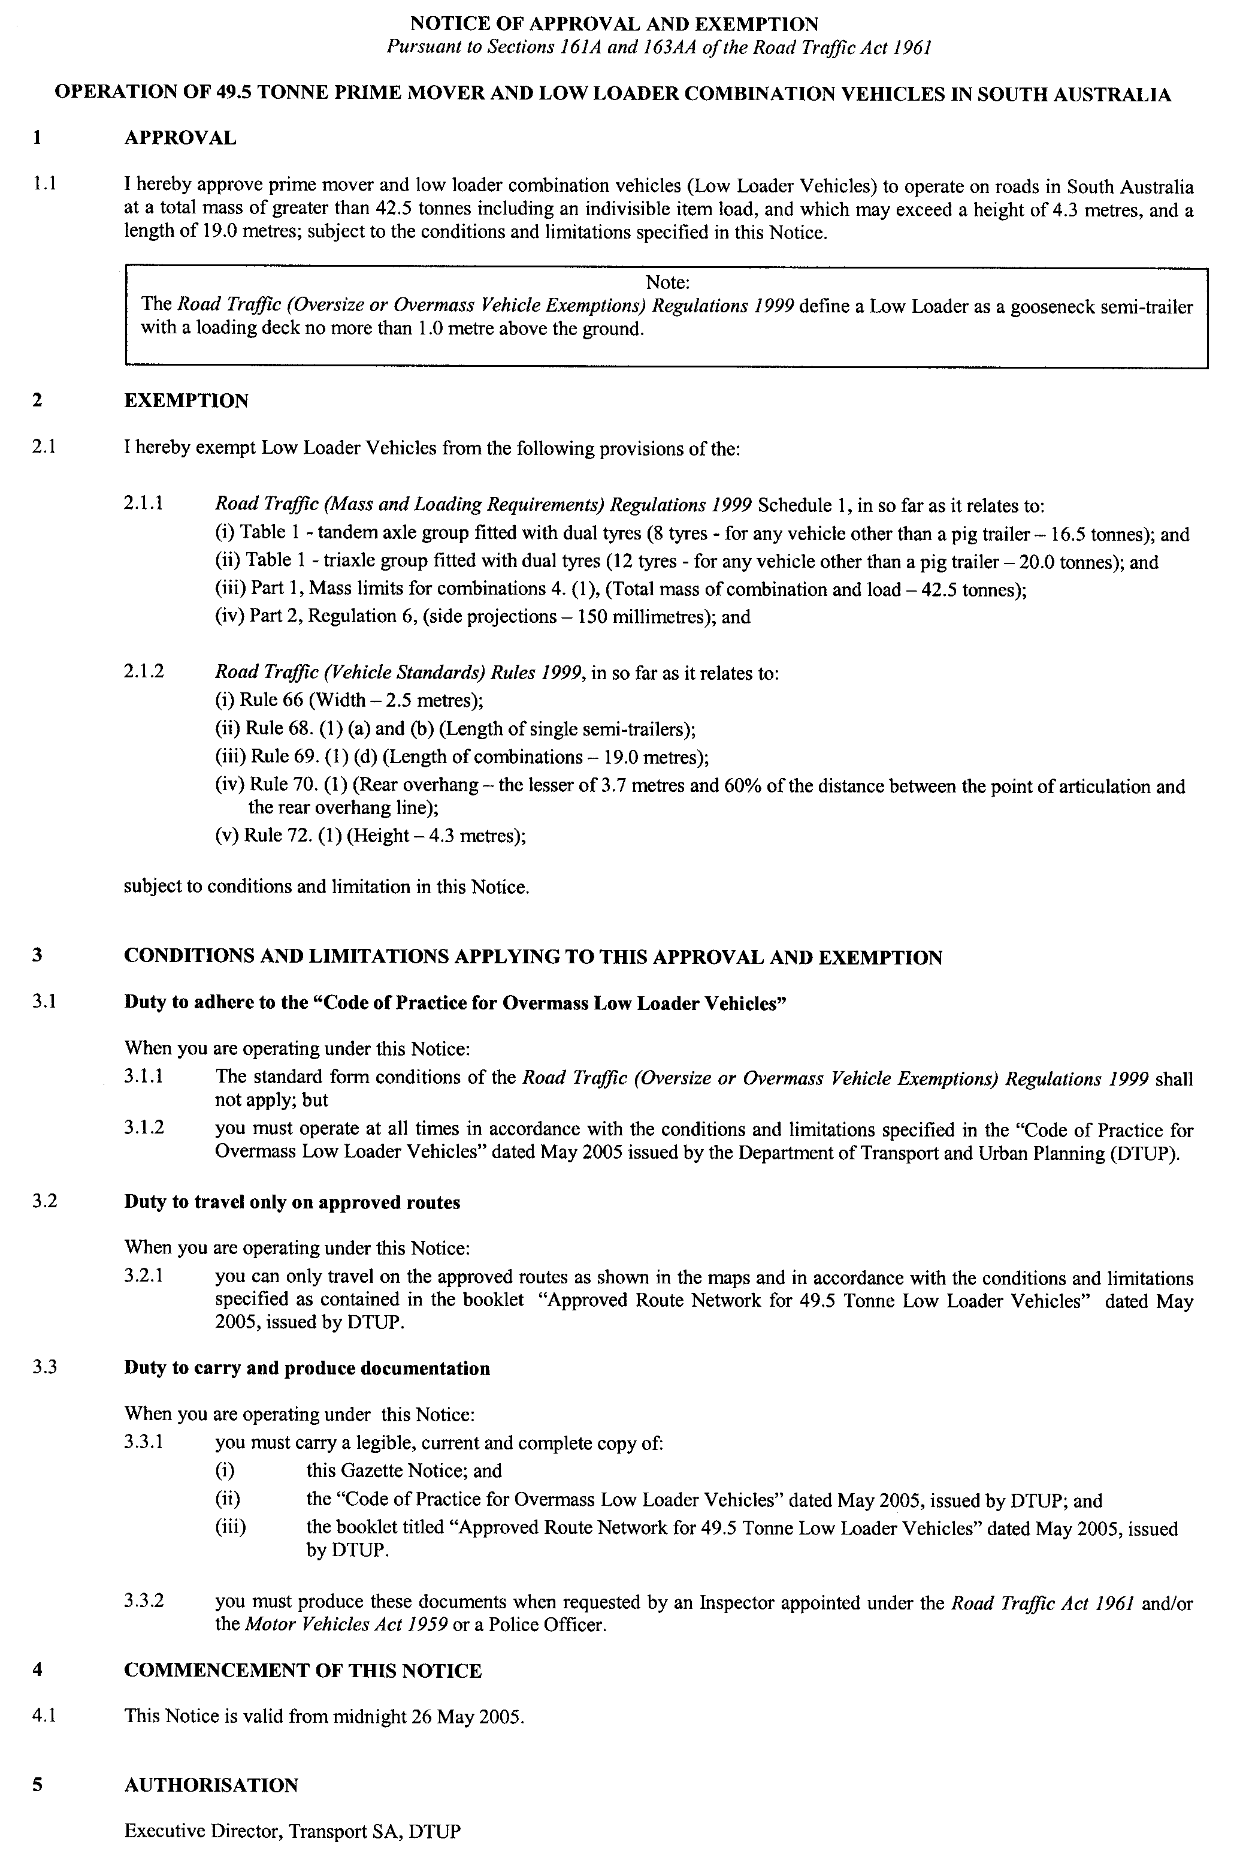

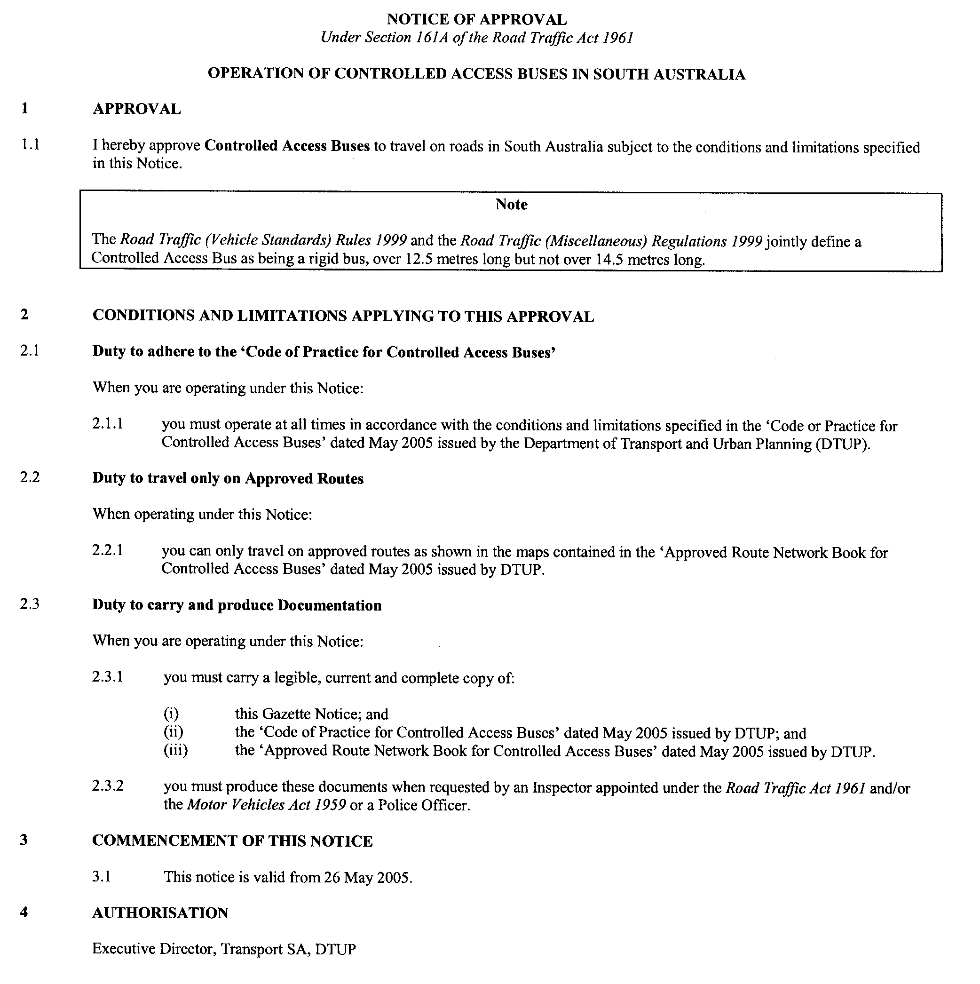

MINING ACT 1971
NOTICE is hereby given in accordance with section 28 (5) of the Mining Act 1971, that the Minister for Mineral Resources Development proposes to grant an Exploration Licence over the undermentioned area:
Applicant: Flinders Diamonds Ltd
Location: Echunga area—Approximately 40 km south-east of Adelaide
Term: 1 year
Area in km²: 253
Ref: 2005/00236
Plan and co-ordinates can be found on the PIRSA Sarig website: http://www.minerals.pir.sa.gov.au/sarig or by phoning Mineral Tenements on (08) 8463 3103.
H. Tyrteos, Mining Registrar

NATIONAL ELECTRICITY (SOUTH AUSTRALIA) ACT 1996
Notice under Section 6 (2) of the National
Electricity Law
New South Wales Derogations Relating to Full
Retail Competition Metering
NOTICE is hereby given pursuant to section 6 (2) of the National Electricity Law, which forms the Schedule to the National Electricity (South Australia) Act 1996, that Chapter 9, Part B (‘Transitional Arrangements for New South Wales’) of the National Electricity Code approved under section 6 of the National Electricity Law is amended.
These Code changes relate principally to the Full Retail Competition metering arrangements in New South Wales. Amendments have been made to clauses 9.17A of the National Electricity Code.
These amendments have effect from the beginning of 20 May 2005.
A copy of the ACCC’s letter dated 7 March 2005 to the National Electricity Code Administrator (‘NECA’) (ACN 073 942 775) providing final authorisation for these amendments is set out below.
Both the amendments and a copy of the ACCC’s letter dated
7 March 2005 can be viewed in full in the document entitled ‘New South Wales Full Retail Competition metering derogation’ on the Internet website of NECA at www.neca.com.au under ‘The Code’—‘Gazette notices’ section of that website.
The National Electricity Code can be viewed on the NECA Internet website at www.neca.com.au and at the offices of NECA and the National Electricity Market Management Company Limited (ACN 072 010 327). A list of addresses where the Code can be viewed is available on the NECA website.
Dated 19 May 2005.

7 March 2005
Mr John Eastham
Director
National Electricity Code Administrator Limited
Level 5, 41 Currie Street
Adelaide, S.A. 5000
Dear John,
ACCC Determination on New South Wales Full Retail Competition Metering Derogations
I am writing to advise you that on 2 March 2005, the Australian Competition and Consumer Commission (ACCC) issued its final determination on applications for authorisation numbered A90928, A90929 and A90930, to extend New South Wales’ existing derogations to Chapter 7 of the National Electricity Code.
In accordance with clause 9.1.1 (h) of the Code, I notify NECA of the final determination and attach the changes to Chapter 9 modified in accordance with that determination. I would be grateful if you could arrange for gazettal of this letter, the enclosed copy of the ACCC’s authorization and the approved Code changes.
I would like to thank NECA for its assistance in preparing and submitting the application for authorisation.
Yours sincerely,
Frank Sartor

PREVENTION OF CRUELTY TO ANIMALS ACT 1985
Revocation of Authority
PURSUANT to section 28 of the Prevention of Cruelty to Animals Act 1985, I, John Hill, Minister for Environment and Conservation, hereby revoke the authority of the following person to be an inspector under the Act following retirement from the RSPCA:
Kingsley Mar COTTER
Dated 13 May 2005.
John Hill, Minister for Environment and Conservation

RIVER MURRAY ACT 2003
Exemption from Requirement to Refer
PURSUANT to section 22 (18) of the River Murray Act 2003, I, Karlene Ann Maywald, Minister for the River Murray, hereby exempt applications for statutory authorisations of the classes specified in the Schedule from the requirement to be referred to me, as Minister, under a related operational Act, subject to the conditions specified below.
Conditions
This exemption is conditional upon the proponent of an application:
- ensuring that the application for the statutory authorisation meets each of the specifications required by and specified in the Schedule hereto for the relevant class of application, and is true and correct in respect of each of those specifications; and
(b) constructing any development approved by the statutory authorisation in accordance with each specification required by and specified in the Schedule hereto for the relevant class of application.
The Schedule
Class of statutory authorisation to which exemption applies
Development authorisation for the construction of a building (required to be referred pursuant to item 19 or 20 of Schedule 8 of the Development Regulations 1993) where:
(a) the application for authorisation includes each of the ‘specifications for domestic outbuilding application’ or each of the ‘specifications for farm building application’, as specified below; and
(b) the building does not involve, or is not for the purposes of, any activity specified in either Schedule 21 or Schedule 22 of the Development Regulations 1993.
Specifications for domestic outbuilding application
In these specifications ‘floodplain’ means land below the 1956 River Murray flood-level.
Purpose of outbuilding
• The outbuilding is only to be used for domestic purposes associated with an existing dwelling on the site.
Size, appearance and siting of outbuilding
• The wall height of the outbuilding will not exceed 3 m and the total building height will not exceed 4.5 m.
• The outbuilding will not be sited such that any part of the outbuilding is closer to the river than any part of the existing dwelling.
• The outbuilding, from its nearest point, is no greater than 6 m from the existing dwelling.
• The external surfaces of the outbuilding will be constructed of material that is pre-coated with factory applied colours of dark grey, brown or dull green so that any external wall is low reflective in nature.
• The construction, extension or replacement of an outbuilding will not result in the total floor area of all outbuildings on the site being more than the current total floor area, or 54 m², whichever is the greater.
Location
• The outbuilding will be sited on an allotment where the existing dwelling with which the outbuilding is to be associated is set back at least 50 m from the river.
• The outbuilding will not detract from the setting of a State heritage place within the meaning of the Development Act 1993.
• The outbuilding will not be sited on coastal land as defined in Schedule 8 of the Development Regulations 1993.
Native vegetation
• The outbuilding development will not result in the clearance of native vegetation.
Stormwater
• The roof area and gutters of outbuildings with a floor area over 15 m² will be connected to a rainwater tank, or tanks, to allow for stormwater collection.
• The rainwater tank(s) will have sufficient capacity to temporarily hold 20 L of stormwater per m² of total roof area on the site, including all dwellings and outbuildings.
• Overflow from the rainwater tank(s) will be diverted away from wastewater disposal areas, such as septic tanks and aerobic systems, in line with the on-site wastewater systems standards. If there is suitable space on the site, overflow will then be diverted into an infiltration basin and/or a level-spreader to reduce the rate of stormwater runoff.
Erosion and landform
• The outbuilding development will not require or involve excavation or filling exceeding 3 m³ if sited on the floodplain, or 9 m³ if sited elsewhere.
Hydrology
• The outbuilding will not impede floodwaters.
• If the outbuilding is sited in the floodplain it will be fitted with openings, roller doors, removable panels or similar on two ends or sides (whichever elevations face the direction of river flow).
Specifications for farm building application
In these specifications:
‘cliff’ means any point where the land rises from the floodplain at or more steeply than a rate of 1:1, with a rise of 5 m or more;
‘floodplain’ means land below the 1956 River Murray flood-level.
Purpose of building
• The farm building is only to be used for purposes associated with the agricultural use of the land on which it is built.
Size, appearance and siting of building
• The wall height of the building will not exceed 6 m, and the total building height will not exceed 7.5 m.
• The construction, extension or replacement of the building will not result in the total floor area of the relevant building being greater than 100 m².
• The external surfaces of the building will be constructed of material that is pre-coated with factory applied colours of dark grey, brown or dull green so that any external wall is low reflective in nature.
Location
• The building will not detract from the setting of the State heritage place within the meaning of the Development Act 1993.
• The building will not be sited on the floodplain, or within
200 m of the River Murray.
• Where the building is situated on a cliff, it will have a minimum setback of 100 m behind the top of a cliff when viewed from the River Murray, and will be no closer than
200 m to the River Murray.
• The building will not be sited on coastal land as defined in Schedule 8 of the Development Regulations 1993.
Native vegetation
• The building development will not result in the clearance of native vegetation.
Stormwater
• The roof area and gutters of a building with a floor area over 15 m² will be connected to a rainwater tank, or tanks, to allow for stormwater collection. The rainwater tank(s) will have sufficient capacity to temporarily hold 20 L of stormwater per m² of total roof area on the site, including all dwellings and outbuildings.
• Overflow from the rainwater tank(s) will be diverted away from wastewater disposal areas, such as septic tanks and aerobic systems, in line with the on-site wastewater systems standards. If there is suitable space on the site, overflow will then be diverted into an infiltration basin and/or a level-spreader to reduce the rate of stormwater runoff.
Erosion and landform
• The building will not require or involve excavation or filling exceeding 18 m³.
AND TAKE NOTE that failure to comply with a condition of exemption is an offence under the River Murray Act 2003, for which a maximum penalty of $20 000 applies.
Dated 6 May 2005.
K. A. Maywald, Minister for the River Murray

ROADS (OPENING AND CLOSING) ACT 1991:
SECTION 24
NOTICE OF CONFIRMATION OF ROAD
PROCESS ORDER
Night Cart Lane, Port Pirie
Deposited Plan 64110
BY Road Process Order made on 22 December 2003, the Port Pirie Regional Council ordered that:
1. Portion of the public road (Night Cart Lane) east of Gordon Street and between allotment 830 in Filed Plan 184102 and allotment 112 in Deposited Plan 43783 more particularly lettered ‘A’ in Preliminary Plan No. 03/0024 be closed.
2. The whole of the land subject to closure be transferred to Gerardus Leonardus Jamar in accordance with agreement for transfer dated 22 December 2003 entered into between the Port Pirie Regional Council and G. L. Jamar.
On 12 May 2005 that order was confirmed by the Minister for Administrative Services conditionally on approval and deposit of the survey plan by the Registrar-General. The condition has now been fulfilled.
Pursuant to section 24 (5) of the Roads (Opening and Closing) Act 1991, NOTICE of the order referred to above and its confirmation is hereby given.
Dated 19 May 2005
P. M. Kentish, Surveyor-General

WHEAT MARKETING ACT 1989
Deductions for Grains Research
PURSUANT to section 10 of the Wheat Marketing Act 1989, I, Rory McEwen, Minister for Agriculture, Food and Fisheries, make the following notice concerning grains for the season 2005-2006:
1. There shall be deductions for the purposes of research from the proceeds of all grain for the season.
2. The prescribed amount for such deductions shall be 15 cents per tonne.
3. Any grain grower not wishing to have such deductions made from his or her grain proceeds must signify that desire by 31 August 2006.
4. A written request to the above effect should be forwarded to the Minister for Agriculture, Food and Fisheries, G.P.O. Box 1671, Adelaide, S.A. 5001 by the stipulated date.
Dated 10 May 2005.
R. McEwen, Minister for Agriculture, Food and Fisheries

WHEAT MARKETING ACT 1989
Deductions for South Australian Farmers Federation (SAFF) Grains Council
PURSUANT to section 10 of the Wheat Marketing Act 1989, I, Rory McEwen, Minister for Agriculture, Food and Fisheries, make the following notice concerning grain for the season 2005-2006:
1. There shall be deductions for the purposes of the SAFF Grains Council from the proceeds of all grain for the season.
2. The prescribed amount for such deductions shall be 3 cents per tonne.
3. Any grain grower not wishing to have such deductions made from his or her grain proceeds must signify that desire by 31 August 2006.
4. A written request to the above effect should be forwarded to the Minister for Agriculture, Food and Fisheries, G.P.O. Box 1671, Adelaide, S.A. 5001 by the stipulated date.
Dated 10 May 2005.
R. McEwen, Minister for Agriculture, Food and Fisheries

South Australia
Gaming Machines (Miscellaneous) Amendment Act (Commencement) Proclamation 2005
1—Short title
This proclamation may be cited as the Gaming Machines (Miscellaneous) Amendment Act (Commencement) Proclamation 2005.
2—Commencement of suspended provisions
Sections 9 and 19 of the Gaming Machines (Miscellaneous) Amendment Act 2004 (No 46 of 2004) will come into operation on 1 July 2005.
Made by the Governor
with the advice and consent of the Executive Council
on 19 May 2005
T&F05/050CS

South Australia
Liquor Licensing (Designation of District Court Judge as Licensing Court Judge) Proclamation 2005
under section 15 of the Liquor Licensing Act 1997
1—Short title
This proclamation may be cited as the Liquor Licensing (Designation of District Court Judge as Licensing Court Judge) Proclamation 2005.
2—Commencement
This proclamation comes into operation on the day on which it is made.
3—Designation of District Court Judge as Licensing Court Judge
The District Court Judge named in Schedule 1 is designated as the Licensing Court Judge.
Schedule 1—District Court Judge designated as Licensing Court Judge
His Honour Gordon Fraser Barrett
Made by the Governor
with the advice and consent of the Executive Council
on 19 May 2005
AGO0071/03CS

South Australia
Water Resources (Barossa Prescribed Water Resources Area) Regulations 2005
under the Water Resources Act 1997

Contents
Preamble
1 Short title
2 Commencement
3 Interpretation
4 Barossa Prescribed Water Resources Area declarations
5 Establishment and prescribed periods for Greenock Creek catchment area
Schedule 1—Revocation
1 Revocation of proclamation
2 Revocation of regulations

Preamble
1 A proclamation was made pursuant to section 33(1) and (2) of the Water Resources Act 1990 (the 1990 Act) (see Gazette 14.5.1992 p1389) in respect of an area of the State delineated and shown on GRO Plan No 327/1992 (the Barossa area) declaring—
(a) the North Para River, and its tributaries, within the Barossa area to be proclaimed watercourses; and
(b) all wells situated within the Barossa area to be proclaimed wells; and
(c) all wells drilled in the Barossa area after the making of the proclamation to be proclaimed wells.
2 The proclamation referred to in clause 1 came into operation on 1 July 1992.
3 Regulations were made pursuant to section 8 of the Water Resources Act 1997 (the current Act) (see the Water Resources (Surface Water Prescribed Area—Barossa) Regulations 1998, Gazette 17.12.1998 p1994) declaring the Barossa area to be a surface water prescribed area.
4 Schedule 3, clause 2 of the current Act provides that —
(a) a proclamation under section 33(1) or (2) of the 1990 Act in force immediately before the commencement of the current Act continues in force as though it were a regulation under section 8(1) of the current Act; and
(b) a proclamation referred to in paragraph (a)—
(i) may be varied or revoked by regulation as though it were a regulation under section 8(1) of the current Act; and
(ii) in the case of a proclamation declaring a well, will, unless varied by regulation, be taken to exclude the operation of section 7(5).
5 It is now appropriate to make regulations that will have the effect—
(a) of continuing the declaration of proclaimed watercourses and proclaimed wells in the Barossa area (and making provision for future wells in that area) (under the current Act to be designated as prescribed watercourses and prescribed wells);
(b) of declaring prescribed watercourses in an additional area;
(c) of declaring an additional surface water prescribed area (and the establishment and prescribed periods for that additional area);
(d) of adding the additional area to the current Barossa area and naming the whole of the area as the Barossa Prescribed Water Resources Area (in keeping with practices under the current Act);
(e) by not excluding the operation of section 7(5) of the current Act to the Barossa Prescribed Water Resources Area—of allowing occupiers of land situated in that area to take water to use for domestic purposes or watering stock (other than stock subject to intensive farming).

1—Short title
These regulations may be cited as the Water Resources (Barossa Prescribed Water Resources Area) Regulations 2005.
2—Commencement
These regulations come into operation on the day on which they are made.
3—Interpretation
In these regulations, unless the contrary intention appears—
Act means the Water Resources Act 1997;
Barossa Prescribed Water Resources Area means—
(a) the area delineated and shown on GRO Plan No 327/1992 (the Barossa area);
(b) the area delineated and shown on GRO Plan No 128/2004 (the Greenock Creek catchment area);
revoked regulations means the Water Resources (Surface Water Prescribed Area—Barossa) Regulations 1998 revoked by Schedule 1.
4—Barossa Prescribed Water Resources Area declarations
(1) Pursuant to section 8(1) of the Act—
(a) the North Para River, and its tributaries, within the Barossa area are declared to be prescribed watercourses¹; and
(b) wells situated in the Barossa area and wells drilled in that area after the commencement of these regulations are declared to be prescribed wells¹; and
1 See the proclamation referred to in clause 1 of the preamble.
(c) all watercourses in the Greenock Creek catchment area are declared to be prescribed watercourses.
(2) Pursuant to section 8(2) of the Act, the Barossa Prescribed Water Resources Area is declared to be a surface water prescribed area.
(3) The operation of section 7(5) of the Act is not excluded in relation to the Barossa Prescribed Water Resources Area.
5—Establishment and prescribed periods for Greenock Creek catchment area
(1) The establishment period¹ for the Greenock Creek catchment area commenced on 18 February 1999 and ended at the commencement of the prescribed period (20 May 2004).
(2) The prescribed period² for the Greenock Creek catchment area commenced on 20 May 2004 and will end 3 years form the day on which these regulations come into operation.
1 The establishment period for that part of the Barossa Prescribed Water Resources Area that is the Barossa area commenced on 5 December 1991 and ended at the commencement of the prescribed period (18 December 1997) (see regulation 4 of the revoked regulations).
2 The prescribed period for that part of the Barossa Prescribed Water Resources Area that is the Barossa area commenced on 18 December 1997 and ended on 31 December 1999 (see regulation 4 of the revoked regulations).
Schedule 1—Revocation
1—Revocation of proclamation
The proclamation referred to in clause 1 of the preamble is revoked.
2—Revocation of regulations
The Water Resources (Surface Water Prescribed Area—Barossa) Regulations 1998 are revoked.
Note—
As required by section 10AA(2) of the Subordinate Legislation Act 1978, the Minister has certified that, in the Minister's opinion, it is necessary or appropriate that these regulations come into operation as set out in these regulations.
Made by the Governor
on the recommendation of the Minister and with the advice and consent of the Executive Council
on 19 May 2005
No 34 of 2005
EC05/0007CS

South Australia
Aquaculture Variation Regulations 2005
under the Aquaculture Act 2001

Contents
Part 1—Preliminary
1 Short title
2 Commencement
3 Variation provisions
Part 2—Variation of Aquaculture Regulations 2002
4 Variation of regulation 3—Interpretation
5 Variation of regulation 11—Fees
6 Substitution of Schedule
Schedule 1—Fees
Part 1—Application fees
1 Application fees
Part 2—Periodic fees
2 Preamble relating to new fee structure applicable from 1 July 2005
3 Proportion of periodic fee payable before grant of licence
4 Transitional arrangements for period between 1 January 2005 and 30 June 2005
Schedule 1—Revocation of Aquaculture (Fees) Regulations 2002

Part 1—Preliminary
1—Short title
These regulations may be cited as the Aquaculture Variation Regulations 2005.
2—Commencement
These regulations come into operation on the day on which they are made.
3—Variation provisions
In these regulations, a provision under a heading referring to the variation of specified regulations varies the regulations so specified.
Part 2—Variation of Aquaculture Regulations 2002
4—Variation of regulation 3—Interpretation
(1) Regulation 3—before the definition of Act insert:
abalone means abalone (Haliotis spp.) of all species;
(2) Regulation 3, definition of Fund—delete the definition and substitute:
tuna means southern bluefin tuna (Thunnus maccoyii);
5—Variation of regulation 11—Fees
Regulation 11—after subregulation (2) insert:
(3) A fee payable to the Minister under the Act or these regulations may be recovered by the Minister by action in a court of competent jurisdiction as a debt due to the Minister.
6—Substitution of Schedule
Schedule—delete the Schedule and substitute:
Schedule 1—Fees
Part 1—Application fees
1—Application fees
The following application fees are payable under the Act:

(a) | Application for consent to transfer development lease (section 36) | $525.00
(b) | Application for aquaculture licence authorising the carrying on of aquaculture in an area held under a lease (section 49) | $2 000.00
(c) | Application for aquaculture licence authorising the carrying on of aquaculture in an area not held under a lease (section 49) | $150.00
(d) | Application to vary conditions of aquaculture licence authorising the carrying on of aquaculture in an area held under a lease (section 52) | $225.00
(e) | Application to vary conditions of aquaculture licence authorising the carrying on of aquaculture in an area not held under a lease (section 52) | $150.00
(f) | Application for renewal of aquaculture licence (section 53) | no fee
(g) | Application for consent to transfer aquaculture licence (section 55) | $525.00
Part 2—Periodic fees
2—Preamble relating to new fee structure applicable from 1 July 2005
From 1 July 2005, the periodic fees payable by aquaculture licence holders are payable each financial year (rather than each calendar year).
3—Proportion of periodic fee payable before grant of licence
A person who applies for an aquaculture licence must, before the licence is granted, pay to the Minister a fee of an amount calculated by multiplying—
(a) the periodic fee that would have been payable by the person had the person held the licence at the last date for payment of periodic fees; and
(b) the proportion that the number of whole months between the grant of the licence and the next 30 June bears to 12 months.
4—Transitional arrangements for period between 1 January 2005 and 30 June 2005
(1) An aquaculture licence holder authorised under the licence to carry on aquaculture in an area held under an aquaculture lease must, before the payment date fixed by the Minister by written notice given to the licence holder, pay to the Minister, in respect of the period between 1 January 2005 and 30 June 2005, a fee of the following amount:
(a) for a licence to farm tuna—the amount obtained by multiplying $37.73 by the number of hectares in the licence area;
(b) for a licence to farm finfish other than tuna—the amount obtained by multiplying $73.14 by the number of hectares in the licence area;
(c) for a licence to farm abalone—the amount obtained by multiplying $69.27 by the number of hectares in the licence area;
(d) for a licence to farm molluscs other than abalone—the amount obtained by multiplying $166.01 by the number of hectares in the licence area;
(e) for a licence to farm algae—the amount obtained by multiplying $33.23 by the number of hectares in the licence area;
(f) for a licence authorising the storage of sea cages—the amount obtained by multiplying $33.23 by the number of hectares in the licence area.
(2) If 2 or more licences are held in respect of the same area—
(a) the licence holder is only liable for 1 fee under subclause (1); and
(b) the fee payable is the higher or highest of the fees that would be payable under subclause (1) but for this subclause.
(3) An aquaculture licence holder authorised under the licence to carry on aquaculture in an area not held under an aquaculture lease must, before the payment date fixed by the Minister by written notice given to the licence holder, pay to the Minister, in respect of the period between 1 January 2005 and 30 June 2005, a fee of the following amount:
(a) for an aquaculture licence classified by the Minister (by virtue of the low level of intensity of farming to be carried on under the licence) as a class A licence—$92.92;
(b) for an aquaculture licence classified by the Minister (by virtue of the medium level of intensity of farming to be carried on under the licence) as a class B licence—$115.36;
(c) for an aquaculture licence classified by the Minister (by virtue of the high level of intensity of farming to be carried on under the licence) as a class C licence—
(i) in the case of a licence designated by the Minister as being for a mobile farming arrangement—$1 128.00;
(ii) in any other case—$1 372.00.
(4) In the case of an aquaculture licence granted on or after 1 January 2005 but before the payment date referred to in this regulation, the periodic fee payable by the licence holder under this regulation is reduced to an amount calculated by multiplying—
(a) the periodic fee that would be payable but for this subclause; and
(b) the proportion that the number of whole months between the grant of the licence and 30 June 2005 bears to 6 months.
(5) If it is proposed to grant an aquaculture licence to a person on or after the payment date referred to in this regulation but before 1 July 2005, the person must (instead of paying a fee of an amount fixed by clause 3) pay to the Minister a fee of an amount calculated by multiplying—
(a) the periodic fee that would have been payable by the person under subclause (1) or (3) had the person held the licence at that payment date; and
(b) the proportion that the number of whole months between the grant of the licence and 30 June 2005 bears to 6 months.
Schedule 1—Revocation of Aquaculture (Fees) Regulations 2002
The Aquaculture (Fees) Regulations 2002 are revoked.
Note—
As required by section 10AA(2) of the Subordinate Legislation Act 1978, the Minister has certified that, in the Minister's opinion, it is necessary or appropriate that these regulations come into operation as set out in these regulations.
Made by the Governor
with the advice and consent of the Executive Council
on 19 May 2005
No 35 of 2005
MAFF04/0040CS

South Australia
Liquor Licensing (Dry Areas—Long Term) Variation Regulations 2005
under the Liquor Licensing Act 1997

Contents
Part 1—Preliminary
1 Short title
2 Commencement
3 Variation provisions
Part 2—Variation of Liquor Licensing (Dry Areas—Long Term) Regulations 1997
4 Variation of Schedule 1—Long term dry areas
5 Variation of Schedule 2—Plans of long term dry areas
Schedule 1—Plans to be substituted

Part 1—Preliminary
1—Short title
These regulations may be cited as the Liquor Licensing (Dry Areas—Long Term) Variation Regulations 2005.
2—Commencement
These regulations come into operation on the day on which they are made.
3—Variation provisions
In these regulations, a provision under a heading referring to the variation of specified regulations varies the regulations so specified.
Part 2—Variation of Liquor Licensing (Dry Areas—Long Term) Regulations 1997
4—Variation of Schedule 1—Long term dry areas
(1) Schedule 1, item headed "Hallett Cove—Area 1", column headed "Period"—delete "30 March 2005" and substitute:
19 May 2006
(2) Schedule 1, item headed "Hallett Cove—Area 2", column headed "Area", description of area—delete "to the southern boundary of Coorabie Reserve (the boundary approximately indicated by olive groves), then generally westerly, north-westerly and south-westerly along that southern boundary of Coorabie Reserve" and substitute:
to the southern boundary of Coorabie Reserve, then generally westerly and north-westerly along that boundary of the Reserve to the point at which it meets the eastern boundary of Lot 340 DP 10699, then south-westerly along that boundary of Lot 340
(3) Schedule 1, item headed "Hallett Cove—Area 2", column headed "Period"—delete "30 March 2005" and substitute:
19 May 2006
(4) Schedule 1, item headed "Hallett Cove—Area 3", column headed "Area"—delete ", Area A"
(5) Schedule 1, item headed "Hallett Cove—Area 3", column headed "Period"—delete "30 March 2005" and substitute:
19 May 2006
(6) Schedule 1, item headed "Hallett Cove—Area 4", column headed "Area"—delete ", Area B"
(7) Schedule 1, item headed "Hallett Cove—Area 4", column headed "Area", description of area—delete the description and substitute:
The area in Hallett Cove known as Shakes Crescent Reserve, being the area bounded on the south-east by Lonsdale Road, on the north-east by the south-western boundaries of Lot 7 DP 14891 and Lot 10 DP 19176 (the south-western boundary of the Hallett Cove Shopping Centre), on the north by Gledsdale Road and on the south-west by Shakes Crescent.
(8) Schedule 1, item headed "Hallett Cove—Area 4", column headed "Period"—delete "30 March 2005" and substitute:
19 May 2006
(9) Schedule 1, item headed "Hallett Cove—Area 5", column headed "Area", description of area—delete "Murnanda Street" wherever occurring and substitute:
Murnada Street
(10) Schedule 1, item headed "Hallett Cove—Area 5", column headed "Period"—delete "30 March 2005" and substitute:
19 May 2006
(11) Schedule 1, item headed "Hallett Cove—Area 6", column headed "Area", description of area—delete "to the northern boundary of Balboa Drive, then generally westerly and southerly along that boundary to the southern end of Balboa Drive, then in a straight line by the shortest route to the northern boundary of the western end of Sigma Road," and substitute:
and the prolongation in a straight line of that boundary to the northern boundary of Balboa Drive, then generally westerly and southerly along that boundary to the point at which the southern boundary of Balboa Drive meets the north-western boundary of Lot 334 DP 54164, then south-westerly along that boundary of Lot 334 to the southern boundary of the Lot, then in a straight line by the shortest route to the point at which the prolongation in a straight line of the western boundary of Chrysler Road intersects the northern boundary of Sigma Road,
(12) Schedule 1, item headed "Hallett Cove—Area 6", column headed "Period"—delete "30 March 2005" and substitute:
19 May 2006
(13) Schedule 1, item headed "Oaklands Park—Area 1", column headed "Area", description of area—delete the description and substitute:
The area in Oaklands Park bounded on the west by Morphett Road, on the south by Sturt Road, on the east by Diagonal Road and on the north by the northern boundary of the Marion Shopping Centre/Bunnings Warehouse car park (being the south-eastern and southern boundaries of Lot 61 DP 52571; the southern boundaries of Lot 3 DP 59367, Lot 220 DP 56981, Lot 42 DP 56981 and Lot 31 DP 56981; the portion of the southern boundary of Lot 21 DP 52571 that lies to the east of the eastern boundary of Community Plan 21155; and the eastern and southern boundaries of Community Plan 21155), but excluding any building within the area other than any part of a building that is set aside for car parking.
(14) Schedule 1, item headed "Oaklands Park—Area 1", column headed "Period"—delete "30 March 2005" and substitute:
19 May 2006
5—Variation of Schedule 2—Plans of long term dry areas
(1) Schedule 2, plans headed "Hallett Cove—Plan No 1", "Hallett Cove—Plan No 2", "Hallett Cove—Plan No 3", "Hallett Cove—Plan No 4" and "Hallett Cove—Plan No 5"—delete the plans and substitute the plans headed "Hallett Cove—Plan No 1", "Hallett Cove—Plan No 2", "Hallett Cove—Plan No 3", "Hallett Cove—Plan No 4" and "Hallett Cove—Plan No 5" in Schedule 1 of these regulations
(2) Schedule 2, plan headed "Oaklands Park—Plan No 1"—delete the plan and substitute the plan headed "Oaklands Park—Plan No 1" in Schedule 1 of these regulations
Schedule 1—Plans to be substituted
Hallett Cove—Plan No 1
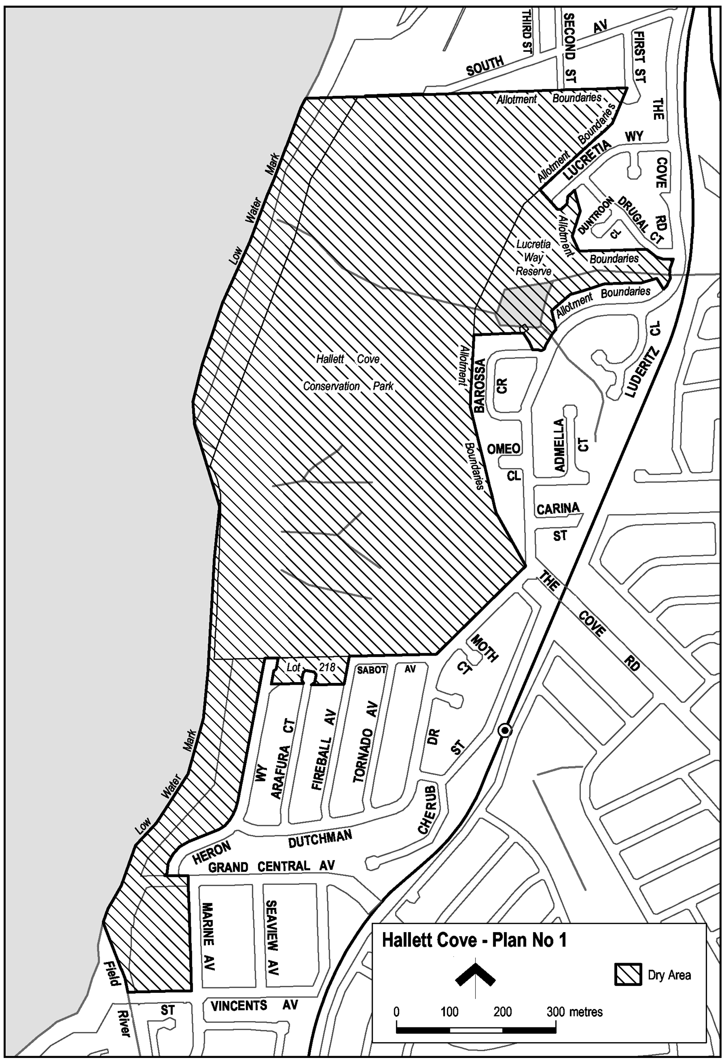
Hallett Cove—Plan No 2
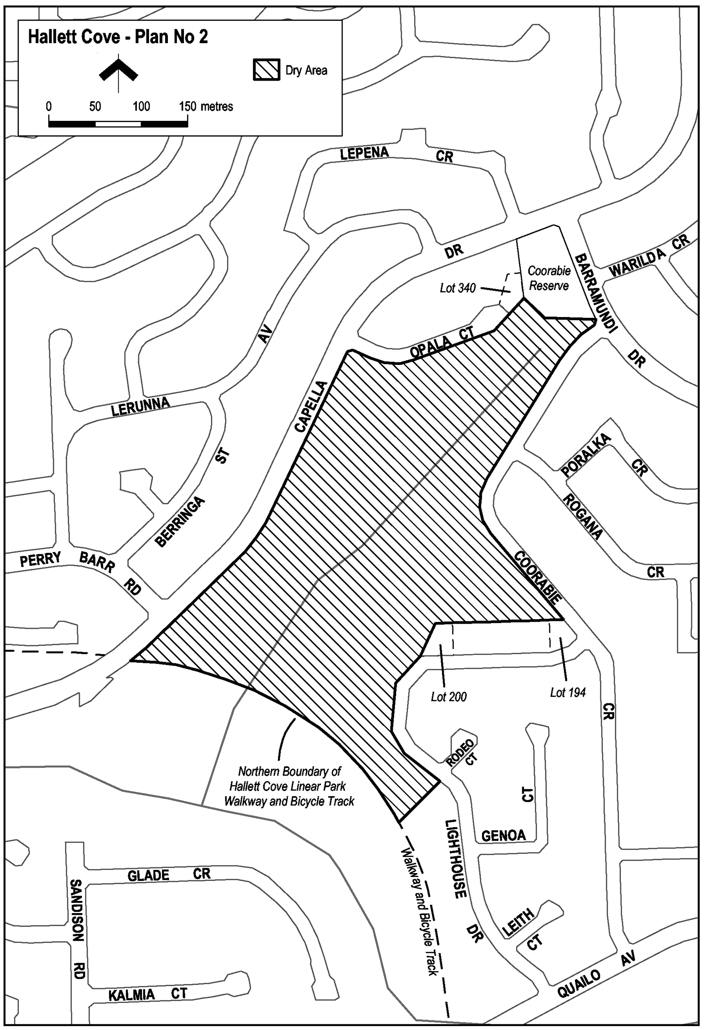
Hallett Cove—Plan No 3
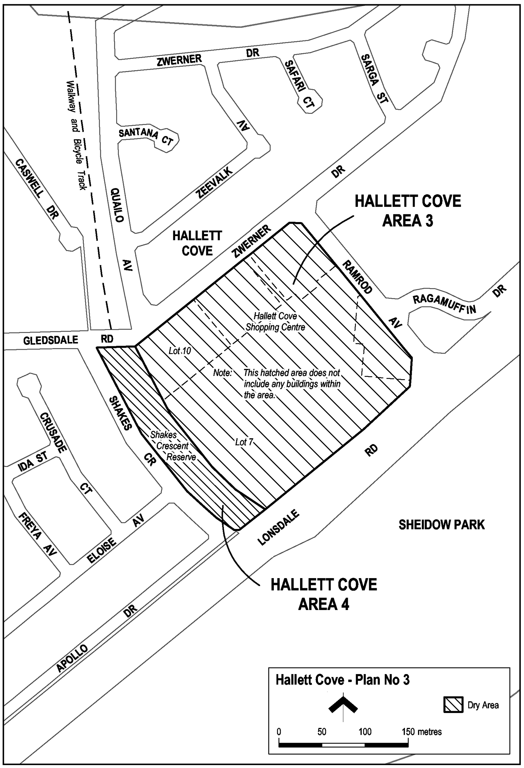
Hallett Cove—Plan No 4
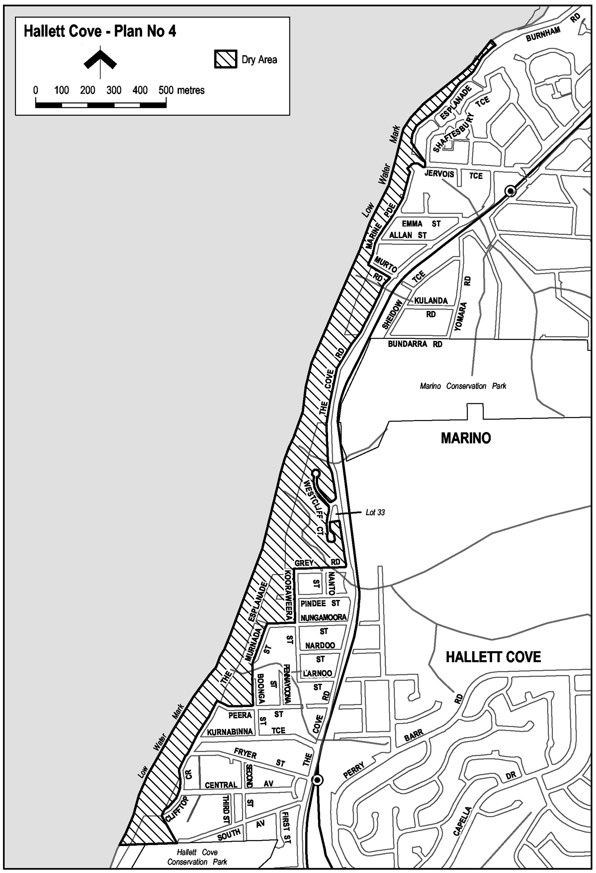
Hallett Cove—Plan No 5
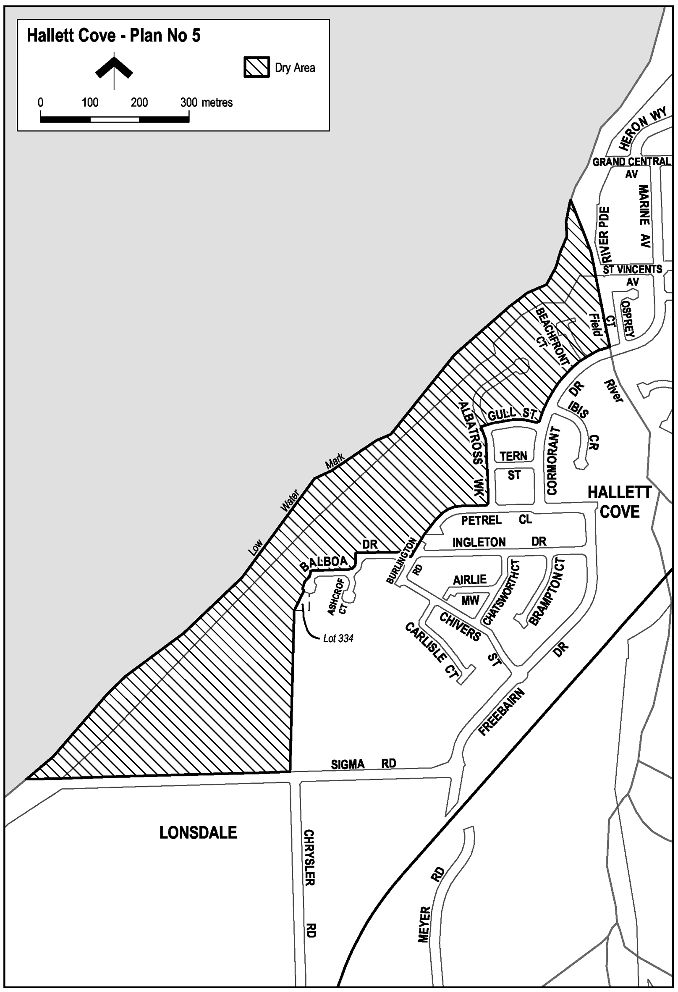
Oaklands Park—Plan No 1
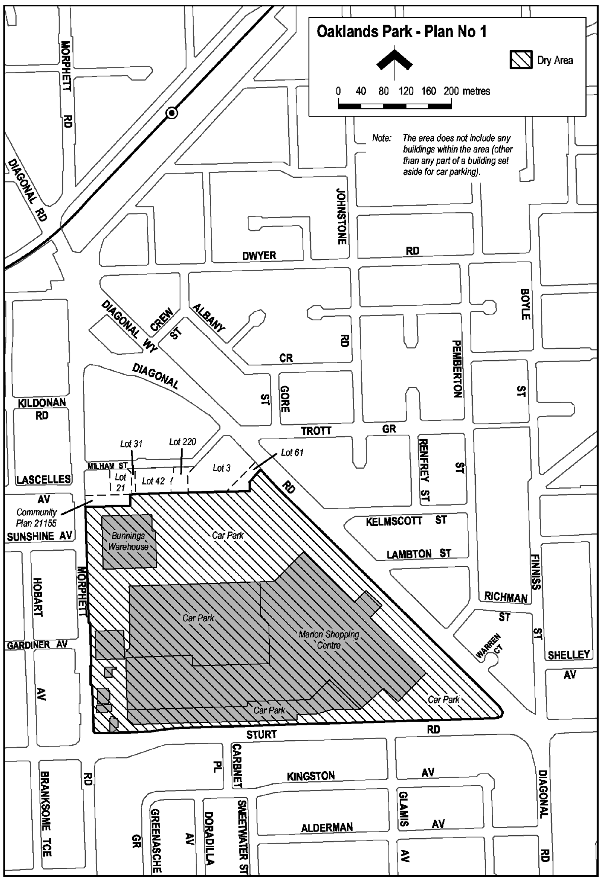
Note—
As required by section 10AA(2) of the Subordinate Legislation Act 1978, the Minister has certified that, in the Minister's opinion, it is necessary or appropriate that these regulations come into operation as set out in these regulations.
Made by the Governor
with the advice and consent of the Executive Council
on 19 May 2005
No 36 of 2005
CSOLGC0225

South Australia
Public Corporations (Information Industries Development Centre) Variation Regulations 2005
under the Public Corporations Act 1993

Contents
Part 1—Preliminary
1 Short title
2 Commencement
3 Variation provisions
Part 2—Variation of Public Corporations (Information Industries Development Centre) Regulations 1996
4 Variation of regulation 1—Short title
5 Variation of regulation 3—Interpretation
6 Substitution of heading to Part 3
7 Variation of heading to Part 3 Division 1
8 Variation of regulation 5—Establishment of Playford Centre (section 24)
9 Variation of regulation 7—Composition of board
10 Variation of heading to Part 3 Division 2
11 Variation of regulation 14—Functions of Playford Centre

Part 1—Preliminary
1—Short title
These regulations may be cited as the Public Corporations (Information Industries Development Centre) Variation Regulations 2005.
2—Commencement
These regulations come into operation on the day on which they are made.
3—Variation provisions
In these regulations, a provision under a heading referring to the variation of specified regulations varies the regulations so specified.
Part 2—Variation of Public Corporations (Information Industries Development Centre) Regulations 1996
4—Variation of regulation 1—Short title
Regulation 1—delete "Information Industries Development Centre" and substitute:
Playford Centre
5—Variation of regulation 3—Interpretation
(1) Regulation 3, definitions of EDS, IT, IT2000 Vision, IT Industry, Local IT Business and Minister—delete the definitions and substitute:
Minister means the Minister for Science and Information Economy;
(2) Regulation 3, definition of the subsidiary—delete "Information Industries Development Centre (IIDC)" and substitute:
Playford Centre
6—Substitution of heading to Part 3
Heading to Part 3—delete the heading and substitute:
Part 3—Playford Centre
7—Variation of heading to Part 3 Division 1
Heading to Part 3, Division 1—delete "IIDC" and substitute:
Playford Centre
8—Variation of regulation 5—Establishment of Playford Centre (section 24)
Regulation 5(1)—delete subregulation (1) and substitute:
(1) The subsidiary of the Minister established under the name Information Industries Development Centre continues under the name Playford Centre (and a reference in any instrument to the Information Industries Development Centre or IIDC will be taken to be a reference to the Playford Centre).
9—Variation of regulation 7—Composition of board
(1) Regulation 7(1)—delete "12" and substitute:
7
(2) Regulation 7(1)—delete "member of the Department of Information Industries" and substitute:
person appointed to the Public Service under the Public Sector Management Act 1995
(3) Regulation 7(5)—delete subregulation (5)
(4) Regulation 7(7)—delete subregulation (7)
10—Variation of heading to Part 3 Division 2
Heading to Part 3, Division 2—delete "IIDC" and substitute:
Playford Centre
11—Variation of regulation 14—Functions of Playford Centre
Regulation 14(1)(a) to (c)—delete paragraphs (a) to (c) and substitute:
(a) to contribute to South Australia's economic development by facilitating the formation and development of innovative technology ventures and, in particular—
(i) to provide seed capital and business guidance to such ventures; and
(ii) to manage prudently any investment by the Crown in such ventures so as to minimise any commercial risk or financial exposure while maximising any financial return; and
(iii) to assist in locating and attracting investment by others in such ventures;
Note—
As required by section 10AA(2) of the Subordinate Legislation Act 1978, the Minister has certified that, in the Minister's opinion, it is necessary or appropriate that these regulations come into operation as set out in these regulations.
Made by the Governor
with the advice and consent of the Executive Council
on19 May 2005
No 37 of 2005
MSIE10/04CS

South Australia
Liquor Licensing (Dry Areas—Long Term) Variation Regulations 2005
under the Liquor Licensing Act 1997

Contents
Part 1—Preliminary
1 Short title
2 Commencement
3 Variation provisions
Part 2—Variation of Liquor Licensing (Dry Areas—Long Term) Regulations 1997
4 Variation of Schedule 1—Long term dry areas

Part 1—Preliminary
1—Short title
These regulations may be cited as the Liquor Licensing (Dry Areas—Long Term) Variation Regulations 2005.
2—Commencement
These regulations come into operation on the day on which they are made.
3—Variation provisions
In these regulations, a provision under a heading referring to the variation of specified regulations varies the regulations so specified.
Part 2—Variation of Liquor Licensing (Dry Areas—Long Term) Regulations 1997
4—Variation of Schedule 1—Long term dry areas
Schedule 1, item headed "Goolwa—Area 1", column headed "Period"—delete "29 April 2005" and substitute:
12 May 2006
Note—
As required by section 10AA(2) of the Subordinate Legislation Act 1978, the Minister has certified that, in the Minister's opinion, it is necessary or appropriate that these regulations come into operation as set out in these regulations.
Made by the Governor
with the advice and consent of the Executive Council
on 19 May 2005
No 38 of 2005
OLGC0016/03

South Australia
Liquor Licensing (General) Variation Regulations 2005
under the Liquor Licensing Act 1997

Contents
Part 1—Preliminary
1 Short title
2 Commencement
3 Variation provisions
Part 2—Variation of Liquor Licensing (General) Regulations 1997
4 Variation of regulation 8—Cases where licence is not required

Part 1—Preliminary
1—Short title
These regulations may be cited as the Liquor Licensing (General) Variation Regulations 2005.
2—Commencement
These regulations come into operation on the day on which they are made.
3—Variation provisions
In these regulations, a provision under a heading referring to the variation of specified regulations varies the regulations so specified.
Part 2—Variation of Liquor Licensing (General) Regulations 1997
4—Variation of regulation 8—Cases where licence is not required
(1) Regulation 8(2)(j)—after "Gladstone High School," insert:
Hamilton Secondary College,
(2) Regulation 8(2)(j)(i)—delete subparagraph (i) and substitute:
(i) the wine is produced as part of a course in viticulture or winemaking offered by the school or college and sold as part of, or for the purposes of, that course; and
Note—
As required by section 10AA(2) of the Subordinate Legislation Act 1978, the Minister has certified that, in the Minister's opinion, it is necessary or appropriate that these regulations come into operation as set out in these regulations.
Made by the Governor
with the advice and consent of the Executive Council
on 19 May 2005
No 39 of 2005
CSOLGC0186/04

South Australia
Primary Industry Funding Schemes (Cattle Industry Fund) Variation Regulations 2005
under the Primary Industry Funding Schemes Act 1998

Contents
Part 1—Preliminary
1 Short title
2 Commencement
3 Variation provisions
Part 2—Variation of Primary Industry Funding Schemes (Cattle Industry Fund) Regulations 2000
4 Variation of regulation 6—Contributions to Fund
5 Variation of regulation 7—Application of Fund
Part 3—Further variation of Primary Industry Funding Schemes (Cattle Industry Fund) Regulations 2000 to come into operation on 1 July 2005
6 Variation of regulation 6—Contributions to Fund

Part 1—Preliminary
1—Short title
These regulations may be cited as the Primary Industry Funding Schemes (Cattle Industry Fund) Variation Regulations 2005.
2—Commencement
(1) Subject to subregulation (2), these regulations come into operation on the day on which they are made.
(2) Part 3 will come into operation on 1 July 2005.
3—Variation provisions
In these regulations, a provision under a heading referring to the variation of specified regulations varies the regulations so specified.

Part 2—Variation of Primary Industry Funding Schemes (Cattle Industry Fund) Regulations 2000
4—Variation of regulation 6—Contributions to Fund
(1) Regulation 6(1)(b)—delete paragraph (b) and substitute:
(b) 50 cents per transaction tag other than—
(i) a bobby calf tag; or
(ii) a tag of a kind approved by the Chief Inspector as a green European Union transaction tag;
(2) Regulation 6(1)(c)—delete "25 cents" and substitute:
50 cents
(3) Regulation 6—after subregulation (5) insert:
(5a) The Minister will, on application by a person who has paid contributions in respect of a transaction tag, refund the amount of the contributions to the person if—
(a) the Minister is satisfied that the person claiming the refund paid the contributions; and
(b) either—
(i) the tag is unused and given to the Minister; or
(ii) the Minister is satisfied that the tag has been attached to an animal already identified with a permanent identification device.
(4) Regulation 6(6) and (7)—redesignate subregulations (6) and (7) as regulation 6A (Refunds) subregulations (1) and (2) respectively
5—Variation of regulation 7—Application of Fund
Regulation 7—after its present contents (now to be designated as subregulation (1)) insert:
(2) However, a person who has, at the person's request, been refunded contributions under regulation 6A will not be entitled to receive a direct benefit from the Fund for the period of 5 financial years following the financial year during which the contributions were refunded.
Part 3—Further variation of Primary Industry Funding Schemes (Cattle Industry Fund) Regulations 2000 to come into operation on 1 July 2005
6—Variation of regulation 6—Contributions to Fund
Regulation 6(1)(b)—delete paragraph (b)
Note—
As required by section 10AA(2) of the Subordinate Legislation Act 1978, the Minister has certified that, in the Minister's opinion, it is necessary or appropriate that these regulations come into operation as set out in these regulations.
Made by the Governor
with the advice and consent of the Executive Council
on 19 May 2005
No 40 of 2005
MAFF05/0003CS

FAXING COPY?
IF you fax copy to Government Publishing SA for inclusion in the Government Gazette, there is no need to send a Confirmation Copy to us as well.
This creates confusion and may well result in your notice being printed twice.
Please use the following fax number:
Fax transmission: (08) 8207 1040
Phone Inquiries: (08) 8207 1045
Please include a contact person, phone number and order number so that we can phone back with any queries we may have regarding the fax copy.
NOTE: Closing time for lodging new copy (fax, hard copy or email) is 4 p.m. on Tuesday preceding the day of publication.

Government Gazette notices can be E-mailed.
The address is:
governmentgazette@saugov.sa.gov.au
Documents should be sent as attachments in Word format.
When sending a document via E-mail, please confirm your transmission with a faxed copy of your document, including the date the notice is to be published.
Fax transmission: (08) 8207 1040
Enquiries: (08) 8207 1045
NOTE: Closing time for lodging new copy (fax, hard copy or email) is 4 p.m. on Tuesday preceding the day of publication.

[Republished]
CITY OF CAMPBELLTOWN
Periodical Review of Elector Representation
PURSUANT to the provisions of section 12 (5) of the Local Government Act 1999, notice is hereby given that the City of Campbelltown is to carry out a review to determine whether a change of arrangements in respect of elector representation (altering the composition of the Council, or to divide, or redivide, the area of the Council into wards, alter the division of the area of the Council into wards, or abolish the division of the area of the Council into wards) will result in the electors of the area being more adequately and fairly represented.
Information regarding the nature of the periodical review is available from the Campbelltown Library, on the Council website at www.campbelltown.sa.gov.au or by contacting Jan Franklin on 8366 9239.
Interested persons are invited to make written submissions directed to the Chief Executive Officer, P.O. Box 1, Campbelltown, S.A. 5074 by 5 p.m. on 30 June 2005. Any person making a written submission will also be invited to appear before a meeting of the Council to be heard in respect of their submission.
J. Hanlon, Chief Executive Officer

[Republished]
CITY OF MITCHAM
Elector Representation Review
NOTICE is hereby given that the City of Mitcham endorsed its preferred position for its Elector Representation Review at the council meeting held on 26 April 2005. This position maintains a system of six wards, with the addition of one extra councillor for Craigburn Ward, along with a minimal re-distribution of electors between The Park Ward and Craigburn Ward. It is also recommended that the Mayor continue to be elected by popular vote. Any changes would take effect at the next Local Government Elections in 2006.
Public consultation on this proposal commences on 19 May 2005 and concludes by close of business on 10 June 2005. Written submissions should be forwarded to the Chief Executive Officer, City of Mitcham, P.O. Box 21, Mitcham Shopping Centre, Torrens Park, S.A. 5062, by fax on 8372 8101 or by email to: mitcham@mitchamcouncil.sa.gov.au. More detailed information is available at the City of Mitcham, Civic Centre, (131 Belair Road, Torrens Park), Mitcham Library (154 Belair Road, Hawthorn), Blackwood Library (215 Main Road, Blackwood) and on the council website at: www.mitchamcouncil.sa.gov.au or by contacting Meredith Nunan on 8372 8837.
R. Malcolm, Chief Executive Officer

CITY OF SALISBURY
Roads (Opening and Closing) Act 1991
Road re-alignment Wyatt Road, Direk
NOTICE is hereby given pursuant to section 10 of the Roads (Opening and Closing) Act 1991, that Council proposes to make a Road Process Order to open as road:
an irregularly-shaped portion (a strip generally 5 m wide following the southern boundary with cut corners at either end) of Allotments 11 and 12 in Filed Plan 103331 shown as ‘15’ and ‘14’ (respectively) on Preliminary Plan No. 04/0123.
A copy of the plan and statement of persons affected are available for public inspection at the Council office, 12 James Street, Salisbury and at the office of the Surveyor-General, 101 Grenfell Street, Adelaide during normal office hours.
Any objections must set out the full name, address and details of the submission and must be fully supported by reasons.
The objections must be made in writing within 28 days commencing from 19 May 2005 to the Council, P.O. Box 8, Salisbury, S.A. 5108 and to the Surveyor-General, G.P.O. Box 1354, Adelaide, S.A. 5001, setting out full details.
Where a submission is made, Council will give notification of a meeting at which the matter will be considered.
Enquiries relating to this matter may be directed in the first instance to Milan Millison on 8406 8216 or Karen Pepe on 8406 8397
Dated 18 May 2005.
S. Hains, City Manager

CITY OF VICTOR HARBOR
Authorised Officers
NOTICE is hereby given that at a meeting of council held on 9 May 2005, council resolved to vary the list of Authorised Officers as follows:
Local Government Act 1999—
Delete: Paul Raymond Emes
Add: Ben Coventry
Development Act 1993—
Delete: Paul Raymond Emes
Add: Ben Coventry
G. K. Maxwell, City Manager

TOWN OF WALKERVILLE
Change of Starting Time for Meetings of Council
NOTICE is hereby given that at the meeting of council held on 2 May 2005, it was resolved that council meetings would commence at 7 p.m. in lieu of 7.15 p.m. as in the past. This has been as a result of there being only council meetings now held on the first and third Monday of the month. Council also resolved that committee meetings will only take place when required.
R. H. Wallace, Chief Executive Officer

ALEXANDRINA COUNCIL
Roads (Opening and Closing) Act 1991
Hundred of Nangkita
NOTICE is hereby given pursuant to section 10 of the Roads (Opening and Closing) Act 1991, that the Alexandrina Council proposes to make a road process order to:
(i) Open as road, portion of sections 2362, 2361 and 2358, Hundred of Nangkita more particularly delineated and numbered ‘1’, ‘2’ and ‘3’ respectively on Preliminary Plan No. 05/0020; and
(ii) close and transfer to T. R. and A. L. Anderson the whole of the public roads adjoining the eastern boundary of section 2361 and the western boundary of section 2358 in exchange for land taken for new road ‘1’, ‘2’ and ‘3’, above more particularly delineated and lettered ‘A’, ‘B’, ‘C’ and ‘D’ on Preliminary Plan No. 05/0020.
Closed road ‘A’ is to be merged with section 2361, closed road ‘B’ is to be merged with allotment 1 in Filed Plan 15478 and closed road ‘C’ and ‘D’ are to be merged with allotment 2 in Filed Plan 15478.
A copy of the Preliminary Plan and Statement of persons affected are available for public inspection at the Council Office, 16 Dawson Street, Goolwa, S.A. 5214 or Adelaide office of the Surveyor-General during normal office hours.
Any application for easement or objection must set out the full name, address and details for the submission and must be fully supported by reasons.
The application for easement or objection must be made in writing to the Council, P.O. Box 21, Goolwa, S.A. 5214, within 28 days of the publication of this notice and a copy must be forwarded to the Surveyor-General, G.P.O. Box 1354, Adelaide, S.A. 5001. Where a submission is made, the Council will give notification of a meeting at which the matter will be considered.
J. L. Coombe, Chief Executive Officer

THE FLINDERS RANGES COUNCIL
Supplementary Election for Three Area Councillors
NOMINATIONS are hereby invited and will be received at The Flinders Ranges Council located at 1 Seventh Street, Quorn, from Thursday, 26 May 2005 until 12 noon on Thursday, 16 June 2005 from any person eligible to be a candidate for election to the vacancies.
Nomination forms and candidate’s handbooks are available from 1 Seventh Street, Quorn.
A candidate must submit a profile of not more than 150 words with the nomination form.
A candidate photograph of predominantly the head and shoulders, taken within the preceding 12 months, may also be submitted.
A briefing session for prospective candidates will be conducted at 7 p.m. on Thursday, 2 June 2005 at Council Chambers, 1 Seventh Street, Quorn.
If more than the required number of nominations are received for the vacancies, an election will be conducted entirely by postal ballot with the return of the completed ballot papers to reach the Returning Officer no later than 12 noon on Monday, 18 July 2005.
D. Gully, Returning Officer

DISTRICT COUNCIL OF MOUNT BARKER
Periodical Elector Representation
NOTICE is hereby given that the District Council of Mount Barker, in accordance with section 12 of the Local Government Act 1999, has commenced a review to determine whether current arrangements for elected representation are adequate in fairly representing the electors of the district. Issues to be examined during the review include:
• Retainment of the current ward structure or whether Council Members be elected to represent the whole area.
• Examination of the number of wards; if the ward structure is retained, and whether the ward quotas are within acceptable limits.
• The number of Council Members required to adequately represent the community.
• The consideration of new ward names.
• Whether the Principal Member (ie the Mayor) of the council should be popularly elected or elected from within the council.
Any person wishing to contribute to the review is invited to obtain a Representation Options Paper which discusses the issues and options available to the council, concerning the current ward structures and elector representations. The Representation Options Paper is available from the council offices, 23 Mann Street, Mount Barker, telephone 8391 1633, by emailing:
council@dcmtbarker.sa.gov.au or from the council website
www.dcmtbarker.sa.gov.au.
Enquiries are to be directed to Narelle Jeffery on 8391 7249. A public meeting will be held on Thursday, 9 June 2005 at 7.00 p.m. at the Mount Barker Bowling Club, Mann Street, Mount Barker.
Written submissions will be received until 5 p.m. on Friday, 1 July 2005. Any person who provides a written submission to council will be given the opportunity to appear before the council to speak to their submission.
A. Stuart, Chief Executive Officer

SOUTHERN MALLEE DISTRICT COUNCIL
Roads (Opening and Closing) Act 1991
Road Closure—Hundred of Pinnaroo
PURSUANT to section 10 of the Roads (Opening and Closing) Act 1991 the Southern Mallee District Council hereby gives notice of its intent to make a Road Process Order to close and retain the portion of public adjoining the boundary of section 59, Hundred of Pinnaroo and Allotment 91 in Filed Plan 200064, more particularly delineated and lettered ‘A’ in Preliminary Plan No. 05/0011.
A copy of the Preliminary Plan and a statement of persons affected are available for public inspection at the Council Offices, Day Street, Pinnaroo and Railway Terrace North, Lameroo or the Adelaide office of the Surveyor-General, during normal office hours.
Any application for easement or objection must set out the full name, address and details of the submission and must be fully supported by reasons.
The application for easement or objection must be made in writing to the council, P.O. Box 49, Pinnaroo, S.A. 5304 within 28 days of this notice and a copy must be forwarded to the Surveyor-General, G.P.O. Box 1354, Adelaide, S.A. 5001. Where a submission is made, the council will give notification of a meeting at which the manner will be considered.
P. A. Wood, Chief Executive Officer

DISTRICT COUNCIL OF TATIARA
Proportional Separate Rate
NOTICE is hereby given that pursuant to section 154 of the Local Government Act 1999, on 10 May 2005, Council resolved to charge a proportional separate rate of $5 per lineal metre of rateable property frontage abutting the road where kerbing and sealing works were completed. The following township properties will be charged a proportional separate rate of $5 per lineal metre, on the condition that pensioner concessions will be granted in accordance with pensioner concessions for the general rate:
• Salom Street between Dunn Street and Glyde Street, Bordertown
• Venn Avenue between Baker Street and Ramsay Terrace, (north side) Bordertown
• Lawrence Street (new cul-de-sac), Keith
R. J. Harkness, Chief Executive Officer

WAKEFIELD REGIONAL COUNCIL
Supplementary Election for Councillor in Western Ward
NOMINATIONS are hereby invited and will be received at Wakefield Regional Council located at Scotland Place, Balaklava, from Thursday, 26 May 2005 until 12 noon on Thursday, 16 June, 2005, from any person eligible to be a candidate for election to the vacancy.
Nomination forms and candidate’s handbooks are available from Scotland Place, Balaklava.
A candidate must submit a profile of not more than 150 words with the nomination form.
A candidate photograph of predominantly the head and shoulders, taken within the preceding 12 months, may also be submitted.
A briefing session for prospective candidates will be conducted at 7 p.m. on Monday, 30 May 2005 at Civic Centre, Scotland Place, Balaklava.
If more than the required number of nominations are received for the vacancy, an election will be conducted entirely by postal ballot with the return of the completed ballot papers to reach the Returning Officer no later than 12 noon on Monday, 18 July 2005.
D. Gully, Returning Officer

IN the matter of the estates of the undermentioned deceased persons:
Brewer, John Thomas, late of 13 Thornton Street, Dulwich, retired public servant, who died on 22 October 2004.
Burford, Marjorie Jean, late of 160 O.G. Road, Felixstow, of no occupation, who died on 23 August 2004.
Doe, Christina, late of 7 Wilson Street, Prospect, home duties, who died on 29 December 2004.
Ferguson, Lloyd Perston, late of 8 Elmore Road, Salisbury North, retired chef, who died on 7 April 2005.
Goddard, Winifred Marie, late of 86 Oaklands Road, Glengowrie, widow, who died on 9 December 2004.
Green, Harold Mertin, late of 89 Hawker Street, Ridleyton, retired bale repairer, who died on 21 December 2004.
Kempe, Donald Anthony, late of Percy Court, Alice Springs, Northern Territory, retired stockman, who died on 2 February 2000.
Klopper, Ross James, late of Sturdee Street, Linden Park, retired retail sales manager, who died on 11 March 2005.
Poole, Sydney Francis, late of 5 Charnock Street, Largs North, retired warehouse manager, who died on 22 February 2005.
Power, Catherine Ann, late of 3 Marryat Court, Para Hills West, of no occupation, who died on 1 April 2005.
Wilkins, Mark Ambrose, late of 415 Seaview Road, Henley Beach, retired environmental scientist, who died on 17 November 2004.
Notice is hereby given pursuant to the Trustee Act 1936, as amended, the Inheritance (Family Provision) Act 1972, and the Family Relationships Act 1975, that all creditors, beneficiaries, and other persons having claims against the said estates are required to send, in writing, to the Public Trustee, 25 Franklin Street, Adelaide, S.A. 5000, full particulars and proof of such claims, on or before 17 June 2005, otherwise they will be excluded from the distribution of the said estate; and notice is also hereby given that all persons who are indebted to the said estates are required to pay the amount of their debts to the Public Trustee or proceedings will be taken for the recovery thereof; and all persons having any property belonging to the said estates are forthwith to deliver the same to the Public Trustee.
Dated 19 May 2005.
C. J. O’Loughlin, Public Trustee

SOUTH AUSTRALIA—In the Supreme Court No. 179 of 2004. In the matter of Misada (NT) Pty Ltd (in liquidation) (ACN 085 691 765) and in the matter of the Corporations Act 2001.
Notice of Release of Liquidator and Dissolution of the Company
Take notice that by order of the Supreme Court of South Australia, dated 10 December 2004, I, Bruce James Carter of Ferrier Hodgson, Level 6, 81 Flinders Street, Adelaide, S.A. 5000, the liquidator of the abovenamed company, was granted my release as liquidator and the company was dissolved.
Dated 11 May 2005.
B. J. Carter, Liquidator

SOUTH AUSTRALIA—In the Supreme Court No. 825 of 2003. In the matter of Tatiara Shearing Contractors Pty Ltd (in liquidation) (ACN 008 204 546) and in the matter of the Corporations Act 2001.
Notice of Release of Liquidator and Dissolution of the Company
Take notice that by order of the Supreme Court of South Australia, dated 2 May 2005, I, Bruce James Carter of Ferrier Hodgson, Level 6, 81 Flinders Street, Adelaide, S.A. 5000, the liquidator of the abovenamed company, was granted my release as liquidator and the company was dissolved.
Dated 11 May 2005.
B. J. Carter, Liquidator

ATTENTION

CUSTOMERS requiring a proof of their notice for inclusion in the Government Gazette, please note that the onus is on you to inform Government Publishing SA of any subsequent corrections by 10 a.m. on Thursday, which is our publication deadline.

For any corrections to your notice please phone 8207 1045 or Fax 8207 1040 before 10 a.m. on Thursday.

If we do not receive any communication by 10 a.m. on Thursday (day of publication) we will presume the notice is correct and will print it as it is.

Remember—the onus is on you to inform us of any corrections necessary to your notice.

NOTE: Closing time for lodging new copy (electronically, fax or hard copy) is 4 p.m. on Tuesday preceding the day of publication. Phone 8207 1045—Fax 8207 1040.
Email: governmentgazette@saugov.sa.gov.au

Printed and published by authority every Thursday by J. D. FERGUSON, Government Printer, South Australia
Price: $4.85, plus postage; to subscribers, $247.00 per annum.
(The above prices are inclusive of GST)

