No. 48 1329

THE SOUTH AUSTRALIAN

GOVERNMENT GAZETTE
www.governmentgazette.sa.gov.au

PUBLISHED BY AUTHORITY

ALL PUBLIC ACTS appearing in this GAZETTE are to be considered official, and obeyed as such

ADELAIDE, THURSDAY, 26 MAY 2005

CONTENTS

Page
Act Assented To 1330
Ambulance Services Act 1992—Notice 1330
Appointments, Resignations, Etc. 1330
Corporations and District Councils—Notices 1359
Crown Lands Act 1929—Notice 1330
Development Act 1993—Notices 1332
Equal Opportunity Tribunal—Notice 1332
Housing Improvement Act 1940—Notices 1333
Land and Business (Sale and Conveyancing) Act 1994—
Notice 1335
Liquor Licensing Act 1997—Notices 1335
Mining Act 1971—Notices 1338
Motor Vehicles Act 1959—Notice 1339
National Electricity (South Australia) Act 1996—Notice 1340
Passenger Transport Act 1994—Notice 1341

Page
Petroleum Act 2000—Notice 1343
Police Service Fees and Charges—Notice 1346
Proof of Sunrise and Sunset Act 1923—Notice 1351
Public Trustee Office—Administration of Estates 1360
Rail Safety Act 1996—Notice 1348
Roads (Opening and Closing) Act 1991—Notices 1350
Rules of Court 1331
Sewerage Act 1929—Notice 1351
South Australian Metropolitan Fire Service—Notice 1332
Trade Standards Act 1979—Notice 1350
Transport, Department of—Notice to Mariners 1350
Valuation of Land Act 1971—Notice 1352
Water Conservation Act 1936—Notice 1352
Water Mains and Sewers—Mains Laid, Replaced, Etc. 1353
Waterworks Act 1932—Notices 1355

GOVERNMENT GAZETTE NOTICES
ALL poundkeepers’ and private advertisements forwarded for publication in the South Australian Government Gazette must be PAID FOR PRIOR TO INSERTION; and all notices, from whatever source, should be legibly written on one side of the paper only and sent to Government Publishing SA so as to be received no later
than 4 p.m. on the Tuesday preceding the day of publication. Phone 8207 1045 or Fax 8207 1040. E-mail: governmentgazette@saugov.sa.gov.au. Send as attachments in Word format and please confirm your transmission with a faxed copy of your document, including the date the notice is to be published and to whom the notice will be charged. The Government Gazette is available online at: www.governmentgazette.sa.gov.au

Department of the Premier and Cabinet
Adelaide, 26 May 2005
HER Excellency the Governor directs it to be notified for general information that she has in the name and on behalf of Her Majesty The Queen, this day assented to the undermentioned Act passed by the Legislative Council and House of Assembly in Parliament assembled, viz.:
Act No. 16 of 2005—Railways (Operations and Access) (Regulator) Amendment Act 2005. An Act to amend the Railways (Operations and Access) Act 1997.
By command,
C. Zollo, for Premier
DPC 02/0586

Department of the Premier and Cabinet
Adelaide, 26 May 2005
HER Excellency the Governor in Executive Council has been pleased to appoint the undermentioned to the Art Gallery Board, pursuant to the provisions of the Art Gallery Act 1939:
Member (from 26 May 2005 until 25 May 2008)
Adam Wynn
By command,
C. Zollo, for Premier
ASA 00007/2002CS

Department of the Premier and Cabinet
Adelaide, 26 May 2005
HER Excellency the Governor in Executive Council has been pleased to appoint the Honourable Jane Lomax-Smith, MP, Minister for Education and Children’s Services and Minister for Tourism to be also Acting Minister for Environment and Conservation, Acting Minister for the Southern Suburbs and Acting Minister Assisting the Premier in the Arts for the period 27 July 2005 to 7 August 2005 inclusive, during the absence of the Honourable John David Hill, MP.
By command,
C. Zollo, for Premier
MEC0029/05CS

Department of the Premier and Cabinet
Adelaide, 26 May 2005
HER Excellency the Governor in Executive Council has been pleased to appoint David Cyril Gurry to act as a Judge of the District Court of South Australia for a period commencing on 1 June 2005 and ending on 31 October 2005, pursuant to section 12 (3) of the District Court Act 1991.
By command,
C. Zollo, for Premier
ATTG0310/04CS

Department of the Premier and Cabinet
Adelaide, 26 May 2005
HER Excellency the Governor in Executive Council has been pleased to appoint Peter Bowen Pain A.M. to the office of Master of the Supreme Court on an auxiliary basis from 1 June 2005 to 30 June 2005, it being a condition of appointment that the powers and jurisdictions of office should only be exercised during the time or times the actual duties are being undertaken, but at no other time throughout the period of appointment, pursuant to section 3 of the Judicial Administration (Auxiliary Appointments and Powers) Act 1988.
By command,
C. Zollo, for Premier
ATTG0241/02CS

AMBULANCE SERVICES ACT 1992
Fees and Charges
I, LEA STEVENS, Minister for Health, hereby give notice pursuant to section 17 of the Ambulance Services Act 1992, of the following fees to apply for ambulance services:
These charges will operate from 1 July 2005 to 30 June 2006.
 | $
Emergency 1 call out fee | 636.00
Emergency 2 call out fee | 459.00
Non-emergency Fee | 142.00
Per Km Charge | 3.70
These charges will be GST-free where the service is in the course of treatment of a patient who pays for the supply of the ambulance service. GST may be charged in addition to the above amounts in circumstances where the Commissioner of Taxation has ruled that the services are not GST-free, for example, for services contracted by a hospital.
Dated 25 May 2005.
Lea Stevens, Minister for Health

CROWN LANDS ACT 1929: SECTION 5
TAKE notice that pursuant to the Crown Lands Act 1929, I, JOHN HILL, Minister for Environment and Conservation, Minister of the Crown to whom the administration of the Crown Lands Act 1929 is committed DO HEREBY dedicate the Crown Land defined in The Schedule as Public Roads.
The Schedule
Allotments 26 and 27 of Deposited Plan 65840, Hundred of Mount Muirhead, County of Grey, being within the district of Wattle Range.
Dated 26 May 2005.
J. Hill, Minister for Environment and Conservation
DEHAA 09/1724

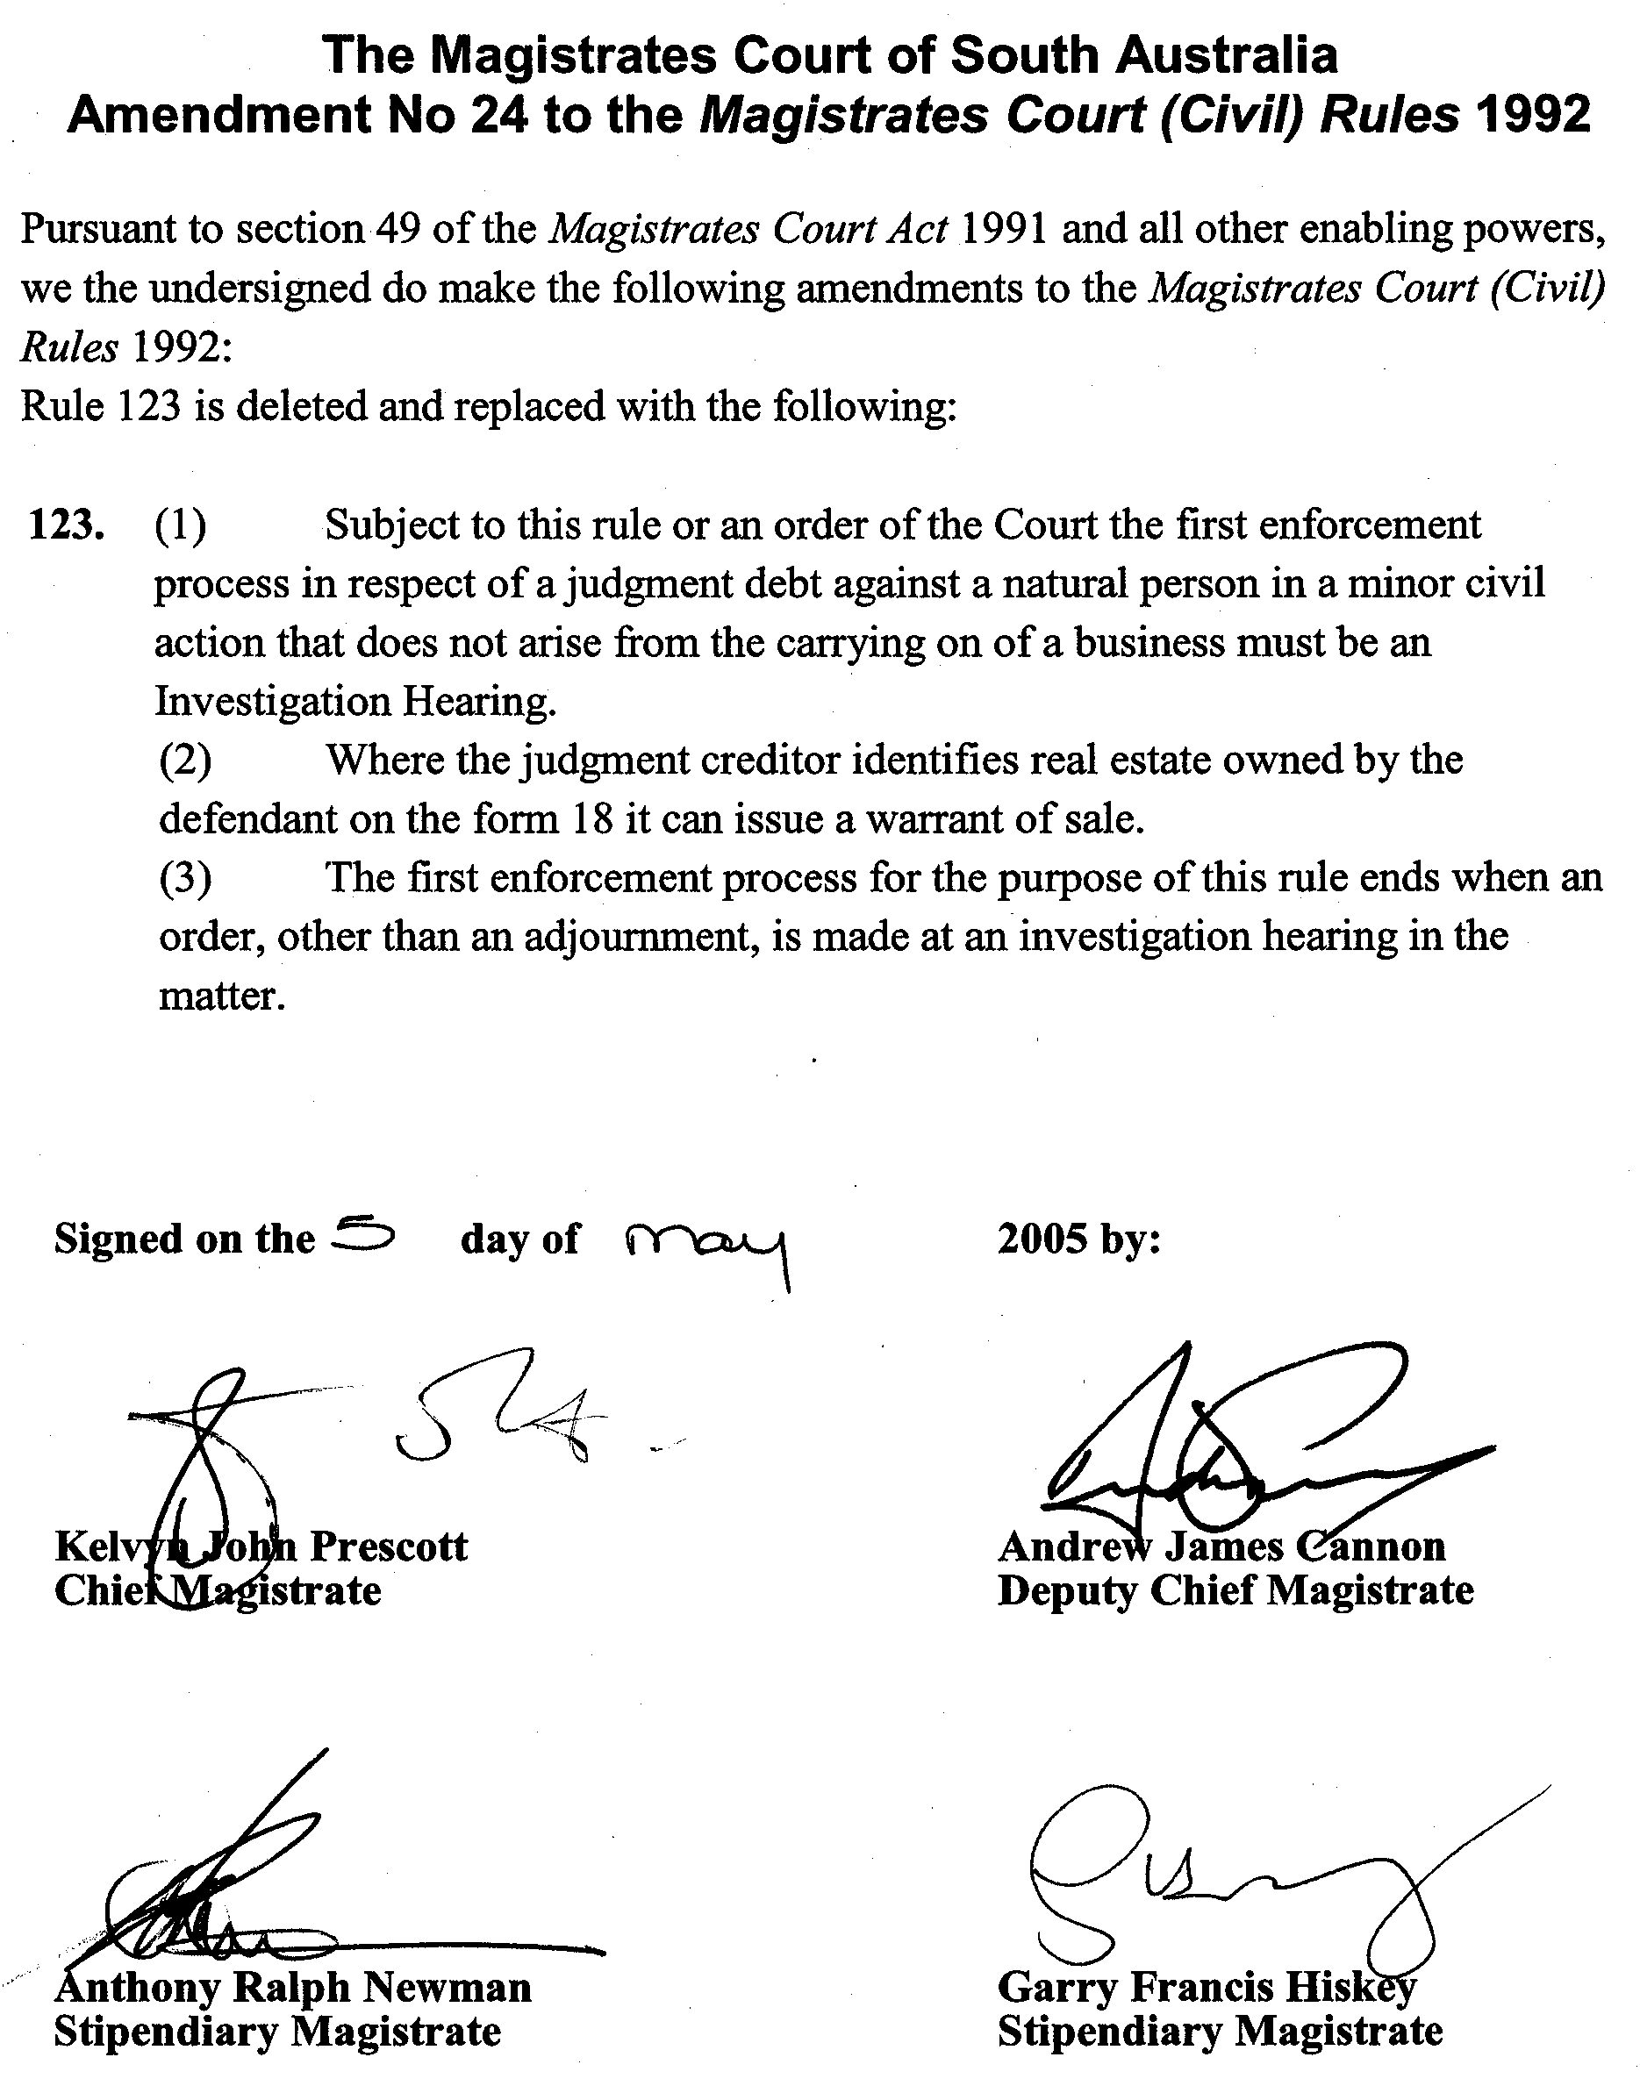

DEVELOPMENT ACT 1993, SECTION 25 (17): CITY OF MOUNT GAMBIER—BULKY GOODS (PENOLA ROAD) ZONE PLAN AMENDMENT
Preamble
1. The Development Plan amendment entitled ‘City of Mount Gambier—Bulky Goods (Penola Road) Zone Plan Amendment’ (the Plan Amendment) has been finalised in accordance with the provisions of the Development Act 1993.
2. The Minister for Urban Development and Planning has decided to approve the Plan Amendment.
Notice
PURSUANT to section 25 of the Development Act 1993, I—
(a) approve the Plan Amendment; and
(b) fix the day on which this notice is published in the Gazette as the day on which the Plan Amendment will come into operation.
Dated 26 May 2005.
P. Holloway, Minister for Urban Development and Planning
PLN/03/0237

DEVELOPMENT ACT 1993, SECTION 25 (17): THE BAROSSA COUNCIL—SOUTH EAST NURIOOTPA COMMERCIAL PLAN AMENDMENT
Preamble
1. The Development Plan amendment entitled ‘The Barossa Council—South East Nuriootpa Commercial Plan Amendment’ (the Plan Amendment) has been finalised in accordance with the provisions of the Development Act 1993.
2. The Minister for Urban Development and Planning has decided to approve the Plan Amendment.
Notice
PURSUANT to section 25 of the Development Act 1993, I—
(a) approve the Plan Amendment; and
(b) fix the day on which this notice is published in the Gazette as the day on which the Plan Amendment will come into operation.
Dated 26 May 2005.
P. Holloway, Minister for Urban Development and Planning
PLN/04/0400

DEVELOPMENT ACT 1993, SECTION 25 (17): RURAL CITY OF MURRAY BRIDGE—MURRAY BRIDGE TOWN CENTRE PLAN AMENDMENT
Preamble
1. The Development Plan amendment entitled ‘Rural City of Murray Bridge—Murray Bridge Town Centre Plan Amendment’ (the Plan Amendment) has been finalised in accordance with the provisions of the Development Act 1993.
2. The Minister for Urban Development and Planning has decided to approve the Plan Amendment.
Notice
PURSUANT to section 25 of the Development Act 1993, I—
(a) approve the Plan Amendment; and
(b) fix the day on which this notice is published in the Gazette as the day on which the Plan Amendment will come into operation.
Dated 26 May 2005.
P. Holloway, Minister for Urban Development and Planning
PLN/02/0391

SOUTH AUSTRALIAN METROPOLITAN FIRE SERVICE
Fees and Charges 2005-2006
I, THE Minister for Emergency Services, approve the increase to the South Australian Metropolitan Fire Service Fees and Charges from 1 July 2005 by 2.9 per cent.
Dated 20 May 2005.
C. Zollo, Minister for Emergency Services

EQUAL OPPORTUNITY TRIBUNAL
No. 80 of 2005
Notice of Exemption
Before Deputy Presiding Officer Bright
Members Altman and Simmons
I HEREBY certify that on 27 April 2005, the Equal Opportunity Tribunal of South Australia, on the application of the Department of Health made the following orders for exemption:
1. Under the provisions of section 92 of the Equal Opportunity Act 1984 there is granted a three year exemption to the Department of Health to appoint only Aboriginal and Torres Strait Islanders to Aboriginal Health Worker positions in South Australia. The Tribunal renews the existing exemption for a further period of three years from 8 May 2005.
2. Notice of the renewal of the exemption is to be published in the Government Gazette forthwith.
Dated 11 May 2005.
D. Hoban, for M. Moore, Registrar, Equal Opportunity Tribunal

HOUSING IMPROVEMENT ACT 1940
WHEREAS by notice published in the Government Gazette on the dates mentioned in the following table the South Australian Housing Trust did declare the houses described in the said table to be substandard for the purposes of Part 7 of the Housing Improvement Act 1940, the South Australian Housing Trust in the exercise of the powers conferred by the said Part, does hereby fix as the maximum rental per week which shall be payable subject to section 55 of the Residential Tenancies Act 1995, in respect of each house described in the following table the amount shown in the said table opposite the description of such house and this notice shall come into force on the date of this publication in the Gazette.
Address of House | Allotment, Section, etc. | Certificate of Title  Volume Folio | Date and page of Government Gazette in which notice declaring house to be substandard published | Maximum rental per week payable in respect of each house  $

37 Port Road, Auburn |  | Allotment 793 in Filed Plan 168922, Hundred of Upper Wakefield | 5424 | 559 |  | 3.2.00, page 714 | 162.00
Lot 32, March Street, Bowmans (Balaklava) |  | Allotment 32 in Deposited Plan 3870, Hundred of Inkerman | 5594 | 134 |  | 27.1.05, page 293 | 62.00
64 Coglin Street, Brompton |  | Allotment 31 of portion of Section 370 in Deposited Plan 795, Hundred of Yatala | 5294 | 57 |  | 13.4.67, page 1281 | 145.00
Lot 2, Onkaparinga Valley Road, Charleston (left hand dwelling) (also known as Mount Torrens Road) |  | Allotment 2 in Filed Plan 125916, Hundred of Onkaparinga | 5228 | 156 |  | 24.3.05, page 698 | 140.00
Lot 30, Angle Vale Road, Evanston Gardens |  | Section 30, Hundred of Munno in the area named Kudla | 5703 | 754 |  | 28.8.80, page 730 | 140.00
2 Seventeenth Street, Gawler South |  | Allotment 9 in Filed Plan 27690, Hundred of Mudla Wirra | 5808 | 505 |  | 12.11.87, page 1609 | 84.00
Unit 1, 22 Weller Street, Goodwood |  | Unit 1 of Strata Plan 4932, Hundred of Adelaide | 5025 | 407 |  | 24.2.05, page 523 | 263.00
174 Melrose Street, Mount Pleasant |  | Allotment 8 in Deposited Plan 235, Hundred of Talunga | 5416 | 872 |  | 16.4.81, page 1180 | 100.00
165 Piper Street, Kadina (Wallaroo Mines) |  | Section 2446, Hundred 211100, Hundred of Wallaroo | 5464 | 756 |  | 30.7.92, page 759 | 105.00
2 Springhead Road, Mount Torrens |  | Allotment 315 in Filed Plan 211911, Hundred of Talunga | 5781 | 414 |  | 24.2.05, page 523 | 115.00
Colonial Drive, Norton Summit ‘Wallmans Cottage’ |  | Allotment of Piece 2 in Deposited Plan 28258, Hundred of Adelaide | Cro  5779 | wn Lease  764 |  | 24.5.90, page 1430 | 110.00
167 Moscow Street, Peterborough |  | Allotment 1 in Filed Plan 14706, Hundred of Yongala | 5478 | 979 |  | 27.11.80, page 1995 | 90.00
33 Seventh Street, Port Pirie West |  | Allotment 188 in Deposited Plan 622, Hundred of Pirie | 5099 | 286 |  | 28.4.05, page 1012 | 92.00
43 Seventh Street, Port Pirie West |  | Allotment 183 in Deposited Plan 622, Hundred of Pirie | 5711 | 762 |  | 25.11.04, page 4390 | 50.00
3 Branford Street, Port Pirie (Solomontown) |  | Allotment 19 in Deposited Plan 854, Hundred of Pirie | 5895 | 247 |  | 20.7.78, page 254 | 105.00
10 King Street, Port Pirie (Solomontown)  Lots 29-30, Hope Street, Redhill |  | Allotment 4 in Filed Plan 104649, Hundred of Pirie  Allotment 33, Hundred of Redhill  Allotment 32, Hundred of Redhill  Allotment 279 of portion of Section 29, Hundred of Redhill | 5148  5532  5532  5532 | 341  120  121  122 |  | 19.1.78, page 342  26.2.98, page 1010 | 85.00  80.00
12 Karrawirra Avenue, Rostrevor |  | Allotment 13 in Deposited Plan 45254, Hundred of Adelaide | 5369 | 946 |  | 23.6.77, page 1807 | 90.00
9 Stirrup Street, Saddleworth |  | Allotment 481 in Filed Plan 168610, Hundred of Saddleworth  Allotment 482 in Filed Plan 168611, Hundred of Saddleworth | 5545  5545 | 812  813 |  | 30.10.03, page 3902 | 100.00
22 Parks Street, Solomontown, (Port Pirie) |  | Allotment 359 in Filed Plan 184441, Hundred of Pirie | 5858 | 509 |  | 24.2.05, page 523 | 66.00
62 Russell Terrace, Woodville Park |  | Allotment 6 in Deposited Plan 1600, Hundred of Yatala | 5185 | 701 |  | 30.9.04, page 3763 | 138.00

Dated at Adelaide, 28 April 2005. M. Downie, General Manager, Housing Trust

HOUSING IMPROVEMENT ACT 1940
WHEREAS by notice published in the Government Gazette on the dates mentioned in the following table the South Australian Housing Trust did declare the houses described in the following table to be substandard for the purposes of Part 7 of the Housing Improvement Act 1940, and whereas the South Australian Housing Trust is satisfied that each of the houses described hereunder has ceased to be substandard, notice is hereby given that, in exercise of the powers conferred by the said Part, the South Australian Housing Trust does hereby revoke the said declaration in respect of each house.
Address of House | Allotment, Section, etc. | Certificate of Title  Volume Folio | Date and page of Government Gazette in which notice declaring house to be substandard published

18 Harriett Street, Adelaide |  | Allotment 133 in Filed Plan 207423, Hundred of Adelaide | 5848 | 304 |  | 12.8.76, page 554
57 Golding Street, Beverley |  | Allotment 152 in Deposited Plan 4022, Hundred of Yatala | 5180 | 820 |  | 27.1.05, page 293
10 Press Road, Brooklyn Park |  | Allotment 74 in Filed Plan 144702, Hundred of Adelaide | 5715 | 581 |  | 26.5.94, page 1277
9 Viaduct Road, Eden Hills |  | Allotment 9 in Filed Plan 105592, Hundred of Adelaide | 5161 | 550 |  | 16.12.04, page 4534
Unit 12, 42 Eighth Street, Gawler South |  | Allotment 742 in Deposited Plan 61770, Hundred of Mudla Wirra | 5895 | 484 |  | 27.5.04, page 1372
598 South Road, Glandore |  | Allotment 30 in Filed Plan 6860, Hundred of Adelaide | 5685 | 592 |  | 30.7.98, page 280
25 Telford Street, Ovingham |  | Allotment 5 of Section 354, Hundred of Yatala | 5209 | 267 |  | 21.10.71, page 1735
38 Fourth Street, Snowtown |  | Allotment 28 in Township 210101, Hundred of Barunga | 5399 | 923 |  | 27.9.90, page 1034
40 Fourth Street, Snowtown |  | Allotment 710 in Filed Plan 190462, Hundred of Barunga | 5682 | 543 |  | 24.1.91, page 255
36 Frederick Street, Welland |  | Allotment 90 in Filed Plan 116302, Hundred of Yatala | 5222 | 69 |  | 29.10.92, page 1439
19 McDonnell Street, West Hindmarsh |  | Allotment 57 of portion of Section 372, Hundred of Yatala | 5678 | 559 |  | 13.7.72, page 251
Shack 1, 23 Kleeman Street, Whyalla |  | Allotment 663 in Township 560501, Hundred of Randell | 5569 | 293 |  | 19.11.70, page 2338
68 Cormack Road, Wingfield, (formerly 33) |  | Allotment 21 of portion of Section 374, Hundred of Port Adelaide | 5729 | 447 |  | 16.4.70, page 1421

Dated at Adelaide, 26 May 2005. M. Downie, General Manager, Housing Trust

HOUSING IMPROVEMENT ACT 1940
NOTICE is hereby given that the South Australian Housing Trust in the exercise of the powers conferred by the Housing Improvement Act 1940, does hereby declare the houses described in the table hereunder to be substandard for the purposes of Part 7 of the Housing Improvement Act 1940.
No. of House and Street | Locality | Allotment, Section, etc. | Certificate of Title  Volume Folio

Lot 2, Onkaparinga Valley Road, (also known as Mount Torrens Road, Mount Torrens) (right hand dwelling) |  | Charleston | Allotment 2 in Filed Plan 125916, Hundred of Onkaparinga | 5228 | 156
Unit 3, 24 Northcote Street |  | Kilburn | Allotment 44 in Deposited Plan 2267, Hundred of Yatala | 5735 | 602
62A Rose Street |  | Mile End | Allotment 12 in Filed Plan 119731, Hundred of Adelaide | 5391 | 560
19 Princess Street |  | Peterborough | Allotment 419 in Deposited Plan 3873, Hundred of Yongala | 5244 | 851
85 Bridges Street |  | Peterborough | Section 402, Hundred of Yongala in the area named Peterborough | 5557 | 489
338 Anzac Highway |  | Plympton | Allotment 9 in Deposited Plan 2658, Hundred of Adelaide | 5760 | 300

Dated at Adelaide, 26 May 2005. M. Downie, General Manager, Housing Trust

LAND AND BUSINESS (SALE AND CONVEYANCING)
ACT 1994
Exemption
TAKE notice that pursuant to section 23 (3) of the Land and Business (Sale and Conveyancing) Act 1994, I, Karlene Maywald, Minister for Consumer Affairs, do hereby exempt the person named in Schedule 1 from the application of section 23 (2) of the Act in relation to the purchase of the land specified in Schedule 2.
Schedule 1
Glen Alexander Govett, an employee of Kaesler Di Martino & Co. Pty Ltd.
Schedule 2
The whole of the land described in certificate of title register book volume 5492, folio 310 situated at 369 Lady Gowrie Drive, Osborne, S.A. 5017.
Dated 26 May 2005.
Signed for and on behalf of the Minister for Consumer Affairs by the Commissioner for Consumer Affairs:
M. Bodycoat, Commissioner

LIQUOR LICENSING ACT 1997 AND GAMING MACHINES ACT 1992
Notice of Application
NOTICE is hereby given, pursuant to section 52 of the Liquor Licensing Act 1997 and section 29 of the Gaming Machines Act 1992, that Denmar Hotels Pty Ltd as trustee for the Edinburgh Hotel Unit Trust and CNE Consulting Pty Ltd have applied to the Licensing Authority for the transfer of a Hotel Licence and Gaming Machine Licence in respect of premises situated at 233 Currie Street, Adelaide, S.A. 5000 and known as Edinburgh Castle Hotel.
The applications have been set down for hearing on 27 June 2005 at 9 a.m.
Any person may object to the application by lodging a notice of objection in the prescribed form with the Licensing Authority, and serving a copy of the notice on the applicants at the applicants’ address given above, at least seven days before the hearing date (viz: 19 June 2005).
The applicants’ address for service is c/o Wallmans Lawyers, 173 Wakefield Street, Adelaide, S.A. 5000 (Attention: Angela Hoban or Ben Allen).
Plans in respect of the premises the subject of the application are open to public inspection without fee at the Office of the Liquor and Gaming Commissioner, 9th Floor, East Wing, 50 Grenfell Street, Adelaide, S.A. 5000. Phone 8226 8410, Fax: 8226 8512. Email: olgc@agd.sa.gov.au.
Dated 18 May 2005.
Applicants

LIQUOR LICENSING ACT 1997 AND GAMING MACHINES ACT 1992
Notice of Application
NOTICE is hereby given, pursuant to section 52 of the Liquor Licensing Act 1997 and section 29 of the Gaming Machines Act 1992, that Chyswick Pty Ltd has applied to the Licensing Authority for the transfer of a Hotel and Gaming Machine Licences, variation to Extended Trading Authorisation and variation to Entertainment Consent in respect of premises situated at 1 Main Street, Cowell, S.A. 5602 and known as Franklin Harbour Hotel.
The applications have been set down for hearing on 27 June 2005 at 10.30 a.m.
Conditions
The following licence conditions are sought:
• Variation to Extended Trading Authorisation:
Good Friday—Midnight to 2 a.m.;
Sundays—8 a.m. to 11 a.m.
• For consumption off the licensed premises:
Sundays—8 a.m. to 11 a.m.
• Variation to Entertainment Consent to include Area 4.
Any person may object to the application by lodging a notice of objection in the prescribed form with the Licensing Authority, and serving a copy of the notice on the applicant at the applicant’s address given above, at least seven days before the hearing date (viz: 17 June 2005).
The applicant’s address for service is c/o Wallmans Lawyers, 173 Wakefield Street, Adelaide, S.A. 5000 (Attention: Peter Hoban or Ben Allen, Telephone: 8235 3000).
Plans in respect of the premises the subject of the application are open to public inspection without fee at the Office of the Liquor and Gaming Commissioner, 9th Floor, East Wing, 50 Grenfell Street, Adelaide, S.A. 5000. Phone 8226 8410, Fax: 8226 8512. Email: olgc@agd.sa.gov.au.
Dated 19 May 2005.
Applicant

LIQUOR LICENSING ACT 1997
Notice of Application
NOTICE is hereby given, pursuant to section 52 (2) (b) of the Liquor Licensing Act 1997, that Kylie Smith, Melanie Smith, Rebecca Smith and Joanne Smith have applied to the Licensing Authority for a Restaurant Licence, Entertainment Consent and Extended Trading Authorisation in respect of premises situated at 17 Commercial Street West, Mount Gambier, S.A. 5290 and to be known as Anno Domani.
The application has been set down for hearing on 24 June 2005 at 9 a.m.
Conditions
The following licence conditions are sought:
• Approval under section 34 (1) (c) to sell liquor for consumption on the licensed premises by persons:
(a) seated at a table; or
- attending a function at which food is provided.
• Extended Trading Authorisation:
Sunday—8 a.m. to 11 a.m. and 8 p.m. to midnight.
• Entertainment Consent:
Monday to Sunday—Noon to midnight;
Maundy Thursday—Noon to midnight;
Christmas Eve—Noon to midnight;
Sunday Christmas Eve—Noon to midnight;
New Year’s Eve—Noon to midnight;
Days preceding other Public Holidays—Noon to midnight;
Sundays preceding Public Holidays—Noon to midnight.
Any person may object to the application by lodging a notice of objection in the prescribed form with the Licensing Authority, and serving a copy of the notice on the applicants at the applicants’ address given above, at least seven days before the hearing date (viz: 16 June 2005).
The applicants’ address for service is c/o Kylie Smith, P.O. Box 8147, Mount Gambier East, S.A. 5291.
Plans in respect of the premises the subject of the application are open to public inspection without fee at the Office of the Liquor and Gambling Commissioner, 9th Floor, East Wing, 50 Grenfell Street, Adelaide, S.A. 5000. Phone 8226 8410, Fax:
8226 8512. Email: olgc@agd.sa.gov.au.
Dated 20 May 2005.
Applicants

LIQUOR LICENSING ACT 1997
Notice of Application
NOTICE is hereby given, pursuant to section 52 (2) (b) of the Liquor Licensing Act 1997, that Giocondo Mario Musolino and Judith Musolino have applied to the Licensing Authority for a Restaurant Licence, Extended Trading Authorisation and Entertainment Consent in respect of premises situated at 114 Semaphore Road, Semaphore, S.A. 5019 and to be known as Phore Seasons Restaurant.
The application has been set down for hearing on 24 June 2005 at 9 a.m.
Conditions
The following licence conditions are sought:
• Approval under section 34 (1) © to sell liquor for consumption on the licensed premises by persons:
- seated at a table; or
(b) attending a function at which food is provided.
• Extended Trading Authorisation:
Friday and Saturday—Midnight to 1 a.m. the following day;
Sunday—9 a.m. to 11 a.m. and 8 p.m. to 11 p.m.;
Good Friday—Midnight to 1 a.m.;
Christmas Day—Midnight to 1 a.m.;
Sunday Christmas Eve—8 p.m. to 2 a.m. the following day;
Days preceding other Public Holidays—Midnight to 1 a.m. the following day;
Sundays preceding Public Holidays—8 p.m. to 2 a.m. the following day;
• Entertainment Consent:
Monday to Sunday—Noon to 11 p.m.;
Good Friday—Noon to 11 p.m.;
Christmas Day—Noon to 11 p.m.;
Sunday Christmas Day—Noon to 2 a.m. the following day;
New Year’s Eve—Noon to 2 a.m. the following day;
Days preceding other Public Holidays—Noon to 11 p.m.;
Sundays preceding Public Holidays—Noon to 2 a.m. the following day.
Any person may object to the application by lodging a notice of objection in the prescribed form with the Licensing Authority, and serving a copy of the notice on the applicants at the applicants’ address given above, at least seven days before the hearing date (viz: 16 June 2005).
The applicants’ address for service is c/o Gio Musolino, 22 Fortisgreen Avenue, Pennington, S.A. 5013.
Plans in respect of the premises the subject of the application are open to public inspection without fee at the Office of the Liquor and Gambling Commissioner, 9th Floor, East Wing, 50 Grenfell Street, Adelaide, S.A. 5000. Phone 8226 8410, Fax:
8226 8512. Email: olgc@agd.sa.gov.au.
Dated 20 May 2005.
Applicants

LIQUOR LICENSING ACT 1997
Notice of Application
NOTICE is hereby given, pursuant to section 52 (2) (b) of the Liquor Licensing Act 1997, that Bremer’s Touch Pty Ltd as trustee for Bremer’s Touch Trust has applied to the Licensing Authority for a Producer’s Licence in respect of premises situated at Section 87, Hundred of Freeling, Bremer South Road, Langhorne Creek, S.A. 5255 and to be known as Bremer’s Touch.
The application has been set down for hearing on 24 June 2005 at 9 a.m.
Any person may object to the application by lodging a notice of objection in the prescribed form with the Licensing Authority, and serving a copy of the notice on the applicant at the applicant’s address given above, at least seven days before the hearing date (viz: 16 June 2005).
The applicant’s address for service is c/o Jeremy Moore and Associates, 10 Albyn Terrace, Strathalbyn, S.A. 5255 (Attention: Shelley Broadbent).
Plans in respect of the premises the subject of the application are open to public inspection without fee at the Office of the Liquor and Gambling Commissioner, 9th Floor, East Wing, 50 Grenfell Street, Adelaide, S.A. 5000. Phone 8226 8410, Fax:
8226 8512. Email: olgc@agd.sa.gov.au.
Dated 19 May 2005.
Applicant

LIQUOR LICENSING ACT 1997
Notice of Application
NOTICE is hereby given, pursuant to section 52 (2) (b) of the Liquor Licensing Act 1997, that Bernard Thomas Dwyer and Martina Christine Dwyer have applied to the Licensing Authority for a Producer’s Licence in respect of premises situated at Lot 51, Kookaburra Court, Willunga, S.A. 5172 and to be known as Home Block Vineyard.
The application has been set down for hearing on 24 June 2005 at 9 a.m.
Any person may object to the application by lodging a notice of objection in the prescribed form with the Licensing Authority, and serving a copy of the notice on the applicants at the applicants’ address given above, at least seven days before the hearing date (viz: 16 June 2005).
The applicants’ address for service is c/o Harris Lawyers, P.O. Box 279, Morphett Vale, S.A. 5162.
Plans in respect of the premises the subject of the application are open to public inspection without fee at the Office of the Liquor and Gambling Commissioner, 9th Floor, East Wing, 50 Grenfell Street, Adelaide, S.A. 5000. Phone 8226 8410, Fax:
8226 8512. Email: olgc@agd.sa.gov.au.
Dated 19 May 2005.
Applicants

LIQUOR LICENSING ACT 1997
Notice of Application
NOTICE is hereby given, pursuant to section 52 (2) (b) of the Liquor Licensing Act 1997, that Fradom Pty Ltd as trustee for Joe Agostino Family Trust has applied to the Licensing Authority for the a Producer’s Licence in respect of premises situated at Plains Road, Aldinga, S.A. 5173 and to be known as Agostino Wines.
The application has been set down for hearing on 24 June 2005 at 9 a.m.
Any person may object to the application by lodging a notice of objection in the prescribed form with the Licensing Authority, and serving a copy of the notice on the applicant at the applicant’s address given above, at least seven days before the hearing date (viz: 16 June 2005).
The applicant’s address for service is c/o R. A. Berton, 2A Basten Avenue, Seaview Downs, S.A. 5049.
Plans in respect of the premises the subject of the application are open to public inspection without fee at the Office of the Liquor and Gambling Commissioner, 9th Floor, East Wing, 50 Grenfell Street, Adelaide, S.A. 5000. Phone 8226 8410, Fax:
8226 8512. Email: olgc@agd.sa.gov.au.
Dated 19 May 2005.
Applicant

LIQUOR LICENSING ACT 1997
Notice of Application
NOTICE is hereby given, pursuant to section 52 (2) (b) of the Liquor Licensing Act 1997, that Gregory Bruce Nankivell and Elaine Nankivell have applied to the Licensing Authority for a Hotel Licence in respect of premises situated at 154 North Coast Road, Point Turton, S.A. 5575 and to be known as Tavern on Turton.
The application has been set down for hearing on 24 June 2005 at 9 a.m.
Any person may object to the application by lodging a notice of objection in the prescribed form with the Licensing Authority, and serving a copy of the notice on the applicants at the applicants’ address given above, at least seven days before the hearing date (viz: 16 June 2005).
The applicants’ address for service is c/o Gregory Nankivell, 61 Roberts Terrace, Whyalla, S.A. 5600.
Plans in respect of the premises the subject of the application are open to public inspection without fee at the Office of the Liquor and Gambling Commissioner, 9th Floor, East Wing, 50 Grenfell Street, Adelaide, S.A. 5000. Phone 8226 8410, Fax:
8226 8512. Email: olgc@agd.sa.gov.au.
Dated 20 May 2005.
Applicants

LIQUOR LICENSING ACT 1997
Notice of Application
NOTICE is hereby given, pursuant to section 52 (2) (b) of the Liquor Licensing Act 1997, that JD JD Enterprises Pty Ltd as trustee for J. D. McCormick Family Trust has applied to the Licensing Authority for the transfer of a Restaurant Licence in respect of premises situated at 220 Mount Barker Road, Aldgate, S.A. 5154 and known as Cheers Cafe and to be known as Tangos Cafe and Restaurant.
The application has been set down for hearing on 28 June 2005 at 10 a.m.
Any person may object to the application by lodging a notice of objection in the prescribed form with the Licensing Authority, and serving a copy of the notice on the applicant at the applicant’s address given above, at least seven days before the hearing date (viz: 20 June 2005).
The applicant’s address for service is c/o Denise McCormick,
5 Minton Avenue, Modbury Heights, S.A. 5092.
Plans in respect of the premises the subject of the application are open to public inspection without fee at the Office of the Liquor and Gambling Commissioner, 9th Floor, East Wing, 50 Grenfell Street, Adelaide, S.A. 5000. Phone 8226 8410, Fax:
8226 8512. Email: olgc@agd.sa.gov.au.
Dated 19 May 2005.
Applicant

LIQUOR LICENSING ACT 1997
Notice of Application
NOTICE is hereby given, pursuant to section 52 (2) (b) of the Liquor Licensing Act 1997, that Dening Holdings Pty Ltd as trustee for the Dening Family Trust has applied to the Licensing Authority for the transfer of a Restaurant Licence and Producer’s Licence in respect of premises situated at Menge Road, Tanunda, S.A. 5352 and known as the Lanzerac Estate and to be known as Lanzerac Country Estate.
The application has been set down for hearing on 28 June 2005 at 9 a.m.
Any person may object to the application by lodging a notice of objection in the prescribed form with the Licensing Authority, and serving a copy of the notice on the applicant at the applicant’s address given above, at least seven days before the hearing date (viz: 20 June 2005).
The applicant’s address for service is c/o David Watts, 1 Cator Street, Glenside, S.A. 5065.
Plans in respect of the premises the subject of the application are open to public inspection without fee at the Office of the Liquor and Gambling Commissioner, 9th Floor, East Wing, 50 Grenfell Street, Adelaide, S.A. 5000. Phone 8226 8410, Fax:
8226 8512. Email: olgc@agd.sa.gov.au.
Dated 19 May 2005.
Applicant

LIQUOR LICENSING ACT 1997
Notice of Application
NOTICE is hereby given, pursuant to section 52 (2) (b) of the Liquor Licensing Act 1997, that Naomi Lynette Casgrande has applied to the Licensing Authority for the transfer of a Restaurant Licence in respect of premises situated at 55 Main Street, Hahndorf, S.A. 5245 and known as Hahndorf Garden Cafe.
The application has been set down for hearing on 27 June 2005 at 10 a.m.
Any person may object to the application by lodging a notice of objection in the prescribed form with the Licensing Authority, and serving a copy of the notice on the applicant at the applicant’s address given above, at least seven days before the hearing date (viz: 19 June 2005).
The applicant’s address for service is c/o Naomi Lynette Casgrande, 266 Seacombe Road, Seacliff Park, S.A. 5049.
Plans in respect of the premises the subject of the application are open to public inspection without fee at the Office of the Liquor and Gambling Commissioner, 9th Floor, East Wing, 50 Grenfell Street, Adelaide, S.A. 5000. Phone 8226 8410, Fax:
8226 8512. Email: olgc@agd.sa.gov.au.
Dated 13 May 2005.
Applicant

LIQUOR LICENSING ACT 1997
Notice of Application
NOTICE is hereby given, pursuant to section 52 (2) (b) of the Liquor Licensing Act 1997, that David Hamilton as trustee for the Dam Blond Family Trust has applied to the Licensing Authority for a Producer’s Licence in respect of premises situated at 46 High Street, Willunga, S.A. 5172 and to be known as McLaren Range Vineyard.
The application has been set down for hearing on 24 June 2005 at 9 a.m.
Any person may object to the application by lodging a notice of objection in the prescribed form with the Licensing Authority, and serving a copy of the notice on the applicant at the applicant’s address given above, at least seven days before the hearing date (viz: 16 June 2005).
The applicant’s address for service is c/o David Hamilton, P.O. Box 389, Willunga, S.A. 5172.
Plans in respect of the premises the subject of the application are open to public inspection without fee at the Office of the Liquor and Gambling Commissioner, 9th Floor, East Wing, 50 Grenfell Street, Adelaide, S.A. 5000. Phone 8226 8410, Fax:
8226 8512. Email: olgc@agd.sa.gov.au.
Dated 13 May 2005.
Applicant

LIQUOR LICENSING ACT 1997
Notice of Application
NOTICE is hereby given, pursuant to section 52 (2) (b) of the Liquor Licensing Act 1997, that Lee Cheong Tong has applied to the Licensing Authority for the transfer of a Special Circumstances Licence in respect of premises situated at 141 West Terrace, Adelaide, S.A. 5000 and known as Hawkers Corner Restaurant.
The application has been set down for hearing on 24 June 2005 at 9 a.m.
Any person may object to the application by lodging a notice of objection in the prescribed form with the Licensing Authority, and serving a copy of the notice on the applicant at the applicant’s address given above, at least seven days before the hearing date (viz: 16 June 2005).
The applicant’s address for service is c/o Yapp Hau Pehn Solicitors, 1st Floor, 149 Flinders Street, Adelaide, S.A. 5000. Phone: (08) 8227 2388 or Facsimile: (08) 8227 2199.
Plans in respect of the premises the subject of the application are open to public inspection without fee at the Office of the Liquor and Gambling Commissioner, 9th Floor, East Wing, 50 Grenfell Street, Adelaide, S.A. 5000. Phone 8226 8410, Fax:
8226 8512. Email: olgc@agd.sa.gov.au.
Dated 20 May 2005.
Applicant

LIQUOR LICENSING ACT 1997
Notice of Application
NOTICE is hereby given, pursuant to section 52 (2) (b) of the Liquor Licensing Act 1997, that Victor Harbor Soccer Club Inc. has applied to the Licensing Authority for a Limited Club Licence in respect of premises situated at Tottenham Court Road, Port Elliot, S.A. 5212 and to be known as Southern Breakers Soccer Club.
The application has been set down for hearing on 24 June 2005 at 9 a.m.
Any person may object to the application by lodging a notice of objection in the prescribed form with the Licensing Authority, and serving a copy of the notice on the applicant at the applicant’s address given above, at least seven days before the hearing date (viz: 16 June 2005).
The applicant’s address for service is c/o P.O. Box 156, Victor Harbor, S.A. 5211.
Plans in respect of the premises the subject of the application are open to public inspection without fee at the Office of the Liquor and Gambling Commissioner, 9th Floor, East Wing, 50 Grenfell Street, Adelaide, S.A. 5000. Phone 8226 8410, Fax:
8226 8512. Email: olgc@agd.sa.gov.au.
Dated 20 May 2005.
Applicant

LIQUOR LICENSING ACT 1997
Notice of Application
NOTICE is hereby given, pursuant to section 52 (2) (b) of the Liquor Licensing Act 1997, that Graeme Maxwell Thompson and Sharon Maree Thompson have applied to the Licensing Authority for a Producer’s Licence in respect of premises situated at Section 678, Qualco Road, Waikerie, S.A. 5330 and to be known as GM & SM Thompson.
The application has been set down for hearing on 24 June 2005 at 9 a.m.
Any person may object to the application by lodging a notice of objection in the prescribed form with the Licensing Authority, and serving a copy of the notice on the applicants at the applicants’ address given above, at least seven days before the hearing date (viz: 16 June 2005).
The applicants’ address for service is c/o Wallmans Lawyers, 173 Wakefield Street, Adelaide, S.A. 5000 (Attention: Peter Hoban or Ben Allen).
Plans in respect of the premises the subject of the application are open to public inspection without fee at the Office of the Liquor and Gambling Commissioner, 9th Floor, East Wing, 50 Grenfell Street, Adelaide, S.A. 5000. Phone 8226 8410, Fax:
8226 8512. Email: olgc@agd.sa.gov.au.
Dated 20 May 2005.
Applicants

MINING ACT 1971
NOTICE is hereby given in accordance with section 28 (5) of the Mining Act 1971, that the Minister for Mineral Resources Development proposes to grant an Exploration Licence over the undermentioned area:
Applicant: Hillment Pty Ltd
Location: Warrior area—Approximately 50 km west-north-west of Tarcoola.
Term: 1 year
Area in km²: 165
Ref.: 2004/00739
Plan and co-ordinates can be found on the PIRSA Sarig website: http://www.minerals.pir.sa.gov.au/sarig or by phoning Mineral Tenements on (08) 8463 3103.
H. Tyrteos, Mining Registrar

MINING ACT 1971
NOTICE is hereby given in accordance with section 28 (5) of the Mining Act 1971, that the Minister for Mineral Resources Development proposes to grant an Exploration Licence over the undermentioned area:
Applicant: Peninsula Exploration Pty Ltd
Location: Pyramid Bore area—Approximately 50 km east of Kingoonya.
Term: 1 year
Area in km²: 548
Ref.: 2004/00772
Plan and co-ordinates can be found on the PIRSA Sarig website: http://www.minerals.pir.sa.gov.au/sarig or by phoning Mineral Tenements on (08) 8463 3103.
H. Tyrteos, Mining Registrar

MINING ACT 1971
NOTICE is hereby given in accordance with section 28 (5) of the Mining Act 1971, that the Minister for Mineral Resources Development proposes to grant an Exploration Licence over the undermentioned area:
Applicant: BHP Billiton Minerals Pty Ltd
Location: Mount Mary area—Approximately 130 km north-east of Adelaide.
Term: 1 year
Area in km²: 835
Ref.: 2004/00794
Plan and co-ordinates can be found on the PIRSA Sarig website: http://www.minerals.pir.sa.gov.au/sarig or by phoning Mineral Tenements on (08) 8463 3103.
H. Tyrteos, Mining Registrar

MINING ACT 1971
NOTICE is hereby given in accordance with section 28 (5) of the Mining Act 1971, that the Minister for Mineral Resources Development proposes to grant an Exploration Licence over the undermentioned area:
Applicant: BHP Billiton Minerals Pty Ltd
Location: Swan Reach area—Approximately 100 km north-east and south-east of Adelaide.
Term: 1 year
Area in km²: 843
Ref.: 2004/00843
Plan and co-ordinates can be found on the PIRSA Sarig website: http://www.minerals.pir.sa.gov.au/sarig or by phoning Mineral Tenements on (08) 8463 3103.
H. Tyrteos, Mining Registrar

MINING ACT 1971
NOTICE is hereby given in accordance with section 28 (5) of the Mining Act 1971, that the Minister for Mineral Resources Development proposes to grant an Exploration Licence over the undermentioned area:
Applicant: Shane Le Plastrier
Location: Wild Horse Plain area—Approximately 100 km south-west of Whyalla.
Term: 1 year
Area in km²: 816
Ref.: 2004/00852
Plan and co-ordinates can be found on the PIRSA Sarig website: http://www.minerals.pir.sa.gov.au/sarig or by phoning Mineral Tenements on (08) 8463 3103.
H. Tyrteos, Mining Registrar

MINING ACT 1971
NOTICE is hereby given in accordance with section 28 (5) of the Mining Act, 1971 that the Minister for Mineral Resources Development proposes to grant an Exploration Licence over the undermentioned area:
Applicant: Red Metal Ltd
Location: Lake Callabonna area—Approximately 180 km east-south-east of Marree.
Term: 1 year
Area in km²: 603
Ref.: 2005/00026
Plan and co-ordinates can be found on the PIRSA Sarig website: http://www.minerals.pir.sa.gov.au/sarig or by phoning Mineral Tenements on (08) 8463 3103.
H. Tyrteos, Mining Registrar

MINING ACT 1971
NOTICE is hereby given in accordance with section 28 (5) of the Mining Act 1971, that the Minister for Mineral Resources Development proposes to grant an Exploration Licence over the undermentioned area:
Applicant: Centrex Metals Ltd
Location: Gilles Downs area—Approximately 60 km east-north-east of Kimba.
Term: 1 year
Area in km²: 170
Ref.: 2005/00035
Plan and co-ordinates can be found on the PIRSA Sarig website: http://www.minerals.pir.sa.gov.au/sarig or by phoning Mineral Tenements on (08) 8463 3103.
H. Tyrteos, Mining Registrar

MINING ACT 1971
NOTICE is hereby given in accordance with section 35A (1) of the Mining Act 1971, that an application for an extractive mineral lease over the undermentioned mineral claim has been received. Details of the proposal may be inspected at the Department of Primary Industries and Resources, Mineral Resources Group, Level 5, 101 Grenfell Street, Adelaide, S.A. 5000:
Applicant: Wattle Range Council
Claim Number: 3303
Location: In Part Section 184 and Allotment 2 of DP38641, Hundred of Mount Muirhead, approximately 4 km north-west of Millicent.
Area: 9.1 hectares
Purpose: Recovery of Limestone
Reference: T02323
Written submissions in relation to the granting of the extractive mineral lease are invited to be received at the Department of Primary Industries and Resources, Mineral Resources Group, Level 5, 101 Grenfell Street, Adelaide, S.A. 5000 or G.P.O. Box 1671, Adelaide, S.A. 5001 no later than 13 June 2005.
H. Tyrteos, Mining Registrar

MINING ACT 1971
NOTICE is hereby given in accordance with section 35A (1) of the Mining Act 1971, that an application for an extractive mineral lease over the undermentioned mineral claim has been received. Details of the proposal may be inspected at the Department of Primary Industries and Resources, Mineral Resources Group, Level 5, 101 Grenfell Street, Adelaide, S.A. 5000:
Applicant: Phillip John Rolland
Claim Number: 3440
Location: In Allotments 4 and 5 FP1157747, Hundred of Tungkillo, approximately 6 km south-west of Tungkillo.
Area: 5.4 hectares
Purpose: Recovery of sandstone for crushed rock
Reference: T02404
A copy of the proposal has been provided to the Mid Murray Council.
Written submissions in relation to the granting of the extractive mineral lease are invited to be received at the Department of Primary Industries and Resources, Mineral Resources Group, Level 5, 101 Grenfell Street, Adelaide, S.A. 5000 or G.P.O. Box 1671, Adelaide, S.A. 5001 no later than 20 June 2005.
H. Tyrteos, Mining Registrar

MOTOR VEHICLES ACT 1959
Recognised as an Historic Motor Vehicle Club
NOTICE is hereby given that the undermentioned club is recognised as an historic motor vehicle club in accordance with Schedule 1 Clause 3 (3) (a) of the Motor Vehicles Regulations, for the purposes of section 25 of the Motor Vehicles Act 1959:
Mustangs on the Move Incorporated
Dated 17 May 2005.
R. J. Frisby, Registrar of Motor Vehicles

NATIONAL ELECTRICITY (SOUTH AUSTRALIA) ACT 1996
Notice Under the National Electricity Code
South Australia—Full Retail Competition Metering Derogation
NOTICE is hereby given under clause 9.1.1 (h) of the National Electricity Code, approved under section 6 of the National Electricity Law which forms the Schedule to the National Electri-city (South Australia) Act 1996, that Chapter 9, Part D (‘Transitional Arrangements for South Australia’) of the National Electricity Code is amended. Amendments have been made to clauses 9.30.1. These Code changes relate principally to the Full Retail Competition metering arrangements.
These amendments to the National Electricity Code commence at the beginning of 26 May 2005.
As required by clause 9.1.1 (h) of the National Electricity Code, copies of:
1. the ACCC’s letter dated 12 May 2005 to NECA granting interim authorisation for these amendments; and
2. the letter from the Hon. Patrick Conlon, MP dated 23 May 2005 notifying the National Electricity Code Administrator (‘NECA’) (ACN 073 942 775) of the amendments to Chapter 9 are set out below.
Both the amendments and copies of the above letters can be viewed in full in the document entitled ‘Victoria Full Retail Competition metering derogation’ on the Internet website of NECA at www.neca.com.au under ‘The Code’—‘Gazette notices’ section of that website.
The National Electricity Code can be viewed on the NECA Internet website at www.neca.com.au and at the offices of NECA and the National Electricity Market Management Company Limited (ACN 072 010 327). A list of addresses where the Code can be viewed is available on the NECA website.
Dated: 26 May 2005.

12 May 2005
Mr John Eastham
Director
National Electricity Code Administrator
Level 5, 41 Currie Street
Adelaide, S.A. 5000
Dear John,
Draft Determination and Interim Authorisation of South Australian Metering Full Retail Competition Derogations
On 22 March 2005, the Australian Competition and Consumer Commission (ACCC) received applications for authorisation (Nos A40103, A40104 and A40105) of derogations to Chapter 7 of the National Electricity Code (code). The applications were made by the National Electricity Code Administrator (NECA) on behalf of the South Australian Government, under Part VII of the Trade Practices Act 1974 (TPA). The stated purpose of the applications includes extending current jurisdictional derogations in the short term to provide sufficient time for the code changes recommended by the jurisdictional regulators to be pursued through the usual code consultation process.
I also note that South Australia requested interim authorisation of the applications. The ACCC has considered this request and has decided, pursuant to section 91 (2) of the TPA to grant interim authorisation of these applications. The interim authorisation becomes effective from 12 May 2005 and will lapse when the ACCC’s final determination in regard to each application comes into force, unless this interim authorisation is revoked before this date. Please note that under subsection 91 (2) of the TPA, the ACCC may revoke an interim authorisation at any time.
The ACCC has also made a draft determination on the applications for authorisation. The draft determination outlines the ACCC’s proposal to grant authorisation of the derogations. A copy of the draft determination is enclosed
Written submissions on the draft determination are to be received by 10 June 2005. Further, the ACCC invites NECA and other interested parties to notify it by 26 May 2005 as to whether they wish the ACCC to hold a pre-determination conference. If a conference is requested on the draft determination, the ACCC will hold a conference on 3 June 2005 in Adelaide at a time and venue to be notified.
The applicant and interested parties who receive a copy of the draft determination, and any other interested parties whose presence the ACCC considers appropriate are entitled to participate in any such conference. Following the conference, the ACCC will take into account issues raised at the conference and any related submissions, and will issue a final determination.
If no pre-determination conference is called, or written submissions received, then the draft determination will form the basis of the final determination. A person dissatisfied with the final determination may apply to the Australian Competition Tribunal for its review.
If you have any queries about any issue raised in this letter, please contact me on (03) 9290 1435 or Owen Seadon on (03) 9290 1445.
Yours sincerely,
Sebastian Roberts, General Manager, ACCC Electricity

Mr John Eastham
Director
National Electricity Code Administrator Limited
Level 5, 41 Currie Street
Adelaide, S.A. 5000
Dear Mr Eastham,
I am writing to advise you that on 11 May 2005, the Australian Competition and Consumer Commission (ACCC) issued a draft determination and interim authorisation on applications for authorisation Nos A40103, A40104 and A40105 to extend South Australia’s existing derogations to Chapter 7 of the National Electricity Code.
In accordance with clause 9.1.1 (h) of the Code, I notify NECA of the draft determination and interim authorisation. I would be grateful if you could arrange for gazettal of this letter, the enclosed copy of the ACCC’s interim authorisation dated 12 May 2005 and the approved Code changes.
I would like to thank NECA for its assistance in preparing and submitting the application for authorisation.
Dated 23 May 2005.
Yours sincerely,
P. Conlon, Minister for Energy

PASSENGER TRANSPORT ACT 1994
Passenger Transport Board (Regular Passenger Services—Fares and Charges)
PURSUANT to its powers under the Passenger Transport Act 1994 and Regulations, the Passenger Transport Board has determined that the fares and charges to be paid by passengers on regular passenger services within Metropolitan Adelaide will be the fares and charges as detailed in Schedule 1 below:
These fares and charges will be effective from 3 July 2005.
P. Conlon, Minister for Transport

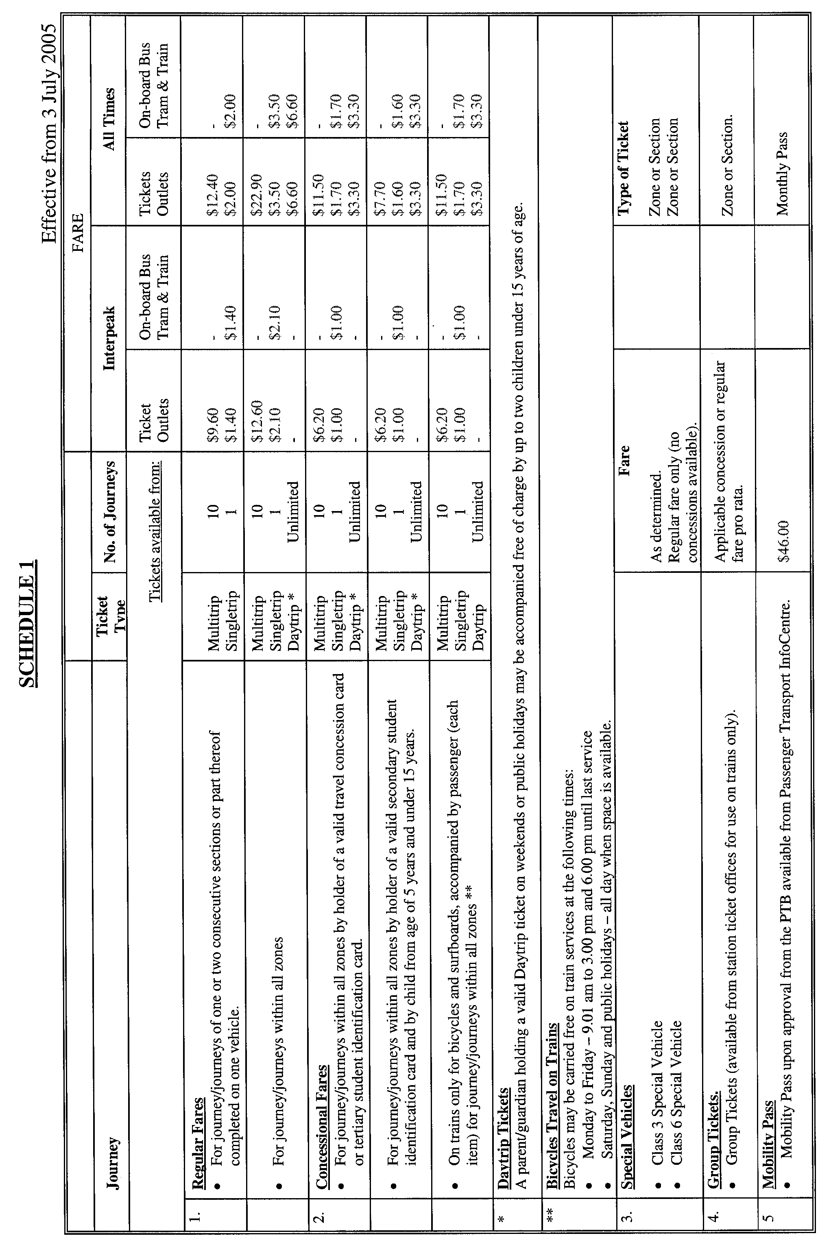
PETROLEUM ACT 2000
Grant of Geothermal Exploration Licences—GEL 175 and GEL 176
NOTICE is hereby given that the undermentioned Geothermal Exploration Licences have been granted under the provisions of the Petroleum Act 2000, pursuant to delegated powers dated 28 March 2002, Gazetted 11 April 2002, page 1573.

No of Licence | Licensee | Locality | Area in km² | Reference
GEL 175 | Eden Energy Limited | Renmark area | 499 | 27/2/298
GEL 176 | Eden Energy Limited | Renmark area | 495 | 27/2/299

Description of Area—GEL 175
All that part of the State of South Australia, bounded as follows Commencing at a point being the intersection of latitude 33°36′00″S GDA94 and longitude 140°48′00″E GDA94, thence north-easterly to a northern boundary of Chowilla Regional Reserve, thence generally easterly and southerly along the boundary of the said Regional Reserve to latitude 33°47′00″S, west to longitude 140°56′00″E GDA94, south to latitude 33°49′00″S GDA94, west to longitude 140°55′00″E GDA94, south to latitude 33°50′00″S GDA94, west to a western boundary of Chowilla Regional Reserve, thence generally northerly, westerly and northerly along the boundary of the said Regional Reserve to latitude 33°41′00″S GDA94, east to longitude 140°43′00″E GDA94, north to latitude 33°40′00″S GDA94, east to longitude 140°44′00″E GDA94, north to latitude 33°39′00″S GDA94, east to longitude 140°45′00″E GDA94, north to latitude 33°38′00″S GDA94, east to longitude 140°46′00″E GDA94, north to latitude 33°37′00″S GDA94, east to longitude 140°47′00″E GDA94, north to latitude 33°36′00″S GDA94, and east to the point of commencement.
Area: 499 km² approximately.
Description of Area—GEL 176
All that part of the State of South Australia, bounded as follows Commencing at a point being the intersection of latitude 33°36′00″S GDA94 and longitude 140°43′00″E GDA94, thence east to longitude 140°47′00″E GDA94, south to latitude 33°37′00″S GDA94, west to longitude 140°46′00″E GDA94, south to latitude 33°38′00″S GDA94, west to longitude 140°45′00″E GDA94, south to latitude 33°39′00″S GDA94, west to longitude 140°44′00″E GDA94, south to latitude 33°40′00″S GDA94, west to longitude 140°43′00″E GDA94, south to latitude 33°41′00″S GDA94, west to a western boundary of Chowilla Regional Reserve, thence generally southerly, easterly and southerly along the boundary of the said Regional Reserve to latitude 33°50′00″S GDA94, east to longitude 140°55′00″E GDA94, north to latitude 33°49′00″S GDA94, east to longitude 140°56′00″E GDA94, north to latitude 33°47′00″S GDA94, east to the eastern boundary of Chowilla Regional Reserve, thence southerly along the boundary of the said Regional Reserve to latitude 33°52′00″S GDA94, west to longitude 140°35′00″E GDA94, north to latitude 33°51′00″S GDA94, west to longitude 140°34′00″E GDA94, north to latitude 33°48′00″S GDA94, east to longitude 140°36′00″E GDA94, north to latitude 33°47′00″S GDA94, east to longitude 140°37′00″E GDA94, north to latitude 33°46′00″S GDA94, east to longitude 140°38′00″E GDA94, north to latitude 33°45′00″S GDA94, east to longitude 140°39′00″E GDA94, north to latitude 33°44′00″S GDA94, east to longitude 140°40′00″E GDA94, north to latitude 33°40′00″S GDA94, east to longitude 140°41′00″E GDA94, north to latitude 33°38′00″S GDA94, east to longitude 140°42′00″E GDA94, north to latitude 33°37′00″S GDA94, east to longitude 140°43′00″E GDA94, and north to the point of commencement.
Area: 495 km² approximately.
Dated 23 May 2005.
B. A. Goldstein, Director Petroleum
Minerals and Energy Division
Primary Industries and Resources SA
Delegate of the Minister for Mineral Resources Development

GOVERNMENT GAZETTE ADVERTISEMENT RATES

To apply from 1 July 2004

$  Agents, Ceasing to Act as 35.50  Associations:  Incorporation 18.10  Intention of Incorporation 44.75  Transfer of Properties 44.75  Attorney, Appointment of 35.50  Bailiff’s Sale 44.75  Cemetery Curator Appointed 26.50  Companies:  Alteration to Constitution 35.50  Capital, Increase or Decrease of 44.75  Ceasing to Carry on Business 26.50  Declaration of Dividend 26.50  Incorporation 35.50  Lost Share Certificates:  First Name 26.50  Each Subsequent Name 9.10  Meeting Final 29.75  Meeting Final Regarding Liquidator’s Report on  Conduct of Winding Up (equivalent to ‘Final  Meeting’)  First Name 35.50  Each Subsequent Name 9.10  Notices:  Call 44.75  Change of Name 18.10  Creditors 35.50  Creditors Compromise of Arrangement 35.50  Creditors (extraordinary resolution that ‘the Com-pany be wound up voluntarily and that a liquidator be appointed’) 44.75  Release of Liquidator⎯Application⎯Large Ad. 70.50  ⎯Release Granted 44.75  Receiver and Manager Appointed 41.25  Receiver and Manager Ceasing to Act 35.50  Restored Name 33.50  Petition to Supreme Court for Winding Up 62.00  Summons in Action 53.00  Order of Supreme Court for Winding Up Action 35.50  Register of Interests⎯Section 84 (1) Exempt 80.00  Removal of Office 18.10  Proof of Debts 35.50  Sales of Shares and Forfeiture 35.50  Estates:  Assigned 26.50  Deceased Persons⎯Notice to Creditors, etc. 44.75  Each Subsequent Name 9.10  Deceased Persons⎯Closed Estates 26.50  Each Subsequent Estate 1.15  Probate, Selling of 35.50  Public Trustee, each Estate 9.10 |  | $  Firms:  Ceasing to Carry on Business (each insertion) 23.60  Discontinuance Place of Business 23.60  Land⎯Real Property Act:  Intention to Sell, Notice of 44.75  Lost Certificate of Title Notices 44.75  Cancellation, Notice of (Strata Plan) 44.75  Mortgages:  Caveat Lodgment 18.10  Discharge of 19.00  Foreclosures 18.10  Transfer of 18.10  Sublet 9.10  Leases⎯Application for Transfer (2 insertions) each 9.10  Lost Treasury Receipts (3 insertions) each 26.50  Licensing 53.00  Municipal or District Councils:  Annual Financial Statement⎯Forms 1 and 2 499.00  Electricity Supply⎯Forms 19 and 20 354.00  Default in Payment of Rates:  First Name 70.50  Each Subsequent Name 9.10  Noxious Trade 26.50  Partnership, Dissolution of 26.50  Petitions (small) 18.10  Registered Building Societies (from Registrar-  General) 18.10  Register of Unclaimed Moneys⎯First Name 26.50  Each Subsequent Name 9.10  Registers of Members⎯Three pages and over:  Rate per page (in 8pt) 226.00  Rate per page (in 6pt) 299.00  Sale of Land by Public Auction 45.25  Advertisements 2.50  Advertisements, other than those listed are charged at $2.50 per column line, tabular one-third extra.  Notices by Colleges, Universities, Corporations and District Councils to be charged at $2.50 per line.  Where the notice inserted varies significantly in length from that which is usually published a charge of $2.50 per column line will be applied in lieu of advertisement rates listed.  South Australian Government publications are sold on the condition that they will not be reproduced without prior permission from the Government Printer.
All the above prices include GST

GOVERNMENT GAZETTE NOTICES
ALL private advertisements forwarded for publication in the South Australian Government Gazette must be PAID FOR PRIOR TO INSERTION; and all notices, from whatever source, should be legibly written on one side of the paper only and sent to Government Publishing SA so as to be received no later than 4 p.m. Tuesday preceding the day of publication. Phone 8207 1045 or Fax 8207 1040. E-mail: governmentgazette@saugov.sa.gov.au. Send as attachments in Word format. Please include date the notice is to be published and to whom the notice will be charged. The Government Gazette is available online at: www.governmentgazette.sa.gov.au.

MISCELLANEOUS LEGISLATION AND GOVERNMENT PUBLICATIONS PRICES AS FROM 1 JULY 2004

Acts, Bills, Rules, Parliamentary Papers and Regulations
Pages | Main | Amends | Pages | Main | Amends

1-16 | 2.15 | 0.95 | 497-512 | 30.25 | 29.00
17-32 | 2.90 | 1.80 | 513-528 | 31.25 | 29.90
33-48 | 3.80 | 2.70 | 529-544 | 32.00 | 31.00
49-64 | 4.75 | 3.65 | 545-560 | 33.00 | 32.00
65-80 | 5.60 | 4.60 | 561-576 | 33.75 | 33.00
81-96 | 6.50 | 5.40 | 577-592 | 34.75 | 33.50
97-112 | 7.40 | 6.30 | 593-608 | 35.75 | 34.50
113-128 | 8.30 | 7.25 | 609-624 | 36.50 | 35.50
129-144 | 9.35 | 8.25 | 625-640 | 37.25 | 36.10
145-160 | 10.20 | 9.10 | 641-656 | 38.25 | 37.20
161-176 | 11.20 | 10.00 | 657-672 | 38.75 | 38.00
177-192 | 12.00 | 11.00 | 673-688 | 40.50 | 38.80
193-208 | 13.00 | 11.90 | 689-704 | 41.25 | 39.90
209-224 | 13.80 | 12.70 | 705-720 | 41.75 | 41.00
225-240 | 14.70 | 13.60 | 721-736 | 43.50 | 41.50
241-257 | 15.70 | 14.30 | 737-752 | 44.00 | 42.90
258-272 | 16.60 | 15.30 | 753-768 | 45.00 | 43.40
273-288 | 17.50 | 16.40 | 769-784 | 45.50 | 44.70
289-304 | 18.30 | 17.20 | 785-800 | 46.50 | 45.60
305-320 | 19.30 | 18.20 | 801-816 | 47.25 | 46.00
321-336 | 20.10 | 19.00 | 817-832 | 48.25 | 47.25
337-352 | 21.20 | 20.00 | 833-848 | 49.25 | 48.00
353-368 | 22.00 | 21.00 | 849-864 | 50.00 | 48.80
369-384 | 22.90 | 21.90 | 865-880 | 51.00 | 50.00
385-400 | 23.80 | 22.70 | 881-896 | 51.50 | 50.50
401-416 | 23.70 | 23.50 | 897-912 | 53.00 | 51.50
417-432 | 25.75 | 24.50 | 913-928 | 53.50 | 53.00
433-448 | 26.60 | 25.50 | 929-944 | 54.50 | 53.50
449-464 | 27.50 | 26.25 | 945-960 | 55.50 | 54.00
465-480 | 28.00 | 27.25 | 961-976 | 56.50 | 55.00
481-496 | 29.25 | 28.00 | 977-992 | 57.50 | 56.00

Legislation—Acts, Regulations, etc: $
Subscriptions:
Acts 187.00
All Bills as Laid 447.00
Rules and Regulations 447.00
Parliamentary Papers 447.00
Bound Acts 207.00
Index 103.00
Government Gazette
Copy 4.85
Subscription 247.00
Hansard
Copy 13.50
Subscription—per session (issued weekly) 388.00
Cloth bound—per volume 167.00
Subscription—per session (issued daily) 388.00
Legislation on Disk
Whole Database 2 868.00
Annual Subscription for fortnightly updates 881.00
Individual Act(s) including updates POA
Compendium
Subscriptions:
New Subs 1 700.00
Updates 600.00
(All the above prices include GST)

All Legislation, Government Gazette, Hansard and Legislation on disk are available from:
Counter Sales Service SA, Government Legislation⁺ Outlet
and Mail Orders: Lands Titles Office, 101 Grenfell Street, Adelaide
Phone: 13 23 24 (local call cost), Fax: (08) 8204 1909
Postal: G.P.O. Box 1707, Adelaide, S.A. 5001

Online Shop: www.shop.service.sa.gov.au

Subscriptions and Government Publishing SA
Standing Orders: Box 9, Plaza Level, Riverside Centre, North Terrace, Adelaide, S.A. 5000
Phone: (08) 8207 0908, (08) 8207 0910, Fax: (08) 8207 1040

POLICE SERVICE FEES AND CHARGES
Description of Police Service | Current Fee  2004-05  $ | Proposed  Fee  2005-06  $

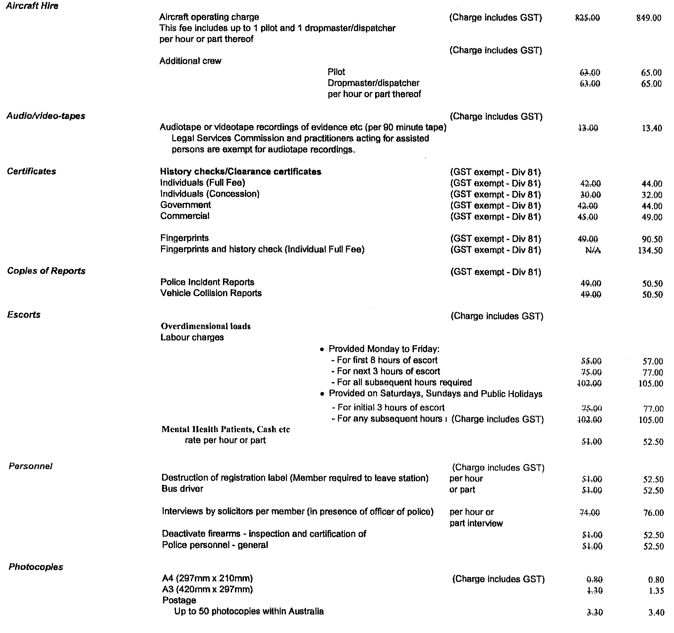

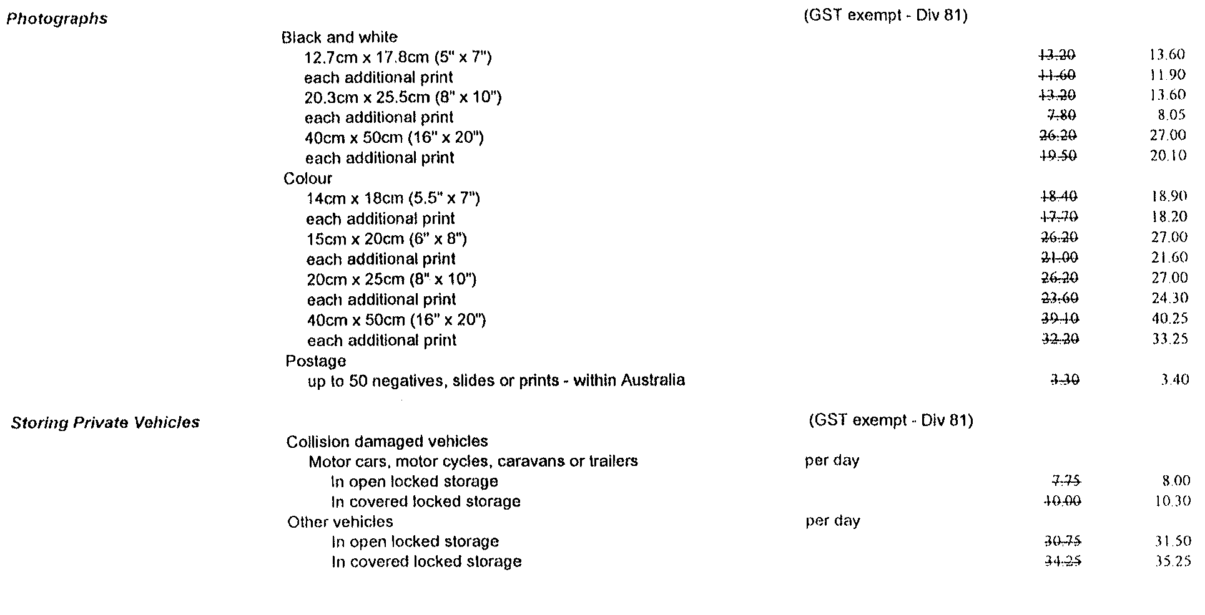
Police Service Fees and Charges—continued
Description of Police Service | Current Fee  2004-05  $ | Proposed  Fee  2005-06  $

K. Foley, Minister for Police

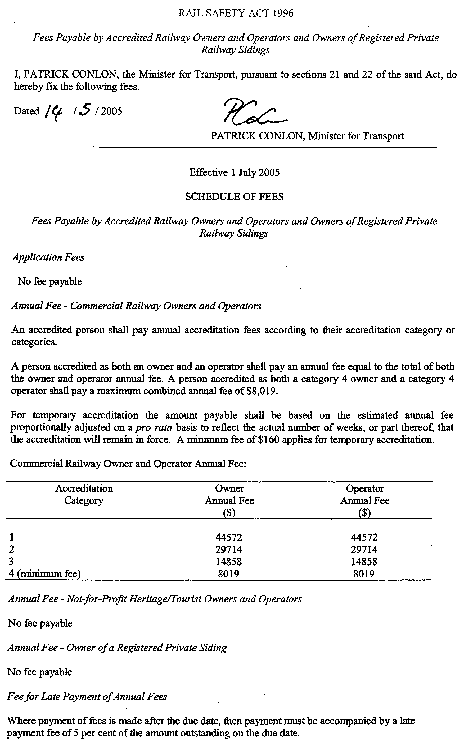

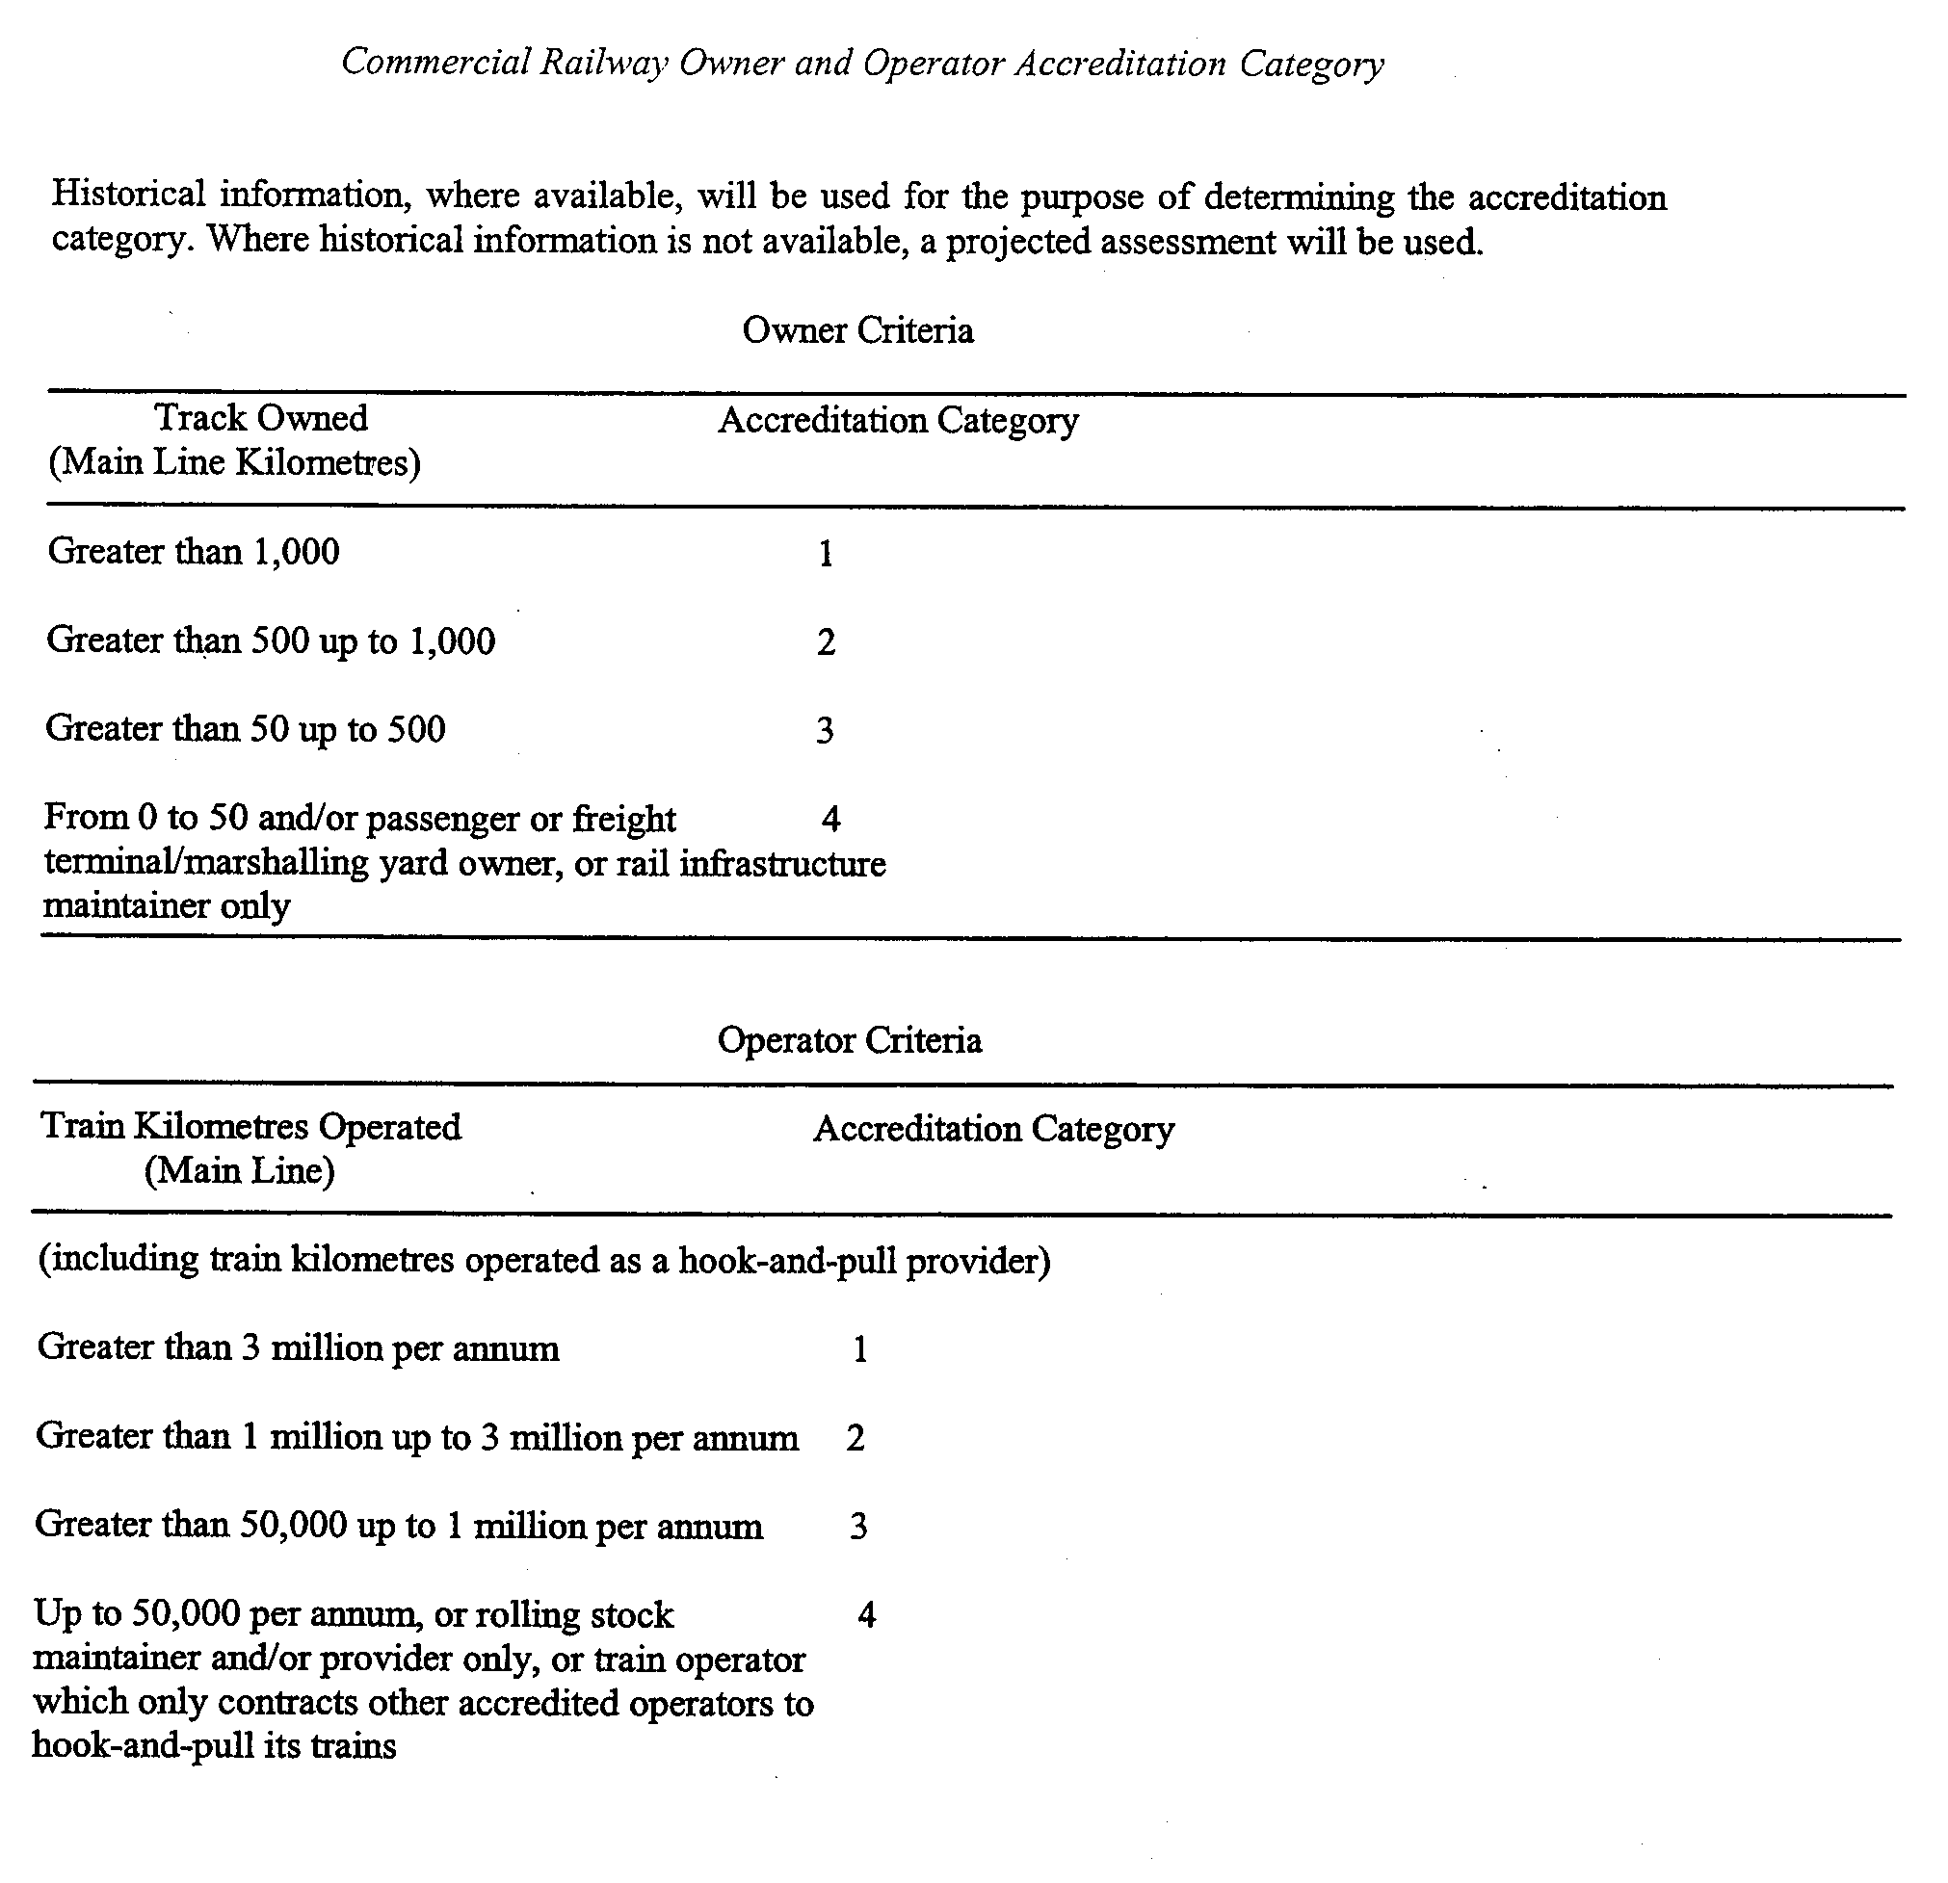

ROADS (OPENING AND CLOSING) ACT 1991:
SECTION 24
NOTICE OF CONFIRMATION OF ROAD
PROCESS ORDER
Aberle and Belt Roads, Millicent
Deposited Plan 65840
BY Road Process Order made on 20 July 2004, the Wattle Range Council ordered that:
1. Portions of allotment 2 in Filed Plan 13881, portion of allotments 4 and 5 in Filed Plan 2115 and portions of piece 3 in Deposited Plan 31486 more particularly delineated and numbered ‘1’, ‘3’ and portion of the land numbered ‘2’ in Preliminary Plan No. 32/0456 be opened as road.
2. Portion of the public road (Belt Road) adjoining section 190 in the Hundred of Mount Muirhead and portions of the public road (Aberle Road) adjoining allotment 2 in Filed Plan 13881 and allotment 10 in Deposited Plan 46855 more particularly delineated and lettered ‘A’, ‘B’ and ‘C’ (respectively) in Preliminary Plan No. 32/0456 be closed.
3. Transfer the whole of the closed road to AUSBULK LTD in accordance with agreement for exchange dated 30 October 2003 entered into between the Wattle Range Council and AUSBULK LTD.
4. The following easement be granted over portion of the land subject to that closure.
Grant to the Wattle Range Council an easement for drainage purposes.
On 17 January 2005 that order was confirmed by the Minister for Administrative Services, conditionally on approval and deposit of the survey plan by the Registrar-General. The condition has now been fulfilled.
Pursuant to section 24 (5) of the Roads (Opening and Closing) Act 1991, NOTICE of the order referred to above and its confirmation is hereby given.
Dated 26 May 2005.
P. M. Kentish, Surveyor-General

ROADS (OPENING AND CLOSING) ACT 1991:
SECTION 24
NOTICE OF CONFIRMATION OF ROAD
PROCESS ORDER
Dunstone Street, Whyalla
Deposited Plan 67562
BY Road Process Order made on 18 January 2005, The Corporation of the City of Whyalla ordered that:
1. A triangular-shaped portion of the public road (southern end of Dunstone Street) adjoining allotment 102 in Deposited Plan 61444, shown more particularly delineated and lettered ‘A’ on Preliminary Plan No. 03/0100 be closed.
2. The whole of the land subject to closure be transferred to John Roger Yates and Josephine Margaret O’Connell in accordance with agreement for transfer dated 9 January 2005, entered into between The Corporation of the City of Whyalla and to J. R. Yates and J. M. O’Connell.
On 23 May 2005 that order was confirmed by the Minister for Administrative Services conditionally on approval and deposit of the survey plan by the Registrar-General. The condition has now been fulfilled.
Pursuant to section 24 (5) of the Roads (Opening and Closing) Act 1991, NOTICE of the order referred to above and its confirmation is hereby given.
Dated 26 May 2005.
P. M. Kentish, Surveyor-General

REGULATIONS UNDER THE TRADE STANDARDS
ACT 1979
Exemption
TAKE notice that, pursuant to clause 3 in Schedule 1 of the Regulations under the Trade Standards Act 1979, I, Mark Ian Bodycoat, Commissioner for Consumer Affairs, do hereby exempt the article named in Schedule 1 from the application of those sections of the Regulations in relation to the trapping space described in Schedule 2.
Schedule 1
Johnson’s Baby Camping Chair, C27027 and Barbie Camping Chair, C27017.
Schedule 2
Exemption from complying with the provisions of Clause 2 (1). A children’s folding chair must be so constructed that the minimum distance between components forming a trapping space is 5 mm.
Dated 5 May 2005.
M. Bodycoat, Commissioner of Consumer Affairs
PS 118/86

NOTICE TO MARINERS
No. 15 of 2005
South Australia—Gulf St Vincent—Port Adelaide—Dredging and Diving Operations
MARINERS are advised that the cutter suction dredge Wombat and attendant plant will be carrying out dredging operations in the Outer Harbor basin and adjacent areas of the Port Adelaide River over the next seven months until late 2005.
The dredge will operate using sea-anchors and a floating pipeline will be used to place the dredged material ashore.
Whilst in position, the dredge will exhibit the appropriate lights and shapes required by the International Regulations for the Prevention of Collisions at Sea.
Diving operations will also be conducted during this period. The location of these diving operations will be indicated by the display of the International Code flag ‘A’.
Mariners are advised to proceed with caution whilst in the vicinity of the dredge, floating pipeline or diving operations.
Navy Chart affected: Aus 137
Publication affected: Australian Pilot, Volume 1 (Seventh Edition, 1992) pages 125-130.
Dated 18 May 2005.
P. Conlon, Minister for Transport
FP 2001/1439
TSA 2005/00419

PROOF OF SUNRISE AND SUNSET ACT 1923—ALMANAC FOR JULY, AUGUST AND SEPTEMBER 2005
PURSUANT to the requirements of the Proof of Sunrise and Sunset Act 1923, I, Tim O’Loughlin, Commissioner of Highways, at the direction of the Honourable the Minister for Transport and Urban Planning, publish in the Schedule hereto an almanac setting out the times of sunrise and sunset on every day for the three calendar months of July, August and September 2005.
Dated at Adelaide, 20 May 2005.
T. O’Loughlin, Commissioner of Highways
97/03263

The Schedule
Times of sunrise and sunset during the months of July, August and September 2005 for Adelaide: latitude 34°56′S, longitude 138°36′E, GMT +09h30m.
Month | July |  | August |  |  | September
Date | Sunrise  a.m. | Sunset  p.m. |  | Sunrise  a.m. | Sunset  p.m. |  | Sunrise  a.m. | Sunset  p.m.

1  2  3  4  5  6  7  8  9  10  11  12  13  14  15  16  17  18  19  20  21  22  23  24  25  26  27  28  29  30  31 | 7.24  7.24  7.24  7.24  7.24  7.24  7.23  7.23  7.23  7.23  7.22  7.22  7.22  7.21  7.21  7.21  7.20  7.20  7.19  7.19  7.18  7.17  7.17  7.16  7.16  7.15  7.14  7.13  7.13  7.12  7.11 | 17.15  17.15  17.16  17.16  17.17  17.17  17.18  17.18  17.19  17.19  17.20  17.20  17.21  17.22  17.22  17.23  17.23  17.24  17.25  17.25  17.26  17.27  17.28  17.28  17.29  17.30  17.30  17.31  17.32  17.32  17.33 | 7.10  7.09  7.09  7.08  7.07  7.06  7.05  7.04  7.03  7.02  7.01  7.00  6.59  6.57  6.56  6.55  6.54  6.53  6.52  6.51  6.49  6.48  6.47  6.46  6.44  6.43  6.42  6.40  6.39  6.38  6.37 | 17.34  17.35  17.35  17.36  17.37  17.38  17.38  17.39  17.40  17.41  17.41  17.42  17.43  17.44  17.44  17.45  17.46  17.46  17.47  17.48  17.49  17.49  17.50  17.51  17.52  17.52  17.53  17.54  17.54  17.55  17.56 | 6.35  6.34  6.32  6.31  6.30  6.28  6.27  6.26  6.24  6.23  6.21  6.20  6.18  6.17  6.16  6.14  6.13  6.11  6.10  6.08  6.07  6.06  6.04  6.03  6.01  6.00  5.58  5.57  5.56  5.54 | 17.57  17.57  17.58  17.59  17.59  18.00  18.01  18.02  18.02  18.03  18.04  18.05  18.05  18.06  18.07  18.07  18.08  18.09  18.10  18.10  18.11  18.12  18.12  18.13  18.14  18.15  18.15  18.16  18.17  18.18

SEWERAGE ACT 1929
Charges in Respect of Lands Exempted from Sewerage Rates
PURSUANT to section 65 (2) of the Sewerage Act 1929, and after consultation with the South Australian Water Corporation, I fix the charges set out in the Schedule for the drainage of and removal of sewage in respect of the 2005-2006 financial year.
Schedule
Charge determined according to number of water  closets draining into the sewers |  | Land Affected

$75 per water closet draining into the sewers |  | All land exempted from sewerage rates by section 65 (1)
$102 per water closet draining into the sewers |  | All other land exempted from sewerage rates under other Acts

Dated 23 May 2005.
M. Wright, Minister for Administrative Services

VALUATION OF LAND ACT 1971
Notice of General Valuation
PURSUANT to the Valuation of Land Act 1971, notice is hereby given that within the following Local Government Areas, I have made a general valuation of all land subject to the general valuation. The values are assigned as at 1 January 2005.
L.G.A. Local Government Areas
No.
0200 Adelaide
0300 Adelaide Hills 1
0400 Port Adelaide Enfield 1
0500 Prospect
0600 Port Adelaide Enfield 2
0710 Metropolitan UIA
0800 Mitcham
0900 Unley
1000 Marion
1200 Holdfast Bay
1300 Onkaparinga 1
1400 Onkaparinga 2
1500 Norwood Payneham St Peters 1
1600 Norwood Payneham St Peters 2
1700 Campbelltown
1800 Burnside
1900 Norwood Payneham St Peters 3
2000 Walkerville
2100 West Torrens
2500 Charles Sturt
2600 Yankalilla
2800 Tea Tree Gully
2910 Playford 1
3030 Wakefield 1
3050 Copper Coast 1
3120 Mallala
3130 Light
3200 Playford 2
3300 Adelaide Hills 2
3410 Copper Coast 2
3430 Barunga West 1
3530 Port Pirie 3
3540 Port Pirie 1
3550 Port Pirie 2
3720 Wakefield 2
3820 Grant 1
3840 Mount Gambier
4000 Tatiara
4150 Murray Bridge
4230 Goyder 1
4240 Goyder 2
4310 Clare & Gilbert Valleys 1
4320 Clare & Gilbert Valleys 2
4400 Salisbury
4530 Victor Harbor
4540 Alexandrina 1
4610 Yorke Peninsula 1
4710 Adelaide Hills 3
4820 Orroroo Carrieton 1
4830 Flinders Ranges 1
4900 Gawler
5010 Peterborough 1
5020 Orroroo Carrieton 2
5030 Peterborough 2
5130 Karoonda East Murray
5210 Kangaroo Island 1
5230 Kangaroo Island 2
5410 Yorke Peninsula 2
5420 Yorke Peninsula 3
5430 Yorke Peninsula 4
5500 Loxton Waikerie 1
5630 Adelaide Hills 4
5800 Mount Barker
5910 Loxton Waikerie 2
6400 Kingston
6600 Port Augusta
6710 Naracoorte Lucindale 1
6720 Naracoorte Lucindale 2
6801 Northern UIA
6802 Eyre UIA
6803 Riverland UIA
6804 Yorke UIA
6805 Lower North UIA
6806 Southern UIA
6807 South East UIA
6910 Coober Pedy
6920 Roxby Downs
7100 Mid Murray
7210 Southern Mallee 1
7220 Southern Mallee 2
7310 Grant 2
7400 Flinders Ranges 2
7530 Renmark Paringa
7550 Loxton Waikerie 3
7560 Berri Barmera
7610 Northern Areas 1
7630 Northern Areas 2
7710 Alexandrina 2
7830 Streaky Bay
7840 Ceduna
8000 Coorong
8210 Naracoorte Lucindale 3
8220 Robe
8300 Mount Remarkable
8400 Wattle Range 1
8500 Whyalla
8600 Onkaparinga 3
8710 Northern Areas 3
8920 Wattle Range 2
8930 Wattle Range 3
9000 Kimba
9250 Tumby Bay
9260 Cleve
9270 Le Hunte
9280 Franklin Harbour
9340 Port Lincoln
9350 Lower Eyre Peninsula
9360 Elliston
9420 Barunga West 2
9680 Clare & Gilbert Valleys 3
9690 Barossa
9810 Goyder 3
9820 Goyder 4
These values will come into force at midnight on 30 June 2005.
Dated 26 May 2005.
N. A. Bray, Valuer-General
DL 110/93

WATER CONSERVATION ACT 1936
Rates for Supply by Agreement
IN relation to agreements for the supply of water pursuant to section 19 of the Water Conservation Act 1936, I fix the rates payable in respect of the 2006-2007 financial year under agreements to which that section applies as set out in the Schedule.
Schedule
Quarterly rate payable $74.
Additional water rates payable for water supplied to or in relation to land and standpipes during the consumption year ending in the 2006-2007 financial year:
(i) for each kilolitre supplied up to and including 125 kilolitres—$0.94 per kilolitre.
(ii) for each kilolitre supplied over 125 kilolitres—$4.36 per kilolitre.
Dated 26 May 2005.
J. D. Hill, Minister for Environment and Conservation
SAW 05/04331

WATER MAINS AND SEWERS

Office of the South Australian Water Corporation
Adelaide, 26 May 2005

WATER MAINS LAID

Notice is hereby given that the following main pipes or parts of main pipes have been laid down by the South Australian Water Corporation in or near the undermentioned water districts and are now available for a constant supply of water to adjacent land.

ADELAIDE WATER DISTRICT

THE DISTRICT COUNCIL OF MOUNT BARKER
Tate Avenue, Mount Barker. p21
Scarborough Way, Mount Barker. p21 and 23
Dawson Street, Mount Barker. p21-24
Melville Street, Mount Barker. p21, 22 and 24
Olden Place, Mount Barker. p22
Parkview Drive, Mount Barker. p22-24

CITY OF NORWOOD PAYNEHAM & ST PETERS
Westminster Street, St Peters. p46

CITY OF PLAYFORD
Moir Street, Smithfield. p53

CITY OF PORT ADELAIDE ENFIELD
Denver Terrace, Kilburn. p52

THE CITY OF PROSPECT
Lettie Street, Prospect. p47

CITY OF SALISBURY
Garden Terrace, Mawson Lakes. p29 and 44
Light Common, Mawson Lakes. p29
In and across Main Street, Mawson Lakes. p29 and 30
Public road (lot 803 in LTRO DP 64256) , Mawson Lakes. p30
Hurtle Parade, Mawson Lakes. p29 and 44
Goodall Parade, Mawson Lakes. p30
Easement in lot 703 in LTRO DP 65996, Main Street, Mawson Lakes. p30 and 44
Lomond Circuit, Mawson Lakes. p34
Argyle Street, Mawson Lakes. p34
Torrens Lane, Mawson Lakes. p34
Sanctuary Drive, Mawson Lakes. p35-37
Otway Crescent, Mawson Lakes. p35
Lincoln Place, Mawson Lakes. p35
Fraser Lane, Mawson Lakes. p35
Freycinet Street, Mawson Lakes. p35
Newland Way, Mawson Lakes. p35 and 36
Maquarie Street, Mawson Lakes. p36
Flinders Court, Mawson Lakes. p35 and 36
St Elias Street, Mawson Lakes. p36
Lakefield Crescent, Mawson Lakes. p36
Heard Avenue, Mawson Lakes. p37
Lord Howe Crescent, Mawson Lakes. p37
Easements in lot 714 in LTRO DP 66474, Sanctuary Drive, Mawson Lakes. p37
Morton Street, Mawson Lakes. p37
Iluka Crescent, Mawson Lakes. p37
Fisher Place, Mawson Lakes. p44
Chapel Lane, Mawson Lakes. p45
Burton Road, Salisbury. p48
Parkview Drive, Mawson Lakes. p51

COWELL WATER DISTRICT

DISTRICT COUNCIL OF FRANKLIN HARBOUR
Across Chase Street, Cowell. p49
Brooks Drive, Cowell. p49

KINGSTON SE WATER DISTRICT

KINGSTON DISTRICT COUNCIL
Barber Street, Rosetown. p50

MOONTA WATER DISTRICT

DISTRICT COUNCIL OF THE COPPER COAST
Highview Grove, Moonta Bay. p17 and 19
Phillips Street, Moonta Bay. p17 and 19
Rossiters Road, Moonta Bay. This main is available to section 166, hundred of Wallaroo, by application only. p17-19
Stocker Street, Moonta Bay. p17-19
Couch Close, Moonta Bay. p18 and 19
Westside Avenue, Moonta Bay. p18 and 19
Across Bay Road, Moonta Bay. p20
Easement in lot 52 in LTRO FP 17451, Bay Road, Moonta Bay. p20

MORGAN-WHYALLA COUNTRY LANDS WATER
DISTRICT

CLARE AND GILBERT VALLEYS COUNCIL
Government road south of lot 4 in LTRO DP 31374, Hill River. p1
Across Blockers Road, Hill River and Stanley Flat. p1 and 2
Moccundunda Road, Stanley Flat. This main is available to allotment piece 7 in LTRO CP 20458 by application only. 2 and 3
Slaughterhouse Road, Spring Farm. p3 and 4
Spring Farm Road, Spring Farm. This main is available to lots 40-43 in LTRO DP 58091 by application only. p4-8

MOUNT COMPASS WATER DISTRICT

ALEXANDRINA COUNCIL
Waye Street, Mount Compass. p25
Waye Court, Mount Compass. p25
Easement in lot 104 in LTRO DP 67416, Waye Court, Mount Compass. p25

MURRAY BRIDGE WATER DISTRICT

THE RURAL CITY OF MURRAY BRIDGE
Lyric Close, Murray Bridge. p26
Zenca Court, Murray Bridge. p26

TOWNSHIP OF SEVENHILL WATER DISTRICT

CLARE AND GILBERT VALLEYS COUNCIL
In and across Main North Road, Sevenhill. These mains are available to allotment piece 101 in LTRO FP 170286, and lot 99 in LTRO FP 174447 by application only. p32, 33, 38, 42 and 43
In and across Bayes Road, Sevenhill. p38
Church Street, Sevenhill. p38 and 41
Easement in allotment piece 91 in LTRO FP 212096, Church Street, Sevenhill. p41
Government road south of lot 90 in LTRO FP 212664, Sevenhill p41
Easements in allotment piece 92 in LTRO FP 212096, Mountain Street, Sevenhill. p41
Mountain Street, Sevenhill. p41 and 38
Anton Street, Sevenhill. p38 and 39
Across and in Industrial Street, Sevenhill. p39
College Road, Sevenhill. This main is available to lot 3 in LTRO FP 208259 by application only. p38 and 40
In and across private road (lot A in LTRO DP 25243), Sevenhill. p42

WALLAROO WATER DISTRICT

DISTRICT COUNCIL OF THE COPPER COAST
Clarke Street, Wallaroo. p27 and 28
Easement in lot 300 in LTRO DP 65543, Clarke Street, Wallaroo. p27
Boase Crescent, Wallaroo. p27
Diedrich Street, Wallaroo. p27 and 28
WATER MAINS ABANDONED

Notice is hereby given that the undermentioned water mains have been abandoned by the South Australian Water Corporation.

ADELAIDE WATER DISTRICT

CITY OF SALISBURY
Garden Terrace, Mawson Lakes. p29
In and across Light Common, Mawson Lakes. p29
Easement in lots 303 and 306 in LTRO DP 61733, Station Lane, Mawson Lakes. p29
Across Station Lane, Mawson Lakes. p29
Easement in lot 309 in LTRO DP 61733, Hurtle Parade, Mawson Lakes. p29
Across Hurtle Parade, Mawson Lakes. p29
Easement in lot 331 in LTRO DP 61733, and lots 392 and 391 in LTRO DP 65996, Main Street, Mawson Lakes. p29 and 30
Across Main Street, Mawson Lakes. p30
Easement in lot 702 in LTRO DP 64256, Main Street, and lot 603 in LTRO DP 64909, The Drive, Mawson Lakes. p30
Cross Keys Road, Mawson Lakes. p30

WATER MAINS LAID

Notice is hereby given that the undermentioned water mains have been laid down by the South Australian Water Corporation and are not available for a constant supply of water to adjacent land.

OUTSIDE WATER DISTRICTS

CLARE AND GILBERT VALLEYS COUNCIL
Spring Farm Road, Spring Farm, Polish Hill River and Penwortham. p8-16
Stone Cutting Road, Polish Hill River and Sevenhill. p31 and 32
Sevenhill-Mintaro Road, Sevenhill. p32
Main North Road, Sevenhill. p32

CORRECTION

Correction to notice in “Government Gazette” of 28 April 2005.

“WATER MAINS ABANDONED”

“Notice is hereby given that the undermentioned water mains have been abandoned by the South Australian Water Corporation.”

“PORT ELLIOT WATER DISTRICT”

“CITY OF VICTOR HARBOR”

“Waterfront Road, Hindmarsh Valley. p11”

For “Waterfront Road” read “Waterport Road.”

SEWERS LAID

Notice is hereby given that the following sewers have been laid down by the South Australian Water Corporation in the undermentioned drainage areas and are now available for house connections.

ADELAIDE DRAINAGE AREA

CAMPBELLTOWN CITY COUNCIL
Sparks Terrace, Rostrevor. FB 1135 p34
Rostrevor Avenue, Rostrevor. FB 1135 p40

CITY OF PORT ADELAIDE ENFIELD
Carlisle Street, Northfield. FB 1135 p32
Berryman Street, Greenacres. FB 1135 p35
Stuart Street, Hillcrest. FB 1135 p36
Frome Avenue, Hampstead Gardens. FB 1135 p37
Second Avenue, Klemzig. FB 1135 p41

THE CITY OF PROSPECT
Lettie Street, Prospect. FB 1135 p33

CITY OF SALISBURY
Emerald Street, Mawson Lakes. FB 1137 p22
The Strand, Mawson Lakes. FB 1137 p23
Chapel Lane, Mawson Lakes. FB 1137 p23
Lomond Circuit, Mawson Lakes. FB 1137 p24 and 25
Sanctuary Drive, Mawson Lakes. FB 1137 p26-32, and 34-36
Newland Way, Mawson Lakes. FB 1137 p26-28, 30, 31 and 33
Freycinet Street, Mawson Lakes. FB 1137 p26-28
Flinders Court, Mawson Lakes. FB 1137 p26-28, 30, 31 and 33
Fraser Lane, Mawson Lakes. FB 1137 p26, 27 and 29
Lincoln Place, Mawson Lakes. FB 1137 p26, 27 and 29
Otway Crescent, Mawson Lakes. FB 1137 p26-29
Maquarie Street, Mawson Lakes. FB 1137 p30, 31 and 33
St Elias Street, Mawson Lakes. FB 1137 p30-32
Lakefield Crescent, Mawson Lakes. FB 1137 p30-32
Heard Avenue, Mawson Lakes. FB 1137 p34-36
Lord Howe Crescent, Mawson Lakes. FB 1137 p34-37
Morton Street, Mawson Lakes. FB 1137 p34-36
Iluka Crescent, Mawson Lakes. FB 1137 p34, 35 and 37
Easement in lot 714 in LTRO DP 66474, Sanctuary Drive, Mawson Lakes. FB 1137 p34-36
Easement in lots 15 and 16, Tiffany Court, Ingle Farm. FB 1135 p18
Burton Road, Salisbury. FB 1135 p39

CITY OF WEST TORRENS
Weston Street, West Beach. FB 1135 p38

STIRLING COUNTRY DRAINAGE AREA

ADELAIDE HILLS COUNCIL
Easement in lot 11, Arkaba Road, Aldgate. FB 1137 p17 and 18
Arkaba Road, Aldgate. FB 1137 p17 and 18

A. Howe, Chief Executive Officer, South Australian Water Corporation

WATERWORKS ACT 1932
Clare Valley Water Supply Scheme Charges
1. Despite anything else in this determination, the charges specified in this determination do not apply in respect of a connection, or a supply of water:
(a) to which rates apply under Part 5 of the Waterworks Act 1932;
(b) to the extent that the Corporation agrees in writing that those charges do not apply, or that other charges apply; or
(c) to the extent that the Corporation determines pursuant to the Waterworks Act 1932 that those charges do not apply or that other charges apply.
2. The supply charge specified in Item 1 of the Schedule is payable in respect of each connection to the Pipeline pursuant to an Irrigation Agreement existing at any time during the Notice Period, through which water is, or is capable of being, supplied to the Clare Valley Water Supply Scheme Area, whether or not water is so supplied during the Notice Period.
3. The charges per kilolitre specified in the Schedule apply in respect of water taken during the Notice Period.
4. In this determination:
(a) ‘Clare Valley Water Supply Scheme Area’ means the Hundred of Upper Wakefield, Hundred of Clare or Hundred of Stanley.
(b) ‘Contract Quantity’ means water determined to constitute the Contract Quantity under an Irrigation Agreement pursuant to section 37 of the Waterworks Act 1932 and supplied from the Pipeline to land located in the Clare Valley Water Supply Scheme Area in accordance with that agreement;
(c) ‘Irrigation Agreement’ means an agreement with the Corporation entered into on or after 20 October 2004 that provides for the taking of water from the Pipeline for irrigation;
(d) ‘Notice Period’ means the period on and from 1 July 2005 until and including 30 June 2006; and
(e) ‘Pipeline’ means any pipe connected directly or indirectly to the Morgan to Whyalla Main Pipe or the Swan Reach to Paskeville Main Pipe.
Schedule
1. Supply charge |  | $160
2. Charge per kilolitre for Contract Quantity |  | $1.06
3. Charge per kilolitre for water other than Contract Quantity supplied from the Pipeline during the Notice Period to land located in the Clare Valley Water Supply Scheme Area in accordance with an Irrigation Agreement |  | $1.06
4. Charge per kilolitre for water taken from the Pipeline during the Notice Period other than in accordance with an agreement with the Corporation |  | $1.06

Dated 23 May 2005.
Signed for and on behalf of the South Australian Water Corporation by a person duly authorised so to do:
Anne Howe, Chief Executive
In the presence of: Geoff Henstock, Corporation Secretary

WATERWORKS ACT 1932
Water Rates in Respect of Non-Commercial Land (except Residential and Vacant Land)
AFTER consultation with the South Australian Water Corporation, I fix the following water rates under section 65C (1) (d) of the Waterworks Act 1932 in respect of all water supplied to all classes of non-commercial land except residential and vacant land for the financial year commencing on 1 July 2006 and ending on 30 June 2007:
(i) for each kilolitre supplied up to and including 125 kilolitres |  | $0.47 per kilolitre
(ii) for each kilolitre supplied over 125 kilolitres |  | $1.09 per kilolitre

Dated 23 May 2005.
Michael Wright, Minister for Administrative Services

WATERWORKS ACT 1932
Supply Charge in Respect of Non-Commercial Land (except Residential and Vacant Land)
AFTER consultation with the South Australian Water Corporation, I fix the supply charge under section 65C (1) (a) of the Waterworks Act 1932 in respect of all classes of non-commercial land except residential and vacant land for the financial year commencing on 1 July 2006 and ending on 30 June 2007 at $164 per annum.
Dated 23 May 2005.
Michael Wright, Minister for Administrative Services

WATERWORKS ACT 1932
Supply Charge in Respect of Non-Commercial (Residential and Vacant) Land
AFTER consultation with the South Australian Water Corporation, I fix the supply charge under section 65C (1) (a) of the Waterworks Act 1932 in respect of residential and vacant land for the financial year commencing on 1 July 2006 and ending on 30 June 2007 at $148 per annum.
Dated 23 May 2005.
Michael Wright, Minister for Administrative Services

WATERWORKS ACT 1932
Water Rates in Respect of Non-Commercial (Residential and Vacant) Land
AFTER consultation with the South Australian Water Corporation, I fix the following water rates under section 65C (1) (d) of the Waterworks Act 1932 in respect of water supplied to residential and vacant land for the financial year commencing on 1 July 2006 and ending on 30 June 2007:
(i) for each kilolitre supplied up to and including 125 kilolitres |  | $0.47 per kilolitre
(ii) for each kilolitre supplied over 125 kilolitres |  | $1.09 per kilolitre

Dated 23 May 2005.
Michael Wright, Minister for Administrative Services

WATERWORKS ACT 1932
Water Rates in Respect of Commercial Land
AFTER consultation with the South Australian Water Corporation, I fix the following water rates under section 65C (1) (d) of the Waterworks Act 1932 in respect of water supplied to commercial land for the financial year commencing on 1 July 2006 and ending on 30 June 2007:
(i) for each kilolitre supplied up to and including 125 kilolitres |  | $0.47 per kilolitre
(ii) for each kilolitre supplied over 125 kilolitres |  | $1.09 per kilolitre

Dated 23 May 2005.
Michael Wright, Minister for Administrative Services

WATERWORKS ACT 1932
Rates for Supply by Agreement (other than recycled water and the Clare Valley Water Supply Scheme)
IN relation to agreements for the supply of water entered into pursuant to section 37 (1) of the Waterworks Act 1932, the rates payable in respect of the financial year commencing on 1 July 2006 and ending on 30 June 2007 are as set out in the Schedule. The rates in the Schedule do not apply:
(a) to supplies for which rates apply under Part 5 of the Waterworks Act 1932;
(b) to the extent that the Corporation determines pursuant to the Waterworks Act 1932 that those charges do not apply or that other charges apply.
Schedule
Supply charge payable in respect to each supply in any water district other than those in the Marla water district |  | $148
Water rates payable in respect to each and every supply in any water district other than those in the Marla water district for water supplied during the consumption year ending in the 2006-2007 financial year:  (i) for each kilolitre supplied up to, and including, 125 kilolitres |  | $0.47 per kilolitre
(ii) for each kilolitre supplied over 125 kilolitres |  | $1.09 per kilolitre
Charge payable in respect to each supply in the Marla water district |  | $296
Water rates payable in respect to each and every supply in the Marla water district for water supplied during the consumption year ending in the 2006-2007 financial year:  (i) for each kilolitre supplied up to, and including, 125 kilolitres |  | $0.94 per kilolitre
(ii) for each kilolitre supplied over 125 kilolitres |  | $2.18 per kilolitre

Dated 23 May 2005.
Signed for and on behalf of the South Australian Water Corporation by a person duly authorised so to do:
Anne Howe, Chief Executive
In the presence of: Geoff Henstock, Corporation Secretary

WATERWORKS ACT 1932
Annual Charge for Additional Services Provided
PURSUANT to section 35 (1c) of the Waterworks Act 1932, and after consultation with the South Australian Water Corporation, I fix, in respect of the 2005-2006 financial year, the annual charge payable by the owner or occupier of land in respect of any additional service provided to that land at $160 for each additional service.
Dated 23 May 2005.
M. Wright, Minister for Administrative Services

WATERWORKS ACT 1932
Lands Exempted from Water Rates
PURSUANT to section 88 (4) of the Waterworks Act 1932, and after consultation with the South Australian Water Corporation, I fix the charges set out in the Schedule in respect of the 2005-2006 financial year.
Schedule
Class of land affected |  | Charge determined according  to the volume of water supplied |  | Fixed Minimum  Charge

All land in the State exempted under section 88 (1) (a) or (b) of the Waterworks Act 1932, and all land that has been acquired or is used for the purpose of a Children’s Services Centre within the meaning of the Children’s Services Act 1985 |  | For each kilolitre supplied up to, and including, 125 kilolitres: $0.3450 |  | $145
 |  | For each kilolitre supplied over 125 kilolitres: $0.7950 |  | $145
All other lands in the State exempted from payment of rates |  | For each kilolitre supplied up to, and including, 125 kilolitres: $0.46 |  | $145
All other lands in the State exempted from payment of rates |  | For each kilolitre supplied over 125 kilolitres: $1.06 |  | $145

Dated 23 May 2005.
M. Wright, Minister for Administrative Services

WATERWORKS ACT 1932
Save the River Murray Levy
FOR GENERAL INFORMATION
PURSUANT to section 65CA of the Waterworks Act 1932 the charges for the Save the River Murray Levy for the financial year commencing 1 July 2005 will be:
(a) For Category 1 land—$7.85 per quarter
(b) For Category 2 land—$35.20 per quarter
Dated 23 May 2005.
M. Wright, Minister for Administrative Services

FAXING COPY?
IF you fax copy to Government Publishing SA for inclusion in the Government Gazette, there is no need to send a Confirmation Copy to us as well.
This creates confusion and may well result in your notice being printed twice.
Please use the following fax number:
Fax transmission: (08) 8207 1040
Phone Inquiries: (08) 8207 1045
Please include a contact person, phone number and order number so that we can phone back with any queries we may have regarding the fax copy.
NOTE: Closing time for lodging new copy (fax, hard copy or email) is 4 p.m. on Tuesday preceding the day of publication.

Government Gazette notices can be E-mailed.
The address is:
governmentgazette@saugov.sa.gov.au
Documents should be sent as attachments in Word format.
When sending a document via E-mail, please confirm your transmission with a faxed copy of your document, including the date the notice is to be published.
Fax transmission: (08) 8207 1040
Enquiries: (08) 8207 1045
NOTE: Closing time for lodging new copy (fax, hard copy or email) is 4 p.m. on Tuesday preceding the day of publication.

CITY OF ADELAIDE
Declaration as Public Road—Notice of Intention
NOTICE is hereby given pursuant to section 210 of the Local Government Act 1999, that at a future meeting Council intends to declare the following road to be Public Road:
The unnamed road off Bowen Street in Town Acre 262, which is delineated as Allotment 12 on L.T.O. Plan D.P. 546 and contained in Certificate of Title Volume 5317 Folio 61.
M. Hemmerling, Chief Executive Officer

CITY OF CAMPBELLTOWN
Periodical Review of Elector Representation—Extension of Time
NOTICE is hereby given that council wishes to advise that in relation to its advertisement published in the Government Gazette on 19 May 2005 the closing date for submissions has been extended to 5 p.m. on 4 July 2005.
P. Vlatko, Chief Executive Officer

CITY OF PORT ADELAIDE ENFIELD
Change of Name of Portion of a Public Road
Assignment of a Name for a Public Road
NOTICE is hereby given that the Council of the City of Port Adelaide Enfield at its meeting held on 3 May 2005 resolved that pursuant to section 219 (1) of the Local Government Act 1999, portion of certain public road in the suburb of Northgate be changed and that a certain public road in the suburb of Northgate be assigned a street name, as detailed below:
• Portion of Fosters Road, Northgate as marked 1 in Plan 1 be changed to Bishop Place.
• Public road shown as Allotment 1247 in Deposited Plan 56322 and Allotment 29 in Deposited Plan 65156 be assigned the street name Greengate Close.
Plans that delineate the area of public roads which are subject to the change of a street name and assignment of a street name, together with a copy of the Council’s resolutions are available for inspection at the Council’s Principal Office, 163 St Vincent Street, Port Adelaide, S.A. 5015, from 9 a.m. to 5 p.m. week days.
H. J. Wierda, City Manager

CITY OF SALISBURY
Exclusion of Land from Classification as Community Land
NOTICE is hereby given that pursuant to section 193 (4) of the Local Government Act 1999 the City of Salisbury resolved at its meeting held on 27 September 2004, that two portions of St Kilda Road and Mangrove Street to be closed and identified as those areas marked ‘E’ and ‘F’ on Preliminary Road Closure Plan 04/0023, in the area named St Kilda, be excluded from classification as community land, subject to confirmation of the Road Process Order by the Minister, pursuant to section 24 (4) of the Roads (Opening and Closing) Act 1991.
Pursuant to section 193 (6) of the Local Government Act 1999 the council hereby gives notice of its resolution.
S. Hains, City Manager

CITY OF WEST TORRENS
Naming of Private Roads
NOTICE is hereby given that at its meeting held on 17 May 2005, the Council of the City of West Torrens resolved, pursuant to section 219 (1) of the Local Government Act 1999, to assign the names Vimy Avenue, Fred Custance Street, and Butler Boulevard to three private roads on Commonwealth land at Adelaide Airport.
On the site is an existing private road called Vimy Court which will be realigned to become Vimy Avenue, so that the name Vimy Court is redundant.
The three private roads are contained within Deposited Plan 49654, lot 50, and the suburb is Adelaide Airport, Postcode 5950.
T. Starr, Chief Executive Officer

THE COORONG DISTRICT COUNCIL
Periodical Review
NOTICE is hereby given that pursuant to the provisions of section 12 of the Local Government Act 1999, The Coorong District Council has completed a review to determine whether a change to ward boundaries and/or composition would result in the electors of the area being more fairly represented.
Council has prepared a report which details the review process, public consultation undertaken and the proposal it considered should be implemented. Copies of this report are available from the Council offices at Meningie, Tailem Bend and Tintinara. A copy is also available by visiting the Council Website:
www.coorong.sa.gov.au.
Written submissions are invited from interested persons and should be directed to the Chief Executive Officer, The Coorong District Council, P.O. Box 28, Meningie, S.A. 5264 to be received before 4 p.m. on Friday, 24 June 2005.
Any person making a written submission will also be invited to appear personally, or by representative before a meeting of Council or a Council Committee to be heard in support of their submission.
W. R. Paterson, Chief Executive Officer

THE FLINDERS RANGES COUNCIL
Elector Representation Review
NOTICE is hereby given that The Flinders Ranges Council endorsed its preferred position for its Elector Representation Review at the Ordinary Meeting of Council held on 12 April 2005.
The position maintains that Council remain an unsubdivided Council district, and retain the existing elected member number of a popularly elected Mayor and eight elected members.
An interim report on the position is available at the Council Office, Quorn and the Council Service Centre at Hawker.
Public consultation in the proposal concludes at the close of business on Friday, 24 June 2005. Written submissions should be addressed to the Chief Executive Officer, P.O. Box 43, Quorn or by email to council@flindersrangescouncil.sa.gov.au.
Dated at Quorn, 23 May 2005.
L. Connors, Chief Executive Officer

DISTRICT COUNCIL OF GRANT
Aerodrome Fees
NOTICE is hereby given that pursuant to the delegated powers contained in section 6 of the Aerodrome Fees Act 1998, the Mount Gambier and District Airport Management Committee at its meeting held on Wednesday, 9 March 2005, resolved that the following fees (inclusive of GST) be fixed for aircraft landing at the Mount Gambier Airport effective 1 July 2005:
Landing Charges—Regular Public Transport (RPT)
Arrival Fees:
$6.05 per Adult;
$3.025 per Child.
Departure Fees:
$6.05 per Adult;
$3.025 per Child.
Landing Charges—Non RPT
$7 per 1 000 kg MTOW pro rata—Minimum Fee $12;
Royal Flying Doctor Service flights—$12.
An Annual Licence to Operate (non RPT) is Available
to Locally Based Operators
Private Aircraft—one landing fee times 10;
Business Aircraft—one landing fee times 20.
Pavement Concessions
$55.
C. C. Nelson, Airport Manager

KINGSTON DISTRICT COUNCIL
Renaming of Public Roads
NOTICE is hereby given that pursuant to section 219 of the Local Government Act 1999, Council at its monthly meeting held on 22 April 2005, resolved to rename the following roads:
• That First Street, West Terrace and portions of Cooke Street and an unnamed ‘Government Road’, Rosetown, be renamed Catherine Gibson Way.
• That the southern portion of Second Street, up to the North Street intersection, be renamed Bonney Terrace.
M. McCarthy, Chief Executive Officer

RENMARK PARINGA COUNCIL
Roads (Opening and Closing) Act 1991
Road Closure—Sixty Foot Road, Renmark West
NOTICE is hereby given, pursuant to section 10 of the Roads (Opening and Closing) Act 1991, that the Renmark Paringa Council proposes to make a Road Process Order to close portions of the public road (Sixty Foot Road) at the intersections of Ontario Street and Government Road adjoining Allotment 616 in Filed Plan 177822 and allotment 10 in Filed Plan 105571, more particularly delineated and lettered ‘A’ and ‘B’ respectively in Preliminary Plan No. 05/0022.
The whole of the closed roads are to be transferred to Yandilla Park Ltd.
A copy of the plan and a statement of persons affected are available for public inspection at the office of the Renmark Paringa Council, 8 Ral Ral Avenue, Renmark and the office of the Surveyor-General, 101 Grenfell Street, Adelaide during normal office hours.
Any application for easement or objection must be made in writing within 28 days of this notice, to the Council, P.O. Box 730, Renmark, S.A. 5341 and the Surveyor-General, G.P.O. Box 1354, Adelaide, S.A. 5001, setting out full details. Where a submission is made, Council will give notification of a meeting to deal with the matter.
Dated 26 May 2005.
B. Hurst, Chief Executive Officer

IN the matter of the estates of the undermentioned deceased persons:
Boyd, Rosalind Doris, late of 52 Dunrobin Road, Hove, of no occupation, who died on 15 March 2005.
Elliott, William Bennett, late of 51 Manuel Avenue, Blair Athol, retired truck driver, who died on 19 March 2005.
Geisler, Nancy Heather, late of 14-22 King William Road, Wayville, of no occupation, who died on 28 March 2005.
Hann, Debbie Joy, late of 19 Jessie Road, Paralowie, home duties, who died on 6 March 2005.
Hubbert, Allan Jon, late of 8 Haynes Street, Whyalla Norrie, retired steel worker, who died on 27 October 2002.
Ilic, Adolfine, late of Fosters Road, Oakden, of no occupation, who died on 12 April 2004.
Johnson, James Bernard, late of 122 Esplanade, Semaphore, retired detailer, who died on 25 March 2005.
Karpany, Ross Trevor, late of 2 Oldford Road, Davoren Park, of no occupation, who died on 23 January 2003.
Keppel, William, late of 160 O.G. Road, Felixstow, retired administration manager, who died on 20 November 2004.
Mitten, Keith Maurice, late of 2 Jelley Street, Woodville, retired toolmaker, who died on 4 December 2004.
Raines, Lindsay Edwin, late of Casson Avenue, Loxton North, forklift operator, who died on 10 November 2004.
Slater, Jack, late of 35 Farr Terrace, Glenelg East, retired manager, who died on 20 March 2005.
Smart, Sydney, late of Potch Gully Road, Coober Pedy, retired mines inspector, who died on 6 April 2003.
Spence, Lance Lewis, late of Grand Junction Road, Oakden, of no occupation, who died on 25 July 2004.
Thoman, Kenneth George, late of 24 McConville Street, Whyalla Playford, retired assistant superintendent, who died on 14 March 2005.
Tucker, Marcus Saville, late of section 244, White Park Road, Hundred of Wongyarra, Information Technology con-sultant, who died on 6 January 2005.
Wilson, John Simpson, late of Grainger Road, Somerton Park, retired leading hand, who died on 8 March 2005.
Notice is hereby given pursuant to the Trustee Act 1936, as amended, the Inheritance (Family Provision) Act 1972, and the Family Relationships Act 1975, that all creditors, beneficiaries, and other persons having claims against the said estates are required to send, in writing, to the Public Trustee, 25 Franklin Street, Adelaide, S.A. 5000, full particulars and proof of such claims, on or before 24 June 2005, otherwise they will be excluded from the distribution of the said estate; and notice is also hereby given that all persons who are indebted to the said estates are required to pay the amount of their debts to the Public Trustee or proceedings will be taken for the recovery thereof; and all persons having any property belonging to the said estates are forthwith to deliver the same to the Public Trustee.
Dated 26 May 2005.
C. J. O’Loughlin, Public Trustee

ATTENTION

CUSTOMERS requiring a proof of their notice for inclusion in the Government Gazette, please note that the onus is on you to inform Government Publishing SA of any subsequent corrections by 10 a.m. on Thursday, which is our publication deadline.

For any corrections to your notice please phone 8207 1045 or Fax 8207 1040 before 10 a.m. on Thursday.

If we do not receive any communication by 10 a.m. on Thursday (day of publication) we will presume the notice is correct and will print it as it is.

Remember—the onus is on you to inform us of any corrections necessary to your notice.

NOTE: Closing time for lodging new copy (electronically, fax or hard copy) is 4 p.m. on Tuesday preceding the day of publication. Phone 8207 1045—Fax 8207 1040.
Email: governmentgazette@saugov.sa.gov.au

Printed and published by authority every Thursday by J. D. FERGUSON, Government Printer, South Australia
Price: $4.85, plus postage; to subscribers, $247.00 per annum.
(The above prices are inclusive of GST)

