No. 101 3843

THE SOUTH AUSTRALIAN

GOVERNMENT GAZETTE
www.governmentgazette.sa.gov.au

PUBLISHED BY AUTHORITY

ALL PUBLIC ACTS appearing in this GAZETTE are to be considered official, and obeyed as such

ADELAIDE, THURSDAY, 3 NOVEMBER 2005

CONTENTS

Page
Act Assented To 3844
Appointments, Resignations, Etc. 3844
Aquaculture Act 2001—Notices 3865
Casino Act 1997—Notice 3845
Corporations and District Councils—Notices 3887
Crown Lands Act 1929—Notice 3846
Development Act 1993—Notices 3846
Environment Protection Act 1993—Notice 3849
Environment Protection (Miscellaneous) Amendment
Act 2005—Notice 3867
Fisheries Act 1982—Notice 3848
Land and Business (Sale and Conveyancing) Act 1994—
Notices 3848
Liquor Licensing Act 1997—Notices 3852
Local Government Act 1999—Notice 3858
Mining Act 1971—Notices 3858

Page
Motor Vehicles Act 1959—Notices 3860, 3870
National Parks and Wildlife Act 1972—Notice 3860
National Parks Regulations 2001—Notice 3860
Natural Resources Management Act 2004—Notices 3861
Petroleum Act 2000—Notices 3864
Petroleum (Submerged Lands) Act 1967—Notice 3862
Port Augusta Circuit Court—Notice 3846
Private Advertisements 3891
Proclamation 3882
Public Trustee Office—Administration of Estates 3890

REGULATION
Motor Vehicles Act 1959 (No. 233 of 2005) 3883
Renmark Irrigation Trust Act 1936—Notice 3877
Roads (Opening and Closing) Act 1991—Notice 3864
Road Traffic Act 1961—Notice 3879

GOVERNMENT GAZETTE NOTICES
ALL poundkeepers’ and private advertisements forwarded for publication in the South Australian Government Gazette must be PAID FOR PRIOR TO INSERTION; and all notices, from whatever source, should be legibly written on one side of the paper only and sent to Government Publishing SA so as to be received no later
than 4 p.m. on the Tuesday preceding the day of publication. Phone 8207 1045 or Fax 8207 1040. E-mail: governmentgazette@saugov.sa.gov.au. Send as attachments in Word format and please confirm your transmission with a faxed copy of your document, including the date the notice is to be published and to whom the notice will be charged. The Government Gazette is available online at: www.governmentgazette.sa.gov.au

Department of the Premier and Cabinet
Adelaide, 3 November 2005
HER Excellency the Governor directs it to be notified for general information that she has in the name and on behalf of Her Majesty The Queen, this day assented to the undermentioned Act passed by the Legislative Council and House of Assembly in Parliament assembled, viz.:
No. 55 of 2005—Carers Recognition Act 2005. An Act to provide for the recognition of carers; and for other purposes.
By command,
C. Zollo, for Premier
DPC 02/0586

Department of the Premier and Cabinet
Adelaide, 3 November 2005
HER Excellency the Governor in Executive Council has been pleased to appoint the undermentioned to the South Australian Citrus Industry Development Board, pursuant to the provisions of the Citrus Industry Act 2005:
Member: (from 3 November 2005 until 2 November 2008)
Peter Anderson Walker
John Baxter Cox
Richard William Fewster
Graham James McInness
George Mercurio
Pamela Clare Strange
Amos Andrew Weigall
Presiding Member: (from 3 November 2005 until 2 Novem-ber 2008)
Peter Anderson Walker
By command,
C. Zollo, for Premier
MAFF 05/0040CS

CASINO ACT 1997
Redefinition of Boundaries
HER Excellency the Governor in Executive Council has been pleased to redefine the boundary of the casino premises pursuant to section 6 (3) of the Casino Act 1997, as recommended by the Independent Gambling Authority on 28 September 2005.
The following plan (provided for information purposes only) generally indicates the area removed from the casino premises as a result of the redefinition of the boundaries.
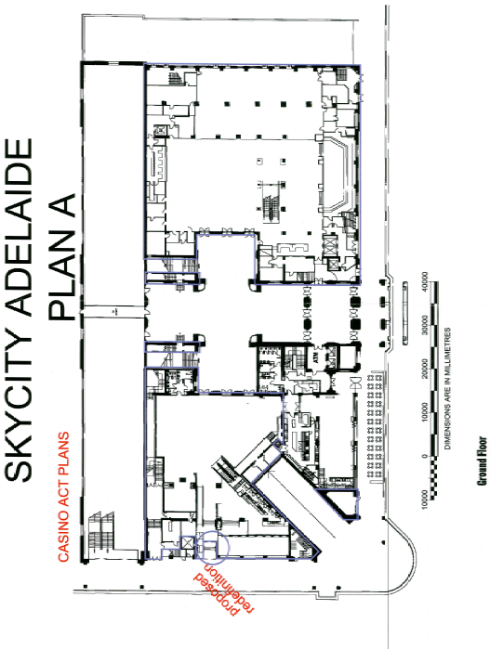
Marjorie Jackson-Nelson, Governor
TF 05/090CS

CROWN LANDS ACT 1929: SECTION 5
TAKE NOTICE that pursuant to the Crown Lands Act 1929, I, JOHN HILL, Minister for Environment and Conservation, Minister of the Crown to whom the administration of the Crown Lands Act 1929 is committed DO HEREBY:
1. Resume the land defined in The First Schedule.
2. Dedicate the Crown Land defined in The Second Schedule as an Emergency Services Reserve and declare that such land shall be under the care, control and management of the Minister for Emergency Services.
3. Dedicate the Crown Land defined in The Third Schedule as a Reserve for District Council Purposes and declare that such land shall be under the care, control and management of the Mid Murray Council.
The First Schedule
Site for a District Council Chamber, now identified as Section 686, Hundred of Ridley, the Proclamation of which was published in the Government Gazette of 27 October 1892 at pages 1135 and 1136, The First Schedule, and amended by Proclamation published in the Government Gazette of 17 February 1910 at pages 259 and 260, being the whole of the land comprised in Crown Record Volume 5757, Folio 417.
The Second Schedule
Allotment 58 of Deposited Plan 68791, Hundred of Ridley, County of Sturt, exclusive of all necessary roads, subject nevertheless to a free and unrestricted right of way over that portion of Allotment 58 marked B on Deposited Plan 68791 and appurtenant to Allotment 57 of Deposited Plan 68791.
The Third Schedule
Allotment 57 of Deposited Plan 68791, Hundred of Ridley, County of Sturt, exclusive of all necessary roads, subject nevertheless to a free and unrestricted right of way over that portion of Allotment 57 marked A on Deposited Plan 68791 and appurtenant to Allotment 58 of Deposited Plan 68791.
Dated 3 November 2005.
J. Hill, Minister for Environment and Conservation
DEHAA 11/2713

DEVELOPMENT ACT 1993, SECTION 25 (17): KINGSTON DISTRICT COUNCIL—COMMERCIAL PLAN AMENDMENT
Preamble
1. The Development Plan amendment entitled ‘Kingston District Council—Commercial Plan Amendment’ (the Plan Amendment) has been finalised in accordance with the provisions of the Development Act 1993.
2. The Minister for Urban Development and Planning has decided to approve the Plan Amendment.
Notice
PURSUANT to section 25 of the Development Act 1993, I—
(a) approve the Plan Amendment; and
(b) fix the day on which this notice is published in the Gazette as the day on which the Plan Amendment will come into operation.
Dated 3 November 2005.
Paul Holloway, Minister for Urban Development and Planning
PLN 04/0444

DEVELOPMENT ACT 1993, SECTION 25 (17): DISTRICT COUNCIL OF ELLISTON—GENERAL REVIEW PLAN AMENDMENT
Preamble
1. The Development Plan amendment entitled ‘District Council of Elliston—General Review Plan Amendment’ (the Plan Amend-ment) has been finalised in accordance with the provisions of the Development Act 1993.
2. The Minister for Urban Development and Planning has decided to approve the Plan Amendment.
Notice
PURSUANT to section 25 of the Development Act 1993, I—
(a) approve the Plan Amendment; and
(b) fix the day on which this notice is published in the Gazette as the day on which the Plan Amendment will come into operation.
Dated 3 November 2005.
Paul Holloway, Minister for Urban Development and Planning
PLN 02/0413

DEVELOPMENT ACT 1993, SECTION 25 (17): DISTRICT COUNCIL OF ROBE—MISCELLANEOUS PLAN AMEND-MENT
Preamble
1. The Development Plan amendment entitled ‘District Council of Robe—Miscellaneous Plan Amendment’ (the Plan Amend-ment) has been finalised in accordance with the provisions of the Development Act 1993.
2. The Minister for Urban Development and Planning has decided to approve the Plan Amendment.
Notice
PURSUANT to section 25 of the Development Act 1993, I—
(a) approve the Plan Amendment; and
(b) fix the day on which this notice is published in the Gazette as the day on which the Plan Amendment will come into operation.
Dated 3 November 2005.
Paul Holloway, Minister for Urban Development and Planning
PLN 03/0045

DISTRICT COURT OF SOUTH AUSTRALIA
PORT AUGUSTA CIRCUIT COURT
Sheriff’s Office, Adelaide, 26 October 2005
IN pursuance of a precept from the District Court of South Australia to me directed, I do hereby give notice that the said Court will sit as a Court of Oyer and Terminer and General Gaol Delivery at the Courthouse at Port Augusta on the day and time undermentioned and all parties bound to prosecute and give evidence and all jurors summoned and all others having business at the said Court are required to attend the sittings thereof and the order of such business will be unless a Judge otherwise orders as follows:
Monday, 7 November 2005, at 10 a.m. on the first day of the sittings the only business taken will be the arraignment of prisoners in gaol and the passing of sentences on prisoners in gaol committed for sentence; the surrender of prisoners on bail committed for sentence; the surrender of persons in response to ex officio informations or of persons on bail and committed for trial who have signified their intentions to plead guilty and the passing of sentences.
Juries will be summoned for Wednesday, 9 November 2005, and persons will be tried on this and subsequent days of the sittings.
Prisoners in HM Gaol and on bail for sentence and for trial at the sittings of the Port Augusta Courthouse, commencing Monday, 7 November 2005.
Luckman, Brett Raymond |  | Application for enforcement of a breached bond; commit common assault on member of own family | On bail
Taylor, Nathan James |  | Application for enforcement of a breached bond; unlawful sexual intercourse | In gaol
Anderson, Francis Irene |  | Application for enforcement of a breached bond; unlawful wounding (2) | On bail
Andrew, Steven Clive |  | Rape | On bail
Baines, Andrew Robert |  | Unlawful sexual intercourse (2) | On bail
Beare, Brenton Andrew |  | Possess methamphetamine for sale; possessing cannabis for sale; producing cannabis; unlawful possession | On bail
Biddell, Jarrad Clayton |  | Threatening life; assault occasioning actual bodily harm; threatening a witness in judicial proceedings | On bail
Bloemen, Paul Anthony |  | Wounding with intent to do grievous bodily harm | In gaol
Brooks, Barry Stephen |  | Unlawful sexual intercourse with a person under 12 (4) | On bail
Burgess, Robert John |  | Application for enforcement of a breached bond; larceny | On bail
C |  | Unlawful sexual intercourse (7); indecent assault (2) | In gaol
Coe, Mark Steven |  | Attempt to procure witness; fail to comply with bail agreement | On bail
Coe, Mark Steven |  | Indecent assault (7); rape (2) | On bail
Coe, Mark Steven |  | Threaten person in judicial proceedings to influence outcome; fail to comply with bail agreement | On bail
Collins, Daniel Craig |  | Attempted aggravated robbery | In gaol
Cottrell, David Andrew |  | Supplying a controlled substance (3) | On bail
Dearing, Lance Raymond |  | Escape from custody | In gaol
Deblasio, Vincenzo |  | Aggravated serious criminal trespass in non-residential building; theft | On bail
Dennis, Geoffrey Maxwell |  | Aggravated serious criminal trespass in a place of residence; common assault; theft | On bail
Dixon, Graehme |  | Gross indecency; indecent assault | On bail
Donnellan, Steven John |  | Unlawful sexual intercourse | On bail
Drion, Marc Claude |  | Application for enforcement of a breached bond; assault occasioning actual bodily harm | On bail
Franks, Anthony Kym |  | Indecent assault (2) | On bail
Ginger, Norris |  | Arson (2); endangering life (2) | On bail
Hallett, Gary Raymond |  | Unlawful sexual intercourse (4) | In gaol
Hamilton, Gregory James |  | Aggravated serious criminal trespass in a place of residence; common assault (2); theft | On bail
Hankey, Brendon Wilston |  | Aggravated serious criminal trespass in a place of residence | In gaol
Haseldine, Alan Roy |  | Endangering life; assault police; resist police | On bail
Hoskins, Graeme William |  | Rape (2) | On bail
James, Levi Edward |  | Aggravated robbery in company; unlawfully detain a person against their will; threatening life; common assault on person other than family member; drive or use motor vehicle without consent | In gaol
Miller, Kenneth John |  | Aggravated robbery in company; unlawfully detain a person against their will; threatening life; common assault on person other than family member; drive or use motor vehicle without consent | In gaol
Kalmar, Jozsef |  | Possess a firearm without a licence authorising possession; failing to properly secure a firearm (3); failing to properly store ammunition (3); possessing firearm without a licence authorising possession | On bail
Kokar, Mark Anthony |  | Assault and unlawful imprison person against his will; assault occasioning actual bodily harm; carry offensive weapon | In gaol
Kokotis, Matthew |  | Taking part in the sale of a drug of dependence (4) | On bail
Lang, Rosemary |  | Aggravated serious criminal trespass—not known if place occupied | In gaol
Lennon, Clifton John |  | Aggravated serious criminal trespass (non-residential); theft (2) | In gaol
Makings, Stephen Jonathon |  | Aggravated serious criminal trespass (non-residential) (2); dishonestly take property without owner’s consent (2) | On bail
Marks, Aaron Paul |  | Application for enforcement of a breached bond; aggravated serious criminal trespass (non-residential); dishonestly take property without owner’s consent | On bail
Mason, Rhiannon Dann |  | Arson | On bail
Mattner, Stuart Courtney |  | Aggravated serious criminal trespass in a place of residence; theft; common assault | On bail
Mills, Kyron Brougham |  | Producing a controlled substance | On bail
Erskine, Alison |  | Producing a controlled substance | On bail
Monkedieck, Hubert |  | Indecent assault (2); unlawful sexual intercourse; rape | On bail
Moore, Matthew Phillip |  | Rape; creating a risk of bodily harm; threatening life; indecent assault | On bail
Mutton, Hugh John |  | Unlawful sexual intercourse with a person under 12 | On bail
Nelson, Maitland Frederick |  | Criminal trespass in a place of residence; false imprisonment; rape; attempted rape; common assault; using a motor vehicle without consent | In gaol
Nicholas, Bryan Alan |  | Rape; unlawful sexual intercourse | On bail
Pavlich, James Phillip |  | Causing bodily harm by dangerous driving (4); drive at dangerous speed; due care; drive with excess blood alcohol | On bail
Phanos, Dean Ron |  | Possessing methylamphetamine for sale; unlawful possession | On bail
Pym, Howard Ross |  | Indecent assault (2); unlawful sexual intercourse with a person under 12 (2) | In gaol
Raymond, Randal |  | Rape | On bail
Sam, Rex |  | Wounding with intent to do grievous bodily harm; assault occasioning actual bodily harm | In gaol
Sherlock, Sandra |  | Selling cannabis to a child (3); selling cannabis (5) | On bail
Warner, Gregory Aurther |  | Selling cannabis to a child (3); selling cannabis (5) | On bail
Smith, Shane Alan |  | Non-aggravated serious criminal trespass (place of residence); dishonestly take property without owner’s consent | On bail
Smith, Steven James |  | Rape; unlawful sexual intercourse (5) | On bail
Van De Graaf, Adrian |  | Aggravated robbery in company | In gaol
Viragh, Paul |  | Producing a controlled substance (2) | On bail
Watkins, Vivian Malcolm |  | Application for enforcement of a breached bond; indecent assault | On bail
White, David Gregory |  | Attempted rape | On bail
Wilton, Raymond Clarence |  | Unlawful sexual intercourse with a person under 12 | On bail
Zimmermann, Shane Elliott |  | Damaging property (2); assault occasioning actual bodily harm; resisting a police officer; assaulting a police officer; threatening to cause harm (2) | On bail
Prisoners on bail must surrender at 10 a.m. of the day appointed for their respective trials. If they do not appear when called upon their recognizances and those of their bail will be estreated and a bench warrant will be issued forthwith.
By order of the Court,
M. A. Stokes, Sheriff

FISHERIES ACT 1982: SECTION 59
TAKE notice that pursuant to section 59 of the Fisheries Act 1982, Troy Horn of Forestry SA, Jubilee Highway East, Mount Gambier, S.A. 5290, (the ‘exemption holder’) or a person acting as his agent, is exempt from the provisions of section 41 of the Fisheries Act 1982 and the Fisheries (General) Regulations 2000, insofar as they may engage in the collection of fish (the ‘exempted activity’) from the waters described in Schedule 1, using the gear specified in Schedule 2, subject to the conditions set out in Schedule 3 from 1 November 2005 until 30 November 2005, unless varied or revoked earlier.
Schedule 1
Wetlands located on Forestry SA land in the South East of South Australia.
Schedule 2
• Dip nets
• Bait traps
• Fyke nets
Schedule 3
1. The specimens collected by the exemption holders are for scientific and research purposes only and must not be sold.
2. All native fish taken pursuant to the exempted activity must be immediately returned to the water as soon as information is collected. All non-native fish must be destroyed and disposed of appropriately.
3. The exempted activity may only be conducted on the exemption holder’s behalf by Bryan Haywood, Trevor Wynniat, Robert Mengler and Michael Hammer.
4. Before conducting the exempted activity, the exemption holder must contact the PIRSA Fisheries Compliance Unit on 1800 065 522 and answer a series of questions about the exempted activity. You will need to have a copy of your exemption with you at the time of making the call, and be able to provide information about the area and time of the exempted activity, the vehicles and/or boats involved, the number of agents undertaking the exempted activity and other related issues.
5. While engaged in the exempted activity, the exemption holder must be in possession of a copy of this notice. Such notice must be produced to a PIRSA Fisheries Compliance Officer if requested.
6. The exemption holder must not contravene or fail to comply with the Fisheries Act 1982, or any regulations made under that Act, except where specifically exempted by this notice.
Dated 1 November 2005.
W. Zacharin, Director of Fisheries

LAND AND BUSINESS (SALE AND CONVEYANCING)
ACT 1994
Exemption
TAKE notice that, pursuant to section 23 (3) of the Land and Business (Sale and Conveyancing) Act 1994, I, Karlene Maywald, Minister for Consumer Affairs, do hereby exempt the person named in Schedule 1 from the application of section 23 (2) of the Act in relation to the purchase of the land specified in Schedule 2.
Schedule 1
Margaret Anne Meadows, an employee of D. & L. Morris Real Estate Pty Ltd.
Schedule 2
The whole of the land described in certificate of title register book volume 5591, folio 888, situated at 13 Suffolk Avenue, Brahma Lodge, S.A. 5109.
Dated 3 November 2005.
Signed for and on behalf of the Minister for Consumer Affairs by the Commissioner for Consumer Affairs.
M. Bodycoat, Commissioner

LAND AND BUSINESS (SALE AND CONVEYANCING)
ACT 1994
Exemption
TAKE notice that, pursuant to section 23 (3) of the Land and Business (Sale and Conveyancing) Act 1994, I, Karlene Maywald, Minister for Consumer Affairs, do hereby exempt the person named in Schedule 1 from the application of section 23 (2) of the Act in relation to the purchase of the land specified in Schedule 2.
Schedule 1
Penelope Ann Riggs, an employee of Klemich Real Estate Pty Ltd.
Schedule 2
The land described in certificate of title register book volume 5210, folio 620, situated at 18 Fourth Avenue, St Peters, S.A. 5069.
Dated 3 November 2005.
Signed for and on behalf of the Minister for Consumer Affairs by the Commissioner for Consumer Affairs.
M. Bodycoat, Commissioner

ENVIRONMENT PROTECTION ACT 1993
Approval of Additional Collection Depot
I, STEPHEN RICHARD SMITH, Senior Adviser, Container Deposit Legislation, and Delegate of the Environment Protection Authority (‘the Authority’), pursuant to section 69 of the Environment Protection Act 1993 (SA) (‘the Act’) hereby:
Approval of Additional Collection Depot
1. Approval of Collection Depot
Approve the collection depot identified by reference to the following matters, to receive all containers belonging to a class of containers which is, at or subsequent to the date of this Notice, approved as Category B Containers:
(a) the name of the collection depot described in Column 1 of Schedule 1 of this Notice;
(b) the name of the proprietor of the depot identified in Column 3 of Schedule 1 of this Notice;
(c) the location of the depot described in Columns 4-6 of Schedule 1 of this Notice; and
(d) the collection area in relation to which the collection depot is approved referred to in Column 7 of Schedule 1 of this Notice.
2. Conditions of Approval
Impose the following conditions of these approvals:
(a) The person in charge of a collection depot shall ensure the depot premises complies with Council planning regulations and shall be kept in an orderly condition.
(b) The person in charge of a collection depot who wishes to transfer the operation of a depot to another person or intends to change the location of a depot shall notify the Authority in writing within one month of the change occurring.
(c) The person in charge of a collection depot who wishes to cease operation of that depot shall give notice in writing to the Authority.
(d) The person in charge of a collection depot shall take such measures as are necessary in the operation and maintenance of the depot to prevent or control:
(i) a nuisance or offensive condition;
(ii) a risk to health or safety;
(iii) damage to the environment.
(e) The person in charge of a collection depot is reminded of the general environmental duty, as required by section 25 of the Environment Protection Act 1993, to take all reasonable and practical measures to ensure that the activities on the whole site, do not pollute the environment in a way which causes or may cause environmental harm.
Schedule 1

Column 1 | Column 2 | Column 3 | Column 4 | Column 5 | Column 6 | Column 7
Depot Name | Company/  Trading Name | Proprietors | Depot Location  Street | Depot Location Suburb | Certificate of  Title No.  Volume/Folio No. | Collection Area
Stuart Hamilton Recycling | Stuart Hamilton Recycling | Stuart Hamilton | Lot 122, Lacey Drive | Aldinga Beach | 5109/988 | Southern

GOVERNMENT GAZETTE ADVERTISEMENT RATES

To apply from 1 July 2005

$  Agents, Ceasing to Act as 36.50  Associations:  Incorporation 18.60  Intention of Incorporation 46.00  Transfer of Properties 46.00  Attorney, Appointment of 36.50  Bailiff’s Sale 46.00  Cemetery Curator Appointed 27.25  Companies:  Alteration to Constitution 36.50  Capital, Increase or Decrease of 46.00  Ceasing to Carry on Business 27.25  Declaration of Dividend 27.25  Incorporation 36.50  Lost Share Certificates:  First Name 27.25  Each Subsequent Name 9.35  Meeting Final 30.50  Meeting Final Regarding Liquidator’s Report on  Conduct of Winding Up (equivalent to ‘Final  Meeting’)  First Name 36.50  Each Subsequent Name 9.35  Notices:  Call 46.00  Change of Name 18.60  Creditors 36.50  Creditors Compromise of Arrangement 36.50  Creditors (extraordinary resolution that ‘the Com-pany be wound up voluntarily and that a liquidator be appointed’) 46.00  Release of Liquidator⎯Application⎯Large Ad. 72.50  ⎯Release Granted 46.00  Receiver and Manager Appointed 42.50  Receiver and Manager Ceasing to Act 36.50  Restored Name 34.50  Petition to Supreme Court for Winding Up 64.00  Summons in Action 54.50  Order of Supreme Court for Winding Up Action 36.50  Register of Interests⎯Section 84 (1) Exempt 82.50  Removal of Office 18.60  Proof of Debts 36.50  Sales of Shares and Forfeiture 36.50  Estates:  Assigned 27.25  Deceased Persons⎯Notice to Creditors, etc. 46.00  Each Subsequent Name 9.35  Deceased Persons⎯Closed Estates 27.25  Each Subsequent Estate 1.20  Probate, Selling of 36.50  Public Trustee, each Estate 9.35 |  | $  Firms:  Ceasing to Carry on Business (each insertion) 24.30  Discontinuance Place of Business 24.30  Land⎯Real Property Act:  Intention to Sell, Notice of 46.00  Lost Certificate of Title Notices 46.00  Cancellation, Notice of (Strata Plan) 46.00  Mortgages:  Caveat Lodgment 18.60  Discharge of 19.50  Foreclosures 18.60  Transfer of 18.60  Sublet 9.35  Leases⎯Application for Transfer (2 insertions) each 9.35  Lost Treasury Receipts (3 insertions) each 27.25  Licensing 54.50  Municipal or District Councils:  Annual Financial Statement⎯Forms 1 and 2 513.00  Electricity Supply⎯Forms 19 and 20 364.00  Default in Payment of Rates:  First Name 72.50  Each Subsequent Name 9.35  Noxious Trade 27.25  Partnership, Dissolution of 27.25  Petitions (small) 18.60  Registered Building Societies (from Registrar-  General) 18.60  Register of Unclaimed Moneys⎯First Name 27.25  Each Subsequent Name 9.35  Registers of Members⎯Three pages and over:  Rate per page (in 8pt) 233.00  Rate per page (in 6pt) 308.00  Sale of Land by Public Auction 46.50  Advertisements 2.60  ¼ page advertisement 109.00  ½ page advertisement 218.00  Full page advertisement 427.00  Advertisements, other than those listed are charged at $2.60 per column line, tabular one-third extra.  Notices by Colleges, Universities, Corporations and District Councils to be charged at $2.60 per line.  Where the notice inserted varies significantly in length from that which is usually published a charge of $2.60 per column line will be applied in lieu of advertisement rates listed.  South Australian Government publications are sold on the condition that they will not be reproduced without prior permission from the Government Printer.
All the above prices include GST

GOVERNMENT GAZETTE NOTICES
ALL private advertisements forwarded for publication in the South Australian Government Gazette must be PAID FOR PRIOR TO INSERTION; and all notices, from whatever source, should be legibly written on one side of the paper only and sent to Government Publishing SA so as to be received no later than 4 p.m. Tuesday preceding the day of publication. Phone 8207 1045 or Fax 8207 1040. E-mail: governmentgazette@saugov.sa.gov.au. Send as attachments in Word format. Please include date the notice is to be published and to whom the notice will be charged. The Government Gazette is available online at: www.governmentgazette.sa.gov.au.

MISCELLANEOUS LEGISLATION AND GOVERNMENT PUBLICATIONS PRICES AS FROM 1 JULY 2005

Acts, Bills, Rules, Parliamentary Papers and Regulations
Pages | Main | Amends | Pages | Main | Amends

1-16 | 2.20 | 1.00 | 497-512 | 31.00 | 30.00
17-32 | 3.00 | 1.85 | 513-528 | 32.00 | 30.75
33-48 | 3.90 | 2.80 | 529-544 | 33.00 | 32.00
49-64 | 4.90 | 3.75 | 545-560 | 34.00 | 33.00
65-80 | 5.75 | 4.75 | 561-576 | 34.75 | 34.00
81-96 | 6.70 | 5.55 | 577-592 | 35.75 | 34.50
97-112 | 7.60 | 6.50 | 593-608 | 36.75 | 35.50
113-128 | 8.55 | 7.45 | 609-624 | 37.50 | 36.50
129-144 | 9.60 | 8.50 | 625-640 | 38.50 | 37.00
145-160 | 10.50 | 9.35 | 641-656 | 39.50 | 38.50
161-176 | 11.50 | 10.30 | 657-672 | 40.00 | 39.00
177-192 | 12.40 | 11.30 | 673-688 | 41.75 | 40.00
193-208 | 13.40 | 12.30 | 689-704 | 42.50 | 41.00
209-224 | 14.20 | 13.10 | 705-720 | 43.00 | 42.00
225-240 | 15.10 | 14.00 | 721-736 | 44.75 | 43.00
241-257 | 16.20 | 14.70 | 737-752 | 45.25 | 44.00
258-272 | 17.10 | 15.70 | 753-768 | 46.25 | 44.50
273-288 | 18.00 | 16.90 | 769-784 | 46.75 | 46.00
289-304 | 18.80 | 17.70 | 785-800 | 47.75 | 47.00
305-320 | 19.90 | 18.70 | 801-816 | 48.50 | 47.50
321-336 | 20.70 | 19.60 | 817-832 | 49.75 | 48.50
337-352 | 21.80 | 20.60 | 833-848 | 50.75 | 49.50
353-368 | 22.60 | 21.60 | 849-864 | 51.50 | 50.00
369-384 | 23.60 | 22.50 | 865-880 | 52.50 | 51.50
385-400 | 24.50 | 23.40 | 881-896 | 53.00 | 52.00
401-416 | 25.50 | 24.20 | 897-912 | 54.50 | 53.00
417-432 | 26.50 | 25.25 | 913-928 | 55.00 | 54.50
433-448 | 27.50 | 26.25 | 929-944 | 56.00 | 55.00
449-464 | 28.25 | 27.00 | 945-960 | 57.00 | 55.50
465-480 | 28.75 | 28.00 | 961-976 | 58.25 | 56.50
481-496 | 30.00 | 28.75 | 977-992 | 59.25 | 57.00

Legislation—Acts, Regulations, etc: $
Subscriptions:
Acts 192.00
All Bills as Laid 460.00
Rules and Regulations 460.00
Parliamentary Papers 460.00
Bound Acts 213.00
Index 106.00
Government Gazette
Copy 5.00
Subscription 254.00
Hansard
Copy 14.00
Subscription—per session (issued weekly) 399.00
Cloth bound—per volume 172.00
Subscription—per session (issued daily) 399.00
Legislation on Disk
Whole Database 2 951.00
Annual Subscription for fortnightly updates 907.00
Individual Act(s) including updates POA
Compendium
Subscriptions:
Subscriptions 1 749.00
Updates 617.00
(All the above prices include GST)

All Legislation, Government Gazette, Hansard and Legislation on disk are available from:
Counter Sales Service SA, Government Legislation⁺ Outlet
and Mail Orders: Lands Titles Office, 101 Grenfell Street, Adelaide, S.A. 5000
Phone: 13 23 24 (local call cost), Fax: (08) 8204 1909
Postal: G.P.O. Box 1707, Adelaide, S.A. 5001

Online Shop: www.shop.service.sa.gov.au

Subscriptions and Government Publishing SA
Standing Orders: Box 9, Plaza Level, Riverside Centre, North Terrace, Adelaide, S.A. 5000
Phone: (08) 8207 0908, (08) 8207 0910, Fax: (08) 8207 1040

LIQUOR LICENSING ACT 1997
Notice of Application
NOTICE is hereby given, pursuant to section 52 (2) (b) of the Liquor Licensing Act 1997, that The Northern Alliance Pty Ltd as agent for Catherine Anne Spurling as trustee for CAS Trust and Prairie Oyster Co. Pty Ltd as trustee for Fargher Melrose Trust have applied to the Licensing Authority for the transfer of a Hotel Licence in respect of premises situated at Nott Street, Melrose, S.A. 5483 and known as North Star Hotel.
The application has been set down for hearing on 18 November 2005 at 9.30 a.m.
Any person may object to the application by lodging a notice of objection in the prescribed form with the Licensing Authority, and serving a copy of the notice on the applicants at the applicants’ address given above, at least seven days before the hearing date (viz: 17 November 2005).
The applicants’ address for service is c/o Duncan Basheer Hannon, Barristers and Solicitors, G.P.O. Box 2, Adelaide, S.A. 5001 (Attention: Max Basheer or David Tillett).
Plans in respect of the premises the subject of the application are open to public inspection without fee at the Office of the Liquor and Gambling Commissioner, 9th Floor, East Wing, 50 Grenfell Street, Adelaide, S.A. 5000. Phone 8226 8410, Fax:
8226 8512. Email: olgc@agd.sa.gov.au.
Dated 31 October 2005.
Applicants

LIQUOR LICENSING ACT 1997
Notice of Application
NOTICE is hereby given, pursuant to section 52 (2) (b) of the Liquor Licensing Act 1997, that Jessie Vineyards Pty Ltd has applied to the Licensing Authority for a Producer’s Licence in respect of premises situated at Section 643, Hynam Caves Road, Naracoorte, S.A. 5271 and to be known as Jessie Vineyards.
The application has been set down for hearing on 2 December 2005 at 9 a.m.
Any person may object to the application by lodging a notice of objection in the prescribed form with the Licensing Authority, and serving a copy of the notice on the applicant at the applicant’s address given above, at least seven days before the hearing date (viz: 24 November 2005).
The applicant’s address for service is c/o Westley Digiorgio, P.O. Box 1265, Naracoorte, S.A. 5271 (Attention: Peter Westley).
Plans in respect of the premises the subject of the application are open to public inspection without fee at the Office of the Liquor and Gambling Commissioner, 9th Floor, East Wing, 50 Grenfell Street, Adelaide, S.A. 5000. Phone 8226 8410, Fax:
8226 8512. Email: olgc@agd.sa.gov.au.
Dated 26 October 2005.
Applicant

LIQUOR LICENSING ACT 1997
Notice of Application
NOTICE is hereby given, pursuant to section 52 (2) (b) of the Liquor Licensing Act 1997, that Jon Cameron-Hill and Margaret Anne Wallace have applied to the Licensing Authority for a Producer’s Licence in respect of premises situated at Section 68, Hundred of Clare, Spring Gully Road, Clare, S.A. 5453 and to be known as Piambong Wines.
The application has been set down for hearing on 2 December 2005 at 9 a.m.
Any person may object to the application by lodging a notice of objection in the prescribed form with the Licensing Authority, and serving a copy of the notice on the applicants at the applicants’ address given above, at least seven days before the hearing date (viz: 24 November 2005).
The applicants’ address for service is c/o Jon Cameron-Hill, P.O. Box 26, Sevenhill, S.A. 5453.
Plans in respect of the premises the subject of the application are open to public inspection without fee at the Office of the Liquor and Gambling Commissioner, 9th Floor, East Wing, 50 Grenfell Street, Adelaide, S.A. 5000. Phone 8226 8410, Fax:
8226 8512. Email: olgc@agd.sa.gov.au.
Dated 26 October 2005.
Applicants

LIQUOR LICENSING ACT 1997
Notice of Application
NOTICE is hereby given, pursuant to section 52 (2) (b) of the Liquor Licensing Act 1997, that Kalyndra Pty Ltd has applied to the Licensing Authority for a Restaurant Licence with section 34 (1) (c) in respect of premises situated at Arndale Shopping Centre, 470 Torrens Road, Kilkenny, S.A. 5009 and known as Billy Baxter’s Arndale.
The application has been set down for hearing on 2 December 2005 at 9 a.m.
Conditions
The following licence conditions are sought:
• Approval under section 34 (1) (c) to sell liquor for consumption on the licensed premises by persons:
(a) seated at a table; or
(b) attending a function at which food is provided.
Any person may object to the application by lodging a notice of objection in the prescribed form with the Licensing Authority, and serving a copy of the notice on the applicant at the applicant’s address given above, at least seven days before the hearing date (viz: 24 November 2005).
The applicant’s address for service is c/o Lynette Cornish, 10 Gransden Parade, Greenwith, S.A. 5125.
Plans in respect of the premises the subject of the application are open to public inspection without fee at the Office of the Liquor and Gambling Commissioner, 9th Floor, East Wing, 50 Grenfell Street, Adelaide, S.A. 5000. Phone 8226 8410, Fax:
8226 8512. Email: olgc@agd.sa.gov.au.
Dated 27 October 2005.
Applicant

LIQUOR LICENSING ACT 1997
Notice of Application
NOTICE is hereby given, pursuant to section 52 (2) (b) of the Liquor Licensing Act 1997, that Jambell Pty Ltd as trustee for Schulz Family Trust has applied to the Licensing Authority for a Restaurant Licence with section 34 (1) (c) in respect of premises situated at Shop 25/26, Gawler Northern Market, Murray Street, Gawler, S.A. 5118 and known as Billy Baxter’s Gawler.
The application has been set down for hearing on 2 December 2005 at 9 a.m.
Conditions
The following licence conditions are sought:
• Approval under section 34 (1) (c) to sell liquor for consumption on the licensed premises by persons:
(a) seated at a table; or
(b) attending a function at which food is provided.
Any person may object to the application by lodging a notice of objection in the prescribed form with the Licensing Authority, and serving a copy of the notice on the applicant at the applicant’s address given above, at least seven days before the hearing date (viz: 24 November 2005).
The applicant’s address for service is c/o Phillip Mauviel, 36 Glen Osmond Road, Parkside, S.A. 5063.
Plans in respect of the premises the subject of the application are open to public inspection without fee at the Office of the Liquor and Gambling Commissioner, 9th Floor, East Wing, 50 Grenfell Street, Adelaide, S.A. 5000. Phone 8226 8410, Fax:
8226 8512. Email: olgc@agd.sa.gov.au.
Dated 27 October 2005.
Applicant

LIQUOR LICENSING ACT 1997
Notice of Application
NOTICE is hereby given, pursuant to section 52 (2) (b) of the Liquor Licensing Act 1997, that Kilburn Community Tennis Club Inc. has applied to the Licensing Authority for a Limited Club Licence in respect of premises situated at Lionel Avenue, Blair Athol, S.A. 5084 and to be known as Kilburn Community Tennis Club.
The application has been set down for hearing on 2 December 2005 at 9 a.m.
Any person may object to the application by lodging a notice of objection in the prescribed form with the Licensing Authority, and serving a copy of the notice on the applicant at the applicant’s address given above, at least seven days before the hearing date (viz: 24 November 2005).
The applicant’s address for service is c/o Cassandra Dunn, P.O. Box 268, Kilburn, S.A. 5084.
Plans in respect of the premises the subject of the application are open to public inspection without fee at the Office of the Liquor and Gambling Commissioner, 9th Floor, East Wing, 50 Grenfell Street, Adelaide, S.A. 5000. Phone 8226 8410, Fax:
8226 8512. Email: olgc@agd.sa.gov.au.
Dated 27 October 2005.
Applicant

LIQUOR LICENSING ACT 1997
Notice of Application
NOTICE is hereby given, pursuant to section 52 (2) (b) of the Liquor Licensing Act 1997, that Agostino Farms Pty Ltd has applied to the Licensing Authority for the removal of a Wholesale Liquor Merchant’s Licence in respect of premises situated at Shop 101, Centro Arndale, corner Torrens and Hanson Roads, Kilkenny, S.A. 5009 and to be situated at 132 Grange Road, Allenby Gardens, S.A. 5009 and known as Agostino Farms Pty Ltd.
The application has been set down for hearing on 2 December 2005 at 9 a.m.
Any person may object to the application by lodging a notice of objection in the prescribed form with the Licensing Authority, and serving a copy of the notice on the applicant at the applicant’s address given above, at least seven days before the hearing date (viz: 24 November 2005).
The applicant’s address for service is c/o Agostino Farms Pty Ltd, P.O. Box 100, Kilkenny, S.A. 5009.
Plans in respect of the premises the subject of the application are open to public inspection without fee at the Office of the Liquor and Gambling Commissioner, 9th Floor, East Wing, 50 Grenfell Street, Adelaide, S.A. 5000. Phone 8226 8410, Fax:
8226 8512. Email: olgc@agd.sa.gov.au.
Dated 27 October 2005.
Applicant

LIQUOR LICENSING ACT 1997
Notice of Application
NOTICE is hereby given, pursuant to section 52 (2) (b) of the Liquor Licensing Act 1997, that Agostino Farms Pty Ltd has applied to the Licensing Authority for the removal of a Producer’s Licence in respect of premises situated at Office Suite 5, Innovation House, Mawson Lakes Boulevard, Technology Park, Mawson Lakes, S.A. 5095 and to be situated at 132 Grange Road, Allenby Gardens, S.A. 5009 and to be known as Agostino Farms Pty Ltd.
The application has been set down for hearing on 2 December 2005 at 9 a.m.
Any person may object to the application by lodging a notice of objection in the prescribed form with the Licensing Authority, and serving a copy of the notice on the applicant at the applicant’s address given above, at least seven days before the hearing date (viz: 24 November 2005).
The applicant’s address for service is c/o Agostino Farms Pty Ltd, P.O. Box 100, Kilkenny, S.A. 5009.
Plans in respect of the premises the subject of the application are open to public inspection without fee at the Office of the Liquor and Gambling Commissioner, 9th Floor, East Wing, 50 Grenfell Street, Adelaide, S.A. 5000. Phone 8226 8410, Fax:
8226 8512. Email: olgc@agd.sa.gov.au.
Dated 27 October 2005.
Applicant

LIQUOR LICENSING ACT 1997
Notice of Application
NOTICE is hereby given, pursuant to section 52 (2) (b) of the Liquor Licensing Act 1997, that The Northern Alliance Pty Ltd as agents for Catherine Anne Spurling as trustee for CAS Trust and Prairie Oyster Co. Pty Ltd as trustee for Fargher Melrose Trust have applied to the Licensing Authority for an Extended Trading Authorisation and Entertainment Consent in respect of premises situated at Nott Street, Melrose, S.A. 5483 and known as North Star Hotel.
The application has been set down for hearing on 2 December 2005 at 9 a.m.
Conditions
The following licence conditions are sought:
• Extended Trading Authorisation for Consumption on the Licensed Premises:
Thursday: Midnight to 1 a.m. the following day;
Friday: Midnight to 1 a.m. the following day;
Saturday: Midnight to 2 a.m. the following day;
Sunday: 9 a.m. to 11 a.m. and 8 p.m. to midnight;
Christmas Day: Midnight to 2 a.m.;
Sunday Christmas Eve: 8 p.m. to 2 a.m. the following day;
New Year’s Eve: 2 a.m. the following day to 3 a.m. the following day;
Days preceding other Public Holidays: Midnight to 2 a.m. the following day;
Sundays preceding Public Holidays: 8 p.m. to 2 a.m. the following day.
• Extended Trading Authorisation for consumption off the licensed premises:
Sunday: 8 p.m. to 9 p.m.
• Entertainment Consent is sought for the whole of the licensed premises.
Any person may object to the application by lodging a notice of objection in the prescribed form with the Licensing Authority, and serving a copy of the notice on the applicants at the applicants’ address given above, at least seven days before the hearing date (viz: 24 November 2005).
The applicants’ address for service is c/o Duncan Basheer Hannon, Barristers and Solicitors, G.P.O. Box 2, Adelaide, S.A. 5001 (Attention: Max Basheer or David Tillett).
Plans in respect of the premises the subject of the application are open to public inspection without fee at the Office of the Liquor and Gambling Commissioner, 9th Floor, East Wing, 50 Grenfell Street, Adelaide, S.A. 5000. Phone 8226 8410, Fax:
8226 8512. Email: olgc@agd.sa.gov.au.
Dated 31 October 2005.
Applicants

LIQUOR LICENSING ACT 1997
Notice of Application
NOTICE is hereby given, pursuant to section 52 (2) (b) of the Liquor Licensing Act 1997, that Ultimate Limousines and Chauffeured Vehicles Pty Ltd as trustee for the Brow Family Trust has applied to the Licensing Authority for a Special Circumstances Licence in respect of premises situated at 21 Lindon Place, Port Adelaide, S.A. 5015 and known as Ultimate Limousines and Chauffeured Vehicles.
The application has been set down for hearing on 2 December 2005 at 9 a.m.
Condition
The following licence condition is sought:
• The licensee authorises the sale, supply and consumption of all types of liquor to and by passengers on any day and at any time in the vehicle and areas adjacent thereto provided such sales and consumption is always under the supervision and control of the driver of the subject vehicle.
Any person may object to the application by lodging a notice of objection in the prescribed form with the Licensing Authority, and serving a copy of the notice on the applicant at the applicant’s address given above, at least seven days before the hearing date (viz: 24 November 2005).
The applicant’s address for service is c/o Rowland Brow, 21 Lindon Place, Port Adelaide, S.A. 5015.
Plans in respect of the premises the subject of the application are open to public inspection without fee at the Office of the Liquor and Gambling Commissioner, 9th Floor, East Wing, 50 Grenfell Street, Adelaide, S.A. 5000. Phone 8226 8410, Fax:
8226 8512. Email: olgc@agd.sa.gov.au.
Dated 27 October 2005.
Applicant

LIQUOR LICENSING ACT 1997
Notice of Application
NOTICE is hereby given, pursuant to section 52 (2) (b) of the Liquor Licensing Act 1997, that B. Selge Nominees Pty Ltd as trustee for the Bill Selge Family Trust has applied to the Licensing Authority for a Producer’s Licence in respect of premises situated at 1 Lindsay Terrace, Belair, S.A. 5052 and to be known as Selnom.
The application has been set down for hearing on 2 December 2005 at 9 a.m.
Any person may object to the application by lodging a notice of objection in the prescribed form with the Licensing Authority, and serving a copy of the notice on the applicant at the applicant’s address given above, at least seven days before the hearing date (viz: 24 November 2005).
The applicant’s address for service is c/o B. Selge Nominees Pty Ltd, 1 Lindsay Terrace, Belair, S.A. 5052.
Plans in respect of the premises the subject of the application are open to public inspection without fee at the Office of the Liquor and Gambling Commissioner, 9th Floor, East Wing, 50 Grenfell Street, Adelaide, S.A. 5000. Phone 8226 8410, Fax:
8226 8512. Email: olgc@agd.sa.gov.au.
Dated 27 October 2005.
Applicant

LIQUOR LICENSING ACT 1997
Notice of Application
NOTICE is hereby given, pursuant to section 52 (2) (b) of the Liquor Licensing Act 1997, that Dogridge Wine Company Pty Ltd has applied to the Licensing Authority for a Wholesale Liquor Merchant’s Licence in respect of premises situated at RSD 195, Bagshaws Road, McLaren Flat, S.A. 5171 and to be known as Dogridge Wine Company.
The application has been set down for hearing on 2 December 2005 at 9 a.m.
Any person may object to the application by lodging a notice of objection in the prescribed form with the Licensing Authority, and serving a copy of the notice on the applicant at the applicant’s address given above, at least seven days before the hearing date (viz: 24 November 2005).
The applicant’s address for service is c/o David Wright and Fred Howard, RSD 195 Bagshaws Road, McLaren Flat, S.A. 5171.
Plans in respect of the premises the subject of the application are open to public inspection without fee at the Office of the Liquor and Gambling Commissioner, 9th Floor, East Wing, 50 Grenfell Street, Adelaide, S.A. 5000. Phone 8226 8410, Fax:
8226 8512. Email: olgc@agd.sa.gov.au.
Dated 28 October 2005.
Applicant

LIQUOR LICENSING ACT 1997
Notice of Application
NOTICE is hereby given, pursuant to section 52 (2) (b) of the Liquor Licensing Act 1997, that Kevin James Cook has applied to the Licensing Authority for a Special Circumstances Licence in respect of premises situated at Berth KO1A, Royal South Australian Yacht Squadron, 161 Oliver Rogers Road, Outer Harbor, S.A. 5018 and to be known as Viking Yacht Charters.
The application has been set down for hearing on 2 December 2005 at 9 a.m.
Condition
The following licence condition is sought:
• The licence will authorise the sale and supply of liquor for consumption on the vessel, at any time for the purpose of a voyage and during the course of that voyage.
Any person may object to the application by lodging a notice of objection in the prescribed form with the Licensing Authority, and serving a copy of the notice on the applicant at the applicant’s address given above, at least seven days before the hearing date (viz: 24 November 2005).
The applicant’s address for service is c/o Kevin Cook, 36 Romilly Avenue, Manningham, S.A. 5086.
Plans in respect of the premises the subject of the application are open to public inspection without fee at the Office of the Liquor and Gambling Commissioner, 9th Floor, East Wing, 50 Grenfell Street, Adelaide, S.A. 5000. Phone 8226 8410, Fax:
8226 8512. Email: olgc@agd.sa.gov.au.
Dated 28 October 2005.
Applicant

LIQUOR LICENSING ACT 1997
Notice of Application
NOTICE is hereby given, pursuant to section 52 (2) (b) of the Liquor Licensing Act 1997, that Lawrie Brothers Pty Ltd has applied to the Licensing Authority for an extension of Trading Area and variation to Extended Trading Authorisation in respect of premises situated at 82 Currie Street, Adelaide, S.A. 5000 and known as Duke of York Hotel.
The application has been set down for hearing on 2 December 2005 at 9 a.m.
Conditions
The following licence conditions are sought:
• Extension of Trading Area to increase Area 7 (Outdoor Area).
• Variation to Extended Trading Authorisation for the above-mentioned area for the following hours:
Wednesday to Saturday: Midnight to 2 a.m. the follow-ing day.
Any person may object to the application by lodging a notice of objection in the prescribed form with the Licensing Authority, and serving a copy of the notice on the applicant at the applicant’s address given above, at least seven days before the hearing date (viz: 24 November 2005).
The applicant’s address for service is c/o Duke of York Hotel, 82 Currie Street, Adelaide, S.A. 5000.
Plans in respect of the premises the subject of the application are open to public inspection without fee at the Office of the Liquor and Gambling Commissioner, 9th Floor, East Wing, 50 Grenfell Street, Adelaide, S.A. 5000. Phone 8226 8410, Fax:
8226 8512. Email: olgc@agd.sa.gov.au.
Dated 28 October 2005.
Applicant

LIQUOR LICENSING ACT 1997
Notice of Application
NOTICE is hereby given, pursuant to section 52 (2) (b) of the Liquor Licensing Act 1997, that Moorook Bowling Club Inc. has applied to the Licensing Authority for a Limited Club Licence in respect of premises situated at Kingston-Loxton Road, Moorook, S.A. 5332 and known as Moorook Bowling Club Inc.
The application has been set down for hearing on 2 December 2005 at 9 a.m.
Any person may object to the application by lodging a notice of objection in the prescribed form with the Licensing Authority, and serving a copy of the notice on the applicant at the applicant’s address given above, at least seven days before the hearing date (viz: 24 November 2005).
The applicant’s address for service is c/o P.O. Box 89, Moorook, S.A. 5332.
Plans in respect of the premises the subject of the application are open to public inspection without fee at the Office of the Liquor and Gambling Commissioner, 9th Floor, East Wing, 50 Grenfell Street, Adelaide, S.A. 5000. Phone 8226 8410, Fax:
8226 8512. Email: olgc@agd.sa.gov.au.
Dated 28 October 2005.
Applicant

LIQUOR LICENSING ACT 1997
Notice of Application
NOTICE is hereby given, pursuant to section 52 (2) (b) of the Liquor Licensing Act 1997, that Peter John Jarrett and Cheryl Rae Jarrett have applied to the Licensing Authority for an extension of Trading Area and variation to Extended Trading Authorisation in respect of premises situated at Railway Terrace, Wolseley, S.A. 5269 and known as Wolseley Hotel.
The application has been set down for hearing on 2 December 2005 at 9 a.m.
Conditions
The following licence conditions are sought:
• Extension of Trading Area to include a portion of the verandah area as per plans lodged with this office.
• Variation to Extended Trading Authorisation to include the abovementioned area.
Any person may object to the application by lodging a notice of objection in the prescribed form with the Licensing Authority, and serving a copy of the notice on the applicants at the applicants’ address given above, at least seven days before the hearing date (viz: 24 November 2005).
The applicants’ address for service is c/o Wolseley Hotel, P.O. Box 38, Wolseley, S.A. 5269.
Plans in respect of the premises the subject of the application are open to public inspection without fee at the Office of the Liquor and Gambling Commissioner, 9th Floor, East Wing, 50 Grenfell Street, Adelaide, S.A. 5000. Phone 8226 8410, Fax:
8226 8512. Email: olgc@agd.sa.gov.au.
Dated 31 October 2005.
Applicants

LIQUOR LICENSING ACT 1997
Notice of Application
NOTICE is hereby given, pursuant to section 52 (2) (b) of the Liquor Licensing Act 1997, that Matnec Pty Ltd has applied to the Licensing Authority for a Restaurant Licence with section 34 (1) (c), Extended Trading Authorisation and Entertainment Consent in respect of premises situated at 206-208 Port Road, Aldinga, S.A. 5173 and to be known as Harts.
The application has been set down for hearing on 2 December 2005 at 9 a.m.
Conditions
The following licence conditions are sought:
• Approval under section 34 (1) (c) to sell liquor for consumption on the licensed premises by persons:
(a) seated at a table; or
(b) attending a function at which food is provided.
• Entertainment Consent is to apply to the whole of the licensed premises.
• Extended Trading Authorisation (including Entertainment Consent) to apply to the whole of the licensed premises at the following times:
Friday and Saturday: Midnight to 1 a.m. the following day;
Sunday: 8 a.m. to 11 a.m. and 8 p.m. to midnight.
Any person may object to the application by lodging a notice of objection in the prescribed form with the Licensing Authority, and serving a copy of the notice on the applicant at the applicant’s address given above, at least seven days before the hearing date (viz: 24 November 2005).
The applicant’s address for service is c/o Peter Hoban, 173 Wakefield Street, Adelaide, S.A. 5000.
Plans in respect of the premises the subject of the application are open to public inspection without fee at the Office of the Liquor and Gambling Commissioner, 9th Floor, East Wing, 50 Grenfell Street, Adelaide, S.A. 5000. Phone 8226 8410, Fax:
8226 8512. Email: olgc@agd.sa.gov.au.
Dated 28 October 2005.
Applicant

LIQUOR LICENSING ACT 1997
Notice of Application
NOTICE is hereby given, pursuant to section 52 (2) (b) of the Liquor Licensing Act 1997, that B & D Pty Ltd has applied to the Licensing Authority for a Residential Licence with section 33 (1) (b) in respect of premises situated at Lot 8, Onkaparinga Valley Road, Oakbank, S.A. 5243 and to be known as Aquador Retreat.
The application has been set down for hearing on 2 December 2005 at 9 a.m.
Conditions
The following licence conditions are sought:
• Approval under section 33 (1) (b) to sell liquor for consumption on the licensed premises by persons:
(a) seated at a table; or
(b) attending a function at which food is provided.
Any person may object to the application by lodging a notice of objection in the prescribed form with the Licensing Authority, and serving a copy of the notice on the applicant at the applicant’s address given above, at least seven days before the hearing date (viz: 24 November 2005).
The applicant’s address for service is c/o Lindbloms Lawyers, Charles Wright, 93 Goodwood Road, Goodwood, S.A. 5034.
Plans in respect of the premises the subject of the application are open to public inspection without fee at the Office of the Liquor and Gambling Commissioner, 9th Floor, East Wing, 50 Grenfell Street, Adelaide, S.A. 5000. Phone 8226 8410, Fax:
8226 8512. Email: olgc@agd.sa.gov.au.
Dated 28 October 2005.
Applicant

LIQUOR LICENSING ACT 1997
Notice of Application
NOTICE is hereby given, pursuant to section 52 (2) (b) of the Liquor Licensing Act 1997, that Allan Hansford has applied to the Licensing Authority for a Producer’s Licence in respect of premises situated at 1A Julian Street, Penola, S.A. 5277 and to be known as A. G. Hansford.
The application has been set down for hearing on 2 December 2005 at 9 a.m.
Any person may object to the application by lodging a notice of objection in the prescribed form with the Licensing Authority, and serving a copy of the notice on the applicant at the applicant’s address given above, at least seven days before the hearing date (viz: 24 November 2005).
The applicant’s address for service is c/o Allan Hansford, 17 Petticoat Lane, Penola, S.A. 5277.
Plans in respect of the premises the subject of the application are open to public inspection without fee at the Office of the Liquor and Gambling Commissioner, 9th Floor, East Wing, 50 Grenfell Street, Adelaide, S.A. 5000. Phone 8226 8410, Fax:
8226 8512. Email: olgc@agd.sa.gov.au.
Dated 25 October 2005.
Applicant

LIQUOR LICENSING ACT 1997
Notice of Application
NOTICE is hereby given, pursuant to section 52 (2) (b) of the Liquor Licensing Act 1997, that Adam Joseph Sobels and Lauren Susan Sobels have applied to the Licensing Authority for the transfer of a Special Circumstances Licence, variation to Licence Conditions, variation to Extended Trading Authorisation and redefinition of Licensed Area in respect of premises situated at 147-149 Hindley Street, Adelaide, S.A. 5000, known as Tapas West and to be known as Lizard Lounge.
The application has been set down for hearing on 2 December 2005 at 9 a.m.
Conditions
The following licence conditions are sought:
• The applicant seeks to have the following condition removed from the licence:
The licence will authorise the sale and consumption of liquor of all types, save and except for keg beer.
• Redefinition of licensed premises to include an additional outdoor area as per plans lodged with this office.
• Variation to Extended Trading Authorisation to include the proposed additional outdoor area.
Any person may object to the application by lodging a notice of objection in the prescribed form with the Licensing Authority, and serving a copy of the notice on the applicants at the applicants’ address given above, at least seven days before the hearing date (viz: 24 November 2005).
The applicants’ address for service is c/o Lauren Sobels, 6 Atunga Street, Glenelg, S.A. 5045.
Plans in respect of the premises the subject of the application are open to public inspection without fee at the Office of the Liquor and Gambling Commissioner, 9th Floor, East Wing, 50 Grenfell Street, Adelaide, S.A. 5000. Phone 8226 8410, Fax:
8226 8512. Email: olgc@agd.sa.gov.au.
Dated 31 October 2005.
Applicants

LIQUOR LICENSING ACT 1997
Notice of Application
NOTICE is hereby given, pursuant to section 52 (2) (b) of the Liquor Licensing Act 1997, that Ned Hall and Tracy Wilson have applied to the Licensing Authority for the transfer of a Restaurant Licence in respect of premises situated at 39 Main Street, Kapunda, S.A. 5373, known as Fresh Fields Tea Rooms & Restaurant and to be known as Copper Pot Kitchen.
The application has been set down for hearing on 5 December 2005 at 10 a.m.
Any person may object to the application by lodging a notice of objection in the prescribed form with the Licensing Authority, and serving a copy of the notice on the applicants at the applicants’ address given above, at least seven days before the hearing date (viz: 25 November 2005).
The applicants’ address for service is c/o Tracy Wilson, 17 Rowett Street, Kapunda, S.A. 5373.
Plans in respect of the premises the subject of the application are open to public inspection without fee at the Office of the Liquor and Gambling Commissioner, 9th Floor, East Wing, 50 Grenfell Street, Adelaide, S.A. 5000. Phone 8226 8410, Fax:
8226 8512. Email: olgc@agd.sa.gov.au.
Dated 25 October 2005.
Applicants

LIQUOR LICENSING ACT 1997
Notice of Application
NOTICE is hereby given, pursuant to section 52 (2) (b) of the Liquor Licensing Act 1997, that Apostolos Lucky Logothetis and Belinda Louise Logothetis have applied to the Licensing Authority for the transfer of a Restaurant Licence in respect of premises situated at 242-248 Kensington Road, Marryatville, S.A. 5068 and known as Kava 5068.
The application has been set down for hearing on 5 December 2005 at 9.30 a.m.
Any person may object to the application by lodging a notice of objection in the prescribed form with the Licensing Authority, and serving a copy of the notice on the applicants at the applicants’ address given above, at least seven days before the hearing date (viz: 25 November 2005).
The applicants’ address for service is c/o Lucky Logothetis, 109 Kingston Avenue, Melrose Park, S.A. 5039.
Plans in respect of the premises the subject of the application are open to public inspection without fee at the Office of the Liquor and Gambling Commissioner, 9th Floor, East Wing, 50 Grenfell Street, Adelaide, S.A. 5000. Phone 8226 8410, Fax:
8226 8512. Email: olgc@agd.sa.gov.au.
Dated 25 October 2005.
Applicants

LIQUOR LICENSING ACT 1997
Notice of Application
NOTICE is hereby given, pursuant to section 52 (2) (b) of the Liquor Licensing Act 1997, that Blue Smoke Pty Ltd as trustee for the Derek Zappia Family Trust and Livkorp Pty Ltd as trustee for Kristian Livolsi Trust have applied to the Licensing Authority for the transfer of a Restaurant Licence in respect of premises situated at 173 Hutt Street, Adelaide, S.A. 5000 and known as Tantino.
The application has been set down for hearing on 7 December 2005 at 10 a.m.
Any person may object to the application by lodging a notice of objection in the prescribed form with the Licensing Authority, and serving a copy of the notice on the applicants at the applicants’ address given above, at least seven days before the hearing date (viz: 29 November 2005).
The applicants’ address for service is c/o Edgley Lawyers, G.P.O. Box 468, Adelaide, S.A. 5001 (Attention: Ian Edgley).
Plans in respect of the premises the subject of the application are open to public inspection without fee at the Office of the Liquor and Gambling Commissioner, 9th Floor, East Wing, 50 Grenfell Street, Adelaide, S.A. 5000. Phone 8226 8410, Fax:
8226 8512. Email: olgc@agd.sa.gov.au.
Dated 27 October 2005.
Applicants

LIQUOR LICENSING ACT 1997
Notice of Application
NOTICE is hereby given, pursuant to section 52 (2) (b) of the Liquor Licensing Act 1997, that Daryl Ronald McCallum and Deborah Jane Pilgrim have applied to the Licensing Authority for the transfer of a Hotel Licence in respect of premises situated at Darke Terrace, Darke Peak, S.A. 5642 and known as Darke Peak Hotel.
The application has been set down for hearing on 7 December 2005 at 11 a.m.
Any person may object to the application by lodging a notice of objection in the prescribed form with the Licensing Authority, and serving a copy of the notice on the applicants at the applicants’ address given above, at least seven days before the hearing date (viz: 29 November 2005).
The applicants’ address for service is c/o Duncan Basheer Hannon, Barristers and Solicitors, G.P.O. Box 2, Adelaide, S.A. 5001 (Attention: Max Basheer or David Tillett).
Plans in respect of the premises the subject of the application are open to public inspection without fee at the Office of the Liquor and Gambling Commissioner, 9th Floor, East Wing, 50 Grenfell Street, Adelaide, S.A. 5000. Phone 8226 8410, Fax:
8226 8512. Email: olgc@agd.sa.gov.au.
Dated 28 October 2005.
Applicants

LIQUOR LICENSING ACT 1997 AND GAMING MACHINES ACT 1992
Notice of Application
NOTICE is hereby given, pursuant to section 52 of the Liquor Licensing Act 1997 and section 29 of the Gaming Machines Act 1992, that G. W. Hodgens Pty Ltd as trustee for Wally Hodgens Family Trust has applied to the Licensing Authority for the transfer of a Special Circumstances Licence and Gaming Machine Licence and variation to Conditions in respect of premises situated at 125 Hindley Street, Adelaide, S.A. 5000 and known as Royal Admiral Hotel.
The applications have been set down for hearing on 25 November 2005 at 9 a.m.
Conditions
The following licence conditions are sought:
• Variation to Conditions to delete the following:
Meals shall be available to patrons of the licensed premises upon request at all times during which the premises are open and trading.
Any person may object to the application by lodging a notice of objection in the prescribed form with the Licensing Authority, and serving a copy of the notice on the applicant at the applicant’s address given above, at least seven days before the hearing date (viz: 17 November 2005).
The applicant’s address for service is c/o Fisher Jeffries Solicitors, Level 15, 211 Victoria Square, Adelaide, S.A. 5000.
Plans in respect of the premises the subject of the application are open to public inspection without fee at the Office of the Liquor and Gambling Commissioner, 9th Floor, East Wing, 50 Grenfell Street, Adelaide, S.A. 5000. Phone 8226 8410, Fax:
8226 8512. Email: olgc@agd.sa.gov.au.
Dated 25 October 2005.
Applicant

LIQUOR LICENSING ACT 1997 AND GAMING MACHINES ACT 1992
Notice of Application
NOTICE is hereby given, pursuant to section 52 of the Liquor Licensing Act 1997 and section 29 of the Gaming Machines Act 1992, that Sturt Football Club Inc. has applied to the Licensing Authority for the transfer of a Hotel and Gaming Machine Licence, variation to Extended Trading Authorisation and variation to Entertainment Consent in respect of premises situated at the corner of Furness Avenue and South Road, Edwardstown, S.A. 5039 and known as Castle Tavern.
The applications have been set down for hearing on 2 December 2005 at 9 a.m.
Conditions
The following licence conditions are sought:
• Variation to Extended Trading Authorisation to apply to the whole of the licensed premises:
Good Friday: Midnight to 2 a.m.
• Variation to Entertainment Consent to apply to the above-mentioned hours.
Any person may object to the application by lodging a notice of objection in the prescribed form with the Licensing Authority, and serving a copy of the notice on the applicant at the applicant’s address given above, at least seven days before the hearing date (viz: 24 November 2005).
The applicant’s address for service is c/o Ben Allen, 173 Wakefield Street, Adelaide, S.A. 5000.
Plans in respect of the premises the subject of the application are open to public inspection without fee at the Office of the Liquor and Gambling Commissioner, 9th Floor, East Wing, 50 Grenfell Street, Adelaide, S.A. 5000. Phone 8226 8410, Fax:
8226 8512. Email: olgc@agd.sa.gov.au.
Dated 28 October 2005.
Applicant

LIQUOR LICENSING ACT 1997 AND GAMING MACHINES ACT 1992
Notice of Application
NOTICE is hereby given, pursuant to section 52 of the Liquor Licensing Act 1997 and section 29 of the Gaming Machines Act 1992, that Maurice John Treacy, Alison Joan Treacy, Wladimir Labschin and Allan Howard Keys have applied to the Licensing Authority for the transfer of a Hotel and Gaming Machine Licence in respect of premises situated at 144 St Vincent Street, Port Adelaide, S.A. 5015 and known as Golden Port Tavern.
The applications have been set down for hearing on 6 December 2005 at 9.30 a.m.
Any person may object to the application by lodging a notice of objection in the prescribed form with the Licensing Authority, and serving a copy of the notice on the applicants at the applicants’ address given above, at least seven days before the hearing date (viz: 28 November 2005).
The applicants’ address for service is c/o Maurice Treacy, 144 St Vincent Street, Port Adelaide, S.A. 5015.
Plans in respect of the premises the subject of the application are open to public inspection without fee at the Office of the Liquor and Gambling Commissioner, 9th Floor, East Wing, 50 Grenfell Street, Adelaide, S.A. 5000. Phone 8226 8410, Fax:
8226 8512. Email: olgc@agd.sa.gov.au.
Dated 27 October 2005.
Applicants

LIQUOR LICENSING ACT 1997 AND GAMING MACHINES ACT 1992
Notice of Application
NOTICE is hereby given, pursuant to section 52 of the Liquor Licensing Act 1997 and section 29 of the Gaming Machines Act 1992, that Nichrich Pty Ltd as trustee for the Nichrich Family Trust has applied to the Licensing Authority for the transfer of a Hotel and Gaming Machine Licence in respect of premises situated at Bowman Street, Crystal Brook, S.A. 5523 and known as Royal Hotel.
The applications have been set down for hearing on 8 December 2005 at 11.30 a.m.
Any person may object to the application by lodging a notice of objection in the prescribed form with the Licensing Authority, and serving a copy of the notice on the applicant at the applicant’s address given above, at least seven days before the hearing date (viz: 30 November 2005).
The applicant’s address for service is c/o Geoff Forbes, 167 Flinders Street, Adelaide, S.A. 5000.
Plans in respect of the premises the subject of the application are open to public inspection without fee at the Office of the Liquor and Gambling Commissioner, 9th Floor, East Wing, 50 Grenfell Street, Adelaide, S.A. 5000. Phone 8226 8410, Fax:
8226 8512. Email: olgc@agd.sa.gov.au.
Dated 31 October 2005.
Applicant

LOCAL GOVERNMENT ACT 1999
City of Whyalla
Boundary Adjustment Facilitation Panel—Structural Reform Proposal
PURSUANT to section 27 (3) of the Local Government Act 1999, notice is hereby given that the Boundary Adjustment Facilitation Panel has received a structural reform proposal from the City of Whyalla to alter its boundary to include the areas briefly described below:
An area comprising approximately 3 600 ha bounded southerly by McBryde Terrace, Whyalla Norrie, northerly along Lincoln Highway to the boundary of the Whyalla Conservation Park and then westerly along the aforementioned boundary and then southerly to McBryde Terrace.
An area comprising 22.55 ha bounded by McBryde Terrace and Charles Avenue, Whyalla Norrie.
An area comprising 7.565 ha located east of Lincoln Highway known as Tanderra.
An area comprising Lot 501, (1.311 ha) and Lot 502 (6 300 m²) located east of Lincoln Highway occupied by Transmission Lessor Company (electrical substation).
An area encompassing the Whyalla Marina basin and a buffer zone located approximately 25 m from the outside of the groyne.
A copy of the structural reform proposal is available for inspection at the Office of Local Government, Level 7, 136 North Terrace, Adelaide, the Office of the City of Whyalla, Darling Terrace, or the Alex Ramsay Library, Ramsay Street or Civic Library, Patterson Street.
Any person or organisation wishing to make a written submission to the Boundary Adjustment Facilitation Panel about this proposal is invited to do so by 5 p.m. on Thursday,
1 December 2005.
Enquiries or correspondence to:
Colin Hore or Jennie Wilkinson
Office of Local Government
P.O. Box 8021, Hindley Street
Adelaide, S.A. 5001
Telephone: (08) 8204 8700
Facsimile: (08) 8204 8734
C. Hore, Executive Officer, Boundary Adjustment Facilitation Panel

MINING ACT 1971
NOTICE is hereby given in accordance with section 28 (5) of the Mining Act 1971, that the Minister for Mineral Resources Development proposes to grant an Exploration Licence over the undermentioned area:
Applicant: Southern Cross Resources Australia Pty Ltd
Location: Mount Wedge area—Approximately 120 km south-east of Streaky Bay.
Term: 1 year
Area in km²: 700
Ref.: 2005/00084
Plan and co-ordinates can be found on the PIRSA Sarig website: http://www.minerals.pir.sa.gov.au/sarig or by phoning Mineral Tenements on (08) 8463 3103.
H. Tyrteos, Mining Registrar

MINING ACT 1971
NOTICE is hereby given in accordance with section 28 (5) of the Mining Act 1971, that the Minister for Mineral Resources Development proposes to grant an Exploration Licence over the undermentioned area:
Applicant: Red Metal Limited
Location: Barton area—Approximately 190 km north-west of Ceduna.
Term: 1 year
Area in km²: 578
Ref.: 2005/00134
Plan and co-ordinates can be found on the PIRSA Sarig website: http://www.minerals.pir.sa.gov.au/sarig or by phoning Mineral Tenements on (08) 8463 3103.
H. Tyrteos, Mining Registrar

MINING ACT 1971
NOTICE is hereby given in accordance with section 28 (5) of the Mining Act 1971, that the Minister for Mineral Resources Development proposes to grant an Exploration Licence over the undermentioned area:
Applicant: Marathon Resources Limited
Location: Mabel Creek area—Approximately 70 km west of Coober Pedy.
Term: 1 year
Area in km²: 264
Ref.: 2005/00245
Plan and co-ordinates can be found on the PIRSA Sarig website: http://www.minerals.pir.sa.gov.au/sarig or by phoning Mineral Tenements on (08) 8463 3103.
H. Tyrteos, Mining Registrar

MINING ACT 1971
NOTICE is hereby given in accordance with section 28 (5) of the Mining Act 1971, that the Minister for Mineral Resources Development proposes to grant an Exploration Licence over the undermentioned area:
Applicant: Centrex Exploration Limited
Location: Cockabidnee North area—Approximately 40 km south of Kimba.
Term: 1 year
Area in km²: 11
Ref.: 2005/00275
Plan and co-ordinates can be found on the PIRSA Sarig website: http://www.minerals.pir.sa.gov.au/sarig or by phoning Mineral Tenements on (08) 8463 3103.
H. Tyrteos, Mining Registrar

MINING ACT 1971
NOTICE is hereby given in accordance with section 28 (5) of the Mining Act 1971, that the Minister for Mineral Resources Development proposes to grant an Exploration Licence over the undermentioned area:
Applicant: Sceale Bay Development Corporation Pty Ltd
Location: Sceale Bay area—Approximately 15 km south of Streaky Bay.
Term: 1 year
Area in km²: 86
Ref.: 2005/00293
Plan and co-ordinates can be found on the PIRSA Sarig website: http://www.minerals.pir.sa.gov.au/sarig or by phoning Mineral Tenements on (08) 8463 3103.
H. Tyrteos, Mining Registrar

MINING ACT 1971
NOTICE is hereby given in accordance with section 28 (5) of the Mining Act 1971, that the Minister for Mineral Resources Development proposes to grant an Exploration Licence over the undermentioned area:
Applicant: Tasman Resources NL
Location: Galaxy Tank area—Approximately 85 km south-west of Coober Pedy.
Term: 1 year
Area in km²: 379
Ref.: 2005/00258
Plan and co-ordinates can be found on the PIRSA Sarig website: http://www.minerals.pir.sa.gov.au/sarig or by phoning Mineral Tenements on (08) 8463 3103.
H. Tyrteos, Mining Registrar

MINING ACT 1971
NOTICE is hereby given in accordance with section 28 (5) of the Mining Act 1971, that the Minister for Mineral Resources Development proposes to grant an Exploration Licence over the undermentioned area:
Applicant: Agricola Mining Pty Ltd
Location: Kingston SE area—Approximately 90 km north-west of Naracoorte.
Term: 1 year
Area in km²: 68
Ref.: 2005/00720
Plan and co-ordinates can be found on the PIRSA Sarig website: http://www.minerals.pir.sa.gov.au/sarig or by phoning Mineral Tenements on (08) 8463 3103.
H. Tyrteos, Mining Registrar

MINING ACT 1971
NOTICE is hereby given in accordance with section 28 (5) of the Mining Act 1971, that the Minister for Mineral Resources Development proposes to grant an Exploration Licence over the undermentioned area:
Applicant: Dominion Gold Operations Pty Ltd
Location: Blowout area—Approximately 160 km north-west of Tarcoola.
Term: 1 year
Area in km²: 336
Ref.: 2005/00736
Plan and co-ordinates can be found on the PIRSA Sarig website: http://www.minerals.pir.sa.gov.au/sarig or by phoning Mineral Tenements on (08) 8463 3103.
H. Tyrteos, Mining Registrar

MINING ACT 1971
NOTICE is hereby given in accordance with section 28 (5) of the Mining Act 1971, that the Minister for Mineral Resources Development proposes to grant an Exploration Licence over the undermentioned area:
Applicant: Bimba Mining Ltd, Polymetals (SA) Pty Ltd
Location: Wompinie area—Approximately 50 km north-east of Olary.
Term: 1 year
Area in km²: 110
Ref.: 2005/00739
Plan and co-ordinates can be found on the PIRSA Sarig website: http://www.minerals.pir.sa.gov.au/sarig or by phoning Mineral Tenements on (08) 8463 3103.
H. Tyrteos, Mining Registrar

MINING ACT 1971
NOTICE is hereby given in accordance with section 28 (5) of the Mining Act 1971, that the Minister for Mineral Resources Development proposes to grant an Exploration Licence over the undermentioned area:
Applicant: Goldstream Mining NL
Location: Mount Woods area—Approximately 50 km south-east of Coober Pedy.
Term: 1 year
Area in km²: 1 706
Ref.: 2005/00740
Plan and co-ordinates can be found on the PIRSA Sarig website: http://www.minerals.pir.sa.gov.au/sarig or by phoning Mineral Tenements on (08) 8463 3103.
H. Tyrteos, Mining Registrar

MOTOR VEHICLES ACT 1959
Recognised Historic Motor Vehicles Club
NOTICE is hereby given that the undermentioned club is recognised as an Historic Motor Vehicles Club in accordance with Schedule 1, clause 3 (3) (a) of the Motor Vehicles Regulations, for the purposes of section 25 of the Motor Vehicles Act 1959:
Jensen Car Club Inc.
Dated 27 October 2005.
R. J. Frisby, Registrar of Motor Vehicles

NATIONAL PARKS AND WILDLIFE ACT 1972
Bool Lagoon Game Reserve and Hacks Lagoon Conservation Park—Draft Park Management and Ramsar Plan
I, JOHN HILL, Minister for Environment and Conservation, hereby give notice under the provisions of section 38 of the National Parks and Wildlife Act 1972, that a draft management plan has been proposed for Bool Lagoon Game Reserve and Hacks Lagoon Conservation Park.
Copies of the plan may be inspected at or obtained from the Offices of the Department for Environment and Heritage at:
• 1 Richmond Road, Keswick, S.A. 5035 (G.P.O. Box 1047, Adelaide, S.A. 5001), telephone 8124 4700;
• South East Regional Office, SGIC Building, 11 Helen Street, Mount Gambier, S.A. 5290 (P.O. Box 1046), telephone 8735 1111;
• http://www.environment.sa.gov.au/parks/management_plans.html.
For general enquiries, please contact the DEH Information Line, telephone 8204 1910 or e-mail:
dehinformation@saugov.sa.gov.au.
Any person may make representations in connection with the draft management plan during the period up to and including Friday, 3 February 2006.
Written comments should be forwarded to the Manager, Policy and Planning, Department for Environment and Heritage, G.P.O. Box 1047, Adelaide, S.A. 5001 or e-mailed to:
irving.jason@saugov.sa.gov.au.
J. Hill, Minister for Environment and Conservation

NATIONAL PARKS REGULATIONS 2001
Opening Parts of the Coorong National Park and Establishing a Restricted Area and Exclusion Zones within the Park
PURSUANT to sections 80 (2) (f) and 80 (2) (n) of the National Parks and Wildlife Act 1972 and Regulations 8 (3) (a), 8 (3) (d) and 41 of the National Parks Regulations 2001, I, Edward Gregory
Leaman, Director of National Parks and Wildlife, rescind the South Australian Government Gazette notice of 3 October 2002 (page 3588) relating to closure of the Coorong National Park and declare the area previously closed and contained within the following co-ordinates, to be a Restricted Area:
ID  Number | Easting | Northing | Zone | Datum
1 | 307058.83 | 6063837.01 | 54 | GDA 94
2 | 307130.42 | 6064077.80 | 54 | GDA 94
3 | 307527.40 | 6063967.17 | 54 | GDA 94
4 | 307885.33 | 6063723.12 | 54 | GDA 94
5 | 308383.18 | 6063540.90 | 54 | GDA 94
6 | 308292.07 | 6063261.06 | 54 | GDA 94
7 | 307937.39 | 6063225.27 | 54 | GDA 94
8 | 307625.01 | 6063355.43 | 54 | GDA 94
9 | 307511.13 | 6063485.59 | 54 | GDA 94
10 | 307110.89 | 6063664.55 | 54 | GDA 94
Eastings and Northings are in Universal Transverse Mercator Projection, Zone 54, Datum: Geocentric Datum of Australia 1994.
This area will be open for public access from 4 November 2005 until further notice subject to the following restrictions:
1. The ocean beach from the area known as Godfreys Landing up to and including the area surrounding the mouth of the Murray River will remain closed to all vehicles other than vehicles used by commercial fishers holding an appropriate permit.
2. Exclusion Zones will exist in the Restricted Area within 5 m of a perimeter formed by buoy lines and markers surrounding any dredging plant or equipment. These Exclusion Zones will remain closed to all persons other than those provided for in this notice.
The following persons are permitted to enter an Exclusion Zone:
• Officers authorised under the National Parks and Wildlife Act 1972.
• Authorised persons associated with dredging operations and dredge maintenance.
• Any other person with the written permission of the Director of National Parks and Wildlife.
3. In accordance with Regulation 128 of the Harbours and Navigation Act 1993 and the relevant Department for Transport, Energy and Infrastructure, Notice to Mariners relating to this area, the anchoring of vessels within the Restricted Area will be prohibited until further notice.
4. That any direction given to Mariners by the Marine Safety Section of the Department for Transport, Energy and Infrastructure be adhered to.
The purpose of this notice is to allow for:
• Navigation of the Murray Mouth and associated waterways, subject to the requirements of the Department for Transport, Energy and Infrastructure, Notice to Mariners; and
• To ensure public safety and facilitate park management while dredging operations continue in the vicinity of the Murray Mouth and in those channels leading to the Murray Mouth.
The remainder of the Coorong National Park remains open to the public.
Dated 31 October 2005.
E. G. Leaman, Director of National Parks and Wildlife

NATURAL RESOURCES MANAGEMENT ACT 2004
Establishment of Areas within the South Australian Murray-Darling Basin Natural Resources Management Region
PURSUANT to section 45 of the Natural Resources Management Act 2004, the South Australian Murray-Darling Basin Natural Resources Management Board designates four areas within its region as areas within which an NRM group will operate. The region is divided into the following areas as defined and designated by General Registry Office Plan No. 346/05:
South Australian Murray-Darling Basin NRM—Riverland Area
South Australian Murray-Darling Basin NRM—Rangelands Area
South Australian Murray-Darling Basin NRM—Mallee and Coorong Area
South Australian Murray-Darling Basin NRM—Eastern Mount Lofty’s and Murray Plains Area
Dated 27 October 2005.
D. Wotton, Presiding Member, South Australian Murray-Darling Basin Natural Resources Management Board

NATURAL RESOURCES MANAGEMENT ACT 2004
Establishment of NRM Groups within the South Australian Murray-Darling Basin Natural Resources Management Region
PURSUANT to section 46 of the Natural Resources Management Act 2004, the South Australian Murray-Darling Basin Natural Resources Management Board establishes the following NRM groups:
Area | NRM Group Name
South Australian Murray-Darling Basin NRM—Riverland Area | South Australian Murray-Darling NRM—Riverland Group
South Australian Murray-Darling Basin NRM—Rangelands Area | South Australian Murray-Darling NRM—Rangelands Group
South Australian Murray Darling Basin NRM—Mallee and Coorong Area | South Australian Murray-Darling NRM—Mallee and Coorong Group
South Australian Murray-Darling Basin NRM—Eastern Mount Lofty’s and Murray Plains Area | South Australian Murray-Darling NRM—Eastern Mount Lofty’s and Murray Plains Group
Dated 27 October 2005.
D. Wotton, Presiding Member, South Australian Murray-Darling Basin Natural Resources Management Board

COMMONWEALTH OF AUSTRALIA
Petroleum (Submerged Lands) Act 1967
Notice of Invitation of Applications for Exploration Permits
I, BARRY ALAN GOLDSTEIN, the Delegate of the Designated Authority in respect of the adjacent area in respect of South Australia and on behalf of the Commonwealth-South Australia Offshore Petroleum Joint Authority, acting pursuant to delegated powers dated 14 July 2002, Gazetted 22 August 2002, page 3127 and pursuant to section 20 (1) of the Petroleum (Submerged Lands) Act 1967 of the Commonwealth of Australia, hereby invite applications for the grant of an exploration permit in respect of the following area as scheduled below:
Schedule
(The references hereunder are to the names of the map sheets of the 1:1,000,000 series and to the numbers of graticular sections shown thereon).
The Commonwealth/State/Territory jurisdictional boundary in coastal waters is determined by the Australian Maritime Boundaries Information System Dataset of 2001, released in January 2001 by the Australian Surveying and Land Information Group (now Geoscience Australia National Mapping Division).
Section 5AAA of the Petroleum (Submerged Lands) Act 1967 provides that, where a change to the baseline of Australia's territorial sea would impact on the boundary of an existing petroleum title (in Commonwealth or State or Territory waters), there is in fact no such impact. The Commonwealth, State or Territory Act (as the case may be) under which the title has been granted, continues to apply to the title and the whole title area for as long as the title remains in force. Therefore, this Instrument does not apply to any such area that is already under title.
Description Of Blocks
Area: S05-1
Otway Basin, South Australia.
Map Sheet SJ 54 (Hamilton).

879 | 880 | 881 | 882 | 883 Part | 884 Part
885 Part | 950 | 951 | 952 | 953 | 954
955 | 956 Part | 957 Part | 1024 | 1025 | 1026
1027 | 1028 | 1029 Part | 1096 | 1097 | 1098
1099 | 1100 | 1101 Part | 1102 Part | 1168 | 1169
1170 | 1171

Assessed to contain 32 graticular blocks.
Applications
Applications lodged under section 20 of the Petroleum (Submerged Lands) Act 1967 are required to be made in the approved form and should be accompanied by:
(a) Details of:
(i) the applicant’s technical assessment of the petroleum potential of the area, including the concepts underlying its proposed exploration program, with sufficient detail to support that program;
(ii) the applicant’s minimum guaranteed proposal (including indicative minimum expenditure) for exploration wells to be drilled, 3D and 2D seismic and other surveying activities, data evaluation and other work, for each year of the first three years of the permit term. This proposal, to be known as the minimum guaranteed work program should comprise work expected to involve a substantial exploration component—normally, appraisal work should not be included; and
(iii) the applicant’s proposal (including indicative minimum expenditure) for exploration wells to be drilled, 3D and 2D seismic and other surveying activities, data evaluation and other work, for each of the three remaining years of the permit term. This proposal, to be known as the secondary work program, should comprise work expected to involve a substantial exploration component—normally, appraisal work should not be included.
(b) Particulars of:
(i) the technical qualifications of the applicant and of its key employees;
(ii) the technical advice available to the applicant;
(iii) the financial resources available to the applicant, including evidence of the applicant’s ability to fund the work program proposed, a statement of other exploration commitments over the next six years, and a copy of the latest annual report and quarterly reports for each applicant company;
(iv) where relevant, the viability of the consortium lodging the application, including evidence that a satisfactory settlement has been, or can be, reached on the Joint Operating Agreement (a copy of a signed Heads of Agreement Dealing will generally suffice); and
(v) the percentage participation interest of each party to the application.
(c) Such other information as the applicant wishes to be taken into account in consideration of the application.
(d) Each application must be accompanied by a fee of $A4 040, payable to the Commonwealth of Australia through an Australian bank or bank cheque.
Further details of the work program bidding system outlined above, including the criteria for assessment of applications and the conditions to apply following the award of a permit, are available from the Director Petroleum, Minerals and Energy Resources, Department of Primary Industries and Resources in Adelaide and from the Offshore Resources Branch, Department of Industry, Tourism and Resources in Canberra.
It should be noted that any income derived in the future from the recovery of petroleum from this area will be subject to the Commonwealth Government’s Resource Rent Tax.
Applications together with relevant data should be submitted in the following manner to the Director Petroleum, Minerals and Energy Resources, Department of Primary Industries and Resources SA, Level 7, 101 Grenfell Street, Adelaide, S.A. 5000 before 4 p.m. on Thursday, 20 April 2006.
The following special instructions should be observed:
• two copies of the application and supporting data, together with a fee of $A4 040, payable to the Commonwealth of Australia through an Australian bank or by bank cheque, should be enclosed in an envelope or package;
• the application should then be sealed and clearly marked as ‘Application for Area S05-1—Commercial-in-Confidence’;
• this envelope or package should then be enclosed in a plain covering envelope or package and delivered by hand or posted to the relevant address above.
Copies of the basic exploration data pertaining to the blocks comprising this notice may be purchased from the Petroleum Group, Minerals and Energy Resources, Department of Primary Industries and Resources SA. Verbal enquiries may be directed to Barry Goldstein, Director Petroleum (Telephone (08) 8463 3200 or email Goldstein.Barry@saugov.sa.gov.au).
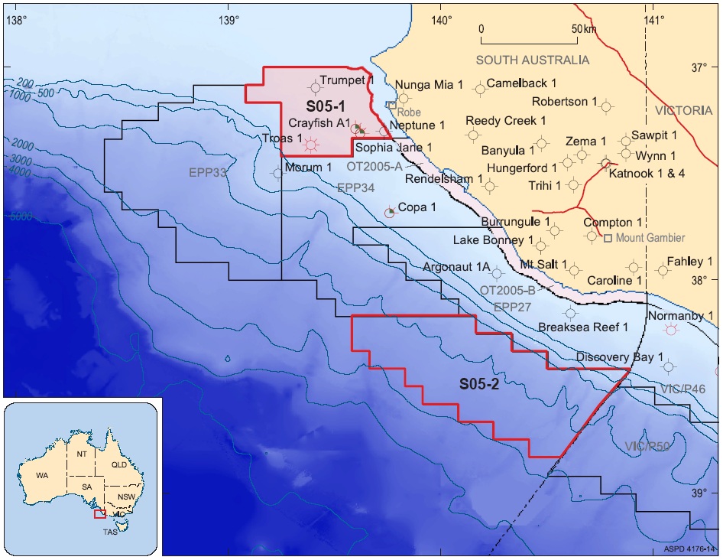
As a result of a recent amendment to the Petroleum (Submerged Lands) Act 1967, any permits granted from this re-release cannot be renewed more than twice.

Dated 26 October 2005.
Made under the Petroleum (Submerged Lands) Act 1967 of the Commonwealth of Australia.
B. A. Goldstein,
Delegate of the Designated Authority for and
on behalf of the Commonwealth-South Australia
Offshore Petroleum Joint Authority

PETROLEUM ACT 2000
Section 25 (5) (b)
Variation of Petroleum Exploration Licences—PEL 101
and PEL 103
NOTICE is hereby given that under the provisions of the Petroleum Act 2000, pursuant to delegated powers dated 28 March 2002, Gazetted 11 April 2002, page 1573, the conditions of the abovementioned Exploration Licences held by Vernon E. Faulconer Australia Inc. and Innamincka Petroleum Limited have been varied, with effect from 31 October 2005, as follows:
Petroleum Exploration Licence—PEL 101
Condition 1 of the licence is omitted and the following substituted:
‘1. During the term of the licence, the Licensees shall carry out or cause to be carried out, exploratory operations on the area comprised in the licence in accordance with such work programs as are approved by the Minister from time to time. Years one and two exploratory operations are guaranteed, and any subsequent licence year work program becomes guaranteed upon entry into that licence year. These exploratory operations shall include but not necessarily be limited to:
Year of Term of Licence | Minimum Work Requirements
One to Two | Drill 2 wells;  100 km 2D Seismic Acquisition
Three | Drill 1 well
Four | Drill 3 wells
Five | Drill 3 wells
’
Petroleum Exploration Licence—PEL 103
Condition 1 of the licence is omitted and the following substituted:
‘1. During the term of the licence, the Licensees shall carry out or cause to be carried out, exploratory operations on the area comprised in the licence in accordance with such work programs as are approved by the Minister from time to time. Years one and two exploratory operations are guaranteed, and any subsequent licence year work program becomes guaranteed upon entry into that licence year. These exploratory operations shall include but not necessarily be limited to:
Year of Term of Licence | Minimum Work Requirements
One | 4 wells; 200 km 2D Seismic Reprocessing; Geochemical Survey
Two | 2 wells; 150 km 2D Seismic; 3D Seismic Acquisition
Three | 2 wells
Four | 3 wells; 100 km Seismic
Five | 2 wells
’
These variations provide for one well originally programmed for Year 3 of each licence to be drilled in Year 4. The revised work requirements as a result of this variation would not have altered the outcome of the original competitive tender process.
Dated 31 October 2005.
B. A. Goldstein, Director Petroleum
Minerals and Energy Division
Primary Industries and Resources SA
Delegate of the Minister for Mineral Resources Development

PETROLEUM ACT 2000
Grant of Associated Facilities Licences—AFLs 30, 31 and 32
(Adjunct to Petroleum Exploration Licence—PEL 106)
NOTICE is hereby given that the undermentioned Associated Facilities Licences have been granted under the provisions of the Petroleum Act 2000, pursuant to delegated powers dated 28 March 2002, Gazetted 11 April 2002, page 1573.
Description of Areas
AFL 30
A 150 m buffer around a line segment defined by the following pair of co-ordinates (MGA Zone 54, GDA94), adjacent to Petroleum Exploration Licence 106 in the State of South Australia:
From | To
373092mE, 6925684mN | 374190mE, 6927080mN
Area: 0.52 km² approximately.
AFL 31
A 50 m buffer around line segments defined by the following pairs of co-ordinates (MGA Zone 54, GDA94), adjacent to Petroleum Exploration Licence 106 in the State of South Australia:
From | To
366691mE, 6925721mN | 368780mE, 6924040mN
365862mE, 6925244mN | 368790mE, 6922885mN
Area: 0.65 km² approximately.
AFL 32
A 150 m buffer around line segments defined by the following pairs of co-ordinates (MGA Zone 54, GDA94), adjacent to Petroleum Exploration Licence 106 in the State of South Australia:
From | To
365308mE, 6919923mN | 368837mE, 6918863mN
364980mE, 6917150mN | 368805mE, 6922013mN
366341mE, 6917096mN | 368820mE, 6920250mN
367155mE, 6916393mN | 368840mE, 6918678mN
Area: 4.94 km² approximately.
Dated 27 October 2005.
B. A. Goldstein, Director Petroleum
Minerals and Energy Resources
Primary Industries and Resources SA
Delegate of the Minister for Mineral Resources Development

ROADS (OPENING AND CLOSING) ACT 1991:
SECTION 24
NOTICE OF CONFIRMATION OF ROAD
PROCESS ORDER
Road Closure
Esplanade, Point Turton
BY Road Process Order made on 2 December 2002, the District Council of Yorke Peninsula ordered that:
1. Portions of the public road (Esplanade) adjoining sections 400, 403, 404, 265 and 416 in Hundred of Para Wurlie more particularly delineated and lettered ‘A’, ‘B’ and ‘C’ in Preliminary Plan No. 02/0053 be closed.
2. Vest the whole of the land subject to closure in the Crown.
On 29 January 2004 that order was confirmed by the Minister for Administrative Services conditionally upon the deposit by the Registrar-General of Deposited Plan 60093 being the authority for the new boundaries.
Pursuant to section 24 (5) of the Roads (Opening and Closing) Act 1991, NOTICE of the order referred to above and its confirmation is hereby given.
Dated 3 November 2005.
P. M. Kentish, Surveyor-General

South Australia
Aquaculture (Standard Lease Conditions) Policy 2005
under the Aquaculture Act 2001

Contents
1 Short title
2 Standard conditions of aquaculture lease
3 Variation of lease or lease conditions

1—Short title
This policy may be cited as the Aquaculture (Standard Lease Conditions) Policy 2005.
2—Standard conditions of aquaculture lease
The provisions of this policy constitute conditions of an aquaculture lease.
3—Variation of lease or lease conditions
(1) Subject to this clause, an aquaculture lease or its conditions may be varied, at the request or with the consent of the lessee, by the Minister by written notice to the lessee.
(2) The variation must not extend the area of the lease or the class of aquaculture that may be carried on in the area (see section 25(2)(c) of the Aquaculture Act 2001).
(3) If the variation consists of or involves the substitution of the area leased:
(a) the variation may not be made if the lease is registered under the Real Property Act 1886; and
(b) if the original area leased was within an aquaculture zone or prospective aquaculture zone, the new area leased must not be within a different aquaculture zone or prospective aquaculture zone; and
(c) the variation may not be made unless the holder of each corresponding licence has requested or consented to a variation of the conditions of the licence by substitution of the licence area and the EPA has approved the variation (to take effect on the variation of the lease).
South Australia
Aquaculture (Approval of Standard Lease Conditions Policy) Notice 2005
under section 12(7) of the Aquaculture Act 2001
1—Short title
This notice may be cited as the Aquaculture (Approval of Standard Lease Conditions Policy) Notice 2005.
2—Approval of aquaculture policy
(1) The Aquaculture (Standard Lease Conditions) Policy 2005 is approved.
(2) The policy comes into operation on the day on which this notice is published in the Gazette.
Made by the Minister

South Australia
Environment Protection (Amendment of Environment Protection Policies) Notice 2005
under the Environment Protection (Miscellaneous) Amendment Act 2005
Part 1—Preliminary
1—Short title
This notice may be cited as the Environment Protection (Amendment of Environment Protection Policies) Notice 2005.
2—Commencement
This notice comes into operation on the day on which it is made.
3—Amendment provisions
In this notice, a provision under a heading referring to the amendment of a specified environmental protection policy amends the policy so specified.
Part 2—Amendment of Environment Protection (Air Quality) Policy 1994
4—Amendment of clause 4—Prevention of environmental harm
(1) Clause 4(2)—after "Authority" insert:
or another administering agency
(2) Clause 4(4)—after "Authority" insert:
or another administering agency
(3) Clause 4(5)—after "Authority" insert:
or other administering agency
(4) Clause 4(8)—after "Authority" insert:
or another administering agency
Part 3—Amendment of Environment Protection (Burning) Policy 1994
5—Amendment of clause 4—Fires in the open on non-domestic premises
(1) Clause 4(1)—after "the Authority" first occurring insert:
or another administering agency,
(2) Clause 4(3)—after "Authority" first occurring insert:
or another administering agency
(3) Clause 4(4)—after "Authority" first occurring insert:
or another administering agency
(4) Clause 4(4)—after "Authority," second occurring insert:
administering agency,
6—Amendment of clause 5—Domestic burning and burning on streets, roads or laneways
(1) Clause 5(5)(d)(i)—after "Authority" first occurring insert:
or another administering agency
(2) Clause 5(6)—after "Authority," wherever occurring insert:
other administering agency,
(3) Clause 5(7)—after "Authority" insert:
or other administering agency,
Part 4—Amendment of Environment Protection (Industrial Noise) Policy 1994
7—Amendment of clause 3—Interpretation
(1) Clause 3, definition of measurement place—after "Authority" insert:
or another administering agency
(2) Clause 3, definition of sampling time—after "Authority" first occurring insert:
or another administering agency
(3) Clause 3, definition of sampling time—after "Authority" second occurring insert:
or other administering agency
Part 5—Amendment of Environment Protection (Water Quality) Policy 2003
8—Amendment of clause 22—Antifoulants
Clause 22(3)—after "Authority" insert:
or another administering agency
9—Amendment of clause 28—Milking sheds
Clause 28(4)—after "Authority" insert:
or another administering agency
10—Amendment of clause 32—Septic systems
Clause 32(5)—after "Authority" insert:
or another administering agency
11—Amendment of clause 33—Septic tank effluent disposal schemes
Clause 33(7)—after "Authority" insert:
or another administering agency
12—Amendment of clause 34—Sewerage systems and sewage treatment systems
Clause 34(6)—after "Authority" insert:
or another administering agency
13—Amendment of clause 36—Vessels on inland waters—waste
Clause 36(7)—after "Authority" insert:
or another administering agency
14—Amendment of clause 42—Environment protection order may be issued to give effect to code of practice under this Part
Clause 42—after "Authority" insert:
or another administering agency
Made by the Minister for Environment and Conservation
on 2 November 2005

South Australia
Motor Vehicles (Approval of Motor Bikes and Motor Trikes) Notice 2005
under the Motor Vehicles Act 1959
1—Short title
This notice may be cited as the Motor Vehicles (Approval of Motor Bikes and Motor Trikes) Notice 2005.
2—Commencement
This notice will come into operation on 14 November 2005 immediately after the commencement of the Motor Vehicles Variation Regulations 2005 (No 233 of 2005).
3—Approved motor bikes and motor trikes
For the purposes of Schedules 2 and 3 of the Motor Vehicles Regulations 1996 and the transitional provisions of the Motor Vehicles Variation Regulations 2005 (No 233 of 2005), the motor bikes and motor trikes specified in Schedule 1 are approved.
Schedule 1—Approved motor bikes and motor trikes
1—Motor bikes and motor trikes with an engine capacity not exceeding 260 ml
All motor bikes and motor trikes with an engine capacity not exceeding 260 milliliters and a power to weight ratio not exceeding 150 kilowatts per tonne other than the following:
Suzuki RGV250
Kawasaki KR250 (KR-1 and KR1s models)
Honda NSR250
Yamaha TZR250
Aprilia RS250.
2—Motor bikes and motor trikes with an engine capacity not less than 261 ml and not exceeding 660 ml
The motor bikes and motor trikes listed in the table below.

Make | Model
AJS | Model 18  Model 30
Aprilia | Moto 6.5  Pegaso 650  Pegaso 650 I.E.
Ariel | Huntmaster  Red Hunter 350  Red Hunter 500
Benelli | Velvet 400
Bultaco | Sherpa
BMW | F650  F650CS  F650GD  F650GS  F650ST  R50  R60  R60/5  R60/6  R65  R69
BSA | B33  B50SS Gold Star  Empire Star  M24 Gold Star  Gold Star post-war 350 singles  Golden Flash  Lightning

Make | Model
BSA | Spitfire MKIII  Thunderbolt
Cagiva | 410TE  610TE  610TE-E  Canyon 500  Canyon 600  River 600  W16 600
Cossack | 650
Dneper | K650
Douglas | Post-war 350
Ducati | 400 SS Junior  DM450  DM500  M620ie (24kw Lite)  SL 500 Pantah  SL 600 Pantah
Enfield | Bullet Deluxe  Bullet STD  Taurus
Gasgas | EC400  FSE400  SM400  Supermotard
Harley | SS350
Honda | 600V Transalp  Bros  CB350  CB350F  CB400  CB400F  CB400N  CB400T  CB500  CRF450  CX500  Deauville  NX650  FT500  Revere  RVF400  Shadow  Silverwing  SL350  VF400F  VT500
Honda | VT600C  XBR500  XL350  XL500  XL600  XL650 Transalp  XR350  XR350R  XR400R  XR500  XR600  XR600R  XR650L
Husaberg | FE(Enduro)4E8  FE(Enduro)5E8  FE(Enduro)7E8  FE400  FE450  FE501  FE550  FE600  FE650  FS450  FS650
Husqvarna | 350TE  400TE  410TE  430WR  510TE  610TE  610TE-E
Hyosung | Comet GT650L
Jawa | 350
Kawasaki | EN450  ER500A  ER500C  EX400  EX500A  KL600  KL650A  KL650B  KL650C  KLE500A  KLX300B  KLX400B  KLX650B  KLX650C

Make | Model
Kawasaki | KZ400  KZ440  KZ500  KZ550  LTD440  Z600A  Z650B  ZR550B  Z500
KTM | EXC Series 300  EXC Series 360  EXC Series 380  EXC Series 400  EXC Series 510  EXC Series 525  GS Series 300  GS Series 400  GS Series 450  GS Series 500  GS Series 550  GS Series 600  LC4 Series 300  LC4 Series 400  LC4 Series 500  LC4 Series 540  LC4 Series 550  LC4 Series 600  LC4 Series 625  LC4 Series 650
Matchless | 600  650  G80 Major
Montesa | Cota
Moto Morini | 350 Sport  500 Strada  500W
Moto Guzzi | V35  V50  V65
MuZ | Baghira 660  Scorpion Replica  Skorpion Sport  Skorpion Tour
MV Agusta | 350
Norton | Model 50  Dominator Model 88  Dominator Model 90  ES2
Panther | 600  650
Piaggio | X9 500
Royal Enfield | 650  Bullet 500  Lightning 500  Bullet 350  Diesel 324
Rudge-Whitworth | 650
Suzuki | AN650  DR350  DR350S  DR500  DR600R  DR650R  DR650RE  DR650RL  DR650RSL  DR650SE  DR-Z400E  GR650  GS450E  GS450S  GS450SX  GS500  GS500E  GS500K  GS550  GSX400E  GSX400F  LS650  RE5  XF650
TM | 300 Enduro  TM300  TM400
Triumph | Bonneville 650  Speed Twin  T100 Tiger  T100R Daytona 500  Thunderbird 650  Trophy 500
Triumph | Trophy 650  TRW25  Note: Only includes models manufactured up to and including 1983.
Ural | 650
Velocette  Velocette | MAC 350  MSS 500  Venom
VOR | 400 Enduro  450 Enduro  500 Enduro  530 Enduro
Yamaha | RD400  RT350  SR500  SRX600  SZR660  TT350  TT600  TT600E  TT600R  TX650  WR400F  WR426F  WR450  XJ550  XJ650  XJR400  XP500  XS400  XS650  XT225  XT350  XT550  XT600  XT660R  XT660X  XTZ660  XV535  XVS650  XVS650A  XZ550  YP 400
Made by R J FRISBY, Registrar of Motor Vehicles
on 26 October 2005.
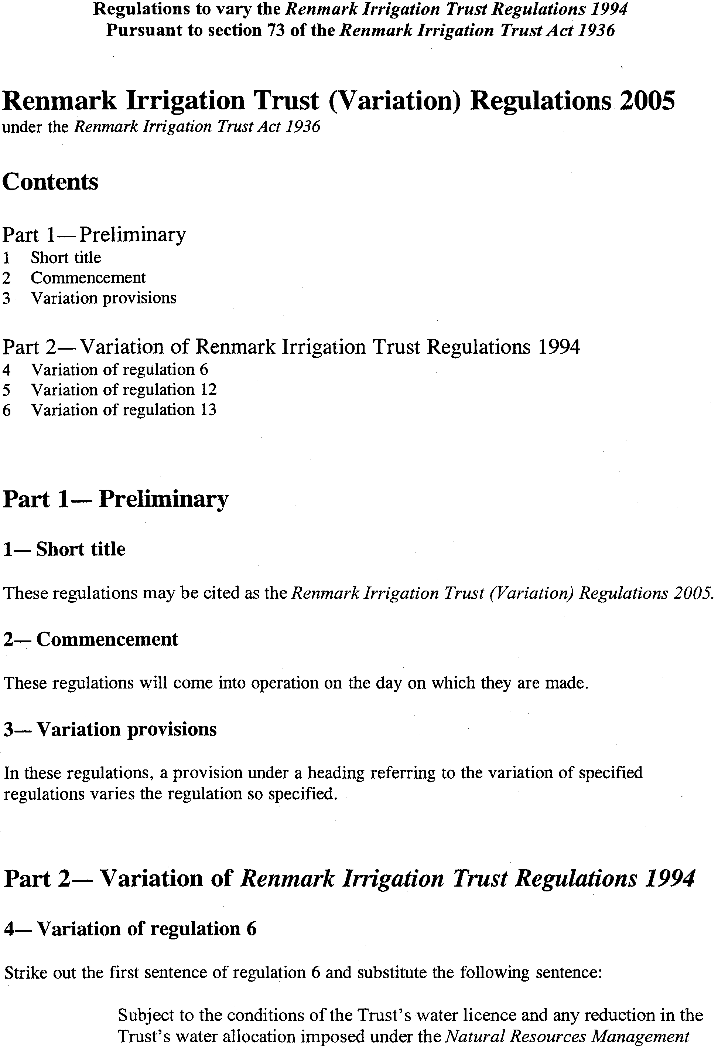

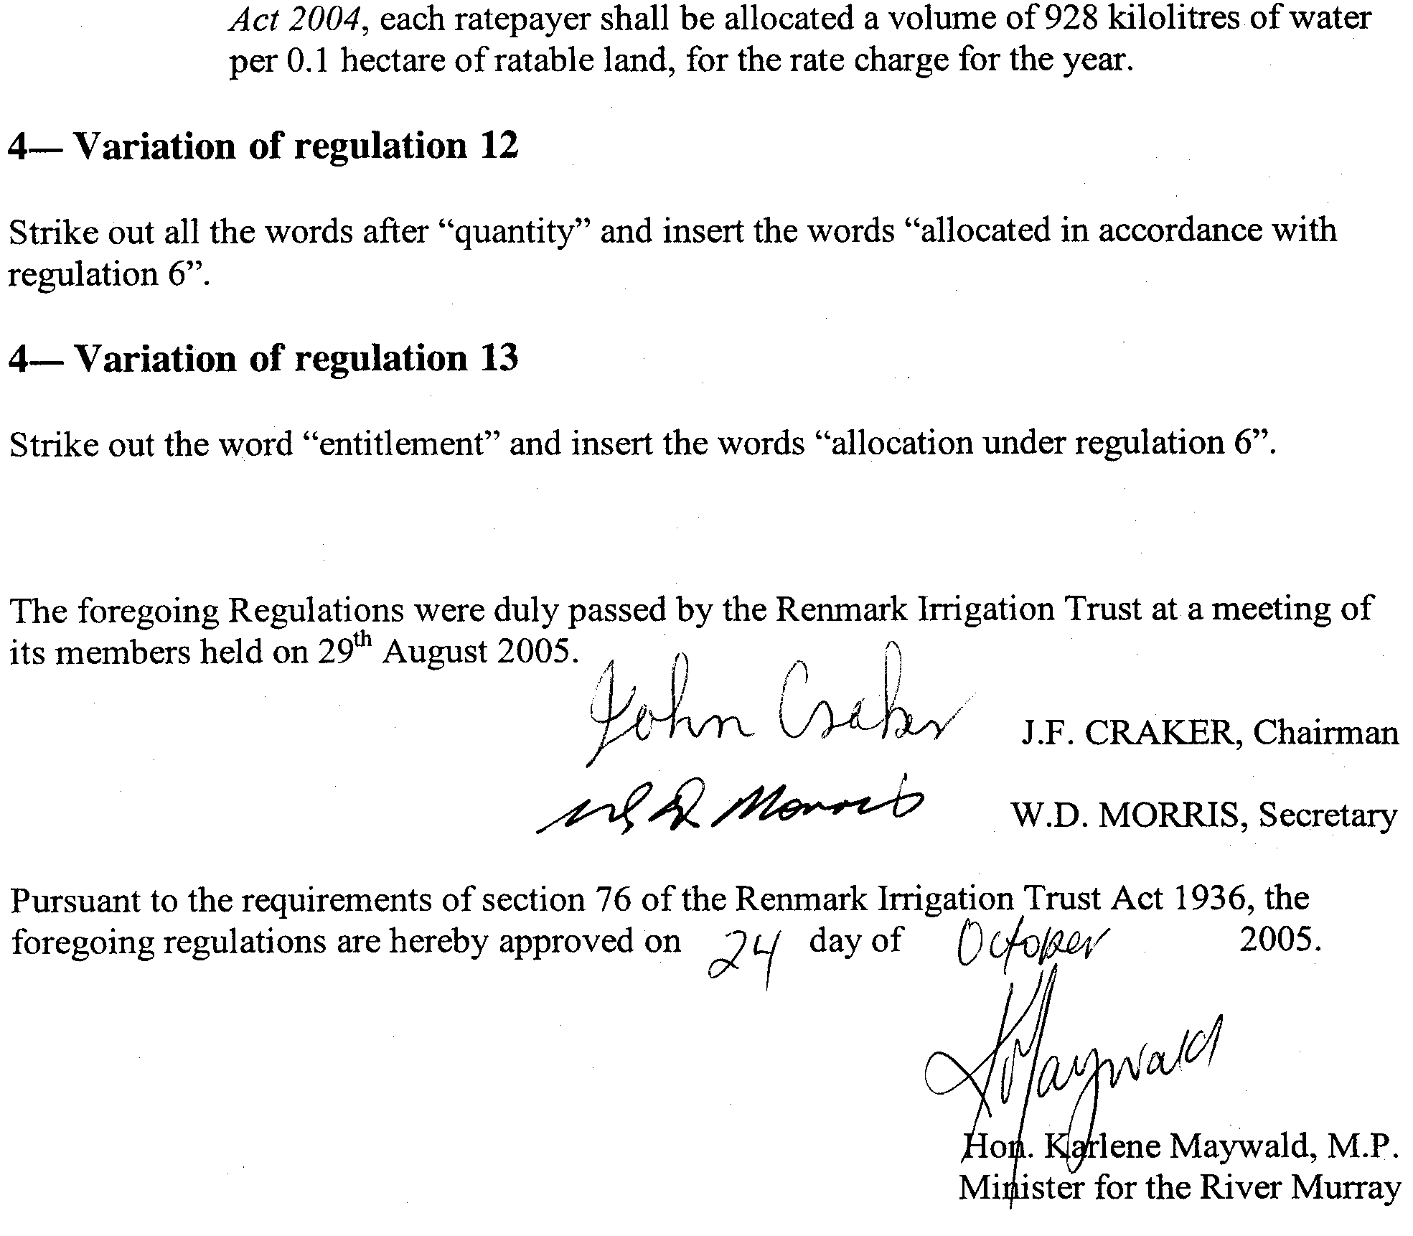

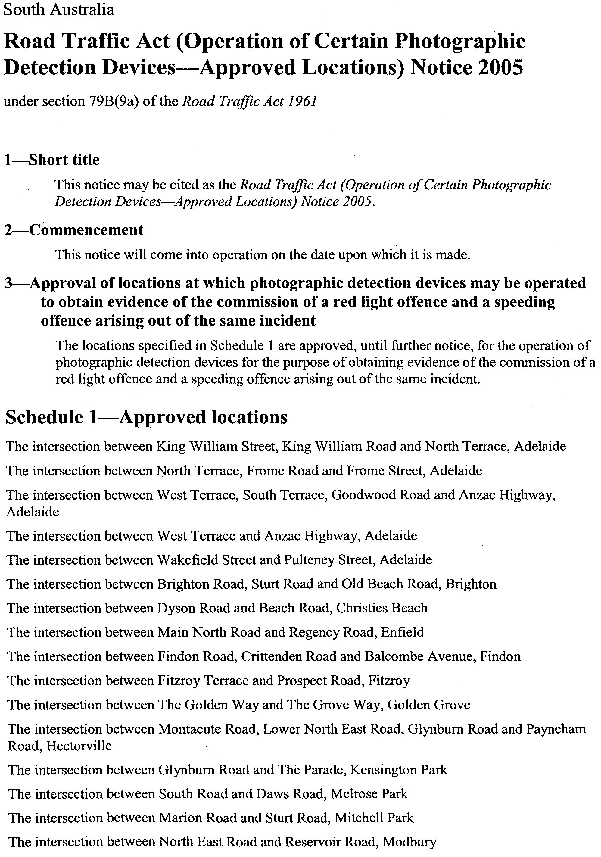
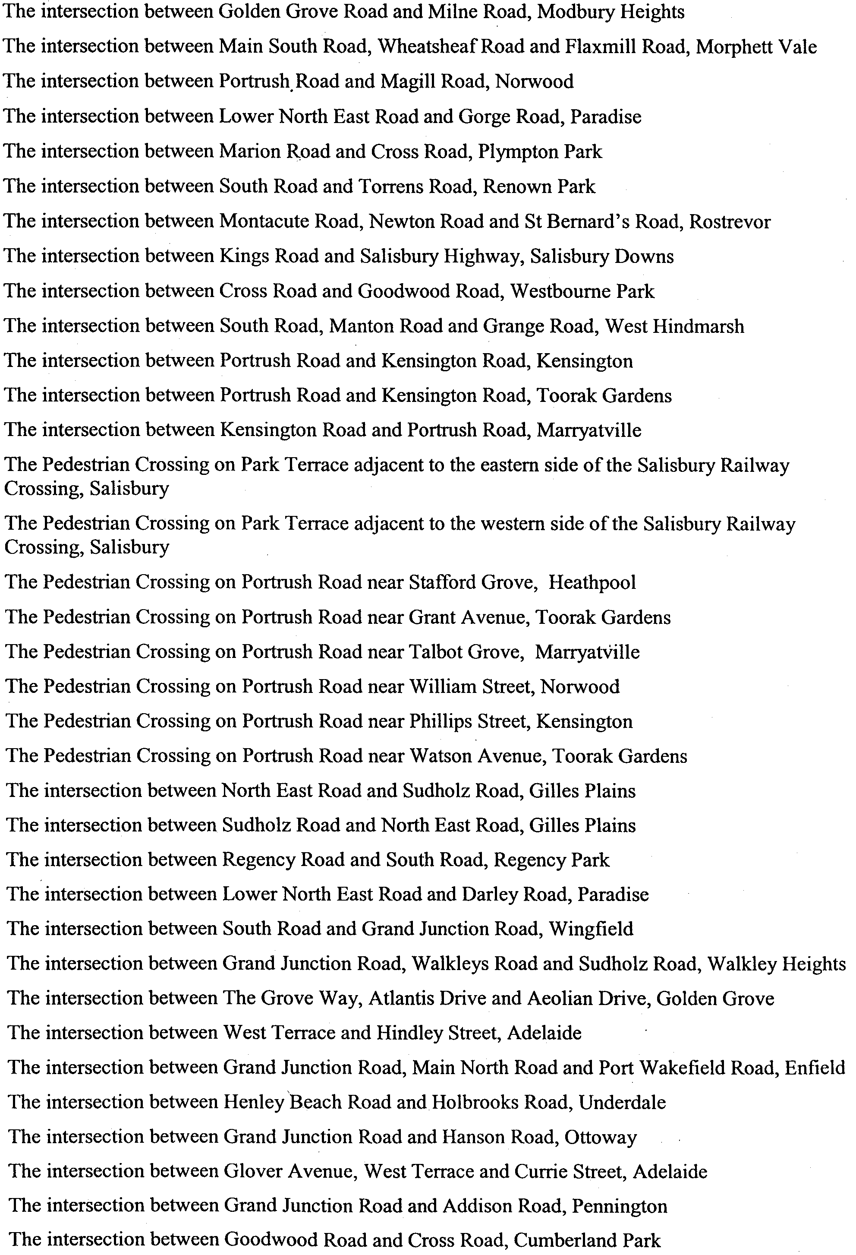

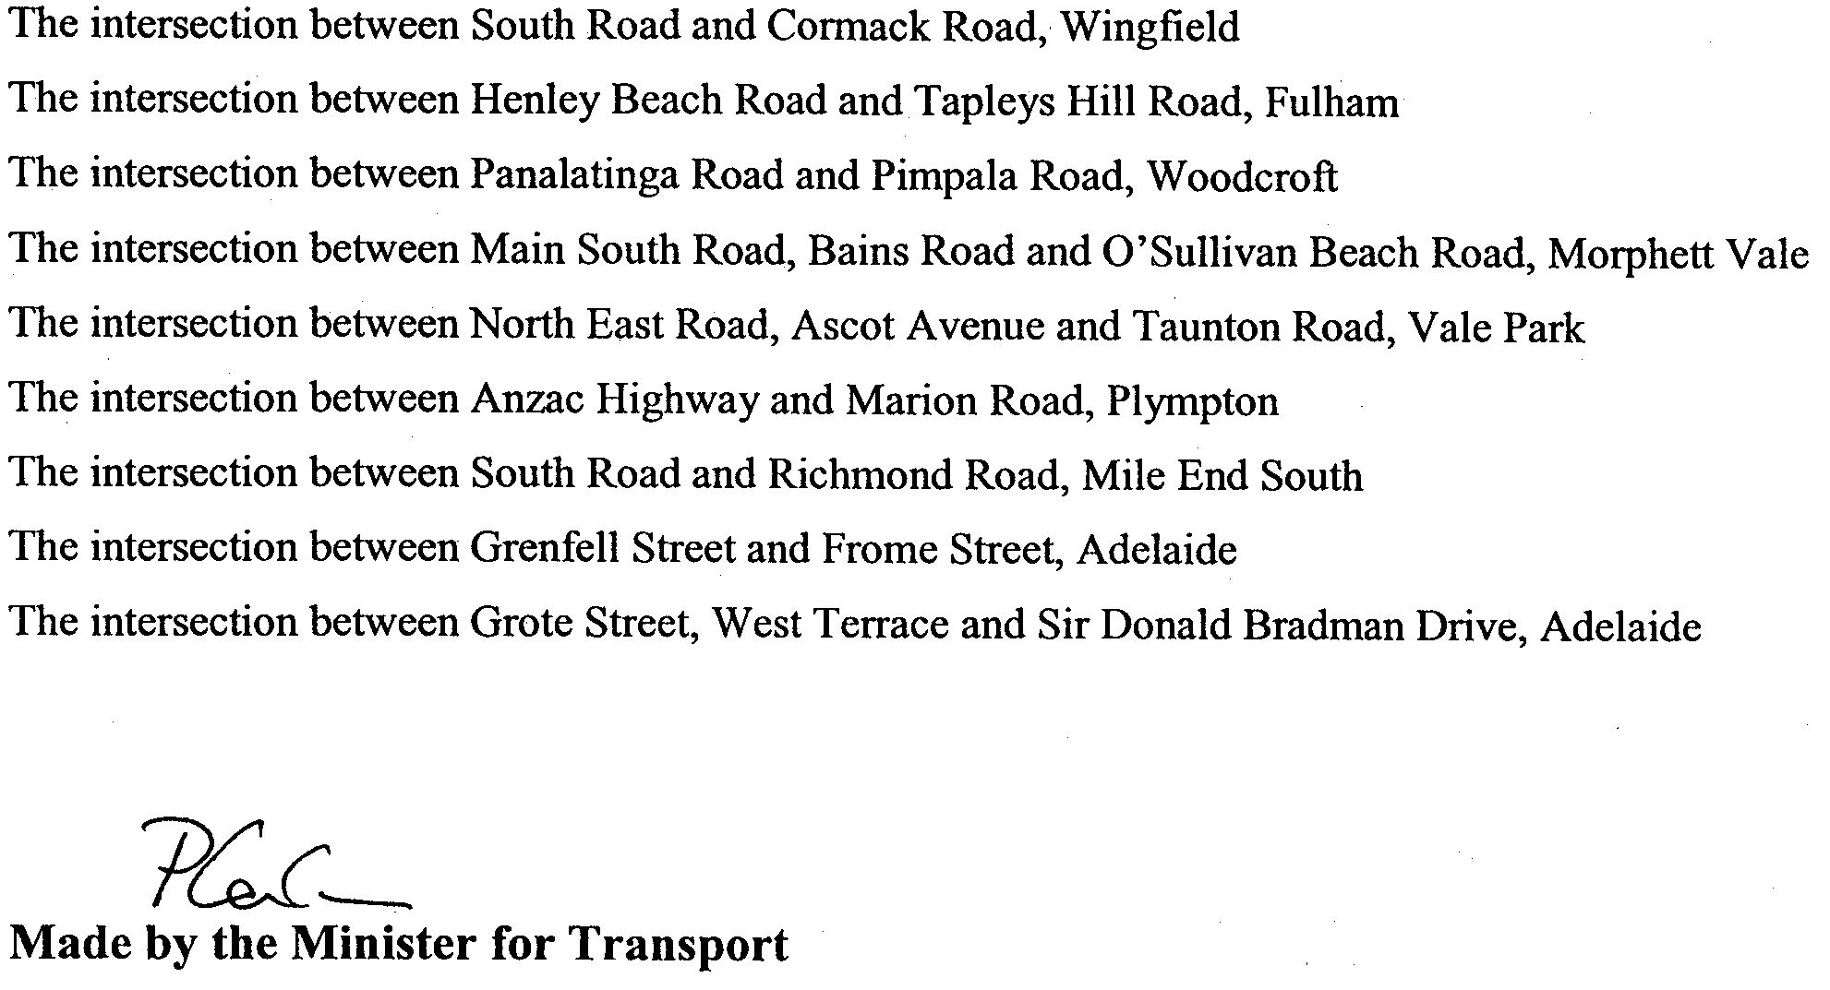

On 3 October 2005.

South Australia
Broken Hill Proprietary Company's Steel Works Indenture (Environmental Authorisation) Amendment Act (Commencement) Proclamation 2005
1—Short title
This proclamation may be cited as the Broken Hill Proprietary Company's Steel Works Indenture (Environmental Authorisation) Amendment Act (Commencement) Proclamation 2005.
2—Commencement of Act
The Broken Hill Proprietary Company's Steel Works Indenture (Environmental Authorisation) Amendment Act 2005 (No 48 of 2005) will come into operation on 3 November 2005.
Made by the Governor
with the advice and consent of the Executive Council
on 3 November 2005
MMRD05/011CS
South Australia
Motor Vehicles Variation Regulations 2005
under the Motor Vehicles Act 1959

Contents
Part 1—Preliminary
1 Short title
2 Commencement
3 Variation provisions
Part 2—Variation of Motor Vehicles Regulations 1996
4 Variation of Regulation 4—Interpretation
5 Variation of Schedule 2—Classification of driver's licences
6 Variation of Schedule 3—Conditions of driver's licences and learner's permits
Schedule 1—Transitional provisions
1 Transitional provisions

Part 1—Preliminary
1—Short title
These regulations may be cited as the Motor Vehicles Variation Regulations 2005.
2—Commencement
These regulations will come into operation on 14 November 2005.
3—Variation provisions
In these regulations, a provision under a heading referring to the variation of specified regulations varies the regulations so specified.
Part 2—Variation of Motor Vehicles Regulations 1996
4—Variation of Regulation 4—Interpretation
Regulation 4—after subregulation (2) insert:
(3) For the purposes of these regulations—
(a) the power to weight ratio of a motor bike or motor trike is to be calculated by dividing its engine power by the sum of its tare weight and 90 kilograms, and multiplying the product of that division by 1000; and
(b) the engine power of a motor bike or motor trike is the engine power stated in the Road Vehicle Descriptor for that vehicle's make and model published by the Commonwealth Department of Transport and Regional Services; and
(c) the tare weight of a motor bike or motor trike is the tare weight as stated in the Road Vehicle Descriptor for that vehicle's make or model.
5—Variation of Schedule 2—Classification of driver's licences
(1) Schedule 2, clause 1, table, entry relating to the licence classification R-DATE—delete the entry and substitute:

R-DATE | 7 | A motor bike or motor trike that—  (a) has an engine capacity not exceeding 660 millilitres and a power to weight ratio not exceeding 150 kilowatts per tonne; and | Nil.
R-DATE |  | (b) is of a kind approved from time to time by the Registrar by notice in the Gazette. | Nil.
(2) Schedule 2, clause 1, table, note relating to the licence classification R-DATE—delete the note
6—Variation of Schedule 3—Conditions of driver's licences and learner's permits
Schedule 3, clause 1, table, entry relating to the licence condition endorsed with the letter "E"—delete the entry and substitute:

The holder of the licence is permitted to drive only a motor bike or motor trike that—  (a) has an engine capacity not exceeding 660 millilitres and a power to weight ratio not exceeding 150 kilowatts per tonne; and  (b) is of a kind approved from time to time by the Registrar by notice in the Gazette. | E
The holder of the permit is permitted to drive only a motor bike or motor trike that—  (a) has an engine capacity not exceeding 660 millilitres and a power to weight ratio not exceeding 150 kilowatts per tonne; and  (b) is of a kind approved from time to time by the Registrar by notice in the Gazette. | R-DATE

Schedule 1—Transitional provisions
1—Transitional provisions
(1) A person who, immediately before the commencement of these regulations, was the holder of a driver's licence endorsed with the classification R-DATE is authorised, while the holder of that licence, to drive—
(a) a motor bike or motor trike that has an engine capacity not exceeding 250 millimetres; or
(b) a motor bike or motor trike that—
(i) has an engine capacity not exceeding 660 millilitres and a power to weight ratio not exceeding 150 kilowatts per tonne; and
(ii) is of a kind approved from time to time by the Registrar by notice in the Gazette.
(2) A person who, immediately before the commencement of these regulations, was the holder of a learner's permit endorsed with the letters "R-DATE" is authorised, while the holder of a driver's licence endorsed with the classification R-DATE, to drive a motor bike or motor trike of a kind referred to in subclause (1).
(3) A person who, immediately before the commencement of these regulations, was the holder of a driver's licence subject to a condition endorsed on the licence with the letter "E", is authorised, while the holder of that licence, to drive a motor bike or motor trike of a kind referred to in subclause (1).
(4) A person who, immediately before the commencement of these regulations, was the holder of a learner's permit endorsed with the letters "R-DATE", is authorised, while the holder of that permit, to drive a motor bike or motor trike of a kind referred to in subclause (1).
Note—
As required by section 10AA(2) of the Subordinate Legislation Act 1978, the Minister has certified that, in the Minister's opinion, it is necessary or appropriate that these regulations come into operation as set out in these regulations.
Made by the Governor
with the advice and consent of the Executive Council
on 3 November 2005
No 233 of 2005
MTR05/025CS

FAXING COPY?
IF you fax copy to Government Publishing SA for inclusion in the Government Gazette, there is no need to send a Confirmation Copy to us as well.
This creates confusion and may well result in your notice being printed twice.
Please use the following fax number:
Fax transmission: (08) 8207 1040
Phone Inquiries: (08) 8207 1045
Please include a contact person, phone number and order number so that we can phone back with any queries we may have regarding the fax copy.
NOTE: Closing time for lodging new copy (fax, hard copy or email) is 4 p.m. on Tuesday preceding the day of publication.

Government Gazette notices can be E-mailed.
The address is:
governmentgazette@saugov.sa.gov.au
Documents should be sent as attachments in Word format.
When sending a document via E-mail, please confirm your transmission with a faxed copy of your document, including the date the notice is to be published.
Fax transmission: (08) 8207 1040
Enquiries: (08) 8207 1045
NOTE: Closing time for lodging new copy (fax, hard copy or email) is 4 p.m. on Tuesday preceding the day of publication.

CITY OF PORT ADELAIDE ENFIELD
Assignment of Names for New Roads
NOTICE is hereby given that the Council of the City of Port Adelaide Enfield at its meeting held on 9 November 2004 resolved that, pursuant to section 219 (1) of the Local Government Act 1999, the new roads in the suburb of Largs North be assigned the street names, as detailed below:
• Collins Street, Farncomb Court, Rankin Drive, Sheean Street and Waller Court.
A plan that delineates the assignment of the new street names, together with a copy of the Council’s resolution is available for inspection at the Council’s Principal Office, 163 St Vincent Street, Port Adelaide, S.A. 5015, during the hours of 9 a.m. and 5 p.m. on weekdays.
Change of Name of a Portion of a Public Road
Notice is hereby given that the Council of the City of Port Adelaide Enfield at its meeting held on 18 January 2005 resolved that, pursuant to section 219 (1) of the Local Government Act 1999, the name of a portion of a certain public road in the suburb of Angle Park be changed, as detailed below:
• Portion of Nelson Road, Angle Park as marked ‘1’ in Plan 1 be changed to Pitcher Court.
A plan that delineates the area of public road which is subject to the change of street name, together with a copy of the Council’s resolution is available for inspection at the Council’s Principal Office, 163 St Vincent Street, Port Adelaide, S.A. 5015, during the hours of 9 a.m. and 5 p.m. on weekdays.
H. J. Wierda, City Manager

CITY OF VICTOR HARBOR
Appointment of Authorised Officers
NOTICE is hereby given that at a meeting of Council held on 24 October 2005, Council revoked all previous appointments and resolved to appoint the following officers as Authorised Officers for the City of Victor Harbor:
Local Government Act 1999 (Section 260)
Graeme Keith Maxwell (City Manager)
Jane Bohnsack (Director of Finance and Administration)
Peter Andrew Bond (Director of Technical Services)
Peter Eric Hall (Director of Planning and Community Services)
David Andrew Read (Principal Planning Officer)
Craig Rowe (Senior Planner)
Ben Coventry (Planner)
Kym Matthew Overall (Senior Building Officer)
Matthew Alexander James Smith (Building Officer)
Norman William Rose (Environmental Health Officer)
Trevor Wayne Button (General Inspector/Fire Prevention Officer)
Natasha Jean Sherrah (General Inspector/Fire Prevention Officer)
Timothy John Read (General Inspector)
Graham Thomas Stephens (General Inspector)
Mathew John Allen (Operations Co-ordinator)
Roger Budarick (Infrastructure Engineer)
David Mark Buckley (Technical Support Co-ordinator)
John Charles Perkins (Technical Officer)
Brian Doman (Parks and Recreation Officer)
Development Act 1993 (Section 18)
Graeme Keith Maxwell (City Manager)
Jane Bohnsack (Director of Finance and Administration)
Peter Andrew Bond (Director of Technical Services)
Peter Eric Hall (Director of Planning and Community Services)
David Andrew Read (Principal Planning Officer)
Craig Rowe (Senior Planner)
Ben Coventry (Planner)
Kym Matthew Overall (Senior Building Officer)
Matthew Alexander James Smith (Building Officer)
Norman William Rose (Environmental Health Officer)
Roger Donald Budarick (Infrastructure Engineer)
Environmental Protection Act 1993 (Part 10, Division 1)
Graeme Keith Maxwell (City Manager)
Jane Bohnsack (Director of Finance and Administration)
Peter Andrew Bond (Director of Technical Services)
Peter Eric Hall (Director of Planning and Community Services)
Roger Donald Budarick (Infrastructure Engineer)
Trevor Wayne Button (General Inspector/Fire Prevention Officer)
Natasha Jean Sherrah (General Inspector/Fire Prevention Officer)
Timothy John Read (General Inspector)
Graham Thomas Stephens (General Inspector)
Dog and Cat Management Act 1995 (Sections 27 (1) and 68 (1))
Graeme Keith Maxwell (City Manager)
Jane Bohnsack (Director of Finance and Administration)
Peter Eric Hall (Director of Planning and Community Services)
Trevor Wayne Button (General Inspector/Fire Prevention Officer)
Natasha Jean Sherrah (General Inspector/Fire Prevention Officer)
Timothy John Read (General Inspector)
Graham Thomas Stephens (General Inspector)
Impounding Act 1920
Graeme Keith Maxwell (City Manager)
Jane Bohnsack (Director of Finance and Administration)
Peter Eric Hall (Director of Planning and Community Services)
Trevor Wayne Button (General Inspector/Fire Prevention Officer)
Natasha Jean Sherrah (General Inspector/Fire Prevention Officer)
Timothy John Read (General Inspector)
Graham Thomas Stephens (General Inspector)
Road Traffic Act 1961 (Section 35 (1a))
Graeme Keith Maxwell (City Manager)
Jane Bohnsack (Director of Finance and Administration)
Peter Andrew Bond (Director of Technical Services)
Mathew John Allen (Operations Co-ordinator)
David Mark Buckley (Technical Support Co-ordinator)
John Charles Perkins (Technical Officer)
Roger Donald Budarick (Infrastructure Engineer)
Expiation of Offences Act 1996
Graeme Keith Maxwell (City Manager)
Jane Bohnsack (Director of Finance and Administration)
Peter Eric Hall (Director of Planning and Community Services)
Trevor Wayne Button (General Inspector/Fire Prevention Officer)
Natasha Jean Sherrah (General Inspector/Fire Prevention Officer)
Timothy John Read (General Inspector)
Graham Thomas Stephens (General Inspector)
Fire and Emergency Services 2005 (Part 3, Division 8 and Part 4, Divisions 7 and 8)
Graeme Keith Maxwell (City Manager)
Jane Bohnsack (Director of Finance and Administration)
Peter Eric Hall (Director of Planning and Community Services)
Trevor Wayne Button (General Inspector/Fire Prevention Officer)
Natasha Jean Sherrah (General Inspector/Fire Prevention Officer)
Timothy John Read (General Inspector)
Graham Thomas Stephens (General Inspector)
Public and Environment Health Act 1987 (Section 7 (1))
Norman William Rose (Environmental Health Officer)
Food Act 1985 (Section 8(2))
Norman William Rose (Environmental Health Officer)
Supported Residential Facilities Act 1972 (Section 21)
Peter Eric Hall (Director of Planning and Community Services)
Norman William Rose (Environmental Health Officer)
Harbours and Navigation Act 1993 (Part 2, Division 4)
Graeme Keith Maxwell (City Manager)
Jane Bohnsack (Director of Finance and Administration)
Peter Eric Hall (Director of Planning and Community Services)
Trevor Wayne Button (General Inspector/Fire Prevention Officer)
Natasha Jean Sherrah (General Inspector/Fire Prevention Officer)
Timothy John Read (General Inspector)
Graham Thomas Stephens (General Inspector)
G. K. Maxwell, City Manager

TOWN OF GAWLER
Rates Declarations
NOTICE is hereby given that in exercise of the powers contained in Chapters 8, 9 and 10 of the Local Government Act 1999, (the Act) and in respect of the financial year ending 30 June 2006, the Town of Gawler (the Council) declares as follows:
Adoption of Rating Policy
That pursuant to section 171 of the Act, the Rating Policy being Attachment 1, is adopted.
Adoption of Budget
That pursuant to section 123 (1) and (2) (b) of the Act, the budget for that year is adopted, as detailed in the papers before the Council, including:
• Budgeted statement as to the basis for the determination of the rates;
• Budgeted cash flow statement;
• Budgeted operating statement;
• Budgeted statement of financial position;
• Budgeted statement of changes in equity,
and all recommendations within these documents, providing for:
• Total estimated expenditure: $17 757 305.
• Total estimated incomings from sources other than general rates: $9 595 170.
• Total net amount required to be raised from general rates: $8 141 500.
1. Adoption of Valuations
That pursuant to section 167 (2) (a) of the Act, the Council adopts, for rating purposes for that year, the Valuer-General’s Valuation of Capital Values applicable to land within the area of the Council, totalling $2 008 256 600 and that 26 July 2005 is specified as the date on which such values are adopted.
2. Attribution of Land Uses
2.1 The numbers indicated against the various categories of land use prescribed by Regulation 10 of the Local Government (General) Regulations 1999, are used to designate land uses in the Assessment Record.
2.2 The use indicated by those numbers in respect of each separate assessment of land described in the Assessment Record (as laid before the Council) is attributed to each such assessment respectively.
2.3 Reference in the Council resolutions to land being of a certain category use means the use indicated by that category number in the Regulations.
3. Declaration of General Rates
3.1 That pursuant to sections 152 (1) (a), 153 (1) (b) and 156 (1) (a) of the Local Government Act 1999, Council declares differential general rates upon the basis of land use for the year ending 30 June 2006, as follows:
0.417166 cents in the dollar of the Capital Value on rateable land of land use categories 1, 2, 3, 4, 5,
6, 8 and 9 (Residential, Commercial—Shop, Com-mercial—Office, Commercial—Other, Industry—Light, Industry—Other, Vacant Land and Other).
0.381309 cents in the dollar of the Capital Value of rateable land of Category 7 (Primary Production).
3.2 Pursuant to section 158 of the Local Government 1999, the Council fixes a minimum amount that shall be payable by way of rates on all rateable properties within the whole of the Council area for the year ending 30 June 2006 at $600.
4. Declaration of Water Catchment Rates
Notice is hereby given that the Town of Gawler, pursuant to section 154 of the Local Government Act 1999 and pursuant to the provisions of section 138 of the Water Resources Act 1997, for the financial year 2005-2006 declares a separate rate of 0.008504 cents in the dollar on the Capital Value of all rateable land in the Council area within the Catchment area of the Northern Adelaide and Barossa Water Catchment Board (total amount to be raised in 2005-2006 is $162 600).
5. Declaration of Car Parking Levy
Pursuant to section 154 of the Local Government Act 1999, for the year ending 30 June 2006, the following differential separate rates are declared on all rateable land based upon Capital Value of the land situated in the area delineated and marked ‘A’ in the enclosed map (Figure 1) in order to raise $309 000 to carry out the project of providing additional car parking in the Town Centre and adjoining areas for the purpose of enhancing business viability in that part of the Council’s area indicated in Figure 1.
A separate differential rate in respect of land uses:
• Categories 2, 3, 4, 5 and 6 (Commercial—Shop, Com-mercial—Office, Commercial—Other, Industry—Light, Industry—Other) 0.299108 cents in the dollar.
6. Declaration of Town Centre—Business Development and Marketing Levy and Business Development Levy
6.1 Pursuant to section 154 of the Local Government Act 1999, for the year ending 30 June 2006, the following differential separate rates are declared on all rateable land based upon Capital Value of the land situated in the area delineated and marked ‘A’ in the enclosed map (Figure 1) in order to raise $80 000 to support the role of the Gawler Business Development Board in town centre marketing and development for the economic benefit of the business community in that part of the Council’s area indicated in Figure 1 (Town Centre—Business Develop-ment and Marketing Levy).
A separate differential rate in respect of land uses:
• Categories 2, 3, 4, 5 and 6 (Commercial—
Shop, Commercial—Office, Commercial—Other, Industry—Light, Industry—Other) 0.077439 cents in the dollar.
6.2 Pursuant to section 154 of the Local Government Act 1999, for the year ending 30 June 2006, a differential separate rate of 0.047586 cents in the dollar based
upon Capital Value of land use Categories 2, 3, 4, 5 and 6 (Commercial—Shop, Commercial—Office, Com-mercial—Other, Industry—Light, Industry—Other) on all land situated in the area delineated and marked ‘B’ in the enclosed map (Figure 1) in order to raise $35 000 to support the role of the Gawler Business Development Board to develop, fund and manage integrated programs for the economic benefit of the business community in that part of Council’s area. (Business Development Levy).
7. Payment by Instalments
Pursuant to section 181 of the Local Government Act 1999, in respect of the financial year ending 30 June 2006, all rates are payable in four equal (or approximately equal) quarterly instal-ments falling due on the following dates:
23 September 2005
9 December 2005
10 March 2006
9 June 2006.
8. Rebate of Rates
8.1 In exercise of the powers contained in section 166 (1) (l) of the Act to provide relief against what would otherwise amount to a substantial change in rates payable due to a redistribution of the rates burden within the community arising from a change to the basis of Council’s rates, Principal Ratepayers of rateable land in land use Categories 1, 8 and 9 where such rateable land is equal to or greater than 0.4 ha and who will not receive a rebate (without application) for any other circumstance within Chapter 10 Part 1 Division 5—Rebate of Rates are granted, for the financial year 2005-2006, a rebate for general rates to have the effect that these Ratepayers will pay the same rate in the dollar as Primary Production Ratepayers. This rebate will only apply to properties located in rural zoned areas.
8.2 In exercise of the powers contained in section 166 (1) (l) of the Act to provide relief against what would otherwise amount to a substantial change in rates payable due to a redistribution of the rates burden within the community arising from a change to the basis of Council’s rates, rebates (without application) be provided to James Martin Nursing Home, Southern Cross Hostel, Martin-dale Nursing Home, Trevu Nursing Home and Gawler & District Aged Cottage Homes to have the effect of those ratepayers receiving a maximum rebate of 50% on their 2005-2006 general rates.
8.3 In exercise of the powers contained in section 166 (1) (l) of the Act to provide relief against what would otherwise amount to a substantial change in rates payable due to a redistribution of the rates burden within the community arising from a change to the basis of Council’s rates, on application and the provision of appropriate evidence of use as solely primary production, rebates be provided so that these properties attract a higher rebate up to 50% of the residential rate for the financial year 2005-2006.
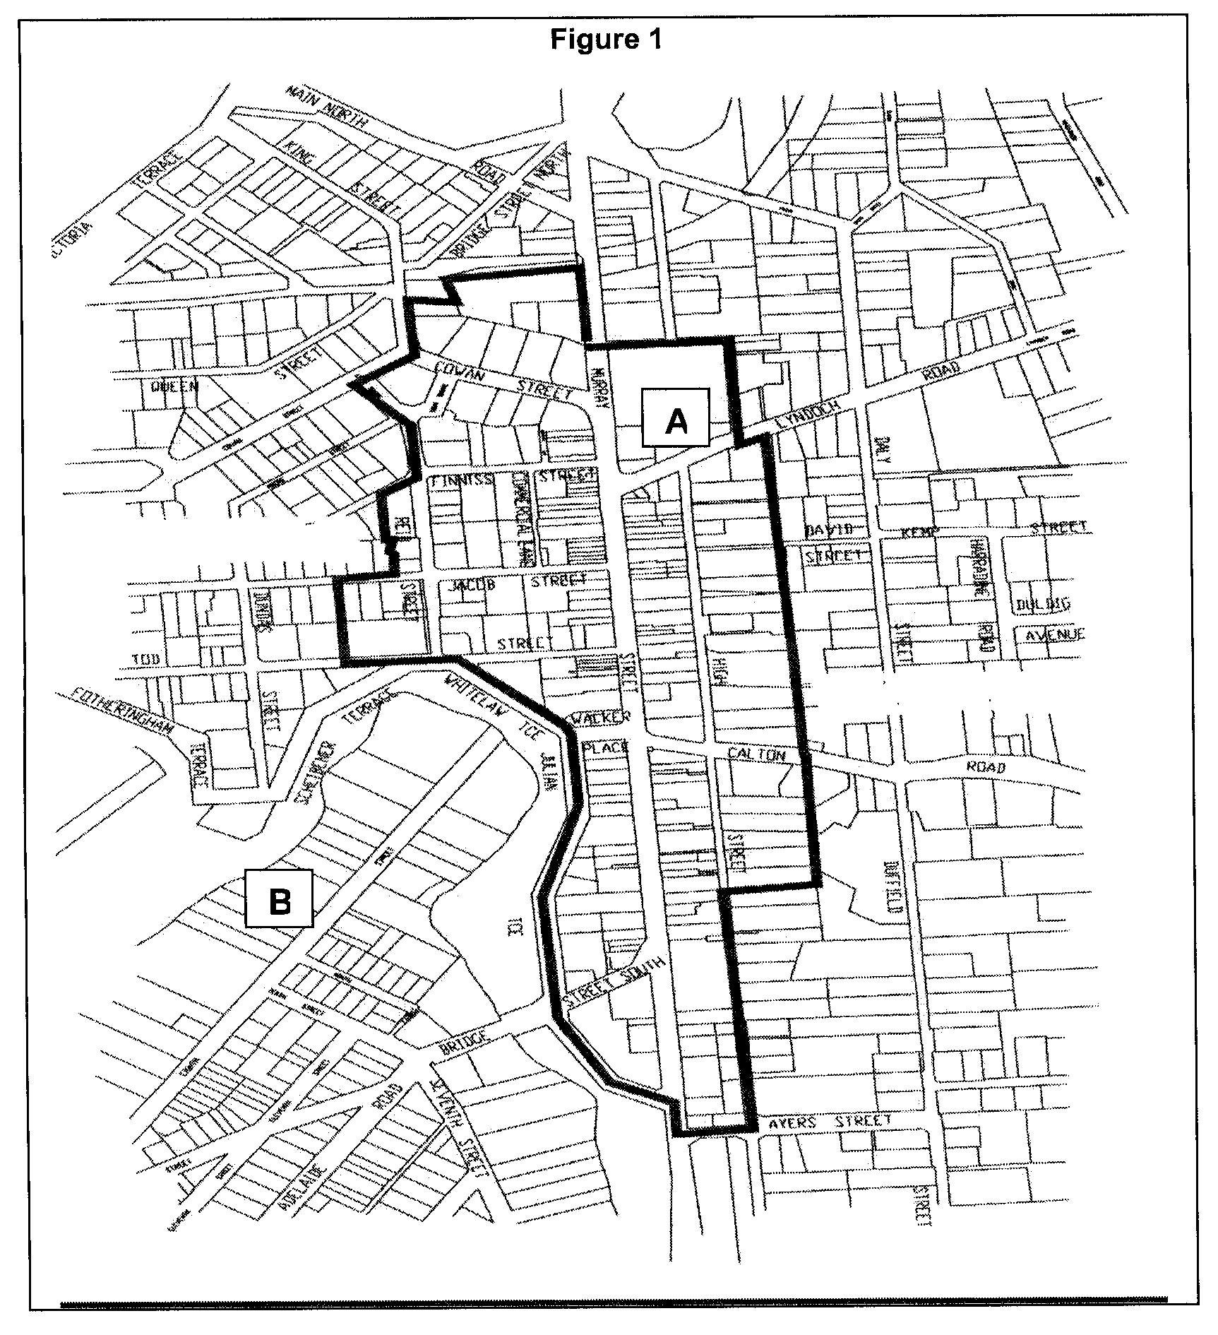
8.4 In exercise of the powers contained in section 166 (1) (l) of the Act to provide relief against what would otherwise amount to a substantial change in rates payable due to a redistribution of the rates burden within the community arising from a change to the basis of Council’s rates, rebates be provided (without application) to Dalkeith Caravan Park and Hillier Park, given their localities, to have the effect that these Ratepayers pay the same rate in the dollar as Primary Production Ratepayers.
8.5 In exercise of the powers contained in section 166 (1) (l) of the Act to provide relief against what would otherwise amount to a substantial change in rates payable due to a redistribution of the rates burden within the community arising from a change to the basis of Council’s rates, rebates be provided to residential ratepayers (land use code—1), who are subject to tenancy apportionments, of 60%. The rebate is calculated on the difference between the rates payable under tenancy apportionments and the amount that would have been payable if tenancy apportionments were not applied (60% of the difference is rebated).
N. Jacobs, Chief Executive Officer

DISTRICT COUNCIL OF BARUNGA WEST
Adoption of Valuation and Declaration of Rates
NOTICE is hereby given that at a meeting of Council held on 12 July 2005, it was resolved that the Council of the District Council of Barunga West adopts the most recent capital valuation of the Valuer-General that is to apply to the area for rating purposes for the 2005-2006 financial year, being capital valuation totalling $680 742 360, comprising $662 578 150 for rateable land and $18 164 210 for non-rateable land.
Adoption of Rates
1. Notice is hereby given that by virtue of the powers vested in it by the Local Government Act 1999, and all other powers there unto enabling the Council of the District Council of Barunga West (hereinafter called ‘the Council’) at a meeting held on 12 July 2005 resolves:
(a) That an amount of $200 be a fixed charge on each separate piece of rateable land in the area of the Council for the purposes of rates pursuant to section 152 of the Local Government Act 1999, for the year ending 30 June 2006.
(b) That the differential general rates on capital value of rateable land with the area of the Council be declared for the financial year ending 30 June 2006 which differential general rates are pursuant to section 152 (1) (c) based on two components—(1) one being the value of the rateable land and (2) the other being the fixed charge applicable to the rateable land and which differential general rates vary according to the use in accordance with section 156 (1) (a).
(c) That the amounts of differential general rates are as follows:
(i) That the differential general rate for all rateable land within the area of the Council which has a land designated as Category 1 (Residential) be fixed at 0.242 cents in the dollar.
(ii) That the differential general rate for all rateable land within the area of the Council which has a land use designated as Categories 2, 3 or 4 (Commercial—Shop, Office or Other) or Categories 5 or 6 (Industrial—Light or Other) be fixed at 0.45 cents in the dollar.
(iii) That the differential general rate for all rateable land within the area of the Council which has a land use designated as Category 7 (Primary Production) be fixed and rated at 0.218 cents in the dollar.
(iv) That the differential general rate for all rateable land within the area of the Council which has a land use designated as Category 8 (Vacant) be fixed and rated at 0.215 cents in the dollar.
Payment of Rates
2. Notice is hereby given that the requirements for the payment of rates as follows:
(a) Rates (i.e. Differential General Rates plus Fixed Charges, Service Charges and Separate Rates) declared by Council for the financial year ending 30 June 2006 will fall due in four equal or approximately equal instalments.
(b) The said four instalments shall be payable on or before 9 September 2005, 9 December 2005, 9 March 2006 and 9 June 2006 failing which the said rates shall be regarded as being in arrears and subject to the imposition of fines, as prescribed.
Service Charge
3. Pursuant to section 155 of the Local Government Act 1999, Council declares a service charge being levied on buildings and vacant properties being serviced by:
The Bute Common Effluent Scheme:
Building $95;
Vacant $55.
The Port Broughton Common Effluent Scheme:
Building $290;
Vacant $205.
Separate Rates
4. Pursuant to section 154 of the Local Government Act 1999, Council hereby declares that a separate rate of $12 per assessment being levied on properties within the Port Broughton and Fisherman’s Bay townships for the purpose of mosquito control.
Rating Policy
5. Pursuant to section 171 (1) of the Local Government Act 1999, Council adopts the Rating Policy for the 2005-2006 financial year.
N. Hand, District Manager

KINGSTON DISTRICT COUNCIL
Exclusion of Land from Community Land Classification
NOTICE is hereby given that pursuant to section 193 (4) of the Local Government Act 1999, that land comprised in Deposited Plan 68590, being Lot 2, Hundred of Mount Benson, comprised in certificate of title volume 5560, folio 348, be excluded from the Classification of Community Land.
M. McCarthy, Chief Executive Officer

DISTRICT COUNCIL OF MOUNT BARKER
Roads (Opening and Closing) Act 1991
Road Closure—Blaser Road, Mylor—Cancellation
NOTICE appearing in Government Gazette of 27 October 2005 on page 3841 was printed in error and will be cancelled until further notice.
[*]

IN the matter of the estates of the undermentioned deceased persons:
Barton, George William, late of 35 Whitford Road, Elizabeth South, retired press worker, who died on 14 August 2005.
Bates, Kevin Michael, late of 27-28 Main Street, Port Kenny, retired fisherman, who died on 28 July 2005.
Brace, Keith William, late of 93 Kingston Avenue, Daw Park, retired printer, who died on 30 August 2005.
Broadbridge, Mary, late of Donovan Street, Augusta, Western Australia, of no occupation, who died on 7 August 2005.
Chowis, Tahleah Renee Louise, late of 52 Regency Road, Kilkenny, scrap metal merchant, who died on 30 April 2005.
Cushway, Fenella Muriel, late of 7 Stewart Street, Henley Beach, married woman, who died on 23 April 2005.
Date, Ronald Alonzo, late of 160 Walkerville Terrace, Walkerville, retired motor trimmer, who died on 16 August 2005.
Driscoll, Kathleen Joan, late of 81 Tapleys Hill Road, Hendon, retired clerk, who died on 28 July 2005.
Long, Andy Chin Wah, late of 586 Cross Road, South Plympton, medical practitioner, who died on 9 June 2005.
Rogers, Kathleen Joyce, late of 81 Tapleys Hill Road, Hendon, widow, who died on 19 August 2005.
Russell, Edward Boon, late of 342 Marion Road, North Plympton, retired engineer, who died on 6 September 2005.
Sachse, Pauline Janice, late of 3 Sixth Avenue, Ascot Park, home duties, who died on 31 July 2005.
Salamon, Alison Martha, late of 53-59 Austral Terrace, Morphettville, retired music teacher, who died on 24 August 2005.
Shippey, Ada Isabel, late of 1 Myzantha Street, Lockleys, of no occupation, who died on 26 April 2005.
Smith, Dorothy Evelyn, late of 21 Corella Avenue, Glenalta, retired public servant, who died on 3 August 2005.
Steward, Claire Gwenyth, late of 23 Playford Avenue, Whyalla Playford, home duties, who died on 6 July 2005.
Westdyk, John, late of 19 Albert Street, Hamley Bridge, of no occupation, who died on 18 June 2005.
Wilson, Edna Christobel, late of 86 Oaklands Road, Glengowrie, retired nursing sister, who died on 31 August 2005.
Notice is hereby given pursuant to the Trustee Act 1936, as amended, the Inheritance (Family Provision) Act 1972, and the Family Relationships Act 1975, that all creditors, beneficiaries, and other persons having claims against the said estates are required to send, in writing, to the Public Trustee, 25 Franklin Street, Adelaide, S.A. 5000, full particulars and proof of such claims, on or before 25 November 2005, otherwise they will be excluded from the distribution of the said estate; and notice is also hereby given that all persons who are indebted to the said estates are required to pay the amount of their debts to the Public Trustee or proceedings will be taken for the recovery thereof; and all persons having any property belonging to the said estates are forthwith to deliver the same to the Public Trustee.
Dated 27 October 2005.
C. J. O’Loughlin, Public Trustee

IN the matter of the estates of the undermentioned deceased persons:
Bennett, Gerald Patrick, late of 15 Bailey Street, St Marys, retired public servant, who died on 21 July 2005.
Butler, Louis James, late of 21 Weewanda Street, Glenelg South, retired sales manager, who died on 2 August 2005.
Champion, Elva Rose, late of 1-7 Leicester Street, Clearview, widow, who died on 11 August 2005.
Cummings, Thomas John, late of 160-164 Military Road, Semaphore, retired gas company worker, who died on
7 July 2004.
Foster, Margaret Joan, late of 23 Fuller Street, Walkerville, retired Supreme Court secretary, who died on 16 August 2005.
Francis, Maria, late of 9 Winchester Street, St Peters, of no occupation, who died on 1 October 2004.
Gemmell, Colin John, late of Ethelbert Square, Brompton, retired bus driver, who died on 25 August 2005.
Grove, Lily Forrest Savage, late of 18 Gurumbi Crescent, Munno Para, home duties, who died on 3 September 2005.
Howard, Eric Stanley, late of 200 Fosters Road, Oakden, retired sales manager, who died on 2 July 2005.
Kalms, Coral June, late of Bundey Terrace, Pinnaroo, of no occupation, who died on 22 February 2005.
Kroemer, Loretta Kaye, late of 6 Goode Terrace, Pata, near Loxton, retired nurse, who died on 7 June 2005.
Mackay, Maureen Lesley, late of 5A Pepper Street, Magill, schoolteacher, who died on 27 September 2004.

McIntyre, Donald Alexander, late of 29 Austral Terrace, Morphettville, retired factory supervisor, who died on 14 August 2005.
Norman, William, late of 56 High Street, Grange, retired fitter and turner, who died on 28 July 2005.
Peel, Phoebe Rosa, late of 150-164 Bay Road, Encounter Bay, of no occupation, who died on 30 June 2005.
Rowley, Emily Scissley, late of 177 Longwood Road, Heathfield, of no occupation, who died on 23 August 2005.
Todd, John Lawrence, late of 15 Normandy Avenue, Para Hills, retired postman, who died on 10 July 2005.
Walker, Iris Joyce Millicent, late of 10 Morton Road, Christie Downs, widow, who died on 1 September 2005.
Wilson, Alan John, late of 25 Roopena Street, Ingle Farm, retired warehouse manager, who died on 9 August 2005.
Notice is hereby given pursuant to the Trustee Act 1936, as amended, the Inheritance (Family Provision) Act 1972, and the Family Relationships Act 1975, that all creditors, beneficiaries, and other persons having claims against the said estates are required to send, in writing, to the Public Trustee, 25 Franklin Street, Adelaide, S.A. 5000, full particulars and proof of such claims, on or before 2 December 2005, otherwise they will be excluded from the distribution of the said estate; and notice is also hereby given that all persons who are indebted to the said estates are required to pay the amount of their debts to the Public Trustee or proceedings will be taken for the recovery thereof; and all persons having any property belonging to the said estates are forthwith to deliver the same to the Public Trustee.
Dated 3 November 2005.
C. J. O’Loughlin, Public Trustee

G. J. & J. A. MATZ & ASSOCIATES PTY LIMITED
(IN LIQUIDATION)
Notice of Final Meeting
NOTICE is hereby given that a final meeting of the members and creditors of the company will be held at the offices of MC, Chartered Accountants, 1st Floor, Menai House, 17 Bagot Street, North Adelaide on 25 November 2005 at 10 a.m.
Agenda
1. To receive a final report from the liquidator showing how the winding up has been conducted and the property of the company has been disposed of and giving any necessary explanation of the account.
2. Any other business.
Dated 26 October 2005.
H. L. Slater, Liquidator

SOUTH AUSTRALIA—In the Supreme Court. No. 553 of 1998. In the matter of Shengli Pty Limited (in liquidation) (ACN 008 062 217) and in the matter of the Corporations Law.
Notice of Release of Liquidator and Dissolution of the Company
Take notice that by order of the Supreme Court of South Australia dated 10 October 2005, I, Barrie Malcolm Mansom, 1st Floor, 17 Bagot Street, North Adelaide, S.A. 5006, the liquidator of the abovenamed company, was granted my release as liquidator and the company was dissolved as at the date of this order.
Dated 24 October 2005.
B. M. Mansom, Liquidator

ATTENTION

CUSTOMERS requiring a proof of their notice for inclusion in the Government Gazette, please note that the onus is on you to inform Government Publishing SA of any subsequent corrections by 10 a.m. on Thursday, which is our publication deadline.

For any corrections to your notice please phone 8207 1045 or Fax 8207 1040 before 10 a.m. on Thursday.

If we do not receive any communication by 10 a.m. on Thursday (day of publication) we will presume the notice is correct and will print it as it is.

Remember—the onus is on you to inform us of any corrections necessary to your notice.

NOTE: Closing time for lodging new copy (electronically, fax or hard copy) is 4 p.m. on Tuesday preceding the day of publication. Phone 8207 1045—Fax 8207 1040.
Email: governmentgazette@saugov.sa.gov.au

Printed and published by authority every Thursday by K. O’CALLAGHAN, Government Printer, South Australia
Price: $5.00, plus postage; to subscribers, $254.00 per annum.
(The above prices are inclusive of GST)

