No. 105 3955

THE SOUTH AUSTRALIAN

GOVERNMENT GAZETTE
www.governmentgazette.sa.gov.au

PUBLISHED BY AUTHORITY

ALL PUBLIC ACTS appearing in this GAZETTE are to be considered official, and obeyed as such

ADELAIDE, THURSDAY, 17 NOVEMBER 2005

CONTENTS

Page
Acts Assented To 3956
Appointments, Resignations, Etc. 3956
Building Work Contractors Act 1995—Notice 3956
Corporations and District Councils—Notices 3987
Crown Lands Act 1929—Notice 3956
Development Act 1993—Notices 3956
Electoral Districts Boundaries Commission—Notice 3959
Environment Protection and Biodiversity Conservation
Act 1999—Notice 3957
Fisheries Act 1982—Notices 3958
Land and Business (Sale and Conveyancing) Act 1994—
Notice 3962

Page
Liquor Licensing Act 1997—Notices 3962
Mining Act 1971—Notices 3966
National Electricity Law—Notice 3967
National Parks and Wildlife Act 1972—Notices 3967
Petroleum Act 2000—Notices 3968
Proclamations 3972
Public Trustee Office—Administration of Estates 3988
REGULATIONS
Correctional Services Act 1982 (No. 239 of 2005) 3974
Heritage Places Act 1993 (No. 240 of 2005) 3978
Liquor Licensing Act 1997 (No. 241 of 2005) 3984
Roads (Opening and Closing) Act 1991—Notices 3969

GOVERNMENT GAZETTE NOTICES
ALL poundkeepers’ and private advertisements forwarded for publication in the South Australian Government Gazette must be PAID FOR PRIOR TO INSERTION; and all notices, from whatever source, should be legibly written on one side of the paper only and sent to Government Publishing SA so as to be received no later
than 4 p.m. on the Tuesday preceding the day of publication. Phone 8207 1045 or Fax 8207 1040. E-mail: governmentgazette@saugov.sa.gov.au. Send as attachments in Word format and please confirm your transmission with a faxed copy of your document, including the date the notice is to be published and to whom the notice will be charged. The Government Gazette is available online at: www.governmentgazette.sa.gov.au

Department of the Premier and Cabinet
Adelaide, 17 November 2005
HER Excellency the Governor directs it to be notified for general information that she has in the name and on behalf of Her Majesty The Queen, this day assented to the undermentioned Acts passed by the Legislative Council and House of Assembly in Parliament assembled, viz.:
No. 56 of 2005—Justices of the Peace Act 2005. An Act to provide for the appointment of justices of the peace; to repeal the Justices of the Peace Act 1991; and to make related amendments to various other Acts.
No. 57 of 2005—Liquor Licensing (Exemption for Tertiary Institutions) Amendment Act 2005. An Act to amend the Liquor Licensing Act 1997.
No. 58 of 2005—River Murray (Miscellaneous) Amendment Act 2005. An Act to amend the River Murray Act 2003 and to make associated amendments to the Development Act 1993 and the Renmark Irrigation Trust Act 1936.
By command,
C. Zollo, for Premier
DPC 02/0586

Department of the Premier and Cabinet
Adelaide, 17 November 2005
HER Excellency the Governor in Executive Council has been pleased to appoint the undermentioned to the Veterinary Surgeons Board of South Australia, pursuant to the provisions of the Veterinary Practice Act 2003:
Member: (from 17 November 2005 until 30 September 2008)
Paul Douglas Leadbeter
Helen Radoslovich
Andrew Carter
Member: (from 17 November 2005 until 30 September 2006)
Andrew John Doube
Deputy Member: (from 17 November 2005 until 30 September 2008)
Helena Alide Jasinski (Deputy to Leadbeter)
Ian David Balfour McBryde (Deputy to Carter)
Deputy Member: (from 17 November 2005 until 30 September 2006)
John Bernard Mason (Deputy to Doube)
Presiding Member: (from 17 November 2005 until 30 September 2008)
Paul Douglas Leadbeter
By command,
C. Zollo, for Premier
MAFF 05/0039CS

Department of the Premier and Cabinet
Adelaide, 17 November 2005
HER Excellency the Governor in Executive Council has been pleased to appoint Stephen Kevin McEwen to the Office of Judge of the Youth Court of South Australia on an auxiliary basis for a term commencing on 17 November 2005 and expiring on 30 June 2006 inclusive, pursuant to the provisions of the Judicial Administration (Auxiliary Appointments and Powers) Act 1988.
By command,
C. Zollo, for Premier
AGO 0057/05CS

BUILDING WORK CONTRACTORS ACT 1995
Exemption
TAKE notice that, pursuant to section 45 of the Building Work Contractors Act 1995, I, Judith Hughes, Deputy Commissioner, Policy and Legal, do hereby exempt the licensee named in Schedule 1 from the application of Division 3 of Part 5 of the Act in relation to domestic building work described in Schedule 2 and subject to the conditions specified in Schedule 3.
Schedule 1
Philip Evans, BLD 113102.
Schedule 2
Domestic building work performed by the licensee for the construction of a single-storey, timber-framed dwelling for the licensee’s new family residence at Lot 26, 12 Holmes Street, Old Noarlunga.
Schedule 3
That the licensee will not transfer his interest in the land prior to five years from the date of completion of the building work, the subject of this exemption, without the authorisation of the Commissioner for Consumer Affairs.
Dated 9 November 2005.
J. Hughes, Deputy Commissioner, Policy and Legal, Office of Consumer and Business Affairs, Delegate of the Minister for Consumer Affairs
Ref.: 610/05-00072

CROWN LANDS ACT 1929: SECTION 5
TAKE NOTICE that pursuant to the Crown Lands Act 1929, I, JOHN HILL, Minister for Environment and Conservation, Minister of the Crown to whom the administration of the Crown Lands Act 1929 is committed DO HEREBY dedicate the Crown Land defined in The Schedule as a Conservation Reserve and declare that such land shall be under the care, control and management of the District Council of Yankalilla.
The Schedule
Section 212, Hundred of Yankalilla, County of Hindmarsh, exclusive of all necessary roads, being the whole of the land comprised in Crown Record Volume 5946, Folio 665.
Dated 17 November 2005.
J. Hill Minister for Environment and Conservation
DEH 17/1651

DEVELOPMENT ACT 1993, SECTION 25 (17): CITY OF ADELAIDE—CENTRAL WEST PRECINCT STRATEGIC URBAN RENEWAL PLAN AMENDMENT
Preamble
1. The Development Plan amendment entitled ‘City of Adelaide—Central West Precinct Strategic Urban Renewal Plan Amendment’ (the Plan Amendment) has been finalised in accordance with the provisions of the Development Act 1993.
2. The Minister for Urban Development and Planning has decided to approve the Plan Amendment.
Notice
PURSUANT to section 25 of the Development Act 1993, I—
(a) approve the Plan Amendment; and
(b) fix the day on which this notice is published in the Gazette as the day on which the Plan Amendment will come into operation.
Dated 17 November 2005.
Paul Holloway, Minister for Urban Development and Planning
PLN 04/0191

DEVELOPMENT ACT 1993, SECTION 28 (1): DECLARA-TION OF INTERIM OPERATION OF CITY OF CAMP-BELLTOWN—LOCAL HERITAGE PLACES PLAN AMENDMENT
Notice
PURSUANT to section 28 (1) of the Development Act 1993, I, the Governor, with the advice and consent of the Executive Council, being of the opinion that it is necessary in the interest of the orderly and proper development of the area affected by the ‘City of Campbelltown—Local Heritage Places Plan Amendment’ that the Plan Amendment should come into operation without delay, declare that the Plan Amendment will come into operation on an interim basis on 17 November 2005.
Given under my hand at Adelaide, 10 November 2005.
Marjorie Jackson-Nelson, Governor

DEVELOPMENT ACT 1993, SECTION 28 (1): DECLAR-ATION OF INTERIM OPERATION OF TOWN OF GAWLER—GAWLER URBAN BOUNDARY PLAN AMENDMENT
Notice
PURSUANT to section 28 (1) of the Development Act 1993, I, the Governor, with the advice and consent of the Executive Council, being of the opinion that it is necessary in the interest of the orderly and proper development of the area affected by the ‘Town of Gawler—Gawler Urban Boundary Plan Amendment’ that the Plan Amendment should come into operation without delay, declare that the Plan Amendment will come into operation on an interim basis on 17 November 2005.
Given under my hand at Adelaide, 17 November 2005.
Marjorie Jackson-Nelson, Governor

DEVELOPMENT ACT 1993
Gawler Urban Boundary Plan Amendment Report by the Minister
Draft for Public Consultation
NOTICE is hereby given that the Minister for Urban Development and Planning has, pursuant to sections 24 and 26 of the Development Act 1993, prepared a draft Plan Amendment Report (PAR) to amend the Town of Gawler Development Plan.
The Plan Amendment will amend the Town of Gawler Develop-ment Plan by:
• replacing the Rural A Zone within the Urban Boundary with a Deferred Urban Zone;
• replacing the Rural A Zone over that land located to the north of Tiver Road and east of Trinity College with a Deferred Urban Zone, and incorporating this land within a revised Urban Boundary for Gawler;
• replacing the Rural Living Zone over that land located at Evanston Park west of Gawler One Tree Hill Road with a Deferred Urban Zone, and incorporating this land within a revised Urban Boundary for Gawler; and
• replacing the balance of the Rural A Zone located outside the revised Urban Boundary with a Rural Zone, and strengthening current land division provisions.
The draft PAR will be on public consultation from Thursday, 17 November 2005 until Tuesday, 31 January 2006.
Copies of the draft PAR are available during normal office hours at Planning SA—Department of Primary Industry and Resources SA, Level 5, 136 North Terrace, Adelaide. Alternatively the Plan Amendment Report can be viewed on the Internet at www.planning.sa.gov.au/gawlerUB or during normal office hours at the following Council locations:
• Town of Gawler, 89 Murray Street, Gawler.
• Gawler Library, 91 Murray Street, Gawler.
Written submissions regarding the draft PAR should be submitted no later than 5 p.m. on Tuesday, 31 January 2006. All submissions should be addressed to the Presiding Member, Development Policy Advisory Committee, c/o G.P.O. Box 1815, Adelaide, S.A. 5001 and should clearly indicate whether you wish to be heard in support of your submission at the public hearing. If
you wish to lodge your submission electronically, please email it to the Presiding Member, Development Policy Advisory Committee at GawlerUB@planning.sa.gov.au.
Copies of all submissions will be available for inspection at Planning SA, Level 5, 136 North Terrace, Adelaide, from Wednesday, 1 February 2006 until the conclusion of the public hearing.
A public hearing will be held on Thursday, 9 February 2006 at 7 p.m. at the Gawler Elderly Centre, 37 Fourteenth Street, Gawler South at which time interested persons may appear to be heard in relation to the draft PAR and the submissions. The public hearing will not be held if no submissions are received or if no submission makes a request to be heard.
If you would like further information about the draft PAR, contact Planning SA on telephone 8303 0791 or via email at GawlerUB@planning.sa.gov.au.
Dated 17 November 2005.
Alison Houghton, Acting Secretary Development Policy Advisory Committee

ENVIRONMENT PROTECTION AND BIODIVERSITY CONSERVATION ACT 1999
Notice by the State of South Australia under subsection 130 (1b)
Name: | Dr Gabriel Bittar
Description of  action: | Subdivide and develop Allotment 218  in Filed Plan181060 at Archibald Street, American River, Kangaroo Island.
Reference No.: | 2004/1631
Controlling provisions  under Part 3, Division  1, for action under the  Environment Protection and Biodiversity Conservation Act are: | Sections 18 and 18A (Listed  threatened species and  communities)
I, THE HONOURABLE JOHN DAVID HILL, Minister for Environment and Conservation, hereby give notice on behalf of the State of South Australia, that the certain and likely impacts of the above action on things other than matters protected by the controlling provisions for that action under the Environment Protection and Biodiversity Conservation Act 1999, have been assessed to the greatest extent practicable.
The abovementioned development was assessed according to objectives and principles of development control outlined in the Kangaroo Island Council Development Plan of 7 August 2003.
The Kangaroo Island Council received Development Applica-tion 520/D554/03 from Weber, Frankiw and Associates on behalf of G. Bittar, who sought provisional Development Plan consent and Land Division consent to allow for a land division of one allotment to create five allotments at Lot 218 in Filed Plan 181060 of Part Section 224, Archibald Street, American River, Hundred of Haines.
The subject site is located within the Residential Zone of the Kangaroo Island Council Development Plan. The division of land is neither complying nor non-complying in the Zone. The application was considered on its merits and does not require public notification pursuant to Schedule 9, Part 1, Category 1, Development 2 (1) (e) of the Development Regulations 1993.
As part of its assessment under the Development Act 1993, the proposal was forwarded to the Native Vegetation Council for assessment. The Native Vegetation Council is responsible under the Native Vegetation Act 1991, for the preservation of native vegetation and regulating clearance. A report in relation to the proposed clearance was provided on behalf of the Council in September 2003 and the impacts on native vegetation were assessed in accordance with the criteria prescribed under the Native Vegetation Act 1991, for those purposes.
This matter was referred to the Development Assessment Panel for consideration of the proposal as it raised a number of concerns with regard to the proposals potential impact on native vegetation.
On 7 April 2004, the Development Assessment Panel refused the Development Application, pursuant to section 40 (1) of the Development Act 1993.
The application was refused for the following reasons:
1. The proposal is at variance with the following Objectives of the Kangaroo Island Development Plan:
• Objective 58—Development should ensure the protec-tion of the Island’s unique and endemic flora and fauna. Particular regard must be given to threatened and endangered species and their habitat, including the Glossy Black Cockatoo.
• Objective 62—The retention of environmentally signifi-cant areas of native vegetation.
• Objective 64—The retention of native vegetation, particularly areas containing threatened plant species . . . for the movement of native wildlife.
2. The proposal is at variance with the following Principles of Development Control of the Kangaroo Island Development Plan:
• PDC 3—New housing, holiday accommodation and other urban development should:
(e) not result in clearance of valuable native vegetation . . .
• PDC 183—Development should be undertaken with the minimal effect on natural features, significant stands of native vegetation . . .
• PDC 195—Native vegetation should not be cleared if it:
(a) provides important habitat for wildlife.
Pursuant to section 40 (1) of the Development Act 1993, the applicant lodged an appeal to the Environment Resources and Development Court against the Panel’s decision.
Dated 9 November 2005.
John Hill, Minister for Environment and Conservation

FISHERIES ACT 1982: SECTION 43
TAKE notice that it is hereby declared that it shall be unlawful for any person to engage in the class of fishing activity specified in Schedule 1 during the periods specified in Schedule 2.
Schedule 1
The act of using prawn trawl nets pursuant to a West Coast Prawn Fishery Licence in all waters of the West Coast Prawn Fishery.
Schedule 2
From 1700 hours on 16 November 2005 to 0600 hours on 30 November 2006.
Dated 16 November 2005.
K. Crosthwaite, Manager, Legal Services

FISHERIES ACT 1982: SECTION 43
TAKE notice that it is hereby declared that it shall be unlawful for any person to engage in the class of fishing activity specified in Schedule 1 during the periods specified in Schedule 2.
Schedule 1
The act of using prawn trawl nets pursuant to a Spencer Gulf Prawn Fishery Licence in all waters of the Spencer Gulf Prawn Fishery.
Schedule 2
From 1700 hours on 16 November 2005 to 0600 hours on 30 November 2006.
Dated 16 November 2005.
K. Crosthwaite, Manager, Legal Services

ELECTORAL DISTRICTS BOUNDARIES COMMISSION

AMENDMENT TO 2003 REPORT

The statistics set out in Appendix 13 of the 2003 Report of the Electoral Districts Boundaries Commission contain an inadvertent error with respect to the swing-to-lose figures. The swing-to-lose percentage for Mount Gambier is shown as 30.4%, whereas the correct figure should have been 28.2%. At a meeting held on 9 November 2005 the Commission resolved that Appendix 13 be corrected so as to read as set out below.

The corrected Appendix 13 is to be read in substitution for that published with the 2003 report.

The Commission also points out that the correction to Appendix 13 could not have affected the redistribution made by its order dated 20 March 2003.

Signed for and on behalf of the Commission

The Honourable Justice Perry
Chairman

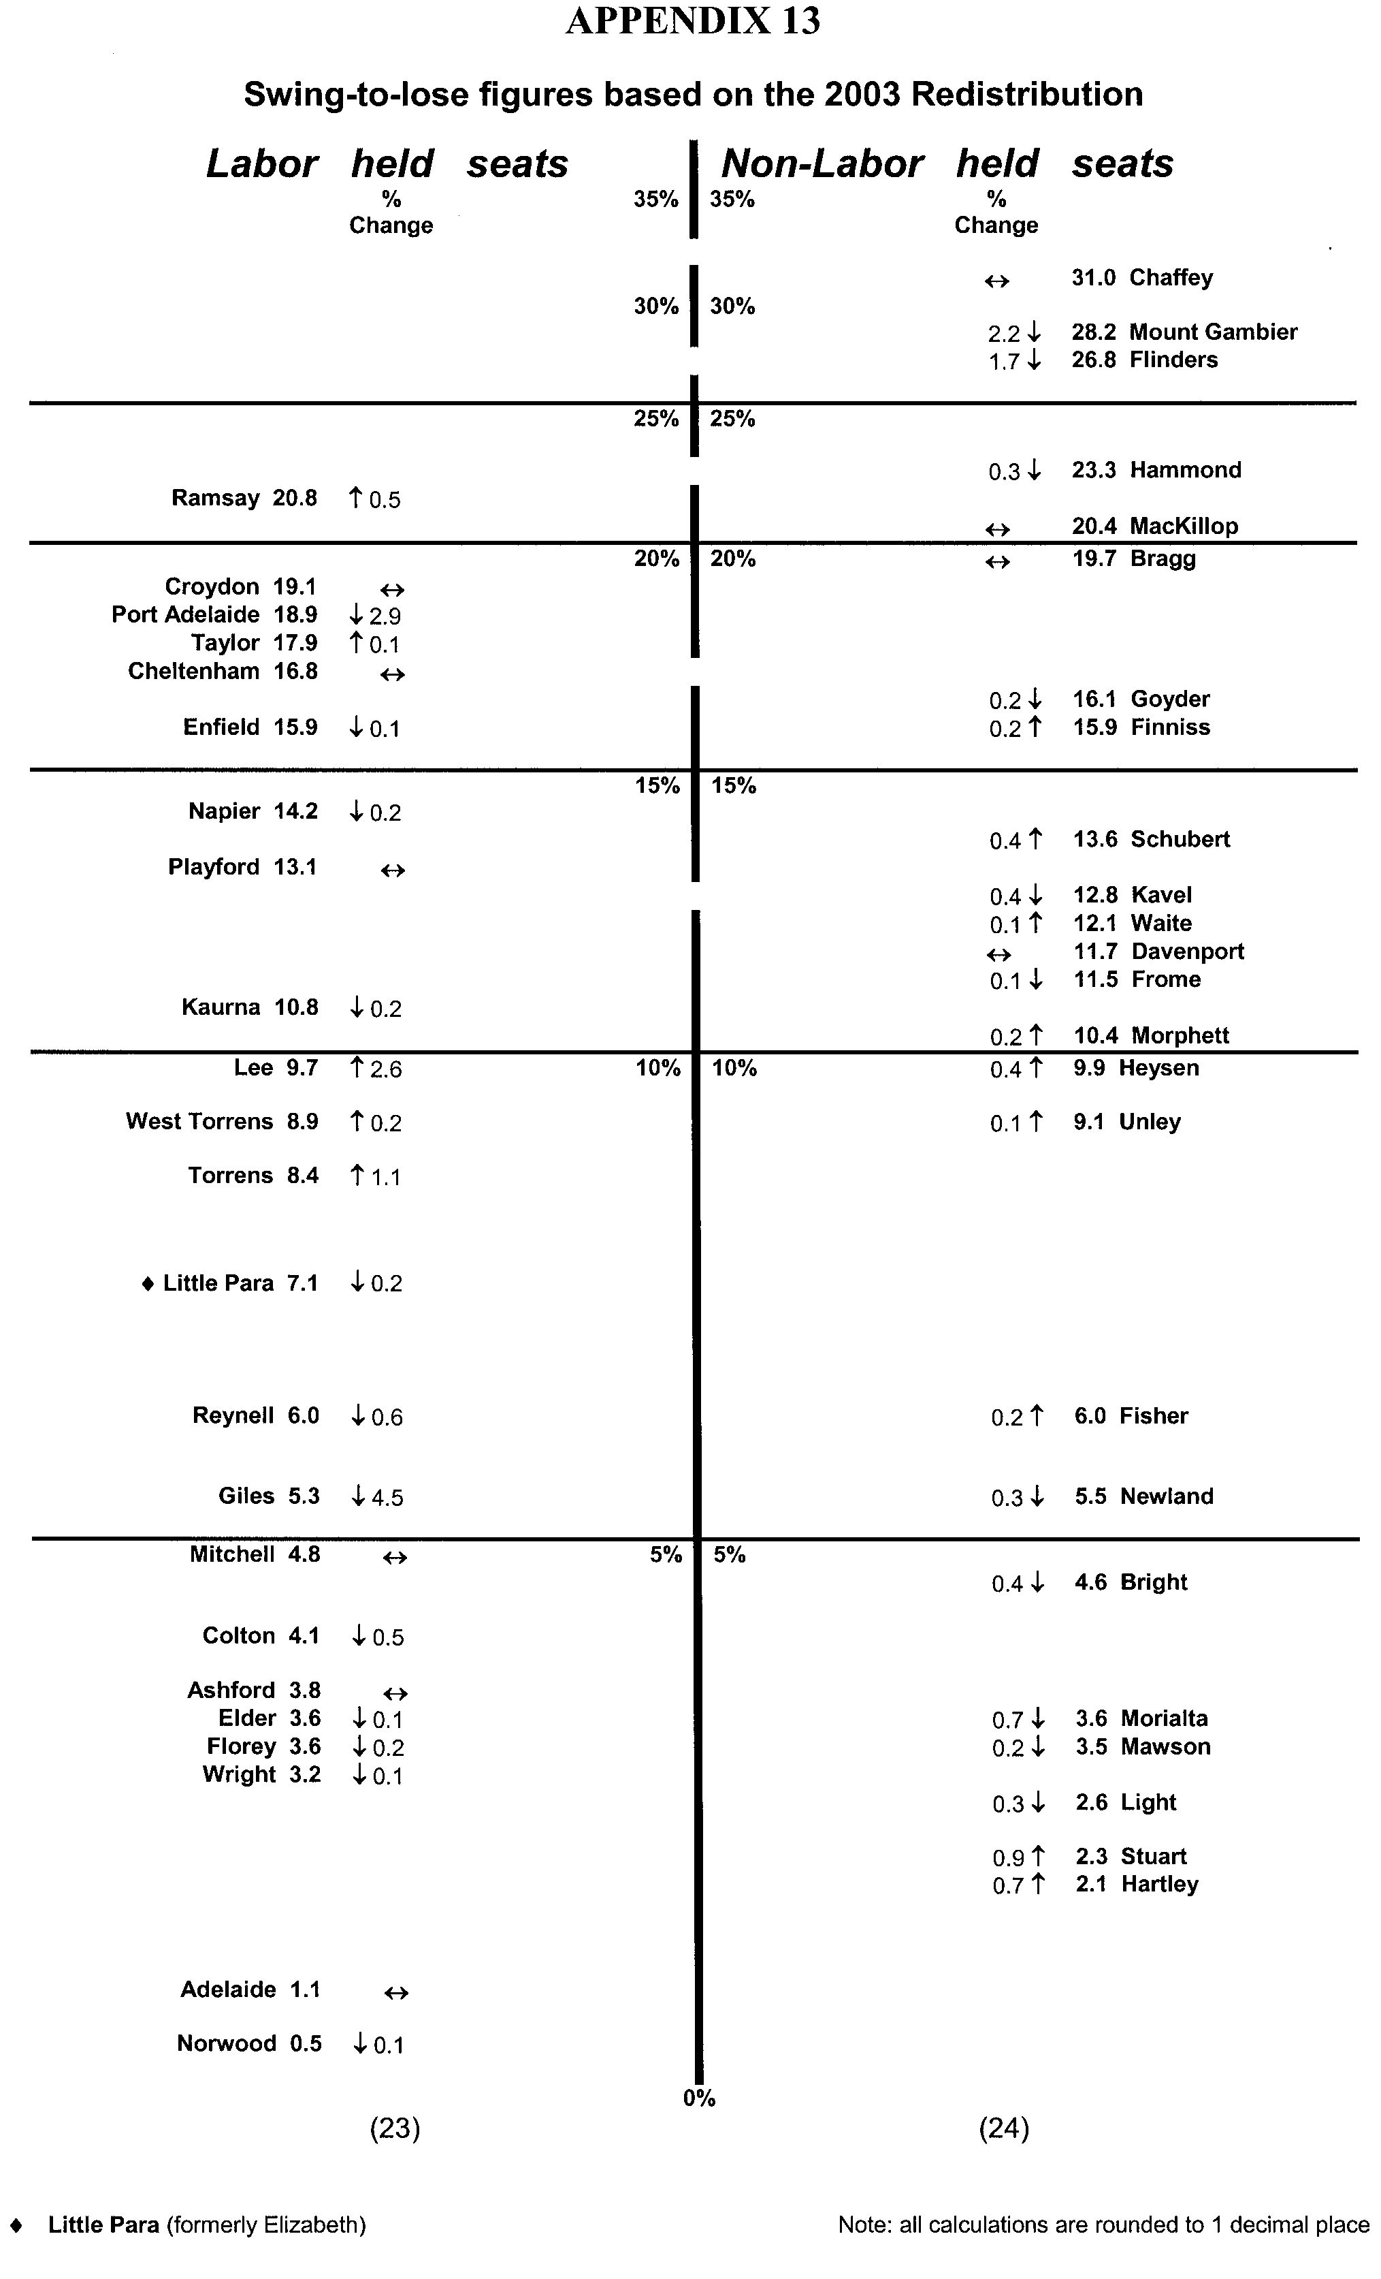


LAND AND BUSINESS (SALE AND CONVEYANCING)
ACT 1994
Exemption
TAKE notice that, pursuant to section 23 (3) of the Land and Business (Sale and Conveyancing) Act 1994, I, Karlene Maywald, Minister for Consumer Affairs, do hereby exempt the person named in Schedule 1 from the application of section 23 (2) of the Act in relation to the purchase of the land specified in Schedule 2.
Schedule 1
Christine Joy Obst, an employee of Kies Real Estate Pty Ltd.
Schedule 2
The whole of the land described in certificate of title register book volume 5730, folio 66, situated at 97 Goodman Road, Elizabeth South, S.A. 5112.
Dated 17 November 2005.
Signed for and on behalf of the Minister for Consumer Affairs by the Commissioner for Consumer Affairs.
M. Bodycoat, Commissioner

LIQUOR LICENSING ACT 1997
Notice of Application
NOTICE is hereby given, pursuant to section 52 (2) (b) of the Liquor Licensing Act 1997, that Agostino Danieli Trimarchi has applied to the Licensing Authority for the transfer of a Restaurant Licence in respect of premises situated at 24 Saltfleet Street, Port Noarlunga, S.A. 5167 and known as Kasbah Cafe.
The application has been set down for hearing on 19 December 2005 at 11.30 a.m.
Any person may object to the application by lodging a notice of objection in the prescribed form with the Licensing Authority, and serving a copy of the notice on the applicant at the applicant’s address given above, at least seven days before the hearing date (viz: 9 December 2005).
The applicant’s address for service is c/o Tom Manolakis, P.O. Box 521, Salisbury, S.A. 5108.
Plans in respect of the premises the subject of the application are open to public inspection without fee at the Office of the Liquor and Gambling Commissioner, 9th Floor, East Wing, 50 Grenfell Street, Adelaide, S.A. 5000. Phone 8226 8410, Fax:
8226 8512. Email: olgc@agd.sa.gov.au.
Dated 9 November 2005.
Applicant

LIQUOR LICENSING ACT 1997
Notice of Application
NOTICE is hereby given, pursuant to section 52 (2) (b) of the Liquor Licensing Act 1997, that Thomas Edward Nelson and Roderick Frank Grant have applied to the Licensing Authority for the transfer of a Restaurant Licence in respect of premises situated at 840 Lower North East Road, Dernancourt, S.A. 5075 and known as Marcellina Pizza Bar & Rotisserie and to be known as Marcellina Pizza Bar Restaurant—Dernancourt.
The application has been set down for hearing on 19 December 2005 at 10.30 a.m.
Any person may object to the application by lodging a notice of objection in the prescribed form with the Licensing Authority, and serving a copy of the notice on the applicants at the applicants’ address given above, at least seven days before the hearing date (viz: 9 December 2005).
The applicants’ address for service is c/o Cowell Clarke, Level 5, 63 Pirie Street, Adelaide, S.A. 5000.
Plans in respect of the premises the subject of the application are open to public inspection without fee at the Office of the Liquor and Gambling Commissioner, 9th Floor, East Wing, 50 Grenfell Street, Adelaide, S.A. 5000. Phone 8226 8410, Fax:
8226 8512. Email: olgc@agd.sa.gov.au.
Dated 8 November 2005.
Applicants

LIQUOR LICENSING ACT 1997
Notice of Application
NOTICE is hereby given, pursuant to section 52 (2) (b) of the Liquor Licensing Act 1997, that Eric John Ott has applied to the Licensing Authority for Redefinition, variation to Extended Trading Authorisation and variation to Entertainment Consent in respect of premises situated at 173 Hindley Street, Adelaide, S.A. 5000 and known as Enigma Bar.
The application has been set down for hearing on 9 December 2005 at 9 a.m.
Conditions
The following licence conditions are sought:
• Redefinition of the licensed area to include a new outdoor area at the rear of the premises as per plans lodged with this office.
• Variation to Extended Trading Authorisation to include the abovementioned area.
• Variation to Extended Trading Authorisation to apply to the whole of the premises:
Good Friday: Midnight to 2 a.m.;
Christmas Day: Midnight to 2 a.m.;
Sunday Christmas Eve: 8 p.m. to 2 a.m. the following day.
• Variation to Entertainment Consent to apply to the above-mentioned hours.
Any person may object to the application by lodging a notice of objection in the prescribed form with the Licensing Authority, and serving a copy of the notice on the applicant at the applicant’s address given above, at least seven days before the hearing date (viz: 1 December 2005).
The applicant’s address for service is c/o Kelly & Co., Santos House, Level 17, 91 King William Street, Adelaide, S.A. 5000.
Plans in respect of the premises the subject of the application are open to public inspection without fee at the Office of the Liquor and Gambling Commissioner, 9th Floor, East Wing, 50 Grenfell Street, Adelaide, S.A. 5000. Phone 8226 8410, Fax:
8226 8512. Email: olgc@agd.sa.gov.au.
Dated 7 November 2005.
Applicant

LIQUOR LICENSING ACT 1997
Notice of Application
NOTICE is hereby given, pursuant to section 52 (2) (b) of the Liquor Licensing Act 1997, that Gustavo Eduardo Trujillo Cedeno and Samuel David Valderrama Escobar have applied to the Licensing Authority for a Wholesale Liquor Merchant’s Licence in respect of premises situated at 26A Colby Place, Adelaide, S.A. 5000 and known as IDI Importers, Distributors & Investment Group.
The application has been set down for hearing on 16 December 2005 at 9 a.m.
Any person may object to the application by lodging a notice of objection in the prescribed form with the Licensing Authority, and serving a copy of the notice on the applicants at the applicants’ address given above, at least seven days before the hearing date (viz: 8 December 2005).
The applicants’ address for service is c/o David Watts, 1 Cator Street, Glenside, S.A. 5065.
Plans in respect of the premises the subject of the application are open to public inspection without fee at the Office of the Liquor and Gambling Commissioner, 9th Floor, East Wing, 50 Grenfell Street, Adelaide, S.A. 5000. Phone 8226 8410, Fax:
8226 8512. Email: olgc@agd.sa.gov.au.
Dated 10 November 2005.
Applicants

LIQUOR LICENSING ACT 1997
Notice of Application
NOTICE is hereby given, pursuant to section 52 (2) (b) of the Liquor Licensing Act 1997, that Montego Estate Wines Pty Ltd has applied to the Licensing Authority for a Wholesale Liquor Merchant’s Licence in respect of premises situated at 1 Holidays Road, Summertown, S.A. 5141 and to be known as Montego Estate Wines.
The application has been set down for hearing on 16 December 2005 at 9 a.m.
Any person may object to the application by lodging a notice of objection in the prescribed form with the Licensing Authority, and serving a copy of the notice on the applicant at the applicant’s address given above, at least seven days before the hearing date (viz: 8 December 2005).
The applicant’s address for service is c/o David Watts, 1 Cator Street, Glenside, S.A. 5065.
Plans in respect of the premises the subject of the application are open to public inspection without fee at the Office of the Liquor and Gambling Commissioner, 9th Floor, East Wing, 50 Grenfell Street, Adelaide, S.A. 5000. Phone 8226 8410, Fax:
8226 8512. Email: olgc@agd.sa.gov.au.
Dated 9 November 2005.
Applicant

LIQUOR LICENSING ACT 1997
Notice of Application
NOTICE is hereby given, pursuant to section 52 (2) (b) of the Liquor Licensing Act 1997, that Pancake House Adelaide Pty Ltd as trustee for the Pancake House Trust has applied to the Licensing Authority for the transfer of a Restaurant Licence in respect of premises situated at 13-15 Gilbert Place, Adelaide, S.A. 5000 and known as Gilbert Place Pancake House.
The application has been set down for hearing on 19 December 2005 at 9.30 a.m.
Any person may object to the application by lodging a notice of objection in the prescribed form with the Licensing Authority, and serving a copy of the notice on the applicant at the applicant’s address given above, at least seven days before the hearing date (viz: 9 December 2005).
The applicant’s address for service is c/o David Watts and Associates, 1 Cator Street, Glenside, S.A. 5065.
Plans in respect of the premises the subject of the application are open to public inspection without fee at the Office of the Liquor and Gambling Commissioner, 9th Floor, East Wing, 50 Grenfell Street, Adelaide, S.A. 5000. Phone 8226 8410, Fax:
8226 8512. Email: olgc@agd.sa.gov.au.
Dated 7 November 2005.
Applicant

LIQUOR LICENSING ACT 1997
Notice of Application
NOTICE is hereby given, pursuant to section 52 (2) (b) of the Liquor Licensing Act 1997, that Spook Hill Wines Pty Ltd has applied to the Licensing Authority for a Producer’s Licence in respect of premises situated at 21 River Terrace, Cadell, S.A. 5321 and to be known as Spook Hill Wines.
The application has been set down for hearing on 16 December 2005 at 9 a.m.
Any person may object to the application by lodging a notice of objection in the prescribed form with the Licensing Authority, and serving a copy of the notice on the applicant at the applicant’s address given above, at least seven days before the hearing date (viz: 8 December 2005).
The applicant’s address for service is c/o Jock Gordon, Box 335, Cadell, S.A. 5321.
Plans in respect of the premises the subject of the application are open to public inspection without fee at the Office of the Liquor and Gambling Commissioner, 9th Floor, East Wing, 50 Grenfell Street, Adelaide, S.A. 5000. Phone 8226 8410, Fax:
8226 8512. Email: olgc@agd.sa.gov.au.
Dated 11 November 2005.
Applicant

LIQUOR LICENSING ACT 1997
Notice of Application
NOTICE is hereby given, pursuant to section 52 (2) (b) of the Liquor Licensing Act 1997, that Barr- Vinum Pty Ltd has applied to the Licensing Authority for a Producer’s Licence in respect of premises situated at 6-8 Washington Street, Angaston, S.A. 5353 and to be known as Barr- Vinum.
The application has been set down for hearing on 16 December 2005 at 9 a.m.
Any person may object to the application by lodging a notice of objection in the prescribed form with the Licensing Authority, and serving a copy of the notice on the applicant at the applicant’s address given above, at least seven days before the hearing date (viz: 8 December 2005).
The applicant’s address for service is c/o Wallmans Lawyers, 173 Wakefield Street, Adelaide, S.A. 5000 (Attention: Peter Hoban or Ben Allen).
Plans in respect of the premises the subject of the application are open to public inspection without fee at the Office of the Liquor and Gambling Commissioner, 9th Floor, East Wing, 50 Grenfell Street, Adelaide, S.A. 5000. Phone 8226 8410, Fax:
8226 8512. Email: olgc@agd.sa.gov.au.
Dated 11 November 2005.
Applicant

LIQUOR LICENSING ACT 1997
Notice of Application
NOTICE is hereby given, pursuant to section 52 (2) (b) of the Liquor Licensing Act 1997, that Morphett Arms Hotel Pty Ltd has applied to the Licensing Authority for alterations and redefinition of the Licensed Premises, variation to Entertainment Consent, variation to Extended Trading Authorisation and variation to Licence Conditions in respect of premises situated at 138 Morphett Road, Glengowrie, S.A. 5044 and known as Morphett Arms Hotel.
The application has been set down for hearing on 16 December 2005 at 9 a.m.
Conditions
The following licence conditions are sought:
• Alterations and redefinition of the licensed premises to add the area outlined in red as per plans lodged with this office.
• Variation to Entertainment Consent attaching to the licensed premises to add Areas 3, 4 and 7.
• Variation to the Extended Trading Authorisation (with Entertainment Consent except for the new area) to apply to the whole of the licensed premises including the new area for on licence consumption:
Monday to Saturday: Midnight to 2 a.m. the following day (except the new area).
Sunday: 8 a.m. to 11 a.m. and 8 p.m. to 2 a.m. the following day (except the new area where Extended Trading Authorisation will apply from 8 p.m. to midnight).
Christmas Day and Good Friday: Midnight to 2 a.m. (except the new area).
• Variation to the conditions of licence as follows:
By deleting Condition 1 which reads ‘There is to be no live entertainment between midnight and 2 a.m.’.
By varying Condition 2 by relieving the licensee from the obligation to provide a licensed security person Sunday to Tuesday (inclusive).
By deleting Condition 3 which reads ‘Subject to satisfactory approvals, I note the licensee proposes to close the exit door to the courtyard at 12.30 a.m. when the Exended Trading Authorisation is utilised’.
Any person may object to the application by lodging a notice of objection in the prescribed form with the Licensing Authority, and serving a copy of the notice on the applicant at the applicant’s address given above, at least seven days before the hearing date (viz: 8 December 2005).
The applicant’s address for service is c/o Wallmans Lawyers, 173 Wakefield Street, Adelaide, S.A. 5000 (Attention: Peter Hoban or Ben Allen).
Plans in respect of the premises the subject of the application are open to public inspection without fee at the Office of the Liquor and Gambling Commissioner, 9th Floor, East Wing, 50 Grenfell Street, Adelaide, S.A. 5000. Phone 8226 8410, Fax:
8226 8512. Email: olgc@agd.sa.gov.au.
Dated 14 November 2005.
Applicant

LIQUOR LICENSING ACT 1997
Notice of Application
NOTICE is hereby given, pursuant to section 52 (2) (b) of the Liquor Licensing Act 1997, that Falanga Enterprises Pty Ltd as trustee for Falanga Family Trust has applied to the Licensing Authority for a Restaurant Licence in respect of premises situated at Shop 3, 453 Fullarton Road, Highgate, S.A. 5063 and to be known as Highgate Mall Cafe.
The application has been set down for hearing on 16 December 2005 at 9 a.m.
Any person may object to the application by lodging a notice of objection in the prescribed form with the Licensing Authority, and serving a copy of the notice on the applicant at the applicant’s address given above, at least seven days before the hearing date (viz: 8 December 2005).
The applicant’s address for service is c/o Tony Falanga, P.O. Box 3374, Port Adelaide, S.A. 5015.
Plans in respect of the premises the subject of the application are open to public inspection without fee at the Office of the Liquor and Gambling Commissioner, 9th Floor, East Wing, 50 Grenfell Street, Adelaide, S.A. 5000. Phone 8226 8410, Fax:
8226 8512. Email: olgc@agd.sa.gov.au.
Dated 10 November 2005.
Applicant

LIQUOR LICENSING ACT 1997
Notice of Application
NOTICE is hereby given, pursuant to section 52 (2) (b) of the Liquor Licensing Act 1997, that Terroir Selections Pty Ltd has applied to the Licensing Authority for a Direct Sales Licence in respect of premises situated at 248 Flinders Street, Adelaide, S.A. 5000 and to be known as Terroir Selections.
The application has been set down for hearing on 16 December 2005 at 9 a.m.
Any person may object to the application by lodging a notice of objection in the prescribed form with the Licensing Authority, and serving a copy of the notice on the applicant at the applicant’s address given above, at least seven days before the hearing date (viz: 8 December 2005).
The applicant’s address for service is c/o Wallmans Lawyers, 173 Wakefield Street, Adelaide, S.A. 5000 (Attention: Peter Hoban or Ben Allen).
Plans in respect of the premises the subject of the application are open to public inspection without fee at the Office of the Liquor and Gambling Commissioner, 9th Floor, East Wing, 50
Grenfell Street, Adelaide, S.A. 5000. Phone 8226 8410, Fax:
8226 8512. Email: olgc@agd.sa.gov.au.
Dated 10 November 2005.
Applicant

LIQUOR LICENSING ACT 1997
Notice of Application
NOTICE is hereby given, pursuant to section 52 (2) (b) of the Liquor Licensing Act 1997, that Wayne Gilbert Ahrens and Suzanne Louise Hilder have applied to the Licensing Authority for a Wholesale Liquor Merchant’s Licence in respect of premises situated at 13 Murray Street, Angaston, S.A. 5355 and to be known as Smallfry Wines.
The application has been set down for hearing on 16 December 2005 at 9 a.m.
Any person may object to the application by lodging a notice of objection in the prescribed form with the Licensing Authority, and serving a copy of the notice on the applicants at the applicants’ address given above, at least seven days before the hearing date (viz: 8 December 2005).
The applicants’ address for service is c/o Heuzenroeder & Heuzenroeder, 49 Murray Street, Tanunda, S.A. 5352.
Plans in respect of the premises the subject of the application are open to public inspection without fee at the Office of the Liquor and Gambling Commissioner, 9th Floor, East Wing, 50 Grenfell Street, Adelaide, S.A. 5000. Phone 8226 8410, Fax:
8226 8512. Email: olgc@agd.sa.gov.au.
Dated 9 November 2005.
Applicants

LIQUOR LICENSING ACT 1997
Notice of Application
NOTICE is hereby given, pursuant to section 52 (2) (b) of the Liquor Licensing Act 1997, that Wayne Gilbert Ahrens and Suzanne Louise Hilder have applied to the Licensing Authority for a Producer’s Licence in respect of premises situated at 13 Murray Street, Angaston, S.A. 5355 and to be known as Smallfry Wines.
The application has been set down for hearing on 16 December 2005 at 9 a.m.
Any person may object to the application by lodging a notice of objection in the prescribed form with the Licensing Authority, and serving a copy of the notice on the applicants at the applicants’ address given above, at least seven days before the hearing date (viz: 8 December 2005).
The applicants’ address for service is c/o Heuzenroeder & Heuzenroeder, 49 Murray Street, Tanunda, S.A. 5352.
Plans in respect of the premises the subject of the application are open to public inspection without fee at the Office of the Liquor and Gambling Commissioner, 9th Floor, East Wing, 50 Grenfell Street, Adelaide, S.A. 5000. Phone 8226 8410, Fax:
8226 8512. Email: olgc@agd.sa.gov.au.
Dated 9 November 2005.
Applicants

LIQUOR LICENSING ACT 1997
Notice of Application
NOTICE is hereby given, pursuant to section 52 (2) (b) of the Liquor Licensing Act 1997, that AAA Star Entertainment Pty Ltd has applied to the Licensing Authority for the transfer of a Special Circumstances Licence in respect of premises situated at 58-60 North Terrace, Adelaide, S.A. 5000, known as Lah-Di-Dahs Nightclub and to be known as Rapture.
The application has been set down for hearing on 13 December 2005 at 11.30 a.m.
Any person may object to the application by lodging a notice of objection in the prescribed form with the Licensing Authority, and serving a copy of the notice on the applicant at the applicant’s address given above, at least seven days before the hearing date (viz: 5 December 2005).
The applicant’s address for service is c/o Adrian Battiston, SGIC Building, Level 15, 211 Victoria Square, Adelaide, S.A. 5000.
Plans in respect of the premises the subject of the application are open to public inspection without fee at the Office of the Liquor and Gambling Commissioner, 9th Floor, East Wing, 50 Grenfell Street, Adelaide, S.A. 5000. Phone 8226 8410, Fax:
8226 8512. Email: olgc@agd.sa.gov.au.
Dated 7 November 2005.
Applicant

LIQUOR LICENSING ACT 1997
Notice of Application
NOTICE is hereby given, pursuant to section 52 (2) (b) of the Liquor Licensing Act 1997, that John Garth Willoughby has applied to the Licensing Authority for the removal of a Producer’s Licence in respect of premises situated at 19 Flinders Avenue, Kingscote, Kangaroo Island, S.A. 5223 and to be situated at Lot 3, Deposited Plan 17704, Section 398, Cordes Road, Kingscote, Kangaroo Island, S.A. 5223 and known as Bay of Shoals Wines.
The application has been set down for hearing on 9 December 2005 at 9 a.m.
Any person may object to the application by lodging a notice of objection in the prescribed form with the Licensing Authority, and serving a copy of the notice on the applicant at the applicant’s address given above, at least seven days before the hearing date (viz: 1 December 2005).
The applicant’s address for service is c/o John Willoughby, 19 Flinders Avenue, Kingscote, Kangaroo Island, S.A. 5223.
Plans in respect of the premises the subject of the application are open to public inspection without fee at the Office of the Liquor and Gambling Commissioner, 9th Floor, East Wing, 50 Grenfell Street, Adelaide, S.A. 5000. Phone 8226 8410, Fax:
8226 8512. Email: olgc@agd.sa.gov.au.
Dated 9 November 2005.
Applicant

LIQUOR LICENSING ACT 1997
Notice of Application
NOTICE is hereby given, pursuant to section 52 (2) (b) of the Liquor Licensing Act 1997, that Herbert Schmidt and Laurentia Schmidt have applied to the Licensing Authority for the transfer of a Residential Licence in respect of premises situated at 197-199 O’Connell Street, North Adelaide, S.A. 5006 and known as O’Connell Motor Inn.
The application has been set down for hearing on 20 December 2005 at 9 a.m.
Any person may object to the application by lodging a notice of objection in the prescribed form with the Licensing Authority, and serving a copy of the notice on the applicants at the applicants’ address given above, at least seven days before the hearing date (viz: 12 December 2005).
The applicants’ address for service is c/o Laurentia Schmidt,
3 Hamilton Road, Fairview Park, S.A. 5123.
Plans in respect of the premises the subject of the application are open to public inspection without fee at the Office of the Liquor and Gambling Commissioner, 9th Floor, East Wing, 50 Grenfell Street, Adelaide, S.A. 5000. Phone 8226 8410, Fax:
8226 8512. Email: olgc@agd.sa.gov.au.
Dated 8 November 2005.
Applicants

LIQUOR LICENSING ACT 1997
Notice of Application
NOTICE is hereby given, pursuant to section 52 (2) (b) of the Liquor Licensing Act 1997, that Mischa Nominees Pty Ltd has applied to the Licensing Authority for the transfer of a Hotel Licence in respect of premises situated at 160 The Terrace, Port Pirie, S.A. 5540 and known as Federal Hotel.
The application has been set down for hearing on 20 December 2005 at 10 a.m.
Any person may object to the application by lodging a notice of objection in the prescribed form with the Licensing Authority, and serving a copy of the notice on the applicant at the applicant’s address given above, at least seven days before the hearing date (viz: 12 December 2005).
The applicant’s address for service is c/o Piper Alderman, 167 Flinders Street, Adelaide, S.A. 5000 (Attention: Geoff Forbes).
Plans in respect of the premises the subject of the application are open to public inspection without fee at the Office of the Liquor and Gambling Commissioner, 9th Floor, East Wing, 50 Grenfell Street, Adelaide, S.A. 5000. Phone 8226 8410, Fax:
8226 8512. Email: olgc@agd.sa.gov.au.
Dated 9 November 2005.
Applicant

LIQUOR LICENSING ACT 1997
Notice of Application
NOTICE is hereby given, pursuant to section 52 (2) (b) of the Liquor Licensing Act 1997, that Kenneth John Stott and Anne Margaret Stott have applied to the Licensing Authority for the transfer of a Hotel Licence in respect of premises situated at Wendouree Road, Clare, S.A. 5433 and known as Salt N Vines Bar & Bistro.
The application has been set down for hearing on 21 December 2005 at 10 a.m.
Any person may object to the application by lodging a notice of objection in the prescribed form with the Licensing Authority, and serving a copy of the notice on the applicants at the applicants’ address given above, at least seven days before the hearing date (viz: 13 December 2005).
The applicants’ address for service is c/o Kenneth Stott, P.O. Box 528, Clare, S.A. 5453.
Plans in respect of the premises the subject of the application are open to public inspection without fee at the Office of the Liquor and Gambling Commissioner, 9th Floor, East Wing, 50 Grenfell Street, Adelaide, S.A. 5000. Phone 8226 8410, Fax:
8226 8512. Email: olgc@agd.sa.gov.au.
Dated 9 November 2005.
Applicants

LIQUOR LICENSING ACT 1997
Notice of Application
NOTICE is hereby given, pursuant to section 52 (2) (b) of the Liquor Licensing Act 1997, that Liqum Pty Ltd has applied to the Licensing Authority for the transfer of a Restaurant Licence in respect of premises situated at 97-99 O’Connell Street, North Adelaide, S.A. 5006 and known as Scuzzi.
The application has been set down for hearing on 21 December 2005 at 10.30 a.m.
Any person may object to the application by lodging a notice of objection in the prescribed form with the Licensing Authority, and serving a copy of the notice on the applicant at the applicant’s address given above, at least seven days before the hearing date (viz: 13 December 2005).
The applicant’s address for service is c/o Luke Dean, 97-99 O’Connell Street, North Adelaide, S.A. 5006.
Plans in respect of the premises the subject of the application are open to public inspection without fee at the Office of the Liquor and Gambling Commissioner, 9th Floor, East Wing, 50 Grenfell Street, Adelaide, S.A. 5000. Phone 8226 8410, Fax:
8226 8512. Email: olgc@agd.sa.gov.au.
Dated 11 November 2005.
Applicant

LIQUOR LICENSING ACT 1997
Notice of Application
NOTICE is hereby given, pursuant to section 52 (2) (b) of the Liquor Licensing Act 1997, that Coco Bean Pty Ltd has applied to the Licensing Authority for the transfer of a Restaurant Licence in respect of premises situated at 281-283 Rundle Street, Adelaide, S.A. 5000 known as Cafe Frappe Adelaide and to be known as Cocolat.
The application has been set down for hearing on 22 December 2005 at 10 a.m.
Any person may object to the application by lodging a notice of objection in the prescribed form with the Licensing Authority, and serving a copy of the notice on the applicant at the applicant’s address given above, at least seven days before the hearing date (viz: 14 December 2005).
The applicant’s address for service is c/o Terena Blanton, 83 Main Road, Balhannah, S.A. 5242.
Plans in respect of the premises the subject of the application are open to public inspection without fee at the Office of the Liquor and Gambling Commissioner, 9th Floor, East Wing, 50 Grenfell Street, Adelaide, S.A. 5000. Phone 8226 8410, Fax:
8226 8512. Email: olgc@agd.sa.gov.au.
Dated 9 November 2005.
Applicant

LIQUOR LICENSING ACT 1997
Notice of Application
NOTICE is hereby given, pursuant to section 52 (2) (b) of the Liquor Licensing Act 1997, that Son Thanh Phan and Dat Ngoc Nguyen as trustees for Henry Family Trust have applied to the Licensing Authority for the transfer of a Restaurant Licence in respect of premises situated at 14-15 Kilkenny Road, Woodville Park, S.A. 5011 and known as Lam-Phuong Restaurant and to be known as Vien Xu Vietnamese & Chinese Restaurant.
The application has been set down for hearing on 22 December 2005 at 11 a.m.
Any person may object to the application by lodging a notice of objection in the prescribed form with the Licensing Authority, and serving a copy of the notice on the applicants at the applicants’ address given above, at least seven days before the hearing date (viz: 14 December 2005).
The applicants’ address for service is c/o Duc Mai Lawyers, P.O. Box 149, Kilkenny, S.A. 5008.
Plans in respect of the premises the subject of the application are open to public inspection without fee at the Office of the Liquor and Gambling Commissioner, 9th Floor, East Wing, 50 Grenfell Street, Adelaide, S.A. 5000. Phone 8226 8410, Fax:
8226 8512. Email: olgc@agd.sa.gov.au.
Dated 11 November 2005.
Applicants

LIQUOR LICENSING ACT 1997
Notice of Application
NOTICE is hereby given, pursuant to section 52 (2) (b) of the Liquor Licensing Act 1997, that Plancor Pty Ltd as trustee for Joel Steinberg Trust has applied to the Licensing Authority for the transfer of a Residential Licence in respect of premises situated at 21-29 Melbourne Street, North Adelaide, S.A. 5006 and known as Meridien Lodge.
The application has been set down for hearing on 15 December 2005 at 10 a.m.
Any person may object to the application by lodging a notice of objection in the prescribed form with the Liquor and Gambling Commissioner (and serving a copy of the notice on the applicant) before the hearing date.
The applicant’s address for service is c/o Piper Alderman, 167 Flinders Street, Adelaide, S.A. 5000 (Attention: Tony Britten-Jones).
Plans in respect of the premises the subject of the application are open to public inspection without fee at the Office of the Liquor and Gambling Commissioner, 9th Floor, East Wing, 50 Grenfell Street, Adelaide, S.A. 5000. Phone 8226 8410, Fax:
8226 8512. Email: olgc@agd.sa.gov.au.
Dated 15 November 2005.
Applicant

LIQUOR LICENSING ACT 1997
Notice of Application
NOTICE is hereby given, pursuant to section 52 (2) (b) of the Liquor Licensing Act 1997, that Ceduna Community Hotel Ltd has applied to the Licensing Authority for Alterations, variation to Extended Trading Authorisation, variation to Entertainment Consent and an order of the Liquor and Gambling Commissioner in respect of premises situated at O’Loughlin Terrace, Ceduna, S.A. 5690 and known as Ceduna Foreshore Hotel Motel.
The application has been set down for hearing on 16 December 2005 at 9 a.m.
Conditions
The following licence conditions are sought:
• Alterations to the licensed premises as per plans lodged with this office.
• Variation to Extended Trading Authorisation to include the whole of the licensed premises to include Sundays from 9 p.m. to midnight as outlined in pink on the plans lodged with the application.
• Variation to Entertainment Consent to include the new Sports Bar, Saloon Bar, Lounge, Dining, Deck, Functions 1 and 2 and Alfresco area as outlined in blue on the plans lodged with the application.
• Variation to Extended Trading Authorisation to include Christmas Day and Good Friday from midnight to 2 a.m. to apply to the whole of the licensed premises including Entertainment Consent.
• A temporary facility providing liquor and gaming will be utilised during the reconstruction period trading under the terms and conditions of the current licence.
Any person may object to the application by lodging a notice of objection in the prescribed form with the Licensing Authority, and serving a copy of the notice on the applicant at the applicant’s address given above, at least seven days before the hearing date (viz: 8 December 2005).
The applicant’s address for service is c/o Wallmans Lawyers, 173 Wakefield Street, Adelaide, S.A. 5000 (Attention: Peter Hoban or Ben Allen).
Plans in respect of the premises the subject of the application are open to public inspection without fee at the Office of the Liquor and Gambling Commissioner, 9th Floor, East Wing, 50 Grenfell Street, Adelaide, S.A. 5000. Phone 8226 8410, Fax:
8226 8512. Email: olgc@agd.sa.gov.au.
Dated 15 November 2005.
Applicant

MINING ACT 1971
NOTICE is hereby given in accordance with section 28 (5) of the Mining Act 1971, that the Minister for Mineral Resources Development proposes to grant an Exploration Licence over the undermentioned area:
Applicant: RMG Services Pty Ltd
Location: Hatch Hill area⎯Approximately 60 km east-south-east of Woomera.
Term: 1 year
Area in km²: 457
Ref.: 2005/00325
Plans and co-ordinates can be found on the PIRSA Sarig website: http://www.minerals.pir.sa.gov.au/sarig or by phoning Mineral Tenements on (08) 8463 3103.
H. Tyrteos, Mining Registrar

MINING ACT 1971
NOTICE is hereby given in accordance with section 28 (5) of the Mining Act 1971, that the Minister for Mineral Resources Development proposes to grant an Exploration Licence over the undermentioned area:
Applicant: Southern Gold Limited
Location: Kolendo area⎯Approximately 70 km north-north-west of Kimba.
Term: 1 year
Area in km²: 208
Ref.: 2005/00342
Plans and co-ordinates can be found on the PIRSA Sarig website: http://www.minerals.pir.sa.gov.au/sarig or by phoning Mineral Tenements on (08) 8463 3103.
H. Tyrteos, Mining Registrar

MINING ACT 1971
NOTICE is hereby given in accordance with section 28 (5) of the Mining Act 1971, that the Minister for Mineral Resources Development proposes to grant an Exploration Licence over the undermentioned area:
Applicant: Hiltaba Gold Pty Ltd
Location: Kychering area⎯Approximately 35 km west of Tarcoola.
Term: 1 year
Area in km²: 91
Ref.: 2005/00337
Plans and co-ordinates can be found on the PIRSA Sarig website: http://www.minerals.pir.sa.gov.au/sarig or by phoning Mineral Tenements on (08) 8463 3103.
H. Tyrteos, Mining Registrar

MINING ACT 1971
NOTICE is hereby given in accordance with section 28 (5) of the Mining Act 1971, that the Minister for Mineral Resources Development proposes to grant an Exploration Licence over the undermentioned area:
Applicant: Havilah Resources NL
Location: Oratan area⎯Approximately 80 km south-west of Olary.
Term: 1 year
Area in km²: 118
Ref.: 2005/00500
Plans and co-ordinates can be found on the PIRSA Sarig website: http://www.minerals.pir.sa.gov.au/sarig or by phoning Mineral Tenements on (08) 8463 3103.
H. Tyrteos, Mining Registrar

NATIONAL ELECTRICITY LAW
Notice under Section 99
Draft Rule Determination
Draft National Electricity Amendment (Timely Information to NEMMCO After Operating Incidents) Rule 2005
THE Australian Energy Market Commission (Commission) gives notice under section 99 of the National Electricity Law (NEL) of a draft Rule determination in relation to Registered Participants providing timely information in response to a request from NEMMCO after power system operating incidents.
This Rule proposal was received by NECA (the Commission’s predecessor) on 19 April 2005. Under the NEL transitional provisions, consideration of this Rule proposal became the Commission’s responsibility on 1 July 2005.
The draft Rule determination, including the draft of the Rule to be made, is published on the Commission’s website and is available for inspection at the offices of the Commission.
The Commission invites written submissions from any person or body in relation to the draft Rule determination. The Com-
mission’s policy is to promptly publish all submissions on its website upon receipt, subject to any claim of confidentiality that is maintained in accordance with the NEL.
Submissions must be received no later than 6 January 2006.
A person who has made submissions may request the Commission to hold a hearing in relation to a draft Rule determination, in accordance with section 101 of the NEL. The request must be in writing and must be made no later than 25 November 2005.

Postal Address:  P.O. Box H166  Australia Square, N.S.W. 1215 | Offices:  Level 16, 1 Margaret Street,  Sydney, N.S.W. 2000
Facsimile:  (02) 8296 7899 | Email to request hearing:  aemc@aemc.gov.au
Email for submissions:  submissions@aemc.gov.au | Website:  www.aemc.gov.au
J. Tamblyn, Chairman, Australian Energy Market Commission

NATIONAL PARKS AND WILDLIFE ACT 1972
Co-management Agreement—Vulkathunha-Gammon Ranges National Park
I, JOHN HILL, Minister for Environment and Conservation, hereby give notice under section 43F (6) of the National Parks and Wildlife Act 1972, that on 7 November 2005, a co-management agreement was entered into for the Vulkathunha-Gammon Ranges National Park between the Minister for Environment and Conservation for the State of South Australia, and the Adnyamathanha Traditional Lands Association.
Dated 7 November 2005.
J. Hill, Minister for Environment and Conservation

NATIONAL PARKS AND WILDLIFE ACT 1972
Red Banks Conservation Park Management Plan—Draft
I, GREG LEAMAN, Director of National Parks and Wildlife, hereby give notice under the provisions of section 38 of the National Parks and Wildlife Act 1972, that a draft management plan has been proposed for Red Banks Conservation Park.
Copies of the plan may be inspected at or obtained from the offices of the Department for Environment and Heritage at:
• 1 Richmond Road, Keswick, S.A. 5035 (G.P.O. Box 1047, Adelaide, S.A. 5001), telephone 8124 4700;
• Northern and Yorke Regional Office, (Unit 6, 17 Lennon Street, Clare, S.A. 5453), telephone 8841 3400;
• http://www.environment.sa.gov.au/parks/management_plans.html.
For general enquiries, please contact the DEH Information Line, telephone 8204 1910 or e-mail:
dehinformation@saugov.sa.gov.au.
Any person may make representations in connection with the draft management plan during the period up to and including Friday, 17 February 2006.
Written comments should be forwarded to the Manager, Policy and Planning, Department for Environment and Heritage, G.P.O. Box 1047, Adelaide, S.A. 5001 or e-mailed to:
irving.jason@saugov.sa.gov.au.
G. Leaman, Director of National Parks and Wildlife, Delegate of the Minister for Environment and Conservation

PETROLEUM ACT 2000
Grant of Geothermal Exploration Licence—GEL 211
NOTICE is hereby given that the undermentioned Geothermal Exploration Licence has been granted under the provisions of the Petroleum Act 2000, pursuant to delegated powers dated 28 March 2002, Gazetted 11 April 2002, page 1573.

No. of Licence | Licensee | Locality | Area in  km² | Reference
GEL 211 | Geodynamics Limited | Cooper Basin of South Australia | 481 | 27/02/344

Description of Area
All that part of the State of South Australia, bounded as follows: Commencing at a point being the intersection of latitude 27°53′00″S GDA94 and longitude 140°28′00″E GDA94, thence east to longitude 140°30′00″E GDA94, south to latitude 27°54′00″S GDA94, east to longitude 140°35′00″E GDA94, north to latitude 27°53′00″S GDA94, east to longitude 140°36′00″E GDA94, south to latitude 28°04′00″S GDA94, west to longitude 140°23′00″E GDA94, north to latitude 28°03′00″S GDA94, west to longitude 140°20′00″E GDA94, north to latitude 28°02′00″S GDA94, west to longitude 140°19′00″E GDA94, north to latitude 27°55′00″S GDA94, east to longitude 140°28′00″E GDA94, and north to the point of commencement.
Area: 481 km² approximately.
Dated 14 November 2005.
B. A. Goldstein, Director Petroleum
Minerals and Energy Resources
Primary Industries and Resources SA
Delegate of the Minister for Mineral Resources Development

PETROLEUM ACT 2000
Grant of Associated Facilities Licences—AFLs 33 and 34
(Adjunct to Petroleum Exploration Licence—PEL 106)
NOTICE is hereby given that the undermentioned Associated Facilities Licences have been granted under the provisions of the Petroleum Act 2000, pursuant to delegated powers dated 28 March 2002, Gazetted 11 April 2002, page 1573.
Description of Areas
AFL 33
All that part of the State of South Australia, bounded as follows:
A line joining points of co-ordinates:
AREA 1
391089.70mE 6919959.47mN
390169.59mE 6919489.11mN
390158.35mE 6920926.42mN
390375.73mE 6920930.17mN successively
AREA 2
389354.45mE 6919382.74mN
389946.58mE 6919385.91mN
389344.95mE 6919072.43mN successively
MGA Zone 54
Area: 0.863 km² approximately.
AFL 34
All that part of the State of South Australia, bounded as follows:
A line joining points of co-ordinates:
378233.89mE 6925464.19mN
380523.75mE 6926620.76mN
380527.03mE 6926378.11mN
380803.13mE 6926378.11mN
380810.80mE 6925151.00mN
380538.54mE 6925151.00mN
380538.54mE 6924836.55mN
380270.10mE 6924836.55mN
380270.10mE 6924525.94mN
379725.57mE 6924525.94mN
379725.57mE 6924207.65mN
379449.47mE 6924207.65mN
379453.31mE 6923590.26mN
378839.35mE 6923585.73mN successively
MGA Zone 54
Area: 4.41 km² approximately.
Dated 14 November 2005.
B. A. Goldstein
Director Petroleum
Minerals and Energy Resources
Primary Industries and Resources SA
Delegate of the Minister for Mineral Resources
Development

ROADS (OPENING AND CLOSING) ACT 1991:
SECTION 24
NOTICE OF CONFIRMATION OF ROAD
PROCESS ORDER
Road Closure, Meadows
BY Road Process Order made on 22 June 2005, The District Council of Mount Barker ordered that:
1. The whole of the unnamed public road adjoining Wattle Road and the southern boundary of allotment 927 in Filed Plan 6194 more particularly lettered ‘A’ in Preliminary Plan No. 04/0049 be closed.
2. The whole of the land subject to closure be transferred to Philip Mervyn Griggs and Karen Leanne Griggs in accordance with agreement for transfer dated 26 August 2004 entered into between The District Council of Mount Barker and P. M. and
K. L. Griggs.
3. The following easement be granted over portion of the land subject to that closure:
Grant a restricted right of way for emergency vehicular access only appurtenant to Certificate of Title Volume 5351, Folio 342.
On 10 November 2005 that order was confirmed by the Minister for Administrative Services conditionally upon the deposit by the Registrar-General of Deposited Plan 68660 being the authority for the new boundaries.
Pursuant to section 24 (5) of the Roads (Opening and Closing) Act 1991, NOTICE of the order referred to above and its confirmation is hereby given.
Dated 17 November 2005.
P. M. Kentish, Surveyor-General

ROADS (OPENING AND CLOSING) ACT 1991:
SECTION 24
NOTICE OF CONFIRMATION OF ROAD
PROCESS ORDER
Road Closure, Coonalpyn
BY Road Process Order made on 20 June 2005, The Coorong District Council ordered that:
1. The whole of the un-named public road adjoining the north-eastern boundary of allotments 101 and 102 in Deposited Plan 51775 more particularly lettered ‘A’ in Preliminary Plan No. 04/0109 be closed.
2. The whole of the land subject to closure be transferred to Ausbulk Ltd in accordance with agreement for transfer dated 18 February 2005 entered into between The Coorong District Council and Ausbulk Ltd.
3. The following easement be granted over portion of the land subject to that closure:
Grant a free and unrestricted right of way appurtenant to allotment 101 in Deposited Plan 51775 contained in Certificate of Title Volume 5683, Folio 249.
On 10 November 2005 that order was confirmed by the Minister for Administrative Services conditionally upon the deposit by the Registrar-General of Deposited Plan 68737 being the authority for the new boundaries.
Pursuant to section 24 (5) of the Roads (Opening and Closing) Act 1991, NOTICE of the order referred to above and its confirmation is hereby given.
Dated 17 November 2005.
P. M. Kentish, Surveyor-General

GOVERNMENT GAZETTE ADVERTISEMENT RATES

To apply from 1 July 2005

$  Agents, Ceasing to Act as 36.50  Associations:  Incorporation 18.60  Intention of Incorporation 46.00  Transfer of Properties 46.00  Attorney, Appointment of 36.50  Bailiff’s Sale 46.00  Cemetery Curator Appointed 27.25  Companies:  Alteration to Constitution 36.50  Capital, Increase or Decrease of 46.00  Ceasing to Carry on Business 27.25  Declaration of Dividend 27.25  Incorporation 36.50  Lost Share Certificates:  First Name 27.25  Each Subsequent Name 9.35  Meeting Final 30.50  Meeting Final Regarding Liquidator’s Report on  Conduct of Winding Up (equivalent to ‘Final  Meeting’)  First Name 36.50  Each Subsequent Name 9.35  Notices:  Call 46.00  Change of Name 18.60  Creditors 36.50  Creditors Compromise of Arrangement 36.50  Creditors (extraordinary resolution that ‘the Com-pany be wound up voluntarily and that a liquidator be appointed’) 46.00  Release of Liquidator⎯Application⎯Large Ad. 72.50  ⎯Release Granted 46.00  Receiver and Manager Appointed 42.50  Receiver and Manager Ceasing to Act 36.50  Restored Name 34.50  Petition to Supreme Court for Winding Up 64.00  Summons in Action 54.50  Order of Supreme Court for Winding Up Action 36.50  Register of Interests⎯Section 84 (1) Exempt 82.50  Removal of Office 18.60  Proof of Debts 36.50  Sales of Shares and Forfeiture 36.50  Estates:  Assigned 27.25  Deceased Persons⎯Notice to Creditors, etc. 46.00  Each Subsequent Name 9.35  Deceased Persons⎯Closed Estates 27.25  Each Subsequent Estate 1.20  Probate, Selling of 36.50  Public Trustee, each Estate 9.35 |  | $  Firms:  Ceasing to Carry on Business (each insertion) 24.30  Discontinuance Place of Business 24.30  Land⎯Real Property Act:  Intention to Sell, Notice of 46.00  Lost Certificate of Title Notices 46.00  Cancellation, Notice of (Strata Plan) 46.00  Mortgages:  Caveat Lodgment 18.60  Discharge of 19.50  Foreclosures 18.60  Transfer of 18.60  Sublet 9.35  Leases⎯Application for Transfer (2 insertions) each 9.35  Lost Treasury Receipts (3 insertions) each 27.25  Licensing 54.50  Municipal or District Councils:  Annual Financial Statement⎯Forms 1 and 2 513.00  Electricity Supply⎯Forms 19 and 20 364.00  Default in Payment of Rates:  First Name 72.50  Each Subsequent Name 9.35  Noxious Trade 27.25  Partnership, Dissolution of 27.25  Petitions (small) 18.60  Registered Building Societies (from Registrar-  General) 18.60  Register of Unclaimed Moneys⎯First Name 27.25  Each Subsequent Name 9.35  Registers of Members⎯Three pages and over:  Rate per page (in 8pt) 233.00  Rate per page (in 6pt) 308.00  Sale of Land by Public Auction 46.50  Advertisements 2.60  ¼ page advertisement 109.00  ½ page advertisement 218.00  Full page advertisement 427.00  Advertisements, other than those listed are charged at $2.60 per column line, tabular one-third extra.  Notices by Colleges, Universities, Corporations and District Councils to be charged at $2.60 per line.  Where the notice inserted varies significantly in length from that which is usually published a charge of $2.60 per column line will be applied in lieu of advertisement rates listed.  South Australian Government publications are sold on the condition that they will not be reproduced without prior permission from the Government Printer.
All the above prices include GST

GOVERNMENT GAZETTE NOTICES
ALL private advertisements forwarded for publication in the South Australian Government Gazette must be PAID FOR PRIOR TO INSERTION; and all notices, from whatever source, should be legibly written on one side of the paper only and sent to Government Publishing SA so as to be received no later than 4 p.m. Tuesday preceding the day of publication. Phone 8207 1045 or Fax 8207 1040. E-mail: governmentgazette@saugov.sa.gov.au. Send as attachments in Word format. Please include date the notice is to be published and to whom the notice will be charged. The Government Gazette is available online at: www.governmentgazette.sa.gov.au.

MISCELLANEOUS LEGISLATION AND GOVERNMENT PUBLICATIONS PRICES AS FROM 1 JULY 2005

Acts, Bills, Rules, Parliamentary Papers and Regulations
Pages | Main | Amends | Pages | Main | Amends

1-16 | 2.20 | 1.00 | 497-512 | 31.00 | 30.00
17-32 | 3.00 | 1.85 | 513-528 | 32.00 | 30.75
33-48 | 3.90 | 2.80 | 529-544 | 33.00 | 32.00
49-64 | 4.90 | 3.75 | 545-560 | 34.00 | 33.00
65-80 | 5.75 | 4.75 | 561-576 | 34.75 | 34.00
81-96 | 6.70 | 5.55 | 577-592 | 35.75 | 34.50
97-112 | 7.60 | 6.50 | 593-608 | 36.75 | 35.50
113-128 | 8.55 | 7.45 | 609-624 | 37.50 | 36.50
129-144 | 9.60 | 8.50 | 625-640 | 38.50 | 37.00
145-160 | 10.50 | 9.35 | 641-656 | 39.50 | 38.50
161-176 | 11.50 | 10.30 | 657-672 | 40.00 | 39.00
177-192 | 12.40 | 11.30 | 673-688 | 41.75 | 40.00
193-208 | 13.40 | 12.30 | 689-704 | 42.50 | 41.00
209-224 | 14.20 | 13.10 | 705-720 | 43.00 | 42.00
225-240 | 15.10 | 14.00 | 721-736 | 44.75 | 43.00
241-257 | 16.20 | 14.70 | 737-752 | 45.25 | 44.00
258-272 | 17.10 | 15.70 | 753-768 | 46.25 | 44.50
273-288 | 18.00 | 16.90 | 769-784 | 46.75 | 46.00
289-304 | 18.80 | 17.70 | 785-800 | 47.75 | 47.00
305-320 | 19.90 | 18.70 | 801-816 | 48.50 | 47.50
321-336 | 20.70 | 19.60 | 817-832 | 49.75 | 48.50
337-352 | 21.80 | 20.60 | 833-848 | 50.75 | 49.50
353-368 | 22.60 | 21.60 | 849-864 | 51.50 | 50.00
369-384 | 23.60 | 22.50 | 865-880 | 52.50 | 51.50
385-400 | 24.50 | 23.40 | 881-896 | 53.00 | 52.00
401-416 | 25.50 | 24.20 | 897-912 | 54.50 | 53.00
417-432 | 26.50 | 25.25 | 913-928 | 55.00 | 54.50
433-448 | 27.50 | 26.25 | 929-944 | 56.00 | 55.00
449-464 | 28.25 | 27.00 | 945-960 | 57.00 | 55.50
465-480 | 28.75 | 28.00 | 961-976 | 58.25 | 56.50
481-496 | 30.00 | 28.75 | 977-992 | 59.25 | 57.00

Legislation—Acts, Regulations, etc: $
Subscriptions:
Acts 192.00
All Bills as Laid 460.00
Rules and Regulations 460.00
Parliamentary Papers 460.00
Bound Acts 213.00
Index 106.00
Government Gazette
Copy 5.00
Subscription 254.00
Hansard
Copy 14.00
Subscription—per session (issued weekly) 399.00
Cloth bound—per volume 172.00
Subscription—per session (issued daily) 399.00
Legislation on Disk
Whole Database 2 951.00
Annual Subscription for fortnightly updates 907.00
Individual Act(s) including updates POA
Compendium
Subscriptions:
Subscriptions 1 749.00
Updates 617.00
(All the above prices include GST)

All Legislation, Government Gazette, Hansard and Legislation on disk are available from:
Counter Sales Service SA, Government Legislation⁺ Outlet
and Mail Orders: Lands Titles Office, 101 Grenfell Street, Adelaide, S.A. 5000
Phone: 13 23 24 (local call cost), Fax: (08) 8204 1909
Postal: G.P.O. Box 1707, Adelaide, S.A. 5001

Online Shop: www.shop.service.sa.gov.au

Subscriptions and Government Publishing SA
Standing Orders: Box 9, Plaza Level, Riverside Centre, North Terrace, Adelaide, S.A. 5000
Phone: (08) 8207 0908, (08) 8207 0910, Fax: (08) 8207 1040

South Australia
Correctional Services (Miscellaneous) Amendment Act (Commencement) Proclamation 2005
1—Short title
This proclamation may be cited as the Correctional Services (Miscellaneous) Amendment Act (Commencement) Proclamation 2005.
2—Commencement of Act
The Correctional Services (Miscellaneous) Amendment Act 2005 (No 1 of 2005) will come into operation on 17 November 2005.
Made by the Governor
with the advice and consent of the Executive Council
on 17 November 2005
CSC0018/03

South Australia
Heritage (Heritage Directions) Amendment Act (Commencement) Proclamation 2005
1—Short title
This proclamation may be cited as the Heritage (Heritage Directions) Amendment Act (Commencement) Proclamation 2005.
2—Commencement of Act
The Heritage (Heritage Directions) Amendment Act 2005 (No 39 of 2005) will come into operation on 17 November 2005.
Made by the Governor
with the advice and consent of the Executive Council
on 17 November 2005
ECO5/0065CS

South Australia
Statutes Amendment (Transport Portfolio) Act (Commencement) Proclamation 2005
1—Short title
This proclamation may be cited as the Statutes Amendment (Transport Portfolio) Act (Commencement) Proclamation 2005.
2—Commencement of Act
The Statutes Amendment (Transport Portfolio) Act 2005 (No 53 of 2005) will come into operation on 17 November 2005.
Made by the Governor
with the advice and consent of the Executive Council
on 17 November 2005
MTR05/055CS

South Australia
Correctional Services Variation Regulations 2005
under the Correctional Services Act 1982

Contents
Part 1—Preliminary
1 Short title
2 Commencement
3 Variation provisions
Part 2—Variation of Correctional Services Regulations 2001
4 Variation of regulation 4—Interpretation
5 Insertion of regulation 4A
4A Corresponding laws for purposes of section 27A of Act
6 Variation of regulation 9—Prohibited items (sections 33, 33A and 51)
7 Variation of regulation 10—Prohibited activities (section 33)
8 Variation of regulation 11—Penalties for breaches of regulations (sections 43 and 44)
9 Variation of regulation 12—Prohibited manners of communication (section 51)
10 Regulation 15—Serious breaches—miscellaneous
11 Variation of regulation 16—Serious breaches—sexual offences
12 Variation of regulation 37—Drug testing of prisoners (section 37AA)

Part 1—Preliminary
1—Short title
These regulations may be cited as the Correctional Services Variation Regulations 2005.
2—Commencement
These regulations will come into operation on the day on which the Correctional Services (Miscellaneous) Amendment Act 2005 comes into operation.
3—Variation provisions
In these regulations, a provision under a heading referring to the variation of specified regulations varies the regulations so specified.
Part 2—Variation of Correctional Services Regulations 2001
4—Variation of regulation 4—Interpretation
Regulation 4—after the definition of Act insert:
authorised telephone call means a telephone call that is made or received in accordance with rules made by the manager of a correctional institution, or that has been specifically authorised by the manager;
5—Insertion of regulation 4A
After regulation 4 insert:
4A—Corresponding laws for purposes of section 27A of Act
The following laws are corresponding laws for the purposes of section 27A of the Act:
(a) the Prisoners Interstate Leave Act 1997 of the Australian Capital Territory;
(b) Part 2 Division 3 Subdivision 2 (sections 27 to 37) of the Crimes (Administration of Sentences) Act 1999 of New South Wales;
(c) Part XVII Division 2 (sections 65A to 65K) of the Prisons (Correctional Services) Act of the Northern Territory;
(d) Chapter 2, Part 2, Division 10 (sections 67 to 74) of the Corrective Services Act 2000 of Queensland;
(e) Part 6 (sections 47 to 56) of the Corrections Act 1997 of Tasmania;
(f) Part 8A (sections 80 to 84EA) of the Corrections Act 1986 of Victoria.
6—Variation of regulation 9—Prohibited items (sections 33, 33A and 51)
(1) Regulation 9—after paragraph (a) insert:
(ab) a syringe or needle;
(ac) a device capable of being used for the administration of a drug of dependence or prohibited substance by means of the drawing of smoke or fumes (resulting from the heating or burning of the drug or substance), including a device known as a bong;
(2) Regulation 9—delete paragraph (h) and substitute:
(h) a film classified RC, X 18+ or R 18+, or a computer game classified RC, under the Classification (Publications, Films and Computer Games) Act 1995;
(3) Regulation 9(j) and (k)—delete paragraphs (j) and (k) and substitute:
(j) a camera or other device capable of capturing or recording images (whether digitally or on film or tape);
(k) a mobile telephone, mobile telephone accessory or other device that may be used to make or receive a telephone call other than an authorised telephone call;
(l) a 2-way radio (also known as a walkie talkie);
(m) any device that includes a modem or other device enabling it to transmit or receive data to or from a network of computers;
(n) any unauthorised data storage device.
An unauthorised data storage device means a data storage device that has not been specifically authorised by the manager, but does not include a data storage device of a kind referred to in a preceding paragraph or a data storage device containing only a film or computer game classified G under the Classification (Publications, Films and Computer Games) Act 1995.
7—Variation of regulation 10—Prohibited activities (section 33)
Regulation 10—after paragraph (b) insert:
(c) escape from lawful custody.
8—Variation of regulation 11—Penalties for breaches of regulations (sections 43 and 44)
(1) Regulation 11(1)—delete "$25" and substitute:
$40
(2) Regulation 11(2)—delete "$50" and substitute:
$75
9—Variation of regulation 12—Prohibited manners of communication (section 51)
Regulation 12(2)—delete subregulation (2)
10—Regulation 15—Serious breaches—miscellaneous
(1) Regulation 15(3)—delete subregulation (3) and substitute:
(3) A prisoner must not—
(a) make preparation for a prohibited activity; or
(b) possess plans for the carrying out of a prohibited activity; or
(c) attempt to carry out a prohibited activity; or
(d) without the specific authorisation of the manager—possess an article that may assist a prisoner to engage in a prohibited activity.
(2) Regulation 15(4)(a)—delete "prison" and substitute:
correctional institution
(3) Regulation 15—after subregulation (6) insert:
(7) A prisoner must not communicate with a person in a manner prohibited under these regulations.
11—Variation of regulation 16—Serious breaches—sexual offences
(1) Regulation 16(1)(a)—delete "another prisoner" and substitute:
any other prisoner or person
(2) Regulation 16(1)(b)—delete "another prisoner" and substitute:
any other prisoner or person
(3) Regulation 16—after subregulation (1) insert:
(1a) Subregulation (1) does not apply to a prisoner during any period of leave to be absent and unaccompanied from the place in which he or she is being detained granted to the prisoner by the Chief Executive Officer under section 27 of the Act, subject to any condition to the contrary imposed by the Chief Executive Officer on granting the leave of absence.
12—Variation of regulation 37—Drug testing of prisoners (section 37AA)
(1) Regulation 37—before subregulation (1) insert:
(a1) The directions that can be given to a prisoner for the purpose of conducting an alcotest on the prisoner to detect the presence of alcohol in his or her blood are as follows:
(a) a direction to accompany an officer or employee of the Department to a part of the correctional institution set aside for the purpose of alcotesting;
(b) a direction to exhale, in the presence of 2 officers or employees of the Department, into the alcotest apparatus;
(c) a direction as to the manner and duration of the exhalation.
(2) Regulation 37(1)—delete "a drug" and substitute:
any other drug
Note—
As required by section 10AA(2) of the Subordinate Legislation Act 1978, the Minister has certified that, in the Minister's opinion, it is necessary or appropriate that these regulations come into operation as set out in these regulations.
Made by the Governor
with the advice and consent of the Executive Council
on 17 November 2005
No 239 of 2005
CSC0018/03

South Australia
Heritage Places Regulations 2005
under the Heritage Places Act 1993

Contents
1 Short title
2 Commencement
3 Interpretation
4 Establishment of statutory committee
5 Period within which Council to be notified
6 Notice
7 Fees
8 Transitional provision for delegations
Schedule 1—Prescribed form
Schedule 2—Fees
Schedule 3—Revocation of Heritage Regulations 2005

1—Short title
These regulations may be cited as the Heritage Places Regulations 2005.
2—Commencement
These regulations will come into operation on the day on which the Heritage (Heritage Directions) Amendment Act 2005 comes into operation.
3—Interpretation
In these regulations, unless the contrary intention appears—
Act means the Heritage Places Act 1993;
business day means any day except—
(a) Saturday, Sunday or a public holiday; or
(b) any other day which falls between 25 December in any year and 1 January in the following year.
4—Establishment of statutory committee
(1) The Council must establish a committee to advise or assist the Council as to—
(a) the making of an entry in the Register pursuant to section 14(2) of the Act; and
(b) the designation of a State Heritage Place pursuant to section 14(7) of the Act; and
(c) the provisional entry of a particular place in the Register pursuant to section 17 of the Act (on the basis that the committee will act as the Council's delegate in relation to this matter).
(2) The members of the committee—
(a) will be appointed by the Council; and
(b) in accordance with terms and conditions determined by the Council.
5—Period within which Council to be notified
For the purposes of section 27(2)(b) of the Act—
(a) the prescribed period for notifying the Council of the location of an object is 5 business days from the date of discovery; and
(b) the prescribed period for furnishing information to the Council is 10 business days from the date on which the Council requested the provision of the relevant information, or such longer period as the Council may allow.
6—Notice
For the purposes of paragraph (a) of section 38A(5) of the Act, a notice of the Minister under that paragraph must be in the form prescribed by Schedule 1.
7—Fees
(1) The fees set out in Schedule 2 are payable to the Council.
(2) The Council may waive or reduce a fee if satisfied that it is appropriate to do so in a particular case.
8—Transitional provision for delegations
A delegation made by the State Heritage Authority may continue to operate as if it were a delegation made by the Council until that delegation is varied or revoked by the Council.
Schedule 1—Prescribed form
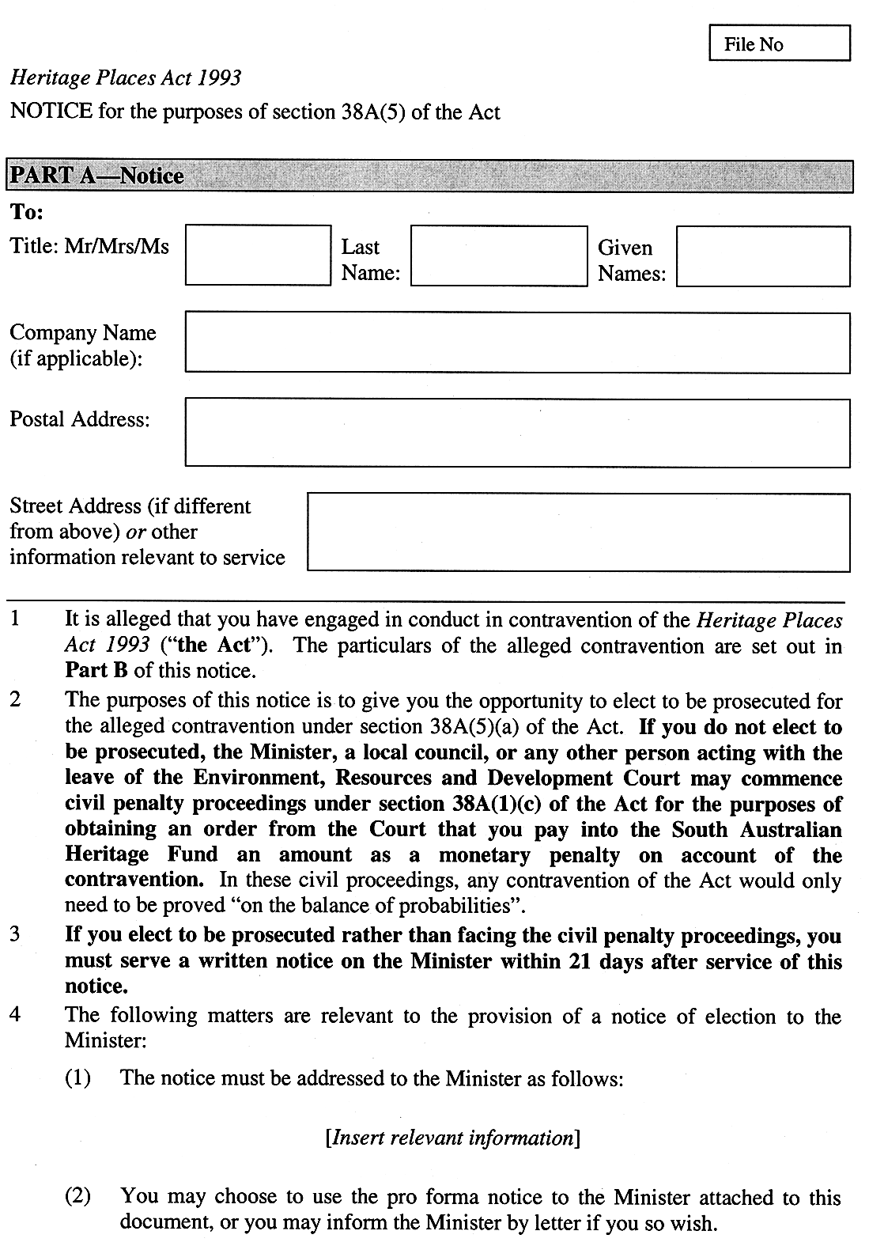
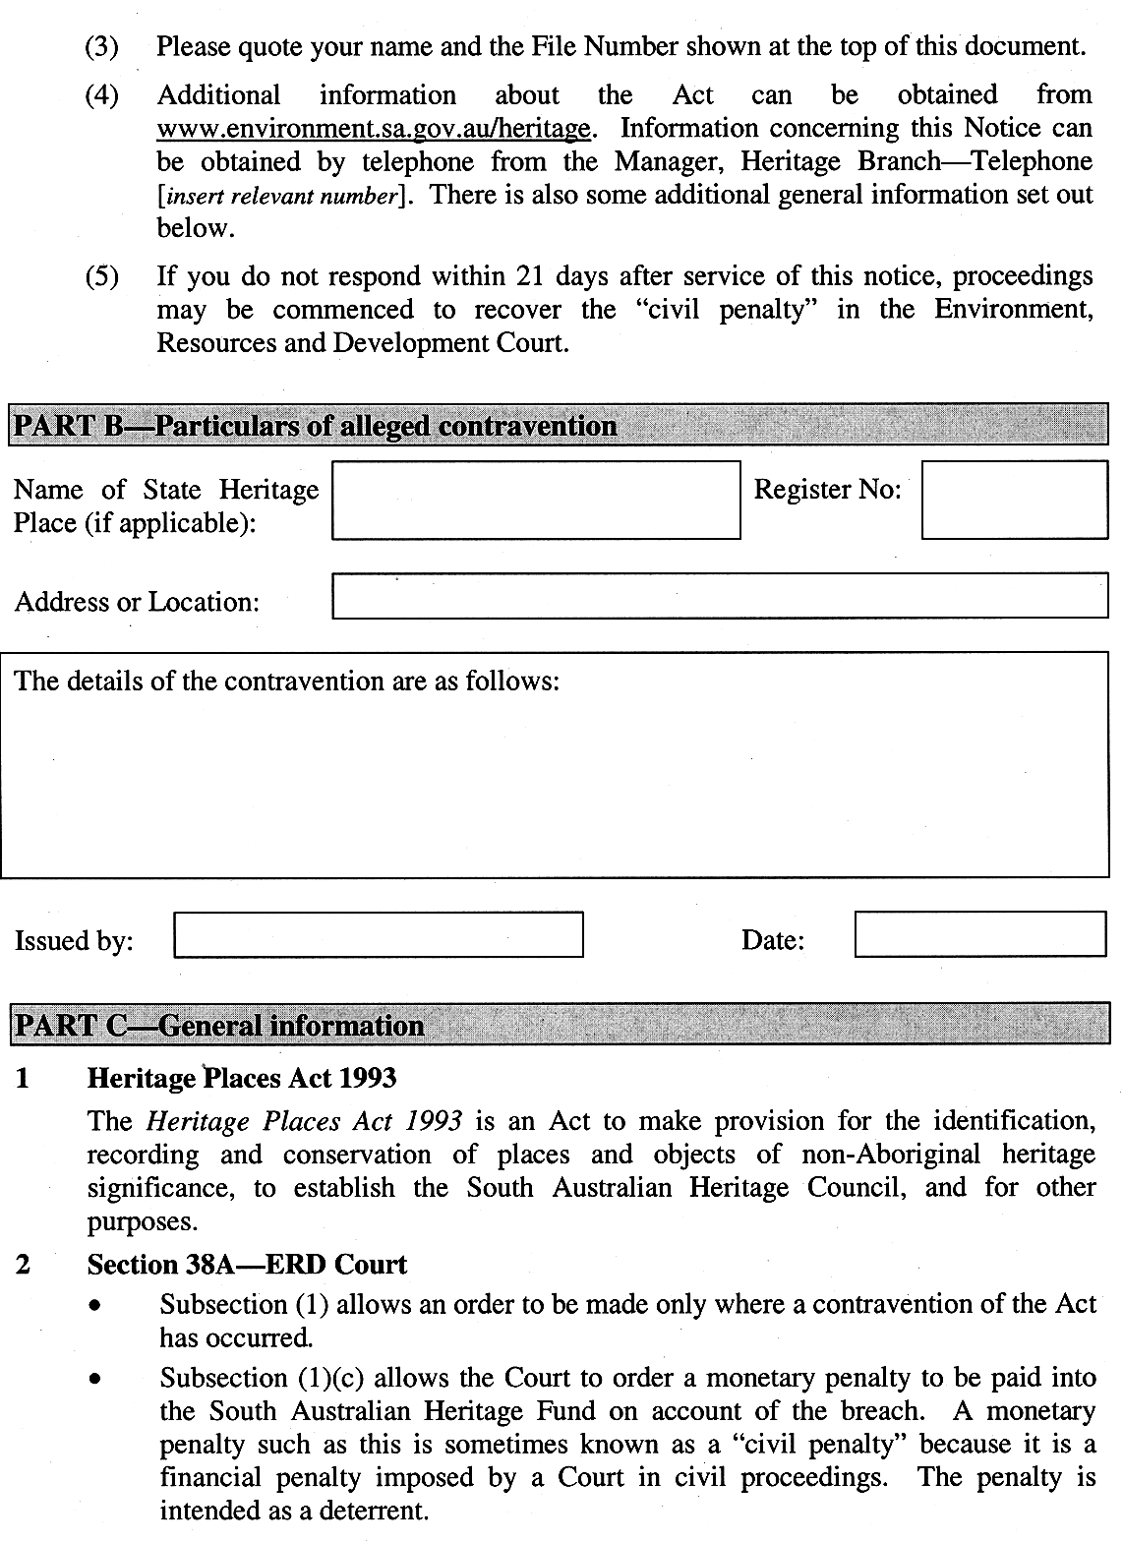
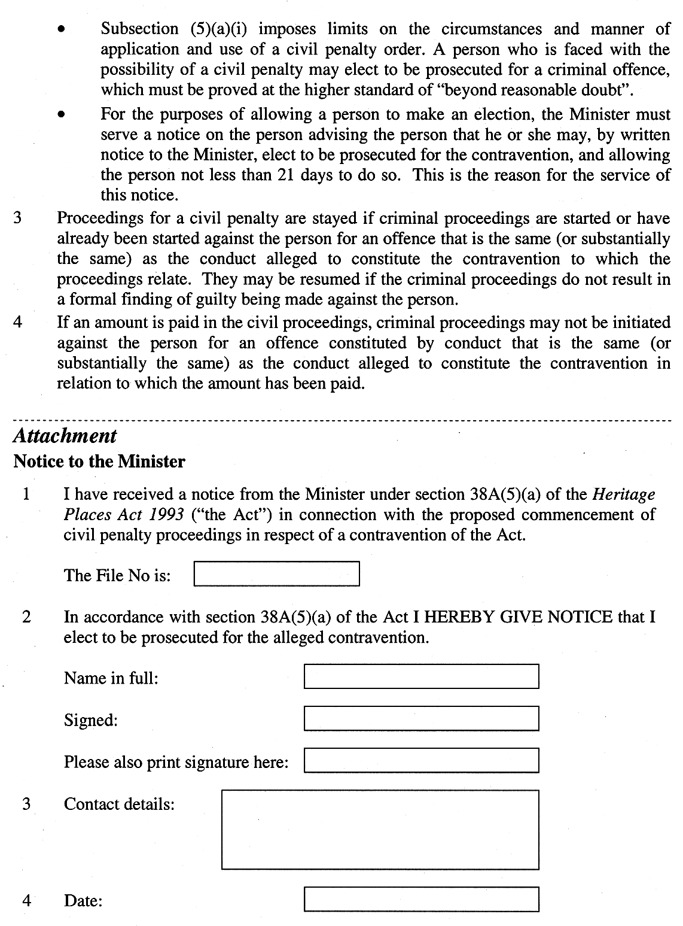

Schedule 2—Fees

1 | Certified copy of an entry in the Register in relation to a State heritage place, or an object identified by the Council under section 14(2) of the Act | $23
2 | Application for certificate of exclusion in relation to land zoned "residential" under the relevant Development Plan—
 | (a) initial application fee  plus | $115
 | (b) if the Council determines to invite public submissions | $1 042
3 | Application for certificate of exclusion in relation to any other land | 5% of Valuer-General's assessment of site value
4 | Application for a permit under Part 5 Division 1 of the Heritage Places Act 1993 | $115
Schedule 3—Revocation of Heritage Regulations 2005
The Heritage Regulations 2005 are revoked.
Note—
As required by section 10AA(2) of the Subordinate Legislation Act 1978, the Minister has certified that, in the Minister's opinion, it is necessary or appropriate that these regulations come into operation as set out in these regulations.
Made by the Governor
with the advice and consent of the Executive Council
on 17 November 2005
No 240 of 2005
ECO5/0065CS

South Australia
Liquor Licensing (Dry Areas—Short Term) Variation Regulations 2005
under the Liquor Licensing Act 1997

Contents
Part 1—Preliminary
1 Short title
2 Commencement
3 Variation provisions
Part 2—Variation of Liquor Licensing (Dry Areas—Short Term) Regulations 1997
4 Variation of Schedule 1—Short term dry areas

Part 1—Preliminary
1—Short title
These regulations may be cited as the Liquor Licensing (Dry Areas—Short Term) Variation Regulations 2005.
2—Commencement
These regulations come into operation on the day on which they are made.
3—Variation provisions
In these regulations, a provision under a heading referring to the variation of specified regulations varies the regulations so specified.
Part 2—Variation of Liquor Licensing (Dry Areas—Short Term) Regulations 1997
4—Variation of Schedule 1—Short term dry areas
(1) Schedule 1, item headed "Victor Harbor—Area 1", column headed "Period", (a) and (b)—delete paragraphs (a) and (b) and substitute:

(a) From 8 a.m. on 25 November 2005 to 10 p.m. on 3 December 2005; and
(b) From 3 p.m. on 31 December 2005 to 8 a.m. on 1 January 2006.
(2) Schedule 1, item headed "Victor Harbor—Area 2", column headed "Period", (a) and (b)—delete paragraphs (a) and (b) and substitute:

(a) From 8 a.m. on 25 November 2005 to 10 p.m. on 3 December 2005; and
(b) From 3 p.m. on 31 December 2005 to 8 a.m. on 1 January 2006.
Note—
As required by section 10AA(2) of the Subordinate Legislation Act 1978, the Minister has certified that, in the Minister's opinion, it is necessary or appropriate that these regulations come into operation as set out in these regulations.
Made by the Governor
with the advice and consent of the Executive Council
on 17 November 2005
No 241 of 2005
OLGC97/0271PTII

FAXING COPY?
IF you fax copy to Government Publishing SA for inclusion in the Government Gazette, there is no need to send a Confirmation Copy to us as well.
This creates confusion and may well result in your notice being printed twice.
Please use the following fax number:
Fax transmission: (08) 8207 1040
Phone Inquiries: (08) 8207 1045
Please include a contact person, phone number and order number so that we can phone back with any queries we may have regarding the fax copy.
NOTE: Closing time for lodging new copy (fax, hard copy or email) is 4 p.m. on Tuesday preceding the day of publication.

Government Gazette notices can be E-mailed.
The address is:
governmentgazette@saugov.sa.gov.au
Documents should be sent as attachments in Word format.
When sending a document via E-mail, please confirm your transmission with a faxed copy of your document, including the date the notice is to be published.
Fax transmission: (08) 8207 1040
Enquiries: (08) 8207 1045
NOTE: Closing time for lodging new copy (fax, hard copy or email) is 4 p.m. on Tuesday preceding the day of publication.

CITY OF CAMPBELLTOWN
Development Act 1993
Campbelltown (City) Development Plan, Local Heritage Places Plan Amendment Report—Draft for Public Consultation
NOTICE is hereby given that the Campbelltown City Council has prepared a draft Plan Amendment Report (PAR) to amend the Campbelltown (City) Development Plan. The Local Heritage Places Plan Amendment Report has been declared by the Governor, in Executive Council, to come into interim effect on Thursday, 17 November 2005, pursuant to section 28 of the Development Act 1993.
The PAR will amend the Development Plan in the following ways:
• Replace Table Cam/2 Local Heritage Places with a new table that adds 30 places to the list of Local Heritage Places, as well as expanded descriptions of Place of Value and amended data where required to existing Local Heritage Places.
• Insert 11 new Figures (Figures Cam(HP)/1 to Cam(HP)/11) identifying the location of State and Local Heritage Places.
• Replace Table Cam/3 State Heritage Places with a new table with revised descriptions of Place of Value and amended data where required.
The draft PAR is available for public inspection during normal office hours at the Campbelltown Council Offices, 172 Montacute Road, Rostrevor and at both branches of the Council Library from Thursday, 17 November 2005 until Thursday, 16 February 2006. The PAR can also be viewed on the internet at www.campbelltown.sa.gov.au.
Copies of the PAR are available for purchase from the Council at a cost of $5, inclusive of GST.
Interested people are invited to make written or electronic submissions regarding the draft PAR, and the City of Campbelltown will accept these submissions until Thursday, 16 February 2006.
The submission should state whether you wish to be heard at the public hearing in relation to your submission. Written submissions should be sent to the Chief Executive Officer, City of Campbelltown, P.O. Box 1, Campbelltown, S.A. 5074. Electronic submissions can be made at the above website.
Copies of all submissions received will be available for inspection by interested parties at the Council Offices, 172 Montacute Road, Rostrevor from Thursday, 16 February 2006 until Tuesday, 28 February 2006, the date of the public hearing.
A public hearing will be held at 7 p.m. in the Campbelltown Function Centre at the rear of the Council Offices, 172 Montacute Road, Rostrevor on Tuesday, 28 February 2006. The public meeting may not be held if submissions indicate that no author has an interest in speaking at the public meeting.
Further information can be obtained by contacting David Barone on 8366 9288.
Dated 17 November 2005.
P. Vlatko, Chief Executive Officer

RURAL CITY OF MURRAY BRIDGE
Development Act 1993
Primary Industry Zone Plan Amendment Report (PAR)—
Draft for Public Consultation
NOTICE is hereby given that the Rural City of Murray Bridge has prepared a draft Plan Amendment Report (PAR) to amend the Murray Bridge (Rural City) Development Plan. This Amendment Report has been revised following earlier consultation in mid-2004 and the consideration of submissions from business, community, property owners and Government agencies.
The major changes contained within the PAR are:
• Changing the Zone name from Rural Zone to Primary Industry Zone to enable the principal purpose of the Zone to be more clearly conveyed.
• Introduce specific quantifiable performance based criteria drawn from the Planning Bulletin for Development in Rural Areas.
• Establish one Primary Industry Zone incorporating six new Policy Areas, allowing for land use differentiation between areas within the Primary Industry Zone.
The draft PAR will be available for public inspection at the Council Offices, 2 Seventh Street, Murray Bridge from Thursday, 17 November 2005 to Friday, 17 February 2006. Copies of the PAR can be viewed and purchased at the Council Offices for $15. Alternatively, a copy of the PAR may also be downloaded from Council’s website, www.rcmb.sa.gov.au, during the public consultation period.
Written submissions regarding the draft amendment will be accepted by the Rural City of Murray Bridge until 4.45 p.m. on Friday, 17 February 2006. All submissions should be entitled ‘Primary Industry Zone—PAR’ and addressed to The Chief Executive Officer, Rural City of Murray Bridge, P.O. Box 421, Murray Bridge, S.A. 5253.
Copies of all written submissions received will be available for inspection by interested persons during normal office hours at the Council Offices from Monday, 20 February 2006 to Monday, 6 March 2006.
A public hearing (if required) will be held on Monday, 6 March 2006 at 6 p.m. in the Council Chambers, 2 Seventh Street, Murray Bridge, to hear verbal representations from any person who had made written representations in relation to this PAR. The public hearing may not be held if no submissions have been received or if no submission indicates an interest in speaking at the public hearing.
Further information: Kosta Livaditis, Telephone: (08) 8539 1100 or Email: k.livaditis@rcmb.sa.gov.au.
Dated 10 November 2006.
D. Altmann, Chief Executive Officer

CITY OF NORWOOD, PAYNEHAM & ST PETERS
Supplementary Election for Councillor in Torrens Ward
NOMINATIONS are hereby invited and will be received at the City of Norwood, Payneham & St Peters located at 175 The Parade, Norwood, from Thursday, 24 November 2005 until 12 noon Thursday, 15 December 2005, from any person eligible to be a candidate for election to the vacancy.
Nomination forms and candidate’s handbooks are available from 175 The Parade, Norwood.
A candidate must submit a profile of not more than 150 words with the nomination form.
A candidate photograph of predominantly the head and shoulders, taken within the preceding 12 months, may also be submitted.
A briefing session for prospective candidates will be conducted at 7 p.m. on Monday, 28 November 2005 at the Mayor’s Parlour, Norwood Town Hall, 175 The Parade, Norwood.
If more than the required number of nominations are received for the vacancy, an election will be conducted entirely by postal ballot with the return of the completed ballot papers to reach the Returning Officer no later than 12 noon on Monday, 30 January 2006.
K. Mousley, Returning Officer

TOWN OF GAWLER
Town Centre Carparking Fund
NOTICE is hereby given that pursuant to section 50 (a) (1) of the Development Act 1993, the establishment of a Carparking Fund which will apply to the Town Centre Zones as designated in the Gawler (CT) Development Plan.
Details of the Fund are as follows:
Name of Fund—Town Centre Carparking Fund.
Designated Area—Town Centre Zone, Town Centre (Retail Core) Zone, Town Centre (Fringe) Zone (as set out in the sketch below).
Contribution Rate (per carpark not provided)—$4 575 in Town Centre Zone and Town Centre (Retail Core) Zone and $3 425 in Town Centre (Fringe) Zone.
Date of Operation: 17 November 2005.
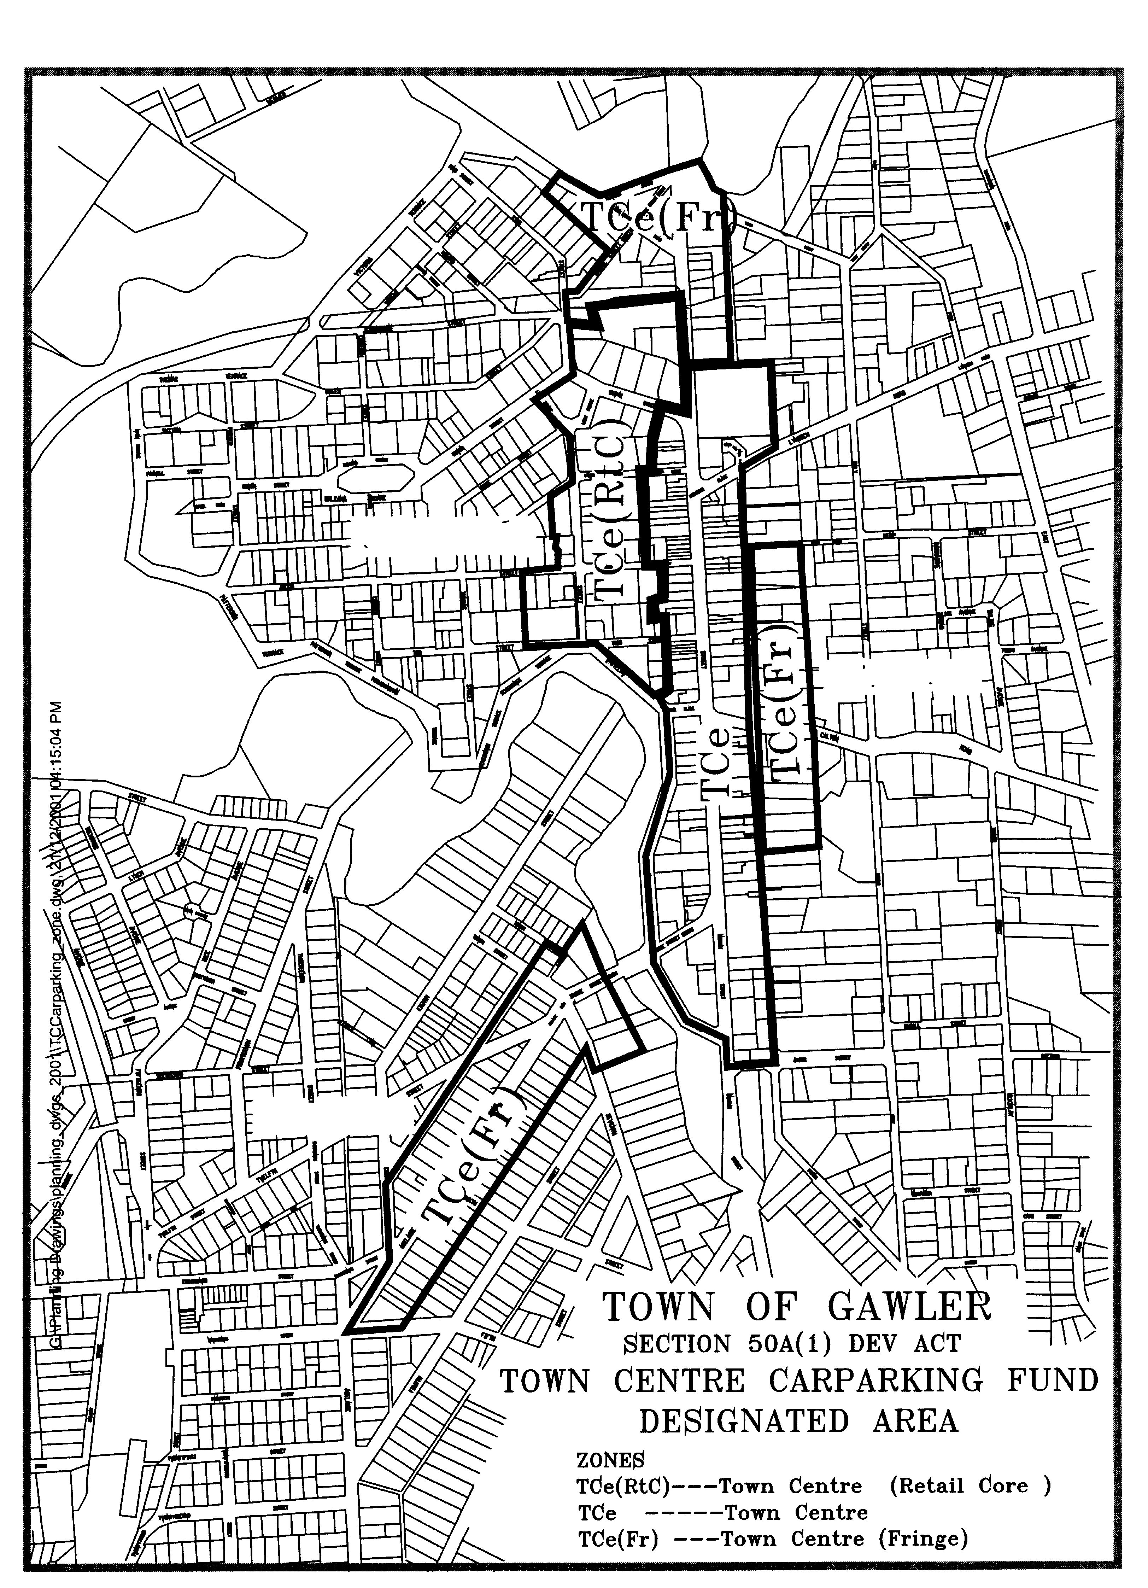

Dated 14 November 2005.
N. Jacobs, Chief Executive Officer

NARACOORTE LUCINDALE COUNCIL
Change of Council/Committee Meeting Venue
NOTICE is hereby given that at a meeting held on 27 September 2005, it was resolved that the Council/Committee meetings for November 2005 be held in the Lucindale War Memorial Hall, Centenary Avenue, Lucindale on 22 November 2005, com-mencing at 2.30 p.m.
D. A. Hovenden, Chief Executive Officer

IN the matter of the estates of the undermentioned deceased persons:
Barber, Rosemarie, late of One Tree Hill Road, Bibaringa, public servant, who died on 27 September 2005.
Black, William Fergus, late of 98 Rozelle Avenue, Melrose Park, retired office manager, who died on 21 August 2005.
Borlace, Mary Christina, late of 18 Victoria Street, Wallaroo, retired housekeeper, who died on 12 September 2005.
Carruthers, Margaret Mary, late of 11 Scott Street, Pooraka, home duties, who died on 5 October 2005.
Carslaw, Mavis Ellen, late of 110 Strathfield Terrace, Largs North, of no occupation, who died on 10 August 2005.
Dartee, Theodorus, late of 34 Grange Road, West Hindmarsh, retired welder, who died on 17 August 2005.
Flemmig, Ilse Anna, late of 10 Morton Road, Christie Downs, of no occupation, who died on 16 July 2005.
Grigorovits, Argiro, late of 1 Kent Street, Hawthorn, of no occupation, who died on 19 September 2002.
Hill, Shirley, late of 20 Pioneer Street, Seaton, home duties, who died on 24 September 2005.
Jambrovic, Gabrijela, late of 3 Noblet Street, Findon, of no occupation, who died on 24 July 2005.
Kreuzer, Renate Magdalena, late of 15-19 Woodville Road, Woodville South, retired registered nurse, who died on
2 September 2005.
Noden, Barbara Shirley, late of 470 Churchill Road, Kilburn, of no occupation, who died on 10 July 2005.
Rutter, John Samuel, late of 33 Cecelia Street, Hove, retired postmaster, who died on 3 September 2005.
Schofield, Winifred, late of 580 Brighton Road, South Brighton, of no occupation, who died on 18 June 2005.
Schultz, Patricia Mary, late of 18 Cross Road, Myrtle Bank, widow, who died on 8 September 2005.
Smyth, James, late of 11 Springbank Road, Colonel Light Gardens, of no occupation, who died on 30 July 2005.
Trueman, John Ernest, late of 840 Military Road, North Haven, retired motor mechanic, who died on 23 September 2005.
Wielgosz, Maria Elisabeth, late of 11 Montpelier Street, Parkside, retired nurse, who died on 4 July 2005.
Notice is hereby given pursuant to the Trustee Act 1936, as amended, the Inheritance (Family Provision) Act 1972, and the Family Relationships Act 1975, that all creditors, beneficiaries, and other persons having claims against the said estates are required to send, in writing, to the Public Trustee, 25 Franklin Street, Adelaide, S.A. 5000, full particulars and proof of such claims, on or before 16 December 2005, otherwise they will be excluded from the distribution of the said estate; and notice is also hereby given that all persons who are indebted to the said estates are required to pay the amount of their debts to the Public Trustee or proceedings will be taken for the recovery thereof; and all persons having any property belonging to the said estates are forthwith to deliver the same to the Public Trustee.
Dated 17 November 2005.
C. J. O’Loughlin, Public Trustee

ATTENTION

CUSTOMERS requiring a proof of their notice for inclusion in the Government Gazette, please note that the onus is on you to inform Government Publishing SA of any subsequent corrections by 10 a.m. on Thursday, which is our publication deadline.

For any corrections to your notice please phone 8207 1045 or Fax 8207 1040 before 10 a.m. on Thursday.

If we do not receive any communication by 10 a.m. on Thursday (day of publication) we will presume the notice is correct and will print it as it is.

Remember—the onus is on you to inform us of any corrections necessary to your notice.

NOTE: Closing time for lodging new copy (electronically, fax or hard copy) is 4 p.m. on Tuesday preceding the day of publication. Phone 8207 1045—Fax 8207 1040.
Email: governmentgazette@saugov.sa.gov.au

Printed and published by authority every Thursday by K. O’CALLAGHAN, Government Printer, South Australia
Price: $5.00, plus postage; to subscribers, $254.00 per annum.
(The above prices are inclusive of GST)

