No. 89 3305

THE SOUTH AUSTRALIAN

GOVERNMENT GAZETTE
www.governmentgazette.sa.gov.au

PUBLISHED BY AUTHORITY

ALL PUBLIC ACTS appearing in this GAZETTE are to be considered official, and obeyed as such

ADELAIDE, THURSDAY, 15 SEPTEMBER 2005

CONTENTS

Page
Administrative Arrangements Act 1994—Notice 3307
Appointments, Resignations, Etc. 3306
Brands Act 1933—Notice 3308
Corporations and District Councils—Notices 3354
Crown Lands Act 1929—Notices 3318
Development Act 1993—Notices 3318
Fisheries Act 1982—Notice 3323
Geographical Names Act 1991—Notice 3324
Housing Improvement Act 1940—Erratum 3323
Land and Business (Sale and Conveyancing) Act 1994—
Notices 3323
Liquor Licensing Act 1997—Notices 3324
Mount Gambier Circuit Court 3322
National Electricity Law—Notice 3330
National Parks and Wildlife Act 1972—Notice 3330
Page
Natural Resources Management Act 2004—Notices 3330
Petroleum Act 2000—Notice 3333
Private Advertisement 3356
Proclamations 3341
Public Trustee Office—Administration of Estates 3356
REGULATIONS
State Procurement Act 2004 (No. 201 of 2005) 3347
Veterinary Practice Act 2003 (No. 202 of 2005) 3349
Sale of Property 3356
Sewerage Act 1929—Notice 3334
Trade Standards Act 1979—Notice 3334
Training and Skills Development Act 2003—
Contracts of Training 3335
Water Mains and Sewers—Mains Laid, Replaced, Etc. 3337
Waterworks Act 1932—Notices 3339

GOVERNMENT GAZETTE NOTICES
ALL poundkeepers’ and private advertisements forwarded for publication in the South Australian Government Gazette must be PAID FOR PRIOR TO INSERTION; and all notices, from whatever source, should be legibly written on one side of the paper only and sent to Government Publishing SA so as to be received no later
than 4 p.m. on the Tuesday preceding the day of publication. Phone 8207 1045 or Fax 8207 1040. E-mail: governmentgazette@saugov.sa.gov.au. Send as attachments in Word format and please confirm your transmission with a faxed copy of your document, including the date the notice is to be published and to whom the notice will be charged. The Government Gazette is available online at: www.governmentgazette.sa.gov.au

Department of the Premier and Cabinet
Adelaide, 15 September 2005
HER Excellency the Governor in Executive Council has been pleased to appoint the undermentioned to the Aquaculture Tenure Allocation Board, pursuant to the provisions of the Aquaculture Act 2001:
Member: (from 15 September 2005 until 14 September 2008)
Malcolm Hill
Julie Ann Vanco
Bronwyn Gillanders
Robert Frederick Seamark
James Maurice Oloughlin
Glenn Stuart Davis
Presiding Member: (from 15 September 2005 until 14 September 2008)
Malcolm Hill
Deputy Member: (from 15 September 2005 until 14 September 2008)
Jeremy James Moore (Deputy to Davis)
Michael Geddes (Deputy to Gillanders)
By command,
C. Zollo, for Premier
MAFF 05/0027 CS

Department of the Premier and Cabinet
Adelaide, 15 September 2005
HER Excellency the Governor in Executive Council has been pleased to appoint the undermentioned to the Aquaculture Advisory Committee, pursuant to the provisions of the Aquaculture Act 2001:
Member: (from 15 September 2005 until 14 September 2008)
Mary Mitchell
Bruce Lawrence Zippel
Brian Jeffriess
Julianne Marshall
Hagen Heinz Stehr
Barbara Felicja Nowak
Susan Mary Carthew
Fred Pedler
Ian Nightingale
Peter Dolan
Presiding Member: (from 15 September 2005 until 14 September 2008)
Mary Mitchell
Deputy Member: (from 15 September 2005 until 14 September 2008)
Steven Cameron Mawer (Deputy to Zippel)
Andrew Christian (Deputy to Marshall)
Michael Whillas (Deputy to Jeffriess)
Simon John Lawrence Stone (Deputy to Stehr)
Steven Clarke (Deputy to Nowak)
Wolfgang Zeidler (Deputy to Carthew)
By command,
C. Zollo, for Premier
MAFF 05/0026 CS

Department of the Premier and Cabinet
Adelaide, 15 September 2005
HER Excellency the Governor in Executive Council has been pleased to appoint the undermentioned to the State Procurement Board, pursuant to the provisions of the State Procurement Act 2004:
Member: (from 4 October 2005 until 3 October 2007)
Patricia Ann Crook
Roy Arnold
John Gresty
Catherine Mary Schultz
Gino Degennaro
Virginia Deegan
Timothy William O’loughlin
Leanne Burch
By command,
C. Zollo, for Premier
MAS 05/023 CS

Department of the Premier and Cabinet
Adelaide, 15 September 2005
HER Excellency the Governor in Executive Council has been pleased to appoint the undermentioned to the HomeStart Finance Board of Management, pursuant to the provisions of the Housing and Urban Development (Administrative Arrangements) Act 1995:
Member: (from 19 September 2005 until 18 September 2007)
Claude Arthur Long
Presiding Member: (from 19 September 2005 until 18 September 2007)
Claude Arthur Long
Member: (from 1 November 2005 until 31 October 2007)
Jim Kouts
Deputy Presiding Member: (from 1 November 2005 until 31 October 2007)
Jim Kouts
By command,
C. Zollo, for Premier
MFC/CS 05/0027

Department of the Premier and Cabinet
Adelaide, 15 September 2005
HER Excellency the Governor in Executive Council has been pleased to appoint Teresa Anderson as a Stipendiary Magistrate from 15 September 2005, pursuant to the provisions of the Magistrates Act 1983.
By command,
C. Zollo, for Premier
AGO 0203/02 CSPTIII

Department of the Premier and Cabinet
Adelaide, 15 September 2005
HER Excellency the Governor in Executive Council has been pleased to authorise Teresa Anderson to issue recognition certificates for the purposes of the Sexual Reassignment Act 1988, effective from 15 September 2005, pursuant to Section 7 of the Sexual Reassignment Act 1988.
By command,
C. Zollo, for Premier
AGO 0203/02 CSPTIII

Department of the Premier and Cabinet
Adelaide, 15 September 2005
HER Excellency the Governor in Executive Council has been pleased to appoint Teresa Anderson as a Deputy State Coroner from 15 September 2005, pursuant to Section 8 of the Coroners Act 1975.
By command,
C. Zollo, for Premier
AGO 0203/02 CSPTIII

Department of the Premier and Cabinet
Adelaide, 15 September 2005
HER Excellency the Governor in Executive Council has been pleased to approve the appointment of Michael Gerard Smith as Deputy Chief Officer of the South Australian Metropolitan Fire Service for a period from 23 September 2005 until 22 September 2010, pursuant to Section 40 of the South Australian Metropolitan Fire Service Act 1936.
By command,
C. Zollo, for Premier
MES 05/008 CS

ADMINISTRATIVE ARRANGEMENTS ACT 1994
Delegation
PURSUANT to section 9 (1) of the Administrative Arrangements Act 1994, I, John Hill, Minister for Environment and Con-servation, delegate my functions and powers under section 132 of the Natural Resources Management Act 2004 to the Minister for the River Murray but only insofar as the exercise of those functions and powers relate to the River Murray prescribed watercourse.
Dated 9 September 2005.
John Hill, Minister for Environment and Conservation

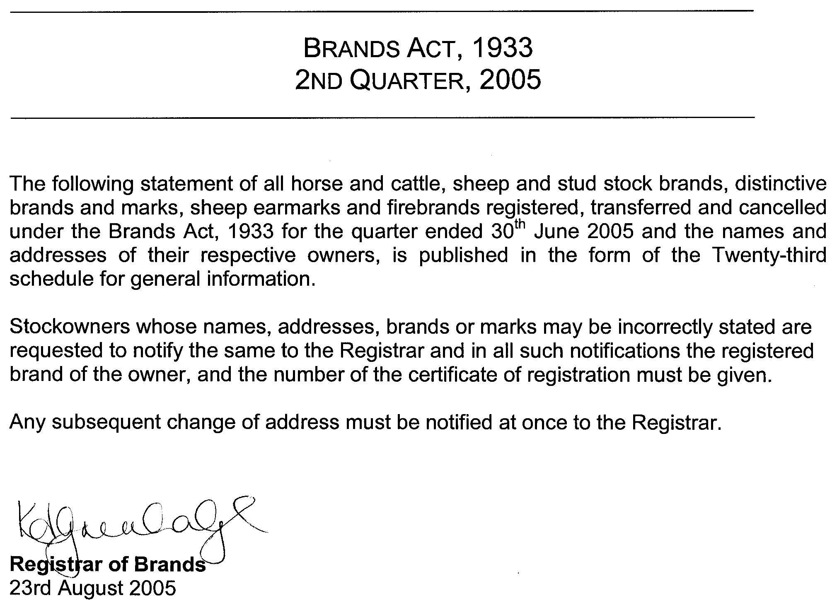

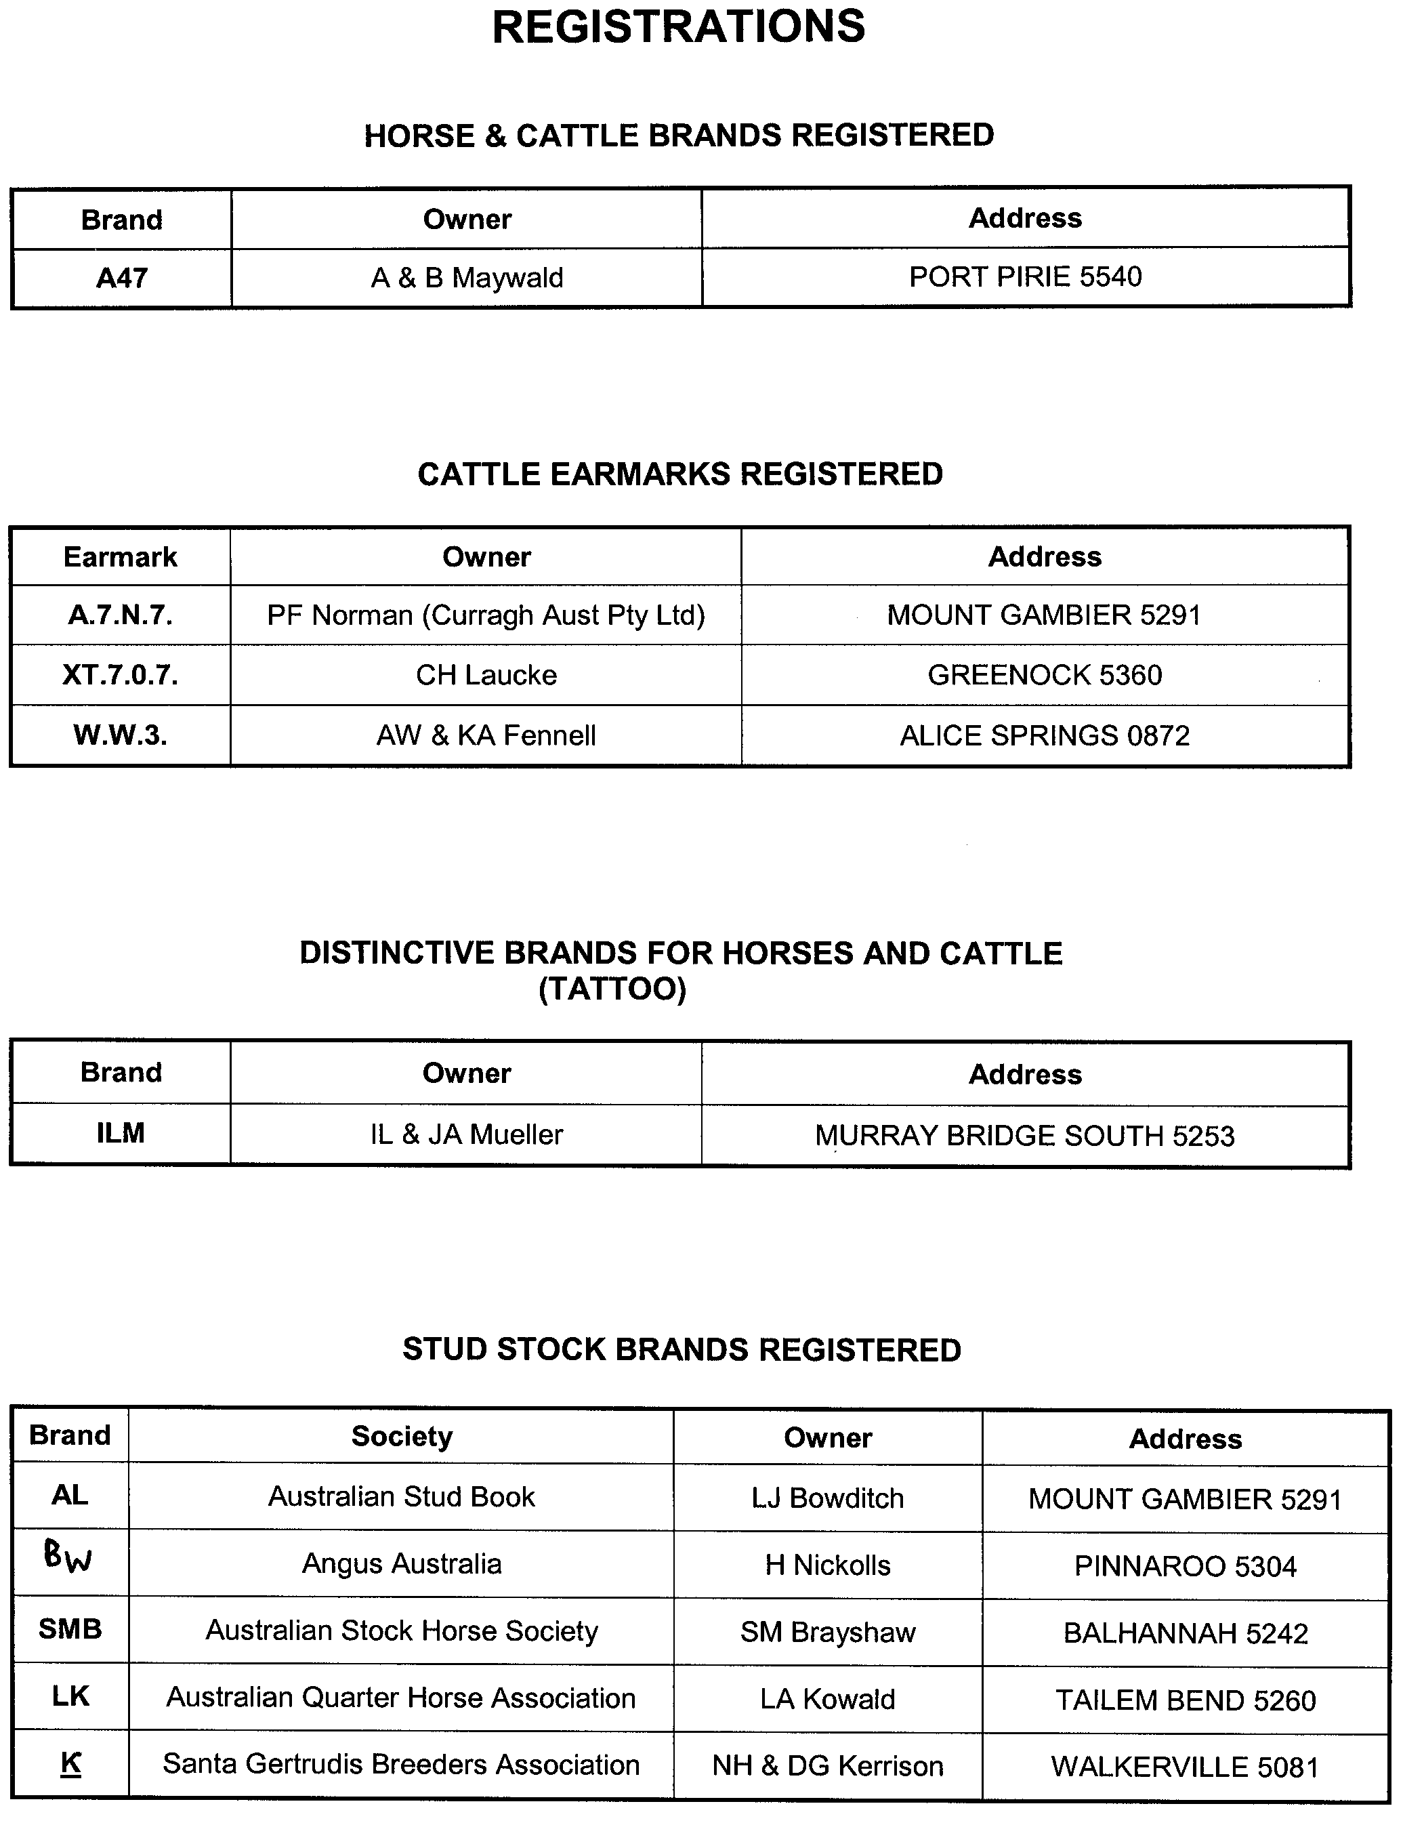
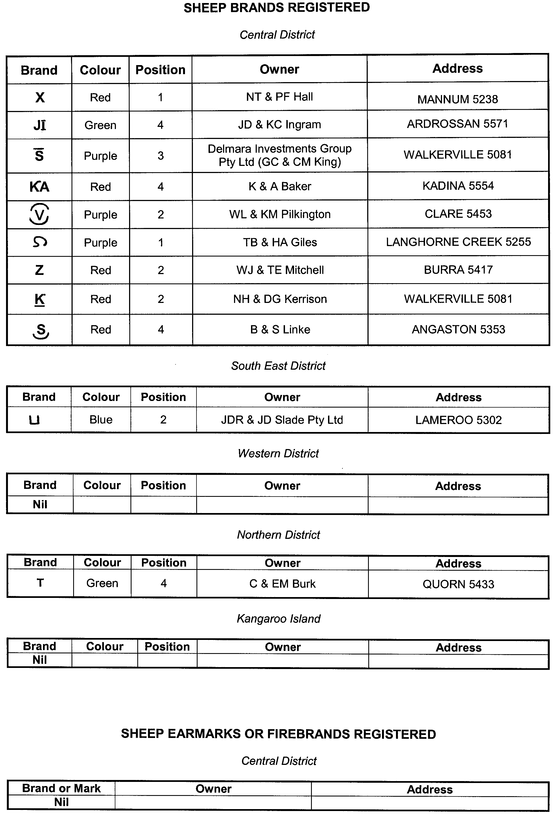
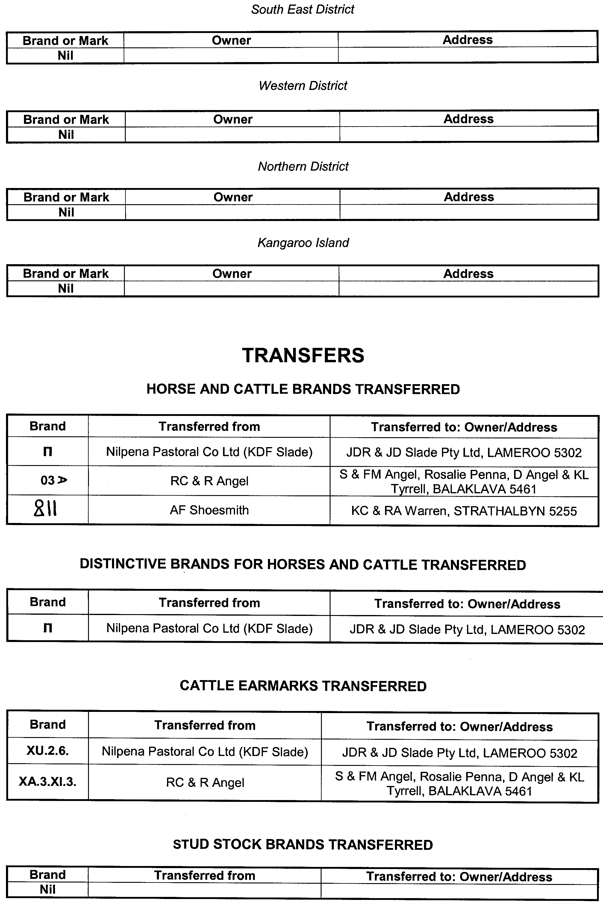
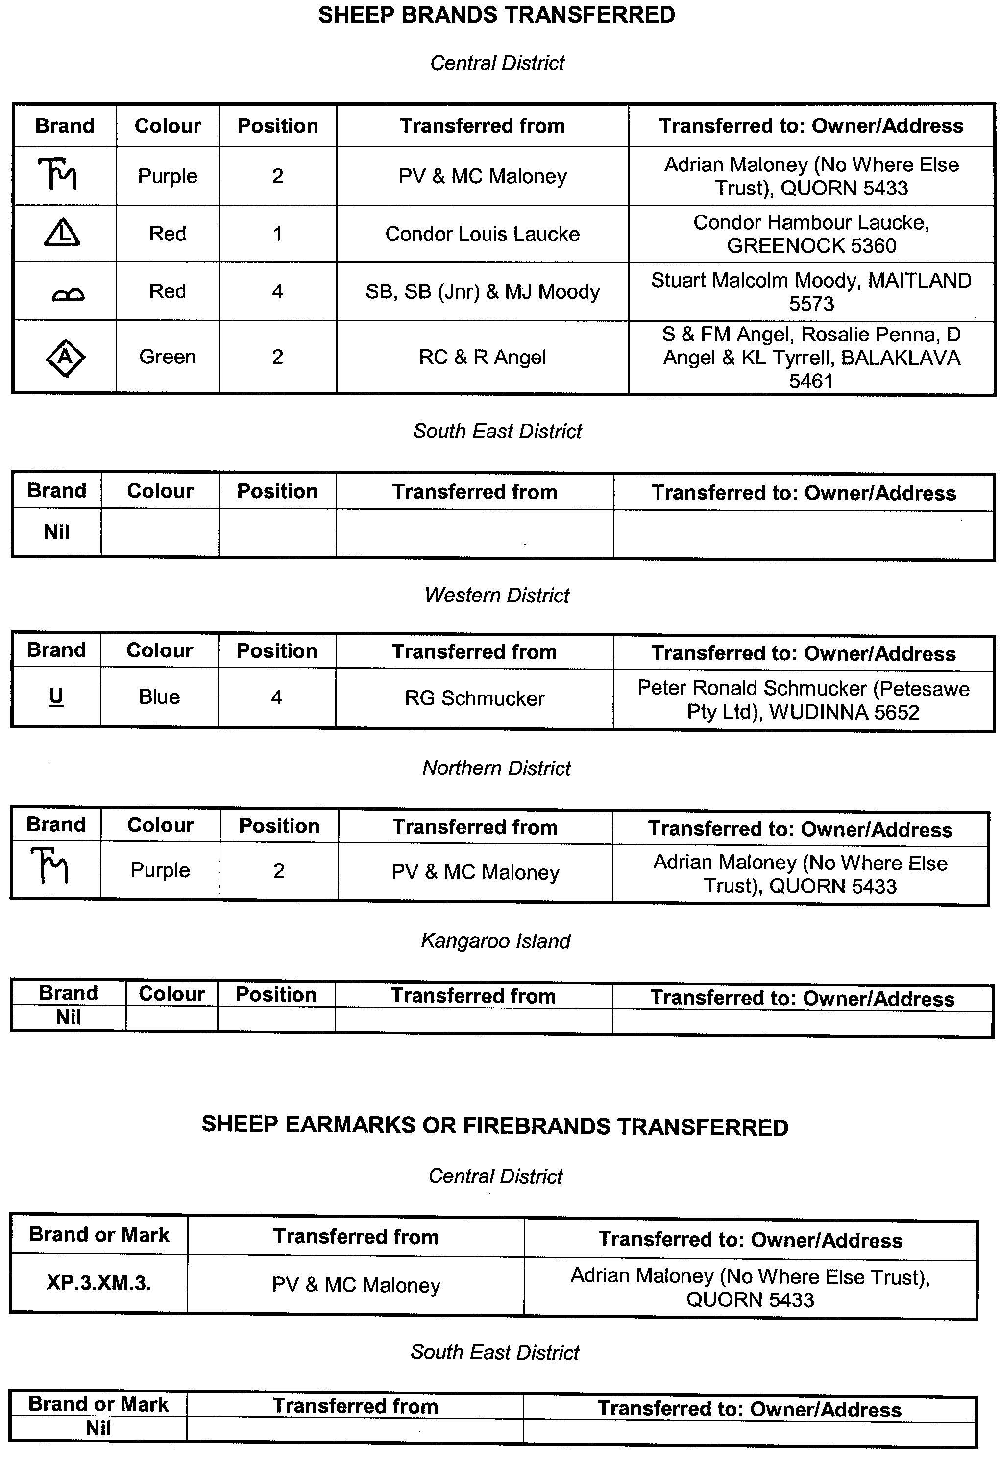
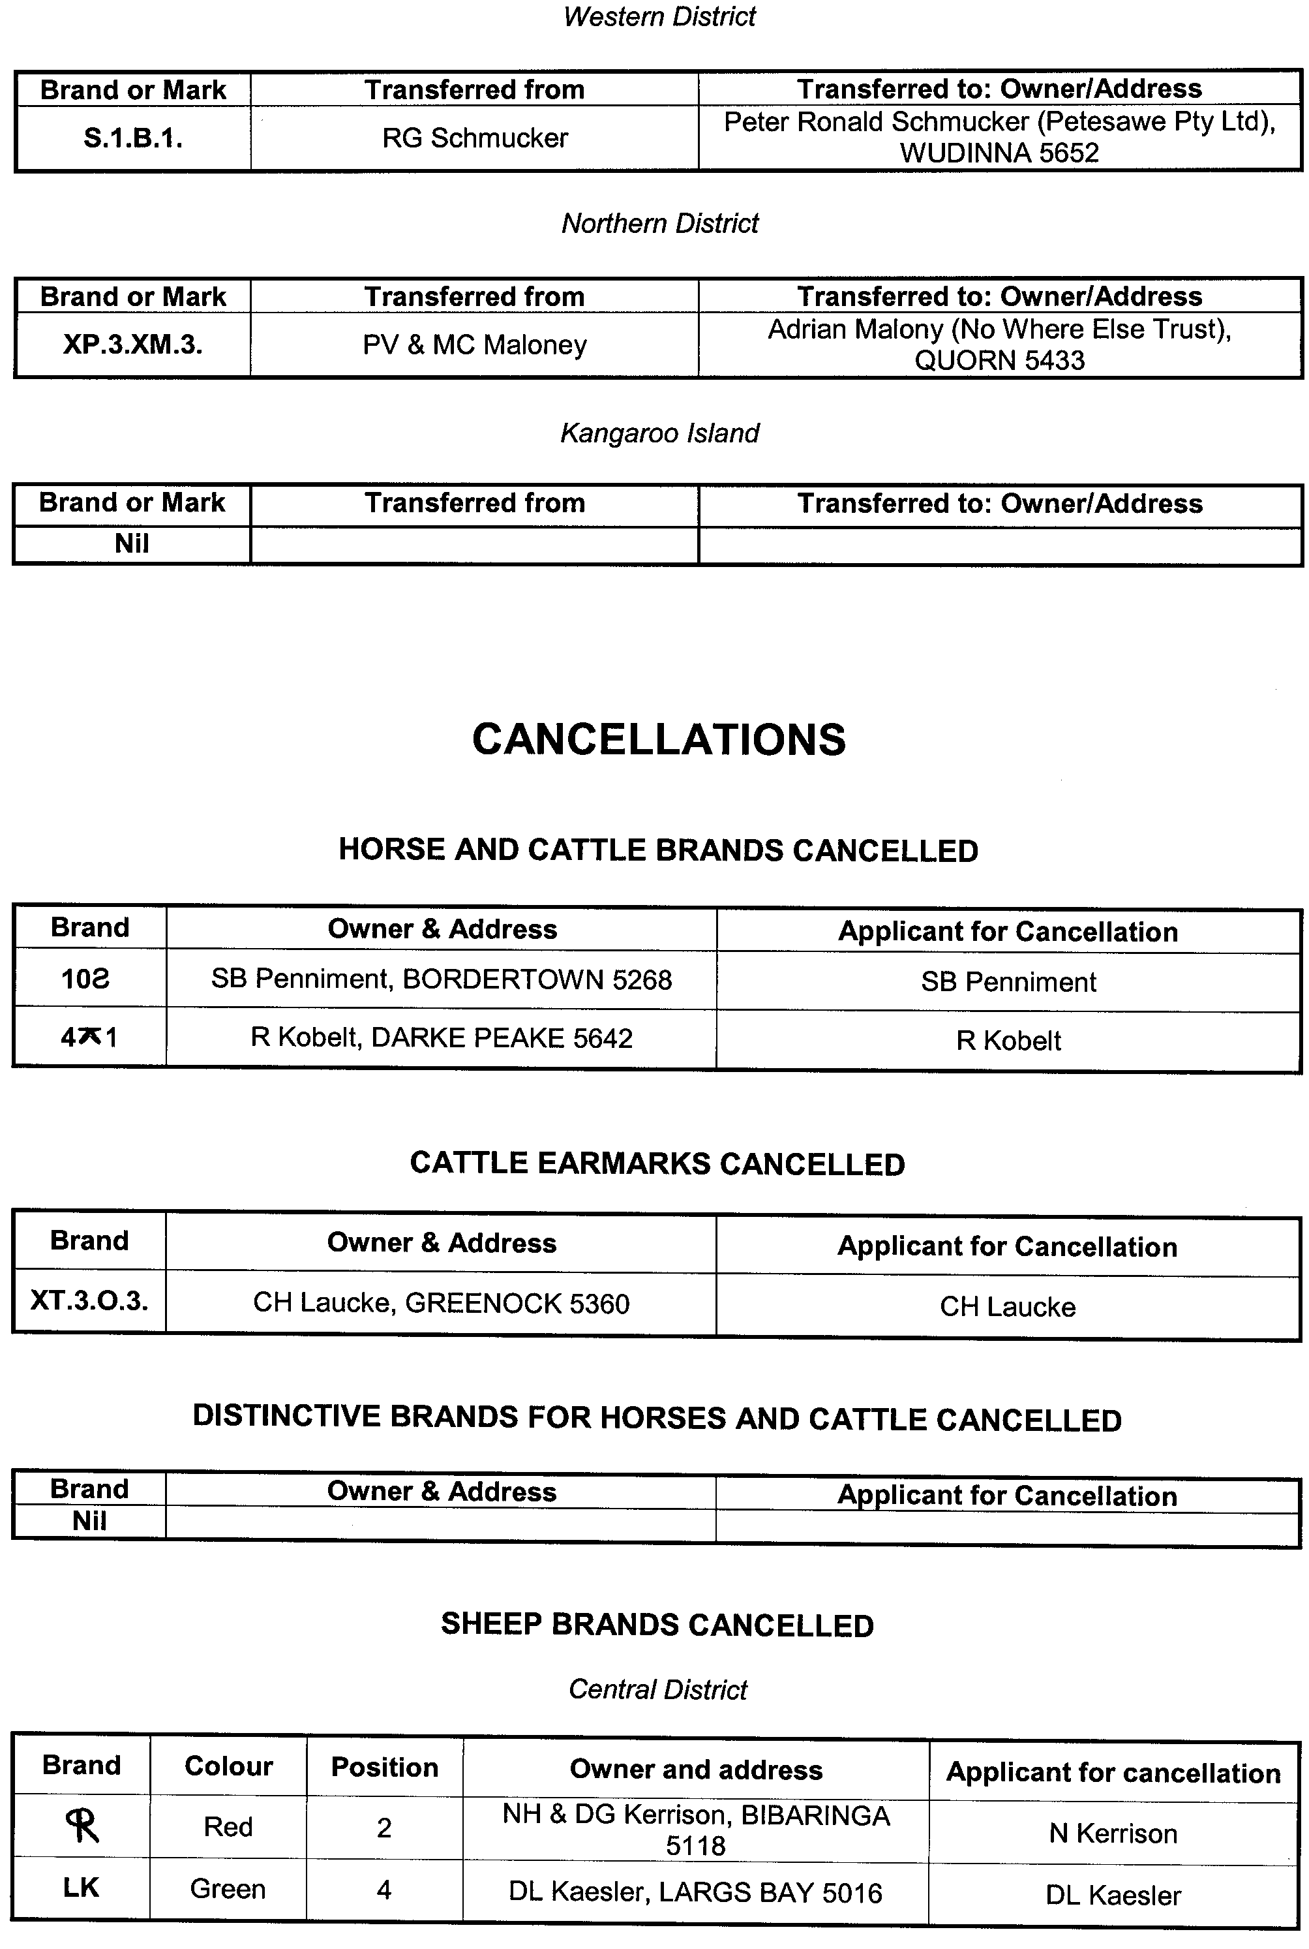
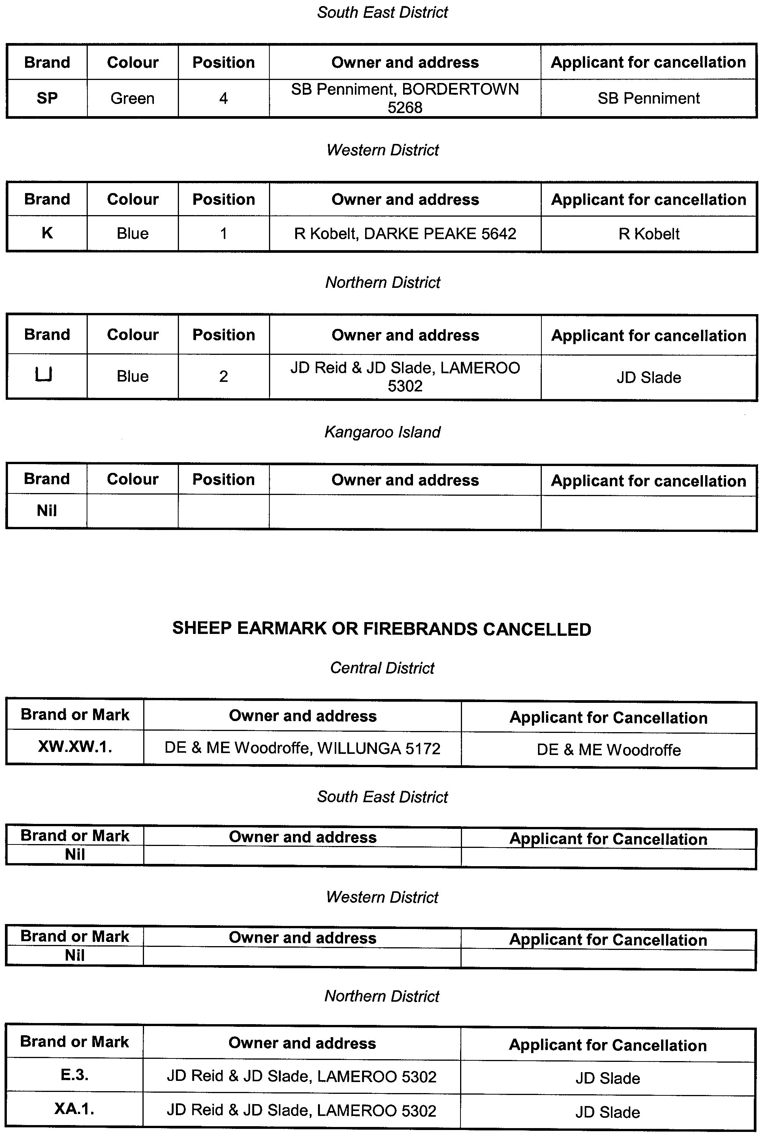
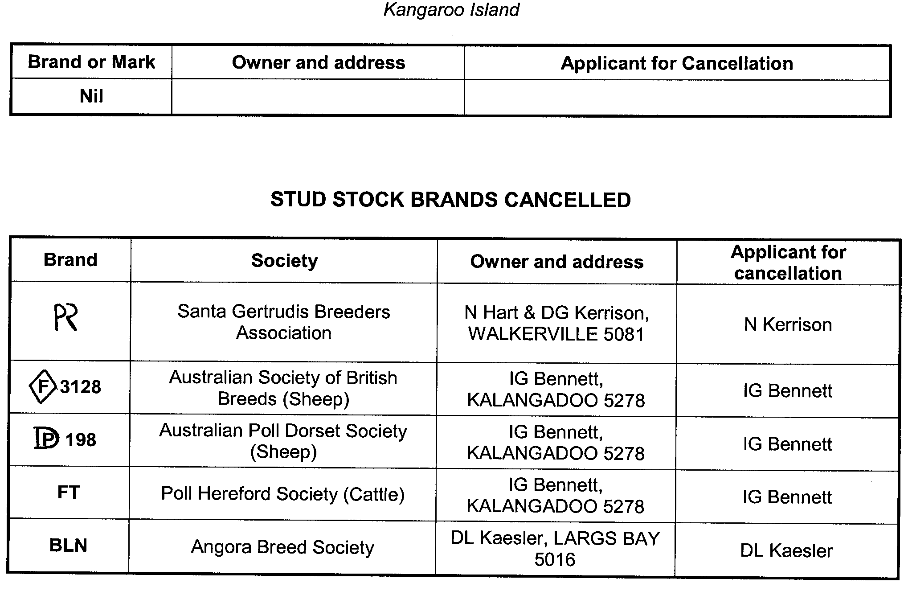

GOVERNMENT GAZETTE ADVERTISEMENT RATES

To apply from 1 July 2005

$  Agents, Ceasing to Act as 36.50  Associations:  Incorporation 18.60  Intention of Incorporation 46.00  Transfer of Properties 46.00  Attorney, Appointment of 36.50  Bailiff’s Sale 46.00  Cemetery Curator Appointed 27.25  Companies:  Alteration to Constitution 36.50  Capital, Increase or Decrease of 46.00  Ceasing to Carry on Business 27.25  Declaration of Dividend 27.25  Incorporation 36.50  Lost Share Certificates:  First Name 27.25  Each Subsequent Name 9.35  Meeting Final 30.50  Meeting Final Regarding Liquidator’s Report on  Conduct of Winding Up (equivalent to ‘Final  Meeting’)  First Name 36.50  Each Subsequent Name 9.35  Notices:  Call 46.00  Change of Name 18.60  Creditors 36.50  Creditors Compromise of Arrangement 36.50  Creditors (extraordinary resolution that ‘the Com-pany be wound up voluntarily and that a liquidator be appointed’) 46.00  Release of Liquidator⎯Application⎯Large Ad. 72.50  ⎯Release Granted 46.00  Receiver and Manager Appointed 42.50  Receiver and Manager Ceasing to Act 36.50  Restored Name 34.50  Petition to Supreme Court for Winding Up 64.00  Summons in Action 54.50  Order of Supreme Court for Winding Up Action 36.50  Register of Interests⎯Section 84 (1) Exempt 82.50  Removal of Office 18.60  Proof of Debts 36.50  Sales of Shares and Forfeiture 36.50  Estates:  Assigned 27.25  Deceased Persons⎯Notice to Creditors, etc. 46.00  Each Subsequent Name 9.35  Deceased Persons⎯Closed Estates 27.25  Each Subsequent Estate 1.20  Probate, Selling of 36.50  Public Trustee, each Estate 9.35 |  | $  Firms:  Ceasing to Carry on Business (each insertion) 24.30  Discontinuance Place of Business 24.30  Land⎯Real Property Act:  Intention to Sell, Notice of 46.00  Lost Certificate of Title Notices 46.00  Cancellation, Notice of (Strata Plan) 46.00  Mortgages:  Caveat Lodgment 18.60  Discharge of 19.50  Foreclosures 18.60  Transfer of 18.60  Sublet 9.35  Leases⎯Application for Transfer (2 insertions) each 9.35  Lost Treasury Receipts (3 insertions) each 27.25  Licensing 54.50  Municipal or District Councils:  Annual Financial Statement⎯Forms 1 and 2 513.00  Electricity Supply⎯Forms 19 and 20 364.00  Default in Payment of Rates:  First Name 72.50  Each Subsequent Name 9.35  Noxious Trade 27.25  Partnership, Dissolution of 27.25  Petitions (small) 18.60  Registered Building Societies (from Registrar-  General) 18.60  Register of Unclaimed Moneys⎯First Name 27.25  Each Subsequent Name 9.35  Registers of Members⎯Three pages and over:  Rate per page (in 8pt) 233.00  Rate per page (in 6pt) 308.00  Sale of Land by Public Auction 46.50  Advertisements 2.60  ¼ page advertisement 109.00  ½ page advertisement 218.00  Full page advertisement 427.00  Advertisements, other than those listed are charged at $2.60 per column line, tabular one-third extra.  Notices by Colleges, Universities, Corporations and District Councils to be charged at $2.60 per line.  Where the notice inserted varies significantly in length from that which is usually published a charge of $2.60 per column line will be applied in lieu of advertisement rates listed.  South Australian Government publications are sold on the condition that they will not be reproduced without prior permission from the Government Printer.
All the above prices include GST

GOVERNMENT GAZETTE NOTICES
ALL private advertisements forwarded for publication in the South Australian Government Gazette must be PAID FOR PRIOR TO INSERTION; and all notices, from whatever source, should be legibly written on one side of the paper only and sent to Government Publishing SA so as to be received no later than 4 p.m. Tuesday preceding the day of publication. Phone 8207 1045 or Fax 8207 1040. E-mail: governmentgazette@saugov.sa.gov.au. Send as attachments in Word format. Please include date the notice is to be published and to whom the notice will be charged. The Government Gazette is available online at: www.governmentgazette.sa.gov.au.

MISCELLANEOUS LEGISLATION AND GOVERNMENT PUBLICATIONS PRICES AS FROM 1 JULY 2005

Acts, Bills, Rules, Parliamentary Papers and Regulations
Pages | Main | Amends | Pages | Main | Amends

1-16 | 2.20 | 1.00 | 497-512 | 31.00 | 30.00
17-32 | 3.00 | 1.85 | 513-528 | 32.00 | 30.75
33-48 | 3.90 | 2.80 | 529-544 | 33.00 | 32.00
49-64 | 4.90 | 3.75 | 545-560 | 34.00 | 33.00
65-80 | 5.75 | 4.75 | 561-576 | 34.75 | 34.00
81-96 | 6.70 | 5.55 | 577-592 | 35.75 | 34.50
97-112 | 7.60 | 6.50 | 593-608 | 36.75 | 35.50
113-128 | 8.55 | 7.45 | 609-624 | 37.50 | 36.50
129-144 | 9.60 | 8.50 | 625-640 | 38.50 | 37.00
145-160 | 10.50 | 9.35 | 641-656 | 39.50 | 38.50
161-176 | 11.50 | 10.30 | 657-672 | 40.00 | 39.00
177-192 | 12.40 | 11.30 | 673-688 | 41.75 | 40.00
193-208 | 13.40 | 12.30 | 689-704 | 42.50 | 41.00
209-224 | 14.20 | 13.10 | 705-720 | 43.00 | 42.00
225-240 | 15.10 | 14.00 | 721-736 | 44.75 | 43.00
241-257 | 16.20 | 14.70 | 737-752 | 45.25 | 44.00
258-272 | 17.10 | 15.70 | 753-768 | 46.25 | 44.50
273-288 | 18.00 | 16.90 | 769-784 | 46.75 | 46.00
289-304 | 18.80 | 17.70 | 785-800 | 47.75 | 47.00
305-320 | 19.90 | 18.70 | 801-816 | 48.50 | 47.50
321-336 | 20.70 | 19.60 | 817-832 | 49.75 | 48.50
337-352 | 21.80 | 20.60 | 833-848 | 50.75 | 49.50
353-368 | 22.60 | 21.60 | 849-864 | 51.50 | 50.00
369-384 | 23.60 | 22.50 | 865-880 | 52.50 | 51.50
385-400 | 24.50 | 23.40 | 881-896 | 53.00 | 52.00
401-416 | 25.50 | 24.20 | 897-912 | 54.50 | 53.00
417-432 | 26.50 | 25.25 | 913-928 | 55.00 | 54.50
433-448 | 27.50 | 26.25 | 929-944 | 56.00 | 55.00
449-464 | 28.25 | 27.00 | 945-960 | 57.00 | 55.50
465-480 | 28.75 | 28.00 | 961-976 | 58.25 | 56.50
481-496 | 30.00 | 28.75 | 977-992 | 59.25 | 57.00

Legislation—Acts, Regulations, etc: $
Subscriptions:
Acts 192.00
All Bills as Laid 460.00
Rules and Regulations 460.00
Parliamentary Papers 460.00
Bound Acts 213.00
Index 106.00
Government Gazette
Copy 5.00
Subscription 254.00
Hansard
Copy 14.00
Subscription—per session (issued weekly) 399.00
Cloth bound—per volume 172.00
Subscription—per session (issued daily) 399.00
Legislation on Disk
Whole Database 2 951.00
Annual Subscription for fortnightly updates 907.00
Individual Act(s) including updates POA
Compendium
Subscriptions:
Subscriptions 1 749.00
Updates 617.00
(All the above prices include GST)

All Legislation, Government Gazette, Hansard and Legislation on disk are available from:
Counter Sales Service SA, Government Legislation⁺ Outlet
and Mail Orders: Lands Titles Office, 101 Grenfell Street, Adelaide, S.A. 5000
Phone: 13 23 24 (local call cost), Fax: (08) 8204 1909
Postal: G.P.O. Box 1707, Adelaide, S.A. 5001

Online Shop: www.shop.service.sa.gov.au

Subscriptions and Government Publishing SA
Standing Orders: Box 9, Plaza Level, Riverside Centre, North Terrace, Adelaide, S.A. 5000
Phone: (08) 8207 0908, (08) 8207 0910, Fax: (08) 8207 1040

CROWN LANDS ACT 1929: SECTION 5
TAKE NOTICE that pursuant to the Crown Lands Act 1929, I, JOHN HILL, Minister for Environment and Conservation, Minister of the Crown to whom the administration of the Crown Lands Act 1929 is committed DO HEREBY resume the land defined in The Schedule.
The Schedule
1. Community Centre and Recreation Reserve, Section 447, Hundred of Malcolm, the proclamation of which was published in the Government Gazette of 2 June 1960 at pages 1500 and 1501, The Second Schedule, being the whole of the land comprised in Crown Record Volume 5754 Folio 493.
2. Memorial Hall Reserve, Section 448, Hundred of Malcolm, the proclamation of which was published in the Government Gazette of 12 February 1959 at page 278, The Fourth Schedule, being the whole of the land comprised in Crown Record Volume 5754 Folio 494.
Dated 15 September 2005.
J. Hill, Minister for Environment and Conservation
DEHAA 12/0787

CROWN LANDS ACT 1929: SECTION 5
TAKE NOTICE that pursuant to the Crown Lands Act 1929, I, JOHN HILL, Minister for Environment and Conservation, Minister of the Crown to whom the administration of the Crown Lands Act 1929 is committed DO HEREBY dedicate the Crown Land defined in The Schedule as a Reserve for Playground Purposes and declare that such land shall be under the care, control and management of the Port Pirie Regional Council.
The Schedule
Allotment 65, Town of Napperby, Hundred of Napperby, County of Victoria, exclusive of all necessary roads, subject nevertheless to an existing easement to the Port Pirie Regional Council for drainage purposes (RLG 9617219) over that portion marked E on Filed Plan 38118, being the whole of the land comprised in Crown Record Volume 5899 Folio 499.
Dated 15 September 2005.
J. Hill, Minister for Environment and Conservation
DEH 13/0989

DEVELOPMENT ACT 1993: SECTION 27 (5)
Onkaparinga (City)—Local Heritage (Noarlunga)—
Plan Amendment Report
Preamble
Pursuant to section 27 (3) (b) of the Development Act 1993, the Environment, Resources and Development Committee of Parliament has suggested an amendment to the Onkaparinga (City) Development Plan, as amended by the City of Onkaparinga—Local Heritage (Noarlunga) Plan Amendment.
Pursuant to section 27 (5) (a) of the Development Act 1993, it is necessary to amend the Onkaparinga (City) Development Plan dated 17 March 2005.
Notice
PURSUANT to section 27 (5) of the Development Act 1993, I, the Minister administering the Act, amend the Onkaparinga (City) Development Plan as follows:
Remove 1 Moana Crescent, Moana from TABLE Onka/9 on page 436.
Dated 15 September 2005.
Paul Holloway, Minister for Urban Development and Planning
PLN 02/0103

DEVELOPMENT ACT 1993: SECTION 29 (2) (b) (ii)
Amendment to the Onkaparinga (City) Development Plan
Preamble
It is necessary to amend the Onkaparinga (City) Development Plan dated 17 March 2005.
Notice
PURSUANT to section 29 (2) (b) (ii) of the Development Act 1993, I, Paul Holloway, being the Minister administering the Act, amend the Onkaparinga (City) Development Plan as follows:
In TABLE Onka/9 on page 451, change the Property Address of Free Presbyterian Church (Ruin) (ID 537) to ‘Allotment 208 Section 241 (FP 164031) Ryan Road, Whites Valley (CT 5696/439)’.
In TABLE Onka/9 on page 451, change the Property Address of Cottage (Former Hampshire Hotel) (ID 545) to ‘Allotment 5 (DP 59613) Little Road, Aldinga (CT 5878/763)’.
Dated 15 September 2005.
Paul Holloway, Minister for Urban Development and Planning
PLN 02/0401

DEVELOPMENT ACT 1993: SECTION 46 (1)
Preamble
Clause 28 (2) of the Olympic Dam and Stuart Shelf Indenture in the Schedule to the Roxby Downs (Indenture Ratification) Act 1982 provides that references to the ‘Minister’ in Division 2 of Part 4 of the Development Act 1993, are to be taken to be references to the Minister responsible for Mineral Resources Development (the Indenture Minister). Subsection (1) of section 46 of the Development Act 1993, therefore enables the Minister to apply that section to a specified kind of development or project if the Minister is of the opinion that a declaration under that section is appropriate or necessary for the proper assessment of development or a project of major environmental, social or economic importance.
Notice
PURSUANT to section 46 (1) of the Development Act 1993, being of the opinion that a declaration is appropriate for the proper assessment of a development or project of major environmental, social or economic importance, I declare that section 46 of the Act applies to any development of a kind specified in the Schedule.
Schedule—Specified kinds of development
Development for the purposes of establishing the expanded Olympic Dam Project (not including works in the nature of repairs or maintenance), including any or all of the following elements:
(a) any new water supply pipeline from any borefield or seawater desalination plant, including any related bores or pumps;
(b) any new energy supply transmission line;
(c) any new natural gas pipeline, not including the liquid fuel replacement gas pipeline between Moomba and Olympic Dam being investigated as part of current operations;
(d) any new on-site power station;
(e) any rail line;
(f) any mine expansion, including open pit mine, tailings disposal facilities and evaporation ponds, or waste rock disposal area;
(g) any minerals processing facility;
(h) any new airport; and
(i) any future alteration to any approved element of the expanded Olympic Dam Project which occupies a significantly different site than that of the approved element.
P. Holloway, Minister for Mineral Resources Development

DEVELOPMENT ACT 1993, SECTION 48: DECISION BY HER EXCELLENCY THE GOVERNOR
Preamble
1. The Governor, by a decision made on 23 September 2004 and published in the Gazette of that date at pages 3674-3676, granted development authorisation under section 48 of the Development Act 1993 for development of a Wine Bottling and Storage Facility in the Barossa Valley, near Nuriootpa. That development authorisation was subject to 16 conditions attached to the authorisation.
2. By a notice published in the Gazette of the same date at pages 3673 and 3674 the Governor acting under section 48 (8) of the Development Act 1993 delegated the power under section 48 (7) of that Act to revoke or vary the conditions of that development authorisation to the Development Assessment Commission (provided that the essential nature of the development is not changed). Amendments to the development were granted by the Development Assessment Commission as delegate of the Governor on 14 October 2004, 16 December 2004, 3 March 2005, 28 April 2005 and 9 June 2005.
3. Beringer Blass Wine Estates Limited, the person having the benefit of the development authorisation has applied for an amendment to that development authorisation in relation to installing an overhead services bridge/gantry instead of a tunnel below Light Pass Road.
4. The proposal has been the subject of an Amended Development Report and an Amendment to the Assessment Report under the Development Act 1993.
5. I am satisfied that an appropriate Amended Development Report and an Amendment to the Assessment Report that encompasses the amended development have been prepared, and have, in considering the application, had regard to all relevant matters under section 48 (5) of the Development Act 1993.
Decision
PURSUANT to section 48 of the Development Act 1993, and with the advice and consent of Executive Council, and having regard to matters set out in section 48 (5) and all other relevant matters, I:
(a) grant a provisional development authorisation in relation to the proposed Amended Major Development referred to in the Preamble and subject to the Conditions and Notes to the applicant below;
(b) reserve a decision on the following matters (upon application of further information) pursuant to section 48 (6) and Regulation 64 (1):
(i) Further assessment and certification in respect of the Building Rules, for additional packages for Stage 1 and Stage 2 of the development, and the overhead services bridge/gantry (refer to Conditions and Notes to Applicant below);
(c) specify all matters relating to this provisional development authorisation as matters in respect of which conditions of this authorisation may be varied or revoked, or new conditions attached;
(d) specify, for the purposes of section 48 (11) (b) of the Development Act 1993, the period of two years from the date hereof, as the time within which substantial work must be commenced on-site, failing which I may cancel this authorisation.
Conditions of Approval
1. Except where minor amendments may be required by other legislation, or by conditions imposed herein, the proposed Major Development shall be undertaken in strict accordance with:
(a) the following drawings contained within the Development Report, ‘Proposed Wine Bottling and Storage Facility, Light Pass Road/Pipeline Road, Barossa Valley’, lodged by Beringer Blass Wine Estates, dated May 2004:
• Drawing Titled: ‘Proposed Bottling Facility, Landscape Plan’; Drawing Number: N080-SK01 B.
• Drawing Titled: ‘Proposed Bottling Facility, Elevations’; Drawing Number: N080-SK02 A.
(b) the following drawings contained within the letter from Nolan Rumsby Planners dated 11 November 2004 insofar as they are varied by the drawings indicated in paragraph (d):
• Drawing Titled: ‘Wine Bottling and Storage Facility, Development Consent Amendment, Proposed Bottling, Storage and Winery Facility, Final Development Site Plan’; Drawing Number: WLF04-000-0265 B.
• Drawing Titled: ‘Wine Bottling and Storage Facility, Development Consent Amendment, Proposed Bottling and Storage Facility Stage 1A Development Plan (2 Bottling Lines)’; Drawing Number: WLF04-000-0260 C.
• Drawing Titled: ‘Wine Bottling and Storage Facility, Development Consent Amendment, Proposed Bottling and Storage Facility Stage 1B Development Plan (4 Bottling Lines)’; Drawing Number: WLF04-000-0262 B.
• Drawing Titled: ‘Wine Bottling and Storage Facility, Development Consent Amendment, Proposed Bottling and Storage Facility Final Development Plan (8 Bottling Lines)’; Drawing Number: WLF04-000-0263 B.
• Drawing Titled: ‘Wine Bottling and Storage Facility, Development Consent Amendment, Proposed Bottling and Storage Facility Final Development Plans Overlayed’; Drawing Number: WLF04-000-0266 B.
• Drawing Titled: ‘Wine Bottling and Storage Facility, Development Consent Amendment, Proposed Bottling and Storage Facility Stages 1A & 1B Development Elevations’; Drawing Number: WLF04-000-0261 A.
• Drawing Titled: ‘Wine Bottling and Storage Facility, Development Consent Amendment, Proposed Bottling and Storage Facility Final Development Elevations’; Drawing Number: WLF04-000-0264 A.
• Drawing Titled: ‘Wine Bottling and Storage Facility, Development Consent Amendment, Proposed Bottling and Storage Facility Final Development Elevations Overlayed’; Drawing Number: WLF04-000-0267 A.
(c) the following documents insofar as they are varied by the documents indicated in paragraphs (e), (f), (g), (h), (i), (j), (k), (l) and (m):
• Development application, ‘Proposed Wine Bottling and Storage Facility (in association with the existing Beringer Blass Winery Sturt Highway, Light Pass Road/Pipeline Road) at Light Pass Road/Pipeline Road, Barossa Valley’, prepared by Nolan Rumsby Planners (for Beringer Blass Wine Estates), dated 3 December 2003 (except to the extent that it may be varied by a subsequent document in this paragraph).
• Development Report, ‘Proposed Wine Bottling and Storage Facility, Light Pass Road/Pipeline Road, Barossa Valley’, lodged by Beringer Blass Wine Estates, dated May 2004 (except to the extent that it may be varied by a subsequent document in this paragraph).
• Response to Submissions, ‘Response Document: Proposed Wine Bottling and Storage Facility, Light Pass Road/Pipeline Road, Barossa Valley’, lodged by Beringer Blass Wine Estates, dated July 2004 (contained within an appendix to the Assessment Report noted below) (except to the extent that it may be varied by a subsequent document in this paragraph).
• Correspondence from Nolan Rumsby Planners (for Beringer Blass Wine Estates) to Planning SA, dated 13 August 2004, confirming the storage volumes for the stormwater dam.
• Correspondence from Nolan Rumsby Planners (for Beringer Blass Wine Estates) to Planning SA, dated 19 August 2004, confirming details relating to finishing colour selections, landscaping, building layouts, and the establishment of a frost fan (except to the extent that it may be varied by a subsequent document in this paragraph).
• Correspondence from Nolan Rumsby Planners (for Beringer Blass Wine Estates) to Planning SA, dated 31 August 2004, confirming the relevant and revised plans for assessment and consideration by the Governor (except to the extent that it may be varied by a subsequent document in this paragraph).
• Assessment Report prepared by the Minister for Urban Development and Planning dated September 2004.
(d) the following drawings:
• Drawing Titled: ‘Wolf Blass Packaging Facility, Architectural Site Plan’; Drawing Number: WLF05-200-1001, 250401-00-1-101 Rev 0C.
• Drawing Titled: ‘Wolf Blass Packaging Facility, Architectural General Arrangement’; Drawing Number: WLF05-200-1002, 250401-00-1-102 Rev 0E.
• Drawing Titled: ‘Wolf Blass Packaging Facility, Architectural Elevations’; Drawing Number: WLF05-200-1003, 250401-00-1-103 Rev D.
• Drawing Titled: ‘Wolf Blass Packaging Facility, Concrete Footing Plan’; Drawing Number: WLF05-200-3000, 250401-00-3-300 Rev A.
• Drawing Titled: ‘Wolf Blass Packaging Facility, Footing Detail Sheet’; Drawing Number: WLF05-200-3005, 250401-00-3-305 Rev A.
(e) The Environmental Management and Monitoring Plan prepared by Parsons Brinckerhoff on behalf of Beringer Blass Wine Estates Limited (Report No. 2102542A-04-0600-03) revised April 2005.
(f) The letters from Nolan Rumsby Planners dated 11 November 2004 and 23 November 2004.
(g) The letter from Nolan Rumsby Planners dated 13 December 2004, including Building Rules Certification by McKenzie Group Consulting.
(h) The correspondence and plans from McKenzie Group Consulting dated 22 December 2004, including Building Rules Certification and plans, with the exception of the layout for the car park and administration building indicated on the plans.
(i) The correspondence and plans from Nolan Rumsby Planners dated 7 February 2005.
(j) The correspondence and plans from McKenzie Group Consulting dated 21 March 2005, including Building Rules Certification and plans dated 9 March 2005.
(k) The correspondence and documents from Nolan Rumsby Planners dated 31 March 2005.
(l) The Amended Development Report, Proposed Wine Bottling and Storage Facility Light Pass Road/Pipeline Road Barossa Valley dated June 2005.
2. The applicant shall submit further information and application(s) in relation to the matters that have been reserved for further decision-making.
3. No works on any part of the proposed Major Development shall commence until a favourable decision has been notified to the applicant by me or my delegate in respect of the reserved matter referred to in subparagraph (i) in paragraph (b) of the Decision section above (refer also to Condition 6).
4. No construction activities or building works shall commence until a heritage survey has been completed to identify any Aboriginal Sites, Objects or Remains in the site area, and monitoring shall be undertaken during construction to enable the development to proceed without a breach of the Aboriginal Heritage Act 1988. Details of the applicant’s Heritage Agreement and consultation with the Ngadjuri Heritage Association shall also be provided to the Development Assessment Commission and the Department of Aboriginal Affairs and Reconciliation prior to construction commencing.
5. Subject to Conditions 3, 4, and 6, the applicant may stage building works, and, if so, may commence an approved stage before receiving my decision concerning building rules compliance for other stages (refer reserved matter (i) in paragraph (b) of the Decision section above). No building works shall commence on a stage of the development, however, until a favourable decision in relation to building rules compliance in respect of that stage has been notified in writing to the applicant by me or my delegate.
6. A decision on building rules compliance will only be made after a Building Rules assessment and certification has been undertaken and issued by the Barossa Council, or a private certifier, in accordance with the provisions of the Development Act 1993, and after the Minister for Urban Development and Planning receives a copy of all relevant certification documentation, as outlined in Regulation 64 of the Development Regulations 1993 (refer to ‘Notes to Applicant’ below for further information).
7. The management and monitoring of the pre-construction, construction and operational phases of the wine bottling and storage facility shall be undertaken in accordance with the Environmental Management and Monitoring Plan, prepared by Parsons Brinckerhoff on behalf of Beringer Blass Wine Estates Limited (Report No. 2102542A-04-0600-02), dated October 2004, and as amended by the letter from Nolan Rumsby Planners dated 23 November 2004.
8. The wastewater collection and treatment system shall be designed to ensure that the general obligations of the Environment Protection (Water Quality) Policy 2003 are met, and to ensure that effluent does not overflow or escape from drains, pipes, sumps, tanks, storage/treatment basins into any watercourse, or into stormwater drains which do not drain into the effluent collection, treatment and disposal system, except where the effluent complies with criteria in the above Policy.
9. In accordance with commitments by the applicant, wastewater shall not be stored in open storage ponds until it is first treated to reduce the potential for odours to occur.
10. The applicant shall ensure that stormwater, which does not comply with the Environment Protection (Water Quality) Policy 2003 criteria, is not discharged from the site without prior effective treatment.
11. Noise from the development shall be in accordance with the following:
Construction Activities—Mondays to Saturdays:
(a) not exceed 52 dB (A) between the hours of 7 a.m. and 10 p.m. measured and adjusted at the nearest existing residential property;
(b) not exceed 45 dB (A) between the hours of 6 a.m. and 7 a.m. measured and adjusted at the nearest existing residential property;
(c) shall be in accordance with the Environment Protection (Industrial Noise) Policy 1994;
(d) site deliveries and other noisier construction activities shall be scheduled to minimise noise impacts;
(e) all other aspects of construction activities shall be undertaken in accordance with the Environmental Management and Monitoring Plan.
Operation of the Development:
(a) shall not exceed 52 dB (A) between the hours of 7 a.m. and 10 p.m. measured and adjusted at the nearest existing residential property in accordance with the Environment Protection (Industrial Noise) Policy 1994;
(b) shall not exceed 45 dB (A) between the hours of 10 p.m. and 7 a.m. measured and adjusted at the nearest existing residential property in accordance with the Environment Protection (Industrial Noise) Policy 1994;
(c) a short term typical maximum noise level of 60 dB (A) when measured at the nearest existing residential property.
12. The proponent shall, subject to obtaining the landowner’s consent in relation thereto, install, operate and maintain frost fans on the property located north of the proposed development site either in accordance with the recommendations in the Development Report and assessed in the Acoustic report on frost fan impacts and in accordance with the Environment Protection Authority’s standards for their operation, siting and distance from potential receptors, or in accordance with any alternative arrangement negotiated with the landowner. If the landowner refuses consent for the establishment of frost fans on the property located to the north of the proposed development, the proponent is excused from compliance with this condition.
13. Landscaping of the site shall commence prior to construction of the proposed Major Development, and when established must be maintained in good health and condition at all times. A plant must be replaced if or when it dies or becomes seriously diseased within the first growing season after the plant dies or becomes seriously diseased.
14. In accordance with commitments by the applicant, building walls up to 3 m shall be clad in colorbond ‘ironstone’ (or similar), and walls above 3 m shall be clad in colorbond ‘paperbark’ (or similar).
15. All lighting shall be directed and shielded in such a way as to prevent glare from the site, and any lighting that is not in use for operational or security reasons shall be switched off.
16. In accordance with EPA recommendations, no trucks or heavy vehicles shall access the site from the portion of Light Pass Road, south of the access point for the proposed Major Development.
17. The temporary concrete batching plant for on-site construction activities and associated infrastructure shall be decommissioned and removed from the site no later than 1 August 2005.
18. The overhead services gantry shall be undertaken in accordance with the amended proposal and site plans contained in the Amended Development Report Proposed Wine Bottling and Storage Facility Light Pass Road/Pipeline Road Barossa Valley dated June 2005.
Notes to Applicant
• Pursuant to Development Regulation 64, the applicant is advised that the Barossa Council or private certifier conducting a Building Rules assessment must:
(a) provide to the Minister a certification in the form set out in Schedule 12A of the Development Regulations 1993 in relation to the building works in question; and
(b) to the extent that may be relevant and appropriate:
(i) issue a Schedule of Essential Safety Provisions under Division 4 of Part 12;
(ii) assign a classification of the building under these regulations; and
(iii) ensure that the appropriate levy has been paid under the Construction Industry Training Fund 1993.
Regulation 64 of the Development Regulations 1993 provides further information about the type and quantity of all Building Rules certification documentation for Major Developments required for referral to the Minister for Urban Development and Planning.
• The Barossa Council or private certifier undertaking Building Rules assessments must ensure that the assessment and certification are consistent with this provisional development authorisation (including any Conditions or Notes that apply in relation to this provisional development authorisation).
• Should the applicant wish to vary the Major Development or any of the components of the Major Development, an application may be submitted, provided that the development application variation remains within the ambit of the Development Report and Assessment Report referred to in this provisional development authorisation. If an application variation involves substantial changes to the proposal, pursuant to section 47 of the Development Act 1993, the applicant may be required to prepare an amended Development Report for public inspection and purchase. An amended Assessment Report may also be required to assess any new issues not covered by the original Assessment Report and a decision made by the Governor pursuant to section 48 of the Development Act 1993.
• It is recommended that the applicant finalise the required water licence arrangements pursuant to the Water Resources Act 1997, for the construction of the proposed water storage dam and subsequent re-use of water, prior to construction of the proposed Major Development (in order for operations to proceed). The applicant is also advised to submit information on the water licence arrangements to Planning SA, together with final details on the design of the stormwater dam and associated release mechanism(s) and infrastructure.
• The proponent is advised of the General Environmental Duty under section 25 of the Environment Protection Act 1993, which requires that a person must not undertake any activity, which pollutes, or may pollute; without taking all reasonable and practical measures to prevent or minimise harm to the environment.
• The applicant’s EMMP should be prepared taking into consideration, and with explicit reference to, relevant EPA policies and guideline documents, including, but not limited to: the Environment Protection (Air Quality) Policy 1994, the Environment Protection (Water Quality) Policy 2003, the Occupational Health and Safety Regulations, EPA Guidelines on Odour Assessment, using odour source modelling 2003, EPA Handbook for Pollution Avoidance on Commercial and Residential Building Sites 2004, and the EPA Stormwater Pollution Prevention Code of Practice for the Building and Construction Industry, in addition to other legislative requirements and Guidelines/Australian Standards requiring compliance.
• The applicant is reminded of its obligations under the Aboriginal Heritage Act 1988 whereby any ‘clearance’ work, which may require permission to disturb damage or destroy Aboriginal Sites, must be undertaken with the full authorisation of the Minister for Aboriginal Affairs and Reconciliation, according to Section 23 of the Aboriginal Heritage Act 1988.
• It is recommended that the applicant ensure there are measures in place to promote staff vehicle access to the site from the northern end of Light Pass Road.
• The applicant is advised that a further development application and authorisation will be required pursuant to Part 4, Division 2 of the Development Act 1993, for the following matters:
(a) prior to commencement of Stage 2, if the applicant proposes to treat wastewater at the existing Wolf Blass winery wastewater treatment system;
(b) for the establishment of any additional frost fans that may be required as part of Stage 2;
(c) if the external advertising signage is amended from that indicated in the Development Report, or additional advertising signage is proposed.
• The applicant is advised that any construction activities proposed to be undertaken on Sundays shall be subject to EPA requirements and further approval.
• The Minister has a specific power to require testing, monitoring and auditing under section 48C of the Development Act 1993.
• The Environment Protection Authority has advised that an authorisation (licence) will be required for the temporary concrete batching plant.
Given under my hand at Adelaide, 15 September 2005.
Marjorie Jackson-Nelson, Governor

DEVELOPMENT ACT 1993, SECTION 48
Notice by the Governor
Preamble
1. I have given a provisional development authorisation pursuant to section 48 of the Development Act 1993 concerning an amendment to the approved Beringer Blass Wine Bottling and Storage Facility development by Beringer Blass Wine Estates Limited, located on Light Pass Road, Nuriootpa.
2. It is appropriate to delegate certain powers to the Development Assessment Commission in relation to this matter.
Delegation
PURSUANT to section 48 (8) of the Development Act 1993 and with the advice and consent of the Executive Council, I delegate to the Development Assessment Commission, in relation to the provisional development authorisation referred to in clause 1 above given by me this day:
(a) the power to make a decision on any reserved matters specified within that provisional development authorisation (provided that the essential nature of the development is not changed);
(b) the power to grant or permit any variation associated with that provisional development authorisation (provided that the essential nature of the development is not changed); and
(c) in relation to that provisional development authorisation, or any variation-the power to vary or revoke conditions, or to attach new conditions, under section 48 (7) of the Development Act 1993 (provided that the essential nature of the development is not changed).
Given under my hand at Adelaide, 15 September 2005.
Marjorie Jackson-Nelson, Governor

DISTRICT COURT OF SOUTH AUSTRALIA
MOUNT GAMBIER CIRCUIT COURT
Sheriff’s Office, Adelaide, 12 September 2005
IN pursuance of a precept from the District Court to me directed, I do hereby give notice that the said Court will sit as a Court of Oyer and Terminer and General Gaol Delivery at the Courthouse at Mount Gambier on the day and time undermentioned and all parties bound to prosecute and give evidence and all jurors summoned and all others having business at the said Court are required to attend the sittings thereof and the order of business will be, unless a Judge otherwise orders, as follows:
Tuesday, 4 October 2005 at 10 a.m. on the first day of the sittings the only business taken will be the arraignment of prisoners in gaol and the passing of sentences on prisoners in gaol committed for sentence; the surrender of prisoners on bail committed for sentence; the surrender of persons in response to ex officio informations or of persons on bail and committed for trial who have signified their intention to plead guilty and the passing of sentences for all matters listed for disposition by the District Court.
Juries will be summoned for Wednesday, 5 October 2005 and persons will be tried on this and subsequent days of the sittings.
Prisoners in H.M. Gaol and on Bail for Sentence and for Trial at the Sittings of the Mount Gambier Courthouse, commencing Tuesday, 4 October 2005.

Dent, Paul Michael |  | Aggravated serious criminal trespass—not known if place occupied; common assault on person other than family member (2); damaging property | On bail
Chaston, Donald John |  | Aggravated serious criminal trespass—not known if place occupied; common assault on person other than family member (2); damaging property | On bail
Easton, Andrew John |  | Aggravated serious criminal trespass—residence occupied (2); dishonestly take property without owner’s consent; common assault on person other than family member; arson (2); endangering life | In gaol
Wallis, William |  | Aggravated serious criminal trespass—residence occupied (2); dishonestly take property without owner’s consent; common assault on person other than family member; arson (2); endangering life | In gaol
Forrest, Dean John |  | Assault occasioning actual bodily harm; threatening life | On bail
G |  | Carnal knowledge—female 13 years but less than 17 years old (3); gross indecency | On bail
Gunn, Nathan Mark |  | Aggravated serious criminal trespass—residence occupied; common assault on person other than family member | On bail
Haines, Mahani Rose |  | Endangering life (6); possess object with intent to kill or endanger life; assault a police officer (4); commit common assault on member of own family | On bail
Hewett, Darren |  | Aggravated serious criminal trespass—residence not occupied; assault occasioning actual bodily harm; common assault on person other than own family member; dishonestly take property without owner’s consent | On bail
Hindle, Benjamin Thomas |  | Deceive another to benefit self or third person (6); dishonestly take property without owner’s consent | On bail
Huebler, Garry Leigh |  | Threatening life | On bail
Hulford, Mark Ian |  | Common assault on person other than family member; threatening to cause harm (2); assisting offender | On bail
Hutchesson, Justin Andrew |  | Aggravated serious criminal trespass (non-residential); unlawfully on premises | On bail
Irvine, Darlene June |  | Aggravated robbery; assault police (2) | In gaol
Jewell, Benjamin Thomas |  | Aggravated robbery with offensive weapon; dishonestly take property without owner’s consent | On bail
McLister, Timothy Phillip |  | Aggravated robbery with offensive weapon | In gaol
Larkin, Jon William |  | Aggravated serious criminal trespass—not known if place occupied; common assault on person other than family member | On bail
Gordon, Corey Robert |  | Aggravated serious criminal trespass—not known if place occupied; common assault on person other than family member | On bail
McKenna, Tony Michael Edward |  | Non-aggravated serious trespass (non-residential); dishonestly take property without owner’s consent | In gaol
Meegan, Daniel Kevin |  | Rape; unlawful sexual intercourse | On bail
Oliver, Glen Phillip |  | Rape; commit common assault on member of own family | On bail
Parham, Gerard Michael |  | Unlawful wounding | On bail
Pittas, Wayne Trevor |  | Non-aggravated serious criminal trespass (place of residence) (2); dishonestly take property without owner’s consent (3); drive or use motor vehicle without owner’s consent; attempted non-aggravated serious criminal trespass | In gaol
Pittas, Wayne Trevor |  | Non-aggravated serious criminal trespass (non-residential); dishonestly take property without owner’s consent (5); non-aggravated serious criminal trespass | In gaol
Pittas, Wayne Trevor |  | Dishonestly take property without owner’s consent; resist police | In gaol
P |  | Indecent assault (6) | On bail
Smith, Damien James |  | Non-aggravated serious criminal trespass (non-residential); dishonestly take property without owner’s consent | In gaol
Stock, Kevin James |  | Possess a firearm without a licence (2); possess unregistered firearm; fail to keep class A, B, C, D or H firearm secured; fail to store ammunition in locked container | On bail
Van Derr Heul, Byron Roger |  | Commit common assault on member of own family; threatening life | On bail
Wallis, William |  | Aggravated serious criminal trespass—residence occupied (2); dishonestly take property without owner’s consent; common assault on person other than family member; arson (2); endangering life | On bail
Wheeler, Paul Richard |  | Aggravated serious criminal trespass—residence not occupied; dishonestly take property without owner’s consent; dishonest dealings with documents (2) | On bail
Wheeler, Paul Richard |  | Serious criminal trespass in a place of residence; theft; dishonestly dealing with a document; attempted serious criminal trespass in a place of residence | On bail
Prisoners on bail must surrender at 10 a.m. of the day appointed for their respective trials. If they do not appear when called upon their recognizances and those of their bail will be estreated and a bench warrant will be issued forthwith.
By order of the Court,
M. A. Stokes, Sheriff

FISHERIES ACT 1982: SECTION 59
TAKE notice that pursuant to section 59 of the Fisheries Act 1982, the class of persons described in Schedule 1 (the ‘exemption holders’) are exempt from the notice issued pursuant to section 43 of the Fisheries Act 1982, that was published in the Gazette on 25 August 2005, imposing a prohibition on the use of pilchard nets, during the period commencing on 9 September 2005 and ending on 1 October 2005, subject to the conditions in Schedule 2.
Schedule 1
Any person authorised to undertake fishing activities using the boat Gemma Marie endorsed on Marine Scalefish Fishery Licence No. M505.
Schedule 2
1. The exemption holder may only use a pilchard net pursuant to this exemption if the registered boat being used to undertake fishing activity has an observer on board that is approved by the Director of Fisheries.
2. Any observers on board a registered boat must be provided with accommodation, food and drinks during the fishing trip.
3. The exemption holder must conform to the Pilchard Industry Code of Practice concerning interactions with species that are protected under the National Parks and Wildlife Act 1972.
4. A copy of this exemption notice must be on board any registered boat undertaking fishing activity pursuant to this exemption and must be produced to a fisheries officer upon request.
5. The exemption holder must not contravene or fail to comply with the Fisheries Act 1982, or any other regulations made under that Act except where specifically exempted by this notice.
Dated 9 September 2005.
W. Zacharin, Director of Fisheries

HOUSING IMPROVEMENT ACT 1940
Erratum
IN Government Gazette of 28 July 2005, page 2511, for 19 Old Kapunda Road, Kapunda, read 19 Old Adelaide Road, Kapunda.

LAND AND BUSINESS (SALE AND CONVEYANCING)
ACT 1994
Exemption
TAKE notice that, pursuant to section 23 (3) of the Land and Business (Sale and Conveyancing) Act 1994, I, Karlene Maywald, Minister for Consumer Affairs, do hereby exempt the person named in Schedule 1 from the application of section 23 (2) of the Act in relation to the purchase of the land specified in Schedule 2.
Schedule 1
Philip James Lavis, an officer of Lavis Real Estate Pty Ltd.
Schedule 2
The whole of the land described in certificate of title register book volume 5891, folio 764, situated at 60 Wandearah Road, Port Pirie, S.A. 5540.
Dated 15 September 2005.
Signed for and on behalf of the Minister for Consumer Affairs by the Commissioner for Consumer Affairs:
M. Bodycoat, Commissioner

LAND AND BUSINESS (SALE AND CONVEYANCING)
ACT 1994
Exemption
TAKE notice that, pursuant to section 23 (3) of the Land and Business (Sale and Conveyancing) Act 1994, I, Karlene Maywald, Minister for Consumer Affairs, do hereby exempt the person named in Schedule 1 from the application of section 23 (2) of the Act in relation to the purchase of the land specified in Schedule 2.
Schedule 1
Raelene Brenda Boughen, an employee of Greenfield Agencies Pty Ltd.
Schedule 2
The land described in certificate of title register book volume 5667, folio 308, situated at Part Section 38, North Terrace, Karoonda, S.A. 5307.
Dated 15 September 2005.
Signed for and on behalf of the Minister for Consumer Affairs by the Commissioner for Consumer Affairs:
M. Bodycoat, Commissioner

LAND AND BUSINESS (SALE AND CONVEYANCING)
ACT 1994
Exemption
TAKE notice that, pursuant to section 23 (3) of the Land and Business (Sale and Conveyancing) Act 1994, I, Karlene Maywald, Minister for Consumer Affairs, do hereby exempt the person named in Schedule 1 from the application of section 23 (2) of the Act in relation to the purchase of the land specified in Schedule 2.
Schedule 1
Lynne Davies, an employee of Country Estates Realty Pty Ltd.
Schedule 2
A portion of the land described in certificate of title register book volume 5229, folio 42, situated at Lot 3, Cromer Road, Birdwood, S.A. 5234.
Dated 15 September 2005.
Signed for and on behalf of the Minister for Consumer Affairs by the Commissioner for Consumer Affairs:
M. Bodycoat, Commissioner

LAND AND BUSINESS (SALE AND CONVEYANCING)
ACT 1994
Exemption
TAKE notice that, pursuant to section 23 (3) of the Land and Business (Sale and Conveyancing) Act 1994, I, Karlene Maywald, Minister for Consumer Affairs, do hereby exempt the person named in Schedule 1 from the application of section 23 (2) of the Act in relation to the purchase of the land specified in Schedule 2.
Schedule 1
Wendy Margaret Day, an employee of Elders Ltd.
Schedule 2
The whole of the land described in certificate of title register book volume 5403, folio 84, situated at Lot 101, Kingston Avenue, Naracoorte, S.A. 5271.
Dated 15 September 2005.
Signed for and on behalf of the Minister for Consumer Affairs by the Commissioner for Consumer Affairs:
M. Bodycoat, Commissioner

GEOGRAPHICAL NAMES ACT 1991
For Public Consultation
Notice of Intention to Alter the Name of Places
NOTICE is hereby given pursuant to the provisions of the above Act, that the Minister for Administrative Services seeks public comment on a proposal to:
1. Exclude from INGLEWOOD and include into LOWER HERMITAGE that area marked (A).
2. Exclude from UPPER HERMITAGE and include into LOWER HERMITAGE that area marked (B), as shown on the plan below:
The Plan
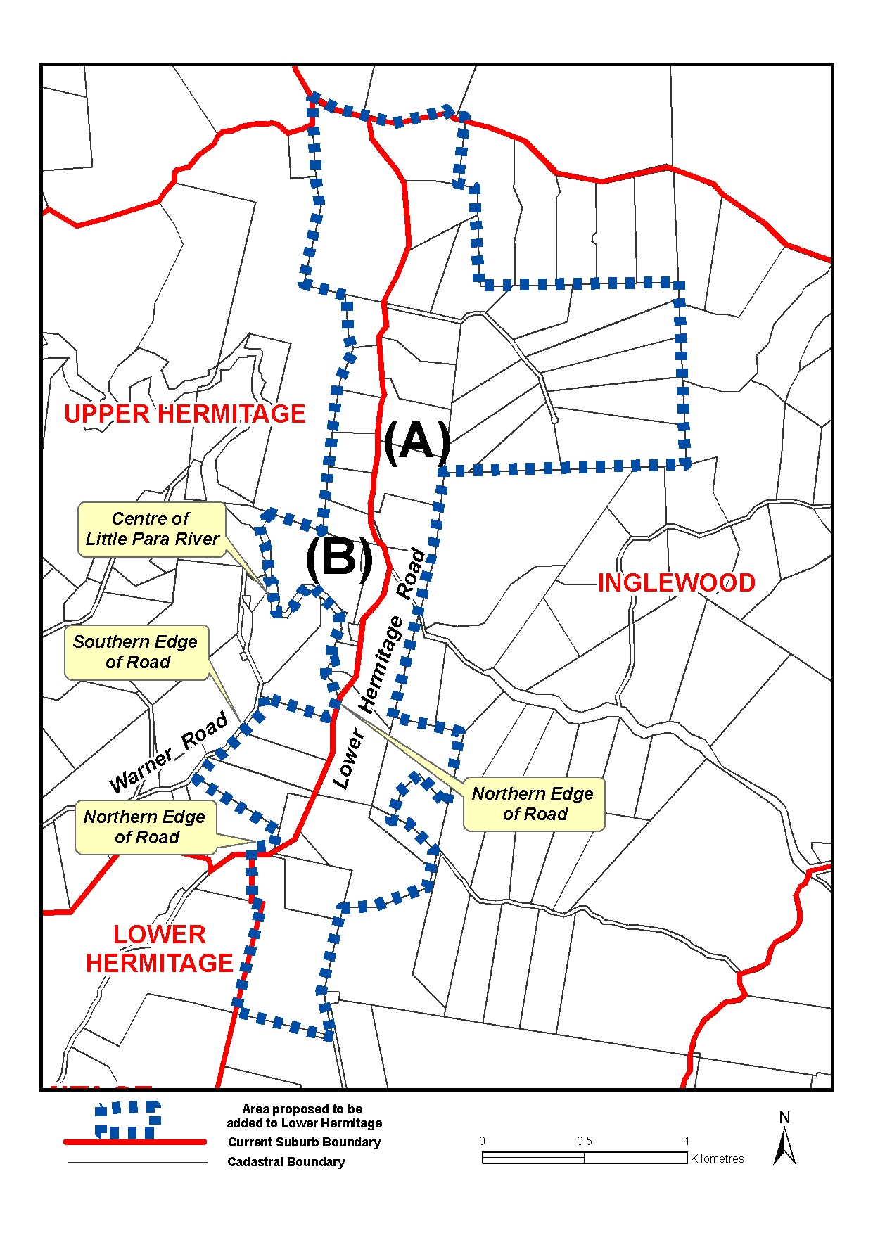
Submissions in writing regarding this proposal may be lodged with the Secretary, Geographical Names Advisory Committee, G.P.O. Box 1354, Adelaide, S.A. 5001, within one month of the publication of this notice.
Dated 8 September 2005.
P. M. Kentish, Surveyor-General, Department for Administrative and Information Services
DAIS 22-413/04/0028

LIQUOR LICENSING ACT 1997
Notice of Application
NOTICE is hereby given, pursuant to section 52 (2) (b) of the Liquor Licensing Act 1997, that Rort Pty Ltd and Kyledon Pty Ltd have applied to the Licensing Authority for alterations, redefinition, variation to Extended Trading Authorisation and variation to Entertainment Consent in respect of premises situated at 893 South Road, Clarence Gardens, S.A. 5039 and known as Avoca Hotel.
The application has been set down for hearing on 14 October 2005 at 9 a.m.
Conditions
The following licence conditions are sought:
• Alterations to and extension of the licensed premises to include proposed courtyard garden, saloon bar and bottleshop as per plans lodged with this office.
• Redefinition of the licensed premises, variation to Extended Trading Authorisation and variation to Entertainment Consent to include the abovementioned areas.
• Variation to the current Extended Trading Authorisation:
Monday to Wednesday: Midnight to 2 a.m. the following day;
Good Friday: Midnight to 2 a.m.;
Christmas Day: Midnight to 2 a.m.;
Sunday Christmas Eve: 8 p.m. to 2 a.m. the following day;
Days preceding other Public Holidays: Midnight to 2 a.m. the following day;
Sundays preceding Public Holidays: 8 p.m. to 2 a.m. the following day.
• Variation to Entertainment Consent to apply to the above-mentioned hours.
Any person may object to the application by lodging a notice of objection in the prescribed form with the Licensing Authority, and serving a copy of the notice on the applicants at the applicants’ address given above, at least seven days before the hearing date (viz: 6 October 2005).
The applicants’ address for service is c/o Avoca Hotel, Michael Caines, 893 South Road, Clarence Gardens, S.A. 5039.
Plans in respect of the premises the subject of the application are open to public inspection without fee at the Office of the Liquor and Gambling Commissioner, 9th Floor, East Wing, 50 Grenfell Street, Adelaide, S.A. 5000. Phone 8226 8410, Fax:
8226 8512. Email: olgc@agd.sa.gov.au.
Dated 12 September 2005.
Applicants

LIQUOR LICENSING ACT 1997
Notice of Application
NOTICE is hereby given, pursuant to section 52 (2) (b) of the Liquor Licensing Act 1997, that Moorooroo Estate Wines Pty Ltd has applied to the Licensing Authority for Redefinition and Entertainment Consent in respect of premises situated at 1 Lyndoch Road, Lyndoch, S.A. 5351 and known as Schild Estate Wines.
The application has been set down for hearing on 14 October 2005 at 9 a.m.
Conditions
The following licence conditions are sought:
• Redefinition of the licensed premises to include a designated dining area as per plans lodged with this office.
• Entertainment Consent:
Monday to Wednesday: 10 a.m. to 10 p.m.;
Thursday to Saturday: 10 a.m. to 1 a.m. the following day;
Sunday: 10 a.m. to 7 p.m.;
Sunday Christmas Eve: 10 a.m. to 7 p.m.;
New Year’s Eve: 10 a.m. to 2 a.m. the following day;
Days preceding other Public Holidays: 10 a.m. to 1 a.m. the following day;
Sundays preceding Public Holidays: 10 a.m. to 7 p.m.
Any person may object to the application by lodging a notice of objection in the prescribed form with the Licensing Authority, and serving a copy of the notice on the applicant at the applicant’s address given above, at least seven days before the hearing date (viz: 6 October 2005).
The applicant’s address for service is c/o Schild Estate Wines,
1 Lyndoch Road, Lyndoch, S.A. 5351 (contact: Daniel Eggleton).
Plans in respect of the premises the subject of the application are open to public inspection without fee at the Office of the Liquor and Gambling Commissioner, 9th Floor, East Wing, 50 Grenfell Street, Adelaide, S.A. 5000. Phone 8226 8410, Fax:
8226 8512. Email: olgc@agd.sa.gov.au.
Dated 12 September 2005.
Applicant

LIQUOR LICENSING ACT 1997
Notice of Application
NOTICE is hereby given, pursuant to section 52 (2) (b) of the Liquor Licensing Act 1997, that Kanta Pty Ltd as agent for the Kanta Joint Venture has applied to the Licensing Authority for a Producer’s Licence in respect of premises situated at 93 King William Street, Kent Town, S.A. 5067 and to be known as Kanta Wines.
The application has been set down for hearing on 21 October 2005 at 9 a.m.
Any person may object to the application by lodging a notice of objection in the prescribed form with the Licensing Authority, and serving a copy of the notice on the applicant at the applicant’s address given above, at least seven days before the hearing date (viz: 13 October 2005).
The applicant’s address for service is c/o David Watts and Associates, 1 Cator Street, Glenside, S.A. 5065.
Plans in respect of the premises the subject of the application are open to public inspection without fee at the Office of the Liquor and Gambling Commissioner, 9th Floor, East Wing, 50 Grenfell Street, Adelaide, S.A. 5000. Phone 8226 8410, Fax:
8226 8512. Email: olgc@agd.sa.gov.au.
Dated 12 September 2005.
Applicant

LIQUOR LICENSING ACT 1997
Notice of Application
NOTICE is hereby given, pursuant to section 52 (2) (b) of the Liquor Licensing Act 1997, that Ingleburne Wine Company Pty Ltd has applied to the Licensing Authority for a Wholesale Liquor Merchant’s Licence in respect of premises situated at Lot 100, Main Road, McLaren Vale, S.A. 5171 and to be known as Ingleburne Wine Company.
The application has been set down for hearing on 21 October 2005 at 9 a.m.
Any person may object to the application by lodging a notice of objection in the prescribed form with the Licensing Authority, and serving a copy of the notice on the applicant at the applicant’s address given above, at least seven days before the hearing date (viz: 13 October 2005).
The applicant’s address for service is c/o David Watts and Associates, 1 Cator Street, Glenside, S.A. 5065.
Plans in respect of the premises the subject of the application are open to public inspection without fee at the Office of the Liquor and Gambling Commissioner, 9th Floor, East Wing, 50 Grenfell Street, Adelaide, S.A. 5000. Phone 8226 8410, Fax:
8226 8512. Email: olgc@agd.sa.gov.au.
Dated 12 September 2005.
Applicant

LIQUOR LICENSING ACT 1997
Notice of Application
NOTICE is hereby given, pursuant to section 52 (2) (b) of the Liquor Licensing Act 1997, that Nuriootpa Vine Inn Hotel Motel Pty Ltd has applied to the Licensing Authority for redefinition of the Licensed Area, variation to Extended Trading Authoriation, variation to Entertainment Consent and variation to Licence Conditions in respect of premises situated at Murray Street, Nuriootpa, S.A. 5355 and known as Vine Inn.
The application has been set down for hearing on 14 October 2005 at 9 a.m.
Conditions
The following licence conditions are sought:
• Redefinition of the licensed area of the hotel and premises to include the area outlined in red as per plans lodged with this office.
• Variation to the current Extended Trading Authorisation to include the new area as per plans lodged with this office and for the following hours:
Monday to Wednesday: Midnight to 1 a.m. the following day;
Thursday to Saturday: Midnight to 2 a.m. the following day;
Sunday: 8 p.m. to midnight;
Public Holidays (except Good Friday): Midnight to 2 a.m.
• Variation to Entertainment Consent to include the new area and for the abovementioned hours.
• Deletion of the following licence conditions:
Declaring areas 7 and 8 out of bounds to minors from 9 p.m. to midnight on Friday and Saturday nights.
No entertainment shall be provided after 9 p.m. between Sunday and Thursday without four weeks prior written notice to the officer in charge of Nuriootpa Police Station.
After midnight when live entertainment is being provided in any part of the licensed premises there shall be a staff member stationed at each unlocked door leading to the area where the entertainment is being provided and a licensed Security Officer is to patrol outside of the licensed premises from midnight to 90 minutes after close of trade on those occasions. However, this condition can be waived by written agreement between the officer in charge of the Nuriootpa Police Station and the Manager.
Any person may object to the application by lodging a notice of objection in the prescribed form with the Licensing Authority, and serving a copy of the notice on the applicant at the applicant’s address given above, at least seven days before the hearing date (viz: 6 October 2005).
The applicant’s address for service is c/o Wallmans Lawyers, 173 Wakefield Street, Adelaide, S.A. 5000 (Attention: Peter Hoban or Ben Allen).
Plans in respect of the premises the subject of the application are open to public inspection without fee at the Office of the Liquor and Gambling Commissioner, 9th Floor, East Wing, 50 Grenfell Street, Adelaide, S.A. 5000. Phone 8226 8410, Fax:
8226 8512. Email: olgc@agd.sa.gov.au.
Dated 12 September 2005.
Applicant

LIQUOR LICENSING ACT 1997
Notice of Application
NOTICE is hereby given, pursuant to section 52 (2) (b) of the Liquor Licensing Act 1997, that UBM Investments Pty Ltd, Dontaris Pty Ltd, Uppy Pty Ltd and P. M. & J. M. Burnett Pty Ltd have applied to the Licensing Authority for a variation to the current Extended Trading Authorisation and variation to the current Entertainment Consent in respect of premises situated at Old South Road, Reynella, S.A. 5161 and known as Crown Inn.
The application has been set down for hearing on 14 October 2005 at 9 a.m.
Conditions
The following licence conditions are sought:
• Variation to the current Extended Trading Authorisation:
Monday to Thursday: Midnight to 2 a.m. the following day;
Sunday: 8 p.m. to 2 a.m. the following day;
Good Friday: Midnight to 2 a.m.;
Sunday Christmas Eve: 8 p.m. to 2 a.m. the following day.
• Variation to the current Entertainment Consent to apply to the abovementioned hours.
Any person may object to the application by lodging a notice of objection in the prescribed form with the Licensing Authority, and serving a copy of the notice on the applicants at the applicants’ address given above, at least seven days before the hearing date (viz: 6 October 2005).
The applicants’ address for service is c/o Crown Inn, Darren Morrison, Old South Road, Reynella, S.A. 5161.
Plans in respect of the premises the subject of the application are open to public inspection without fee at the Office of the Liquor and Gambling Commissioner, 9th Floor, East Wing, 50 Grenfell Street, Adelaide, S.A. 5000. Phone 8226 8410, Fax:
8226 8512. Email: olgc@agd.sa.gov.au.
Dated 8 September 2005.
Applicants

LIQUOR LICENSING ACT 1997
Notice of Application
NOTICE is hereby given, pursuant to section 52 (2) (b) of the Liquor Licensing Act 1997, that Steven Robert Glen and Terri Lee Stevens have applied to the Licensing Authority for a transfer of a Restaurant Licence in respect of premises situated at Shop 3, Rivoli Lane, Naracoorte, S.A. 5271 and known as The Blue Wattle Cafe.
The application has been set down for hearing on 17 October 2005 at 11 a.m.
Any person may object to the application by lodging a notice of objection in the prescribed form with the Licensing Authority, and serving a copy of the notice on the applicants at the applicants’ address given above, at least seven days before the hearing date (viz: 7 October 2005).
The applicants’ address for service is c/o Westley Digiorgio, P.O. Box 1265, Naracoorte, S.A. 5271 (Attention: Peter Westley).
Plans in respect of the premises the subject of the application are open to public inspection without fee at the Office of the Liquor and Gambling Commissioner, 9th Floor, East Wing, 50 Grenfell Street, Adelaide, S.A. 5000. Phone 8226 8410, Fax:
8226 8512. Email: olgc@agd.sa.gov.au.
Dated 8 September 2005.
Applicants

LIQUOR LICENSING ACT 1997
Notice of Application
NOTICE is hereby given, pursuant to section 52 (2) (b) of the Liquor Licensing Act 1997, that Woolies Liquor Stores Pty Ltd has applied to the Licensing Authority for the removal of a Retail Liquor Merchant’s Licence in respect of premises situated at Shop 103, Hollywood Plaza, Winzor Street, Salisbury Downs, S.A. 5109 to be situated at Shops 41, 43 and 44, Hollywood Plaza, Winzor Street, Salisbury Downs, S.A. 5109 and known as Woolworths Liquor.
The application has been set down for hearing on 14 October 2005 at 9 a.m.
Any person may object to the application by lodging a notice of objection in the prescribed form with the Licensing Authority, and serving a copy of the notice on the applicant at the applicant’s address given above, at least seven days before the hearing date (viz: 6 October 2005).
The applicant’s address for service is c/o Clelands Lawyers, 208 Carrington Street, Adelaide, S.A. 5000 (Attention: Leon McEvoy).
Plans in respect of the premises the subject of the application are open to public inspection without fee at the Office of the Liquor and Gambling Commissioner, 9th Floor, East Wing, 50 Grenfell Street, Adelaide, S.A. 5000. Phone 8226 8410, Fax:
8226 8512. Email: olgc@agd.sa.gov.au.
Dated 8 September 2005.
Applicant

LIQUOR LICENSING ACT 1997
Notice of Application
NOTICE is hereby given, pursuant to section 52 (2) (b) of the Liquor Licensing Act 1997, that Nonabel Nominees Pty Ltd as trustee for Seven Vessels Discretionary Trust has applied to the Licensing Authority for the transfer on an Entertainment Venue Licence in respect of premises situated at 279A Hindley Street, Adelaide, S.A. 5000 known as E & I Lounge and to be known as Club Feva.
The application has been set down for hearing on 18 October 2005 at 11 a.m.
Any person may object to the application by lodging a notice of objection in the prescribed form with the Licensing Authority, and serving a copy of the notice on the applicant at the applicant’s address given above, at least seven days before the hearing date (viz: 10 October 2005).
The applicant’s address for service is c/o Tony Saleh, 279A Hindley Street, Adelaide, S.A. 5000.
Plans in respect of the premises the subject of the application are open to public inspection without fee at the Office of the Liquor and Gambling Commissioner, 9th Floor, East Wing, 50 Grenfell Street, Adelaide, S.A. 5000. Phone 8226 8410, Fax:
8226 8512. Email: olgc@agd.sa.gov.au.
Dated 8 September 2005.
Applicant

LIQUOR LICENSING ACT 1997
Notice of Application
NOTICE is hereby given, pursuant to section 52 (2) (b) of the Liquor Licensing Act 1997, that Giovanni Pilla has applied to the Licensing Authority for the transfer of a Hotel Licence with Extended Trading Authorisation, Entertainment Consent and extension of Trading Area, in respect of premises situated at Bice Street, Tarcoola, S.A. 5710 and known as Wilgena Hotel.
The application has been set down for hearing on 23 September 2005 at 9 a.m.
Conditions
The following licence conditions are sought:
• Extended Trading Authorisation is sought for Areas 1, 2, 3, 4 and the Verandah Areas as per plans lodged:
For consumption on the premises:
Monday to Saturday: Midnight to 5 a.m. the following day;
Sunday: 8 a.m. to 11 a.m. and 8 p.m. to 2 a.m. the following day;
Maundy Thursday: Midnight to 2 a.m. the following day;
Christmas Eve: Midnight to 2 a.m. the following day;
Sunday Christmas Eve: 8 p.m. to 2 a.m. the following day;
New Year’s Eve: 2 a.m. the following day to 5 a.m. the following day;
Days preceding other Public Holidays: Midnight to 5 a.m. the following day;
Sundays preceding Public Holidays: 8 p.m. to 5 a.m. the following day.
For consumption off the licensed premises:
Sunday: 8 p.m. to 9 p.m.
• Entertainment Consent is sought for Areas 1, 2, 3 and 4 as per plans lodged:
Monday to Saturday: 12 p.m. to 2 a.m. the following day;
Sunday: 11 a.m. to 2 a.m. the following day;
Maundy Thursday: 12 p.m. to 2 a.m. the following day;
Christmas Eve: 12 p.m. to 2 a.m. the following day;
Sunday Christmas Eve: 12 p.m. to 2 a.m. the following day;
New Year’s Eve: 12 p.m. to 2 a.m. the following day;
Days preceding other Public Holidays: 12 p.m. to 2 a.m. the following day;
Sundays preceding Public Holidays: 12 p.m. to 2 a.m. the following day.
• Redefinition of the licensed premises is sought to include the Outdoor Verandah Areas as per plans lodged with this office.
Any person may object to the application by lodging a notice of objection in the prescribed form with the Licensing Authority, and serving a copy of the notice on the applicant at the applicant’s address given above, at least seven days before the hearing date (viz: 15 September 2005).
The applicant’s address for service is c/o Giovanni Pilla, P.O. Box 405, Enfield Plaza, S.A. 5085.
Plans in respect of the premises the subject of the application are open to public inspection without fee at the Office of the Liquor and Gambling Commissioner, 9th Floor, East Wing, 50 Grenfell Street, Adelaide, S.A. 5000. Phone 8226 8410, Fax:
8226 8512. Email: olgc@agd.sa.gov.au.
Dated 8 September 2005.
Applicant

LIQUOR LICENSING ACT 1997
Notice of Application
NOTICE is hereby given, pursuant to section 52 (2) (b) of the Liquor Licensing Act 1997, that Stunsail Boom Pty Ltd has applied to the Licensing Authority for the removal of a Direct Sales Licence in respect of premises situated at Level 2, 89 King William Street, Adelaide, S.A. 5000 and to be situated at 69 King William Street, Kent Town, S.A. 5067 and known as Adelaide Cellar Door.
The application has been set down for hearing on 14 October 2005 at 9 a.m.
Any person may object to the application by lodging a notice of objection in the prescribed form with the Licensing Authority, and serving a copy of the notice on the applicant at the applicant’s address given above, at least seven days before the hearing date (viz: 6 October 2005).
The applicant’s address for service is c/o Jane Harris, 33A Seventh Avenue, St Peters, S.A. 5069.
Plans in respect of the premises the subject of the application are open to public inspection without fee at the Office of the Liquor and Gambling Commissioner, 9th Floor, East Wing, 50 Grenfell Street, Adelaide, S.A. 5000. Phone 8226 8410, Fax:
8226 8512. Email: olgc@agd.sa.gov.au.
Dated 8 September 2005.
Applicant

LIQUOR LICENSING ACT 1997
Notice of Application
NOTICE is hereby given, pursuant to section 52 (2) (b) of the Liquor Licensing Act 1997, that He Chen and Hui Yin Chan have applied to the Licensing Authority for the transfer on a Restaurant Licence in respect of premises situated at 448 Goodwood Road, Cumberland Park, S.A. 5041 and known as Happy Buddha Restaurant.
The application has been set down for hearing on 18 October 2005 at 10 a.m.
Any person may object to the application by lodging a notice of objection in the prescribed form with the Licensing Authority, and serving a copy of the notice on the applicants at the applicants’ address given above, at least seven days before the hearing date (viz: 10 October 2005).
The applicants’ address for service is c/o Yapp Hau Pehn Solicitors, 1st Floor, 149 Flinders Street, Adelaide, S.A. 5000.
Plans in respect of the premises the subject of the application are open to public inspection without fee at the Office of the Liquor and Gambling Commissioner, 9th Floor, East Wing, 50 Grenfell Street, Adelaide, S.A. 5000. Phone 8226 8410, Fax:
8226 8512. Email: olgc@agd.sa.gov.au.
Dated 7 September 2005.
Applicants

LIQUOR LICENSING ACT 1997
Notice of Application
NOTICE is hereby given, pursuant to section 52 (2) (b) of the Liquor Licensing Act 1997, that Aaron Troy Greig has applied to the Licensing Authority for the transfer on a Hotel Licence in respect of premises situated at 1 Railway Terrace, Warnertown, S.A. 5540 and known as Flinders Rest Hotel.
The application has been set down for hearing on 17 October 2005 at 10 a.m.
Any person may object to the application by lodging a notice of objection in the prescribed form with the Licensing Authority, and serving a copy of the notice on the applicant at the applicant’s address given above, at least seven days before the hearing date (viz: 7 October 2005).
The applicant’s address for service is c/o Aaron Troy Greig, P.O. Box 227, Wallaroo, S.A. 5556.
Plans in respect of the premises the subject of the application are open to public inspection without fee at the Office of the Liquor and Gambling Commissioner, 9th Floor, East Wing, 50 Grenfell Street, Adelaide, S.A. 5000. Phone 8226 8410, Fax:
8226 8512. Email: olgc@agd.sa.gov.au.
Dated 6 September 2005.
Applicant

LIQUOR LICENSING ACT 1997
Notice of Application
NOTICE is hereby given, pursuant to section 52 (2) (b) of the Liquor Licensing Act 1997, that Charles Alexander Hill-Smith and Michael Andrew Ray Krieg have applied to the Licensing Authority for a redefinition of the licensed premises, variation to the Extended Trading Authorisation, variation to the Enter-tainment Consent and variation to Licence Conditions in respect of premises situated at 11-13 Frome Street, Adelaide, S.A. 5000 and known as Rhino Room.
The application has been set down for hearing on 14 October 2005 at 9 a.m.
Conditions
The following licence conditions are sought:
• Deleting the existing authorisation from the licence and replacing with the following authorisation:
For consumption on the licensed premises from 4 p.m. to 3 a.m. the following day on any day. The licence does not authorise any trade on Good Friday or Christmas Day.
• Deleting all existing Conditions 1-17 and replacing them with the following:
The predominant activity conducted on the licensed premised on any day shall be one or more of the following:
(a) Visual Art Exhibition(s);
(b) Live Artistic Performance(s); and
(c) Private Functions(s).
• Redefinition of the licensed premises to include Ground Floor as the First Floor is currently licensed.
Any person may object to the application by lodging a notice of objection in the prescribed form with the Licensing Authority, and serving a copy of the notice on the applicants at the applicants’ address given above, at least seven days before the hearing date (viz: 6 October 2005).
The applicants’ address for service is c/o Rhino Room, 11-13 Frome Street, Adelaide, S.A. 5000.
Plans in respect of the premises the subject of the application are open to public inspection without fee at the Office of the Liquor and Gambling Commissioner, 9th Floor, East Wing, 50 Grenfell Street, Adelaide, S.A. 5000. Phone 8226 8410, Fax:
8226 8512. Email: olgc@agd.sa.gov.au.
Dated 6 September 2005.
Applicants

LIQUOR LICENSING ACT 1997
Notice of Application
NOTICE is hereby given, pursuant to section 52 (2) (b) of the Liquor Licensing Act 1997, that Oaks Hotels & Resorts (SA) Pty Ltd has applied to the Licensing Authority for the transfer of a Hotel Licence in respect of premises situated at 92 North Terrace, Adelaide, S.A. 5000 and known as MBC Lounge and Restaurant.
The application has been set down for hearing on 26 September 2005 at 10.30 a.m.
Any person may object to the application by lodging a notice of objection in the prescribed form with the Licensing Authority, and serving a copy of the notice on the applicant at the applicant’s address given above, before the hearing date (viz: 23 September 2005).
The applicant’s address for service is c/o Leanne Summers, P.O. Box 473, Cotton Tree, Qld 4558.
Plans in respect of the premises the subject of the application are open to public inspection without fee at the Office of the Liquor and Gambling Commissioner, 9th Floor, East Wing, 50 Grenfell Street, Adelaide, S.A. 5000. Phone 8226 8410, Fax:
8226 8512. Email: olgc@agd.sa.gov.au.
Dated 7 September 2005.
Applicant

LIQUOR LICENSING ACT 1997
Notice of Application
NOTICE is hereby given, pursuant to section 52 (2) (b) of the Liquor Licensing Act 1997, that George Mitrotasios has applied to the Licensing Authority for a Producer’s Licence in respect of premises situated at Lot 9, Ryan Road, Willunga, S.A. 5172 and to be known as Palombo/Mitrotasios.
The application has been set down for hearing on 14 October 2005 at 9 a.m.
Any person may object to the application by lodging a notice of objection in the prescribed form with the Licensing Authority, and serving a copy of the notice on the applicant at the applicant’s address given above, at least seven days before the hearing date (viz: 6 October 2005).
The applicant’s address for service is c/o George Mitrotasios, P.O. Box 692, Willunga, S.A. 5172.
Plans in respect of the premises the subject of the application are open to public inspection without fee at the Office of the Liquor and Gambling Commissioner, 9th Floor, East Wing, 50 Grenfell Street, Adelaide, S.A. 5000. Phone 8226 8410, Fax:
8226 8512. Email: olgc@agd.sa.gov.au.
Dated 8 September 2005.
Applicant

LIQUOR LICENSING ACT 1997
Notice of Application
NOTICE is hereby given, pursuant to section 52 (2) (b) of the Liquor Licensing Act 1997, that Barreau Birkenhead Pty Ltd and Jake Barreau Investments Pty Ltd have applied to the Licensing Authority for a variation to the current Extended Trading Authorisation in respect of premises situated at 3 Elder Road, Birkenhead, S.A. 5015 and known as Birkenhead Tavern.
The application has been set down for hearing on 14 October 2005 at 9 a.m.
Conditions
The following licence conditions are sought:
• Variation to the current Extended Trading Authorisation:
Sunday: Midnight to 5 a.m. the following day;
Good Friday: Midnight to 2 a.m.;
Christmas Day: Midnight to 2 a.m.
Any person may object to the application by lodging a notice of objection in the prescribed form with the Licensing Authority, and serving a copy of the notice on the applicants at the applicants’ address given above, at least seven days before the hearing date (viz: 6 October 2005).
The applicants’ address for service is c/o Australian Hotels Association, 4th Floor, 60 Hindmarsh Square, Adelaide, S.A. 5000.
Plans in respect of the premises the subject of the application are open to public inspection without fee at the Office of the Liquor and Gambling Commissioner, 9th Floor, East Wing, 50 Grenfell Street, Adelaide, S.A. 5000. Phone 8226 8410, Fax:
8226 8512. Email: olgc@agd.sa.gov.au.
Dated 8 September 2005.
Applicants

LIQUOR LICENSING ACT 1997
Notice of Application
NOTICE is hereby given, pursuant to section 52 (2) (b) of the Liquor Licensing Act 1997, that Rogwil Investments Pty Ltd has applied to the Licensing Authority for a variation to the current Extended Trading Authorisation in respect of premises situated at 423 Churchill Road, Kilburn, S.A. 5084 and known as Albion Hotel.
The application has been set down for hearing on 14 October 2005 at 9 a.m.
Conditions
The following licence conditions are sought:
• Variation to the current Extended Trading Authorisation:
Monday to Thursday: 2 a.m. to 5 a.m.;
Friday and Saturday: 3 a.m. to 5 a.m.;
Sunday: Midnight to 5 a.m. the following day;
Good Friday: Midnight to 2 a.m.;
Christmas Day: Midnight to 2 a.m.
Any person may object to the application by lodging a notice of objection in the prescribed form with the Licensing Authority, and serving a copy of the notice on the applicant at the applicant’s address given above, at least seven days before the hearing date (viz: 6 October 2005).
The applicant’s address for service is c/o Australian Hotels Association, 4th Floor, 60 Hindmarsh Square, Adelaide, S.A. 5000.
Plans in respect of the premises the subject of the application are open to public inspection without fee at the Office of the Liquor and Gambling Commissioner, 9th Floor, East Wing, 50 Grenfell Street, Adelaide, S.A. 5000. Phone 8226 8410, Fax:
8226 8512. Email: olgc@agd.sa.gov.au.
Dated 8 September 2005.
Applicant

LIQUOR LICENSING ACT 1997
Notice of Application
NOTICE is hereby given, pursuant to section 52 (2) (b) of the Liquor Licensing Act 1997, that Silenus Pty Ltd has applied to the Licensing Authority for a variation to the current Extended Trading Authorisation in respect of premises situated at Lincoln Highway, Whyalla, S.A. 5600 and known as Sundowner Motel Hotel.
The application has been set down for hearing on 14 October 2005 at 9 a.m.
Any person may object to the application by lodging a notice of objection in the prescribed form with the Licensing Authority, and serving a copy of the notice on the applicant at the applicant’s address given above, at least seven days before the hearing date (viz: 6 October 2005).
The applicant’s address for service is c/o Australian Hotels Association, 4th Floor, 60 Hindmarsh Square, Adelaide, S.A. 5000.
Plans in respect of the premises the subject of the application are open to public inspection without fee at the Office of the Liquor and Gambling Commissioner, 9th Floor, East Wing, 50 Grenfell Street, Adelaide, S.A. 5000. Phone 8226 8410, Fax:
8226 8512. Email: olgc@agd.sa.gov.au.
Dated 8 September 2005.
Applicant

LIQUOR LICENSING ACT 1997
Notice of Application
NOTICE is hereby given, pursuant to section 52 (2) (b) of the Liquor Licensing Act 1997, that Steve and Anna Grimley as trustees for Grimley Family Trust have applied to the Licensing Authority for a Wholesale Liquor Merchant’s Licence in respect of premises situated at 7 Captain Sturt Parade, Hindmarsh Island, S.A. 5214 and to be known as Loom Wine.
The application has been set down for hearing on 14 October 2005 at 9 a.m.
Any person may object to the application by lodging a notice of objection in the prescribed form with the Licensing Authority, and serving a copy of the notice on the applicants at the applicants’ address given above, at least seven days before the hearing date (viz: 6 October 2005).
The applicants’ address for service is c/o David Watts, 1 Cator Street, Glenside, S.A. 5065.
Plans in respect of the premises the subject of the application are open to public inspection without fee at the Office of the Liquor and Gambling Commissioner, 9th Floor, East Wing, 50 Grenfell Street, Adelaide, S.A. 5000. Phone 8226 8410, Fax:
8226 8512. Email: olgc@agd.sa.gov.au.
Dated 6 September 2005.
Applicants

LIQUOR LICENSING ACT 1997 AND GAMING MACHINES ACT 1992
Notice of Application
NOTICE is hereby given, pursuant to section 52 of the Liquor Licensing Act 1997 and section 29 of the Gaming Machines Act 1992, that Clone Pty Ltd as trustee for Bare Trust has applied to the Licensing Authority for the transfer of a Hotel Licence and Gaming Machine Licence in respect of premises situated at 77 Pirie Street, Adelaide, S.A. 5000 and known as Planet Hotel.
The application has been set down for hearing on 19 October 2005 at 11 a.m.
Any person may object to the application by lodging a notice of objection in the prescribed form with the Licensing Authority, and serving a copy of the notice on the applicant at the applicant’s address given above, at least seven days before the hearing date (viz: 11 October 2005).
The applicant’s address for service is c/o Grope Hamilton Budini Lawyers, Tonia Karagiannis, Level 2, 15 Bentham Street, Adelaide, S.A. 5000.
Plans in respect of the premises the subject of the application are open to public inspection without fee at the Office of the Liquor and Gaming Commissioner, 9th Floor, East Wing, 50 Grenfell Street, Adelaide, S.A. 5000. Phone 8226 8410, Fax: 8226 8512. Email: olgc@agd.sa.gov.au.
Dated 9 September 2005.
Applicant

NATIONAL ELECTRICITY LAW
Notice under Section 99
Draft Rule Determination
Draft National Electricity Amendment (Revision of Dispatch Pricing Due to Manifestly Incorrect Inputs) Rule No. 2005/3
THE Australian Energy Market Commission (Commission) gives notice under section 99 of the National Electricity Law (NEL) of the making of a Draft Rule Determination in relation to a Rule proposal by NEMMCO to allow NEMMCO, in specified limited circumstances, to revise market prices after identified manifestly incorrect inputs into the dispatch system.
This Rule proposal was received by NECA (the Commission’s predecessor) on 15 February 2005. Under the NEL transitional provisions, consideration of this Rule proposal became the Commission’s responsibility on 1 July 2005. The Commission gives notice that it has decided to dispense with the first round consultation steps under the Rule making process in respect of this Rule proposal because those steps duplicate processes already carried out under the National Electricity Code. The Commission has determined therefore to progress this Rule proposal to the stage of issuing a Draft Rule Determination.
The Draft Rule Determination, including the draft Rule, is pub-lished on the Commission’s website and is available for inspection at the offices of the Commission. The Commission invites written submissions from any person or body in relation to the draft Rule. Submissions must be received by no later than Friday, 28 October 2005.
In accordance with section 101 of the NEL, any interested person or body may request the Commission to hold a hearing in relation to a Draft Rule Determination. A request must be received by Friday, 23 September 2005.
Postal Address:  P.O. Box H166  Australia Square, N.S.W. 1215 | Offices:  Level 16, 1 Margaret Street,  Sydney, N.S.W. 2000
Facsimile:
(02) 8296 7899
Email:  submissions@aemc.gov.au | Website:  www.aemc.gov.au
John Tamblyn, Chairman, Australian Energy Market Commission

NATIONAL PARKS AND WILDLIFE ACT 1972
Anstey Hill Recreation Park Management Plan—Draft
I, LEANNE BURCH, Acting Director of National Parks and Wildlife, hereby give notice under the provisions of section 38 of the National Parks and Wildlife Act 1972, that a draft management plan has been prepared for the Anstey Hill Recreation Park.
Copies of the draft management plan may be inspected at or obtained from the Department for Environment and Heritage at:
• 1 Richmond Road, Keswick, S.A. 5035 (G.P.O. Box 1047, Adelaide, S.A. 5001), telephone 8124 4700;
• Northern Lofty District Office (Black Hill Conservation Park, 115 Maryvale Road, Athelstone, S.A. 5076), telephone 8336 0901;
• http://www.environment.sa.gov.au/parks/management_plans.html.
For general enquiries, please contact the DEH Information Line, telephone 8204 1910 or e-mail to:
dehinformation@saugov.sa.gov.au.
Any person may make representations in connection with the draft management plan during the period up to and including Thursday, 15 December 2005.
Written comments should be forwarded to the Manager, Policy and Planning, Department for Environment and Heritage, G.P.O. Box 1047, Adelaide, S.A. 5001 or e-mailed to:
irving.jason@saugov.sa.gov.au.
Leanne Burch, Acting Director of National Parks and Wildlife, Delegate of the Minister for Environment and Conservation

NATURAL RESOURCES MANAGEMENT ACT 2004
Notice of Prohibition on Taking Water from Wells in the Eastern Mount Lofty Ranges Area
PURSUANT to section 132 (1) of the Natural Resources Management Act 2004 (‘the Act’), I, John David Hill, Minister for Environment and Conservation in the State of South Australia, and Minister to whom the administration of the Act is committed, being of the opinion that the rate at which water is being taken from wells in the area described in Schedule 1 (‘the Underground Water Area’) is such that there is a risk that the available water will not be sufficient to meet future demand, hereby prohibit the taking of water from wells except in the circumstances specified in Schedule 2.
Schedule 1
The Underground Water Area
The area bounded by the bold solid line as shown in the GRO Plan No. 423/2003 (‘the Underground Water Area’).
Schedule 2
1. A person may take water from a well in the Underground Water Area in accordance with the terms of a written authorisation granted by me or my authorised agent under the Notice of Prohibition on Taking Water from Wells in the Eastern Mount Lofty Ranges Area published on 16 October 2003, pursuant to section 16 (1) of the Water Resources Act 1997.
2. A person may take water from a well in the Underground Water Area in accordance with the terms of a written authorisation granted under this Notice by me or my authorised agent.
3. An authorisation under this Notice may be granted to:
(a) A person (‘a Current User’) who has been taking water from a well in the Underground Water Area during the period 1 July 2000 to 15 October 2003 inclusive (‘the Relevant Period’), entitling that person to take:
• where the water taken during the relevant period was to water a crop or crops, the amount of water reason-ably necessary, in my opinion, to water that crop or those crops, the amount being determined taking into account the maximum area of each crop or crops grown, the water requirements of the respective crop or crops and the irrigation capacity of the irrigation equipment used to water the crop or crops; or
• where the water was taken during the relevant period for any other purpose, the amount of water which, in my opinion, is reasonably necessary to continue that purpose in the manner in which it had been undertaken during the relevant period.
(b) The transferee under a contract for the sale or other transfer of land where the transferor of the land is the holder of an authorisation under this notice, entitling that person to take the same amount of water from the same source as the transferor was authorised to take.
(c) Subject to clause 4, a person (‘a Prospective User’) who did not take any water from a well but who needs water for a development, project or undertaking:
• to which that person was legally committed during the relevant period; or
• in respect of which that person had, in my opinion, committed significant financial or other resources during the relevant period,
entitling that person to take the amount of water from a well in the Underground Water Area, which in my opinion, is reasonably necessary to undertake the development, project or undertaking to which that person was committed.
4. A Prospective User may not be granted an authorisation or may only be granted an authorisation subject to conditions relating to the manner of taking water where, in my opinion:
(a) the taking of water will detrimentally affect the ability of other persons to take water from any watercourse, well or dam for domestic purposes or the watering of stock (other than stock being intensively farmed); or
(b) the taking of water will detrimentally affect the capacity of the water resource to meet the current or future demand including the demands of ecosystems dependent on that water resource.
5. Until authorised under this Notice, a Current User may continue to take an amount of water equivalent to the maximum amount taken in any one year, from the same source and for the same purpose or purposes as that person took during the relevant period without a written authorisation.
6. This Notice does not apply:
(a) to the taking of water pursuant to section 124 (4) of the Act for domestic purposes or for watering stock (other than stock subject to intensive farming);
(b) to the taking of water for fire fighting purposes or public road making purposes; or
(c) to the taking of water for the purpose of use in the application of chemicals on crops.
7. The following condition applies to the taking of water in accordance with an authorisation granted under this Notice:
• The water may only be taken through a meter which accurately measures the quantity of water taken and is at all times in good working condition.
In this Notice:
‘Maximum area’ for a particular crop means the average of the maximum areas of land planted to a particular crop during the Relevant Period.
‘Water requirement’ of a crop means the reasonable rate of irrigation (expressed as a volume of water per hectare) to properly produce that crop.
‘Irrigation capacity’ of irrigation equipment means the amount of water that can be applied by the usual operation of that equipment in its condition at 15 October 2003, under usual pumping rates, hours of operation and seasonal fluctuations.
This Notice will remain in effect for two years unless earlier varied or revoked.
Dated 12 September 2005.
John Hill, Minister for Environment and Conservation

NATURAL RESOURCES MANAGEMENT ACT 2004
Notice of Prohibition on Taking Surface Water and Water from Watercourses in the Eastern Mount Lofty Ranges Area
PURSUANT to section 132 (1) of the Natural Resources Manage-ment Act 2004 (‘the Act’), I, John David Hill, Minister for Environment and Conservation in the State of South Australia, and Minister to whom the administration of the Act is committed, being of the opinion that:
• the rate at which surface water is taken in the area described in Schedule 1 (‘the Area’) is such that the surface water available can no longer meet the demand; and
• the rate at which water is taken from watercourses in the Area is such that there is a risk that the available water will not be sufficient to meet future demand,
hereby prohibit the taking of surface water and water from water-courses in the Area except in the circumstances specified in Schedule 2.
Schedule 1
The Area
The Area bounded by the bold solid line as shown in the GRO Plan No. 422/2003 (‘the Area’).
Schedule 2
1. A person may take water from surface water and water from watercourses in the Area in accordance with the terms of a written authorisation granted by me or my authorised agent under the Notice of Prohibition on Taking Surface Water and Water from Watercourses in the Eastern Mount Lofty Ranges Area published on 16 October 2003, pursuant to section 16 (1) of the Water Resources Act 1997.
2. A person may take surface water and water from a water-course in the Area in accordance with the terms of a written authorisation granted under this Notice by me or my authorised agent.
3. An authorisation under this Notice may be granted to:
(a) A person (‘a Current User’), who has been taking surface water or water from a watercourse in the Area during the period 1 July 2000 to 15 October 2003 inclusive (‘the Relevant Period’), entitling that person to take, from the source specified in the authorisation:
• where the water taken during the Relevant Period was to water a crop or crops, the amount of water reasonably necessary, in my opinion, to water that crop or those crops, the amount being determined taking into account the maximum area of each crop or crops grown, the water requirements of the respective crop or crops and the irrigation capacity of the irrigation equipment used to water the crop or crops; or
• where the water was taken during the Relevant Period for any other purpose, the amount of water which, in my opinion, is reasonably necessary to continue that purpose in the manner in which it had been undertaken during the Relevant Period.
The source specified will be the resource or resources where water was taken during the Relevant Period.
(b) The transferee under a contract for the sale or other transfer of land where the transferor of the land is the holder of an authorisation under this Notice, entitling that person to take the same amount of water from the same source as the transferor was authorised to take.
(c) Subject to clause 4, a person (‘a Prospective User’) who did not take any surface water or water from a water-course in the Area but who needs water for a develop-ment, project or undertaking:
• to which that person was legally committed during the Relevant Period; or
• in respect of which that person had, in my opinion, committed significant financial or other resources during the Relevant Period,
entitling that person to take the amount of surface water or water from a watercourse in the Area, which in my opinion, is reasonably necessary to undertake the development, project or undertaking to which that person was committed.
4. A Prospective User may not be granted an authorisation or may only be granted an authorisation subject to conditions relating to the manner of taking water where, in my opinion:
(a) the taking of surface water or water from watercourses will detrimentally affect the ability of other persons to take water from any watercourse, well or dam for domestic purposes or for watering of stock (other than stock being intensively farmed); or
(b) the taking of surface water or water from watercourses will detrimentally affect the capacity of surface water or any watercourse or well to meet the current or future demand, including the demands of ecosystems dependent on that water resource.
5. Until authorised under this Notice, a Current User may continue to take an amount of water equivalent to the maximum amount taken in any one year, from the same source and for the same purpose or purposes as that person took during the Relevant Period without a written authorisation.
6. This Notice does not apply:
(a) to the taking of water directly from a watercourse pursuant to section 124 (4) of the Act for domestic purposes or for watering stock (other than stock being intensively farmed);
(b) to the taking of water by a dam where the taking is for domestic purposes or for watering stock (other than stock being intensively farmed);
(c) to the taking of water for fire fighting purposes or public road making purposes;
(d) to the taking of water for the purpose of use in the application of chemicals on crops.
7. The following condition applies to the taking of water in accordance with an authorisation granted under this Notice:
• The water may only be taken through a meter which accurately measures the quantity of water taken and is at all times in good working condition.
In this Notice:
‘Maximum area’ for a particular crop means the maximum areas of land planted to a particular crop during the relevant period.
‘Water requirement’ of a crop means the reasonable rate of irrigation (expressed as a volume of water per hectare) to properly produce that crop.
‘Irrigation capacity’ of irrigation equipment means the amount of water that can be applied by the usual operation of that equipment in its condition at 15 October 2003, under usual pumping rates, hours of operation and seasonal fluctuations.
This Notice does not affect the taking of water, pursuant to a water licence, from the River Murray Prescribed Watercourse.
This Notice will remain in effect for two years unless earlier varied or revoked.
Dated 13 September 2005.
John Hill, Minister for Environment and Conservation

NATURAL RESOURCES MANAGEMENT ACT 2004
Notice of Restriction on the Taking of Water from the River Murray Prescribed Watercourse
PURSUANT to section 132 (1) of the Natural Resources Management Act 2004 (‘the Act’), and pursuant to the delegation of the power in section 132 of the Act made to me by the Minister for Environment and Conservation (under section 9 (1) of the Administrative Arrangements Act 1994) and by the notice published in the Government Gazette, I, Karlene Maywald, Minister for the River Murray, being of the opinion that due to reduced River Murray flow to South Australia, the rate at which water is being taken from the River Murray Prescribed Watercourse as described in Schedule 1:
• is such that the quantity of water available can no longer meet the demand;
• is such that there is a risk that the available water will not be sufficient to meet future demand; and
• is affecting the quality of water in the watercourse,
hereby restrict the taking of water from the River Murray Prescribed Watercourse in the manner and subject to the conditions specified in Schedule 2.
Schedule 1
The River Murray Prescribed Watercourse established by proclamation under the Water Resources Act 1976 and continued in existence as if it had been proclaimed under the Water Resources Act 1990 and continued in existence by virtue of clause 2 (1) (a) of Schedule 3 of the Water Resources Act 1997 and clause 52 (a) of Schedule 4 of the Natural Resources Management Act 2004, and described in the General Registry Office Plan No. 926/78, sheets 1 to 13.
Schedule 2
1. A person may only take water from the River Murray Prescribed Watercourse in accordance with the terms of a written authorisation granted under this Notice by me or my authorised agent.
2. An authorisation terminates according to its terms, or upon expiry or revocation of this Notice, whichever is the earliest.
3. An authorisation under this Notice may be granted as follows:
(a) To a person holding a water licence endorsed with a water (taking) allocation to take water from the River Murray Prescribed Watercourse entitling that person to take a quantity of water equivalent to 82.5 per cent of the water (taking) allocation endorsed on the water licence, excluding water allocations for the purposes specified in clause 7 and subject to the provision of clause 4.
(b) To a person holding a water licence endorsed with a water (taking) allocation for the taking of water for urban water supply through reticulated water supply infrastructure under the Waterworks Act 1932 (Metropolitan Adelaide) entitling that person to take 127 gigalitres.
(c) To a person holding a water licence endorsed with a water (taking) allocation for the taking of water for urban water supply through reticulated water supply infrastructure under the Waterworks Act 1932 (Country Towns) entitling that person to take a quantity of water equivalent to 82.5 per cent of the water (taking) allocation endorsed on the water licence, excluding water allocations for the purposes specified in clause 7 and subject to the provision of clause 4.
(d) To a person who during the period of this Notice, receives approval to convert a water (holding) allocation to a water (taking) allocation under the Water Resources Act 1997 entitling that person to take a quantity of water equivalent to 82.5 per cent of the water (taking) allocation endorsed on the water licence after conversion, excluding water allocations for purposes specified in clause 7 and subject to the provision of clause 4.
4. Where a water allocation is transferred to the State of South Australia for taking purposes from interstate the total volume transferred may be taken by the transferee.
5. The following condition applies to the taking of water in accordance with this Notice:
• The water may only be taken through a meter that accurately measures the quantity of water taken and is at all times in good working condition, unless water is taken to irrigate reclaimed land within the Lower Murray Reclaimed Irrigation Management Zone as defined in the Water Allocation Plan for the River Murray Prescribed Watercourse adopted on 1 July 2002.
6. An authorisation granted under this Notice will terminate if the person to whom the authorisation was granted no longer holds a licence endorsed with a water (taking) allocation.
7. This Notice of Restriction does not apply:
• to the taking of water for domestic purposes or for watering stock;
• to the taking of water for animal health and welfare; or
• to the taking of water for fire fighting purposes.
This Notice will take effect on 15 September 2005 and will remain in effect until 30 June 2006 unless earlier varied or revoked.
Dated 15 September 2005.
Karlene Maywald, Minister for the River Murray

PETROLEUM ACT 2000
Application for Grant of Associated Facilities Licences
AFL 30, 31 and 32
PURSUANT to section 65 (6) of the Petroleum Act 2000 (the Act) and Delegation dated 28 March 2002, Gazetted 11 April 2002, page 1573, notice is hereby given that applications for the grant of Associated Facilities Licences over the areas described below have been received from Great Artesian Oil & Gas Limited.
Description of Application Areas
AFL 30
A 150 m buffer around a line segment defined by the following pair of coordinates (MGA Zone 54, GDA), adjacent to Petroleum Exploration Licence 106 in the State of South Australia:
From |  | To
373092mE | 6925684mN | 374190mE | 6927080mN

AREA: 0.52 km² approximately.
AFL 31
A 50 m buffer around line segments defined by the following pairs of coordinates (MGA Zone 54, GDA94), adjacent to Petroleum Exploration Licence 106 in the State of South Australia:
From |  | To
366691mE | 6925721mN | 368780mE | 6924040mN
365862mE | 6925244mN | 368790mE | 6922885mN

AREA: 0.65 km² approximately.
AFL 32
A 150 m buffer around line segments defined by the following pairs of coordinates (MGA Zone 54, GDA94), adjacent to Petroleum Exploration Licence 106 in the State of South Australia:
From |  | To
365308mE | 6919923mN | 368837mE | 6918863mN
364980mE | 6917150mN | 368805mE | 6922013mN
366341mE | 6917096mN | 368820mE | 6920250mN
367155mE | 6916393mN | 368840mE | 6918678mN

AREA: 4.94 km² approximately.
Dated 12 September 2005.
B. A. Goldstein, Director Petroleum
Minerals and Energy Division
Primary Industries and Resources SA
Delegate of the Minister for Mineral Resources Development

SEWERAGE ACT 1929
Addition of Land to Murray Bridge Country Drainage Area
PURSUANT to section 18 of the Sewerage Act 1929, the South Australian Water Corporation:
(a) adds to the Murray Bridge Country Drainage Area all the land contained in:
(i) allotments 41 and 42 in Deposited Plan 66651;
(ii) allotment 202 in Deposited Plan 16694;
(iii) piece 102 in Filed Plan 213513;
(iv) allotment 103 in Filed Plan 213514; and
(b) declares that this notice will have effect from 1 July 2005.
Dated 12 September 2005.
Signed for and on behalf of the South Australian Water Corporation by a person duly authorised so to do:
A. Popplewell, General Manager Shared Services
In the presence of:
P. M. Rucioch, Manager Billing and Collection
SAWATER 05/06602 D1284

REGULATIONS UNDER THE TRADE STANDARDS
ACT 1979
Exemption
TAKE notice that, pursuant to clause 3 in Schedule 1 of the Regulations under the Trade Standards Act 1979, I, Mark Ian Bodycoat, Commissioner for Consumer Affairs, do hereby exempt the article named in Schedule 1 from the application of those sections of the Regulations as described in Schedule 2.
Schedule 1
Spider-Man Disc Camping Chair, Item No. C27029 and Frame No. JD003 and Barbie Disc Camping Chair, Item No. C27030 and Frame No. JD003.
Schedule 2
Exemption from complying with the provisions of Clause 2 (4), if a children’s folding chair incorporates springs, the springs must not facilitate the operation of folding or unfolding the chair.
Dated 8 September 2005.
M. Bodycoat, Commissioner for Consumer Affairs
Ref: PS 118/86

Training and Skills Development Act 2003

Part 4 – Apprenticeships/Traineeships

Pursuant to the provision of the Training and Skills Development Act 2003, the Training and Skills Commission (TaSC) gives notice that determines the following:
Trades, Declared Vocations or Other Occupations

The following schedule is additional to the gazettals of:

- 5 February 2004 | - 19 February 2004 | - 11 March 2004 | - 1 April 2004
- 1 July 2004 | - 15 July 2004 | - 22 July 2004 | - 30 September 2004
- 16 December 2004 | - 27 January 2005 | - 3 February 2005 | - 10 February 2005
- 10 March 2005 | - 24 March 2005 | - 5 May 2005 | - 12 May 2005
- 2 June 2005 | - 16 June 2005 | - 7 July 2005 | - 4 August 2005
- 18 August 2005

which set out the Trades, Declared Vocations or Other Occupations and the terms and conditions applicable to the Trades, Declared Vocations or other Occupations.

Trades, Declared Vocations or Other Occupations, Required Qualifications and Contract of Training Conditions for the Asset Maintenance Training Package (PRM04)

*Trade/  #Declared Vocation/  Other Occupation | National Code | Qualification | Nominal Term  of Contract of Training | Probationary Period
#Asset Maintenance | PRM20604 | Certificate II in Asset Maintenance (Carpet Cleaning) | 12 months | 1 month
#Asset Maintenance | PRM30604 | Certificate III in Asset Maintenance (Carpet Cleaning) | 12 months | 1 month
#Asset Maintenance | PRM40704 | Certificate IV in Asset Maintenance (Fire Safety Systems Inspection) | 24 months | 2 months

Training and Skills Development Act 2003

Part 4 – Apprenticeships/Traineeships

Pursuant to the provision of the Training and Skills Development Act 2003, the Training and Skills Commission (TaSC) gives notice that determines the following:
Trades, Declared Vocations or Other Occupations

The following schedule is additional to the gazettals of:

- 5 February 2004 | - 19 February 2004 | - 11 March 2004 | - 1 April 2004
- 1 July 2004 | - 15 July 2004 | - 22 July 2004 | - 30 September 2004
- 16 December 2004 | - 27 January 2005 | - 3 February 2005 | - 10 February 2005
- 10 March 2005 | - 24 March 2005 | - 5 May 2005 | - 12 May 2005
- 2 June 2005 | - 16 June 2005 | - 7 July 2005 | - 4 August 2005
- 18 August 2005

which set out the Trades, Declared Vocations or Other Occupations and the terms and conditions applicable to the Trades, Declared Vocations or Other Occupations.

Trades, Declared Vocations or Other Occupations, required Qualifications and Contract of Training Conditions for the
Furnishing Training Package (LMF02)

*Trade / #Declared Vocation / Other Occupation | National Code | Training Package Qualification | Nominal Term of Contract of Training | Probationary Period
*Furniture Tradesperson | LMF30302 | Certificate III in Furniture Making | 48 months | 3 months
*Soft Furnishing | LMF30902 | Certificate III in Soft Furnishing | 36 months | 3 months
*Upholstering | LMF31102 | Certificate III in Production Upholstery | 48 months | 3 months
*Mattress Making | LMF30702 | Certificate III in Mattress and Base Making | 36 months | 3 months
Changes in bold

WATER MAINS AND SEWERS

Office of the South Australian Water Corporation
Adelaide, 15 September 2005

WATER MAINS LAID

Notice is hereby given that the following main pipes or parts of main pipes have been laid down by the South Australian Water Corporation in or near the undermentioned water districts and are now available for a constant supply of water to adjacent land.

ADELAIDE WATER DISTRICT

ADELAIDE CITY COUNCIL
Across Margaret Street, North Adelaide. p7
Easement in lot 93 in LTRO FP 209600, Margaret Street, North Adelaide. p7

CITY OF CHARLES STURT
Across Holthouse Road, Fulham Gardens. p50
Easement in lot 51 in LTRO DP 38228, Cheadle Street, Fulham Gardens. p50
Fisher Terrace, Fulham Gardens. p50
McLean Street, Beverley. p56

CITY OF ONKAPARINGA
The Boulevard, Flagstaff Hill. p17 and 18
Pinyon Court, Flagstaff Hill. p17
Norfolk Street, Flagstaff Hill. p17 and 18
Longleaf Court, Flagstaff Hill. p18
In and across Coulter Street, Flagstaff Hill. p18 and 19
In and across Evergreen Parade, Flagstaff Hill. p18 and 19
Plantation Avenue, Flagstaff Hill. p18
Easement in lot 717 in LTRO DP 67118, Coulter Street, Flagstaff Hill. p19
Maritime Way, Flagstaff Hill. p19
Cypress Court, Flagstaff Hill. p19

CITY OF PORT ADELAIDE ENFIELD
Fosters Road, Northgate. p22
Shiers Avenue, Northgate. p22
Abingdon Way, Northgate. p22
Rainsford Place, Northgate. p22
Lomond Road, Klemzig. p46
Cormack Road, Wingfield. p54
Hanson Road, Wingfield. p54 and 55

CITY OF SALISBURY
Newhaven Terrace, Burton. p12
Heathpool Street, Burton. p12

BEETALOO COUNTRY LANDS WATER DISTRICT

DISTRICT COUNCIL OF THE COPPER COAST
Government road west of section 59, hundred of Kadina, Boors Plain. p94
Easement in section 70, hundred of Kadina, Boors Plain. p95

COOBOWIE WATER DISTRICT

DISTRICT COUNCIL OF YORKE PENINSULA
Rattley Drive, Coobowie. p51

MILANG WATER DISTRICT

ALEXANDRINA COUNCIL
McDonald Street, Milang. p47-49
Maroo Street, Milang. p48
In and across Orana Street, Milang. p48
In and across Coxe Street, Milang. p49

MILLICENT WATER DISTRICT

WATTLE RANGE COUNCIL
Grays Lane, Millicent. p53

MOUNT GAMBIER WATER DISTRICT

CITY OF MOUNT GAMBIER
Boandik Street, Mount Gambier. p96

NARACOORTE WATER DISTRICT

NARACOORTE LUCINDALE COUNCIL
Brighton Drive, Naracoorte. p20 and 21

PORT AUGUSTA WATER DISTRICT

CITY OF PORT AUGUSTA
Margaret Street, Willsden. p13
McConnel Road, Stirling North. This main is available on the south side by application only. p52

PORT ELLIOT WATER DISTRICT

ALEXANDRINA COUNCIL
Rosetta Terrace, Port Elliot. p81
Charlotte Street, Port Elliot. p81
Barbara Street, Port Elliot. p81

WILMINGTON WATER DISTRICT

DISTRICT COUNCIL OF MOUNT REMARKABLE
Melrose Terrace, Wilmington. p93

YORKE PENINSULA COUNTRY LANDS WATER DISTRICT

DISTRICT COUNCIL OF YORKE PENINSULA
Troubridge Hill Road, Honiton. p91
Yorketown Road, Honiton. p92

WATER MAINS ABANDONED

Notice is hereby given that the undermentioned water mains have been abandoned by the South Australian Water Corporation.

ADELAIDE WATER DISTRICT

CITY OF PORT ADELAIDE ENFIELD
Cormack Road, Wingfield. p54
Hanson Road, Wingfield. p54 and 55

BEETALOO COUNTRY LANDS WATER DISTRICT

DISTRICT COUNCIL OF THE COPPER COAST
Government road west of section 59, hundred of Kadina, Boors Plain. p94
Easement in section 70, hundred of Kadina, Boors Plain. p95

MOUNT GAMBIER WATER DISTRICT

CITY OF MOUNT GAMBIER
Boandik Street, Mount Gambier. p96

NARACOORTE WATER DISTRICT

NARACOORTE LUCINDALE COUNCIL
Brighton Drive, Naracoorte. p20

PORT AUGUSTA WATER DISTRICT

CITY OF PORT AUGUSTA
Across Abernethy Avenue, Willsden. p14
Easement in lots 200 and 202 in LTRO DP 53459, Abernethy Avenue, Willsden. p14

PORT ELLIOT WATER DISTRICT

ALEXANDRINA COUNCIL
Rosetta Terrace, Port Elliot. p82
Beaumont Street, Port Elliot. p82
Battunga Avenue, Port Elliot. p82
Barbara Street, Port Elliot. p82

WILMINGTON WATER DISTRICT

DISTRICT COUNCIL OF MOUNT REMARKABLE
Melrose Terrace, Wilmington. p93

YORKE PENINSULA COUNTRY LANDS WATER DISTRICT

DISTRICT COUNCIL OF YORKE PENINSULA
Troubridge Hill Road, Honiton. p91
Yorketown Road, Honiton. p92

OUTSIDE WATER DISTRICTS

OUTSIDE DISTRICT COUNCILS
Easements in sections 19 and 9, hundred of Handyside. p97-99

WATER MAINS LAID

Notice is hereby given that the undermentioned water mains have been laid down by the South Australian Water Corporation and are not available for a constant supply of water to adjacent land.

ADELAIDE WATER DISTRICT

ADELAIDE CITY COUNCIL
Easement in section 1604, hundred of Yatala, Main North Road, North Adelaide. p39 and 40
Across Lefevre Road, North Adelaide. p40
Easement in section 1704, hundred of Yatala, Main North Road, North Adelaide. p40
Waterworks land (section 1643, hundred of Yatala), O’Connell Street, North Adelaide. p57
Across and in O’Connell Street, North Adelaide. p57
Childers Street, North Adelaide. p57 and 58

ADELAIDE HILLS COUNCIL
Waterworks land (section 619, hundred of Adelaide), Kintyre Road, Woodforde. p28-32

CITY OF BURNSIDE
Easements in lot 47 in LTRO FP 141608, Hallett Road, Burnside. p59-65
Across Hallett Road, Burnside. p59 and 63-65
Waterworks land (lot 5 in LTRO DP 8067), Norwich Avenue, Burnside. p60 and 63-65

CITY OF ONKAPARINGA
Waterworks land (lot 15 in LTRO FP 152191), Oakridge Road, Chandlers Hill. p66-75

CITY OF SALISBURY
Waterworks land (lot 4 in LTRO DP 62679), Ingle Farm. p23-27

THE CORPORATION OF THE TOWN OF WALKERVILLE
Across Robe Terrace, North Adelaide. p40
Main North Road, Medindie. p40-43
Nottage Terrace, Medindie. p43-45

BEETALOO COUNTRY LANDS WATER DISTRICT

Waterworks land (lot 587 in LTRO FP 188719), Gulfview Road, Napperby. p8-11
Easement in lot 5 in LTRO FP 125273, Gulfview Road, Napperby. p8-11

TOD RIVER COUNTRY LANDS WATER DISTRICT

DISTRICT COUNCIL OF LOWER EYRE PENINSULA
Waterworks land (sections 151 and 152, hundred of Wanilla, and lot 9 in LTRO FP 35799), Fountain and Uley. p1-6

WARREN COUNTRY LANDS WATER DISTRICT

CLARE AND GILBERT VALLEYS COUNCIL
Waterworks land (lot 6 in LTRO FP 470), Girraween Road, Alma. p83-88

SEWERS LAID

Notice is hereby given that the following sewers have been laid down by the South Australian Water Corporation in the under-mentioned drainage area and are now available for house connections.

ADELAIDE DRAINAGE AREA

CITY OF BURNSIDE
Windsor Road, Glenunga. FB 1141 p22

CITY OF CHARLES STURT
Fourth Avenue, Seaton. FB 1141 p17

CITY OF MARION
Day Street, Sturt. FB 1141 p18

CITY OF ONKAPARINGA
Sewerage land (lot 714 in LTRO DP 65182), Plantation Avenue, Flagstaff Hill. FB 1140 p48, 49 and 52, and FB 1142 p1-3
In and across Plantation Avenue, Flagstaff Hill. FB 1140 p48, 49 and 52
The Boulevard, Flagstaff Hill. FB 1140 p48, 49, 52 and 55
Evergreen Parade, Flagstaff Hill. FB 1140 p48, 50 and 52
Easements in reserve (lot 705 in LTRO DP 65182), Plantation Avenue, Flagstaff Hill. FB 1140 p48, 49 and 53, and FB 1142
p1-3
Easements in lots 431 and 700 in LTRO DP 65182, Plantation Avenue, Flagstaff Hill and O’Halloran Hill. FB 1140 p48-50, 53 and 54
Easements in lot 432 and lots 441-445, Coulter Street, Flagstaff Hill. FB 1140 p48, 49 and 52
Easements in lots 434, 440 and 439, Coulter Street, Flagstaff Hill. FB 1140 p48, 49 and 53
Longleaf Court, Flagstaff Hill. FB 1140 p48, 49 and 53
In and across Norfolk Street, Flagstaff Hill. FB 1140 p48-50, 53 and 54
Easements in lot 465 in LTRO DP 65182, The Boulevard, and lot 718 in LTRO DP 67118, Evergreen Parade, Flagstaff Hill. FB 1140 p48, 50 and 54
Easements in lot 452, Norfolk Street, and lots 409 and 408, The Boulevard, Flagstaff Hill. FB 1140 p48, 50 and 54
Easements in lots 410-413, The Boulevard, Flagstaff Hill. FB 1140 p48-50, and 54
Easement in lot 404, Pinyon Court, Flagstaff Hill. FB 1140 p48, 50 and 54
Pinyon Court, Flagstaff Hill. FB 1140 p48, 50 and 55
Easements in lots 420-418, Coulter Street, Flagstaff Hill. FB 1142 p1-3
Easements in lot 717 in LTRO DP 67118, Coulter Street, Flagstaff Hill. FB 1142 p1-3
Across and in Coulter Street, Flagstaff Hill. FB 1142 p1-3
Easements in lots 304, 480, and 503-495, Evergreen Parade, Flagstaff Hill. FB 1142 p1, 2 and 4
In and across Evergreen Parade, Flagstaff Hill. FB 1142 p1, 2, 4 and 5
Public road (lot 719 in LTRO DP 67118) , Flagstaff Hill. FB 1142 p1, 2 and 4
Cypress Court, Flagstaff Hill. FB 1142 p1, 2 and 4
Maritime Way, Flagstaff Hill. FB 1142 p1, 2 and 5
Easement in lot 510, Evergreen Parade, and lot 718 in LTRO DP 67118, Black Road, Flagstaff Hill. FB 1142 p1, 2 and 5
Torquay Street, Christies Beach. FB 1141 p11
Janet Court, Flagstaff Hill. FB 1141 p12
Easements in lot 35 in LTRO DP 10356, Janet Court, Flagstaff Hill. FB 1141 p12
Easements in lots 64 and 201, Dodd Avenue, Port Noarlunga. FB 1141 p14
Riverview Drive, Port Noarlunga. FB 1141 p15

CITY OF PORT ADELAIDE ENFIELD
Rainsford Place, Northgate. FB 1140 p58-60
Abingdon Way, Northgate. FB 1140 p58-60
Fosters Road, Northgate. FB 1140 p58-60
Shiers Avenue, Northgate. FB 1140 p58-60
Marram Terrace, Largs North. FB 1141 p13
Mill Street, Windsor Gardens. FB 1141 p20

CITY OF SALISBURY
Newhaven Terrace, Burton. FB 1140 p45-47
Heathpool Street, Burton. FB 1140 p45-47
Kent Avenue, Brahma Lodge. FB 1141 p10
Donald Avenue, Valley View. FB 1141 p19

CITY OF WEST TORRENS
Arthur Street, Richmond. FB 1141 p16

SEWERS ABANDONED

Notice is hereby given that the undermentioned sewers have been abandoned by the South Australian Water Corporation.

ADELAIDE DRAINAGE AREA

CITY OF PORT ADELAIDE ENFIELD
Sewerage land (lot 12 in LTRO DP 15063), Port Adelaide—250 mm MSCL pumping main. FB 1141 p27
Easement in lot 31 in LTRO DP 57714, and lot 500 in LTRO DP 64221, Grand Trunkway, Port Adelaide—250 mm MSCL pump-ing main. FB 1141 p27
Across Grand Trunkway, Port Adelaide—250 mm AC pumping main. FB 1141 p27

CITY OF SALISBURY
Easement in lot 34 in LTRO DP 34146, Quondong Avenue, Parafield Gardens. FB 1141 p25

SEWERS LAID

Notice is hereby given that the undermentioned sewers have been laid down by the South Australian Water Corporation and are not available for house connections.

ADELAIDE DRAINAGE AREA

CITY OF ONKAPARINGA
Sewerage land (lot 714 in LTRO DP 65182), Plantation Avenue, Flagstaff Hill—100 mm PVC pumping main. FB 1140 p48, 51, 56 and 57
Easement in lot 705 in LTRO DP 65182, Plantation Avenue, and lot 717 in LTRO DP 67118, Coulter Street, Flagstaff Hill—100 mm PVC pumping main. FB 1140 p48, 51 and 57
Across and in Coulter Street, Flagstaff Hill—100 mm PVC pump-ing main. FB 1140 p48, 51 and 57
Easement in reserve (lot 716 in LTRO DP 67118), Black Road, Flagstaff Hill—100 mm PVC pumping main. FB 1140 p48, 51 and 57
Across and in Black Road, Flagstaff Hill—100 mm PVC pumping main. FB 1140 p48, 51 and 57
Black Road, Flagstaff Hill. FB 1140 p48, 51 and 57
In and across Flagstaff Road, Flagstaff Hill. FB 1140 p48, 51
and 57

CITY OF PORT ADELAIDE ENFIELD
Sewerage land (lot 12 in LTRO DP 15063), Port Adelaide—250 mm PVC pumping main. FB 1141 p27
Easement in lot 31 in LTRO DP 57714, and lot 500 in LTRO DP 64221, Grand Trunkway, Port Adelaide—250 mm PVC pumping main. FB 1141 p27
Across Grand Trunkway, Port Adelaide—250 mm PVC pumping main. FB 1141 p27

CORRECTION

Correction to notice in “Government Gazette” of 3 February 2005.

“SEWERS LAID”

“Notice is hereby given that the following sewers have been laid down by the South Australian Water Corporation in the under-mentioned drainage areas and are now available for house connections.”

“MOUNT GAMBIER COUNTRY DRAINAGE AREA”

“CITY OF MOUNT GAMBIER”
“Eglington Terrace, Mount Gambier. FB 1114 p30”
For “FB 1114 p30” read “FB 1130 p1.”

A. Howe, Chief Executive Officer, South Australian Water Corporation

WATERWORKS ACT 1932
Removal of Land from Brinkley Country Lands Water District and Addition to Murray Bridge Water District
PURSUANT to section 6 of the Waterworks Act 1932, the South Australian Water Corporation:
(a) removes from the Brinkley Country Lands Water District and adds to the Murray Bridge Water District all the land contained in:
(i) allotments 41 and 42 in Deposited Plan 66651;
(ii) allotment 202 in Deposited Plan 16694;
(iii) piece 102 in Filed Plan 213513;
(iv) allotment 103 in Filed Plan 213514; and
(b) declares that this notice will have effect from 1 July 2005.
Dated 12 September 2005.
Signed for and on behalf of the South Australian Water Corporation by a person duly authorised so to do:
A. Popplewell, General Manager Shared Services
In the presence of:
P. M. Rucioch, Manager Billing and Collection
SAWATER 05/06601 W1283

WATERWORKS ACT 1932
Removal of Land from Morgan-Whyalla Country Lands Water District and Addition to Township of Clare Water District
PURSUANT to section 6 of the Waterworks Act 1932, the South Australian Water Corporation:
(a) removes from the Morgan-Whyalla Country Lands Water District and adds to the Township of Clare Water District all the land contained in:
(i) allotments 1 and 2 in Deposited Plan 46693;
(ii) allotments 1 and 2 in Deposited Plan 62072;
(iii) allotment 1 in Filed Plan 122560; and
(b) declares that this notice will have effect from 1 July 2005.
Dated 12 September 2005.
Signed for and on behalf of the South Australian Water Corporation by a person duly authorised so to do:
A. Popplewell, General Manager Shared Services
In the presence of:
P. M. Rucioch, Manager Billing and Collection
SAWATER 05/06603 W1285

WATERWORKS ACT 1932
Addition of Land to Township of Clare Water District
PURSUANT to section 6 of the Waterworks Act 1932, the South Australian Water Corporation:
(a) adds to the Township of Clare Water District all the land contained in:
(i) allotment 10 in Deposited Plan 47387; and
(ii) the portion of Craig Hill Road, Clare and Stanley Flat abutting allotment 10 in Deposited Plan 47387; and
(b) declares that this notice will have effect from 1 July 2005.
Dated 12 September 2005.
Signed for and on behalf of the South Australian Water Corporation by a person duly authorised so to do:
A. Popplewell, General Manager Shared Services
In the presence of:
P. M. Rucioch, Manager Billing and Collection
SAWATER 05/06604 W1286

South Australia
Administrative Arrangements (Administration of Veterinary Practice Act) Proclamation 2005
under section 5 of the Administrative Arrangements Act 1994
1—Short title
This proclamation may be cited as the Administrative Arrangements (Administration of Veterinary Practice Act) Proclamation 2005.
2—Commencement
This proclamation comes into operation on the day on which it is made.
3—Administration of Act committed to Minister for Agriculture, Food and Fisheries
The administration of the Veterinary Practice Act 2003 is committed to the Minister for Agriculture, Food and Fisheries.
Made by the Governor
with the advice and consent of the Executive Council
on 15 September 2005
MAFF04/0001CS

South Australia
Administrative Arrangements (Administration of State Procurement Act) Proclamation 2005
under section 5 of the Administrative Arrangements Act 1994
1—Short title
This proclamation may be cited as the Administrative Arrangements (Administration of State Procurement Act) Proclamation 2005.
2—Commencement
This proclamation comes into operation on the day on which it is made.
3—Administration of Act committed to Minister for Administrative Services
The administration of the State Procurement Act 2004 is committed to the Minister for Administrative Services.
Made by the Governor
with the advice and consent of the Executive Council
on 15 September 2005
MAS04/017CS

South Australia
State Procurement Act (Commencement)
Proclamation 2005
1—Short title
This proclamation may be cited as the State Procurement Act (Commencement) Proclamation 2005.
2—Commencement of Act
The State Procurement Act 2004 (No 28 of 2004) will come into operation on 4
October 2005.
Made by the Governor
with the advice and consent of the Executive Council
on 15 September 2005
MAS 05/022 CS

South Australia
Veterinary Practice Act (Commencement) Proclamation 2005
1—Short title
This proclamation may be cited as the Veterinary Practice Act (Commencement) Proclamation 2005.
2—Commencement of Act
The Veterinary Practice Act 2003 (No 41 of 2003) will come into operation on 15 September 2005.
Made by the Governor
with the advice and consent of the Executive Council
on 15 September 2005
MAFF 04/0001 CS

South Australia
Youth Court (Designation of Magistrate)
Proclamation 2005
under section 9 of the Youth Court Act 1993
1—Short title
This proclamation may be cited as the Youth Court (Designation of Magistrate) Proclamation 2005.
2—Commencement
This proclamation comes into operation on the day on which it is made.
3—Designation of Magistrate
The Magistrate named in Schedule 1 is—
(a) designated as a Magistrate of the Youth Court of South Australia; and
(b) classified as a member of the Court's ancillary judiciary.
Schedule 1—Magistrate designated as Magistrate of Youth
Court
Teresa Marie Anderson, SM
Made by the Governor
with the advice and consent of the Executive Council
on 15 September 2005
AGO0203/02CS PTIII

South Australia
Parliamentary Superannuation (Scheme for New
Members) Amendment Act (Commencement) Proclamation 2005
1—Short title
This proclamation may be cited as the Parliamentary Superannuation (Scheme for New Members) Amendment Act (Commencement) Proclamation 2005.
2—Commencement of Act
The Parliamentary Superannuation (Scheme for New Members) Amendment Act 2005
(No 43 of 2005) (except section 47) will come into operation on 15 September 2005.
Note—
Section 47 came into operation on 3 July 2003—see section 2(2).
Made by the Governor
with the advice and consent of the Executive Council
on 15 September 2005
DPC002/04CS

South Australia
State Procurement Regulations 2005
under the State Procurement Act 2004

Contents
1 Short title
2 Commencement
3 Interpretation
4 Bodies declared to be prescribed public authorities (section 4 of Act)
5 Operations excluded from definition of procurement operations (section 4 of Act)
Schedule 1—Revocation of State Supply Regulations 1996

1—Short title
These regulations may be cited as the State Procurement Regulations 2005.
2—Commencement
These regulations will come into operation on the day on which the State Procurement Act 2004 comes into operation.
3—Interpretation
In these regulations—
Act means the State Procurement Act 2004.
4—Bodies declared to be prescribed public authorities (section 4 of Act)
Each of the following bodies is declared to be a prescribed public authority for the purposes of the Act:
Local Government Finance Authority
Local Government Superannuation Board
South Australian Forestry Corporation
South Australian Housing Trust
South Australian Water Corporation
Superannuation Funds Management Corporation of South Australia
TransAdelaide
5—Operations excluded from definition of procurement operations (section 4 of Act)
(1) For the purposes of the definition of procurement operations in section 4 of the Act, a prescribed construction project of a cost exceeding $150 000 is excluded from the definition.
(2) A prescribed construction project—
(a) is a project that primarily involves the procurement of construction work; and
(b) encompasses—
(i) the acquisition and installation of fixtures, plant, equipment, appliances and fittings in conjunction with the construction work; and
(ii) the acquisition of survey, planning, design and other services in conjunction with the construction work; and
(c) does not encompass the acquisition of goods and services for the ongoing maintenance of a building or structure.
(3) In this regulation—
building work has the same meaning as in the Building Work Contractors Act 1995;
construction work means—
(a) building work; or
(b) the whole or part of the work of excavating or filling of land not constituting building work.
Schedule 1—Revocation of State Supply Regulations 1996
The State Supply Regulations 1996 are revoked.
Note—
As required by section 10AA(2) of the Subordinate Legislation Act 1978, the Minister has certified that, in the Minister's opinion, it is necessary or appropriate that these regulations come into operation as set out in these regulations.
Made by the Governor
with the advice and consent of the Executive Council
on 15 September 2005
No 201 of 2005
MAS04/017CS

South Australia
Veterinary Practice Regulations 2005
under the Veterinary Practice Act 2003

Contents
1 Short title
2 Commencement
3 Interpretation
4 Meaning of veterinary treatment
5 Exemptions for provision of veterinary treatment by unqualified persons
6 Prescribed information—claims against veterinary surgeon
7 Prescribed information—interests in prescribed business
8 Prescribed information—health professional's report as to medical unfitness of veterinary surgeon
9 Fees

1—Short title
These regulations may be cited as the Veterinary Practice Regulations 2005.
2—Commencement
These regulations will come into operation on the day on which the Veterinary Practice Act 2003 comes into operation.
3—Interpretation
In these regulations—
Act means the Veterinary Practice Act 2003;
livestock has the same meaning as in the Livestock Act 1997;
registered health professional means a person registered under the law of this State as a medical practitioner, dental practitioner, physiotherapist or chiropractor;
restricted equine dentistry means equine dentistry involving the administration of an anaesthetic, sedative or analgesic.
4—Meaning of veterinary treatment
(1) For the purposes of paragraph (d) of the definition of veterinary treatment in section 3(1) of the Act, the following are prescribed artificial breeding procedures:
(a) laparoscopic artificial insemination;
(b) laparoscopic transfer of embryos.
(2) The following are excluded from the ambit of the definition of veterinary treatment in section 3(1) of the Act:
(a) the deworming of an animal other than by intranasal oesophageal tube;

(b) the performance of the Mules operation on sheep;
(c) the dehorning of cattle or sheep if the animal is less than 6 months of age;
(d) the castration of cattle, sheep or pigs if the animal is less than 3 months of age;
(e) the tailing of lambs that are less than 3 months of age;
(f) the treatment of an animal for ectoparasites;
(g) the treatment of footrot in sheep or goats by foot-paring or foot-bathing;
(h) the vaccination of livestock;
Note—
The Livestock Act 1997 contains provisions regulating the supply and use of vaccines.
(i) the diagnosis of pregnancy of an animal by ultrasound or by testing of blood or milk (other than the diagnosis of pregnancy of a horse by ultrasound);
(j) equine dentistry other than restricted equine dentistry.
5—Exemptions for provision of veterinary treatment by unqualified persons
Pursuant to section 39(2) of the Act, section 39(1) of the Act does not apply in relation to veterinary treatment provided by an unqualified person in the following circumstances:
(a) the treatment of an animal for disease by an inspector appointed under the Livestock Act 1997 in the course of the inspector's duties;
(b) the treatment of an animal by a person pursuant to a licence under the Prevention of Cruelty to Animals Act 1985;
(c) the treatment of an animal by a registered health professional in accordance with the directions of a veterinary surgeon;
(d) the treatment of an animal, under the supervision of a veterinary surgeon, by a person who is undertaking a course of instruction to obtain a qualification approved or recognised by the Board for the purposes of registration under the Act;
(e) restricted equine dentistry provided by a person in accordance with the directions of a veterinary surgeon;
(f) the administration of an anaesthetic, drug or vaccine to an animal by a person in accordance with the directions of a veterinary surgeon.
6—Prescribed information—claims against veterinary surgeon
For the purposes of section 45 of the Act, the following information is prescribed:
(a) the nature of the veterinary treatment that is alleged to have been carried out negligently;
(b) full details of the alleged negligence;
(c) details of the place at which the negligence is alleged to have occurred;
(d) the time at which and the date on which the negligence is alleged to have occurred;

(e) full details of the injury or loss suffered or allegedly suffered by the claimant as a result of the alleged negligence;
(f) if an order has been made by a court to pay damages or other compensation in respect of the claim or an agreement has been entered into for payment of a sum of money in settlement of that claim, details of the order or agreement (including the amount ordered or agreed to be paid).
7—Prescribed information—interests in prescribed business
(1) For the purposes of section 47(1) of the Act, the following information is prescribed:
(a) the full name and residential address of the person who has the interest;
(b) if the person who has the interest is a prescribed relative of a veterinary surgeon—the relationship of the person to the veterinary surgeon;
(c) the name, address and nature of the prescribed business in which the person has the interest;
(d) the nature of the interest and of any benefit derived from the interest;
(e) if the interest consists of a shareholding in a prescribed business—the number, nominal value and class of shares held and particulars of any voting rights exercisable by the holder at a meeting of shareholders.
(2) For the purposes of section 47(2) of the Act, the prescribed information is full details of the change in the information referred to in subregulation (1).
8—Prescribed information—health professional's report as to medical unfitness of veterinary surgeon
For the purposes of section 59 of the Act, the following information is prescribed in connection with a report made by a health professional:
(a) the diagnosis of the patient's medical condition;
(b) the prognosis and likely duration of the patient's medical condition;
(c) a description of treatment being received by the patient for the medical condition.
9—Fees
The Board may fix—
(a) fees or charges for the purposes of the Act; and
(b) fees or charges for services provided by the Board in the exercise of its functions under the Act.
Note—
As required by section 10AA(2) of the Subordinate Legislation Act 1978, the Minister has certified that, in the Minister's opinion, it is necessary or appropriate that these regulations come into operation as set out in these regulations.
Made by the Governor
with the advice and consent of the Executive Council
on 15 September 2005
No 202 of 2005
MAFF04/0001CS

FAXING COPY?
IF you fax copy to Government Publishing SA for inclusion in the Government Gazette, there is no need to send a Confirmation Copy to us as well.
This creates confusion and may well result in your notice being printed twice.
Please use the following fax number:
Fax transmission: (08) 8207 1040
Phone Inquiries: (08) 8207 1045
Please include a contact person, phone number and order number so that we can phone back with any queries we may have regarding the fax copy.
NOTE: Closing time for lodging new copy (fax, hard copy or email) is 4 p.m. on Tuesday preceding the day of publication.

Government Gazette notices can be E-mailed.
The address is:
governmentgazette@saugov.sa.gov.au
Documents should be sent as attachments in Word format.
When sending a document via E-mail, please confirm your transmission with a faxed copy of your document, including the date the notice is to be published.
Fax transmission: (08) 8207 1040
Enquiries: (08) 8207 1045
NOTE: Closing time for lodging new copy (fax, hard copy or email) is 4 p.m. on Tuesday preceding the day of publication.

THE RURAL CITY OF MURRAY BRIDGE
Development Act 1993
Murray Bridge (RC) Development Plan
Minor (Light Industry) Plan Amendment Report (PAR)—
Draft for Public and Agency Consultation
NOTICE is hereby given that The Rural City of Murray Bridge has prepared a draft Plan Amendment Report (PAR) to amend the Murray Bridge (RC) Development Plan.
The PAR will amend the Development Plan by rezoning two sites on Maurice Road and Adelaide Road from Residential to Light Industry, both of which are currently used for light industrial activities. The PAR also adopts minimum buffer distances to ensure that any new development on these sites is screened from adjoining land uses.
The draft PAR will be available for public inspection at the Council Offices, 2 Seventh Street, Murray Bridge from Thursday, 15 September 2005 to Friday, 18 November 2005. Copies of the PAR can be purchased at the Council office at $5 each and are available on the Council website www.rcmb.sa.gov.au.
Written submissions regarding the draft amendment will be accepted by The Rural City of Murray Bridge until 4.45 p.m. on Friday, 18 November 2005. The written submission should also clearly indicate whether you wish to speak at the public hearing on your submission. All submissions should be addressed to The Chief Executive Officer, The Rural City of Murray Bridge, P.O. Box 421, Murray Bridge, S.A. 5253. Copies of all written submissions received will be available for inspection by interested persons at the Council offices from Monday, 21 November 2005 to Monday, 5 December 2005.
A public hearing will be held on Monday, 5 December 2005 from 7.30 p.m. at the Council Committee Room, 2 Seventh Street, Murray Bridge, to enable people to speak to Council’s committee in relation to the PAR and submissions.
For further information, contact Kosta Livaditis, Development Assessment Officer on 8539 1100.
Dated 13 September 2005.
D. Altmann, Chief Executive Officer

THE RURAL CITY OF MURRAY BRIDGE
Development Act 1993
Murray Bridge (RC) Development Plan
Minor Townships Plan Amendment Report (PAR)—
Draft for Public Consultation
NOTICE is hereby given that The Rural City of Murray Bridge has prepared a draft Plan Amendment Report (PAR) to amend the Murray Bridge (RC) Development Plan.
The PAR will amend the Development Plan by:
• expanding the existing Country Township Zone in Mypolonga, Monteith and Jervois to incorporate land that is currently zoned Rural;
• inserting new Objectives, Principles of Development Control and a Concept Plan to further assist in guiding appropriate forms of development;
• updating zone maps and structure plans for the affected townships.
The draft PAR will be available for public inspection at the Council Offices, 2 Seventh Street, Murray Bridge from Thursday, 15 September 2005 to Friday, 18 November 2005. Copies of the PAR can be purchased at the Council office at $10 each and are available on the Council website www.rcmb.sa.gov.au.
In addition the Council and its consultants are holding a series of open sessions during September in the relevant townships, where Council staff will be available to discuss the PAR and to respond to any queries from members of the public. Open sessions will be held at the following dates and venues:
• Wednesday, 5 October 2005 from 10 a.m.-1 p.m.: Jervois Hall (Supper Room).
• Wednesday, 5 October 2005 from 3 p.m.-6 p.m.: Mypo-longa Community Hall.
• Thursday, 6 October 2005 from 10 a.m.-1 p.m.: Mypolonga Community Hall.
• Thursday, 6 October 2005 from 3 p.m.-6 p.m.: Monteith Hall.
Written submissions regarding the draft amendment will be accepted by The Rural City of Murray Bridge until 4.45 p.m. on Friday, 18 November 2005. The written submission should also clearly indicate whether you wish to speak at the public hearing on your submission. All submissions should be addressed to The Chief Executive Officer, The Rural City of Murray Bridge, P.O. Box 421, Murray Bridge, S.A. 5253. Copies of all written submissions received will be available for inspection by interested persons at the Council offices from Monday, 21 November 2005 to Monday, 5 December 2005.
A public hearing will be held on Monday, 5 December 2005 from 5.30 p.m. at the Council Committee Room, 2 Seventh Street, Murray Bridge, to enable people to speak to Council’s committee in relation to the PAR and submissions.
For further information, contact Kosta Livaditis, Development Assessment Officer, on 8539 1100.
Dated 13 September 2005.
D. Altmann, Chief Executive Officer

CITY OF UNLEY
Reclassification of Land to Community Land
NOTICE is hereby given that, pursuant to section 193 (6) (b) of the Local Government Act 1999, the City of Unley at its meeting held on 29 March 2005, resolved to reclassify the land described as allotment 30, in Filed Plan 8863 (CT 5788/570) 18A Millswood Crescent, Millswood from the Classification of Non-Community to Community Land, Category 2—Minor Parks and Streetscape Areas.
M. Withers, Chief Executive Officer

CITY OF WEST TORRENS
Alteration to Names of Public Road at Underdale
NOTICE is hereby given that, pursuant to section 219 of the Local Government Act 1999, at its meeting of 6 September 2005, the Council of the City of West Torrens resolved to alter the names of two public roads at the new residential land development at Underdale on the former site of the University of South Australia.
The changes are:
Lemon Avenue to become Arthur Lemon Avenue and Leal Drive to become James Leal Drive.
T. Starr, Chief Executive Officer

LIGHT REGIONAL COUNCIL
Exclusion of Vehicles
NOTICE is hereby given that the Light Regional Council at its ordinary meeting of 15 February 2005, resolved to exclude all vehicles, pursuant to section 359 of the Local Government Act 1934, from the following sections of public roads:
(a) That portion of Kalimna Road, Nuriootpa, between the eastern boundary of Moppa Road and Kalimna Road, being the common boundary of Moppa Road and Kalimna Road to an imaginary line on Kalimna Road 130 m to the east of the south-west corner of Allotment 2, Filed Plan 7128 measured on the northern boundary of Kalimna Road.
(b) That portion of Pine Drive, Nuriootpa, between the eastern boundary of Pine Drive and Moppa Road being the common boundary of Pine Drive and Moppa Road and the western boundary of Pine Drive and Schulz Road being the common boundary of Pine Drive and Schulz Road.
(c) That portion of Schulz Road, Nuriootpa from an imaginary line extending south-east from the north-east corner of Allotment 5, Filed Plan 112877 to an imaginary line on Schulz Road 200 m from the south-west corner of Allotment 6, Filed Plan 7128 measured on the eastern boundary of Schulz Road.
(d) That portion of Schulz Road, Nuriootpa between the southern boundary of Pine Drive and Schulz Road being the common boundary of Pine Drive and Schulz Road and the above aforementioned section of Kalimna Road.
P. Beare, Chief Executive Officer

PORT PIRIE REGIONAL COUNCIL
Roads (Opening and Closing) Act 1991
Portion of Lacey Street, Port Pirie West
NOTICE is hereby given that pursuant to section 10 of the Roads (Opening and Closing) Act 1991, the Port Pirie Regional Council proposes to make a Road Process Order to close a portion of public road (Lacey Street) adjacent to Allotments 19-25, Town of Port Pirie West, more particularly delineated and marked ‘A’ in Preliminary Plan No. 05/0050.
The portion marked ‘A’ is to be transferred to the adjacent owner and merged with allotment 22, Town of Port Pirie West, held in Certificate of Title 5360-502.
A copy of the preliminary plan and statement of persons affected is available for public inspection at the Council office, 115 Ellen Street, Port Pirie or at the Adelaide office of the Surveyor-General during normal office hours.
Any person affected may object to the proposed road process, or apply for an easement to be granted in the person’s favour over land subject to the proposed road closure. Such objection, or application for an easement, must set out the full name and address of the person, and reason for making the objection or application. Any application for an easement must give full particulars of the nature and location of the easement and, where made by a person as the owner of adjoining or nearby land, specify the land to which the easement is to be annexed.
An objection, or application for an easement, must be lodged in writing to the Port Pirie Regional Council, 115 Ellen Street, Port Pirie, S.A. 5540, and a copy lodged with the Surveyor-General, Department of Administrative and Information Services, G.P.O. Box 1354, Adelaide, S.A. 5001, within 28 days of this notice.
Where an objection, or application for an easement is made, the Council will give notification of a meeting at which the matter will be considered, so that the person making the objection or applica-tion may attend, if desired, personally or by a representative.
I. L. Burfitt, Chief Executive Officer

DISTRICT COUNCIL OF YORKE PENINSULA
Development Act 1993
Port Clinton Plan Amendment Report prepared by the Council—
Draft for Public Consultation
NOTICE is hereby given that the District Council of Yorke Peninsula has prepared a draft Plan Amendment Report (PAR) as it affects the land currently zoned General Farming and Conservation, to the west of the township of Port Clinton.
The draft Plan Amendment Report seeks to rezone the above land which lies to the west of Moonta Terrace and south of the Port Wakefield-Yorketown Road, Port Clinton. Changes involve:
• The rezoning of part of the affected area from General Farming zone to Industry zone.
• The rezoning of part of the affected area from General Farming zone to Country Township zone.
• The rezoning of part of the affected area from Conservation zone to Coastal zone.
The draft Plan Amendment Report and Statement of Investigations will be available for public inspection and purchase during normal working hours at the Council Offices, 15 Edithburgh Road, Yorketown, 8 Elizabeth Street, Maitland and 18 Main Street, Minlaton.
The PAR may also be accessed on the Council’s web-site at www.yorke.sa.gov.au/.
The Plan will be on display from 15 September 2005 to 15 November 2005.
Written submissions regarding the draft amendment should be lodged no later than 5 p.m., on 15 November 2005. All submissions should be addressed to The Chief Executive Officer, District Council of Yorke Peninsula, P.O. Box 88, Minlaton, S.A. 5575, and should clearly indicate whether you wish to be heard in support of your submission.
Copies of all submissions will be available for inspection by interested persons at the Council Offices from 16 November 2005 until the public hearing.
A hearing will be held at 7 p.m. on Wednesday, 7 December 2005 in the Minlaton Town Hall, Main Street, Minlaton.
The hearing will not be held if no submissions are received or if no submission has a request to be heard.
Dated 14 September 2005.
S. P. Griffiths, Chief Executive Officer

DISTRICT COUNCIL OF YORKE PENINSULA
Development Act 1993
Shack Design Guidelines Plan Amendment Report
prepared by the Council—Draft for Public Consultation
NOTICE is hereby given that the District Council of Yorke Peninsula has prepared a draft Plan Amendment Report (PAR) to amend its current Development Plan to address the development of shack sites and other coastal dwellings within the Council area.
Matters addressed in the draft Plan Amendment Report include:
• The deletion of existing Ministerial provisions relating to the freeholding of Crown lease shack sites;
• The introduction of new policy and design guidelines relevant to the assessment of shack sites and other coastal dwellings which have a direct frontage to the coastline.
The new guidelines will address issues of siting, design, site coverage, building height and form, colours and materials, outbuildings, rainwater tanks, stormwater disposal, fencing, aerials, energy efficiency and landscaping.
The draft Plan Amendment Report and Statement of Investigations will be available for public inspection and purchase during normal working hours at the Council Offices:
• 15 Edithburgh Road, Yorketown, 8 Elizabeth Street, Maitland and 18 Main Street, Minlaton.
• The PAR may also be accessed on the Council’s web-site at www.yorke.sa.gov.au/.
• The Plan will be on display from 15 September 2005 to 15 November 2005.
Written submissions regarding the draft amendment should be lodged no later than 5 p.m., on 15 November 2005. All submissions should be addressed to The Chief Executive Officer, District Council of Yorke Peninsula, P.O. Box 88, Minlaton, S.A. 5575, and should clearly indicate whether you wish to be heard in support of your submission.
Copies of all submissions will be available for inspection by interested persons at the Council Offices from 16 November 2005 until the public hearing.
A hearing will be held at 8 p.m. on Wednesday, 7 December 2005 in the Minlaton Town Hall, Main Street, Minlaton.
The hearing will not be held if no submissions are received or if no submission has a request to be heard.
Dated 14 September 2005.
S. P. Griffiths, Chief Executive Officer

IN the matter of the estates of the undermentioned deceased persons:
Drogemuller, Evelyn Mavis Annie, late of 251 Payneham Road, Joslin, of no occupation, who died on 9 June 2005.
Foster, Henry Phillip, late of 8 Hall Crescent, Old Noarlunga, retired sheetmetal worker, who died on 25 July 2005.
Heffernan, Marguerite Doreen, late of 39 Sydney Crescent, Christies Beach, of no occupation, who died on 6 June 2005.
Hordacre, Jean Catherine, late of 333 Marion Road, North Plympton, of no occupation, who died on 17 July 2005.
Noye, Ronald Leaford, late of 20 Alpha Road, Prospect, of no occupation, who died on 19 October 2004.
Reynolds, Marjorie Ellen, late of 238 Sturt Road, Marion, widow, who died on 6 July 2005.
Rotman, Johann Gerard, late of 12 Gore Street, Glenelg North, retired machinist, who died on 8 July 2005.
Slinger, Daphne, late of 13 Moseley Street, Glenelg, home duties, who died on 21 July 2005.
Tepper, Mavis, late of 14 Frew Street, Fullarton, retired stenographer, who died on 22 July 2005.
Tsakalakis, Christos, late of 89 Hawker Street, Ridleyton, retired labourer, who died on 2 June 2005.
Tscheresch, Maria, late of 2 Malken Way, Findon, of no occupation, who died on 7 July 2005.
Washington, Raymond Keith, late of 110 Strathfield Terrace, Largs North, retired carpenter, who died on 6 July 2005.
Notice is hereby given pursuant to the Trustee Act 1936, as amended, the Inheritance (Family Provision) Act 1972 and the Family Relationships Act 1975, that all creditors, beneficiaries, and other persons having claims against the said estates are required to send, in writing, to the Public Trustee, 25 Franklin Street, Adelaide, S.A. 5000, full particulars and proof of such claims, on or before 14 October 2005, otherwise they will be excluded from the distribution of the said estate; and notice is also hereby given that all persons who are indebted to the said estates are required to pay the amount of their debts to the Public Trustee or proceedings will be taken for the recovery thereof; and all persons having any property belonging to the said estates are forthwith to deliver the same to the Public Trustee.
Dated 15 September 2005.
C. J. O’Loughlin, Public Trustee

G. J. & J. A. MATZ & ASSOCIATES PTY LIMITED
(ACN 008 251 150)
NOTICE is hereby given that Henry Leon Slater, Chartered Accountant, 1st Floor, 17 Bagot Street, North Adelaide, S.A. 5006, was appointed liquidator of G. J. & J. A. Matz & Associates Pty Limited by resolutions of the shareholders of that company on 31 August 2005.
Any persons having such claims against G. J. & J. A. Matz & Associates Pty Limited (in liquidation) are required to lodge proof of such claims with the liquidator not later than 6 October 2005.
Further notice is hereby given that the liquidator will proceed after that date to distribute the assets of the company without regard to creditors’ claims.
Dated 12 September 2005.
H. L. Slater, Liquidator

SALE OF PROPERTY
Auction Date: Wednesday, 28 September 2005 at 10 a.m.
Location: Government Auctions SA, 47 Transport Avenue, Netley.
NOTICE is hereby given that on the above date at the time and place stated, by virtue of Orders for Sale issued by the Fines Payment Unit of South Australia, Penalty No. EXREG 04-4263-1 and others, are directed to the Sheriff of South Australia in an action wherein Edward Takla is the Defendant, I, Mark Stokes, Sheriff of the State of South Australia, will by my auctioneers, Government Auctions SA make sale of the following:
Hino Tray Top Truck
Registration No.: WPO 596.

ATTENTION

CUSTOMERS requiring a proof of their notice for inclusion in the Government Gazette, please note that the onus is on you to inform Government Publishing SA of any subsequent corrections by 10 a.m. on Thursday, which is our publication deadline.

For any corrections to your notice please phone 8207 1045 or Fax 8207 1040 before 10 a.m. on Thursday.

If we do not receive any communication by 10 a.m. on Thursday (day of publication) we will presume the notice is correct and will print it as it is.

Remember—the onus is on you to inform us of any corrections necessary to your notice.

NOTE: Closing time for lodging new copy (electronically, fax or hard copy) is 4 p.m. on Tuesday preceding the day of publication. Phone 8207 1045—Fax 8207 1040.
Email: governmentgazette@saugov.sa.gov.au

Printed and published by authority every Thursday by G. K. PARKER, Acting Government Printer, South Australia
Price: $5.00, plus postage; to subscribers, $254.00 per annum.
(The above prices are inclusive of GST)

