No. 21 1099

THE SOUTH AUSTRALIAN

GOVERNMENT GAZETTE
www.governmentgazette.sa.gov.au

PUBLISHED BY AUTHORITY

ALL PUBLIC ACTS appearing in this GAZETTE are to be considered official, and obeyed as such

ADELAIDE, THURSDAY, 20 APRIL 2006

CONTENTS

Page
Appointments, Resignations, Etc. 1100
Controlled Substances Act 1984—Notice 1100
District Council—Notice 1136
Crown Lands Act 1929—Notices 1100
Development Act 1993—Notice 1101
Environment Protection (Burning) Policy Amendment
Notice 2006 1105
Fisheries Act 1982—Notices 1107
Geographical Names Act 1991—Notices 1108
Government Land Sale—Notice 1100
Liquor Licensing Act 1997—Notices 1108
Mining Act 1971—Notices 1110

Page
National Electricity Law—Notice 1111
Petroleum Act 2000—Notices 1111
Proclamations 1127
Public Trustee Office—Administration of Estates 1136

REGULATIONS
Development Act 1993 (No. 40 of 2006) 1130
Public Finance and Audit Act 1987 (No. 41 of 2006) 1134
Training and Skills Development Act 2003—Notices 1123
Transport, Department of—Notice to Mariners 1125
Treasury—Quarterly Statement 1116
Water Mains and Sewers—Mains Laid, Replaced, Etc. 1125

GOVERNMENT GAZETTE NOTICES
ALL poundkeepers’ and private advertisements forwarded for publication in the South Australian Government Gazette must be PAID FOR PRIOR TO INSERTION; and all notices, from whatever source, should be legibly written on one side of the paper only and sent to Government Publishing SA so as to be received no later
than 4 p.m. on the Tuesday preceding the day of publication. Phone 8207 1045 or Fax 8207 1040. E-mail: governmentgazette@saugov.sa.gov.au. Send as attachments in Word format and please confirm your transmission with a faxed copy of your document, including the date the notice is to be published and to whom the notice will be charged. The Government Gazette is available online at: www.governmentgazette.sa.gov.au

Department of the Premier and Cabinet
Adelaide, 20 April 2006
HER Excellency the Governor in Executive Council has been pleased to appoint the undermentioned to the Lotteries Commission of South Australia, pursuant to the provisions of the State Lotteries Act 1966:
Member: (from 20 April 2006 until 19 April 2009)
Suzanne MacKenzie
By command,
P. Caica, for Premier
MGE 06/001CS

Department of the Premier and Cabinet
Adelaide, 20 April 2006
HER Excellency the Governor in Executive Council has been pleased to appoint the Honourable Patrick Frederick Conlon, MP, Minister for Transport, Minister for Infrastructure and Minister for Energy to be also Acting Deputy Premier, Acting Treasurer, Acting Minister for Industry and Trade and Acting Minister for Federal/State Relations for the period 22 April 2006 to 26 April 2006 inclusive during the absence of the Honourable Kevin Owen Foley, MP.
By command,
P. Caica, for Premier
MIT 06/001CS

Department of the Premier and Cabinet
Adelaide, 20 April 2006
HER Excellency the Governor in Executive Council has been pleased to appoint Margaret Elizabeth Barnett as Deputy Commissioner for Public Employment, for a term of six months commencing on 20 April 2006, pursuant to section 19 (3) of the Public Sector Management Act 1995.
By command,
P. Caica, for Premier
DPC 045/02CS

Department of the Premier and Cabinet
Adelaide, 20 April 2006
HER Excellency the Governor in Executive Council has been pleased to determine that the Registry of the Magistrates Court of South Australia, 20 Main Road, Port Pirie, S.A. 5540, will be maintained from 20 April 2006 as a Registry of the Magistrates Court of South Australia, pursuant to section 16 (4) of the Magistrates Court Act 1991.
By command,
P. Caica, for Premier
AGO 0053/06CS

CONTROLLED SUBSTANCES ACT 1984
Order
TAKE notice that on 6 April 2006, I, Keith Evans, Executive Director of the Drug and Alcohol Services South Australia, exercised the authority delegated by the Minister for Mental Health and Substance Abuse under section 62A of the Controlled Substances Act 1984 and order, under section 57 (2) of the Act, that the previous order made under section 57 (1) in relation to Robert Mardall Hannah, 7A Rhyl Avenue, Wayville, South Australia on 21 July 1995 be revoked.
K. Evans, Delegate for the Minister for Mental Health and Substance Abuse

CROWN LANDS ACT 1929: SECTION 5
TAKE NOTICE that pursuant to the Crown Lands Act 1929, I, GAIL ELIZABETH GAGO, Minister for Environment and Conservation, Minister of the Crown to whom the administration of the Crown Lands Act 1929 is committed DO HEREBY:
1. Resume the land defined in The First Schedule.
2. Dedicate the Crown Land defined in The Second Schedule as an Emergency Services Reserve and declare that such land shall be under the care, control and management of the Minister for Emergency Services.
The First Schedule
Country Fire Services Reserve, Section 340, Hundred of Lochaber, County of MacDonnell, the notice of which was published in the Government Gazette of 8 October 1987 at page 1084, The Second Schedule, being the whole of the land comprised in Crown Record Volume 5633, Folio 66.
The Second Schedule
Section 340, Hundred of Lochaber, County of MacDonnell, exclusive of all necessary roads, being the whole of the land comprised in Crown Record Volume 5633, Folio 66.
Dated 20 April 2006.
G. E. Gago, Minister for Environment and Conservation
DEHAA 09/2017

CROWN LANDS ACT 1929: SECTION 5
TAKE NOTICE that pursuant to the Crown Lands Act 1929, I, GAIL ELIZABETH GAGO, Minister for Environment and Conservation, Minister of the Crown to whom the administration of the Crown Lands Act 1929 is committed DO HEREBY:
1. Resume the land defined in The First Schedule.
2. Dedicate the Crown Land defined in The Second Schedule as Public Road.
The First Schedule
Railway Reserve, Allotment 20 of Deposited Plan 26912, Hundred of Whyte, County of Victoria, the notice of which was published in the Government Gazette of 7 December 1989 at page 1735, being the whole of the land comprised in Crown Record Volume 5753, Folio 168.
The Second Schedule
Allotment 20 of Deposited Plan 26912, Hundred of Whyte, County of Victoria, being within the Northern Areas district.
Dated 20 April 2006.
G. E. Gago, Minister for Environment and Conservation
DEH 10/1233

GOVERNMENT LAND SALE
Under the Crown Lands Act 1929
Section 228
Department for Environment and Heritage
Adelaide, 18 April 2006
NOTICE is hereby given that the undermentioned Crown Lands will be offered for sale by public auction to be held on site, Thursday, 27 April 2006, at 2 p.m.
Conditions of Sale
Subject to a reserve price the Allotment shall be sold at the highest bid.
If any dispute arises at the fall of the hammer, the Allotment may be put up again at the discretion of the auctioneer.
The Allotment will not be sold to any person under the age of 18 years and no such person shall be entitled to obtain a Land Grant.
All biddings must be made in an audible voice and the name of the purchaser as declared by the highest bidder will be announced by the auctioneer, and immediately entered by him, against the Allotment sold. Such entry shall be taken as conclusive evidence of the Allotment having been bought by the person whose name has been so announced and entered and the Land Grant shall issue accordingly.
No advance of less than one dollar will be taken as a bid by the auctioneer.
If at the conclusion of the sale any deposit that is unpaid the Allotment may be at once reofferred.
Time shall be deemed to be of the essence of the contract.
The sale is also subject to all Acts and Regulations now in force relating to the sale of Crown Lands.
The purchaser shall pay to the Department for Environment and Heritage the full purchase money or a deposit of at least 20 per centum thereof at the time of the sale and the balance, if any, within one calendar month.
The purchaser shall also pay within one calendar month of the date of sale the sum of $305.10 for the preparation and registration of each Land Grant.
G. Gago, Minister for Environment and Conservation

The Schedule
ALLOTMENT 7
DEPOSITED PLAN 69935 HUNDRED OF COPLEY
COUNTY OF MANCHESTER
Limitation: Nil
In the event of expenses being incurred by the Department for Environment and Heritage, pursuant to the Fences Act 1975, in regard to the above Allotment such amounts will be added to the purchase money of the Allotment and will be payable with the deposit.
A. Holmes, Chief Executive, Department for Environment and Heritage
DEH DL/4680/1994

DEVELOPMENT ACT 1993, SECTION 48: DECISION BY THE DEVELOPMENT ASSESSMENT COMMISSION AS DELEGATE OF THE GOVERNOR
Preamble
1. The Governor, by a decision made on 29 January 1998 and published in the Gazette of that date at pages 320-321, granted development authorisation under section 48 of the Development Act 1993, for the development of a waste management facility in the form of a solid waste landfill in the area of the District Council of Mallala. That development authorisation was subject to the nine conditions attached to the authorisation.
2. By a notice published in the Gazette of the same date at page 321 the Governor acting under section 48 (8) of the Development Act 1998, delegated the power under section 48 (7) of that Act to revoke or vary the conditions of that development authorisation to the Development Assessment Commission.
3. The Development Assessment Commission, as delegate of the Governor, by a decision made on 17 October 2002 and published in the Gazette of that date at pages 3847 and 3848, varied the conditions of development authorisation pursuant to section 48 (7) of the Development Act 1993.
4. The proposal was the subject of an Amended Environmental Impact Statement and an Amendment to the Assessment Report under the Development Act 1993, that was granted provisional development consent by the Governor on 8 September 2005.
5. Integrated Waste Services Pty Ltd, the person having the benefit of the development authorisation has applied to the Development Assessment Commission, as delegate of the Governor, for a decision regarding the reserved matter of Building Rules Certification for a wheel wash facility.
6. The Development Assessment Commission has, in considering the application, had regard to all relevant matters under section 48 (5) of the Development Act 1993.
7. The Development Assessment Commission is satisfied that there is no requirement to prepare a further or amended Environmental Impact Statement.
Decision
PURSUANT to section 48 of the Development Act 1993, the Development Assessment Commission, as delegate of the Governor, grants provisional development authorisation to the Amended Major Development subject to the Conditions and Notes to the applicant below:
(a) reserve my decision on the following matters (upon application of further information) pursuant to section 48 (6) and Regulation 64 (1):
(i) Compliance with the Building Rules in relation to all aspects of the proposed Amended Major Development relating to building works (refer to Conditions and Notes to Applicant below);
(b) specify all matters relating to this amended development authorisation as matters in respect of which conditions of this authorisation may be varied or revoked, or new conditions attached;
(c) specify, for the purposes of section 48 (11) (b) of the Development Act 1993, the period of two years from the date hereof, as the time within which substantial work must be commenced in relation to the amendment indicated in the preamble, failing which I may cancel the authorisation.
Conditions of Approval
Solid Waste Balefill
1. The work shall be carried out as shown on the plans (Figures 3.1 to 3.9) in the Development Application Report dated 28 November 1997, included with the Development Application dated 2 December 1997, except as varied by these conditions.
2. Subject to conditions 3, 4 and 5, all waste received for disposal at the facility shall be shredded and baled.
3. Unbaled green waste or unbaled construction or demolition waste of appropriate particle sizes may be placed and compacted in any voids unavoidably occurring between bales and the inclined surface of the cells in which those bales are placed to the reasonable satisfaction of the Environment Protection Authority (‘the EPA’) and in accordance with any applicable requirements of a relevant environmental authorisation.
4. Waste materials received for disposal at the facility need not be shredded before baling where shredding of those materials is not required for the purpose of producing bales of a density and structural integrity that satisfy the applicable requirements of any relevant environmental authorisation.
5. Non-friable asbestos waste shall not be shredded or baled but shall be disposed of in accordance with the applicable requirements of any relevant environmental authorisation.
6. All perimeter plantings shall be started as early as practicable after the date of this authorisation to achieve maximum amelioration of visual impacts.
7. Screening by suitable plantings where adequate natural screening is not provided, shall be provided for the perimeter fence, all built structures, stockpiles and internal roads (where practicable) using suitable species in accordance with the Vegetation Management and Revegetation Plan proposed as part of the Landfill Environmental Management Plan (LEMP).
8. All firebreaks and external drainage channels shall be located on the inner edge of the vegetation screen and existing stands of native vegetation. In the event that drainage channels are required to be located close to the site boundary, their redesign to form low-lying wetland/saltmarsh communities as part of the vegetation screen shall be undertaken and implemented to the satisfaction of the EPA.
9. A leachate monitoring bore shall be installed within each cell to assist with leachate management, particularly if leachate circulation is incorporated in the Landfill Environmental Management Plan (LEMP).
10. No Listed Waste as prescribed in Schedule 1, Part B of the Environment Protection Act 1993, other than asbestos bound in a cement matrix or otherwise treated to the requirements of the EPA, may be disposed of.
11. The proponent shall pay all reasonable costs of the detailed design and construction of any public roadworks made necessary by this development. Such works may include the opening and associated left turn deceleration lane from Port Wakefield Road and the upgrading of the entrance to balefill junction to the satisfaction of the Commissioner of Highways.
12. The proponent shall seal (two coat spray seal) the internal site access road for a minimum of 520 m from the nearest residence.
13. The applicant shall prepare a Vegetation Management and Revegetation Plan (which may be included in the LEMP) to the reasonable satisfaction of the Development Assessment Commission and must implement that Plan once it has been approved by the Development Assessment Commission.
Low Level Contaminated Soil and Liquid Treatment Plant Residues
14. Low Level Contaminated Soil (LLCS) and Liquid Treatment Plant Residues (LLPR) are not required to be baled or shredded.
15. The work shall be carried in accordance with the following documents and plans:
• EIS Amendment, Receipt of Low Level Contaminated Soil and Liquid Waste Treatment Plant Residues at the IWS Northern Balefill, dated July 2003.
• Response Document on the EIS Amendment for the Receipt of Low Level Contaminated Soil and Liquid Waste Treatment Plant Residues (Revised), dated 30 April 2004.
• Supplementary Information EIS Amendment Receipt of Low Level Contaminated Soil and Liquid Waste Treatment Plant Residues at the IWS Northern Balefill, dated 26 November 2004.
• Landfill Environmental Management Plan, dated 2001 or as varied by any applicable requirements of a licence from the Environment Protection Authority.
• Drawings
—3307DO1, 4/11/2004—cell 31 design plan:
○ 3307DO2, Drawn 25/8/2004 and checked 18/2/2005—Section A, liner and sump design;
—3307DO3, 10/8/2004—liner design sections and details;
—3307DO4, 14/10/2004—cell 31 interim capping design;
—3307DO5, 13/8/2004—landfill staging plan;
—3307DO6, 13/8/2004—final surface water control;
○ 3307DO8, Drawn 27/8/2004 and checked 26/11/2004—interim surface water control;
○ 3307DO9 P1, Drawn 4/11/2004 and checked 26/11/2004—cell design plan line 2;
○ 3307DO10, Drawn 29/8/2004 and checked 26/11/2004—sections D and E, swale drain design.
16. Distance to groundwater requirements shall be as follows:
—Based on groundwater level monitoring results and interpolated highest groundwater levels for Cell 31, including a 0.1 m buffer; the base of the sump shall be at 9.1 m AHD;
—Notwithstanding the above requirement, a minimum separation distance of 2 m between the underside of the lowest portion of the lining system (including the sump area) and the underlying groundwater shall be maintained at all times.
17. Leachate collection and extraction system requirements shall be as follows:
—Leachate removal shall implement a system which accommodates the installation of the pumps at the leachate riser access point.
—Following cell completion and until the entire cell base is covered with a minimum of 1.5 m of waste, a pump with a flow capacity of a minimum of 40 litres per second shall be installed.
—After it can be demonstrated that leachate production has declined to less than 1 litre per second, this pump can be replaced by a pump of lesser flow capacity.
—A back-up pump with the relevant capacity shall be readily available on site at all times.
18. Leachate treatment requirements shall be as follows:
—Leachate may be managed and treated by means of:
• direct extraction into an on-site leachate evaporation pond which shall meet the minimum design specification as follows:
○ composite lining system comprising a 1 m low permeability clay liner with k < 1x 10-⁹m/s compacted to 95% Maximum Dry Density by standard compaction, and a moisture content between 0% and +4% wet of Optimum Moisture Content, overlaid by a 2 mm High Density Polyethylene (HDPE) liner (welded);
○ minimum of 600 mm freeboard;
○ modelling with HELP or LANDSIM shall consider a 1 in 25, 24 hour duration storm event;
○ a minimum separation distance of 2 m between the underside of the lowest portion of the lining system and the underlying groundwater shall be maintained at all times.
• Direct extraction into an on-site tank vehicle suitable for the transport of leachate into an on-site leachate evaporation pond.
• Direct extraction into a licensed vehicle and transported to an off-site EPA licensed Waste Water Treatment Plant.
• Direct extraction into a suitably designed, temporary on-site storage tank prior to off-site disposal by an EPA licensed vehicle at an EPA licensed Waste Water Treatment Plant or prior to on-site transport to an onsite leachate evaporation pond.
19. Leachate management requirements shall be as follows:
—The head of leachate on the liner shall not exceed 300 mm (excluding the sump) at all times. To facilitate this, the trigger level for leachate extraction out of the leachate sump shall be set at 290 mm.
—In addition to automatic leachate data readings, a manual monitoring probe shall be installed and calibrated to allow for direct readings of the vertical elevation of leachate in the riser pipe and conversion to the maximum leachate head on top of the liner.
—Leachate levels shall be read manually daily and recorded in the on-site operations logbook or as specified otherwise in the EPA licence.
20. Distance between LLCS/LTPR cells and Balefill cells (reference drawing 3307DO3, 18/8/2004) shall be as follows:
—The distance between LLCS/LTPR cells and Balefill cells shall be at a minimum of 5 m, measured between the toe of the LLCS cell structure (that is where the outer surface of the cap of the completed LLCS/LTPR cell joins the outer surface of the underlying clay liner for the same cell) and the cap of the nearest balefill cell (that is where the outer surface of the cap of a completed balefill cell joins the outer surface of the underlying clay liner).
21. Level 1 Supervision requirements shall be as follows:
—The construction of the clay liner of the cell shall be carried out under Level 1 Supervision in accordance with AS 3798-1996, Appendix B.
—The construction of the HDPE liner shall be carried out under the full-time supervision of a suitably qualified geotechnical consultant with experience in the construction and supervision of the construction of HDPE lining systems, quality control procedures and testing.
22. ‘As Constructed Report’ requirements shall be as follows:
—An ‘As Constructed Report’ certifying compliance with the approved design for the lining system, including a Construction Quality Assurance Report (CQA) for the HDPE liner and the Level 1 Supervision Report, shall be submitted to the EPA for acceptance prior to the commencement of the receipt and disposal of waste in each cell. No waste shall be received and disposed of prior to written acceptance of the ‘As Constructed Report’ by the EPA.
23. Coverage of waste requirements shall be as follows:
—All waste shall be covered as soon as reasonable practicable after the receipt of waste and placement in the cell or at close of business on each business day with at least 150 mm of cover material (waste fill or intermediate landfill cover with the restriction to a maximum particle size of 100 mm).
—If a load of particularly odorous material is received at the LLCS/LTPR cell, it shall be covered immediately with a minimum of 150 mm cover material.
—During periods when the LLCS/LTPR cell is not operating, routine monitoring for odorous gases shall be carried out as part of the site monitoring program and may trigger the application of additional cover material.
—Alternative cover materials may be used after the proponent:
• has demonstrated to the EPA that the proposed material and placement method result in an equivalent or better performance compared to the approved material; and
• has received written approval from the EPA prior to the use of alternative materials and placement methods.
24. Groundwater management requirements shall be as follows:
—An additional groundwater well shall be installed west of cell 30 and the first round of groundwater sampling and testing shall be completed at least two weeks prior to commencement of construction of cell 31.
—Groundwater level monitoring shall commence at least two weeks before commencement of construction of cell 31; groundwater levels shall be taken weekly and reported to the EPA monthly (datasheet and graph) or as specified otherwise in the EPA authorisation.
—Four monitoring rounds at three monthly intervals in the first 12 months of operation shall be carried out to establish additional background analyte levels around cell 31.
—Six monthly monitoring rounds shall be undertaken following the completion of the initial 12 months of groundwater monitoring or as specified otherwise in the EPA licence.
—Prior to the commencement of construction of any other cell for the receipt of LLCS/LTPR, the groundwater management and monitoring program shall be reviewed and submitted for EPA approval.
25. Surface Water Management requirements shall be as follows:
—A stormwater management plan shall be developed and submitted for EPA’s approval addressing all issues related to the staged construction of LLCS/LTPR cells on-site prior to commencement of construction of cell 31;
—The stormwater management plan shall provide surface water control and management measures for:
• surface water or stormwater runoff that does not interact with the waste material or other operational areas of the site and is considered to be uncontaminated;
• surface water that comes into contact with waste materials or is collected from landfill areas or other operational areas and is considered to be contaminated;
• surface runoff from the final landfill cap which has to be controlled; and
• diversion of surface water runoff from perimeter areas away from the operating cell.
26. Landfill Environmental Management Plan (LEMP) requirements shall be as follows:
—The new section of the LEMP (‘Section 17’) shall be completed and incorporated in the revised LEMP document.
—The complete revised LEMP document shall be finalised and submitted to the EPA for approval prior to the receipt and disposal of LLCS/LTPR on the premises.
27. A wheel wash with water sprays shall be installed to ensure removal of residues from the wheels and underside of the vehicles transporting low level contaminated soil and liquid treatment plant residues and subject to the provisions in the Building Rules Certification dated 6 April 2006 as specified in conditions 30 and 31 and plans from Katnich Dodd received on 10 April 2006.
Building Rules
28. No part of the Major Development deemed to be building work shall commence until a favourable decision has been notified to the applicant by me or my delegate in respect of the reserved matter referred to in subparagraph (i) in paragraph (a) of the Decision section above.
29. A decision on building rules compliance will only be made after a Building Rules assessment and certification has been undertaken and issued by the District Council of Mallala, or a private certifier, in accordance with the provisions of the Development Act 1993 and after the Minister for Urban Development and Planning receives a copy of all relevant certification documentation, as outlined in Regulation 64 of the Development Regulations 1993, (refer to ‘Notes to the Applicant’ below for further information).
30. The engineer shall inspect and certify that the proposed fill satisfies the requirements of ‘Certified Controlled Fill’ in accordance with the Level 1 certification requirements of AS 3798 prior to placement of the reinforcement into the footings.
31. The footing piers shall be fully founded into natural ground where not fully founded into the ‘Certified Controlled Fill’.
Notes to the Applicant:
1. To provide additional screening and wildlife habitat the following options could be investigated by the proponent, Council, community and local landowners:
• revegetation of the road reserve along Prime Beach Road, in conjunction with the District Council of Mallala and the community;
• revegetation of the road reserve along Port Wakefield Road, in conjunction with the Department of Transport and Urban Planning (Transport SA) to further reduce views from the eastern direction;
• plantings on private property along fence lines adjoining the site, in conjunction with landowners and the community.
2. All sedimentation basins, evaporation ponds and surface water drainage channels should be suitably located, designed and managed to ensure native vegetation (especially low-lying saltmarsh communities) is not adversely affected by construction activities or groundwater mounding and, if possible, the ecological value enhanced.
3. A comprehensive Pest Plant and Animal Management Plan must be implemented prior to landfill operations commencing, to ensure the site is free of as many pest species as possible from the onset and adequate monitoring and follow-up control should occur, as discussed in the Assessment Report.
4. Whilst not totally within the control of the proponent, monitoring and control programs to reduce the risk of disease transmission between activities in the area may ideally be prepared by adopting a district approach, in co-ordination with the Adelaide Plains Animal and Plant Control Board, Department of Primary Industries and Resources and landowners.
5. To minimise and control any on-site soil erosion (particularly of stockpiled material), a Soil Erosion and Drainage Management Plan (SEDMP) as described in the Environment Protection Agency’s ‘Stormwater Pollution Prevention Codes of Practice’, must be prepared and approved as part of the LEMP, before the site becomes operational.
6. As part of the LEMP, a Surface Water Management Plan must be prepared by the proponent to the satisfaction of the EPA prior to receipt of any waste. The plan should address the collection and management of all on-site surface water (including any contaminated runoff originating from roadways, carparks and hardstands, the vehicle workshop or wheel washing facility) and management of all surface water flows entering the site from land external to the site, in particular to ensure their final discharge does not impact adversely on any downstream wetlands.
7. A monitoring program must be established to record levels of coastal flooding in the western section of the site and if results indicate a significant risk, a review process be undertaken (ideally through any relevant local community consultative committee) to determine whether to proceed with Stage 9.
8. If blasting is required to remove any of the Ripon Calcrete, explosion vibration characteristics and monitoring requirements must be determined in consultation with the Environment Protection Authority and District Council of Mallala, prior to commencement.
9. The Environment Protection Agency must be provided with all additional data concerning the site geology as it becomes available, as this could necessitate minor changes to landfill design or method of operation and the installation of additional groundwater monitoring bores.
10. To enable detailed design of the proposed groundwater protection system, to determine the minimum depth at which the landfill cells should be based and to enable detailed design of the surface water management system, further investigation of groundwater levels and behaviour on the site must be undertaken prior to finalisation of the detailed design of the landfill and preparation of management plans.
11. As part of the LEMP, a detailed Groundwater and Leachate Management Plan must be prepared by the proponent to the satisfaction of the Environment Protection Authority, prior to receipt of any waste. The Plan must demonstrate how the method of hydraulic containment proposed can be practically achieved. Further hydrogeological investigations must be carried out prior to the commencement of any landfill construction in order to fully define the dewatering and groundwater disposal requirements and to provide details of how the cells can be dewatered and
constructed for full hydraulic containment of leachate. In particular, monitoring of watertable levels must commence immediately after the granting of the development authorisation in order that the magnitude of seasonal fluctuations can be fully established prior to construction of the landfill. The Plan may provide for staging of leachate and groundwater management works which may be required as a result of the staging of waste disposal activities upon the site, and should include contingency measures to be implemented in the event of any failure of the leachate management system.
12. A more sustainable after-use for the site that will encourage the regeneration and rehabilitation of natural communities must be considered during future post closure planning.
13. If appropriate with the desired end use to be determined in more detail at a later stage, the entire landform may be planted with appropriate types of native vegetation cover.
14. Determination of interim and post closure land uses of the site, proposed to be undertaken in association with any relevant local community consultative committee, must be undertaken as required by the Environment Protection Authority as part of the LEMP.
15. Pursuant to Development Regulation 64, the applicant is advised that the District Council of Mallala or private certifier conducting a Building Rules assessment is required to:
(a) provide to the Minister a certification in the form set out in Schedule 12A of the Development Regulations 1993, in relation to the building works in question; and
(b) to the extent that may be relevant and appropriate:
(i) issue a Schedule of Essential Safety Provisions under Division 4 of Part 12;
(ii) assign a classification of the building under these regulations; and
(iii) ensure that the appropriate levy has been paid under the Construction Industry Training Fund 1993.
Regulation 64 of the Development Regulations 1993, provides further information about the type and quantity of all Building Rules certification documentation for Major Developments required for referral to the Minister for Urban Development and Planning.
16. The District Council of Mallala or private certifier undertaking Building Rules assessments is required to ensure that the assessment and certification are consistent with this provisional development authorisation (including any Conditions or Notes that apply in relation to this provisional development authorisation).
Dated 20 April 2006.
A Houghton, Secretary, Development Assessment Commission

South Australia
Environment Protection (Burning) Policy Amendment Notice 2006
under section 32 of the Environment Protection Act 1993 and regulation 4A of the Environment Protection (General) Regulations 1994
Part 1—Preliminary
1—Short title
This notice may be cited as the Environment Protection (Burning) Policy Amendment Notice 2006.
2—Commencement
The amendment of the environment protection policy effected by this notice comes into operation on the day on which this notice is made.
3—Amendment provisions
In this notice, a provision under a heading referring to the amendment of a specified environment protection policy amends the policy so specified.
Part 2—Amendment of Environment Protection (Burning) Policy 1994
4—Amendment of clause 4—Fires in the open on non-domestic premises
(1) Clause 4(2)(c)—delete "Elizabeth," and "Munno Para,"
(2) Clause 4(2)(c)—after "Payneham," insert:
Playford,
5—Amendment of Schedule 1—Council areas or portions of council areas in which burning on domestic premises is prohibited
(1) Schedule 1, entry relating to Berri and Barmera—delete the entry and substitute:
Berri Barmera—the area of The Berri Barmera Council excluding the following areas as defined in the relevant Development Plan under the Development Act 1993:
• Horticulture Zone;
• Dryland Farming Zone;
• Rural Zone.
(2) Schedule 1, entry relating to Elizabeth—delete the entry
(3) Schedule 1, entry relating to Munno Para—delete the entry

(4) Schedule 1—after the entry relating to Norwood, Payneham & St. Peters insert:
Playford—the area of the City of Playford excluding the following areas as defined in the relevant Development Plan under the Development Act 1993:
• Extractive Industry Zone;
• Horticulture Zone;
• Horticulture West Zone;
• Rural Zone;
• Mount Lofty Ranges Rural Zone;
• Watershed Zone;
• Rural Living Zone;
• Hills Face Zone;
• Recreation (Motor Sports) Zone;
• Moss (Recreation) Zone.
Made by the Minister for Environment and Conservation on application by The Berri Barmera Council and the City of Playford
on 15 April 2006.

FISHERIES ACT 1982: SECTION 59
TAKE notice that pursuant to section 59 of the Fisheries Act 1982, William Ritter, (the ‘exemption holder’) is exempted from Regulations 4 and 5 of the Fisheries (Vessel Monitoring Scheme) Regulations 2003, insofar as he is permitted to undertake fishing activity pursuant to the licence using a tender boat that is registered and endorsed on the licence, without having an operational VMS fitted on the registered boat, provided that the boat is one of two registered boats endorsed on the licence and the other registered boat does have an operational VMS unit fitted to it in accordance with the Regulations (the ‘exempted activity’).
This exemption is granted subject to the conditions set out in the Schedule, and has effect from 23 April 2006 until 31 May 2006, unless this notice is varied or revoked earlier.
Schedule
1. The exempted activity may only be undertaken when fishing pursuant to Northern Zone Rock Lobster Fishery Licence No. N077.
2. Prior to conducting the exempted activity, the exemption holder must contact the PIRSA Fisheries Compliance Unit on 1800 065 522 and answer a series of questions about the exempted activity. The exemption holder will need to have a copy of the exemption at the time of making the call and be able to provide information about the area and time of the exempted activity, the vehicles and/or boats involved, the number of agents undertaking the exempted activity and other related questions. Exemption No. 9901851.
3. The exemption holder must ensure that all commercial rock lobster pots are secured in a place that is not within the vicinity of any registered boat endorsed on the licence, being a place where a Fisheries Officer can inspect those pots.
4. No rock lobster pots may be on board the tender boat during the exempted activity.
5. No rock lobster may be taken, or be on board the boat, during the exempted activity.
6. While engaged in the exempted activity the exemption holder must have in his possession a copy of this notice and produce a copy of the notice if required by a PIRSA Fisheries Compliance Officer.
7. An exemption holder must not contravene or fail to comply with the Fisheries Act 1982, or any other regulations made under that Act except where specifically exempted by this notice.
Dated 19 April 2006.
M. Smallridge, Director of Fisheries

FISHERIES ACT 1982: SECTION 59
TAKE notice that pursuant to section 59 of the Fisheries Act 1982, Dr Robert K. Browne, 1/400 The Parade, Kensington Gardens, S.A. 5068, (the ‘exemption holder’), or a person acting as her agent, is exempt from the Fisheries (General) Regulations 2000, but only insofar as the exemption holder shall not be guilty of an offence when engaging in the collection and possession of the organisms listed in Schedule 1 in the waters described in Schedule 2 (the ‘exempted activity’), subject to the conditions specified in Schedule 3, from 13 April 2006 until 31 May 2007, unless varied or revoked earlier.
Schedule 1
• Sygnathid species (excluding Leafy and Weedy Sead-ragons).
• Gobidae and Gobiesocidae species.
Schedule 2
South Australian coastal waters including aquatic reserves.
Schedule 3
1. All specimens taken pursuant to this notice must only be used for scientific purposes and must not be transferred, gifted or sold to another person.
2. Any by-catch species not covered under this notice must be immediately released to the water in the area collected.
3. A maximum of 10 specimens of any species collected pursuant to this exemption may be kept as voucher specimens and must be given to the SA Museum collection.
4. No more than five of each species of the same sex may be collected within 5 km of any one collection site.
5. Any unwanted specimens collected must be immediately returned to the water in a live and vigorous condition after scientific information has been collected.
6. The exempted activity may also be conducted on the exemption holder’s behalf by:
• Kevin Smith, 9 Centre Street, Largs Bay, S.A. 5016;
• David Muirhead, 9 Giles Avenue, Glenelg, S.A. 5045;
• Karen Whitford, 22 Matthews Avenue, Seaton, S.A. 5023.
7. The exemption holder must provide a written report on the number of animals taken, specific location and their condition to the Director of Fisheries (Attention: Alex Chalupa, P.O. Box 1625, Adelaide, S.A. 5001) within 14 days of the expiration of this exemption.
8. Before collecting any specimens pursuant to this notice, the exemption holder must contact the PIRSA Fisheries Compliance Unit on 1800 065 522 and answer a series of questions about the exempted activity. The exemption holder will need to have a copy of the exemption with them at the time of making the call and be able to provide information about the area and time of the exempted activity, the vehicles and boats involved, the number of agents undertaking the exempted activity and other related issues.
9. While engaged in the exempted activity the exemption holder or a person acting as an agent must be in possession of a copy of this notice. Such notice must be produced to a PIRSA Fisheries Compliance Officer if requested.
10. The exemption holder or a person acting as an agent must not contravene or fail to comply with the Fisheries Act 1982, or any regulations made under that Act, except where specifically exempted by this notice.
Dated 13 April 2006.
W. Zacharin, Director of Fisheries

FISHERIES ACT 1982: SECTION 43
TAKE notice that it is hereby declared that it shall be unlawful for any person to engage in the class of fishing activity specified in Schedule 1 during the period specified in Schedule 2.
Schedule 1
The act of taking or an act preparatory to or involved in the taking of any shellfish species in the following area:
That part of the area of the Port River/Barker Inlet known as the Section Bank bounded by a line:
• commencing at position latitude 34°45′S and longitude 138°28′E;
• then running in a straight line in an easterly direction to position latitude 34°45′S and longitude 138°31′E;
• then running in a straight line in a southerly direction to position latitude 34°47′S and longitude 138°31′E;
• then running in a straight line in a westerly direction to position latitude 34°47′S and longitude 138°28′E;
• then running in a straight line in a northerly direction to the point of commencement.
Schedule 2
From 2359 hours on 13 April 2006 until 2359 hours on 5 May 2006.
Dated 12 April 2006.
W. Zacharin, Director of Fisheries

GEOGRAPHICAL NAMES ACT 1991
Notice to Alter Boundaries of Places
NOTICE is hereby given pursuant to section 11B (4) of the Geographical Names Act 1991, that I, PETER S. SMITH, Acting Surveyor-General and Delegate appointed by Michael Wright, Minister for Administrative Services and Government Enterprises, Minister of the Crown to whom the administration of the Geographical Names Act 1991, is committed, DO HEREBY exclude from the suburb of BIRKENHEAD and include into the suburb of PETERHEAD that area marked (A) as shown on the plan below.
The Plan
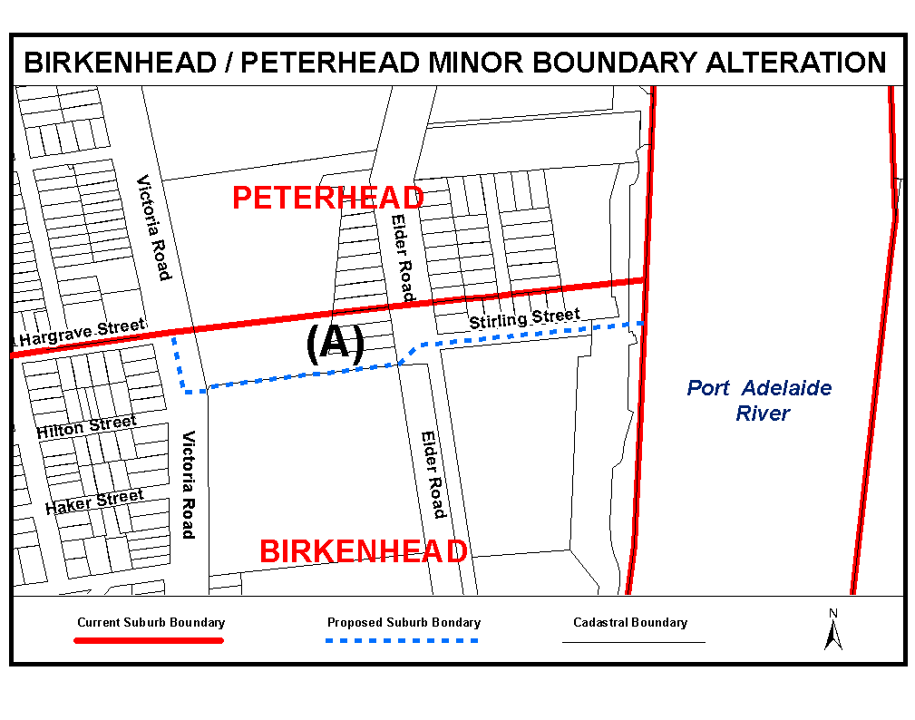

Dated 11 April 2006.
P. S. Smith, Acting Surveyor-General, Department for Administrative and Information Services
DAIS.22-413/02/0038

GEOGRAPHICAL NAMES ACT 1991
Notice to Alter Boundaries of Places
NOTICE is hereby given pursuant to section 11B (4) of the Geographical Names Act 1991, that I, PETER S. SMITH, Acting Surveyor-General and Delegate appointed by Michael Wright, Minister for Administrative Services and Government Enterprises, Minister of the Crown to whom the administration of the Geographical Names Act 1991, is committed, DO HEREBY exclude from the suburb of WEST LAKES SHORE and include into the suburb of TENNYSON that area marked (A) as shown on the plan below.
The Plan
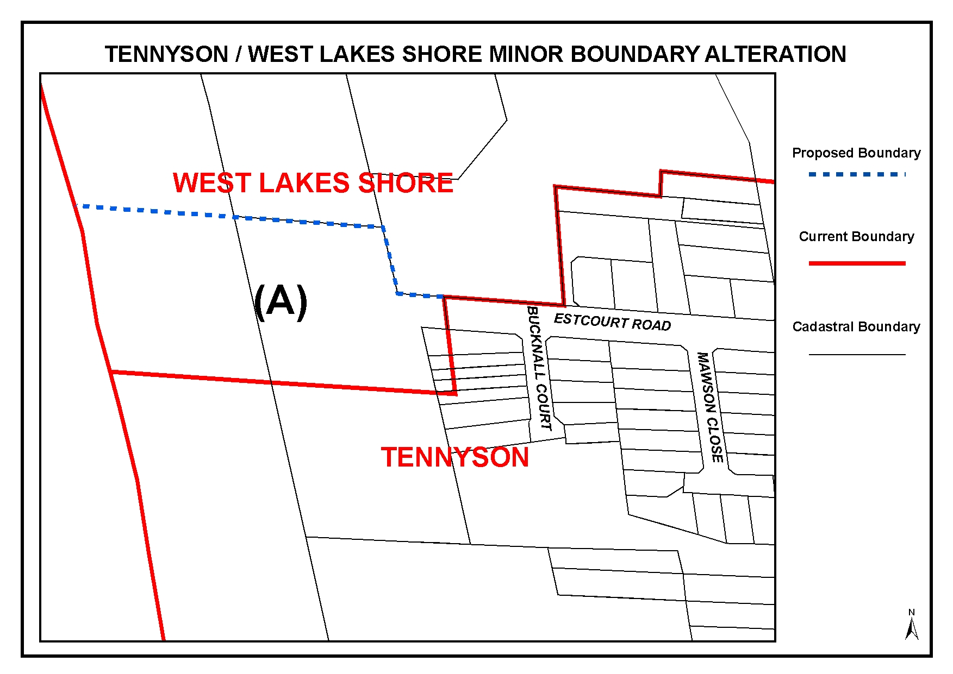
Dated 11 April 2006.
P. S. Smith, Acting Surveyor-General, Department for Administrative and Information Services
DAIS.22-413/06/0001

LIQUOR LICENSING ACT 1997 AND GAMING MACHINES ACT 1992
Notice of Application
NOTICE is hereby given, pursuant to section 52 of the Liquor Licensing Act 1997 and section 29 of the Gaming Machines Act 1992, that Dewens Holdings Pty Ltd as trustee for the Dewens Family Settlement and Kingbear Pty Ltd as trustee for the Kingbear Trust have applied to the Licensing Authority for the transfer of a Hotel and Gaming Machine Licence in respect of premises situated at 233 Franklin Street, Adelaide, S.A. 5000 and known as Flagstaff On Franklin Hotel.
The applications have been set down for hearing on 22 May 2006 at 9.30 a.m.
Any person may object to the application by lodging a notice of objection in the prescribed form with the Liquor and Gambling Commissioner and serving a copy of the notice on the applicants at the applicants’ address given above, at least seven days before the hearing date (viz: 12 May 2006).
The applicants’ address for service is c/o Piper Alderman, 167 Flinders Street, Adelaide, S.A. 5000.
Plans in respect of the premises the subject of the application are open to public inspection without fee at the Office of the Liquor and Gambling Commissioner, 9th Floor, East Wing, 50 Grenfell Street, Adelaide, S.A. 5000. Phone 8226 8410, Fax:
8226 8512. Email: olgc@agd.sa.gov.au.
Dated 11 April 2006.
Applicants

LIQUOR LICENSING ACT 1997
Notice of Application
NOTICE is hereby given, pursuant to section 52 (2) (b) of the Liquor Licensing Act 1997, that Guiseppe Luigi Polito and Elisabetta Polito have applied to the Licensing Authority for a Restaurant Licence in respect of premises situated at 46 Waterport Road, Port Elliot, S.A. 5212 and to be known as Mamma Lisa Bread.
The application has been set down for hearing on 19 May 2006 at 9 a.m.
Any person may object to the application by lodging a notice of objection in the prescribed form with the Liquor and Gambling Commissioner and serving a copy of the notice on the applicants at the applicants’ address given above, at least seven days before the hearing date (viz: 11 May 2006).
The applicants’ address for service is c/o 46 Waterport Road, Port Elliot, S.A. 5212.
Plans in respect of the premises the subject of the application are open to public inspection without fee at the Office of the Liquor and Gambling Commissioner, 9th Floor, East Wing, 50 Grenfell Street, Adelaide, S.A. 5000. Phone 8226 8410, Fax:
8226 8512. Email: olgc@agd.sa.gov.au.
Dated 10 April 2006.
Applicants

LIQUOR LICENSING ACT 1997
Notice of Application
NOTICE is hereby given, pursuant to section 52 (2) (b) of the Liquor Licensing Act 1997, that Range Road Estate Pty Ltd as trustee for Range Road Estate Unit Trust has applied to the Licensing Authority for a Producer’s Licence in respect of premises situated at Lot 4, Ellen Place, Tanunda, S.A. 5352 and to be known as Range Road Estate.
The application has been set down for hearing on 19 May 2006 at 9 a.m.
Any person may object to the application by lodging a notice of objection in the prescribed form with the Liquor and Gambling Commissioner and serving a copy of the notice on the applicant at the applicant’s address given above, at least seven days before the hearing date (viz: 11 May 2006).
The applicant’s address for service is c/o Cherryl Hoey, P.O. Box 789, Tanunda, S.A. 5352.
Plans in respect of the premises the subject of the application are open to public inspection without fee at the Office of the Liquor and Gambling Commissioner, 9th Floor, East Wing, 50 Grenfell Street, Adelaide, S.A. 5000. Phone 8226 8410, Fax:
8226 8512. Email: olgc@agd.sa.gov.au.
Dated 11 April 2006.
Applicant

LIQUOR LICENSING ACT 1997
Notice of Application
NOTICE is hereby given, pursuant to section 52 (2) (b) of the Liquor Licensing Act 1997, that Scalzi Wines Pty Ltd has applied to the Licensing Authority for a Wholesale Liquor Merchant’s Licence in respect of premises situated at 184 Portrush Road, Trinity Gardens, S.A. 5068 and to be known as Scalzi Wines.
The application has been set down for hearing on 19 May 2006 at 9 a.m.
Any person may object to the application by lodging a notice of objection in the prescribed form with the Liquor and Gambling Commissioner and serving a copy of the notice on the applicant at the applicant’s address given above, at least seven days before the hearing date (viz: 11 May 2006).
The applicant’s address for service is c/o David Watts and Associates, 1 Cator Street, Glenside, S.A. 5065.
Plans in respect of the premises the subject of the application are open to public inspection without fee at the Office of the Liquor and Gambling Commissioner, 9th Floor, East Wing, 50 Grenfell Street, Adelaide, S.A. 5000. Phone 8226 8410, Fax:
8226 8512. Email: olgc@agd.sa.gov.au.
Dated 12 April 2006.
Applicant

LIQUOR LICENSING ACT 1997
Notice of Application
NOTICE is hereby given, pursuant to section 52 (2) (b) of the Liquor Licensing Act 1997, that Cristino Maglieri and Filomena Maglieri as trustee for JJDM Family Trust have applied to the Licensing Authority for the transfer of a Restaurant Licence in respect of premises situated at 98 Gawler Place, Adelaide, S.A. 5000 and known as Glow Cafe.
The application has been set down for hearing on 22 May 2006 at 10 a.m.
Any person may object to the application by lodging a notice of objection in the prescribed form with the Liquor and Gambling Commissioner and serving a copy of the notice on the applicants at the applicants’ address given above, at least seven days before the hearing date (viz: 12 May 2006).
The applicants’ address for service is c/o Cristino Maglieri, P.O. Box 317, Brighton, S.A. 5048.
Plans in respect of the premises the subject of the application are open to public inspection without fee at the Office of the Liquor and Gambling Commissioner, 9th Floor, East Wing, 50 Grenfell Street, Adelaide, S.A. 5000. Phone 8226 8410, Fax:
8226 8512. Email: olgc@agd.sa.gov.au.
Dated 11 April 2006.
Applicants

LIQUOR LICENSING ACT 1997
Notice of Application
NOTICE is hereby given, pursuant to section 52 (2) (b) of the Liquor Licensing Act 1997, that LMC (Glenelg) Pty Ltd has applied to the Licensing Authority for the transfer of a Special Circumstances Licence in respect of premises situated at 1 Colley Terrace, Glenelg, S.A. 5045 and known as Lungomare Caffe.
The application has been set down for hearing on 22 May 2006 at 10.30 a.m.
Any person may object to the application by lodging a notice of objection in the prescribed form with the Liquor and Gambling Commissioner and serving a copy of the notice on the applicant at the applicant’s address given above, at least seven days before the hearing date (viz: 12 May 2006).
The applicant’s address for service is c/o Thompson & Associates, P.O. Box 6596, Halifax Street, Adelaide, S.A. 5000.
Plans in respect of the premises the subject of the application are open to public inspection without fee at the Office of the Liquor and Gambling Commissioner, 9th Floor, East Wing, 50 Grenfell Street, Adelaide, S.A. 5000. Phone 8226 8410, Fax:
8226 8512. Email: olgc@agd.sa.gov.au.
Dated 12 April 2006.
Applicant

LIQUOR LICENSING ACT 1997
Notice of Application
NOTICE is hereby given, pursuant to section 52 (2) (b) of the Liquor Licensing Act 1997, that GRE Pty Ltd as trustee for Gavranich Family Trust has applied to the Licensing Authority for the transfer of a Residential Licence in respect of premises situated at 766 Anzac Highway, Glenelg, S.A. 5045 and known as Buffalo Motor Inn.
The application has been set down for hearing on 22 May 2006 at 11 a.m.
Any person may object to the application by lodging a notice of objection in the prescribed form with the Liquor and Gambling Commissioner and serving a copy of the notice on the applicant at the applicant’s address given above, at least seven days before the hearing date (viz: 11 May 2006).
The applicant’s address for service is c/o Richard Phillips Solicitors, Roper Street Chambers, Ground Floor, 21 Roper Street, Adelaide, S.A. 5000.
Plans in respect of the premises the subject of the application are open to public inspection without fee at the Office of the Liquor and Gambling Commissioner, 9th Floor, East Wing, 50 Grenfell Street, Adelaide, S.A. 5000. Phone 8226 8410, Fax:
8226 8512. Email: olgc@agd.sa.gov.au.
Dated 12 April 2006.
Applicant

LIQUOR LICENSING ACT 1997
Notice of Application
NOTICE is hereby given, pursuant to section 52 (2) (b) of the Liquor Licensing Act 1997, that Saranjif Sanguandeekul has applied to the Licensing Authority for the transfer of a Restaurant Licence in respect of premises situated at 79 Hindley Street, Adelaide, S.A. 5000 known as Thai on Hindley and to be known as Thai Lucky Bell.
The application has been set down for hearing on 24 May 2006 at 9.30 a.m.
Any person may object to the application by lodging a notice of objection in the prescribed form with the Liquor and Gambling Commissioner and serving a copy of the notice on the applicant at the applicant’s address given above, at least seven days before the hearing date (viz: 16 May 2006).
The applicant’s address for service is c/o Winters Solicitors, P.O. Box 7070, Hutt Street, Adelaide, S.A. 5000.
Plans in respect of the premises the subject of the application are open to public inspection without fee at the Office of the Liquor and Gambling Commissioner, 9th Floor, East Wing, 50 Grenfell Street, Adelaide, S.A. 5000. Phone 8226 8410, Fax:
8226 8512. Email: olgc@agd.sa.gov.au.
Dated 12 April 2006.
Applicant

LIQUOR LICENSING ACT 1997
Notice of Application
NOTICE is hereby given, pursuant to section 52 (2) (b) of the Liquor Licensing Act 1997, that Jakato Pty Ltd as trustee for the Jakato Trust has applied to the Licensing Authority for the transfer of a Residential Licence in respect of premises situated at Jubilee Highway West, Mount Gambier, S.A. 5290 and known as Presidential Motel.
The application has been set down for hearing on 24 May 2006 at 10 a.m.
Any person may object to the application by lodging a notice of objection in the prescribed form with the Liquor and Gambling Commissioner and serving a copy of the notice on the applicant at the applicant’s address given above, at least seven days before the hearing date (viz: 16 May 2006).
The applicant’s address for service is c/o Moody Rossi & Co., Barristers amd Solicitors, 7th Floor, 185 Victoria Square, Adelaide, S.A. 5000.
Plans in respect of the premises the subject of the application are open to public inspection without fee at the Office of the Liquor and Gambling Commissioner, 9th Floor, East Wing, 50 Grenfell Street, Adelaide, S.A. 5000. Phone 8226 8410, Fax:
8226 8512. Email: olgc@agd.sa.gov.au.
Dated 12 April 2006.
Applicant

LIQUOR LICENSING ACT 1997
Notice of Application
NOTICE is hereby given, pursuant to section 52 (2) (b) of the Liquor Licensing Act 1997, that Peter John Seppelt as trustee for Peter Seppelt Family Trust has applied to the Licensing Authority for the transfer of a Producer’s Licence in respect of premises situated at Laube’s Road, Springton, S.A. 5235 and known as K. J. Seppelt and to be known as Peter Seppelt Wines.
The application has been set down for hearing on 24 May 2006 at 10.30 a.m.
Any person may object to the application by lodging a notice of objection in the prescribed form with the Liquor and Gambling Commissioner and serving a copy of the notice on the applicant at the applicant’s address given above, at least seven days before the hearing date (viz: 16 May 2006).
The applicant’s address for service is c/o Jamison & Associates, 31 Dequetteville Terrace, Kent Town, S.A. 5067.
Plans in respect of the premises the subject of the application are open to public inspection without fee at the Office of the Liquor and Gambling Commissioner, 9th Floor, East Wing, 50 Grenfell Street, Adelaide, S.A. 5000. Phone 8226 8410, Fax:
8226 8512. Email: olgc@agd.sa.gov.au.
Dated 13 April 2006..
Applicant

LIQUOR LICENSING ACT 1997
Notice of Application
NOTICE is hereby given, pursuant to section 52 (2) (b) of the Liquor Licensing Act 1997, that Wildlife Partners Pty Ltd has applied to the Licensing Authority for the transfer of a Special Circumstances Licence in respect of premises situated at 21 Williams Road, Mylor, S.A. 5153 and known as Warrawong Sanctuary.
The application has been set down for hearing on 25 May 2006 at 10 a.m.
Any person may object to the application by lodging a notice of objection in the prescribed form with the Liquor and Gambling Commissioner and serving a copy of the notice on the applicant at the applicant’s address given above, at least seven days before the hearing date (viz: 17 May 2006).
The applicant’s address for service is c/o Lynch Meyer Lawyers, Level 2, 190 Flinders Street, Adelaide, S.A. 5000.
Plans in respect of the premises the subject of the application are open to public inspection without fee at the Office of the Liquor and Gambling Commissioner, 9th Floor, East Wing, 50 Grenfell Street, Adelaide, S.A. 5000. Phone 8226 8410, Fax:
8226 8512. Email: olgc@agd.sa.gov.au.
Dated 13 April 2006.
Applicant

LIQUOR LICENSING ACT 1997
Notice of Application
NOTICE is hereby given, pursuant to section 52 (2) (b) of the Liquor Licensing Act 1997, that Graeme Maxwell Thompson and Sharon Maree Thompson have applied to the Licensing Authority for a Wholesale Liquor Merchant’s Licence in respect of premises situated at Section 678, Qualco Road, Waikerie, S.A. 5330 and to be known as G. M. and S. M. Thompson.
The application has been set down for hearing on 19 May 2006 at 9 a.m.
Any person may object to the application by lodging a notice of objection in the prescribed form with the Liquor and Gambling Commissioner, and serving a copy of the notice on the applicants at the applicants’ address given above, at least seven days before the hearing date (viz: 11 May 2006).
The applicants’ address for service is c/o Wallmans Lawyers, 173 Wakefield Street, Adelaide, S.A. 5000 (Attention: Peter Hoban or Ben Allen).
Plans in respect of the premises the subject of the application are open to public inspection without fee at the Office of the Liquor and Gambling Commissioner, 9th Floor, East Wing, 50 Grenfell Street, Adelaide, S.A. 5000. Phone 8226 8410, Fax:
8226 8512. Email: olgc@agd.sa.gov.au.
Dated 18 April 2006.
Applicants

MINING ACT 1971
NOTICE is hereby given in accordance with section 28 (5) of the Mining Act 1971, that the Minister for Mineral Resources Development proposes to grant an Exploration Licence over the undermentioned area:
Applicant: Scimitar Resources Ltd
Location: Ooloo Hill area—Approximately 100 km east of Marree.
Term: 1 year
Area in km²: 491
Ref.: 2005/00673
Plan and co-ordinates can be found on the PIRSA Sarig website: http://www.minerals.pir.sa.gov.au/sarig or by phoning Mineral Tenements on (08) 8463 3103.
H. Tyrteos, Mining Registrar

MINING ACT 1971
NOTICE is hereby given in accordance with section 28 (5) of the Mining Act 1971, that the Minister for Mineral Resources Development proposes to grant an Exploration Licence over the undermentioned area:
Applicant: Minotaur Operations Pty Ltd
Location: Yudnapinna area—Approximately 90 km west-north-west of Port Augusta.
Term: 1 year
Area in km²: 189
Ref.: 2005/00766
Plan and co-ordinates can be found on the PIRSA Sarig website: http://www.minerals.pir.sa.gov.au/sarig or by phoning Mineral Tenements on (08) 8463 3103.
H. Tyrteos, Mining Registrar

MINING ACT 1971
NOTICE is hereby given in accordance with section 28 (5) of the Mining Act 1971, that the Minister for Mineral Resources Development proposes to grant an Exploration Licence over the undermentioned area:
Applicant: International Base Metals Ltd
Location: Three Creeks area—Approximately 120 km north-east of Port Augusta.
Term: 1 year
Area in km²: 253
Ref.: 2005/00946
Plan and co-ordinates can be found on the PIRSA Sarig website: http://www.minerals.pir.sa.gov.au/sarig or by phoning Mineral Tenements on (08) 8463 3103.
H. Tyrteos, Mining Registrar

MINING ACT 1971
NOTICE is hereby given in accordance with section 35A (1) of the Mining Act 1971, that an application for a mining lease over the undermentioned mineral claim has been received. Details of the proposal may be inspected at the Department of Primary Industries and Resources, Mineral Resources Group, Level 5, 101 Grenfell Street, Adelaide, S.A. 5000:
Applicant: Paul Maurice Fitzgerald and Kerri Lyn Fitzgerald
Claim No.: 3573
Location: Sections 325 and 327, Hundred of Myponga—Approximately 4 km north-east of Yankalilla.
Area: 10.10 hectares
Purpose: For the recovery of sandstone
Reference: T02543
A copy of the proposal has been provided to the District Council of Yankalilla.
Written submissions in relation to the granting of the mining lease are invited to be received at the Department of Primary Industries and Resources, Mineral Resources Group, Level 5, 101 Grenfell Street, Adelaide, S.A. 5000 or G.P.O. Box 1671, Adelaide, S.A. 5001 no later than 11 May 2006.
H. Tyrteos, Mining Registrar

NATIONAL ELECTRICITY LAW
THE Australian Energy Market Commission (AEMC) gives notice under the National Electricity Law (NEL) of the following matters:
Under sections 102 and 103:
• the making of the National Electricity Amendment (Statement of Opportunities Update) Rule 2006 No. 5 and the corresponding final determination; and
• the making of the National Electricity Amendment (System Restart Ancillary Services and pricing under market suspension) Rule 2006 No. 6 and the corresponding final determination.
All provisions of the above Rules have commenced.
Under section 107, the time period for the making of the draft determination for the proposed National Electricity Amendment (Reform of the Regulatory Test Principles) Rule 2006 to 17 August 2006.
Under section 99, AEMC has made a draft Rule determination in relation to the proposed National Electricity Amendment (Dispute Resolution for Regulatory Test) Rule 2006. A copy of the draft determination and the draft Rule are published on AEMC’s website and are available for inspection at AEMC. Upon receipt AEMC publishes all submissions on its website, subject to consideration of any claim of confidentiality. In relation to the draft determination:
• submissions should be forwarded to submissions@aemc.gov.au and must be received no later than 2 June 2006; and
• Requests for a hearing should be forwarded in writing to aemc@aemc.gov.au and must be received no later than 27 April 2006.
Further details on the above matter are available on AEMC’s website www.aemc.gov.au.
John Tamblyn
Chairman
Australian Energy Market Commission
Level 16, 1 Margaret Street
Sydney, N.S.W. 2000
Telephone: (02) 8296 7800
Facsimile: (02) 8296 7899
Dated 20 April 2006.

PETROLEUM ACT 2000
Section 25 (5) (b)
Variation of Petroleum Exploration Licences—PEL 108, PEL 109
and PEL 112
NOTICE is hereby given that under the provisions of the Petroleum Act 2000, pursuant to delegated powers dated 28 March 2002, Gazetted 11 April 2002, page 1573, the conditions of the abovementioned Exploration Licences have been varied as follows:
Condition 1 of the licence is omitted and the following substituted:
‘1. During the term of the licences, the Licensees shall carry out or cause to be carried out exploratory operations on the area comprised in the licences in accordance with such work programs as are approved by the Minister from time to time. Years one to four exploratory operations are guaranteed. These exploratory operations shall include but not necessarily be limited to:
Year of Term of Licence | Minimum Work Requirements
One | Seismic reprocessing; Geological and geophysical review.
Two | Geological and geophysical review.
Three | Geological and geophysical studies; Seismic reprocessing; 190 km 2D seismic acquisition (Year 3 program to be conducted anywhere within the combined area covered by PELs 108, 109 and 112).
Four | 2 wells; Geological and geophysical studies (Year 4 program to be conducted anywhere within the combined area covered by PELs 108, 109 and 112).
Five | 3 wells; Geological and geophysical studies (Year 5 program to be conducted anywhere within the combined area covered by PELs 108, 109 and 112).
This variation provides for the removal of the guarantee for one of the wells in Year 5. The revised work requirements as a result of this variation would not have altered the outcome of the original competitive tender process.
’
Dated 13 April 2006.
B. A. Goldstein, Director Petroleum and Geothermal
Minerals and Energy Resources
Primary Industries and Resources SA
Delegate of the Minister for Mineral
Resources Development

PETROLEUM ACT 2000
Suspension of Exploration Licence—PEL 73
PURSUANT to section 90 of the Petroleum Act 2000, notice is hereby given that the abovementioned Exploration Licence has been suspended under the provisions of the Petroleum Act 2000, from and including 15 April 2006 until 14 October 2006, pursuant to delegated powers dated 28 March 2002, Gazetted 11 April 2002, page 1573.
The expiry date of Exploration Licence PEL 73 is now determined to be 26 December 2007.
Dated 13 April 2006.
B. A. Goldstein, Director Petroleum and Geothermal
Minerals and Energy Resources
Primary Industries and Resources SA
Delegate of the Minister for Mineral
Resources Development

IMPORTANT NOTICE
Government Gazette Publication

********************

Anzac Day Holiday Week Publishing Information

Government Gazette Notices
Publishing Date: Thursday, 27 April 2006

Closing date for notices for publication will be
4 p.m. on Monday, 24 April 2006

********************

GOVERNMENT GAZETTE ADVERTISEMENT RATES

To apply from 1 July 2005

$  Agents, Ceasing to Act as 36.50  Associations:  Incorporation 18.60  Intention of Incorporation 46.00  Transfer of Properties 46.00  Attorney, Appointment of 36.50  Bailiff’s Sale 46.00  Cemetery Curator Appointed 27.25  Companies:  Alteration to Constitution 36.50  Capital, Increase or Decrease of 46.00  Ceasing to Carry on Business 27.25  Declaration of Dividend 27.25  Incorporation 36.50  Lost Share Certificates:  First Name 27.25  Each Subsequent Name 9.35  Meeting Final 30.50  Meeting Final Regarding Liquidator’s Report on  Conduct of Winding Up (equivalent to ‘Final  Meeting’)  First Name 36.50  Each Subsequent Name 9.35  Notices:  Call 46.00  Change of Name 18.60  Creditors 36.50  Creditors Compromise of Arrangement 36.50  Creditors (extraordinary resolution that ‘the Com-pany be wound up voluntarily and that a liquidator be appointed’) 46.00  Release of Liquidator⎯Application⎯Large Ad. 72.50  ⎯Release Granted 46.00  Receiver and Manager Appointed 42.50  Receiver and Manager Ceasing to Act 36.50  Restored Name 34.50  Petition to Supreme Court for Winding Up 64.00  Summons in Action 54.50  Order of Supreme Court for Winding Up Action 36.50  Register of Interests⎯Section 84 (1) Exempt 82.50  Removal of Office 18.60  Proof of Debts 36.50  Sales of Shares and Forfeiture 36.50  Estates:  Assigned 27.25  Deceased Persons⎯Notice to Creditors, etc. 46.00  Each Subsequent Name 9.35  Deceased Persons⎯Closed Estates 27.25  Each Subsequent Estate 1.20  Probate, Selling of 36.50  Public Trustee, each Estate 9.35 |  | $  Firms:  Ceasing to Carry on Business (each insertion) 24.30  Discontinuance Place of Business 24.30  Land⎯Real Property Act:  Intention to Sell, Notice of 46.00  Lost Certificate of Title Notices 46.00  Cancellation, Notice of (Strata Plan) 46.00  Mortgages:  Caveat Lodgment 18.60  Discharge of 19.50  Foreclosures 18.60  Transfer of 18.60  Sublet 9.35  Leases⎯Application for Transfer (2 insertions) each 9.35  Lost Treasury Receipts (3 insertions) each 27.25  Licensing 54.50  Municipal or District Councils:  Annual Financial Statement⎯Forms 1 and 2 513.00  Electricity Supply⎯Forms 19 and 20 364.00  Default in Payment of Rates:  First Name 72.50  Each Subsequent Name 9.35  Noxious Trade 27.25  Partnership, Dissolution of 27.25  Petitions (small) 18.60  Registered Building Societies (from Registrar-  General) 18.60  Register of Unclaimed Moneys⎯First Name 27.25  Each Subsequent Name 9.35  Registers of Members⎯Three pages and over:  Rate per page (in 8pt) 233.00  Rate per page (in 6pt) 308.00  Sale of Land by Public Auction 46.50  Advertisements 2.60  ¼ page advertisement 109.00  ½ page advertisement 218.00  Full page advertisement 427.00  Advertisements, other than those listed are charged at $2.60 per column line, tabular one-third extra.  Notices by Colleges, Universities, Corporations and District Councils to be charged at $2.60 per line.  Where the notice inserted varies significantly in length from that which is usually published a charge of $2.60 per column line will be applied in lieu of advertisement rates listed.  South Australian Government publications are sold on the condition that they will not be reproduced without prior permission from the Government Printer.
All the above prices include GST

GOVERNMENT GAZETTE NOTICES
ALL private advertisements forwarded for publication in the South Australian Government Gazette must be PAID FOR PRIOR TO INSERTION; and all notices, from whatever source, should be legibly written on one side of the paper only and sent to Government Publishing SA so as to be received no later than 4 p.m. Tuesday preceding the day of publication. Phone 8207 1045 or Fax 8207 1040. E-mail: governmentgazette@saugov.sa.gov.au. Send as attachments in Word format. Please include date the notice is to be published and to whom the notice will be charged. The Government Gazette is available online at: www.governmentgazette.sa.gov.au.

MISCELLANEOUS LEGISLATION AND GOVERNMENT PUBLICATIONS PRICES AS FROM 1 JULY 2005

Acts, Bills, Rules, Parliamentary Papers and Regulations
Pages | Main | Amends | Pages | Main | Amends

1-16 | 2.20 | 1.00 | 497-512 | 31.00 | 30.00
17-32 | 3.00 | 1.85 | 513-528 | 32.00 | 30.75
33-48 | 3.90 | 2.80 | 529-544 | 33.00 | 32.00
49-64 | 4.90 | 3.75 | 545-560 | 34.00 | 33.00
65-80 | 5.75 | 4.75 | 561-576 | 34.75 | 34.00
81-96 | 6.70 | 5.55 | 577-592 | 35.75 | 34.50
97-112 | 7.60 | 6.50 | 593-608 | 36.75 | 35.50
113-128 | 8.55 | 7.45 | 609-624 | 37.50 | 36.50
129-144 | 9.60 | 8.50 | 625-640 | 38.50 | 37.00
145-160 | 10.50 | 9.35 | 641-656 | 39.50 | 38.50
161-176 | 11.50 | 10.30 | 657-672 | 40.00 | 39.00
177-192 | 12.40 | 11.30 | 673-688 | 41.75 | 40.00
193-208 | 13.40 | 12.30 | 689-704 | 42.50 | 41.00
209-224 | 14.20 | 13.10 | 705-720 | 43.00 | 42.00
225-240 | 15.10 | 14.00 | 721-736 | 44.75 | 43.00
241-257 | 16.20 | 14.70 | 737-752 | 45.25 | 44.00
258-272 | 17.10 | 15.70 | 753-768 | 46.25 | 44.50
273-288 | 18.00 | 16.90 | 769-784 | 46.75 | 46.00
289-304 | 18.80 | 17.70 | 785-800 | 47.75 | 47.00
305-320 | 19.90 | 18.70 | 801-816 | 48.50 | 47.50
321-336 | 20.70 | 19.60 | 817-832 | 49.75 | 48.50
337-352 | 21.80 | 20.60 | 833-848 | 50.75 | 49.50
353-368 | 22.60 | 21.60 | 849-864 | 51.50 | 50.00
369-384 | 23.60 | 22.50 | 865-880 | 52.50 | 51.50
385-400 | 24.50 | 23.40 | 881-896 | 53.00 | 52.00
401-416 | 25.50 | 24.20 | 897-912 | 54.50 | 53.00
417-432 | 26.50 | 25.25 | 913-928 | 55.00 | 54.50
433-448 | 27.50 | 26.25 | 929-944 | 56.00 | 55.00
449-464 | 28.25 | 27.00 | 945-960 | 57.00 | 55.50
465-480 | 28.75 | 28.00 | 961-976 | 58.25 | 56.50
481-496 | 30.00 | 28.75 | 977-992 | 59.25 | 57.00

Legislation—Acts, Regulations, etc: $
Subscriptions:
Acts 192.00
All Bills as Laid 460.00
Rules and Regulations 460.00
Parliamentary Papers 460.00
Bound Acts 213.00
Index 106.00
Government Gazette
Copy 5.00
Subscription 254.00
Hansard
Copy 14.00
Subscription—per session (issued weekly) 399.00
Cloth bound—per volume 172.00
Subscription—per session (issued daily) 399.00
Legislation on Disk
Whole Database 2 951.00
Annual Subscription for fortnightly updates 907.00
Individual Act(s) including updates POA
Compendium
Subscriptions:
Subscriptions 1 749.00
Updates 617.00
(All the above prices include GST)

All Legislation, Government Gazette, Hansard and Legislation on disk are available from:
Counter Sales Service SA, Government Legislation⁺ Outlet
and Mail Orders: Lands Titles Office, 101 Grenfell Street, Adelaide, S.A. 5000
Phone: 13 23 24 (local call cost), Fax: (08) 8204 1909
Postal: G.P.O. Box 1707, Adelaide, S.A. 5001

Online Shop: www.shop.service.sa.gov.au

Subscriptions and Government Publishing SA
Standing Orders: Box 9, Plaza Level, Riverside Centre, North Terrace, Adelaide, S.A. 5000
Phone: (08) 8207 0908, (08) 8207 0910, Fax: (08) 8207 1040

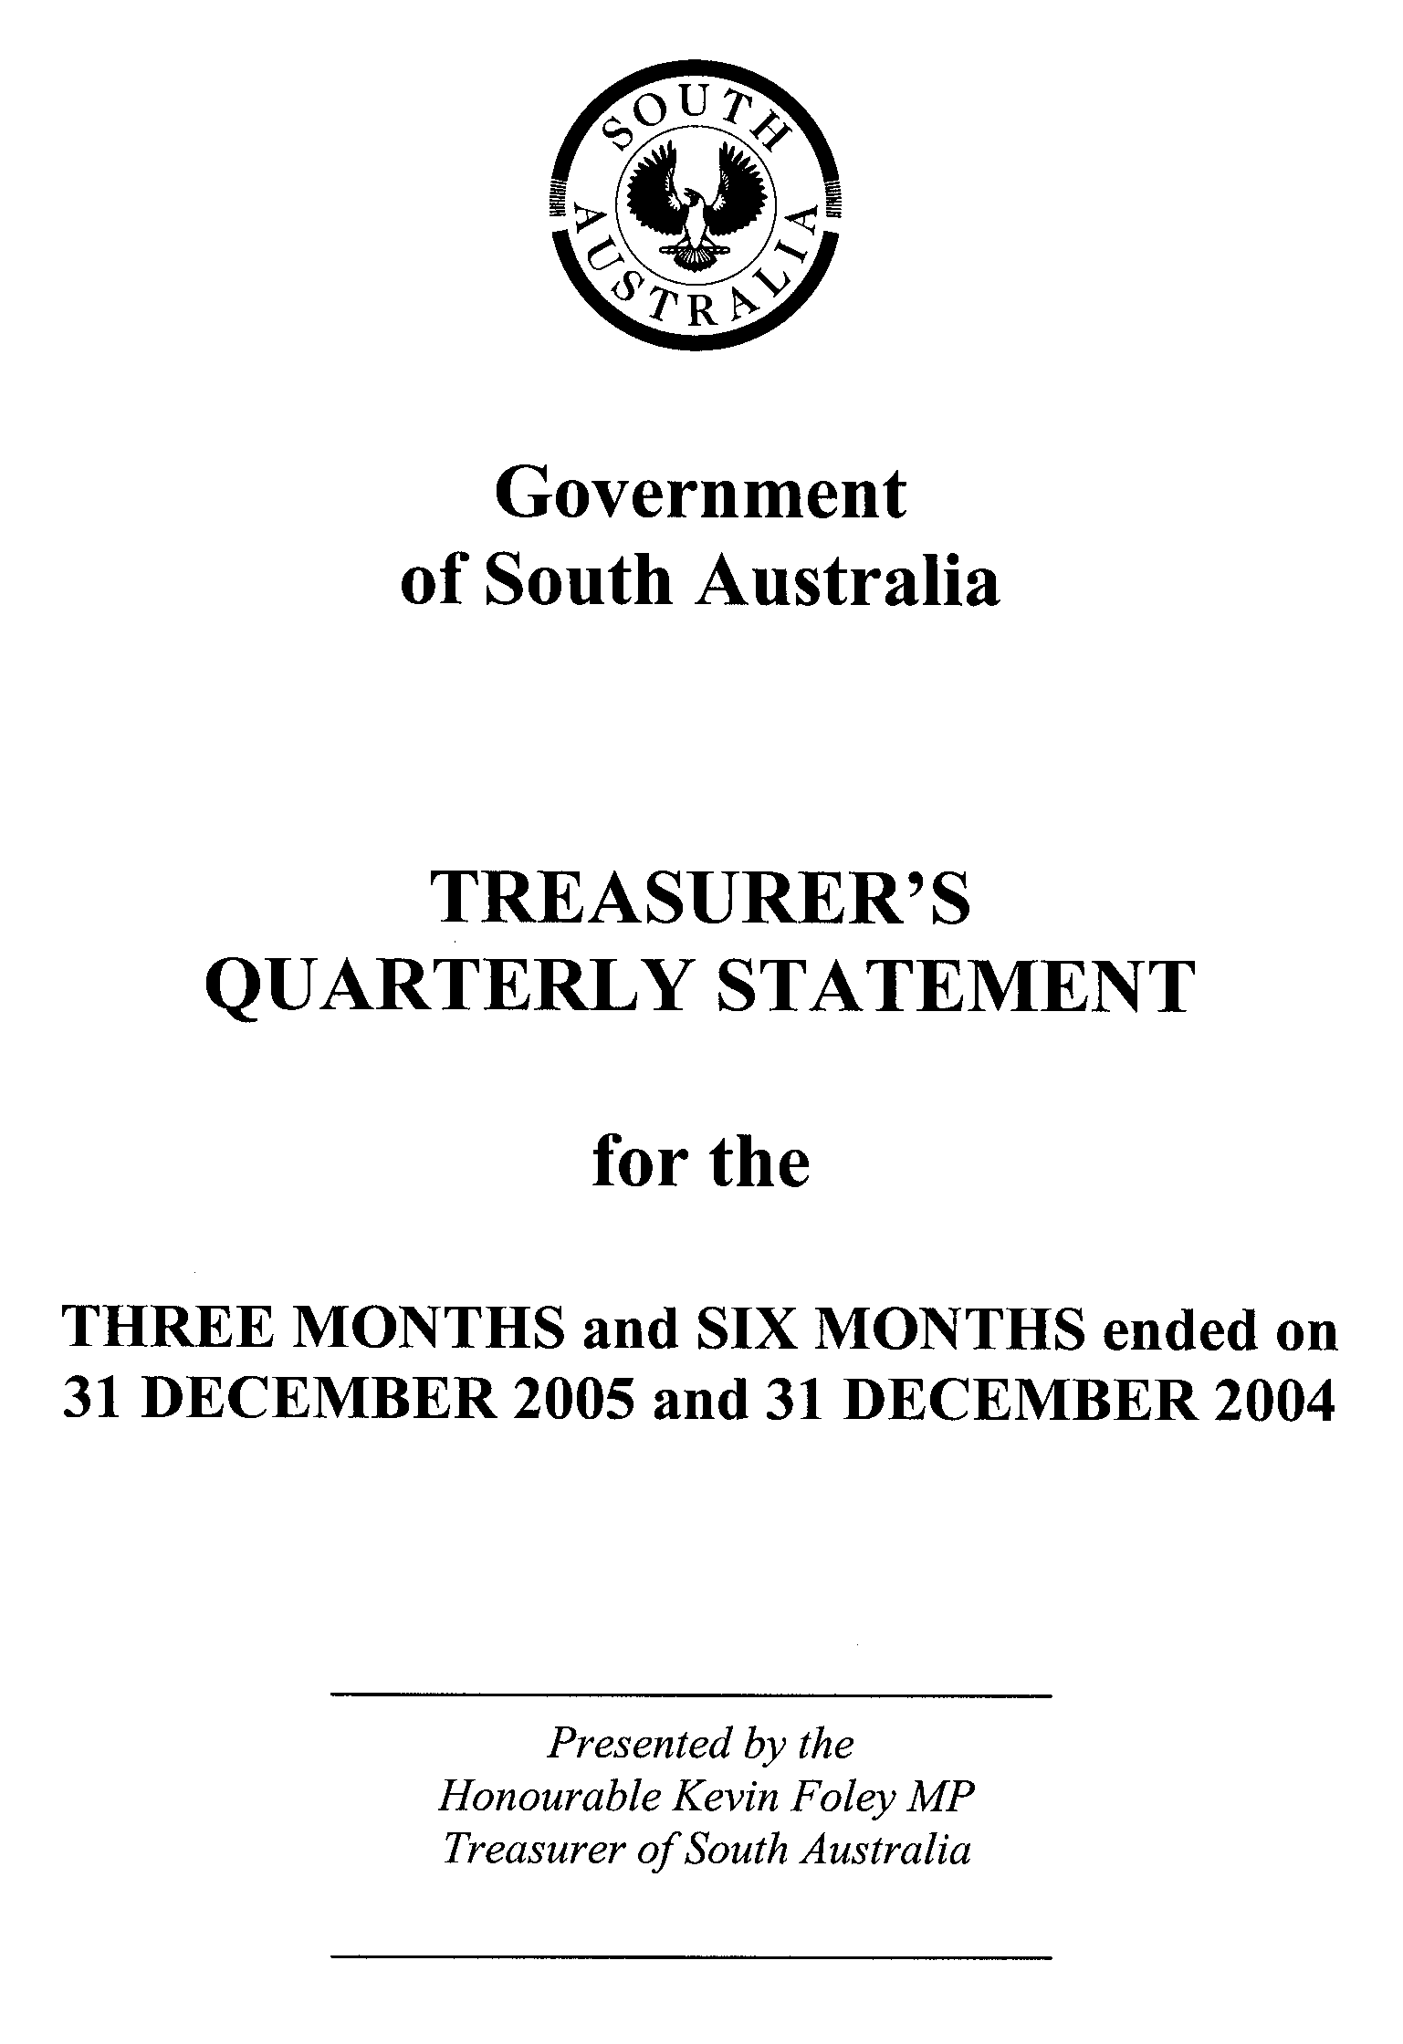

GOVERNMENT OF SOUTH AUSTRALIA

COMMENTARY TO THE STATEMENT OF THE AMOUNTS CREDITED TO
AND ISSUED FROM THE CONSOLIDATED ACCOUNT FOR THE QUARTERS ENDED
31 DECEMBER 2005 AND 31 DECEMBER 2004

Receipts

Taxation

Higher land tax receipts in the first half of 2005-06, compared with the same period a year ago, mainly reflects the earlier timing of land tax payments by the South Australian Housing Trust which paid its land tax liability ($115.9 million) in the December quarter 2005, compared with the March quarter in 2004.

Payroll tax receipts for the first six months of 2005-06 were higher than for the same period in the previous year mainly reflecting underlying strength in economic conditions impacting on payroll tax.

Stamp duty receipts for the first six months of 2005-06 compared with the same period in 2004-05 are lower reflecting the timing of large share duty transactions in the September quarter 2004 and the abolition of mortgage duty on loan refinancing and on residential loans for owner occupation, which took effect from 1 July 2005. Low levels of debits tax receipts in 2005-06 reflect the abolition of the tax with effect from 1 July 2005, resulting in only residual collections in the September quarter 2005.

Gambling tax receipts were lower in the first half of 2005-06, compared to the same period a year ago, reflecting timing differences in the monthly transfer of casino tax revenues to Consolidated Account.

Royalties

Royalty receipts were lower in the six months to December 2005 compared with the same period in 2004-05 due to the later timing of royalty payments from the Olympic Dam mine and fewer shipments of petroleum liquids.

Commonwealth—General Purpose Grants

GST monthly payments are based on a schedule prepared by the Commonwealth at the commencement of each year. The schedule may be revised later in the year if actual GST collections vary significantly from the original Budget estimate.

Growth in Commonwealth general purpose grants between the first half of 2004-05 and the first half of 2005-06 mainly reflects differences between the years in the monthly pattern of payments by the Commonwealth and is not indicative of underlying GST revenue growth. In addition, an earlier overpayment of $22 million in transitional assistance was recovered by the Commonwealth in the September quarter 2004. This had the effect of lowering the level of general purpose grants in that quarter.

Commonwealth—Specific Purpose Grants

The increase in the level of Commonwealth Specific Purpose Payments in the first six months of this year, compared with the same period last year, mainly reflects the timing of debt redemption assistance payments by the Commonwealth.

Other Receipts

Other Receipts are higher in the first half of 2005-06 compared with the same period in 2004-05 because of repayments of equity capital contributions from SA Water ($74.3 million paid in July) in line with the 2005-06 Budget.

Payments

Payments have been made pursuant to the Appropriation Act, passed at the time of the 2005-06 State Budget and in accordance with various Acts for which specific appropriation has been authorised.

Payments made from the Consolidated Account for the first six months of 2005-06 were higher than the same period in 2004-05. This is primarily due to the level of appropriation approved in the 2005 Appropriation Act being greater than the appropriation level included in the 2004 Appropriation Act.

Note

Considerable caution should be exercised in interpreting the quarterly statement of Consolidated Account transactions. Unlike the State budget, which comprises transactions on an accrual basis, the information reflected in the quarterly statements is limited to cash transactions. In addition, the Consolidated Account does not capture all the transactions undertaken by the general government sector (in particular, it does not record receipts to and payments from special deposit accounts). Finally, it should be noted that the timing of receipts and payments could be volatile within a particular year. As a result, apparently significant movements between years may only be due to changes in the timing of receipts and payments, and therefore may not have implications for the underlying budget position.

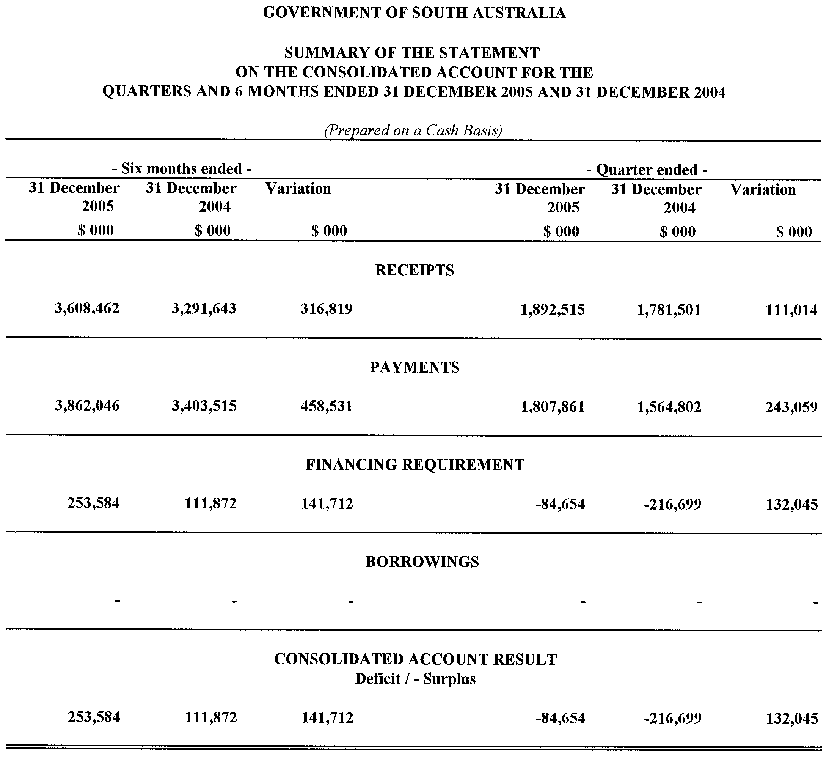
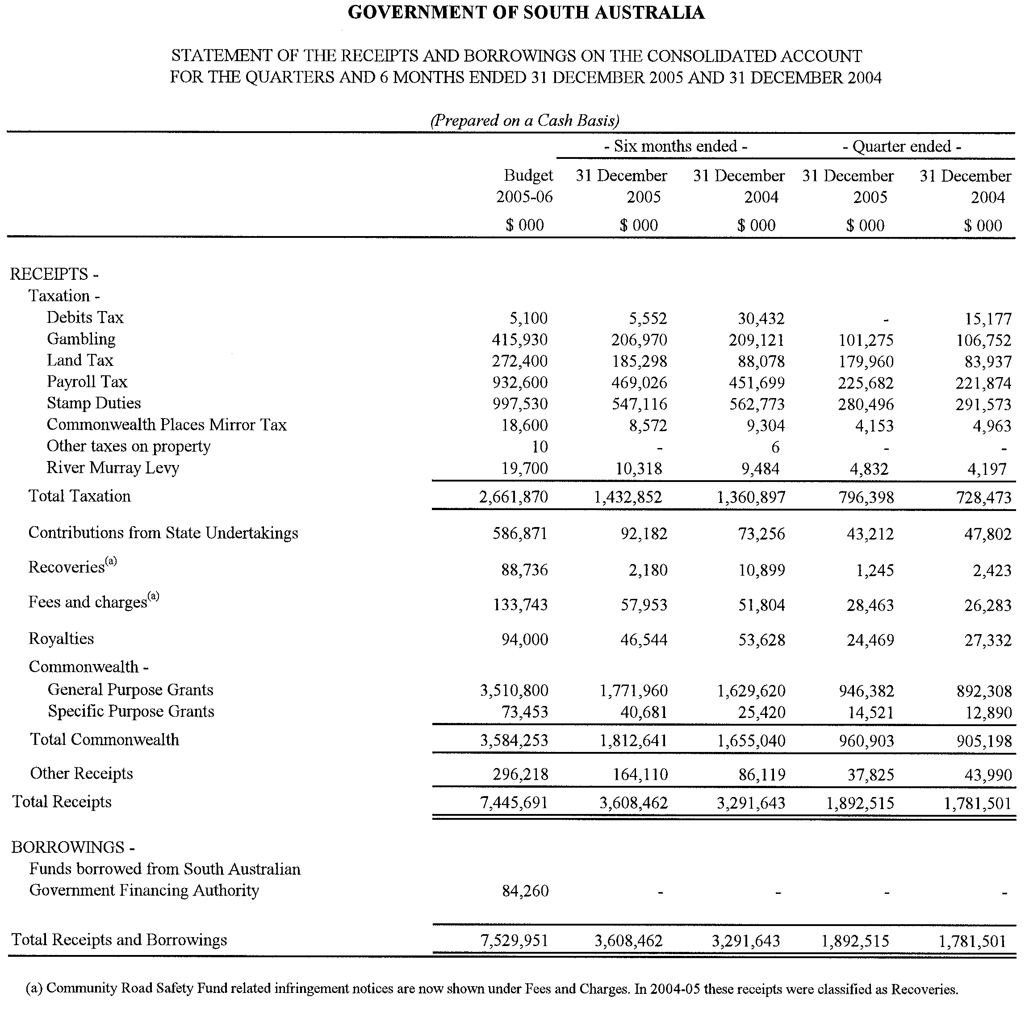
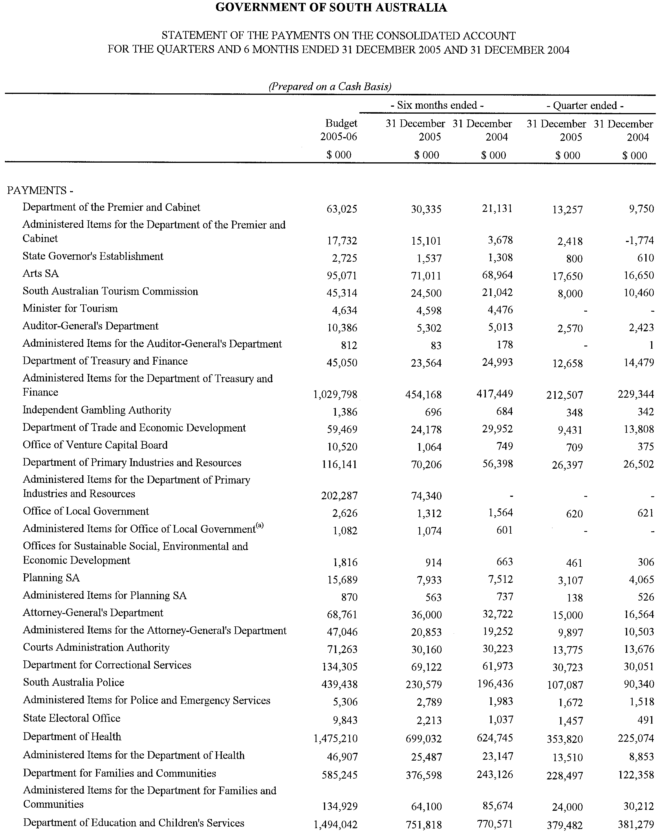
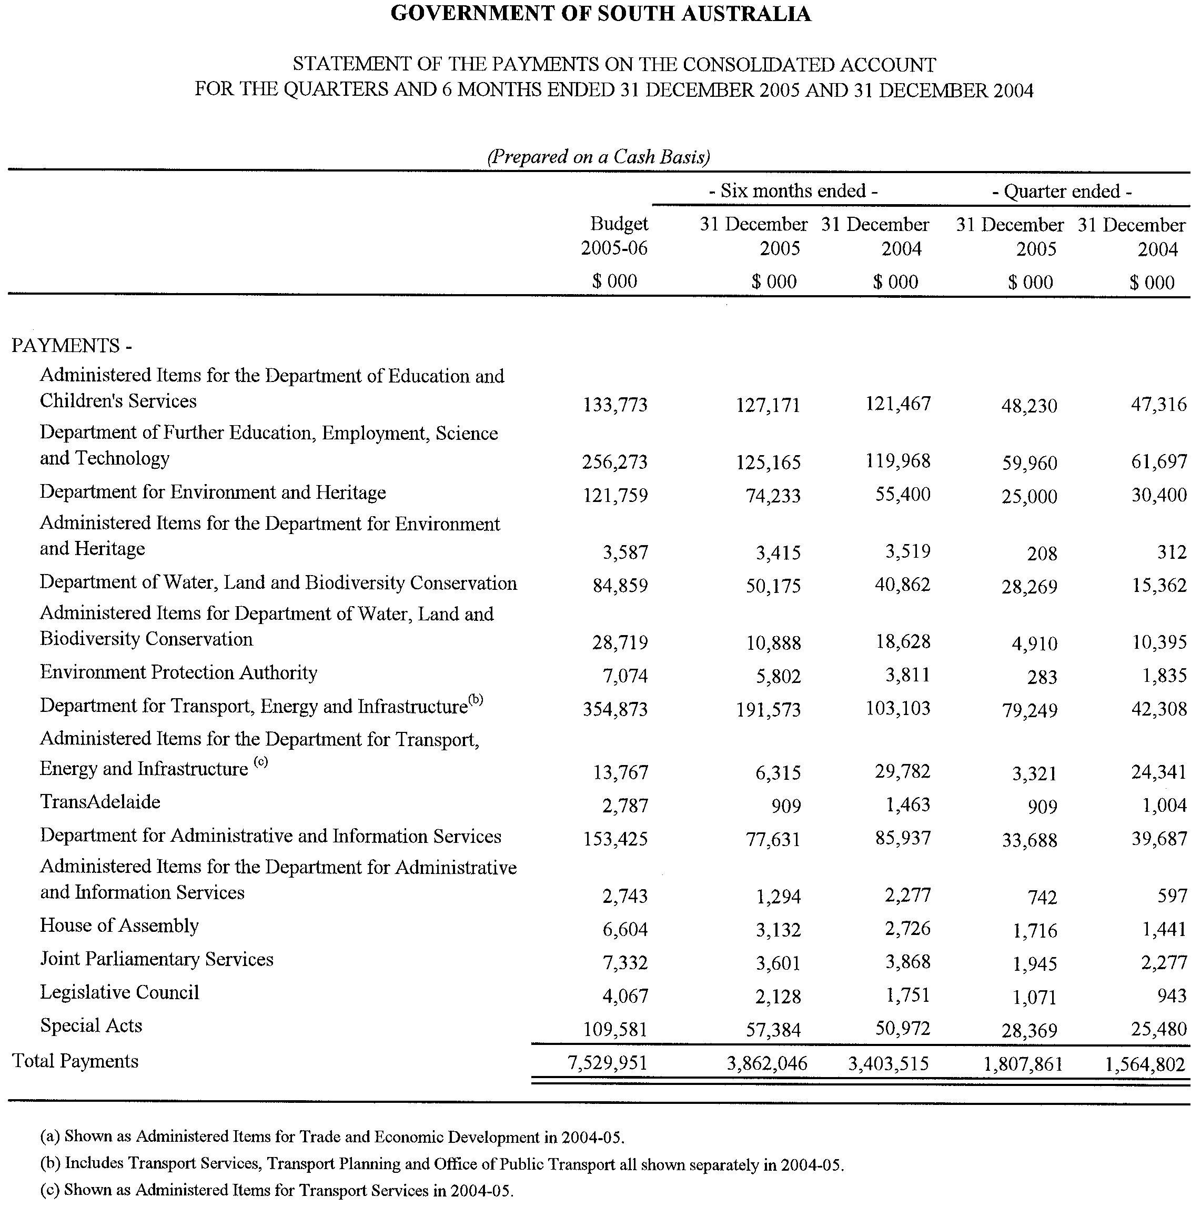

TRAINING AND SKILLS DEVELOPMENT ACT 2003

Part 4 – Apprenticeships/Traineeships

Pursuant to the provision of the Training and Skills Development Act 2003, the Training and Skills Commission (TaSC) gives notice that determines the following:
Trades, Declared Vocations or Other Occupations

The following schedule is additional to the gazettals of:

- 5 February 2004 | - 19 February 2004 | - 11 March 2004 | - 1 April 2004
- 1 July 2004 | - 15 July 2004 | - 22 July 2004 | - 30 September 2004
- 16 December 2004 | - 27 January 2005 | - 3 February 2005 | - 10 February 2005
- 10 March 2005 | - 24 March 2005 | - 5 May 2005 | - 12 May 2005
- 2 June 2005 | - 16 June 2005 | - 7 July 2005 | - 4 August 2005
- 18 August 2005 | - 1 September 2005 | - 15 September 2005 | - 22 September 2005
- 6 October 2005 | - 20 October 2005 | - 27 October 2005 | - 8 December 2005
- 22 December 2005 | - 9 March 2006 | - 6 April 2006

which set out the Trades, Declared Vocations or Other Occupations and the terms and conditions applicable to the Trades, Declared Vocations or Other Occupations.

Trades, Declared Vocations or Other Occupations, required Qualifications and Contract of Training Conditions

* Trade/#Declared  Vocation/Other  Occupation | Code | Title | Term of  Contract of  Training | Probationary  Period
# School Assistant | 2148VIC  Expires  31/12/08 | Certificate III in Education | 12 months | 1 month

TRAINING AND SKILLS DEVELOPMENT ACT 2003

Part 4 – Apprenticeships/Traineeships

Pursuant to the provision of the Training and Skills Development Act 2003, the Training and Skills Commission (TaSC) gives notice that determines the following:
Trades, Declared Vocations or Other Occupations

The following schedule is additional to the gazettals of:

- 5 February 2004 | - 19 February 2004 | - 11 March 2004 | - 1 April 2004
- 1 July 2004 | - 15 July 2004 | - 22 July 2004 | - 30 September 2004
- 16 December 2004 | - 27 January 2005 | - 3 February 2005 | - 10 February 2005
- 10 March 2005 | - 24 March 2005 | - 5 May 2005 | - 12 May 2005
- 2 June 2005 | - 16 June 2005 | - 7 July 2005 | - 4 August 2005
- 18 August 2005 | - 1 September 2005 | - 15 September 2005 | - 22 September 2005
- 6 October 2005 | - 20 October 2005 | - 27 October 2005 | - 8 December 2005
- 22 December 2005 | - 9 March 2006

which set out the Trades, Declared Vocations or Other Occupations and the terms and conditions applicable to the Trades, Declared Vocations or Other Occupations.

Trades, Declared Vocations or Other Occupations, required Qualifications and Contract of Training Conditions for
Community Recreation (SRC04)

*Trade/ #Declared Vocation/ Other Occupation | Code | Qualification Title | Nominal Term of Contract of Training | Probationary Period
# Recreation Industry Worker | SRC20204 | Certificate II in Community Recreation | 12 months | 1 month
# Recreation Industry Worker | SRC30204 | Certificate III in Community Recreation | 24 months | 2 months
# Recreation Industry Worker | SRC40204 | Certificate IV in Community Recreation | 36 months | 3 months

NOTICE TO MARINERS
No. 22 of 2006
South Australia—Franklin Harbour—Beacon at Southern End of Entrance Island Missing
MARINERS are advised that the Starboard hand beacon in position latitude 33°43.810′S, longitude 136°57.410′E is missing and has run adrift. Mariners should exercise extreme caution when navigating in the area.
Charts affected: Aus 777 and 344.
Adelaide, 13 April 2006.
Patrick Conlon, Minister for Transport
TSA 2006/00419

WATER MAINS AND SEWERS

Office of the South Australian Water Corporation
Adelaide, 20 April 2006

WATER MAINS LAID

Notice is hereby given that the following main pipes or parts of main pipes have been laid down by the South Australian Water Corporation in or near the undermentioned water districts and are now available for a constant supply of water to adjacent land.

ADELAIDE WATER DISTRICT

ADELAIDE CITY COUNCIL
Public road west of lot 2 in LTRO DP 63738, Adelaide. p14

CITY OF PLAYFORD
Easements in lot 1005 in LTRO DP 67509, Craigmore Road, Craigmore. p6

BALAKLAVA WATER DISTRICT

WAKEFIELD REGIONAL COUNCIL
Racecourse Road, Balaklava. p12

BEETALOO COUNTRY LANDS WATER DISTRICT

PORT PIRIE REGIONAL COUNCIL
Spinifex Lane, Risdon Park South. p1
Casuarina Drive, Risdon Park South. p1-3
Hakea Court, Risdon Park South. p3

BUNDALEER COUNTRY LANDS WATER DISTRICT

WAKEFIELD REGIONAL COUNCIL
In and across Racecourse Road, Balaklava. p12
Easement in lot 93 in LTRO FP 212891, Racecourse Road, Balaklava. p12

CEDUNA WATER DISTRICT

DISTRICT COUNCIL OF CEDUNA
Tonkin Street, Ceduna. p22
Payne Street, Ceduna. p22

GREENOCK WATER DISTRICT

LIGHT REGIONAL COUNCIL
Koncke Street, Greenock. p10 and 11
Lina Street, Greenock. p10

HOYLETON WATER DISTRICT

WAKEFIELD REGIONAL COUNCIL
Back Street, Hoyleton. p13

KADINA WATER DISTRICT

DISTRICT COUNCIL OF THE COPPER COAST
Russell Street, Kadina. p7
South Terrace, Kadina. This main is available on the south side by application only. p7 and 8
Across South Terrace, Kadina. p8
Easements in lots 100 and 99 in LTRO DP 67758, South Terrace, Kadina. p8

WARREN COUNTRY LANDS WATER DISTRICT

BAROSSA COUNCIL
In and across Barossa Valley Highway, Rowland Flat. p17

CLARE AND GILBERT VALLEYS COUNCIL
Across and in Heards Hill Road, Auburn. p15
Waterworks land (lot 749 in LTRO FP 168878), Heards Hill Road, Auburn. p15

WATER MAINS ABANDONED

Notice is hereby given that the undermentioned water mains have been abandoned by the South Australian Water Corporation.

CEDUNA WATER DISTRICT

DISTRICT COUNCIL OF CEDUNA
Tonkin Street, Ceduna. p22
Payne Street, Ceduna. p22

GREENOCK WATER DISTRICT

LIGHT REGIONAL COUNCIL
Koncke Street, Greenock. p10 and 11

KADINA WATER DISTRICT

DISTRICT COUNCIL OF THE COPPER COAST
Russell Street, Kadina. p9
In and across South Terrace, Kadina. p9

WARREN COUNTRY LANDS WATER DISTRICT

BAROSSA COUNCIL
Barossa Valley Highway, Rowland Flat. p17

WATER MAINS LAID

Notice is hereby given that the undermentioned water mains have been laid down by the South Australian Water Corporation and are not available for a constant supply of water to adjacent land.

ADELAIDE WATER DISTRICT

CITY OF BURNSIDE
Across Penfold Road, Wattle Park. p18
Waterworks land (lot 39 in LTRO FP 141800, Penfold Road, lot 94 in LTRO FP 204251 and lot 14 in LTRO FP 217988, Simpson Road), Wattle Park. p18-20

OUTSIDE WATER DISTRICTS

THE FLINDERS RANGES COUNCIL
Waterworks land (section 668, hundred of Pichi Richi, and lot 188 in LTRO FP 185890), Quorn. p23-27
Waterworks land (section 670, hundred of Pichi Richi, and lot 1 in LTRO FP 5020), Quorn. p23, 24, 26 and 27
Easements in lot 4 in LTRO FP 5020, Arden Vale Road, Quorn. p23-27
Waterworks land (lot 188 in LTRO FP 185890), Quorn. p28

SEWERS LAID

Notice is hereby given that the following sewers have been laid down by the South Australian Water Corporation in the undermentioned drainage areas and are now available for house connections.

ADELAIDE DRAINAGE AREA

ADELAIDE CITY COUNCIL
George Street, Adelaide. FB 1146 p38

CITY OF HOLDFAST BAY
Across Pine Avenue, Kingston Park. FB 1146 p50
Easement in lot 14 in LTRO DP 60184, Pine Avenue, Kingston Park. FB 1146 p50

CITY OF PLAYFORD
Easements in lot 1005 in LTRO DP 67509, Craigmore Road, Craigmore. FB 1147 p35-38

CITY OF PORT ADELAIDE ENFIELD
Bowman Crescent, Enfield. FB 1146 p52

ALDINGA DRAINAGE AREA

CITY OF ONKAPARINGA
Whinnerah Avenue, Aldinga Beach. FB 1146 p53

PORT AUGUSTA COUNTRY DRAINAGE AREA

CITY OF PORT AUGUSTA
Raedel Court, Port Augusta West. FB 1146 p45
Easements in lot 289 in LTRO DP 10940, Simmons Crescent, Port Augusta West. FB 1146 p45

PORT LINCOLN COUNTRY DRAINAGE AREA

CITY OF PORT LINCOLN
Easement in lot 47 in LTRO DP 3716, Wandana Avenue, Port Lincoln. FB 1146 p54

SEWERS ABANDONED

Notice is hereby given that the undermentioned sewer has been abandoned by the South Australian Water Corporation.

ADELAIDE DRAINAGE AREA

ADELAIDE CITY COUNCIL
George Street, Adelaide. FB 1146 p38

CORRECTION
Correction to notice in “Government Gazette” of 6 April 2006.

WATER MAINS LAID

Notice is hereby given that the undermentioned water mains have been laid down by the South Australian Water Corporation and are not available for a constant supply of water to adjacent land.

“ADELAIDE WATER DISTRICT”

“CITY OF WEST TORRENS”
“Easements in lot 104 in LTRO DP 56982, Anderson Avenue, Glenelg North. p45
Waterworks land (lots 103 and 102 in LTRO DP 56982), Anderson Avenue, Glenelg North. p45”
For “p45” read “p51”

A. Howe, Chief Executive Officer, South Australian Water Corporation

South Australia
Development (Miscellaneous) Amendment Act (Commencement) Proclamation 2006
1—Short title
This proclamation may be cited as the Development (Miscellaneous) Amendment Act (Commencement) Proclamation 2006.
2—Commencement of suspended provisions
The following provisions of the Development (Miscellaneous) Amendment Act 2005 (No 79 of 2005) will come into operation on 20 April 2006:
(a) section 4(2) and (3);
(b) section 11;
(c) section 21.
Made by the Governor
with the advice and consent of the Executive Council
on 20 April 2006
MUDP06/015CS

South Australia
Statutes Amendment and Repeal (Aggravated Offences) Act (Commencement) Proclamation 2006
1—Short title
This proclamation may be cited as the Statutes Amendment and Repeal (Aggravated Offences) Act (Commencement) Proclamation 2006.
2—Commencement of Act and suspension of certain provisions
(1) The Statutes Amendment and Repeal (Aggravated Offences) Act 2005 (No 62 of 2005) will come into operation on 15 May 2006.
(2) The operation of sections 18, 22 and 23 of the Act are suspended until a day or time or days or times to be fixed by subsequent proclamation or proclamations.
Made by the Governor
with the advice and consent of the Executive Council
on 20 April 2006
AGO0255/03CS
South Australia
Statutes Amendment (Sentencing of Sex Offenders) Act (Commencement) Proclamation 2006
1—Short title
This proclamation may be cited as the Statutes Amendment (Sentencing of Sex Offenders) Act (Commencement) Proclamation 2006.
2—Commencement of suspended provisions
Part 3 of the Statutes Amendment (Sentencing of Sex Offenders) Act 2005 (No 31 of 2005) will come into operation on 15 May 2006 immediately after the Statutes Amendment and Repeal (Aggravated Offences) Act 2005 comes into operation.
Made by the Governor
with the advice and consent of the Executive Council
on 20 April 2006
AGO0255/03CS

South Australia
Crown Lands (Resumption of Dedicated Land) Proclamation 2006
under section 5AA(1)(c) of the Crown Lands Act 1929

Preamble
1 The following land is dedicated as a reserve for school purposes, not intended for ecclesiastical or denominational purposes (Gazette 18.11.1920 p1235):
Allotments 3, 4, 13, 14, 19 and 20, Town of Price, Hundred of Cunningham, being the whole of the land comprised in Certificate of Title Register Book Volume 5774 Folio 283.
2 The registered proprietor of the land has consented to resumption of the land.

1—Short title
This proclamation may be cited as the Crown Lands (Resumption of Dedicated Land) Proclamation 2006.
2—Commencement
This proclamation comes into operation on the day on which it is made.
3—Resumption of dedicated land
The land defined in clause 1 of the preamble is resumed.
Made by the Governor
with the advice and consent of the Executive Council
on 20 April 2006
EHCS06/0001

South Australia
Development (Miscellaneous No 2) Variation Regulations 2006
under the Development Act 1993

Contents
Part 1—Preliminary
1 Short title
2 Commencement
3 Variation provisions
Part 2—Variation of Development Regulations 1993
4 Variation of regulation 32—Public notice categories
5 Variation of regulation 41—Time within which a decision must be made
6 Insertion of regulation 98B
98B Land management agreements—development applications
7 Variation of Schedule 5—Requirements as to plans and specifications
8 Variation of Schedule 6—Fees
9 Variation of Schedule 8—Referrals and concurrences
10 Variation of Schedule 9—Public notice categories
11 Insertion of Schedule 10A
Schedule 10A—Notice—section 42(2) of the Development Act 1993

Part 1—Preliminary
1—Short title
These regulations may be cited as the Development (Miscellaneous No 2) Variation Regulations 2006.
2—Commencement
(1) Regulations 5 and 11 will come into operation on the day on which section 11 of the Development (Miscellaneous) Amendment Act 2005 comes into operation.
(2) Regulations 6 and 8 will come into operation on the day on which section 21 of the Development (Miscellaneous) Amendment Act 2005 comes into operation.
(3) Regulations 7 and 9 will come into operation on 1 May 2006.
(4) The remaining regulations will come into operation on the day on which they are made.
3—Variation provisions
In these regulations, a provision under a heading referring to the variation of specified regulations varies the regulations so specified.
Part 2—Variation of Development Regulations 1993
4—Variation of regulation 32—Public notice categories
Regulation 32—after subregulation (4) insert:
(5) For the purposes of the Act and these regulations, a development that comprises 2 or more elements (as set out in the relevant application or as determined by the relevant authority)—
(a) where all of those elements are within Part 1 of Schedule 9, will be assigned to Category 1 for the purposes of section 38 of the Act;
(b) where all of those elements are within Part 1 or Part 2 of Schedule 9 (with at least 1 element within Part 2), will be assigned to Category 2 for the purposes of section 38 of the Act.
5—Variation of regulation 41—Time within which a decision must be made
Regulation 41—after subregulation (2) insert:
(3) For the purposes of section 41(2)(b) of the Act, a notice to the relevant authority must—
(a) be in the form set out in Schedule 10A; and
(b) be lodged at the principal office of the relevant authority.
6—Insertion of regulation 98B
After regulation 98A insert:
98B—Land management agreements—development applications
(1) The Minister must establish a register of agreements entered into by the Minister, or any other designated Minister, under section 57A of the Act.
(2) A council must establish a register of agreements entered into by the council under section 57A of the Act.
(3) A register must contain a copy of each agreement entered into by a Minister or the council (as the case may be) under section 57A of the Act and may contain other information the Minister or the council (as the case may be) considers appropriate.
(4) The register established by the Minister must be kept at the principal office of the Department of the Minister.
(5) A register established by a council must be kept at the principal office of the council.
(6) A register must be kept available for public inspection during normal office hours for the office where the register is situated.
(7) For the purposes of section 57A(18) of the Act, the period of 9 months from the operative date of the relevant development approval is prescribed.
(8) A notice given by the relevant authority under section 57A(18) of the Act—
(a) must be in writing; and
(b) must identify the relevant development approval according to the site of the proposed development and the date on which the approval was given; and
(c) must state that the relevant authority has decided to lapse the development approval because the agreement has not been noted against the relevant instrument of title or land (as the case may be) under section 57A of the Act within the period that applies under subregulation (7); and
(d) must be given to each person named as a party to the agreement (other than the relevant authority).
(9) The relevant authority must also give a copy of a notice under subregulation (8) to—
(a) any owner of the land who is not a party to the agreement; and
(b) if the council for the area where the relevant land is situated is not a party to the agreement—the council.
(10) In this regulation—
operative date of an approval means—
(a) the date on which the approval is given; or
(b) if the decision to grant the approval has been the subject to an appeal under this Act, the date on which any appeal is dismissed, struck out or withdrawn, or all questions raised by any appeal have been finally determined (other than any question as to costs),
whichever is the later.
7—Variation of Schedule 5—Requirements as to plans and specifications
Schedule 5, clause 2A—after subclause (2) insert:
(3) This regulation will apply with respect to applications made on or after 1 January 2007.
8—Variation of Schedule 6—Fees
Schedule 6, item 7—delete "section 57(2d)" and substitute:
sections 57(2d) and 57A(7)
9—Variation of Schedule 8—Referrals and concurrences
Schedule 8, clause 1—after subclause (2) insert:
(2aa) Item 9B will apply with respect to applications made on or after 1 January 2007.
10—Variation of Schedule 9—Public notice categories
Schedule 9—after item 15A insert:
15B For the purpose of determining whether a development should be considered to be of a minor nature only, the relevant authority—
(a) must not take into account what is included within Schedule 3; and
(b) may take into account the size of the site of the development, the location of the development within that site, and the manner in which the development relates to the locality of the site; and
(c) if relevant, may conclude that the development is of a minor nature only despite the fact that it satisfies some, but not all, of the criteria set out in item 2(1)(ca).
11—Insertion of Schedule 10A
After Schedule 10 insert:
Schedule 10A—Notice—section 42(2) of the Development Act 1993
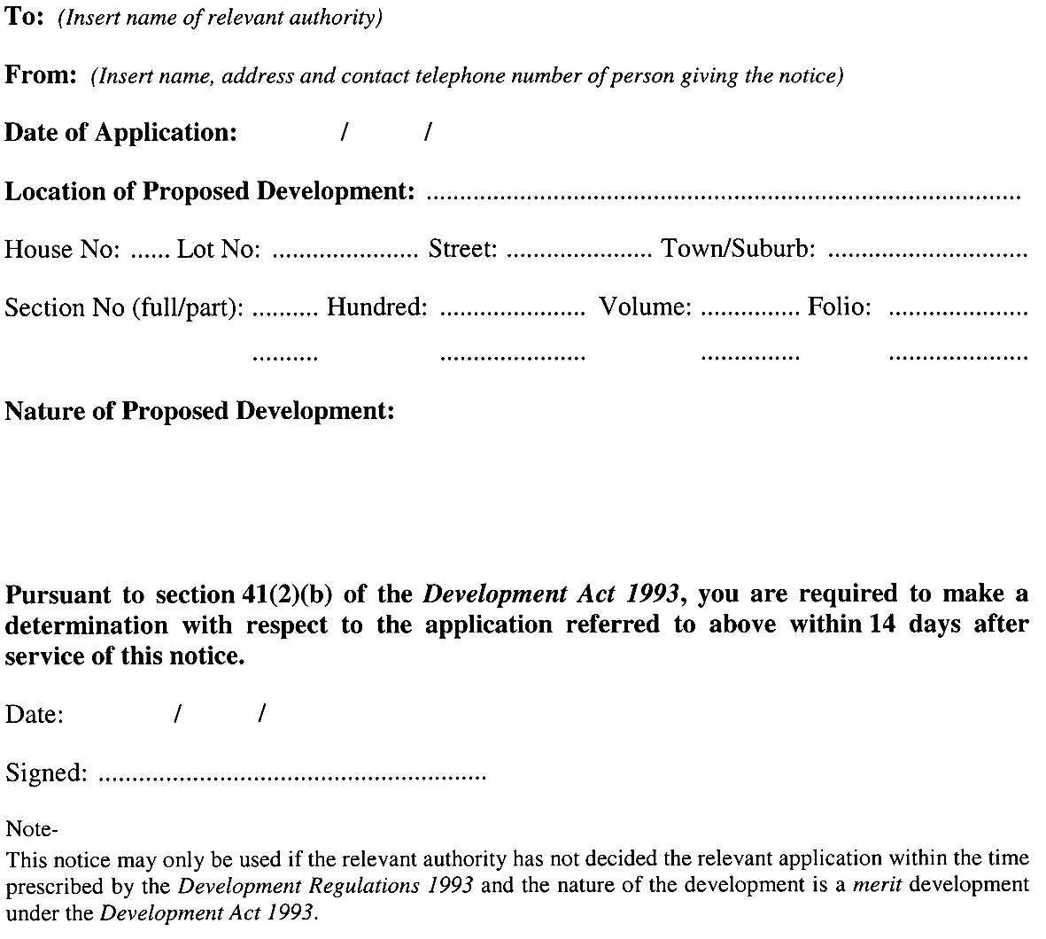
Note—
As required by section 10AA(2) of the Subordinate Legislation Act 1978, the Minister has certified that, in the Minister's opinion, it is necessary or appropriate that these regulations come into operation as set out in these regulations.
Made by the Governor
with the advice and consent of the Executive Council
on 20 April 2006
No 40 of 2006
MUDP 06/015CS
South Australia
Public Finance and Audit Variation Regulations 2006
under the Public Finance and Audit Act 1987

Contents
Part 1—Preliminary
1 Short title
2 Commencement
3 Variation provisions
Part 2—Variation of Public Finance and Audit Regulations 2002
4 Variation of regulation 5—Public authority

Part 1—Preliminary
1—Short title
These regulations may be cited as the Public Finance and Audit Variation Regulations 2006.
2—Commencement
These regulations come into operation on the day on which they are made.
3—Variation provisions
In these regulations, a provision under a heading referring to the variation of specified regulations varies the regulations so specified.
Part 2—Variation of Public Finance and Audit Regulations 2002
4—Variation of regulation 5—Public authority
Regulation 5—after paragraph (d) insert:
(e) South Australian Centre for Trauma and Injury Recovery Incorporated.
Note—
As required by section 10AA(2) of the Subordinate Legislation Act 1978, the Minister has certified that, in the Minister's opinion, it is necessary or appropriate that these regulations come into operation as set out in these regulations.
Made by the Governor
with the advice and consent of the Executive Council
on 20 April 2006
No 41 of 2006
T&F05/010CS

FAXING COPY?
IF you fax copy to Government Publishing SA for inclusion in the Government Gazette, there is no need to send a Confirmation Copy to us as well.
This creates confusion and may well result in your notice being printed twice.
Please use the following fax number:
Fax transmission: (08) 8207 1040
Phone Inquiries: (08) 8207 1045
Please include a contact person, phone number and order number so that we can phone back with any queries we may have regarding the fax copy.
NOTE: Closing time for lodging new copy (fax, hard copy or email) is 4 p.m. on Tuesday preceding the day of publication.

Government Gazette notices can be E-mailed.
The address is:
governmentgazette@saugov.sa.gov.au
Documents should be sent as attachments in Word format.
When sending a document via E-mail, please confirm your transmission with a faxed copy of your document, including the date the notice is to be published.
Fax transmission: (08) 8207 1040
Enquiries: (08) 8207 1045
NOTE: Closing time for lodging new copy (fax, hard copy or email) is 4 p.m. on Tuesday preceding the day of publication.

KANGAROO ISLAND COUNCIL
Revoke Community Land Classification
NOTICE is hereby given pursuant to section 194 (3) (b) of the Local Government Act 1999, that at a meeting of Council held on 12 April 2006, Council revokes the Classification as Community Land of Allotment 1, Drew Street, Kingscote, Deposited Plan 18546, comprised in certificate of title volume 5454, folio 243.
N. M. Brown, Chief Executive Officer

IN the matter of the estates of the undermentioned deceased persons:
Anear, Nancy Alison, late of 226 Fullarton Road, Glenside, widow, who died on 21 February 2006.
Bennier, Jeffrey Michael, late of Grand Junction Road, Oakden, of no occupation, who died on 13 September 2005.
Breeuwsma, Rosemary Anne, late of 11 Brown Street, Northfield, hospital equipment cleaner, who died on 19 February 2006.
Czesek, Kiriena Sabina, late of Everard Street, Largs Bay, of no occupation, who died on 5 August 2005.
Doughty, Edna Beryl, late of 38 Barker Avenue, South Plympton, home duties, who died on 14 February 2006.
George, Christopher Leonard, late of 22 Esplanade, Semaphore South, retired taxi driver, who died on 26 January 2006.
Hanson, Arthur Joseph Albert, late of 1188 North East Road, St Agnes, retired accountant, who died on 1 February 2006.
Kimpton, Lily June, late of Blamey Road, Elizabeth East, of no occupation, who died on 4 December 2005.
O’Donohue, Ronald Michael, late of 131 Beovich Road, Ingle Farm, retired groundsman, who died on 22 December 2005.
Potter, Doris Irene, late of 18 Cross Road, Myrtle Bank, of no occupation, who died on 13 March 2006.
Ryde, Doris Lily, late of 66 Nelson Road, Valley View, of no occupation, who died on 6 January 2006.
Smith, Raymond Alexander, late of 1 Henry Street, Rosewater, fitter and machinist, who died on 16 January 2006.
Stanley-Murray, Kenneth Allen, late of 1A Mount Barker Road, Hahndorf, retired social worker, who died on 23 July 2005.
Sypek, Janina, late of 86 Oaklands Road, Glengowrie, of no occupation, who died on 17 February 2006.
Warhurst, Frank Allison, late of 160 Walkerville Terrace, Walkerville, of no occupation, who died on 17 February 2006.
Way, Frederick Lloyd, late of Memorial Drive, Williamstown, retired mail officer, who died on 12 February 2006.
Wilson, Bert Hadden, late of 181-193 Days Road, Regency Park, of no occupation, who died on 13 March 2006.
Notice is hereby given pursuant to the Trustee Act 1936, as amended, the Inheritance (Family Provision) Act 1972, and the Family Relationships Act 1975, that all creditors, beneficiaries, and other persons having claims against the said estates are required to send, in writing, to the Public Trustee, 25 Franklin Street, Adelaide, S.A. 5000, full particulars and proof of such claims, on or before 19 May 2006, otherwise they will be excluded from the distribution of the said estate; and notice is also hereby given that all persons who are indebted to the said estates are required to pay the amount of their debts to the Public Trustee or proceedings will be taken for the recovery thereof; and all persons having any property belonging to the said estates are forthwith to deliver the same to the Public Trustee.
Dated 20 April 2006.
C. J. O’Loughlin, Public Trustee

ATTENTION

CUSTOMERS requiring a proof of their notice for inclusion in the Government Gazette, please note that the onus is on you to inform Government Publishing SA of any subsequent corrections by 10 a.m. on Thursday, which is our publication deadline.

For any corrections to your notice please phone 8207 1045 or Fax 8207 1040 before 10 a.m. on Thursday.

If we do not receive any communication by 10 a.m. on Thursday (day of publication) we will presume the notice is correct and will print it as it is.

Remember—the onus is on you to inform us of any corrections necessary to your notice.

NOTE: Closing time for lodging new copy (electronically, fax or hard copy) is 4 p.m. on Tuesday preceding the day of publication. Phone 8207 1045—Fax 8207 1040.
Email: governmentgazette@saugov.sa.gov.au

Printed and published by authority every Thursday by K. O’CALLAGHAN, Government Printer, South Australia
Price: $5.00, plus postage; to subscribers, $254.00 per annum.
(The above prices are inclusive of GST)

