No. 22 1139

THE SOUTH AUSTRALIAN

GOVERNMENT GAZETTE
www.governmentgazette.sa.gov.au

PUBLISHED BY AUTHORITY

ALL PUBLIC ACTS appearing in this GAZETTE are to be considered official, and obeyed as such

ADELAIDE, THURSDAY, 27 APRIL 2006

CONTENTS

Page
Appointments, Resignations, Etc. 1140
Corporations and District Councils—Notices 1178
Crown Lands Act 1929—Notice 1140
Education Act 1972—Notice 1141
Electoral Act 1985—Notice 1142
Equal Opportunity Tribunal—Notices 1154
Expiation of Offences Act 1996—Notices 1154
Fair Work Act 1994—Rules 1143
Fisheries Act 1982—Notices 1154
Fruit and Plant Protection Act 1992—Notice 1158
Housing Improvement Act 1940—Notices 1156
Land and Business (Sale and Conveyancing) Act 1994—
Notices 1158
Liquor Licensing Act 1997—Notices 1159

Page
Local Government Act 1999—Notices 1162
Mining Act 1971—Notices 1164
Petroleum Act 2000—Notices 1165
Prevention of Cruelty to Animals Act 1985—Notice 1167
Proclamation 1172
Public Trustee Office—Administration of Estates 1180
Real Property Act 1886—Notice 1168
REGULATIONS
Liquor Licensing Act 1997 (No. 42 of 2006) 1173
Harbors and Navigation Act 1993 (No. 43 of 2006) 1175
Roads (Opening and Closing) Act 1991—Notice 1167
Sewerage Act 1929—Notices 1168
Unclaimed Moneys Act 1891—Notice 1180
Waterworks Act 1932—Notices 1170

GOVERNMENT GAZETTE NOTICES
ALL poundkeepers’ and private advertisements forwarded for publication in the South Australian Government Gazette must be PAID FOR PRIOR TO INSERTION; and all notices, from whatever source, should be legibly written on one side of the paper only and sent to Government Publishing SA so as to be received no later
than 4 p.m. on the Tuesday preceding the day of publication. Phone 8207 1045 or Fax 8207 1040. E-mail: governmentgazette@saugov.sa.gov.au. Send as attachments in Word format and please confirm your transmission with a faxed copy of your document, including the date the notice is to be published and to whom the notice will be charged. The Government Gazette is available online at: www.governmentgazette.sa.gov.au

Department of the Premier and Cabinet
Adelaide, 27 April 2006
HER Excellency the Governor in Executive Council has been pleased to appoint the undermentioned to the Independent Gambling Authority, pursuant to the provisions of the Independent Gambling Authority Act 1995:
Member: (from 1 May 2006 until 30 April 2009)
Margaret Wallace
By command,
G. Gago, for Premier
MGA 01/06 CS

Department of the Premier and Cabinet
Adelaide, 27 April 2006
HER Excellency the Governor in Executive Council has been pleased to appoint the undermentioned to the South Australian Health Commission, pursuant to the provisions of the South Australian Health Commission Act 1976:
Member: (from 27 April 2006 until 31 August 2008) or until she ceases to hold a position within the Department of Health, whichever occurs first:
Sandra Anne Miller
By command,
G. Gago, for Premier
HEACS 06/107

Department of the Premier and Cabinet
Adelaide, 27 April 2006
HER Excellency the Governor in Executive Council has been pleased to appoint Monsignor David John Cappo as Commissioner for Social Inclusion for a period commencing on 27 April 2006 and expiring on 26 April 2010, pursuant to section 68 of the Constitution Act 1934.
By command,
G. Gago, for Premier
DPC 06/005 CS

Department of the Premier and Cabinet
Adelaide, 27 April 2006
HER Excellency the Governor in Executive Council has been pleased to appoint the people listed as Justices of the Peace for South Australia, pursuant to section 4 of the Justices of the Peace Act 1991:
Beverly May Bills
Albert Joseph Camilleri
David Wight Cowans
Sally Louise Kolbig
Trevor John Ranger
By command,
G. Gago, for Premier
AGO 0082/03 CS

Department of the Premier and Cabinet
Adelaide, 27 April 2006
HER Excellency the Governor in Executive Council has removed from office the Justices of the Peace listed, pursuant to Section 6 of the Justices of the Peace Act 1991:
Michelle Ann Bywater
Ronald Davenport
John Anthony William Gardner
Lancelot Colin Jenner
Rosemary Anne Menadue
Alan Reid
Timothy John Squire
By command,
G. Gago, for Premier
AGO 0046/03 CS

Department of the Premier and Cabinet
Adelaide, 27 April 2006
HER Excellency the Governor in Executive Council has determined that the Registry of the Magistrates Court of South Australia, 4 Kay Avenue, Berri, South Australia, 5343, will be maintained from 1 May 2006 as a Registry of the Magistrates Court of South Australia, pursuant to section 16 (4) of the Magistrates Court Act 1991.
By command,
G. Gago, for Premier
AGO 0055/06 CS

CROWN LANDS ACT 1929: SECTION 5
TAKE NOTICE that pursuant to the Crown Lands Act 1929, I, GAIL ELIZABETH GAGO, Minister for Environment and Conservation, Minister of the Crown to whom the administration of the Crown Lands Act 1929 is committed DO HEREBY dedicate the Crown Land defined in The Schedule as a Reserve for Coastal Conservation Purposes and declare that such land shall be under the care, control and management of The District Council of Mount Remarkable.
The Schedule
Section 493, Hundred of Telowie, County of Frome and Allotment 562 of Deposited Plan 65720, Hundred of Pirie, County of Victoria, exclusive of all necessary roads, being the whole of the land comprised in Crown Record Volume 5767, Folio 269 and Crown Record Volume 5945, Folio 527 (respectively).
Dated 27 April 2006.
G. E. Gago, Minister for Environment and Conservation
DEH 13/1039

EDUCATION ACT 1972
Notice Fixing Charges for Full Fee Paying Overseas Students
PURSUANT to section 106B of the Education Act 1972, I fix the following charges payable by a full fee paying overseas student (defined in section 72I of the Education Act 1972) of a Govern-ment school:
1. Administration charge for application processing and school enrolment: | $
(a) for a student holding a temporary visa under the Migration Act 1958 of the Common-wealth valid for a total period of 12 months or less and who is enrolled for the whole or part of school year | 1 070
(b) in any other case:
(i) for the first school year of enrolment  (ii) for each subsequent school year of enrolment | 500  300
2. Tuition charge for student enrolled for whole school year:
(a) if the student is a dependant of a person who holds a temporary visa under the Migration Act 1958 of the Commonwealth and who is participating in tertiary education:
(i) for tuition in primary courses | 3 600
(ii) for tuition in secondary courses or in an intensive English course at secondary level | 4 500
(b) in any other case:
(i) for tuition in primary courses or in an intensive English course at primary level | 7 500
(ii) for tuition in secondary courses or in an intensive English course at secondary level | 9 500
3. Tuition charge for student enrolled for part of school year—If a student is enrolled at a Government school for part of a school year, the tuition charge is:
(a) a proportion of the tuition charge that would be payable if the student were enrolled for the full school year, being the proportion that the number of school terms for the whole or part of which the student is enrolled bears to 4; plus
(b) if the student is enrolled in secondary courses or an intensive English course at secondary level for a period of less than 10 weeks and the student is not a dependant of a person who holds a temporary visa under the Migration Act 1958, of the Commonwealth and who is participating in tertiary education, $25 for each week for which the student is enrolled.
Dated 16 March 2006.
J. Andrews, Acting Director-General of Education

ELECTORAL ACT 1985
Notice of House of Assembly Results for the State Elections Held on 18 March 2006
PURSUANT to section 96 (11) of the Electoral Act 1985, the following are the votes attributed to the two unexcluded candidates in each House of Assembly election held on Saturday, 18 March 2006.
District | Votes after distribution of preferences of excluded candidates | Result

Adelaide | Lomax-Smith, Jane | 11 640 | Carroll, Diana | 7 697 | ALP
Ashford | Key, Steph | 13 230 | Kaeding, Kevin | 6 796 | ALP
Bragg | Plimer, Andrew | 7 415 | Chapman, Vickie | 12 525 | LIB
Bright | Fox, Chloe | 11 983 | Redford, Angus | 8 199 | ALP
Chaffey | Baric, Anna | 6 385 | Maywald, Karlene | 13 101 | NP
Cheltenham | Weatherill, Jay | 14 444 | Lawrie, Sue | 4 712 | ALP
Colton | Caica, Paul | 13 522 | Blackamore, Tim | 6 867 | ALP
Croydon | Atkinson, Mick | 14 808 | Whitehouse, Briony | 4 678 | ALP
Davenport | Bowen, Gerry | 8 621 | Evans, Iain | 11 143 | LIB
Elder | Conlon, Patrick | 12 476 | Greaves, Heidi | 6 747 | ALP
Enfield | Rau, John | 14 310 | Joyce, Sam | 4 903 | ALP
Finniss | Corcoran, Mary-Lou | 8 999 | Pengilly, Michael | 11 701 | LIB
Fisher | Rishworth, Amanda | 6 796 | Such, Bob | 13 590 | IND
Flinders | Penfold, Liz | 11 358 | Swalue, Hank | 7 544 | LIB
Florey | Bedford, Frances | 11 787 | Trainor, Pat | 7 195 | ALP
Frome | Rohde, John | 9 352 | Kerin, Rob | 10 721 | LIB
Giles | Breuer, Lyn | 12 317 | Wakelin, Tina | 6 796 | ALP
Goyder | Bourke, Aemon | 8 411 | Griffiths, Steven | 12 169 | LIB
Hammond | Peikert, James | 7 790 | Pederick, Adrian | 12 716 | LIB
Hartley | Portolesi, Grace | 10 564 | Scalzi, Joe | 8 791 | ALP
Heysen | Christie, Andrew | 9 293 | Redmond, Isobel | 10 491 | LIB
Kaurna | Hill, John | 14 153 | Flaherty, Tim | 5 495 | ALP
Kavel | Marshall, John | 7 948 | Goldsworthy, Mark | 11 624 | LIB
Lee | Wright, Michael | 13 938 | Rea, Peter | 6 176 | ALP
Light | Piccolo, Tony | 10 768 | Buckby, Malcolm | 9 911 | ALP
Little Para | Stevens, Lea | 13 285 | Watts, Ron | 6 622 | ALP
MacKillop | Golding, Phil | 5 606 | Williams, Mitch | 14 553 | LIB
Mawson | Bignell, Leon | 10 572 | Brokenshire, Robert | 9 695 | ALP
Mitchell | Clancy, Rosemary | 9 769 | Hanna, Kris | 9 997 | IND
Morialta | Simmons, Lindsay | 11 859 | Hall, Joan | 8 608 | ALP
Morphett | Looker, Tim | 9 414 | McFetridge, Duncan | 11 686 | LIB
Mount Gambier | McEwen, Rory | 11 618 | Gandolfi, Peter | 9 057 | IND
Napier | O’Brien, Michael | 14 681 | Federico, Joe | 5 075 | ALP
Newland | Kenyon, Tom | 11 639 | Osterstock, Mark | 8 853 | ALP
Norwood | Ciccarello, Vini | 10 723 | Smart, Nigel | 9 062 | ALP
Playford | Snelling, Jack | 15 642 | Javor, Tom | 5 002 | ALP
Port Adelaide | Foley, Kevin | 14 823 | Micheel, Anna | 4 769 | ALP
Ramsay | Rann, Mike | 15 088 | Pilkington, Damien | 4 139 | ALP
Reynell | Thompson, Gay | 13 568 | Hennessy, Gary | 6 507 | ALP
Schubert | Wilson, Kym | 9 053 | Venning, Ivan | 11 706 | LIB
Stuart | Jarvis, Justin | 10 202 | Gunn, Graham | 10 435 | LIB
Taylor | White, Trish | 15 494 | Caruso, Linda | 4 525 | ALP
Torrens | Geraghty, Robyn | 13 614 | Howard, Adam | 6 096 | ALP
Unley | Keenan, Michael | 9 627 | Pisoni, David | 10 064 | LIB
Waite | Gibbs, Ludbrook Diana | 9 666 | Hamilton-Smith, Martin | 11 362 | LIB
West Torrens | Koutsantonis, Tom | 13 536 | Costanzo, Emilio | 6 296 | ALP
Wright | Rankine, Jennifer | 13 694 | Ernst, Stephen | 7 283 | ALP

K. M. Mousley, Electoral Commissioner
SEO 116-7/2005

FAIR WORK ACT 1994

INDUSTRIAL PROCEEDINGS RULES 1995

I, WILLIAM DAVID JENNINGS, the Senior Judge and President of the Industrial Relations Court and Commission of South Australia, by virtue of the provisions of section 178 of the Industrial and Employee Relations Act 1994, and all other enabling powers, do hereby amend the Industrial Proceedings Rules 1995 as follows, as from 21 August 2006:

1. That Rule Twenty – Unfair Dismissal Proceedings, be repealed and replaced with the following Rule 20 – Unfair Dismissal Proceedings.

2. That Form 4 be replaced with the following new Form 4.

Given under my hand and the seals of the Industrial Relations Court and Commission of South Australia.

Dated 19 April 2006.
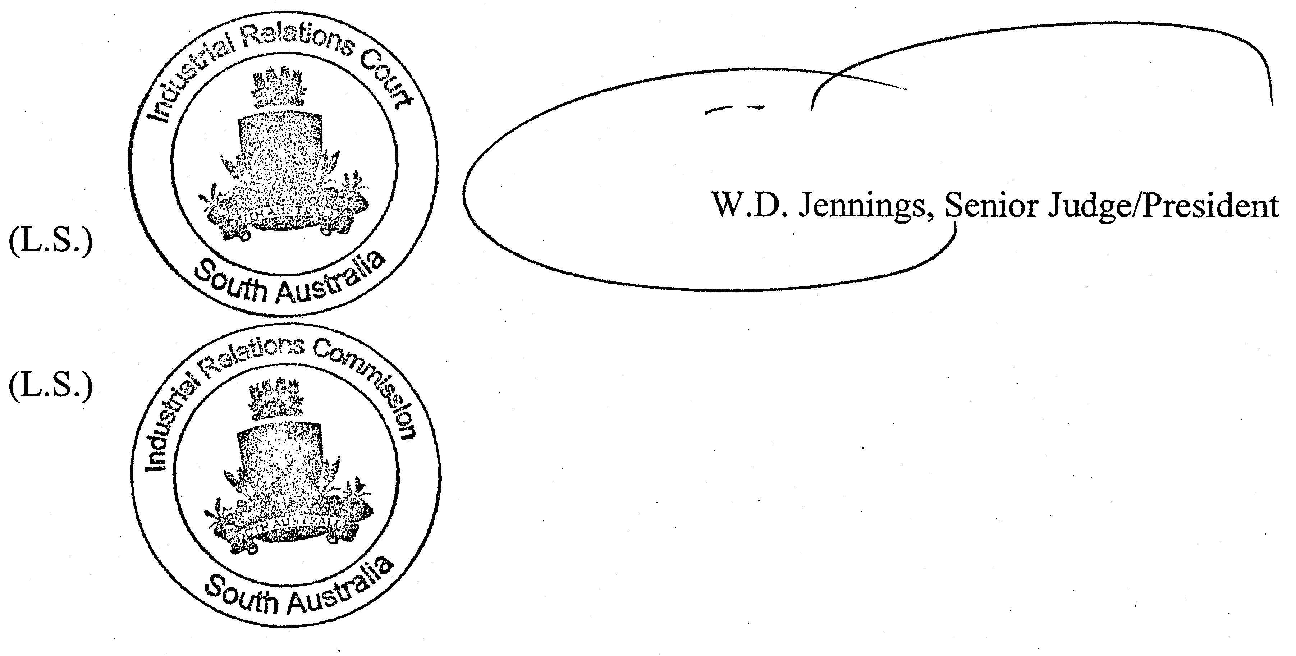

RULE TWENTY - UNFAIR DISMISSAL PROCEEDINGS
(Formally operational 21 August 2006, but proceedings dealt with in manner consistent with this Rule from 24 April 2006 - see Practice Direction 21)

(1) Except for referrals from other authorities which are governed by sub-rule (25), an application pursuant to Section 106 shall be made in accordance with Form 3 and shall be lodged in the Registry personally or by post, facsimile transmission or email.

(2) Unless otherwise directed by the President and subject to sub-rule (26), the Registrar must provide a copy of the Section 106 application to the respondent as identified in the application by any means contemplated by Rule 13.

(3) The respondent named in a Section 106 application must, within 10 days of being provided with a copy of the application, file a response in accordance with
Form 4. This response is to be lodged in the Registry personally or by post, facsimile transmission or email.

(4) The Registrar must cause to be provided to the applicant at his or her address for service a copy of any Form 4 lodged in accordance with these Rules.

(5) Where the respondent objects to the jurisdiction of the Commission based upon alleged inconsistency with the Workplace Relations Act 1996 (Cth) and does not consent to conciliation, the jurisdictional objection is to be heard at a time and location determined by the Member assigned to initially deal with the application.

(6) Subject to sub-rule 5 the Commission will fix a time and place for the conference required by Section 155B of the Act and provide the applicant and respondent with a notice confirming the hearing.

(7) Where the Commission has determined that the conference will be conducted outside of the metropolitan area of Adelaide, the proceedings will be conducted at a place that is as far as practicable within reasonable proximity of the location where the employment of the applicant was based.

(8) The conference conducted for the purposes of Section 155B may be held by utilising video and/or telephone facilities if directed by the Member who is to preside over the conference.

(9) The Commission may direct that additional documentation as it considers necessary, must accompany the notices provided to the parties under this Rule.

(10) All parties to the proceedings shall attend a conference pursuant to Section 155B to be presided over by a Member of the Commission at a date, time and place specified in the notice of sitting for the purpose of:

(a) exploring the possibility of resolving the matters in issue by conciliation;

(b) ensuring that the parties are fully informed of the possible consequences of taking the proceedings further; and

(c) if the proceedings are to progress further and the parties are involved in two or more sets of proceedings under the Act, exploring the possibility of hearing and determining some or all of the proceedings concurrently.

(11) If a respondent is a body corporate, or the State of South Australia, or the Commissioner for Public Employment, it shall be represented at the conference by a duly authorised employee or officer who is familiar with the matters in issue and who has the authority to bind the respondent to any agreement.

(12) The Commission Member presiding at the conference will determine the manner in which the proceedings are to be conducted and in so doing may give directions as to the conduct of the parties and their representatives. The Member may also adjourn the conference to other times and places as the needs of the matter require.

(13) Subject to sub-rules (15), (16), (20) and (21) nothing said or done at the conference by either party or any other person attending is admissible on the hearing of the arbitration except by the consent of the parties; save that it will become admissible in relation to any application for costs in respect of the proceedings.

(14) If the conference resolves some or all of the matters in issue between the parties, the Member of the Commission may make and sign a written memorandum of the terms of settlement which shall be filed in the Registry and may be received in evidence in any proceedings.

(15) If the application is not discontinued or settled and the Member of the Commis-sion presiding at the conference considers that further conciliation would not be appropriate, then the Member will conclude the conference by issuing a written memorandum in accordance with Form 5 which may also contain:

(a) an order requiring the parties to confirm the assertions and the basis of their positions as outlined in the Form 3 and Form 4 as lodged;

(b) an order requiring the applicant to provide better particulars concerning the Section 106 application or as to an application pursuant to Section 167 of the Act, a copy of which shall be filed in the Registry;

(c) an order that the respondent employer provide better particulars including written reasons for the dismissal of the employee, given at the time, or to be relied upon to the applicant if not already given, or if there is a denial of a dismissal then the grounds upon which the dismissal is denied, a copy of which shall be filed in the Registry;

(d) an order requiring the respondent employer to confirm the basis of any jurisdictional challenge to the application being heard and determined, a copy of which shall be filed in the Registry;

(e) a statement confirming the relevant costs provisions under the Act;

(f) an order that all parties provide discovery in accordance with Rule 25.

(16) Before, or not more than three business days after the conclusion of the con-ference, the Member of the Commission must prepare a memorandum:

(a) which will include a preliminary assessment of the merits of the claim (or, if there is more than one claim, of each claim) and any defence of the claim (or claims); and

(b) recommending to the parties how best to proceed to resolution of the questions in issue between them (or, if in the Member’s opinion the application patently lacks merit, recommending that the claim be withdrawn),

and forward it to the parties, provided that any memorandum so prepared is subject to sub-rule (13).

(17) Upon the filing of Form 5, the Commission will give directions as to the date, time and place of the hearing and determination of the application and the parties will be given notice.

(18) Nothing in this Rule shall prevent the Commission making procedural and inter-locutory orders as are reasonable for the effective conduct of proceedings.

(19) Nothing in this Rule shall derogate from the power of the President to direct that the application be heard forthwith or at some other time or before some other Member of the Commission.

(20) The application lodged pursuant to sub-rule (1) and the response lodged pursuant to sub-rule (3) will not be taken to be formal pleadings. The Commission
may where appropriate, including during proceedings conducted pursuant to Section 155B of the Act, grant leave to amend an application or a response lodged pursuant to the relevant sub-rule. This may include for example the alteration of particulars and with the consent of the parties, the name of the respondent so as to cite the correct employer of the applicant.
(21) A breach of either the terms of a memorandum to which sub-rule (14) applies or any other written agreement reached between the parties in consequence of the Section 155B conference, will allow the aggrieved party to approach the Commis-sion for further and other relief by lodging an application for directions.

(22) Where an applicant in a proceeding relating to a Section 106 application fails to attend the proceeding in person or by a representative, the Commission may, if satisfied that the applicant had reasonable notice and a reasonable opportunity to be heard, dismiss the application.

(23) Nothing in this Rule will prevent the Commission from waiving compliance with the Rule or making directions for the processing of an application in a manner not contemplated in the relevant Rule where the circumstances warrant.

(24) For the purposes of Section 155B proceedings under this Rule, reference to the Commission will where appropriate include the Court or a Stipendiary Magistrate where the President so directs.

(25) Where an authority under another Act purports to refer a matter to the Commis-sion pursuant to Chapter 3 Part 6 of the Act, the proceedings will be commenced by the filing of a statement by the authority setting out the nature of the matter and the parties said to be involved. Any such matter will then be conducted in a manner as directed by the Commission including where appropriate, as otherwise contemplated by this Rule.

(26) Where an applicant lodges an application under this Rule and in response to any clarification sought by the Registrar or a Member regarding their intention to proceed does not confirm such an intention with 10 days, the matter may be deemed to be discontinued without further notice.

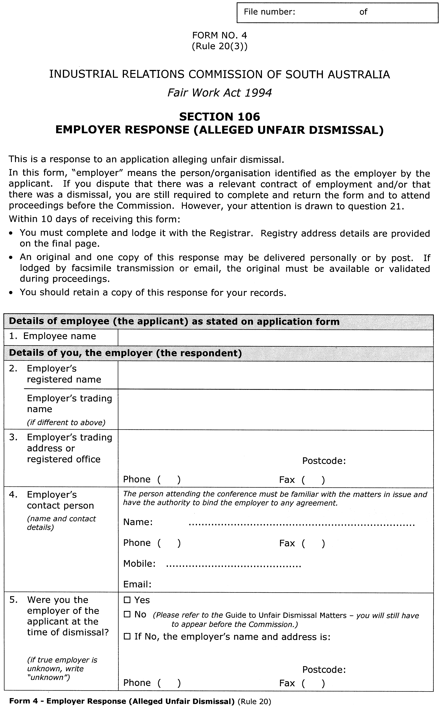
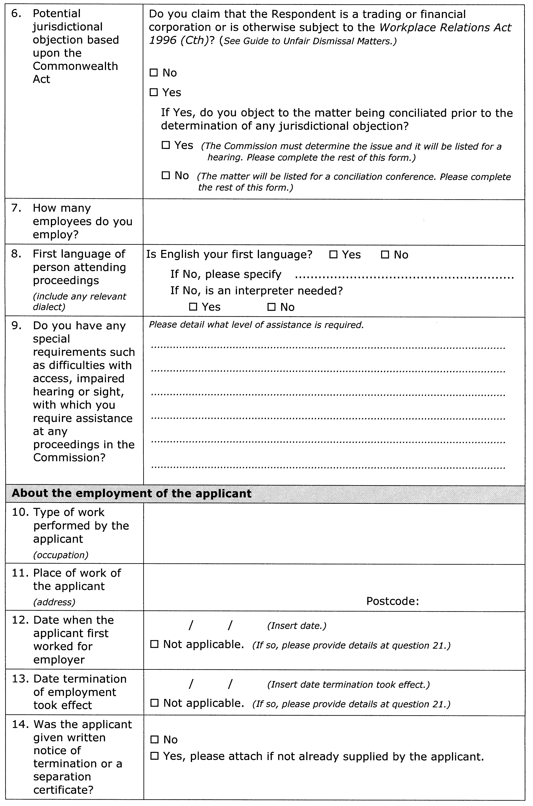
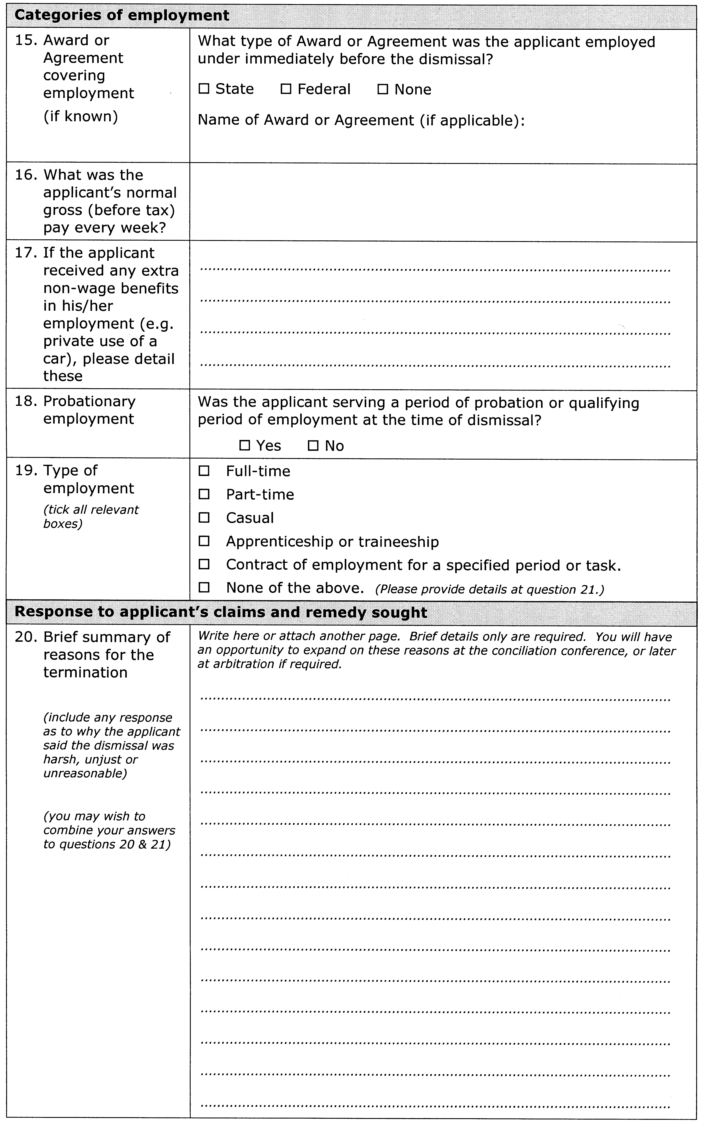
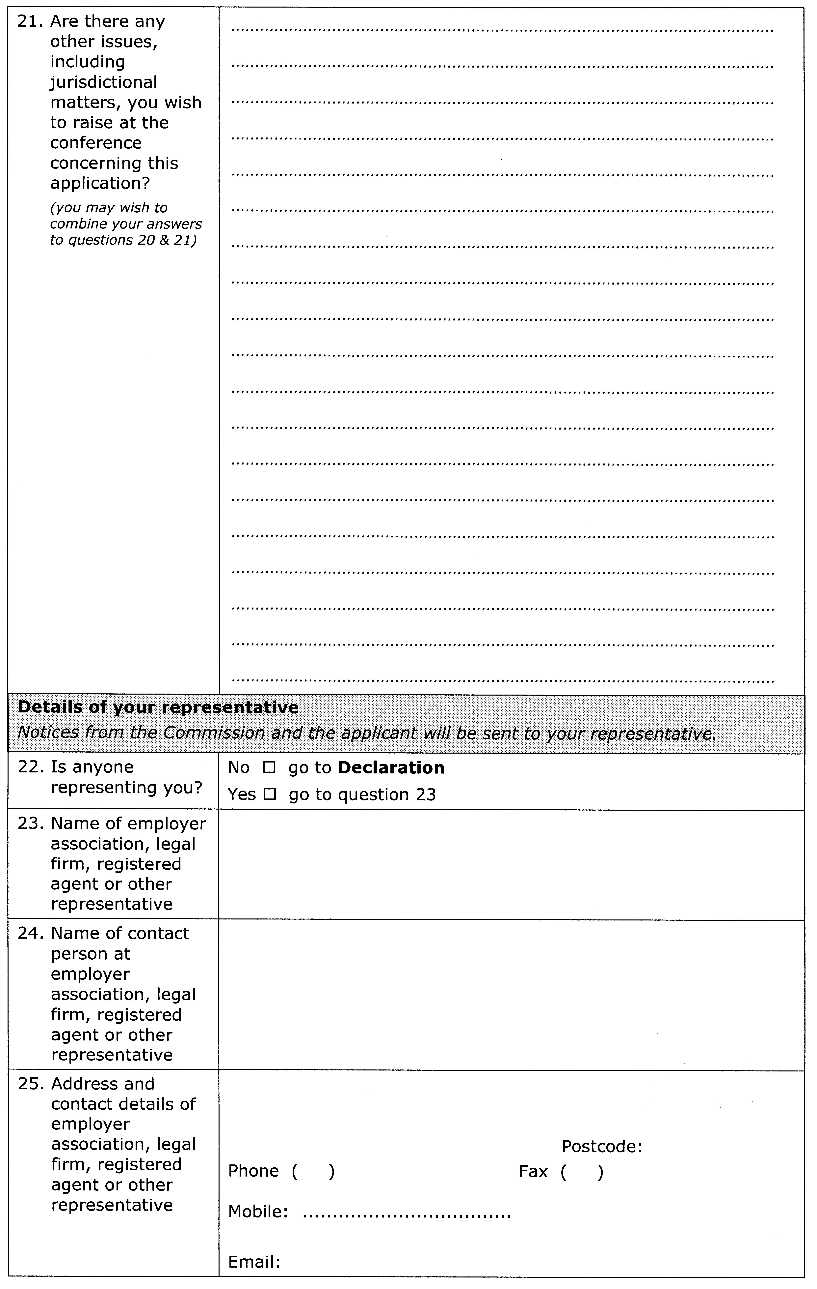
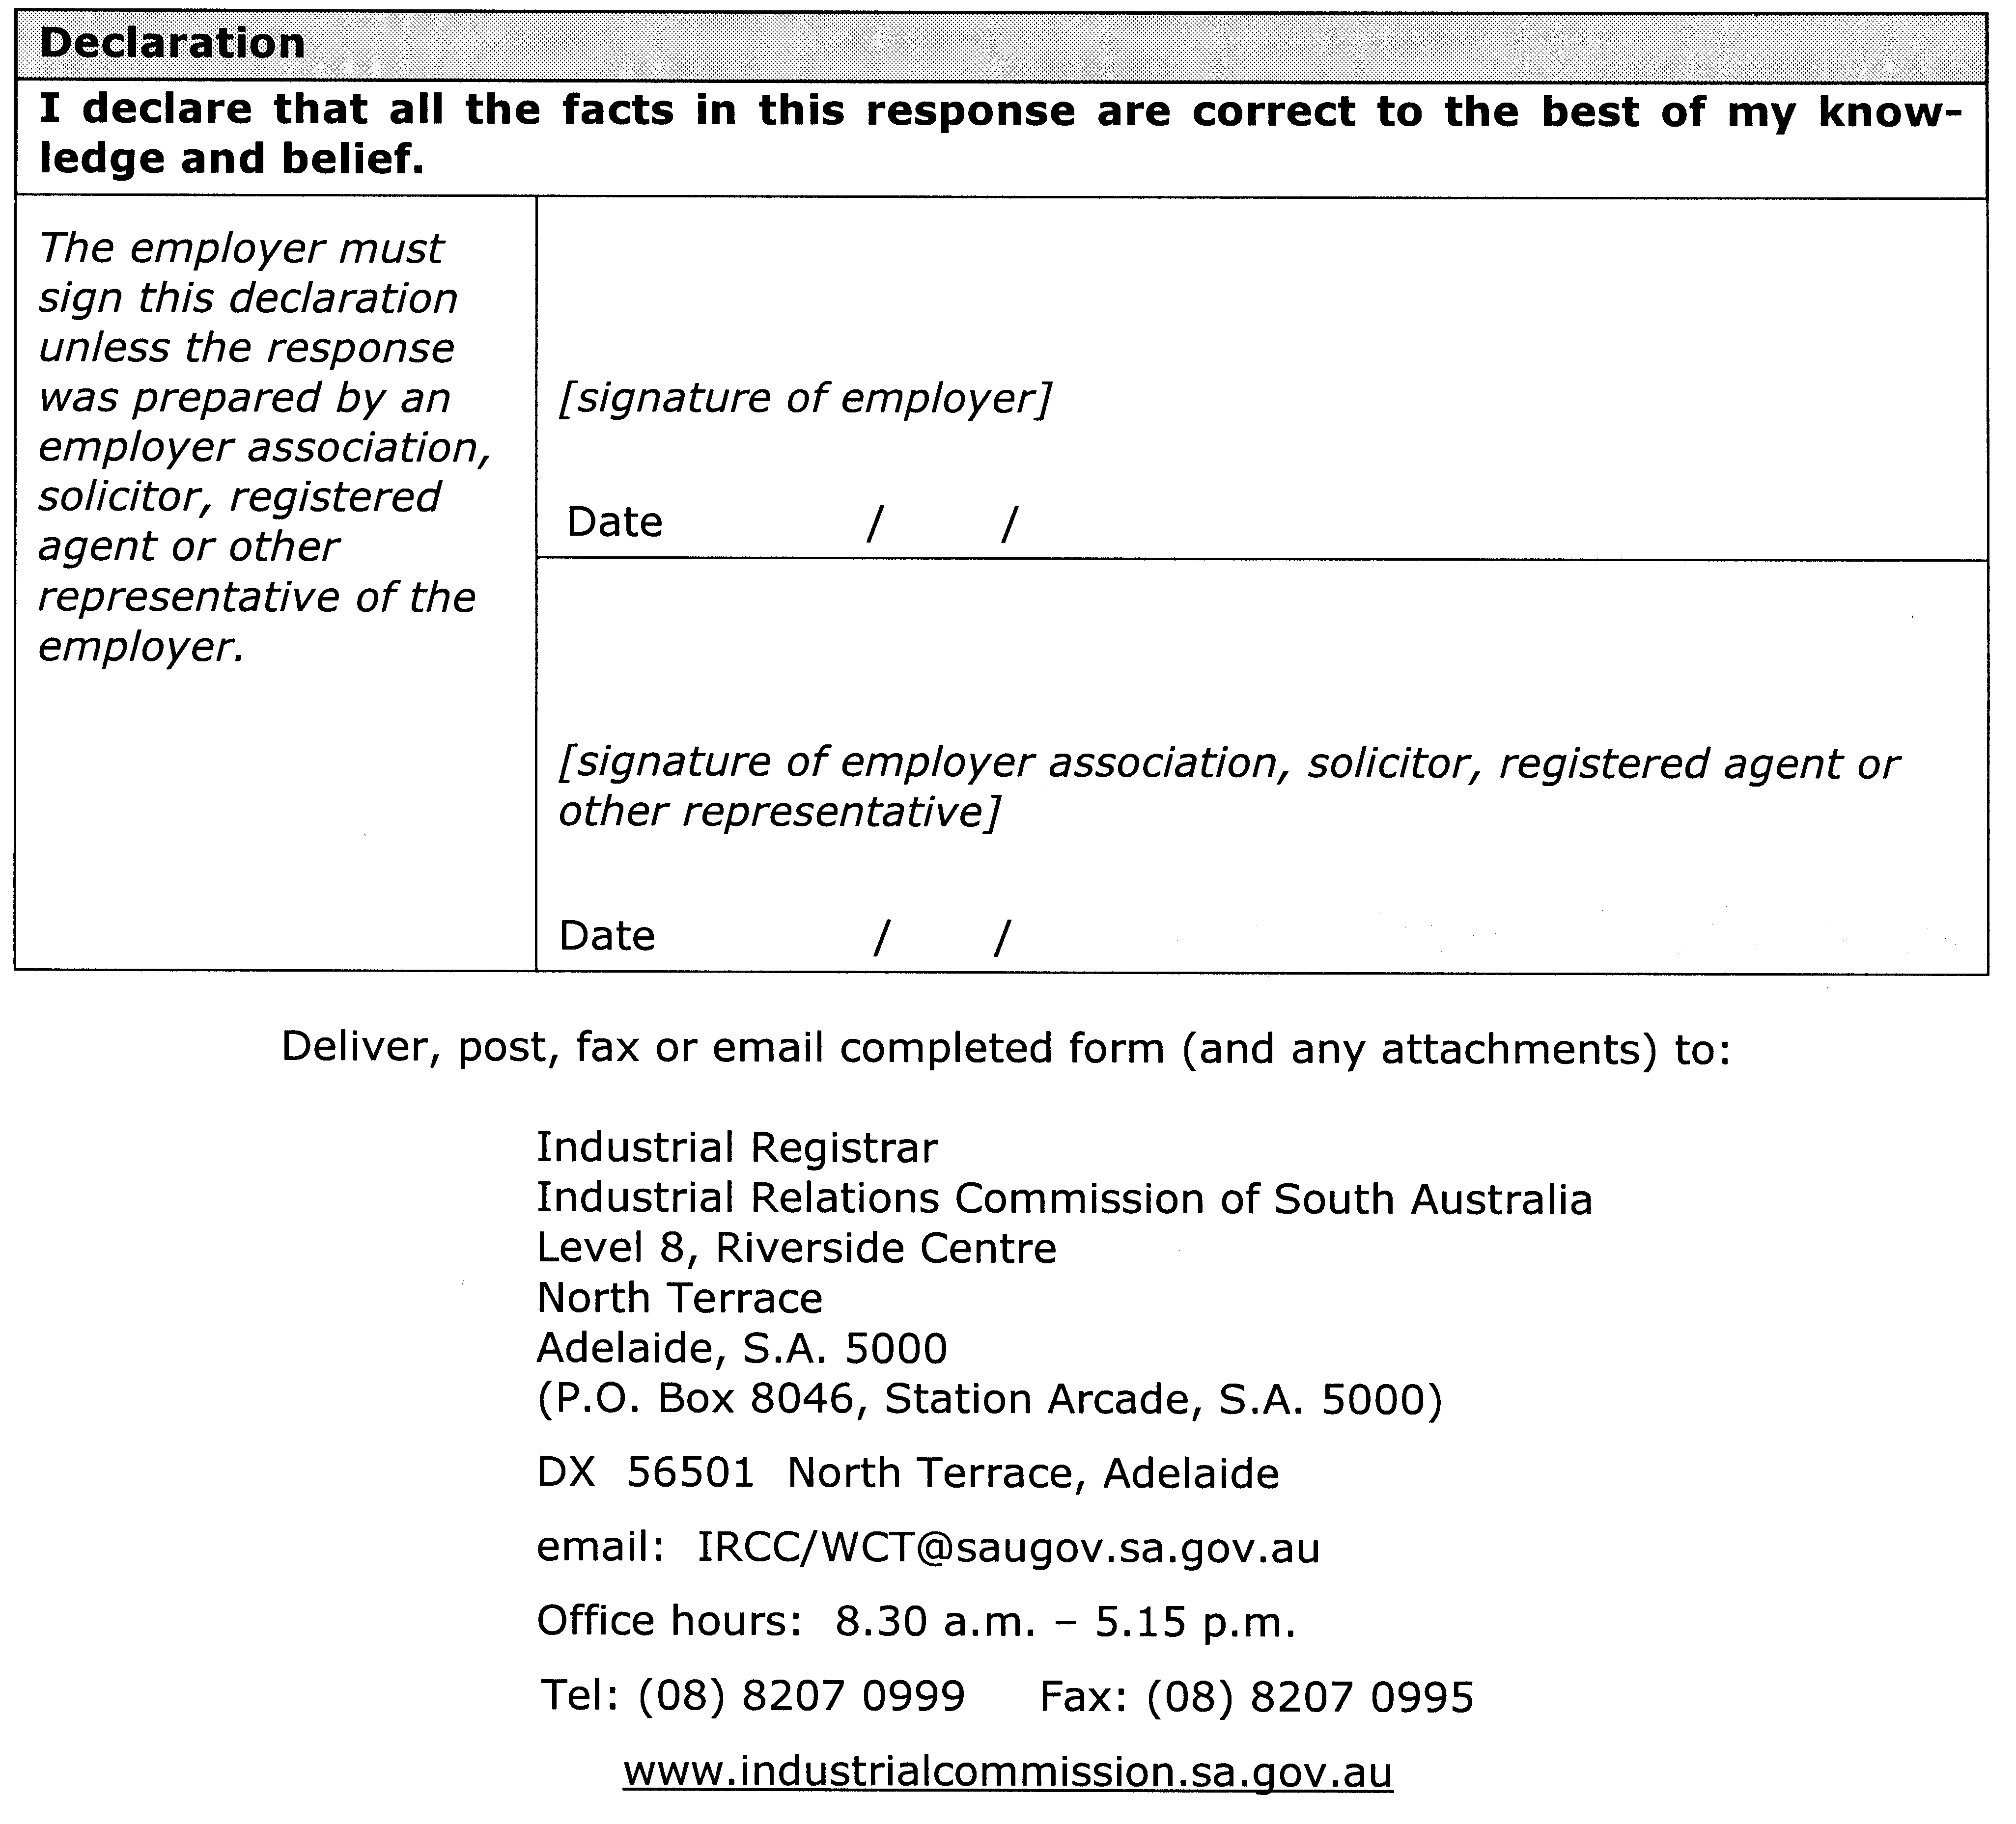

GOVERNMENT GAZETTE ADVERTISEMENT RATES

To apply from 1 July 2005

$  Agents, Ceasing to Act as 36.50  Associations:  Incorporation 18.60  Intention of Incorporation 46.00  Transfer of Properties 46.00  Attorney, Appointment of 36.50  Bailiff’s Sale 46.00  Cemetery Curator Appointed 27.25  Companies:  Alteration to Constitution 36.50  Capital, Increase or Decrease of 46.00  Ceasing to Carry on Business 27.25  Declaration of Dividend 27.25  Incorporation 36.50  Lost Share Certificates:  First Name 27.25  Each Subsequent Name 9.35  Meeting Final 30.50  Meeting Final Regarding Liquidator’s Report on  Conduct of Winding Up (equivalent to ‘Final  Meeting’)  First Name 36.50  Each Subsequent Name 9.35  Notices:  Call 46.00  Change of Name 18.60  Creditors 36.50  Creditors Compromise of Arrangement 36.50  Creditors (extraordinary resolution that ‘the Com-pany be wound up voluntarily and that a liquidator be appointed’) 46.00  Release of Liquidator⎯Application⎯Large Ad. 72.50  ⎯Release Granted 46.00  Receiver and Manager Appointed 42.50  Receiver and Manager Ceasing to Act 36.50  Restored Name 34.50  Petition to Supreme Court for Winding Up 64.00  Summons in Action 54.50  Order of Supreme Court for Winding Up Action 36.50  Register of Interests⎯Section 84 (1) Exempt 82.50  Removal of Office 18.60  Proof of Debts 36.50  Sales of Shares and Forfeiture 36.50  Estates:  Assigned 27.25  Deceased Persons⎯Notice to Creditors, etc. 46.00  Each Subsequent Name 9.35  Deceased Persons⎯Closed Estates 27.25  Each Subsequent Estate 1.20  Probate, Selling of 36.50  Public Trustee, each Estate 9.35 |  | $  Firms:  Ceasing to Carry on Business (each insertion) 24.30  Discontinuance Place of Business 24.30  Land⎯Real Property Act:  Intention to Sell, Notice of 46.00  Lost Certificate of Title Notices 46.00  Cancellation, Notice of (Strata Plan) 46.00  Mortgages:  Caveat Lodgment 18.60  Discharge of 19.50  Foreclosures 18.60  Transfer of 18.60  Sublet 9.35  Leases⎯Application for Transfer (2 insertions) each 9.35  Lost Treasury Receipts (3 insertions) each 27.25  Licensing 54.50  Municipal or District Councils:  Annual Financial Statement⎯Forms 1 and 2 513.00  Electricity Supply⎯Forms 19 and 20 364.00  Default in Payment of Rates:  First Name 72.50  Each Subsequent Name 9.35  Noxious Trade 27.25  Partnership, Dissolution of 27.25  Petitions (small) 18.60  Registered Building Societies (from Registrar-  General) 18.60  Register of Unclaimed Moneys⎯First Name 27.25  Each Subsequent Name 9.35  Registers of Members⎯Three pages and over:  Rate per page (in 8pt) 233.00  Rate per page (in 6pt) 308.00  Sale of Land by Public Auction 46.50  Advertisements 2.60  ¼ page advertisement 109.00  ½ page advertisement 218.00  Full page advertisement 427.00  Advertisements, other than those listed are charged at $2.60 per column line, tabular one-third extra.  Notices by Colleges, Universities, Corporations and District Councils to be charged at $2.60 per line.  Where the notice inserted varies significantly in length from that which is usually published a charge of $2.60 per column line will be applied in lieu of advertisement rates listed.  South Australian Government publications are sold on the condition that they will not be reproduced without prior permission from the Government Printer.
All the above prices include GST

GOVERNMENT GAZETTE NOTICES
ALL private advertisements forwarded for publication in the South Australian Government Gazette must be PAID FOR PRIOR TO INSERTION; and all notices, from whatever source, should be legibly written on one side of the paper only and sent to Government Publishing SA so as to be received no later than 4 p.m. Tuesday preceding the day of publication. Phone 8207 1045 or Fax 8207 1040. E-mail: governmentgazette@saugov.sa.gov.au. Send as attachments in Word format. Please include date the notice is to be published and to whom the notice will be charged. The Government Gazette is available online at: www.governmentgazette.sa.gov.au.

MISCELLANEOUS LEGISLATION AND GOVERNMENT PUBLICATIONS PRICES AS FROM 1 JULY 2005

Acts, Bills, Rules, Parliamentary Papers and Regulations
Pages | Main | Amends | Pages | Main | Amends

1-16 | 2.20 | 1.00 | 497-512 | 31.00 | 30.00
17-32 | 3.00 | 1.85 | 513-528 | 32.00 | 30.75
33-48 | 3.90 | 2.80 | 529-544 | 33.00 | 32.00
49-64 | 4.90 | 3.75 | 545-560 | 34.00 | 33.00
65-80 | 5.75 | 4.75 | 561-576 | 34.75 | 34.00
81-96 | 6.70 | 5.55 | 577-592 | 35.75 | 34.50
97-112 | 7.60 | 6.50 | 593-608 | 36.75 | 35.50
113-128 | 8.55 | 7.45 | 609-624 | 37.50 | 36.50
129-144 | 9.60 | 8.50 | 625-640 | 38.50 | 37.00
145-160 | 10.50 | 9.35 | 641-656 | 39.50 | 38.50
161-176 | 11.50 | 10.30 | 657-672 | 40.00 | 39.00
177-192 | 12.40 | 11.30 | 673-688 | 41.75 | 40.00
193-208 | 13.40 | 12.30 | 689-704 | 42.50 | 41.00
209-224 | 14.20 | 13.10 | 705-720 | 43.00 | 42.00
225-240 | 15.10 | 14.00 | 721-736 | 44.75 | 43.00
241-257 | 16.20 | 14.70 | 737-752 | 45.25 | 44.00
258-272 | 17.10 | 15.70 | 753-768 | 46.25 | 44.50
273-288 | 18.00 | 16.90 | 769-784 | 46.75 | 46.00
289-304 | 18.80 | 17.70 | 785-800 | 47.75 | 47.00
305-320 | 19.90 | 18.70 | 801-816 | 48.50 | 47.50
321-336 | 20.70 | 19.60 | 817-832 | 49.75 | 48.50
337-352 | 21.80 | 20.60 | 833-848 | 50.75 | 49.50
353-368 | 22.60 | 21.60 | 849-864 | 51.50 | 50.00
369-384 | 23.60 | 22.50 | 865-880 | 52.50 | 51.50
385-400 | 24.50 | 23.40 | 881-896 | 53.00 | 52.00
401-416 | 25.50 | 24.20 | 897-912 | 54.50 | 53.00
417-432 | 26.50 | 25.25 | 913-928 | 55.00 | 54.50
433-448 | 27.50 | 26.25 | 929-944 | 56.00 | 55.00
449-464 | 28.25 | 27.00 | 945-960 | 57.00 | 55.50
465-480 | 28.75 | 28.00 | 961-976 | 58.25 | 56.50
481-496 | 30.00 | 28.75 | 977-992 | 59.25 | 57.00

Legislation—Acts, Regulations, etc: $
Subscriptions:
Acts 192.00
All Bills as Laid 460.00
Rules and Regulations 460.00
Parliamentary Papers 460.00
Bound Acts 213.00
Index 106.00
Government Gazette
Copy 5.00
Subscription 254.00
Hansard
Copy 14.00
Subscription—per session (issued weekly) 399.00
Cloth bound—per volume 172.00
Subscription—per session (issued daily) 399.00
Legislation on Disk
Whole Database 2 951.00
Annual Subscription for fortnightly updates 907.00
Individual Act(s) including updates POA
Compendium
Subscriptions:
Subscriptions 1 749.00
Updates 617.00
(All the above prices include GST)

All Legislation, Government Gazette, Hansard and Legislation on disk are available from:
Counter Sales Service SA, Government Legislation⁺ Outlet
and Mail Orders: Lands Titles Office, 101 Grenfell Street, Adelaide, S.A. 5000
Phone: 13 23 24 (local call cost), Fax: (08) 8204 1909
Postal: G.P.O. Box 1707, Adelaide, S.A. 5001

Online Shop: www.shop.service.sa.gov.au

Subscriptions and Government Publishing SA
Standing Orders: Box 9, Plaza Level, Riverside Centre, North Terrace, Adelaide, S.A. 5000
Phone: (08) 8207 0908, (08) 8207 0910, Fax: (08) 8207 1040

EQUAL OPPORTUNITY TRIBUNAL
No. 488 of 2005
Notice of Exemption
Before Deputy Presiding Officer Tilmouth
Members Altman and Shetliffe
I HEREBY certify that on 24 March 2006, the Equal Opportunity Tribunal of South Australia, on the application of Vicki Radford, Kristy Mott and Christine Pressler, trading as Diamond Weight-loss Centre made the following orders for exemption:
1. Pursuant to section 92 of the Equal Opportunity Act 1984, an exemption is granted jointly to Vicki Radford, Kristy Mott and Christine Pressler, trading as Diamond Weightloss Centre, from the provisions of section 30 (relating to employment), section 39 (providing goods and services) and section 103 (relating to advertising) of the Equal Opportunity Act 1984 (SA), with respect to the provision of health and fitness centres.
2. This exemption will be in force for a period of three years from the date it is gazetted.
Dated 29 March 2006.
Di Hoban for M. Moore, Registrar, Equal Opportunity Tribunal

EQUAL OPPORTUNITY TRIBUNAL
No. 17 of 2006
Notice of Exemption
Before Presiding Officer Chief Judge Worthington
Members Yapp and Worley
I HEREBY certify that on 22 March 2006, the Equal Opportunity Tribunal of South Australia, on the application of Nunga
Mi:Minar Incorporated made the following orders for exemption:
1. Nunga Mi:Minar Incorporated is granted an exemption from the provisions of sections 30, 39, 52, 61, 62 and 103 of the Equal Opportunity Act 1984, as specified hereunder.
2. This exemption shall apply only to people working (or to work) in the following positions: the Manager, the Team Leader, the four family support workers and the receptionist.
3. This exemption will be in force for a period of three years from 22 March 2006.
Dated 29 March 2006.
Di Hoban for M. Moore, Registrar, Equal Opportunity Tribunal

EQUAL OPPORTUNITY TRIBUNAL
No. 10 of 2006
Notice of Exemption
Before Deputy Presiding Officer Tilmouth
Members Altman and Shetliffe
I HEREBY certify that on 24 March 2006, the Equal Opportunity Tribunal of South Australia, on the application of LeisureCo Pty Ltd trading as InShape Women made the following orders for exemption:
1. Pursuant to section 92 of the Equal Opportunity Act 1984, LeisureCo trading as InShape Women, is granted an exemption from the provisions of section 30 (relating to employment), section 39 (providing goods and services) and section 103 (relating to advertising) of the Equal Opportunity Act 1984 (SA), with respect to the provision of health and fitness centres.
2. This exemption will be in force for a period of three years from the date it is gazetted.
Dated 29 March 2006.
Di Hoban for M. Moore, Registrar, Equal Opportunity Tribunal

EXPIATION OF OFFENCES ACT 1996
Notice of Authorisation
PURSUANT to section 6 (3) (b) (i) of the Expiation of Offences Act 1996, I, Gail Gago, hereby authorise the following person, whilst employed within Public Health of the Department of Health to issue expiation notices in respect of Regulations 6 (1), 6 (2),
6 (3), 10 (2), 12 (4), 16 (1), 17 (1), 18 (1), 18 (2), 19 (1), 19 (2),
19 (3), 19 (4), 20, 21 (1), 21 (2), 21 (3), 21 (4), 21 (5), 21 (6), 22 and 23 of the Controlled Substances (Pesticide) Regulations 2003:
Emma Jane Denehy
Dated 13 April 2006.
G. Gago, Minister for Mental Health and Substance Abuse

EXPIATION OF OFFENCES ACT 1996
Notice of Authorisation
PURSUANT to sections 12 and 16 of the Expiation of Offences Act 1996, I, Gail Gago, hereby authorise the persons employed or acting in the positions of Director, Public Health and Manager, Scientific Services, to accept late payment of expiation fees or withdraw an expiation notice issued under the Controlled Substances (Pesticide) Regulations 2003.
Dated 13 April 2006.
G. Gago, Minister for Mental Health and Substance Abuse

FISHERIES ACT 1982: SECTION 43
TAKE note that the notice made under section 43 of the Fisheries Act 1982, published in the South Australian Government Gazette on page number 965, dated 28 March 2006, being the fourth notice on that page, referring to the Gulf St Vincent Prawn Fishery, is hereby varied such that it will not be unlawful for a person fishing pursuant to a Gulf St Vincent Prawn Fishery licence to use prawn trawl nets in the area specified in Schedule 1 during the period specified in Schedule 2.
Schedule 1
1. The waters of the Gulf St Vincent Prawn Fishery located in the Investigator Strait, which are defined as the waters within the following co-ordinates, starting at position latitude 35°25.50′S longitude 137°49.80′E, then to position latitude 35°24.50′S longitude 137°40.00′E, then to position latitude 35°20.00′S longitude 137°41.50′E, then to position latitude 35°20.00′S longitude 137°49.00′E, then to position latitude 35°24.00′S longitude 137°53.24′E, then back to position latitude 35°25.50′S longitude 137°49.80′E.
Schedule 2
From 2000 hours on 26 April 2006 to 0600 hours on 28 April 2006.
Dated 26 April 2006.
S. Sloan, Principal Fisheries Manager

FISHERIES ACT 1982: SECTION 43
TAKE note that the notice made under section 43 of the Fisheries Act 1982, published in the South Australian Government Gazette on page number 3958, dated 17 November 2005, being the third notice on that page, referring to the Spencer Gulf Prawn Fishery, is hereby varied such that it will be unlawful for a person fishing pursuant to a Spencer Gulf Prawn Fishery licence to use prawn trawl nets, except in the area specified in Schedule 1 during the period specified in Schedule 2.
Schedule 1
1. The waters of the Spencer Gulf Prawn Fishery that are within the northern area commencing at position latitude 33°46.00′S longitude 137°44.00′E, then to position latitude 33°37.00′S longitude 137°33.00′E, then to position latitude 33°37.00′S longitude 137°30.00′E, then to position latitude 33°42.00′S
longitude 137°28.00′E, then to position latitude 33°48.00′S longitude 137°27.00′E, then to position latitude 33°49.00′S longitude 137°29.00′E, then to position latitude 33°47.00′S longitude 137°31.00′E, then to position latitude 33°48.00′S longitude 137°32.50′E, then to position latitude 33°50.30′S longitude 137°30.50′E, then to position latitude 33°54.00′S longitude 137°38.00′E.
2. The waters of the Spencer Gulf Prawn Fishery that are within the northern area commencing at position latitude 34°08.00′S longitude 137°32.00′E, then to position latitude 33°51.00′S longitude 137°20.00′E, then to position latitude 33°53.00′S longitude 137°12.00′E, then to position latitude 33°57.00′S longitude 137°14.00′E, then to position latitude 34°08.00′S longitude 137°06.00′E, then to position latitude 34°08.00′S longitude 137°33.00′E.
Schedule 2
From 1830 hours on 26 April 2006 to 0630 hours on 28 April 2006.
Dated 26 April 2006.
S. Sloan, Principal Fisheries Manager

FISHERIES ACT 1982: SECTION 59
TAKE notice that pursuant to section 59 of the Fisheries Act 1982, persons listed in Schedule 1, (the ‘exemption holders’), are exempt from section 43 of the Fisheries Act 1982, but only insofar as the exemption holder shall not be guilty of an offence when taking mud cockles (Katelysia spp.) from a closed area (the ‘exempted activity’), subject to the conditions specified in Schedule 2, from 21 April 2006 until 5 May 2006, unless this notice is varied or revoked earlier.
Schedule 1
• Robert Jones—M031
• Lee Bassell—M447
• Gary Oswald—M398
Schedule 2
1. The cockles collected by the exemption holders are for research purposes only and must not be sold.
2. The exemption holders must notify PIRSA Fishwatch on 1800 065 522 at least two hours prior to conducting the exempted activity and answer a series of questions about the exempted activity. The exemption holders will need to have a copy of the exemption notice at the time of making the call and be able to provide information about the area and time of the exempted activity, the vehicles involved and other related questions. Exemption No. 9901856.
3. While engaged in the exempted activity, the exemption holders must have in their possession a copy of this notice and produce a copy of this notice if requested by a PIRSA Fisheries Compliance Officer.
4. The exemption holders must not contravene or fail to comply with the Fisheries Act 1982, or any regulation made under that Act, except where specifically exempted by this notice.
Dated 20 April 2006.
M. Smallridge, Director of Fisheries

FISHERIES ACT 1982: SECTION 59
TAKE notice that pursuant to section 59 of the Fisheries Act 1982, Robert Von Stanke, holder of Southern Zone Rock Lobster Fishery Licence No. S198, (the ‘exemption holder’), is exempt from paragraphs 14 (1) (a) (ii) of the Fisheries (Scheme of Management—Rock Lobster Fisheries) Regulations 1991, insofar as he may allow Mark Feast to operate rock lobster pots registered on Southern Zone Rock Lobster Fishery Licence No. S157 from the exemption holders registered vessel Invader (the ‘exempted activity’) subject to the conditions in Schedule 1, during the period commencing 21 April 2006 and ending 31 May 2006, unless varied or revoked earlier.
Schedule 1
1. The exemption holder may pull pots from Southern Zone Rock Lobster Licence No. S157 from the vessel registered on Southern Zone Rock Lobster Licence No. S198 (Invader).
2. The exemption holder must ensure that any fish caught using pots registered on Licence Holder No. S157 are in marked bins and CDR forms must be completed for the catch from pots of Licence Holder No. S157. Any fish caught using pots registered on Licence Holder No. S198 must be kept in separate marked bins and recorded on that licences CDR forms.
3. The exemption holder (S198) must notify PIRSA Fishwatch on 1800 065 522 at least two hours prior to conducting the exempted activity and answer a series of questions about the exempted activity. The exemption holder (S198) must also contact PIRSA Fishwatch one hour prior to landing and nominate a port of landing. The exemption holder will need to have a copy of the exemption notice at the time of making the call, and be able to provide information about the area and time of the exempted activity and other related questions, including the exemption number 9901857.
4. While engaged in the exempted activity the exemption holder must have in his possession a copy of this notice and produce a copy of the notice if required by a PIRSA Fisheries Compliance Officer.
5. An exemption holder must not contravene or fail to comply with the Fisheries Act 1982, or any other regulations made under that Act except where specifically exempted by this notice.
Dated 21 April 2006.
M. Smallridge, Director of Fisheries

FISHERIES ACT 1982: SECTION 43
TAKE note that the notice made under section 43 of the Fisheries Act 1982, published in the South Australian Government Gazette on page 3958, dated 17 November 2005, being the third notice on that page, referring to the Spencer Gulf Prawn Fishery, is hereby varied such that it will be unlawful for a person fishing pursuant to a Spencer Gulf Prawn Fishery licence to use prawn trawl nets, except in the area specified in Schedule 1 during the period specified in Schedule 2.
Schedule 1
1. The waters of the Spencer Gulf Prawn Fishery that are within the northern area commencing at position latitude 33°46.00′S longitude 137°44.00′E, then to position latitude 33°37.00′S longitude 137°33.00′E, then to position latitude 33°37.00′S longitude 137°30.00′E, then to position latitude 33°42.00′S longitude 137°28.00′E, then to position latitude 33°48.00′S longitude 137°27.00′E, then to position latitude 33°49.00′S longitude 137°29.00′E, then to position latitude 33°47.00′S longitude 137°31.00′E, then to position latitude 33°48.00′S longitude 137°32.50′E, then to position latitude 33°50.30′S longitude 137°30.50′E, then to position latitude 33°54.00′S longitude 137°38.00′E.
2. The waters of the Spencer Gulf Prawn Fishery that are within the northern area commencing at position latitude 34°08.00′S longitude 137°32.00′E, then to position latitude 33°51.00′S longitude 137°20.00′E, then to position latitude 33°53.00′S longitude 137°12.00′E, then to position latitude 33°57.00′S longitude 137°14.00′E, then to position latitude 34°08.00′S longitude 137°06.00′E, then to position latitude 34°08.00′S longitude 137°33.00′E.
3. The waters of the Spencer Gulf Prawn Fishery that are south of the southern closure area, commencing at position latitude 34°30.00′S longitude 136°06.00′E, then to position latitude 34°30.00′S longitude 137°15.00′E, then to position latitude 34°55.00′S longitude 137°15.00′E.
Schedule 2
From 1830 hours on 25 April 2006 to 0630 hours on 26 April 2006.
Dated 21 April 2006.
M. Smallridge, Principal Fisheries Manager

HOUSING IMPROVEMENT ACT 1940
WHEREAS by notice published in the Government Gazette on the dates mentioned in the following table the South Australian Housing Trust did declare the houses described in the said table to be substandard for the purposes of Part 7 of the Housing Improvement Act 1940, the South Australian Housing Trust in the exercise of the powers conferred by the said Part, does hereby fix as the maximum rental per week which shall be payable subject to section 55 of the Residential Tenancies Act 1995, in respect of each house described in the following table the amount shown in the said table opposite the description of such house and this notice shall come into force on the date of this publication in the Gazette.
Address of House | Allotment, Section, etc. | Certificate of Title  Volume Folio | Date and page of Government Gazette in which notice declaring house to be substandard published | Maximum rental per week payable in respect of each house  $

Unit 1, 11 Williams Avenue, Dulwich (also known as 11 Williams Avenue) |  | Unit 1, Strata Plan 5389, Hundred of Adelaide  Common property, Strata Plan 5389, Hundred of Adelaide | 5028  5028 | 347  349 |  | 29.10.98, page 1289 | 116.00
Unit 2, 11 Williams Avenue, Dulwich |  | Unit 2, Strata Plan 5389, Hundred of Adelaide | 5028 | 348 |  | 30.9.99, page 1348 | 110.00
8 King Street, Gawler |  | Allotment 85 in Filed Plan 154486, Hundred of Mudla Wirra | 5829 | 248 |  | 22.5.69, page 1545 | 140.00
70 Orsmond Street, Hindmarsh |  | Allotment 93 in Filed Plan 120212, Hundred of Yatala | 5711 | 628 |  | 5.9.74, page 1702 | 140.00
161 K. R. Wilson Drive, Karoonda |  | Section 146, Hundred of Marmon Jabuk | 5157 | 112 |  | 28.10.93, page 2118 | 80.00
Flat 3, 266 Main South Road, Morphett Vale |  | Unit 3, Strata Plan 2413, Hundred of Noarlunga | 5039 | 221 |  | 2.3.06, page 766 | 82.00
26 Eleanor Terrace, Murray Bridge |  | Allotment 50 in Deposited Plan 67671, Hundred of Mobilong | 5945 | 608 |  | 24.8.95, page 508 | 130.00
37 Patapinda Road, Old Noarlunga |  | Allotment 91 in Filed Plan 164703 and Filed Plan 166882, Hundred of Noarlunga | 5310  5309 | 2  874 |  | 2.3.06, page 766 | 120.00
Flat at rear, 20 Gameau Road, Paradise, (also known as 20A Gameau Road) |  | Allotment 10 in Deposited Plan 6627, Hundred of Adelaide | 5633 | 356 |  | 28.4.05, page 1012 | 73.00
6-8 Pamir Court, Port Lincoln, (also known as 8 Pamir Street) |  | Allotment 225 in Deposited Plan 7972, Hundred of Port Lincoln | 5443 | 96 |  | 27.10.05, page 3813 | 140.00
5 Magor Road, Port Pirie |  | Allotment 8 in Filed Plan 11139, Hundred of Pirie | 5537 | 952 |  | 2.3.06, page 766 | 110.00
23 Harrow Road, St Peters |  | Allotment 78 in Deposited Plan 1142, Hundred of Adelaide  Allotment 94 in Filed Plan 136445. Hundred of Adelaide | 5547  5547 | 187  188 |  | 2.3.06, page 766 | 259.00

Dated at Adelaide, 27 April 2006. M. Downie, General Manager, Housing Trust

HOUSING IMPROVEMENT ACT 1940
NOTICE is hereby given that the South Australian Housing Trust in the exercise of the powers conferred by the Housing Improvement Act 1940, does hereby declare the houses described in the table hereunder to be substandard for the purposes of Part 7 of the Housing Improvement Act 1940.
No. of House and Street | Locality | Allotment, Section, etc. | Certificate of Title  Volume Folio

38 Clovelly Avenue |  | Christies Beach | Allotment 150 in Deposited Plan 3087, Hundred of Noarlunga | 5166 | 48
23 Penzance Avenue |  | Christies Beach | Allotment 404 in Deposited Plan 4516, Hundred of Noarlunga | 5370 | 344
4 Blight Street |  | Davoren Park | Allotment 10 in Deposited Plan 42936, Hundred of Munno Para | 5289 | 579
6 Blight Street |  | Davoren Park | Allotment 9 in Deposited Plan 42936, Hundred of Munno Para | 5289 | 578
52 Albatross Avenue |  | Hayborough (also known as Victor Harbor) | Allotment 315 in Deposited Plan 3207, Hundred of Goolwa | 5751 | 242
124 Sheriffs Road (attached to right of shop) |  | Morphett Vale | Allotment 5 in Deposited Plan 5912, Hundred of Noarlunga | 5169 | 912
3 Bayclay Street |  | Para Hills | Allotment 38 in Deposited Plan 7696, Hundred of Yatala | 5559 | 830
32 Randall Street |  | Port Mannum (also known as Mannum) | Allotment 43, Port Mannum, Hundred of Finniss | 5312 | 873
3 Murn Street |  | Port Pirie South | Allotment 436 in Filed Plan 189378, Port Pirie South, Hundred of Port Pirie | 5773 | 560
24 Alfred Street |  | Risdon Park | Allotment 28 in Deposited Plan 479, Hundred of Port Pirie | 5215 | 221
17 Farley Grove |  | Salisbury North | Allotment 26 in Filed Plan 38912, Hundred of Munno Para | 5520 | 910
50 Ann Street |  | Stepney | Allotment 72 in Filed Plan 134823, Hundred of Adelaide | 5317 | 7

Dated at Adelaide, 27 April 2006. M. Downie, General Manager, Housing Trust

HOUSING IMPROVEMENT ACT 1940
WHEREAS by notice published in the Government Gazette on the dates mentioned in the following table the South Australian Housing Trust did declare the houses described in the following table to be substandard for the purposes of Part 7 of the Housing Improvement Act 1940, and whereas the South Australian Housing Trust is satisfied that each of the houses described hereunder has ceased to be substandard, notice is hereby given that, in exercise of the powers conferred by the said Part, the South Australian Housing Trust does hereby revoke the said declaration in respect of each house.
Address of House | Allotment, Section, etc. | Certificate of Title  Volume Folio | Date and page of Government Gazette in which notice declaring house to be substandard published

11B Walker Street, Birkenhead |  | Allotment 37 in Filed Plan 4202, Hundred of Port Adelaide | 5248 | 530 |  | 29.9.83, page 978
173 Queen Street, Peterborough |  | Allotment 399 in Deposited Plan 3443, Hundred of Yongala | 5233 | 998 |  | 29.4.94, page 867
4 May Street, Wallaroo (pertaining to stone and brick dwelling circa 1900’s, now demolished) |  | Allotment 869 of portion of Allotment 182 in Filed Plan 189811, Hundred of Wallaroo  Allotment 870 of portion of Allotment 182 in Filed Plan 189812, Hundred of Wallaroo | 5367  5367 | 922  924 |  | 24.8.95, page 508

Dated at Adelaide, 27 April 2006. M. Downie, General Manager, Housing Trust

FRUIT AND PLANT PROTECTION ACT 1992
Revocation of a Quarantine Area
PURSUANT to section 14 of the Fruit and Plant Protection Act 1992, I, Rory McEwen, Minister for Agriculture, Food and Fisheries make the following notice:
Revocation
This notice hereby revokes the notice under the Act that was published in the Gazette of 29 July 2004 (page 2649) and that established the Riverland as a Quarantine Area with respect to the disease citrus canker and prohibited the importation or introduction of fruits and plant material of hosts of citrus canker from Queensland into the Quarantine Area.
R. McEwen, Minister for Agriculture, Food and Fisheries

LAND AND BUSINESS (SALE AND CONVEYANCING)
ACT 1994
Exemption
TAKE notice that, pursuant to section 23 (3) of the Land and Business (Sale and Conveyancing) Act 1994, I, Jennifer Rankine, Minister for Consumer Affairs, do hereby exempt the person named in Schedule 1 from the application of section 23 (2) of the Act in relation to the purchase of the land specified in Schedule 2.
Schedule 1
Nathan Steven Edgington-Fry, an employee of Kat Forde Pty Ltd.
Schedule 2
The land described in certificate of title register book volume 5689, folio 228, situated at 11 Foster Place, Goolwa, S.A. 5214.
Dated 27 April 2006.
J. Rankine, Minister for Consumer Affairs

LAND AND BUSINESS (SALE AND CONVEYANCING)
ACT 1994
Exemption
TAKE notice that, pursuant to section 23 (3) of the Land and Business (Sale and Conveyancing) Act 1994, I, Jennifer Rankine, Minister for Consumer Affairs, do hereby exempt the person named in Schedule 1 from the application of section 23 (2) of the Act in relation to the purchase of the land specified in Schedule 2.
Schedule 1
Lisa Boughen, an employee of Andrews and Hodges Pty Ltd.
Schedule 2
The land described in certificate of title register book volume 5373, folio 629, situated at 355 Nelson Road, Para Hills, S.A. 5096.
Dated 27 April 2006.
J. Rankine, Minister for Consumer Affairs

LAND AND BUSINESS (SALE AND CONVEYANCING)
ACT 1994
Exemption
TAKE notice that, pursuant to section 23 (3) of the Land and Business (Sale and Conveyancing) Act 1994, I, Jennifer Rankine, Minister for Consumer Affairs, do hereby exempt the person named in Schedule 1 from the application of section 23 (2) of the Act in relation to the purchase of the land specified in Schedule 2.
Schedule 1
Lee Karalis, an employee of Burlington Properties Pty Ltd.
Schedule 2
The whole of the land described in certificate of title register book volume 5796, folio 223, situated at 16 Hatch Street, Nuriootpa, S.A. 5255.
Dated 27 April 2006.
J. Rankine, Minister for Consumer Affairs

LAND AND BUSINESS (SALE AND CONVEYANCING)
ACT 1994
Exemption
TAKE notice that, pursuant to section 23 (3) of the Land and Business (Sale and Conveyancing) Act 1994, I, Jennifer Rankine, Minister for Consumer Affairs, do hereby exempt the person named in Schedule 1 from the application of section 23 (2) of the Act in relation to the purchase of the land specified in Schedule 2.
Schedule 1
Rosalie Ann Gryguc, an officer of Semaphore Real Estate Pty Ltd.
Schedule 2
The whole of the land described in certificate of title register book volume 5375, folio 781, situated at 49/62 Seaview Avenue, Wirrina Cove, S.A. 5204.
Dated 27 April 2006.
J. Rankine, Minister for Consumer Affairs

LAND AND BUSINESS (SALE AND CONVEYANCING)
ACT 1994
Exemption
TAKE notice that, pursuant to section 23 (3) of the Land and Business (Sale and Conveyancing) Act 1994, I, Jennifer Rankine, Minister for Consumer Affairs, do hereby exempt the person named in Schedule 1 from the application of section 23 (2) of the Act in relation to the purchase of the land specified in Schedule 2.
Schedule 1
Blake Matthew Gontar, an employee of Lindco Pty Ltd.
Schedule 2
The whole of the land described in certificate of title register book volume 5873, folio 240, situated at 12 Witney Street, Evanston, S.A. 5116.
Dated 27 April 2006.
J. Rankine, Minister for Consumer Affairs

LAND AND BUSINESS (SALE AND CONVEYANCING)
ACT 1994
Exemption
TAKE notice that, pursuant to section 23 (3) of the Land and Business (Sale and Conveyancing) Act 1994, I, Jennifer Rankine, Minister for Consumer Affairs, do hereby exempt the person named in Schedule 1 from the application of section 23 (2) of the Act in relation to the purchase of the land specified in Schedule 2.
Schedule 1
Carmel Lowe, an employee of Daper Pty Ltd.
Schedule 2
The whole of the land described in certificate of title register book volume 5251, folio 476, situated at 414 Senate Road, Port Pirie, S.A. 5540.
Dated 27 April 2006.
J. Rankine, Minister for Consumer Affairs

LAND AND BUSINESS (SALE AND CONVEYANCING)
ACT 1994
Exemption
TAKE notice that, pursuant to section 23 (3) of the Land and Business (Sale and Conveyancing) Act 1994, I, Jennifer Rankine, Minister for Consumer Affairs, do hereby exempt the person named in Schedule 1 from the application of section 23 (2) of the Act in relation to the purchase of the land specified in Schedule 2.
Schedule 1
Trevor Alan Gilliver, an employee of Gawler Real Estate Pty Ltd.
Schedule 2
The whole of the land described in certificate of title register book volume 5872, folio 491, situated at 8 Coleman Parade, Evanston Park, S.A. 5116.
Dated 27 April 2006.
J. Rankine, Minister for Consumer Affairs

LAND AND BUSINESS (SALE AND CONVEYANCING)
ACT 1994
Exemption
TAKE notice that, pursuant to section 23 (3) of the Land and Business (Sale and Conveyancing) Act 1994, I, Jennifer Rankine, Minister for Consumer Affairs, do hereby exempt the person named in Schedule 1 from the application of section 23 (2) of the Act in relation to the purchase of the land specified in Schedule 2.
Schedule 1
Teresa Cox, an employee of John De Michele Real Estate Pty Ltd.
Schedule 2
The land described in certificate of title register part of book volume 5869, folio 433, situated at Lot 112, Carter Road, Murray Bridge, S.A. 5253.
Dated 20 April 2006.
J. Rankine, Minister for Consumer Affairs

LAND AND BUSINESS (SALE AND CONVEYANCING)
ACT 1994
Exemption
TAKE notice that, pursuant to section 23 (3) of the Land and Business (Sale and Conveyancing) Act 1994, I, Jennifer Rankine, Minister for Consumer Affairs, do hereby exempt the person named in Schedule 1 from the application of section 23 (2) of the Act in relation to the purchase of the land specified in Schedule 2.
Schedule 1
Christine Michelle Rana, an employee of River Forde Pty Ltd.
Schedule 2
The land described in certificate of title register book volume 5268, folio 326, situated at 15 McLean Street, Berri, S.A. 5343.
Dated 20 April 2006.
J. Rankine, Minister for Consumer Affairs

LAND AND BUSINESS (SALE AND CONVEYANCING)
ACT 1994
Exemption
TAKE notice that, pursuant to section 23 (3) of the Land and Business (Sale and Conveyancing) Act 1994, I, Jennifer Rankine, Minister for Consumer Affairs, do hereby exempt the person named in Schedule 1 from the application of section 23 (2) of the Act in relation to the purchase of the land specified in Schedule 2.
Schedule 1
Anna Ruth Beale, an employee of River Forde Pty Ltd.
Schedule 2
The land described in certificate of title register book volume 5883, folio 970, situated at Lot 2, The Avenue, Waikerie, S.A. 5330.
Dated 20 April 2006.
J. Rankine, Minister for Consumer Affairs

LIQUOR LICENSING ACT 1997 AND GAMING MACHINES ACT 1992
Notice of Application
NOTICE is hereby given, pursuant to section 52 of the Liquor Licensing Act 1997 and section 29 of the Gaming Machines Act 1992, that Margaret Mary McCready and Thomas John McCready have applied to the Licensing Authority for the transfer of a Hotel and a Gaming Machine Licence in respect of premises situated at 195 Main Street, Peterborough, S.A. 5422 and known as Hotel Peterborough.
The applications have been set down for hearing on 29 May 2006 at 10 a.m.
Any person may object to the application by lodging a notice of objection in the prescribed form with the Liquor and Gambling Commissioner and serving a copy of the notice on the applicants at the applicants’ address given above, at least seven days before the hearing date (viz: 19 May 2006).
The applicants’ address for service is c/o Thomas McCready, 110 Main Street, Peterborough, S.A. 5422.
Plans in respect of the premises the subject of the application are open to public inspection without fee at the Office of the Liquor and Gambling Commissioner, 9th Floor, East Wing, 50 Grenfell Street, Adelaide, S.A. 5000. Phone 8226 8410, Fax:
8226 8512. Email: olgc@agd.sa.gov.au.
Dated 18 April 2006.
Applicants

LIQUOR LICENSING ACT 1997
Notice of Application
NOTICE is hereby given, pursuant to section 52 (2) (b) of the Liquor Licensing Act 1997, that Katrina Lee Pitman and Michael James Pitman have applied to the Licensing Authority for a Special Circumstances Licence in respect of premises situated at Foreshore, Jetty Road, Normanville, S.A. 5204 and to be known as Normanville Beach Cafe.
The application has been set down for hearing on 26 May 2006 at 9 a.m.
Conditions
The following licence conditions are sought:
• For consumption on the licensed premises (including Extended Trading Authorisation):
Monday to Saturday: 10 a.m. to 1 a.m. the following day;
Sunday: 8 a.m. to 1 a.m. the following day;
New Year’s Eve: 10 a.m. to 3 a.m. the following day.
• For consumption off the Licensed Premises (including Extended Trading Authorisation):
Monday to Saturday: 10 a.m. to midnight;
Sunday: 8 a.m. to 9 p.m.
• The sale of liquor for on and off premises consumption is limited to the following:
• Wine produced in the following regions:
McLaren Vale;
Langhorne Creek;
Currency Creek;
Southern Fleurieu.
• Beer produced in South Australia.
Any person may object to the application by lodging a notice of objection in the prescribed form with the Liquor and Gambling Commissioner and serving a copy of the notice on the applicants at the applicants’ address given above, at least seven days before the hearing date (viz: 18 May 2006).
The applicants’ address for service is c/o Katrina Pitman, P.O. Box 900, Normanville, S.A. 5204.
Plans in respect of the premises the subject of the application are open to public inspection without fee at the Office of the Liquor and Gambling Commissioner, 9th Floor, East Wing, 50 Grenfell Street, Adelaide, S.A. 5000. Phone 8226 8410, Fax:
8226 8512. Email: olgc@agd.sa.gov.au.
Dated 21 April 2006.
Applicants

LIQUOR LICENSING ACT 1997
Notice of Application
NOTICE is hereby given, pursuant to section 52 (2) (b) of the Liquor Licensing Act 1997, that Erica Joy Richards has applied to the Licensing Authority for the transfer of a Restaurant Licence in respect of premises situated at 82 Commercial Street West, Mount Gambier, S.A. 5290 and known as Café Luna & Gourmet Deli and to be known as Vanilla Bean.
The application has been set down for hearing on 31 May 2006 at 10 a.m.
Any person may object to the application by lodging a notice of objection in the prescribed form with the Liquor and Gambling Commissioner and serving a copy of the notice on the applicant at the applicant’s address given above, at least seven days before the hearing date (viz: 23 May 2006).
The applicant’s address for service is c/o Erica Richards, 82 Commercial Street West, Mount Gambier, S.A. 5290.
Plans in respect of the premises the subject of the application are open to public inspection without fee at the Office of the Liquor and Gambling Commissioner, 9th Floor, East Wing, 50 Grenfell Street, Adelaide, S.A. 5000. Phone 8226 8410, Fax:
8226 8512. Email: olgc@agd.sa.gov.au.
Dated 20 April 2006.
Applicant

LIQUOR LICENSING ACT 1997
Notice of Application
NOTICE is hereby given, pursuant to section 52 (2) (b) of the Liquor Licensing Act 1997, that Wine Lovers Club Pry Ltd has applied to the Licensing Authority for the transfer of a Wholesale Liquor Merchant’s Licence in respect of premises situated at 75 Fullarton Road, Kent Town, S.A. 5067 and known as Robert Mayne Public Relations and to be known as Wine Lovers Club Pty Ltd.
The application has been set down for hearing on 30 May 2006 at 11.30 a.m.
Any person may object to the application by lodging a notice of objection in the prescribed form with the Liquor and Gambling Commissioner and serving a copy of the notice on the applicant at the applicant’s address given above, at least seven days before the hearing date (viz: 22 May 2006).
The applicant’s address for service is c/o Philip Buxton, 75 Fullarton Road, Kent Town, S.A. 5067.
Plans in respect of the premises the subject of the application are open to public inspection without fee at the Office of the Liquor and Gambling Commissioner, 9th Floor, East Wing, 50 Grenfell Street, Adelaide, S.A. 5000. Phone 8226 8410, Fax:
8226 8512. Email: olgc@agd.sa.gov.au.
Dated 20 April 2006.
Applicant

LIQUOR LICENSING ACT 1997
Notice of Application
NOTICE is hereby given, pursuant to section 52 (2) (b) of the Liquor Licensing Act 1997, that Wine Lovers Club Pty Ltd has applied to the Licensing Authority for the transfer of a Direct Sales Licence in respect of premises situated at 75 Fullarton Road, Kent Town, S.A. 5067 and known as Robert Mayne Public Relations and to be known as Wine Lovers Club Pty Ltd.
The application has been set down for hearing on 30 May 2006 at 11 a.m.
Any person may object to the application by lodging a notice of objection in the prescribed form with the Liquor and Gambling Commissioner and serving a copy of the notice on the applicant at the applicant’s address given above, at least seven days before the hearing date (viz: 22 May 2006).
The applicant’s address for service is c/o Philip Brown, 75 Fullarton Road, Kent Town, S.A. 5067.
Plans in respect of the premises the subject of the application are open to public inspection without fee at the Office of the Liquor and Gambling Commissioner, 9th Floor, East Wing, 50 Grenfell Street, Adelaide, S.A. 5000. Phone 8226 8410, Fax:
8226 8512. Email: olgc@agd.sa.gov.au.
Dated 20 April 2006.
Applicant

LIQUOR LICENSING ACT 1997
Notice of Application
NOTICE is hereby given, pursuant to section 52 (2) (b) of the Liquor Licensing Act 1997, that Katawa Holdings Pty Ltd as trustee for Shavers Ridge Trust has applied to the Licensing Authority for the transfer of a Producer’s Licence in respect of premises situated at Borunes Road, Bool Lagoon, S.A. 5271 and known as Bool Lagoon Wines.
The application has been set down for hearing on 29 May 2006 at 11 a.m.
Any person may object to the application by lodging a notice of objection in the prescribed form with the Liquor and Gambling Commissioner and serving a copy of the notice on the applicant at the applicant’s address given above, at least seven days before the hearing date (viz: 19 May 2006).
The applicant’s address for service is c/o Jon Vasey, P.O. Box 589, Naracoorte, S.A. 5271.
Plans in respect of the premises the subject of the application are open to public inspection without fee at the Office of the Liquor and Gambling Commissioner, 9th Floor, East Wing, 50 Grenfell Street, Adelaide, S.A. 5000. Phone 8226 8410, Fax:
8226 8512. Email: olgc@agd.sa.gov.au.
Dated 19 April 2006.
Applicant

LIQUOR LICENSING ACT 1997
Notice of Application
NOTICE is hereby given, pursuant to section 52 (2) (b) of the Liquor Licensing Act 1997, that Bacchus Wine Bar Pty Ltd as trustee for the Phil Brooks Trust has applied to the Licensing Authority for the variation to Entertainment Consent in respect of premises situated at 253 The Esplanade, Henley Beach, S.A. 5022 and known as Bacchus Wine Bar.
The application has been set down for hearing on 26 May 2006 at 9 a.m.
Conditions
The following licence conditions are sought:
• Variation to Entertainment Consent:
Wednesday: 8.30 p.m. to 12.30 a.m. the following day;
Thursday: 8.30 p.m. to 12.30 a.m. the following day.
Any person may object to the application by lodging a notice of objection in the prescribed form with the Liquor and Gambling Commissioner and serving a copy of the notice on the applicant at the applicant’s address given above, at least seven days before the hearing date (viz: 18 May 2006).
The applicant’s address for service is c/o Phil Brooks, P.O. Box 513, Henley Beach, S.A. 5022.
Plans in respect of the premises the subject of the application are open to public inspection without fee at the Office of the Liquor and Gambling Commissioner, 9th Floor, East Wing, 50 Grenfell Street, Adelaide, S.A. 5000. Phone 8226 8410, Fax:
8226 8512. Email: olgc@agd.sa.gov.au.
Dated 18 April 2006.
Applicant

LIQUOR LICENSING ACT 1997
Notice of Application
NOTICE is hereby given, pursuant to section 52 (2) (b) of the Liquor Licensing Act 1997, that Beringer Blass Wine Estates Ltd has applied to the Licensing Authority for the removal of a Wholesale Liquor Merchant’s Licence in respect of premises situated at 80 Grove Avenue, Marleston, S.A. 5033 and to be situated at 78 Penfold Road, Magill, S.A. 5072 and known as Beringer Blass.
The application has been set down for hearing on 26 May 2006 at 9 a.m.
Any person may object to the application by lodging a notice of objection in the prescribed form with the Liquor and Gambling Commissioner and serving a copy of the notice on the applicant at the applicant’s address given above, at least seven days before the hearing date (viz: 18 May 2006).
The applicant’s address for service is c/o Wallmans Lawyers, 173 Wakefield Street, Adelaide, S.A. 5000.
Plans in respect of the premises the subject of the application are open to public inspection without fee at the Office of the Liquor and Gambling Commissioner, 9th Floor, East Wing, 50 Grenfell Street, Adelaide, S.A. 5000. Phone 8226 8410, Fax:
8226 8512. Email: olgc@agd.sa.gov.au.
Dated 21 April 2006.
Applicant

LIQUOR LICENSING ACT 1997
Notice of Application
NOTICE is hereby given, pursuant to section 52 (2) (b) of the Liquor Licensing Act 1997, that Carlton and United Beverages Limited has applied to the Licensing Authority for the removal of a Wholesale Liquor Merchant’s Licence in respect of premises situated at 34-36 Rosberg Road, Wingfield, S.A. 5013 and to be situated at 78 Penfold Road, Magill, S.A. 5072 and known as Foster’s Australia.
The application has been set down for hearing on 26 May 2006 at 9 a.m.
Any person may object to the application by lodging a notice of objection in the prescribed form with the Liquor and Gambling Commissioner and serving a copy of the notice on the applicant at the applicant’s address given above, at least seven days before the hearing date (viz: 18 May 2006).
The applicant’s address for service is c/o Wallmans Lawyers, 173 Wakefield Street, Adelaide, S.A. 5000.
Plans in respect of the premises the subject of the application are open to public inspection without fee at the Office of the Liquor and Gambling Commissioner, 9th Floor, East Wing, 50 Grenfell Street, Adelaide, S.A. 5000. Phone 8226 8410, Fax:
8226 8512. Email: olgc@agd.sa.gov.au.
Dated 21 April 2006.
Applicant

LIQUOR LICENSING ACT 1997
Notice of Application
NOTICE is hereby given, pursuant to section 52 (2) (b) of the Liquor Licensing Act 1997, that Longshot Cruises & Charters Pty Ltd has applied to the Licensing Authority for a Special Circumstances Licence in respect of premises situated at Holdfast Shores Marina, Glenelg, S.A. 5045 and to be known as Getaway Cruises & Charters.
The application has been set down for hearing on 26 May 2006 at 9 a.m.
Condition
The following licence condition is sought:
• The sale and supply of liquor for consumption to persons on board the vessel for the purpose of a voyage and during the course of that voyage.
Any person may object to the application by lodging a notice of objection in the prescribed form with the Liquor and Gambling Commissioner and serving a copy of the notice on the applicant at the applicant’s address given above, at least seven days before the hearing date (viz: 18 May 2006).
The applicant’s address for service is c/o 348 Cross Road, Clarence Park, S.A. 5034.
Plans in respect of the premises the subject of the application are open to public inspection without fee at the Office of the Liquor and Gambling Commissioner, 9th Floor, East Wing, 50 Grenfell Street, Adelaide, S.A. 5000. Phone 8226 8410, Fax:
8226 8512. Email: olgc@agd.sa.gov.au.
Dated 20 April 2006.
Applicant

LIQUOR LICENSING ACT 1997
Notice of Application
NOTICE is hereby given, pursuant to section 52 (2) (b) of the Liquor Licensing Act 1997, that Ross Jessup Orton, Marion Elizabeth Orton, Sidney Rodda Orton, Andrew Ross Orton and John Howard Orton have applied to the Licensing Authority for a Producer’s Licence in respect of premises situated at Section 288, Ortons Road, Hundred of Glenroy, Keppoch, S.A. 5271 and to be known as H. W. Orton & Co.
The application has been set down for hearing on 26 May 2006 at 9 a.m.
Any person may object to the application by lodging a notice of objection in the prescribed form with the Liquor and Gambling Commissioner and serving a copy of the notice on the applicants at the applicants’ address given above, at least seven days before the hearing date (viz: 18 May 2006).
The applicants’ address for service is c/o Marion Orton, P.M.B. 65, Naracoorte, S.A. 5271.
Plans in respect of the premises the subject of the application are open to public inspection without fee at the Office of the Liquor and Gambling Commissioner, 9th Floor, East Wing, 50 Grenfell Street, Adelaide, S.A. 5000. Phone 8226 8410, Fax:
8226 8512. Email: olgc@agd.sa.gov.au.
Dated 19 April 2006.
Applicants

LOCAL GOVERNMENT ACT 1999
Regulations by the Local Government Superannuation Board
THE Local Government Superannuation Board makes the following regulations pursuant to Part 2 of Schedule 1 of the Local Government Act 1999.
The Rules constituting the Local Government Superannuation Scheme known as Local Super are amended as follows:
1. Rule 2 is amended as follows:
1.1 deleting the word ‘member’ from the definition of ‘Accrued Benefit Entitlement’ and replacing it with the following:
‘Member’; and
1.2 the definition of SHAR is amended by:
1.2.1 deleting the reference to ‘SHAR’ and replacing it with the following:
‘SHASA’;
1.2.2 deleting the word ‘Reserve’ and replacing it with the following:
‘Special Account’.
2. Rule 39 is amended by deleting the word ‘SHAR’ where it appears in Rule 39, including the heading, and replacing it with the following:
‘SHASA’.
Dated 19 April 2006.
N. Szuster, Chief Executive

LOCAL GOVERNMENT ACT 1999
Regulations by the Local Government Superannuation Board
THE Local Government Superannuation Board makes the following regulations pursuant to Part 2 of Schedule 1 of the Local Government Act 1999.
The Rules constituting the Local Government Superannuation Scheme known as Local Super are amended with effect from 1 May 2006 as follows:
1. Rule 74 (a) is amended by inserting the following sentence at the end of the paragraph:
‘The minimum amount of each withdrawal made pursuant to this Rule 74 (a) is the lesser of:
(i) $2 000; or
(ii) the total amount which is available for withdrawal in respect of the Member under this Rule 74 (a).’
2. Rules 74 (b) and (c) are deleted and replaced with the following:
‘(b) Subject to the Commonwealth Act and any conditions imposed by the Board, a Member who remains in Service after the Member’s 65th birthday may request, by completing a form prescribed by the Board, a withdrawal of all or part of the monies that would be payable to the Member under Rule 55 (a) and (b) if the Member had terminated Service on the date of the request. For the avoidance of doubt, the Board may, upon the request of the Member, apply any amount or amounts withdrawn or to be withdrawn pursuant to this Rule 74 (b) to the payment of a pension to the Member in accordance with Rule 75. Any withdrawals made pursuant to this Rule 74 (b) (either in cash or as a pension) must satisfy the following conditions:
(i) the minimum amount of each withdrawal is $2 000; and
(ii) the amount of each withdrawal must not result in an amount of less than $5 000 becoming payable to the Member if he or she voluntarily ceased to be a Member of the Scheme immediately following the withdrawal.
(c) A Member may make a written request for the rollover or transfer of monies pursuant to Regulation 6.33 of the Superannuation Industry (Supervision) Regulations and the Board may, subject to any conditions the Board may impose, give effect to that request. For the avoidance of doubt, a minimum withdrawal amount is not applicable to any withdrawals made pursuant to this Rule 74 (c).
(d) The Board:
(i) shall adjust the Member’s benefit remaining in the Fund (if any) to take account of any withdrawal made pursuant to this Rule 74; and
(ii) may deduct an administration fee, to be determined by it, from any withdrawal made pursuant to this Rule 74.’
3. Rule 51 (c) (iv) is amended by inserting the following at the end of the paragraph:
‘(to the extent that such withdrawals are attributable to the Member’s Credit).’
Dated 19 April 2006.
N. Szuster, Chief Executive

MINING ACT 1971
NOTICE is hereby given in accordance with section 28 (5) of the Mining Act 1971, that the Minister for Mineral Resources Development proposes to grant an Exploration Licence over the undermentioned area:
Applicant: Centrex Exploration Ltd
Location: Kallioota area—Approximately 60 km north-north-east of Port Augusta.
Term: 1 year
Area in km²: 183
Ref.: 2005/00731
Plan and co-ordinates can be found on the PIRSA Sarig website: http://www.minerals.pir.sa.gov.au/sarig or by phoning Mineral Tenements on (08) 8463 3103.
H. Tyrteos, Mining Registrar

MINING ACT 1971
NOTICE is hereby given in accordance with section 28 (5) of the Mining Act 1971, that the Minister for Mineral Resources Development proposes to grant an Exploration Licence over the undermentioned area:
Applicant: Flinders Power Partnership
Location: Lake Bumbunga area—Immediately north-east of Lochiel.
Term: 2 years
Area in km²: 15
Ref.: 2005/00897
Plan and co-ordinates can be found on the PIRSA Sarig website: http://www.minerals.pir.sa.gov.au/sarig or by phoning Mineral Tenements on (08) 8463 3103.
H. Tyrteos, Mining Registrar

MINING ACT 1971
NOTICE is hereby given in accordance with section 28 (5) of the Mining Act 1971, that the Minister for Mineral Resources Development proposes to grant an Exploration Licence over the undermentioned area:
Applicant: Flinders Power Partnership
Location: Parachilna area—Approximately 60 km south of Leigh Creek.
Term: 1 year
Area in km²: 186
Ref.: 2005/00898
Plan and co-ordinates can be found on the PIRSA Sarig website: http://www.minerals.pir.sa.gov.au/sarig or by phoning Mineral Tenements on (08) 8463 3103.
H. Tyrteos, Mining Registrar

MINING ACT 1971
NOTICE is hereby given in accordance with section 28 (5) of the Mining Act 1971, that the Minister for Mineral Resources Development proposes to grant an Exploration Licence over the undermentioned area:
Applicant: Minotaur Operations Pty Ltd
Location: Mingary area—Approximately 40 km north-east of Olary.
Term: 2 years
Area in km²: 671
Ref.: 2006/00185
Plan and co-ordinates can be found on the PIRSA Sarig website: http://www.minerals.pir.sa.gov.au/sarig or by phoning Mineral Tenements on (08) 8463 3103.
H. Tyrteos, Mining Registrar

MINING ACT 1971
NOTICE is hereby given in accordance with section 28 (5) of the Mining Act 1971, that the Minister for Mineral Resources Development proposes to grant an Exploration Licence over the undermentioned area:
Applicant: Steiner Holdings Pty Ltd
Location: Woolpunda area—Approximately 160 km north-east of Adelaide.
Term: 1 year
Area in km²: 1 706
Ref.: 2005/00716
Plan and co-ordinates can be found on the PIRSA Sarig website: http://www.minerals.pir.sa.gov.au/sarig or by phoning Mineral Tenements on (08) 8463 3103.
H. Tyrteos, Mining Registrar

MINING ACT 1971
NOTICE is hereby given in accordance with section 28 (5) of the Mining Act 1971, that the Minister for Mineral Resources Development proposes to grant an Exploration Licence over the undermentioned area:
Applicant: Steiner Holdings Pty Ltd
Location: Renmark area—Approximately 220 km north-east of Adelaide.
Term: 1 year
Area in km²: 625
Ref.: 2005/00717
Plan and co-ordinates can be found on the PIRSA Sarig website: http://www.minerals.pir.sa.gov.au/sarig or by phoning Mineral Tenements on (08) 8463 3103.
H. Tyrteos, Mining Registrar

MINING ACT 1971
NOTICE is hereby given in accordance with section 35A (1) of the Mining Act 1971, that an application for a mining lease over the undermentioned mineral claim has been received. Details of the proposal may be inspected at the Department of Primary Industries and Resources, Mineral Resources Group, Level 5, 101 Grenfell Street, Adelaide, S.A. 5000:
Applicant: Barry Robert Stirling
Claim Number: 3568
Location: Section 329, Hundred of Hutchison—Approxi-mately 9 km west of Tumby Bay.
Area: 5.65 hectares
Purpose: For the recovery of Rubble
Reference: T02516
A copy of the proposal has been provided to the District Council of Tumby Bay.
Written submissions in relation to the granting of the mining lease are invited to be received at the Department of Primary Industries and Resources, Mineral Resources Group, Level 5, 101 Grenfell Street, Adelaide, S.A. 5000 or G.P.O. Box 1671, Adelaide, S.A. 5001 no later than 11 May 2006.
H. Tyrteos, Mining Registrar

PETROLEUM ACT 2000
Application for Grant of Associated Facilities Licences—
AFL 41, AFL 42, AFL 43, AFL 44, AFL 45 and AFL 46
PURSUANT to section 65 (6) of the Petroleum Act 2000 (the Act) and Delegation dated 28 March 2002, Gazetted 11 April 2002, page 1573, notice is hereby given that applications for the grant of Associated Facilities Licences over the areas described below have been received from Santos Limited.
Description of Application Areas
AFL 41
All that part of the State of South Australia, bounded as follows:
Commencing at a point being the intersection of latitude 28°31′00″S GDA94 and longitude 140°14′30″E GDA94, thence east to longitude 140°15′00″E AGD66, south to latitude 28°32′30″S GDA94, west to longitude 140°14′00″E GDA94, north to latitude 28°31′30″S GDA94, east to longitude 140°14′30″E GDA94 and north to the point of commencement.
Area: 4.1 km² approximately.
AFL 42
All that part of the State of South Australia, bounded as follows:
Commencing at a point being the intersection of latitude 28°32′30″S GDA94 and longitude 140°14′00″E GDA94, thence east to longitude 140°15′00″E AGD66, south to latitude 28°33′45″S GDA94, west to longitude 140°14′00″E GDA94 and north to the point of commencement.
Area: 4.0 km² approximately.
AFL 43
All that part of the State of South Australia, bounded as follows:
Commencing at a point being the intersection of latitude 28°33′45″S GDA94 and longitude 140°14′00″E GDA94, thence east to longitude 140°15′00″E AGD66, south to latitude 28°35′30″S GDA94, west to longitude 140°14′30″E GDA94, north to latitude 28°34′30″S GDA94, west to longitude 140°14′00″E GDA94 and north to the point of commencement.
Area: 4.2 km² approximately.
AFL 44
All that part of the State of South Australia, bounded as follows:
Commencing at a point being the intersection of latitude 28°40′00″S AGD66 and longitude 140°19′30″E GDA94, thence east to longitude 140°20′30″E GDA94, south to latitude 28°40′30″S GDA94, east to longitude 140°21′00″E GDA94, south to latitude 28°41′00″S GDA94, west to longitude 140°19′00″E GDA94, north to latitude 28°40′30″S GDA94, east to longitude 140°19′30″E GDA94, and north to the point of commencement.
Area: 4.8 km² approximately.
AFL 45
All that part of the State of South Australia, bounded as follows:
Commencing at a point being the intersection of latitude 28°40′00″S AGD66 and longitude 140°20′30″E GDA94, thence east to longitude 140°22′00″E GDA94, south to latitude 28°40′30″S GDA94, east to longitude 140°22′30″E GDA94, south to latitude 28°41′00″S GDA94, west to longitude 140°21′00″E GDA94, north to latitude 28°40′30″S GDA94, west to longitude 140°20′30″E GDA94 and north to the point of commencement.
Area: 4.9 km² approximately.
AFL 46
All that part of the State of South Australia, bounded as follows:
Commencing at a point being the intersection of latitude 28°40′00″S AGD66 and longitude 140°22′00″E GDA94, thence east to longitude 140°25′00″E GDA94, south to latitude
28°40′15″S GDA94, west to longitude 140°24′00″E GDA94, south to latitude 28°40′30″S GDA94, west to longitude 140°22′00″E GDA94 and north to the point of commencement.
Area: 4.6 km² approximately.
Dated 24 April 2006.
B. A. Goldstein, Director Petroleum and Geothermal
Minerals and Energy Resources
Primary Industries and Resources SA
Delegate of the Minister for Mineral
Resources Development

PETROLEUM ACT 2000
Application for Grant of Associated Facilities Licences—
AFL 47, AFL 48, AFL 49, AFL 50, AFL 51, AFL 52, AFL 53,
AFL 54 and AFL 55
PURSUANT to section 65 (6) of the Petroleum Act 2000 (the Act) and Delegation dated 28 March 2002, Gazetted 11 April 2002, page 1573, notice is hereby given that applications for the grant of Associated Facilities Licences over the areas described below have been received from Santos Limited, Vamgas Pty Ltd, Alliance Petroleum Australia Pty Ltd, Reef Oil Pty Ltd, Santos Petroleum Pty Ltd, Bridge Oil Developments Pty Ltd, Santos (BOL) Pty Ltd, Origin Energy Resources Ltd, Delhi Petroleum Pty Ltd, Basin Oil Pty Ltd and Santos (NARNL Cooper) NL.
Description of Application Areas
AFL 47
All that part of the State of South Australia, bounded as follows:
Commencing at a point being the intersection of latitude 28°33′30″S AGD66 and longitude 140°20′30″E AGD66, thence east to longitude 140°20′50″E AGD66, south to latitude 28°33′40″S AGD66, east to longitude 140°21′30″E AGD66, south to latitude 28°34′00″S Clarke1858, east to longitude 140°22′00″E AGD66, north to latitude 28°33′50″S AGD66, east to longitude 140°22′10″E AGD66, south to latitude 28°34′05″S AGD66, west to longitude 140°21′30″E AGD66, south to latitude 28°34′10″S AGD66, west to longitude 140°21′20″E AGD66, south to latitude 28°34′20″S AGD66, west to longitude 140°20′30″E AGD66 and north to the point of commencement.
Area: 2.3 km² approximately.
AFL 48
All that part of the State of South Australia, bounded as follows:
Commencing at a point being the intersection of latitude 28°30′30″S AGD66 and longitude 140°25′30″E AGD66, thence east to longitude 140°26′00″E AGD66, south to latitude 28°31′10″S AGD66, west to longitude 140°25′50″E AGD66, south to latitude 28°31′20″S AGD66, west to longitude 140°25′30″E AGD66 and north to the point of commencement.
Area: 1.2 km² approximately.
AFL 49
All that part of the State of South Australia, bounded as follows:
Commencing at a point being the intersection of latitude 28°39′45″S GDA94 and longitude 140°14′30″E GDA94, thence east to longitude 140°15′00″E AGD66, south to latitude 28°40′00″S AGD66, east to longitude 140°15′40″E AGD66, south to latitude 28°40′30″S AGD66, west to longitude 140°15′30″E AGD66, south to latitude 28°40′30″S GDA94, west to longitude 140°14′00″E GDA94, north to latitude 28°40′00″S GDA94, east to longitude 140°14′30″E GDA94 and north to the point of commencement.
Area: 3.2 km² approximately.
AFL 50
All that part of the State of South Australia, bounded as follows:
Commencing at a point being the intersection of latitude 28°40′30″S GDA94 and longitude 140°13′45″E GDA94, thence east to longitude 140°15′30″E AGD66, south to latitude 28°40′40″S AGD66, west to longitude 140°15′00″E Clarke1858, south to latitude 28°41′30″S GDA94, west to longitude 140°13′45″E GDA94 and north to the point of commencement.
Area: 3.7 km² approximately.
AFL 51
All that part of the State of South Australia, bounded as follows:
Commencing at a point being the intersection of latitude 28°41′30″S GDA94 and longitude 140°14′00″E GDA94, thence east to longitude 140°15′00″E Clarke1858, south to latitude 28°41′50″S AGD66, east to longitude 140°15′30″E GDA94, south to latitude 28°42′45″S GDA94, west to longitude 140°15′00″E GDA94, south to latitude 28°43′00″S GDA94, west to longitude 140°14′30″E GDA94, north to latitude 28°42′30″S GDA94, west to longitude 140°14′15″E GDA94, north to latitude 28°42′00″S GDA94, west to longitude 140°14′00″E GDA94 and north to point of commencement.
Area: 4.9 km² approximately.
AFL 52
All that part of the State of South Australia, bounded as follows:
Commencing at a point being the intersection of latitude 28°41′30″S AGD66 and longitude 140°15′40″E AGD66, thence east to longitude 140°16′10″E AGD66, south to latitude 28°42′10″S AGD66, east to longitude 140°16′30″E GDA94, south to latitude 28°43′15″S GDA94, west to longitude 140°16′00″E GDA94, north to latitude 28°43′00″S GDA94, west to longitude 140°15′30″E GDA94, north to latitude 28°41′50″S AGD66, east to longitude 140°15′40″E AGD66 and north to the point of commencement.
Area: 4.4 km² approximately.
AFL 53
All that part of the State of South Australia, bounded as follows:
Commencing at a point being the intersection of latitude 28°42′00″S GDA94 and longitude 140°17′10″E AGD66, thence east to longitude 140°18′15″E GDA94, south to latitude 28°42′30″S GDA94, west to longitude 140°18′00″E GDA94, south to latitude 28°42′45″S GDA94, west to longitude 140°17′30″E GDA94, south to latitude 28°43′00″S GDA94, west to longitude 140°16′30″E GDA94, north to latitude 28°42′10″S AGD66, east to longitude 140°17′10″E AGD66 and north to the point of commencement.
Area: 4.3 km² approximately.
AFL 54
All that part of the State of South Australia, bounded as follows:
Commencing at a point being the intersection of latitude 28°41′00″S GDA94 and longitude 140°17′40″E AGD66, thence east to longitude 140°19′00″E GDA94, south to latitude 28°42′00″S GDA94, west to longitude 140°17′10″E AGD66, north to latitude 28°41′30″S AGD66, east to longitude 140°17′40″E AGD66 and north to the point of commencement.
Area: 4.7 km² approximately.
AFL 55
All that part of the State of South Australia, bounded as follows:
Commencing at a point being the intersection of latitude 28°40′00″S AGD66 and longitude 140°17′50″E AGD66, thence east to longitude 140°19′30″E GDA94, south to latitude 28°40′30″S GDA94, west to longitude 140°19′00″E GDA94,
south to latitude 28°41′00″S GDA94, west to longitude 140°17′40″E AGD66, north to latitude 28°40′50″S AGD66, east to longitude 140°17′50″E AGD66 and north to the point of commencement.
Area: 4.6 km² approximately.
Dated 24 April 2006.
B. A. Goldstein, Director Petroleum and Geothermal
Minerals and Energy Resources
Primary Industries and Resources SA
Delegate of the Minister for Mineral
Resources Development

PETROLEUM ACT 2000
(Section 25 (5) (b))
Resumption of Suspension of Petroleum Exploration Licences—
PEL 104 and PEL 111
PURSUANT to section 90 of the Petroleum Act 2000, notice is hereby given that the suspension of the abovementioned Petroleum Exploration Licences dated 28 February 2006, and granted temporary cessation from 20 March 2006, have been resumed under the provisions of the Petroleum Act 2000, from and including 12 April 2006 to 18 September 2006, pursuant to delegated powers dated 28 March 2002, Gazetted 11 April 2002, page 1573.
The expiry date of PEL 104 is now determined to be 24 September 2008.
The expiry date of PEL 111 is now determined to be 12 November 2008.
Dated 24 April 2006.
B. A. Goldstein, Director Petroleum and Geothermal
Minerals and Energy Resources
Primary Industries and Resources SA
Delegate of the Minister for Mineral
Resources Development

PETROLEUM ACT 2000: SECTION 25 (5) (b)
Variation of Petroleum Exploration Licence—PEL 113
NOTICE is hereby given that under the provisions of the Petroleum Act 2000, pursuant to delegated powers dated 28 March 2002, Gazetted 11 April 2002, page 1573, the conditions of the abovementioned Exploration Licence have been varied as follows:
Condition 1 of the licence is omitted and the following sub-stituted:
‘ 1. During the term of the licence, the Licensee shall carry out or cause to be carried out exploratory operations on the area comprised in the licence in accordance with such work programs as are approved by the Minister from time to time. Years one to five exploratory operations are guaranteed. These exploratory operations shall include but not necessarily be limited to:
Year of Term of Licence | Minimum Work Requirements
One | 200 km seismic  Geological and geophysical studies
Two | 3 wells  15 km² 3D seismic  185 km 2D seismic
Three | 3 wells  205 km² 3D seismic
Four | 6 wells
Five | 4 wells
’
The revised work requirements as a result of this variation would not have altered the outcome of the original competitive tender process.
Dated 18 April 2006.
B. A. Goldstein, Director Petroleum and Geothermal
Minerals and Energy Resources
Primary Industries and Resources SA
Delegate of the Minister for Mineral
Resources Development

PREVENTION OF CRUELTY TO ANIMALS ACT 1985
Validation of Licence
THIS licence authorises Allan Holmes, Chief Executive on behalf of the Department for Environment and Heritage to use animals for the purposes of teaching or research. This licence is valid for a period of two years from the date shown below.
Conditions
1. The acquisition and use of animals for teaching or research must not commence before:
(a) all information requested by the Wildlife Ethics Com-mittee has been supplied; and
(b) approval has been granted by the Wildlife Ethics Com-mittee.
2. Adequate care, housing and handling is maintained.
3. Proper and adequate post-procedural care, including appro-priate veterinary attention must be provided for the animals.
4. Animals must be treated humanely and in accordance with the Act and Regulations, all procedures are carried out in accordance with the ‘Australian Code of Practice for the Care and Use of Animals for Scientific Purposes’ produced by the National Health and Medical Research Council, Commonwealth Scientific and Industrial Research Organisation and the Australian Agricultural Council, published by the Australian Government Publishing Service, Canberra, 1997, as amended.
Dated 13 April 2006.
G. Gago, Minister for Environment and Conservation
Licence No. 19

ROADS (OPENING AND CLOSING) ACT 1991:
SECTION 24
NOTICE OF CONFIRMATION OF
ROAD PROCESS ORDER
Road Closure—McEvoy Road, Buckland Park
BY Road Process Order made on 2 November 2004, the City of Playford ordered that:
1. The whole of McEvoy Road between Beagle Hole Road and Brooks Road adjoining sections 142 and 138 in the Hundred of Port Adelaide more particularly lettered ‘A’ in Preliminary Plan No. 04/0020 be closed.
2. The whole of the land subject to closure be transferred to
L. F. Jeffries Nominees Pty Ltd in accordance with agreement for transfer dated 2 November 2004 entered into between the City of Playford and L. F. Jeffries Nominees Pty Ltd.
3. The following easements are granted over portions of the land subject to that closure:
Grant to the City of Playford easements for water reticulation purposes.
On 18 April 2006, that order was confirmed by the Minister for Administrative Services and Government Enterprises con-ditionally upon the deposit by the Registrar-General of Deposited Plan 66821 being the authority for the new boundaries.
Pursuant to section 24 (5) of the Roads (Opening and Closing) Act 1991, notice of the order referred to above and its confirmation is hereby given.
Dated 27 April 2006.
P. S. Smith, Acting Surveyor-General

REAL PROPERTY ACT NOTICE
WHEREAS the persons named at the foot hereof have each respectively for himself made application to have the land set forth and described before his name at the foot hereof brought under the operation of the Real Property Act: Notice is hereby given that unless caveat be lodged with the Registrar-General by some person having estate or interest in the said lands on or before the expiration of the period herein below for each case specified, the said several pieces of land will be brought under the operation of the said Act as by law directed. Diagrams delineating these parcels of land may be inspected at the Lands Titles Registration Office, Adelaide, and in the offices of the several corporations or district councils in which the lands are situated.

The Schedule
No. of  Applica-  tion | Description of Property |  | Name |  | Residence | Date up to and  inclusive of which  caveat may be  lodged

31047 | Portion of section 254, Hundred of Adelaide in the area named Parkside and more particularly defined as portion of Allotment 1000 in Filed Plan No. 45028 |  | Angelo Leonardis |  | 7 Davey Street, Parkside, S.A. 5063 | 27 June 2006
Dated 27 April 2006, at the Lands Titles Registration Office, Adelaide. J. Zaccaria, Deputy Registrar-General

SEWERAGE ACT 1929
Addition of Land to Adelaide Drainage Area
PURSUANT to section 18 of the Sewerage Act 1929, the South Australian Water Corporation:
(a) adds to the Adelaide Drainage Area all the land con-tained in:
(i) allotment 60 in Filed Plan 36563;
(ii) piece 63 in Filed Plan 36563 (except the portion of that land already in the Adelaide Drainage Area);
(iii) allotment 9 in Deposited Plan 45907;
(iv) allotments 102 to 108 inclusive in Deposited Plan 59169 (except the portion of that land already in the Adelaide Drainage Area);
(v) allotment 109 in Deposited Plan 59169;
(vi) allotments 500 to 502 inclusive and 505 in Deposited Plan 62268;
(vii) Community Plan 21874;
(viii) Greenbriar Avenue, Happy Valley (except the portion of that road already in the Adelaide Drainage Area); and
(b) declares that this notice will have effect from 1 July 2005.
Dated 21 April 2006.
Signed for and on behalf of the South Australian Water Corporation by a person duly authorised so to do:
A. Popplewell, General Manager Shared Services
In the presence of:
C. J. McNamara, Billing Manager
SAWATER 06/01408 D1318

SEWERAGE ACT 1929
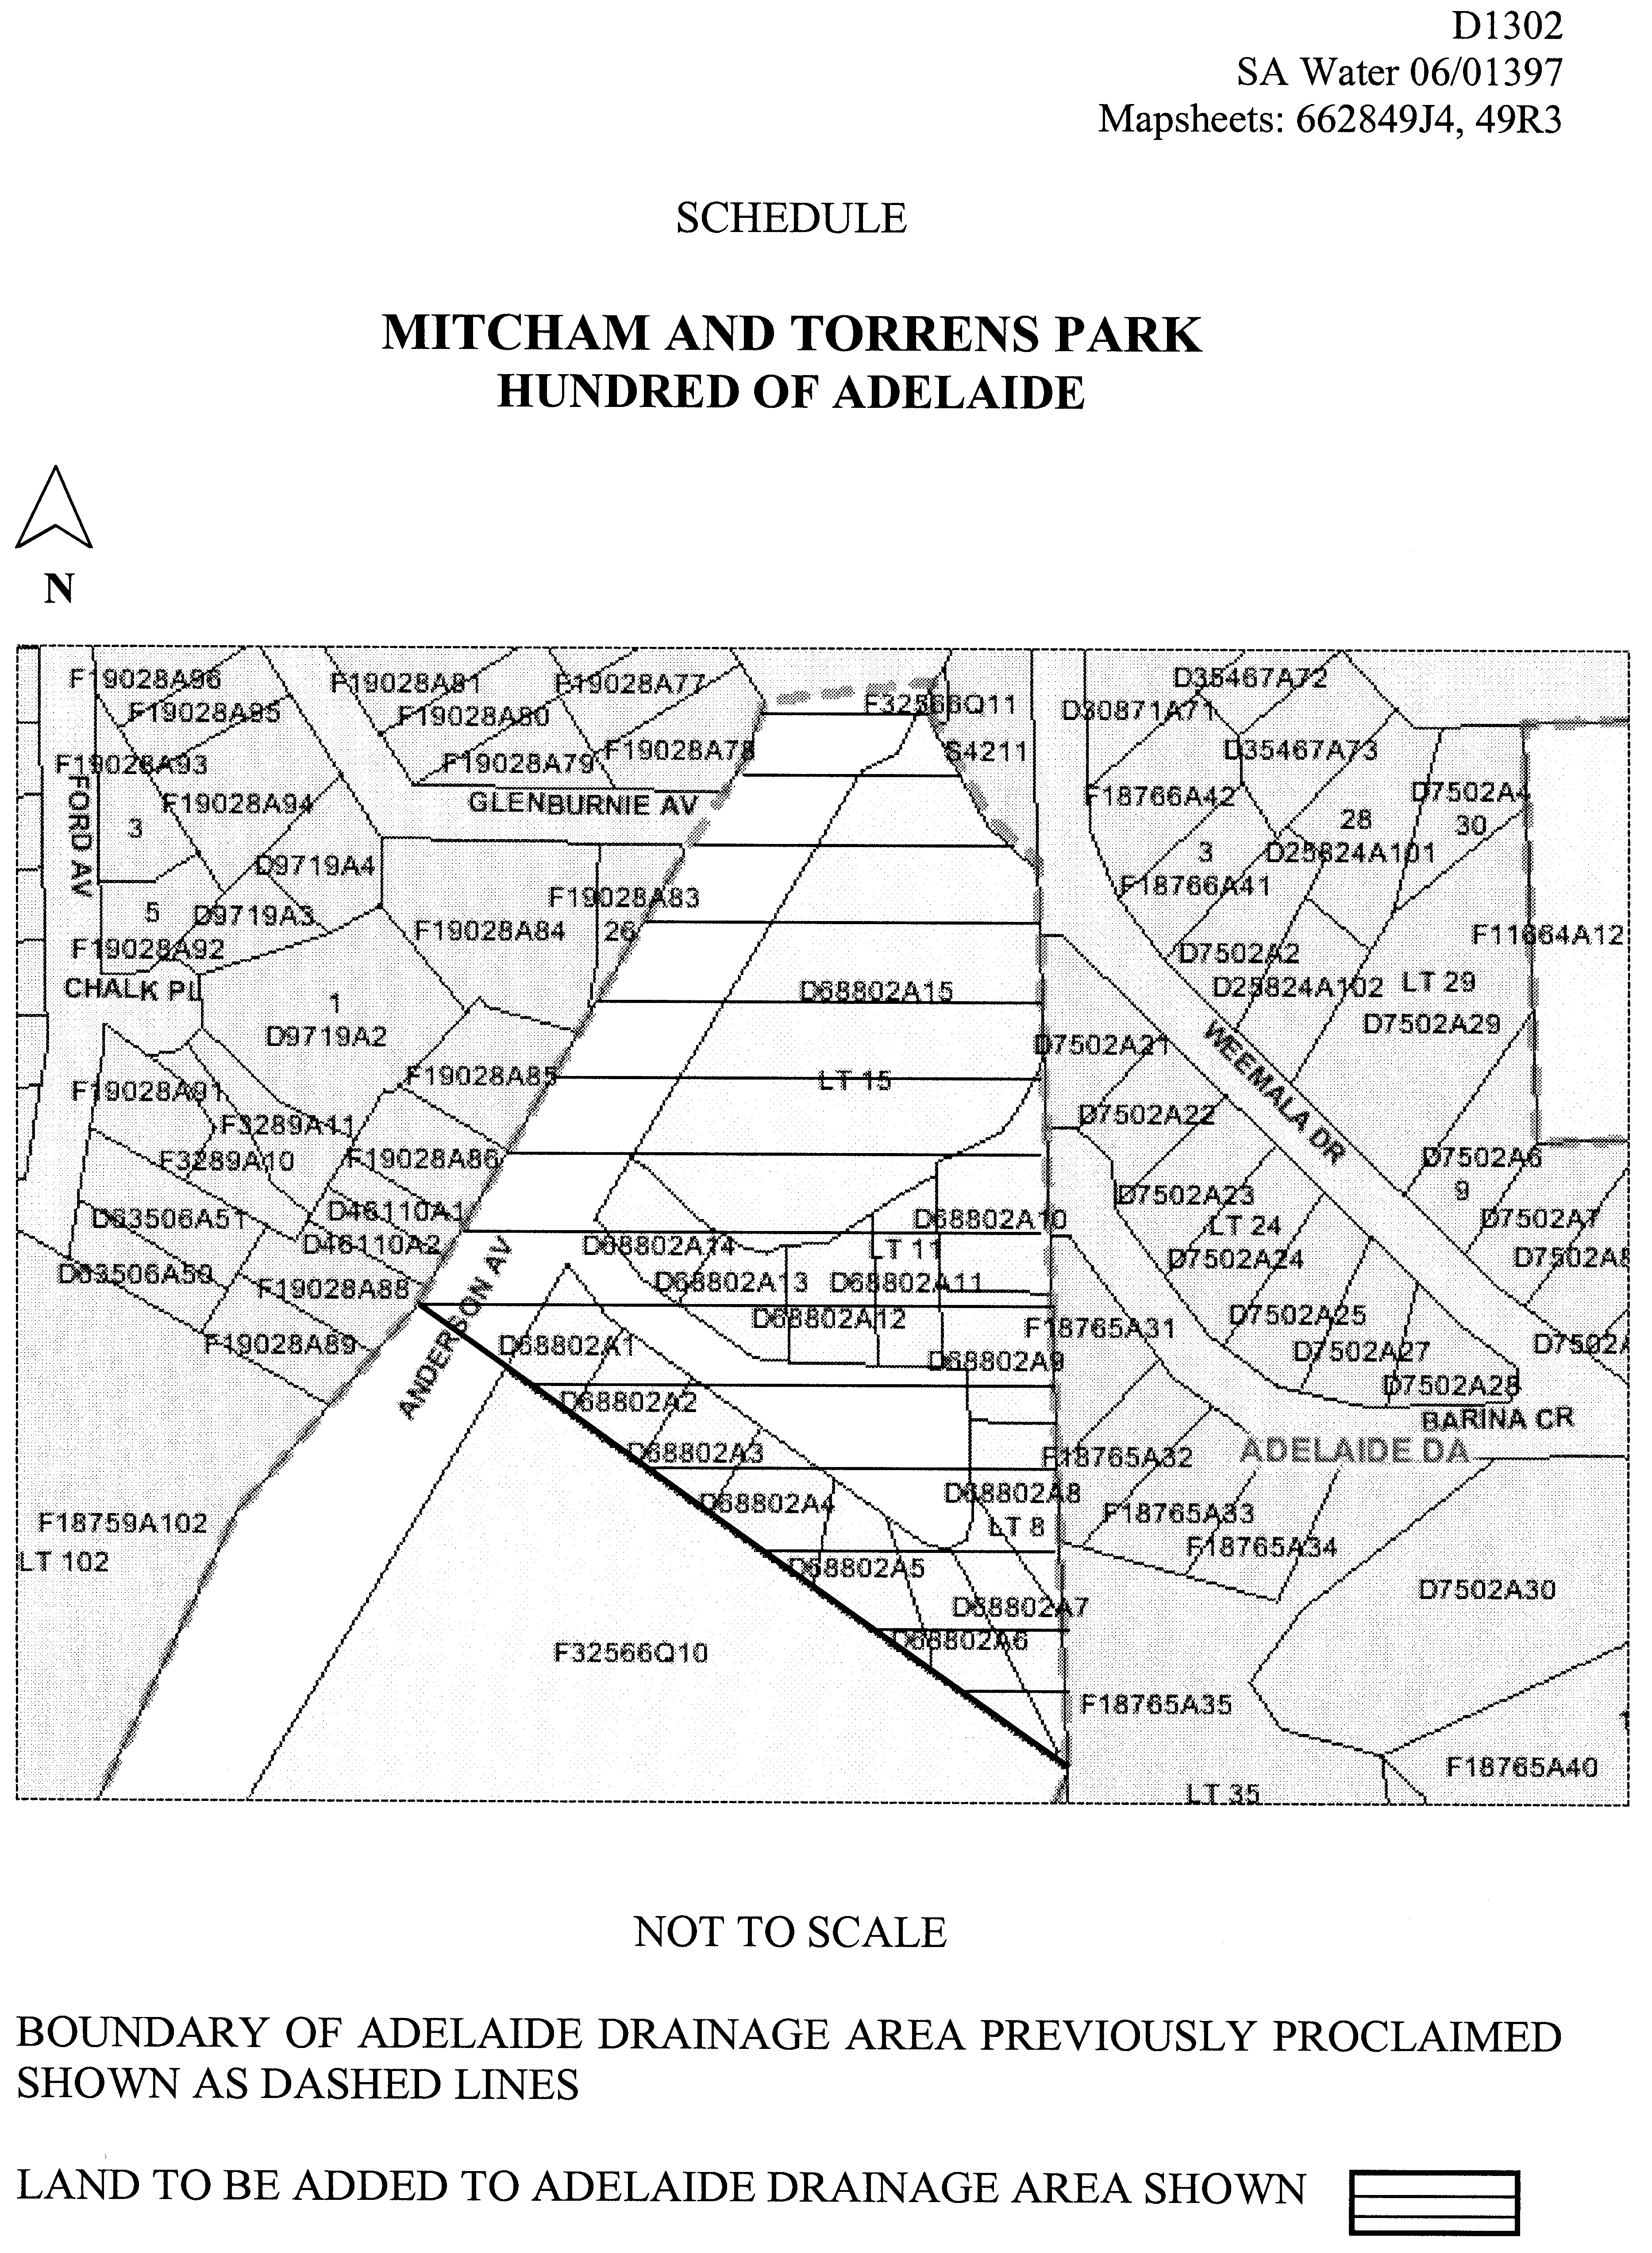
Addition of Land to Adelaide Drainage Area
PURSUANT to section 18 of the Sewerage Act 1929, the South Australian Water Corporation:
(a) adds to the Adelaide Drainage Area the land shown on the plan in the Schedule; and
(b) declares that this notice will have effect from 1 July 2006.

Dated 21 April 2006.
Signed for and on behalf of the South Australian Water Corporation by a person duly authorised so to do:
A. Popplewell, General Manager Shared Services
In the presence of:
C. J. McNamara, Billing Manager
SAWATER 06/01397 D1302

WATERWORKS ACT 1932
Removal of Land from Yorke Peninsula Country Lands Water District and Addition to Yorketown Water District
PURSUANT to section 6 of the Waterworks Act 1932, the South Australian Water Corporation:
(a) removes from the Yorke Peninsula Country Lands Water District and adds to the Yorketown Water District all the land contained in:
(i) allotment 532 in Filed Plan 195954 (except the portion of that land already in the Yorketown Water District);
(ii) allotments 4 and 5 in Deposited Plan 66607; and
(b) declares that this notice will have effect from 1 July 2006.
Dated 21 April 2006.
Signed for and on behalf of the South Australian Water Corporation by a person duly authorised so to do:
A. Popplewell, General Manager Shared Services
In the presence of:
C. J. McNamara, Billing Manager
SAWATER 06/01398 W1221

WATERWORKS ACT 1932
Removal of Land from Yorke Peninsula Country Lands Water District and Addition to Coobowie Water District
PURSUANT to section 6 of the Waterworks Act 1932, the South Australian Water Corporation:
(a) removes from the Yorke Peninsula Country Lands Water District and adds to the Coobowie Water District all the land contained in:
(i) allotment 51 in Deposited Plan 68601 (except the portion of that land already in the Coobowie Water District);
(ii) allotment 52 in Deposited Plan 68601; and
(b) declares that this notice will have effect from 1 July 2006.
Dated 21 April 2006.
Signed for and on behalf of the South Australian Water Corporation by a person duly authorised so to do:
A. Popplewell, General Manager Shared Services
In the presence of:
C. J. McNamara, Billing Manager
SAWATER 06/01399 W1303

WATERWORKS ACT 1932
Removal of Land from Beetaloo Country Lands Water District and Addition to Kadina Water District
Removal of Land from Kadina Water District and Addition to Beetaloo Country Lands Water District
PURSUANT to section 6 of the Waterworks Act 1932, the South Australian Water Corporation:
(a) removes from the Beetaloo Country Lands Water District and adds to the Kadina Water District all the land contained in:
(i) allotments 59 and 60 in Deposited Plan 68598 (except the portion of that land already in the Kadina Water District);
(ii) allotments 104 to 106 inclusive in Deposited Plan 68598 (except the portion of that land already in the Kadina Water District);
(iii) allotment 208 (road) in Deposited Plan 68598 (except the portion of that land already in the Kadina Water District);
(b) removes from the Kadina Water District and adds to the Beetaloo Country Lands Water District all the land contained in allotment 300 in Deposited Plan 68598 (except the portion of that land already in the Beetaloo Country Lands Water District); and
(c) declares that this notice will have effect from 1 July 2006.
Dated 21 April 2006.
Signed for and on behalf of the South Australian Water Corporation by a person duly authorised so to do:
A. Popplewell, General Manager Shared Services
In the presence of:
C. J. McNamara, Billing Manager
SAWATER 06/01400 W1304

WATERWORKS ACT 1932
Addition of Land to Township of Clare Water District
Addition of Land to Morgan-Whyalla Country Lands Water District
PURSUANT to section 6 of the Waterworks Act 1932, the South Australian Water Corporation:
(a) adds to the Township of Clare Water District the land shown on the plan in the Schedule;
(b) adds to the Morgan-Whyalla Country Lands Water District the land shown on the plan in the Schedule; and
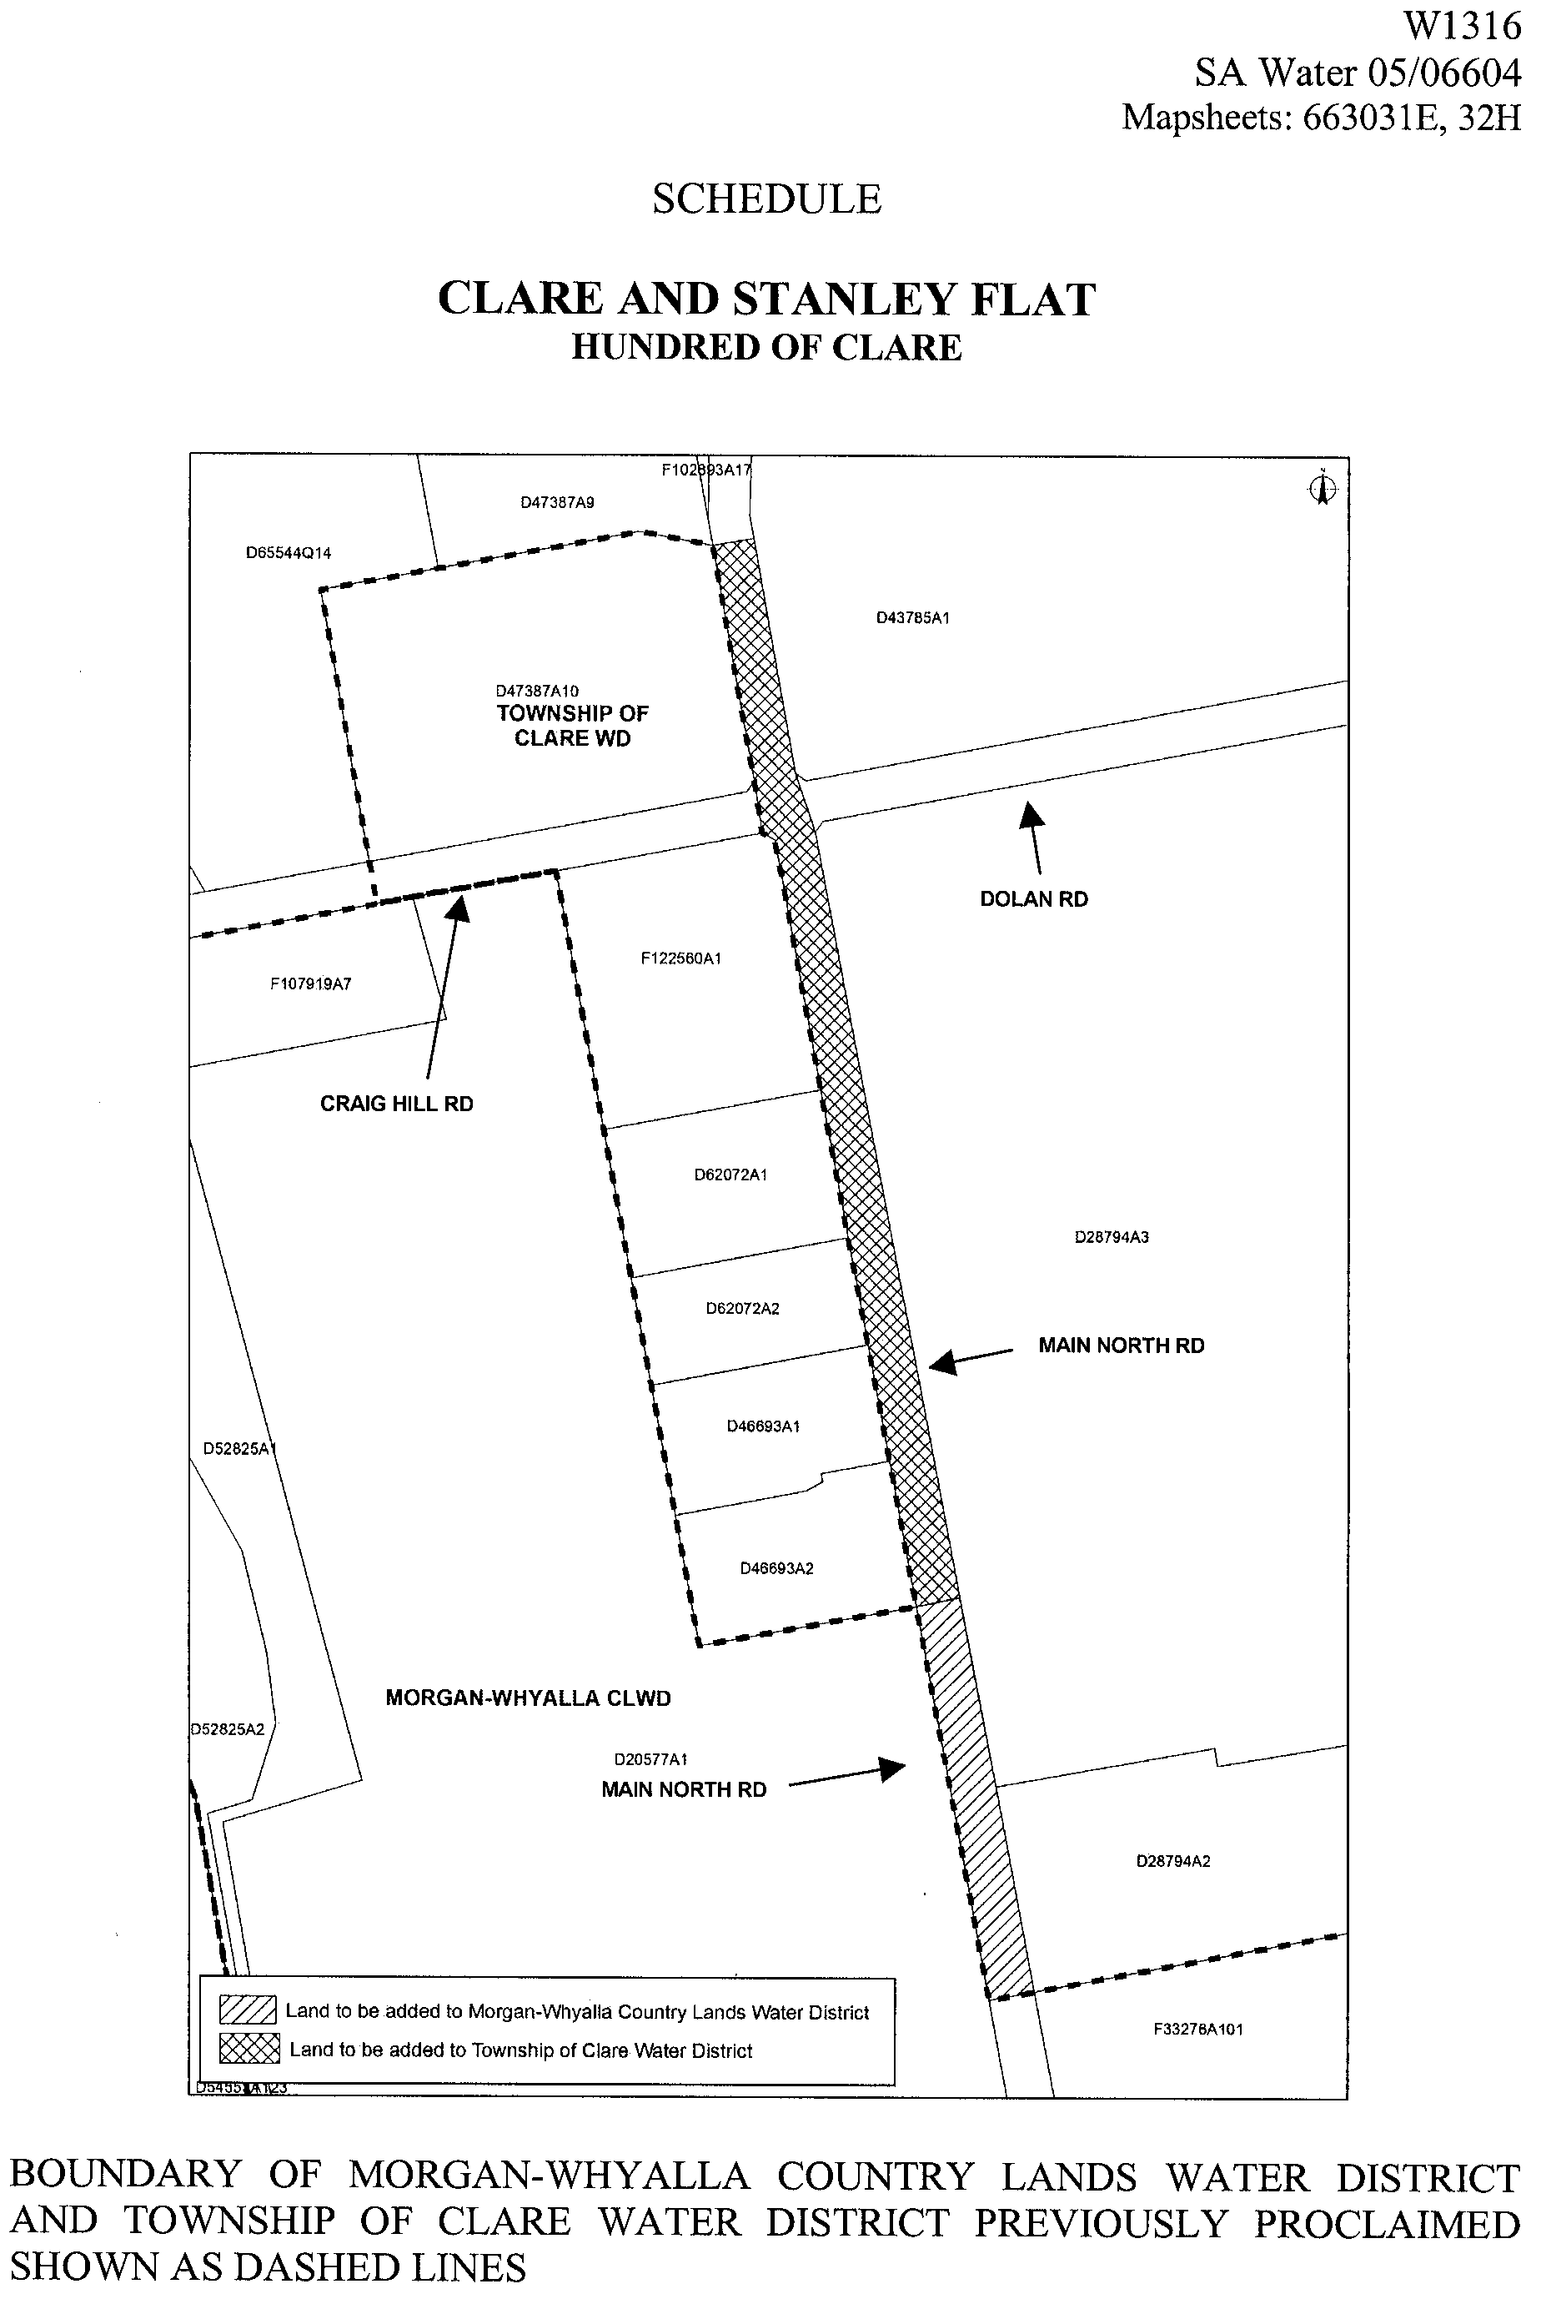
(c) declares that this notice has effect from the commencement of the financial year in which it is published in the Gazette.

Dated 21 April 2006.
Signed for and on behalf of the South Australian Water Corporation by a person duly authorised so to do:
A. Popplewell, General Manager Shared Services
In the presence of:
C. J. McNamara, Billing Manager
SAWATER 05/06604 W1316

South Australia
Public Sector Management (Exclusion from Public Service) Proclamation 2006
under clause 1(2) of Schedule 1 of the Public Sector Management Act 1995
1—Short title
This proclamation may be cited as the Public Sector Management (Exclusion from Public Service) Proclamation 2006.
2—Commencement
This proclamation comes into operation on the day on which it is made.
3—Exclusion from Public Service
Monsignor David John Cappo VG (Commissioner for Social Inclusion) is excluded from the Public Service.
Made by the Governor
with the advice and consent of the Executive Council
on 27 April 2006
DPC06/005CS

South Australia
Liquor Licensing (Dry Areas—Long Term) Variation Regulations 2006
under the Liquor Licensing Act 1997

Contents
Part 1—Preliminary
1 Short title
2 Commencement
3 Variation provisions
Part 2—Variation of Liquor Licensing (Dry Areas—Long Term) Regulations 1997
4 Variation of Schedule 1—Long term dry areas

Part 1—Preliminary
1—Short title
These regulations may be cited as the Liquor Licensing (Dry Areas—Long Term) Variation Regulations 2006.
2—Commencement
These regulations come into operation on the day on which they are made.
3—Variation provisions
In these regulations, a provision under a heading referring to the variation of specified regulations varies the regulations so specified.
Part 2—Variation of Liquor Licensing (Dry Areas—Long Term) Regulations 1997
4—Variation of Schedule 1—Long term dry areas
Schedule 1, item headed "Wattle Park—Area 1", column headed "Period"—delete "2006" and substitute:
2009
Note—
As required by section 10AA(2) of the Subordinate Legislation Act 1978, the Minister has certified that, in the Minister's opinion, it is necessary or appropriate that these regulations come into operation as set out in these regulations.
Made by the Governor
with the advice and consent of the Executive Council
on 27 April 2006
No 42 of 2006
CSLLC2059-01
South Australia
Harbors and Navigation Variation Regulations 2006
under the Harbors and Navigation Act 1993

Contents
Part 1—Preliminary
1 Short title
2 Commencement
3 Variation provisions
Part 2—Variation of Harbors and Navigation Regulations 1994
4 Variation of regulation 79—Application for licence
5 Variation of regulation 80—Granting of licence

Part 1—Preliminary
1—Short title
These regulations may be cited as the Harbors and Navigation Variation Regulations 2006.
2—Commencement
These regulations come into operation on the day on which they are made.
3—Variation provisions
In these regulations, a provision under a heading referring to the variation of specified regulations varies the regulations so specified.
Part 2—Variation of Harbors and Navigation Regulations 1994
4—Variation of regulation 79—Application for licence
Regulation 79—after subregulation (3) insert:
(4) The CEO may require an applicant under this regulation to undertake a practical demonstration relating to the applicant's capacity to satisfy the requirements of this Part.
5—Variation of regulation 80—Granting of licence
Regulation 80—after subregulation (1) insert:
(1a) For the purpose of determining whether a person is a fit and proper person to hold a licence under Part 8 of the Act, the CEO may, without limitation, have regard to—
(a) the reputation, honesty and integrity (including the creditworthiness) of the person; and
(b) whether the person has appropriate knowledge, experience and skills.
Note—
As required by section 10AA(2) of the Subordinate Legislation Act 1978, the Minister has certified that, in the Minister's opinion, it is necessary or appropriate that these regulations come into operation as set out in these regulations.
Made by the Governor
with the advice and consent of the Executive Council
on 27 April 2006
No 43 of 2006
MTR05/060CS

FAXING COPY?
IF you fax copy to Government Publishing SA for inclusion in the Government Gazette, there is no need to send a Confirmation Copy to us as well.
This creates confusion and may well result in your notice being printed twice.
Please use the following fax number:
Fax transmission: (08) 8207 1040
Phone Inquiries: (08) 8207 1045
Please include a contact person, phone number and order number so that we can phone back with any queries we may have regarding the fax copy.
NOTE: Closing time for lodging new copy (fax, hard copy or email) is 4 p.m. on Tuesday preceding the day of publication.

Government Gazette notices can be E-mailed.
The address is:
governmentgazette@saugov.sa.gov.au
Documents should be sent as attachments in Word format.
When sending a document via E-mail, please confirm your transmission with a faxed copy of your document, including the date the notice is to be published.
Fax transmission: (08) 8207 1040
Enquiries: (08) 8207 1045
NOTE: Closing time for lodging new copy (fax, hard copy or email) is 4 p.m. on Tuesday preceding the day of publication.

CITY OF CHARLES STURT
Roads (Opening And Closing) Act 1991
Road Closing, Un-named Road, Adjacent Pickering
Street, Brompton
NOTICE is hereby given pursuant to section 10 of the Roads (Opening and Closing) Act 1991, that Council proposes to make a Road Process Order to close and sell to Brompton Holdings Pty Ltd the public road between Pickering Street and Allotment 202 in Deposited Plan 31450 shown as ‘A’ on Preliminary Plan No. 06/0030.
A copy of the plan and statement of persons affected are available for public inspection at Council’s Office, 72 Woodville Road, Woodville and the office of the Surveyor-General, 101 Grenfell Street, Adelaide during normal office hours.
Any application for easement or objections must be made in writing within 28 days from 27 April 2006 to the Council, P.O. Box 1, Woodville, S.A. 5011 and the Surveyor-General, G.P.O. Box 1354, Adelaide, S.A. 5001, setting out full details.
Where a submission is made, Council will give notification of a meeting to deal with the matter.
P. Lockett, Chief Executive Officer

CITY OF MARION
Change of Name of Public Road
NOTICE is hereby given that the Council of the City of Marion at its meeting held on 11 April 2006, resolved that pursuant to section 219 (1) of the Local Government Act 1999, that a certain public road, being portion of East Terrace, north from Raglan Avenue to Vincent Street, South Plympton be renamed to Eastern Avenue, South Plympton. The change to take effect from 1 May 2006.
A plan which delineates the public road which is subject to the change of street name, together with a copy of the Council’s resolution is available for inspection at the Council’s Principal Office, 245 Sturt Road, Marion, S.A., during the hours of 8.30 a.m. and 5 p.m. on weekdays.
M. Searle, Chief Executive Officer

DISTRICT COUNCIL OF THE COPPER COAST
Roads (Opening and Closing) Act 1991
Portion of Windjammer Lane, Wallaroo
NOTICE is hereby given that pursuant to section 10 of the Roads (Opening and Closing) Act 1991, the District Council of the Copper Coast proposes to make a Road Process Order to close portion of public road (Windjammer Lane) adjacent to Allotment 801 in Deposited Plan 55334 and Allotment 608 in Deposited Plan 47195, Hundred of Wallaroo, more particularly delineated and marked ‘A’ and ‘B’ in Preliminary Plan No. 06/0029.
The portion marked ‘A’ is to be transferred and merged with adjoining Allotment 801 in Deposited Plan 55334.
The portion marked ‘B’ is to be transferred and merged with adjoining Allotment 608 (Reserve) in Deposited Plan 41795.
A copy of the preliminary plan and statement of persons affected is available for public inspection at the Council Office, 51 Taylor Street, Kadina or at the Adelaide office of the Surveyor-General, during normal office hours.
Any person affected may object to the proposed road process, or apply for an easement to be granted in the person’s favour over land subject to the proposed road closure. Such objection, or application for an easement, must set out the full name and address of the person and reason for making the objection or application. Any application for an easement must give full particulars of the nature and location of the easement and where made by a person as the owner of adjoining or nearby land, specify the land to which the easement is to be annexed.
An objection, or application for an easement, must be lodged in writing to the District Council of the Copper Coast, 51 Taylor Street, Kadina, S.A. 5554 and a copy lodged with the Surveyor-General, Department of Administrative and Information Services, G.P.O. Box 1354, Adelaide, S.A. 5001, within 28 days of this notice.
Where an objection, or application for an easement is made, the Council will give notification of a meeting at which the matter will be considered, so that the person making the objection or applica-tion may attend, if desired, personally or by a representative.
P. Dinning, Chief Executive Officer

KANGAROO ISLAND COUNCIL
Casual Vacancy
NOTICE is hereby given pursuant to section 54 (8) of the Local Government Act 1999, that at a meeting of Council held on 12 April 2006, Council elected Councillor Jayne Bates to act in the office of Mayor until the conclusion of the next general election.
N. M. Brown, Chief Executive Officer

NORTHERN AREAS COUNCIL
Expansion of the Township Boundary
NOTICE is hereby given that the Northern Areas Council at a meeting held on 11 April 2006, resolved to expand the Township Boundary of Jamestown to include the following Valuer-General Numbers:
8700001609, 8700001801, 8700002003, 8700003006, 8700004009, 8700006004, 8700007007, 870000800*, 8700009002, 8700010003, 8700011006, 8700012009, 8700013001, 8700014004, 8700015007, 8700019008, 8700046006, 8700047009, 8700049004, 8700060051, 870006030*, 8700061003, 8700072001, 8700547003, 8700548006, 8700559004, 870218500*, 8702186109, 8702186301, 8702186504, 8702189000, 8702190108, 8702192007, 8702196008, 8702197000, 8702203503 within the Northern Areas Council in accordance with section 4 of the Local Government Act 1999, as defined in The Schedule.
The Schedule
The area of the township of Jamestown shall be that land situated in the Hundred of Belalie, more particularly delineated on the plan published herewith.
TOWNSHIP OF JAMESTOWN
Hundred of Belalie
PURSUANT TO THE LOCAL GOVERNMENT ACT 1999

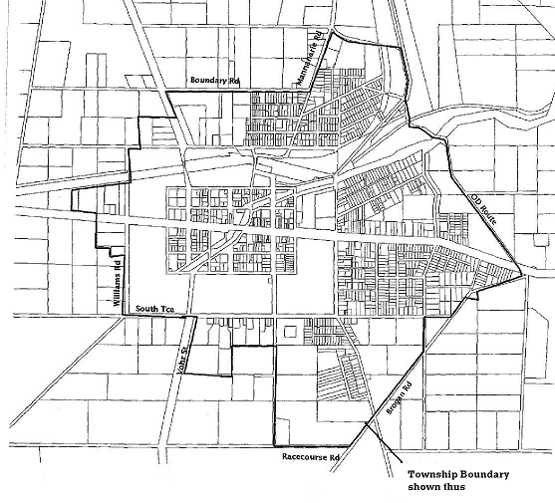
Reduction of the Township Boundary
Notice is hereby given that the Northern Areas Council at a meeting held on 11 April 2006, resolved to reduce the Township Boundary of Gladstone to exclude the following Valuer-General Numbers:
7620488053, 7620489056, 7620489902, 7620554006, 7622237004, 7622236001, 762227100*, 7622272002, 7622268003, 7622267000, 7622270007 within the Northern Areas Council in accordance with section 4 of the Local Government Act 1999, as defined in The Schedule.
The Schedule
The area of the township of Gladstone shall be that land situated in the Hundreds of Booyoolie and Yangya, more particularly delineated on the plan published herewith.
TOWNSHIP OF GLADSTONE
Hundred of Booyoolie and Hundred of Yangya
PURSUANT TO THE LOCAL GOVERNMENT ACT 1999
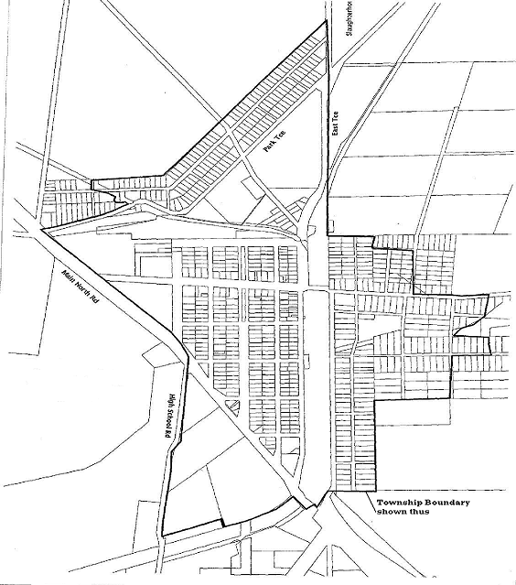
Reduction of the Township Boundary
Notice is hereby given that the Northern Areas Council at a meeting held on 11 April 2006, resolved to reduce the Township Boundary of Laura to exclude the following Valuer-General Numbers:
762250220*, 7622504002, 762250300*, 762249000* within the Northern Areas Council in accordance with section 4 of the Local Government Act 1999, as defined in The Schedule.
The Schedule
The area of the township of Laura shall be that land situated in the Hundred of Booyoolie, more particularly delineated on the plan published herewith.
TOWNSHIP OF LAURA
Hundred of Booyoolie
PURSUANT TO THE LOCAL GOVERNMENT ACT 1999
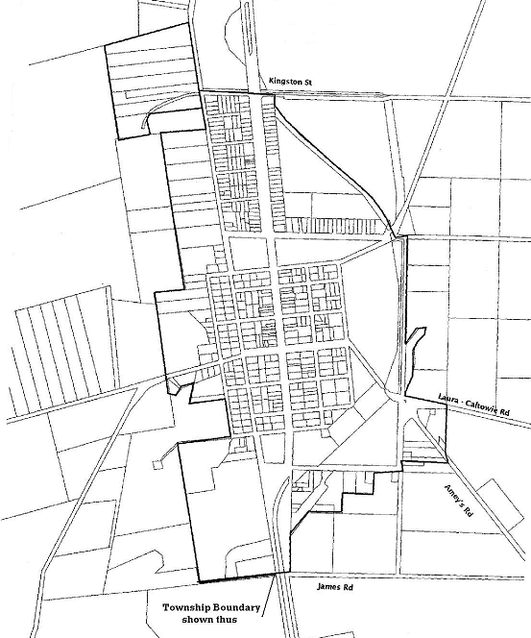
P. A. McInerney, Chief Executive Officer

DISTRICT COUNCIL OF YORKE PENINSULA
Erratum
Exclusion of Land from Classification as Community Land
NOTICE is hereby given pursuant to section 193 of the Local Government Act 1999, that in the Government Gazette dated 21 November 2002, page 4285, Council resolved that the following lands be excluded from the Classification as Community Land:
Line 31
Asset No. | Section/Lot | Street Address | Town/Hundred | Current Use
618 | Lot 1 |  | Balgowan | CFS Station & Tennis Courts
should read
Asset No. | Section/Lot | Street Address | Town/Hundred | Current Use
618 | Lot 2 |  | Balgowan | Vacant Land, CFS Station & Tennis Courts
R. K. Bruhn, Chief Executive Officer

IN the matter of the estates of the undermentioned deceased persons:
Beames, Wallace Milford, late of Maude Street, Encounter Bay, retired administration officer, who died on 3 March 2006.
Boyd, Laurel Eliza, late of Burton Street, Clare, of no occupation, who died on 23 January 2006.
Moule, Colin George, late of 142 Brighton Road, Glenelg East, retired company manager, who died on 1 March 2006.
Murphy, Beryl Jean, late of 19-21 Princes Road, Kingswood, retired secretary, who died on 28 February 2006.
Rutter, Margaret Dove, late of 75 Brighton Road, Glenelg, widow, who died on 26 December 2001.
Smith, Louisa Edith, late of 166 Kesters Road, Para Hills, of no occupation, who died on 14 March 2006.
Surman, Shirley Florence Fortescue, late of 110 Strathfield Terrace, Largs North, of no occupation, who died on 5 February 2006.
Vickers, Estelle Vera Monica, late of 18 Broad Street, Marden, of no occupation, who died on 5 February 2006.
Notice is hereby given pursuant to the Trustee Act 1936, as amended, the Inheritance (Family Provision) Act 1972, and the Family Relationships Act 1975, that all creditors, beneficiaries, and other persons having claims against the said estates are required to send, in writing, to the Public Trustee, 25 Franklin Street, Adelaide, S.A. 5000, full particulars and proof of such claims, on or before 26 May 2006, otherwise they will be excluded from the distribution of the said estate; and notice is also hereby given that all persons who are indebted to the said estates are required to pay the amount of their debts to the Public Trustee or proceedings will be taken for the recovery thereof; and all persons having any property belonging to the said estates are forthwith to deliver the same to the Public Trustee.
Dated 27 April 2006.
C. J. O’Loughlin, Public Trustee

UNCLAIMED MONEYS ACT 1891
Register of Unclaimed Moneys held by The Barossa Council

Name of Owner and Last Known Address |  |  | Property Details |  |  | Amount  Due  $ | Description of  Unclaimed Money |  |  | Date  Payable
Harris, William |  |  |  | 31 William Street, Springton, S.A. 5235, certificate of title volume 5841, folio 90, Plan D125, Allotment 236, Hundred of Jutland | 18 724.84 |  |  |  | Sale of land at Springton for non-payment of rates section 184 of the Local Government Act 1999 |  | 28.1.05

ATTENTION

CUSTOMERS requiring a proof of their notice for inclusion in the Government Gazette, please note that the onus is on you to inform Government Publishing SA of any subsequent corrections by 10 a.m. on Thursday, which is our publication deadline.

For any corrections to your notice please phone 8207 1045 or Fax 8207 1040 before 10 a.m. on Thursday.

If we do not receive any communication by 10 a.m. on Thursday (day of publication) we will presume the notice is correct and will print it as it is.

Remember—the onus is on you to inform us of any corrections necessary to your notice.

NOTE: Closing time for lodging new copy (electronically, fax or hard copy) is 4 p.m. on Tuesday preceding the day of publication. Phone 8207 1045—Fax 8207 1040.
Email: governmentgazette@saugov.sa.gov.au

Printed and published by authority every Thursday by K. O’CALLAGHAN, Government Printer, South Australia
Price: $5.00, plus postage; to subscribers, $254.00 per annum.
(The above prices are inclusive of GST)

