No. 12 721

THE SOUTH AUSTRALIAN

GOVERNMENT GAZETTE
www.governmentgazette.sa.gov.au

PUBLISHED BY AUTHORITY

ALL PUBLIC ACTS appearing in this GAZETTE are to be considered official, and obeyed as such

ADELAIDE, THURSDAY, 23 FEBRUARY 2006

CONTENTS

Page
Administrative Arrangements Act 1994—Notice 722
Corporations and District Councils—Notices 746
Crown Lands Act 1929—Notice. 722
Development Act 1993—Notices 722
Fair Trading Act 1987—Notice 722
Fisheries Act 1982—Notices 723
Fruit and Plant Protection Act 1992—Notice 723
Liquor Licensing Act 1997—Notices 723
Mining Act 1971—Notices 730
Mount Gambier Circuit Court 734
Petroleum Act 2000—Notice 731
Public Trustee Office—Administration of Estates 747
Radiation Protection and Control Act 1982—Notice 735
Roads (Opening and Closing) Act 1991—Notice 735
Sewerage Act 1929—Notices 735
South Australian Water Corporation Act 1994—Notice 735
Transport, Department of—Notices to Mariners 735
Treasurer’s Quarterly Statement 736
Water Mains and Sewers—Mains Laid, Replaced, Etc. 743
Waterworks Act 1932—Notice 744

GOVERNMENT GAZETTE NOTICES
ALL poundkeepers’ and private advertisements forwarded for publication in the South Australian Government Gazette must be PAID FOR PRIOR TO INSERTION; and all notices, from whatever source, should be legibly written on one side of the paper only and sent to Government Publishing SA so as to be received no later
than 4 p.m. on the Tuesday preceding the day of publication. Phone 8207 1045 or Fax 8207 1040. E-mail: governmentgazette@saugov.sa.gov.au. Send as attachments in Word format and please confirm your transmission with a faxed copy of your document, including the date the notice is to be published and to whom the notice will be charged. The Government Gazette is available online at: www.governmentgazette.sa.gov.au

ADMINISTRATIVE ARRANGEMENTS ACT 1994
Delegation of Power to Direct
PURSUANT to section 9 of the Administrative Arrangements Act 1994, I, Michael Wright, Minister for Administrative Services, being the Minister to whom administration of the South Australian Water Corporation Act 1994, is committed, delegate to the Minister for the River Murray the power vested in me by the Public Corporations Act 1993, to direct the South Australian Water Corporation, for the purpose only of requiring and enabling the South Australian Water Corporation to act as agent of the Minister for the River Murray for the purpose of purchasing of water entitlements from willing sellers for and on behalf of that Minister.
Dated 8 February 2006.
M. Wright, Minister for Administrative Services

CROWN LANDS ACT 1929: SECTION 5
TAKE NOTICE that pursuant to the Crown Lands Act 1929, I, JOHN HILL, Minister for Environment and Conservation, Minister of the Crown to whom the administration of the Crown Lands Act 1929 is committed DO HEREBY:
1. Resume the land defined in The First Schedule.
2. Dedicate the Crown Land defined in The Second Schedule as Public Road.
The First Schedule
Police Reserve, Allotment 4 of Deposited Plan 22423, formerly identified as Section 256, Hundred of Copley, County of Manchester, the notice of which was published in the Government Gazette of 12 December 1985 at page 1805, The Second Schedule, being the whole of the land comprised in Crown Record Volume 5753, Folio 686.
The Second Schedule
Allotment 8 of Deposited Plan 69935, Hundred of Copley, County of Manchester, being within the municipality of the City of Port Augusta.
Dated 23 February 2006.
J. Hill, Minister for Environment and Conservation
DEH 13/1041

DEVELOPMENT ACT 1993, SECTION 25 (17): CITY OF HOLDFAST BAY—RESIDENTIAL POLICIES AND MIS-CELLANEOUS AMENDMENTS PLAN AMENDMENT
Preamble
1. The Development Plan Amendment entitled ‘City of Holdfast Bay—Residential Policies and Miscellaneous Amendments Plan Amendment’ (the Plan Amendment) has been finalised in accordance with the provisions of the Development Act 1993.
2. The Minister for Urban Development and Planning has decided to approve the Plan Amendment.
Notice
PURSUANT to section 25 of the Development Act 1993, I—
(a) approve the Plan Amendment; and
(b) fix the day on which this notice is published in the Gazette as the day on which the Plan Amendment will come into operation.
Dated 23 February 2006.
Paul Holloway, Minister for Urban Development and Planning
PLN 01/0387

DEVELOPMENT ACT 1993, SECTION 25 (17): CITY OF ONKAPARINGA—COROMANDEL VALLEY DESIRED CHARACTER (STAGE 2) PLAN AMENDMENT
Preamble
1. The Development Plan Amendment entitled ‘City of Onkaparinga—Coromandel Valley Desired Character (Stage 2) Plan Amendment’ (the Plan Amendment) has been finalised in accordance with the provisions of the Development Act 1993.
2. The Minister for Urban Development and Planning has decided to approve the Plan Amendment.
Notice
PURSUANT to section 25 of the Development Act 1993, I—
(a) approve the Plan Amendment; and
(b) fix the day on which this notice is published in the Gazette as the day on which the Plan Amendment will come into operation.
Dated 23 February 2006.
Paul Holloway, Minister for Urban Development and Planning
PLN 05/0270

DEVELOPMENT ACT 1993, SECTION 25 (17): DISTRICT COUNCIL OF YORKE PENINSULA—INDUSTRY (COM-MERCIAL BULK HANDLING) PLAN AMENDMENT
Preamble
1. The Development Plan Amendment entitled ‘District Council of Yorke Peninsula—Industry (Commercial Bulk Handling) Plan Amendment’ (the Plan Amendment) has been finalised in accordance with the provisions of the Development Act 1993.
2. The Minister for Urban Development and Planning has decided to approve the Plan Amendment.
Notice
PURSUANT to section 25 of the Development Act 1993, I—
(a) approve the Plan Amendment; and
(b) fix the day on which this notice is published in the Gazette as the day on which the Plan Amendment will come into operation.
Dated 23 February 2006.
Paul Holloway, Minister for Urban Development and Planning
PLN 04/0681

FAIR TRADING ACT 1987
Prohibition of Third-Party Scheme
Part 9—Third-Party Trading Scheme
TAKE note that I, Karlene Maywald, Minister for Consumer Affairs, declare that the Scheme specified in the Schedule is a prohibited third-party trading scheme, pursuant to section 45A of the Fair Trading Act 1987, I am satisfied that this declaration is necessary as the Scheme is contrary to the interests of the consumer.
On publication of this notice, the specified Scheme becomes a prohibited Scheme.
Schedule
Third-Party Trading Scheme known as ‘Cashback Australia’ and trading as Cashback Australia Ltd, (ACN 097 975 623), registered 28 August 2000.
Dated 25 January 2006.
K. Maywald, Minister for Consumer Affairs

FISHERIES ACT 1982: SECTION 59
TAKE notice that pursuant to section 59 of the Fisheries Act 1982, Professor Stephen Donnellan, of the SA Museum, North Terrace, Adelaide, S.A. 5000 (the ‘exemption holder’), or a person acting as his agent, is exempt from Clause 65 of Schedule 1 of the Fisheries (General) Regulations 2000, insofar as they may engage in the activities specified in Schedule 1 (the ‘exempted activity’), using gear listed in Schedule 2, subject to the conditions set out in Schedule 3 from 23 February 2006 until 31 December 2006, unless this notice is varied or revoked earlier.
Schedule 1
The collection of marine fish, shark, ray and chimaera from South Australian coastal waters, which include Barker Inlet, St Kilda-Chapman Creek and American River (including intertidal rocky reefs) for DNA analysis.
Schedule 2
• 1 fishing rod per person
• 1 dab net per person
• 1 seine net (maximum length 5 m and minimum mesh size of 2 mm)
• 1 barrier net (maximum length 8 m and minimum mesh size of 5 mm)
• 1 hand spear per person
• 1 spear gun per person
• 5 shrimp traps
• use of clove oil as an anaesthetic.
Schedule 3
1. Specimens collected by the exemption holder pursuant to this notice must not be sold.
2. The exemption holder or a person acting as his agent must not collect any protected species pursuant to this exemption.
3. A maximum of 10 specimens from each species collected may be collected for tissue sampling, all other specimens must be returned to the water immediately.
4. A maximum of two specimens from each species may be collected from the following five geographical areas:
• West Coast
• Spencer Gulf
• Kangaroo Island
• Gulf St Vincent
• South-East
5. Any species collected that are not returned to the water must be lodged as voucher specimens with the South Australian Museum.
6. The exemption holder must notify PIRSA Fishwatch on 1800 065 522 at least two hours prior to conducting the exempted activity and answer a series of questions about the exempted activity. The exemption holder will need to have a copy of the exemption at the time of making the call, and be able to provide information about the area and time of the exempted activity, the vehicles and boats involved, the number of agents undertaking the exempted activity and other related questions.
7. The exempted activity may only be conducted on the exemption holder’s behalf by Dr Terry Bertozzi, Ralph Foster, Michael Hammer and Ruan Gannon.
8. A final report upon completion of the sampling and collecting must be forwarded to the Director of Fisheries marked Attention: Alex Chalupa (G.P.O. Box 1625, Adelaide, S.A. 5001).
9. While engaged in the exempted activity, the exemption holder or an agent of the exemption holder must be in possession of a copy of this notice. Such notice must be produced to a PIRSA Fisheries Officer upon request.
10. A person undertaking the exempted activity must not contravene or fail to comply with the Fisheries Act 1982 or any regulations made under that Act, except where specifically exempted by this notice.
Dated 20 February 2006.
W. Zacharin, Director of Fisheries

FISHERIES ACT 1982: SECTION 59
TAKE notice that pursuant to section 59 of the Fisheries Act 1982, Tony Bartram of Kangaroo Island Community Education, Centenary Avenue, Kingscote, S.A. 5223 (the ‘exemption holder’) is exempt from the Fisheries Act 1982, but only insofar as he may engage in the activities specified in Schedule 1 using the gear specified in Schedule 2 (the ‘exempted activity’), subject to the conditions set out in Schedule 3, from 23 February 2006 until
31 December 2006, unless varied or revoked earlier.
Schedule 1
The catch, tag and release of Bream (Acanthopagrus spp) from Harriet, Eleanor, Cygnet and Chapman Rivers on Kangaroo Island for the purpose of scientific research.
Schedule 2
• Purse seine net
• Fyke net
• Fish traps
Schedule 3
1. The specimens collected by the exemption holder are for scientific and research purposes only and must not be sold.
2. Any mortalities must be lodged with the University of Adelaide.
3. Before collecting any specimens pursuant to this notice, the exemption holder must contact the PIRSA Fisheries Compliance Unit on 1800 065 522 and answer a series of questions about the exempted activity. The exemption holder will need to have a copy of the exemption at the time of making the call and be able to provide information about the area and time of the exempted activity, the vehicles and/or boats involved, the number of agents undertaking the exempted activity and other related questions. Exemption number 9901828.
4. While engaged in the exempted activity, the exemption holders must be in possession of a copy of this notice. Such notice must be produced to a PIRSA Fisheries Compliance Officer if requested.
5. The exemption holders must not contravene or fail to comply with the Fisheries Act 1982, or any regulations made under that Act, except where specifically exempted by this notice.
Dated 22 February 2006.
W. Zacharin, Director of Fisheries

FRUIT AND PLANT PROTECTION ACT 1992
Notice Concerning the Control of Branched Broomrape
PURSUANT to the Fruit and Plant Protection Act 1992 (the Act), I, John David Hill, Minister for Environment and Conservation, vary the notice under the Act published at page 4260 of the Government Gazette of 20 September 2001 (as varied) as follows:
Paragraph 3 is amended by the addition of the following areas to that portion of the State defined in (1) to be a quarantine area with respect to the disease Branched Broomrape:
The whole of the land comprised and described in certificate of title volume 5270, folio 482, Hundred of Forster, section 3C, County of Albert, South Australia.
Dated 15 February 2006.
J. Hill, Minister for Environment and Conservation

LIQUOR LICENSING ACT 1997 AND GAMING MACHINES ACT 1992
Notice of Application
NOTICE is hereby given, pursuant to section 52 of the Liquor Licensing Act 1997 and section 29 of the Gaming Machines Act 1992, that Dennis John Liddy and Jennifer Fay Liddy as trustee for the Dennis Liddy Family Trust have applied to the Licensing Authority for the transfer of a Hotel and Gaming Machine Licence in respect of premises situated at 2 Ryan Street, Moonta, S.A. 5558 and known as Royal Hotel.
The applications have been set down for hearing on 29 March 2006 at 9.30 a.m.
Any person may object to the application by lodging a notice of objection in the prescribed form with the Liquor and Gambling Commissioner and serving a copy of the notice on the applicants at the applicants’ address given above, at least seven days before the hearing date (viz: 21 March 2006).
The applicants’ address for service is c/o Duncan Basheer Hannon, Barristers & Solicitors, G.P.O. Box 2, Adelaide, S.A. 5001 (Attention: Max Basheer or David Tillett).
Plans in respect of the premises the subject of the application are open to public inspection without fee at the Office of the Liquor and Gambling Commissioner, 9th Floor, East Wing, 50 Grenfell Street, Adelaide, S.A. 5000. Phone 8226 8410, Fax:
8226 8512. Email: olgc@agd.sa.gov.au.
Dated 20 February 2006.
Applicants

LIQUOR LICENSING ACT 1997 AND GAMING MACHINES ACT 1992
Notice of Application
NOTICE is hereby given, pursuant to section 52 of the Liquor Licensing Act 1997 and section 29 of the Gaming Machines Act 1992, that Barry James Bargwanna has applied to the Licensing Authority for the transfer of a Hotel and Gaming Machine Licence in respect of premises situated at Main Street, Yunta, S.A. 5440 and known as Yunta Hotel.
The applications have been set down for hearing on 27 March 2006 at 9 a.m.
Any person may object to the application by lodging a notice of objection in the prescribed form with the Liquor and Gambling Commissioner and serving a copy of the notice on the applicant at the applicant’s address given above, at least seven days before the hearing date (viz: 17 March 2006).
The applicant’s address for service is c/o Foreman Legal, 69 Mount Barker Road, Stirling, S.A. 5152.
Plans in respect of the premises the subject of the application are open to public inspection without fee at the Office of the Liquor and Gambling Commissioner, 9th Floor, East Wing, 50 Grenfell Street, Adelaide, S.A. 5000. Phone 8226 8410, Fax:
8226 8512. Email: olgc@agd.sa.gov.au.
Dated 16 February 2006.
Applicant

LIQUOR LICENSING ACT 1997 AND GAMING MACHINES ACT 1992
Notice of Application
NOTICE is hereby given, pursuant to section 52 of the Liquor Licensing Act 1997 and section 29 of the Gaming Machines Act 1992, that Anthony Bevan Treloar and Louise Marie Treloar have applied to the Licensing Authority for the transfer of a Hotel and Gaming Machine Licence in respect of premises situated at 95 Main Street, Lobethal, S.A. 5241 and known as Rising Sun Hotel.
The applications have been set down for hearing on 27 March 2006 at 10 a.m.
Any person may object to the application by lodging a notice of objection in the prescribed form with the Liquor and Gambling Commissioner and serving a copy of the notice on the applicants at the applicants’ address given above, at least seven days before the hearing date (viz: 17 March 2006).
The applicants’ address for service is c/o Foreman Legal, 69 Mount Barker Road, Stirling, S.A. 5152.
Plans in respect of the premises the subject of the application are open to public inspection without fee at the Office of the Liquor and Gambling Commissioner, 9th Floor, East Wing, 50 Grenfell Street, Adelaide, S.A. 5000. Phone 8226 8410, Fax:
8226 8512. Email: olgc@agd.sa.gov.au.
Dated 16 February 2006.
Applicants

LIQUOR LICENSING ACT 1997 AND GAMING MACHINES ACT 1992
Notice of Application
NOTICE is hereby given, pursuant to section 52 of the Liquor Licensing Act 1997 and section 29 of the Gaming Machines Act 1992, that Frank Agostino has applied to the Licensing Authority for the transfer of a Hotel and Gaming Machine Licence in respect of premises situated at Mount Barker Road, Eagle on the Hill, S.A. 5150 and known as Eagle on the Hill Hotel.
The applications have been set down for hearing on 27 March 2006 at 11 a.m.
Any person may object to the application by lodging a notice of objection in the prescribed form with the Liquor and Gambling Commissioner and serving a copy of the notice on the applicant at the applicant’s address given above, at least seven days before the hearing date (viz: 17 March 2006).
The applicant’s address for service is c/o Lynch Meyer, G.P.O. Box 467, Adelaide, S.A. 5001 (Attention: Joe Subic).
Plans in respect of the premises the subject of the application are open to public inspection without fee at the Office of the Liquor and Gambling Commissioner, 9th Floor, East Wing, 50 Grenfell Street, Adelaide, S.A. 5000. Phone 8226 8410, Fax:
8226 8512. Email: olgc@agd.sa.gov.au.
Dated 17 February 2006.
Applicant

LIQUOR LICENSING ACT 1997 AND GAMING MACHINES ACT 1992
Notice of Application
NOTICE is hereby given, pursuant to section 52 of the Liquor Licensing Act 1997 and section 29 of the Gaming Machines Act 1992, that Thirsty Mack’s Pty Ltd as trustee for Mack’s Hotel Trust has applied to the Licensing Authority for the transfer of a Hotel and Gaming Machine Licence in respect of premises situated at Melrose Street, Mount Pleasant, S.A. 5235 and known as Mount Pleasant Hotel Motel.
The applications have been set down for hearing on 27 March 2006 at 9.30 a.m.
Any person may object to the application by lodging a notice of objection in the prescribed form with the Liquor and Gambling Commissioner and serving a copy of the notice on the applicant at the applicant’s address given above, at least seven days before the hearing date (viz: 17 March 2006).
The applicant’s address for service is c/o Moody Rossi & Co., Barristers and Solicitors, Level 7, 185 Victoria Square, Adelaide, S.A. 5000.
Plans in respect of the premises the subject of the application are open to public inspection without fee at the Office of the Liquor and Gambling Commissioner, 9th Floor, East Wing, 50 Grenfell Street, Adelaide, S.A. 5000. Phone 8226 8410, Fax:
8226 8512. Email: olgc@agd.sa.gov.au.
Dated 16 February 2006.
Applicant

LIQUOR LICENSING ACT 1997
Notice of Application
NOTICE is hereby given, pursuant to section 52 (2) (b) of the Liquor Licensing Act 1997, that St Vincent Hotel Nominees Pty Ltd has applied to the Licensing Authority for a variation to Extended Trading Authorisation, variation to Entertainment Consent and variation to Conditions in respect of premises situated at 28 Jetty Road, Glenelg, S.A. 5045 and known as Glenelg Jetty Hotel.
The application has been set down for hearing on 24 March 2006 at 9 a.m.
Conditions
The following licence conditions are sought:
• Variation to Extended Trading Authorisation (excluding Area 5):
Sunday: Midnight to 1.30 a.m. the following day;
Good Friday: Midnight to 2 a.m.;
Sunday Christmas Eve: 8 p.m. to 2 a.m. the following day;
New Year’s Eve: 2 a.m. the following day to 2.30 a.m. the following day;
Days preceding other Public Holidays: Midnight to 2 a.m. the following day;
Sundays preceding Public Holidays: Midnight to 2 a.m. the following day.
• Variation to Entertainment Consent to apply to the above-mentioned hours;
• Variation to conditions to delete condition 3—Entertain-ment in Area 1 shall comprise a pianist or other solo of duo musicians providing cocktail bar style background music; and
• Variation to conditions to delete condition 4—Live Enter-tainment in Area 1 shall not be permitted beyond midnight on any trading day.
Any person may object to the application by lodging a notice of objection in the prescribed form with the Liquor and Gambling Commissioner and serving a copy of the notice on the applicant at the applicant’s address given above, at least seven days before the hearing date (viz: 16 March 2006).
The applicant’s address for service is c/o Glenelg Jetty Hotel, 28 Jetty Road, Glenelg, S.A. 5045 (Attention: Lyell Wilson).
Plans in respect of the premises the subject of the application are open to public inspection without fee at the Office of the Liquor and Gambling Commissioner, 9th Floor, East Wing, 50 Grenfell Street, Adelaide, S.A. 5000. Phone 8226 8410, Fax:
8226 8512. Email: olgc@agd.sa.gov.au.
Dated 21 February 2006.
Applicant

LIQUOR LICENSING ACT 1997
Notice of Application
NOTICE is hereby given, pursuant to section 52 (2) (b) of the Liquor Licensing Act 1997, that Nimble Enterprises Pty Ltd as trustee for the Carey Family Trust has applied to the Licensing Authority for a Residential Licence in respect of premises situated at 126 Church Street, Penola, S.A. 5277 and to be known as
Must @ Coonawarra.
The application has been set down for hearing on 24 March 2006 at 9 a.m.
Any person may object to the application by lodging a notice of objection in the prescribed form with the Liquor and Gambling Commissioner and serving a copy of the notice on the applicant at the applicant’s address given above, at least seven days before the hearing date (viz: 16 March 2006).
The applicant’s address for service is c/o Brian Carey, 126 Church Street, Penola, S.A. 5277.
Plans in respect of the premises the subject of the application are open to public inspection without fee at the Office of the Liquor and Gambling Commissioner, 9th Floor, East Wing, 50 Grenfell Street, Adelaide, S.A. 5000. Phone 8226 8410, Fax:
8226 8512. Email: olgc@agd.sa.gov.au.
Dated 15 February 2006.
Applicant

LIQUOR LICENSING ACT 1997
Notice of Application
NOTICE is hereby given, pursuant to section 52 (2) (b) of the Liquor Licensing Act 1997, that Rosella Ridge Wines Pty Ltd has applied to the Licensing Authority for a Wholesale Liquor Merchant’s Licence in respect of premises situated at 61D Murray Street, Tanunda, S.A. 5352 and to be known as Rosella Ridge Wines.
The application has been set down for hearing on 24 March 2006 at 9 a.m.
Any person may object to the application by lodging a notice of objection in the prescribed form with the Liquor and Gambling Commissioner and serving a copy of the notice on the applicant at the applicant’s address given above, at least seven days before the hearing date (viz: 16 March 2006).
The applicant’s address for service is c/o Michael Hislop, 337 Carrington Street, Adelaide, S.A. 5000.
Plans in respect of the premises the subject of the application are open to public inspection without fee at the Office of the Liquor and Gambling Commissioner, 9th Floor, East Wing, 50 Grenfell Street, Adelaide, S.A. 5000. Phone 8226 8410, Fax:
8226 8512. Email: olgc@agd.sa.gov.au.
Dated 15 February 2006.
Applicant

LIQUOR LICENSING ACT 1997
Notice of Application
NOTICE is hereby given, pursuant to section 52 (2) (b) of the Liquor Licensing Act 1997, that Calitin Pty Ltd has applied to the Licensing Authority for the removal of a Producer’s Licence in respect of premises situated at Lot 51, Tatachilla Road, McLaren Vale, S.A. 5171, to be situated at Lot 115, California Road, McLaren Vale, S.A. 5171 and known as Dowie Doole.
The application has been set down for hearing on 24 March 2006 at 9 a.m.
Any person may object to the application by lodging a notice of objection in the prescribed form with the Liquor and Gambling Commissioner and serving a copy of the notice on the applicant at the applicant’s address given above, at least seven days before the hearing date (viz: 16 March 2006).
The applicant’s address for service is c/o Dowie Doole, P.O. Box 391, Willunga, S.A. 5172 (Attention: Bel Darley).
Plans in respect of the premises the subject of the application are open to public inspection without fee at the Office of the Liquor and Gambling Commissioner, 9th Floor, East Wing, 50 Grenfell Street, Adelaide, S.A. 5000. Phone 8226 8410, Fax:
8226 8512. Email: olgc@agd.sa.gov.au.
Dated 15 February 2006
Applicant

LIQUOR LICENSING ACT 1997
Notice of Application
NOTICE is hereby given, pursuant to section 52 (2) (b) of the Liquor Licensing Act 1997, that Calitin Pty Ltd has applied to the Licensing Authority for a Wholesale Liquor Merchant’s Licence in respect of premises situated at Lot 115, California Road, McLaren Vale, S.A. 5171 and to be known as Calitin Pty Ltd.
The application has been set down for hearing on 24 March 2006 at 9 a.m.
Any person may object to the application by lodging a notice of objection in the prescribed form with the Licensing Authority, and serving a copy of the notice on the applicant at the applicant’s address given above, at least seven days before the hearing date (viz: 16 March 2006).
The applicant’s address for service is c/o Calitin Pty Ltd, P.O. Box 391, Willunga, S.A. 5172 (Attention: Bel Darley).
Plans in respect of the premises the subject of the application are open to public inspection without fee at the Office of the Liquor and Gambling Commissioner, 9th Floor, East Wing, 50 Grenfell Street, Adelaide, S.A. 5000. Phone 8226 8410, Fax:
8226 8512. Email: olgc@agd.sa.gov.au.
Dated 15 February 2006.
Applicant

LIQUOR LICENSING ACT 1997
Notice of Application
NOTICE is hereby given, pursuant to section 52 (2) (b) of the Liquor Licensing Act 1997, that Feathers Hotel Pty Ltd has applied to the Licensing Authority for a variation to Extended Trading Authorisation and variation to Entertainment Consent in respect of premises situated at 516 Glynburn Road, Burnside, S.A. 5066 and known as Feathers Hotel.
The application has been set down for hearing on 24 March 2006 at 9 a.m.
Conditions
The following licence conditions are sought:
• Variation to Extended Trading Authorisation to including the following hours:
Good Friday: Midnight to 2 a.m.
• Variation to Entertainment Consent to include the above-mentioned hours.
Any person may object to the application by lodging a notice of objection in the prescribed form with the Licensing Authority, and serving a copy of the notice on the applicant at the applicant’s address given above, at least seven days before the hearing date (viz: 16 March 2006).
The applicant’s address for service is c/o Shaun Matthews, 1/36 George Street, Stepney, S.A. 5069.
Plans in respect of the premises the subject of the application are open to public inspection without fee at the Office of the Liquor and Gambling Commissioner, 9th Floor, East Wing, 50 Grenfell Street, Adelaide, S.A. 5000. Phone 8226 8410, Fax:
8226 8512. Email: olgc@agd.sa.gov.au.
Dated 15 February 2006.
Applicant

LIQUOR LICENSING ACT 1997
Notice of Application
NOTICE is hereby given, pursuant to section 52 (2) (b) of the Liquor Licensing Act 1997, that Gambier Hotel Pty Ltd has applied to the Licensing Authority for a variation to Extended Trading Authorisation and variation to Entertainment Consent in respect of premises situated at 2 Commercial Street West, Mount Gambier, S.A. 5290 and known as Mount Gambier Hotel.
The application has been set down for hearing on 24 March 2006 at 9 a.m.
Conditions
The following licence conditions are sought:
• Variation to Extended Trading Authorisation to including the following hours:
Good Friday: Midnight to 2 a.m.
• Variation to Entertainment Consent to include the above-mentioned hours.
Any person may object to the application by lodging a notice of objection in the prescribed form with the Licensing Authority, and serving a copy of the notice on the applicant at the applicant’s address given above, at least seven days before the hearing date (viz: 16 March 2006).
The applicant’s address for service is c/o Shaun Matthews, 1/36 George Street, Stepney, S.A. 5069.
Plans in respect of the premises the subject of the application are open to public inspection without fee at the Office of the Liquor and Gambling Commissioner, 9th Floor, East Wing, 50 Grenfell Street, Adelaide, S.A. 5000. Phone 8226 8410, Fax:
8226 8512. Email: olgc@agd.sa.gov.au.
Dated 15 February 2006.
Applicant

LIQUOR LICENSING ACT 1997
Notice of Application
NOTICE is hereby given, pursuant to section 52 (2) (b) of the Liquor Licensing Act 1997, that Hotel Eyre Pty Ltd has applied to the Licensing Authority for a variation to Extended Trading Authorisation and variation to Entertainment Consent in respect of premises situated at corner Playford Avenue and Elliott Street, Whyalla, S.A. 5600 and known as Hotel Eyre.
The application has been set down for hearing on 24 March 2006 at 9 a.m.
Conditions
The following licence conditions are sought:
• Variation to Extended Trading Authorisation to including the following hours:
Good Friday: Midnight to 2 a.m.
• Variation to Entertainment Consent to include the above-mentioned hours.
Any person may object to the application by lodging a notice of objection in the prescribed form with the Licensing Authority, and serving a copy of the notice on the applicant at the applicant’s address given above, at least seven days before the hearing date (viz: 16 March 2006).
The applicant’s address for service is c/o Shaun Matthews, 1/36 George Street, Stepney, S.A. 5069.
Plans in respect of the premises the subject of the application are open to public inspection without fee at the Office of the Liquor and Gambling Commissioner, 9th Floor, East Wing, 50 Grenfell Street, Adelaide, S.A. 5000. Phone 8226 8410, Fax:
8226 8512. Email: olgc@agd.sa.gov.au.
Dated 15 February 2006.
Applicant

LIQUOR LICENSING ACT 1997
Notice of Application
NOTICE is hereby given, pursuant to section 52 (2) (b) of the Liquor Licensing Act 1997, that Matthew Frederick Pulling and Madeline Jane Pulling have applied to the Licensing Authority for the transfer of a Hotel Licence, variation to Extended Trading Authorisation, variation to Entertainment Consent and Redefini-tion in respect of premises situated at Main Street, Curramulka, S.A. 5580 and known as Curramulka Hotel.
The application has been set down for hearing on 24 March 2006 at 9 a.m.
Conditions
The following licence conditions are sought:
• Variation to Extended Trading Authorisation to include the following:
Sundays: 10 a.m. to 11 a.m. and 8 p.m. to midnight.
• Variation to the current Entertainment Consent to include the abovementioned hours and Area 5.
• Redefinition of the licensed premises to include the verandah area (including Extended Trading Authorisation, current and proposed).
Any person may object to the application by lodging a notice of objection in the prescribed form with the Licensing Authority, and serving a copy of the notice on the applicants at the applicants’ address given above, at least seven days before the hearing date (viz: 16 March 2006).
The applicants’ address for service is c/o Duncan Basheer Hannon, Barristers & Solicitors, G.P.O. Box 2, Adelaide, S.A. 5001 (Attention: Max Basheer or David Tillett).
Plans in respect of the premises the subject of the application are open to public inspection without fee at the Office of the Liquor and Gambling Commissioner, 9th Floor, East Wing, 50 Grenfell Street, Adelaide, S.A. 5000. Phone 8226 8410, Fax:
8226 8512. Email: olgc@agd.sa.gov.au.
Dated 16 February 2006.
Applicants

LIQUOR LICENSING ACT 1997
Notice of Application
NOTICE is hereby given, pursuant to section 52 (2) (b) of the Liquor Licensing Act 1997, that Sandor Kekes and Katalin Kekes have applied to the Licensing Authority for the transfer of a Restaurant Licence, section 34 (1) (c) and Extended Trading Authorisation in respect of premises situated at 77 Unley Road, Parkside, S.A. 5063, known as La Casalinga Restaurant and to be known as Brasserie on Unley.
The application has been set down for hearing on 24 March 2006 at 9 a.m.
Conditions
The following licence conditions are sought:
• Approval under section 34 (1) (c) to sell liquor for con-sumption on the licensed premises by persons:
(a) seated at a table; or
(b) attending a function at which food is provided.
• Extended Trading Authorisation:
Friday and Saturday: Midnight to 1 a.m. the following day;
Sunday: 8 p.m. to 11 p.m.
Any person may object to the application by lodging a notice of objection in the prescribed form with the Licensing Authority, and serving a copy of the notice on the applicants at the applicants’ address given above, at least seven days before the hearing date (viz: 16 March 2006).
The applicants’ address for service is c/o Sandor Kekes, 11 Galaxy Way, Athelstone, S.A. 5076.
Plans in respect of the premises the subject of the application are open to public inspection without fee at the Office of the Liquor and Gambling Commissioner, 9th Floor, East Wing, 50 Grenfell Street, Adelaide, S.A. 5000. Phone 8226 8410, Fax:
8226 8512. Email: olgc@agd.sa.gov.au.
Dated 16 February 2006.
Applicants

LIQUOR LICENSING ACT 1997
Notice of Application
NOTICE is hereby given, pursuant to section 52 (2) (b) of the Liquor Licensing Act 1997, that David Alistair Cheesley has applied to the Licensing Authority for a Producer’s Licence in respect of premises situated at Lot 361, Delabole Road, Willunga, S.A. 5172 and to be known as Willunga Creek Wines.
The application has been set down for hearing on 24 March 2006 at 9 a.m.
Any person may object to the application by lodging a notice of objection in the prescribed form with the Licensing Authority, and serving a copy of the notice on the applicant at the applicant’s address given above, at least seven days before the hearing date (viz: 16 March 2006).
The applicant’s address for service is c/o David Watts, 1 Cator Street, Glenside, S.A. 5065.
Plans in respect of the premises the subject of the application are open to public inspection without fee at the Office of the Liquor and Gambling Commissioner, 9th Floor, East Wing, 50 Grenfell Street, Adelaide, S.A. 5000. Phone 8226 8410, Fax:
8226 8512. Email: olgc@agd.sa.gov.au.
Dated 16 February 2006.
Applicant

LIQUOR LICENSING ACT 1997
Notice of Application
NOTICE is hereby given, pursuant to section 52 (2) (b) of the Liquor Licensing Act 1997, that Jennifer Ma’adi Haggett-Hoskin as trustee for the Kalangadoo Hotel Trust has applied to the Licensing Authority for the transfer of a Hotel Licence, Extended Trading Authorisation and variation to Entertainment Consent in respect of premises situated at John Street, Kalangadoo, S.A. 5278 and known as Kalangadoo Hotel.
The application has been set down for hearing on 24 March 2006 at 9 a.m.
Conditions
The following licence conditions are sought:
• Extended Trading Authorisation:
Thursday to Saturday: Midnight to 2 a.m. the following day.
• Variation to Entertainment Consent to include the above-mentioned hours.
Any person may object to the application by lodging a notice of objection in the prescribed form with the Licensing Authority, and serving a copy of the notice on the applicant at the applicant’s address given above, at least seven days before the hearing date (viz: 16 March 2006).
The applicant’s address for service is c/o Duncan Basheer Hannon, Barristers & Solicitors, G.P.O. Box 2, Adelaide, S.A. 5001 (Attention: Max Basheer or David Tillett).
Plans in respect of the premises the subject of the application are open to public inspection without fee at the Office of the Liquor and Gambling Commissioner, 9th Floor, East Wing, 50 Grenfell Street, Adelaide, S.A. 5000. Phone 8226 8410, Fax:
8226 8512. Email: olgc@agd.sa.gov.au.
Dated 16 February 2006.
Applicant

LIQUOR LICENSING ACT 1997
Notice of Application
NOTICE is hereby given, pursuant to section 52 (2) (b) of the Liquor Licensing Act 1997, that Fibmagees Pty Ltd has applied to the Licensing Authority for the transfer of a Hotel Licence and variation to Licence Conditions in respect of premises situated at Murray Street, Gawler, S.A. 5118 and known as Fibber Magee’s.
The application has been set down for hearing on 24 March 2006 at 9 a.m.
Condition
The following licence condition is sought:
• Variation to licence condition:
To increase the overall capacity of the Hotel from 100 people to 140 people.
Any person may object to the application by lodging a notice of objection in the prescribed form with the Licensing Authority, and serving a copy of the notice on the applicant at the applicant’s address given above, at least seven days before the hearing date (viz: 16 March 2006).
The applicant’s address for service is c/o Clelands Lawyers, 208 Carrington Street, Adelaide, S.A. 5000 (Attention: Leon McEvoy).
Plans in respect of the premises the subject of the application are open to public inspection without fee at the Office of the Liquor and Gambling Commissioner, 9th Floor, East Wing, 50 Grenfell Street, Adelaide, S.A. 5000. Phone 8226 8410, Fax:
8226 8512. Email: olgc@agd.sa.gov.au.
Dated 17 February 2006.
Applicant

LIQUOR LICENSING ACT 1997
Notice of Application
NOTICE is hereby given, pursuant to section 52 (2) (b) of the Liquor Licensing Act 1997, that Woolworths Limited has applied to the Licensing Authority for the removal of a Retail Liquor Merchant’s Licence in respect of premises situated at Shop 124, Colonnades Shopping Centre, Noarlunga Centre, S.A. 5168, to be situated at Tenancy M1, Colonnades Shopping Centre, Noarlunga Centre, S.A. 5168 and known as Woolworths Liquor.
The application has been set down for hearing on 24 March 2006 at 9 a.m.
Any person may object to the application by lodging a notice of objection in the prescribed form with the Licensing Authority, and serving a copy of the notice on the applicant at the applicant’s address given above, at least seven days before the hearing date (viz: 16 March 2006).
The applicant’s address for service is c/o Leon McEvoy, 208 Carrington Street, Adelaide, S.A. 5000.
Plans in respect of the premises the subject of the application are open to public inspection without fee at the Office of the Liquor and Gambling Commissioner, 9th Floor, East Wing, 50 Grenfell Street, Adelaide, S.A. 5000. Phone 8226 8410, Fax:
8226 8512. Email: olgc@agd.sa.gov.au.
Dated 17 February 2006.
Applicant

LIQUOR LICENSING ACT 1997
Notice of Application
NOTICE is hereby given, pursuant to section 52 (2) (b) of the Liquor Licensing Act 1997, that Todd-Viking Wines Pty Ltd has applied to the Licensing Authority for the removal of a Wholesale Liquor Merchant’s Licence in respect of premises situated at 26 Braunack Avenue, Tanunda, S.A. 5352, to be situated at 147 Sturt Highway, Nuriootpa, S.A. 5355 and known as Todd Viking Wines.
The application has been set down for hearing on 24 March 2006 at 9 a.m.
Any person may object to the application by lodging a notice of objection in the prescribed form with the Licensing Authority, and serving a copy of the notice on the applicant at the applicant’s address given above, at least seven days before the hearing date (viz: 16 March 2006).
The applicant’s address for service is c/o Bridey Shane, 49 Murray Street, Tanunda, S.A. 5352.
Plans in respect of the premises the subject of the application are open to public inspection without fee at the Office of the Liquor and Gambling Commissioner, 9th Floor, East Wing, 50 Grenfell Street, Adelaide, S.A. 5000. Phone 8226 8410, Fax:
8226 8512. Email: olgc@agd.sa.gov.au.
Dated 17 February 2006.
Applicant

LIQUOR LICENSING ACT 1997
Notice of Application
NOTICE is hereby given, pursuant to section 52 (2) (b) of the Liquor Licensing Act 1997, that Saturno’s Pasadena Cellars Pty Ltd has applied to the Licensing Authority for a Retail Liquor Merchant’s Licence in respect of premises situated at 101 Beach Road, Christies Beach, S.A. 5162 and to be known as Saturno’s Beach Road Cellars.
The application has been set down for hearing on 24 March 2006 at 9 a.m.
Any person may object to the application by lodging a notice of objection in the prescribed form with the Licensing Authority, and serving a copy of the notice on the applicant at the applicant’s address given above, at least seven days before the hearing date (viz: 16 March 2006).
The applicant’s address for service is c/o Clelands Lawyers, 208 Carrington Street, Adelaide, S.A. 5000 (Attention: Leon McEvoy).
Plans in respect of the premises the subject of the application are open to public inspection without fee at the Office of the Liquor and Gambling Commissioner, 9th Floor, East Wing, 50 Grenfell Street, Adelaide, S.A. 5000. Phone 8226 8410, Fax:
8226 8512. Email: olgc@agd.sa.gov.au.
Dated 17 February 2006.
Applicant

LIQUOR LICENSING ACT 1997
Notice of Application
NOTICE is hereby given, pursuant to section 52 (2) (b) of the Liquor Licensing Act 1997, that 2 North Terrace Pty Ltd has applied to the Licensing Authority for a variation to Extended Trading Authorisation in respect of premises situated at 2 North Terrace, Kent Town, S.A. 5067 and known as Royal Hotel.
The application has been set down for hearing on 24 March 2006 at 9 a.m.
Conditions
The following licence conditions are sought:
• Variation to Extended Trading Authorisation:
Monday to Wednesday: Midnight to 4 a.m. the following day;
Good Friday: Midnight to 2 a.m.
Any person may object to the application by lodging a notice of objection in the prescribed form with the Liquor and Gambling Commissioner and serving a copy of the notice on the applicant at the applicant’s address given above, at least seven days before the hearing date (viz: 16 March 2006).
The applicant’s address for service is c/o Australian Hotels Association, 4th Floor, 60 Hindmarsh Square, Adelaide, S.A. 5000 (Attention: Michael Jeffries).
Plans in respect of the premises the subject of the application are open to public inspection without fee at the Office of the Liquor and Gambling Commissioner, 9th Floor, East Wing, 50 Grenfell Street, Adelaide, S.A. 5000. Phone 8226 8410, Fax:
8226 8512. Email: olgc@agd.sa.gov.au.
Dated 17 February 2006.
Applicant

LIQUOR LICENSING ACT 1997
Notice of Application
NOTICE is hereby given, pursuant to section 52 (2) (b) of the Liquor Licensing Act 1997, that A. & A. Smallacombe Nominees Pty Ltd as trustee for A. & A. Smallacombe Discretionary Trust has applied to the Licensing Authority for a section 33 (1) (b) and Extended Trading Authorisation in respect of premises situated at Watson Terrace, Whyalla, S.A. 5600 and known as Foreshore Motel.
The application has been set down for hearing on 24 March 2006 at 9 a.m.
Conditions
The following licence conditions are sought:
• Approval under section 33 (1) (b) to sell liquor for con-sumption on the licensed premises by persons:
(a) seated at a table; or
(b) attending a function at which food is provided.
• Extended Trading Authorisation:
Sunday: 8 a.m. to 11 a.m. and 8 p.m. to midnight;
Sunday Christmas Eve: 8 p.m. to midnight;
Sunday preceding Public Holidays: 8 p.m. to midnight.
Any person may object to the application by lodging a notice of objection in the prescribed form with the Liquor and Gambling Commissioner and serving a copy of the notice on the applicant at the applicant’s address given above, at least seven days before the hearing date (viz: 16 March 2006).
The applicant’s address for service is c/o Adrian Smallacombe, P.O. Box 534, Whyalla, S.A. 5600.
Plans in respect of the premises the subject of the application are open to public inspection without fee at the Office of the Liquor and Gambling Commissioner, 9th Floor, East Wing, 50 Grenfell Street, Adelaide, S.A. 5000. Phone 8226 8410, Fax:
8226 8512. Email: olgc@agd.sa.gov.au.
Dated 17 February 2006.
Applicant

LIQUOR LICENSING ACT 1997
Notice of Application
NOTICE is hereby given, pursuant to section 52 (2) (b) of the Liquor Licensing Act 1997, that Montepellier Pty Ltd has applied to the Licensing Authority for a Restaurant Licence, section
34 (1) (c), Extended Trading Authorisation and Entertainment Consent in respect of premises situated at Shop 1, 31-39 Gouger Street, Adelaide, S.A. 5000 and to be known as Montepellier.
The application has been set down for hearing on 24 March 2006 at 9 a.m.
Conditions
The following licence conditions are sought:
• Approval under section 34 (1) (c) to sell liquor for con-sumption on the licensed premises by persons:
(a) seated at a table; or
(b) attending a function at which food is provided.
• Extended Trading Authorisation:
Sunday: 8 p.m. to 11 p.m.
• Entertainment Consent:
On any day: 8 p.m. to midnight.
Any person may object to the application by lodging a notice of objection in the prescribed form with the Liquor and Gambling Commissioner and serving a copy of the notice on the applicant at the applicant’s address given above, at least seven days before the hearing date (viz: 16 March 2006).
The applicant’s address for service is c/o Lang Lien, 698 Anzac Highway, Glenelg, S.A. 5045.
Plans in respect of the premises the subject of the application are open to public inspection without fee at the Office of the Liquor and Gambling Commissioner, 9th Floor, East Wing, 50 Grenfell Street, Adelaide, S.A. 5000. Phone 8226 8410, Fax:
8226 8512. Email: olgc@agd.sa.gov.au.
Dated 20 February 2006.
Applicant

LIQUOR LICENSING ACT 1997
Notice of Application
NOTICE is hereby given, pursuant to section 52 (2) (b) of the Liquor Licensing Act 1997, that Michael Clarence Koch and Diane Elizabeth Koch have applied to the Licensing Authority for a Producer’s Licence in respect of premises situated at Lot 17, Moculta Road, Penrice, S.A. 5353 and to be known as Tributary Estate.
The application has been set down for hearing on 24 March 2006 at 9 a.m.
Any person may object to the application by lodging a notice of objection in the prescribed form with the Liquor and Gambling Commissioner and serving a copy of the notice on the applicants at the applicants’ address given above, at least seven days before the hearing date (viz: 16 March 2006).
The applicants’ address for service is c/o Heuzenroeder & Heuzenroeder, P.O. Box 60, Tanunda, S.A. 5352.
Plans in respect of the premises the subject of the application are open to public inspection without fee at the Office of the Liquor and Gambling Commissioner, 9th Floor, East Wing, 50 Grenfell Street, Adelaide, S.A. 5000. Phone 8226 8410, Fax:
8226 8512. Email: olgc@agd.sa.gov.au.
Dated 20 February 2006.
Applicants

LIQUOR LICENSING ACT 1997
Notice of Application
NOTICE is hereby given, pursuant to section 52 (2) (b) of the Liquor Licensing Act 1997, that M. L. Italian Place Restaurant Group Pty Ltd has applied to the Licensing Authority for the transfer of a Restaurant Licence, Alterations and Redefinition in respect of premises situated at 271 North East Road, Hampstead Gardens, S.A. 5086 and known as Marina Pizza Bar and to be known as Cafe Lucca an Italian Place.
The application has been set down for hearing on 24 March 2006 at 9 a.m.
Condition
The following licence condition is sought:
• Redefinition of licensed area to include adjoining premises (Shop 2) as per plans lodged with this office.
Any person may object to the application by lodging a notice of objection in the prescribed form with the Liquor and Gambling Commissioner and serving a copy of the notice on the applicant at the applicant’s address given above, at least seven days before the hearing date (viz: 16 March 2006).
The applicant’s address for service is c/o Nicky Raschella, 271 North East Road, Hampstead Gardens, S.A. 5086.
Plans in respect of the premises the subject of the application are open to public inspection without fee at the Office of the Liquor and Gambling Commissioner, 9th Floor, East Wing, 50 Grenfell Street, Adelaide, S.A. 5000. Phone 8226 8410, Fax:
8226 8512. Email: olgc@agd.sa.gov.au.
Dated 20 February 2006.
Applicant

LIQUOR LICENSING ACT 1997
Notice of Application
NOTICE is hereby given, pursuant to section 52 (2) (b) of the Liquor Licensing Act 1997, that Sharon Louise Romeo and David Anthony Swain have applied to the Licensing Authority for the transfer of a Special Circumstances Licence in respect of premises situated at 8 Hill Street, Willunga, S.A. 5172 and known as Willunga Black Duck Cellars.
The application has been set down for hearing on 27 March 2006 at 10.30 a.m.
Any person may object to the application by lodging a notice of objection in the prescribed form with the Liquor and Gambling Commissioner and serving a copy of the notice on the applicants at the applicants’ address given above, at least seven days before the hearing date (viz: 17 March 2006).
The applicants’ address for service is c/o David Watts, 1 Cator Street, Glenside, S.A. 5065.
Plans in respect of the premises the subject of the application are open to public inspection without fee at the Office of the Liquor and Gambling Commissioner, 9th Floor, East Wing, 50 Grenfell Street, Adelaide, S.A. 5000. Phone 8226 8410, Fax:
8226 8512. Email: olgc@agd.sa.gov.au.
Dated 16 February 2006.
Applicants

LIQUOR LICENSING ACT 1997
Notice of Application
NOTICE is hereby given, pursuant to section 52 (2) (b) of the Liquor Licensing Act 1997, that Hogs Adelaide Pty Ltd has applied to the Licensing Authority for the transfer of a Restaurant Licence in respect of premises situated at 127 Gouger Street, Adelaide, S.A. 5000 and known as Hog’s Breath Cafe.
The application has been set down for hearing on 28 March 2006 at 11.30 a.m.
Any person may object to the application by lodging a notice of objection in the prescribed form with the Liquor and Gambling Commissioner and serving a copy of the notice on the applicant at the applicant’s address given above, at least seven days before the hearing date (viz: 20 March 2006).
The applicant’s address for service is c/o Costi & Co., Commercial Lawyers, 106 South Terrrace, Adelaide, S.A. 5000 (Attention: Chris Andonas).
Plans in respect of the premises the subject of the application are open to public inspection without fee at the Office of the Liquor and Gambling Commissioner, 9th Floor, East Wing, 50 Grenfell Street, Adelaide, S.A. 5000. Phone 8226 8410, Fax:
8226 8512. Email: olgc@agd.sa.gov.au.
Dated 17 February 2006.
Applicant

MINING ACT 1971
NOTICE is hereby given in accordance with section 28 (5) of the Mining Act 1971, that the Minister for Mineral Resources Development proposes to grant an Exploration Licence over the undermentioned area:
Applicant: Minotaur Operations Pty Ltd
Location: Cultana area⎯Approximately 30 km south of Port Augusta.
Term: 1 year
Area in km²: 316
Ref.: 2000/00105
Plans and co-ordinates can be found on the PIRSA Sarig website: http://www.minerals.pir.sa.gov.au/sarig or by phoning Mineral Tenements on (08) 8463 3103.
H. Tyrteos, Mining Registrar

MINING ACT 1971
NOTICE is hereby given in accordance with section 28 (5) of the Mining Act 1971, that the Minister for Mineral Resources Development proposes to grant an Exploration Licence over the undermentioned area:
Applicant: Minotaur Operations Pty Ltd
Location: Nonning area⎯Approximately 70 km north of Kimba.
Term: 1 year
Area in km²: 312
Ref.: 2005/00326
Plans and co-ordinates can be found on the PIRSA Sarig website: http://www.minerals.pir.sa.gov.au/sarig or by phoning Mineral Tenements on (08) 8463 3103.
H. Tyrteos, Mining Registrar

PETROLEUM ACT 2000
Renewal of Preliminary Survey Licence—PSL 11
NOTICE is hereby given that the undermentioned Preliminary Survey Licence has been renewed under the provisions of the Petroleum Act 2000, pursuant to delegated powers dated 28 March 2002, Gazetted 11 April 2002, page 1573.
No. of  Licence | Licensee | Locality | Date of  Expiry | Approximate  Area in  km² | Reference
11 | Beach Petroleum Limited;  Cooper Energy Limited | Sellicks #1 Well to Tantanna Oil Field | 6 March 2007 | 389 | 27/2/254

General Description of Preliminary Survey Licence Area
Preliminary survey activities are authorised in a corridor which is approximately 10 km wide and 41 km in length with a total area of approximately 389 km² as shown on the attached plan.
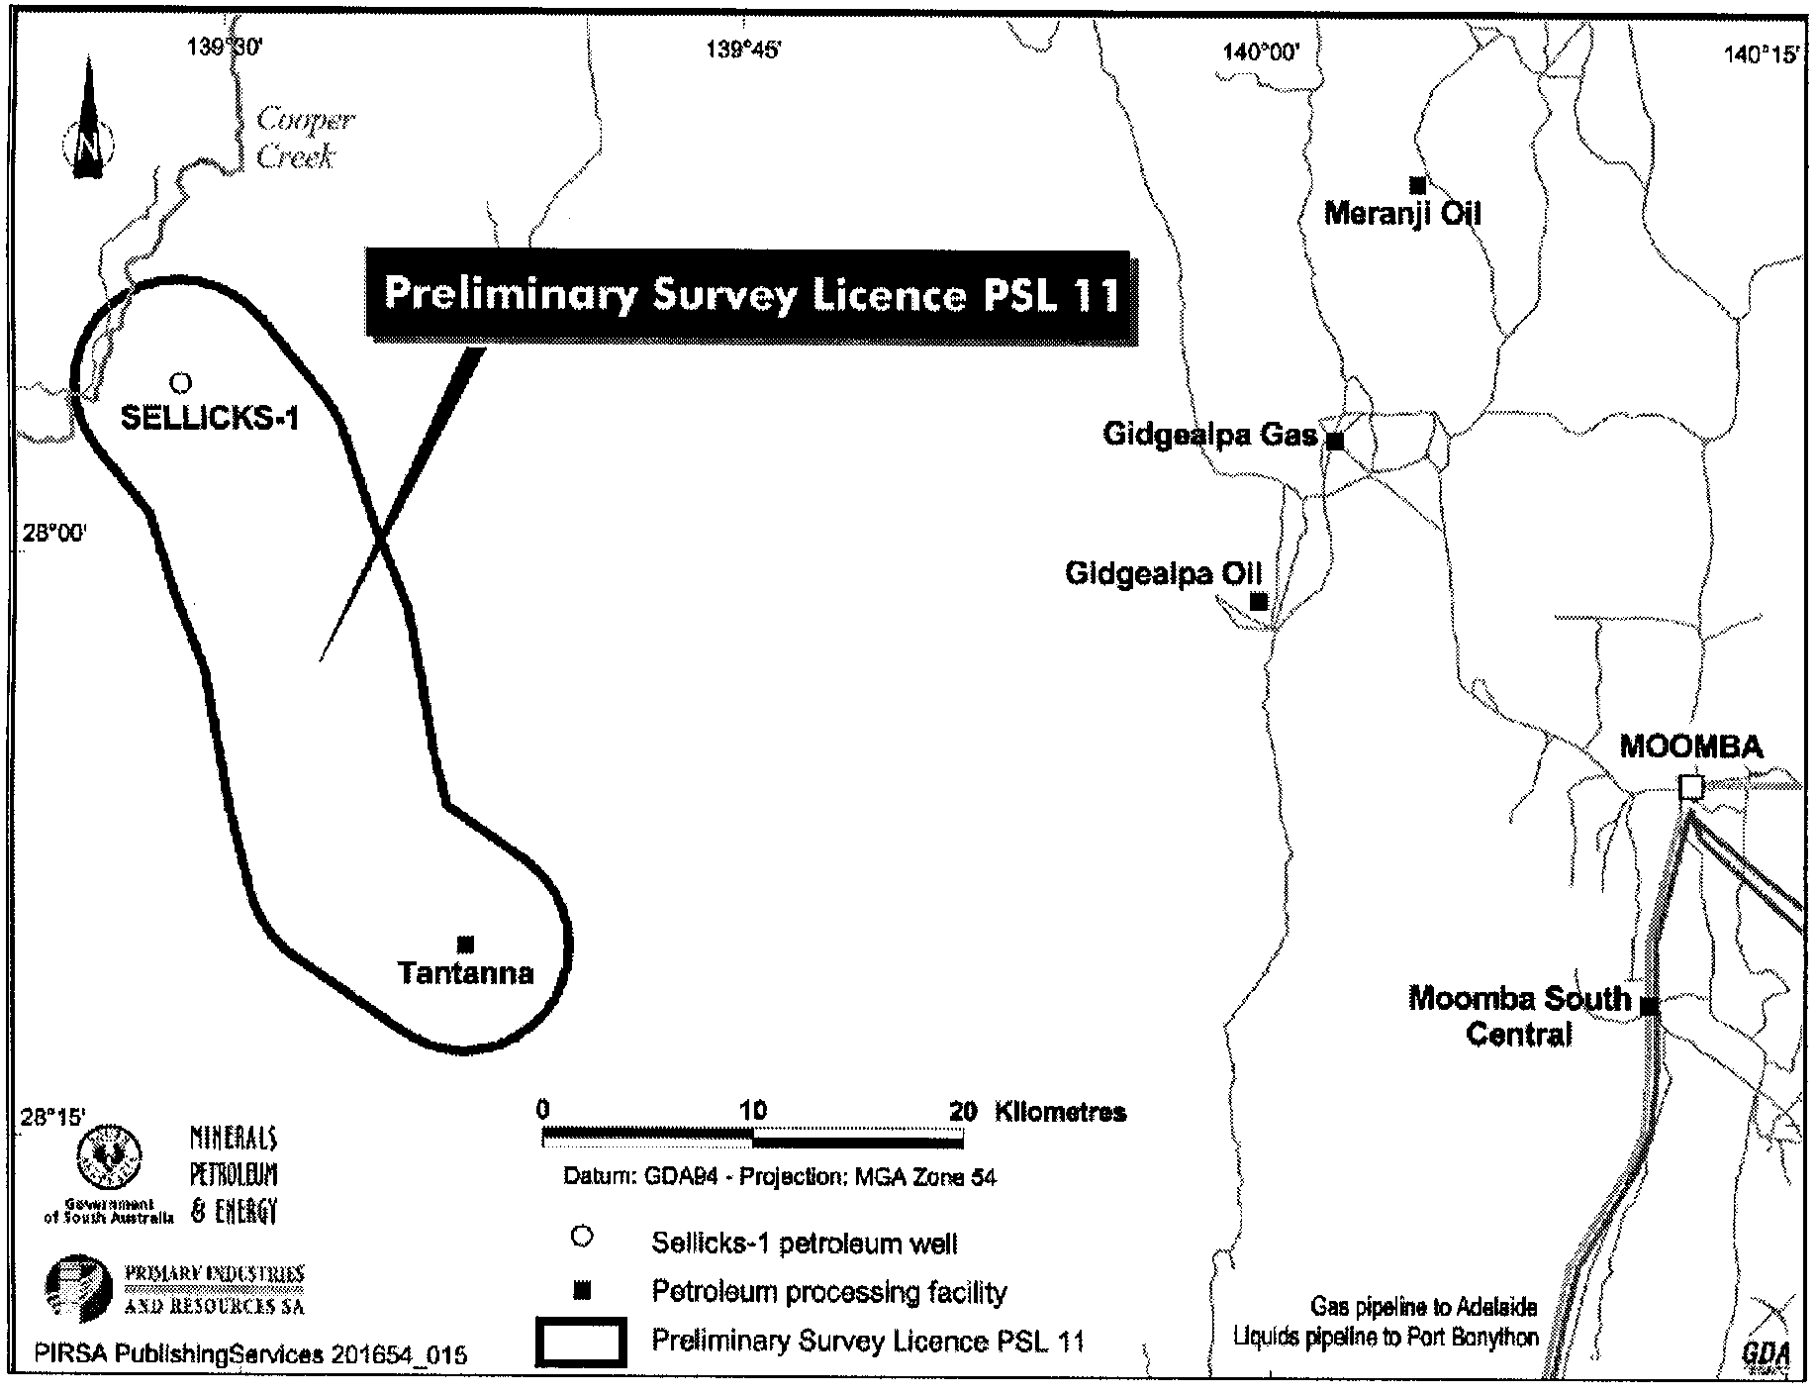
Dated 20 February 2006.
B. A. Goldstein, Director Petroleum and Geothermal
Minerals and Energy Resources
Primary Industries and Resources SA
Delegate of the Minister for Mineral Resources Development

GOVERNMENT GAZETTE ADVERTISEMENT RATES

To apply from 1 July 2005

$  Agents, Ceasing to Act as 36.50  Associations:  Incorporation 18.60  Intention of Incorporation 46.00  Transfer of Properties 46.00  Attorney, Appointment of 36.50  Bailiff’s Sale 46.00  Cemetery Curator Appointed 27.25  Companies:  Alteration to Constitution 36.50  Capital, Increase or Decrease of 46.00  Ceasing to Carry on Business 27.25  Declaration of Dividend 27.25  Incorporation 36.50  Lost Share Certificates:  First Name 27.25  Each Subsequent Name 9.35  Meeting Final 30.50  Meeting Final Regarding Liquidator’s Report on  Conduct of Winding Up (equivalent to ‘Final  Meeting’)  First Name 36.50  Each Subsequent Name 9.35  Notices:  Call 46.00  Change of Name 18.60  Creditors 36.50  Creditors Compromise of Arrangement 36.50  Creditors (extraordinary resolution that ‘the Com-pany be wound up voluntarily and that a liquidator be appointed’) 46.00  Release of Liquidator⎯Application⎯Large Ad. 72.50  ⎯Release Granted 46.00  Receiver and Manager Appointed 42.50  Receiver and Manager Ceasing to Act 36.50  Restored Name 34.50  Petition to Supreme Court for Winding Up 64.00  Summons in Action 54.50  Order of Supreme Court for Winding Up Action 36.50  Register of Interests⎯Section 84 (1) Exempt 82.50  Removal of Office 18.60  Proof of Debts 36.50  Sales of Shares and Forfeiture 36.50  Estates:  Assigned 27.25  Deceased Persons⎯Notice to Creditors, etc. 46.00  Each Subsequent Name 9.35  Deceased Persons⎯Closed Estates 27.25  Each Subsequent Estate 1.20  Probate, Selling of 36.50  Public Trustee, each Estate 9.35 |  | $  Firms:  Ceasing to Carry on Business (each insertion) 24.30  Discontinuance Place of Business 24.30  Land⎯Real Property Act:  Intention to Sell, Notice of 46.00  Lost Certificate of Title Notices 46.00  Cancellation, Notice of (Strata Plan) 46.00  Mortgages:  Caveat Lodgment 18.60  Discharge of 19.50  Foreclosures 18.60  Transfer of 18.60  Sublet 9.35  Leases⎯Application for Transfer (2 insertions) each 9.35  Lost Treasury Receipts (3 insertions) each 27.25  Licensing 54.50  Municipal or District Councils:  Annual Financial Statement⎯Forms 1 and 2 513.00  Electricity Supply⎯Forms 19 and 20 364.00  Default in Payment of Rates:  First Name 72.50  Each Subsequent Name 9.35  Noxious Trade 27.25  Partnership, Dissolution of 27.25  Petitions (small) 18.60  Registered Building Societies (from Registrar-  General) 18.60  Register of Unclaimed Moneys⎯First Name 27.25  Each Subsequent Name 9.35  Registers of Members⎯Three pages and over:  Rate per page (in 8pt) 233.00  Rate per page (in 6pt) 308.00  Sale of Land by Public Auction 46.50  Advertisements 2.60  ¼ page advertisement 109.00  ½ page advertisement 218.00  Full page advertisement 427.00  Advertisements, other than those listed are charged at $2.60 per column line, tabular one-third extra.  Notices by Colleges, Universities, Corporations and District Councils to be charged at $2.60 per line.  Where the notice inserted varies significantly in length from that which is usually published a charge of $2.60 per column line will be applied in lieu of advertisement rates listed.  South Australian Government publications are sold on the condition that they will not be reproduced without prior permission from the Government Printer.
All the above prices include GST

GOVERNMENT GAZETTE NOTICES
ALL private advertisements forwarded for publication in the South Australian Government Gazette must be PAID FOR PRIOR TO INSERTION; and all notices, from whatever source, should be legibly written on one side of the paper only and sent to Government Publishing SA so as to be received no later than 4 p.m. Tuesday preceding the day of publication. Phone 8207 1045 or Fax 8207 1040. E-mail: governmentgazette@saugov.sa.gov.au. Send as attachments in Word format. Please include date the notice is to be published and to whom the notice will be charged. The Government Gazette is available online at: www.governmentgazette.sa.gov.au.

MISCELLANEOUS LEGISLATION AND GOVERNMENT PUBLICATIONS PRICES AS FROM 1 JULY 2005

Acts, Bills, Rules, Parliamentary Papers and Regulations
Pages | Main | Amends | Pages | Main | Amends

1-16 | 2.20 | 1.00 | 497-512 | 31.00 | 30.00
17-32 | 3.00 | 1.85 | 513-528 | 32.00 | 30.75
33-48 | 3.90 | 2.80 | 529-544 | 33.00 | 32.00
49-64 | 4.90 | 3.75 | 545-560 | 34.00 | 33.00
65-80 | 5.75 | 4.75 | 561-576 | 34.75 | 34.00
81-96 | 6.70 | 5.55 | 577-592 | 35.75 | 34.50
97-112 | 7.60 | 6.50 | 593-608 | 36.75 | 35.50
113-128 | 8.55 | 7.45 | 609-624 | 37.50 | 36.50
129-144 | 9.60 | 8.50 | 625-640 | 38.50 | 37.00
145-160 | 10.50 | 9.35 | 641-656 | 39.50 | 38.50
161-176 | 11.50 | 10.30 | 657-672 | 40.00 | 39.00
177-192 | 12.40 | 11.30 | 673-688 | 41.75 | 40.00
193-208 | 13.40 | 12.30 | 689-704 | 42.50 | 41.00
209-224 | 14.20 | 13.10 | 705-720 | 43.00 | 42.00
225-240 | 15.10 | 14.00 | 721-736 | 44.75 | 43.00
241-257 | 16.20 | 14.70 | 737-752 | 45.25 | 44.00
258-272 | 17.10 | 15.70 | 753-768 | 46.25 | 44.50
273-288 | 18.00 | 16.90 | 769-784 | 46.75 | 46.00
289-304 | 18.80 | 17.70 | 785-800 | 47.75 | 47.00
305-320 | 19.90 | 18.70 | 801-816 | 48.50 | 47.50
321-336 | 20.70 | 19.60 | 817-832 | 49.75 | 48.50
337-352 | 21.80 | 20.60 | 833-848 | 50.75 | 49.50
353-368 | 22.60 | 21.60 | 849-864 | 51.50 | 50.00
369-384 | 23.60 | 22.50 | 865-880 | 52.50 | 51.50
385-400 | 24.50 | 23.40 | 881-896 | 53.00 | 52.00
401-416 | 25.50 | 24.20 | 897-912 | 54.50 | 53.00
417-432 | 26.50 | 25.25 | 913-928 | 55.00 | 54.50
433-448 | 27.50 | 26.25 | 929-944 | 56.00 | 55.00
449-464 | 28.25 | 27.00 | 945-960 | 57.00 | 55.50
465-480 | 28.75 | 28.00 | 961-976 | 58.25 | 56.50
481-496 | 30.00 | 28.75 | 977-992 | 59.25 | 57.00

Legislation—Acts, Regulations, etc: $
Subscriptions:
Acts 192.00
All Bills as Laid 460.00
Rules and Regulations 460.00
Parliamentary Papers 460.00
Bound Acts 213.00
Index 106.00
Government Gazette
Copy 5.00
Subscription 254.00
Hansard
Copy 14.00
Subscription—per session (issued weekly) 399.00
Cloth bound—per volume 172.00
Subscription—per session (issued daily) 399.00
Legislation on Disk
Whole Database 2 951.00
Annual Subscription for fortnightly updates 907.00
Individual Act(s) including updates POA
Compendium
Subscriptions:
Subscriptions 1 749.00
Updates 617.00
(All the above prices include GST)

All Legislation, Government Gazette, Hansard and Legislation on disk are available from:
Counter Sales Service SA, Government Legislation⁺ Outlet
and Mail Orders: Lands Titles Office, 101 Grenfell Street, Adelaide, S.A. 5000
Phone: 13 23 24 (local call cost), Fax: (08) 8204 1909
Postal: G.P.O. Box 1707, Adelaide, S.A. 5001

Online Shop: www.shop.service.sa.gov.au

Subscriptions and Government Publishing SA
Standing Orders: Box 9, Plaza Level, Riverside Centre, North Terrace, Adelaide, S.A. 5000
Phone: (08) 8207 0908, (08) 8207 0910, Fax: (08) 8207 1040

DISTRICT COURT OF SOUTH AUSTRALIA
MOUNT GAMBIER CIRCUIT COURT
Sheriff’s Office, Adelaide, 20 February 2006
IN pursuance of a precept from the District Court to me directed, I do hereby give notice that the said Court will sit as a Court of Oyer and Terminer and General Gaol Delivery at the Courthouse at Mount Gambier on the day and time undermentioned and all parties bound to prosecute and give evidence and all jurors summoned and all others having business at the said Court are required to attend the sittings thereof and the order of such business will be unless a Judge otherwise orders as follows:
Monday, 6 March 2006 at 10 a.m. on the first day of the sittings the only business taken will be the arraignment of prisoners in gaol and the passing of sentences on prisoners in gaol committed for sentence; the surrender of prisoners on bail committed for sentence; the surrender of persons in response to ex officio informations or of persons on bail and committed for trial who have signified their intentions to plead guilty and the passing of sentences for all matters listed for disposition by the District Court.
Juries will be summoned for Tuesday, 7 March 2006 and persons will be tried on this and subsequent days of the sittings.
Prisoners in H.M. Gaol and on bail for sentence and for trial at the sittings of the Mount Gambier Courthouse, commencing Monday, 6 March 2006.
Wheeler, Paul Richard | Non-aggravated serious criminal trespass (non-residential) | On bail
Bahnisch, Mark Robert | Taking part in the manufacture of methylamphetamine | In gaol
Blake, Barry James | Aggravated serious criminal trespass in a place of residence; common assault; damaging property | On bail
Burr, Damien Slade | False imprisonment; assault occasioning actual bodily harm; aggravated robbery | On bail
Stevens, Jamie Luke | False imprisonment; assault occasioning actual bodily harm; aggravated robbery | On bail
Deacon, Hayden Andrew | False imprisonment; assault occasioning actual bodily harm; aggravated robbery | On bail
Cary, Adam James | Aggravated robbery with offensive weapon | In gaol
Chant, Milton Darryl | Indecent assault; procuring an act of gross indecency; unlawful sexual intercourse | On bail
Coff, Quentin Charles | Cause grievous bodily harm with intent to cause grievous | On bail
Dorward, Brad | Rape | On bail
Gabriel, Kevin Andrew | Aggravated serious trespass—not known if place occupied; common assault on person other than family member; carry offensive weapon; damage property not by marking graffiti; damage  type unknown | On bail
Hewett, Darren | Aggravated serious criminal trespass in a place of residence; assault occasioning actual bodily harm (3) | On bail
Howard, Martyn Lee | Unlawful sexual intercourse with a person under 12; unlawful sexual intercourse with a person under 12 attempted | On bail
Laurie, Michael Kevin Barry | Drive unregistered motor vehicle on a road; drive uninsured motor vehicle on road; fail to comply with request to stop vehicle; drive in reckless or dangerous manner; act likely to cause harm | In gaol
Marks, Sharee Key | Taking part in the production of a controlled substance | On bail
McCallum, Dwayne Owen | Non-aggravated serious criminal trespass (place of residence); common assault on person other than family member; assault occasioning actual bodily harm | On bail
McCarthy, Damien James | Aggravated serious criminal trespass—residence occupied; dishonestly take property without owner’s consent (3); aggravated serious criminal trespass (non-residential) (2); aid and abet non-aggravated serious criminal trespass | On bail
McCarthy, James Elliott | Producing a controlled substance; possessing cannabis | On bail
Pittas, Dion Lawrence | Threatening life (2); common assault on person other than family member (2); carry offensive weapon | On bail
Placucci, Dwayne Hayden | Aggravated serious criminal trespass (non-residential); dishonestly take property without owner’s consent | On bail
Shaw, Damien Aaron | Selling a prohibited substance or drug of dependence | On bail
Simpson, Duane Matthew | Aggravated serious criminal trespass—residence occupied; dishonestly take property without owner’s consent; drive or use motor vehicle without consent; threatening life; common assault on person other than own  family member | In gaol
Stone, Jason Terrence | Threatening life; fail to comply with restraining or foreign restraining order; use carriage service in harassing or  offensive way | In gaol
Vanderhorst, Clayton Andre | Non-aggravated serious criminal trespass (non-residential) (2) | On bail
Vanderhorst, Clayton Andrew | Aid and abet to commit serious criminal trespass (4); dishonestly take property without owner’s consent (8); attempted to enter a non-residential building; non-aggravated serious  criminal trespass | On bail
Warden, Aaron Dwain | Rape (3); common assault on person other than family member; indecent assault | On bail
Wheeler, Paul Richard | Aggravated serious criminal trespass—residence occupied dishonestly take property without owner’s consent; dishonest dealings with documents (2) | On bail
Wheeler, Paul Richard | Serious criminal trespass in a place of residence; theft; dishonestly dealing with a document; attempted serious criminal trespass in a place  of residence | On bail
Prisoners on bail must surrender at 10 a.m. of the day appointed for the respective trials. If they do not appear when called upon their recognizances and those of their bail will be estreated and a bench warrant issued forthwith.
By Order of the Court,
M. A. Stokes, Sheriff

RADIATION PROTECTION AND CONTROL ACT 1982:
SECTION 44
Notice by Delegate of the Minister for Environment and Conservation
PURSUANT to section 44 of the Radiation Protection and Control Act 1982, I, Keith Baldry, Director of the Radiation Protection Division of the Environment Protection Authority, being a person to whom the powers of the Minister under that section have been delegated under the Act, exempt diagnostic radiographers from the requirement of Regulation 40 of the Radiation Protection and Control (Ionising Radiation) Regulations 2000, subject to the following conditions:
1. the exemption applies to plain radiography of the chest only; and
2. examinations are only conducted on persons who have been referred by the Australian Government.
Dated 16 February 2006.
K. Baldry, Delegate of the Minister for Environment and Conservation

ROADS (OPENING AND CLOSING) ACT 1991:
SECTION 24
NOTICE OF CONFIRMATION OF ROAD
PROCESS ORDER
Road Closure
Kellett Street, Adelaide
BY Road Process Order made on 5 September 2005, The Corporation of the City of Adelaide ordered that:
1. The whole of Kellett Street situated between Sturt Street and allotment 392 in Filed Plan 182854, more particularly delineated and lettered ‘A’ in Preliminary Plan No. 04/0069 be closed.
2. The whole of the land subject to closure be transferred to the Commercial Motor Industries Pty Ltd in accordance with agreement for transfer dated 23 September 2004 entered into between The Corporation of the City of Adelaide and Commercial Motor Industries Pty Ltd.
3. The following easement be granted over the whole of the land subject to that closure:
Grant to the Distribution Lessor Corporation an easement for electricity supply purposes.
On 1 November 2005 that order was confirmed by the Minister for Administrative Services conditionally upon the deposit by the Registrar-General of Deposited Plan 69386 being the authority for the new boundaries.
Pursuant to section 24 (5) of the Roads (Opening and Closing) Act 1991, notice of the order referred to above and its confirmation is hereby given.
Dated 23 February 2006.
P. M. Kentish, Surveyor-General

SEWERAGE ACT 1929
Addition of Land to Mount Gambier Country Drainage Area
PURSUANT to section 18 of the Sewerage Act 1929, the South Australian Water Corporation:
(a) adds to the Mount Gambier Country Drainage Area all the land contained in allotments 1 and 2 in Filed Plan 6083; and
(b) declares that this notice will have effect from 1 July 2005.
Dated 21 February 2006.
Signed for and on behalf of the South Australian Water Corporation by a person duly authorised so to do:
A. Popplewell, General Manager Shared Services
In the presence of:
C. J. McNamara, Billing Manager
SAWATER 06/00976 D1299

SEWERAGE ACT 1929
Removal of Land from Mount Gambier Country Drainage Area
Addition of Land to Mount Gambier Country Drainage Area
PURSUANT to section 18 of the Sewerage Act 1929, the South Australian Water Corporation:
(a) removes from the Mount Gambier Country Drainage Area all the land contained in allotment 3 in Deposited Plan 54738 (except the portion of that land already outside the Mount Gambier Country Drainage Area);
(b) adds to the Mount Gambier Country Drainage Area all the land contained in:
(i) allotment 2 in Deposited Plan 54738 (except the portion of that land already in the Mount Gambier Country Drainage Area);
(ii) allotment 843 in Filed Plan 194645;
(iii) allotment 844 in Filed Plan 194646; and
(c) declares that this notice will have effect from 1 July 2005.
Dated 21 February 2006.
Signed for and on behalf of the South Australian Water Corporation by a person duly authorised so to do:
A. Popplewell, General Manager Shared Services
In the presence of:
C. J. McNamara, Billing Manager
SAWATER 06/00978 D1300

SOUTH AUSTRALIAN WATER CORPORATION ACT 1994
Conferral of Function
PURSUANT to section 7 (2) (f) of the South Australian Water Corporation Act 1994, I, Michael Wright, Minister for Adminis-trative Services, being the Minister to whom administration of that Act is committed, hereby confer on the South Australian Water Corporation the function of acting as agent of the Minister to whom administration of the River Murray Act 2003, is committed for the purpose only of purchasing water entitlements from willing sellers for and on behalf of and as instructed by that Minister from time to time.
Dated 8 February 2006.
M. Wright, Minister for Administrative Services

NOTICE TO MARINERS
No. 10 of 2006
Formerly No. 2 of 2006
South Australia—Port Adelaide—Port River—Birkenhead Bridge—Bridge Closure
MARINERS are advised that the Birkenhead Bridge will be closed to all traffic, except for Emergency Response Vessels as necessary, for scheduled maintenance on the following dates, and between the hours of:
Monday, 20 February 2006 to Friday, 24 February 2006, between the hours of 9 a.m. (0900 hours) to 3.30 p.m. (1530 hours).
Mariners are further advised that this restriction may be extended in the event of delays to the works programme. Due notice of such extensions will be given.
Charts affected: Aus 137.
Publications affected: Australian Pilot Vol. 1 2005 edition, page 389.
South Australia’s Waters, CW Map 6F, page 196.
Adelaide, 16 February 2006.
P. Conlon, Minister for Transport
TSA 2006/0419

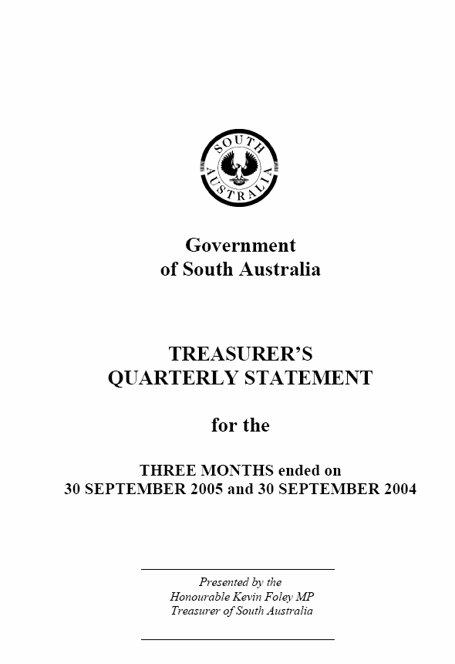
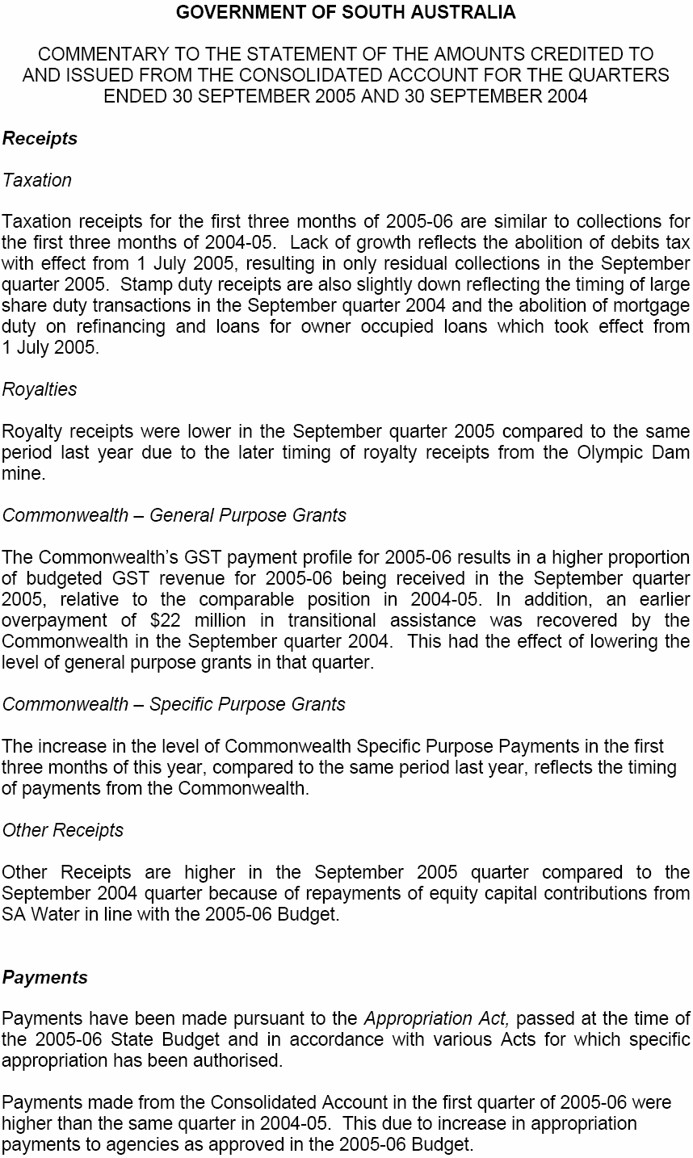
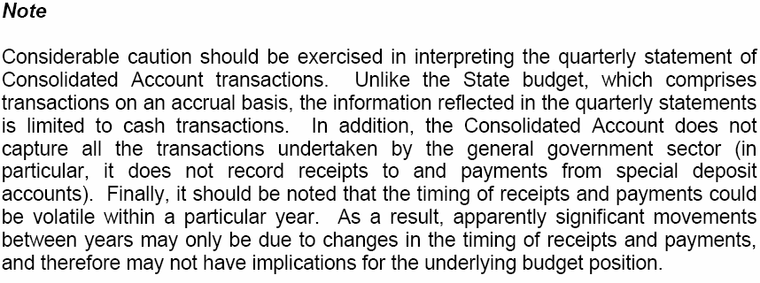

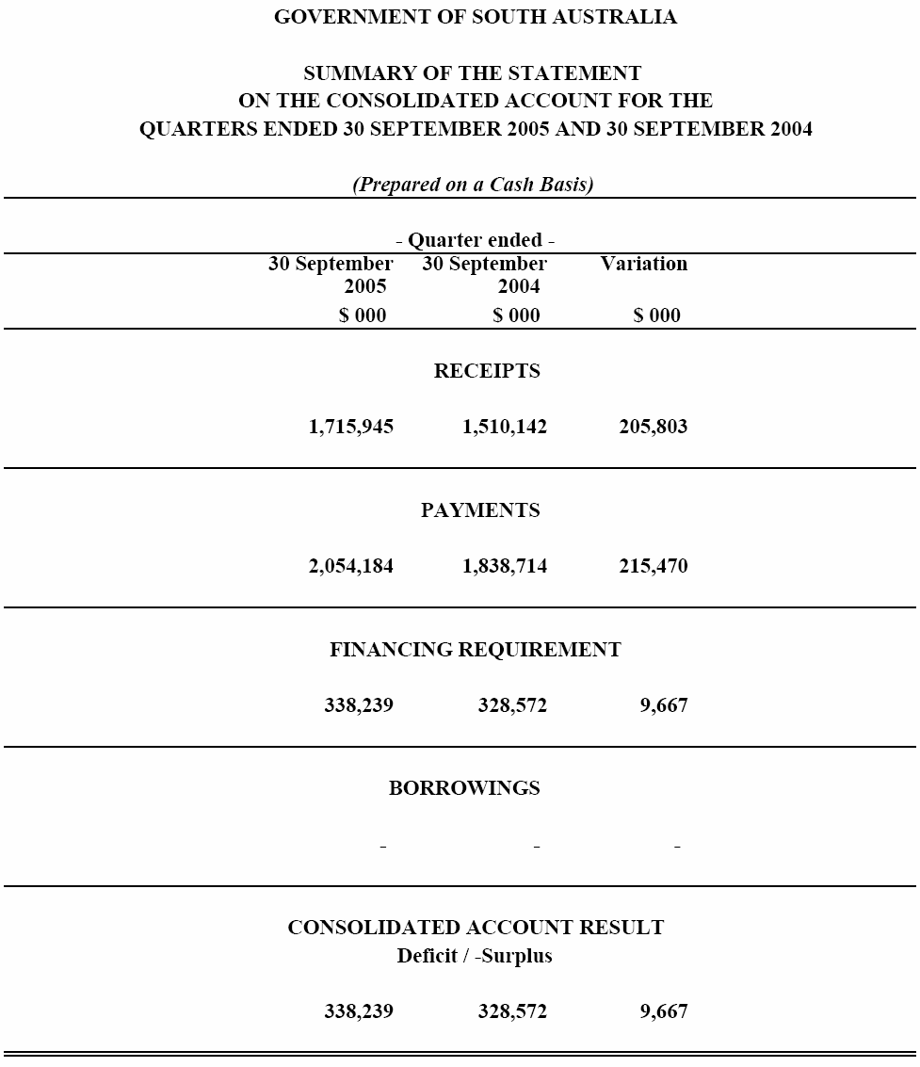

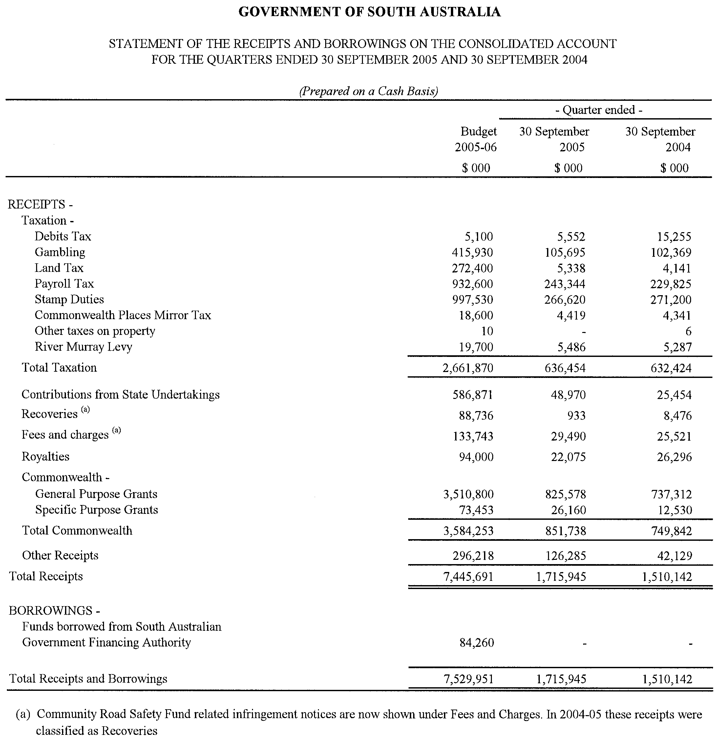

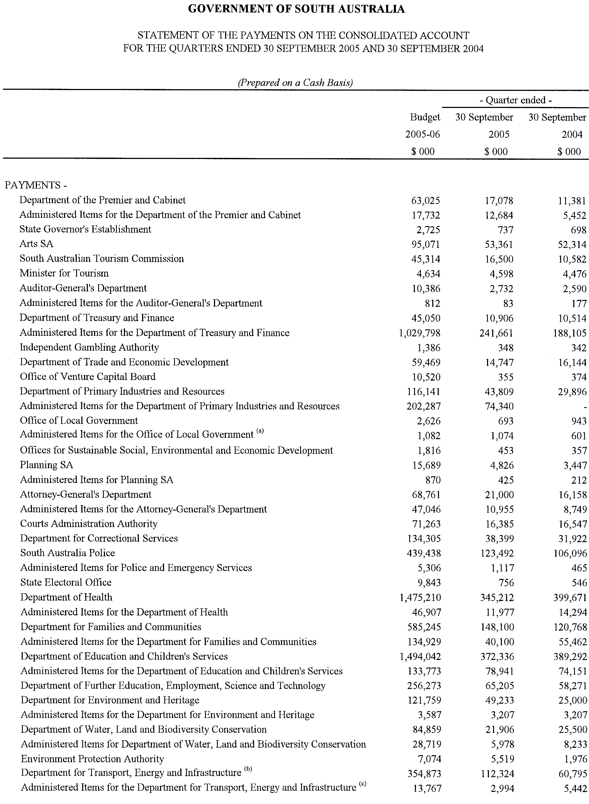

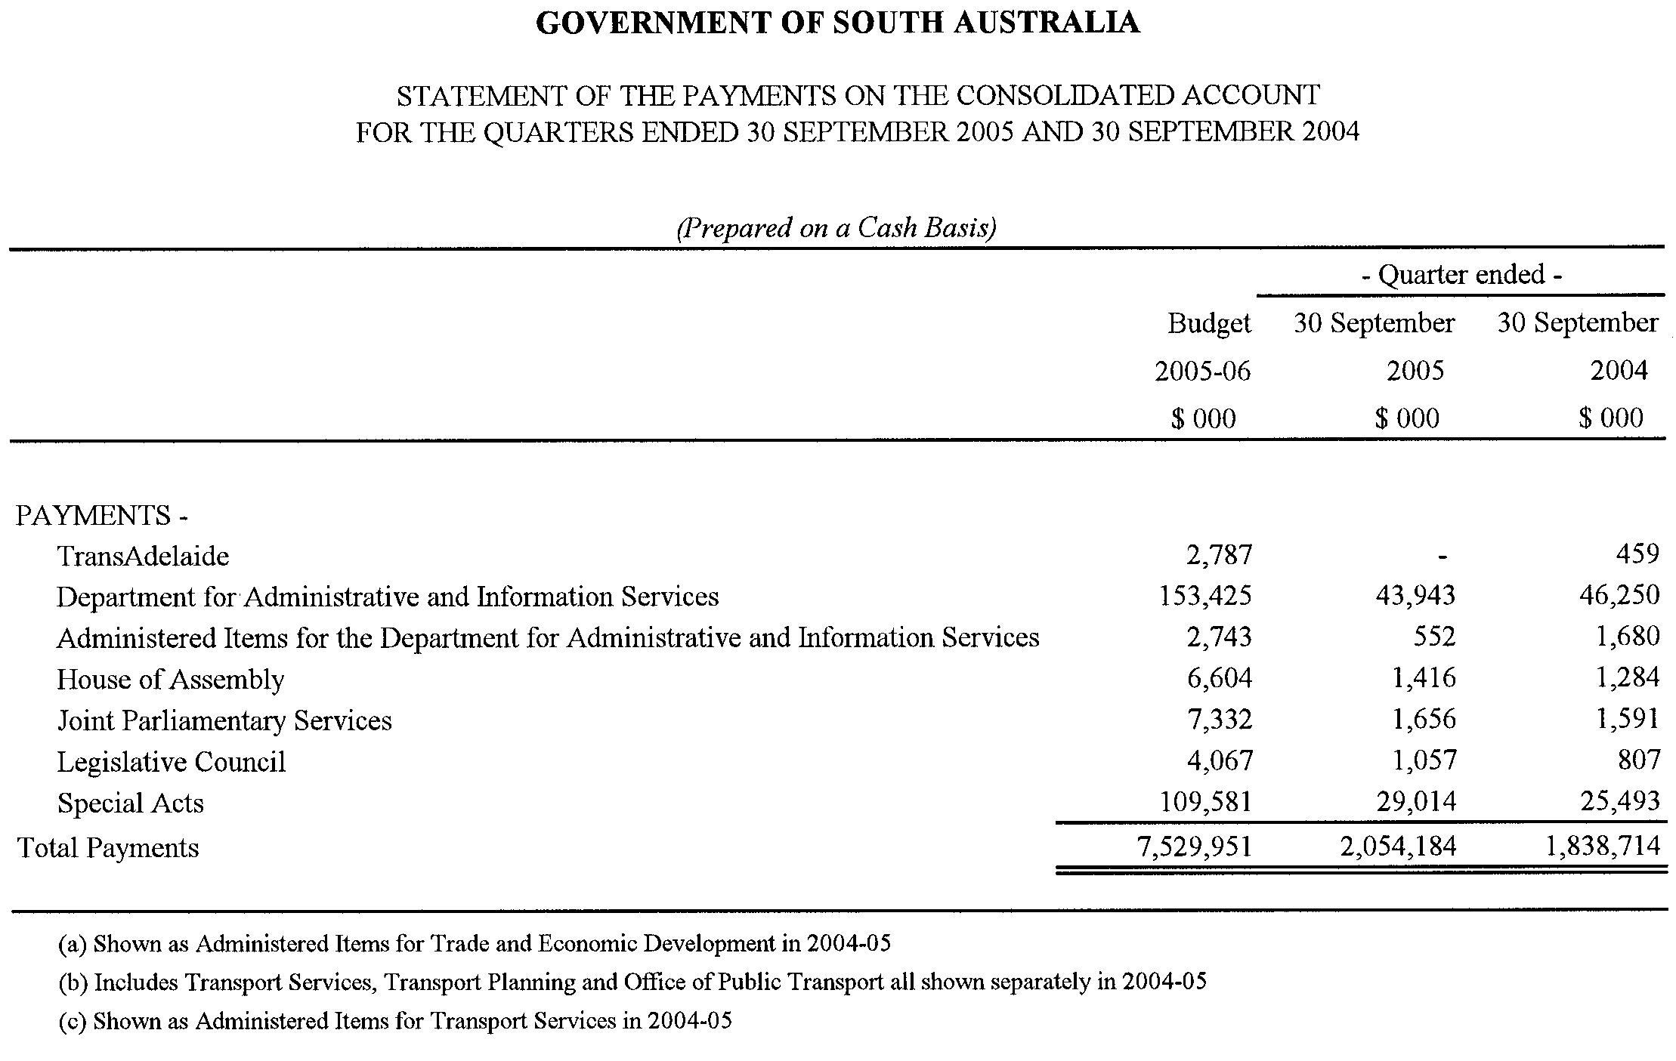

WATER MAINS AND SEWERS

Office of the South Australian Water Corporation
Adelaide, 23 February 2006

WATER MAINS LAID

Notice is hereby given that the following main pipes or parts of main pipes have been laid down by the South Australian Water Corporation in or near the undermentioned water districts and are now available for a constant supply of water to adjacent land.

ADELAIDE WATER DISTRICT

THE DISTRICT COUNCIL OF MOUNT BARKER
Hutchinson Street, Mount Barker. p4
Pridmore Terrace, Mount Barker. p4

CITY OF PORT ADELAIDE ENFIELD
Horley Terrace, Kilburn. p11
Dawlish Road, Osborne. p12

CITY OF SALISBURY
Across Burma Road, Pooraka. p7
Easements in lot 1009 in LTRO DP 59393, Goldsborough Road, Pooraka. p7 and 8
Across Goldsborough Road, Pooraka. p8

BLUE LAKE COUNTRY LANDS WATER DISTRICT

DISTRICT COUNCIL OF GRANT
Thompson Court, Moorak. p3

CURRAMULKA WATER DISTRICT

DISTRICT COUNCIL OF YORKE PENINSULA
Across West Terrace, Curramulka. p15
First Street, Curramulka. p15

ENCOUNTER BAY COUNTRY LANDS WATER DISTRICT

CITY OF VICTOR HARBOR
Arabian Court, Hindmarsh Valley. p1
Appaloosa Drive, Hindmarsh Valley. p1 and 2
Palomino Court, Hindmarsh Valley. p2

KANMANTOO WATER DISTRICT

THE DISTRICT COUNCIL OF MOUNT BARKER
Nursery Road, Kanmantoo. p16

MOUNT COMPASS WATER DISTRICT

ALEXANDRINA COUNCIL
Haywood Court, Mount Compass. p5

MURRAY BRIDGE WATER DISTRICT

THE RURAL CITY OF MURRAY BRIDGE
Across Darling Avenue, Murray Bridge. p6
Carole Court, Murray Bridge. p6

PORT ELLIOT WATER DISTRICT

ALEXANDRINA COUNCIL
Across North Terrace, Port Elliot. p9
Cinema Court, Port Elliot. p9
Clark Terrace, Port Elliot. p9
Pomery Street, Port Elliot. p9
Classic Court, Port Elliot. p9 and 10
Easement in reserve (lot 60 in LTRO DP 65360), Elliot Street, Port Elliot. p10
Across and in Elliot Street, Port Elliot. p10

PORT PIRIE WATER DISTRICT

PORT PIRIE REGIONAL COUNCIL
Broadstock Street, Solomontown. p13
Easement in lot 100 in LTRO DP 34772, Broadstock Road, Solomontown. p13

WALLAROO WATER DISTRICT

DISTRICT COUNCIL OF THE COPPER COAST
Daly Street, Wallaroo. p14

DELETION

Deletion of notice in “Government Gazette” of 1 September 2005.

“WATER MAINS LAID”

“Notice is hereby given that the undermentioned water mains have been laid down by the South Australian Water Corporation and are not available for a constant supply of water to adjacent land.”

“BAROSSA COUNTRY LANDS WATER DISTRICT”

“BAROSSA COUNCIL”

“Sunnydale Avenue, Gawler East. p59”

Delete this notice

SEWERS LAID

Notice is hereby given that the following sewers have been laid down by the South Australian Water Corporation in the undermentioned drainage areas and are now available for house connections.

ADELAIDE DRAINAGE AREA

CITY OF MITCHAM
In and across Cedar Avenue, Blackwood. FB 1146 p9
Easements in lot 491 in LTRO DP 3968, Cedar Avenue, Blackwood. FB 1146 p9

CITY OF NORWOOD PAYNEHAM & ST PETERS
Boskenna Avenue, Norwood. FB 1146 p5
Shirley Avenue, Felixstow. FB 1146 p7

CITY OF ONKAPARINGA
Hill Street, O’Sullivan Beach. FB 1146 p11
Across Penneys Hill Road, Hackham. FB 1146 p18
Sandy Lane, Hackham. FB 1146 p18

CITY OF PLAYFORD
Perre Drive, Craigmore. FB 1146 p19

CITY OF PORT ADELAIDE ENFIELD
Nairne Street, Ferryden Park. FB 1145 p51
Easements in lots 96 and 79 in LTRO DP 4945, Wells Street, Greenacres. FB 1146 p8
Chaplin Avenue, Hillcrest. FB 1146 p10
Gascoyne Avenue, Hillcrest. FB 1146 p12
Ridgeway Avenue, Enfield. FB 1146 p13
Second Avenue, Woodville Gardens. FB 1146 p14
McKay Avenue, Windsor Gardens. FB 1146 p17

CITY OF PROSPECT
Meredith Street, Broadview. FB 1146 p16

CITY OF SALISBURY
Across Goldsborough Road, Cavan and Pooraka. FB 1145 p54 and 56
Easements in lot 1009 in LTRO DP 59393, Goldsborough Road, Pooraka. FB 1145 p54-56
March Street, Salisbury. FB 1146 p6
Londonderry Avenue, Salisbury Downs. FB 1146 p15
McCabe Avenue, Parafield Gardens. FB 1146 p20

MURRAY BRIDGE COUNTRY DRAINAGE AREA

THE RURAL CITY OF MURRAY BRIDGE
Darling Avenue, Murray Bridge. FB 1145 p52 and 53
Hume Avenue, Murray Bridge. FB 1145 p52 and 53
Carole Court, Murray Bridge. FB 1145 p52 and 53

A. Howe, Chief Executive Officer, South Australian Water Corporation

WATERWORKS ACT 1932
Addition of Land to Tumby Bay Water District
PURSUANT to section 6 of the Waterworks Act 1932, the South Australian Water Corporation:
(a) adds to the Tumby Bay Water District all the land con-tained in allotments 212 to 216 inclusive in Deposited Plan 66876; and
(b) declares that this notice will have effect from 1 July 2005.
Dated 21 February 2006.
Signed for and on behalf of the South Australian Water Corporation by a person duly authorised so to do:
A. Popplewell, General Manager Shared Services
In the presence of:
C. J. McNamara, Billing Manager
SAWATER 06/00662 W1298

FAXING COPY?
IF you fax copy to Government Publishing SA for inclusion in the Government Gazette, there is no need to send a Confirmation Copy to us as well.
This creates confusion and may well result in your notice being printed twice.
Please use the following fax number:
Fax transmission: (08) 8207 1040
Phone Inquiries: (08) 8207 1045
Please include a contact person, phone number and order number so that we can phone back with any queries we may have regarding the fax copy.
NOTE: Closing time for lodging new copy (fax, hard copy or email) is 4 p.m. on Tuesday preceding the day of publication.

Government Gazette notices can be E-mailed.
The address is:
governmentgazette@saugov.sa.gov.au
Documents should be sent as attachments in Word format.
When sending a document via E-mail, please confirm your transmission with a faxed copy of your document, including the date the notice is to be published.
Fax transmission: (08) 8207 1040
Enquiries: (08) 8207 1045
NOTE: Closing time for lodging new copy (fax, hard copy or email) is 4 p.m. on Tuesday preceding the day of publication.

CITY OF CHARLES STURT
Development Act 1993
Charles Sturt (City) Development Plan—Findon Urban Village Plan Amendment Report—Draft for Public Consultation
NOTICE is hereby given that the City of Charles Sturt has prepared a draft Plan Amendment Report to amend the Charles Sturt (City) Development Plan. The Findon Urban Village PAR affects land within the Neighbourhood Centre (Findon) Zone and the Industry Zone.
The Plan Amendment Report proposes to amend the Charles Sturt (City) Development Plan by:
• rezoning the existing Industry Zone and the Neighbourhood Centre (Findon) Zone within the Affected Area to the Mixed Use Zone, and incorporate a new Mixed Use Findon Urban Village Policy Area;
• advancing the Council-wide Urban Villages objective, with a high quality sustainable urban environment;
• accommodating a mix of land uses, including affordable, medium density and aged persons housing, bulky goods retailing, offices, commercial and light industrial activities;
• outlining the desired building design and public realm and environment;
• integrating with the adjacent Neighbourhood Centre and residential areas.
The draft Plan Amendment Report and statement will be available for public inspection and purchase during normal office hours at the Council Office, 72 Woodville Road, Woodville, Civic Library and Findon Library and are available on Council’s website at www.charlessturt.sa.gov.au from Thursday, 23 February 2006 to Monday, 24 April 2006. Copies of the Plan Amendment Report can be purchased from the Council at $10 each.
Written submissions regarding the draft amendment will be accepted by the City of Charles Sturt until 5 p.m. on Monday, 24 April 2006. The written submission should clearly indicate whether you will wish to speak at the public hearing on your submission. All submissions should be addressed to the Chief Executive, City of Charles Sturt, P.O. Box 1, Woodville, S.A. 5011.
Copies of all submissions received will be available for inspec-tion by interested persons at the Civic Centre, 72 Woodville Road, Woodville, from Monday, 24 April 2006 until the date of the public hearing.
A public hearing has been set for Tuesday, 9 May 2006 at 6 p.m. at Council’s Civic Centre, 72 Woodville Road, Woodville.
Persons wishing to be heard at the public hearing are requested to indicate their intention in their submission. The public hearing may not be held if no submission indicates an interest in speaking at the public hearing.
Dated 23 February 2006.
P. Lockett, Chief Executive Officer

CITY OF TEA TREE GULLY
Closure of Portion of Hancock Road
NOTICE is hereby given that the City of Tea Tree Gully proposes to make a Road Process Order in accordance with section 10 of the Roads (Opening and Closing) Act 1991:
To close a portion of road in Hundred of Yatala, being a strip of Hancock Road, Fairview Park situate adjoining the following allotments:
• Allotment 95 in Filed Plan 132497 being Blue Gums Hotel;
• Allotment 4 in Filed Plan 128555 being Body Workshop;
• Allotment 1 in Filed Plan 2557 being Fairview Park Fitness;
• Allotment 2 in Filed Plan 2557 being Cenna Pty Ltd;
• Allotment 3 in Strata Plan 4389 being Fairview Park Shopping Centre;
• Allotment 94 in Filed Plan 132496 being the Shell Company of Australia;
on Preliminary Plan No. 06/0013.
It is proposed that the road to be closed:
• Marked ‘A’ to be retained by the Council for the area;
• Marked ‘B’ to be transferred to Blue Gums Hotel Pty Ltd and merged with said allotment 95 in Filed Plan 132497;
• Marked ‘C’ be transferred to Shell Company of Australia Ltd and merged with said Allotment 94 in Filed Plan 132496.
A preliminary plan of the proposal, and statement, may be viewed at the Civic Centre, 571 Montague Road, Modbury between the hours of 8.45 a.m. and 5 p.m., Monday to Friday or at the Adelaide Office of the Surveyor-General during normal office hours.
Any person may object to the proposal (and any adjoining landowner or other person substantially affected by the proposed road closure may apply for an easement relative to the closure). Such objection (or application for an easement) must be made in writing to the City of Tea Tree Gully within 28 days of the date of this Notice (by Monday, 3 April 2006). If a submission is made, the City of Tea Tree Gully is required to give notice of the time and place at which a meeting will be held to consider the matter, so that the person making the submission (or representative) may attend to support the submission, if desired. Any submission must set out the full name and address of the person making the submission, and must be fully supported by reasons and any application for the grant of an easement must give full particulars of the nature and location of the easement and, where made by a person as the owner of adjoining or nearby land, specify the land to which the easement is to be annexed. A copy of the submission must be forwarded to the Surveyor-General at Adelaide.
Dated 23 February 2006.
G. J. Perkin, Chief Executive Officer

DISTRICT COUNCIL OF BARUNGA WEST
Appointment of Authorised Officers
NOTICE is hereby given that at a meeting of Council held on
14 February 2006, Council resolves to appoint the following officers as Authorised Officers for the District Council of Barunga West:
Supported Residential Facilities Act 1992 (section 21):
Mark Marziale (Manager—Environmental Services);
John Dalle-Nogare (Environmental Health Officer).
Land and Business (Sale and Conveyancing) Act 1994:
Nigel Andrew Hand (District Manager);
Mark Marziale (Manager—Environmental Services).
Liquor Licensing Act 1997:
Nigel Andrew Hand (District Manager);
Mark Marziale (Manager—Environmental Services).
Community Title Act 1996:
Nigel Andrew Hand (District Manager);
Mark Marziale (Manager—Environmental Services).
N. Hand, District Manager

DISTRICT COUNCIL OF ROBE
Fire and Emergency Services Regulations 2005
Regulation 34, Schedule 11
Declaration of an area of the state in which a person may operate a gas fire or electric element for cooking purposes in the open air contrary to the terms of a total fire ban
PURSUANT to regulations under the Fire and Emergency Services Act 2005, the District Council of Robe declares that persons may operate gas fires or electric elements for cooking purposes in the open air contrary to the terms of a total fire ban day at the following places:
Sea-Vu Caravan Park, 1 Squires Drive, Robe;
Nampara Cabins, 28 Laurel Terrace, Robe;
Robe Long Beach Tourist Park, The Esplanade, Robe;
Lakeside Tourist Park, 24 Main Road, Robe;
Lions Rotunda, Long Beach Reserve, The Esplanade, Robe; and
Bushland Cabins and Caravan Park, corner Main Road and Nora Creina Road, Robe.
This notice operates at all times unless revoked.
The operation of a gas fire or electric element under this notice is subject to the following conditions:
(1) The space immediately around and above the gas fire or electric element must be cleared of all flammable material to a distance of at least 4 m.
(2) A person who is able to control the gas fire or electric element must be present at all times while it is lighted or charged.
(3) An appropriate agent adequate to extinguish the fire must be at hand.
(4) No person can use a gas fire or electric element in the open on a fire ban day without the permission of the park manager.
R. J. Kay, Chief Executive Officer

IN the matter of the estates of the undermentioned deceased persons:
Amos, Millicent Mary, late of 17 Robsart Street, Parkside, of no occupation, who died on 10 December 2005.
Ball, Dulcie Gladys, late of 49 Commercial Road, Hyde Park, widow, who died on 19 December 2005.
Clarke, Sandra Balfour, late of 103 Fisher Street, Fullarton, of no occupation, who died on 29 October 2005.
de Bruin, Jacoba Wilhelmina, late of 6 McRostie Street, Millicent, home duties, who died on 14 March 1994.
Freer, Alice Maude, late of 1A Mount Barker Road, Hahndorf, widow, who died on 29 September 2005.
Garreffa, Dominic, late of 70 Addison Road, Pennington, of no occupation, who died on 29 September 2005.
Hall, Beryl Evelyn, late of 15 Rosemary Street, Woodville West, of no occupation, who died on 5 December 2005.
Hooper, Francis James, late of 29 Austral Terrace, Morphettville, retired labourer, who died on 6 January 2006.
Klemettila, Peter Augie, late of 6 Kenner Street, Elizabeth Downs, retired railway employee, who died on 2 December 2005.
McMahon, Frederick Joseph, late of 348 Halifax Street, Adelaide, retired greengrocer, who died on 13 October 2005.
Munro, Alice Margaret, late of 5 Bradford Court, Enfield, of no occupation, who died on 4 December 2005.
O’Reilly, Margaret Elsie, late of 580 Lower North East Road, Campbelltown, widow, who died on 5 October 2005.
Parker, Sabina Mary May, late of 3 Fourth Avenue, St Peters, of no occupation, who died on 18 December 2005.
Potticary, June Kay, late of Cockburn Road, Telowie, retired social worker, who died on 30 July 2005.
Pratt, Marjorie Rae, late of 67 Porter Street, Salisbury, widow, who died on 20 August 2005.
Preston, Violet Lilian, late of 37 Caulfield Crescent, Paralowie, home duties, who died on 14 November 2005.
Renshaw, Mervyn William, late of 32 Cross Road, Myrtle Bank, retired senior traffic instructor, who died on 31 December 2005.
Sage, William John, late of 156 Main North Road, Prospect, retired carpenter, who died on 9 October 2005.
Notice is hereby given pursuant to the Trustee Act 1936, as amended, the Inheritance (Family Provision) Act 1972, and the Family Relationships Act 1975, that all creditors, beneficiaries, and other persons having claims against the said estates are required to send, in writing, to the Public Trustee, 25 Franklin Street, Adelaide, S.A. 5000, full particulars and proof of such claims, on or before 24 March 2006, otherwise they will be excluded from the distribution of the said estate; and notice is also hereby given that all persons who are indebted to the said estates are required to pay the amount of their debts to the Public Trustee or proceedings will be taken for the recovery thereof; and all persons having any property belonging to the said estates are forthwith to deliver the same to the Public Trustee.
Dated 23 February 2006.
C. J. O’Loughlin, Public Trustee

ATTENTION

CUSTOMERS requiring a proof of their notice for inclusion in the Government Gazette, please note that the onus is on you to inform Government Publishing SA of any subsequent corrections by 10 a.m. on Thursday, which is our publication deadline.

For any corrections to your notice please phone 8207 1045 or Fax 8207 1040 before 10 a.m. on Thursday.

If we do not receive any communication by 10 a.m. on Thursday (day of publication) we will presume the notice is correct and will print it as it is.

Remember—the onus is on you to inform us of any corrections necessary to your notice.

NOTE: Closing time for lodging new copy (electronically, fax or hard copy) is 4 p.m. on Tuesday preceding the day of publication. Phone 8207 1045—Fax 8207 1040.
Email: governmentgazette@saugov.sa.gov.au

Printed and published by authority every Thursday by K. O’CALLAGHAN, Government Printer, South Australia
Price: $5.00, plus postage; to subscribers, $254.00 per annum.
(The above prices are inclusive of GST)

