No. 6 317

THE SOUTH AUSTRALIAN

GOVERNMENT GAZETTE
www.governmentgazette.sa.gov.au

PUBLISHED BY AUTHORITY

ALL PUBLIC ACTS appearing in this GAZETTE are to be considered official, and obeyed as such

ADELAIDE, WEDNESDAY, 25 JANUARY 2006

CONTENTS

Page
Appointments, Resignations, Etc. 318
Corporations and District Councils—Notices 378
Crown Lands Act 1929—Notices 319
Development Act 1993—Notices 319, 327
Fisheries Act 1982—Notice 321
Liquor Licensing Act 1997—Notices 321
Mining Act 1971—Notice 323
National Electricity Law—Notice 323
National Parks Regulations 2001—Notices 323
Petroleum Act 2000—Notices 324
Port Augusta Circuit Court 319
Private Advertisements 380
Proclamations 346

Page
Public Trustee Office—Administration of Estates 379

REGULATIONS
Dangerous Substances Act 1979 (No. 13 of 2006) 355
Explosives Act 1936 (No. 14 of 2006) 357
Fisheries Act 1982 (No. 15 of 2006) 376
Roads (Opening and Closing) Act 1991—Notices 324
Sewerage Act 1929—Notice 325
Transport, Department of—Notice to Mariners 325
Unclaimed Moneys Act 1891—Notice 381
Water Mains and Sewers—Mains Laid, Replaced, Etc 325
Waterworks Act 1932—Notices 327
Workers Rehabilitation and Compensation Act 1986 328

GOVERNMENT GAZETTE NOTICES
ALL poundkeepers’ and private advertisements forwarded for publication in the South Australian Government Gazette must be PAID FOR PRIOR TO INSERTION; and all notices, from whatever source, should be legibly written on one side of the paper only and sent to Government Publishing SA so as to be received no later
than 4 p.m. on the Tuesday preceding the day of publication. Phone 8207 1045 or Fax 8207 1040. E-mail: governmentgazette@saugov.sa.gov.au. Send as attachments in Word format and please confirm your transmission with a faxed copy of your document, including the date the notice is to be published and to whom the notice will be charged. The Government Gazette is available online at: www.governmentgazette.sa.gov.au

Department of the Premier and Cabinet
Adelaide, 25 January 2006
HER Excellency the Governor in Executive Council has been pleased to appoint the undermentioned to the RESI Corporation Board, pursuant to the provisions of the Electricity Corporations Act 1994:
Director: (from 25 January 2006 until 24 January 2009)
Robert Murrie Fuller
By command,
J. D. Lomax-Smith, for Premier
TF 05/105CS

Department of the Premier and Cabinet
Adelaide, 25 January 2006
HER Excellency the Governor in Executive Council has been pleased to appoint the undermentioned to the Nurses Board of South Australia, pursuant to the provisions of the Nurses Act 1999:
Deputy Presiding Member: (from 25 January 2006 until 16 January 2007)
Roslyn Donnellan-Fernandez
By command,
J. D. Lomax-Smith, for Premier
HEACS/05/093

Department of the Premier and Cabinet
Adelaide, 25 January 2006
HER Excellency the Governor in Executive Council has been pleased to appoint the undermentioned to the Petroleum Products Retail Outlets Board, pursuant to the provisions of the Petroleum Products Regulation Act 1995:
Member: (from 25 January 2006 until 30 June 2006)
Christopher Jones
Chair: (from 25 January 2006 until 30 June 2006)
Christopher Jones
By command,
J. D. Lomax-Smith, for Premier
MIR 06/001CSSFW

Department of the Premier and Cabinet
Adelaide, 25 January 2006
HER Excellency the Governor in Executive Council has been pleased to appoint the undermentioned to the South Australian Multicultural and Ethnic Affairs Commission, pursuant to the provisions of the South Australian Multicultural and Ethnic Affairs Commission Act 1980:
Member: (from 25 January 2006 until 31 December 2007)
Peter Ppiros
Archie Kwesi Andrews
Vahedeh Mansoury
Norman Schueler
Petar Zdravkovski
Member: (from 25 January 2006 until 31 December 2006)
Branka King
Subha Mameledzija
Gala Mustafa
Deputy Chair: (from 25 January 2006 until 31 December 2007)
Peter Ppiros
By command,
J. D. Lomax-Smith, for Premier
AGO 0433/02CS

Department of the Premier and Cabinet
Adelaide, 25 January 2006
HER Excellency the Governor in Executive Council has been pleased to appoint the undermentioned to the Independent Gambling Authority, pursuant to the provisions of the Independent Gambling Authority Act 1995:
Member: (from 13 February 2006 until 30 April 2006)
Margaret Wallace
By command,
J. D. Lomax-Smith, for Premier
TF 06/003CS

Department of the Premier and Cabinet
Adelaide, 25 January 2006
HER Excellency the Governor in Executive Council has been pleased to appoint the undermentioned to the Council for the Care of Children, pursuant to the provisions of the Children’s Protection Act 1993:
Member: (from 1 February 2006 until 31 January 2008)
Rosemary Anne Crowley
Diana Hetzel
Dorothy Scott
Cody Morris
Jadynne Harvey
Mellita Kimber
Simon Andrew Schrapel
Juliet Haslam
Jane Chapman
Jayne Ann Lehmann
Chair: (from 1 February 2006 until 31 January 2008)
Rosemary Anne Crowley
By command,
J. D. Lomax-Smith, for Premier
MFC/CS/06/002

Department of the Premier and Cabinet
Adelaide, 25 January 2006
HER Excellency the Governor in Executive Council has removed from office Jeffery Charles McEvoy as a Justice of the Peace, pursuant to section 6 of the Justices of the Peace Act 1991.
By command,
J. D. Lomax-Smith, for Premier
AGO 0082/03CS

Department of the Premier and Cabinet
Adelaide, 25 January 2006
HER Excellency the Governor in Executive Council has been pleased to appoint the people listed as Justices of the Peace for South Australia, pursuant to section 4 of the Justices of the Peace Act 1991:
Jeffrey Charles McEvoy
William Harold Betts
Tina Caruso
Kay Douglas
June Evelyn Gover
Kathryn Lee McDougall
Paola Mavrogiannis
Leon Roger Moroney
Anthony George Nemer
Joanna Nicoloulias
Mladen Soda
By command,
J. D. Lomax-Smith, for Premier
AGO 0039/03CS

Department of the Premier and Cabinet
Adelaide, 25 January 2006
HER Excellency the Governor in Executive Council has been pleased to allow and countersign the proposed amendments to Statute 9.1 of the Flinders University of South Australia, sealed on 7 December 2005, pursuant to section 20 (3) of The Flinders University of South Australia Act 1966.
By command,
J. D. Lomax-Smith, for Premier
METAFE 04/06CS

CROWN LANDS ACT 1929: SECTION 5
TAKE NOTICE that pursuant to the Crown Lands Act 1929, I, JOHN HILL, Minister for Environment and Conservation, Minister of the Crown to whom the administration of the Crown Lands Act 1929 is committed DO HEREBY resume the land defined in The Schedule.
The Schedule
Nullarbor Conservation Reserve, Sections 496 and 498, Out of Hundreds (Nullarbor), the notice of which, together with other land was published in the Government Gazette of 9 December 1993 at page 2887, The Third Schedule, being the whole of the land comprised in Crown Record Volume 5772, Folio 465.
Dated 25 January 2006.
J. Hill, Minister for Environment and Conservation
DEH 13/1029

CROWN LANDS ACT 1929: SECTION 5
TAKE NOTICE that pursuant to the Crown Lands Act 1929, I, JOHN HILL, Minister for Environment and Conservation, Minister of the Crown to whom the administration of the Crown Lands Act 1929 is committed DO HEREBY dedicate the Crown Land defined in The Schedule as Public Road.
The Schedule
Allotment 5 of Deposited Plan 68209, Out of Hundreds (Coober Pedy), being within the Coober Pedy district.
Dated 25 January 2006.
J. Hill, Minister for Environment and Conservation
DEH 14/0340

DEVELOPMENT ACT 1993, SECTION 25 (17): CITY OF SALISBURY—INDUSTRY ZONE BURTON PLAN AMENDMENT
Preamble
The Development Plan amendment entitled ‘City of Salisbury—Industry Zone Burton Plan Amendment’ (the Plan Amendment) has been finalised in accordance with the provisions of the Development Act 1993.
The Minister for Urban Development and Planning has decided to approve the Plan Amendment.
Notice
PURSUANT to section 25 of the Development Act 1993, I—
(a) approve the Plan Amendment; and
(b) fix the day on which this notice is published in the Gazette as the day on which the Plan Amendment will come into operation.
Dated 25 January 2006.
P. Holloway, Minister for Urban Development and Planning
PLN 05/0326

DEVELOPMENT ACT 1993: SECTION 46 (1)
Preamble
Section 46 (1) of the Development Act 1993, allows the Minister for Urban Development and Planning to apply that section to a specified kind of development or project if the Minister is of the opinion that a declaration under that section is appropriate or necessary for the proper assessment of development or a project of major environmental, social or economic importance.
Notice
PURSUANT to section 46 (1) of the Development Act 1993, being of the opinion that a declaration under section 46 of the Act is appropriate for the proper assessment of development of major environmental, social or economic importance, I declare that section 46 of the Act applies to any development of a kind specified in Schedule 1.
Schedule 1
The following kinds of development are specified if undertaken in, or in relation to, the part of the State specified in Schedule 2:
(a) building work;
(b) change in the use of land;
(c) the excavating or filling (or excavation and filling) of land, or the forming of a levee or mound; and
(d) any other kind of development,
for the purpose of, or ancillary to, operating a cast metal manu-facturing plant (including the management, storage, treatment or disposal of stormwater, wastewater, effluent, air emissions or noise emissions).
Schedule 2
The following parts of the State are specified for the purposes of Schedule 1:
(1) The whole of the land comprised in Lot 32-34, Cromwell Road, Kilburn and contained in certificates of title volume 5776, folio 177 and volume 2751, folio 13.
(2) Other land on which it is necessary or desirable to under-take the kinds of development referred to in Schedule 1 for, or in relation to, the management, storage, treatment or disposal of stormwater, wastewater, effluent, air emissions or noise emissions or access road caused by, or associated with, the operation of a cast metal manu-facturing plant on the land referred to in Clause 1.
Dated 12 January 2006.
P. Holloway, Minister for Urban Development and Planning

PORT AUGUSTA CIRCUIT COURT
Sheriff’s Office, Adelaide, 20 January 2006
IN pursuance of a precept from the District Court of South Australia to me directed, I do hereby give notice that the said Court will sit as a Court of Oyer and Terminer and General Gaol Delivery at the Courthouse at Port Augusta on the day and time undermentioned and all parties bound to prosecute and give evidence and all jurors summoned and all others having business at the said Court are required to attend the sittings thereof and the order of such business will be unless a Judge otherwise orders as follows:
Monday, 30 January 2006 at 10 a.m. on the first day of the sittings the only business taken will be the arraignment of prisoners in gaol and the passing of sentences on prisoners in gaol committed for sentence; the surrender of prisoners on bail committed for sentence; the surrender of persons in response to ex officio informations or of persons on bail and committed for trial who have signified their intentions to plead guilty and the passing of sentences.
Juries will be summoned for Wednesday, 1 February 2006 and persons will be tried on this and subsequent days of the sittings.
Prisoners in HM Gaol and on bail for sentence and for trial at the sittings of the Port Augusta Courthouse, commencing on Monday, 30 January 2006.
Andrew, Steven Clive |  | Rape | On bail
Aplin, Darrel Stevon |  | Possessing methylamphetamine for sale | In gaol
Barnes, Darren John |  | Prevent person from attending as witness | In gaol
Barnes, Mervyn Michael |  | Aggravated serious criminal trespass (non-residential); dishonestly take property without owner’s consent | In gaol
Beare, Brenton Andrew |  | Possess methamphetamine for sale; possessing cannabis for sale; producing cannabis; unlawful possession | On bail
Brooks, Barry Stephen |  | Unlawful sexual intercourse with a person under 12 (4) | On bail
C |  | Unlawful sexual intercourse (3); indecent assault | In gaol
Coe, Mark Steven |  | Threatening to cause harm (2) | On bail
Coe, Mark Steven |  | Unlawful sexual intercourse (6); indecent assault (6) | On bail
Crombie, Desmond John |  | Threatening life (2); threatening to cause harm (2) | On bail
Datson, Joshua Simon |  | Application for enforcement of a breached bond; threaten person in judicial proceedings to influence outcome; damaging property; non-aggravated serious criminal trespass (non-residential); larceny | In gaol
Dixon, Graehme |  | Indecent assault | On bail
Donnellan, Steven John |  | Unlawful sexual intercourse | On bail
Edge, Jamie Robert |  | Attempted aggravated serious criminal trespass (non-residential) | On bail
Franks, Anthony Kym |  | Indecent assault (2) | On bail
Ginger, Norris |  | Arson; endangering life (2) | On bail
Gray, David Raymond |  | Unlawful sexual intercourse (5) | In gaol
Gray, David Raymond |  | Unlawful sexual intercourse | In gaol
Hirte, Rodney William |  | Rape | On bail
Hoskins, Graeme William |  | Rape (2) | On bail
J |  | Rape (7); threatening life; possess a firearm without a licence; possess unregistered firearm; fail to keep class C, D or H firearm secured; fail to store ammunition in locked container | On bail
James, Levi Edward |  | Aggravated robbery; false imprisonment; threatening life; using a motor vehicle without consent | In gaol
K |  | Possess a firearm without a licence authorising possession; failing to properly secure a firearm (3); failing to properly store ammunition (3); possessing firearm without a licence; authorising possession | On bail
Kelly, Daniel Joseph |  | Threatening life (2); common assault | On bail
Kokotis, Matthew |  | Taking part in the sale of a drug of dependence (4) | On bail
Lange, Clifford Ian |  | Producing a controlled substance; possessing a controlled substance for sale | On bail
Maddison, Richard William |  | Unlawful sexual intercourse with a person under 12 (2); indecent assault (2) | On bail
Mason, Rhiannon Dann |  | Arson | On bail
Miller, Kenneth John |  | Aggravated robbery; false imprisonment; threatening life; using a motor vehicle without consent | In gaol
Mills, Kyron Brougham |  | Producing a controlled substance | On bail
Monkedieck, Hubert |  | Indecent assault (2); unlawful sexual intercourse; Rape | On bail
Moore, Matthew Phillip |  | Rape; threatening life; indecent assault; creating risk of bodily harm | On bail
Mutton, Hugh John |  | Unlawful sexual intercourse with a person under 12 | On bail
Nicholas, Bryan Alan |  | Rape; unlawful sexual intercourse | On bail
Pavlich, James Phillip |  | Causing bodily harm by dangerous driving (4) | On bail
Peel, Priscilla Anne |  | Aggravated serious criminal trespass—residence occupied; dishonestly take property without owner’s consent | On bail
Perkins, Christoper Lee |  | Possessing a controlled substance for sale; possess a firearm without a licence; fail to store ammunition in locked container; carry offensive weapon | On bail
Phanos, Dean Ron |  | Possessing methylamphetamine for sale; unlawful possession | On bail
Pym, Howard Ross |  | Indecent assault (2); unlawful sexual intercourse with a person under 12 (2) | In gaol
Raymond, Randal |  | Rape | On bail
Rincon, Christian Francois |  | Aggravated serious criminal trespass in a place of residence; theft; threatening to cause harm; common assault | On bail
Sam, Rex |  | Wounding with intent to do grievous bodily harm; assault occasioning actual bodily harm | In gaol
S |  | Indecent assault (3); procuring an act of gross indecency; unlawful sexual intercourse (2) | On bail
Smith, Steven James |  | Rape; unlawful sexual intercourse (5) | On bail
Strugnell, Rebecca Leigh |  | Aggravated serious criminal trespass in a place of residence; assault occasioning actual bodily harm (2) | On bail
Faulkner, Zachary Wade |  | Aggravated serious criminal trespass in a place of residence; assault occasioning actual bodily harm (2) | On bail
Sullivan, Adrian Scott Sully |  | Assault occasioning actual bodily harm | On bail
Waye, Ian John |  | Aggravated serious criminal trespass in a place of residence; common assault; threatening to cause harm | On bail
Waye, Robert Clayton |  | Aggravated serious criminal trespass in a place of residence; common assault; threatening to cause harm | On bail
Waye, Joanne Rose |  | Aggravated serious criminal trespass in a place of residence; common assault; threatening to cause harm | On bail
Waye, Tammy Elizabeth |  | Aggravated serious criminal trespass in a place of residence; common assault; threatening to cause harm | On bail
Wavehill, Anthony David |  | Aggravated serious criminal trespass in a place of residence; theft (2); serious criminal trespass in a place of residence; robbery | In gaol
Wilton, Raymond Clarence |  | Unlawful sexual intercourse with a person under 12 | On bail
Wonga, Daryl |  | Assault with intent to rape; rape | In gaol
Woodlands, Danuel Robin |  | Attempted arson (2); endangering life (4) | In gaol
Young, Lisa Michelle |  | Aggravated serious criminal trespass in a place of residence; theft; threatening to cause harm | On bail
Zimmermann, Shane Elliott |  | Damaging property (2); assault occasioning actual bodily harm; resisting a police officer; assaulting a police officer; threatening to cause harm (2) | On bail
Prisoners on bail must surrender at 10 a.m. of the day appointed for their respective trials. If they do not appear when called upon their recognizances and those of their bail will be estreated and a bench warrant will be issued forthwith.
By order of the Court,
M. A. Stokes, Sheriff

FISHERIES ACT 1982: SECTION 59
TAKE notice that, pursuant to section 59 of the Fisheries Act 1982, Jason Roy Wright, 16 Linklater Street, Streaky Bay, S.A. 5680 (the ‘exemption holder’), is exempt from the provisions of Regulation 15 (2) of the Fisheries (Scheme of Management― Marine Scalefish Fisheries) Regulations 1991, but only insofar as the exemption holder shall not be guilty of an offence when permitting more than two persons to act as his agents when taking salmon (Arripis truttaceus) from the shore for the purposes of trade or business (the ‘exempted activity’), subject to the conditions specified in Schedule 1, from the date of gazettal of this notice until 31 May 2006, unless varied or revoked earlier.
Schedule 1
1. The exemption holder may use no more than nine persons acting as his agents on the shore at any one time when engaged in the exempted activity.
2. The exempted activity may only be undertaken using gear endorsed on Marine Scalefish Fishery Licence No. M522.
3. The exemption holder must be within 700 m of all agents conducting fishing activities pursuant to this exemption.
4. While engaged in the exempted activity, the exemption holder must carry or have about or near his person, a copy of this notice. Such notice must be produced to a PIRSA Fisheries Compliance Officer upon request.
5. The exemption holder shall not contravene or fail to comply with the Fisheries Act 1982, or any regulation made under that Act, except where specifically exempted by this notice.
Dated 25 January 2006.
W. Zacharin, Director of Fisheries

LIQUOR LICENSING ACT 1997 AND GAMING MACHINES ACT 1992
Notice of Application
NOTICE is hereby given, pursuant to section 52 of the Liquor Licensing Act 1997 and section 29 of the Gaming Machines Act 1992, that Saturno’s Oxford Hotel Pty Ltd has applied to the Licensing Authority for the transfer of a Hotel and Gaming Machine Licence, variation to Extended Trading Authorisation and Entertainment Consent in respect of premises situated at 101 O’Connell Street, North Adelaide, S.A. 5006 and known as Oxford Hotel.
The applications have been set down for hearing on 17 February 2006 at 9 a.m.
Conditions
The following licence conditions are sought:
• Variation to the current Extended Trading Authorisation to include the following hours:
Christmas Day: Midnight to 2 a.m.
Sunday Christmas Eve: 8 p.m. to 2 a.m. the following day.
New Year’s Eve: 2 a.m. the following day to 3 a.m. the following day.
Days preceding other Public Holidays: Midnight to 3 a.m. the following day.
• Variation to Entertainment Consent to include the above-mentioned hours.
Any person may object to the application by lodging a notice of objection in the prescribed form with the Liquor and Gambling Commissioner and serving a copy of the notice on the applicant at the applicant’s address given above, at least seven days before the hearing date (viz: 10 February 2006).
The applicant’s address for service is c/o Clelands Lawyers, 208 Carrington Street, Adelaide, S.A. 5000 (Attention: Leon McEvoy).
Plans in respect of the premises the subject of the application are open to public inspection without fee at the Office of the Liquor and Gambling Commissioner, 9th Floor, East Wing, 50 Grenfell Street, Adelaide, S.A. 5000. Phone 8226 8410, Fax:
8226 8512. Email: olgc@agd.sa.gov.au.
Dated 19 January 2006.
Applicant

LIQUOR LICENSING ACT 1997 AND GAMING MACHINES ACT 1992
Notice of Application
NOTICE is hereby given, pursuant to section 52 of the Liquor Licensing Act 1997 and section 29 of the Gaming Machines Act 1992, that Thomas Ralph Joy has applied to the Licensing Authority for the transfer of a Hotel and Gaming Machine Licence in respect of premises situated at 25 Railway Terrace, Quorn, S.A. 5433 and known as Grand Junction Hotel.
The applications have been set down for hearing on 22 February 2006 at 9 a.m.
Any person may object to the application by lodging a notice of objection in the prescribed form with the Liquor and Gambling Commissioner and serving a copy of the notice on the applicant at the applicant’s address given above, at least seven days before the hearing date (viz: 14 February 2006).
The applicant’s address for service is c/o Foreman Legal, 69 Mount Barker Road, Stirling, S.A. 5152.
Plans in respect of the premises the subject of the application are open to public inspection without fee at the Office of the Liquor and Gambling Commissioner, 9th Floor, East Wing, 50 Grenfell Street, Adelaide, S.A. 5000. Phone 8226 8410, Fax:
8226 8512. Email: olgc@agd.sa.gov.au.
Dated 19 January 2006.
Applicant

LIQUOR LICENSING ACT 1997
Notice of Application
NOTICE is hereby given, pursuant to section 52 (2) (b) of the Liquor Licensing Act 1997, that Woodlands Grove Residents Association Inc. has applied to the Licensing Authority for a Limited Club Licence and Entertainment Consent in respect of premises situated at 15 Woodlands Drive, Mount Gambier, S.A. 5290 and to be known as Woodlands Grove Retirement Village.
The application has been set down for hearing on 24 February 2006 at 9 a.m.
Conditions
The following licence conditions are sought:
• Entertainment Consent is sought for the following times and areas as per plans lodged with this office:
Monday and Tuesday: 2 p.m. to 8 p.m.
Wednesday and Thursday: 2 p.m. to 9 p.m.
Friday and Saturday: 2 p.m. to midnight.
Sunday: Noon to 8 p.m.
Good Friday: 4 p.m. to midnight.
Christmas Day: 4 p.m. to midnight.
Sunday Christmas Day: 4 p.m. to 10 p.m.
New Year’s Eve: 4 p.m. to 1 a.m. the following day.
Days preceding other Public Holidays: 4 p.m. to 10 p.m.
Any person may object to the application by lodging a notice of objection in the prescribed form with the Liquor and Gambling Commissioner and serving a copy of the notice on the applicant at the applicant’s address given above, at least seven days before the hearing date (viz: 16 February 2006).
The applicant’s address for service is c/o Woodlands Grove Retirement Village, 15 Woodlands Drive, Mount Gambier, S.A. 5290 (Attention: Annette McLaughlin).
Plans in respect of the premises the subject of the application are open to public inspection without fee at the Office of the Liquor and Gambling Commissioner, 9th Floor, East Wing, 50 Grenfell Street, Adelaide, S.A. 5000. Phone 8226 8410, Fax:
8226 8512. Email: olgc@agd.sa.gov.au.
Dated 13 January 2006.
Applicant

LIQUOR LICENSING ACT 1997
Notice of Application
NOTICE is hereby given, pursuant to section 52 (2) (b) of the Liquor Licensing Act 1997, that Demetor S.A. Pty Ltd has applied to the Licensing Authority for the variation to an Extended Trading Authorisation and variation to Entertainment Consent in respect of premises situated at 128 Rundle Mall, Adelaide, S.A. 5000 and known as Hotel Richmond.
The application has been set down for hearing on 24 February 2006 at 9 a.m.
Conditions
The following licence conditions are sought:
• Variation to Extended Trading Authorisation (including Entertainment Consent) to include Good Friday from midnight to 2 a.m. and Monday from midnight to 5 a.m.
• Variation to Entertainment Consent to include Area 6.
Any person may object to the application by lodging a notice of objection in the prescribed form with the Liquor and Gambling Commissioner and serving a copy of the notice on the applicant at the applicant’s address given above, at least seven days before the hearing date (viz: 16 February 2006).
The applicant’s address for service is c/o Wallmans Lawyers, 173 Wakefield Street, Adelaide, S.A. 5000.
Plans in respect of the premises the subject of the application are open to public inspection without fee at the Office of the Liquor and Gambling Commissioner, 9th Floor, East Wing, 50 Grenfell Street, Adelaide, S.A. 5000. Phone 8226 8410, Fax:
8226 8512. Email: olgc@agd.sa.gov.au.
Dated 23 January 2006.
Applicant

LIQUOR LICENSING ACT 1997
Notice of Application
NOTICE is hereby given, pursuant to section 52 (2) (b) of the Liquor Licensing Act 1997, that Kirschild Pty Ltd has applied to the Licensing Authority for an extension of Trading Area and variation to Extended Trading Authorisation in respect of premises situated at 205 Rundle Street, Adelaide, S.A. 5000 and known as Austral Hotel.
The application has been set down for hearing on 17 February 2006 at 9 a.m.
Conditions
The following licence conditions are sought:
• Extension of Trading Area to include a section of the Bent Street footpath as per plans lodged with this office.
• Variation to Extended Trading Authorisation to apply to the abovementioned area.
Any person may object to the application by lodging a notice of objection in the prescribed form with the Liquor and Gambling Commissioner and serving a copy of the notice on the applicant at the applicant’s address given above, at least seven days before the hearing date (viz: 9 February 2006).
The applicant’s address for service is c/o Camatta Lempens, Level 1, 345 King William Street, Adelaide, S.A. 5000 (Attention: Bob Lempens).
Plans in respect of the premises the subject of the application are open to public inspection without fee at the Office of the Liquor and Gambling Commissioner, 9th Floor, East Wing, 50 Grenfell Street, Adelaide, S.A. 5000. Phone 8226 8410, Fax:
8226 8512. Email: olgc@agd.sa.gov.au.
Dated 19 January 2006.
Applicant

LIQUOR LICENSING ACT 1997
Notice of Application
NOTICE is hereby given, pursuant to section 52 (2) (b) of the Liquor Licensing Act 1997, that Michael John Sparrow and Margaret Joan Heads have applied to the Licensing Authority for a Producer’s Licence in respect of premises situated at Lot 72, Lenger Road, Mount Torrens, S.A. 5244 and to be known as Burnton Ridge Vineyard.
The application has been set down for hearing on 24 February 2006 at 9 a.m.
Any person may object to the application by lodging a notice of objection in the prescribed form with the Liquor and Gambling Commissioner and serving a copy of the notice on the applicants at the applicants’ address given above, at least seven days before the hearing date (viz: 16 February 2006).
The applicants’ address for service is c/o Michael Sparrow, P.O. Box 1676, Mount Torrens, S.A. 5244.
Plans in respect of the premises the subject of the application are open to public inspection without fee at the Office of the Liquor and Gambling Commissioner, 9th Floor, East Wing, 50 Grenfell Street, Adelaide, S.A. 5000. Phone 8226 8410, Fax:
8226 8512. Email: olgc@agd.sa.gov.au.
Dated 20 January 2006.
Applicants

LIQUOR LICENSING ACT 1997
Notice of Application
NOTICE is hereby given, pursuant to section 52 (2) (b) of the Liquor Licensing Act 1997, that Ezygifts Pty Ltd has applied to the Licensing Authority for a Direct Sales Licence in respect of premises situated at 26 Sunbeam Road, Glynde, S.A. 5070 and to be known as Ezygifts.
The application has been set down for hearing on 24 February 2006 at 9 a.m.
Any person may object to the application by lodging a notice of objection in the prescribed form with the Liquor and Gambling Commissioner and serving a copy of the notice on the applicant at the applicant’s address given above, at least seven days before the hearing date (viz: 16 February 2006).
The applicant’s address for service is c/o Vicki Karan, 26 Sunbeam Road, Glynde, S.A. 5070.
Plans in respect of the premises the subject of the application are open to public inspection without fee at the Office of the Liquor and Gambling Commissioner, 9th Floor, East Wing, 50 Grenfell Street, Adelaide, S.A. 5000. Phone 8226 8410, Fax:
8226 8512. Email: olgc@agd.sa.gov.au.
Dated 23 January 2006.
Applicant

MINING ACT 1971
NOTICE is hereby given in accordance with section 35A (1) of the Mining Act 1971, that an application for a mining lease over the undermentioned mineral claim has been received. Details of the proposal may be inspected at the Department of Primary Industries and Resources, Mineral Resources Group, Level 5, 101 Grenfell Street, Adelaide, S.A. 5000:
Applicant: Clay and Mineral Sales Pty Ltd
Claim No.: 3569
Location: Section 9, Hundred of Moseley, approximately 20 km north-east of Kimba.
Area: 2.9 hectares
Purpose: Recovery of sand.
Ref.: T02544
A copy of the proposal has been provided to the District Council of Kimba.
Written submissions in relation to the granting of the mining lease are invited to be received at the Department of Primary Industries and Resources, Mineral Resources Group, Level 5, 101 Grenfell Street, Adelaide, S.A. 5000 or G.P.O. Box 1671, Adelaide, S.A. 5001 no later than 10 February 2006.
H. Tyrteos, Mining Registrar

NATIONAL ELECTRICITY LAW
Notice To Extend Time Period Under Section 107
Draft National Electricity Amendment (System Restart Ancillary Services and Pricing Under Market Suspension) Rule 2006
THE Australian Energy Market Commission (Commission) has extended the time for the receipt of submissions in relation to this draft Rule determination.
The Commission considers that as a result of an error occurring during publication of the above draft Rule, it is in the public interest to extend the time period for submissions by a further
6 weeks. Submissions must be received no later than 13 March 2006.
The draft determination including an updated draft Rule are published on the Commission’s website and are available for inspection at the offices of the Commission. The Commission’s policy is to promptly publish all submissions on its website, subject to consideration of any claim of confidentiality.
Australian Energy Market Commission

Postal Address:  P.O. Box H166  Australia Square, N.S.W. 1215 | Offices:  Level 16, 1 Margaret Street,  Sydney, N.S.W. 2000
Telephone: (02) 8296 7800  Facsimile: (02) 8296 7899 | Email:  submissions@aemc.gov.au
Website:
www.aemc.gov.au

Dated 25 January 2006.
J. Tamblyn, Chairman, Australian Energy Market Commission

NATIONAL PARKS REGULATIONS 2001
Closure of the Coffin Bay National Park
PURSUANT to Regulation 8 (3) (d) of the National Parks Regulations 2001, I, Edward Gregory Leaman, the Director of National Parks and Wildlife, close to the public, a part of Coffin Bay National Park from 6 p.m. on Sunday, 26 February 2006 until 11 a.m. on Saturday, 4 March 2006.
The closure of the Coffin Bay National Park applies to the area encompassing all of the park area to the north and west of Yangie Bay. The remainder of the Coffin Bay National Park will remain open to the public during this period.
The purpose of the closure is to ensure the safety of the public during an animal-culling program being conducted within the Coffin Bay National Park during the abovementioned period.
Use of Firearms Within the Reserve
Pursuant to Regulations 8 (4), 20 (1) and 41 of the National Parks Regulations 2001, I, Edward Gregory Leaman, Director of National Parks and Wildlife grant permission to members of the Sporting Shooters Association of South Australia (SA Branch) in possession of both a current Hunting Permit and a firearm to enter and remain in Coffin Bay National Park from 6 p.m. on Sunday, 26 February 2006 until 11 a.m. on Saturday, 4 March 2006 for the purpose of taking pest animals.
This permission is conditional upon the observance by each of those persons of the requirements of the National Parks and Wildlife Act 1972, National Parks Regulations 2001 and the National Parks and Wildlife (Hunting) Regulations 1996, including those requiring compliance with the Director’s requests, requirements and orders of a Warden.
Dated 17 January 2006.
E. G. Leaman, Director, National Parks and Wildlife

NATIONAL PARKS REGULATIONS 2001
Closure of the Piccaninnie Ponds Conservation Park
PURSUANT to Regulation 8 (3) (d) of the National Parks Regulations 2001, I, Edward Gregory Leaman, the Director of National Parks and Wildlife, close to the public, a part of Piccaninnie Ponds Conservation Park from 6 a.m. on Monday,
30 January 2006 until 6 p.m. on Saturday, 4 March 2006.
The closure of a section of Piccaninnie Ponds Conservation Park applies to the following grid references only:
495066/5788341
495075/5788371
495098/5788337
495106/5788356
The remainder of the Piccaninnie Ponds Conservation Park will remain open to the public during this period.
The purpose of the part-closure is to ensure the safety of the public during an approved park infrastructure project, as well as enabling contractors to store plant and equipment during the project.
Dated 23 January 2006.
E. G. Leaman, Director, National Parks and Wildlife

PETROLEUM ACT 2000
Grant of Petroleum Production Licence—PPL 212
PURSUANT to section 92 (1) of the Petroleum Act 2000, notice is hereby given that the undermentioned Petroleum Production Licence has been granted with effect from 23 January 2006, under the provisions of the Petroleum Act 2000, pursuant to delegated powers dated 28 March 2002, Gazetted 11 April 2002, page 1573.

No. of Licence | Licensees | Locality | Area in  km² | Reference
PPL 212 | Beach Petroleum Limited  Great Artesian Oil and Gas Limited  Magellan Petroleum (Southern) Pty Ltd | Cooper Basin of South Australia | 1.6 | 28/01/394

Description of Area
All that part of the State of South Australia, bounded as follows: Commencing at a point being the intersection of latitude 28°08′50″S GDA94 and longitude 139°52′00″E GDA94, thence east to longitude 139°52′40″E GDA94, south to latitude 28°09′20″S GDA94, west to longitude 139°52′30″E GDA94, south to latitude 28°09′35″S GDA94, west to longitude 139°52′10″E GDA94, north to latitude 28°09′30″S GDA94, west to longitude 139°51′55″E GDA94, north to latitude 28°09′20″S GDA94, west to longitude 139°51′47″E GDA94, north to latitude 28°09′00″S GDA94, east to longitude 139°52′00″E GDA94, and north to the point of commencement.
Area: 1.6 km² approximately.
Dated 23 January 2006.
B. A. Goldstein, Director Petroleum
Minerals and Energy Resources
Primary Industries and Resources SA
Delegate of the Minister for Mineral Resources Development

PETROLEUM ACT 2000
Suspension of Exploration Licence PEL—107
PURSUANT to section 90 of the Petroleum Act 2000, notice is hereby given that the abovementioned Exploration Licence has been suspended under the provisions of the Petroleum Act 2000, for a period of 244 days, from and including 23 January 2006 until 23 September 2006, pursuant to delegated powers dated 28 March 2002, Gazetted 11 April 2002, page 1573.
The expiry date of Exploration Licence PEL 107 is now deter-mined to be 1 December 2008.
Dated 18 January 2006.
B. A. Goldstein, Director Petroleum
Minerals and Energy Resources
Primary Industries and Resources SA
Delegate of the Minister for Mineral
Resources Development

PETROLEUM ACT 2000
Suspension of Exploration Licence—GEL 157
PURSUANT to section 90 of the Petroleum Act 2000, notice is hereby given that the abovementioned Exploration Licence has been suspended under the provisions of the Petroleum Act 2000, from and including 11 January 2006 to 6 April 2006, pursuant to delegated powers dated 28 March 2002, Gazetted 11 April 2002, page 1573.
The expiry date of Exploration Licence GEL 157 is now deter-mined to be 16 February 2010.
Dated 17 January 2006.
B. A. Goldstein, Director Petroleum
Minerals and Energy Resources
Primary Industries and Resources SA
Delegate of the Minister for Mineral
Resources Development

ROADS (OPENING AND CLOSING) ACT 1991:
SECTION 24
NOTICE OF CONFIRMATION OF ROAD
PROCESS ORDER
Road Closure
Robe Road, Sandy Grove
BY Road Process Order made on 3 August 2005, the Kingston District Council ordered that:
1. Portion of Robe Road adjoining Pinks Beach Road, allotment 4 in Filed Plan 122537, allotment 14 in Deposited Plan 28055 and section 15 in the Hundred of Lacepede more particularly delineated and lettered ‘A’ in Preliminary Plan
No. 03/0107 be closed.
2. The whole of the land subject to closure be transferred to David Stuart Gibbs in accordance with agreement for transfer dated 23 December 2003 entered into between the Kingston District Council and D. S. Gibbs.
3. The following easement be granted over portion of the land subject to that closure:
Grant to Distribution Lessor Corporation an easement for overhead electricity supply purposes.
On 20 December 2005 that order was confirmed by the Minister for Administrative Services conditionally upon the deposit by the Registrar-General of Deposited Plan 69054 being the authority for the new boundaries.
Pursuant to section 24 (5) of the Roads (Opening and Closing) Act 1991, NOTICE of the order referred to above and its confirmation is hereby given.
Dated 25 January 2006.
P. M. Kentish, Surveyor-General

ROADS (OPENING AND CLOSING) ACT 1991:
SECTION 24
NOTICE OF CONFIRMATION OF ROAD
PROCESS ORDER
Road Opening
Wyatt Road, Direk
BY Road Process Orders made on 17 October 2005, the City of Salisbury ordered that:
All those portions of allotments 11 and 12 in Filed Plan 103331, being a strip generally of 5 m wide following the southern boundaries of the said allotments with the cut corners widening at either road junction end, as more particularly delineated and numbered ‘14’ and ‘15’ in Preliminary Plan No. 04/0123, be opened as road forming a widening of Wyatt Road and Heaslip Road.
On 15 December 2005 that order was confirmed by the Minister for Administrative Services conditionally upon the deposit by the Registrar-General of Deposited Plan 69616 being the authority for the new boundaries.
Pursuant to section 24 (5) of the Roads (Opening and Closing) Act 1991, NOTICE of the order referred to above and its confirmation is hereby given.
Dated 25 January 2006.
P. M. Kentish, Surveyor-General

SEWERAGE ACT 1929
Addition of Land to Mount Gambier Country Drainage Area
PURSUANT to section 18 of the Sewerage Act 1929, the South Australian Water Corporation:
(a) adds to the Mount Gambier Country Drainage Area all the land contained in:
(i) allotment 846 in Filed Plan 194648;
(ii) allotment 55 in Deposited Plan 56264 (except the portion of that land already in the Mount Gambier Country Drainage Area); and
(b) declares that this notice has effect from the commence-ment of the financial year in which it is published in the Gazette.
Dated 23 January 2006.
Signed for and on behalf of the South Australian Water Corporation by a person duly authorised so to do:
A. Popplewell, General Manager Shared Services
In the presence of:
C. J. McNamara, Billing Manager
SAWATER 06/00643 D1296

NOTICE TO MARINERS
No. 2 of 2006
South Australia—Port of Adelaide—Port River—Birkenhead Bridge—Bridge Closure
MARINERS are advised that the Birkenhead Bridge will be closed to all traffic, except for Emergency Response Vessels as necessary, for scheduled maintenance on the following dates and between the hours of:
Monday, 30 January 2006 to Friday, 3 February 2006, between the hours of 9 a.m. (0900 hours) to 3.30 p.m. (1530 hours); and
Monday, 6 February 2006 to Friday, 10 February 2006, between the hours of 9 a.m. (0900 hours) to 3.30 p.m. (1530 hours).
Mariners are further advised that this restriction may be extended in the event of delays to the works programme. Due notice of such extension will be given.
Charts affected: Aus 137.
Publications affected: Australia Pilot Vol. 1 2005 edition, page 389, South Australia’s Waters CW Map 6F, page 196.
Dated 6 January 2006.
P. Conlon, Minister for Transport
TSA 2006/00419

WATER MAINS AND SEWERS

Office of the South Australian Water Corporation
Adelaide, 25 January 2006

WATER MAINS LAID

Notice is hereby given that the following main pipes or parts of main pipes have been laid down by the South Australian Water Corporation in or near the undermentioned water districts and are now available for a constant supply of water to adjacent land.

ADELAIDE WATER DISTRICT

CITY OF CHARLES STURT
St Albyns Street, Findon. p6

CITY OF ONKAPARINGA
Roy Terrace, Christies Beach. p3
Geraldton Street, Port Noarlunga South. p4
Carter Street, Aldinga. p5
Esplanade, Aldinga Beach. p19

CITY OF WEST TORRENS
Scotland Road, Mile End South. p7
Easements in lots 1 and 2 in LTRO FP 149499, and lot 23 in LTRO DP 57945, Scotland Road, Mile End South. p7

BEETALOO COUNTRY LANDS WATER DISTRICT

DISTRICT COUNCIL OF THE COPPER COAST
Coast Road, Moonta Bay. p12
North Terrace, Moonta Bay. p12

BLYTH WATER DISTRICT

WAKEFIELD REGIONAL COUNCIL
Moore Street, Blyth. p9

MORGAN WATER DISTRICT

MID MURRAY COUNCIL
Ninth Street, Morgan. p14
North West Terrace, Morgan. This main is available on the west side by application only. p14

MOUNT GAMBIER WATER DISTRICT

CITY OF MOUNT GAMBIER
Goss Street, Mount Gambier. p8
Across Annette Street, Mount Gambier. p10
Lee Court, Mount Gambier. p10

PORT LINCOLN WATER DISTRICT

CITY OF PORT LINCOLN
Grantala Road, Port Lincoln. p1

PORT NEILL WATER DISTRICT

THE DISTRICT COUNCIL OF TUMBY BAY
Coast Road, Port Neill. This main is available on the west side by application only. p2
Habib Road, Port Neill. This main is available on the south side by application only. p2
Coneybeer Terrace, Port Neill. p2
Carrow Terrace, Port Neill. p2

ROSEWORTHY WATER DISTRICT

LIGHT REGIONAL COUNCIL
Arthur Road, Roseworthy. p15

SPRINGTON WATER DISTRICT

BAROSSA COUNCIL
Edward Street, Springton. p16
Gilbert Terrace, Springton. This main is available on the north side by application only. p16

TANUNDA WATER DISTRICT

BAROSSA COUNCIL
Menge Road, Tanunda. p17

TWO WELLS WATER DISTRICT

DISTRICT COUNCIL OF MALLALA
McCord Road, Two Wells. p18
Germantown Road, Two Wells. p18

WATER MAINS ABANDONED

Notice is hereby given that the undermentioned water mains have been abandoned by the South Australian Water Corporation.

BEETALOO COUNTRY LANDS WATER DISTRICT

DISTRICT COUNCIL OF THE COPPER COAST
Coast Road, Moonta Bay. p12
North Terrace, Moonta Bay. p12

PORT LINCOLN WATER DISTRICT

CITY OF PORT LINCOLN
Grantala Road, Port Lincoln. p1

TOD RIVER COUNTRY LANDS WATER DISTRICT

THE DISTRICT COUNCIL OF TUMBY BAY
Waterworks land (section 226, hundred of Koppio), Koppio. p36 and 37

WATER MAINS LAID

Notice is hereby given that the undermentioned water mains have been laid down by the South Australian Water Corporation and are not available for a constant supply of water to adjacent land.

ADELAIDE WATER DISTRICT

CITY OF ONKAPARINGA
Waterworks land (section 466, hundred of Noarlunga), Chandlers Hill Road, Happy Valley. p20-35

SMOKY BAY WATER DISTRICT

THE DISTRICT COUNCIL OF CEDUNA
Across and in Beach Esplanade, Smoky Bay. p11
Easements in lot 800 in LTRO DP 68500, Watson Cove, Smoky Bay. p11
Watson Cove, Smoky Bay. p11
TOD RIVER COUNTRY LANDS WATER DISTRICT

THE DISTRICT COUNCIL OF CEDUNA
Across and in public road north of section 67, hundred of Wallinippie, Smoky Bay. p11

DISTRICT COUNCIL OF LOWER EYRE PENINSULA
Waterworks land (sections 461 and 306, hundred of Louth), Reservoir Drive, Whites Flat. p39-48
Reservoir Drive, Whites Flat. p39, 41, 43-45 and 47

THE DISTRICT COUNCIL OF TUMBY BAY
Waterworks land (section 226, hundred of Koppio), Koppio. p36 and 37

SEWERS LAID

Notice is hereby given that the following sewers have been laid down by the South Australian Water Corporation in the under-mentioned drainage areas and are now available for house connections.

ADELAIDE DRAINAGE AREA

CITY OF BURNSIDE
Blairgowrie Road, St Georges. FB 1144 p57

CAMPBELLTOWN CITY COUNCIL
Dawn Avenue, Hectorville. FB 1144 p38

CITY OF CHARLES STURT
Willsmore Street, Beverley. FB 1144 p32
Cole Avenue, Findon. FB 1144 p35
Pioneer Street, Findon. FB 1144 p49
St Albyns Street, Findon. FB 1146 p3

CITY OF HOLDFAST BAY
South Esplanade, Glenelg South. FB 1144 p59

CITY OF MARION
Rosslyn Street, Glengowrie. FB 1144 p36
Bells Road, Glengowrie. FB 1144 p37
Mulga Street, Seacombe Gardens. FB 1144 p48
Across Paringa Avenue, Marino. FB 1144 p39
Easement in lot 67 in LTRO FP 148805, Paringa Avenue, Marino. FB 1144 p39
Clement Street, Plympton Park. FB 1144 p42

CITY OF NORWOOD PAYNEHAM AND ST PETERS
Cardigan Avenue, Felixstow. FB 1144 p34
Across First Lane, St Peters. FB 1144 p46
Easement in lot 972 in LTRO FP 21849, Stephen Terrace, St Peters. FB 1144 p46

CITY OF ONKAPARINGA
Roy Terrace, Christies Beach. FB 1144 p33
Avon Avenue, Morphett Vale. FB 1144 p40
Braemar Avenue, Morphett Vale. FB 1144 p41
Geraldton Street, Port Noarlunga South. FB 1144 p43
Easement in lots 141 and 140 in LTRO DP 6488, Valleyview Crescent, Hackham West. FB 1144 p60

CITY OF PORT ADELAIDE ENFIELD
Danvers Grove, Woodville Gardens. FB 1144 p50

CITY OF SALISBURY
Meath Avenue, Salisbury Downs. FB 1144 p47

ALDINGA DRAINAGE AREA

CITY OF ONKAPARINGA
Esplanade, Port Willunga. FB 1144 p44 and 58
Seaborne Avenue, Port Willunga. FB 1144 p45
Loader Crescent, Port Willunga. FB 1144 p53
Esplanade, Aldinga Beach. FB 1144 p54
Storey Avenue, Aldinga Beach. FB 1144 p56

MOUNT GAMBIER COUNTRY DRAINAGE AREA

CITY OF MOUNT GAMBIER
Burcham Street, Mount Gambier. FB 1130 p23
Easements in lot 267 in LTRO FP 194879, and lot 3 in LTRO DP 66682, Wireless Road, Mount Gambier. FB 1130 p23

PORT LINCOLN COUNTRY DRAINAGE AREA

CITY OF PORT LINCOLN
Easements in lots 204-201 and 205 in LTRO DP 65605, Grantala Road, Port Lincoln. FB 1143 p35

STIRLING COUNTRY DRAINAGE AREA

ADELAIDE HILLS COUNCIL
Across Kingsland Road, Aldgate. FB 1144 p52
Surrey Road, Aldgate. FB 1144 p52
Easement in lot 51 in LTRO DP 62088, Braeside Road, Stirling. FB 1144 p55
Snows Road, Stirling. FB 1144 p30

SEWERS LAID

Notice is hereby given that the undermentioned sewers have been laid down by the South Australian Water Corporation and are not available for house connections.

STIRLING COUNTRY DRAINAGE AREA

ADELAIDE HILLS COUNCIL
Across Snows Road, Stirling—40 mm MDPE pressure sewer system. FB 1144 p31
Lot 71 in LTRO FP 158017, Snows Road, Stirling—40 mm MDPE pressure sewer system. FB 1144 p31

A. Howe, Chief Executive Officer, South Australian Water Corporation

DEVELOPMENT ACT 1993, SECTION 28 (1): DECLARA-TION OF INTERIM OPERATION OF CITY OF BURNSIDE—HISTORIC (CONSERVATION) ZONE No. 2 PLAN AMENDMENT
Notice
PURSUANT to section 28 (1) of the Development Act 1993, I, the Governor’s Deputy, with the advice and consent of the Executive Council, being of the opinion that it is necessary in the interest of the orderly and proper development of the area affected by the ‘City of Burnside—Historic (Conservation) Zone No. 2 Plan Amendment’ that the Plan Amendment should come into operation without delay, declare that the Plan Amendment will come into operation on an interim basis on 25 January 2006.
Given under my hand at Adelaide, 19 January 2006.
Bruno Krumins, Governor’s Deputy

DEVELOPMENT ACT 1993, SECTION 28 (1): DECLARA-TION OF INTERIM OPERATION OF CITY OF CHARLES STURT—DISTRICT CENTRE (WEST LAKES) ZONE BUILDING HEIGHT AND DESIGN PLAN AMENDMENT
Notice
PURSUANT to section 28 (1) of the Development Act 1993, I, the Governor’s Deputy, with the advice and consent of the Executive Council, being of the opinion that it is necessary in the interest of
the orderly and proper development of the area affected by the ‘City of Charles Sturt—District Centre (West Lakes) Zone Building Height and Design Plan Amendment’ that the Plan Amendment should come into operation without delay, declare that the Plan Amendment will come into operation on an interim basis on 25 January 2006.
Given under my hand at Adelaide, 19 January 2006.
Bruno Krumins, Governor’s Deputy

DEVELOPMENT ACT 1993, SECTION 28 (1): DECLARA-TION OF INTERIM OPERATION OF CITY OF PLAY-FORD—MUNNO PARA DISTRICT CENTRE PLAN AMENDMENT
Notice
PURSUANT to section 28 (1) of the Development Act 1993, I, the Governor’s Deputy, with the advice and consent of the Executive Council, being of the opinion that it is necessary in the interest of the orderly and proper development of the area affected by the ‘City of Playford—Munno Para District Centre Plan Amendment’ that the Plan Amendment should come into operation without delay, declare that the Plan Amendment will come into operation on an interim basis on 25 January 2006.
Given under my hand at Adelaide, 19 January 2006.
Bruno Krumins, Governor’s Deputy

WATERWORKS ACT 1932
Removal of Land from Barossa Country Lands Water District
and Addition to Adelaide Water District
PURSUANT to section 6 of the Waterworks Act 1932, the South Australian Water Corporation:
(a) removes from the Barossa Country Lands Water District and adds to the Adelaide Water District all the land contained in allotment 300 in Deposited Plan 57343; and
(b) declares that this notice will have effect from 1 July 2005.
Dated 23 January 2006.
Signed for and on behalf of the South Australian Water Corporation by a person duly authorised so to do:
A. Popplewell, General Manager Shared Services
In the presence of:
C. J. McNamara, Billing Manager
SAWATER 06/00640 W1295

WATERWORKS ACT 1932
Removal of Land from Coonalpyn Downs Country Lands Water District and Addition to Tailem Bend Water District
PURSUANT to section 6 of the Waterworks Act 1932, the South Australian Water Corporation:
(a) removes from the Coonalpyn Downs Country Lands Water District and adds to the Tailem Bend Water District all the land contained in:
(i) allotments 5 and 6 in Filed Plan 17373;
(ii) the portion of Stanley Street, Tailem Bend, abutting allotments 5 and 6 in Filed Plan 17373; and
(b) declares that this notice has effect from the commence-ment of the financial year in which it is published in the Gazette.
Dated 23 January 2006.
Signed for and on behalf of the South Australian Water Corporation by a person duly authorised so to do:
A. Popplewell, General Manager Shared Services
In the presence of:
C. J. McNamara, Billing Manager
SAWATER 06/00644 W1297

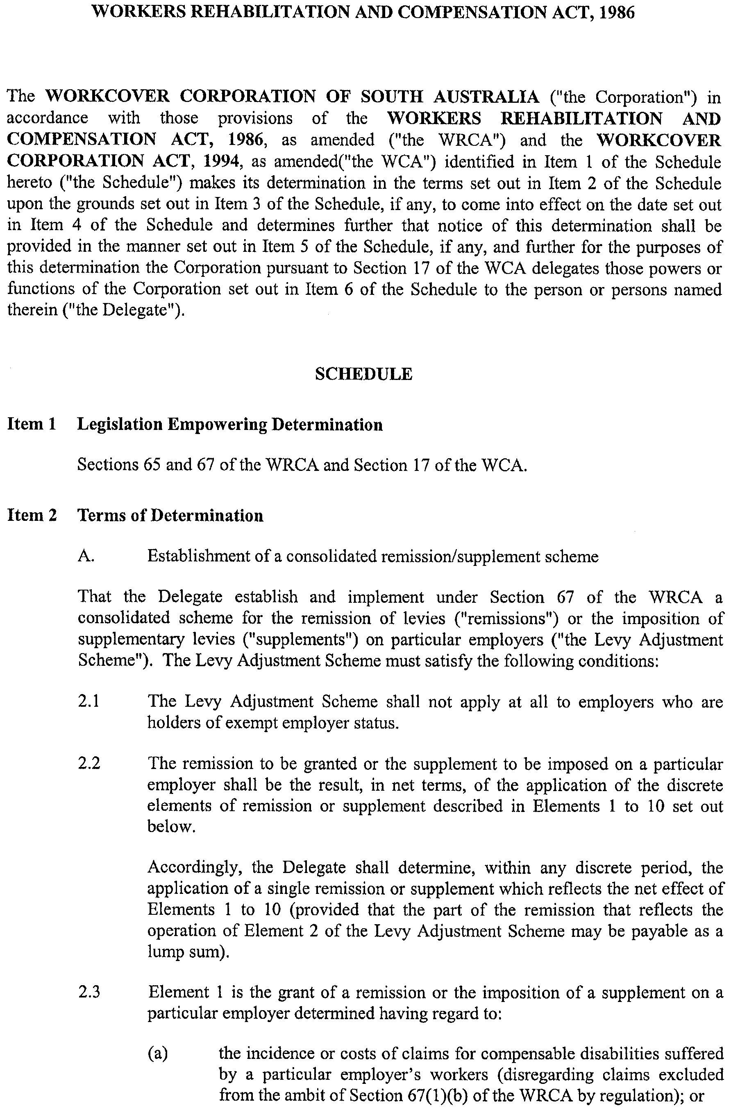
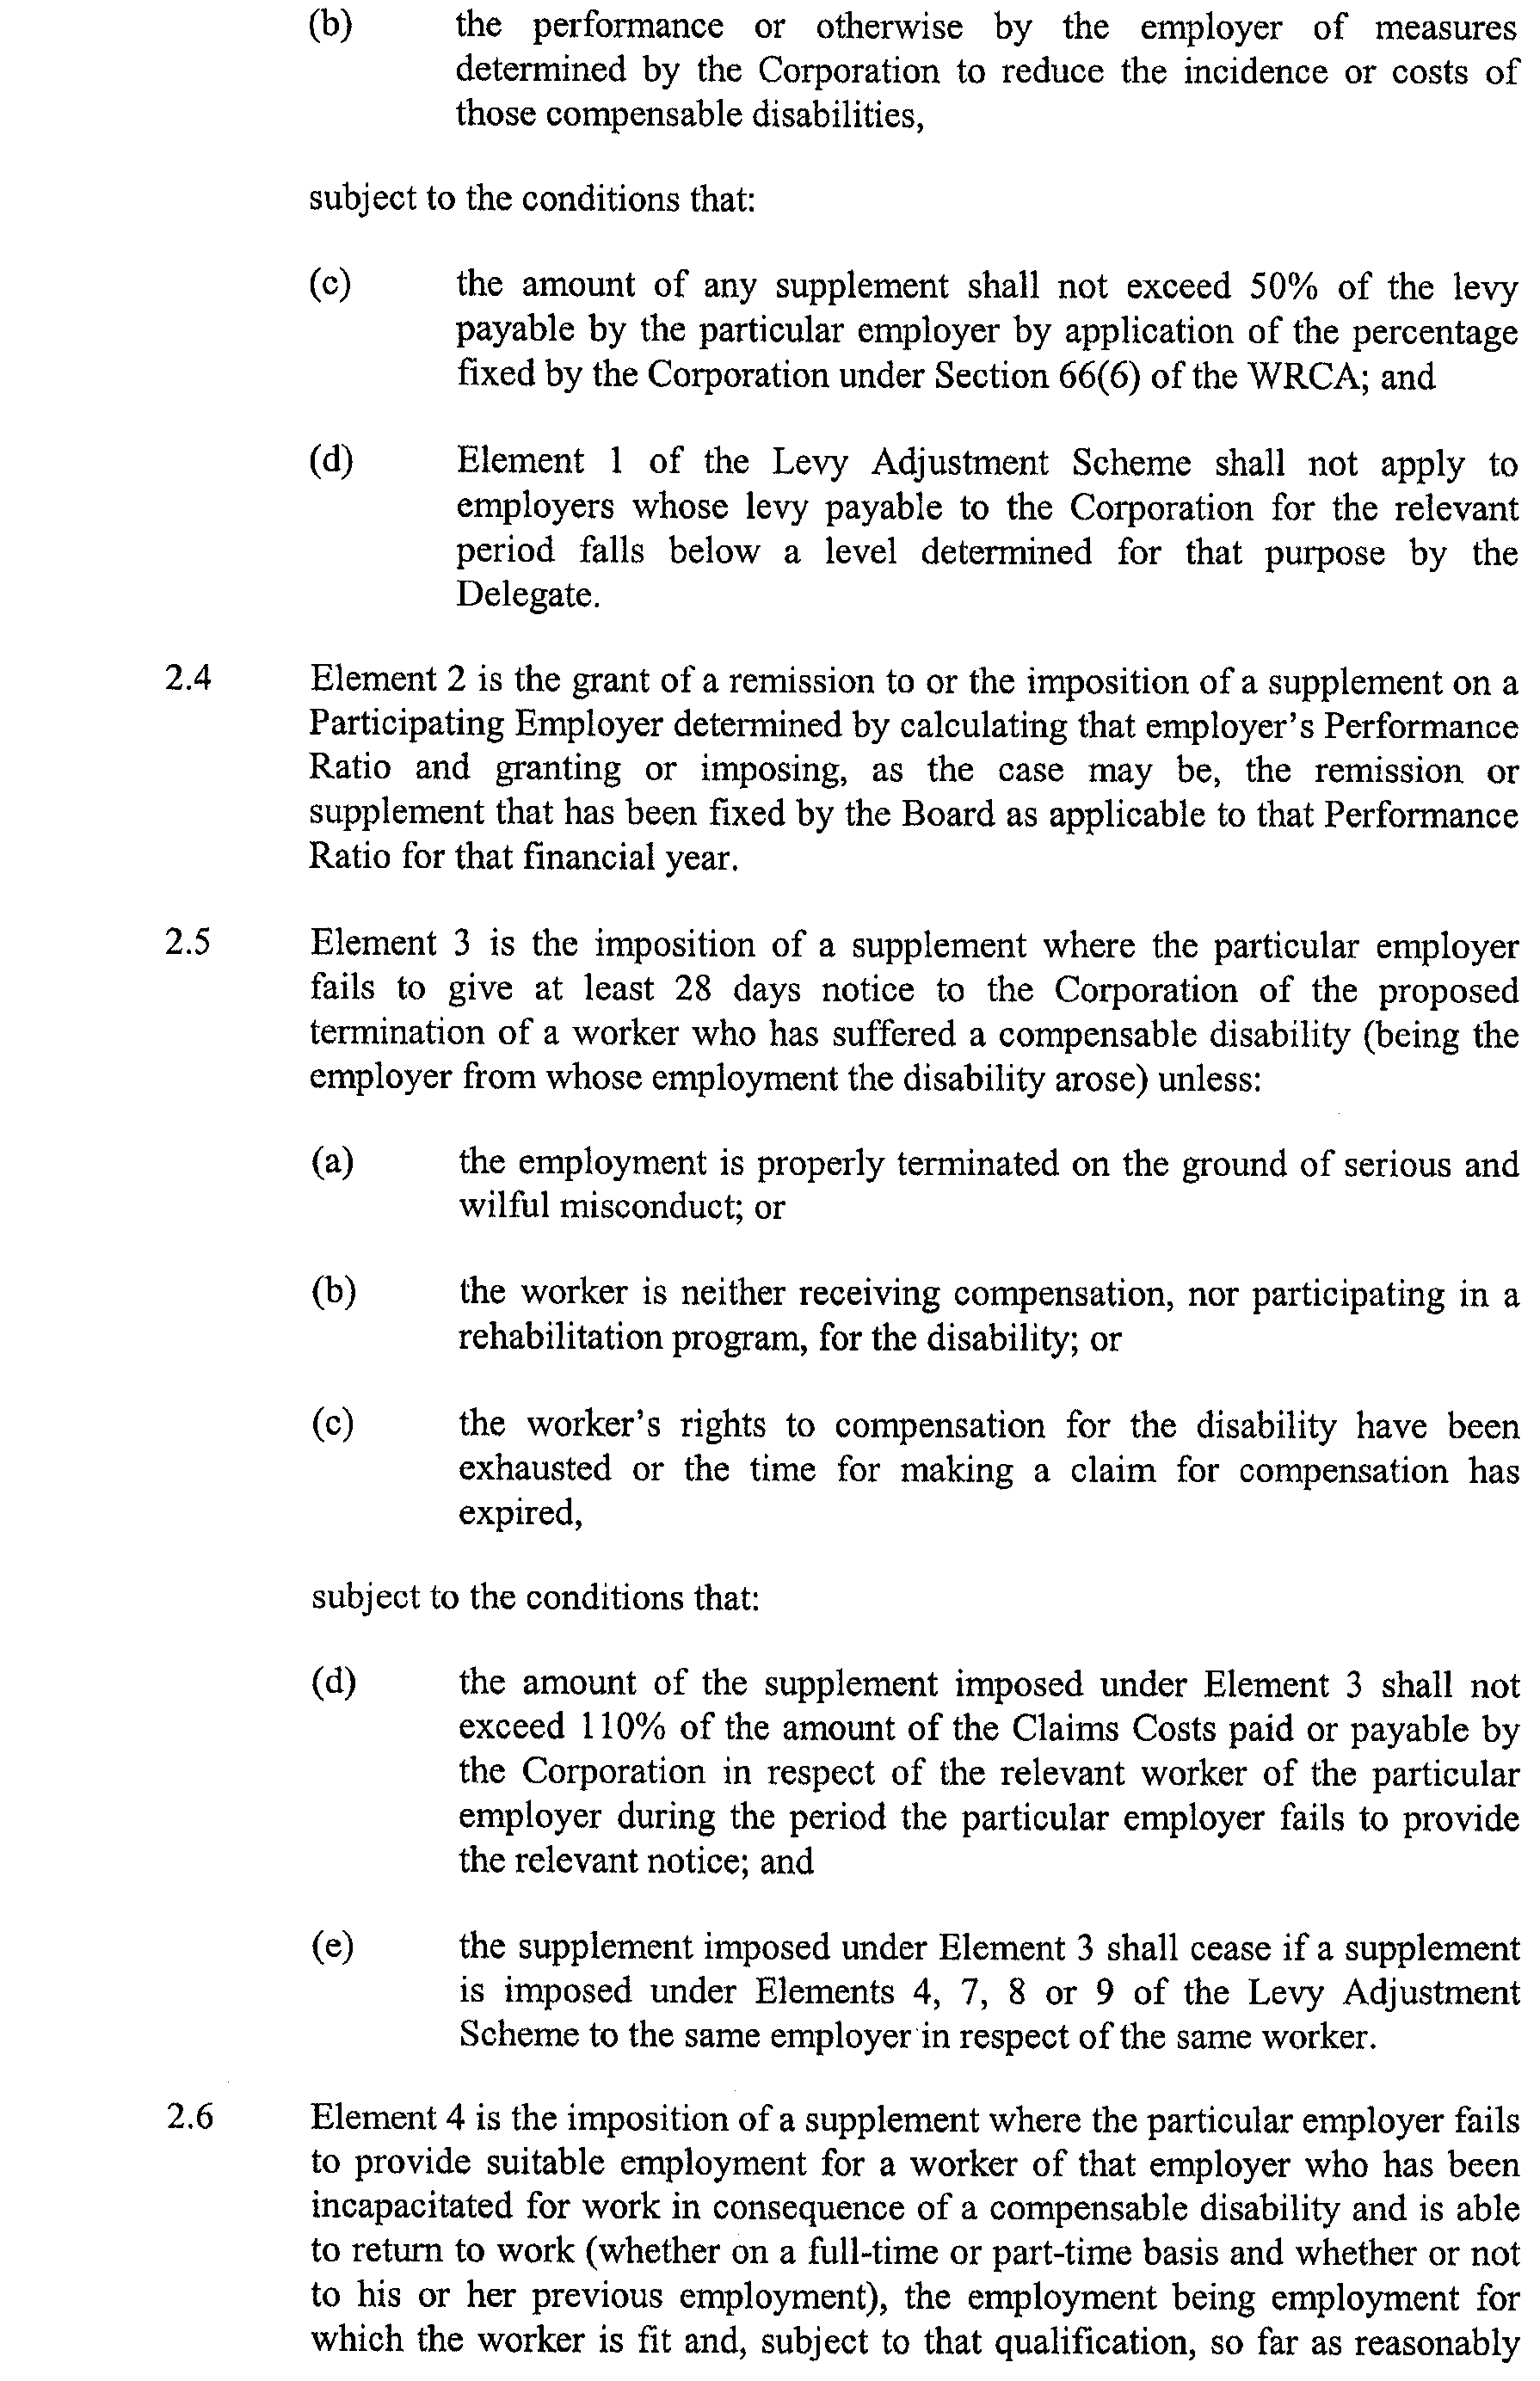
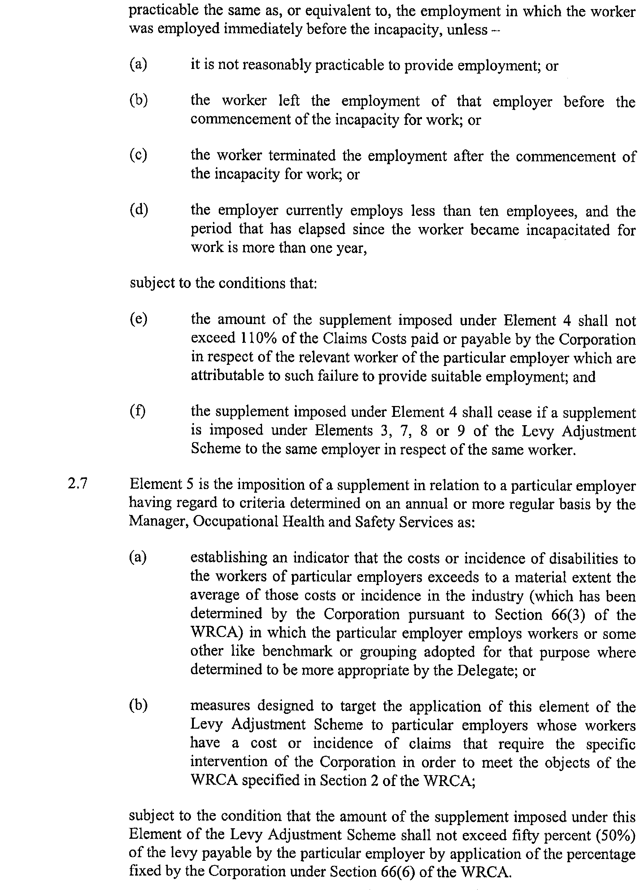
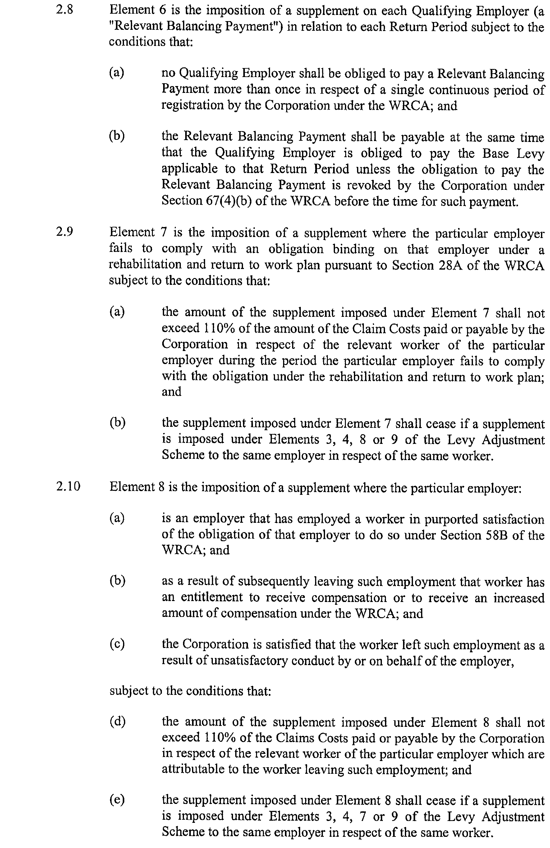
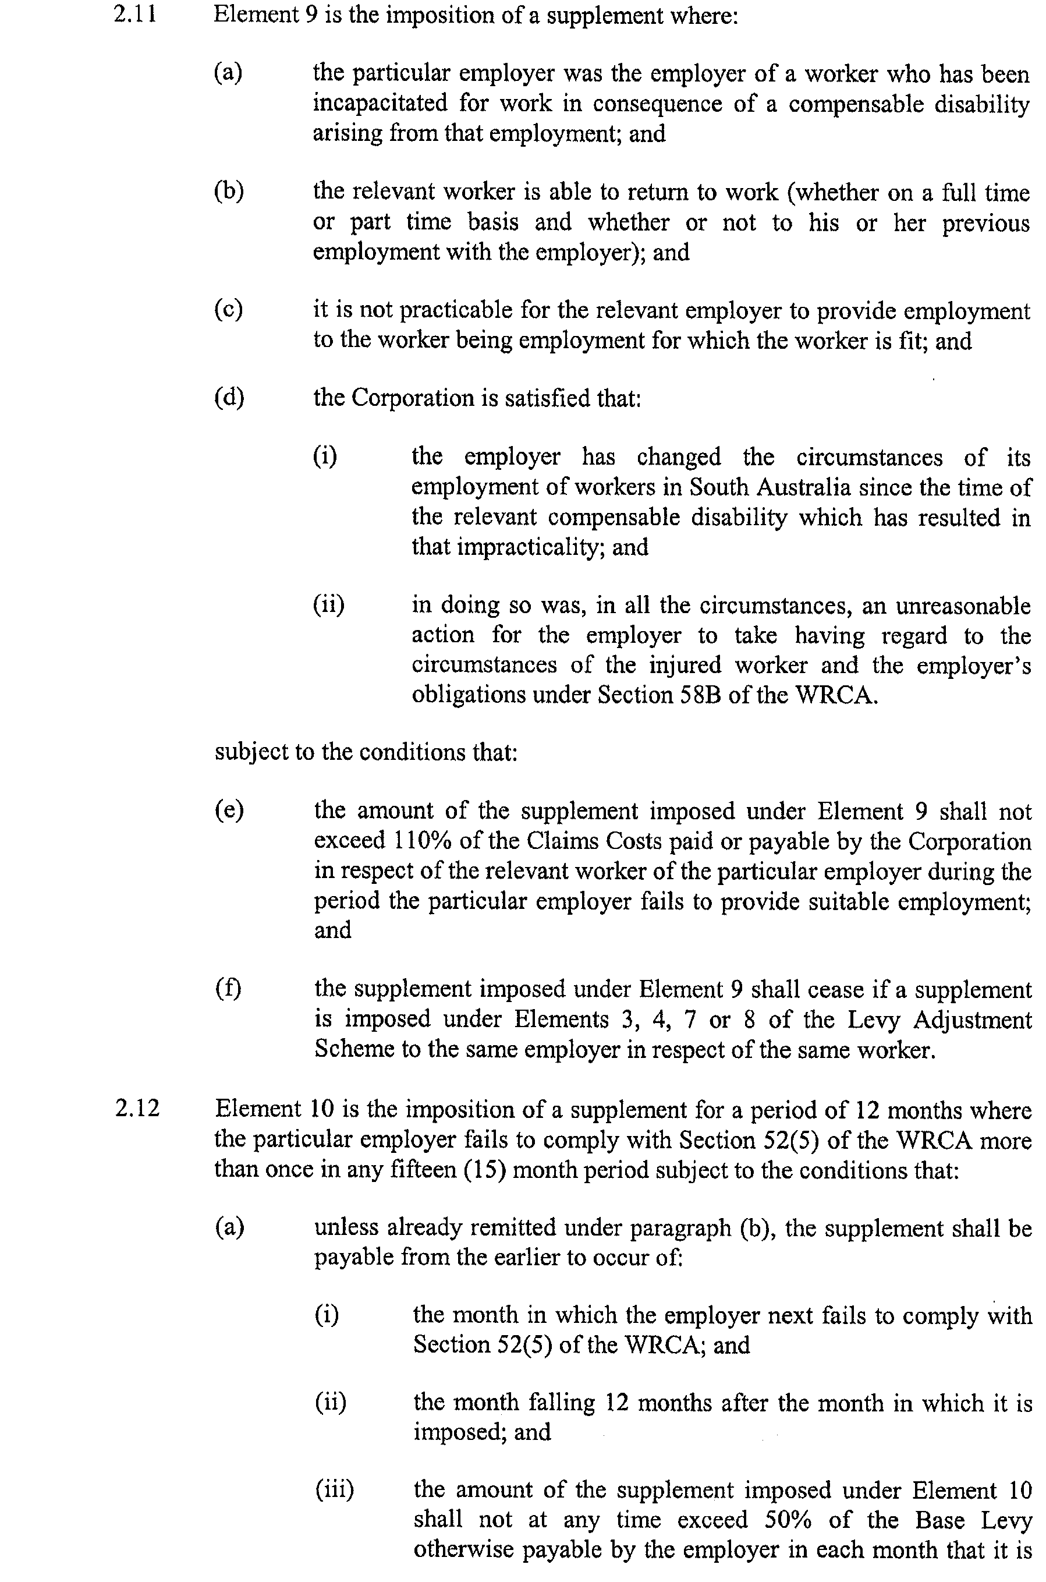
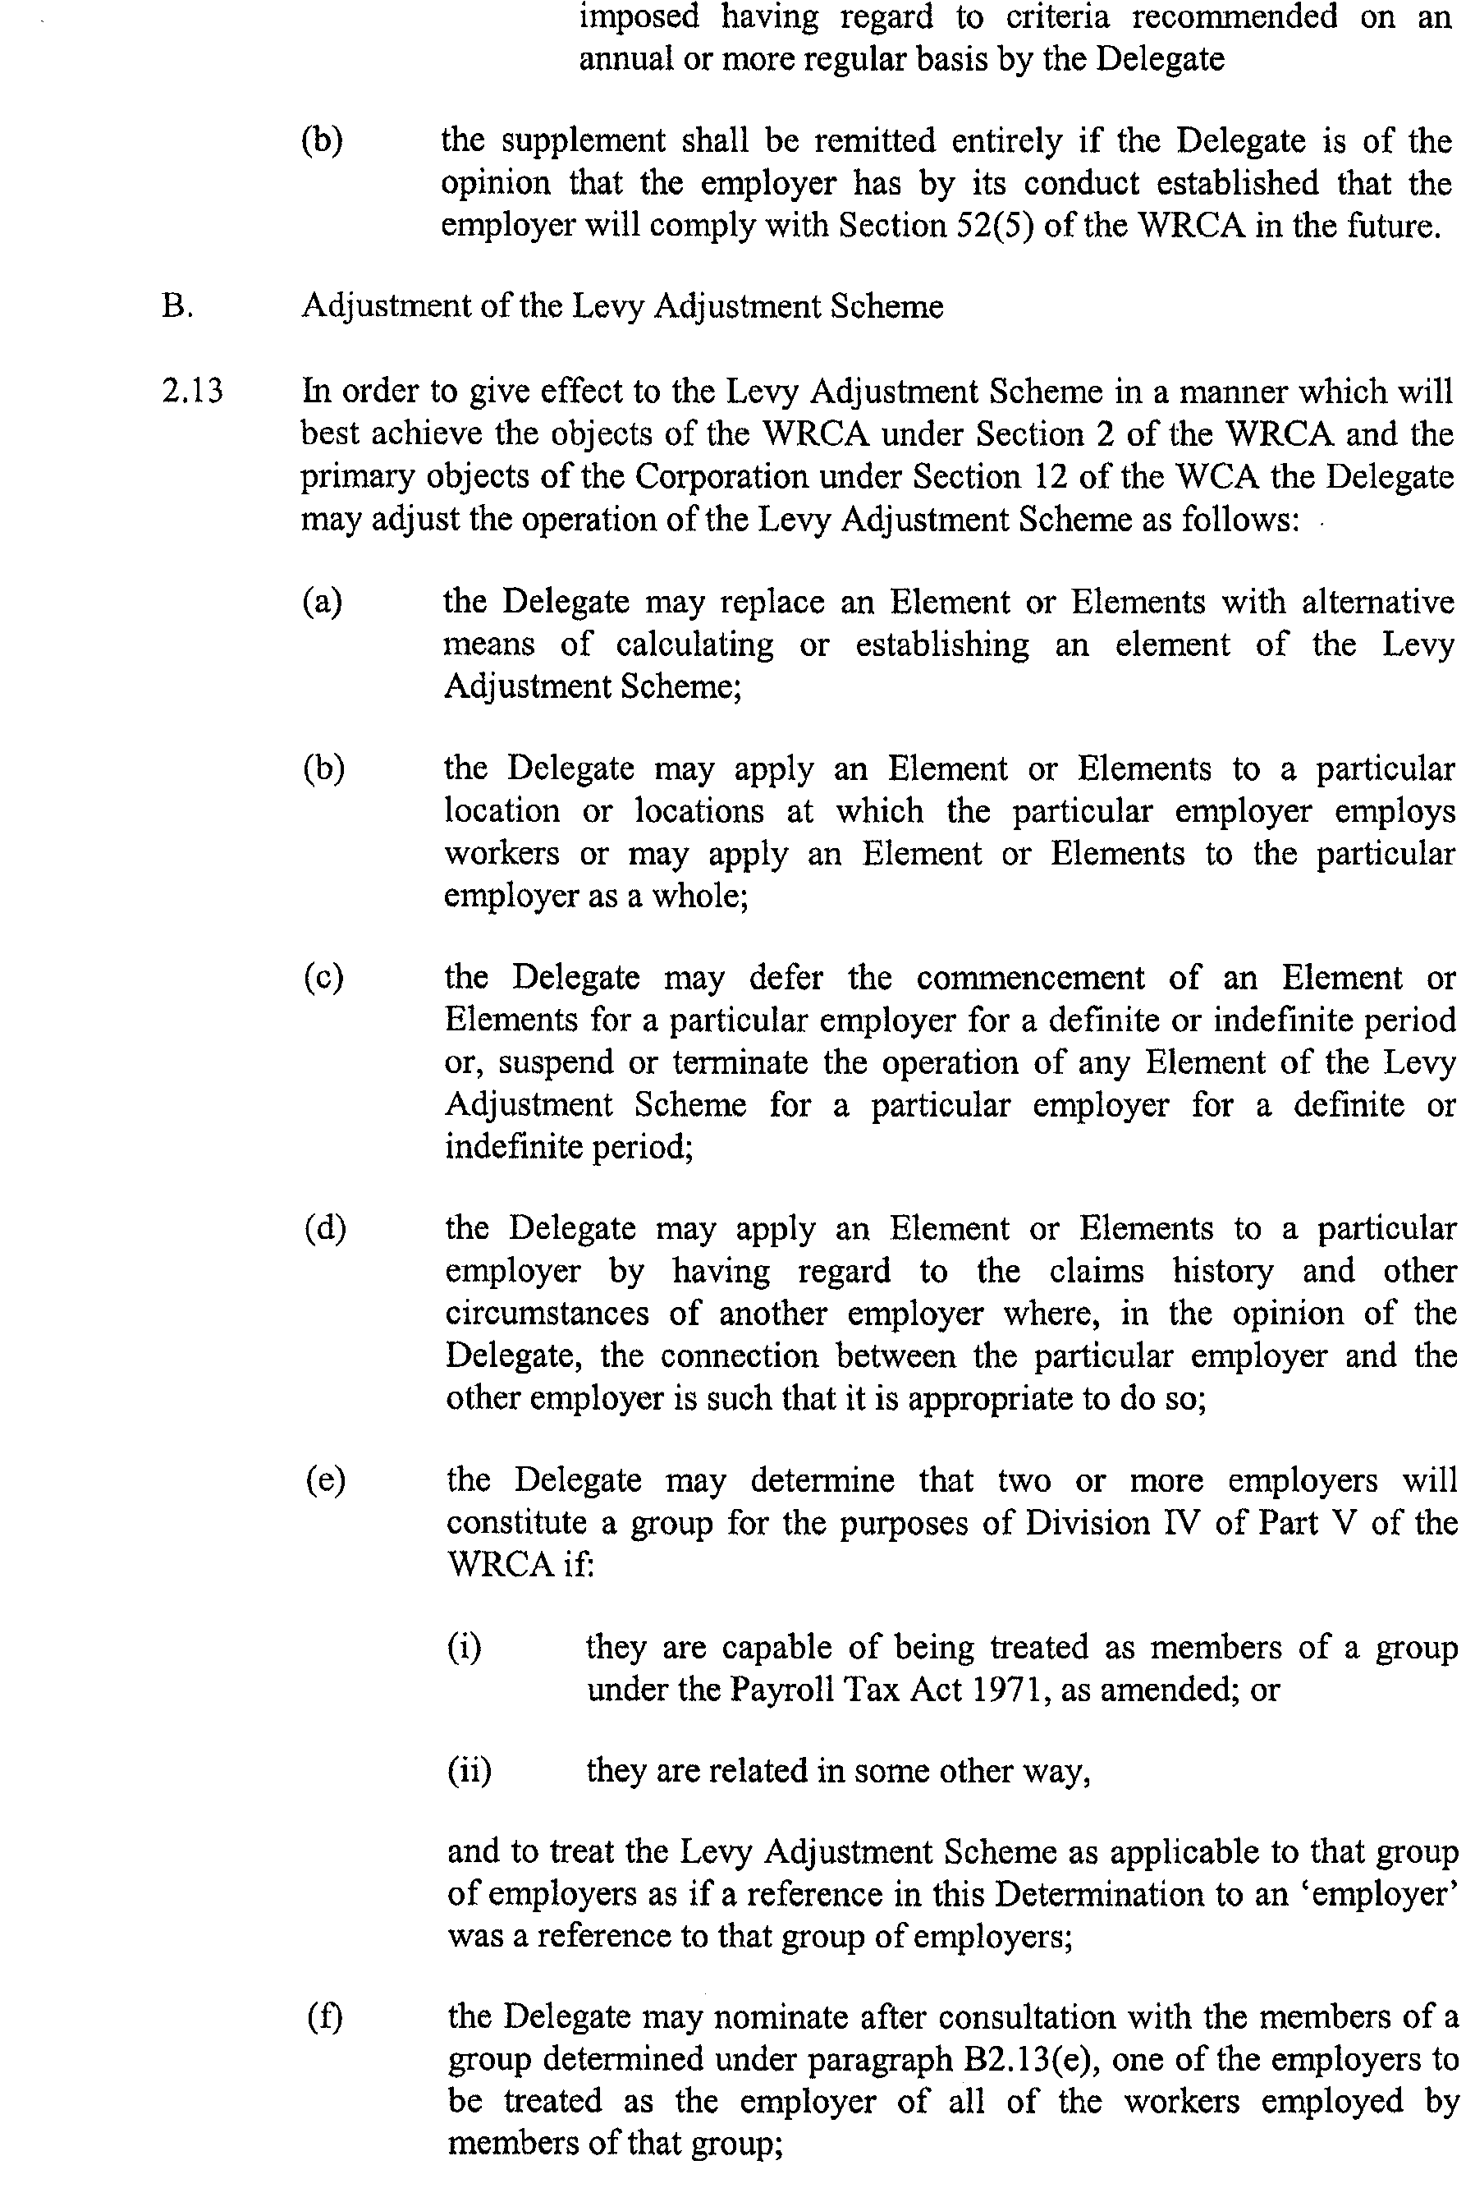
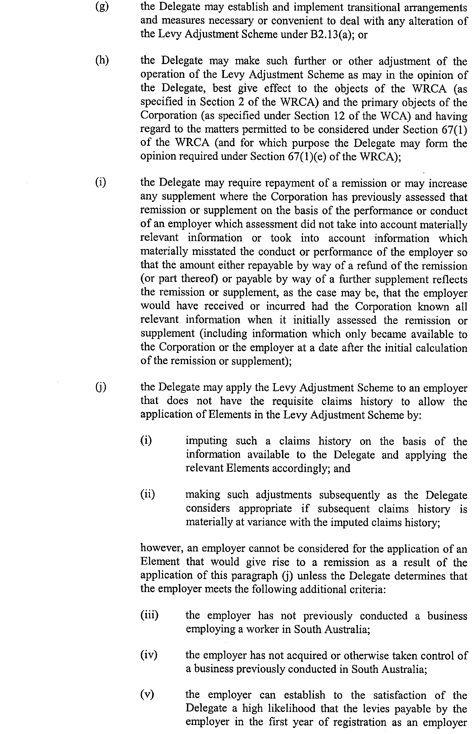
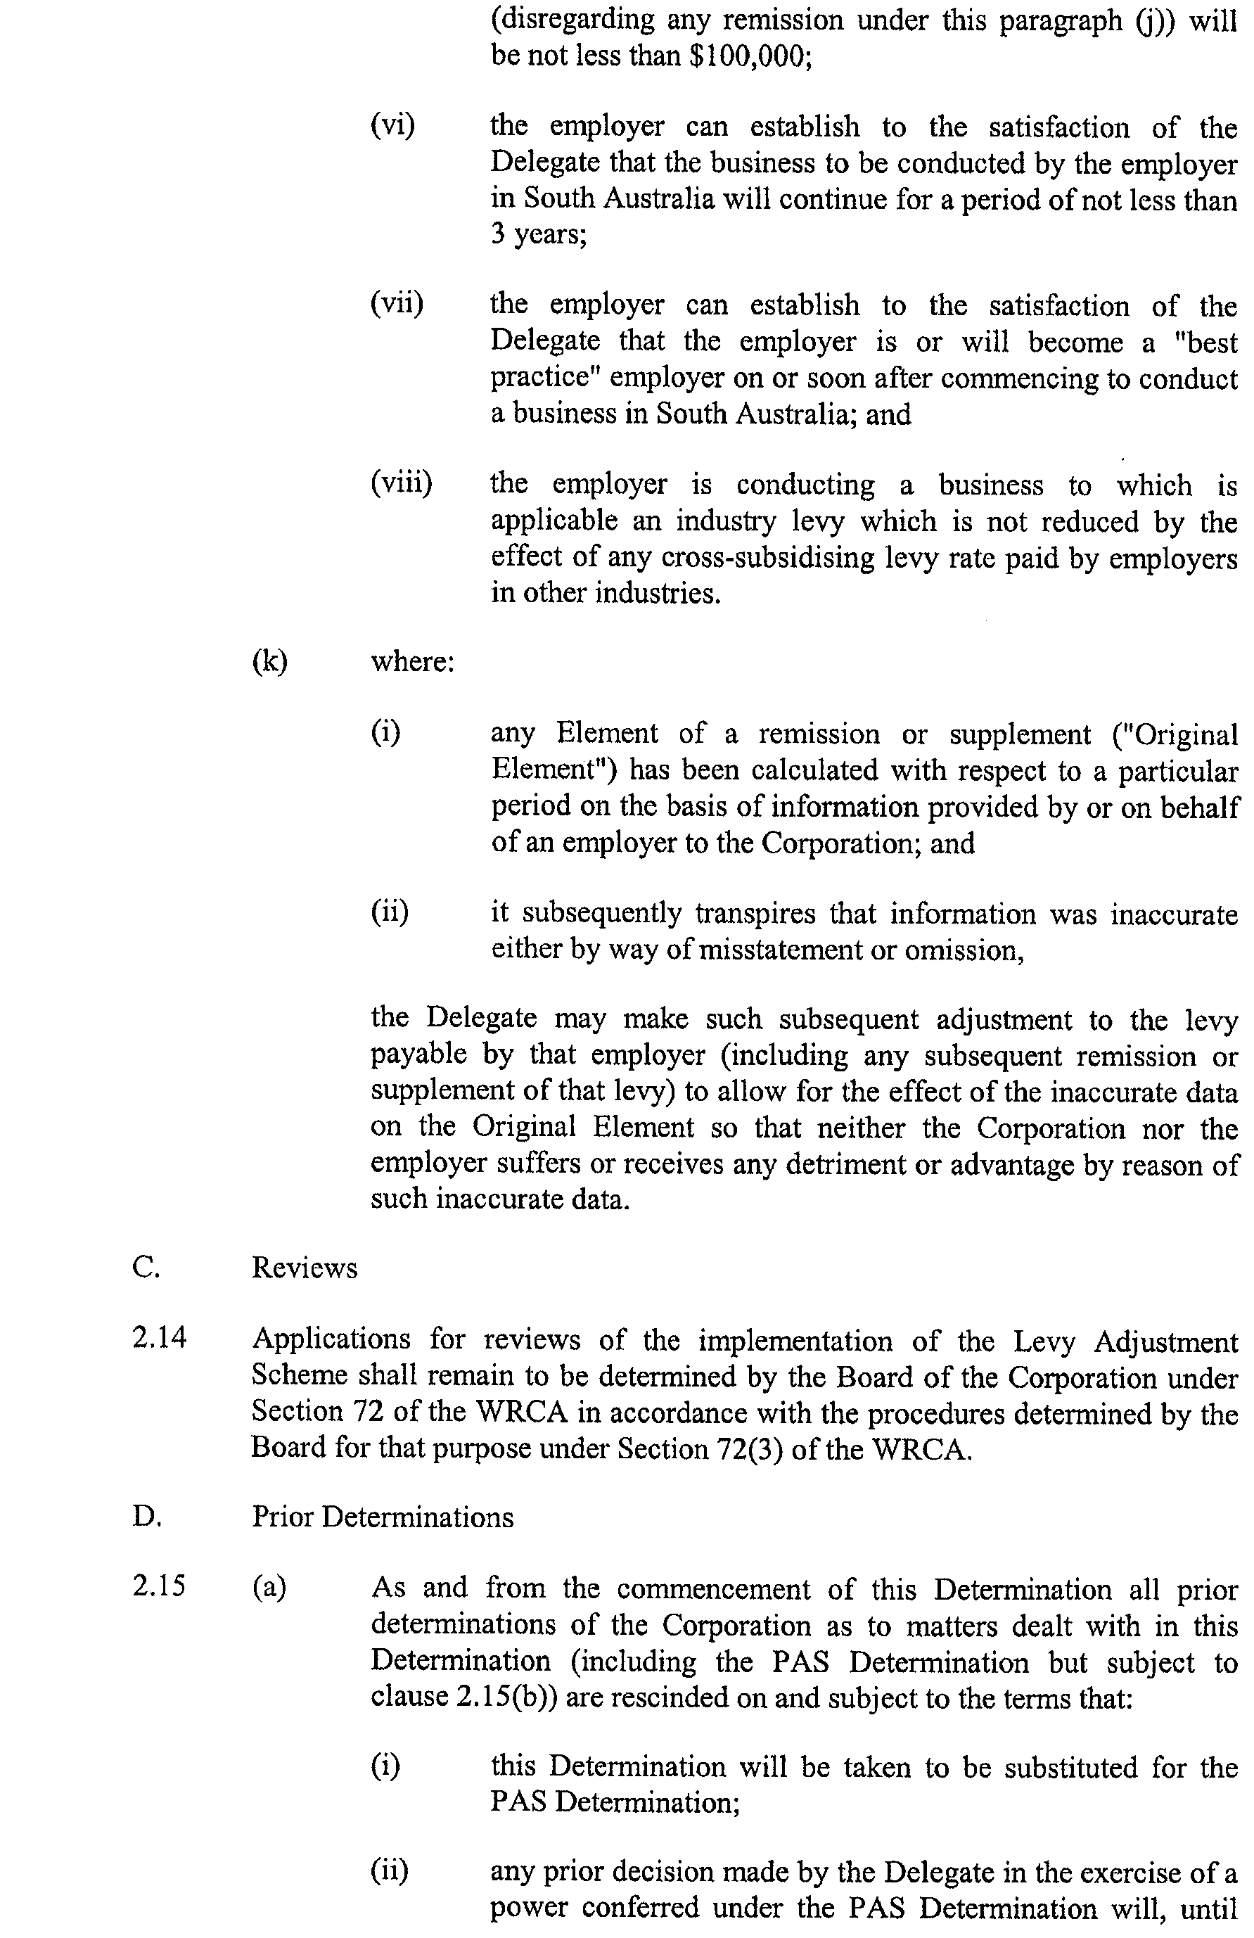
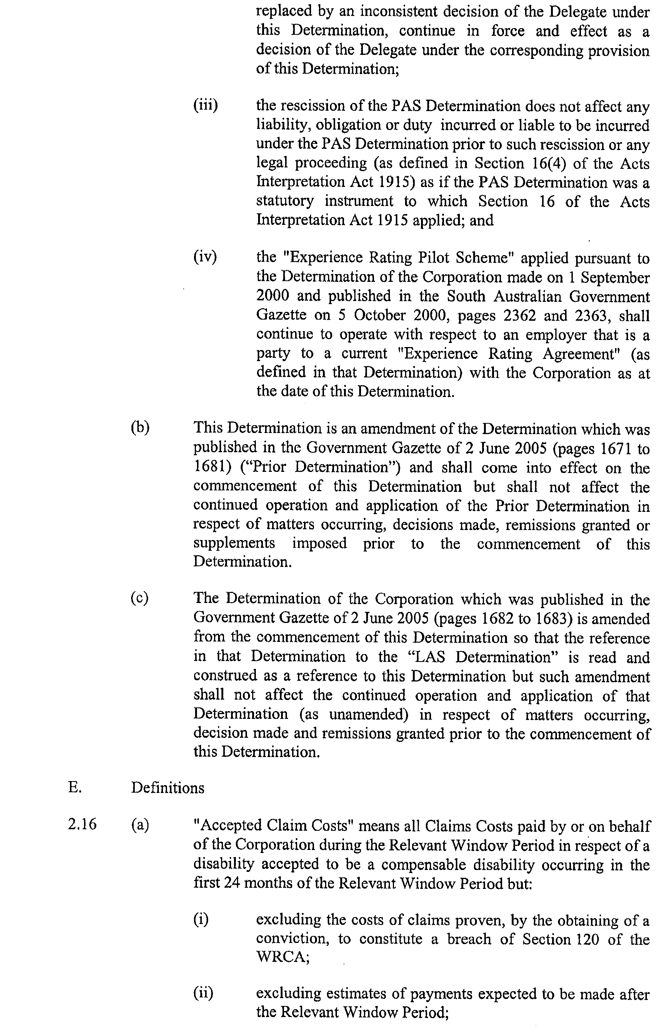
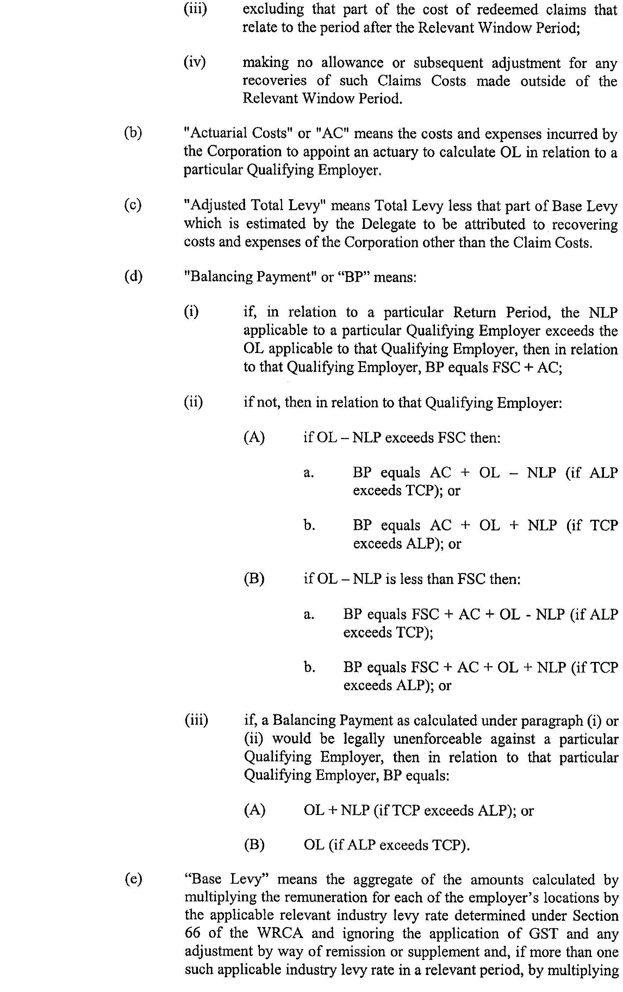
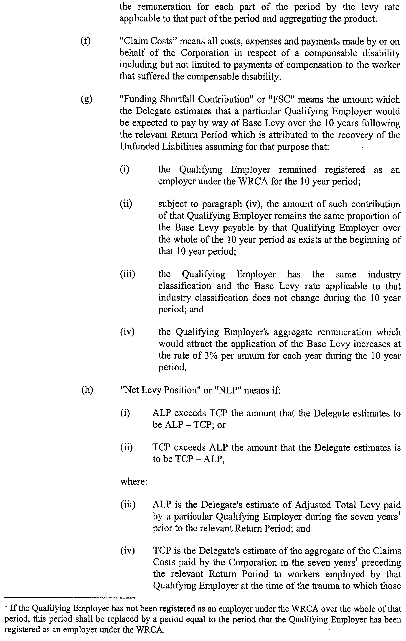
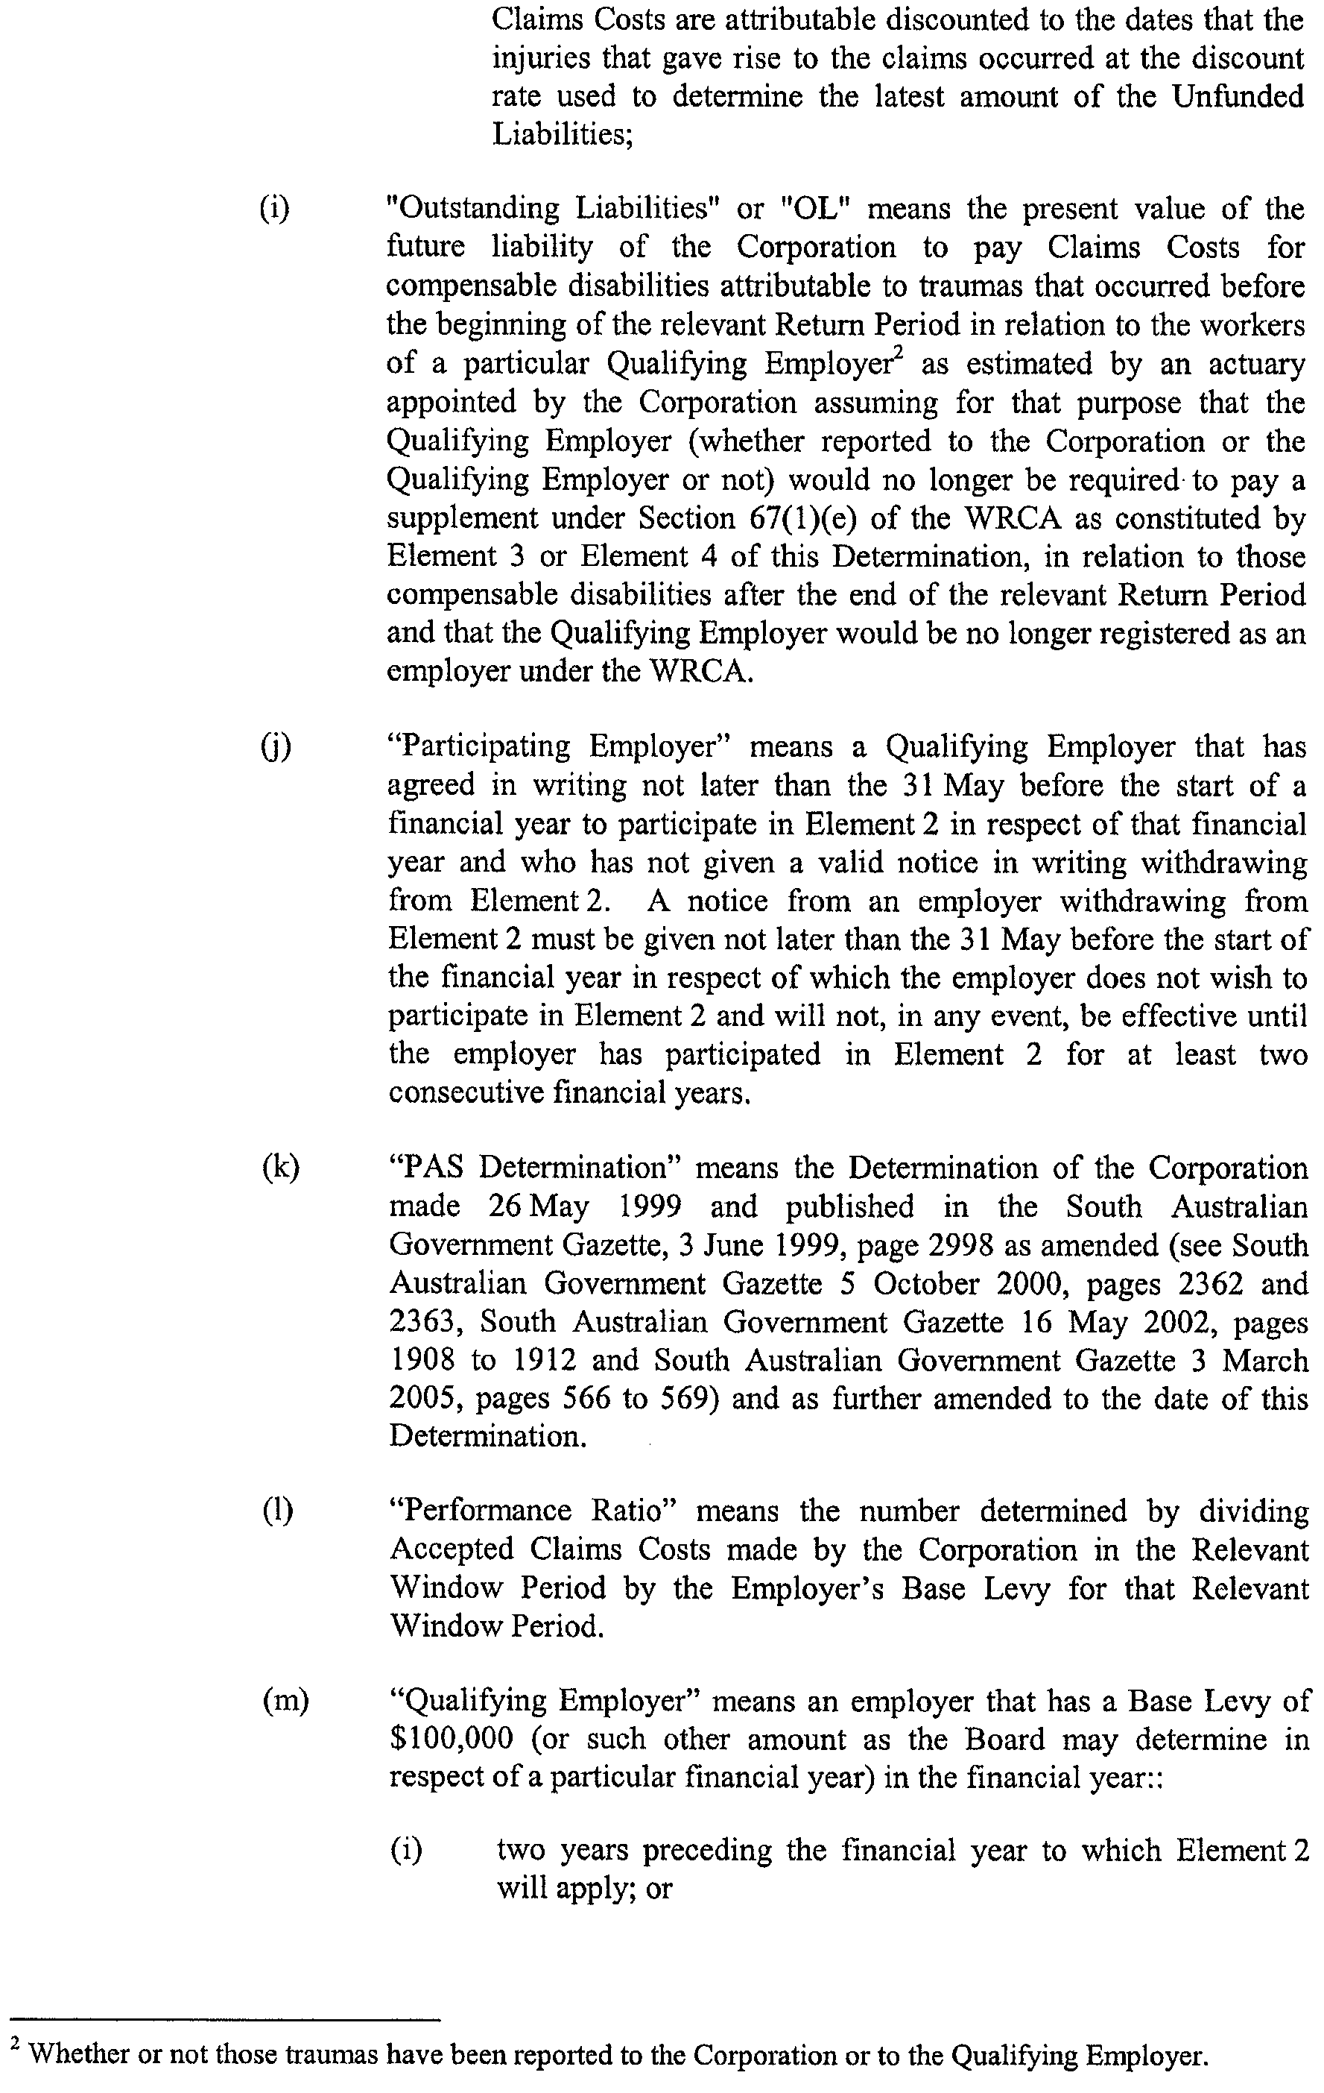
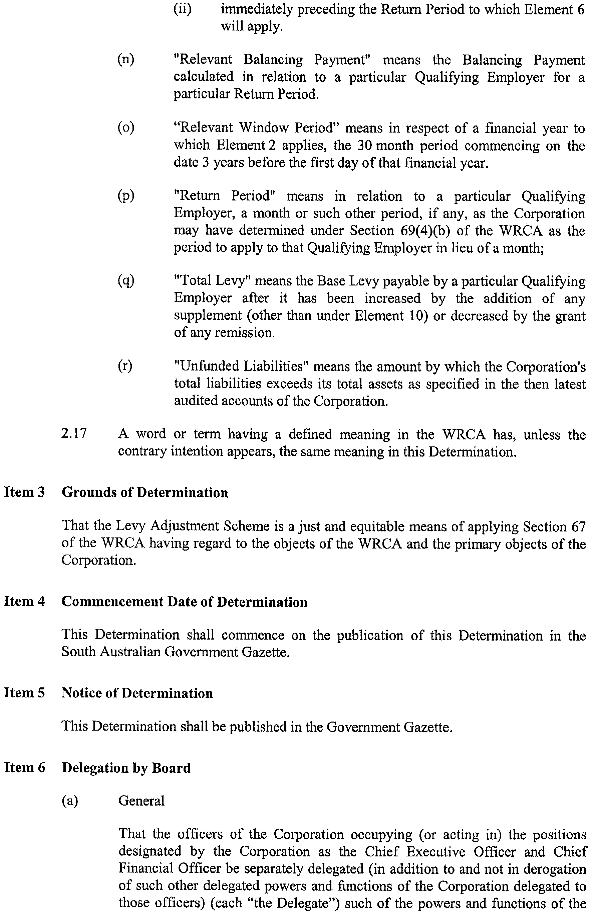
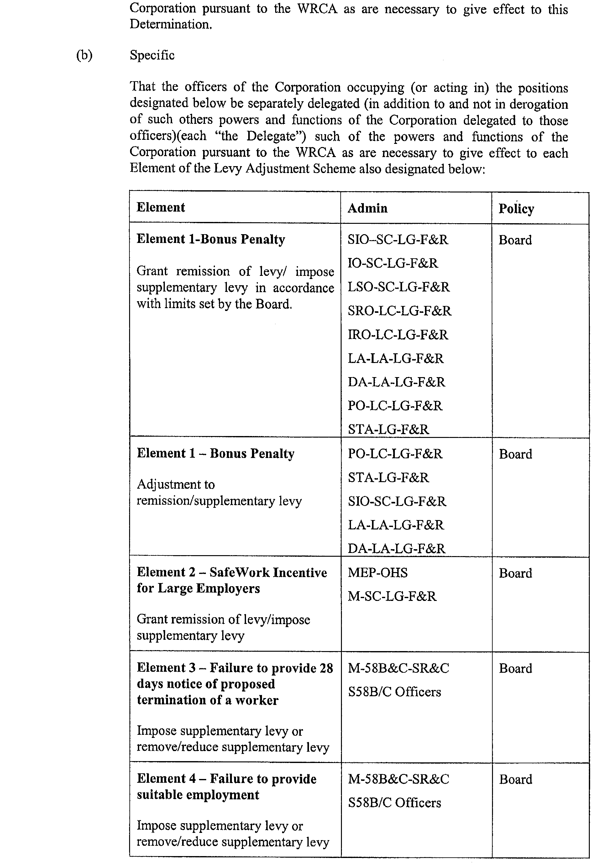
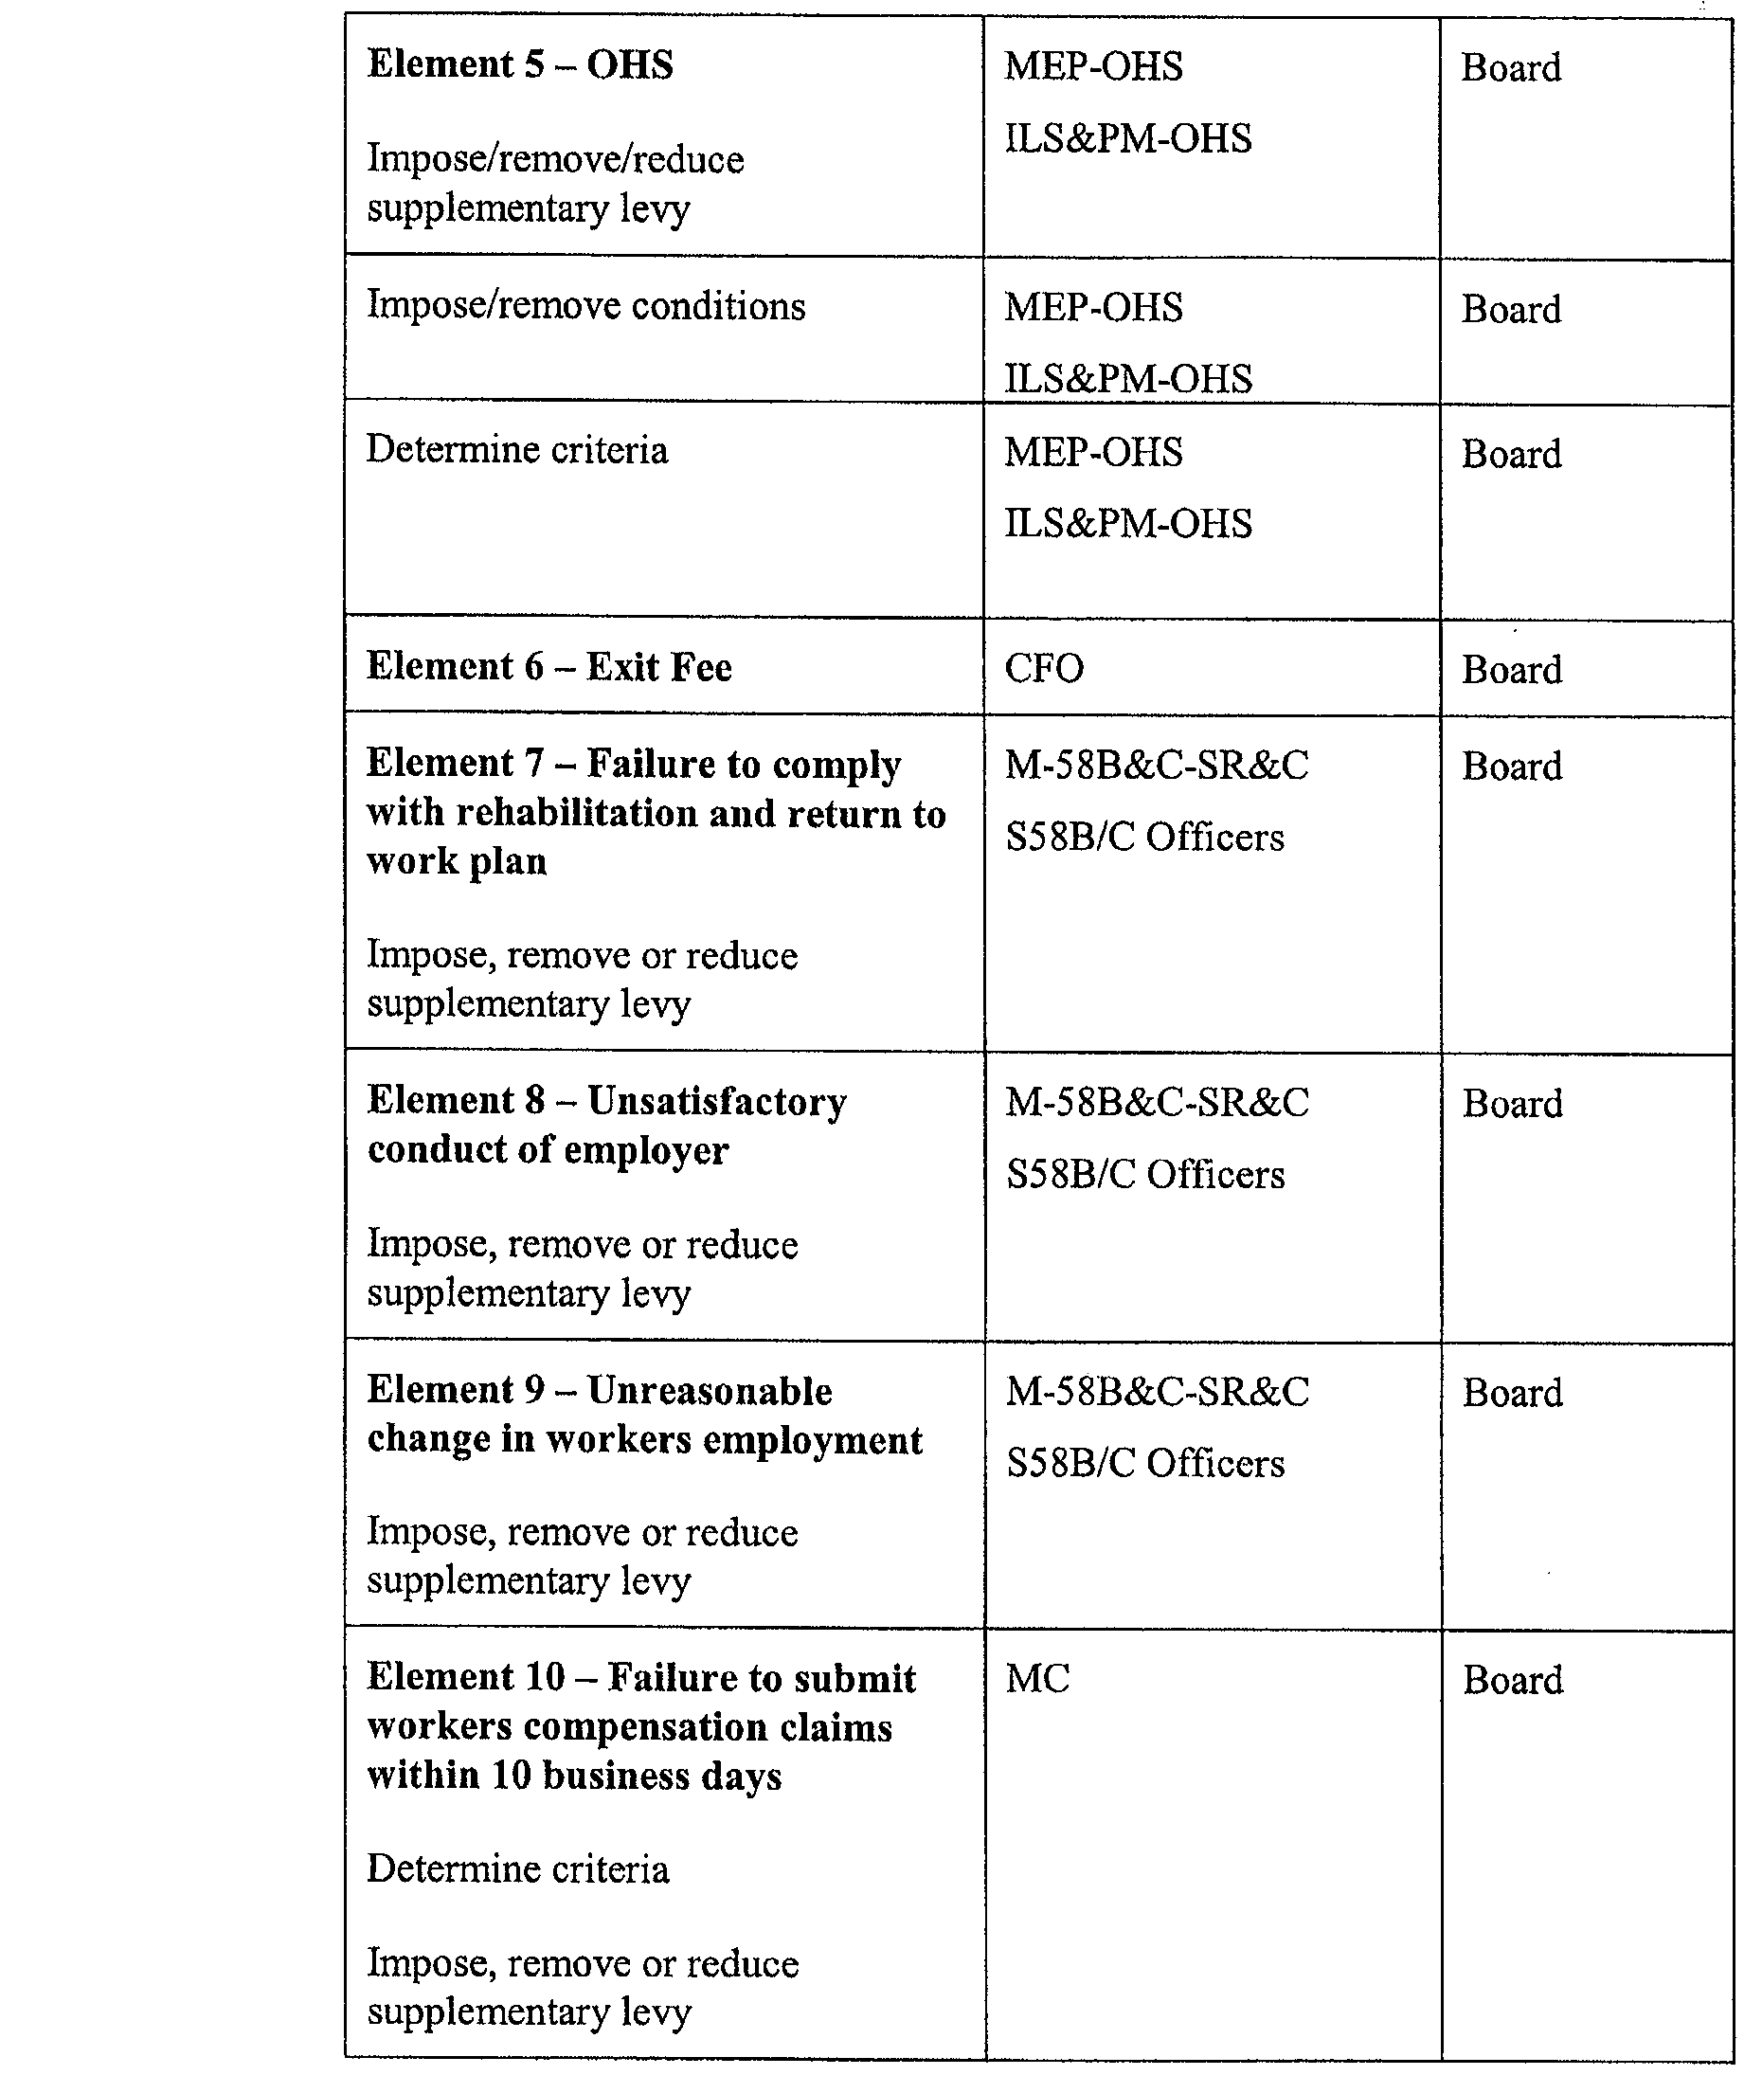
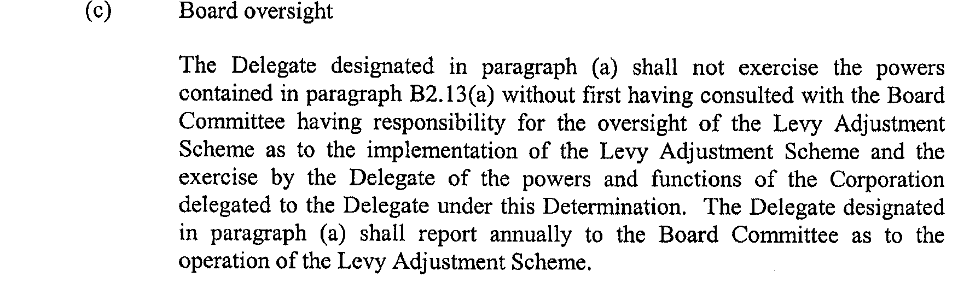
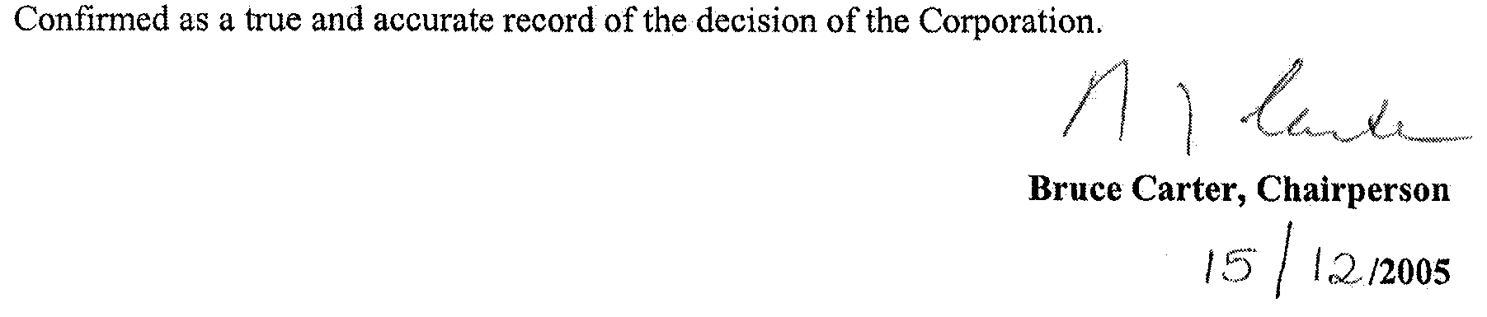

GOVERNMENT GAZETTE ADVERTISEMENT RATES

To apply from 1 July 2005

$  Agents, Ceasing to Act as 36.50  Associations:  Incorporation 18.60  Intention of Incorporation 46.00  Transfer of Properties 46.00  Attorney, Appointment of 36.50  Bailiff’s Sale 46.00  Cemetery Curator Appointed 27.25  Companies:  Alteration to Constitution 36.50  Capital, Increase or Decrease of 46.00  Ceasing to Carry on Business 27.25  Declaration of Dividend 27.25  Incorporation 36.50  Lost Share Certificates:  First Name 27.25  Each Subsequent Name 9.35  Meeting Final 30.50  Meeting Final Regarding Liquidator’s Report on  Conduct of Winding Up (equivalent to ‘Final  Meeting’)  First Name 36.50  Each Subsequent Name 9.35  Notices:  Call 46.00  Change of Name 18.60  Creditors 36.50  Creditors Compromise of Arrangement 36.50  Creditors (extraordinary resolution that ‘the Com-pany be wound up voluntarily and that a liquidator be appointed’) 46.00  Release of Liquidator⎯Application⎯Large Ad. 72.50  ⎯Release Granted 46.00  Receiver and Manager Appointed 42.50  Receiver and Manager Ceasing to Act 36.50  Restored Name 34.50  Petition to Supreme Court for Winding Up 64.00  Summons in Action 54.50  Order of Supreme Court for Winding Up Action 36.50  Register of Interests⎯Section 84 (1) Exempt 82.50  Removal of Office 18.60  Proof of Debts 36.50  Sales of Shares and Forfeiture 36.50  Estates:  Assigned 27.25  Deceased Persons⎯Notice to Creditors, etc. 46.00  Each Subsequent Name 9.35  Deceased Persons⎯Closed Estates 27.25  Each Subsequent Estate 1.20  Probate, Selling of 36.50  Public Trustee, each Estate 9.35 |  | $  Firms:  Ceasing to Carry on Business (each insertion) 24.30  Discontinuance Place of Business 24.30  Land⎯Real Property Act:  Intention to Sell, Notice of 46.00  Lost Certificate of Title Notices 46.00  Cancellation, Notice of (Strata Plan) 46.00  Mortgages:  Caveat Lodgment 18.60  Discharge of 19.50  Foreclosures 18.60  Transfer of 18.60  Sublet 9.35  Leases⎯Application for Transfer (2 insertions) each 9.35  Lost Treasury Receipts (3 insertions) each 27.25  Licensing 54.50  Municipal or District Councils:  Annual Financial Statement⎯Forms 1 and 2 513.00  Electricity Supply⎯Forms 19 and 20 364.00  Default in Payment of Rates:  First Name 72.50  Each Subsequent Name 9.35  Noxious Trade 27.25  Partnership, Dissolution of 27.25  Petitions (small) 18.60  Registered Building Societies (from Registrar-  General) 18.60  Register of Unclaimed Moneys⎯First Name 27.25  Each Subsequent Name 9.35  Registers of Members⎯Three pages and over:  Rate per page (in 8pt) 233.00  Rate per page (in 6pt) 308.00  Sale of Land by Public Auction 46.50  Advertisements 2.60  ¼ page advertisement 109.00  ½ page advertisement 218.00  Full page advertisement 427.00  Advertisements, other than those listed are charged at $2.60 per column line, tabular one-third extra.  Notices by Colleges, Universities, Corporations and District Councils to be charged at $2.60 per line.  Where the notice inserted varies significantly in length from that which is usually published a charge of $2.60 per column line will be applied in lieu of advertisement rates listed.  South Australian Government publications are sold on the condition that they will not be reproduced without prior permission from the Government Printer.
All the above prices include GST

GOVERNMENT GAZETTE NOTICES
ALL private advertisements forwarded for publication in the South Australian Government Gazette must be PAID FOR PRIOR TO INSERTION; and all notices, from whatever source, should be legibly written on one side of the paper only and sent to Government Publishing SA so as to be received no later than 4 p.m. Tuesday preceding the day of publication. Phone 8207 1045 or Fax 8207 1040. E-mail: governmentgazette@saugov.sa.gov.au. Send as attachments in Word format. Please include date the notice is to be published and to whom the notice will be charged. The Government Gazette is available online at: www.governmentgazette.sa.gov.au.

MISCELLANEOUS LEGISLATION AND GOVERNMENT PUBLICATIONS PRICES AS FROM 1 JULY 2005

Acts, Bills, Rules, Parliamentary Papers and Regulations
Pages | Main | Amends | Pages | Main | Amends

1-16 | 2.20 | 1.00 | 497-512 | 31.00 | 30.00
17-32 | 3.00 | 1.85 | 513-528 | 32.00 | 30.75
33-48 | 3.90 | 2.80 | 529-544 | 33.00 | 32.00
49-64 | 4.90 | 3.75 | 545-560 | 34.00 | 33.00
65-80 | 5.75 | 4.75 | 561-576 | 34.75 | 34.00
81-96 | 6.70 | 5.55 | 577-592 | 35.75 | 34.50
97-112 | 7.60 | 6.50 | 593-608 | 36.75 | 35.50
113-128 | 8.55 | 7.45 | 609-624 | 37.50 | 36.50
129-144 | 9.60 | 8.50 | 625-640 | 38.50 | 37.00
145-160 | 10.50 | 9.35 | 641-656 | 39.50 | 38.50
161-176 | 11.50 | 10.30 | 657-672 | 40.00 | 39.00
177-192 | 12.40 | 11.30 | 673-688 | 41.75 | 40.00
193-208 | 13.40 | 12.30 | 689-704 | 42.50 | 41.00
209-224 | 14.20 | 13.10 | 705-720 | 43.00 | 42.00
225-240 | 15.10 | 14.00 | 721-736 | 44.75 | 43.00
241-257 | 16.20 | 14.70 | 737-752 | 45.25 | 44.00
258-272 | 17.10 | 15.70 | 753-768 | 46.25 | 44.50
273-288 | 18.00 | 16.90 | 769-784 | 46.75 | 46.00
289-304 | 18.80 | 17.70 | 785-800 | 47.75 | 47.00
305-320 | 19.90 | 18.70 | 801-816 | 48.50 | 47.50
321-336 | 20.70 | 19.60 | 817-832 | 49.75 | 48.50
337-352 | 21.80 | 20.60 | 833-848 | 50.75 | 49.50
353-368 | 22.60 | 21.60 | 849-864 | 51.50 | 50.00
369-384 | 23.60 | 22.50 | 865-880 | 52.50 | 51.50
385-400 | 24.50 | 23.40 | 881-896 | 53.00 | 52.00
401-416 | 25.50 | 24.20 | 897-912 | 54.50 | 53.00
417-432 | 26.50 | 25.25 | 913-928 | 55.00 | 54.50
433-448 | 27.50 | 26.25 | 929-944 | 56.00 | 55.00
449-464 | 28.25 | 27.00 | 945-960 | 57.00 | 55.50
465-480 | 28.75 | 28.00 | 961-976 | 58.25 | 56.50
481-496 | 30.00 | 28.75 | 977-992 | 59.25 | 57.00

Legislation—Acts, Regulations, etc: $
Subscriptions:
Acts 192.00
All Bills as Laid 460.00
Rules and Regulations 460.00
Parliamentary Papers 460.00
Bound Acts 213.00
Index 106.00
Government Gazette
Copy 5.00
Subscription 254.00
Hansard
Copy 14.00
Subscription—per session (issued weekly) 399.00
Cloth bound—per volume 172.00
Subscription—per session (issued daily) 399.00
Legislation on Disk
Whole Database 2 951.00
Annual Subscription for fortnightly updates 907.00
Individual Act(s) including updates POA
Compendium
Subscriptions:
Subscriptions 1 749.00
Updates 617.00
(All the above prices include GST)

All Legislation, Government Gazette, Hansard and Legislation on disk are available from:
Counter Sales Service SA, Government Legislation⁺ Outlet
and Mail Orders: Lands Titles Office, 101 Grenfell Street, Adelaide, S.A. 5000
Phone: 13 23 24 (local call cost), Fax: (08) 8204 1909
Postal: G.P.O. Box 1707, Adelaide, S.A. 5001

Online Shop: www.shop.service.sa.gov.au

Subscriptions and Government Publishing SA
Standing Orders: Box 9, Plaza Level, Riverside Centre, North Terrace, Adelaide, S.A. 5000
Phone: (08) 8207 0908, (08) 8207 0910, Fax: (08) 8207 1040

South Australia
Adelaide Park Lands Act (Commencement) Proclamation 2006
1—Short title
This proclamation may be cited as the Adelaide Park Lands Act (Commencement) Proclamation 2006.
2—Commencement of Act and suspension of certain provisions
(1) The Adelaide Park Lands Act 2005 (No 69 of 2005) will come into operation on 1 February 2006.
(2) The operation of the following provisions of the Act is suspended until a day or time or days or times to be fixed by subsequent proclamation or proclamations:
(a) sections 5 to 26 (inclusive);
(b) Schedule 1, Parts 2 to 6 (inclusive);
(c) Schedule 1, Parts 8 to 11 (inclusive).
Made by the Governor
with the advice and consent of the Executive Council
on 25 January 2006
EC06/0004CS

South Australia
Administrative Arrangements (Administration of Adelaide Park Lands Act) Proclamation 2006
under section 5 of the Administrative Arrangements Act 1994
1—Short title
This proclamation may be cited as the Administrative Arrangements (Administration of Adelaide Park Lands Act) Proclamation 2006.
2—Commencement
This proclamation comes into operation on the day on which it is made.
3—Administration of Act committed to Minister for Environment and Conservation
The administration of the Adelaide Park Lands Act 2005 is committed to the Minister for Environment and Conservation.
Made by the Governor
with the advice and consent of the Executive Council
on 25 January 2006
EC06/0004CS
South Australia
Explosives (Security Sensitive Ammonium Nitrate) Proclamation 2006
under section 5 of the Explosives Act 1936
1—Short title
This proclamation may be cited as the Explosives (Security Sensitive Ammonium Nitrate) Proclamation 2006.
2—Commencement
This proclamation will come into operation 6 months after the day on which it is made.
3—Interpretation
In this proclamation—
Act means the Explosives Act 1936;
ammonium nitrate blasting intermediate means an emulsion, suspension or gel primarily made up of ammonium nitrate (with or without other inorganic nitrates), containing other substances such as oxidisers and fuels, and intended for use as a blasting explosive following modification prior to use;
Class 1 Dangerous Goods has the same meaning as in the Explosives Regulations 1996;
security sensitive ammonium nitrate means—
(a) ammonium nitrate; or
(b) ammonium nitrate blasting intermediate; or
(c) ammonium nitrate at greater than 45% mass per mass mixed with any other substance, but not in solution,
but does not include a substance or article that satisfies the requirements for assignment to Class 1 Dangerous Goods.
4—Extension of definition of explosive to security sensitive ammonium nitrate
Security sensitive ammonium nitrate is declared to be an explosive within the meaning of the Act.
5—Application of Act and regulations
For the purposes of the Act and regulations made under the Act, security sensitive ammonium nitrate is declared to be a security sensitive substance.
Made by the Governor
with the advice and consent of the Executive Council
on 25 January 2006
DPC015/04CS

South Australia
Liquor Licensing (Conferral of Authority) Proclamation 2006
under section 15 of the Liquor Licensing Act 1997
1—Short title
This proclamation may be cited as the Liquor Licensing (Conferral of Authority) Proclamation 2006.
2—Commencement
This proclamation comes into operation on the day on which it is made.
3—Conferral of authority on District Court Judge
Authority is conferred on the District Court Judge named in Schedule 1 to exercise the jurisdiction of the Licensing Court of South Australia.
Schedule 1—District Court Judge on which authority is conferred
His Honour Paul John Rice
Made by the Governor
with the advice and consent of the Executive Council
on 25 January 2006
AGO0310/04CS

South Australia
National Parks and Wildlife (Nullarbor National Park) Proclamation 2006
under section 28(2) of the National Parks and Wildlife Act 1972
1—Short title
This proclamation may be cited as the National Parks and Wildlife (Nullarbor National Park) Proclamation 2006.
2—Commencement
This proclamation comes into operation on the day on which it is made.
3—Alteration of boundaries of Nullarbor National Park
The boundaries of the Nullarbor National Park are altered by adding to the Park the following Crown land:
Sections 496 and 498, Out of Hundreds (Nullarbor).
Made by the Governor
with the advice and consent of the Executive Council
on 25 January 2006
EC06/0003CS

South Australia
Natural Resources Management (Dissolution of Prescribed Bodies) Proclamation 2006
under Schedule 4 clauses 45 and 46 of the Natural Resources Management Act 2004
1—Short title
This proclamation may be cited as the Natural Resources Management (Dissolution of Prescribed Bodies) Proclamation 2006.
2—Commencement
This proclamation comes into operation on the day on which it is made.
3—Interpretation
In this proclamation—
Act means the Natural Resources Management Act 2004;
prescribed bodies has the same meaning as in Schedule 4 Part 18 of the Act;
statutory bodies has the same meaning as in Schedule 4 Part 18 of the Act.
4—Dissolution of prescribed bodies
(1) The following control boards established under Part 2 Division 2 of the Animal and Plant Control (Agricultural Protection and Other Purposes) Act 1986 and continued in existence under Schedule 4 clause 45 of the Act are dissolved:
(a) Eastern Eyre Animal and Plant Control Board;
(b) Kangaroo Island Animal and Plant Control Board;
(c) Lacepede Tatiara Robe Animal and Plant Control Board;
(d) Lower Flinders Animal and Plant Control Board;
(e) Loxton Waikerie Animal and Plant Control Board;
(f) Mid Murray Animal and Plant Control Board;
(g) Murray Bridge Animal and Plant Control Board;
(h) Murray Lands Animal and Plant Control Board;
(i) Northern Animal and Plant Control Board;
(j) Riverland Animal and Plant Control Board;
(k) Southern Eyre Animal and Plant Control Board;
(l) Southern Mallee Animal and Plant Control Board;
(m) Western Animal and Plant Control Board;
(n) Yorke Peninsula Animal and Plant Control Board.
(2) The following soil conservation boards established under Part 3 Division 3 of the Soil Conservation and Land Care Act 1989 and continued in existence under Schedule 4 clause 45 of the Act are dissolved:
(a) Central Eyre Peninsula Soil Conservation Board;
(b) Eastern Districts Soil Conservation Board;
(c) Eastern Eyre Peninsula Soil Conservation Board;
(d) Kangaroo Island Soil Conservation Board;
(e) Kingoonya Soil Conservation Board;
(f) Lacepede Tatiara Soil Conservation Board;
(g) Lower Eyre Peninsula Soil Conservation Board;
(h) Lower South East Soil Conservation Board;
(i) Marree Soil Conservation Board;
(j) Mount Remarkable Soil Conservation Board;
(k) Murray Plains Soil Conservation Board;
(l) North East Pastoral Soil Conservation Board;
(m) Western Eyre Peninsula Soil Conservation Board;
(n) Yorke Peninsula Soil Conservation Board.
(3) The following catchment water management boards established under Part 6 Division 3 of the Water Resources Act 1997 and continued in existence under Schedule 4 clause 45 of the Act are dissolved:
(a) Arid Areas Catchment Water Management Board;
(b) Eyre Peninsula Catchment Water Management Board;
(c) Northern Adelaide and Barossa Catchment Water Management Board;
(d) Onkaparinga Catchment Water Management Board;
(e) Patawalonga Catchment Water Management Board;
(f) River Murray Catchment Water Management Board;
(g) Torrens Catchment Water Management Board;
(h) South East Catchment Water Management Board.
(4) The Clare Valley Water Resources Planning Committee established under Part 6 Division 4 of the Water Resources Act 1997 and continued in existence under Schedule 4 clause 45 of the Act is dissolved.
5—Vesting of property etc of statutory bodies
The assets, rights and liabilities of the statutory bodies listed in column 1 of the following table are vested in the regional NRM board listed in column 2:

Eastern Eyre Animal and Plant Control Board | Eyre Peninsula NRM Board
Kangaroo Island Animal and Plant Control Board | Kangaroo Island NRM Board
Lacepede Tatiara Robe Animal and Plant Control Board | South East NRM Board
Lower Flinders Animal and Plant Control Board | Northern and Yorke NRM Board
Loxton Waikerie Animal and Plant Control Board | South Australian Murray Darling Basin NRM Board
Mid Murray Animal and Plant Control Board | South Australian Murray Darling Basin NRM Board
Murray Bridge Animal and Plant Control Board | South Australian Murray Darling Basin NRM Board
Murray Lands Animal and Plant Control Board | South Australian Murray Darling Basin NRM Board
Northern Animal and Plant Control Board | Northern and Yorke NRM Board
Riverland Animal and Plant Control Board | South Australian Murray Darling Basin NRM Board
Southern Eyre Animal and Plant Control Board | Eyre Peninsula NRM Board
Southern Mallee Animal and Plant Control Board | South Australian Murray Darling Basin NRM Board
Western Animal and Plant Control Board | Eyre Peninsula NRM Board
Yorke Peninsula Animal and Plant Control Board | Northern and Yorke NRM Board
Central Eyre Peninsula Soil Conservation Board | Eyre Peninsula NRM Board
Eastern Districts Soil Conservation Board | South Australian Murray Darling Basin NRM Board
Eastern Eyre Peninsula Soil Conservation Board | Eyre Peninsula NRM Board
Kangaroo Island Soil Conservation Board | Kangaroo Island NRM Board
Kingoonya Soil Conservation Board | South Australian Arid Lands NRM Board
Lacepede Tatiara Soil Conservation Board | South East NRM Board
Lower Eyre Peninsula Soil Conservation Board | Eyre Peninsula NRM Board
Lower South East Soil Conservation Board | South East NRM Board
Marree Soil Conservation Board | South Australian Arid Lands NRM Board
Mount Remarkable Soil Conservation Board | Northern and Yorke NRM Board
Murray Plains Soil Conservation Board | South Australian Murray Darling Basin NRM Board
North East Pastoral Soil Conservation Board | South Australian Arid Lands NRM Board
Western Eyre Peninsula Soil Conservation Board | Eyre Peninsula NRM Board
Yorke Peninsula Soil Conservation Board | Northern and Yorke NRM Board
Arid Areas Catchment Water Management Board | South Australian Arid Lands NRM Board
Eyre Peninsula Catchment Water Management Board | Eyre Peninsula NRM Board
Northern Adelaide and Barossa Catchment Water Management Board | Adelaide and Mt Lofty Ranges NRM Board
Onkaparinga Catchment Water Management Board | Adelaide and Mt Lofty Ranges NRM Board
Patawalonga Catchment Water Management Board | Adelaide and Mt Lofty Ranges NRM Board
River Murray Catchment Water Management Board | South Australian Murray Darling Basin NRM Board
Torrens Catchment Water Management Board | Adelaide and Mt Lofty Ranges NRM Board
South East Catchment Water Management Board | South East NRM Board
Clare Valley Water Resources Planning Committee | Northern and Yorke NRM Board
Made by the Governor
being satisfied that the prescribed bodies referred to in clause 4 no longer have any employees and that adequate arrangements are in place to deal with any remaining assets, rights and liabilities in the manner contemplated by Schedule 4 clause 46(1) of the Act and with the advice and consent of the Executive Council
on 25 January 2006
EC06/0005CS, EC06/0006CS, EC06/0007CS

South Australia
Dangerous Substances (Security Sensitive Substances) Variation Regulations 2006
under the Dangerous Substances Act 1979

Contents
Part 1—Preliminary
1 Short title
2 Commencement
3 Variation provisions
Part 2—Variation of Dangerous Substances Regulations 2002
4 Variation of regulation 4—Interpretation
5 Variation of regulation 5—Dangerous substances

Part 1—Preliminary
1—Short title
These regulations may be cited as the Dangerous Substances (Security Sensitive Substances) Variation Regulations 2006.
2—Commencement
These regulations will come into operation 6 months after the day on which they are made.
3—Variation provisions
In these regulations, a provision under a heading referring to the variation of specified regulations varies the regulations so specified.
Part 2—Variation of Dangerous Substances Regulations 2002
4—Variation of regulation 4—Interpretation
Regulation 4(1)—after the definition of rural industry insert:
security sensitive substance means a substance declared to be an explosive by proclamation under section 5 of the Explosives Act 1936 and declared by that proclamation to be a security sensitive substance;

5—Variation of regulation 5—Dangerous substances
Regulation 5—after its present contents (now to be designated as subregulation (1)) insert:
(2) However, a security sensitive substance is not a dangerous substance for the purposes of the Act.
Made by the Governor
with the advice and consent of the Executive Council
on 25 January 2006
No 13 of 2006
DPC015/04CS

South Australia
Explosives (Security Sensitive Substances) Regulations 2006
under the Explosives Act 1936

Contents
Part 1—Preliminary
1 Short title
2 Commencement
3 Interpretation
4 Prescribed quantity for Part 3 (Carriage of Explosives)
5 Non-application of regulations to inspectors or customs officers
Part 2—Meaning and classification of security sensitive substances
6 Security sensitive substances
Part 3—Prohibitions
7 Certain uses of security sensitive ammonium nitrate prohibited
Part 4—Licences and permits
8 Requirement for licence
9 Requirement for permit
10 Offence to sell or supply
11 Grant or renewal of licence or permit
12 Term of licence or permit
13 Annual returns
14 Conditions of licence or permit
15 Security management plan for licences
16 Security clearance of certain persons
17 Reporting of theft etc of security sensitive substances
18 Manufacture
19 Separation distances
20 Import and export
21 Records of sale or supply
22 Records of purchase or acquisition
23 Records of use or disposal
24 Offence to contravene conditions of licence or permit
25 Variation of licence or permit
26 Criteria for determination of applications
27 Applications
28 Licence or permit may include photograph
29 Suspension or revocation of licence or permit or revocation of approval
30 Production of licences, permits, approvals and records
31 False or misleading statements
32 Police reports
Part 5—Appeal
33 Right of appeal
Part 6—Miscellaneous
34 Exemption
35 Waiver of fees
Schedule 1—Fees
Schedule 2—Related variations and transitional provisions
Part 1—Preliminary
1 Variation provisions
Part 2—Variation of Explosives Regulations 1996
2 Variation of regulation 1.05—Interpretation
3 Insertion of regulation 3.A1
3.001 Application of Part
4 Insertion of regulation 6.01A
6.001 Application of Part
5 Insertion of regulation 7.01A
7.001 Application of Part
6 Insertion of regulation 10.01A
10.001 Application of Part
7 Insertion of regulation 11.01A
11.001 Application of Part
8 Insertion of regulation 13.01A
13.001 Application of Part
9 Variation of regulation 14.001—Application of Part
Part 3—Transitional provisions
10 Current licences and permits relating to security sensitive substances

Part 1—Preliminary
1—Short title
These regulations may be cited as the Explosives (Security Sensitive Substances) Regulations 2006.
2—Commencement
These regulations will come into operation 6 months after the day on which they are made.
3—Interpretation
(1) In these regulations, unless the contrary intention appears—
Act means the Explosives Act 1936;
application for variation of a licence or permit—see regulation 25;
Class 1 Dangerous Goods has the same meaning as in the Explosives Regulations 1996;
compatibility group has the same meaning as in Part 2 of the Explosives Regulations 1996;
harm to a person includes death of the person;
licence means a licence granted under the Act in relation to a security sensitive substance;
permit means a permit granted under these regulations;
plant includes—
(a) a machine, engine, equipment, container or device; and
(b) a component, fitting, pipe or accessory used in or in connection with a machine, engine, equipment, container or device;
protected works has the same meaning as in Part 11 of the Explosives Regulations 1996;
secure means secure from—
(a) loss; or
(b) theft; or
(c) sabotage; or
(d) unauthorised access;
security risk means risk of—
(a) loss, theft or sabotage of a security sensitive substance; or
(b) unauthorised access to a security sensitive substance;
security sensitive ammonium nitrate has the same meaning as in the Explosives (Security Sensitive Ammonium Nitrate) Proclamation 2005;
security sensitive substance—see regulation 6;
sell includes offer to sell;
spouse includes a putative spouse (whether or not a declaration of the relationship has been made under the Family Relationships Act 1975);
supply includes offer to supply.
(2) For the purposes of these regulations, 2 persons are close associates if—
(a) 1 is a spouse, parent, child, brother or sister of the other; or
(b) they are in partnership; or
(c) they are related bodies corporate (within the meaning of the Corporations Act 2001 of the Commonwealth); or
(d) 1 is a body corporate and the other is a director, manager, secretary or public officer of the body corporate; or
(e) 1 is a body corporate (other than a public company whose shares are listed on a stock exchange) and the other is a shareholder in the body corporate; or
(f) 1 is a trustee of a trust and the other is a beneficiary of the trust or, in the case of a discretionary trust, an object of the trust; or
(g) 1 has a right to participate, or participates, (otherwise than as a shareholder in a body corporate) in income or profits derived from a business conducted by the other; or
(h) 1 is in a position to exercise, or exercises, control or significant influence over the conduct of the other.
(3) A reference to keeping security sensitive substances secure includes a reference to keeping the substances secure for the purposes of security within the meaning of the Australian Security Intelligence Organisation Act 1979 of the Commonwealth.
4—Prescribed quantity for Part 3 (Carriage of Explosives)
For the purposes of Part 3 of the Act, the prescribed quantity of security sensitive substances is 20 kilograms.
5—Non-application of regulations to inspectors or customs officers
These regulations do not apply to an inspector, or a person employed in the Australian Customs Service, acting in the course of official duties.
Part 2—Meaning and classification of security sensitive substances
6—Security sensitive substances
(1) Subject to subregulation (3), in these regulations—
security sensitive substance means a substance declared to be an explosive by proclamation under section 5 of the Act and declared by that proclamation to be a security sensitive substance.
(2) Despite the Explosives Regulations 1996, a security sensitive substance may be classified by the Director under those regulations without assigning it to 1 of the divisions of Class 1 Dangerous Goods.
(3) However, if the Director assigns a substance that would otherwise be a security sensitive substance to 1 of the divisions of Class 1 Dangerous Goods, the substance is to be regarded for the purposes of the Act and regulations under the Act as an explosive that is not a security sensitive substance.
Part 3—Prohibitions
7—Certain uses of security sensitive ammonium nitrate prohibited
Security sensitive ammonium nitrate must not be used for household or domestic purposes or as a fertiliser for recreational grounds.
Part 4—Licences and permits
8—Requirement for licence
The requirements of the Act in relation to licensing apply to an explosive that is a security sensitive substance.
9—Requirement for permit
A person must not, except as authorised by permit under these regulations—
(a) import or export a security sensitive substance (whether to or from a place inside or outside Australia);
(b) sell or otherwise supply to another a security sensitive substance;
(c) purchase or otherwise acquire a security sensitive substance;
(d) use or dispose of a security sensitive substance.
Maximum penalty: $5 000.
Expiation fee: $315.
10—Offence to sell or supply
A person must not sell or otherwise supply a security sensitive substance to a person unless the person purchasing or otherwise acquiring the substance holds a permit authorising its purchase or acquisition.
Maximum penalty: $5 000.
Expiation fee: $315.
11—Grant or renewal of licence or permit
(1) The Director may, on application by a person, grant or renew a licence or permit.
(2) If an applicant applies to the Director for the grant or renewal of a permit authorising several activities involving a security sensitive substance, the Director may, in the Director's discretion, grant the applicant a single permit or multiple permits authorising those activities.
12—Term of licence or permit
(1) Subject to these regulations—
(a) a licence remains in force for a period specified in the licence on its grant or renewal; and
(b) a permit remains in force for a period specified in the permit on its grant or renewal.
(2) The period specified must not exceed—
(a) in the case of a licence or permit issued on an application made within 6 months after the commencement of this regulation—3 years and 6 months; and
(b) in any other case—3 years.
(3) The Director may, if the Director thinks fit, renew a licence or permit despite the fact that application for renewal of the licence or permit was made after the end of the previous term of the licence or permit.
(4) The Director may, of the Director's own initiative and without application by the holder of a licence or permit, renew the licence or permit if the Director is satisfied that it is necessary for the purposes of protecting persons, property or the environment from harm or keeping a security sensitive substance secure that the holder of the licence or permit continue to be bound by conditions of the licence or permit.
(5) A licence or permit has effect, on grant or renewal, from the date specified in the licence or permit for that purpose, which may be earlier than the date of application for the grant or renewal of the licence or permit.
13—Annual returns
(1) This regulation applies to a licence or permit granted or renewed for a term of 2 years or more.
(2) The holder of a licence or permit must, in each year, lodge with the Director, before the date notified in writing to the holder by the Director for that purpose, an annual return containing the information required by the Director by licence or permit condition or by written notice.
Maximum penalty: $5 000.
Expiation fee: $315.
(3) In this section—
holder of a licence or permit includes the holder of a licence or permit that has been suspended.
14—Conditions of licence or permit
(1) A licence or permit is subject to—
(a) conditions imposed by these regulations; and
(b) conditions imposed by the Director.
(2) Without limiting subregulation (1), conditions imposed by the Director may include the following:
(a) conditions specifying the activities authorised;
(b) conditions specifying the nature or quantity of security sensitive substances that may be involved in the authorised activity;
(c) conditions specifying packaging and labelling requirements for security sensitive substances;
(d) conditions specifying separation distances in relation to the storage of security sensitive substances;
(e) conditions specifying the training or supervision of employees, contractors and others, or requiring certain persons to hold specified qualifications or have specified experience;
(f) conditions specifying the mechanisms for controlling and recording access to security sensitive substances or to information about security sensitive substances;
(g) conditions specifying the premises, vehicles or plant that may be used under the licence or permit;
(h) conditions requiring any alteration to premises, vehicles or plant to be approved by the Director;
(i) other conditions limiting or regulating the authorised activities for the purposes of protecting persons, property or the environment from harm or keeping security sensitive substances secure.
(3) Without limiting subregulation (1), conditions imposed by the Director may relate to premises and plant associated with, or in the vicinity of, a security sensitive substance or premises or plant used, or to be used, in connection with a security sensitive substance.
15—Security management plan for licences
(1) It is a condition of a licence that the holder of the licence must—
(a) have a security management plan approved by the Director; and
(b) ensure that activities under the licence conform with the security management plan approved by the Director; and
(c) review the security management plan in a manner, at intervals, and within a period, as required by conditions imposed by the Director and provide a report of the review to the Director.
(2) A security management plan—
(a) must incorporate or refer to a written report identifying and assessing security risks associated with the activities authorised by the licence; and
(b) must incorporate a set of processes adopted by the holder of the licence to apply to the activities authorised by the licence for the purposes of keeping security sensitive substances secure; and
(c) must, if it contemplates a security sensitive substance—
(i) being kept in a building, container or area that is not physically secured; or
(ii) being transported in a vehicle in a compartment that is not physically secured,
require that the substance be under constant surveillance by specified means for each period during which the substance is so kept or transported; and
(d) must be fully documented.
(3) Without limiting subregulation (2), the processes adopted by the holder of the licence may relate to 1 or more of the following:
(a) security of premises or of magazines, buildings, tanks or other containers or storage areas for security sensitive substances;
(b) security during transport of security sensitive substances, including during loading and unloading;
(c) the mechanisms for controlling and recording access to security sensitive substances;
(d) recording and stocktaking of security sensitive substances;
(e) security of information about security sensitive substances or activities involving security sensitive substances;
(f) assignment of responsibility for ensuring compliance with the plan or tasks included in the plan;
(g) monitoring of compliance with the processes;
(h) reviewing identification and assessment of security risks, in particular, where there may be additional or varied risks associated with a change in circumstances;
(i) reviewing the processes.
(4) The Director may issue guidelines about security management plans for particular activities.
(5) The Director may, on application by the holder of a licence or an applicant for a licence, approve a security management plan for that licence.
(6) If, at any time, the Director is not satisfied as to the adequacy of a security management plan, the Director may require the plan to be resubmitted for approval within a specified period in a modified form (which may be specified by the Director).
(7) If the holder of a licence fails to resubmit a security management plan as required, the holder is guilty of an offence.
Maximum penalty: $5 000.
Expiation fee: $315.
(8) The Director may grant an exemption from the application of subregulation (1) for such period as the Director considers necessary to allow the licensee to prepare a security management plan and its supporting material.
(9) An exemption under subregulation (8)—
(a) may be conditional on the licensee—
(i) having, within a specified period, a compliance plan approved by the Director; and
(ii) conforming with the approved compliance plan; and
(b) is subject to other conditions imposed by the Director.
(10) In this regulation—
compliance plan means a plan setting out the manner in which, and the period within which, a security management plan and its supporting material will be prepared;
supporting material, in relation to a security management plan, means a detailed explanation of the grounds on which it is proposed that the plan should be approved.
16—Security clearance of certain persons
(1) It is a condition of a licence or permit that the holder of the licence or permit must ensure that—
(a) each person who supervises or manages the activities authorised by the licence or permit is an approved security cleared manager for that licence or permit; and
(b) each person—
(i) who has responsibility for ensuring compliance with an approved security management plan or tasks included in the plan; or
(ii) who may have access to a security sensitive substance other than in the presence of and under the direct supervision of an approved security cleared manager or approved security cleared agent,
is an approved security cleared manager, or approved security cleared agent, for that licence or permit; and
(c) if required by condition of licence or permit imposed by the Director, each approved security cleared manager and approved security cleared agent wears, while undertaking duties relating to the activity authorised by the licence or permit, an identification card that is in a form approved by the Director and is clearly visible to other persons.
(2) The Director may, on application by the holder of or an applicant for a licence or permit, approve a person as an approved security cleared manager, or approved security cleared agent, for that licence or permit.
(3) An approval granted under this regulation remains in force for a period specified in the approval.
17—Reporting of theft etc of security sensitive substances
It is a condition of a licence or permit that the holder of the licence or permit must ensure that the theft, loss or apparent unauthorised interference with a security sensitive substance to which the licence or permit relates is reported immediately to a police officer and the Director.
18—Manufacture
It is a condition of a licence authorising the manufacture of a security sensitive substance that the holder of the licence must ensure that the name and address of each person from whom an ingredient for the substance is obtained has been notified in writing to the Director.
19—Separation distances
(1) It is a condition of a licence authorising the storage of ammonium nitrate blasting intermediate that the holder of the licence must ensure that, unless the Director has authorised otherwise in writing, the distance between the place where ammonium nitrate blasting intermediate is stored and protected works is not less than the distance prescribed by the Explosives Regulations 1996 for explosives of category ZZ stored in a magazine (see Part 11 and Schedule T of those regulations).
(2) It is a condition of a licence authorising the storage of security sensitive ammonium nitrate other than ammonium nitrate blasting intermediate that the holder of the licence must ensure that, unless the Director has authorised otherwise in writing, the distance between a place where 100 tonnes or more of the substances are stored and protected works is not less than the distance prescribed by the Explosives Regulations 1996 for a mass of explosives of category ZZ stored in a magazine that is half the actual mass of the substances (see Part 11 and Schedule T of those regulations).
(3) In this regulation—
ammonium nitrate blasting intermediate means security sensitive ammonium nitrate comprised of an emulsion, suspension or gel, primarily made up of ammonium nitrate (with or without other inorganic nitrates) and containing other substances such as oxidisers and fuels, and intended for use as a blasting explosive following modification prior to use.
20—Import and export
(1) It is a condition of a permit authorising the import or export of a security sensitive substance from or to a place outside Australia that the holder of the permit must ensure that at least 7 clear working days notice is given of each lot, parcel or consignment of security sensitive substances to be brought into the State or to be taken out of the State.
(2) The notice—
(a) must be given to the Director and, if the security sensitive substance is to be landed at or to leave from a port, to the operator of the port; and
(b) must conform to the requirements of the Director about its form, contents and the manner in which it is made; and
(c) must, without limiting paragraph (b)—
(i) be accompanied by a statement of composition from the manufacturer of the substance and a certificate of analysis provided by a laboratory accredited by the National Association of Testing Authorities Australia or a laboratory accredited by an overseas body that, in the opinion of the Director, corresponds to that association; and
(ii) for import, include details of the licences and permits under which it is proposed that the substance be stored, transported or used while in the State.
21—Records of sale or supply
(1) It is a condition of a permit authorising the sale or supply of a security sensitive substance that the holder of the permit must ensure—
(a) that records are kept in accordance with this regulation and retained for a period of at least 5 years; and
(b) that the identity of each natural person to whom a security sensitive substance is delivered (a recipient) is verified in accordance with this regulation; and
(c) that a security sensitive substance is not delivered to a person on behalf of another unless the holder of the permit has received a written authorisation from the person to whom the substance is sold or supplied authorising the delivery of the substance to the person and there is no reason to doubt the authenticity or currency of the authorisation.
(2) A record must be kept of each transaction for the sale or supply of a security sensitive substance including at least the following information:
(a) the licence or permit number of the person from whom the substance was obtained by the holder or, if the substance was manufactured or imported by the holder, a statement of that fact;
(b) the date of the transaction;
(c) the type and amount of security sensitive substance sold or supplied;
(d) the place at which the security sensitive substance was delivered under the transaction;
(e) the licence or permit number of the person to whom the security sensitive substance was sold or supplied.
(3) The identity of a recipient must be verified by examining in accordance with subregulation (4) evidence produced by the recipient consisting of—
(a) a single card or document that appears—
(i) to have been issued by the government or a statutory authority of the State or the Commonwealth or another State or a Territory; and
(ii) to bear the name, residential address and signature and a photograph of the recipient; or
(b) 2 or more cards or documents—
(i) at least 1 of which appears to have been issued by the government or a statutory authority of the State or the Commonwealth or another State or a Territory and the other or others of which appear to have been issued for some official or other proper purpose by a person or body other than the recipient; and
(ii) that together appear to bear the name, residential address and signature of the recipient.
(4) The person must examine the evidence produced by the recipient so as to ensure—
(a) that it does not appear to have been forged or tampered with; and
(b) that it contains a name and address matching the name and address given to the person by the recipient as the recipient's name and residential address; and
(c) that it contains a signature apparently matching the signature of the recipient obtained by the person; and
(d) if it consists of a single card or document—that the photograph is a likeness of the recipient.
(5) The following details of each card or document used to verify the identity of a recipient must be recorded in the records kept under subregulation (2):
(a) if the card or document has an identifying number—that number;
(b) if the card or document does not have an identifying number but does bear the date of its issue—that date;
(c) details sufficient to enable identification of the body or person who apparently issued the card or document.
(6) The records kept under subregulation (2) must include each written authorisation provided to the holder of the permit for the purposes of this regulation.
22—Records of purchase or acquisition
(1) It is a condition of a permit authorising the purchase or acquisition of a security sensitive substance that the holder of the permit must ensure that records are kept in accordance with this regulation and retained for a period of at least 5 years.
(2) A record must be kept of each purchase or acquisition of a security sensitive substance including at least the following information:
(a) the permit number of the person from whom the security sensitive substance is purchased or acquired;
(b) the date of the purchase or acquisition;
(c) the type and amount of security sensitive substance purchased or acquired;
(d) a brief description of the purpose for which the security sensitive substance is purchased or acquired;
(e) the number of any licence or permit under which the security sensitive substance is to be dealt with following purchase or acquisition.
23—Records of use or disposal
(1) It is a condition of a permit authorising the use or disposal of a security sensitive substance that the holder of the permit must ensure that records are kept in accordance with this regulation and retained for a period of at least 5 years.
(2) A record must be kept of each use or disposal of a security sensitive substance including at least the following information:
(a) the permit number of the person from whom the security sensitive substance was acquired or, if the substance was acquired before the commencement of these regulations, details of how the substance was acquired;
(b) the date of the use or disposal;
(c) the type and amount of security sensitive substance used or disposed of;
(d) the place at which the security sensitive substance was used or disposed of;
(e) a brief description of the use or the method of disposal.
24—Offence to contravene conditions of licence or permit
(1) If a condition of a licence or permit is contravened, the holder of the licence or permit is guilty of an offence.
Maximum penalty: $5 000.
Expiation fee: $315.
(2) This regulation does not apply where the contravention of the condition constitutes an offence against the Act.
25—Variation of licence or permit
(1) The holder of a licence or permit may apply for the Director to take action under section 48A of the Act to vary or revoke the conditions of the licence or permit or to impose further conditions on the licence or permit (an application for variation of the licence or permit).
(2) The holder of a licence or permit must, at the request of the Director and within the period stated by the Director, return the licence or permit to the Director in order for the licence or permit to be replaced or altered to record action taken under section 48A of the Act.
Maximum penalty: $1 250.
Expiation fee: $160.
26—Criteria for determination of applications
(1) A licence or permit is not to be granted to a natural person unless that person has attained 18 years of age and a licence or permit is not to be granted to a body corporate unless each of the directors has attained 18 years of age.
(2) A person is not to be approved as a security cleared manager or security cleared agent unless that person has attained 18 years of age.
(3) The Director may refuse an application for the grant, renewal or variation of a licence or permit if the Director is not satisfied—
(a) that the holder or proposed holder of the licence or permit is a suitable person to hold the licence or permit (or the licence or permit as proposed to be varied); or
(b) that the holder or proposed holder of the licence or permit has the capacity, or has made or proposes to make appropriate arrangements, to satisfy the requirements of the Act and regulations made under the Act; or
(c) that the holder or proposed holder of the licence or permit has a genuine reason for carrying out the activity authorised or to be authorised by the licence or permit (or the licence or permit as proposed to be varied).
(4) The Director may refuse an application for the approval of a security cleared manager or security cleared agent if the Director is not satisfied that the person is a suitable person to be so approved.
(5) Without limiting subregulation (3) or subregulation (4)—
(a) a person who is the subject of an adverse security assessment within the meaning of the Australian Security Intelligence Organisation Act 1979 of the Commonwealth will not be regarded as a suitable person to hold a licence or permit or to be approved as a security cleared manager or security cleared agent; and
(b) in assessing the suitability of a person, the Director may have regard to the character and reputation of the person and the person's close associates and may, without limitation, take into account relevant offences.
(6) If, under the Act, the Director has an absolute discretion to grant or refuse to grant an application, this regulation does not fetter that discretion and is to be read as an expression of the intention of the Director at the time this regulation came into operation.
27—Applications
(1) An application under this Part—
(a) must be made to the Director; and
(b) must conform to the requirements of the Director about its form, contents and the manner in which it is made; and
(c) must, in the case of an application for a licence or permit, specify the purposes for which the person requires the licence or permit; and
(d) must, in the case of an application for a licence or permit, be accompanied by proof (to the satisfaction of the Director) of the applicant's identity and age, or, if the applicant is a body corporate, the identity and age of each of the directors; and
(e) must, in the case of an application for approval of a security cleared manager or security cleared agent, be accompanied by proof (to the satisfaction of the Director) of the identity and age of the person proposed to be approved; and
(f) must, in the case of an application for approval of a security management plan, be accompanied by the supporting material referred to in regulation 15; and
(g) must be accompanied by the fee fixed by these regulations (if any).
(2) The Director may, by written notice—
(a) ask the applicant to give the Director further information, documents or records relevant to the application (including reports about the person's physical or mental health); or
(b) ask the applicant to allow persons authorised by the Director to inspect premises, vehicles, plant or security sensitive substances proposed to be used by the applicant in connection with activities proposed to be authorised by the licence or permit; or
(c) ask the applicant, a close associate of the applicant, a person proposed to be approved as a security cleared manager or security cleared agent or a close associate of such a person to submit to the taking of photographs; or
(d) ask the applicant, a close associate of the applicant, a person proposed to be approved as a security cleared manager or security cleared agent or a close associate of such a person to obtain from the Commissioner of Police such reports on the person as the Director considers necessary, or to provide consents appropriate for the obtaining of such reports (and the cost of obtaining the reports is to be borne by the applicant).
Note—
However, a person who has been approved as a security cleared manager or security cleared agent for a licence or permit within the previous 3 years and whose approval has not been revoked will not be asked to obtain reports or provide consents if an application is made for approval of the person as a security cleared manager or security cleared agent for another licence or permit.
(3) The Director may refuse the application if a person does not comply with such a request.
(4) The applicant may, with the approval of the Director or at the request of the Director, amend the application before the Director has finished considering it.
(5) The Director may, as the Director considers appropriate, accept a single application from an applicant in respect of different activities of the applicant or activities of the applicant at different locations or may require separate applications.
28—Licence or permit may include photograph
(1) A licence or permit granted to a natural person will, if the Director so determines, include a photograph of the holder of the licence or permit.
(2) For that purpose, an applicant for a licence or permit who is a natural person may be required by the Director—
(a) to attend at a specified place to have the applicant's photograph taken; or
(b) to supply the Director with 1 or more photographs of the applicant as specified by the Director.
29—Suspension or revocation of licence or permit or revocation of approval
(1) The Director may suspend or revoke a licence or permit if satisfied that—
(a) the licence or permit was obtained improperly; or
(b) the holder of the licence or permit—
(i) has ceased to engage in the activity authorised by the licence or permit; or
(ii) has not paid fees or charges payable to the Director within the required time; or
(iii) has contravened the Act, regulations under the Act or a law of the Commonwealth or another State or a Territory of the Commonwealth that regulates activities involving explosives; or
(iv) has ceased to be a suitable person to hold the licence; or
(c) the activities authorised by the licence or permit should not be continued because the security risks, or the risks of harm to persons, property or the environment, associated with the activity are unacceptably high.
(2) A suspension under this regulation may be for a specified period, or until the fulfilment of specified conditions, or until further order of the Director.
(3) A suspension under this regulation may be expressed to have effect at a specified future time, or to have effect at a specified future time unless a specified condition is fulfilled.
(4) The Director may revoke an approval of a person as a security cleared manager, or security cleared agent, for a licence or permit if satisfied that—
(a) the approval was obtained improperly; or
(b) the person approved has contravened the Act or a law of the Commonwealth or another State or a Territory of the Commonwealth that regulates activities involving explosives; or
(c) the person has ceased to be a suitable person to be approved.
(5) Before the Director acts under this regulation, the Director must—
(a) give written notice to the holder of the licence or permit of the proposed action specifying the reasons for the proposed action; and
(b) unless satisfied that urgent action is required, allow the holder of the licence or permit at least 14 days within which to make submissions to the Director in relation to the proposed action.
(6) If the Director suspends or revokes a licence or permit, the holder of the licence or permit must return the licence or permit to the Director within 14 days.
Maximum penalty: $1 250.
Expiation fee: $160.
30—Production of licences, permits, approvals and records
(1) An inspector may require the holder of a licence or permit to produce for inspection the licence or permit or approvals or records pertaining to the licence or permit under these regulations.
(2) A person who does not comply with a requirement of an inspector under subregulation (1) is guilty of an offence.
Maximum penalty: $5 000.
Expiation fee: $315.
31—False or misleading statements
A person must not make a statement that is false or misleading in a material particular (whether by reason of the inclusion or omission of any particular) in any information provided or record kept under these regulations.
Maximum penalty: $5 000.
32—Police reports
The Commissioner of Police must, at the request of the Director, provide to the Director any information required by the Director for the purpose of determining an application for a licence, permit or approval or whether a licence, permit or approval should be suspended or revoked.
Part 5—Appeal
33—Right of appeal
(1) The following appeals may be made to the Administrative and Disciplinary Division of the District Court:
(a) an applicant for a licence or permit may appeal against a decision of the Director—
(i) to refuse to grant the licence or permit; or
(ii) to impose particular conditions on the licence or permit;
(b) a person who holds or formerly held a licence or permit may appeal against a decision of the Director—
(i) to suspend or cancel the licence or permit; or
(ii) to impose or vary particular conditions on the licence or permit.
(2) Subject to this regulation, an appeal must be instituted within 1 month of the making of the decision appealed against.
(3) The Director must, on application by a person seeking to appeal a decision of the Director, state in writing the reasons for the decision.
(4) If the reasons of the Director are not given in writing at the time of making a decision and the person affected by the decision, within 1 month of the making of the decision, requires the Director to state the reasons in writing, the time for instituting an appeal runs from the time when the person receives the written statement of those reasons.
Part 6—Miscellaneous
34—Exemption
(1) The Director may, by notice in the Gazette, exempt a class of persons, substances or activities from the application of the Act or specified provisions of the Act.
(2) An exemption is subject to any conditions stated in the notice.
(3) An exemption may be varied or revoked by further notice in the Gazette.
(4) A person who has been exempted from the application of the Act or specified provisions of the Act must not contravene a condition of the exemption.
Maximum penalty: $5 000.
Expiation fee: $315.
35—Waiver of fees
The Director may waive a fee (or part of a fee) payable under these regulations if satisfied it is appropriate to do so in a particular case.
Example—
If an applicant for the grant or renewal of a licence or permit holds an authorisation under the law of another State or a Territory of the Commonwealth authorising activities that are substantially the same as those sought to be authorised by the licence or permit (whether or not this result is achieved by means of the imposition of conditions), the Director may waive the application fee or part of the application fee.
Schedule 1—Fees

1 | Application for grant or renewal of licence or permit (regardless of the number of licences or permits to be granted to the applicant, or held by the applicant to be renewed, at the same time) | $45
2 | Application for variation of licence or permit | $45
3 | If a licence or permit is to be granted or renewed for a period that is less than or more than 36 months, a pro rata adjustment is to be made to the amount of the fee by applying the proportion that the length of the licence or permit period in months bears to 36 months.
Schedule 2—Related variations and transitional provisions
Part 1—Preliminary
1—Variation provisions
In this Schedule, a provision under a heading referring to the variation of specified regulations varies the regulations so specified.
Part 2—Variation of Explosives Regulations 1996
2—Variation of regulation 1.05—Interpretation
Regulation 1.05—after the definition of Schedule insert:
security sensitive substance has the same meaning as in the Explosives (Security Sensitive Substances) Regulations 2006.
3—Insertion of regulation 3.A1
Before regulation 3.01 insert:
3.001—Application of Part
This Part does not apply in relation to a security sensitive substance.
4—Insertion of regulation 6.01A
Before regulation 6.01 insert:
6.001—Application of Part
This Part does not apply in relation to a security sensitive substance.
5—Insertion of regulation 7.01A
Before regulation 7.01 insert:
7.001—Application of Part
(1) Subject to this regulation, this Part does not apply in relation to a security sensitive substance.
(2) If a security sensitive substance is transported together with explosives of any other kind, the security sensitive substance must be taken into account under this Part (see especially regulation 7.10, 7.13 and 7.18) on the basis—
(a) in the case of ammonium nitrate blasting intermediate, that it is an explosive of Division 1.1D; and
(b) in any other case, that it is an explosive of Division 1.1D with a mass that is half its actual mass.
(3) In this regulation—
ammonium nitrate blasting intermediate means security sensitive ammonium nitrate comprised of an emulsion, suspension or gel, primarily made up of ammonium nitrate (with or without other inorganic nitrates) and containing other substances such as oxidisers and fuels, and intended for use as a blasting explosive following modification prior to use.
6—Insertion of regulation 10.01A
Before regulation 10.01 insert:
10.001—Application of Part
This Part does not apply in relation to a security sensitive substance.
7—Insertion of regulation 11.01A
Before regulation 11.01 insert:
11.001—Application of Part
(1) If—
(a) ammonium nitrate blasting intermediate; or
(b) a quantity of security sensitive substance other than ammonium nitrate blasting intermediate exceeding 100 tonnes,
is stored together with or in the vicinity of other explosives, the security sensitive substance must be taken into account under this Part (see especially regulations 11.05 and 11.06) on the basis that it is an explosive of category ZZ.
(2) If a quantity of security sensitive substance other than ammonium nitrate blasting intermediate not exceeding 100 tonnes is stored together with or in the vicinity of other explosives, the security sensitive substance must be taken into account under this Part (see especially regulations 11.05 and 11.06) on the basis that it is an explosive of category ZZ with a mass that is half its actual mass.
(3) In this regulation—
ammonium nitrate blasting intermediate means security sensitive ammonium nitrate comprised of an emulsion, suspension or gel, primarily made up of ammonium nitrate (with or without other inorganic nitrates) and containing other substances such as oxidisers and fuels, and intended for use as a blasting explosive following modification prior to use.
8—Insertion of regulation 13.01A
Before regulation 13.01 insert:
13.001—Application of Part
This Part does not apply in relation to a security sensitive substance.
9—Variation of regulation 14.001—Application of Part
Regulation 14.001—after "fireworks" insert:
or security sensitive substances
Part 3—Transitional provisions
10—Current licences and permits relating to security sensitive substances
(1) These regulations apply to a licence relating to a security sensitive substance that was in force immediately before the commencement of this clause.
(2) A permit relating to a security sensitive substance that was in force under the Explosives Regulations 1996 immediately before the commencement of this clause will be taken to be a permit issued under these regulations (and will expire on the date on which the permit would have expired under the Explosives Regulations 1996).
(3) If there is a conflict between the conditions of such a licence or a permit as in force immediately before the commencement of this clause and the conditions imposed by these regulations, the conditions imposed by these regulations prevail.
Made by the Governor
with the advice and consent of the Executive Council
on 25 January 2006
No 14 of 2006
DPC015/04CS

South Australia
Fisheries (General) Variation Regulations 2006
under the Fisheries Act 1982

Contents
Part 1—Preliminary
1 Short title
2 Commencement
3 Variation provisions
Part 2—Variation of Fisheries (General) Regulations 2000
4 Variation of regulation 6—Protected fish (section 42 of the Act)

Part 1—Preliminary
1—Short title
These regulations may be cited as the Fisheries (General) Variation Regulations 2006.
2—Commencement
These regulations come into operation on the day on which they are made.
3—Variation provisions
In these regulations, a provision under a heading referring to the variation of specified regulations varies the regulations so specified.
Part 2—Variation of Fisheries (General) Regulations 2000
4—Variation of regulation 6—Protected fish (section 42 of the Act)
(1) Regulation 6(c)—delete "Leafy sea dragon (Phycodurus eques eques)"
(2) Regulation 6—after paragraph (d) insert:
(e) fish of the family Syngnathidae.
Note—
As required by section 10AA(2) of the Subordinate Legislation Act 1978, the Minister has certified that, in the Minister's opinion, it is necessary or appropriate that these regulations come into operation as set out in these regulations.
Made by the Governor
with the advice and consent of the Executive Council
on 25 January 2006
No 15 of 2006
MAFF05/0041CS

FAXING COPY?
IF you fax copy to Government Publishing SA for inclusion in the Government Gazette, there is no need to send a Confirmation Copy to us as well.
This creates confusion and may well result in your notice being printed twice.
Please use the following fax number:
Fax transmission: (08) 8207 1040
Phone Inquiries: (08) 8207 1045
Please include a contact person, phone number and order number so that we can phone back with any queries we may have regarding the fax copy.
NOTE: Closing time for lodging new copy (fax, hard copy or email) is 4 p.m. on Tuesday preceding the day of publication.

Government Gazette notices can be E-mailed.
The address is:
governmentgazette@saugov.sa.gov.au
Documents should be sent as attachments in Word format.
When sending a document via E-mail, please confirm your transmission with a faxed copy of your document, including the date the notice is to be published.
Fax transmission: (08) 8207 1040
Enquiries: (08) 8207 1045
NOTE: Closing time for lodging new copy (fax, hard copy or email) is 4 p.m. on Tuesday preceding the day of publication.

CITY OF BURNSIDE
Development Act 1993
Burnside (City) Development Plan
Historic (Conservation) Zone No. 2 Plan Amendment Report—
Draft for Public Consultation and Interim Operation
NOTICE is hereby given that the City of Burnside has prepared a draft Historic (Conservation) Zone No. 2 Plan Amendment Report (PAR) to amend the Burnside (City) Development Plan.
In summary, the draft Plan Amendment Report will amend the Burnside (City) Development Plan by:
• Extending the Historic (Conservation) Zone into parts of the suburbs of Toorak Gardens, Tusmore, Kensington Gardens and Glenunga and creating five new Policy Areas to better reflect the individual character of these areas.
• Amending policy relating to the existing Historic Conservation Policy Areas 1-4. This will also include the addition of a statement of Established Historic Character for each Policy Area.
• Amending Table Bur/1—Conservation and Development Guidelines for Historic (Conservation) Zones to include conservation and development guidelines and examples which are appropriate for early 20th Century Architecture, in addition to that which is relevant to architecture of an earlier period.
In order to prevent inappropriate development and promote orderly planning, the draft Plan Amendment Report has been granted ‘interim development control’ pursuant to section 28 of the Development Act 1993, giving the amendments immediate effect.
The draft Historic (Conservation) Zone No. 2 Plan Amendment Report will be available for public inspection during normal office hours at the Council Office and Library, City of Burnside, 401 Greenhill Road, Tusmore S.A. 5065 and is available on Council’s website at www.burnside.sa.gov.au from Wednesday, 25 January 2006 to Wednesday, 12 April 2006. A hard copy of the Plan Amendment Report can also be obtained from the Council.
Written submissions regarding the draft Historic (Conservation) Zone No. 2 Plan Amendment Report will be accepted by the City of Burnside, until 5 p.m. on Wednesday, 12 April 2006. The written submission should also clearly indicate whether you wish to speak at the public hearing on your submission. All submissions should be addressed to the Chief Executive Officer, City of Burnside, P.O. Box 9, Glenside, S.A. 5065.
Copies of all submissions received will be available for inspection by interested persons at the Council Offices, 401 Greenhill Road, Tusmore, from Thursday, 13 April 2006 until the date of the public hearing.
A public hearing will be held at 7 p.m. on Thursday, 4 May 2006 in the Council Chambers, 401 Greenhill Road, Tusmore, at which time interested parties may appear and be heard in relation to the draft Historic (Conservation) Zone No. 2 Plan Amendment Report and the submissions. The public hearing may not be held if no submission indicates an interest in speaking at the public hearing.
Dated 25 January 2006.
B. Williams, Acting Chief Executive Officer

CITY OF CHARLES STURT
Development Act 1993
Charles Sturt (City) Development Plan—District Centre (West Lakes) Zone Building Height and Design Plan Amendment Report—Draft for Public Consultation
NOTICE is hereby given that the City of Charles Sturt has prepared a draft Plan Amendment Report to amend the Charles Sturt (City) Development Plan. The District Centre (West Lakes) Zone Building Height and Design Plan Amendment Report affects land within the District Centre (West Lakes) Zone.
The Plan Amendment Report proposes to amend the Charles Sturt (City) Development Plan by introducing provisions which deal with the District Centre (West Lakes) Zone and more particularly, Policy Areas 22 and 23 with respect to:
• Establishing a 4-storey (15 m) height limit within the Lakefront Mixed Use Policy Area 23.
• Listing residential development as non-complying within the Retail Core Policy Area 22.
• Improving the Desired Future Character Statement for the Lakefront Mixed Use Policy Area 23 by outlining specific references to desired land-uses within the policy area, the desired building design and identifying the direction sought with respect to improving the public realm and environment.
• New provisions which deal with density, building design, and appearance of new development as viewed from the lake.
• Urban design provisions within the Lakefront Mixed Use Policy Area 23.
• Modifications to Concept Plan Figure DCe(WL)/1 to detail maximum height limits, pedestrian links, and desired sightlines from Brebner Drive to the lakefront.
The draft Plan Amendment Report and statement will be available for public inspection and purchase during normal office hours at the Council Office, 72 Woodville Road, Woodville, Civic Library and West Lakes Library and is available on Council’s website at www.charlessturt.sa.gov.au from Wednesday, 25 January 2006 to Monday, 27 March 2006. A copy of the Plan Amendment Report can be purchased from the Council at $10 each.
Written submissions regarding the draft amendment will be accepted by the City of Charles Sturt until 5 p.m. on Monday, 27 March 2006. The written submission should also clearly indicate whether you will wish to speak at the public hearing on your submission. All submissions should be addressed to the Chief Executive, City of Charles Sturt, P.O. Box 1, Woodville, S.A. 5011.
Copies of all submissions received will be available for public inspection by interested persons at the Civic Centre, 72 Woodville Road, Woodville, from Monday, 27 March 2006 until the date of the public hearing.
A public hearing has been set for Wednesday, 26 April 2006 at 6 p.m. at the Council’s Civic Centre, 72 Woodville Road, Woodville.
Persons wishing to be heard at the public hearing are requested to indicate their intention in their submission. The public hearing may not be held if no submission indicates an interest in speaking at the public hearing.
Please note that this Plan Amendment Report is on interim operation from Wednesday, 25 January 2006. The policies in the Plan Amendment Report now apply.
Dated 25 January 2006.
P. Lockett, Chief Executive

CITY OF PLAYFORD
Development Act 1993
Playford (City) Development Plan
Munno Para District Centre Plan Amendment Report—
Draft for Public Consultation and Interim Development Control
NOTICE is hereby given that the City of Playford has prepared a draft Plan Amendment Report to amend the Playford (City) Development Plan. The Plan Amendment Report affects the existing Munno Para District Centre Zone only, bounded by Anderson Walk to the north, Main North Road to the east, Munno Para Boulevard to the south and Warooka Drive and Konanda Drive to the west.
The Plan Amendment Report will amend the Playford (City) Development Plan by introducing new policies and policy areas associated with the sense of place, land uses, built form and movement systems.
The Minister for Planning and Urban Development has approved, pursuant to section 28 of the Development Act 1993, that the Plan Amendment Report be placed on interim operation as it is in the interests of orderly and proper development that the amendment should come into operation without delay.
The draft Plan Amendment Report is available for public inspection during normal office hours at the City of Playford Civic Centre at Elizabeth Regional Centre and the Customer Service Office at the Munno Para District Centre Library, located within the Munno Para Shopping City.
It is also available on Council’s website at:
www.playford.sa.gov.au
from Wednesday, 25 January 2006 to Monday, 27 March 2006. Copies of the Plan Amendment Report can be gained from the Council free of charge.
Written submissions regarding the draft amendment will be accepted by the City of Playford until Friday, 24 March 2006. The written submission should also clearly indicate whether you will wish to speak at the public hearing on your submission. All submissions should be addressed to the Chief Executive Officer of the City of Playford.
Copies of all submissions received will be available for inspection by interested persons at the abovementioned Council office from Tuesday, 28 March 2006 until the date of the public hearing. A public hearing will be held at 7 p.m. on Wednesday, 12 April 2006, at the City of Playford Council Chambers located at the Playford Civic Centre, Elizabeth Regional Centre. The public hearing may not be held if no submission indicates an interest in speaking at the public hearing.
Dated 25 January 2006.
T. Jackson, Chief Executive Officer

CITY OF PORT ADELAIDE ENFIELD
Change of Name of a Portion of a Public Road
Assignment of Names for New Roads
NOTICE is hereby given that the Council of the City of Port Adelaide Enfield at its meeting held on 27 September 2005 resolved that pursuant to section 219 (1) of the Local Government Act 1999, that a portion of a certain public road in the suburb of Ethelton be changed and the new roads, all in the suburb of Ethelton be assigned the street names, as detailed below:
• Portion of Rennie Road marked ‘1’ on Plan 1 be changed to Wirra Drive.
• New road as marked ‘1’ on Plan 1 be assigned the street name Wirra Drive.
• New road as marked ‘2’ on Plan 1 be assigned the street name Yambo Close.
• New road as marked ‘3’ on Plan 1 be assigned the street name Yao Cove.
• New road as marked ‘4’ on Plan 1 be assigned the street name Karra Cove.
• New road as marked ‘5’ on Plan 1 be assigned the street name Parri Crescent.
• New road as marked ‘6’ on Plan 1 be assigned the street name Kudlyo Close.
• New road as marked ‘7’ on Plan 1 be assigned the street name Yeltu Court.
A plan that delineates the area of public road which is subject to the change of street name and the new roads subject to assignment of street names, together with a copy of the Council’s resolution is available for inspection at the Council's Principal Office, 163 St Vincent Street, Port Adelaide, S.A. 5015, during the hours of 9 a.m. and 5 p.m. on weekdays.
H. J. Wierda, City Manager

THE BERRI BARMERA COUNCIL
Roads (Opening and Closing) Act 1991
Fuller Road, Berri
NOTICE is hereby given pursuant to section 10 of the Roads (Opening and Closing) Act 1991, that The Berri Barmera Council proposes to make a Road Process Order to close, sell and transfer to Lloyd William Wright and Lisa Ruth Bradley the portion of Fuller Road adjoining allotment 23 in Deposited Plan 49924, shown marked ‘A’ on Preliminary Plan No. 05/0065.
A copy of the plan and statement of persons affected are available for public inspection at Council’s Office, 19 Wilson Street, Berri and the office of the Surveyor-General, 101 Grenfell Street, Adelaide during normal office hours.
Any application for easement or objections must be made in writing within 28 days from Tuesday, 31 January 2006, to the Council, P.O. Box 229, Berri, S.A. 5343 and the Surveyor-General, G.P.O. Box 1354, Adelaide, S.A. 5001, setting out full details. Where a submission is made, Council will give notification of a meeting to deal with the matter.
Dated 25 January 2006.
S. Rufus, Chief Executive Officer

DISTRICT COUNCIL OF CEDUNA
Assignment of Road Names
NOTICE is hereby given that the Council has resolved pursuant to Division 5, section 219 of the Local Government Act 1999, to assign the following names to Council’s roads as per map below:
Name: Watson Cove
Jetty Road

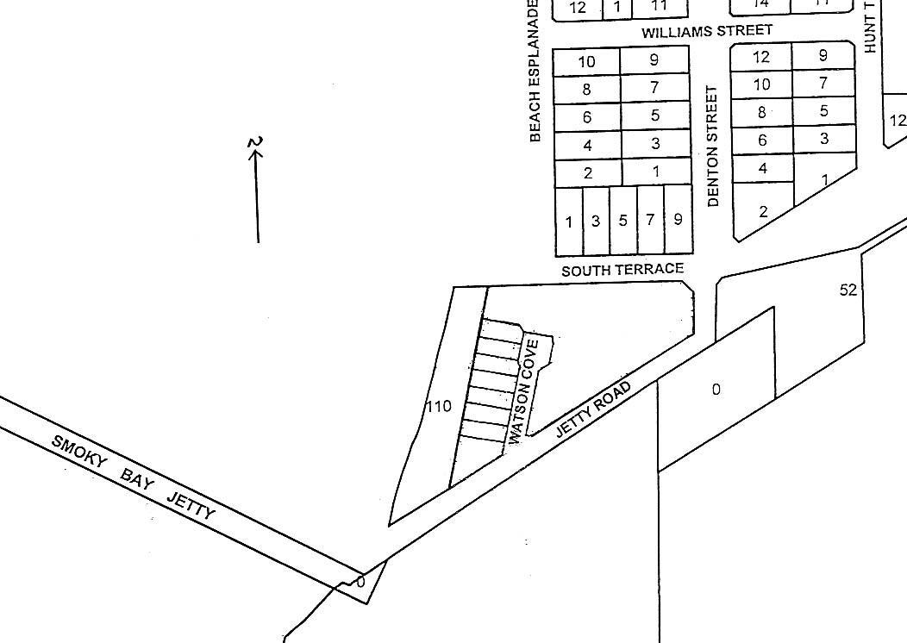
A copy of the plan identifying the road locations is available at the District Council of Ceduna Office, 44 O’Loughlin Terrace, Ceduna, S.A. 5690.
T. Smart, Acting Chief Executive Officer

DISTRICT COUNCIL OF MOUNT BARKER
Declaration of Public Road
NOTICE is hereby given that pursuant to section 208 (4) of the Local Government Act 1999, the District Council of Mount Barker resolved at its meeting held on 19 December 2005, to declare the land described as portion A, West Terrace in Deposited Plan 1376 and Portion B, Scotland Road and part West Terrace in Deposited Plan 1375, Nairne, to be public roads.
A. Stuart, Chief Executive Officer

IN the matter of the estates of the undermentioned deceased persons:
Bissett, Agnes Alexander Daly, late of 30 Evan Avenue, Salisbury, home duties, who died on 24 November 2005.
Fox, Thomas, late of 47 Ballard Road, Smithfield Plains, retired public servant, who died on 30 November 2005.
Graham, Kitty Marian, late of 150-164 Bay Road, Encounter Bay, of no occupation, who died on 14 November 2005.
Harris, Frederick William John, late of 80 Moseley Street, Glenelg South, of no occupation, who died on 1 November 2005.
Kiedyk, Frank Augusta, late of 4 Sullivan Terrace, O’Sullivan Beach, retired handyman, who died on 3 December 2005.
Nemeth, Steven, late of Second Street, Port Pirie West, of no occupation, who died on 30 June 2005.
Sainsbury, James Arthur, late of 9 Jasmine Avenue, Marion, retired public servant, who died on 18 November 2005.
Sommer, Edythe Alice, late of 51 Eve Road, Bellevue Heights, of no occupation, who died on 9 November 2005.

Spurling, Milton Bernard, late of 18 Payton Avenue, Dernancourt, retired associate director, who died on 18 September 2005.
Thomas, Olive Edith, late of 34 Norman Terrace, Everard Park, widow, who died on 30 November 2005.
Todd, Margaret Mary, late of 34 Desmond Road, Hackham, widow, who died on 22 November 2005.
Twine, Peggy Irene, late of 17-19 Cornhill Road, Victor Harbor, retired storekeeper, who died on 8 November 2005.
Williams, Lilian, late of 17-19 Cornhill Road, Victor Harbor, of no occupation, who died on 5 November 2005.
Notice is hereby given pursuant to the Trustee Act 1936, as amended, the Inheritance (Family Provision) Act 1972, and the Family Relationships Act 1975, that all creditors, beneficiaries, and other persons having claims against the said estates are required to send, in writing, to the Public Trustee, 25 Franklin Street, Adelaide, S.A. 5000, full particulars and proof of such claims, on or before 3 March 2006, otherwise they will be excluded from the distribution of the said estate; and notice is also hereby given that all persons who are indebted to the said estates are required to pay the amount of their debts to the Public Trustee or proceedings will be taken for the recovery thereof; and all persons having any property belonging to the said estates are forthwith to deliver the same to the Public Trustee.
Dated 25 January 2006.
C. J. O’Loughlin, Public Trustee

IN the matter of the estate of the undermentioned deceased person:
Thomas, Alan Glenn, late of Unit 2, 4 East Terrace, Clare, retired bank manager, who died on 5 December 2005.
Notice is hereby given pursuant to the Trustee Act 1936, as amended, the Inheritance (Family Provision) Act 1972, and the Family Relationships Act 1975, that all creditors, beneficiaries and other persons having claims against the above estate are directed to send full particulars and evidence of such claims to the undersigned on or before 24 February 2006, otherwise they will be excluded from the distribution of the estate; and notice is also hereby given that all persons who are indebted to the above estate are required to pay the amount of their debt to the undersigned or proceedings will be taken for the recovery thereof; and all persons having any property belonging to the said estate are forthwith to deliver the same to the undersigned.
Dated 25 January 2006.
ANZ Executors & Trustee Company Limited (ACN 006 132 332), 530 Collins Street, Melbourne, Vic. 3000.

IN the matter of the estate of the undermentioned deceased person:
Cox, Shirley Florence, late of Modbury Aged Care Facility, 84 Reservoir Road, Modbury, S.A. 5092, who died on 30 July 2005.
Notice is hereby given pursuant to the Trustee Act 1936, as amended, the Inheritance (Family Provision) Act 1972-1975 and the Family Relationships Act 1975, that all creditors, beneficiaries, and other persons having claims against the abovenamed estate are directed to send full particulars of such claims to the undersigned on or before 17 February 2006, otherwise they will be excluded from the distribution of the estate.
Dated 25 January 2006.
Perpetual Trustees SA Limited (ACN 008 273 916), Level 12/123 Pitt Street, Sydney, N.S.W. 2000.

UNCLAIMED MONEYS ACT 1891
Register of Unclaimed Moneys held by Hardy Wine Company Limited (ABN 86 008 273 907) over $10 as at January 2006

Name |  | Address | Total Amount  Due $ |  | Date Payable
Baimbridge, Colin John |  | 7 Kieandu Court, Ferntree Gully, Vic. 3156 |  | 34.65 |  | October 1999
Baker, James Austin |  | P.O. Box 315, Reservoir, Vic. 3073 |  | 35.00 |  | October 1999
Butler, Jennifer Anne |  | 19 Gleneagles Drive, Sunbury, Vic. 3429 |  | 38.50 |  | April 1999
Butler, Jennifer Anne |  | 19 Gleneagles Drive, Sunbury, Vic. 3429 |  | 38.50 |  | October 1999
Byrne, Matthew Neil and Donna Mitchell |  | Address unknown |  | 70.00 |  | April 1999
Gaunt, John. |  | P.O. Box 243, North Melbourne, Vic. 3051 |  | 210.00 |  | April 1999
Gaunt, John. |  | P.O. Box 243, North Melbourne, Vic. 3051 |  | 210.00 |  | October 1999
Graham, Donald Gordon |  | P.O. Box 5133, Bundaberg West, Qld 4670 |  | 70.00 |  | October 1999
Hellen, Alistair |  | 77 Kedron Brook Road, Wilston, Qld 4051 |  | 21.00 |  | October 1999
Hellen, Clohe |  | 77 Kedron Brook Road, Wilston, Qld 4051 |  | 21.00 |  | October 1999
Hopkins, Marian |  | 39 Thorne Crescent, Mitchell Park, S.A. 5043 |  | 38.50 |  | October 1999
Leith, Peter James |  | C/o G.P.O. Box 1903, Adelaide, S.A. 5001 |  | 11.62 |  | April 1999
Leith, Peter James |  | C/o G.P.O. Box 1903, Adelaide, S.A. 5001 |  | 11.62 |  | October 1999
Leytbury Pty Ltd (Super Fund A/C) |  | 151 Ashburn Grove, Ashburton, Vic. 3147 |  | 154.00 |  | April 1999
Longden, David John |  | 96 Nicholson Road, Subiaco, W.A. 6008 |  | 45.50 |  | April 1999
Loveless, Sharon |  | 10 Beenak Road, Wandin East, Vic. 3139 |  | 17.50 |  | April 1999
McCulloch, Christian |  | 6/186 Forbes Street, Carrington, N.S.W. 2294 |  | 80.50 |  | April. 1999
McCulloch, Christian |  | 6/186 Forbes Street, Carrington, N.S.W. 2294 |  | 80.50 |  | October 1999
Mnan Investments |  | Address unknown |  | 231.00 |  | October 1999
Parkinson, David |  | P.O. Box 2151, Port Moresby, NCD Papua New Guinea |  | 46.62 |  | April 1999
Rubira Investments Pty Ltd |  | C/o Reardon & Associates, 15 Cobden Street, North Melbourne, Vic. 3051 |  | 112.60 |  | October 1999
Solomon, Aaron |  | 18 Kambala Road, Bellevue Hill, N.S.W. 2023 |  | 140.00 |  | April 1999
Solomon, Aaron |  | 18 Kambala Road, Bellevue Hill, N.S.W. 2023 |  | 140.00 |  | October 1999
Williams, Dr. Peter |  | 155 St Johns Road, Glebe, N.S.W. 2037 |  | 35.00 |  | October 1999
Wilson, Ben and Paul |  | 24 Waters Road, Neutral Bay, N.S.W. 2089 |  | 11.62 |  | October 1999
Wood, William Colin |  | 254 Belmore Road, Balwyn, Vic. 3103 |  | 192.50 |  | October 1999
 |  | Total |  | 2 097.13

ATTENTION

CUSTOMERS requiring a proof of their notice for inclusion in the Government Gazette, please note that the onus is on you to inform Government Publishing SA of any subsequent corrections by 10 a.m. on Thursday, which is our publication deadline.

For any corrections to your notice please phone 8207 1045 or Fax 8207 1040 before 10 a.m. on Thursday.

If we do not receive any communication by 10 a.m. on Thursday (day of publication) we will presume the notice is correct and will print it as it is.

Remember—the onus is on you to inform us of any corrections necessary to your notice.

NOTE: Closing time for lodging new copy (electronically, fax or hard copy) is 4 p.m. on Tuesday preceding the day of publication. Phone 8207 1045—Fax 8207 1040.
Email: governmentgazette@saugov.sa.gov.au

Printed and published by authority every Thursday by K. O’CALLAGHAN, Government Printer, South Australia
Price: $5.00, plus postage; to subscribers, $254.00 per annum.
(The above prices are inclusive of GST)

