No. 42 2279

THE SOUTH AUSTRALIAN

GOVERNMENT GAZETTE
www.governmentgazette.sa.gov.au

PUBLISHED BY AUTHORITY

ALL PUBLIC ACTS appearing in this GAZETTE are to be considered official, and obeyed as such

ADELAIDE, THURSDAY, 20 JULY 2006

CONTENTS

Page
Appointments, Resignations, Etc. 2280
Boxing and Martial Arts Act 2000—Notice 2280
Corporations and District Councils—Notices 2352
Dangerous Substances Act 1979—Notice 2281
Development Act 1993—Notices 2281
Electricity Act 1996—Notice 2288
Explosives Act 1936—Notice 2293
Fair Work Act 1994—Notice 2293
Fisheries Act 1982—Notices 2293
Gas Act 1997—Notice 2292
Harbors and Navigation Act 1993—Notices 2295
Land Acquisition Act 1969—Notice 2295
Land and Business (Sale and Conveyancing) Act 1994—
Notices 2295
Liquor Licensing Act 1997—Notices 2296
Local Government (Elections) Act 1999—Notice 2303
Mining Act 1971—Notices 2325
Motor Vehicles (Control of Medical Services and
Charges) Notice 2006 2330

Page
National Parks and Wildlife Act 1972—Notice 2326
Oaths Act 1936—Notice 2326
Occupational Health, Safety and Welfare
Act 1986—Notices 2326
Passenger Transport Act 1994—Notice 2327
Petroleum Act 2000—Notice 2329
Petroleum Products Regulation Act 1995—
Notice 2328
Proclamations 2335
Public Trustee Office—Administration of Estates 2363

REGULATIONS
Road Traffic Act 1961 (No. 190 of 2006) 2337
Electricity Act 1996 (No. 191 of 2006) 2339
Births, Deaths and Marriages Registration Act 1996
(No. 192 of 2006) 2344
Cremation Act 2000 (No. 193 of 2006) 2346
Roads (Opening and Closing) Act 1991—Notices 2327
Sale of Property 2363

GOVERNMENT GAZETTE NOTICES
ALL poundkeepers’ and private advertisements forwarded for publication in the South Australian Government Gazette must be PAID FOR PRIOR TO INSERTION; and all notices, from whatever source, should be legibly written on one side of the paper only and sent to Government Publishing SA so as to be received no later
than 4 p.m. on the Tuesday preceding the day of publication. Phone 8207 1045 or Fax 8207 1040. E-mail: governmentgazette@saugov.sa.gov.au. Send as attachments in Word format and please confirm your transmission with a faxed copy of your document, including the date the notice is to be published and to whom the notice will be charged. The Government Gazette is available online at: www.governmentgazette.sa.gov.au

Department of the Premier and Cabinet
Adelaide, 20 July 2006
HIS Excellency the Governor’s Deputy in Executive Council has been pleased to appoint the undermentioned to the South Australian Council on Reproductive Technology, pursuant to the provisions of the Reproductive Technology (Clinical Practices) Act 1988:
Member: (from 20 July 2006 until 19 July 2009)
Geraldine Mary Hannon
Deputy Member: (from 20 July 2006 until 19 July 2009)
Catherine Ann Jeffries (Deputy to Hannon)
By command,
Gail Gago, for Premier
HEACS 06/126

Department of the Premier and Cabinet
Adelaide, 20 July 2006
HIS Excellency the Governor’s Deputy in Executive Council has been pleased to appoint the undermentioned to the Board of the Royal Zoological Society of South Australia Inc., pursuant to the provisions of the Associations Incorporation Act 1985:
Member: (from 20 July 2006 until 30 June 2008)
Vicki Michelle Linton
By command,
Gail Gago, for Premier
EHCS 06/0014

Department of the Premier and Cabinet
Adelaide, 20 July 2006
HIS Excellency the Governor’s Deputy in Executive Council has been pleased to appoint the Honourable Michael John Wright, MP, Minister for Administrative Services and Government Enterprises, Minister for Industrial Relations and Minister for Recreation, Sport and Racing to be also Acting Minister for Police, Acting Minister for Mineral Resources Development and Acting Minister for Urban Development and Planning for the period 24 July 2006 to 30 July 2006, inclusive, during the absence of the Honourable Paul Holloway, MLC.
By command,
Gail Gago, for Premier
MPOL 06/010CS

Department of the Premier and Cabinet
Adelaide, 20 July 2006
HIS Excellency the Governor’s Deputy in Executive Council has been pleased to appoint the Honourable Gail Elizabeth Gago, MLC, Minister for Environment and Conservation, Minister for Mental Health and Substance Abuse and Minister Assisting the Minister for Health to be also Acting Minister for Health, Acting Minister for the Southern Suburbs and Acting Minister Assisting the Premier in the Arts for the period 25 July 2006 to 2 August 2006 inclusive during the absence of the Honourable John David Hill, MP.
By command,
Gail Gago, for Premier
HEACS 06/135

Department of the Premier and Cabinet
Adelaide, 20 July 2006
HIS Excellency the Governor’s Deputy in Executive Council has accepted the resignation of Chief Magistrate Kelvyn John Prescott from the Offices he holds under the Magistrates Act 1983, with effect from 20 July 2006, pursuant to section 9 (1) of the Magistrates Act 1983.
By command,
Gail Gago, for Premier
AGO 0071/03CS TEMP1

Department of the Premier and Cabinet
Adelaide, 20 July 2006
HIS Excellency the Governor’s Deputy in Executive Council has been pleased to appoint Kelvyn John Prescott as a Judge of the District Court of South Australia from 20 July 2006, pursuant to section 12 of the District Court Act 1991.
By command,
Gail Gago, for Premier
AGO 0071/03CS TEMP1

Department of the Premier and Cabinet
Adelaide, 20 July 2006
HIS Excellency the Governor’s Deputy in Executive Council has been pleased to appoint Jerome Maguire to the positions of Chief Executive, Attorney-General’s Department and Chief Executive, Department of Justice for a term of five years, commencing on 20 July 2006 and expiring on 19 July 2011, pursuant to Part 4 of the Public Sector Management Act 1995.
By command,
Gail Gago, for Premier
DPC 025/04CS

Department of the Premier and Cabinet
Adelaide, 20 July 2006
HIS Excellency the Governor’s Deputy in Executive Council has been pleased to appoint as officers of the Department of Health for the purpose of exercising functions and powers under the Controlled Substances Act 1984, employees of the Southern Adelaide Health Service Inc. (Drug and Alcohol Services South Australia), as listed, pursuant to section 68 of the Constitution Act 1934:
Geoffrey Donald Anderson
Elena Anear
Colin Malcolm Brown
William Bentley Dollman
Keith Robert Evans
Elizabeth Anne Hender
Carolyn Joy Lewis
Karen Jane Lynch
Susan Jane O’Neill
Dean William Piper
Andrea Dorothy Watson
By command,
Gail Gago, for Premier
HEACS 06/128

BOXING AND MARTIAL ARTS ACT 2000
Notice of the World Police and Fire Games Federation (WPFGF) Rules of Amateur Boxing and Karate
TAKE notice that pursuant to section 10 of the Boxing and Martial Arts Act 2000, Michael John Wright, Minister for Recreation, Sport and Racing and the Minister of the Crown to whom the administration of the Boxing and Martial Arts Act 2000, is committed, has approved the rules applicable to the conduct of WPFGF Amateur Boxing and Karate events to commence operation on 5 July 2006.
The rules of Boxing and Karate events are set out below:
Dated 11 July 2006.
M. J. Wright, Minister for Recreation, Sport and Racing

Rules for WPFGF Amateur Boxing Events
2007 World Police and Fire Games Federation
Amateur Boxing Rules.
Revised July 2005.
Rules for WPFGF Karate Events
2007 World Police and Fire Games Federation
Karate Rules.
Revised July 2005.

DANGEROUS SUBSTANCES ACT 1979
Appointments
I, MICHAEL JOHN WRIGHT, Minister for Industrial Relations in and for the State of South Australia, hereby appoint each of the following persons as an Authorised Officer for the purposes of the Dangerous Substances Act 1979, pursuant to section 7 (1) of the Dangerous Substances Act 1979:
Bryan George Russell
Brian Adams
Soritos Mangas
David John McGraw
Donna Marie Carpenter
Marissa Jane Thwaites
Ildiko Farah
Dated 11 July 2006.
M. Wright, Minister for Industrial Relations

DEVELOPMENT ACT 1993, SECTION 48: DECISION BY THE DEVELOPMENT ASSESSMENT COMMISSION AS DELEGATE OF THE GOVERNOR
Preamble
1. The decision of the Governor under section 48 of the Development Act 1993, to approve the development of Holdfast Shores Stage 2B development located adjacent to Colley Terrace, Glenelg was published in the Gazette on 19 February 2004.
2. On 8 June 2000 and pursuant to section 48 of the Development Act 1993, the Governor granted a development approval for the Holdfast Shores 2A development, comprising a hotel, car parking, landscaping and associated works, adjacent to Chappell Drive, Glenelg. The development was subject to a Development Report and an Assessment Report, pursuant to section 46 of the Development Act 1993. Amendments to the Holdfast Shores Stage 2A proposal relating primarily to design, car parking, land division, signage issues and Building Rules, were subsequently granted approval by the Development Assessment Commission (as the Governor’s delegate) on 7 December 2000; 1 March 2001; 17 May 2001; 28 February 2002; 3 October 2002; 20 March 2003, and Stage 2B amendments dated 4 March 2004, 15 July 2004 and 26 August 2004.
3. A proposal for the development of the Holdfast Shores 2B proposal at Glenelg, comprising the construction of the Glenelg Surf Life Saving Club, demolition of the existing GSLSC building; the Magic Mountain building and the construction of a rock seawall, an apartment building, and an entertainment and retail precinct, has been considered under Division 2, Part 4 of the Development Act 1993.
4. The Governor was satisfied that an appropriate Amended Development Report and an Amended Assessment Report have been prepared in relation to the development, in accordance with the requirements of Division 2 of Part 4 of the Development Act 1993 and the proposed development was approved on 19 February 2004.
5. The Governor had, in considering the application, regard to all relevant matters under section 48 (5) of the Development Act 1993.
6. A number of amendments have been approved since the original decision date of 19 February 2004. The most recent amendments are contained in the following documents and drawings:
• Land division plan and associated correspondence for community title land division application 110/C101/05 uploaded onto EDALA on 19 December 2005.
7. Application has now been made to the Development Assess-ment Commission as delegate of the Governor under section 48 of the Development Act 1993, to grant an approval for Secondary Community Title Land Division 110/C101/05.
8. The amendments to the development are contained in final amended plans and associated documents uploaded electronically onto EDALA on 19 December 2005.
9. The Development Assessment Commission has in con-sidering the application had regard to all relevant matters under section 48 (5) of the Development Act 1993.
10. The Development Assessment Commission is satisfied that the variations do not require the preparation of a further amended Development Report.
Decision
Pursuant to section 48 of the Development Act 1993, the Development Assessment Commission as delegate of the Governor, in relation to a proposal submitted by Holdfast Shores Consortium to develop the Holdfast Shores Stage 2B at Glenelg:
(a) grant provisional development authorisation for the Holdfast Shores Stage 2B development at Glenelg, subject to the conditions and notes to the applicant below;
(b) grant development authorisation for Building Rules Certification for the demolition of Magic Mountain and the use of the Police Station building by the Glenelg Surf Life Saving Club;
(c) grant development authorisation for Building Rules Certification for Early Works Package 2B of the development. These apply to bulk excavation, piling, footings, retaining walls, stormwater disposal system, rock seawall extension, base for site paving, car park entry and Hope Street entry, oil pipeline diversion around the basement car park and site utilities infrastructure;
(d) grant development authorisation for Building Rules Certification for Packages 3 and 4 of the development. These apply to early works for the Apartment Building and for the Entertainment and Retail Building, including excavation, piling, retaining walls, columns and in-ground services;
(e) grant development authorisation for Building Rules Certification for Packages 5 and 6 of the development, which applies to the Platinum Apartments Superstructure and parts of the Entertainment Precinct Superstructure, and for the temporary walkway;
(f) grant development authorisation for Building Rules Certification for Package 7 of the development, which applies to the Superstructure for the Entertainment Building and Surf Life Saving Club;
(g) grant provisional development authorisation for the variation relating to an additional underground car park in the Entertainment Building;
(h) grant development authorisation for the variation relating to modifications to the Entertainment Building;
(i) grant development authorisation for the variation relating to a beach observation tower for the Glenelg Surf Life Saving Club;
(j) grant provisional development authorisation for the variation relating to modifications to the Glenelg Town Hall;
(k) grant development authorisation for the amendment No. 4 relating to modifications to the Entertainment Building;
(l) specify all matters relating to this development plan authorisation as matters in respect of which conditions of this authorisation may be varied or revoked, or new conditions attached;
(m) pursuant to section 48 and Regulation 64 (1) of the Development Act 1993, reserve the following matters for further decision-making at a later stage (refer ‘Notes to Applicant’):
(i) further assessment and certification in respect of the Building Rules for components of the proposed development;
(ii) any external advertising signage;
(n) approve the land division application 110/D012/04, lodged on 4 February 2004;
(o) approve the land division application 110/D052/05, lodged electronically with the Development Assessment Commission on EDALA on 22 June 2005;
(p) grant provisional development authorisation for the variation relating to Amendment No. 5—Modifications to the Retail Building. (Windows to the western wall);
(q) grant provisional development authorisation for the variation relating to Amendment No. 6—Revision to retaining walls adjacent Glenelg Town Hall;
(r) grant development authorisation for Building Rules Certification for Building Rules Certificate for Packages 3 and 4 (Platinum Apartments Basement and Enter-tainment Precinct Basement) to reflect modifications to the retaining wall and for Package 7 to reflect the approved modification to the Entertainment Building, (Amendment No. 4);
(s) grant provisional development authorisation for the variation relating to—modifications to Level 3 of the Entertainment Building (Amendment No. 8);
(t) grant provisional development authorisation for the variation relating to—modifications to and signage for the Retail Tenancy T05 on Moseley Square (Amendment No. 9);
(u) approve the land division application 110/C053/05 in plans and associated documents uploaded electronically onto EDALA on 28 April 2006 and 15 May 2006 and a range of associated detailed documentation attached to a letter from Norman Waterhouse to the City of Holdfast Bay dated 11 May 2006;
(v) approve the land division applications 110/C061/05 and 110/C062/05 in plans and associated documents up-loaded electronically onto EDALA on 25 July 2005; and
(w) approve the land division application 110/C101/05 in plans and associated documents uploaded electronically onto EDALA on 19 December 2005.
Conditions of Approval
1. Except where minor amendments may be required by other Acts and/or legislation or by conditions imposed herein, the Holdfast Shores 2B development shall be undertaken in strict accordance with:
(a) The following drawings contained in the Amended Development Report for Holdfast Shores Stage 2B, dated September 2003, except to the extent that they are varied by the plans described in paragraph 1 (b):
• Drawing Titled: ‘Site plan level B2’; Drawing Number: 111.
• Drawing Titled: ‘Site plan level 1’; Drawing Number: 112.
• Drawing Titled: ‘Site plan level 2’; Drawing Number: 113.
• Drawing Titled: ‘Entertainment building basement’; Drawing Number: 114.
• Drawing Titled: ‘Entertainment building level 1’; Drawing Number: 115.
• Drawing Titled: ‘Entertainment building level 2’; Drawing Number: 116.
• Drawing Titled: ‘Entertainment building levels 3 and 4’; Drawing Number: 117.
• Drawing Titled: ‘Entertainment building elevations’; Drawing Number: 118.
• Drawing Titled: ‘Entertainment building elevations’; Drawing Number: 119.
• Drawing Titled: ‘Entertainment building sections’; Drawing Number: 120.
• Drawing Titled: ‘Apartment Plans B2 and B1’; Drawing Number: 121.
• Drawing Titled: ‘Apartment Plans L1, L2, L3-4 and L5’; Drawing Number: 122.
• Drawing Titled: ‘Apartment Plans L6-8 and L9, roof plan’; Drawing Number: 123.
• Drawing Titled: ‘Apartment elevations—north and east’; Drawing Number: 124.
• Drawing Titled: ‘Apartment elevations—west and south’; Drawing Number: 125.
• Drawing Titled: ‘Apartment sections’; Drawing Number: 126.
• Drawing Titled: ‘Land use’; Drawing Number: 127.
• Drawing Titled: ‘Built form’; Drawing Number: 128.
• Drawing Titled: ‘Urban spaces’; Drawing Number: 129.
• Drawing Titled: ‘Open space/vegetation’; Drawing Number: 130.
• Drawing Titled: ‘View corridor’; Drawing Number: 131.
• Drawing Titled: ‘Climate’; Drawing Number: 132.
• Drawing Titled: ‘Microclimate’; Drawing Number: 133.
• Drawing Titled: ‘Links to surrounding areas’; Drawing Number: 134.
• Drawing Titled: ‘Pedestrian movement’; Drawing Number: 135.
• Drawing Titled: ‘Vehicle movement’; Drawing Number: 136.
• Drawing Titled: ‘Concourse study—pedestrian move-ment’; Drawing Number: 137.
• Drawing Titled: ‘Concourse study—vehicle move-ment’; Drawing Number: 138.
• Drawing Titled: ‘Moseley Square study’; Drawing Number: 139.
• Drawing Titled: ‘Town Hall opportunities’; Drawing Number: 140.
• Drawing Titled: ‘Foreshore open space study’; Drawing Number: 141.
• Drawing Titled: ‘Apartment building study’; Plan Number: 142.
• Drawing Titled: ‘Entertainment precinct—east plaza study’; Drawing Number: 143.
• Drawing Titled: ‘Sun diagrams summer’; Drawing Number: 144.
• Drawing Titled: ‘Sun diagrams winter’; Drawing Number: 145.
• Drawing Titled: ‘Landscaping’; Drawing Number: 146.
• Drawing Titled: ‘Construction Stage 1’; Drawing Number: 147.
• Drawing Titled: ‘Construction Stage 2’; Drawing Number: 148.
• Drawing Titled: ‘Construction Stage 3’; Drawing Number: 149.
• Drawing Titled: ‘Construction Stage 4’; Drawing Number: 150.
(b) The following drawings accompanying the Response by proponent to submissions, 3. City of Holdfast Bay Submission, dated 17 December 2003, as they relate to the proposal for Holdfast Shores Stage 2B, except to the extent that they are varied by the plans as described in paragraph (c):
• Drawing Titled: ‘Sun diagrams summer’; Drawing Number: 144 rev. A.
• Drawing Titled: ‘Sun diagrams winter’; Drawing Number: 145 rev. A.
• Drawing Titled: ‘Entertainment building basement supplementary plan’; Drawing Number: 151 rev. A.
• Drawing Titled: ‘Entertainment building level 1 supplementary plan’; Drawing Number: 152 rev. A.
• Drawing Titled: ‘Entertainment building level 2 supplementary plan’; Drawing Number: 153 rev. A.
• Drawing Titled: ‘Entertainment building levels 3 and 4 supplementary plan’; Drawing Number 154.
• Drawing Titled: ‘Entertainment building levels 3 and 4 supplementary plan’; Drawing Number: 154 rev. A.
(c) The following drawings accompanying the further information and clarification letter dated 22 January 2004, as they relate to the proposal for Holdfast Shores Stage 2B:
• Drawing Titled: ‘Car park ventilation supplementary plan’; Drawing Number: 155.
• Drawing Titled: ‘Civil stormwater supplementary plan’; Drawing Number: 156.
• Drawing Titled: ‘Civil stormwater supplementary plan’ Drawing Number: 157.
• Drawing Titled: ‘Oil pipeline supplementary plan’; Drawing Number: 158.
(d) The land division plan lodged with the Development Assessment Commission on 4 February 2004: Application number 110/D012/04.
(e) The land division plan lodged electronically on EDALA with the Development Assessment Commission on 22 June 2005: Application number 110/D052/054.
(f) The land division plans lodged electronically on EDALA with the Development Assessment Commission which include an amended final scheme description uploaded on 28 April 2006 and an amended final plan uploaded on 15 May 2006: Application number 110/C053/05.
(g) The land division plans lodged electronically on EDALA with the Development Assessment Commission on 25 July 2005: Application numbers 110/D061/05 and 110/D062/05.
(h) The land division plan lodged electronically on EDALA with the Development Assessment Commission on 19 December 2005: Application number 110/C101/05.
(i) The following documents, except to the extent that they are varied by the plans described in paragraphs (a) and (c):
• Amended Development Report for Stage 2B, Volumes 1 and 2 by the Holdfast Shores Consortium, dated 18 September 2003 (except to the extent that it may be varied by a subsequent document in this paragraph).
• The letter from Woodhead International to Planning SA, titled Response by proponent to submissions, 3. City of Holdfast Bay submission, dated 17 December 2003 (except to the extent that it may be varied by a subsequent document in this paragraph).
• The Amended Assessment Report prepared by the Minister for Aboriginal Affairs and Reconciliation (as delegate Minister for the Minister for Urban Develop-ment and Planning), for the Holdfast Shores 2B development, dated February 2004 (except to the extent that it may be varied by a subsequent document in this paragraph).
• The letter from Woodhead International to Planning SA, titled Further Information and Clarification, dated 22 January 2004.
• The letter from Woodhead International to Planning SA, titled Packages 1 and 2A Building Rules Certification, dated 21 June 2004.
• The letter from Woodhead International to Planning SA, titled Early Works Package 2B Building Rules Certification, dated 15 July 2004.
• The letter from Woodhead International to Planning SA, titled Amendment No. 1 to Provisional Develop-ment Authorisation (reserved matters), dated 1 June 2004.
• The letter from Woodhead International to Planning SA, titled Amendment No. 2 to Provisional Develop-ment Authorisation (reserved matters), dated 17 August 2004.
• The letter from Woodhead International to Planning SA, titled Building Rules Certification for Packages 3 and 4, dated 28 September 2004.
• The letter from Woodhead International to Planning SA, titled Amendment No. 3 to Development Authori-sation—Temporary Walkway, dated 24 January 2005.
• The letter from Woodhead International to Planning SA, Amendment No. 3 to Provisional Development Authorisation, dated 11 January 2005.
• The letter from Woodhead International to Planning SA, titled Packages 5 and 6 Building Rules Certification, dated 4 January 2005.
• The letter from Woodhead International to Planning SA, Amendment No. 2 of Provisional Development Authorisation, dated 27 October 2004.
• Letter from Woodhead International to Planning SA, titled Package 7 Building Rules Certification, dated 6 May 2005.
• Letter from Woodhead International to Planning SA, Holdfast Shores Stage 2B, Glenelg Town Hall Egress, dated 8 March 2005.
• Letter from Alexander Symonds to Planning SA titled Holdfast Shores Stage 2B—Land Division Application 110/D052/05 and 100/C053/05, dated 11 October 2005.
• Letter from Baulderstone Hornibrook Urban Construct Joint Venture, titled Holdfast Shores Stage 2B—Land Division, to Planning SA dated 14 December 2005.
• Letter from Connor Holmes, titled Holdfast Shores Stage 2B—Land Division Application 110/D052/05 and 110/C053/05, to Planning SA dated 6 January 2006.
• Letter from Norman Waterhouse to Planning SA, titled Holdfast Shores Stage 2B—Land Divisions—Glenent Pty Ltd, dated 20 January 2006.
• Letter from Woodhead International to Planning SA, Holdfast Shores Stage 2B, Amendment No. 5 to the Provisional Development Authorisation, dated 2 December 2005.
• Letter from Woodhead International to Planning SA, Holdfast Shores Stage 2B, Amendments to Packages 2B and 7 Building Rules Certification, dated 21 September 2005.
• Letter from Baulderstone Hornibrook to City of Holdfast Bay (copied to Planning SA) Holdfast Shores Stage 2B, excavation of basement, eastern side of Glenelg Town Hall, dated 7 November 2005.
• Letter from Harben Design included with e-mail dated 8 December 2005.
• Letter from QED Pty Ltd, on behalf of Starbucks Australia, dated 10 January 2006.
• E-mail from QED Pty Ltd, dated 27 January 2006, titled ‘Starbucks—Glenelg—Extra Information’.
• A range of associated detailed documentation (associated with 110/C053/05) attached to a letter from Norman Waterhouse to the City of Holdfast Bay dated 11 May 2006.
2. A Construction Environmental Management Plan (CEMP) shall be prepared, in consultation with the Environment Protection Authority, Coast Protection Board and the City of Holdfast Bay, to address the management issues during construction. Matters to be addressed in the CEMP must include:
• traffic management during construction, including transport beyond the site;
• control and management of construction noise;
• dust and mud control;
• working hours;
• stormwater and groundwater management during con-struction;
• site security and fencing;
• disposal of building waste and refuse;
• protection and cleaning of roads and pathways;
• site clean-up;
• adherence to all relevant Environment Protection Authority policies and codes of practice for construction sites;
• identification and management of potential and actual acid sulphate soils (should these be encountered); and
• identification and management of contaminated soils and groundwater (should these be encountered).
3. The applicant shall submit further information and appli-cation(s) in relation to the matters that have been reserved for further decision-making by the Governor (or her delegate).
4. No building works shall commence on subsequent stages of the development until a decision has been made by the Governor (or her delegate), involving matters relating to the Building Rules assessment and certification requirements and any other reserved matters that are subject to further development application.
5. No works shall commence unless, and until, legal rights to develop the Magic Mountain site have been secured.
6. The car parking areas shall be designed in accordance with Australian Standards 2890 1-1993 and line markings shall be maintained in good and substantial condition at all times.
7. Access for service deliveries and waste disposal vehicles at the Holdfast Promenade shall only be allowed between 7 a.m. and 10 a.m. daily.
8. Stormwater from the Holdfast Shores Stage 2B site shall not be disposed of by way of a pipe or similar structure that conveys the stormwater to the beach.
9. Site works, construction work and truck movements to and from the site shall only be carried out between 7 a.m. and 6 p.m., Monday to Saturday, inclusive.
10. Pedestrian access ways, from Moseley Square to the Entertainment Plaza and from Hope Street through the ‘air lock’, shall remain open to the public at all times.
11. Landscaping shall be provided in accordance with the authorised plans and shall be maintained and nurtured, with any diseased or dying plants being replaced.
12. The waste storage and service area at the rear of the buildings shall be kept in a neat, tidy and healthy condition at all times and the service area access door shall remain closed at all times, other than when loading or unloading is taking place.
13. Machinery, plant operating equipment, lighting or sound devices shall not impair or impinge upon the enjoyment of adjoining properties or occupiers thereof.
14. All drainage, finished floor levels, and public works associated with the development, including the disposal of stormwater, shall be carried out in accordance with accepted engineering standards and to the reasonable satisfaction of the City of Holdfast Bay.
15. The period of time for which the building (the Police Station building) shall be used as clubrooms shall be 18 months from the date of Development Authorisation of 15 July 2004, after which period the building shall be vacated.
16. The clubrooms (in the Police Station building) will not be used as a nightclub or discotheque or the like.
17. The door to the accessible male toilet (in the Police Station building) shall be handed to provide latch side clearance in accordance with Fig. 12 of AS1428.1. BCA-Part D3.2.
18. The levels of any openings to the basement car park, including ventilation outlets, inlets and the like shall be in accord with those previously proposed in section 4.1Q of the Amended Development Report for Stage 2B dated 18 September 2003.
19. The fit-out of the public toilets shall be to the reasonable satisfaction of the City of Holdfast Bay.
20. Service plant/machinery associated with the Entertainment Building shall be appropriately concealed from public view.
21. The proposed transformer located on the southern elevation of the Entertainment Building shall be appropriately screened to minimise its visual impact on the public realm.
22. The applicant shall place outdoor showers along the back of the beach to the reasonable satisfaction of the City of Holdfast Bay.
23. The southern most waterslide shall not project over the walkway space located between the Town Hall and Entertainment Building and in any event, should not be located within 5 m of the Town Hall.
24. Structures or ornaments in the mini-golf course shall be arranged and sited to ensure that:
(a) no individual structure or ornament exceeds a height of 1.5 m within the southern section of the mini-golf course so as to obscure western and north-western views from the Town Hall; and
(b) structures or ornaments are not grouped in a manner that creates visual bulk to the southern or western elevations of the Entertainment Building or obscures western and north-western views from the Town Hall.
25. The modifications to the Glenelg Town Hall access shall be executed with minimum intervention to the historic fabric of the building.
26. The encumbrance dated 16 February 2006, shall be registered on the five Torrens titles, facing Moseley Square as soon as practicable after the land division No. 110/D052/05 is implemented.
27. The financial requirements of the SA Water Corporation shall be met for the provision of water supply and sewerage services, for land division application Nos 110/D052/05, 110/C053/05, 110/C061/05 110/C062/05 and 110/C101/05. (SA Water 90097/04 Water/Sewer).
28. The necessary easements shall be granted to the SA Water Corporation free of cost for land division application Nos 110/D052/05, 110/C053/05 and 110/C101/05.
29. Two copies of a certified survey plan shall be lodged for Certificate purposes for land division application Nos 110/D052/05, 110/C053/05, 110/C061/05, 110/C062/05 and 110/C101/05.
30. Vibration during construction is an issue which shall be addressed within a Construction Environmental Plan. A before and after dilapidation study of the former Glenelg Town Hall shall be prepared to note new cracking and other damage. The Plan shall also provide a maximum vibration reading during use of machinery, pile driving or other construction activities. Regular monitoring of the building shall be undertaken while work proceeds. (Note: a copy of this information shall be provided to Heritage SA.).
31. Heritage SA shall be consulted prior to any further development changes relating to building rules approval, for modifications to the retaining wall adjacent Glenelg Town Hall.
32. The proposed bi-fold doors and windows at the southern elevation of Retail Tenancy T05, shall be secured completely within the confines of the tenancy and not encroach onto the Council footpath/Moseley Square, when operated.
33. The signage for Retail Tenancy T05, (including its structure and advertising material thereon) shall be maintained in good condition.
34. The signage for Retail Tenancy T05 shall not be of a light intensity as to cause light overspill, which results in unreasonable nuisance to adjoining land and buildings.
Notes on Building Rules Certification (for demolition of Magic Mountain and use of the Police Station Building by GSLSC)
The Early Fire Hazard Indices of wall, floor and ceiling linings, and air-handling ductwork shall comply with Clause C1.10 of the BCA.
Notes on Building Rules Certification (for the Platinum Apart-ments Basement and Entertainment Precinct Basement)
The application does not include the superstructure works which shall be the subject of a separate application.
This consent is issued on the understanding that the proprietary type materials and products as specified either on the architectural plans or specifications are to be selected and installed in accordance with the manufacturers’ recommendations and relevant standards.
Fire precautions must be taken during construction in accordance with BCA-E1.9. The builder must also ensure, once the method of construction has been determined, that the design of the building/structure adequately accommodates the anticipated construction activity actions.
The person proposing to undertake building work on land (or who is in charge of such work) is warned of their obligation to give Council notice at stages prescribed in Regulation 74.
Notes on Building Rules Certification (for the Platinum Apart-ments Superstructure and parts of the Entertainment Precinct Superstructure)
This application does not include the Entertainment Building superstructure which shall be the subject of a separate application.
The certified drawings/documents will be issued by the Council with the notification of development approval.
The drawings are stamped ‘Preliminary’. Future changes may require separate approval.
The propriety type materials and products as specified either on the architectural plans or specification are to be selected and installed in accordance with the manufacturers’ recommendation and relevant standards.
Fire precautions must be taken during construction in accordance with BCA-E1.9. The builder must ensure once the method of construction has been determined, that the design of the building/structure adequately accommodates the anticipated construction activity actions.
The person proposing to undertake building work on land (or who is in charge of such work) is warned of their obligation to give the Council notice at stages prescribed in Regulation 74.
Notes on Building Rules Certification (for the Entertainment Building Superstructure and Surf Life Saving Club)
The certified drawings/documents will be issued by the Council with the notification of development approval.
The proprietary type materials and products as specified either on the architectural plans or specifications are to be selected and installed in accordance with the manufacturers’ recommendations and relevant standards.
Fire precautions must be taken during construction in accordance with BCA-E1.9. The builder must also ensure, once the method of construction has been determined, that the design of the building/structure adequately accommodates the anticipated construction activity actions.
The person proposing to undertake building work on land (or who is in charge of such work) is warned of their obligation to give the Council notice at stages prescribed in Regulation 74.
SCHEDULE OF ESSENTIAL SAFETY PROVISIONS: Regulation 76 requires that the relevant authority on granting provisional building rules consent, issue a schedule that specifies the essential safety provisions for the building and the standards or requirements for the maintenance and testing in respect of each of those essential safety provisions set out in Minister’s Specification SA 76. The items to be inspected or tested will be detailed on a Schedule attached to the Building Rules Consent for the superstructures.
For building work prescribed in Regulation 75, the building owner must, at least 28 days before the building work is commenced cause to be served on the owner of the affected land or premises a notice of intention to perform the building work and the nature of that work as required by section 60.
Pursuant to section 53A of the Development Act 1993, the relevant authority must form an opinion as to whether the existing building is unsafe or structurally unsound. It is considered that although there are/may be items or matters that are not in strict conformity with the Building Rules, or other matters of non-compliance that cannot be identified from the information supplied by the applicant, that the proposed upgrading measures will render the building safe.
Wet areas details including floor grades, set-downs and impervious surfaces shall comply with Minister’s Specification SA F1.7 including provision of drainage flanges.
Existing glass in doors, side panels and other human impact areas shall be assessed by the glazier for compliance with section 5 of AS 1288-1994 Glass in Buildings. The applicant is advised that to comply with the Occupational Health, Safety and Welfare Act 1986, any glass that does not meet current requirements should be replaced.
IMPORTANT: The Building Rules Certification does not imply compliance with the Electricity Act 1996, (building within prescribed distances of adjacent power lines) or Occupational Health, Safety and Welfare Act 1986, the (State) Equal Opportunity Act 1984, or with the Commonwealth Disability Discrimination Act as amended or any of the regulations under those Acts. It is the responsibility of the owner and the person erecting the building to ensure compliance with same.
Proof of maintenance must be provided to Council each calendar year by the building owner.
CERTIFICATE OF OCCUPANCY: A new Certificate of Occupancy is required to be issued in relation to the proposed development. Katnich Dodd, will before granting a certificate of occupancy, require:
1. A Statement of Compliance from the licensed building work contractor who carried out the relevant work or who was in charge of carrying out the relevant work or if there is no such licensed building work contractor—from a registered building work supervisor or private certifier all in accordance with the pro forma attached to the building rules consent for Packages 5 and 6 which must also be signed by the owner of the relevant land, or by someone acting on his or her behalf.
2. A certificate of compliance for each essential provision, in the appropriate form under Schedule 16, signed by the installer of the safety provision, or where the installer is a company, signed by the manager responsible for the installation work.
3. Where a building is required by the Building Rules to be equipped with a booster assembly for use by fire-fighters or to have installed a fire alarm that transmits a signal to a fire station and facilities for fire detection, fire-fighting or the control of smoke must be installed in the building pursuant to an approval under the Act, the ‘wet’ and/or ‘dry’ report(s) from the fire authority as to whether those facilities have been installed and operate satisfactorily.
Storey | Portion | Classification | Area  m² | Max.  Occupants
Basement | All | 7a | — | —
Level 01  (Ground) | Tenancies  Entertainment  Boat store  Gymnasium | 5 and 6  (dual classification)  9b  7b  9b | —  — | —  900 persons  —
Level 02  (First) | Tenancies  Games  Functions | 5 and 6  (dual classification)  9b  9b | —  660  390 | —  660 persons  390 persons
Level 03  (Second) | Conference  Centre | 9b | 300 | 240 persons
Level 04  (Third) | Offices | 5 | 175 | 18 persons
Level 05  (Fourth) | Waterslide  Deck | 9b | 175 | 175 persons

For building work prescribed in Regulation 75, the building owner, must, at least 28 days before the building work is commenced cause to be served on the owner of the affected land or premises a notice of intention to perform the building work and the nature of that work, as required by section 60.
Pursuant to the Local Government Act 1999, the builder may be required to erect and maintain hoardings and platforms for the protection of the public on adjoining streets and footpaths as directed by the City of Holdfast Bay.
Wet area details including floor grades, set downs, and water resistant surfaces shall comply with Minister’s Specification SA F1.7-2004 and AS3740 Waterproofing of wet areas within residential buildings including provision of drainage flanges.
A person must not fill the pool with water unless the pool is enclosed by a fence that complies with Part 3.9.3 of the BCA.
IMPORTANT: The Building Rules Certification for Packages 5, 6 and 7 is for compliance with the Development Act 1993 and does not imply compliance with the Swimming Pools (Safety) Act 1972, as amended, or any of the regulations under this Act. It is the responsibility of the owner and the person erecting the building/structure to ensure compliance with same.
NOTES TO APPLICANT
• A decision on the reserved matters relating to Building Rules assessment and certification requirements for further stages will only be made by the Governor (or her delegate) after a Building Rules assessment and certification has been under-taken and issued by the City of Holdfast Bay, or a private certifier, as required by the Development Act 1993 and after the Minister for Urban Development and Planning receives a copy of all relevant certification documentation, as outlined in Regulation 64 of the Development Regulations 1993.
• If the Building Rules assessment process demonstrates that the Holdfast Shores Stage 2B development complies with the Building Rules pursuant to the Development Act 1993 and Development Regulations 1993, the City of Holdfast Bay, or a private certifier conducting the Building Rules assessment, must:
(a) provide to the Minister the certification in the form set out in Schedule 12A of the Development Regulations 1993; and
(b) to the extent that may be relevant and appropriate:
(i) issue a schedule of essential safety provisions under Division 4 of Part 12;
(ii) assign a classification of the building under these regulations; and
(iii) ensure that the appropriate levy has been paid under the Construction Industry Training Fund 1993.
Regulation 64 of the Development Regulations 1993, provides further information about the type and quantity of all building certification documentation required for referral to the Minister:
• The City of Holdfast Bay, or a private certifier undertaking the Building Rules assessment and certification for the Holdfast Shores Stage 2B development, must ensure that any assessment and certification is consistent with this provisional development authorisation (including any conditions or notes that apply in relation to this provisional development authorisation).
• Should the applicant wish to vary the application or the staging of any reserved matters, as outlined in this provisional development authorisation, a variation to the application may be submitted, pursuant to section 48B of the Development Act 1993, provided that the development application variation remains within the ambit of the Amended Development Report and Amendment Assess-ment Report referred to in this provisional development authorisation.
• The applicant is advised of the requirement to comply with the Environment Protection Authority’s (EPA) ‘Stormwater Pollution Prevention Code of Practice for the Building and Construction Industry’ during demolition and construction of the development.
• Noise emissions from the Holdfast Shores Stage 2B development will be subject to the Environment Protection (Industrial Noise) Policy 1994 and the Environment Protection Authority (EPA) Guidelines and the Environ-ment Protection Act 1993.
• Prior to any construction, the applicant should consult with Adelaide Airport Ltd, about crane operations.
• The Heritage Branch of the Department for Environment and Heritage, should be consulted if there is to be any physical intervention to the structures on the adjacent State Heritage place (Glenelg Town Hall). Any such work must be executed in accordance with advice arising from such consultation.
• The proponent is reminded of the General Environmental Duty under section 25 of the Environment Protection Act 1993, which requires that a person must not undertake any activity, which pollutes, or may pollute, without taking all reasonable and practical measures to prevent or minimise harm to the environment.
• If the Holdfast Shores 2B development is not substantially commenced within two years of the date of any reserved matter decisions, the Governor may cancel this provisional development authorisation and any subsequent decisions on reserved matters (where relevant).
• The Minister has a specific power to require testing, monitoring and auditing under section 48C of the Develop-ment Act 1993.
• Final details on the size and construction of the beach tower and confirmation that ownership and maintenance is to be by the Surf Life Saving Club to be provided to the satisfaction of the City of Holdfast Bay.
• The precise location of the beach tower needs to allow for future volleyball courts and be to the satisfaction of Council’s Holdfast Shores Stage 2B Project Board Steering Committee.
• Visually attractive options, such as the incorporation of public art, should be considered for the screening of the proposed transformer located on the southern elevation of the Entertainment Building.
• Further details shall be provided to the City of Holdfast Bay regarding the waterslides and their support structures to ensure that:
(a) the proposed support structures do not dominate the built form and western and south-western face of the Entertainment Building; and
(b) adequate visual permeability is retained between the waterslide tubes.
• All land division documentation, including easement plans should be forwarded to Council for execution under the Real Property Act 1886.
• Variation No. 5 to the Retail Tenancy will be subject to meeting the requirements of the Building Code of Australia, particularly in terms of fire safety.
• External advertising and proposed colour schemes of the buildings adjacent to the former Town Hall shall be the subject of a separate approval.
• Applicants for Retail Tenancies which sell food and beverages (including the applicant for Retail Tenancy T05) are required to lodge a formal application for the internal fitout with Council’s Environmental Health Unit for assess-ment against the Food Act 2001 and Environmental Health Act 1987.
• Applicants for Retail Tenancies which incorporate outdoor dining areas (including the applicant for Retail Tenancy T05) are required to lodge a separate application for an Outdoor Dining Permit with Council for any proposed Out-door Dining areas. (NB: this will be assessed in accordance with Councils adopted Moseley Square Outdoor Dining Guidelines).
• Following completion of the retail buildings and associated balconies, an Encroachment Permit and invoice for the annual encroachment fee will be forwarded to the building owner/s by Council. (NB: the annual fee is based on a valuation of the size of the encroachment and its use).
Dated 20 July 2006.
R. Barua, Secretary, Development Assessment Commission

DEVELOPMENT ACT 1993, SECTION 25 (17): TOWN OF WALKERVILLE—TOWN CENTRE ZONE PLAN AMEND-MENT
Preamble
1. The Development Plan amendment entitled ‘Town of Walkerville—Town Centre Zone Plan Amendment’ (the Plan Amendment) has been finalised in accordance with the provisions of the Development Act 1993.
2. The Minister for Urban Development and Planning has decided to approve the Plan Amendment.
Notice
PURSUANT to section 25 of the Development Act 1993, I—
(a) approve the Plan Amendment; and
(b) fix the day on which this notice is published in the Gazette as the day on which the Plan Amendment will come into operation.
Dated 20 July 2006.
Paul Holloway, Minister for Urban Development and Planning
PLN 03/0261

ELECTRICITY ACT 1996
Notice under the Electricity Act 1996 by TRUenergy Pty Ltd (ABN 99 086 014 968) of Default Contract Prices for Small Customers
IN accordance with section 36AB of the Electricity Act 1996 (SA), TRUenergy Pty Ltd (ABN 99 086 014 968) (formerly known as CLP Australia Retail Pty Ltd and SPI Retail Pty Ltd) (‘TRUenergy’) hereby publishes its default electricity contract prices for customers who are consuming less than 160MWh per annum of electricity (‘small customers’). The default contract prices are set out below in this notice and will apply on and from 18 August 2006.
The prices detailed in this notice apply for small customers only of TRUenergy who are purchasing electricity under TRUenergy’s Default Contract Terms and Conditions published in the Government Gazette on 1 April 2005.
TRUenergy reserves the right to change its default electricity contract price from time to time acting in accordance with all applicable regulations.
Justification Statement
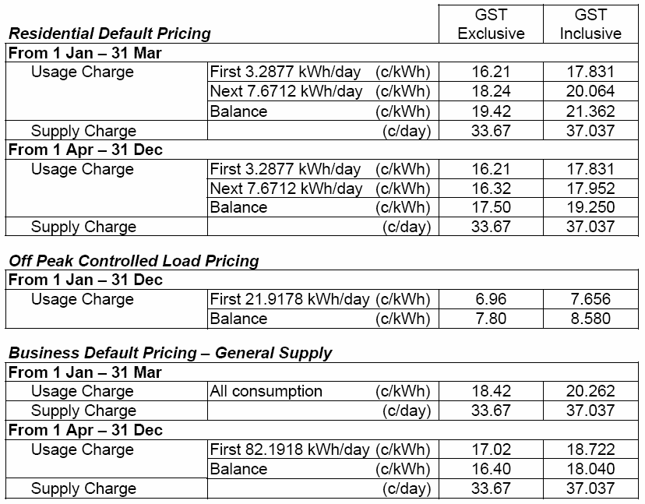
The default contract prices set out in this notice are the same as the electricity standing contract retailer tariffs approved on 1 June 2006 by the Essential Services Commission of South Australia (‘ESCOSA’) and ETSA Utilities’ distribution tariff approved by ESCOSA pursuant to the 2005-2010 Electricity Distribution Price Determination Part B as varied on 9 June 2006. The setting by TRUenergy of these default contract prices is in accordance with ESCOSA’s Electricity Retail Price Justification Guideline of December 2003.
TRUenergy Default South Australian Electricity Pricing

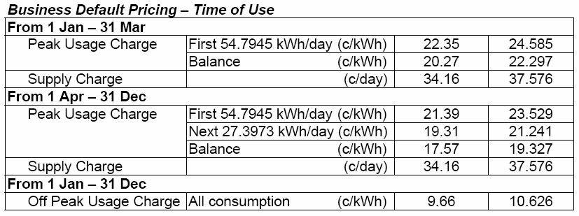
Explanatory Notes:
1. Default contract price categories will only apply to small customers (that is, those customers who consume less than 160MWh of electricity per annum) who are purchasing electricity under TRUenergy’s default contract terms and conditions. The above default contract prices apply in accordance with the following principles:
(a) Daily Consumption is the total electricity consumption for the period to which the customer’s bill relates, divided by the number of days in that period.
(b) Residential Default Pricing:
• applies to residential customers in premises used wholly or principally as private residences based on Domestic 110* tariff meter configuration and, in the case of off peak, Off Peak Controlled Load Domestic 116* tariff meter configuration (refer to explanatory note 1 (e) below for the circumstances in which off peak rates apply).
(c) Business Default Pricing—General Supply:
• applies to non-residential customers in premises that are not used wholly or principally as private residences based on General Supply 126* tariff meter configuration.
(d) Business Default Pricing—Time of Use:
• applies to non-residential customers in premises that are not used wholly or principally as private residences based on General Supply Time of Use 128* tariff meter configuration.
(e) Off Peak Controlled Load:
• for electricity used in permanently installed storage water heaters with a rated delivery of not less than 125 litres, storage space heaters and other approved thermal storage applications. The hours of application are fixed from time to time with control by time switch or other means. This price does not apply to electricity used outside those hours.
2. Peak period is 0700 hours to 2100 hours from Monday to Friday (Central Standard Time) for all tariffs other than Domestic 110* tariff meter configuration, except where the network meters do not recognise specific tariff days. In these situations peak period is 0700 hours to 2100 hours (Central Standard Time) each day for meter types other than Domestic 110* tariff meter configuration.
3. Off peak period is all times other than peak period.
4. Where prices change during a billing cycle the bill for that billing cycle will be calculated on a pro rata basis using:
(a) the old price up to and including the date of change; and
(b) the new price from the date of change to the end of the billing cycle.
* These tariff descriptions refer to tariffs published by AGL South Australia Pty Limited.

GOVERNMENT GAZETTE ADVERTISEMENT RATES

To apply from 1 July 2006

$  Agents, Ceasing to Act as 38.00  Associations:  Incorporation 19.30  Intention of Incorporation 47.75  Transfer of Properties 47.75  Attorney, Appointment of 38.00  Bailiff’s Sale 47.75  Cemetery Curator Appointed 28.25  Companies:  Alteration to Constitution 38.00  Capital, Increase or Decrease of 47.75  Ceasing to Carry on Business 28.25  Declaration of Dividend 28.25  Incorporation 38.00  Lost Share Certificates:  First Name 28.25  Each Subsequent Name 9.70  Meeting Final 31.75  Meeting Final Regarding Liquidator’s Report on  Conduct of Winding Up (equivalent to ‘Final  Meeting’)  First Name 38.00  Each Subsequent Name 9.70  Notices:  Call 47.75  Change of Name 19.30  Creditors 38.00  Creditors Compromise of Arrangement 38.00  Creditors (extraordinary resolution that ‘the Com-pany be wound up voluntarily and that a liquidator be appointed’) 47.75  Release of Liquidator⎯Application⎯Large Ad. 75.50  ⎯Release Granted 47.75  Receiver and Manager Appointed 44.00  Receiver and Manager Ceasing to Act 38.00  Restored Name 35.75  Petition to Supreme Court for Winding Up 66.50  Summons in Action 56.50  Order of Supreme Court for Winding Up Action 38.00  Register of Interests⎯Section 84 (1) Exempt 85.50  Removal of Office 19.30  Proof of Debts 38.00  Sales of Shares and Forfeiture 38.00  Estates:  Assigned 28.25  Deceased Persons⎯Notice to Creditors, etc. 47.75  Each Subsequent Name 9.70  Deceased Persons⎯Closed Estates 28.25  Each Subsequent Estate 1.25  Probate, Selling of 38.00  Public Trustee, each Estate 9.70 |  | $  Firms:  Ceasing to Carry on Business (each insertion) 25.25  Discontinuance Place of Business 25.25  Land⎯Real Property Act:  Intention to Sell, Notice of 47.75  Lost Certificate of Title Notices 47.75  Cancellation, Notice of (Strata Plan) 47.75  Mortgages:  Caveat Lodgement 19.30  Discharge of 20.20  Foreclosures 19.30  Transfer of 19.30  Sublet 9.70  Leases⎯Application for Transfer (2 insertions) each 9.70  Lost Treasury Receipts (3 insertions) each 28.25  Licensing 56.50  Municipal or District Councils:  Annual Financial Statement⎯Forms 1 and 2 532.00  Electricity Supply⎯Forms 19 and 20 378.00  Default in Payment of Rates:  First Name 75.50  Each Subsequent Name 9.70  Noxious Trade 28.25  Partnership, Dissolution of 28.25  Petitions (small) 19.30  Registered Building Societies (from Registrar-  General) 19.30  Register of Unclaimed Moneys⎯First Name 28.25  Each Subsequent Name 9.70  Registers of Members⎯Three pages and over:  Rate per page (in 8pt) 242.00  Rate per page (in 6pt) 320.00  Sale of Land by Public Auction 48.25  Advertisements 2.70  ¼ page advertisement 113.00  ½ page advertisement 226.00  Full page advertisement 443.00  Advertisements, other than those listed are charged at $2.70 per column line, tabular one-third extra.  Notices by Colleges, Universities, Corporations and District Councils to be charged at $2.70 per line.  Where the notice inserted varies significantly in length from that which is usually published a charge of $2.70 per column line will be applied in lieu of advertisement rates listed.  South Australian Government publications are sold on the condition that they will not be reproduced without prior permission from the Government Printer.
All the above prices include GST

GOVERNMENT GAZETTE NOTICES
ALL private advertisements forwarded for publication in the South Australian Government Gazette must be PAID FOR PRIOR TO INSERTION; and all notices, from whatever source, should be legibly written on one side of the paper only and sent to Government Publishing SA so as to be received no later than 4 p.m. Tuesday preceding the day of publication. Phone 8207 1045 or Fax 8207 1040. E-mail: governmentgazette@saugov.sa.gov.au. Send as attachments in Word format. Please include date the notice is to be published and to whom the notice will be charged. The Government Gazette is available online at: www.governmentgazette.sa.gov.au.

MISCELLANEOUS LEGISLATION AND GOVERNMENT PUBLICATIONS PRICES AS FROM 1 JULY 2006

Acts, Bills, Rules, Parliamentary Papers and Regulations
Pages | Main | Amends | Pages | Main | Amends

1-16 | 2.30 | 1.05 | 497-512 | 32.25 | 31.25
17-32 | 3.10 | 1.95 | 513-528 | 33.25 | 32.00
33-48 | 4.05 | 2.90 | 529-544 | 34.25 | 33.25
49-64 | 5.10 | 3.90 | 545-560 | 35.25 | 34.25
65-80 | 6.00 | 4.95 | 561-576 | 36.00 | 35.25
81-96 | 6.95 | 5.75 | 577-592 | 37.00 | 35.75
97-112 | 7.90 | 6.75 | 593-608 | 38.25 | 36.75
113-128 | 8.90 | 7.75 | 609-624 | 39.00 | 38.00
129-144 | 9.95 | 8.80 | 625-640 | 40.00 | 38.50
145-160 | 10.90 | 9.70 | 641-656 | 41.00 | 40.00
161-176 | 11.90 | 10.70 | 657-672 | 41.50 | 40.50
177-192 | 12.90 | 11.70 | 673-688 | 43.25 | 41.50
193-208 | 13.90 | 12.80 | 689-704 | 44.00 | 42.50
209-224 | 14.70 | 13.60 | 705-720 | 44.75 | 43.50
225-240 | 15.70 | 14.50 | 721-736 | 46.50 | 44.50
241-257 | 16.80 | 15.30 | 737-752 | 47.00 | 45.50
258-272 | 17.70 | 16.30 | 753-768 | 48.00 | 46.25
273-288 | 18.70 | 17.50 | 769-784 | 48.50 | 47.75
289-304 | 19.50 | 18.40 | 785-800 | 49.50 | 48.75
305-320 | 20.70 | 19.40 | 801-816 | 50.50 | 49.25
321-336 | 21.50 | 20.30 | 817-832 | 51.50 | 50.50
337-352 | 22.60 | 21.40 | 833-848 | 52.50 | 51.50
353-368 | 23.50 | 22.40 | 849-864 | 53.50 | 52.00
369-384 | 24.50 | 23.40 | 865-880 | 54.50 | 53.50
385-400 | 25.50 | 24.30 | 881-896 | 55.00 | 54.00
401-416 | 26.50 | 25.00 | 897-912 | 56.50 | 55.00
417-432 | 27.50 | 26.25 | 913-928 | 57.00 | 56.50
433-448 | 28.50 | 27.25 | 929-944 | 58.00 | 57.00
449-464 | 29.25 | 28.00 | 945-960 | 59.00 | 57.50
465-480 | 29.75 | 29.00 | 961-976 | 60.50 | 58.50
481-496 | 31.25 | 29.75 | 977-992 | 61.50 | 59.00

Legislation—Acts, Regulations, etc: $
Subscriptions:
Acts 199.00
All Bills as Laid 477.00
Rules and Regulations 477.00
Parliamentary Papers 477.00
Bound Acts 221.00
Index 110.00
Government Gazette
Copy 5.20
Subscription 263.00
Hansard
Copy 14.50
Subscription—per session (issued weekly) 414.00
Cloth bound—per volume 178.00
Subscription—per session (issued daily) 414.00
Legislation on Disk
Whole Database 3063.00
Annual Subscription for fortnightly updates 941.00
Individual Act(s) including updates POA
Compendium
Subscriptions:
Subscriptions 1815.00
Updates 640.00
(All the above prices include GST)

All Legislation, Government Gazette, Hansard and Legislation on disk are available from:
Counter Sales Service SA, Government Legislation⁺ Outlet
and Mail Orders: Lands Titles Office, 101 Grenfell Street, Adelaide, S.A. 5000
Phone: 13 23 24 (local call cost), Fax: (08) 8204 1909
Postal: G.P.O. Box 1707, Adelaide, S.A. 5001

Online Shop: www.shop.service.sa.gov.au

Subscriptions and Government Publishing SA
Standing Orders: Box 9, Plaza Level, Riverside Centre, North Terrace, Adelaide, S.A. 5000
Phone: (08) 8207 1043, (08) 8207 0910, Fax: (08) 8207 1040

GAS ACT 1997
Notice under the Gas Act 1997 by TRUenergy Pty Ltd (ABN 99 086 014 968) of Default Contract Prices for Small Customers
IN accordance with section 34B of the Gas Act 1997 (SA), TRUenergy Pty Ltd (ABN 99 086 014 968) (formerly known as CLP Australia Retail Pty Ltd and SPI Retail Pty Ltd) (‘TRUenergy’) hereby publishes its default gas contract prices for customers who are consuming less than one terajoule per annum of gas (‘small customers’). The default contract prices are set out below in this notice and will apply on and from 18 August 2006.
The prices detailed in this notice apply for small customers only of TRUenergy who are purchasing gas under TRUenergy’s Default Contract Terms and Conditions published in the Government Gazette on 1 April 2005.
TRUenergy reserves the right to change its default gas contract price from time to time acting in accordance with all applicable regulations.
Justification Statement
The default contract prices set out in this notice are the same as the standing contract prices for small customers as approved on 1st June 2006 by the Essential Services Commission of South Australia in accordance with its Gas Standing Contract Price Determination made on 28 June 2005.
TRUenergy Default South Australian Gas Pricing
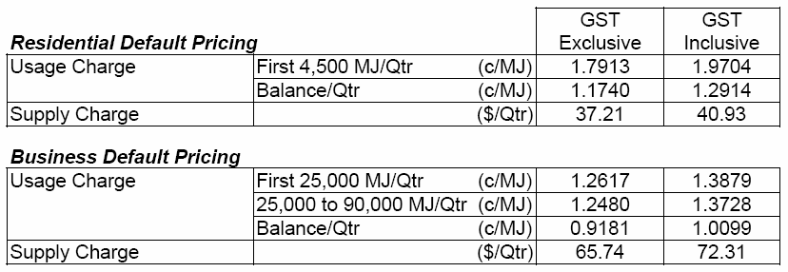
Explanatory Notes:
1. Residential Default Pricing applies to residential customers in premises used wholly or principally as private residences.
2. Business Default Pricing applies to business customers in premises that are not used wholly or principally as private residences.

EXPLOSIVES ACT 1936
Appointments
I, MICHAEL JOHN WRIGHT, Minister for Industrial Relations in and for the State of South Australia, hereby appoint each of the following persons as an Inspector for the purposes of the Explosives Act 1936, pursuant to section 9 (1) of the Explosives Act 1936:
Bryan George Russell
Prabhu Tumkur Mallikariunjah Shankar
Daljit Singh Monga
Helen Marie Kelly
Sarah Jane Villanueva
Darryl William Woolven
Dated 11 July 2006.
M. Wright, Minister for Industrial Relations

FAIR WORK ACT 1994
Appointments
I, MICHAEL JOHN WRIGHT, Minister for Industrial Relations in and for the State of South Australia, hereby appoint each of the following persons to be an Inspector for the purposes of the Fair Work Act 1994, pursuant to section 64 (1) (b) of the Fair Work Act 1994:
Bryan George Russell
Brian Adams
Soritos Mangas
David John McGraw
Donna Marie Carpenter
Marissa Jane Thwaites
Ildiko Farah
Dated 11 July 2006.
M. Wright, Minister for Industrial Relations

FISHERIES ACT 1982: SECTION 59
TAKE notice that pursuant to section 59 of the Fisheries Act 1982, Victor Bell, P.O. Box 131, Kingscote, S.A. 5223, holder of Marine Scalefish Fishery Licence No. M104 (the ‘exemption holder’), is exempt from the provisions of section 41 of the Fisheries Act 1982, Regulation 7 and Schedule 6 of the Fisheries (General) Regulations 2000, but only insofar as the exemption holder shall not be guilty of an offence when taking undersized fish of the species cockles (Katelysia spp.) (the ‘exempted activity’), within those waters specified in Schedule 1, subject to the conditions specified in Schedule 2, from 18 July 2006 until 30 June 2007, unless varied or revoked earlier.
Schedule 1
The waters in the vicinity of Kingscote bounded as follows:
Commencing at a point at high water mark at Cape Rouge, latitude 35°35′52″S and longitude 137°37′32″E, then along the geodesic (190°T), to a point at high water mark on the south coast on the Bay of Shoals, latitude 35°38′18″S and longitude 137°37′05″E, then following the line of high water mark in a generally easterly and southerly direction to a point at high water mark at the landward end of the Kingscote jetty, latitude 35°39′15″S and longitude 137°38′32″E, then along the geodesic (133°T) for a distance of 2.3 nautical miles to position latitude 35°40′32″S, longitude 137°41′00″E, then along the geodesic (033°T) for a distance of 2.1 nautical miles to a position latitude 35°38′50″S, longitude 137°42′15″E, then along the geodesic (325°T) to a point at high water mark on Marsden Point, latitude 35°33′55″S and longitude 137°38′07″E, then following the line of high water mark in a generally southerly direction back to the point of commencement.
Schedule 2
1. Any fish taken by the exemption holder pursuant to this notice must be not less than 27 mm in length measured at the greatest dimension.
2. Any fish taken by the exemption holder pursuant to this notice must be used for bait only and must not be sold.
3. The exemption holder must include all cockles taken pursuant to this exemption on the monthly catch and effort summary provided to the South Australian Research and Development Institute (SARDI).
4. While engaged in the exempted activity, the exemption holder must have in his possession a copy of this notice and produce a copy of this notice if requested by a PIRSA Fisheries Compliance Officer.
5. The exemption holder shall not contravene or fail to comply with the Fisheries Act 1982, or any regulation made under that Act, except where specifically exempted by this notice.
Dated 17 July 2006.
W. Zacharin, Director of Fisheries

FISHERIES ACT 1982: SECTION 59
TAKE notice that pursuant to section 59 of the Fisheries Act 1982, Robert Chirgwin, 9 Seaview Road, Kingscote, S.A. 5223, holder of Marine Scalefish Fishery Licence No. M039 (the ‘exemption holder’), is exempt from the provisions of section 41 of the Fisheries Act 1982, Regulation 7 and Schedule 6 of the Fisheries (General) Regulations 2000, but only insofar as the exemption holder shall not be guilty of an offence when taking undersized fish of the species cockles (Katelysia spp.) (the ‘exempted activity’), within those waters specified in Schedule 1, subject to the conditions specified in Schedule 2, from 18 July 2006 until 30 June 2007, unless varied or revoked earlier.
Schedule 1
The waters in the vicinity of Kingscote bounded as follows:
Commencing at a point at high water mark at Cape Rouge, latitude 35°35′52″S and longitude 137°37′32″E, then along the geodesic (190°T), to a point at high water mark on the south coast on the Bay of Shoals, latitude 35°38′18″S and longitude 137°37′05″E, then following the line of high water mark in a generally easterly and southerly direction to a point at high water mark at the landward end of the Kingscote jetty, latitude 35°39′15″S and longitude 137°38′32″E, then along the geodesic (133°T) for a distance of 2.3 nautical miles to position latitude 35°40′32″S, longitude 137°41′00″E, then along the geodesic (033°T) for a distance of 2.1 nautical miles to a position latitude 35°38′50″S, longitude 137°42′15″E, then along the geodesic (325°T) to a point at high water mark on Marsden Point, latitude 35°33′55″S and longitude 137°38′07″E, then following the line of high water mark in a generally southerly direction back to the point of commencement.
Schedule 2
1. Any fish taken by the exemption holder pursuant to this notice must be not less than 27 mm in length measured at the greatest dimension.
2. Any fish taken by the exemption holder pursuant to this notice must be used for bait only and must not be sold.
3. The exemption holder must include all cockles taken pursuant to this exemption on the monthly catch and effort summary provided to the South Australian Research and Development Institute (SARDI).
4. While engaged in the exempted activity, the exemption holder must have in his possession, a copy of this notice and produce a copy of the notice if requested by a PIRSA Fisheries Compliance Officer.
5. The exemption holder must not contravene or fail to comply with the Fisheries Act 1982, or any regulation made under that Act, except where specifically exempted by this notice.
Dated 17 July 2006.
W. Zacharin, Director of Fisheries

FISHERIES ACT 1982: SECTION 59
TAKE notice that pursuant to section 59 of the Fisheries Act 1982, Peter Bell, P.O. Box 298, Kingscote, S.A. 5223, holder of Marine Scalefish Fishery Licence No. M040 (the ‘exemption holder’), is exempt from the provisions of section 41 of the Fisheries Act 1982, Regulation 7 and Schedule 6 of the Fisheries (General) Regulations 2000, but only insofar as the exemption holder shall not be guilty of an offence when taking undersized fish of the species cockles (Katelysia spp.) (the ‘exempted activity’), within those waters specified in Schedule 1, subject to the conditions specified in Schedule 2, from 18 July 2006 until 30 June 2007, unless varied or revoked earlier.
Schedule 1
The waters in the vicinity of Kingscote bounded as follows:
Commencing at a point at high water mark at Cape Rouge, latitude 35°35′52″S and longitude 137°37′32″E, then along the geodesic (190°T), to a point at high water mark on the south coast on the Bay of Shoals, latitude 35°38′18″S and longitude 137°37′05″E, then following the line of high water mark in a generally easterly and southerly direction to a point at high water mark at the landward end of the Kingscote jetty, latitude 35°39′15″S and longitude 137°38′32″E, then along the geodesic (133°T) for a distance of 2.3 nautical miles to position latitude 35°40′32″S, longitude 137°41′00″E, then along the geodesic (033°T) for a distance of 2.1 nautical miles to a position latitude 35°38′50″S, longitude 137°42′15″E, then along the geodesic (325°T) to a point at high water mark on Marsden Point, latitude 35°33′55″S and longitude 137°38′07″E, then following the line of high water mark in a generally southerly direction back to the point of commencement.
Schedule 2
1. Any fish taken by the exemption holder pursuant to this notice must be not less than 27 mm in length measured at the greatest dimension.
2. Any fish taken by the exemption holder pursuant to this notice must be used for bait only and must not be sold.
3. The exemption holder must include all cockles taken pursuant to this exemption on the monthly catch and effort summary provided to the South Australian Research and Development Institute (SARDI).
4. While engaged in the exempted activity, the exemption holder must have in his posession a copy of this notice and produce a copy of the notice if requested by a PIRSA Fisheries Compliance Officer.
5. The exemption holder must not contravene or fail to comply with the Fisheries Act 1982, or any regulation made under that Act, except where specifically exempted by this notice.
Dated 17 July 2006.
W. Zacharin, Director of Fisheries

FISHERIES ACT 1982: SECTION 59
TAKE notice that pursuant to section 59 of the Fisheries Act 1982, Trevor Bell, c/o P.O. Box 3, Kingscote, S.A. 5223, holder of Marine Scalefish Fishery Licence No. M041 (the ‘exemption holder’), is exempt from the provisions of section 41 of the Fisheries Act 1982, Regulation 7 and Schedule 6 of the Fisheries (General) Regulations 2000, but only insofar as the exemption holder shall not be guilty of an offence when taking undersized fish of the species cockles (Katelysia spp.) (the ‘exempted activity’), within those waters specified in Schedule 1, subject to the conditions specified in Schedule 2, from 18 July 2006 until 30 June 2007, unless varied or revoked earlier.
Schedule 1
The waters in the vicinity of Kingscote bounded as follows:
Commencing at a point at high water mark at Cape Rouge, latitude 35°35′52″S and longitude 137°37′32″E, then along the geodesic (190°T), to a point at high water mark on the south coast on the Bay of Shoals, latitude 35°38′18″S and longitude 137°37′05″E, then following the line of high water mark in a generally easterly and southerly direction to a point at high water mark at the landward end of the Kingscote jetty, latitude 35°39′15″S and longitude 137°38′32″E, then along the geodesic (133°T) for a distance of 2.3 nautical miles to position latitude 35°40′32″S, longitude 137°41′00″E, then along the geodesic (033°T) for a distance of 2.1 nautical miles to a position latitude 35°38′50″S, longitude 137°42′15″E, then along the geodesic (325°T) to a point at high water mark on Marsden Point, latitude 35°33′55″S and longitude 137°38′07″E, then following the line of high water mark in a generally southerly direction back to the point of commencement.
Schedule 2
1. Any fish taken by the exemption holder pursuant to this notice must be not less than 27 mm in length measured at the greatest dimension.
2. Any fish taken by the exemption holder pursuant to this notice must be used for bait only and must not be sold.
3. The exemption holder must include all cockles taken pursuant to this exemption on the monthly catch and effort summary provided to the South Australian Research and Development Institute (SARDI).
4. While engaged in the exempted activity, the exemption holder must have in his possession, a copy of this notice and produce a copy of the notice if requested by a PIRSA Fisheries Compliance Officer.
5. The exemption holder shall not contravene or fail to comply with the Fisheries Act 1982, or any regulation made under that Act, except where specifically exempted by this notice.
Dated 17 July 2006.
W. Zacharin, Director of Fisheries

FISHERIES ACT 1982: SECTION 59
TAKE notice that pursuant to section 59 of the Fisheries Act 1982, all holders of a Blue Crab Fishery Licence (the ‘exemption holders’), are exempt from the definition of ‘crab pot’ and Clause 22 of Schedule 1 of the Fisheries (General) Regulations 2000, but only insofar as the exemption holder may use two registered crab pots that have the dimensions set out in Schedule 1 for the purpose of trade or business (the ‘exempted activity’) within the area specified in Schedule 2, subject to the conditions in Schedule 3, from 18 July 2006 until 30 June 2007, unless varied or revoked earlier.
Schedule 1
A crab pot of the following dimensions and specifications:
• has a maximum height of 650 mm;
• has a maximum diameter of 1.4 m; and
• has a mesh size of 55 mm.
Schedule 2
All waters of the Gulf St Vincent and Spencer Gulf Crab Fishing Zone (subject to licence holder quota holdings).
Schedule 3
1. The exemption holder may only conduct the exempted activity from a boat registered and endorsed on their Blue Crab Fishery Licence.
2. All undersize blue crabs and other species taken in the modified blue crab pots must be returned to the water immediately.
3. The following information must be recorded in relation to each blue crab retained within a modified pot:
• length in millimetres;
• sex (male or female);
• condition (soft, hard or berried);
• location of the pot (longitude and latitude); and
• the date of capture.
4. The information recorded in accordance with condition 3 must be provided to SARDI in relation to each calendar month and sent to:
Graham Hooper
South Australian Research Development Institute (SARDI)
P.O. Box 120
Henley Beach, S.A. 5022.
5. While engaged in the exempted activity the principal exemp-tion holder must have in their possession a copy of this notice. Such notice must be produced to a PIRSA Fisheries Officer if requested.
6. The exemption holders must not contravene or fail to comply with the Fisheries Act 1982, or any regulations made under that Act except where specifically exempted by this notice.
Dated 17 July 2006.
W. Zacharin, Director of Fisheries

HARBORS AND NAVIGATION ACT 1993
Determination of the State Crewing Committee
THE following determination is made by the State Crewing Committee pursuant to part 6, section 45 of the Harbors and Navigation Act 1993, was convened on 26 May 2006.
Patrick Conlon, Minister for Transport
TSA V11273

HARBORS AND NAVIGATION ACT 1993
Determination of the State Crewing Committee in respect of the
M.V. ‘Jaymar Star’
THE following determination is made by the State Crewing Committee pursuant to part 6, section 45 of the Harbors and Navigation Act 1993 in respect of the Jaymar Star whilst operating within 30 nautical miles of the coast of South Australia:
Minimum Complement
Normal Operations and Diving
Master—One person.
Engineer—One person.
Minimum Qualifications of Crew
Master—Certificate of Competency as Master Class 5.
Engineer—Certificate of Competency as Marine Engine Driver Grade III.
Capt. W. Ferrao, Presiding Member, State Crewing Committee

HARBORS AND NAVIGATION ACT 1993
Determination of the State Crewing Committee
THE following determination is made by the State Crewing Committee pursuant to part 6, section 45 of the Harbors and Navigation Act 1993 was convened on 26 May 2006.
Patrick Conlon, Minister for Transport
TSA V20230

HARBORS AND NAVIGATION ACT 1993
Determination of the State Crewing Committee in respect of the
M.V. ‘Andree Dean’
THE following determination is made by the State Crewing Committee pursuant to part 6, section 45 of the Harbors and Navigation Act 1993 in respect of the Andree Dean whilst operating within the following limits:
Limit 1—Within Partially Smooth Water limits of South Australia as per Schedule 1 of the Harbors and Navigation Regulations 1994.
Limit 2—Within 15 nautical miles of the coast of South Australia.
Minimum Complement
Limit 1—One person Master and to be the holder of Marine Engine Driver.
Limit 2—Two persons Master and Marine Engine Driver.
Minimum Qualifications of Crew
Master—Certificate of Competency as Master Class 5.
MED—Certificate of Competency as Marine Engine Driver Grade III.
Capt. W. Ferrao, Presiding Member, State Crewing Committee

LAND ACQUISITION ACT 1969
(Section 16)
Notice of Acquisition
THE COMMISSIONER OF HIGHWAYS (the Authority), 33 Warwick Street, Walkerville, S.A. 5081, acquires the following interests in the following land:
Definition of Land Acquired
Comprising the fee simple of that piece of land situated at Main South Road, Sellicks Hill, S.A. 5174, being portion of the land contained in certificate of title volume 5282, folio 229 and being the whole of Allotment 68 in the plan lodged in the Registrar-General’s Office and numbered DP 69285.
This notice is given under section 16 of the Land Acquisition Act 1969.
Compensation
A person who has or had an interest in the land that is divested or diminished by the acquisition or the enjoyment of which is adversely affected by the acquisition who does not receive an offer of compensation from the Authority may apply to the Authority for compensation.
Inquiries
Inquiries should be directed to:
Brenton Wilkinson,
P.O. Box 1,
Walkerville, S.A. 5081
Telephone (08) 8343 2460
Dated 13 July 2006.
The Common Seal of the Commissioner of Highways was hereto affixed by direction of the Commissioner of Highways in the presence of:
(l.s.) T. Lawry, Manager, Property Planning and Management Services, Department for Transport, Energy and Infrastructure

LAND AND BUSINESS (SALE AND CONVEYANCING)
ACT 1994
Exemption
TAKE notice that, pursuant to section 23 (3) of the Land and Business (Sale and Conveyancing) Act 1994, I, Jane Lomax-Smith, Acting Minister for Consumer Affairs, do hereby exempt the person named in Schedule 1 from the application of section 23 (2) of the Act in relation to the purchase of the land specified in Schedule 2.
Schedule 1
Daniel Luke Crawford, an employee of Macven Pty Ltd.
Schedule 2
The land described in certificate of title register book volume 5030, folio 702, situated at 3/21 Nora Street, Maylands, S.A. 5069.
Dated 20 July 2006.
Jane Lomax-Smith, Acting Minister for Consumer Affairs

LAND AND BUSINESS (SALE AND CONVEYANCING)
ACT 1994
Exemption
TAKE notice that, pursuant to section 23 (3) of the Land and Business (Sale and Conveyancing) Act 1994, I, Jane Lomax-Smith, Acting Minister for Consumer Affairs, do hereby exempt the person named in Schedule 1 from the application of section 23 (2) of the Act in relation to the purchase of the land specified in Schedule 2.
Schedule 1
Neil Patrick Ottoson, an employee of Naracoorte First National Pty Ltd.
Schedule 2
The land described in a portion of certificate of title register book volume 5825, folio 39, situated at Lot 41, Deposited Plan 70039, Hundred of Joanna, via Naracoorte, S.A. 5271.
Dated 20 July 2006.
Jane Lomax-Smith, Acting Minister for Consumer Affairs

LAND AND BUSINESS (SALE AND CONVEYANCING)
ACT 1994
Exemption
TAKE notice that, pursuant to section 23 (3) of the Land and Business (Sale and Conveyancing) Act 1994, I, Jane Lomax-Smith, Acting Minister for Consumer Affairs, do hereby exempt the person named in Schedule 1 from the application of section 23 (2) of the Act in relation to the purchase of the land specified in Schedule 2.
Schedule 1
Kevin John Barry, an officer of Real Estate Solutions (S.A.) Pty Ltd.
Schedule 2
The land described in certificate of title register book volume 5960, folio 990, situated at Lot 101, Fremantle Road, Port Noarlunga South, S.A. 5167.
Dated 20 July 2006.
Jane Lomax-Smith, Acting Minister for Consumer Affairs

LAND AND BUSINESS (SALE AND CONVEYANCING)
ACT 1994
Exemption
TAKE notice that, pursuant to section 23 (3) of the Land and Business (Sale and Conveyancing) Act 1994, I, Jane Lomax-Smith, Acting Minister for Consumer Affairs, do hereby exempt the person named in Schedule 1 from the application of section 23 (2) of the Act in relation to the purchase of the land specified in Schedule 2.
Schedule 1
Antony Andrew Dalton Brabham, an employee of Delfin Realty Pty Ltd.
Schedule 2
The land described in a portion of certificate of title register book volume 5957, folio 417, situated at Lot 106, Harvey Circuit, Mawson Lakes, S.A. 5095.
Dated 20 July 2006.
Jane Lomax-Smith, Acting Minister for Consumer Affairs

LAND AND BUSINESS (SALE AND CONVEYANCING)
ACT 1994
Exemption
TAKE notice that, pursuant to section 23 (3) of the Land and Business (Sale and Conveyancing) Act 1994, I, Jane Lomax-Smith, Acting Minister for Consumer Affairs, do hereby exempt the person named in Schedule 1 from the application of section 23 (2) of the Act in relation to the purchase of the land specified in Schedule 2.
Schedule 1
Troy Andrew Jamieson, an employee of Delfin Realty Pty Ltd.
Schedule 2
The land described in a portion of certificate of title register book volume 5963, folio 151, situated at Lot 140, Hummock Lane, Mawson Lakes, S.A. 5095.
Dated 20 July 2006.
Jane Lomax-Smith, Acting Minister for Consumer Affairs

LAND AND BUSINESS (SALE AND CONVEYANCING)
ACT 1994
Exemption
TAKE notice that, pursuant to section 23 (3) of the Land and Business (Sale and Conveyancing) Act 1994, I, Jane Lomax-Smith, Acting Minister for Consumer Affairs, do hereby exempt the person named in Schedule 1 from the application of section 23 (2) of the Act in relation to the purchase of the land specified in Schedule 2.
Schedule 1
Angela Jane Langberg, an employee of Onkaparinga Real Estate Pty Ltd.
Schedule 2
The whole of the land described in certificate of title register book volume 5184, folio 534, situated at 12 Clipper Court, Seaford, S.A. 5169.
Dated 20 July 2006.
Jane Lomax-Smith, Acting Minister for Consumer Affairs

LAND AND BUSINESS (SALE AND CONVEYANCING)
ACT 1994
Exemption
TAKE notice that, pursuant to section 23 (3) of the Land and Business (Sale and Conveyancing) Act 1994, I, Jane Lomax-Smith, Acting Minister for Consumer Affairs, do hereby exempt the persons named in Schedule 1 from the application of section 23 (2) of the Act in relation to the purchase of the land specified in Schedule 2.
Schedule 1
Richard Douglas Osborne, Alan Donald Miller, Andrew Duncan Oliver and Jeffrey Maxwell McHugh, employees of Delfin Realty Pty Ltd.
Schedule 2
The whole of the land described in certificate of title register book volume 5965, folio 385, situated at Lot 530, Metro Parade, Mawson Lakes, S.A. 5095.
Dated 20 July 2006.
Jane Lomax-Smith, Acting Minister for Consumer Affairs

LIQUOR LICENSING ACT 1997 AND GAMING MACHINES ACT 1992
Notice of Application
NOTICE is hereby given, pursuant to section 52 of the Liquor Licensing Act 1997 and section 29 of the Gaming Machines Act 1992, that Ian Geoffrey Williamson and Linda Williamson have applied to the Licensing Authority for the transfer of a Hotel and Gaming Machine Licence and variation to the current Extended Trading Authorisation in respect of premises known as Port Broughton Hotel and the transfer of the Special Circumstances Licence in respect of premises known as Port Broughton Hotel Courtesy Bus, both situated at 2 Bay Street, Port Broughton, S.A. 5522.
The applications have been set down for hearing on 18 August 2006 at 9 a.m.
Condition
The following licence condition is sought:
• That the current Extended Trading Authorisation be varied to include Area 6.
Any person may object to the application by lodging a notice of objection in the prescribed form with the Licensing Authority, and serving a copy of the notice on the applicants at the applicants’ address given above, at least seven days before the hearing date (viz: 10 August 2006).
The applicants’ address for service is c/o Clelands Lawyers, 208 Carrington Street, Adelaide, S.A. 5000.
Plans in respect of the premises the subject of the application are open to public inspection without fee at the Office of the Liquor and Gambling Commissioner, 9th Floor, East Wing, 50 Grenfell Street, Adelaide, S.A. 5000. Phone 8226 8410, Fax:
8226 8512. Email: olgc@agd.sa.gov.au.
Dated 17 July 2006.
Applicants

LIQUOR LICENSING ACT 1997 AND GAMING MACHINES ACT 1992
Notice of Application
NOTICE is hereby given, pursuant to section 52 of the Liquor Licensing Act 1997 and section 29 of the Gaming Machines Act 1992, that Jericho’s Tin Shed Pty Ltd as trustee for the Mark and Joan Jericho Family Trust has applied to the Licensing Authority for the transfer of a Hotel and Gaming Machine Licence in respect of premises situated at 34 Main Street, Woodside, S.A. 5244 and known as Woodside Hotel.
The applications has been set down for hearing on 23 August 2006 at 10.30 a.m.
Any person may object to the application by lodging a notice of objection in the prescribed form with the Licensing Authority, and serving a copy of the notice on the applicant at the applicant’s address given above, at least seven days before the hearing date (viz: 15 August 2006).
The applicant’s address for service is c/o Fisher Jeffries, Level 15, 211 Victoria Square, Adelaide, S.A. 5000 (Attention: Craig Vozzo or Adrian Battiston).
Plans in respect of the premises the subject of the application are open to public inspection without fee at the Office of the Liquor and Gaming Commissioner, 9th Floor, East Wing, 50 Grenfell Street, Adelaide, S.A. 5000. Phone 8226 8410, Fax: 8226 8512. Email: olgc@agd.sa.gov.au.
Dated 17 July 2006.
Applicant

LIQUOR LICENSING ACT 1997 AND GAMING MACHINES ACT 1992
Notice of Application
NOTICE is hereby given, pursuant to section 52 of the Liquor Licensing Act 1997 and section 29 of the Gaming Machines Act 1992, that Anchor Hill Investments Pty Ltd has applied to the Licensing Authority for the transfer of a Hotel and Gaming Machine Licence in respect of premises situated at Ocean Street, Victor Harbor, S.A. 5211 and known as Grosvenor Hotel.
The applications have been set down for hearing on 23 August 2006 at 9.30 a.m.
Any person may object to the application by lodging a notice of objection in the prescribed form with the Liquor and Gambling Commissioner and serving a copy of the notice on the applicant at the applicant’s address given above, at least seven days before the hearing date (viz: 15 August 2006).
The applicant’s address for service is c/o Hume Taylor & Co., 84 Flinders Street, Adelaide, S.A. 5000 (Attention: Brendan Bowler).
Plans in respect of the premises the subject of the application are open to public inspection without fee at the Office of the Liquor and Gambling Commissioner, 9th Floor, East Wing, 50 Grenfell Street, Adelaide, S.A. 5000. Phone 8226 8410, Fax:
8226 8512. Email: olgc@agd.sa.gov.au.
Dated 14 July 2006.
Applicant

LIQUOR LICENSING ACT 1997 AND GAMING MACHINES ACT 1992
Notice of Application
NOTICE is hereby given, pursuant to section 52 of the Liquor Licensing Act 1997 and section 29 of the Gaming Machines Act 1992, that Claddagh Hotels Pty Ltd has applied to the Licensing Authority for the transfer of a Hotel and Gaming Machine Licence in respect of premises situated at Railway Terrace, Morgan, S.A. 5320 and known as Terminus Hotel.
The application has been set down for hearing on 23 August 2006 at 10 a.m.
Any person may object to the application by lodging a notice of objection in the prescribed form with the Liquor and Gambling Commissioner and serving a copy of the notice on the applicant at the applicant’s address given above, at least seven days before the hearing date (viz: 15 August 2006).
The applicant’s address for service is c/o Duncan Basheer Hannon, Barristers and Solicitors, G.P.O. Box 2, Adelaide, S.A. 5001 (Attention: Max Basheer or David Tillett).
Plans in respect of the premises the subject of the application are open to public inspection without fee at the Office of the Liquor and Gambling Commissioner, 9th Floor, East Wing, 50 Grenfell Street, Adelaide, S.A. 5000. Phone 8226 8410, Fax:
8226 8512. Email: olgc@agd.sa.gov.au.
Dated 17 July 2006.
Applicant

LIQUOR LICENSING ACT 1997
Notice of Application
NOTICE is hereby given, pursuant to section 52 (2) (b) of the Liquor Licensing Act 1997, that Gordon Zhu and Lanying Chen have applied to the Licensing Authority for a Restaurant Licence in respect of premises situated at 3-5 Divett Street, Port Adelaide, S.A. 5015 and to be known as Riverside Chinese Restaurant.
The application has been set down for hearing on 18 August 2006 at 9 a.m.
Any person may object to the application by lodging a notice of objection in the prescribed form with the Liquor and Gambling Commissioner, and serving a copy of the notice on the applicants at the applicants’ address given above, at least seven days before the hearing date (viz: 10 August 2006).
The applicants’ address for service is c/o Scammell and Co., Barristers and Solicitors, P.O. Box 3066, Port Adelaide, S.A. 5015 (Attention: Errol Kaplan).
Plans in respect of the premises the subject of the application are open to public inspection without fee at the Office of the Liquor and Gambling Commissioner, 9th Floor, East Wing, 50 Grenfell Street, Adelaide, S.A. 5000. Phone 8226 8410, Fax:
8226 8512. Email: olgc@agd.sa.gov.au.
Dated 18 July 2006.
Applicants

LIQUOR LICENSING ACT 1997
Notice of Application
NOTICE is hereby given, pursuant to section 52 (2) (b) of the Liquor Licensing Act 1997, that Peter John Stibbs has applied to the Licensing Authority for a Residential Licence with Entertainment Consent in respect of premises situated at Battunga Road, Echunga, S.A. 5153 and to be known as Hazelmere Homestead.
The application has been set down for hearing on 18 August 2006 at 9 a.m.
Condition
The following licence condition is sought:
• Entertainment Consent in respect of the indoor swimming pool and dining areas for the following days and times:
Every day: 11 a.m. to midnight.
Any person may object to the application by lodging a notice of objection in the prescribed form with the Liquor and Gambling Commissioner, and serving a copy of the notice on the applicant at the applicant’s address given above, at least seven days before the hearing date (viz: 10 August 2006).
The applicant’s address for service is c/o Foreman Legal, 69 Mount Barker Road, Stirling, S.A. 5152.
Plans in respect of the premises the subject of the application are open to public inspection without fee at the Office of the Liquor and Gambling Commissioner, 9th Floor, East Wing, 50 Grenfell Street, Adelaide, S.A. 5000. Phone 8226 8410, Fax:
8226 8512. Email: olgc@agd.sa.gov.au.
Dated 18 July 2006.
Applicant

LIQUOR LICENSING ACT 1997
Notice of Application
NOTICE is hereby given, pursuant to section 52 (2) (b) of the Liquor Licensing Act 1997, that Kooringa Hotel Burra Pty Ltd has applied to the Licensing Authority for the transfer of a Hotel Licence, Extended Trading Authorisation and variation to Entertainment Consent in respect of premises situated at 4 Kingston Street, Burra, S.A. 5417 and known as Kooringa Hotel.
The application has been set down for hearing on 18 August 2006 at 9 a.m.
Conditions
The following licence conditions are sought:
Application for Extended Trading Authorisation to include the following hours:
For consumption on the premises:
Thursday to Saturday: Midnight to 2 a.m. the following day;
Sunday: 8 a.m. to 11 a.m. and 8 p.m. to midnight;
Christmas Eve: Midnight to 2 a.m. the following day;
Sunday Christmas Eve: 8 p.m. to 2 a.m. the following day;
Days preceding other Public Holidays: Midnight to 2 a.m. the following day;
Sundays preceding Public Holidays: 8 p.m. to 2 a.m. the following day.
For consumption off the premises (carry off):
Sundays: 8 a.m. to 11 a.m. and 8 p.m. to 9 p.m.
The current Entertainment Consent is to be varied to include the abovementioned hours.
Any person may object to the application by lodging a notice of objection in the prescribed form with the Liquor and Gambling Commissioner, and serving a copy of the notice on the applicant at the applicant’s address given above, at least seven days before the hearing date (viz: 10 August 2006).
The applicant’s address for service is c/o Duncan Basheer Hannon, Barristers and Solicitors, 66 Wright Street, Adelaide, S.A. 5000 (Attention: Max Basheer or David Tillett).
Plans in respect of the premises the subject of the application are open to public inspection without fee at the Office of the Liquor and Gambling Commissioner, 9th Floor, East Wing, 50 Grenfell Street, Adelaide, S.A. 5000. Phone 8226 8410, Fax:
8226 8512. Email: olgc@agd.sa.gov.au.
Dated 17 July 2006.
Applicant

LIQUOR LICENSING ACT 1997
Notice of Application
NOTICE is hereby given, pursuant to section 52 (2) (b) of the Liquor Licensing Act 1997, that Gambier Hotel Pty Ltd has applied to the Licensing Authority for a variation to an Extended Trading Authorisation and Entertainment Consent in respect of premises situated at 2 Commercial Street West, Mount Gambier, S.A. 5290 and known as Mount Gambier Hotel.
The application has been set down for hearing on 18 August 2006 at 9 a.m.
Conditions
The following licence conditions are sought:
• Variation to the current Extended Trading Authorisation to include the following additional hours:
Sunday Christmas Eve: 8 p.m. to 2 a.m. the following day;
New Year’s Eve (automatically extended to 2 a.m. the following day): 2 a.m. the following day to 3 a.m. the following day;
Days preceding other Public Holidays: Midnight to 2 a.m. the following day;
Sundays preceding Public Holidays: 8 p.m. to 2 a.m. the following day.
• Variation to the current Entertainment Consent to include the abovementioned hours.
Any person may object to the application by lodging a notice of objection in the prescribed form with the Liquor and Gambling Commissioner, and serving a copy of the notice on the applicant at the applicant’s address given above, at least seven days before the hearing date (viz: 10 August 2006).
The applicant’s address for service is c/o Matthews Hotels, 1st Floor, 36 George Street, Stepney, S.A. 5069.
Plans in respect of the premises the subject of the application are open to public inspection without fee at the Office of the Liquor and Gambling Commissioner, 9th Floor, East Wing, 50 Grenfell Street, Adelaide, S.A. 5000. Phone 8226 8410, Fax:
8226 8512. Email: olgc@agd.sa.gov.au.
Dated 14 July 2006.
Applicant

LIQUOR LICENSING ACT 1997
Notice of Application
NOTICE is hereby given, pursuant to section 52 (2) (b) of the Liquor Licensing Act 1997, that Park Hotel Pty Ltd has applied to the Licensing Authority for a variation to an Extended Trading Authorisation in respect of premises situated at 163 Commercial Street West, Mount Gambier, S.A. 5290 and known as Park Hotel.
The application has been set down for hearing on 18 August 2006 at 9 a.m.
Conditions
The following licence conditions are sought:
• Variation to the current Extended Trading Authorisation in Areas 1 and 3:
From:
Monday to Wednesday: Midnight to 1 a.m. the follow-ing day;
Thursday to Saturday: Midnight to 2 a.m. the follow-ing day.
To:
Monday to Wednesday: Midnight to 2 a.m. the follow-ing day;
Thursday to Saturday: Midnight to 3 a.m. the follow-ing day;
Sunday: 8 a.m. to 11 a.m. and 8 p.m. to 1 a.m. the following day.
Any person may object to the application by lodging a notice of objection in the prescribed form with the Liquor and Gambling Commissioner, and serving a copy of the notice on the applicant at the applicant’s address given above, at least seven days before the hearing date (viz: 10 August 2006).
The applicant’s address for service is c/o Matthews Hotels, 1st Floor, 36 George Street, Stepney, S.A. 5069.
Plans in respect of the premises the subject of the application are open to public inspection without fee at the Office of the Liquor and Gambling Commissioner, 9th Floor, East Wing, 50 Grenfell Street, Adelaide, S.A. 5000. Phone 8226 8410, Fax:
8226 8512. Email: olgc@agd.sa.gov.au.
Dated 14 July 2006.
Applicant

LIQUOR LICENSING ACT 1997
Notice of Application
NOTICE is hereby given, pursuant to section 52 (2) (b) of the Liquor Licensing Act 1997, that Graeme Macartney and Associates Pty Ltd has applied to the Licensing Authority for a Wholesale Liquor Merchant’s Licence in respect of premises situated at 108 Main South Road, Hackham, S.A. 5163 and to be known as Aussie Inn.
The application has been set down for hearing on 18 August 2006 at 9 a.m.
Any person may object to the application by lodging a notice of objection in the prescribed form with the Liquor and Gambling Commissioner, and serving a copy of the notice on the applicant at the applicant’s address given above, at least seven days before the hearing date (viz: 10 August 2006).
The applicant’s address for service is c/o Wallmans Lawyers, 173 Wakefield Street, Adelaide, S.A. 5000 (Attention: Peter Hoban or Ben Allen).
Plans in respect of the premises the subject of the application are open to public inspection without fee at the Office of the Liquor and Gambling Commissioner, 9th Floor, East Wing, 50 Grenfell Street, Adelaide, S.A. 5000. Phone 8226 8410, Fax:
8226 8512. Email: olgc@agd.sa.gov.au.
Dated 14 July 2006.
Applicant

LIQUOR LICENSING ACT 1997
Notice of Application
NOTICE is hereby given, pursuant to section 52 (2) (b) of the Liquor Licensing Act 1997, that Beachfield Pty Ltd has applied to the Licensing Authority for a Producer’s Licence in respect of premises situated at 124 Jacka Road, Mintaro, S.A. 5415 and to be known as Beachfield.
The application has been set down for hearing on 18 August 2006 at 9 a.m.
Any person may object to the application by lodging a notice of objection in the prescribed form with the Liquor and Gambling Commissioner and serving a copy of the notice on the applicant at the applicant’s address given above, at least seven days before the hearing date (viz: 10 August 2006).
The applicant’s address for service is c/o David Paulke, Unit 24, Windemere Tower, 27 Harbour Road, Hamilton, Qld 4007.
Plans in respect of the premises the subject of the application are open to public inspection without fee at the Office of the Liquor and Gambling Commissioner, 9th Floor, East Wing, 50 Grenfell Street, Adelaide, S.A. 5000. Phone 8226 8410, Fax:
8226 8512. Email: olgc@agd.sa.gov.au.
Dated 13 July 2006.
Applicant

LIQUOR LICENSING ACT 1997
Notice of Application
NOTICE is hereby given, pursuant to section 52 (2) (b) of the Liquor Licensing Act 1997, that Charmaine Leslie Aplin and Keith Bernard Halloran have applied to the Licensing Authority for a Residential Licence with Section 33 (1) (b), Extended Trading Authorisation and Entertainment Consent in respect of premises situated at 152 River Lane, Mannum, S.A. 5238 and to be known as Baseby House Bed & Breakfast.
The application has been set down for hearing on 18 August 2006 at 9 a.m.
Conditions
The following licence conditions are sought:
• Extended Trading Authorisation is sought as per plans lodged and for the following hours:
Monday to Saturday: Midnight to 2 a.m. the following day;
Sunday: 9 a.m. to 11 a.m. and 8 p.m. to midnight (including Sundays preceding Public Holidays);
Christmas Day: Midnight to 2 a.m.;
Good Friday: Midnight to 2 a.m.;
Days preceding other Public Holidays: Midnight to 2 a.m. the following day.
• Approval under Section 33 (1) (b) to sell liquor for consumption on the licensed premises by persons:
(a) seated at a table; or
(b) attending a function at which food is provided.
• Entertainment Consent is sought as per plans lodged and for the following times:
Monday to Thursday: 7 p.m. to midnight;
Friday: 6 p.m. to midnight;
Saturday: 11 a.m. to midnight;
Sunday: 11 a.m. to 10 p.m.;
Public Holidays: 11 a.m. to midnight.
Any person may object to the application by lodging a notice of objection in the prescribed form with the Liquor and Gambling Commissioner and serving a copy of the notice on the applicants at the applicants’ address given above, at least seven days before the hearing date (viz: 10 August 2006).
The applicants’ address for service is c/o Charmaine Aplin, 152 River Lane, Mannum, S.A. 5238.
Plans in respect of the premises the subject of the application are open to public inspection without fee at the Office of the Liquor and Gambling Commissioner, 9th Floor, East Wing, 50 Grenfell Street, Adelaide, S.A. 5000. Phone 8226 8410, Fax:
8226 8512. Email: olgc@agd.sa.gov.au.
Dated 13 July 2006.
Applicants

LIQUOR LICENSING ACT 1997
Notice of Application
NOTICE is hereby given, pursuant to section 52 (2) (b) of the Liquor Licensing Act 1997, that Vox Australia Pty Ltd has applied to the Licensing Authority for a Special Circumstances Licence in respect of premises situated at 35 Unley Road, Parkside, S.A. 5063 and to be known as Destination for Men.
The application has been set down for hearing on 18 August 2006 at 9 a.m.
Conditions
The following licence conditions are sought:
• The predominant activity of the premises is to be that of a male grooming salon with the provision of alcohol ancillary to this business.
• The alcohol will be offered and provided to customers on a gratuitous basis.
• Alcohol is not to be provided or offered for sale to the general public.
• The trading hours will be as follows:
Tuesday and Wednesday: 10 a.m. to 6 p.m.;
Thursday and Friday: 10 a.m. to 8 p.m.;
Saturday: 8.30 a.m. to 5.30 p.m.
Any person may object to the application by lodging a notice of objection in the prescribed form with the Liquor and Gambling Commissioner and serving a copy of the notice on the applicant at the applicant’s address given above, at least seven days before the hearing date (viz: 10 August 2006).
The applicant’s address for service is c/o Troy Gray, 35 Unley Road, Parkside, S.A. 5063.
Plans in respect of the premises the subject of the application are open to public inspection without fee at the Office of the Liquor and Gambling Commissioner, 9th Floor, East Wing, 50 Grenfell Street, Adelaide, S.A. 5000. Phone 8226 8410, Fax:
8226 8512. Email: olgc@agd.sa.gov.au.
Dated 13 July 2006.
Applicant

LIQUOR LICENSING ACT 1997
Notice of Application
NOTICE is hereby given, pursuant to section 52 (2) (b) of the Liquor Licensing Act 1997, that Subramani Krishnan and Nagaraju Thamanna have applied to the Licensing Authority for a Restaurant Licence with Entertainment Consent in respect of premises situated at 6/384 Prospect Road, Kilburn, S.A. 5084 and to be known as Indus Tandoori Restaurant.
The application has been set down for hearing on 18 August 2006 at 9 a.m.
Conditions
The following licence conditions are sought:
• Entertainment Consent is sought as per plans lodged and for the following times:
Friday and Saturday: Noon to midnight.
Any person may object to the application by lodging a notice of objection in the prescribed form with the Liquor and Gambling Commissioner and serving a copy of the notice on the applicants at the applicants’ address given above, at least seven days before the hearing date (viz: 10 August 2006).
The applicants’ address for service is c/o David Watts and Associates, 1 Cator Street, Glenside, S.A. 5065.
Plans in respect of the premises the subject of the application are open to public inspection without fee at the Office of the Liquor and Gambling Commissioner, 9th Floor, East Wing, 50 Grenfell Street, Adelaide, S.A. 5000. Phone 8226 8410, Fax:
8226 8512. Email: olgc@agd.sa.gov.au.
Dated 12 July 2006.
Applicants

LIQUOR LICENSING ACT 1997
Notice of Application
NOTICE is hereby given, pursuant to section 52 (2) (b) of the Liquor Licensing Act 1997, that Australian Selected Vineyards Pty Ltd has applied to the Licensing Authority for the removal of a Producer’s Licence in respect of premises situated at 15 Nicholas Court, Lyndoch, S.A. 5351, to be situated at 61C Murray Street, Tanunda S.A. 5352 and known as Australian Selected Vineyards.
The application has been set down for hearing on 18 August 2006 at 9 a.m.
Any person may object to the application by lodging a notice of objection in the prescribed form with the Liquor and Gambling Commissioner and serving a copy of the notice on the applicant at the applicant’s address given above, at least seven days before the hearing date (viz: 10 August 2006).
The applicant’s address for service is c/o Michael Hislop, P.O. Box 572, Tanunda, S.A. 5352.
Plans in respect of the premises the subject of the application are open to public inspection without fee at the Office of the Liquor and Gambling Commissioner, 9th Floor, East Wing, 50 Grenfell Street, Adelaide, S.A. 5000. Phone 8226 8410, Fax:
8226 8512. Email: olgc@agd.sa.gov.au.
Dated 17 July 2006.
Applicant

LIQUOR LICENSING ACT 1997
Notice of Application
NOTICE is hereby given, pursuant to section 52 (2) (b) of the Liquor Licensing Act 1997, that Joperi Hotel Pty Ltd has applied to the Licensing Authority for a variation to an Extended Trading Authorisation in respect of premises situated at 132 Main South Road, Morphett Vale, S.A. 5162 and known as Emu Hotel—Morphett Vale.
The application has been set down for hearing on 18 August 2006 at 9 a.m.
Conditions
The following licence conditions are sought:
• Variation to Extended Trading Authorisation for con-sumption on the licensed premises:
Sundays (including Sundays preceding Public Holidays): Midnight to 2 a.m. the following day (currently 8 p.m. to midnight);
Monday to Wednesday: Midnight to 2 a.m. the following day.
Any person may object to the application by lodging a notice of objection in the prescribed form with the Liquor and Gambling Commissioner and serving a copy of the notice on the applicant at the applicant’s address given above, at least seven days before the hearing date (viz: 10 August 2006).
The applicant’s address for service is c/o Duncan Basheer Hannon, Barristers & Solicitors, G.P.O. Box 2, Adelaide, S.A. 5001 (Attention: David Tillett or John Williams).
Plans in respect of the premises the subject of the application are open to public inspection without fee at the Office of the Liquor and Gambling Commissioner, 9th Floor, East Wing, 50 Grenfell Street, Adelaide, S.A. 5000. Phone 8226 8410, Fax:
8226 8512. Email: olgc@agd.sa.gov.au.
Dated 14 July 2006.
Applicant

LIQUOR LICENSING ACT 1997
Notice of Application
NOTICE is hereby given, pursuant to section 52 (2) (b) of the Liquor Licensing Act 1997, that SOGM Pty Ltd has applied to the Licensing Authority for the transfer of a Restaurant Licence in respect of premises situated at Shop 11, Magnet Shopping Centre, 10 Coromandel Parade, Blackwood, S.A. 5051 and known as Cafe Rimini.
The application has been set down for hearing on 21 August 2006 at 9 a.m.
Any person may object to the application by lodging a notice of objection in the prescribed form with the Liquor and Gambling Commissioner and serving a copy of the notice on the applicant at the applicant’s address given above, at least seven days before the hearing date (viz: 11 August 2006).
The applicant’s address for service is c/o Philip Foreman, 69 Mount Barker Road, Stirling, S.A. 5152.
Plans in respect of the premises the subject of the application are open to public inspection without fee at the Office of the Liquor and Gambling Commissioner, 9th Floor, East Wing, 50 Grenfell Street, Adelaide, S.A. 5000. Phone 8226 8410, Fax:
8226 8512. Email: olgc@agd.sa.gov.au.
Dated 18 July 2006.
Applicant

LIQUOR LICENSING ACT 1997
Notice of Application
NOTICE is hereby given, pursuant to section 52 (2) (b) of the Liquor Licensing Act 1997, that Xing Chen Pty Ltd, Hai Guo, Yu Li and Bi Qing Lin have applied to the Licensing Authority for the transfer of a Restaurant Licence in respect of premises situated at 217 The Parade, Norwood, S.A. 5067 and to be known as Fortuna Court Chinese Restaurant.
The application has been set down for hearing on 21 August 2006 at 9.30 a.m.
Any person may object to the application by lodging a notice of objection in the prescribed form with the Liquor and Gambling Commissioner and serving a copy of the notice on the applicants at the applicants’ address given above, at least seven days before the hearing date (viz: 11 August 2006).
The applicants’ address for service is c/o Yapp Hau Pehn, Yapp Hau Pehn Solicitors, 1st Floor, 149 Flinders Street, Adelaide, S.A. 5000.
Plans in respect of the premises the subject of the application are open to public inspection without fee at the Office of the Liquor and Gambling Commissioner, 9th Floor, East Wing, 50 Grenfell Street, Adelaide, S.A. 5000. Phone 8226 8410, Fax:
8226 8512. Email: olgc@agd.sa.gov.au.
Dated 18 July 2006.
Applicants

LIQUOR LICENSING ACT 1997
Notice of Application
NOTICE is hereby given, pursuant to section 52 (2) (b) of the Liquor Licensing Act 1997, that David James Cook and Wendy Anne Prowse as trustee for the D.J. & W.A. Cook Family Trust have applied to the Licensing Authority for the transfer of a Special Circumstances Licence in respect of premises situated at Shop 3/22 Shannon Street, Birdwood, S.A. 5234 and known as Birdwood Wine and Cheese Centre.
The application has been set down for hearing on 21 August 2006 at 10 a.m.
Any person may object to the application by lodging a notice of objection in the prescribed form with the Liquor and Gambling Commissioner and serving a copy of the notice on the applicants at the applicants’ address given above, at least seven days before the hearing date (viz: 11 August 2006).
The applicants’ address for service is c/o Carrington Con-veyancers, 100 Carrington Street, Adelaide, S.A. 5000.
Plans in respect of the premises the subject of the application are open to public inspection without fee at the Office of the Liquor and Gambling Commissioner, 9th Floor, East Wing, 50 Grenfell Street, Adelaide, S.A. 5000. Phone 8226 8410, Fax:
8226 8512. Email: olgc@agd.sa.gov.au.
Dated 12 July 2006.
Applicants

LIQUOR LICENSING ACT 1997
Notice of Application
NOTICE is hereby given, pursuant to section 52 (2) (b) of the Liquor Licensing Act 1997, that Craig Anthony Smith has applied to the Licensing Authority for the transfer of a Producer’s Licence in respect of premises situated at Lot 11, Clarke Road, OB Flat, S.A. 5290 and known as Barreta Estate.
The application has been set down for hearing on 21 August 2006 at 10.30 a.m.
Any person may object to the application by lodging a notice of objection in the prescribed form with the Liquor and Gambling Commissioner and serving a copy of the notice on the applicant at the applicant’s address given above, at least seven days before the hearing date (viz: 11 August 2006).
The applicant’s address for service is c/o Craig Smith, P.O. Box 1544, Mount Gambier, S.A. 5291.
Plans in respect of the premises the subject of the application are open to public inspection without fee at the Office of the Liquor and Gambling Commissioner, 9th Floor, East Wing, 50 Grenfell Street, Adelaide, S.A. 5000. Phone 8226 8410, Fax:
8226 8512. Email: olgc@agd.sa.gov.au.
Dated 13 July 2006.
Applicant

LIQUOR LICENSING ACT 1997
Notice of Application
NOTICE is hereby given, pursuant to section 52 (2) (b) of the Liquor Licensing Act 1997, that Jodie Krollig, Kym Krollig, Karen Krollig, Ryan Krollig, Justin Maloney and Lauren Roether have applied to the Licensing Authority for the transfer of a Liquor Licence in respect of premises situated at 50 Chucka Bend Road, Bowhill, S.A. 5238 and to be known as Bowhill General Store.
The application has been set down for hearing on 22 August 2006 at 9.30 a.m.
Any person may object to the application by lodging a notice of objection in the prescribed form with the Liquor and Gambling Commissioner and serving a copy of the notice on the applicants at the applicants’ address given above, at least seven days before the hearing date (viz: 14 August 2006).
The applicants’ address for service is c/o Jodie Krollig, 50 Chucka Bend Road, Bowhill, S.A. 5238.
Plans in respect of the premises the subject of the application are open to public inspection without fee at the Office of the Liquor and Gambling Commissioner, 9th Floor, East Wing, 50 Grenfell Street, Adelaide, S.A. 5000. Phone 8226 8410, Fax:
8226 8512. Email: olgc@agd.sa.gov.au.
Dated 18 July 2006.
Applicants

LIQUOR LICENSING ACT 1997
Notice of Application
NOTICE is hereby given, pursuant to section 52 (2) (b) of the Liquor Licensing Act 1997, that Ranty Pty Ltd as trustee for the Ranty Business Trust of 82 Halifax Street, Adelaide S.A. 5000 has applied to the Licensing Authority for the transfer of a Special Circumstances Licence in respect of premises situated at Level 3, Barbara Hanrahan Building, North Terrace, Adelaide, S.A. 5000, known as University of S.A.—City West Campus and to be known as Rob’s Aroma Cafe.
The application has been set down for hearing on 22 August 2006 at 10 a.m.
Any person may object to the application by lodging a notice of objection in the prescribed form with the Liquor and Gambling Commissioner and serving a copy of the notice on the applicant at the applicant’s address given above, at least seven days before the hearing date (viz: 14 August 2006).
The applicant’s address for service is c/o Harry Patsouris, 82 Halifax Street, Adelaide, S.A. 5000.
Plans in respect of the premises the subject of the application are open to public inspection without fee at the Office of the Liquor and Gambling Commissioner, 9th Floor, East Wing, 50 Grenfell Street, Adelaide, S.A. 5000. Phone 8226 8410, Fax:
8226 8512. Email: olgc@agd.sa.gov.au.
Dated 18 July 2006.
Applicant

LIQUOR LICENSING ACT 1997
Notice of Application
NOTICE is hereby given, pursuant to section 52 (2) (b) of the Liquor Licensing Act 1997, that Bangdong Zhou and Junyi Lin have applied to the Licensing Authority for the transfer of a Liquor Licence in respect of premises situated at Shop 11, 329-331 Henley Beach Road, Brooklyn Park, S.A. 5032 and known as Nizam’s Indian Curry Bar.
The application has been set down for hearing on 22 August 2006 at 9 a.m.
Any person may object to the application by lodging a notice of objection in the prescribed form with the Liquor and Gambling Commissioner and serving a copy of the notice on the applicants at the applicants’ address given above, at least seven days before the hearing date (viz: 14 August 2006).
The applicants’ address for service is c/o Bangdong Zhou and Jungi Lin, Shop 11, 329-331 Henley Beach Road, Brooklyn Park, S.A. 5032.
Plans in respect of the premises the subject of the application are open to public inspection without fee at the Office of the Liquor and Gambling Commissioner, 9th Floor, East Wing, 50 Grenfell Street, Adelaide, S.A. 5000. Phone 8226 8410, Fax:
8226 8512. Email: olgc@agd.sa.gov.au.
Dated 18 July 2006.
Applicants

LIQUOR LICENSING ACT 1997
Notice of Application
NOTICE is hereby given, pursuant to section 52 (2) (b) of the Liquor Licensing Act 1997, that The Power House Pool Lounge Pty Ltd has applied to the Licensing Authority for the transfer of a Special Circumstances Licence in respect of premises situated at 6 Sims Street, Old Reynella, S.A. 5161, known as Southern Cue Sportz Centre and to be known as The Power House Pool Lounge.
The application has been set down for hearing on 22 August 2006 at 10.30 a.m.
Any person may object to the application by lodging a notice of objection in the prescribed form with the Liquor and Gambling Commissioner and serving a copy of the notice on the applicant at the applicant’s address given above, at least seven days before the hearing date (viz: 14 August 2006).
The applicant’s address for service is c/o Duncan Basheer Hannon, Barristers and Solicitors, 66 Wright Street, Adelaide, S.A. 5000 (Attention: Max Basheer or David Tillett).
Plans in respect of the premises the subject of the application are open to public inspection without fee at the Office of the Liquor and Gambling Commissioner, 9th Floor, East Wing, 50 Grenfell Street, Adelaide, S.A. 5000. Phone 8226 8410, Fax:
8226 8512. Email: olgc@agd.sa.gov.au.
Dated 14 July 2006.
Applicant

LIQUOR LICENSING ACT 1997
Notice of Application
NOTICE is hereby given, pursuant to section 52 (2) (b) of the Liquor Licensing Act 1997, that the Brompton Hotel Pty Ltd as trustee for the Brompton Hotel Class Trust has applied to the Licensing Authority for alterations, redefinition, Extended Trading Authorisation and variation to Entertainment Consent in respect of premises situated at 5 First Street, Brompton Park, S.A. 5007 and known as Brompton Hotel.
The application has been set down for hearing on 18 August 2006 at 9 a.m.
Conditions
The following licence conditions are sought:
• Approval of the proposed alterations and redefinition to the licensed premises in accordance with the plans.
• Variation to trading hours (including Extended Trading Authorisation) to apply to the whole of the licensed premises:
For consumption on the licensed premises:
Monday to Saturday: 9 a.m. to midnight;
Sundays: 9 a.m. to 11 p.m.
For consumption off the licensed premises:
Sundays: 9 a.m. to 9 p.m.
• Variation to Entertainment Consent (including the hours described above) to apply to the areas outlined.
Any person may object to the application by lodging a notice of objection in the prescribed form with the Liquor and Gambling Commissioner, and serving a copy of the notice on the applicant at the applicant’s address given above, at least seven days before the hearing date (viz: 10 August 2006).
The applicant’s address for service is c/o Wallmans Lawyers, 173 Wakefield Street, Adelaide, S.A. 5000.
Plans in respect of the premises the subject of the application are open to public inspection without fee at the Office of the Liquor and Gambling Commissioner, 9th Floor, East Wing, 50 Grenfell Street, Adelaide, S.A. 5000. Phone 8226 8410, Fax:
8226 8512. Email: olgc@agd.sa.gov.au.
Dated 18 July 2006.
Applicant

LOCAL GOVERNMENT (ELECTIONS) ACT 1999
PURSUANT to the Local Government (Elections) Act 1999, section 92A, and after consultation with the Local Government Association, I, K. M. Mousley, Electoral Commissioner, determine that, for the purpose of the conduct of Local Government elections, the following forms be gazetted.

K. M. Mousley, Electoral Commissioner

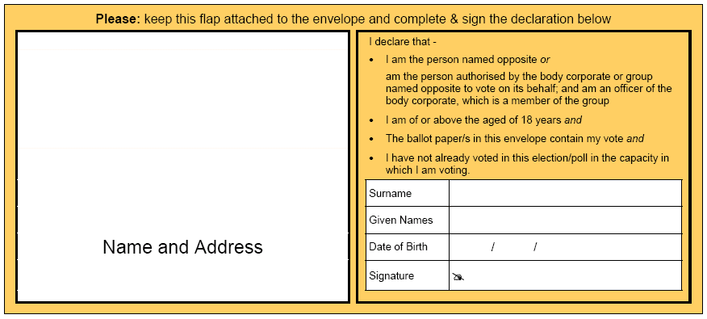
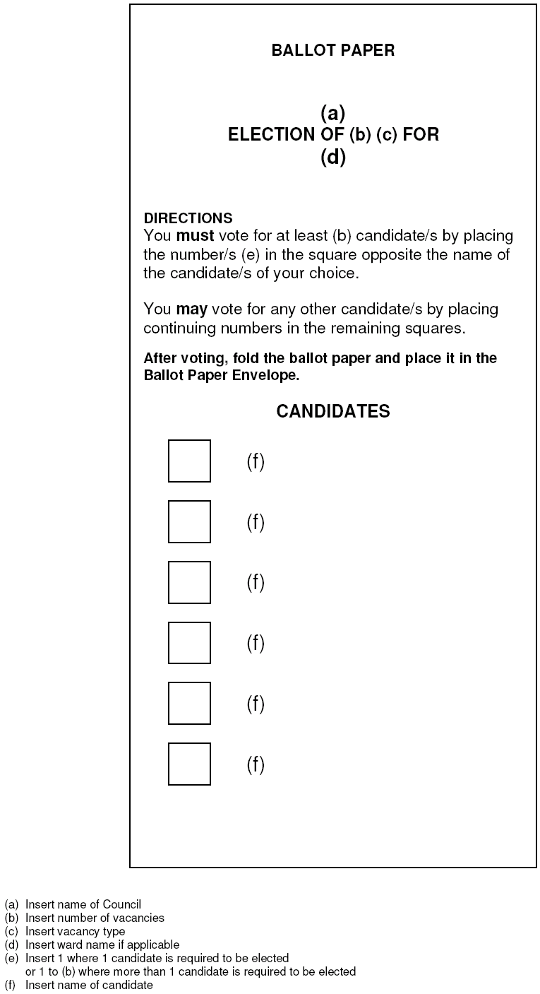


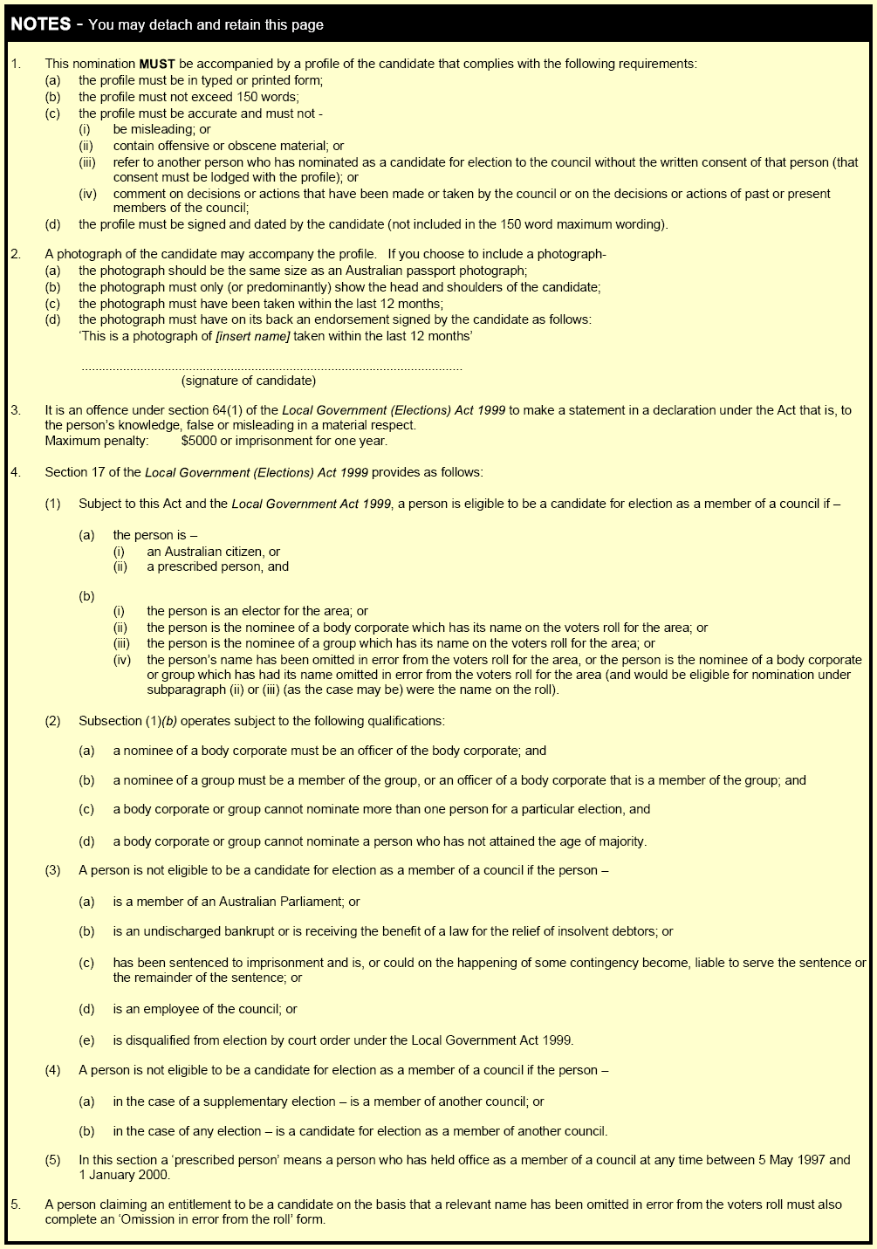
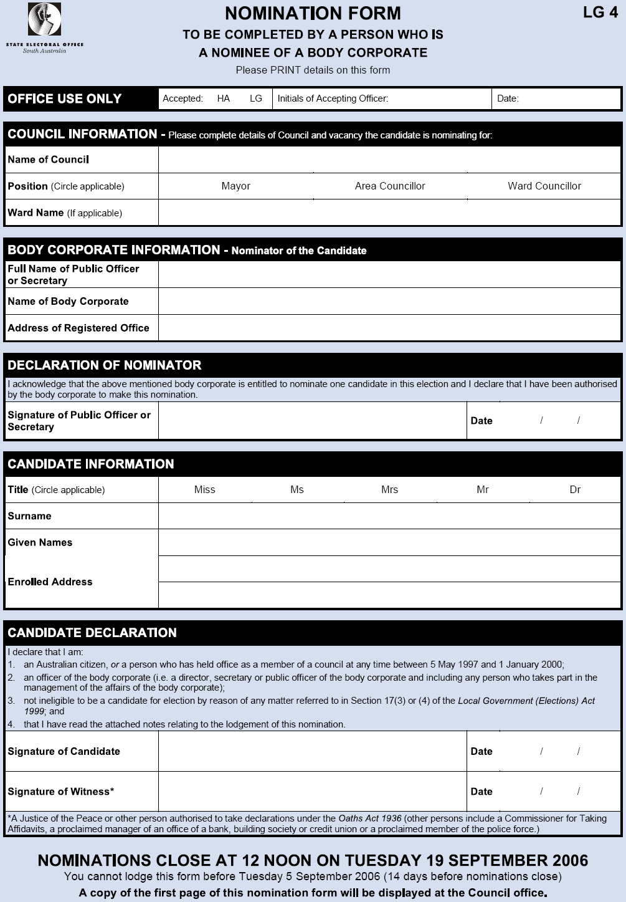

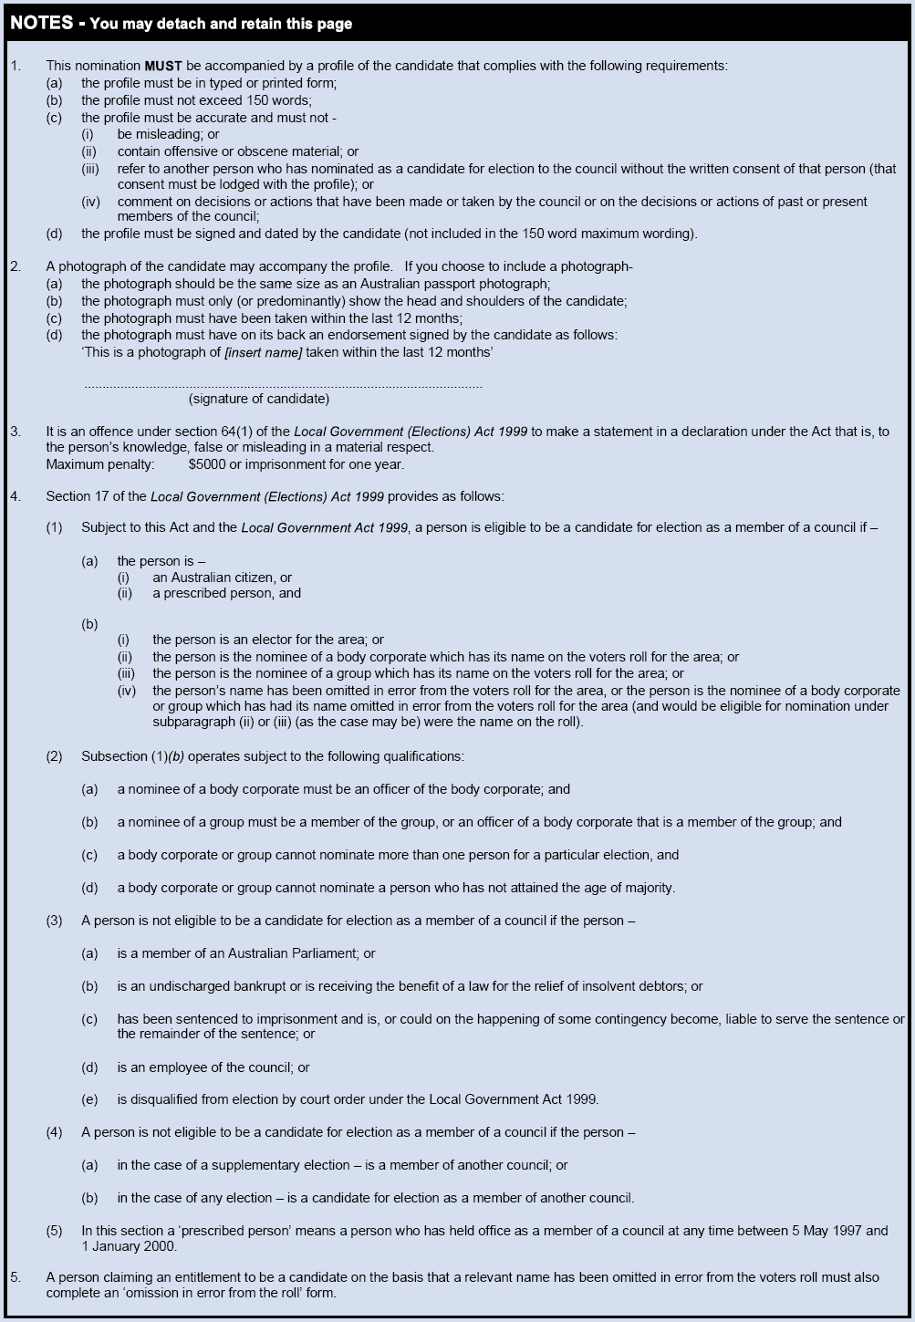


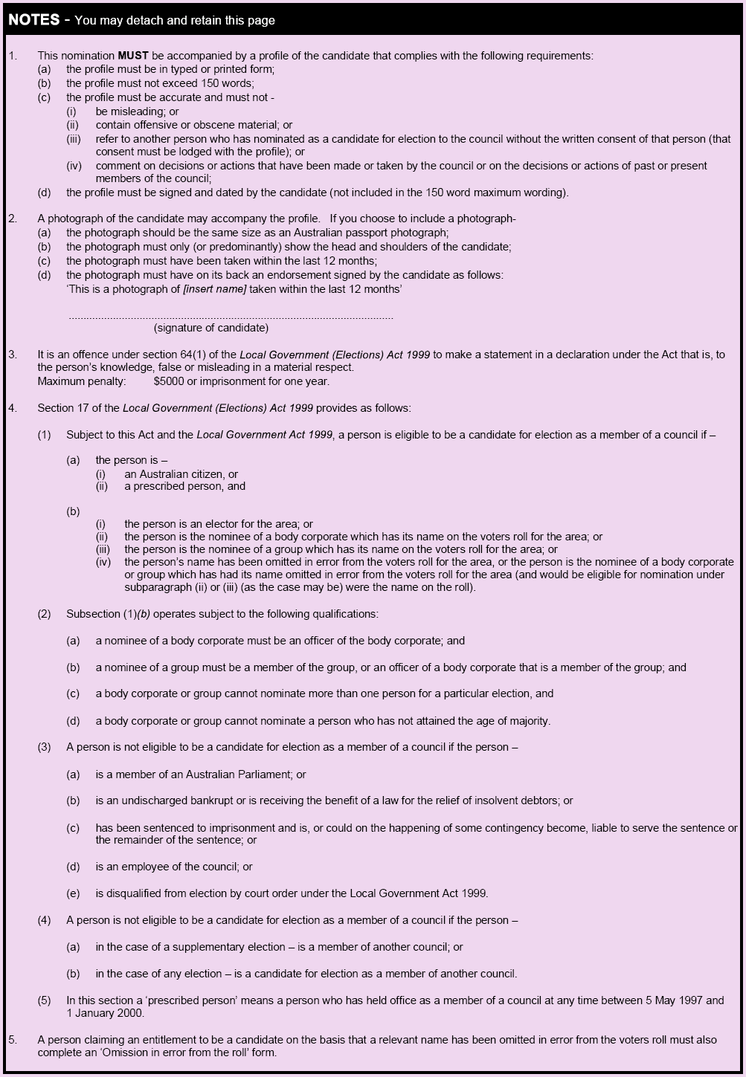
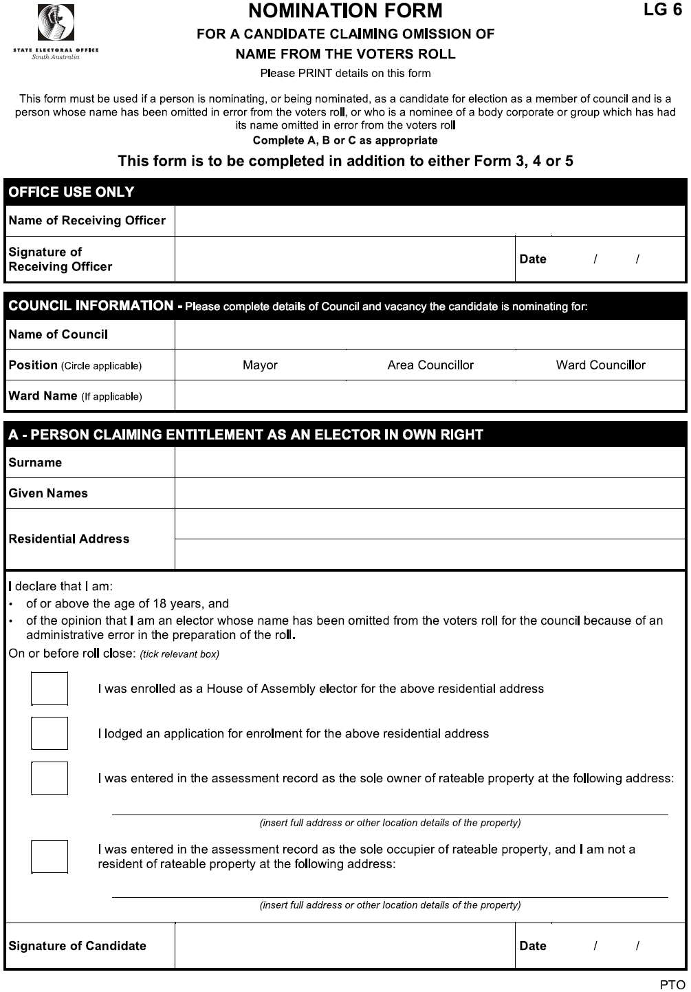
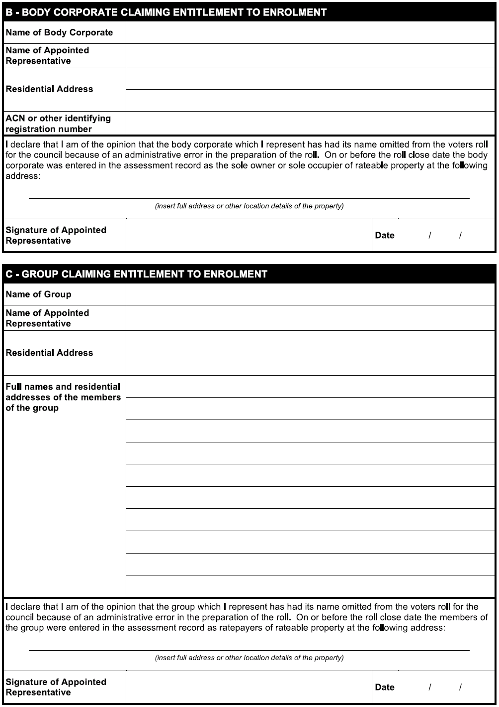
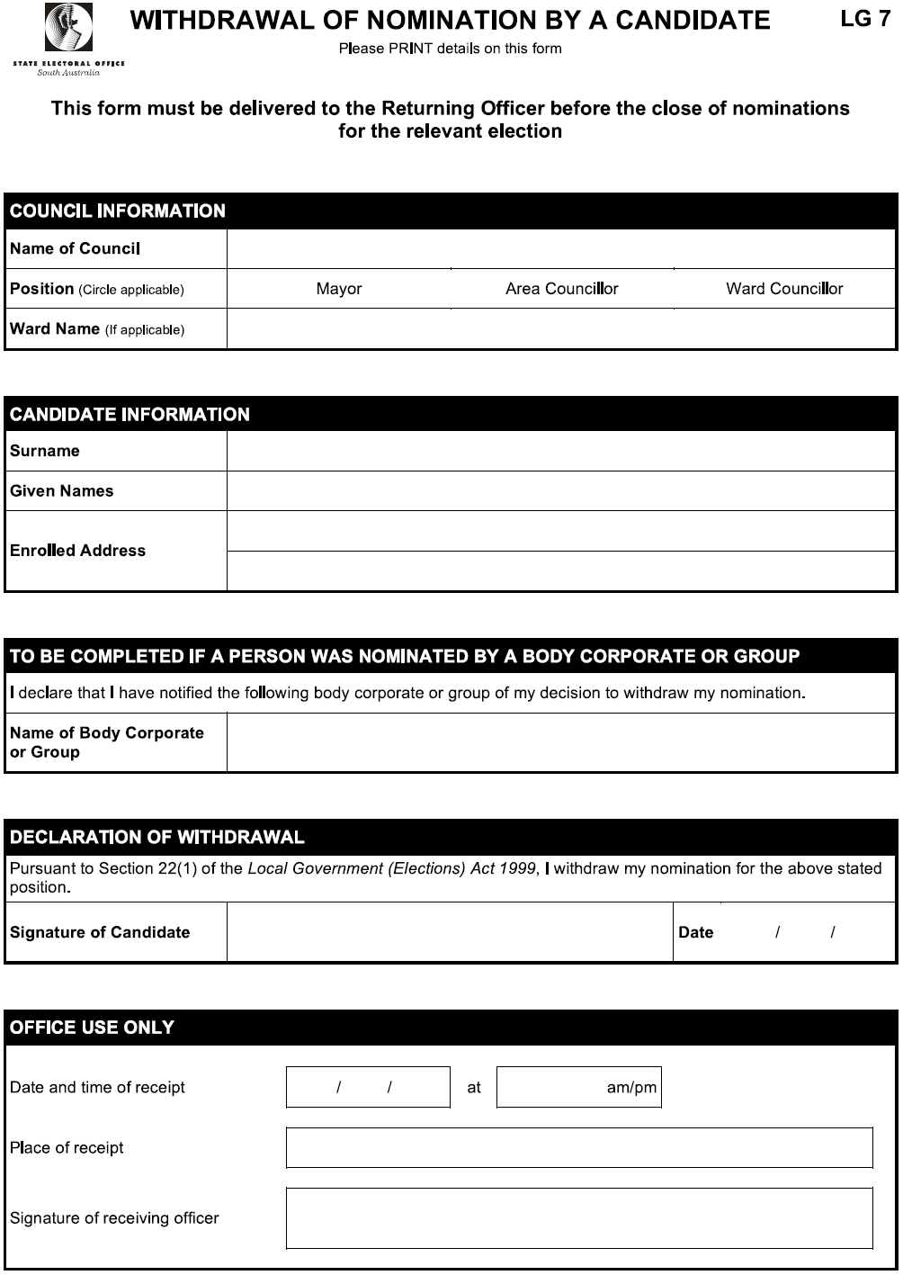
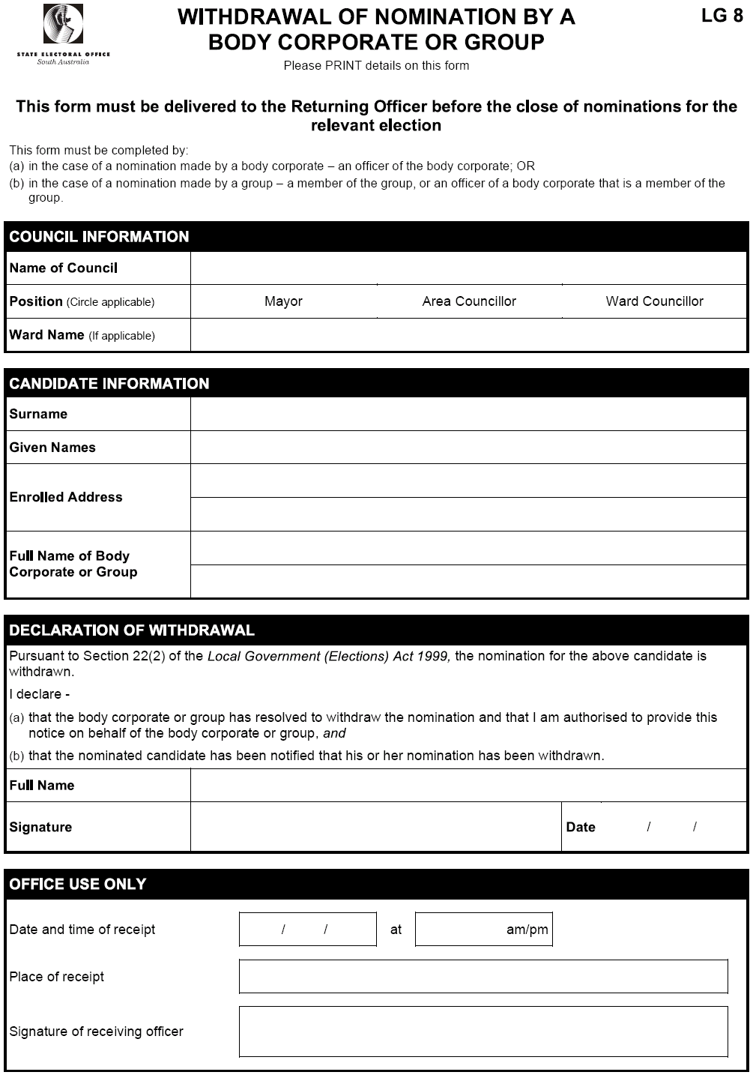
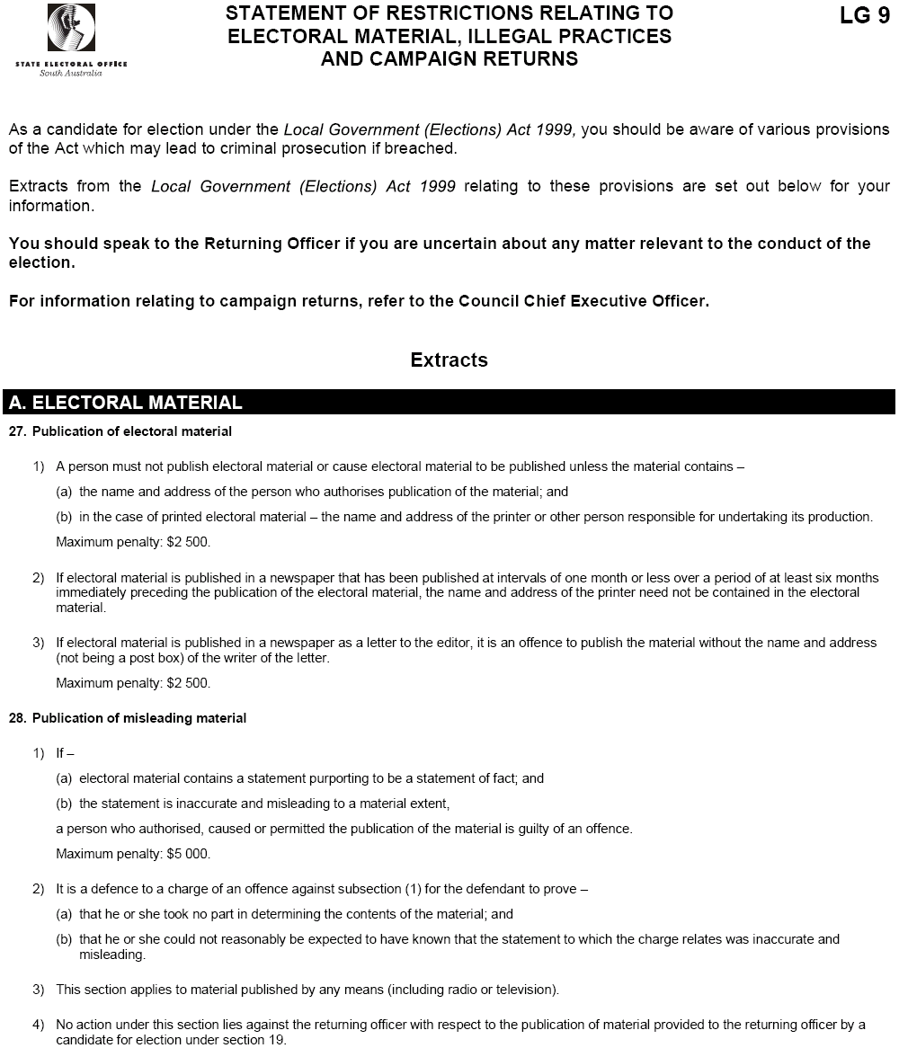
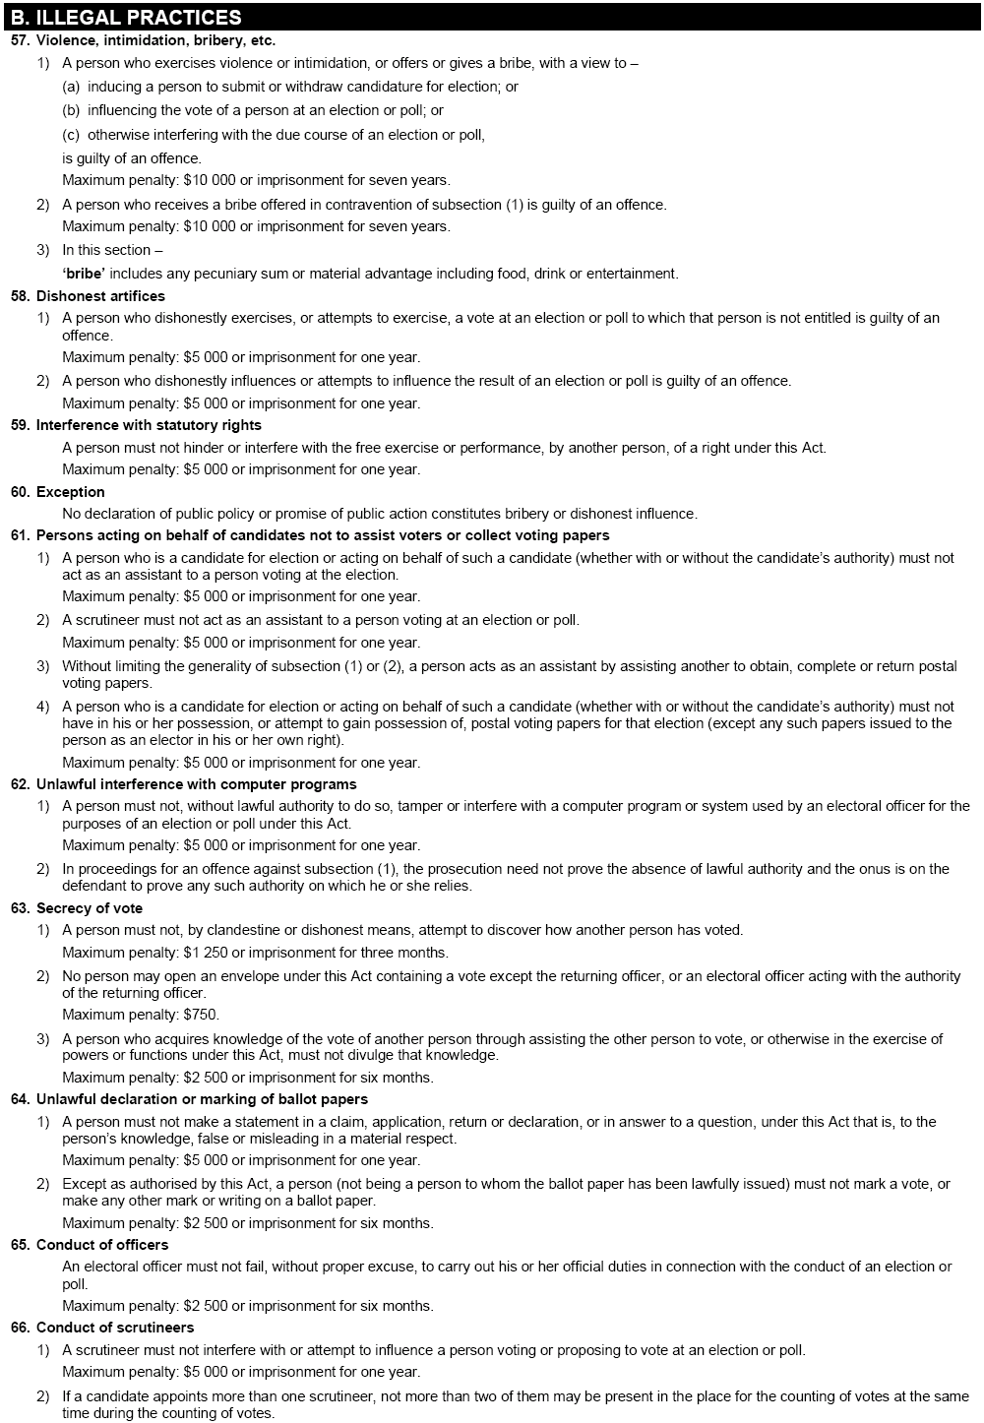
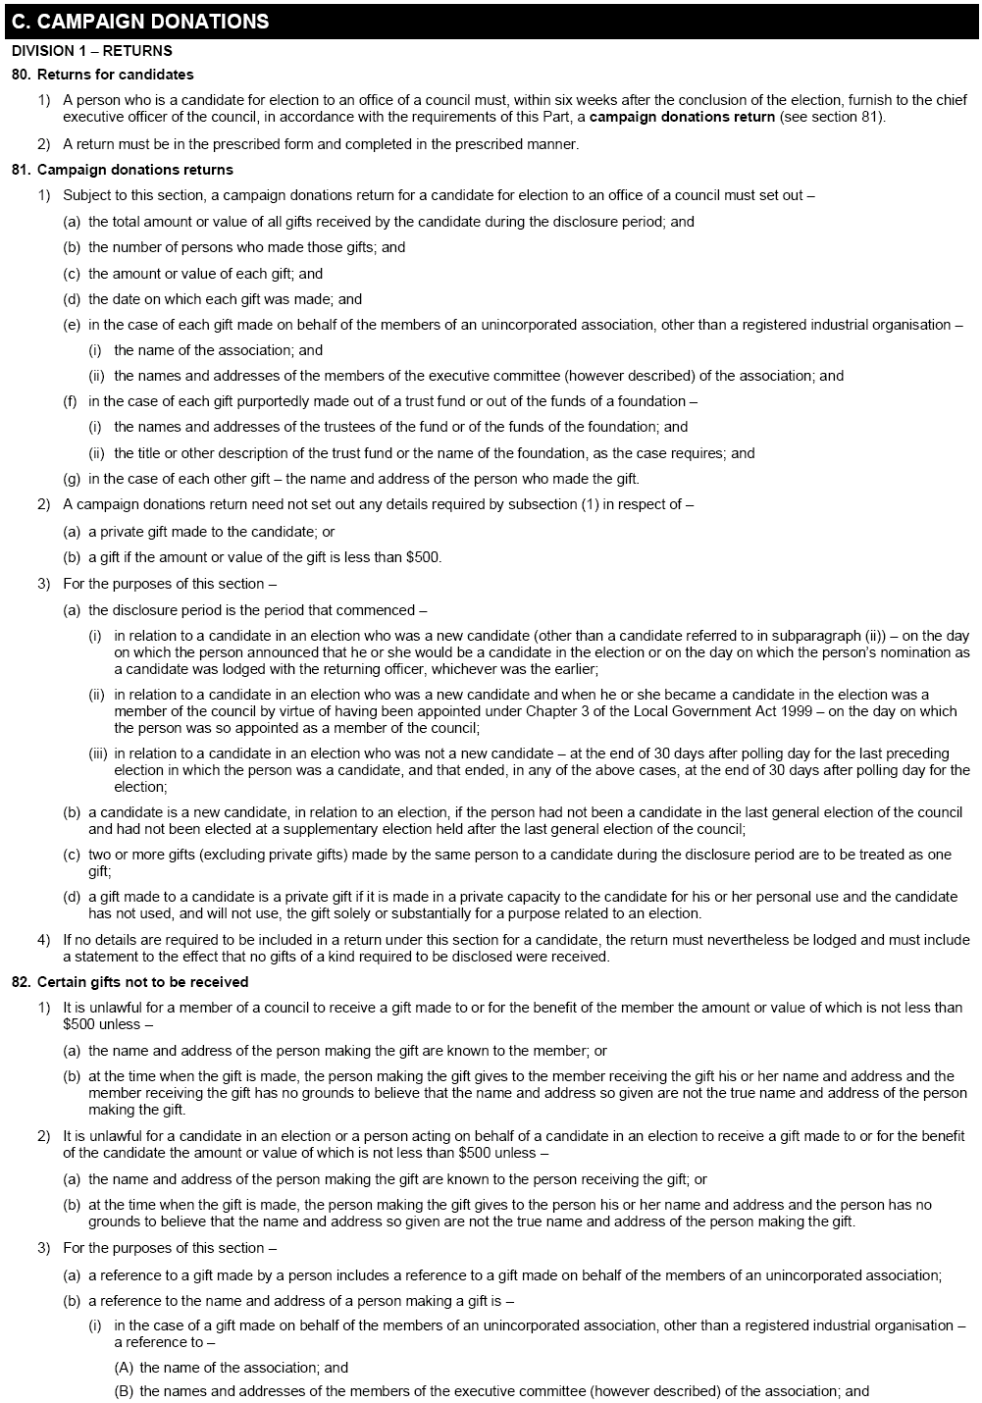
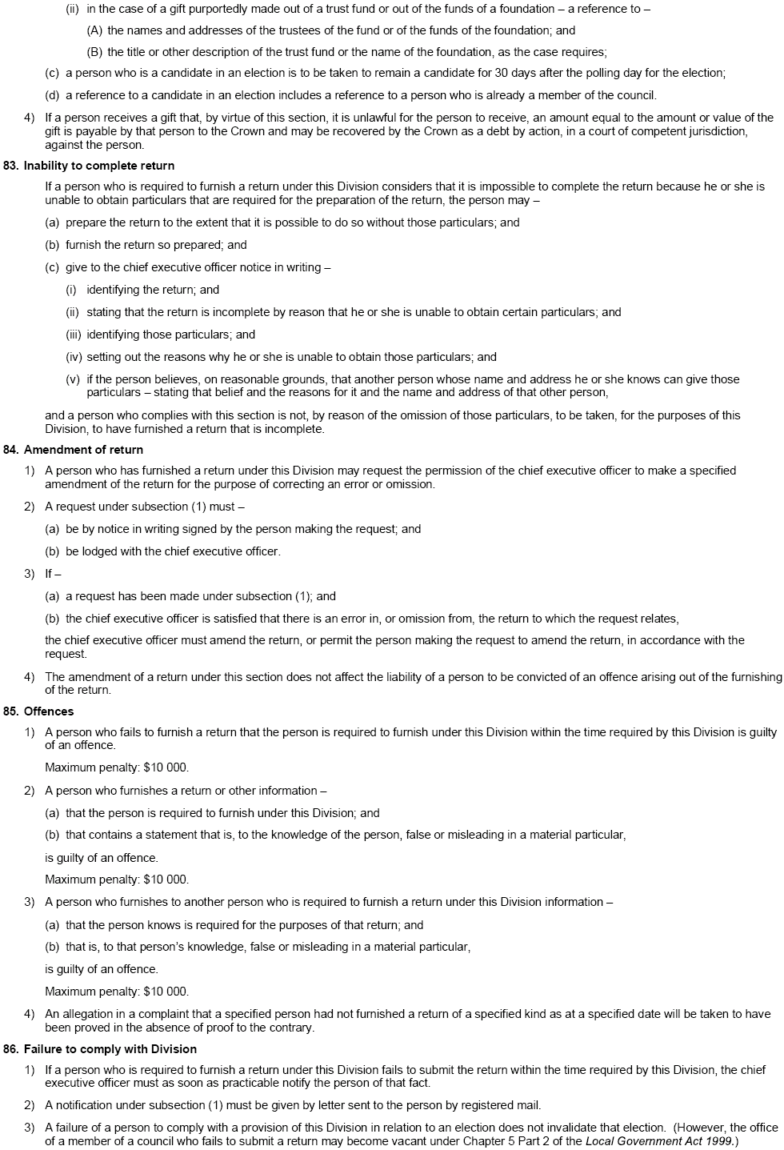
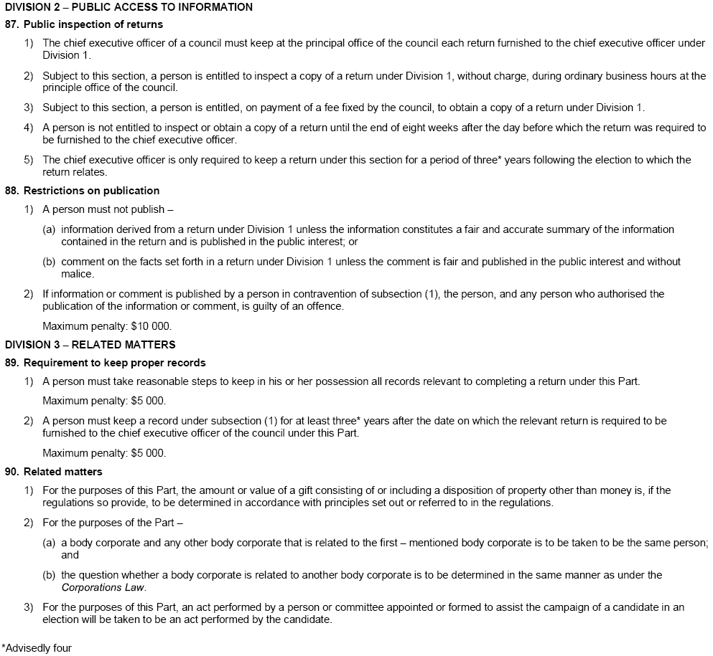
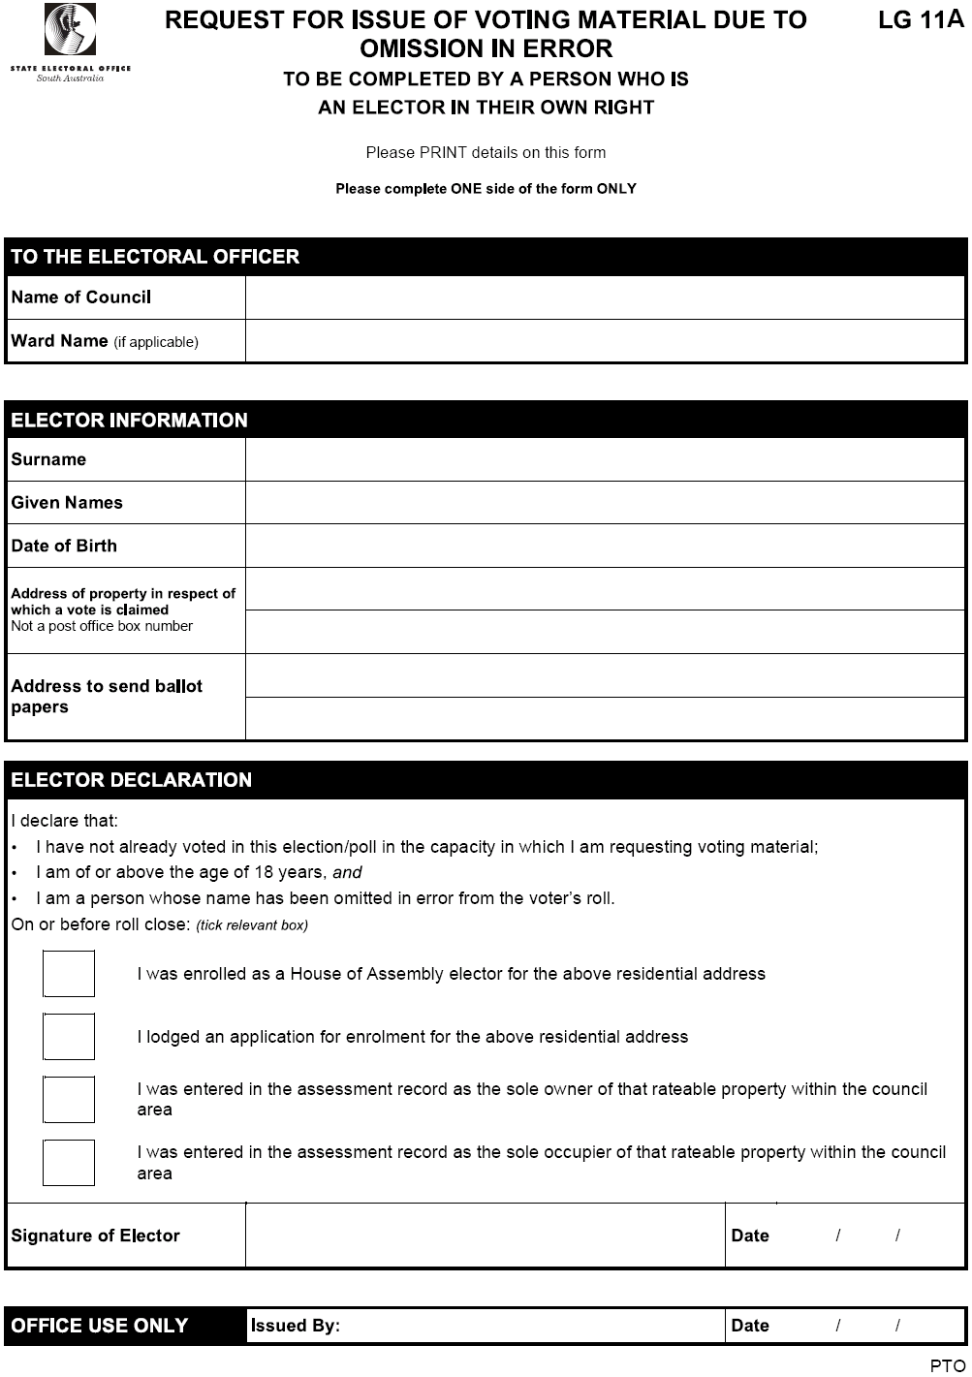
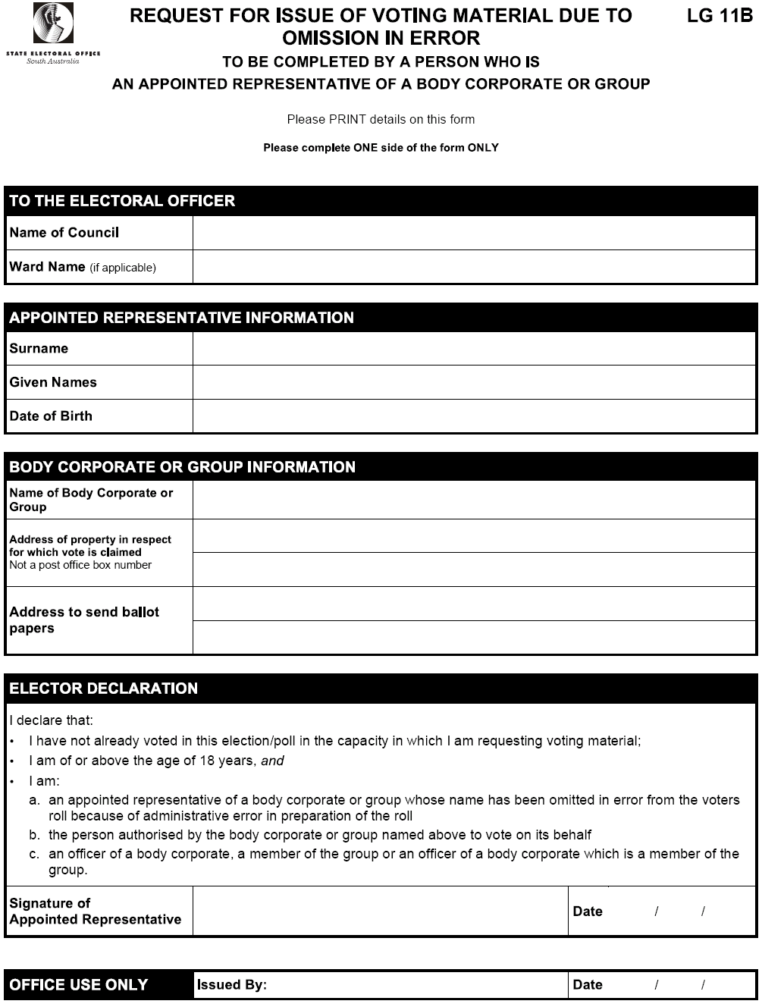

MINING ACT 1971
NOTICE is hereby given in accordance with section 28 (5) of the Mining Act 1971, that the Minister for Mineral Resources Development proposes to grant an Exploration Licence over the undermentioned area:
Applicant: James Fraser Allender
Location: Willouran Hill area—Approximately 30 km south-west of Marree.
Term: 1 year
Area in km²: 676
Ref.: 2005/00749
Plan and co-ordinates can be found on the PIRSA Sarig website: http://www.minerals.pir.sa.gov.au/sarig or by phoning Mineral Tenements on (08) 8463 3103.
H. Tyrteos, Mining Registrar

MINING ACT 1971
NOTICE is hereby given in accordance with section 28 (5) of the Mining Act 1971, that the Minister for Mineral Resources Development proposes to grant an Exploration Licence over the undermentioned area:
Applicant: Uranium SA Pty Ltd
Location: Tumby Bay area—Approximately 40 km north-north-east of Port Lincoln.
Term: 1 year
Area in km²: 185
Ref.: 2006/00038
Plan and co-ordinates can be found on the PIRSA Sarig website: http://www.minerals.pir.sa.gov.au/sarig or by phoning Mineral Tenements on (08) 8463 3103.
H. Tyrteos, Mining Registrar

MINING ACT 1971
NOTICE is hereby given in accordance with section 28 (5) of the Mining Act 1971, that the Minister for Mineral Resources Development proposes to grant an Exploration Licence over the undermentioned area:
Applicant: Adelaide Exploration Ltd
Location: Minnipa area—Approximately 80 km east of Streaky Bay.
Term: 1 year
Area in km²: 184
Ref.: 2006/00337
Plan and co-ordinates can be found on the PIRSA Sarig website: http://www.minerals.pir.sa.gov.au/sarig or by phoning Mineral Tenements on (08) 8463 3103.
H. Tyrteos, Mining Registrar

MINING ACT 1971
NOTICE is hereby given in accordance with section 28 (5) of the Mining Act 1971, that the Minister for Mineral Resources Development proposes to grant an Exploration Licence over the undermentioned area:
Applicant: Adelaide Exploration Ltd
Location: Cocata area—Approximately 100 km south-east of Streaky Bay.
Term: 1 year
Area in km²: 106
Ref.: 2006/00338
Plan and co-ordinates can be found on the PIRSA Sarig website: http://www.minerals.pir.sa.gov.au/sarig or by phoning Mineral Tenements on (08) 8463 3103.
H. Tyrteos, Mining Registrar

MINING ACT 1971
NOTICE is hereby given in accordance with section 28 (5) of the Mining Act 1971, that the Minister for Mineral Resources Development proposes to grant an Exploration Licence over the undermentioned area:
Applicant: Adelaide Exploration Ltd
Location: Warramboo area—Approximately 160 km south-east of Streaky Bay.
Term: 1 year
Area in km²: 1 363
Ref.: 2006/00339
Plan and co-ordinates can be found on the PIRSA Sarig website: http://www.minerals.pir.sa.gov.au/sarig or by phoning Mineral Tenements on (08) 8463 3103.
H. Tyrteos, Mining Registrar

MINING ACT 1971
NOTICE is hereby given in accordance with section 28 (5) of the Mining Act 1971, that the Minister for Mineral Resources Development proposes to grant an Exploration Licence over the undermentioned area:
Applicant: Lost Sands Pty Ltd
Location: Eucla Basin area—Approximately 480 km north-west of Ceduna.
Term: 1 year
Area in km²: 2 235
Ref.: 2002/00109
Plan and co-ordinates can be found on the PIRSA Sarig website: http://www.minerals.pir.sa.gov.au/sarig or by phoning Mineral Tenements on (08) 8463 3103.
H. Tyrteos, Mining Registrar

MINING ACT 1971
NOTICE is hereby given in accordance with section 28 (5) of the Mining Act 1971, that the Minister for Mineral Resources Development proposes to grant an Exploration Licence over the undermentioned area:
Applicant: Lost Sands Pty Ltd
Location: Eucla Basin area—Approximately 390 km north-west of Ceduna.
Term: 1 year
Area in km²: 2 309
Ref.: 2002/00110
Plan and co-ordinates can be found on the PIRSA Sarig website: http://www.minerals.pir.sa.gov.au/sarig or by phoning Mineral Tenements on (08) 8463 3103.
H. Tyrteos, Mining Registrar

MINING ACT 1971
NOTICE is hereby given in accordance with section 28 (5) of the Mining Act 1971, that the Minister for Mineral Resources Development proposes to grant an Exploration Licence over the undermentioned area:
Applicant: Lost Sands Pty Ltd
Location: Eucla Basin area—Approximately 320 km north-west of Ceduna.
Term: 1 year
Area in km²: 1 556
Ref.: 2004/00181
Plan and co-ordinates can be found on the PIRSA Sarig website: http://www.minerals.pir.sa.gov.au/sarig or by phoning Mineral Tenements on (08) 8463 3103.
H. Tyrteos, Mining Registrar

MINING ACT 1971
NOTICE is hereby given in accordance with section 28 (5) of the Mining Act 1971, that the Minister for Mineral Resources Development proposes to grant an Exploration Licence over the undermentioned area:
Applicant: WMC Resources Ltd
Location: Stuart Shelf area—Approximately 70 km north-east of Woomera.
Term: 2 years
Area in km²: 1 766
Ref.: 2006/00340
Plan and co-ordinates can be found on the PIRSA Sarig website: http://www.minerals.pir.sa.gov.au/sarig or by phoning Mineral Tenements on (08) 8463 3103.
H. Tyrteos, Mining Registrar

MINING ACT 1971
NOTICE is hereby given in accordance with section 28 (5) of the Mining Act 1971, that the Minister for Mineral Resources Development proposes to grant an Exploration Licence over the undermentioned area:
Applicant: Dr David Thomas Miller
Location: Matt Whim area—Approximately 70 km north of Orroroo.
Term: 1 year
Area in km²: 75
Ref.: 2006/00342
Plan and co-ordinates can be found on the PIRSA Sarig website: http://www.minerals.pir.sa.gov.au/sarig or by phoning Mineral Tenements on (08) 8463 3103.
H. Tyrteos, Mining Registrar

MINING ACT 1971
NOTICE is hereby given in accordance with section 28 (5) of the Mining Act 1971, that the Minister for Mineral Resources Development proposes to grant an Exploration Licence over the undermentioned area:
Applicant: Terramin Australia Ltd
Location: Bremer area—Immediately west and north-east of Strathalbyn.
Term: 2 years
Area in km²: 457
Ref.: 2006/00343
Plan and co-ordinates can be found on the PIRSA Sarig website: http://www.minerals.pir.sa.gov.au/sarig or by phoning Mineral Tenements on (08) 8463 3103.
H. Tyrteos, Mining Registrar

MINING ACT 1971
NOTICE is hereby given in accordance with section 35A (1) of the Mining Act 1971, that an application for a mining lease over the undermentioned mineral claim has been received. Details of the proposal may be inspected at the Department of Primary Industries and Resources, Mineral Resources Group, Level 7, 101 Grenfell Street, Adelaide, S.A. 5000:
Applicant: Clive Donald Gare
Claim Number: 3618
Location: Allotment 104, Filed Plan 16081, Hundreds of Balalie and Whyte—Approximately 16 km south-east of Jamestown.
Area: 10.9 hectares
Purpose: For the recovery of Limestone Rubble
Reference: T02563
A copy of the proposal has been provided to the Northern Areas Council.
Written submissions in relation to the granting of the mining lease are invited to be received at the Department of Primary Industries and Resources, Mineral Resources Group, Level 7, 101 Grenfell Street, Adelaide, S.A. 5000 or G.P.O. Box 1671, Adelaide, S.A. 5001 no later than 11 August 2006.
Copies of all submissions will be forwarded to the applicant and may be made available for public inspection unless confidentiality is requested.
H. Tyrteos, Mining Registrar

NATIONAL PARKS AND WILDLIFE ACT 1972
Venus Bay Conservation Park Management Plan
I, GAIL GAGO, Minister for Environment and Conservation, hereby give notice under the provisions of section 38 of the National Parks and Wildlife Act 1972, that on 3 July 2006, I adopted a plan of management for Venus Bay Conservation Park.
Copies of the plan may be inspected at or obtained from the offices of the Department for Environment and Heritage at:
• 1 Richmond Road, Keswick, S.A. 5035 (G.P.O. Box 1047, Adelaide, S.A. 5001), telephone 8124 4854;
• Port Lincoln Office, 75 Liverpool Street, Port Lincoln, S.A. 5606 (P.O. Box 22, Port Lincoln, S.A. 5606), telephone 8688 3111;
• Ceduna Office, 11 McKenzie Street, Ceduna, S.A. 5690 (P.O. Box 569, Ceduna, S.A. 5690), telephone 8625 3144;
• Venus Bay Conservation Park (c/o Post Office, Port Kenny, S.A. 5690), telephone 8625 5110;
• http://www.environment.sa.gov.au/parks/management_plans.html.
For general enquiries, please contact the DEH Information Line, telephone 8204 1910 or e-mail dehinformation@saugov.sa.gov.au.
Copies of this publication can be purchased at a cost of $10 per copy (plus $2 postage within South Australia) from the addresses above.
Gail Gago, Minister for Environment and Conservation

OATHS ACT 1936
Notice of Termination of Appointment of Managers to Take Declarations and Attest the Execution of Instruments
PURSUANT to subsection (3) of section 33 of the Oaths Act 1936, I give notice that I have terminated the appointment of these managers to take declarations and attest the execution of instruments under that section:
Alan Douglas Hartwell of the ANZ Bank
Simon Lee Howe of BankSA
Dated 11 July 2006.
M. Atkinson, Attorney-General
00/10253

OCCUPATIONAL HEALTH, SAFETY AND WELFARE
ACT 1986
Approved Code of Practice for Amusement Structures
NOTICE is hereby given that pursuant to subsection 63 (1) of the Occupational Health, Safety and Welfare Act 1986, the following Australian Standard is an approved code of practice.
AS 2601-2001 Demolition of Structures
AS 2601-2001 Demolition of Structures shall be read as incorporating the ‘Foreword’, which is included in this notice and shall have effect three months after the date of Gazettal.
M. Wright, Minister for Industrial Relations

Foreword
The term ‘approved code of practice’ has a particular meaning under the South Australian Occupational Health, Safety and Welfare Act 1986.
An approved code of practice is designed to be used in addition to the Act and Regulations. In proceedings for an offence against the Act, where it is proved that a person failed to comply with a provision of a relevant approved code of practice, the person shall be taken to have failed to exercise the required standard of care, in the absence of proof to the contrary, (section 63A of the Act).
Thus, a code of practice provides practical guidance on how a particular standard of health and safety can be achieved. It describes the preferred methods or courses of action for achieving this standard of health and safety. However, an approved code of practice allows the flexibility to show that an equivalent or better standard of health and safety is achieved by alternative action. An approved code of practice is therefore different from a regulation where the responsible person must meet the specific requirement of the regulation.
In summary, an approved code of practice:
• provides practical guidance;
• should be followed unless there is another solution which achieves the same or a better standard of health and safety; and
• can be used to support prosecution.
Codes of Practice are approved by the Minister for Industrial Relations, following recommendation from the SafeWork SA Advisory Committee which is constituted under the Occupational Health, Safety and Welfare Act 1986.

OCCUPATIONAL HEALTH, SAFETY AND WELFARE
ACT 1986
Appointments
I, MICHAEL JOHN WRIGHT, Minister for Industrial Relations in and for the State of South Australia, hereby under the Occupational Health, Safety and Welfare Act 1986, authorise the following public service employees to exercise the powers of an Inspector pursuant to the Occupational Health, Safety and Welfare Act 1986:
Bryan George Russell
Brian Adams
Soritos Mangas
David John McGraw
Donna Marie Carpenter
Marissa Jane Thwaites
Ildiko Farah
Dated 11 July 2006.
M. Wright, Minister for Industrial Relations

PASSENGER TRANSPORT ACT 1994
Appointment of an Authorised Officer
NOTICE is hereby given that the following person has been appointed by the Minister for Transport as an Authorised Officer under section 53 of the Passenger Transport Act 1994:
Phil Stewart
Dated 13 July 2006.
J. Hallion, Chief Executive

ROADS (OPENING AND CLOSING) ACT 1991:
SECTION 24
NOTICE OF CONFIRMATION OF ROAD
PROCESS ORDER
Road Closure
Light Pass Road, Stockwell
BY Road Process Order made on 11 March 2006, The Barossa Council ordered that:
1. Portion of Light Pass Road extending northerly from Pipeline Road by approximately 800 m, more particularly delineated and lettered ‘A’ in Preliminary Plan No. 05/0027 be closed.
2. The whole of the land subject to closure be transferred to Beringer Blass Wine Estates Ltd in accordance with agreement for transfer dated 10 March 2006, entered into between The Barossa Council and Beringer Blass Wine Estate Ltd.
3. The following easements are granted over portions of the land subject to that closure:
Grant to The Barossa Council an easement for drainage purposes.
Grant to the Distribution Lessor Corporation an easement for overhead electricity supply purposes.
Grant to the South Australian Water Corporation an ease-ment for water supply purposes.
On 26 May 2006, that order was confirmed by the Minister
for Administrative Services and Government Enterprises con-ditionally upon the deposit by the Registrar-General of Deposited Plan 70818 being the authority for the new boundaries.
Pursuant to section 24 (5) of the Roads (Opening and Closing) Act 1991, NOTICE of the order referred to above and its confirmation is hereby given.
Dated 20 July 2006.
P. M. Kentish, Surveyor-General

ROADS (OPENING AND CLOSING) ACT 1991:
SECTION 24
NOTICE OF CONFIRMATION OF ROAD
PROCESS ORDER
Road Opening and Closing
Wandearah Road, Crystal Brook
BY Road Process Order made on 20 October 2005, the Port Pirie Regional Council ordered that:
1. Portion of sections 293 and 288W in Hundred of Crystal Brook more particularly delineated and numbered ‘1’ and ‘2’ (respectively) in Preliminary Plan No. 04/0107 be opened as road, forming a realignment of Wandearah Road.
2. Portion of Wandearah Road adjoining the northern boundaries of allotment 13 in Filed Plan 108474, more particularly delineated and lettered ‘A’ in Preliminary Plan No. 04/0107 be closed.
3. The whole of the land subject to closure be transferred to Bletchley Farm Pty Ltd in accordance with agreement for exchange dated 4 April 2005, entered into between the Port Pirie Regional Council and Bletchley Farm Pty Ltd.
4. The following easement be granted over the whole of the land subject to that closure:
Grant to South Australian Water Corporation an easement for water supply purposes.

On 13 July 2006, that order was confirmed by the Minister
for Administrative Services and Government Enterprises con-ditionally upon the deposit by the Registrar-General of Deposited Plan 69974 being the authority for the new boundaries.
Pursuant to section 24 (5) of the Roads (Opening and Closing) Act 1991, NOTICE of the order referred to above and its confirmation is hereby given.
Dated 20 July 2006.
P. M. Kentish, Surveyor-General

ROADS (OPENING AND CLOSING) ACT 1991:
SECTION 24
NOTICE OF CONFIRMATION OF ROAD
PROCESS ORDER
Road Closure
Linwood Terrace, Brighton
BY Road Process Order made on 18 August 2005, the City of Holdfast Bay ordered that:
1. A rectangularly-shaped strip of Linwood Terrace south of Alfreda Street and adjoining the eastern boundary of allotment 28 in Deposited Plan 2880, more particularly delineated and lettered ‘A’ in Preliminary Plan No. 05/0034 be closed.
2. The whole of the land subject to closure be transferred to Murray Leslie Whitelaw and Parimala Raghavendra in accordance to agreement for transfer dated 10 June 2005, entered into between the City of Holdfast Bay and M. L. Whitelaw and P. Raghavendra.
On 13 July 2006 that order was confirmed by the Minister
for Administrative Services and Government Enterprises con-ditionally upon the deposit by the Registrar-General of Deposited Plan 69062 being the authority for the new boundaries.
Pursuant to section 24 (5) of the Roads (Opening and Closing) Act 1991, NOTICE of the order referred to above and its confirmation is hereby given.
Dated 20 July 2006.
P. M. Kentish, Surveyor-General

PETROLEUM PRODUCTS REGULATION ACT 1995
Appointments
I, MICHAEL JOHN WRIGHT, Minister for Industrial Relations in and for the State of South Australia, hereby appoint each of the following persons as an Authorised Officer for the purposes of the Petroleum Products Regulation Act 1995, in accordance with my delegated authority under section 49 of the Petroleum Products Regulation Act 1995:
Bryan George Russell
Brian Adams
Soritos Mangas
David John McGraw
Donna Marie Carpenter
Marissa Jane Thwaites
Ildiko Farah
Dated 11 July 2006.
M. Wright, Minister for Industrial Relations

PETROLEUM ACT 2000
Grant of Geothermal Exploration Licences—
GEL 214, GEL 215, GEL 216 and GEL 217
NOTICE is hereby given that the undermentioned Geothermal Exploration Licences have been granted with effect from and including 12 July 2006, under the provisions of the Petroleum Act 2000, pursuant to delegated powers dated 28 March 2002, Gazetted 11 April 2002, page 1573.

No. of Licence | Licensees | Locality | Area in km²
GEL 214 | Geothermal Resources Limited | Otway Basin, South Australia | 490
GEL 215 | Geothermal Resources Limited | Otway Basin, South Australia | 493
GEL 216 | Geothermal Resources Limited | Otway Basin, South Australia | 495
GEL 217 | Geothermal Resources Limited | Otway Basin, South Australia | 476
Description of Area—GEL 214
All that part of the State of South Australia, bounded as follows:
Commencing at a point being the intersection of latitude 37°10′00″S GDA94 and longitude 140°40′00″E GDA94, thence east to longitude 140°54′00″E GDA94, south to latitude 37°23′00″S GDA94, west to longitude 140°40′00″E GDA94 and north to the point of commencement, but excluding Glen Roy Conservation Park and Penola Conservation Park.
Area: 490 km² approximately.
Description of Area—GEL 215
All that part of the State of South Australia, bounded as follows:
Commencing at a point being the intersection of latitude 37°02′00″S GDA94 and longitude 140°10′00″E GDA94, thence east to longitude 140°28′00″E GDA94, south to latitude 37°12′00″S GDA94, west to longitude 140°10′00″E GDA94 and north to the point of commencement.
Area: 493 km² approximately.
Description of Area—GEL 216
All that part of the State of South Australia, bounded as follows:
Commencing at a point being the intersection of latitude 37°04′00″S GDA94 and longitude 139°47′00″E GDA94, thence east to longitude 140°07′00″E GDA94, south to latitude 37°13′00″S GDA94, west to longitude 139°46′00″E GDA94, north to latitude 37°10′00″S GDA94, east to longitude 139°47′00″E GDA94 and north to the point of commencement, but excluding Guichen Bay Conservation Park, Little Dip Conservation Park and Lake Robe Game Reserve.
Area: 495 km² approximately.
Description of Area—GEL 217
All that part of the State of South Australia, bounded as follows:
Commencing at a point being the intersection of latitude 37°07′00″S GDA94 and longitude 140°28′00″E GDA94, thence east to longitude 140°40′00″E GDA94, south to latitude 37°22′00″S GDA94, west to longitude 140°28′00″S GDA94 and north to the point of commencement, but excluding Big Heath Conservation Park, Mary Seymour Conservation Park, Calectasia Conservation Park and Bool Lagoon Game Reserve.
Area: 476 km² approximately.
Dated 12 July 2006.
B. A. Goldstein, Director Petroleum and Geothermal
Minerals and Energy Resources
Primary Industries and Resources SA
Delegate of the Minister for Mineral Resources Development

Motor Vehicles (Control of Medical Services and Charges) Notice 2006

under section 127A (2) (a) of the Motor Vehicles Act 1959.

Preamble
1. The Workers Rehabilitation and Compensation (Scales of Charges—Medical Practitioners) Regulations 1999 prescribe the scales of charges payable to a medical practitioner for providing services to a worker who has suffered a compensable disability except where the Workers Rehabilitation and Compensation (Scale of Charges—Medical Prac-titioners) Regulations 1999 apply to services rendered to a person who has suffered bodily injury caused by or arising out of the use of a motor vehicle and are to be read subject to modifications specified in a notice given by the Minister pursuant to section 127A of the Motor Vehicles Act 1959.

2. Section 127A of the Motor Vehicles Act 1959 provides that the scales of charges prescribed for prescribed services for the purposes of section 32 of the Workers Rehabilitation and Compensation Act 1986 apply to services rendered to a person who has suffered bodily injury caused by or arising out of the use of a motor vehicle.

3. On 28 July 2005, the Minister published the Motor Vehicles (Control of Medical Services and Charges) Notice 2005, requiring that for the purposes of section 127A (2) of the Motor Vehicles Act 1959 that the Workers Rehabilitation and Compensation (Scales of Charges—Medical Practitioners) Regulations 1999 be read subject to the modifications specified in that notice.

4. The Minister requires that for the purposes of section 127A (2) of the Motor Vehicles Act 1959, the Motor Vehicles (Control of Medical Services and Charges) Notice 2005 is
varied as specified by the wording shown in bold in paragraph 1 of the Preamble and in Schedule 1 of this notice.

1—Short Title
This notice may be cited as the Motor Vehicles (Control of Medical Services and Charges) Notice 2006.

2—Commencement
This notice comes into operation on the day on which it is made.

3—Interpretation
In this notice—
regulations means the Workers Rehabilitation and Compensation (Scales of Charges—Medical Practitioners) Regulations 1999.

4—Variation to the Motor Vehicles (Control of Medical Services and Charges) Notice 2005
The Motor Vehicles (Control of Medical Services and Charges) Notice 2005 provides that for the purposes of section 127A of the Motor Vehicles Act 1959 the regulations are to be read as if the scales of charges set out in Schedule B of the regulations and prescribed as scales of charges pursuant to regulation 5 of the regulations provide that the maximum fee payable for each item number described in the first four columns of Schedule 1 of the notice is subject to the modifi-cation shown in the fifth column of Schedule 1 of the notice. Pursuant to section 127A (2) (c) of the Motor Vehicles Act 1959, the Minister varies Schedule 1 of the Motor Vehicles (Control of Medical Services and Charges) Notice 2005 as follows:

Schedule 1

Reading time to prepare a report—treating doctor
Item No. | Group | Description | Maximum fee—excl GST | Modification
WMG55 | General Practitioners | Reading time—payable to a treating doctor for reading prior reports or other information forwarded by the requestor in order to prepare a report | $40.00 | 1. Where the reports or other information forwarded or approved on reasonable grounds by the requestor to be read by the treating doctor exceed the equivalent of 20 full A4 size pages of standard (12 point font) print, the treating doctor may charge an additional $5 per full page of A4 size standard (12 point font) print.  2. Where the reports or other information forwarded or approved on reasonable grounds by the requestor comprise investigative reports and/or institutional clinical notes that cannot be classified as standard pages for the purposes of modification (1) above, the treating doctor may, charge an additional $180 per hour to a maximum of two hours.  3. Where the reports or other information forwarded or approved on reasonable grounds by the requestor solely comprise investigative reports and/or institutional clinical notes that cannot be classified as standard pages for the purposes of modification (1) above, the maximum fee of $40 in the fourth column of the schedule will not apply and the treating doctor may charge $180 per hour to a limit of 2 hours.
WMS55 | Specialists in a surgical discipline | Reading time—payable to a treating doctor for reading prior reports or other information forwarded by the requestor in order to prepare a report | $50.00 | 1. Where the reports or other information forwarded or approved on reasonable grounds by the requestor to be read by the treating doctor exceed the equivalent of 20 full A4 size pages of standard (12 point font) print, the treating doctor may charge an additional fee of $5 per full page of A4 size standard (12 point font) print.

Item No. | Group | Description | Maximum fee—excl GST | Modification
2. Where the reports or other information forwarded or approved on reasonable grounds by the requestor comprise investigative reports and/or institutional clinical notes that cannot be classified as standard pages for the purposes of modification (1) above, the treating doctor may charge an additional fee of $240 per hour to a maximum of two hours.
3. Where the reports or other information forwarded or approved on reasonable grounds by the requestor solely comprise investigative reports and/or institutional clinical notes that cannot be classified as standard pages for the purposes of modification (1) above, the maximum fee of $50 in the fourth column of the schedule will not apply and the treating doctor may charge a fee of $240 per hour to a limit of 2 hours.
WMP55 | Consultant Physicians | Reading time—payable to a treating doctor for reading prior reports or other information forwarded by the requestor in order to prepare a report | $50.00 | 1. Where the reports or other information forwarded or approved on reasonable grounds by the requestor to be read by the treating doctor exceed the equivalent of 20 full A4 size pages of standard (12 point font) print, the treating doctor may charge an additional $5 per full page of A4 size standard (12 point font) print.  2. Where the reports or other information forwarded or approved on reasonable grounds by the requestor comprise investigative reports and/or institutional clinical notes that cannot be classified as standard pages for the purposes of modification (1) above, the treating doctor may charge an additional $240 per hour to a maximum of two hours.  3. Where the reports or other information forwarded or approved on reasonable grounds by the requestor solely comprise investigative reports and/or institutional clinical notes that cannot be classified as standard pages for the purposes of modification (1) above, the maximum fee of $50 in the fourth column of the schedule will not apply and the treating doctor may charge $240 per hour to a limit of 2 hours.

Independent Medical Examiner—reading time
Item No. | Group | Description | Maximum fee—excl GST | Modification
WMS32 | Specialists in a surgical discipline | Reading time—payable to an independent medical examiner for reading prior reports or other information forwarded by the requestor | $100.00 | 1. Where the reports or other information forwarded or approved on reasonable grounds by the requestor to be read by the independent medical examiner exceed the equivalent of 20 full A4 size pages of standard (12 point font) print, the independent medical examiner may charge an additional $5 per full page of A4 size standard (12 point font) print.  2. Where the reports or other information forwarded or approved on reasonable grounds by the requestor comprise investigative reports and/or institutional clinical notes that cannot be classified as standard pages for the purposes of modification (1) above, the independent medical examiner may charge an additional fee of $240 per hour to a maximum of two hours.  3. Where the reports or other information forwarded or approved on reasonable grounds by the requestor solely comprise investigative reports and/or institutional clinical notes that cannot be classified as standard pages for the purposes of modification (1) above, the maximum fee of $100 in the fourth column of the schedule will not apply and the independent medical examiner may charge $240 per hour to a limit of 2 hours.
WMP32 | Consultant Physicians | Reading time—payable to an independent medical examiner for reading prior reports or other information forwarded by the requestor | $100.00 | 1. Where the reports or other information forwarded or approved on reasonable grounds by the requestor to be read by the independent medical examiner exceed the equivalent of 20 full A4 size pages of standard (12 point font) print, the independent medical examiner may charge an additional $5 per full page of A4 size standard (12 point font) print.  2. Where the reports or other information forwarded or approved on reasonable grounds by the requestor comprise investigative reports and/or institutional clinical notes that cannot be classified as standard pages for the purposes of modification (1) above, the independent medical examiner may charge an additional $240 per hour to a maximum of two hours.

Item No. | Group | Description | Maximum fee—excl GST | Modification
 |  |  |  | 3. Where the reports or other information forwarded or approved on reasonable grounds by the requestor solely comprise investigative reports and/or institutional clinical notes that cannot be classified as standard pages for the purposes of modification (1) above, the maximum fee of $100 in the fourth column of the schedule will not apply and the independent medical examiner may charge $240 per hour to a limit of 2 hours.

5—Variation of previous notice
The Motor Vehicles (Control of Medical Services and Charges) Notice 2005 (published in the Government Gazette on 28 July 2005) is hereby varied.

Made by the Minister for Transport
after consultation with professional associations representing the providers of services to which this notice relates.

Dated 17 July 2006.

Patrick Conlon, Minister for Transport

South Australia
Statutes Amendment (Disposal of Human Remains) Act (Commencement) Proclamation 2006
1—Short title
This proclamation may be cited as the Statutes Amendment (Disposal of Human Remains) Act (Commencement) Proclamation 2006.
2—Commencement of Act
The Statutes Amendment (Disposal of Human Remains) Act 2006 (No 10 of 2006) will come into operation on 24 July 2006.
Made by the Governor’s Deputy
with the advice and consent of the Executive Council
on 20 July 2006
AG00165/05CSTemp1

South Australia
Youth Court (Designation of Judge) Proclamation 2006
under section 9 of the Youth Court Act 1993
1—Short title
This proclamation may be cited as the Youth Court (Designation of Judge) Proclamation 2006.
2—Commencement
This proclamation comes into operation on the day on which it is made.
3—Designation of Judge
The District Court Judge named in Schedule 1 is—
(a) designated as a Judge of the Youth Court of South Australia; and
(b) classified as a member of the Court's principal judiciary; and
(c) declared to be a member of the Court's principal judiciary for a term of 10 years.
Schedule 1—Designation of Judge
His Honour Kelvyn John Prescott
Made by the Governor’s Deputy
with the advice and consent of the Executive Council
on 20 July 2006
AGO0071/03CS

South Australia
Road Traffic (Miscellaneous) Variation Regulations 2006
under the Road Traffic Act 1961

Contents
Part 1—Preliminary
1 Short title
2 Commencement
3 Variation provisions
Part 2—Variation of Road Traffic (Miscellaneous) Regulations 1999
4 Variation of regulation 13—Declaration of hospitals for compulsory blood testing

Part 1—Preliminary
1—Short title
These regulations may be cited as the Road Traffic (Miscellaneous) Variation Regulations 2006.
2—Commencement
These regulations will come into operation on 1 August 2006.
3—Variation provisions
In these regulations, a provision under a heading referring to the variation of specified regulations varies the regulations so specified.
Part 2—Variation of Road Traffic (Miscellaneous)
Regulations 1999
4—Variation of regulation 13—Declaration of hospitals for compulsory blood testing
(1) Regulation 13, list of hospitals—delete "Crystal Brook District Hospital Incorporated" and "Rocky River Health Service Incorporated"
(2) Regulation 13, list of hospitals—before "St. Andrew's Hospital Incorporated" insert:
Southern Flinders Health Incorporated
Note—
As required by section 10AA(2) of the Subordinate Legislation Act 1978, the Minister has certified that, in the Minister's opinion, it is necessary or appropriate that these regulations come into operation as set out in these regulations.
Made by the Governor’s Deputy
with the advice and consent of the Executive Council
on 20 July 2006
No 190 of 2006
MTR06/029CS

South Australia
Electricity (General) Variation Regulations 2006
under the Electricity Act 1996

Contents
Part 1—Preliminary
1 Short title
2 Commencement
3 Variation provisions
Part 2—Variation of Electricity (General) Regulations 1997
4 Variation of regulation 39—Erection of buildings in proximity to aerial lines
5 Variation of Schedule 2—Requirements for aerial lines

Part 1—Preliminary
1—Short title
These regulations may be cited as the Electricity (General) Variation Regulations 2006.
2—Commencement
These regulations come into operation on the day on which they are made.
3—Variation provisions
In these regulations, a provision under a heading referring to the variation of specified regulations varies the regulations so specified.
Part 2—Variation of Electricity (General) Regulations 1997
4—Variation of regulation 39—Erection of buildings in proximity to aerial lines
(1) Regulation 39(1)(a)—delete "33kV" and substitute:
66kV
(2) Regulation 39(1)(b)—delete "33kV" and substitute:
66kV
5—Variation of Schedule 2—Requirements for aerial lines
(1) Schedule 2, clause 10(4)(a)—delete "33kV" and substitute:
66kV
(2) Schedule 2, clause 10(4)(ab)—delete "33kV" and substitute:
66kV
(3) Schedule 2, clause 10(6)—delete "33kV" and substitute:
66kV
(4) Schedule 2, clause 13, Table 1—delete Table 1 and substitute:

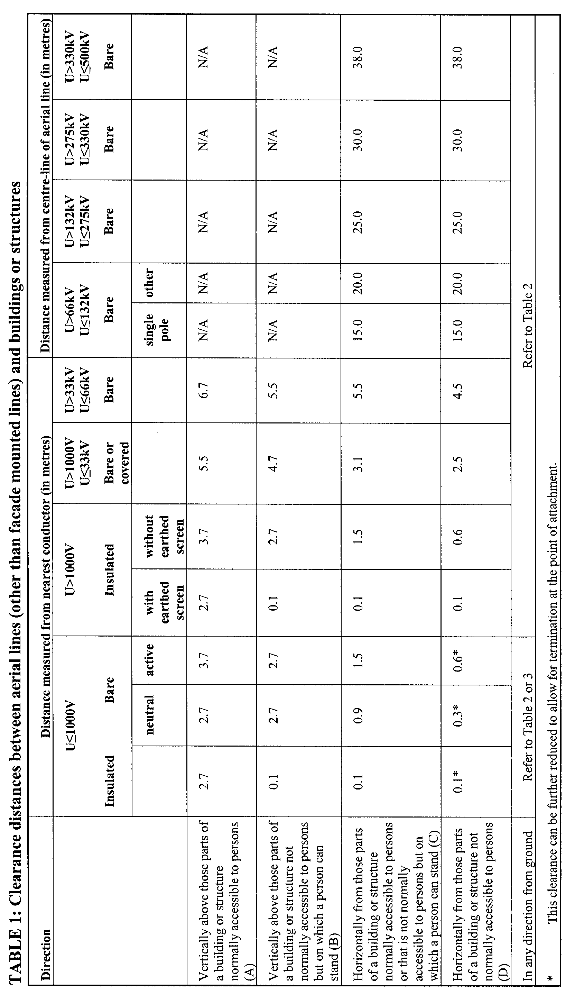
Table 1 figures—
1 Figures (a) and (b) will assist in understanding the required minimum safety clearance for aerial lines constructed to operate at a voltage of more than 66kV.
2 Figure (c) will assist in understanding the required minimum safety clearance for aerial lines constructed to operate at a voltage of 66kV or less (that is, minimum safety clearance from nearest conductor (maximum swing and sag)).
(a)
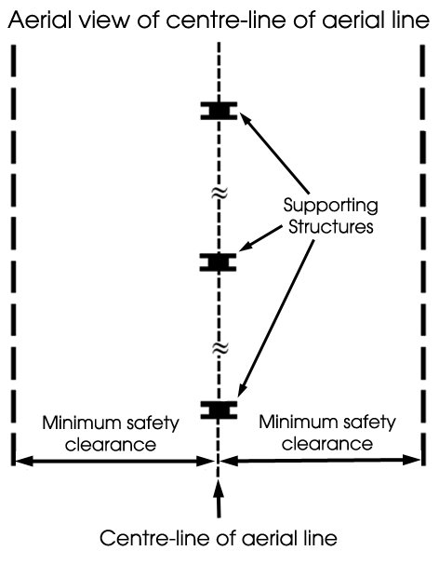
(b)
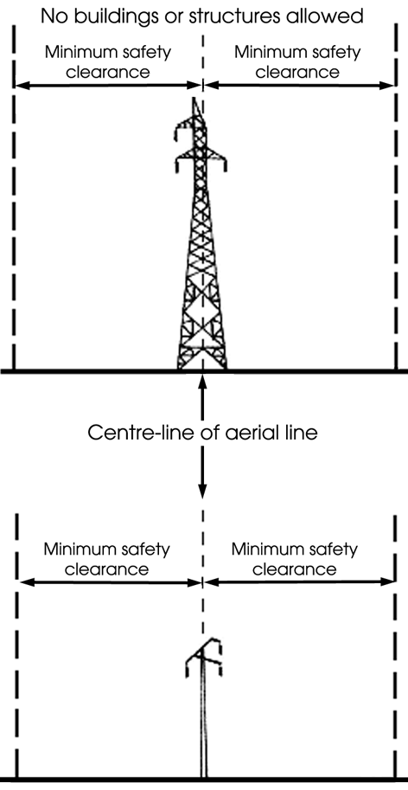
(c)
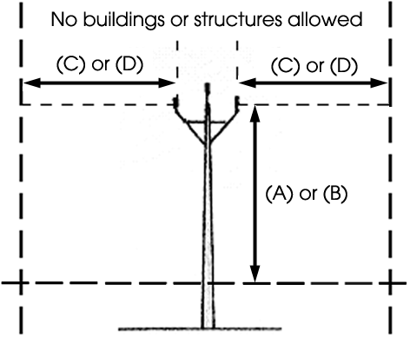

Vertical dimension (A) applies for example to:  · Balconies  · Terraces  · Walkways  · Bridges  · Scaffolds | Vertical dimension (B) applies in relation to things such as:  · Roofs with a slope of less than 45°  · Parapets wider than 0.1 metre  · Pergolas  · Carports
Horizontal dimension (C) applies to the same as (A) and (B) | Horizontal dimension (D) applies in relation to things such as:  · Roofs with a slope of 45° or more  · Flag Poles  · Light Poles
Note—
As required by section 10AA(2) of the Subordinate Legislation Act 1978, the Minister has certified that, in the Minister's opinion, it is necessary or appropriate that these regulations come into operation as set out in these regulations.
Made by the Governor’s Deputy
with the advice and consent of the Executive Council
on 20 July 2006
No 191 of 2006
MEN06/005CS

South Australia
Births, Deaths and Marriages Registration Variation Regulations 2006
under the Births, Deaths and Marriages Registration Act 1996

Contents
Part 1—Preliminary
1 Short title
2 Commencement
3 Variation provisions
Part 2—Variation of Births, Deaths and Marriages Registration
Regulations 1996
4 Variation of Schedule—Fees

Part 1—Preliminary
1—Short title
These regulations may be cited as the Births, Deaths and Marriages Registration Variation Regulations 2006.
2—Commencement
These regulations will come into operation on the day on which Part 2 of the Statutes Amendment (Disposal of Human Remains) Act 2006 comes into operation.
3—Variation provisions
In these regulations, a provision under a heading referring to the variation of specified regulations varies the regulations so specified.
Part 2—Variation of Births, Deaths and Marriages Registration Regulations 1996
4—Variation of Schedule—Fees
Schedule—after clause 6 insert:

7 | Application for authorisation for disposal of human remains (section 50A of Act) | $70.50
Note—
As required by section 10AA(2) of the Subordinate Legislation Act 1978, the Minister has certified that, in the Minister's opinion, it is necessary or appropriate that these regulations come into operation as set out in these regulations.
Made by the Governor’s Deputy
with the advice and consent of the Executive Council
on 20 July 2006
No 192 of 2006
AGO0165/05CS

South Australia
Cremation Variation Regulations 2006
under the Cremation Act 2000

Contents
Part 1—Preliminary
1 Short title
2 Commencement
3 Variation provisions
Part 2—Variation of Cremation Regulations 2001
4 Variation of regulation 4—Interpretation
5 Variation of regulation 5—Forms
6 Variation of regulation 6—Application for cremation permit
7 Variation of Schedule—Forms
8 Insertion of Schedule 2
Schedule 2—Application fees for cremation permits

Part 1—Preliminary
1—Short title
These regulations may be cited as the Cremation Variation Regulations 2006.
2—Commencement
These regulations will come into operation on the day on which Part 4 of the Statutes Amendment (Disposal of Human Remains) Act 2006 comes into operation.
3—Variation provisions
In these regulations, a provision under a heading referring to the variation of specified regulations varies the regulations so specified.
Part 2—Variation of Cremation Regulations 2001
4—Variation of regulation 4—Interpretation
Regulation 4(2)—delete "the Schedule" and substitute:
Schedule 1
5—Variation of regulation 5—Forms
(1) Regulation 5(1)—delete "the Schedule" and substitute:
Schedule 1
(2) Regulation 5(2)—delete "the Schedule" first occurring and substitute:
Schedule 1
6—Variation of regulation 6—Application for cremation permit
Regulation 6(b)—delete paragraph (b) and substitute:
(b) must be lodged with the Registrar; and
(c) if the application is made under section 6(2) of the Act, must be accompanied by—
(i) the following information:
(A) the date and time of the deceased's death;
(B) the place of death (for example, the deceased's place of residence or the hospital, nursing home, lodgings, etc, where the deceased died);
(C) whether the applicant is—
• the executor or administrator of the deceased's estate; or
• a near relative of the deceased (specifying the relationship); or
• a person of or over the age of 18 years (specifying the reasons why the applicant is making the application);
(D) whether the deceased left written directions as to the mode of disposal of his or her remains and, if so, details of the directions;
(E) whether there has been any objection to the proposed cremation by the personal representative or a spouse, parent or child of the deceased;
(F) whether the applicant knows, or has reason to believe, that the death of the deceased was not due to natural causes and, if so, details of the cause of death;
(G) the name and address of the doctor who ordinarily attended the deceased;
(H) whether there is to be a post mortem examination of the body of the deceased;
(I) whether there is to be an inquest or inquiry into the death of the deceased;
(J) the name of the crematorium at which it is intended that the deceased's body will be cremated;
(K) the name of the person to whom the cremation permit is to be issued; and
(ii) the relevant fee set out in Schedule 2; and
(d) if the application is made under section 6(3)(b) of the Act, must be accompanied by—
(i) the following information:
(A) whether the applicant is—
• the executor or administrator of the deceased's estate; or
• a near relative of the deceased (specifying the relationship); or
• a person of or over the age of 18 years (specifying the reasons why the applicant is making the application);
(B) the reason why none of the documents required to accompany an application for a cremation permit under section 6(2) of the Act can be produced;
(C) whether the applicant knows of any reason why the cremation permit should not be issued; and
(ii) the relevant fee set out in Schedule 2.
7—Variation of Schedule—Forms
(1) Schedule, Form 1—delete Form 1 and substitute:
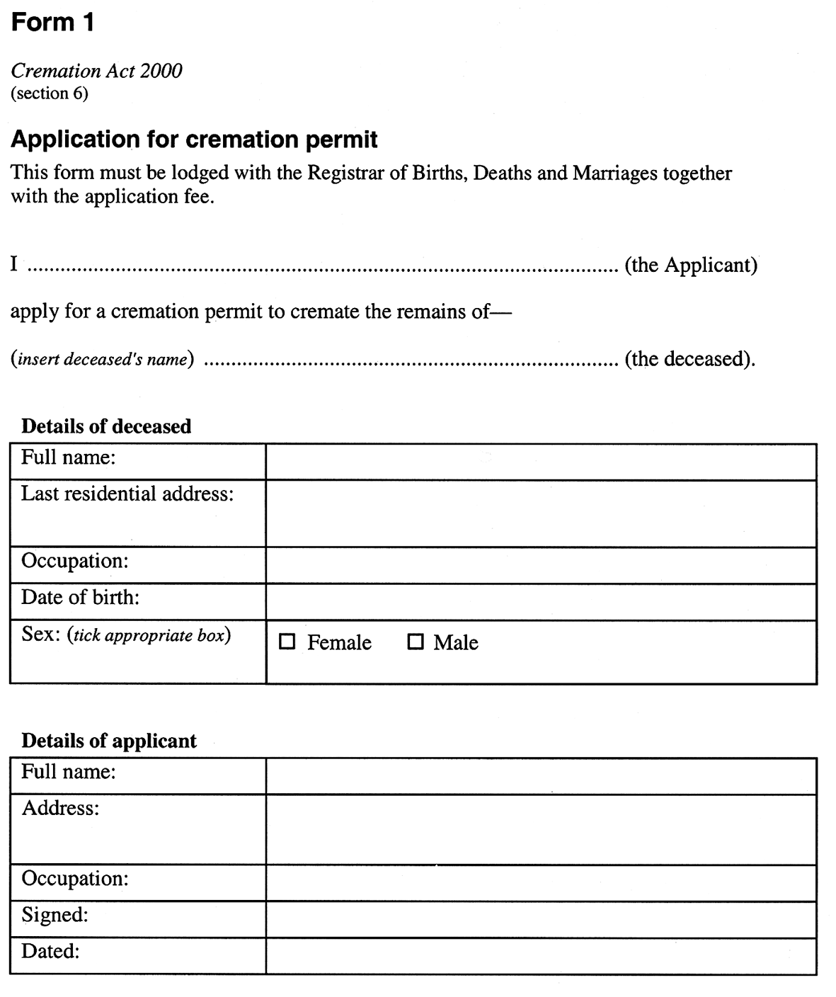
(2) Schedule—redesignate the Schedule as Schedule 1
8—Insertion of Schedule 2
After the Schedule insert:
Schedule 2—Application fees for cremation permits

Application for cremation permit—
(a) if the application is made under section 6(2) of the Act | $35.25
(b) if the application is made under section 6(3)(b) of the Act | $70.50
Note—
As required by section 10AA(2) of the Subordinate Legislation Act 1978, the Minister has certified that, in the Minister's opinion, it is necessary or appropriate that these regulations come into operation as set out in these regulations.
Made by the Governor’s Deputy
with the advice and consent of the Executive Council
on 20 July 2006
No 193 of 2006
AGO0165/05CS

FAXING COPY?
IF you fax copy to Government Publishing SA for inclusion in the Government Gazette, there is no need to send a Confirmation Copy to us as well.
This creates confusion and may well result in your notice being printed twice.
Please use the following fax number:
Fax transmission: (08) 8207 1040
Phone Inquiries: (08) 8207 1045
Please include a contact person, phone number and order number so that we can phone back with any queries we may have regarding the fax copy.
NOTE: Closing time for lodging new copy (fax, hard copy or email) is 4 p.m. on Tuesday preceding the day of publication.

Government Gazette notices can be E-mailed.
The address is:
governmentgazette@saugov.sa.gov.au
Documents should be sent as attachments in Word format.
When sending a document via E-mail, please confirm your transmission with a faxed copy of your document, including the date the notice is to be published.
Fax transmission: (08) 8207 1040
Enquiries: (08) 8207 1045
NOTE: Closing time for lodging new copy (fax, hard copy or email) is 4 p.m. on Tuesday preceding the day of publication.

CITY OF MITCHAM
Development Act 1993
Mitcham (City) Development Plan—General Amendments No. 1 Plan Amendment Report—Draft for Public Consultation
NOTICE is hereby given that the City of Mitcham has prepared a Plan Amendment Report (PAR) to amend the Mitcham (City) Development Plan.
The Plan Amendment Report will amend the Mitcham (City) Development Plan by:
• rectifying errors;
• refining public notification categories;
• refining non-complying development;
• refining Council-wide Residential policy and policy in the State Heritage Area (Colonel Light Gardens);
• introducing new Council-wide policies for telecom-munication facilities and educational establishments;
• introducing new policy specific to 163 Main Road, Blackwood.
The draft Plan Amendment Report will be available for public inspection during office hours at the Civic Centre and Libraries of the City of Mitcham from 21 July 2006 to 22 September 2006. The Council Civic Centre is located at 131 Belair Road, Torrens Park.
Copies of the Plan Amendment Report can be viewed or down-loaded at Council’s website: www.mitchamcouncil.sa.gov.au or purchased from the Council Civic Centre for a photocopying fee of $5.
Council invites written submissions regarding the draft Plan Amendment Report until 5 p.m. on 22 September 2006.
Written submissions should clearly indicate whether or not their author (or agent) intends to speak at a public hearing to be held at 6.30 p.m. on Wednesday, 11 October 2006 at the Council Civic Centre located at 131 Belair Road, Torrens Park. All submissions should be addressed to the Chief Executive Officer, City of Mitcham, P.O. Box 21, Mitcham Shopping Centre, Torrens Park, S.A. 5062.
Copies of all submissions received will be available for inspection by interested persons at the Council Civic Centre from 22 September 2006 until the date of the public hearing (11 October 2006).
Please note that the public hearing may not be held if no submission indicates an interest in speaking at the public hearing.
Dated 20 July 2006.
R. Malcolm, Chief Executive Officer

RURAL CITY OF MURRAY BRIDGE
Adoption of Budget, Annual Valuations and Declaration of Rates
NOTICE is hereby given that at its meeting held on 10 July 2006, the Rural City of Murray Bridge resolved that in exercise of the powers contained in Chapters 8 and 10 of the Local Government Act 1999 (‘the Act’), and in respect of the financial year ending 30 June 2007:
1. Adoption of Budget
That the budget for the year of 2006-2007 as detailed at the Council meeting held on 10 July 2006 and which consists of the:
• budgeted operating statement;
• budgeted statement of financial position;
• budgeted statement of changes in equity;
• budgeted statement of cash flows; and
• budgeted statement as to the basis for the determination of rates;
and which provides for:
(a) Total estimated expenditure of $29 047 505 (including depreciation).
(b) Total estimated income from sources other than rates and loans of $10 479 225.
(c) Total new loans of $3 527 700.
(d) Total amount required to be raised from rates $10 508 000,
and also endorses the Works Program and Plant Replacement Schedule.
2. Adoption of Valuation
Pursuant to section 167 (2) (a) of the Act the most recent valuations of the Valuer-General available to the Council of the Capital Value of land within the Council’s area, being $1 938 662 220 be adopted for rating purposes.
3. Attribution of Land Uses
The numbers indicated against the various categories of land use prescribed by Regulation 10 of the Local Government (General) Regulations 1999 (‘the Regulations’), be used to designate land uses in the Assessment Record.
4. Declaration of General Rates
In order to raise the amount required for general rate revenue:
(a) Pursuant to section 153 (1) (b) of the Act, differential general rates be declared on all rateable land within the Council’s area as follows:
(i) 0.5264 cents in the dollar of the Capital Value of rateable land of Categories 1 and 9 use (Residential and ‘Other’ Categories);
(ii) 0.8422 cents in the dollar of the Capital Value of rateable land of Categories 2, 3 and 4 use (Commercial Categories);
(iii) 0.7350 cents in the dollar of the Capital Value of rateable land of Categories 5 and 6 use (Industrial Categories);
(iv) 0.4260 cents in the dollar of the Capital Value of rateable land of Category 7 use (Primary Production); and
(v) 0.6860 cents in the dollar of the Capital Value of rateable land of Category 8 use (Vacant Land).
(b) Pursuant to section 158 (1) (a) of the Act a minimum amount payable by way of the general rate of $572 be fixed in respect of each assessment.
5. Declaration of Separate Rates
Pursuant to section 154 of the Act and in order to upgrade and improve the Town Centre Zone (as defined in the Development Plan under the Development Act 1993, applicable to the Council’s area), a separate rate of 0.00 cents in the dollar of the Capital Value of rateable land for land use Categories 2, 3 and 4 in the Town Centre Zone is declared on that land;
6. Declaration of Natural Resources Management Levy
Pursuant to section 154 of the Act and section 95 of the Natural Resources Management Act 2004, a separate rate of 0.006789 cents in the dollar of Capital Value of all rateable land within the area of the Council, in order to reimburse the Council of amounts contributed to the South Australian Murray-Darling Basin Natural Resources Management Board.
7. Declaration of Service Rates and Annual Service Charges
(a) Pursuant to section 155 of the Act, a total of $55 000 is to be levied against the properties within the area defined as ‘Riverglen’ to which Council provides a service, namely the provision of septic tank effluent disposal and water supply. An annual service charge of $425 per assessment and a service rate of 0.14697 cents in the dollar of the Capital Value of rateable land comprising Allotments 1 to 30, 125 and 126 in Deposited Plan 30450 and Allotment 50 in Deposited Plan 42391 and Units 1 to 73 in Strata Plan No. 11238, the area defined as ‘Riverglen’ is declared on the land, to which the septic tank effluent disposal scheme and the water supply scheme is supplied.
(b) Pursuant to section 155 of the Act, a total of $37 000 is to be levied against the properties within the area defined as ‘Woodlane’, to which Council provides a service, namely the provision of septic tank effluent disposal and water supply. A service charge of $400 per assessment and a service rate of 0.2511 cents in the dollar of the Capital Value of rateable land comprising Allotments 1 to 19 in Deposited Plans 44292 and 48073 and Allotments 1 to 4, 7 to 37 and 40 in Deposited Plan 51229 and Allotment 50 in Deposited Plan 53034 and Allotment 200 in Deposited Plan 62423, the area defined as ‘Woodlane’, is declared on the land, to which the septic tank effluent disposal and water supply scheme is supplied.
(c) Pursuant to section 155 of the Act, an annual service charge of $50 per new bin is to be raised on new properties which require bins where Council provide a waste disposal collection service and receptacle.
8. Payment
Pursuant to section 181 (1) of the Act, all rates are payable in four equal or approximately equal instalments on or before the following dates:
26 September 2006;
15 December 2006;
16 March 2007; and
15 June 2007.
9. Early Payment Incentive Scheme
In exercise of the powers contained in section 181 (11) of the Act, and being of the opinion that it is desirable to encourage ratepayers to pay their general rates and/or separate rates, and/or service rates, and/or service charges early, the Council offers to give a discount of 1% of the amount payable of general rates, and/or separate rates, and/or service rates, and/or service charges if paid in full by 25 September 2006.
10. Rating Policy
Pursuant to section 171 of the Local Government Act 1999, the rating policy of the Rural City of Murray Bridge for 2006-2007 is adopted.
D. J. Altmann, Chief Executive Officer

PORT AUGUSTA CITY COUNCIL
Development Act 1993
Development Plan Review—Public Consultation
THE Port Augusta City Council has commenced a review of its Development Plan in accordance with section 30 of the Development Act 1993.
A Policy Options Paper has been prepared which provides a background to the review, identifies a number of planning issues and proposes some preliminary policy options. The Policy Options Paper will be available for public inspection during normal office hours at the Port Augusta Council Office and Library, 4 Mackay Street, Port Augusta and at:
www.portaugusta.sa.gov.au/goto/consultation
from Thursday, 20 July to Wednesday, 20 September 2006.
Written submissions regarding the Development Plan Review will be accepted by the Port Augusta City Council until 5 p.m. on Wednesday, 20 September 2006. The written submission should also clearly indicate whether you wish to speak at the public hearing on your submission. All submissions should be addressed to the City Manager, Port Augusta City Council, P.O. Box 1704, Port Augusta, S.A. 5700.
Copies of all submissions received will be available for inspection by interested persons at 4 Mackay Street, Port Augusta from Thursday, 21 September 2006, until the date of the public hearing.
A public hearing will be held at 5.30 p.m. on Tuesday,
3 October 2006 in the Port Augusta Council Chambers located at
4 Mackay Street, Port Augusta.
The public hearing may not be held if no submission indicates an interest in speaking at the public hearing.
Any queries can be directed to Tung Pham, Council’s Community Planner by phone 8641 9100.
Dated 20 July 2006.
J. G. Stephens, City Manager

PORT AUGUSTA CITY COUNCIL
Adoption of Valuation and Declaration of Rates
NOTICE is hereby given that at a Special Meeting of the Council held on 27 June 2006, it was resolved that the Council of the Corporation of the City of Port Augusta for the 2006-2007 financial year adopts the Government valuation of site values for all property constituting the area of the Council which amounts in total to $223 735 480 and hereby specifies 27 June 2006, as the day upon which such valuation shall become the valuation of the Council.
Declaration of Rates
Notice is hereby given that at a Special Meeting of the Council of the Corporation of the City of Port Augusta held on 27 June 2006, in exercise of the powers contained in the Local Government Act 1999, in respect of the financial year ending 30 June 2007, declared rates as follows:
1. (1) That pursuant to section 156 (1) (c) of the Local Government Act 1999, the Council declares differential general rates according to the locality and the use of the land based upon the site value of the land on all rateable land within the area of the Council for the year ending 30 June 2007, as follows:
(a) In that area of the City zoned in the Development Plan as Residential, Highway Services, Residential Stables, Neighbourhood Centre, Urban Coastal, District Centre, Local Centre, Industry, Airport, Recreation:
(i) 4.0 cents in the dollar on rateable land with a land use Category of 1, 8 and 9;
(ii) 6.4 cents in the dollar on all rateable land with a land use Category of 2, 3, 4, 5 and 6; and
(iii) 0.39 cents in the dollar for all rateable land with a land use Category of 7.
(b) In that area of the City zoned in the Development Plan as Public Purposes, Defence, Conservation, Rural Living, Coastal Conservation, Primary Industry:
(i) 2.66 cents in the dollar on rateable land with a land use Category of 1 and 9;
(ii) 6.4 cents in the dollar on all rateable land with a land use Category of 2, 3, 4, 5 and 6;
(iii) 0.39 cents in the dollar for all rateable land within a land use Category of 7;
(iv) 1.33 cents in the dollar on all rateable land with a land use Category of 8.
(c) In the area of the City zoned in the Development Plan as Coastal Holiday Settlement:
(i) 4.0 cents in the dollar on all rateable land with a land use Category of 1, 2, 3, 4, 5, 6 and 9;
(ii) 0.39 cents in the dollar on all rateable land with a land use Category of 7;
(iii) 1.33 cents in the dollar on all rateable land with a land use Category of 8.
(d) In all other areas not specifically referred to in sub-paragraphs (a), (b) and (c) above, 4.0 cents in the dollar on all other rateable land irrespective of its land use Category.
(2) Pursuant to section 158 of the Local Government Act 1999, the Council fixes a minimum amount payable by way of rates of $737 in respect of all rateable land in its area except rateable land with a land use Category of 7 or 8 located in the Development Plan Zones of Public Purposes, Defence, Conservation, Coastal Conservation, Coastal Holiday Settlement, Primary Industry or Rural Living.
(3) Pursuant to section 166 (1) (l) (ii) of the Local Government Act 1999, to provide relief against what would otherwise amount to a substantial change in rates payable by a ratepayer due to rapid changes in valuation, a rebate of general rates for the 2006-2007 financial year will be granted, on application, to the Principal Ratepayer of an assessment as follows:
(a) rates in excess of $1 935 on any assessment which comprises rateable land in that area of the City defined within paragraph 1 (a) above, with a land use Category of 1, 8 or 9.
and
(b) rates in excess of $1 451 on any assessment which comprises rateable land in that area of the City defined within paragraph 1 (b) above, with a land use Category of 1 or 9;
and
(c) rates in excess of $737 on any assessment which comprises rateable land in that area of the City defined within paragraph 1 (c) above, with any land use Category except 7 or 8.
(4) Pursuant to section 166 (1) (l) (ii) of the Act and to provide additional relief against what would otherwise amount to a substantial change in rates payable by a ratepayer due to rapid changes in valuation, a rebate of general rates for the 2006-2007 financial year will be granted to the Principal Ratepayer of an Assessment on application to the Council, where the amount of any increase in rates in respect of that assessment between the amount of the general rates imposed for the 2006-2007 financial year and the amount of general rates payable for the 2005-2006 financial year is greater than 10 per centum, for land with a land use of 1, 7, 8 or 9 or is greater than 15 per centum for land with a land use of 2, 3, 4, 5 or 6.
Provided, however, that the rebate shall not apply where:
(a) any such increase is due in full or in part to the use of the land being different for rating purposes on the date the Council declared its general rates for 2006-2007 financial year than on the date Council declared its general rates for the 2005-2006 financial year; or
(b) the ownership of the rateable property has changed since 1 July 2005;
the amount of the rebate being the difference between the amount of the general rates in monetary terms imposed for the 2006-2007 financial year and the amount of rates in monetary terms payable (prior to deducting any pensioner concession or other concessions) for the 2005-2006 financial year plus 10 per centum of those rates for land uses 1, 7, 8 or 9 or 15 per centum for land uses 2, 3, 4, 5 or 6.
(5) Pursuant to section 182 (1) (b) of the Act, Council agrees to provide for the 2006-2007 financial year a pensioner remission to remit up to $200 of the rates payable by the Principal Ratepayers who are in receipt of a State Government concession on rates and where the rate liability after deduction of State Government concession exceeds $900 for the financial year. The remission will be applied as follows:
• Rates liability greater than $1 100 after deduction of the State Government concession—remission of $200.
• Rates liability between $900 and $1 100 after deduction of the State Government concession—remission of an amount to reduce the liability to $900.
Pursuant to section 155 of the Local Government Act 1999, the Council declares an annual service charge of $230 per unit for all vacant and occupied properties connected to the effluent drainage disposal services within the City of Port Augusta for the 2006-2007 financial year in the Willsden, Augusta Park, Hospital Road, Zanuckville, Conwaytown, Transcontinental Estate and Stirling North Effluent Disposal Schemes in accordance with the CWMS Property Units Code as provided at Regulation 9A of the Local Government (General) Regulations 1999.
Pursuant to section 181 (11) of the Local Government Act 1999, the Council grants a discount of 5% of the total rates be payable for the 2006-2007 financial year where the total rates are paid by
1 September 2006.
Pursuant to section 95 of the Natural Resources Management Act 2004 and section 154 of the Local Government Act 1999 and in order to reimburse the Council for amounts contributed to the Northern and Yorke Natural Resources Management Board, totalling $38 874, the Council declares a separate rate based on a fixed charge of $6.50 on all rateable properties within the area of the Council.
J. G. Stephens, City Manager

ADELAIDE HILLS COUNCIL
Adoption of Budget and Declaration of Rates for 2006-2007
NOTICE is hereby given that at the meeting held on 4 July 2005, the Council in exercise of the powers contained in Chapter 10 of the Local Government Act 1999, passed the following resolutions:
Determination of Valuation—2006-2007
1. The most recent valuations of the Valuer-General available to the Council of the capital value of land within the Council’s area, be adopted for rating purposes being $6 293 344 320.
Declaration of Rates
2. The following rates were declared by the Council to apply to all rateable land within the Council area:
(a) on rateable land of Category 7 use (Primary Production), a rate of 0.2322 cents in the dollar of the capital value of such land;
(b) on rateable land of all other Category uses, a rate of 0.2580 cents in the dollar of the capital value of such land.
The Council declared a fixed charge of $230 be imposed in respect of all rateable land in the Council’s area.
Imposition of Natural Resources Management Levy
3. In order to reimburse to the Council the amount contributed to Natural Resources Management Boards, the Council declared a separate rate upon the capital value of rateable land as follows:
3.1 0.011998 cents in the dollar on all rateable land in the Council’s area which is in the Natural Resources Management Area of the Adelaide and Mount Lofty Ranges Natural Resources Management Board;
3.2 0.006733 cents in the dollar on all rateable land in the Council’s area which is in the Natural Resources Management Area of the SA Murray-Darling Basin Natural Resources Management Board.
Service Charges
4. The Council imposed the following annual service charges:
4.1 in the areas covered by the Woodside Septic Tank Effluent Drainage Scheme an annual service charge of $435 on each occupied allotment and an annual service charge of $324 on each vacant allotment;
4.2 in the areas covered by the Woodside Extension Septic Tank Effluent Drainage Scheme an annual service charge of $435 on each occupied allotment and an annual service charge of $324 on each vacant allotment;
4.3 in the areas covered by the Birdwood and Mount Torrens Township Septic Tank Effluent Drainage Scheme an annual service charge of $435 on each occupied allotment and an annual service charge of $324 on each vacant allotment;
4.4 in the areas covered by the Kersbrook Township Septic Tank Effluent Drainage Scheme an annual service charge of $460 on each occupied allotment and an annual service charge of $332 on each vacant allotment;
4.5 in the areas covered by the Charleston Township Septic Tank Effluent Drainage Scheme an annual service charge of $460 on each occupied allotment and an annual service charge of $332 on each vacant allotment;
4.6 in the areas covered by the Verdun Township Septic Tank Effluent Drainage Scheme an annual service charge of $493 on each occupied allotment and an annual service charge of $339 on each vacant allotment;
4.7 in the areas covered by the Mount Lofty Ward Septic Tank Effluent Drainage Scheme an annual service charge of $435 on each occupied allotment and an annual service charge of $332 on each vacant allotment.
Rebates
5. Rebate on Service Charges:
5.1 That in exercise of the powers contained in section 166 (1) (b) of the Act, the Council grant the principal ratepayer of the Mount Lofty Golf Club land a rebate in respect of the service charge imposed by the Council in relation to the Mount Lofty Ward Septic Tank Effluent Drainage Scheme of 20% of the total service charge payable.
5.2 Rate Cap Rebate—Pursuant to section 166 (1) (l) (ii) of the Local Government Act 1999 and to provide relief against what would otherwise amount to a substantial change in rates payable by a ratepayer due to rapid changes in valuations, the Council will grant a rebate of general rates on application by the Principal Ratepayer in respect to land used by the Principal Ratepayer as the principal place of residence, to cap any increase in general rates payable to that paid in the previous year plus 15% and where the increase is greater than $50, and where the increase in valuation is not as a result of:
(a) improvements made to the property worth more than $20 000;
(b) a change to the land use of the property; or
(c) a change in ownership of the rateable property since 1 July 2005,
the amount of the rebate being the difference between the amount of general rates in monetary terms imposed for the 2005-2006 financial year and the amount of rates in monetary terms payable (after any rebate was applied but prior to deducting any pensioner con-cessions) for the 2006-2007 financial year plus 15% of those rates.
In respect to land ratepayers with multiple assessments (such as primary producers) the rate cap will apply to the assessment containing the principal place of residence only.
Separate Rate—Stirling Traders
6.1 Pursuant to section 154 of the Local Government Act 1999, for the financial year ending 30 June 2007, in order to raise the amount of $35 000 to carry out the project of promoting and enhancing business viability, profitability, trade and commerce in that part of the Council’s area comprising rateable land, within the precinct known as the District Centre (Stirling) Zone and the businesses fronting both sides of Mount Barker Road east of the District Centre (Stirling) Zone to Pine Street, excluding land with a land use code 1 (Residential) and government owned land, the Council declares a separate rate (to be known as the Stirling Traders Separate Rate) of 0.068718 cents in the dollar of the capital value of all rateable land within that part of the area.
6.2 In exercise of the powers contained in section 166 (1) (b) of the Local Government Act 1999, principal ratepayers of rateable land in that part of the area liable to pay individually or in aggregate a Stirling Traders Separate Rate of $1 500 or more in respect of one or more assessments shall be entitled, upon written application to the Council, to a rebate of 100% in respect of each dollar payable in excess of $1 500.
6.3 In exercise of the powers contained in section 44 of the Local Government Act 1999, the Council delegates to the Chief Executive Officer the power to receive a written application for a rebate of the Stirling Traders Separate Rate from a principal ratepayer and to authorise a rebate in respect of the Stirling Traders Separate Rate in accordance with part 6.2 of this resolution.
Payment of Rates
7.1 That pursuant to the provisions of section 181 of the Act, the Council resolves that the abovementioned rates including charges which have been imposed for the financial year ending 30 June 2007 be payable by four quarterly instalments (unless otherwise agreed with the principal ratepayer), and in exercise of the power contained in section 44 of the Act that the Chief Executive Officer be delegated authority pursuant to section 181 (2) (a) of the Act to determine the days the four quarterly instalments will fall due during the months of September, December, March and June.
7.2 The Chief Executive Officer be delegated power pursuant to section 181 (5) of the Act, to enter into agreements with the principal ratepayers relating to the payment of rates in any case of hardship or financial difficulty.
Dated 18 July 2006.
P. Peppin, Chief Executive Officer

ALEXANDRINA COUNCIL
Adoption of Valuation and Declaration of Rates
NOTICE is hereby given that the Alexandrina Council, at its meeting held on 3 July 2006, for the financial year ending 30 June 2007, in exercise of the powers contained in Chapter 10 of the Local Government Act 1999, resolved as follows:
Adoption of Valuation
Pursuant to section 167 (2) of the Act, adopted for rating purposes for the year ending 30 June 2007, the Valuer-General’s valuation of the capital value in relation to land within the area of the Council and declared that the total valuation that is to apply within the area is $4 767 735 700 of which $4 645 054 470 is the valuation of rateable land.
Declaration of Rates
That pursuant to sections 153 (1) (b) and 156 (1) (a) of the Act, declared the following differential general rates on rateable land within the Council area, based on the capital value of the land and by reference to land use as categorised within Regulation 10 of the Local Government (General) Regulations 1999:
• In respect of rateable land which is categorised by Land Use Category 1 (Residential), Category 2 (Commercial—Shops), Category 3 (Commercial—Office), Category 4 (Commercial—Other), Category 5 (Industrial—Light), Category 6 (Industrial—Other), Category 8 (Vacant Land) and Category 9 (Other), a differential general rate of 0.003479 cents in the dollar.
• In respect of rateable land which is categorised by Land Use Category 7 (Primary Production), a differential general rate of 0.003005 cents in the dollar.
Minimum Rate
Pursuant to section 158 (1) (a) of the Act, a minimum amount payable by way of rates of $540 be fixed for rateable land within the Council’s area.
Declaration of Separate Rates—Natural Resources Management Levy Valuations
In exercise of the powers contained in section 95 of the Natural Resources Management Act 2004 and section 154 of the Local Government Act 1999 and in order to reimburse to Council, the amount contributed to:
• The Adelaide and Mount Lofty Natural Resources Management Board, being $14 264 a separate rate of 0.000014 cents in the dollar, based on rateable land in the Council’s area, the Capital value of such land comprising $1 081 100 000.
• The SA Murray-Darling Basin Natural Resources Management Board, being $253 743 a separate rate of 0.000070 cents in the dollar, based on rateable land in the Council’s area, the Capital value of such land comprising $3 671 700 000.
Rebates—Rate Relief
Pursuant to section 166 (1) (l) of the Act, a rebate on general rates will be offered to the principal ratepayer of rateable land where there is an increase in general rates levied upon a property which exceeds the 2005-2006 general rates levied by more than 8% as a result of valuation changes or changes to the basis of rating.
Provided, however, that the rebate shall not apply where:
• The property has been acquired by the ratepayer or has become their principal place of residence after 1 January 2005 (residential qualification period).
• The increase in general rate payable is due in whole or in part to an increase in valuation of the land in the assess-ment because of improvements (including maturing vines) made to it valued in excess of $20 000.
The increase in general rate payable is due in whole or in part to an increase in valuation of the property attributable to a change in the zoning of the land under the Development Act.
Service Charges
Pursuant to section 155 of the Act, the Alexandrina Council declare the following service charges for all properties serviced by these schemes for the year ending 30 June 2007 as follows:
1. Common Effluent Service Charges:
(a) Strathalbyn:
occupied unit—$266
vacant unit—$200
(b) Goolwa:
occupied unit—$334
vacant unit—$250
(c) Port Elliot:
occupied unit—$322
vacant unit—$242
(d) Port Elliot (Waterport):
occupied unit—$349
vacant unit—$262
(e) Elliot Gardens:
occupied unit—$121
(f) Milang:
occupied unit—$366
half occupied—$180
vacant unit—$275
(g) Mount Compass:
occupied unit—$300
vacant unit—$225
2. Water Schemes
(a) Clayton Water Scheme:
(i) An access charge of $172 for properties con-nected to the Scheme which includes an allocation of 125 kilolitres and an excess rate of $0.75 per kilolitre for usage over 125 kilolitres an excess charge of $1.50 per kilolitres for usages over 300 kilolitre.
(ii) An access charge of $100 for properties to which the water service is available, but not connected.
(iii) That the Clayton Caravan Park be excluded from an excess charge of $1.50 per kilolitre for usages over 300 kilolitre and that it receive a 50% rebate for any excess water used.
(b) Langhorne Creek Water Scheme:
(i) A charge of $143 for properties connected to the Scheme with an additional charge of 43 cents per kilolitre for consumption up to a maximum of 125 kilolitres per year.
(ii) An excess rate of $1.03 per kilolitre for usage above 125 kilolitres.
(c) Finniss Water Scheme:
(i) An access charge of $166 for properties con-nected to the Scheme with an additional charge of $1.60 per kilolitre for consumption.
Payment of Rates
That pursuant to section 181 (1) of the Local Government Act 1999, Council declares that all rates for the year ending 30 June 2007 are payable by quarterly instalments on the first days of the month of September 2006, December 2006, March 2007 and June 2007.
J. Coombe, Chief Executive Officer

THE BAROSSA COUNCIL
Naming of Three Cols Road
NOTICE is hereby given that pursuant to section 219 of the Local Government Act 1999, Council on 4 July 2006, resolved that the section of un-named road from Burkes Hill Road, Eden Valley to the lookout (approximately 500 m) be named Three Cols Road.
J. G. Jones, Chief Executive Officer

THE FLINDERS RANGES COUNCIL
Adoption of Valuation and Declaration of Rates
NOTICE is hereby given that the Flinders Ranges Council at its meeting held on 11 July 2006 passed the following resolutions:
Adoption of Valuation
That the Council, in accordance with section 167 (2) (a) of the Local Government Act 1999, adopt the most recent valuation of the Valuer-General available to the Council for the year ending 30 June 2007 of the Capital Value of land within the Council’s area totalling $143 384 640.
Differential General Rates and Minimum Payable—Declaration
That in exercise of the powers contained in section 153 (1) (b) of the Local Government Act 1999, the Council declare differential general rates according to land use in accordance with section 156 (1) of the Local Government Act 1999 and Regulation 10 of the Local Government (General) Regulations, 1999 for the year ending 30 June 2007 as follows:
• 0.5700 cents in the dollar on rateable land in the Council’s area of Category 1 (Residential) land use;
• 0.71250 cents in the dollar on rateable land in the Council’s area of Category 2, 3 and 4 (Commercial) land use;
• 0.71250 cents in the dollar on rateable land in the Council’s area of Category 5 (Industry—Light) land use;
• 0.71250 cents in the dollar on rateable land in the Council’s area of Category 6 (Industry—Other) land use;
• 0.4845 cents in the dollar on rateable land in the Council’s area of Category 7 (Primary Production) land use;
• 0.5700 cents in the dollar on rateable land in the Council’s area of Category 8 (Vacant Land) land use;
• 0.5700 cents in the dollar on rateable land in the Council’s area of Category 9 (Other) land use.
The Council, pursuant to section 158 (1) of the Local Govern-ment Act 1999, fixes a minimum amount of $380 payable by way of rates for the year ending 30 June 2007.
Pursuant to section 181 (1) (c) of the Local Government Act 1999, the Council declare that the rates be paid by quarterly instalments payable on 20 September 2006, 20 December 2006, 20 March 2007 and 20 June 2007.
Annual Service Charges
That Council, pursuant to section 155 (2) of the Local Govern-ment Act 1999, declare and impose annual service charges for the year ending 30 June 2007, as follows:
Community Wastewater Management Schemes
Hawker Scheme
(a) Occupied Unit—$165.
(b) Unoccupied Unit—$125.
Quorn Scheme
(a) Occupied Unit—$390.
(b) Unoccupied Unit—$360.
Refuse Management
(a) Hawker Hospital—$500.
(b) Hawker Area School—$500.
(c) Quorn Hospital—$740.
(d) Quorn Area School—$740.
(e) Occupied residential properties in townships of Hawker and Quorn—$85.
(f) Occupied commercial properties in townships of Hawker and Quorn—$120.
Separate Rate—Natural Resources Management Levy
That pursuant to section 95 of the Natural Resources Manage-ment Act 2004 and section 154 of the Local Government Act 1999, the following separate rate of 0.0050 cent in the dollar based on capital value, be declared on all rateable land in the area of the Council and of the Northern and Yorke Natural Resources Management Board in order to reimburse the Council the amount contributed to the Northern and Yorke Natural Resources Manage-ment Board for the year ending 30 June 2007.
Rate Capping Rebate
That Council, pursuant to section 166 (1) (l) (ii) of the Local Government Act 1999 and to provide relief against what would otherwise amount to a substantial change in rates payable by a ratepayer due to rapid changes in valuations, Council will grant a rebate of general rates to the Principal Ratepayer of Land Use Categories 1, 2, 3, 4, 5, 6, 7 and 9 land uses, to cap any increase in general rates payable to that paid in the previous year plus 10% where the increase in valuation is not a result of:
• a change in ownership of the rateable property since 1 July 2006;
• any such increase is due in full or in part to the use of the land being different for rating purposes on the date the Council declared its general rates for 2006-2007 financial year than on the date Council declared its general rates for the 2005-2006 financial year; or
• properties subdivided in 2005-2006.
L. E. Connors, Chief Executive Officer

DISTRICT COUNCIL OF GRANT
Adoption of Valuation and Declaration of Rates
NOTICE is hereby given that at its meeting held on 17 July 2006, Council in exercise of the powers contained in Part 1 of Chapter 10 of the Local Government Act 1999:
1. Adopted the valuation that is to apply in its area for rating purposes for the 2006-2007 financial year, being the capital valuation of the Valuer-General, totalling $1 986 041 500.
2. Declared a general rate on all rateable land within its area of 0.228 cents in the dollar on the capital value of rateable land, for the year ending 30 June 2007.
3. Declared a minimum amount payable by way of general rates on rateable land in its area of $398 for the year ending
30 June 2007.
4. Declared an annual service charge of $135 for the year ending 30 June 2007, for the collection and disposal (including recycling) of domestic waste (Mobile Garbage Bins) on each rateable occupied property as follows:
(a) in the townships of Port MacDonnell, Racecourse Bay, Donovans, Caveton, Carpenter Rocks, Blackfellows Caves, Nene Valley, Kongorong, Allendale East and the Pelican Point/Carpenter Rocks Shacks area;
(b) in the following streets and roads at Moorak: Kilsby Road, Orchard Road, Florence Street, Berkefeld Road, Johnston Road, Thompson Court, Northumberland Avenue and Bay Road (from the boundary of the City of Mount Gambier to Tarrant Road);
(c) in the following street and roads at Yahl: Brim Brim Road, Church Street, Yahl Road (from Square Mile Road to Yahl Hall Road), Yahl Hall Road (from Brim Brim Road to Yahl Road), Lange Road (from Yahl Road to the eastern boundary of property A5325,
Lot 1, FP9406);
(d) in the following street and roads at Tarpeena: bounded by McEncroe Road (from Riddoch Highway to Bailey Road), Bailey Road (from McEncroe Road to Clezy
Road), Clezy Road (from Bailey Road to Quarry Road), Quarry Road (from Clezy Road to Medhurst Road), Medhurst Road (from Quarry Road to Riddoch Highway), Riddoch Highway (from Medhurst Road to Albinia Terrace West), Albinia Terrace West (from Riddoch Highway to Marion Terrace), Marion Terrace (from Albinia Terrace West to Boully Road) and Boully Road (from Marion Terrace to Riddoch Highway);
(e) in the following streets and roads at Worrolong: bounded by Hawkins Road (from Worrolong Road to Buchanan Road), Buchanan Road (from Hawkins Road to Triangle Road), Triangle Road (from Buchanan Road to Worrolong Road), Worrolong Road (from Triangle Road to Hawkins Road), including Williams Road, Kavanagh Road, Cutting Court, Billings Road, McMahon Road, Leggett Road and O’Neil Road (from Triangle Road to Worrolong Road); and
(f) in the following streets and roads at Cafpirco Road area including Cafpirco Road (from Princes Highway to Burnda Road), Burnda Road (from Mitchell Road to Railway line), Bells Lane, Allie Drive, John Fallas Drive, Bill James Court and Muluwala Road (from Cafpirco Road to the southern boundary of Lot 11 in division of Lots 22 and 23, DP1755).
5. In order to reimburse Council for amounts contributed to the South East Natural Resources Management Board, declared a separate rate (Regional Natural Resources Management Levy) of $30.80, in respect of the financial year ending 30 June 2007, on all rateable land in Council area, based on a fixed charge of the same amount on all rateable land.
6. Declared for the financial year ending 30 June 2007:
(a) an annual service charge of:
$117 per annum on all vacant property units; and
$325 per annum on all occupied property units in that part of the township of Port MacDonnell served by the Community Wastewater Management System;
(b) an annual service charge of:
$110 per annum on all vacant property units; and
$177 per annum on all occupied property units in that part of the township of Tarpeena served by the Community Wastewater Management System;
(c) an annual service charge of:
$1 374 per annum on all occupied property units in that part of the Pelican Point area from sections 690 to 700, sections 702 to 726, Hundred of Kongorong,
Lot 8, (DP5111) Newton Road and Lot 651, Newton Road, served by the Community Wastewater Management System;
(d) an annual service charge of:
$330 per annum on all vacant property units; and
$380 per annum on all occupied property units in that part of the township of Allendale East served by the Community Wastewater Management System.
Being charged in accordance with the Common Wastewater Management System Property Units Code as provided at Regulation 9A of the Local Government (General) Regulations 1999.
7. Declared that all rates in respect of the financial year ending 30 June 2007, are payable in four equal or approximately equal instalments with the first instalment payable on or
before 8 September 2006, the second instalment payable on
or before 8 December 2006, the third instalment payable
on or before 9 March 2007 and the fourth instalment payable on or before 8 June 2007.
Dated 18 July 2006.
R. J. Peate, Chief Executive Officer

KANGAROO ISLAND COUNCIL
Roads (Opening and Closing) Act 1991
NOTICE is hereby given pursuant to section 10 of the Roads (Opening and Closing) Act 1991, that the Kangaroo Island Council proposes to make a Road Process Order to close and transfer that portion of North Cape Road marked ‘A’ on the Preliminary Plan No. 06/0055:
Transfer ‘A’ to San Angeles Pty Ltd, 170 East Terrace, Adelaide, S.A. 5000 and to merge that portion with certificate of title volume 5570, folio 217.
A statement of persons affected by the proposed road process together with a copy of the Preliminary Plan is available for inspection at the offices of the Kangaroo Island Council, Dauncey Street, Kingscote, S.A. 5223, during normal office hours. Copies may also be inspected at the Adelaide office of the Surveyor-General, 101 Grenfell Street, Adelaide, during normal office hours.
Any person is entitled to object to the proposed road process, or any person affected by the proposed closure is entitled to apply for an easement to be granted in that person’s favour over the land subject to the proposed closure. Such objection or application for an easement must set out the full name and address of the person making the objection of application and must be fully supported by reasons. Any application for an easement must give full particulars of the nature and location of the easement land, where made by a person as the owner of adjoining land or nearby land, specify the land to which the easement is to be annexed.
The objection or application for and easement must be made in writing to the Kangaroo Island Council, P.O. Box 121, Kingscote, S.A. 5223 within 28 days of this notice and a copy shall be forwarded to the Adelaide office of the Surveyor-General, G.P.O. Box 1354, Adelaide, S.A. 5001. Where a submission is made, the Kangaroo Island Council will give notification of a meeting at which matter will be considered, so that the person making the submission or a representative may attend, if desired.
Dated 20 July 2006.
N. Brown, Chief Executive Officer

DISTRICT COUNCIL OF KIMBA
Adoption of Valuation
NOTICE is hereby given that the District Council of Kimba at a meeting held on 12 July 2006, by virtue of the powers contained in section 167 (2) (a) of the Local Government Act 1999, the Council resolved to adopt, for rating purposes for the financial year ending on 30 June 2007, the Valuer-General’s valuation of site values applicable to land within the area of the Council, which amounts in total to $122 037 060 and that 12 May 2006, is specified as the date on which such values are adopted, subject to such alterations as may appear necessary.
Declaration of Rates
Notice is hereby given that in the exercise of the powers contained in section 153 (1) (b) of the Local Government Act 1999, the District Council of Kimba at a meeting held on 12 July 2006, after considering and adopting the budget, financial estimates and statements for the financial year ending on 30 June 2007 and adopting valuations that are to apply to land within the Council’s area, resolved to declare the following rates for the financial year ending on 30 June 2007:
• A differential general rate of 5.025 cents in the dollar on the site value of all rateable land situated within the Kimba township area.
• A differential general rate of 0.545 cents in the dollar on the site value of all rateable land situated outside of the Kimba township area.
Declaration of Service Charges
Pursuant to the provisions of section 155 of the Local Govern-ment Act 1999, the District Council of Kimba declares the following annual service charges for the year ending on 30 June 2007:
• In the areas covered by the Kimba Township Community Wastewater Management Scheme, an annual service charge of $75 on each vacant allotment and an annual service charge of $115 on each occupied allotment.
• All Clubs and residential and commercial properties serviced by Waste Management as follows:
Residential/Clubs $60
Commercial $100
Declaration of Minimum Rate
Pursuant to the provisions of section 158 of the Local Govern-ment Act 1999, the District Council of Kimba fixes the minimum amount payable by way of rates at $125 in respect of all rateable land in the Council’s area in respect of the year ending on 30 June 2007.
Declaration of Separate Rate—Natural Resources
Management Levy
Notice is hereby given that in exercise of the powers contained in Natural Resources Management Act 2004 and the Local Government Act 1999, the District Council of Kimba at a meeting held on 12 July 2006, declared a separate rate, being a fixed levy of $72 upon all rateable property in the Council area. The fixed levy was declared in order to reimburse the Council the amount which Council is required to contribute towards the cost of operating the Eyre Peninsula Natural Resources Management Board for the 2006-2007 financial year.
Payment of Rates
Notice is hereby given that pursuant to section 181 of the Local Government Act 1999, the District Council of Kimba declares that the rates and charges payable in respect of the financial year ending on 30 June 2007, are payable in four equal (or approximately equal) instalments falling due on the following dates:
14 September 2006
14 December 2006
15 March 2007
14 June 2007
Early Payment Discount
Notice is hereby given that pursuant to section 181 (11) of the Local Government Act 1999, all rates and service charges in respect of the financial year ending on 30 June 2007 paid in full on or before 14 September 2006 will attract a 2.5% discount as an incentive for early payment.
D. A. Cearns, Chief Executive Officer

DISTRICT COUNCIL OF LOXTON WAIKERIE
Adoption of Valuation, Annual Budget and Business Plan and Declaration of Rates for 2006-2007
NOTICE is hereby given that at its meeting held on 14 July 2006, the District Council of Loxton Waikerie for the financial year ending 30 June 2007 and in exercise of the powers contained in Chapter 10 of the Local Government Act 1999, passed the following resolutions:
1. Adoption of Valuation
1.1 The rates assessed on rateable land in the area of the Council will be based on the capital value of land for all rateable land.
1.2 Pursuant to section 167 (2) (a) of the Local Government Act 1999, hereinafter referred to as ‘the Act’ the most recent valuations of the Valuer-General available to the Council of the capital value of land within the Council’s area, be adopted for rating purposes for the 2006-2007 financial year totalling $1 437 755 240.
2. Declaration of the General Rates
The said general rates declared are as follows:
That pursuant to sections 152 and 153 (1) (a) of the Act, the Council declares a general rate of 0.4775 cents in the dollar on the capital value of all rateable land within the Council’s area.
3. Minimum Rate
3.1 Subject to 3.2 and pursuant to section 158 (1) (a) of the Act, the Council declares a minimum amount payable by way of rates of $350 upon all rateable properties within its area for the financial year ending 30 June 2007.
3.2 The Council pursuant to section 158 (1) (b) of the Act, the Council alters the amount that would otherwise be payable by way of rates in respect of land that falls below a capital value of $5 000 as follows:
• any property within the former District Council of Brown’s Well will pay only $145; and
• any other property within the area of the Council will pay only $175.
4. Service Charges
Pursuant to section 155 of the Act, the Council declares the following service charges payable where a common effluent connection point is provided:
• to such properties serviced by the Waikerie Community Wastewater Management System Scheme—an annual service charge of $350 per unit on each occupied allotment and an annual service charge of $330 on each vacant allotment and whether such allotments are rateable land or not;
• to such properties serviced by the Loxton Community Wastewater Management System Scheme—an annual service charge of $260 per unit on each occupied allotment and an annual service charge of $240 on each vacant allotment and whether such allotments are rateable land or not;
• to such properties serviced by the Moorook Community Wastewater Management System Scheme—an annual service charge of $300 per unit on each occupied allotment and an annual service charge of $280 on each vacant allotment and whether such allotments are rateable land or not.
where a ‘unit’ is determined by the Community Wastewater Management System Property Units Code as provided at Regulation 9A of the Local Government (General) Regulations 1999.
5. Separate Rate
In order to raise the amount of $95 665 (being the amount of $95 665 payable to the SA Murray Darling Basin Natural Resources Management Board net of applicable rebates) the Council:
• Pursuant to the powers contained in section 95 of the Natural Resources Management Act 2004 and section 154 of the Local Government Act 1999, declares a separate rate of $0.00822 cents in the dollar, based on the Capital Value of rateable land, on all rateable land in the Council area; and
• Pursuant to the powers contained in section 95 of the Natural Resources Management Act 2004 and section 158 of the Local Government Act 1999 fixes a minimum amount payable by way of this separate rate of $7; and
• Pursuant to the powers contained in section 166 (1) (l) (i) of the Local Government Act 1999, grants a rebate of rates of any amount payable by way of this separate rate in excess of $30, which rebate will be provided by the Council of its own volition without any requirement for a principal ratepayer to make application.
6. Payment of Rates
Pursuant to section 181 of the Act the general rates, minimum rates and service charges shall be payable in four equal or approximately equal instalments on 1 September 2006, 1 December 2006, 2 March 2007 and 1 June 2007.
P. D. Ackland, Chief Executive Officer

DISTRICT COUNCIL OF MALLALA
Adoption of Valuation
NOTICE is hereby given that the Council at its meeting held on 4 July 2006, resolved in accordance with section 167 (2) (a) of the Local Government Act 1999, adopts for rating purposes the most recent valuations of the Valuer-General available to the Council of the Capital Value of land within the Council’s area, totalling $1 047 249 200.
Declaration of Rates
Notice is hereby given that the Council at its meeting held on 4 July 2006, resolved pursuant to section 153 of the Local Govern-ment Act 1999 and in respect of the financial year ending 30 June 2007, in order to raise the amount of $4 251 555 from rate income:
1. Differential general rates pursuant to section 156 (1) (b) of the Act be declared on all rateable land as follows:
(1) 0.54 cents in the dollar in the Centre Zones in Mallala and Two Wells, in the Industrial Zone in Two Wells;
(2) 0.425 cents in the dollar in the Residential and Recreational Zones in Mallala and Two Wells and Country Town Zones;
(3) 0.412 cents in the dollar in the Rural Living (1), the Rural Living (2) and the Rural Living (Animal Husbandry) Zones;
(4) 0.436 cents in the dollar in the Coastal Township and Settlements Zones;
(5) 0.439 cents in the dollar in the Horticulture Zone;
(6) 0.358 cents in the dollar in the Future Urban Mallala and Two Wells, Commercial (Bulk Handling), Special Use (Mallala Racecourse), Industry (Mallala Race-course), Regional Open Space System (Conservation), Regional Open Space System (Watercourse), Coastal and General Farming Zones.
2. A minimum amount payable by way of the general rate of $500 be fixed in respect of all rateable land within the Council’s area in accordance with section 158 (1) (a) of the Local Govern-ment Act 1999.
Annual Service Charge
Pursuant to section 155 of the Local Government Act 1999, the Council having regard to the level of useage of the service imposes the following service charges payable in respect to rate-able and non-rateable land where a septic tank effluent disposal connection point is provided as follows:
Middle Beach
Occupied Land: $
Large Tank 325
Small Tank 350
Vacant Land 300
and an additional service charge component payable by those ratepayers who have chosen to fund their STED Scheme installation costs from loan funds raised by Council to finance the establishment of the Middle Beach STED scheme of $575.08.
C. H. Dunlop, Chief Executive Officer

MID MURRAY COUNCIL
Adoption of Valuation and Declaration of Rates
NOTICE is hereby given that at a meeting held on 10 July 2006, the Mid Murray Council, pursuant to the provisions of the Local Government Act 1999 and for the year ending 30 June 2007 made the following resolutions:
1. The adoption of capital valuations to apply in its area for rating purposes for the 2006-2007 financial year, supplied by the Valuer-General, totalling $1 626 215 400.
2. Declared general rates in the dollar on the capital value of all rateable land within the area upon the basis of locality and land use as follows:
2.1 0.423 cents in the dollar of the capital value of all rateable land within the Townships of Blanchetown, Cadell, Cambrai, Dutton, Keyneton, Mannum, Morgan, Palmer, Nildottie, Purnong, Sedan and Tungkillo;
2.2 0.423 cents in the dollar of the capital value of all rateable land with land use Categories 1 (Residential), 2, 3 and 4 (Commercial—Shop, Commercial—Office and Commercial—Other respectively) 5 and 6 (Industry—Light and Industry—Other respectively), 8 (Vacant Land) and 9 (Other) within the Townships of Barton, Greenways, Swan Reach and Truro;
2.3 0.343 cents in the dollar of the capital value of rateable land with land use Category 7 (Primary Production) within the Townships of Barton, Greenways, Swan Reach and Truro; and
2.4 0.343 cents in the dollar of the capital value of rateable land outside the Townships of Barton, Blanchetown, Cadell, Cambrai, Dutton, Greenways, Keyneton, Mannum, Morgan, Palmer, Nildottie, Purnong, Sedan, Swan Reach, Truro and Tungkillo.
3. Fixed a minimum amount of $380 payable by way of rates on rateable land within the Council area.
4. Declared annual service charges for each property connected to a septic tank effluent drainage scheme as follows:
4.1 $350 (per unit) for the Greenways Landing area, Kroehn’s Landing area, Seven Mile Shacks, Scrubby Flat area, Walker Flat area, Bolto Reserve area, Old Teal Flat area, The Rocks area and Five Miles Shacks and Kia Marina area schemes;
4.2 $300 (per unit) for the Big Bend area, Swan Reach area and Truro schemes;
4.3 $155 (per unit) for the North Punyelroo area scheme;
4.4 $200 (per unit) for the Caloote Landing area scheme;
4.5 $250 (per unit) for the Caurnamont area scheme;
4.6 $150 (per unit) for the Pellaring Flat area scheme;
4.7 $846 (per unit) for the Blanchetown area scheme;
4.8 $757 (per unit) for the Brenda Park/Morphett Flat area scheme;
4.9 $924 (per unit) for the Marks Landing area scheme;
4.10 $956 (per unit) for the Scott Creek area scheme;
4.11 $964 (per unit) for the Teal Flat area scheme;
4.12 $1 098 (per unit) for the Punyelroo South area scheme;
4.13 $937 (per unit) for the North West Bend/Beaumonts area scheme;
4.14 $1 141 (per unit) for the Idyll Acres area scheme.
5. Declared an annual service charge for each property connected to the Bowhill multi access television system of $120 per serviced property.
6. Declared the following annual service charges for each property serviced by the Bowhill reticulated water supply system:
Annual service charge, which includes the consumption of up to 120 kilolitres of water $213.
Excess water charge for all water consumed in excess of 120 kilolitres during the 12 month period 30 cents per kilolitre.
Separate Rate—Natural Resources Management Levy
Pursuant to section 95 of the Natural Resources Management Act 2004 and section 154 of the Local Government Act 1999, a separate rate of 0.0068 cents in the dollar based on capital value, was declared on all rateable land in the Council area in order to reimburse the Council the amount contributed to the Murray Darling Basin Natural Resources Management Region for the year ending 30 June 2007.
D. H. Gollan, Chief Executive Officer

PORT PIRIE REGIONAL COUNCIL
Declaration of Public Roads
NOTICE is hereby given, pursuant to section 210 of the Local Government Act 1999, that at a meeting of Council held on 28 June 2006, Council declared that portion of Elizabeth Street and Cottell Street, Lots 85 and 86, Port Pirie South, contained in Deposited Plan 1976, to be public roads.
I. Burfitt, Chief Executive Officer

SOUTHERN MALLEE DISTRICT COUNCIL
Roads (Opening and Closing) Act 1991
Road Closure, Hundred of Bews and Parilla
NOTICE is hereby given pursuant to section 10 of the Roads (Opening and Closing) Act 1991, that the Southern Mallee District Council proposes to make a Road Process Order to close the whole of the public road adjoining Allotment 1 in Filed Plan 159126, Hundred of Parilla and Hundred of Bews, lettered ‘A’ in Preliminary Plan No. 06/0053. The closed road is transferred to
M. A. & F. J. Pye Investments Pty Ltd and merged with Allotment 1 in Filed Plan 159126.
A copy of the Preliminary Plan and statement of persons affected is available for public inspection at the Council Offices, Day Street, Pinnaroo and Railway Terrace North, Lameroo, or at the Adelaide office of the Surveyor-General, during normal office hours.
Any application for easement or objection must set out the full name, address and details of the submission and must be fully supported by reasons.
The application for easement or objection must be made in writing to the Council, P.O. Box 49, Pinnaroo, S.A. 5304, within 28 days of this notice and a copy must be forwarded to the Surveyor-General, G.P.O. Box 1354, Adelaide, S.A. 5001. Where a submission is made, the Council will give notification of a meeting at which the matter will be considered.
P. Wood, Chief Executive Officer

DISTRICT COUNCIL OF TATIARA
Adoption of Valuation and Declaration of Rates
NOTICE is hereby given that the District Council of Tatiara at its meeting held on 11 July 2006, resolved the following:
Adoption of Valuation
That in accordance with the provisions of section 167 (2) (a) of the Local Government Act 1999, the Council adopt for rating purposes for the year ending 30 June 2007, the Valuer-General’s valuations of the capital values applicable to land within the area of the Council, totalling $1 718 568 460 and that the date of adoption of the valuations be 11 July 2006.
Adoption of 2006-2007 Budget
That Council adopts the budget for the financial year ending 30 June 2007, with a deficit amount of $34 662, comprising the following documents pursuant to section 123 (2) (b) of the Local Government Act 1999:
• Budgeted operating statement.
• Budgeted statement of financial position.
• Budgeted statement of changes in equity.
• Budgeted statement of cash flows.
Declaration of Minimum Rate
Pursuant to section 158 (1) (a) of the Local Government Act 1999, the Council hereby fixes in respect of the year ending 30 June 2007, a minimum amount of $260 that shall be payable by way of general rate on rateable land.
Declaration of Rates
Pursuant to sections 153 (1) (b) and 156 (1) (b) of the Local Government Act 1999, the Council declares the following differential general rates for the 2006-2007 financial year, on rateable land within the area, by reference to the locality of the land:
• 0.5200 cents in the dollar within the townships of Bordertown, Keith, Mundulla, Padthaway, and Wolseley;
• 0.3325 cents in the dollar in the area outside the town-ships of Bordertown, Keith, Mundulla, Padthaway and Wolseley.
Declaration of Separate Rate—Natural Resources
Management Levy
Pursuant to section 95 of the Natural Resources Management Act 2004 and section 154 of the Local Government Act 1999, in order to reimburse to the Council the amount contributed to the South East Natural Resources Management Board, in the 2006-2007 financial year, the Council declares a separate rate based on a fixed charge of the same amount on all rateable land in the area of the Council of $28.30.
Rebate Arrangements
Pursuant to section 166 (1) (l) (ii) of the Local Government Act 1999, the Council for the purpose of providing relief against what would otherwise amount to a substantial change in rates payable by a ratepayer due to a rapid change in valuations, provide a rebate on the general rate on any one assessment so that the maximum general rate paid is not greater than 20% more than applicable in the previous year. The rebate will not apply where:
(1) The property has been acquired by the ratepayer after 1 June 2004.
(2) The increase in the general rate payable is due in whole or in part to an increase in the valuation of the property attributable to improvements made to it valued in excess of $10 000.
(3) The increase in the general rate payable is due in whole or in part to an increase in the valuations of the property attributable to a change in the zoning of the land under the Development Act 1993.
The rebate will be automatically calculated by Council and recorded on the 2006-2007 rates notice.
Declaration of Separate Rate—Aged Care Levy
Pursuant to section 154 of the Local Government Act 1999, the Council declares a separate rate of $20.33 for the 2006-2007 financial year on rateable properties in the East Ward and a separate rate of $26.23 for the 2006-2007 financial year on rateable properties in the West Ward. Pensioner concessions will be granted in accordance with pensioner concessions for the general rate. The East Ward separate rate and the West Ward separate rate are for the purpose of funding the redevelopment of the Bordertown Memorial Hospital Inc. and the Keith & District Hospital Inc. for aged care facilities. The East Ward separate rate and the West Ward separate rate will be payable in four equal instalments in conjunction with the general rate.
Payment of Rates
Pursuant to section 181 (1) (a) of the Local Government Act 1999, the Council declares that the rates and charges payable in respect to the 2006-2007 financial year, are payable in four instalments due on:
1 September 2006;
1 December 2006;
1 March 2007; and
1 June 2007.
Community Wastewater Management Schemes (STEDS)
Pursuant to section 155 of the Local Government Act 1999, in respect of the year ending 30 June 2007, the Council imposes:
(1) An annual service charge, based on the nature of service, on rateable and non-rateable land within its area, which is serviced by Community Wastewater Management Schemes (STEDS).
(2) In the area serviced by the Bordertown, Keith, Mundulla and Wolseley Community Wastewater Management Schemes, an annual service charge of $150 on each vacant allotment and an annual service charge of $210 on all other serviced properties.
Bin Refuse Collection System Annual Service Charge
Pursuant to section 155 of the Local Government Act 1999, in respect of the year ending 30 June 2007, the Council imposes:
(1) An annual service charge, based on the nature of service, on rateable and non-rateable land within its area, which is serviced by the new Bin Refuse Collection System.
(2) In the area covered by Bordertown, Keith, Mundulla, Padthaway and Wolseley Bin Refuse Collection System an annual service charge of $90 per annum on all properties that have access to the Bin Refuse Collection System to be charged pro rata based on the commencement of the new service.
R. J. Harkness, Chief Executive Officer

WAKEFIELD REGIONAL COUNCIL
Adoption of Valuation and Declaration of Rates
NOTICE is hereby given that Wakefield Regional Council, at its meeting held on 12 July 2006, in exercise of the powers contained in Chapter 10 of the Local Government Act 1999, made the following resolutions:
Adoption of Valuation
Council, in accordance with the provisions of section 167 of the Local Government Act 1999, adopts for the year ending 30 June 2007, the most recent valuation made by the Valuer-General of capital value in relation to the area of the Council, that being the valuation listing of 1 July 2006, showing a total assessment for the district of $1 382 704 020.
Fixed Charge
Pursuant to the provisions of sections 151 and 152 of the Local Government Act 1999, Council declares a fixed charge of $174 on rateable property within its area for the financial year ending 30 June 2007.
Declaration of Differential General Rates
Pursuant to the provisions of sections 151 and 156 of the Local Government Act 1999, Council declared differential general rates on property within its area for the financial year ending 30 June 2007, based on land use as follows:
• 0.275 cents in the dollar on rateable land of Category 1 (Residential) and Category 9 (Other) use;
• 0.4125 cents in the dollar on rateable land of Category 2 (Commercial—Shop), Category 3 (Commercial—Office), Category 4 (Commercial—Other), Category 5 (Industry—Light) and Category 6 (Industry—Other) use;
• 0.22 cents in the dollar on rateable land of Category 7 (Primary Production) use; and
• 1.375 cents in the dollar on rateable land of Category 8 (Vacant) use,
and further that pursuant to the provisions of section 166 (1) (l) of the Local Government Act 1999, rebates shall be granted to provide relief against what would otherwise amount to a substantial change in rates payable by individual ratepayers due to rapid changes or anomalies in valuations, to the extent that the general rate payable on each assessment shall not incur an increase of greater than 20% on the previous year’s (2005-2006) general rate amount so payable, except where an increase is the result of changes in rebates or concessions or is the result of valuation increases as a result of new building work or development activity or where a change of ownership has occurred in the previous 18 months.
Community Wastewater Management Schemes
Service Charges
Pursuant to section 155 of the Local Government Act 1999, Wakefield Regional Council declared service charges for the year ending 30 June 2007, for the purposes of recovering from ratepayers who will be benefited by the authorised Community Wastewater Management schemes for the disposal of sewerage effluent the capital cost of the work and the cost of the maintenance and operation thereof, of $200 for each occupied unit and $180 for each unoccupied unit.
Waste Collection Charge
Pursuant to the provisions of section 155 of the Local Government Act 1999, Wakefield Regional Council declares a service charge for the year ending 30 June 2007, of $105 for the purpose of recovering from ratepayers who will be benefited by the collection of waste, the full cost of providing that service.
Natural Resources Management Levy
Pursuant to the provisions of section 95 of the Natural Resources Management Act 2004 and section 154 of the Local Government Act 1999, Wakefield Regional Council declares a separate rate of 0.0055 cents in the dollar on rateable land within its area for the financial year ending 30 June 2007, for the purpose of raising the amount of $73 999 payable to the Northern and Yorke Natural Resources Management Board in accordance with the requirements of the Natural Resources Management Act 2004.
Payment of Rates
Pursuant to section 181 of the Local Government Act 1999, determined that all rates imposed in respect of the year ending 30 June 2007, will fall due in four instalments and that the instalments will fall due on Friday, 8 September 2006, Friday, 8 December 2006, Friday, 9 March 2007 and Friday, 8 June 2007.
P. Barry, Chief Executive Officer

DISTRICT COUNCIL OF YORKE PENINSULA
Adoption of Valuation and Declaration of Rates
NOTICE is hereby given that at a meeting of Council held on 12 July 2006, it was resolved that in exercise of the powers contained in Chapter 10 of the Local Government Act 1999 (the ‘Act’) and in respect of the financial year ending 30 June 2007:
Adoption of Budget and Annual Statement
1. The budget for that year as laid before the Council at this meeting, which consists of:
(a) a budgeted statement of financial performance;
(b) a budgeted statement of financial position;
(c) a budgeted statement of changes in equity;
(d) a budgeted statement of cash flows; and
(e) a statement reconciling expected cash and non-cash revenues and expenses which provides the basis for determining the rates to be imposed by the Council for that year,
be adopted, such budget involving an amount of $8 635 300 to be raised from the general rates.
Adoption of Valuations
2. The most recent valuations of the Valuer-General available to the Council of the capital value of land within the Council’s area, be adopted for rating purposes for that year, totalling $3 897 018 360, comprising $109 708 490 in respect of non-rateable land and $3 787 309 870 in respect of rateable land.
Determination of Basis for Differential Rates
3. That this Council, pursuant to section 156 (1) (d) of the Act, determines that the basis for differential rates on land within its area shall be as follows:
(a) there shall be differentiation according to the use to which land is being put, in accordance with Regulation 10 of the Local Government (General) Regulations, 1999; and
(b) there shall be differentiation according to whether land is within the previous Council area of the District Council of Warooka, such area as existing imme-diately prior to the coming into existence of the District Council of Yorke Peninsula.
Attribution of Land Uses
4. (1) The numbers indicated against the various categories of land use prescribed by Regulation 10 of the Local Government (General) Regulations 1999 (the ‘Regulations’) be used to designate land uses in the Assessment Book.
(2) The use indicated by those numbers in respect of each separate assessment of land described in the Assessment Book on this date (as laid before the Council) be attributed to each such assessment respectively.
(3) Reference in this resolution to land being of a certain category use means the use indicated by that category number in the Regulations.
Declaration of General Rates
5. That in order to raise the amount in paragraph 1 above differential general rates are declared on rateable land as follows:
(1) on rateable land of Category 7 use (Primary Production) in the area of the Council, a rate of 0.128 cents in the dollar of the capital value of such land;
(2) on rateable land of Category 8 use (Vacant Land) in the area of the Council, a rate of 0.215 cents in the dollar of the capital value of such land;
(3) (a) on rateable land of Category 9 use (a use ‘Other’ than Categories 1 to 8 use) in the area of the previous District Council of Warooka, a rate of 0.215 cents in the dollar of the capital value of such land;
(b) on all other rateable land of Category 9 use (a use ‘Other’ than Categories 1 to 8 use) in the area of the Council, a rate of 0.18 cents in the dollar of the capital value of such land;
(4) on all other rateable land within the Council area, a rate of 0.18 cents in the dollar of the capital value of such land; and
(5) pursuant to section 152 of the Act a fixed charge component of the general rate of $255 be imposed.
Service Charges
6. That pursuant to section 155 of the Act, service charges be imposed (in accordance with the CWMS Property Units Code as provided at Regulation 9A of the Local Government [General] Regulations 1999) as follows on each assessment of rateable and non-rateable land in the following areas:
(1) to which land the Council makes available a Community Wastewater Management System:
Per Unit
Ardrossan area: $
• occupied land 215
• vacant land 150
Maitland area:
• occupied land 215
Tiddy Widdy Beach area:
• occupied land 185
Black Point area:
• occupied land 185
• vacant land 145
Yorketown, Port Vincent Marina, Port
Vincent, Stansbury and Port Victoria areas:
• occupied land 255
• vacant land 200
Sultana Point area:
• all land 235
Bluff Beach, Hardwicke Bay and
Rogues Point areas:
• all land 275
Chinaman Wells, Foul Bay and
Point Turton areas:
• all land 255
and that in recognition of the additional costs incurred by the property owners of Assessment Nos 200634, 200642, 200659, 200667, 200683, 200691, 200226, 202234 and 202242 due to the requirement to install and maintain a pumping facility and/or due to the provision of an Advanced Wastewater Treatment System a grant of 50% of the Community Wastewater Management System charge payable be provided;
(2) to which land the Council makes available a water supply service:
Per Unit
$
Black Point area 80
Balgowan area 330
Hardwicke Bay area 340
and that in recognition of the contributions of infra-structure and funding for future augmentation at Balgowan received from the developers of allotments created under Deposited Plan Nos 60463, 64246 and 66679 these allotments be levied at a maintenance only component of $60.
Declaration of Separate Rates
7. That pursuant to section 95 of the Natural Resources Management Act 2004 and section 154 of the Local Government Act 1999, a separate rate of 0.0052 cents in the dollar is declared on all rateable land in the area of the Council to raise the amount of $193 812 payable to the Northern and Yorke Natural Resources Management Board.
Payment
8. (1) All rates (general and separate) be payable in four equal or approximately equal instalments payable in the months of September and December 2006, and March and June 2007, (unless otherwise agreed with the Principal Ratepayer) and that the Chief Executive Officer be delegated authority to fix the dates by which rates must be paid.
(2) Pursuant to section 44 of the Act, the Chief Executive Officer is delegated the power in section 181 (5) of the Act to enter into agreements with ratepayers relating to the payment of rates in any case of hardship or financial difficulty.
Adoption of Rating Policy
9. That pursuant to section 171 of the Act, the Rating Policy for that year as laid before the Council at this meeting be adopted.
R. K. Bruhn, Chief Executive Officer

IN the matter of the estates of the undermentioned deceased persons:
Barnes, Emily Ruth, late of 39 Fisher Street, Myrtle Bank, of no occupation, who died on 26 May 2006.
Carey, Rose Marie, late of 17 Condada Avenue, Park Holme, home duties, who died on 1 April 2006.
Carllo, Mario, late of 81 Tapleys Hill Road, Hendon, retired machinist, who died on 17 January 2006.
Cavenett, Kenneth Rex, late of 410 Henley Beach Road, Lockleys, retired barman, who died on 29 April 2006.
Davey, Florence Dorothy, late of 38 Sixth Avenue, St Peters, of no occupation, who died on 21 May 2006.
Dempsey, Hilda Elizabeth, late of 15 Halliday Street, Risdon Park, of no occupation, who died on 25 March 2006.
Edwards, Katherine Orontes, late of 19A Limbert Avenue, Seacombe Gardens, home duties, who died on 26 April 2006.
Foale, Frank Lewis, late of 85 Military Road, West Beach, retired specialist representative, who died on 4 May 2006.
Golding, Francis Henry, late of 20 Pemberton Street, Oaklands Park, retired police inspector, who died on 9 May 2006.
Knibbs, Clarence Henry, late of 150 Reynell Road, Woodcroft, of no occupation, who died on 22 September 2005.
Norris, John Scott, late of 70 Maesbury Street, Kensington, of no occupation, who died on 10 December 2004.
Olczyk, Boleslaw, late of 333 Marion Road, North Plympton, retired welder, who died on 6 June 2006.
Stephens, Percy Gabriel, late of 39 Finniss Street, Marion, retired bank messenger, who died on 15 May 2006.
Notice is hereby given pursuant to the Trustee Act 1936, as amended, the Inheritance (Family Provision) Act 1972, and the Family Relationships Act 1975, that all creditors, beneficiaries, and other persons having claims against the said estates are required to send, in writing, to the Public Trustee, 25 Franklin Street, Adelaide, S.A. 5000, full particulars and proof of such claims, on or before 18 August 2006, otherwise they will be excluded from the distribution of the said estate; and notice is also hereby given that all persons who are indebted to the said estates are required to pay the amount of their debts to the Public Trustee or proceedings will be taken for the recovery thereof; and all persons having any property belonging to the said estates are forthwith to deliver the same to the Public Trustee.
Dated 20 July 2006.
C. J. O’Loughlin, Public Trustee

SALE OF PROPERTY
Auction Date: Wednesday, 2 August 2006 at 10 a.m.
Location: Government Auctions SA, 47 Transport Avenue, Netley.
NOTICE is hereby given that on the above date at the time and place stated, by virtue of Orders for Sale issued by the Fines Payment Unit of South Australia, Penalty No. MCHHL 05/1376-1 and others, are directed to the Sheriff of South Australia in an action wherein Robert James Watson is the Defendant, I, Mark Stokes, Sheriff of the State of South Australia, will by my auctioneers, Government Auctions SA, make sale of the following:
Mazda E1600 Tray Top Truck
Registration No. WLX 163.

ATTENTION

CUSTOMERS requiring a proof of their notice for inclusion in the Government Gazette, please note that the onus is on you to inform Government Publishing SA of any subsequent corrections by 10 a.m. on Thursday, which is our publication deadline.

For any corrections to your notice please phone 8207 1045 or Fax 8207 1040 before 10 a.m. on Thursday.

If we do not receive any communication by 10 a.m. on Thursday (day of publication) we will presume the notice is correct and will print it as it is.

Remember—the onus is on you to inform us of any corrections necessary to your notice.

NOTE: Closing time for lodging new copy (electronically, fax or hard copy) is 4 p.m. on Tuesday preceding the day of publication. Phone 8207 1045—Fax 8207 1040.
Email: governmentgazette@saugov.sa.gov.au

Printed and published by authority every Thursday by K. O’CALLAGHAN, Government Printer, South Australia
Price: $5.20, plus postage; to subscribers, $263.00 per annum.
(The above prices are inclusive of GST)

