No. 32 1555

THE SOUTH AUSTRALIAN

GOVERNMENT GAZETTE
www.governmentgazette.sa.gov.au

PUBLISHED BY AUTHORITY

ALL PUBLIC ACTS appearing in this GAZETTE are to be considered official, and obeyed as such

ADELAIDE, THURSDAY, 8 JUNE 2006

CONTENTS

Page
Appointments, Resignations, Etc. 1556, 1562
Authorised Betting Operations Act 2000—Notices 1564
Brands Act 1933—Notice 1570
Compulsory Third Party Insurance Premium—Notice 1594
Corporations and District Councils—Notices 1642
Crown Lands Act 1929—Notices 1565
Development Act 1993—Notices 1559, 1565
Environment Protection Act 1993—Notices 1581
Expiation of Offences Act 1996—Notice 1584
Fisheries Act 1982—Notices 1584
Gaming Machines Act 1992—Notice 1587
Geographical Names Act 1991—Notice 1587
Land and Business (Sale and Conveyancing) Act 1994—
Notices 1590
Legal Practitioners’ Education and Admissions
Council 2004—Erratum 1593
Liquor Licensing Act 1997—Notices 1587
Local Government Act 1999—Notice 1591
Mining Act 1971—Notices 1591
Motor Accident Commission Act 1992—[Republished] 1591
National Electricity Law—Notice 1592
National Parks and Wildlife Act 1972—Notice 1584, 1592
Natural Resources Management Act 2004—Notices 1562

Page
Petroleum Act 2000—Notices 1592
Private Advertisement 1654
Proclamations 1600
Public Trustee Office—Administration of Estates 1654
REGULATIONS
Primary Produce (Food Safety Schemes) Act 2004
(No. 65 of 2006) 1601
Domestic Violence Act 1994 (No. 66 of 2006) 1618
Summary Procedure Act 1921 (No. 67 of 2006) 1620
Natural Resources Management Act 2004—
(No. 68 of 2006) 1622
(No. 69 of 2006) 1624
Development Act 1993 (No. 70 of 2006) 1626
Fisheries Act 1982 (No. 71 of 2006) 1628
Road Traffic Act 1961 (No. 72 of 2006) 1630
Motor Vehicles Act 1959 (No. 73 of 2006) 1639
Roads (Opening and Closing) Act 1991—Notice 1593
Road Traffic (Apparatuses for Conducting Drug
Screening Tests and Oral Fluid Analysis)—Notice 2006 1599
Sale of Property 1654
State Emergency Relief Fund—Notice 1556
Waterworks Act 1932—Notices 1596
Wilderness Protection Act 1992—Notice 1596

GOVERNMENT GAZETTE NOTICES
ALL poundkeepers’ and private advertisements forwarded for publication in the South Australian Government Gazette must be PAID FOR PRIOR TO INSERTION; and all notices, from whatever source, should be legibly written on one side of the paper only and sent to Government Publishing SA so as to be received no later
than 4 p.m. on the Tuesday preceding the day of publication. Phone 8207 1045 or Fax 8207 1040. E-mail: governmentgazette@saugov.sa.gov.au. Send as attachments in Word format and please confirm your transmission with a faxed copy of your document, including the date the notice is to be published and to whom the notice will be charged. The Government Gazette is available online at: www.governmentgazette.sa.gov.au

Department of the Premier and Cabinet
Adelaide, 8 June 2006
HER Excellency the Governor in Executive Council has been pleased to appoint the undermentioned to the Industries Development Committee, pursuant to the provisions of the Industries Development Act 1941:
Member: (from 15 June 2006 until 14 June 2008)
Brett Gregory Rowse
Secretary: (from 15 June 2006 until 14 June 2008)
James Kent Crosby
By command,
Gail Gago, for Premier
CS 105/005/005 PT4

Department of the Premier and Cabinet
Adelaide, 8 June 2006
HER Excellency the Governor in Executive Council has been pleased to appoint the undermentioned to the Teachers Registration Board, pursuant to the Teachers Registration and Standards Act 2004:
Member: (from 8 June 2006 until 30 March 2008)
Margaret Julia Kelly
Deputy Member: (from 8 June 2006 until 30 March 2008)
Kevin Daniel Comber (Deputy to O’Brien)
Deputy Member: (from 8 June 2006 until 30 June 2006)
Julie McIntyre (Temporary Deputy to Brown during the absence of Elizabeth Ann Sheppard)
By command,
Gail Gago, for Premier
MECS 06/007

Department of the Premier and Cabinet
Adelaide, 8 June 2006
HER Excellency the Governor in Executive Council has been pleased to appoint Barry Joseph Grear as Fund Administrator of the State Emergency Relief Fund for a term commencing on 8 June 2006, pursuant to section 68 of the Constitution Act 1934.
By command,
Gail Gago, for Premier
DPC 009/05CS

STATE EMERGENCY RELIEF FUND
Appointments of Committee Members
THE PREMIER advises the appointment of the following Members to the State Emergency Relief Fund Committee as ongoing members for a term of three years commencing 8 June 2006 and expiring on 7 June 2009, pursuant to the Emergency Management Act 2004:
• Barry Joseph Grear
• Terry Richard Tysoe
• Raina Nella Nechvoglod
• Veronica Margaret Faggotter
The Premier advises the appointment of the following Members to the State Emergency Relief Fund Committee as particular members for the Emergency arising from the explosion of the Gladstone factory for a term of six months commencing 8 June 2006 and expiring on 7 December 2006, pursuant to the Emergency Management Act 2004:
• Hon. Rob Kerin
• Paul McInerney
• Alan Thomson
• Jan Crawford
• Ian Harslett
• Rhonda Pech
• Martin Carney
The Premier advises the appointment of the following Members to the State Emergency Relief Fund Committee as particular members for the Emergency arising from the flooding that occurred at Virginia and other localities in the vicinity of Adelaide on 9 November 2005 for a term of six months commencing 8 June 2006 and expiring on 7 December 2006, pursuant to the Emergency Management Act 2004:
• Henk Fernee
• Martin Carney
• Helena Dawkins
• Barry Windle
• Marilyn Baker
Dated 8 June 2006.
M. D. Rann, Premier

GOVERNOR’S DIRECTIONS
To the Members of the Committee Appointed to Administer the State Emergency Relief Fund
1. General Directions
THE STATE EMERGENCY RELIEF FUND (‘the fund’) provides a publicly accountable mechanism for the disbursement of donated funds following an emergency. The fund is an administered item under the Department of the Premier and Cabinet. The Security and Emergency Management Office in the Department of the Premier and Cabinet, provides administrative and policy support to the fund.
The committee to administer the State Emergency Relief fund is appointed by the Minister under section 37 (3) of the Emergency Management Act 2004 (‘the Act’) and is subject to broad directions by the Governor. The term ‘emergency’ in these directions has the meaning given to it under the Act.
Certain members are appointed for a term of three years (‘ongoing members’). Other members are appointed for a period of six months from the date of gazettal to provide knowledge and judgment in relation to administration of the fund in response to a particular emergency (‘particular members’).
One of the ongoing members of the committee is also appointed as Funds Administrator (the ‘administrator’) and will chair meetings of the committee unless a direction given in relation to a particular emergency otherwise provides.
A further direction may nominate a particular member of the committee to chair its meetings in so far as those meetings relate to the distribution of funds in respect of a particular emergency and matters incidental thereto. If such a direction is not relevant or applicable then the person appointed as administrator will chair meetings of the committee.
A quorum of the committee will consist of the chairperson and four members of the committee. A further direction may provide that only members appointed to participate in the administration of the fund in relation to a particular emergency will be counted in forming the quorum for a meeting relating to that emergency.
Where possible the committee should reach decisions by consensus. However if a vote is required, and the results are tied, the chair will have a deliberative and casting vote. Particular members may only vote on issues relating to the administration and distribution of the fund in respect of the emergency to which their appointment relates.
Members of the committee are obliged to maintain confidentiality in relation to the deliberations of the committee and in relation to personal information that may be made available to the committee by or about potential recipients of fund monies.
Pursuant to the Act and any relevant direction the committee is responsible for the appropriate disbursement of the monies in the fund for the relief of persons who have suffered injury, loss or damage as a result of an emergency.
The committee may adopt any fair and reasonable assessment scheme for disbursement of monies, whether of its own design or that has been developed wholly or in part by any government or non-government agency.
The committee may make such enquiries as it thinks relevant as to the effect of the emergency upon victims.
The committee will be responsible for ensuring:
— Monies received by the fund are disbursed equitably and fairly for the relief of persons who suffer injury, loss or damage as a result of an emergency Monies may be paid directly to such persons and may also be used to provide services or programs that will relieve the injury, loss or damage they have suffered;
— Administrative processes for the management and disbursement of the monies are developed which are transparent and meet all appropriate legal, probity and procedural requirements;
— Appropriate information is provided to affected parties and to the community on the availability of relief, on eligibility and disbursement and on any other matters which the committee determines should be communicated in order to assist the proper administration of the fund;
— A written report is provided to the Minister when the committee is satisfied that it has appropriately disbursed the available monies in relation to a particular emergency. The written report should include an audit of all monies disbursed, an evaluation of the effectiveness of the fund in meeting identified need and recommendations on any issues, which should be addressed in a future use of the fund following an emergency;
— That monies are allocated in an equitable, fair and culturally appropriate manner, may take into account the following principles:
• Priority is given to those in most financial need and those assessed to have the most difficulty recovering quickly;
• Available monies can be used to provide relief over the short-term or long-term for persons who have suffered injury, loss or damage as determined by the committee;
• Monies provided to victims are gifts from the community in recognition of injury, loss or damage arising from the emergency, not a form of compensation;
• Monies provided may complement or recognise other forms of assistance received by those affected by the explosion including any insurance payments, government grants, other gifts from public donations or other sources of known tangible support;
• Where the committee is of the opinion that a person who suffered injury, loss or damage as a result of the emergency has been overcompensated for that injury, loss or damage by reason of being paid money from the fund and damages for compensation from another source, the committee may, by notice in writing given personally or by post to the person, require the person to pay the fund the amount of the overcompensation as determined by the committee and specified in the notice;
• Monies may be provided irrespective of the insurance status of the recipient;
• Their will be a maximum and minimum amount that any recipient can receive from the fund which will be determined by the committee from time to time;

GOVERNOR’S DIRECTIONS
To the Members of the Committee Appointed to Administer the State Emergency Relief Fund
2. Directions in Relation to the Emergency Arising from the Explosion of the Gladstone Factory
THE STATE EMERGENCY RELIEF FUND (‘the fund’) provides a publicly accountable mechanism for the disbursement of donated funds following an emergency. The fund is an administered item under the Department of the Premier and Cabinet. The Security and Emergency Management Office in the Department of the Premier and Cabinet, provides administrative and policy support to the fund.
The committee to administer the State Emergency Relief Fund is appointed by the Minister under section 37 (3) of the Emergency Management Act 2004 (‘the Act’) and is subject to broad directions by the Governor. The term ‘emergency’ in these directions has the meaning given to it under the Act.
Certain members are appointed for a term of three years (‘ongoing members’). Other members are appointed for a period of six months from the date of gazettal to provide knowledge and judgment in relation to administration of the fund in response to a particular emergency (‘particular members’).
One of the particular members of the committee, the Hon. Rob Kerin has been invited to chair meetings of the committee. A quorum of the committee will constitute the chair and four members of the committee.
Where possible the committee should reach decisions by consensus. However if a vote is required, and the results are tied, the chair will have a deliberative and casting vote. Particular members may only vote on issues relating to the administration and distribution of the fund in respect of the emergency to which their appointment relates.
Members of the committee are obliged to maintain confidentiality in relation to the deliberations of the committee and in relation to personal information that may be made available to the committee on potential recipients of fund monies.
Pursuant to the provisions of the Act and these directions, the committee is responsible for the appropriate disbursement of the monies in the fund for the relief of the families of the men who were killed and those injured in the explosion at the site of the explosion.
The committee may adopt any fair and reasonable assessment scheme for disbursement of monies, whether of its own design or that has been developed wholly or in part by any government or non-government agency.
The committee may make such enquiries as it thinks relevant as to the effect of the emergency upon victims.
In these directions ‘family’ means a parent, spouse or domestic partner and children of a person killed or injured in the explosion; and, ‘injury’ will include both physical and psychological injury.
The committee will be responsible for ensuring:
— Monies received by the fund are disbursed equitably and fairly for the relief of the families of the men who were killed and those injured in the explosion. Monies may be paid directly to such persons and may also be used to provide services or programs that will relieve the injury, loss or damage they have suffered;
— Administrative processes for the management and disbursement of the monies are developed which are transparent and meet all appropriate legal, probity and procedural requirements;
— Appropriate information is provided to affected parties and to the community on the availability of relief, on eligibility and disbursement and on any other matters which the committee determines should be communicated in order to assist the proper administration of the fund;
— A written report is provided to the Minister when the committee is satisfied that it has appropriately disbursed the available monies. The written report should include an audit of all monies disbursed, an evaluation of the effectiveness of the fund in meeting identified need and recommendations on any issues, which should be addressed in a future use of the Fund following an emergency;
— That monies are allocated in an equitable, fair and culturally appropriate manner, may take into account the following principles:
• Priority is given to those in most financial need and those assessed to have the most difficulty recovering quickly;
• Available monies can be used to provide relief over the short-term or long-term for the families of the men who were killed and those injured in the explosion, as determined by the committee;
• Monies provided to the families of the men who were killed and those injured in the explosion are gifts from the community in recognition of injury, loss or damage arising from the explosion, not a form of compensation;
• Monies provided may complement or recognise other forms of assistance received by those affected by the explosion including any insurance payments, government grants, other gifts from public donations or other sources of known tangible support;
• Where the committee is of the opinion that a person who suffered injury, loss or damage as a result of the explosion has been overcompensated for that injury, loss or damage by reason of being paid money from the fund and damages for compensation from another source, the committee may, by notice in writing given personally or by post to the person, require the person to pay the fund the amount of the overcompensation as determined by the committee and specified in the notice;
• Monies may be provided irrespective of the insurance status of the recipient;
• Their will be a maximum and minimum amount that any recipient can receive from the fund, which will be determined by the committee from time to time;

GOVERNOR’S DIRECTIONS
To the Members of the Committee Appointed to Administer the State Emergency Relief Fund
3. Directions in Relation to the Emergency Arising from the Flooding that occurred at Virginia and other Localities in the Vicinity of Adelaide on 9 November 2005
THE STATE EMERGENCY RELIEF FUND (‘the fund’) provides a publicly accountable mechanism for the disbursement of donated funds following an emergency. The fund is an administered item under the Department of the Premier and Cabinet. The Security and Emergency Management Office in the Department of the Premier and Cabinet, provides administrative and policy support to the fund.
The committee to administer the State Emergency Relief Fund is appointed by the Minister under section 37 (3) of the Emergency Management Act 2004 (‘the Act’) and is subject to broad directions by the Governor. The term ‘emergency’ in these directions has the meaning given to it under the Act.
Certain members are appointed for a term of three years (‘ongoing members’). Other members are appointed for a period of six months from the date of gazettal to provide knowledge and judgment in relation to administration of the fund in response to a particular emergency (‘particular members’).
One of the ongoing members of the committee is also appointed as Funds Administrator (the ‘administrator’) and will chair meetings of the committee unless a direction given in relation to a particular emergency otherwise provides.
A quorum of the committee will constitute the chairperson and four of the members of the committee appointed.
Where possible the committee should reach decisions by consensus. However if a vote is required, and the results are tied, the chairperson will have a deliberative and casting vote. Ongoing members, and also those particular members appointed in relation to the floods, may vote in connection with matters relating to the administration and distribution of the fund in response to that emergency.
Members of the committee are obliged to maintain confidentiality in relation to the deliberations of the committee and in relation to personal information that may be made available to the committee by or about potential recipients of monies from the fund.
Pursuant to the Act and these directions, the committee is responsible for the appropriate disbursement of the monies in the fund for the relief of persons who suffered injury, loss or damage as result of the floods.
The committee may adopt any fair and reasonable assessment scheme for disbursement of monies, whether of its own design or that has been developed wholly or in part by any government or non-government agency.
The committee may consult with individuals, organisations or groups (including local councils), as appropriate, on the impacts of the floods and the resulting needs of individuals, families and households.
The committee will be responsible for ensuring:
— Monies received by the fund are disbursed equitably and fairly for the relief of persons who suffered injury, loss or damage as result of the floods. Monies are to be paid directly to such persons;
— Administrative processes for the management and disbursement of the monies are developed which are transparent and meet all appropriate legal, probity and procedural requirements;
— Appropriate information is provided to affected parties and to the community on the availability of relief, on eligibility and disbursement and on any other matters which the committee determines should be communicated in order to assist the proper administration of the fund;
— A written report is provided to the Minister when the committee is satisfied that it has appropriately disbursed the available monies. The written report should include an audit of all monies disbursed, an evaluation of the effectiveness of the fund in meeting identified need and recommendations on any issues, which should be addressed in a future use of the fund following an emergency.
— That monies are allocated in an equitable, fair and culturally appropriate manner, may take into account the following principles:
• Priority is given to those in most financial need and those assessed to have the most difficulty recovering quickly;
• Available monies can be used to provide relief as determined by the committee over the short-term or long-term for individuals, families and households;
• Monies provided to persons are gifts from the community in recognition of personal injury, loss or damage arising from the floods and not a form of compensation;
• Monies provided may complement and recognise other forms of assistance received by those affected by the floods including any insurance payments, government grants, other gifts from public donations or other sources of known tangible support;
• Where the committee is of the opinion that a person who suffered injury, loss or damage as a result of the floods has been overcompensated for that injury, loss or damage by reason of being paid money from the fund and damages for compensation from another source the committee may, by notice in writing given personally or by post to the person, require the person to pay the fund the amount of the overcompensation as determined by the committee and specified in the notice;
• Priority is to given in the allocation of monies to persons who experienced direct injury, loss or damage from the floods and whose primary place of residence at the time of the floods was within the area of the City of Playford and the Town of Gawler or who owned a place of business in those council areas. Persons affected by the floods whose primary residence is outside of these two local government areas may also be granted money provided that they meet assessment criteria to be determined by the committee;
• Monies may be provided irrespective of the insurance status of the recipient; and
• Their will be a maximum and minimum amount that any recipient can receive from the fund, which will be determined by the committee from time to time. Such a determination may differentiate on the basis of the area in primary residence of the victim is located.

DEVELOPMENT ACT 1993: SECTION 48
Decision by the Governor
Preamble
1. The Governor, by a decision made on 23 September 2004 and published in the Gazette of that date at pages 3674-3676, granted development authorisation under section 48 of the Development Act 1993 for development of a Wine Bottling and Storage Facility in the Barossa Valley, near Nuriootpa. That development authorisation was subject to 16 conditions attached to the authorisation.
2. The Governor by a decision made on 15 September 2005 and published in the Gazette of that date at pages 3319-3322, granted and amended development authorisation under section 48 of the Development Act 1993.
3. By a notice published in the Gazette of the same date at pages 3673 and 3674 the Governor acting under section 48 (8) of the Development Act 1993 delegated the power under section 48 (7) of that Act to revoke or vary the conditions of that development authorisation to the Development Assessment Commission (provided that the essential nature of the development is not changed). Amendments to the development were granted by the Development Assessment Commission as delegate of the Governor on 14 October 2004, 16 December 2004, 3 March 2005, 28 April 2005, 9 June 2005 and 18 August 2005 and 15 September 2005.
4. Decisions relating to Building Rules Certification were granted by the Development Assessment Commission, as delegate of the Governor on 16 December 2004, 13 January 2005, 7 April 2005, 22 September 2005, 8 December 2005, 2 March 2006 and 13 April 2006.
5. A further application has been made to amend the development authorisation as it relates to Condition 12.
6. I am satisfied that the proposed amendment to Condition 12 is captured by an appropriate Amended Development Report and an Amendment to the Assessment Report, and have, in considering the application, had regard to all relevant matters under section 48 (5) of the Development Act 1993.
Decision
PURSUANT to section 48 of the Development Act 1993, and with the advice and consent of Executive Council and having regard to matters set out in section 48 (5) and all other relevant matters, I:
(a) reserve a decision on the following matters (upon application of further information) pursuant to section 48 (6) and Regulation 64 (1):
(i) Further assessment and certification in respect of the Building Rules, for Stage 2 of the development (refer to Conditions and Notes to Applicant below).
(b) specify all matters relating to this provisional development authorisation as matters in respect of which conditions of this authorisation may be varied or revoked, or new conditions attached.
(c) specify, for the purposes of section 48 (11) (b) of the Development Act 1993, the period of two years from the date hereof, as the time within which substantial work must be commenced on site, failing which I may cancel this authorisation.
Conditions of Approval
1. Except where minor amendments may be required by other legislation, or by conditions imposed herein, the proposed Major Development shall be undertaken in strict accordance with:
(a) the following drawings contained within the Development Report, ‘Proposed Wine Bottling and Storage Facility, Light Pass Road/Pipeline Road, Barossa Valley’, lodged by Beringer Blass Wine Estates, dated May 2004:
• Drawing Titled: ‘Proposed Bottling Facility, Landscape Plan’; Drawing Number: N080-SK01 A.
• Drawing Titled: ‘Proposed Bottling Facility, Elevations’; Drawing Number: N080-SK02 A.
(b) the following drawings contained within the letter from Nolan Rumsby Planners dated 11 November 2004 in so far as they are varied by the drawings indicated in paragraph (d):
• Drawing Titled: ‘Wine Bottling and Storage Facility, Development Consent Amendment, Proposed Bottling, Storage and Winery Facility, Final Development Site Plan’; Drawing Number: WLF04-000-0265 A.
• Drawing Titled: ‘Wine Bottling and Storage Facility, Development Consent Amendment, Proposed Bottling and Storage Facility Stage 1A Development Plan (2 Bottling Lines)’; Drawing Number: WLF04-000-0260 C.
• Drawing Titled: ‘Wine Bottling and Storage Facility, Development Consent Amendment, Proposed Bottling and Storage Facility Stage 1B Development Plan (4 Bottling Lines)’; Drawing Number: WLF04-000-0262 B.
• Drawing Titled: ‘Wine Bottling and Storage Facility, Development Consent Amendment, Proposed Bottling and Storage Facility Final Development Plan (8 Bottling Lines)’; Drawing Number: WLF04-000-0263 B.
• Drawing Titled: ‘Wine Bottling and Storage Facility, Development Consent Amendment, Proposed Bottling and Storage Facility Final Development Plans Overlayed’; Drawing Number: WLF04-000-0266 B.
• Drawing Titled: ‘Wine Bottling and Storage Facility, Development Consent Amendment, Proposed Bottling and Storage Facility Stage 1A & 1B Development Elevations’; Drawing Number: WLF04-000-0261 A.
• Drawing Titled: ‘Wine Bottling and Storage Facility, Development Consent Amendment, Proposed Bottling and Storage Facility Final Development Elevations’; Drawing Number: WLF04-000-0264 A.
• Drawing Titled: ‘Wine Bottling and Storage Facility, Development Consent Amendment, Proposed Bottling and Storage Facility Final Development Elevations Overlayed’; Drawing Number: WLF04-000-0267 A.
(c) the following documents in so far as they are varied by the documents indicated in paragraphs (e), (f), (g), (h), (i), (j), (k), (l), (m), (n), (o), (p), (q) and (r):
• Development application, ‘Proposed Wine Bottling & Storage Facility (in association with the existing Beringer Blass Winery Sturt Highway, Light Pass Road/Pipeline Road) at Light Pass Road/Pipeline Road, Barossa Valley’, prepared by Nolan Rumsby Planners (for Beringer Blass Wine Estates), dated 3 December 2003 (except to the extent that it may be varied by a subsequent document in this paragraph).
• Development Report, ‘Proposed Wine Bottling and Storage Facility, Light Pass Road/Pipeline Road, Barossa Valley’, lodged by Beringer Blass Wine Estates, dated May 2004 (except to the extent that it may be varied by a subsequent document in this paragraph).
• Response to Submissions, ‘Response Document: Proposed Wine Bottling and Storage Facility, Light Pass Road/Pipeline Road, Barossa Valley’, lodged by Beringer Blass Wine Estates, dated July 2004 (contained within an appendix to the Assessment Report noted below) (except to the extent that it may be varied by a subsequent document in this paragraph).
• Correspondence from Nolan Rumsby Planners (for Beringer Blass Wine Estates) to Planning SA, dated 13 August 2004, confirming the storage volumes for the stormwater dam.
• Correspondence from Nolan Rumsby Planners (for Beringer Blass Wine Estates) to Planning SA, dated 19 August 2004, confirming details relating to finishing colour selections, landscaping, building layouts, and the establishment of a frost fan (except to the extent that it may be varied by a subsequent document in this paragraph).
• Correspondence from Nolan Rumsby Planners (for Beringer Blass Wine Estates) to Planning SA, dated 31 August 2004, confirming the relevant and revised plans for assessment and consideration by the Governor (except to the extent that it may be varied by a subsequent document in this paragraph).
• Assessment Report prepared by the Minister for Urban Development & Planning dated September 2004.
(d) the following drawings:
• Drawing Titled: ‘Wolf Blass Packaging Facility, Architectural Site Plan’, Drawing Number WLF05-200-1001, 250401-00-1-101 Rev 0C.
• Drawing Titled: ‘Wolf Blass Packaging Facility, Architectural General Arrangement’, Drawing Number WLF05-200-1002, 250401-00-1-102 Rev 0E.
• Drawing Titled: ‘Wolf Blass Packaging Facility, Architectural Elevations’, Drawing Number WLF05-200-1003, 250401-00-1-103 Rev D.
• Drawing Titled: ‘Wolf Blass Packaging Facility, Concrete Footing Plan’, Drawing Number WLF05-200-3000, 250401-00-3-300 Rev A.
• Drawing Titled: ‘Wolf Blass Packaging Facility, Footing Detail Sheet’, Drawing Number WLF05-200-3005, 250401-00-3-305 Rev A.
(e) The Environmental Management and Monitoring Plan prepared by Parsons Brinckerhoff on behalf of Beringer Blass Wine Estates Limited (Report No. 2102542A-04-0600-03) revised April 2005.
(f) The letters from Nolan Rumsby Planners dated 11 November 2004 and 23 November 2004.
(g) The letter from Nolan Rumsby Planners dated 13 December 2004, including Building Rules Certification by McKenzie Group Consulting.
(h) The correspondence and plans from McKenzie Group Consulting dated 22 December 2004, including Building Rules Certification and plans, with the exception of the layout for the car park and administration building indicated on the plans.
(i) The correspondence and plans from Nolan Rumsby Planners dated 7 February 2005.
(j) The correspondence and plans from McKenzie Group Consulting dated 21 March 2005, including Building Rules Certification and plans dated 9 March 2005.
(k) The correspondence and documents from Nolan Rumsby Planners dated 31 March 2005.
(l) The correspondence and documents from Nolan Rumsby Planners dated 30 May 2005.
(m) The correspondence and documents from Nolan Rumsby Planners dated 30 June 2005.
(n) The Amended Development Report, Proposed Wine Bottling and Storage Facility Light Pass Road/Pipeline Road Barossa Valley dated June 2005.
(o) The plans from McKenzie Group Consulting received 6 September 2005 and including Building Rules Certification dated 15 August 2005.
(p) The plans from McKenzie Group Consulting received 24 November 2005 and including Building Rules Certification dated 5 September 2005.
(q) The plans from McKenzie Group Consulting received 21 and 27 February 2006 and including Building Rules Certification dated 23 February 2006.
(r) The plans from McKenzie Group Consulting received 5 April 2006 and including Building Rules Certification dated 30 March 2006.
2. The applicant shall submit further information and application(s) in relation to the matters that have been reserved for further decision-making.
3. No building works on any part of the development shall commence until a favourable decision has been notified to the applicant by the Governor or the Governor’s delegate in respect of those reserved matters referred to in subparagraph (i) in paragraph (a) of the Decision section above.
4. No construction activities or building works shall commence until a heritage survey has been completed to identify any Aboriginal Sites, Objects or Remains in the site area, and monitoring shall be undertaken during construction to enable the
development to proceed without a breach of the Aboriginal Heritage Act 1988. Details of the applicant's Heritage Agreement and consultation with the Ngadjuri Heritage Association shall also be provided to the Development Assessment Commission and the Department of Aboriginal Affairs and Reconciliation prior to construction commencing.
5. Subject to condition 3 and 4, the applicant may commence a stage of building works before receiving the Governor’s decision concerning building rules compliance for other stages (refer reserved matter (i) in paragraph (a) of the Decision section above). No building works shall commence on a stage of the development, however, until a favourable decision in relation to building rules compliance in respect of that stage has been notified in writing to the applicant by the Governor or the Governor’s delegate.
6. A decision on building rules compliance will only be made after a Building Rules assessment and certification has been undertaken and issued by the Barossa Council, or a private certifier, in accordance with the provisions of the Development Act 1993, and after the Minister for Urban Development & Planning receives a copy of all relevant certification documentation, as outlined in Regulation 64 of the Development Regulations 1993 (refer to ‘Notes to Applicant’ below for further information).
7. The management and monitoring of the pre-construction, construction and operational phases of the wine bottling and storage facility shall be undertaken in accordance with the Environmental Management and Monitoring Plan, prepared by Parsons Brinckerhoff on behalf of Beringer Blass Wine Estates Limited (Report No. 2102542A-04-0600-02), dated October 2004, and as amended by the letter from Nolan Rumsby Planners dated 23 November 2004.
8. The wastewater collection and treatment system shall be designed to ensure that the general obligations of the Environment Protection (Water Quality) Policy 2003 are met, and to ensure that effluent does not overflow or escape from drains, pipes, sumps, tanks, storage/treatment basins into any watercourse, or into stormwater drains which do not drain into the effluent collection, treatment and disposal system, except where the effluent complies with criteria in the above Policy.
9. In accordance with commitments by the applicant, wastewater shall not be stored in open storage ponds until it is first treated to reduce the potential for odours to occur.
10. The applicant shall ensure that stormwater, which does not comply with the Environment Protection (Water Quality) Policy 2003 criteria, is not discharged from the site without prior effective treatment.
11. Noise from the development shall be in accordance with the following:
Construction Activities—Mondays to Saturdays
(a) not exceed 52 dB (A) between the hours of 7 a.m. and 10 p.m. measured and adjusted at the nearest existing residential property;
(b) not exceed 45 dB (A) between the hours of 6 a.m. and 7 a.m. measured and adjusted at the nearest existing residential property;
(c) shall be in accordance with the Environment Protection (Industrial Noise) Policy 1994;
(d) site deliveries and other noisier construction activities shall be scheduled to minimise noise impacts;
(e) all other aspects of construction activities shall be undertaken in accordance with the Environmental Management and Monitoring Plan.
Operation of the development
(a) shall not exceed 52 dB (A) between the hours of 7 a.m. and 10 p.m. measured and adjusted at the nearest existing residential property in accordance with the Environment Protection (Industrial Noise) Policy 1994;
(b) shall not exceed 45 dB (A) between the hours of 10 p.m. and 7 a.m. measured and adjusted at the nearest existing residential property in accordance with the Environment Protection (Industrial Noise) Policy 1994;
(c) a short term typical maximum noise level of 60 dB (A) when measured at the nearest existing residential property.
12. The proponent shall, within 12 months from the date of this notice and in accordance with the commitments given in the letter by the proponent dated 12 April 2006 and subject to obtaining the landowner's consent to access the land, supply and install two frost fans on the adjacent property located north of the proposed development site. Such fans are to be a 4 blade type as specified in the Acoustic Report in Appendix H of the Response Document and the fans shall be sited in accordance with the recommendations of the Frost Report at Appendix I of the Development Report. If the landowner refuses access to the land, or seeks to condition access in an unreasonable way that is not acceptable to the proponent, the proponent shall not be required to comply with the commitments in the letter dated 12 April 2006.
13. Landscaping of the site shall commence prior to construction of the proposed Major Development, and when established must be maintained in good health and condition at all times. A plant must be replaced if or when it dies or becomes seriously diseased within the first growing season after the plant dies or becomes seriously diseased.
14. In accordance with commitments by the applicant, building walls up to 3 m shall be clad in colorbond ‘ironstone’ (or similar), and walls above 3 m shall be clad in colorbond ‘paperbark’ (or similar).
15. All lighting shall be directed and shielded in such a way as to prevent glare from the site and any lighting that is not in use for operational or security reasons shall be switched off.
16. In accordance with EPA recommendations, no trucks or heavy vehicles shall access the site from the portion of Light Pass Road, south of the access point for the proposed Major Development.
17. The temporary concrete batching plant for on-site construction activities and associated infrastructure shall be decommissioned and removed from the site no later than 1 August 2005.
18. The applicant shall, prior to the commencement of operations, prepare an Irrigation Management Plan to the satisfaction of the Environment Protection Authority to demonstrate that the proposed development will:
(a) minimise the risk of polluting surface and groundwater resources by preventing excessive wastewater runoff or infiltration;
(b) minimise soil degradation and damage to crops by using sustainable irrigation application rates, based on soil limitations (determined by a soil survey), crop requirements and limiting wastewater constituents;
(c) prevent environmental nuisance by identifying wastewater pre-treatment requirements and employing suitable separation distances for irrigation;
(d) prevent public and animal health impacts by using appropriate irrigation equipment and implementing training and awareness programs for staff;
(e) maximise organic carbon, nutrient and salt removal by selecting suitable land, viable and tolerant crops and suitable cropping practices;
(f) maintain a 50 m buffer between irrigation areas and the Council stormwater collection system.
19. The Irrigation Management Plan shall contain contingency measures for the disposal of any excess wastewater that cannot be irrigated during the winter periods.
Notes to Applicant
Pursuant to Development Regulation 64, the applicant is advised that the Barossa Council or private certifier conducting a Building Rules assessment must-
(a) provide to the Minister a certification in the form set out in Schedule 12A of the Development Regulations 1993 in relation to the building works in question; and
(b) to the extent that may be relevant and appropriate -
(i) issue a Schedule of Essential Safety Provisions under Division 4 of Part 12;
(ii) assign a classification of the building under these regulations; and
(iii) ensure that the appropriate levy has been paid under the Construction Industry Training Fund 1993.
Regulation 64 of the Development Regulations 1993 provides further information about the type and quantity of all Building Rules certification documentation for Major Developments required for referral to the Minister for Urban Development & Planning.
• The Barossa Council or private certifier undertaking Building Rules assessments must ensure that the assessment and certification are consistent with this provisional development authorisation (including any Conditions or Notes that apply in relation to this provisional development authorisation).
• Should the applicant wish to vary the Major Development or any of the components of the Major Development, an application may be submitted, provided that the development application variation remains within the ambit of the Development Report and Assessment Report referred to in this provisional development authorisation. If an application variation involves substantial changes to the proposal, pursuant to section 47 of the Development Act 1993, the applicant may be required to prepare an amended Development Report for public inspection and purchase. An amended Assessment Report may also be required to assess any new issues not covered by the original Assessment Report and a decision made by the Governor pursuant to section 48 of the Development Act 1993.
• It is recommended that the applicant finalise the required water licence arrangements pursuant to the Water Resources Act 1997, for the construction of the proposed water storage dam and subsequent reuse of water, prior to construction of the proposed Major Development (in order for operations to proceed). The applicant is also advised to submit information on the water licence arrangements to Planning SA, together with final details on the design of the stormwater dam and associated release mechanism(s) and infrastructure.
• The proponent is advised of the General Environmental Duty under section 25 of the Environment Protection Act 1993, which requires that a person must not undertake any activity, which pollutes, or may pollute; without taking all reasonable and practical measures to prevent or minimise harm to the environment.
• The applicant’s EMMP should be prepared taking into consideration, and with explicit reference to, relevant EPA policies and guideline documents, including, but not limited to: the Environment Protection (Air Quality) Policy 1994, the Environment Protection (Water Quality) Policy 2003, the Occupational Health and Safety Regulations, EPA Guidelines on Odour Assessment, using odour source modelling 2003, EPA Handbook for Pollution Avoidance on Commercial and Residential Building Sites 2004, and the EPA Stormwater Pollution Prevention Code of Practice for the Building and Construction Industry, in addition to other legislative requirements and Guidelines/Australian Standards requiring compliance.
• The applicant is reminded of its obligations under the Aboriginal Heritage Act 1988 whereby any ‘clearance’ work, which may require permission to disturb damage or destroy Aboriginal Sites, must be undertaken with the full authorisation of the Minister for Aboriginal Affairs and Reconciliation, according to section 23 of the Aboriginal Heritage Act 1988.
• It is recommended that the applicant ensure there are measures in place to promote staff vehicle access to the site from the northern end of Light Pass Road.
• The applicant is advised that a further development application and authorisation will be required pursuant to Part 4, Division 2 of the Development Act 1993, for the following matters:
— prior to commencement of Stage 2, if the applicant proposes to treat wastewater at the existing Wolf Blass winery wastewater treatment system;
— for the establishment of any additional frost fans that may be required as part of Stage 2;
— if the external advertising signage is amended from that indicated in the Development Report, or additional advertising signage is proposed.
• The applicant is advised that any construction activities proposed to be undertaken on Sundays shall be subject to EPA requirements and further approval.
• The Minister has a specific power to require testing, monitoring and auditing under section 48C of the Development Act 1993.
• The Environment Protection Authority has advised that an authorisation (licence) will be required for the temporary concrete batching plant.
• Wastewater dams shall be constructed in accordance with EPA Guidelines for Wastewater and Evaporation Lagoon Construction (March 2004).
Given under my hand at Adelaide, 8 June 2006.
Marjorie Jackson-Nelson, Governor

Department of the Premier and Cabinet
Adelaide, 8 June 2006
HER Excellency the Governor in Executive Council has revoked the appointment of Tatia Lynn Walters and Scott Willis as officers of the Crown for the purpose of providing the range of custodial services for Prisoner Movement and In-Court Management services, pursuant to section 68 of the Constitution Act 1934 and the Acts Interpretation Act 1915.
By command,
Gail Gago, for Premier
MCS 06/006

Department of the Premier and Cabinet
Adelaide, 8 June 2006
HER Excellency the Governor in Executive Council has been pleased to appoint as officers of the Crown for the purpose of providing the range of custodial services for the management of the Mount Gambier Prison, in accordance with the South Australian Prisoner Movement In-Court Management contract, without pay or other industrial entitlement, staff of GSL Custodial Services Pty Ltd, as listed, pursuant to section 68 of the Constitution Act 1934:
Tatia Lynn Walters
Scott Willis
By command,
Gail Gago, for Premier
MCS 06/006

Department of the Premier and Cabinet
Adelaide, 8 June 2006
HER Excellency the Governor in Executive Council has revoked the appointment as officers of the Crown for the purpose of providing the range of custodial services for Prisoner Movement and In-Court Management services, the former staff of GSL Custodial Services Pty Ltd listed, pursuant to section 68 of the Constitution Act 1934 and the Acts Interpretation Act 1915:
Esther Hope Salter
Naomi Jane Ellis
Alexander Mark Durward
Leah Michelle Sullivan
Linda Anne Bainbridge
Cindy Maree Clode
Michel Robin Mulder
Robert Paul Smith
Sarah Jane Murphy
By command,
Gail Gago, for Premier
MCS 06/007CS

Department of the Premier and Cabinet
Adelaide, 8 June 2006
HER Excellency the Governor in Executive Council has been pleased to appoint as officers of the Crown for the purpose of providing the range of custodial services for Prisoner Movement
and In-Court Management services, in accordance with the South Australian Prisoner Movement In-Court Management contract, without pay or other industrial entitlement, staff of GSL Custodial Services Pty Ltd, as listed, pursuant to section 68 of the Constitution Act 1934:
Philip Dawson
Alison Catherine Deamer
Mark Leighton Feckner
Jennifer Gullidge
Linda Koutlakis
Brett Anthony McKerlie
Troy Robert Metcalfe
Heather Ann Millisits
Mia Elizabeth Mudock
Glynis Joy Pritchard
Matthew John Shane
Diane Elizabeth Thorpe
Suzanne Joy Ward
By command,
Gail Gago, for Premier
MCS 06/007CS

Department of the Premier and Cabinet
Adelaide, 8 June 2006
HER Excellency the Governor in Executive Council has been pleased to appoint the people listed as Justices of the Peace for South Australia, pursuant to section 4 of the Justices of the Peace Act 1991.
Lucy Alice Evans
Pasquale Gerace
Sherie Joy Lamb
Jane Diane Lomax-Smith
Sally Macdonald
By command,
Gail Gago, for Premier
AG O0082/03CS

NATURAL RESOURCES MANAGEMENT ACT 2004
Notice of Contributions in 2006-2007 by Constituent Councils in the Northern and Yorke Natural Resources Management Region
PURSUANT to section 92 of the Natural Resources Management Act 2004, I, Gail Gago, Minister for Environment and Conservation, have determined the shares of councils pursuant to subsection 92 (4) and having submitted them to the Governor pursuant to subsection 92 (6) and the Governor having approved those shares on 8 June 2006 hereby advise, pursuant to subsection 92 (7) that the shares of the constituent councils of the Northern and Yorke Natural Resources Management Region will be as follows:
Constituent Councils Amount
$
Barossa Council 257
District Council of Barunga West 37 135
Clare and Gilbert Valleys Council 94 226
District Council of Copper Coast 95 651
The Flinders Ranges Council 6 678
Goyder Regional Council 18 360
Light Regional Council 30 498
District Council of Mallala 18 831
District Council of Mount Remarkable 20 355
Northern Areas Council 56 789
District Council of Orroroo Carrieton 7 406
District Council of Peterborough 6 091
City Council of Port Augusta 38 874
Port Pirie Regional Council 61 465
Wakefield Regional Council 73 974
District Council of Yorke Peninsula 193 812
Total $760 402
Dated 8 June 2006.
Gail Gago, Minister for Environment and Conservation

NATURAL RESOURCES MANAGEMENT ACT 2004
Notice of Contributions in 2006-2007 by Constituent Councils in the South Australian Murray-Darling Basin Natural Resources Management Region
PURSUANT to section 92 of the Natural Resources Management Act 2004, I, Gail Gago, Minister for Environment and Conservation, have determined the shares of councils pursuant to subsection 92 (4) and having submitted them to the Governor pursuant to subsection 92 (6) and the Governor having approved those shares on 8 June 2006 hereby advise, pursuant to subsection 92 (7) that the shares of the constituent councils of the South Australian Murray-Darling Basin Natural Resources Management Region will be as follows:
Constituent Councils Amount
$
Adelaide Hills Council 1 268
Alexandrina Council 253 743
Barossa Council 13 751
Berri Barmera Council 74 380
Coorong District Council 38 293
Goyder Regional Council 32 615
District Council of Karoonda East Murray 11 397
District Council of Loxton Waikerie 95 665
Mid Murray Council 106 372
District Council of Mount Barker 189 815
Rural City of Murray Bridge 120 515
Northern Areas Council 603
City of Onkaparinga 725
District Council of Peterborough 840
Renmark Paringa Council 76 721
Southern Mallee District Council 25 186
City of Victor Harbor 710
Total $1 042 599
Dated 8 June 2006.
Gail Gago, Minister for Environment and Conservation

NATURAL RESOURCES MANAGEMENT ACT 2004
Notice of Contributions in 2006-2007 by Constituent Councils in the Eyre Peninsula Natural Resources Management Region
PURSUANT to section 92 of the Natural Resources Management Act 2004, I, Gail Gago, Minister for Environment and Conservation, have determined the shares of councils pursuant to subsection 92 (4) and having submitted them to the Governor pursuant to subsection 92 (6) and the Governor having approved those shares on 8 June 2006 hereby advise, pursuant to subsection 92 (7) that the shares of the constituent councils of the Eyre Peninsula Natural Resources Management Region will be as follows:
Constituent Councils Amount
$
District Council of Ceduna 100 815
District Council of Cleve 77 667
District Council of Elliston 66 141
District Council of Franklin Harbour 49 210
District Council of Kimba 45 129
District Council of Le Hunte 51 360
District Council of Lower Eyre Peninsula 136 499
City of Port Lincoln 249 522
District Council of Streaky Bay 76 296
District Council of Tumby Bay 96 449
City of Whyalla 22 693
Total $971 781
Dated 8 June 2006.
Gail Gago, Minister for Environment and Conservation

NATURAL RESOURCES MANAGEMENT ACT 2004
Notice of Contribution in 2006-2007 by the Constituent Council in the Kangaroo Island Natural Resources Management Region
PURSUANT to section 92 of the Natural Resources Management Act 2004, I, Gail Gago, Minister for Environment and Conservation, have determined the share of Kangaroo Island
Council pursuant to subsection 92 (4) and having submitted it to the Governor pursuant to subsection 92 (6) and the Governor having approved that share on 8 June 2006 hereby advise, pursuant to subsection 92 (7) that the share for 2006-2007 of Kangaroo Island Council, as sole constituent council will be as follows:
Constituent Councils Amount
$
Kangaroo Island Council 44 089
Total $44 089
Dated 8 June 2006.
Gail Gago, Minister for Environment and Conservation

NATURAL RESOURCES MANAGEMENT ACT 2004
Notice of Contributions in 2006-2007 by the Constituent Council in the South East Natural Resources Management Region
PURSUANT to section 92 of the Natural Resources Management Act 2004, I, Gail Gago, Minister for Environment and Conservation, have determined the shares of councils pursuant to subsection 92 (4) and having submitted them to the Governor pursuant to subsection 92 (6) and the Governor having approved those shares on 8 June 2006 hereby advise, pursuant to subsection 92 (7) that the shares of the constituent councils of the South East Natural Resources Management Region will be as follows:
Constituent Councils Amount
$
District Council of Coorong 25 719
District Council of Grant 131 507
District Council of Kingston 58 999
City of Mount Gambier 373 389
Naracoorte Lucindale Council 135 845
District Council of Robe 52 212
District Council of Southern Mallee 434
District Council of Tatiara 100 769
Wattle Range Council 213 126
Total $1 092 000
Dated 8 June 2006.
Gail Gago, Minister for Environment and Conservation

NATURAL RESOURCES MANAGEMENT ACT 2004
Notice of Contributions in 2006-2007 by the Constituent Council in the Adelaide and Mount Lofty Ranges Natural Resources Management Region
PURSUANT to section 92 of the Natural Resources Management Act 2004, I, Gail Gago, Minister for Environment and Conservation, have determined the shares of councils pursuant to subsection 92 (4) and having submitted them to the Governor pursuant to subsection 92 (6) and the Governor having approved those shares on 8 June 2006 hereby advise, pursuant to subsection 92 (7) that the shares of the constituent councils of the Adelaide and Mount Lofty Ranges Natural Resources Management Region will be as follows:
Constituent Councils Amount
$
Adelaide City Council 549 055
Adelaide Hills Council 715 414
Alexandrina Council 14 264
Barossa Council 233 590
City of Burnside 641 978
Campbelltown City Council 425 583
City of Charles Sturt 1 119 104
Town of Gawler 185 362
Holdfast Bay City Council 426 059
Light Regional Council 111 874
District Council of Mallala 51 246
Corporation of the City of Marion 734 125
City of Mitcham 548 347
District Council of Mount Barker 88 422
City of Norwood, Payneham and St Peters 472 130
City of Onkaparinga 1 812 501
City of Playford 484 818
City of Port Adelaide Enfield 1 001 521
City of Prospect 230 199
City of Salisbury 884 983
City of Tea Tree Gully 834 127
Corporation of the City of Unley 431 102
City of Victor Harbor 44 561
Corporation of the Town of Walkerville 121 824
City of West Torrens 497 806
District Council of Yankalilla 51 481
Total $12 711 476
Dated 8 June 2006.
Gail Gago, Minister for Environment and Conservation

AUTHORISED BETTING OPERATIONS ACT 2000
Section 4 (1) (b)
Notice of Approval of Contingencies
No. 4 of 2006
INDEPENDENT GAMBLING AUTHORITY, by this notice, approves contingencies relating to sporting or other events within Australia:
1. Citation
This notice may be cited as the Approved Contingencies (Marree Picnic Races—Galloping) Notice 2006.
2. Approval
(1) The contingencies listed in the table are approved in respect of fixed odds betting by licensed bookmakers.
(2) This approval is subject to the provisions of the Authorised Betting Operations Act 2000 (‘Act’), the Bookmakers Licensing Rules 2000, any other rules made under section 62 of the Act, and the conditions to which a licence or permit are subject.
(3) This approval of contingencies may be amended or revoked by further notice.
3. Definitions
In this notice—
‘Event’—
(a) means a race on the flat for horses where each animal is ridden by a person;
(b) includes, in relation to an event mentioned in paragraph (a) for which there were more accepters than places, a division of that event offering the same prize as the event.
‘Place’ means the contingency that a specified Entrant will place either first, second or third (or, if applicable, fourth) in a specified Event (including where different odds are offered by a bookmaker for first place vis-a-vis any of second, third or, if applicable, fourth place).
‘race’, with respect to horses, includes—
(a) a race conducted by a licensed racing club; and
(b) a race at a picnic race meeting or a gymkhana.
‘Win’ means the contingency that a specified Entrant will place first in or win a specified Event.
Table
Picnic race meeting conducted by or on behalf of the Marree Picnic Race Club at the Marree Racecourse on 10 June 2006 and such later date to which the meeting may be adjourned
No. | Description of Event | Prizes | Approved  Contingencies
1. | Open sprint over 400 metres for horses | First—$400  Second—$200  Third—$100 | Win, place or derivative
2. | Open race over 1 000 metres for horses | First—$1 000  Second—$500  Third—$300 | Win, place or derivative
3. | District bred race over 600 metres for horses—open only to horses bred in the district | First—$250  Second—$150  Third—$75 | Win, place or derivative
4. | Open sprint over 400 metres for horses | First—$400  Second—$200  Third—$100 | Win, place or derivative
5. | Open race over 1 600 metres for horses | First—$1 500  and Cup  Second—$500  Third—$300 | Win, place or derivative
6. | District bred race over 1 400 metres for horses—open only to horses bred in the district | First—$400 and Cup  Second—$200  Third—$100 | Win, place or derivative
7. | Open race over 1 400 metres for horses | First—$800  Second—$500  Third—$300 | Win, place or derivative
8. | Consolation race over 600 metres for horses—open to horses which have started, but not won, on the day | First—$400  Second—$200  Third—$100 | Win, place or derivative
Dated 1 June 2006.
R. C. J. Chappell, Secretary to the Independent Gambling Authority

AUTHORISED BETTING OPERATIONS ACT 2000
Section 4 (1) (b)
Notice of Approval of Contingencies
No. 5 of 2006
INDEPENDENT GAMBLING AUTHORITY, by this notice, approves contingencies relating to sporting or other events within or outside Australia for the purposes of betting operations conducted under the major betting operations licence:
1. Citation
(1) This notice may be cited as the Approved Contingencies (Additional Fixed Odds—SA TAB) Notice 2006.
(2) This notice amends the notice dated 11 December 2001 published in the Government Gazette on 13 December 2001 at page 5549, in this notice called ‘the Principal Notice’.
2. Insertion of contingencies
(1) In Item 1 of the Table in Division 1 of Part 2 of the Principal Notice, insert—
‘ | 1. | All Approved Sports | * Player of the match  * Period all up * Correct time * Fastest lap  * Finishing position  * Team performance
(2) In Item 2 of the Table in Division 1 of Part 2 of the Principal Notice, insert—
‘ | 2. | Australian Rules Football Games | Time of first goal | ’
(3) After Item 5A of the Table in Part 2 of the Principal Notice, insert—
‘ | 5B. | Soccer | Time of first goal | ’
(4) After Item 5B of the Table in Part 2 of the Principal Notice, insert—
‘ | 5C. | Baseball | 1st home run hit | ’
(5) After Item 5C of the Table in Part 2 of the Principal Notice, insert—
‘ | 5D. | Softball | 1st home run hit | ’

(6) After Item 5D of the Table in Part 2 of the Principal Notice, insert—
‘ | 5E. | American Football | Yards by individual | ’
3. Insertion of definitions
(1) Insert, in the appropriate alphabetical sequence in the Principal Notice, the following definitions:
‘Time of First Goal’ means the contingency that the first goal in an Event will be scored at a specified time or within a specificed time range of 15 minute increments based on game time.
‘Player of the Match’ means the contingency that a specified player or Entrant will win the Player of the Match or equivalent as selected by a pre-determined panel in the nominated game.
‘Period All Up’ means the contingency that a specified Entrant(s) in an Event or round or series of an Event is leading at the end of the specified period of the match.
‘Correct Time’ means the contingency that a specified Entrant will place first in or win a specified Event in a specified time or in a time falling within a specified range.
‘Fastest Lap’ means the contingency that a specified Entrant will complete the fastest lap in an Event relative to any one or more other Entrants.
‘Finishing Position’ means the contingency that a specified Entrant(s) in an Event will finish the Event in a specified position.
‘Team Performance’ means the contingency that a specified Entrant(s) in an Event being a competition will finish the Event in a specified position.
‘Yards by Individual’ means the contingency that a specified Entrant in an Event will make a specified number of yards or metres, or a number of yards or metres falling within a specified range.
‘1st Home Run Hit’ means the contingency that the first home run in a match will be made by a particular player or Entrant.
Dated 8 June 2006.
R. C. J. Chappell, Secretary to the Independent Gambling Authority

CROWN LANDS ACT 1929: SECTION 5
TAKE notice that pursuant to the Crown Lands Act 1929, I, GAIL GAGO, Minister for Environment and Conservation, Minister of the Crown to whom the administration of the Crown Lands Act 1929 is committed DO HEREBY resume the land defined in The Schedule.
The Schedule
Reserve for Historic and Tourist Railway Purposes, Sections 795, 797 and 799, Hundred of Encounter Bay, County of Hindmarsh, the notice of which was published in the Government Gazette of 14 January 1988 at page 81, The First Schedule, being the whole of the land comprised in Crown Record Volume 5757 Folio 326.
Dated 8 June 2006.
G. Gago, Minister for Environment and Conservation
DEH 11/3236

CROWN LANDS ACT 1929: SECTION 5
TAKE notice that pursuant to the Crown Lands Act 1929, I, GAIL GAGO, Minister for Environment and Conservation, Minister of the Crown to whom the administration of the Crown Lands Act 1929 is committed DO HEREBY resume the land defined in The Schedule.
The Schedule
1. Reserve for Recreation Purposes, Section 62, Hundred of Pyap, the proclamation of which was published in the Government Gazette of 29 October 1964 at page 1333, The Second Schedule, being the whole of the land comprised in Crown Record Volume 5755 Folio 655.
2. Reserve for Stone and Refuse Purposes, Section 84, Hundred of Pyap, the proclamation of which was published in the Government Gazette of 18 October 1917 at page 905, being the whole of the land comprised in Crown Record Volume 5755 Folio 656.
Dated 8 June 2006.
G. Gago, Minister for Environment and Conservation
DEH 11/3433

DEVELOPMENT ACT 1993, SECTION 28 (1): DECLAR-ATION OF INTERIM OPERATION OF NARACOORTE LUCINDALE COUNCIL EFFLUENT DISPOSAL WASTE CONTROL SYSTEM PLAN AMENDMENT
Notice
PURSUANT to section 28 (1) of the Development Act 1993, I, the Governor’s Deputy, with the advice and consent of the Executive Council, being of the opinion that it is necessary in the interest of the orderly and proper development of the area affected by the ‘Naracoorte Lucindale Council—Effluent Disposal—Waste Control System Plan Amendment’ that the Plan Amendment should come into operation without delay, declare that the Plan Amendment will come into operation on a interim basis on 8 June 2006.
Given under my hand at Adelaide, 1 June 2006.
Bruno Krumins, Governor’s Deputy

DEVELOPMENT ACT 1993, SECTION 25 (17): CITY OF TEA TREE GULLY—EXTRACTIVE INDUSTRY ZONE (WASTE MANAGEMENT) PLAN AMENDMENT
Preamble
1. The Development Plan amendment entitled ‘City of Tea Tree Gully—Extractive Industry Zone (Waste Management) Plan Amendment’ (the Plan Amendment) has been finalised in accordance with the provisions of the Development Act 1993.
2. The Minister for Urban Development and Planning has decided to approve the Plan Amendment.
Notice
PURSUANT to section 25 of the Development Act 1993, I—
(a) approve the Plan Amendment; and
(b) fix the day on which this notice is published in the Gazette as the day on which the Plan Amendment will come into operation.
Dated 8 June 2006.
Paul Holloway, Minister for Urban Development and Planning
PLN/03/0190

DEVELOPMENT ACT 1993, SECTION 25 (17): WAKEFIELD REGIONAL COUNCIL—PRIMARY INDUSTRY ZONE PLAN AMENDMENT
Preamble
1. The Development Plan amendment entitled ‘Wakefield Regional Council—Primary Industry Zone Plan Amendment’ (the Plan Amendment) has been finalised in accordance with the provisions of the Development Act 1993.
2. The Minister for Urban Development and Planning has decided to approve the Plan Amendment.
Notice
PURSUANT to section 25 of the Development Act 1993, I—
(a) approve the Plan Amendment; and
(b) fix the day on which this notice is published in the Gazette as the day on which the Plan Amendment will come into operation.
Dated 8 June 2006.
Paul Holloway, Minister for Urban Development and Planning
PLN/04/0193

DEVELOPMENT ACT 1993, SECTION 26 (9): MOUNT LOFTY RANGES WATERSHED WINERIES AND ANCILLARY DEVELOPMENT PLAN AMENDMENT
Preamble
1. The Development Plan amendment entitled ‘Mount Lofty Ranges Watershed Wineries and Ancilliary Development Plan Amendment’ (the Plan Amendment) has been finalised in accordance with the provisions of the Development Act 1993.
2. The Minister for Urban Development and Planning has decided to approve the Plan Amendment.
Notice
PURSUANT to section 26 of the Development Act 1993, I—
(a) approve the Plan Amendment; and
(b) fix the day on which this notice is published in the Gazette as the day on which the Plan Amendment will come into operation.
Dated 6 June 2006.
Paul Holloway, Minister for Urban Development and Planning
PLN/04/0605

DEVELOPMENT ACT 1993, SECTION 48: DECISION BY THE DEVELOPMENT ASSESSMENT COMMISSION AS DELEGATE OF THE GOVERNOR
Preamble
1. The decision of the Governor under section 48 of the Development Act 1993, to grant provisional development authori-sation of the Beringer Blass Wine Bottling and Storage Facility at Nuriootpa was published in the Gazette on 23 September 2004.
2. The amended decision of the Governor under section 48 of the Development Act 1993, to grant provisional development authorisation of the Beringer Blass Wine Bottling and Storage Facility at Nuriootpa was published in the Gazette on 15 September 2005.
3. Pursuant to section 48 of the Development Act 1993 and Regulation 64 (1) of the Development Regulations 1993, the Governor reserved certain matters for further decision-making.
4. Amendments to the development were granted by the Development Assessment Commission as delegate of the Governor on 14 October 2004, 16 December 2004, 3 March 2005, 28 April 2005, 9 June 2005, 18 August 2005 and 15 September 2005.
5. Decisions relating to Building Rules Certification were granted by the Development Assessment Commission, as delegate of the Governor on 16 December 2004, 13 January 2005, 7 April 2005, 22 September 2005 and 8 December 2005, 2 March 2006 and 13 April 2006.
6. A further application has been made to the Development Assessment Commission, as delegate of the Governor, for a decision regarding the reserved matter of Building Rules Certification for Alterations to Bottling Hall Line 3—Grid 2 Bracing, Grid 16 Conveyor Platform and Grid 17 Walkways Works.
7. The Development Assessment Commission has, in con-sidering the application, had regard to all relevant matters under section 48 (5) of the Development Act 1993.
8. The Development Assessment Commission is satisfied that there is no requirement to prepare a further or amended Develop-ment Report.
Decision
PURSUANT to section 48 of the Development Act 1993, the Development Assessment Commission, as delegate of the Governor, grants provisional development authorisation to the amended Beringer Blass Wine Bottling and Storage Facility subject to the Conditions and Notes to the applicant below:
(a) reserve a decision on the following matters (upon application of further information) pursuant to section 48 (6) and Regulation 64 (1):
(i) Further assessment and certification in respect of the Building Rules, for Stage 2 of the development (refer to Conditions and Notes to Applicant below).
(b) specify all matters relating to this provisional develop-ment authorisation as matters in respect of which conditions of this authorisation may be varied or revoked, or new conditions attached;
(c) specify, for the purposes of section 48 (11) (b) of the Development Act 1993, the period of two years from the date hereof, as the time within which substantial work must be commenced on-site, failing which I may cancel this authorisation.
Conditions of Approval
1. Except where minor amendments may be required by other legislation, or by conditions imposed herein, the proposed Major Development shall be undertaken in strict accordance with:
(a) the following drawings contained within the Develop-ment Report, ‘Proposed Wine Bottling and Storage Facility, Light Pass Road/Pipeline Road, Barossa Valley’, lodged by Beringer Blass Wine Estates, dated May 2004:
• Drawing Titled: ‘Proposed Bottling Facility, Land-scape Plan’; Drawing Number: N080-SK01 A.
• Drawing Titled: ‘Proposed Bottling Facility, Elevations’; Drawing Number: N080-SK02 A.
(b) the following drawings contained within the letter from Nolan Rumsby Planners dated 11 November 2004 insofar as they are varied by the drawings indicated in paragraph (d):
• Drawing Titled: ‘Wine Bottling and Storage Facility, Development Consent Amendment, Proposed Bottling, Storage and Winery Facility, Final Development Site Plan’; Drawing Number: WLF04-000-0265 A.
• Drawing Titled: ‘Wine Bottling and Storage Facility, Development Consent Amendment, Proposed Bottling and Storage Facility Stage 1A Development Plan (2 Bottling Lines)’; Drawing Number: WLF04-000-0260 C.
• Drawing Titled: ‘Wine Bottling and Storage Facility, Development Consent Amendment, Proposed Bottling and Storage Facility Stage 1B Development Plan (4 Bottling Lines)’; Drawing Number: WLF04-000-0262 B.
• Drawing Titled: ‘Wine Bottling and Storage Facility, Development Consent Amendment, Proposed Bottling and Storage Facility Final Development Plan (8 Bottling Lines)’; Drawing Number: WLF04-000-0263 B.
• Drawing Titled: ‘Wine Bottling and Storage Facility, Development Consent Amendment, Proposed Bottling and Storage Facility Final Development Plans Overlayed’; Drawing Number: WLF04-000-0266 B.
• Drawing Titled: ‘Wine Bottling and Storage Facility, Development Consent Amendment, Proposed Bottling and Storage Facility Stages 1A and 1B Development Elevations’; Drawing Number: WLF04-000-0261 A.
• Drawing Titled: ‘Wine Bottling and Storage Facility, Development Consent Amendment, Proposed Bottling and Storage Facility Final Development Elevations’; Drawing Number: WLF04-000-0264 A.
• Drawing Titled: ‘Wine Bottling and Storage Facility, Development Consent Amendment, Proposed Bottling and Storage Facility Final Development Elevations Overlayed’; Drawing Number: WLF04-000-0267 A.
(c) the following documents insofar as they are varied by the documents indicated in paragraphs (e), (f), (g), (h) (i), (j), (k), (l), (m), (n), (o), (p), (q), (r) and (s):
• Development application, ‘Proposed Wine Bottling and Storage Facility (in association with the existing Beringer Blass Winery Sturt Highway, Light Pass Road/Pipeline Road) at Light Pass Road/Pipeline Road, Barossa Valley’, prepared by Nolan Rumsby Planners (for Beringer Blass Wine Estates), dated 3 December 2003 (except to the extent that it may be varied by a subsequent document in this paragraph).
• Development Report, ‘Proposed Wine Bottling and Storage Facility, Light Pass Road/Pipeline Road, Barossa Valley’, lodged by Beringer Blass Wine Estates, dated May 2004 (except to the extent that it may be varied by a subsequent document in this paragraph).
• Response to Submissions, ‘Response Document: Proposed Wine Bottling and Storage Facility, Light Pass Road/Pipeline Road, Barossa Valley’, lodged by Beringer Blass Wine Estates, dated July 2004 (con-tained within an Appendix to the Assessment Report noted below) (except to the extent that it may be varied by a subsequent document in this paragraph).
• Correspondence from Nolan Rumsby Planners (for Beringer Blass Wine Estates) to Planning SA, dated 13 August 2004, confirming the storage volumes for the stormwater dam.
• Correspondence from Nolan Rumsby Planners (for Beringer Blass Wine Estates) to Planning SA, dated 19 August 2004, confirming details relating to finishing colour selections, landscaping, building layouts, and the establishment of a frost fan (except to the extent that it may be varied by a subsequent document in this paragraph).
• Correspondence from Nolan Rumsby Planners (for Beringer Blass Wine Estates) to Planning SA, dated 31 August 2004, confirming the relevant and revised plans for assessment and consideration by the Governor (except to the extent that it may be varied by a subsequent document in this paragraph).
• Assessment Report prepared by the Minister for Urban Development and Planning dated September 2004.
(d) the following drawings:
• Drawing Titled: ‘Wolf Blass Packaging Facility, Architectural Site Plan’, Drawing Number: WLF05-200-1001, 250401-00-1-101 Rev 0C.
• Drawing Titled: ‘Wolf Blass Packaging Facility, Architectural General Arrangement’, Drawing Number: WLF05-200-1002, 250401-00-1-102 Rev 0E.
• Drawing Titled: ‘Wolf Blass Packaging Facility, Architectural Elevations’, Drawing Number: WLF05-200-1003, 250401-00-1-103 Rev D.
• Drawing Titled: ‘Wolf Blass Packaging Facility, Concrete Footing Plan’, Drawing Number: WLF05-200-3000, 250401-00-3-300 Rev A.
• Drawing Titled: ‘Wolf Blass Packaging Facility, Footing Detail Sheet’, Drawing Number: WLF05-200-3005, 250401-00-3-305 Rev A.
(e) The Environmental Management and Monitoring Plan prepared by Parsons Brinckerhoff on behalf of Beringer Blass Wine Estates Limited (Report No. 2102542A-04-0600-04) revised April 2005.
(f) The letters from Nolan Rumsby Planners dated 11 November 2004 and 23 November 2004.
(g) The letter from Nolan Rumsby Planners dated 13 December 2004, including Building Rules Certification by McKenzie Group Consulting.
(h) The correspondence and plans from McKenzie Group Consulting dated 22 December 2004, including Building Rules Certification and plans, with the exception of the layout for the car park and administration building indicated on the plans.
(i) The correspondence and plans from Nolan Rumsby Planners dated 7 February 2005.
(j) The correspondence and plans from McKenzie Group Consulting dated 21 March 2005, including Building Rules Certification and plans dated 9 March 2005.
(k) The correspondence and documents from Nolan Rumsby Planners dated 31 March 2005.
(l) The correspondence and documents from Nolan Rumsby Planners dated 30 May 2005.
(m) The correspondence and documents from Nolan Rumsby Planners dated 30 June 2005.
(n) The Amended Development Report, Proposed Wine Bottling and Storage Facility Light Pass Road/Pipeline Road, Barossa Valley dated June 2005.
(o) The plans from McKenzie Group Consulting received
6 September 2005 and including Building Rules Certification dated 15 August 2005.
(p) The plans from McKenzie Group Consulting received 24 November 2005 and including Building Rules Certification dated 5 September 2005.
(q) The plans from McKenzie Group Consulting received 21 and 27 February 2006 and including Building Rules Certification dated 23 February 2006.
(r) The plans from McKenzie Group Consulting received
5 April 2006 and including Building Rules Certification dated 30 March 2006.
(s) The plans from McKenzie Group Consulting received 24 May 2006 and Building Rules Certification dated 1 June 2006.
2. The applicant shall submit further information and appli-cation(s) in relation to the matters that have been reserved for further decision-making.
3. No building works on any part of the development shall commence until a favourable decision has been notified to the applicant by the Governor or the Governor’s delegate in respect of those reserved matters referred to in subparagraph (i) in paragraph (a) of the Decision section above.
4. No construction activities or building works shall commence until a heritage survey has been completed to identify any Aboriginal sites, objects or remains in the site area, and monitoring shall be undertaken during construction to enable the development to proceed without a breach of the Aboriginal Heritage Act 1988. Details of the applicant’s Heritage Agreement and consultation with the Ngadjuri Heritage Association shall also be provided to the Development Assessment Commission and the Department of Aboriginal Affairs and Reconciliation prior to construction commencing.
5. Subject to conditions 3 and 4, the applicant may commence a stage of building works before receiving the Governor’s decision concerning building rules compliance for other stages (refer reserved matter (i) in paragraph (a) of the Decision section above). No building works shall commence on a stage of the development, however, until a favourable decision in relation to building rules compliance in respect of that stage has been notified in writing to the applicant by the Governor or the Governor’s delegate.
6. A decision on building rules compliance will only be made after a building rules assessment and certification has been under-taken and issued by the Barossa Council, or a private certifier, in accordance with the provisions of the Development Act 1993, and after the Minister for Urban Development and Planning receives a copy of all relevant certification documentation, as outlined in Regulation 64 of the Development Regulations 1993 (refer to ‘Notes to Applicant’ below for further information).
7. The management and monitoring of the pre-construction, construction and operational phases of the wine bottling and storage facility shall be undertaken in accordance with the Environmental Management and Monitoring Plan, prepared by Parsons Brinckerhoff on behalf of Beringer Blass Wine Estates
Limited (Report No. 2102542A-04-0600-02), dated October 2004, and as amended by the letter from Nolan Rumsby Planners dated 23 November 2004.
8. The wastewater collection and treatment system shall be designed to ensure that the general obligations of the Environment Protection (Water Quality) Policy 2003 are met, and to ensure that effluent does not overflow or escape from drains, pipes, sumps, tanks, storage/treatment basins into any watercourse, or into stormwater drains which do not drain into the effluent collection, treatment and disposal system, except where the effluent complies with criteria in the above policy.
9. In accordance with commitments by the applicant, waste-water shall not be stored in open storage ponds until it is first treated to reduce the potential for odours to occur.
10. The applicant shall ensure that stormwater, which does not comply with the Environment Protection (Water Quality) Policy 2003 criteria, is not discharged from the site without prior effective treatment.
11. Noise from the development shall be in accordance with the following:
Construction Activities—Mondays to Saturdays:
(a) not exceed 52 dB(A) between the hours of 7 a.m. and 10 p.m. measured and adjusted at the nearest existing residential property;
(b) not exceed 45 dB(A) between the hours of 6 a.m. and 7 a.m. measured and adjusted at the nearest existing residential property;
(c) shall be in accordance with the Environment Protection (Industrial Noise) Policy 1994;
(d) site deliveries and other noisier construction activities shall be scheduled to minimise noise impacts;
(e) all other aspects of construction activities shall be undertaken in accordance with the Environmental Management and Monitoring Plan.
Operation of the development:
(a) shall not exceed 52 dB (A) between the hours of 7 a.m. and 10 p.m. measured and adjusted at the nearest existing residential property in accordance with the Environment Protection (Industrial Noise) Policy 1994;
(b) shall not exceed 45 dB (A) between the hours of 10 p.m. and 7 a.m. measured and adjusted at the nearest existing residential property in accordance with the Environment Protection (Industrial Noise) Policy 1994;
(c) a short-term typical maximum noise level of 60 dB (A) when measured at the nearest existing residential property.
12. The proponent shall, subject to obtaining the landowner’s consent in relation thereto, install, operate and maintain frost fans on the property located north of the proposed development site either in accordance with the recommendations in the Develop-
ment Report and assessed in the Acoustic report on frost fan impacts and in accordance with the Environment Protection Authority’s standards for their operation, siting and distance from potential receptors, or in accordance with any alternative arrange-ment negotiated with the landowner. If the landowner refuses consent for the establishment of frost fans on the property located to the north of the proposed development, the proponent is excused from compliance with this condition.
13. Landscaping of the site shall commence prior to construc-tion of the proposed major development, and when established must be maintained in good health and condition at all times. A plant must be replaced if or when it dies or becomes seriously diseased within the first growing season after the plant dies or becomes seriously diseased.
14. In accordance with commitments by the applicant, building walls up to 3 m shall be clad in colorbond ‘ironstone’ (or similar), and walls above 3 m shall be clad in colorbond ‘paperbark’ (or similar).
15. All lighting shall be directed and shielded in such a way as to prevent glare from the site, and any lighting that is not in use for operational or security reasons shall be switched off.
16. In accordance with EPA recommendations, no trucks or heavy vehicles shall access the site from the portion of Light Pass Road, south of the access point for the proposed major development.
17. The temporary concrete batching plant for on-site construc-tion activities and associated infrastructure shall be decom-missioned and removed from the site no later than 1 August 2005.
18. The applicant shall, prior to the commencement of operations, prepare an Irrigation Management Plan to the satis-faction of the Environment Protection Authority to demonstrate that the proposed development will:
(a) minimise the risk of polluting surface and groundwater resources by preventing excessive wastewater runoff or infiltration;
(b) minimise soil degradation and damage to crops by using sustainable irrigation application rates, based on soil limitations (determined by a soil survey), crop require-ments and limiting wastewater constituents;
(c) prevent environmental nuisance by identifying waste-water pre-treatment requirements and employing suitable separation distances for irrigation;
(d) prevent public and animal health impacts by using appropriate irrigation equipment and implementing training and awareness programs for staff;
(e) maximise organic carbon, nutrient and salt removal by selecting suitable land, viable and tolerant crops and suitable cropping practices;
(f) maintain a 50 m buffer between irrigation areas and the Council stormwater collection system.
19. The Irrigation Management Plan shall contain contingency measures for the disposal of any excess wastewater that cannot be irrigated during the winter periods.
Notes to Applicant
• Pursuant to Development Regulation 64, the applicant is advised that the Barossa Council or private certifier con-ducting a building rules assessment must:
(a) provide to the Minister a certification in the form set out in Schedule 12A of the Development Regulations 1993 in relation to the building works in question; and
(b) to the extent that may be relevant and appropriate:
(i) issue a Schedule of Essential Safety Provisions under Division 4 of Part 12; and
(ii) assign a classification of the building under these regulations; and
(iii) ensure that the appropriate levy has been paid under the Construction Industry Training Fund 1993.
Regulation 64 of the Development Regulations 1993 provides further information about the type and quantity of all building rules certification documentation for major developments required for referral to the Minister for Urban Development and Planning.
• The Barossa Council or private certifier undertaking building rules assessments must ensure that the assessment and certification are consistent with this provisional development authorisation (including any Conditions or Notes that apply in relation to this provisional development authorisation).
• Should the applicant wish to vary the major development or any of the components of the major development, an application may be submitted, provided that the development application variation remains within the ambit of the Development Report and Assessment Report referred to in this provisional development authorisation. If an application variation involves substantial changes to the proposal, pursuant to section 47 of the Development Act 1993, the applicant may be required to prepare an amended Develop-ment Report for public inspection and purchase. An amended Assessment Report may also be required to assess any new issues not covered by the original Assessment Report and a decision made by the Governor pursuant to section 48 of the Development Act 1993.
• It is recommended that the applicant finalise the required water licence arrangements pursuant to the Water Resources Act 1997, for the construction of the proposed water storage dam and subsequent re-use of water, prior to construction of the proposed major development (in order for operations to proceed). The applicant is also advised to submit information on the water licence arrangements to Planning SA, together with final details on the design of the stormwater dam and associated release mechanism(s) and infrastructure.
• The proponent is advised of the General Environmental Duty under section 25 of the Environment Protection Act 1993, which requires that a person must not undertake any activity, which pollutes, or may pollute; without taking all reasonable and practical measures to prevent or minimise harm to the environment.
• The applicant’s EMMP should be prepared taking into consideration, and with explicit reference to, relevant EPA policies and guideline documents, including, but not limited to the Environment Protection (Air Quality) Policy 1994, the Environment Protection (Water Quality) Policy 2003, the Occupational Health and Safety Regulations, EPA Guidelines on Odour Assessment, using odour source modelling 2003, EPA Handbook for Pollution Avoidance on Commercial and Residential Building Sites 2004, and the EPA Stormwater Pollution Prevention Code of Practice for the Building and Construction Industry, in addition to other legislative requirements and Guidelines/Australian Standards requiring compliance.
• The applicant is reminded of its obligations under the Aboriginal Heritage Act 1988 whereby any ‘clearance’ work, which may require permission to disturb damage or destroy Aboriginal Sites, must be undertaken with the full authorisation of the Minister for Aboriginal Affairs and Reconciliation, according to section 23 of the Aboriginal Heritage Act 1988.
• It is recommended that the applicant ensure there are measures in place to promote staff vehicle access to the site from the northern end of Light Pass Road.
• The applicant is advised that a further development application and authorisation will be required pursuant to Part 4, Division 2 of the Development Act 1993, for the following matters:
– prior to commencement of Stage 2, if the applicant proposes to treat wastewater at the existing Wolf Blass winery wastewater treatment system;
– for the establishment of any additional frost fans that may be required as part of Stage 2;
– if the external advertising signage is amended from that indicated in the Development Report, or additional adver-tising signage is proposed.
• The applicant is advised that any construction activities proposed to be undertaken on Sundays shall be subject to EPA requirements and further approval.
• The Minister has a specific power to require testing, moni-toring and auditing under section 48C of the Development Act 1993.
• The Environment Protection Authority has advised that an authorisation (licence) will be required for the temporary concrete batching plant.
• Wastewater dams shall be constructed in accordance with EPA Guidelines for Wastewater and Evaporation Lagoon Construction (March 2004).
Dated 8 June 2006.
R Barua, Secretary Development Assessment Commission

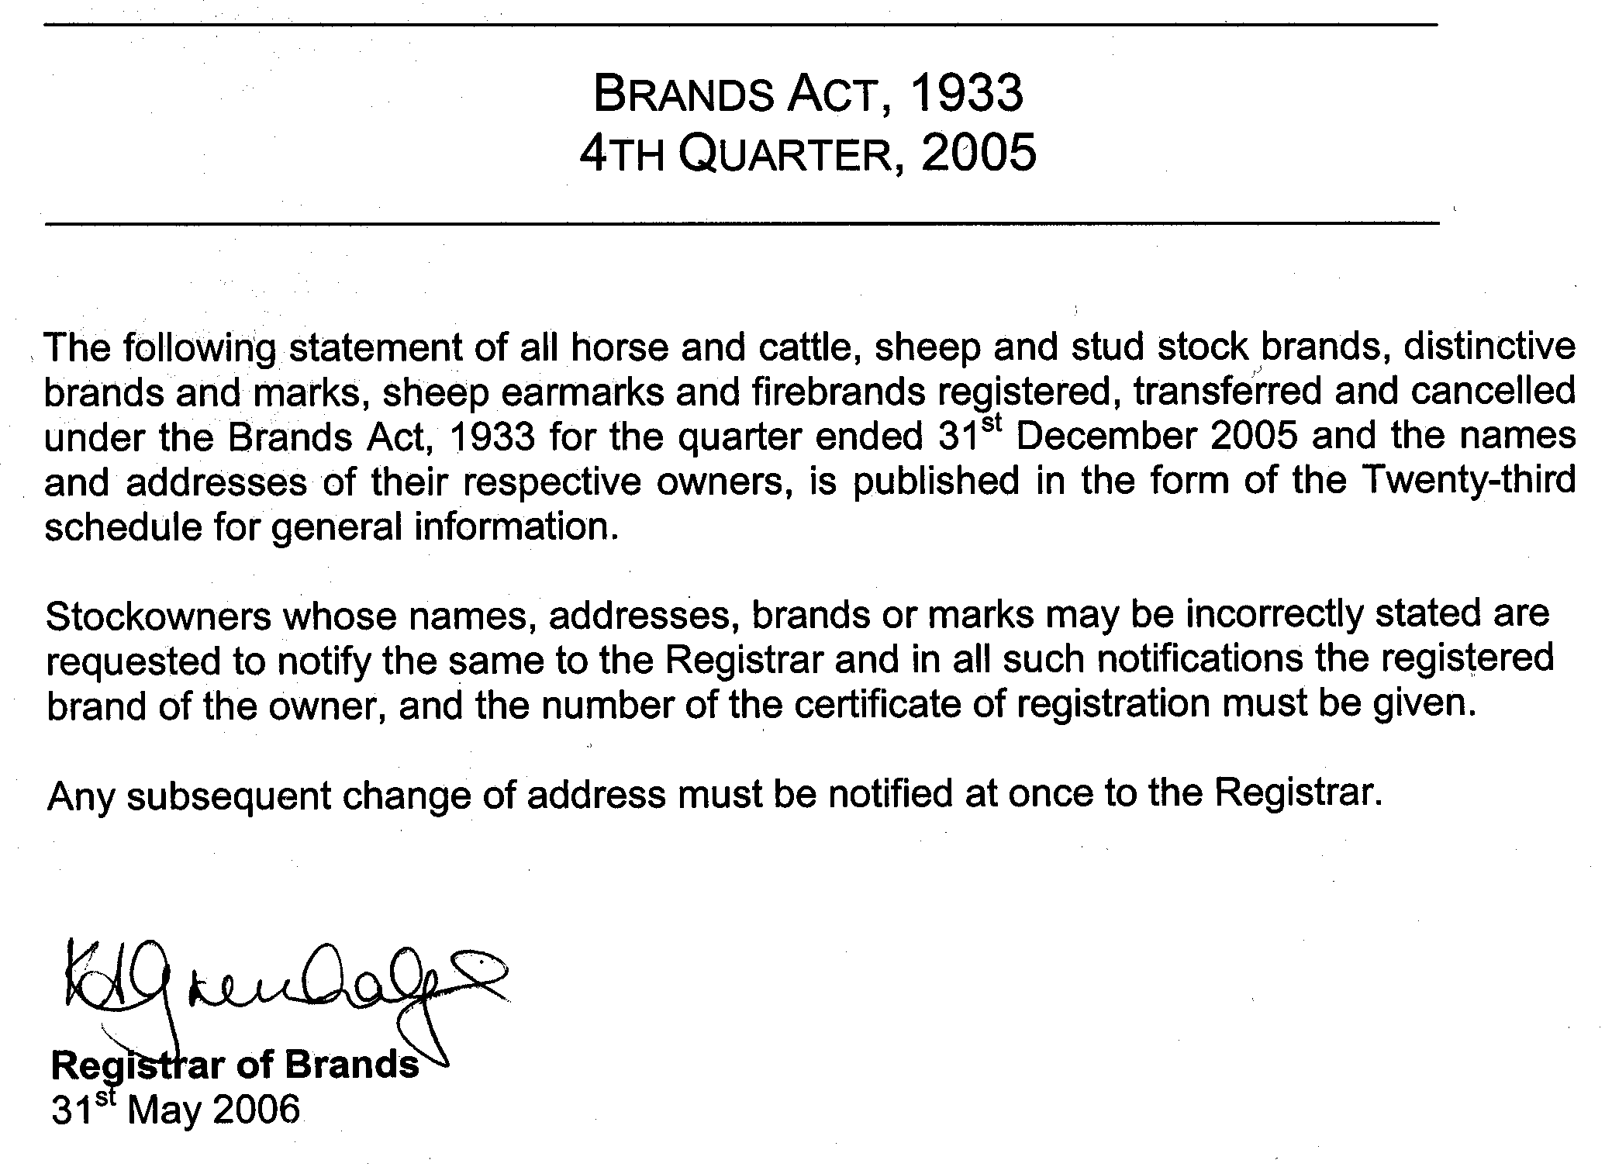
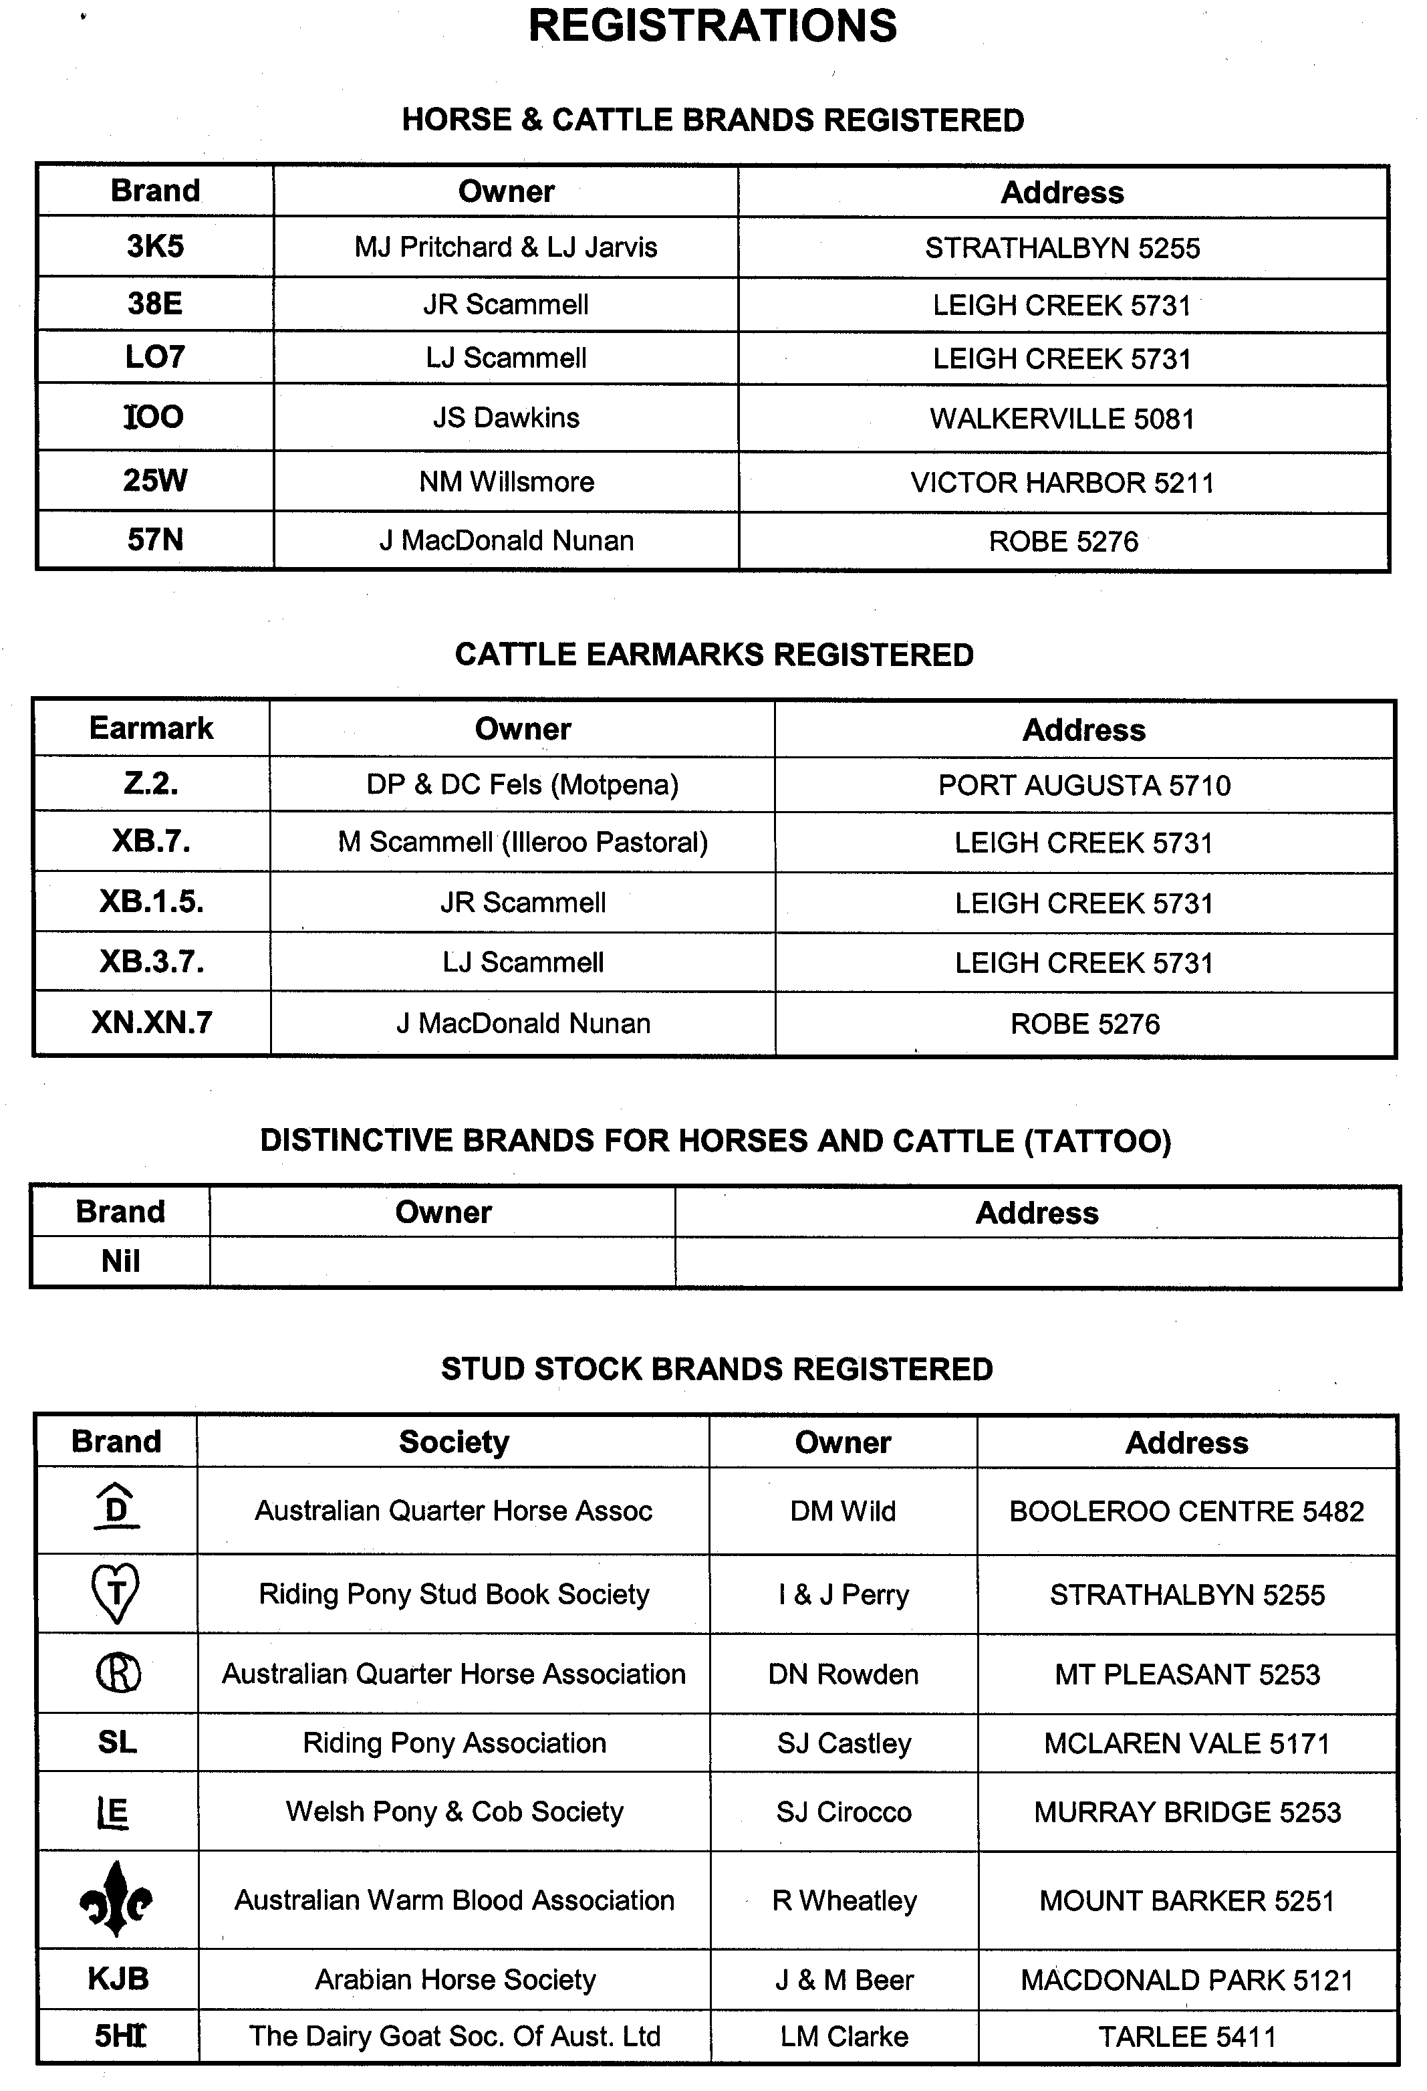
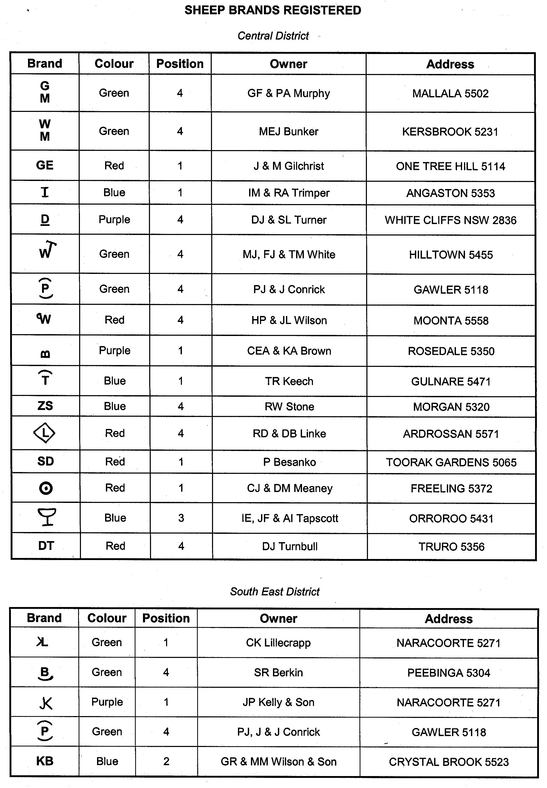
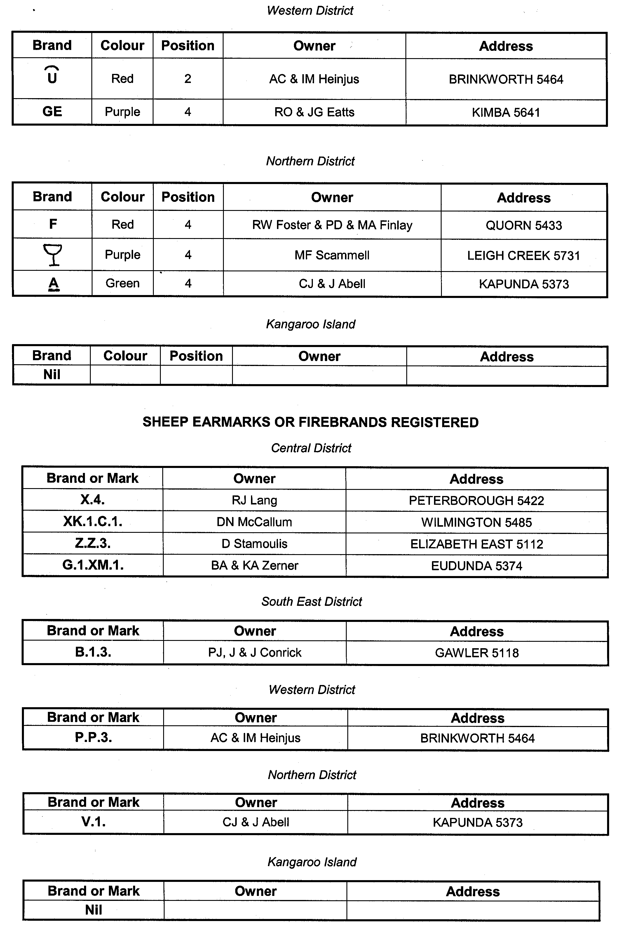
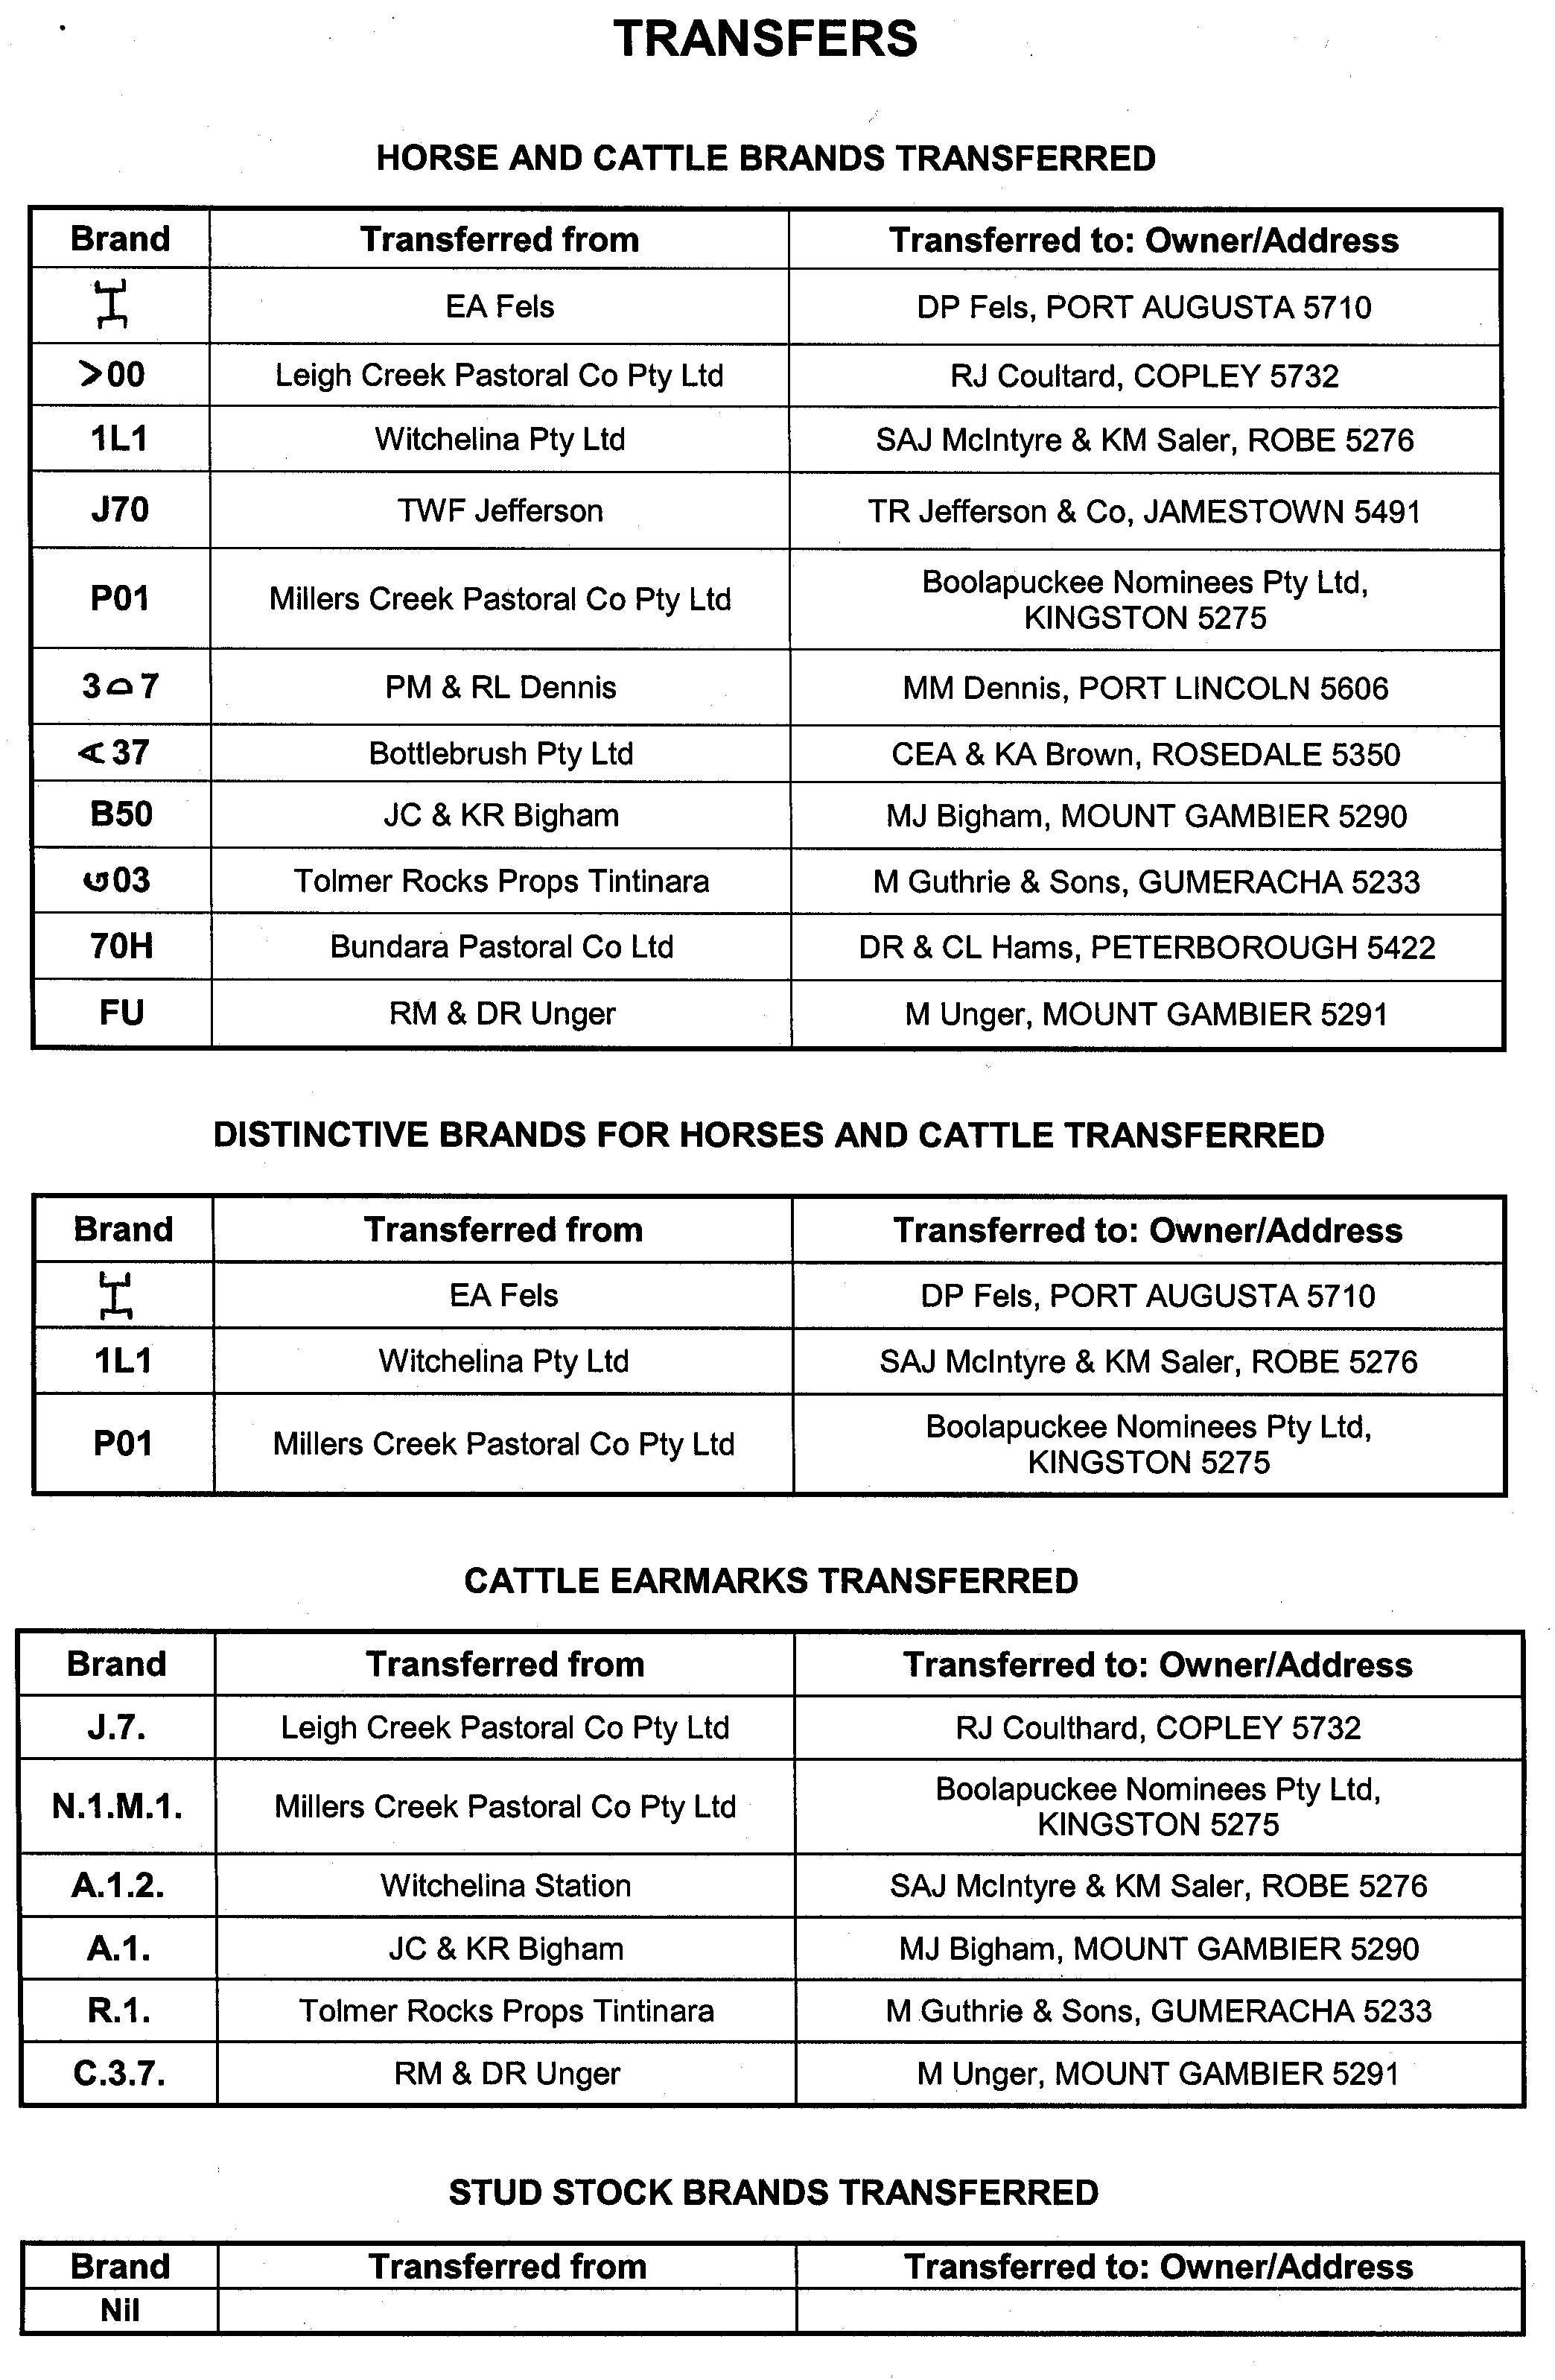
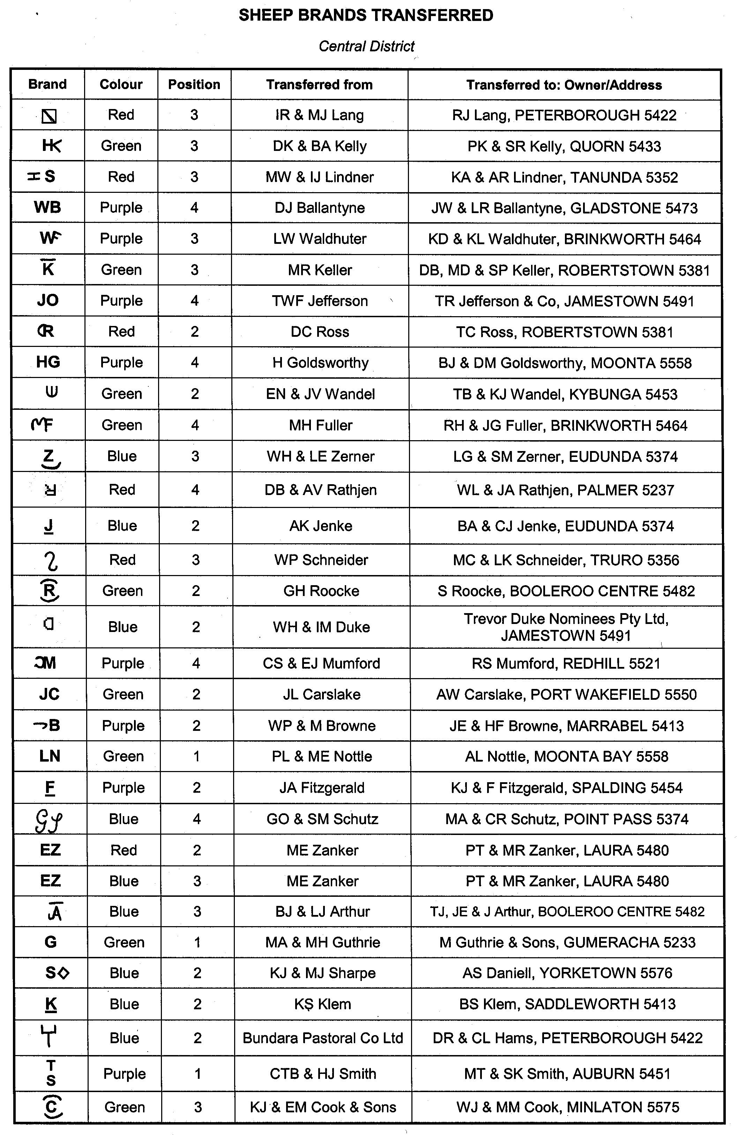
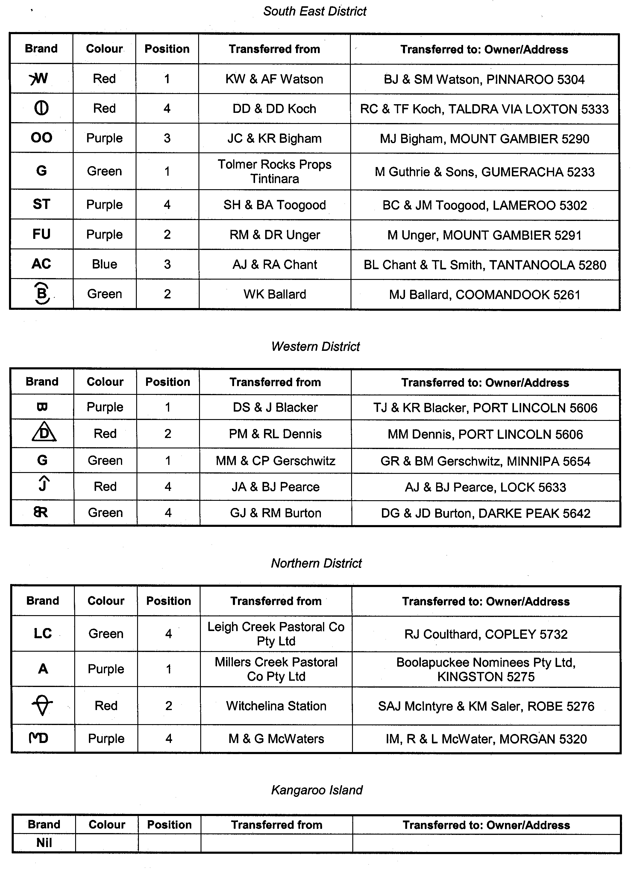
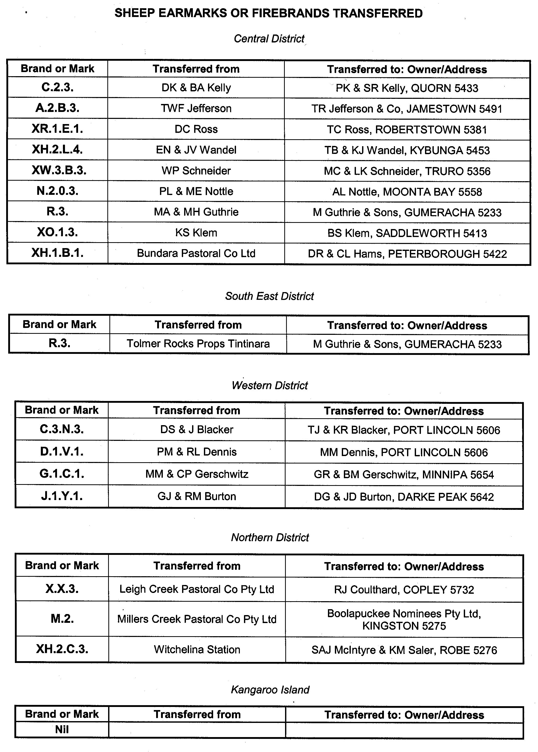
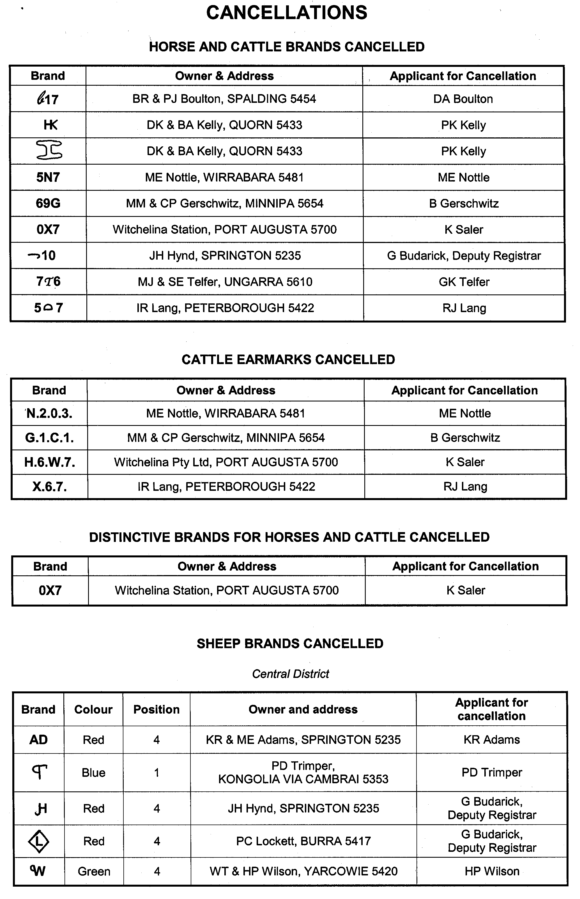
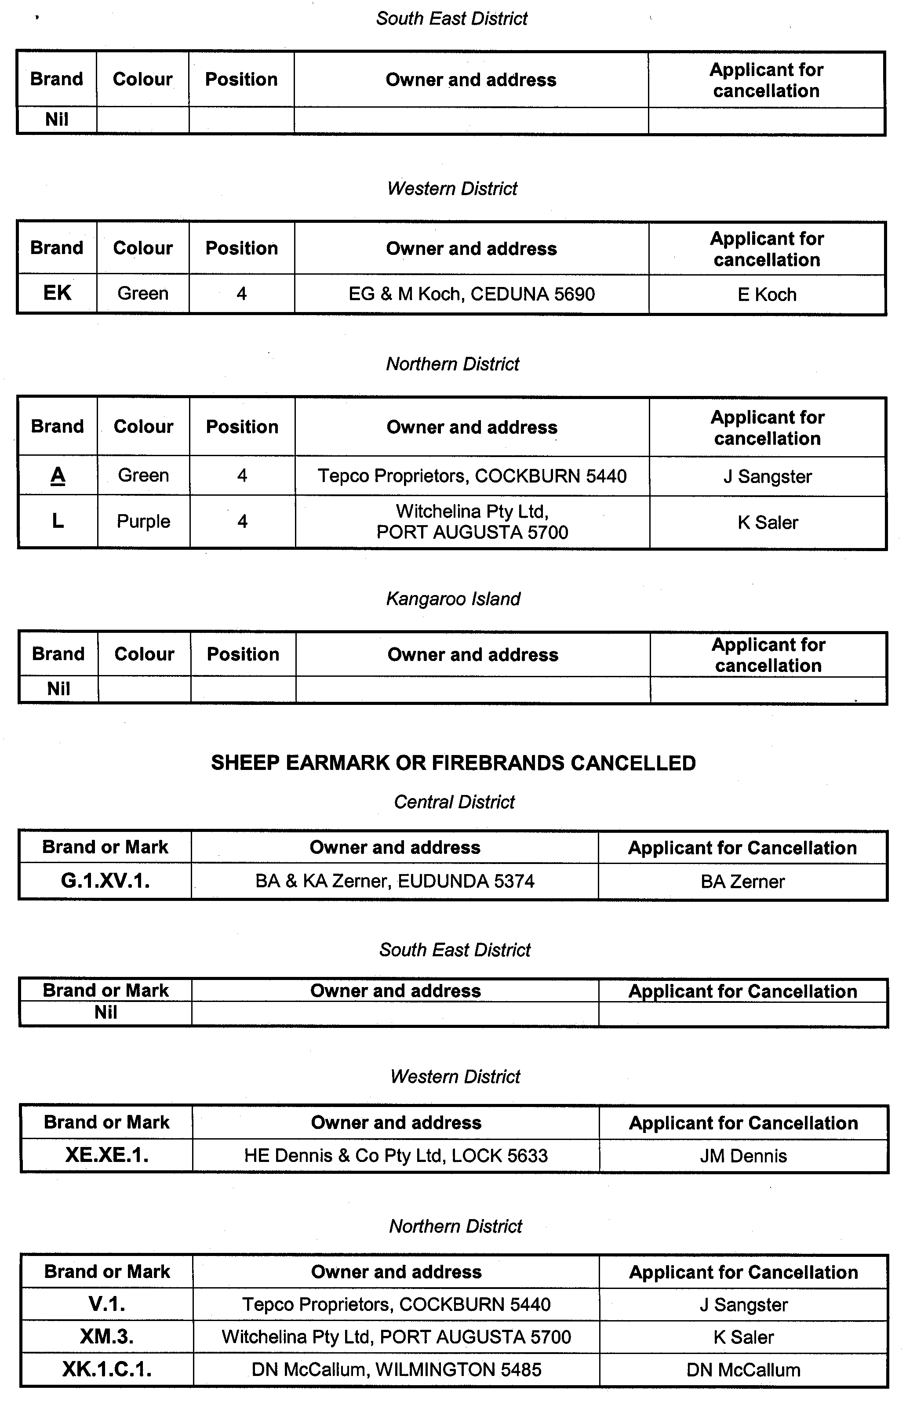
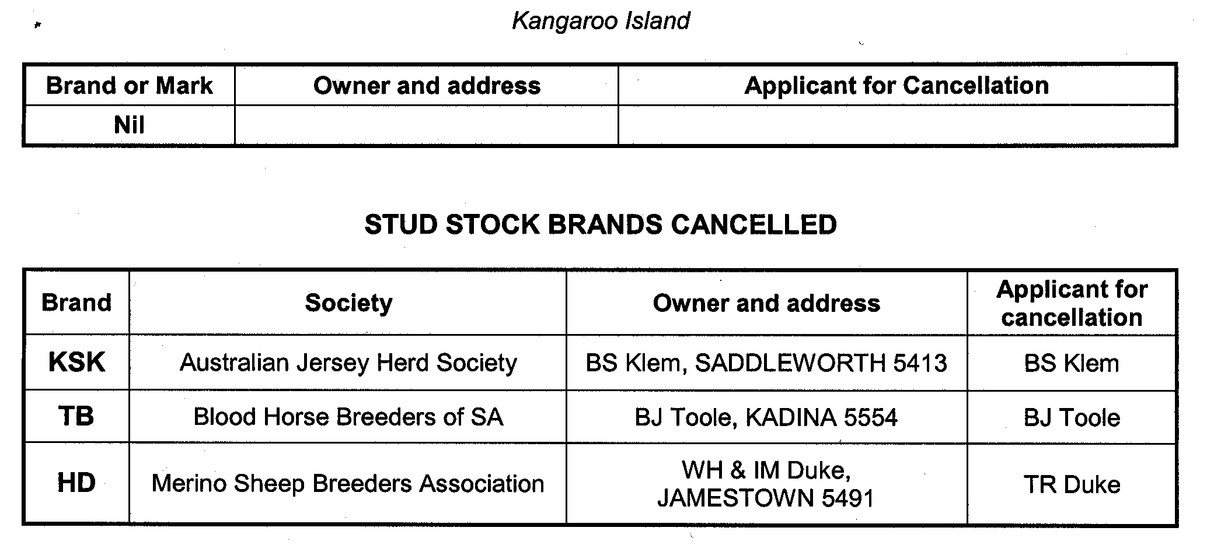

ENVIRONMENT PROTECTION ACT 1993
Variation to Existing Approval of Collection Depot
I, STEPHEN RICHARD SMITH, Senior Adviser, Container Deposit Legislation and Delegate of the Environment Protection Authority (‘the Authority’), pursuant to section 69 of the Environment Protection Act 1993 (SA) (‘the Act’) hereby:
Variation to Existing Approval of Collection Depot
Vary the approval of the collection depot, listed at Schedule 1 of this Notice, that was granted under the Act prior to the date of this Notice and impose the conditions of this approval to be as follows:
Approval of Collection Depot
The collection depot identified by reference to the following matters is approved:
(a) the name of the collection depot described in Column 1 of Schedule 1 of this Notice;
(b) the name of the proprietor of the depot identified in Column 3 of Schedule 1 of this Notice;
(c) the location of the depot described in Columns 4 and 5 of Schedule 1 of this Notice; and
(d) the collection area in relation to which the collection depot is approved referred to in Column 6 of Schedule 1 of this Notice.
The collection depot listed at Schedule 1 of this Notice is approved in relation to all classes of containers which were approved under the Act, at or subsequent to the date of this Notice, as Category B Containers.
Conditions of Approval
Impose the following conditions on the approval:
(a) The person in charge of the collection depot shall ensure the depot premises complies with Council Planning Regulations and shall be kept in an orderly condition.
(b) The person in charge of the collection depot who wishes to transfer the operation of a depot to another person or intends to change the location of a depot shall notify the Authority in writing within one month of the change occurring.
(c) The person in charge of the collection depot who wishes to cease operation of that depot shall give notice in writing to the Authority.
(d) The person in charge of the collection depot shall take such measures as are necessary in the operation and maintenance of the depot to prevent or control:
(i) A nuisance or offensive condition.
(ii) A risk to health or safety.
(iii) Damage to the environment.
(e) The person in charge of the collection depot is reminded of the general environmental duty, as required by section 25 of the Environment Protection Act 1993, to take all reasonable and practical measures to ensure that the activities on the whole site, do not pollute the environment in a way which causes or may cause environmental harm.
Schedule 1

Column 1 | Column 2 | Column 3 | Column 4 | Column 5 | Column 6
Depot Name | Company/  Trading Name | Proprietors | Depot Location  Street | Depot Location Suburb | Collection Area
Hawker Recycle | Hawker Recycle | Wayne and Vicki Cameron | Druid Range Drive | Hawker | Northern

ENVIRONMENT PROTECTION ACT 1993
Approval of Category B Containers
I, STEPHEN RICHARD SMITH, Senior Adviser, Container Deposit Legislation and Delegate of the Environment Protection Authority (‘the Authority’), pursuant to section 69 of the Environment Protection Act 1993 (SA) (‘the Act’) hereby:
Approval of Category B Containers:
Approve as Category B Containers, subject to the conditions in subclauses (i) and (ii) below, each of the classes of containers identified by reference to the following matters described in the first 4 columns of Schedule 1 of this Notice which are sold in South Australia:
(a) the product which each class of containers shall contain;
(b) the size of the containers;
(c) the type of containers;
(d) the name of the holders of these approvals.
(i) Subsection 69 (3) Arrangements:
The holders of these approvals must ensure that the empty containers which belong to their respective class of containers hereby approved as Category B Containers are collected from collection depots approved under section 69 of the Act by the party named in Column 5 of Schedule 1 of this Notice; and
(ii) Approved Refund Markings:
(a) The holders of these approvals must ensure that each container which belongs to their respective class of containers hereby approved as Category B Containers bears the refund marking approved by the Authority in respect of that class of containers.
(b) The refund marking that appears on each container that belongs to the class of containers hereby approved, must be a minimum 1.5 mm for the smallest letter in the statement and a minimum 3 mm for the numeric (‘5’) in the statement.
(c) The holder of these approvals must ensure that if a sticker bearing the refund marking has been approved, and is applied to the container, then the sticker must not be placed on any portion of the opening mechanism or in any other place that would require complete or partial removal of the sticker before the contents may be consumed.
Schedule 1

Column 1 | Column 2 | Column 3 | Column 4 | Column 5
Product Name | Container  Size (mL) | Container Type | Approval Holder | Collection  Arrangements
Birra Moretti Baffo Doro | 330 | Glass | Arquilla Bulk Trading Pty Ltd | Statewide Recycling
Birra Moretti La Rosa | 330 | Glass | Arquilla Bulk Trading Pty Ltd | Statewide Recycling
Gilde Pilsener | 330 | Glass | Arquilla Bulk Trading Pty Ltd | Statewide Recycling
HY Cuvee Beer | 750 | Glass | Arquilla Bulk Trading Pty Ltd | Statewide Recycling
HY Super Beer | 750 | Glass | Arquilla Bulk Trading Pty Ltd | Statewide Recycling
Menabrea Italia Birra | 330 | Glass | Arquilla Bulk Trading Pty Ltd | Statewide Recycling
Steaz Green Tea Soda Ginger Ale | 300 | Glass | Bettalife Distributors Pty Ltd | Statewide Recycling
Steaz Green Tea Soda Key Lime | 300 | Glass | Bettalife Distributors Pty Ltd | Statewide Recycling
Steaz Green Tea Soda Lemon Dew | 300 | Glass | Bettalife Distributors Pty Ltd | Statewide Recycling
Steaz Green Tea Soda Orange | 300 | Glass | Bettalife Distributors Pty Ltd | Statewide Recycling
Steaz Green Tea Soda Raspberry | 300 | Glass | Bettalife Distributors Pty Ltd | Statewide Recycling
Steaz Green Tea Soda Root Beer | 300 | Glass | Bettalife Distributors Pty Ltd | Statewide Recycling
Schweppes Agrum | 300 | Glass | Cadbury Schweppes Pty Ltd | Statewide Recycling
Schweppes Bitter Lemon | 250 | Can—Aluminium | Cadbury Schweppes Pty Ltd | Statewide Recycling
Schweppes Ciata | 300 | Glass | Cadbury Schweppes Pty Ltd | Statewide Recycling
Schweppes Indian Tonic Water | 300 | Glass | Cadbury Schweppes Pty Ltd | Statewide Recycling
Schweppes Lemon Lime & Bitters | 300 | Glass | Cadbury Schweppes Pty Ltd | Statewide Recycling
Schweppes Lemonade | 300 | Glass | Cadbury Schweppes Pty Ltd | Statewide Recycling
Schweppes Soda Water | 300 | Glass | Cadbury Schweppes Pty Ltd | Statewide Recycling
Schweppes Sueno | 300 | Glass | Cadbury Schweppes Pty Ltd | Statewide Recycling
Coca Cola | 600 | PET | Coca Cola Amatil (Aust) Pty Ltd | Statewide Recycling
Mount Franklin Lightly Sparkling | 750 | Glass | Coca Cola Amatil (Aust) Pty Ltd | Statewide Recycling
Mount Franklin Still | 250 | Glass | Coca Cola Amatil (Aust) Pty Ltd | Statewide Recycling
Mount Franklin Still | 750 | Glass | Coca Cola Amatil (Aust) Pty Ltd | Statewide Recycling
Echigo Super Premium Reijo | 350 | Glass | Daiwa Food Corporation Pty Ltd | Statewide Recycling
Kirin Gogo Tea Lemon | 500 | PET | Daiwa Food Corporation Pty Ltd | Statewide Recycling
Kirin Gogo Tea Straight | 500 | PET | Daiwa Food Corporation Pty Ltd | Statewide Recycling
UCC Green Tea | 330 | Can—Aluminium | Daiwa Food Corporation Pty Ltd | Statewide Recycling
UCC Melon Cream Soda | 490 | Can—Aluminium | Daiwa Food Corporation Pty Ltd | Statewide Recycling
UCC Milk Coffee | 337 | Can—Aluminium | Daiwa Food Corporation Pty Ltd | Statewide Recycling
UCC Oolong Tea | 330 | Can—Aluminium | Daiwa Food Corporation Pty Ltd | Statewide Recycling
Bundaberg Rum & Cola | 440 | Can—Aluminium | Diageo Australia Pty Ltd | Statewide Recycling
Agbarr Cream Soda | 330 | Can—Aluminium | Funworks | Flagcan Distributors
F & N Icecream Soda | 325 | Can—Aluminium | Funworks | Flagcan Distributors
Orchid Aqualibra Original | 750 | Glass | Funworks | Flagcan Distributors
Vimto Mini | 150 | Can—Aluminium | Funworks | Flagcan Distributors
Kristov Cruiser Black Guava | 330 | Glass | Independent Distillers (Aust) Pty Ltd | Statewide Recycling
Kristov Vodka Cruiser Cranberry & Lime | 275 | Glass | Independent Distillers (Aust) Pty Ltd | Statewide Recycling
Vodka Freeze Alaskan Blue Raspberry and Lime | 330 | Glass | Independent Distillers (Aust) Pty Ltd | Statewide Recycling
Vodka Freeze Ice Tip Lemon Lime and Bitters | 330 | Glass | Independent Distillers (Aust) Pty Ltd | Statewide Recycling
Vodka Freeze Polar Myst Limoncello | 330 | Glass | Independent Distillers (Aust) Pty Ltd | Statewide Recycling
Just Delicious Fruit Juices Apple & Blackcurrant Juice | 300 | PET | Just Squeezed Fruit Juices Pty Ltd | Marine Stores Ltd
Just Delicious Fruit Juices Apple & Blackcurrant Juice | 500 | PET | Just Squeezed Fruit Juices Pty Ltd | Marine Stores Ltd
Just Delicious Fruit Juices Apple & Guava Juice | 500 | PET | Just Squeezed Fruit Juices Pty Ltd | Marine Stores Ltd
Just Delicious Fruit Juices Apple Juice | 300 | PET | Just Squeezed Fruit Juices Pty Ltd | Marine Stores Ltd
Just Delicious Fruit Juices Apple Juice | 500 | PET | Just Squeezed Fruit Juices Pty Ltd | Marine Stores Ltd
Just Delicious Fruit Juices Crushed Lemonade | 300 | PET | Just Squeezed Fruit Juices Pty Ltd | Marine Stores Ltd
Just Delicious Fruit Juices Crushed Lemonade | 500 | PET | Just Squeezed Fruit Juices Pty Ltd | Marine Stores Ltd
Just Delicious Fruit Juices Orange Apple & Mango Juice | 300 | PET | Just Squeezed Fruit Juices Pty Ltd | Marine Stores Ltd
Just Delicious Fruit Juices Orange Apple & Mango Juice | 500 | PET | Just Squeezed Fruit Juices Pty Ltd | Marine Stores Ltd
Just Delicious Fruit Juices Orange Apple & Passionfruit Juice | 500 | PET | Just Squeezed Fruit Juices Pty Ltd | Marine Stores Ltd
Just Delicious Fruit Juices Orange Juice | 300 | PET | Just Squeezed Fruit Juices Pty Ltd | Marine Stores Ltd
Just Delicious Fruit Juices Orange Juice | 500 | PET | Just Squeezed Fruit Juices Pty Ltd | Marine Stores Ltd
Just Delicious Fruit Juices Pineapple Juice | 300 | PET | Just Squeezed Fruit Juices Pty Ltd | Marine Stores Ltd
Just Delicious Fruit Juices Tropical Fruit Juice Blend | 300 | PET | Just Squeezed Fruit Juices Pty Ltd | Marine Stores Ltd
Wonderfarm Artichoke Drink | 330 | Can—Aluminium | Maxim Pty Ltd | Statewide Recycling
Wonderfarm Basil Seed Drink | 330 | Can—Aluminium | Maxim Pty Ltd | Statewide Recycling
Wonderfarm Bird Nest Drink | 250 | Can—Steel | Maxim Pty Ltd | Statewide Recycling
Wonderfarm Coco Juice Drink | 250 | Can—Aluminium | Maxim Pty Ltd | Statewide Recycling
Wonderfarm Coffee Drink | 250 | Can—Steel | Maxim Pty Ltd | Statewide Recycling
Wonderfarm Dragon Fruit Drink | 330 | Can—Aluminium | Maxim Pty Ltd | Statewide Recycling
Wonderfarm Grass Jelly Drink | 330 | Can—Steel | Maxim Pty Ltd | Statewide Recycling
Wonderfarm Ice Cupuccino | 250 | Can—Aluminium | Maxim Pty Ltd | Statewide Recycling
Wonderfarm Ice Mocha Coffee | 250 | Can—Aluminium | Maxim Pty Ltd | Statewide Recycling
Wonderfarm Lychee Drink | 330 | Can—Aluminium | Maxim Pty Ltd | Statewide Recycling
Wonderfarm Pennywort Juice Drink | 330 | Can—Aluminium | Maxim Pty Ltd | Statewide Recycling
Wonderfarm Tamarind Drink | 330 | Can—Aluminium | Maxim Pty Ltd | Statewide Recycling
Wonderfarm Vietnamese Coffee Drink | 250 | Can—Steel | Maxim Pty Ltd | Statewide Recycling
Wonderfarm Young Coco Water With Meat | 330 | Can—Steel | Maxim Pty Ltd | Statewide Recycling
Daily Juice Company Morning Start Breakfast With A C & E | 500 | PET | National Foods Milk Limited | Statewide Recycling
Kyneton Springs Apple & Raspberry Juice | 300 | Glass | National Foods Milk Limited | Statewide Recycling
Kyneton Springs Italian Chinotto | 300 | Glass | National Foods Milk Limited | Statewide Recycling
Kyneton Springs Lemon & Lime Juice | 300 | Glass | National Foods Milk Limited | Statewide Recycling
Kyneton Springs Lemon Juice | 300 | Glass | National Foods Milk Limited | Statewide Recycling
Kyneton Springs Orange Juice | 300 | Glass | National Foods Milk Limited | Statewide Recycling
Kyneton Springs Sparkling Mineral Water | 300 | Glass | National Foods Milk Limited | Statewide Recycling
Evian Natural Spring Water | 1 000 | PET | Orlando Wyndham Group Pty Ltd | Marine Stores Ltd
Evian Natural Spring Water | 500 | Glass | Orlando Wyndham Group Pty Ltd | Marine Stores Ltd
Evian Natural Spring Water | 500 | PET | Orlando Wyndham Group Pty Ltd | Marine Stores Ltd
Evian Natural Spring Water | 330 | PET | Orlando Wyndham Group Pty Ltd | Marine Stores Ltd
Shokata | 2 000 | PET | Ras Trade Pty Ltd | Statewide Recycling

EXPIATION OF OFFENCES ACT 1996
NATIONAL PARKS AND WILDLIFE ACT 1972
Instrument of Authorisation
I, GAIL ELIZABETH GAGO, Minister for Environment and Conservation, being the Minister responsible for the administration of the National Parks and Wildlife Act 1972 (the Act), do hereby authorise, pursuant to section 6 (3) (b) (i) of the Expiation of Offences Act 1996, those persons appointed as Wardens pursuant to section 20 of the Act to issue expiation notices for expiable offences under the Act, or Regulations made under the Act:
Hollow, Phillip Rodney
Clayton, Stephen John
Coombe, Arthur Richard
Best, Lindsay Wilfred
Stelmann, Joe Gerry
Fitzpatrick, Gary John
Halstead, Christopher Kenneth
Harper, Michael John
Watkins, Raymond John
Anderson, Malcolm John
Dahl, Erik Svern
Scholz, Volker Helmet
Maguire, Anthony
Houlahan, Neville Ross
Gilbert, Steven John
Giebel, Gerhard Wilhelm Otto
Heyne, Kenneth Maxwell
Bailey, Nicholas John
Fuhlbohm, Timothy Wayne
Kraehenbuehl, Janine Ann
Naismith, Trevor Leonard
Allen, Ross James
Gerschwitz, Ronald Thomas
Falkenberg, Ian Douglas
Mount, Donald Gerard
de Groot, Richard
Fraser, Timothy Scott
Dougherty, Pearce Nicholson
Young, Robin Edward
Collins, James Timothy
Bracken, John Francis
Zepf, Albert Gerard
Ellis, Robert James
Tilley, Joseph William
Chance, Robert Stephen
Meyer-Jurd, Shirley
Saers, Ronald Henry
Brown, Stephen Hugh
Alexander, Peter James
Nixon, Craig Leslie
Jackway, Glenn Richard
Southcombe, Stuart Edward
Troath, Robert Bryn Lewis
Hollow, Phillip Rodney
Wigg, Michael John
Crocker, James Scott
Tanner, Ian Craig
Egan, Leah Marree
Dalzell, Brett Graham
Strachan, Phillip James
Freak, Michael James
Robins, Brian Andrew
Warner, Andrew Craig
Pendlebury, Brett John
Beinke, Stuart W.
Dridan, Hannah Gosse
Storr, Robin
Wauchope, Jeffrey Andrew
McPherson, Michelle Ann
Gable, Grant Morrison
Ah Chee, Dean Lennie
Armenio, Melanie Marie
Anderson, Kenneth Paul
Leggett, Tamara Jane
McIntosh, Thomas William
Unsworth, Paul Graham
Arnold, Christine Radegunde
Drogemuller, Glen
Oster, Simon Mark
Taylor, Stephen Martin
Kelly, Deborah Kaye
Zidarich, Anthony David
Te, Thai Seng
Axford, Geoffrey Bruce
Coulthard, Arthur Fredrick
Crawford, Darren Robert
Watkins, Peter James
Childs, Shane Robert
De Smit, Eric Edward
Paterson, Caroline Jane
Woods, Jonathan David
Kalinowska, Ewilina (Eva)
Farroway, Lisa Nicole
Buck, Alison Janette
Doyle, Daniel Dominic
Belcher, Kenneth Ross
Dodd, Christopher Edward
Wigg, Michael John
Coulthard, Kristian
Koerner, Dylan Charles
Jennings, Scott Adrian
Kennewell, Matthew Paul
Clisby, Nathan James
Crack, Rebecca Jane
Laudenbach, Karren
Armstrong, David Mark
Sleep, Robert George
Morcom, Robyn Joanne
Coulthard, Darcy
Anderson, Ross David
Edwards, Teddy
Newchurch, Anton
Clarke, Simon
Peek, Peter Wayne
Welsby, Keith Antony
Bourne, Steven
Nicholls, Sonya
Kondylas, Stella Maree
Mills, Richard
Liddle, Leanne
Winter, Jasmine
Arnott, Terry
Pobke, Katrina
Wright, Jacqueline
Trebilcock, Michael
Hoffman, Andrew
Heard, David
Snowball, Derek
Smith, Aaron
Haegi, Laurence
Laver, Robert
Hall, Tim
Holton, Michael
Bredl, Rose-Marie
Nussio, Donna
Dickson, Catherine
Burton, Kate
Penhall, Michael
Wilkins, Peter
Coulthard, Shara
Hinslff, Mike
Dated 3 June 2006.
G. Gago, Minister for Environment and Conservation

FISHERIES ACT 1982: SECTION 43
TAKE note that the notice made under section 43 of the Fisheries Act 1982, and published in the South Australian Government Gazette dated 3 June 2006, referring to the Gulf St Vincent Prawn Fishery, is hereby revoked at 1430 hours on 4 June 2006.
Dated 4 June 2006.
S. Sloan, Principal Fisheries Manager

FISHERIES ACT 1982: SECTION 43
TAKE note that the notice made under section 43 of the Fisheries Act 1982, published in the South Australian Government Gazette on page 965, dated 28 March 2006, being the fourth notice on that page, referring to the Gulf St Vincent Prawn Fishery, is hereby varied such that it will not be unlawful for a person fishing pursuant to a Gulf St Vincent Prawn Fishery licence to use prawn trawl nets in the area specified in Schedule 1 during the period specified in Schedule 2.
Schedule 1
The waters of the Gulf St Vincent Prawn Fishery located adjacent to Troubridge Island, which are defined as the waters within the following co-ordinates, starting at position latitude 35°20.00′S, longitude 137°56.50′E, then to position latitude 35°15.00′S, longitude 137°51.50′E, then to position latitude 35°07.75′S, longitude 138°00.00′E, then to position latitude 35°14.00′S, longitude 138°02.60′E, then to position latitude 35°14.00′S, longitude 137°58.00′E, then to position latitude 35°18.80′S, longitude 137°58.00′E, then back to position latitude 35°20.00′S, longitude 137°56.50′E.
Schedule 2
From 1800 hours on 4 June 2006 to 0630 hours on 6 June 2006.
Dated 4 June 2005.
S. Sloan, Principal Fisheries Manager

FISHERIES ACT 1982: SECTION 59
TAKE notice that, pursuant to section 59 of the Fisheries Act 1982, Dallas Power, Power Aquaculture Pty Ltd, 4 Tally Ho Avenue, Port Lincoln, S.A. 5606 (the ‘exemption holder’) is exempt from the Fisheries Act 1982, but only insofar as he may take Pinna bicolor and Atrina tasmanica for the purpose of aquaculture broodstock (the ‘exempted activity’) in the waters specified in Schedule 1, subject to the conditions in Schedule 2 from 1 August 2006 until 31 December 2006.
Schedule 1
South Australian coastal waters of Denial Bay.
Schedule 2
1. The exemption holder may take a maximum of 250 Razorfish (Pinna bicolor) and 125 Pen mussel (Atrina tasmanica), however these species may only be taken pursuant to this exemption after approval of aquaculture activities by PIRSA Aquaculture.
2. A maximum of 50 individuals of each species may be taken from each collection site. Each collection site must be a minimum of 100 m apart to reduce local depletion of stock in each site.
3. All specimens taken pursuant to this exemption must not be sold or transferred to another party.
4. All specimens taken pursuant to this exemption must be delivered to and retained on an aquaculture site on which PIRSA Aquaculture have endorsed aquaculture of these species.
5. The exempted activity may also be conducted on the exemption holder’s behalf by Rachel Lawrie.
6. The exemption holder must notify PIRSA Fishwatch on 1800 065 522 at least 2 hours prior to conducting the exempted activity answer a series of questions about the exempted activity. The exemption holder will need to have a copy of the exemption at the time of making the call, and be able to provide information about the area and time of the exempted activity, the vehicles and other related questions. Exemption No. 9901846.
7. While engaged in the exempted activity the exemption holder must carry or have about or near his person a copy of this notice. Such notice must be produced to a PIRSA Fisheries Officer upon request.
8. The exemption holder must not contravene or fail to comply with the Fisheries Act 1982 or any regulations made under that Act, except where specifically exempted by this notice.
Dated 5 June 2006.
W. Zacharin, Director of Fisheries

FISHERIES ACT 1982: SECTION 59
TAKE notice that, pursuant to section 59 of the Fisheries Act 1982, James Boylan, Boylan Shearing Pty Ltd, P.O. Box 1, Wudinna, S.A. 5652 (the ‘exemption holder’) is exempt from the Fisheries Act 1982, but only insofar as he may take Pinna bicolor and Atrina tasmanica for the purpose of aquaculture broodstock (the ‘exempted activity’) in the waters specified in Schedule 1, subject to the conditions in Schedule 2 from 1 August 2006 until 31 December 2006.
Schedule 1
South Australian coastal waters of Denial Bay.
Schedule 2
1. The exemption holder may take a maximum of 250 Razorfish (Pinna bicolor) and 125 Pen mussel (Atrina tasmanica), however these species may only be taken pursuant to this exemption after approval of aquaculture activities by PIRSA Aquaculture.
2. A maximum of 50 individuals of each species may be taken from each collection site. Each collection site must be a minimum of 100 m apart to reduce local depletion of stock in each site.
3. All specimens taken pursuant to this exemption must not be sold or transferred to another party.
4. All specimens taken pursuant to this exemption must be delivered to and retained on an aquaculture site on which PIRSA Aquaculture have endorsed aquaculture of these species.
5. The exempted activity may also be conducted on the exemption holder’s behalf by Rachel Lawrie.
6. The exemption holder must notify PIRSA Fishwatch on 1800 065 522 at least 2 hours prior to conducting the exempted activity answer a series of questions about the exempted activity. The exemption holder will need to have a copy of the exemption at the time of making the call, and be able to provide information about the area and time of the exempted activity, the vehicles and other related questions. Exemption No. 9901872.
7. While engaged in the exempted activity the exemption holder must carry or have about or near his person a copy of this notice. Such notice must be produced to a PIRSA Fisheries Officer upon request.
8. The exemption holder must not contravene or fail to comply with the Fisheries Act 1982 or any regulations made under that Act, except where specifically exempted by this notice.
Dated 5 June 2006.
W. Zacharin, Director of Fisheries

FISHERIES ACT 1982: SECTION 43
TAKE note that the notice made under section 43 of the Fisheries Act 1982, published in the South Australian Government Gazette on page 965, dated 28 March 2006, being the fourth notice on that page, referring to the Gulf St Vincent Prawn Fishery, is hereby varied such that it will not be unlawful for a person fishing pursuant to a Gulf St Vincent Prawn Fishery licence to use prawn trawl nets in the area specified in Schedule 1 during the period specified in Schedule 2.
Schedule 1
1. The waters of the Gulf St Vincent Prawn Fishery located adjacent to Troubridge Island, which are defined as the waters within the following co-ordinates, starting at position latitude 35°20.00′S, longitude 137°56.50′E, then to position latitude 35°15.00′S, longitude 137°51.50′E, then to position latitude 35°07.75′S, longitude 138°00.00′E, then to position latitude 35°12.17′S, longitude 138°04.30′E, then to position latitude 35°13.50′S, longitude 138°02.75′E, then to position latitude 35°13.50′S, longitude 138°00.00′E, then back to position latitude 35°20.00′S, longitude 137°56.50′E.
Schedule 2
From 1800 hours on 3 June 2006 to 0630 hours on 6 June 2006.
Dated 3 June 2005.
S. Sloan, Principal Fisheries Manager

FISHERIES ACT 1982: SECTION 43
TAKE note that the notice made under section 43 of the Fisheries Act 1982, published in the South Australian Government Gazette on page 965, dated 28 March 2006, being the fourth notice on that page, referring to the Gulf St Vincent Prawn Fishery, is hereby varied such that it will not be unlawful for a person fishing pursuant to a Gulf St Vincent Prawn Fishery Licence to use prawn trawl nets in the area specified in Schedule 1 during the period specified in Schedule 2.
Schedule 1
1. The waters of the Gulf St Vincent Prawn Fishery located adjacent to Troubridge Island, which are defined as the waters within the following co-ordinates, starting at position latitude 35°20.00′S, longitude 137°56.50′E, then to position latitude 35°15.00′S, longitude 137°51.50′E, then to position latitude 35°11.00′S, longitude 137°56.50′E, then to position latitude 35°14.50′S, longitude 138°04.50′E, then back to position latitude 35°20.00′S, longitude 137°56.50′E.
Schedule 2
From 1800 hours on 1 June 2006 to 0630 hours on 2 June 2006.
Dated 31 May 2005.
S. Sloan, Principal Fisheries Manager

FISHERIES ACT 1982: SECTION 59
TAKE notice that pursuant to section 59 of the Fisheries Act 1982, the class of persons described in Schedule 1 (the ‘exemption holders’) are exempted from the provisions of Clause 123 of Schedule 1 of the Fisheries (General) Regulations 2000 in that an exemption holder shall not be guilty of an offence when using a registered boat that is endorsed on the licence to undertake fishing activity for purposes other than trade or business (the ‘exempted activity’), subject to the conditions specified in Schedule 2, from
1 July 2006 until 30 June 2007, unless this notice is varied or revoked earlier.
Schedule 1
The holder of a licence issued pursuant to the Fisheries (Scheme of Management—Marine Scalefish Fisheries) Regulations 1991, the Fisheries (Scheme of Management—Miscellaneous Fishery) Regulations 2000, the Fisheries (Scheme of Management—Blue Crab Fishery) Regulations 1998, the Fisheries (Scheme of Management—Prawn Fisheries) Regulations 1991, the Fisheries (Scheme of Management—Abalone Fisheries) Regulations 1991, the Fisheries (Scheme of Management—River Fishery) Regulations 1991, the Fisheries (Scheme of Management—Lakes and Coorong Fishery) Regulations 1991, the Fisheries (Scheme of Management—Charter Boat Fishery) Regulations 2005 and the Fisheries (Scheme of Management—Rock Lobster Fisheries) Regulations 1991, or any regulations that replace these regulations.
Schedule 2
1. The exempted activity may only be undertaken if the registered boat is also registered for recreational use in accordance with regulations made under the Harbours and Navigation Act 1993.
2. An exemption holder must ensure that the commercial fishery boat registration number marked on a boat is covered over during the exempted activity, and any recreational registration numbers are displayed as required by regulations made under the Harbours and Navigation Act 1993.
3. The exemption holder must notify PIRSA Fisheries by calling 1800 065 522 prior to engaging in the exempted activity and providing the following information:
• the name of the licence holder making the call;
• the fishery licence number(s) of the licence(s) on which the registered boat is endorsed;
• the name of the boat and the commercial boat registration number;
• the recreational boat registration number of the boat;
• registration numbers of recreational devices (rock lobster pots or nets) that will be on board the boat;
• the time and date the exempted activity will commence; and
• the time and date the exempted activity will cease.
4. At any time during the exempted activity, an exemption holder must not have on board the registered boat any registered fishing device that is endorsed on the fishery licence on which the registered boat is also endorsed.
5. An exemption holder who is the holder of a licence issued pursuant to the Fisheries (Scheme of Management—Rock Lobster Fisheries) Regulations 1991, must ensure that no recreational rock lobster pots are on board a registered boat that is endorsed on a rock lobster fishery licence at any time during the exempted activity.
6. An exemption holder who is the holder of a licence issued pursuant to the Fisheries (Scheme of Management—Rock Lobster Fisheries) Regulations 1991, must not take or have on board the registered boat any rock lobster during the exempted activity.
7. All fish taken in the course of the exempted activity must be removed from the boat at the end of the exempted activity.
8. An exemption holder must not contravene or fail to comply with the Fisheries Act 1982 or any other regulations made under that Act, except where specifically exempted by this notice.
Dated 1 June 2006.
W. Zacharin, Director of Fisheries

FISHERIES ACT 1982: SECTION 59
TAKE notice that pursuant to section 59 of the Fisheries Act 1982, the Director of Fisheries is exempt from subsection 36 (2) of the Fisheries Act 1982 and regulation 12 of the Fisheries (Scheme of Management—Marine Scalefish Fisheries) Regulations 1991, insofar as the Director may, upon application, grant registration of a person as the master of a registered boat in relation to a licence of a class listed in Schedule 1 to a person that is not the holder of the licence, from the date of gazettal of this notice until 30 June 2007.
Schedule 1
Marine Scalefish Fishery Licences endorsed to allow the use of a pilchard net.
Marine Scalefish Fishery Licences endorsed to allow the use of an ocean leather jacket trap.
Marine Scalefish Fishery Licences endorsed to allow the use of sand crab pots.
Marine Scalefish Fishery Licences endorsed to allow the use of velvet crab pots.
Dated 30 May 2006.
R. McEwen, Minister for Agriculture, Food And Fisheries

FISHERIES ACT 1982: SECTION 43
TAKE note that the notice made under section 43 of the Fisheries Act 1982, published in the South Australian Government Gazette on page 3958, dated 17 November 2005, being the third notice on that page, referring to the Spencer Gulf Prawn Fishery, is hereby varied such that it will be unlawful for a person fishing pursuant to a Spencer Gulf Prawn Fishery Licence to use prawn trawl nets in the closed areas specified in Schedule 1 during the period specified in Schedule 2.
Schedule 1
The waters of the Spencer Gulf Prawn Fishery that are north and east of the area, commencing at position latitude 34°30.00′S, longtitude 136°06.00′E, then to position latitude 34°30.00′S, longitude 137°15.00′E, then to position latitude 34°55.00′S, longtitude 137°15.00′E.
Schedule 2
From 1830 hours on 2 June 2006 to 0630 hours on 4 June 2006.
Dated 2 June 2006.
S. Sloan, Principal Fisheries Manager

GEOGRAPHICAL NAMES ACT 1991
Notice to Alter the Boundary of a Suburb
NOTICE is hereby given pursuant to the provisions of the above Act that I, Michael Wright, Minister for Administrative Services and Government Enterprises, Minister of the Crown to whom the administration of the Geographical Names Act 1991, is committed DO HEREBY exclude from the suburb of MAWSON LAKES and assign the name CAVAN to that area marked (A) on the plan below.
The Plan
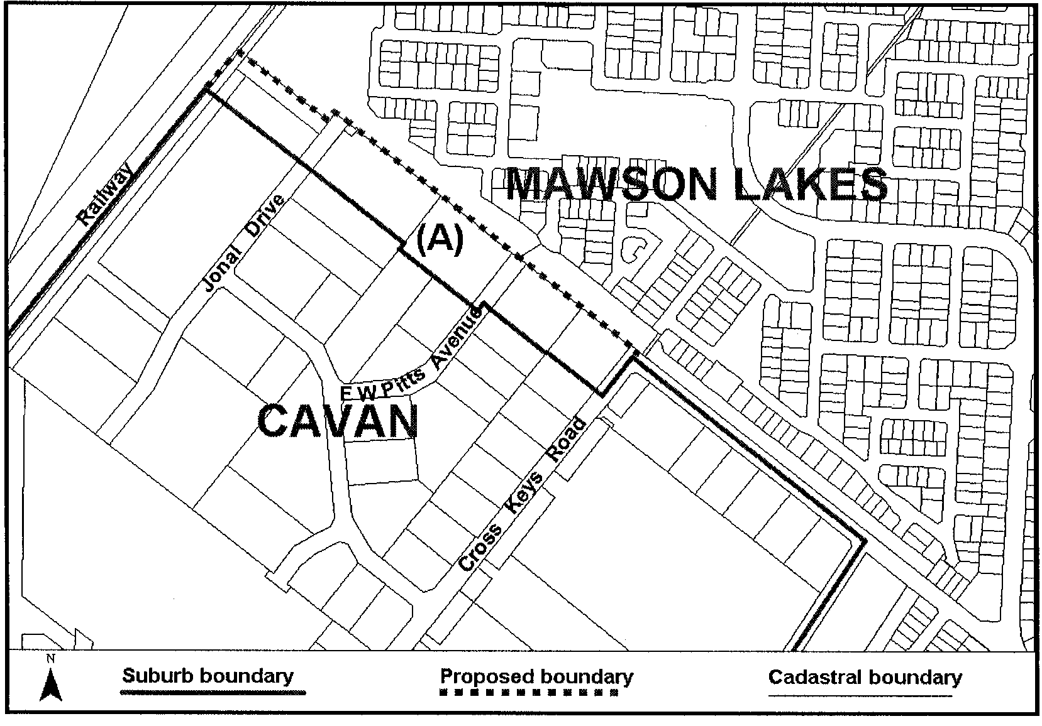
Dated 25 May 2006.
M. Wright, Minister for Administrative Services and Government Enterprises, Department for Administrative and Information Services
DAIS.22-413/05/0008

GAMING MACHINES ACT 1992
Notice of Application
NOTICE is hereby given, pursuant to section 29 of the Gaming Machines Act 1992 that Renmark Golf Club Inc. has applied to the Licensing Authority for an increase in the approved number of gaming machines from 8 to 16 in respect of premises situated at Sturt Highway, Renmark, S.A. 5341 and known as Renmark Golf Club.
The application has been set down for hearing on 7 July 2006 at 9 a.m.
Any person may object to the application by lodging a notice of objection in the prescribed form with the Liquor and Gambling Commissioner and serving a copy of the notice on the applicant at least seven days before the hearing date (viz: 29 June 2006).
The applicant’s address for service is c/o O’Briens Solicitors, Riverview Drive, Berri, S.A. 5343.
Plans in respect of the premises the subject of the application are open to public inspection without fee at the Office of the Liquor and Gaming Commissioner, 9th Floor, East Wing, 50 Grenfell Street, Adelaide, S.A. 5000.
Dated 30 May 2006.
Applicant

LIQUOR LICENSING ACT 1997 AND GAMING MACHINES ACT 1992
Notice of Application
NOTICE is hereby given, pursuant to section 52 of the Liquor Licensing Act 1997 and section 29 of the Gaming Machines Act 1992, that Daly Waters Property Pty Ltd, M. J. Lunniss Investments Pty Ltd and Taylor Cove Pty Ltd have applied to the Licensing Authority for the removal of a Hotel Licence including the existing Extended Trading Authorisation (Monday to Saturday—Midnight to 2 a.m. the following day and Sunday—8 p.m. to Midnight for consumption on the licensed premises) and entertainment consent and the grant of a Gaming Machine Licence in respect of premises situated at 57 Flinders Street, Adelaide, S.A. 5000 and to be situated at 111 King William Street, Adelaide,
S.A. 5000 and known as Jackpots On Flinders and to be known as Jackpots On King William.
The application hase been set down for hearing on 7 July 2006 at 9 a.m.
Any person may object to the application by lodging a notice of objection in the prescribed form with the Licensing Authority, and serving a copy of the notice on the applicants at the applicants’ address given above, at least seven days before the hearing date (viz: 29 June 2006).
The applicants’ address for service is c/o Kelly & Co. Lawyers, Level 17, Santos House, 91 King William Street, Adelaide, S.A. 5000 (Attention: Graham Hobbs).
Plans in respect of the premises the subject of the application are open to public inspection without fee at the Office of the Liquor and Gambling Commissioner, 9th Floor, East Wing, 50 Grenfell Street, Adelaide, S.A. 5000. Phone 8226 8410, Fax:
8226 8512. Email: olgc@agd.sa.gov.au.
Dated 31 May 2006.
Applicants

LIQUOR LICENSING ACT 1997
Notice of Application
NOTICE is hereby given, pursuant to section 52 (2) (b) of the Liquor Licensing Act 1997, that Turn Of The Road Pty Ltd as trustee for the Kay Telfer Trust has applied to the Licensing Authority for the transfer of a Restaurant Licence in respect of premises situated at 9 Cadell Street, Goolwa, S.A. 5214 and known as Woks 2 Eat and to be known as Cafelicious.
The application has been set down for hearing on 3 July 2006 at 11.30 a.m.
Any person may object to the application by lodging a notice of objection in the prescribed form with the Liquor and Gambling Commissioner, and serving a copy of the notice on the applicant at the applicant’s address given above, at least seven days before the hearing date (viz: 30 June 2006).
The applicant’s address for service is c/o Townsends Solicitors, Annoushka Scharnberg, 91 Halifax Street, Adelaide, S.A. 5000.
Plans in respect of the premises the subject of the application are open to public inspection without fee at the Office of the Liquor and Gambling Commissioner, 9th Floor, East Wing, 50 Grenfell Street, Adelaide, S.A. 5000. Phone 8226 8410, Fax:
8226 8512. Email: olgc@agd.sa.gov.au.
Dated 1 June 2006.
Applicant

LIQUOR LICENSING ACT 1997
Notice of Application
NOTICE is hereby given, pursuant to section 52 (2) (b) of the Liquor Licensing Act 1997, that Tickera Social Golf Club Inc. has applied to the Licensing Authority for a Limited Club Licence in respect of premises situated at corner Wallaroo Terrace and Coast Terrace, Tickera, S.A. 5555 and to be known as Tickera Social Golf Club.
The application has been set down for hearing on 7 July 2006 at 9 a.m.
Any person may object to the application by lodging a notice of objection in the prescribed form with the Liquor and Gambling Commissioner, and serving a copy of the notice on the applicant at the applicant’s address given above, at least seven days before the hearing date (viz: 29 June 2006).
The applicant’s address for service is c/o Ian Price, P.O. Box 13, Tickera, S.A. 5555.
Plans in respect of the premises the subject of the application are open to public inspection without fee at the Office of the Liquor and Gambling Commissioner, 9th Floor, East Wing, 50 Grenfell Street, Adelaide, S.A. 5000. Phone 8226 8410, Fax:
8226 8512. Email: olgc@agd.sa.gov.au.
Dated 6 June 2006.
Applicant

LIQUOR LICENSING ACT 1997
Notice of Application
NOTICE is hereby given, pursuant to section 52 (2) (b) of the Liquor Licensing Act 1997, that The Pines Management Comm-ittee as nominee for the District Council of Loxton Waikerie has applied to the Licensing Authority for a Special Circumstances Licence and Entertainment Consent in respect of premises situated at 18 Henry Street, Loxton, S.A. 5333 and to be known as The Pines.
The application has been set down for hearing on 7 July 2006 at 9 a.m.
Conditions
The following licence conditions are sought:
• For consumption on the licensed premises at any time with or ancillary to a meal provided by the licensee (Except Good Friday and Christmas Day).
• No liquor sold or supplied by the licensee for consumption on the licensed premises shall be removeded from the licensed premises.
• Entertainment Consent:
Monday to Saturday: 7 a.m. to midnight;
Sunday: 8 a.m. to mdnight;
Maunday Thursday: 7 a.m. to midnight;
Christmas Eve: 7 a.m. to midnight;
Sunday Christmas Eve: 7 a.m. to midnight;
New Year’s Eve: 7 a.m. to 2 a.m. the following day;
Days preceding other Public Holidays: 7 a.m. to midnight;
Sundays preceding Public Holidays: 7 a.m. to midnight.
Any person may object to the application by lodging a notice of objection in the prescribed form with the Liquor and Gambling Commissioner, and serving a copy of the notice on the applicant at the applicant’s address given above, at least seven days before the hearing date (viz: 29 June 2006).
The applicant’s address for service is c/o 3 Drabsch Street, Loxton, S.A. 5333.
Plans in respect of the premises the subject of the application are open to public inspection without fee at the Office of the Liquor and Gambling Commissioner, 9th Floor, East Wing, 50 Grenfell Street, Adelaide, S.A. 5000. Phone 8226 8410, Fax:
8226 8512. Email: olgc@agd.sa.gov.au.
Dated 6 June 2006.
Applicant

LIQUOR LICENSING ACT 1997
Notice of Application
NOTICE is hereby given, pursuant to section 52 (2) (b) of the Liquor Licensing Act 1997, that The Society of Saint Hilarion Inc. have applied to the Licensing Authority for a Special Circumstances Licence in respect of premises situated at 8 Barpowell Road, Welland, S.A. 5007 and known as Riverbanks Function Centre.
The application has been set down for hearing on 7 July 2006 at 9 a.m.
Conditions
The following licence conditions are sought:
1. The proposed trading hours during which liquor may be sold for consumption on the licensed premises (including Extended Trading Authorisation) are as follows:
Sunday to Thursday: 9 a.m. to midnight;
Friday and Saturday: 9 a.m. to 2 a.m. the following day;
Sunday preceding a Public Holiday: 9 a.m. to 2 a.m. the following day.
2. Entertainment shall apply during the above hours in accordance with the existing conditions of the Club Licence No. 50904822.
3. That all other conditions of the Club Licence No. 50904822 shall apply to this application.
Any person may object to the application by lodging a notice of objection in the prescribed form with the Liquor and Gambling Commissioner, and serving a copy of the notice on the applicant at the applicant’s address given above, at least seven days before the hearing date (viz: 29 June 2006).
The applicant’s address for service is c/o Fisher Jeffries, Level 15, 211 Victoria Square, Adelaide, S.A. 5000, Phone 82121 4903 (Attention: Craig Vozzo or Adrian Battiston).
Plans in respect of the premises the subject of the application are open to public inspection without fee at the Office of the Liquor and Gambling Commissioner, 9th Floor, East Wing, 50 Grenfell Street, Adelaide, S.A. 5000. Phone 8226 8410, Fax:
8226 8512. Email: olgc@agd.sa.gov.au.
Dated 31 May 2006.
Applicant

LIQUOR LICENSING ACT 1997
Notice of Application
NOTICE is hereby given, pursuant to section 52 (2) (b) of the Liquor Licensing Act 1997, that Jane Elizabeth Green has applied to the Licensing Authority for a Retail Liquor Merchant’s Licence in respect of premises situated at Shop 2, Ground Floor East, 50 Grenfell Street, Adelaide, S.A. 5000 and to be known as The Gift Specialist.
The application has been set down for hearing on 7 July 2006 at 9 a.m.
Any person may object to the application by lodging a notice of objection in the prescribed form with the Liquor and Gambling Commissioner, and serving a copy of the notice on the applicant at the applicant’s address given above, at least seven days before the hearing date (viz: 29 June 2006).
The applicant’s address for service is c/o Jane Green, P.O. Box 10346, Adelaide, S.A. 5001.
Plans in respect of the premises the subject of the application are open to public inspection without fee at the Office of the Liquor and Gambling Commissioner, 9th Floor, East Wing, 50 Grenfell Street, Adelaide, S.A. 5000. Phone 8226 8410, Fax:
8226 8512. Email: olgc@agd.sa.gov.au.
Dated 31 May 2006.
Applicant

LIQUOR LICENSING ACT 1997
Notice of Application
NOTICE is hereby given, pursuant to section 52 (2) (b) of the Liquor Licensing Act 1997, that The Pub Restaurant Co. Pty Ltd has applied to the Licensing Authority for alterations, redefinition and variation to Extended Trading Authorisation in respect of premises situated at 68 Walkerville Terrace, Walkerville, S.A. 5081 and known as Hotel Sussex.
The application has been set down for hearing on 7 July 2006 at 9 a.m.
Conditions
The following licence conditions are sought:
• Application and redefinition to provide a new gaming room adjacent to the existing front bar and the conversion of the current gaming room into a new dining area. All other areas of the premises will be extensively refurbished and additional toilet facilities provided.
• Variation to Extended Trading Authorisation:
Sunday: 11 p.m. to midnight;
Wednesday: Midnight to 1 a.m. the following day;
Thursday: 1 a.m. the following day to 2 a.m. the following day;
Good Friday: Midnight to 2 a.m.;
Christmas Day: Midnight to 2 a.m.
• The existing licence conditions restricting entertainment will remain in force.
Any person may object to the application by lodging a notice of objection in the prescribed form with the Liquor and Gambling Commissioner, and serving a copy of the notice on the applicant at the applicant’s address given above, at least seven days before the hearing date (viz: 29 June 2006).
The applicant’s address for service is c/o Australian Hotels Association, Michael Jeffries, 4th Floor, 60 Hindmarsh Square, Adelaide, S.A. 5000.
Plans in respect of the premises the subject of the application are open to public inspection without fee at the Office of the Liquor and Gambling Commissioner, 9th Floor, East Wing, 50 Grenfell Street, Adelaide, S.A. 5000. Phone 8226 8410, Fax:
8226 8512. Email: olgc@agd.sa.gov.au.
Dated 2 June 2006.
Applicant

LIQUOR LICENSING ACT 1997
Notice of Application
NOTICE is hereby given, pursuant to section 52 (2) (b) of the Liquor Licensing Act 1997, that Jadepoint Pty Ltd and PVA Holdings Pty Ltd have applied to the Licensing Authority for the variation to an Extended Trading Authorisation in respect of premises situated at 232 The Parade, Norwood, S.A. 5067 and known as Bath Hotel.
The application has been set down for hearing on 7 July 2006 at 9 a.m.
Conditions
The following licence conditions are sought:
• That the licensees be permitted to sell liquor in the Front Bar and Sports Bar for consumption on the licensed premises during the time authorised for other areas of the premises, being Thursday from midnight to 2 a.m. the following day, and Friday and Saturday—Midnight to 3 a.m. the following day.
• That the Extended Trading Authorisation shall apply to the Beer Garden during these times and Sunday from 8 a.m. to 11 a.m. and 8 p.m. to midnight and Christmas Day and Good Friday from midnight to 2 a.m..
• The licensee will not provide entertainment in these areas during the additional Extended Trading Authorisation.
Any person may object to the application by lodging a notice of objection in the prescribed form with the Liquor and Gambling Commissioner, and serving a copy of the notice on the applicants at the applicants’ address given above, at least seven days before the hearing date (viz: 29 June 2006).
The applicants’ address for service is c/o Australian Hotels Association, Michael Jeffries, 4th Floor, 60 Hindmarsh Square, Adelaide, S.A. 5000.
Plans in respect of the premises the subject of the application are open to public inspection without fee at the Office of the Liquor and Gambling Commissioner, 9th Floor, East Wing, 50 Grenfell Street, Adelaide, S.A. 5000. Phone 8226 8410, Fax:
8226 8512. Email: olgc@agd.sa.gov.au.
Dated 5 June 2006.
Applicants

LIQUOR LICENSING ACT 1997
Notice of Application
NOTICE is hereby given, pursuant to section 52 (2) (b) of the Liquor Licensing Act 1997, that Justin James Grinter and Sharyn Lila Grinter have applied to the Licensing Authority for the transfer of a Restaurant Licence in respect of premises situated at 55 Bridge Street, Murray Bridge, S.A. 5253 and known as Amorosa Restaurant and to be known as Table 55.
The application has been set down for hearing on 10 July 2006 at 10 a.m.
Any person may object to the application by lodging a notice of objection in the prescribed form with the Liquor and Gambling Commissioner, and serving a copy of the notice on the applicants at the applicants’ address given above, at least seven days before the hearing date (viz: 30 June 2006).
The applicants’ address for service is c/o 169 Murray Drive, Murray Bridge, S.A. 5253.
Plans in respect of the premises the subject of the application are open to public inspection without fee at the Office of the Liquor and Gambling Commissioner, 9th Floor, East Wing, 50 Grenfell Street, Adelaide, S.A. 5000. Phone 8226 8410, Fax:
8226 8512. Email: olgc@agd.sa.gov.au.
Dated 30 May 2006.
Applicants

LIQUOR LICENSING ACT 1997
Notice of Application
NOTICE is hereby given, pursuant to section 52 (2) (b) of the Liquor Licensing Act 1997, that Adelaide Wine Co. Pty Ltd has applied to the Licensing Authority for the transfer of a Producer’s Licence in respect of premises situated at 87 King William Road, Unley, S.A. 5061 known as Falconers Estate and to be known as Tomich Hill.
The application has been set down for hearing on 10 July 2006 at 10.30 a.m.
Any person may object to the application by lodging a notice of objection in the prescribed form with the Liquor and Gambling Commissioner, and serving a copy of the notice on the applicant at the applicant’s address given above, at least seven days before the hearing date (viz: 30 June 2006).
The applicant’s address for service is c/o Wallmans Lawyers, 173 Wakefield Street, Adelaide, S.A. 5000 (Attention: Peter Hoban or Ben Allen).
Plans in respect of the premises the subject of the application are open to public inspection without fee at the Office of the Liquor and Gambling Commissioner, 9th Floor, East Wing, 50 Grenfell Street, Adelaide, S.A. 5000. Phone 8226 8410, Fax:
8226 8512. Email: olgc@agd.sa.gov.au.
Dated 2 June 2006.
Applicant

LIQUOR LICENSING ACT 1997
Notice of Application
NOTICE is hereby given, pursuant to section 52 (2) (b) of the Liquor Licensing Act 1997, that Smiros Pty Ltd has applied to the Licensing Authority for the transfer of a Restaurant Licence in respect of premises situated at 45C Sussex Street, Hawthorn, S.A. 5062 and known as Cafe Astros.
The application has been set down for hearing on 10 July 2006 at 9.30 a.m.
Any person may object to the application by lodging a notice of objection in the prescribed form with the Liquor and Gambling Commissioner, and serving a copy of the notice on the applicant at the applicant’s address given above, at least seven days before the hearing date (viz: 30 June 2006).
The applicant’s address for service is c/o Irene Gelekis, 45C Sussex Street, Hawthorn, S.A. 5062.
Plans in respect of the premises the subject of the application are open to public inspection without fee at the Office of the Liquor and Gambling Commissioner, 9th Floor, East Wing, 50 Grenfell Street, Adelaide, S.A. 5000. Phone 8226 8410, Fax:
8226 8512. Email: olgc@agd.sa.gov.au.
Dated 1 June 2006.
Applicant

LIQUOR LICENSING ACT 1997
Notice of Application
NOTICE is hereby given, pursuant to section 52 (2) (b) of the Liquor Licensing Act 1997, that Prasit Chuykrom and Sandra Faye Chuykrom as trustees for the Chuykrom Family Trust have applied to the Licensing Authority for the transfer of a Restaurant Licence in respect of premises situated at 33-35 O’Connell Street, North Adelaide, S.A. 5006 and known as Tookie Thai Restaurant and to be known as Chuy’s Thai Restaurant.
The application has been set down for hearing on 11 July 2006 at 11 a.m.
Any person may object to the application by lodging a notice of objection in the prescribed form with the Liquor and Gambling Commissioner, and serving a copy of the notice on the applicants at the applicants’ address given above, at least seven days before the hearing date (viz: 3 July 2006).
The applicants’ address for service is c/o 22 Blaxland Avenue, Wynn Vale, S.A. 5127.
Plans in respect of the premises the subject of the application are open to public inspection without fee at the Office of the Liquor and Gambling Commissioner, 9th Floor, East Wing, 50 Grenfell Street, Adelaide, S.A. 5000. Phone 8226 8410, Fax:
8226 8512. Email: olgc@agd.sa.gov.au.
Dated 1 June 2006.
Applicants

LIQUOR LICENSING ACT 1997
Notice of Application
NOTICE is hereby given, pursuant to section 52 (2) (b) of the Liquor Licensing Act 1997, that Kwik Stix Flinders Takeaway Pty Ltd as trustee for Calvaresi Flinders Takeaway Trust, Chieng Flinders Takeaway Trust, Hyde Flinders Takeaway Trust, Irkulla Flinders Takeaway Trust, Ting Flinders Takeaway Trust, NG Flinders Takeaway Trust and Ventura Flinders Takeaway Trust has applied to the Licensing Authority for the transfer of a Restaurant Licence in respect of premises situated at 1/4 Rupert Avenue, Bedford Park, S.A. 5042 and known as Wok On Fire and to be known as Kwik Stix Kitchen.
The application has been set down for hearing on 12 July 2006 at 10.30 a.m.
Any person may object to the application by lodging a notice of objection in the prescribed form with the Liquor and Gambling Commissioner, and serving a copy of the notice on the applicant at the applicant’s address given above, at least seven days before the hearing date (viz: 4 July 2006).
The applicant’s address for service is c/o 192 Hindley Street, Adelaide, S.A. 5000.
Plans in respect of the premises the subject of the application are open to public inspection without fee at the Office of the Liquor and Gambling Commissioner, 9th Floor, East Wing, 50 Grenfell Street, Adelaide, S.A. 5000. Phone 8226 8410, Fax:
8226 8512. Email: olgc@agd.sa.gov.au.
Dated 1 June 2006.
Applicant

LIQUOR LICENSING ACT 1997
Notice of Application
NOTICE is hereby given, pursuant to section 52 (2) (b) of the Liquor Licensing Act 1997, that Punt Brothers Investments Pty Ltd as trustee for Punt Brothers Investment Trust has applied to the Licensing Authority for the transfer of an Entertainment Venue Licence in respect of premises situated at 95 Gouger Street, Adelaide, S.A. 5000 and known as Soul 168 of Asia.
The application has been set down for hearing on 12 July 2006 at 10 a.m.
Any person may object to the application by lodging a notice of objection in the prescribed form with the Liquor and Gambling Commissioner, and serving a copy of the notice on the applicant at the applicant’s address given above, at least seven days before the hearing date (viz: 4 July 2006).
The applicant’s address for service is c/o Kelly & Co., Level 17, Santos House, 91 King William Street, Adelaide, S.A. 5000.
Plans in respect of the premises the subject of the application are open to public inspection without fee at the Office of the Liquor and Gambling Commissioner, 9th Floor, East Wing, 50 Grenfell Street, Adelaide, S.A. 5000. Phone 8226 8410, Fax:
8226 8512. Email: olgc@agd.sa.gov.au.
Dated 5 June 2006.
Applicant

LIQUOR LICENSING ACT 1997
Notice of Application
NOTICE is hereby given, pursuant to section 52 (2) (b) of the Liquor Licensing Act 1997, that Weng International Trading Pty Ltd and Goldhope International Pty Ltd have applied to the Licensing Authority for the transfer of a Restaurant Licence in respect of premises situated at 187 Rundle Street, Adelaide, S.A. 5000 and known as Red Rock Noodle Bar.
The application has been set down for hearing on 12 July 2006 at 9.30 a.m.
Any person may object to the application by lodging a notice of objection in the prescribed form with the Liquor and Gambling Commissioner, and serving a copy of the notice on the applicants at the applicants’ address given above, at least seven days before the hearing date (viz: 4 July 2006).
The applicants’ address for service is c/o Jennifer Jeon, P.O. Box 3137, Rundle Mall, Adelaide, S.A. 5000.
Plans in respect of the premises the subject of the application are open to public inspection without fee at the Office of the Liquor and Gambling Commissioner, 9th Floor, East Wing, 50 Grenfell Street, Adelaide, S.A. 5000. Phone 8226 8410, Fax:
8226 8512. Email: olgc@agd.sa.gov.au.
Dated 1 June 2006.
Applicants

LAND AND BUSINESS (SALE AND CONVEYANCING)
ACT 1994
Exemption
TAKE notice that, pursuant to section 23 (3) of the Land and Business (Sale and Conveyancing) Act 1994, I, Jennifer Rankine, Minister for Consumer Affairs, do hereby exempt the person named in Schedule 1 from the application of section 23 (2) of the Act in relation to the purchase of the land specified in Schedule 2.
Schedule 1
Paula Jayne Griggs, an employee of Pope Nitschke Pty Ltd.
Schedule 2
The whole of the land described in certificate of title register book volume 5874, folio 85, situated at 1 Pentland Street, Strathalbyn, S.A. 5255.
Dated 8 June 2006.
Signed for and on behalf of the Minister for Consumer Affairs by the Commissioner for Consumer Affairs:
J. Rankine, Minister for Consumer Affairs

LAND AND BUSINESS (SALE AND CONVEYANCING)
ACT 1994
Exemption
TAKE notice that, pursuant to section 23 (3) of the Land and Business (Sale and Conveyancing) Act 1994, I, Jennifer Rankine, Minister for Consumer Affairs, do hereby exempt the person named in Schedule 1 from the application of section 23 (2) of the Act in relation to the purchase of the land specified in Schedule 2.
Schedule 1
Roger Ian Searle Smith, an employee of Kat Forde Pty Ltd.
Schedule 2
The land described in certificate of title register book volume 5153, folio 746, situated at 10 Bunyip Street, Goolwa South, S.A. 5214.
Dated 8 June 2006.
Signed for and on behalf of the Minister for Consumer Affairs by the Commissioner for Consumer Affairs:
J. Rankine, Minister for Consumer Affairs

LAND AND BUSINESS (SALE AND CONVEYANCING)
ACT 1994
Exemption
TAKE notice that, pursuant to section 23 (3) of the Land and Business (Sale and Conveyancing) Act 1994, I, Jennifer Rankine, Minister for Consumer Affairs, do hereby exempt the person named in Schedule 1 from the application of section 23 (2) of the Act in relation to the purchase of the land specified in Schedule 2.
Schedule 1
Lynn Evans-D’Angelo, an employee of Gawler Real Estate Pty Ltd.
Schedule 2
The whole of the land described in certificate of title register book volume 5403, folio 408, situated at 56 Dawkins Avenue, Willaston, S.A. 5118.
Dated 8 June 2006
Signed for and on behalf of the Minister for Consumer Affairs by the Commissioner for Consumer Affairs:
J. Rankine, Minister for Consumer Affairs

LAND AND BUSINESS (SALE AND CONVEYANCING)
ACT 1994
Exemption
TAKE notice that, pursuant to section 23 (3) of the Land and Business (Sale and Conveyancing) Act 1994, I, Jennifer Rankine, Minister for Consumer Affairs, do hereby exempt the person named in Schedule 1 from the application of section 23 (2) of the Act in relation to the purchase of the land specified in Schedule 2.
Schedule 1
Kelly Theresa Ross, an employee of Landmark Operations Ltd.
Schedule 2
The whole of the land described in certificate of title register book volume 5059, folio 454, situated at 1 View Street, Burra, S.A. 5417.
Dated 8 June 2006
Signed for and on behalf of the Minister for Consumer Affairs by the Commissioner for Consumer Affairs:
J. Rankine, Minister for Consumer Affairs

LOCAL GOVERNMENT ACT 1999
Notice of Winding-up of a Subsidiary
Unley Street Life Trust
Preamble
1. The Unley Street Life Trust was established on 17 May 2001 as a subsidiary of the City of Unley, pursuant to section 42 of the Local Government Act 1999.
2. The Council has requested that the subsidiary be wound up.
Notice
PURSUANT to Clause 16 (2) of Part 1 of Schedule 2 of the Local Government Act 1999, I wind up the Unley Street Life Trust subsidiary effective from 30 June 2006.
Dated 31 May 2006.
J. Rankine, Minister for State/Local Government Relations

MINING ACT 1971
NOTICE is hereby given in accordance with section 28 (5) of the Mining Act 1971, that the Minister for Mineral Resources Development proposes to grant an Exploration Licence over the undermentioned area:
Applicant: Sunthe Uranium Pty Ltd
Location: Oakdam area—Approximately 40 km north of Woomera.
Term: 1 year
Area in km²: 174
Ref.: 2005/00443
Plan and co-ordinates can be found on the PIRSA Sarig website: http://www.minerals.pir.sa.gov.au/sarig or by phoning Mineral Tenements on (08) 8463 3103.
H. Tyrteos, Mining Registrar

MINING ACT 1971
NOTICE is hereby given in accordance with section 28 (5) of the Mining Act 1971, that the Minister for Mineral Resources Development proposes to grant an Exploration Licence over the undermentioned area:
Applicant: Brewer Geological Services (50%) and Teale and Associates Pty Ltd (50%)
Location: Prospect Hill area—Approximately 150 km east of Marree.
Term: 1 year
Area in km²: 45
Ref.: 2005/00188
Plan and co-ordinates can be found on the PIRSA Sarig website: http://www.minerals.pir.sa.gov.au/sarig or by phoning Mineral Tenements on (08) 8463 3103.
H. Tyrteos, Mining Registrar

[Republished]
MOTOR ACCIDENT COMMISSION ACT 1992
Compulsory Third Party Fund
PURSUANT to section 13A of the Motor Accident Commission Act 1992, the following formula is designed to ensure that the Compulsory Third Party Fund is able to meet all its reasonably estimated liabilities as they fall due.
1. The Fund will have a sufficient level of solvency if its assets exceed the sum of:
(a) the Fund’s liabilities;
(b) 10% of the outstanding claims liabilities provision;
(c) 10% of the premium liabilities provision; and
(d) 10% of the investments in equities and property.
2. Provisions for outstanding claims liabilities and premium liabilities will include prudential margins which will be calculated by reference to an 80% probability that the provisions will be adequate, as reported in actuarial reports to the Motor Accident Commission.
3. The calculation of liability for outstanding claims and premium liabilities must comply with the following standards (as amended or replaced from time to time by the relevant professional or regulatory bodies):
(a) Accounting Standard AASB1023.
(b) Professional Standard Number 300, ‘Actuarial reports and advice on outstanding claims in general insurance’, issued by the Institute of Actuaries of Australia.
(c) Australian Prudential Regulation Authority Prudential Standard GPS 210 (GPS 310 from 1 October 2006) in respect of the outstanding claims liabilities and premium liabilities (with the exception that the risk margins adopted are to be at the 80% probability of sufficiency).
Dated 17 May 2006.
Kevin Foley, Deputy Premier/Treasurer

NATIONAL ELECTRICITY LAW
THE Australian Energy Market Commission (AEMC) gives notice under the National Electricity Law (NEL) of the following matters.
Under section 99, the making of the draft determination for the proposed National Electricity Amendment (Management of negative settlement residues in the Snowy Region) Rule 2006. A copy of the draft determination and the draft Rule are published on AEMC’s website and are available for inspection at AEMC. In relation to the draft determination:
• submissions should be forwarded to:
submissions@aemc.gov.au and must be received no later than 20 July 2006; and
• requests for a hearing should be forwarded in writing to aemc@aemc.gov.au and must be received no later than 15 June 2006.
Under section 95, Snowy Hydro Limited has requested the making of the proposed National Electricity Amendment (Management of negative settlement residues by re-orientation) Rule 2006 which relates to the management of negative settlement residues in the Snowy Region by re-orientation. A copy of the Rule proposal and the proposed Rule are published on AEMC’s website and are available for inspection at AEMC. Submissions on the proposed Rule should be forwarded to:
submissions@aemc.gov.au
and must be received by 10 July 2006.
Upon receipt AEMC publishes all submissions on its website, subject to consideration of any claim of confidentiality. Further details on the above matters are available on AEMC’s website: www.aemc.gov.au.
John Tamblyn
Chairman
Australian Energy Market Commission
Level 16, 1 Margaret Street
Sydney, N.S.W. 2000
Telephone: (02) 8296 7800
Facsimile: (02) 8296 7899
Dated 8 June 2006.

NATIONAL PARKS AND WILDLIFE ACT 1972
Totness Recreation Park Management Plan—Draft
I, GREG LEAMAN, Director of National Parks and Wildlife, hereby give notice under the provisions of section 38 of the National Parks and Wildlife Act 1972, that a draft management plan has been proposed for Totness Recreation Park.
Copies of the plan may be inspected at or obtained from the offices of the Department for Environment and Heritage:
• 1 Richmond Road, Keswick, S.A. 5035 (G.P.O Box 1047, Adelaide, S.A. 5001), telephone 8124 4700;
• Southern Lofty District Office (Belair National Park), Upper Sturt Road, Belair, S.A. 5052 (P.O. Box 2, Belair, S.A. 5052), telephone 8278 5477;
• http://www.environment.sa.gov.au/parks/management_plans.html.
For general enquires, please contact the DEH Information Line, telephone 8204 1910 or e-mail dehinformation@saugov.sa.gov.au.
Any person may make representations in connection with the draft management plan during the period up to and including Friday, 15 September 2006.
Written comments should be forwarded to the Manager, Policy and Planning, Department for Environment and Heritage, G.P.O. Box 1047, Adelaide, S.A. 5001 or e-mailed to:
irving.jason@saugov.sa.gov.au.
Greg Leaman, Director of National Parks and Wildlife

PETROLEUM ACT 2000
Grant of Associated Facilities Licences—AFL 35, AFL 36,
AFL 37, AFL 38 and AFL 39
(Adjunct to Petroleum Production Licence PPL 182)
NOTICE is hereby given that the undermentioned Associated Facilities Licences have been granted under the provisions of the Petroleum Act 2000, pursuant to delegated powers dated 28 March 2002, Gazetted 11 April 2002, page 1573.
Description of Areas
AFL 35
All that part of the State of South Australia, bounded as follows:
Commencing at a point being the intersection of latitude 26°47′31″S GDA94 and longitude 140°49′25″E GDA94, thence east to longitude 140°51′00″E GDA94, south to latitude 26°48′15″S GDA94, west to longitude 140°49′25″E GDA94, and north to point of commencement.
Area: 3.6 km² approximately.
AFL 36
All that part of the State of South Australia, bounded as follows:
Commencing at a point being the intersection of latitude 26°47′31″S GDA94 and longitude 140°51′00″E GDA94, thence east to longitude 140°51′58″E GDA94, south to latitude 26°49′00″S GDA94, west to longitude 140°51′05″E AGD66, north to latitude 26°48′40″S AGD66, west to longitude 140°51′00″E GDA94, and north to the point of commencement.
Area: 4.2 km² approximately.
AFL 37
All that part of the State of South Australia, bounded as follows:
Commencing at a point being the intersection of latitude 26°49′00″S GDA94 and longitude 140°51′05″E AGD66, thence east to longitude 140°51′58″E GDA94, south to latitude 26°50′31″S GDA94, west to longitude 140°51′00″E GDA94, north to latitude 26°49′40″S AGD66, east to longitude 140°51′05″E AGD66, north to latitude 26°49′30″S AGD66, east to longitude 140°51′10″E AGD66, north to latitude 26°49′20″S AGD66, west to longitude 140°51′05″E AGD66, and north to the point of commencement.
Area: 4.2 km² approximately.
AFL 38
All that part of the State of South Australia, bounded as follows:
Commencing at a point being the intersection of latitude 26°49′30″S GDA94 and longitude 140°49′25″E GDA94, thence east to longitude 140°50′25″E AGD66, south to latitude 26°49′40″S AGD66, east to longitude 140°51′00″E GDA94, south to latitude 26°50′31″S GDA94, west to longitude 140°49′25″E GDA94, and north to the point of commencement.
Area: 4.8 km² approximately.
AFL 39
All that part of the State of South Australia, bounded as follows:
Commencing at a point being the intersection of latitude 26°48′15″S GDA94 and longitude 140°49′25″E GDA94, thence east to longitude 140°51′00″E GDA94, south to latitude 26°48′40″S AGD66, west to longitude 140°50′55″E AGD66, north to latitude 26°48′30″S AGD66, west to longitude 140°50′25″E AGD66, south to latitude 26°48′40″S AGD66, west to longitude 140°50′15″E AGD66, south to latitude 26°49′30″S AGD66, east to longitude 140°50′25″E AGD66, south to latitude 26°49′30″S GDA94, west to longitude 140°49′25″E GDA94, and north to the point of commencement.
Area: 3.9 km² approximately.
Dated: 2 June 2006.
B. A. Goldstein,
Director Petroleum and Geothermal
Minerals and Energy Resources
Primary Industries and Resources SA
Delegate of the Minister for Mineral
Resources Development

PETROLEUM ACT 2000
Application for Grant of a Petroleum Production Licence—
PPL 213
PURSUANT to section 65 (6) of the Petroleum Act 2000 (the Act) and Delegation dated 28 March 2002, Gazetted 11 April 2002, page 1573, notice is hereby given that an application for the grant of a production licence over the area described below, which falls within the area of Petroleum Exploration Licence PEL 1115 has been received from Victoria Oil Exploration (1977) Pty Ltd, Impress (Cooper Basin) Pty Ltd, Permian Oil Pty Ltd and Springfield Oil and Gas Pty Ltd.
Description of Application Area
All that part of the State of South Australia, bounded as follows: commencing at a point being the intersection of latitude 28°31′55″S GDA94 and longitude 140°42′35″E GDA94, thence east to longitude 140°44′10″E GDA94, south to latitude 28°33′57″S GDA94, west to longitude 140°42′35″E GDA94 and north to the point of commencement.
Area: 9.7 km² approximately.
Dated 31 May 2006.
B. A. Goldstein,
Director Petroleum and Geothermal
Minerals and Energy Resources
Primary Industries and Resources SA
Delegate of the Minister for Mineral
Resources Development

ROADS (OPENING AND CLOSING) ACT 1991:
SECTION 24
NOTICE OF CONFIRMATION OF ROAD
PROCESS ORDER
Road Closure,
Snowy View Road, Snowtown
BY Road Process Order made on 12 May 2006, the Wakefield Regional Council ordered that:
1. The whole of Snowy View Road adjoining section 149 in Hundred of Barunga and allotment 2 in Filed Plan 17031, more particularly delineated and lettered ‘I’ in the Preliminary Plan No. 04/0080 be closed.
2. The whole of the land subject to closure be transferred to Hansen Co. Pty Ltd in accordance with agreement to transfer dated 31 January 2005 entered into between the Wakefield Regional Council and Hansen Co. Pty Ltd.
3. The following easement be granted over the whole of the land subject to that closure.
Grant a free and unrestricted right of way appurtenant to Crown Record Volume 5762, Folio 688.
On 30 May 2006 that order was confirmed by the Minister for Administrative Services and Government Enterprises condition-ally upon the deposit by the Registrar-General of Deposited Plan 67643 being the authority for the new boundaries.
Pursuant to section 24 (5) of the Roads (Opening and Closing) Act 1991, notice of the order referred to above and its confirmation is hereby given.
Dated 8 June 2006.
P. M. Kentish, Surveyor-General

RULES OF THE LEGAL PRACTITIONERS’ EDUCATION AND ADMISSIONS COUNCIL 2004
Erratum
ON 22 September 2005 Amendment No. 2 to the Legal Practitioners’ Education and Admissions Council Rules 2004 was printed in the Government Gazette containing an error in Rule 9—Renewal of Practising Certificates. Rule 9.1 (a) should refer to ‘Rule 3’ and not ‘Rule 6’. The correct version Rule 9.1 (a) should read:
‘This rule does not apply to practitioners to whom Rule 3 applies’.
Dated 6 April 2006.
J. Doyle, Chief Justice

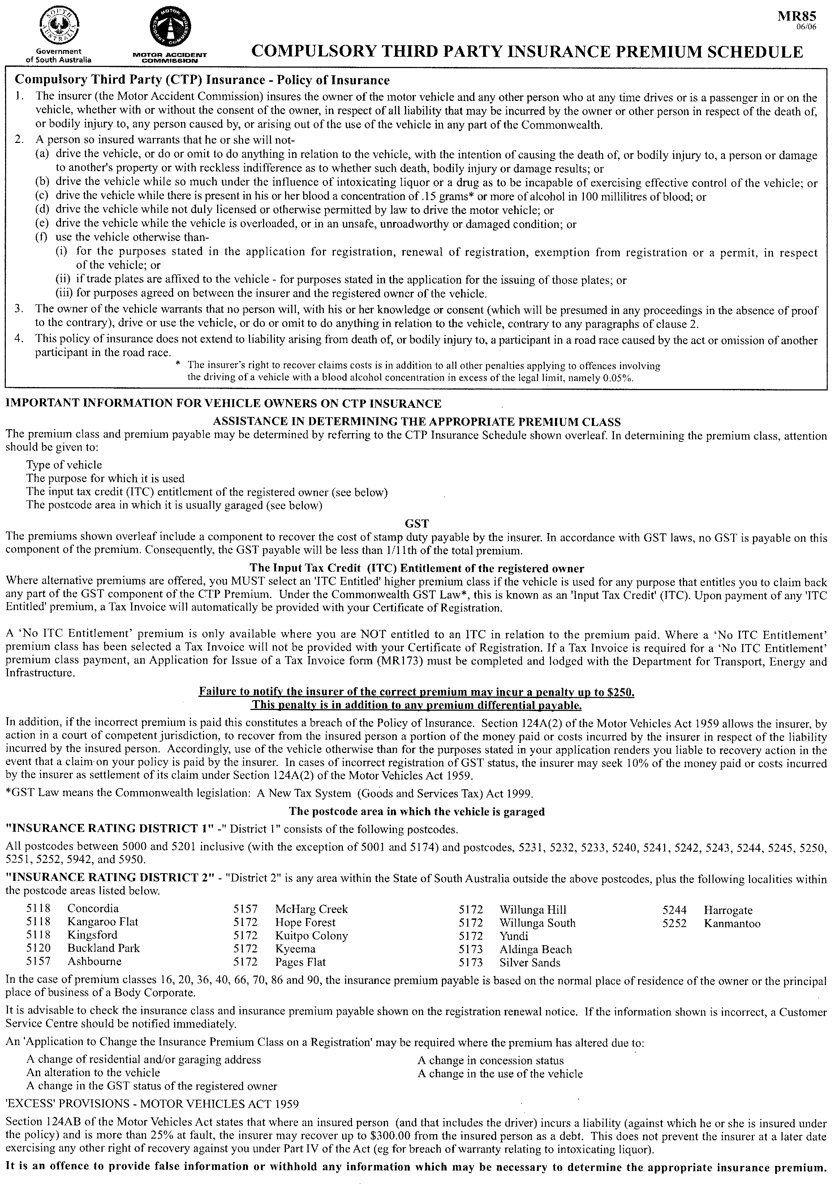

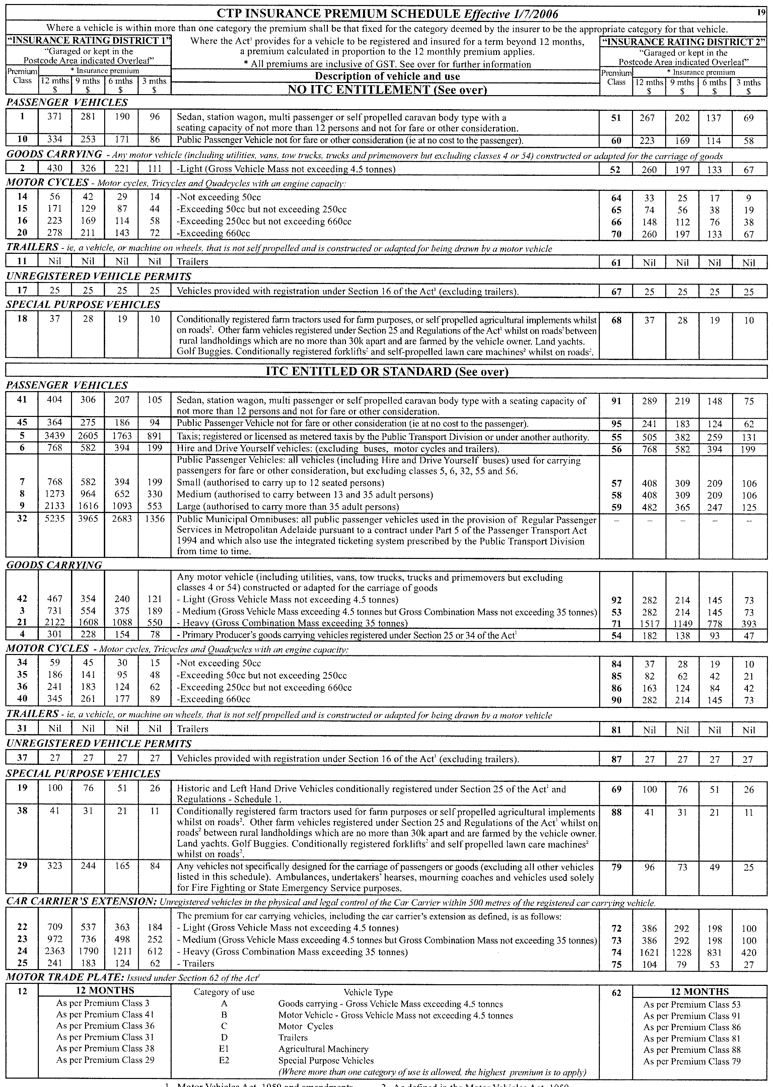
1 Motor Vehicles Act, 1959 and amendments. 2 As defined in the Motor Vehicles Act, 1959.

WATERWORKS ACT 1932
Removal of Land from Warren Country Lands Water District and Addition to Nuriootpa Water District
PURSUANT to section 6 of the Waterworks Act 1932, the South Australian Water Corporation:
(a) removes from the Warren Country Lands Water District and adds to the Nuriootpa Water District all the land contained in allotment 745 in Filed Plan 173006; and
(b) declares that this notice will have effect from 1 July 2006.
Dated 2 June 2006.
Signed for and on behalf of the South Australian Water Corporation by a person duly authorised so to do:
A. Popplewell, General Manager Shared Services
In the presence of:
C. J. McNamara, Billing Manager
SAWATER 05/02327 W1326

WATERWORKS ACT 1932
Addition of land to Kingston S.E. Water District
PURSUANT to section 6 of the Waterworks Act 1932, the South Australian Water Corporation:
(a) adds to the Kingston S.E. Water District all the land contained in allotment 41 in Deposited Plan 22566; and
(b) declares that this notice will have effect from 1 July 2006.
Dated 2 June 2006.
Signed for and on behalf of the South Australian Water Corporation by a person duly authorised so to do:
A. Popplewell, General Manager Shared Services
In the presence of:
C. J. McNamara, Billing Manager
SAWATER 06/03201 W1327

WATERWORKS ACT 1932
Removal of Land from Encounter Bay Country Lands Water District and Addition to Port Elliot Water District
PURSUANT to section 6 of the Waterworks Act 1932, the South Australian Water Corporation:
(a) removes from the Encounter Bay Country Lands Water District and adds to the Port Elliot Water District all the land contained in allotment piece 201 in Deposited Plan 69290; and
(b) declares that this notice will have effect from 1 July 2006.
Dated 2 June 2006.
Signed for and on behalf of the South Australian Water Corporation by a person duly authorised so to do:
A. Popplewell, General Manager Shared Services
In the presence of:
C. J. McNamara, Billing Manager
SAWATER 06/03202 W1328

WILDERNESS PROTECTION ACT 1992
Proposed Billiatt, Danggali and Ngarkat Wilderness Protection Areas—Wilderness Assessment Reports
I, GREG LEAMAN, Director of National Parks and Wildlife, hereby give notice under the provisions of section 31 of the Wilderness Protection Act 1992, that copies of public submissions made with regard to the Billiatt, Danggali and Ngarkat Wilderness Assessment Reports are available for inspection.
Copies of the submissions may be viewed at the offices of the Department for Environment and Heritage, 1 Richmond Road, Keswick, S.A. 5035, telephone 8124 4700; Berri Office, 28 Vaughan Terrace, Berri, S.A. 5343, telephone 8595 2111 or at Lameroo Office, 74 Railway Terrace North, Lameroo, S.A. 5302, telephone 8576 3690.
The submissions will be available for viewing from the date of this publication to 28 July 2006.
G. Leaman, Director of National Parks and Wildlife

GOVERNMENT GAZETTE ADVERTISEMENT RATES

To apply from 1 July 2006

$  Agents, Ceasing to Act as 38.00  Associations:  Incorporation 19.30  Intention of Incorporation 47.75  Transfer of Properties 47.75  Attorney, Appointment of 38.00  Bailiff’s Sale 47.75  Cemetery Curator Appointed 28.25  Companies:  Alteration to Constitution 38.00  Capital, Increase or Decrease of 47.75  Ceasing to Carry on Business 28.25  Declaration of Dividend 28.25  Incorporation 38.00  Lost Share Certificates:  First Name 28.25  Each Subsequent Name 9.70  Meeting Final 31.75  Meeting Final Regarding Liquidator’s Report on  Conduct of Winding Up (equivalent to ‘Final  Meeting’)  First Name 38.00  Each Subsequent Name 9.70  Notices:  Call 47.75  Change of Name 19.30  Creditors 38.00  Creditors Compromise of Arrangement 38.00  Creditors (extraordinary resolution that ‘the Com-pany be wound up voluntarily and that a liquidator be appointed’) 47.75  Release of Liquidator⎯Application⎯Large Ad. 75.50  ⎯Release Granted 47.75  Receiver and Manager Appointed 44.00  Receiver and Manager Ceasing to Act 38.00  Restored Name 35.75  Petition to Supreme Court for Winding Up 66.50  Summons in Action 56.50  Order of Supreme Court for Winding Up Action 38.00  Register of Interests⎯Section 84 (1) Exempt 85.50  Removal of Office 19.30  Proof of Debts 38.00  Sales of Shares and Forfeiture 38.00  Estates:  Assigned 28.25  Deceased Persons⎯Notice to Creditors, etc. 47.75  Each Subsequent Name 9.70  Deceased Persons⎯Closed Estates 28.25  Each Subsequent Estate 1.25  Probate, Selling of 38.00  Public Trustee, each Estate 9.70 |  | $  Firms:  Ceasing to Carry on Business (each insertion) 25.25  Discontinuance Place of Business 25.25  Land⎯Real Property Act:  Intention to Sell, Notice of 47.75  Lost Certificate of Title Notices 47.75  Cancellation, Notice of (Strata Plan) 47.75  Mortgages:  Caveat Lodgement 19.30  Discharge of 20.20  Foreclosures 19.30  Transfer of 19.30  Sublet 9.70  Leases⎯Application for Transfer (2 insertions) each 9.70  Lost Treasury Receipts (3 insertions) each 28.25  Licensing 56.50  Municipal or District Councils:  Annual Financial Statement⎯Forms 1 and 2 532.00  Electricity Supply⎯Forms 19 and 20 378.00  Default in Payment of Rates:  First Name 75.50  Each Subsequent Name 9.70  Noxious Trade 28.25  Partnership, Dissolution of 28.25  Petitions (small) 19.30  Registered Building Societies (from Registrar-  General) 19.30  Register of Unclaimed Moneys⎯First Name 28.25  Each Subsequent Name 9.70  Registers of Members⎯Three pages and over:  Rate per page (in 8pt) 242.00  Rate per page (in 6pt) 320.00  Sale of Land by Public Auction 48.25  Advertisements 2.70  ¼ page advertisement 113.00  ½ page advertisement 226.00  Full page advertisement 443.00  Advertisements, other than those listed are charged at $2.70 per column line, tabular one-third extra.  Notices by Colleges, Universities, Corporations and District Councils to be charged at $2.70 per line.  Where the notice inserted varies significantly in length from that which is usually published a charge of $2.70 per column line will be applied in lieu of advertisement rates listed.  South Australian Government publications are sold on the condition that they will not be reproduced without prior permission from the Government Printer.
All the above prices include GST

GOVERNMENT GAZETTE NOTICES
ALL private advertisements forwarded for publication in the South Australian Government Gazette must be PAID FOR PRIOR TO INSERTION; and all notices, from whatever source, should be legibly written on one side of the paper only and sent to Government Publishing SA so as to be received no later than 4 p.m. Tuesday preceding the day of publication. Phone 8207 1045 or Fax 8207 1040. E-mail: governmentgazette@saugov.sa.gov.au. Send as attachments in Word format. Please include date the notice is to be published and to whom the notice will be charged. The Government Gazette is available online at: www.governmentgazette.sa.gov.au.

MISCELLANEOUS LEGISLATION AND GOVERNMENT PUBLICATIONS PRICES AS FROM 1 JULY 2006

Acts, Bills, Rules, Parliamentary Papers and Regulations
Pages | Main | Amends | Pages | Main | Amends

1-16 | 2.30 | 1.05 | 497-512 | 32.25 | 31.25
17-32 | 3.10 | 1.95 | 513-528 | 33.25 | 32.00
33-48 | 4.05 | 2.90 | 529-544 | 34.25 | 33.25
49-64 | 5.10 | 3.90 | 545-560 | 35.25 | 34.25
65-80 | 6.00 | 4.95 | 561-576 | 36.00 | 35.25
81-96 | 6.95 | 5.75 | 577-592 | 37.00 | 35.75
97-112 | 7.90 | 6.75 | 593-608 | 38.25 | 36.75
113-128 | 8.90 | 7.75 | 609-624 | 39.00 | 38.00
129-144 | 9.95 | 8.80 | 625-640 | 40.00 | 38.50
145-160 | 10.90 | 9.70 | 641-656 | 41.00 | 40.00
161-176 | 11.90 | 10.70 | 657-672 | 41.50 | 40.50
177-192 | 12.90 | 11.75 | 673-688 | 43.25 | 41.50
193-208 | 13.90 | 12.10 | 689-704 | 44.00 | 42.50
209-224 | 14.70 | 13.60 | 705-720 | 44.50 | 43.60
225-240 | 15.70 | 14.50 | 721-736 | 46.50 | 44.60
241-257 | 16.80 | 15.30 | 737-752 | 47.00 | 45.60
258-272 | 17.70 | 16.30 | 753-768 | 48.00 | 46.25
273-288 | 18.70 | 17.50 | 769-784 | 48.50 | 47.75
289-304 | 19.50 | 18.40 | 785-800 | 49.50 | 48.75
305-320 | 20.70 | 19.40 | 801-816 | 50.50 | 49.25
321-336 | 21.50 | 20.30 | 817-832 | 51.50 | 50.50
337-352 | 22.60 | 21.40 | 833-848 | 52.50 | 51.50
353-368 | 23.50 | 22.40 | 849-864 | 53.50 | 52.00
369-384 | 24.50 | 23.40 | 865-880 | 54.50 | 53.50
385-400 | 25.50 | 24.30 | 881-896 | 55.00 | 54.00
401-416 | 26.50 | 25.00 | 897-912 | 56.50 | 55.00
417-432 | 27.50 | 26.25 | 913-928 | 57.00 | 56.50
433-448 | 28.50 | 27.25 | 929-944 | 58.00 | 57.00
449-464 | 29.25 | 28.00 | 945-960 | 59.00 | 57.50
465-480 | 29.75 | 29.00 | 961-976 | 60.50 | 58.50
481-496 | 31.25 | 29.75 | 977-992 | 61.50 | 59.00

Legislation—Acts, Regulations, etc: $
Subscriptions:
Acts 199.00
All Bills as Laid 477.00
Rules and Regulations 477.00
Parliamentary Papers 477.00
Bound Acts 221.00
Index 110.00
Government Gazette
Copy 5.20
Subscription 263.00
Hansard
Copy 14.50
Subscription—per session (issued weekly) 414.00
Cloth bound—per volume 178.00
Subscription—per session (issued daily) 414.00
Legislation on Disk
Whole Database 3063.00
Annual Subscription for fortnightly updates 941.00
Individual Act(s) including updates POA
Compendium
Subscriptions:
Subscriptions 1815.00
Updates 640.00
(All the above prices include GST)

All Legislation, Government Gazette, Hansard and Legislation on disk are available from:
Counter Sales Service SA, Government Legislation⁺ Outlet
and Mail Orders: Lands Titles Office, 101 Grenfell Street, Adelaide, S.A. 5000
Phone: 13 23 24 (local call cost), Fax: (08) 8204 1909
Postal: G.P.O. Box 1707, Adelaide, S.A. 5001

Online Shop: www.shop.service.sa.gov.au

Subscriptions and Government Publishing SA
Standing Orders: Box 9, Plaza Level, Riverside Centre, North Terrace, Adelaide, S.A. 5000
Phone: (08) 8207 1043, (08) 8207 0910, Fax: (08) 8207 1040

South Australia
Road Traffic (Apparatuses for Conducting Drug Screening Tests and Oral Fluid Analyses) Notice 2006
under section 47H of the Road Traffic Act 1961
1—Short title
This notice may be cited as the Road Traffic (Apparatuses for Conducting Drug Screening Tests and Oral Fluid Analyses) Notice 2006.
2—Commencement
This notice comes into operation on the day that Part 2 of the Road Traffic (Drug Driving) Amendment Act 2005 comes into operation.
3—Approval of apparatuses for purpose of conducting drug screening tests and oral fluid analyses
(1) Apparatuses of the following kind are approved for the purpose of conducting drug screening tests:
Securetec Drugwipe II Twin
(2) Apparatuses of the following kind are approved for the purpose of conducting oral fluid analyses:
Cozart RapiScan
Made by the Governor
with the advice and consent of the Executive Council
on 8 June 2006
MTR04/043CS

South Australia
Primary Produce (Food Safety Schemes) Act (Commencement) Proclamation 2006
1—Short title
This proclamation may be cited as the Primary Produce (Food Safety Schemes) Act (Commencement) Proclamation 2006.
2—Commencement of suspended provisions
Clauses 2, 3(2) and 4(1)(b) of Schedule 1 of the Primary Produce (Food Safety Schemes) Act 2004 (No 20 of 2004) will come into operation on 1 July 2006.
Made by the Governor
with the advice and consent of the Executive Council
on 8 June 2006
MAFF04/0043CS

South Australia
Road Traffic (Drug Driving) Amendment Act (Commencement) Proclamation 2006
1—Short title
This proclamation may be cited as the Road Traffic (Drug Driving) Amendment Act (Commencement) Proclamation 2006.
2—Commencement of Act
The Road Traffic (Drug Driving) Amendment Act 2005 (No 77 of 2005) will come into operation on 1 July 2006.
Made by the Governor
with the advice and consent of the Executive Council
on 8 June 2006
MTR04/043CS

South Australia
Primary Produce (Food Safety Schemes) (Meat
Industry) Regulations 2006
under the Primary Produce (Food Safety Schemes) Act 2004

Contents
Part 1—Preliminary
1 Short title
2 Commencement
3 Interpretation
4 Definition of meat (section 6)
5 Waiver, reduction, deferral and recovery of fees
Part 2—Meat industry food safety scheme
Division 1—Preliminary
6 Meat industry food safety scheme
7 Minister is accreditation body
Division 2—Accreditation
8 Obligation to be accredited
9 Separate accreditation required for each premises
10 Requirements for accreditation
11 Approved food safety arrangement
12 Compliance with codes
13 Approval required to carry on new activity
14 Notification of change in circumstances
Division 3—Marking of meat and containers
15 Marking of meat before removal from premises
16 Marking of containers before removal from premises
17 Leasing and care of brands used to mark meat safe and suitable
18 Offence to manufacture or possess unauthorised brand
Division 4—Sale of meat
19 Meat for human consumption not to be sold unless lawfully produced and safe and suitable
20 Meat for consumption by pets not to be sold unless lawfully produced and suitable
Part 3—Evidence
21 Evidence
Part 4—Fees and returns
Division 1—Preliminary
22 Interpretation
23 Monetary value of fee unit and administration fee
24 Projected annual fee
25 Matters to be determined by Minister in calculating annual fee
26 Date for annual fee and return
Division 2—Fees
27 Application fees
28 Fee payable before grant of accreditation
29 Annual fee
Schedule 1—Codes
Schedule 2—Revocation and transitional provision
Part 1—Revocation of Meat Hygiene Regulations 1994
1 Revocation of regulations
Part 2—Transitional provision
2 Transitional provision
3 Food safety arrangement for existing processors or handlers

Part 1—Preliminary
1—Short title
These regulations may be cited as the Primary Produce (Food Safety Schemes) (Meat Industry) Regulations 2006.
2—Commencement
These regulations will come into operation on the day on which clause 3(2) of the Primary Produce (Food Safety Schemes) Act 2004 comes into operation.
3—Interpretation
(1) In these regulations, unless the contrary intention appears—
accredited processor or handler means an accredited producer authorised by the accreditation to carry on the business of processing or handling meat;
Act means the Primary Produce (Food Safety Schemes) Act 2004;
Food Standards Code has the same meaning as in the Food Act 2001;
handle, in relation to meat, means pack, store or transport meat;
lawfully produced for consumption by pets—see subregulation (3);
lawfully produced for human consumption—see subregulation (2);
meat industry food safety scheme means the food safety scheme for the meat industry established under these regulations;
poultry means a carinate bird (ie a bird having a keeled breastbone—this excludes, for example, an emu, ostrich or cassowary);
process, in relation to meat, means carry on an activity involved in meat processing;
ready-to-eat meat means ready-to-eat meat within the meaning of Division 3 of Standard 4.2.3 of the Food Standards Code;
wild game means an animal living in a wild state and not under any artificial confinement.
(2) For the purposes of these regulations, meat will only be taken to have been lawfully produced for human consumption if—
(a) in the case of meat that has been processed outside of Australia—it has been lawfully imported into Australia; and
(b) in any case, to the extent to which it has been processed or handled in Australia, the processing or handling has been carried on—
(i) in accordance with the requirements of the Act and these regulations; or
(ii) in accordance with the law in force in another State or Territory of the Commonwealth,
relating to the processing and handling of meat for human consumption.
(3) For the purposes of these regulations, meat will only be taken to have been lawfully produced for consumption by pets if—
(a) in the case of meat that has been processed outside of Australia—it has been lawfully imported into Australia; and
(b) in any case, to the extent to which it has been processed or handled in Australia, the processing or handling has been carried on—
(i) in accordance with the requirements of the Act and these regulations; or
(ii) in accordance with the law in force in another State or Territory of the Commonwealth,
relating to the processing and handling of meat for consumption by pets.
4—Definition of meat (section 6)
(1) For the purposes of the definition of meat in section 6 of the Act—
(a) the following products within the meaning of Standards 1.6.2 and 2.2.1 of the Food Standards Code are included within the ambit of the definition:
(i) cured meat (see Division 1 of Standard 2.2.1);
(ii) dried meat (see clause 5 of Standard 1.6.2);
(iii) manufactured meat (see Division 1 of Standard 2.2.1), including ready-to-eat meat;
(iv) processed meat (see Division 1 of Standard 2.2.1);
(v) sausage meat (see Division 2 of Standard 2.2.1);
(vi) sausage (see Division 1 of Standard 2.2.1);
(b) the following products are included within the ambit of the definition:
(i) minced meat;
(ii) salted meat;
(iii) tripe;
(iv) cooked meat products that are on premises at which meat processing other than the production of the cooked meat products is carried on;
(c) the following products are excluded from the ambit of the definition:
(i) a meat pie, or meat and vegetable pie, within the meaning of Division 1 of Standard 2.2.1 of the Food Standards Code (clause 1);
(ii) a sausage roll or meat pastie or any other pastry product containing meat;
(iii) canned meat products;
(iv) pasta, or pasta sauce, containing meat;
(v) cooked meat products (other than those referred to in paragraph (a) or (b)).
(2) In this regulation—
cooked, in relation to meat, means meat the core temperature of which has been maintained—
(a) at 65° Celsius for a period of at least 10 minutes; or
(b) at a higher temperature for a period of time that produces an equivalent microbiological effect in relation to the meat.
5—Waiver, reduction, deferral and recovery of fees
(1) The Minister may waive, reduce or defer payment of a fee payable under these regulations if the Minister considers that appropriate in the circumstances.
(2) The Minister may recover an amount payable to the Minister by way of a fee or part of a fee payable under these regulations as a debt from the person liable to pay.
Part 2—Meat industry food safety scheme
Division 1—Preliminary
6—Meat industry food safety scheme
These regulations establish a food safety scheme for the following classes of activities:
(a) carrying on the business of processing or handling meat;
(b) carrying on the business of selling meat (by wholesale or retail).
7—Minister is accreditation body
The Minister is the accreditation body for accrediting persons carrying on the business of processing or handling meat.
Division 2—Accreditation
8—Obligation to be accredited
(1) For the purposes of section 12 of the Act, a person must not carry on the business of processing or handling meat without an accreditation.
(2) Subregulation (1) does not apply in respect of the following activities:
(a) the killing of an animal, or the further processing or handling of an animal, at premises by or on behalf of the owner of the premises if none of the meat from the animal is—
(i) sold or intended for sale; or
(ii) used, or intended for use, as food for paying guests; or
(iii) taken away, or intended to be taken away, from the premises;
(b) the killing of wild game, or the further processing or handling of wild game, if none of the meat from the game is—
(i) sold or intended for sale; or
(ii) used, or intended for use, for business purposes;
(c) the further processing or handling of meat that has been lawfully produced for human consumption if—
(i) the further processing or handling occurs in the course of the retail sale of meat and consists of—
(A) the storage of meat in the package in which it was received; or
(B) cutting or slicing and packaging of ready-to-eat meat in a supermarket or delicatessen; or
(ii) the further processing or handling is done by a person in the course of the preparation of food for consumption by customers or guests of that person; or
(iii) the further processing or handling does not constitute or form part of a business and none of the meat is—
(A) sold or intended for sale; or
(B) used, or intended for use, for business purposes.
9—Separate accreditation required for each premises
If an applicant for accreditation proposes to carry on the business of processing or handling meat at more than 1 discrete premises, application must be made for a separate accreditation in respect of each of the premises.
10—Requirements for accreditation
For the purposes of section 15(1)(c) of the Act, an applicant for accreditation must satisfy the Minister that the applicant has the capacity, or has made or proposes to make appropriate arrangements, to satisfy the requirements of the Act and these regulations applicable to the activities to be accredited.
11—Approved food safety arrangement
An accredited processor or handler must adopt an approved food safety arrangement.
Maximum penalty: $5 000.
Expiation fee: $315.
12—Compliance with codes
(1) An accredited processor or handler must ensure that the activities authorised under the accreditation are carried on in compliance with the codes set out in Schedule 1 (subject to the general modifications in subregulation (3)) applicable under that Schedule to those activities.
Maximum penalty: $5 000.
Expiation fee: $315.
(2) The Minister may, on application, exempt an accredited processor or handler from compliance with specified provisions of a code if satisfied that the person has made alternative arrangements in order to be able to comply within a specified period.
(3) The Australian Standards set out in Schedule 1 are (in addition to any specific modifications set out in that Schedule) modified as follows:
(a) a reference to the Controlling Authority or to the Chief Inspector is to be taken to be a reference to the Minister;
(b) a reference to a licence is to be taken to be a reference to an accreditation;
(c) a reference to a licensee is to be taken to be a reference to an accredited processor or handler;
(d) a reference to a registration is to be taken to be a reference to an accreditation;
(e) a reference to a registered person is to be taken to be a reference to an accredited processor or handler;
(f) a reference to an inspector or to a meat safety inspector is to be taken to be a reference to an authorised person or a person designated (individually or by class) by the Minister by condition of accreditation as an inspector in relation to an accredited processor or handler;
(g) a reference to the production of meat is to be taken to be a reference to the processing or handling of meat;
(h) a reference to an approved arrangement is to be taken to be a reference to an approved food safety arrangement;
(i) a reference to premises is to be taken to be a reference to premises specified under the accreditation;
(j) a reference to the proprietor of a meat business is to be taken to be a reference to a person carrying on the business of processing or handling meat;
(k) a reference to the proprietor of a meat transport business is to be taken to be a reference to a person carrying on the business of transporting meat;
(l) a reference to equipment is to be taken to be a reference to equipment used under the accreditation.
13—Approval required to carry on new activity
An accredited processor or handler must not carry on activities under the accreditation other than activities of a class specified under the accreditation without the prior written approval of the Minister.
14—Notification of change in circumstances
An accredited processor or handler must, no later than 14 days after—
(a) a change in business name under which the accredited processor or handler carries on activities under the accreditation; or
(b) a change in the accredited processor's or handler's business address (including a change in the registered corporate office if the accredited processor or handler is a body corporate); or
(c) the commencement of construction, demolition or removal of a building or part of a building at premises at which activities are carried on under the accreditation,
give the Minister written notice of those matters.
Expiation fee: $250.
Maximum penalty: $80.
Division 3—Marking of meat and containers
15—Marking of meat before removal from premises
(1) An accredited processor or handler authorised under the accreditation to slaughter animals must ensure that, before meat derived from animals processed under the accreditation and intended for human consumption is removed from premises subject to the accreditation, the meat—
(a) is safe and suitable; and
(b) has been marked as safe and suitable.
Maximum penalty: $5 000.
Expiation fee: $315.
(2) Subregulation (1)(b) does not apply in relation to—
(a) meat processed or handled in an establishment registered under the Export Control Act 1982 of the Commonwealth (as amended from time to time) and marked in accordance with that Act; or
(b) meat derived from poultry.
(3) For the purposes of subregulation (1)(b), meat will only be taken to have been marked as safe and suitable if it is marked—
(a) in accordance with the accreditation; or
(b) by means of a brand or brands1 leased by the processor or handler from the Minister in accordance with the terms of the lease.
Note—
1 The brand will include the relevant accreditation number and may, if the brand is to be used in relation to a particular class of meat, include letters, numbers or symbols identifying the class of meat.
16—Marking of containers before removal from premises
(1) An accredited processor or handler must ensure that, before a container or other thing containing meat intended for human consumption is removed from the premises subject to the accreditation, it is marked with the person's accreditation number and the date of packing1.
Maximum penalty: $5 000.
Expiation fee: $315.
(2) This regulation does not apply in relation to poultry.
Note—
1 These requirements are in addition to labelling requirements under the Food Act 2001 or other legislation.
17—Leasing and care of brands used to mark meat safe and suitable
(1) The Minister may charge a fee for leasing a brand and may impose conditions on the lease.
(2) An accredited processor or handler to whom a brand is leased must take all reasonable steps to prevent the brand from being stolen, defaced or used for a purpose other than the marking of meat for human consumption processed under the accreditation.
Maximum penalty: $5 000.
Expiation fee: $315.
(3) An accredited processor or handler to whom a brand is leased must return the brand to the Minister within 7 days after—
(a) the accreditation is cancelled, suspended or surrendered; or
(b) receiving a written request for its return from the Minister.
Maximum penalty: $2 500.
Expiation fee: $210.
18—Offence to manufacture or possess unauthorised brand
(1) A person must not, without the approval of the Minister—
(a) manufacture; or
(b) have in his or her custody or possession,
a brand that is or purports or appears to be a brand of a kind leased from the Minister under this Part.
Maximum penalty: $5 000.
Expiation fee: $315.
(2) Subregulation (1)(b) does not apply in relation to a brand leased from the Minister being in the custody or possession of the lessee, or an employee or agent of the lessee, at the premises at which animals are slaughtered under the lessee's accreditation.
Division 4—Sale of meat
19—Meat for human consumption not to be sold unless lawfully produced and safe and suitable
A person must not sell meat for human consumption unless—
(a) it has been lawfully produced for human consumption; and
(b) it is safe and suitable.
Maximum penalty: $5 000.
Expiation fee: $315.
20—Meat for consumption by pets not to be sold unless lawfully produced and suitable
A person must not sell meat for consumption by pets unless—
(a) it has been lawfully produced for consumption by pets; and
(b) it is suitable.
Maximum penalty: $5 000.
Expiation fee: $315.
Part 3—Evidence
21—Evidence
(1) In proceedings for an offence against the Act or these regulations, an allegation—
(a) that specified matter was meat; or
(b) that specified meat was intended for human consumption; or
(c) that specified meat was intended for consumption by pets; or
(d) that the sale of specified meat was for human consumption; or
(e) that the sale of specified meat was for consumption by pets,
will be accepted as proved, in the absence of proof to the contrary.
(2) In proceedings for an offence against the Act or these regulations, proof that specified meat was on any premises used by a person for or in connection with the business of selling meat, or on any adjacent premises occupied by that person or any member of his or her family, will, in the absence of proof to the contrary, be accepted as proof that the meat was being offered, exposed or stored for sale by that person.
Part 4—Fees and returns
Division 1—Preliminary
22—Interpretation
In this Part, unless the contrary intention appears—
administration fee—see regulation 23;
cooked has the same meaning as in regulation 4(2);
fee unit—see regulation 23;
mechanised process in relation to slaughtering means a process involving the automated transfer of carcasses along all or part of a production line;
prime mover has the same meaning as in the Road Traffic Act 1961;
projected annual fee—see regulation 24;
red meat animals means cattle, sheep, pigs, goats or deer;
relevant period means the period determined by the Minister as the relevant period under regulation 25(1)(a);
retail meat processor and handler means a person who operates a business involving the processing and handling of meat for human consumption for retail sale where—
(a) 50% or more (by mass) of the meat sold in the course of that business during the relevant period is sold by retail; and
(b) not more than 4 tonnes of meat sold in the course of that business during the relevant period is sold by wholesale;
semi-trailer has the same meaning as in the Road Traffic Act 1961;
smallgoods means meat of a kind referred to in regulation 4(1)(a) and (b).
23—Monetary value of fee unit and administration fee
In this Part—

(a) | the monetary value of a fee unit is | $80
(b) | the administration fee is | $155
24—Projected annual fee
An applicant's projected annual fee is the amount determined by the Minister as equivalent to the annual fee that would be payable by the applicant were the applicant an accredited processor or handler liable to pay an annual fee under section 17 of the Act calculated by reference to the nature and level of the activity carried on by the applicant during the relevant period or the Minister's reasonable assumptions as to what would have been the nature and level of activity during the relevant period had the applicant's business commenced then.
25—Matters to be determined by Minister in calculating annual fee
(1) For the purposes of calculating the annual fee, the Minister may determine the following matters:
(a) the Minister may, from time to time, determine the period that is to be the relevant period for determining the nature and level of activity of accredited processors or handlers;
(b) the Minister may determine the nature of an accredited processor's or handler's activity having regard to information about the amount (by mass) of meat processed, handled or sold in the course of the person's business during the relevant period;
(c) the Minister may determine the level of activity of an accredited processor or handler having regard to information about the number of positions held by persons engaged in the processor's or handler's business during the relevant period;
(d) if an accredited processor or handler has not carried on business under the accreditation during the relevant period or part of the relevant period, the Minister may determine the nature and level of the processor's or handler's activity having regard to the Minister's reasonable assumptions as to what would have been the nature and level of the activity during the relevant period or part of the relevant period had the person carried on the business during that time.
(2) An accredited processor or handler must, if the Minister so requires by written notice, provide the Minister with specified information to enable the Minister to determine a matter under this regulation.
Maximum penalty: $5 000.
Expiation fee: $315.
26—Date for annual fee and return
(1) The date for payment of an annual fee and for lodging an annual return is 30 June in each year.
(2) The penalty for default in paying an annual fee or lodging an annual return is $180.
Division 2—Fees
27—Application fees
Application fees under the Act are payable as follows:

(a) | application for accreditation—
 | (i) if 6 or fewer full time equivalent positions are to be held by persons engaged in processing or handling meat under the accreditation | $117
 | (ii) in any other case | $267
(b) | application for variation of conditions of accreditation or variation of an approved food safety arrangement—
 | (i) if 6 or fewer full time equivalent positions are to be held by persons engaged in processing or handling meat under the accreditation | $117
 | (ii) in any other case | $267
(c) | application for exemption from compliance with code (r 12) | $267
(d) | no fee is payable on an application for accreditation by the holder of a temporary accreditation under Schedule 1 Part 4 of the Act
28—Fee payable before grant of accreditation
A person who applies for accreditation must, before the accreditation is granted, pay to the Minister a fee of an amount calculated by multiplying the applicant's projected annual fee by the proportion that the number of whole months between the grant of the accreditation and the next 30 June bears to 12 months.
29—Annual fee
The annual fee under section 17 of the Act is payable as follows:

(a) | in the case of an accreditation that authorises a person to process or handle meat for consumption by pets only | administration fee
(b) | in the case of an accreditation that authorises a person to store or transport meat only—
 | (i) .................................................................................... | administration fee
 | plus
 | (ii) if the person is authorised to store meat | 2 fee units
 | plus
 | (iii) if the person is authorised to transport meat—for each vehicle used to transport meat under the accreditation during the relevant period | 1 fee unit
 | If the person uses more than one semi-trailer for each prime mover used to transport meat, each additional semi-trailer is, for the purposes of subparagraph (iii), to be regarded as a separate vehicle.
(c) | in the case of an accreditation that authorises a person to process or handle kangaroos in the field—
 | (i) .................................................................................... | administration fee
 | plus
 | (ii) for each tray or rack (being a tray or rack to be attached to a vehicle used for transporting kangaroo carcasses) approved for use under the accreditation | 1 fee unit
 | plus
 | (iii) for each field chiller owned or leased by the person and approved for use under the accreditation | 1 fee unit
(d) | in the case of an accreditation that authorises a retail meat processor and handler to undertake further processing or handling of meat that has been lawfully produced for human consumption—
 | (i) .................................................................................... | administration fee
 | plus
(ii) the aggregate of the fee units applicable to the each of the following types of activity carried on by the processor or handler:
type of activity
 | (A) production of smallgoods by a process involving fermentation | 1 fee unit
 | (B) production of smallgoods by a process involving cooking or curing | 1 fee unit
 | (C) processing of raw meat (for example, boning, slicing, mincing or dicing of meat) or production of raw smallgoods (for example, sausages, patties or corned or pickled meat) within the ambit of the definition of meat (see section 6 of the Act and regulation 4) | 1 fee unit
(e) | in any other case—
 | (i) .................................................................................... | administration fee
 | plus
(ii) the aggregate of the fee units applicable to each of the following types of activity carried on by an accredited processor or handler:
type of activity
 | (A) slaughtering for human consumption using a mechanised process—
 | - poultry only | 8 fee units
 | - red meat animals only | 8 fee units
 | - other | 11 fee units
 | (B) slaughtering for human consumption without using a mechanised process—
 | - poultry only | 4 fee units
 | - red meat animals only | 4 fee units
 | - other | 7 fee units
 | (C) slaughtering for consumption by pets | 4 fee units
 | (D) production of smallgoods for human consumption by a process involving cooking or curing | 4 fee units
 | (E) production of smallgoods for human consumption by a process involving fermentation | 4 fee units
 | (F) production of smallgoods for human consumption by a process not involving cooking, curing or fermentation | 4 fee units
 | (G) further processing or handling of meat that has been lawfully produced for human consumption (other than the production of smallgoods) (eg boning, producing primal or other cuts of meat, packing meat and offal or processing or handling of field processed kangaroo carcasses) | 4 fee units
 | plus
(iii) the fee units applicable to the highest number of full-time equivalent positions held by persons engaged in processing or handling meat under the accreditation during the relevant period as follows:
full-time equivalent positions
 | (A) not more than 6 | 2 fee units
 | (B) more than 6 but not more than 11 | 6 fee units
 | (C) more than 11 but not more than 26 | 12 fee units
 | (D) more than 26 but not more than 40 | 20 fee units
 | (E) more than 40 but not more than 60 | 30 fee units
 | (F) more than 60 | 40 fee units
 | plus
 | (iv) if the person owns or leases a field chiller used for initially refrigerating kangaroo carcasses under the accreditation, for each field chiller | 1 fee unit
(f) | Despite paragraphs (a) to (e), the annual fee payable by an accredited processor or handler who is authorised to process or handle meat other than for supply to the domestic Australian market and is registered in accordance with regulations under the Export Control Act 1982 of the Commonwealth is the administration fee.

Schedule 1—Codes
A code set out in an entry in the table below applies with modifications specified in the table or in regulation 12 in relation to the type of activity specified in the entry.

 | Type of activity | Code | Modifications
1 | Processing of meat consisting of killing an animal intended for human consumption excluding—  • killing poultry; or  • killing kangaroos or other game in the field; or  • killing rabbits; or  • killing ratite birds.  Processing or handling of a killed animal, or meat derived from a killed animal, for human consumption excluding—  • processing poultry; or  • processing kangaroos or other game; or  • processing rabbits; or  • processing ratite birds; or  • transporting field processed kangaroos or other game to initial refrigeration facilities.  For example—  • boning;  • pre-trimming;  • trimming;  • producing primal or other cuts of meat;  • mincing;  • dicing;  • packing and storing meat or offal. | AS 4696:2002 Hygienic Production and Transportation of Meat and Meat Products for Human Consumption, as amended or substituted from time to time.
2 | Processing or handling of products within the meaning of meat as defined by regulation 4: | AS 4696:2002 Hygienic Production and Transportation of Meat and Meat Products for Human Consumption, as amended or substituted from time to time. | The carrying on of activities authorised under the accreditation in compliance with the  Guidelines for the Safe Manufacture of Smallgoods published by the Meat & Livestock Australia Ltd, ISBN 1 74036 0508, as amended or substituted from time to time, will be taken to be the carrying on of those activities in compliance with AS 4696:2002.
3 | Processing or handling of poultry, or meat derived from poultry, for human consumption. | AS 4465:2001 Australian Standard for the Construction of Premises and Hygienic Production of Poultry Meat for Human Consumption, as amended or substituted from time to time.
4 | Processing or handling of kangaroos or other game, or meat derived from kangaroos or other game, for human consumption.  Transporting field processed kangaroos or other game to initial refrigeration facilities. | AS 4464:1997 Hygienic Production of Game Meat for Human Consumption, as amended or substituted from time to time.
5 | Processing or handling of rabbits, or meat derived from rabbits for human consumption. | AS 4466:1997 Hygienic Production of Rabbit Meat for Human Consumption, as amended or substituted from time to time.
6 | Processing or handling of ratite birds, or meat derived from ratite birds for human consumption. | AS 5010:2001 Hygienic Production of Ratite (Emu/Ostrich) Meat for Human Consumption, as amended or substituted from time to time.
7 | Processing of natural sausage casings derived from the intestines of sheep, pigs, goats or cattle. | AS 5011:2001 Hygienic Production of Natural Casings for Human Consumption, as amended or substituted from time to time.
8 | Processing or handling of meat for consumption by pets. | Part 3 (except regulation 3.18), Part 4, Part 5, Part 6 (except Division 3), Part 7, Part 8, Part 9 (except regulations 9.01 to 9.06) and Part 10 of the Pet Food Regulations 1984 (see Gazette 24.1.1985 p209), as in force immediately before 1 December 1994. | A reference to the Authority or to the Chief Inspector is to be taken to be a reference to the Minister.  A reference to a licence is to be taken to be a reference to an accreditation.  A reference to a licensee is to be taken to be a reference to an accredited processor or handler.  A reference to an inspector is to be taken to be a reference to an authorised person or a person designated (individually or by class) by the Minister by condition of accreditation as an inspector in relation to an accredited processor or handler.
Schedule 2—Revocation and transitional provision
Part 1—Revocation of Meat Hygiene Regulations 1994
1—Revocation of regulations
The Meat Hygiene Regulations 1994 are revoked.
Part 2—Transitional provision
2—Transitional provision
The annual fee payable on the first occasion after the commencement of these regulations by a person who holds or has held a temporary accreditation under Schedule 1 Part 4 of the Act will be reduced by the amount, if any, of the annual fee paid by the person under the Meat Hygiene Act 1994 attributable to the portion of the term of the accreditation that was unexpired at that commencement.
3—Food safety arrangement for existing processors or handlers
Regulation 11 does not apply to a person who was carrying on the business of processing or handling meat immediately before the commencement of these regulations until 6 months after that commencement.
Note—
As required by section 10AA(2) of the Subordinate Legislation Act 1978, the Minister has certified that, in the Minister's opinion, it is necessary or appropriate that these regulations come into operation as set out in these regulations.
Made by the Governor
following compliance by the Minister with section 11(4) of the Act and with the advice and consent of the Executive Council
on 8 June 2006
No 65 of 2006
MAFF04/0043CS

South Australia
Domestic Violence Regulations 2006
under the Domestic Violence Act 1994

Contents
1 Short title
2 Commencement
3 Revocation
4 Interpretation
5 Foreign domestic violence restraining orders

1—Short title
These regulations may be cited as the Domestic Violence Regulations 2006.
2—Commencement
These regulations come into operation on the day on which they are made.
3—Revocation
The Domestic Violence Regulations 1994 are revoked.
4—Interpretation
In these regulations, unless the contrary intention appears—
Act means the Domestic Violence Act 1994.
5—Foreign domestic violence restraining orders
For the purposes of the definition of foreign domestic violence restraining order in section 3 of the Act, the following laws are declared to be laws corresponding to the Act:

Country, State or Territory | Corresponding law
Australian Capital Territory | Domestic Violence and Protection Orders Act 2001
New South Wales | Crimes Act 1900, Part 15A
New Zealand | Children, Young Persons, and Their Families Act 1989, section 87
 | Domestic Violence Act 1995
 | Harassment Act 1997
Northern Territory | Domestic Violence Act
 | Justices Act, section 99
Queensland | Domestic and Family Violence Protection Act 1989
 | Peace and Good Behaviour Act 1982, sections 6 and 11
Tasmania | Family Violence Act 2004
 | Justices Act 1959, Parts X and XA
Victoria | Crimes (Family Violence) Act 1987
Western Australia | Restraining Orders Act 1997
Note—
As required by section 10AA(2) of the Subordinate Legislation Act 1978, the Minister has certified that, in the Minister's opinion, it is necessary or appropriate that these regulations come into operation as set out in these regulations.
Made by the Governor
with the advice and consent of the Executive Council
on 8 June 2006
No 66 of 2006
AGO0001/06CS
South Australia
Summary Procedure (Restraining Orders)
Regulations 2006
under the Summary Procedure Act 1921

Contents
1 Short title
2 Commencement
3 Revocation
4 Interpretation
5 Foreign restraining orders

1—Short title
These regulations may be cited as the Summary Procedure (Restraining Orders) Regulations 2006.
2—Commencement
These regulations come into operation on the day on which they are made.
3—Revocation
The Summary Procedure (Restraining Orders) Regulations 1994 are revoked.
4—Interpretation
In these regulations, unless the contrary intention appears—
Act means the Summary Procedure Act 1921.
5—Foreign restraining orders
For the purposes of the definition of foreign restraining order in section 4(1) of the Act, the following laws are declared to be laws corresponding to Part 4 Division 7 of the Act:

Country, State or Territory | Corresponding law
Australian Capital Territory | Domestic Violence and Protection Orders Act 2001
New South Wales | Crimes Act 1900, Part 15A
New Zealand | Children, Young Persons, and Their Families Act 1989, section 87
 | Domestic Violence Act 1995
 | Harassment Act 1997
Northern Territory | Domestic Violence Act
 | Justices Act, section 99
Queensland | Domestic and Family Violence Protection Act 1989
 | Peace and Good Behaviour Act 1982, sections 6 and 11
Tasmania | Family Violence Act 2004
 | Justices Act 1959, Parts X and XA
Victoria | Crimes (Family Violence) Act 1987
Western Australia | Restraining Orders Act 1997
Note—
As required by section 10AA(2) of the Subordinate Legislation Act 1978, the Minister has certified that, in the Minister's opinion, it is necessary or appropriate that these regulations come into operation as set out in these regulations.
Made by the Governor
with the advice and consent of the Executive Council
on 8 June 2006
No 67 of 2006
AGO0001/06CS

South Australia
Natural Resources Management (Transitional
Provisions—Levies) Variation Regulations 2006
under the Natural Resources Management Act 2004

Contents
Part 1—Preliminary
1 Short title
2 Commencement
3 Variation provisions
Part 2—Variation of Natural Resources Management (Transitional Provisions—Levies) Regulations 2005
4 Insertion of regulation 6
6 Differentiating factors—section 92

Part 1—Preliminary
1—Short title
These regulations may be cited as the Natural Resources Management (Transitional Provisions—Levies) Variation Regulations 2006.
2—Commencement
These regulations will come into operation on the day on which they are made.
3—Variation provisions
In these regulations, a provision under a heading referring to the variation of specified regulations varies the regulations so specified.
Part 2—Variation of Natural Resources Management
(Transitional Provisions—Levies) Regulations 2005
4—Insertion of regulation 6
After regulation 5 insert:
6—Differentiating factors—section 92
(1) This regulation applies in relation to the 2006/2007 and 2007/2008 financial years.
(2) For the purposes of applying subsection (3) of section 92 of the NRM Act in respect of a financial year to which this regulation applies, the following are prescribed as matters to be taken into account by the Minister (if the Minister determines to act under that subsection in relation to the constituent councils of a particular region), namely—
(a) that the respective shares of those constituent councils with respect to the amount to be paid to the relevant regional NRM board under the board's regional NRM plan may be adjusted so that the share of each council in respect of the financial year (after taking into account any adjustment under paragraph (b)) is approximately equal to the amount contributed (or to be contributed) by the council to the board under Part 8 Division 2 of the Water Resources Act 1997 in relation to the 2005/2006 financial year, as provided by regulation 5, plus any amount paid (or to be paid) by the council to the board under the scheme established by section 36 of the Animal and Plant Control (Agricultural Protection and Other Purposes) Act 1986 in relation to the 6 month period ending on 31 December 2005 and the 6 month period ending on 30 June 2006, as provided by clause 55 of Schedule 4 of the NRM Act, with each of these amounts being adjusted to take into account increases in the CPI—
(i) during the 12 months ending on 30 September 2005 for the 2006/2007 financial year; and
(ii) during the 24 months ending on 30 September 2006 for the 2007/2008 financial year;
(b) insofar as the relevant regional NRM board must recover amounts to cover its liabilities under section 96 of the Act, that the respective shares of those constituent councils with respect to the amount to be paid to the board under the board's regional NRM plan may be adjusted so that the share of each council in respect of the financial year—
(i) takes into account the amount (if any) that the council is intending to recover under section 96 of the Act in relation to the financial year; or
(ii) takes into account the number of rateable properties in the area of each council (being properties that are also situated in the relevant NRM region).
Note—
As required by section 10AA(2) of the Subordinate Legislation Act 1978, the Minister has certified that, in the Minister's opinion, it is necessary or appropriate that these regulations come into operation as set out in these regulations.
Made by the Governor
with the advice and consent of the Executive Council
on 8 June 2006
No 68 of 2006

South Australia
Natural Resources Management (Financial Provisions) Variation Regulations 2006
under the Natural Resources Management Act 2004

Contents
Part 1—Preliminary
1 Short title
2 Commencement
3 Variation provisions
Part 2—Variation of Natural Resources Management (Financial Provisions) Regulations 2005
4 Insertion of regulation 4AA
4AA Rateable land divided by NRM boundary—section 95
5 Variation of regulation 4B—Exclusions from operation of section 97

Part 1—Preliminary
1—Short title
These regulations may be cited as the Natural Resources Management (Financial Provisions) Variation Regulations 2006.
2—Commencement
These regulations come into operation on the day on which they are made.
3—Variation provisions
In these regulations, a provision under a heading referring to the variation of specified regulations varies the regulations so specified.
Part 2—Variation of Natural Resources Management (Financial Provisions) Regulations 2005
4—Insertion of regulation 4AA
After regulation 4 insert:
4AA—Rateable land divided by NRM boundary—section 95
If—
(a) a piece of rateable land within the area of a council is divided by the boundaries of 2 or more NRM regions; and
(b) assessment information provided to the council assigns the land to the region of a particular regional NRM board for the purposes of the imposition of regional NRM levies in a particular financial year (on the basis that the greatest portion of the relevant piece of land is within that particular region, or on some other basis determined or approved by the Valuer-General),
then—
(c) section 92 of the Act will apply as if it provided that the whole of the land constitutes rateable land within the area of the regional NRM board for the region to which the land has been so assigned; and
(d) section 95 of the Act will apply as if it provided—
(i) that one regional NRM levy is to be imposed on the whole of the land in accordance with the assessment information that has been so provided; and
(ii) that the council will impose the regional NRM levy as if the whole of the land were within the region to which the land has been so assigned; and
(iii) that the amount represented by the regional NRM levy will be payable with respect to the regional NRM board for the region to which the land has been so assigned.
5—Variation of regulation 4B—Exclusions from operation of section 97
Regulation 4B—delete "that is non-rateable land" and substitute:
of a class that is not rateable
Note—
As required by section 10AA(2) of the Subordinate Legislation Act 1978, the Minister has certified that, in the Minister's opinion, it is necessary or appropriate that these regulations come into operation as set out in these regulations.
Made by the Governor
with the advice and consent of the Executive Council
on 8 June 2006
No 69 of 2006

South Australia
Development (Schedule 2) Variation Regulations 2006
under the Development Act 1993

Contents
Part 1—Preliminary
1 Short title
2 Commencement
3 Variation provisions
Part 2—Variation of Development Regulations 1993
4 Variation of Schedule 2—Additional acts and activities constituting development
5 Variation of Schedule 10A—Notice

Part 1—Preliminary
1—Short title
These regulations may be cited as the Development (Schedule 2) Variation Regulations 2006.
2—Commencement
These regulations will come into operation on the day on which they are made.
3—Variation provisions
In these regulations, a provision under a heading referring to the variation of specified regulations varies the regulations so specified.
Part 2—Variation of Development Regulations 1993
4—Variation of Schedule 2—Additional acts and activities constituting development
Schedule 2, clause 1(2)—after paragraph (b) insert:
(c) The Residential Policy Area 27—Southern Foothills in the Residential Zone in the Development Plan applying in the area of the City of Burnside.
5—Variation of Schedule 10A—Notice
Schedule 10A, heading—delete "section 42(2)" and substitute:
section 41(2)
Note—
As required by section 10AA(2) of the Subordinate Legislation Act 1978, the Minister has certified that, in the Minister's opinion, it is necessary or appropriate that these regulations come into operation as set out in these regulations.
Made by the Governor
with the advice and consent of the Executive Council
on 8 June 2006
No 70 of 2006

South Australia
Fisheries (Scheme of Management—Marine Scalefish Fisheries) Variation Regulations 2006
under the Fisheries Act 1982

Contents
Part 1—Preliminary
1 Short title
2 Commencement
3 Variation provisions
Part 2—Variation of Fisheries (Scheme of Management—Marine Scalefish Fisheries) Regulations 1991
4 Variation of regulation 10B—Transfer of licences under amalgamation scheme
5 Revocation of regulation 10C

Part 1—Preliminary
1—Short title
These regulations may be cited as the Fisheries (Scheme of Management—Marine Scalefish Fisheries) Variation Regulations 2006.
2—Commencement
These regulations come into operation on the day on which they are made.
3—Variation provisions
In these regulations, a provision under a heading referring to the variation of specified regulations varies the regulations so specified.
Part 2—Variation of Fisheries (Scheme of Management—Marine Scalefish Fisheries) Regulations 1991
4—Variation of regulation 10B—Transfer of licences under amalgamation scheme
(1) Regulation 10B(1), definition of gear endorsement—after "conditions" insert:
and registrations
(2) Regulation 10B(1), definition of net—delete the definition and substitute:
net means a fish net as defined in the Fisheries (General) Regulations 2000 but does not include a bait net as defined in those regulations;
5—Revocation of regulation 10C
Regulation 10C—delete the regulation
Note—
As required by section 10AA(2) of the Subordinate Legislation Act 1978, the Minister has certified that, in the Minister's opinion, it is necessary or appropriate that these regulations come into operation as set out in these regulations.
Made by the Governor
with the advice and consent of the Executive Council
on 8 June 2006
No 71 of 2006
MAFF05/0019CS

South Australia
Road Traffic (Miscellaneous) Variation Regulations 2006
under the Road Traffic Act 1961

Contents
Part 1—Preliminary
1 Short title
2 Commencement
3 Variation provisions
Part 2—Variation of Road Traffic (Miscellaneous) Regulations 1999
4 Substitution of heading to Part 2
5 Variation of regulation 7—Approved blood test kit
6 Insertion of regulation 8AA
8AA Prescribed drugs
7 Variation of regulation 8A—Conduct of breath analysis
8 Variation of regulation 8B—Oral advice on refusal or failure to comply with alcotest or breath analysis direction
9 Insertion of regulation 8C
8C Oral advice on refusal or failure to comply with drug screening test, oral fluid analysis or blood test direction
10 Variation of regulation 9—Oral advice and written notice on recording of positive breath analysis reading
11 Variation of regulation 10—Request for approved blood test kit
12 Variation of regulation 11—Procedures for voluntary blood test
13 Substitution of regulation 12
12 Prescribed period for keeping blood samples and oral fluid samples
14 Insertion of regulation 12A
12A Information to be included on analyst's certificate
15 Insertion of Schedule 1A
Schedule 1A—Prescribed oral advice
16 Substitution of Schedule 1
Schedule 1—Prescribed oral advice and written notice
17 Substitution of Schedule 2
Schedule 2—Form of request
18 Substitution of Schedule 3
Schedule 3—Form of certificate
19 Variation of Schedule 9—Expiation Fees
Schedule 1—Transitional provision

Part 1—Preliminary
1—Short title
These regulations may be cited as the Road Traffic (Miscellaneous) Variation Regulations 2006.
2—Commencement
These regulations will come into operation on the day that Part 2 of the Road Traffic (Drug Driving) Amendment Act 2005 comes into operation.
3—Variation provisions
In these regulations, a provision under a heading referring to the variation of specified regulations varies the regulations so specified.
Part 2—Variation of Road Traffic (Miscellaneous) Regulations 1999
4—Substitution of heading to Part 2
Heading to Part 2—delete the heading and substitute:
Part 2—Drink driving and drug driving
5—Variation of regulation 7—Approved blood test kit
Regulation 7—delete "Section 47G(2a)(b)" and substitute:
Section 47K(2a)(b)
6—Insertion of regulation 8AA
After regulation 8 insert:
8AA—Prescribed drugs
For the purposes of the definition of prescribed drug in section 47A(1) of the Act (Interpretation), the following are declared to be prescribed drugs:
(a) delta-9-tetrahydrocannabinol;
(b) methylamphetamine.
7—Variation of regulation 8A—Conduct of breath analysis
Regulation 8A(1)—after "section 47E(2e)" insert:
of the Act (Police may require alcotest or breath analysis)
8—Variation of regulation 8B—Oral advice on refusal or failure to comply with alcotest or breath analysis direction
Regulation 8B—after "section 47E(4)(ab)" insert:
of the Act (Police may require alcotest or breath analysis)
9—Insertion of regulation 8C
After regulation 8B insert:
8C—Oral advice on refusal or failure to comply with drug screening test, oral fluid analysis or blood test direction
The prescribed oral advice for the purposes of section 47EAA(10)(b) of the Act (Police may require drug screening test, oral fluid analysis or blood test) is set out in Schedule 1A.
10—Variation of regulation 9—Oral advice and written notice on recording of positive breath analysis reading
(1) Regulation 9(1)—delete "section 47G(2a)(a)" and substitute:
section 47K(2a)(a)
(2) Regulation 9(2)—delete "section 47G(2a)(a) of the Act" and substitute:
section 47K(2a)(a) of the Act (Evidence etc)
11—Variation of regulation 10—Request for approved blood test kit
Regulation 10—delete "section 47G(2a)(b) of the Act" and substitute:
section 47K(2a)(b) of the Act (Evidence etc)
12—Variation of regulation 11—Procedures for voluntary blood test
(1) Regulation 11—delete "section 47G(1a) of the Act" and substitute:
section 47K(1a) of the Act (Evidence etc)
(2) Regulation 11(a)—delete "section 47G(2a)(b)" and substitute:
section 47K(2a)(b) of the Act (Evidence etc)
13—Substitution of regulation 12
Regulation 12—delete the regulation and substitute:
12—Prescribed period for keeping blood samples and oral fluid samples
For the purposes of clauses 2(e)(ii) and 7(e)(ii) of Schedule 1 of the Act, the prescribed period for which a container containing a sample of a person's blood or oral fluid (as the case requires) must be kept available for collection by or on behalf of that person is 12 months from the day on which the sample was taken from the person.
14—Insertion of regulation 12A
After regulation 12 insert:
12A—Information to be included on analyst's certificate
For the purposes of clause 7(f)(iv) of Schedule 1 of the Act, the required information in relation to any prescribed drug or drugs found to be present in the sample is information identifying the drug or drugs.
15—Insertion of Schedule 1A
After Schedule 1AA insert:
Schedule 1A—Prescribed oral advice
(Section 47EAA(10)(b))
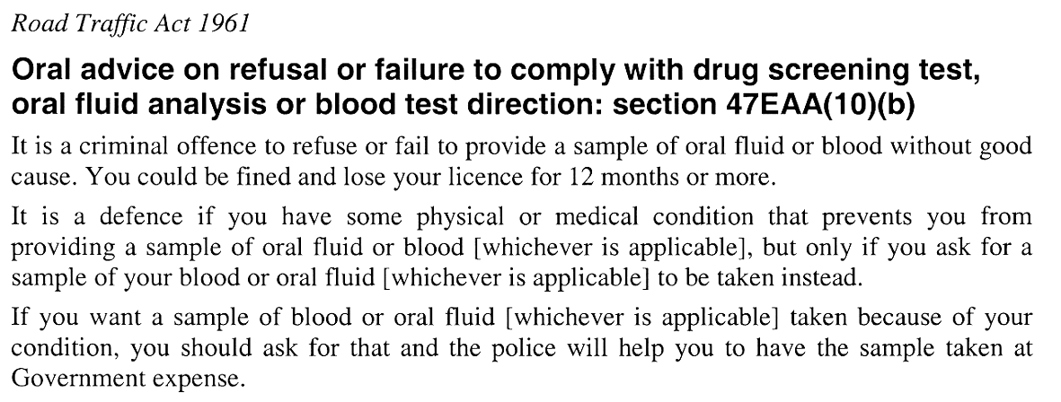
16—Substitution of Schedule 1
Schedule 1—delete the Schedule and substitute:
Schedule 1—Prescribed oral advice and written notice
(Section 47K(2a)(a))
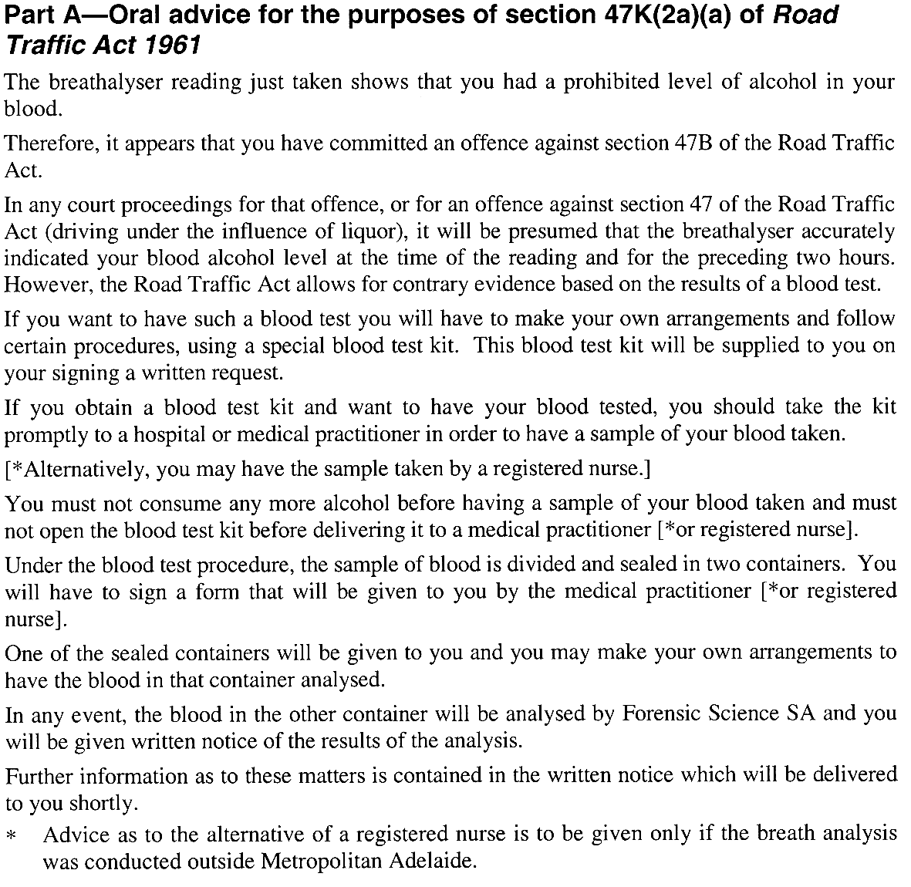
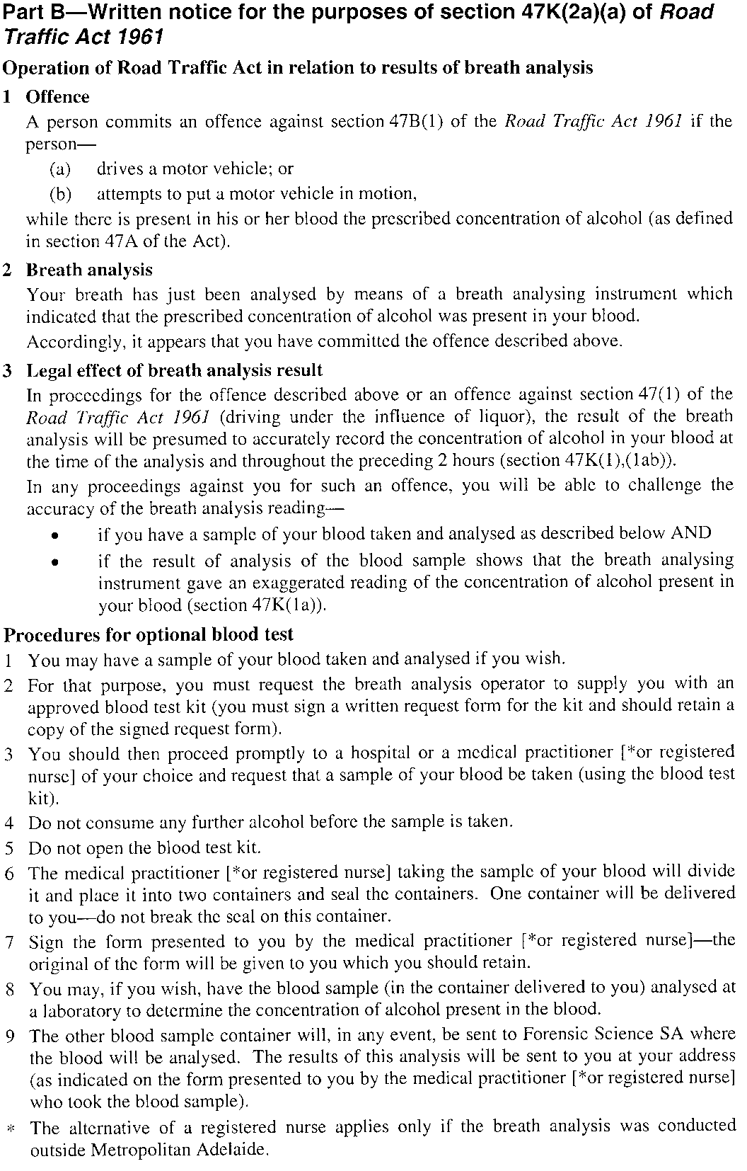
17—Substitution of Schedule 2
Schedule 2—delete the schedule and substitute:
Schedule 2—Form of request
(Section 47K(2a)(b))
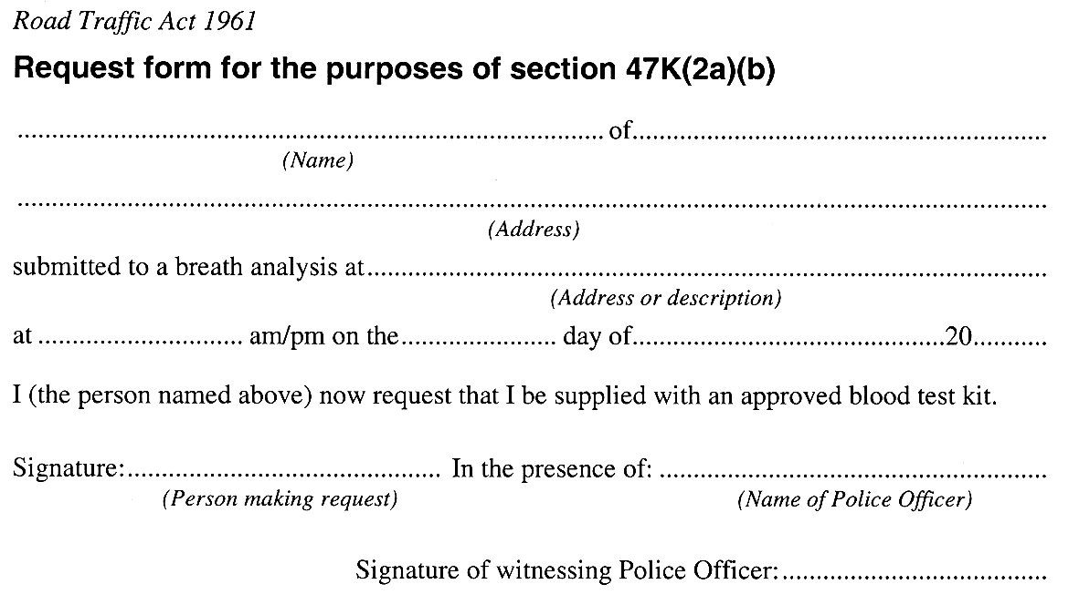
18—Substitution of Schedule 3
Schedule 3—delete the schedule and substitute:
Schedule 3—Form of certificate
(Section 47K(1a) and regulation 11)

19—Variation of Schedule 9—Expiation Fees
Schedule 9 Part 2, table—after the entry related to section 47B(1) insert:

47BA(1) | Driving with prescribed drug in oral fluid or blood | $300
Schedule 1—Transitional provision
1 A reference in a form purporting to be a form prescribed by these regulations to section 47G(1a), 47G(2a)(a) or 47G(2a)(b) of the Act will be taken to be a reference to section 47K(1a), 47K(2a)(a) or 47K(2a)(b) of the Act as appropriate.
2 A reference on a blood test kit purporting to be an approved blood kit for the purposes of the Act to section 47G(2a)(b) of the Act will be taken to be a reference to section 47K(2a)(b) of the Act.
Note—
As required by section 10AA(2) of the Subordinate Legislation Act 1978, the Minister has certified that, in the Minister's opinion, it is necessary or appropriate that these regulations come into operation as set out in these regulations.
Made by the Governor
with the advice and consent of the Executive Council
on 8 June 2006
No 72 of 2006
MTR04/043CS

South Australia
Motor Vehicles Variation Regulations 2006
under the Motor Vehicles Act 1959

Contents
Part 1—Preliminary
1 Short title
2 Commencement
3 Variation provisions
Part 2—Variation of Motor Vehicles Regulations 1996
4 Variation of Schedule 6—Expiation fees
5 Variation of Schedule 7—Demerit points

Part 1—Preliminary
1—Short title
These regulations may be cited as the Motor Vehicles Variation Regulations 2006.
2—Commencement
These regulations will come into operation on the day that Part 2 of the Road Traffic (Drug Driving) Amendment Act 2005 comes into operation.
3—Variation provisions
In these regulations, a provision under a heading referring to the variation of specified regulations varies the regulations so specified.
Part 2—Variation of Motor Vehicles Regulations 1996
4—Variation of Schedule 6—Expiation fees
Schedule 6 Part 1, table, entry related to section 72A—delete the entry and substitute:

72A | Acting as qualified supervising driver while having prescribed concentration of alcohol or prescribed drug in oral fluid or blood | $144
5—Variation of Schedule 7—Demerit points
(1) Schedule 7 Part 2 Division 1, table—after the entry related to section 47B(1) insert:

47BA(1) | Driving while a prescribed drug is in oral fluid or blood | 3

(2) Schedule 7 Part 2 Division 1, table—after the entry related to section 47E(3) insert:

47EAA(9) | Refusing or failing to comply with direction of member of police force in relation to drug screening test, oral fluid analysis or blood test | 6
Note—
As required by section 10AA(2) of the Subordinate Legislation Act 1978, the Minister has certified that, in the Minister's opinion, it is necessary or appropriate that these regulations come into operation as set out in these regulations.
Made by the Governor
with the advice and consent of the Executive Council
on 8 June 2006
No 73 of 2006
MTR04/043CS

FAXING COPY?
IF you fax copy to Government Publishing SA for inclusion in the Government Gazette, there is no need to send a Confirmation Copy to us as well.
This creates confusion and may well result in your notice being printed twice.
Please use the following fax number:
Fax transmission: (08) 8207 1040
Phone Inquiries: (08) 8207 1045
Please include a contact person, phone number and order number so that we can phone back with any queries we may have regarding the fax copy.
NOTE: Closing time for lodging new copy (fax, hard copy or email) is 4 p.m. on Tuesday preceding the day of publication.

Government Gazette notices can be E-mailed.
The address is:
governmentgazette@saugov.sa.gov.au
Documents should be sent as attachments in Word format.
When sending a document via E-mail, please confirm your transmission with a faxed copy of your document, including the date the notice is to be published.
Fax transmission: (08) 8207 1040
Enquiries: (08) 8207 1045
NOTE: Closing time for lodging new copy (fax, hard copy or email) is 4 p.m. on Tuesday preceding the day of publication.

CITY OF CAMPBELLTOWN
Renumbering of Street
NOTICE is hereby given that Council at its meeting held on Tuesday, 18 April 2006, resolved to renumber the southern side of Reservoir Road, Paradise, due to a new land subdivision. The renumbering will take effect on Monday, 29 May 2006 and will ensure a consistent numbering pattern.
P. Vlatko, Chief Executive Officer

CITY OF PORT LINCOLN
Appointment of Authorised Officer
NOTICE is hereby given that the City of Port Lincoln had duly appointed Jeffrey Walter Carr as an Authorised Officer, pursuant to the Dog and Cat Management Act 1995; section 27 (1) and section 68 of the Land and Business (Sale and Conveyancing) Act 1994; Local Government Act 1999; section 260 of the Road Traffic Act 1961 and Road Traffic (Road Rules—Ancillary and Miscellaneous Provisions) Regulations 1999.
All previous appointments made to David Bothe as an Authorised Officer are hereby revoked.
G. Dodd, Chief Executive Officer

ADELAIDE HILLS COUNCIL
Development Act 1993
Adelaide Hills Council Development Plan
Categories of Public Notification Plan Amendment Report—
Draft for Public Consultation
THE ADELAIDE HILLS COUNCIL has prepared a draft Plan Amendment Report to amend the Adelaide Hills Council Development Plan as it affects the whole Council area.
The Plan Amendment Report will amend the Adelaide Hills Council Development Plan by amending policies relating to public notification categories for minor and appropriate forms of developments within the Watershed (Primary Production) Zone, Tourist Accommodation Zone, Country Living Zone, Country Township Zones, Residential Zones and Industrial-Type policy areas.
The draft Plan Amendment Report and statement will be available for public inspection at the Adelaide Hills Council Offices and Libraries located at 28 Onkaparinga Valley Road, Woodside, 63 Mount Barker Road, Stirling and 47 Albert Street, Gumeracha, during normal office hours, or is available on Council’s web site at www.ahc.sa.gov.au from Thursday, 8 June 2006 to Friday, 11 August 2006. A copy of the Plan Amendment Report can also be obtained from any of the Council Offices and Libraries.
Written submissions regarding the draft amendment must be received by the Adelaide Hills Council by no later than 5 p.m. on Friday, 11 August 2006. All submissions should be addressed to the Chief Executive Officer, P.O. Box 44, Woodside, S.A. 5244. The written submission should also clearly indicate whether the writer wishes to speak on the submission at the public hearing.
Copies of all submissions received will be available to the public for inspection by interested persons at the Council Offices and Libraries from Friday, 11 August 2006 until the date of the public hearing. A public hearing will be held at 6.30 p.m. on Monday, 28 August 2006 at the Woodside Day Care Centre, 36 Nairne Road, Woodside.
Note however that the public hearing may not be held if no submission indicates an interest in speaking at the public hearing.
Dated 8 June 2006.
P. Peppin, Chief Executive Officer

BERRI BARMERA COUNCIL
By-law Made under the Local Government Act 1999
By-law No. 1—Permits and Penalties
TO repeal by-laws, provide for a permit system and continuing penalties in Council by-laws and, to clarify the construction of such by-laws.
All previous by-laws made or adopted by the Council, prior to the date this by-law is made, are hereby repealed.
1. Permits
1.1 In any by-law of the Council unless the contrary intention is clearly indicated the word ‘permission’ means the permission of the Council given in writing.
1.2 The Council may attach such conditions to a grant of permission as it thinks fit, and may vary or revoke such conditions or impose new conditions by notice in writing to the permit holder.
1.3 Any permit holder shall comply with every such condition.
1.4 The Council may revoke such grant of permission at any time by notice in writing to the permit holder.
2. Penalties
2.1 Any person who commits a breach of any by-law of the Council shall be guilty of an offence and shall be liable to a maximum penalty being the maximum penalty referred to in the Local Government Act 1999, that may be fixed by by-law for any breach of a by-law.
2.2 Any person who commits a breach of any by-law of the Council of a continuing nature shall be guilty of an offence and, in addition to any other penalty that may be imposed, shall be liable to further penalty for every day on which the offence is continued, such penalty being the maximum amount referred to in the Local Government Act 1934, as amended, and/or the Local Government Act 1999, which may be prescribed by by-law for offences of a continuing nature.
3. Construction
Every by-law of the Council shall be subject to any Act of Parliament and Regulations made thereunder.
The foregoing by-laws were duly made and passed at a meeting of the Berri Barmera Council held on 16 May 2006, by an absolute majority of the members for the time being constituting the Council, there being at least two-thirds of the members present.
S. Rufus, Chief Executive Officer

BERRI BARMERA COUNCIL
By-law Made under the Local Government Act 1999
By-law No. 2—Moveable Signs
TO protect visual amenity and public safety on roads and footpaths by setting standards for moveable signs and regulating their placement in a manner which recognises the advertising needs of businesses to maximise economic viability.
1. Definitions
In this by-law:
1.1 ‘footpath area’ means that part of a street or road between the property boundary of the street or road and the edge of the carriageway on the same side as that boundary;
1.2 ‘moveable sign’ has the same meaning as in the Local Government Act 1999;
1.3 ‘authorised person’ means a person appointed as an authorised person pursuant to section 260 of the Local Government Act 1999;
1.4 ‘business premises’ means the premises from which a business, trade or calling is conducted;
1.5 ‘road’ means public streets and public roads.
2. Construction and design
A moveable sign displayed on a road shall:
2.1 be of a kind known as an ‘A’ Frame or Sandwich Board sign, an ‘inverted “T”’ sign, or a flat sign;
2.2 be well constructed and maintained in good condition so as not to present a hazard to any member of the public using the footpath upon which the moveable sign has been placed;
2.3 be of strong construction so as to be stable when in position and to be able to keep its position in adverse weather conditions;
2.4 not contain sharp or jagged edges or corners;
2.5 not be unsightly or offensive in appearance or content;
2.6 not contain flashing parts;
2.7 be constructed of timber, metal, plastic or plastic coated cardboard, or a mixture of such materials;
2.8 not exceed 900 mm in perpendicular height, or have a base with any side exceeding 600 mm in length;
2.9 not have a display area exceeding one square metre in total or, if the sign is two-sided, one square metre on each side;
2.10 be stable when in position;
2.11 in the case of an ‘A’ Frame or Sandwich Board sign:
2.11.1 be hinged or joined at the top;
2.11.2 be of such construction that its sides shall be securely fixed or locked in position when erected; and
2.12 in the case of an ‘inverted “T”’ sign, contain no struts or supports that run between the display area and the base of the sign.
3. Placement
A moveable sign shall only be positioned on a public street or road on the footpath area subject to the following conditions. The moveable sign:
3.1 must be adjacent to the premises of the business to which it relates;
3.2 where there is no kerb to define the footpath, must allow a set back of 400 mm from the edge of the carriageway;
3.3 in the case of a flat sign, must be in line with and against the property boundary of the street or road;
3.4 must be placed no less than 2 m away from any structure, fixed object, tree, bush or plant (including another moveable sign);
3.5 must not, without council’s permission, be fixed, tied or chained to or, leaned against any other structure, fixed object, tree, bush or plant (including another moveable sign);
3.6 must not be placed on a sealed part of any footpath area, unless the sealed part is wide enough to contain the sign and still leave a clear thoroughfare at least 1.2 m wide;
3.7 must not be placed within one metre of the corner of a street or road;
3.8 must not be placed on a landscaped area;
3.9 must not be placed on a designated parking area or within 1 m of an entrance to or exit from premises;
3.10 must not be placed within 6 m of an intersection; or
3.11 must not unreasonably restrict the use of the footpath or road or endanger the safety of members of the public.
4. Restrictions
A moveable sign displayed on a public street or road shall:
4.1 display material which advertises a business being conducted on commercial premises adjacent to the sign, or the products available from that business but no brand names of a product shall be displayed unless the name of the business is also displayed on the sign;
4.2 be limited to one per business premises;
4.3 only be displayed when the business is open to the public;
4.4 be securely fixed in position such that it cannot be blown over or swept away;
4.5 not be in such a position or in such circumstances that the safety of any user of the street or road is at risk;
4.6 not be displayed during the hours of darkness unless it is clearly visible;
4.7 not to be displayed on a median strip, traffic island or on a carriage way of a street or road.
5. Exemptions
5.1 Paragraphs 3.1 and 4.1 do not apply to a moveable sign which is used:
5.1.1 to advertise a garage sale taking place from residential premises;
5.1.2 as a directional sign to an event run by an incorporated association or a charitable body;
5.1.3 with permission.
5.2 Paragraphs 4.1 and 4.2 do not apply to a flat sign, the message of which only contains newspaper headlines and the name of a newspaper.
6. This by-law does not apply to:
6.1 a moveable sign that is placed on a public street or road pursuant to an authorisation under another Act; or
6.2 a moveable sign that is designed to direct people to the open inspection of any land or building that is available for purchase or lease; or
6.3 a moveable sign that is related to a State or Commonwealth election and is displayed during the period commencing on the issue of the writ or writs for the election and ending at the close of polls on polling days.
7. Removal of unauthorised moveable signs
7.1 if a moveable sign has been placed on any public street, road or footpath in contravention of this by-law or of Section 226 of the Local Government Act 1999, an authorised person may direct the owner of the sign to remove the moveable sign from the street, road or footpath;
7.2 if the authorised person cannot find the owner, or the owner fails to comply immediately with the order, the authorised person may remove the sign;
7.3 if a moveable sign that is removed is not claimed within 30 days of such removal the authorised person may sell, destroy or otherwise dispose of moveable sign as the authorised person thinks fit;
7.4 any person who displays an unauthorised moveable sign or who is the owner of an unauthorised moveable sign which has been removed must pay the Council any reasonable costs incurred in removing, storing or attempting to dispose of the moveable sign before being entitled to recover the moveable sign.
8. Removal of authorised moveable sign
8.1 a moveable sign must be removed or relocated by the person who placed the moveable sign on a street, road or footpath or the owner of the moveable sign, at the request of an authorised officer if, in the opinion of the authorised person, and notwithstanding compliance with this by-law, there is any hazard or obstruction or there is likely to be a hazard or obstruction arising out of the location of the moveable sign;
8.2 a moveable sign must be removed or relocated by the person who placed the moveable sign on a street, road or public place or the owner of the sign, at the request of an authorised person if so required by the authorised person for the purpose of special events, parades, road or footpath works or any other circumstances which, in the opinion of the authorised person, requires relocation of the moveable sign.
The foregoing by-law was duly made and passed at a meeting of the Berri Barmera Council held on 16 May 2006, by an absolute majority of the members for the time being constituting the Council, there being at least two-thirds of the members present.
S. Rufus, Chief Executive Officer

BERRI BARMERA COUNCIL
By-law made under the Local Government Act 1999
By-Law No. 3—Local Government Land
FOR the management and regulation of the use of and access to local government land vested in or under the control of council, including the prohibition and regulation of particular activities on local government land.
1. Definitions
In this by-law:
1.1 ‘local government land’ means land owned by the Council or under the Council’s care, control and management;
1.2 ‘liquor’ has the same meaning as defined in the Liquor Licensing Act 1997;
1.3 ‘open container’ means a container which:
1.3.1 after the contents thereof have been sealed at the time of manufacture and:
(a) being a bottle, has had its cap, cork or top removed (whether or not it has since been replaced);
(b) being a can, it has been opened or punctured;
(c) being a cask, has had its tap placed in a position to allow it to be used;
(d) being any form of container, it has been opened, broken, punctured or manipulated in such a way as to allow access to the contents thereof; or
1.3.2 is a flask, glass or mug or other container used for drinking purposes;
1.4 ‘electoral matter’ has the same meaning as in the Electoral Act 1985 provided that such electoral matter is not capable of causing physical damage or injury to any person within its immediate vicinity;
1.5 ‘authorised person’ means a person appointed an authorised person pursuant to Section 260 of the Local Government Act 1999;
1.6 ‘public place’ means a place (including a place on private land) to which the public has access (except a street or road) but does not include any part of a community parcel divided by a plan of community division under the Community Titles Act 1996;
1.7 ‘park’ means community land reserved or delineated as a park or designated by the Council as a park;
1.8 ‘reserve’ means community land reserved or dedicated as a reserve or designated by the Council as a reserve.
2. Activities requiring permission
No person shall without permission on any local government land:
2.1 Working on vehicles
perform the work of repairing, washing, painting, panel beating or other work of any nature on or to any vehicle, except for running repairs in the case of breakdown;
2.2 Entertaining
sing, busk or play a musical instrument for the purpose of, or so as to appear to be for the purpose of entertaining others whether or not receiving money;
2.3 Preaching
preach or harangue;
2.4 Horses, cattle etc
ride, lead or drive any horse, cattle, sheep and other like animal except where the Council has set aside a track or other area for use by or in connection with the animal of that kind;
2.5 Donations
ask for or receive or indicate that he or she desires a donation of money or any other valuable item or thing;
2.6 Amplification
use an amplifier or other device whether mechanical or electrical for the purpose of amplifying sound;
2.7 Distributing
give out or distribute to any bystander or passer-by any handbill, book, notice, or other printed matter, provided that this restriction shall not apply to any handbill or leaflet given out or distributed by or with the authority of a candidate during the course of a Federal, State or Local Government Election or to a handbill or leaflet given out or distributed during the course and for the purpose of a Referendum;
2.8 Handbills on Cars
place or put on any vehicle any handbill, advertisement, notice or printed matter except for any electoral matter posted on a building or structure with the authority of a candidate during the course of a Federal, State or Local Government election or Referendum;
2.9 Canvassing
convey any advertising, religious or other message to any bystander, passer by or person provided that this restriction shall not apply to any handbill or leaflet given out or distributed by or with the authority of a candidate during the course of a Federal, State or Local Government Election or to a handbill or leaflet given out or distributed during the course and for the purpose of a Referendum;
2.10 Advertising
display any sign for the purpose of commercial advertising, other than a moveable sign which is displayed in accordance with council’s moveable sign by-law;
2.11 Fires
light any fires except:
2.11.1 in a place provided by the Council for that purpose; or
2.11.2 in a portable barbeque, as long as the barbeque is used in an area that is clear of flammable material; and
2.11.3 in accordance with the provision of the Country Fires Act 1989
2.12 Fireworks
ignite, discharge or use any fireworks thereon;
2.13 Attachments to trees
attach, hang or fix any rug, blanket, sheet, rope or other material to any tree, shrub, plant, tree guard, notice board, seat, fence, post or other item or structure which is the property of the Council;
2.14 Overhanging articles
suspend or hang any article or thing from any building, verandah, pergola, post or other structure where it might present a nuisance or danger to any person using local government land;
2.15 Removing soil
carry away or remove any soil, sand, timber, stones, pebbles, other organic or inorganic materials or any part of the land;
2.16 Picking fruit
pick fruit, nuts or berries from any trees or bushes;
2.17 Flora and fauna
subject to the Native Vegetation Act 1991 and the National Parks and Wildlife Act 1972:
2.17.1 damage, pick, or interfere with any plant or flower thereon; or
2.17.2 tease, or cause harm to any animal, bird or marine creature;
2.18 Games
2.18.1 participate in any game, recreation or amusement which involves the use of a ball, missile or other object which by the use thereof may cause or be likely to cause injury or discomfort to any person being on or in the vicinity of that land or detract from or be likely to detract from another person’s lawful use and enjoyment of that land;
2.18.2 fly any model aircraft or operate any power model boat from or on any local government land;
2.19 Athletic and ball sports
to which this sub-paragraph applies, in accordance with paragraph 10 of this by-law:
2.19.1 promote, organise or take part in any organised athletic sport;
2.19.2 play any organised competition sport, as distinct from organised social play;
2.19.3 play or practice the game of golf;
2.20 No liquor
to which this sub-paragraph applies, in accordance with paragraph 10 of this by-law:
2.20.1 consume, carry or be in possession or charge of any liquor (provided the land constitutes a park or reserve);
2.20.2 excepting sealed containers, consume, carry, be in possession or charge of any liquor in an open container (provided the land constitutes a park or reserve);
2.21 Weddings
conduct or participate in a marriage ceremony;
2.22 Encroachment
erect or place any fencing, posts or other structures or any other items or substance such as to encroach onto the land;
2.23 Closed lands
enter or remain on any part of local government land:
2.23.1 at any time during which the Council has declared that it shall be closed to the public and which is indicated by a sign to that effect;
2.23.2 where land is enclosed with fences and/or walls, and gates, at any time when the gates have been closed and locked; or
2.23.3 where admission charges are payable, to enter without paying those charges;
2.24 Rubbish and rubbish dumps
2.24.1 interfere with, remove or take away any rubbish that has been discarded at any rubbish dump on local government land;
2.24.2 remove, disperse or interfere with any rubbish (including bottles, newspapers, cans, containers or packaging) that has been discarded in a Council rubbish bin on local government land;
2.25 Cemeteries
comprising a cemetery:
2.25.1 bury or inter any human or animal remains;
2.25.2 erect any memorial;
2.25.3 drive or propel any vehicle except on paths or roads constructed and set aside for that purpose and in compliance with any signs that have been erected;
2.26 Camping and tents
camp or stay overnight;
2.27 Smoking
smoke tobacco or any other substance in any building or part of any building;
2.28 Toilets
in any public convenience:
2.28.1 urinate other than in a urinal or pan or defecate other than in a pan set apart for that purpose:
2.28.2 smoke tobacco or any other substance;
2.28.3 deposit anything in a pan, urinal or drain which is likely to cause a blockage;
2.28.4 use it for a purpose for which it was not designed or constructed;
2.28.5 enter any toilet that is set aside for use of the opposite sex except where:
(a) a child under the age of five years accompanied by an adult person of that other sex; and/or
(b) to provide assistance to a disabled person;
2.29 Swimming and aquatic activity
to which this sub-paragraph applies, in accordance with paragraph 10 of this by-law, enter, swim or engage in any aquatic activity in or on any body of water except:
2.29.1 a body of water that the Council has set aside for that purpose; or
2.29.2 in an area where a nearby sign states that such activity is allowed and, in accordance with any conditions stated in the sign;
2.30 Mooring
2.30.1 moor any boat, house boat, raft or other water craft on or to local government land or in any area that the Council has not set aside for the mooring of any boat, raft or other water craft; or
2.30.2 obstruct any boat, raft or other water craft or any mooring place, or any access to any boat, raft, object (either floating or sunk);
2.31 Use of boats and boat ramps
2.31.1 use or launch a boat or other object in any body of water except:
(a) a body of water that the Council has set aside for that purpose; or
(b) in an area where a nearby sign states that such activity is allowed and, in accordance with any conditions stated in the sign;
2.31.2 launch or retrieve a boat other than from a boat ramp constructed for that purpose;
2.31.3 hire out a boat on or from any part of a body of water;
2.32 Depasturing
cause, suffer or permit any animal under his or her control to depasture thereon;
2.33 Trading
2.33.1 carry on the business of buying, selling, offering or exposing for sale or the hiring or leasing of any goods, merchandise, commodity, article, service or thing (including any vehicle, water craft or aircraft), or
2.33.2 set up a van or other vehicle or stall or other structure, tray, carpet, or device for the purpose of buying, selling, offering or exposing for sale or the hiring or leasing of any goods, merchandise, commodity, article, service or thing (including any vehicle) water craft or aircraft;
2.34 Skateboards and small wheeled vehicles
to which this sub-paragraph applies, in accordance with paragraph 10 of this by-law ride on a skateboard or use roller skates or blades or any other small wheeled vehicle.
3. Posting of bills etc
No person shall without the Council’s permission post any bills, advertisements or other papers or items on a building or structure on local government land or other public place except for any electoral matter posted on a building or structure with the authority of a candidate during the course of a Federal, State or Local Government election or Referendum.
4. Prohibited activities
No person shall on local government land:
4.1 Use of equipment
use any item of equipment and/or facilities or other council property:
4.1.1 other than in the manner and for the purpose for which it was designed or set aside; and
4.1.2 where any nearby sign states the conditions of use, except in accordance with such conditions.
4.2 Annoyances
4.2.1 annoy, commit any nuisance or unreasonably interfere with any other person’s use of local government land by making a noise or by creating a disturbance that has not been authorised by the Council;
4.2.2 spit, urinate or defecate other than in toilets provided on any local government land;
4.3 Interference with permitted use
interrupt or disrupt or interfere with any person’s use of parks or reserves for which permission has been granted;
4.4 Obstruction
obstruct:
4.4.1 any path in or on any local government land;
4.4.2 any door entrance stairway or aisle in any building in or on any local government land; or
4.4.3 any gate or entrance to, in or on local government land;
4.5 Interference with land
4.5.1 interfere with the land such as levelling or flattening sand hills, planting grass, lawn or other vegetation, paving the land, or otherwise use the land in a manner contrary to the purpose for which the land was designed to be used; or
4.5.2 destroy, damage or deface or cause or permit to be destroyed, damaged or defaced any article, structure, building or thing fixed to local government land;
4.6 Defacing Property
deface, paint, write, cut names or make marks on or fix bills or advertisements to any tree, rock, gate, fence, building, sign or other property of the Council therein except for any electoral matter posted on a building or structure with the authority of a candidate during the course of a Federal, State or Local Government election or Referendum.
4.7 Missiles
throw, roll or discharge any stone, substance or missile to the danger of any person or animal therein;
4.8 Glass
wilfully break any glass, china or other brittle material;
4.9 Flora
collect or take any dead wood or timber for the purpose of using the same to make or maintain a fire;
4.10 Camping
4.10.1 fail to keep the area on which he or she is camped in the surrounds in a clean, tidy and sanitary condition;
4.10.2 fail to permit any Council officer or authorised person to enter onto and inspect his or her camp site or any tent, caravan or vehicle thereon or thereby;
5. Removal of encroachment or interference
Any person who encroaches onto or interferes with local government land contrary to this by-law must at the request in writing of an authorised person, cease the encroachment or interference and remove the source of the encroachment or interference, and reinstate the land to the same standard as the state of the land prior to the encroachment or interference;
6. Council may do work
If a person fails to remove an encroachment or interference on local government land in accordance with a request of an authorised officer pursuant to Clause 5 of this by-law, then the Council may:
6.1 undertake the work itself; and
6.2 recover the cost of doing so from that person.
7. Directions
Any person on local government land must comply with any reasonable direction or request from an authorised person relating to:
7.1 that person’s use of the land;
7.2 that person’s conduct and behaviour on the land;
7.3 that person’s safety on the land;
7.4 the safety and enjoyment of the land by other persons.
8. Removal of animals and persons
8.1 If any animal is found on local government land in breach of a by-law:
8.1.1 any person in charge of the animal shall remove it on the request of an authorised person; and
8.1.2 an authorised person may remove the animal if a person fails to comply with the request, or if no person is in charge of the animal.
8.2 Any authorised person may direct any person found committing a breach of these by-laws to cease the action or to take specified action to remedy the breach.
9. Exemptions
The restrictions in this by-law do not apply to any Police Officer, Council Officer or employee acting in the course and within the scope of that person’s normal duties, or to a contractor while performing work for the Council and while acting under the supervision of a Council Officer, or to the drivers of Emergency Vehicles (as defined in the Road Traffic (Road RulesAncillary & Miscellaneous Provisions) Regulations 1999 and the Australian Road Rules 1999) while driving that vehicle in relation to an emergency.
10. Application
Paragraphs 2.19, 2.20, 2.29 and 2.34 of this by-law shall apply only in such portion or portions of the area as the Council may by resolution direct in accordance with Section 246 (3) (e) of the Local Government Act 1999.
The foregoing by-law was duly made and passed at a meeting of the Berri Barmera Council held on 16 May 2006 by an absolute majority of the members for the time being constituting the Council, there being at least two-thirds of the members present.
S. Rufus, Chief Executive Officer

BERRI BARMERA COUNCIL
By-law made under the Local Government Act 1999
By-Law No. 4—Roads
FOR the management, control and regulation of activities on roads.
1. Definitions
In this by-law:
1.1 ‘road’ has the same meaning as in the Local Government Act 1999;
1.2 ‘authorised person’ means a person appointed an authorised person pursuant to Section 260 of the Local Government Act 1999;
1.3 ‘electoral matter’ has the same meaning as in the Electoral Act 1995 provided that such electoral matter is not capable of causing physical damage or injury to any person within its immediate vicinity;
1.4 ‘Emergency Vehicle’ has the same meaning as in the Australian Road Rules 1999 and the Road Traffic (Road Rules—Ancillary and Miscellaneous Provisions) Regulations 1999.
2. Activities requiring permission
No person shall without permission on any road:
2.1 Working on vehicles
perform the work of repairing, washing, painting, panel beating or other work of any nature on or to any vehicle, except for running repairs in the case of breakdown;
2.2 Preaching
preach or harangue;
2.3 Horses, cattle etc
2.3.1 ride, lead or drive any horse, cattle, sheep and other like animal, except where the Council has set aside a track or other area for use by or in connection with the animal of that kind;
2.3.2 stand, draw up or allow to remain stationary any horse, cattle, sheep and other like animal whether attached to a vehicle or not;
2.4 Donations
ask for or receive or indicate that he or she desires a donation of money or any other thing;
2.5 Amplification
use an amplifier or other device whether mechanical or electrical for the purpose of amplifying sound or broadcasting announcements or advertisements;
2.6 Canvassing
convey any advertising, religious or other message to any bystander, passer by or other person provided that this restriction shall not apply to any handbill or leaflet given out or distributed by or with the authority of a candidate during the course of a Federal, State or Local Government Election or to a handbill or leaflet given out or distributed during the course and for the purpose of a Referendum;
2.7 Advertising
display any sign for the purpose of commercial advertising, other than a moveable sign which is displayed on a public road in accordance with Council’s moveable signs by-law;
2.8 Camping
camp or remain overnight;
2.9 Exhibition or Display
conduct any public exhibition or display.
3. Posting of bills etc
No person shall, without the Council’s permission, post any bills, advertisements or other papers or items on a building or structure on a road except for any electoral matter posted on a building or structure with the authority of a candidate during the course of a Federal, State or Local Government election or Referendum.
4. Removal of Animals and Directions to Persons
4.1 No person shall allow or permit any horse, cattle, sheep, bird or other like animal to wander on any road unless that animal is under the person’s effective control.
4.2 If any animal is found on part of a road in breach of a by-law any person in charge of the animal shall immediately remove it from that part on the request of any authorised person;
4.3 An authorised person may remove the animal if a person fails to comply with the request, or if no person is in charge of the animal; and
4.4 An authorised person may direct any person who is considered to be committing or has committed a breach of this by-law to leave that part of the road. Failure to comply with that direction forthwith is a breach of this by-law.
5. Exemptions
The Restrictions in this by-law do not apply to any Police Officer, Council officer or employee acting in the course and within the scope of that person’s normal duties, or to a contractor while performing work for the Council and while acting under the supervision of a Council officer, or to an emergency worker when driving an Emergency Vehicle in an emergency situation.
6. Paragraph 2.3 of this by-law shall apply only in such portion or portions of the area as the Council may by resolution direct in accordance with Section 246 (3) (e) of the Local Government Act 1999.
The foregoing by-law was duly made and passed at a meeting of the Berri Barmera Council held on 16 May 2006 by an absolute majority of the members for the time being constituting the Council, there being at least two-thirds of the members present.
S. Rufus, Chief Executive Officer

BERRI BARMERA COUNCIL
By-law made under the Dog and Cat Management Act 1995 and the Local Government Act 1999
By-Law No. 5—Dogs
FOR the control of dogs within the area, to limit the number of dogs kept in premises and for the management of dogs in the Council’s area.
1. Definitions
In this by-law:
1.1 ‘approved kennel establishment’ means a building, structure or area approved by the relevant authority, pursuant to the Development Act 1993, for the keeping of dogs on a temporary or permanent basis;
1.2 ‘dog’ means an animal of the species canis familiaris over the age of three months but does not include a dingo;
1.3 ‘effective control’ has the same meaning as that contained within Section 8 of the Act and includes effective control by command providing the dog is in close proximity to the person responsible for control of the dog and that person is able to see the dog at all times;
1.4 ‘premises’ means any domestic and non-domestic premises, except an approved kennel establishment;
1.5 ‘public place’ means all streets, roads, parklands, reserves, open space, jetties, bridges, and all other land in the ownership of the Council or under the care, control and management of council;
1.6 ‘small dwelling’ means a flat, a service flat, home unit, or a suite of rooms which is wholly occupied, or designed or intended or adapted to be occupied, as a separate dwelling, but does not include a detached, semi-detached or row dwelling house;
1.7 ‘working dog’ means a dog used principally for the droving or tendering of stock.
2. Limit on Dog Numbers
2.1 The limit on the number of dogs shall be:
2.1.1 in a small dwelling, one dog; and
2.1.2 in premises other than a small dwelling, two dogs.
2.2 No person shall, without obtaining written permission of the Council, keep any dog on any premises where the number of dogs exceeds the limit:
2.2.1 unless the premises is an approved kennel establishment; or
2.2.2 the council has exempted any premises from compliance with Clause 2 of this by-law by the granting of an exemption; or
2.2.3 other than working dogs kept in rural areas.
3. Dog Free Areas
No person shall in a public place to which this paragraph applies in accordance with clause 6 of this by-law cause, suffer or permit any dog (except guide dogs guiding a person who is wholly or partially blind; or wholly or partially deaf), under that person's control, charge or authority to be in, or remain in that place.
4. Dogs on Leashes
No person shall in a public place to which this paragraph applies cause, suffer or permit any dog (except guide dogs guiding a person who is wholly or partially blind; or wholly or partially deaf), under that person's control, charge or authority to be or remain in that place unless such dog is restrained by a strong leash not exceeding 2 metres in length and either tethered securely to a fixed object or held by a person capable of controlling the dog and preventing it from being a nuisance or danger to other persons.
5. Dog Exercise Areas
5.1 Any person may enter upon any public place to which this paragraph applies in accordance with clause 6 of this by-law for the purpose of exercising a dog under his or her effective control;
5.2 Where a person enters upon such public place for that purpose, he or she shall ensure that the dog or dogs under his or her control remain under effective control while on the land;
5.3 Signs shall be erected to denote land to which this paragraph applies.
6. Application
Paragraphs 3, 4 and 5 of this by-law shall apply only in such portion or portions of the area as the council may by resolution direct (in accordance with section 246 (3) (e) of the Local Government Act 1999).
7. Exemptions
Council may by permission, granted in writing, exempt (conditionally or unconditionally) classes of persons or activities from the application of the by-law or specified provisions of the by-law.
The foregoing by-law was duly made and passed at a meeting of the Berri Barmera Council held on 16 May 2006 by an absolute majority of the members for the time being constituting the Council, there being at least two-thirds of the members present.
S. Rufus, Chief Executive Officer

DISTRICT COUNCIL OF GRANT
Roads (Opening and Closing) Act 1991
Walters Road, Suttontown
NOTICE is hereby given, pursuant to section 10 of the Roads (Opening and Closing) Act 1991, that the District Council of Grant proposes to make a Road Process Order to close portion of Walters Road adjacent Allotments 121 and 122 in Filed Plan 13861 and merge with the adjoining Allotment 122 in Filed Plan 13861 more particularly delineated and lettered ‘A’ in Preliminary Plan No. 06/0022.
A copy of the plan and a statement of persons affected are available for public inspection at the office of the Council, 324 Commercial Street West, Mount Gambier and the Adelaide office of the Surveyor-General during normal office hours.
Any application for easement or objection must set out the full name, address and details of the submission and must be fully supported by reasons. The application for easement or objection must be made in writing to the Council, P.O. Box 724, Mount Gambier, S.A. 5290 within 28 days of this notice and a copy must be forwarded to the Surveyor-General, G.P.O. Box 1354, Adelaide, S.A. 5001. Where a submission is made, the Council will give notification of a meeting at which the matter will be considered.
R. Peate, Chief Executive Officer

NARACOORTE LUCINDALE COUNCIL
Development Act 1993
Effluent Disposal Waste Control System Plan Amendment Report—Draft for Public Consultation and Interim Operation
NOTICE is hereby given that the Naracoorte Lucindale Council has prepared a draft Plan Amendment Report to amend its current Development Plan as it affects current policies relating to effluent disposal within the whole of the Council area. The Plan Amendment Report will amend the Development Plan policies to improve effluent disposal practices throughout the Council area and protect groundwater quality.
In order to prevent inappropriate development and promote orderly planning, the draft PAR has been granted ‘interim authorisation’ by the Governor, in Executive Council, giving the amendments immediate effect.
The draft Plan Amendment Report will be available for public inspection and purchase during normal office hours at the Council Office, Degaris Place, Naracoorte from Thursday, 8 June 2006 to Thursday, 10 August 2006. A copy of the Plan Amendment Report can be purchased from the Council at $10 each.
Written submissions regarding the draft amendment will be accepted by the Naracoorte Lucindale Council until 5 p.m. on Thursday, 10 August 2006. The written submission should also clearly indicate whether you will wish to speak at the public hearing regarding your submission. All submissions should be addressed to the Chief Executive Officer, Naracoorte Lucindale Council, P.O. Box 55, Naracoorte, S.A. 5271.
Copies of all written submissions received will be available for inspection by interested persons at the Council offices from Friday, 11 August 2006 until the date of the public hearing.
A public hearing will be held in the Council Chamber on Thursday, 17 August 2006. The public hearing may not be held if no submission indicates an interest in speaking at the public hearing.
Dated 8 June 2006.
D. Hovenden, Chief Executive Officer

DISTRICT COUNCIL OF YORKE PENINSULA
By-law Made under the Local Government Act 1999
By-Law Number ‘L’—Port Vincent Marina
TO promote the good management of traffic using the waterways and surrounds of the Port Vincent Marina, and to regulate the activities which may cause a danger or nuisance to persons using such areas.
This by-law applies to the areas delineated on the plan comprising Annexure A to this by-law including Allotments 101, 104, 201 to 212 inclusive and 230 in Plan of Division 54608 and 61702 and including the waterways (as defined).
1. Definitions
In this by-law:
1.1 ‘boat refuelling facility’ means the fuelling facilities provided at the area known as ‘211’, shown on Annexure A.
1.2 ‘breakwater reserve’ means the area described as ‘reserve’, as shown in Annexure A.
1.3 ‘commercial vessel’ means a vessel that is used for industrial, commercial or scientific purposes, including a fishing vessel.
1.4 ‘fishing boat berth’ means the area shown as 203, as shown on Annexure A.
1.5 ‘Council’ means the District Council of Yorke Peninsula and includes any officer/employee of the Council authorised to oversee the activities and operations of the Port Vincent Marina.
1.6 ‘fishing vessel’ means:
1.6.1 a vessel (not propelled solely by oars) used in the taking of fish for sale;
1.6.2 a vessel (not propelled solely by oars) used in connection with a fish farm whether or not it is used in the taking of fish for sale; or
1.6.3 a vessel that has been used, or is used by the owner of a fishing boat berth in the taking of fish for sale.
1.7 ‘hot work’ means work involving welding, burning, cutting or heating of plant, equipment or materials on, as part of, or associated with, any vessel whether undertaken on the vessel or not.
1.8 ‘jetty’ means a wharf or landing, and includes recreation launching facilities, walkways, boardwalks, piles and pontoons constructed as part of a jetty, a pier or the piles or wooden structure protecting a pier.
1.9 ‘Marina Manager’ means the person appointed to manage the Port Vincent Marina.
1.10 ‘pontoon’ means a pontoon or jetty.
1.11 ‘recreational vessel’ means a vessel used for purposes that are not solely for industrial, commercial or scientific purposes.
1.12 ‘revetment wall’ means the retaining limestone or concrete wall supporting the earthen rampart along the waterway land, the granite rocks of the sloping embankment immediately adjacent to the limestone or concrete retaining wall and all other edge treatments to the marina basin.
1.13 ‘unloading wharf area’ means the area shown as 210 and 209, as shown on Annexure A.
1.14 ‘vessel’ means a vessel as defined in the Harbours and Navigation Act 1993, as amended, and including a recreational vessel and a commercial vessel.
1.15 ‘waterways’ include the breakwater reserve, the waterway land, the waterway reserve, the fishing boat berths, the unloading wharf area, the boat refuelling facility and includes all navigation waters to which the public has access in the Port Vincent Marina.
1.16 ‘waterway land’ means the portion of a waterfront allotment in the Port Vincent Marina consisting of waterway situated between the boundaries of the waterfront allotment and the revetment wall of the waterfront allotment.
1.17 ‘waterway reserve’ means the whole of the land including allotments 101, 104, 201 to 212 inclusive and 230 in Plan of Division 54608 and 61702.
2. Moorings
2.1 No person shall suffer, cause or permit to be moored in the waterways any:
2.1.1 recreational vessel unless it is secured to a jetty;
2.1.2 commercial vessel unless it is secured to a fishing boat berth or to the unloading wharf area.
3. Protruding Vessels
3.1 No person shall suffer, cause or permit any vessel or any part of any vessel, secured to a jetty on the waterway land to protrude into the waterways.
4. Sunken Vessels
4.1 No person shall suffer, cause or permit any sunken vessel to remain in the waterways for a period exceeding 3 days.
5. Notification of Ownership
5.1 No person shall suffer, cause or permit a vessel to remain in the waterways for a period exceeding 7 days without the Owner of the vessel having first provided details of such vessel to the Council including the name, length, description, use and location of such vessel.
6. Nuisances in the Waterways
6.1 No person shall cause, suffer or permit any nuisance or conduct likely to cause injury to health in the waterways and, without limiting the generality of the foregoing, nuisance or conduct likely to cause injury to health shall include:
6.1.1 the creation of unnecessary noise including loud talking and playing of music and/or musical instruments between 11 p.m. and 7 a.m. on any day;
6.1.2 the permitting of rigging or spars to cause a nuisance or impair the amenity;
6.1.3 the use of generators and/or compressors between 9 p.m. and 6 a.m. on any day in any daylight saving period and between 8 p.m. and 7 a.m. on any other day.
7. Living on Board a Vessel
7.1 No person shall cause, suffer or permit either himself, herself, themselves or any other person to reside on a vessel in the waterways, for a period greater than 7 days without the written permission of the Council first being obtained.
8. Reporting of Spills
8.1 All spills and/or discharges shall be reported to the Council immediately, which may remove or cause the same to be removed and the cost of such removal shall be reimbursed to the Council by the person responsible from such spill and/or discharge or the owner of the vessel for which such spill or discharge originates.
9. Boat Repair and Maintenance Generally
9.1 No person shall cause, suffer or permit in the waterways any major repairs to:
9.1.1 any recreational vessel; or
9.1.2 any commercial vessel.
9.2. Any person effecting any minor repairs to:
9.2.1 any recreational vessel; or
9.2.2 any commercial vessel
shall ensure
9.2.3 that all such work is done within the confines of that recreational vessel itself;
9.2.4 that such work is not carried out except between the hours of 7 a.m. and 8 p.m. on any one day;
9.2.5 that no such work shall be undertaken on any Sunday; and
9.2.6 in the case of a commercial vessel that all such work is done whilst that vessel is moored at a fishing boat berth only.
9.3 Nothing contained in this Part 9 shall authorise or permit any person to:
9.3.1 carry out any spray painting on any vessel;
9.3.2 chip paint and/or rust on any vessel;
9.3.3 use any noisy equipment including using any angle grinder, sand blaster or other electrical power tool and/or welding equipment on any vessel except for minor maintenance work which must not adversely affect the amenity of lessees, visitors and/or residents in the locality;
9.3.4 obstruct the use of piers, jetties and/or access to moorings with tools, equipment or materials for the use of such tools and/or equipment;
9.3.5 allow any repair/maintenance materials and/or waste materials to be left on a jetty after 8 p.m. on any one day;
9.3.6 carry out or have carried out, any hot work without first making application for and obtaining a Hotwork Approval Certificate in accordance with Form 1 of this by-law from the Council and complying with any conditions set out on that Certificate.
10. Conduct of Persons in the Waterways
10.1 No person shall:
10.1.1 allow any dog under his or her control to enter, or swim, in the waterways;
10.1.2 release any duck or goose, or any other bird, animal or fish into the waterways;
10.1.3 engage in water skiing or any other water sports or activity in the waterways;
10.1.4 destroy, damage, disturb, deface or interfere with any buoy, float, life preserver, sign, notice or any other property of the Council.
11. Vessel Control Generally
11.1 No person shall:
11.1.1 cause, suffer or permit a vessel to remain in the waterways unless it is operated under power;
11.1.2 tow any object or person, except a disabled vessel or floating plant for marina maintenance and/or construction purposes in the waterways;
11.1.3 obstruct or fail to give way to the operator of a vessel towing floating plant for marina maintenance and/or construction purposes.
12. Commercial Vessels
12.1 Commercial vessels shall only be moored at fishing boat berths or the unloading wharf area.
13. Safe Mooring
13.1 No person shall cause, suffer or permit a vessel to be moored in the waterways in such a place or manner so as to cause, or be likely to cause, any risk or danger to any person or property.
14. Unloading Wharf Area Operation
14.1 No person shall cause, suffer or permit, without the written permission of the Council first being obtained:
14.1.1 a vessel to be berthed at the unloading wharf area, except for the purpose of loading and unloading that vessel, for a period not exceeding 60 minutes; or
14.1.2 a vessel to be moored at the unloading wharf area:
14.1.2.1 to be left unattended;
14.1.2.2 to undertake commercial activity outside the hours between 7 a.m. and 8 p.m. on any one day; or
14.1.2.3 to load or unload any fresh fish, frozen fish or any other fish produce except in leakproof bins or containers.
15. Unloading Wharf Area—Directions
15.1 A person in charge of a vessel must comply with any direction/directions given by the Council, the Marina Manager, or any person authorised by the Council or Port Operator, including and without limiting the generality of the foregoing:
15.1.1 a direction that vessels proceed to load or unload in a particular order,
15.1.2 a direction that a vessel be moored or anchored in a particular position,
15.1.3 a direction that a vessel be secured in a particular way,
15.1.4 a direction that a vessel be moved from a particular area or position.
16. Unloading Wharf Area—Uncontrolled Vessels
16.1 The Council may, if there is no appropriate person on board the vessel to whom a direction may be given, board the vessel and cause the vessel to be moved as the Council thinks fit;
16.2 the Council shall not be liable for any damage or loss suffered by reason of the boarding and/or moving in accordance with part 16.1 of this by-law.
17. Unloading Wharf Area—Costs
17.1 Any costs incurred by the Council in acting pursuant to part 16 of this by-law are recoverable as a debt from the owner of the vessel.
18. Fishing Boat Berths
18.1 No person shall cause, suffer or permit any vessel which has or is to be moored at the fishing boat berth, for the purpose of unloading fish for sale, to enter the waterway land or the waterway reserve.
19. Boat Refuelling Facility
19.1 No person shall cause, suffer or permit without the written permission of the Council first being obtained:
19.1.1 a vessel to be berthed at the boat refuelling facility, except for the purpose of refuelling for any period longer than 60 minutes;
19.1.2 a vessel moored at the boat refuelling facility:
19.1.2.1 to be left unattended; or
19.1.2.2 to undertake commercial activity except between the hours of 7 a.m. and 8 p.m. on any one day.
20. Inspections
20.1 A Council Officer and/or any employee or contractor of the Council can enter upon any waterfront allotment and/or waterway land to inspect the same, after giving reasonable notice to the owner thereof, or at any time if Council is of the opinion that such inspection is necessary.
20.2 Any person who refuses any Council Officer, employee or contractor permission to enter upon any waterway land and/or waterway allotment shall commit an offence under this by-law.
21. Maintenance
21.1 No person shall cause or commit any revetment wall, waterway land or waterfront allotment to not be in good order and appearance.
21.2 The Council may, by notice in writing to the owner of any waterway allotment, (which includes its revetment wall), require that owner to undertake such work as shall, in the opinion of the Council, be necessary to maintain such allotment and/or wall in good order and appearance within such reasonable time as shall, in the opinion of the Council, be necessary but not less than 28 days from the date of service of this Notice.
21.3 Council may undertake such work as shall be necessary to maintain any waterway allotment, including its revetment wall, if the owner shall fail to undertake such work as shall have been prescribed within the time frame prescribed by the Notice given under paragraph 21.2 and recover the costs of such work from the owner.
22. Penalties
22.1 Any person who commits a breach of this by-law of the Council is guilty of an offence and is liable to a penalty being the maximum amount that can be prescribed by by-law for any breach of a by-law: currently this amount is $750.
22.2 Any person who commits a breach of this by-law of the Council of a continuing nature shall be guilty of an offence and in addition to any other penalty that may be imposed, shall be liable to a further penalty for every day on which the offence is continued, such penalty being the maximum amount referred to in the Local Government Act 1934, which may be prescribed by by-law for offences of a continuing nature: currently this amount is not exceeding $50 for each and every day on which the offence or breach continues.
23. Construction
23.1 Every by-law of the Council shall be subject to any Act of Parliament and Regulations made thereunder.
The foregoing by-law was duly made and passed at a meeting of the District Council of Yorke Peninsula held on 8 February 2006, by an absolute majority of the members for the time being constituting the Council, there being at lease two-thirds of the members present, and was approved by the Hon. Patrick Conlon, Minister for Transport on 21 May 2006, pursuant to section 18A of the Harbors and Navigators Act 1993.
R. Bruhn, Chief Executive Officer

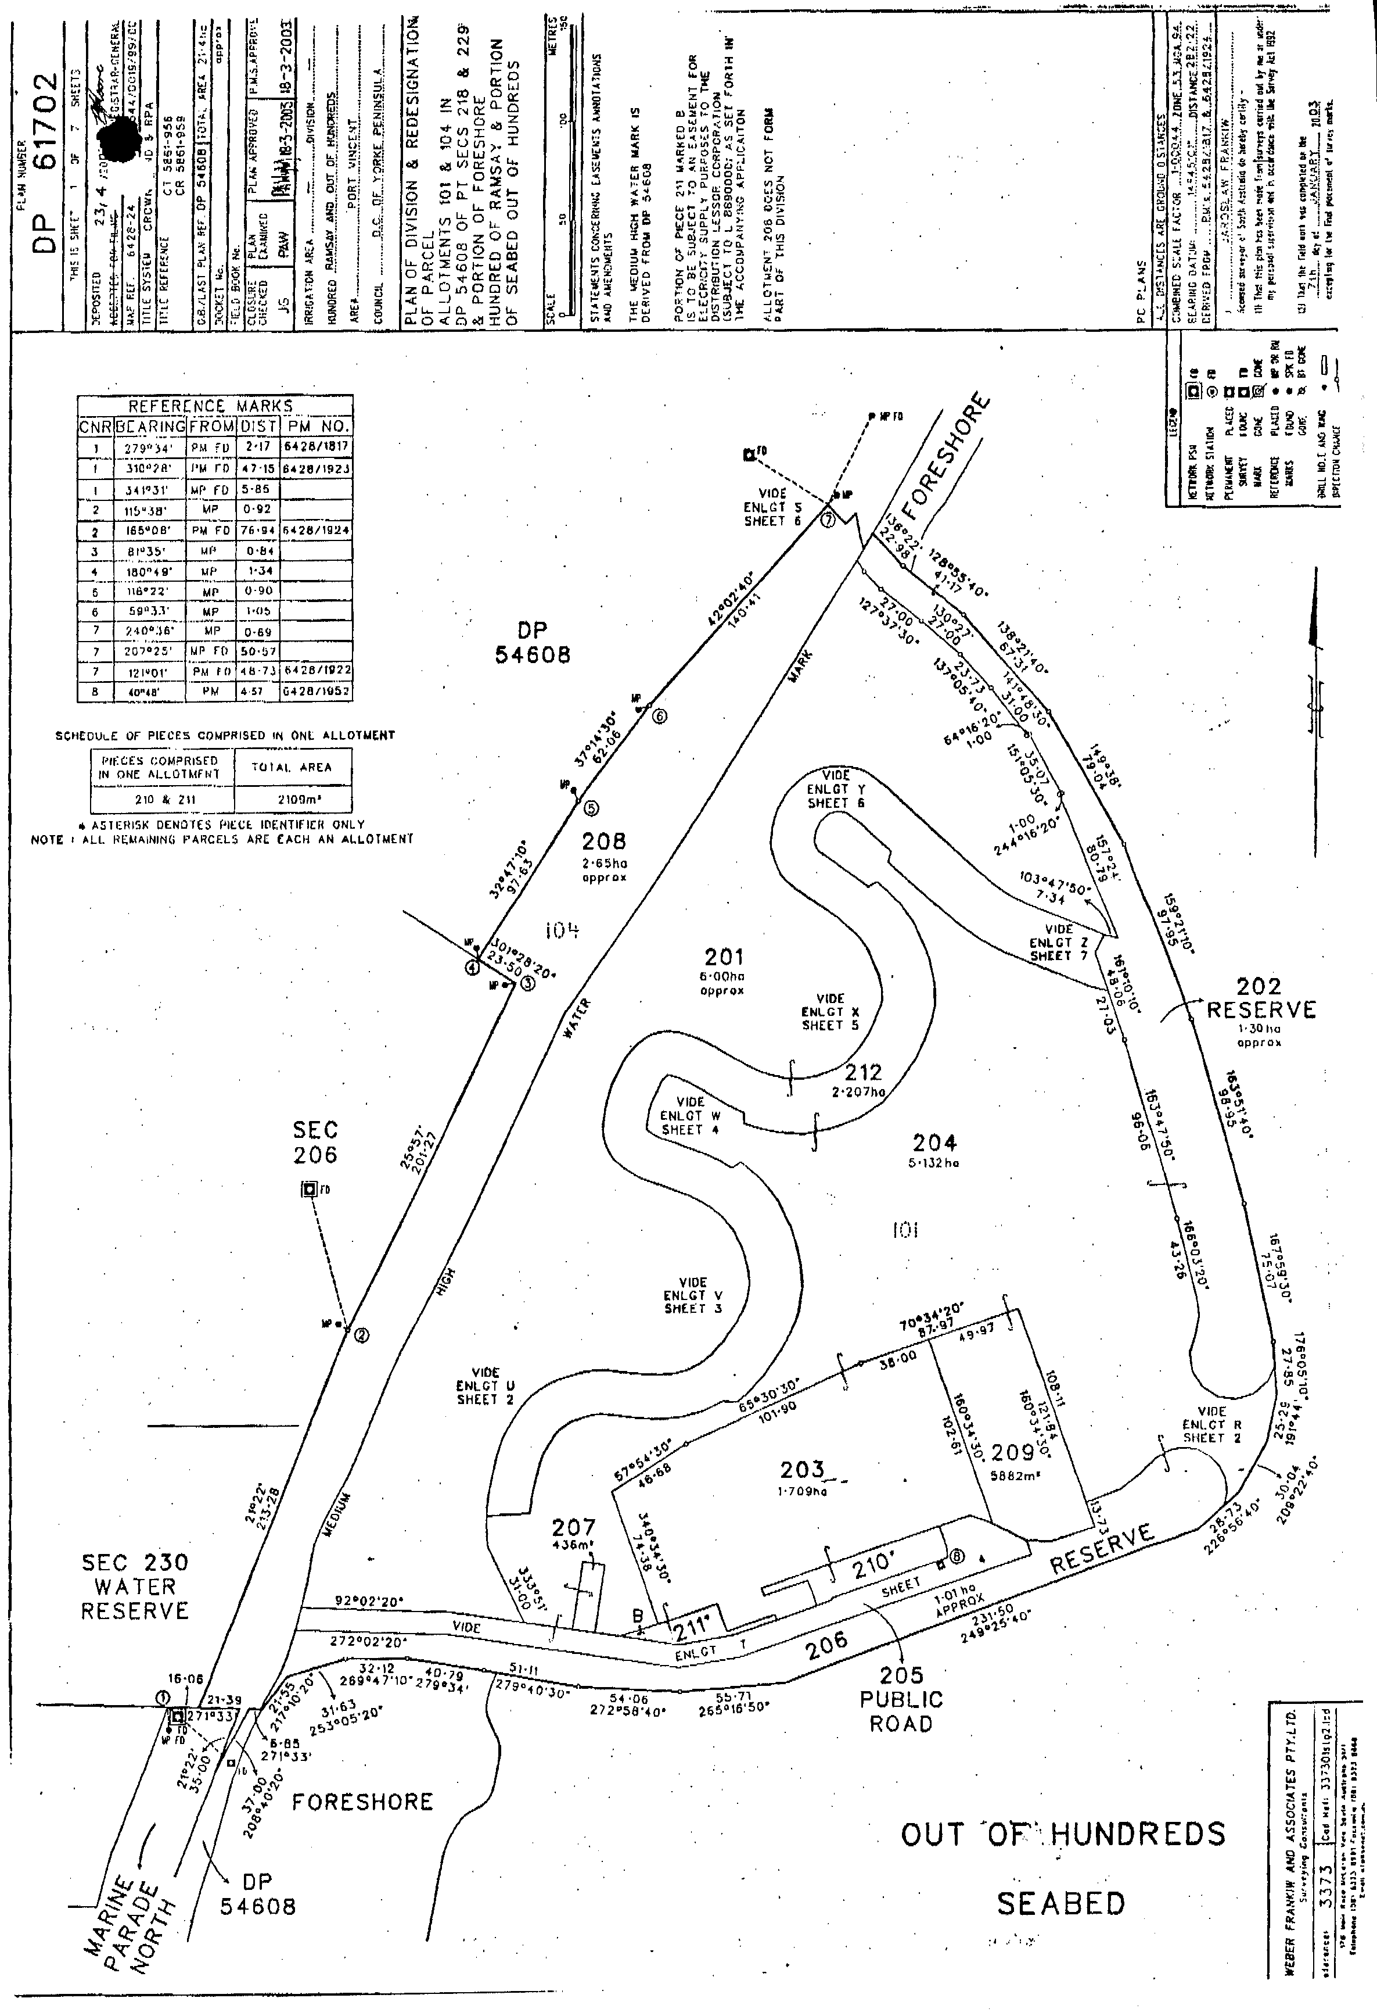

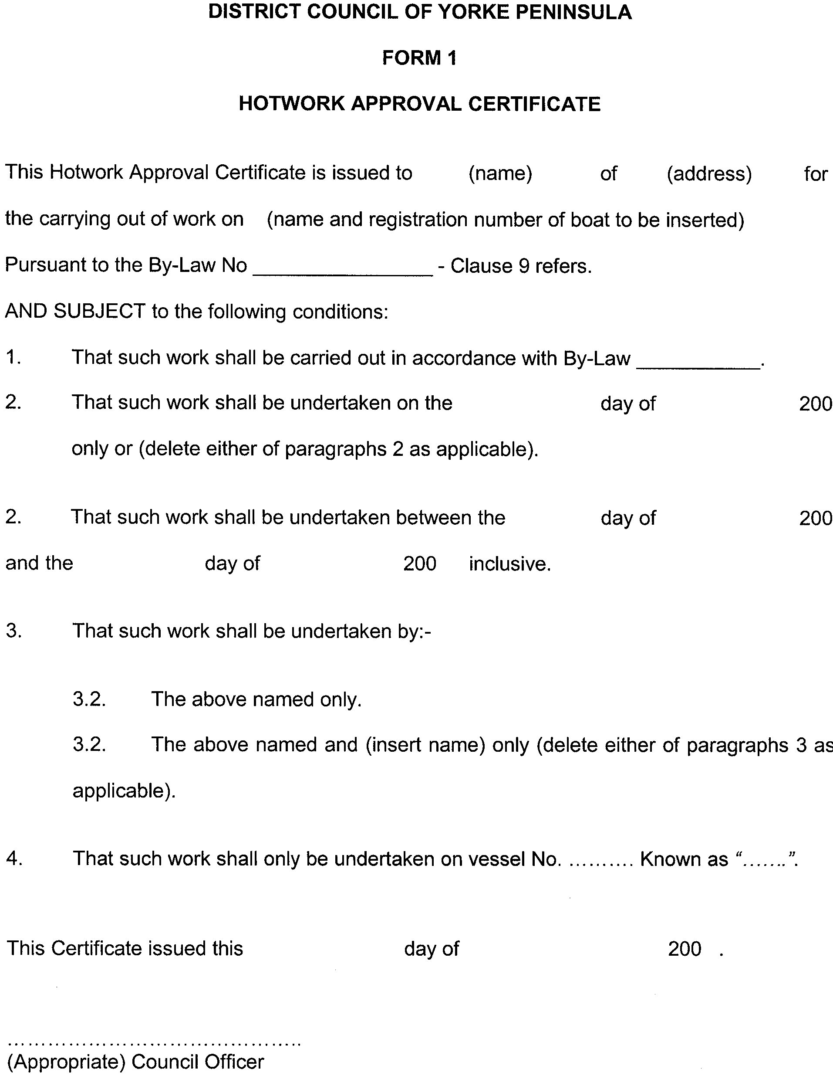

DISTRICT COUNCIL OF YANKALILLA
Temporary Road Closure
NOTICE is hereby given that the District Council of Yankalilla at its meeting held on 18 May 2006, resolved that pursuant to section 339 (1) of the Local Government Act 1934, as amended, that all vehicles other than those vehicles identified in Column 3 below, shall be excluded from the road so named in Column 1 and as described in Column 2.
Column 1  Street | Column 2  Location | Column 3  Class of Vehicle Exempt
Tuna Crescent, Carrickalinga (north-western section). | 5 m east of the eastern alignment of Lewis Road. | Any vehicle owned or operated by or on behalf of the District Council of Yankalilla for the purpose of road maintenance.  Non-motor powered cycles.

The closure to commence from 19 May 2006, for an indefinite period.
R. D. Sweetman, Chief Executive Officer

IN the matter of the estates of the undermentioned deceased persons:
Cameron, Joy Elizabeth, late of 22 Mathias Avenue, Cumberland Park, retired nurse, who died on 16 April 2006.
Camp, Mervyn Oldridge, late of Main Street, Curramulka, retired workshop supervisor, who died on 11 March 2006.
Collins, John James, late of 73 Gladstone Avenue, Magill, retired plumber, who died on 4 April 2006.
Eckhold, Joan Mary, late of 6 McInnes Terrace, Semaphore Park, widow, who died on 4 April 2006.
Fisk, Leila Ann, late of 86 Oaklands Road, Glengowrie, retired business proprietor, who died on 6 January 2006.
Hall, Violet Evelyn, late of 51 Eve Road, Bellevue Heights, of no occupation, who died on 17 February 2006.
Lochner, Anne Margaret, late of 2 Barton Court, St Agnes, receptionist, who died on 10 February 2006.
Miller, Dulcie Nita, late of Everard Street, Largs Bay, of no occupation, who died on 20 March 2006.
Mitchell, James Keith Lenton, late of 86 L’Estrange Street, Glenunga, retired machinist, who died on 10 August 2005.
Mitchell, John Anthony, late of 279 Wright Street, Adelaide, cleaner, who died on 4 February 2005.
Rodda, Dorothy Gwendoline, late of 580 Brighton Road, South Brighton, of no occupation, who died on 26 March 2006.
Scarman, Joyce Pearl, late of 101 Lake Terrace East, Mount Gambier, retired cook, who died on 13 March 2006.
Sosnitzki, Eva Maria, late of 2 Samuel Street, Tranmere, home duties, who died on 8 April 2006.
Thomas, Anthony Roger, late of 40 Winchester Street, Malvern, of no occupation, who died on 29 December 2004.
Notice is hereby given pursuant to the Trustee Act 1936, as amended, the Inheritance (Family Provision) Act 1972, and the Family Relationships Act 1975, that all creditors, beneficiaries, and other persons having claims against the said estates are required to send, in writing, to the Public Trustee, 25 Franklin Street, Adelaide, S.A. 5000, full particulars and proof of such claims, on or before 7 July 2006, otherwise they will be excluded from the distribution of the said estate; and notice is also hereby given that all persons who are indebted to the said estates are required to pay the amount of their debts to the Public Trustee or proceedings will be taken for the recovery thereof; and all persons having any property belonging to the said estates are forthwith to deliver the same to the Public Trustee.
Dated 8 June 2006.
C. J. O’Loughlin, Public Trustee

SOUTH AUSTRALIA—In the Supreme Court. No. 2298 of 1988. In the matter of Simes & Martin Pty Limited (ACN 007 713 242) and in the matter of the Corporations Law of South Australia.
Notice by a Liquidator of His Intention to Seek His Release
Take notice that I, Barrie Malcolm Mansom, 1st Floor, Menai House, 17 Bagot Street, North Adelaide, the liquidator of the abovenamed company, intend to make application to the Supreme Court of South Australia for my release as the liquidator of the abovenamed company.
Take further notice that if you have any objection to the granting of my release, you must file at the Supreme Court and also forward to me within 21 days of the publication in the Gazette of the notice of my intention to apply for a release a notice of objection in the form laid down by the Corporations (South Australia) Rules 1993.
Dated 12 December 2000.
B. M. Mansom, Liquidator
Note: Section 481 of the Corporations Law enacts that an order of the Court releasing a liquidator shall discharge him/her in the administration of the affairs of the company, or otherwise in relation to his or her conduct as liquidator, but any such order may be revoked on proof that is was obtained by fraud or by suppression or by concealment of any material fact.

SALE OF PROPERTY
Auction Date: Wednesday, 21 June 2006 at 10 a.m.
Location: Government Auctions SA, 47 Transport Avenue, Netley.
NOTICE is hereby given that on the above date at the time and place stated, by virtue of Orders for Sale issued by the Fines Payment Unit of South Australia—Penalty No. EXREG 00/74351-1 and others, are directed to the Sheriff of South Australia in an action wherein Michael Brenton Stevens is the Defendant, I, Mark Stokes, Sheriff of the State of South Australia, will by my auctioneers, Government Auctions SA make sale of the following:
Nissan 4WD, Registration No. VTS 192

ATTENTION

CUSTOMERS requiring a proof of their notice for inclusion in the Government Gazette, please note that the onus is on you to inform Government Publishing SA of any subsequent corrections by 10 a.m. on Thursday, which is our publication deadline.

For any corrections to your notice please phone 8207 1045 or Fax 8207 1040 before 10 a.m. on Thursday.

If we do not receive any communication by 10 a.m. on Thursday (day of publication) we will presume the notice is correct and will print it as it is.

Remember—the onus is on you to inform us of any corrections necessary to your notice.

NOTE: Closing time for lodging new copy (electronically, fax or hard copy) is 4 p.m. on Tuesday preceding the day of publication. Phone 8207 1045—Fax 8207 1040.
Email: governmentgazette@saugov.sa.gov.au

Printed and published by authority every Thursday by K. O’CALLAGHAN, Government Printer, South Australia
Price: $5.00, plus postage; to subscribers, $254.00 per annum.
(The above prices are inclusive of GST)

