No. 35 1981

THE SOUTH AUSTRALIAN

GOVERNMENT GAZETTE
www.governmentgazette.sa.gov.au

PUBLISHED BY AUTHORITY

ALL PUBLIC ACTS appearing in this GAZETTE are to be considered official, and obeyed as such

ADELAIDE, THURSDAY, 22 JUNE 2006

CONTENTS

Page
Act Assented To 1982
Appointments, Resignations, Etc. 1982
Australian Energy Market Commission—Notice 1983
Corporations and District Councils—Notices 2050
Crown Lands Act 1929—Notices 1983
Development Act 1993—Notice 1983
Development Regulations 1993—Notice 1983
Dog Fence Act 1946—Notice 1984
ETSA Utilities Network Tariffs 1985
Fisheries Act 1982—Notices 1999
Gas Act 1997—Notice 1998
Land Acquisition Act 1969—Notice 2001
Land and Business (Sale and Conveyancing) Act 1994—
Notices 2001
Liquor Licensing Act 1997—Notices 2002
Mining Act 1971—Notice 2005
National Electricity Law—Notice 2005
Natural Resources Management Act 2004—Notices 2006
Occupational Health, Safety and Welfare Act 1986—
Notice 2007
Page
Passenger Transport Act 1994—Notice 2007
Petroleum Act 2000—Notices 2007
Proclamations 2012
Radiation Protection and Control Act 1982—
Notice 2010

REGULATIONS
Psychological Practices Act 1973 (No. 172 of 2006) 2015
Public and Environmental Health Act 1987
(No. 173 of 2006) 2016
Gaming Machines Act 1992 (No. 174 of 2006) 2018
Environment Protection Act 1993 (No. 175 of 2006) 2022
Justices of the Peace Act 2005 (No. 176 of 2006) 2028
Development Act 1993 (No. 177 of 2006) 2035
Retention of Title 1983
Roads (Opening and Closing) Act 1991—Notices 2010
Superannuation Act 1988—Notice 2010
Superannuation Funds Management Corporation of
South Australia Act 1995—Notice 2011
Transport—Notice to Mariners 2007

GOVERNMENT GAZETTE NOTICES
ALL poundkeepers’ and private advertisements forwarded for publication in the South Australian Government Gazette must be PAID FOR PRIOR TO INSERTION; and all notices, from whatever source, should be legibly written on one side of the paper only and sent to Government Publishing SA so as to be received no later
than 4 p.m. on the Tuesday preceding the day of publication. Phone 8207 1045 or Fax 8207 1040. E-mail: governmentgazette@saugov.sa.gov.au. Send as attachments in Word format and please confirm your transmission with a faxed copy of your document, including the date the notice is to be published and to whom the notice will be charged. The Government Gazette is available online at: www.governmentgazette.sa.gov.au

Department of the Premier and Cabinet
Adelaide, 22 June 2006
HER Excellency the Governor directs it to be notified for general information that she has in the name and on behalf of Her Majesty The Queen, this day assented to the undermentioned Acts passed by the Legislative Council and House of Assembly in Parliament assembled, viz.:
No. 4 of 2006—Gas Pipelines Access (South Australia) (Greenfields Pipeline Incentives) Amendment Act 2006. An Act to amend the Gas Pipelines Access (South Australia) Act 1997.
By command,
J. W. Weatherill, for Premier
DPC 06/0875

Department of the Premier and Cabinet
Adelaide, 22 June 2006
HER Excellency the Governor in Executive Council has been pleased to appoint the undermentioned to the History Trust of South Australia, pursuant to the provisions of the History Trust of South Australia Act 1981:
Member: (from 22 June 2006 until 21 June 2009)
Philip Satchell
By command,
J. W. Weatherill, for Premier
CASA 2002/00006

Department of the Premier and Cabinet
Adelaide, 22 June 2006
HER Excellency the Governor in Executive Council has been pleased to appoint the undermentioned to the Motor Accident Commission, pursuant to the Motor Accident Commission Act 1992:
Chair: (from 1 July 2006 until 30 June 2007)
Roger Cook
By command,
J. W. Weatherill, for Premier
TF 06/046 CS

Department of the Premier and Cabinet
Adelaide, 22 June 2006
HER Excellency the Governor in Executive Council has been pleased to appoint the Honourable Paul Holloway, MLC, Minister for Police, Minister for Mineral Resources Development and Minister for Urban Development and Planning to be also Acting Deputy Premier, Acting Treasurer, Acting Minister for Industry and Trade and Acting Minister for Federal/State Relations for the period 23 June 2006 to 13 July 2006 inclusive during the absence of the Honourable Kevin Owen Foley, MP.
By command,
J. W. Weatherill, for Premier
MIT 06/007 CS

Department of the Premier and Cabinet
Adelaide, 22 June 2006
HER Excellency the Governor in Executive Council has been pleased to appoint the Honourable John David Hill, MP, Minister for Health, Minister for the Southern Suburbs and Minister Assisting the Premier in the Arts to be also Acting Minister for Education and Children’s Services, Acting Minister for Tourism and Acting Minister for the City of Adelaide for the period 26 June 2006 to 4 July 2006 inclusive during the absence of the Honourable Jane Diane Lomax-Smith, MP.
By command,
J. W. Weatherill, for Premier
MECS 06/008 CS

Department of the Premier and Cabinet
Adelaide, 22 June 2006
HER Excellency the Governor in Executive Council has been pleased to appoint the Honourable Paul Holloway, MLC, Minister for Police, Minister for Mineral Resources Development and Minister for Urban Development and Planning to be also Acting Minister for Emergency Services, Acting Minister for Correctional Services and Acting Minister for Road Safety for the period 2 July 2006 to 18 July 2006 inclusive during the absence of the Honourable Carmel Zollo, MLC.
By command,
J. W. Weatherill, for Premier
MES 06/007

Department of the Premier and Cabinet
Adelaide, 22 June 2006
HER Excellency the Governor in Executive Council has been pleased to appoint the Honourable John David Hill, MP, Minister for Health, Minister for the Southern Suburbs and Minister Assisting the Premier in the Arts to be also Acting Minister for Environment and Conservation and Acting Minister for Mental Health and Substance Abuse for the period 28 June 2006 to 5 July 2006 inclusive during the absence of the Honourable Gail Gago, MLC.
By command,
J. W. Weatherill, for Premier
EHCS 06/0006

Department of the Premier and Cabinet
Adelaide, 22 June 2006
HER Excellency the Governor in Executive Council has been pleased to appoint the people listed as Justices of the Peace for South Australia, pursuant to section 4 of the Justices of the Peace Act 1991:
Chad Robert Cambell Buchanan
Randall Jeff Crozier
Thomas Haig
Spiros Karanikos-Mimis
Tanya Rosina Kerr
Andrea Ruth Moore
Naomi Sarah Moore
Amal Mia Zahra
By command,
J. W. Weatherill, for Premier
AGO 0039/03 CS

Department of the Premier and Cabinet
Adelaide, 22 June 2006
HER Excellency the Governor in Executive Council has removed James Vincent Hallion, former Chief Executive of the Department of Primary Industries and Resources from the office of Deputy Commissioner representing South Australia on the Murray-Darling Basin Commission, effective from 22 June 2006, pursuant to section 11 of the Murray-Darling Basin Act 1993.
By command,
J. W. Weatherill, for Premier
MRMCS 06/005

Department of the Premier and Cabinet
Adelaide, 22 June 2006
HER Excellency the Governor in Executive Council has been pleased to appoint Geoffrey Ronald Knight, Acting Chief Executive of the Department of Primary Industries and Resources, as a Deputy Commissioner representing South Australia on the Murray-Darling Basin Commission for a period commencing on 22 June 2006 and expiring on 19 June 2009, pursuant to section 6 (1) of the Murray-Darling Basin Act 1993.
By command,
J. W. Weatherill, for Premier
MRMCS 06/005

Department of the Premier and Cabinet
Adelaide, 22 June 2006
HER Excellency the Governor in Executive Council has accepted the resignation of His Honour Judge Alan Moss from the Offices of Judge of the District Court of South Australia and Senior Judge of the Youth Court of South Australia, with effect from 4 August 2006.
By command,
J. W. Weatherill, for Premier
AGO 0098/05 CS

Department of the Premier and Cabinet
Adelaide, 22 June 2006
HER Excellency the Governor directs it to be notified that she has been pleased to approve retention of the title Honourable by:
The Honourable Stephanie Key, MP.
Dated 9 June 2006.
By command,
Mike Rann, Premier
DPC 06/0670

AUSTRALIAN ENERGY MARKET COMMISSION
Appointment
I, PATRICK CONLON, Minister for Energy advise that, on 19 June 2006, pursuant to the Australian Energy Market Commission Establishment Act 2004, I appointed Liza Carver as Acting Chairperson of the Australian Energy Market Commission for the periods when the Chairperson is unable to perform official functions, or when the office of the Chairperson is vacant. The term of the acting appointment will continue until such time as Liza Carver ceases to be a Commissioner of the Australian Energy Market Commission, as nominated by the Ministerial Council on Energy (States and Territories). The term of the acting appoint-ment will cease in the event that Liza Carver is nominated to the position of Commissioner by the Commonwealth.
Patrick Conlon, Minister for Energy

CROWN LANDS ACT 1929: SECTION 5
TAKE NOTICE that pursuant to the Crown Lands Act 1929, I, GAIL GAGO, Minister for Environment and Conservation, Minister of the Crown to whom the administration of the Crown Lands Act 1929 is committed DO HEREBY dedicate the Crown Land defined in The Schedule as Public Road.
The Schedule
Sections 405, 410, 424, 439, 447, 448, 449, 450, 452, 453, 456, 462, 463, 478, Allotments 8 and 12 of Deposited Plan 51674, Allotments 4, 6, 7 and 8 of Deposited Plan 52537, Allotments 3, 4, 5, 6 and 7 of Deposited Plan 51656 and Allotments 2, 3, 4 and 7 of Deposited Plan 51173, Hundred of Cadell, County of Albert, being within the district of Mid Murray.
Dated 22 June 2006.
Gail Gago, Minister for Environment and Conservation
DEH 11/3426

CROWN LANDS ACT 1929: SECTION 5
TAKE NOTICE that pursuant to the Crown Lands Act 1929, I, GAIL GAGO, Minister for Environment and Conservation, Minister of the Crown to whom the administration of the Crown Lands Act 1929 is committed DO HEREBY dedicate the Crown Land defined in The Schedule as Public Road.
The Schedule
Section 851, Hundred of Waikerie, County of Albert, being the whole of the land comprised in Crown Record Volume 5442, Folio 498, being within the district of Loxton Waikerie.
Dated 22 June 2006.
Gail Gago, Minister for Environment and Conservation
DEH 11/3436

DEVELOPMENT ACT 1993, SECTION 25 (17): CITY OF MOUNT GAMBIER—FLETCHER JONES PLAN AMEND-MENT
Preamble
1. The Development Plan amendment entitled ‘City of Mount Gambier—Fletcher Jones Plan Amendment’ (the Plan Amend-ment) has been finalised in accordance with the provisions of the Development Act 1993.
2. The Minister for Urban Development and Planning has decided to approve the Plan Amendment.
Notice
PURSUANT to section 25 of the Development Act 1993, I—
(a) approve the Plan Amendment; and
(b) fix the day on which this notice is published in the Gazette as the day on which the Plan Amendment will come into operation.
Dated 22 June 2006.
Paul Holloway, Minister for Urban Development and Planning
PLN 05/0721

DEVELOPMENT REGULATIONS 1993
Notice Under Schedule 6
Preamble
Schedule 6 of the Development Regulations 1993, refers to a construction index determined by the Minister from time to time and set out in the Schedule of Construction Indices. The Construction Indices will be used in the determination of fees payable by applicants seeking assessment against the Building Rules under the Development Act 1993.
Notice
PURSUANT to Schedule 6 of the Development Regulations 1993, I have determined the Construction Indices in the Schedule for the purposes of Schedule 6 of the Development Regulations 1993.
This notice will come into effect on 1 July 2006.
Schedule
Schedule of 2006 Construction Indices
Dated 19 June 2006.
Building Classes | Construction Indices
Class 1, 2, 4 | 919
Class 3, 5, 6 | 1 223
Class 7, 8 | 811
Class 9a and 9c | 1 387
Class 9b | 1 261
Class 10 | 274
Paul Holloway, Minister for Urban Development and Planning

DOG FENCE ACT 1946
Declaration of Rate
PURSUANT to the provision of section 25 of the Dog Fence Act 1946, the Dog Fence Board, with the approval of the Minister for Environment and Conservation, hereby declares that for the financial year ending 30 June 2007 the dog fence rate shall be $1 per km² and the minimum amount payable $70 for all separate holdings for more than 10 km² of land situated inside the dog fence.
Excluding:
1. For all the land in:
(a) The whole of the counties of Musgrave, Flinders, Jervois, Frome, Victoria, Daly, Stanley, Gawler, Fergusson, Light, Eyre, Albert, Alfred, Adelaide, Sturt, Hindmarsh, Russell, Buccleuch, Chandos, Card-well, Buckingham, MacDonnell, Robe, Grey and Carnarvon.
(b) The whole of the Hundreds of Finlayson, Tarlton, Cungena, Kaldoonera, Scott, Murray, Chandada, Karcultaby, Condada, Pildappa, Ripon, Forrest, Camp-bell, Inkster, Moorkitabie, Carina, Minnipa, Pinbong, Wrenfordsley, Rounsevell, Witera, Addison, Travers, Yaninee, Pygery, Wudinna, Hill, Peella, Pordia, Palabie, Wannamanna, Mamblin, Kongawa, Pinka-willinie, Cortlinye, Moseley, Wright, Downer, Wallis, Cocata, Kappakoola, Warramboo, Cootra, Caralue, Solomon, Kelly, Barna, Yalanda, Panitya, Coomooroo, Walloway, Pekina, Black Rock Plain, Tarcowie, Mannanarie, Yongala, Terowie, Hallett, Kingston, Mongolata, Kooringa, Baldina, Apoinga and Bright.
Where this contribution from holdings in 1 (a) and 1 (b) is paid via the Sheep Advisory Group.
2. Lake Torrens National Park and Lake Gairdner National Park, which are exempted from dog fence rates.
3. All the islands along the seacoast.
M. J. Balharry, Manager, Dog Fence Administration, Land and Biodiversity Services Division, Department of Water, Land and Biodiversity Con-servation.

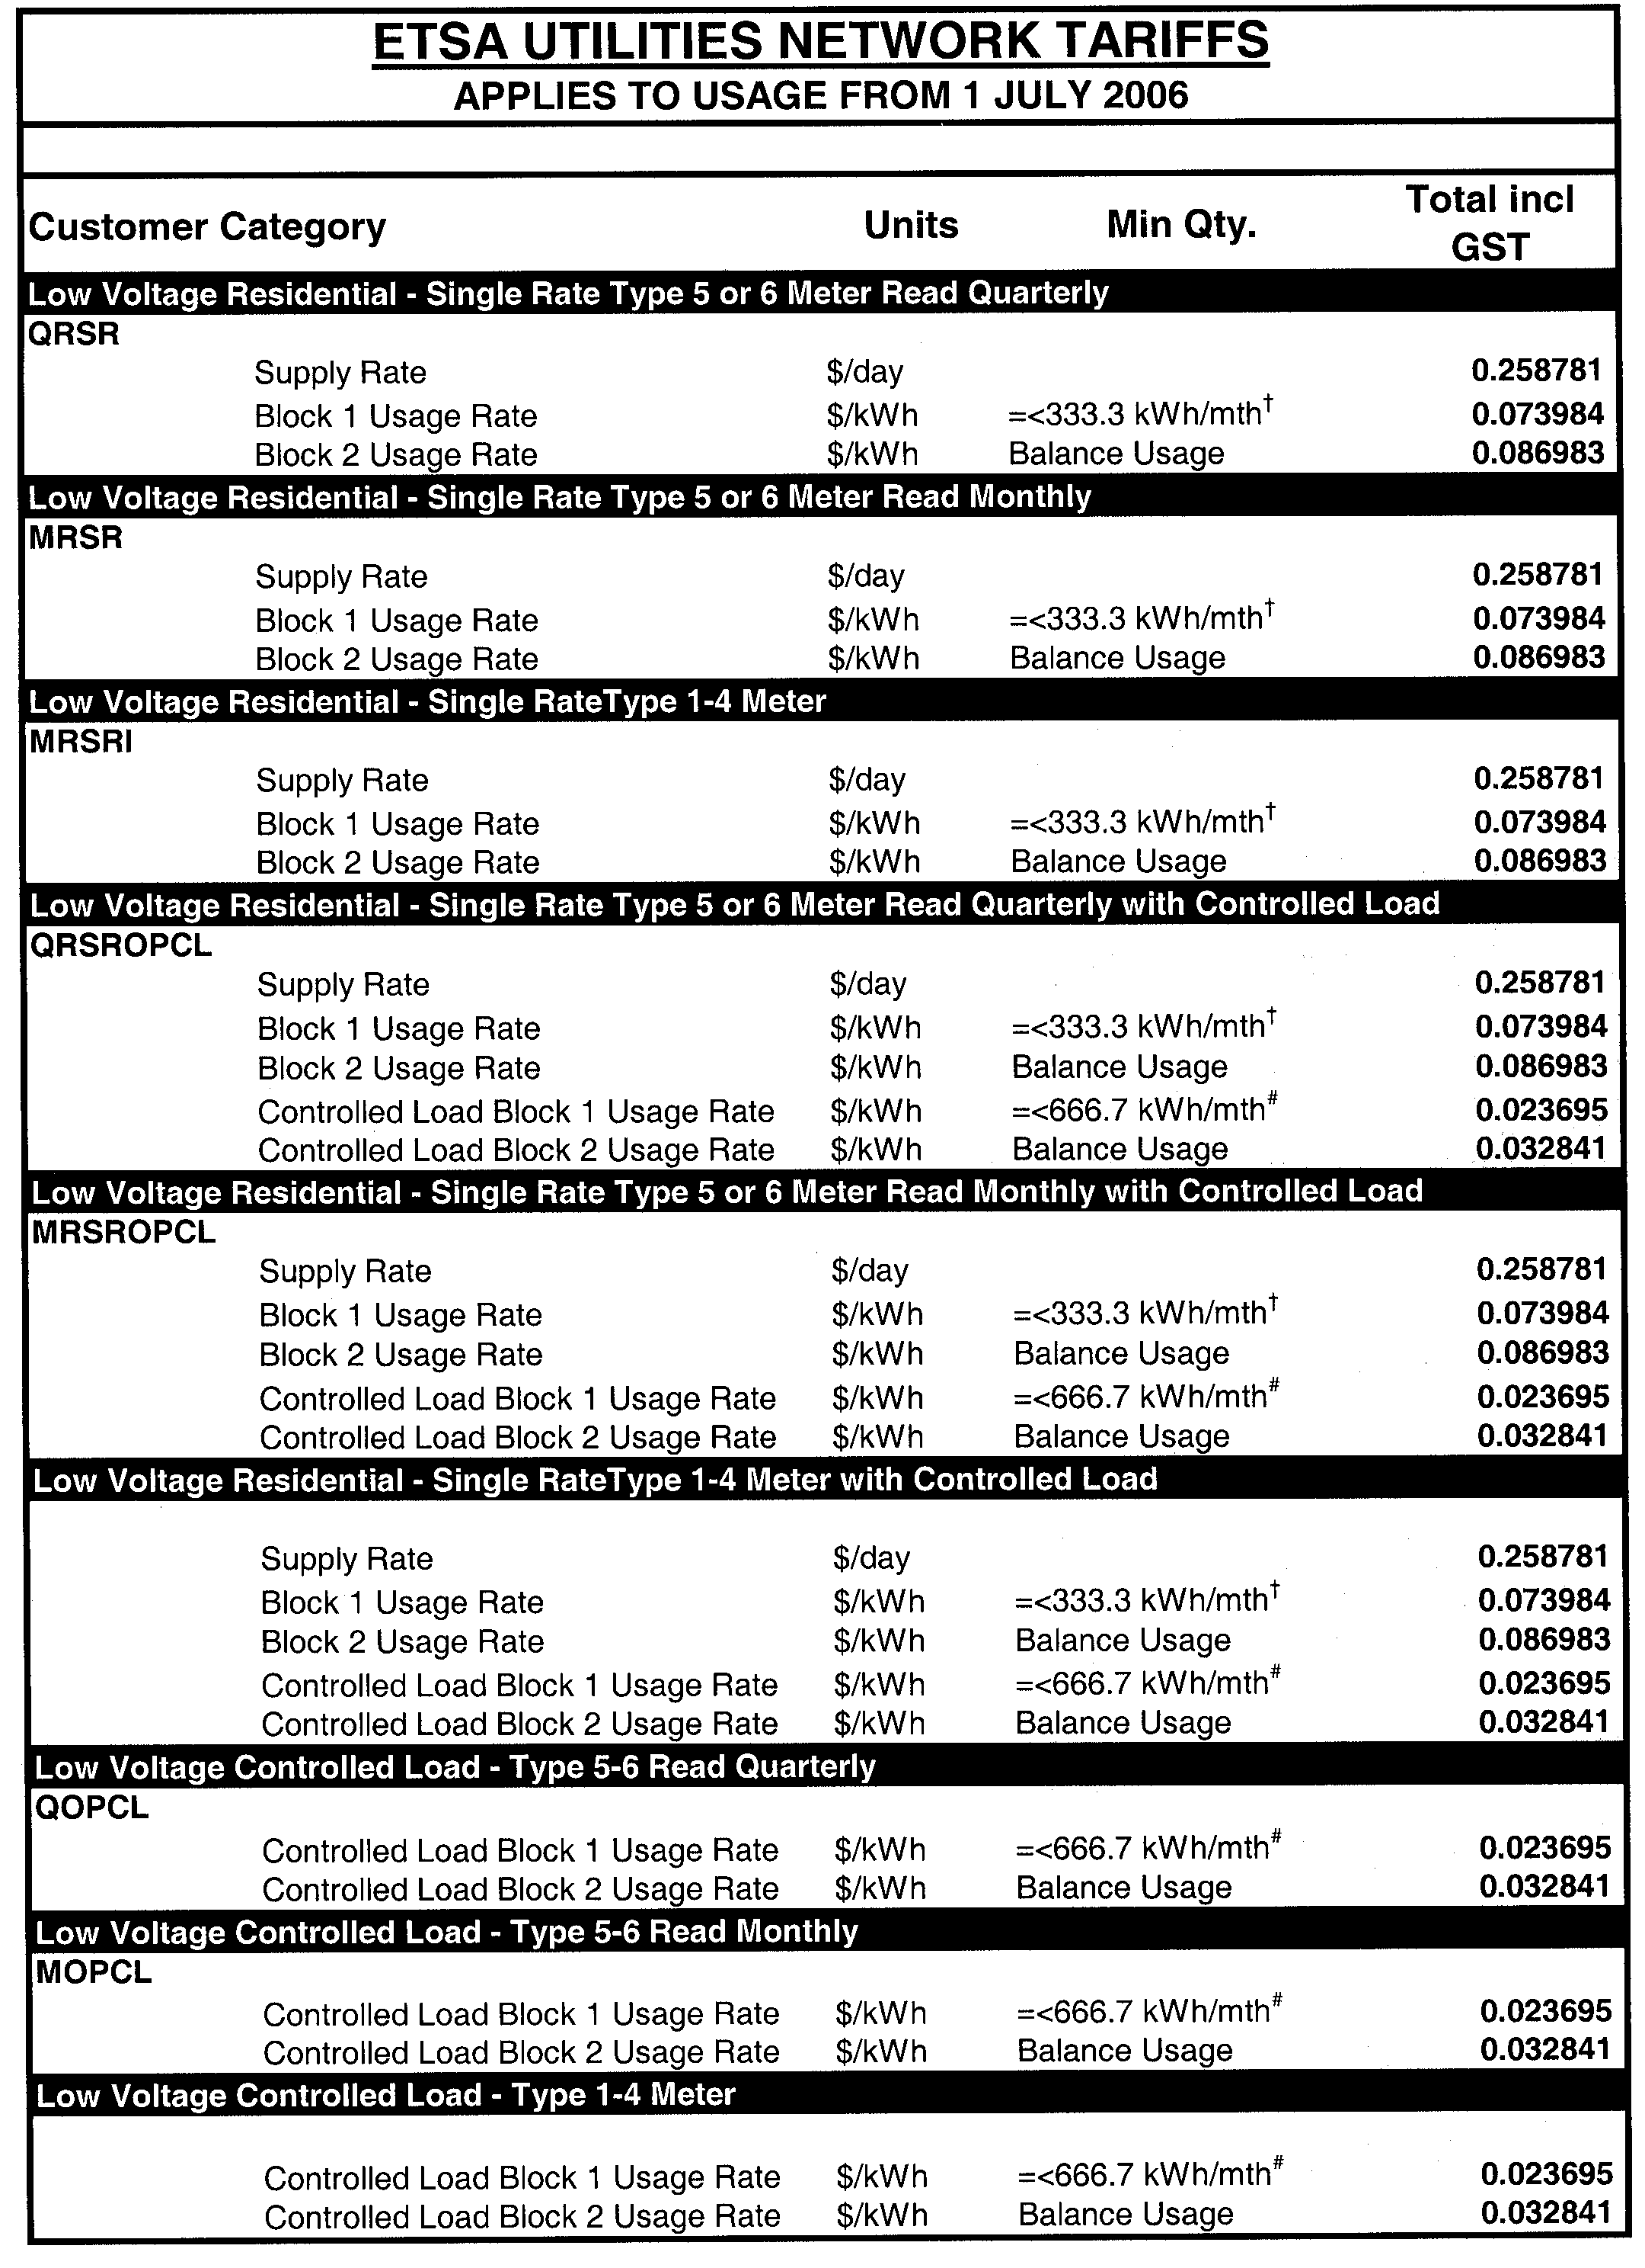
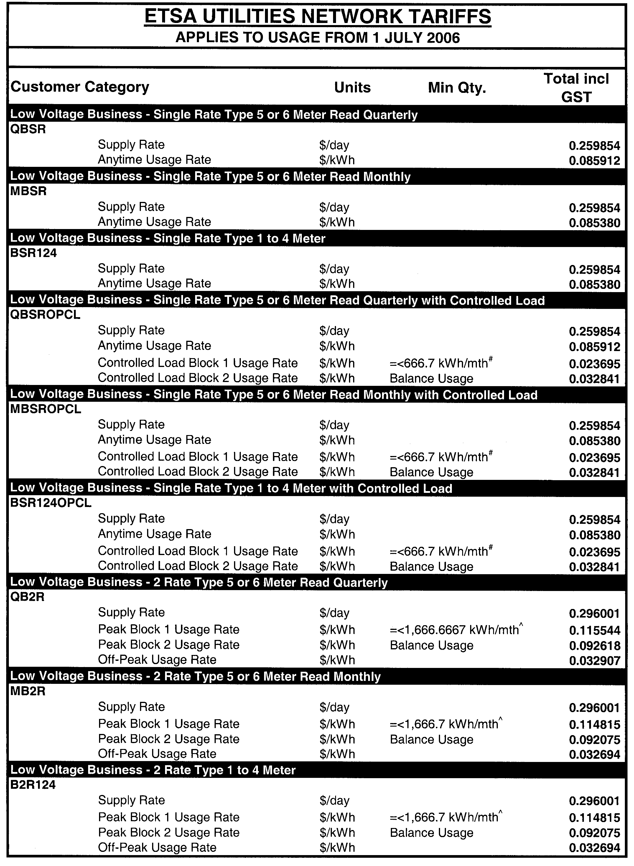
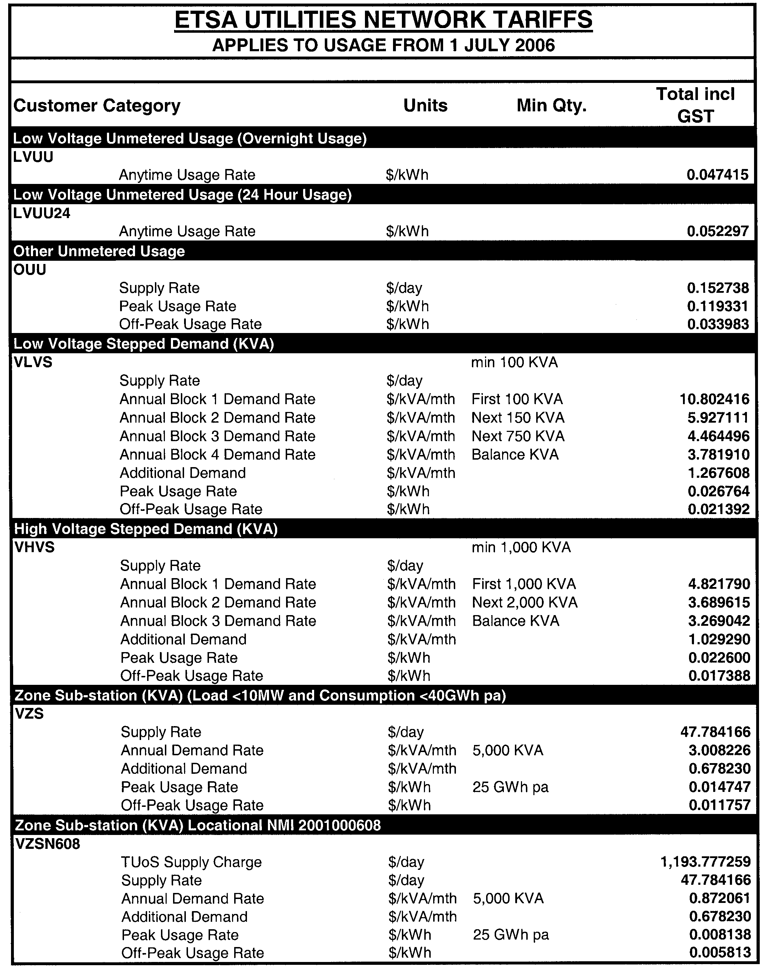
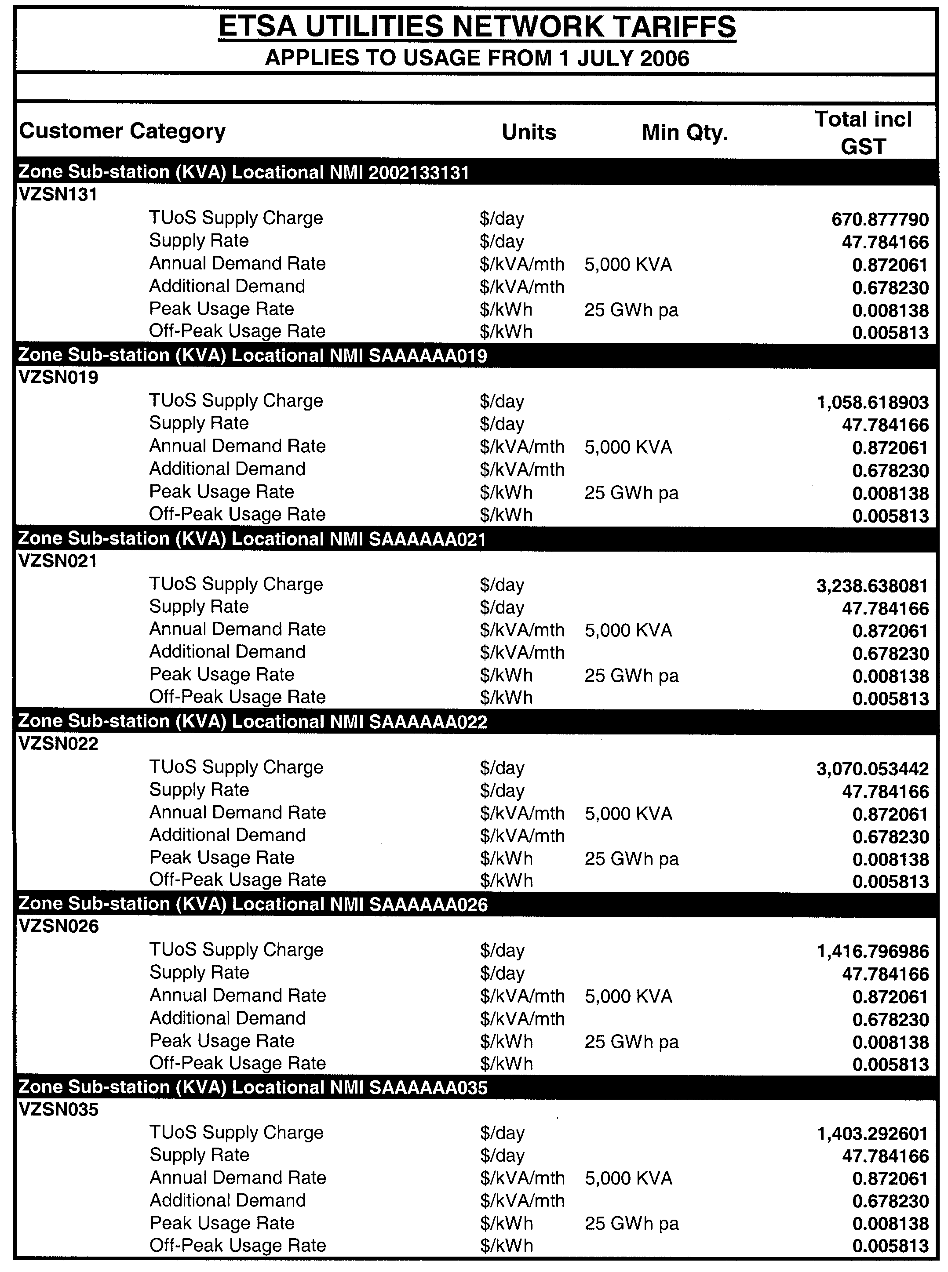
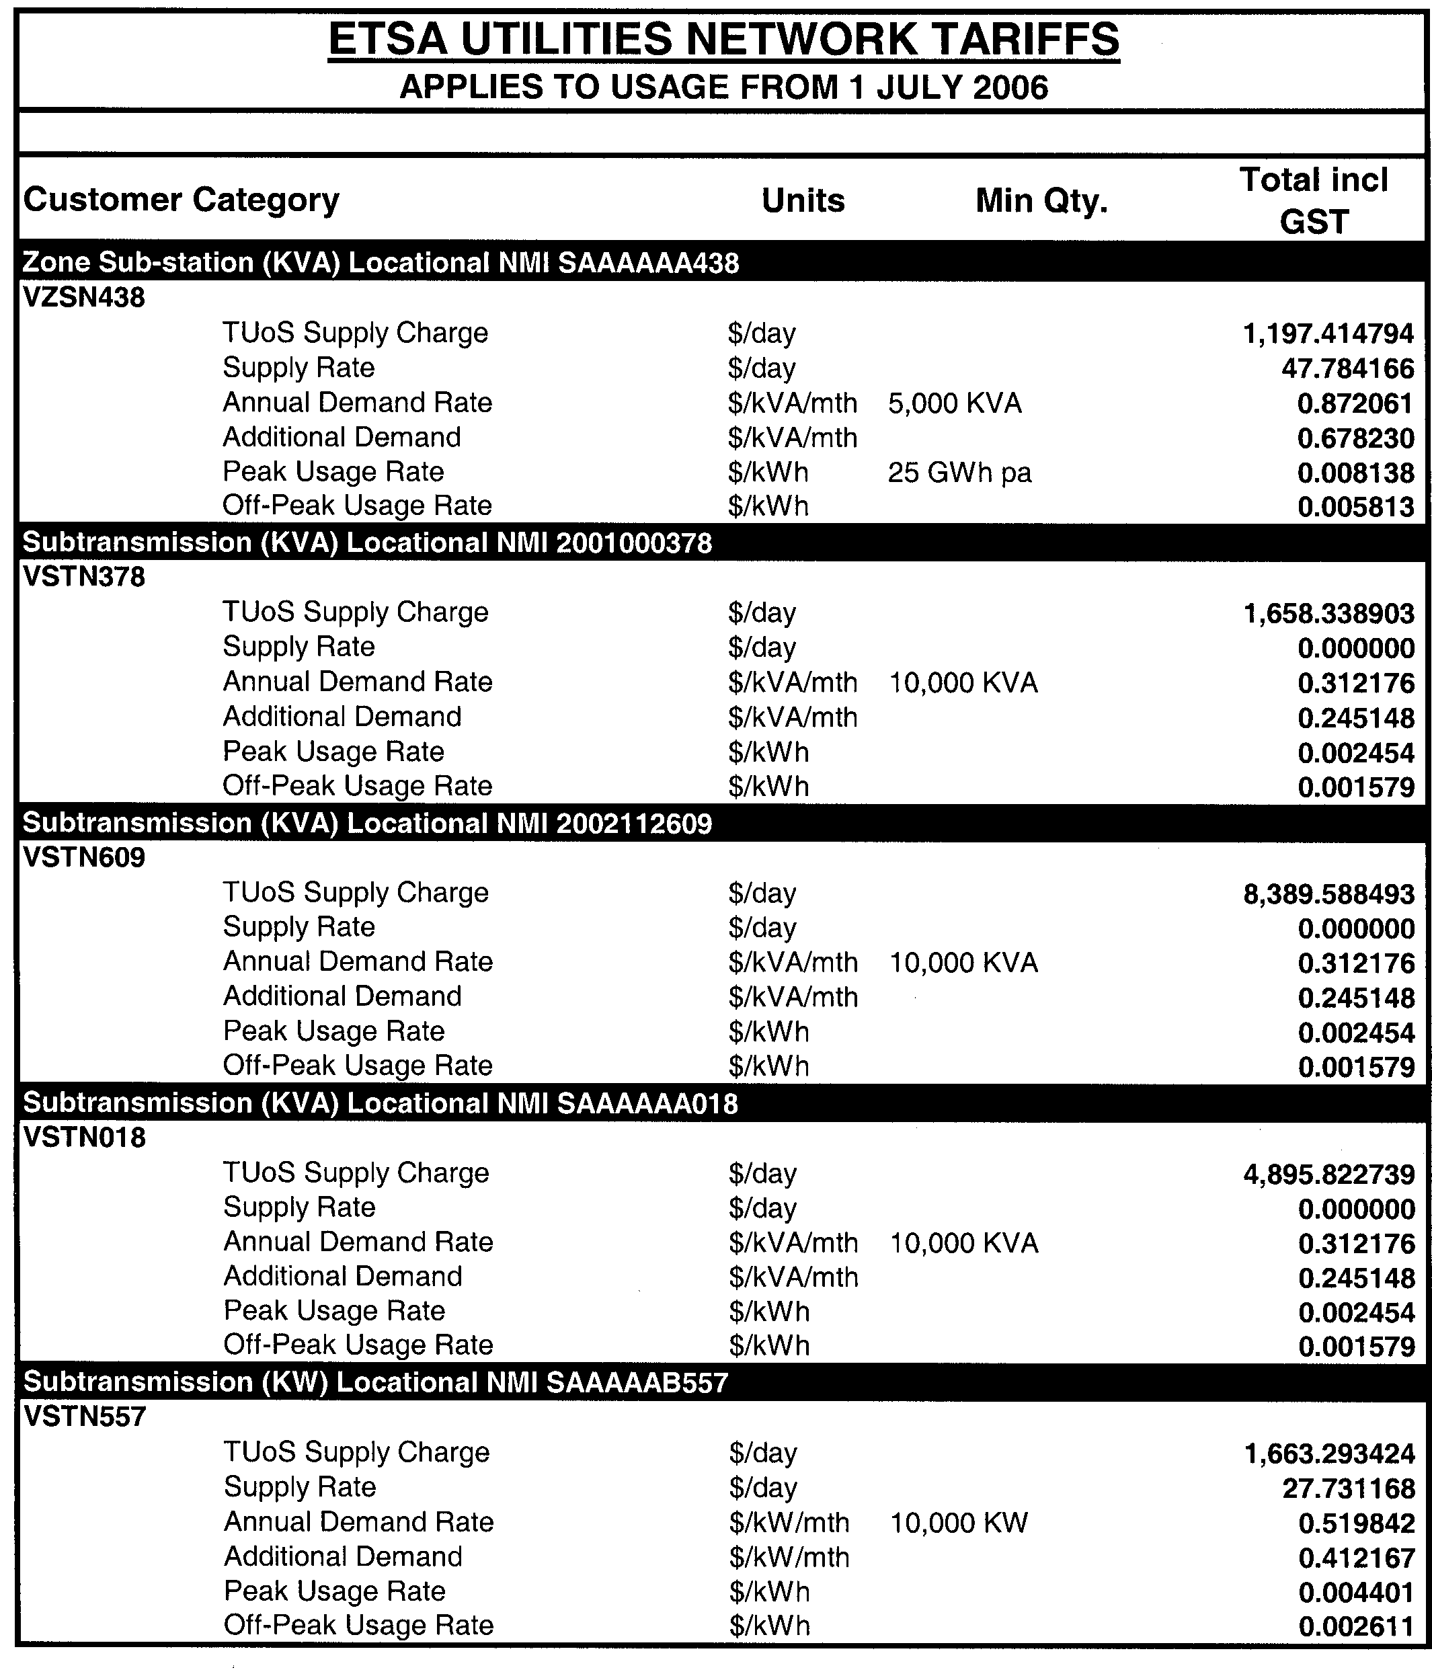
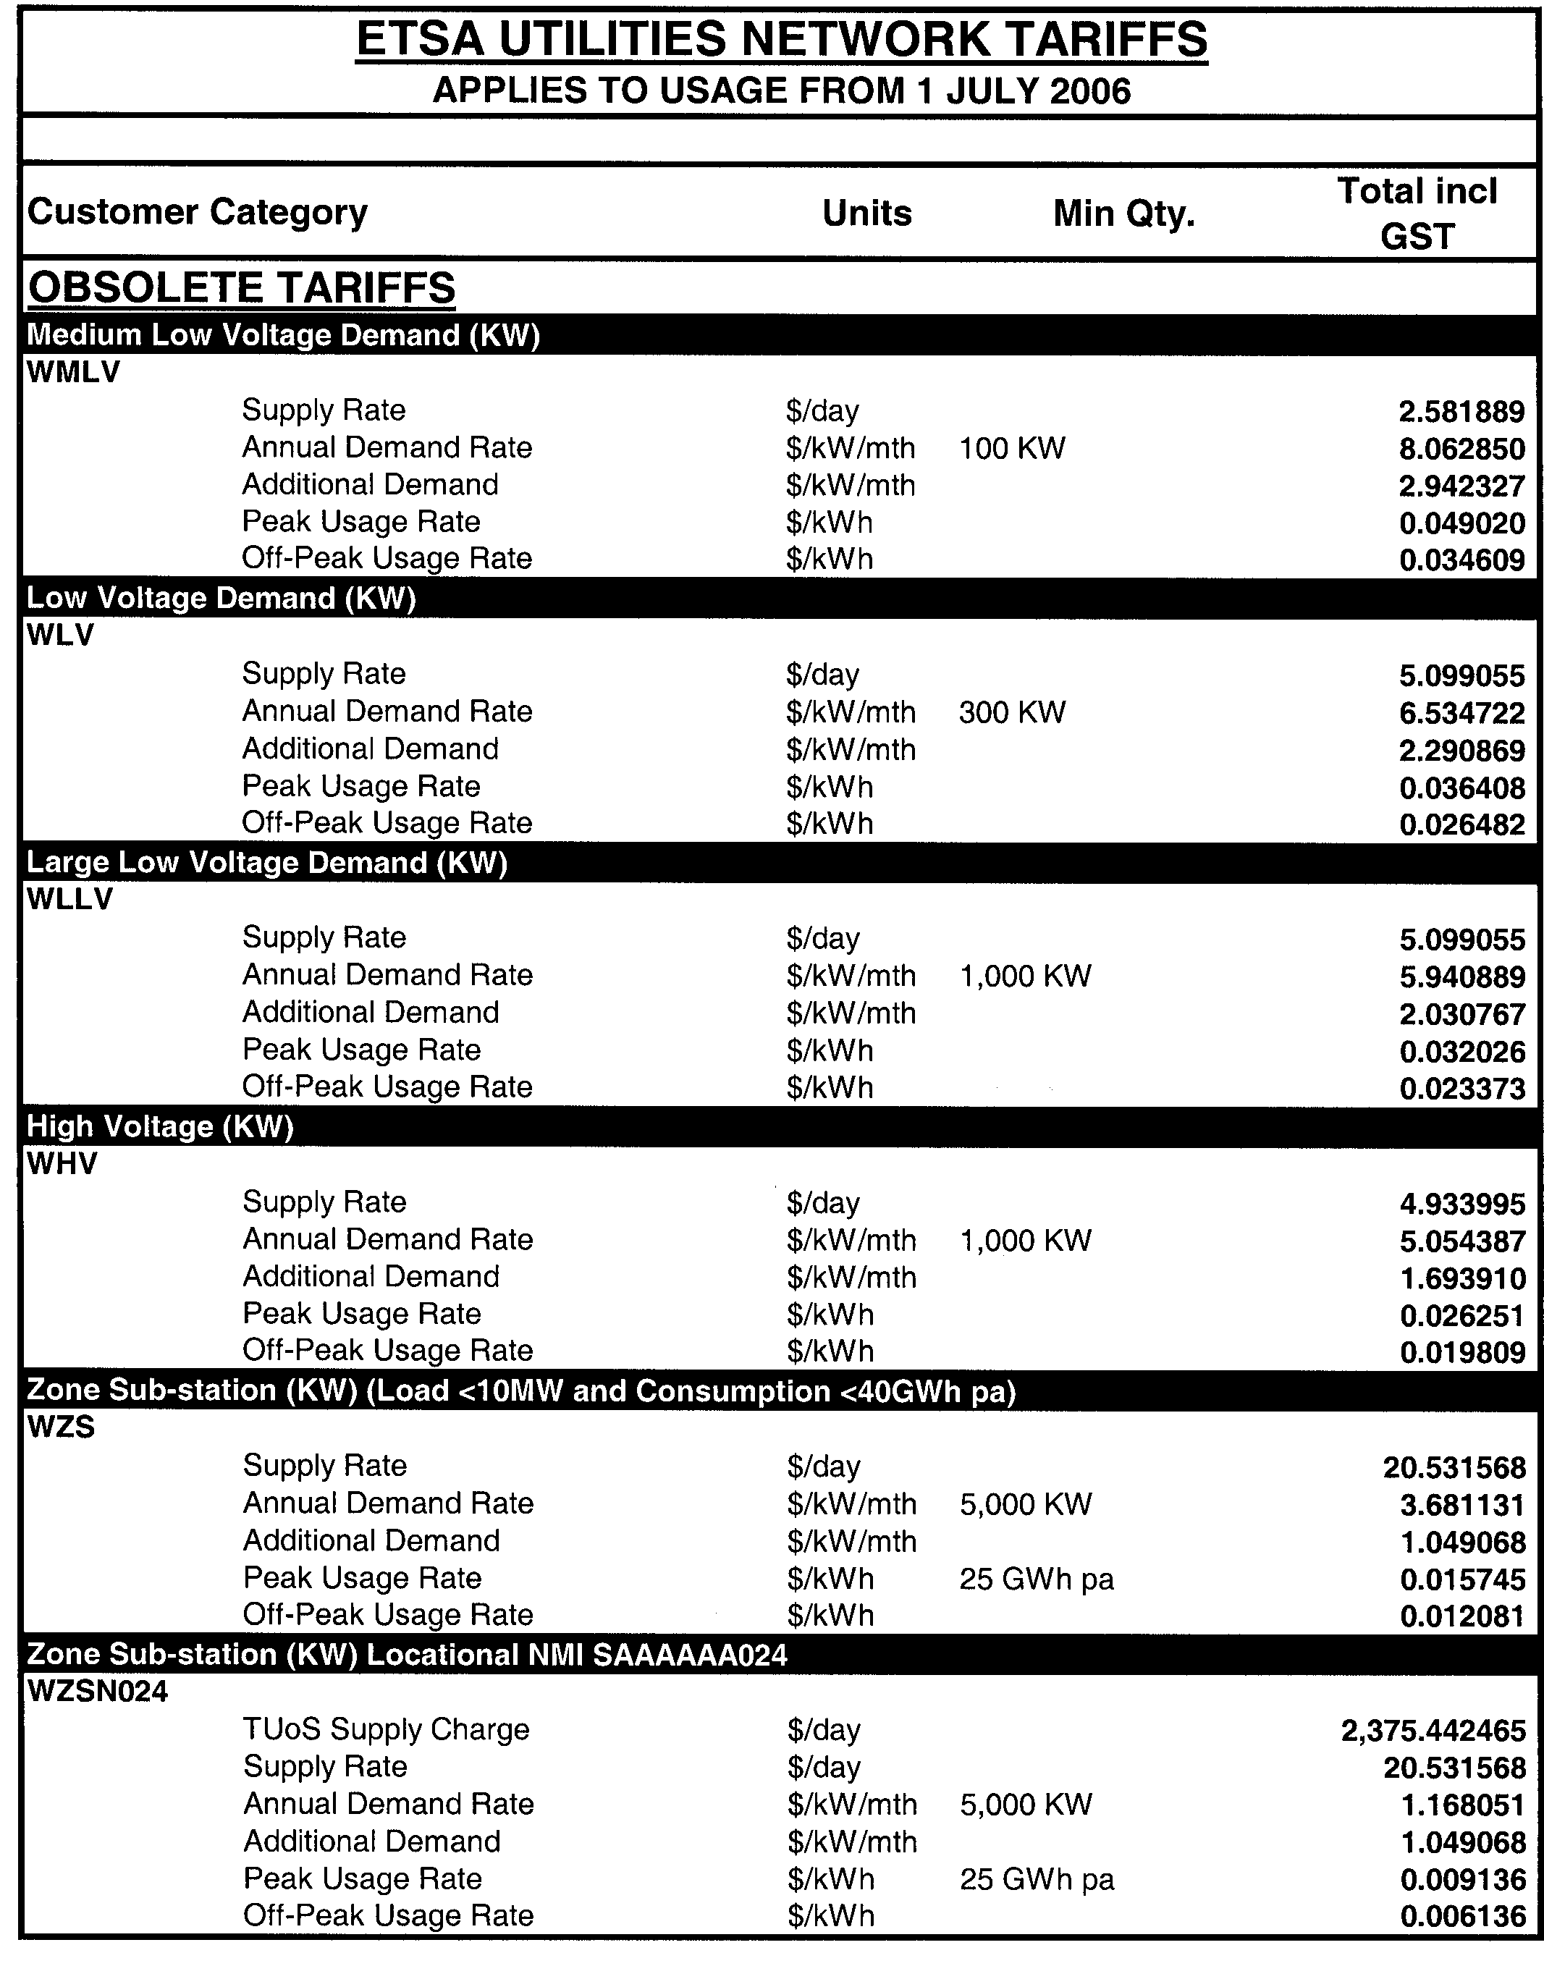
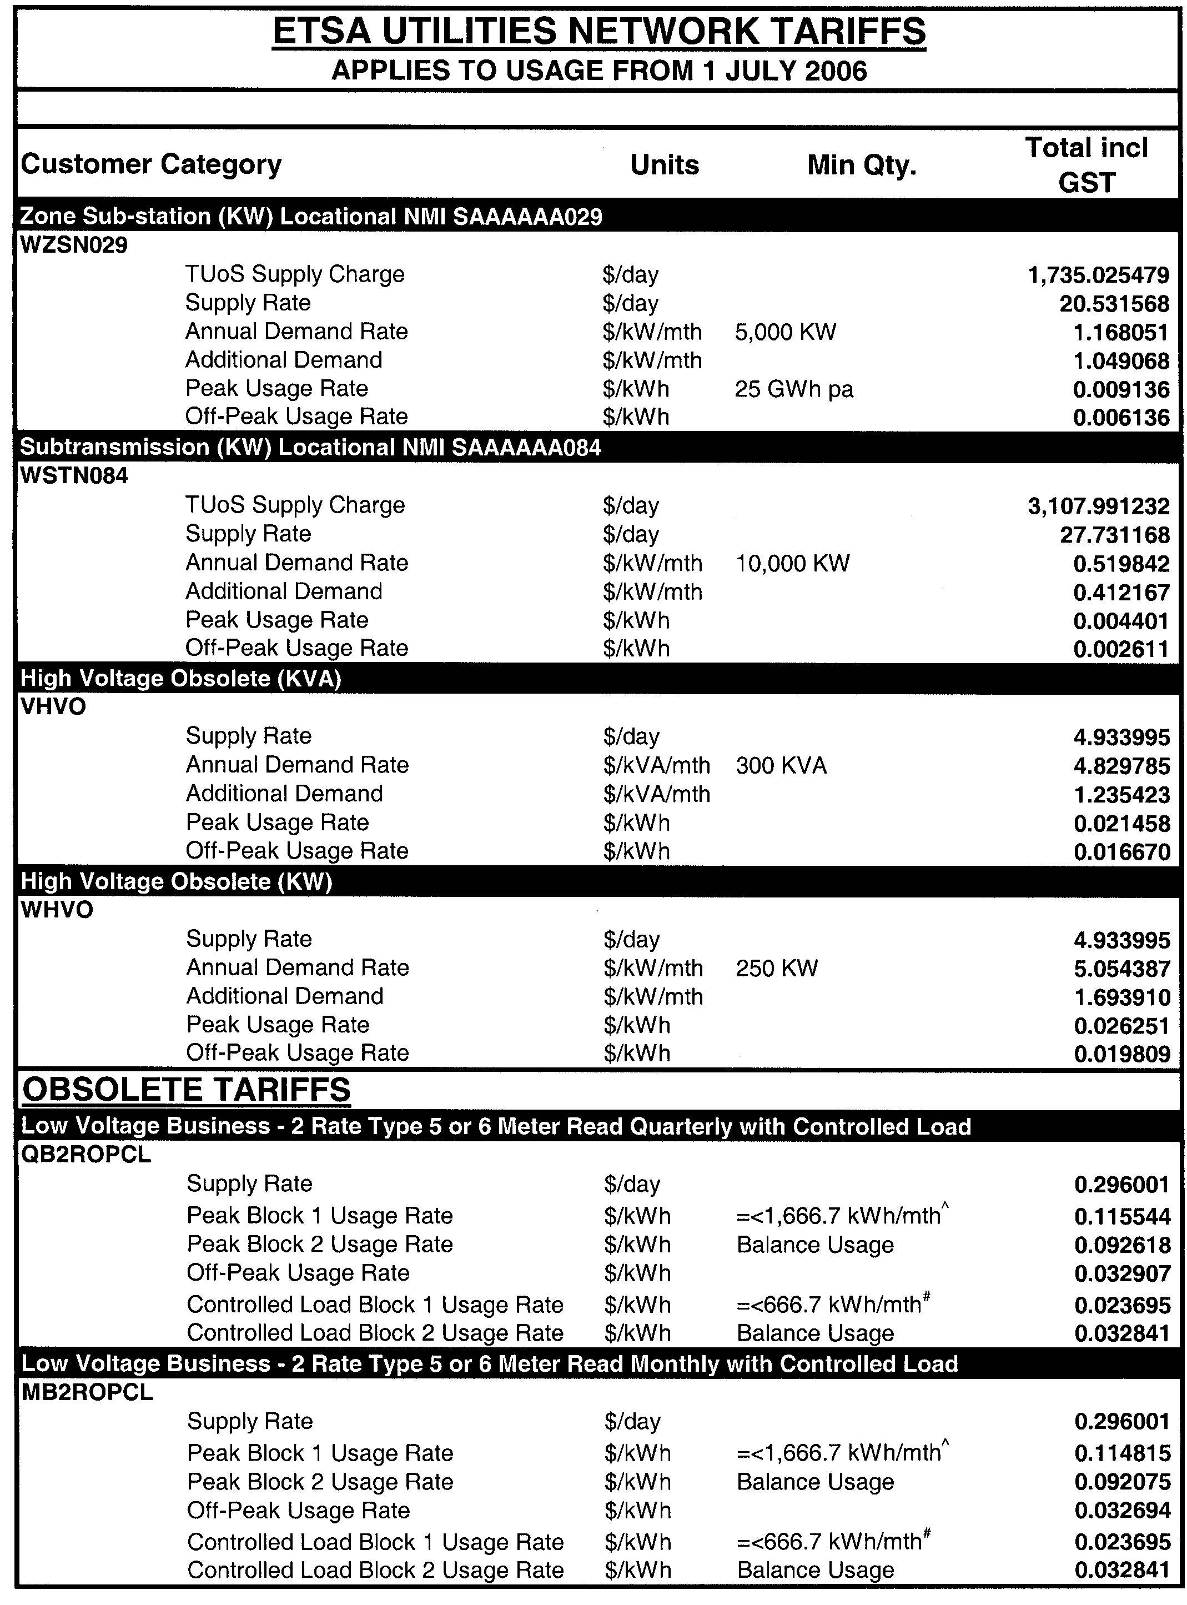
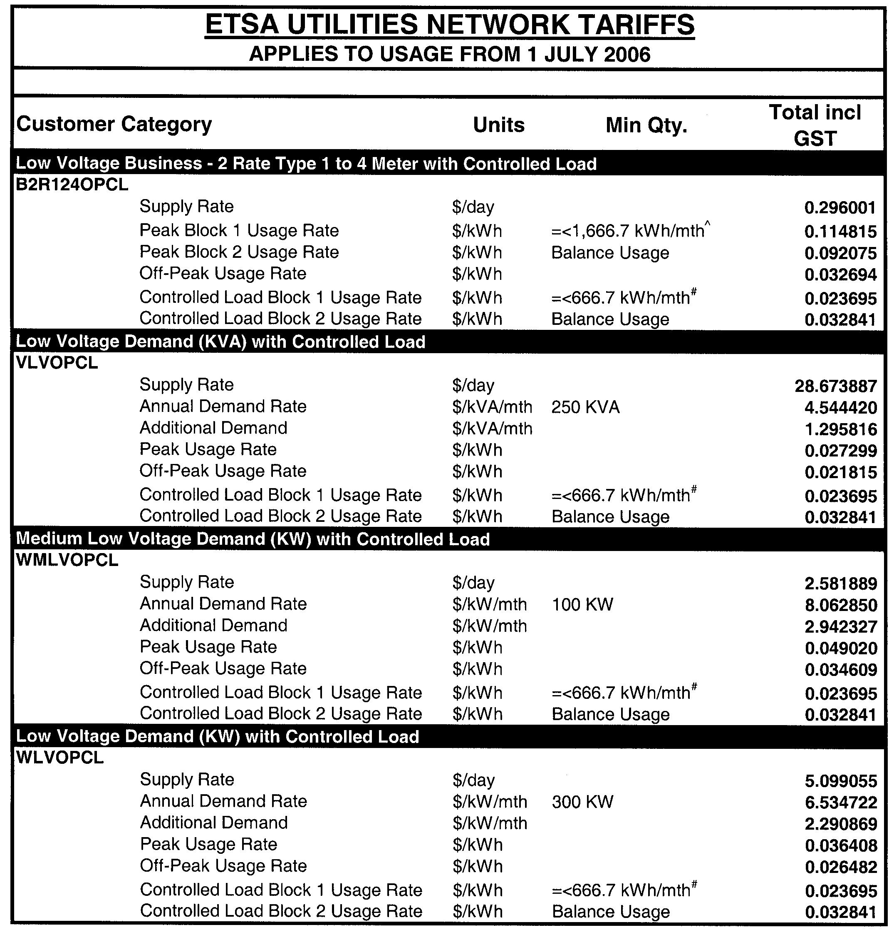
Notes accompanying 2006-2007 Tariffs

† - Approximate annual consumption of 4,000 kWh.
# - Approximate annual consumption of 8,000 kWh.
^ - Approximate annual peak consumption of 20,000 kWh.

Notes:
1. Distribution tariffs are determined on a GST exclusive basis. GST is added to the distribution tariffs.

2. ETSA Utilities must assign each Distribution Network User to a distribution tariff in respect of each of its connection points in accordance with the following principles:
(a) A Distribution Network User that has an agreed maximum demand of 250kVA or more in respect of a connection point, must be assigned to a distribution tariff that includes a demand component in respect of that connection point.
(b) A Sub-Transmission (kVA) Network User is a Distribution Network User taking supply at 66kV, or at 33kV outside of the Adelaide Metropolitan area. A minimum annual demand of 10 MVA applies. A NEM compliant type 1-4 interval meter is required with the ability to measure both active and reactive power. Customers electing to switch to this tariff from 1 July 2002 must meet or exceed the minimum power factor requirements for their customer installation as set out in Part B of the Distribution Code (generally 0.90 pf). These tariffs are invoiced monthly.
(c) A Zone Substation (kVA) customer is a Distribution Network User taking supply generally at 11kV from the low voltage transformer terminals. Supply may also be taken at lower voltages that exceed 1kV.
A minimum annual demand of 5 MVA and a minimum annual usage of 25GWh apply. A NEM compliant type 1-4 interval meter is required with the ability to measure both active and reactive power. Customers electing to switch to this tariff from 1 July 2002 must meet or exceed the minimum power factor require-ments for their customer installation as set out in Part B of the Distribution Code (generally 0.90 pf). These tariffs are invoiced monthly.
(d) A High Voltage Stepped Demand (kVA) customer is a Distribution Network User taking supply generally at 11kV. Supply may also be taken at lower voltages that exceed 1kV or at 33kV in metropolitan Adelaide. A minimum annual demand of 1 MVA applies. The steps to be applied to the annual demand are detailed in the Tariff Schedule. A NEM compliant type 1-4 interval meter is required with Customers electing to switch to this tariff from 1 July 2002 must meet or exceed the minimum power factor require-ments for their customer installation as set out in Part B of the Distribution Code (generally 0.85 pf). These tariffs are invoiced monthly.
(e) A High Voltage (kVA) (Obsolete) customer is a Distribution Network User taking supply generally at 11kV. This tariff is available only to Distribution Network Users that were taking supply under the High Voltage Demand (kW) (Obsolete) tariff as at 11 October 1999. Supply may also be taken at lower voltages that exceed 1kV or at 33kV in metropolitan Adelaide. A minimum annual demand of 300kVA applies. A NEM compliant type 1-4 interval meter is required with the ability to measure both active and reactive power. Customers electing to switch to this tariff from 1 July 2002 must meet or exceed the minimum power factor requirements for their customer installation as set out in Part B of the Distribution Code (generally 0.85 pf). These tariffs are invoiced monthly.
(f) A Low Voltage Stepped Demand (kVA) customer is a Distribution Network User generally taking supply at less than 1kV and generally from the low voltage distribution transformer terminals. A minimum agreed maximum demand of 100KVA applies. The steps to be applied to the annual demand are detailed in the Tariff Schedule. A NEM compliant type 1-4 interval meter is required with the ability to measure both active and reactive power. Customers electing to switch to this tariff from 1 July 2002 must meet or exceed the minimum power factor requirements for their customer installation as set out in Part B of the Distribution Code (generally 0.85 pf). These tariffs are invoiced monthly.
(g) A Low Voltage Business 2 rate – Type 1-4 Meter customer is a Distribution Network User that is not a residential customer taking supply at less than 1kV and using peak and off-peak network charges.
The User utilises a type 1-4 meter with the ability to measure both active and reactive power. Peak consumption is charged at two rates, one rate for consumption up to and including 1,666.7 kWh/mth^ and another rate for the balance of peak consumption. Off Peak consumption is charged at a flat rate.
An excluded service charge applies where ETSA Utilities is required to read the type 1-4 meter (e.g. for tier one customers and for tier two customers < 160MWh pa). This tariff is invoiced monthly.
(h) A Low Voltage Business 2 rate – Type 5-6 Meter Read Monthly customer is a Distribution Network User that is not a residential customer taking supply at less than 1kV and using peak and off-peak network charges. Peak consumption is charged at two rates, one rate for consumption up to and including 1,666.7 kWh/mth^ and another rate for the balance of peak consumption. Off Peak consumption is charged at a flat rate. The User utilises a type 5-6 meter and requires ETSA Utilities to read the meter monthly for which an excluded service charge applies. This tariff is invoiced monthly.

(i) A Low Voltage Business 2 rate – Type 5-6 Meter Read Quarterly customer is a Distribution Network User that is not a residential customer taking supply at less than 1kV and using peak and off-peak network charges. Peak consumption is charged at two rates, one rate for consumption up to and including 1,666.7 kWh/mth^ and another rate for the balance of peak consumption. Off Peak consumption is charged at a flat rate. The User utilises a type 5-6 meter which requires ETSA Utilities to read the meter. This tariff is invoiced quarterly.
(j) A Low Voltage Business single rate – Type 1-4 Meter customer is a Distribution Network User that is not a residential customer taking supply at less than 1kV and using single rate network charges. The User utilises a type 1-4 meter with the ability to measure both active and reactive power. An excluded service charge applies where ETSA Utilities is required to read the type 1-4 meter (e.g. for tier one customers and for tier two customers < 160MWh pa). This tariff is invoiced monthly.
(k) A Low Voltage Business single rate – Type 5-6 Meter Read Monthly customer is a Distribution Network User that is not a residential customer taking supply at less than 1kV and using single rate network charges. The User utilises a type 5-6 meter and requires ETSA Utilities to read the meter monthly for which an excluded service charge applies. This tariff is invoiced monthly.
(l) A Low Voltage Business single rate – Type 5-6 Meter Read Quarterly customer is a Distribution Network User that is not a residential customer taking supply at less than 1kV and using single rate metering.
The User utilises a type 5-6 meter which requires ETSA Utilities to read the meter. This tariff is invoiced quarterly.
(m) A Low Voltage Residential single rate – Type 1-4 Meter Read Monthly customer is a Distribution Network User that is a residential customer taking supply at less than 1kV. Consumption is charged at two rates, one rate for consumption up to and including 333.3 kWh/mth† and another rate for the balance of consumption. The User utilises a type 1-4 meter with the ability to measure both active and reactive power. An excluded service charge applies where ETSA Utilities is required to read the type 1-4 meter (e.g. for tier one customers and for tier two customers < 160MWh pa). This tariff is invoiced monthly.
(n) A Low Voltage Residential single rate – Type 5-6 Meter Read Monthly customer is a Distribution Network User that is a residential customer taking supply at less than 1kV. Consumption is charged at two rates, one rate for consumption up to and including 333.3 kWh/mth† and another rate for the balance of consumption. The User utilises a type 5-6 meter and requires ETSA Utilities to read the meter monthly for which an excluded service charge applies. This tariff is invoiced monthly.
(o) A Low Voltage Residential single rate – Type 5-6 Meter Read Quarterly customer is a Distribution Network User that is a residential customer taking supply at less than 1kV. Consumption is charged at two rates, one rate for consumption up to and including 333.3 kWh/mth† and another rate for the balance of consumption. The User utilises a type 5-6 meter which requires ETSA Utilities to read the meter.
This tariff is invoiced quarterly.
(p) A Low Voltage Controlled Load is used by a Distribution Network User for permanently installed storage water heaters with a rated delivery of not less than 125 litres, storage space heaters and other approved applications involving a time switch and separate metering where the timing has been set in accordance with ETSA Utilities' requirements regarding the timing of loads. Consumption is charged at two rates, one rate for consumption up to and including 666.7 kWh/mth# and another rate for the balance of consumption. This tariff is available only to Distribution Network Users that were taking supply under the Controlled Load tariff as at 30 June 2003, or are utilising a business single or residential tariff at the NMI in conjunction with the controlled load. This tariff is invoiced at the same frequency as other tariffs used by the Distribution Network User at that NMI.
(q) Unmetered Overnight Usage supply is defined as overnight use by a Distribution Network User for public lighting. These tariffs are generally invoiced monthly, unless otherwise agreed by ETSA Utilities.
(r) Unmetered 24 Hour Usage supply is defined as constant 24 hour per day use by a Distribution Network User, typically public phones, traffic lights and telecommunications installations. These tariffs are generally invoiced monthly, unless otherwise agreed by ETSA Utilities.
(s) Other Unmetered Supply is defined as unmetered use by Distribution Network Users other than public lighting or continuous use. These tariffs are generally invoiced monthly, unless otherwise agreed by ETSA Utilities.
(t) A Sub-Transmission Network (kW) User is a Distribution Network User taking supply at 66kV, or at 33kV outside of the Adelaide metropolitan area. A minimum annual demand of 10MW applies. A NEM compliant type 1-4 interval meter is required with the ability to measure both active and reactive power. This tariff is available only to Distribution Network Users that were taking supply under this tariff as at
30 June 2001. These tariffs are invoiced monthly.
(u) A Zone Substation (kW) customer is a Distribution Network User taking supply generally at 11kV from the low voltage transformer terminals. Supply may also be taken at lower voltages that exceed 1kV.
A minimum annual demand of 5MW and a minimum annual usage of 25GWh apply. A NEM compliant type 1-4 interval meter is required with the ability to measure both active and reactive power. This tariff is available only to Distribution Network Users that were taking supply under this tariff as at 30 June 2001. These tariffs are invoiced monthly.
(v) A High Voltage Demand (kW) customer is a Distribution Network User taking supply generally at 11kV. Supply may also be taken at lower voltages that exceed 1kV or at 33kV in metropolitan Adelaide.
A minimum annual demand of 1MW applies. A NEM compliant type 1-4 interval meter is required with the ability to measure both active and reactive power. This tariff is available only to Distribution Network Users that were taking supply under this tariff as at 30 June 2001. These tariffs are invoiced monthly.
(w) The High Voltage Demand (kW) (Obsolete) tariff is available only to Distribution Network Users that were taking supply under this tariff as at 11 October 1999. Conditions applicable at that date apply.
These tariffs are invoiced monthly.
(x) A Large Low Voltage Demand (kW) customer is a Distribution Network User taking supply at less than 1kV and generally from the low voltage distribution transformer terminals. A minimum annual demand of 1MW applies. A NEM compliant type 1-4 interval meter is required with the ability to measure both active and reactive power. This tariff is available only to Distribution Network Users that were taking supply under this tariff as at 30 June 2001. These tariffs are invoiced monthly.
(y) A Low Voltage Demand (kW) customer is a Distribution Network User taking supply at less than 1kV and generally from the low voltage distribution transformer terminals. A minimum annual demand of 300kW applies. A NEM compliant type 1-4 interval meter is required with the ability to measure both active and reactive power. This tariff is available only to Distribution Network Users that were taking supply under this tariff as at 30 June 2001. These tariffs are invoiced monthly.
(z) A Medium Low Voltage Demand (kW) customer is a Distribution Network User that is not a residential customer taking supply at less than 1kV and using demand, peak and off-peak network charges.
A minimum annual demand of 100kW applies. A NEM compliant type 1-4 interval meter is required with the ability to measure both active and reactive power. This tariff is available only to Distribution Network Users that were taking supply under this tariff as at 30 June 2001. These tariffs are invoiced monthly.

3. The supply and demand charges are levied and billed to Distribution Network Users periodically on a pro-rata basis.

4. Demand charges are determined on the basis of:
(a) Agreed maximum demand (Annual Demand); and
(b) Agreed additional maximum demand (Additional Demand),
determined in accordance with Schedule 2 of Part B of the 2005-2010 Electricity Distribution Price Determination.

5. Peak energy is energy consumed on business days between the hours of 0700 and 2100 (Central Standard Time). For Distribution Network Users with metering that does not recognise specific days, peak energy is energy consumed on each day between the hours of 0700 and 2100 (Central Standard Time).

6. Off-peak energy is energy consumed other than peak energy.

GOVERNMENT GAZETTE ADVERTISEMENT RATES

To apply from 1 July 2006

$  Agents, Ceasing to Act as 38.00  Associations:  Incorporation 19.30  Intention of Incorporation 47.75  Transfer of Properties 47.75  Attorney, Appointment of 38.00  Bailiff’s Sale 47.75  Cemetery Curator Appointed 28.25  Companies:  Alteration to Constitution 38.00  Capital, Increase or Decrease of 47.75  Ceasing to Carry on Business 28.25  Declaration of Dividend 28.25  Incorporation 38.00  Lost Share Certificates:  First Name 28.25  Each Subsequent Name 9.70  Meeting Final 31.75  Meeting Final Regarding Liquidator’s Report on  Conduct of Winding Up (equivalent to ‘Final  Meeting’)  First Name 38.00  Each Subsequent Name 9.70  Notices:  Call 47.75  Change of Name 19.30  Creditors 38.00  Creditors Compromise of Arrangement 38.00  Creditors (extraordinary resolution that ‘the Com-pany be wound up voluntarily and that a liquidator be appointed’) 47.75  Release of Liquidator⎯Application⎯Large Ad. 75.50  ⎯Release Granted 47.75  Receiver and Manager Appointed 44.00  Receiver and Manager Ceasing to Act 38.00  Restored Name 35.75  Petition to Supreme Court for Winding Up 66.50  Summons in Action 56.50  Order of Supreme Court for Winding Up Action 38.00  Register of Interests⎯Section 84 (1) Exempt 85.50  Removal of Office 19.30  Proof of Debts 38.00  Sales of Shares and Forfeiture 38.00  Estates:  Assigned 28.25  Deceased Persons⎯Notice to Creditors, etc. 47.75  Each Subsequent Name 9.70  Deceased Persons⎯Closed Estates 28.25  Each Subsequent Estate 1.25  Probate, Selling of 38.00  Public Trustee, each Estate 9.70 |  | $  Firms:  Ceasing to Carry on Business (each insertion) 25.25  Discontinuance Place of Business 25.25  Land⎯Real Property Act:  Intention to Sell, Notice of 47.75  Lost Certificate of Title Notices 47.75  Cancellation, Notice of (Strata Plan) 47.75  Mortgages:  Caveat Lodgement 19.30  Discharge of 20.20  Foreclosures 19.30  Transfer of 19.30  Sublet 9.70  Leases⎯Application for Transfer (2 insertions) each 9.70  Lost Treasury Receipts (3 insertions) each 28.25  Licensing 56.50  Municipal or District Councils:  Annual Financial Statement⎯Forms 1 and 2 532.00  Electricity Supply⎯Forms 19 and 20 378.00  Default in Payment of Rates:  First Name 75.50  Each Subsequent Name 9.70  Noxious Trade 28.25  Partnership, Dissolution of 28.25  Petitions (small) 19.30  Registered Building Societies (from Registrar-  General) 19.30  Register of Unclaimed Moneys⎯First Name 28.25  Each Subsequent Name 9.70  Registers of Members⎯Three pages and over:  Rate per page (in 8pt) 242.00  Rate per page (in 6pt) 320.00  Sale of Land by Public Auction 48.25  Advertisements 2.70  ¼ page advertisement 113.00  ½ page advertisement 226.00  Full page advertisement 443.00  Advertisements, other than those listed are charged at $2.70 per column line, tabular one-third extra.  Notices by Colleges, Universities, Corporations and District Councils to be charged at $2.70 per line.  Where the notice inserted varies significantly in length from that which is usually published a charge of $2.70 per column line will be applied in lieu of advertisement rates listed.  South Australian Government publications are sold on the condition that they will not be reproduced without prior permission from the Government Printer.
All the above prices include GST

GOVERNMENT GAZETTE NOTICES
ALL private advertisements forwarded for publication in the South Australian Government Gazette must be PAID FOR PRIOR TO INSERTION; and all notices, from whatever source, should be legibly written on one side of the paper only and sent to Government Publishing SA so as to be received no later than 4 p.m. Tuesday preceding the day of publication. Phone 8207 1045 or Fax 8207 1040. E-mail: governmentgazette@saugov.sa.gov.au. Send as attachments in Word format. Please include date the notice is to be published and to whom the notice will be charged. The Government Gazette is available online at: www.governmentgazette.sa.gov.au.

MISCELLANEOUS LEGISLATION AND GOVERNMENT PUBLICATIONS PRICES AS FROM 1 JULY 2006

Acts, Bills, Rules, Parliamentary Papers and Regulations
Pages | Main | Amends | Pages | Main | Amends

1-16 | 2.30 | 1.05 | 497-512 | 32.25 | 31.25
17-32 | 3.10 | 1.95 | 513-528 | 33.25 | 32.00
33-48 | 4.05 | 2.90 | 529-544 | 34.25 | 33.25
49-64 | 5.10 | 3.90 | 545-560 | 35.25 | 34.25
65-80 | 6.00 | 4.95 | 561-576 | 36.00 | 35.25
81-96 | 6.95 | 5.75 | 577-592 | 37.00 | 35.75
97-112 | 7.90 | 6.75 | 593-608 | 38.25 | 36.75
113-128 | 8.90 | 7.75 | 609-624 | 39.00 | 38.00
129-144 | 9.95 | 8.80 | 625-640 | 40.00 | 38.50
145-160 | 10.90 | 9.70 | 641-656 | 41.00 | 40.00
161-176 | 11.90 | 10.70 | 657-672 | 41.50 | 40.50
177-192 | 12.90 | 11.70 | 673-688 | 43.25 | 41.50
193-208 | 13.90 | 12.80 | 689-704 | 44.00 | 42.50
209-224 | 14.70 | 13.60 | 705-720 | 44.75 | 43.50
225-240 | 15.70 | 14.50 | 721-736 | 46.50 | 44.50
241-257 | 16.80 | 15.30 | 737-752 | 47.00 | 45.50
258-272 | 17.70 | 16.30 | 753-768 | 48.00 | 46.25
273-288 | 18.70 | 17.50 | 769-784 | 48.50 | 47.75
289-304 | 19.50 | 18.40 | 785-800 | 49.50 | 48.75
305-320 | 20.70 | 19.40 | 801-816 | 50.50 | 49.25
321-336 | 21.50 | 20.30 | 817-832 | 51.50 | 50.50
337-352 | 22.60 | 21.40 | 833-848 | 52.50 | 51.50
353-368 | 23.50 | 22.40 | 849-864 | 53.50 | 52.00
369-384 | 24.50 | 23.40 | 865-880 | 54.50 | 53.50
385-400 | 25.50 | 24.30 | 881-896 | 55.00 | 54.00
401-416 | 26.50 | 25.00 | 897-912 | 56.50 | 55.00
417-432 | 27.50 | 26.25 | 913-928 | 57.00 | 56.50
433-448 | 28.50 | 27.25 | 929-944 | 58.00 | 57.00
449-464 | 29.25 | 28.00 | 945-960 | 59.00 | 57.50
465-480 | 29.75 | 29.00 | 961-976 | 60.50 | 58.50
481-496 | 31.25 | 29.75 | 977-992 | 61.50 | 59.00

Legislation—Acts, Regulations, etc: $
Subscriptions:
Acts 199.00
All Bills as Laid 477.00
Rules and Regulations 477.00
Parliamentary Papers 477.00
Bound Acts 221.00
Index 110.00
Government Gazette
Copy 5.20
Subscription 263.00
Hansard
Copy 14.50
Subscription—per session (issued weekly) 414.00
Cloth bound—per volume 178.00
Subscription—per session (issued daily) 414.00
Legislation on Disk
Whole Database 3063.00
Annual Subscription for fortnightly updates 941.00
Individual Act(s) including updates POA
Compendium
Subscriptions:
Subscriptions 1815.00
Updates 640.00
(All the above prices include GST)

All Legislation, Government Gazette, Hansard and Legislation on disk are available from:
Counter Sales Service SA, Government Legislation⁺ Outlet
and Mail Orders: Lands Titles Office, 101 Grenfell Street, Adelaide, S.A. 5000
Phone: 13 23 24 (local call cost), Fax: (08) 8204 1909
Postal: G.P.O. Box 1707, Adelaide, S.A. 5001

Online Shop: www.shop.service.sa.gov.au

Subscriptions and Government Publishing SA
Standing Orders: Box 9, Plaza Level, Riverside Centre, North Terrace, Adelaide, S.A. 5000
Phone: (08) 8207 1043, (08) 8207 0910, Fax: (08) 8207 1040

GAS ACT 1997
Default Contract Prices for Small Customers
Notice under the Gas Act 1997 by AGL South Australia Pty Ltd (AGLSA)
(ABN 49 091 105 092) of Default Contract Prices for Small Customers
PURSUANT to section 34B of the Gas Act 1997, notice is hereby given by AGLSA of its default contract prices for customers who are consuming less than one terajoule per annum of gas (‘small customers’) and who are purchasing gas under AGLSA’s default contract terms and conditions. The default contract prices are set out below and will apply from and after the expiry of 28 days from the date of publication of this notice.
Justification Statement
The default contract prices set out in this notice are the same as the standing contract prices for small customers as approved on 1 June 2006 by the Essential Services Commission of South Australia in accordance with its Gas Standing Contract Price Determination made on 28 June 2005.
For further information please call AGLSA on 131 245.
P. James, Director, AGL South Australia Pty Limited

AGLSA GAS DEFAULT CONTRACT PRICES FOR SMALL CUSTOMERS (all charges are inclusive of GST)
REGIONS | Metropolitan | Mount Gambier | Port Pirie | Whyalla | Riverland
RESIDENTIAL
Supply charge per quarter | $40.93 | $40.93 | $40.93 | $40.93 | $40.93
Consumption charge c/MJ:
First 4 500 MJ per quarter | 1.9704 | 2.0748 | 2.0103 | 2.0095 | 1.9516
Thereafter | 1.2914 | 1.3850 | 1.2807 | 1.3536 | 1.4742
SMALL BUSINESS
Supply charge per quarter | $72.31 | $72.31 | $72.31 | $72.31 | $61.34
Consumption charge c/MJ:
First 25 000 MJ per quarter | 1.3879 | 1.3624 | 1.4293 | 1.4300 | 1.4416
Next 65 000 MJ per quarter | 1.3728 | 1.3184 | 1.3869 | 1.4183 | 1.2972
Thereafter | 1.0099 | 1.0272 | 1.0141 | 1.0442 | 0.8889
POSTCODES | See below* | 5277, 5280, 5290 | 5540 | 5600, 5608, 5609 | 5253, 5342, 5343, 5344
* The Metropolitan Region comprises the areas of the State of South Australia other than Mount Gambier, Port Pirie, Whyalla, Riverland but including Barossa and Peterborough.

FISHERIES ACT 1982: SECTION 43
TAKE notice that it is hereby declared that it shall be unlawful for any person to engage in the class of fishing activity specified in Schedule 1 during the period specified in Schedule 2.
Schedule 1
The act of taking or an act preparatory to or involved in the taking of any shellfish species in the following area:
That part of the area of the Port River/Barker Inlet known as the Section Bank bounded by a line:
• commencing at position latitude 34°45′S and longitude 138°28′E;
• then running in a straight line in an easterly direction to position latitude 34°45'S and longitude 138°31′E;
• then running in a straight line in a southerly direction to position latitude 34°47′S and longitude 138°31′E;
• then running in a straight line in a westerly direction to position latitude 34°47′S and longitude 138°28′E;
• then running in a straight line in a northerly direction to the point of commencement.
Schedule 2
From 2359 hours on 17 June 2006 until 2359 hours on
1 January 2007 inclusive.
Dated 15 June 2006.
W. Zacharin, Director of Fisheries

FISHERIES ACT 1982: SECTION 59
TAKE notice that pursuant to section 59 of the Fisheries Act 1982, persons listed in Schedule 1 (the ‘exemption holders’), are exempt from section 43 of the Fisheries Act 1982, but only insofar as the exemption holder shall not be guilty of an offence when taking mud cockles (Katelysia spp.) from a closed area (the ‘exempted activity’), subject to the conditions specified in Schedule 2, from 17 June 2006 until 23 June 2006, unless this notice is varied or revoked earlier.
Schedule 1
• John Spadavechia—M432.
Schedule 2
1. The cockles collected by the exemption holder are for research purposes only and must not be sold.
2. The exemption holder must notify PIRSA Fishwatch on 1800 065 522 at least two hours prior to conducting the exempted activity and answer a series of questions about the exempted activity. The exemption holder will need to have a copy of the exemption notice at the time of making the call, and be able to provide information about the area and time of the exempted activity, the vehicles involved and other related questions. Exemption No. 9901887.
3. While engaged in the exempted activity, the exemption holder must have in his possession a copy of this notice and produce a copy of this notice if requested by a PIRSA Fisheries Compliance Officer.
4. The exemption holder must not contravene or fail to comply with the Fisheries Act 1982, or any regulation made under that Act, except where specifically exempted by this notice.
Dated 16 June 2006.
W. Zacharin, Director of Fisheries

FISHERIES ACT 1982: SECTION 59
TAKE notice that pursuant to section 59 of the Fisheries Act 1982, E. F. Hendry Pty Ltd, (the ‘exemption holder’), P.O. Box 1, Warooka, S.A. 5577, is exempt from Clause 30 (b) of Schedule 1 of the Fisheries (General) Regulations 2000, but only insofar as the exemption holder may use a purse seine endorsed on its Marine Scalefish Fishery Licence in the waters specified in Schedule 1 to fish for Australian salmon (Arripis truttaceus) for the purposes of trade or business (the ‘exempted activity’), subject to the conditions set out in Schedule 2, from 1 July 2006 until 30 June 2007, unless varied or revoked earlier.
Schedule 1
The waters adjacent to the south-west coast of Yorke Peninsula and bounded as follows:
Commencing at the intersection of the high water mark at Corny Point and latitude 34.897°S, then in a westerly direction to a point at latitude 34.897°S, and longitude 137.750°E, then in a southerly direction to a point at latitude 35.417°S, and longitude 136.750°E, then in a direction of 80°T to a point at latitude 35.356°S and longitude 137.113°E, then in a northerly direction to a point at the intersection of the high water mark at the eastern end of Marion Bay and longitude 137.113°E, and then in a westerly direction along the high water mark of the coastline of Yorke Peninsula to the point of commencement (GDA 94).
Schedule 2
1. The exempted activity must not be undertaken during the following periods:
(a) from 1 a.m. on any Saturday to midnight on the following Sunday; or
(b) from 1 a.m. on the Thursday preceding Easter Sunday to midnight on the following Monday; or
(c) from 1 a.m. on any Thursday to midnight on the following Sunday if the Friday in that period is a public holiday; or
(d) from 1 a.m. on any Friday to midnight on the following Monday if that Monday is a public holiday.
2. The exempted activity must only be conducted from a boat registered on Marine Scalefish Fishery Licence No. M210, and that boat must be in the charge of a registered master.
3. All species of fish other than Australian salmon (Arripis truttaceus) that are taken when conducting the exempted activity must be returned to the water.
4. At least two hours prior to conducting the exempted activity the exemption holder or a registered master endorsed on Licence No. M210 must advise the PIRSA Fisheries Compliance Unit on 1800 065 522 that they will be undertaking the exempted activity. Exemption No. 9901885.
5. While engaged in the exempted activity the exemption holder or their registered master must have in his possession a copy of this notice and produce a copy of the notice if required by a PIRSA Fisheries Compliance Officer.
6. The exemption holder must not contravene or fail to comply with the Fisheries Act 1982, or any regulations made under that Act, except where specifically exempted by this notice.
Dated 16 June 2006.
W. Zacharin, Director of Fisheries

FISHERIES ACT 1982: SECTION 59
TAKE notice that pursuant to section 59 of the Fisheries Act 1982, Mark Short of Port Vincent Primary School and Aquatic Centre (the ‘exemption holder’), or a person acting as his agent, P.O. Box 116, Port Vincent, S.A. 5581, is exempt from the Fisheries (General) Regulations 2000, in that the exemption holder shall not be guilty of an offence when engaging in the activity specified in Schedule 1, in the waters specified in Schedule 2, subject to the conditions specified in Schedule 3, from 22 June 2006 until 30 June 2007.
Schedule 1
Activities involving the taking, possessing and subsequent release of aquatic organisms (not including species protected pursuant to section 42 of the Fisheries Act 1982, from the waters specified in Schedule 2 for education purposes at the Port Vincent Primary School and Aquatic Centre (the ‘exempted activity’).
Schedule 2
South Australian marine coastal waters of Gulf St Vincent, including intertidal ‘rocky’ reef areas.
Schedule 3
1. All organisms taken by the exemption holder are for display purposes only and must not be sold.
2. An employee of the Port Vincent Primary School and Aquatic Centre must be present at all times whilst conducting the exempted activity.
3. No more than five of any species may be taken or possessed at any one time.
4. The exemption holder must ensure that organisms taken pursuant to this notice are kept only with specimens taken from the same location.
5. All organisms released pursuant to this notice must be released as near as practicable to the point of capture.
6. Within 14 days of the collection of organisms pursuant to this notice, the exemption holder must provide a report in writing to the Director of Fisheries, (Attention: Alex Chalupa, G.P.O. Box 1625, Adelaide, S.A. 5001), giving the following details:
• the date and time of collection;
• the name and number of each species taken, including any mortalities resulting from collecting; and
• details of any organisms released.
7. The exemption holder must notify PIRSA Fishwatch on 1800 065 522 at least two hours prior to conducting the exempted activity and answer a series of questions about the exempted activity. The exemption holder will need to have a copy of the exemption at the time of making the call, and be able to provide information about the area and time of the exempted activity, the vehicles and boats involved, the number of agents undertaking the exempted activity and other related questions. Exemption No. 9901883.
8. The exempted activity must be undertaken in a manner that ensures minimal disturbance of the reef.
9. While engaged in the exempted activity, the exemption holder must have in their possession of a copy of this notice and produce a copy of the notice if required by a PIRSA Fisheries Compliance Officer.
10. The exemption holder shall not contravene or fail to comply with the Fisheries Act 1982, or any regulations made under that Act, except where specifically exempted by the notice.
Dated 16 June 2006.
W. Zacharin, Director of Fisheries

FISHERIES ACT 1982: SECTION 59
TAKE notice that pursuant to section 59 of the Fisheries Act 1982, Alice Gleeson, of Macquarie University (the ‘exemption holder’), North Ryde, N.S.W. 2109, is exempt from the provisions of Clause 65 of Schedule 1 of the Fisheries (General) Regulations 2000, to engage in the activities specified in Schedule 1 (the ‘exempted activity’), subject to the conditions set out in Schedule 2 from 21 June 2006 until 27 June 2006, unless varied or revoked earlier.
Schedule 1
The collection of introduced tube worm (Galeolaria caespitose) from South Australian coastal waters (including intertidal rocky reefs).
Schedule 2
1. Specimens collected by the exemption holder pursuant to this notice are for scientific research and must not be sold.
2. The exemption holder must notify PIRSA Fishwatch on 1800 065 522 at least two hours prior to conducting the exempted activity and answer a series of questions about the exempted activity. The exemption holder will need to have a copy of the exemption at the time of making the call, and be able to provide information about the area and time of the exempted activity, the vehicles involved and other related questions. Exemption No. 9901882.
3. While engaged in the exempted activity, the exemption holder must be in possession of a copy of this notice. Such notice must be produced to a PIRSA Fisheries Officer upon request.
4. The exemption holder must not contravene or fail to comply with the Fisheries Act 1982, or any regulations made under that Act, except where specifically exempted by this notice.
Dated 16 June 2006.
W. Zacharin, Director of Fisheries

FISHERIES ACT 1982: SECTION 59
TAKE notice that pursuant to section 59 of the Fisheries Act 1982, Kathryn Newton, of Macquarie University (the ‘exemption holder’), North Ryde, N.S.W. 2109, is exempt from the provisions of Clause 65 of Schedule 1 of the Fisheries (General) Regulations 2000, to engage in the activities specified in Schedule 1 (the ‘exempted activity’), subject to the conditions set out in Schedule 2 from 21 June 2006 until 27 June 2006, unless varied or revoked earlier.
Schedule 1
The collection of introduced ascidian species from South Australian coastal waters (including intertidal rocky reefs).
Schedule 2
1. Specimens collected by the exemption holder pursuant to this notice are for scientific research and must not be sold.
2. The exemption holder must notify PIRSA Fishwatch on 1800 065 522 at least two hours prior to conducting the exempted activity and answer a series of questions about the exempted activity. The exemption holder will need to have a copy of the exemption at the time of making the call, and be able to provide information about the area and time of the exempted activity, the vehicles involved and other related questions. Exemption No. 9901881.
3. While engaged in the exempted activity, the exemption holder must be in possession of a copy of this notice. Such notice must be produced to a PIRSA Fisheries Officer upon request.
4. The exemption holder must not contravene or fail to comply with the Fisheries Act 1982, or any regulations made under that Act, except where specifically exempted by this notice.
Dated 16 June 2006.
W. Zacharin, Director of Fisheries

FISHERIES ACT 1982: SECTION 59
TAKE notice that pursuant to section 59 of the Fisheries Act 1982, Barry Bruce, CSIRO Marine Research, G.P.O. Box 1538, Hobart, Tas. 7001 (the ‘exemption holder’), or a person acting as his agent, is exempt from subregulation 24 (1) and Clause 2 of Schedule 1 of the Fisheries (General) Regulations 2000, but only insofar as he will not be guilty of an offence when undertaking the activities described in Schedule 1 (the ‘exempted activity’) using the gear specified in Schedule 2, subject to the conditions set out in Schedule 3 from 27 June 2006 until 30 June 2006 inclusive, unless varied or revoked earlier.
Schedule 1
1. The tagging of great white sharks.
2. Tagging of three 3-4 m white sharks for the purpose of attaching satellite tags at North Neptune Island during the period 27 June 2006 until 30 June 2006 (inclusive).
Schedule 2
• Two non-stainless steel, barbless, 14-0 hooks attached to a short (approximately 1 m) braided wire trace (3 mm diameter).
• The trace must be attached to a 12 mm silver rope and secured under three polystyrene floats (2 nine inch diameter and 1 twelve inch diameter).
Schedule 3
1. Only the following persons may act as an agent of the exemption holder:
• Employees of CSIRO Marine Research and SARDI Aquatic Sciences.
• Rolf Czabayski.
2. The exemption holder must advise the PIRSA Fisheries Compliance Unit, on 1800 065 522, as well as the DEH Duty Ranger on 0428 883 113 at least two hours prior to undertaking the exempted activity, and provide details of the persons undertaking the exempted activity, proposed locations and the dates on which the exempted activity is to be conducted. Exemption No. 9901886.
3. The exemption holder must not conduct any other fishing activity including recreational fishing whilst undertaking the exempted activity.
4. While engaged in the exempted activity, the exemption holder must be in possession of a copy of this notice. The exemption holder must also provide each of his agents with a short letter confirming that they may act as his agents. A copy of this notice and such a letter must be produced to a PIRSA Fisheries Compliance Officer if requested.
5. The exemption holder must not contravene or fail to comply with the Fisheries Act 1982, or any regulations made under that Act, except where specifically exempted by this notice.
Dated 16 June 2006.
W. Zacharin, Director of Fisheries

FISHERIES ACT 1982: SECTION 59
TAKE notice that pursuant to section 59 of the Fisheries Act 1982, Pang Quong of PQ Aquatics, 4 Burrawong Avenue, Seaford in the State of Victoria (the ‘exemption holder’), or a person acting as his agent, is exempt from paragraph 6 (c) of the Fisheries (General) Regulations 2000, but only insofar as the exemption holder shall not be guilty of an offence when taking one egg-bearing male leafy seadragon (the ‘exempted activity’) from the waters described in Schedule 1, subject to the conditions specified in Schedule 2, during the period commencing 1 November 2006 and ending 31 March 2007, unless varied or revoked earlier.
Schedule 1
South Australian coastal waters excluding waters within one nautical mile of the jetties at Rapid Bay and Second Valley.
Schedule 2
1. Any specimen collected pursuant to this exemption must be retained by the exemption holder.
2. The exemption holder must notify PIRSA Fisheries on 1800 065 522 at least two hours prior to conducting the exempted activity and answer a series of questions about the exempted activity. The exemption holder will need to have a copy of the exemption at the time of making the call, and be able to provide information about the area and time of the exempted activity, the vehicles and boats involved, the number of agents undertaking the exempted activity and other related questions. Exemption No. 9901888.
3. The exempted activity may also be conducted on the exemption holder’s behalf by Anthony Quong.
4. The exemption holder must provide a written report to the Director of Fisheries (G.P.O. Box 1625, Adelaide, S.A. 5001) within seven days of collecting a leafy seadragon pursuant to this exemption, providing details of the location, time and conditions of the collection.
5. The exemption holder must also provide a written report to the Director of Fisheries (G.P.O. Box 1625, Adelaide, S.A. 5001) by 30 April 2006, providing the following information:
• The number of eggs hatched from the specimen collected pursuant to this notice.
• The number of animals hatched from these eggs and an indication of survival rate.
• The number of surviving animals kept as broodstock and the number of animals sold domestically, exported or given away.
• A status report on the breeding program of the leafy sea-dragon.
6. While engaged in the exempted activity the exemption holder or his agents must be in possession of a copy of this notice and must be produced to a PIRSA Fisheries Compliance Officer if requested.
7. The exemption holder must not contravene or fail to comply with the Fisheries Act 1982, or any regulations made under that Act, except where specifically exempted by this notice.
Dated 21 June 2006.
W. Zacharin, Director of Fisheries

LAND ACQUISITION ACT 1969
(Section 16)
Notice of Acquisition
THE COMMISSIONER OF HIGHWAYS (the ‘Authority’), 33 Warwick Street, Walkerville, S.A. 5081, acquires the following interests in the following land:
Definition of Land Acquired
Comprising the fee simple of that piece of land situated at Tatachilla Road, Tatachilla, S.A. 5171, being portion of the land contained in certificate of title 5680, folio 995 and being the whole of Allotment 52 in the plan lodged in the Registrar-General’s Office and numbered DP 69076.
This notice is given under section 16 of the Land Acquisition Act 1969.
Compensation
A person who has or had an interest in the land that is divested or diminished by the acquisition or the enjoyment of which is adversely affected by the acquisition who does not receive an offer of compensation from the Authority may apply to the Authority for compensation.
Inquiries
Inquiries should be directed to:
Brenton Wilkinson,
P.O. Box 1,
Walkerville, S.A. 5081
Telephone (08) 8343 2460
Dated 20 June 2006.
The Common Seal of the Commissioner of Highways was hereto affixed by direction of the Commissioner of Highways in the presence of:
(l.s.) T. Lawry, Manager, Property Planning and Management Services, Department for Transport, Energy and Infrastructure.

LAND AND BUSINESS (SALE AND CONVEYANCING)
ACT 1994
Exemption
TAKE notice that, pursuant to section 23 (3) of the Land and Business (Sale and Conveyancing) Act 1994, I, Jennifer Rankine, Minister for Consumer Affairs, do hereby exempt the person named in Schedule 1 from the application of section 23 (2) of the Act in relation to the purchase of the land specified in Schedule 2.
Schedule 1
Stephen McMullen, an employee of Playford Real Estate Pty Ltd.
Schedule 2
The land described in certificate of title register book volume 5736, folio 953, situated at 3 Toorak Drive, Blakeview, S.A. 5114.
Dated 22 June 2006
J. Rankine, Minister for Consumer Affairs

LAND AND BUSINESS (SALE AND CONVEYANCING)
ACT 1994
Exemption
TAKE notice that, pursuant to section 23 (3) of the Land and Business (Sale and Conveyancing) Act 1994, I, Jennifer Rankine, Minister for Consumer Affairs, do hereby exempt the person named in Schedule 1 from the application of section 23 (2) of the Act in relation to the purchase of the land specified in Schedule 2.
Schedule 1
Emily Nell Lovelock, an employee of Sexton Glover Pty Ltd.
Schedule 2
The land described in certificate of title register book volume 5099, folio 770, situated at Lot 31, Wellington Road, Mount Barker, S.A. 5251.
Dated 22 June 2006.
J. Rankine, Minister for Consumer Affairs

LAND AND BUSINESS (SALE AND CONVEYANCING)
ACT 1994
Exemption
TAKE notice that, pursuant to section 23 (3) of the Land and Business (Sale and Conveyancing) Act 1994, I, Jennifer Rankine, Minister for Consumer Affairs, do hereby exempt the person named in Schedule 1 from the application of section 23 (2) of the Act in relation to the purchase of the land specified in Schedule 2.
Schedule 1
Geoffrey James Knappstein, an employee of Landmark Operations Ltd.
Schedule 2
The land described in certificate of title register book volume 5618, folios 657 and 658, situated at 27 West Terrace, Clare, S.A. 5453.
Dated 22 June 2006.
J. Rankine, Minister for Consumer Affairs

LAND AND BUSINESS (SALE AND CONVEYANCING)
ACT 1994
Exemption
TAKE notice that, pursuant to section 23 (3) of the Land and Business (Sale and Conveyancing) Act 1994, I, Jennifer Rankine, Minister for Consumer Affairs, do hereby exempt the person named in Schedule 1 from the application of section 23 (2) of the Act in relation to the purchase of the land specified in Schedule 2.
Schedule 1
Dale Ian Schulz, an employee of Robin Turner & Associates Pty Ltd.
Schedule 2
The whole of the land described in certificate of title register book volume 5606, folio 753, situated at 37 Amy Street, West Croydon, S.A. 5008.
Dated 22 June 2006.
J. Rankine, Minister for Consumer Affairs

LAND AND BUSINESS (SALE AND CONVEYANCING)
ACT 1994
Exemption
TAKE notice that, pursuant to section 23 (3) of the Land and Business (Sale and Conveyancing) Act 1994, I, Jennifer Rankine, Minister for Consumer Affairs, do hereby exempt the person named in Schedule 1 from the application of section 23 (2) of the Act in relation to the purchase of the land specified in Schedule 2.
Schedule 1
Philip George Holmes, an employee of Landmark Operations Ltd.
Schedule 2
The whole of the land described in certificate of title register book volume 5217, folios 701, situated at 24 Albert Street, Clare, S.A. 5453.
Dated 22 June 2006.
J. Rankine, Minister for Consumer Affairs

LIQUOR LICENSING ACT 1997 AND GAMING MACHINES ACT 1992
Notice of Application
NOTICE is hereby given, pursuant to section 52 of the Liquor Licensing Act 1997 and section 29 of the Gaming Machines Act 1992, that Brendan Montgomerie Boylan, Veronica Reddington and David Wayne Bevan have applied to the Licensing Authority for the transfer of a Hotel and Gaming Machine Licence in respect of premises situated at Highway One, Lochiel, S.A. 5510 and known as Lochiel Lakeview Hotel.
The applications have been set down for hearing on 24 July 2006 at 11 a.m.
Any person may object to the application by lodging a notice of objection in the prescribed form with the Licensing Authority, and serving a copy of the notice on the applicants at the applicants’ address given above, at least seven days before the hearing date (viz: 14 July 2006).
The applicants’ address for service is c/o Paul Boylan, 138 Florence Street, Port Pirie, S.A. 5540.
Plans in respect of the premises the subject of the application are open to public inspection without fee at the Office of the Liquor and Gambling Commissioner, 9th Floor, East Wing, 50 Grenfell Street, Adelaide, S.A. 5000. Phone 8226 8410, Fax:
8226 8512. Email: olgc@agd.sa.gov.au.
Dated 16 June 2006.
Applicants

LIQUOR LICENSING ACT 1997 AND GAMING MACHINES ACT 1992
Notice of Application
NOTICE is hereby given, pursuant to section 52 of the Liquor Licensing Act 1997 and section 29 of the Gaming Machines Act 1992, that The Producers Hotel Pty Ltd has applied to the Licensing Authority for the transfer of a Hotel and Gaming Machine Licence in respect of premises situated at 235 Grenfell Street, Adelaide, S.A. 5000, known as East End Exchange and to be known as The Producers Hotel.
The applications have been set down for hearing on 25 July 2006 at 9.30 a.m.
Any person may object to the application by lodging a notice of objection in the prescribed form with the Licensing Authority, and serving a copy of the notice on the applicant at the applicant’s address given above, at least seven days before the hearing date (viz: 17 July 2006).
The applicant’s address for service is c/o David Watts & Associates, 1 Cator Street, Glenside, S.A. 5065.
Plans in respect of the premises the subject of the application are open to public inspection without fee at the Office of the Liquor and Gaming Commissioner, 9th Floor, East Wing, 50 Grenfell Street, Adelaide, S.A. 5000. Phone 8226 8410, Fax: 8226 8512. Email: olgc@agd.sa.gov.au.
Dated 16 June 2006.
Applicant

LIQUOR LICENSING ACT 1997 AND GAMING MACHINES ACT 1992
Notice of Application
NOTICE is hereby given, pursuant to section 52 of the Liquor Licensing Act 1997 and section 29 of the Gaming Machines Act 1992, that Duke of York Hotel (S.A.) No. 1 Pty Ltd has applied to the Licensing Authority for the transfer of a Hotel and Gaming Machine Licence in respect of premises situated at 82 Currie Street, Adelaide, S.A. 5000 and known as Duke of York Hotel.
The applications have been set down for hearing on 25 July 2006 at 11 a.m.
Any person may object to the application by lodging a notice of objection in the prescribed form with the Licensing Authority, and serving a copy of the notice on the applicant at the applicant’s address given above, at least seven days before the hearing date (viz: 17 July 2006).
The applicant’s address for service is c/o Wallmans Lawyers, 173 Wakefield Street, Adelaide, S.A. 5000 (Attention: Ben Allen or Andrew Fisher).
Plans in respect of the premises the subject of the application are open to public inspection without fee at the Office of the Liquor and Gaming Commissioner, 9th Floor, East Wing, 50 Grenfell Street, Adelaide, S.A. 5000. Phone 8226 8410, Fax: 8226 8512. Email: olgc@agd.sa.gov.au.
Dated 19 June 2006.
Applicant

LIQUOR LICENSING ACT 1997
Notice of Application
NOTICE is hereby given, pursuant to section 52 (2) (b) of the Liquor Licensing Act 1997, that Flinders Campus Community Services Incorporated has applied to the Licensing Authority for the transfer of a Restaurant Licence and Special Circumstances Licence in respect of premises situated at Sturt Road, Bedford Park, S.A. 5042 and known as Flinders University Union.
The application has been set down for hearing on 3 July 2006 at 10 a.m.
Any person may object to the application by lodging a notice of objection in the prescribed form with the Liquor and Gambling Commissioner, and serving a copy of the notice on the applicant at the applicant’s address given above, on or before the hearing date (viz: 29 June 2006).
The applicant’s address for service is c/o Fisher Jeffries, Level 15, 211 Victoria Square, Adelaide, S.A. 5000 (Attention: Craig Vozzo or Adrian Battiston).
Plans in respect of the premises the subject of the application are open to public inspection without fee at the Office of the Liquor and Gambling Commissioner, 9th Floor, East Wing, 50 Grenfell Street, Adelaide, S.A. 5000. Phone 8226 8410, Fax:
8226 8512. Email: olgc@agd.sa.gov.au.
Dated 16 June 2006.
Applicant

LIQUOR LICENSING ACT 1997
Notice of Application
NOTICE is hereby given, pursuant to section 52 (2) (b) of the Liquor Licensing Act 1997, that Pekina Creek Pty Ltd as trustee for Slaven Family Trut has applied to the Licensing Authority for the transfer of a Hotel Licence, Extended Trading Authorisation and Entertainment Consent in respect of premises situated at Main Street, Pekina, S.A. 5431 and known as Pekina Hotel.
The application has been set down for hearing on 14 July 2006 at 9 a.m.
Conditions
The following licence conditions are sought:
• Extended Trading Authorisation:
For consumption on the premises:
Friday and Saturday: Midnight to 2 a.m. the following day;
Sunday: 8 p.m. to 10 p.m.;
Sunday Christmas Eve: 8 p.m. to 10 p.m.;
Days preceding other Public Holidays: Midnight to 2 a.m. the following day;
Sundays preceding Public Holidays: 8 p.m. to 2 a.m. the following day.
For consumption off the premises:
Sunday: 8 p.m. to 9 p.m.
• Entertainment Consent is sought for the areas shown on the plans lodged with the office and include the above-mentioned hours.
Any person may object to the application by lodging a notice of objection in the prescribed form with the Liquor and Gambling Commissioner, and serving a copy of the notice on the applicant at the applicant’s address given above, at least seven days before the hearing date (viz: 6 July 2006).
The applicant’s address for service is c/o Duncan Basheer Hannon Lawyers, 66 Wright Street, Adelaide, S.A. 5000 (Attention: John Williams).
Plans in respect of the premises the subject of the application are open to public inspection without fee at the Office of the Liquor and Gambling Commissioner, 9th Floor, East Wing, 50 Grenfell Street, Adelaide, S.A. 5000. Phone 8226 8410, Fax:
8226 8512. Email: olgc@agd.sa.gov.au.
Dated 13 June 2006.
Applicant

LIQUOR LICENSING ACT 1997
Notice of Application
NOTICE is hereby given, pursuant to section 52 (2) (b) of the Liquor Licensing Act 1997, that Allan Ronald Falland and Leonie Margaret Falland have applied to the Licensing Authority for a Producer’s Licence in respect of premises situated at Lot 2, Wellington Road, Langhorne Creek, S.A. 5255 and to be known as Willows & Gums Enterprises.
The application has been set down for hearing on 21 July 2006 at 9 a.m.
Any person may object to the application by lodging a notice of objection in the prescribed form with the Liquor and Gambling Commissioner, and serving a copy of the notice on the applicants at the applicants’ address given above, at least seven days before the hearing date (viz: 13 July 2006).
The applicants’ address for service is c/o Allan Falland, P.O. Box 31, Langhorne Creek, S.A. 5255.
Plans in respect of the premises the subject of the application are open to public inspection without fee at the Office of the Liquor and Gambling Commissioner, 9th Floor, East Wing, 50 Grenfell Street, Adelaide, S.A. 5000. Phone 8226 8410, Fax:
8226 8512. Email: olgc@agd.sa.gov.au.
Dated 14 June 2006.
Applicants

LIQUOR LICENSING ACT 1997
Notice of Application
NOTICE is hereby given, pursuant to section 52 (2) (b) of the Liquor Licensing Act 1997, that Vintellectuals Pty Ltd has applied to the Licensing Authority for a Wholesale Liquor Merchant’s Licence in respect of premises situated at 17 Light Terrace, Thebarton, S.A. 5031 and to be known as Vintellectuals.
The application has been set down for hearing on 21 July 2006 at 9 a.m.
Any person may object to the application by lodging a notice of objection in the prescribed form with the Liquor and Gambling Commissioner and serving a copy of the notice on the applicant at the applicant’s address given above, at least seven days before the hearing date (viz: 13 July 2006).
The applicant’s address for service is c/o David Watts & Associates, 1 Cator Street, Glenside, S.A. 5065.
Plans in respect of the premises the subject of the application are open to public inspection without fee at the Office of the Liquor and Gambling Commissioner, 9th Floor, East Wing, 50 Grenfell Street, Adelaide, S.A. 5000. Phone 8226 8410, Fax:
8226 8512. Email: olgc@agd.sa.gov.au.
Dated 15 June 2006.
Applicant

LIQUOR LICENSING ACT 1997
Notice of Application
NOTICE is hereby given, pursuant to section 52 (2) (b) of the Liquor Licensing Act 1997, that Twygz Pty Ltd has applied to the Licensing Authority for a Restaurant Licence, Section 34 (1) (c), Extended Trading Authorisation and Entertainment Consent in respect of premises situated at 31A Seventh Street, Murray Bridge, S.A. 5253 and to be known as Uccello.
The application has been set down for hearing on 21 July 2006 at 9 a.m.
Conditions
The following licence conditions are sought:
• Approval under Section 34 (1) (c) to sell liquor for con-sumption on the licensed premises by persons:
(a) seated at a table; or
(b) attending a function at which food is provided.
• Extended Trading Authorisation:
Sunday: 8 p.m. to midnight.
• Entertainment Consent:
On any Day: 12 noon to midnight.
Any person may object to the application by lodging a notice of objection in the prescribed form with the Liquor and Gambling Commissioner and serving a copy of the notice on the applicant at the applicant’s address given above, at least seven days before the hearing date (viz: 13 July 2006).
The applicant’s address for service is c/o 31A Seventh Street, Murray Bridge, S.A. 5253.
Plans in respect of the premises the subject of the application are open to public inspection without fee at the Office of the Liquor and Gambling Commissioner, 9th Floor, East Wing, 50 Grenfell Street, Adelaide, S.A. 5000. Phone 8226 8410, Fax:
8226 8512. Email: olgc@agd.sa.gov.au.
Dated 15 June 2006.
Applicant

LIQUOR LICENSING ACT 1997
Notice of Application
NOTICE is hereby given, pursuant to section 52 (2) (b) of the Liquor Licensing Act 1997, that Wohlers Enterprises Pty Ltd has applied to the Licensing Authority for redefinition and variation to Extended Trading Authorisation in respect of premises situated at 101-103 Murray Street, Tanunda, S.A. 5352 and known as Rumours Espresso.
The application has been set down for hearing on 21 July 2006 at 9 a.m.
Conditions
The following licence conditions are sought:
• Redefinition of the Licensed Premises to include an outdoor cafe area.
• Variation to Extended Trading Authorisation to include the abovementioned area.
Any person may object to the application by lodging a notice of objection in the prescribed form with the Liquor and Gambling Commissioner and serving a copy of the notice on the applicant at the applicant’s address given above, at least seven days before the hearing date (viz: 13 July 2006).
The applicant’s address for service is c/o Duncan Basheer Hannon, 66 Wright Street, Adelaide, S.A. 5000 (Attention: David Tillett).
Plans in respect of the premises the subject of the application are open to public inspection without fee at the Office of the Liquor and Gambling Commissioner, 9th Floor, East Wing, 50 Grenfell Street, Adelaide, S.A. 5000. Phone 8226 8410, Fax:
8226 8512. Email: olgc@agd.sa.gov.au.
Dated 16 June 2006.
Applicant

LIQUOR LICENSING ACT 1997
Notice of Application
NOTICE is hereby given, pursuant to section 52 (2) (b) of the Liquor Licensing Act 1997, that Andreas Skarmoutsos has applied to the Licensing Authority for a Restaurant Licence in respect of premises situated at Lot 6, Wright Road, Coober Pedy, S.A. 5723 and to be known as Breakaways Cafe.
The application has been set down for hearing on 21 July 2006 at 9 a.m.
Any person may object to the application by lodging a notice of objection in the prescribed form with the Liquor and Gambling Commissioner and serving a copy of the notice on the applicant at the applicant’s address given above, at least seven days before the hearing date (viz: 13 July 2006).
The applicant’s address for service is c/o Andreas Skarmoutsos, P.O. Box 632, Coober Pedy, S.A. 5723.
Plans in respect of the premises the subject of the application are open to public inspection without fee at the Office of the Liquor and Gambling Commissioner, 9th Floor, East Wing, 50 Grenfell Street, Adelaide, S.A. 5000. Phone 8226 8410, Fax:
8226 8512. Email: olgc@agd.sa.gov.au.
Dated 16 June 2006.
Applicant

LIQUOR LICENSING ACT 1997
Notice of Application
NOTICE is hereby given, pursuant to section 52 (2) (b) of the Liquor Licensing Act 1997, that Nicole Bay Pty Ltd and M. Steele Investments Pty Ltd have applied to the Licensing Authority for an Extension of Trading Area, redefinition and alterations and a variation to the Extended Trading Authorisation in respect of premises situated at 563-565 Military Road, Largs North, S.A. 5016 and known as Wee Willie’s Tavern.
The application has been set down for callover on 21 July 2006 at 9 a.m.
Conditions
The following licence conditions are sought:
• Redefinition and alterations to the licensed premises as per the plans lodged with the application.
• A variation to the areas that the Extended Trading Authorisation applies to as a result of the alterations. The same hours and conditions that form part of the existing Hotel Licence will remain unchanged.
Any person may object to the application by lodging a notice of objection in the prescribed form with the Liquor and Gambling Commissioner, and serving a copy of the notice on the applicants at the applicants’ address given above, at least seven days before the hearing date (viz: 13 July 2006).
The applicants’ address for service is c/o Kelly & Co. Lawyers, Level 17, 91 King William Street, Adelaide, S.A. 5000 (Attention: Graham Hobbs).
Plans in respect of the premises the subject of the application are open to public inspection without fee at the Office of the Liquor and Gambling Commissioner, 9th Floor, East Wing, 50 Grenfell Street, Adelaide, S.A. 5000. Phone 8226 8410, Fax:
8226 8512. Email: olgc@agd.sa.gov.au.
Dated 16 June 2006.
Applicants

LIQUOR LICENSING ACT 1997
Notice of Application
NOTICE is hereby given, pursuant to section 52 (2) (b) of the Liquor Licensing Act 1997, that Richard Paul Tucker and Mark Allan Aistrope have applied to the Licensing Authority for a Special Circumstances Licence in respect of premises situated at 254-266 Unley Road, Hyde Park, S.A. 5061 and to be known as Portabello.
The application has been set down for hearing on 21 July 2006 at 9 a.m.
Conditions
The following licence conditions are sought:
• The predominant activity of the premises is a hairdressing salon with the provision of alcohol ancillary to the business.
• The alcohol will be offered and provided to customers only on a gratuitous basis for consumption on the premises.
• Alcohol is not to be sold or supplied for sale to the general public.
Any person may object to the application by lodging a notice of objection in the prescribed form with the Liquor and Gambling Commissioner, and serving a copy of the notice on the applicants at the applicants’ address given above, at least seven days before the hearing date (viz: 13 July 2006).
The applicants’ address for service is c/o 254-266 Unley Road, Hyde Park, S.A. 5061.
Plans in respect of the premises the subject of the application are open to public inspection without fee at the Office of the Liquor and Gambling Commissioner, 9th Floor, East Wing, 50 Grenfell Street, Adelaide, S.A. 5000. Phone 8226 8410, Fax:
8226 8512. Email: olgc@agd.sa.gov.au.
Dated 19 June 2006.
Applicants

LIQUOR LICENSING ACT 1997
Notice of Application
NOTICE is hereby given, pursuant to section 52 (2) (b) of the Liquor Licensing Act 1997, that Davinro Amore Pty Ltd as trustee for the Davinro Amore Unit Trust has applied to the Licensing Authority for the transfer of an Entertainment Venue Licence in respect of premises situated at 162-170 Pulteney Street, Adelaide, S.A. 5000, known as Caffe Amore and to be known as Caffe Amore & CBD Bar.
The application has been set down for hearing on 24 July 2006 at 9 a.m.
Any person may object to the application by lodging a notice of objection in the prescribed form with the Liquor and Gambling Commissioner, and serving a copy of the notice on the applicant at the applicant’s address given above, at least seven days before the hearing date (viz: 14 July 2006).
The applicant’s address for service is c/o Meister Belperio Clark, 389 King William Street, Adelaide, S.A. 5000 (Attention: C. Belperio).
Plans in respect of the premises the subject of the application are open to public inspection without fee at the Office of the Liquor and Gambling Commissioner, 9th Floor, East Wing, 50 Grenfell Street, Adelaide, S.A. 5000. Phone 8226 8410, Fax:
8226 8512. Email: olgc@agd.sa.gov.au.
Dated 16 June 2006.
Applicant

LIQUOR LICENSING ACT 1997
Notice of Application
NOTICE is hereby given, pursuant to section 52 (2) (b) of the Liquor Licensing Act 1997, that The Balti House Pty Ltd has applied to the Licensing Authority for the transfer of a Restaurant Licence in respect of premises situated at 167 Goodwood Road, Millswood, S.A. 5034, known as Kim San Long Noodle Box and to be known as The Balti House.
The application has been set down for hearing on 24 July 2006 at 10 a.m.
Any person may object to the application by lodging a notice of objection in the prescribed form with the Liquor and Gambling Commissioner, and serving a copy of the notice on the applicant at the applicant’s address given above, at least seven days before the hearing date (viz: 14 July 2006).
The applicant’s address for service is c/o Townsends Solicitors, 91 Halifax Street, Adelaide, S.A. 5000 (Attention: Annoushka Scharnberg).
Plans in respect of the premises the subject of the application are open to public inspection without fee at the Office of the Liquor and Gambling Commissioner, 9th Floor, East Wing, 50 Grenfell Street, Adelaide, S.A. 5000. Phone 8226 8410, Fax:
8226 8512. Email: olgc@agd.sa.gov.au.
Dated 14 June 2006.
Applicant

LIQUOR LICENSING ACT 1997
Notice of Application
NOTICE is hereby given, pursuant to section 52 (2) (b) of the Liquor Licensing Act 1997, that Angela Vecchio has applied to the Licensing Authority for the transfer of a Restaurant Licence in respect of premises situated at 32-46 Sir Donald Bradman Drive, Mile End, S.A. 5031, known as Cafe HC One and to be known as Cafe HC 1.
The application has been set down for hearing on 25 July 2006 at 10 a.m.
Any person may object to the application by lodging a notice of objection in the prescribed form with the Liquor and Gambling Commissioner, and serving a copy of the notice on the applicant at the applicant’s address given above, at least seven days before the hearing date (viz: 17 July 2006).
The applicant’s address for service is c/o 32-46 Sir Donald Drive, Mile End, S.A. 5031.
Plans in respect of the premises the subject of the application are open to public inspection without fee at the Office of the Liquor and Gambling Commissioner, 9th Floor, East Wing, 50 Grenfell Street, Adelaide, S.A. 5000. Phone 8226 8410, Fax:
8226 8512. Email: olgc@agd.sa.gov.au.
Dated 15 June 2006.
Applicant

MINING ACT 1971
NOTICE is hereby given in accordance with section 28 (5) of the Mining Act 1971, that the Minister for Mineral Resources Development proposes to grant an Exploration Licence over the undermentioned area:
Applicant: Dominion Gold Operations Pty Ltd
Location: Skye area⎯Approximately 160 km north-west of Tarcoola.
Term: 1 year
Area in km²: 48
Ref.: 2006/00042
Plan and co-ordinates can be found on the PIRSA Sarig website: http://www.minerals.pir.sa.gov.au/sarig or by phoning Mineral Tenements on (08) 8463 3103.
H. Tyrteos, Mining Registrar

NATIONAL ELECTRICITY LAW
THE Australian Energy Market Commission (AEMC) gives notice under the National Electricity Law (NEL) of the following matters.
Under section 102, the making of the final determination for the National Electricity Amendment (EnergyAustralia Participant Derogation (Settlement Residue Auctions)) Rule 2006. A copy of the final determination is published on AEMC’s website and is available for inspection at AEMC.
Under section 103, the making of:
• the National Electricity Amendment (Advocacy Panel) Rule 2006, No. 8, which commences operation on 1 July 2006; and
• the National Electricity Amendment (EnergyAustralia Participant Derogation (Settlement Residue Auctions)) Rule No. 9, which commences operation today.
Copies of the above Rules are published on AEMC’s website and are available for inspection at AEMC.
Further details on the above matters are available on AEMC’s website www.aemc.gov.au.
John Tamblyn
Chairman
Australian Energy Market Commission
Level 16, 1 Margaret Street
Sydney, N.S.W. 2000
Telephone: (02) 8296 7800
Facsimile: (02) 8296 7899
Dated 22 June 2006.

NATURAL RESOURCES MANAGEMENT ACT 2004
Notice of Restriction on the Taking of Water from the River Murray Prescribed Watercourse
PURSUANT to section 132 (1) of the Natural Resources Management Act 2004 (‘the Act’), and pursuant to the delegation of the power in section 132 of the Act made to me by the Minister for Environment and Conservation (under section 9 (1) of the Administrative Arrangements Act 1994 and by the notice pub-lished in the Government Gazette) I, Karlene Maywald, Minister for the River Murray, being of the opinion that due to reduced River Murray flow to South Australia, the rate at which water is being taken from the River Murray Prescribed Watercourse as described in Schedule 1:
• is such that the quantity of water available can no longer meet the demand; and
• is such that there is a risk that the available water will not be sufficient to meet future demand; and
• is affecting the quality of water in the watercourse,
hereby restrict the taking of water from the River Murray Prescribed Watercourse in the manner and subject to the conditions specified in Schedule 2.
Schedule 1
The River Murray Prescribed Watercourse established by proclamation under the Water Resources Act 1976 and continued in existence as if it had been proclaimed under the Water Resources Act 1990 and continued in existence by virtue of Clause 2 (1) (a) of Schedule 3 of the Water Resources Act 1997 and Clause 52 (a) of Schedule 4 of the Natural Resources Management Act 2004, and described in the General Registry Office Plan No. 926/78, sheets 1 to 13.
Schedule 2
1. A person may only take water from the River Murray Prescribed Watercourse in accordance with the terms of a written authorisation granted under this Notice by me or my authorised agent.
2. An authorisation terminates according to its terms, or upon expiry or revocation of this Notice, whichever is the earliest.
3. An authorisation under this Notice may be granted as follows:
(a) To a person holding a water licence endorsed with a water (taking) allocation to take water from the River Murray Prescribed Watercourse entitling that person to take a quantity of water equivalent to 80% of the water (taking) allocation endorsed on the water licence, excluding water allocations for the purposes specified in Clause 7 and subject to the provision of Clause 4.
(b) To a person holding a water licence endorsed with a water (taking) allocation for the taking of water for urban water supply through reticulated water supply infra-structure under the Waterworks Act 1932 (Metropolitan Adelaide), entitling that person to take 124 gigalitres.
(c) To a person holding a water licence endorsed with a water (taking) allocation for the taking of water for urban water supply through reticulated water supply infra-structure under the Waterworks Act 1932 (Country Towns), entitling that person to take a quantity of water equivalent to 80% of the water (taking) allocation endorsed on the water licence, excluding water allocations for the purposes specified in Clause 7 and subject to the provision of Clause 4.
(d) To a person who during the period of this Notice, receives approval to convert a water (holding) allocation to a water (taking) allocation under the Water Resources Act 1997, entitling that person to take a quantity of water equivalent to 80% of the water (taking) allocation endorsed on the water licence after conversion, excluding water allocations for purposes specified in Clause 7 and subject to the provision of Clause 4.
4. Where a water allocation is transferred to the State of South Australia for taking purposes from interstate the total volume transferred may be taken by the transferee.
5. The following condition applies to the taking of water in accordance with this Notice:
• The water may only be taken through a meter that accurately measures the quantity of water taken and is at all times in good working condition, unless water is taken to irrigate reclaimed land within the Lower Murray Reclaimed Irrigation Management Zone as defined in the Water Allocation Plan for the River Murray Prescribed Water-course adopted on 1 July 2002.
6. An authorisation granted under this Notice will terminate if the person to whom the authorisation was granted no longer holds a licence endorsed with a water (taking) allocation.
7. This Notice of Restriction does not apply:
• to the taking of water for domestic purposes or for watering stock; or
• to the taking of water for animal health and welfare; or
• to the taking of water for fire fighting purposes.
This notice will take effect on 1 July 2006 and will remain in effect until 30 June 2007 unless earlier varied or revoked.
Dated 19 June 2006.
Karlene Maywald, Minister for the River Murray

NATURAL RESOURCES MANAGEMENT ACT 2004
Notice of Prohibition on Water Use in the Baroota Area
PURSUANT to subsection 132 (1) of the Natural Resources Management Act 2004, I, Gail Gago, Minister for Environment and Conservation in the State of South Australia, being of the opinion that the rate at which water is taken from wells that source water from the Quaternary sands and gravels in the Baroota Area is such that there is a risk that the available water will not be sufficient to meet future demand; hereby prohibit the taking of water from wells in the area bounded by the bold line in G.R.O. Plan No. 213/00 (the ‘defined area’).
The taking of water in the defined area is subject to the exceptions specified in Schedule 1.
Schedule 1
1. A person may continue to take water in accordance with the terms of a written authorisation granted by the Minister for Water Resources or his delegate, issued pursuant to the Notice of Prohibition of Water Use in the Baroota Area published in the Government Gazette on 8 June 2000 at page 3097, for the same purpose and subject to the same conditions as are endorsed on that authorisation, and in accordance with the Guidelines for Authorisation in the Baroota Area dated 3 June 2000 and signed by the Minister for Water Resources (‘the Guidelines’).
2. A person may continue to take water in accordance with the terms of a written authorisation granted by the Minister for Environment and Conservation or his delegate, issued pursuant to the Notice of Prohibition of Water Use in the Baroota Area published in the Government Gazette on 13 June 2002 at page 2130, for the same purpose and subject to the same conditions as are endorsed on that authorisation, and in accordance with the Revised Guidelines for Authorisation in the Baroota Area dated 11 June 2002 and signed by the Minister for Environment and Conservation (‘the Revised Guidelines’).
3. A person may continue to take water in accordance with the terms of a written authorisation granted by the Minister for Environment and Conservation or his delegate, issued pursuant to the Notice of Prohibition of Water Use in the Baroota Area published in the Government Gazette on 17 June 2004 at page 2225, for the same purpose and subject to the same conditions as are endorsed on that authorisation, and in accordance with the Revised Guidelines.
4. A person may take water in accordance with the terms of a written authorisation granted by me or my delegate, pursuant to the Revised Guidelines.
5. Any authorisation to take water from the wells in the defined area may be varied by further written authorisation issued by me or my delegate in accordance with the Revised Guidelines.
6. This prohibition does not apply to the taking of water pursuant to section 124 (4) of the Act for domestic purposes or watering stock (other than stock subject to intensive farming), or to the taking of water for firefighting, public road making, or reticulating supplies of potable water for townships in the defined area.
This notice will remain in effect for two years, unless earlier varied or revoked.
Dated 20 June 2006.
Gail Gago, Minister for Environment and Conservation

NOTICE TO MARINERS
No. 29 of 2006
South Australia—Gulf St Vincent—Port Adelaide—Birkenhead Bridge—Closure for Repairs
MARINERS are advised that the Opening span of the Birkenhead Bridge will be closed to all vessels, Emergency vessels excepted (see note*) requiring an opened bridge, whilst repairs are under-taken on the following dates and times:
Tuesday, 20 June 2006 to Friday, 23 June 2006 inclusive.
Times: 0900 hours (9 a.m.) to 1530 hours (3.30 p.m.) each day.
Monday, 26 June 2006 to Friday, 30 June 2006 inclusive.
Times: 0900 hours (9 a.m.) to 1530 hours (3.30 p.m.) each day.
* Emergency vessels should note that there will be a delay of up to 30 minutes before the bridge can be opened. Earliest possible notice should be given.
Mariners are further advised that these closures may be extended, dependant on status of repairs.
Navy Chart affected: Aus 137.
Publications affected: Australian Pilot, Volume 1 (First Edition, 2005) page 389, South Aus-tralian Waters, CW map 6F, page 196.
Adelaide, 14 June 2006.
Patrick Conlon, Minister for Transport
DTEI 2006/00826

OCCUPATIONAL HEALTH, SAFETY AND WELFARE
ACT 1986
Transfer of Funds
IN accordance with section 67B of the Occupational Health, Safety and Welfare Act 1986, I have obtained the concurrence of the Board of Management of the WorkCover Corporation of South Australia and have consulted with the Treasurer.
The amount of funds to be transferred from the WorkCover Corporation of South Australia to the Department for Adminis-trative and Information Services to be applied towards costs associated with the administration of the Occupational Health, Safety and Welfare Act 1986, is as follows:
• $8.3 million cash, (to be paid in monthly instalments) for the 2006-2007 financial year; and
• $1.2 million (to be provided on an in-kind basis) in the 2006-2007 financial year.
M. J. Wright, Minister for Industrial Relations

PASSENGER TRANSPORT ACT 1994
Appointments
PURSUANT to section 35A of the Passenger Transport Act 1994, I, the Honourable Patrick Frederick Conlon, MP, approve the appointments of the following persons to the Passenger Transport Standards Committee:
Gerarda Antonia Bader
Ian G. Bassham
Mark Borlace
Graeme Burton
Hon. Greg Crafter
John Evans
David Gunner
Denis Hehir
Margaret Heylen
John William Jackson
Kathleen Johnston O.A.M.
Branka King
Dr David King A.M.
Dr Geoffrey E. Krieger
Albert Martin
John David Blair McKenzie
Debbie Jane Myhill
Frank W. E. Pearce
Gordon Porter
Dr Sue G. Stack
Dr Josephine Tiddy
For a 12 month period to commence from 1 January 2006.
Patrick Conlon, Minister for Transport

PETROLEUM ACT 2000
Grant of Associated Facilities Licences—AFL 41, AFL 42,
AFL 43, AFL 44, AFL 45 and AFL 46
(Adjunct to Petroleum Exploration Licence—PEL 114)
NOTICE is hereby given that the undermentioned Associated Facilities Licences have been granted under the provisions of the Petroleum Act 2000, pursuant to delegated powers dated 28 March 2002, Gazetted 11 April 2002, page 1573.
Description of Areas
AFL 41
All that part of the State of South Australia, bounded as follows:
Commencing at a point being the intersection of latitude 28°31′00″S GDA94 and longitude 140°14′30″E GDA94, thence east to longitude 140°15′00″E AGD66, south to latitude 28°32′30″S GDA94, west to longitude 140°14′00″E GDA94, north to latitude 28°31′30″S GDA94, east to longitude 140°14′30″E GDA94, and north to the point of commencement.
Area: 4.1 km² approximately.
AFL 42
All that part of the State of South Australia, bounded as follows:
Commencing at a point being the intersection of latitude 28°32′30″S GDA94 and longitude 140°14′00″E GDA94, thence east to longitude 140°15′00″E AGD66, south to latitude 28°33′45″S GDA94, west to longitude 140°14′00″E GDA94, and north to the point of commencement.
Area: 4 km² approximately.
AFL 43
All that part of the State of South Australia, bounded as follows:
Commencing at a point being the intersection of latitude 28°33′45″S GDA94 and longitude 140°14′00″E GDA94, thence east to longitude 140°15′00″E AGD66, south to latitude 28°35′30″S GDA94, west to longitude 140°14′30″E GDA94, north to latitude 28°34′30″S GDA94, west to longitude 140°14′00″E GDA94, and north to the point of commencement.
Area: 4.2 km² approximately.
AFL 44
All that part of the State of South Australia, bounded as follows:
Commencing at a point being the intersection of latitude 28°40′00″S AGD66 and longitude 140°19′30″E GDA94, thence east to longitude 140°20′30″E GDA94, south to latitude 28°40′30″S GDA94, east to longitude 140°21′00″E GDA94, south to latitude 28°41′00″S GDA94, west to longitude 140°19′00″E GDA94, north to latitude 28°40′30″S GDA94, east to longitude 140°19′30″E GDA94, and north to the point of commencement.
Area: 4.8 km² approximately.
AFL 45
All that part of the State of South Australia, bounded as follows:
Commencing at a point being the intersection of latitude 28°40′00″S AGD66 and longitude 140°20′30″E GDA94, thence east to longitude 140°22′00″E GDA94, south to latitude 28°40′30″S GDA94, east to longitude 140°22′30″E GDA94, south to latitude 28°41′00″S GDA94, west to longitude 140°21′00″E GDA94, north to latitude 28°40′30″S GDA94, west to longitude 140°20′30″E GDA94, and north to the point of commencement.
Area: 4.9 km² approximately.
AFL 46
All that part of the State of South Australia, bounded as follows:
Commencing at a point being the intersection of latitude 28°40′00″S AGD66 and longitude 140°22′00″E GDA94, thence east to longitude 140°25′00″E GDA94, south to latitude 28°40′15″S GDA94, west to longitude 140°24′00″E GDA94, south to latitude 28°40′30″S GDA94, west to longitude 140°22′00″E GDA94, and north to the point of commencement.
Area: 4.6 km² approximately.
Dated 16 June 2006.
B. A. Goldstein,
Director Petroleum and Geothermal
Minerals and Energy Resources
Primary Industries and Resources SA
Delegate of the Minister for Mineral
Resources Development

PETROLEUM ACT 2000
Grant of Associated Facilities Licences—AFL 47 and AFL 48
(Adjunct to Petroleum Production Licence—PPL 30)
NOTICE is hereby given that the undermentioned Associated Facilities Licences have been granted under the provisions of the Petroleum Act 2000, pursuant to delegated powers dated 28 March 2002, Gazetted 11 April 2002, page 1573.
Description of Areas
AFL 47
All that part of the State of South Australia, bounded as follows:
Commencing at a point being the intersection of latitude 28°33′30″S AGD66 and longitude 140°20′30″E AGD66, thence east to longitude 140°21′30″E AGD66, south to latitude 28°34′00″S Clarke1858, east to longitude 140°22′00″E AGD66, north to latitude 28°33′50″S AGD66, east to longitude 140°22′10″E AGD66, south to latitude 28°34′05″S AGD66, west to longitude 140°21′30″E AGD66, south to latitude 28°34′10″S AGD66, west to longitude 140°21′20″E AGD66, south to latitude 28°34′20″S AGD66, west to longitude 140°20′30″E AGD66, and north to the point of commencement.
Area: 2.7 km² approximately.
AFL 48
All that part of the State of South Australia, bounded as follows:
Commencing at a point being the intersection of latitude 28°30′30″S AGD66 and longitude 140°25′30″E AGD66, thence east to longitude 140°26′00″E AGD66, south to latitude
28°31′10″S AGD66, west to longitude 140°25′50″E AGD66, south to latitude 28°31′20″S AGD66, west to longitude 140°25′30″E AGD66, and north to the point of commence-ment.
Area: 1.2 km² approximately.
Dated 16 June 2006.
B. A. Goldstein,
Director Petroleum and Geothermal
Minerals and Energy Resources
Primary Industries and Resources SA
Delegate of the Minister for Mineral
Resources Development

PETROLEUM ACT 2000
Grant of Associated Facilities Licences—AFL 49, AFL 50,
AFL 51, AFL 52, AFL 53, AFL 54 and AFL 55
(Adjunct to Petroleum Production Licence—PPL 186)
NOTICE is hereby given that the undermentioned Associated Facilities Licences have been granted under the provisions of the Petroleum Act 2000, pursuant to delegated powers dated 28 March 2002, Gazetted 11 April 2002, page 1573.
Description of Areas
AFL 49
All that part of the State of South Australia, bounded as follows:
Commencing at a point being the intersection of latitude 28°39′45″S GDA94 and longitude 140°14′30″E GDA94, thence east to longitude 140°15′00″E AGD66, south to latitude 28°40′00″S AGD66, east to longitude 140°15′40″E AGD66, south to latitude 28°40′30″S AGD66, west to longitude 140°15′30″E AGD66, south to latitude 28°40′30″S GDA94, west to longitude 140°14′00″E GDA94, north to latitude 28°40′00″S GDA94, east to longitude 140°14′30″E GDA94, and north to the point of commencement.
Area: 3.2 km² approximately.
AFL 50
All that part of the State of South Australia, bounded as follows:
Commencing at a point being the intersection of latitude 28°40′30″S GDA94 and longitude 140°13′45″E GDA94, thence east to longitude 140°15′30″E AGD66, south to latitude 28°40′40″S AGD66, west to longitude 140°15′00″E Clarke1858, south to latitude 28°41′30″S GDA94, west to longitude 140°13′45″E GDA94, and north to the point of commencement.
Area: 3.7 km² approximately.
AFL 51
All that part of the State of South Australia, bounded as follows:
Commencing at a point being the intersection of latitude 28°41′30″S GDA94 and longitude 140°14′00″E GDA94, thence east to longitude 140°15′00″E Clarke1858, south to latitude 28°41′50″S AGD66, east to longitude 140°15′30″E GDA94, south to latitude 28°42′45″S GDA94, west to longitude 140°15′00″E GDA94, south to latitude 28°43′00″S GDA94, west to longitude 140°14′30″E GDA94, north to latitude 28°42′30″S GDA94, west to longitude 140°14′15″E GDA94, north to latitude 28°42′00″S GDA94, west to longitude 140°14′00″E GDA94, and north to point of commencement.
Area: 4.9 km² approximately.
AFL 52
All that part of the State of South Australia, bounded as follows:
Commencing at a point being the intersection of latitude 28°41′30″S AGD66 and longitude 140°15′40″E AGD66, thence east to longitude 140°16′10″E AGD66, south to latitude 28°42′10″S AGD66, east to longitude 140°16′30″E GDA94, south to latitude 28°43′15″S GDA94, west to longitude 140°16′00″E GDA94, north to latitude 28°43′00″S GDA94, west to longitude 140°15′30″E GDA94, north to latitude 28°41′50″S AGD66, east to longitude 140°15′40″E AGD66, and north to the point of commencement.
Area: 4.4 km² approximately.
AFL 53
All that part of the State of South Australia, bounded as follows:
Commencing at a point being the intersection of latitude 28°42′00″S GDA94 and longitude 140°17′10″E AGD66, thence east to longitude 140°18′15″E GDA94, south to latitude 28°42′30″S GDA94, west to longitude 140°18′00″E GDA94, south to latitude 28°42′45″S GDA94, west to longitude 140°17′30″E GDA94, south to latitude 28°43′00″S GDA94, west to longitude 140°16′30″E GDA94, north to latitude 28°42′10″S AGD66, east to longitude 140°17′10″E AGD66, and north to the point of commencement.
Area: 4.3 km² approximately.
AFL 54
All that part of the State of South Australia, bounded as follows:
Commencing at a point being the intersection of latitude 28°41′00″S GDA94 and longitude 140°17′40″E AGD66, thence east to longitude 140°19′00″E GDA94, south to latitude 28°42′00″S GDA94, west to longitude 140°17′10″E AGD66, north to latitude 28°41′30″S AGD66, east to longitude 140°17′40″E AGD66, and north to the point of commencement.
Area: 4.7 km² approximately.
AFL 55
All that part of the State of South Australia, bounded as follows:
Commencing at a point being the intersection of latitude 28°40′00″S AGD66 and longitude 140°17′50″E AGD66, thence east to longitude 140°19′30″E GDA94, south to latitude 28°40′30″S GDA94, west to longitude 140°19′00″E GDA94, south to latitude 28°41′00″S GDA94, west to longitude 140°17′40″E AGD66, north to latitude 28°40′50″S AGD66, east to longitude 140°17′50″E AGD66, and north to the point of commencement.
Area: 4.6 km² approximately.
Dated 16 June 2006.
B. A. Goldstein,
Director Petroleum and Geothermal
Minerals and Energy Resources
Primary Industries and Resources SA
Delegate of the Minister for Mineral
Resources Development

PETROLEUM ACT 2000
Application for Grant of a Petroleum Production Licence—
PPL 214
PURSUANT to section 65 (6) of the Petroleum Act 2000 (the Act) and Delegation dated 28 March 2002, Gazetted 11 April 2002, page 1573, notice is hereby given that an application for the grant of a Production Licence over the area described below, which falls within the area of Petroleum Exploration Licence PEL 115 has been received from Victoria Oil Exploration (1977) Pty Ltd, Impress (Cooper Basin) Pty Ltd, Permian Oil Pty Ltd and Springfield Oil and Gas Pty Ltd.
Description of Application Area
All that part of the State of South Australia, bounded as follows:
Commencing at a point being the intersection of latitude 28°31′48″S GDA94 and longitude 140°40′00″E AGD66, thence east to longitude 140°40′46″E GDA94, south to latitude 28°32′33″S GDA94, west to longitude 140°40′00″E AGD66, and north to the point of commencement.
Area: 1.6 km² approximately.
Dated 20 June 2006.
B. A. Goldstein,
Director Petroleum and Geothermal
Minerals and Energy Resources
Primary Industries and Resources SA
Delegate of the Minister for Mineral
Resources Development

PETROLEUM ACT 2000
South Australian Cooper Basin Operators’ Statement of
Environmental Objectives for Geophysical
Operations, June 2006
PURSUANT to section 104 (1) of the Petroleum Act 2000 (the Act) Barry Goldstein, Director Petroleum and Geothermal Group, Minerals and Energy Resources, PIRSA, Delegate of the Minister for Mineral Resources Development pursuant to Delegation, dated 28 March 2002, Gazetted 28 September 2001, do hereby publish the following document as having been approved as a statement of environmental objectives under the Act:
Document
South Australian Cooper Basin Operators’ statement of environmental objectives for geophysical operations, June 2006.
This document is available for public inspection on the Environmental Register section of the Petroleum Group’s website (www.petroleum.pir.sa.gov.au) or at the Public Office determined pursuant to section 107 (1) of the Act to be at:
Minerals and Petroleum Centre
Minerals and Energy Resources
Level 7
101 Grenfell Street
Adelaide, S.A. 5000
Dated 16 June 2006.
B. A. Goldstein,
Director Petroleum and Geothermal
Minerals and Energy Resources
Primary Industries and Resources SA
Delegate of the Minister for Mineral
Resources Development

PETROLEUM ACT 2000
Section 25 (5) (b)
Variation of Petroleum Exploration Licence—PEL 91
NOTICE is hereby given that under the provisions of the Petroleum Act 2000, pursuant to delegated powers dated 28 March 2002, Gazetted 11 April 2002, page 1573, the conditions of the abovementioned Exploration Licence have been varied as follows:
Condition 1 of the licence is omitted and the following substituted:
‘1. During the term of the licence, the Licensee shall carry out or cause to be carried out exploratory operations on the area comprised in the licence in accordance with such work programs as are approved by the Minister from time to time. These exploratory operations shall include but not necessarily be limited to:
Licence  Year | Minimum Work Requirements
One to  Three | Geological and Geophysical studies;  Drill 1 well to basement;  Acquire 401 km 2D seismic data;  Reprocess 750 km seismic data
Four | Geological and Geophysical studies
Five | Drill 2 exploration well;  Acquire 300 km 2D seismic data
 | ’
The revised work requirements as a result of this variation would not have altered the outcome of the original competitive tender process.
Dated 16 June 2006.
B. A. Goldstein,
Director Petroleum and Geothermal
Minerals and Energy Resources
Primary Industries and Resources SA
Delegate of the Minister for Mineral
Resources Development

RADIATION PROTECTION AND CONTROL ACT 1982
Approvals Pursuant to Part 2, Division 4 of the Radiation Protection and Control (Ionising Radiation) Regulations 2000—Personal Radiation
Monitoring Devices
Notice by Delegate of the Minister for Environment
and Conservation
PURSUANT to Part 2, Division 4 of the Radiation Protection and Control (Ionising Radiation) Regulations 2000, I, Keith Baldry, Director of the Radiation Protection Division of the Environment Protection Authority, being a person to whom the powers of the Minister under that section have been delegated under the Act, approve the following kinds of personal monitoring devices issued by the organisation listed in Column 1 of the Schedule below to be an approved monitoring device for detecting and measuring external exposure to the type of ionising radiations listed in Column 2, subject to the following conditions:
(1) all measurements must remain traceable to Australian standards, or international standards in the absence of an Australian standard;
(2) relevant NATA or equivalent accreditation of the measurement system must be maintained; and
(3) the organisation must supply free of charge to the Radiation Protection Division, measurements of radiation workers’ exposures.
The approved personal monitoring devices are also to be used in accordance with any instructions given by the organisation including the maximum wearing period that a specific monitoring device may be used to monitor a radiation worker’s exposure before its return to the organisation for measurement.
The Schedule
Column 1 |  | Column 2
Pa Badge Landauer Australasia Pty Ltd |  | beta, gamma, X-ray
Ta Badge Landauer Australasia Pty Ltd |  | beta, gamma, X-ray, neutron
U Badge (Ring) Landauer Australasia Pty Ltd |  | beta, gamma, X-ray
Dated 15 June 2006.
K. Baldry, Delegate of the Minister for Environment and Conservation

ROADS (OPENING AND CLOSING) ACT 1991:
SECTION 24
NOTICE OF CONFIRMATION OF ROAD
PROCESS ORDER
Road Opening and Closing
Millers Road, Menzies/Cassini
BY Road Process Order made on 8 July 2005, the Kangaroo Island Council ordered that:
1. Portion of section 418 in Hundred of Menzies more particularly delineated and numbered ‘1’ in Preliminary Plan No. 04/0089 be opened as road, forming a realignment of Millers Road to Springs Road.
2. Portion of Millers Road south of Springs Road and between section 99 in Hundred of Cassini and section 418 in Hundred of Menzies, more particularly delineated and lettered ‘A’ in Preliminary Plan No. 04/0089 be closed.
3. Add the whole of the land subject to closure to section 418 in Hundred of Menzies which land is dedicated under the Crown Lands Act 1929 for water purposes.
On 23 May 2006 that order was confirmed by the Minister for Administrative Services and Government Enterprises condi-tionally upon the deposit by the Registrar-General of Deposited Plan 68838 being the authority for the new boundaries.
Pursuant to section 24 (5) of the Roads (Opening and Closing) Act 1991, NOTICE of the order referred to above and its confirmation is hereby given.
Dated 22 June 2006.
P. M. Kentish, Surveyor-General

ROADS (OPENING AND CLOSING) ACT 1991:
SECTION 24
NOTICE OF CONFIRMATION OF ROAD
PROCESS ORDER
Road Opening and Closing
Greenhills Road and Water Reserve Road, Lower Inman Valley
BY Road Process Order made on 15 September 2005, the City of Victor Harbor ordered that:
1. Portion of allotment 21 in Deposited Plan 61886, more particularly delineated and numbered ‘1’ in Preliminary Plan No. 05/0003 be opened as road, forming a widening of the adjoining Water Reserve Road.
2. Portion of Greenhills Road adjoining the north-eastern boundary of allotment 21 in Deposited Plan 61886, more particularly delineated and lettered ‘A’ in Preliminary Plan No. 05/0003 be closed.
3. The whole of the land subject to closure be transferred to Torsten Hans Bazoche and Philomela Heide Viktoria Bazoche in accordance with agreement for exchange dated 1 March 2005 entered into between the City of Victor Harbor and T. H. and
P. H. V. Bazoche.
On 19 June 2006 that order was confirmed by the Minister for Administrative Services and Government Enterprises condi-tionally upon the deposit by the Registrar-General of Deposited Plan 69312 being the authority for the new boundaries.
Pursuant to section 24 (5) of the Roads (Opening and Closing) Act 1991, NOTICE of the order referred to above and its confirmation is hereby given.
Dated 22 June 2006.
P. M. Kentish, Surveyor-General

SUPERANNUATION ACT 1988
South Australian Superannuation Board
Election of Two Board Members
PURSUANT to Regulation 6 under the Superannuation Act 1988, I am required to conduct the election of two members to the South Australian Superannuation Board.
Nominations are invited and may be made from Tuesday, 20 June 2006 but must reach me by no later than 12 noon on Friday, 7 July 2006. Nomination forms may be obtained from the State Electoral Office, 134 Fullarton Road, Rose Park, S.A. 5067, Phone: 8401 4300.
Nominations must be made on the approved form and signed by at least three persons eligible to vote in the election. Persons eligible to vote must be contributors within the meaning of the Superannuation Act 1988, or a member of the Southern State Superannuation (Triple S) Scheme as at Friday, 9 June 2006.
Candidates may, in support of their nomination, prepare promotional material of not more than 200 words and one photograph which will be forwarded to voters with their ballot papers. For inclusion this material must reach me by no later than the close of nominations.
Should a postal ballot be necessary, it will open on Friday,
4 August 2006 and will close at 10 a.m. on Monday, 28 August 2006.
Any queries in relation to the role of a Board Member should be directed to Deanna Hall, Acting Secretary, Super SA, G.P.O. Box 48, Adelaide, S.A. 5001, Phone: 8226 9710.
Please forward nominations to:
State Electoral Office
G.P.O. Box 646
Adelaide, S.A. 5001
(134 Fullarton Road, Rose Park, S.A. 5067)
Dated 17 June 2006.
K. Mousley, Returning Officer

SUPERANNUATION FUNDS MANAGEMENT CORPORATION OF SOUTH AUSTRALIA ACT 1995
Election Notice
Election of one Board Member by contributors within the meaning of:
• The Police Superannuation Act 1990.
• The Superannuation Act 1988.
• Members of the Scheme established under the Southern State Superannuation Act 1994.
PURSUANT to Regulation 5 under the Act, I am required to conduct the election of one member to the Board of Directors of the Superannuation Funds Management Corporation of South Australia.
Nominations are invited and may be made from Tuesday, 20 June 2006 but must reach me by no later than 12 noon on Friday, 7 July 2006. Nomination forms may be obtained from the State Electoral Office, 134 Fullarton Road, Rose Park, S.A. 5067, Phone: 8401 4300.
Persons eligible to nominate must:
• have obtained a degree, diploma or other qualification with an emphasis on law, accountancy, economics, commerce, mathematics, statistics, investment or financial manage-ment from an institution or tertiary education; or
• have had at least five years experience in:
- the investment and management of superannuation funds or other substantial sums of money; or
- business management; or
- financial management in the banking sector; or
- asset management; or
- auditing; or
- any other area that is relevant to the performance by the Authority of its functions,
or at least five years experience in two or more of those areas.
Nominations must be made on the approved form and signed by at least three persons eligible to vote in the election. Persons eligible to vote must be contributors within the meaning of the Police Superannuation Act 1990, the Superannuation Act 1988, or a member of the Southern State Superannuation (Triple S) Scheme as at Friday, 9 June 2006.
Candidates may, in support of their nomination, provide promotional material of not more than 200 words and one photograph which will be forwarded to electors with their ballot papers. For inclusion this material must reach me by no later than the close of nominations.
Should a postal ballot be necessary, it will open on Friday,
4 August 2006 and will close at 10 a.m. on Monday, 28 August 2006.
Any queries in relation to the role of a Board Member should be directed to Richard Smith, Acting Chief Executive Officer, Super-annuation Funds Management Corporation of South Australia, G.P.O. Box 2639, Adelaide, S.A. 5001, Phone: 8204 2355.
Please forward nominations to:
State Electoral Office
G.P.O. Box 646
Adelaide, S.A. 5001
(134 Fullarton Road, Rose Park, S.A. 5067)
Dated 17 June 2006.
K. Mousley, Returning Officer

South Australia
Gaming Machines (Miscellaneous) Amendment Act (Commencement) Proclamation 2006
1—Short title
This proclamation may be cited as the Gaming Machines (Miscellaneous) Amendment Act (Commencement) Proclamation 2006.
2—Commencement of suspended provisions
The remaining provisions of the Gaming Machines (Miscellaneous) Amendment Act 2004 (No 46 of 2004) will come into operation on 1 July 2006.
Made by the Governor
with the advice and consent of the Executive Council
on 22 June 2006
MGA03/06CS

South Australia
Justices of the Peace Act (Commencement) Proclamation 2006
1—Short title
This proclamation may be cited as the Justices of the Peace Act (Commencement) Proclamation 2006.
2—Commencement of Act
The Justices of the Peace Act 2005 (No 56 of 2005) will come into operation on 1 July 2006.
Made by the Governor
with the advice and consent of the Executive Council
on 22 June 2006
AGO0203/03CS
South Australia
Administrative Arrangements (Administration of Justices of the Peace Act) Proclamation 2006
under section 5 of the Administrative Arrangements Act 1994
1—Short title
This proclamation may be cited as the Administrative Arrangements (Administration of Justices of the Peace Act) Proclamation 2006.
2—Commencement
This proclamation comes into operation on the day on which it is made.
3—Administration of Act committed to Attorney-General
The administration of the Justices of the Peace Act 2005 is committed to the Attorney-General.
Made by the Governor
with the advice and consent of the Executive Council
on 22 June 2006
AGO0203/03CS

South Australia
National Parks and Wildlife (Ramco Point Conservation Park) Proclamation 2006
under section 30(1) of the National Parks and Wildlife Act 1972
1—Short title
This proclamation may be cited as the National Parks and Wildlife (Ramco Point Conservation Park) Proclamation 2006.
2—Commencement
This proclamation comes into operation on the day on which it is made.
3—Constitution of Ramco Point Conservation Park
The following Crown land is constituted as a conservation park and assigned the name Ramco Point Conservation Park:
Allotment 4 of DP 66666, Hundred of Waikerie, County of Albert.
Made by the Governor
being of the opinion that the Crown land described in clause 3 should be protected and preserved for the purpose of conserving any wildlife and the natural and historic features of the land and with the advice and consent of the Executive Council
on 22 June 2006
EHCS06/0005

South Australia
Psychological Practices (Fees) Variation Regulations 2006
under the Psychological Practices Act 1973

Contents
Part 1—Preliminary
1 Short title
2 Commencement
3 Variation provisions
Part 2—Variation of Psychological Practices Regulations 1996
4 Variation of Schedule 2—Fees

Part 1—Preliminary
1—Short title
These regulations may be cited as the Psychological Practices (Fees) Variation Regulations 2006.
2—Commencement
These regulations come into operation on the day on which they are made.
3—Variation provisions
In these regulations, a provision under a heading referring to the variation of specified regulations varies the regulations so specified.
Part 2—Variation of Psychological Practices Regulations 1996
4—Variation of Schedule 2—Fees
Schedule 1, item 2(b)—delete "$225" and substitute:
$250
Note—
As required by section 10AA(2) of the Subordinate Legislation Act 1978, the Minister has certified that, in the Minister's opinion, it is necessary or appropriate that these regulations come into operation as set out in these regulations.
Made by the Governor
with the advice and consent of the Executive Council
on 22 June 2006
No 172 of 2006
HEACS/06/115
South Australia
Public and Environmental Health (Cervical and Related Cancer Screening) Regulations 2006
under the Public and Environmental Health Act 1987

Contents
1 Short title
2 Commencement
3 Interpretation
4 Notification of test results
Schedule 1—Revocation of Public and Environmental Health (Cervical Cancer Screening) Regulations 1993

1—Short title
These regulations may be cited as the Public and Environmental Health (Cervical and Related Cancer Screening) Regulations 2006.
2—Commencement
These regulations will come into operation on 3 July 2006.
3—Interpretation
In these regulations—
cervical cancer test means the examination of a specimen taken from a woman to determine the presence in the woman of cancer of the uterine cervix or a precursor to such a cancer;
pathology laboratory includes a branch pathology laboratory;
pathology request form means a form submitted to a pathology laboratory by or on behalf of a medical practitioner requesting the laboratory to perform a cervical or related cancer test;
patient means the person in respect of whom a cervical or related cancer test is performed;
related cancer test means the examination of a specimen taken from a woman to determine the presence in the woman of cancer of the reproductive organs or tissue surrounding such organs other than the uterine cervix.
4—Notification of test results
(1) The person in charge of a pathology laboratory must, as soon as practicable after a cervical or related cancer test is performed at the laboratory, ensure that the following information is provided to the Council:
(a) the details (including the name, address, date of birth, Medicare number and any other identifying particulars) included on the pathology request form relating to the patient;
(b) the full name and business address of the medical practitioner who requested the test;
(c) the date shown on the pathology request form;
(d) the name of the laboratory at which the test was performed;
(e) the slide or specimen number assigned to the specimen by the laboratory;
(f) the results of the test and the recommendations of the pathologist responsible for the test.
(2) However, details included on the pathology request form relating to the patient are not required to be provided to the Council if the medical practitioner who requested the test has indicated on the form that those details are not to be released by the laboratory.
Schedule 1—Revocation of Public and Environmental Health (Cervical Cancer Screening) Regulations 1993
The Public and Environmental Health (Cervical Cancer Screening) Regulations 1993 are revoked.
Note—
As required by section 10AA(2) of the Subordinate Legislation Act 1978, the Minister has certified that, in the Minister's opinion, it is necessary or appropriate that these regulations come into operation as set out in these regulations.
Made by the Governor
with the advice and consent of the Executive Council
on 22 June 2006
No 173 of 2006
HEACS/06/116

South Australia
Gaming Machines Variation Regulations 2006
under the Gaming Machines Act 1992

Contents
Part 1—Preliminary
1 Short title
2 Commencement
3 Variation provisions
Part 2—Variation of Gaming Machines Regulations 2005
4 Variation of regulation 3—Interpretation
5 Variation of regulation 6—Notification of cessation of employment
6 Variation of regulation 7—Duty to wear identification cards
7 Revocation of regulation 8
8 Variation of regulation 10—Minister may grant exemptions
9 Variation of regulation 13—Indemnity must be lodged with certain applications
10 Substitution of Schedule 2
Schedule 2—Fees and charges

Part 1—Preliminary
1—Short title
These regulations may be cited as the Gaming Machines Variation Regulations 2006.
2—Commencement
These regulations will come into operation on 1 July 2006 immediately after the Gaming Machines (Fees) Variation Regulations 2006 come into operation.
3—Variation provisions
In these regulations, a provision under a heading referring to the variation of specified regulations varies the regulations so specified.
Part 2—Variation of Gaming Machines Regulations 2005
4—Variation of regulation 3—Interpretation
Regulation 3, definition of approved service agent—delete the definition
5—Variation of regulation 6—Notification of cessation of employment
Regulation 6(2)—delete subregulation (2) and substitute:
(2) The holder of a gaming machine service licence must, within 14 days of an approved gaming machine technician ceasing to be in his or her employment, give written notice of that fact to the Commissioner.
Maximum penalty: $750.
6—Variation of regulation 7—Duty to wear identification cards
Regulation 7(2)—delete subregulation (2) and substitute:
(2) The holder of a gaming machine service licence must, while carrying out his or her duties on licensed premises, wear an identification card that—
(a) is in the form approved by the Commissioner; and
(b) is clearly visible to other persons.
Maximum penalty: $2 500.
(3) An approved gaming machine technician or an employee of the holder of the gaming machine monitor licence must, while carrying out his or her duties on licensed premises, wear an identification card that—
(a) is in the form approved by the Commissioner; and
(b) is clearly visible to other persons.
Maximum penalty: $2 500.
7—Revocation of regulation 8
Regulation 8—delete the regulation
8—Variation of regulation 10—Minister may grant exemptions
(1) Regulation 10(2)(a)—delete "Supply" and substitute:
Procurement
(2) Regulation 10(3)—delete subregulation (3) and substitute:
(3) The Minister may grant exemptions from such provisions of the Act as may be necessary for the purpose of—
(a) enabling an approved gaming machine technician to install, service or repair gaming machines, prescribed gaming machine components or gaming equipment; and
(b) enabling an approved gaming machine technician or the holder of a gaming machine service licence to do any of the following:
(i) have or take possession of a gaming machine for the purpose of installing, servicing or repairing it;
(ii) have possession of a gaming machine on a temporary basis prior to its installation;
(iii) seal gaming equipment or the computer cabinet or any other part of a gaming machine or break or otherwise interfere with any such seal, in the course of his or her duties.
9—Variation of regulation 13—Indemnity must be lodged with certain applications
(1) Regulation 13(2)—after paragraph (a) insert:
(ab) an application for a gaming machine service licence;
(2) Regulation 13(2)(g)—delete paragraph (g)
(3) Regulation 13(4)(a)—after "licence" insert:
or gaming machine service licence
(4) Regulation 13(4)(c)—delete paragraphs (c) and (d)
10—Substitution of Schedule 2
Schedule 2—delete the Schedule and substitute:
Schedule 2—Fees and charges

1 | Application for a gaming machine licence, gaming machine dealer's licence or gaming machine service licence | $396.00
2 | Application for the gaming machine monitor licence | $396.00
3 | Application for consent to the transfer of a gaming machine licence | $396.00
4 | Application for approval of a person as a gaming machine manager—
 | (a) if the person is the subject of an approval of the Commissioner in force under section 37 or 38 of the Act | No fee
 | (b) if an approval referred to in paragraph (a) is not in force but the person is the subject of an approval of the Commissioner in force under section 71 of the Liquor Licensing Act 1997 | $8.00
 | (c) in any other case | $93.00
5 | Application for approval of a person as a gaming machine employee—
 | (a) if the person is the subject of an approval of the Commissioner in force under section 37 or 38 of the Act | No fee
 | (b) if an approval referred to in paragraph (a) is not in force but the person is the subject of an approval of the Commissioner in force under section 71 of the Liquor Licensing Act 1997 | $8.00
 | (c) in any other case | $93.00
6 | Application for approval of a person as a gaming machine technician | $93.00
7 | Application for approval of a person to assume a position of authority in body corporate—
 | (a) if the person is the subject of an approval of the Commissioner in force under section 37 or 38 of the Act | No fee
 | (b) if an approval referred to in paragraph (a) is not in force but the person is the subject of an approval of the Commissioner in force under section 71 of the Liquor Licensing Act 1997 | $8.00
 | (c) in any other case | $93.00
8 | Application for approval of a gaming machine | $396.00
9 | Application for approval of a game | $396.00
10 | Application for approval of gaming tokens | $396.00
11 | Application for approval to manufacture gaming tokens | $396.00
12 | Application for approval of an agreement or arrangement (section 68(2) of the Act) | $396.00
13 | Application by the holder of a gaming machine licence for approval to sell or dispose of any number of gaming machines or prescribed gaming machine components | $85.50
14 | Application to vary licence conditions (other than a condition relating to number of gaming machines on licensed premises) | $85.50
15 | Application to vary a licence condition relating to number of gaming machines on licensed premises | No fee
16 | For the issue of an identification badge | $14.50
17 | For investigation of a natural person—for each person | $46.50
Note—
As required by section 10AA(2) of the Subordinate Legislation Act 1978, the Minister has certified that, in the Minister's opinion, it is necessary or appropriate that these regulations come into operation as set out in these regulations.
Made by the Governor
with the advice and consent of the Executive Council
on 22 June 2006
No 174 of 2006
MGA04/06CS

South Australia
Environment Protection (General) Variation Regulations 2006
under the Environment Protection Act 1993

Contents
Part 1—Preliminary
1 Short title
2 Commencement
3 Variation provisions
Part 2—Variation of Environment Protection (General) Regulations 1994
4 Variation of regulation 13—Warrants
5 Insertion of regulation 14A
14A Civil penalties—prescribed form of notice (section 104A)
6 Variation of heading
7 Insertion of Schedule
Schedule 2—Civil penalties—prescribed form of notice

Part 1—Preliminary
1—Short title
These regulations may be cited as the Environment Protection (General) Variation Regulations 2006.
2—Commencement
These regulations will come into operation on the day on which section 58 of the Environment Protection (Miscellaneous) Amendment Act 2005 comes into operation.
3—Variation provisions
In these regulations, a provision under a heading referring to the variation of specified regulations varies the regulations so specified.
Part 2—Variation of Environment Protection (General) Regulations 1994
4—Variation of regulation 13—Warrants
Regulation 13—delete "the Schedule" and substitute:
Schedule 1
5—Insertion of regulation 14A
After regulation 14 insert:
14A—Civil penalties—prescribed form of notice (section 104A)
For the purposes of section 104A(3)(a) of the Act, the form of a notice to be served by the Authority under that provision is as set out in Schedule 2.
6—Variation of heading
Heading to Schedule—delete the heading and substitute:
Schedule 1—Notice of execution of warrant
7—Insertion of Schedule
After the Schedule insert:
Schedule 2—Civil penalties—prescribed form of notice
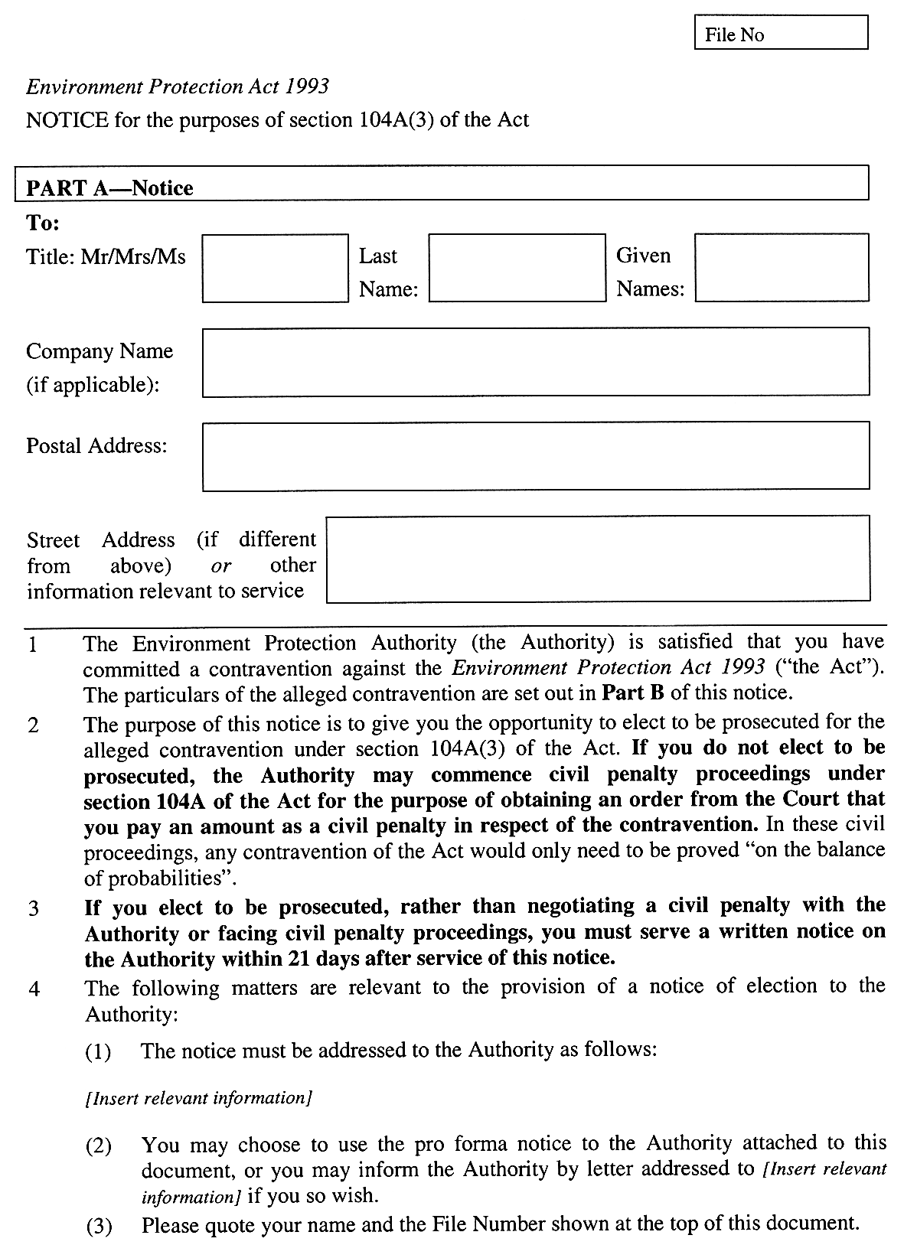
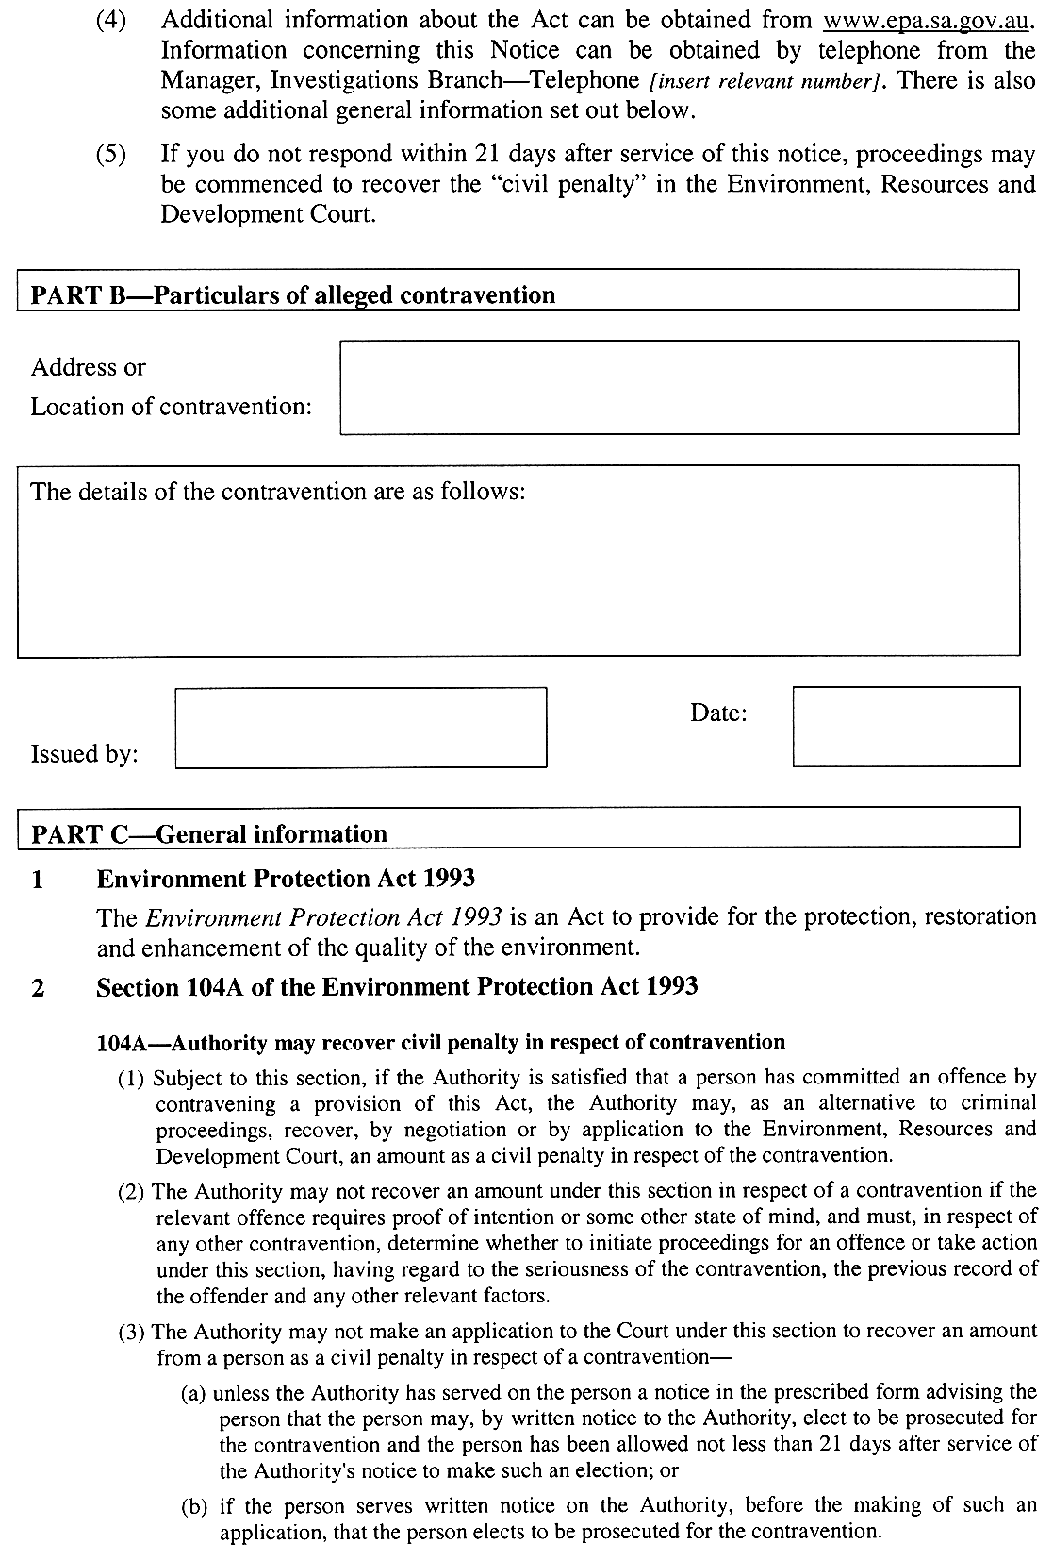
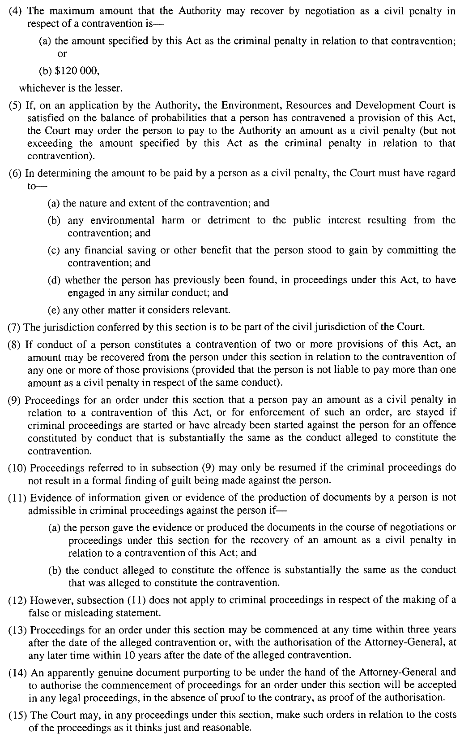
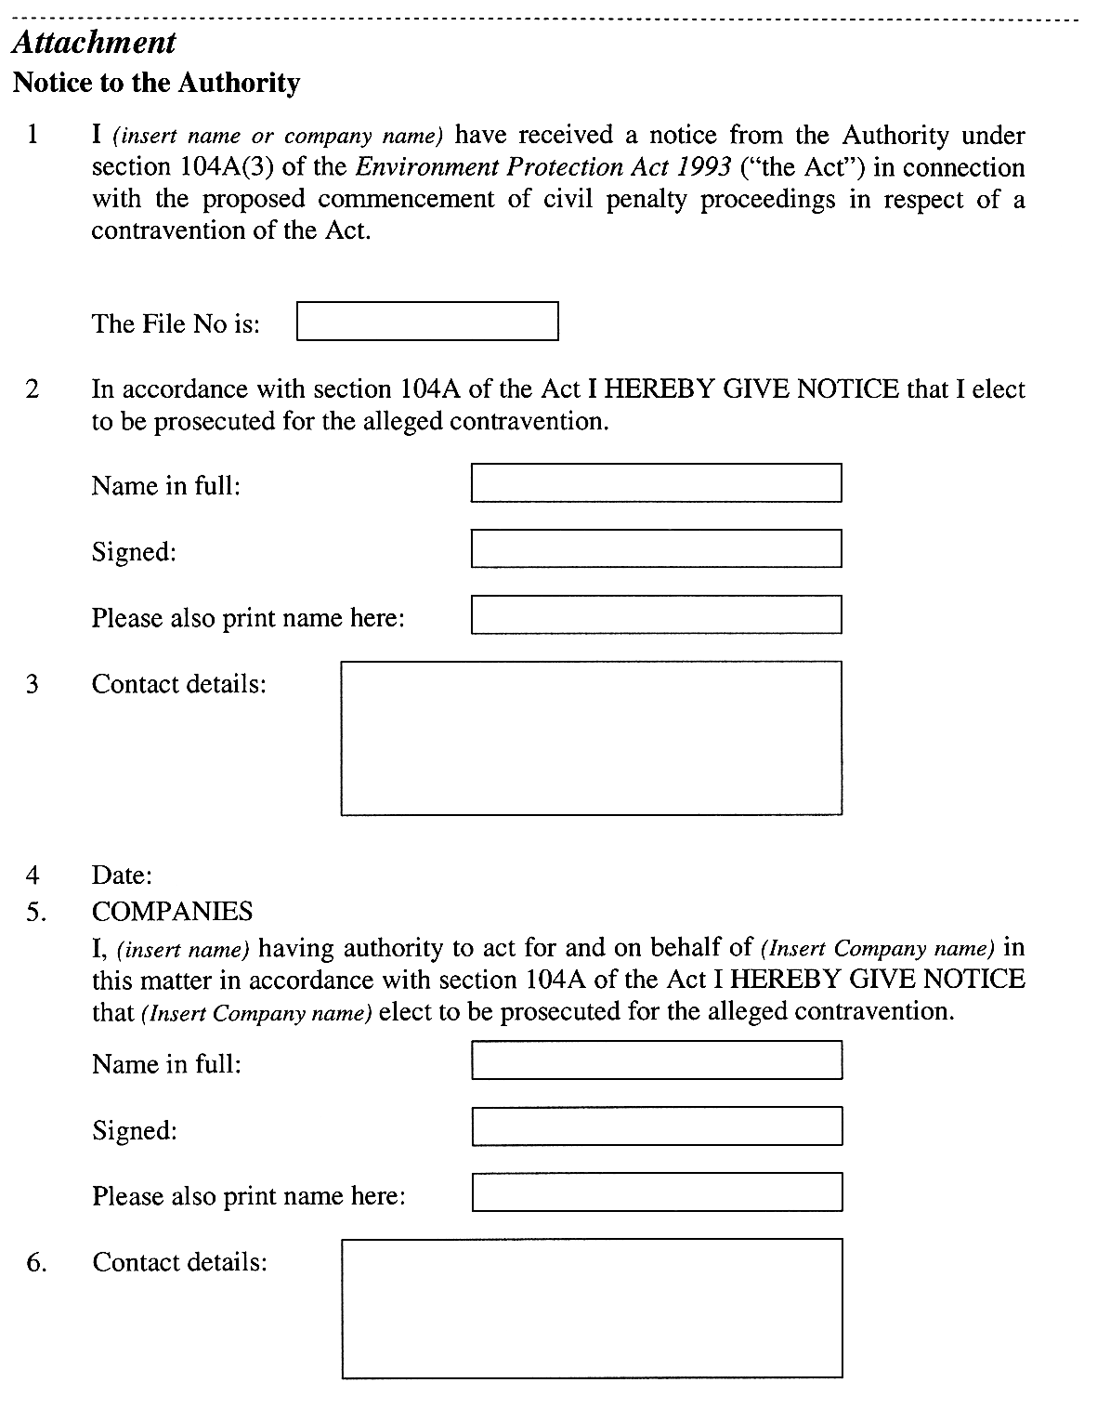
Note—
As required by section 10AA(2) of the Subordinate Legislation Act 1978, the Minister has certified that, in the Minister's opinion, it is necessary or appropriate that these regulations come into operation as set out in these regulations.
Made by the Governor
with the advice and consent of the Executive Council
on 22 June 2006
No 175 of 2006
EPCS06/0001

South Australia
Justices of the Peace Regulations 2006
under the Justices of the Peace Act 2005

Contents
1 Short title
2 Commencement
3 Interpretation
4 Prescribed requirements for appointment as justice
5 Additional prescribed requirements for appointment as special justice
6 Disciplinary action
7 Period of service prescribed for retired justices
8 Exemption from including certain telephone numbers in roll of justices
Schedule 1—Code of Conduct for Justices of the Peace and Special Justices
Part 1—Provisions applicable to all justices of the peace
1 Justice must act within conditions of appointment
2 Prohibition on charging fees etc
3 Conflict of interest and improper influence
4 Administering oaths, taking affidavits, witnessing instruments, etc
5 Justice must not divulge confidential information
6 Prohibition on profiting from office of justice
7 General conduct
8 Notice of certain information to be provided to Attorney-General
Part 2—Additional provisions applicable to special justices
9 Interpretation
10 Court duties etc
11 Notice of certain information to be provided to Chief Magistrate and Senior Judge of Youth Court
Schedule 2—Code of Conduct for Retired Justices of the Peace
1 Prohibition on profiting from office of justice

1—Short title
These regulations may be cited as the Justices of the Peace Regulations 2006.
2—Commencement
These regulations will come into operation on the day on which the Justices of the Peace Act 2005 comes into operation.
3—Interpretation
In these regulations—
Act means the Justices of the Peace Act 2005.
4—Prescribed requirements for appointment as justice
For the purposes of section 4(8)(d) of the Act, a person who is to be appointed as a justice must meet the following prescribed requirements:
(a) the person must be able to understand the duties and powers of a justice;
(b) the person must be sufficiently proficient in speaking English, and in reading and writing in the English language, so as to be able to—
(i) identify the nature of documents; and
(ii) read and understand instructions relating to his or her official duties; and
(iii) seek advice about his or her official duties;
(c) the person must not be bankrupt or have applied as a debtor to take the benefit of the laws relating to bankruptcy;
(d) the person must not be disqualified from managing or being involved in the management of any company under the Corporations Act 2001 of the Commonwealth;
(e) the person must provide at least 2 references as to the person's good character, reputation and standing in the community;
(f) the person must live or work in an area or community in which there is a need for a justice.
Examples—
1 The community in which the applicant lives or works may be scattered over a wide area. In that case, it may be desirable to appoint more justices per head of population than in a densely populated urban community.
2 The community in which the applicant lives or works may include particular ethnic or cultural groups. In that case, it may be desirable to appoint a justice of the same ethnic or cultural group.
3 Some places of employment (such as a local council office or the electorate office of a Member of Parliament) have a higher than usual demand for the services of a justice. In that case, it may desirable to appoint an applicant employed in such a place as a justice.
5—Additional prescribed requirements for appointment as special justice
(1) For the purposes of section 7(3)(c) of the Act, a justice who is to be recommended by the Attorney-General for appointment as a special justice must meet the following prescribed requirements:
(a) the justice must be under the age of 65 years;
(b) the justice must speak English fluently, and be sufficiently proficient in reading and writing in the English language, so as to be able to—
(i) communicate clearly in a courtroom; and
(ii) read and understand court documents and legislation;
(c) the justice must not have been convicted of any offence and must not have any outstanding charges or proceedings in relation to an offence alleged to have been committed by the justice;
(d) the justice must have been recommended to the Attorney-General by the Chief Magistrate or the Senior Judge of the Youth Court.
(2) Despite subregulation (1)(a), the Attorney-General may appoint a special justice who is of or over the age of 65 years if satisfied that there is good reason to do so.
(3) Despite subregulation (1)(c), the Attorney-General may appoint a special justice who has been convicted of an offence or who has outstanding against him or her a charge or proceedings in relation to an offence if the Attorney-General is satisfied that the conviction, or outstanding charge or proceedings should, in the circumstances, be disregarded.
(4) In this regulation—
offence does not include an offence that is expiable.
6—Disciplinary action
(1) Pursuant to section 11(1)(b) of the Act, there is proper cause for taking disciplinary action against a justice if the justice breaches, or fails to comply with, Part 1 (other than clause 8(2) or (3)) of the Code.
(2) Pursuant to section 11(1)(b) of the Act, there is proper cause for taking disciplinary action against a special justice if the special justice breaches, or fails to comply with—
(a) Part 1 (other than clause 8(2) or (3)) of the Code; or
(b) Part 2 of the Code.
(3) In this regulation—
Code means the Code of Conduct for Justices of the Peace and Special Justices.
7—Period of service prescribed for retired justices
For the purposes of section 16(4)(a) of the Act, the prescribed period is 20 years.
8—Exemption from including certain telephone numbers in roll of justices
The Attorney-General may determine that the telephone number on which a justice can be contacted after business hours (the justice's after hours number) need not be included in the roll of justices in relation to the justice if satisfied that—
(a) inclusion of the justice's after hours number in the roll would endanger the safety of the justice or a member of his or her family; or
(b) —
(i) the justice is usually able to be contacted and available to carry out his or her official duties as a justice during business hours; and
(ii) there is good reason why the justice's after hours number should not be included in the roll.
Schedule 1—Code of Conduct for Justices of the Peace and Special Justices
Part 1—Provisions applicable to all justices of the peace
1—Justice must act within conditions of appointment
A justice must not breach, or fail to comply with, a condition of his or her appointment.
2—Prohibition on charging fees etc
A justice must not exercise the powers of a justice for fee or reward.
3—Conflict of interest and improper influence
(1) A justice must not exercise the powers of a justice in respect of a matter in which the justice has a direct or indirect interest.
(2) A justice must not improperly influence, or attempt to improperly influence, a person who seeks the services of the justice.
4—Administering oaths, taking affidavits, witnessing instruments, etc
(1) If, under an Act, it is provided—
(a) that a declaration may be made before a justice; or
(b) that an instrument may be signed or executed in the presence of, or be attested by, a justice,
the justice taking the declaration, or witnessing or attesting to the instrument, must do so in accordance with any directions provided under the Act.
Example—
Regulation 23 and Schedule 6 Form 1 (Waiver of Rights) under the Second-hand Vehicle Dealers Regulations 1995.
(2) A justice must not—
(a) administer an oath or affirmation to a person; or
(b) take the declaration or affidavit of a person; or
(c) witness the signing or execution of an instrument,
if the justice reasonably doubts that the person is legally or mentally competent to make the oath, affirmation, declaration or affidavit or to execute the document.
5—Justice must not divulge confidential information
A justice must not intentionally divulge information of a private, confidential or commercially sensitive nature obtained by the justice in carrying out his or her official duties except—
(a) as authorised or required by law; or
(b) with the consent of the person from whom the information was obtained or to whom the information relates.
6—Prohibition on profiting from office of justice
A justice must not use, or seek to use, the office of justice of the peace for the purpose of advancing his or her business interests.
7—General conduct
(1) A justice must not criticise or comment on the choice of a person as to whether the person takes an oath or makes a declaration.
(2) A justice must behave in a proper and courteous manner to any person who seeks his or her services as a justice.
(3) A justice must not conduct himself or herself in such a way that brings the office of justice of the peace into disrepute.
8—Notice of certain information to be provided to Attorney-General
(1) A justice must, within 14 days after any of the following matters occurring:
(a) being charged with an offence (other than an offence that is expiable);
(b) the withdrawal, dismissal or discontinuance of a charge of an offence (other than an offence that is expiable) alleged to have been committed by the justice;
(c) being convicted or acquitted of an offence (other than an offence that is expiable);
(d) being adjudged in civil proceedings to have acted dishonestly;
(e) becoming bankrupt or applying as a debtor to take the benefit of the laws relating to bankruptcy;
(f) being disqualified from managing or being involved in the management of any company under the Corporations Act 2001 of the Commonwealth,
provide written notice of the details of the matter to the Attorney-General.
(2) A justice must, within 28 days after a change in—
(a) the justice's name; or
(b) the justice's business or home address; or
(c) the telephone number on which the justice can be contacted during business hours or after business hours; or
(d) the justice's occupation,
provide written notice of the change to the Attorney-General.
(3) A justice must, as soon as practicable after becoming aware—
(a) that he or she will be absent from the State for a period expected to last at least 3 months; or
(b) that he or she will, for some other reason, be unable to carry out his or her official duties as a justice for a period of at least 3 months,
provide written notice of that information to the Attorney-General.
Part 2—Additional provisions applicable to special justices
9—Interpretation
In this Part—
Senior Judge of the Youth Court includes, if the Senior Judge is not reasonably available to exercise a power vested in the Senior Judge under the Youth Court Act 1993, the most senior of the Judges of the Youth Court who is available to exercise that power;
supervising judicial officer means—
(a) the Chief Magistrate; or
(b) the Deputy Chief Magistrate; or
(c) a Magistrate who is designated as a Regional Manager of the Magistrates Court; or
(d) the Senior Judge of the Youth Court.
10—Court duties etc
(1) A special justice must observe the directions of the relevant supervising judicial officer relating to the administration of the Magistrates Court or the Youth Court.
(2) A special justice must attend court at the time and place notified to the special justice.
(3) However, a special justice will be excused from attending court if he or she has given reasonable notice to the relevant supervising judicial officer of his or her inability to attend.
(4) A special justice must attend to the business of the court that is entrusted to the special justice diligently and to the best of his or her ability.
(5) A special justice must, at all times—
(a) when carrying out his or her official duties as a special justice; and
(b) while in the precincts of a court,
observe the standard of conduct and dress expected of a judicial officer.
11—Notice of certain information to be provided to Chief Magistrate and Senior Judge of Youth Court
A special justice must, within 14 days after any of the following matters occurring:
(a) being charged with an offence (other than an expiable offence);
(b) the charge of an offence (other than an expiable offence) alleged to have been committed by the justice being withdrawn, dismissed or discontinued;
(c) being convicted or acquitted of an offence (other than an expiable offence);
(d) being adjudged in civil proceedings to have acted dishonestly;
(e) becoming bankrupt or applying as a debtor to take the benefit of the laws relating to bankruptcy;
(f) being disqualified from managing or being involved in the management of any company under the Corporations Act 2001 of the Commonwealth,
provide written notice of the details of the matter to the Chief Magistrate or the Senior Judge of the Youth Court (depending on the court to which the special justice is assigned).
Note—
See also clause 8 of the Code (Notice of certain information to be provided to Attorney-General)
Schedule 2—Code of Conduct for Retired Justices of the Peace
1—Prohibition on profiting from office of justice
A person must not use, or seek to use, "JP (Retired)", or any other title or description that implies that the person is a retired justice, for the purpose of advancing his or her business interests.
Note—
See also section 16(4) of the Justices of the Peace Act 2005 which makes it an offence (punishable by a fine of $2 500) to use the title or description when not entitled to do so.
Note—
As required by section 10AA(2) of the Subordinate Legislation Act 1978, the Minister has certified that, in the Minister's opinion, it is necessary or appropriate that these regulations come into operation as set out in these regulations.
Made by the Governor
with the advice and consent of the Executive Council
on 22 June 2006
No 176 of 2006
AGO0203/03CS

South Australia
Development (Review of Fees) Variation Regulations 2006
under the Development Act 1993

Contents
Part 1—Preliminary
1 Short title
2 Commencement
3 Variation provisions
Part 2—Variation of Development Regulations 1993
4 Variation of regulation 46—Special provision relating to staged consents
5 Variation of regulation 63B—Prescribed fee
6 Variation of regulation 93A—Register of private certifiers
7 Substitution on Schedule 6
Schedule 6—Fees
8 Variation of Schedule 7

Part 1—Preliminary
1—Short title
These regulations may be cited as the Development (Review of Fees) Variation Regulations 2006.
2—Commencement
These regulations will come into operation on 1 July 2006.
3—Variation provisions
In these regulations, a provision under a heading referring to the variation of specified regulations varies the regulations so specified.
Part 2—Variation of Development Regulations 1993
4—Variation of regulation 46—Special provision relating to staged consents
Regulation 46—after subregulation (2) insert:
(3) The requirement under subregulation (1) does not arise unless or until the Development Authorisation (Staged Consents) Fee under Schedule 6 has been paid, if relevant.
5—Variation of regulation 63B—Prescribed fee
(1) Regulation 63B(1)(a)—delete "$1 313" and substitute:
$1 363
(2) Regulation 63B(1)(b)—after "components (2)" insert:
(c) or (d)
(3) Regulation 63B(1)—after paragraph (b) insert:
plus
(c) if the development cost exceeds $100 000—0.25 per cent of the development cost up to a maximum amount determined by the Minister.
(4) Regulation 63B—after subregulation (4) insert:
(5) In this regulation—
development cost does not include any fit-out costs.
6—Variation of regulation 93A—Register of private certifiers
(1) Regulation 93A(2)(b)—delete "$66" and substitute:
$107
(2) Regulation 93A(5)(a)—delete "$39.25" and substitute:
$53.50
7—Substitution on Schedule 6
Schedule 6—delete Schedule 6 and substitute:
Schedule 6—Fees
1 The following fees are payable in relation to an application under Part 4 of the Act:

(1) | A Lodgement Fee (the base amount) | $45.00
 | plus
 | (a) if the application is seeking the relevant authority to assess a non-complying development under the Development Plan, other than where the application relates to development that involves the division of land; and | $72.00
 | (b) if the application is seeking the relevant authority to assess an application that relates to the division of land—
 | (i) if the number of allotments resulting from the division under the application is equal to or less than the number of existing allotments; or | $36.00
 | (ii) if the number of allotments resulting from the division under the application is greater than the number of existing allotments; and | $105.00
 | (c) if the application is seeking the relevant authority to assess the development against the provisions of the Building Rules and the development cost exceeds $5 000 | $51.00
(2) | If the application requires the relevant authority to assess the development against the provisions of the relevant Development Plan, other than where the application relates—
 | (a) to a complying development under these regulations or the Development Plan; or
 | (b) to a proposed division of land into allotments which does not involve the performance of building work,
 | a Development Plan Assessment Fee of the following amount:
 | (c) if the development cost does not exceed $10 000 | $28.00
 | (d) if the development cost exceeds $10 000 but does not exceed $100 000 | $77.00
 | (e) if the development cost exceeds $100 000 | 0.125 per cent of the development cost up to a maximum of $200 000
(3) | If the application relates to a proposed division of land—
 | (a) other than where the application relates to a complying development under these regulations or the Development Plan, a Land Division Fee of the following amount:
 | (i) if the number of allotments resulting from the division is equal to or less than the number of existing allotments | $52.00
 | (ii) if the number of allotments resulting from the division is greater than the number of existing allotments | $114.00 plus $10.70 for each allotment up to a maximum of $5 190
 | and
 | (b) a Statement of Requirements Fee for the purposes of section 33(1)(c) or (d) of the Act—
 | (i) if the number of allotments resulting from the division is equal to or less than the existing number of allotments | $212.00
 | (ii) if the number of allotments resulting from the division is greater than the number of existing allotments | $300.00
 | and
 | (c) a Development Assessment Commission Consultation Report Fee—
 | (i) if the number of allotments resulting from the division is equal to or less than the existing number of allotments | $50.00
 | (ii) if the number of allotments resulting from the division is greater than the existing number of allotments | $150.00
 | and
 | (d) a Certificate of Approval Fee for the purposes of section 51 of the Act—
 | (i) if the number of allotments resulting from the division is equal to or less than the existing number of allotments | $75.00
 | (ii) if the number of allotments resulting from the division is greater than the existing number of allotments | $250.00
(4) | If the application relates to a proposed development that is of a kind described as a non-complying development under the relevant Development Plan—
 | (a) a Non-complying Development Administration Fee (in respect of the requirement for a concurrence under section 35(2) of the Act (one fee)) | $91.00
 | and
 | (b) a Non-complying Development Assessment Fee of the following amount (unless no assessment is to be undertaken due to an immediate refusal of the application):
 | (i) if the development cost does not exceed $10 000 | $38.50
 | (ii) if the development cost exceeds $10 000 but does not exceed $100 000 | $91.00
 | (iii) if the development cost exceeds $100 000 | 0.125 per cent of the development cost up to a maximum of $200 000
 | (iv) if the application relates to the proposed division of land—
 | (A) if the number of allotments resulting from the division is equal to or less than the existing number of allotments | $38.50
 | (B) if the number of allotments resulting from the division is greater than the number of existing allotments | $91.00 plus $10.70 for each new allotment up to a maximum of $1 602
(5) | If the application must be referred to a body prescribed under Schedule 8 for the purposes of section 37 of the Act—
 | (a) except to the extent that paragraph (b) applies, for each body to which the application must be referred—a Referral Fee of the following amount:
 | (i) unless subparagraph (ii) applies | $160.00
 | (ii) if the development cost exceeds $1 000 000 | $267.00
 | (b) for a referral—
 | (i) that falls within the ambit of clauses 1(6), 2(3), 2(7), 2(8), 2(10) or 3(3) of Schedule 22—for the referral to the Environment Protection Authority | $267.00
 | (ii) that falls within the ambit of item 19, 20 or 21—for a referral under those items | $267.00
(6) | If the proposed development is a Category 2 or Category 3 development for the purposes of section 38 of the Act—a Public Notification Fee | $77.00
(7) | If the proposed development is a Category 3 development for the purposes of section 38 of the Act—an Advertisement Fee | An amount determined by the relevant authority as being appropriate to cover its reasonable costs in giving public notice of the application under section 38(5)(c) of the Act
(8) | If the application requires a relevant authority to assess the development against the provisions of the Building Rules—
 | (a) in the case of a building that has a floor area | F = 0.0023 ×CI ×A ×CF, or $48.00, whichever is the greater
 | (b) in the case of a building that does not have a floor area | F = 0.0023 ×CI ×S ×CF, or $48.00, whichever is the greater
where—
F is the fee (in dollars) payable under this component (unless the $48.00 minimum applies)
CI is the construction index determined by the Minister from time to time and set out in the Schedule of Construction Indices published in the Gazette
A is the prescribed floor area
S is the projected area of the largest side or plane of the building
CF is the complexity factor
(9) | If the application requires a relevant authority to grant consent to a development that is at variance with the Building Rules | $112.00
(10) | If the application requires referral to the Building Rules Assessment Commission for concurrence before granting consent to a development that is at variance with the performance requirements of the Building Code | $226.00
(11) | If— | $45.00
 | (a) a council is the relevant authority with respect to a particular development; and
 | (b) the development requires both provisional development plan consent and provisional building rules consent; and
 | (c) an applicant applies for the provisional building rules consent after applying for the provisional development plan consent,
 | a Development Authorisation (Staged Consents) Fee
For the purposes of this item:
(a) development cost does not include any fit-out costs;
(b) allotment does not include an allotment for road or open space requirements;
(c) subject to Schedule 7, a body prescribed under Schedule 8 for the purposes of section 37 of the Act may waive the whole or part of a fee due to the body under component (5), or refund any such fee (in whole or in part);
(d) if an application must be referred to the same body under more than one item in Schedule 8, only one fee is payable under component (5) with respect to the referral to that particular body (being, if relevant, the higher or highest fee);
(e) if—
(i) a State agency lodges an application for approval with the Development Assessment Commission under section 49 of the Act; or
(ii) a prescribed person lodges an application for approval with the Development Assessment Commission under section 49A of the Act,
then—
(iii) if—
(A) the development cost exceeds $100 000; or
(B) the development involves the division of land and the number of allotments resulting from the division is greater than the existing number of allotments,
any relevant fee under components (1), (2) and (3) of this item will be payable to the Development Assessment Commission as if it were a relevant authority (but not so as to require any payment by the Development Assessment Commission to a council under Schedule 7);
(iv) in any other case—no fee is payable;
(f) no fee is payable in respect of a development—
(i) excluded from the provisions of section 49 of the Act by a regulation under section 49(3); or
(ii) excluded from the provisions of section 49A of the Act by a regulation under section 49A(3);
(g) no fee is payable in respect of a development which is to be undertaken by a council, except where the primary reason for the proposed development is to raise revenue for the council;
(h) an application seeking the variation of a development authorisation previously given under the Act (including a condition imposed in relation to a development) will be subject to the fees prescribed by this item as if it were an application for a new development, but only to the extent that a particular fee imposed in relation to the application reflects the step or steps to be undertaken by the relevant authority or another relevant body on account of the application and not so as to require the payment of a fee for a minor variation that makes no substantive change to the development authorisation that has been previously given.
2 The following fee is payable in respect of an application for assignment of a classification to a building or a change in the classification of a building for the purposes of section 66 of the Act:

(a) in the case of a building that has a floor area | F = 0.00184 ×CI ×A ×CF, or $48.00, whichever is the greater
(b) in the case of a building that does not have a floor area | F = 0.00184 ×CI ×S ×CF, or $48.00, whichever is the greater
where—
F is the fee (in dollars) payable under this component (unless the $48.00 minimum applies)
CI is the construction index determined by the Minister from time to time and set out in the Schedule of Construction Indices published in the Gazette
A is the prescribed floor area
S is the projected area of the largest side or plane of the building
CF is the complexity factor.
3 A fee of $32.00 is payable in respect of an application for a certificate of occupancy.
4 A fee of $69.50 is payable in respect of an application under regulation 76(3)(b).
5 (1) If the matter involves an application to a private certifier for an assessment of a development against the provisions of the Building Rules, a fee equal to 5 per cent of the fee that would apply under component (8) of item 1 if a council were the relevant authority for that assessment, exclusive of any GST component, is payable by the applicant.
(2) The fee must be paid by the applicant to the private certifier at the time of application.
(3) The fee must be held by the private certifier pending payment to the Minister under Schedule 7.
(4) Except as provided above, the fee to be paid to a private certifier will be determined by agreement between the applicant and the private certifier.
6 The following fees are payable in respect of a referral to the Building Rules Assessment Commission under section 36(2b) of the Act:
(a) for Class 1 and 10 buildings—$353.00;
(b) for Class 2 to 9 buildings—$774.00.
7 (1) A fee of $53.50 is payable in respect of the registration of an agreement under section 57 or 57A of the Act.
(2) A fee of $10.00 is prescribed for the purposes of section 57(2d) or 57A(7) of the Act.
8 (1) A fee of $107 is payable in respect of an application to the Minister for an approval under section 101 of the Act.
(2) A fee under this item must be paid in a manner determined by the Minister.
9 A fee of $72.00 is payable in respect of an application to extend a period under regulation 48.
10 For the purposes of items 1(8) and 2—
(a) the prescribed floor area is—
(i) for the purpose of calculating the fee on an application for assessment against the provisions of the Building Rules that consists of the erection of a building or the demolition of a building—the aggregate of the floor areas of the building proposed to be erected or demolished;
(ii) for the purpose of calculating the fee on an application for assessment against the provisions of the Building Rules where the building work consists of an alteration to a building—
(A) the aggregate of the floor areas of the rooms or compartments to be altered; or
(B) where the alteration consists of the fixing or erection of an attachment that does not have a floor area—the floor area of the building within a distance of three metres of where the attachment is to be fixed or erected;
(iii) for the purpose of calculating the fee on application for assignment of a classification to, or a change in the classification of, a building—the aggregate of the floor areas of the building;
(b) the floor area of a building is to be measured over any enclosing walls and is to include the area of the floor of any fully or partly covered carport, portico, verandah, balcony, porch or other similar structure attached or to be attached to the building;
(c) where a building is without storeys, or has a storey of a height of more than 10 metres, the floor area is to be calculated as if the building contained floors at 10 metre intervals, measured vertically;
(d) a building is to be taken not to have any floor area if it is principally of open framework or web construction or solid construction and without any fully or partly enclosed space intended for occupation or use by persons;
(e) the complexity factor is—
(i) except as below—1.0;
(ii) for building work for the erection or alteration of a building that exceeds 6 storeys—1.3;
(iii) for building work for the erection or alteration of a building that contains an atrium—1.3;
(iv) for building work for the erection or alteration of a building that contains an arcade exceeding 40 metres in length—1.3;
(v) for building work that consists solely of the demolition of a building—0.2;
(vi) for assignment of classification or a change in classification where no building work is proposed—0.8;
(f) where a building is made up of parts that have different construction indices, the fee payable for the assessment of building work against the provisions of the Building Rules, the assignment of classification or a change in classification, is the aggregate of the fees calculated in accordance with this Schedule for those parts;
(g) where an application for the assessment of building work against the provisions of the Building Rules incorporates an application for the assignment of a classification to, or a change in the classification of, the building, one fee is payable in respect of the applications, being whichever of the fees for those applications that is of the greater amount.
8—Variation of Schedule 7
(1) Schedule 7, clauses 2 and 3—delete clauses 2 and 3 and substitute:
2—Distribution of fees between a council and other authorities
A council must, within 10 business days after the end of each quarter—
(a) pay to the Development Assessment Commission an amount equal to the sum of the following:
(i) in relation to fees received by the council during that quarter under component (1) of item 1 of Schedule 6 in respect of applications for which the Development Assessment Commission is the relevant authority—75 per cent of fees representing the base amount under that component plus 75 per cent of fees paid under paragraph (a) or (c) of that component; and
(ii) in relation to fees received by the council during that quarter under component (2) of item 1 of Schedule 6—
(A) 5 per cent of fees under that component in respect of applications for which the council is the relevant authority; and
(B) the total of all fees under that component in respect of applications for which the Development Assessment Commission is the relevant authority; and
(iii) in relation to fees received by the council during that quarter under component (4)(a) of item 1 of Schedule 6—
(A) 90 per cent of fees under that component in respect of applications for which the council is the relevant authority; and
(B) 10 per cent of fees under that component in respect of applications for which the Development Assessment Commission is the relevant authority; and
(iv) in relation to fees received by the council during that quarter under component (4)(b)(i), (ii) or (iii) of item 1 of Schedule 6—
(A) 5 per cent of fees under that component in respect of applications for which the council is the relevant authority; and
(B) the total of all fees under that component in respect of applications for which the Development Assessment Commission is the relevant authority; and
(v) the total of all fees received by the council during that quarter under components (5), (6) and (7) of item 1 of Schedule 6 in respect of applications for which the Development Assessment Commission is the relevant authority; and
(vi) the total of all fees received by the council during that quarter under components (8) and (9) of item 1 of Schedule 6 in relation to applications for which the council is not the relevant authority for the purposes of the assessment of the applications in respect of the Building Rules; and
(vii) $15 for each amount received by the council during that quarter under component (11) of item 1 of Schedule 6; and
(b) in relation to fees received by the council during that quarter in relation to component (5)(a) of item 1 of Schedule 6 on account of referrals of applications under Schedule 8 where the council is the relevant authority—
(i) where component (5)(a)(i) applies—pay to the relevant body under Schedule 8 $130 for each amount received by the council on account of referrals to that body;
(ii) where component (5)(a)(ii) applies—pay to the relevant body $237 for each amount received by the council on account of referrals to that body;
(c) in relation to fees received by the council during that quarter in relation to component (5)(b) of item 1 of Schedule 6 on account of referrals of applications under Schedule 8 where the council is the relevant authority—pay to the relevant body $237 for each amount received by the council on account of referrals to that body;
(d) pay to the Minister 5 per cent of fees received by the council during the quarter under component (8) of item 1 of Schedule 6, or under clause 3(a)(ix) of this Schedule, exclusive of any GST component.
3—Distribution of fees between the Commission and councils
The Development Assessment Commission must, within 10 business days after the end of each quarter—
(a) pay to a council an amount equal to the sum of the following:
(i) in relation to fees received by the Development Assessment Commission during that quarter under component (1) of item 1 of Schedule 6 in respect of applications that involve the division of land for which the council is the relevant authority—75 per cent of the fees representing the base amount under that component plus 75 per cent of the fees paid under paragraph (c) of that component; and
(ii) in relation to fees received by the Development Assessment Commission during that quarter under component (2) of item 1 of Schedule 6—95 per cent of fees under that component in respect of applications for which the council is the relevant authority; and
(iii) the total of all fees received by the Development Assessment Authority during that quarter under component (3)(a) of item 1 of Schedule 6 in respect of applications for which the council is the relevant authority; and
(iv) $132 for each amount received by the Development Assessment Commission during that quarter under component (3)(b) of item 1 of Schedule 6 in respect of developments within the area of the council; and
(v) 90 per cent of fees received by the Development Assessment Commission during that quarter under component (4)(a) of item 1 of Schedule 6 where the Development Assessment Commission is the relevant authority in respect of developments within the area of the council; and
(vi) 10 per cent of fees received by the Development Assessment Commission during that quarter under component (4)(a) of item 1 of Schedule 6 where the council is the relevant authority; and
(vii) 95 per cent of fees received by the Development Assessment Commission during that quarter under component (4)(b)(i), (ii) or (iii) of item 1 of Schedule 6 where the council is the relevant authority; and
(viii) the total of all fees received by the Development Assessment Commission during that quarter under components (5), (6) and (7) of item 1 of Schedule 6 in respect of applications for which the council is the relevant authority; and
(ix) the total of all fees received by the Development Assessment Commission during that quarter under components (8) and (9) of item 1 of Schedule 6 in relation to applications for which the council is the relevant authority for the purposes of the assessment of the applications in respect of the Building Rules; and
(x) $30 for each amount received by the Development Assessment Commission during that quarter under component (11) of item 1 of Schedule 6; and
(b) in relation to fees received by the Development Assessment Commission during that quarter in relation to component (5)(a) of item 1 of Schedule 6 on account of referrals of applications under Schedule 8 where the Development Assessment Commission is the relevant authority—
(i) where component (5)(a)(i) applies—pay to the relevant body under Schedule 8 $130 for each amount received by the Development Assessment Commission on account of referrals to that body;
(ii) where component (5)(a)(ii) applies—pay to the relevant body $237 for each amount received by the Development Assessment Commission on account of referrals to that body; and
(c) in relation to fees received by the Development Assessment Commission in relation to component (5)(b) of item 1 of Schedule 6 on account of referrals of applications under Schedule 8 where the Development Assessment Commission is the relevant authority—pay to the relevant body $237 for each amount received by the Development Assessment Commission on account of referrals to that body.
(2) Schedule 7, clauses 5 and 6—delete clauses 5 and 6 and substitute:
5—Payments direct to the Development Assessment Commission
The fees payable under the following items of Schedule 6 must be paid in all cases to the Development Assessment Commission:
(a) item 1(1)(b);
(b) item 1(3);
(c) item 1(4)(b)(iv);
(d) any other fee expressed to be payable to the Development Assessment Commission.
Note—
As required by section 10AA(2) of the Subordinate Legislation Act 1978, the Minister has certified that, in the Minister's opinion, it is necessary or appropriate that these regulations come into operation as set out in these regulations.
Made by the Governor
with the advice and consent of the Executive Council
on 22 June 2006
No 177 of 2006
MUDP06/025CS

FAXING COPY?
IF you fax copy to Government Publishing SA for inclusion in the Government Gazette, there is no need to send a Confirmation Copy to us as well.
This creates confusion and may well result in your notice being printed twice.
Please use the following fax number:
Fax transmission: (08) 8207 1040
Phone Inquiries: (08) 8207 1045
Please include a contact person, phone number and order number so that we can phone back with any queries we may have regarding the fax copy.
NOTE: Closing time for lodging new copy (fax, hard copy or email) is 4 p.m. on Tuesday preceding the day of publication.

Government Gazette notices can be E-mailed.
The address is:
governmentgazette@saugov.sa.gov.au
Documents should be sent as attachments in Word format.
When sending a document via E-mail, please confirm your transmission with a faxed copy of your document, including the date the notice is to be published.
Fax transmission: (08) 8207 1040
Enquiries: (08) 8207 1045
NOTE: Closing time for lodging new copy (fax, hard copy or email) is 4 p.m. on Tuesday preceding the day of publication.

DISTRICT COUNCIL OF BARUNGA WEST
Proposed By-law to be Made Under the
Local Government Act 1999
By-law No. 6—Boat Ramps
TO regulate the use of boat ramps within the Council area and surrounding lands used for access to the boat ramps and which are under the control of the Council.
Definitions
1. In this by-law:
‘Annual Ticket’ means a ticket purchased from the Council offices authorising the launch of one craft at a boat ramp, and is valid until the next 30 June.
‘Authorised Officer’ means a person appointed pursuant to section 260 of the Local Government Act 1999.
‘Boat Ramp’ means a facility constructed, maintained and operated by the Council for the launching of craft at Port Broughton and Fisherman’s Bay.
‘Short Term Ticket’ means a ticket purchased from a vending machine located at the boat ramp, valid for one launch of any one craft from the boat ramp on the same day of purchase.
‘Ticket’ means either an Annual Ticket or a Short Term Ticket.
Boat Ramp Usage
2. No person shall use a boat ramp to launch, propel or float any boat, raft, pontoon or watercraft, including model boats without having first purchased a ticket.
3. The fee for a ticket to use a boat ramp shall be such as determined by the Council from time to time.
4. Upon request of an Authorised Officer or a member of the South Australian Police Force, any person about to use, using, or having used, a boat ramp is required to produce a ticket.
5. If a ticket cannot be produced, the Authorised Officer may issue an account to the person using or having used the boat ramp, which shall be payable in accordance with the terms specified on the account.
6. Council may exempt organisations involved in search and rescue at sea from the requirement to purchase a ticket.
Offence
7. Any person who commits a breach of this by-law shall be guilty of an offence.
The foregoing by-law was duly made and passed at a meeting of the Council of the District Council of Barunga West held on
6 June 2006, by an absolute majority of the members for the time being constituting the Council, there being at least two-thirds of the members present.
N. Hand, District Manager

DISTRICT COUNCIL OF CLEVE
Adoption of Valuations
NOTICE is hereby given that the District Council of Cleve in accordance with section 167 of the Local Government Act 1999, at a meeting held on 9 June 2006, adopted for the year ending 30 June 2007, the site valuations made by the State Valuation Office in relation to the area of the Council, being the most recent valuations available and totalling $218 907 680.
Declaration of Rates and Charges
Notice is hereby given pursuant to section 170 of the Local Government Act 1999, that the District Council of Cleve at a meeting held on 9 June 2006, declared the following rates and charges for the year ending 30 June 2007.
1. Pursuant to section 153 of the Local Government Act 1999, differential general rates based on the site value of land according to locality as hereunder:
Cents in
the $
Arno Bay—Town 1.7840
Arno Bay—Coastal Zone 0.7835
Cleve—Town 3.1302
Cleve—Rural Living/Fringe Zone 2.0325
Other Towns—Rudall, Darke Peak, etc. 50.0000
Outside Towns—Rural 0.7835
Special Industry Zone (Grain Storage Silos) 21.7612
2. Pursuant to section 158 of the Local Government Act 1999, a minimum amount that shall be payable by way of rates on rateable properties of $322.
3. Pursuant to section 155 of the Local Government Act 1999, annual service charges payable on land serviced by prescribed services as hereunder:
Cleve Common Effluent Drainage Scheme $240 per unit
Arno Bay Foreshore Waste Drainage and
Treatment Scheme $240 per unit
Common Antenna TV Retransmission Service:
Elson Subdivision $75 per unit (GST inc.)
Whyte Street/Cottages Division $182 per unit (GST inc.)
4. Pursuant to section 154 of the Local Government Act 1999, a separate rate of 1.9625 cents in the dollar payable on the site value of the following specified land at Arno Bay undergoing the shack site freeholding process, which activity, the Council has agreed to support. Allotment Nos 5, 7, 10, 12, 14, 16, 19, 22 and 25 of DP35669, Hundred of Boothby, Arno Bay.
5. Pursuant to section 154 of the Local Government Act 1999, a separate rate of 0.3461 cents in the dollar payable on the site value of all rateable properties abutting the Arno Bay Centenary Lane Kerbing and Sealing Project, together with discretionary rebates pursuant to section 166 (1) (a) and (i) and (ii), on all such properties where valuation anomalies would result in any property ratepayers paying any more than $180 per year, to assist in defraying the capital cost of the works directly benefiting those properties.
6. Pursuant to section 154 of the Local Government Act 1999, a separate rate of 0.7500 cents in the dollar on the site value of 2 Hauschild Road, Cleve, to recoup approximately $180 per year, to assist in defraying the capital cost of the works directly benefiting these properties.
7. Pursuant to section 95 of the Natural Resources Management Act 2004 and section 154 of the Local Government Act 1999, the Council declared a separate rate being a fixed NRM levy of $74 upon all rateable property in the Council area. The fixed NRM Levy was declared in order to reimburse the Council the amount of $77 016 which Council is required to contribute towards the costs of operating the Eyre Peninsula Natural Resources Manage-ment Board for the 2006-2007 financial year.
Rating Policy
Pursuant to section 171 of the Local Government Act 1999, the District Council of Cleve has prepared and adopted a rating policy in conjunction with the declaration of rates and charges for the 2006-2007 financial year. A summary version of the policy will accompany each rates notice sent to ratepayers and copies of the policy are available at the Council office.
Payment of Rates and Discounts
The District Council of Cleve has resolved pursuant to section 181 of the Local Government Act 1999, that rates shall be payable in four equal or approximately equal instalments due on 15 September 2006, 15 December 2006, 15 March 2007 and 15 June 2007 for the 2006-2007 financial year.
Pursuant to section 181 (11) of the Act, a discount of 2% is offered if the annual rates amount is paid in full prior to 16 September 2006.
F. L. Gillings, Chief Executive Officer

DISTRICT COUNCIL OF KAROONDA EAST MURRAY
Adoption of 2006-2007 Annual Business Plan
NOTICE is hereby given that at its meeting held on Tuesday, 13 June 2006, the Council in accordance with section 123 (5) of the Local Government Act 1999, adopted the 2006-2007 Annual Business Plan.
Adoption of Valuation
Notice is hereby given that at its meeting held on Tuesday, 13 June 2006, the Council in accordance with section 167 (2) (a) of the Local Government Act 1999, made a valuation of all properties within the district for the year ending 30 June 2007, by adopting the most recent capital valuation as supplied by the Valuer-General and that such valuation will become and be the valuation of the Council for the 2006-2007 financial year.
$
Rateable 176 684 520
Non-rateable 5 581 700
Total 182 266 220
Service Charge—Common Effluent Drainage Scheme
Karoonda Township
Pursuant to section 155 of the Local Government Act 1999, the Council declared the following service charges to be payable by owners or occupiers as set out thereunder, in respect to the financial year ending 30 June 2007.
$
Occupied properties 120
Vacant properties 95
Declaration of Rates
Pursuant to section 153 of the Local Government Act 1999, the Council did on 13 June 2006 declare a general rate of 0.4177 cents in the dollar on the capital value of all rateable land within the area for the 2006-2007 financial year.
Minimum Amount Payable
Pursuant to section 158 (1) of the Local Government Act 1999, the Council resolved that the minimum amount payable by way of rates in respect of rateable land within the area for the 2006-2007 financial year shall be $130.
Payment of Rates
Pursuant to section 181 (a) of the Local Government Act 1999, rates will fall due in four instalments on 12 September 2006, 12 December 2006, 13 March 2007 and 13 June 2007.
To encourage prompt payment of rates Council offers a discount of 5% on all rates paid in full by 12 September 2006.
P. Smithson, Chief Executive Officer

MID MURRAY COUNCIL
Change of Street Name—Chandler Avenue
NOTICE is hereby given that in accordance with the provisions of section 219 of the Local Government Act 1999, that at a meeting held on 13 June 2006, the Council resolved to change the name of Queen Mary Street between King George Street and River Lane, Mannum, as delineated on Deposited Plan 69409, to Chandler Avenue.
D. H. Gollan, Chief Executive Officer

WATTLE RANGE COUNCIL
Declaration of Public Road
NOTICE is hereby given that Wattle Range Council at its meeting held on 13 June 2006, in accordance with the provisions of section 208 of the Local Government Act 1999, declared the land contained in certificate of title volume 5845, folio 217 and certificate of title volume 5845, folio 220, to be a public road.
This land is required as road to provide legal access to the land contained in Stage 2 of the Council’s Ellen Street Industrial Estate at Penola.
F. N. Brennan, Chief Executive Officer

WATTLE RANGE COUNCIL
Declaration of Public Road
NOTICE is hereby given that Wattle Range Council at its meeting held on 13 June 2006, in accordance with the provisions of section 210 of the Local Government Act 1999, declared the land contained in certificate of title volume 951, folio 150; certificate of title volume 5434, folio 658 and certificate of title volume 5434, folio 669, to be a public road.
This land is required as road to finalise the creation of the road known as ‘Davenport Lane’ off Davenport Street, Millicent.
F. N. Brennan, Chief Executive Officer

ATTENTION

CUSTOMERS requiring a proof of their notice for inclusion in the Government Gazette, please note that the onus is on you to inform Government Publishing SA of any subsequent corrections by 10 a.m. on Thursday, which is our publication deadline.

For any corrections to your notice please phone 8207 1045 or Fax 8207 1040 before 10 a.m. on Thursday.

If we do not receive any communication by 10 a.m. on Thursday (day of publication) we will presume the notice is correct and will print it as it is.

Remember—the onus is on you to inform us of any corrections necessary to your notice.

NOTE: Closing time for lodging new copy (electronically, fax or hard copy) is 4 p.m. on Tuesday preceding the day of publication. Phone 8207 1045—Fax 8207 1040.
Email: governmentgazette@saugov.sa.gov.au

Printed and published by authority every Thursday by K. O’CALLAGHAN, Government Printer, South Australia
Price: $5.00, plus postage; to subscribers, $254.00 per annum.
(The above prices are inclusive of GST)

