No. 13 749

THE SOUTH AUSTRALIAN

GOVERNMENT GAZETTE
www.governmentgazette.sa.gov.au

PUBLISHED BY AUTHORITY

ALL PUBLIC ACTS appearing in this GAZETTE are to be considered official, and obeyed as such

ADELAIDE, THURSDAY, 2 MARCH 2006

CONTENTS

Page
Architects Act 1939—Notice 750
Corporations and District Councils—Notices 829
Crown Lands Act 1929—Notices 750
Development Act 1993—Notices 750
Fisheries Act 1982—Notices 764
Housing Improvement Act 1940—Notices 766
Land and Business (Sale and Conveyancing) Act 1994—
Notices 770
Liquor Licensing Act 1997—Notices 770
Local Government Act 1999—Notice 778
Mining Act 1971—Notices 775
Motor Vehicles Act 1959—Notices 791
National Electricity Law—Notices 814
National Parks Regulations 2001—Notice 814
Natural Resources Management Act 2004—Notice 815
Petroleum Act 2000—Notices 822
Proof of Sunrise and Sunset Act 1923—Notice 823
Public Corporations Act 1993—Notice 822
Public Trustee Office—Administration of Estates 830
Radiation Protection and Control Act 1982—Notice 822
Rules of Court 824
Survey Act 1992—Notice 827
Transport, Department of—Notices to Mariners 827
Unclaimed Moneys Act 1891—Notices 831

GOVERNMENT GAZETTE NOTICES
ALL poundkeepers’ and private advertisements forwarded for publication in the South Australian Government Gazette must be PAID FOR PRIOR TO INSERTION; and all notices, from whatever source, should be legibly written on one side of the paper only and sent to Government Publishing SA so as to be received no later
than 4 p.m. on the Tuesday preceding the day of publication. Phone 8207 1045 or Fax 8207 1040. E-mail: governmentgazette@saugov.sa.gov.au. Send as attachments in Word format and please confirm your transmission with a faxed copy of your document, including the date the notice is to be published and to whom the notice will be charged. The Government Gazette is available online at: www.governmentgazette.sa.gov.au

ARCHITECTS ACT 1939: SECTION 8
The Architects Board of South Australia
Notice of Election
TAKE notice that, following the close of nominations on Monday, 20 February 2006, the people listed below were duly elected as Members of The Architects Board of South Australia:
John Ingram Cooper
Robert Denyer Cheesman
Dated 28 February 2006.
R. Dennis, Clerk of Executive Council

CROWN LANDS ACT 1929: SECTION 5
TAKE NOTICE that pursuant to the Crown Lands Act 1929, I, JOHN HILL, Minister for Environment and Conservation, Minister of the Crown to whom the administration of the Crown Lands Act 1929 is committed DO HEREBY dedicate the Crown Land defined in The Schedule as a Metropolitan Open Space System Reserve and declare that such land shall be under the care, control and management of the City of Playford, subject to the following condition: that no dealing with or development of the land will be undertaken without the prior approval of the Minister for Urban Development and Planning or his/her successor as the Minister responsible for the Planning and Development Fund.
The Schedule
Sections 91, 92, 7590 and Allotment 200 of Deposited Plan 29985, Hundred of Munno Para, County of Adelaide, exclusive of all necessary roads, being the whole of the land comprised in Crown Record Volume 5766, Folio 805, Crown Record Volume 5744, Folio 241, Crown Record Volume 5766, Folio 808 and Crown Record Volume 5779, Folio 766 (respectively).
Dated 2 March 2006.
J. Hill, Minister for Environment and Conservation
DEH 17/1698

CROWN LANDS ACT 1929: SECTION 5
TAKE NOTICE that pursuant to the Crown Lands Act 1929, I, JOHN HILL, Minister for Environment and Conservation, Minister of the Crown to whom the administration of the Crown Lands Act 1929 is committed DO HEREBY dedicate the Crown Land defined in The Schedule as Public Road.
The Schedule
Sections 963, 965, 967, 977, 985, 987, 1002, 1003, 1012, 1039, 1040, 1047, 1048, 1049, 1059, 1063, 1064, Allotment 4 of Deposited Plan 27848, Allotments 4 and 7 of Deposited Plan 25952 and Allotments 3, 4, 5, 6, 7 and 8 of Deposited Plan 41257, Hundred of Loveday, County of Hamley, being within the district of Berri and Barmera.
Dated 2 March 2006.
J. Hill, Minister for Environment and Conservation
DENR 3170/1994

DEVELOPMENT ACT 1993, SECTION 25 (17): CITY OF ONKAPARINGA—NOARLUNGA REGIONAL CENTRE PLAN AMENDMENT
Preamble
1. The Development Plan Amendment entitled ‘City of Onkaparinga—Noarlunga Regional Centre Plan Amendment’ (the Plan Amendment) has been finalised in accordance with the provisions of the Development Act 1993.
2. The Minister for Urban Development and Planning has decided to approve the Plan Amendment.
Notice
PURSUANT to section 25 of the Development Act 1993, I—
(a) approve the Plan Amendment; and
(b) fix the day on which this notice is published in the Gazette as the day on which the Plan Amendment will come into operation.
Dated 2 March 2006.
Paul Holloway, Minister for Urban Development and Planning
PLN 03/0230

DEVELOPMENT ACT 1993, SECTION 48: DECISION BY THE DEVELOPMENT ASSESSMENT COMMISSION AS DELEGATE OF THE GOVERNOR
Preamble
1. The decision of the Governor under section 48 of the Development Act 1993, to grant provisional development authori-sation of the Beringer Blass Wine Bottling and Storage Facility at Nuriootpa was published in the Gazette on 23 September 2004.
2. The amended decision of the Governor under section 48 of the Development Act 1993, to grant provisional development authorisation of the Beringer Blass Wine Bottling and Storage Facility at Nuriootpa was published in the Gazette on 15 September 2005.
3. Pursuant to section 48 of the Development Act 1993 and Regulation 64 (1) of the Development Regulations 1993, the Governor reserved certain matters for further decision-making.
4. Amendments to the development were granted by the Development Assessment Commission as delegate of the Governor on 14 October 2004, 16 December 2004, 3 March 2005, 28 April 2005, 9 June 2005, 18 August 2005 and 15 September 2005.
5. Decisions relating to Building Rules Certification were granted by the Development Assessment Commission, as delegate of the Governor on 16 December 2004, 13 January 2005, 7 April 2005, 22 September 2005 and 8 December 2005.
6. A further application has been made to the Development Assessment Commission, as delegate of the Governor, for a decision regarding the reserved matter of Building Rules Certification for footings and structural steelwork of the ware-house for Stage 2A of the development.
7. The Development Assessment Commission has, in con-sidering the application, had regard to all relevant matters under section 48 (5) of the Development Act 1993.
8. The Development Assessment Commission is satisfied that there is no requirement to prepare a further or amended Develop-ment Report.
Decision
PURSUANT to section 48 of the Development Act 1993, the Development Assessment Commission, as delegate of the Governor, grants provisional development authorisation to the amended Beringer Blass Wine Bottling and Storage Facility subject to the Conditions and Notes to the applicant below:
(a) reserve a decision on the following matters (upon application of further information) pursuant to section 48 (6) and Regulation 64 (1):
(i) Further assessment and certification in respect of the Building Rules, for Stage 2 of the development (refer to Conditions and Notes to Applicant below).
(b) specify all matters relating to this provisional develop-ment authorisation as matters in respect of which conditions of this authorisation may be varied or revoked, or new conditions attached;
(c) specify, for the purposes of section 48 (11) (b) of the Development Act 1993, the period of two years from the date hereof, as the time within which substantial work must be commenced on-site, failing which I may cancel this authorisation.
Conditions of Approval
1. Except where minor amendments may be required by other legislation, or by conditions imposed herein, the proposed Major Development shall be undertaken in strict accordance with:
(a) the following drawings contained within the Develop-ment Report, ‘Proposed Wine Bottling and Storage Facility, Light Pass Road/Pipeline Road, Barossa Valley’, lodged by Beringer Blass Wine Estates, dated May 2004:
• Drawing Titled: ‘Proposed Bottling Facility, Land-scape Plan’; Drawing Number: N080-SK01 A.
• Drawing Titled: ‘Proposed Bottling Facility, Elevations’; Drawing Number: N080-SK02 A.
(b) the following drawings contained within the letter from Nolan Rumsby Planners dated 11 November 2004 insofar as they are varied by the drawings indicated in paragraph (d):
• Drawing Titled: ‘Wine Bottling and Storage Facility, Development Consent Amendment, Proposed Bottling, Storage and Winery Facility, Final Development Site Plan’; Drawing Number: WLF04-000-0265 A.
• Drawing Titled: ‘Wine Bottling and Storage Facility, Development Consent Amendment, Proposed Bottling and Storage Facility Stage 1A Development Plan (2 Bottling Lines)’; Drawing Number: WLF04-000-0260 C.
• Drawing Titled: ‘Wine Bottling and Storage Facility, Development Consent Amendment, Proposed Bottling and Storage Facility Stage 1B Development Plan (4 Bottling Lines)’; Drawing Number: WLF04-000-0262 B.
• Drawing Titled: ‘Wine Bottling and Storage Facility, Development Consent Amendment, Proposed Bottling and Storage Facility Final Development Plan (8 Bottling Lines)’; Drawing Number: WLF04-000-0263 B.
• Drawing Titled: ‘Wine Bottling and Storage Facility, Development Consent Amendment, Proposed Bottling and Storage Facility Final Development Plans Overlayed’; Drawing Number: WLF04-000-0266 B.
• Drawing Titled: ‘Wine Bottling and Storage Facility, Development Consent Amendment, Proposed Bottling and Storage Facility Stages 1A and 1B Development Elevations’; Drawing Number: WLF04-000-0261 A.
• Drawing Titled: ‘Wine Bottling and Storage Facility, Development Consent Amendment, Proposed Bottling and Storage Facility Final Development Elevations’; Drawing Number: WLF04-000-0264 A.
• Drawing Titled: ‘Wine Bottling and Storage Facility, Development Consent Amendment, Proposed Bottling and Storage Facility Final Development Elevations Overlayed’; Drawing Number: WLF04-000-0267 A.
(c) the following documents insofar as they are varied by the documents indicated in paragraphs (e), (f), (g), (h) (i), (j), (k), (l), (m), (n), (o), (p) and (q):
• Development application, ‘Proposed Wine Bottling and Storage Facility (in association with the existing Beringer Blass Winery Sturt Highway, Light Pass Road/Pipeline Road) at Light Pass Road/Pipeline Road, Barossa Valley’, prepared by Nolan Rumsby Planners (for Beringer Blass Wine Estates), dated 3 December 2003 (except to the extent that it may be varied by a subsequent document in this paragraph).
• Development Report, ‘Proposed Wine Bottling and Storage Facility, Light Pass Road/Pipeline Road, Barossa Valley’, lodged by Beringer Blass Wine Estates, dated May 2004 (except to the extent that it may be varied by a subsequent document in this paragraph).
• Response to Submissions, ‘Response Document: Proposed Wine Bottling and Storage Facility, Light Pass Road/Pipeline Road, Barossa Valley’, lodged by Beringer Blass Wine Estates, dated July 2004 (con-tained within an Appendix to the Assessment Report noted below) (except to the extent that it may be varied by a subsequent document in this paragraph).
• Correspondence from Nolan Rumsby Planners (for Beringer Blass Wine Estates) to Planning SA, dated 13 August 2004, confirming the storage volumes for the stormwater dam.
• Correspondence from Nolan Rumsby Planners (for Beringer Blass Wine Estates) to Planning SA, dated 19 August 2004, confirming details relating to finishing colour selections, landscaping, building layouts, and the establishment of a frost fan (except to the extent that it may be varied by a subsequent document in this paragraph).
• Correspondence from Nolan Rumsby Planners (for Beringer Blass Wine Estates) to Planning SA, dated 31 August 2004, confirming the relevant and revised plans for assessment and consideration by the Governor (except to the extent that it may be varied by a subsequent document in this paragraph).
• Assessment Report prepared by the Minister for Urban Development and Planning dated September 2004.
(d) the following drawings:
• Drawing Titled: ‘Wolf Blass Packaging Facility, Architectural Site Plan’, Drawing Number: WLF05-200-1001, 250401-00-1-101 Rev 0C.
• Drawing Titled: ‘Wolf Blass Packaging Facility, Architectural General Arrangement’, Drawing Number: WLF05-200-1002, 250401-00-1-102 Rev 0E.
• Drawing Titled: ‘Wolf Blass Packaging Facility, Architectural Elevations’, Drawing Number: WLF05-200-1003, 250401-00-1-103 Rev D.
• Drawing Titled: ‘Wolf Blass Packaging Facility, Concrete Footing Plan’, Drawing Number: WLF05-200-3000, 250401-00-3-300 Rev A.
• Drawing Titled: ‘Wolf Blass Packaging Facility, Footing Detail Sheet’, Drawing Number: WLF05-200-3005, 250401-00-3-305 Rev A.
(e) The Environmental Management and Monitoring Plan prepared by Parsons Brinckerhoff on behalf of Beringer Blass Wine Estates Limited (Report No. 2102542A-04-0600-04) revised April 2005.
(f) The letters from Nolan Rumsby Planners dated 11 November 2004 and 23 November 2004.
(g) The letter from Nolan Rumsby Planners dated 13 December 2004, including Building Rules Certification by McKenzie Group Consulting.
(h) The correspondence and plans from McKenzie Group Consulting dated 22 December 2004, including Building Rules Certification and plans, with the exception of the layout for the car park and administration building indicated on the plans.
(i) The correspondence and plans from Nolan Rumsby Planners dated 7 February 2005.
(j) The correspondence and plans from McKenzie Group Consulting dated 21 March 2005, including Building Rules Certification and plans dated 9 March 2005.
(k) The correspondence and documents from Nolan Rumsby Planners dated 31 March 2005.
(l) The correspondence and documents from Nolan Rumsby Planners dated 30 May 2005.
(m) The correspondence and documents from Nolan Rumsby Planners dated 30 June 2005.
(n) The Amended Development Report, Proposed Wine Bottling and Storage Facility Light Pass Road/Pipeline Road, Barossa Valley dated June 2005.
(o) The plans from McKenzie Group Consulting received
6 September 2005 and including Building Rules Certification dated 15 August 2005.
(p) The plans from McKenzie Group Consulting received 24 November 2005 and including Building Rules Certification dated 5 September 2005.
(q) The plans from McKenzie Group Consulting received 21 and 27 February 2006 and including Building Rules Certification dated 23 February 2006.
2. The applicant shall submit further information and appli-cation(s) in relation to the matters that have been reserved for further decision-making.
3. No building works on any part of the development shall commence until a favourable decision has been notified to the applicant by the Governor or the Governor’s delegate in respect of those reserved matters referred to in subparagraph (i) in paragraph (a) of the Decision section above.
4. No construction activities or building works shall commence until a heritage survey has been completed to identify any Aboriginal sites, objects or remains in the site area, and monitoring shall be undertaken during construction to enable the development to proceed without a breach of the Aboriginal Heritage Act 1988. Details of the applicant’s Heritage Agreement and consultation with the Ngadjuri Heritage Association shall also be provided to the Development Assessment Commission and the Department of Aboriginal Affairs and Reconciliation prior to construction commencing.
5. Subject to conditions 3 and 4, the applicant may commence a stage of building works before receiving the Governor’s decision concerning building rules compliance for other stages (refer reserved matter (i) in paragraph (a) of the Decision section above). No building works shall commence on a stage of the development, however, until a favourable decision in relation to building rules compliance in respect of that stage has been notified in writing to the applicant by the Governor or the Governor’s delegate.
6. A decision on building rules compliance will only be made after a building rules assessment and certification has been under-taken and issued by the Barossa Council, or a private certifier, in accordance with the provisions of the Development Act 1993, and after the Minister for Urban Development and Planning receives a copy of all relevant certification documentation, as outlined in Regulation 64 of the Development Regulations 1993 (refer to ‘Notes to Applicant’ below for further information).
7. The management and monitoring of the pre-construction, construction and operational phases of the wine bottling and storage facility shall be undertaken in accordance with the Environmental Management and Monitoring Plan, prepared by Parsons Brinckerhoff on behalf of Beringer Blass Wine Estates Limited (Report No. 2102542A-04-0600-02), dated October 2004, and as amended by the letter from Nolan Rumsby Planners dated 23 November 2004.
8. The wastewater collection and treatment system shall be designed to ensure that the general obligations of the Environment Protection (Water Quality) Policy 2003 are met, and to ensure that effluent does not overflow or escape from drains, pipes, sumps, tanks, storage/treatment basins into any watercourse, or into stormwater drains which do not drain into the effluent collection, treatment and disposal system, except where the effluent complies with criteria in the above policy.
9. In accordance with commitments by the applicant, waste-water shall not be stored in open storage ponds until it is first treated to reduce the potential for odours to occur.
10. The applicant shall ensure that stormwater, which does not comply with the Environment Protection (Water Quality) Policy 2003 criteria, is not discharged from the site without prior effective treatment.
11. Noise from the development shall be in accordance with the following:
Construction Activities—Mondays to Saturdays:
(a) not exceed 52 dB(A) between the hours of 7 a.m. and 10 p.m. measured and adjusted at the nearest existing residential property;
(b) not exceed 45 dB(A) between the hours of 6 a.m. and 7 a.m. measured and adjusted at the nearest existing residential property;
(c) shall be in accordance with the Environment Protection (Industrial Noise) Policy 1994;
(d) site deliveries and other noisier construction activities shall be scheduled to minimise noise impacts;
(e) all other aspects of construction activities shall be undertaken in accordance with the Environmental Management and Monitoring Plan.
Operation of the development:
(a) shall not exceed 52 dB (A) between the hours of 7 a.m. and 10 p.m. measured and adjusted at the nearest existing residential property in accordance with the Environment Protection (Industrial Noise) Policy 1994;
(b) shall not exceed 45 dB (A) between the hours of 10 p.m. and 7 a.m. measured and adjusted at the nearest existing residential property in accordance with the Environment Protection (Industrial Noise) Policy 1994;
(c) a short-term typical maximum noise level of 60 dB (A) when measured at the nearest existing residential property.
12. The proponent shall, subject to obtaining the landowner’s consent in relation thereto, install, operate and maintain frost fans on the property located north of the proposed development site either in accordance with the recommendations in the Develop-
ment Report and assessed in the Acoustic report on frost fan impacts and in accordance with the Environment Protection Authority’s standards for their operation, siting and distance from potential receptors, or in accordance with any alternative arrange-ment negotiated with the landowner. If the landowner refuses consent for the establishment of frost fans on the property located to the north of the proposed development, the proponent is excused from compliance with this condition.
13. Landscaping of the site shall commence prior to construc-tion of the proposed major development, and when established must be maintained in good health and condition at all times. A plant must be replaced if or when it dies or becomes seriously diseased within the first growing season after the plant dies or becomes seriously diseased.
14. In accordance with commitments by the applicant, building walls up to 3 m shall be clad in colorbond ‘ironstone’ (or similar), and walls above 3 m shall be clad in colorbond ‘paperbark’ (or similar).
15. All lighting shall be directed and shielded in such a way as to prevent glare from the site, and any lighting that is not in use for operational or security reasons shall be switched off.
16. In accordance with EPA recommendations, no trucks or heavy vehicles shall access the site from the portion of Light Pass Road, south of the access point for the proposed major development.
17. The temporary concrete batching plant for on-site construc-tion activities and associated infrastructure shall be decom-missioned and removed from the site no later than 1 August 2005.
18. The applicant shall, prior to the commencement of operations, prepare an Irrigation Management Plan to the satis-faction of the Environment Protection Authority to demonstrate that the proposed development will:
(a) minimise the risk of polluting surface and groundwater resources by preventing excessive wastewater runoff or infiltration;
(b) minimise soil degradation and damage to crops by using sustainable irrigation application rates, based on soil limitations (determined by a soil survey), crop require-ments and limiting wastewater constituents;
(c) prevent environmental nuisance by identifying waste-water pre-treatment requirements and employing suitable separation distances for irrigation;
(d) prevent public and animal health impacts by using appropriate irrigation equipment and implementing training and awareness programs for staff;
(e) maximise organic carbon, nutrient and salt removal by selecting suitable land, viable and tolerant crops and suitable cropping practices;
(f) maintain a 50 m buffer between irrigation areas and the Council stormwater collection system.
19. The Irrigation Management Plan shall contain contingency measures for the disposal of any excess wastewater that cannot be irrigated during the winter periods.
Notes to Applicant
• Pursuant to Development Regulation 64, the applicant is advised that the Barossa Council or private certifier con-ducting a building rules assessment must:
(a) provide to the Minister a certification in the form set out in Schedule 12A of the Development Regulations 1993 in relation to the building works in question; and
(b) to the extent that may be relevant and appropriate:
(i) issue a Schedule of Essential Safety Provisions under Division 4 of Part 12; and
(ii) assign a classification of the building under these regulations; and
(iii) ensure that the appropriate levy has been paid under the Construction Industry Training Fund 1993.
Regulation 64 of the Development Regulations 1993 provides further information about the type and quantity of all building rules certification documentation for major developments required for referral to the Minister for Urban Development and Planning.
• The Barossa Council or private certifier undertaking building rules assessments must ensure that the assessment and certification are consistent with this provisional development authorisation (including any Conditions or Notes that apply in relation to this provisional development authorisation).
• Should the applicant wish to vary the major development or any of the components of the major development, an application may be submitted, provided that the development application variation remains within the ambit of the Development Report and Assessment Report referred to in this provisional development authorisation. If an application variation involves substantial changes to the proposal, pursuant to section 47 of the Development Act 1993, the applicant may be required to prepare an amended Develop-ment Report for public inspection and purchase. An amended Assessment Report may also be required to assess any new issues not covered by the original Assessment Report and a decision made by the Governor pursuant to Section 48 of the Development Act 1993.
• It is recommended that the applicant finalise the required water licence arrangements pursuant to the Water Resources Act 1997, for the construction of the proposed water storage dam and subsequent re-use of water, prior to construction of the proposed major development (in order for operations to proceed). The applicant is also advised to submit information on the water licence arrangements to Planning SA, together with final details on the design of the stormwater dam and associated release mechanism(s) and infrastructure.
• The proponent is advised of the General Environmental Duty under section 25 of the Environment Protection Act 1993, which requires that a person must not undertake any activity, which pollutes, or may pollute; without taking all reasonable and practical measures to prevent or minimise harm to the environment.
• The applicant’s EMMP should be prepared taking into consideration, and with explicit reference to, relevant EPA policies and guideline documents, including, but not limited to the Environment Protection (Air Quality) Policy 1994, the Environment Protection (Water Quality) Policy 2003, the Occupational Health and Safety Regulations, EPA Guidelines on Odour Assessment, using odour source modelling 2003, EPA Handbook for Pollution Avoidance on Commercial and Residential Building Sites 2004, and the EPA Stormwater Pollution Prevention Code of Practice for the Building and Construction Industry, in addition to other legislative requirements and Guidelines/Australian Standards requiring compliance.
• The applicant is reminded of its obligations under the Aboriginal Heritage Act 1988 whereby any ‘clearance’ work, which may require permission to disturb damage or destroy Aboriginal Sites, must be undertaken with the full authorisation of the Minister for Aboriginal Affairs and Reconciliation, according to section 23 of the Aboriginal Heritage Act 1988.
• It is recommended that the applicant ensure there are measures in place to promote staff vehicle access to the site from the northern end of Light Pass Road.
• The applicant is advised that a further development application and authorisation will be required pursuant to Part 4, Division 2 of the Development Act 1993, for the following matters:
– prior to commencement of Stage 2, if the applicant proposes to treat wastewater at the existing Wolf Blass winery wastewater treatment system;
– for the establishment of any additional frost fans that may be required as part of Stage 2;
– if the external advertising signage is amended from that indicated in the Development Report, or additional adver-tising signage is proposed.
• The applicant is advised that any construction activities proposed to be undertaken on Sundays shall be subject to EPA requirements and further approval.
• The Minister has a specific power to require testing, moni-toring and auditing under section 48C of the Development Act 1993.
• The Environment Protection Authority has advised that an authorisation (licence) will be required for the temporary concrete batching plant.
• Wastewater dams shall be constructed in accordance with EPA Guidelines for Wastewater and Evaporation Lagoon Construction (March 2004).
Dated 2 March 2006.
A. Houghton, Secretary Development Assessment Commission

DEVELOPMENT ACT 1993, SECTION 48: DECISION BY THE DEVELOPMENT ASSESSMENT COMMISSION AS DELEGATE OF THE GOVERNOR
Preamble
1. The Governor, by a decision made on 27 May 2004 and published in the Gazette of that date at pages 1350-1354, granted provisional development authorisation under section 48 of the Development Act 1993, for the development of a 19 storey apartment complex located at 41-51 Hindmarsh Square and 131-139 Grenfell Street (RAA Corner), incorporating environmentally sustainable development features and comprising:
• the construction of a 19 level residential apartment tower and podium (10 storeys high) containing 127 apartments, with ground and part first floor retail and office use;
• renovation of the adjacent two-storey State Heritage listed YWCA building (incorporating a cafe, gymnasium, function room, lounges and wine storage areas);
• redevelopment of the roadway on the western side of Hindmarsh Square in front of the apartment allotment; and
• a three-level basement car park extending 30 m under the Hindmarsh Square roadway (for the width of the development site only), with provision for 158 car spaces, 27 bicycle spaces, storage, plant rooms and water storage tank.
That provisional development authorisation was subject to the 22 conditions attached to the authorisation.
2. Conservatory on Hindmarsh Square Pty Ltd (formerly Grenfell Street East Pty Ltd), the person having the benefit of the development authorisation applied for an amendment to that development authorisation to amend the development which was still for a 19 storey building but contained several changes, including:
• deletion of the underground car parking intruding into the roadway of Hindmarsh Square;
• an elevated car park has been incorporated into the building at levels 2 to 5. The car park façade includes solar panels and passive ventilation. The number of car parking spaces has been reduced from 155 to 116;
• the building of 19 storeys is no longer constructed over the adjoining YWCA heritage building;
• the number of apartments is reduced from 124 to 72 and more commercial space is included with an increase from 832 m² to 3 600 m²;
• all green elements such as water retention, water saving, waste management, power generation and energy usage minimisation have been maintained or improved.
3. The proposal was the subject of an Amended Development Report and an Amended Assessment Report under section 47 of the Development Act 1993.
4. The Governor, by a decision made on 1 September 2005 and published in the Gazette of that date at pages 3145-3149 granted provisional development authorisation under section 48 of the Development Act 1993, for the amended development.
5. Application has now been made to the Development Assess-ment Commission as delegate of the Governor under section 48 of the Development Act 1993 to grant an approval for variation to the Temporary Display Unit in the former YWCA Building and its associated Building Rules Certification, which is a reserved matter.
6. The amendments and reserved matters to the development are contained in the letter and accompanying plans by Tecon Australia dated 15 February 2006, which includes the signed approval of the Building Rules Certification for the Temporary Display Unit.
7. The Development Assessment Commission has in con-sidering the application had regard to all relevant matters under section 48 (5) of the Development Act 1993.
8. The Development Assessment Commission is satisfied that the variations do not require the preparation of a further amended Development Report.
Decision
Pursuant to section 48 of the Development Act 1993, the Development Assessment Commission as delegate of the Governor, in relation to a proposal submitted by Conservatory on Hindmarsh Square Pty Ltd to develop the Hindmarsh Square Apartment Complex at 41-51 Hindmarsh Square and 131-139 Grenfell Street:
(a) grant a provisional development authorisation in relation to the proposed major development, subject to the conditions and notes to the applicant below;
(b) pursuant to section 48 (6) reserve my decision on the following matters:
(i) compliance with the Building Rules in relation to all aspects of the proposed major development. (However, the applicant may stage building works and may either seek a decision on compliance with the Building Rules in respect of the development as a whole or of successive individual stages of the building works);
(ii) final design of the apartment complex roof line and the design of the top storey (Level 18);
(iii) final façade of the apartment complex development (colours, materials, finishes and configuration of façade elements) resulting from further sustain-ability modelling by the applicant;
(iv) materials, finishes, colour schedules and any other works or activities affecting the locality and the adjacent two-storey YWCA State Heritage listed building to be developed in consultation with, and to the approval of the Development Assessment Commission in consultation with a group consisting of the Working Party referred to in the Development Report dated 5 November 2003, the Heritage Branch, Department for Environment and Heritage and the Urban Design Unit of Planning SA;
(v) final design of the pedestrian entrance canopy of the apartment complex to enhance compatibility with the adjacent State Heritage listed YWCA building;
(vi) final selection of detailed environmentally sustain-able feature options and plant and equipment for the apartment complex development referred to in the Development Report dated 5 November 2003 and Amended Development Report dated 4 April 2005, to be undertaken in accordance with agreed targets and pending further sustainability modelling by the applicant, in consultation with Planning SA and the Working Party referred to in the Development Report dated 5 November 2003;
(vii) any external advertising signage;
(viii) final design details of the northern wall of the YWCA State Heritage listed building in consul-tation with Heritage SA, Department for Environ-ment and Heritage;
(c) specify all matters relating to this provisional develop-ment authorisation as matters in respect of which conditions of this authorisation may be varied or revoked, or new conditions may be attached;
(d) specify for the purposes of section 48 (11) (b) the period of two years from the date hereof as the time within which substantial work must be commenced on the site of the development.
Conditions of Approval
1. Except where minor amendments may be required by other legislation, or by conditions imposed herein, the proposed major development shall be undertaken in strict accordance with:
(a) the following drawings contained within the letter from Connor Holmes Pty Ltd (for Grenfell East Pty Ltd) to Planning SA dated 30 April 2004, outlining the final, amended application except to the extent that they are varied by the plans as described in paragraph (c) and (e):
• Drawing Titled: ‘Location Plan’; 1:500; Drawing Number: 503225 A000 C; dated 16 April 2004.
• Drawing Titled: ‘Plan B01’; 1:100; Drawing Number: 503225 A109 F; dated 16 April 2004.
• Drawing Titled: ‘Plan B02’; 1:100; Drawing Number: 503225 A110 G; dated 16 April 2004.
• Drawing Titled: ‘Plan B03’; 1:100; Drawing Number: 503225 A111 A; dated 16 April 2004 (new drawing).
• Drawing Titled: ‘Plan L00’; 1:100; Drawing Number: 503225 A100 C; dated 16 April 2004.
• Drawing Titled: ‘Plan L01’; 1:100; Drawing Number: 503225 A101 C; dated 16 April 2004.
• Drawing Titled: ‘Plan L02’; 1:100; Drawing Number: 503225 A102 C; dated 16 April 2004.
• Drawing Titled: ‘Plan L03-L09’; 1:100; Drawing Number: 503225 A103 C; dated 16 April 2004.
• Drawing Titled: ‘Plan L10’; 1:100; Drawing Number: 503225 A104 C; dated 16 April 2004.
• Drawing Titled: ‘Plan L11-L18’; 1:100; Drawing Number: 503225 A105 C; dated 16 April 2004 (except to the extent that they may be varied by a document in paragraph (b), dated 30 April 2004).
• Drawing Titled: ‘Plan Roof’; 1:100; Drawing Number: 503225 A108 C; dated 16 April 2004 (except to the extent that they may be varied by a document in paragraph (b), dated 30 April 2004).
• Drawing Titled: ‘North Elevation’; 1:200; Drawing Number: 503225 A200 C; dated 16 April 2004.
• Drawing Titled: ‘East Elevation’; 1:200; Drawing Number: 503225 A201 C; dated 16 April 2004.
• Drawing Titled: ‘West Elevation/South Elevation’; 1:200; Drawing Number: 503225 A202 C; dated 16 April 2004.
• Drawing Titled: ‘Sections’; 1:200; Drawing Number: 503225 A203 C; dated 16 April 2004.
and
(b) the following documents except to the extent that they are varied by the plans as described in paragraph (d):
• Development application, ‘Residential apartment building with retailing and offices and basement car parking at 131-139 Grenfell Street/41-51 Hindmarsh Square, Adelaide’, prepared by Connor Holmes Pty Ltd (for Grenfell East Pty Ltd) dated 26 May 2003 (except to the extent that it may be varied by a subsequent document in this paragraph).
• Development Report, Hindmarsh Square Apartment Complex, prepared by Connor Holmes Pty Ltd (for Grenfell East Pty Ltd) dated 5 November 2003 (except to the extent that it may be varied by a subsequent document in this paragraph).
• Response to Submissions Document, Hindmarsh Square Apartment Complex, prepared by Connor Holmes Pty Ltd (for Grenfell East Pty Ltd) dated 18 December 2003 (contained within an appendix to the Assessment Report noted below) (except to the extent that it may be varied by a subsequent document in this paragraph).
• Assessment Report prepared by the Minister for Urban Development and Planning and released 8 March 2004 (except to the extent that it may be varied by a sub-sequent document in this paragraph).
• Letter from Connor Holmes Pty Ltd (for Grenfell East Pty Ltd) to the Minister for Urban Development and Planning dated 18 March 2004, outlining the applicant’s response to the Assessment Report (except to the extent that it may be varied by a subsequent document in this paragraph).
• Letter from Grenfell East Pty Ltd to the Minister for Urban Development and Planning dated 24 March 2004, proposing amendments to the proposal (except to the extent that it may be varied by a subsequent document in this paragraph).
• Letter from Grenfell East Pty Ltd to the Minister for Urban Development and Planning dated 22 April 2004, outlining additional transport initiatives (except to the extent that it may be varied by a subsequent document in this paragraph).
• Letter from Connor Holmes Pty Ltd (for Grenfell East Pty Ltd) to Planning SA dated 30 April 2004, outlining a final, amended application and accom-panying plans, including reduction of the apartment tower height by two levels; reduction of the extent of the three-level basement car park (located under the apartment complex and adjacent roadway and foot-path) with no encroachment in front of the adjacent property to the south; and a list of reserved matters for further application and decision-making (except to the extent that it may be varied by a subsequent document in this paragraph).
• Correspondence from Jack Hines (for Grenfell East Pty Ltd) to Planning SA dated 30 April 2004, listing final design of the apartment complex roof line and Level 18 of the complex as reserved matters for later decision-making subject to further application.
(c) the following drawings accompanying the Further Information and Clarification letter dated 27 June 2005 and the Amended Development Report dated 4 April 2005, except to the extent that they are varied by the plans as described in paragraph (e):
• Drawing Titled: ‘Site Plan’; 1:500; Drawing Number: D-04335-01-01; dated 24 June 2005.
• Drawing Titled: ‘Basement Floor Plan’; 1:100; Drawing Number: D-04335-02-01; dated 24 June 2005.
• Drawing Titled: ‘Ground Floor Plan’; 1:100; Drawing Number: D-04335-02-02; dated 24 June 2005.
• Drawing Titled: ‘Level 1 Floor Plan’; 1:100; Drawing Number: D-04335-02-03; dated 24 June 2005.
• Drawing Titled: ‘Ramp Arrangement Floor Plan’; 1:100; Drawing Number: D-04335-02-04; dated 24 June 2005.
• Drawing Titled: ‘Level 2 Floor Plan’; 1:100; Drawing Number: D-04335-02-05; dated 24 June 2005.
• Drawing Titled: ‘Level 3 Floor Plan’; 1:100; Drawing Number: D-04335-02-06; dated 24 June 2005.
• Drawing Titled: ‘Level 4 Carparking’; 1:100; Drawing Number: D-04335-02-07; dated 24 June 2005.
• Drawing Titled: ‘Level 5 Floor Plan’; 1:100; Drawing Number: D-04335-02-08; dated 24 June 2005.
• Drawing Titled: ‘Level 6 Commercial Floor Plan’; 1:100; Drawing Number: D-04335-02-09; dated 24 June 2005.
• Drawing Titled: ‘Level 7-9 Commercial Floor Plan’; 1:100; Drawing Number: D-04335-02-10; dated 24 June 2005.
• Drawing Titled: ‘Level 10 Residential Floor Plan’; 1:100; Drawing Number: D-04335-02-11; dated 24 June 2005.
• Drawing Titled: ‘Level 11-18 Residential Floor Plan’; 1:100; Drawing Number: D-04335-02-12; dated 24 June 2005.
• Drawing Titled: ‘East Elevation (Hindmarsh Square)’; 1:200; Drawing Number: D-04335-04-01; dated 24 June 2005.
• Drawing Titled: ‘North Elevation (Grenfell Street)’; 1:200; Drawing Number: D-04335-04-02; dated 24 June 2005.
• Drawing Titled: ‘West Elevation/South Elevation’; 1:200; Drawing Number: D-04335-04-03; dated 24 June 2005.
• Drawing Titled: ‘Section 1’; 1:200; Drawing Number: D-04335-05-01; dated 24 June 2005.
• Drawing Titled: ‘Perspective’; Drawing Number: D-04335-12-02; dated 24 June 2005.
• Drawing Titled: ‘Shadow Diagram’; 1:1 000; Drawing Number: D-04335-12.01; dated 24 June 2005.
• Drawing Titled: ‘Ground Floor Plan Display YWCA Building’; 1:100; Unnumbered drawing submitted with drawings dated 24 June 2005.
• Drawing Titled: ‘Roof Floor Plan’; 1:100; Drawing Number: D-04335-02-13; dated 28 March 2005.
(d) the following documents:
• Letter from Tecon Australia dated 15 February 2006 which includes copies of the varied drawings for the Temporary Display Unit in the YWCA Building and its associated Building Rules Certification.
• Correspondence dated 14 February 2006 by Pruszinski Architects.
• Amended Development Report, Hindmarsh Square Apartment Complex, prepared by Connor Holmes Pty Ltd (for Grenfell East Pty Ltd) dated 4 April 2005 (except to the extent that it may be varied by a subsequent document in this paragraph).
• Letter from Connor Holmes Pty Ltd (for Grenfell East Pty Ltd) to the Assessment Branch, Planning SA dated 27 June 2005, outlining the applicant’s response to issues raised in emails seeking further information dated 29 May 2005 and 8 June 2005.
(e) the following drawings:
• Architectural drawings numbered 05354-02-03, 05354-03-01, 05354-03-02, 05354-03-03, 05354-06-01 and 05354-06-02 by Pruszinski Architects, dated 21 December 2005.
• Mechanical services drawings numbered LCE2453A-M01 by Lucid Consulting Engineers, dated 13 February 2006.
• Electrical services drawings numbered LCE2453A-E01 by Lucid Consulting Engineers, dated 13 February 2006.
• Hydraulic services drawings numbered LCE2453A-H01 by Lucid Consulting Engineers, dated 13 February 2006.
2. The applicant shall submit further information and applica-tion(s) in relation to the matters that have been reserved, to the satisfaction of the Minister for Urban Development and Planning.
3. No building works on any part of the development shall commence until a favourable decision has been notified to the applicant by the Governor or the Governor’s delegate in respect of those reserved matters referred to in subparagraphs (ii) to (viii) in paragraph (b) of the Decision section (above).
4. Subject to condition 3, the applicant may commence a stage of building works before receiving the Governor’s decision con-cerning building rules compliance for other stages (refer reserved matter (i) in paragraph (b) of the Decision section (above)). No building works shall commence on a stage of the development, however, until a favourable decision in relation to building rules compliance in respect of that stage has been notified in writing to the applicant by the Governor or the Governor’s delegate.
5. A decision on building rules compliance (refer reserved matter above) will only be made after a Building Rules assessment and certification has been undertaken and issued by the Adelaide City Council, or a private certifier, in accordance with the provisions of the Development Act 1993, and after the Minister for Urban Development and Planning receives a copy of all relevant certification documentation, as outlined in Regulation 64 of the Development Regulations 1993 (refer to ‘Notes to Applicant’ (below) for further information).
6. Further sustainability modelling, for the selection of materials and finishes and sustainability features of the apartment complex (listed as reserved matters), shall be undertaken in consultation with a group consisting of the Urban Design Unit of Planning SA, the Heritage Branch, Department for Environment and Heritage and the Working Party referred to in the applicant’s Development Report, dated 5 November 2003.
7. Before any works commence, a Construction Environmental Management Plan (CEMP) shall be prepared in consultation with and approved by the Environment Protection Authority, Planning SA and the Adelaide City Council, to address management issues during construction and to be lodged with the Minister for Urban Development and Planning. An Environmental Auditor shall be engaged to audit the management plan in accordance with commitments made by the applicant in the Original Response to Submissions dated 18 December 2003. Matters to be addressed in the CEMP must include (but shall not be limited to):
• reference to, and methods of adherence to, all relevant Environment Protection Authority (EPA) policies and codes of practice for construction sites, including the inclusion of a copy of Schedule 1 of the Environment Protection Act 1993, as an Appendix to the Construction Environmental Management Plan to ensure contractors are aware of EPA requirements, in accordance with commit-ments made in the applicant’s Response to Submissions, dated 18 December 2003;
• timing, staging and methodology of the construction process and working hours (refer also to condition outlining working hours);
• a Risk Assessment relating to the potential impacts of construction activities;
• traffic management strategies during construction of the apartment complex, including transport beyond the development site;
• management of infrastructure services during construction and/or relocation and re-establishment of local amenity and landscaping;
• control and management of construction noise, vibration, dust and mud;
• stormwater and groundwater management during con-struction;
• identification and management of contaminated soils and groundwater, should these be encountered;
• site security, fencing and safety and management of impacts on local amenity for residents, traffic and pedestrians;
• disposal of construction, waste and refuse in an appropriate manner according to the nature of the waste;
• protection and cleaning of roads and pathways;
• overall site clean up.
8. The applicant shall conduct monitoring of the effectiveness of attaining the agreed post-construction sustainability targets and regularly lodge documented outcomes, where the information is available, with Planning SA, the Department for Environment and Heritage (Office of Sustainability) and the Sustainability Working Party, in accordance with commitments made in the letter from the applicant dated 30 April 2004 and confirmed in the letter from Connor Holmes to Planning SA dated 27 June 2005. The applicant shall also report in person to the Working Party to verify the attainment of the sustainability goals of the development on a regular basis, to be agreed between the applicant and the Working Party.
9. Operating hours for construction activities and truck move-ments to and from the site shall be from 7 a.m. to 7 p.m., Monday to Saturday inclusive. If it is considered necessary for construction works to also be undertaken on Sundays, construction hours shall be from 9 a.m. to 6 p.m. on Sundays (refer ‘Notes to Applicant’ relating to EPA noise emission policies).
10. Any collected groundwater or stormwater shall only be discharged to the stormwater system if it meets quality control criteria specified in Environment Protection Authority require-ments to avoid sedimentation of local pipes and pollution of the Torrens Lake (refer ‘Notes to the Applicant’ for relevant requirements).
11. All drainage, finished floor levels, landscaping, and public works associated with the development, including the disposal of stormwater and earthworks, shall be carried out in accordance with accepted engineering standards and to the reasonable satis-faction of the Adelaide City Council.
12. Any hazardous substances (e.g. fuels, compressed gases, solvents, paints, asbestos, polychlorinated biphenyls (PCB’s) and other construction-related substances), shall be removed and disposed of in accordance with Environment Protection Authority requirements.
13. Provision shall be made for 32 bicycle parking spaces in addition to the provision of bicycle racks for use by RAA staff (the location of which is to be determined in consultation with Planning SA and the Adelaide City Council).
14. The apartment complex and car park shall be maintained in a serviceable condition and operated in an orderly, tidy, safe and healthy manner at all times.
15. The waste and general storage and service/operational areas of the apartment complex building shall be kept in a neat, tidy, safe and healthy condition at all times and the service area access door shall remain closed at all times other than when loading or unloading is taking place.
16. Any machinery, plant operating equipment, lighting, building façade designs, or sound devices associated with the apartment complex development shall not impair or impinge upon the enjoyment or safety of residents of the apartment complex, adjoining properties (or occupiers thereof), or the local traffic and pedestrian environment.
Notes
• Pursuant to Development Regulation 64, the applicant is advised that the Adelaide City Council or private certifier conducting a Building Rules assessment must:
(a) provide to the Minister for Urban Development and Planning a certification in the form set out in Schedule 12A of the Development Regulations 1993, in relation to the building works in question; and
(b) to the extent that may be relevant and appropriate:
(i) issue a schedule of essential safety provisions under Division 4 of Part 12; and
(ii) assign a classification of the building under these regulations; and
(iii) ensure that the appropriate levy has been paid under the Construction Industry Training Fund 1993.
Regulation 64 of the Development Regulations 1993, provides further information about the type and quantity of all Building Rules certification documentation for Major Developments required for referral to the Minister for Urban Development and Planning.
• The Adelaide City Council or private certifier undertaking Building Rules assessment and certification must ensure that the assessment and certification are consistent with this provisional development authorisation (including any con-ditions or notes that apply in relation to this provisional development authorisation).
• This provisional development authorisation does not extend to the provision of any wind turbines, as indicated in the letter from Grenfell East Pty Ltd to the Minister for Urban Development and Planning dated 24 March 2004, or any other such devices. Any such turbines or devices, if sub-sequently proposed, will require a new application under the appropriate assessment process.
• Should the applicant wish to vary the development or any of the components of the development in relation to which a decision has been reserved, an application may be submitted, pursuant to section 48B of the Development Act 1993, provided that the development application variation remains within the ambit of the Amended Development Report and Amendment to the Assessment Report referred to in this provisional development authorisation. If an application variation involves substantial changes to the proposal, pursuant to section 47 of the Development Act 1993, the applicant will be required to prepare an amended Development Report for public inspection and purchase. A further amended Assessment Report may also be required to assess any new issues not covered by the Assessment Report and the Amendment to the Assessment Report and a decision made by the Governor pursuant to section 48 of the Development Act 1993.
• If the development is not substantially commenced within two years of the date hereof, the Governor may cancel this development authorisation.
• The applicant is reminded that the Heritage SA of the Department for Environment and Heritage (DEH) shall be consulted in regard to any physical intervention to
the northern wall on the adjacent YWCA State Heritage listed building, which is listed as a reserved matter for further decision-making in this provisional development authorisation. Any such work must be executed in accordance with requirements notified to it by the DEH and must be consistent with the decision by the Governor (or her delegate) on the reserved matter (e.g. materials, finishes and colour schedules).
• The proponent is advised of the General Environmental Duty under section 25 of the Environment Protection Act 1993, which requires that a person must not undertake any activity, which pollutes, or may pollute, without taking all reasonable and practical measures to prevent or minimise harm to the environment.
• The applicant is advised of the requirement to comply with the Environment Protection Authority’s (EPA) ‘Stormwater Pollution Prevention Code of Practice for the Building and Construction Industry’ during demolition and construction of the development.
• The applicant is advised that noise emissions from the apartment complex development will be subject to the Environment Protection (Industrial Noise) Policy 1994, Environment Protection Authority Guidelines and Information Sheet Number 7 (‘Construction Noise’, July 2002) and the Environment Protection Act 1993.
• The applicant will consult with the Adelaide City Council about the type, nature and ongoing maintenance of any landscaping undertaken in relation to the apartment complex, in accordance with commitments (excluding those relating to the underground car park) made by the applicant in the original Response to Submissions document, dated 18 December 2003.
• The applicant is advised that the Development Act 1993, outlines the roles and responsibilities of the applicant and the Adelaide City Council for matters relating to building works during and after construction of the apartment complex development and associated works.
• It is recommended that the applicant consult with Planning SA when applying to the Adelaide City Council for a ‘Certificate of Occupancy’, to ascertain that all conditions of this provisional development authorisation and decisions on reserved matters have been complied with in an appropriate manner, including those relating to Building Rules assessment and certification requirements.
• The Minister for Urban Development and Planning has a specific power to require testing, monitoring and auditing under section 48C of the Development Act 1993.
• Pursuant to Regulation 74 of the Development Regulations 1993, the applicant or builder proposing to undertake the development is advised of their obligation to give the Council one days notice of the commencement and completion of the development and at the stages notified by Council with the Development Approval. The notice of commencement shall include the names of the persons who will be signing the Statement of Compliance required by Regulation 83AB (8) of the Development Regulations 1993.
• Tecon Australia Pty Ltd has formed the opinion that the building is not unsafe or structurally unsound and that access for people with disabilities has been considered as required by section 53A of the Development Act 1993.
• The report by Tecon Australia Pty Ltd is based on the building rules assessment only and does not suggest or infer compliance with any other legislation.
• A certificate of occupation will not be required for this new work as the building is lawfully occupied and there is no change in classification.
• A Schedule of Essential Safety Provisions Form 2 and a pro forma Builders Statement of compliance have been attached to this consent. These forms shall be completed by the builder and returned to Tecon Australia at the com-pletion of the development.
• The existing method of recording the maintenance of the essential safety provisions shall be amended as necessary to include the alterations to the fire and life safety items.
Dated 2 March 2006.
A. Houghton, Secretary, Development Assessment Commission

DEVELOPMENT ACT 1993, SECTION 48: DECISION BY THE DEVELOPMENT ASSESSMENT COMMISSION AS DELEGATE OF THE GOVERNOR
Preamble
1. The decision of the Governor under section 48 of the Development Act 1993, to approve the development of Holdfast Shores Stage 2B development located adjacent to Colley Terrace, Glenelg was published in the Gazette on 19 February 2004.
2. On 3 October 1997, and pursuant to section 48 of the Development Act 1993, the Governor granted development approval for the new marina, marina pier building platform, offshore reef structure for sand trapping and other works in the area of the Glenelg Foreshore and Environs. The development was subject to an Environmental Impact Statement and Assessment Report, pursuant to sections 46 and 46B of the Development Act 1993 (and as officially recognised under the Planning Act 1982).
3. On 8 June 2000 and pursuant to section 48 of the Develop-ment Act 1993, the Governor granted a development approval for the Holdfast Shores 2A development, comprising a hotel, car parking, landscaping and associated works, adjacent to Chappell Drive, Glenelg. The development was subject to a Development Report and an Assessment Report, pursuant to section 46 of the Development Act 1993. Amendments to the Holdfast Shores Stage 2A proposal relating primarily to design, car parking, land division, signage issues and Building Rules, were subsequently granted approval by the Development Assessment Commission (as the Governor’s delegate) on 7 December 2000; 1 March 2001; 17 May 2001; 28 February 2002; 3 October 2002; 20 March 2003, and Stage 2B amendments dated 4 March 2004; 15 July 2004 and 26 August 2004.
4. A proposal for the development of the Holdfast Shores 2B proposal at Glenelg, comprising the construction of the Glenelg Surf Life Saving Club, demolition of the existing GSLSC building; the Magic Mountain building and the construction of a rock seawall, an apartment building and an entertainment and retail precinct, has been considered under Division 2, Part 4 of the Development Act 1993.
5. Application was made to the Governor under section 48 of the Development Act 1993, for a development authorisation for the proposed Holdfast Shores Stage 2B development at Glenelg. The development application, as it relates to the Holdfast Shores Stage 2B development was amended and expanded upon by the amended Development Report, dated 18 September 2003, the Applicant’s Response to submissions, dated 17 December 2003 and the following updated documents and drawings:
Documents
• Letter from Woodhead International to Planning SA, Holdfast Shores Stage 2B, Amendment No. 5 to the Provisional Development Authorisation, dated 2 December 2005.
• Letter from Woodhead International to Planning SA, Holdfast Shores Stage 2B, Amendments to Package 2B and 7 Building Rules Certification, dated 21 September 2005 (included Amendment No. 6—revision to retaining wall, adjacent Glenelg Town Hall).
• Letter from Baulderstone Hornibrook to City of Holdfast Bay (copied to Planning SA) Holdfast Shores Stage 2B, excavation of basement, eastern side of Glenelg Town Hall, dated 7 November 2005.
• Letter from Alexander Symonds to Planning SA dated 11 October 2005.
• Letter from Baulderstone Hornibrook Urban Construct Joint Venture to Planning SA dated 14 December 2005.
• Letter from Connor Holmes to Planning SA dated 6 January 2006.
• Letter from Norman Waterhouse to Planning SA dated 20 January 2006.
• Letter from Woodhead International to Planning SA, titled Holdfast Shores Stage 2B Amendment No. 4 of Provisional Development Authorisation, dated 13 May 2005.
• Letter from Woodhead International to Planning SA, Holdfast Shores Stage 2B, Response to Council Issues, dated 27 May 2005.
• Letter from Woodhead International to Planning SA, titled Package 7 Building Rules Certification, dated 6 May 2005.
• Letter from Woodhead International to Planning SA, titled Holdfast Shores Stage 2B, Glenelg Town Hall Egress, dated 8 March 2005.
• Letter from Woodhead International to Planning SA, titled Amendment No. 3 to Development Authorisation—Tem-porary Walkway, dated 24 January 2005.
• Letter from Woodhead International to Planning SA, Amendment No. 3 to Provisional Development Authori-sation, dated 11 January 2005.
• Letter from Woodhead International to Planning SA, titled Packages 5 and 6 Building Rules Certification, dated 4 January 2005.
• Letter from Woodhead International to Planning SA, Amendment No. 3 of Provisional Development Authori-sation, dated 27 October 2004.
• Letter from Woodhead International to Planning SA, titled Packages 3 and 4 Building Rules Certification, dated 28 September 2004.
• Letter from Woodhead International to Planning SA, Amendment No. 2 to Provisional Development Authori-sation, dated 17 August 2004.
• Letter from Woodhead International to Planning SA, Amendment No. 1 to Provisional Development Authori-sation, dated 1 June 2004.
• Letter from Woodhead International to Planning SA titled Early Works Package 2B Building Rules Certification, dated 15 July 2004.
• Letter from Woodhead International to Planning SA titled Packages 1 and 2A Building Rules Certification, dated 21 June 2004.
• The letter from Woodhead International to Planning SA titled Further Information and Clarification, dated 22 January 2004 and accompanying documents.
Drawings
• Drawing Titled: ‘Retail Building rev A’; Drawing Number 02-0473-AR SK575, (22 November 2005).
• Drawing Titled: ‘Retail Building Window rev A’; Drawing Number 02-0473-AR SK576, (22 November 2005)
• Drawing Titled: ‘Basement Footing Plan, Entertainment and Retail (Sheet 1)’; Drawing Number S100 (June 04).
• Drawing Titled: ‘Level 1 Floor Plan, Entertainment and Retail Concrete Profile (Sheet 1)’; Drawing Number S200 (July 04).
• Drawing Titled: ‘Basement Sections and Details, Enter-tainment and Retail (Sheet 1)’; Drawing Number S300 (June 04).
• Drawing Titled: ‘Basement Sections and Details, Enter-tainment and Retail (Sheet 2)’; Drawing Number S301 (June 04).
• Land Division Plan for DA 110/D052/05 Ref. A031202.00 lodged electronically on EDALA on 22 June 2005.
• Drawing Titled: ‘Stage 2B Entertainment Building Level 1’ Supplementary Plan Number: 115 rev E (13 May 2005).
• Drawing Titled: ‘Stage 2B Entertainment Building Level 2’; Supplementary Plan Number: 116 rev E (13 May 2005).
• Drawing Titled: ‘Stage 2B Entertainment Building Levels 3, 4 and 5’; Supplementary Plan Number: 117 rev E (13 May 2005).
• Drawing Titled: ‘Alterations to Glenelg Town Hall’; Drawing No. 02047301AR W308G-revision G.
• Drawing Titled: ‘Stage 2B Entertainment Building Level 1’; Supplementary Plan Number: 115 rev E.
• Drawing Titled: ‘Stage 2B Entertainment Building Level 2’; Supplementary Plan Number: 116 rev D.
• Drawing Titled: ‘Stage 2B Entertainment Building Levels 3, 4 and 5’; Supplementary Plan Number: 117 rev D.
• Drawing Titled: ‘Stage 2B Entertainment Building Elevations’; Supplementary Plan Number: 118 rev D.
• Drawing Titled: ‘Stage 2B Entertainment Building Elevations’; Supplementary Plan Number: 119 rev D.
• Drawing Titled: ‘Stage 2B Entertainment Building Sections’; Supplementary Plan Number: 120 rev D.
• Drawing Titled: ‘Stage 2B Entertainment Building Basement Carpark’; Supplementary Plan Number: 187.
• Drawing Titled: ‘GSLSC Beach Tower’; Supplementary Plan Number: 186.
• Drawing Titled: ‘Car Park Ventilation Supplementary Plan’; Drawing Number: 155.
• Drawing Titled: ‘Civil Stormwater Supplementary Plan’; Drawing Number: 156.
• Drawing Titled: ‘Civil Stormwater Supplementary Plan’; Drawing Number: 157.
• Drawing Titled: ‘Oil Pipeline Supplementary Plan’; Drawing Number: 158.
6. The Governor was satisfied that an appropriate Amended Development Report and an Amended Assessment Report have been prepared in relation to the development, in accordance with the requirements of Division 2 of Part 4 of the Development Act 1993.
7. The Governor had, in considering the application, regard to all relevant matters under section 48 (5) of the Development Act 1993.
8. Pursuant to section 48 of the Development Act 1993 and Regulation 64 (1) of the Development Regulations 1993, the Governor has the right to reserve matters for further decision-making. The Governor decided to grant a provisional development authorisation, with a view to certain matters being considered for further decision-making.
9. Application was made to the Governor under section 48 of the Development Act 1993 to give an approval for the reserved matters for the roofline of the Platinum Apartments and the balconies fronting Moseley Square.
10. The amendments to the development are contained in a letter received from Woodhead International on 1 June 2004.
11. The Governor has, in considering the application, had regard to all relevant matters under section 48 (5) of the Development Act 1993.
12. The Governor was satisfied that the amendments do not require the preparation of a further or amended Development Report and granted provisional development authorisation on 28 October 2004.
13. Application was made to the Development Assessment Commission as delegate of the Governor under section 48 of the Development Act 1993 to give an approval for the Building Rules Certification for Packages 3 and 4, and underground extension to the car park and the construction of a beach hut/observation tower.
14. The amendments to the development were contained in the letters received by Woodhead International dated 17 August 2004 and 28 September 2004. The letter of 28 September 2004 contains accompanying Building Rules documentation from Katnich Dodd. The letter contains the signed approval by Katnich Dodd of the Building Rules Certification for Packages 3 and 4.
15. Application has now been made to the Development Assess-ment Commission as delegate of the Governor under section 48 of the Development Act 1993 to give an approval for the Building Rules Certification for Packages 5 and 6 and the temporary walkway and modifications to the Entertainment Building.
16. The amendments to the development are contained in the letters received by Woodhead International dated 27 October 2004 and 11 January 2005. The letters dated 4 January 2005 and 24 January 2005 contain accompanying Building Rules documen-tation from Katnich Dodd. The letter contains the signed approval by Katnich Dodd of the Building Rules Certification for Packages 5 and 6 and the temporary walkway.
17. Application was made to the Development Assessment Commission as delegate of the Governor under section 48 of the Development Act 1993 to grant an approval for the Building Rules Certification for Package 7 and modifications to the Glenelg Town Hall egress.
18. The amendments to the development were contained in the letter received by Woodhead International dated 8 March 2005. The letter dated 6 May 2005 contains accompanying Building Rules documentation from Katnich Dodd. The letter contains the signed approval by Katnich Dodd of the Building Rules Certification for Package 7.
19. Application was made to the Development Assessment Commission as delegate of the Governor under section 48 of the Development Act 1993 to grant an approval for Amendment
No. 4—Modifications to the Entertainment Building.
20. The amendments to the development were contained in the letter and accompanying plans received by Woodhead Inter-national dated 13 May 2005 and the letter dated 27 May 2005.
21. Application was made to the Governor under section 48 of the Development Act 1993 for a Land Division creating 9 new titles from 4 existing titles including 5 new Torrens Titles fronting Moseley Square.
22. The amendments to the development were contained in the plans lodged electronically on EDALA on 22 June 2005 and correspondence from Alexander Symonds dated 11 October 2005, Baulderstone Hornibrook Urban Construct Joint Venture dated 14 December 2005, Connor Holmes dated 6 January 2006 and Norman Waterhouse dated 20 January 2006.
23. Application has now been made to the Development Assess-ment Commission as delegate of the Governor under section 48 of the Development Act 1993, to grant an approval for Amendment No. 5—modifications to the Retail Building (windows on the western wall).
24. The amendments to the development are contained in the letter and accompanying plans received by Woodhead Inter-national dated 2 December 2005.
25. Application has also been made to the Development Assessment Commission as delegate of the Governor under section 48 of the Development Act 1993, to grant an approval for Amendment No. 6—(Modifications to the retaining walls adjacent the Glenelg Town Hall) and Building Rules Certification for Packages 3 and 4 (Platinum Apartments Basement and Entertain-ment Precinct Basement) to reflect modifications to the retaining wall and for Package 7 to reflect the approved modification to the Entertainment Building (Amendment No. 4).
26. The amendments to the development are contained in the letter and accompanying plans received by Woodhead Inter-national dated 21 September 2005 and the letter from Baulder-stone Hornibrook dated 7 November 2005. The letter dated 21 September 2005 contains the signed approval by Katnich Dodd of the Building Rules Certification for Packages 3, 4 and 7.
27. The Development Assessment Commission has in con-sidering the application had regard to all relevant matters under section 48 (5) of the Development Act 1993.
28. The Development Assessment Commission is satisfied that the variations do not require the preparation of a further amended Development Report.
Decision
PURSUANT to section 48 of the Development Act 1993, the Development Assessment Commission as delegate of the Governor, in relation to a proposal submitted by Holdfast Shores Consortium to develop the Holdfast Shores Stage 2B at Glenelg:
(a) grant provisional development authorisation for the Holdfast Shores Stage 2B development at Glenelg, subject to the conditions and notes to the applicant below;
(b) grant development authorisation for Building Rules Certification for the demolition of Magic Mountain and the use of the Police Station building by the Glenelg Surf Life Saving Club;
(c) grant development authorisation for Building Rules Certification for Early Works Package 2B of the development. These apply to bulk excavation, piling, footings, retaining walls, stormwater disposal system, rock seawall extension, base for site paving, car park entry and Hope Street entry, oil pipeline diversion around the basement car park and site utilities infrastructure;
(d) grant development authorisation for Building Rules Certification for Packages 3 and 4 of the development. These apply to early works for the Apartment Building and for the Entertainment and Retail Building, including excavation, piling, retaining walls, columns and in-ground services;
(e) grant development authorisation for Building Rules Certification for Packages 5 and 6 of the development, which applies to the Platinum Apartments Super-structure, parts of the Entertainment Precinct Super-structure and for the temporary walkway;
(f) grant development authorisation for Building Rules Certification for Package 7 of the development, which applies to the Superstructure for the Entertainment Building and Surf Life Saving Club;
(g) grant provisional development authorisation for the variation relating to an additional underground carpark in the Entertainment Building;
(h) grant development authorisation for the variation relating to modifications to the Entertainment Building;
(i) grant development authorisation for the variation relating to a beach observation tower for the Glenelg Surf Life Saving Club;
(j) grant provisional development authorisation for the variation relating to modifications to the Glenelg Town Hall;
(k) grant development authorisation for the Amendment
No. 4 relating to modifications to the Entertainment Building;
(l) specify all matters relating to this development plan authorisation as matters in respect of which conditions of this authorisation may be varied or revoked, or new conditions attached;
(m) pursuant to section 48 and Regulation 64 (1) of the Development Act 1993, reserve the following matters for further decision-making at a later stage (refer ‘notes to the applicant’):
(i) further assessment and certification in respect of the Building Rules for components of the proposed development;
(ii) any external advertising signage;
(n) approve the land division application 110/D012/04, lodged on 4 February 2004;
(o) approve the land division application 110/D052/05, lodged electronically with the Development Assessment Commission on EDALA on 22 June 2005;
(p) grant provisional development authorisation for the variation relating to Amendment No. 5—Modifications to the Retail Building (windows to the western wall);
(q) grant provisional development authorisation for the variation relating to Amendment No. 6—Revision to retaining walls adjacent Glenelg Town Hall;
(r) grant development authorisation for Building Rules Certification for Building Rules Certificate for Packages 3 and 4 (Platinum Apartments Basement and Enter-tainment Precinct Basement) to reflect modifications to the retaining wall and for Package 7 to reflect the approved modification to the Entertainment Building (Amendment No. 4).
Conditions of Approval
1. Except where minor amendments may be required by other Acts and/or legislation or by conditions imposed herein, the Holdfast Shores 2B development shall be undertaken in strict accordance with:
(a) The following drawings contained in the Amended Development Report for Holdfast Shores Stage 2B, dated September 2003, except to the extent that they are varied by the plans described in paragraph 1 (b):
• Drawing Titled: ‘Site plan level B2’; Drawing Number: 111.
• Drawing Titled: ‘Site plan level 1’; Drawing Number: 112.
• Drawing Titled: ‘Site plan level 2’; Drawing Number: 113.
• Drawing Titled: ‘Entertainment building basement’; Drawing Number: 114.
• Drawing Titled: ‘Entertainment building level 1’; Drawing Number: 115.
• Drawing Titled: ‘Entertainment building level 2’; Drawing Number: 116.
• Drawing Titled: ‘Entertainment building levels 3 and 4’; Drawing Number: 117.
• Drawing Titled: ‘Entertainment building elevations’; Drawing Number: 118.
• Drawing Titled: ‘Entertainment building elevations’; Drawing Number: 119.
• Drawing Titled: ‘Entertainment building sections’; Drawing Number: 120.
• Drawing Titled: ‘Apartment Plans B2 and B1’; Drawing Number: 121.
• Drawing Titled: ‘Apartment Plans L1, L2, L3-4 and L5’; Drawing Number: 122.
• Drawing Titled: ‘Apartment Plans L6-8 and L9, roof plan’; Drawing Number: 123.
• Drawing Titled: ‘Apartment elevations—north and east’; Drawing Number: 124.
• Drawing Titled: ‘Apartment elevations—west and south’; Drawing Titled: 125.
• Drawing Titled: ‘Apartment sections’; Drawing Number: 126.
• Drawing Titled: ‘Land use’; Drawing Number: 127.
• Drawing Titled: ‘Built form’; Drawing Number: 128.
• Drawing Titled: ‘Urban spaces’; Drawing Number: 129.
• Drawing Titled: ‘Open space/vegetation’; Drawing Number: 130.
• Drawing Titled: ‘View corridor’; Drawing Number: 131.
• Drawing Titled: ‘Climate’; Drawing Number: 132.
• Drawing Titled: ‘Microclimate’; Drawing Number: 133.
• Drawing Titled: ‘Links to surrounding areas’; Drawing Number: 134.
• Drawing Titled: ‘Pedestrian movement’; Drawing Number: 135.
• Drawing Titled: ‘Vehicle movement’; Drawing Number: 136.
• Drawing Titled: ‘Concourse study—pedestrian move-ment’; Drawing Number: 137.
• Drawing Titled: ‘Concourse study—vehicle move-ment’; Drawing Number: 138.
• Drawing Titled: ‘Moseley Square study’; Drawing Number: 139.
• Drawing Titled: ‘Town Hall opportunities’; Drawing Number: 140.
• Drawing Titled: ‘Foreshore open space study’; Drawing Number: 141.
• Drawing Titled: ‘Apartment building study’; Drawing Number: 142.
• Drawing Titled: ‘Entertainment precinct—east plaza study’; Drawing Number: 143.
• Drawing Titled: ‘Sun diagrams summer’; Drawing Number: 144.
• Drawing Titled: ‘Sun diagrams winter’; Drawing Number: 145.
• Drawing Titled: ‘Landscaping’; Drawing Number: 146.
• Drawing Titled: ‘Construction Stage 1’; Drawing Number: 147.
• Drawing Titled: ‘Construction Stage 2’; Drawing Number: 148.
• Drawing Titled: ‘Construction Stage 3’; Drawing Number: 149.
• Drawing Titled: ‘Construction Stage 4’; Drawing Number: 150.
(b) The following drawings accompanying the Response by proponent to submissions, 3. City of Holdfast Bay Submission, dated 17 December 2003 as they relate to the proposal for Holdfast Shores Stage 2B, except to the extent that they are varied by the plans as described in paragraph (c):
• Drawing Titled: ‘Sun diagrams summer’; Drawing Number: 144 rev. A.
• Drawing Titled: ‘Sun diagrams winter’; Drawing Number: 145 rev. A.
• Drawing Titled: ‘Entertainment building basement supplementary plan’; Drawing Number: 151 rev. A.
• Drawing Titled: ‘Entertainment building level 1 supplementary plan’; Drawing Number: 152 rev. A.
• Drawing Titled: ‘Entertainment building level 2 supplementary plan’; Drawing Number: 153 rev. A.
• Drawing Titled: ‘Entertainment building levels 3 and 4 supplementary plan’; Drawing Number: 154.
• Drawing Titled: ‘Entertainment building levels 3 and 4 supplementary plan’; Drawing Number: 154 rev. A.
(c) The following drawings accompanying the further information and clarification letter dated 22 January 2004 as they relate to the proposal for Holdfast Shores Stage 2B:
• Drawing Titled: ‘Car park ventilation supplementary plan’; Drawing Number: 155.
• Drawing Titled: ‘Civil stormwater supplementary plan’; Drawing Number: 156.
• Drawing Titled: ‘Civil stormwater supplementary plan’; Drawing Number: 157.
• Drawing Titled: ‘Oil pipeline supplementary plan’; Drawing Number: 158.
(d) The land division plan lodged with the Development Assessment Commission on 4 February 2004: Application Number 110/D012/04.
(e) The land division plan lodged electronically on EDALA with the Development Assessment Commission on 22 June 2005: Application Number 110/D052/054.
(f) The following documents, except to the extent that they are varied by the plans described in paragraphs (a) and (c):
• Amended Development Report for Stage 2B, Volumes 1 and 2 by the Holdfast Shores Consortium, dated 18 September 2003 (except to the extent that it may be varied by a subsequent document in this paragraph).
• The letter from Woodhead International to Planning SA, titled Response by proponent to submissions, 3. City of Holdfast Bay submission, dated 17 December 2003 (except to the extent that it may be varied by a subsequent document in this paragraph).
• The Amended Assessment Report prepared by the Minister for Aboriginal Affairs and Reconciliation (as delegate Minister for the Minister for Urban Develop-ment and Planning), for the Holdfast Shores 2B development, dated February 2004 (except to the extent that it may be varied by a subsequent document in this paragraph).
• The letter from Woodhead International to Planning SA, titled Further Information and Clarification, dated 22 January 2004.
• The letter from Woodhead International to Planning SA, titled Packages 1 and 2A Building Rules Certification, dated 21 June 2004.
• The letter from Woodhead International to Planning SA, titled Early Works Package 2B Building Rules Certification, dated 15 July 2004.
• The letter from Woodhead International to Planning SA, titled Amendment Number 1 to Provisional Development Authorisation (reserved matters), dated 1 June 2004.
• The letter from Woodhead International to Planning SA, titled Amendment Number 2 to Provisional Development Authorisation (reserved matters), dated 17 August 2004.
• The letter from Woodhead International to Planning SA, titled Building Rules Certification for Packages 3 and 4, dated 28 September 2004.
• The letter from Woodhead International to Planning SA, titled Amendment Number 3 to Development Authorisation—Temporary Walkway, dated 24 January 2005.
• The letter from Woodhead International to Planning SA, Amendment Number 3 to Provisional Develop-ment Authorisation, dated 11 January 2005.
• The letter from Woodhead International to Planning SA, titled Packages 5 and 6 Building Rules Certification, dated 4 January 2005.
• The letter from Woodhead International to Planning SA, Amendment Number 2 of Provisional Develop-ment Authorisation, dated 27 October 2004.
• Letter from Woodhead International to Planning SA, titled Package 7 Building Rules Certification, dated 6 May 2005.
• Letter from Woodhead International to Planning SA, Holdfast Shores Stage 2B, Glenelg Town Hall Egress, dated 8 March 2005.
• Letter from Alexander Symonds to Planning SA titled Holdfast Shores Stage 2B—Land Division Application 110/D052/05 and 110/C053/05, dated 11 October 2005.
• Letter from Baulderstone Hornibrook Urban Construct Joint Venture, titled Holdfast Shores Stage 2B—Land Division, to Planning SA dated 14 December 2005.
• Letter from Connor Holmes, titled Holdfast Shores Stage 2B—Land Division Application 110/D052/05 and 110/C053/05, to Planning SA dated 6 January 2006.
• Letter from Norman Waterhouse to Planning SA, titled Holdfast Shores Stage 2B—Land Divisions—Glenent Pty Ltd dated 20 January 2006.
• Letter from Woodhead International to Planning SA, Holdfast Shores Stage 2B, Amendment No. 5 to the Provisional Development Authorisation, dated 2 December 2005.
• Letter from Woodhead International to Planning SA, Holdfast Shores Stage 2B, Amendments to Package 2B and 7 Building Rules Certification, dated 21 September 2005.
• Letter from Baulderstone Hornibrook to City of Holdfast Bay (copied to Planning SA) Holdfast Shores Stage 2B, excavation of basement, eastern side of Glenelg Town Hall, dated 7 November 2005.
2. A Construction Environmental Management Plan (CEMP) shall be prepared, in consultation with the Environment Protection Authority, Coast Protection Board and the City of Holdfast Bay, to address the management issues during construction. Matters to be addressed in the CEMP must include:
• traffic management during construction, including trans-port beyond the site;
• control and management of construction noise;
• dust and mud control;
• working hours;
• stormwater and groundwater management during con-struction;
• site security and fencing;
• disposal of building waste and refuse;
• protection and cleaning of roads and pathways;
• site clean-up;
• adherence to all relevant Environment Protection Authority policies and codes of practice for construction sites;
• identification and management of potential and actual acid sulphate soils (should these be encountered); and
• identification and management of contaminated soils and groundwater (should these be encountered).
3. The applicant shall submit further information and appli-cation(s) in relation to the matters that have been reserved for further decision-making by the Governor (or her delegate).
4. No building works shall commence on subsequent stages of the development until a decision has been made by the Governor (or her delegate), involving matters relating to the Building Rules assessment and certification requirements and any other reserved matters that are subject to further development application.
5. No works shall commence unless, and until, legal rights to develop the Magic Mountain site have been secured.
6. The car parking areas shall be designed in accordance with Australian Standards 2890 1-1993 and line markings shall be maintained in good and substantial condition at all times.
7. Access for service deliveries and waste disposal vehicles at the Holdfast Promenade shall only be allowed between 7 a.m. and 10 a.m. daily.
8. Stormwater from the Holdfast Shores Stage 2B site shall not be disposed of by way of a pipe or similar structure that conveys the stormwater to the beach.
9. Site works, construction work and truck movements to and from the site shall only be carried out between 7 a.m. and 6 p.m., Monday to Saturday, inclusive.
10. Pedestrian access ways, from Moseley Square to the Entertainment plaza and from Hope Street through the ‘air lock’, shall remain open to the public at all times.
11. Landscaping shall be provided in accordance with the authorised plans and shall be maintained and nurtured, with any diseased or dying plants being replaced.
12. The waste storage and service area at the rear of the buildings shall be kept in a neat, tidy and healthy condition at all times and the service area access door shall remain closed at all times, other than when loading or unloading is taking place.
13. Machinery, plant operating equipment, lighting or sound devices shall not impair or impinge upon the enjoyment of adjoining properties or occupiers thereof.
14. All drainage, finished floor levels and public works associated with the development, including the disposal of stormwater, shall be carried out in accordance with accepted engineering standards and to the reasonable satisfaction of the City of Holdfast Bay.
15. The period of time for which the building (the Police Station building) shall be used as clubrooms shall be 18 months from the date of Development Authorisation of 15 July 2004 after which period the building shall be vacated.
16. The clubrooms (in the Police Station building) will not be used as a nightclub or discotheque or the like.
17. The door to the accessible male toilet (in the Police Station building) shall be handed to provide latch side clearance in accordance with Fig 12 of AS1428.1. BCA-Part D3.2.
18. The levels of any openings to the basement car park, including ventilation outlets, inlets and the like shall be in accord with those previously proposed in section 4.1Q of the Amended Development Report for Stage 2B dated 18 September 2003.
19. The fit-out of the public toilets shall be to the reasonable satisfaction of the City of Holdfast Bay.
20. Service plant/machinery associated with the Entertainment Building shall be appropriately concealed from public view.
21. The proposed transformer located on the southern elevation of the Entertainment Building shall be appropriately screened to minimise its visual impact on the public realm.
22. The applicant shall place outdoor showers along the back of the beach to the reasonable satisfaction of the City of Holdfast Bay.
23. The southern most waterslide shall not project over the walkway space located between the Town Hall and Entertainment Building and in any event, should not be located within 5 m of the Town Hall.
24. Structures or ornaments in the mini-golf course shall be arranged and sited to ensure that:
(a) no individual structure or ornament exceeds a height of 1.5 m within the southern section of the mini-golf course so as to obscure western and north-western views from the Town Hall; and
(b) structures or ornaments are not grouped in a manner that creates visual bulk to the southern or western elevations of the Entertainment Building or obscures western and north-western views from the Town Hall.
25. The modifications to the Glenelg Town Hall access shall be executed with minimum intervention to the historic fabric of the building.
26. That the encumbrance attached to the letter from Glenent Pty Ltd dated 17 February 2006 shall be registered on the 5 Torrens Titles, facing Moseley Square as soon as practicable after the land division No. 110/D052/05 is implemented.
27. That the financial requirements of the SA Water Corporation shall be met for the provision of water supply and sewerage services, for land division application No. 110/D052/05. (SA Water 90097/04 Water/Sewer).
28. That the necessary easements shall be granted to the SA Water Corporation free of cost for land division application No. 110/D052/05.
29. That two copies of a certified survey plan shall be lodged for Certificate purposes for land division application No. 110/D052/05.
30. Vibration during construction is an issue which shall be addressed within a Construction Environmental Plan. A before and after dilapidation study of the former Glenelg Town Hall shall be prepared to note new cracking and other damage. The Plan shall also provide a maximum vibration reading during use of machinery, pile driving or other construction activities. Regular monitoring of the building shall be undertaken while work proceeds. (Note—a copy of this information shall be provided to Heritage SA).
31. Heritage SA shall be consulted prior to any further development changes relating to building rules approval, for modifications to the retaining wall adjacent Glenelg Town Hall.
Notes on Building Rules Certification (for demolition of Magic Mountain and use of the Police Station Building by GSLSC).
The Early Fire Hazard Indices of wall, floor and ceiling linings, and air-handling ductwork shall comply with Clause C1.10 of the BCA.
Notes on Building Rules Certification (for the Platinum Apartments Basement and Entertainment Precinct Basement).
The application does not include the superstructure works which shall be the subject of a separate application.
This consent is issued on the understanding that the proprietary type materials and products as specified either on the architectural plans or specifications are to be selected and installed in accordance with the manufacturers’ recommendations and relevant standards.
Fire precautions must be taken during construction in accordance with BCA-E1.9. The builder must also ensure, once the method of construction has been determined, that the design of the building/structure adequately accommodates the anticipated construction activity actions.
The person proposing to undertake building work on land (or who is in charge of such work) is warned of their obligation to give Council notice at stages prescribed in Regulation 74.
Notes on Building Rules Certification (for the Platinum Apartments Superstructure and parts of the Entertainment Precinct Superstructure).
This application does not include the Entertainment Building superstructure which shall be the subject of a separate application.
The certified drawings/documents will be issued by the Council with the notification of development approval.
The drawings are stamped ‘Preliminary’. Future changes may require separate approval.
The propriety type materials and products as specified either on the architectural plans or specifications are to be selected and installed in accordance with the manufacturers’ recommendation and relevant standards.
Fire precautions must be taken during construction in accordance with BCA-E1.9. The builder must ensure once the method of construction has been determined, that the design of the building/structure adequately accommodates the anticipated construction activity actions.
The person proposing to undertake building work on land (or who is in charge of such work) is warned of their obligation to give the Council notice at stages prescribed in Regulation 74.
Notes on Building Rules Certification (for the Entertainment Building Superstructure and Surf Life Saving Club).
The certified drawings/documents will be issued by the Council with the notification of development approval.
The proprietary type materials and products as specified either on the architectural plans or specifications are to be selected and installed in accordance with the manufacturer’s recommendations and relevant standards.
Fire precautions must be taken during construction in accordance with BCA-E1.9. The builder must also ensure, once the method of construction has been determined, that the design of the building/structure adequately accommodates the anticipated construction activity actions.
The person proposing to undertake building work on land (or who is in charge of such work) is warned of their obligation to give the Council notice at stages prescribed in Regulation 74.
SCHEDULE OF ESSENTIAL SAFETY PROVISIONS: Regulation 76 requires that the relevant authority on granting provisional building rules consent, issue a schedule that specifies the essential safety provisions for the building and the standards or requirements for the maintenance and testing in respect of each of those essential safety provisions set out in Minister’s Specification SA 76. The items to be inspected or tested will be detailed on a schedule attached to the Building Rules Consent for the superstructures.
For building work prescribed in Regulation 75, the building owner must, at least 28 days before the building work is commenced cause to be served on the owner of the affected land or premises a notice of intention to perform the building work and the nature of that work as required by section 60.
Pursuant to section 53A of the Development Act 1993 the relevant authority must form an opinion as to whether the existing building is unsafe or structurally unsound. It is considered that although there are/may be items or matters that are not in strict conformity with the Building Rules, or other matters of non-compliance that cannot be identified from the information supplied by the applicant, that the proposed upgrading measures will render the building safe.
Wet areas details including floor grades, set-downs and impervious surfaces shall comply with Minister’s specification SA F1.7; including provision of drainage flanges.
Existing glass in doors, side panels and other human impact areas shall be assessed by the glazier for compliance with section 5 of AS 1288-1994 Glass in Buildings. The applicant is advised that to comply with the Occupational Health, Safety and Welfare Act 1986 any glass that does not meet current requirements should be replaced.
IMPORTANT: The Building Rules Certification does not imply compliance with the Electricity Act 1996 (building within pres-cribed distances of adjacent power lines) or Occupational Health, Safety and Welfare Act 1986, the (State) Equal Opportunity Act 1984, or with the Commonwealth Disability Discrimination Act as amended or any of the regulations under those Acts. It is the responsibility of the owner and the person erecting the building to ensure compliance with same.
Proof of maintenance must be provided to Council each calendar year by the building owner.
CERTIFICATE OF OCCUPANCY: A new Certificate of Occupancy is required to be issued in relation to the proposed development. Katnich Dodd, will before granting a certificate of occupancy, require:
1. A Statement of Compliance from the licensed building work contractor who carried out the relevant work or who was in charge of carrying out the relevant work—or if there is no such licensed building work contractor—from a registered building work supervisor or private certifier all in accordance with the proforma attached to the building rules consent for Packages 5 and 6 which must also be signed by the owner of the relevant land, or by someone acting on his or her behalf.
2. A certificate of compliance for each essential provision, in the appropriate form under Schedule 16, signed by the installer of the safety provision, or where the installer is a company, signed by the manager responsible for the installation work.
3. Where a building is required by the Building Rules to be equipped with a booster assembly for use by fire fighters; or to have installed a fire alarm that transmits a signal to a fire station; and facilities for fire detection, fire fighting or the control of smoke must be installed in the building pursuant to an approval under the Act, the ‘wet’ and/or ‘dry’ report(s) from the fire authority as to whether those facilities have been installed and operate satisfactorily.
Storey | Portion | Classification | Area  m² | Max.  Occupants
Basement | All | 7a | — | —
Level 01  (Ground) | Tenancies  Entertainment  Boat store  Gymnasium | 5 and 6  (dual classification)  9b  7b  9b | —  — | —  900 persons  —
Level 02  (First) | Tenancies  Games  Functions | 5 and 6  (dual classification)  9b  9b | —  660  390 | —  660 persons  390 persons
Level 03  (Second) | Conference  Centre | 9b | 300 | 240 persons
Level 04  (Third) | Offices | 5 | 175 | 18 persons
Level 05  (Fourth) | Waterslide  Deck | 9b | 175 | 175 persons

For building work prescribed in regulation 75, the building owner, must, at least 28 days before the building work is commenced cause to be served on the owner of the affected land or premises a notice of intention to perform the building work and the nature of that work, as required by section 60.
Pursuant to the Local Government Act, the builder may be required to erect and maintain hoardings and platforms for the protection of the public on adjoining streets and footpaths as directed by the City of Holdfast Bay.
Wet area details including floor grades, set downs, and water resistant surfaces shall comply with Minister’s Specification SA F1.7-2004 and AS3740 Waterproofing of wet areas within residential buildings; including provision of drainage flanges.
A person must not fill the pool with water unless the pool is enclosed by a fence that complies with Part 3.9.3 of the BCA.
IMPORTANT: The Building Rules Certification for Packages 5, 6 and 7 is for compliance with the Development Act 1993 and does not imply compliance with the Swimming Pools (Safety) Act 1972 as amended or any of the regulations under this Act. It is the responsibility of the owner and the person erecting the building/structure to ensure compliance with same.
Notes to Applicant
• A decision on the reserved matters relating to Building Rules assessment and certification requirements for further stages will only be made by the Governor (or her delegate) after a Building Rules assessment and certification has been undertaken and issued by the City of Holdfast Bay, or a private certifier, as required by the Development Act 1993 and after the Minister for Urban Development and Planning receives a copy of all relevant certification docu-mentation, as outlined in Regulation 64 of the Development Regulations 1993.
• If the Building Rules assessment process demonstrates that the Holdfast Shores Stage 2B development complies with the Building Rules pursuant to the Development Act 1993 and Development Regulations 1993, the City of Holdfast Bay, or a private certifier conducting the Building Rules assessment, must:
(a) provide to the Minister the certification in the form set out in Schedule 12A of the Development Regulations 1993; and
(b) to the extent that may be relevant and appropriate:
(i) issue a schedule of essential safety provisions under Division 4 of Part 12;
(ii) assign a classification of the building under these regulations; and
(iii) ensure that the appropriate levy has been paid under the Construction Industry Training Fund 1993.
Regulation 64 of the Development Regulations 1993 provides further information about the type and quantity of all building certification documentation required for referral to the Minister:
• The City of Holdfast Bay, or a private certifier undertaking the Building Rules assessment and certification for the Holdfast Shores Stage 2B development, must ensure that any assessment and certification is consistent with this provisional development authorisation (including any conditions or notes that apply in relation to this provisional development authorisation).
• Should the applicant wish to vary the application or the staging of any reserved matters, as outlined in this provisional development authorisation, a variation to the application may be submitted, pursuant to section 48B of the Development Act 1993, provided that the development application variation remains within the ambit of the Amended Development Report and Amendment Assess-ment Report referred to in this provisional development authorisation.
• The applicant is advised of the requirement to comply with the Environment Protection Authority’s (EPA) ‘Stormwater Pollution Prevention Code of Practice for the Building and Construction Industry’ during demolition and construction of the development.
• Noise emissions from the Holdfast Shores Stage 2B development will be subject to the Environment Protection (Industrial Noise) Policy 1994 and the Environment Protection Authority (EPA) Guidelines and the Environ-ment Protection Act 1993.
• Prior to any construction, the applicant should consult with Adelaide Airport Ltd, about crane operations.
• The Heritage Branch of the Department for Environment and Heritage, should be consulted if there is to be any physical intervention to the structures on the adjacent State Heritage place (Glenelg Town Hall). Any such work must be executed in accordance with advice arising from such consultation.
• The proponent is reminded of the General Environmental Duty under section 25 of the Environment Protection Act 1993, which requires that a person must not undertake any activity, which pollutes, or may pollute, without taking all reasonable and practical measures to prevent or minimise harm to the environment.
• If the Holdfast Shores 2B development is not substantially commenced within two years of the date of any reserved matter decisions, the Governor may cancel this provisional development authorisation and any subsequent decisions on reserved matters (where relevant).
• The Minister has a specific power to require testing, moni-toring and auditing under section 48C of the Development Act 1993.
• Final details on the size and construction of the beach tower and confirmation that ownership and maintenance is to be by the Surf Life Saving Club to be provided to the satisfaction of the City of Holdfast Bay.
• The precise location of the beach tower needs to allow for future volleyball courts and be to the satisfaction of Council’s Holdfast Shores Stage 2B Project Board Steering Committee.
• Visually attractive options, such as the incorporation of public art, should be considered for the screening of the proposed transformer located on the southern elevation of the Entertainment Building.
• Further details shall be provided to the City of Holdfast Bay regarding the waterslides and their support structures to ensure that:
(a) the proposed support structures do not dominate the built form and western and south-western face of the Entertainment Building; and
(b) adequate visual permeability is retained between the waterslide tubes.
• All land division documentation, including easement plans should be forwarded to Council for execution under the Real Property Act.
• Variation No. 5 to the Retail Tenancy will be subject to meeting the requirements of the Building Code of Australia, particularly in terms of fire safety.
• External advertising and proposed colour schemes of the buildings adjacent to the former Town Hall shall be the subject of a separate approval.
Dated 2 March 2006.
A. Houghton, Secretary, Development Assessment Commission

FISHERIES ACT 1982: SECTION 59
TAKE notice that pursuant to section 59 of the Fisheries Act 1982, E. F. Hendry Pty Ltd, Warooka, S.A. 5577 (the ‘exemption holder’), is exempt from Clause 30 of Schedule 1 of the Fisheries (General) Regulations 2000, but only insofar as the exemption holder may use a fish net endorsed on its Marine Scalefish Fishery Licence in the waters specified in Schedule 1 to fish for Australian Salmon (Arripis truttaceus) for the purposes of trade or business (the ‘exempted activity’), subject to the conditions set out in Schedule 2, from 1 March 2006 until 30 June 2007, unless varied or revoked earlier.
Schedule 1
The waters of Spencer Gulf bounded as follows:
Commencing at a point at high water mark at the most western point of Wedge Island, latitude 35°09.05′S and longitude 136°26.33′E, then along the geodesic (031°T), to a point at high water mark on the most western point of North Islet, latitude 35°07.13′S and longitude 136°27.75′E, then following the line of high water mark south-easterly and then north-westerly to a point at high water mark on the most south-easterly point of North Islet, latitude 35°07.28′S and longitude 136°28.66′E, then along the geodesic (164°T), to a point at high water mark on the most north-easterly point of Wedge Island, latitude 35°09.90′S and longitude 136°29.55′E, then following the line of high water mark generally north-westerly, southerly and westerly to the point of commencement.
Schedule 2
1. The exempted activity may only be conducted from a boat registered on Marine Scalefish Fishery Licence No. M210.
2. The exempted activity may be undertaken by a registered master endorsed on Licence No. M210.
3. The exemption holder must return to the water all species of fish other than Australian Salmon (Arripis truttaceus) that are taken when conducting the exempted activity.
4. The exemption holder may undertake fishing activity for a maximum of five days in the area specified in Schedule 1 during the period that this notice is in force.
5. At least two hours prior to conducting the exempted activity the exemption holder, or the registered master, must advise the PIRSA Fisheries Compliance Unit on 1800 065 522 that they will be undertaking the exempted activity.
6. While engaged in the exempted activity the exemption holder must have in his possession a copy of this notice and produce a copy of the notice if required by a PIRSA Fisheries Compliance Officer.
7. The exemption holder must not contravene or fail to comply with the Fisheries Act 1982, or any regulations made under that Act, except where specifically exempted by this notice.
Dated 23 February 2006.
W. Zacharin, Director of Fisheries

FISHERIES ACT 1982: SECTION 59
TAKE notice that pursuant to section 59 of the Fisheries Act 1982, the exemption notice dated 24 October 2005, issued to the Spencer Gulf and West Coast Fishermen’s Association is hereby revoked.
Take notice that pursuant to section 59 of the Fisheries Act 1982, the Spencer Gulf and West Coast Fishermen’s Association (the ‘exemption holder’) or a person authorised by the Association to act as their agent and undertake fishing activity pursuant to this exemption (‘authorised licence holder’), is exempt from the notice made under section 43 of the Fisheries Act 1982 in June 2005, prohibiting fishing pursuant to a Spencer Gulf Prawn Fishery Licence insofar as the exemption holder or an authorised licence holder shall not be guilty of an offence when using prawn trawl nets pursuant to their fishery licence for the purpose of undertaking prawn surveys (the ‘exempted activity’), subject to the conditions contained in Schedule 1.
Schedule 1
1. The exempted activity may only be undertaken from 24 February 2006 until 30 June 2006.
2. The exemption holder may authorise the holder of a Spencer Gulf Prawn Fishery Licence to act as their agent and undertake the exempted activity pursuant to this notice.
3. The exemption holder must contact the PIRSA Fisheries Compliance Unit on 1800 065 522 not less than one hour prior to departure from port and provide the following information for each survey period:
• a list of the licence numbers of the authorised licence holders who will be conducting fishing activity pursuant to this notice;
• the date of departure from port for each boat;
• the general area in which the surveys are to be conducted;
• the time of return to port for each boat; and
• the registered master who will be in charge of each registered boat during the exempted activity.
4. If a registered boat will return to port more than 30 minutes before or after the time reported in accordance with condition 3, then the authorised licence holder (or the registered master in charge of the boat) must make a new report at least one hour before the registered boat returns to port.
5. Authorised licence holders may only engage in the exempted activity in the waters of the Spencer Gulf Prawn Fishery that are greater than 10 m in depth.
6. All fish other than prawns, calamary (Sepioteuthis australis) and slipper lobster (Ibacus spp.) taken during the exempted activity must be returned to the water immediately after capture.
7. The exemption holder must provide a written report to the Director of Fisheries within 15 days of the end of each prawn survey, specifying the total aggregated catch of slipper lobster and squid taken by all authorised licence holders during the survey.
8. The exemption holder or an authorised licence holder must not contravene or fail to comply with Fisheries Act 1982, or any other regulations made under that Act, except whereby specifically exempted by this notice.
Dated 23 February 2006.
S. Sloan, Principal Fisheries Manager

FISHERIES ACT 1982: SECTION 59
TAKE notice that pursuant to section 59 of the Fisheries Act 1982, the holder of a prawn fishery licence issued pursuant to the Fisheries (Scheme of Management—Prawn Fisheries) Regulations 1991, for the West Coast Prawn Fishery listed in Schedule 1 (the ‘exemption holders’) are exempt from the notices made under section 43 of the Fisheries Act 1982, prohibiting fishing pursuant to a West Coast Prawn Fishery Licence insofar as the exemption holder shall not be guilty of an offence when using prawn trawl nets pursuant to their fishery licence for the purpose of undertaking prawn surveys (the ‘exempted activity’), subject to the conditions contained in Schedule 2.
Schedule 1
Licence Number | Licence Holder | Boat Name | Allotted Area
D01 | Nicholas Paleologoudias | Bosanquet Bay | Venus Bay
D03 | Konstantine Paleologoudias | Limnos | Ceduna
Schedule 2
1. The exemption is valid from 1800 hours on 28 February 2006 until 0700 hours on 1 March 2006.
2. The exemption holder must comply with the instructions from Cameron Dixon, Senior Research Scientist, SARDI Aquatic Sciences and work in the allotted trawl area nominated in Schedule 1.
3. All fish, other than prawns, southern calamary, arrow squid, scallops, octopus and slipper lobster taken during the exempted activity for stock assessment purposes, are to be returned to the water immediately after capture.
4. While engaged in the exempted activity or unloading of the survey catch, the exemption holder must have on board his boat or near his person a copy of this notice. Such notice must be produced to a PIRSA Fisheries Compliance Officer if requested.
5. The exemption holder must not contravene or fail to comply with the Fisheries Act 1982, or any other regulations made under that Act except where specifically exempted by this notice.
Dated 23 February 2006.
S. Sloan, Principal Fisheries Manager

HOUSING IMPROVEMENT ACT 1940
NOTICE is hereby given that the South Australian Housing Trust in the exercise of the powers conferred by the Housing Improvement Act 1940, does hereby declare the houses described in the table hereunder to be substandard for the purposes of Part 7 of the Housing Improvement Act 1940.
No. of House and Street | Locality | Allotment, Section, etc. | Certificate of Title  Volume Folio

Unit 2/16 Grundy Terrace |  | Christies Beach | Allotment 43 in Deposited Plan 3074, Hundred of Noarlunga | 5177 | 436
78 Halsey Road |  | Elizabeth East | Allotment 2 in Filed Plan 13648, Hundred of Munno Para | 5470 | 400
31 Heinicke Avenue |  | Goolwa South | Allotment 225 in Deposited Plan 6276, Hundred of Goolwa | 5213 | 400
Unit 12/45 Avenue Road |  | Highgate | Unit 12, Strata Plan 1345, Hundred of Adelaide | 5855 | 971
14 Patricia Avenue |  | Hillcrest | Allotment 580 in Deposited Plan 5517, Hundred of Yatala | 5221 | 83
60 Sidney Parade |  | Hindmarsh Island | Allotment 33 in Filed Plan 20964, portion of section 22, Hundred of Nangkita | 5462 | 94
Section 424, Magdalla Road (also known as Bridge Road, Wasleys) |  | Magdalla | Section 424, Hundred of Mudla Wirra | 5170 | 115
Flat 3/266 Main South Road |  | Morphett Vale | Unit 3, Strata Plan 2413, Hundred of Noarlunga | 5039 | 221
37 Patapinda Road |  | Old Noarlunga | Allotment 91 in Filed Plans 164703 and 166882, Hundred of Noarlunga | 5310  5309 | 2  874
30 Tusmore Drive |  | Onkaparinga Hills | Allotment 88 in Deposited Plan 34800, Hundred of Noarlunga | 5083 | 391
6 Spencer Street |  | Parafield Gardens | Allotment 61 in Deposited Plan 6993, Hundred of Yatala | 5615 | 858
4 Dunks Street |  | Parkside | Allotment 83 in Filed Plan 14391, Hundred of Adelaide | 5857 | 913
15 Walton Street |  | Peterhead | Allotment 31 in Deposited Plan 1440, Hundred of Port Adelaide | 5691 | 602
53 North Terrace |  | Port Elliot | Allotment 1 in Deposited Plan 63566, Hundred of Goolwa | 5911 | 744
5 Magor Road |  | Port Pirie | Allotment 8 in Filed Plan 11139, Hundred of Pirie | 5537 | 952
267 Payneham Road (also known as 263-275) |  | Royston Park | Allotment 83 in Filed Plan 135934, Hundred of Adelaide | 5676 | 117
73 Alexander Street |  | Sellicks Beach | Allotment 25 in Deposited Plan 4850, portion of section 670, Hundred of Willunga | 5271 | 217
23 Harrow Road |  | St Peters | Allotment 78 in Deposited Plan 1142, Hundred of Adelaide and allotment 94 in Filed Plan 136445, Hundred of Adelaide | 5547  5547 | 187  188
28 Unley Road |  | Unley | Allotment 17 in Filed Plan 13433, Hundred of Adelaide | 5138 | 920
Lot 16, Dennis Road |  | Waitpinga | Allotment 16 in Deposited Plan 42375, Hundred of Waitpinga | 5416 | 308

Dated at Adelaide, 2 March 2006. M. Downie, General Manager, Housing Trust

HOUSING IMPROVEMENT ACT 1940
WHEREAS by notice published in the Government Gazette on the dates mentioned in the following table the South Australian Housing Trust did declare the houses described in the said table to be substandard for the purposes of Part 7 of the Housing Improvement Act 1940, and whereas the South Australian Housing Trust is satisfied that each of the houses described hereunder has ceased to be substandard, notice is hereby given that, in exercise of the powers conferred by the said Part, the South Australian Housing Trust does hereby revoke the said declaration in respect of each house.
Address of House | Allotment, Section, etc. | Certificate of Title  Volume Folio | Date and page of Government Gazette in which notice declaring house to be substandard published

62 Corryton Street, Adelaide |  | Allotment 617 in Filed Plan 182269, portion of Town Acre 590, Hundred of Adelaide | 5609 | 542 |  | 29.6.67, page 1966
26 Wright Court, Adelaide |  | Allotment 594 of portion of Town Acre 459, Hundred of Adelaide | 5879 | 686 |  | 28.5.81, page 1563
28 Wright Court, Adelaide |  | Allotment 594 of portion of Town Acre 459, Hundred of Adelaide | 5879 | 686 |  | 28.5.81, page 1563
79 Coburg Road, Alberton |  | Allotment 12 of portion of section 423, Hundred of Yatala | 5667 | 853 |  | 27.6.68, page 1900
6 Kerry Street, Athelstone |  | Allotment 119 in Deposited Plan 6777, Hundred of Adelaide | 5373 | 771 |  | 15.12.05, page 4282
Section 1569, MacGillivray Road, Berri Irrigation Area |  | Section 1569, Hundred of Berri Irrigation Area | 5424 | 454 |  | 27.6.91, page 2033
2 Scott Street, Beulah Park (now known as 6 Heyne Place) |  | Allotment 92 in Filed Plan 141353, section 288, Hundred of Adelaide | 5495 | 787 |  | 6.3.69, page 645
65 Torrens Road, Brompton |  | Allotment 47 in Filed Plan 122194, Hundred of Yatala | 5480 | 661 |  | 28.11.96, page 1755
55 East Street, Brompton |  | Allotment 16 of portion of section 355, Hundred of Yatala | 5390 | 236 |  | 8.4.65, page 834
4 Coronation Avenue, Campbelltown |  | Allotment 3 in Deposited Plan 5221, Hundred of Adelaide | 5382 | 849 |  | 29.5.03, page 2068
7 Gulfview Road, Christies Beach |  | Allotment 2 in Deposited Plan 5407, Hundred of Noarlunga | 5213 | 39 |  | 30.6.05, page 2009
8 Esplanade, Christies Beach |  | Allotment 604 of subdivision of portion of sections 633 and 645 | 5684 | 166 |  | 21.4.94, page 1083
38 Blight Street, Davoren Park |  | Allotment 11 in Deposited Plan 44845, Hundred of Munno Para | 5345 | 500 |  | 30.6.05, page 2009
5 Wellesley Avenue, Evandale |  | Allotment 11 in Deposited Plan 1397, portion of section 279, Hundred of Adelaide | 5512 | 38 |  | 29.10.92, page 1438
Unit 1/45 Allinga Avenue, Glenside |  | Unit 1, Strata Plan 851, Hundred of Adelaide | 5050 | 17 |  | 26.6.03, page 2710
28 Cuthbert Avenue, Gulfview Heights |  | Allotment 19 in Deposited Plan 9755, Hundred of Yatala | 5127 | 984 |  | 27.10.05, page 3813
402 Beach Road, Hackham West |  | Allotment 84 in Deposited Plan 7119, Hundred of Noarlunga | 5071 | 51 |  | 24.3.05, page 698
2 Black Top Road, Hillbank |  | Allotment 521 in Deposited Plan 32670, portion of section 2021, Hundred of Munno Para | 5409 | 429 |  | 28.9.95, page 831
4 Phillips Street, Kensington |  | Allotment 2 in Filed Plan 17011, portion of section 289, Hundred of Adelaide | 5878 | 981 |  | 8.8.68, page 386
27 Ellen Street, Nailsworth |  | Allotment 33 of portion of section 347 in Deposited Plan 614, Hundred of Yatala | 5159 | 342 |  | 26.5.94, page 1277
29 Livingston Street, Naracoorte |  | Allotment 44 in T Plan 441202, Hundred of Naracoorte | 5416 | 890 |  | 28.11.91, page 1477
39 Park Terrace, Ovingham |  | Allotment 77 in Filed Plan 121924, portion of section 354, Hundred of Yatala | 5409 | 608 |  | 29.10.92, page 1439
11 Toronto Street, Ovingham (also known as 11-13 Toronto Street) |  | Allotment 2 of portion of section 113, Hundred of Yatala | 5197  5198 | 957  130 |  | 18.1.68, page 110
17 Princess Street, Peterborough |  | Allotment 420 in Deposited Plan 3873, Hundred of Yongala | 5951 | 991 |  | 25.7.91, page 410
19 Ward Street, Semaphore |  | Allotment 225 in Filed Plan 16224, Hundred of Port Adelaide | 5113 | 294 |  | 30.9.93, page 1370
32 Wilsden Street, Walkerville |  | Allotment 25 in Filed Plan 100385, Hundred of Yatala | 5097 | 429 |  | 29.4.99, page 2375
495 Port Road, West Croydon |  | Allotment 2 of portion of section 375, Hundred of Yatala | 5404 | 457 |  | 30.3.95, page 1142
61 Flinders Avenue, Whyalla Stuart |  | Allotment 5692, Town of Whyalla, Hundred of Randell | 5374 | 966 |  | 28.7.05, page 2512
Lot 91 Main North Road, Wilmington (Hundred of Gregory, Part 80) |  | Portion of section 80 in Filed Plan 207372, Hundred of Gregory | 5455 | 976 |  | 11.12.86, page 1836
A detached stone and brick house at Lot 1, Garwood Lane, Winkie (formally Section 340, Rumball Street) |  | Allotment 1 in Deposited Plan 35364, Hundred of Berri Irrigation Area | 5231 | 241 |  | 30.1.92, page 283

Dated at Adelaide, 2 March 2006. M. Downie, General Manager, Housing Trust

HOUSING IMPROVEMENT ACT 1940
WHEREAS by notice published in the Government Gazette on the dates mentioned in the following table the South Australian Housing Trust did declare the houses described in the said table to be substandard for the purposes of Part 7 of the Housing Improvement Act 1940, the South Australian Housing Trust in the exercise of the powers conferred by the said Part, does hereby fix as the maximum rental per week which shall be payable subject to section 55 of the Residential Tenancies Act 1995, in respect of each house described in the following table the amount shown in the said table opposite the description of such house and this notice shall come into force on the date of this publication in the Gazette.
Address of House | Allotment, Section, etc. | Certificate of Title  Volume Folio | Date and page of Government Gazette in which notice declaring house to be substandard published | Maximum rental per week payable in respect of each house  $

315 Gorge Road, Athelstone |  | Allotment 33 of portion of section 1116, Hundred of Adelaide |  | 5774 |  | 206 |  |  | 13.4.89, page 1053 | 84.00
A detached brick house at Section 901, Jones Road, Barmera |  | Sections 701 and 901, Valuation No. 7581797004 Hundred of Berri Irrigation Area |  | Cro  1430 |  | wn Lease  43 |  |  | 14.7.88, page 378 | 10.00
Section 134, Old Ferry Landing, Blanchetown |  | Section 134, H Plan 121300, Hundred of Skurray |  | 5898 |  | 669 |  |  | 27.6.96, page 3120 | 5.00
40 Blight Street, Davoren Park |  | Allotment 6 in Deposited Plan 38779, Hundred of Munno Para |  | 5169 |  | 149 |  |  | 25.7.02, page 2936 | 96.00
33 John Street, Eastwood |  | Allotment 58 in Filed Plan 15146, Hundred of Adelaide |  | 5826 |  | 976 |  |  | 24.11.05, page 3997 | 135.00
51 Bartel Boulevard, Encounter Bay (also known as Victor Harbor) |  | Allotment 2 in Filed Plan 11220, Hundred of Encounter Bay |  | 5480 |  | 748 |  |  | 24.6.04, page 2259 | 70.00
29 Exmouth Road, Exeter |  | Allotment 313 in Filed Plan 17705, Hundred of Port Adelaide |  | 5326 |  | 288 |  |  | 13.1.66, page 83 | 150.00
31 High Street, Gladstone |  | Allotment 93 in Filed Plan 170348, Hundred of Booyoolie |  | 5317 |  | 149 |  |  | 30.11.89, page 1635 | 102.00
18 Bondowie Road, Gladstone |  | Allotment 9 of portion of section 31, Hundred of Yangya |  | 5839 |  | 172 |  |  | 28.9.89, page 968 | 45.00
Unit 3, Gaol Complex, Ward Street, Gladstone |  | Section 413, Hundred of Booyoolie |  | 5816 |  | 581 |  |  | 20.4.00, page 2265 | 77.00
213 Fenchurch Street, Goolwa |  | Allotment 13 in Deposited Plan 50543, portion of Allotment 15, Hundred of Goolwa |  | 5583 |  | 511 |  |  | 16.2.89, page 491 | 115.00
4 Eaton Avenue, Goolwa Beach |  | Allotment 33 in Deposited Plan 6114, portion of section 2360, Hundred of Goolwa |  | 5487 |  | 698 |  |  | 23.12.93, page 3049 | 146.00
31 Christie Street, Kadina |  | Allotment 1 in Filed Plan 107272, Hundred of Wallaroo |  | 5180 |  | 589 |  |  | 25.9.03, page 3620 | 140.00
412 Morphett Terrace, Kadina (also known as Wallaroo Mines) |  | Allotment 131 in Filed Plan 28398, Hundred of Wallaroo |  | Crow  5748 |  | n Record  270 |  |  | 11.4.91, page 1221 | 110.00
A detached double-fronted stone house at Section 588, Kelliher Road, Loxton North |  | Section 588, H Plan 710300, Hundred of Gordon |  | 5940 |  | 240 |  |  | 14.12.89, page 1783 | 115.00
14 Hinckley Street, Naracoorte |  | Allotment 269 in Filed Plan 199163, portion of section 5, Hundred of Naracoorte |  | 5649 |  | 282 |  |  | 12.9.91, page 819 | 115.00
32 Melbourne Street, North Adelaide |  | Allotment 7 in Filed Plan 107279, Hundred of Yatala |  | 5180 |  | 452 |  |  | 27.9.01, page 4303 | 180.00
158 Barnard Street, North Adelaide |  | Allotment 743 in Filed Plan 183205, Hundred of Yatala |  | 5875 |  | 784 |  |  | 27.3.86, page 757 | 235.00
29 Buxton Crescent, Peterborough |  | Allotment 481 of portion of section 209, Hundred of Yongala |  | 5926 |  | 39 |  |  | 30.1.92, page 283 | 106.00
157 Moscow Street, Peterborough |  | Allotment 228 in Deposited Plan 3224, Hundred of Yongala |  | 5523 |  | 595 |  |  | 27.3.03, page 1186 | 60.00
39 Young Street, Port Pirie (also known as Solomontown) |  | Allotment 264 of portion of section 2, Hundred of Pirie |  | 5817 |  | 417 |  |  | 3.5.84, page 976 | 33.00
Unit 3/17 Trewren Avenue, Rostrevor |  | Unit 3, Strata Plan 6854, Hundred of Adelaide |  | 5015 |  | 387 |  |  | 28.7.05, page 2512 | 165.00
203 Commercial Road, Seaford (also known as Port Noarlunga South) |  | Allotment 3 in Deposited Plan 7884, Hundred of Willunga |  | 5583 |  | 228 |  |  | 1.3.01, page 805 | 175.00
Address of House |  |  | Allotment, Section, etc. |  | Certificate of Title  Volume Folio |  |  | Date and page of Government Gazette in which notice declaring house to be substandard published |  |  | Maximum rental per week payable in respect of each house  $
Main House at 62 Esplanade, Semaphore (also known as Units 1-4/562 Esplanade) |  | Allotments 118 and 119 in Filed Plan 3055, Hundred of Port Adelaide |  | 5104  5784 |  | 917  839 |  |  | 27.2.03, page 793 | 40.00
217 Railway Terrace, Tailem Bend |  | Allotment 158, T Plan 750702, Hundred of Seymour |  | 5225 |  | 170 |  |  | 22.11.84, page 1651 | 50.00
Front Flat at 152 South Road, Torrensville |  | Allotments 200 and 201, portion of section 47, Hundred of Adelaide |  | 5895 |  | 232 |  |  | 10.5.74, page 1688 | 100.00
82 Meyer Street, Torrensville |  | Allotment 20 in Deposited Plan 2674, portion of section 95, Hundred of Adelaide |  | 5760 |  | 297 |  |  | 25.11.93, page 2605 | 85.00
61 Cornish Terrace, Wallaroo |  | Allotment 610 in Filed Plan 189552, Hundred of Wallaroo |  | 5934 |  | 505 |  |  | 15.12.05, page 4282 | 140.00
150 Anthony Terrace, Wallaroo Mines |  | Sections 2437 and 2438, Hundred of Wallaroo |  | 5439 |  | 901 |  |  | 29.4.93, page 1556 | 90.00
439 Goodwood Road, Westbourne Park |  | Allotment 2 in Deposited Plan 3105, Hundred of Adelaide |  | 5271 |  | 743 |  |  | 24.11.05, page 3997 | 135.00
31 Scotia Street, West Croydon |  | Allotment 132 in Deposited Plan 4001, Hundred of Yatala |  | 5721 |  | 365 |  |  | 24.11.05, page 3997 | 100.00
Lot 12, Wellington Road, Wistow (also known as Lot 12, Daniel Road) |  | Allotment 12 in Deposited Plan 55864 in the area named Wistow, Hundred of Strathalbyn |  | 5834 |  | 807 |  |  | 24.11.05, page 3997 | 205.00
84 Harvey Street East, Woodville Park |  | Allotment 298 of portion of section 397, Hundred of Yatala |  | 5929 |  | 368 |  |  | 14.12.72, page 2637 | 221.00

Dated at Adelaide, 2 March 2006. M. Downie, General Manager, Housing Trust

LAND AND BUSINESS (SALE AND CONVEYANCING)
ACT 1994
Exemption
TAKE notice that, pursuant to section 23 (3) of the Land and Business (Sale and Conveyancing) Act 1994, I, Karlene Maywald, Minister for Consumer Affairs, do hereby exempt the person named in Schedule 1 from the application of section 23 (2) of the Act in relation to the purchase of the land specified in Schedule 2.
Schedule 1
Tricia Gail Tuckfield, an employee of Brock Real Estate Pty Ltd.
Schedule 2
The whole of the land described in certificate of title register book volume 5701, folio 920, situated at 10 Milton Avenue, Tranmere, S.A. 5073.
Dated 2 March 2006.
Signed for and on behalf of the Minister for Consumer Affairs by the Commissioner for Consumer Affairs.
M. Bodycoat, Commissioner

LAND AND BUSINESS (SALE AND CONVEYANCING)
ACT 1994
Exemption
TAKE notice that, pursuant to section 23 (3) of the Land and Business (Sale and Conveyancing) Act 1994, I, Karlene Maywald, Minister for Consumer Affairs, do hereby exempt the person named in Schedule 1 from the application of section 23 (2) of the Act in relation to the purchase of the land specified in Schedule 2.
Schedule 1
Jane Elizabeth Gooden, an employee of K. P. Walter Estates Pty Ltd.
Schedule 2
The whole of the land described in certificate of title register book volume 5422, folio 894, situated at 25 Frederick Street, Clarence Park, S.A. 5034.
Dated 2 March 2006.
Signed for and on behalf of the Minister for Consumer Affairs by the Commissioner for Consumer Affairs.
M. Bodycoat, Commissioner

LAND AND BUSINESS (SALE AND CONVEYANCING)
ACT 1994
Exemption
TAKE notice that, pursuant to section 23 (3) of the Land and Business (Sale and Conveyancing) Act 1994, I, Karlene Maywald, Minister for Consumer Affairs, do hereby exempt the person named in Schedule 1 from the application of section 23 (2) of the Act in relation to the purchase of the land specified in Schedule 2.
Schedule 1
Danielle Monica Purcell, an employee of Barrie Magain Reality (The Hub) Pty Ltd.
Schedule 2
The whole of the land described in certificate of title register book volume 5084, folio 10, situated at 11 Sonar Court, Seaford Rise, S.A. 5169.
Dated 2 March 2006.
Signed for and on behalf of the Minister for Consumer Affairs by the Commissioner for Consumer Affairs.
M. Bodycoat, Commissioner

LAND AND BUSINESS (SALE AND CONVEYANCING)
ACT 1994
Exemption
TAKE notice that, pursuant to section 23 (3) of the Land and Business (Sale and Conveyancing) Act 1994, I, Karlene Maywald, Minister for Consumer Affairs, do hereby exempt the person named in Schedule 1 from the application of section 23 (2) of the Act in relation to the purchase of the land specified in Schedule 2.
Schedule 1
Brenton Michael Leggett, an employee of Elders Ltd.
Schedule 2
The land described in certificate of title register book volume 5530, folio 916, situated at Lot 11, Princes Highway, Tantanoola, S.A. 5280.
Dated 2 March 2006.
Signed for and on behalf of the Minister for Consumer Affairs by the Commissioner for Consumer Affairs.
M. Bodycoat, Commissioner

LIQUOR LICENSING ACT 1997 AND GAMING MACHINES ACT 1992
Notice of Application
NOTICE is hereby given, pursuant to section 52 of the Liquor Licensing Act 1997 and section 29 of the Gaming Machines Act 1992, that Pubwalker Pty Ltd has applied to the Licensing Authority for the transfer of a Hotel and a Gaming Machine Licence in respect of premises situated at 32 Hughes Street, Wallaroo, S.A. 5556 and known as Prince Edward Hotel.
The applications have been set down for hearing on 5 April 2006 at 10 a.m.
Any person may object to the application by lodging a notice of objection in the prescribed form with the Liquor and Gambling Commissioner and serving a copy of the notice on the applicant at the applicant’s address given above, at least seven days before the hearing date (viz: 28 March 2006).
The applicant’s address for service is c/o Duncan Basheer Hannon, Barristers & Solicitors, G.P.O. Box 2, Adelaide, S.A. 5001 (Attention: Max Basheer/David Tillett).
Plans in respect of the premises the subject of the application are open to public inspection without fee at the Office of the Liquor and Gambling Commissioner, 9th Floor, East Wing, 50 Grenfell Street, Adelaide, S.A. 5000. Phone 8226 8410, Fax:
8226 8512. Email: olgc@agd.sa.gov.au.
Dated 27 February 2006.
Applicant

LIQUOR LICENSING ACT 1997 AND GAMING MACHINES ACT 1992
Notice of Application
NOTICE is hereby given, pursuant to section 52 of the Liquor Licensing Act 1997 and section 29 of the Gaming Machines Act 1992, that Caledonian Hotel (Robe) Pty Ltd has applied to the Licensing Authority for the transfer of a Hotel and a Gaming Machine Licence in respect of premises situated at Main North Road, Auburn, S.A. 5451 and known as Rising Sun Hotel.
The applications have been set down for hearing on 5 April 2006 at 10.30 a.m.
Any person may object to the application by lodging a notice of objection in the prescribed form with the Liquor and Gambling Commissioner and serving a copy of the notice on the applicant at the applicant’s address given above, at least seven days before the hearing date (viz: 28 March 2006).
The applicant’s address for service is c/o Duncan Basheer Hannon, Barristers & Solicitors, G.P.O. Box 2, Adelaide, S.A. 5001 (Attention: Max Basheer/David Tillett).
Plans in respect of the premises the subject of the application are open to public inspection without fee at the Office of the Liquor and Gambling Commissioner, 9th Floor, East Wing, 50 Grenfell Street, Adelaide, S.A. 5000. Phone 8226 8410, Fax:
8226 8512. Email: olgc@agd.sa.gov.au.
Dated 27 February 2006.
Applicant

LIQUOR LICENSING ACT 1997 AND GAMING MACHINES ACT 1992
Notice of Application
NOTICE is hereby given, pursuant to section 52 of the Liquor Licensing Act 1997 and section 29 of the Gaming Machines Act 1992, that Lawrie Hotels Pty Ltd, as trustee for the Lawrie Hotels Trust, has applied to the Licensing Authority for the transfer of a Hotel and a Gaming Machine Licence in respect of premises situated at 158 Smith Street, Naracoorte, S.A. 5271 and known as Kincraig Hotel.
The applications have been set down for hearing on 3 April 2006 at 11 a.m.
Any person may object to the application by lodging a notice of objection in the prescribed form with the Liquor and Gambling Commissioner and serving a copy of the notice on the applicant at the applicant’s address given above, at least seven days before the hearing date (viz: 24 March 2006).
The applicant’s address for service is c/o Philip Foreman, 69 Mount Barker Road, Stirling, S.A. 5152.
Plans in respect of the premises the subject of the application are open to public inspection without fee at the Office of the Liquor and Gambling Commissioner, 9th Floor, East Wing, 50 Grenfell Street, Adelaide, S.A. 5000. Phone 8226 8410, Fax:
8226 8512. Email: olgc@agd.sa.gov.au.
Dated 27 February 2006.
Applicant

LIQUOR LICENSING ACT 1997
Notice of Application
NOTICE is hereby given, pursuant to section 52 (2) (b) of the Liquor Licensing Act 1997, that RJFG Romano Pty Ltd has applied to the Licensing Authority for a Producer’s Licence in respect of premises situated at Lot 7, Plains Road, Aldinga, S.A. 5173 and to be known as Romano Estate Winery.
The application has been set down for hearing on 31 March 2006 at 9 a.m.
Any person may object to the application by lodging a notice of objection in the prescribed form with the Liquor and Gambling Commissioner and serving a copy of the notice on the applicant at the applicant’s address given above, at least seven days before the hearing date (viz: 23 March 2006).
The applicant’s address for service is c/o Tony Romano, P.O. Box 685, McLaren Vale, S.A. 5171.
Plans in respect of the premises the subject of the application are open to public inspection without fee at the Office of the Liquor and Gambling Commissioner, 9th Floor, East Wing, 50 Grenfell Street, Adelaide, S.A. 5000. Phone 8226 8410, Fax:
8226 8512. Email: olgc@agd.sa.gov.au.
Dated 21 February 2006.
Applicant

LIQUOR LICENSING ACT 1997
Notice of Application
NOTICE is hereby given, pursuant to section 52 (2) (b) of the Liquor Licensing Act 1997, that The Wanderers Cricket Club of Murray Bridge Inc. has applied to the Licensing Authority for a Club Licence with Extended Trading Authorisation and Entertain-ment Consent in respect of premises situated at The Showgrounds, Princess Highway, Murray Bridge, S.A. 5253 and to be known as Eastern Sports & Social Centre.
The application has been set down for hearing on 31 March 2006 at 9 a.m.
Conditions
The following licence conditions are sought:
• Extended Trading Authorisation:
Friday: Midnight to 2 a.m. the following day;
Saturday: Midnight to 3 a.m. the following day;
Sunday: 8 a.m. to 11 a.m. and 8 p.m. to 10 p.m.;
Christmas Eve: Midnight to 2 a.m. the following day;
Sunday Christmas Eve: 8 p.m. to 2 a.m. the following day;
New Year’s Eve: 2 a.m. the following day to 3 a.m. the following day.
• Entertainment Consent:
Friday and Saturday: Noon to 2 a.m. the following day;
Sunday: 10 a.m. to 9 p.m.;
Christmas Eve: Noon to midnight;
Sunday Christmas Eve: Noon to midnight;
New Year’s Eve: Noon to 2 a.m. the following day.
Any person may object to the application by lodging a notice of objection in the prescribed form with the Liquor and Gambling Commissioner and serving a copy of the notice on the applicant at the applicant’s address given above, at least seven days before the hearing date (viz: 23 March 2006).
The applicant’s address for service is c/o Deanna Spurling, P.O. Box 356, Murray Bridge, S.A. 5253.
Plans in respect of the premises the subject of the application are open to public inspection without fee at the Office of the Liquor and Gambling Commissioner, 9th Floor, East Wing, 50 Grenfell Street, Adelaide, S.A. 5000. Phone 8226 8410, Fax:
8226 8512. Email: olgc@agd.sa.gov.au.
Dated 23 February 2006.
Applicant

LIQUOR LICENSING ACT 1997
Notice of Application
NOTICE is hereby given, pursuant to section 52 (2) (b) of the Liquor Licensing Act 1997, that Cheveat Pty Ltd as trustee for the Cheveat Unit Trust has applied to the Licensing Authority for a Producer’s Licence in respect of premises situated at Lot 299, Gawler River Road, Lewiston, S.A. 5501 and to be known as Wild Fox Wines.
The application has been set down for hearing on 31 March 2006 at 9 a.m.
Any person may object to the application by lodging a notice of objection in the prescribed form with the Liquor and Gambling Commissioner, and serving a copy of the notice on the applicant at the applicant’s address given above, at least seven days before the hearing date (viz: 23 March 2006).
The applicant’s address for service is c/o Terry Markou, 15 Farrant Street, Prospect, S.A. 5082.
Plans in respect of the premises the subject of the application are open to public inspection without fee at the Office of the Liquor and Gambling Commissioner, 9th Floor, East Wing, 50 Grenfell Street, Adelaide, S.A. 5000. Phone 8226 8410, Fax:
8226 8512. Email: olgc@agd.sa.gov.au.
Dated 22 February 2006.
Applicant

LIQUOR LICENSING ACT 1997
Notice of Application
NOTICE is hereby given, pursuant to section 52 (2) (b) of the Liquor Licensing Act 1997, that Andrew Richard Proffitt, Jodie Emma Proffitt and Kathryn Joy Proffitt as trustees for Proffittable Family Trust have applied to the Licensing Authority for a Restaurant Licence in respect of premises situated at 97 Belair Road, Torrens Park, S.A. 5062 and to be known as Tastes Good.
The application has been set down for hearing on 31 March 2006 at 9 a.m.
Any person may object to the application by lodging a notice of objection in the prescribed form with the Liquor and Gambling Commissioner, and serving a copy of the notice on the applicants at the applicants’ address given above, at least seven days before the hearing date (viz: 23 March 2006).
The applicants’ address for service is c/o David Watts and Associates, 1 Cator Street, Glenside, S.A. 5065.
Plans in respect of the premises the subject of the application are open to public inspection without fee at the Office of the Liquor and Gambling Commissioner, 9th Floor, East Wing, 50 Grenfell Street, Adelaide, S.A. 5000. Phone 8226 8410, Fax:
8226 8512. Email: olgc@agd.sa.gov.au.
Dated 22 February 2006.
Applicants

LIQUOR LICENSING ACT 1997
Notice of Application
NOTICE is hereby given, pursuant to section 52 (2) (b) of the Liquor Licensing Act 1997, that Le Rox Entertainment Productions Pty Ltd has applied to the Licensing Authority for a redefinition to Licensed Area and variation to Entertainment Consent in respect of premises situated at 27-29 Hindley Street, Adelaide, S.A. 5000 and known as Earth Nightclub.
The application has been set down for hearing on 31 March 2006 at 9 a.m.
Conditions
The following licence conditions are sought:
• Redefinition to Licensed Area to include upper level as per plans lodged with this office.
• Variation to Entertainment Consent to include the proposed new area.
Any person may object to the application by lodging a notice of objection in the prescribed form with the Liquor and Gambling Commissioner, and serving a copy of the notice on the applicant at the applicant’s address given above, at least seven days before the hearing date (viz: 23 March 2006).
The applicant’s address for service is c/o Rino Cufone, P.O. Box 575, Salisbury, S.A. 5108.
Plans in respect of the premises the subject of the application are open to public inspection without fee at the Office of the Liquor and Gambling Commissioner, 9th Floor, East Wing, 50 Grenfell Street, Adelaide, S.A. 5000. Phone 8226 8410, Fax:
8226 8512. Email: olgc@agd.sa.gov.au.
Dated 21 February 2006.
Applicant

LIQUOR LICENSING ACT 1997
Notice of Application
NOTICE is hereby given, pursuant to section 52 (2) (b) of the Liquor Licensing Act 1997, that Westminster School Incorporated has applied to the Licensing Authority for a Producer’s Licence in respect of premises situated at Alison Avenue, Marion, S.A. 5043 and to be known as Westminster School.
The application has been set down for hearing on 31 March 2006 at 9 a.m.
Any person may object to the application by lodging a notice of objection in the prescribed form with the Liquor and Gambling Commissioner, and serving a copy of the notice on the applicant at the applicant’s address given above, at least seven days before the hearing date (viz: 23 March 2006).
The applicant’s address for service is c/o Kelly & Co., Santos House, Level 17, 91 King William Street, Adelaide, S.A. 5000.
Plans in respect of the premises the subject of the application are open to public inspection without fee at the Office of the Liquor and Gambling Commissioner, 9th Floor, East Wing, 50 Grenfell Street, Adelaide, S.A. 5000. Phone 8226 8410, Fax:
8226 8512. Email: olgc@agd.sa.gov.au.
Dated 27 February 2006.
Applicant

LIQUOR LICENSING ACT 1997
Notice of Application
NOTICE is hereby given, pursuant to section 52 (2) (b) of the Liquor Licensing Act 1997, that Thomas Soekinto, Ping Ling Soekinto and Bankie Soekinto have applied to the Licensing Authority for the transfer of a Restaurant Licence in respect of premises situated at 26 John Street, Salisbury, S.A. 5108 and known as Emperors Crown Chinese Restaurant.
The application has been set down for hearing on 3 April 2006 at 10.30 a.m.
Any person may object to the application by lodging a notice of objection in the prescribed form with the Liquor and Gambling Commissioner, and serving a copy of the notice on the applicants at the applicants’ address given above, at least seven days before the hearing date (viz: 24 March 2006).
The applicants’ address for service is c/o Richard Chong, P.O. Box 605, Kent Town, S.A. 5071.
Plans in respect of the premises the subject of the application are open to public inspection without fee at the Office of the Liquor and Gambling Commissioner, 9th Floor, East Wing, 50 Grenfell Street, Adelaide, S.A. 5000. Phone 8226 8410, Fax:
8226 8512. Email: olgc@agd.sa.gov.au.
Dated 23 February 2006.
Applicants

LIQUOR LICENSING ACT 1997
Notice of Application
NOTICE is hereby given, pursuant to section 52 (2) (b) of the Liquor Licensing Act 1997, that Adelaide Comets Football Club Inc. has applied to the Licensing Authority for a Limited Club Licence with Extended Trading Authorisation in respect of premises situated at Ellis Park, West Terrace, Adelaide, S.A. 5000 and to be known as Adelaide Comets Football Club.
The application has been set down for hearing on 31 March 2006 at 9 a.m.
Condition
The following licence condition is sought:
• Extended Trading Authorisation:
Sundays: 9 a.m. to 11 a.m.
Any person may object to the application by lodging a notice of objection in the prescribed form with the Liquor and Gambling Commissioner, and serving a copy of the notice on the applicant at the applicant’s address given above, at least seven days before the hearing date (viz: 23 March 2006).
The applicant’s address for service is c/o Peter Aslanidis, P.O. Box 530, Glenside, S.A. 5065.
Plans in respect of the premises the subject of the application are open to public inspection without fee at the Office of the Liquor and Gambling Commissioner, 9th Floor, East Wing, 50 Grenfell Street, Adelaide, S.A. 5000. Phone 8226 8410, Fax:
8226 8512. Email: olgc@agd.sa.gov.au.
Dated 22 February 2006.
Applicant

LIQUOR LICENSING ACT 1997
Notice of Application
NOTICE is hereby given, pursuant to section 52 (2) (b) of the Liquor Licensing Act 1997, that Saturno’s Oxford Hotel Pty Ltd has applied to the Licensing Authority for the transfer of an Entertainment Venue Licence in respect of premises situated at 107-109 O’Connell Street, North Adelaide, S.A. 5006 and known as Banque Wine Bar.
The application has been set down for hearing on 4 April 2006 at 11 a.m.
Any person may object to the application by lodging a notice of objection in the prescribed form with the Liquor and Gambling Commissioner and serving a copy of the notice on the applicant at the applicant’s address given above, at least seven days before the hearing date (viz: 27 March 2006).
The applicant’s address for service is c/o Leon McEvoy, 208 Carrington Street, Adelaide, S.A. 5000.
Plans in respect of the premises the subject of the application are open to public inspection without fee at the Office of the Liquor and Gambling Commissioner, 9th Floor, East Wing, 50 Grenfell Street, Adelaide, S.A. 5000. Phone 8226 8410, Fax:
8226 8512. Email: olgc@agd.sa.gov.au.
Dated 27 February 2006.
Applicant

LIQUOR LICENSING ACT 1997
Notice of Application
NOTICE is hereby given, pursuant to section 52 (2) (b) of the Liquor Licensing Act 1997, that Truong Tuan Le has applied to the Licensing Authority for the transfer of a Restaurant Licence in respect of premises situated at Marden Shopping Complex, Lower Portrush Road, Marden, S.A. 5070 and known as Cafe Tiamo.
The application has been set down for hearing on 3 April 2006 at 10 a.m.
Any person may object to the application by lodging a notice of objection in the prescribed form with the Liquor and Gambling Commissioner and serving a copy of the notice on the applicant at the applicant’s address given above, at least seven days before the hearing date (viz: 24 March 2006).
The applicant’s address for service is c/o Duc Mai Lawyers, P.O. Box 149, Kilkenny, S.A. 5008.
Plans in respect of the premises the subject of the application are open to public inspection without fee at the Office of the Liquor and Gambling Commissioner, 9th Floor, East Wing, 50 Grenfell Street, Adelaide, S.A. 5000. Phone 8226 8410, Fax:
8226 8512. Email: olgc@agd.sa.gov.au.
Dated 21 February 2006.
Applicant

LIQUOR LICENSING ACT 1997
Notice of Application
NOTICE is hereby given, pursuant to section 52 (2) (b) of the Liquor Licensing Act 1997, that Sullivans Hotels Pty Ltd, C. T. and M. R. Lampard and T. W. and I. P. Toohey have applied to the Licensing Authority for a variation to Extended Trading Authori-sation in respect of premises situated at 207-209 Unley Road, Unley, S.A. 5061 and known as Cremorne Hotel.
The application has been set down for hearing on 31 March 2006 at 9 a.m.
Conditions
The following additional licence conditions are sought:
• That the licensees be permitted to sell liquor for consump-tion on the licensed premises each Thursday from midnight to 1 a.m. the following morning, each Friday and Saturday from 1 a.m. to 2 a.m. and on Good Friday and Christmas Day from midnight to 2 a.m.
• That the Extended Trading Authorisation shall apply to the currently approved areas, referred to as areas 1 to 3 on the plan held in the Liquor and Gambling Commission, during days and times sought in this application and all other days and times previously authorised for extended trading.
Any person may object to the application by lodging a notice of objection in the prescribed form with the Liquor and Gambling Commissioner and serving a copy of the notice on the applicants at the applicants’ address given above, at least seven days before the hearing date (viz: 23 March 2006).
The applicants’ address for service is c/o The Australian Hotels Association (S.A. Branch), 4th Floor, 60 Hindmarsh Square, Adelaide, S.A. 5000.
Plans in respect of the premises the subject of the application are open to public inspection without fee at the Office of the Liquor and Gambling Commissioner, 9th Floor, East Wing, 50 Grenfell Street, Adelaide, S.A. 5000. Phone 8226 8410, Fax:
8226 8512. Email: olgc@agd.sa.gov.au.
Dated 23 February 2006.
Applicants

LIQUOR LICENSING ACT 1997
Notice of Application
NOTICE is hereby given, pursuant to section 52 (2) (b) of the Liquor Licensing Act 1997, that Steel United Soccer Club Inc. has applied to the Licensing Authority for the removal of a Club Licence in respect of premises situated at Penglase Street, Whyalla Playford, S.A. 5600 and to be situated at Part Lot 6550, Keith Street, Whyalla Playford, S.A. 5608 and known as Steel United Soccer Club.
The application has been set down for hearing on 31 March 2006 at 9 a.m.
Any person may object to the application by lodging a notice of objection in the prescribed form with the Liquor and Gambling Commissioner, and serving a copy of the notice on the applicant at the applicant’s address given above, at least seven days before the hearing date (viz: 23 March 2006).
The applicant’s address for service is c/o Barry Lawrenson, P.O. Box 2133, Whyalla Norrie, S.A. 5600.
Plans in respect of the premises the subject of the application are open to public inspection without fee at the Office of the Liquor and Gambling Commissioner, 9th Floor, East Wing, 50 Grenfell Street, Adelaide, S.A. 5000. Phone 8226 8410, Fax:
8226 8512. Email: olgc@agd.sa.gov.au.
Dated 23 February 2006.
Applicant

LIQUOR LICENSING ACT 1997
Notice of Application
NOTICE is hereby given, pursuant to section 52 (2) (b) of the Liquor Licensing Act 1997, that Jill Tinson and Victor Alberry Francis Winslet have applied to the Licensing Authority for the transfer of a Special Circumstances Licence in respect of premises situated at 6 Bay Street, Port Broughton, S.A. 5522 and known as Bay Street Cafe and Antiques.
The application has been set down for hearing on 5 April 2006 at 9.30 a.m.
Any person may object to the application by lodging a notice of objection in the prescribed form with the Liquor and Gambling Commissioner, and serving a copy of the notice on the applicants at the applicants’ address given above, at least seven days before the hearing date (viz: 28 March 2006).
The applicants’ address for service is c/o John Voumard, P.O. Box 171, Jamestown, S.A. 5491.
Plans in respect of the premises the subject of the application are open to public inspection without fee at the Office of the Liquor and Gambling Commissioner, 9th Floor, East Wing, 50 Grenfell Street, Adelaide, S.A. 5000. Phone 8226 8410, Fax:
8226 8512. Email: olgc@agd.sa.gov.au.
Dated 27 February 2006.
Applicants

LIQUOR LICENSING ACT 1997
Notice of Application
NOTICE is hereby given, pursuant to section 52 (2) (b) of the Liquor Licensing Act 1997, that Samuel Michael Savis, Thomas Samuel Savis and Elizabeth Jane Bayley have applied to the Licensing Authority for the transfer of a Special Circumstances Licence and variation to Licence Conditions in respect of premises situated at 60 Bridge Street, Kensington, S.A. 5068 and known as Rising Sun Inn.
The application has been set down for hearing on 31 March 2006 at 9 a.m.
Conditions
The following licence conditions are sought:
Conditions concerning capacity be varied by adding as follows:
• The maximum capacity shall be 125 persons whilst the licensee provides not less than two off-site carparking spaces approved by the City of Norwood, Payneham and
St Peters and 119 when such carpark spaces are not provided by the licensee.
Any person may object to the application by lodging a notice of objection in the prescribed form with the Liquor and Gambling Commissioner, and serving a copy of the notice on the applicants at the applicants’ address given above, at least seven days before the hearing date (viz: 23 March 2006).
The applicants’ address for service is c/o David Tillett, 66 Wright Street, Adelaide, S.A. 5000.
Plans in respect of the premises the subject of the application are open to public inspection without fee at the Office of the Liquor and Gambling Commissioner, 9th Floor, East Wing, 50 Grenfell Street, Adelaide, S.A. 5000. Phone 8226 8410, Fax:
8226 8512. Email: olgc@agd.sa.gov.au.
Dated 24 February 2006.
Applicants

LIQUOR LICENSING ACT 1997
Notice of Application
NOTICE is hereby given, pursuant to section 52 (2) (b) of the Liquor Licensing Act 1997, that Treakle Factory Pty Ltd has applied to the Licensing Authority for a variation to Extended Trading Authorisation in respect of premises situated at 35 The Strand, Port Elliot, S.A. 5212 and known as Hotel Elliot.
The application has been set down for hearing on 31 March 2006 at 9 a.m.
Conditions
The following licence conditions are sought:
• Variation to the current Extended Trading Authorisation to include the following hours:
Good Friday: Midnight to 2 a.m.;
Christmas Day: Midnight to 2 a.m.;
Sunday Christmas Eve: 8 p.m. to 2 a.m. the following day.
Any person may object to the application by lodging a notice of objection in the prescribed form with the Liquor and Gambling Commissioner, and serving a copy of the notice on the applicant at the applicant’s address given above, at least seven days before the hearing date (viz: 23 March 2006).
The applicant’s address for service is c/o Foreman Legal, 69 Mount Barker Road, Stirling, S.A. 5152.
Plans in respect of the premises the subject of the application are open to public inspection without fee at the Office of the Liquor and Gambling Commissioner, 9th Floor, East Wing, 50 Grenfell Street, Adelaide, S.A. 5000. Phone 8226 8410, Fax:
8226 8512. Email: olgc@agd.sa.gov.au.
Dated 27 February 2006.
Applicant

LIQUOR LICENSING ACT 1997
Notice of Application
NOTICE is hereby given, pursuant to section 52 (2) (b) of the Liquor Licensing Act 1997, that Chamonix 2005 Pty Ltd has applied to the Licensing Authority for the transfer and variation to Conditions of a Special Circumstances Licence in respect of premises situated at 1st Floor, 106 O’Connell Street, North Adelaide, S.A. 5006, known as Smooth Omnibar and to be known as Cambridge Balcony Bar.
The application has been set down for hearing on 31 March 2006 at 9 a.m.
Conditions
The following licence conditions are sought:
A variation to licence conditions to remove the following conditions:
1. Entertainment is limited to that of a piano style bar.
2. The premises must be used predominantly as a piano/
lounge bar and pool hall.
and replace it with:
1. Entertainment is limited to that of a pool lounge/bar. There shall be no live entertainment.
2. The premises must be used predominantly as a pool/
lounge bar.
Any person may object to the application by lodging a notice of objection in the prescribed form with the Liquor and Gambling Commissioner, and serving a copy of the notice on the applicant at the applicant’s address given above, at least seven days before the hearing date (viz: 23 March 2006).
The applicant’s address for service is c/o 8 Middle Gully Avenue, Sheidow Park, S.A. 5158.
Plans in respect of the premises the subject of the application are open to public inspection without fee at the Office of the Liquor and Gambling Commissioner, 9th Floor, East Wing, 50 Grenfell Street, Adelaide, S.A. 5000. Phone 8226 8410, Fax:
8226 8512. Email: olgc@agd.sa.gov.au.
Dated 24 February 2006.
Applicant

MINING ACT 1971
NOTICE is hereby given in accordance with section 28 (5) of the Mining Act 1971, that the Minister for Mineral Resources Development proposes to grant an Exploration Licence over the undermentioned area:
Applicant: Marathon Resources Limited
Location: Orwell Well area—Approximately 130 km north-west of Woomera.
Term: 1 year
Area in km²: 537
Ref.: 2005/00359
Plan and co-ordinates can be found on the PIRSA Sarig website: http://www.minerals.pir.sa.gov.au/sarig or by phoning Mineral Tenements on (08) 8463 3103.
H. Tyrteos, Mining Registrar

MINING ACT 1971
NOTICE is hereby given in accordance with section 28 (5) of the Mining Act 1971, that the Minister for Mineral Resources Development proposes to grant an Exploration Licence over the undermentioned area:
Applicant: C. Leiblich, E. Leiblich, G. Leiblich, J. Lunnay
Location: Murninnie area—Approximately 40 km south-west of Whyalla.
Term: 1 year
Area in km²: 67
Ref.: 2005/00642
Plan and co-ordinates can be found on the PIRSA Sarig website: http://www.minerals.pir.sa.gov.au/sarig or by phoning Mineral Tenements on (08) 8463 3103.
H. Tyrteos, Mining Registrar

MINING ACT 1971
NOTICE is hereby given in accordance with section 28 (5) of the Mining Act 1971, that the Minister for Mineral Resources Development proposes to grant an Exploration Licence over the undermentioned area:
Applicant: Steiner Holdings Pty Ltd
Location: Pine Valley area—Approximately 220 km north-east of Adelaide.
Term: 1 year
Area in km²: 1 360
Ref.: 2005/00718
Plan and co-ordinates can be found on the PIRSA Sarig website: http://www.minerals.pir.sa.gov.au/sarig or by phoning Mineral Tenements on (08) 8463 3103.
H. Tyrteos, Mining Registrar

GOVERNMENT GAZETTE ADVERTISEMENT RATES

To apply from 1 July 2005

$  Agents, Ceasing to Act as 36.50  Associations:  Incorporation 18.60  Intention of Incorporation 46.00  Transfer of Properties 46.00  Attorney, Appointment of 36.50  Bailiff’s Sale 46.00  Cemetery Curator Appointed 27.25  Companies:  Alteration to Constitution 36.50  Capital, Increase or Decrease of 46.00  Ceasing to Carry on Business 27.25  Declaration of Dividend 27.25  Incorporation 36.50  Lost Share Certificates:  First Name 27.25  Each Subsequent Name 9.35  Meeting Final 30.50  Meeting Final Regarding Liquidator’s Report on  Conduct of Winding Up (equivalent to ‘Final  Meeting’)  First Name 36.50  Each Subsequent Name 9.35  Notices:  Call 46.00  Change of Name 18.60  Creditors 36.50  Creditors Compromise of Arrangement 36.50  Creditors (extraordinary resolution that ‘the Com-pany be wound up voluntarily and that a liquidator be appointed’) 46.00  Release of Liquidator⎯Application⎯Large Ad. 72.50  ⎯Release Granted 46.00  Receiver and Manager Appointed 42.50  Receiver and Manager Ceasing to Act 36.50  Restored Name 34.50  Petition to Supreme Court for Winding Up 64.00  Summons in Action 54.50  Order of Supreme Court for Winding Up Action 36.50  Register of Interests⎯Section 84 (1) Exempt 82.50  Removal of Office 18.60  Proof of Debts 36.50  Sales of Shares and Forfeiture 36.50  Estates:  Assigned 27.25  Deceased Persons⎯Notice to Creditors, etc. 46.00  Each Subsequent Name 9.35  Deceased Persons⎯Closed Estates 27.25  Each Subsequent Estate 1.20  Probate, Selling of 36.50  Public Trustee, each Estate 9.35 |  | $  Firms:  Ceasing to Carry on Business (each insertion) 24.30  Discontinuance Place of Business 24.30  Land⎯Real Property Act:  Intention to Sell, Notice of 46.00  Lost Certificate of Title Notices 46.00  Cancellation, Notice of (Strata Plan) 46.00  Mortgages:  Caveat Lodgment 18.60  Discharge of 19.50  Foreclosures 18.60  Transfer of 18.60  Sublet 9.35  Leases⎯Application for Transfer (2 insertions) each 9.35  Lost Treasury Receipts (3 insertions) each 27.25  Licensing 54.50  Municipal or District Councils:  Annual Financial Statement⎯Forms 1 and 2 513.00  Electricity Supply⎯Forms 19 and 20 364.00  Default in Payment of Rates:  First Name 72.50  Each Subsequent Name 9.35  Noxious Trade 27.25  Partnership, Dissolution of 27.25  Petitions (small) 18.60  Registered Building Societies (from Registrar-  General) 18.60  Register of Unclaimed Moneys⎯First Name 27.25  Each Subsequent Name 9.35  Registers of Members⎯Three pages and over:  Rate per page (in 8pt) 233.00  Rate per page (in 6pt) 308.00  Sale of Land by Public Auction 46.50  Advertisements 2.60  ¼ page advertisement 109.00  ½ page advertisement 218.00  Full page advertisement 427.00  Advertisements, other than those listed are charged at $2.60 per column line, tabular one-third extra.  Notices by Colleges, Universities, Corporations and District Councils to be charged at $2.60 per line.  Where the notice inserted varies significantly in length from that which is usually published a charge of $2.60 per column line will be applied in lieu of advertisement rates listed.  South Australian Government publications are sold on the condition that they will not be reproduced without prior permission from the Government Printer.
All the above prices include GST

GOVERNMENT GAZETTE NOTICES
ALL private advertisements forwarded for publication in the South Australian Government Gazette must be PAID FOR PRIOR TO INSERTION; and all notices, from whatever source, should be legibly written on one side of the paper only and sent to Government Publishing SA so as to be received no later than 4 p.m. Tuesday preceding the day of publication. Phone 8207 1045 or Fax 8207 1040. E-mail: governmentgazette@saugov.sa.gov.au. Send as attachments in Word format. Please include date the notice is to be published and to whom the notice will be charged. The Government Gazette is available online at: www.governmentgazette.sa.gov.au.

MISCELLANEOUS LEGISLATION AND GOVERNMENT PUBLICATIONS PRICES AS FROM 1 JULY 2005

Acts, Bills, Rules, Parliamentary Papers and Regulations
Pages | Main | Amends | Pages | Main | Amends

1-16 | 2.20 | 1.00 | 497-512 | 31.00 | 30.00
17-32 | 3.00 | 1.85 | 513-528 | 32.00 | 30.75
33-48 | 3.90 | 2.80 | 529-544 | 33.00 | 32.00
49-64 | 4.90 | 3.75 | 545-560 | 34.00 | 33.00
65-80 | 5.75 | 4.75 | 561-576 | 34.75 | 34.00
81-96 | 6.70 | 5.55 | 577-592 | 35.75 | 34.50
97-112 | 7.60 | 6.50 | 593-608 | 36.75 | 35.50
113-128 | 8.55 | 7.45 | 609-624 | 37.50 | 36.50
129-144 | 9.60 | 8.50 | 625-640 | 38.50 | 37.00
145-160 | 10.50 | 9.35 | 641-656 | 39.50 | 38.50
161-176 | 11.50 | 10.30 | 657-672 | 40.00 | 39.00
177-192 | 12.40 | 11.30 | 673-688 | 41.75 | 40.00
193-208 | 13.40 | 12.30 | 689-704 | 42.50 | 41.00
209-224 | 14.20 | 13.10 | 705-720 | 43.00 | 42.00
225-240 | 15.10 | 14.00 | 721-736 | 44.75 | 43.00
241-257 | 16.20 | 14.70 | 737-752 | 45.25 | 44.00
258-272 | 17.10 | 15.70 | 753-768 | 46.25 | 44.50
273-288 | 18.00 | 16.90 | 769-784 | 46.75 | 46.00
289-304 | 18.80 | 17.70 | 785-800 | 47.75 | 47.00
305-320 | 19.90 | 18.70 | 801-816 | 48.50 | 47.50
321-336 | 20.70 | 19.60 | 817-832 | 49.75 | 48.50
337-352 | 21.80 | 20.60 | 833-848 | 50.75 | 49.50
353-368 | 22.60 | 21.60 | 849-864 | 51.50 | 50.00
369-384 | 23.60 | 22.50 | 865-880 | 52.50 | 51.50
385-400 | 24.50 | 23.40 | 881-896 | 53.00 | 52.00
401-416 | 25.50 | 24.20 | 897-912 | 54.50 | 53.00
417-432 | 26.50 | 25.25 | 913-928 | 55.00 | 54.50
433-448 | 27.50 | 26.25 | 929-944 | 56.00 | 55.00
449-464 | 28.25 | 27.00 | 945-960 | 57.00 | 55.50
465-480 | 28.75 | 28.00 | 961-976 | 58.25 | 56.50
481-496 | 30.00 | 28.75 | 977-992 | 59.25 | 57.00

Legislation—Acts, Regulations, etc: $
Subscriptions:
Acts 192.00
All Bills as Laid 460.00
Rules and Regulations 460.00
Parliamentary Papers 460.00
Bound Acts 213.00
Index 106.00
Government Gazette
Copy 5.00
Subscription 254.00
Hansard
Copy 14.00
Subscription—per session (issued weekly) 399.00
Cloth bound—per volume 172.00
Subscription—per session (issued daily) 399.00
Legislation on Disk
Whole Database 2 951.00
Annual Subscription for fortnightly updates 907.00
Individual Act(s) including updates POA
Compendium
Subscriptions:
Subscriptions 1 749.00
Updates 617.00
(All the above prices include GST)

All Legislation, Government Gazette, Hansard and Legislation on disk are available from:
Counter Sales Service SA, Government Legislation⁺ Outlet
and Mail Orders: Lands Titles Office, 101 Grenfell Street, Adelaide, S.A. 5000
Phone: 13 23 24 (local call cost), Fax: (08) 8204 1909
Postal: G.P.O. Box 1707, Adelaide, S.A. 5001

Online Shop: www.shop.service.sa.gov.au

Subscriptions and Government Publishing SA
Standing Orders: Box 9, Plaza Level, Riverside Centre, North Terrace, Adelaide, S.A. 5000
Phone: (08) 8207 0908, (08) 8207 0910, Fax: (08) 8207 1040

LOCAL GOVERNMENT ACT 1999
Provincial Cities Association of South Australia
Regional Subsidiary Charter
THE Cities of Mount Gambier, Port Augusta, Port Lincoln, Whyalla, Victor Harbor, the Port Pirie Regional Council, the Riverland Councils and the Rural City of Murray Bridge (the Constituent Councils) have resolved to establish the Charter of the Provincial Cities Association of South Australia to take effect from 2 February 2006.
This Subsidiary is established pursuant to section 43 of the Local Government Act 1999, for the purposes of further developing and implementing relationships reflecting a co-operative approach to the development of the Constituent Council’s respective communities, representation of their people, the productive, efficient and effective provision of planning, funding and management of services for the mutual benefit of the communities that compromise the Constituent Councils.
The Charter of the Provisional Cities Association of South Australia Regional Subsidiary is set out below.

Provincial Cities Association of South Australia
Regional Subsidiary Charter
1. INTRODUCTION
1.1 Name
The name of the Subsidiary is the Provincial Cities Association of South Australia (referred to as ‘the Subsidiary’ in this Charter).
1.2 Definitions
1.2.1 ‘absolute majority’ means a majority of the whole number of the Board Members or of the Constituent Councils as the case may be;
1.2.2 ‘Act’ means the Local Government Act 1999 and all relevant Regulations made thereunder;
1.2.3 ‘Board’ means the Board of Management established under Clause 4.2 of this Charter;
1.2.4 ‘Constituent Councils’ means those Councils named in Clause 1.3;
1.2.5 ‘deliberative vote’ means a vote cast by each Member of the Board (including the Chair-person) for the purpose of deciding a matter under deliberation;
1.2.6 ‘Financial Year’ means 1 July in each year to 30 June in the subsequent year;
1.2.7 ‘Gazette’ means the South Australian Government Gazette;
1.2.8 ‘Riverland Agreement’ means the agreement entered into by the Riverland Councils relating to the Subsidiary;
1.2.9 ‘Riverland Councils’ means Berri Barmera Council, Loxton Waikerie Council and Renmark Paringa District Council; and
1.2.10 ‘simple majority’ means a majority of those present and entitled to vote.
1.3 Establishment
The Subsidiary is a regional Subsidiary established pursuant to section 43 of the Act by the:
1.3.1 City of Mount Gambier;
1.3.2 City of Port Augusta;
1.3.3 City of Port Lincoln;
1.3.4 Port Pirie Regional Council;
1.3.5 City of Whyalla;
1.3.6 Riverland Councils;
1.3.7 Rural City of Murray Bridge; and
1.3.8 City of Victor Harbor.
1.4 Local Government Act 1999
This Charter must be read in conjunction with Parts 2 and 3 of Schedule 2 to the Act. The Subsidiary shall conduct its affairs in accordance with Schedule 2 to the Act except as modified by this Charter in a manner permitted by Schedule 2.
1.5 Objects and Purposes
The Subsidiary is established to:
1.5.1 further develop and implement relationships reflecting a co-operative approach to the develop-ment of the Constituent Council’s respective communities, representation of their people the productive, and efficient and effective provision, planning, funding and management of services for the mutual benefit of the communities that comprise the Constituent Councils;
1.5.2 continue with a process of meetings based on open respectful and co-operative interaction and the exchange of information and resources between the Constituent Councils;
1.5.3 progressively develop a collective position of negotiation arrangements between responsible State Ministers and the Constituent Councils covering agreed specific areas;
1.5.4 to negotiate with the State Government on programs responsibilities and funding arrangements for the purpose of:
• more effective, cost efficient and responsive service delivery;
• clearer definition of roles and responsibilities within any particular functions; and
• collective lobbying on an on-going basis of the State Government for better recognition and real support and resources to the Constituent Council’s either collectively and/or individually;
1.5.5 collaboratively work with a view to enhance relationships and mechanisms for extensive representation to the State Government;
1.5.6 provide leadership to and for individual member Councils in their development of Local Government views on issues that need to be negotiated with the State Government or other levels of government;
1.5.7 formulate views on matters of interest to the Constituent Councils and to convey such views to the appropriate groups, bodies and persons at a regional, State and national level;
1.5.8 undertake projects (including educational programmes and processes) and activities that benefit the areas of the Constituent Councils and their communities;
1.5.9 associate, collaborate and work in conjunction with other local government bodies for the advancement of matters of common interest;
1.5.10 to co-ordinate and represent the views of Local Government generally while not precluding the right of the individual Constituent Councils to represent their own views;
1.5.11 ensuring that the individual Constituent Councils have the opportunity to present their responsibilities to other governmental bodies;
1.5.12 ensuring that other levels of government treat the Constituent Councils with fairness and respect and that the principle of social justice and equity is upheld by the State Government to the Constituent Councils;
1.5.13 attempt to identify the challenges facing the Constituent Councils (and make recommendations on how to address them);
1.5.14 initiating specific actions on individual issues that the Subsidiary considers relevant to the majority of the member Councils;
1.5.15 addressing the long term sustainability and viability of the regional communities of South Australia and in particular the Constituent Councils; and
1.5.16 to liase with the Local Government Association of South Australia to facilitate the Sub-sidiary’s objects and purposes specified in this Clause 1.5,
and in so doing the Subsidiary will give due weight to economic, social and environmental con-siderations.
1.6 Powers, Functions and Duties
The powers, functions and duties of the Subsidiary are to be exercised in the performance of the Subsidiary’s objects and purposes. The Subsidiary shall have those powers, functions and duties delegated to it by the Constituent Councils from time to time which include but are not limited to:
1.6.1 becoming a member or co-operating or contracting with any other association or organisation;
1.6.2 entering into contracts or arrangements with any government agency or authority;
1.6.3 entering into contracts with any person or body for the acquisition of provision of goods and services;
1.6.4 charging the Constituent Councils fees incurred by the Subsidiary in undertaking and carrying out the Subsidiary’s objects and purposes such fees not to exceed an amount of Five Hundred Dollars ($500) for each Constituent Council without written approval from each Constituent Council;
1.6.5 printing and publishing any reports, articles, books, leaflets, statistics or other like writings;
1.6.6 providing a forum for the discussion and consideration of topics related to the Constituent Councils’ obligations and responsibilities in respect of the Subsidiary’s objects and purposes; and
1.6.7 the power to do anything else necessary or convenient for or incidental to the exercise, performance or discharge of the Subsidiary’s powers, functions or duties.
1.7 Delegation by the Subsidiary
The Board may by resolution delegate any of its powers, functions and duties under this Charter but may not delegate:
1.7.1 the power to approve the reimbursement of expenses or payment of allowances to members of the Board; and
1.7.2 the power to make any application or recommendation to the Minister.
A delegation is revocable at will and does not prevent the Subsidiary from acting in a matter.
2. STRUCTURE
2.1 The Subsidiary is a body corporate and is governed subject to the Act over this Charter, by its Board, which has the responsibility to manage the business and other affairs of the Subsidiary ensuring that the Subsidiary acts in accordance with this Charter, with any relevant State legislation and with any conditions attached to grants received from the Commonwealth or South Australian Government or other parties.
2.2 All meetings of the Subsidiary shall be meetings of the Board.
2.3 The Board will be entitled to make decisions in accordance with the powers and functions of the Subsidiary established in this Charter.
3. MEMBERSHIP AND SUBSCRIPTION
3.1 Initial Constituent Councils
All those Councils which are Constituent Councils upon establishment of the Subsidiary under this Charter (as set out at Clause 1.3) are known as the initial Constituent Councils.
3.2 New Members
Subject to the provisions of the Act including but not limited to Ministerial approval, this Charter may be amended by a unanimous resolution of the Constituent Councils to provide for the admission of a new Constituent Council or Councils, with or without conditions of membership.
3.3 Equity Share
3.3.1 Upon establishment of the Subsidiary each initial Constituent Council will have an equity share in the Subsidiary as set out in the table contained at Schedule 1 to this Charter.
3.3.2 The only time that the equity share of the Constituent Councils in the Subsidiary will vary is where a new Constituent Council is admitted to or an existing Constituent Council withdraws from the Subsidiary in accordance with this Charter.
3.3.3 Funding
Each Constituent Council shall contribute in accordance with its equity share, the amount of money specified in the budget adopted under Clause 6.4.4 and otherwise as agreed in writing by the Constituent Councils.
3.3.4 Liability
In accordance with section 31 of Schedule 2 of the Act, the Constituent Councils shall guarantee all liabilities incurred or assumed by the Subsidiary in accordance with their equity share.
3.4 Withdrawal
3.4.1 A Constituent Council (including each of the Councils comprising the Riverland Councils) may not withdraw from the Subsidiary except with the approval of the Minister and subject to the Act, this Charter and in the case of the Riverland Councils, the Riverland Agreement.
3.4.2 A Constituent Council which intends to withdraw from the Subsidiary shall give to the Board written notice of such intention, specifying the date of intended withdrawal. The notice shall be a minimum of 12 months notice expiring on 30 June in the Financial Year after which the notice period has expired unless otherwise agreed by unanimous resolution of the other Constituent Councils.
3.4.3 The withdrawal of a Constituent Council does not extinguish the liability of that Constituent Council for the payment of its contribution towards any actual or contingent deficiency in the net assets of the Subsidiary at the end of the Financial Year in which such withdrawal occurs.
3.4.4 The withdrawal of a Constituent Council does not extinguish the liability of that Constituent Council to contribute to any loss or liability incurred by the Subsidiary at any time before or after such withdrawal in respect of any act or omission by the Subsidiary prior to such withdrawal.
3.4.5 Notwithstanding the withdrawal of one or more of the Council’s constituting the ‘Riverland Councils’ the remaining Council(s) shall subject to the Riverland Agreement comprise the Riverland Councils.
4. BOARD OF MANAGEMENT
The Board shall have the responsibility to manage all of the activities of the Subsidiary ensuring that the Subsidiary acts in accordance with this Charter.
4.1 Functions of the Board
4.1.1 The formulation of strategic plans and strategies aimed at improving the activities of the Subsidiary.
4.1.2 To provide professional input and policy direction to the Subsidiary.
4.1.3 Monitoring, overseeing and evaluating the performance of the Executive Officer of the Subsidiary.
4.1.4 Ensuring that ethical behaviour and integrity is established and maintained by the Subsidiary and its Board Members in all activities undertaken by the Subsidiary.
4.1.5 Subject to subclause 4.5.15 ensuring that the activities of the Subsidiary are undertaken in an open and transparent manner.
4.1.6 The preparation and development of Business Plans to be considered in consultation with the Constituent Councils.
4.1.7 Exercising the care, diligence and skill that a prudent person of business would exercise in managing the affairs of other persons.
4.2 Membership of the Board
4.2.1 The Board shall consist of one member from each of the Constituent Councils appointed by the Constituent Councils.
4.2.2 Each Constituent Council shall appoint its member to the Board immediately after it has held its general election excepting the Riverland Councils who shall appoint its member in accordance with Clause 5 of the Riverland Agreement.
4.2.3 Subject to this Clause 4.2, a Board Member shall be appointed for a term of three years specified in the instrument of appointment except during the first term of office during which a Board Member shall be appointed for the period until the first general election of the Council (or in the case of the Riverland Councils, the first general election of each Council constituting the Riverland Councils), and at the expiration of the term of office will be eligible for re-appointment.
4.2.4 Each Constituent Council must give notice in writing to the Subsidiary of the persons appointed as Board Members and of any revocation of those appointments.
4.2.5 The appointment of a Board Member shall terminate upon any of the grounds set out at Clause 20, Part 2, Schedule 2 of the Act arising or otherwise:
(a) if the Board Member has been appointed under Clause 4.2:
(i) upon the Council who appointed him/her ceasing to be a Constituent Council; or
(ii) if the Board Member is an elected member of a Constituent Council upon ceasing to be an elected member; or
(iii) if the Board Member is a member of a Constituent Council, upon ceasing to be employed by the Council which appointed him/her;
(b) in respect of any Board appointment upon the happening of any other event through which the Board Member would be ineligible to remain as a member of the Board.
(See Clause 20, Part 2, Schedule 2 of the Act for the grounds which give rise to a vacancy)
4.2.6 The Board may by a two-thirds majority vote of the Board Members present (excluding the Board Member subject to this Clause 4.2.6) make a recommendation to the relevant Constituent Council requesting the Constituent Council to terminate the appointment of a Board Member that it has appointed under Clause 4.2.1 or terminate the appointment of a Board Member appointed under Clause 4.4 for:
(a) any behaviour of the Board Member which in the opinion of the Board amounts to impropriety;
(b) serious neglect of duty in attending to his/her responsibilities as a Board Member;
(c) breach of fiduciary duty to the Subsidiary or the Constituent Council(s);
(d) breach of the duty of confidentiality to the Subsidiary and the Constituent Council(s);
(e) breach of the conflict of interest provisions; or
(f) any other behaviour which may discredit the Subsidiary.
4.2.7 A Board Member may be removed from office as a Board Member prior to the expiration of a term of appointment by a Constituent Council by resolution.
4.2.8 If any casual vacancy occurs in the membership of the Board it will be filled in the same manner as the original appointment. The person appointed to the Board to fill a casual vacancy will be appointed for the balance of the term of the original appointment.
4.2.9 A Board Member shall be eligible for such allowance from the funds of the Subsidiary as the Board shall determine from time to time.
4.2.10 In addition to and notwithstanding the appointment of a Board Member by each Constituent Council, each Constituent Council may appoint a maximum of two observers who shall be entitled to attend all meetings of the Board and participate in discussions but who shall not be entitled to vote.
4.2.11 Notwithstanding Clause 4.2.1, each Constituent Council may appoint from one of the observers appointed under Clause 4.2.10 or if only one is appointed, that observer to be a deputy Board Member to act in place of that Constituent Council’s Board Member appointed pursuant to Clause 4.2.1, where the Board Member will not be present at a meeting of the Board.
4.2.12 In the absence of the Board Member, a deputy Board Member appointed under Clause 4.2.11 will be deemed to be the Board Member and can exercise all rights, privileges and obligations of the Board Member during the absence of that Board Member.
4.3 Propriety of Members of the Board
4.3.1 The principles regarding conflict of interest prescribed in the Act apply to all Board Members in the same manner as if they were elected members of a Council.
(See Chapter 5, Part 4, Division 3 of the Act for Conflict of Interest Provisions)
4.3.2 The Board Members are not required to comply with Division 2, Chapter 5 (Register of Interests) of the Act.
4.3.3 The Board Members will at all times act in accordance with their duties of confidence and confidentiality and individual fiduciary duties including honesty and the exercise of reason-able care and diligence with respect to the performance and discharge of official functions and duties as required by Chapter 5, Part 4, Division 1 of the Act and Clause 23 of Part 2 of Schedule 2 to the Act.
4.4 Chairperson of the Board
4.4.1 The Chairperson of the Board shall be appointed by the Board from amongst its members and shall hold office for a term of three years, unless he/she resigns or is removed from office pursuant to a resolution of the Board or until he/she is otherwise no longer eligible to act as a Board Member.
4.4.2 There shall also be a Deputy Chairperson of the Board who shall appointed by the Board from amongst its members and shall hold office for a term of three years, unless he/she resigns or is removed from office pursuant to a resolution of the Board or until he/she is otherwise no longer eligible to act as a Board Member.
4.4.3 The Chairperson and the Deputy Chairperson are eligible for re-appointment at the expiration of their terms of office.
4.4.4 In the event that the appointed Chairperson either resigns or is no longer eligible to act as a Board Member prior to the expiration of that persons term, then the Deputy Chairperson shall act in that office or in the event of the Deputy Chairperson refusing or being unable to so act the Board shall elect from amongst the other Board Members a new Chairperson who shall hold office until a further appointment is made pursuant to Clause 4.4.1 whereupon the person so appointed will hold office for the duration of the original appointment.
4.4.5 The Chairperson shall preside at all meetings of the Board and, in the event of the Chairperson being absent from a meeting, the Deputy Chairperson shall preside and in the event of both the Chairperson and the Deputy Chairperson being absent from a meeting the Board Members present shall appoint a member from amongst them, who shall preside for that meeting or until the Chairperson or the Deputy Chairperson is present.
4.5 Meetings of the Board
4.5.1 The Board may determine procedures, in addition to but not inconsistent with those specified in this Charter, to apply at or in relation to its meetings.
4.5.2 Ordinary meetings of the Board must take place at such times and places as may be fixed by the Board or the Executive Officer of the Subsidiary from time to time, and in any event not less than three times per Financial Year.
4.5.3 An ordinary meeting of the Board will constitute an ordinary meeting of the Subsidiary. The Board shall administer the business of the ordinary meeting.
4.5.4 For the purposes of this subclause, the contemporary linking together by telephone, audio-visual or other instantaneous means (‘telecommunications meeting’) of a number of the Board Members provided that at least a quorum is present, is deemed to constitute a meeting of the Board. Each of the Board Members taking part in the telecommunications meeting, must at all times during the telecommunications meeting be able to hear and be heard by each of the other Board Members present. At the commencement of the meeting, each Board Member must announce his/her presence to all other Board Members taking part in the meeting. A Board Member must not leave a telecommunications meeting by disconnecting his/her telephone, audio-visual or other communication equipment, unless that Board Member has previously notified the Chairperson of the meeting.
4.5.5 A proposed resolution in writing and given to all Board Members in accordance with proceedings determined by the Board will be a valid decision of the Board where a majority of Board Members vote in favour of the resolution by signing and returning the resolution to the Executive Officer or otherwise giving written notice of their consent and setting out the terms of the resolution to the Executive Officer. The resolution shall thereupon be as valid and effectual as if it had been passed at a meeting of the Board duly convened and held.
4.5.6 Notice of ordinary meetings of the Board must be given by the Executive Officer to each Board Member not less than one month prior to the holding of the meeting and a further notice must be given upon the distribution of the agenda, being not less than seven clear business days prior to the holding of the meeting.
4.5.7 Notice of a meeting for the purpose of making a recommendation to wind up the Subsidiary will be sent to Board Members and to the Chief Executive Officers of the Constituent Councils at least eight weeks before the date of the meeting at which the recommendation will be considered.
4.5.8 The Chairperson, or any three Board Members (provided each member is from a different Constituent Council) may by delivering a written request to the Executive Officer of the Subsidiary require a special meeting of the Board to be held. On receipt of the request the Executive Officer shall send a notice of the special meeting to all Board Members and the Chief Executive Officers of the Constituent Councils at least 24 hours prior to the commencement of the special meeting. Such notice shall specify the date, time and place of the special meeting and be signed by the Executive Officer of the Subsidiary, and contain, or be accompanied by, the agenda for the meeting.
4.5.9 The request by any Board Member to the Executive Officer of the Subsidiary requiring a special meeting to be held must be accompanied by the proposed agenda for the meeting and any written reports intended to be considered at the meeting (and if the proposed agenda is not provided the request is of no effect).
4.5.10 The Chairperson may convene urgent general meetings of the Board at the Chairpersons’ discretion.
4.5.11 The Chairperson shall convene other general meetings of the Board as the Board may direct.
4.5.12 A majority of the Board Members present at a meeting of the Board may adjourn the meeting from time to time and from place to place.
4.5.13 Subject to Clause 4.5.15 meetings of the Board must be conducted in a place open to the public.
4.5.14 All Board Members must keep confidential all documents and any information provided to them on a confidential basis for their consideration prior to a meeting of the Board.
4.5.15 The Board may order that the public be excluded from attendance at any meeting in order to enable the Board to consider in confidence any information or matter listed in section 90 (3) of the Act (after taking into account any relevant consideration under that subsection).
This exercise of this power does not exclude Board Members and any other person permitted by the Board to remain in the room.
4.5.16 Where an order is made under Clause 4.5.15, a note must be made in the minutes of the making of the order and of the grounds on which it was made.
4.5.17 Where the Board has considered any information or a matter in confidence under Clause 4.5.15 it may subsequently resolve to keep minutes and/or documents considered during that part of the meeting as confidential in accordance with section 91 of the Act.
4.5.18 The Executive Officer must cause minutes to be kept of the proceedings at every meeting of the Board and ensure that the minutes are presented to the next ordinary meeting of the Board for confirmation and adoption.
4.5.19 Where the Executive Officer is excluded from attendance at a meeting of the Board pursuant to Clause 4.5.15, the person presiding at the meeting shall cause the minutes to be kept.
4.5.20 The Board may invite any person to attend at a meeting of the Board to act in an advisory capacity.
4.6 Quorum
4.6.1 The quorum for any meeting of the Board is a majority of the number of Board Members in office being a number ascertained by dividing the total number of Board Members for the time being in office by two, ignoring any fraction resulting from the division, and adding one and no business will be transacted at a meeting of the Board unless a quorum is present.
4.6.2 In the matter of a meeting for the purpose of recommending the winding up of the Subsidiary, a quorum will be constituted by the attendance of Board Members of a majority of the Constituent Councils.
4.7 Voting
4.7.1 Each of the Constituent Councils shall have one vote at a meeting of the Board. The Chairperson if exercising his/her vote on behalf of his/her Constituent Council shall not in the event of an equality of votes have a second or casting vote.
4.7.2 Subject to 4.7.1:
4.7.2.1 All matters will be decided by a simple majority of votes of those entitled to vote by Constituent Councils. In the event of an equality of votes the matter will lapse.
4.7.2.2 A recommendation to Constituent Council’s to wind up the Subsidiary requires the votes of the Board Members of a majority of the Constituent Councils.
4.7.2.3 Subject to conflicts of interest, each Board Member validly present at a meeting must vote on a matter arising for decision at the meeting. Failure by any Board Member to vote other than in conflict of interest situations will be deemed to be a negative vote in relation to the question for decision.
4.7.2.4 Subject to this Charter and to any direction of the Constituent Councils the Board may determine its own procedures for voting which must be fair and contribute to free and open decision-making.
4.8 Minutes
4.8.1 Subject to Clause 4.8.3 (a) a person is entitled to inspect, without payment of a fee:
(a) minutes of a Board Meeting;
(b) reports to the Board received at a meeting of the Board; and
(c) recommendations presented to the Board in writing and adopted by resolution of the Board.
4.8.2 Subject to Clause 4.8.3, a person is entitled, on payment of a fee fixed by the Board, to obtain a copy of any documents available for inspection under Clause 4.8.1.
4.8.3 Clauses 4.8.1 and 4.8.2 do not apply in relation to a document or part of a document if:
(a) the document or part of the document relates to a matter of a kind referred to in Clause 4.5.15; and
(b) the Board has ordered in accordance with Clause 4.5.17 that the document or part of the document be kept confidential (provided that in so ordering the Board must specify the duration of the order or the circumstances in which it will cease to apply or a period after which it must be reviewed).
5. EMPLOYEES OF THE SUBSIDIARY
5.1 The Board must appoint an Executive Officer of the Subsidiary to manage the business of the Board on terms agreed between the Executive Officer and the Board. The Executive Officer may be a natural person or a body corporate approved by the Board.
5.2 The Executive Officer shall cause records to be kept of the business and financial affairs of the Subsidiary in accordance with this Charter, in addition to other duties provided for by this Charter and those specified in the terms and conditions of appointment.
5.3 In the absence of the Executive Officer for any period exceeding four weeks a suitable person to act in the position of Executive Officer of the Subsidiary must be appointed by the Board.
5.4 The Board shall delegate responsibility for the day to day management of the Subsidiary to the Executive Officer, who will ensure that sound business and human resource management practices are applied in the efficient and effective management of the operations of the Subsidiary.
5.5 The functions of the Executive Officer shall be specified in the terms and conditions of appointment and shall include but are not limited to:
5.5.1 attending at all meetings of the Board unless excluded by resolution of the Board;
5.5.2 ensuring that the decisions of the Board are implemented in a timely and efficient manner;
5.5.3 providing information to assist the Board to assess the Subsidiary’s performance against its Strategic and Business Plans;
5.5.4 providing advice and reports to the Board on the exercise and performance of its powers and functions under this Charter or any Act;
5.5.5 ensuring that the Subsidiary is at all times complying with Schedule 2 to the Act;
5.5.6 ensuring that the Subsidiary’s annual report in accordance with section 28 of Schedule 2 of the Act is distributed to the Constituent Councils in time to be incorporated in their annual reports;
5.5.7 co-ordinating and initiating proposals for consideration of the Board including but not limited to continuing improvement of the operations of the Subsidiary;
5.5.8 ensuring that the assets and resources of the Subsidiary are properly managed and maintained;
5.5.9 exercising, performing or discharging other powers, functions or duties conferred on the Executive Officer by or under the Act or any other Act, and performing other functions lawfully directed by the Board; and
5.5.10 invite any person to attend at a meeting to act in an advisory capacity.
5.6 The Executive Officer shall provide a report on his/her activities to the Board every Board Meeting.
6. MANAGEMENT
6.1 Financial Management
6.1.1 The Subsidiary shall keep proper books of accounts in accordance with the requirements of the Local Government (Financial Management) Regulations 1999.
6.1.2 The Subsidiary must reconsider its budget at least three times in each Financial Year at intervals of not less than three months between 30 September and 31 May (inclusive) in accordance with the requirements of the Local Government (Financial Management) Regulations 1999.
6.1.3 The Subsidiary’s books of account must be available for inspection by any Board Member or authorised representative of any Constituent Council at any reasonable time on request.
6.1.4 The Subsidiary must establish and maintain a bank account with such banking facilities and at a bank to be determined by the Board.
6.1.5 The Subsidiary shall appoint no less than two Board Members, the Executive Officer, the Chairperson and the Deputy Chairperson as authorised operators of the bank accounts. A minimum of two authorised operators must be required to deal with the bank account at any one time.
6.1.6 All cheques must be signed by two persons authorised by resolution of the Board.
6.1.7 Any payments made by Electronic Funds Transfer must be made in accordance with procedures which have received the prior approval of the Auditor.
The Executive Officer must act prudently in the handling of all financial transactions for the Subsidiary and must provide quarterly financial and corporate reports to the Board and if requested, the Constituent Councils.
6.2 Audit
6.2.1 The Board shall appoint an Auditor in accordance with the Local Government (Financial Management) Regulations 1999.
6.2.2 The Auditor shall hold office until the appointment is rescinded by a resolution of the Board at an ordinary meeting.
6.2.3 The Auditor will have the same powers and responsibilities as set out in the Act in relation to a Council.
6.2.4 The audit of financial statements of the Subsidiary, together with the accompanying report from the Auditor, shall be submitted to both the Board and the Constituent Councils.
6.2.5 The books of account and financial statements shall be audited at least once per year.
6.2.6 The Subsidiary is not required to establish an audit committee.
6.3 Business Plan
The Subsidiary shall:
6.3.1 prepare a Business Plan every three years consequent upon Clause 6.3.2;
6.3.2 the initial Business Plan must be prepared within six months of establishment of the Subsidiary;
6.3.3 the Business Plan must:
6.3.3.1 link the core activities of the Subsidiary to strategic, operational and organisational requirements with supporting financial projections setting out the estimates of revenue and expenditure as necessary for the period;
6.3.3.2 include the performance targets of the Subsidiary; and
6.3.3.3 include those measures to be employed to monitor and assess performance and achievement of targets;
6.3.4 the Board shall compare the Business Plan against performance targets at least twice every Financial Year;
6.3.5 review the contents of the Business Plan annually; and
6.3.6 undertake reasonable consultation with the Constituent Councils prior to adopting or amending the Business Plan.
(See Clause 24, Part 2, Schedule 2 to the Act for the contents of the Business Plan)
6.4 Annual Program and Budget
6.4.1 Before the end of June in each Financial Year in accordance with the Local Government (Financial Management) Regulations 1999, a proposed annual program and budget detailing the estimated revenues and costs for the forthcoming Financial Year shall be submitted by the Executive Officer to the Board.
6.4.2 The proposed annual program and the budget must be referred to Constituent Councils at the same time as the Executive Officer submits them to the Board Members.
6.4.3 A Constituent Council may comment in writing to the Executive Officer on the annual program and the budget at least three business days before the meeting at which they will be considered by the Board or, alternatively, may comment through its Board Member at the meeting of the Board.
6.4.4 The Board must provide a copy of the adopted budget to the Chief Executive Officer of each Constituent Council within five business days after the adoption.
6.4.5 Reports summarising the financial position and performance of the Authority against the annual budget shall be prepared and presented to the Board every three calendar months and copies provided to the Constituent Councils within five days of the Board meeting to which they have been presented.
(See Clause 25, Part 2, Schedule 2 to the Act for the contents of the budget)
6.5 Reporting
6.5.1 The Executive Officer shall ensure the Chief Executive Officer and the Principal Member of each Constituent Council shall receive a copy of the minutes from each Board meeting for distribution to the elected members of the Constituent Councils.
6.5.2 The Board must submit to the Constituent Councils by 31 October in each Financial Year a report in accordance with section 28 of Schedule 2 of the Act on the work and operations of the Subsidiary detailing achievement of the aims and objectives of its Business Plan and incorporating the audited Financial Statements of the Subsidiary and any other information or reports required by the Constituent Councils.
6.5.3 The Board shall present financial statements in accordance with the Local Government (Financial Management) Regulations 1999, to the Constituent Councils at the end of each Financial Year.
7. MISCELLANEOUS
7.1 Insurance and Superannuation Requirements
7.1.1 The Subsidiary shall register with the Local Government Mutual Liability Scheme and comply with the Rules of that Scheme.
7.1.2 If the Subsidiary employs any person it shall register with the Local Government Superan-nuation Scheme and the Local Government Workers Compensation Scheme and comply with the Rules of those Schemes.
7.2 Winding Up
7.2.1 The Subsidiary may be wound up by the Minister acting upon a unanimous resolution of the Constituent Councils or by the Minister in accordance with Schedule 2, Part 2, Clause 33 (1) (b) of the Act.
7.2.2 In the event of a winding up of the Subsidiary, any surplus assets after payment of all expenses shall be returned to the Constituent Councils in proportion to the equity shares of the Constituent Councils prior to the passing of the resolution to wind up.
7.2.3 If there are insufficient funds to pay all expenses due by the Subsidiary on winding up, a levy shall be imposed on all Constituent Councils in proportion to the equity share of the Constituent Councils in the financial year prior to the passing of the resolution to wind up.
7.3 Non-Derogation and Direction by Constituent Councils
7.3.1 The establishment of the Subsidiary does not derogate from the power of any of the Constituent Councils to act independently in relation to a matter within the jurisdiction of the Subsidiary.
7.3.2 Provided that the Constituent Councils have all first agreed unanimously as to the action to be taken, the Constituent Councils may direct and control the Subsidiary.
7.3.3 For the purpose of Clause 7.3.1, any decision of the Constituent Councils under Clause 7.3.2 and/or direction given or control exercised by the Constituent Councils must be given in writing to the Executive Officer of the Subsidiary.
7.4 Alteration and Review of Charter
7.4.1 This Charter will be reviewed by the Constituent Councils acting in concurrence at least once in every three years.
7.4.2 This Charter may be amended by a resolution passed by each of the Constituent Councils.
7.4.3 The Executive Officer must ensure that the amended Charter is published in the Gazette and a copy of the amended Charter is provided to the Minister and to all Constituent Councils.
7.5 Disputes Between Constituent Councils
7.5.1 The Constituent Councils agree to work together in good faith to resolve any matter requiring their direction or resolution.
7.5.2 Where the Constituent Councils are unable to resolve a matter within 21 days of the matter being presented to them, the matter will be referred by the Executive Officer to the Institute of Arbitrators and Mediators Australia for arbitration by its President (or his/her nominee).
7.5.3 Notwithstanding Clause 7.5.2 the Constituent Councils agree to be bound by the decision of the appointed arbitrator (except in relation to any decision relating to the acquisition or disposal of any real property) and will endeavour to work together in good faith in the implementation of that decision.
7.5.4 The costs of arbitration shall be borne equally by the Constituent Councils involved in the arbitration.
7.6 Committees
7.6.1 The Board may establish a committee of Board Members for the purpose of:
(a) enquiring into and reporting to the Board on any matter within the Subsidiary’s functions and powers and as detailed in the terms of reference given by the Board to the committee;
(b) exercising, performing or discharging delegated powers, functions or duties.
7.6.2 A member of a committee established under Clause 7.6.1 holds office at the pleasure of the Board.
7.6.3 The Board may establish advisory committees consisting of or including persons who are not Board Members for enquiring into and reporting to the Board on any matter within the Subsidiary’s functions and powers and as detailed in the terms of reference which must be given by the Board to the advisory committee.
7.6.4 The Chairperson of the Board is an ex-officio member of any committee or advisory committee established by the Board.
7.7 Common Seal
7.7.1 The Subsidiary shall have a Common Seal upon which its corporate name shall appear in legible characters.
7.7.2 The Common Seal shall not be used without the express authorisation of a resolution of the Subsidiary and every use of the Common Seal shall be recorded in the minute book of the Subsidiary.
7.7.3 The affixing of the Common Seal shall be witnessed by the Chairperson or the Deputy Chairperson and the Executive Officer or such other person as the Subsidiary may appoint for the purpose.
7.7.4 The Common Seal shall be kept in the custody of the Executive Officer or such other person as the Subsidiary may from time to time decide.
7.8 Circumstances Not Provided For
7.8.1 If any circumstance arises about which this Charter is silent, incapable of taking effect or being implemented according to its strict provisions, the Chairperson may decide the action to be taken to ensure achievement of the objects of the Subsidiary and its effective administration.
7.8.2 The Chairperson shall report any such decision at the next ordinary meeting of the Subsidiary.
Schedule 1
Equity Share
Constituent Councils | Equity  Share
City of Mount Gambier | 1/8
City of Port Augusta | 1/8
City of Port Lincoln | 1/8
Port Pirie Regional Council | 1/8
City of Whyalla | 1/8
Riverland Councils | 1/8
Rural City of Murray Bridge | 1/8
City of Victor Harbor | 1/8
TOTAL | 1

Dated 2 February 2006.
Rory McEwen, Minister for Local Government

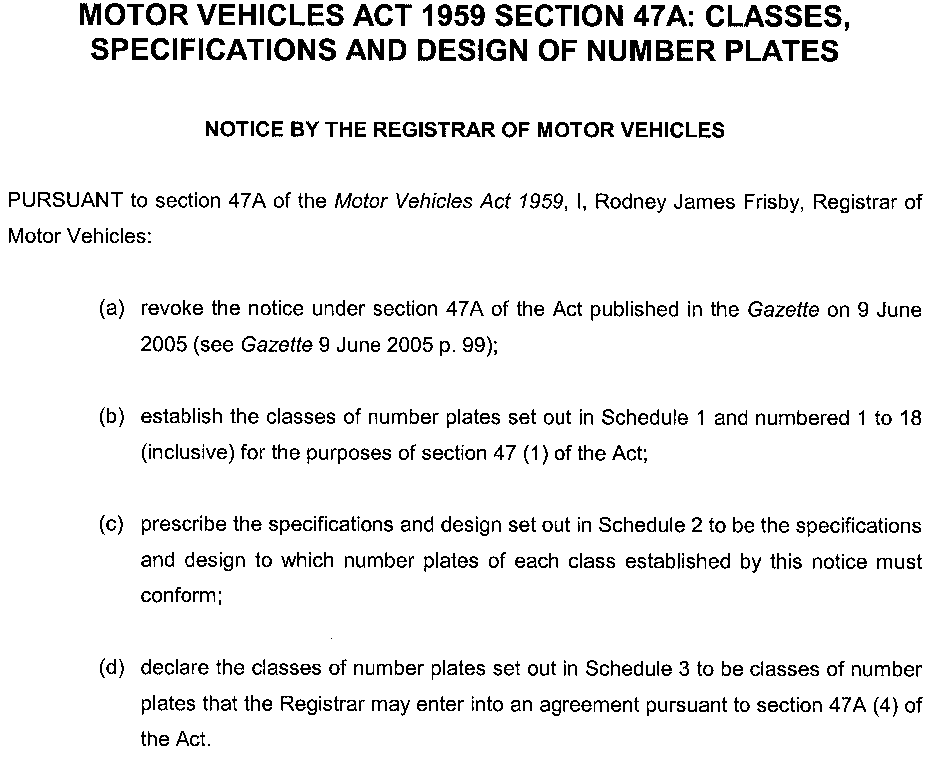
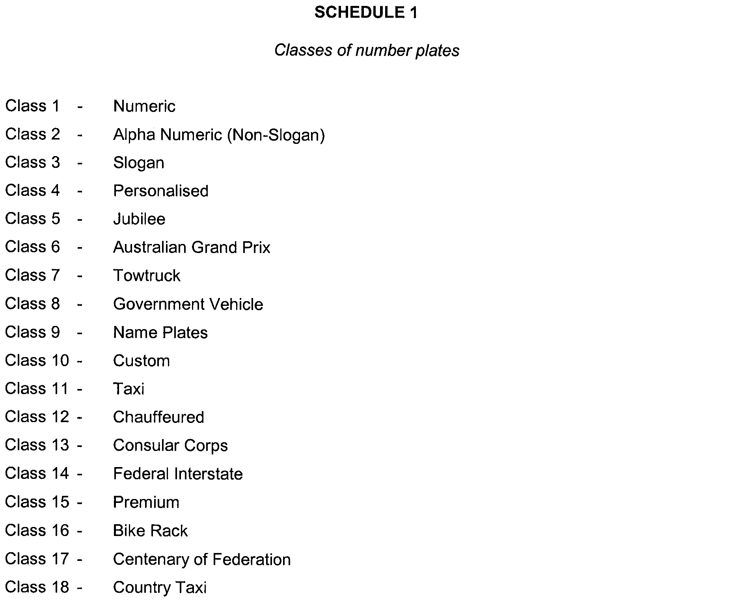
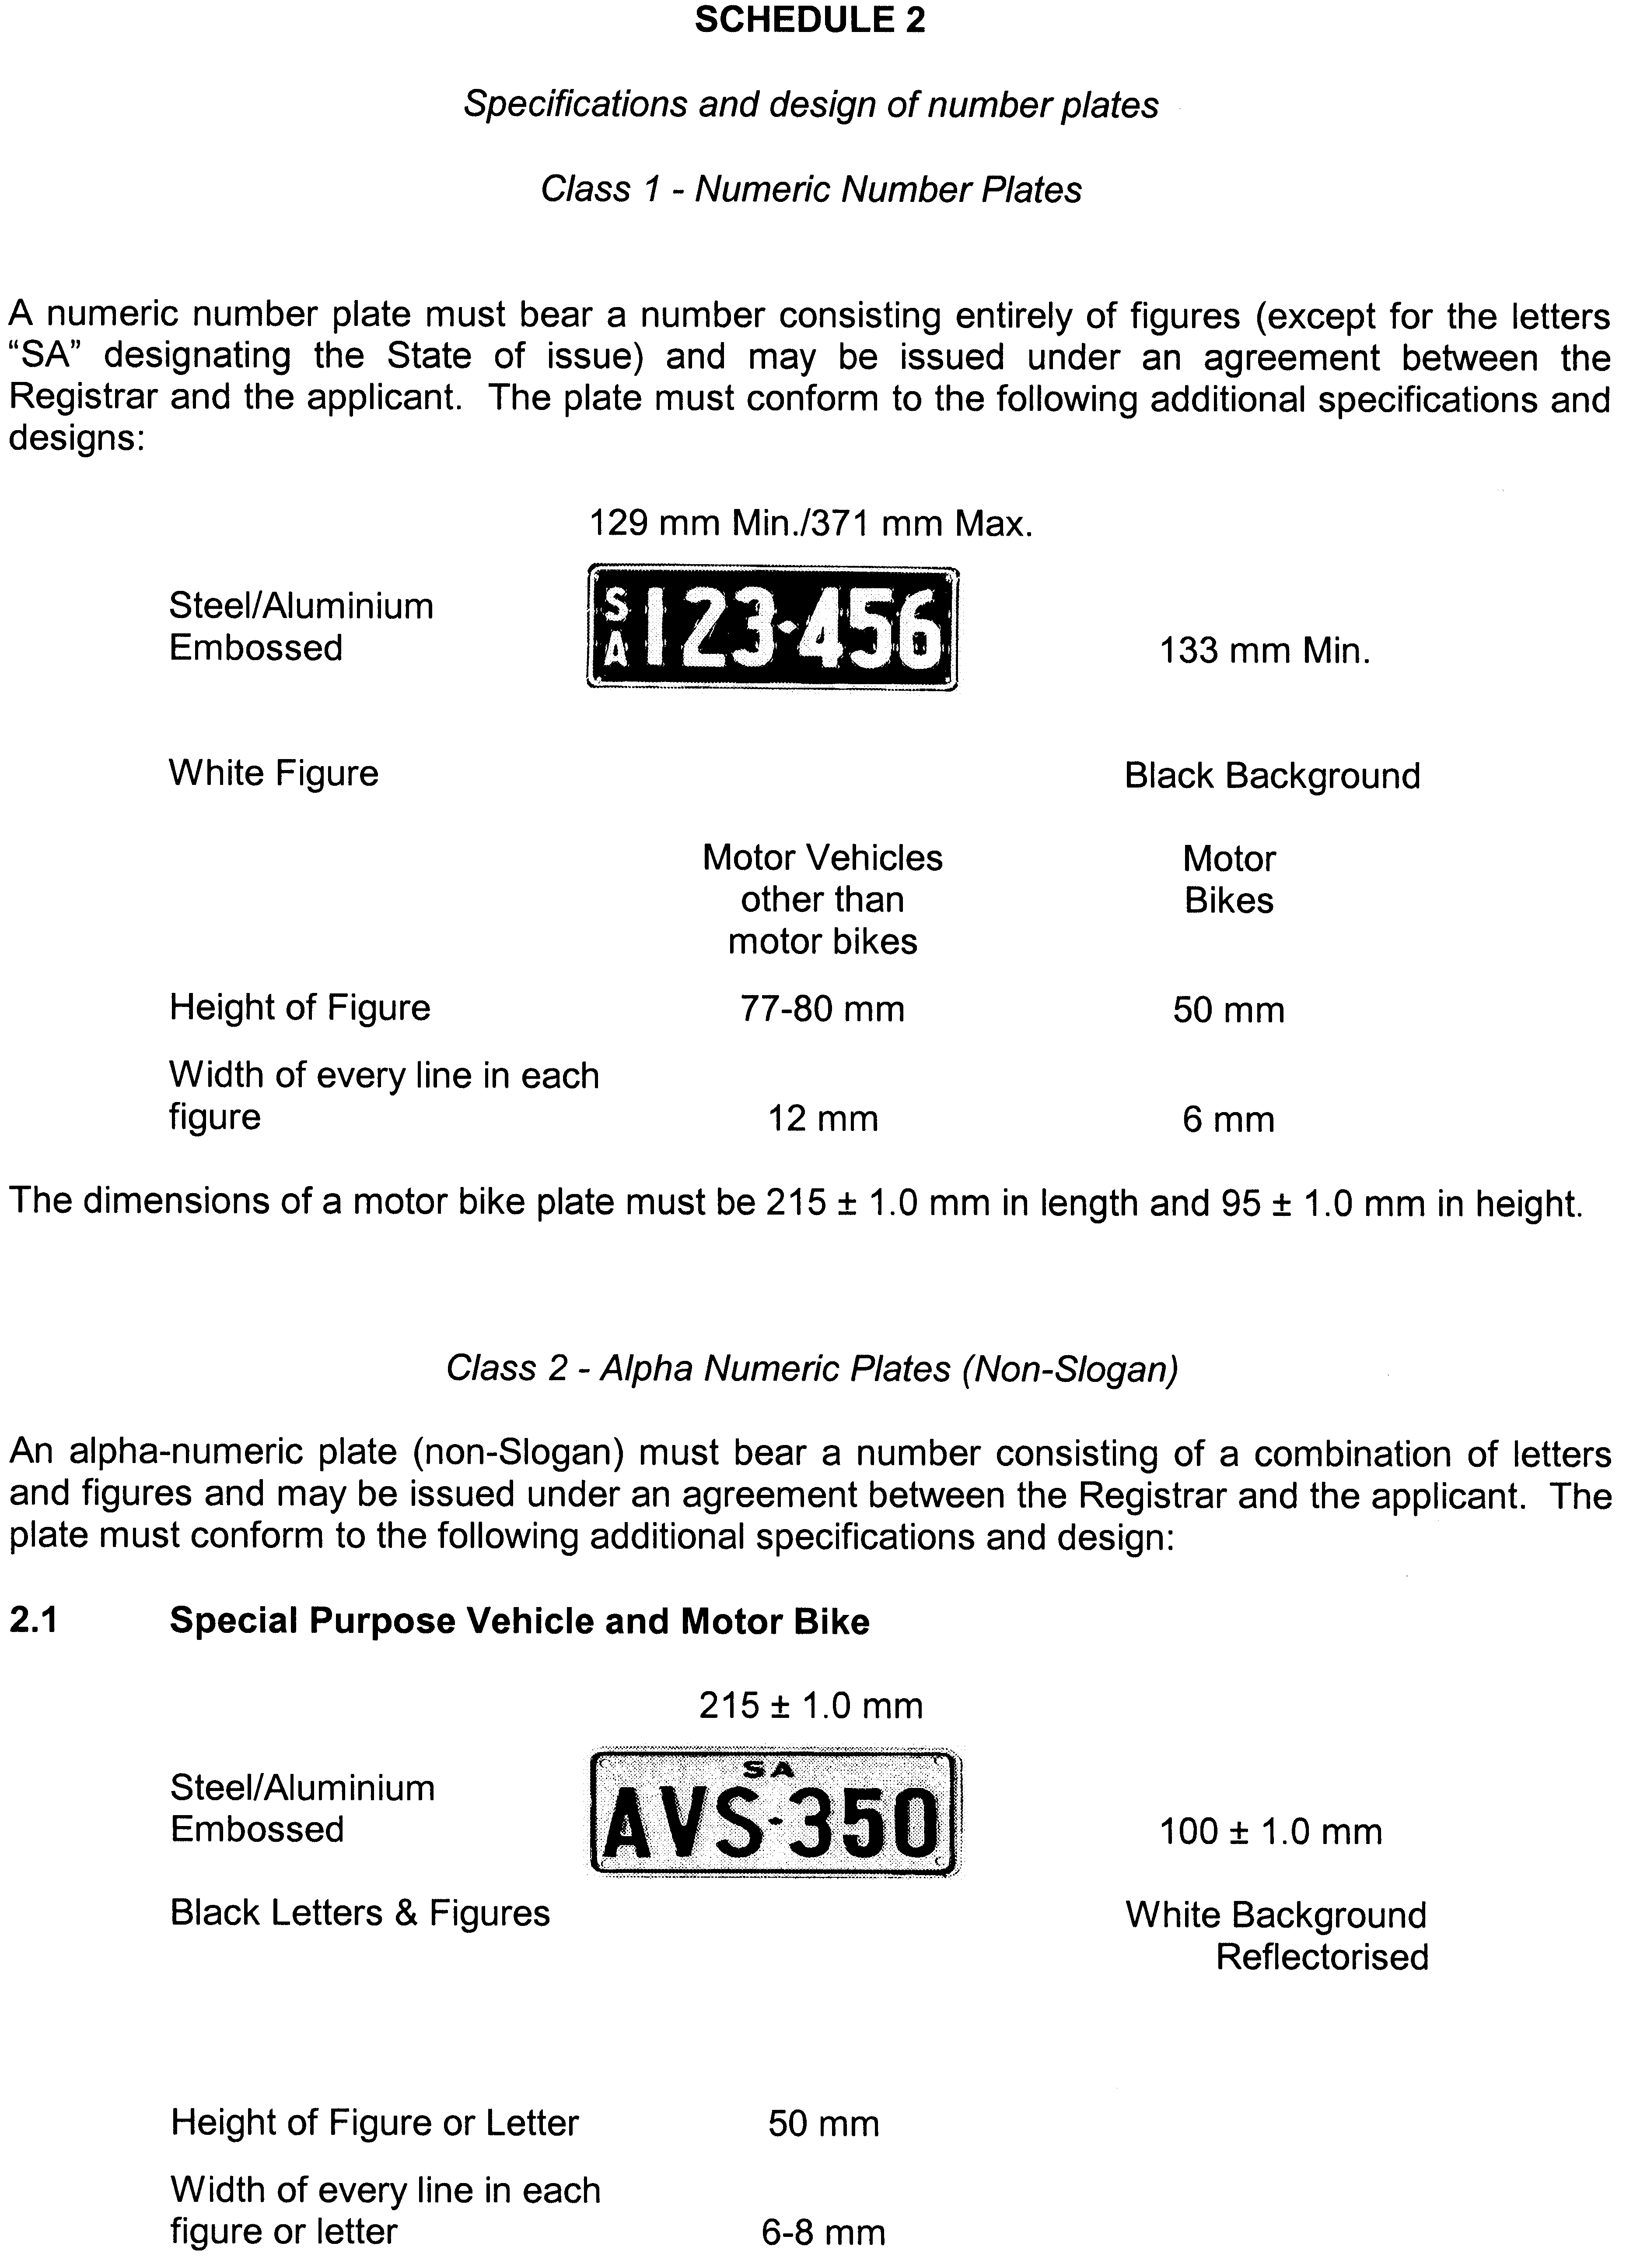
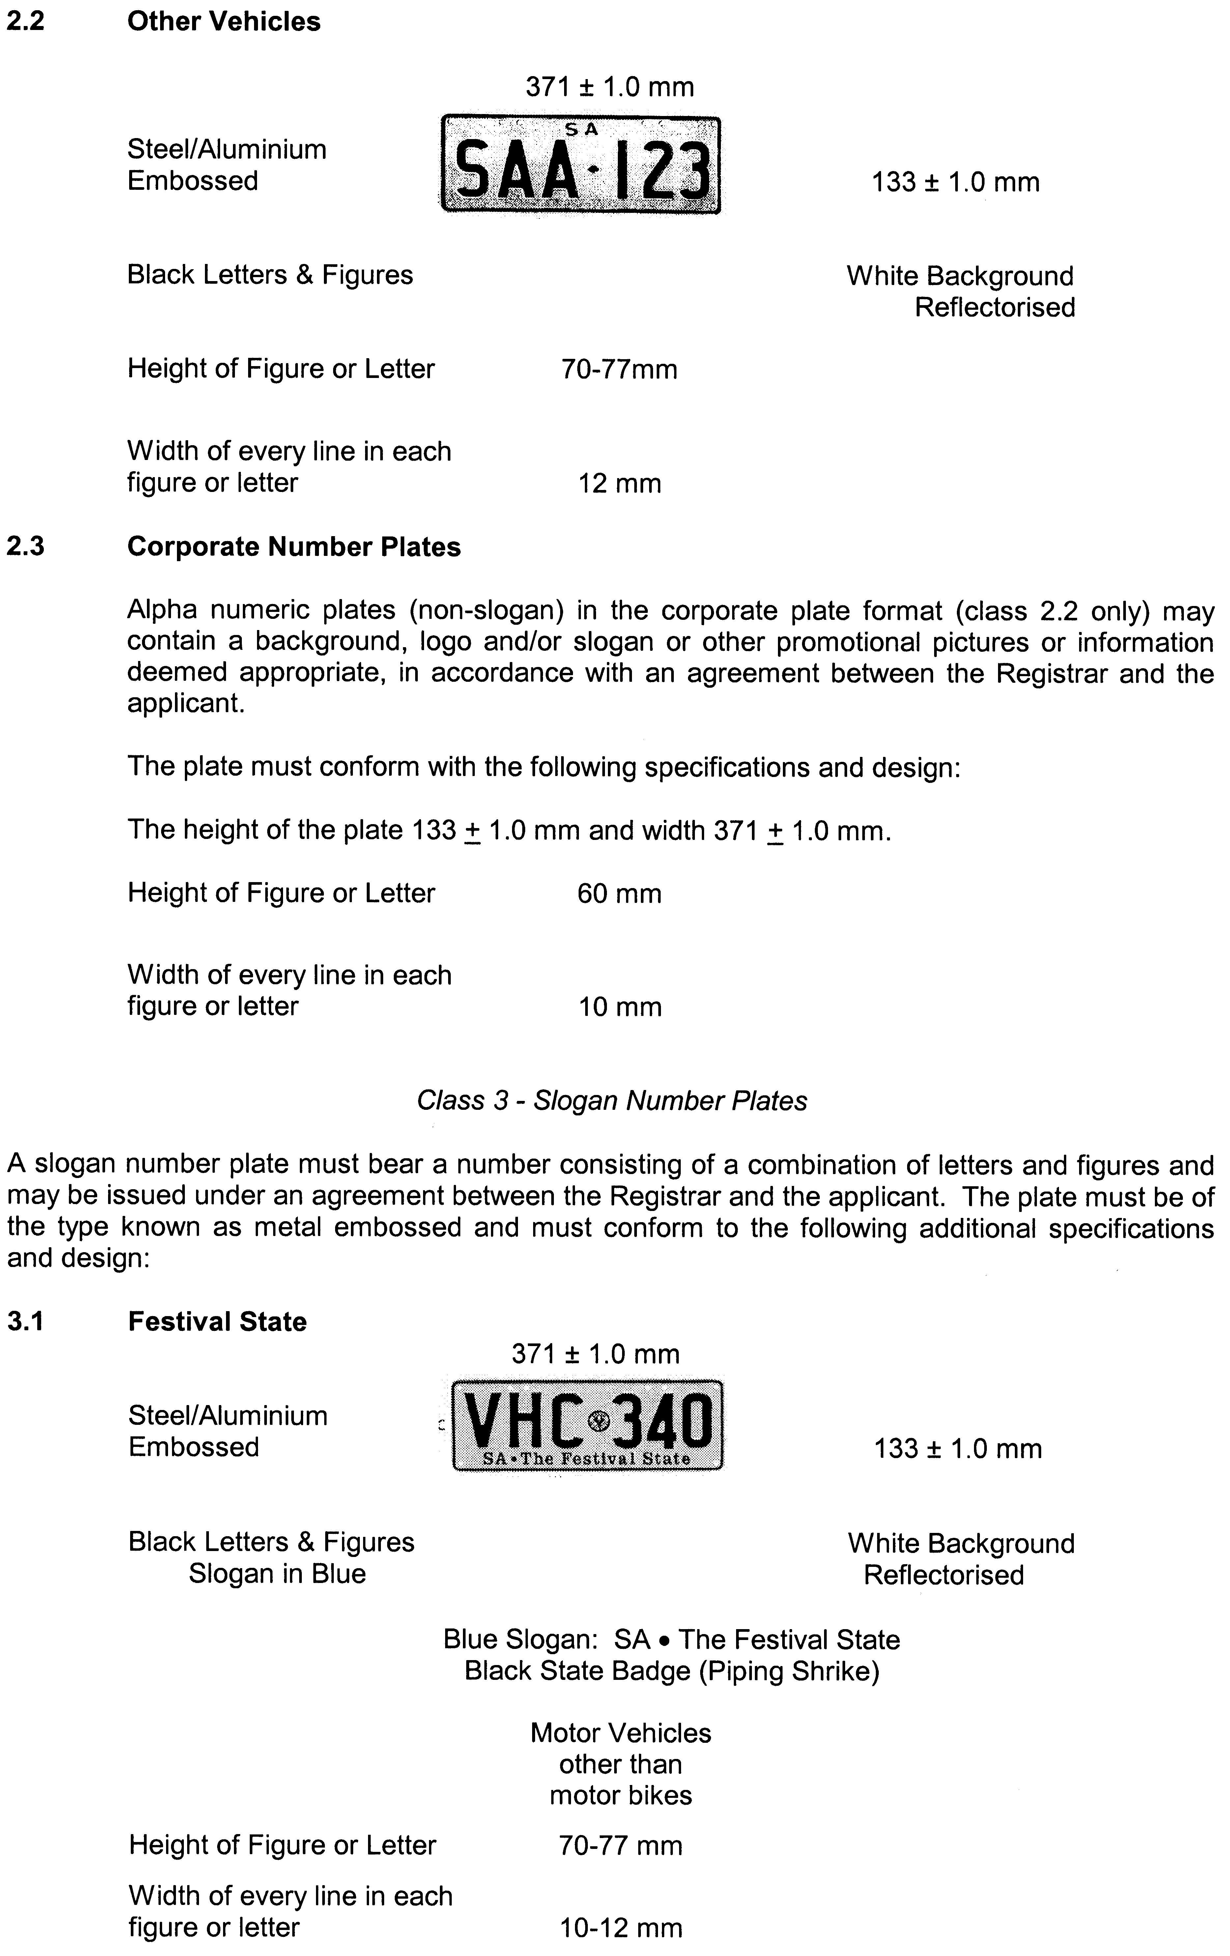
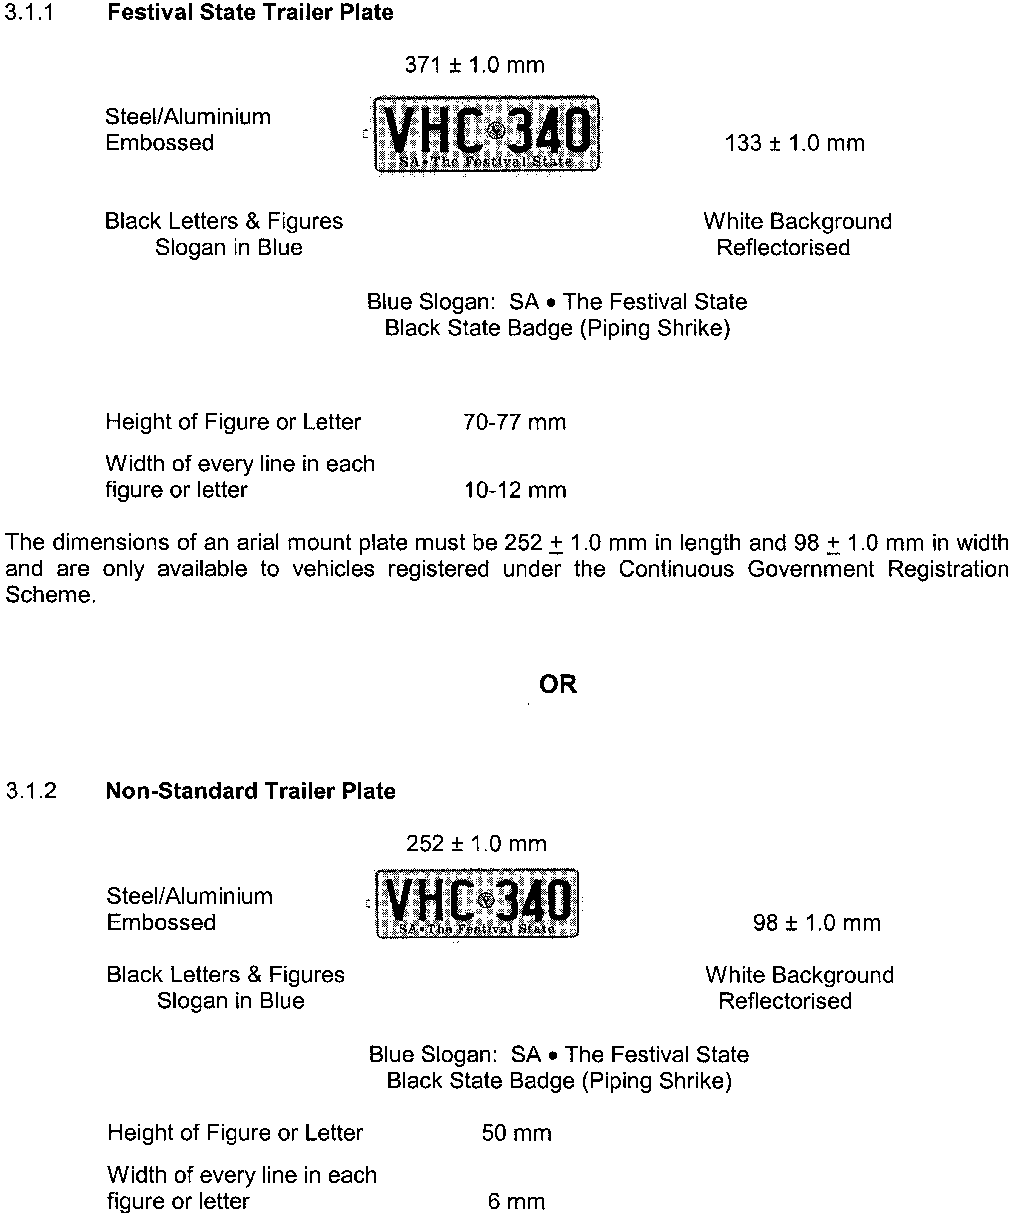
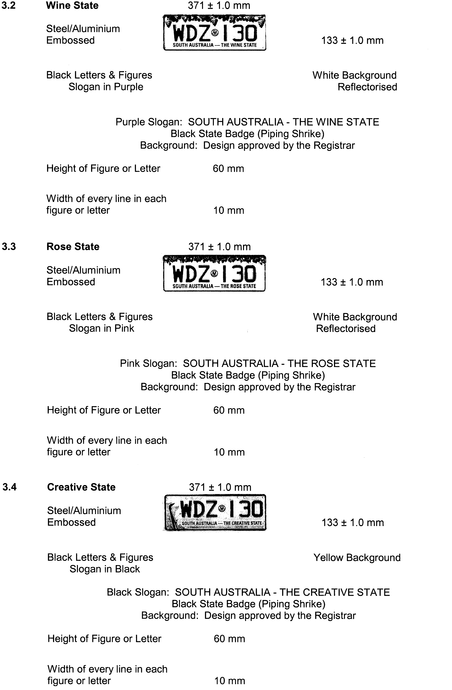
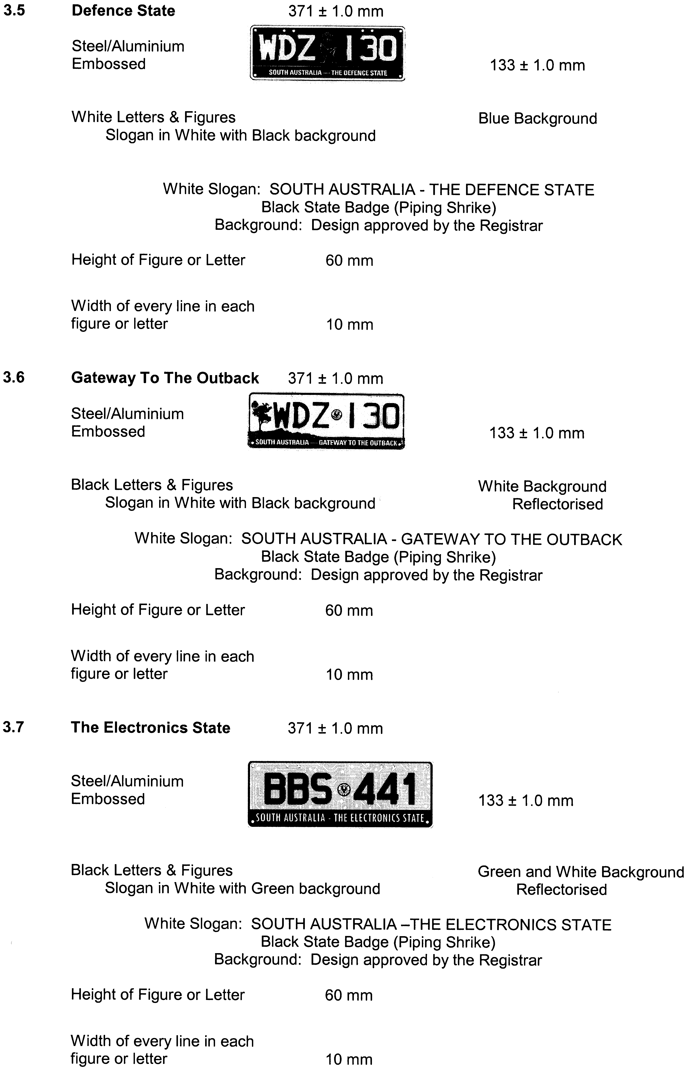
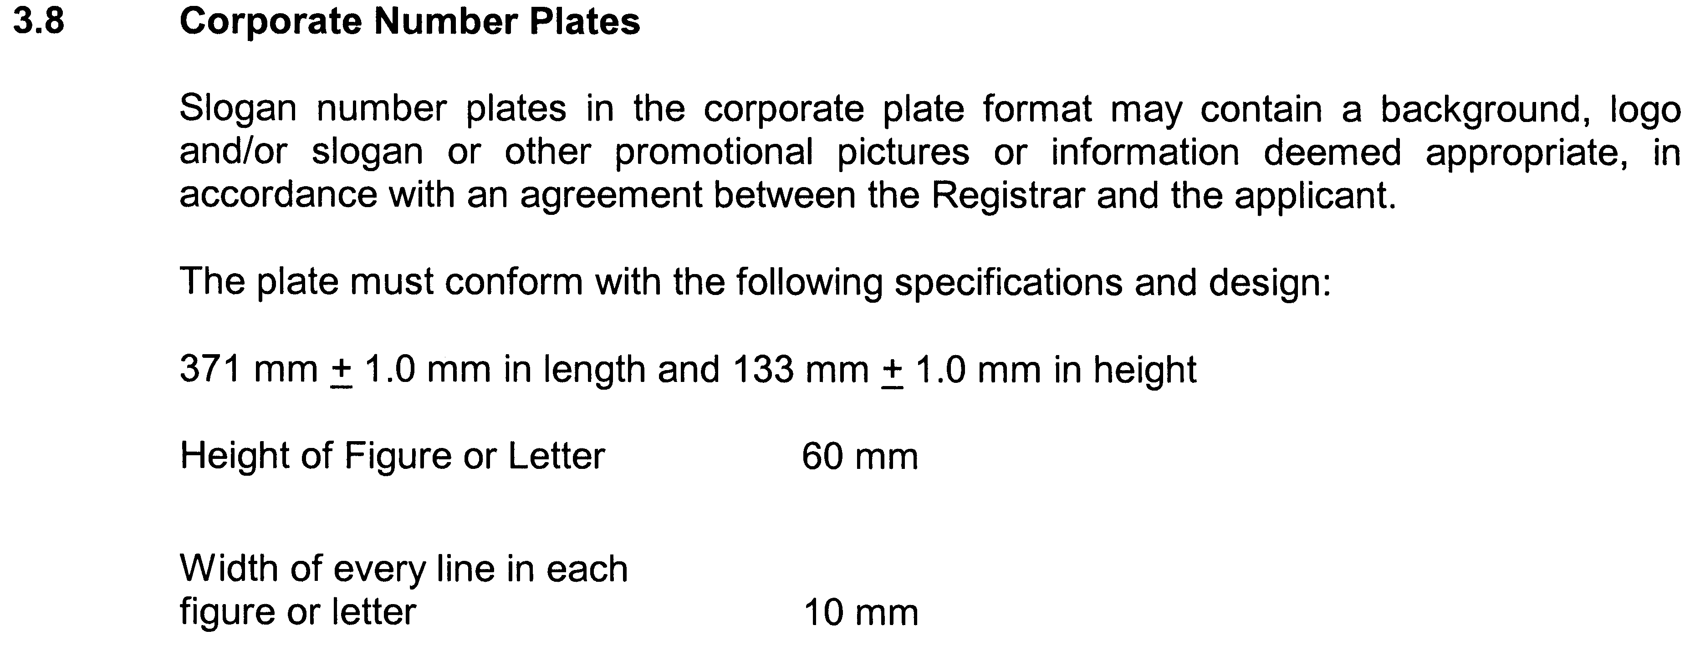

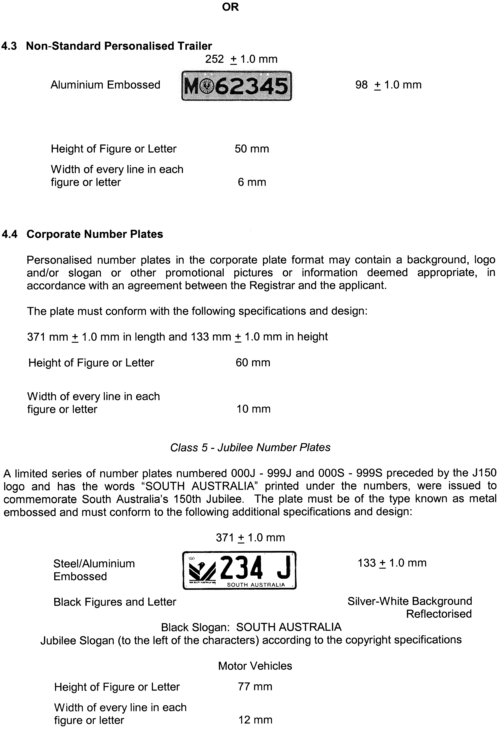
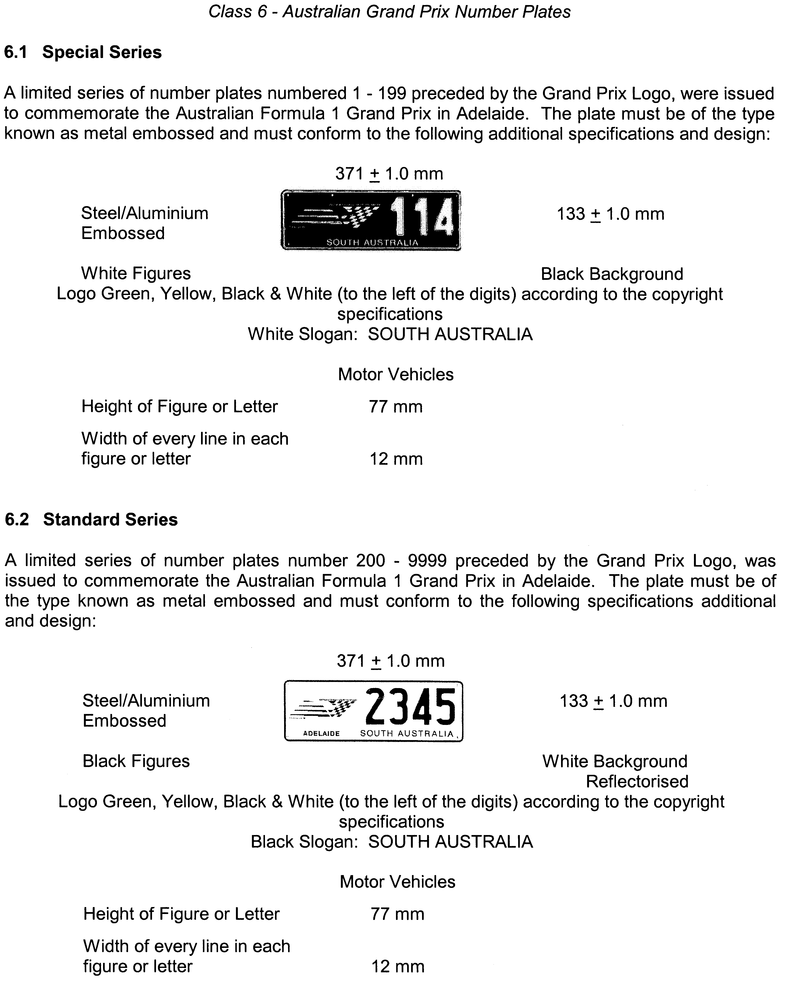
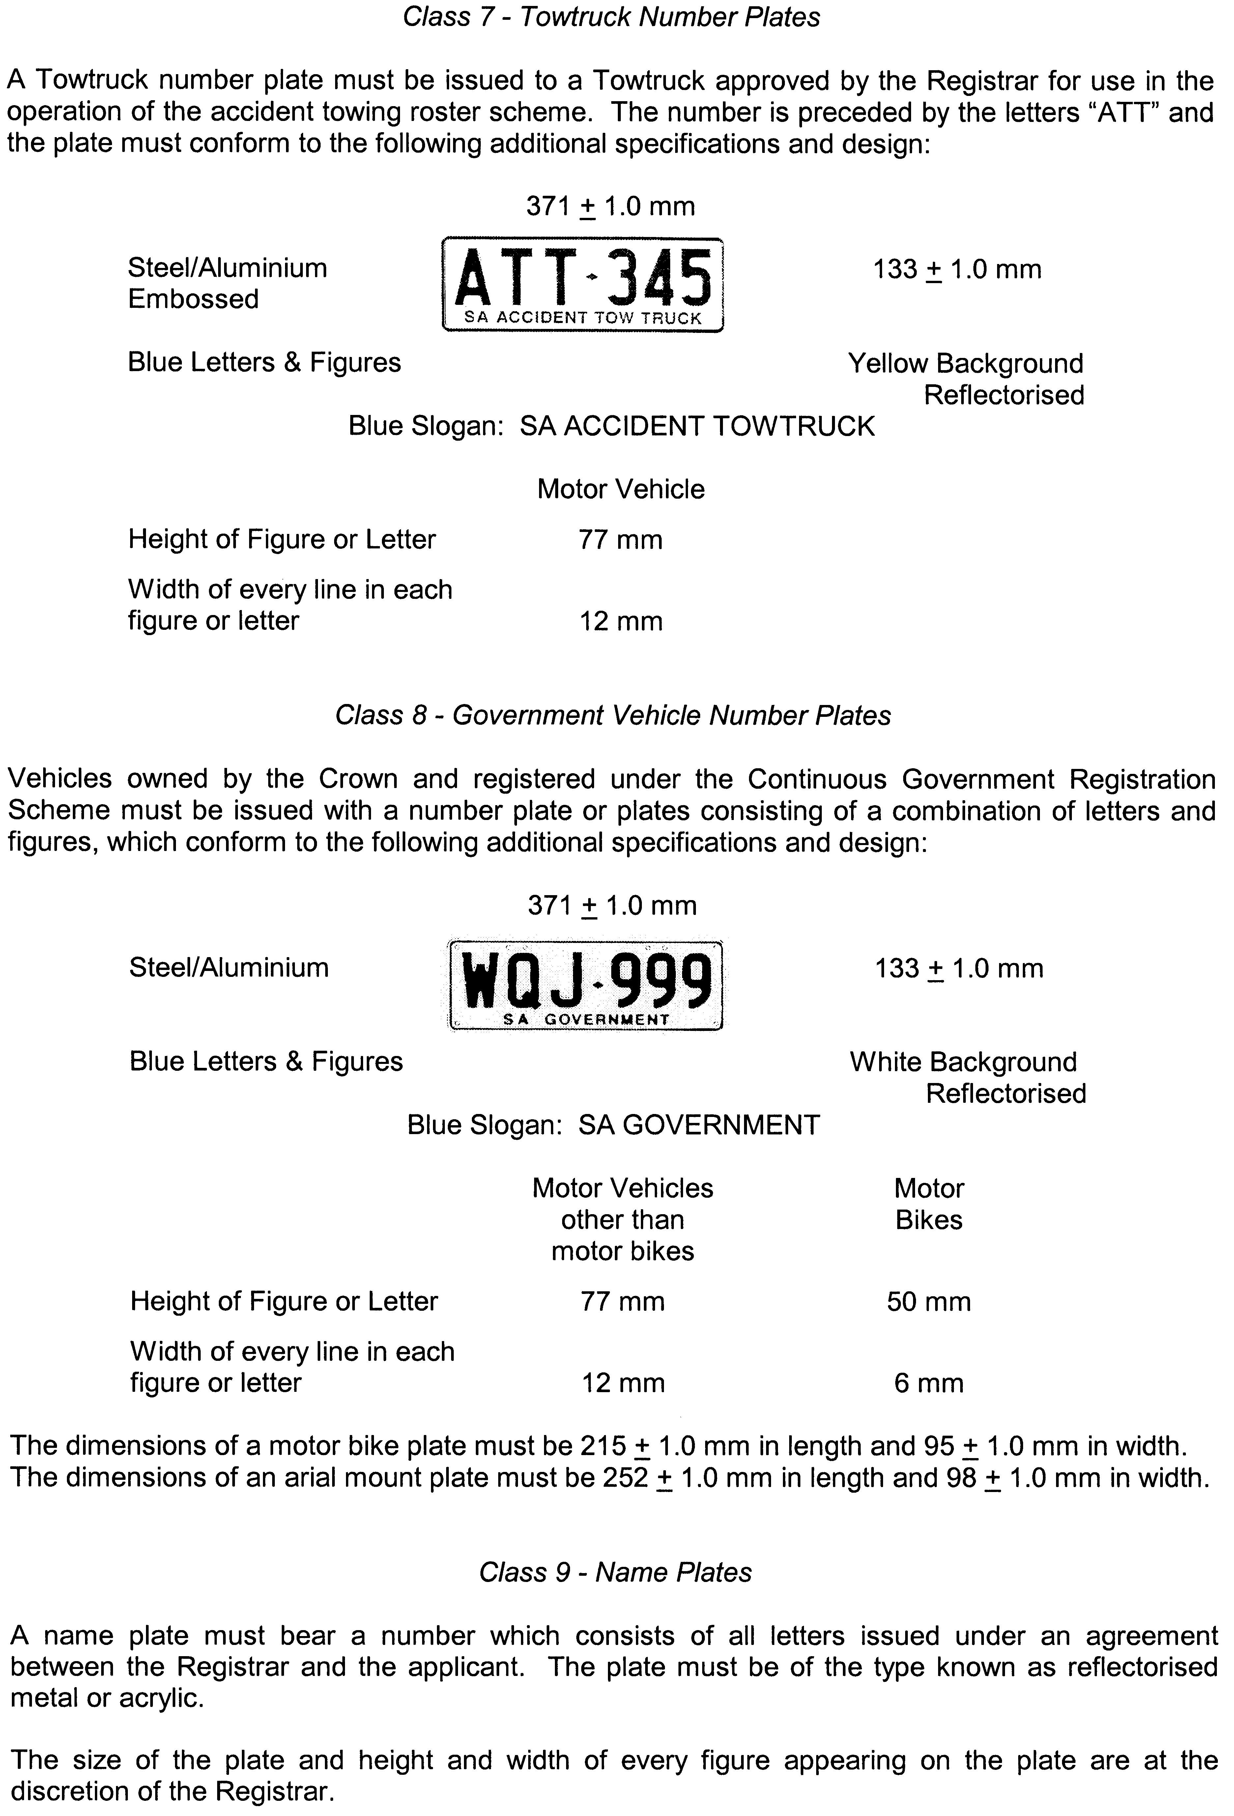
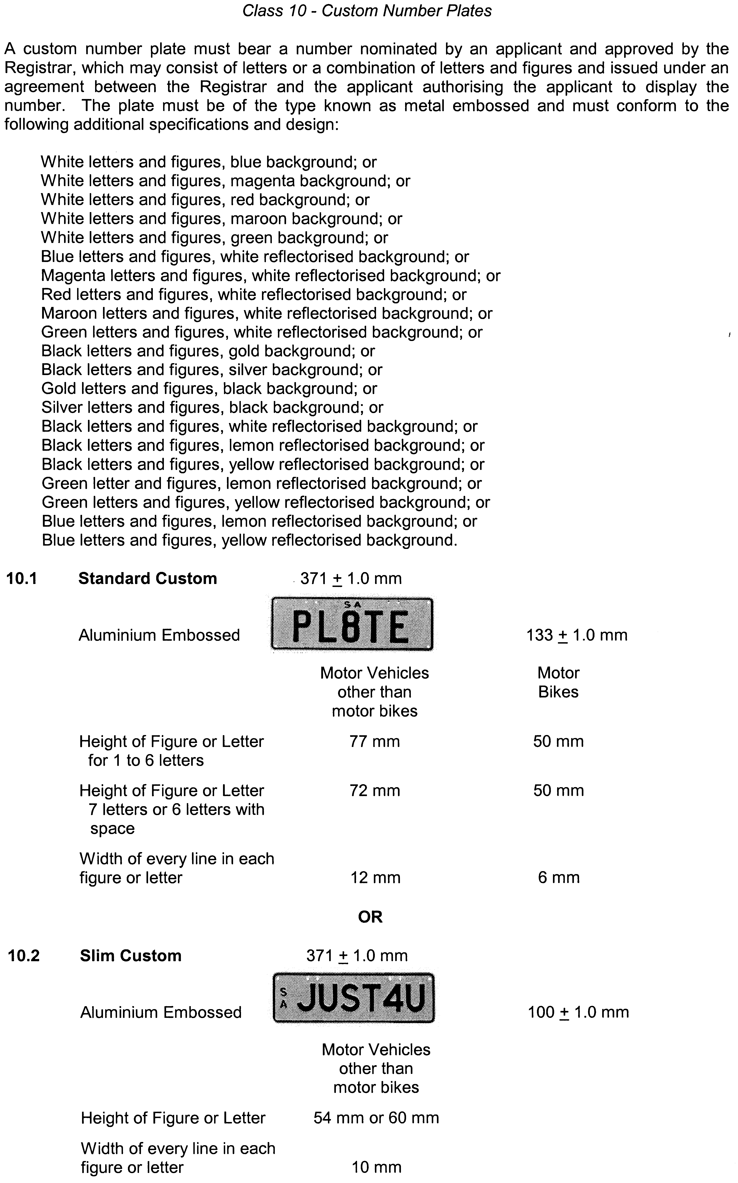
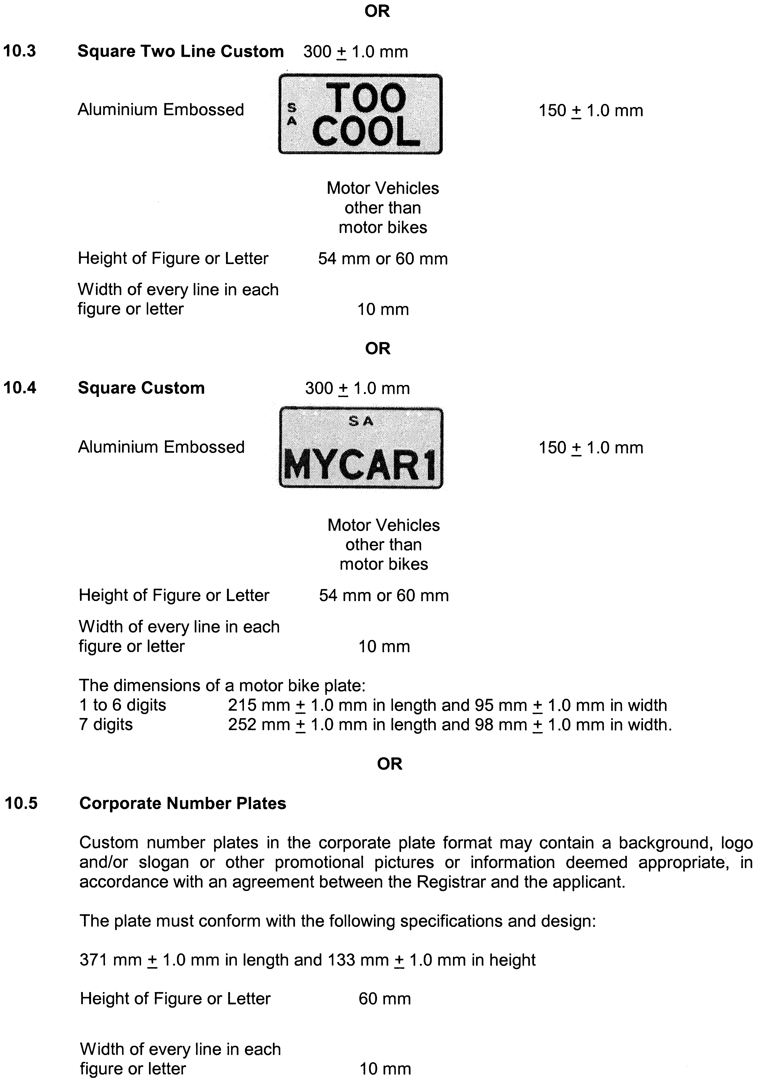
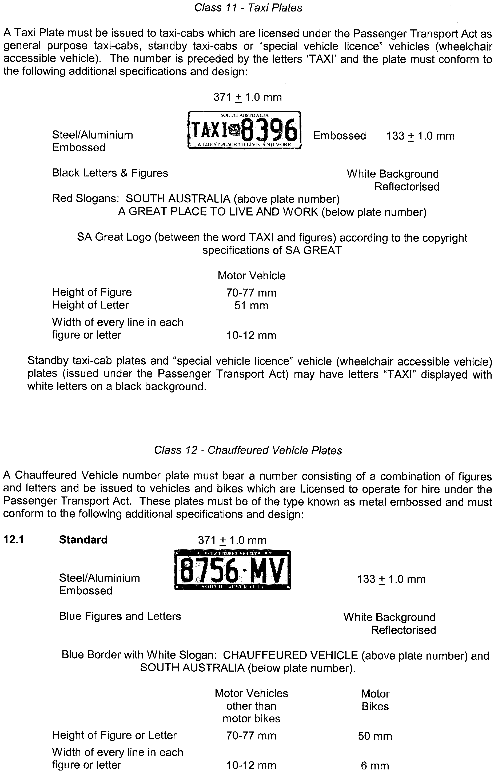
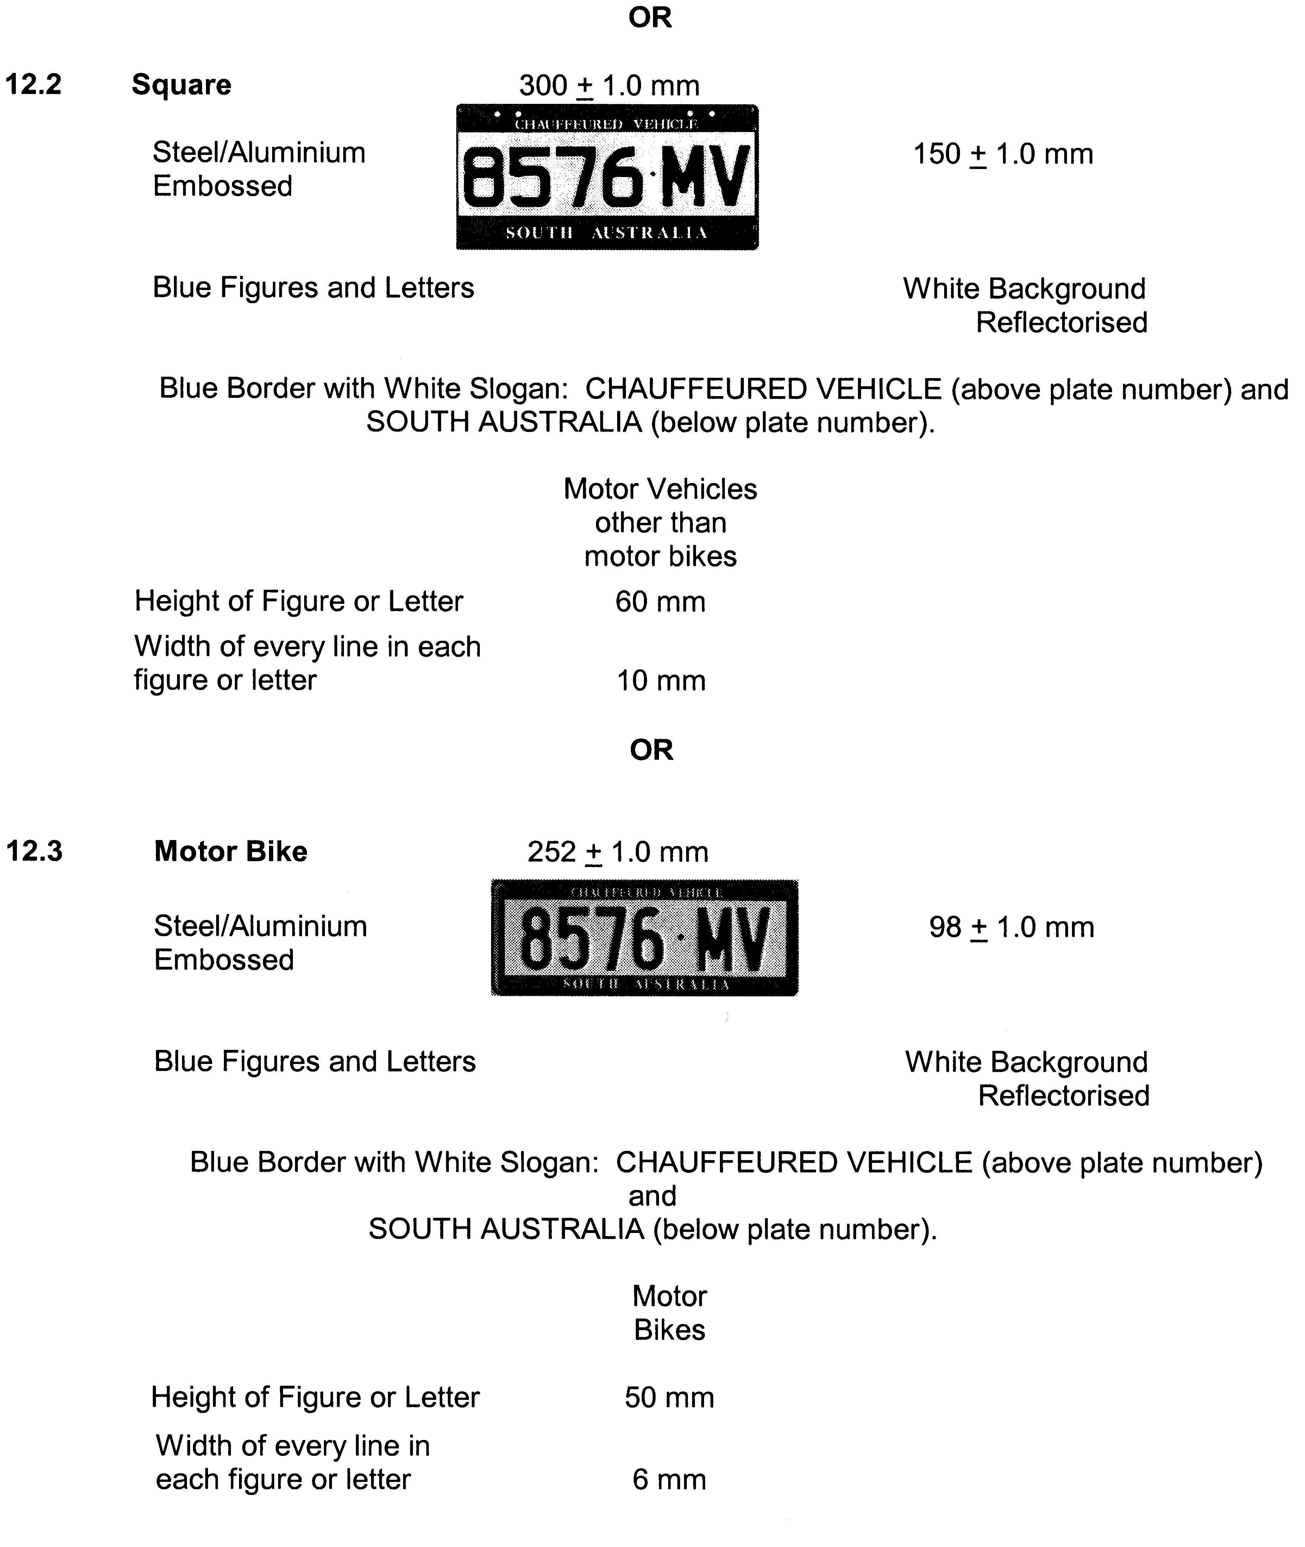
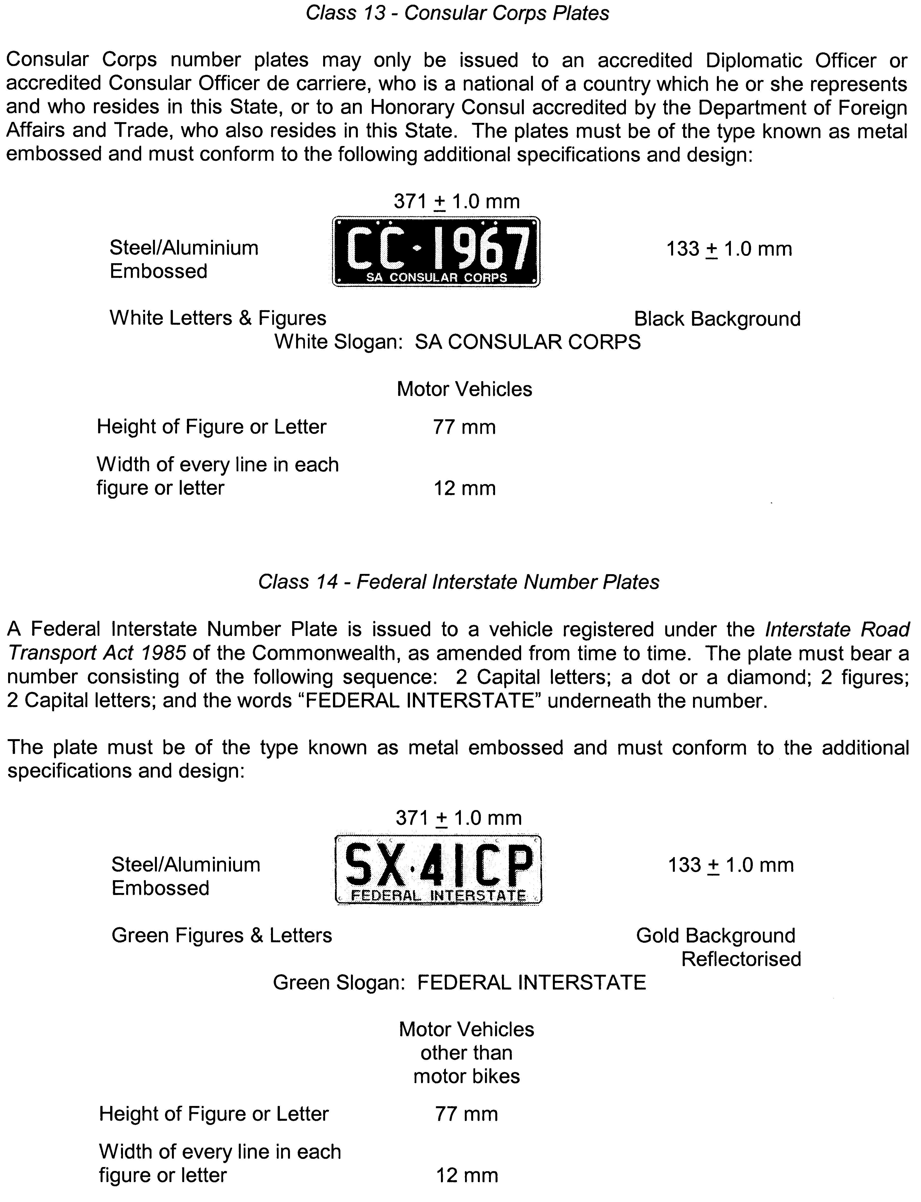
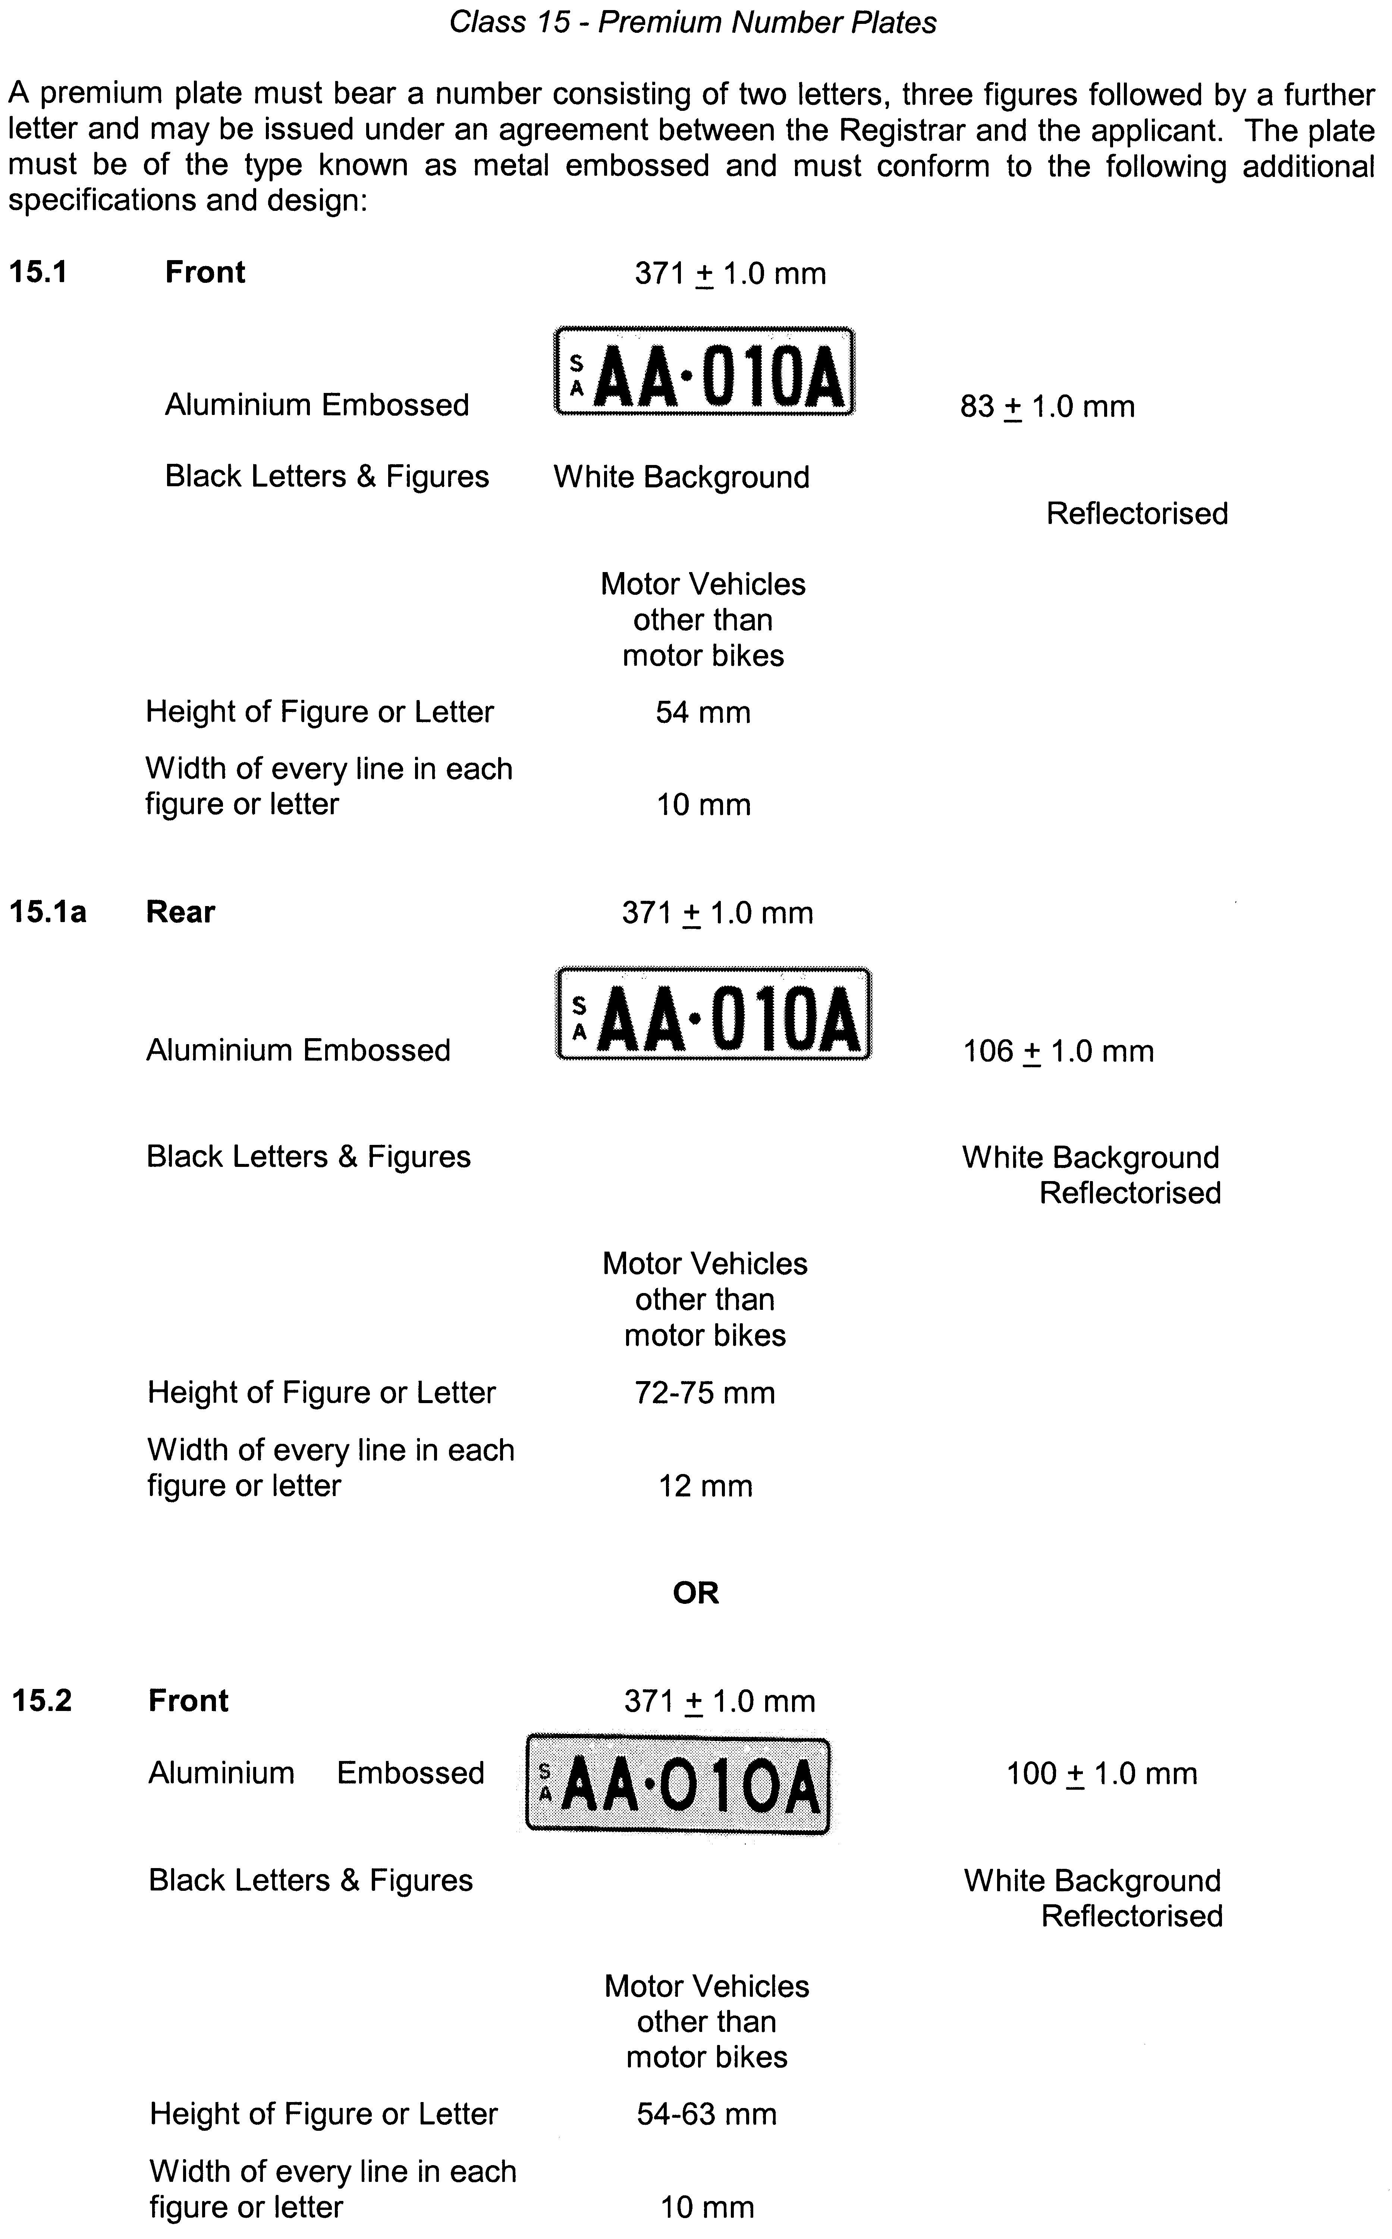
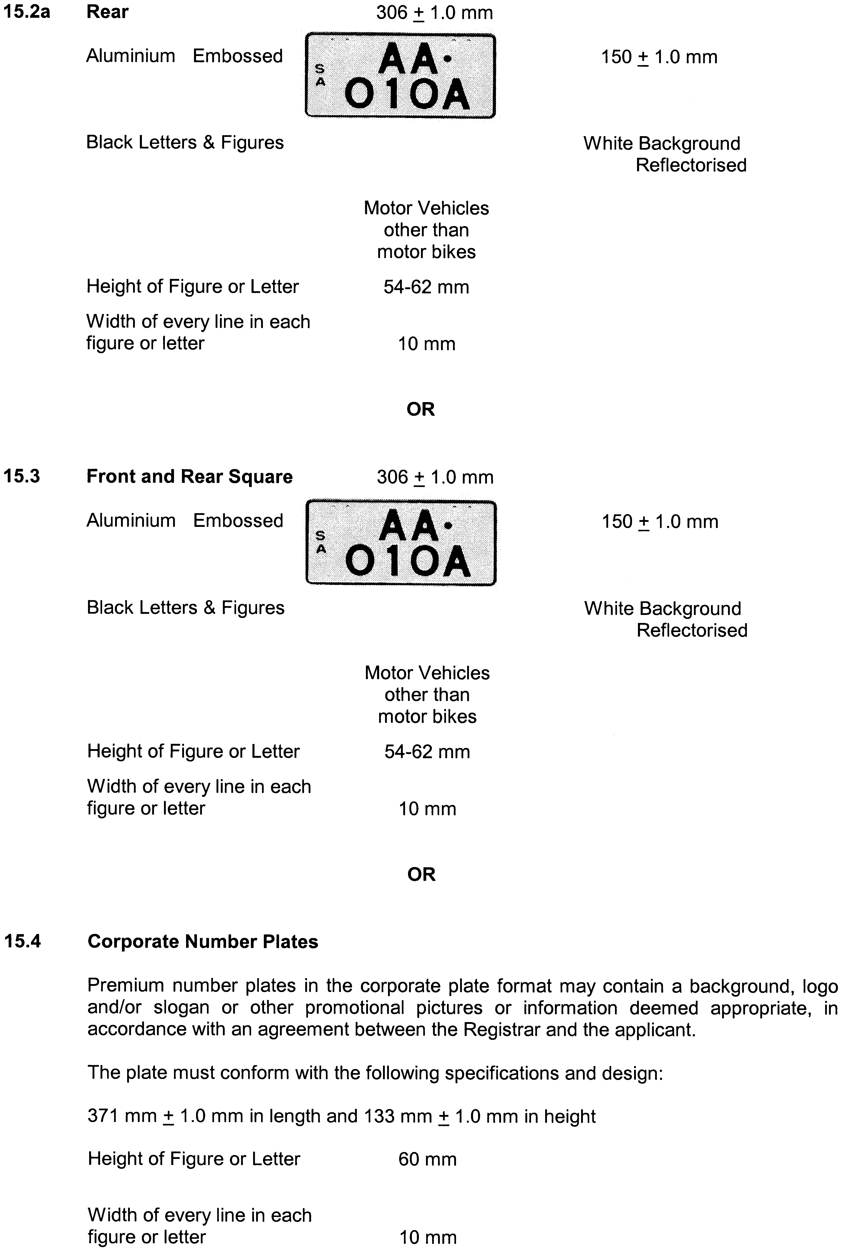
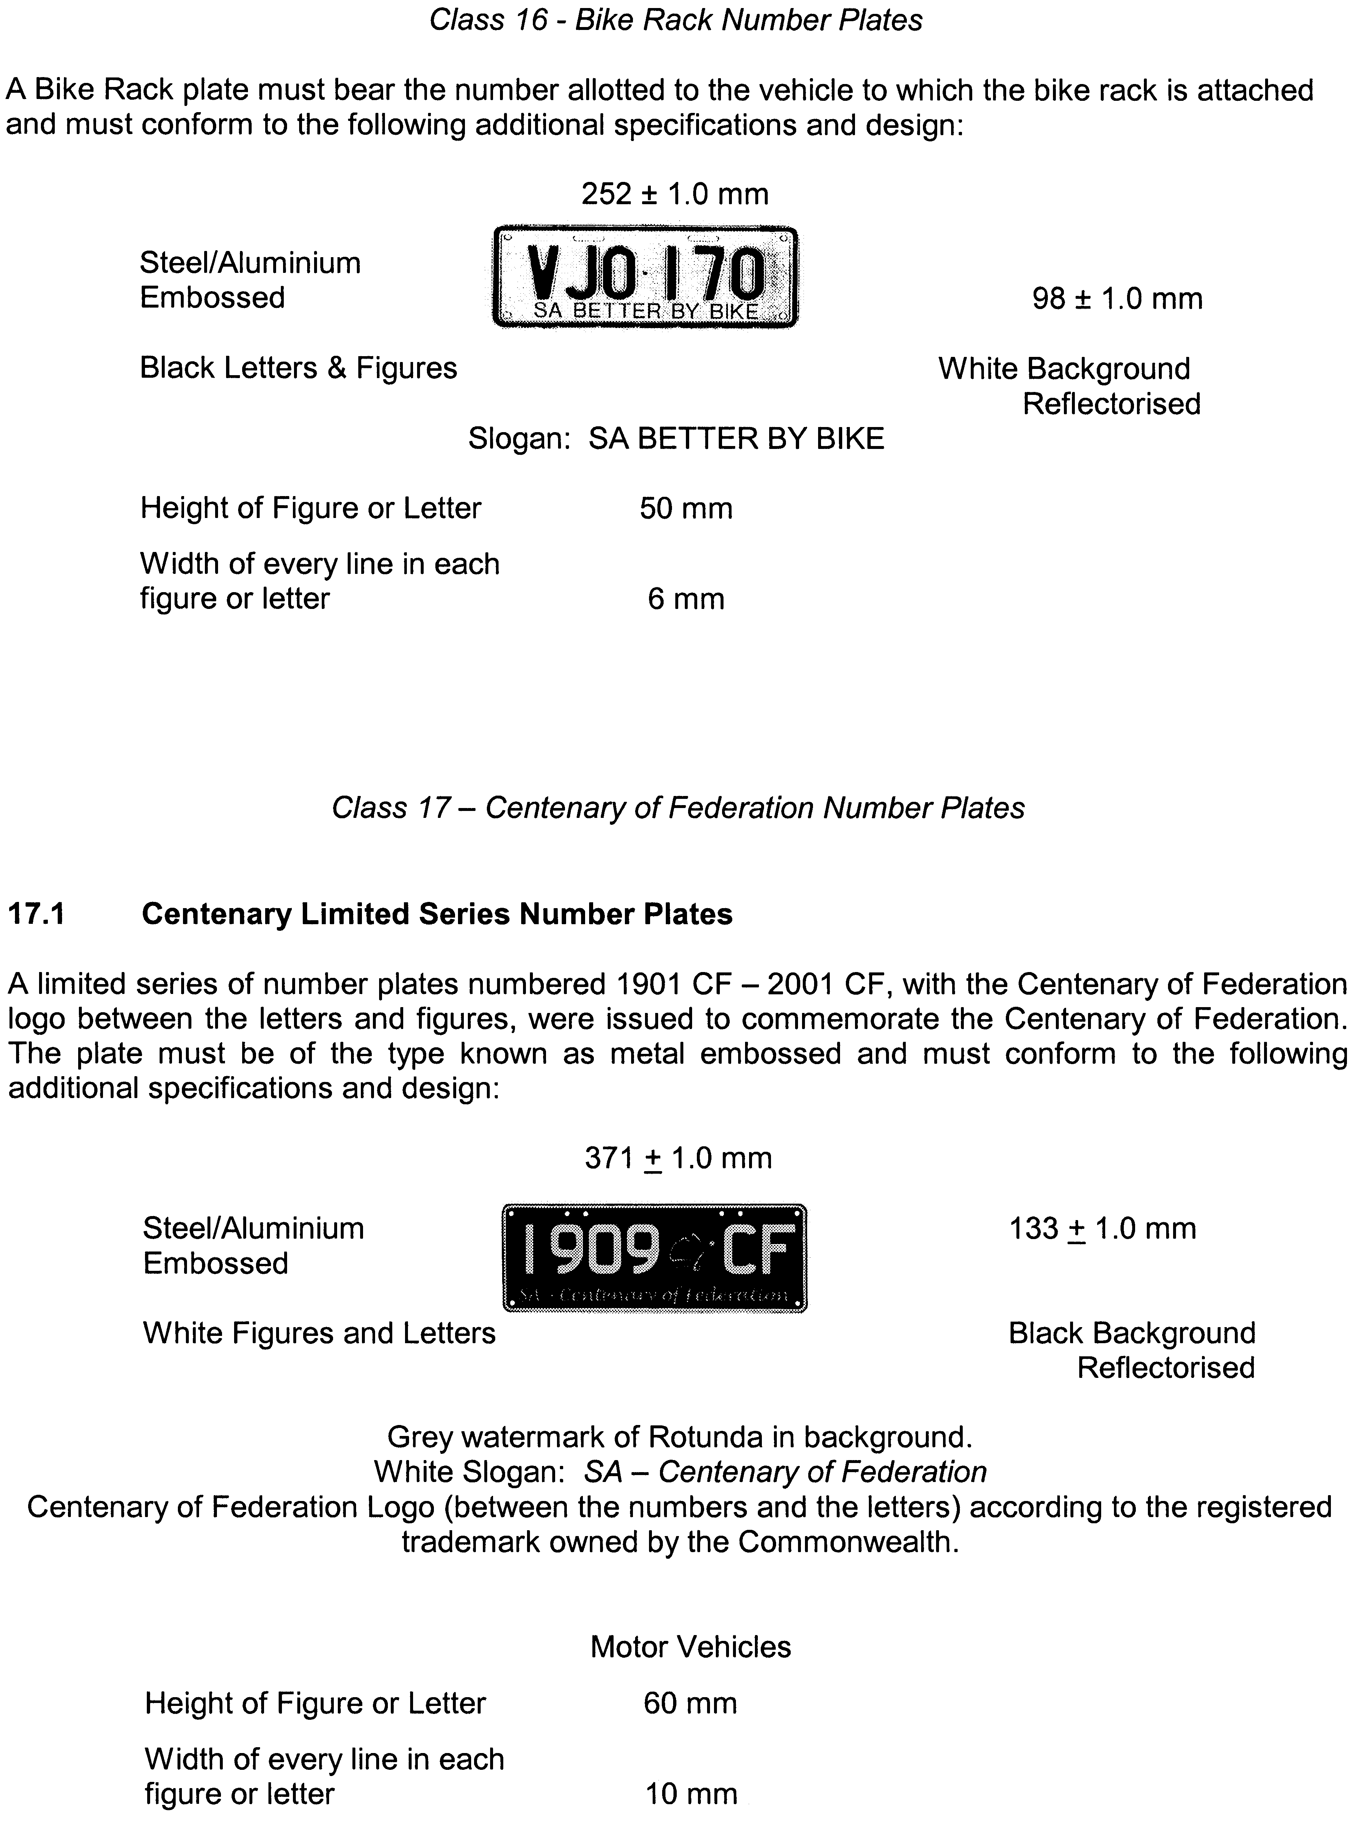

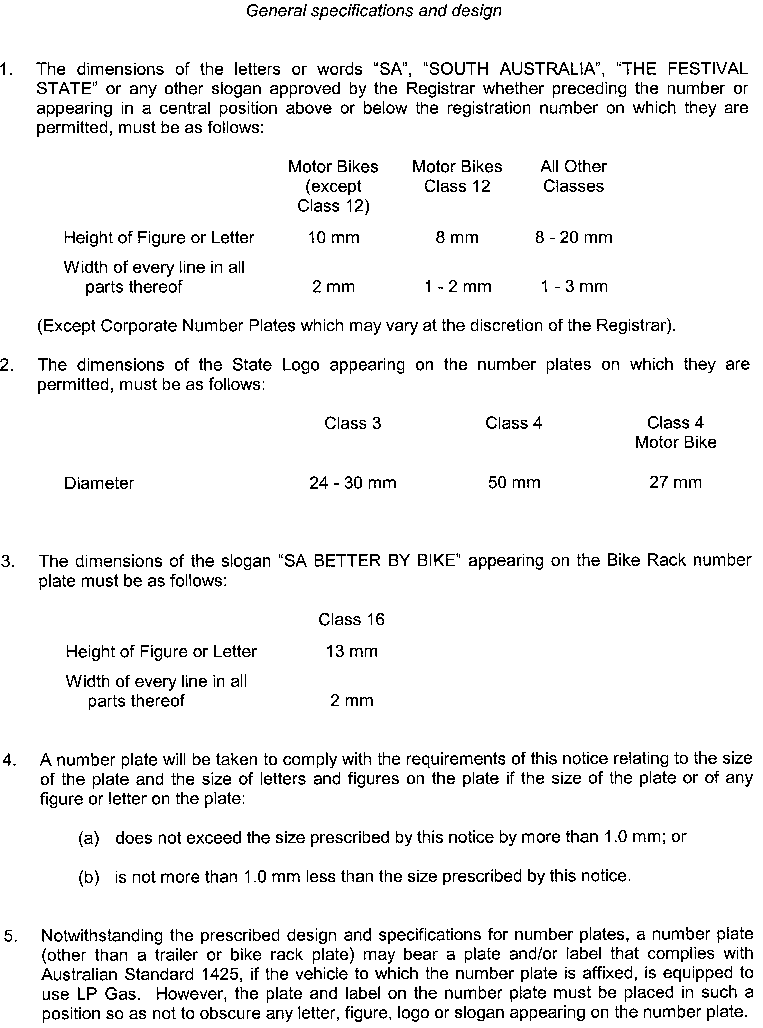
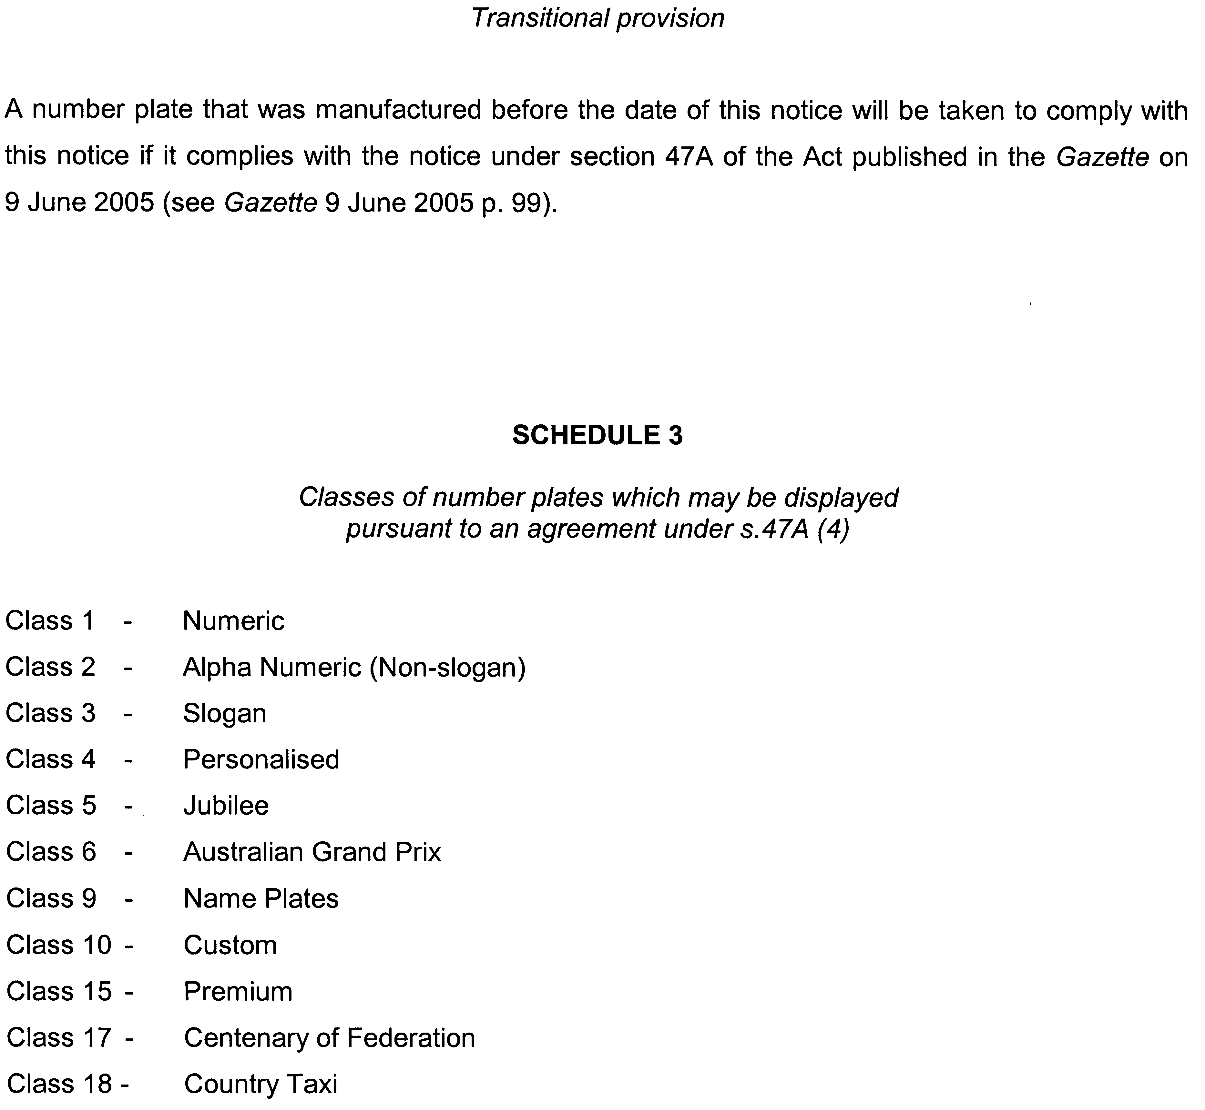

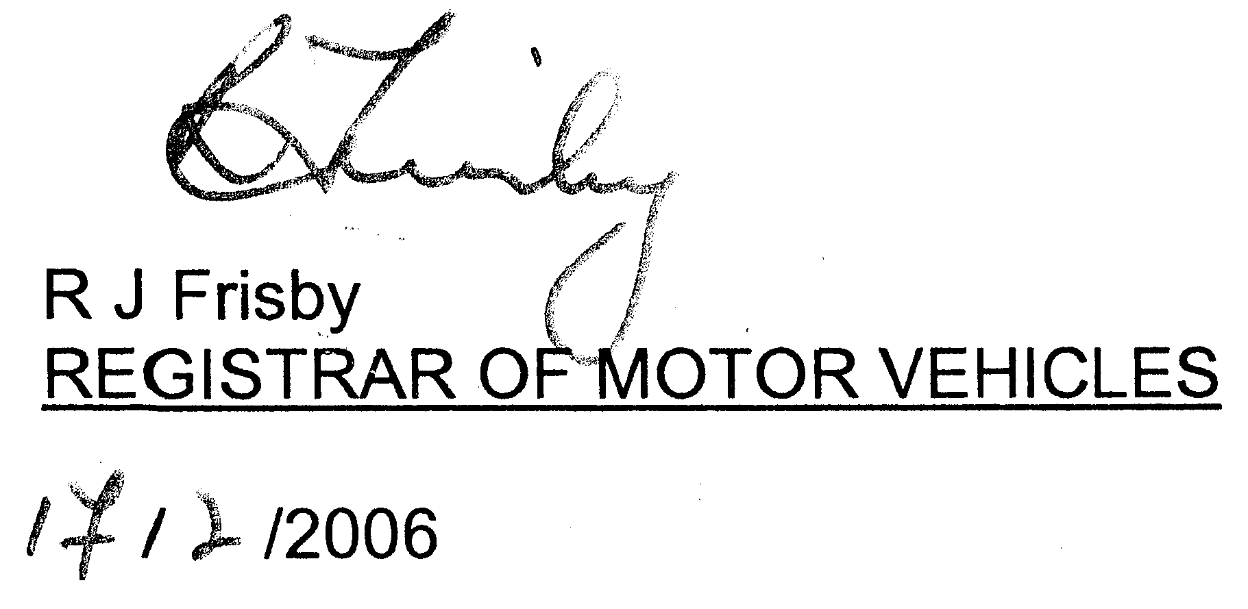

MOTOR VEHICLES ACT 1959
Recognised as an Historic Motor Vehicle Club
NOTICE is hereby given that the undermentioned club is recognised as an historic motor vehicle club in accordance with Schedule 1, Clause 3 (3) (a) of the Motor Vehicles Regulations, for the purposes of section 25 of the Motor Vehicles Act 1959:
Ducati Owners Club of S.A. Inc.
Dated 27 February 2006.
R. J. Frisby, Registrar of Motor Vehicles

NATIONAL ELECTRICITY LAW
Notice under Section 99—Draft Rule Determination
Draft National Electricity Amendment (Reliability Safety
Net Extension) Rule 2006
THE Australian Energy Market Commission (Commission) has made a draft Rule determination in relation to the Reliability Safety Net Extension.
The draft Rule determination, including the draft of the Rule to be made, is published on the Commission’s website and is available for inspection at the offices of the Commission.
The Commission invites written submissions in relation to the draft Rule determination. The Commission’s policy is to promptly publish all submissions on its website upon receipt, subject to consideration of any claim of confidentiality.
Submissions must be received no later than 28 April 2006.
A person making a written submission may request the Commission to hold a hearing in relation to a draft Rule determination. The request must be in writing and must be received no later than 8 March 2006.

Postal Address:  P.O. Box H166  Australia Square, N.S.W. 1215  Website: www.aemc.gov.au | Offices:  Level 16, 1 Margaret Street,  Sydney, N.S.W. 2000  Email for submissions:  submissions@aemc.gov.au
Telephone: (02) 8296 7800  Facsimile: (02) 8296 7899 | Email to request hearing:  aemc@aemc.gov.au
Dated 2 March 2006.
J. Tamblyn, Chairman, Australian Energy Market Commission

NATIONAL ELECTRICITY LAW
Notice to Extend Time Period under Section 107
Draft National Electricity Amendment (TransGrid Participant Derogation—Treatment of Contingent Projects (Interim Arrangements)) Rule 2006
THE Australian Energy Market Commission (Commission) has extended the time for the receipt of submissions in relation to this draft Rule determination.
The Commission considers that as a result of an error occurring during publication of the above draft Rule, it is in the public interest to extend the time period for submissions by a further six weeks. Submissions must be received no later than 19 April 2006.
The draft determination including a correct draft Rule are published on the Commission’s website and are available for inspection at the offices of the Commission. The Commission’s policy is to promptly publish all submissions on its website, subject to consideration of any claim of confidentiality.
A person making a written submission may request the Commission to hold a hearing in relation to a draft Rule determination. The request must be in writing and must be received no later than 20 March 2006.

Postal Address:  P.O. Box H166  Australia Square, N.S.W. 1215  Telephone: (02) 8296 7800  Facsimile: (02) 8296 7899 | Offices:  Level 16, 1 Margaret Street,  Sydney, N.S.W. 2000  Email:  submissions@aemc.gov.au
 | Website: www.aemc.gov.au
Dated 2 March 2006.
J. Tamblyn, Chairman, Australian Energy Market Commission

NATIONAL PARKS REGULATIONS 2001
Closure of the Vulkathunha-Gammon Ranges National Park
PURSUANT to Regulation 8 (3) (d) of the National Parks Regulations 2001, the Vulkathunha-Gammon Ranges National Park Co-Management Board, closes, to the public, the whole of Vulkathunha-Gammon Ranges National Park from 6 a.m. on Sunday, 5 March 2006 until 6 p.m. on Tuesday, 7 March 2006. The purpose of the closure is to ensure the safety of the public during a feral animal control program being conducted within the Vulkathunha-Gammon Ranges National Park during the above-mentioned period.
Use of Firearms within the Reserve
Pursuant to Regulations 8 (4), 20 (1) and 41 of the National Parks Regulations 2001, the Vulkathunha-Gammon Ranges National Park Co-Management Board grant permission to members of the Sporting Shooters Association of South Australia (SA Branch) in possession of both a current Hunting Permit and a firearm to enter and remain in Vulkathunha-Gammon Ranges National Park from 6 a.m. on Sunday, 5 March 2006 until 6 p.m. on Tuesday, 7 March 2006, for the purpose of taking pest animals. This permission is conditional upon the observance by each of those persons of the requirements of the National Parks and Wildlife Act 1972, National Parks Regulations 2001 and the National Parks and Wildlife (Hunting) Regulations 1996, including those requiring compliance with the requests of the Vulkathunha-Gammon Ranges National Park Co-Management Board and the requirements and orders of a Warden.
Dated 24 February 2006.
E. G. Leaman, Chairperson, Vulkathunha-Gammon Ranges National Park Co-Management Board

NATURAL RESOURCES MANAGEMENT ACT 2004
Notice of Authorisation to Take Water
PURSUANT to section 128 of the Natural Resources Management Act 2004, I, John David Hill, Minister for Environment and Conservation, hereby authorise the taking of roof runoff (surface water) from all Surface Water Prescribed Areas within the State of South Australia for the purposes of commercial (but not irrigation) use and industrial, environmental or recreational use, subject to the conditions specified in Schedule A.
Schedule A
1. Surface water taken pursuant to this authorisation may only be used for one or more of the purposes described above and no other purpose, unless otherwise authorised.
2. Surface water taken pursuant to this authorisation can only be collected where:
(a) the volume of water deemed to be collected from the connected roof area is equal to or less than 500 kilolitres per annum; or
(b) the volume of water deemed to be collected from the connected roof area is determined as follows:

Potential Estimated Average Annual Capture =  Amount (kilolitres) | roof area  (in square metres) x | average annual rainfall for the relevant location (in millimetres)
 | 1 000

On the basis that 1 mm of rain per square metre of roof yields 1 L of water and using the relevant map of those appended as Attachments 1-6 to determine the average annual rainfall.
3. All water taken pursuant to this authorisation must be directed to closed water storage facilities (holding tanks).
4. Any water collected pursuant to this authorisation that overflows from a holding tank(s) must be released into the environment through the existing surface water drainage arrangements and must not be recaptured or redirected, unless otherwise authorised.
5. This authorisation will not apply where the Minister determines that the collection of rainwater from a particular roof by a person in a particular Surface Water Prescribed Area has or will have a detrimental effect on the ability of the holders of water licences in the same Surface Water Prescribed Area to exercise their rights in respect of the allocations endorsed on their licences and the Minister notifies the person in writing of that determination.
This authorisation will commence on the date below and will remain in effect for a period of five years unless earlier varied or revoked.
Dated 16 February 2006.
John Hill, Minister for Environment and Conservation

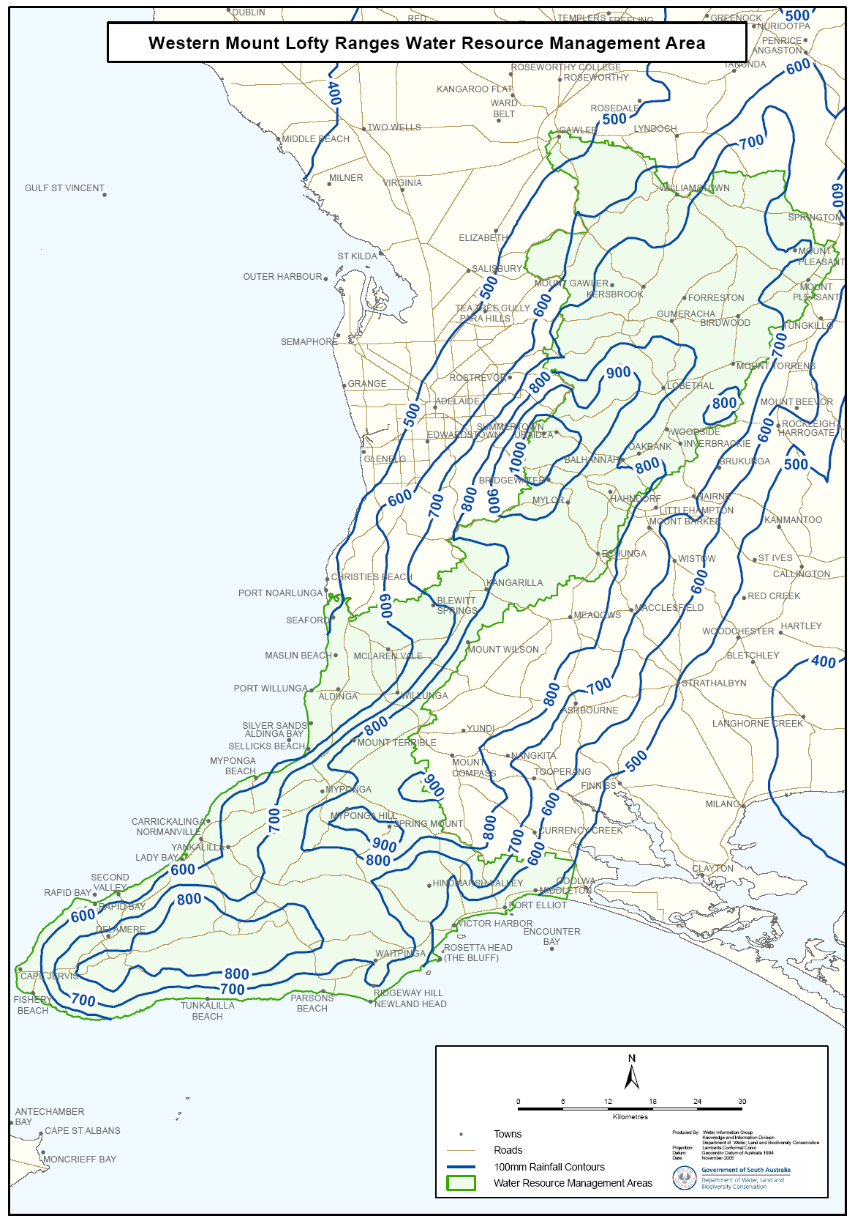
Attachment 1

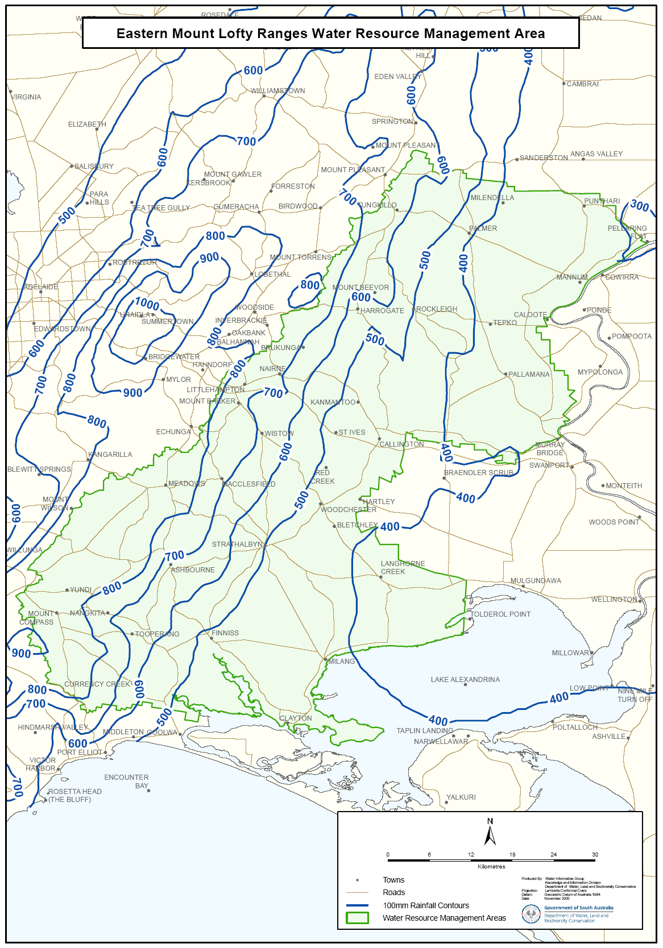
Attachment 2

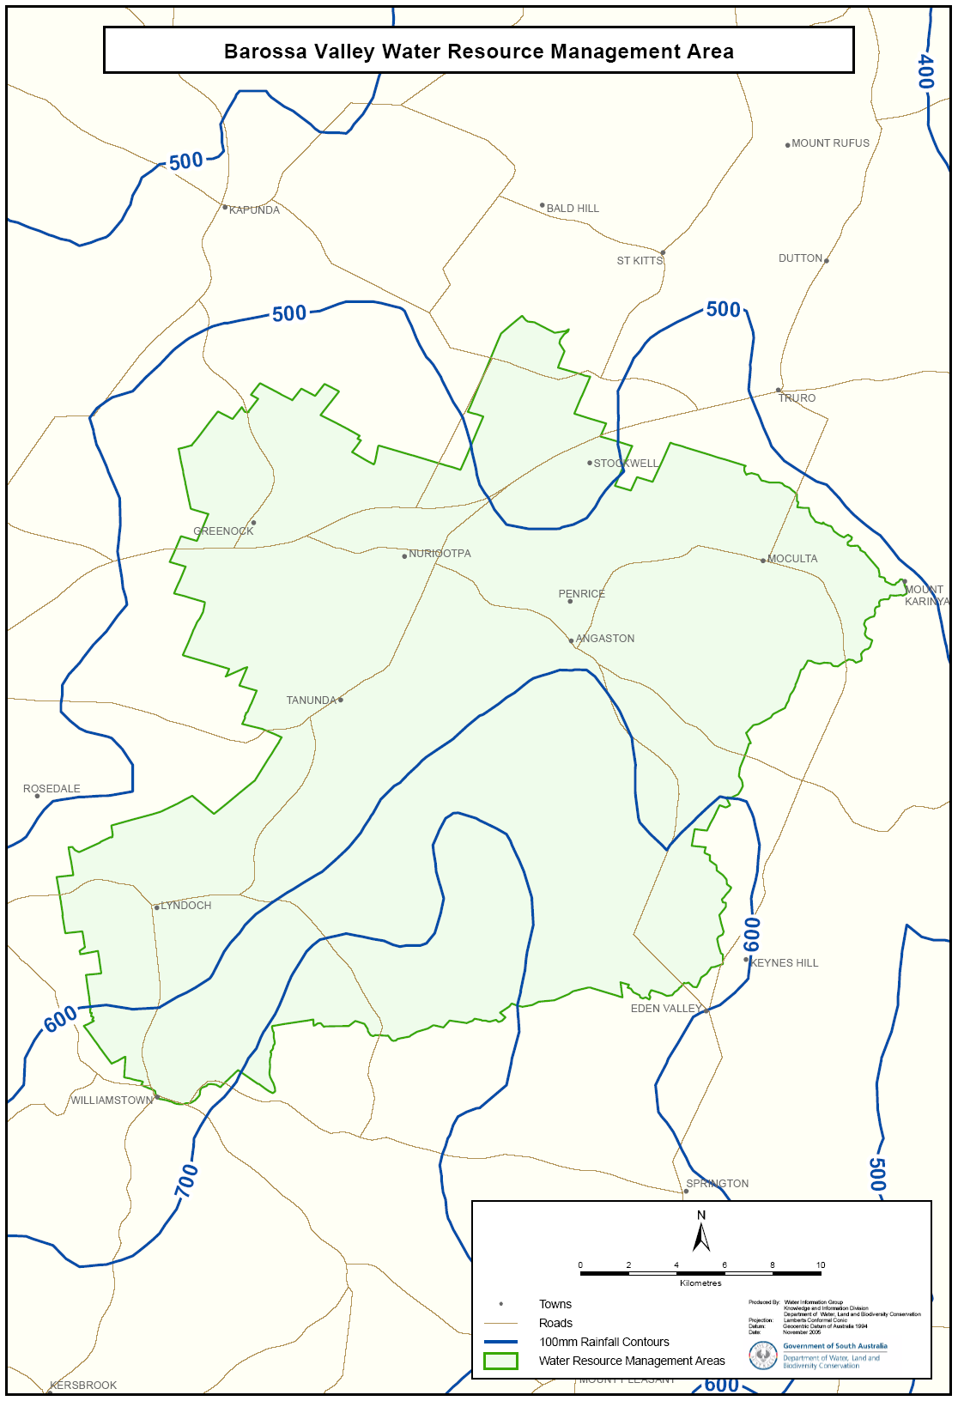
Attachment 3

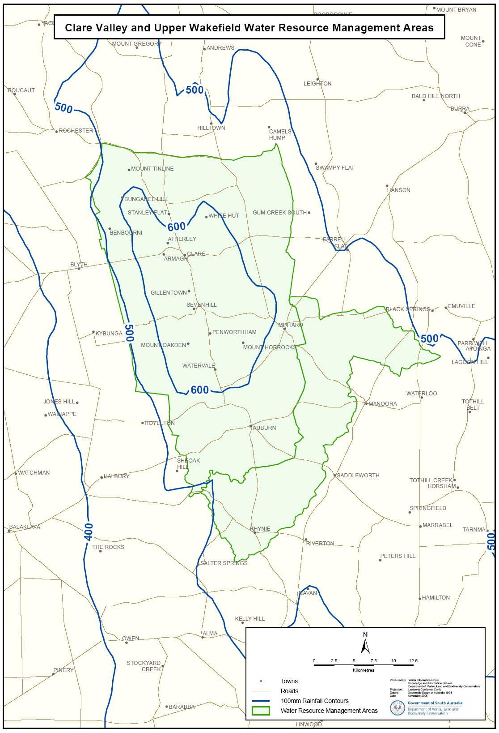
Attachment 4

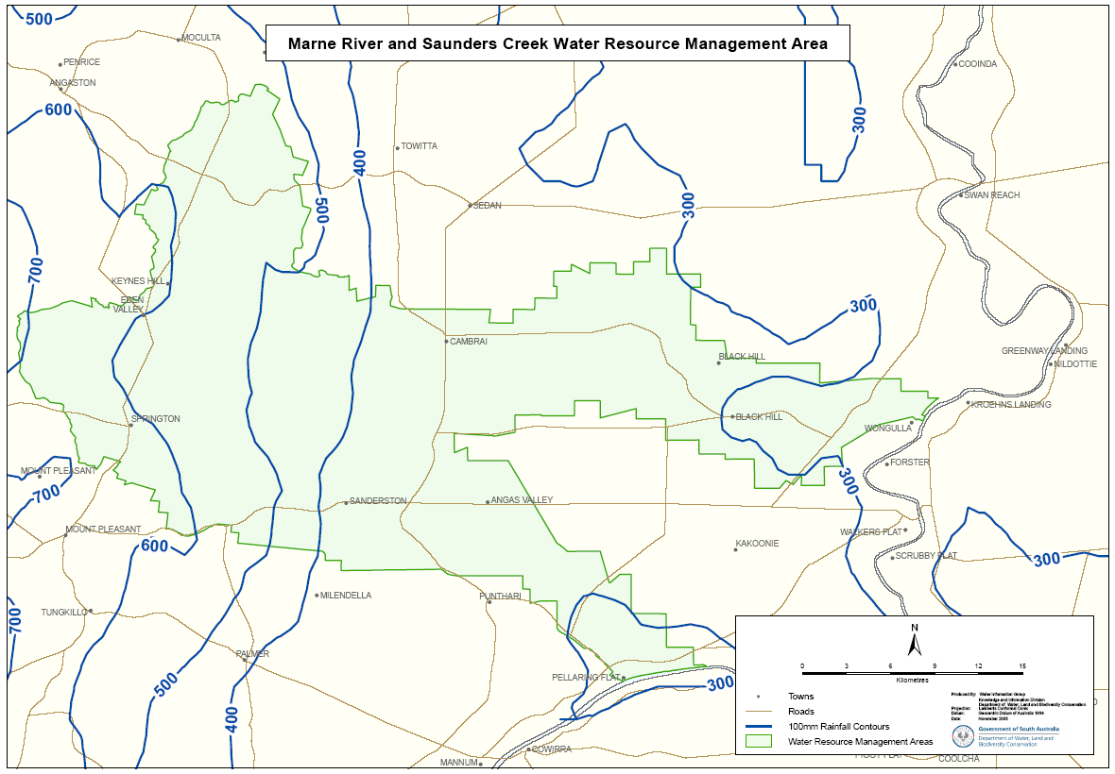
Attachment 5

Attachment 6
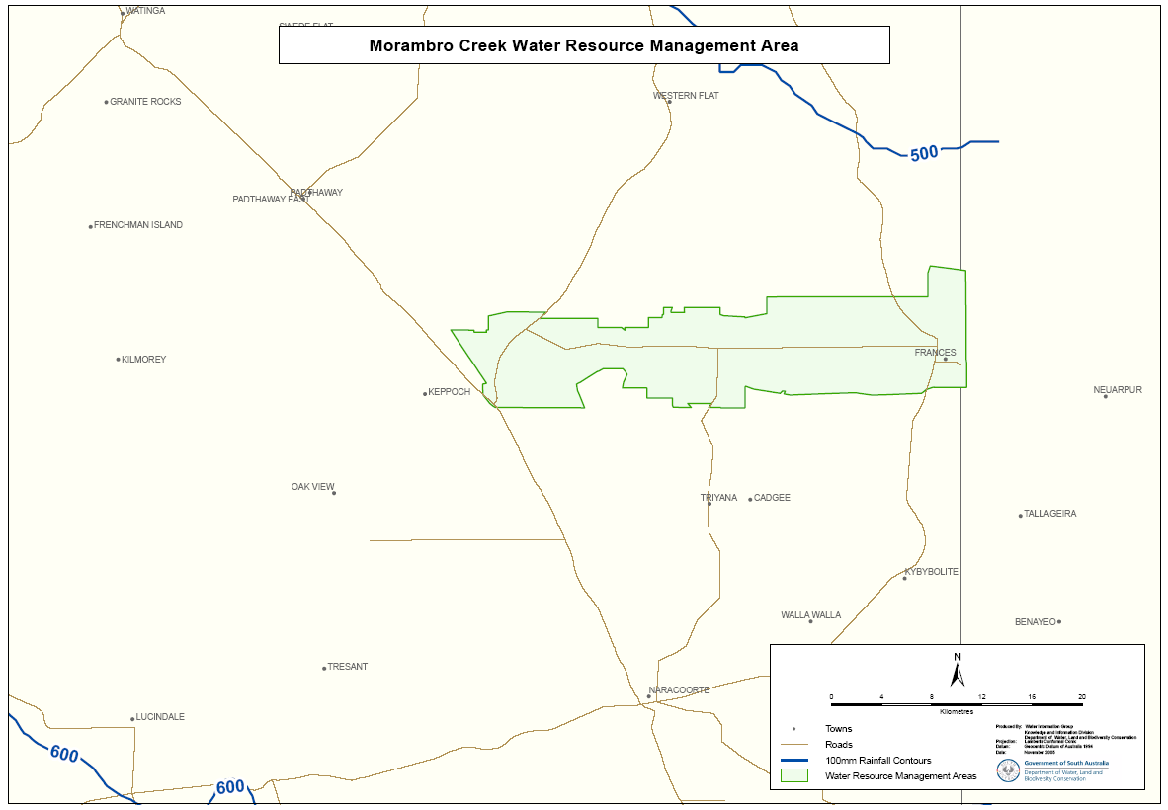

PETROLEUM ACT 2000
Application for Grant of Associated Facilities Licence—
AFL 40
PURSUANT to section 65 (6) of the Petroleum Act 2000 (the Act) and Delegation dated 28 March 2002, Gazetted 11 April 2002, page 1573, notice is hereby given that an application for the grant of an Associated Facilities Licence over the area described below has been received from Stuart Petroleum Limited.
Description of Application Area
All that part of the State of South Australia, bounded as follows:
Commencing at a point being the intersection of latitude 28°32′20″S AGD66 and longitude 140°00′00″E AGD66, thence east to longitude 140°00′10″E AGD66, south to latitude 28°33′00″S AGD66, west to longitude 139°59′30″E AGD66, north to latitude 28°32′50″S AGD66, east to longitude 139°59′40″E AGD66, north to latitude 28°32′40″S AGD66, east to longitude 139°59′50″E AGD66, north to latitude 28°32′30″S AGD66, east to longitude 140°00′00″E AGD66 and north to point of commencement.
Area: 0.83 km² approximately.
Dated 28 February 2006.
E. Alexander, Acting Director Petroleum
and Geothermal
Minerals and Energy Resources
Primary Industries and Resources SA
Delegate of the Minister for Mineral Resources Development

PETROLEUM ACT 2000
Suspension of Petroleum Exploration Licences—
PEL 104 and PEL 111
NOTICE is hereby given that the abovementioned Petroleum Exploration Licences have been suspended under the provisions of the Petroleum Act 2000, from and including 27 February 2006 to 26 August 2006, pursuant to delegated powers dated 28 March 2002, Gazetted 11 April 2002, page 1573.
The expiry date of PEL 104 is now determined to be 24 September 2008.
The expiry date of PEL 111 is now determined to be 12 November 2008.
Dated 28 February 2006.
E. Alexander, Acting Director Petroleum
and Geothermal
Minerals and Energy Resources
Primary Industries and Resources SA
Delegate of the Minister for Mineral Resources Development

PETROLEUM ACT 2000
Suspension of Petroleum Exploration Licence—PEL 105
NOTICE is hereby given that the abovementioned Petroleum Exploration Licence has been suspended under the provisions
of the Petroleum Act 2000, from and including 6 April 2006 to
5 October 2006, pursuant to delegated powers dated 28 March 2002, Gazetted 11 April 2002, page 1573.
The expiry date of PEL 105 is now determined to be 23 October 2009.
Dated 24 February 2006.
B. A. Goldstein, Director Petroleum
and Geothermal
Minerals and Energy Resources
Primary Industries and Resources SA
Delegate of the Minister for Mineral Resources Development

PUBLIC CORPORATIONS ACT 1993
Direction to South Australian Water Corporation
I, KARLENE MAYWALD, Minister for the River Murray and Minister to whom administration of the Murray-Darling Basin Act 1993, is committed, and to whom power to direct the South Australian Water Corporation has been delegated pursuant to section 9 of the Administrative Arrangements Act 1994, hereby direct the South Australian Water Corporation to act as my agent for the purpose of purchasing water entitlements from willing vendors on my behalf as instructed by me from time to time.
Dated 13 February 2006.
K. Maywald, Minister for the River Murray

RADIATION PROTECTION AND CONTROL ACT 1982
Section 44
Notice by Delegate of the Minister for Environment
and Conservation
PURSUANT to section 44 of the Radiation Protection and Control Act 1982, I, Keith Baldry, Director of the Radiation Protection Division of the Environment Protection Authority, being a person to whom the powers of the Minister under that section have been delegated under the Act, exempt diagnostic radiographers from the requirements of Regulation 40 of the Radiation Protection and Control (Ionising Radiation) Regulations 2000, subject to the following conditions:
1. This exemption only applies to the exposure of a person to ionising radiation for the purposes of plain radiography where the exposure has been directed by Luke Andrew Christofis while engaged in the capacity of Nurse Practitioner at an Emergency Department; and
2. The direction referred to in condition 1 must comply with the following requirements:
(1) it must be in writing;
(2) it must contain details of the examination or treatment being undertaken;
(3) it must contain the clinical indications for the examina-tion or treatment;
(4) it must contain a statement by Luke Andrew Christofis making the direction that the person is presenting with the following:
• suspected cervical spine injury;
• penetrating eye injuries;
• extremity injuries;
• pelvic injuries;
• chest pathology,
(5) it must contain a statement by Luke Andrew Christofis that he has due authority to give the direction;
(6) it must be signed by Luke Andrew Christofis; and
(7) it must be signed by the radiographer who is perform-ing the examination or treatment.
3. Luke Andrew Christofis must, when directed to do so by the Radiation Protection Division, provide the Radiation Protection Division with a written report on diagnostic radio-graphy authorised by him during a period specified by the Radiation Protection Division. The report must contain statistics of diagnostic radiography authorised and details of any radiation safety issues associated with the examinations during the specified period.
4. The exemption shall take effect commencing on the date of publication of this notice in the Government Gazette. The exemption from compliance with Regulations 40 of the Radiation Protection and Control (Ionising Radiation) Regulations 2000, granted on 29 January 2004, to radiographers performing radiography authorised by Luke Andrew Christofis, is hereby revoked.
Dated 31 January 2006.
K. Baldry, Delegate of the Minister for Environment and Conservation

PROOF OF SUNRISE AND SUNSET ACT 1923—ALMANAC FOR APRIL, MAY AND JUNE 2006
PURSUANT to the requirements of the Proof of Sunrise and Sunset Act 1923, I, James Horne, Commissioner of Highways, at the direction of the Honourable the Minister for Transport, Energy and Infrastructure, publish in the schedule hereto an almanac setting out the times of sunrise and sunset on every day for the three calendar months of April, May and June 2006.
Dated at Adelaide, 27 February 2006.
J. Horne, Commissioner of Highways
97/03263

The Schedule
Times of sunrise and sunset during the months of April, May and June 2006 for Adelaide: latitude 34°56′S, longitude 138°36′E, GMT -09h30m.
Month | April |  | May |  | June
Date | Sunrise  hr min | Sunset  hr min | Sunrise  hr min | Sunset  hr min | Sunrise  hr min | Sunset  hr min

1 | 07 28 | 19 11 | 06 52 | 17 33 | 07 15 | 17 12
*2 | 06 29 | 18 09 | 06 53 | 17 32 | 07 15 | 17 12
3 | 06 30 | 18 07 | 06 53 | 17 31 | 07 16 | 17 12
4 | 06 31 | 18 06 | 06 54 | 17 30 | 07 16 | 17 11
5 | 06 31 | 18 05 | 06 55 | 17 29 | 07 17 | 17 11
6 | 06 32 | 18 03 | 06 56 | 17 28 | 07 17 | 17 11
7 | 06 33 | 18 02 | 06 57 | 17 27 | 07 18 | 17 11
8 | 06 34 | 18 01 | 06 57 | 17 26 | 07 18 | 17 11
9 | 06 34 | 17 59 | 06 58 | 17 26 | 07 19 | 17 11
10 | 06 35 | 17 58 | 06 59 | 17 25 | 07 19 | 17 11
11 | 06 36 | 17 57 | 07 00 | 17 24 | 07 20 | 17 10
12 | 06 37 | 17 55 | 07 00 | 17 23 | 07 20 | 17 10
13 | 06 38 | 17 54 | 07 01 | 17 22 | 07 21 | 17 10
14 | 06 38 | 17 53 | 07 02 | 17 21 | 07 21 | 17 11
15 | 06 39 | 17 52 | 07 03 | 17 21 | 07 21 | 17 11
16 | 06 40 | 17 50 | 07 04 | 17 20 | 07 22 | 17 11
17 | 06 41 | 17 49 | 07 04 | 17 19 | 07 22 | 17 11
18 | 06 42 | 17 48 | 07 05 | 17 19 | 07 22 | 17 11
19 | 06 42 | 17 47 | 07 06 | 17 18 | 07 23 | 17 11
20 | 06 43 | 17 45 | 07 06 | 17 17 | 07 23 | 17 11
21 | 06 44 | 17 44 | 07 07 | 17 17 | 07 23 | 17 12
22 | 06 45 | 17 43 | 07 08 | 17 16 | 07 23 | 17 12
23 | 06 45 | 17 42 | 07 09 | 17 16 | 07 24 | 17 12
24 | 06 46 | 17 41 | 07 09 | 17 15 | 07 24 | 17 12
25 | 06 47 | 17 40 | 07 10 | 17 15 | 07 24 | 17 13
26 | 06 48 | 17 38 | 07 11 | 17 14 | 07 24 | 17 13
27 | 06 49 | 17 37 | 07 11 | 17 14 | 07 24 | 17 13
28 | 06 49 | 17 36 | 07 12 | 17 13 | 07 24 | 17 14
29 | 06 50 | 17 35 | 07 13 | 17 13 | 07 24 | 17 14
30 | 06 51 | 17 34 | 07 13 | 17 13 | 07 24 | 17 14
31 |  |  | 07 14 | 17 12
*Note: Daylight saving time is subject to change.

RULES OF COURT
Magistrates Court of South Australia
Amendment No. 24 to the Magistrates Court Rules
PURSUANT to section 49 of the Magistrates Court Act 1991, and all other enabling powers, we, the undersigned, do hereby make the following amendments to the Magistrates Court Rules 1992, as amended.
1. These Rules may be cited as the Magistrates Court Rules 1992, Amendment No. 24.
2. The Magistrates Court Rules 1992, as amended by these Rules, may be cited as the ‘Magistrates Court Rules 1992’.
3. Rule 41 is amended by adding the following subrule:
41.07 A warrant for the arrest of a person pursuant to section 71 (3) (a) and section 71 (4) of the Criminal Law (Sentencing) Act 1988, shall comply with Form No. 78.
41.08 A warrant for the arrest of a person pursuant to section 71 (3) (b) of the Criminal Law (Sentencing) Act 1988, shall comply with Form 82.
4. Form 78 is deleted and Forms 78 and 82 as annexed are prescribed.
Dated 15 February 2006.
K. J. Prescott, Chief Magistrate
A. J. Cannon, Deputy Chief Magistrate
G. B. Harris, Magistrate
P. B. Snopek, Magistrate




SURVEY ACT 1992
Designated Survey Areas
PURSUANT to section 49 (1) (b) of the Survey Act 1992, I declare that from 1 June 2006:
• designated survey area number 20 is revoked; and
• the following areas of the State, numbered 20, 169, 170, 171, 172 and 174, outlined in black on Rack Plan 903, to be designated survey areas.
Rack Plan 903 may be inspected at the Land Titles Office Viewing Room, Ground Floor, 101 Grenfell Street, Adelaide.
Dated 2 March 2006.
P. M. Kentish, Surveyor-General

NOTICE TO MARINERS
No. 11 of 2006
South Australia—Spencer Gulf—Tumby Bay—Port Hand Mark—North-North-West of Tumby Island—Light Established
MARINERS are advised that a light Fl R ev 5 secs 2 NM. Range (not yet listed Vol. K) has been established on a previously unlit, and unmarked beacon north-north-west of Tumby Island on the approaches to Tumby Bay, in position:
Latitude 34°24.313′S and Longitude 136°09.282′E.
Charts affected: Aus 777.
Publications affected: Australian Pilot Vol. 1, 2005 edition, page 352. South Australia’s Waters, CW Map 10, page 213.
Adelaide, 20 February 2006.
P. Conlon, Minister for Transport
TSA 2006/00419

NOTICE TO MARINERS
No. 13 of 2006
South Australia—West Coast—Approaches to Thevenard—Goat Island—Wreck of ‘Ellene K’—North Cardinal Buoy—
Out of Position
MARINERS are advised that the North Cardinal Buoy, marking safe water to the north of the Ellene K wreck, is out of its charted position by approximately 0.5 nautical miles in a 148° true direction. The buoy is now located in position:
Latitude 32°17.887′S and Longitude 133°31.551′E.
Mariners are further advised to use extreme caution when navigating in the vicinity of the wreck and the buoy at all times, as its present position lies in very close proximity to portions of the wreck, which are close to the surface.
Charts affected: Aus 120.
Publications affected: Australia Pilot Vol. 1, 2005 edition, page 331; South Australia’s Waters, CW Map 14, page 223.
Adelaide, 23 February 2006.
P. Conlon, Minister for Transport
TSA 2006/00419

FAXING COPY?
IF you fax copy to Government Publishing SA for inclusion in the Government Gazette, there is no need to send a Confirmation Copy to us as well.
This creates confusion and may well result in your notice being printed twice.
Please use the following fax number:
Fax transmission: (08) 8207 1040
Phone Inquiries: (08) 8207 1045
Please include a contact person, phone number and order number so that we can phone back with any queries we may have regarding the fax copy.
NOTE: Closing time for lodging new copy (fax, hard copy or email) is 4 p.m. on Tuesday preceding the day of publication.

Government Gazette notices can be E-mailed.
The address is:
governmentgazette@saugov.sa.gov.au
Documents should be sent as attachments in Word format.
When sending a document via E-mail, please confirm your transmission with a faxed copy of your document, including the date the notice is to be published.
Fax transmission: (08) 8207 1040
Enquiries: (08) 8207 1045
NOTE: Closing time for lodging new copy (fax, hard copy or email) is 4 p.m. on Tuesday preceding the day of publication.

CITY OF HOLDFAST BAY
Local Government Act 1999
Variation to Car Parking Fund Contribution Rate
NOTICE is hereby given that at its meeting held on 14 February 2006, the City of Holdfast Bay, pursuant to section 50A (6) (b) of the Development Act 1993, resolved to vary the contribution rate under the City of Holdfast Bay Car Parking Contributions Fund to $15 500 (excluding GST) per car parking space for applications for development approval providing cash payment in lieu of car parking spaces.
The City of Holdfast Bay Car Parking Contributions Fund was approved by the former Minister for Transport and Urban Planning and Gazetted on 28 February 2002, pursuant to section 50A of the Development Act 1993. The Fund is applicable to an area of Glenelg that is located within the District Centre Zone illustrated on Map HoB/5 of the City of Holdfast Bay Development Plan dated 9 February 2006.
The rate may be varied by further determination of Council, notice of which will be published in the Gazette.
R. T. Donaldson, Chief Executive Officer

CITY OF ONKAPARINGA
Roads (Opening and Closing) Act 1991
NOTICE is hereby given pursuant to section 10 of the Roads (Opening and Closing) Act 1991, that the City of Onkaparinga proposes to make a Road Process Order to close and transfer those portions of Right of Way marked ‘A’, ‘B’, ‘C’, ‘D’, ‘E’, ‘F’, ‘G’ and ‘H’ on Preliminary Plan No. 06/0016.
Transfer ‘A’ to R. D. Evans, Esplanade, Aldinga Beach, S.A. 5173 and to merge that portion with certificate of title volume 5646, folio 994.
Transfer ‘B’ to Strata Corporation No. 10017, 229 Esplanade, Aldinga Beach, S.A. 5173 and to merge that portion with certificate of title volume 5002, folio 318.
Transfer ‘C’ to C. M. Greenfield, RSD 3, Kielpa, S.A. 5642 and to merge that portion with certificate of title volume 5647, folio 535.
Transfer ‘D’ to C. P. and C. A. Arnoul, 45 Ward Street, North Adelaide, S.A. 5006 and to merge that portion with certificate of title volume 5257, folio 557.
Transfer ‘E’ to D. M. Belle, P.O. Box 6049, Halifax Street, Adelaide, S.A. 5000 and to merge that portion with certificate of title volume 5557, folio 300.
Transfer ‘F’ to Monapilla Pty Ltd, P.O. Box 65, McLaren Vale, S.A. 5171 and to merge that portion with certificate of title volume 5834, folio 611.
Transfer ‘G’ to A. J. and B. H. Wilke, 30 Kennaway Street, Tusmore, S.A. 5065 and to merge that portion with certificate of title volume 5501, folio 25.
Transfer ‘H’ to G. R. and J. Potter, 17 Hazelwood Avenue, Hazelwood Park, S.A. 5066 and to merge that portion with certificate of title volume 5792, folio 105.
A statement of persons affected by the proposed road process together with a copy of the preliminary plan is available for inspection at the offices of the City of Onkaparinga, Ramsay Place, Noarlunga Centre, during normal office hours. Copies may also be inspected at the Adelaide office of the Surveyor-General, 101 Grenfell Street, Adelaide, during normal office hours.
Any person is entitled to object to the proposed road process, or any person affected by the proposed closure is entitled to apply for an easement to be granted in that person’s favour over the land subject to the proposed closure. Such objection or application for an easement must set out the full name and address of the person making the objection of application and must be fully supported by reasons. Any application for an easement must give full particulars of the nature and location of the easement land, where made by a person as the owner of adjoining land or nearby land, specify the land to which the easement is to be annexed.
The objection or application for and easement must be made in writing to the City of Onkaparinga, P.O. Box 1, Noarlunga Centre, S.A. 5168, within 28 days of this notice, and a copy shall be forwarded to the Adelaide office of the Surveyor-General, G.P.O. Box 1354, Adelaide, S.A. 5001. Where a submission is made, the City of Onkaparinga will give notification of a meeting at which the matter will be considered, so that the person making the sub-mission or a representative may attend, if desired.
Dated 9 March 2006.
J. Tate, Chief Executive Officer

CITY OF PORT LINCOLN
Exclusion of Land from Classification as Community Land
NOTICE is hereby given that at its meeting held on 13 February 2006 the Council, in accordance with section 194 of the Local Government Act 1999, resolved that the land comprised in Allotment 111 in Deposited Plan 45972, certificate of title volume 5391, folio 986, be excluded from Classification as Community Land.
G. P. Dodd, Chief Executive Officer

LIGHT REGIONAL COUNCIL
Revocation of Temporary Road Closure and Imposition of Road Closure—Sturt Road, Nuriootpa
NOTICE is hereby given that, pursuant to the provisions of section 359 of the Local Government Act 1934, Council has revoked the temporary road closure of Sturt Road, Nuriootpa, adjoining part section 80, Hundred of Belvidere for a distance of 10 m, 500 m south of Kalimna Road, imposed at the ordinary meeting of the District Council of Kapunda and Light held on 16 December 1997.
Pursuant to the provisions of section 359 of the Local Government Act 1934, Council has resolved, at its meeting held on 21 February 2006, to exclude all vehicles except bicycles from that portion of Sturt Road, Nuriootpa, which lies between the area described by a line (across the full width of the Sturt Road Reserve) 26 m offset to the north and parallel to the easterly production of the common boundary between Filed Plan 171176 and Filed Plan 173420 and another line (across the full width of the Sturt Road Reserve), 10 m offset to the north from the line first described and parallel thereto, until further notice.
P. J. Beare, Chief Executive Officer

MID MURRAY COUNCIL
Roads (Opening and Closing) Act 1991
Riverboat Drive, Hogwash Bend, Cadell
NOTICE is hereby given pursuant to section 10 of the said Act, that Council proposes to make a Road Process Order to open as road a strip of piece 3 in DP 56807 to realign Riverboat Drive shown numbered ‘10’ on Preliminary Plan No. 06/0015 and to close and transfer the old portion of Riverboat Drive marked ‘A’, ‘B’, ‘C’ and ‘D’ on the said plan as follows:
‘A’ to G. K. Sutherland, ‘B’ to W. E. Fischer and D. E. Gemmell, ‘C’ to H. G. Winter and (in exchange for the new road) ‘D’ with Nashly Pty Ltd.
A copy of the plan and statement of persons affected are available for public inspection at Council’s Office, 49 Adelaide Road, Mannum and the office of the Surveyor-General, 101 Grenfell Street, Adelaide during normal office hours.
Any objection or representation must be made in writing within 28 days from 2 March 2006, to the Council, P.O. Box 28, Mannum, S.A. 5238 and the Surveyor-General, G.P.O. Box 1354, Adelaide, S.A. 5001, setting out full details.
Where a submission is made, Council will give notification of a meeting to deal with the matter.
D. Gollin, Chief Executive Officer

DISTRICT COUNCIL OF MOUNT REMARKABLE
Roads (Opening and Closing) Act 1991
Road Closure
Wirrabara—Melrose—Appila
NOTICE is hereby given, pursuant to section 10 of the Road (Opening and Closing) Act 1991, that the District Council of Mount Remarkable gives notice of its intent to implement a road process order to close:
1. Portion of Main North Road and merge with the adjoining Allotment 54 in Deposited Plan 24141 (T. D. Zwar), section 212 (IOOF Australia Trustees Ltd and D. R. Zwar) and section 244 (C. F. Ziepers) in the Hundred of Appila, as delineated and lettered ‘A’, ‘B’ and ‘C’ on Preliminary Plan No. 06/0009.
2. Portion of the Public Road between Girdhams Road and Hundred Line Road and merge with the adjoining section 114 (J. K. and D. J. McCallum) and section 171 (K. R. and M. C. Girdham) in the Hundred of Booleroo, as delineated and lettered ‘B’ and ‘C’ respectively on Preliminary Plan No. 06/0010.
3. The whole of the Public Road west of Appila-Caltowie Road and merge with the adjoining sections 147, 148, 149, 151 and 300 in the Hundred of Appila (Dalmore Nominees Pty Ltd), as delineated and lettered ‘A’ on Preliminary Plan No. 06/0011.
A copy of the plan and a statement of persons affected are available for public inspection at the Council Office, Melrose, S.A. 5483 and the Adelaide office of the Surveyor-General during normal office hours.
Any person is entitled to object to the proposed closure. The reasons for such objection must be fully supported in the submission and include the objector’s full name and address. Any person who desires to make application for a grant of easement over all or portion of the road to be closed must include the full name and address of the applicant and full details of the nature and location of the proposed easement and the full description and title of the land to which the easement is to be annexed.
The objection or application for an easement must be made, in writing to the District Council of Mount Remarkable, P.O. Box 94, Melrose, S.A. 5483, who will deal with this matter within 28 days of this notice and a copy must be forwarded to the Surveyor-General, G.P.O. Box 1354, Adelaide, S.A. 5001. Where a submission is made, the Council will give notification of a meeting at which the matter will be considered, so that the person making the submission or a representative may attend, if so desired.
Dated 2 March 2006.
S. Cheriton, Chief Executive Officer

DISTRICT COUNCIL OF PETERBOROUGH
Revocation of Community Land Classification
NOTICE is hereby given in accordance with section 193 of the Local Government Act 1999, that the following land has, by resolution of Council at the meeting held on 20 February 2006, been excluded from the Classification of Community Land:
Peterborough Caravan Park, being portion of Allotment 1 in Filed Plan No. 4678, certificate of title volume 5165, folio 305 depicted as Allotment 21 in plan of Division Application 504/D002/05.
T. D. Barnes, Chief Executive Officer

IN the matter of the estates of the undermentioned deceased persons:
Carter, Anne Olwen, late of 528 Anzac Highway, Glenelg East, retired hairdresser, who died on 12 November 2005.
Clements, Lois Carmen, late of Sturdee Street, Linden Park, of no occupation, who died on 30 December 2005.
Dixon, Marjorie Helen, late of 276 Portrush Road, Beulah Park, retired teacher, who died on 24 September 2005.
Fry, Lilian Ross, late of Newton Street, Whyalla, widow who died on 15 November 2005.
Gluyas, Jack Ronald, late of 29 Austral Terrace, Morphettville, retired labourer, who died on 8 January 2006.
Hyde, Bazel Charles, late of 50 Gulfview Road, Christies Beach, retired cartage contractor, who died on 26 November 2005.
Mathews, Rosemary Constance, late of 68 Gladstone Avenue, Magill, retired social worker, who died on 26 September 2005.
McPherson, John Harris Frederick, late of 47 Eve Road, Bellevue Heights, retired storeman, who died on 10 September 2005.
Nakonecznyj, Katharina, late of 66 Nelson Road, Valley View, of no occupation, who died on 27 September 2005.
Noye, Joan, late of 84 Reservoir Road, Modbury, of no occupation, who died on 20 October 2005.
Oswald, Geoffrey Norman, late of 7 Coralie Street, Plympton, retired administrator, who died on 3 January 2006.
Polglase, Gertrude Alice, late of 740 Torrrens Road, Rosewater, retired tailoress, who died on 20 November 2005.
Richardson, Clifton Cecil, late of 1 Myzantha Street, Lockleys, retired wine representative, who died on 1 January 2006.
Waldon, Lorna Mavis, late of 13 Walnut Street, Old Reynella, home duties, who died on 19 December 2005.
Notice is hereby given pursuant to the Trustee Act 1936, as amended, the Inheritance (Family Provision) Act 1972, and the Family Relationships Act 1975, that all creditors, beneficiaries, and other persons having claims against the said estates are required to send, in writing, to the Public Trustee, 25 Franklin Street, Adelaide, S.A. 5000, full particulars and proof of such claims, on or before 31 March 2006, otherwise they will be excluded from the distribution of the said estate; and notice is also hereby given that all persons who are indebted to the said estates are required to pay the amount of their debts to the Public Trustee or proceedings will be taken for the recovery thereof; and all persons having any property belonging to the said estates are forthwith to deliver the same to the Public Trustee.
Dated 2 March 2006.
C. J. O’Loughlin, Public Trustee

UNCLAIMED MONEYS ACT 1891
Register of Unclaimed Moneys held by Peter Lehmann Wines Limited over $10

Name and Address of Owner |  | Amount  $ | Date
A. Farrah Nominees Pty Ltd, P.O. Box 190, Campbell, A.C.T. 2612 |  | 272.00 | May-98
Peter Apoefis, 27 Milton Avenue, Fulham Gardens, S.A. 5024 |  | 20.00 | May-98
Maxwell Cooper, 4 Knightsbridge Road, Hazelwood Park, S.A. 5066 |  | 112.00 | May-98
Mark Peter Hanna, 12 Thompson Close, West Pennant Hills, N.S.W. 2125 |  | 60.00 | May-98
Matthew David McLennan, P.O. Box 1237, Grafton, N.S.W. 2460 |  | 30.00 | May-98
Peter Apoefis, 27 Milton Avenue, Fulham Gardens, S.A. 5024 |  | 42.50 | Nov-98
Helene Josephine Brown, 751 Hampton Street, Brighton, Vic. 3186 |  | 42.50 | Nov-98
Gerald Michael Carr, c/o Barkus Pearson, Lot 9, 370 Pitt Street, Sydney, N.S.W. 2000 |  | 178.50 | Nov-98
Paul Cross, 11 Hillview Avenue, Panorama, S.A. 5041 |  | 10.63 | Nov-98
Mark Peter Hanna, 12 Thompson Close, West Pennant Hills, N.S.W. 2125 |  | 127.50 | Nov-98
Robert Douglas Holdsworth, 8 Allumba Grove, Cordeaux Heights, N.S.W. 2526 |  | 157.25 | Nov-98
Geoffrey and Lora Osborne, 22 Finniss Street, Gawler, S.A. 5118 |  | 238.00 | Nov-98
Paul McGrath, 2 Hunter Street, Not known |  | 98.60 | Nov-98
Dean Joseph Michalik, 4 Aldrin Crescent, Modbury North, S.A. 5092 |  | 21.25 | Nov-98
Hedonna Morris, 20 Cobby Street, Campbell, A.C.T. 2612 |  | 21.25 | Nov-98

UNCLAIMED MONEYS ACT 1891
Register of Unclaimed Moneys held by Peter Lehmann Wines Limited over $10

Name and Address of Owner | Amount  $ |  | Date
Gabrielle Amies, 22 Dora Street, Hendra, Qld 4011 |  | 50.00 |  | May-99
Peter Apoefis, 27 Milton Avenue, Fulham Gardens, S.A. 5024 |  | 25.00 |  | May-99
William South Botting, c/o C. C. Rodda, P.O. Box 197, McLaren Vale, S.A. 5171 |  | 640.53 |  | May-99
Stephen Brain, RMB 1196, Mumbannar, Vic. 3304 |  | 25.00 |  | May-99
Gerald Michael Carr, c/o Barkus Pearson, Level 9, 370 Pitt Street, Sydney, N.S.W. 2000 |  | 55.00 |  | May-99
Robyn De Brettargh, 5 Tinderry Circuit, Palmerston, A.C.T. 2913 |  | 25.00 |  | May-99
Halcyon Pty Ltd, 90 Victoria Road, Bellevue Hill, N.S.W. 2023 |  | 625.00 |  | May-99
Hamish John McDonald, 2/445 Brunswick Road, West Brunswick, Vic. 3055 |  | 15.00 |  | May-99
Arthur Herbert McKenzie, 18 Waterfall Road, Oatley, N.S.W. 2223 |  | 50.00 |  | May-99
Matthew David McLennan, P.O. Box 1237, Grafton, N.S.W. 2460 |  | 37.50 |  | May-99
Dean Joseph Michalik, 4 Aldrin Crescent, Modbury North, S.A. 5092 |  | 12.50 |  | May-99
Craig Michael Michie, 26 Dorlton Street, Kings Langley, N.S.W. 2147 |  | 12.50 |  | May-99
Michael George Reif, 51 Dickens Street, Elwood, Vic. 3184 |  | 40.00 |  | May-99
Craig Stewart Saul, 1/175 Powlett Street, East Melbourne, Vic. 3002 |  | 11.25 |  | May-99
Felicity Jane Scholz, 16 Marlborough Street, College Park, S.A. 5069 |  | 175.00 |  | May-99
Robert Andrew Stark, 187 Mount Eliza Way, Mount Eliza, Vic. 3930 |  | 75.00 |  | May-99
Swantime Pty Ltd, 16B Gladstone Road, Leeming, W.A. 6149 |  | 50.00 |  | May-99
Jennifer Rose Barons, c/o Carlton House, 30 The Terrace, Torquay, Devon, TQ1 1BS, U.K. |  | 140.00 |  | May-99
Peter Apoefis, 27 Milton Avenue, Fulham Gardens, S.A. 5024 |  | 50.00 |  | Nov-99
Donald Logan Ballantyne, P.O. Box 5903, Gold Coast Mail Centre, Gold Coast, Qld 4217 |  | 400.00 |  | Nov-99
Martin Beeken, 207 Swan Street, Yokine, W.A. 6060 |  | 65.00 |  | Nov-99
Douglas Gordon Blight, PMB 44, Bon Bon Station via Port Augusta, S.A. 5700 |  | 20.00 |  | Nov-99
John Boyd, c/o Hogan & Partners, P.O. Box 278, Fremantle, Perth, W.A. 6959 |  | 150.00 |  | Nov-99
Robyn De Brettargh, 5 Tinderry Circuit, Palmerston, A.C.T. 2913 |  | 50.00 |  | Nov-99
Bryan King, 2/12-16 Walton Crescent, Abbotsford, N.S.W. 2046 |  | 150.00 |  | Nov-99
Hamish John McDonald, 2/445 Brunswick Road, West Brunswick, Vic. 3055 |  | 30.00 |  | Nov-99
Dean Joseph Michalik, 4 Aldrin Crescent, Modbury North, S.A. 5092 |  | 25.00 |  | Nov-99
Craig Michael Michie, 26 Dorlton Street, Kings Langley, N.S.W. 2147 |  | 25.00 |  | Nov-99
Semaphore Investments Pty Ltd, P.O. Box 2, Semaphore, S.A. 5019 |  | 131.05 |  | Nov-99
Simeon Wines Limited, 170 Greenhill Road, Parkside, S.A. 5063 |  | 25.00 |  | Nov-99
Francis and Pauline Slowiak, Level 30, St Martins Tower, 31 Market Street |  | 250.00 |  | Nov-99
Swantime Pty Ltd, 16B Gladstone Road, Leeming, W.A. 6149 |  | 100.00 |  | Nov-99
Fiona Wylie and Lisa Simms, 473 Montogue Road, Red Hill, Qld 4059 |  | 20.00 |  | Nov-99
Ellum Pty Ltd, P.O. Box 674, Mareeba, Qld 4008 |  | 151.05 |  | Nov-99

UNCLAIMED MONEYS ACT 1891
Register of Unclaimed Moneys held by News Holdings Limited

Name of Owner on Books and  Last Known Address | Amount Due  to Owner  $ | Dividend Payment | Date when  Amount First  Became Payable
101 Catherine Street Pty Limited, 66 Viking Road, Dalkeith, W.A. 6009 | 67.50 | Cheque | 3.11.99
Aldersey Pty Ltd, 53 Alexandra Street, Hunters Hill, N.S.W. 2110 | 10.30 | Cheque | 30.4.99
Aldersey Pty Ltd, 53 Alexandra Street, Hunters Hill, N.S.W. 2110 | 10.30 | Cheque | 30.4.99
Stephen Alexander Andrea, P.O. Box 468, Paddington, N.S.W. 2021 | 23.15 | Cheque | 30.4.99
Anne M. Dynon Pty Ltd, <Flemington Vet Super A/C>, 187 Mount Alexander Road, Ascot Vale, Vic. 3032 | 19.55 | Cheque | 3.11.99
Apex Management Consultants Pty Ltd, 27 Robinson Street, Croydon, N.S.W. 2132 | 18.81 | Cheque | 30.4.99
Apex Management Consultants Pty Ltd, 27 Robinson Street, Croydon, N.S.W. 2132 | 18.81 | Cheque | 3.11.99
A. S. Nominees Ltd, <B. C. Durack Super Fund A/C>, (In Liquidation), c/o A.C.T. Super, G.P.O. Box 799, Canberra, A.C.T. 2601 | 14.58 | Cheque | 30.4.99
Richard Brian Ayre and Thora Geraldine Ayre, <Thoric Investment A/C>, P.O. Box 260, Clayfield, Qld 4011 | 33.75 | Cheque | 30.4.99
Abraham Baher, Unit 2605, 71-73 Spring Street, Bondi Junction, N.S.W. 2022 | 77.25 | Cheque | 3.11.99
Allison Nancy Bailey, c/o Computershare Registry Services Pty Ltd, G.P.O. Box 1903, Adelaide, S.A. 5001 | 22.95 | Cheque | 30.4.99
Allison Nancy Bailey, c/o Computershare Registry Services Pty Ltd, G.P.O. Box 1903, Adelaide, S.A. 5001 | 22.95 | Cheque | 3.11.99
Kenneth Dale Barassi and Joy Barassi, 378 Bay Street, Port Melbourne, Vic. 3207 | 13.05 | Cheque | 3.11.99
Janine J. Beagley, 34 Rhonda Avenue, Willetton, W.A. 6155 | 12.00 | Cheque | 30.4.99
Janine J. Beagley, 34 Rhonda Avenue, Willetton, W.A. 6155 | 12.00 | Cheque | 3.11.99
Beltech Corporation Ltd, 6th Floor, 19 Pier Street, Perth, W.A. 6000 | 35.00 | Cheque | 30.4.99
Beltech Corporation Ltd, 6th Floor, 19 Pier Street, Perth, W.A. 6000 | 35.00 | Cheque | 3.11.99
Peter John Bigg, 19 Clive Street, Bicton, W.A. 6157 | 16.88 | Cheque | 30.4.99
Biz Pty Limited, c/o Oscar Fabian, 10 Kilrush Street, Brighton, Vic. 3186 | 74.25 | Cheque | 3.11.99
Peter Terence Blake and Claire Rosalind Blake, N105, 575 Main Street, New York, NY 10044, U.S.A. | 12.75 | Cheque | 30.4.99
Peter Terence Blake and Claire Rosalind Blake, N105, 575 Main Street, New York, NY 10044, U.S.A. | 12.75 | Cheque | 3.11.99
Fraser Grant Boddy and Dairne Joan Shanahan, <F. G. Boddy No. 3 A/C>, P.O. Box 28881, Remuera, Auckland, New Zealand | 25.50 | Cheque | 3.11.99
Brading Nominees Pty Ltd, <Anthea Crawford Super Fund A/C>, 90-95 Nicholson Street, Abbotsford, Vic. 3067 | 15.00 | Cheque | 30.4.99
Penelope Brault and Bretton Daniel Smith, P.O. Box 5133, Port Nelson 7001, New Zealand | 344.18 | Cheque | 3.11.99
Janine Sue Brown, Post Office, Lucindale, S.A. 5272 | 30.00 | Cheque | 3.11.99
Matthew Lovell Burley, 12 Pearl Avenue, Chatswood, N.S.W. 2067 | 67.50 | Cheque | 30.4.99
Alexander Busby, Cassilis Cassilis, N.S.W. 2329 | 19.31 | Cheque | 3.11.99
Anthony John Byrne, Hiroo Quelle # 101 3-5-22, Hiroo Shibuya-Ku, Tokyo | 25.50 | Cheque | 30.4.99
Phillip Casson, c/o Coppleson 905/12 Macleay Street, Potts Point, N.S.W. 2011 | 15.45 | Cheque | 3.11.99
Dr Maxwell Roy Chalmers and Dr Elizabeth Mary Chalmers, <Chalmers Super Fund A/C>, P.O. Box 1024, Mount Isa, Qld 4825 | 231.00 | Cheque | 30.4.99
Fai Hung Chan, 46 Watersedgen Close, Knoxfield, Vic. 3180 | 21.35 | Cheque | 30.4.99
Michael Ho Yin Chan, 12 Huntingfield Drive, Doncaster East, Vic. 3109 | 38.60 | Cheque | 3.11.99
Vernon Chan, 2/56 Queen’s Grove, Lower Hutt, New Zealand | 45.90 | Cheque | 30.4.99
Chiron Chemicals Pty Ltd, <Chiron Chemicals Super Fund A/C>, 74 Burwood Road, Hawthorn, Vic. 3122 | 118.13 | Cheque | 3.11.99
Renu Choudhary, 69A/177 Reservoir Road, Blacktown, N.S.W. 2148 | 37.50 | Cheque | 30.4.99
Renu Choudhary, 69A/177 Reservoir Road, Blacktown, N.S.W. 2148 | 37.50 | Cheque | 3.11.99
Damon Edgar Clapshaw, 10 Meanda Gardens, Pakuranga, Auckland, New Zealand | 12.75 | Cheque | 3.11.99
Estate of the late George Contos, c/o C. Contos, 28 Kalgoorlie Street, Mount Hawthorn, W.A. 6016 | 27.80  27.80 | Cheque  Cheque | 30.4.99  3.11.99
Judith Cooke, P.O. Box 225, Fairy Meadow, N.S.W. 2519 | 13.90 | Cheque | 30.4.99
Judith Cooke, P.O. Box 225, Fairy Meadow, N.S.W. 2519 | 13.90 | Cheque | 3.11.99
Marilyn Peta Cooper, 1 Parry Avenue, East Fremantle, W.A. 6158 | 30.00 | Cheque | 3.11.99
Margaret McCausland Coote, 42 Iluka Road, Mosman, N.S.W. 2088 | 23.76 | Cheque | 3.11.99
Maree Crane, 6 Barooga Road, Wamberal, N.S.W. 2260 | 16.88 | Cheque | 30.4.99
Henry W. Crouch, Mount Mill, Coolah, N.S.W. 2843 | 16.90 | Cheque | 30.4.99
Henry W. Crouch, Mount Mill, Coolah, N.S.W. 2843 | 16.90 | Cheque | 3.11.99
Estate of the late James Herbert Crowther, c/o ANZ Trustees Ltd, G.P.O. Box 389D, Melbourne, Vic. 3001 | 173.70 | Cheque | 30.4.99
David Curran, c/o Anderson Consulting, 141 Walker Street, North Sydney, N.S.W. 2060 | 10.13 | Cheque | 3.11.99
Jonathon C. Dawson, c/o M. W. Allworth, P.O. Box 799, Canberra City, A.C.T. 2601 | 10.80 | Cheque | 30.4.99
Jonathon C. Dawson, c/o M. W. Allworth, P.O. Box 799, Canberra City, A.C.T. 2601 | 10.80 | Cheque | 3.11.99
Patricia Delany, Unit 4, 423 Glenferrie Road, Malvern, Vic. 3144 | 163.80 | Cheque | 30.4.99
Ernest Dowrich, c/o Otelia Washington, P.O. Box 794, New York, NY 10026, U.S.A. | 49.57 | Cheque | 30.4.99
Ernest Dowrich, c/o Otelia Washington, P.O. Box 794, New York, NY 10026, U.S.A. | 49.57 | Cheque | 3.11.99
Dr Rick Sherman Pty Ltd, <Dr R. Sherman Super Fund A/C>, P.O. Box 46, Malvern, Vic. 3144 | 10.20 | Cheque | 13.12.99
George Dracopoulos, Unit 13, 14 Edensor Street, Epping, N.S.W. 2121 | 11.85 | Cheque | 30.4.99
Leon W. Draper, Old Gimpie Road, Kallangur, Qld 4503 | 36.18 | Cheque | 30.4.99
Leon W. Draper, Old Gimpie Road, Kallangur, Qld 4503 | 36.18 | Cheque | 30.4.99
Drs M. & E. Chalmers Pty Ltd, <Chalmers Superannuation A/C>, P.O. Box 1294 Katherine, N.T. 0851 | 45.00 | Cheque | 30.4.99
Sonia Elliott, <A/C 3201308>, c/o Morgan Stanley & Co., 1251 Avenue of the Americas, New York, NY 10020, U.S.A. | 76.31  76.31 | Cheque  Cheque | 30.4.99  3.11.99
Timothy Elliott, <A/C 3201309>, c/o Morgan Stanley & Co., 1251 Avenue of the Americas, New York, NY 10020, U.S.A. | 76.31  76.31 | Cheque  Cheque | 30.4.99  3.11.99
Maxwell J. Ellis, 22 Southern Cross, Chirnside Park, Vic. 3116 | 21.60 | Cheque | 30.4.99
Eltham Pty Ltd, 108 First Avenue, Joslin, S.A. 5070 | 18.75 | Cheque | 30.4.99
Eltham Pty Ltd, 108 First Avenue, Joslin, S.A. 5070 | 18.75 | Cheque | 3.11.99
Charles Samuel Finkelstein and Dr Michael Finkelstein, 6 Portland Street, Dover Heights, N.S.W. 2030 | 11.25 | Cheque | 3.11.99
Eileen A. Flynn and Pamela L. Nicholson, 31 Avenel Road, Kooyong, Vic. 3144 | 524.88 | Cheque | 3.11.99
Christa Frankham, P.O. Box 701, Auckland 1000, New Zealand | 12.75 | Cheque | 30.4.99
Kaye M. Fraser, c/o Lance A. Kelly, 266 Charman Road, Cheltenham, Vic. 3192 | 21.06 | Cheque | 30.4.99
Kaye M. Fraser, c/o Lance A. Kelly, 266 Charman Road, Cheltenham, Vic. 3192 | 21.06 | Cheque | 3.11.99
Ian Raymond Fredericks, P.O. Box 219, Manly Whangaparaoa, Auckland, New Zealand | 11.02 | Cheque | 3.11.99
Dr Edgar David D’avigdor Freed, 10 Rockley Street, Bondi, N.S.W. 2026 | 10.12 | Cheque | 13.12.99
Brian Robert Gamble, Sandra Elaine Gamble and Keith George Savory, <Aurora A/C>, 12 McBreen Avenue, Northcote, Auckland, New Zealand | 76.50 | Cheque | 3.11.99
Garry Thompson Pty Ltd, <Bull’s Investment A/C>, 55 Alva Terrace, Gordon Park, Qld 4031 | 12.00 | Cheque | 3.11.99
Andrew Donald Bruce Gibb, 57A Palmer Street, Richmond, Vic. 3121 | 10.13 | Cheque | 30.4.99
Katharine Glass, 39 Bay View Street, Lavender Bay, N.S.W. 2060 | 15.45 | Cheque | 3.11.99
John Barry Gordon, 115 Cavell Street, Tainui, Dunedin, DN9001, New Zealand | 22.95 | Cheque | 30.4.99
John Barry Gordon, 115 Cavell Street, Tainui, Dunedin, DN9001, New Zealand | 22.95 | Cheque | 3.11.99
Richard H. Green, 29 Free Street, Newmarket, Qld 4051 | 50.51 | Cheque | 30.4.99
Richard H. Green, 29 Free Street, Newmarket, Qld 4051 | 50.51 | Cheque | 3.11.99
Terrance Roy Griffin and Evan Murray MacGregor, <Lynn Shoes Super Fund A/C>, 1B Cross Street, East Brunswick, Vic. 3057 | 54.00  54.00 | Cheque  Cheque | 30.4.99  3.11.99
Richard Francis Grosvenor, 13 Fallbrook Street, Kenmore, Qld 4069 | 27.00 | Cheque | 30.4.99
Richard Francis Grosvenor, 13 Fallbrook Street, Kenmore, Qld 4069 | 27.00 | Cheque | 3.11.99
Margaret J. Hamilton, P.O. Box 753, Moe, Vic. 3825 | 10.26 | Cheque | 30.4.99
Margaret J. Hamilton, P.O. Box 753, Moe, Vic. 3825 | 10.26 | Cheque | 3.11.99
Gordon J. Hand, 11/92 Albert Street, East Melbourne, Vic. 3002 | 10.24 | Cheque | 30.4.99
Gordon J. Hand, 11/92 Albert Street, East Melbourne, Vic. 3002 | 10.24 | Cheque | 3.11.99
Estate of the late Thomas M. Hardy, c/o Johnston Vaughan, P.O. Box 286, Kogarah, N.S.W. 1485 | 291.60 | Cheque | 30.4.99
Estate of the late Thomas M. Hardy, c/o Johnston Vaughan, P.O. Box 286, Kogarah, N.S.W. 1485 | 291.60 | Cheque | 3.11.99
Hartco Nominees Pty Ltd, <A/C The Trevor Bishop Trust>, c/o Hart Larwill, G.P.O. Box 1396, Brisbane, Qld 4001 | 16.88 | Cheque | 30.4.99
Thomas Edward Hermann, 93 Wellington Square, North Adelaide, S.A. 5006 | 48.06 | Cheque | 30.4.99
Hersfield Developments Corporation Pty Ltd, 16 Narrawong Road, South Caulfield, Vic. 3162 | 21.10 | Cheque | 30.4.99
Hersfield Developments Corporation Pty Ltd, 16 Narrawong Road, South Caulfield, Vic. 3162 | 21.10 | Cheque | 3.11.99
Hoole Nominees Pty Ltd, <Hoole Super Fund A/C>, Suite 8, Peninsula Private Consulting Suite, 49 McClelland Drive, Langwarrin, Vic. 3910 | 37.50 | Cheque | 3.11.99
Bryan Simpson Hutchins and Roger Neil Wilson, <Phaben A/C>, P.O. Box 147, Te Anau 9681, New Zealand | 12.75 | Cheque | 3.11.99
Infosystem Pty Limited, 11/8 Water Street, Birchgrove, N.S.W. 2041 | 146.07 | Cheque | 30.4.99
Katherine Ann Vallentine Jameson, 52 Bills Way, Wanaka, Otago, New Zealand | 41.37 | Cheque | 3.11.99
Reba J. Jenkins, 8 Monomeith Crescent, Mount Waverley, Vic. 3149 | 13.90 | Cheque | 30.4.99
Reba J. Jenkins, 8 Monomeith Crescent, Mount Waverley, Vic. 3149 | 13.90 | Cheque | 3.11.99
J. W. E. Raine Nominees Ltd, 52 Friend Street, Karori, Wellington, New Zealand | 61.63 | Cheque | 3.11.99
Wai Fai Kan, P.O. Box 56, Pymble, N.S.W. 2073 | 35.00 | Cheque | 30.4.99
Wai Fai Kan, P.O. Box 56, Pymble, N.S.W. 2073 | 67.50 | Cheque | 3.11.99
Kefalos Pty Limited, P.O. Box 121, Kensington, Vic. 3031 | 38.60 | Cheque | 3.11.99
James Campbell Lahore, <The AHD Super Fund A/C>, P.O. Box 277, Mansfield, Vic. 3724 | 93.75 | Cheque | 30.4.99
Kai Pooi Lai, P.O. Box 474, Weipa, Qld 4874 | 67.50 | Cheque | 30.4.99
Kai Pooi Lai, P.O. Box 474, Weipa, Qld 4874 | 35.00 | Cheque | 3.11.99
Wayne Edward Lambert, 1/88 Victoria Street, Spring Hill, Qld 4000 | 56.25 | Cheque | 3.11.99
Robert Leslie Langer, P.O. Box 68, Burwood, Vic. 3125 | 22.50 | Cheque | 30.4.99
Charles Lay, P.O. Box 1327, Armidale, N.S.W. 2350 | 15.83 | Cheque | 30.4.99
Charles Lay, P.O. Box 1327, Armidale, N.S.W. 2350 | 15.83 | Cheque | 3.11.99
Leasing Corporation of Australia (Vic.) Pty Ltd, c/o R. W. Cooper, 10 Cyril Street, Ashburton, Vic. 3147 | 33.75  33.75 | Cheque  Cheque | 30.4.99  3.11.99
Sew Ty Lee, 18 Adam Street, Fairfield, N.S.W. 2165 | 23.15 | Cheque | 3.11.99
Teck Lian Shirley Lee, 9 Penang Road, 10-01 Parkmall, 238459, Singapore | 12.75 | Cheque | 30.4.99
Lewbar Nominee Corporation, c/o H. Hentz & Co., 72 Wall Street, New York 10005, U.S.A. | 413.10 | Cheque | 30.4.99
Lewbar Nominee Corporation, c/o H. Hentz & Co., 72 Wall Street, New York 10005, U.S.A. | 413.10 | Cheque | 3.11.99
Lindblade Investments Pty Ltd, c/o Corporate Registry Services Pty Ltd, G.P.O. Box 1903, Adelaide, S.A. 5001 | 50.15 | Cheque | 30.4.99
Lindblade Investments Pty Ltd, c/o Corporate Registry Services Pty Ltd, G.P.O. Box 1903, Adelaide, S.A. 5001 | 50.15 | Cheque | 3.11.99
Robert Alan Lindsay and Kenneth Alan Lindsay, 27 Mayston Street, Hawthorn, Vic. 3122 | 17.75 | Cheque | 30.4.99
Marianne Little, 2/111 Ramsgate Avenue, Bondi Beach, N.S.W. 2026 | 18.75 | Cheque | 30.4.99
Marianne Little, 2/111 Ramsgate Avenue, Bondi Beach, N.S.W. 2026 | 18.75 | Cheque | 3.11.99
Dr Roland Maurice Lucas, P.O. Box 5040, Greenmeadows, Napier, New Zealand | 12.44 | Cheque | 30.4.99
Rosemary Dawn Luke, 24 Fryers Road, Chewton, Vic. 3451 | 16.20 | Cheque | 3.11.99
Robert Luketic, 27/42 Macleay Street, Potts Point, N.S.W. 2011 | 17.00 | Cheque | 30.4.99
Majestic Enterprises Australia Pty Ltd, <Yu Family A/C>, 29 Roosevelt Drive, Stretton, Qld 4116 | 45.00 | Cheque | 3.11.99
Manuels Newsagency Pty Ltd, c/o John and Lee Anne Manuel, 411 Esplanade, Henley Beach, S.A. 5022 | 56.25 | Cheque | 30.4.99
Jeff Martin, 10 Miller Street, Glenelg East, S.A. 5045 | 19.55 | Cheque | 3.11.99
Maxmarnia Pty Ltd, (In Voluntary Liquidation), c/o A. H. G. Clarke & Co., 460 Bourke Street, Melbourne, Vic. 3000 | 267.15 | Cheque | 30.4.99
Maxmarnia Pty Ltd, (In Voluntary Liquidation), c/o A. H. G. Clarke & Co., 460 Bourke Street, Melbourne, Vic. 3000 | 267.15 | Cheque | 3.11.99
Eileen M. A. Maynard, P.O. Box 252, Robinvale, Vic. 3549 | 12.96 | Cheque | 30.4.99
Yigal Mazor, 128 High Street, Doncaster, Vic. 3108 | 43.13 | Cheque | 30.4.99
Yigal Mazor, 128 High Street, Doncaster, Vic. 3108 | 43.13 | Cheque | 3.11.99
Frank McDonald, 10/2-4 Heather Street, South Melbourne, Vic. 3205 | 30.00 | Cheque | 3.11.99
Campbell Duirs McKellar, Peter Stewart Everest and Bruce Sidebottom, <Ballarat Vet. Pract. Super Fund A/C>, 1410 Sturt Street, Ballarat, Vic. 3350 | 29.10 | Cheque | 3.11.99
Errol McKenzie and Sarah Innes, 22 Hebe Place, Birkenhead, Auckland, New Zealand | 11.47 | Cheque | 30.4.99
Errol McKenzie and Sarah Innes, 22 Hebe Place, Birkenhead, Auckland, New Zealand | 11.47 | Cheque | 3.11.99
Theresa McKinley, P.O. Box 31-046 Milfred, Auckland, New Zealand | 22.95 | Cheque | 30.4.99
Theresa McKinley, P.O. Box 31-046 Milfred, Auckland, New Zealand | 22.95 | Cheque | 3.11.99
Estate of the late Louisa Violet McLennan, c/o Jean Dunn, 282 Canning Street, Carlton North, Vic. 3054 | 337.50 | Cheque | 30.4.99
Dr Alan Carrick Meek, Lot 5, Glen Road, Ourimbah, N.S.W. 2258 | 10.31 | Cheque | 30.4.99
Jennifer Irene Mitchell, 144 Harold Street, Mount Lawley, W.A. 6050 | 67.50 | Cheque | 30.4.99
John R. Mitchell, 27 Menzies Close, Frankston, Vic. 3199 | 11.34 | Cheque | 30.4.99
John R. Mitchell, 27 Menzies Close, Frankston, Vic. 3199 | 11.34 | Cheque | 3.11.99
Rosemary Frances Mokhtar, 29 Portland Place, South Yarra, Vic. 3141 | 21.91 | Cheque | 30.4.99
Rosemary Frances Mokhtar, 29 Portland Place, South Yarra, Vic. 3141 | 21.91 | Cheque | 3.11.99
Colm Molloy, 18/1 Morton Street, Waverton, N.S.W. 2060 | 29.10 | Cheque | 3.11.99
Ishwerlal Morar and Raju Morar, 2C Lytion Street, Wadestown, Wellington, New Zealand. | 14.35 | Cheque | 30.4.99
Morinia Pty Ltd, 43 Vernon Street, Spotswood, Vic. 3015 | 15.45 | Cheque | 30.4.99
Graham Mouat, <D. J. Patterson Family A/C>, 11 Raqhiti Terrace, Kelburn, Wellington, New Zealand | 16.32 | Cheque | 3.11.99
Taine Alexander George Moufarrige, c/o Servcorp Pty Ltd, Level 67, MLC Centre, Martin Place, Sydney, N.S.W. 2000 | 15.45  15.45 | Cheque  Cheque | 30.4.99  3.11.99
Michael J. Mullins, 37 Coldstream Street, Leederville, W.A. 6007 | 39.20 | Cheque | 30.4.99
Michael J. Mullins, 37 Coldstream Street, Leederville, W.A. 6007 | 39.20 | Cheque | 3.11.99
Mulway Pty Ltd, 66 John Street, Petersham, N.S.W. 2049 | 69.50 | Cheque | 30.4.99
Frenky Mulyanto and Jacob Suryanata, Unit 14/416 Pitt Street, Sydney, N.S.W. 2000 | 13.90 | Cheque | 3.11.99
Bradley Phillip Neve, 72 Addis Street, Kalgoorlie, W.A. 6430 | 34.17 | Cheque | 30.4.99
Deborah Maree Newman, 79 Lake Street, Cairns, Qld 4870 | 15.00 | Cheque | 30.4.99
Newton Holdings Pty Ltd, 264 Old South Head Road, Vaucluse, N.S.W. 2030 | 33.75 | Cheque | 30.4.99
Newton Holdings Pty Ltd, 264 Old South Head Road, Vaucluse, N.S.W. 2030 | 33.75 | Cheque | 3.11.99
Dr Budi Notowidjojo, c/o F. Notowidjojo, 40 Lynelle Street, Sunnybank Hills, Qld 4109 | 12.11 | Cheque | 30.4.99
Estate of the late Geoffrey Ronald Oakley, Unit 2/8 Biggs Court, Bendigo, Vic. 3550 | 11.40 | Cheque | 3.11.99
Pauline Mary O’Brien, 32 Inverness Avenue, Balwyn North, Vic. 3104 | 17.75 | Cheque | 3.11.99
Lynley Olsen, 126 Lucerne Road, Remuera, Auckland 1005, New Zealand | 344.18 | Cheque | 30.4.99
Claudia Mary O’Malley, 94 Essex Street, Wembley, W.A. 6014 | 535.95 | Cheque | 3.11.99
Kenneth Wayne Osburn, 61 Kimberley Avenue, Lane Cove, N.S.W. 2066 | 35.03 | Cheque | 30.4.99
Visnja Dall Oste, 131 Serangoon Avenue, 3 03-23 Chiltern Park, 556 112, Singapore | 10.84 | Cheque | 3.11.99
Alicja Pallion, c/o Hanna Ottes, 73 Crawford Street, Cannington, W.A. 6107 | 17.75 | Cheque | 3.11.99
Alix Palmer, c/o Corporate Registry Service Pty Ltd, G.P.O. Box 1903, Adelaide, S.A. 5001 | 84.24 | Cheque | 30.4.99
Alix Palmer, c/o Corporate Registry Service Pty Ltd, G.P.O. Box 1903, Adelaide, S.A. 5001 | 84.24 | Cheque | 3.11.99
Elaine Rae Patchett, P.O. Box 158, Broadford, Vic. 3658 | 23.76 | Cheque | 3.11.99
Simone Veronica Pelly, 56 The Crescent Road, Hamilton, Qld 4007 | 37.50 | Cheque | 30.4.99
Nicholas John Penny, <N. J. Penny—T. A/C>, 41 St James Road, Bondi Junction, N.S.W. 2022 | 10.50 | Cheque | 30.4.99
Nicholas John Penny, <N. J. Penny—T. A/C>, 41 St James Road, Bondi Junction, N.S.W. 2022 | 10.50 | Cheque | 3.11.99
Permanent Trustee Australia Limited, <ADVMULAS A/C>, G.P.O. Box 4270, Sydney, N.S.W. 2001 | 11.15 | Cheque | 9.7.99
Permanent Trustee Australia Limited, <PRU0007 A/C>, G.P.O. Box 4270, Sydney, N.S.W. 2001 | 10.04 | Cheque | 13.12.99
Permanent Trustee Company Limited, <NAL0001 A/C>, G.P.O. Box 4270, Sydney, N.S.W. 2001 | 11.21 | Cheque | 13.12.99
Permanent Trustee Company Limited, <NAT0023 A/C>, G.P.O. Box 4270, Sydney, N.S.W. 2001 | 10.72 | Cheque | 13.12.99
Permanent Trustee Company Limited, <SGS A/C>, G.P.O. Box 4270, Sydney, N.S.W. 2001 | 10.23 | Cheque | 13.12.99
Permanent Trustee Company Limited, <TUV0001 A/C>, G.P.O. Box 4270, Sydney, N.S.W. 2001 | 10.26 | Cheque | 13.12.99
Permanent Trustee Company Limited, <UNQ0001 A/C>, G.P.O. Box 4270, Sydney, N.S.W. 2001 | 11.16 | Cheque | 13.12.99
Bartle Pitcher and Liam Healy, c/o Independent Newspapers Ltd, Middle Abbet Street, Dublin, Ireland | 27.12 | Cheque | 3.11.99
Dawn Porteus, 17 Cornwall Street, Annerley, Qld 4103 | 67.50 | Cheque | 30.4.99
Dawn Porteus, 17 Cornwall Street, Annerley, Qld 4103 | 67.50 | Cheque | 3.11.99
Porthouse Pty Ltd, <Equity Margins Limited A/C>, 46 Salisbury Street, Leederville, W.A. 6007 | 30.00 | Cheque | 3.11.99
Dennis William Prendergast, G.P.O. Box 3124, Sydney, N.S.W. 2001 | 11.47 | Cheque | 30.4.99
Dennis William Prendergast, G.P.O. Box 3124, Sydney, N.S.W. 2001 | 11.47 | Cheque | 3.11.99
Geraldine Reilly, 142 Coronation Road, West Singapore 269360, Singapore | 14.94 | Cheque | 30.4.99
Geraldine Reilly, 142 Coronation Road, West Singapore 269360, Singapore | 14.94 | Cheque | 3.11.99
Joseph C. Richards, G.P.O. Box 34, Darwin, N.T. 0801 | 56.81 | Cheque | 30.4.99
Joseph C. Richards, G.P.O. Box 34, Darwin, N.T. 0801 | 56.81 | Cheque | 3.11.99
Alastair Euan Richardson, <Richardson Family A/C>, c/o ABN Amro Morgans MPS, G.P.O. Box 582, Brisbane, Qld 4001 | 99.53 | Cheque | 30.4.99
Hilda E. Richardson, 16 Richmond Hill Road, Christchurch 8, New Zealand | 91.80 | Cheque | 30.4.99
Hilda E. Richardson, 16 Richmond Hill Road, Christchurch 8, New Zealand | 91.80 | Cheque | 3.11.99
Gwynion May Robertson, 1/9 Watson Street, Neutral Bay, N.S.W. 2089 | 456.30 | Cheque | 30.4.99
Jeffrey Rogers, 10 Faraday Avenue, Rose Bay, N.S.W. 2029 | 33.75 | Cheque | 30.4.99
Jeffrey Rogers, 10 Faraday Avenue, Rose Bay, N.S.W. 2029 | 33.75 | Cheque | 3.11.99
William Rolfe, 2/6114 Rickards Court, Malak, N.T. 0812 | 16.88 | Cheque | 3.11.99
Gregory Richard Rowe and Helen Louise Rowe, 11 Furber Place, Davidson, N.S.W. 2085 | 16.88 | Cheque | 30.4.99
John Michael Ruggero, 14 Bingle Street, Newcastle, N.S.W. 2300 | 27.00 | Cheque | 3.11.99
Robert Ernest Russell, P.O. Box 642, Lavington, N.S.W. 2641 | 15.00 | Cheque | 30.4.99
R. W. Corlett Pty Ltd, 30 Oleander Avenue, Figtree, N.S.W. 2525 | 90.00 | Cheque | 30.4.99
Kevin Thomas Ryan and Yueh-Chin Ryan, 18 Castelnau Street, Caringbah, N.S.W. 2229 | 16.50 | Cheque | 3.11.99
Saralon Pty Limited, <Saralon Staff Super Fund A/C>, 5/44 Homebush Road, Strathfield, N.S.W. 2135 | 202.50 | Cheque | 30.4.99
Saralon Pty Limited, <Saralon Staff Super Fund A/C>, 5/44 Homebush Road, Strathfield, N.S.W. 2135 | 202.50 | Cheque | 3.11.99
John A. Sittner, c/o Corporate Registry Services Pty Ltd, G.P.O. Box 1903, Adelaide, S.A. 5001 | 62.80 | Cheque | 30.4.99
John A. Sittner, c/o Corporate Registry Services Pty Ltd, G.P.O. Box 1903, Adelaide, S.A. 5001 | 62.80 | Cheque | 3.11.99
Skylake Pty Ltd, <Family A/C>, P.O. Box 3295, South Brisbane, Qld 4101 | 50.45 | Cheque | 3.11.99
Estate of the late Edmund Smith, 2 South Crescent, c/o P.O., Somers, Vic. 3927 | 56.14 | Cheque | 30.4.99
Estate of the late Edmund Smith, 2 South Crescent, c/o P.O., Somers, Vic. 3927 | 56.14 | Cheque | 3.11.99
Mark Colin Smith, 17 Cash Street, Rostrevor, S.A. 5073 | 14.39 | Cheque | 30.4.99
Patricia Smith, c/o Corporate Registry Services Pty Ltd, G.P.O. Box 1903, Adelaide, S.A. 5001 | 246.91 | Cheque | 30.4.99
Patricia Smith, c/o Corporate Registry Services Pty Ltd, G.P.O. Box 1903, Adelaide, S.A. 5001 | 246.91 | Cheque | 3.11.99
Andrew James Snowball, 17 Belmont Road, Glen Waverley, Vic. 3150 | 23.76 | Cheque | 3.11.99
John Harry Stafford, 191 Westlake Drive, Westlake, Qld 4074 | 45.90 | Cheque | 30.4.99
Zoe Stanley, 22 Riga Crescent, Willetton, W.A. 6155 | 10.19 | Cheque | 9.7.99
S.T.W. Futures Pty Ltd, <The S.T.W. Unit A/C>, 13/72 Day Street, Drummoyne, N.S.W. 2047 | 22.50 | Cheque | 30.4.99
Christine Swainson, c/o S. D. Baker, 14 Cannington Road, Cave, New Zealand | 12.85 | Cheque | 30.4.99
Christine Swainson, c/o S. D. Baker, 14 Cannington Road, Cave, New Zealand | 12.85 | Cheque | 3.11.99
Kwang Jee Tai, 5 Thacker Close, Gymea, N.S.W. 2227 | 15.00 | Cheque | 3.11.99
Audrey Eva Tait, c/o Equity Trustees Limited, G.P.O. Box 2307, Melbourne, Vic. 3001 | 13.90 | Cheque | 30.4.99
Audrey Eva Tait, c/o Equity Trustees Limited, G.P.O. Box 2307, Melbourne, Vic. 3001 | 13.90 | Cheque | 3.11.99
Susie Chen Tang, c/o Christina Chan, 5/7 Longworth Avenue, Point Piper, N.S.W. 2027 | 15.45 | Cheque | 3.11.99
Taspace Pty Ltd, P.O. Box 294, Brighton-Le-Sands, N.S.W. 2216 | 15.00 | Cheque | 30.4.99
Estate of the late Eunice Mary Tindley, 46 Gilarth Street, Highett, Vic. 3190 | 36.18 | Cheque | 30.4.99
Peter Sydney James Trowbridge and Maureen Anne Trowbridge, 6 Kiamba Court, Sunshine Beach, Qld 4567 | 108.00 | Cheque | 30.4.99
The Tees of the Catholic Church for the Diocese Wilcannia-Forbes, P.O. Box 28, Forbes, N.S.W. 2871 | 13.50 | Cheque | 30.4.99
Michael Tsouroutis, 84 Fravent Street, Toukeley, N.S.W. 2263 | 27.00 | Cheque | 3.11.99
Turnco Industries Pty Ltd, <Super Fund A/C>, 109 Victoria Street, Williamstown, Vic. 3016 | 90.00 | Cheque | 3.11.99
Swiss Volksbank Bahnhoftrasse, 53 Postfach 631, CH-8021, Zurich, Switzerland | 42.40 | Cheque | 3.11.99
Mary L. Watson, P.O. Box 738, Wellington, New Zealand | 275.40 | Cheque | 3.11.99
Lorraine Mary Witten, 13 Rhine Street, Island Bay, Wellington, New Zealand | 12.75 | Cheque | 3.11.99
Tat Ming Wong, 21 Flinders Street, Matraville, N.S.W. 2036 | 18.75 | Cheque | 30.4.99
Tat Ming Wong, 21 Flinders Street, Matraville, N.S.W. 2036 | 18.75 | Cheque | 3.11.99
Shelley Anne Wood, 440 Yan Yean Road, Yarrambat, Vic. 3091 | 23.76 | Cheque | 3.11.99
Brian Edward Woodford, P.O. Box 1015, Irymple, Vic. 3498 | 10.13 | Cheque | 3.11.99
Tom Yin, 2 Reid Street, Lindfield, N.S.W. 2070 | 10.73 | Cheque | 9.7.99
Estate of the late Margaret Sinclair Munnoch Young, c/o J. H. Powell & Co., Cathedral Chambers, Amen Alley, Derby, DE1, 3GT, United Kingdom | 150.45  150.45 | Cheque  Cheque | 30.4.99  3.11.99
George Zagoridis, Maria Zagoridis and Wallace Zagoridis, <Neodel Super No. 1 A/C>, 5/5 Kaleski Street, Moorebank, N.S.W. 2170 | 23.15 | Cheque | 3.11.99

UNCLAIMED MONEYS ACT 1891
Register of Unclaimed Moneys held by OneSteel Whyalla Steelworks (formerly BHP Long Products Whyalla) for the Year 1999
Name | Description |  | Amount  $
Paul Rakits | Cheque cancelled #86348, 15.12.97 J/E 0623 LSP |  | 258.00
Nathan Cartwright | Cheque cancelled #89684, 21.12.98 J/E 0571 LSP |  | 229.00
Bronwyn Bishop | Cheque #92106 J/E 613 Award |  | 50.00
Horans Steel | Original cheque 91969, drawn 10.11.99, stop payment on 26.10.00 and redrew cheque 96531, stop payment on cheque No. 96531, 15.11.01 |  | 1 254.80
R. Wall | Cheque 93820 lump sum payment 24.7.00 |  | 47.00

UNCLAIMED MONEYS ACT 1891
Register of Unclaimed Moneys held by Sundowner Motor Inns Limited

Name and Address of Owner | Amount  $ | Dividend  Payment | Date
Deanna Marina Alberton, 18 Stanley Street, Woodville, S.A. 5011 | 75.89 | Cheque | 4.3.98
Giovanni Alberton and Luigina Alberton, c/o Baker Young PMS, National Australia Trustees, 22-28 King William Street, Adelaide, S.A. 5000 | 71.98 | Cheque | 4.3.98
Amare Safety Pty Ltd, <Amare Safety Superannuation Fund A/C>, c/o Haines Muir Hill, P.O. Box 1385, Doncaster East, Vic. 3109 | 146.24 | Cheque | 4.3.98
A.W. & J.E. Wilks Pty Ltd, P.O. Box 141, Lucindale, S.A. 5272 | 109.68 | Cheque | 4.3.98
Baron Nominees Pty Limited, G.P.O. Box 5135, Sydney, N.S.W. 2001 | 918.40 | Cheque | 4.3.98
Roderick MacCarthy Barren and Janice Edith Barren, P.O. Box 343, North Hobart, Tas. 7002 | 85.24 | Cheque | 24.11.98
Peter Ralph Beggs, ‘Sarafan’, Illabo, N.S.W. 2590 | 146.24 | Cheque | 4.3.98
Chrisoula Pauline Beran, 39 Blake Street, Rose Bay, N.S.W. 2029 | 38.22 | Cheque | 4.3.98
Harold Berry and Ivy Berry, Unit 217, ‘Victoria Grove’, 254-266 Greenhill Road, Glenside, S.A. 5065 | 219.36 | Cheque | 4.3.98
Jennifer Marie Boreland, 31 Albert Street, Gladesville, N.S.W. 2111 | 96.38 | Cheque | 28.5.98
Jennifer Marie Boreland, 31 Albert Street, Gladesville, N.S.W. 2111 | 88.78 | Cheque | 14.8.98
Brad Industries Pty Limited, <Stewart 1986 Superannuation Fund A/C>, P.O. Box 1, Lane Cove, N.S.W. 1595 | 438.72 | Cheque | 4.3.98
Jann Brown, c/o Austrust Limited, G.P.O. Box 546, Adelaide, S.A. 5001 | 146.24 | Cheque | 4.3.98
Brownbar Holdings Pty Limited, <Superannuation Fund A/C>, 117 Helmsman Boulevarde, St Huberts Island, N.S.W. 2257 | 292.49 | Cheque | 4.3.98
Grace Margaret Mi Ling Chan, 13 Mead Street, Banksia, N.S.W. 2216 | 146.24 | Cheque | 4.3.98
Glen Havelock Charlick and June Christine Charlick, P.O. Box 476, Goolwa, S.A. 5214 | 146.24 | Cheque | 4.3.98
Brian Thomas Clayton and Janet Clayton, Bennelong, Apartment 91, 5 MacQuarie Street, Sydney, N.S.W. 2000 | 75.89 | Cheque | 4.3.98
Comsec Nominees Pty Limited, Locked Bag 22, Australia Square, N.S.W. 1215 | 189.06 | Cheque | 4.3.98
Marion Louise Davoren and Elizabeth-Anne Davoren, <Davoren Family Superannuation Fund A/C>, P.O. Box 800, South Yarra, Vic. 3141 | 146.24 | Cheque | 4.3.98
Simon Robert Dawson, <Dawson Family A/C>, 13 Emily Avenue, Clapham, S.A. 5062 | 30.67 | Cheque | 28.5.98
Moyna Lien Delprat, 23 Ethel Street, Balgowlah, N.S.W. 2093 | 73.12 | Cheque | 4.3.98
Nicola Charlotte Nina Dickinson, ‘Mount Pleasant’, Bannockburn, Vic. 3331 | 146.24 | Cheque | 4.3.98
Diskfoil Pty Limited, 16 Manning Street, Queens Park, N.S.W. 2022 | 73.12 | Cheque | 4.3.98
Diskfoil Pty Limited, 16 Manning Street, Queens Park, N.S.W. 2022 | 85.24 | Cheque | 24.11.98
Elsa Meta Dutschke, P.O. Box 8, Ceduna, S.A. 5690 | 47.98 | Cheque | 4.3.98
Eli Farms Pty Ltd, <R. R. A. Harris Family A/C>, 138 Warnbro Beach Road, Waikiki, W.A. 6169 | 292.49 | Cheque | 4.3.98
Erichsen Properties Pty Ltd, c/o B. E. Gambling, P.O. Box 165, Hahndorf, S.A. 5245 | 292.49 | Cheque | 4.3.98
Esposup Pty Ltd, 6 Burchett Street, Brunswick, Vic. 3056 | 73.12 | Cheque | 4.3.98
Ashley James Falconer, 13/70 Swann Road, Taringa, Qld 4068 | 73.12 | Cheque | 4.3.98
Catherine Fritz and Carla Fritz, 6 Henrietta Street, Double Bay, N.S.W. 2028 | 15.20 | Cheque | 4.3.98
G. & J. Holland Investments Pty Ltd, <Holland Superannuation Fund A/C>, 37 Kalakau Avenue, Forresters Beach, N.S.W. 2260 | 88.78 | Cheque | 14.8.98
Diana Claire Gambling, 3/25 Melton Street, Somerton Park, S.A. 5044 | 192.75 | Cheque | 28.5.98
G. G. Calvert Services Pty Ltd, <Bande Superannuation Fund A/C>, P.O. Box 1017, North Adelaide, S.A. 5006 | 584.97 | Cheque | 4.3.98
GLS Canberra Pty Limited, <GLS (ACT) Superannuation Fund A/C>, 55 Glossop Crescent, Campbell, A.C.T. 2612 | 29.25 | Cheque | 4.3.98
John Murray Gothe and Beverley Joan Gothe, 93 Raglan Street, Mosman, N.S.W. 2088 | 292.49 | Cheque | 4.3.98
Kornelius Greenwood and Neeltje Greenwood, 47 Hunter Road, Wandin, Vic. 3139 | 101.10 | Cheque | 28.5.98
Hadebret Nominees Pty Ltd, c/o JT Portfolio Admin., G.P.O. Box 4718TT, Melbourne, Vic. 3001 | 365.61 | Cheque | 4.3.98
Patricia Hamilton, c/o Austrust Limited, G.P.O. Box 546, Adelaide, S.A. 5001 | 73.12 | Cheque | 4.3.98
Nicholas Peter Hobley, 4 Clendon Road, Armadale, Vic. 3143 | 32.17 | Cheque | 4.3.98
William James Hamilton Hodgen and Jeanette Hodgen, <Hamilton Stewart Invest A/C>, 35 Yacca Road, Seacliff, S.A. 5049 | 231.64 | Cheque | 4.3.98
Raymond Hortle and Karen Hortle, <R. & K. Hortle Superannuation Fund A/C>, 42 Hallam Street, Lavington, N.S.W. 2641 | 73.12 | Cheque | 4.3.98
Jeanne Marie Hutchinson, 35 Mandolong Road, Mosman, N.S.W. 2088 | 146.24 | Cheque | 4.3.98
J. A. Witter (Holdings) Pty Limited, <36 Superannuation Fund A/C>, Level 37, 225 George Street, Sydney, N.S.W. 2000 | 355.15 | Cheque | 14.8.98
Gabrielle Margaret Johnstone, 236 Coolart Road, Somerville, Vic. 3912 | 73.12 | Cheque | 4.3.98
JWM Nominees Pty Ltd, <Accumulation Entrepot A/C>, G.P.O. Box 2131, Brisbane, Qld 4001 | 23.02 | Cheque | 4.3.98
Kamgale Nominees Pty Ltd, <D. T. Stone Superannuation Fund A/C>, 6/3-25 Hanover Street, Fitzroy, Vic. 3065 | 73.12 | Cheque | 4.3.98
Estate of the late Phyliss Katzeff, c/o Michael K. Rawack & Co., P.O. Box 33, Beverly Hills, N.S.W. 2209 | 38.22 | Cheque | 4.3.98
K. C. Pty Limited, c/o Austrust Limited, G.P.O. Box 546, Adelaide, S.A. 5001 | 292.49 | Cheque | 4.3.98
Kevin Douglas Keating, <K. D. Keating Superannuation Fund A/C>, Box 983, Gunnedah, N.S.W. 2380 | 73.12 | Cheque | 4.3.98
Donul Thomas Kidson and Francisca Kidson, <Don and Thea Kidson Superan-nuation Fund A/C>, 3 Hewitt Close, Noranda, W.A. 6062 | 146.24 | Cheque | 4.3.98
Duncan Wai Hong Kwok, 16 Melissa Place, West Pennant Hills, N.S.W. 2125 | 96.38 | Cheque | 28.5.98
Mary Ann Laffey and Patrick Joseph Laffey, <Chemainus Pty Ltd Superannuation Fund A/C>, P.O. Box 434, Bulimba, Qld 4171 | 146.24 | Cheque | 4.3.98
Marcus Dallas La Vincente and Rosalie Moya La Vincente, <Superannuation Fund A/C>, 36 Myall Avenue, Kensington, S.A. 5068 | 75.89 | Cheque | 4.3.98
Peter Loewensohn, 44 Ryries Parade, Cremorne, N.S.W. 2090 | 38.22 | Cheque | 4.3.98
Raymond Manchester, P.O. Box 185, South Melbourne, Vic. 3205 | 29.25 | Cheque | 4.3.98
Bernice Anne McCabe, 53 Aberdeen Drive, Dandenong North, Vic. 3175 | 44.40 | Cheque | 14.8.98
Fiona McDougall, c/o Austrust Limited, G.P.O. Box 546, Adelaide, S.A. 5001 | 146.24 | Cheque | 4.3.98
James Phillip Melling and Penelope Ann Melling, P.O. Box 7243, Kin Kora, Qld 4680 | 33.64 | Cheque | 4.3.98
Mido Nominees Pty Ltd, <H. F. Bowden A/C>, Dean Newberry & Partners, P.O. Box 755, North Adelaide, S.A. 5006 | 447.50 | Cheque | 4.3.98
Estate of the late Constance Nell Midworth, c/o Executor Trustee Australia Limited, G.P.O. Box 546, Adelaide, S.A. 5001 | 23.02 | Cheque | 4.3.98
Francis Richard Andrew Milner, 8 Rockley Street, Castlecrag, N.S.W. 2068 | 146.24 | Cheque | 4.3.98
Christine Hartland Mitchell, 14 Elfred Street, Paddington, N.S.W. 2021 | 170.48 | Cheque | 24.11.98
Patricia Monaghan, 65 Minnamorra Avenue, Earlwood, N.S.W. 2206 | 77.28 | Cheque | 4.3.98
Michael Desmond Mulcahy and Margaret Joyce Mulcahy, 88 Union Street, Kyabram, Vic. 3620 | 365.61 | Cheque | 4.3.98
Kieran Dennis Murphy, P.O. Box 8, Berrimah, N.T. 0828 | 66.26 | Cheque | 24.11.98
Eigil Nielsen, c/o MacQuarie Equities Limited, (Attention: Jill Wilson), Level 19, 20 Bond Street, Sydney, N.S.W. 2000 | 75.89 | Cheque | 4.3.98
O. C. & M. F. Woodroffe Pty Ltd, <Superannuation Fund A/C>, P.O. Box 685, Ballarat, Vic. 3353 | 177.57 | Cheque | 14.8.98
Oscar Hughes & Associates Pty Ltd, <Superannuation Fund A/C>, 12 Brown Street, Yarralumla, A.C.T. 2600 | 146.24 | Cheque | 4.3.98
Panstyn Investments Pty Ltd, c/o Pima Mining, Mezzanine Level, 210 George Street, Sydney, N.S.W. 2000 | 146.24 | Cheque | 4.3.98
Petroica Superannuation Pty Ltd, 104D Osmond Terrace, Norwood, S.A. 5067 | 992.25 | Cheque | 4.3.98
Peter Emmanuel Petros and Margaret Petros, <The Petros Superannuation Fund A/C>, c/o D. Newton-Aust. S/A & Complc, P.O. Box 1773, West Perth, W.A. 6872 | 56.83 | Cheque | 4.3.98
Cathy Pipinias, 14 Hakea Avenue, Athelstone, S.A. 5076 | 73.12 | Cheque | 4.3.98
Jean Sarah Pomroy, William Ernest Pomroy and Roderick Earle Pomroy, 1373 Pacific Highway, Turramurra, N.S.W. 2074 | 43.87 | Cheque | 4.3.98
David James Porter and Eva Daphne Porter, <The Porter Superannuation Fund A/C>, G.P.O. Box 9981, Adelaide, S.A. 5001 | 78.17 | Cheque | 4.3.98
Frederic Godfrey Billett Potter and Dorothy Jeannette Potter, 48 First Avenue,  St Peters, S.A. 5069 | 114.93 | Cheque | 24.11.98
Druanne Redfern, c/o Hillross Financial Services, P.O. Box R220, Royal Exchange, N.S.W. 1225 | 27.44 | Cheque | 4.3.98
Remlot Pty Ltd, <Superannuation Fund A/C>, 251 Stanley Street, North Adelaide, S.A. 5006 | 170.48 | Cheque | 24.11.98
Simon Wu Pty Ltd, P.O. Box 510, Gymea, N.S.W. 2227 | 88.78 | Cheque | 14.8.98
Simon Wu Pty Ltd, P.O. Box 510, Gymea, N.S.W. 2227 | 85.24 | Cheque | 24.11.98
John William Sleeman, P.O. Box 1743, Coffs Harbour, N.S.W. 2450 | 29.25 | Cheque | 4.3.98
Spastic Centres of South Australia Incorporated, P.O. Box 485, Woodville, S.A. 5011 | 963.44 | Cheque | 4.3.98
Helen Sykes, 25 Grange Road, Kew, Vic. 3101 | 438.72 | Cheque | 4.3.98
Thomson Gallagher Pty Limited, ‘Derringullen’, Wargeila Road, Yass, N.S.W. 2582 | 378.11 | Cheque | 4.3.98
Ron Tuddenham and Beryl Tuddenham, P.O. Box 305, Terrigal, N.S.W. 2260 | 43.87 | Cheque | 4.3.98
Dennis Vlachoulis and Theodora Vlachoulis, <Vlachoulis Family A/C>, 14 Hakea Avenue, Athelstone, S.A. 5076 | 219.36 | Cheque | 4.3.98
James Cameron Walker, P.O. Box 3676, Marsfield, N.S.W. 2122 | 73.12 | Cheque | 4.3.98
Robert Westle, 105 Stanleys Road, Red Hill South, Vic. 3937 | 58.49 | Cheque | 4.3.98

UNCLAIMED MONEYS ACT 1891
Register of Unclaimed Moneys held by Sundowner Motor Inns Limited

Name and Address of Owner | Amount  $ |  | Dividend  Payment |  | Date
Gary Charnas and Christine Charnas, <Charnas Family Superannuation Fund Account>, 14 Echuca Road, Rochester, Vic. 2561 |  | 93.68 |  | Cheque |  | 31.5.99
Dr John Corry, <Dr John Corry Superannuation Account>, RMB 287, Bungedore, N.S.W. 2621 |  | 113.32 |  | Cheque |  | 25.2.99
Dub Pty Limited, <Superannuation Fund Account>, 8 Arlington Avenue, Castle Hill, N.S.W. 2154 |  | 222.57 |  | Cheque |  | 30.8.99
Elsa Meta Dutschke, P.O. Box 8, Ceduna, S.A. 5690 |  | 73.88 |  | Cheque |  | 25.2.99
Ashley James Falconer, 13/70 Swann Road, Taringa, Qld 4068 |  | 93.68 |  | Cheque |  | 31.5.99
Elizabeth Harold, 150 Cecil Street, South Melbourne, Vic. 3205 |  | 140.56 |  | Cheque |  | 25.2.99
Elizabeth Harold, 150 Cecil Street, South Melbourne, Vic. 3205 |  | 116.18 |  | Cheque |  | 31.5.99
Elizabeth Harold, 150 Cecil Street, South Melbourne, Vic. 3205 |  | 138.09 |  | Cheque |  | 30.8.99
Elizabeth Harold, 150 Cecil Street, South Melbourne, Vic. 3205 |  | 103.51 |  | Cheque |  | 26.11.99
Gabrielle Margaret Johnstone, 236 Coolart Road, Somerville, Vic. 3912 |  | 113.32 |  | Cheque |  | 25.2.99
Christopher Ronald Edward Joye, 66 Milson Road, Cremorne, N.S.W. 2090 |  | 74.94 |  | Cheque |  | 31.5.99
Kalyks Pty Limited, Level 16, 25 Bligh Street, Sydney, N.S.W. 2000 |  | 238.24 |  | Cheque |  | 30.8.99
Kalyks Pty Limited, Level 16, 25 Bligh Street, Sydney, N.S.W. 2000 |  | 2 336.99 |  | Cheque |  | 30.8.99
Kalyks Pty Ltd, <Kalyks Pty Ltd Superannuation Fund Account>, Level 16, 25 Bligh Street, Sydney, N.S.W. 2000 |  | 447.52 |  | Cheque |  | 30.8.99
KED Investments Pty Ltd, <D. & D. Superannuation Fund Account>, 5 Woolls Street, Yarralumla, A.C.T. 2600 |  | 166.68 |  | Cheque |  | 26.11.99
Michael Desmond Mulcahy and Margaret Joyce Mulcahy, 88 Union Street, Kyabram, Vic. 3620 |  | 468.40 |  | Cheque |  | 31.5.99
Muskfire Pty Limited, P.O. Box 1496, Tamworth, N.S.W. 2340 |  | 725.24 |  | Cheque |  | 25.2.99
David John Nancarrow, <Superannuation Fund Account>, 323 Portrush Road, Toorak Gardens, S.A. 5065 |  | 187.36 |  | Cheque |  | 31.5.99
Peter Emmanuel Petros and Margaret Petros, <The Petros Superannuation Fund Account>, c/o D. Newton-Aust. S/A and Complc, P.O. Box 1773, West Perth, W.A. 6872 |  | 72.62 |  | Cheque |  | 31.5.99
P. J. Investments Pty Ltd, 70 Bay Road, Mount Gambier, S.A. 5290 |  | 226.64 |  | Cheque |  | 25.2.99
Simon Wu Pty Ltd, P.O. Box 510, Gymea, N.S.W. 2227 |  | 113.32 |  | Cheque |  | 25.2.99
Simon Wu Pty Ltd, P.O. Box 510, Gymea, N.S.W. 2227 |  | 93.68 |  | Cheque |  | 31.5.99
Simon Wu Pty Ltd, P.O. Box 510, Gymea, N.S.W. 2227 |  | 111.29 |  | Cheque |  | 30.8.99
Simon Wu Pty Ltd, P.O. Box 510, Gymea, N.S.W. 2227 |  | 83.33 |  | Cheque |  | 26.11.99
Phyllis Lillian Stephenson, Unit 3/69 Sackville Street, Kew, Vic. 3101 |  | 111.29 |  | Cheque |  | 30.8.99
Julian Marcus Tully, 2/20 Tyne Street, Box Hill North, Vic. 3129 |  | 149.89 |  | Cheque |  | 31.5.99
William John Webb and Timothy Robin Thies, <W. J. Webb Superannuation Fund Account>, P.O. Box 638, Cottesloe, W.A. 6911 |  | 120.11 |  | Cheque |  | 25.2.99
William John Webb and Timothy Robin Thies, <W. J. Webb Superannuation Fund Account>, P.O. Box 638, Cottesloe, W.A. 6911 |  | 99.30 |  | Cheque |  | 31.5.99
Estate of the late Walter Alexander Wiggs, c/o Lou Castellano, P.O. Box 1462, Geelong, Vic. 3220 |  | 226.64 |  | Cheque |  | 25.2.99

UNCLAIMED MONEYS ACT 1891
Register of Unclaimed Moneys held by S.E.A.S. SAPFOR Forests Pty Ltd (ACN 007 872 120) over $10—1999 Dividend and Interest

Name and Address of Owner | Amount  $ | Dividend  Payment | Date
Shirley Beveridge Adam, 58 Ormond Grove, Toorak Gardens, S.A. 5065 | 28.44 | Cheque | 30.6.99
Adam Ahern, Lot 3, Illawarra Highway, Robertson, N.S.W. 2577 | 14.05 | Cheque | 30.6.99
Roger Keith Aickin, P.O. Box 1312, Frankston, Vic. 3199 | 19.48 | Cheque | 30.6.99
Joan Ethel Angel, 4 Hawthorne Street, Dalby, Qld 4405 | 15.90 | Cheque | 30.6.99
Sharon Jane Annett, c/o Computershare, G.P.O. Box 1903, Adelaide, S.A. 5001 | 114.83 | Cheque | 30.6.99
Arnolds Electrical Service Pty Ltd, <Arnold Family A/C>, 4 Flinders Street, Mitcham, Vic. 3132 | 27.60 | Cheque | 30.6.99
Noel John Herbert Atkin, 16 Radford Court, Hoppers Crossing, Vic. 3029 | 28.44 | Cheque | 30.6.99
Valerie Bacon, 22 Purnell Street, Altona, Vic. 3018 | 229.66 | Cheque | 30.6.99
Robert John Bailey, c/o Baileys Newsagency, Southside Village, Homburg Drive, Murray Bridge, S.A. 5253 | 114.83 | Cheque | 30.6.99
Susan Virginia Bailey, Ann Margaret Millard, Sharlene Joy McCallum and Andrea Gaye McCallum, 73 Stephen Street, Hamilton, Vic. 3300 | 13.72 | Cheque | 30.6.99
Annette Kaye Bain, Helen Suzanne Kirk, Pauline Lynda Lamshed and Marica Jayne Ebsary, P.O. Box 2, Port Broughton, S.A. 5522 | 30.44 | Cheque | 30.6.99
Frank Barbagallo, 20 North Street, Glenroy, Vic. 3046 | 468.89 | Cheque | 30.6.99
Andrew Russell Bateman, 323 Wellington Street, Collingwood, Vic. 3066 | 234.42 | Cheque | 30.6.99
Estate of Norman William Henry Battams, c/o Computershare, G.P.O. Box 1903, Adelaide, S.A. 5001 | 234.42 | Cheque | 30.6.99
Paul Michael Bayliss, 12 Rialto Street, Raymonds Hill, Qld 4305 | 14.22 | Cheque | 30.6.99
Kathryn Beech, 2/57 Asling Street, Brighton, Vic. 3186 | 29.22 | Cheque | 30.6.99
Mark Harold Bell, 11 Stanley Street, Morphett Vale, S.A. 5162 | 30.44 | Cheque | 30.6.99
Andrew Dale Blair, Watchem, Vic. 3482 | 13.72 | Cheque | 30.6.99
Estate of the late Aubrey David Bond, c/o Kevin James Bond, 37 Wondah Street, Cobram, Vic. 3644 | 229.66 | Cheque | 30.6.99
Alison Millie Bosisto, Kondoparinga Road, Meadows, S.A. 5201 | 13.72 | Cheque | 30.6.99
Andrew John Devilliers Bosisto, Kondoparinga Road, Meadows, S.A. 5201 | 13.72 | Cheque | 30.6.99
Katrina Lyle Bosisto, Kondoparinga Road, Meadows, S.A. 5201 | 13.72 | Cheque | 30.6.99
John Richard Briglia, c/o Computershare, G.P.O. Box 1903, Adelaide, S.A. 5001 | 343.99 | Cheque | 30.6.99
Herbert Eric Brose, c/o Computershare, G.P.O. Box 1903, Adelaide, S.A. 5001 | 234.42 | Cheque | 30.6.99
Trevor Michael Brown and Warrick Andrew Brown, 39 Hawke Street, Parkdale, Vic. 3195 | 28.44 | Cheque | 30.6.99
Louis Charles Burdett, 1/9 Toward Street, Murrumbeena, Vic. 3163 | 42.77 | Cheque | 30.6.99
Peter Alexander Burger, 6 Battrass Street, Innaloo, W.A. 6018 | 30.44 | Cheque | 30.6.99
Suzanne Pauline Burger, 6 Battrass Street, Innaloo, W.A. 6018 | 30.44 | Cheque | 30.6.99
Astrid Burke, 2 Victoria Drive, Modbury, S.A. 5092 | 234.42 | Cheque | 30.6.99
Terry James Burns, 7 Glass Court, Alice Springs, N.T. 0870 | 114.83 | Cheque | 30.6.99
Dr Michael Burr, P.O. Box 142, Stepney, S.A. 5069 | 173.08 | Cheque | 30.6.99
Raymond John Burrows, c/o Computershare, G.P.O. Box 1903, Adelaide, S.A. 5001 | 229.66 | Cheque | 30.6.99
Anastasia Louise Camac, ‘Tarama’, Narrung, S.A. 5259 | 13.72 | Cheque | 30.6.99
Donald Arthur Campbell, 3 Blackwood Court, Ridgehaven, S.A. 5097 | 61.88 | Cheque | 30.6.99
Jeannie Elizabeth Campbell, 34 Acland Street, St Kilda, Vic. 3182 | 14.05 | Cheque | 30.6.99
Allan Douglas Carmichael, c/o Computershare Registry Pty Ltd, G.P.O. Box 1903, Adelaide, S.A. 5001 | 114.83 | Cheque | 30.6.99
Charles David Carr, Post Office, Aireys Inlet, Vic. 3221 | 114.83 | Cheque | 30.6.99
Frank William James Cheshire, 22 Bevan Street, Balwyn, Vic. 3103 | 114.83 | Cheque | 30.6.99
Frank William James Cheshire, 22 Bevan Street, Balwyn, Vic. 3103 | 85.59 | Cheque | 30.6.99
Kevin John Clarke, 7 First Street, Cowell, S.A. 5602 | 469.84 | Cheque | 30.6.99
Peter Thornton Clarke, c/o Computershare, G.P.O. Box 1903, Adelaide, S.A. 5001 | 114.83 | Cheque | 30.6.99
Danny Lae Claughton, Wayne Andrew Claughton, Vicki Lorraine Claughton and Mark Adam Claughton, 8 St Nicholas Avenue, Port Willunga, S.A. 5173 | 15.90 | Cheque | 30.6.99
Simon Paul Clode, Unit 1, 43 Beare Street, Clare, S.A. 5453 | 19.48 | Cheque | 30.6.99
Catherine Francis Collins, 97 Fifth Avenue, Windsor, Qld 4030 | 14.22 | Cheque | 30.6.99
Julie Patricia Coughlin, 32 Gowrie Avenue, Glengowrie, S.A. 5044 | 14.05 | Cheque | 30.6.99
Ian James Croft, P.O. Box 368, Geelong, Vic. 3220 | 704.76 | Cheque | 30.6.99
Ian James Croft, P.O. Box 368, Geelong, Vic. 3220 | 61.88 | Cheque | 30.6.99
Ian James Croft, P.O. Box 368, Geelong, Vic. 3220 | 28.44 | Cheque | 30.6.99
Allan James Cromb, 22 The Parade, Terang, Vic. 3264 | 13.72 | Cheque | 30.6.99
Ralph Cyril Crowder and Heather Joy Crowder, P.O. Box 130, Blackwood, S.A. 5051 | 234.42 | Cheque | 30.6.99
Harold Michael Cutts, 44 Glyde Street, Beulah Park, S.A. 5067 | 234.42 | Cheque | 30.6.99
Estate of the late Florence Edna Dalrymple, c/o A. R. Dalrymple, RMB 537, Charlton, Vic. 3525 | 19.48 | Cheque | 30.6.99
Katherine Elizabeth Dalwood, 12/10 Homestead Bay Avenue, Bucasia North, Qld 4750 | 15.90 | Cheque | 30.6.99
Danuta No. 13 Pty Ltd, P.O. Box 678, Dickson, A.C.T. 2602 | 28.44 | Cheque | 30.6.99
Robert McNeish Deans and Derris Ann Vernon, 42 McLaughlan Road, Windsor Gardens, S.A. 5087 | 19.48 | Cheque | 30.6.99
Lillian Elizabeth Demmler, 3 Sunnyside Road, Floreat Park, W.A. 6014 | 38.46 | Cheque | 30.6.99
Renata Dobrez, 3085 E 5th Avenue, Denver, Colorado, U.S.A. | 28.44 | Cheque | 30.6.99
Christine Ann Dobson, 1317 Burke Road, East Kew, Vic. 3102 | 19.48 | Cheque | 30.6.99
Debra Catherine Dolling, 179 Dank Street, Albert Park, Vic. 3206 | 13.72 | Cheque | 30.6.99
John Lindsay Douglas, ‘Quamby East’, Woolsthorpe, Vic. 3276 | 15.90 | Cheque | 30.6.99
John Lindsay Douglas, ‘Quamby East’, Woolsthorpe, Vic. 3276 | 71.10 | Cheque | 30.6.99
Marjanne Dunlevy, P.O. Box 147, McLaren Vale, S.A. 5171 | 234.42 | Cheque | 30.6.99
Lesla Kathryn Dyer, Unit 4, 20 Newport Road, Clayton South, Vic. 3169 | 114.83 | Cheque | 30.6.99
Stanley Michael Edwards, Box 192, Lameroo, S.A. 5302 | 15.40 | Cheque | 30.6.99
Aileen Lesley Perry Eldridge, 1 Aitken Street, Berri, S.A. 5343 | 42.77 | Cheque | 30.6.99
Estate of the late Barbara May Epps, 4/8 Burns Street, Waikerie, S.A. 5330 | 19.48 | Cheque | 30.6.99
Roger Douglas Evans, P.O. Box 166, Albert Park, Vic. 3206 | 469.84 | Cheque | 30.6.99
Adelorata Fazzalari, 282 Port Road, Hindmarsh, S.A. 5007 | 38.46 | Cheque | 30.6.99
Christine Lillian Fenn, P.O. Box 614, Cloncurry, Qld 4824 | 28.44 | Cheque | 30.6.99
Robert James Fiddler, 401 Anzac Road, Port Pirie, S.A. 5540 | 30.94 | Cheque | 30.6.99
Brian William Fleming, 8 MacQuoid Place, Kambah, A.C.T. 2902 | 234.42 | Cheque | 30.6.99
Lyndon Charles Florence, 22 Pearce Street, Merrigum, Vic. 3618 | 38.46 | Cheque | 30.6.99
David Michael Georgiou, Antony Mark Georgiou, Michael Andrew Georgiou and Diana Grace Georgiou, c/o Post Office, Cudlee Creek, S.A. 5232 | 30.94 | Cheque | 30.6.99
Viola Edna Geue, 26 East Terrace, Strathalbyn, S.A. 5255 | 19.48 | Cheque | 30.6.99
Barrie Edwin Gibson and Karen Vivienne Gibson, 28 Splatt Street, Swan Hill, Vic. 3585 | 60.43 | Cheque | 30.6.99
Dr Donald Richard Gilchrist, 102 Reservoir Road, Modbury, S.A. 5092 | 26.99 | Cheque | 30.6.99
Robert James Glass, 70 Monash Street, Port Lincoln, S.A. 5606 | 15.40 | Cheque | 30.6.99
Peter Leslie Golovsky, Kensington Gardens Estates Pty Ltd, 11 Wentworth Street, Point Piper, N.S.W. 2027 | 14.22 | Cheque | 30.6.99
Duncan Laurence Good, 3/12 Old Beach Road, Brighton, S.A. 5048 | 30.44 | Cheque | 30.6.99
Richard Scott Goodale, 23 Jerome Street, Coorparoo, Qld 4515 | 114.83 | Cheque | 30.6.99
Cheryl Elise Greenslade, ‘Tarralee’, Womma Road, Penfield Gardens, S.A. 5121 | 30.44 | Cheque | 30.6.99
Eric Douglas Grubb, c/o Computershare, G.P.O. Box 1903, Adelaide, S.A. 5001 | 234.42 | Cheque | 30.6.99
Michael Gerard Guiney and Sandra Evelyn Guiney, 71 Garden Street, East Geelong, Vic. 3219 | 14.22 | Cheque | 30.6.99
Thomas Guthrie, Braeside House, Braeside Gardens, Acomb Road, York YO2 4EZ, U.K. | 43.27 | Cheque | 30.6.99
Aileen Mary Joyce Hammond, P.O. Box 8, Terang, Vic. 3264 | 458.82 | Cheque | 30.6.99
Craig Leonard Hannay and Rachael Leanne Hannay, RSD 6, Bletchley, via Strathalbyn, S.A. 5255 | 14.22 | Cheque | 30.6.99
Garth Ernest Harris, P.O. Box 250, Coolum Beach, Qld 4573 | 19.48 | Cheque | 30.6.99
Reginald Winston Harris, 85 Howard Road, Dingley, Vic. 3172 | 19.48 | Cheque | 30.6.99
Brian Campbell Harvey, P.O. Box 168, Kununurra, W.A. 6743 | 60.43 | Cheque | 30.6.99
Howard David Harwood, c/o Computershare, G.P.O. Box 1903, Adelaide, S.A. 5001 | 38.96 | Cheque | 30.6.99
Stephen Victor Head, 9 Suzanne Avenue, Morphett Vale, S.A. 5162 | 61.88 | Cheque | 30.6.99
Rodney Thomas Heard, 41 Hunter Street, Carnegie, Vic. 3163 | 42.77 | Cheque | 30.6.99
Damien John Heaslip, Anthony J. Heaslip, Benedict P. Heaslip and Emma E. Heaslip, 12 Deepdene Court, O’Halloran Hill, S.A. 5158 | 14.05 | Cheque | 30.6.99
Jennifer Henrietta Mary Hille, P.O. Box 141, Woodside, S.A. 5244 | 60.43 | Cheque | 30.6.99
Joseph Harold Hills, 321 Whitehorse Road, Balwyn, Vic. 3103 | 114.83 | Cheque | 30.6.99
Timothy Mark Hirst, Jillmatong Station, P.O. Box 170, Keith, S.A. 5267 | 114.83 | Cheque | 30.6.99
Bernd Hoffmann, 88A Ashbrook Avenue, Payneham, S.A. 5070 | 234.42 | Cheque | 30.6.99
Mark Hoffmann, 88A Ashbrook Avenue, Payneham, S.A. 5070 | 234.42 | Cheque | 30.6.99
Wing Robert Theodor Holsken, 2 Parr Place, Monash, A.C.T. 2904 | 15.40 | Cheque | 30.6.99
Grace Hould and Phyllis Ursula Hould, P.O. Box 474, Camberwell, Vic. 3124 | 114.83 | Cheque | 30.6.99
Gregory John Howe, 20 Clarke Street, North Coburg, Vic. 3058 | 13.72 | Cheque | 30.6.99
John Martin Hoye, ‘Maranatha’, 10 Ramsey Close, Gladstone Park, Vic. 3043 | 15.90 | Cheque | 30.6.99
Gregory John Hulton, 17 Dandaraga Road, Brightwaters, N.S.W. 2264 | 30.44 | Cheque | 30.6.99
Althea Merle Hunt, P.O. Box 64, Merbein, Vic. 3505 | 28.44 | Cheque | 30.6.99
Dennett Patricia Hutchins, 1606 High Street, Glen Iris, Vic. 3146 | 15.40 | Cheque | 30.6.99
Jean Jacobs, Private Mail Bag 1, Kadina, S.A. 5555 | 19.48 | Cheque | 30.6.99
Michael Nugent Jeffries, 24 Braeside Road, Stirling, S.A. 5152 | 30.94 | Cheque | 30.6.99
Margaret Elizabeth Johnson, c/o Computershare, G.P.O. Box 1903, Adelaide, S.A. 5001 | 30.85 | Cheque | 30.6.99
Brian Edward Jones, P.O. Box 352, Greenacres, S.A. 5086 | 15.40 | Cheque | 30.6.99
Geraldine Jane Jones, 110 Stevedore Street, Williamstown, Vic. 3016 | 234.42 | Cheque | 30.6.99
Terence John Jose, 57 Reef Street, Maldon, Vic. 3463 | 30.85 | Cheque | 30.6.99
Keechiam Nominees Pty Ltd, 1st Floor, 16 McCartin Street, Leongatha, Vic. 3953 | 30.94 | Cheque | 30.6.99
Noel Ivor Kelly, 7 Jenkins Street, Curtin, A.C.T. 2605 | 13.72 | Cheque | 30.6.99
Catherine Helen Kidd, 366 Fullarton Road, Fullarton, S.A. 5063 | 114.83 | Cheque | 30.6.99
Geoffrey John Kitchin, Deniliquin Caravan Park, P.O. Box 385, Deniliquin, N.S.W. 2710 | 13.72 | Cheque | 30.6.99
John Neil Klingberg, 110 Discovery Drive, Helensvale, Qld 4210 | 26.99 | Cheque | 30.6.99
Dr Lothar Max Ludwig Klingmuller, c/o Computershare, G.P.O. Box 1903, Adelaide, S.A. 5001 | 229.66 | Cheque | 30.6.99
Dr Lothar Max Ludwig Klingmuller, c/o Computershare, G.P.O. Box 1903, Adelaide, S.A. 5001 | 234.42 | Cheque | 30.6.99
Robert Cedric Parnwell Knight, PMB 27, Dunmurra, via Katherine, N.T. 0851 | 14.05 | Cheque | 30.6.99
George Kobal, 361 Anzac Highway, Camden Park, S.A. 5038 | 42.77 | Cheque | 30.6.99
Bohoan Jurij Kostyshyn, 28 Hayward Avenue, Torrensville, S.A. 5031 | 30.44 | Cheque | 30.6.99
Heidi Miriam Kowalski, c/o Computershare, G.P.O. Box 1903, Adelaide, S.A. 5001 | 15.40 | Cheque | 30.6.99
Hermann Bernhard Kramm, P.O. Box 8, Hahndorf, S.A. 5245 | 19.48 | Cheque | 30.6.99
Robert Farrell Laidlaw, c/o Corporate Registry Services Pty Ltd, G.P.O. Box 1903, Adelaide, S.A. 5001 | 229.66 | Cheque | 30.6.99
Stephen Richard Lewis, 12 Midlands Drive, North Ballarat, Vic. 3350 | 13.72 | Cheque | 30.6.99
Robert John Lomman, 9 Kurrajong Avenue, Dry Creek, S.A. 5094 | 63.60 | Cheque | 30.6.99
Ian Merlyn Luck and Jonathan Luck, 116 Wattle Valley Road, Camberwell, Vic. 3124 | 234.42 | Cheque | 30.6.99
Jonathan Luck, P.O. Box 6920, Cairns, Qld 4870 | 30.94 | Cheque | 30.6.99
Jane Mathie MacIlwain, 29 Antilo Road, Ingle Farm, S.A. 5098 | 14.05 | Cheque | 30.6.99
Julie-Anne Madsen, P.O. Box 100, Glenelg, S.A. 5045 | 42.77 | Cheque | 30.6.99
Jeanette Mary Maher, Box 1627, Cairns, Qld 4870 | 15.90 | Cheque | 30.6.99
Peter Charles McCauley, P.O. Box 583, Wagga Wagga, N.S.W. 2650 | 114.83 | Cheque | 30.6.99
Adrian Michael McDonald, <E. L. and H. R. McDonald A/C>, 9 Diamond Avenue, Emerald, Qld 4720 | 13.72 | Cheque | 30.6.99
Brian Russell McInnes, P.O. Box 4, Wickliffe, Vic. 3379 | 30.94 | Cheque | 30.6.99
Robert John Mervyn McKinnon, RMB W212, Cape Clear, via Ballarat, Vic. 3352 | 28.44 | Cheque | 30.6.99
Dianne Elizabeth McNamara, 5 Ultima Road, Swan Hill, Vic. 3585 | 30.94 | Cheque | 30.6.99
Ian Kenneth McPherson, RMB 2670, Sandmount Road, Katunga, Vic. 3640 | 114.83 | Cheque | 30.6.99
Ian Kenneth McPherson, RMB 2670, Sandmount Road, Katunga, Vic. 3640 | 234.92 | Cheque | 30.6.99
Waltraudt McPherson, 46 Boonderabbi Drive, Clifton Springs, Vic. 3220 | 19.48 | Cheque | 30.6.99
Anna Kate Meares, Unit 1, 37A Canterbury Road, Toorak, Vic. 3142 | 14.22 | Cheque | 30.6.99
Robert Archer Meares, Unit 1, 37A Canterbury Road, Toorak, Vic. 3142 | 14.22 | Cheque | 30.6.99
Wayne Herbert Melmeth, c/o Post Office, Iron Baron, S.A. 5600 | 19.48 | Cheque | 30.6.99
Rodney Stephen Merritt, 22 Splat Street, Swan Hill, Vic. 3585 | 234.42 | Cheque | 30.6.99
Jeffrey Neil Mikkelsen, ‘Haddington’, Carisbrook, Vic. 3464 | 19.48 | Cheque | 30.6.99
Moira Joan Mikkelsen, ‘Hardington’, RMB 250, Carisbrook, Vic. 3464 | 19.48 | Cheque | 30.6.99
Christopher John Miles, P.O. Box 322, Naracoorte, S.A. 5271 | 14.22 | Cheque | 30.6.99
Gregory John Millhouse, 20 Argyle Street, Prospect, S.A. 5082 | 13.72 | Cheque | 30.6.99
Peter Robert Mitchell and Margaret Joan Young, c/o Glencoe West, S.A. 5291 | 42.77 | Cheque | 30.6.99
Thomas Bengamin Moulsdale, 120A Poath Road, Hughesdale, Vic. 3166 | 19.48 | Cheque | 30.6.99
Roger Graham Moyle, P.O. Box 108, Rockhampton, Qld 4700 | 15.40 | Cheque | 30.6.99
Kathryn Dawn Mueller, c/o Computershare, G.P.O. Box 1903, Adelaide, S.A. 5001 | 30.44 | Cheque | 30.6.99
Peter Donald Frank Murray and Helen Mary Murray, 62 Servitus Street, Claremont, W.A. 6010 | 13.72 | Cheque | 30.6.99
Andrew Denham Myers, c/o CSR Plane Creek Mill, P.O. Box 242, Sarina, Qld 4737 | 19.48 | Cheque | 30.6.99
Joanne Beth Derham Nall, 22 Capitol Avenue, McKinnon, Vic. 3204 | 14.05 | Cheque | 30.6.99
Lois Hilda Niland, 13 Bombay Street, Oaklands Park, S.A. 5046 | 42.77 | Cheque | 30.6.99
Margaret Ellen Nolan, 39 Fantone Road, Craigie, W.A. 6025 | 19.48 | Cheque | 30.6.99
Leonard Norton, 69 Bookpurnong Terrace, Loxton, S.A. 5333 | 15.90 | Cheque | 30.6.99
The Official Trustee In Bankruptcy, 10th Floor, 470 Collins Street, Melbourne, Vic. 3000 | 15.40 | Cheque | 30.6.99
Justin John O’Neill, ‘Myall Plains’, Berrigan, N.S.W. 2712 | 28.44 | Cheque | 30.6.99
Tania Maree Panozzo, P.O. Box 671, Horsham, Vic. 3400 | 13.72 | Cheque | 30.6.99
William George Maxwell Parsons, P.O. Box 766, Swan Hill, Vic. 3585 | 30.44 | Cheque | 30.6.99
Sarah Ann Patterson, ‘Steep Bank’, Casterton, Vic. 3311 | 573.20 | Cheque | 30.6.99
Heather Paul, 1/5 Erica Avenue, Glen Iris, Vic. 3146 | 14.22 | Cheque | 30.6.99
Ralph Ashford Perry, 16 Chartwell Drive, Benowa, Qld 4217 | 13.72 | Cheque | 30.6.99
Sally Anne Perry, 8 Hawthorn Way, Mount Barker, S.A. 5251 | 13.72 | Cheque | 30.6.99
Noel James Pierce, 17 Barclay Road, Naracoorte, S.A. 5271 | 42.77 | Cheque | 30.6.99
Dr Eryl Hugh Pitt, 3 Ord Street, West Perth, W.A. 6005 | 171.13 | Cheque | 30.6.99
Arthur Johannes Pohlers, 1/71 Hare Street, Echuca, Vic. 3564 | 229.66 | Cheque | 30.6.99
Christina Polato, 16 Grant Court, Upper Beaconsfield, Vic. 3808 | 14.22 | Cheque | 30.6.99
Eileen Dorothy Polmear, Russell Allan Bell and Margaret Lilian Rumpff, 10 Lawford Street, Box Hill North, Vic. 3129 | 19.48 | Cheque | 30.6.99
Lionel George Revell and Keith James Revell, 3 Hanson Road, Craigieburn, Vic. 3064 | 114.83 | Cheque | 30.6.99
Margaret Rich, 6 Grange Court, Northlakes, N.T. 0812 | 30.44 | Cheque | 30.6.99
Gary Edmund Richards, 96 Chapman Street, Swan Hill, Vic. 3585 | 30.44 | Cheque | 30.6.99
Pamela Richardson, P.O. Box 3712, Sydney, N.S.W. 2001 | 114.83 | Cheque | 30.6.99
Pamela Richardson, P.O. Box 3712, Sydney, N.S.W. 2001 | 234.92 | Cheque | 30.6.99
Pamela Richardson, P.O. Box 3712, Sydney, N.S.W. 2001 | 15.90 | Cheque | 30.6.99
Stewart Scott Clifford Ricketts, 6 Harbison Street, Mount Gambier, S.A. 5290 | 15.90 | Cheque | 30.6.99
Nick Ritorto, 6 Telford Street, Findon, S.A. 5023 | 14.22 | Cheque | 30.6.99
Jonathan Barrington Roach, 4 Thomas Street, Seacliff Park, S.A. 5049 | 15.90 | Cheque | 30.6.99
Robertson Wilson Nominees, 77 Cambridge Terrace, Malvern, S.A. 5061 | 30.85 | Cheque | 30.6.99
David James Robinson, P.O. Box 81, Sunshine, Vic. 3020 | 114.83 | Cheque | 30.6.99
Alexander Bruce Rossiter, 22 Greig Street, Albert Park, Vic. 3206 | 114.83 | Cheque | 30.6.99
William Russell, 48 The Crescent, Gowkshill, Midlothian, Scotland EH23, U.K. | 234.92 | Cheque | 30.6.99
Paula Maree Saddington, 1 Lindsay Street, Drouin, Vic. 3818 | 114.83 | Cheque | 30.6.99
Nigel Vindin Samuel, c/o Computershare, G.P.O. Box 1903, Adelaide, S.A. 5001 | 38.46 | Cheque | 30.6.99
Nigel Vindin Samuel, c/o Computershare, G.P.O. Box 1903, Adelaide, S.A. 5001 | 42.77 | Cheque | 30.6.99
Allan Clifford Schultz, P.O. Box 37044, Winnellie, N.T. 0821 | 43.27 | Cheque | 30.6.99
Raymond Leslie Schultz, 260 Drummond Street, Carlton, Vic. 3053 | 42.77 | Cheque | 30.6.99
Kenneth James Schuster, P.O. Box 975, Lightning Ridge, N.S.W. 2834 | 14.22 | Cheque | 30.6.99
Robert Wayne Schutz, P.O. Box 1022, Murray Bridge, S.A. 5253 | 234.42 | Cheque | 30.6.99
Samantha Taryn Dundas Scott, P.O. Box 5, Goolwa, S.A. 5214 | 14.22 | Cheque | 30.6.99
Christine Rhonda Secker, 9 Bentley Avenue, Fulham Gardens, S.A. 5024 | 19.48 | Cheque | 30.6.99
Rainer Seidl and Anke Seidl, 75 Booth Avenue, Morphett Vale, S.A. 5162 | 30.44 | Cheque | 30.6.99
Karin Marie Helen Shepherd, c/o Computershare, G.P.O. Box 1903, Adelaide, S.A. 5001 | 114.83 | Cheque | 30.6.99
Clair Elizabeth Shreeve, 108 Holland Street, Wembley, W.A. 6014 | 234.42 | Cheque | 30.6.99
David Courtney Simpson, 9 Sebastopol Street, North Caulfield, Vic. 3161 | 42.77 | Cheque | 30.6.99
Estate of the late Kenneth Single, c/o Computershare, G.P.O. Box 1903, Adelaide, S.A. 5001 | 19.48 | Cheque | 30.6.99
Maxine Smith, Michael Hagen, Jeffrey Maddock and Judy Blazejewski, 109 Eighth Avenue, Joslin, S.A. 5070 | 57.94 | Cheque | 30.6.99
Ronald Alexander Smith, ‘Glenburn’, Daysdale, N.S.W. 2646 | 13.72 | Cheque | 30.6.99
Ian Leonard Spencer, c/o Computershare, G.P.O. Box 1903, Adelaide, S.A. 5001 | 15.40 | Cheque | 30.6.99
Donald Maxwell Spokes and Karen Helen Spokes, c/o Computershare, G.P.O. Box 1903, Adelaide, S.A. 5001 | 13.72 | Cheque | 30.6.99
Naomi Spruzen and Paul Daniel Spruzen, 42 Greenslopes Drive, Mooroolbark, Vic. 3138 | 13.72 | Cheque | 30.6.99
Christopher Ray Streicher, 21 Woodhouse Crescent, Wattle Park, S.A. 5066 | 14.05 | Cheque | 30.6.99
Helen Mary Strickland, c/o Computershare, G.P.O. Box 1903, Adelaide, S.A. 5001 | 43.27 | Cheque | 30.6.99
Lucy Scarlett Stubbs, 21 Guildford Grove, Greenwich, London SE10 8JY, U.K. | 19.48 | Cheque | 30.6.99
Maryann Tarrant, P.O. Box 722, Queanbeyan, N.S.W. 2620 | 114.83 | Cheque | 30.6.99
Margaret Josephine Taylor, 33 Hunter Street, Camberwell, Vic. 3124 | 14.05 | Cheque | 30.6.99
Robert James Taylor and Philip John Taylor, 63 Hume Street, Echuca, Vic. 3564 | 15.90 | Cheque | 30.6.99
Margaret Aileen Teperto, c/o Computershare, G.P.O. Box 1903, Adelaide, S.A. 5001 | 31.80 | Cheque | 30.6.99
Peter Leonard Thompson, 26 Marshall Street, Waikerie, S.A. 5330 | 114.83 | Cheque | 30.6.99
Richard Edward Joseph Thynne, 2 Phillip Street, Mount Morgan, Qld 4701 | 15.40 | Cheque | 30.6.99
Stuart James Tucker, P.O. Box 169, Streaky Bay, S.A. 5680 | 14.22 | Cheque | 30.6.99
Bertha Bella Tweg, 1/200 Kambrook Road, Caulfield, Vic. 3162 | 19.48 | Cheque | 30.6.99
Titia Van Keulen, c/o Computershare, G.P.O. Box 1903, Adelaide, S.A. 5001 | 114.83 | Cheque | 30.6.99
Harold John Vyner and Irene Patricia Vyner, 1/6 Ayr Street, Laverton, Vic. 3028 | 19.48 | Cheque | 30.6.99
Therese Ann Warman, Christopher John Warman and Danielle Marie James, 22 Ocean Boulevard, Seacliff South, S.A. 5049 | 30.44 | Cheque | 30.6.99
Samuel Brian Warne and Jocelyn Barbara Warne, P.O. Box 78, Christies Beach, S.A. 5165 | 28.10 | Cheque | 30.6.99
Chester John Saville White, 136 Barnard Street, Bendigo, Vic. 3550 | 15.40 | Cheque | 30.6.99
Keith Whittaker, Carpentaria Street, Talbot, Vic. 3371 | 19.48 | Cheque | 30.6.99
Estate of the late William Talbot Whittaker, c/o Computershare, G.P.O. Box 1903, Adelaide, S.A. 5001 | 19.48 | Cheque | 30.6.99
Alan Robert Williames, 200 Hien Road, Buccan, Qld 4207 | 14.05 | Cheque | 30.6.99
Phillip Andrew Williams, 49 Roslyn Street, Elizabeth Bay, N.S.W. 2011 | 15.40 | Cheque | 30.6.99
David John Williamson, Richard Allan Williamson and Margaret Ruth Williamson, c/o Computershare Reg. Serv. Pty Ltd, G.P.O. Box 1903, Adelaide, S.A. 5001 | 114.83 | Cheque | 30.6.99
Anthony Wilson Flat, 5E Casa Grandi, Bligh Place, Randwick, N.S.W. 2031 | 19.48 | Cheque | 30.6.99
Eric Wood, No. 15, Block 4, S. M. Q. Wickham, W.A. 6720 | 13.72 | Cheque | 30.6.99
Iris Caroline Ernestine Woolrich, Range View Nursery, McCarthy Road, Olinda, Vic. 3788 | 114.83 | Cheque | 30.6.99
Sylvia Irene Wynne, 2A Heathmont Road, Ringwood, Vic. 3134 | 19.48 | Cheque | 30.6.99

UNCLAIMED MONEYS ACT 1891
Register of Unclaimed Moneys held by The International Wine Investment Fund over $10—1998 Dividend

Name and Address of Owner | Amount  $ | Dividend Payment | Date
Belinda Andrews, 33 Gladstone Street, Toowoomba, Qld 4350 | 16.55 | Cheque | 24.9.98
Leslie Kevin John Barnes, c/o KPMG Registrars Pty Ltd, G.P.O. Box 1903, Adelaide, S.A. 5001 | 84.33 | Cheque | 26.3.98
Leslie Kevin John Barnes, c/o KPMG Registrars Pty Ltd, G.P.O. Box 1903, Adelaide, S.A. 5001 | 98.39 | Cheque | 24.9.98
Estate of the late Ashley Godfrey John Binney, c/o Southern Vales Legal, P.O. Box 693, McLaren Vale, S.A. 5171 | 156.84  182.98 | Cheque  Cheque | 26.3.98  24.9.98
Chris Chliaras, c/o KPMG Registrars Pty Ltd, G.P.O. Box 1903, Adelaide, S.A. 5001 | 170.52 | Cheque | 26.3.98
Chris Chliaras, c/o KPMG Registrars Pty Ltd, G.P.O. Box 1903, Adelaide, S.A. 5001 | 185.34 | Cheque | 24.9.98
Chris Chliaras, c/o KPMG Registrars Pty Ltd, G.P.O. Box 1903, Adelaide, S.A. 5001 | 18.96 | Cheque | 26.3.98
Chris Chliaras, c/o KPMG Registrars Pty Ltd, G.P.O. Box 1903, Adelaide, S.A. 5001 | 20.67 | Cheque | 24.9.98
Wilfred Thomas Dalby and Christine Evelyn Dalby, P.O. Box 196, Chilton Road, Berri, S.A. 5343 | 138.04 | Cheque | 24.9.98
Marilyn Marie Finn, c/o KPMG Registrars Pty Ltd, G.P.O. Box 1903, Adelaide, S.A. 5001 | 16.92 | Cheque | 26.3.98
Marilyn Marie Finn, c/o KPMG Registrars Pty Ltd, G.P.O. Box 1903, Adelaide, S.A. 5001 | 19.74 | Cheque | 24.9.98
G. & D. Karamanis Pty Ltd and G. Karamanis, P.O. Box 405, Berri, S.A. 5343 | 10.20 | Cheque | 26.3.98
G. & D. Karamanis Pty Ltd and G. Karamanis, P.O. Box 405, Berri, S.A. 5343 | 11.40 | Cheque | 24.9.98
Malcolm Ronald Hebblewhite and Sally Houghton, 1725 Orrington Avenue, #614 Evanston, Illinois 60201, U.S.A | 62.48 | Cheque | 24.9.98
Gregory John Keep, 17 Ironbark Avenue, Flagstaff Hill, S.A. 5159 | 42.22 | Cheque | 24.9.98
Sergio Marsi and Carol Ann Marsi, c/o KPMG Registrars Pty Ltd, G.P.O. Box 1903, Adelaide, S.A. 5001 | 75.96  88.62 | Cheque  Cheque | 26.3.98  24.9.98
John Angas Menzel and Pamela Anne Menzel, P.O. Box 27, Berri, S.A. 5343 | 106.68 | Cheque | 26.3.98
John Angas Menzel and Pamela Anne Menzel, P.O. Box 27, Berri, S.A. 5343 | 124.46 | Cheque | 24.9.98
John Papazaharias and Marina Papazaharias, P.O. Box 1145, Renmark, S.A. 5341 | 18.23 | Cheque | 24.9.98
Kulwant Singh Sohota and J. S. Sahota, c/o KPMG Registrars Pty Ltd, G.P.O. Box 1903, Adelaide, S.A. 5001 | 129.36 | Cheque | 26.3.98
Kulwant Singh Sahota and J. S. Sahota, c/o KPMG Registrars Pty Ltd, G.P.O. Box 1903, Adelaide, S.A. 5001 | 140.72 | Cheque | 24.9.98
Gurmail Singh and Surjit Kaur Singh, c/o KPMG Registrars Pty Ltd, G.P.O. Box 1903, Adelaide, S.A. 5001 | 74.79  87.26 | Cheque  Cheque | 26.3.98  24.9.98
Harminder Singh and Pieta Cody, P.O. Box 41, Moorook, S.A. 5332 | 138.42 | Cheque | 26.3.98
Harminder Singh and Pieta Cody, P.O. Box 41, Moorook, S.A. 5332 | 150.34 | Cheque | 24.9.98
Jaswinder Singh and Gurvinded Kaur Singh, P.O. Box 31, Glossop, S.A. 5344 | 21.72 | Cheque | 26.3.98
Jaswinder Singh and Gurvinded Kaur Singh, P.O. Box 31, Glossop, S.A. 5344 | 23.89 | Cheque | 24.9.98
Endogan Ugur, c/o KPMG Registrars Pty Ltd, G.P.O. Box 1903, Adelaide, S.A. 5001 | 286.68 | Cheque | 26.3.98
Endogan Ugur, c/o KPMG Registrars Pty Ltd, G.P.O. Box 1903, Adelaide, S.A. 5001 | 334.46 | Cheque | 24.9.98
Mastan Yaris, c/o KPMG Registrars Pty Ltd, G.P.O. Box 1903, Adelaide, S.A. 5001 | 35.58 | Cheque | 26.3.98
Mastan Yaris, c/o KPMG Registrars Pty Ltd, G.P.O. Box 1903, Adelaide, S.A. 5001 | 41.51 | Cheque | 24.9.98
Slaiman Kassem Zahr, 20 Bruce Crescent, Highbury, S.A. 5089 | 121.94 | Cheque | 24.9.98

UNCLAIMED MONEYS ACT 1891
Register of Unclaimed Moneys held by The International Wine Investment Fund over $10—1999 Dividend

Name and Address of Owner | Amount  $ | Dividend  Payment | Date
Belinda Andrews, 33 Gladstone Street, Toowoomba, Qld 4350 | 17.50 | Cheque | 12.3.99
Belinda Andrews, 33 Gladstone Street, Toowoomba, Qld 4350 | 14.20 | Cheque | 10.9.99
Leslie Kevin John Barnes, c/o KPMG Registrars Pty Ltd, G.P.O. Box 1903, Adelaide, S.A. 5001 | 98.39 | Cheque | 12.3.99
Leslie Kevin John Barnes, c/o KPMG Registrars Pty Ltd, G.P.O. Box 1903, Adelaide, S.A. 5001 | 112.44 | Cheque | 10.9.99
Chris Chliaras, c/o KPMG Registrars Pty Ltd, G.P.O. Box 1903, Adelaide, S.A. 5001 | 198.94 | Cheque | 12.3.99
Chris Chliaras, c/o KPMG Registrars Pty Ltd, G.P.O. Box 1903, Adelaide, S.A. 5001 | 157.51 | Cheque | 10.9.99
Cornel Craciun, c/o KPMG Registrars Pty Ltd, G.P.O. Box 1903, Adelaide, S.A. 5001 | 22.12 | Cheque | 12.3.99
Cornel Craciun, c/o KPMG Registrars Pty Ltd, G.P.O. Box 1903, Adelaide, S.A. 5001 | 17.53 | Cheque | 10.9.99
Hugh Philip Duthoit, P.O. Box 755, Loxton, S.A. 5333 | 80.00 | Cheque | 10.9.99
M. Dyer and M. Dyer, P.O. Box 388, Barmera, S.A. 5345 | 368.34 | Cheque | 12.3.99
Helen Ede and Donald James Morrow, 2 Plymouth Court, North Haven, S.A. 5018 | 10.15 | Cheque | 12.3.99
Marilyn Marie Finn, c/o KPMG Registrars Pty Ltd, G.P.O. Box 1903, Adelaide, S.A. 5001 | 19.74 | Cheque | 12.3.99
Marilyn Marie Finn, c/o KPMG Registrars Pty Ltd, G.P.O. Box 1903, Adelaide, S.A. 5001 | 22.56 | Cheque | 10.9.99
Norman Baden Gomm, 134 Mundaring Weir Road, Kalamunda, W.A. 6076 | 10.50 | Cheque | 12.3.99
Ryan Donald Higgins, 3 Louise Avenue, Fulham, S.A. 5024 | 22.30 | Cheque | 10.9.99
Fredrick Harold Jones and Lorraine Margaret Jones, P.O. Box 337, Renmark, S.A. 5341 | 153.23 | Cheque | 12.3.99
Issam Khizam and Omaya May Khizam, Shop 6, 94 St Bernards Road, Magill, S.A. 5072 | 46.90 | Cheque | 12.3.99
Issam Khizam and Omaya May Khizam, Shop 6, 94 St Bernards Road, Magill, S.A. 5072 | 53.60 | Cheque | 10.9.99
Peter Kuhlmann and Frank Kuhlmann, <Mudabie Superannuation Fund A/C>, RMD 77, Streaky Bay, S.A. 5680 | 140.00 | Cheque | 12.3.99
Lach Corp. Pty Ltd, Lake Roy, PMB 21, Naracoorte, S.A. 5271 | 175.00 | Cheque | 12.3.99
Sergio Marsi and Carol Ann Marsi, c/o Computershare, G.P.O. Box 1903, Adelaide, S.A. 5001 | 88.62 | Cheque | 12.3.99
Sergio Marsi and Carol Ann Marsi, c/o Computershare, G.P.O. Box 1903, Adelaide, S.A. 5001 | 101.28 | Cheque | 10.9.99
Iain Mathewson, <Self Managed Superannuation Fund A/C>, 23 Wellington Street, Mackay, Qld 4740 | 105.00 | Cheque | 12.3.99
Richard John McDonough, Leone Maree McDonough and David Andrew Connell, <Superannuation Account>, P.O. Box 338, Mount Gambier, S.A. 5290 | 238.08 | Cheque | 10.9.99
Robert Andrew Mengler and Robyn Kaye Mengler, Box 384, Blackwood, S.A. 5051 | 111.51 | Cheque | 10.9.99
Pauline Margaret Menz, 44A Eton Street, Malvern, S.A. 5061 | 442.10 | Cheque | 10.9.99
Stephen John Proud and Bronwyn Coral Proud, Post Office, Loxton North, S.A. 5333 | 234.00 | Cheque | 10.9.99
Kulwant Singh Sahota and J. S. Sahota, c/o Computershare, G.P.O. Box 1903, Adelaide, S.A. 5001 | 150.92 | Cheque | 12.3.99
Kulwant Singh Sahota and J. S. Sahota, c/o Computershare, G.P.O. Box 1903, Adelaide, S.A. 5001 | 119.63 | Cheque | 10.9.99
Gurmail Singh and Surjit Kaur Singh, c/o Computershare, G.P.O. Box 1903, Adelaide, S.A. 5001 | 87.26 | Cheque | 12.3.99
Gurmail Singh and Surjit Kaur Singh, c/o Computershare, G.P.O. Box 1903, Adelaide, S.A. 5001 | 99.72 | Cheque | 10.9.99
Harjit Singh and Gurmit Kaur Singh, P.O. Box 1073, Loxton, S.A. 5333 | 11.91 | Cheque | 10.9.99
Harminder Singh and Pieta Cody, P.O. Box 41, Moorook, S.A. 5332 | 161.49 | Cheque | 12.3.99
Harminder Singh and Pieta Cody, P.O. Box 41, Moorook, S.A. 5332 | 127.81 | Cheque | 10.9.99
Endogan Ugur, c/o KPMG Registrars Pty Ltd, G.P.O. Box 1903, Adelaide, S.A. 5001 | 334.46 | Cheque | 12.3.99
Endogan Ugur, c/o KPMG Registrars Pty Ltd, G.P.O. Box 1903, Adelaide, S.A. 5001 | 382.24 | Cheque | 10.9.99
Mastan Yaris, c/o KPMG Registrars Pty Ltd, G.P.O. Box 1903, Adelaide, S.A. 5001 | 41.51 | Cheque | 12.3.99
Mastan Yaris, c/o KPMG Registrars Pty Ltd, G.P.O. Box 1903, Adelaide, S.A. 5001 | 47.44 | Cheque | 10.9.99

UNCLAIMED MONEYS ACT 1891
Register of Unclaimed Moneys held by South Australian Film Corporation as at 31 January 2006

Name and Address of Owner on Books | Amount Due  $
Guy Albert Abell, Mornington, Vic. 3931 | 11.57
Leo Murtho Abell, California, U.S.A. 94598 | 11.57
Brian R. Adams, Burnie, Tas. 7320 | 854.55
Lady Elizabeth May Aickin, Melbourne, Vic. 3000 | 19.44
Thorvald Joseph Andersen, Adelaide, S.A. 5001 | 429.81
Ronald Headland Andrew, Meadows, S.A. 5201 | 157.53
Ross L. Andrews, Wodonga, Vic. 3690 | 341.82
Philip Brendon Angas-Parsons, Adelaide, S.A. 5000 | 47.95
Neil Angwin, Albert Park, Vic. 3206 | 3.73
Duncan Lloyd Ansell, Canterbury, Vic. 3126 | 266.00
Susan Mary Armstrong, Windsor, Qld 4030 | 15.75
Tony Charles Armstrong, Brookfield, Qld 4069 | 54.37
David Anthony Askew, North Glenelg, S.A. 5045 | 15.75
Lindy Astin, Burnside, S.A. 5066 | 200.63
John Atanaskovic, Sydney, N.S.W. 2000 | 7.29
William Edwin Baldwin, Broken Hill, N.S.W. 2880 | 111.43
Stanley Errol Banks, Adelaide, S.A. 5000 | 50.00
Ian William Barker, Parkdale, Vic. 3194 | 10.00
Douglas Barkley, Malvern, Vic. 3144 | 52.74
D. Barnes, Hendon, S.A. 5014 | 342.09
Robert Leslie Battersby, Port Elliott, S.A. 5212 | 224.72
Mari Baxter, Brighton-Le-Sands, N.S.W. 2216 | 197.93
Gordon Berner, Ludmilla, N.T. 0820 | 620.00
James Bidstrup, Rose Park, S.A. 5067 | 31.51
Flora Guthrie Billington, Main Beach, Qld 4215 | 157.53
Lirit Bilu, Armadale, Vic. 3143 | 3 270.80
Black Hill Pty Ltd, Cungena, S.A. 5660 | 40.27
Howard Edward Blackman, Pasadena, S.A. 5042 | 533.57
Brent Blanks, Kings Park, S.A. 5034 | 157.53
Robert Ross Blewett, Colonel Light Gardens, S.A. 5041 | 117.45
Bob Maher Associates Pty Ltd, Perth, W.A. 6000 | 429.81
Boban Enterprises, Potts Point, N.S.W. 2011 | 1 924.00
Richard August Boldys, Grovedale, Vic. 3216 | 31.51
Robert Courtney Bower, West Perth, W.A. 6005 | 140.00
Gavin Martin Braden, Brisbane, Qld 4001 | 15.75
Darcy Thomas Brennan, Ascot Vale, Vic. 3032 | 259.08
Kitchener William A. Bridges, Pymble, N.S.W. 2073 | 23.97
Evelyn Diane Broadley, Mosman Park, W.A. 6012 | 4.79
Evelyn Dianne Broadley, Mosman Park, W.A. 6012 | 14.53
Evelyn Dorothy Broadley, Mosman Park, W.A. 6012 | 5.75
Gary Brock, Fortitude Valley, Qld 4006 | 54.37
James Neville Brown, Tamworth, N.S.W. 2340 | 136.36
C. G. Miller & Son Pty Ltd, Wirrulla, S.A. 5661 | 217.48
Christopher Cain, East Prahran, Vic. 3181 | 123.50
Michael Francis Campbell, Hope Valley, S.A. 5090 | 87.14
Camsell Nominees Pty Ltd, Melbourne, Vic. 3001 | 57.83
John T. Carswell, Queenstown, Tas. 7467 | 4.79
Martin John Carter, Adelaide, S.A. 5000 | 171.93
F. Cass, Elsternwick, Vic. 3132 | 1 071.13
Cham Enterprises Limited, Honolulu, Hawaii, 96839 | 9 545.00
Robert Stirling Chapman, Mount Gambier, S.A. 5290 | 94.52
Colbron Pearse Chessell, Castlecrag, N.S.W. 2068 | 31.51
Anne Chew, Maryborough, Qld 4650 | 50.00
Ross Kingsley Chisholm, Mosman Park, W.A. 6012 | 561.82
John Henry Cleaver, Singleton, N.S.W. 2330 | 78.77
Margaret Beryl Clunies-Ross, Sydney, N.S.W. 2000 | 6.66
Deborah J. Collins, Gerringong, N.S.W. 2534 | 587.27
Collinswood Nominees Pty Ltd, Adelaide, S.A. 5000 | 400.00
Leon C. Connor, Port Pirie, S.A. 5540 | 3.62
Deidra Conyngham-Power, Ocean Shores, N.S.W. 2483 | 47.26
David James N. Cook, Sydney, N.S.W. 2000 | 78.77
Gillian Cook, Queens Park, N.S.W. 2022 | 50.00
Theodore J. L. Cooke, Elizabeth East, S.A. 5112 | 4.86
Elizabeth Geraldine Cooper, Mont Albert, Vic. 3127 | 79.74
John Robert N. Cooper, Albany, W.A. 6330 | 252.05
Geoffrey Cormack, East Malvern, Vic. 3145 | 54.37
Richard Edward Cotter, Fitzroy, Vic. 3065 | 37.56
John Cowl, Richmond, Vic. 3121 | 518.00
Stephen Philip Cowling, Coromandel Valley, S.A. 5051 | 20.00
Enid Madge N. Cox, Tweed Heads, N.S.W. 2485 | 157.53
Jeanette Lilian Cox, Hendon, S.A. 5014 | 9.59
Jeanette Lillian Cox, Hendon, S.A. 5014 | 40.55
Andrew Douglas Craig, Naracoorte, S.A. 5271 | 31.51
Bonney Alma Crow, Hendon, S.A. 5014 | 49.32
Sonya Cullen, Dubbo, N.S.W. 2830 | 8.15
Leanne C. Daniels, Adelaide, S.A. 5000 | 90.62
Julie Christine Davey, Mooloolah, Qld 4553 | 157.53
Brian Roy Davies, Rostrevor, S.A. 5073 | 564.30
George Boswell Davies, Toorak, Vic. 3142 | 787.67
Henry Alan D. Dean, Adelaide, S.A. 5000 | 157.53
Peter Deegan, Magill, S.A. 5072 | 208.80
Dependable Motors Pty Ltd, Sydney, N.S.W. 2001 | 157.53
Herman Henry Detjen, Denistone, N.S.W. 2114 | 31.51
Frederick Andrew Dibden, St Georges, S.A. 5064 | 239.09
Neville George Dixon, Oakleigh, Vic. 3166 | 63.01
Augustine Stanislaus Donnelly, Graceville East, Qld 4075 | 21.82
Bernard James Donnelly, Sandy Bay, Tas. 7005 | 200.00
Melda Kay Donnelly, Hawthorn, Vic. 3122 | 186.00
William Donnelly, Stuart Park, N.T. 0820 | 47.26
Ronald G. Doull, Williamstown, Vic. 3016 | 21.10
Owen Winston Downs, Adelaide, S.A. 5000 | 90.01
Clifford John Duncan, Bardon, Qld 4065 | 63.01
Roderick Darcey C. Edwards, Flagstaff Hill, S.A. 5159 | 78.77
Joseph Thomas Elliott, Geraldton, W.A. 6530 | 372.01
Errichetti Nominees Pty Ltd, West Perth, W.A. 6005 | 787.67
Frances Mary Evins, Springfield, S.A. 5062 | 268.96
John Horton Evins, Springfield, S.A. 5062 | 268.96
Geoffrey William Ewing, Hendon, S.A. 5014 | 468.25
Peter William Fenwick, Prospect, S.A. 5082 | 259.08
John Nicholas Feros, West End, Qld 4101 | 31.51
Wendy Elizabeth Fisher, North Rockhampton, Qld 4701 | 3.64
Charles Frederick R. Fitzhardinge, Unley Park, S.A. 5061 | 429.81
Jill Winona Fitzpatrick, Croydon, Vic. 3136 | 214.89
Malcolm Lionel Fitzpatrick, Croydon, Vic. 3136 | 214.89
Nola Flomersfeld, Adelaide, S.A. 5001 | 1 174.55
Thomas Michael Fogarty, Murray Bridge, S.A. 5253 | 60.75
Keith William Ford, Woody Point, Qld 4019 | 60.00
Francis Arthur Fraser, North Ward, Qld 4810 | 157.53
Tari Freeman, Joslin, S.A. 5070 | 44.58
James French, North Carlton, Vic. 3054 | 78.77
Walter M. French, Skye, Vic. 3977 | 465.00
Ian Leonard Frost, Bundall, Qld 4217 | 12.15
Cynthia Gaden, Darling Point, N.S.W. 2027 | 259.08
Geoffrey John Gadsdon, Perth, W.A. 6000 | 157.53
Richard Stephen Gaffney, Adelaide, S.A. 5000 | 1 107.20
William Francis Garner, Pennant Hills, N.S.W. 2120 | 78.77
David Peter Garrott, East Ivanhoe, Vic. 3079 | 315.07
Geological & Film Consultants, Port Noarlunga, S.A. 5167 | 15.75
Jean D. Germano, Evandale, S.A. 5069 | 101.65
Joseph Gersh, Caulfield, Vic. 3162 | 315.07
Gordon Rodney F. Gibson, Bardon, Qld 4065 | 38.77
David Rodney Gillam, Hawthorn East, Vic. 3123 | 57.83
Florence K. Gizycki, Kensington, Vic. 3031 | 4.79
Nirdosh Kumar Gogna, Darwin, N.T. 0800 | 7.25
Evelyn Foster Gordon, Paddington, Qld 4064 | 15.75
John Peter Gormley, Bangor, N.S.W. 2234 | 15.75
Sidney Douglas Gramp, Glenunga, S.A. 5064 | 40.00
Anthony Matthew Greenwood, Sydney, N.S.W. 2000 | 15.75
Peter Bernhard Grope, North Adelaide, S.A. 5006 | 126.03
Guardian Trust Co. Pty Ltd, Adelaide, S.A. 5000 | 54.37
David Ronald Gunn, Willunga, S.A. 5172 | 341.82
Charles Henry Gurd, Darwin, N.T. 0800 | 31.51
Maurice Gurvich, Kew, Vic. 3101 | 518.18
H. F. Stevenson (Aust.) Pty Ltd, Balwyn, Vic. 3103 | 945.21
Barry Hall, Hawthorn, Vic. 3122 | 133.72
Godfrey Foy Hall, Hendon, S.A. 5014 | 200.14
Nancy May Hall, North Glenelg, S.A. 5045 | 27.85
Robert Donald Hall, North Glenelg, S.A. 5045 | 27.85
Lola Hamer, Caulfield South, Vic. 3162 | 57.83
Laurence Kameel Hamra, Norwood, S.A. 5067 | 6 548.30
Robyn Joy Hamrozi, Tiwi, N.T. 0810 | 31.51
Maurice Hannan, Brisbane, Qld 4001 | 45.45
Richard W. Hannan, Randwick, N.S.W. 2031 | 4.79
Neil J. Harbison, Gladstone, Qld 4680 | 4.53
Ethel Lee V. Hardie, Beaudesert, Qld 4285 | 15.75
Raylee J. Hart, Broken Hill, N.S.W. 2880 | 68.57
Geoffrey Hasenohr, Kent Town, S.A. 5067 | 40.78
Eric Hauge, Hendon, S.A. 5014 | 45.37
Norman Hawkins, Punchbowl, N.S.W. 2196 | 22.28
John Beilby Hawthorn, Toorak, Vic. 3142 | 20.14
John Bielby Hawthorn, Toorak, Vic. 3142 | 34.23
Trevor Michael Hayes, Hendon, S.A. 5014 | 56.25
Barry Michael Healy, Alexandria, N.S.W. 2015 | 45.86
Vincent A. Hebbard, Haigslea, Qld 4306 | 1.20
Vincent Joseph Hefferan, Brisbane, Qld 4000 | 78.77
Kia Song Heng, Whyalla, S.A. 5600 | 80.00
James C. Hill, Fullarton, S.A. 5063 | 4.79
William Harris Hobbs, Glen Osmond, S.A. 5064 | 157.53
John Hodsdon, Pullenvale, Qld 4069 | 40.27
Desmond Charles Hoffmann, Stirling, S.A. 5152 | 268.96
James Bradley Holmes, Spit Junction, N.S.W. 2088 | 54.37
Neale James Hooper, Moorooka, Qld 4105 | 3.94
Kim Marie House, Ballandean, Qld 4382 | 31.51
Robert James House, Ballarat, Vic. 3350 | 81.56
Household Directories Pty Ltd, Modbury North, S.A. 5092 | 334.28
Eric Maxwell Huggard, Middle Brighton, Vic. 3186 | 54.37
Rodney Charles Humphrey, South Melbourne, Vic. 3205 | 157.53
Lawrence Dean Hunt, Somerton Park, S.A. 5044 | 87.14
Gregory Derwent Hunter, Sandford, Tas. 7020 | 63.01
Gordon Hurford, Queenscliff, Vic. 3225 | 55.72
Keith Alfred Hyland, Bentleigh, Vic. 3204 | 15.75
Julie Patricia Ide, Westbourne Park, S.A. 5041 | 18.12
William Davidson Inglis, Stirling, S.A. 5152 | 57.83
Irish Harp Nominees Pty Ltd, Adelaide, S.A. 5001 | 400.00
Jalinsons Pty Ltd, Melbourne, Vic. 3000 | 472.60
Elizabeth Jarrett, North Adelaide, S.A. 5006 | 55.72
Jenpet Pty Limited, Bulimba, Qld 4171 | 157.53
Ian M. Johnson, Brighton, Vic. 3186 | 1 260.27
Anne Maree Johnston, Miranda, N.S.W. 2228 | 15.75
Agnes Clarissa Johnstone, Mount Eliza, Vic. 3930 | 429.81
William Watson Johnstone, Mount Eliza, Vic. 3930 | 834.03
Bernard Thomas M. Jones, Cremorne, N.S.W. 2090 | 315.07
Cecil James Jones, Essendon, Vic. 3040 | 31.51
Joshua Investments Pty Ltd, Naracoorte, S.A. 5271 | 214.89
Eileen Dorothy Karutz, Hendon, S.A. 5014 | 780.42
Leighton Stanley Keast, Mornington, Vic. 3931 | 171.78
David Ward Kendell, Sydney, N.S.W. 2000 | 63.18
Joseph Kiers, Caulfield, Vic. 3162 | 207.20
Kathleen Mary Kirby, Deepdene, Vic. 3103 | 115.67
Geoffrey Knibbs, Chippendale, N.S.W. 2008 | 19.52
Malcolm Douglas Lake, Adelaide, S.A. 5000 | 214.89
James Donald Lamborn, Glen Iris, Vic. 3146 | 15.75
Hans David Larsen, Malvern East, Vic. 3144 | 214.89
Susan Dale Larsen, Malvern East, Vic. 3144 | 214.89
Roy Lee, Hendon, S.A. 5014 | 102.62
Alan Robert Letcher, Seaton, S.A. 5023 | 200.00
Graham Lewis, North Adelaide, S.A. 5006 | 206.47
Owen Darwin Lewis, Mount Gambier, S.A. 5290 | 110.27
Sylvia Linke, Renown Park, S.A. 5008 | 4.86
Lisban Pty Ltd, Glenside, S.A. 5065 | 315.07
Derek Clifford Lowings, Millswood, S.A. 5034 | 50.00
Derek Cliford Lowings, Millswood, S.A. 5034 | 28.77
Brian Nathan Luke, Millswood, S.A. 5034 | 34.29
James MacDonald, Alice Springs, N.T. 0870 | 24.30
James Andrew MacKenzie, Hong Kong | 9.73
Tracey Michelle MacKenzie, Hong Kong | 9.73
Dean Graham Mackie, North Adelaide, S.A. 5006 | 57.83
Leo James Mahon, Dalby, Qld 4405 | 17.94
Grant Robert Manypeney, Home Hill, Qld 4806 | 14.55
Grant Robert Manypenny, Home Hill, Qld 4806 | 25.45
Helen Joyce Marles, Hendon, S.A. 5014 | 184.36
Stanley Roger Marles, Hendon, S.A. 5014 | 138.94
Thomas George Marshall, Beverley, S.A. 5009 | 4.86
James Arthur Martin, Adelaide, S.A. 5000 | 115.67
Louise Martin, Lane Cove, N.S.W. 2066 | 126.52
Robert Garryt May, Adelaide, S.A. 5000 | 214.89
Norman Colburn Mayne, Bellbowrie, Qld 4070 | 105.48
Donald Johnson McCombie, Glenelg South, S.A. 5045 | 168.54
John Robert McDonald, Dernancourt, S.A. 5075 | 429.81
Stuart James McGregor, Sandy Bay, Tas. 7005 | 47.26
William John McKay, Templestowe, Vic. 3106 | 110.27
David McKee, Adelaide, S.A. 5000 | 7.29
David McKinlay, Hendon, S.A. 5014 | 78.77
John Kingsborough McLachlan, Kent Town, S.A. 5067 | 15.75
Colin C. McLeod, Unley Park, S.A. 5061 | 600.00
McMullin Nominees Pty Ltd, Melbourne, Vic. 3001 | 115.67
David B. McNeil, Highbury, S.A. 5089 | 393.73
Donald Bernard McRae, Ashburton, Vic. 3147 | 111.43
Robert Michael McTavish, Dee Why, N.S.W. 2099 | 157.53
Gordon George Miller, Karratha, W.A. 6714 | 8.15
Michael Lancelot Milne, Naracoorte, S.A. 5271 | 57.83
Penelope Jane Milne, Naracoorte, S.A. 5271 | 57.83
Clair Carson Mochrie, North Balwyn, Vic. 3104 | 429.81
Christopher J. Monaghan, Somerton Park, S.A. 5044 | 518.18
James Thomas Moore, Hendon, S.A. 5014 | 145.62
Peter Moran, West Lothian, Scotland | 9.72
John Jackson Morris, Birchgrove, N.S.W. 2041 | 72.73
Monica Morton, Indooroopilly, Qld 4068 | 94.52
Thomas James Mulcahy, Ringwood, Vic. 3134 | 443.29
John Raymond Murphy, Darwin, N.T. 0801 | 21.10
William Ernest Nalder, Hendon, S.A. 5014 | 79.17
Nathanael Enterprises Pty Ltd, Winnellie, N.T. 0820 | 100.00
John Henry W. Nicholl, Tangambalanga, Vic. 3691 | 15.75
David John Nicolle, Belair, S.A. 5052 | 213.63
Ronald Albert Nitschke, Bordertown, S.A. 5268 | 145.45
Ian David Nosworthy, Adelaide, S.A. 5000 | 55.72
C. C. O’Connell, Streaky Bay, S.A. 5680 | 54.37
Roslyn Agnes Oldfield, Clarendon, S.A. 5157 | 15.75
Terry John Oldroyd, Darwin, N.T. 0801 | 157.53
David John Olifent, Adelaide, S.A. 5001 | 57.83
Cyril Vernon Opie, Glenunga, S.A. 5064 | 472.60
Optus Vision Investments, North Ryde, N.S.W. 2113 | 110.47
Conrad Eric Otto, Mount Barker, S.A. 5251 | 213.63
Milton Bruce Page, Manunda, Qld 4870 | 15.75
Graham Clifford Parkinson, Blackwood, S.A. 5051 | 10.00
Graham Clifford Parkinson, Blackwood, S.A. 5051 | 5.75
Antons Pastars, Tusmore, S.A. 5065 | 220.00
Paulsea Pty Ltd, Pendle Hill, N.S.W. 2145 | 222.85
Ronald Stephen Pearse, Nightcliff, N.T. 0810 | 337.28
Colin Maxwell Pepper, Norwood, S.A. 5067 | 157.53
Brian Randall Perkins, Lane Cove, N.S.W. 2066 | 55.72
Pexlo Pty Ltd, Moonee Ponds, Vic. 3039 | 343.15
John Nash Phillips, Adelaide, S.A. 5000 | 34.70
Thomas Nash Phillips, Adelaide, S.A. 5000 | 231.34
Darren James Pittard, Templestowe Lower, Vic. 3107 | 78.77
John Robert Polkinghorn, Mundaring, W.A. 6073 | 20.00
Graham Polkinghorne, Melbourne, Vic. 3000 | 115.67
Pamela Elizabeth Pollock, Casuarina, N.T. 0810 | 2.43
Polygram Filmed Entertainment, California, U.S.A. 90210 | 14 383.56
James Patrick Potts, Warradale, S.A. 5046 | 62.00
Precision Service Centre, Hendon, S.A. 5014 | 493.15
Richard Ewen Pringle-Jones, Hobart, Tas. 7001 | 40.00
Bettine Mary Pullen, Mount Eliza, Vic. 3930 | 561.82
Leslie James Pulman, Hendon, S.A. 5014 | 80.75
Radio Telefis Eirann, Dublin 4, Ireland | 63.38
Ian Craine Ramsay, Camberwell, Vic. 3124 | 541.24
William Randell, Adelaide, S.A. 5001 | 55.72
Gregory John Rayner, Ashford, N.S.W. 2361 | 31.51
Susan Rechichi, Darraweit Guim, Vic. 3756 | 8.15
Betty Ray Rees, South Oakleigh, Vic. 3167 | 78.77
Region Nominees, City Beach, W.A. 6015 | 429.81
Alan Sydney Rich, Cheltenham, N.S.W. 2119 | 157.53
David Alan Richards, Brinkin, N.T. 0810 | 700.78
Lawford Richardson, Hendon, S.A. 5014 | 315.07
Christopher Roach, Woodville, S.A. 5011 | 12.15
Charles Kenneth Roberts, Turramurra, N.S.W. 2074 | 33.43
Alfred G. Robertson, New Town, Tas. 7008 | 8.15
Alfred Gordon Robertson, New Town, Tas. 7008 | 15.75
Richard Ian Robinson, Goodwood, S.A. 5034 | 133.72
Robert Stephen Robinson, Alderley, Qld 4051 | 47.26
Robert Arthur Rose, Wynnum West, Qld 4178 | 15.75
Charles M. Roseby, Richmond, N.S.W. 3121 | 78.77
Sandfly Nominees Pty Ltd, Naracoorte, S.A. 5271 | 422.14
Joan R. Sank, Parkwood, Qld 4214 | 19.27
Leonard John Scanlan, Ferny Grove, Qld 4055 | 4.79
Charles Anthony Schlink, Streaky Bay, S.A. 5680 | 163.11
Jeanette Maree Seabourne, Strathblane, Tas. 7116 | 134.92
Ross Lynley Seabourne, Strathblane, Tas. 7116 | 134.92
Michelle Seawell, Paris, France 75008 | 1 357.00
Eric J. Shaw, Greenwood, W.A. 6024 | 16.31
Charles William Siller, Brisbane, Qld 4000 | 108.74
Judith R. Silver, Howrah, Tas. 7018 | 21.92
Judith Rae Silver, Howrah, Tas. 7018 | 9.59
Dikran Simitian, Doncaster, Vic. 3108 | 63.01
Lucy Simitian, Toorak, Vic. 3142 | 63.01
Clive Maxwell Simpson, Brisbane, Qld 4001 | 78.77
Sixth Avenue Holdings Pty Ltd, Southport, Qld 4215 | 157.53
Raymond John Smith, Mill Park, Vic. 3082 | 94.52
Stephen Smooker, Adelaide, S.A. 5001 | 116.05
Timothy James Somers, Peregian Beach, Qld 4573 | 489.28
John Menzies Spark, Hendon, S.A. 5014 | 79.74
James Sidney Stevens, Middle Park, Vic. 3206 | 94.52
Peter Henry Strachan, Clifton Hill, Vic. 3068 | 78.77
Brenda Rose Strang, Toorak, Vic. 3142 | 44.23
Maria Stratford, North Carlton, Vic. 3054 | 481.00
Corinne Hsiao Yang Stuart, Hendon, S.A. 5014 | 72.81
Corrinne Hsiao Yang Stuart, Hendon, S.A. 5014 | 23.49
Maxine Sym Choon, Glenelg East, S.A. 5045 | 33.43
Gail Tammer, Torquay, Qld 4657 | 422.14
Todd Telford, Largs Bay, S.A. 5016 | 28.67
David Cowper Tennent, Brisbane, Qld 4000 | 181.23
Brian Mackie Thomas, Kilburn, S.A. 5084 | 108.74
Dennes Victor Thomas, Plympton, S.A. 5038 | 9.73
Albert Thomason, Cooma, Vic. 3616 | 7.29
Norman Thompson, Eden Hills, S.A. 5050 | 9.72
Charles Napier Thomson, Taree, N.S.W. 3420 | 9.59
Kylie Ann Thomson, Templestowe, Vic. 3106 | 10.54
Michael Ross Thomson, Templestowe, Vic. 3106 | 15.75
Christopher Richard Tidemann, Lyons, A.C.T 2606 | 2.42
Elizabeth Mary Tidemann, Colonel Light Gardens, S.A. 5041 | 6.66
Ruth Katherine Tidemann, Dunedin, New Zealand | 20.66
Tjilpi Pty Ltd, Wirrulla, S.A. 5661 | 108.74
Simon Tozer, Downer, A.C.T. 2602 | 31.51
Douglas Gordon Trigar, Sherwood, Qld 4075 | 40.00
David Craven Truscott, Wattle Park, S.A. 5066 | 55.72
Geoffrey Tull, Taree, N.S.W. 3420 | 52.74
Robert Gary Turnbull, Brighton, Vic. 3186 | 57.83
Raymond Stanmo Turner, North Adelaide, S.A. 5006 | 214.89
Vacol Pty Ltd, Rosanna, Vic. 3084 | 7.27
Virendra Kumar Verma, Sydney, N.S.W. 2001 | 492.12
Christopher John Wake, Darwin, N.T. 0800 | 214.40
Eunice Isobel Warden, Lawson, N.S.W. 2783 | 78.77
Ronald Greaves Waterhouse, St Peters, S.A. 5069 | 55.72
Nevin John Watson, Nightcliff, N.T. 0810 | 173.29
Kelvin Norevil Wegener, Adelaide, S.A. 5001 | 55.72
Elizabeth Anne Weir, Glenelg, S.A. 5045 | 2.43
Helen Christine Weir, Wanguri, N.T. 0810 | 56.18
Keith Francis Were, Whyalla, S.A. 5600 | 7.29
John R. West, Beechworth, Vic. 3747 | 4.79
Peter John Sydney West, Brisbane, Qld 4001 | 15.75
Richard Ross Westmoreland, Townsville, Qld 4810 | 157.53
Raymond Leonard Whear, Humpty Doo, N.T. 0836 | 78.77
Thomas John Whimpress, Hawthorndene, S.A. 5051 | 31.51
Gary Alan White, Bright, Vic. 3741 | 15.75
Sally Mary White, East Sydney, N.S.W. 2011 | 18.18
Jane Whiting, Fullarton, S.A. 5063 | 47.75
Margeurite E. M. Whitla, Bundaberg, Qld 4670 | 40.27
Alexander James Willett, Melbourne, Vic. 3000 | 271.84
Patricia Claire Willett, Deniliquin, N.S.W. 2710 | 271.84
Anne Williams, Norwood, S.A. 5067 | 27.13
Patricia Joan C. Williams, Kensington Gardens, S.A. 5068 | 72.73
George Williamson, Canterbury, Vic. 3126 | 55.72
Alexander Graeme Wilson, Somerton Park, S.A. 5044 | 7.27
Graeme Arnold Wilson, East Burwood, Vic. 3151 | 15.75
Mary Elizabeth Wilson, Beaumont, S.A. 5066 | 173.50
Richard Eric Woodroffe, Alderley, Qld 4051 | 94.52
Graham Lee Wright, Wynn Vale, S.A. 5125 | 15.75
Ian Charles Wright, Alice Springs, N.T. 0870 | 28.31
John Wright, Cronulla, N.S.W. 2230 | 31.51
Garry A. Wyatt, Sans Souci, N.S.W. 2219 | 4.86
Charles Yates, Mount Gambier, S.A. 5290 | 227.10
Quintin Anderson Young, Adelaide, S.A. 5001 | 57.83
Total for South Australian Film Corporation | $91 067.47

ATTENTION

CUSTOMERS requiring a proof of their notice for inclusion in the Government Gazette, please note that the onus is on you to inform Government Publishing SA of any subsequent corrections by 10 a.m. on Thursday, which is our publication deadline.

For any corrections to your notice please phone 8207 1045 or Fax 8207 1040 before 10 a.m. on Thursday.

If we do not receive any communication by 10 a.m. on Thursday (day of publication) we will presume the notice is correct and will print it as it is.

Remember—the onus is on you to inform us of any corrections necessary to your notice.

NOTE: Closing time for lodging new copy (electronically, fax or hard copy) is 4 p.m. on Tuesday preceding the day of publication. Phone 8207 1045—Fax 8207 1040.
Email: governmentgazette@saugov.sa.gov.au

Printed and published by authority every Thursday by K. O’CALLAGHAN, Government Printer, South Australia
Price: $5.00, plus postage; to subscribers, $254.00 per annum.
(The above prices are inclusive of GST)

