No. 15 897

THE SOUTH AUSTRALIAN

GOVERNMENT GAZETTE
www.governmentgazette.sa.gov.au

PUBLISHED BY AUTHORITY

ALL PUBLIC ACTS appearing in this GAZETTE are to be considered official, and obeyed as such

ADELAIDE, THURSDAY, 16 MARCH 2006

CONTENTS

Page
Associations Incorporation Act 1985—Notice 898
Corporations and District Councils—Notices 916
Crown Lands Act 1929—Notices 898
Fisheries Act 1982—Notice 898
Housing Improvement Act 1940—[Republished] 899
Land and Business (Sale and Conveyancing) Act 1994—
Notices 900
Liquor Licensing Act 1997—Notices 900
Natural Resources Management Act 2004—Notices 906
Petroleum Act 2000—Notice 913
Private Advertisement 916
Public Trustee Office—Administration of Estates 916
Radiation Protection and Control Act 1982—Notices 913
Real Property Act 1886—Notice 912
Roads (Opening and Closing) Act 1991—Notices 913
Sale of Property 917
Transport, Department of—Notices to Mariners 914

GOVERNMENT GAZETTE NOTICES
ALL poundkeepers’ and private advertisements forwarded for publication in the South Australian Government Gazette must be PAID FOR PRIOR TO INSERTION; and all notices, from whatever source, should be legibly written on one side of the paper only and sent to Government Publishing SA so as to be received no later
than 4 p.m. on the Tuesday preceding the day of publication. Phone 8207 1045 or Fax 8207 1040. E-mail: governmentgazette@saugov.sa.gov.au. Send as attachments in Word format and please confirm your transmission with a faxed copy of your document, including the date the notice is to be published and to whom the notice will be charged. The Government Gazette is available online at: www.governmentgazette.sa.gov.au

ASSOCIATIONS INCORPORATION ACT 1985
Deregistration of Associations
NOTICE is hereby given that the Corporate Affairs Commission approves the applications for deregistration received from the associations named below pursuant to section 43A of the Associations Incorporation Act 1985. Deregistration takes effect on the date of publication of this notice:
APRAA Incorporated
Adelaide Fair Trade Association Incorporated
Earlylinks Incorporated
Saltland Solutions Incorporated
Scotch College Superannuation Management Incorporated
S.A. Tourism and Hospitality Industry Training Council Incorporated
St Barnabas Indoor Bowls Club Incorporated
The South East Gun Club Incorporated
The Neighbourhood Support Centre Incorporated
Southern Hills Community Foundation Incorporated
The Probus Club of Morphettville Incorporated
Given at Adelaide, 14 March 2006.
B. Colquist, a delegate of the Corporate Affairs Commission

CROWN LANDS ACT 1929: SECTION 5
TAKE NOTICE that pursuant to the Crown Lands Act 1929, I, JOHN HILL, Minister for Environment and Conservation, Minister of the Crown to whom the administration of the Crown Lands Act 1929 is committed DO HEREBY resume the land defined in The Schedule.
The Schedule
School Reserve, Section 476, Hundred of Cunningham, County of Fergusson, the proclamation of which was published in the Government Gazette of 7 July 1983 at pages 2 and 3, The Third Schedule, being the whole of the land comprised in Crown Record Volume 5758, Folio 40.
Dated 16 March 2006.
J. Hill, Minister for Environment and Conservation
DEH 10/0829

CROWN LANDS ACT 1929: SECTION 5
TAKE NOTICE that pursuant to the Crown Lands Act 1929, I, JOHN HILL, Minister for Environment and Conservation, Minister of the Crown to whom the administration of the Crown Lands Act 1929 is committed DO HEREBY:
1. Resume the land defined in The First Schedule.
2. Dedicate the Crown Land defined in The Second Schedule as a Plantation Reserve and declare that such land shall be under the care, control and management of The Coorong District Council.
The First Schedule
War Memorial Reserve, Allotment 369, Town of Tailem Bend, Hundred of Seymour, County of Russell, the proclamation of which was published in the Government Gazette of 21 October 1982 at page 1160, The Second Schedule, being the whole of the land comprised in Crown Record Volume 5754, Folio 505.
The Second Schedule
Allotment 369, Town of Tailem Bend, Hundred of Seymour, County of Russell, exclusive of all necessary roads, being the whole of the land comprised in Crown Record Volume 5754, Folio 505.
Dated 16 March 2006.
J. Hill, Minister for Environment and Conservation
DEH 09/2775

CROWN LANDS ACT 1929: SECTION 5
TAKE NOTICE that pursuant to the Crown Lands Act 1929, I, JOHN HILL, Minister for Environment and Conservation, Minister of the Crown to whom the administration of the Crown Lands Act 1929 is committed DO HEREBY dedicate the Crown Land defined in The Schedule as a Reserve for a Historic Site Purposes and declare that such land shall be under the care, control and management of the District Council of Orroroo/ Carrieton.
The Schedule
Allotment comprising Pieces 13 and 15 of Deposited Plan 62595, Hundred of Eurelia, County of Dalhousie, exclusive of all necessary roads, being the whole of the land comprised in Crown Record Volume 5923, Folio 142.
Dated 16 March 2006.
J. Hill, Minister for Environment and Conservation
DEH 13/0993

FISHERIES ACT 1982: SECTION 59
TAKE notice that pursuant to section 59 of the Fisheries Act 1982, Dr Craig Styan, of Deakin University (the ‘exemption holder’), Warrnambool, Vic. 3280, is exempt from the provisions of Clauses 60 and 65 of Schedule 1 of the Fisheries (General) Regulations 2000, to engage in the activities specified in Schedule 1 (the ‘exempted activity’), subject to the conditions set out in Schedule 2, from 14 March 2006 until 31 March 2007, unless varied or revoked earlier.
Schedule 1
The collection of intertidal invertebrate species and scallops species from South Australian coastal waters (including intertidal rocky reefs).
Schedule 2
1. Specimens collected by the exemption holder pursuant to this notice are for scientific research and must not be sold.
2. Unwanted specimens must be forwarded to SA Museum.
3. A maximum of 40 specimens per site, may be collected of molluscs (excluding abalone species), polychaetes, echinoderms, bryozoans, barnacles, ascidians and shrimp. A maximum of 100 scallops may be collected per site.
4. Collection of specimens can be made by hand, small chisel (for Galeolaria caespitose only) and SCUBA equipment.
5. The exempted activity may also be conducted on the exemp-tion holder’s behalf by Barry Styan, 76 Tasman Avenue, Gilles Plains, S.A. 5086.
6. The exemption holder must notify PIRSA Fishwatch on
1800 065 522 at least two hours prior to conducting the exempted activity answer a series of questions about the exempted activity. The exemption holder will need to have a copy of the exemption at the time of making the call and be able to provide information about the area and time of the exempted activity, the vehicles involved and other related questions.
7. The exemption holder must provide a report using the provided template to the Director of Fisheries (P.O. Box 1625, Adelaide, S.A. 5001) within 30 days of the expiration of this exemption. A copy of all published reports must be provided to the Director of Fisheries upon completion.
8. While engaged in the exempted activity, the exemption holder must be in possession of a copy of this notice. Such notice must be produced to a PIRSA Fisheries Officer upon request.
9. The exemption holder must not contravene or fail to comply with the Fisheries Act 1982, or any regulations made under that Act, except where specifically exempted by this notice.
Dated 14 March 2006.
W. Zacharin, Director of Fisheries

[Republished]
HOUSING IMPROVEMENT ACT 1940
NOTICE is hereby given that the South Australian Housing Trust in the exercise of the powers conferred by the Housing Improvement Act 1940, does hereby declare the houses described in the table hereunder to be substandard for the purposes of Part 7 of the Housing Improvement Act 1940.
No. of House and Street | Locality | Allotment, Section, etc. | Certificate of Title  Volume Folio

Unit 2/16 Grundy Terrace |  | Christies Beach | Allotment 43 in Deposited Plan 3074, Hundred of Noarlunga | 5177 | 436
78 Halsey Road |  | Elizabeth East | Allotment 2 in Filed Plan 13648, Hundred of Munno Para | 5470 | 400
31 Heinicke Avenue |  | Goolwa South | Allotment 225 in Deposited Plan 6276, Hundred of Goolwa | 5213 | 400
Unit 12/45 Avenue Road |  | Highgate | Unit 12, Strata Plan 1345, Hundred of Adelaide | 5855 | 971
14 Patricia Avenue |  | Hillcrest | Allotment 580 in Deposited Plan 5517, Hundred of Yatala | 5221 | 83
60 Sidney Parade |  | Hindmarsh Island | Allotment 33 in Filed Plan 20964, portion of section 22, Hundred of Nangkita | 5462 | 94
Section 424, Magdalla Road (also known as Hamley Bridge Road, Wasleys) |  | Magdalla | Section 424, Hundred of Mudla Wirra | 5170 | 115
Flat 3/266 Main South Road |  | Morphett Vale | Unit 3, Strata Plan 2413, Hundred of Noarlunga | 5039 | 221
37 Patapinda Road |  | Old Noarlunga | Allotment 91 in Filed Plans 164703 and 166882, Hundred of Noarlunga | 5310  5309 | 2  874
30 Tusmore Drive |  | Onkaparinga Hills | Allotment 88 in Deposited Plan 34800, Hundred of Noarlunga | 5083 | 391
6 Spencer Street |  | Parafield Gardens | Allotment 61 in Deposited Plan 6993, Hundred of Yatala | 5615 | 858
4 Dunks Street |  | Parkside | Allotment 83 in Filed Plan 14391, Hundred of Adelaide | 5857 | 913
15 Walton Street |  | Peterhead | Allotment 31 in Deposited Plan 1440, Hundred of Port Adelaide | 5691 | 602
53 North Terrace |  | Port Elliot | Allotment 1 in Deposited Plan 63566, Hundred of Goolwa | 5911 | 744
5 Magor Road |  | Port Pirie | Allotment 8 in Filed Plan 11139, Hundred of Pirie | 5537 | 952
267 Payneham Road (also known as 263-275) |  | Royston Park | Allotment 83 in Filed Plan 135934, Hundred of Adelaide | 5676 | 117
73 Alexander Street |  | Sellicks Beach | Allotment 25 in Deposited Plan 4850, portion of section 670, Hundred of Willunga | 5271 | 217
23 Harrow Road |  | St Peters | Allotment 78 in Deposited Plan 1142, Hundred of Adelaide and allotment 94 in Filed Plan 136445, Hundred of Adelaide | 5547  5547 | 187  188
28 Unley Road |  | Unley | Allotment 17 in Filed Plan 13433, Hundred of Adelaide | 5138 | 920
Lot 16, Dennis Road |  | Waitpinga | Allotment 16 in Deposited Plan 42375, Hundred of Waitpinga | 5416 | 308

Dated at Adelaide, 2 March 2006. M. Downie, General Manager, Housing Trust

LAND AND BUSINESS (SALE AND CONVEYANCING)
ACT 1994
Exemption
TAKE notice that, pursuant to section 23 (3) of the Land and Business (Sale and Conveyancing) Act 1994, I, Karlene Maywald, Minister for Consumer Affairs, do hereby exempt the person named in Schedule 1 from the application of section 23 (2) of the Act in relation to the purchase of the land specified in Schedule 2.
Schedule 1
Gregory John Cram, an employee of River Forde Pty Ltd.
Schedule 2
The land described in certificate of title register book volume 5110, folios 476 and 477, situated at Units 1 and 2, 42 Queen Elizabeth Drive, Barmera, S.A. 5345.
Dated 16 March 2006.
Signed for and on behalf of the Minister for Consumer Affairs by the Commissioner for Consumer Affairs.
M. Bodycoat, Commissioner

LAND AND BUSINESS (SALE AND CONVEYANCING)
ACT 1994
Exemption
TAKE notice that, pursuant to section 23 (3) of the Land and Business (Sale and Conveyancing) Act 1994, I, Karlene Maywald, Minister for Consumer Affairs, do hereby exempt the person named in Schedule 1 from the application of section 23 (2) of the Act in relation to the purchase of the land specified in Schedule 2.
Schedule 1
William Bruce Woods, an employee of Landmark Operations Ltd.
Schedule 2
The land described in Crown lease book volume 934, folio 40, situated at Section 19, Hundred of Cohen, Penong, S.A. 5690; certificate of title register book volume 5832, folio 318, situated at Section 20, Hundred of Cohen, Penong, S.A. 5690; certificate of title register book volume 5419, folio 749, situated at Section 18, Hundred of Cohen, Penong, S.A. 5690; Crown lease book volume 692, folio 27, situated at Section 17, Hundred of Cohen, Penong, S.A. 5690; certificate of title register book volume 5345, folio 951, situated at Section 16, Hundred of Cohen, Penong, S.A. 5690; Crown lease book volume 1137, folio 35, situated at Section 17, Hundred of Giles, Penong, S.A. 5690 and Crown lease book volume 1278, folio 4, situated at Section 34, Hundred of Cohen, Penong, S.A. 5690.
Dated 16 March 2006.
Signed for and on behalf of the Minister for Consumer Affairs by the Commissioner for Consumer Affairs.
M. Bodycoat, Commissioner

LIQUOR LICENSING ACT 1997 AND GAMING MACHINES ACT 1992
Notice of Application
NOTICE is hereby given, pursuant to section 52 of the Liquor Licensing Act 1997 and section 29 of the Gaming Machines Act 1992, that Langhorne Creek Hotel Pty Ltd has applied to the Licensing Authority for the transfer of a Hotel and Gaming Machine Licence in respect of premises situated at Main Street, Langhorne Creek, S.A. 5255 and known as Bridge Hotel.
The applications have been set down for hearing on 18 April 2006 at 9 a.m.
Any person may object to the application by lodging a notice of objection in the prescribed form with the Liquor and Gambling Commissioner and serving a copy of the notice on the applicant at the applicant’s address given above, at least seven days before the hearing date (viz: 10 April 2006).
The applicant’s address for service is c/o Piper Alderman Lawyers, 167 Flinders Street, Adelaide, S.A. 5000 (Attention: Geoff Forbes).
Plans in respect of the premises the subject of the application are open to public inspection without fee at the Office of the Liquor and Gambling Commissioner, 9th Floor, East Wing, 50 Grenfell Street, Adelaide, S.A. 5000. Phone 8226 8410, Fax:
8226 8512. Email: olgc@agd.sa.gov.au.
Dated 9 March 2006.
Applicant

LIQUOR LICENSING ACT 1997 AND GAMING MACHINES ACT 1992
Notice of Application
NOTICE is hereby given, pursuant to section 52 of the Liquor Licensing Act 1997 and section 29 of the Gaming Machines Act 1992, that J-Poka Pty Ltd as trustee for the Old Bushman’s Unit Trust has applied to the Licensing Authority for the transfer of a Hotel and Gaming Machine Licence in respect of premises situated at 10 Cowan Street, Gawler, S.A. 5118 and known as Old Bushmans Alehouse Cafe.
The applications have been set down for hearing on 19 April 2006 at 10 a.m.
Any person may object to the application by lodging a notice of objection in the prescribed form with the Liquor and Gambling Commissioner and serving a copy of the notice on the applicant at the applicant’s address given above, at least seven days before the hearing date (viz: 11 April 2006).
The applicant’s address for service is c/o Duncan Basheer Hannon, Barristers & Solicitors, G.P.O. Box 2, Adelaide, S.A. 5001, telephone 8231 3668 (Attention: Max Basheer or David Tillett).
Plans in respect of the premises the subject of the application are open to public inspection without fee at the Office of the Liquor and Gambling Commissioner, 9th Floor, East Wing, 50 Grenfell Street, Adelaide, S.A. 5000. Phone 8226 8410, Fax:
8226 8512. Email: olgc@agd.sa.gov.au.
Dated 10 March 2006.
Applicant

LIQUOR LICENSING ACT 1997 AND GAMING MACHINES ACT 1992
Notice of Application
NOTICE is hereby given, pursuant to section 52 of the Liquor Licensing Act 1997 and section 29 of the Gaming Machines Act 1992, that O’Connell Licence Pty Ltd as trustee for the Oberdan On O’Connell Licence Trust has applied to the Licensing Authority for the transfer of a Special Circumstances Licence and Gaming Machine Licence, variation to Extended Trading Authori-sation, variation to Entertainment Consent, redefinition and alterations to Licensed Premises in respect of premises situated at 62 Brougham Place, North Adelaide, S.A. 5006 and known as Hotel Adelaide.
The application has been set down for hearing on 13 April 2006 at 9 a.m.
Conditions
The following licence conditions are sought:
• Redefinition and alteration to Licensed Premises as per plans lodged with this office.
• Variation to Extended Trading Authorisation and Enter-tainment Consent to include the areas sought in the redefinition.
Any person may object to the application by lodging a notice of objection in the prescribed form with the Liquor and Gambling Commissioner, and serving a copy of the notice on the applicant at the applicant’s address given above, at least seven days before the hearing date (viz: 5 April 2006).
The applicant’s address for service is c/o Geoff Forbes, 167 Flinders Street, Adelaide, S.A. 5000.
Plans in respect of the premises the subject of the application are open to public inspection without fee at the Office of the Liquor and Gambling Commissioner, 9th Floor, East Wing, 50 Grenfell Street, Adelaide, S.A. 5000. Phone 8226 8410, Fax: 8226 8512. Email: olgc@agd.sa.gov.au.
Dated 14 March 2006.
Applicant

LIQUOR LICENSING ACT 1997
Notice of Application
NOTICE is hereby given, pursuant to section 52 (2) (b) of the Liquor Licensing Act 1997, that Maxine Ikonomopoulos has applied to the Licensing Authority for the transfer of a Restaurant Licence in respect of premises situated at Lot 24, Hutchison Street, Coober Pedy, S.A. 5723 and known as John’s Pizza Bar.
The application has been set down for hearing on 12 April 2006 at 11.30 a.m.
Any person may object to the application by lodging a notice of objection in the prescribed form with the Liquor and Gambling Commissioner and serving a copy of the notice on the applicant at the applicant’s address given above, at least seven days before the hearing date (viz: 4 April 2006).
The applicant’s address for service is c/o P.O. Box 69, Coober Pedy, S.A. 5723.
Plans in respect of the premises the subject of the application are open to public inspection without fee at the Office of the Liquor and Gambling Commissioner, 9th Floor, East Wing, 50 Grenfell Street, Adelaide, S.A. 5000. Phone 8226 8410, Fax:
8226 8512. Email: olgc@agd.sa.gov.au.
Dated 7 March 2006.
Applicant

LIQUOR LICENSING ACT 1997
Notice of Application
NOTICE is hereby given, pursuant to section 52 (2) (b) of the Liquor Licensing Act 1997, that Pravda Pty Ltd as trustee for the Mirella Morizzi Pravda Trust, Danielle Marietsogas Pravda Trust, Naveen Irkulla Pravda Trust, Kenneth Ting Pradva Trust, Walter Ventura Pravda Trust and Sarah Howell Pradva Trust has applied to the Licensing Authority for an Entertainment Venue Licence with Extended Trading Authorisation, Entertainment Consent and approval under section 35 (1) (c) in respect of premises situated at 138-140 Gouger Street, Adelaide, S.A. 5000 and to be known as Mesa Lunga.
The application has been set down for hearing on 13 April 2006 at 9 a.m.
Conditions
The following licence conditions are sought:
• Approval under section 35 (1) (c) to sell liquor for con-sumption on the licensed premises by persons:
(a) seated at a table; or
(b) attending a function at which food is provided.
• Extended Trading Authorisation is sought at the following times:
Monday to Saturday: Midnight to 5 a.m. the following day;
Sunday: 8 p.m. to 5 a.m. the following day;
Maunday Thursday: Midnight to 2 a.m. the following day;
Christmas Eve: Midnight to 2 a.m. the following day;
Sunday Christmas Eve: 8 p.m. to 2 a.m. the following day;
New Year’s Eve: Midnight to 5 a.m. the following day;
Day preceding other Public Holidays: Midnight to 5 a.m. the following day;
Sundays preceding Public Holidays: 8 p.m. to 5 a.m. the following day.
• Entertainment Consent is sought for the abovementioned hours.
Any person may object to the application by lodging a notice of objection in the prescribed form with the Liquor and Gambling Commissioner and serving a copy of the notice on the applicant at the applicant’s address given above, at least seven days before the hearing date (viz: 5 April 2006).
The applicant’s address for service is c/o Sarah Howell, 192 Hindley Street, Adelaide, S.A. 5000.
Plans in respect of the premises the subject of the application are open to public inspection without fee at the Office of the Liquor and Gambling Commissioner, 9th Floor, East Wing, 50 Grenfell Street, Adelaide, S.A. 5000. Phone 8226 8410, Fax:
8226 8512. Email: olgc@agd.sa.gov.au.
Dated 7 March 2006.
Applicant

LIQUOR LICENSING ACT 1997
Notice of Application
NOTICE is hereby given, pursuant to section 52 (2) (b) of the Liquor Licensing Act 1997, that Steele Caffe Pty Ltd as trustee for B. J. Trust has applied to the Licensing Authority for a Restaurant Licence with section 34 (1) (c) and Extended Trading Authorisation in respect of premises situated at 261 Rundle Street, Adelaide, S.A. 5000 and to be known as Un Caffe Bar—Rundle Street.
The application has been set down for hearing on 13 April 2006 at 9 a.m.
Conditions
The following licence conditions are sought:
• Approval under section 34 (1) (c) to sell liquor for con-sumption on the licensed premises by persons:
(a) seated at a table; or
(b) attending a function at which food is provided.
• Extended Trading Authorisation:
Friday and Saturday: Midnight to 2 a.m. the following day;
Sunday: 8 p.m. to midnight.
Any person may object to the application by lodging a notice of objection in the prescribed form with the Liquor and Gambling Commissioner, and serving a copy of the notice on the applicant at the applicant’s address given above, at least seven days before the hearing date (viz: 5 April 2006).
The applicant’s address for service is c/o Bruce McIntosh, 261 Rundle Street, Adelaide, S.A. 5000.
Plans in respect of the premises the subject of the application are open to public inspection without fee at the Office of the Liquor and Gambling Commissioner, 9th Floor, East Wing, 50 Grenfell Street, Adelaide, S.A. 5000. Phone 8226 8410, Fax:
8226 8512. Email: olgc@agd.sa.gov.au.
Dated 8 March 2006.
Applicant

LIQUOR LICENSING ACT 1997
Notice of Application
NOTICE is hereby given, pursuant to section 52 (2) (b) of the Liquor Licensing Act 1997, that Imprimata Pty Ltd as trustee for the Hammer Trust has applied to the Licensing Authority for a Producer’s Licence in respect of premises situated at Lot 500, Chaffeys Road, McLaren Vale, S.A. 5171 and known as Imprimata.
The application has been set down for hearing on 13 April 2006 at 9 a.m.
Any person may object to the application by lodging a notice of objection in the prescribed form with the Liquor and Gambling Commissioner, and serving a copy of the notice on the applicant at the applicant’s address given above, at least seven days before the hearing date (viz: 5 April 2006).
The applicant’s address for service is c/o Scott Lumsden, 173 Wakefield Street, Adelaide, S.A. 5000.
Plans in respect of the premises the subject of the application are open to public inspection without fee at the Office of the Liquor and Gambling Commissioner, 9th Floor, East Wing, 50 Grenfell Street, Adelaide, S.A. 5000. Phone 8226 8410, Fax:
8226 8512. Email: olgc@agd.sa.gov.au.
Dated 8 March 2006.
Applicant

LIQUOR LICENSING ACT 1997
Notice of Application
NOTICE is hereby given, pursuant to section 52 (2) (b) of the Liquor Licensing Act 1997, that Waterman Beverages Pty Ltd has applied to the Licensing Authority for a Producer’s Licence in respect of premises situated at 28 Hampton Street, Hawthorn, S.A. 5062 and to be known as Yardstick Wines.
The application has been set down for hearing on 13 April 2006 at 9 a.m.
Any person may object to the application by lodging a notice of objection in the prescribed form with the Liquor and Gambling Commissioner, and serving a copy of the notice on the applicant at the applicant’s address given above, at least seven days before the hearing date (viz: 5 April 2006).
The applicant’s address for service is c/o 28 Hampton Street, Hawthorn, S.A. 5062.
Plans in respect of the premises the subject of the application are open to public inspection without fee at the Office of the Liquor and Gambling Commissioner, 9th Floor, East Wing, 50 Grenfell Street, Adelaide, S.A. 5000. Phone 8226 8410, Fax:
8226 8512. Email: olgc@agd.sa.gov.au.
Dated 8 March 2006.
Applicant

LIQUOR LICENSING ACT 1997
Notice of Application
NOTICE is hereby given, pursuant to section 52 (2) (b) of the Liquor Licensing Act 1997, that Hardy Wine Company Limited has applied to the Licensing Authority for a Wholesale Liquor Merchant’s Licence in respect of premises situated at Level 2A, Mark Oliphant Building, Laffer Drive, Bedford Park, S.A. 5042 and to be known as BRL Hardy Limited.
The application has been set down for hearing on 13 April 2006 at 9 a.m.
Any person may object to the application by lodging a notice of objection in the prescribed form with the Liquor and Gambling Commissioner, and serving a copy of the notice on the applicant at the applicant’s address given above, at least seven days before the hearing date (viz: 5 April 2006).
The applicant’s address for service is c/o Piper Alderman Lawyers, 167 Flinders Street, Adelaide, S.A. 5000 (Attention: Geoff Forbes).
Plans in respect of the premises the subject of the application are open to public inspection without fee at the Office of the Liquor and Gambling Commissioner, 9th Floor, East Wing, 50 Grenfell Street, Adelaide, S.A. 5000. Phone 8226 8410, Fax:
8226 8512. Email: olgc@agd.sa.gov.au.
Dated 8 March 2006.
Applicant

LIQUOR LICENSING ACT 1997
Notice of Application
NOTICE is hereby given, pursuant to section 52 (2) (b) of the Liquor Licensing Act 1997, that Abbey Rock Holdings Pty Ltd as trustee for the Abbey Rock Wines Unit Trust has applied to the Licensing Authority for the removal of a Producer and Wholesale Liquor Merchant’s Licence in respect of premises situated at 67 Payneham Road, College Park, S.A. 5069 to be situated at Lot 1, Onkaparinga Valley Road, Balhannah, S.A. 5242 and known as Abbey Rock Wines.
The application has been set down for hearing on 13 April 2006 at 9 a.m.
Any person may object to the application by lodging a notice of objection in the prescribed form with the Liquor and Gambling Commissioner, and serving a copy of the notice on the applicant at the applicant’s address given above, at least seven days before the hearing date (viz: 5 April 2006).
The applicant’s address for service is c/o Les Sampson, 67 Payneham Road, College Park, S.A. 5069.
Plans in respect of the premises the subject of the application are open to public inspection without fee at the Office of the Liquor and Gambling Commissioner, 9th Floor, East Wing, 50 Grenfell Street, Adelaide, S.A. 5000. Phone 8226 8410, Fax:
8226 8512. Email: olgc@agd.sa.gov.au.
Dated 9 March 2006.
Applicant

LIQUOR LICENSING ACT 1997
Notice of Application
NOTICE is hereby given, pursuant to section 52 (2) (b) of the Liquor Licensing Act 1997, that Ravendale Community Sports Centre Inc. has applied to the Licensing Authority for a Club Licence with Extended Trading Authorisation and Entertainment Consent in respect of premises situated at 40 Stamford Terrace, Port Lincoln, S.A. 5606 and to be known as Ravendale Community Sports Centre.
The application has been set down for hearing on 13 April 2006 at 9 a.m.
Conditions
The following licence conditions are sought:
• Extended Trading Authorisation:
Friday and Saturday: Midnight to 2 a.m. the following day;
Sunday: 10 a.m. to 11 a.m. and 8 p.m. to 10 p.m.;
Maundy Thursday: Midnight to 2 a.m. the following day;
Christmas Eve: Midnight to 2 a.m. the following day;
Sunday Christmas Eve: 8 p.m. to 2 a.m. the following day;
Days preceding other Public Holidays: Midnight to 2 a.m. the following day;
Sundays preceding Public Holidays: 8 p.m. to 2 a.m. the following day.
• Entertainment Consent is sought for the abovementioned hours.
• The applicant seeks to licence the immediate surrounds of the clubrooms, as per plans lodged with this office (Extended Trading Authorisation and Entertainment is not sought for this area).
Any person may object to the application by lodging a notice of objection in the prescribed form with the Liquor and Gambling Commissioner, and serving a copy of the notice on the applicant at the applicant’s address given above, at least seven days before the hearing date (viz: 5 April 2006).
The applicant’s address for service is c/o Clelands Lawyers, 208 Carrington Street, Adelaide, S.A. 5000 (Attention: Leon McEvoy).
Plans in respect of the premises the subject of the application are open to public inspection without fee at the Office of the Liquor and Gambling Commissioner, 9th Floor, East Wing, 50 Grenfell Street, Adelaide, S.A. 5000. Phone 8226 8410, Fax:
8226 8512. Email: olgc@agd.sa.gov.au.
Dated 9 March 2006.
Applicant

LIQUOR LICENSING ACT 1997
Notice of Application
NOTICE is hereby given, pursuant to section 52 (2) (b) of the Liquor Licensing Act 1997, that Sandra Jayne Schwerdt has applied to the Licensing Authority for a Direct Sales Licence in respect of premises situated at 499 Esplanade, Grange, S.A. 5022 and to be known as Universal Wine Distributors.
The application has been set down for hearing on 13 April 2006 at 9 a.m.
Any person may object to the application by lodging a notice of objection in the prescribed form with the Liquor and Gambling Commissioner and serving a copy of the notice on the applicant at the applicant’s address given above, at least seven days before the hearing date (viz: 5 April 2006).
The applicant’s address for service is c/o 499 Esplanade, Grange, S.A. 5022.
Plans in respect of the premises the subject of the application are open to public inspection without fee at the Office of the Liquor and Gambling Commissioner, 9th Floor, East Wing, 50 Grenfell Street, Adelaide, S.A. 5000. Phone 8226 8410, Fax:
8226 8512. Email: olgc@agd.sa.gov.au.
Dated 10 March 2006.
Applicant

LIQUOR LICENSING ACT 1997
Notice of Application
NOTICE is hereby given, pursuant to section 52 (2) (b) of the Liquor Licensing Act 1997, that Barpete Pty Ltd has applied to the Licensing Authority for the transfer of a Restaurant Licence in respect of premises situated at 33 Hutchinson Street, Goolwa, S.A. 5214, known as Billy Baxter’s Cafe Goolwa and to be known as Caffe De Carlo.
The application has been set down for hearing on 18 April 2006 at 9.30 a.m.
Any person may object to the application by lodging a notice of objection in the prescribed form with the Liquor and Gambling Commissioner and serving a copy of the notice on the applicant at the applicant’s address given above, at least seven days before the hearing date (viz: 10 April 2006).
The applicant’s address for service is c/o Peter Ferraro, 33 Hutchinson Street, Goolwa, S.A. 5214.
Plans in respect of the premises the subject of the application are open to public inspection without fee at the Office of the Liquor and Gambling Commissioner, 9th Floor, East Wing, 50 Grenfell Street, Adelaide, S.A. 5000. Phone 8226 8410, Fax:
8226 8512. Email: olgc@agd.sa.gov.au.
Dated 9 March 2006.
Applicant

LIQUOR LICENSING ACT 1997
Notice of Application
NOTICE is hereby given, pursuant to section 52 (2) (b) of the Liquor Licensing Act 1997, that Pia Thornton has applied to the Licensing Authority for the transfer of a Hotel Licence in respect of premises situated at Terminus Street, Hoyleton, S.A. 5463 and known as Hoyleton Hotel.
The application has been set down for hearing on 19 April 2006 at 9 a.m.
Any person may object to the application by lodging a notice of objection in the prescribed form with the Liquor and Gambling Commissioner and serving a copy of the notice on the applicant at the applicant’s address given above, at least seven days before the hearing date (viz: 11 April 2006).
The applicant’s address for service is c/o Jeff Stevens, Level 1, 86 Pirie Street, Adelaide, S.A. 5000.
Plans in respect of the premises the subject of the application are open to public inspection without fee at the Office of the Liquor and Gambling Commissioner, 9th Floor, East Wing, 50 Grenfell Street, Adelaide, S.A. 5000. Phone 8226 8410, Fax:
8226 8512. Email: olgc@agd.sa.gov.au.
Dated 10 March 2006.
Applicant

LIQUOR LICENSING ACT 1997
Notice of Application
NOTICE is hereby given, pursuant to section 52 (2) (b) of the Liquor Licensing Act 1997, that Phuong Le has applied to the Licensing Authority for the transfer of a Restaurant Licence in respect of premises situated at 116 Flinders Street, Adelaide, S.A. 5000, known as Echo Karaoke Lounge & Restaurant and to be known as PH2.
The application has been set down for hearing on 19 April 2006 at 11 a.m.
Any person may object to the application by lodging a notice of objection in the prescribed form with the Liquor and Gambling Commissioner and serving a copy of the notice on the applicant at the applicant’s address given above, at least seven days before the hearing date (viz: 11 April 2006).
The applicant’s address for service is c/o Alan Wong, Suite 2, Level 1, 61-63 Grote Street, Adelaide, S.A. 5000.
Plans in respect of the premises the subject of the application are open to public inspection without fee at the Office of the Liquor and Gambling Commissioner, 9th Floor, East Wing, 50 Grenfell Street, Adelaide, S.A. 5000. Phone 8226 8410, Fax:
8226 8512. Email: olgc@agd.sa.gov.au.
Dated 10 March 2006.
Applicant

GOVERNMENT GAZETTE ADVERTISEMENT RATES

To apply from 1 July 2005

$  Agents, Ceasing to Act as 36.50  Associations:  Incorporation 18.60  Intention of Incorporation 46.00  Transfer of Properties 46.00  Attorney, Appointment of 36.50  Bailiff’s Sale 46.00  Cemetery Curator Appointed 27.25  Companies:  Alteration to Constitution 36.50  Capital, Increase or Decrease of 46.00  Ceasing to Carry on Business 27.25  Declaration of Dividend 27.25  Incorporation 36.50  Lost Share Certificates:  First Name 27.25  Each Subsequent Name 9.35  Meeting Final 30.50  Meeting Final Regarding Liquidator’s Report on  Conduct of Winding Up (equivalent to ‘Final  Meeting’)  First Name 36.50  Each Subsequent Name 9.35  Notices:  Call 46.00  Change of Name 18.60  Creditors 36.50  Creditors Compromise of Arrangement 36.50  Creditors (extraordinary resolution that ‘the Com-pany be wound up voluntarily and that a liquidator be appointed’) 46.00  Release of Liquidator⎯Application⎯Large Ad. 72.50  ⎯Release Granted 46.00  Receiver and Manager Appointed 42.50  Receiver and Manager Ceasing to Act 36.50  Restored Name 34.50  Petition to Supreme Court for Winding Up 64.00  Summons in Action 54.50  Order of Supreme Court for Winding Up Action 36.50  Register of Interests⎯Section 84 (1) Exempt 82.50  Removal of Office 18.60  Proof of Debts 36.50  Sales of Shares and Forfeiture 36.50  Estates:  Assigned 27.25  Deceased Persons⎯Notice to Creditors, etc. 46.00  Each Subsequent Name 9.35  Deceased Persons⎯Closed Estates 27.25  Each Subsequent Estate 1.20  Probate, Selling of 36.50  Public Trustee, each Estate 9.35 |  | $  Firms:  Ceasing to Carry on Business (each insertion) 24.30  Discontinuance Place of Business 24.30  Land⎯Real Property Act:  Intention to Sell, Notice of 46.00  Lost Certificate of Title Notices 46.00  Cancellation, Notice of (Strata Plan) 46.00  Mortgages:  Caveat Lodgment 18.60  Discharge of 19.50  Foreclosures 18.60  Transfer of 18.60  Sublet 9.35  Leases⎯Application for Transfer (2 insertions) each 9.35  Lost Treasury Receipts (3 insertions) each 27.25  Licensing 54.50  Municipal or District Councils:  Annual Financial Statement⎯Forms 1 and 2 513.00  Electricity Supply⎯Forms 19 and 20 364.00  Default in Payment of Rates:  First Name 72.50  Each Subsequent Name 9.35  Noxious Trade 27.25  Partnership, Dissolution of 27.25  Petitions (small) 18.60  Registered Building Societies (from Registrar-  General) 18.60  Register of Unclaimed Moneys⎯First Name 27.25  Each Subsequent Name 9.35  Registers of Members⎯Three pages and over:  Rate per page (in 8pt) 233.00  Rate per page (in 6pt) 308.00  Sale of Land by Public Auction 46.50  Advertisements 2.60  ¼ page advertisement 109.00  ½ page advertisement 218.00  Full page advertisement 427.00  Advertisements, other than those listed are charged at $2.60 per column line, tabular one-third extra.  Notices by Colleges, Universities, Corporations and District Councils to be charged at $2.60 per line.  Where the notice inserted varies significantly in length from that which is usually published a charge of $2.60 per column line will be applied in lieu of advertisement rates listed.  South Australian Government publications are sold on the condition that they will not be reproduced without prior permission from the Government Printer.
All the above prices include GST

GOVERNMENT GAZETTE NOTICES
ALL private advertisements forwarded for publication in the South Australian Government Gazette must be PAID FOR PRIOR TO INSERTION; and all notices, from whatever source, should be legibly written on one side of the paper only and sent to Government Publishing SA so as to be received no later than 4 p.m. Tuesday preceding the day of publication. Phone 8207 1045 or Fax 8207 1040. E-mail: governmentgazette@saugov.sa.gov.au. Send as attachments in Word format. Please include date the notice is to be published and to whom the notice will be charged. The Government Gazette is available online at: www.governmentgazette.sa.gov.au.

MISCELLANEOUS LEGISLATION AND GOVERNMENT PUBLICATIONS PRICES AS FROM 1 JULY 2005

Acts, Bills, Rules, Parliamentary Papers and Regulations
Pages | Main | Amends | Pages | Main | Amends

1-16 | 2.20 | 1.00 | 497-512 | 31.00 | 30.00
17-32 | 3.00 | 1.85 | 513-528 | 32.00 | 30.75
33-48 | 3.90 | 2.80 | 529-544 | 33.00 | 32.00
49-64 | 4.90 | 3.75 | 545-560 | 34.00 | 33.00
65-80 | 5.75 | 4.75 | 561-576 | 34.75 | 34.00
81-96 | 6.70 | 5.55 | 577-592 | 35.75 | 34.50
97-112 | 7.60 | 6.50 | 593-608 | 36.75 | 35.50
113-128 | 8.55 | 7.45 | 609-624 | 37.50 | 36.50
129-144 | 9.60 | 8.50 | 625-640 | 38.50 | 37.00
145-160 | 10.50 | 9.35 | 641-656 | 39.50 | 38.50
161-176 | 11.50 | 10.30 | 657-672 | 40.00 | 39.00
177-192 | 12.40 | 11.30 | 673-688 | 41.75 | 40.00
193-208 | 13.40 | 12.30 | 689-704 | 42.50 | 41.00
209-224 | 14.20 | 13.10 | 705-720 | 43.00 | 42.00
225-240 | 15.10 | 14.00 | 721-736 | 44.75 | 43.00
241-257 | 16.20 | 14.70 | 737-752 | 45.25 | 44.00
258-272 | 17.10 | 15.70 | 753-768 | 46.25 | 44.50
273-288 | 18.00 | 16.90 | 769-784 | 46.75 | 46.00
289-304 | 18.80 | 17.70 | 785-800 | 47.75 | 47.00
305-320 | 19.90 | 18.70 | 801-816 | 48.50 | 47.50
321-336 | 20.70 | 19.60 | 817-832 | 49.75 | 48.50
337-352 | 21.80 | 20.60 | 833-848 | 50.75 | 49.50
353-368 | 22.60 | 21.60 | 849-864 | 51.50 | 50.00
369-384 | 23.60 | 22.50 | 865-880 | 52.50 | 51.50
385-400 | 24.50 | 23.40 | 881-896 | 53.00 | 52.00
401-416 | 25.50 | 24.20 | 897-912 | 54.50 | 53.00
417-432 | 26.50 | 25.25 | 913-928 | 55.00 | 54.50
433-448 | 27.50 | 26.25 | 929-944 | 56.00 | 55.00
449-464 | 28.25 | 27.00 | 945-960 | 57.00 | 55.50
465-480 | 28.75 | 28.00 | 961-976 | 58.25 | 56.50
481-496 | 30.00 | 28.75 | 977-992 | 59.25 | 57.00

Legislation—Acts, Regulations, etc: $
Subscriptions:
Acts 192.00
All Bills as Laid 460.00
Rules and Regulations 460.00
Parliamentary Papers 460.00
Bound Acts 213.00
Index 106.00
Government Gazette
Copy 5.00
Subscription 254.00
Hansard
Copy 14.00
Subscription—per session (issued weekly) 399.00
Cloth bound—per volume 172.00
Subscription—per session (issued daily) 399.00
Legislation on Disk
Whole Database 2 951.00
Annual Subscription for fortnightly updates 907.00
Individual Act(s) including updates POA
Compendium
Subscriptions:
Subscriptions 1 749.00
Updates 617.00
(All the above prices include GST)

All Legislation, Government Gazette, Hansard and Legislation on disk are available from:
Counter Sales Service SA, Government Legislation⁺ Outlet
and Mail Orders: Lands Titles Office, 101 Grenfell Street, Adelaide, S.A. 5000
Phone: 13 23 24 (local call cost), Fax: (08) 8204 1909
Postal: G.P.O. Box 1707, Adelaide, S.A. 5001

Online Shop: www.shop.service.sa.gov.au

Subscriptions and Government Publishing SA
Standing Orders: Box 9, Plaza Level, Riverside Centre, North Terrace, Adelaide, S.A. 5000
Phone: (08) 8207 0908, (08) 8207 0910, Fax: (08) 8207 1040

NATURAL RESOURCES MANAGEMENT ACT 2004
Revocation of Notice of Authorisation to Take Water
PURSUANT to section 128 (9) of the Natural Resources Management Act 2004 (the Act), I, John David Hill, Minister for Environment and Conservation in the State of South Australia and Minister to whom the administration of the Act is committed, revoke the Notice of Authorisation to Take Water dated 16 February 2006 and published in the Government Gazette (page 815) on 2 March 2006.
Dated 9 March 2006.
John Hill, Minister for Environment and Conservation

NATURAL RESOURCES MANAGEMENT ACT 2004
Notice of Authorisation to Take Water
PURSUANT to section 128 of the Natural Resources Management Act 2004, I, John David Hill, Minister for Environment and Conservation, hereby authorise the taking of roof runoff (surface water) from all Surface Water Prescribed Areas within the State of South Australia for the purposes of commercial (but not irrigation) use and industrial, environmental or recreational use, subject to the conditions specified in Schedule A.
Schedule A
1. Surface water taken pursuant to this authorisation may only be used for one or more of the purposes described above and no other purpose, unless otherwise authorised.
2. Surface water taken pursuant to this authorisation can only be collected where the volume of water deemed to be collected from the connected roof area is equal to or less than 500 kilolitres per annum.
3. The volume deemed to be collected from the connected roof area is determined as follows:

Potential Estimated Average Annual Capture =  Amount (kilolitres) | roof area  (in square metres) x | average annual rainfall for the relevant location (in millimetres)
 | 1 000

on the basis that 1 mm of rain per square metre of roof yields 1 litre of water and using the relevant map of those appended as Attachments 1-6 to determine the average annual rainfall.
4. All water taken pursuant to this authorisation must be directed to closed water storage facilities (holding tanks).
5. Any water collected pursuant to this authorisation that overflows from a holding tank(s) must be released into the environment through the existing surface water drainage arrangements and must not be recaptured or redirected, unless otherwise authorised.
6. This authorisation will not apply where the Minister determines that the collection of rainwater from a particular roof by a person in a particular Surface Water Prescribed Area has or will have a detrimental effect on the ability of the holders of water licences in the same Surface Water Prescribed Area to exercise their rights in respect of the allocations endorsed on their licences and the Minister notifies the person in writing of that determination.
This authorisation will commence on the date below and will remain in effect for a period of five years unless earlier varied or revoked.
Dated 9 March 2006.
John Hill, Minister for Environment and Conservation

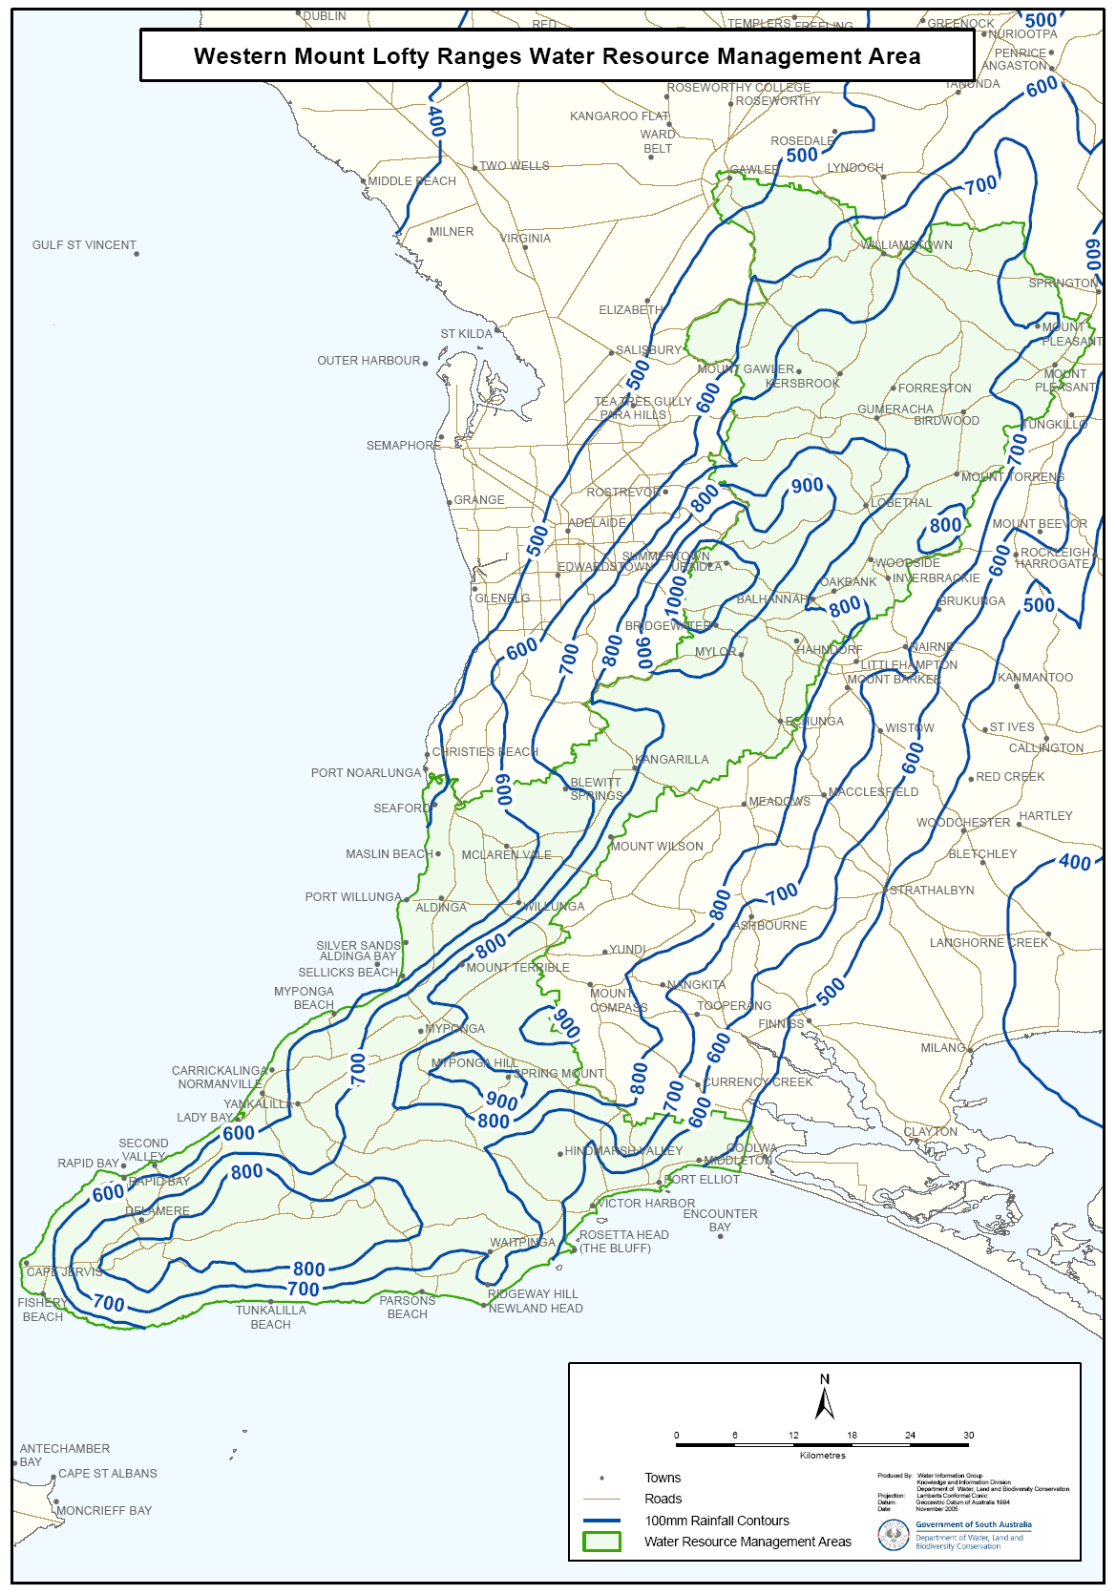
Attachment 1

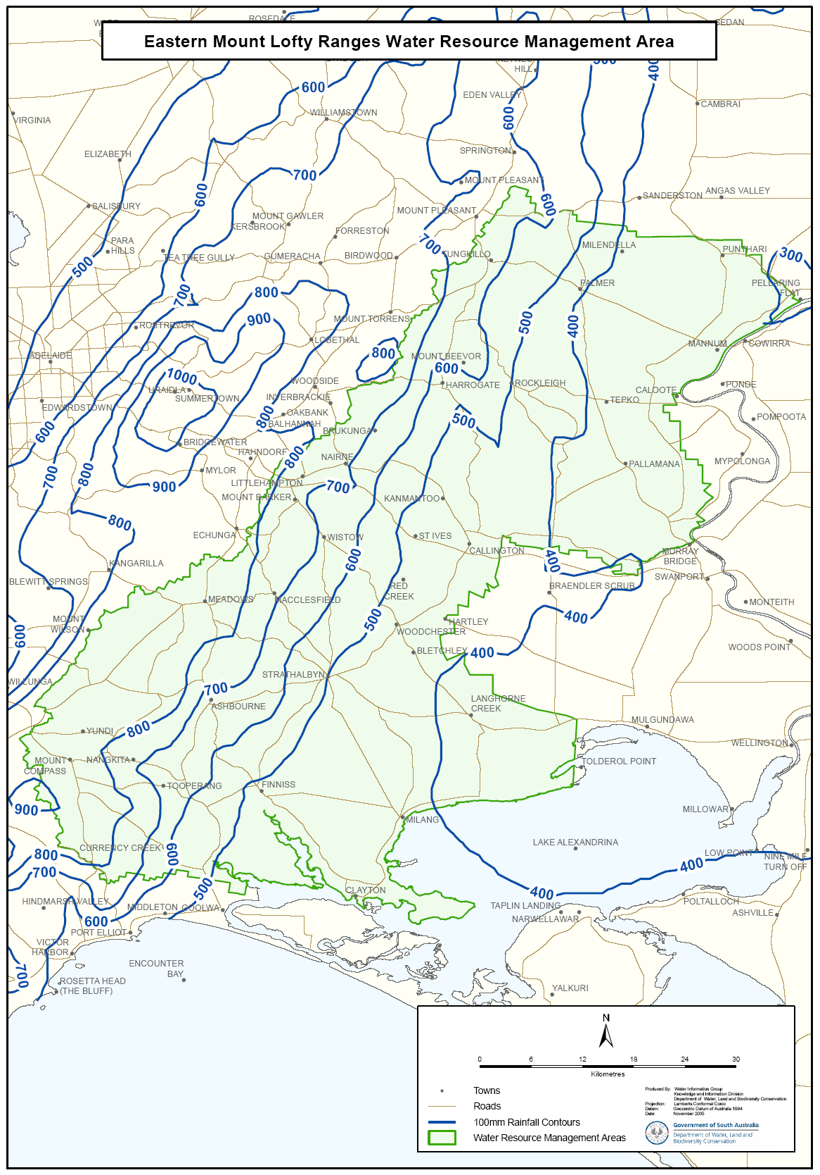
Attachment 2

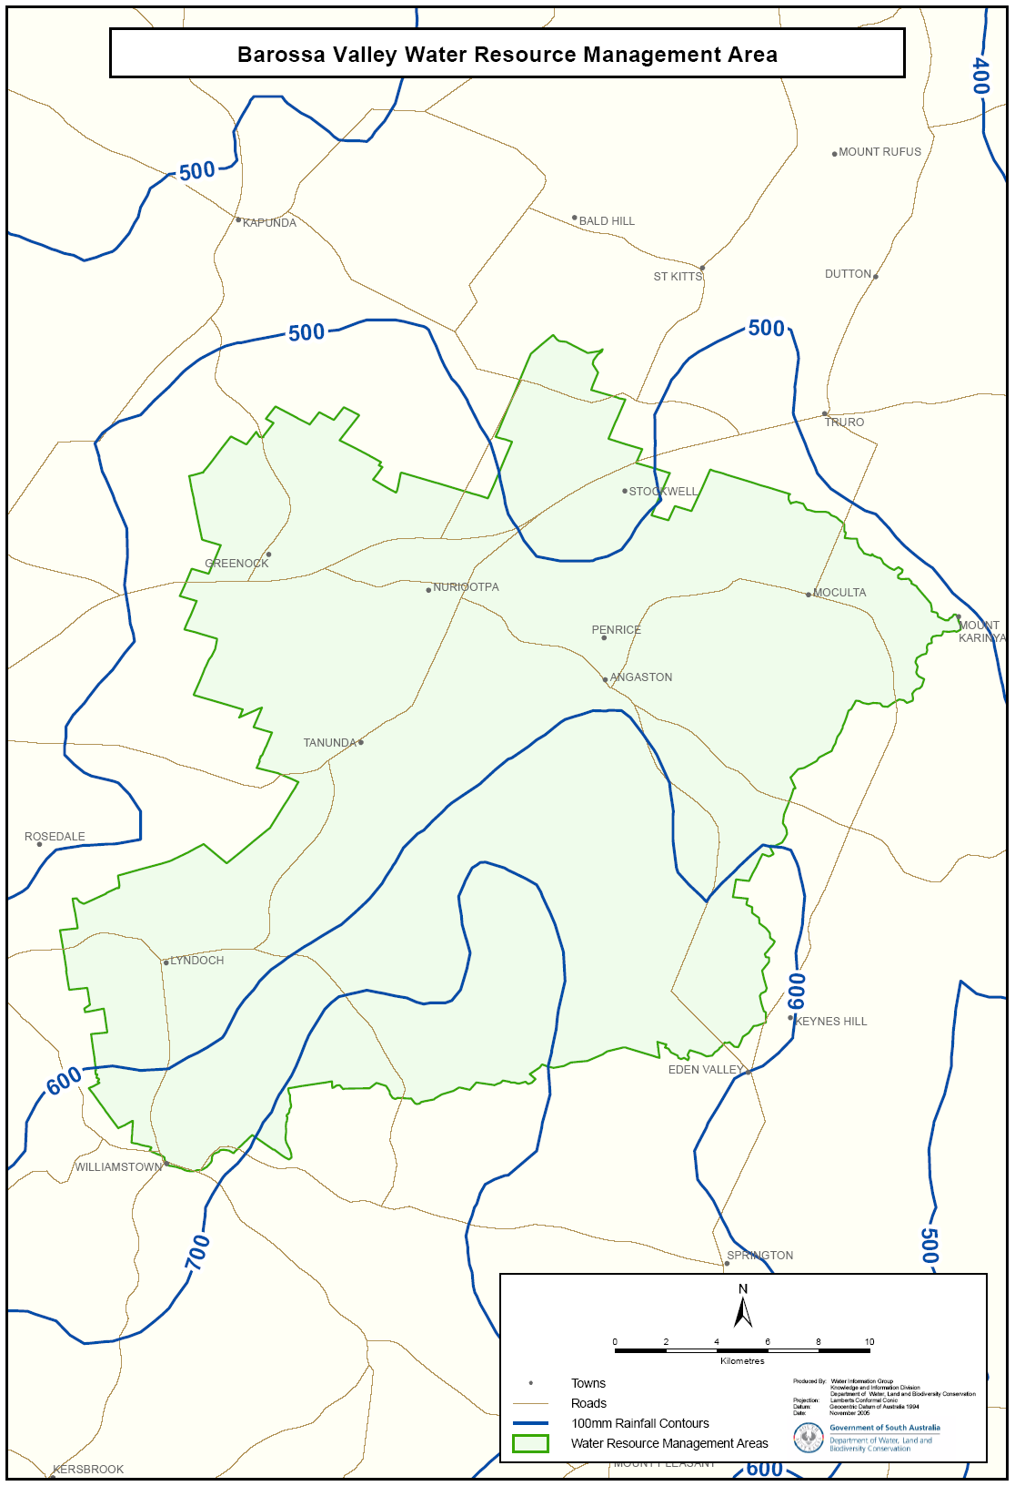
Attachment 3

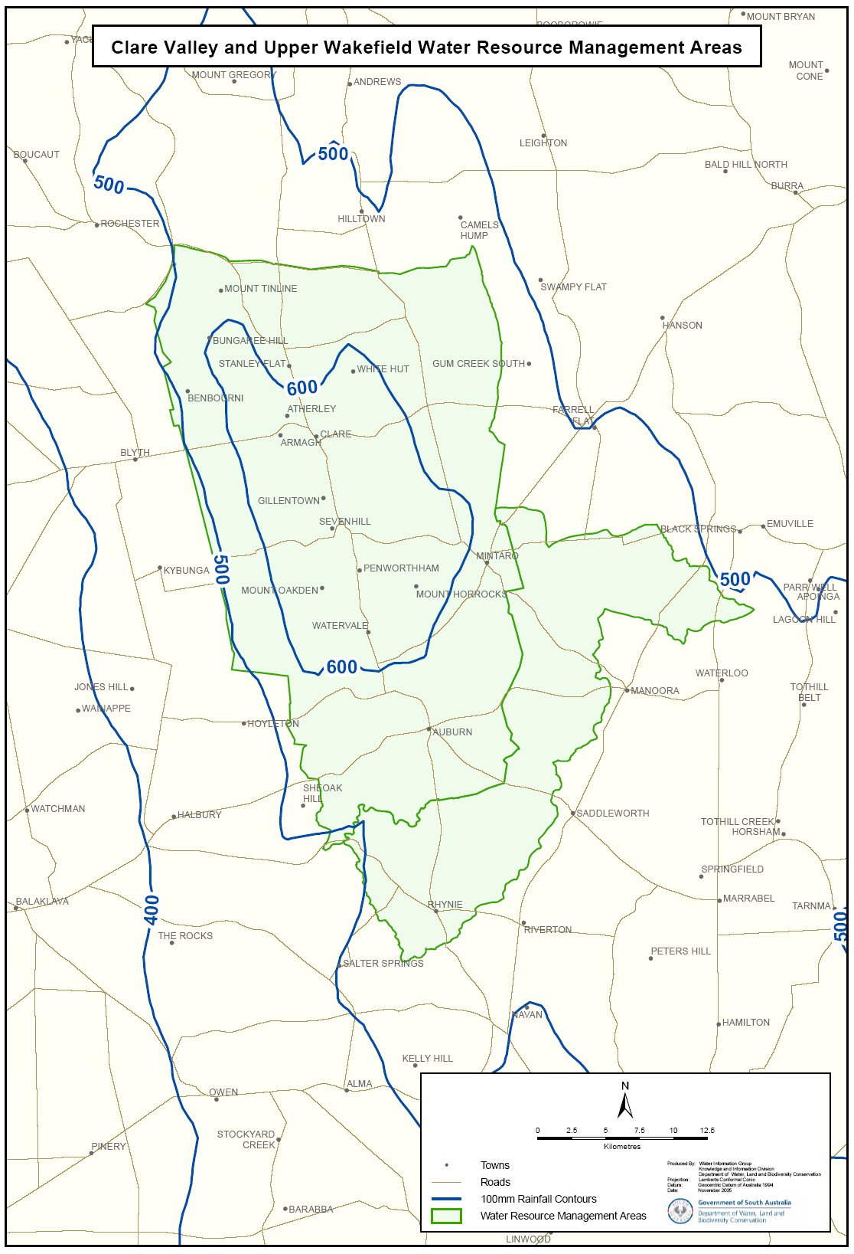
Attachment 4

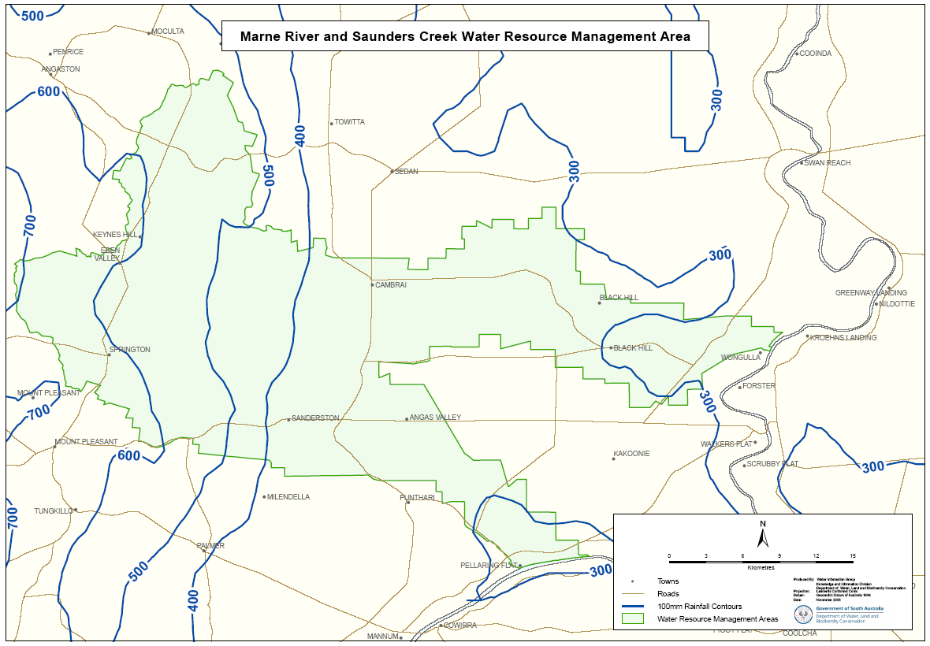
Attachment 5

Attachment 6
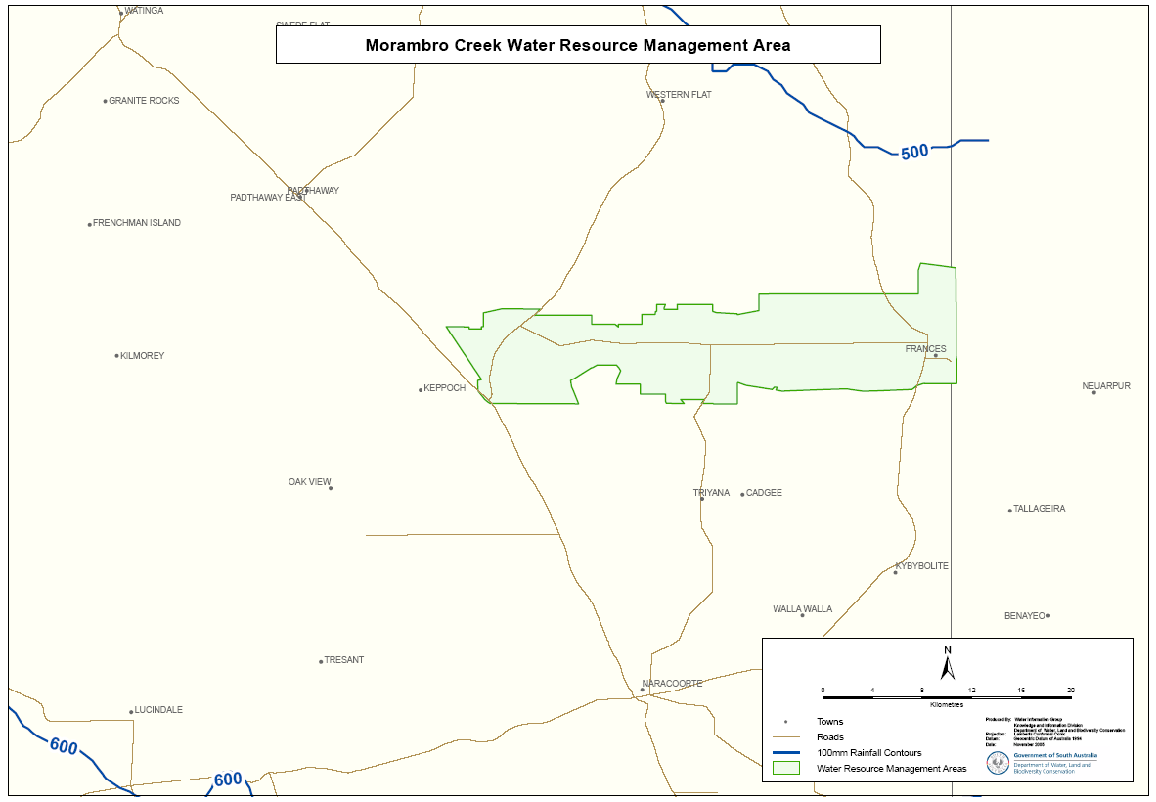

REAL PROPERTY ACT NOTICE
WHEREAS the persons named at the foot hereof have each respectively for himself made application to have the land set forth and described before his name at the foot hereof brought under the operation of the Real Property Act: Notice is hereby given that unless caveat be lodged with the Registrar-General by some person having estate or interest in the said lands on or before the expiration of the period herein below for each case specified, the said several pieces of land will be brought under the operation of the said Act as by law directed. Diagrams delineating these parcels of land may be inspected at the Lands Titles Registration Office, Adelaide, and in the offices of the several corporations or district councils in which the lands are situated.

The Schedule
No. of  Applica-  tion | Description of Property |  | Name |  | Residence | Date up to and  inclusive of which  caveat may be  lodged

31073 | Portion of section 131, Hundred of Clare in the area named Armagh, more particularly delineated as Allotments 94 and 95 in Filed Plan No. 39981 |  | Herbert Dean Vogelsang and Betty Dawn Vogelsang |  | Clare, S.A. 5453 | 9 May 2006
Dated 9 March 2006, at the Lands Titles Registration Office, Adelaide. J. Zaccaria, Deputy Registrar-General

PETROLEUM ACT 2000
(Section 25 (5) (b))
Resumption of Suspension of
Petroleum Exploration Licence—PEL 182
PURSUANT to section 90 of the Petroleum Act 2000, notice is hereby given that the suspension of the abovementioned Explora-tion Licence dated 19 September 2005 and granted temporary cessation from 19 December 2005, has been resumed under the provisions of the Petroleum Act 2000, from and including 5 March 2006 to 14 August 2006, pursuant to delegated powers dated 28 March 2002, Gazetted 11 April 2002, page 1573.
The expiry date of PEL 182 is 9 May 2011.
Dated 8 March 2006.
B. A. Goldstein, Director Petroleum
and Geothermal
Minerals and Energy Resources
Primary Industries and Resources SA
Delegate of the Minister for Mineral Resources Development

RADIATION PROTECTION AND CONTROL ACT 1982
Section 44
Notice by Delegate of the Minister for Environment and Conservation
PURSUANT to section 44 of the Radiation Protection and Control Act 1982, I, Keith Baldry, Director of the Radiation Protection Division of the Environment Protection Authority, being a person to whom the powers of the Minister under that section have been delegated under the Act, exempt from the requirement to hold a licence under section 28 of the Act persons employed to handle bulk mineral sand products at the premises of Flinders Ports registered under section 29 of the Act.
Dated 7 March 2006.
K. Baldry, Delegate of the Minister for Environment and Conservation

RADIATION PROTECTION AND CONTROL ACT 1982
Section 44
Notice by Delegate of the Minister for Environment and Conservation
PURSUANT to section 44 of the Radiation Protection and Control Act 1982, I, Keith Baldry, Director of the Radiation Protection Division of the Environment Protection Authority, being a person to whom the powers of the Minister under that section have been delegated under the Act, exempt from the requirement to hold a licence under section 28 of the Act persons employed in mining and mineral processing operations at facilities registered under section 29 of the Act.
Dated 7 March 2006.
K. Baldry, Delegate of the Minister for Environment and Conservation

ROADS (OPENING AND CLOSING) ACT 1991:
SECTION 24
NOTICE OF CONFIRMATION OF ROAD
PROCESS ORDER
Road Closure,
Swamp Road, Uraidla
BY Road Process Order made on 3 February 2006, the Adelaide Hills Council ordered that:
1. The whole of the public road (portion of Swamp Road) being allotment 32 in Filed Plan 129286, adjoining the southern boundaries of allotment 22 in Filed Plan 129276, as more particularly delineated and lettered ‘A’ in Preliminary Plan No. 05/0070 be closed.
2. Sell the whole of the land subject to closure to the South Australian Water Corporation for use for beneficial public purposes.
On 6 March 2006 that order was confirmed by the Minister for Administrative Services conditionally upon the deposit by the Registrar-General of Deposited Plan 70493 being the authority for the new boundaries.
Pursuant to section 24 (5) of the Roads (Opening and Closing) Act 1991, NOTICE of the order referred to above and its confirmation is hereby given.
Dated 16 March 2006.
P. M. Kentish, Surveyor-General

ROADS (OPENING AND CLOSING) ACT 1991:
SECTION 24
NOTICE OF CONFIRMATION OF ROAD
PROCESS ORDER
Road Closure
Esplanade, Balgowan
BY Road Process Order made on 15 September 2004, The District Council of Yorke Peninsula ordered that:
1. An irregularly-shaped strip of public road (Esplanade) adjoining sections 362, 307, 360, 361, 308, 309, 310, 359 and 358, Hundred of Kilkerran, more particularly delineated and lettered ‘A’ in Preliminary Plan No. 04/0043 be closed.
2. Vest the whole of the land subject to closure in the Crown.
On 7 January 2005 that order was confirmed by the Minister for Administrative Services conditionally upon the deposit by the Registrar-General of Deposited Plan 64929 being the authority for the new boundaries.
Pursuant to section 24 (5) of the Roads (Opening and Closing) Act 1991, NOTICE of the order referred to above and its confirmation is hereby given.
Dated 16 March 2006.
P. M. Kentish, Surveyor-General

ROADS (OPENING AND CLOSING) ACT 1991:
SECTION 24
NOTICE OF CONFIRMATION OF ROAD
PROCESS ORDER
Road Closure
Kealy Street, Millicent
BY Road Process Order made on 21 December 2004, the Wattle Range Council ordered that:
1. Portion of Kealy Street adjoining allotment 202 in Deposited Plan 23605 and allotment 501 in Deposited Plan 23837, more particularly delineated and lettered ‘A’ and ‘B’ in Preliminary Plan No. 04/0070 be closed.
2. The whole of the land subject to closure lettered ‘A’ be transferred to Ian Graham Hamilton in accordance with agreement for transfer dated 21 September 2004, entered into between the Wattle Range Council and I. G. Hamilton.
3. The whole of the land subject to closure lettered ‘B’ be transferred to Rodney Shane Little and Jill Susan Little in accordance with agreement for transfer dated 21 September 2004, entered into between the Wattle Range Council and R. S. and J. S. Little.
On 10 October 2005 that order was confirmed by the Minister for Administrative Services conditionally upon the deposit by the Registrar-General of Deposited Plan 66856 being the authority for the new boundaries.
Pursuant to section 24 (5) of the Roads (Opening and Closing) Act 1991, NOTICE of the order referred to above and its confirmation is hereby given.
Dated 16 March 2006.
P. M. Kentish, Surveyor-General

NOTICE TO MARINERS
No. 14 of 2006
Formerly Notice No. 4 of 2006
South Australia—Spencer Gulf—Port of Whyalla—Inner Harbor—No. 5 Beacon—Light Repaired and Operational
MARINERS are advised that the No. 5 Beacon Starboard Hand Beacon QG Whyalla Inner Harbor entrance Channel Vol. K 1941.7, in position:
Latitude 33°01.25′ South
Longitude 137°36.19′ East,
has been repaired and is now operating normally.
Charts affected: Aus 136.
Publications affected: Australia Pilot Vol. 1 2005 edition, page 363, South Australia’s Waters CW Map 9B page 210, Vol. K 2005-2006 edition page. 93.
Adelaide, 6 March 2006.
Patrick Conlon, Minister for Transport
TSA 2006/00419

NOTICE TO MARINERS
No. 15 of 2006
South Australia—West Coast Approaches to Thevenard—Cardinal Marker Temporarily Removed
MARINERS are advised that the North Cardinal marker on the Eleni-K has been removed from its position temporarily for repairs. A temporary unlit marker in the shape of a yellow foam buoy has been installed to mark the wreck.
Mariners are advised to exercise extreme caution when navigating in the area. The Cardinal marker will be re-installed on completion of repairs.
Charts affected: Aus 120.
Publication affected: Australia Pilot Vol. 1 2005 edition, page 331.
Adelaide, 9 March 2006.
Patrick Conlon Minister for Transport
TSA 2006/00419

FAXING COPY?
IF you fax copy to Government Publishing SA for inclusion in the Government Gazette, there is no need to send a Confirmation Copy to us as well.
This creates confusion and may well result in your notice being printed twice.
Please use the following fax number:
Fax transmission: (08) 8207 1040
Phone Inquiries: (08) 8207 1045
Please include a contact person, phone number and order number so that we can phone back with any queries we may have regarding the fax copy.
NOTE: Closing time for lodging new copy (fax, hard copy or email) is 4 p.m. on Tuesday preceding the day of publication.

Government Gazette notices can be E-mailed.
The address is:
governmentgazette@saugov.sa.gov.au
Documents should be sent as attachments in Word format.
When sending a document via E-mail, please confirm your transmission with a faxed copy of your document, including the date the notice is to be published.
Fax transmission: (08) 8207 1040
Enquiries: (08) 8207 1045
NOTE: Closing time for lodging new copy (fax, hard copy or email) is 4 p.m. on Tuesday preceding the day of publication.

CITY OF PORT ADELAIDE ENFIELD
Assignment of Names for Public Roads
NOTICE is hereby given that the Council of the City of Port Adelaide Enfield at its meeting held on 28 February 2006, resolved that pursuant to section 219 (1) of the Local Government Act 1999, that certain public roads all located in the suburb of Rosewater be assigned the street names, as detailed below:
• Public road as marked ‘A’ in Plan 1 be assigned the street name Brookesville Lane.
• Public road as marked ‘B’ in Plan 1 be assigned the street name Bayswater Lane.
• Public road as marked ‘C’ in Plan 1 be assigned the street name Graytown Lane.
A plan which delineates the public roads that have been assigned the street names, together with a copy of the Council’s resolution are available for inspection at the Council’s Principal Office, 163 St Vincent Street, Port Adelaide, S.A. 5015, during the hours of 9 a.m. and 5 p.m. on weekdays.
H. J. Wierda, City Manager

KANGAROO ISLAND COUNCIL
Airport Fees
NOTICE is hereby given that pursuant to section 6 of the Aerodrome Fees Act 1998, the Council has determined the following increased charges for the Kingscote, Kangaroo Island Airport to take effect from 1 April 2006.
Schedule of Charges as from 1 April 2006
Weight based charges per movement calculated on certified maximum take-off weight of the aircraft with a movement defined as a departure:
From $8.70 to $9.15 plus GST per 1 000 kg pro rata, with a minimum charge from $8.70 to $9.15 plus GST.
From $14.70 to $15.45 plus GST for all helicopters.
Passenger Levy based charges for Regular Passenger Transport and Tourist Charter operations:
Adults—from $6 to $6.30 per head per each way passenger movement plus GST.
Children—from $3 to $3.15 per head per each way passenger movement plus GST.
Training flights—by prior arrangement.
Non RPT aircraft apron parking on sealed apron by prior arrangement only or a parking fee remaining at $200 per day or part thereof may be incurred.
N. Brown, Chief Executive Officer

NORTHERN AREAS COUNCIL
Renaming of Road
NOTICE is hereby given that at a meeting held on Tuesday, 14 February 2006, Council resolved pursuant to the provisions of section 219 of the Local Government Act 1999, to rename the public road formerly known as Flavel Road, running westerly from Cronin Road to Belalie East Road, be known as Hoffmann Road.
P. McInerney, Chief Executive Officer

IN the matter of the estates of the undermentioned deceased persons:
Althorp, Gladys Jean, late of 61 Silkes Road, Paradise, of no occupation, who died on 23 January 2006.
Bosman, Tine Alberdina, late of Yallambee Avenue, West Gosford, New South Wales, of no occupation, who died on 31 December 2005.
Browne, Paul James Adam George, late of 7 Brownes Road, Mount Gambier, mill hand, who died on 19 August 2005.
Dobner, Ethel Rose, late of 336 Kensington Road, Leabrook, of no occupation, who died on 2 January 2006.
Frame, Iris Marjorie May, late of 44 Portland Street, Penola, of no occupation, who died on 30 November 2003.
Fullgrabe, James William, late of 23 Stevens Street, Croydon Park, retired sales clerk, who died on 17 January 2006.
Hendel, Lenis, late of 18 East Terrace, Hawthorndene, retired registered nurse, who died on 13 December 2005.
Keenihan, Barbara May, late of 147 St Bernard’s Road, Rostrevor, retired cleaner, who died on 1 January 2006.
King, Janet, late of 63 Luhrs Road, Payneham South, home duties, who died on 5 January 2006.
Koppe, Hertha, late of 75-79 Hilltop Drive, Oakden, of no occupation, who died on 22 December 2005.
Lawler, Alexander, late of 39 Campus Drive, Aberfoyle Park, retired driver, who died on 15 December 2005.
Martin, Lucy, late of 7 Weymouth Street, Campbelltown, of no occupation, who died on 17 November 2005.
Maynard, Herbert Howard, late of 39 Salisbury Crescent, Colonel Light Gardens, retired carpenter, who died on 9 January 2006.
McAvaney, Zena Grace, late of 6 Pattulo Avenue, Clare, home duties, who died on 13 October 2005.
McDonnell, Teresa, late of 150 Reynell Road, Woodcroft, retired shop assistant, who died on 6 January 2006.
Norton, Alice Alma, late of 200-208 Adams Road, Craigmore, of no occupation, who died on 8 December 2005.
Ramsay, Leila, late of 7 Railway Terrace, Old Reynella, of no occupation, who died on 6 November 2005.
Rowe, Joan Lenora, late of 58 Russell Terrace, Woodville Park, retired clerk, who died on 23 January 2006.
Waddell, Harry Kelvin, late of 55 Ferguson Avenue, Myrtle Bank, retired gold miner, who died on 5 January 2006.
Walters, Freda Gladys, late of 32 Cross Road, Myrtle Bank, married woman, who died on 15 January 2006.
Notice is hereby given pursuant to the Trustee Act 1936, as amended, the Inheritance (Family Provision) Act 1972, and the Family Relationships Act 1975, that all creditors, beneficiaries, and other persons having claims against the said estates are required to send, in writing, to the Public Trustee, 25 Franklin Street, Adelaide, S.A. 5000, full particulars and proof of such claims, on or before 14 April 2006, otherwise they will be excluded from the distribution of the said estate; and notice is also hereby given that all persons who are indebted to the said estates are required to pay the amount of their debts to the Public Trustee or proceedings will be taken for the recovery thereof; and all persons having any property belonging to the said estates are forthwith to deliver the same to the Public Trustee.
Dated 16 March 2006.
C. J. O’Loughlin, Public Trustee

SOUTH AUSTRALIA—In the Supreme Court. No. 1916 of 1991. In the matter of Nicolisa Nominees Pty Ltd (in liquidation) (ACN 005 226 059) and in the matter of the Corporations Law.
Notice by a Liquidator of His Intention to Seek His Release
Take notice that I, Barrie Malcolm Mansom, 1st Floor, Menai House, 17 Bagot Street, North Adelaide, the liquidator of the abovenamed company, intend to make application to the Supreme Court of South Australia for my release as the liquidator of the abovenamed company.
And take further notice that if you have any objection to the granting of my release you must file at the Supreme Court and also forward to me within 21 days of the publication in the Gazette of the notice of my intention to apply for a release a notice of objection in the form laid down by the Corporations (South Australia) Rules 1993.
Dated 14 March 2006.
B. M. Mansom, Liquidator
Note: Section 481 of the Corporations Law enacts that an order of the Court releasing a liquidator shall discharge him/her in the administration of the affairs of the company, or otherwise in relation to his or her conduct as liquidator, but any such order may be revoked on proof that it was obtained by fraud or by suppres-sion or by concealment of any material fact.

SALE OF PROPERTY
Auction Date: Wednesday, 5 April 2006 at 10 a.m.
Location: Government Auctions SA, 47 Transport Avenue, Netley.
NOTICE is hereby given that on the above date at the time and place stated, by virtue of Orders for Sale issued by the Fines Payment Unit of South Australia, Penalty No. EXREG 05/15760-1 and others, are directed to the Sheriff of South Australia in an action wherein Timothy R. Homes is the Defendant, I, Mark Stokes, Sheriff of the State of South Australia, will by my auctioneers, Government Auctions SA make sale of the following:
Holden Rodeo Ute
Registration No. UZS 699
Boat and Trailer
Registration No. PT 27S and TRH 555

ATTENTION

CUSTOMERS requiring a proof of their notice for inclusion in the Government Gazette, please note that the onus is on you to inform Government Publishing SA of any subsequent corrections by 10 a.m. on Thursday, which is our publication deadline.

For any corrections to your notice please phone 8207 1045 or Fax 8207 1040 before 10 a.m. on Thursday.

If we do not receive any communication by 10 a.m. on Thursday (day of publication) we will presume the notice is correct and will print it as it is.

Remember—the onus is on you to inform us of any corrections necessary to your notice.

NOTE: Closing time for lodging new copy (electronically, fax or hard copy) is 4 p.m. on Tuesday preceding the day of publication. Phone 8207 1045—Fax 8207 1040.
Email: governmentgazette@saugov.sa.gov.au

Printed and published by authority every Thursday by K. O’CALLAGHAN, Government Printer, South Australia
Price: $5.00, plus postage; to subscribers, $254.00 per annum.
(The above prices are inclusive of GST)

