No. 18 959

THE SOUTH AUSTRALIAN

GOVERNMENT GAZETTE
www.governmentgazette.sa.gov.au

PUBLISHED BY AUTHORITY

ALL PUBLIC ACTS appearing in this GAZETTE are to be considered official, and obeyed as such

ADELAIDE, THURSDAY, 30 MARCH 2006

CONTENTS

Page
Appointments, Resignations, Etc. 960
Corporations and District Councils—Notices 992
Development Act 1993—Notice 960
Dog and Cat Management Act (Duties Relating To
Certain Classes of Dogs) Notice 2006 960
Explosives Act 1936-1982—Notice 961
Fisheries Act 1982—Notices 964, 979
Geographical Names Act 1991—Notices 969
Housing Improvement Act 1940—Notices 972
Liquor Licensing Act 1997—Notices 974
Mining Act 1971—Notice 980
National Electricity Law—Notice 977
Port Augusta Circuit Court—Notice 977
Private Advertisements 993
Public Trustee Office—Administration of Estates 993
Road Traffic Act 1961—Notices 981
Transport, Department of—Notices to Mariners 989
Unclaimed Moneys Act 1891—Notice 995

GOVERNMENT GAZETTE NOTICES
ALL poundkeepers’ and private advertisements forwarded for publication in the South Australian Government Gazette must be PAID FOR PRIOR TO INSERTION; and all notices, from whatever source, should be legibly written on one side of the paper only and sent to Government Publishing SA so as to be received no later
than 4 p.m. on the Tuesday preceding the day of publication. Phone 8207 1045 or Fax 8207 1040. E-mail: governmentgazette@saugov.sa.gov.au. Send as attachments in Word format and please confirm your transmission with a faxed copy of your document, including the date the notice is to be published and to whom the notice will be charged. The Government Gazette is available online at: www.governmentgazette.sa.gov.au

Department of the Premier and Cabinet
Adelaide, 30 March 2006
HER Excellency the Governor in Executive Council has been pleased to appoint the Honourable Kevin Owen Foley, MP, Deputy Premier, Treasurer, Minister for Industry and Trade and Minister for Federal/State Relations to be also Acting Premier, Acting Minister for Economic Development, Acting Minister for Social Inclusion and Acting Minister for Sustainability and Climate Change for the period 6 April 2006 to 15 April 2006 inclusive, during the absence of the Honourable Michael David Rann, MP.
By command,
G. E. Gago, for Premier
DPC 030/96 PT4 CS

Department of the Premier and Cabinet
Adelaide, 30 March 2006
HER Excellency the Governor in Executive Council has been pleased to appoint the Honourable Jane Diane Lomax-Smith, MP, Minister for Education and Children's Services, Minister for Tourism and Minister for the City of Adelaide to be also Acting Minister for the Arts for the period 6 April 2006 to 15 April 2006 inclusive, during the absence of the Honourable Michael David Rann, MP.
By command,
G. E. Gago, for Premier
DPC 030/96 PT4 CS

Department of the Premier and Cabinet
Adelaide, 30 March 2006
HER Excellency the Governor in Executive Council has been pleased to appoint the Honourable Jay Wilson Weatherill, MP, Minister for Families and Communities, Minister for Aboriginal Affairs and Reconciliation, Minister for Housing, Minister for Ageing, Minister for Disability and Minister Assisting the Premier in Cabinet Business and Public Sector Management to be also Acting Minister for Transport, Acting Minister for Infrastructure and Acting Minister for Energy for the period 31 March 2006 to
6 April 2006 inclusive, during the absence of the Honourable Patrick Frederick Conlon, MP.
By command,
G. E. Gago, for Premier
MTR 06/006 CS

Department of the Premier and Cabinet
Adelaide, 30 March 2006
HER Excellency the Governor in Executive Council has been pleased to appoint the Honourable Jane Diane Lomax-Smith, MP, Minister for Education and Children’s Services, Minister for Tourism and Minister for the City of Adelaide to be also Acting Minister for Health, Acting Minister for the Southern Suburbs and Acting Minister Assisting the Premier in the Arts for the period 1 April 2006 to 9 April 2006 inclusive, during the absence of the Honourable John David Hill, MP.
By command,
G. E. Gago, for Premier
HEACS/06/101

Department of the Premier and Cabinet
Adelaide, 30 March 2006
HER Excellency the Governor in Executive Council has revoked the appointment of Michael Francis O’Brien, MP as Parliamentary Secretary to the Minister for Transport, pursuant to section 67A of the Constitution Act 1934 and the Acts Interpretation Act 1915.
By command,
G. E. Gago, for Premier
DPC 034/94 PT3 CS

Department of the Premier and Cabinet
Adelaide, 30 March 2006
HER Excellency the Governor in Executive Council has been pleased to appoint Michael Francis O’Brien, MP as Parliamentary Secretary to the Premier, pursuant to section 67A of the Constitution Act 1934.
By command,
G. E. Gago, for Premier
DPC 034/94 PT3 CS

Department of the Premier and Cabinet
Adelaide, 30 March 2006
HER Excellency the Governor in Executive Council has been pleased to appoint Grace Portolesi, MP as Parliamentary Secretary to the Attorney-General, Minister for Justice and Minister for Multicultural Affairs, pursuant to section 67A of the Constitution Act 1934.
By command,
G. E. Gago, for Premier
DPC 034/94 PT3 CS

DEVELOPMENT ACT 1993, SECTION 25 (17): CITY OF ADELAIDE—HERITAGE AND CHARACTER NORTH ADELAIDE—PART 1 OF 2 PARTS PLAN AMENDMENT
Preamble
1. The Development Plan amendment entitled ‘City of Adelaide—Heritage and Character North Adelaide—Part 1 of 2 Parts Plan Amendment’ (the Plan Amendment) has been finalised in accordance with the provisions of the Development Act 1993.
2. The Minister for Urban Development and Planning has decided to approve the Plan Amendment.
Notice
PURSUANT to section 25 of the Development Act 1993, I—
(a) approve the Plan Amendment; and
(b) fix the day on which this notice is published in the Gazette as the day on which the Plan Amendment will come into operation.
Dated 30 March 2006.
Paul Holloway, Minister for Urban Development and Planning
PLN 03/0338

DOG AND CAT MANAGEMENT ACT (DUTIES RELATING TO CERTAIN CLASSES OF DOGS) NOTICE 2006
Under Section 45D (3) and Section 45E of the Dog and
Cat Management Act 1995
1. Short title
This notice may be cited as the Dog and Cat Management Act (Duties Relating to Certain Classes of Dogs) Notice 2006.
2. Commencement
This notice comes into operation on the day on which it is made.
3. Interpretation
In this notice:
‘Act’ means the Dog and Cat Management Act 1995.
4. Notice made by Board
This notice is made by the Dog and Cat Management Board.
5. Application of Section 45D
Pursuant to section 45D (3) of the Act, 1 July 2006 is declared to be the day from which the provisions of section 45D apply in respect of attack trained dogs, guard dogs and patrol dogs within the area of the Councils specified in Schedule 1.
6. Exemption from certain provisions of Section 45D
Pursuant to section 45E:
(a) A person who owns, or is responsible for the control of, an attack trained dog, a guard dog or a patrol dog is exempt from complying with section 45D (1) (b).
(b) A person who owns, or is responsible for the control of, an attack trained dog or a patrol dog is exempt from complying with section 45D (1) (d).
(c) Dogs that have previously been exempted under section 9 if in the care and custody of the person responsible for the dog at the time of that exemption, are exempt from section 45D (1) (e).
Schedule 1—Councils Within Which Section 45D Applies
Adelaide, The Corporation of the City of
Adelaide Hills Council
Alexandrina Council
The Barossa Council
Barunga West, District Council of
The Berri Barmera Council
Burnside, City of
Campbelltown, The Corporation of the City of
Ceduna, The District Council of
Charles Sturt, City of
Clare and Gilbert Valleys Council
Cleve, The District Council of
Coober Pedy, District Council of
The Coorong District Council
Copper Coast, District Council of the
Elliston, The District Council of
The Flinders Ranges Council
Franklin Harbour, The District Council of
Gawler, Town of
Goyder, Regional Council of
Grant, District Council of
Holdfast Bay, City of
Kangaroo Island Council
Karoonda East Murray, The District Council of
Kimba, The District Council of
Kingston District Council
Le Hunte, The District Council of
Light Regional Council
Lower Eyre Peninsula, District Council of
Loxton Waikerie, District Council of
Mallala, The District Council of
Marion, The Corporation of the City of
Mid Murray Council
Mitcham, City of
Mount Barker, The District Council of
Mount Gambier, City of
Mount Remarkable, The District Council of
Murray Bridge, Rural City of
Naracoorte Lucindale Council
Northern Areas Council
Norwood Payneham & St Peters, The Corporation of the City of
Onkaparinga, City of
Orroroo/Carrieton, District Council of
Peterborough, District Council of
Playford, City of
Port Adelaide Enfield, City of
Port Augusta, The Corporation of the City of
Port Lincoln, City of
Port Pirie Regional Council
Prospect, City of
Renmark Paringa Council
Robe, The District Council of
Roxby Downs, Municipal Council of
Salisbury, City of
Southern Mallee District Council
Streaky Bay, The District Council of
Tatiara, The District Council of
Tea Tree Gully, City of
Tumby Bay, The District Council of
Unley, The Corporation of the City of
Victor Harbor, City of
Wakefield Regional Council
Walkerville, The Corporation of the Town of
Wattle Range Council
West Torrens, City of
Whyalla, The Corporation of the City of
Yankalilla, The District Council of
Yorke Peninsula, District Council of
Dr Deb Kelly, Executive Officer

EXPLOSIVES ACT 1936-1982
AS required by Regulation 2.05, NOTICE is hereby given that the following explosives have, in accordance with the provisions of section 6 (1) of the Explosives Act 1936-1982, been defined and classified.
Classification Code 1.1A
Mercury Fulminate (ZZ)
Classification Code 1.1B
Anoline Delay Detonator (Z)
Capped Fuse Delay Assembly (Z)
Capped Safety Fuse (Z)
Connectadet Detonator (Z)
Cordline Delay Detonator (Z)
Delay Detonator (Z)
Detaslide (Z)
Detonating Relay (Z)
Detonator (Z)
DuPont ‘SSS’ Seismograph Electric Blasting Cap (Z)
DuPont Acudet Delay Electric Blasting Cap (Z)
DuPont Ledcore Delay Assembly (Z)
DuPont Millisecond Delay Electric Blasting Cap (Z)
DuPont No. 6 Blasting Cap (Z)
DuPont No. 6 Electric Blasting Cap (Z)
DuPont Primacord Millisecond Connector (Z)
Electric Booster (Z)
Electric Delay Action Detonator (Gasless) (Z)
Electric Delay Action Detonator (Z)
Electric Detonator (Z)
Electric Squib (Z)
ERT Detonator (Z)
ERT Electric Detonator (Z)
ERT Half-second Delay Electric Detonator (Z)
ERT Millisecond Delay Electric Detonator (Z)
Exeldet Detonator (Z)
Fuse Delay Assembly (Z)
Gasless Delay Detonator (Z)
GOLDet Detonator (Z)
Instadet Instantaneous Electric Detonator (Z)
Iredet Super SP Millisecond Delay Electric Detonator (Z)
L.E.D.C. Delay Connector (Z)
Magnadet (Z)
Micro-Hit (Z)
Nonel GT Detonator (Z)
Nonel GT1 Detonator (Z)
Nonel GT2 Detonator (Z)
Nonel Primadet Lead in Lines (Z)
Nonel Primadet Long Lead Series (Z)
Nonel Primadet LP Series (Z)
Nonel Primadet MS Connectors (Z)
Nonel Primadet MS Series (Z)
Nonel Primadet Short Lead Series (Z)
Nonel Primadet Trunkline Delays (Z)
Short Delay Detonator (Z)
Siline Delay Detonator (Z)
Siline Relay Connector, One-way (Z)
Siline Relay Connector, Two-way (Z)
Slider Primer Detonator Assemblies (Z)
Superseis Blasting Cap (Z)
TEC No. 8 Plain Detonator (Z)
TECNEL non Electric Detonator (Z)
TECNEL Trunkline Delay Connector (Z)
Vibrocap SR (Z)
Classification Code 1.1C
American Ballistite (ZZ)
AR 2051 (ZZ)
AR 2201 (ZZ)
AR 2202 (ZZ)
AR 2205 (ZZ)
AR 2206 (ZZ)
AR 2207 (ZZ)
AR 2208 (ZZ)
AR 2209 (ZZ)
AR 2211 (ZZ)
AR 4001 (ZZ)
AR 4002 (ZZ)
Ardeer Ballistite (Y or ZZ)
Ardeer Cordite (Y or ZZ)
Assembly, Powder Load for Core Gun (ZZ)
Ballistite (Y or ZZ)
Canadian Rifle Powder 4740 (ZZ)
Clermonite (ZZ)
Collodion Cotton (Y)
Cordite (Y or ZZ)
Cordite A.N. (Y or ZZ)
Cordite A.S.N. (Y or ZZ)
Cordite C.D. (Y or ZZ)
Cordite H.W. (Y or ZZ)
Cordite M.D. (Y or ZZ)
Cordite W (Y or ZZ)
Cordite W.M. (Y or ZZ)
DuPont Hi-Skor 800 X (ZZ)
DuPont Powder HN Shotgun (ZZ)
DuPont Powder IMR 3031 (ZZ)
DuPont Powder IMR 4064 (ZZ)
DuPont Powder IMR 4198 (ZZ)
DuPont Powder IMR 4227 (ZZ)
DuPont Powder IMR 4320 (ZZ)
DuPont Powder IMR 4350 (ZZ)
DuPont Powder IMR 4831 (ZZ)
DuPont Powder IMR 4895 (ZZ)
DuPont Powder P5066 (ZZ)
DuPont Powder PB (ZZ)
DuPont Powder PB6 (ZZ)
DuPont Powder SR4756 (ZZ)
DuPont Powder SR4759 (ZZ)
DuPont Powder SR7625 (ZZ)
E.C. Sporting Powder (ZZ)
ERT PSB Shotgun Powder (ZZ)
Hercules Blue Dot (ZZ)
Hercules Bullseye (ZZ)
Hercules Green Dot (ZZ)
Hercules Herco (ZZ)
Hercules Red Dot (ZZ)
Hercules Unique (ZZ)
Hercules 2400 (ZZ)
Hi Skor 700X (ZZ)
Improved Ballistite (ZZ)
Mechanite (Y or ZZ)
Modified Smokeless Diamond (ZZ)
Neoflak (ZZ)
Neonite (ZZ)
Nobel Cadet Neonite (ZZ)
Nobel CK Powder (ZZ)
Nobel Glascow Shotgun Powder Nos. 60-69 (ZZ)
Nobel Hornet Powder (ZZ)
Nobel Pistol Powder No. 2 (ZZ)
Nobel Pistol Powder No. 3 (ZZ)
Nobel Revolver Powder No. 1 (ZZ)
Nobel Revolver Neonite (ZZ)
Nobel Rifle Neonite (ZZ)
Nobel Rifle Powder Nos 0-3 (ZZ)
Nobel Shotgun Neonite (ZZ)
Nobel Shotgun Powder Nos 60-69 (ZZ)
Nobel Shotgun Powder Nos 78-89 (ZZ)
Norma Handgun Powder No. 1010 (ZZ)
Norma Handgun Powder No. 1020 (ZZ)
Norma Pistol Powder P-1 (ZZ)
Norma Pistol Powder P-2 (ZZ)
Norma Pistol Powder P-3 (ZZ)
Norma Revolver Powder R-1 (ZZ)
Norma Revolver Powder R-2 (ZZ)
Norma Revolver Powder R-3 (ZZ)
Norma Revolver Powder R-23 (ZZ)
Norma Rifle Powder No. 200 (ZZ)
Norma Rifle Powder No. 201 (ZZ)
Norma Rifle Powder No. 203 (ZZ)
Norma Rifle Powder No. 204 (ZZ)
Norma Rifle Powder No. 205 (ZZ)
Norma Shotgun Powder No. 2010 (ZZ)
Norma Shotgun Powder No. 2020 (ZZ)
Norma Shotgun Powder S-70 (ZZ)
NY 100 (ZZ)
NY 200 (ZZ)
NY 300 (ZZ)
NY 500 (ZZ)
Olin Ball Powder (ZZ)
Schultze Gunpowder (ZZ)
Smokeless Diamond (ZZ)
SS Trap (ZZ)
Viscorim (ZZ)
Winchester Ball Powder (ZZ)
Classification Code 1.1D
‘A’ Cord (ZZ)
400 Plastic (ZZ)
A.N. Gelatine Dynamite (ZZ)
A.N. Gelignite (ZZ)
A.N. Ligdyn (ZZ)
Ajax (ZZ)
Amex (ZZ)
Ammonium Nitrate—Mineral Oil Mixture (Ammonium Nitrate Fuel Oil Mixture) (ANFO) (ZZ)
Ammonium Nitrate Molasses Mixture (ANMO) (ZZ)
ANFO HD (ZZ)
ANFO-P (ZZ)
ANFO/Polystyrene (ZZ)
ANFO PS 50/50 (ZZ)
ANFO PS 60/40 (ZZ)
ANFO PS 70/30 (ZZ)
ANFO PS 80/20 (ZZ)
Anforce (ZZ)
Anoline (ZZ)
Anpower (ZZ)
Anzite (ZZ)
Anzite Blue (ZZ)
Anzomex Booster (ZZ)
Anzomex Power Plus Primer (ZZ)
Anzomex Primer (ZZ)
Anzomex Slider (ZZ)
Aquaflex (ZZ)
Aquamex (ZZ)
Aquapour (ZZ)
Astro-Pak (ZZ)
Astrolite K-40 (ZZ)
Astrolite K-65 (ZZ)
Astrolite T (ZZ)
Atlas No. 18 (ZZ)
Atlas No. 25 (ZZ)
Austin Delay Primer (ZZ)
Austin Primer (ZZ)
B.H.A.S. Furnace Bomb (Z)
BD 260 Ballistic Disc (ZZ)
BD 514 Ballistic Disc (ZZ)
Beldyn (ZZ)
Blasting Gelatine (ZZ)
CBS Super Prime Booster (ZZ)
Commercial Waterproof Primers (ZZ)
Cordeau Bickford (ZZ)
Cordline (ZZ)
Cordtex (ZZ)
D.P. 12 (ZZ)
Danfo (ZZ)
Danfo E1 (ZZ)
Detacord (ZZ)
Detagel (ZZ)
Detagel Presplit (ZZ)
Detaline Cord (ZZ)
Detaprime (ZZ)
Detasheet (ZZ)
Detonating Cord (ZZ)
Detonating Cord Primers (ZZ)
DuPont Detadrive Boosters (ZZ)
DuPont Gelatin (ZZ)
DuPont Gelex 1 (ZZ)
DuPont Gelex 2 (ZZ)
DuPont Gelobel AA (ZZ)
DuPont H.D.P. Primers (ZZ)
DuPont Hi-Velocity Gelatin 60% (ZZ)
DuPont Nitramon S (ZZ)
DuPont Nitramon S Primers (ZZ)
DuPont Nitramon WW (ZZ)
DuPont Nitramon WW-EL (ZZ)
DuPont Red Arrow 1 (ZZ)
DuPont Red Arrow 2 (ZZ)
DuPont Seismograph Hi-Velocity 60% Gelatin (ZZ)
DuPont Special Detonating Cord (ZZ)
DuPont Special Gelatin 60% (ZZ)
DuPont Special Gelatin 75% (ZZ)
DuPont Water Work Booster (Z)
DuPont Win-Coal AA (ZZ)
Dynagex (ZZ)
Dynagex C (ZZ)
Dyno Wesfarmers Special 18 Detonating Cord (ZZ)
Dyno Wesfarmers Special 18AA Detonating Cord (ZZ)
Dyno Wesfarmers Special 25 Detonating Cord (ZZ)
Dyno Wesfarmers Special 25A Detonating Cord (ZZ)
Dyno Wesfarmers Special 25AA Detonating Cord (ZZ)
Dyno Wesfarmers Special 40 Detonating Cord (ZZ)
Dyno Wesfarmers Special 50 Detonating Cord (ZZ)
Dyno Wesfarmers Special 50AA Detonating Cord (ZZ)
E-Cord (ZZ)
Econex (ZZ)
Emulan (ZZ)
Emulite 100 (ZZ)
Emulite 100 G (ZZ)
Emulite 130 G (ZZ)
Emulite 150 G (ZZ)
Emulite 415 (ZZ)
Emulite 416 (ZZ)
Emulite 417 (ZZ)
Emulite 850 (ZZ)
Emulite 890 (ZZ)
Energan (ZZ)
Energan 2500 Series (ZZ)
Energan 2600 Series (ZZ)
Energan 2861 (ZZ)
Ensign Bickford Cast Booster (ZZ)
Ensign Bickford Slip-on Booster (ZZ)
ERT Barlite (ZZ)
ERT Detonating Cord (ZZ)
ERT Primer (ZZ)
ETS Barlite (ZZ)
ETS Primer (ZZ)
Exactex (ZZ)
Flexicord (ZZ)
Gelamex A (ZZ)
Gelamex B (ZZ)
Gelamex C (ZZ)
Gelatine Dynamite 60% (ZZ)
Gelatine Dynamite 80% (ZZ)
Gelignite (ZZ)
Geoflex (ZZ)
Geophex (ZZ)
Glass Strip Jet (ZZ)
Goma 1—ED Gelatine Dynamite (ZZ)
Goma 2—EC Gelatine Dynamite (ZZ)
Green Cap Booster (ZZ)
Guncotton (ZZ)
Gunpowder (ZZ)
Handibulk Dry (ZZ)
Handibulk Supadry (ZZ)
Handibulk Supawet (ZZ)
HDP Primer (ZZ)
Hemispherical Shaped Charge HSC 300 (ZZ)
Hemispherical Shaped Charge HSC 53 (ZZ)
Higel (ZZ)
Hydrogel (ZZ)
Hydromex (ZZ)
I.D.L. Cord (ZZ)
Iregel (ZZ)
Johnston TNC Formula (ZZ)
K Pipecharge (ZZ)
Kiri Ammonium Gelatine Dynamite (ZZ)
Kiri Ammonium Gelatine Dynamite 60% (ZZ)
Larvikit Tube Charge (ZZ)
Leigel (ZZ)
Ligdyn (ZZ)
Low Energy Detonating Cord (ZZ)
Magnaprimer (ZZ)
Matsu Blasting Gelatine (ZZ)
Metabel (ZZ)
Miniseis P Primer (ZZ)
Molanal (ZZ)
Molanite (ZZ)
Monograin (ZZ)
Morcol (ZZ)
N.S. Gelatine Dynamite (ZZ)
N.S. Gelignite (ZZ)
Nitrocellulose (ZZ)
Nitrocotton (ZZ)
Nobel Drimix (ZZ)
Nobel Seismic Booster (ZZ)
Nobel’s Explosive No. 852 (ZZ)
Nobel-Prime (ZZ)
Oil Well Cartridge (ZZ)
Orange Cap Booster (ZZ)
Pentolite (ZZ)
Pepan 2600 Series (ZZ)
Picric Acid (ZZ)
Plastergel (ZZ)
Plastic Explosives No. 4 (PE4) (ZZ)
Powercord (ZZ)
Powergel 1500 Series (ZZ)
Powergel 2100 Series (ZZ)
Powergel 2500 Series (ZZ)
Powergel 2655 (ZZ)
Powergel 2800 Series (ZZ)
Powergel 2900 Series (ZZ)
Powergel Backcut (ZZ)
Powergel Breaker (ZZ)
Powergel Extra 4500 (B or G) Series (ZZ)
Powergel Magnum 3151 (ZZ)
Powergel P (ZZ)
Powergel Perimeter (ZZ)
Powergel Permitted 2000 (ZZ)
Powergel Permitted 3000 (ZZ)
Powergel Powerprime (ZZ)
Powergel Reelex 3000 (ZZ)
Powergel Seismic (ZZ)
Powergel Seismic 3000 (ZZ)
Powergel Trimex 3000 (ZZ)
Powermite (ZZ)
Powerpac (ZZ)
Powerpac 3000 (ZZ)
Powersplit (ZZ)
Premium Ribcord (ZZ)
Primaboost (ZZ)
Primacord (ZZ)
Primacord XT (ZZ)
Primaflex (ZZ)
Primaline HD (ZZ)
Primaline RX (ICI) (ZZ)
Classification Code 1.2C
Cartridges for Small Arms which are not Safety Cartridges (Y)
Primaline RX (ZZ)
Quarigel (ZZ)
Quarry Monobel (ZZ)
Quilox (ZZ)
Redcord (ZZ)
Ribcord (ZZ)
Riogel 600 (ZZ)
Riogel 600 LD 30 (ZZ)
Riogel 600 LD 50 (ZZ)
Riogel F (ZZ)
Riogel G (ZZ)
Rock Breaker (ZZ)
Rollex (ZZ)
Roxite (ZZ)
S.N. Gelatine Dynamite (ZZ)
S.N. Gelignite (ZZ)
Saf-T-Pak (ZZ)
Saf-T-Stick (ZZ)
Saxonite (ZZ)
Scalex 30 (ZZ)
Scalex 50 (ZZ)
Scotch Cord (ZZ)
Seagel (ZZ)
Seismex (ZZ)
Seismic Charge (ZZ)
Seismic Primer (ZZ)
Semigel (ZZ)
Shaped Charges (ZZ)
Shearcord (ZZ)
Slidercord (ZZ)
Sliderline (ZZ)
Slurran 916 (ZZ)
Stopeprime (ZZ)
Stripcord (ZZ)
Superseis (ZZ)
T.N.C. (ZZ)
Tetryl Primer (ZZ)
Tonite (or Cotton Powder No. 1) (ZZ)
Tonite (or Cotton Powder No. 2) (ZZ)
Tovex 100 (ZZ)
Tovex 200 (ZZ)
Tovex 472 (ZZ)
Tovex 473 (ZZ)
Tovex 500 (ZZ)
Tovex 650 (ZZ)
Tovex 700 (ZZ)
Tovex 800 (ZZ)
Tovex DX (Drivex) (ZZ)
Tovex Extra-R (ZZ)
Tovex Hi-Drive (ZZ)
Tovex P Primer (ZZ)
Tovex Pumpex (ZZ)
Tovex PX (ZZ)
Tovex S1 (ZZ)
Tovex SDX (ZZ)
Tovex Seismopac (ZZ)
Trojan Primers (ZZ)
Trunkcord (ZZ)
Tuffcord (ZZ)
UEE Booster (ZZ)
Uniline (ZZ)
Vibrogel 3 (ZZ)
Vibronite S Primer (ZZ)
Vibronite S1 (ZZ)
Vorlite (ZZ)
Vortex (ZZ)
Xactex (ZZ)
Classification Code 1.1G
Manufactured Fireworks Type A (Z or ZZ)
Classification Code 1.2G
Comet Line Throwing Rocket (Z)
Comet Parachute Signal Rocket (Z)
Manufactured Fireworks Type B (Y)
Miniflare Distress Kits (X)
Pains Wessex Para Red Mark I Rocket (Z)
Schermuly Para Green Mark I Rocket (Z)
Schermuly Para Illuminating Rocket (Z)
Schermuly Para Red Mark I Rocket (Z)
Classification Code 1.3G
CCR (Y)
Manufactured Fireworks Type C (X)
Classification Code 1.4B
Electric Detonators (Z)
Classification Code 1.4C
Ramset RP-4 Pellet (X)
Classification Code 1.4G
Aluminium Torch (X)
Comet Handflare (X)
Comet Light Smoke Signal (X)
Comet Smoke Signal (X)
Comet Smoke Torch (X)
Electric Lighter for CCR (X)
‘Howard’ Fuse Igniters (X)
Magnesium Torch (X)
Manufactured Fireworks Type D (X)
Pains Wessex Buoysmoke (X)
Pains Wessex Handflare (X)
Pains Wessex Handsmoke (X)
Pains Wessex Lifesmoke (X)
Pains Wessex Manoverboard (X)
Plastic Core Composition (Y)
Plastic Igniter Cord (X)
Quarrycord (X)
Res-Q-Star (X)
Schermuly Day and Night Distress Signal (X)
Schermuly Handflare (X)
Schermuly Handsmoke (X)
Schermuly Lifesmoke (X)
Schermuly Signal Cartridge (X)
Seal Control Cartridge (Y)
Sparkler (X)
Speedline Igniter (X)
Thermalite Ignitacord (X)
Very Signal Cartridge (X)
Classification Code 1.4S
Amorces (X)
Birdfrite (X)
Crack Shot (X)
Electric Arcing Match (X)
Electric Lighter for Igniter Cord (X)
Eley Kynoch No. 1A Percussion Cap (X)
Eley Kynoch No. 1B Percussion Cap (X)
Eley Kynoch No. 91 Percussion Cap (X)
Eley Kynoch No. 175 Small Pistol Primer (X)
Eley Kynoch No. 176 Large Rifle Primer (X)
Eley Kynoch No. 177 Small Rifle Primer (X)
Eley Kynoch No. 178 Large Pistol Primer (X)
Fuse Lighters Dragon Brand (X)
Harpoon Time Fuse (X)
Hot Wire Fuse Lighter (X)
Ignitacord Connector (X)
Igniter Cord Connector (X)
Imperial No. 2 Shotshell Primer (X)
Imperial Small Rifle Primer—Boxer Type (X)
Indoor Table Bomb (X)
Kopa Smoke Alarm (X)
Lead Spitter Fuse Lighter (X)
Lightning Paper (X)
Multiple Safety Fuse Igniter (X)
Nonel Tube (X)
Nobel’s Electric Delay Action Fuse (X)
Percussion Cap (X)
Percussion Caps, .303, Specially Packed (X)
Percussion Caps, .303, (not for retail sale) (X)
Quarrycord Connector (X)
Railway Fog Signal (X)
Safety Cartridges (X)
Safety Cartridges Cases (empty) Capped (X)
Safety Fuse (X)
Silver Match (X)
Skorpion Anti-Theft Device (X)
Smoke Candle No. 2 (X)
Snaps for Bonbon Crackers (X)
Starting Pistol Cap (X)
Streamer Bomb (X)
Throwdown (X)
Toy Pistol Cap (X)
Toy Pistol Cap ‘Flippy’ (X)
Winchester Shotshell Primers (Battery Cup Type) (X)
Winchester (WLP) Large Pistol Primers (X)
Winchester (WLR) Large Rifle Primers (X)
Winchester (WSP) Small Pistol Primers (X)
Winchester (WSR) Small Rifle Primers (X)
Classification Code 1.5D
Emulite 200 (packaged) (ZZ)
Emulite 300 (ZZ)
ERT Isanol (ZZ)
ETS Isanol (ZZ)
GX 20 Slurran (ZZ)
Handibulk Wet (ZZ)
Pepan Gold 2500 Series (ZZ)
Powergel Gold 2500 Series (ZZ)
Riogel TTX (ZZ)
Tovex BE (ZZ)
Tovex Extra (ZZ)
Tovex Extra LD (ZZ)
Tovex LD BE (ZZ)
SafeWork SA 9019/93
Department for Administrative and Information Services

FISHERIES ACT 1982: SECTION 59
TAKE notice that pursuant to section 59 of the Fisheries Act 1982, the holder of a prawn fishery licence issued pursuant to the Fisheries (Scheme of Management—Prawn Fisheries) Regulations 1991, for the Gulf St Vincent Prawn Fishery listed in Schedule 1 (the ‘exemption holders’) or their registered master are exempt from the notices made under section 43 of the Fisheries Act 1982, prohibiting the taking of western king prawns (Melicertus latisulcatus), in that the exemption holders shall not be guilty of an offence when using prawn trawl nets in accordance with the conditions of their fishery licence for the purpose of stock assess-ment survey (the ‘exempted activity’) subject to the conditions contained in Schedule 2.
Schedule 1
Licence  No. | Licence Holder | Boat Name
V01 | Ganelon Pty Ltd | Falcon
V02 | St Vincent Gulf Fisheries & Investments Pty Ltd | Angela Kaye
V03 | Brzic Fisheries Pty Ltd | Cavalier
V04 | Ledo Pty Ltd | Miss Venus
V05 | Maurice J. Corigliano | Frank Cori
V06 | Todreel Pty Ltd | Anna Pearl
V08 | Haralambos Paleologoudias | Shenandoah II
V09 | Hamid Huseljic | Candice K
V10 | N. Wayne Justice | Silda
V14 | S V Gulf Fisheries Pty Ltd | Zadar

Schedule 2
1. The exemption is valid from 1830 hours on 25 March 2006 until 0630 hours on 28 November 2006.
2. All trawling activity is to be completed by 0630 hours on each day with nets out of the water.
3. The exemption holder must comply with the instructions from the SARDI Stock Assessment Co-ordinator and work in the allotted trawl station.
4. All fish, other than prawns, southern calamary and slipper lobster taken during the exempted activity for stock assessment purposes, are to be returned to the water immediately after capture.
5. All fish taken pursuant to the exempted activity are to be processed in accordance with the instructions of the Stock Assessment Co-ordinator.
6. All fish taken pursuant to the exempted activity must be removed from the vessel prior to that vessel undertaking normal fishing activity.
7. Prawns, southern calamary and slipper lobster taken pursuant to the exempted activity must not be retained by the exemption holder, his agent, crew or any other person.
8. The exemption holder must return to Port Adelaide (the designated ports of landing) by 1400 hours on the last day of the survey and off load any product caught during the survey.
9. While engaged in the exempted activity or unloading of the survey catch, the exemption holder must have on board his boat or near his person a copy of this notice. Such notice must be produced to a PIRSA Fisheries Compliance Officer if requested.
10. The exemption holder must not contravene or fail to comply with the Fisheries Act 1982, or any other regulations made under that Act except where specifically exempted by this notice.
Dated 24 March 2006.
S. Sloan, Principal Fisheries Manager

FISHERIES ACT 1982: SECTION 43
TAKE note that the notice made under section 43 of the Fisheries Act 1982, published in the South Australian Government Gazette on page number 3958, dated 17 November 2005, being the third notice on that page, referring to the Spencer Gulf Prawn Fishery, is hereby varied such that it will be unlawful for a person fishing pursuant to a Spencer Gulf Prawn Fishery Licence to use prawn trawl nets, except in the areas specified in Schedule 1 during the period specified in Schedule 2.
Schedule 1
1. The waters of the Spencer Gulf Prawn Fishery that are within the northern area, commencing at position latitude 33°46.00′S, longitude 137°44.00′E, then to position latitude 33°37.00′S, longitude 137°33.00′E, then to position latitude 33°37.00′S, longitude 137°30.00′E, then to position latitude 33°42.00′S, longitude 137°28.00′E, then to position latitude 33°48.00′S, longitude 137°27.00′E, then to position latitude 33°49.00′S, longitude 137°29.00′E, then to position latitude 33°47.00′S, longitude 137°31.00′E, then to position latitude 33°48.00′S, longitude 137°32.50′E, then to position latitude 33°52.00′S, longitude 137°29.00′E, then to position latitude 33°58.00′S, longitude 137°37.00′E.
2. The waters of the Spencer Gulf Prawn Fishery that are within the northern area, commencing at position latitude 34°05.00′S, longitude 137°34.00′E, then to position latitude 33°51.00′S, longitude 137°20.00′E, then to position latitude 33°53.00′S, longitude 137°12.00′E, then to position latitude 33°57.00′S, longitude 137°14.00′E, then to position latitude 34°08.00′S, longitude 137°06.00′E, then to position latitude 34°08.00′S, longitude 137°33.00′E.
Schedule 2
From 2000 hours on 29 March 2006 to 0700 hours on 30 March 2006.
Dated 29 March 2006.
S. Sloan, Principal Fisheries Manager

FISHERIES ACT 1982: SECTION 43
TAKE note that the notice made under section 43 of the Fisheries Act 1982, dated 28 March 2006, referring to the Gulf St Vincent Prawn Fishery, is hereby varied such that it will not be unlawful for a person fishing pursuant to a Gulf St Vincent Prawn Fishery Licence to use prawn trawl nets in the area specified in Schedule 1 during the period specified in Schedule 2.
Schedule 1
The waters of the Gulf St Vincent Prawn Fishery that are in the centre of the Gulf St Vincent, which are defined as the waters within the following co-ordinates, starting at position latitude 35°00.25′S, longitude 138°10.00′E, then to position latitude 35°00.60′S, longitude 138°15.00′E, then to position latitude 35°07.00′S, longitude 138°16.00′E, then to position latitude 35°09.00′S, longitude 138°14.50′E, then to position latitude 35°08.50′S, longitude 138°05.00′E, then back to position latitude 35°00.25′S, longitude 138°10.00′E.
Schedule 2
From 1930 hours on 29 March 2006 to 0700 hours on 2 April 2006.
Dated 29 March 2006.
S. Sloan, Principal Fisheries Manager

FISHERIES ACT 1982: SECTION 43
TAKE notice that it will be unlawful for any person to engage in the class of fishing activity specified in Schedule 1, during the period specified in Schedule 2.
Schedule 1
The act of taking or the act preparatory to or involved in the taking of western king prawn (Melicertus latisulcatus) in all waters of the Gulf St Vincent Prawn Fishery.
Schedule 2
From 2030 hours on 28 March 2006 to 0600 hours on 31 December 2006.
Dated 28 March 2006.
S. Sloan, Principal Fisheries Manager

DEPARTMENT OF PRIMARY INDUSTRIES AND RESOURCES SA—FISHERIES DIVISION
NOTICE is hereby given pursuant to section 28 (10) of the Fisheries Act 1982, that the following items have been seized by officers of the Department of Primary Industries and Resources SA, Fisheries Division at Paringa Causeway side creek on 13 February 2006:
1 green Opera House yabbie net
The above items were suspected to have been used or intended to be used, in contravention of the Fisheries Act 1982, and were taken into possession at Loxton Fisheries Office, Bookpurnong Road, Loxton.
After the expiration of one month from the date of this notice the items listed above shall, on the order of the Minister for Primary Industries, be forfeited to the Crown and shall be either disposed of by sale or destruction.
The above items may be viewed at the Loxton Fisheries office of the Department of Primary Industries and Resources SA, Fisheries Division.
Dated 16 March 2006.
M. Lewis, General Manager, Fisheries Services

DEPARTMENT OF PRIMARY INDUSTRIES AND RESOURCES SA—FISHERIES DIVISION
NOTICE is hereby given pursuant to section 28 (10) of the Fisheries Act 1982, that the following items have been seized by officers of the Department of Primary Industries and Resources SA, Fisheries Division at Venus Bay near Germein Island on 11 February 2006:
2 fish traps, orange mesh, double hinged, green rope and white floats
The above items were suspected to have been used or intended to be used, in contravention of the Fisheries Act 1982, and were taken into possession at Venus Bay.
After the expiration of one month from the date of this notice the items listed above shall, on the order of the Minister for Primary Industries, be forfeited to the Crown and shall be either disposed of by sale or destruction.
The above items may be viewed at the Streaky Bay office of the Department of Primary Industries and Resources SA, Fisheries Division.
Dated 16 March 2006.
M. Lewis, General Manager, Fisheries Services

DEPARTMENT OF PRIMARY INDUSTRIES AND RESOURCES SA—FISHERIES DIVISION
NOTICE is hereby given pursuant to section 28 (10) of the Fisheries Act 1982, that the following items have been seized by officers of the Department of Primary Industries and Resources SA, Fisheries Division at private pontoon in Loxton on 13 February 2006:
1 large wire fish trap
The above items were suspected to have been used or intended to be used, in contravention of the Fisheries Act 1982, and were taken into possession at Loxton Fisheries Office, Bookpurnong Road, Loxton.
After the expiration of one month from the date of this notice the items listed above shall, on the order of the Minister for Primary Industries, be forfeited to the Crown and shall be either disposed of by sale or destruction.
The above items may be viewed at the Loxton Fisheries office of the Department of Primary Industries and Resources SA, Fisheries Division.
Dated 16 March 2006.
M. Lewis, General Manager, Fisheries Services

DEPARTMENT OF PRIMARY INDUSTRIES AND RESOURCES SA—FISHERIES DIVISION
NOTICE is hereby given pursuant to section 28 (10) of the Fisheries Act 1982, that the following items have been seized by officers of the Department of Primary Industries and Resources SA, Fisheries Division at Pipe-clay Creek on 12 February 2006:
1 large plastic mesh drum net
The above items were suspected to have been used or intended to be used, in contravention of the Fisheries Act 1982, and were taken into possession at Loxton Fisheries Office, Bookpurnong Road, Loxton.
After the expiration of one month from the date of this notice the items listed above shall, on the order of the Minister for Primary Industries, be forfeited to the Crown and shall be either disposed of by sale or destruction.
The above items may be viewed at the Loxton Fisheries office of the Department of Primary Industries and Resources SA, Fisheries Division.
Dated 16 March 2006.
M. Lewis, General Manager, Fisheries Services

DEPARTMENT OF PRIMARY INDUSTRIES AND RESOURCES SA—FISHERIES DIVISION
NOTICE is hereby given pursuant to section 28 (10) of the Fisheries Act 1982, that the following items have been seized by officers of the Department of Primary Industries and Resources SA, Fisheries Division at Robe on 13 March 2005:
1 rock lobster pot, red plastic neck (RPN), yellow/white rope
2 black bait baskets (BBBs)
1 4 L red buoy
2 small buoys
The above items were suspected to have been used or intended to be used, in contravention of the Fisheries Act 1982, and were taken into possession at Robe (Guichen Bay).
After the expiration of one month from the date of this notice the items listed above shall, on the order of the Minister for Primary Industries, be forfeited to the Crown and shall be either disposed of by sale or destruction.
The above items may be viewed at the Kingston office of the Department of Primary Industries and Resources SA, Fisheries Division.
Dated 16 March 2006.
M. Lewis, General Manager, Fisheries Services

DEPARTMENT OF PRIMARY INDUSTRIES AND RESOURCES SA—FISHERIES DIVISION
NOTICE is hereby given pursuant to section 28 (10) of the Fisheries Act 1982, that the following items have been seized by officers of the Department of Primary Industries and Resources SA, Fisheries Division at Robe on 13 March 2005:
1 rock lobster pot, red plastic neck (RPN), stainless steel mesh (SSM)
1 black bait basket (BBB), orange rope
1 4 L red buoy with black line
1 2 L yellow buoy
The above items were suspected to have been used or intended to be used, in contravention of the Fisheries Act 1982, and were taken into possession at Robe (Guichen Bay).
After the expiration of one month from the date of this notice the items listed above shall, on the order of the Minister for Primary Industries, be forfeited to the Crown and shall be either disposed of by sale or destruction.
The above items may be viewed at the Kingston office of the Department of Primary Industries and Resources SA, Fisheries Division.
Dated 16 March 2006.
M. Lewis, General Manager, Fisheries Services

DEPARTMENT OF PRIMARY INDUSTRIES AND RESOURCES SA—FISHERIES DIVISION
NOTICE is hereby given pursuant to section 28 (10) of the Fisheries Act 1982, that the following items have been seized by officers of the Department of Primary Industries and Resources SA, Fisheries Division at Robe on 13 March 2005:
1 rock lobster pot, red plastic neck (RPN), stainless steel mesh (SSM)
2 black bait baskets (BBB), red rope
1 orange 4 L plastic buoy
The above items were suspected to have been used or intended to be used, in contravention of the Fisheries Act 1982, and were taken into possession at Robe (Guichen Bay).
After the expiration of one month from the date of this notice the items listed above shall, on the order of the Minister for Primary Industries, be forfeited to the Crown and shall be either disposed of by sale or destruction.
The above items may be viewed at the Kingston office of the Department of Primary Industries and Resources SA, Fisheries Division.
Dated 16 March 2006.
M. Lewis, General Manager, Fisheries Services

DEPARTMENT OF PRIMARY INDUSTRIES AND RESOURCES SA—FISHERIES DIVISION
NOTICE is hereby given pursuant to section 28 (10) of the Fisheries Act 1982, that the following items have been seized by officers of the Department of Primary Industries and Resources SA, Fisheries Division at Venus Bay at Port Victoria on 17 April 2005:
1 nylon small mesh gill net of approximately 30 m in length
1 homemade grapnel anchor
The above items were suspected to have been used or intended to be used, in contravention of the Fisheries Act 1982, and were taken into possession at 5 km south of Port Victoria.
After the expiration of one month from the date of this notice the items listed above shall, on the order of the Minister for Primary Industries, be forfeited to the Crown and shall be either disposed of by sale or destruction.
The above items may be viewed at the Yorketown office of the Department of Primary Industries and Resources SA, Fisheries Division.
Dated 16 March 2006.
M. Lewis, General Manager, Fisheries Services

DEPARTMENT OF PRIMARY INDUSTRIES AND RESOURCES SA—FISHERIES DIVISION
NOTICE is hereby given pursuant to section 28 (10) of the Fisheries Act 1982, that the following items have been seized by officers of the Department of Primary Industries and Resources SA, Fisheries Division at Eight Mile Creek, Whyalla on 26 August 2005:
7 m brown cotton mesh net with floats and lead line
The above items were suspected to have been used or intended to be used, in contravention of the Fisheries Act 1982, and were taken into possession at Eight Mile Creek, Whyalla.
After the expiration of one month from the date of this notice the items listed above shall, on the order of the Minister for Primary Industries, be forfeited to the Crown and shall be either disposed of by sale or destruction.
The above items may be viewed at the Whyalla office of the Department of Primary Industries and Resources SA, Fisheries Division.
Dated 16 March 2006.
M. Lewis, General Manager, Fisheries Services

DEPARTMENT OF PRIMARY INDUSTRIES AND RESOURCES SA—FISHERIES DIVISION
NOTICE is hereby given pursuant to section 28 (10) of the Fisheries Act 1982, that the following items have been seized by officers of the Department of Primary Industries and Resources SA, Fisheries Division at 2 km south of Port MacDonnell on 7 January 2006:
1 rock lobster pot with yellow and blue rope.
2 2 L white floats
1 4 L red float
1 black bait basket
The above items were suspected to have been used or intended to be used, in contravention of the Fisheries Act 1982, and were taken into possession at 2 km south of Port MacDonnell.
After the expiration of one month from the date of this notice the items listed above shall, on the order of the Minister for Primary Industries, be forfeited to the Crown and shall be either disposed of by sale or destruction.
The above items may be viewed at the Mount Gambier office of the Department of Primary Industries and Resources SA, Fisheries Division.
Dated 16 March 2006.
M. Lewis, General Manager, Fisheries Services

DEPARTMENT OF PRIMARY INDUSTRIES AND RESOURCES SA—FISHERIES DIVISION
NOTICE is hereby given pursuant to section 28 (10) of the Fisheries Act 1982, that the following items have been seized by officers of the Department of Primary Industries and Resources SA, Fisheries Division at Mount Gambier on 8 January 2006:
1 rock lobster pot with red plastic neck, a red bait basket, a length of yellow rope and 1 faded buoy
The above items were suspected to have been used or intended to be used, in contravention of the Fisheries Act 1982, and were taken into possession at Black Fellows Caves.
After the expiration of one month from the date of this notice the items listed above shall, on the order of the Minister for Primary Industries, be forfeited to the Crown and shall be either disposed of by sale or destruction.
The above items may be viewed at the Mount Gambier office of the Department of Primary Industries and Resources SA, Fisheries Division.
Dated 16 March 2006.
M. Lewis, General Manager, Fisheries Services

DEPARTMENT OF PRIMARY INDUSTRIES AND RESOURCES SA—FISHERIES DIVISION
NOTICE is hereby given pursuant to section 28 (10) of the Fisheries Act 1982, that the following items have been seized by officers of the Department of Primary Industries and Resources SA, Fisheries Division at Cape Douglas on 20 January 2006:
1 4 L red float marked ‘RXT’
1 orange rope
1 red bait basket
1 rock lobster pot (string—not mesh wire)
The above items were suspected to have been used or intended to be used, in contravention of the Fisheries Act 1982, and were taken into possession at Cape Douglas.
After the expiration of one month from the date of this notice the items listed above shall, on the order of the Minister for Primary Industries, be forfeited to the Crown and shall be either disposed of by sale or destruction.
The above items may be viewed at the Mount Gambier office of the Department of Primary Industries and Resources SA, Fisheries Division.
Dated 16 March 2006.
M. Lewis, General Manager, Fisheries Services

DEPARTMENT OF PRIMARY INDUSTRIES AND RESOURCES SA—FISHERIES DIVISION
NOTICE is hereby given pursuant to section 28 (10) of the Fisheries Act 1982, that the following items have been seized by officers of the Department of Primary Industries and Resources SA, Fisheries Division at Cape Banks on 20 January 2006:
1 rock lobster pot
1 chicken wire bait basket
1 4 L red float
1 red rope
The above items were suspected to have been used or intended to be used, in contravention of the Fisheries Act 1982, and were taken into possession at Cape Banks.
After the expiration of one month from the date of this notice the items listed above shall, on the order of the Minister for Primary Industries, be forfeited to the Crown and shall be either disposed of by sale or destruction.
The above items may be viewed at the Mount Gambier office of the Department of Primary Industries and Resources SA, Fisheries Division.
Dated 16 March 2006.
M. Lewis, General Manager, Fisheries Services

DEPARTMENT OF PRIMARY INDUSTRIES AND RESOURCES SA—FISHERIES DIVISION
NOTICE is hereby given pursuant to section 28 (10) of the Fisheries Act 1982, that the following items have been seized by officers of the Department of Primary Industries and Resources SA, Fisheries Division at Onkaparinga River on 27 July 2005:
1 monofilament mesh net, 25 m in length with monofilament head and lead lines, white and red rubber floats, rolled led weights, 10 cm mesh
The above items were suspected to have been used or intended to be used, in contravention of the Fisheries Act 1982, and were taken into possession at Onkaparinga River, Port Noarlunga.
After the expiration of one month from the date of this notice the items listed above shall, on the order of the Minister for Primary Industries, be forfeited to the Crown and shall be either disposed of by sale or destruction.
The above items may be viewed at the Birkenhead office of the Department of Primary Industries and Resources SA, Fisheries Division.
Dated 16 March 2006.
M. Lewis, General Manager, Fisheries Services

DEPARTMENT OF PRIMARY INDUSTRIES AND RESOURCES SA—FISHERIES DIVISION
NOTICE is hereby given pursuant to section 28 (10) of the Fisheries Act 1982, that the following items have been seized by officers of the Department of Primary Industries and Resources SA, Fisheries Division at Horny Point, Thistle Island on 30 November 2005:
2 beehive pots with red necks, covered with 50 mm stainless steel mesh
White nylon rope with 2 orange 4 L floats
The above items were suspected to have been used or intended to be used, in contravention of the Fisheries Act 1982, and were taken into possession at Horny Point, Thistle Island.
After the expiration of one month from the date of this notice the items listed above shall, on the order of the Minister for Primary Industries, be forfeited to the Crown and shall be either disposed of by sale or destruction.
The above items may be viewed at the Port Lincoln office of the Department of Primary Industries and Resources SA, Fisheries Division.
Dated 16 March 2006.
M. Lewis, General Manager, Fisheries Services

DEPARTMENT OF PRIMARY INDUSTRIES AND RESOURCES SA—FISHERIES DIVISION
NOTICE is hereby given pursuant to section 28 (10) of the Fisheries Act 1982, that the following items have been seized by officers of the Department of Primary Industries and Resources SA, Fisheries Division at Boatswain Point on 1 March 2006:
1 stainless steel mesh rock lobster pot with red plastic neck, black plastic bait basket, yellow strap, 4 L white buoy with red paint flakes and identifying letters W Bool Vic. SWP1 and one other 4 L popper and small weedy float with pink rope attached.
The above items were suspected to have been used or intended to be used, in contravention of the Fisheries Act 1982, and were taken into possession at Boatswain Point.
After the expiration of one month from the date of this notice the items listed above shall, on the order of the Minister for Primary Industries, be forfeited to the Crown and shall be either disposed of by sale or destruction.
The above items may be viewed at the Kingston office of the Department of Primary Industries and Resources SA, Fisheries Division.
Dated 16 March 2006.
M. Lewis, General Manager, Fisheries Services

DEPARTMENT OF PRIMARY INDUSTRIES AND RESOURCES SA—FISHERIES DIVISION
NOTICE is hereby given pursuant to section 28 (10) of the Fisheries Act 1982, that the following items have been seized by officers of the Department of Primary Industries and Resources SA, Fisheries Division at Boatswain Point on 1 March 2006:
1 rock lobster pot, red plastic neck, yellow nylon mesh, floats (2 2 L (S011 marked on one) 1 4 L red, 1 bobber), white strap, blue rope, 1 black bait basket
The above items were suspected to have been used or intended to be used, in contravention of the Fisheries Act 1982, and were taken into possession at Boatswain Point.
After the expiration of one month from the date of this notice the items listed above shall, on the order of the Minister for Primary Industries, be forfeited to the Crown and shall be either disposed of by sale or destruction.
The above items may be viewed at the Kingston office of the Department of Primary Industries and Resources SA, Fisheries Division.
Dated 16 March 2006.
M. Lewis, General Manager, Fisheries Services

DEPARTMENT OF PRIMARY INDUSTRIES AND RESOURCES SA—FISHERIES DIVISION
NOTICE is hereby given pursuant to section 28 (10) of the Fisheries Act 1982, that the following items have been seized by officers of the Department of Primary Industries and Resources SA, Fisheries Division at Beachport, S.A. on 24 February 2006:
1 rock lobster pot with black neck, green and yellow cords
The above items were suspected to have been used or intended to be used, in contravention of the Fisheries Act 1982, and were taken into possession at Beachport, S.A.
After the expiration of one month from the date of this notice the items listed above shall, on the order of the Minister for Primary Industries, be forfeited to the Crown and shall be either disposed of by sale or destruction.
The above items may be viewed at the Kingston office of the Department of Primary Industries and Resources SA, Fisheries Division.
Dated 16 March 2006.
M. Lewis, General Manager, Fisheries Services

DEPARTMENT OF PRIMARY INDUSTRIES AND RESOURCES SA—FISHERIES DIVISION
NOTICE is hereby given pursuant to section 28 (10) of the Fisheries Act 1982, that the following items have been seized by officers of the Department of Primary Industries and Resources SA, Fisheries Division at Cape Jaffa on 22 February 2006:
1 rock lobster pot with red plastic neck, two white floats, white rope
The above items were suspected to have been used or intended to be used, in contravention of the Fisheries Act 1982, and were taken into possession at Cape Jaffa.
After the expiration of one month from the date of this notice the items listed above shall, on the order of the Minister for Primary Industries, be forfeited to the Crown and shall be either disposed of by sale or destruction.
The above items may be viewed at the Kingston office of the Department of Primary Industries and Resources SA, Fisheries Division.
Dated 16 March 2006.
M. Lewis, General Manager, Fisheries Services

DEPARTMENT OF PRIMARY INDUSTRIES AND RESOURCES SA—FISHERIES DIVISION
NOTICE is hereby given pursuant to section 28 (10) of the Fisheries Act 1982, that the following items have been seized by officers of the Department of Primary Industries and Resources SA, Fisheries Division at Cape Jaffa on 22 February 2006:
1 rock lobster pot with red plastic neck, two red floats, orange rope
The above items were suspected to have been used or intended to be used, in contravention of the Fisheries Act 1982, and were taken into possession at Cape Jaffa.
After the expiration of one month from the date of this notice the items listed above shall, on the order of the Minister for Primary Industries, be forfeited to the Crown and shall be either disposed of by sale or destruction.
The above items may be viewed at the Kingston office of the Department of Primary Industries and Resources SA, Fisheries Division.
Dated 16 March 2006.
M. Lewis, General Manager, Fisheries Services

GEOGRAPHICAL NAMES ACT 1991
Notice to Alter Boundaries of Places
NOTICE is hereby given pursuant to the provisions of the above Act that I, PETER MACLAREN KENTISH, Surveyor-General and Delegate appointed by Michael Wright, Minister for Administrative Services, Minister of the Crown to whom the administration of the Geographical Names Act 1991 is committed DO HEREBY exclude from OUTER HARBOR and include into OSBORNE the area marked (A) on the plan below.
The Plan
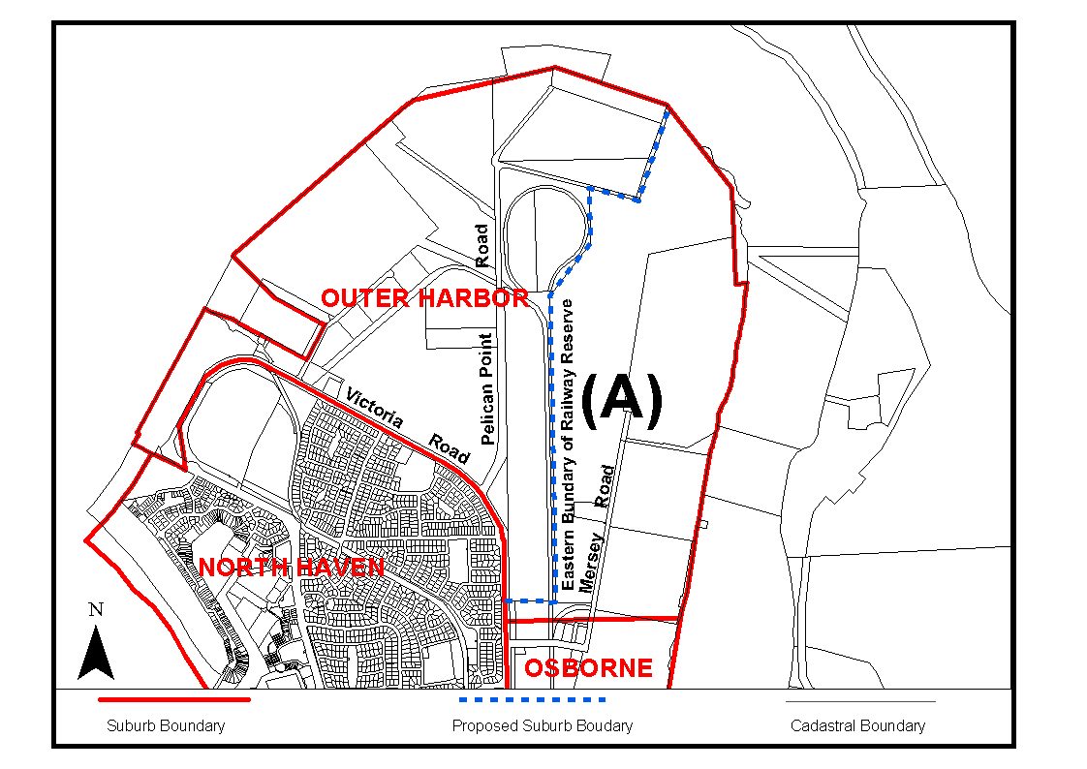
Dated 21 March 2006.
P. M. Kentish, Surveyor-General, Department for Administrative and Information Services
DAIS 22-413/05/0018

GEOGRAPHICAL NAMES ACT 1991
For Public Consultation
Notice of Intention to Assign a Name to a Place
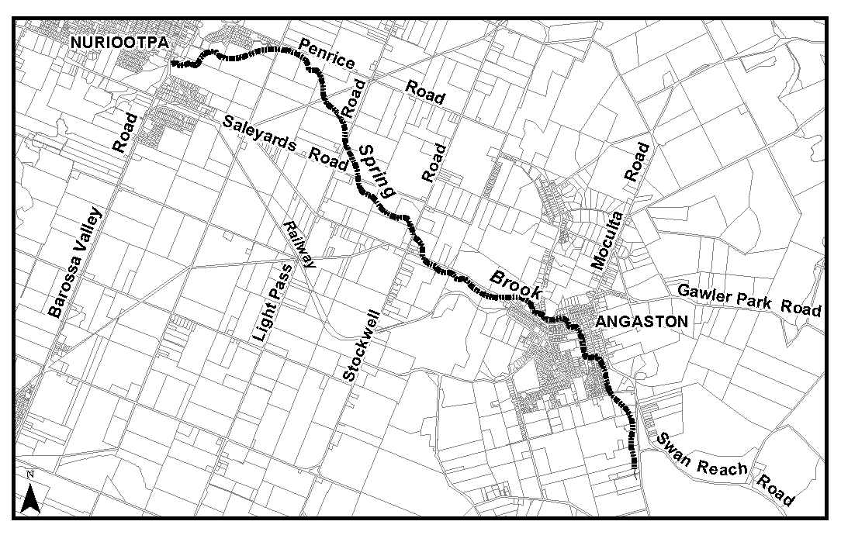
NOTICE is hereby given pursuant to the provisions of the above Act, that the Minister for Administrative Services seeks public comment on a proposal to assign the name SPRING BROOK to that creek located on the 1:50 000 Mapsheets of Angaston (6728-4), Truro (6729-3) and Kapunda (6629-2), as shown on the plan below.
The Plan
Submissions in writing regarding this proposal may be lodged with the Secretary, Geographical Names Advisory Committee, G.P.O. Box 1354, Adelaide, S.A. 5001, within one month of the publication of this notice.
Dated 21 March 2006.
P. M. Kentish, Surveyor-General, Department for Administrative and Information Services
DAIS 22-413/05/0007

GOVERNMENT GAZETTE ADVERTISEMENT RATES

To apply from 1 July 2005

$  Agents, Ceasing to Act as 36.50  Associations:  Incorporation 18.60  Intention of Incorporation 46.00  Transfer of Properties 46.00  Attorney, Appointment of 36.50  Bailiff’s Sale 46.00  Cemetery Curator Appointed 27.25  Companies:  Alteration to Constitution 36.50  Capital, Increase or Decrease of 46.00  Ceasing to Carry on Business 27.25  Declaration of Dividend 27.25  Incorporation 36.50  Lost Share Certificates:  First Name 27.25  Each Subsequent Name 9.35  Meeting Final 30.50  Meeting Final Regarding Liquidator’s Report on  Conduct of Winding Up (equivalent to ‘Final  Meeting’)  First Name 36.50  Each Subsequent Name 9.35  Notices:  Call 46.00  Change of Name 18.60  Creditors 36.50  Creditors Compromise of Arrangement 36.50  Creditors (extraordinary resolution that ‘the Com-pany be wound up voluntarily and that a liquidator be appointed’) 46.00  Release of Liquidator⎯Application⎯Large Ad. 72.50  ⎯Release Granted 46.00  Receiver and Manager Appointed 42.50  Receiver and Manager Ceasing to Act 36.50  Restored Name 34.50  Petition to Supreme Court for Winding Up 64.00  Summons in Action 54.50  Order of Supreme Court for Winding Up Action 36.50  Register of Interests⎯Section 84 (1) Exempt 82.50  Removal of Office 18.60  Proof of Debts 36.50  Sales of Shares and Forfeiture 36.50  Estates:  Assigned 27.25  Deceased Persons⎯Notice to Creditors, etc. 46.00  Each Subsequent Name 9.35  Deceased Persons⎯Closed Estates 27.25  Each Subsequent Estate 1.20  Probate, Selling of 36.50  Public Trustee, each Estate 9.35 |  | $  Firms:  Ceasing to Carry on Business (each insertion) 24.30  Discontinuance Place of Business 24.30  Land⎯Real Property Act:  Intention to Sell, Notice of 46.00  Lost Certificate of Title Notices 46.00  Cancellation, Notice of (Strata Plan) 46.00  Mortgages:  Caveat Lodgment 18.60  Discharge of 19.50  Foreclosures 18.60  Transfer of 18.60  Sublet 9.35  Leases⎯Application for Transfer (2 insertions) each 9.35  Lost Treasury Receipts (3 insertions) each 27.25  Licensing 54.50  Municipal or District Councils:  Annual Financial Statement⎯Forms 1 and 2 513.00  Electricity Supply⎯Forms 19 and 20 364.00  Default in Payment of Rates:  First Name 72.50  Each Subsequent Name 9.35  Noxious Trade 27.25  Partnership, Dissolution of 27.25  Petitions (small) 18.60  Registered Building Societies (from Registrar-  General) 18.60  Register of Unclaimed Moneys⎯First Name 27.25  Each Subsequent Name 9.35  Registers of Members⎯Three pages and over:  Rate per page (in 8pt) 233.00  Rate per page (in 6pt) 308.00  Sale of Land by Public Auction 46.50  Advertisements 2.60  ¼ page advertisement 109.00  ½ page advertisement 218.00  Full page advertisement 427.00  Advertisements, other than those listed are charged at $2.60 per column line, tabular one-third extra.  Notices by Colleges, Universities, Corporations and District Councils to be charged at $2.60 per line.  Where the notice inserted varies significantly in length from that which is usually published a charge of $2.60 per column line will be applied in lieu of advertisement rates listed.  South Australian Government publications are sold on the condition that they will not be reproduced without prior permission from the Government Printer.
All the above prices include GST

GOVERNMENT GAZETTE NOTICES
ALL private advertisements forwarded for publication in the South Australian Government Gazette must be PAID FOR PRIOR TO INSERTION; and all notices, from whatever source, should be legibly written on one side of the paper only and sent to Government Publishing SA so as to be received no later than 4 p.m. Tuesday preceding the day of publication. Phone 8207 1045 or Fax 8207 1040. E-mail: governmentgazette@saugov.sa.gov.au. Send as attachments in Word format. Please include date the notice is to be published and to whom the notice will be charged. The Government Gazette is available online at: www.governmentgazette.sa.gov.au.

MISCELLANEOUS LEGISLATION AND GOVERNMENT PUBLICATIONS PRICES AS FROM 1 JULY 2005

Acts, Bills, Rules, Parliamentary Papers and Regulations
Pages | Main | Amends | Pages | Main | Amends

1-16 | 2.20 | 1.00 | 497-512 | 31.00 | 30.00
17-32 | 3.00 | 1.85 | 513-528 | 32.00 | 30.75
33-48 | 3.90 | 2.80 | 529-544 | 33.00 | 32.00
49-64 | 4.90 | 3.75 | 545-560 | 34.00 | 33.00
65-80 | 5.75 | 4.75 | 561-576 | 34.75 | 34.00
81-96 | 6.70 | 5.55 | 577-592 | 35.75 | 34.50
97-112 | 7.60 | 6.50 | 593-608 | 36.75 | 35.50
113-128 | 8.55 | 7.45 | 609-624 | 37.50 | 36.50
129-144 | 9.60 | 8.50 | 625-640 | 38.50 | 37.00
145-160 | 10.50 | 9.35 | 641-656 | 39.50 | 38.50
161-176 | 11.50 | 10.30 | 657-672 | 40.00 | 39.00
177-192 | 12.40 | 11.30 | 673-688 | 41.75 | 40.00
193-208 | 13.40 | 12.30 | 689-704 | 42.50 | 41.00
209-224 | 14.20 | 13.10 | 705-720 | 43.00 | 42.00
225-240 | 15.10 | 14.00 | 721-736 | 44.75 | 43.00
241-257 | 16.20 | 14.70 | 737-752 | 45.25 | 44.00
258-272 | 17.10 | 15.70 | 753-768 | 46.25 | 44.50
273-288 | 18.00 | 16.90 | 769-784 | 46.75 | 46.00
289-304 | 18.80 | 17.70 | 785-800 | 47.75 | 47.00
305-320 | 19.90 | 18.70 | 801-816 | 48.50 | 47.50
321-336 | 20.70 | 19.60 | 817-832 | 49.75 | 48.50
337-352 | 21.80 | 20.60 | 833-848 | 50.75 | 49.50
353-368 | 22.60 | 21.60 | 849-864 | 51.50 | 50.00
369-384 | 23.60 | 22.50 | 865-880 | 52.50 | 51.50
385-400 | 24.50 | 23.40 | 881-896 | 53.00 | 52.00
401-416 | 25.50 | 24.20 | 897-912 | 54.50 | 53.00
417-432 | 26.50 | 25.25 | 913-928 | 55.00 | 54.50
433-448 | 27.50 | 26.25 | 929-944 | 56.00 | 55.00
449-464 | 28.25 | 27.00 | 945-960 | 57.00 | 55.50
465-480 | 28.75 | 28.00 | 961-976 | 58.25 | 56.50
481-496 | 30.00 | 28.75 | 977-992 | 59.25 | 57.00

Legislation—Acts, Regulations, etc: $
Subscriptions:
Acts 192.00
All Bills as Laid 460.00
Rules and Regulations 460.00
Parliamentary Papers 460.00
Bound Acts 213.00
Index 106.00
Government Gazette
Copy 5.00
Subscription 254.00
Hansard
Copy 14.00
Subscription—per session (issued weekly) 399.00
Cloth bound—per volume 172.00
Subscription—per session (issued daily) 399.00
Legislation on Disk
Whole Database 2 951.00
Annual Subscription for fortnightly updates 907.00
Individual Act(s) including updates POA
Compendium
Subscriptions:
Subscriptions 1 749.00
Updates 617.00
(All the above prices include GST)

All Legislation, Government Gazette, Hansard and Legislation on disk are available from:
Counter Sales Service SA, Government Legislation⁺ Outlet
and Mail Orders: Lands Titles Office, 101 Grenfell Street, Adelaide, S.A. 5000
Phone: 13 23 24 (local call cost), Fax: (08) 8204 1909
Postal: G.P.O. Box 1707, Adelaide, S.A. 5001

Online Shop: www.shop.service.sa.gov.au

Subscriptions and Government Publishing SA
Standing Orders: Box 9, Plaza Level, Riverside Centre, North Terrace, Adelaide, S.A. 5000
Phone: (08) 8207 0908, (08) 8207 0910, Fax: (08) 8207 1040

HOUSING IMPROVEMENT ACT 1940
NOTICE is hereby given that the South Australian Housing Trust in the exercise of the powers conferred by the Housing Improvement Act 1940, does hereby declare the houses described in the table hereunder to be substandard for the purposes of Part 7 of the Housing Improvement Act 1940.
No. of House and Street | Locality | Allotment, Section, etc. | Certificate of Title  Volume Folio

Lot 1362, Riverview Drive |  | Berri | Allotment 1 in Deposited Plan 29163, Berri Irrigation Area | 5404 | 505
39 Vine Terrace |  | Klemzig | Allotment 144 in Deposited Plan 3517, Hundred of Yatala | 5405 | 279
52 Perseverance Road |  | Tea Tree Gully | Allotment 138 in Deposited Plan 6505, Hundred of Yatala | 5644 | 209

Dated at Adelaide, 30 March 2006. M. Downie, General Manager, Housing Trust

HOUSING IMPROVEMENT ACT 1940
WHEREAS by notice published in the Government Gazette on the dates mentioned in the following table the South Australian Housing Trust did declare the houses described in the said table to be substandard for the purposes of Part 7 of the Housing Improvement Act 1940, the South Australian Housing Trust in the exercise of the powers conferred by the said Part, does hereby fix as the maximum rental per week which shall be payable subject to section 55 of the Residential Tenancies Act 1995, in respect of each house described in the following table the amount shown in the said table opposite the description of such house and this notice shall come into force on the date of this publication in the Gazette.
Address of House | Allotment, Section, etc. | Certificate of Title  Volume Folio | Date and page of Government Gazette in which notice declaring house to be substandard published | Maximum rental per week payable in respect of each house  $

Flat 2/52 Victoria Road, Clare (also known as 52A) |  | Allotment 12 in Deposited Plan 43730, Hundred of Clare | 5291 | 952 |  | 14.5.81, page 1486 | 155.00
Flat 1/52 Victoria Road, Clare (also known as 52B) |  | Allotment 12 in Deposited Plan 43730, Hundred of Clare | 5291 | 952 |  | 14.5.81, page 1486 | 155.00
40 Blight Street, Davoren Park |  | Allotment 6 in Deposited Plan 38779, Hundred of Munno Para | 5169 | 149 |  | 25.7.02, page 2936 | 75.00
1 Trevorten Avenue, Glenunga |  | Allotment 43 in Deposited Plan 2113, Hundred of Adelaide | 5559 | 837 |  | 15.12.05, page 4282 | 240.00
Unit 1/22 Weller Street, Goodwood |  | Unit 1, Strata Plan 4932, Hundred of Adelaide | 5025 | 407 |  | 24.2.05, page 523 | 280.00
34 Princes Road, Greenacres |  | Allotment 206 in Deposited Plan 3365, Hundred of Yatala | 5205 | 358 |  | 27.10.05, page 3813 | 159.00
6 No Two Lane, Kadina |  | Allotment 751 in Deposited Plan 198122, Hundred of Wallaroo | 5805 | 416 |  | 15.12.05, page 4282 | 127.00
32 Melbourne Street, North Adelaide |  | Allotment 7 in Filed Plan 107279, Hundred of Yatala | 5180 | 452 |  | 27.9.01, page 4303 | 261.00
35 Glenburnie Avenue, Northfield |  | Allotment 209 in Deposited Plan 4712, Hundred of Yatala | 5676 | 349 |  | 24.11.05, page 3997 | 128.00
Flat at rear of 47 Florence Street, Port Pirie |  | Allotment 541 of portion of Allotment 72, Hundred of Pirie | 5739 | 554 |  | 25.1.96, page 828 | 70.00
137 Three Chain Road, Port Pirie South |  | Allotment 36 in Deposited Plan 635, Hundred of Pirie | 5655 | 115 |  | 27.10.05, page 3813 | 111.00
19 Fourth Avenue, St Peters |  | Allotment 869 of portion of section 258, Hundred of Adelaide | 5749 | 747 |  | 10.12.87, page 1809 | 170.00

Dated at Adelaide, 30 March 2006. M. Downie, General Manager, Housing Trust

HOUSING IMPROVEMENT ACT 1940
WHEREAS by notice published in the Government Gazette on the dates mentioned in the following table the South Australian Housing Trust did declare the houses described in the said table to be substandard for the purposes of Part 7 of the Housing Improvement Act 1940, and whereas the South Australian Housing Trust is satisfied that each of the houses described hereunder has ceased to be substandard, notice is hereby given that, in exercise of the powers conferred by the said Part, the South Australian Housing Trust does hereby revoke the said declaration in respect of each house.
Address of House | Allotment, Section, etc. | Certificate of Title  Volume Folio | Date and page of Government Gazette in which notice declaring house to be substandard published

81 West Street, Brompton |  | Allotment 22 of portion of section 355, Hundred of Yatala | 5462 | 203 |  | 1.7.76, page 41
20 Sissman Street, Davoren Park |  | Allotment 6 in Deposited Plan 40848, Hundred of Munno Para | 5227 | 179 |  | 28.8.03, page 3361
22 Sissman Street, Davoren Park |  | Allotment 5 in Deposited Plan 40848, Hundred of Munno Para | 5227 | 178 |  | 25.7.02, page 2936
12 Viaduct Road, Eden Hills |  | Allotment 21 in Deposited Plan 1296, Hundred of Adelaide | 5876 | 203 |  | 29.5.03, page 2068
16 Dodd Avenue, Port Noarlunga |  | Allotment 169 in Deposited Plan 2827, Hundred of Noarlunga | 5219 | 568 |  | 27.2.97, page 1054
121A Long Street, Queenstown |  | Allotment 9 of section 443 in Filed Plan 102405, Hundred of Yatala | 5122 | 500 |  | 30.5.96, page 2605
15 Daly Street, Wallaroo |  | Allotment 3 in Filed Plan 37166, Hundred of Wallaroo | 5326 | 866 |  | 29.9.05, page 3508

Dated at Adelaide, 30 March 2006. M. Downie, General Manager, Housing Trust

LIQUOR LICENSING ACT 1997 AND GAMING MACHINES ACT 1992
Notice of Application
NOTICE is hereby given, pursuant to section 52 of the Liquor Licensing Act 1997 and section 29 of the Gaming Machines Act 1992, that Loechel Administration Pty Ltd as trustee for Loechel Trading Trust No. 1 and SDJ Forbes Pty Ltd as trustee for SDJ Forbes Investment Trust have applied to the Licensing Authority for the transfer of a Hotel and Gaming Machine Licence and variation to Extended Trading Authorisation in respect of premises situated at 9 Bagot Street, Wallaroo, S.A. 5556 and known as Angler’s Inn Hotel Motel.
The applications have been set down for hearing on 28 April 2006 at 9 a.m.
Conditions
The following licence conditions are sought:
• Variation to Extended Trading Authorisation to include the following hours:
Monday and Tuesday: Midnight to 2 a.m. the following day;
Wednesday and Thursday: Midnight to 3 a.m. the following day;
Maundy Thursday: Midnight to 2 a.m. the following day;
New Year’s Eve: 2 a.m. the following day to 3 a.m. the following day;
Sundays preceding Public Holidays: 8 p.m. to 3 a.m. the following day.
• For consumption off the premises (carry off):
Sundays: 8 p.m. to 9 p.m.
Any person may object to the application by lodging a notice of objection in the prescribed form with the Liquor and Gambling Commissioner and serving a copy of the notice on the applicants at the applicants’ address given above, at least seven days before the hearing date (viz: 20 April 2006).
The applicants’ address for service is c/o Duncan Basheer Hannon, Barristers & Solicitors, G.P.O. Box 2, Adelaide, S.A. 5001 (Attention: Max Basheer or David Tillett).
Plans in respect of the premises the subject of the application are open to public inspection without fee at the Office of the Liquor and Gambling Commissioner, 9th Floor, East Wing, 50 Grenfell Street, Adelaide, S.A. 5000. Phone 8226 8410, Fax:
8226 8512. Email: olgc@agd.sa.gov.au.
Dated 24 March 2006.
Applicants

LIQUOR LICENSING ACT 1997
Notice of Application
NOTICE is hereby given, pursuant to section 52 (2) (b) of the Liquor Licensing Act 1997, that C.P. Firle Pty Ltd has applied to the Licensing Authority for a Restaurant Licence, Section 34 (1) (c), Extended Trading Authorisation and Entertainment Consent in respect of premises situated at Shops 9 and 10, Glynburn Plaza, 151 and 163-167 Glynburn Road, Firle, S.A. 5070 and to be known as Caffe Primo Firle.
The application has been set down for hearing on 28 April 2006 at 9 a.m.
Conditions
The following licence conditions are sought:
• Approval under Section 34 (1) (c) to sell liquor for con-sumption on the licensed premises by persons:
(a) seated at a table; or
(b) attending a function at which food is provided.
• Extended Trading Authorisation:
Monday to Saturday: Midnight to 2 a.m. the following day;
Sunday: 8 a.m. to 11 a.m. and 8 p.m. to 2 a.m. the following day;
Good Friday: Midnight to 2 a.m.;
Christmas Day: Midnight to 2 a.m.;
Sunday Christmas Eve: 8 p.m. to 2 a.m. the following day;
Days preceding Public Holidays: Midnight to 2 a.m. the following day;
Sundays preceding Public Holidays: 8 p.m. to 2 a.m. the following day.
• Entertainment Consent is sought:
On any Day: 12 noon to 2 a.m. the following day.
• Proposed type of entertainment is as follows:
Low Level DJ, 3 Piece Bands, Folk Bands and String Quartet.
Any person may object to the application by lodging a notice of objection in the prescribed form with the Liquor and Gambling Commissioner and serving a copy of the notice on the applicant at the applicant’s address given above, at least seven days before the hearing date (viz: 20 April 2006).
The applicant’s address for service is c/o Camatta Lempens, Level 1, 345 King William Street, Adelaide, S.A. 5000 (Attention: Amanda Warley).
Plans in respect of the premises the subject of the application are open to public inspection without fee at the Office of the Liquor and Gambling Commissioner, 9th Floor, East Wing, 50 Grenfell Street, Adelaide, S.A. 5000. Phone 8226 8410, Fax:
8226 8512. Email: olgc@agd.sa.gov.au.
Dated 23 March 2006.
Applicant

LIQUOR LICENSING ACT 1997
Notice of Application
NOTICE is hereby given, pursuant to section 52 (2) (b) of the Liquor Licensing Act 1997, that Emanuel Skorpos and Laura Maria Skorpos have applied to the Licensing Authority for a Producer’s Licence in respect of premises situated at Lot 298, Gribbles Road, Baroota, S.A. 5495 and to be known as Southern Flinders Ranges Estate.
The application has been set down for hearing on 28 April 2006 at 9 a.m.
Any person may object to the application by lodging a notice of objection in the prescribed form with the Liquor and Gambling Commissioner and serving a copy of the notice on the applicants at the applicants’ address given above, at least seven days before the hearing date (viz: 20 April 2006).
The applicants’ address for service is c/o Emanuel Skorpos, P.O. Box 67, Port Pirie, S.A. 5540.
Plans in respect of the premises the subject of the application are open to public inspection without fee at the Office of the Liquor and Gambling Commissioner, 9th Floor, East Wing, 50 Grenfell Street, Adelaide, S.A. 5000. Phone 8226 8410, Fax:
8226 8512. Email: olgc@agd.sa.gov.au.
Dated 23 March 2006.
Applicants

LIQUOR LICENSING ACT 1997
Notice of Application
NOTICE is hereby given, pursuant to section 52 (2) (b) of the Liquor Licensing Act 1997, that William Laidlaw Davidson has applied to the Licensing Authority for a Direct Sales Licence in respect of premises situated at Lots 30 and 31, Hundred of Kondoparinga, Wattle Flat Road, Sandergrove via Strathalbyn, S.A. 5255 and to be known as Sandergrove Estate.
The application has been set down for hearing on 28 April 2006 at 9 a.m.
Any person may object to the application by lodging a notice of objection in the prescribed form with the Liquor and Gambling Commissioner, and serving a copy of the notice on the applicant at the applicant’s address given above, at least seven days before the hearing date (viz: 20 April 2006).
The applicant’s address for service is c/o William Davidson, P.O. Box 646, Strathalbyn, S.A. 5255.
Plans in respect of the premises the subject of the application are open to public inspection without fee at the Office of the Liquor and Gambling Commissioner, 9th Floor, East Wing, 50 Grenfell Street, Adelaide, S.A. 5000. Phone 8226 8410, Fax:
8226 8512. Email: olgc@agd.sa.gov.au.
Dated 27 March 2006.
Applicant

LIQUOR LICENSING ACT 1997
Notice of Application
NOTICE is hereby given, pursuant to section 52 (2) (b) of the Liquor Licensing Act 1997, that Jamilah Pty Ltd as trustee for Jamilah Family Trust and Eric Charles Semmler have applied to the Licensing Authority for a Producers’s Licence in respect of premises situated at Section 919, Hodges Road, Berri, S.A. 5343 and to be known as 919 Wines.
The application has been set down for hearing on 28 April 2006 at 9 a.m.
Any person may object to the application by lodging a notice of objection in the prescribed form with the Liquor and Gambling Commissioner, and serving a copy of the notice on the applicants at the applicants’ address given above, at least seven days before the hearing date (viz: 20 April 2006).
The applicants’ address for service is c/o Stuart Andrew Solicitors, 11 Ahern Street, Berri, S.A. 5343 (Attention: Dimitria Dale).
Plans in respect of the premises the subject of the application are open to public inspection without fee at the Office of the Liquor and Gambling Commissioner, 9th Floor, East Wing, 50 Grenfell Street, Adelaide, S.A. 5000. Phone 8226 8410, Fax:
8226 8512. Email: olgc@agd.sa.gov.au.
Dated 23 March 2006.
Applicants

LIQUOR LICENSING ACT 1997
Notice of Application
NOTICE is hereby given, pursuant to section 52 (2) (b) of the Liquor Licensing Act 1997, that Vitiwise Pty Ltd has applied to the Licensing Authority for a Producer’s Licence in respect of premises situated at 2/41 High Street, Willunga, S.A. 5172 and to be known as Vitiwise.
The application has been set down for hearing on 28 April 2006 at 9 a.m.
Any person may object to the application by lodging a notice of objection in the prescribed form with the Liquor and Gambling Commissioner, and serving a copy of the notice on the applicant at the applicant’s address given above, at least seven days before the hearing date (viz: 20 April 2006).
The applicant’s address for service is c/o Karen Jacobs, P.O. Box 651, Willunga, S.A. 5172.
Plans in respect of the premises the subject of the application are open to public inspection without fee at the Office of the Liquor and Gambling Commissioner, 9th Floor, East Wing, 50 Grenfell Street, Adelaide, S.A. 5000. Phone 8226 8410, Fax:
8226 8512. Email: olgc@agd.sa.gov.au.
Dated 23 March 2006.
Applicant

LIQUOR LICENSING ACT 1997
Notice of Application
NOTICE is hereby given, pursuant to section 52 (2) (b) of the Liquor Licensing Act 1997, that Red Herron Pty Ltd has applied to the Licensing Authority for a Producer’s Licence in respect of premises situated at 1 Golden Way, Nuriootpa, S.A. 5355 and to be known as Cooper Burns.
The application has been set down for hearing on 28 April 2006 at 9 a.m.
Any person may object to the application by lodging a notice of objection in the prescribed form with the Liquor and Gambling Commissioner, and serving a copy of the notice on the applicant at the applicant’s address given above, at least seven days before the hearing date (viz: 20 April 2006).
The applicant’s address for service is c/o Mark Cooper,
1 Golden Way, Nuriootpa, S.A. 5355.
Plans in respect of the premises the subject of the application are open to public inspection without fee at the Office of the Liquor and Gambling Commissioner, 9th Floor, East Wing, 50 Grenfell Street, Adelaide, S.A. 5000. Phone 8226 8410, Fax:
8226 8512. Email: olgc@agd.sa.gov.au.
Dated 23 March 2006.
Applicant

LIQUOR LICENSING ACT 1997
Notice of Application
NOTICE is hereby given, pursuant to section 52 (2) (b) of the Liquor Licensing Act 1997, that Cape Banks Wines Pty Ltd has applied to the Licensing Authority for a Producer’s Licence in respect of premises situated at 12 Crouch Street South, Mount Gambier, S.A. 5290 and to be known as Cape Banks Wines.
The application has been set down for hearing on 28 April 2006 at 9 a.m.
Any person may object to the application by lodging a notice of objection in the prescribed form with the Liquor and Gambling Commissioner, and serving a copy of the notice on the applicant at the applicant’s address given above, at least seven days before the hearing date (viz: 20 April 2006).
The applicant’s address for service is c/o Clelands Lawyers, 208 Carrington Street, Adelaide, S.A. 5000 (Attention: Leon McEvoy).
Plans in respect of the premises the subject of the application are open to public inspection without fee at the Office of the Liquor and Gambling Commissioner, 9th Floor, East Wing, 50 Grenfell Street, Adelaide, S.A. 5000. Phone 8226 8410, Fax:
8226 8512. Email: olgc@agd.sa.gov.au.
Dated 22 March 2006.
Applicant

LIQUOR LICENSING ACT 1997
Notice of Application
NOTICE is hereby given, pursuant to section 52 (2) (b) of the Liquor Licensing Act 1997, that Paul Le Lacheur has applied to the Licensing Authority for a Producer’s Licence in respect of premises situated at 20 James Street, Prospect, S.A. 5082 and to be known as Le Lacheur.
The application has been set down for hearing on 28 April 2006 at 9 a.m.
Any person may object to the application by lodging a notice of objection in the prescribed form with the Liquor and Gambling Commissioner, and serving a copy of the notice on the applicant at the applicant’s address given above, at least seven days before the hearing date (viz: 20 April 2006).
The applicant’s address for service is c/o Paul Le Lacheur, 20 James Street, Prospect, S.A. 5082.
Plans in respect of the premises the subject of the application are open to public inspection without fee at the Office of the Liquor and Gambling Commissioner, 9th Floor, East Wing, 50 Grenfell Street, Adelaide, S.A. 5000. Phone 8226 8410, Fax:
8226 8512. Email: olgc@agd.sa.gov.au.
Dated 24 March 2006.
Applicant

LIQUOR LICENSING ACT 1997
Notice of Application
NOTICE is hereby given, pursuant to section 52 (2) (b) of the Liquor Licensing Act 1997, that Woolworths Limited has applied to the Licensing Authority for the removal of a Retail Liquor Merchant’s Licence in respect of premises situated at 232 Main Street, Clare, S.A. 5453 to be situated at corner of Old North Road and Wright Street, Clare, S.A. 5453 and known as Woolworths Liquor.
The application has been set down for hearing on 28 April 2006 at 9 a.m.
Any person may object to the application by lodging a notice of objection in the prescribed form with the Liquor and Gambling Commissioner, and serving a copy of the notice on the applicant at the applicant’s address given above, at least seven days before the hearing date (viz: 20 April 2006).
The applicant’s address for service is c/o Clelands Lawyers, 208 Carrington Street, Adelaide, S.A. 5000 (Attention: Leon McEvoy).
Plans in respect of the premises the subject of the application are open to public inspection without fee at the Office of the Liquor and Gambling Commissioner, 9th Floor, East Wing, 50 Grenfell Street, Adelaide, S.A. 5000. Phone 8226 8410, Fax:
8226 8512. Email: olgc@agd.sa.gov.au.
Dated 23 March 2006.
Applicant

LIQUOR LICENSING ACT 1997
Notice of Application
NOTICE is hereby given, pursuant to section 52 (2) (b) of the Liquor Licensing Act 1997, that The Operations Centre Social Club Inc. has applied to the Licensing Authority for a Limited Club Licence in respect of premises situated at 120 Cross Keys Road, Salisbury South, S.A. 5106 and to be known as The Operations Centre Social Club Inc.
The application has been set down for hearing on 28 April 2006 at 9 a.m.
Any person may object to the application by lodging a notice of objection in the prescribed form with the Liquor and Gambling Commissioner and serving a copy of the notice on the applicant at the applicant’s address given above, at least seven days before the hearing date (viz: 20 April 2006).
The applicant’s address for service is c/o William Cornell, 120 Cross Keys Road, Salisbury South, S.A. 5106.
Plans in respect of the premises the subject of the application are open to public inspection without fee at the Office of the Liquor and Gambling Commissioner, 9th Floor, East Wing, 50 Grenfell Street, Adelaide, S.A. 5000. Phone 8226 8410, Fax:
8226 8512. Email: olgc@agd.sa.gov.au.
Dated 23 March 2006.
Applicant

LIQUOR LICENSING ACT 1997
Notice of Application
NOTICE is hereby given, pursuant to section 52 (2) (b) of the Liquor Licensing Act 1997, that Peter Ronald Brinkworth, Helen Margaret Brinkworth and Andrew Mark Brinkworth have applied to the Licensing Authority for the transfer of a Restaurant Licence in respect of premises situated at 172-180 Unley Road, Unley, S.A. 5061, known as Kabab-Ji and to be known as Cafe Rustico.
The application has been set down for hearing on 1 May 2006 at 9.30 a.m.
Any person may object to the application by lodging a notice of objection in the prescribed form with the Liquor and Gambling Commissioner and serving a copy of the notice on the applicants at the applicants’ address given above, at least seven days before the hearing date (viz: 21 April 2006).
The applicants’ address for service is c/o North East Con-veyancers, P.O. Box 4120, Norwood South, S.A. 5067 (Attention: John Paholski).
Plans in respect of the premises the subject of the application are open to public inspection without fee at the Office of the Liquor and Gambling Commissioner, 9th Floor, East Wing, 50 Grenfell Street, Adelaide, S.A. 5000. Phone 8226 8410, Fax:
8226 8512. Email: olgc@agd.sa.gov.au.
Dated 21 March 2006.
Applicants

LIQUOR LICENSING ACT 1997
Notice of Application
NOTICE is hereby given, pursuant to section 52 (2) (b) of the Liquor Licensing Act 1997, that Viti Vini Consulting Pty Ltd has applied to the Licensing Authority for the transfer of a Producer’s Licence in respect of premises situated at Lot 7, Campbell Road, Penwortham, S.A. 5453, known as Lawson Wines and to be known as Viti Vini Consulting Pty Ltd.
The application has been set down for hearing on 1 May 2006 at 10.30 a.m.
Any person may object to the application by lodging a notice of objection in the prescribed form with the Liquor and Gambling Commissioner and serving a copy of the notice on the applicant at the applicant’s address given above, at least seven days before the hearing date (viz: 21 April 2006).
The applicant’s address for service is c/o Matthew Lawson, P.O. Box 8991, Clare, S.A. 5453.
Plans in respect of the premises the subject of the application are open to public inspection without fee at the Office of the Liquor and Gambling Commissioner, 9th Floor, East Wing, 50 Grenfell Street, Adelaide, S.A. 5000. Phone 8226 8410, Fax:
8226 8512. Email: olgc@agd.sa.gov.au.
Dated 24 March 2006.
Applicant

LIQUOR LICENSING ACT 1997
Notice of Application
NOTICE is hereby given, pursuant to section 52 (2) (b) of the Liquor Licensing Act 1997, that Paolo Mascia and Damiano Stomaci have applied to the Licensing Authority for the transfer of a Restaurant Licence in respect of premises situated at 89 Prospect Road, Prospect, S.A. 5082, known as Dixons on Prospect and to be known as Villa Condesa.
The application has been set down for hearing on 2 May 2006 at 10 a.m.
Any person may object to the application by lodging a notice of objection in the prescribed form with the Liquor and Gambling Commissioner and serving a copy of the notice on the applicants at the applicants’ address given above, at least seven days before the hearing date (viz: 24 April 2006).
The applicants’ address for service is c/o David Watts & Associates, 1 Cator Street, Glenside, S.A. 5065.
Plans in respect of the premises the subject of the application are open to public inspection without fee at the Office of the Liquor and Gambling Commissioner, 9th Floor, East Wing, 50 Grenfell Street, Adelaide, S.A. 5000. Phone 8226 8410, Fax:
8226 8512. Email: olgc@agd.sa.gov.au.
Dated 24 March 2006.
Applicants

LIQUOR LICENSING ACT 1997
Notice of Application
NOTICE is hereby given, pursuant to section 52 (2) (b) of the Liquor Licensing Act 1997, that Holly Rose Pty Ltd as trustee for Holly Rose Family Trust has applied to the Licensing Authority for the transfer of a Hotel Licence in respect of premises situated at Main North Road, Rhynie, S.A. 5450 and known as Rhynie Hotel.
The application has been set down for hearing on 2 May 2006 at 11 a.m.
Any person may object to the application by lodging a notice of objection in the prescribed form with the Liquor and Gambling Commissioner and serving a copy of the notice on the applicant at the applicant’s address given above, at least seven days before the hearing date (viz: 24 April 2006).
The applicant’s address for service is c/o Andrew and Helen May, Lot 91, Mallala Road, Gawler Belt, S.A. 5118.
Plans in respect of the premises the subject of the application are open to public inspection without fee at the Office of the Liquor and Gambling Commissioner, 9th Floor, East Wing, 50 Grenfell Street, Adelaide, S.A. 5000. Phone 8226 8410, Fax:
8226 8512. Email: olgc@agd.sa.gov.au.
Dated 24 March 2006.
Applicant

LIQUOR LICENSING ACT 1997
Notice of Application
NOTICE is hereby given, pursuant to section 52 (2) (b) of the Liquor Licensing Act 1997, that Yiu Kwong Fung and Siu Ping Wong have applied to the Licensing Authority for the transfer of a Restaurant Licence in respect of premises situated at 37 Esplanade, Christies Beach, S.A. 5165 and known as Red Ruby Chinese Restaurant.
The application has been set down for hearing on 4 May 2006 at 9.30 a.m.
Any person may object to the application by lodging a notice of objection in the prescribed form with the Liquor and Gambling Commissioner and serving a copy of the notice on the applicants at the applicants’ address given above, at least seven days before the hearing date (viz: 26 April 2006).
The applicants’ address for service is c/o Judy Koh Solicitor, 23A Payneham Road, College Park, S.A. 5069.
Plans in respect of the premises the subject of the application are open to public inspection without fee at the Office of the Liquor and Gambling Commissioner, 9th Floor, East Wing, 50 Grenfell Street, Adelaide, S.A. 5000. Phone 8226 8410, Fax:
8226 8512. Email: olgc@agd.sa.gov.au.
Dated 20 March 2006.
Applicants

NATIONAL ELECTRICITY LAW
THE Australian Energy Market Commission (AEMC) gives notice under the National Electricity Law (NEL) of the following matters:
Under sections 102 and 103, the making of a final determination including the National Electricity Amendment (Negative Inter-Regional Settlements Residue) Rule 2006 No. 4. All provisions will commence on 1 July 2006.
Under section 107, the time periods for the following Rules have been extended as follows:
• The making of the final determination for the draft National Electricity Amendment (System Restart Ancillary Services and Pricing under Market Suspension) Rule 2006 to 20 April 2006.
• The making of the draft determination for the proposed National Electricity Amendment (Management of Negative Settlement Residues in the Snowy Region) Rule 2006 to 19 May 2006.
Under section 95, NEMMCO has requested a Rule for the harmonisation of metrology. A copy of the Rule proposal and the proposed National Electricity Amendment (Metrology) Rule 2006 are published on AEMC’s website and are available for inspection at AEMC. Upon receipt AEMC publishes all submissions on its website, subject to consideration of any claim of confidentiality. Submissions should be forwarded to submissions@aemc.gov.au and must be received no later than 19 May 2006.
Further details on all of the above matters are available on AEMC’s website www.aemc.gov.au.
John Tamblyn
Chairman
Australian Energy Market Commission
Level 16, 1 Margaret Street
Sydney, N.S.W. 2000
Tel: (02) 8296 7800
Fax: (02) 8296 7899
Dated 30 March 2006.

PORT AUGUSTA CIRCUIT COURT
DISTRICT COURT OF SOUTH AUSTRALIA
Sheriff’s Office, Adelaide, 24 March 2006
IN pursuance of a precept from the District Court of South Australia to me directed, I do hereby give notice that the said Court will sit as a Court of Oyer and Terminer and General Gaol Delivery at the Courthouse at Port Augusta on the day and time undermentioned and all parties bound to prosecute and give evidence and all jurors summoned and all others having business at the said Court are required to attend the sittings thereof and the order of such business will be unless a Judge otherwise orders, as follows:
Monday, 3 April 2006 at 10 a.m. on the first day of the sittings the only business taken will be the arraignment of prisoners in gaol and the passing of sentences on prisoners in gaol committed for sentence; the surrender of prisoners on bail committed for sentence; the surrender of persons in response to ex officio informations or of persons on bail and committed for trial who have signified their intentions to plead guilty and the passing of sentences.
Juries will be summoned for Wednesday, 5 April 2006 and persons will be tried on this and subsequent days of the sittings.
Prisoners in H.M. Gaol and on Bail for Sentence and for Trial at the Sittings of the Port Augusta Courthouse, commencing Monday, 3 April 2006.
Peel, Arnold John |  | Application for enforcement of a breached bond; threatening harm; fail to comply with restraining or foreign restraining order; commit common assault on own family (3); fail to comply with On bail agreement | On bail
Peel, Arnold John |  | Fail to comply with restraining order; commit assault on own member of family; resist police (2) | On bail
Andrew, Steven Clive |  | Rape | On bail
Aplin, Darrel Stevon |  | Possessing methylamphetamine for sale | In gaol
Beare, Brenton Andrew |  | Possess methamphetamine for sale; possessing cannabis for sale; producing cannabis; unlawful possession | On bail
Bell, Graeme Anthony |  | Producing a controlled substance (2) | On bail
Bitmead, Gregory Noel |  | Producing cannabis; possessing cannabis for sale; selling cannabis; unlawful possession | On bail
Brooks, Barry Stephen |  | Unlawful sexual intercourse with a person under 12 (4) | On bail
C |  | Unlawful sexual intercourse (3); indecent assault | In gaol
Chignola, Emilio |  | Producing a controlled substance; possessing a controlled substance for sale | On bail
Clark, Shane Delver |  | Application for enforcement of a breached bond; criminal trespass—residence occupied; common assault | On bail
Dixon, Graehme |  | Indecent assault | On bail
Donnellan, Steven John |  | Unlawful sexual intercourse | On bail
Edge, Jamie Robert |  | Attempted aggravated serious criminal trespass (non-residential) | On bail
Egan, Simon Lee |  | Wounding with intent to do grievous bodily harm | On bail
Franks, Anthony Kym |  | Indecent assault (2) | On bail
Gaston, Gordon David |  | Aggravated serious criminal trespass—residence occupied; assault occasioning actual bodily harm | On bail
Ginger, Norris |  | Arson; endangering life (2) | On bail
Gordon, James Raymond |  | Threatening life; threatening to cause harm | On bail
Gray, David Raymond |  | Unlawful sexual intercourse (4); indecent assault | In gaol
Griffiths, Jarrod Rian |  | Aggravated serious criminal trespass—residence occupied; threatening life | On bail
Guiney, Jon Paul |  | Impede investigation; fail to truly answer | On bail
Gurr, Shayne John |  | Manslaughter; causing death by dangerous driving; drive or use motor vehicle without consent; fail to truly answer; fail to stop and give particulars to person at crash scene; fail to give assistance | In gaol
Hall, Samuel Smykala |  | Taking part in the sale of a controlled substance; selling a controlled substance | On bail
Hirte, Rodney William |  | Rape | On bail
Hoskins, Graeme William |  | Rape (2) | On bail
J |  | Possess a firearm without a licence; possess an unregistered firearm; fail to keep a firearm secured; fail to store ammunition in locked container | On bail
Jackson, Ricky Owen |  | Application for enforcement of a breached bond; assault occasioning actual bodily harm | On bail
Jensen, Mark John |  | Possessing a controlled substance for sale; taking part in the sale of a controlled substance | On bail
Johnson, David Paul |  | Indecent assault (3) | On bail
Kelly, Daniel Joseph |  | Threatening life (2); common assault | On bail
Kobelt, Shane Lindsay |  | Taking part in the sale of 3,4 methylenedioxymetham-phetamine (5); taking part in the sale of methylamphetamine; manufacturing methylamphetamine; taking part in the sale of methylamphetamine (3) | On bail
Searle, Leonie Karen |  | Taking part in the sale of 3, 4 methylenedioxymetham-phetamine (3); taking part in the sale of methylamphetamine | On bail
O’Hara, Kym Sidney Tyrone |  | Taking part in the sale of 3,4 methylenedioxymetham-phetamine (2); taking part in the sale of methylamphetamine (2) | On bail
Theodosiou, Paul Apostolos |  | Taking part in the sale of 3,4 methylenedioxymetham-phetamine (3); unlawful possession | On bail
McEntee, Adrian James |  | Taking part in the sale of 3,4 methylenedioxymetham-phetamine (2); taking part in the sale of methylam-phetamine (2); selling methylamphetamine; possessing methylampheta-mine for sale; unlawful possession | On bail
Beare, Brentan Andrew |  | Taking part in the sale of methylamphetamine; possessing methylampheta-mine for sale; possessing cannabis for sale; producing cannabis; unlawful possession | On bail
Lange, Clifford Ian |  | Producing cannabis; possessing cannabis for sale | On bail
Lovegrove, Sean Wayne |  | Rape; unlawful sexual intercourse | On bail
M |  | Unlawful sexual intercourse with a person under 12; indecent assault (2) | On bail
Malcolm, Michelle Connie |  | Possessing a controlled substance for sale; taking part in the sale of a controlled substance | On bail
Mason, Rhiannon Dann |  | Arson | On bail
Mazur, Mark Stanislaw |  | Taking part in the production of methylamphetamine | On bail
Mills, Kyron Brougham |  | Taking part in the production of a drug of dependence | On bail
Monkedieck, Hubert |  | Indecent assault (2); unlawful sexual intercourse; rape | On bail
Moore, Matthew Phillip |  | Rape; threatening life; indecent assault; creating risk of bodily harm | On bail
Murphy, Andru Paul |  | Dishonestly take property without owner’s consent (3); unlawful possession; possessing a controlled substance for sale; producing a controlled substance | On bail
Mutton, Hugh John |  | Unlawful sexual intercourse with a person under 12 | On bail
Oswin, Gregory Craig |  | Arson; endangering life | In gaol
Tuivuya, Jeremaia |  | Arson; endangering life | In gaol
Reed, Benjamin Eugene |  | Arson; endangering life | In gaol
Pavlich, James Phillip |  | Causing bodily harm by dangerous driving (4) | On bail
Peel, Priscilla Anne |  | Application for enforcement of a breached bond; threatening harm; fail to comply with restraining or foreign restraining order; commit common assault on member of own family (3) | In gaol
Peel, Priscilla Anne |  | Aggravated serious criminal trespass in a place of residence | On bail
Phanos, Dean Ron |  | Possessing methylamphetamine for sale; unlawful possession | On bail
Pllu, Richard Daniel |  | Rape; unlawful sexual intercourse | On bail
Press, Ronald Adrian |  | Application for enforcement of a breached bond; threatening life | On bail
Pym, Howard Ross |  | Indecent assault (2); unlawful sexual intercourse with a person under 12 (2) | In gaol
Raymond, Randal |  | Rape | On bail
Reiss, Eric Wayne |  | Taking part in the sale of controlled substance (2); conspiracy; selling a controlled substance (3) | On bail
Hall, Samuel Smykala |  | Taking part in the sale of a controlled substance; selling a controlled substance | On bail
Grillett, Dylan Wayne |  | Conspiracy | On bail
Rawlins, Jesse Schuster |  | Taking part in the sale of a controlled substance; selling a controlled substance (2); possessing a controlled substance for sale (2) | On bail
Rigg, Ian |  | Possessing a controlled substance for sale; producing cannabis | On bail
Rincon, Christian Francois |  | Aggravated serious criminal trespass in a place of residence; theft; threatening to cause harm; common assault | On bail
Young, Lisa Michelle |  | Aggravated serious criminal trespass in a place of residence; theft; threatening to cause harm | In gaol
Roediger, Samuel David |  | Causing bodily harm by dangerous driving; drive under the influence; drive with excess blood alcohol; due care | On bail
Sam, Rex |  | Wounding with intent to do grievous bodily harm; assault occasioning actual bodily harm | In gaol
Smith, Steven James |  | Unlawful sexual intercourse (3) | On bail
Waye, Ian John |  | Aggravated serious criminal trespass in a place of residence; common assault; threatening to cause harm | On bail
Waye, Robert Clayton |  | Aggravated serious criminal trespass in a place of residence; common assault; threatening to cause harm | On bail

Waye, Joanne Rose |  | Aggravated serious criminal trespass in a place of residence; common assault; threatening to cause harm | On bail
Waye, Tammy Elizabeth |  | Aggravated serious criminal trespass in a place of residence; common assault; threatening to cause harm | On bail
Wavehill, Anthony David |  | Aggravated serious criminal trespass in a place of residence; theft (2); serious criminal trespass in a place of residence; robbery | In gaol
Wilton, Raymond Clarence |  | Unlawful sexual intercourse with a person under 12 | On bail
Wonga, Daryl |  | Assault with intent to rape; rape | In gaol
Woodlands, Danuel Robin |  | Attempted arson (2); endangering life (4) | In gaol
Zimmermann, Shane Elliott |  | Damaging property (2); assault occasioning actual bodily harm; resisting a police officer; assaulting a police officer; threatening to cause harm (2) | On bail
Prisoners on bail must surrender at 10 a.m. of the day appointed for their respective trials. If they do not appear when called upon their recognizances and those of their bail will be estreated and a bench warrant will be issued forthwith.
By order of the Court,
M. A. Stokes, Sheriff

FISHERIES ACT 1982: SECTION 43
TAKE note that the notice made under section 43 of the Fisheries Act 1982, published in the South Australian Government Gazette on page number 3958, dated 17 November 2005, being the third notice on that page, referring to the Spencer Gulf Prawn Fishery, is hereby varied such that it will be unlawful for a person fishing pursuant to a Spencer Gulf Prawn Fishery Licence to use prawn trawl nets, except in the areas specified in Schedule 1 during the period specified in Schedule 2.
Schedule 1
1. The waters of the Spencer Gulf Prawn Fishery that are within the northern area, commencing at position latitude 33°46.00′S, longitude 137°44.00′E, then to position latitude 33°37.00′S, longitude 137°33.00′E, then to position latitude 33°37.00′S, longitude 137°30.00′E, then to position latitude 33°42.00′S, longitude 137°28.00′E, then to position latitude 33°48.00′S, longitude 137°27.00′E, then to position latitude 33°49.00′S, longitude 137°29.00′E, then to position latitude 33°47.00′S, longitude 137°31.00′E, then to position latitude 33°48.00′S, longitude 137°32.50′E, then to position latitude 33°52.00′S, longitude 137°29.00′E, then to position latitude 33°58.00′S, longitude 137°37.00′E.
2. The waters of the Spencer Gulf Prawn Fishery that are within the northern area, commencing at position latitude 34°05.00′S, longitude 137°34.00′E, then to position latitude 33°51.00′S, longitude 137°20.00′E, then to position latitude 33°53.00′S, longitude 137°12.00′E, then to position latitude 33°57.00′S, longitude 137°14.00′E, then to position latitude 34°08.00′S, longitude 137°06.00′E, then to position latitude 34°08.00′S, longitude 137°33.00′E.
Schedule 2
From 2200 hours on 30 March 2006 to 0700 hours on 31 March 2006.
Dated 30 March 2006.
S. Sloan, Principal Fisheries Manager

MINING ACT 1971
Prominent Hill Copper-Gold Project
Mining Lease and Miscellaneous Purposes Licence Applications
Invitation for Public Comment on the Mining and Rehabilitation Proposal (MARP)
NOTICE is hereby given in accordance with section 35A (1) of the South Australian Mining Act 1971 (Mining Act), and Part 5 of the Native Title (South Australia) Act 1994 and the Regulations thereunder that an application for a mining lease over the undermentioned mineral claims has been received. Notice is also hereby given in accordance with section 53 (2) of the Mining Act 1971 and Part 5 of the Native Title (South Australia) Act 1994, that applications for miscellaneous purposes licences have been received.
The Minister for Mineral Resources Development is required to have regard to any representations received from owners of the land (including native title holders) to which the application relates and/or any interested members of the public in determining the application or in fixing the conditions to be attached to the lease and licences if granted.
In accordance with the provisions of the Mining Act and the Commonwealth Environment Protection and Biodiversity Conservation Act 1999 (EPBC Act), a Mining and Rehabilitation Proposal (MARP) has been prepared to support the Mining Lease (ML) and Miscellaneous Purposes Licence (MPL) applications and is available for public comment. The controlling provisions under Part 3, Division 1 of the EPBC Act are sections 18 and 18A (listed threatened species and ecological communities). The project will be assessed under the South Australian Government Mining Act process, which has been accredited by the Australian Government for the project.
The MARP describes the proposed project and the associated potential environmental impacts and management measures. The MARP is available for public review and comment from 30 March to 11 May 2006 at the following locations:
Department of Primary Industries and Resources South Australia, Level 7, 101 Grenfell Street, Adelaide, S.A.;
Conservation Council of South Australia, 120 Wakefield Street, Adelaide, S.A.;
District Council of Coober Pedy, Hutchison Street, Coober Pedy, S.A. and Australian Government Department of the Environment and Heritage, Central Library, John Gorton Building, King Edward Terrace, Parkes, Australian Capital Territory.
The report can also be examined for the duration of the public review period on the Department of Primary Industries and Resources South Australia internet site at http://www.pir.sa.gov.au/pages/minerals/reg_rehab/public_notices.htm:sectID=1476&tempID=1.
Hard copies of the MARP Executive Summary together with a CD-ROM of the entire document are available on request from: Oxiana Limited, Ground Floor, 170 Greenhill Road, Parkside, South Australia. Phone: (08) 8229 6600. E-mail: admin@oxiana.com.au.
Mining Lease Application Details | Miscellaneous Purposes Licence Applications Details
Applicant: Minex (S.A.) Pty Ltd (a wholly-owned subsidiary of Oxiana Limited).  Claim Nos: 3515 to 3546 inclusive.  Location: On the Mount Eba Crown Lease and Antakarinja native title claim, about 650 km north-north-west of Adelaide in South Australia.  Area: 7856.10 hectares  Purpose: To produce a copper concentrate (with gold credits) using open pit mining methods and ore processing.  Reference: T02506. | Applicant: Minex (S.A.) Pty Ltd (a wholly-owned subsidiary of Oxiana Limited).  Location: On the McDouall Peak, Mount Eba and Ingomar Crown Leases and the Antakarinja native title claim, about 650 km north-north-west of Adelaide in South Australia.  Area 1: 234 hectares  Area 2: 224.4 hectares  Purpose: Upgrading the access track from Prominent Hill operational site to the Stuart Highway and installation of a fibre optic cable.  Reference: T02567.

Written submissions in relation to the granting of the mining lease and the miscellaneous purpose licences are invited to be received by 11 May 2006 to: Jayne Randall, Mining Regulation and Rehabilitation Branch, Department of Primary Industries and Resources South Australia, Level 7, 101 Grenfell Street, Adelaide, S.A. or G.P.O. Box 1671, Adelaide, S.A., 5001. Fax: (08) 8463 3109. E-mail: randall.jayne@saugov.sa. gov.au.
Submissions will be treated as public documents unless confidentiality is requested. Copies of all submissions will be forwarded to Oxiana Limited.
H. Tyrteos, Mining Registrar

ROAD TRAFFIC ACT 1961
Supplementary Notice of Approval
Pursuant to Section 161A of the Road Traffic Act 1961
HIGHER MASS LIMITS FOR VEHICLES FITTED WITH ROAD FRIENDLY SUSPENSIONS
Information Note
This Notice adds additional routes to the network that can be used by vehicles fitted with Road Friendly Suspensions and is a supplement to the Notice titled ‘Higher Mass Limits for Vehicles Fitted with Road Friendly Suspensions’ dated 5 May 2005.

1. APPROVAL
1.1 In accordance with the powers delegated to me by the Minister for Transport under Section 163AA and of the Road Traffic Act 1961, I hereby vary the conditions of the Gazette Notice of Approval and Exemption titled, ‘Higher Mass Limits for Vehicles Fitted with Road Friendly Suspensions’ dated 5 May 2005 as detailed below.

2. DEFINITIONS
2.1 In this Notice:
2.1.1 ‘Approved Vehicles’ means vehicles fitted with Road Friendly Suspensions as described in Table 1 of the Primary Notice;
2.1.2 ‘Supplementary routes’ means the approved routes specified in the maps ‘Route Network for General Access Vehicles Fitted with Road Friendly Suspensions’ attached to this Supplementary Notice;
2.1.3 ‘Supplementary Notice’ means this Notice;
2.1.4 ‘Primary Notice’ means the Gazette Notice ‘Higher Mass Limits for Vehicles Fitted with Road Friendly Suspensions’ dated 5 May 2005; and
2.1.5 all other terms have the same meaning as in the Primary Notice.

3. APPLICATION OF SUPPLEMENTARY NOTICE
3.1 This Supplementary Notice must be read in conjunction with the Primary Notice and applies to all Approved Vehicles operating under the Primary Notice travelling on routes specified in the attached maps.

4. ROUTES AVAILABLE TO APPROVED VEHICLES
4.1 An Approved Vehicle may operate under the conditions of the Primary Notice on a supplementary route specified in the attached map titled:
4.1.1 Route Network for General Access Vehicles Fitted with Road Friendly Suspensions, Map U1;
4.1.2 Route Network for General Access Vehicles Fitted with Road Friendly Suspensions, Map U2;
4.1.3 Route Network for General Access Vehicles Fitted with Road Friendly Suspensions, Map U2-2.

5. CONDITIONS AND LIMITATIONS APPLYING TO THIS SUPPLEMENTARY NOTICE
5.1 When operating on a route specified in the attached maps, the driver of an Approved Vehicle must:
5.1.1 continue to comply with all conditions and requirements of the Primary Notice; and
5.1.2 carry a legible, current and complete copy of:
(i) This Supplementary Notice and attached maps;
(ii) The Primary Notice;
(iii) Any combination specific documents as required by the Primary Notice; and
5.1.3 produce these documents when requested by a DTEI Transport Safety Compliance Officer appointed under the Road Traffic Act 1961 and/or the Motor Vehicles Act 1959 or a Police Officer.

6. COMMENCEMENT OF THIS NOTICE
6.1 This Notice is effective from 12.01 a.m. on 3 April 2006.

Executive Director
Safety and Regulation Division
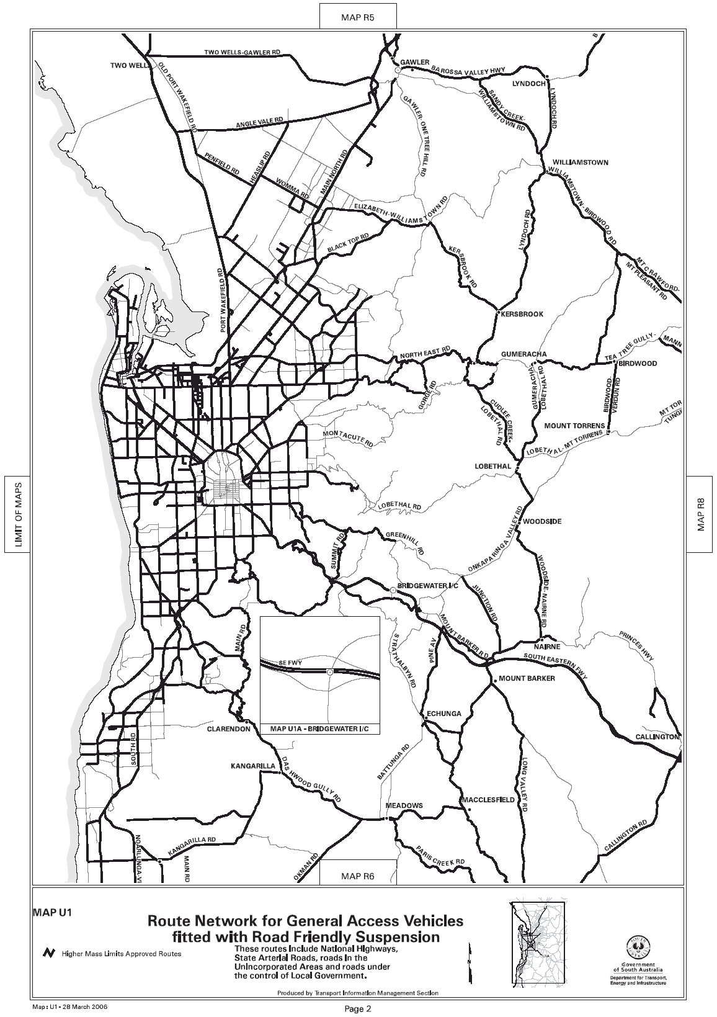
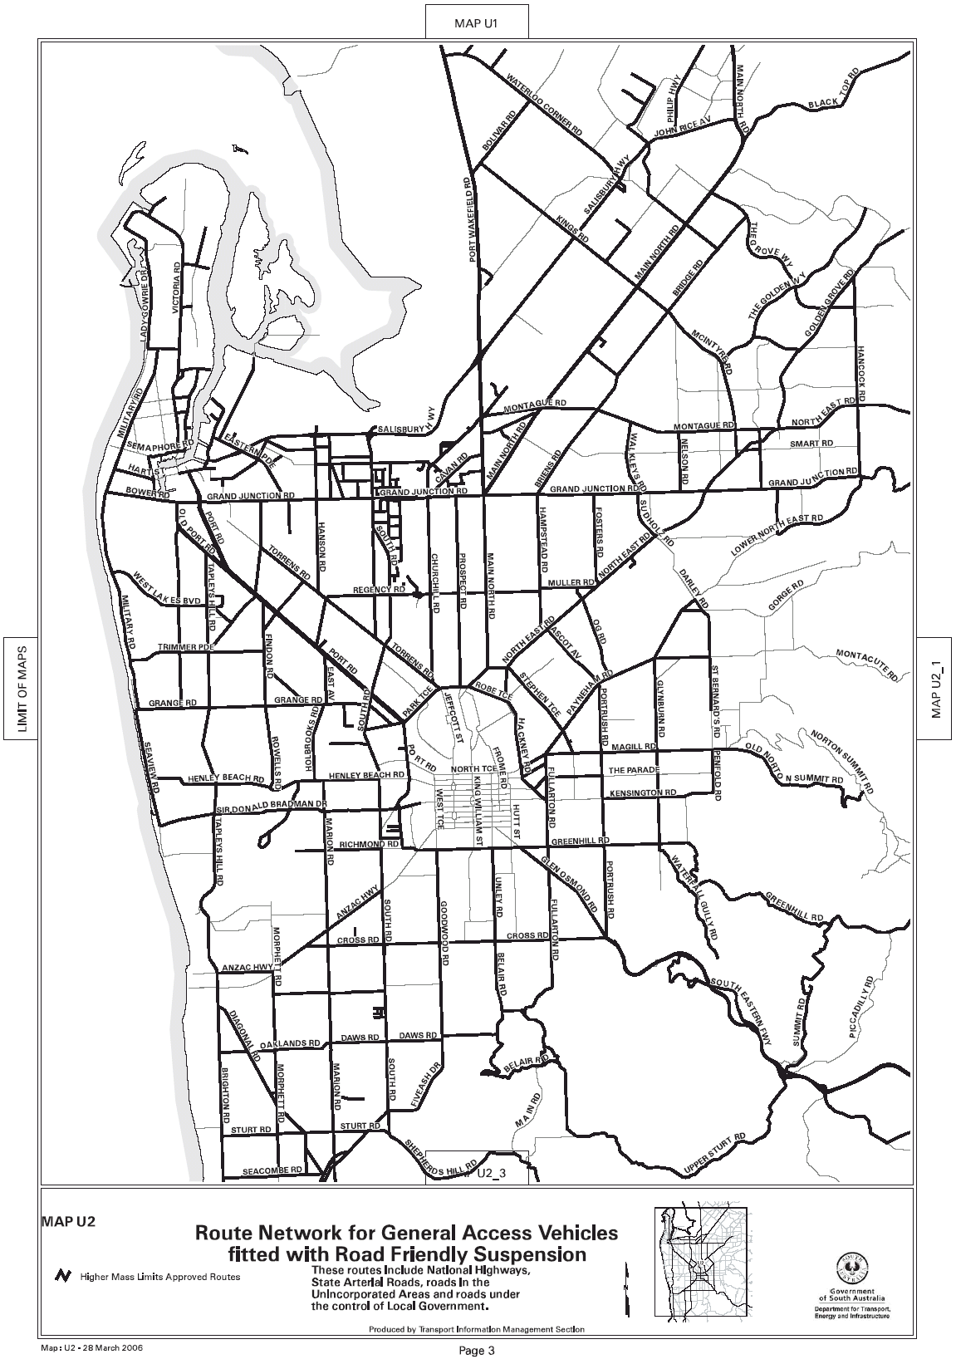
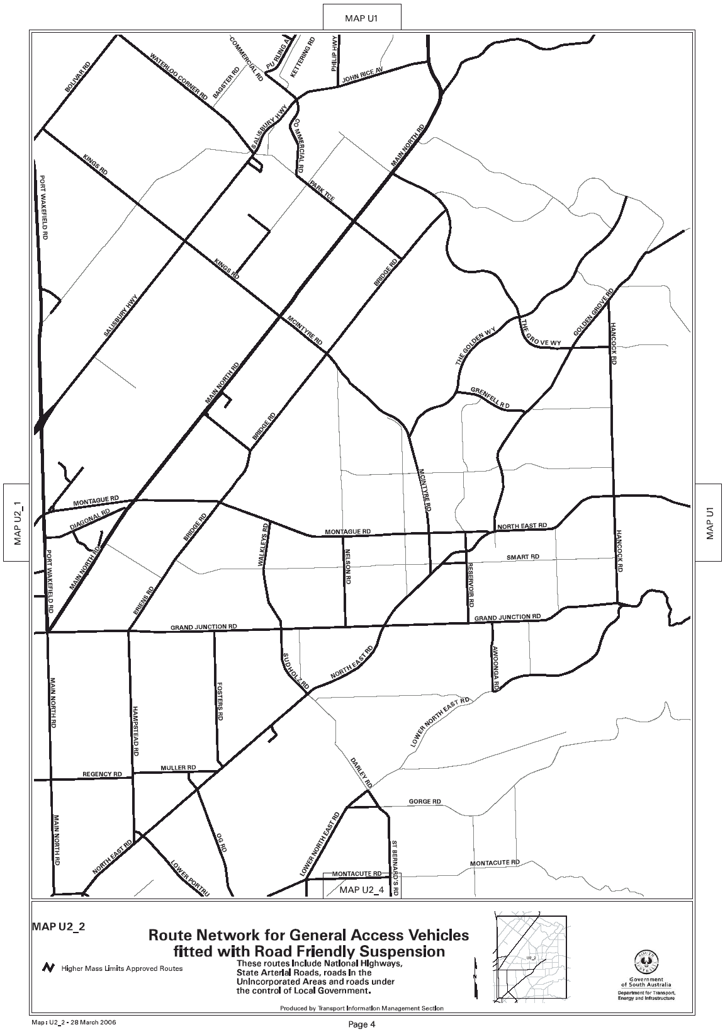

ROAD TRAFFIC ACT 1961
Supplementary Notice of Approval
Pursuant to Section 161A of the Road Traffic Act 1961
OPERATION OF B-DOUBLE VEHICLES UP TO 25 M IN LENGTH
Information Note
This Notice adds additional routes to the network that can be used by B-Double Vehicles up to 25 m in length and is a supplement to the Notice titled ‘Operation of B-Double Vehicles up to 25 m in Length’ dated 30 June 2005.

1. APPROVAL
1.1 In accordance with the powers delegated to me by the Minister for Transport under Section 163AA and of the Road Traffic Act 1961, I hereby vary the conditions of the Gazette Notice of Approval and Exemption titled, ‘Operation of B-Double Vehicles up to 25 m in Length’ dated 30 June 2005 as detailed below.

2. DEFINITIONS
2.1 In this Notice:
2.1.1 ‘Approved Vehicles’ means B-Double vehicles up to an overall length not exceeding 25 m;
2.1.2 ‘Supplementary routes’ means the approved routes specified in the maps ‘Route Network for B-Double Vehicles up to 25 m in Length’ attached to this Supplementary Notice;
2.1.3 ‘Supplementary Notice’ means this Notice;
2.1.4 ‘Primary Notice’ means the Gazette Notice ‘Operation of B-Double Vehicles up to 25 m in Length’ dated 30 June 2005; and
2.1.5 all other terms have the same meaning as in the Primary Notice.

3. APPLICATION OF SUPPLEMENTARY NOTICE
3.1 This Supplementary Notice must be read in conjunction with the Primary Notice and applies to all Approved Vehicles operating under the Primary Notice travelling on routes specified in the attached maps.

4. ROUTES AVAILABLE TO APPROVED VEHICLES
4.1 An Approved Vehicle may operate under the conditions of the Primary Notice on a supplementary route specified hereunder:
4.1.1 ‘Route Network for B-Double Vehicles up to 25 m in Length Higher Mass Limits (HML)’ Map U1;
4.1.2 ‘Route Network for B-Double Vehicles up to 25 m in Length Higher Mass Limits (HML)’ Map U2;
4.1.3 ‘Township Maps Route Network for B-Double Vehicles up to 25 m in Length Higher Mass Limits (HML)’ (Elizabeth South).

5. CONDITIONS AND LIMITATIONS APPLYING TO THIS SUPPLEMENTARY NOTICE
5.1 When operating on a route specified in the attached maps, the driver of an Approved Vehicle must:
5.1.1 continue to comply with all conditions and requirements of the Primary Notice; and
5.1.2 carry a legible, current and complete copy of:
(i) This Supplementary Notice and attached maps;
(ii) The Primary Notice;
(iii) The ‘Code of Practice for B-Doubles’ dated June 2005;
(iv) The map book titled ‘Route Network for B-Doubles’ dated June 2005; and
5.1.3 produce these documents when requested by a DTEI Transport Safety Compliance Officer appointed under the Road Traffic Act 1961 and/or the Motor Vehicles Act 1959 or a Police Officer.

6. COMMENCEMENT OF THIS NOTICE
6.1 This Notice is effective from 12.01 a.m. on 3 April 2006.

EXECUTIVE DIRECTOR,
SAFETY AND REGULATION DIVISION
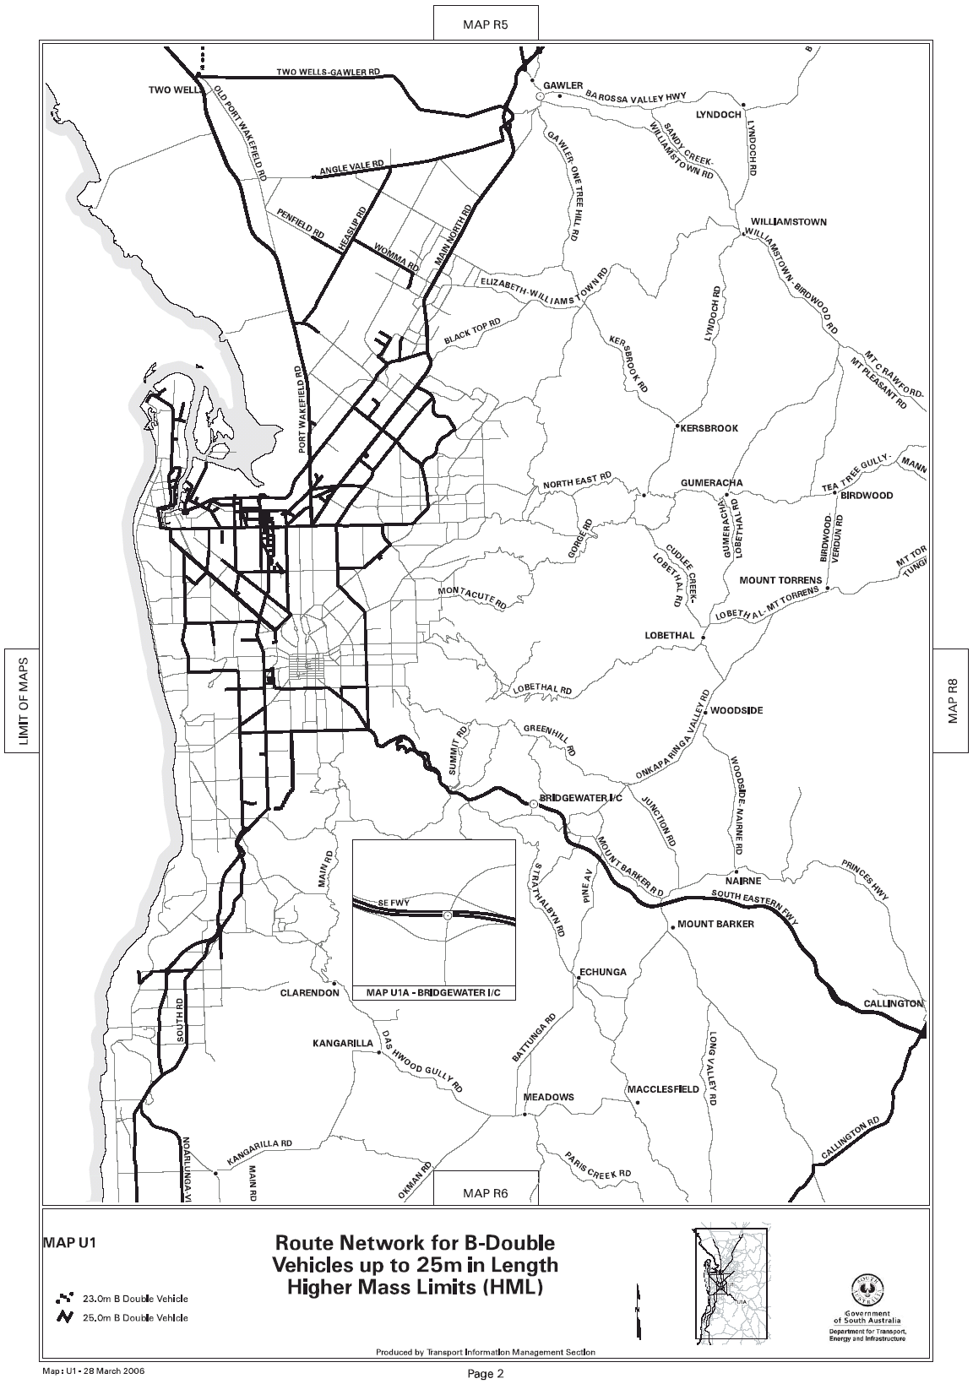
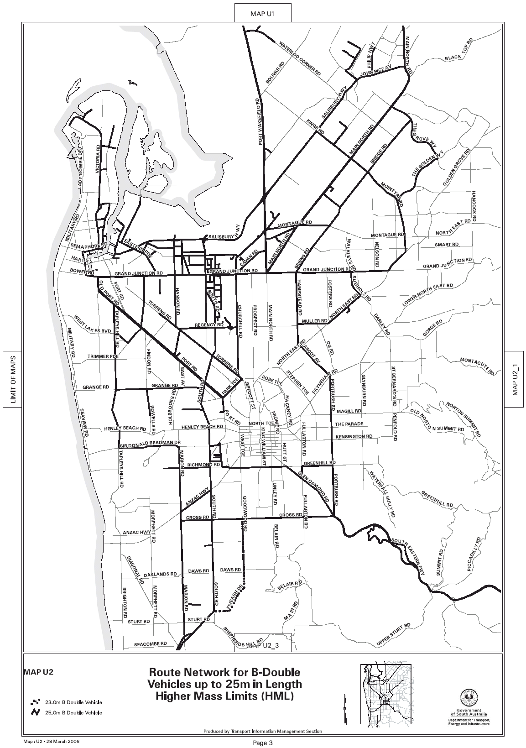
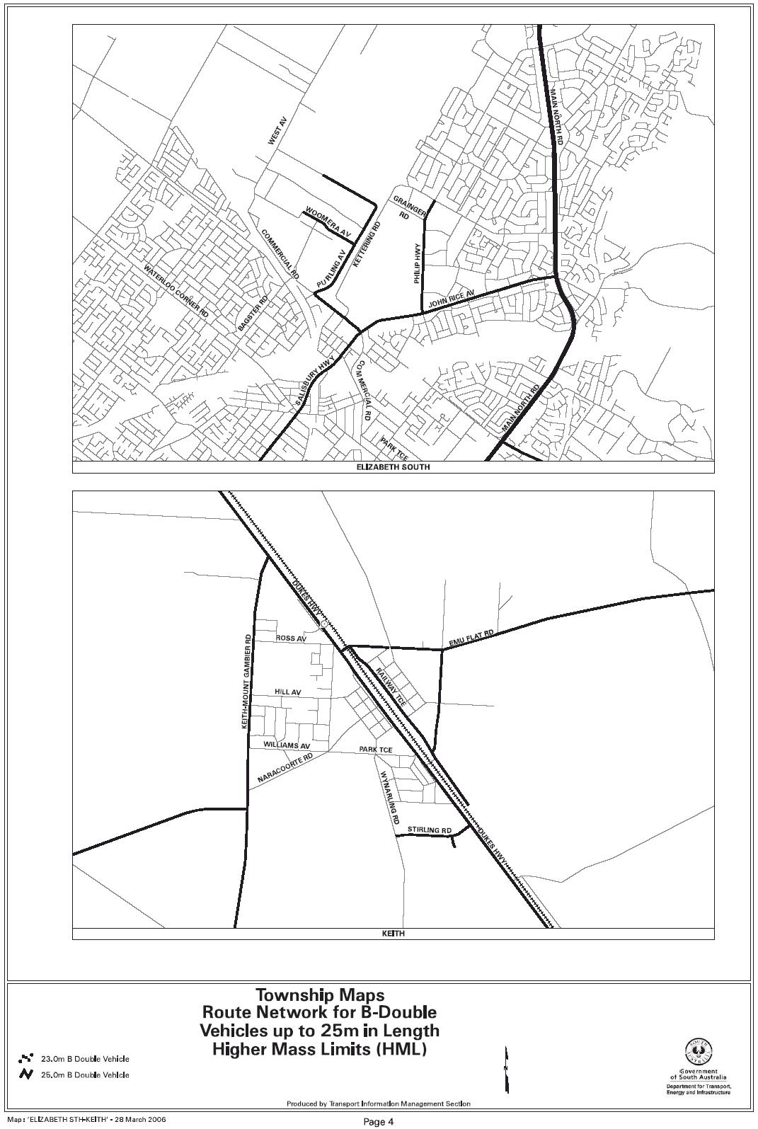

NOTICE TO MARINERS
No. 16 of 2006
South Australia—Spencer Gulf—Port Broughton—Outer Channel—Beacons Established
MARINERS are advised following recent soundings of the Port Broughton Approach Channel, the following top-marked, unlit channel beacons have been established:
Port Hand Beacon in Position:
Latitude 33°33.745′S
Longitude 137°52.797′E
Starboard Hand Beacon in Position:
Latitude 33°33.683′S
Longitude 137°52.745′E
All co-ordinates are WGS 84.
Mariners are further advised to use caution in approaching the channel without local knowledge.
A charlet is published accompanying this notice. A copy of which will be available from the office of the District Council of Barunga West, Port Broughton.
Charts affected: Aus 778
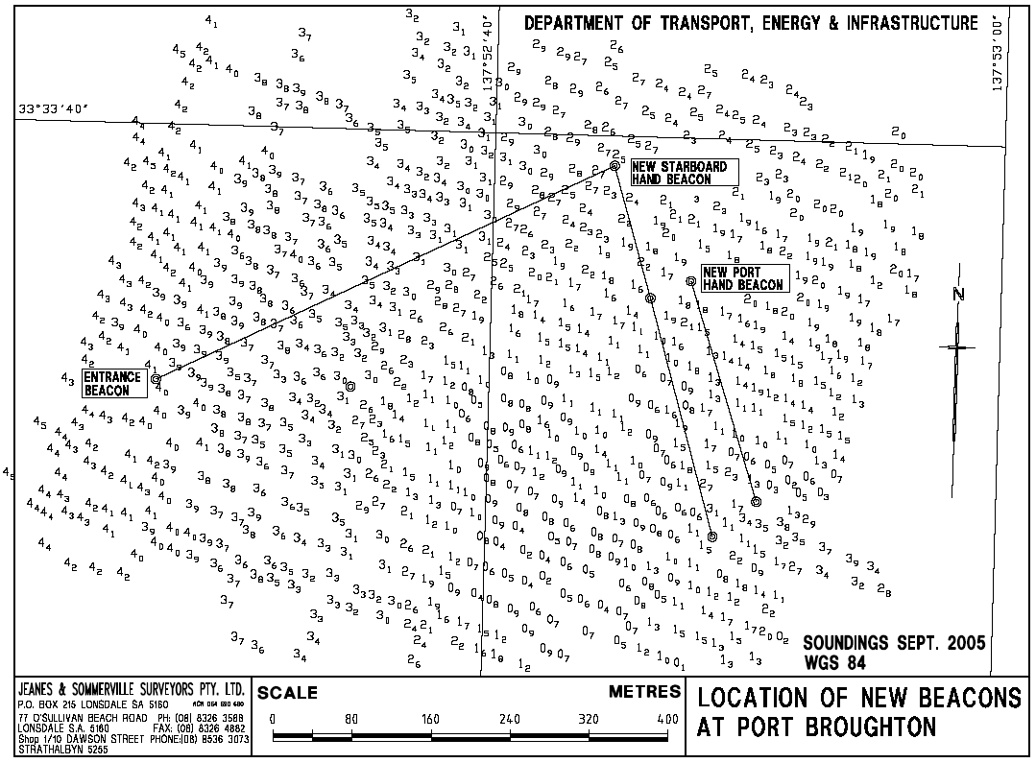
Publications affected: SA Waters Map CW 8C, page 207.

Adelaide, 20 March 2006.
Patrick Conlon, Minister for Transport

NOTICE TO MARINERS
No. 17 of 2006
South Australia—West Coast—Approaches to Thevenard—North Cardinal Marker
MARINERS are advised that the North Cardinal Buoy marking the Eleni-K wreck has been repaired and re-installed in position latitude 32°17.501′S and longitude 133°31.310′E.
Charts affected: Aus 120.
Adelaide, 24 March 2006.
Patrick Conlon, Minister for Transport
TSA 2006/00419

NOTICE TO MARINERS
No. 18 of 2006
South Australia—Approaches to Port Lincoln. BHP Approach South—No. 2 Beacon Damaged
MARINERS are advised that BHP No. 2 Beacon (FR 2 secs) in position latitude 34°45.13′S and longitude 135°53.86′E, has been damaged and withdrawn for repairs. Mariners are advised to exercise caution when navigating in the vicinity. The beacon will be re-installed on completion of repairs.
Charts affected: Aus 134.
List of Lights: Vol. K, No. 1881.4.
Adelaide, 24 March 2006.
Patrick Conlon, Minister for Transport
TSA 2006/00419

NOTICE TO MARINERS
No. 19 of 2006
South Australia—Barker Inlet, Section Bank (Entrance) Light Characteristics Altered
MARINERS are advised that the light in position latitude 34°44.058′S and longitude 138°27.922′E, has been repaired and the light characteristics have been altered to Flashing White every 5 seconds, range 5 nautical miles.
Charts affected: Aus 781.
Adelaide, 27 March 2006.
Patrick Conlon, Minister for Transport
TSA 2006/00419

FAXING COPY?
IF you fax copy to Government Publishing SA for inclusion in the Government Gazette, there is no need to send a Confirmation Copy to us as well.
This creates confusion and may well result in your notice being printed twice.
Please use the following fax number:
Fax transmission: (08) 8207 1040
Phone Inquiries: (08) 8207 1045
Please include a contact person, phone number and order number so that we can phone back with any queries we may have regarding the fax copy.
NOTE: Closing time for lodging new copy (fax, hard copy or email) is 4 p.m. on Tuesday preceding the day of publication.

Government Gazette notices can be E-mailed.
The address is:
governmentgazette@saugov.sa.gov.au
Documents should be sent as attachments in Word format.
When sending a document via E-mail, please confirm your transmission with a faxed copy of your document, including the date the notice is to be published.
Fax transmission: (08) 8207 1040
Enquiries: (08) 8207 1045
NOTE: Closing time for lodging new copy (fax, hard copy or email) is 4 p.m. on Tuesday preceding the day of publication.

CITY OF TEA TREE GULLY
Development Act 1993
Golden Grove District Centre and Adjacent Areas Plan Amendment Report—Draft for Public Consultation
NOTICE is hereby given that the City of Tea Tree Gully has prepared a draft Plan Amendment Report to amend the Develop-ment Plan as it affects the Golden Grove District Centre Zone and adjacent non-residential areas within the City of Tea Tree Gully.
The Plan Amendment Report will amend the Development Plan by amending the policies and the Policy Areas in the existing Golden Grove District Centre Zone and rezone the existing:
• Golden Grove Special Use A Zone;
• The Golden Grove District Commercial Zone (east of The Grove Way);
• Golden Grove Community Zone (south of The Golden Way),
to Golden Grove District Centre Zone and introduce new Policy Areas within the Zone to allow for distinctive forms of develop-ment within each of the Policy Areas.
The draft Plan Amendment Report will be available for viewing and purchase during normal office hours from the Tea Tree Gully Civic Centre, 571 Montague Road, Modbury, S.A. 5092, from 30 March 2006 to 31 May 2006. A copy of the Plan Amendment Report can be purchased from the Council for $5. The document will also be available for viewing at the City of Tea Tree Gully Library.
The Plan Amendment Report can also be viewed on the Council’s website:
www.teatreegully.sa.gov.au
via Council and Consultation Documents.
Written submissions regarding the draft amendment will be accepted by the City of Tea Tree Gully until the close of business on 31 May 2006. Submissions should be addressed to:
The Chief Executive Officer
City of Tea Tree Gully
P.O. Box 571
Modbury, S.A. 5092
Fax.: 8397 7400
Email: cttg@cttg.sa.gov.au
Copies of all submissions will be available for inspection by interested persons during business hours from 5 June 2006 until the date of the public hearing at the following locations:
City of Tea Tree Gully Civic Centre and/or Library
571 Montague Road
Modbury, S.A. 5092
A public hearing will be held at 7 p.m. at the Civic Centre, 571 Montague Road, Modbury on Tuesday, 13 June 2006 provided that at least one submission indicates an interest in being heard by Council.
Dated 30 March 2006.
G. J. Perkin, Chief Executive Officer

KINGSTON DISTRICT COUNCIL
Eleventh Schedule
Fire and Emergency Services Act 2005: Regulation 34—Declaration of an Area of the State in Which a Person May Operate a Gas Fire or Electric Element for Cooking Purposes in the Open Air Contrary to the Terms of a Total Fire Ban
NOTICE is hereby given that, pursuant to Regulations under the Fire and Emergency Services Act 2005, the Kingston District Council declares that persons may operate gas fires or electric elements for cooking purposes in the open air contrary to the terms of a total fire ban at the following places:
(a) Northern end of Cape Jaffa foreshore reserve, being portion of Lot 30, Hundred of Mount Benson.
(b) Thredgold Beach foreshore reserve, being portion of Section 501, Hundred of Lacepede.
(c) Lions Park area, being portion of Section 469, Hundred of Lacepede.
(d) Kingston Caravan Park, being portion of Section 501, Hundred of Lacepede.
(e) Apex Park area, being portion of Section 572, Hundred of Lacepede.
This notice operates at all times until revoked.
The operation of a gas fire or electric element under this notice is subject to the following conditions:
(1) The space immediately around and above the gas fire or electric element must be cleared of all flammable material to a distance of at least four metres.
(2) A person who is able to control the gas fire or electric element must be present at all times while it is lighted or charged.
(3) An appropriate agent adequate to extinguish any fire must be at hand.
Dated 23 March 2006.
M. R. McCarthy, Chief Executive Officer

KINGSTON DISTRICT COUNCIL
Roads (Opening and Closing) Act 1991
Marine Parade (South of Jetty), Kingston SE
NOTICE is hereby given that, pursuant to section 10 of the Roads (Opening and Closing) Act 1991, the Kingston District Council hereby gives notice of its intent to implement a Road Process Order to close and retain portion of Marine Parade (public road) adjoining the southern side of the jetty (Section 477, Hundred of Lacepede) more particularly delineated and lettered ‘A’ on Preliminary Plan No. 06/0020.
A copy of the plan and a statement of persons affected are available for public inspection at the office of the Council, 29 Holland Street, Kingston SE and the Adelaide office of the Surveyor-General during normal office hours.
Any application for easement or objection must set out the full name, address and details of the submission and must be fully supported by reasons.
The application for easement or objection must be made in writing to the Council, P.O. Box 321, Kingston SE, S.A. 5275 within 28 days of this notice and a copy must be forwarded to the Surveyor-General, G.P.O. Box 1354, Adelaide, S.A. 5001.
Where a submission is made, the Council will give notification of a meeting at which the matter will be considered.
M. R. McCarthy, Chief Executive Officer

DISTRICT COUNCIL OF ROBE
Naming of Roads
NOTICE is hereby given that, pursuant to section 219 of the Local Government Act 1999, the District Council of Robe, dated 14 March 2006, resolved that the following road reserves (Resolution No. 317/2006) be known and named accordingly:
Road 101 located at Lot 50, Section 310, 101 Main Road, Plan D63002, CT5907/557, Development Application No. 822/106/03, Hundred of Waterhouse be officially named Colin’s Court.
Road 102 located at Lot 50, Section 310, 101 Main Road, Plan D63002, CT5907/557, Development Application No. 822/106/03, Hundred of Waterhouse be officially named Mary Ellen Court.
G. Sanford, Manager, Works

DISTRICT COUNCIL OF STREAKY BAY
Appointment
NOTICE is hereby given that Fiona Carey has been appointed Acting Chief Executive Officer for the period 7 April 2006 to 13 April 2006, both dates inclusive.
J. Rumbelow, Chief Executive Officer

DISTRICT COUNCIL OF STREAKY BAY
Renaming of Road
NOTICE is hereby given that pursuant to section 219 of the Local Government Act 1999, I advise of the following road name which Council assigned at their meeting held on 15 March 2006:
Howard Road—Road from the Eyre Highway between sections 29 and 30, Hundred of Perlubie.
J. Rumbelow, Chief Executive Officer

IN the matter of the estates of the undermentioned deceased persons:
Bottomley, Thomas Arthur, late of 2 Jelley Street, Woodville, retired driver, who died on 2 February 2006.
Cologne, Edith, late of 5 Gill Court, Semaphore Park, home duties, who died on 6 November 2005.
Dannenberg, Amanda Kate, late of 6 Erica Court, Parafield Gardens, of no occupation, who died on 29 December 2005.
Harris, Betty, late of 10 Keith Street, Para Hills, of no occupation, who died on 8 January 2006.
Harris, Colin Walter Dickinson, late of Everard Street, Largs Bay, retired railway employee, who died on 26 December 2005.
Jones, Leonard Harold, late of 37 Bay Road, Moonta Bay, retired truck driver, who died on 17 December 2005.
Koschak, Alfred, late of 278 Cross Road, Clarence Park, retired bus driver, who died on 20 January 2006.
Parkhill, Ronald Edward, late of 40 Portland Road, Elizabeth East, retired stores clerk, who died on 4 November 2005.
Pearce, Jean Olive Joyce, late of 71 Stokes Terrace, Port Augusta West, of no occupation, who died on 13 October 2005.
Prosser, Iris Joyce, late of 22A Cross Road, Myrtle Bank, of no occupation, who died on 22 January 2006.
Scragg, George Henry, late of 134 Main South Road, Yanka-lilla, retired engineer, who died on 1 February 2006.
Simmons, Dorothy Christiana Marie, late of 1 Wilson Avenue, Black Forest, of no occupation, who died on 7 January 2006.
Tiller, John Charles Keith, late of Sturdee Street, Linden Park, of no occupation, who died on 19 January 2005.
van Ek, Hendrika, late of 17 Graham Avenue, Hackham, of no occupation, who died on 7 December 2005.
Wilkinson, Eric Henry, late of 3A Richmond Road, Westbourne Park, retired clerk, who died on 6 February 2006.
Notice is hereby given pursuant to the Trustee Act 1936, as amended, the Inheritance (Family Provision) Act 1972, and the Family Relationships Act 1975, that all creditors, beneficiaries, and other persons having claims against the said estates are required to send, in writing, to the Public Trustee, 25 Franklin Street, Adelaide, S.A. 5000, full particulars and proof of such claims, on or before 28 April 2006, otherwise they will be excluded from the distribution of the said estate; and notice is also hereby given that all persons who are indebted to the said estates are required to pay the amount of their debts to the Public Trustee or proceedings will be taken for the recovery thereof; and all persons having any property belonging to the said estates are forthwith to deliver the same to the Public Trustee.
Dated 30 March 2006.
C. J. O’Loughlin, Public Trustee

ATOKAN PTY LIMITED
(IN LIQUIDATION)
Notice of Final Meeting
NOTICE is hereby given that a final meeting of the members and creditors of the company will be held at the offices of MC, Chartered Accountants, 1st Floor, Menai House, 17 Bagot Street, North Adelaide, on 1 May 2006, at 10 a.m.
Agenda
1. To receive a final report from the liquidator showing how the winding up has been conducted and the property of the company has been disposed of and giving any necessary explanation of the account.
2. Any other business.
Dated 27 March 2006.
B. M. Mansom, Liquidator

THE CONSTELLATION GROUP PTY LIMITED
(IN LIQUIDATION)
Notice of Final Meeting
NOTICE is hereby given that a final meeting of the members and creditors of the company will be held at the offices of MC, Chartered Accountants, 1st Floor, Menai House, 17 Bagot Street, North Adelaide, on 1 May 2006, at 11 a.m.
Agenda
1. To receive a final report from the liquidator showing how the winding up has been conducted and the property of the company has been disposed of and giving any necessary explanation of the account.
2. Any other business.
Dated 27 March 2006.
B. M. Mansom, Liquidator

EQUITY TREE (1971) CO-OPERATIVE LIMITED
(IN VOLUNTARY LIQUIDATION)
NOTICE is hereby given that by special postal ballot, it was resolved on 21 March 2006, ‘That the co-operative be wound up voluntarily in accordance with the provisions of the Co-operatives Act 1997 and the Corporations Act 2001, relating to members voluntary winding up and that George Divitkos, be appointed liquidator for the purpose of such winding up’.
Dated 21 March 2006.
G. Divitkos, Liquidator, BDO Chartered Accountants & Advisers, 248 Flinders Street, Adelaide, S.A. 5000.

GLOWFALL PTY LIMITED (IN LIQUIDATION)
(Formerly Trading as S.A. Diesels)
Notice of Intention to Declare a Dividend
A SECOND and final dividend is to be declared on 5 May 2006, for the company.
Creditors whose debts or claims have not already been admitted are required on or before 1 May 2006, formally to prove their debts or claims. If they do not, they will be excluded from the benefit of this dividend.
Dated 24 March 2006.
B. M. Mansom, 1st Floor, Menai House, 17 Bagot Street, North Adelaide, S.A. 5006.

HATIRA PTY LIMITED
(IN LIQUIDATION)
Notice of Final Meeting
NOTICE is hereby given that a final meeting of the members and creditors of the company will be held at the offices of MC, Chartered Accountants, 1st Floor, Menai House, 17 Bagot Street, North Adelaide, on 1 May 2006, at 10.30 a.m.
Agenda
1. To receive a final report from the liquidator showing how the winding up has been conducted and the property of the company has been disposed of and giving any necessary explanation of the account.
2. Any other business.
Dated 27 March 2006.
B. M. Mansom, Liquidator

KEARNS FOR KASH PTY LIMITED
(IN LIQUIDATION)
Notice of Final Meeting
NOTICE is hereby given that a final meeting of the members and creditors of the company will be held at the offices of MC, Chartered Accountants, 1st Floor, Menai House, 17 Bagot Street, North Adelaide, on 1 May 2006, at 10.15 a.m.
Agenda
1. To receive a final report from the liquidator showing how the winding up has been conducted and the property of the company has been disposed of and giving any necessary explanation of the account.
2. Any other business.
Dated 27 March 2006.
B. M. Mansom, Liquidator

KEARNS BROTHERS (AUCTIONS) PTY LIMITED
(IN LIQUIDATION)
Notice of Final Meeting
NOTICE is hereby given that a final meeting of the members and creditors of the company will be held at the offices of MC, Chartered Accountants, 1st Floor, Menai House, 17 Bagot Street, North Adelaide, on 1 May 2006, at 10.45 a.m.
Agenda
1. To receive a final report from the liquidator showing how the winding up has been conducted and the property of the company has been disposed of and giving any necessary explanation of the account.
2. Any other business.
Dated 27 March 2006.
B. M. Mansom, Liquidator

SOUTH AUSTRALIA—In the Supreme Court. No. 2829 of 1991. In the matter of Perpetual Holdings Pty Limited (in liquidation) (ACN 007 914 061) and in the matter of the Corporations Law.
Notice by a Liquidator of His Intention to Seek His Release
Take notice that I, Barrie Malcolm Mansom, 1st Floor, Menai House, 17 Bagot Street, North Adelaide, the liquidator of the abovenamed company, intend to make application to the Supreme Court of South Australia for my release as the liquidator of the abovenamed company.
And take further notice that if you have any objection to the granting of my release you must file at the Supreme Court and also forward to me within 21 days of the publication in the Gazette of the notice of my intention to apply for a release a notice of objection in the form laid down by the Corporations (South Australia) Rules 1993.
Dated 23 March 2006.
B. M. Mansom, Liquidator
Note: Section 481 of the Corporations Law enacts that an order of the Court releasing a liquidator shall discharge him/her in the administration of the affairs of the company, or otherwise in relation to his or her conduct as liquidator, but any such order may be revoked on proof that it was obtained by fraud or by suppres-sion or by concealment of any material fact.

PARISH PRINT ASSOCIATION INCORPORATED
(IN LIQUIDATION)
(ABN 15 663 088 664)
Notice Inviting Formal Proof of Debt or Claim
TAKE notice that creditors of the association, whose debts or claims have not already been admitted, are required on or before 6 April 2006, to prove their debts or claims and to establish any title they may have to priority by delivering or sending through the post to me at my address a formal proof of debt or claim in accordance with Forms 535 and 536 containing their respective debts or claims. In default they will be excluded from the benefit of any distribution made before their debts or claims are proved or their priority is established and from objecting to the distribution.
Form of proof may be obtained from this office.
Dated 30 March 2006.
M. McClaren, Liquidator, for Bentleys MRI, 64 Greenhill Road, Wayville, S.A. 5034.

UNCLAIMED MONEYS ACT 1891
Register of Unclaimed Moneys Held by Esanda Finance Corporation Limited

Name and Address of Owner  on Books | Total Amount  Due to  Owner  $ | Description of  Unclaimed Moneys |  | Date  Payable
Allen, Johanna Krystina, 4 Raymond Street, Henley Beach, S.A. 5022 | 117.50 | Principal and Interest | 12.9.98
Arno Bay Country Fire Service, P.O. Box 35, Arno Bay, S.A. 5603 | 71.25 | Principal and Interest | 28.10.99
Arthurton Basketball Club, P.O. Box 37, Arthurton, S.A. 5572 | 14.79 | Principal and Interest | 10.4.99
Athelstone Youth Centre (Inc.), 27 Burton Road, Athelstone, S.A. 5076 | 261.04 | Principal and Interest | 11.3.98
Bastian, Fiona Judith, 13 Cypress Street, Highfields, Qld 4352 | 22.15 | Principal and Interest | 1.1.00
Bastian, Fiona Judith, 13 Cypress Street, Highfields, Qld 4352 | 10.89 | Principal and Interest | 23.12.99
Bastian, Fiona Judith, 13 Cypress Street, Highfields, Qld 4352 | 21.42 | Principal and Interest | 1.10.99
Bastian, Fiona Judith, 13 Cypress Street, Highfields, Qld 4352 | 10.71 | Principal and Interest | 23.9.99
Bastian, Fiona Judith, 13 Cypress Street, Highfields, Qld 4352 | 20.30 | Principal and Interest | 1.7.99
Bastian, Fiona Judith, 13 Cypress Street, Highfields, Qld 4352 | 10.21 | Principal and Interest | 23.6.99
Camerlengo, Dominique Antionette, 6 Stanley Avenue, Fulham Gardens, S.A. 5024 | 52.92 | Principal and Interest | 11.1.00
Cameron, Robert Scott, 1 Fraser Street, Henley Beach South, S.A. 5022 | 105.42 | Principal and Interest | 13.8.98
Casey, Amy Renee, 15 Young Street, Seacliff, S.A. 5049 | 18.35 | Principal and Interest | 3.11.98
Charter Financial Planning, 17-23 Carrington Street, Adelaide, S.A. 5000 | 250.00 | Brokerage | 23.7.98
Coen, Mary Denise, 22 Grenfell Street, Adelaide, S.A. 5000 | 68.75 | Principal and Interest | 7.4.99
Coen, Mary Denise, 22 Grenfell Street, Adelaide, S.A. 5000 | 68.75 | Principal and Interest | 7.1.99
Cunningham, Suzanne Wendy, c/o Post Office, Penola, S.A. 5277 | 11.85 | Principal and Interest | 18.5.99
Dawkins, Margaret S., 7/38 Simcock Street, West Beach, S.A. 5024 | 22.38 | Principal and Interest | 10.9.98
Dawkins, Margaret S., 7/38 Simcock Street, West Beach, S.A. 5024 | 22.38 | Principal and Interest | 10.6.98
Dawkins, Margaret S., 7/38 Simcock Street, West Beach, S.A. 5024 | 22.38 | Principal and Interest | 10.3.98
Dawkins, Margaret S., 7/38 Simcock Street, West Beach, S.A. 5024 | 1 000.00 | Principal | 10.9.98
Diss, Emily Lynne, P.O. Box 433, Mount Gambier, S.A. 5290 | 24.72 | Principal and Interest | 10.6.99
Dodds, Stanley Chia-Ming, 24 Oak Avenue, Clovelly Park, S.A. 5042 | 39.45 | Principal and Interest | 4.4.99
Dodds, Stanley Chia-Ming, 24 Oak Avenue, Clovelly Park, S.A. 5042 | 41.04 | Principal and Interest | 4.10.98
Dodds, Stanley Chia-Ming, 24 Oak Avenue, Clovelly Park, S.A. 5042 | 36.27 | Principal and Interest | 4.1.98
Drewry, David Clifton, 90 Aldinga Road, Willunga, S.A. 5172 | 35.63 | Principal and Interest | 22.12.99
Drewry, David Clifton, 90 Aldinga Road, Willunga, S.A. 5172 | 1 280.20 | Principal and Interest | 28.3.99
Drewry, David Clifton, 90 Aldinga Road, Willunga, S.A. 5172 | 36.38 | Principal and Interest | 22.3.99
Drewry, David Clifton, 90 Aldinga Road, Willunga, S.A. 5172 | 48.50 | Principal and Interest | 22.12.98
Dubrowsky, Olga, 5/537 Greenhill Road, Hazelwood Park, S.A. 5066 | 484.67 | Principal and Interest | 19.11.99
Dyer, David John, 7 Josephine Street, Highbury, S.A. 5089 | 16.20 | Principal and Interest | 19.8.99
Edson, Lyndall Mariah and Edson, Mitchell Bennett, 22 Ryde Street, Gawler West, S.A. 5118 | 848.56 | Principal and Interest | 21.8.99
EWC Morton Nominees Pty Ltd, 1 Clyde Road, Hawthorndene, S.A. 5051 | 356.25 | Brokerage | 18.11.99
Faraway Nominees Pty Ltd, G.P.O. Box 1147, Adelaide, S.A. 5001 | 132.26 | Principal and Interest | 20.6.98
Field, Mary Patricia, 6 Suffolk Road, Aldgate, S.A. 5154 | 54.38 | Principal and Interest | 28.2.98
Field, Mary Patricia, 6 Suffolk Road, Aldgate, S.A. 5154 | 68.75 | Principal and Interest | 26.1.98
Fountain, Stephanie Servante, G.P.O. Box 546, Adelaide, S.A. 5001 | 13.78 | Principal and Interest | 8.12.98
Fragnito, Nazzareno and Fragnito, Georgina, 85 Phillis Street, May-lands, S.A. 5069 | 1 500.00 | Principal | 7.3.98
Gallaway, Phyllis Christina, 11 Debra Court, Netley, S.A. 5037 | 19.13 | Principal and Interest | 30.11.99
Gallaway, Phyllis Christina, 11 Debra Court, Netley, S.A. 5037 | 19.13 | Principal and Interest | 31.8.99
Gallaway, Phyllis Christina, 11 Debra Court, Netley, S.A. 5037 | 19.13 | Principal and Interest | 31.5.99
Gallaway, Phyllis Christina, 11 Debra Court, Netley, S.A. 5037 | 19.13 | Principal and Interest | 28.2.99
Gallaway, Phyllis Christina, 11 Debra Court, Netley, S.A. 5037 | 19.13 | Principal and Interest | 30.11.98
Gallaway, Phyllis Christina, 11 Debra Court, Netley, S.A. 5037 | 27.19 | Principal and Interest | 31.5.98
Gallaway, Phyllis Christina, 11 Debra Court, Netley, S.A. 5037 | 27.19 | Principal and Interest | 28.2.98
Glenane, Graham Vincent and Glenane, Rosita Margaret, 2 Quinton Court, West Albury, N.S.W. 2640 | 154.00 | Principal and Interest | 17.10.98
Goody, Pamela, Unit 9, Fotheringham Terrace, Gawler, S.A. 5118 | 36.27 | Principal and Interest | 9.11.99
Hall, Brian Thomas and Hall, Robin Merilyn, 8 Tarakan Avenue, Enfield, S.A. 5085 | 3 438.92 | Principal and Interest | 19.3.98
Hall, Leonie, Unit 1/8 Sunglo Court, Teringie, S.A. 5072 | 11.75 | Principal and Interest | 8.10.99
Halton, James Antony and Halton, Angela Marie, 13 Wilhelmina Street, Kingston, S.A. 5275 | 16.24 | Principal and Interest | 10.10.98
Harvey, Shelly Lee, 13 Dob Street, Port Lincoln, S.A. 5606 | 66.35 | Principal and Interest | 24.10.98
Hawley, Thomas Edward, 144 Ward Street, North Adelaide, S.A. 5006 | 253.56 | Principal and Interest | 11.2.99
Henderson, John F., P.O. Box 137, Burnside, S.A. 5066 | 29.59 | Principal and Interest | 7.8.98
Hoey, Amanda Jayne, 18 Ringmer Drive, Burnside, S.A. 5066 | 27.86 | Principal and Interest | 29.12.98
Hoey, Amanda Jayne, 18 Ringmer Drive, Burnside, S.A. 5066 | 26.17 | Principal and Interest | 29.9.98
Hunt, Torrie Stoddart, Kil Lel, Bordertown, S.A. 5268 | 170.63 | Principal and Interest | 8.9.99
Hunt, Torrie Stoddart, Kil Lel, Bordertown, S.A. 5268 | 170.63 | Principal and Interest | 8.6.99
Irving, Hilda Vera Adelaide (deceased), P.O. Box 1, Kybybolite, S.A. 5262 | 95.16 | Principal and Interest | 21.9.99
Jarek, Ethel May (deceased), P.O. Box 324, Naracoorte, S.A. 5271 | 39.62 | Principal and Interest | 2.10.98
Johnson, Ernest Bruce (deceased) and Johnson, Dorothy Marie (deceased), 55 Gray Street, Plympton, S.A. 5038 | 82.09 | Principal and Interest | 17.8.99
Jolley, Lewis Raymond (deceased) and Jolley, Coral Lillian E. (deceased), G.P.O. Box 365, Adelaide, S.A. 5001 | 247.50 | Principal and Interest | 10.1.99
Jolley, Lewis Raymond (deceased) and Jolley, Coral Lillian E. (deceased), G.P.O. Box 365, Adelaide, S.A. 5001 | 247.50 | Principal and Interest | 10.7.98
Jose, David John, 20 Sedgehill Road, Elizabeth North, S.A. 5113 | 825.81 | Principal and Interest | 30.3.99
Kasim, Peter, 3/3 Halifax Street, Hilton, S.A. 5033 | 29.61 | Principal and Interest | 13.11.99
Lakin, Mary Helen, P.O. Box 2282, Port Lincoln, S.A. 5606 | 32.55 | Principal and Interest | 13.2.99
Larum, Beatrice Grace, 9 Bayview Crescent, Beaumont, S.A. 5066 | 1 000.00 | Principal | 15.10.98
Lightfoot, Andrew Paul and Lightfoot, Derek James, 15 Blue Gum Road, Morphett Vale, S.A. 5162 | 19.31 | Principal and Interest | 7.4.99
Lim, Mee Lee, 10 Gurrs Road, Kensington Park, S.A. 5068 | 15.34 | Principal and Interest | 19.2.98
Lim, Mee Lee, 10 Gurrs Road, Kensington Park, S.A. 5068 | 31.97 | Principal and Interest | 9.1.98
Lobethal Centennial Hall Inc., 5 Church Street, Lobethal, S.A. 5241 | 33.10 | Principal and Interest | 4.8.99
Lobethal Centennial Hall Inc., 5 Church Street, Lobethal, S.A. 5241 | 30.77 | Principal and Interest | 4.5.99
Lymn, Reginald Bert (deceased), G.P.O. Box 1338, Adelaide, S.A. 5001 | 28.50 | Principal and Interest | 22.8.98
Lymn, Reginald Bert (deceased), G.P.O. Box 1338, Adelaide, S.A. 5001 | 87.75 | Principal and Interest | 18.8.98
Macquarie Financial Services, G.P.O. Box 663, Adelaide, S.A. 5001 | 208.78 | Brokerage | 15.4.99
Matthews, Walter Bruce (deceased), 12 Price Street, Melrose Park, S.A. 5039 | 31.75 | Principal and Interest | 16.10.98
McArthur, Donald Ivor (deceased), 117 King William Street, Adelaide, S.A. 5000 | 112.00 | Principal and Interest | 27.10.98
McLean, Phyllis E., 21 Hobart Crescent, Banksia Park, S.A. 5091 | 410.00 | Principal and Interest | 14.1.98
Merle & Pearl Investments Pty Ltd, 8/165 King William Road, Hyde Park, S.A. 5061 | 1 000.00 | Principal | 25.7.98
Miller, Cathrine Mary (deceased), G.P.O. Box 471, Adelaide, S.A. 5001 | 38.50 | Principal and Interest | 31.5.98
Minge, Carlien Dorothy, G.P.O. Box 1338, Adelaide, S.A. 5001 | 553.50 | Principal and Interest | 9.4.98
Modistach, Richard Graham (deceased), 6 Harding Street, Glen-gowrie, S.A. 5044 | 51.50 | Principal and Interest | 13.5.99
Moore, Marvin, 13/85 Spring Street, Melbourne, Vic. 3000 | 8 000.00 | Principal | 7.8.98
Mueller, Shirley J., P.O. Box 219, Birdwood, S.A. 5234 | 11.88 | Principal and Interest | 9.1.98
Ng, Jn Fatt, 519 Goodwood Road, Colonel Light Gardens, S.A. 5041 | 39.75 | Principal and Interest | 14.1.00
Norwood Junior Chamber Incorporated, P.O. Box 68, Norwood, S.A. 5067 | 10.71 | Principal and Interest | 4.11.99
Norwood Junior Chamber Incorporated, P.O. Box 68, Norwood, S.A. 5067 | 10.49 | Principal and Interest | 4.8.99
Nuske, Edwin Arthur (deceased), P.O. Box 221, Murray Bridge, S.A. 5253 | 155.25 | Principal and Interest | 6.4.99
Passauer, Richard William, P.O. Box 43, Mount Gambier, S.A. 5290 | 29.33 | Principal and Interest | 15.11.99
Passauer, Richard William, P.O. Box 43, Mount Gambier, S.A. 5290 | 44.25 | Principal and Interest | 11.11.99
Passauer, Richard William, P.O. Box 43, Mount Gambier, S.A. 5290 | 19.53 | Principal and Interest | 15.9.99
Passauer, Richard William, P.O. Box 43, Mount Gambier, S.A. 5290 | 29.33 | Principal and Interest | 15.8.99
Passauer, Richard William, P.O. Box 43, Mount Gambier, S.A. 5290 | 44.25 | Principal and Interest | 11.8.99
Passauer, Richard William, P.O. Box 43, Mount Gambier, S.A. 5290 | 19.53 | Principal and Interest | 15.6.99
Passauer, Richard William, P.O. Box 43, Mount Gambier, S.A. 5290 | 29.33 | Principal and Interest | 15.5.99
Passauer, Richard William, P.O. Box 43, Mount Gambier, S.A. 5290 | 19.53 | Principal and Interest | 15.3.99
Passauer, Richard William, P.O. Box 43, Mount Gambier, S.A. 5290 | 29.33 | Principal and Interest | 15.2.99
Passauer, Richard William, P.O. Box 43, Mount Gambier, S.A. 5290 | 44.25 | Principal and Interest | 11.2.99
Passauer, Richard William, P.O. Box 43, Mount Gambier, S.A. 5290 | 19.53 | Principal and Interest | 15.12.98
Reichstein, Stanley Edgar (deceased), Level 5/22 Grenfell Street, Adelaide, S.A. 5001 | 39.25 | Principal and Interest | 15.7.98
Rich, Thomas Henry, 132 Cashel Street, St Marys, S.A. 5042 | 380.25 | Principal and Interest | 3.6.98
Rossetto, Silvano, 5 George Street, Torrens Park, S.A. 5062 | 10.52 | Principal and Interest | 8.10.98
Shearer, Gwen Laura, U3/2A Jervois Street, Hawthorn, S.A. 5062 | 1 600.00 | Principal and Interest | 9.8.98
Shearer, Gwen Laura, U3/2A Jervois Street, Hawthorn, S.A. 5062 | 20 000.00 | Principal | 9.8.98
Song, Yu, 16 Salisbury Crescent, Colonel Light Gardens, S.A. 5041 | 1 500.00 | Principal | 16.8.98
Soos, Josef, 7 Bridge Street, Kensington, S.A. 5068 | 46.13 | Principal and Interest | 15.6.99
Soos, Josef, 7 Bridge Street, Kensington, S.A. 5068 | 46.13 | Principal and Interest | 15.3.99
Soos, Josef, 7 Bridge Street, Kensington, S.A. 5068 | 3 000.00 | Principal | 15.6.99
Sparnon, Kristan Jy, 6/85 Fourth Avenue, St Peters, S.A. 5069 | 39.50 | Principal and Interest | 25.10.99
Sparnon, Kristan Jy, 6/85 Fourth Avenue, St Peters, S.A. 5069 | 39.50 | Principal and Interest | 25.10.98
Sparnon, Kristan Jy, 6/85 Fourth Avenue, St Peters, S.A. 5069 | 79.00 | Principal and Interest | 6.2.98
Sparnon, Kristan Jy, 6/85 Fourth Avenue, St Peters, S.A. 5069 | 500.00 | Principal | 25.10.99
Tan, Chuan Chien, Lincoln College, 45 Brougham Place, North Adelaide, S.A. 5006 | 28.01 | Principal and Interest | 10.5.99
Thomas, Helen Joanna, Post Office, Manoora, S.A. 5414 | 382.95 | Principal and Interest | 2.3.98
Tiller, Meredith Elaine, Box 193, Balaklava, S.A. 5461 | 10.85 | Principal and Interest | 19.3.99
Underdown, Joyce Ellen (deceased), 5/33 Pirie Street, Adelaide, S.A. 5000 | 81.25 | Principal and Interest | 10.6.99
Venables, Clarence Roy (deceased), 10 Gore Street, Glenelg North, S.A. 5045 | 10.86 | Principal and Interest | 26.7.99
Venables, Clarence Roy (deceased), 10 Gore Street, Glenelg North, S.A. 5045 | 10.20 | Principal and Interest | 26.1.99
Venables, Clarence Roy (deceased), 10 Gore Street, Glenelg North, S.A. 5045 | 10.11 | Principal and Interest | 26.10.98
Venables, Clarence Roy (deceased), 10 Gore Street, Glenelg North, S.A. 5045 | 10.32 | Principal and Interest | 26.7.98
Vickery, Richard John, PMB 88, Keith, S.A. 5267 | 397.47 | Principal and Interest | 5.5.98
Vickery, Richard John, PMB 88, Keith, S.A. 5267 | 205.00 | Principal and Interest | 19.1.98
Villis, Patricia Anne, 84 River Drive, Athelstone, S.A. 5076 | 87.66 | Principal and Interest | 27.4.98
Weinert, Thelma Eileen, c/o Post Office, Kersbrook, S.A. 5231 | 743.94 | Principal and Interest | 24.4.98
Weinert, Thelma Eileen, c/o Post Office, Kersbrook, S.A. 5231 | 4 500.00 | Principal | 24.4.98
Wilson, Winifred Joyce (deceased), P.O. Box 520, Kent Town, S.A. 5067 | 33.25 | Principal and Interest | 30.5.98
Wood, Shirley B. (deceased), G.P.O. Box 1338, Adelaide, S.A. 5001 | 35.06 | Principal and Interest | 28.1.98
Wood, Shirley B. (deceased), G.P.O. Box 1338, Adelaide, S.A. 5001 | 21.67 | Principal and Interest | 20.1.98
Wu, Ye, 2 Newcut Street, Hectorville, S.A. 5073 | 17.77 | Principal and Interest | 10.11.99
Yanez, Jose, 88/12 Berri Street, Port Augusta, S.A. 5700 | 130.57 | Principal and Interest | 9.1.00
Yeates, Lorna Clarice, 55 Marine Parade, Port Vincent, S.A. 5581 | 13.00 | Principal and Interest | 19.10.98
Yeates, Lorna Clarice, 55 Marine Parade, Port Vincent, S.A. 5581 | 25.00 | Principal and Interest | 18.10.98
Zilm, Simon Malcolm, 11/9 Cambridge Street, Wynn Vale, S.A. 5127 | 48.00 | Principal and Interest | 9.10.98
Zilm, Simon Malcolm, 11/9 Cambridge Street, Wynn Vale, S.A. 5127 | 600.00 | Principal | 9.10.98

ATTENTION

CUSTOMERS requiring a proof of their notice for inclusion in the Government Gazette, please note that the onus is on you to inform Government Publishing SA of any subsequent corrections by 10 a.m. on Thursday, which is our publication deadline.

For any corrections to your notice please phone 8207 1045 or Fax 8207 1040 before 10 a.m. on Thursday.

If we do not receive any communication by 10 a.m. on Thursday (day of publication) we will presume the notice is correct and will print it as it is.

Remember—the onus is on you to inform us of any corrections necessary to your notice.

NOTE: Closing time for lodging new copy (electronically, fax or hard copy) is 4 p.m. on Tuesday preceding the day of publication. Phone 8207 1045—Fax 8207 1040.
Email: governmentgazette@saugov.sa.gov.au

Printed and published by authority every Thursday by K. O’CALLAGHAN, Government Printer, South Australia
Price: $5.00, plus postage; to subscribers, $254.00 per annum.
(The above prices are inclusive of GST)

