No. 24 1185

THE SOUTH AUSTRALIAN

GOVERNMENT GAZETTE
www.governmentgazette.sa.gov.au

PUBLISHED BY AUTHORITY

ALL PUBLIC ACTS appearing in this GAZETTE are to be considered official, and obeyed as such

ADELAIDE, THURSDAY, 4 MAY 2006

CONTENTS

Page
Appointments, Resignations, Etc. 1186
Constitution Act 1934—Notices 1186
Corporations and District Councils—Notices 1268
Crown Lands Act 1929—Notices 1186
Fisheries Act 1982—Notices 1187
Geographical Names Act 1991—Notices 1190
Land and Business (Sale and Conveyancing) Act 1994—
Notices 1189
Liquor Licensing Act 1997—Notices 1191
Magistrates Court (Civil) Rules 1992—Notice 1199
Magistrates Court Rules 1992—Notice 1199
Mining Act 1971—Notices 1194
Motor Vehicles Act 1959—Notice 1196
National Electricity Law—Notice 1196
Natural Resources Management Act 2004—Notices 1196
Proclamations 1244

Page
Public Trustee Office—Administration of Estates 1270
Rail Safety Act 1996—Notice 1196
REGULATIONS
Occupational Therapists Act 1974 (No. 44 of 2006) 1247
Harbors and Navigation Act 1993 (No. 45 of 2006) 1249
Chiropodists Act 1950 (No. 46 of 2006) 1251
Zero Waste SA Act 2004 (No. 47 of 2006) 1253
Chiropractic and Osteopathy Practice Act 2005
(No. 48 of 2006) 1255
Remuneration Tribunal, Determinations of 1196
Roads (Opening and Closing) Act 1991—Notices 1197
Rules of Court 1205
Survey Act 1992—Notice 1212
Training and Skills Development Act 2003—Notice 1209
Veterinary Surgeons Board of South Australia—Register 1214
Water Mains and Sewers—Mains Laid, Replaced, Etc. 1212

GOVERNMENT GAZETTE NOTICES
ALL poundkeepers’ and private advertisements forwarded for publication in the South Australian Government Gazette must be PAID FOR PRIOR TO INSERTION; and all notices, from whatever source, should be legibly written on one side of the paper only and sent to Government Publishing SA so as to be received no later
than 4 p.m. on the Tuesday preceding the day of publication. Phone 8207 1045 or Fax 8207 1040. E-mail: governmentgazette@saugov.sa.gov.au. Send as attachments in Word format and please confirm your transmission with a faxed copy of your document, including the date the notice is to be published and to whom the notice will be charged. The Government Gazette is available online at: www.governmentgazette.sa.gov.au

Department of the Premier and Cabinet
Adelaide, 4 May 2006
HER Excellency the Governor in Executive Council has been pleased to appoint the undermentioned to the South Australian Government Financing Advisory Board, pursuant to the provisions of the Government Financing Authority Act 1982:
Member: (from 9 June 2006 until 8 June 2009)
Yvonne Sneddon
Deputy Member: (from 9 June 2006 until 8 June 2009)
Brett Gregory Rowse (Deputy to Wright)
By command,
P. Caica, for Premier
TF 06/016 CS

Department of the Premier and Cabinet
Adelaide, 4 May 2006
HER Excellency the Governor in Executive Council has been pleased to appoint the undermentioned to the Land Board, pursuant to the provisions of the Crown Lands Act 1929:
Member: (from 4 May 2006 until 3 May 2008)
Susan Ball
Jack Anthony Nicolaou
Maria Toscano
Chair: (from 4 May 2006 until 3 May 2008)
Susan Ball
Deputy Chair: (from 4 May 2006 until 3 May 2008)
Jack Anthony Nicolaou
By command,
P. Caica, for Premier
EHCS 06/0003

Department of the Premier and Cabinet
Adelaide, 4 May 2006
HER Excellency the Governor in Executive Council has been pleased to appoint the undermentioned to the Community Housing Appeal Panel, pursuant to the provisions of the South Australian Co-operative and Community Housing Act 1991:
Member: (from 4 May 2006 until 31 January 2008)
Margaret Amelia Castles
Ursula Mary Dahl
Chris Finn
Kathleen Patricia McEvoy
Frances Meredith
Member: (from 4 May 2006 until 19 October 2006)
Peter David Anderson
Nicola Dawn Ferencz
Georgina Mary Hone
Gaybrielle Cotton Kenny
Kathryn Jane Millar
Kate Warren
Chairperson: (from 4 May 2006 until 31 January 2008)
Kathleen Patricia McEvoy
By command,
P. Caica, for Premier
MFC/CS/06/008

Department of the Premier and Cabinet
Adelaide, 4 May 2006
HER Excellency the Governor in Executive Council has been pleased to appoint David Cameron Lovell, Q.C., as a Judge of the District Court of South Australia from 4 May 2006, pursuant to Section 12 of the District Court Act 1991.
By command,
P. Caica, for Premier
AGO 0071/03 CS

Department of the Premier and Cabinet
Adelaide, 4 May 2006
HER Excellency the Governor in Executive Council has been pleased to designate David Cameron Lovell, Q.C., as a Judge of the Environment, Resources and Development Court of South Australia from 4 May 2006, pursuant to Section 8 (6) of the Environment, Resources and Development Court Act 1993.
By command,
P. Caica, for Premier
AGO 0071/03 CS

Department of the Premier and Cabinet
Adelaide, 4 May 2006
HER Excellency the Governor in Executive Council has been pleased to appoint David Cameron Lovell, Q.C., as a Deputy Presiding Officer of the Equal Opportunity Tribunal for a term of three years commencing on 4 May 2006, pursuant to Section 18 of the Equal Opportunity Act 1984.
By command,
P. Caica, for Premier
AGO 0071/03 CS

CONSTITUTION ACT 1934
Section 13 (4)
Assembly to Fill Vacancy in Legislative Council
PURSUANT to a Proclamation made by Her Excellency The Governor on 6 April 2006, an assembly of Members of both Houses of Parliament was held on 2 May 2006, to fill the seat in the Legislative Council which had become vacant by virtue of the death of the Honourable Terance Gerald Roberts, MLC.
At that Assembly, Bernard Vincent Finnigan was duly elected to fill the said vacancy.
J. M. Davis, Clerk of the Assembly of Members

CONSTITUTION ACT 1934
Section 13 (4)
Assembly to Fill Vacancy in Legislative Council
PURSUANT to a Proclamation made by Her Excellency The Governor on 6 April 2006, an assembly of Members of both Houses of Parliament was held on 2 May 2006, to fill the seat in the Legislative Council which had become vacant by virtue of the resignation of the Honourable Angus John Redford, MLC.
At that Assembly, Stephen Graham Wade was duly elected to fill the said vacancy.
J. M. Davis, Clerk of the Assembly of Members

CROWN LANDS ACT 1929: SECTION 5
TAKE NOTICE that pursuant to the Crown Lands Act 1929, I, GAIL GAGO, Minister for Environment and Conservation, Minister of the Crown to whom the administration of the Crown Lands Act 1929 is committed DO HEREBY:
1. Resume the land defined in The First Schedule.
2. Dedicate the Crown Land defined in The Second Schedule as an Emergency Services Reserve and declare that such land shall be under the care, control and management of the Minister for Emergency Services.
3. Dedicate the Crown Land defined in The Third Schedule as a District Council Reserve and declare that such land shall be under the care, control and management of The District Council of Robe.
The First Schedule
Reserve for District Council Purposes, Section 127 (formerly portion), Hundred of Waterhouse, the proclamation of which was published in the Government Gazette of 4 November 1897 at page 1383, being the whole of the land comprised in Crown Record Volume 5647, Folio 297.
The Second Schedule
Allotment 1 of Deposited Plan 63771, Hundred of Waterhouse, County of Robe, exclusive of all necessary roads.
The Third Schedule
Allotment 2 of Deposited Plan 63771, Hundred of Waterhouse, County of Robe, exclusive of all necessary roads.
Dated 4 May 2006.
Gail Gago, Minister for Environment and Conservation
DEHAA 09/1969

CROWN LANDS ACT 1929: SECTION 5
TAKE NOTICE that pursuant to the Crown Lands Act 1929, I, GAIL GAGO, Minister for Environment and Conservation, Minister of the Crown to whom the administration of the Crown Lands Act 1929 is committed DO HEREBY dedicate the Crown Land defined in The Schedule as a Reserve for Town Commission Purposes and declare that such land shall be under the care, control and management of The Corporation of the City of Whyalla.
The Schedule
Section 49, Hundred of Randell, County of York, exclusive of all necessary roads, being the whole of the land comprised in Crown Record Volume 5752, Folio 627.
Dated 4 May 2006.
Gail Gago, Minister for Environment and Conservation
DEHAA 13/0784

CROWN LANDS ACT 1929: SECTION 5
TAKE NOTICE that pursuant to the Crown Lands Act 1929, I, GAIL GAGO, Minister for Environment and Conservation, Minister of the Crown to whom the administration of the Crown Lands Act 1929 is committed DO HEREBY dedicate the Crown Land defined in The Schedule as Public Road.
The Schedule
Allotment 201 of Deposited Plan 68708, Hundred of Bremer, County of Hindmarsh, being within the district of Alexandrina.
Dated 4 May 2006.
Gail Gago, Minister for Environment and Conservation
DEH 11/3115

FISHERIES ACT 1982: SECTION 43
TAKE note that the notice made under section 43 of the Fisheries Act 1982, published in the South Australian Government Gazette on page number 965, dated 28 March 2006, being the fourth notice on that page, referring to the Gulf St Vincent Prawn Fishery, is hereby varied such that it will not be unlawful for a person fishing pursuant to a Gulf St Vincent Prawn Fishery licence to use prawn trawl nets in the area specified in Schedule 1 during the period specified in Schedule 2.
Schedule 1
1. The waters of the Gulf St Vincent Prawn Fishery located in the Investigator Strait, which are defined as the waters within the following co-ordinates, starting at position latitude 35°25.50′S, longitude 137°49.80′E, then to position latitude 35°24.50′S, longitude 137°40.00′E, then to position latitude 35°24.50′S, longitude 137°38.20′E, then to position latitude 35°20.00′S, longitude 137°38.20′E, then to position latitude 35°20.00′S, longitude 137°41.50′E, then back to position latitude 35°25.50′S, longitude 137°49.80′E.
Schedule 2
From 1830 hours on 28 April 2006 to 0600 hours on 29 April 2006.
Dated 28 April 2006.
S. Sloan, Principal Fisheries Manager

FISHERIES ACT 1982: SECTION 43
TAKE note that the notice made under section 43 of the Fisheries Act 1982, published in the South Australian Government Gazette on page number 965, dated 28 March 2006, being the fourth notice on that page, referring to the Gulf St Vincent Prawn Fishery, is hereby varied such that it will not be unlawful for a person fishing pursuant to a Gulf St Vincent Prawn Fishery licence to use prawn trawl nets in the area specified in Schedule 1 during the period specified in Schedule 2.
Schedule 1
1. The waters of the Gulf St Vincent Prawn Fishery located in the Investigator Strait, which are defined as the waters within the following co-ordinates, starting at position latitude 35°25.50′S, longitude 137°49.80′E, then to position latitude 35°24.50′S, longitude 137°40.00′E, then to position latitude 35°24.50′S, longitude 137°38.20′E, then to position latitude 35°20.00′S, longitude 137°38.20′E, then to position latitude 35°20.00′S, longitude 137°41.50′E, then back to position latitude 35°25.50′S, longitude 137°49.80′E.
2. The waters of the Gulf St Vincent Prawn Fishery located adjacent to Troubridge Island, which are defined as the waters within the following co-ordinates, starting at position latitude 35°08.25′S, longitude 138°05.00′E, then to position latitude 35°09.90′S, longitude 137°06.40′E, then to position latitude 35°16.50′S, longitude 137°59.00′E, then to position latitude 35°14.60′S, longitude 137°57.00′E, then back to position latitude 35°08.25′S, longitude 138°05.00′E.
Schedule 2
From 1830 hours on 29 April 2006 to 0600 hours on 3 May 2006.
Dated 28 April 2006.
S. Sloan, Principal Fisheries Manager

FISHERIES ACT 1982: SECTION 43
TAKE note that the notice made under section 43 of the Fisheries Act 1982, published in the South Australian Government Gazette on page number 3958, dated 17 November 2005, being the third notice on that page, referring to the Spencer Gulf Prawn Fishery, is hereby varied such that it will be unlawful for a person fishing pursuant to a Spencer Gulf Prawn Fishery licence to use prawn trawl nets, except in the area specified in Schedule 1 during the period specified in Schedule 2.
Schedule 1
1. The waters of the Spencer Gulf Prawn Fishery that are within the northern area commencing at position latitude 33°46.00′S, longitude 137°44.00′E, then to position latitude 33°37.00′S, longitude 137°33.00′E, then to position latitude 33°37.00′S, longitude 137°30.00′E, then to position latitude 33°42.00′S, longitude 137°28.00′E, then to position latitude 33°48.00′S, longitude 137°27.00′E, then to position latitude 33°49.00′S, longitude 137°29.00′E, then to position latitude 33°47.00′S, longitude 137°31.00′E, then to position latitude 33°48.00′S, longitude 137°32.50′E, then to position latitude 33°52.00′S, longitude 137°29.00′E, then to position latitude 33°57.00′S, longitude 137°37.00′E.
2. The waters of the Spencer Gulf Prawn Fishery that are within the northern area commencing at position latitude 34°08.00′S, longitude 137°32.00′E, then to position latitude 33°51.00′S, longitude 137°20.00′E, then to position latitude 33°53.00′S, longitude 137°12.00′E, then to position latitude 33°57.00′S, longitude 137°14.00′E, then to position latitude 34°08.00′S, longitude 137°06.00′E, then to position latitude 34°08.00′S, longitude 137°33.00′E.
Schedule 2
From 2359 hours on 29 April 2006 to 0630 hours on 30 April 2006.
Dated 29 April 2006.
S. Sloan, Principal Fisheries Manager

FISHERIES ACT 1982: SECTION 43
TAKE note that the notice made under section 43 of the Fisheries Act 1982, published in the South Australian Government Gazette on page number 3958, dated 17 November 2005, being the third notice on that page, referring to the Spencer Gulf Prawn Fishery, is hereby varied such that it will be unlawful for a person fishing pursuant to a Spencer Gulf Prawn Fishery licence to use prawn trawl nets, except in the area specified in Schedule 1 during the period specified in Schedule 2.
Schedule 1
1. The waters of the Spencer Gulf Prawn Fishery that are within the northern area commencing at position latitude 33°46.00′S, longitude 137°44.00′E, then to position latitude 33°37.00′S, longitude 137°33.00′E, then to position latitude 33°37.00′S, longitude 137°30.00′E, then to position latitude 33°42.00′S, longitude 137°28.00′E, then to position latitude 33°48.00′S, longitude 137°27.00′E, then to position latitude 33°49.00′S, longitude 137°29.00′E, then to position latitude 33°47.00′S, longitude 137°31.00′E, then to position latitude 33°48.00′S, longitude 137°32.50′E, then to position latitude 33°52.00′S, longitude 137°29.00′E, then to position latitude 33°57.00′S, longitude 137°37.00′E.
2. The waters of the Spencer Gulf Prawn Fishery that are within the northern area commencing at position latitude 34°08.00′S, longitude 137°32.00′E, then to position latitude 33°51.00′S, longitude 137°20.00′E, then to position latitude 33°53.00′S, longitude 137°12.00′E, then to position latitude 33°57.00′S, longitude 137°14.00′E, then to position latitude 34°08.00′S, longitude 137°06.00′E, then to position latitude 34°08.00′S, longitude 137°33.00′E.
3. The waters of the Spencer Gulf Prawn Fishery that are south and west of the southern closure, commencing at position latitude 34°30.00′S, longitude 136°06.00′E, then to position latitude 34°30.00′S, longitude 137°15.00′E, then to position latitude 34°55.00′S, longitude 137°15.00′E.
Schedule 2
From 1830 hours on 30 April 2006 to 0630 hours on 1 May 2006.
Dated 30 April 2006.
S. Sloan, Principal Fisheries Manager

FISHERIES ACT 1982: SECTION 43
TAKE note that the notice made under section 43 of the Fisheries Act 1982, published in the South Australian Government Gazette on page number 3958, dated 17 November 2005, being the third notice on that page, referring to the Spencer Gulf Prawn Fishery, is hereby varied such that it will be unlawful for a person fishing pursuant to a Spencer Gulf Prawn Fishery licence to use prawn trawl nets, except in the area specified in Schedule 1 during the period specified in Schedule 2.
Schedule 1
1. The waters of the Spencer Gulf Prawn Fishery that are within the northern area commencing at position latitude 33°46.00′S, longitude 137°44.00′E, then to position latitude 33°37.00′S, longitude 137°33.00′E, then to position latitude 33°37.00′S, longitude 137°30.00′E, then to position latitude 33°42.00′S, longitude 137°28.00′E, then to position latitude 33°48.00′S, longitude 137°27.00′E, then to position latitude 33°49.00′S, longitude 137°29.00′E, then to position latitude 33°47.00′S, longitude 137°31.00′E, then to position latitude 33°48.00′S, longitude 137°32.50′E, then to position latitude 33°52.00′S, longitude 137°29.00′E, then to position latitude 33°57.00′S, longitude 137°37.00′E.
2. The waters of the Spencer Gulf Prawn Fishery that are within the northern area commencing at position latitude 34°08.00′S and longitude 137°32.00′E, then to position latitude 33°51.00′S, longitude 137°20.00′E, then to position latitude 33°53.00′S, longitude 137°12.00′E, then to position latitude 33°57.00′S, longitude 137°14.00′E, then to position latitude 34°08.00′S, longitude 137°06.00′E, then to position latitude 34°08.00′S, longitude 137°33.00′E.
3. The waters of the Spencer Gulf Prawn Fishery that are south and west of the southern closure, commencing at position latitude 34°30.00′S, longitude 136°06.00′E, then to position latitude 34°30.00′S, longitude 137°15.00′E, then to position latitude 34°55.00′S, longitude 137°15.00′E.
Schedule 2
From 1830 hours on 1 May 2006 to 0630 hours on 2 May 2006.
Dated 1 May 2006.
S. Sloan, Principal Fisheries Manager

FISHERIES ACT 1982: SECTION 59
TAKE notice that pursuant to section 59 of the Fisheries Act 1982, Professor Bob Hill, School of Earth and Environmental Sciences, University of Adelaide, North Terrace, Adelaide, S.A. 5005 (the ‘exemption holder’) or a person acting as his agent is exempt from the Fisheries Act 1982, but only insofar as they may engage in the activities specified in Schedule 1 using the gear specified in Schedule 2 (the ‘exempted activity’), subject to the conditions set out in Schedule 3, from 1 May 2006 until 30 April 2007, unless varied or revoked earlier.
Schedule 1
The collection of aquatic organisms from all waters of South Australia excluding aquatic reserves.
Schedule 2
• Seine nets of the following dimensions:
• seine net (maximum length 50 m, height 2 m, minimum mesh size 6 mm);
• seine net (maximum length 30 m, height 2 m, minimum mesh size 10 mm);
• seine net (maximum length 10 m, height 2 m, minimum mesh size 1 mm).
• Pop nets (5 m square x 1.4 m high x 1 mm mesh).
• Fyke nets (single 6 m wing, three compartments and 5 mm mesh) maximum one per person.
• Electrofishing backpack.
• Fishing (hook and line) (jig and line) two per person.
• Bait traps (400 mm x 250 mm x 200 mm, 30 mm and 60 mm inlets).
• Plankton net (40 cm diameter x 1.5 m long).
• Fish traps (maximum size of 1.5 m x 2 m).
Schedule 3
1. The specimens collected by the exemption holder are for scientific and research purposes only and must not be sold. Any unwanted specimens must be returned to the water immediately.
2. Any specimens not returned to the water must be lodged with the SA Museum as voucher specimens.
3. Before collecting any specimens pursuant to this notice, the exemption holder must contact the PIRSA Fisheries Compliance Unit on 1800 065 522 and answer a series of questions about the exempted activity. The exemption holder will need to have a copy of the exemption at the time of making the call and be able to provide information about the area and time of the exempted activity, the vehicles and/or boats involved, the number of agents undertaking the exempted activity and other related questions. Exemption No. 9901854.
4. The exemption holder must submit the attached reporting sheet by 31 May 2007 to the Director of Fisheries, marked Attention: Alex Chalupa, G.P.O. Box 1625, Adelaide, S.A. 5001.
5. While engaged in the exempted activity, the exemption holders must be in possession of a copy of this notice. Such notice must be produced to a PIRSA Fisheries Compliance Officer if requested.
6. A person acting as an agent must have on him/her a signed letter from the exemption holder stating that they are acting as an agent during the exempted activity.
7. The exemption holders must not contravene or fail to comply with the Fisheries Act 1982, or any regulations made under that Act, except where specifically exempted by this notice.
Dated 1 May 2006.
W. Zacharin, Director of Fisheries

FISHERIES ACT 1982: SECTION 43
TAKE note that the notice made under section 43 of the Fisheries Act 1982, published in the South Australian Government Gazette on page number 3958, dated 17 November 2005, being the third notice on that page, referring to the Spencer Gulf Prawn Fishery, is hereby varied such that it will be unlawful for a person fishing pursuant to a Spencer Gulf Prawn Fishery Licence to use prawn trawl nets, except in the area specified in Schedule 1 during the period specified in Schedule 2.
Schedule 1
1. The waters of the Spencer Gulf Prawn Fishery that are within the northern area commencing at position latitude 33°46.00′S, longitude 137°44.00′E, then to position latitude 33°37.20′S, longitude 137°33.20′E, then to position latitude 33°37.20′S, longitude 137°30.20′E, then to position latitude 33°42.00′S, longitude 137°28.20′E, then to position latitude 33°47.90′S, longitude 137°27.20′E, then to position latitude 33°48.80′S, longitude 137°29.00′E, then to position latitude 33°46.80′S, longitude 137°31.00′E, then to position latitude 33°47.90′S, longitude 137°32.80′E, then to position latitude 33°52.00′S, longitude 137°29.40′E, then to position latitude 33°56.70′S, longitude 137°37.00′E.
2. The waters of the Spencer Gulf Prawn Fishery that are within the northern area commencing at position latitude 34°08.00′S, longitude 137°31.30′E, then to position latitude 33°51.00′S, longitude 137°19.70′E, then to position latitude 33°53.00′S, longitude 137°12.30′E, then to position latitude 33°57.00′S, longitude 137°14.30′E, then to position latitude 34°08.00′S, longitude 137°06.00′E, then to position latitude 34°08.00′S, longitude 137°33.00′E.
3. The waters of the Spencer Gulf Prawn Fishery that are south and west of the southern closure, commencing at position latitude 34°30.00′S, longitude 136°06.00′E, then to position latitude 34°30.00′S, longitude 137°15.00′E, then to position latitude 34°55.00′S, longitude 137°15.00′E.
Schedule 2
From 1830 hours on 2 May 2006 to 0630 hours on 4 May 2006.
Dated 2 May 2006.
S. Sloan, Principal Fisheries Manager

FISHERIES ACT 1982: SECTION 43
TAKE note that the notice made under section 43 of the Fisheries Act 1982, published in the South Australian Government Gazette on page number 965, dated 28 March 2006, being the fourth notice on that page, referring to the Gulf St Vincent Prawn Fishery, is hereby varied such that it will not be unlawful for a person fishing pursuant to a Gulf St Vincent Prawn Fishery licence to use prawn trawl nets in the area specified in Schedule 1 during the period specified in Schedule 2.
Schedule 1
The waters of the Gulf St Vincent Prawn Fishery located adjacent to Troubridge Island, which are defined as the waters within the following co-ordinates, starting at position latitude 35°08.25′S, longitude 138°05.00′E, then to position latitude 35°09.90′S, longitude 138°06.40′E, then to position latitude 35°16.00′S, longitude 137°58.50′E, then to position latitude 35°13.30′S, longitude 138°01.40′E, then back to position latitude 35°08.25′S, longitude 138°05.00′E.
Schedule 2
From 1830 hours on 3 May 2006 to 0600 hours on 4 May 2006.
Dated 3 May 2006.
S. Sloan, Principal Fisheries Manager

FISHERIES ACT 1982: SECTION 43
TAKE note that the notice made under section 43 of the Fisheries Act 1982, published in the South Australian Government Gazette on page number 965, dated 28 March 2006, being the fourth notice on that page, referring to the Gulf St Vincent Prawn Fishery, is hereby varied such that it will not be unlawful for a person fishing pursuant to a Gulf St Vincent Prawn Fishery licence to use prawn trawl nets in the area specified in Schedule 1 during the period specified in Schedule 2.
Schedule 1
The waters of the Gulf St Vincent Prawn Fishery located in the Investigator Strait, which are defined as the waters within the following co-ordinates, starting at position latitude 35°25.50′S, longitude 137°49.80′E, then to position latitude 35°24.50′S, longitude 137°40.00′E, then to position latitude 35°24.50′S, longitude 137°38.20′E, then to position latitude 35°20.00′S, longitude 137°38.20′E, then to position latitude 35°20.00′S, longitude 137°41.50′E, then back to position latitude 35°25.50′S, longitude 137°49.80′E.
Schedule 2
From 1830 hours on 5 May 2006 to 0600 hours on 6 May 2006.
Dated 3 May 2006.
S. Sloan, Principal Fisheries Manager

LAND AND BUSINESS (SALE AND CONVEYANCING)
ACT 1994
Exemption
TAKE notice that, pursuant to section 23 (3) of the Land and Business (Sale and Conveyancing) Act 1994, I, Jennifer Rankine, Minister for Consumer Affairs, do hereby exempt the person named in Schedule 1 from the application of section 23 (2) of the Act in relation to the purchase of the land specified in Schedule 2.
Schedule 1
Amy Brooke Thomas, an employee of John Cavanagh Real Estate Pty Ltd.
Schedule 2
The whole of the land described in certificate of title register book volume 5066, folios 171 and 172, situated at 278 Mount Gambier Road, Millicent, S.A. 5280.
Dated 4 May 2006.
J. Rankine, Minister for Consumer Affairs

LAND AND BUSINESS (SALE AND CONVEYANCING)
ACT 1994
Exemption
TAKE notice that, pursuant to section 23 (3) of the Land and Business (Sale and Conveyancing) Act 1994, I, Jennifer Rankine, Minister for Consumer Affairs, do hereby exempt the person named in Schedule 1 from the application of section 23 (2) of the Act in relation to the purchase of the land specified in Schedule 2.
Schedule 1
Antonio Trimboli, an employee of Property Link (SA) Pty Ltd.
Schedule 2
The whole of the land described in certificate of title register book volume 5242, folio 638, situated at 14 Somerset Grove, Craigmore, S.A. 5114.
Dated 4 May 2006.
J. Rankine, Minister for Consumer Affairs

LAND AND BUSINESS (SALE AND CONVEYANCING)
ACT 1994
Exemption
TAKE notice that, pursuant to section 23 (3) of the Land and Business (Sale and Conveyancing) Act 1994, I, Jennifer Rankine, Minister for Consumer Affairs, do hereby exempt the person named in Schedule 1 from the application of section 23 (2) of the Act in relation to the purchase of the land specified in Schedule 2.
Schedule 1
Nat McFadyen, an employee of Homburg Group Pty Ltd.
Schedule 2
The whole of the land described in certificate of title register book volume 5919, folio 282, situated at 25 Hoffmann Avenue, Tanunda, S.A. 5352.
Dated 4 May 2006.
J. Rankine, Minister for Consumer Affairs

GEOGRAPHICAL NAMES ACT 1991
Notice to Alter Boundaries of Places
NOTICE is hereby given pursuant to section 11B (4) of the Geographical Names Act 1991, that I, PETER MACLAREN KENTISH, Surveyor-General and Delegate appointed by Michael Wright, Minister for Administrative Services and Government Enterprises, Minister of the Crown to whom the administration of the Geographical Names Act 1991, is committed, DO HEREBY:
1. Exclude from the suburb of WOODVILLE GARDENS and include into the suburb of FERRYDEN PARK those areas marked (A), (B) and (C) as shown on the plan below.
2. Exclude from the suburb of FERRYDEN PARK and include into the suburb of WOODVILLE GARDENS those areas marked (D) and (E) as shown on the plan below.
The Plan
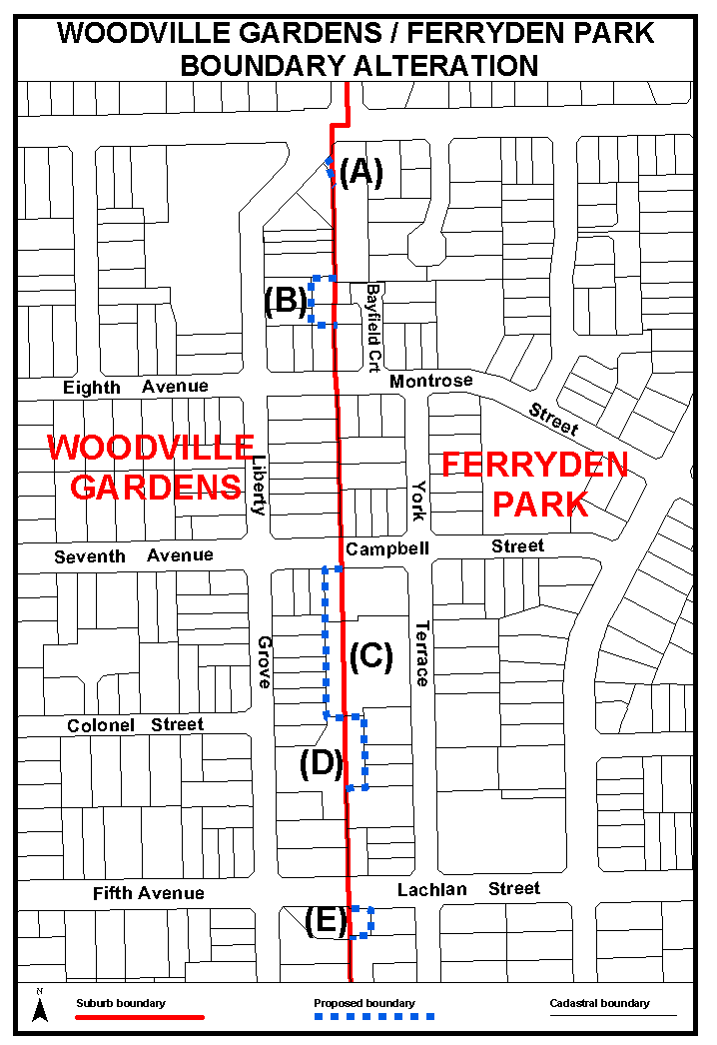
Dated 1 May 2006.
P. M. Kentish, Surveyor-General, Department for Administrative and Information Services
DAIS.22-413/06/0004

GEOGRAPHICAL NAMES ACT 1991
Notice to Alter Boundaries of Places
NOTICE is hereby given pursuant to section 11B (4) of the Geographical Names Act 1991, that I, PETER MACLAREN KENTISH, Surveyor-General and Delegate appointed by Michael Wright, Minister for Administrative Services and Government Enterprises, Minister of the Crown to whom the administration of the Geographical Names Act 1991, is committed DO HEREBY exclude from the bounded locality of CALLINGTON and include into the bounded locality of SAINT IVES that area marked (A) as shown on the plan below:
The Plan
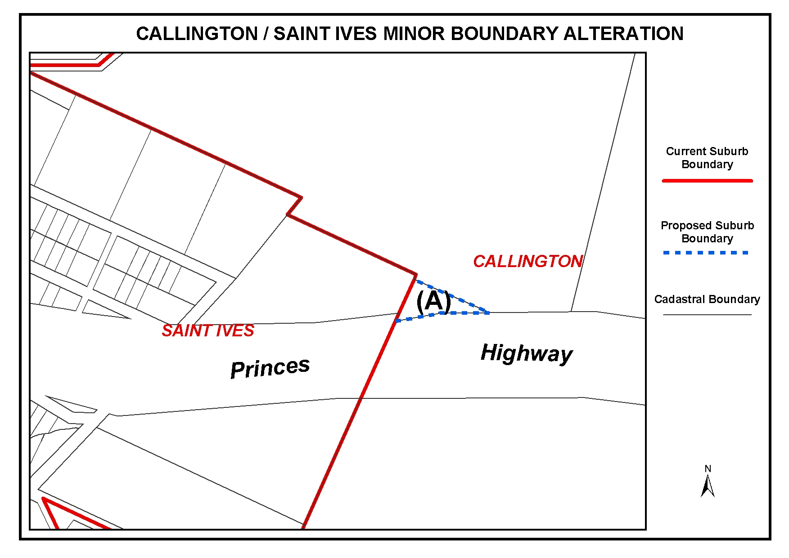
Dated 27 April 2006.
P. M. Kentish, Surveyor-General, Department for Administrative and Information Services
DAIS.22-413/06/0005

GEOGRAPHICAL NAMES ACT 1991
Notice to Alter Boundaries of Places
NOTICE is hereby given pursuant to section 11B (4) of the Geographical Names Act 1991, that I, PETER MACLAREN KENTISH, Surveyor-General and Delegate appointed by Michael Wright, Minister for Administrative Services and Government Enterprises, Minister of the Crown to whom the administration of the Geographical Names Act 1991, is committed, DO HEREBY:
1. Exclude from the bounded locality of SLEAFORD and include into the bounded locality of TULKA that area marked (A) as shown on the plan below.
2. Exclude from the bounded locality of TULKA and include into the bounded locality of SLEAFORD that area marked (B) as shown on the plan below.
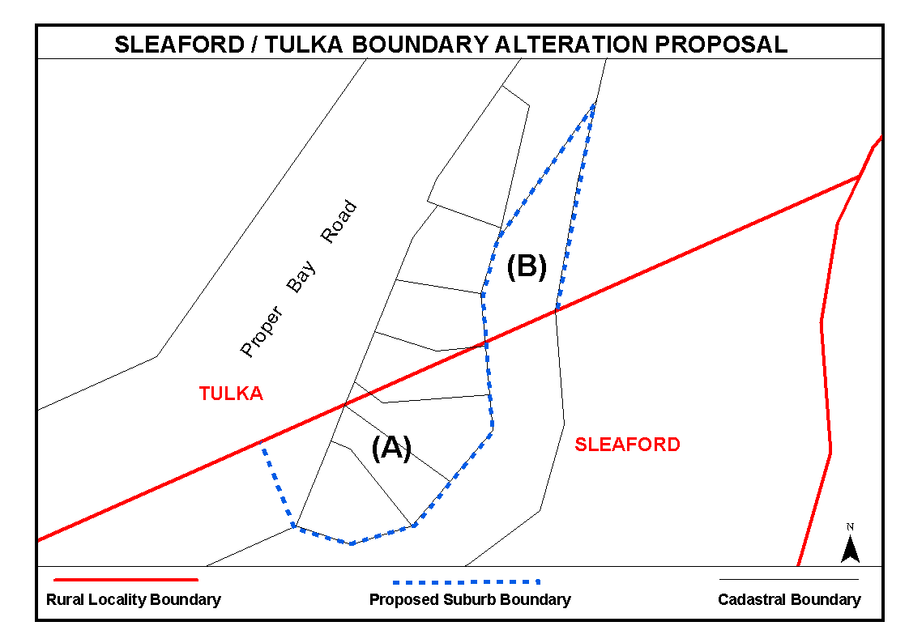
The Plan

Dated 27 April 2006.
P. M. Kentish, Surveyor-General, Department for Administrative and Information Services
DAIS.22-413/05/0022

LIQUOR LICENSING ACT 1997
Notice of Application
NOTICE is hereby given, pursuant to section 52 (2) (b) of the Liquor Licensing Act 1997, that A. D. Raphael & Sons Pty Ltd as trustee for A. D. Raphael Family Trust and M. S. Raphael Pty Ltd as trustee for M. S. Raphael Family Trust have applied to the Licensing Authority for the transfer of a Restaurant Licence in respect of premises situated at 180-182 Main Road, Blackwood, S.A. 5051, known as Cafe Palazzo—Blackwood and to be known as Caffe Primo Blackwood.
The application has been set down for hearing on 6 June 2006 at 9.30 a.m.
Any person may object to the application by lodging a notice of objection in the prescribed form with the Liquor and Gambling Commissioner and serving a copy of the notice on the applicants at the applicants’ address given above, at least seven days before the hearing date (viz: 29 May 2006).
The applicants’ address for service is c/o Duncan Basheer Hannon, Barristers & Solicitors, 66 Wright Street, Adelaide, S.A. 5000 (Attention: Max Basheer or David Tillett).
Plans in respect of the premises the subject of the application are open to public inspection without fee at the Office of the Liquor and Gambling Commissioner, 9th Floor, East Wing, 50 Grenfell Street, Adelaide, S.A. 5000. Phone 8226 8410, Fax:
8226 8512. Email: olgc@agd.sa.gov.au.
Dated 1 May 2006.
Applicants

LIQUOR LICENSING ACT 1997
Notice of Application
NOTICE is hereby given, pursuant to section 52 (2) (b) of the Liquor Licensing Act 1997, that Woodville Hotel Pty Ltd has applied to the Licensing Authority for Alterations, Redefinition, extension of Trading Area and variation to Extended Trading Authorisation in respect of premises situated at 878 Port Road, Woodville, S.A. 5011 and known as Woodville Hotel.
The application has been set down for hearing on 2 June 2006 at 9 a.m.
Conditions
The following licence conditions are sought:
• Alterations to the licensed premises to include an outdoor smoking area at the rear of the premises as per plans lodged with this office.
• Extension of Trading Area to include an area at the front of the premises as per plans lodged with this office.
• Redefinition of the licensed premises and variation to Extended Trading Authorisation to include the above-mentioned areas.
• Variation to the current Extended Trading Authorisation:
Monday to Saturday: Midnight to 2.30 a.m. the following day.
Sunday: Midnight to 2.30 a.m. the following day.
New Year’s Eve: 2 a.m. to 2.30 a.m. the following day.
Sundays preceding Public Holidays: Midnight to 2.30 a.m. the following day.
Any person may object to the application by lodging a notice of objection in the prescribed form with the Liquor and Gambling Commissioner and serving a copy of the notice on the applicant at the applicant’s address given above, at least seven days before the hearing date (viz: 25 May 2006).
The applicant’s address for service is c/o Duncan Basheer Hannon, Barristers & Solicitors, G.P.O. Box 2, Adelaide, S.A. 5001 (Attention: Max Basheer or David Tillett).
Plans in respect of the premises the subject of the application are open to public inspection without fee at the Office of the Liquor and Gambling Commissioner, 9th Floor, East Wing, 50 Grenfell Street, Adelaide, S.A. 5000. Phone 8226 8410, Fax:
8226 8512. Email: olgc@agd.sa.gov.au.
Dated 27 April 2006.
Applicant

LIQUOR LICENSING ACT 1997
Notice of Application
NOTICE is hereby given, pursuant to section 52 (2) (b) of the Liquor Licensing Act 1997, that Dudley Gardner Brown and Karen Wotherspoon as trustee for the California Road Trust have applied to the Licensing Authority for a Producer’s Licence in respect of premises situated at Lot 2, California Road, Tatachilla, S.A. 5171 and to be known as Inkwell.
The application has been set down for hearing on 2 June 2006 at 9 a.m.
Any person may object to the application by lodging a notice of objection in the prescribed form with the Liquor and Gambling Commissioner and serving a copy of the notice on the applicants at the applicants’ address given above, at least seven days before the hearing date (viz: 25 May 2006).
The applicants’ address for service is c/o Dudley Brown, P.O. Box 404, McLaren Vale, S.A. 5171.
Plans in respect of the premises the subject of the application are open to public inspection without fee at the Office of the Liquor and Gambling Commissioner, 9th Floor, East Wing, 50 Grenfell Street, Adelaide, S.A. 5000. Phone 8226 8410, Fax:
8226 8512. Email: olgc@agd.sa.gov.au.
Dated 26 April 2006.
Applicants

LIQUOR LICENSING ACT 1997
Notice of Application
NOTICE is hereby given, pursuant to section 52 (2) (b) of the Liquor Licensing Act 1997, that Ramco Vineyard Pty Ltd as trustee for Ramco Vineyard Trust has applied to the Licensing Authority for a Producer’s Licence in respect of premises situated at Section 1009, Hundred of Waikerie, County of Albert, Waikerie, S.A. 5330 and known as Ramco Vineyards.
The application has been set down for hearing on 2 June 2006 at 9 a.m.
Any person may object to the application by lodging a notice of objection in the prescribed form with the Liquor and Gambling Commissioner and serving a copy of the notice on the applicant at the applicant’s address given above, at least seven days before the hearing date (viz: 25 May 2006).
The applicant’s address for service is c/o Heuzenroeder & Heuzenroeder, P.O. Box 60, Tanunda, S.A. 5352.
Plans in respect of the premises the subject of the application are open to public inspection without fee at the Office of the Liquor and Gambling Commissioner, 9th Floor, East Wing, 50 Grenfell Street, Adelaide, S.A. 5000. Phone 8226 8410, Fax:
8226 8512. Email: olgc@agd.sa.gov.au.
Dated 26 April 2006.
Applicant

LIQUOR LICENSING ACT 1997
Notice of Application
NOTICE is hereby given, pursuant to section 52 (2) (b) of the Liquor Licensing Act 1997, that Jasateal Pty Ltd has applied to the Licensing Authority for a variation to Extended Trading Authori-sation and variation to Entertainment Consent in respect of premises situated at 20 Ryan Street, Moonta, S.A. 5558 and known as Cornwall Hotel.
The application has been set down for hearing on 2 June 2006 at 9 a.m.
Conditions
The following licence conditions are sought:
• Variation to Extended Trading Authorisation:
Good Friday: Midnight to 2 a.m.
Christmas Day: Midnight to 2 a.m.
Sunday Christmas Eve: 8 p.m. to 2 a.m. the following day.
Days preceding other Public Holidays: Midnight to 2 a.m. the following day.
Sundays preceding Public Holidays: 8 p.m. to 2 a.m. the following day.
• Variation to Extended Trading Authorisation to include Areas 3 and 4 as per plans lodged with this office.
• Variation to Entertainment Consent to include Areas 3
and 4 as per plans lodged with this office.
Any person may object to the application by lodging a notice of objection in the prescribed form with the Liquor and Gambling Commissioner and serving a copy of the notice on the applicant at the applicant’s address given above, at least seven days before the hearing date (viz: 25 May 2006).
The applicant’s address for service is c/o Scott Aldridge, 20 Ryan Street, Moonta, S.A. 5558.
Plans in respect of the premises the subject of the application are open to public inspection without fee at the Office of the Liquor and Gambling Commissioner, 9th Floor, East Wing, 50 Grenfell Street, Adelaide, S.A. 5000. Phone 8226 8410, Fax:
8226 8512. Email: olgc@agd.sa.gov.au.
Dated 1 May 2006.
Applicant

LIQUOR LICENSING ACT 1997
Notice of Application
NOTICE is hereby given, pursuant to section 52 (2) (b) of the Liquor Licensing Act 1997, that SATCO South Australian Trading Company Pty Ltd has applied to the Licensing Authority for the removal of a Wholesale Liquor Merchant’s Licence in respect of premises situated at 9 Osmond Terrace, Norwood, S.A. 5067 and to be situated at 10 Albert Street, Prospect, S.A. 5082 and known as SATCO South Australian Trading Company Pty Ltd.
The application has been set down for hearing on 2 June 2006 at 9 a.m.
Any person may object to the application by lodging a notice of objection in the prescribed form with the Liquor and Gambling Commissioner and serving a copy of the notice on the applicant at the applicant’s address given above, at least seven days before the hearing date (viz: 25 May 2006).
The applicant’s address for service is c/o David Ridge, 10 Albert Street, Prospect, S.A. 5082.
Plans in respect of the premises the subject of the application are open to public inspection without fee at the Office of the Liquor and Gambling Commissioner, 9th Floor, East Wing, 50 Grenfell Street, Adelaide, S.A. 5000. Phone 8226 8410, Fax:
8226 8512. Email: olgc@agd.sa.gov.au.
Dated 27 April 2006.
Applicant

LIQUOR LICENSING ACT 1997
Notice of Application
NOTICE is hereby given, pursuant to section 52 (2) (b) of the Liquor Licensing Act 1997, that Woolies Liquor Stores Pty Ltd has applied to the Licensing Authority for the removal of a Retail Liquor Merchant’s Licence in respect of premises situated at Shop 1, 21 Dawson Street, Strathalbyn, S.A. 5255 and to be situated at corner of Donald and Dawson Streets, known as BWS—Beer Wine Spirits and to be known as Woolworths Liquor.
The application has been set down for hearing on 2 June 2006 at 9 a.m.
Any person may object to the application by lodging a notice of objection in the prescribed form with the Liquor and Gambling Commissioner and serving a copy of the notice on the applicant at the applicant’s address given above, at least seven days before the hearing date (viz: 25 May 2006).
The applicant’s address for service is c/o Clelands Lawyers, 208 Carrington Street, Adelaide, S.A. 5000 (Attention: Leon McEvoy).
Plans in respect of the premises the subject of the application are open to public inspection without fee at the Office of the Liquor and Gambling Commissioner, 9th Floor, East Wing, 50 Grenfell Street, Adelaide, S.A. 5000. Phone 8226 8410, Fax:
8226 8512. Email: olgc@agd.sa.gov.au.
Dated 28 April 2006.
Applicant

LIQUOR LICENSING ACT 1997
Notice of Application
NOTICE is hereby given, pursuant to section 52 (2) (b) of the Liquor Licensing Act 1997, that Saturno’s Oxford Hotel Pty Ltd has applied to the Licensing Authority for the redefinition of the Licensed Premises in respect of premises situated at 101 O’Connell Street, North Adelaide, S.A. 5006 and known as the Oxford Hotel.
The application has been set down for hearing on 2 June 2006 at 9 a.m.
Conditions
The following licence conditions are sought:
• To redefine the licensed area to include the premises currently known as the Banque as per the plans lodged.
• All conditions currently approved under the Oxford Hotel Licence are to apply to the redefined area sought in the application.
• In this application there are:
(a) no increase in patron numbers;
(b) no changes in respect of the entertainment permit;
(c) no change to the existing conditions.
Any person may object to the application by lodging a notice of objection in the prescribed form with the Liquor and Gambling Commissioner and serving a copy of the notice on the applicant at the applicant’s address given above, at least seven days before the hearing date (viz: 25 May 2006).
The applicant’s address for service is c/o Clelands Solicitors, 208 Carrington Street, Adelaide, S.A. 5000 (Attention: Leon McEvoy).
Plans in respect of the premises the subject of the application are open to public inspection without fee at the Office of the Liquor and Gambling Commissioner, 9th Floor, East Wing, 50 Grenfell Street, Adelaide, S.A. 5000. Phone 8226 8410, Fax:
8226 8512. Email: olgc@agd.sa.gov.au.
Dated 1 May 2006.
Applicant

LIQUOR LICENSING ACT 1997
Notice of Application
NOTICE is hereby given, pursuant to section 52 (2) (b) of the Liquor Licensing Act 1997, that Jocelyn Darlene Kawana and James Colin Deane have applied to the Licensing Authority for the transfer of a Restaurant Licence in respect of premises situated at Hutchinson Street, Coober Pedy, S.A. 5723 and known as Traces Restaurant.
The application has been set down for hearing on 6 June 2006 at 10.30 a.m.
Any person may object to the application by lodging a notice of objection in the prescribed form with the Liquor and Gambling Commissioner and serving a copy of the notice on the applicants at the applicants’ address given above, at least seven days before the hearing date (viz: 29 May 2006).
The applicants’ address for service is c/o Proud & Company, P.O. Box 914, Kent Town, S.A. 5071.
Plans in respect of the premises the subject of the application are open to public inspection without fee at the Office of the Liquor and Gambling Commissioner, 9th Floor, East Wing, 50 Grenfell Street, Adelaide, S.A. 5000. Phone 8226 8410, Fax:
8226 8512. Email: olgc@agd.sa.gov.au.
Dated 28 April 2006.
Applicants

LIQUOR LICENSING ACT 1997
Notice of Application
NOTICE is hereby given, pursuant to section 52 (2) (b) of the Liquor Licensing Act 1997, that Yvonne Spink has applied to the Licensing Authority for the transfer of a Restaurant Licence in respect of premises situated at Lot 439, Mullaquana Road, Whyalla Norrie, S.A. 5600 and known as Lazy Gardener Cafe.
The application has been set down for hearing on 5 June 2006 at 10 a.m.
Any person may object to the application by lodging a notice of objection in the prescribed form with the Liquor and Gambling Commissioner and serving a copy of the notice on the applicant at the applicant’s address given above, at least seven days before the hearing date (viz: 26 May 2006).
The applicant’s address for service is c/o Yvonne Spink, P.O. Box 2448, Whyalla Norrie, S.A. 5608.
Plans in respect of the premises the subject of the application are open to public inspection without fee at the Office of the Liquor and Gambling Commissioner, 9th Floor, East Wing, 50 Grenfell Street, Adelaide, S.A. 5000. Phone 8226 8410, Fax:
8226 8512. Email: olgc@agd.sa.gov.au.
Dated 27 April 2006.
Applicant

LIQUOR LICENSING ACT 1997
Notice of Application
NOTICE is hereby given, pursuant to section 52 (2) (b) of the Liquor Licensing Act 1997, that P. & J. Hurley Pty Ltd, Good-thing Enterprises Pty Ltd, Hurley/Symons Pty Ltd, Brien Marmion Pty Ltd, C. J. & K. J. Eitzen Pty Ltd and Roo Pty Ltd have applied to the Licensing Authority for an Extended Trading Authorisation in respect of premises situated at 23 Regent Street, Kensington, S.A. 5068 and known as Kensington Hotel.
The application has been set down for hearing on 2 June 2006 at 9 a.m.
Conditions
The following licence conditions are sought:
• That the licensees be permitted to sell liquor for consump-tion on and of the licensed premises each Sunday from 8 p.m to 9 p.m.
• That the Extended Trading Authorisation shall apply to the internal dining areas and the Gaming Room referred to as Areas 1, 2 and 5 on the plan held in the Liquor and Gambling Commission.
• Entertainment will not be provided during the extended trading hours.
Any person may object to the application by lodging a notice of objection in the prescribed form with the Liquor and Gambling Commissioner and serving a copy of the notice on the applicants at the applicants’ address given above, at least seven days before the hearing date (viz: 25 May 2006).
The applicants’ address for service is c/o The Australian Hotels Association (S.A. Branch), 4th Floor, 60 Hindmarsh Square, Adelaide, S.A 5000.
Plans in respect of the premises the subject of the application are open to public inspection without fee at the Office of the Liquor and Gambling Commissioner, 9th Floor, East Wing, 50 Grenfell Street, Adelaide, S.A. 5000. Phone 8226 8410, Fax:
8226 8512. Email: olgc@agd.sa.gov.au.
Dated 28 April 2006.
Applicants

LIQUOR LICENSING ACT 1997
Notice of Application
NOTICE is hereby given, pursuant to section 52 (2) (b) of the Liquor Licensing Act 1997, that Notfair Pty Ltd as trustee for Notfair Family Trust has applied to the Licensing Authority for the transfer of a Residential Licence in respect of premises situated at Princes Highway, Meningie, S.A. 5264 and known as Meningie Waterfront Motel.
The application has been set down for hearing on 5 June 2006 at 11 a.m.
Any person may object to the application by lodging a notice of objection in the prescribed form with the Liquor and Gambling Commissioner and serving a copy of the notice on the applicant at the applicant’s address given above, at least seven days before the hearing date (viz: 26 May 2006).
The applicant’s address for service is c/o Bev Fairweather, 38 Princes Highway, Meningie, S.A. 5264.
Plans in respect of the premises the subject of the application are open to public inspection without fee at the Office of the Liquor and Gambling Commissioner, 9th Floor, East Wing, 50 Grenfell Street, Adelaide, S.A. 5000. Phone 8226 8410, Fax:
8226 8512. Email: olgc@agd.sa.gov.au.
Dated 27 April 2006.
Applicant

LIQUOR LICENSING ACT 1997
Notice of Application
NOTICE is hereby given, pursuant to section 52 (2) (b) of the Liquor Licensing Act 1997, that Kapur Luthra Pty Ltd has applied to the Licensing Authority for the transfer of a Restaurant Licence in respect of premises situated at 1A Calton Road, Gawler East, S.A. 5118, known as Nirvana the Restaurant and to be known as Harvest of India—Gawler.
The application has been set down for hearing on 6 June 2006 at 10 a.m.
Any person may object to the application by lodging a notice of objection in the prescribed form with the Liquor and Gambling Commissioner and serving a copy of the notice on the applicant at the applicant’s address given above, at least seven days before the hearing date (viz: 29 May 2006).
The applicant’s address for service is c/o Duncan Basheer Hannon, 66 Wright Street, Adelaide, S.A. 5000 (Attention: John Williams).
Plans in respect of the premises the subject of the application are open to public inspection without fee at the Office of the Liquor and Gambling Commissioner, 9th Floor, East Wing, 50 Grenfell Street, Adelaide, S.A. 5000. Phone 8226 8410, Fax:
8226 8512. Email: olgc@agd.sa.gov.au.
Dated 1 May 2006.
Applicant

LIQUOR LICENSING ACT 1997
Notice of Application
NOTICE is hereby given, pursuant to section 52 (2) (b) of the Liquor Licensing Act 1997, that Woolworths Limited has applied to the Licensing Authority for the removal of a Retail Liquor Merchant’s Licence in respect of premises situated at Shop 6, Seaford Shopping Centre, Commercial Road, Seaford, S.A. 5169 and to be situated at T54, Seaford Shopping Centre, Commercial Road, Seaford, S.A. 5169, known as BWS—Beer Wine Spirits and to be known as Woolworths Liquor.
The application has been set down for hearing on 2 June 2006 at 9 a.m.
Any person may object to the application by lodging a notice of objection in the prescribed form with the Liquor and Gambling Commissioner and serving a copy of the notice on the applicant at the applicant’s address given above, at least seven days before the hearing date (viz: 25 May 2006).
The applicant’s address for service is c/o Clelands Lawyers, 208 Carrington Street, Adelaide, S.A. 5000 (Attention: Leon McEvoy).
Plans in respect of the premises the subject of the application are open to public inspection without fee at the Office of the Liquor and Gambling Commissioner, 9th Floor, East Wing, 50 Grenfell Street, Adelaide, S.A. 5000. Phone 8226 8410, Fax:
8226 8512. Email: olgc@agd.sa.gov.au.
Dated 28 April 2006.
Applicant

MINING ACT 1971
NOTICE is hereby given in accordance with section 28 (5) of the Mining Act 1971, that the Minister for Mineral Resources Development proposes to grant an Exploration Licence over the undermentioned area:
Applicant: Maximus Resources Ltd
Location: Calcutta area—Approximately 110 km south-east of Marree.
Term: 1 year
Area in km²: 984
Ref.: 2006/00015
Plan and co-ordinates can be found on the PIRSA Sarig website: http://www.minerals.pir.sa.gov.au/sarig or by phoning Mineral Tenements on (08) 8463 3103.
H. Tyrteos, Mining Registrar

MINING ACT 1971
NOTICE is hereby given in accordance with section 28 (5) of the Mining Act 1971, that the Minister for Mineral Resources Development proposes to grant an Exploration Licence over the undermentioned area:
Applicant: Maximus Resources Ltd
Location: Dalarinna Hill area—Approximately 60 km south-east of Marree.
Term: 1 year
Area in km²: 1 000
Ref.: 2006/00016
Plan and co-ordinates can be found on the PIRSA Sarig website: http://www.minerals.pir.sa.gov.au/sarig or by phoning Mineral Tenements on (08) 8463 3103.
H. Tyrteos, Mining Registrar

MINING ACT 1971
NOTICE is hereby given in accordance with section 28 (5) of the Mining Act 1971, that the Minister for Mineral Resources Development proposes to grant an Exploration Licence over the undermentioned area:
Applicant: Maximus Resources Ltd
Location: Wilpoorinna area—Approximately 40 km south-east of Marree.
Term: 1 year
Area in km²: 962
Ref.: 2006/00017
Plan and co-ordinates can be found on the PIRSA Sarig website: http://www.minerals.pir.sa.gov.au/sarig or by phoning Mineral Tenements on (08) 8463 3103.
H. Tyrteos, Mining Registrar

MINING ACT 1971
NOTICE is hereby given in accordance with section 28 (5) of the Mining Act 1971, that the Minister for Mineral Resources Development proposes to grant an Exploration Licence over the undermentioned area:
Applicant: Maximus Resources Ltd
Location: Mundowdna area—Approximately 20 km east of Marree.
Term: 1 year
Area in km²: 963
Ref.: 2006/00018
Plan and co-ordinates can be found on the PIRSA Sarig website: http://www.minerals.pir.sa.gov.au/sarig or by phoning Mineral Tenements on (08) 8463 3103.
H. Tyrteos, Mining Registrar

MINING ACT 1971
NOTICE is hereby given in accordance with section 28 (5) of the Mining Act 1971, that the Minister for Mineral Resources Development proposes to grant an Exploration Licence over the undermentioned area:
Applicant: Maximus Resources Ltd
Location: Marla area—Approximately 220 km north-west of Coober Pedy.
Term: 1 year
Area in km²: 988
Ref.: 2006/00019
Plan and co-ordinates can be found on the PIRSA Sarig website: http://www.minerals.pir.sa.gov.au/sarig or by phoning Mineral Tenements on (08) 8463 3103.
H. Tyrteos, Mining Registrar

MINING ACT 1971
NOTICE is hereby given in accordance with section 28 (5) of the Mining Act 1971, that the Minister for Mineral Resources Development proposes to grant an Exploration Licence over the undermentioned area:
Applicant: Maximus Resources Ltd
Location: Whymlet area—Approximately 60 km north-east of Tarcoola.
Term: 1 year
Area in km²: 973
Ref.: 2006/00026
Plan and co-ordinates can be found on the PIRSA Sarig website: http://www.minerals.pir.sa.gov.au/sarig or by phoning Mineral Tenements on (08) 8463 3103.
H. Tyrteos, Mining Registrar

MINING ACT 1971
NOTICE is hereby given in accordance with section 28 (5) of the Mining Act 1971, that the Minister for Mineral Resources Development proposes to grant an Exploration Licence over the undermentioned area:
Applicant: Maximus Resources Ltd
Location: Haggard Hill area—Approximately 80 km north-east of Tarcoola.
Term: 1 year
Area in km²: 859
Ref.: 2006/00027
Plan and co-ordinates can be found on the PIRSA Sarig website: http://www.minerals.pir.sa.gov.au/sarig or by phoning Mineral Tenements on (08) 8463 3103.
H. Tyrteos, Mining Registrar

MINING ACT 1971
NOTICE is hereby given in accordance with section 28 (5) of the Mining Act 1971, that the Minister for Mineral Resources Development proposes to grant an Exploration Licence over the undermentioned area:
Applicant: Maximus Resources Ltd
Location: Bon Bon area—Approximately 100 km north-east of Tarcoola.
Term: 1 year
Area in km²: 667
Ref.: 2006/00028
Plan and co-ordinates can be found on the PIRSA Sarig website: http://www.minerals.pir.sa.gov.au/sarig or by phoning Mineral Tenements on (08) 8463 3103.
H. Tyrteos, Mining Registrar

MINING ACT 1971
NOTICE is hereby given in accordance with section 28 (5) of the Mining Act 1971, that the Minister for Mineral Resources Development proposes to grant an Exploration Licence over the undermentioned area:
Applicant: Maximus Resources Ltd
Location: McDouall Peak area—Approximately 90 km north-north-east of Tarcoola.
Term: 1 year
Area in km²: 980
Ref.: 2006/00029
Plan and co-ordinates can be found on the PIRSA Sarig website: http://www.minerals.pir.sa.gov.au/sarig or by phoning Mineral Tenements on (08) 8463 3103.
H. Tyrteos, Mining Registrar

MINING ACT 1971
NOTICE is hereby given in accordance with section 28 (5) of the Mining Act 1971, that the Minister for Mineral Resources Development proposes to grant an Exploration Licence over the undermentioned area:
Applicant: Marathon Resources Ltd
Location: Myponga area—Approximately 60 km south-south-west of Adelaide.
Term: 1 year
Area in km²: 153
Ref.: 2005/00252
Plan and co-ordinates can be found on the PIRSA Sarig website: http://www.minerals.pir.sa.gov.au/sarig or by phoning Mineral Tenements on (08) 8463 3103.
H. Tyrteos, Mining Registrar

MINING ACT 1971
NOTICE is hereby given in accordance with section 28 (5) of the Mining Act 1971, that the Minister for Mineral Resources Development proposes to grant an Exploration Licence over the undermentioned area:
Applicant: Minemakers Australia NL
Location: Mount Neville area—Approximately 140 km north-east of Port Augusta.
Term: 1 year
Area in km²: 292
Ref.: 2005/00299
Plan and co-ordinates can be found on the PIRSA Sarig website: http://www.minerals.pir.sa.gov.au/sarig or by phoning Mineral Tenements on (08) 8463 3103.
H. Tyrteos, Mining Registrar

MINING ACT 1971
NOTICE is hereby given in accordance with section 28 (5) of the Mining Act 1971, that the Minister for Mineral Resources Development proposes to grant an Exploration Licence over the undermentioned area:
Applicant: Merrill Christina Gray
Location: Moorlands area—Approximately 100 km south-east of Adelaide.
Term: 1 year
Area in km²: 143
Ref.: 2005/00748
Plan and co-ordinates can be found on the PIRSA Sarig website: http://www.minerals.pir.sa.gov.au/sarig or by phoning Mineral Tenements on (08) 8463 3103.
H. Tyrteos, Mining Registrar

MINING ACT 1971
NOTICE is hereby given in accordance with section 28 (5) of the Mining Act 1971, that the Minister for Mineral Resources Development proposes to grant an Exploration Licence over the undermentioned area:
Applicant: Hindmarsh Resources Ltd
Location: Black Oak Hill area—Approximately 120 km north-west of Port Augusta.
Term: 1 year
Area in km²: 645
Ref.: 2005/00926
Plan and co-ordinates can be found on the PIRSA Sarig website: http://www.minerals.pir.sa.gov.au/sarig or by phoning Mineral Tenements on (08) 8463 3103.
H. Tyrteos, Mining Registrar

MINING ACT 1971
NOTICE is hereby given in accordance with section 28 (5) of the Mining Act 1971, that the Minister for Mineral Resources Development proposes to grant an Exploration Licence over the undermentioned area:
Applicant: Hiltaba Gold Pty Ltd
Location: Windabout area—Approximately 20 km south-east of Woomera.
Term: 1 year
Area in km²: 598
Ref.: 2005/00905
Plan and co-ordinates can be found on the PIRSA Sarig website: http://www.minerals.pir.sa.gov.au/sarig or by phoning Mineral Tenements on (08) 8463 3103.
H. Tyrteos, Mining Registrar

MINING ACT 1971
NOTICE is hereby given in accordance with section 28 (5) of the Mining Act 1971, that the Minister for Mineral Resources Development proposes to grant an Exploration Licence over the undermentioned area:
Applicant: PepinNini Minerals Ltd
Location: Scott Hill area—Approximately 80 km north-west of Mannahill.
Term: 1 year
Area in km²: 521
Ref.: 2006/00004
Plan and co-ordinates can be found on the PIRSA Sarig website: http://www.minerals.pir.sa.gov.au/sarig or by phoning Mineral Tenements on (08) 8463 3103.
H. Tyrteos, Mining Registrar

MOTOR VEHICLES ACT 1959
Recognised Historic Motor Vehicle Club
NOTICE is hereby given that the undermentioned club is recognised as an Historic Motor Vehicle Club in accordance with Schedule 1, Clause 3 (3) (a) of the Motor Vehicles Regulations, for the purposes of section 25 of the Motor Vehicles Act 1959:
Wanderers Rock ‘n’ Roll Car Club Incorporated
Dated 24 April 2006.
R. J. Frisby, Registrar of Motor Vehicles

NATIONAL ELECTRICITY LAW
THE Australian Energy Market Commission (AEMC) gives notice under the National Electricity Law (NEL) of the following matters:
Under section 107, the time period has been extended for the making of the draft determination for the proposed National Electricity Amendment (Region Boundaries) Rule 2006 to 30 November 2006.
Under section 95, NEMMCO has requested a Rule relating to the technical standards for non-scheduled generation and the framework for negotiating access by new generators. A copy of the Rule proposal and the proposed National Electricity Amendment (Technical Standards for Wind Generation) Rule 2006 are published on AEMC’s website and are available for inspection at AEMC. Upon receipt AEMC publishes all submissions on its website, subject to consideration of any claim of confidentiality. Submissions should be forwarded to submissions@aemc.gov.au and must be received no later than 23 June 2006.
Further details on the above matter are available on AEMC’s website www.aemc.gov.au.
John Tamblyn
Chairman
Australian Energy Market Commission
Level 16, 1 Margaret Street
Sydney, N.S.W. 2000
Telephone: (02) 8296 7800
Facsimile: (02) 8296 7899
Dated 4 May 2006.

NATURAL RESOURCES MANAGEMENT ACT 2004
Instrument of Appointment of Authorised Officer
PURSUANT to section 66 (1) of the Natural Resources Management Act 2004 (the Act), I, Gail Elizabeth Gago, MLC, Minister for Environment and Conservation in the State of South Australia, hereby appoint the following person to be a State Authorised Officer for the purposes prescribed under the Act in the State of South Australia:
Environment Protection Authority:
Geoffrey David Guy Corbett
This appointment will commence on the date of Gazettal and will remain in effect for the period the named person is employed by or contracted to the Environment Protection Authority unless earlier revoked or varied.
Dated 27 April 2006.
G. Gago, Minister for Environment and Conservation

NATURAL RESOURCES MANAGEMENT ACT 2004
Instrument of Appointment of Authorised Officers
PURSUANT to section 66 (1) of the Natural Resources Management Act 2004 (the Act), I, Gail Elizabeth Gago, MLC, Minister for Environment and Conservation in the State of South Australia, hereby appoint the following persons to be State Authorised Officers for the purposes prescribed under the Act in the State of South Australia:
Department of Water, Land and Biodiversity Conservation:
Mark Andrew Delaney
Craig Robert Lean
These appointments will commence on the date of Gazettal and will remain in effect for the period the named persons are employed by or contracted to the Department of Water, Land and Biodiversity Conservation unless earlier revoked or varied.
Dated 27 April 2006.
G. Gago, Minister for Environment and Conservation

RAIL SAFETY ACT 1996
Instrument of Appointment
I, PATRICK FREDERICK CONLON, Minister for Transport in the State of South Australia, pursuant to section 3 of the Rail Safety Act 1996 (the Act), hereby:
• Revoke the appointment, dated 23 October 2003, of Jon Steele, Executive Director, Transport Services, Department for Transport, Energy and Infrastructure, as the Administrating Authority for the purposes of the Act.
• Appoint Phillip Thomas Allan, Executive Director, Safety and Regulation, Department for Transport, Energy and Infrastructure, as the Administrating Authority for the purpose of the Act.
Dated 13 April 2006.
Patrick Conlon, Minister for Transport

DETERMINATION AND REPORT OF THE REMUNERATION TRIBUNAL
No. 7 of 2006
4WD Vehicle Request—Mount Gambier Resident Magistrate
1. On 22 June 2005 the resident Magistrate Mount Gambier made an email enquiry of the Remuneration Tribunal in relation to the provision of a 4WD vehicle. At the behest of the Tribunal, the resident Magistrate provided additional written information on 15 August 2005.
2. In part the resident Magistrate claimed a 4WD vehicle was required, given he was involved with prosecutions under the Native Vegetation Management Act 1985 and the Fisheries Act 1982, both of which necessitated viewing of relevant off-road locations. In this context he claimed that in his view it is not appropriate for him to travel with either of the contesting parties, which he has been required to do in the past. On this point the resident Magistrate referred the Tribunal to section 15 of the Remuneration Act, which states:
‘The Tribunal must, where appropriate in determining remuneration under this Act, have regard to the constitutional principle of judicial independence.’
3. The resident Magistrate also submitted that the presence of wildlife on regional roads poses a risk, which could be significantly reduced by the provision of a 4WD vehicle. However, the Tribunal did not believe that the evidence before it supported this contention.
4. For its part, in its submission to the Tribunal of 9 December 2005, the Government stated that it did not see any good reason why an appropriate 4WD vehicle should not be granted to the resident Magistrate Mount Gambier provided the magistrate concerned is able to demonstrate the skills required for safe off-road driving (or is prepared to gain such skills) and a front end protection is fitted to the vehicle. On the Tribunal’s understanding it based its support for the resident Magistrate’s request on the premise of ‘judicial independence’. In particular it cited the following excerpt from J.R.L; Ex parte C.J.L. (1986) 161 CLR 342 wherein Mason J. said at pp 351-2:
‘This principle, which has evolved from the fundamental rule of natural justice that a judicial officer should be free from bias, reflects a concern with the need to maintain public confidence in the administration of justice. This concern is expressed in the cognate principle that, not only must justice be done, it must be seen to be done.’
5. In the past the Tribunal has agreed to provide 4WD vehicles at no extra cost to resident Magistrates located at Port Augusta due to the number of unsealed roads in the area (Determina-tions/Reports No. 8 of 2003 and No. 7 of 2002 respectively).
6. Having fully considered the submissions and having regard to the principle of judicial independence the Tribunal has determined to grant the supply of a 4WD vehicle to the resident Magistrate Mount Gambier at a cost equal to that provided for in Report and Determination No. 5 of 2005 as amended from time to time.
Date of Operation
This Determination will come into operation as from 4 May 2006.
Dated 28 April 2006.
H. R. Bachmann, President
J. A. Meeking, Member
D. J. Smythe, Member

REPORT AND DETERMINATION OF THE REMUNERATION TRIBUNAL
No. 8 of 2006
Deputy State Coroner—Full-Time
A. Report
1. As part of the 2005 annual review process for Judicial salaries the Remuneration Tribunal received a submission from A. E. Schapel seeking that his position as the permanent Deputy State Coroner be remunerated in parity with a Stipendiary Magistrate directed by the Chief Magistrate with the concurrence of the Attorney-General to perform special administrative duties at a particular court (Magistrate-in-Charge) and who is paid an allowance for as long as that person continues to perform such duties.
2. Consequently, the Tribunal invited submissions from the responsible Minister, the Attorney-General, the Chief Magistrate and the State Coroner regarding the Deputy State Coroner’s request. Submissions were received from the Chief Magistrate and State Coroner, which supported Mr Schapel’s submission, however the responsible Minister did not make any submissions on the matter.
3. To enable the Tribunal to fully consider the matter, the Tribunal subsequently sought further information from the Attorney-General’s office and advice from the Crown Solicitor on the specific status and remuneration arrangements for the Deputy State Coroner.
4. Due to the level of responsibility of the Deputy State Coroner function and the requirement to relieve the State Coroner for short periods from time to time the Tribunal has determined to provide the Deputy State Coroner an annual allowance for as long as that person continues to perform such duties on a full-time ongoing basis.
5. The Tribunal believes this would be an equitable way of remunerating a Stipendiary Magistrate when performing the role of Deputy State Coroner attached to the Coronial Court in a full-time ongoing capacity.
B. Determination
1. Scope of Determination
This Determination applies to a Stipendiary Magistrate who is attached to the Coronial Court to perform duties of Deputy State Coroner in a full-time ongoing capacity.
2. Salary
A Stipendiary Magistrate so appointed will receive an annual allowance of $5 780 in addition to salary for as long as that person continues to perform such duties.
3. Date of Operation
The provisions set out in Clause 2 above shall operate on and from 1 November 2005.
Dated 2 May 2006.
H. R. Bachmann, President
J. A. Meeking, Member
D. J. Smythe, Member

ROADS (OPENING AND CLOSING) ACT 1991:
SECTION 24
NOTICE OF CONFIRMATION OF ROAD
PROCESS ORDER
Road Closure
Right of Way, Morphett Vale
BY Road Process Order made on 9 September 2005, the City of Onkaparinga ordered that:
1. Portion of the right of way situated south of Acre Avenue and adjoining allotments 267 to 271 inclusive in Deposited Plan 6510 and more particularly delineated and lettered ‘A’ to ‘E’ inclusive in Preliminary Plan No. 04/0093 be closed.
2. The whole of the land subject to closure be transferred to Ida Coscia in accordance with agreement for transfer dated 26 August 2005 entered into between the City of Onkaparinga and I. Coscia.
3. The following easements are granted over the land subject to that closure:
Grant to the South Australian Water Corporation an easement for sewerage purposes over portion of the land.
Grant a free and unrestricted right of way appurtenant to Certificate of Title Volume 5126, Folio 397, over the whole of the land.
On 31 March 2006 that order was confirmed by the Minister for Administrative Services and Government Enterprises conditionally upon the deposit by the Registrar-General of Deposited Plan 69518 being the authority for the new boundaries.
Pursuant to section 24 (5) of the Roads (Opening and Closing) Act 1991, NOTICE of the order referred to above and its confirmation is hereby given.
Dated 4 May 2006.
P. M. Kentish, Surveyor-General

ROADS (OPENING AND CLOSING) ACT 1991:
SECTION 24
NOTICE OF CONFIRMATION OF ROAD
PROCESS ORDER
Road Closure, Mount Barker Springs
BY Road Process Order made on 3 April 2006, The District Council of Mount Barker ordered that:
1. Portion of the unnamed public road situated adjoining the northern boundary of piece 4 in Filed Plan 40261, being portion of the land lettered ‘N’ in Preliminary Plan No. 03/0093 be closed.
2. The whole of the land subject to closure be transferred to Bartolo Quarisa, Nerea Quarisa, Giacinto Garry Quarisa and Amanda Jayne Quarisa in accordance with the agreement for transfer dated 5 November 2004 entered into between The District Council of Mount Barker and B., N., G. G. and A. J. Quarisa.
3. The following easement be granted over portion of the land subject to that closure:
Grant a free and unrestricted right of way appurtenant to Certificate of Title Volume 5109, Folio 66.
On 12 April 2006 that order was confirmed by the Minister for Administrative Services and Government Enterprises condition-ally upon the deposit by the Registrar-General of Deposited Plan 69064 being the authority for the new boundaries.
Pursuant to section 24 (5) of the Roads (Opening and Closing) Act 1991, NOTICE of the order referred to above and its confirmation is hereby given.
Dated 4 May 2006.
P. M. Kentish, Surveyor-General

ROADS (OPENING AND CLOSING) ACT 1991:
SECTION 24
NOTICE OF CONFIRMATION OF ROAD
PROCESS ORDER
Road Closure, Mount Barker Springs
BY Road Process Order made on 9 February 2006, The District Council of Mount Barker ordered that:
1. Portion of the public road adjoining pieces 1, 2, 3 and 4 in Filed Plan 40261, more particularly delineated and lettered ‘G’, ‘H’, ‘J’, ‘K’, ‘L’ and ‘M’ in Preliminary Plan No. 03/0063 be closed.
2. The whole of the land subject to closure lettered ‘G’, ‘H’, ‘J’ and ‘K’ be transferred to Bartolo Quarisa, Nerea Quarisa, Giacinto Garry Quarisa and Amanda Jayne Quarisa in accordance with the agreement for transfer dated 5 November 2004 entered into between The District Council of Mount Barker and B., N., G. G. and A. J. Quarisa.
3. The whole of the land subject to closure lettered ‘L’ be transferred to Ellensofie Sehested Holm Thomsen in accordance with the agreement for transfer dated 18 March 2005 entered into between The District Council of Mount Barker and E. S. H. Thomsen.
4. The whole of the land subject to closure lettered ‘M’ be transferred to George Carabelas and Virginia Carabelas in accordance with the agreement for transfer dated 18 February 2005 entered into between The District Council of Mount Barker and G. and V. Carabelas.
5. The following easement be granted over portion of the land subject to that closure:
Grant a free and unrestricted right of way appurtenant to Certificate of Title Volume 5109, Folio 66.
On 12 April 2006 that order was confirmed by the Minister for Administrative Services and Government Enterprises condition-ally upon the deposit by the Registrar-General of Deposited Plan 69064 being the authority for the new boundaries.
Pursuant to section 24 (5) of the Roads (Opening and Closing) Act 1991, NOTICE of the order referred to above and its confirmation is hereby given.
Dated 4 May 2006.
P. M. Kentish, Surveyor-General

ROADS (OPENING AND CLOSING) ACT 1991:
SECTION 24
NOTICE OF CONFIRMATION OF ROAD
PROCESS ORDER
Road Closure, Nairne
BY Road Process Order made on 8 March 2006, The District Council of Mount Barker ordered that:
1. The whole of the public road north of West Terrace and west of North Road and between William and Nixon Streets, more particularly delineated and lettered ‘C’ and ‘D’ (respectively) in Preliminary Plan No. 05/0063 be closed.
2. Issue a Certificate of Title to The District Council of Mount Barker for the whole of the land subject to closure which land is being retained by Council for council purposes.
3. The following easement be granted over portion of the land subject to that closure:
Grant to the South Australian Water Corporation an easement for water supply purposes.
On 28 April 2006 that order was confirmed by the Minister for Administrative Services and Government Enterprises condition-ally upon the deposit by the Registrar-General of Deposited Plan 71070 being the authority for the new boundaries.
Pursuant to section 24 (5) of the Roads (Opening and Closing) Act 1991, NOTICE of the order referred to above and its confirmation is hereby given.
Dated 4 May 2006.
P. M. Kentish, Surveyor-General

THE MAGISTRATES COURT OF SOUTH AUSTRALIA
Amendment to the Magistrates Court Rules 1992
of general application and
Amendment No. 26 of Magistrates Court (Civil) Rules 1992
PURSUANT to section 49 of the Magistrates Court Act 1991 and all other enabling powers, We the undersigned do make the following amendments to:
The MAGISTRATES COURT RULES 1992 are amended as follows:
Section A—Rules of General Application are amended as follows:
Rule 4.04 is deleted and replaced with the following:
4.04 The jurisdiction conferred on the Court by the Criminal Assets Confiscation Act 2005, other than section 221, shall vest in the appropriate Civil Division of the Court.
The MAGISTRATES COURT (CIVIL) RULES 1992 are amended as follows:
Rule 37 is deleted and replaced with the following:
37. (1) Actions (other than criminal proceedings) under the following legislation must be commenced in the respective forms set out below:
Any Act not otherwise specified Form 7
Births Deaths and Marriages Registration Act 1996
Sections 22 and 25 Form 7A
Section 19 Form 7B
Section 34 Form 7C
Section 50 Form 7D
Commercial Arbitration Act 1986 Form 8
Community Titles Act 1996 Form 15
Consumer Transactions Act 1972
Sections 13, 15 and 18 Form 9
Criminal Assets Confiscation Act 2005 Form 9A
Employment Agents Registration Act 1993
Section 15 Form 15A
Firearms Act 1977—Section 21D Form 11
Motor Vehicles Act 1959
Section 81B Form 12
Second-Hand Dealers and Pawnbrokers Act 1996 Form 8
Second-Hand Vehicle Dealers Act 1995
Schedule 3 Form 10
South Australian Metropolitan Fire Services Act 1936
Section 51A Form 15B
Strata Titles Act 1988 Form 15
Unclaimed Goods Act 1987 Form 8
Warehouse Liens Act 1990
Sections 12 and 14 Form 8

(2) An application made under the Criminal Assets Confiscation Act 2005, must be accompanied by an affidavit in support of it.
(3) A warrant under section 172 of the Criminal Assets Confiscation Act 2005, must be in Form 36 and a duplicate warrant must be in Form 37.
Rule 40 is deleted and replaced with the following:
40. (1) Subject to any Act and these Rules, on the filing of an application under Rule 37, the Registrar must fix a date, time and place for a directions hearing and give at least 21 days notice in writing of the hearing in Form 23B to, and serve a copy of the application on, the person(s) nominated by the applicant to be the person(s) to be served.
(2) On the filing of an application to commence an action under the Criminal Assets Confiscation Act 2005 or Section 51A of the South Australian Metropolitan Fire Services Act 1936, the Registrar must list it for a directions hearing at the earliest possible time.
(3) The Court may give directions:
(a) that persons who are not nominated, but who may be affected by the relief sought, are to be joined to the application;
(b) as to service; and
(c) as to any other matter.
The Second Schedule is amended by the deletion of Form 14 and the inclusion of Forms 9A, 36 and 37 as follows:

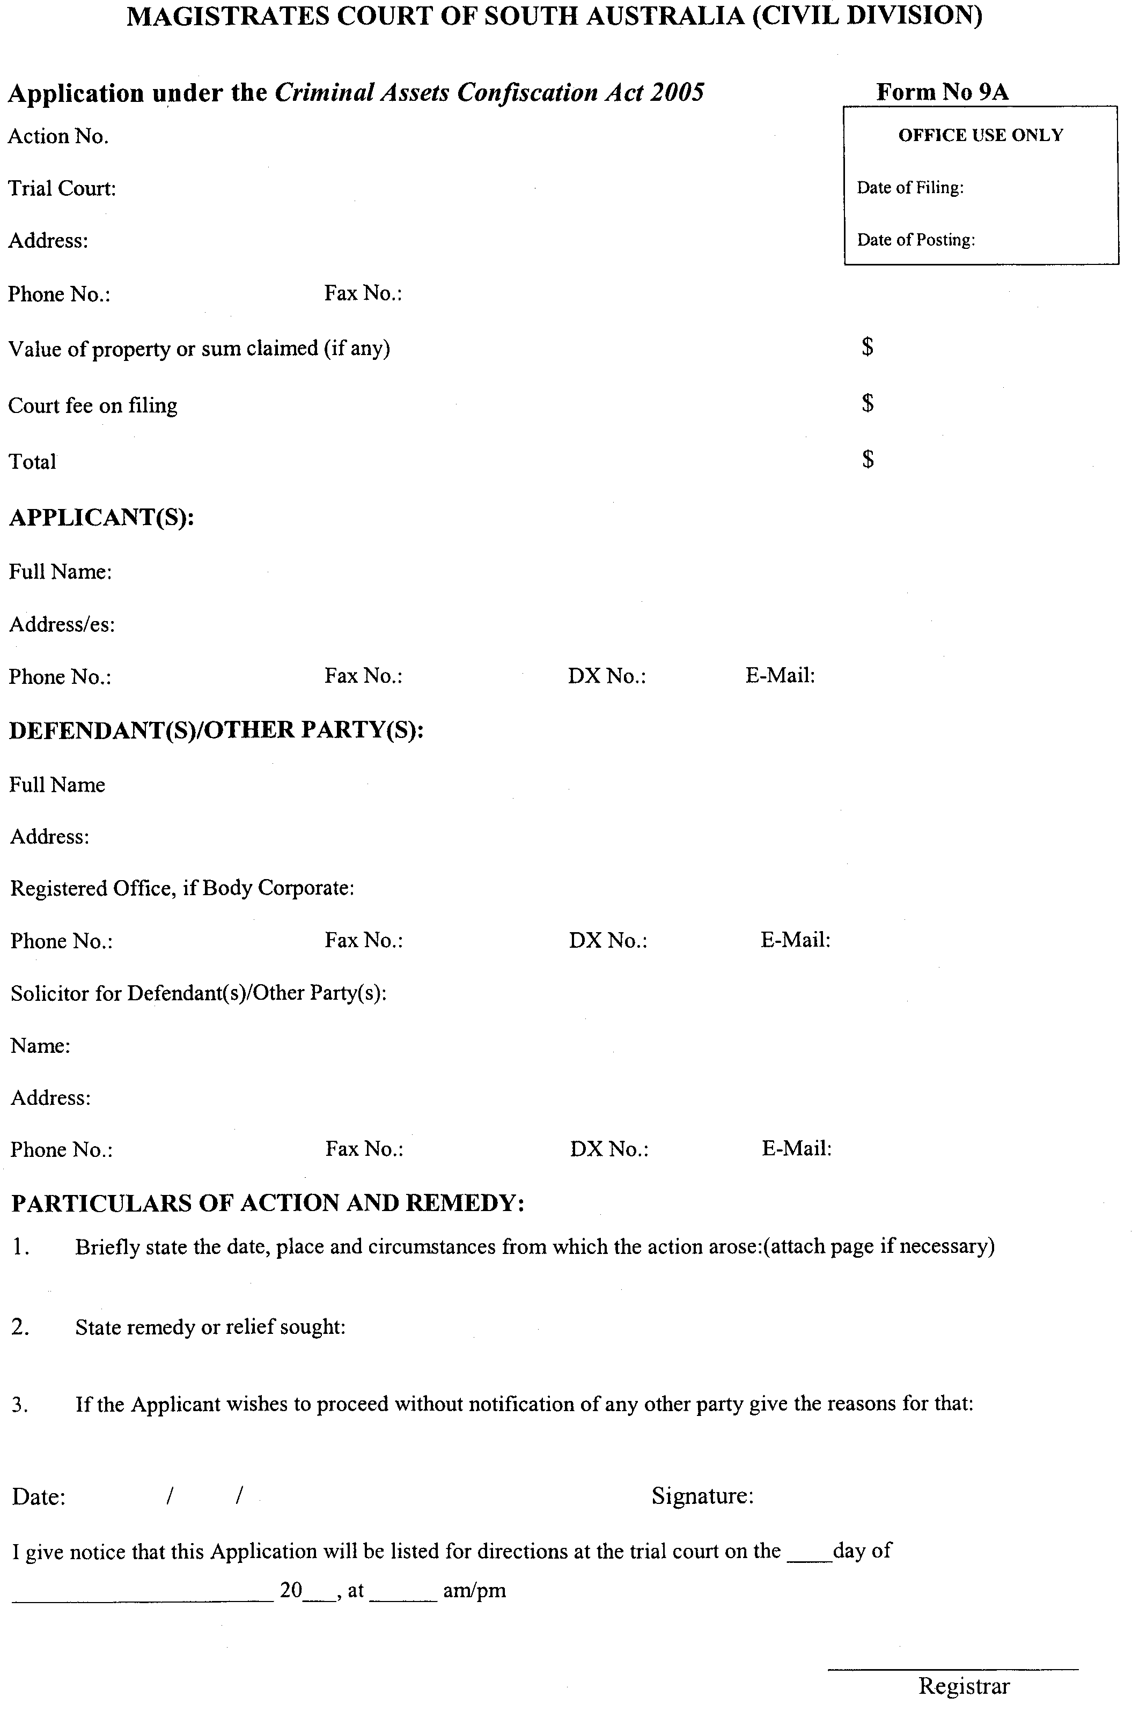
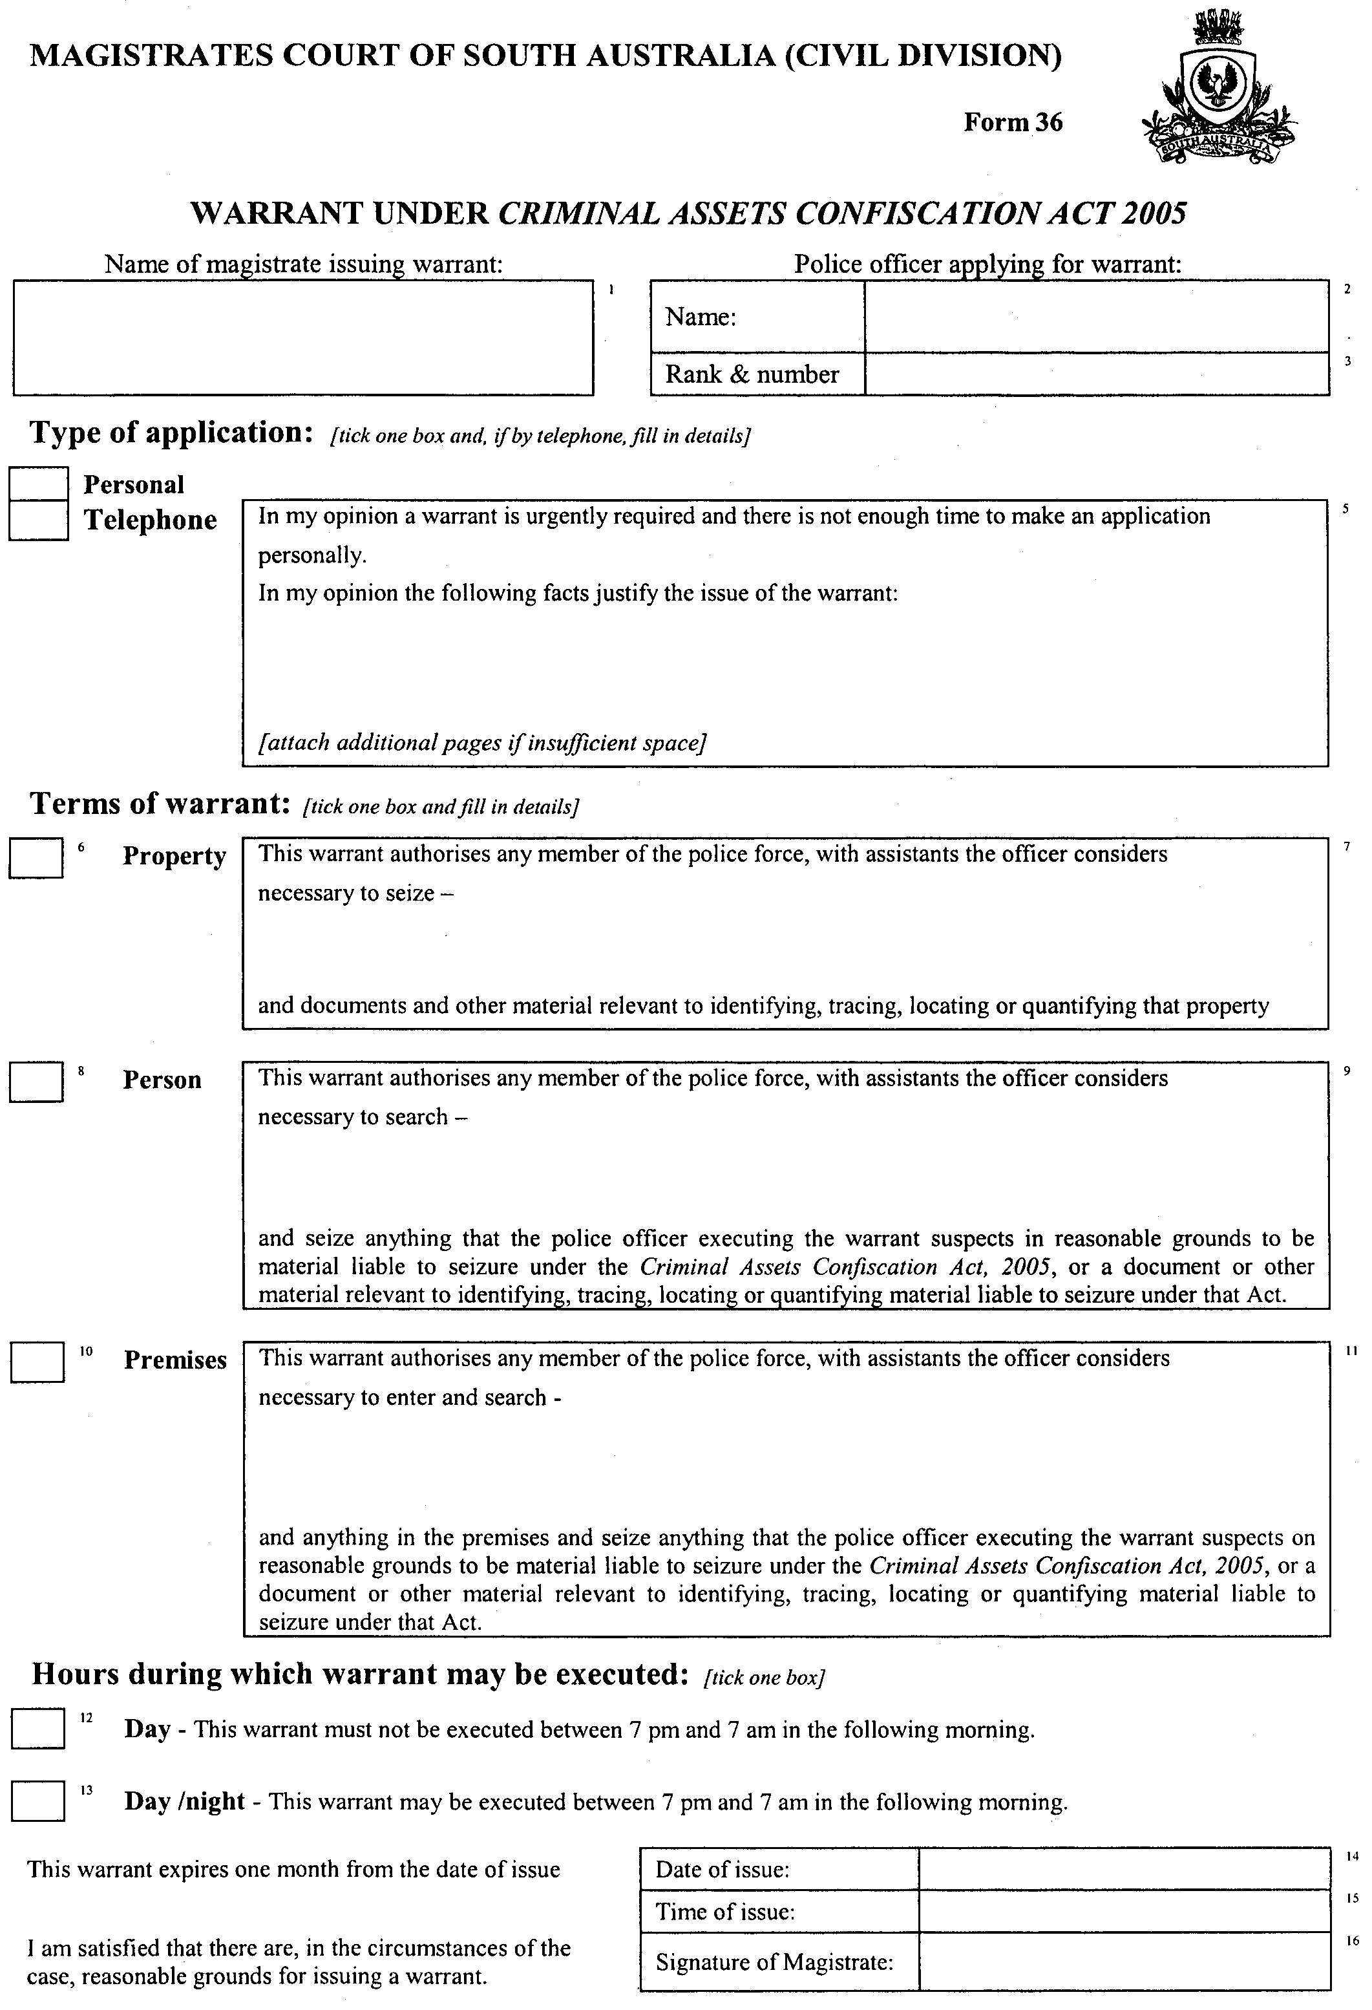
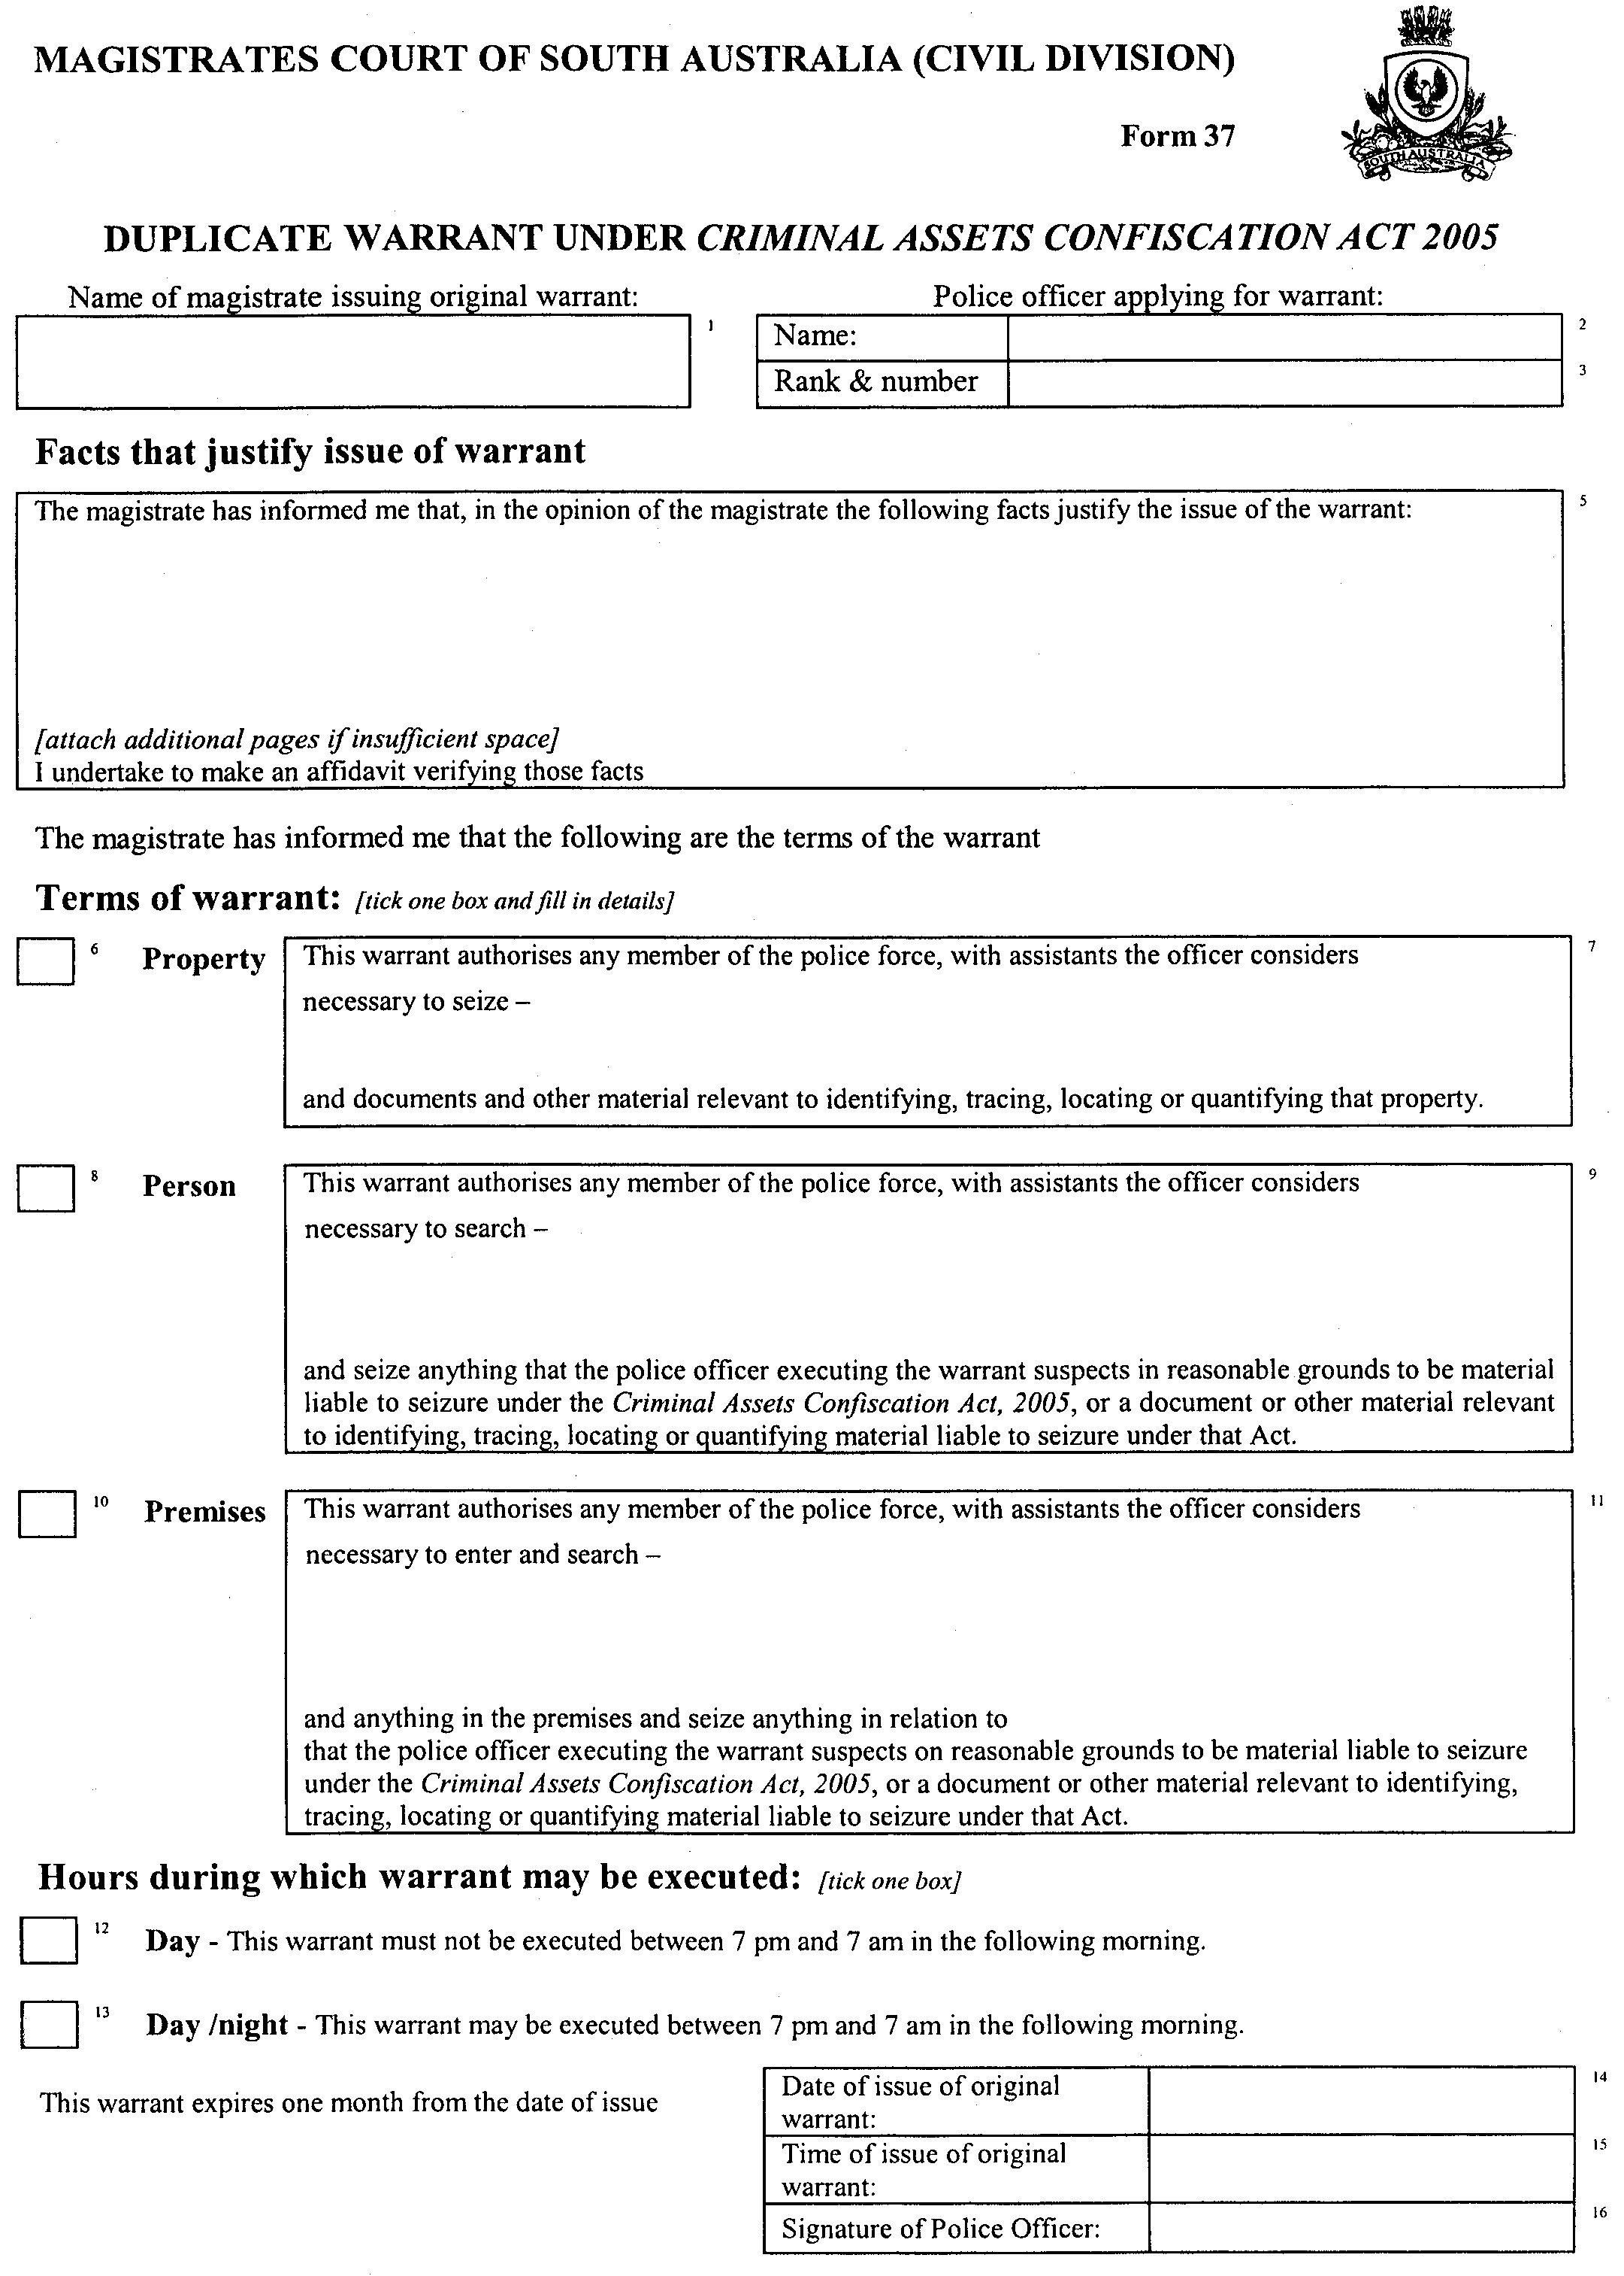

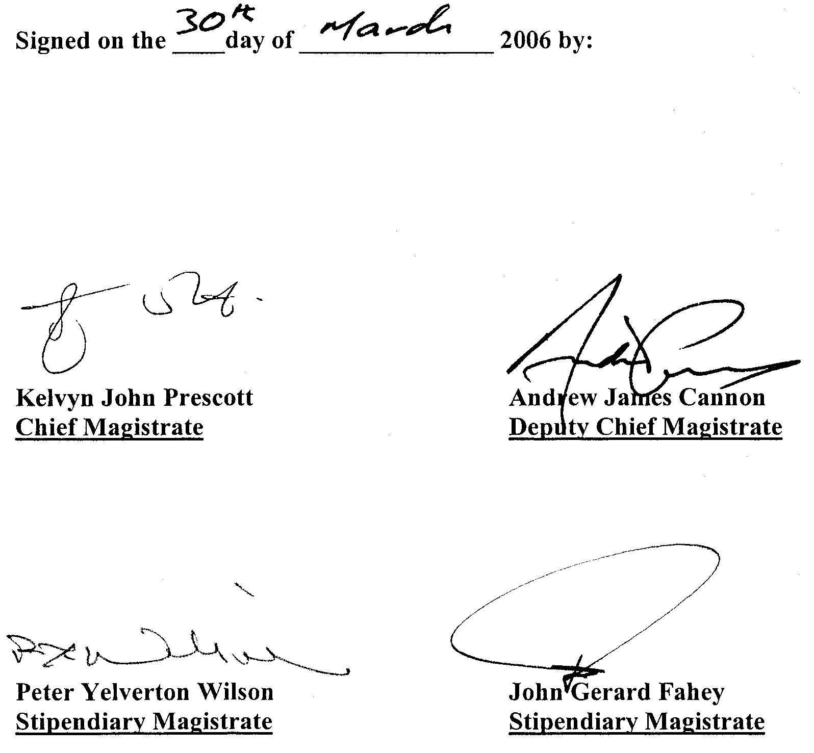

RULES OF COURT
Amending the District Court Rules 1992
Amendment No. 47 to the District Court Rules
BY virtue and in pursuance of section 51 of the District Court Act 1991 and all other enabling powers, We, Terence Anthony Worthington, Chief Judge, Andrea Simpson and Peter Anthony John Herriman, Judges of the District Court of South Australia, do hereby make the following Rules of Court:
1. These Rules may be cited as the ‘District Court Rules 1992, Amendment No. 47’.
2. The District Court Rules 1992, as amended, by these Rules may be cited as the ‘District Court Rules 1992’.
3. Rule II-7 is amended by making the following amendments to Rule 5:
(1) in the definition of ‘Address for service’ in its subparagraph (c) by sub-stituting ‘Document Exchange’ for ‘Adelaide Document Exchange’;
(2) by inserting after the definition of ‘Document’ a new definition:
‘ “Document Exchange” means the document exchange conducted by Toll Priority Pty Ltd which was formerly known as the Adelaide Document Exchange and any other Document Exchange approved by the Registrar as a Document Exchange for the purposes of these Rules at the request of the Law Society of South Australia Inc.’
Dated 16 March 2006.
(l.s.) T. A. Worthington, Chief Judge
A. Simpson, Judge
P. A. J. Herriman, Judge

RULES OF COURT
Amending the District Court Rules 1992
Amendment No. 48 to the District Court Rules
BY virtue and in pursuance of section 51 of the District Court Act 1991 and all other enabling powers, We, Terence Anthony Worthington, Chief Judge, Andrea Simpson and Dean Ernest Clayton, Judges of the District Court of South Australia, do hereby make the following Rules of Court:
1. These Rules may be cited as the ‘District Court Rules 1992, Amendment No. 48’.
2. The District Court Rules 1992, as amended, by these Rules may be cited as the ‘District Court Rules 1992’.
3. Rule I-5 is amended by adding the following subrule:
‘(j) All proceedings commenced in the Court under the Criminal Assets Confiscation Act 2005’.
4. That Part II be amended as follows:
4.1 Rule II-61 is amended by inserting in Rule 101.02A after the words ‘Section 42 (2) of the Act’ the words ‘or pursuant to the Criminal Assets Confiscation Act 2005’.
4.2 By adding Rule II-78C as follows:
‘Rule 113A is to apply to the District Court with the addition of the following subrules:
113A.08 An order made in the Magistrates Court pursuant to section 14 of the Act may be registered by being filed with the Registrar.
113A.09 (1) An application for a monitoring order is to be made by providing the Court with a form setting out the order sought in compliance with the requirements of section 166 of the Act.
(2) In case of urgency the Court may hear the application and make an order by telephone, radio telephone, tele-gram, telex, computer, radio, email or television.’
5. That Part IV be amended by inserting after Rule 10A a new Rule 10B as follows:
‘Proceedings under the Criminal Assets Confiscation Act 2005
10B.01 Rule 10B applies to proceedings under the Criminal Assets Confis-cation Act 2005, which for the purposes of this Rule only is referred to as “the Act”.
10B.02 Where any proceedings under the Act may be dealt with by the Court in its criminal jurisdiction any party may initiate those proceedings by an application in Form 1 which is to comply with Rule 9.
10B.03 An application under Rule 10B.02 is to proceed in accordance with such directions as are given by a Judge in open court or on a directions hearing under Rule 6.07.
10B.04 The Court may direct that any evidence in related criminal proceedings be treated as evidence on the application, but without prejudice to any party having a right to adduce further relevant evidence.’
Dated 29 March 2006.
(l.s.) T. A. Worthington, Chief Judge
A. Simpson, Judge
D. E. Clayton, Judge

RULES OF COURT
Amending the Supreme Court Rules 1987
Amendment No. 100 to the Supreme Court Rules
BY virtue and in pursuance of section 72 of the Supreme Court Act 1935 and all other enabling powers, We, the Judges of the Supreme Court of South Australia, make the following Rules to take effect as amendments to the Supreme Court Rules 1987, as amended:
1. These Rules may be cited as the ‘Supreme Court Rules 1987, Amendment No. 100’.
2. The Supreme Court Rules 1987, as amended, by these Rules may be cited as the ‘Supreme Court Rules 1987’.
3. Rule 1A.22 is deleted.
4. Rule 5 (1) is amended:
(1) in the definition of ‘Address for service’ in its subparagraph (c) by sub-stituting ‘Document Exchange’ for ‘Adelaide Document Exchange’.
(2) by inserting after the definition of ‘Document’ a new definition:
‘ “Document Exchange” means the document exchange conducted by Toll Priority Pty Ltd which was formerly known as the Adelaide Document Exchange and any other Document Exchange approved by the Registrar as a Document Exchange for the purposes of these Rules at the request of the Law Society of South Australia Inc.’
5. Rule 12.05 is amended by substituting in its subparagraph (c) ‘a Document Exchange’ for ‘the service known as The Adelaide Branch of the Australian Document Exchange or other service prescribed by these Rules’.
6. Rule 83.01 is amended by deleting subparagraph (4).
7. The First Schedule is amended by:
(1) deleting Forms 42, 43 and 44;
(2) by inserting a new Form 42:
‘Form 42

AFFIDAVIT

I (full name, address and occupation) MAKE AN OATH/MAKE AN AFFIRMATION (delete one or the other) AND SAY:

[set out text of affidavit in successive, numbered paragraphs]

Sworn/affirmed (delete one or the other) by the abovenamed person

at [Place]

on [Date]

…………………………………
[Signature of Person]

Before me [Signature of Attesting witness]

[Print name of Witness]

[ID Number of Witness]

NOTE: Where the affidavit is filed electronically a signed copy of the original is to be retained by the transmitter of the Affidavit.’
(3) in Form 46 deleting the whole of paragraph 3 and replacing it by:
‘3 [Where order is by consent] The consent is evidenced by:
(set out how consent is being given, e.g. by endorsement on minutes of order, by email from another solicitor dated ………………….. 20….. or otherwise).
GIVEN under our hands and the Seal of the Supreme Court of South Australia this 27th day of February 2006.
(l.s.) J. DOYLE, CJ
J. W. PERRY, J
K. P. DUGGAN, J
B. M. DEBELLE, J
M. J. NYLAND, J
D. J. BLEBY, J
A. BESANKO, J
J. R. SULAN, J
A. M. VANSTONE, J
J. ANDERSON, J
R. C. WHITE, J
R. A. LAYTON, J

TRAINING AND SKILLS DEVELOPMENT ACT 2003

Part 4 – Apprenticeships/Traineeships

Pursuant to the provision of the Training and Skills Development Act 2003, the Training and Skills Commission (TaSC) gives notice that determines the following:
Trades, Declared Vocations or Other Occupations

The following schedule is additional to the gazettals of:

- 5 February 2004 | - 19 February 2004 | - 11 March 2004 | - 1 April 2004
- 1 July 2004 | - 15 July 2004 | - 22 July 2004 | - 30 September 2004
- 16 December 2004 | - 27 January 2005 | - 3 February 2005 | - 10 February 2005
- 10 March 2005 | - 24 March 2005 | - 5 May 2005 | - 12 May 2005
- 2 June 2005 | - 16 June 2005 | - 7 July 2005 | - 4 August 2005
- 18 August 2005 | - 1 September 2005 | - 15 September 2005 | - 22 September 2005
- 6 October 2005 | - 20 October 2005 | - 27 October 2005 | - 8 December 2005
- 22 December 2005 | 30. 9 March 2006 | 31. 6 April 2006 | - 20 April 2006

which set out the Trades, Declared Vocations or Other Occupations and the terms and conditions applicable to the Trades, Declared Vocations or Other Occupations.

Trades, Declared Vocations or Other Occupations, required Qualifications and Contract of Training Conditions for the
Fitness Industry Training Package (SRF04)

*Trade/ #Declared Vocation/Other Occupation | Code | Title | Nominal Term of Contract of Training | Probationary Period
#Recreation Industry Worker | SRF30204 | Certificate III in Fitness | 18 months | 6 weeks
 | SRF40204 | Certificate IV in Fitness | 24 months | 2 months

GOVERNMENT GAZETTE ADVERTISEMENT RATES

To apply from 1 July 2005

$  Agents, Ceasing to Act as 36.50  Associations:  Incorporation 18.60  Intention of Incorporation 46.00  Transfer of Properties 46.00  Attorney, Appointment of 36.50  Bailiff’s Sale 46.00  Cemetery Curator Appointed 27.25  Companies:  Alteration to Constitution 36.50  Capital, Increase or Decrease of 46.00  Ceasing to Carry on Business 27.25  Declaration of Dividend 27.25  Incorporation 36.50  Lost Share Certificates:  First Name 27.25  Each Subsequent Name 9.35  Meeting Final 30.50  Meeting Final Regarding Liquidator’s Report on  Conduct of Winding Up (equivalent to ‘Final  Meeting’)  First Name 36.50  Each Subsequent Name 9.35  Notices:  Call 46.00  Change of Name 18.60  Creditors 36.50  Creditors Compromise of Arrangement 36.50  Creditors (extraordinary resolution that ‘the Com-pany be wound up voluntarily and that a liquidator be appointed’) 46.00  Release of Liquidator⎯Application⎯Large Ad. 72.50  ⎯Release Granted 46.00  Receiver and Manager Appointed 42.50  Receiver and Manager Ceasing to Act 36.50  Restored Name 34.50  Petition to Supreme Court for Winding Up 64.00  Summons in Action 54.50  Order of Supreme Court for Winding Up Action 36.50  Register of Interests⎯Section 84 (1) Exempt 82.50  Removal of Office 18.60  Proof of Debts 36.50  Sales of Shares and Forfeiture 36.50  Estates:  Assigned 27.25  Deceased Persons⎯Notice to Creditors, etc. 46.00  Each Subsequent Name 9.35  Deceased Persons⎯Closed Estates 27.25  Each Subsequent Estate 1.20  Probate, Selling of 36.50  Public Trustee, each Estate 9.35 |  | $  Firms:  Ceasing to Carry on Business (each insertion) 24.30  Discontinuance Place of Business 24.30  Land⎯Real Property Act:  Intention to Sell, Notice of 46.00  Lost Certificate of Title Notices 46.00  Cancellation, Notice of (Strata Plan) 46.00  Mortgages:  Caveat Lodgment 18.60  Discharge of 19.50  Foreclosures 18.60  Transfer of 18.60  Sublet 9.35  Leases⎯Application for Transfer (2 insertions) each 9.35  Lost Treasury Receipts (3 insertions) each 27.25  Licensing 54.50  Municipal or District Councils:  Annual Financial Statement⎯Forms 1 and 2 513.00  Electricity Supply⎯Forms 19 and 20 364.00  Default in Payment of Rates:  First Name 72.50  Each Subsequent Name 9.35  Noxious Trade 27.25  Partnership, Dissolution of 27.25  Petitions (small) 18.60  Registered Building Societies (from Registrar-  General) 18.60  Register of Unclaimed Moneys⎯First Name 27.25  Each Subsequent Name 9.35  Registers of Members⎯Three pages and over:  Rate per page (in 8pt) 233.00  Rate per page (in 6pt) 308.00  Sale of Land by Public Auction 46.50  Advertisements 2.60  ¼ page advertisement 109.00  ½ page advertisement 218.00  Full page advertisement 427.00  Advertisements, other than those listed are charged at $2.60 per column line, tabular one-third extra.  Notices by Colleges, Universities, Corporations and District Councils to be charged at $2.60 per line.  Where the notice inserted varies significantly in length from that which is usually published a charge of $2.60 per column line will be applied in lieu of advertisement rates listed.  South Australian Government publications are sold on the condition that they will not be reproduced without prior permission from the Government Printer.
All the above prices include GST

GOVERNMENT GAZETTE NOTICES
ALL private advertisements forwarded for publication in the South Australian Government Gazette must be PAID FOR PRIOR TO INSERTION; and all notices, from whatever source, should be legibly written on one side of the paper only and sent to Government Publishing SA so as to be received no later than 4 p.m. Tuesday preceding the day of publication. Phone 8207 1045 or Fax 8207 1040. E-mail: governmentgazette@saugov.sa.gov.au. Send as attachments in Word format. Please include date the notice is to be published and to whom the notice will be charged. The Government Gazette is available online at: www.governmentgazette.sa.gov.au.

MISCELLANEOUS LEGISLATION AND GOVERNMENT PUBLICATIONS PRICES AS FROM 1 JULY 2005

Acts, Bills, Rules, Parliamentary Papers and Regulations
Pages | Main | Amends | Pages | Main | Amends

1-16 | 2.20 | 1.00 | 497-512 | 31.00 | 30.00
17-32 | 3.00 | 1.85 | 513-528 | 32.00 | 30.75
33-48 | 3.90 | 2.80 | 529-544 | 33.00 | 32.00
49-64 | 4.90 | 3.75 | 545-560 | 34.00 | 33.00
65-80 | 5.75 | 4.75 | 561-576 | 34.75 | 34.00
81-96 | 6.70 | 5.55 | 577-592 | 35.75 | 34.50
97-112 | 7.60 | 6.50 | 593-608 | 36.75 | 35.50
113-128 | 8.55 | 7.45 | 609-624 | 37.50 | 36.50
129-144 | 9.60 | 8.50 | 625-640 | 38.50 | 37.00
145-160 | 10.50 | 9.35 | 641-656 | 39.50 | 38.50
161-176 | 11.50 | 10.30 | 657-672 | 40.00 | 39.00
177-192 | 12.40 | 11.30 | 673-688 | 41.75 | 40.00
193-208 | 13.40 | 12.30 | 689-704 | 42.50 | 41.00
209-224 | 14.20 | 13.10 | 705-720 | 43.00 | 42.00
225-240 | 15.10 | 14.00 | 721-736 | 44.75 | 43.00
241-257 | 16.20 | 14.70 | 737-752 | 45.25 | 44.00
258-272 | 17.10 | 15.70 | 753-768 | 46.25 | 44.50
273-288 | 18.00 | 16.90 | 769-784 | 46.75 | 46.00
289-304 | 18.80 | 17.70 | 785-800 | 47.75 | 47.00
305-320 | 19.90 | 18.70 | 801-816 | 48.50 | 47.50
321-336 | 20.70 | 19.60 | 817-832 | 49.75 | 48.50
337-352 | 21.80 | 20.60 | 833-848 | 50.75 | 49.50
353-368 | 22.60 | 21.60 | 849-864 | 51.50 | 50.00
369-384 | 23.60 | 22.50 | 865-880 | 52.50 | 51.50
385-400 | 24.50 | 23.40 | 881-896 | 53.00 | 52.00
401-416 | 25.50 | 24.20 | 897-912 | 54.50 | 53.00
417-432 | 26.50 | 25.25 | 913-928 | 55.00 | 54.50
433-448 | 27.50 | 26.25 | 929-944 | 56.00 | 55.00
449-464 | 28.25 | 27.00 | 945-960 | 57.00 | 55.50
465-480 | 28.75 | 28.00 | 961-976 | 58.25 | 56.50
481-496 | 30.00 | 28.75 | 977-992 | 59.25 | 57.00

Legislation—Acts, Regulations, etc: $
Subscriptions:
Acts 192.00
All Bills as Laid 460.00
Rules and Regulations 460.00
Parliamentary Papers 460.00
Bound Acts 213.00
Index 106.00
Government Gazette
Copy 5.00
Subscription 254.00
Hansard
Copy 14.00
Subscription—per session (issued weekly) 399.00
Cloth bound—per volume 172.00
Subscription—per session (issued daily) 399.00
Legislation on Disk
Whole Database 2 951.00
Annual Subscription for fortnightly updates 907.00
Individual Act(s) including updates POA
Compendium
Subscriptions:
Subscriptions 1 749.00
Updates 617.00
(All the above prices include GST)

All Legislation, Government Gazette, Hansard and Legislation on disk are available from:
Counter Sales Service SA, Government Legislation⁺ Outlet
and Mail Orders: Lands Titles Office, 101 Grenfell Street, Adelaide, S.A. 5000
Phone: 13 23 24 (local call cost), Fax: (08) 8204 1909
Postal: G.P.O. Box 1707, Adelaide, S.A. 5001

Online Shop: www.shop.service.sa.gov.au

Subscriptions and Government Publishing SA
Standing Orders: Box 9, Plaza Level, Riverside Centre, North Terrace, Adelaide, S.A. 5000
Phone: (08) 8207 0908, (08) 8207 0910, Fax: (08) 8207 1040

SURVEY ACT 1992
PURSUANT to section 50 (3) of the Survey Act 1992, notice is given that the Confused Boundary Area at Renmark, Filed Plan 46574 bounded by Thurk Street, Twelfth Street, Cowra Street and Eleventh Street is revoked.
Dated 11 May 2006.
P. M. Kentish, Surveyor-General
REF: LTO 60/2004

WATER MAINS AND SEWERS

Office of the South Australian Water Corporation
Adelaide, 4 May 2006

WATER MAINS LAID

Notice is hereby given that the following main pipes or parts of main pipes have been laid down by the South Australian Water Corporation in or near the undermentioned water districts and are now available for a constant supply of water to adjacent land.

ADELAIDE WATER DISTRICT

CITY OF ONKAPARINGA
Across Education Road, Happy Valley. p10
Happy Valley Drive, Happy Valley. p10

CITY OF PLAYFORD
Eton Drive, Andrews Farm. p2
Enterprise Circuit, Andrews Farm. p2
Easement in lot 2006 in LTRO DP 70557, Andrews Road, Andrews Farm. p2

CITY OF PORT ADELAIDE ENFIELD
Collins Street, Largs North. p11 and 12
Easement in reserve (lot 5 in LTRO DP 69689), Wollowra Crescent, Largs North. p12
Sheean Street, Largs North. p11
Waller Court, Largs North. p11
Rankin Drive, Largs North. p12
Victoria Road, Largs North. p12
Farncomb Court, Largs North. p12
Vale Avenue, Valley View. p15

CITY OF SALISBURY
Fern Grove Boulevard, Salisbury East. p13
Strathpine Street, Salisbury East. p13

TOWNSHIP OF AUBURN WATER DISTRICT

CLARE AND GILBERT VALLEYS COUNCIL
West Street, Auburn. This main is available on the west side by application only. p3
Henry Street, Auburn. p3
King William Street, Auburn. p3

BUNDALEER COUNTRY LANDS WATER DISTRICT

WAKEFIELD REGIONAL COUNCIL
Sleeps Crossing Road, Nantawarra. p34
Sleeps Hill Road, Bumbunga. p34 and 35
Isaacsons Pit Road, Bumbunga. p35-40

TOWNSHIP OF CLARE WATER DISTRICT

CLARE AND GILBERT VALLEYS COUNCIL
Across and in Neagles Rock Road, Clare. This main is available on the west side by application only. p4-6
Kelly Street, Clare. p6
Easements in reserve (lot 405 in LTRO DP 67570), Neagles Roack Road, and lot 203 in LTRO DP 68856, Pandappa Drive, Clare. p6 and 7
Pandappa Drive, Clare. p7 and 8
Gooding Court, Clare. p7
Easement in lot 202 in LTRO DP 68856, Gooding Court, Clare. p7
Trezise Way, Clare. p7 and 9
Easement in lot 204 in LTRO DP 68856, Trezise Way, Clare. p9
Roscrow Court, Clare. p8
Hanlins Road, Clare. p8

PORT VICTOR WATER DISTRICT

CITY OF VICTOR HARBOR
George Main Road, Victor Harbor. p16
Ewen Terrace, Victor Harbor. p16 and 17
Across and in Armstrong Road, Victor Harbor. p17
Easements in lot 408 in LTRO FP 165657, and section 732, hundred of Encounter Bay, Armstrong Road, Victor Harbor. p17 and 18
Across Bacchus Road, Victor Harbor. p18
Jasmin Drive, Victor Harbor. p18-20
Singh Court, Victor Harbor. p20
Easement in lot 18 in LTRO DP 70770, Singh Court, and reserve (lot 399 in LTRO DP 70770), Inman Valley Road, Victor Harbor. p20
Across and in Inman Valley Road, Victor Harbor. p21

STRATHALBYN WATER DISTRICT

ALEXANDRINA COUNCIL
Easements in lot 214 in LTRO DP 65772, Strathford Way, Strathalbyn. p41
Strathoak Crescent, Strathalbyn. p42
Easement in lot 213 in LTRO DP 65772, Strathoak Crescent, Strathalbyn. p42

WARREN COUNTRY LANDS WATER DISTRICT

LIGHT REGIONAL COUNCIL
Jas Ryan Road, Freeling. p32
Higgs Road, Freeling. p32 and 33

WATER MAINS ABANDONED

Notice is hereby given that the undermentioned water mains have been abandoned by the South Australian Water Corporation.

BUNDALEER COUNTRY LANDS WATER DISTRICT

WAKEFIELD REGIONAL COUNCIL
Sleeps Crossing Road, Nantawarra. p34
Sleeps Hill Road, Nantawarra. p34 and 35
Isaacsons Pit Road, Nantawarra and Lochiel. p35-40

PENNESHAW WATER DISTRICT

KANGAROO ISLAND COUNCIL
Easement in lot 150 in LTRO DP 67049, Binneys Track, Penneshaw. p14

WARREN COUNTRY LANDS WATER DISTRICT

LIGHT REGIONAL COUNCIL
Jas Ryan Road, Freeling. p32
Higgs Road, Freeling. p32 and 33

WATER MAINS LAID

Notice is hereby given that the undermentioned water mains have been laid down by the South Australian Water Corporation and are not available for a constant supply of water to adjacent land.

BAROSSA COUNTRY LANDS WATER DISTRICT

BAROSSA COUNCIL
Waterworks land (allotment piece 51 in LTRO FP 218963), Warner Court, Sandy Creek. p22-31
Easement in lot 101 in LTRO DP 67672, Warner Court, and lot 47 in LTRO DP 60147, Kakatoe Crescent, Sandy Creek. p22 and 28

PENNESHAW WATER DISTRICT

KANGAROO ISLAND COUNCIL
Easement in lot 150 in LTRO DP 67049, Binneys Track, Penneshaw. p14

SEWERS LAID

Notice is hereby given that the following sewers have been laid down by the South Australian Water Corporation in the under-mentioned drainage areas and are now available for house connections.

ADELAIDE DRAINAGE AREA

CITY OF ONKAPARINGA
Easements in lot 501 in LTRO DP 62268, Chandlers Hill Road, Happy Valley. FB 1147 p54, 55 and 57
Happy Valley Drive, Happy Valley. FB 1147 p54, 55 and 57

CITY OF PLAYFORD
Eton Drive, Andrews Farm. FB 1147 p50-52
Enterprise Circuit, Andrews Farm. FB 1147 p50, 51 and 53
Easement in lot 2006 in LTRO DP 70557, Andrews Road, Andrews Farm. FB 1147 p50, 51 and 53

CITY OF PORT ADELAIDE ENFIELD
Collins Street, Largs North. FB 1148 p1-3
Sheean Street, Largs North. FB 1148 p1, 2 and 4
Waller Court, Largs North. FB 1148 p1-3
Rankin Street, Largs North. FB 1148 p1-3
Farncomb Court, Largs North. FB 1148 p1-3
Wollowra Crescent, Largs North. FB 1148 p1, 2 and 4
Riverina Street, Largs North. FB 1148 p1, 2 and 4

CITY OF SALISBURY
Across and in Smith Road, Salisbury East. FB 1148 p5, 6 and 8
Easements in reserve (lot 1001 in LTRO DP 65493), Main North Road, Salisbury East. FB 1148 p5-9
Across and in Fern Grove Boulevard, Salisbury East. FB 1148 p5, 7, 6 and 9

CITY OF WEST TORRENS
Chatham Road, Keswick. FB 1146 p56

MANNUM COUNTRY DRAINAGE AREA

MID MURRAY COUNCIL
Pearson Street, Port Mannum. FB 1146 p55

MOUNT GAMBIER COUNTRY DRAINAGE AREA

CITY OF MOUNT GAMBIER
Easements in lots 33 and 30 in LTRO DP 65545, Penola Road, and lot 9 in LTRO DP 65933, Lee Court, Mount Gambier. FB 1130 p25 and 26
Lee Court, Mount Gambier. FB 1130 p25 and 26

PORT LINCOLN COUNTRY DRAINAGE AREA

CITY OF PORT LINCOLN
St Andrews Terrace, Port Lincoln. FB 1147 p48 and 49

VICTOR HARBOR COUNTRY DRAINAGE AREA

CITY OF VICTOR HARBOR
In and across Bacchus Road, Victor Harbor. FB 1147 p43, 44 and 46
In and across Jasmin Drive, Victor Harbor. FB 1147 p43-47
Easements in allotment piece 500 in LTRO DP 70770, Inman Valley Drive, Victor Harbor. FB 1147 p43-47
Easements in lot 4, allotment piece 501 and lots 12 and 13 in LTRO DP 70770, Jasmin Drive, Victor Harbor. FB 1147 p43, 44 and 47
In and across Inman Valley Road, Victor Harbor. FB 1147 p43-45
Easements in reserve (lot 399), Inman Valley Road, lot 18, and allotment piece 502 in LTRO DP 70770, Singh Court, and reserve (lot 398 in LTRO DP 70770), Jasmin Drive, Victor Harbor. FB 1147 p43-45
Easement in lot 45 in LTRO DP 70770, Jasmin Drive, Victor Harbor. FB 1147 p43, 44 and 47

SEWERS LAID

Notice is hereby given that the undermentioned sewers have been laid down by the South Australian Water Corporation and are not available for house connections.

ADELAIDE DRAINAGE AREA

CITY OF ONKAPARINGA
Easement in lot 501 in LTRO DP 62268, Chandlers Hill Road, Happy Valley. FB 1147 p54, 55 and 57
Happy Valley Drive, Happy Valley. FB 1147 p54-56

CITY OF SALISBURY
Strathpine Street, Salisbury East. FB 1148 p5, 7 and 9

OUTSIDE ADELAIDE DRAINAGE AREA

CITY OF ONKAPARINGA
Waterworks land (lot 7 in LTRO DP 45907), Chandlers Hill Road, Happy Valley. FB 1147 p54-57
Across and in Chandlers Hill Road, Happy Valley. FB 1147 p54-57

A. Howe, Chief Executive Officer, South Australian Water Corporation

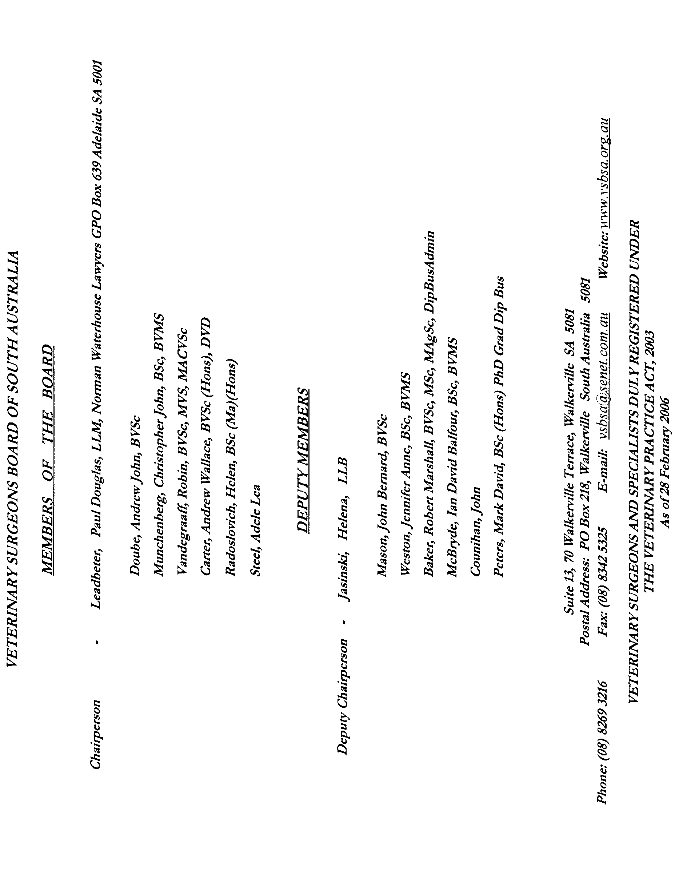
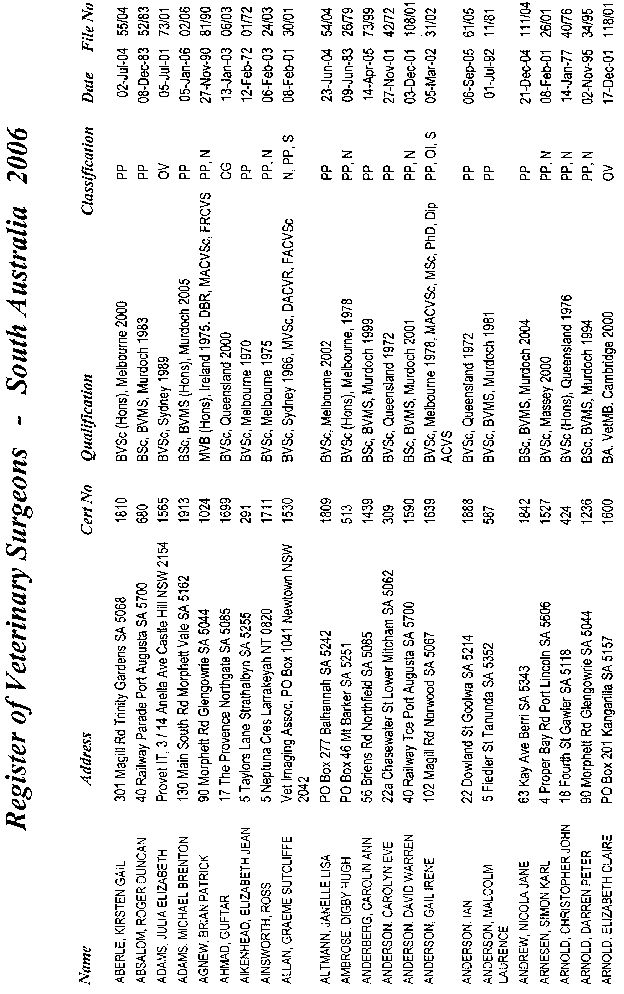
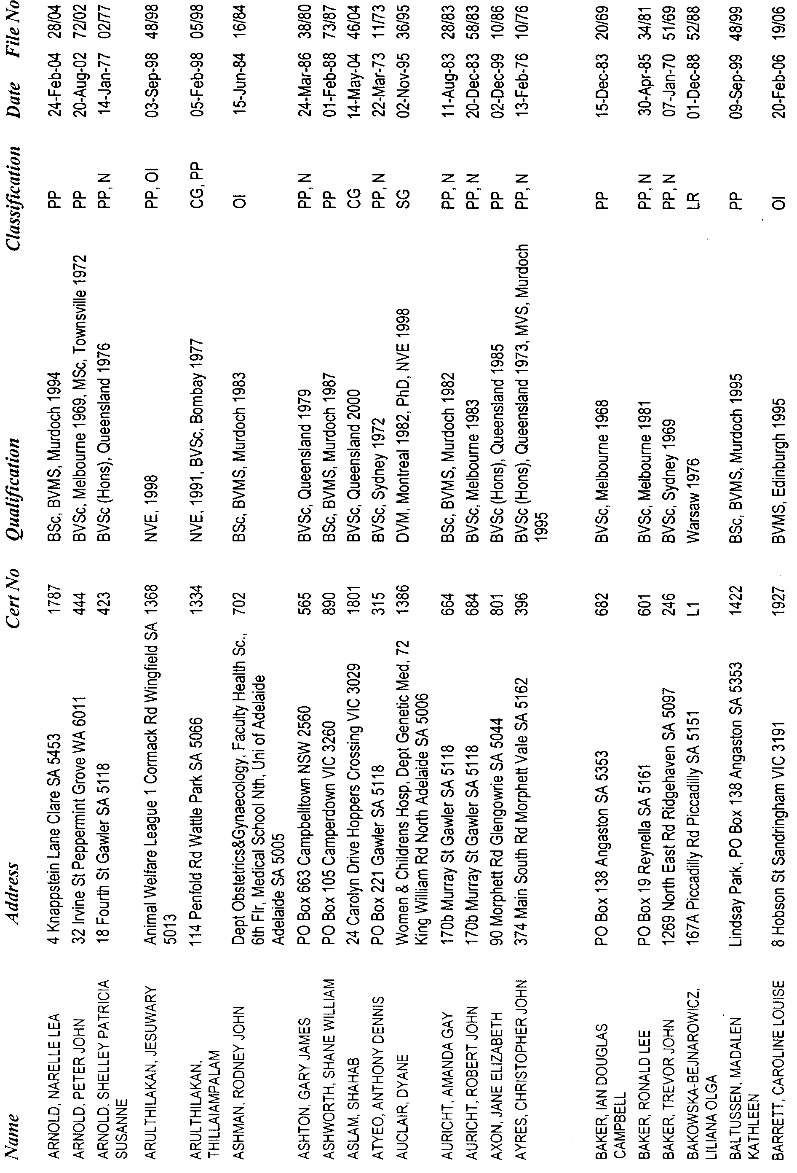
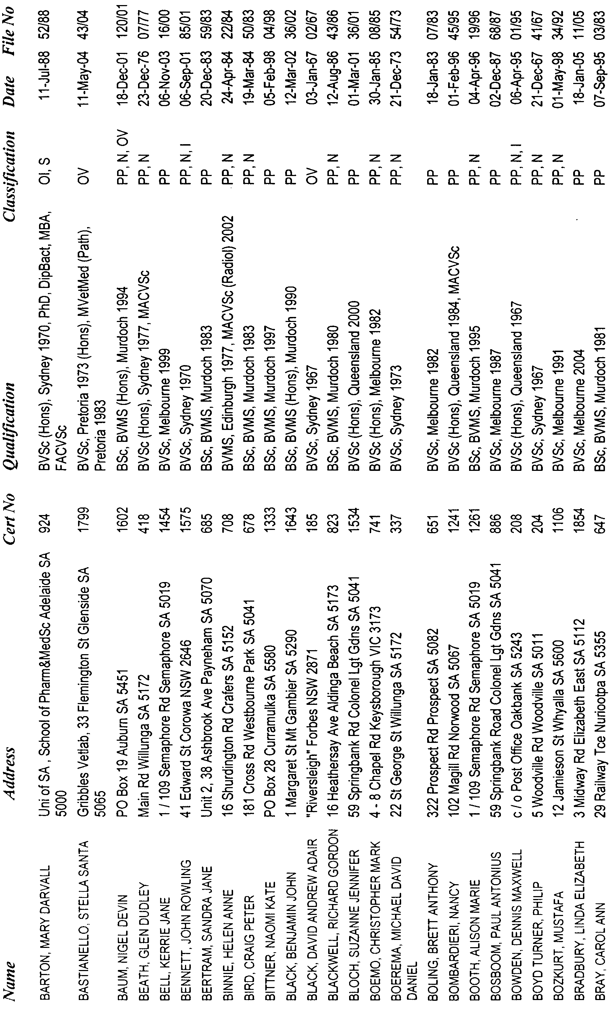
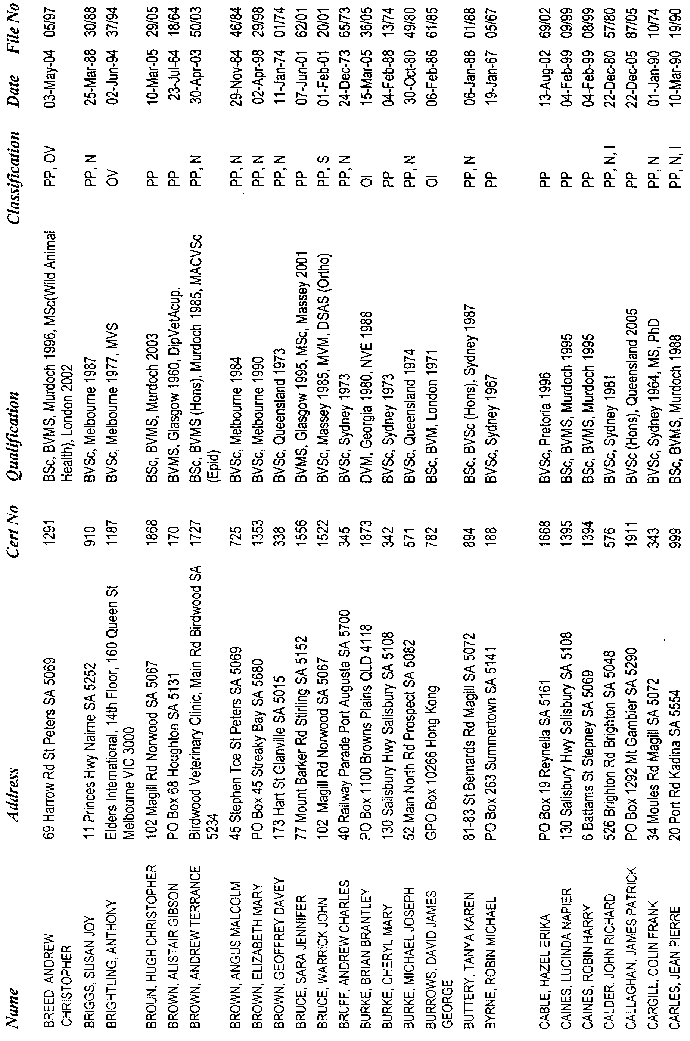
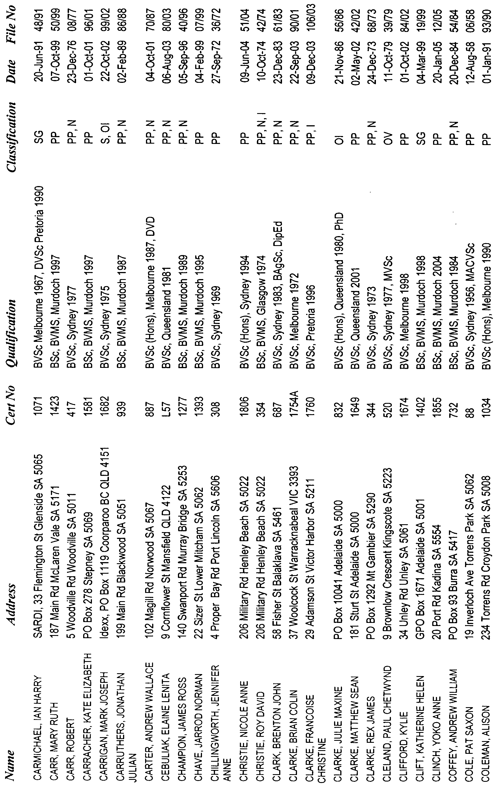
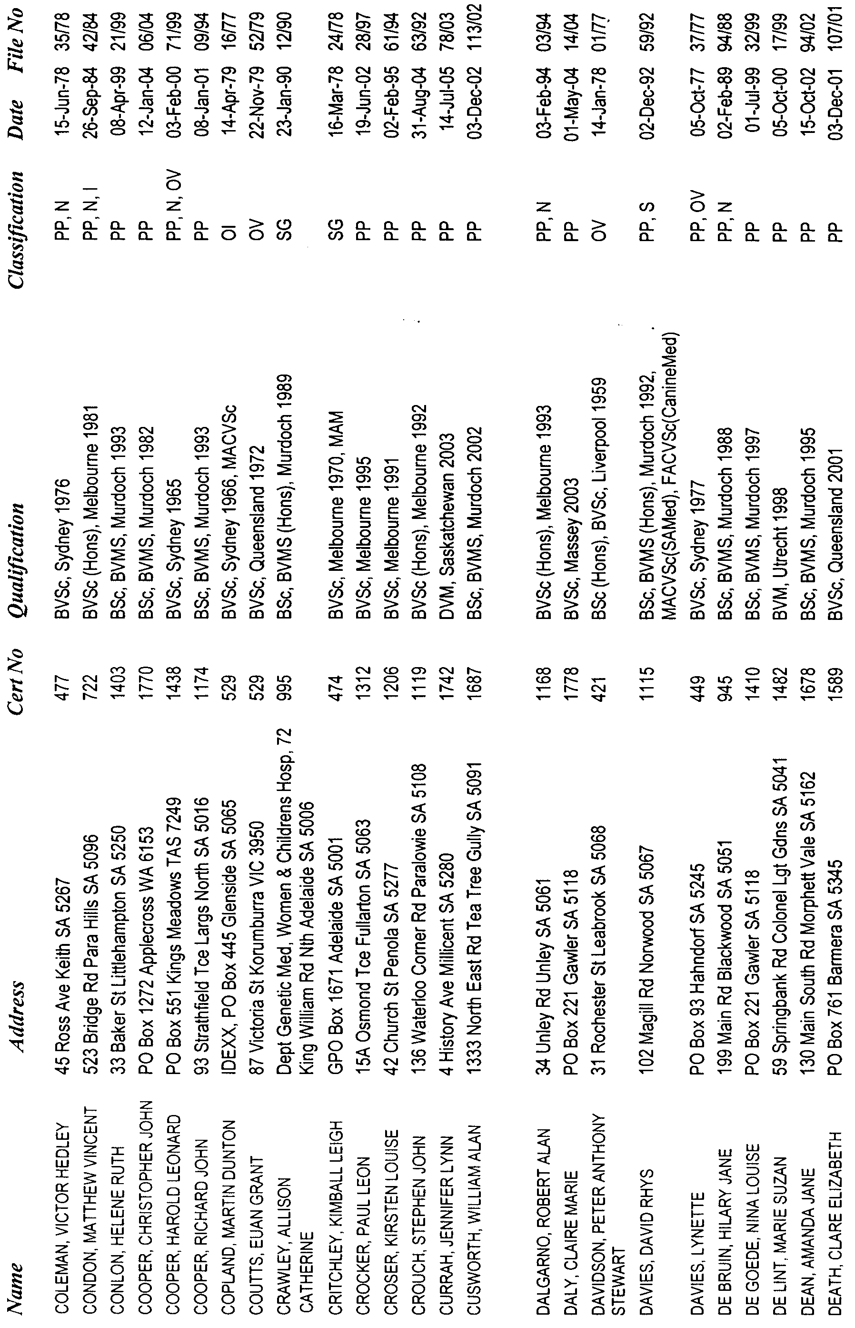
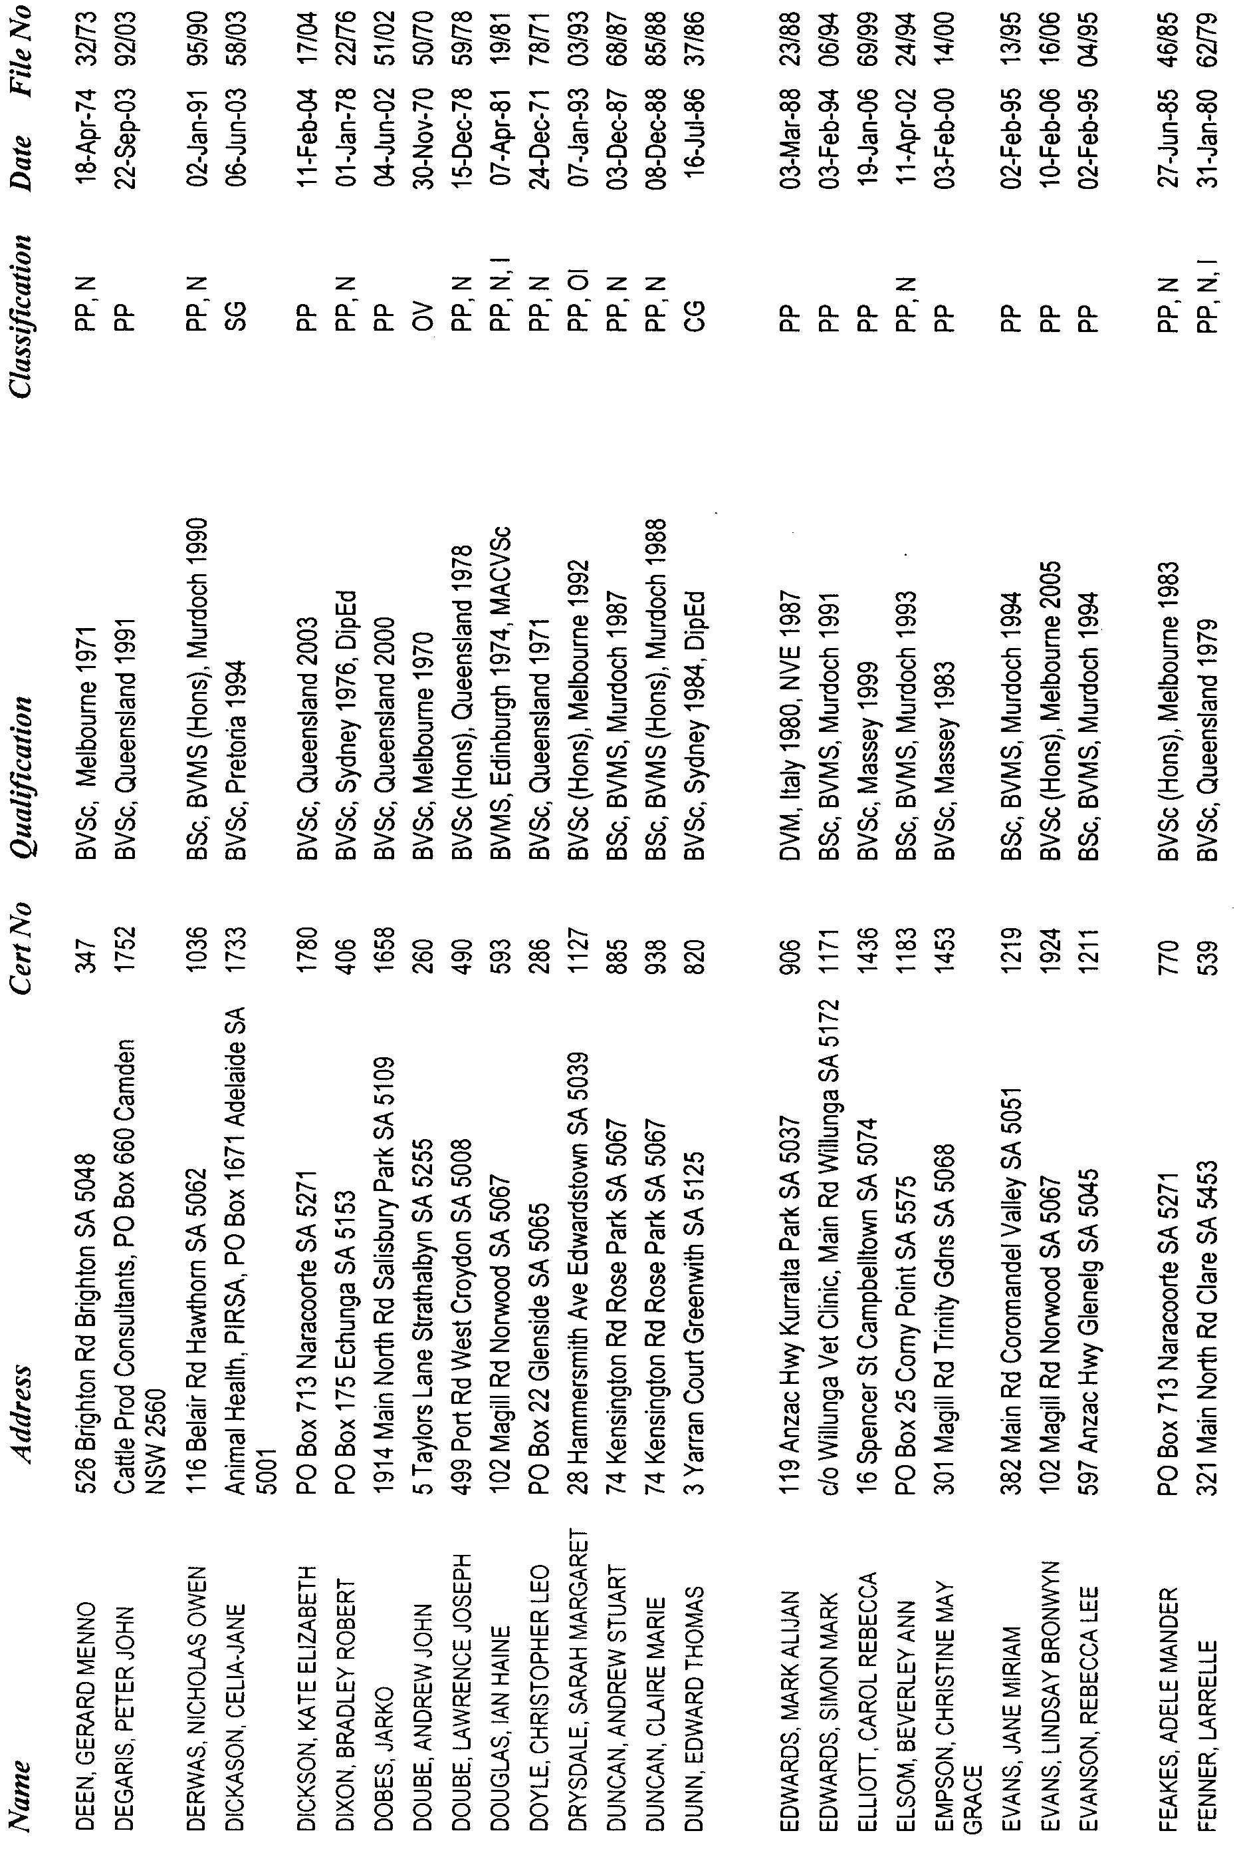
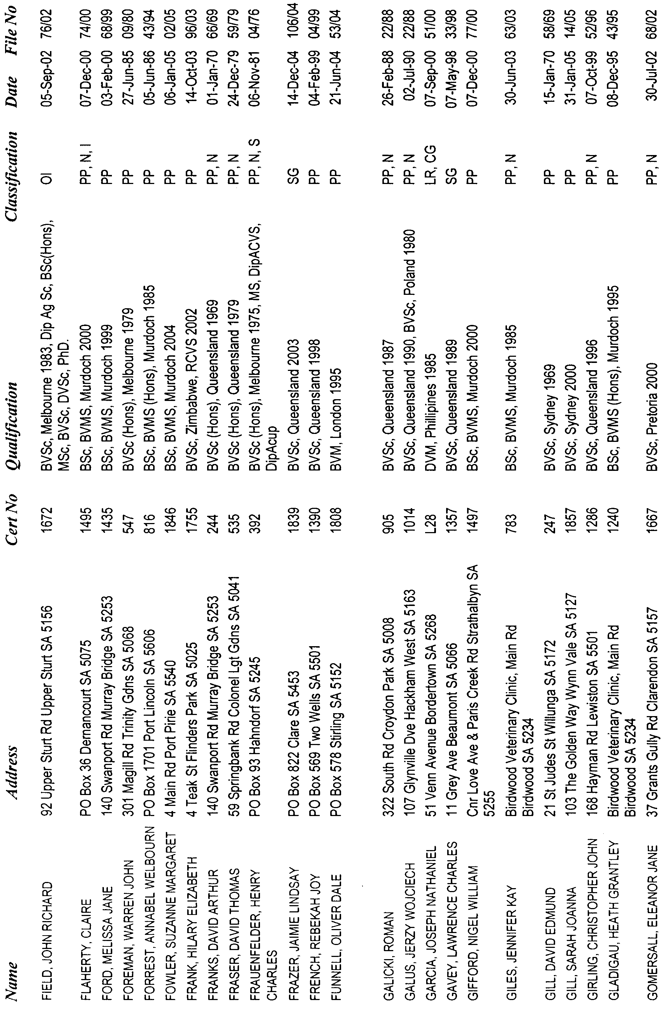
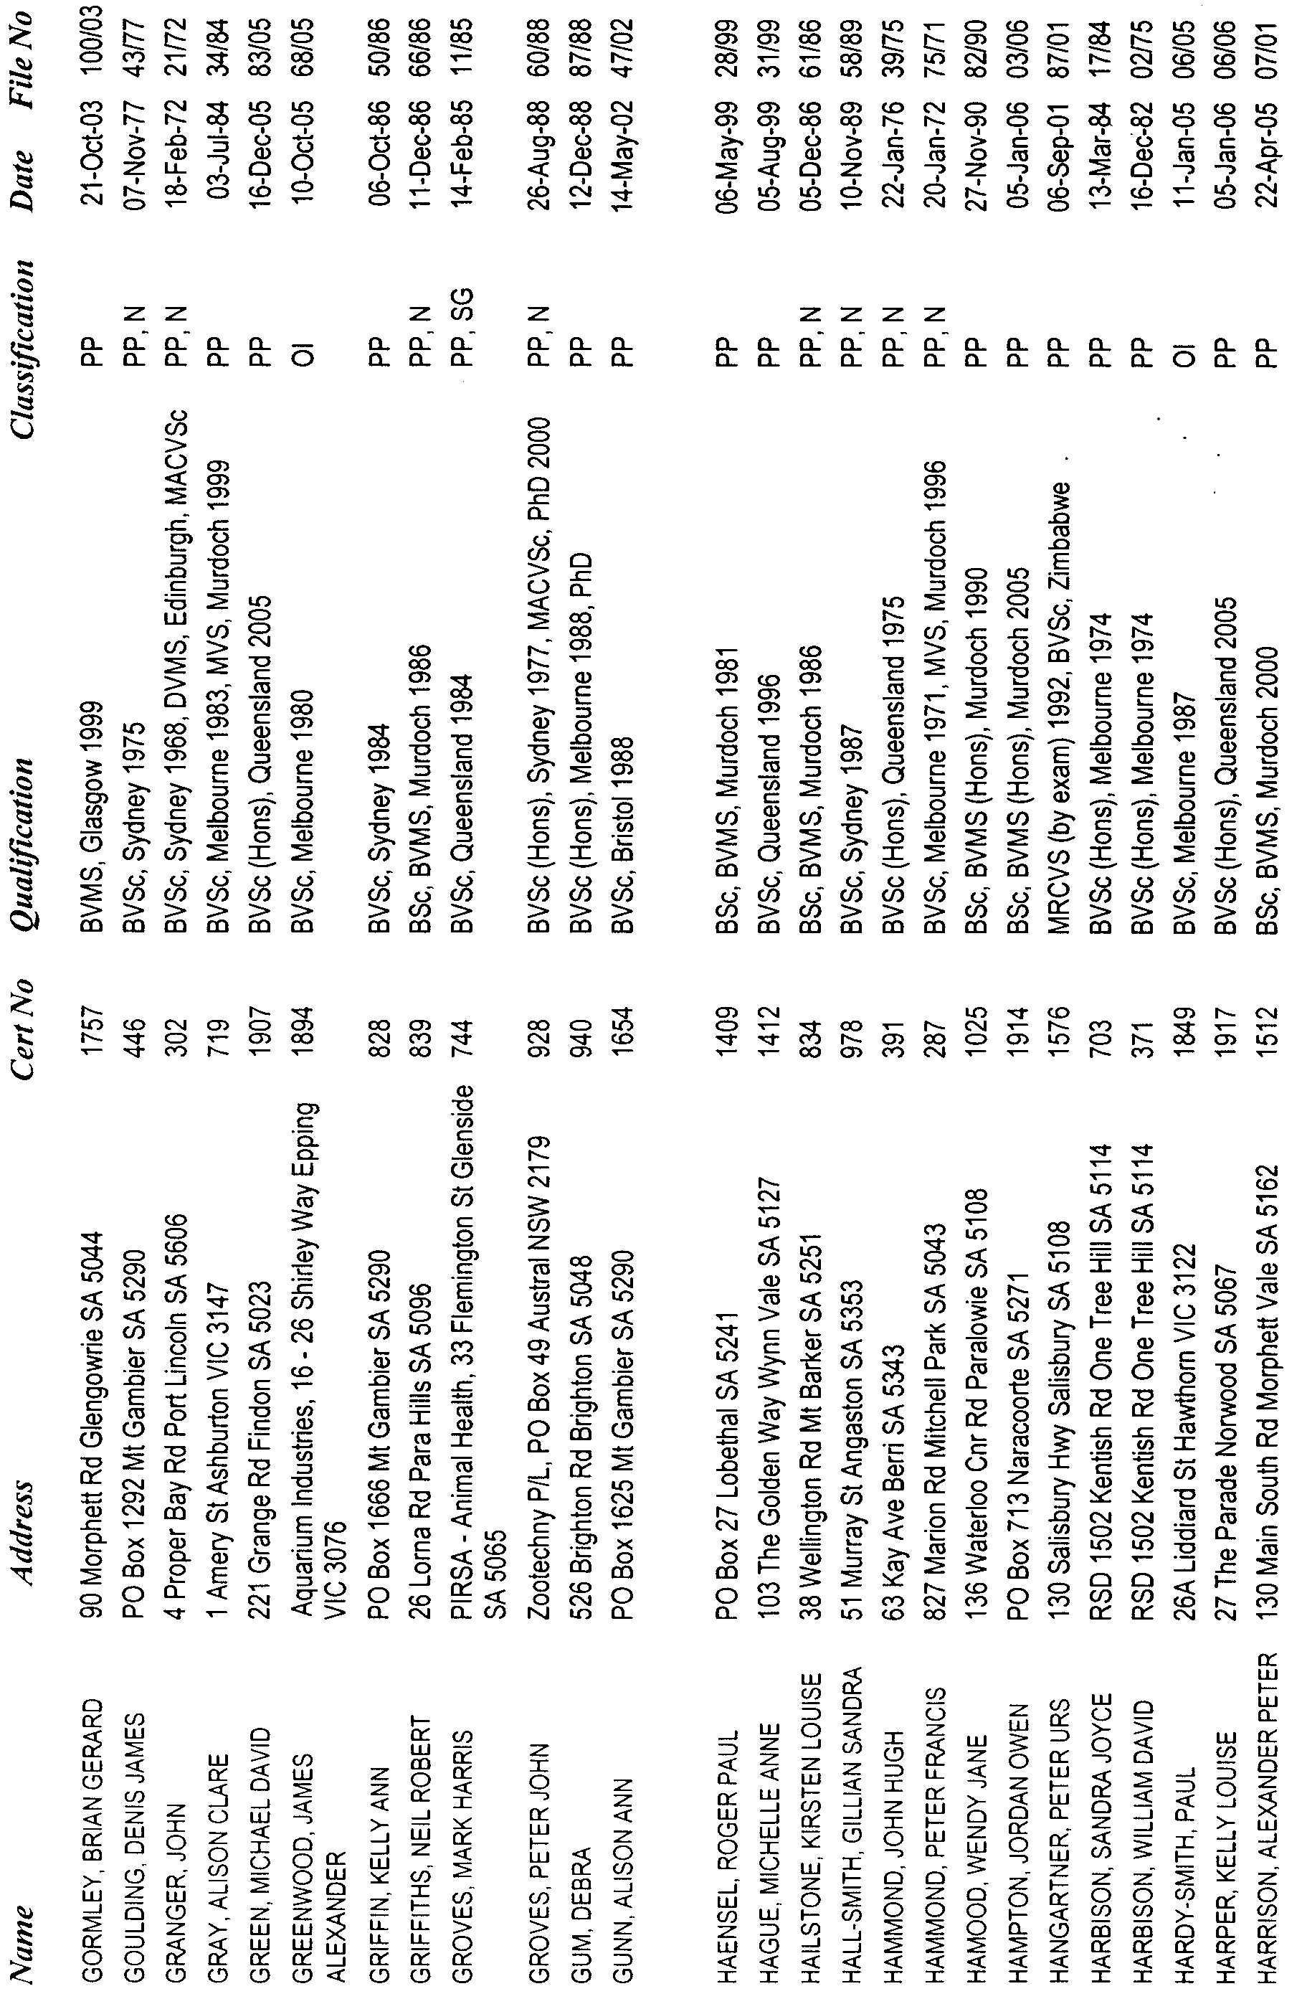
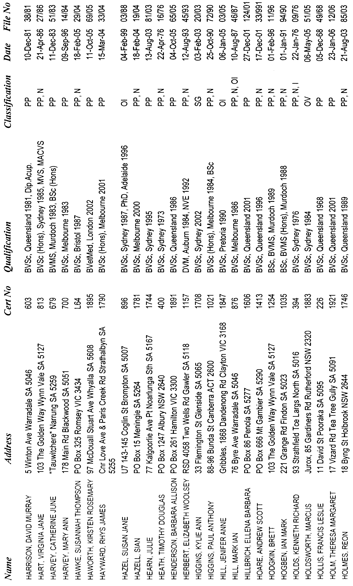
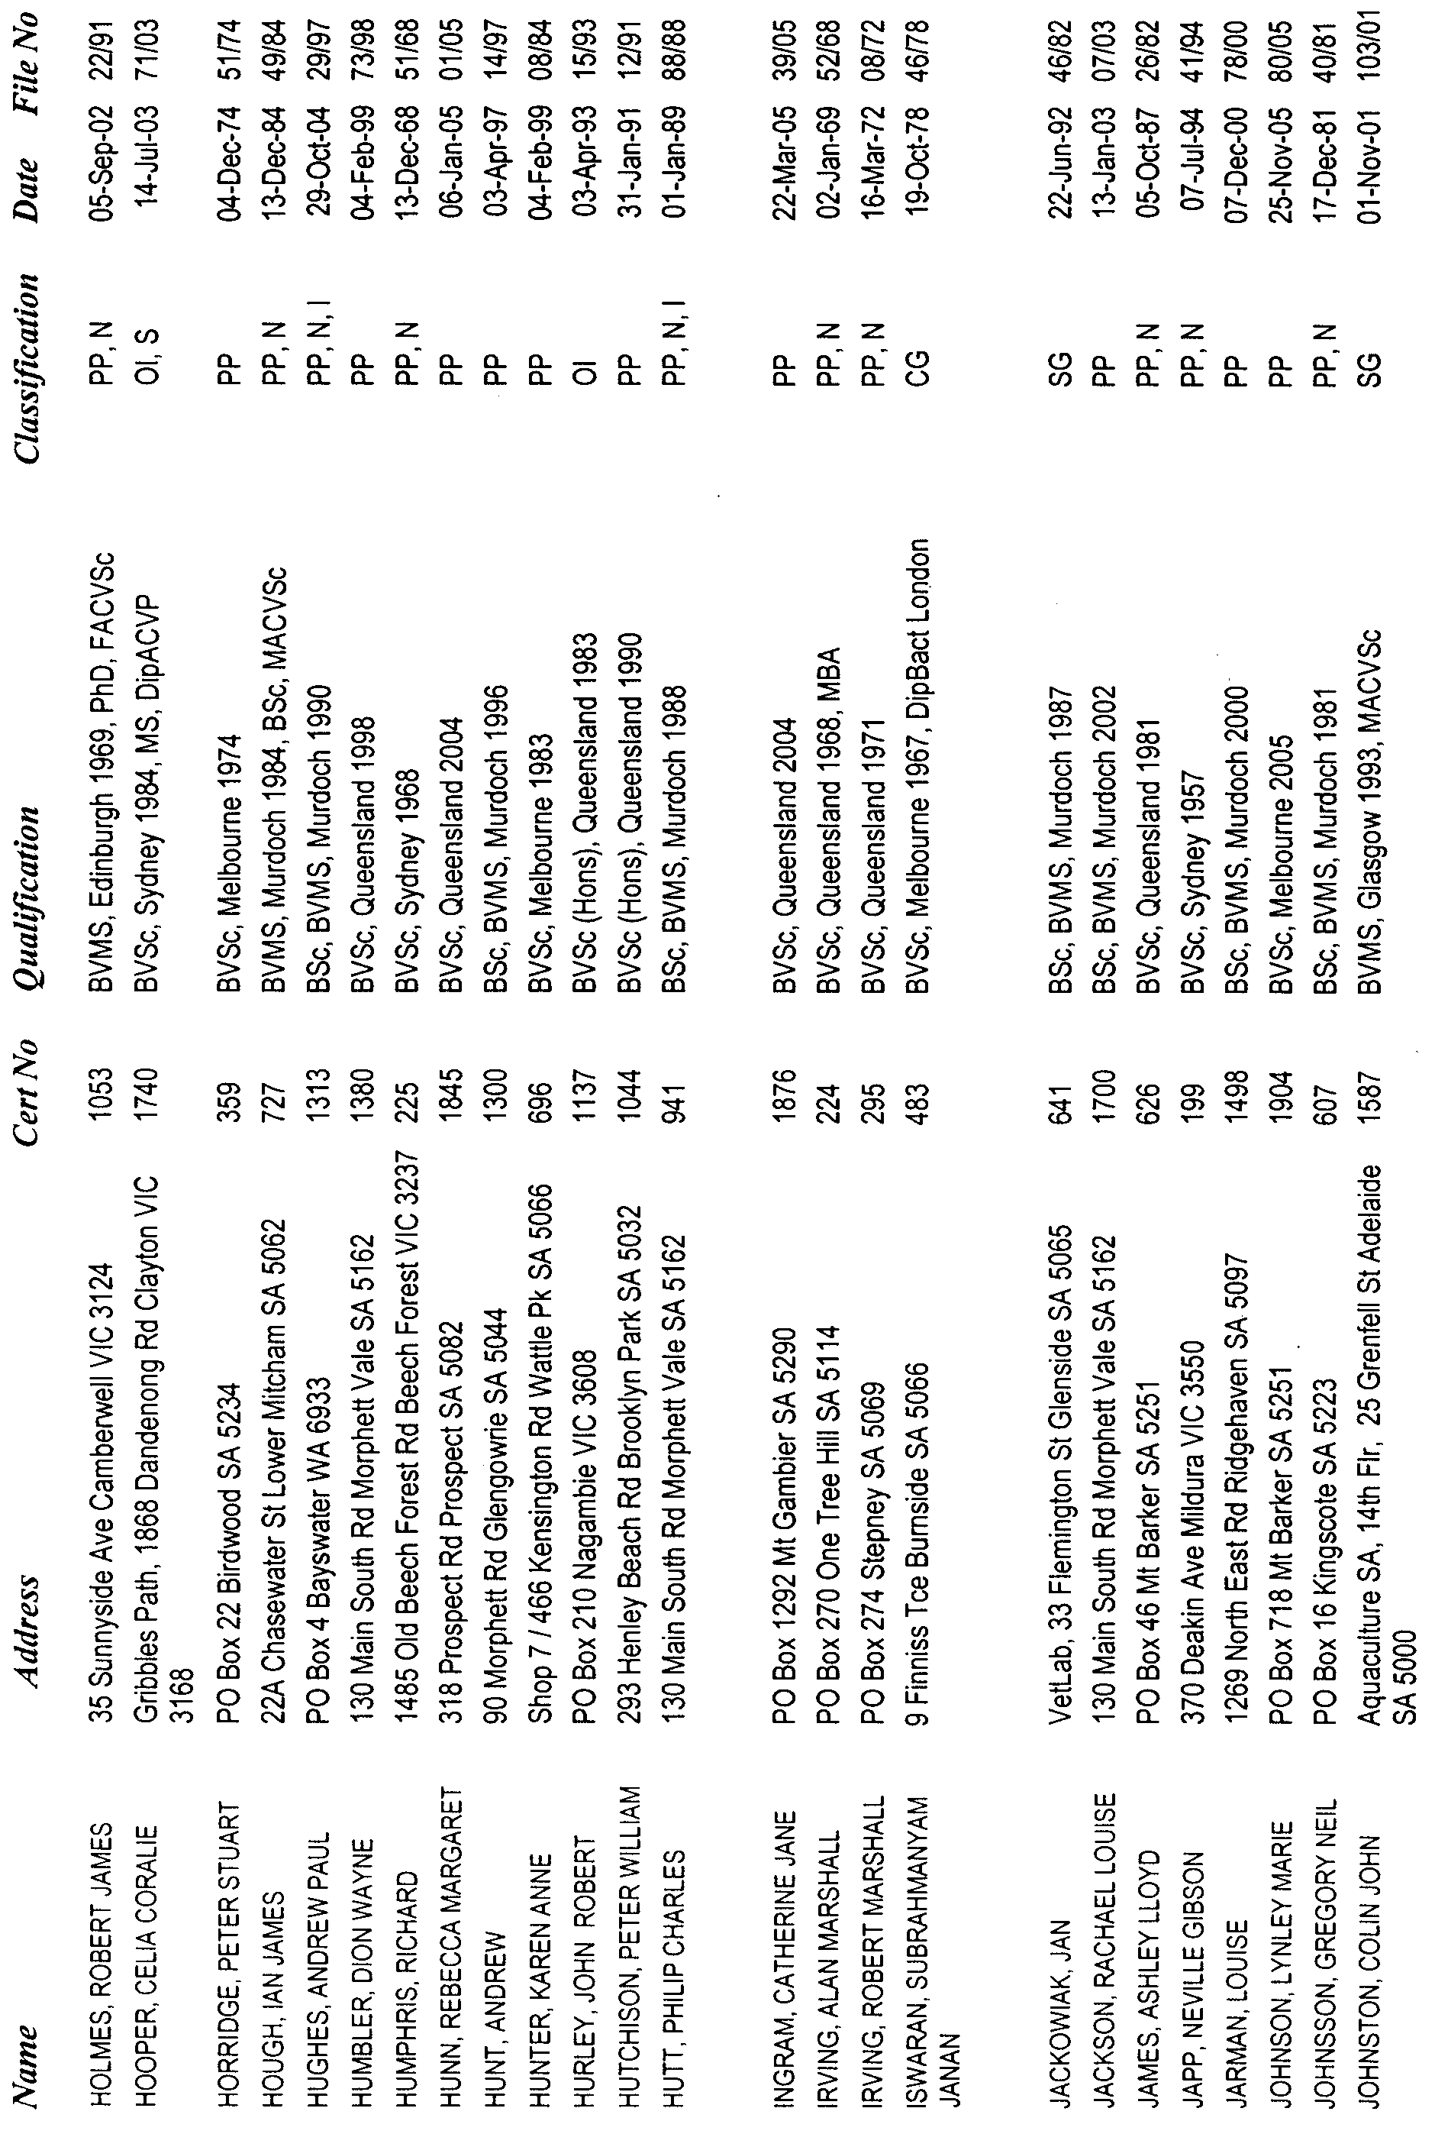
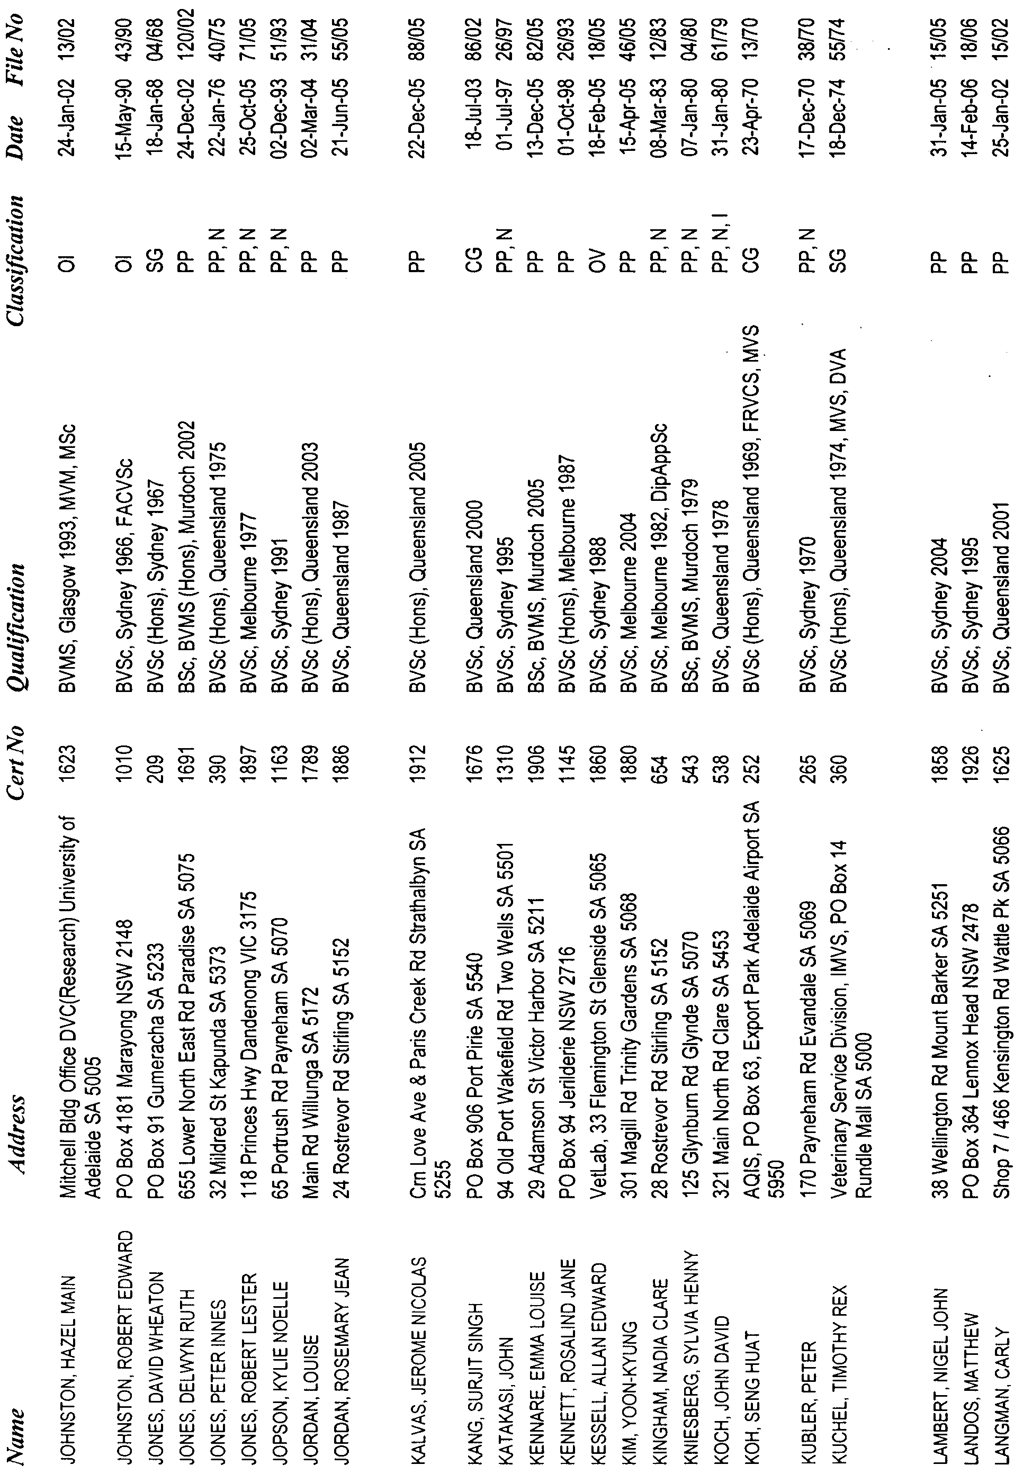
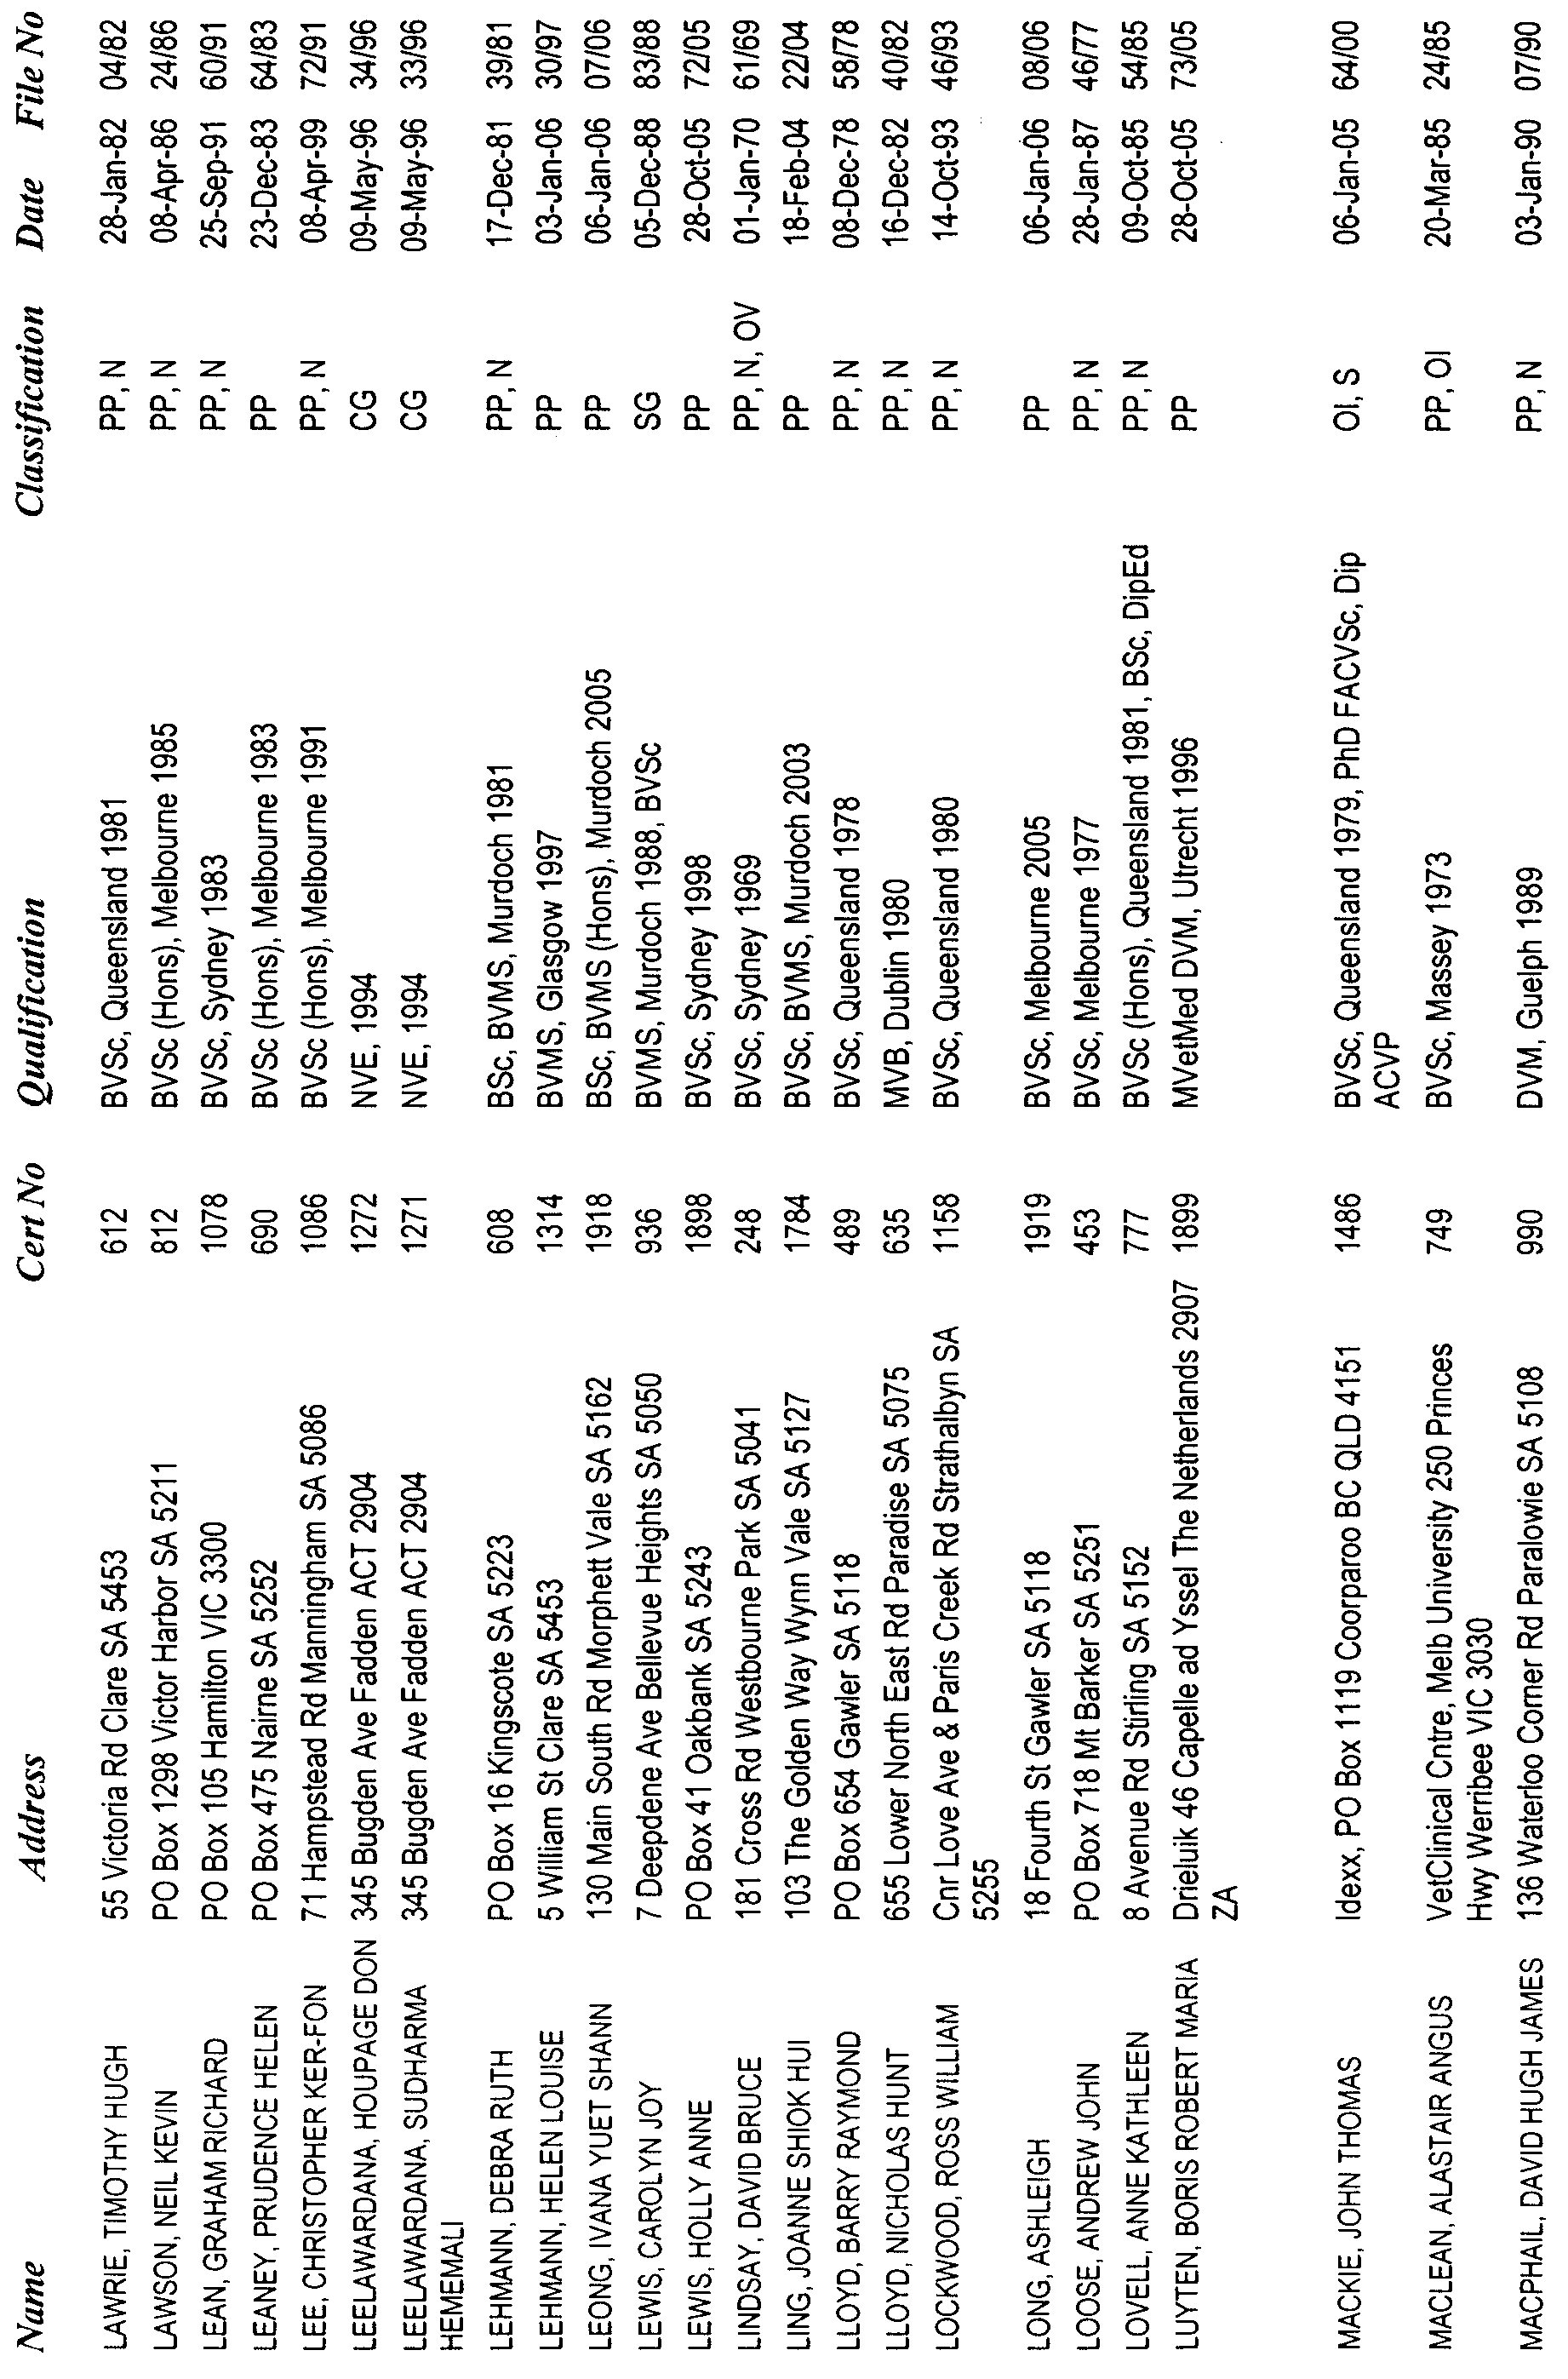
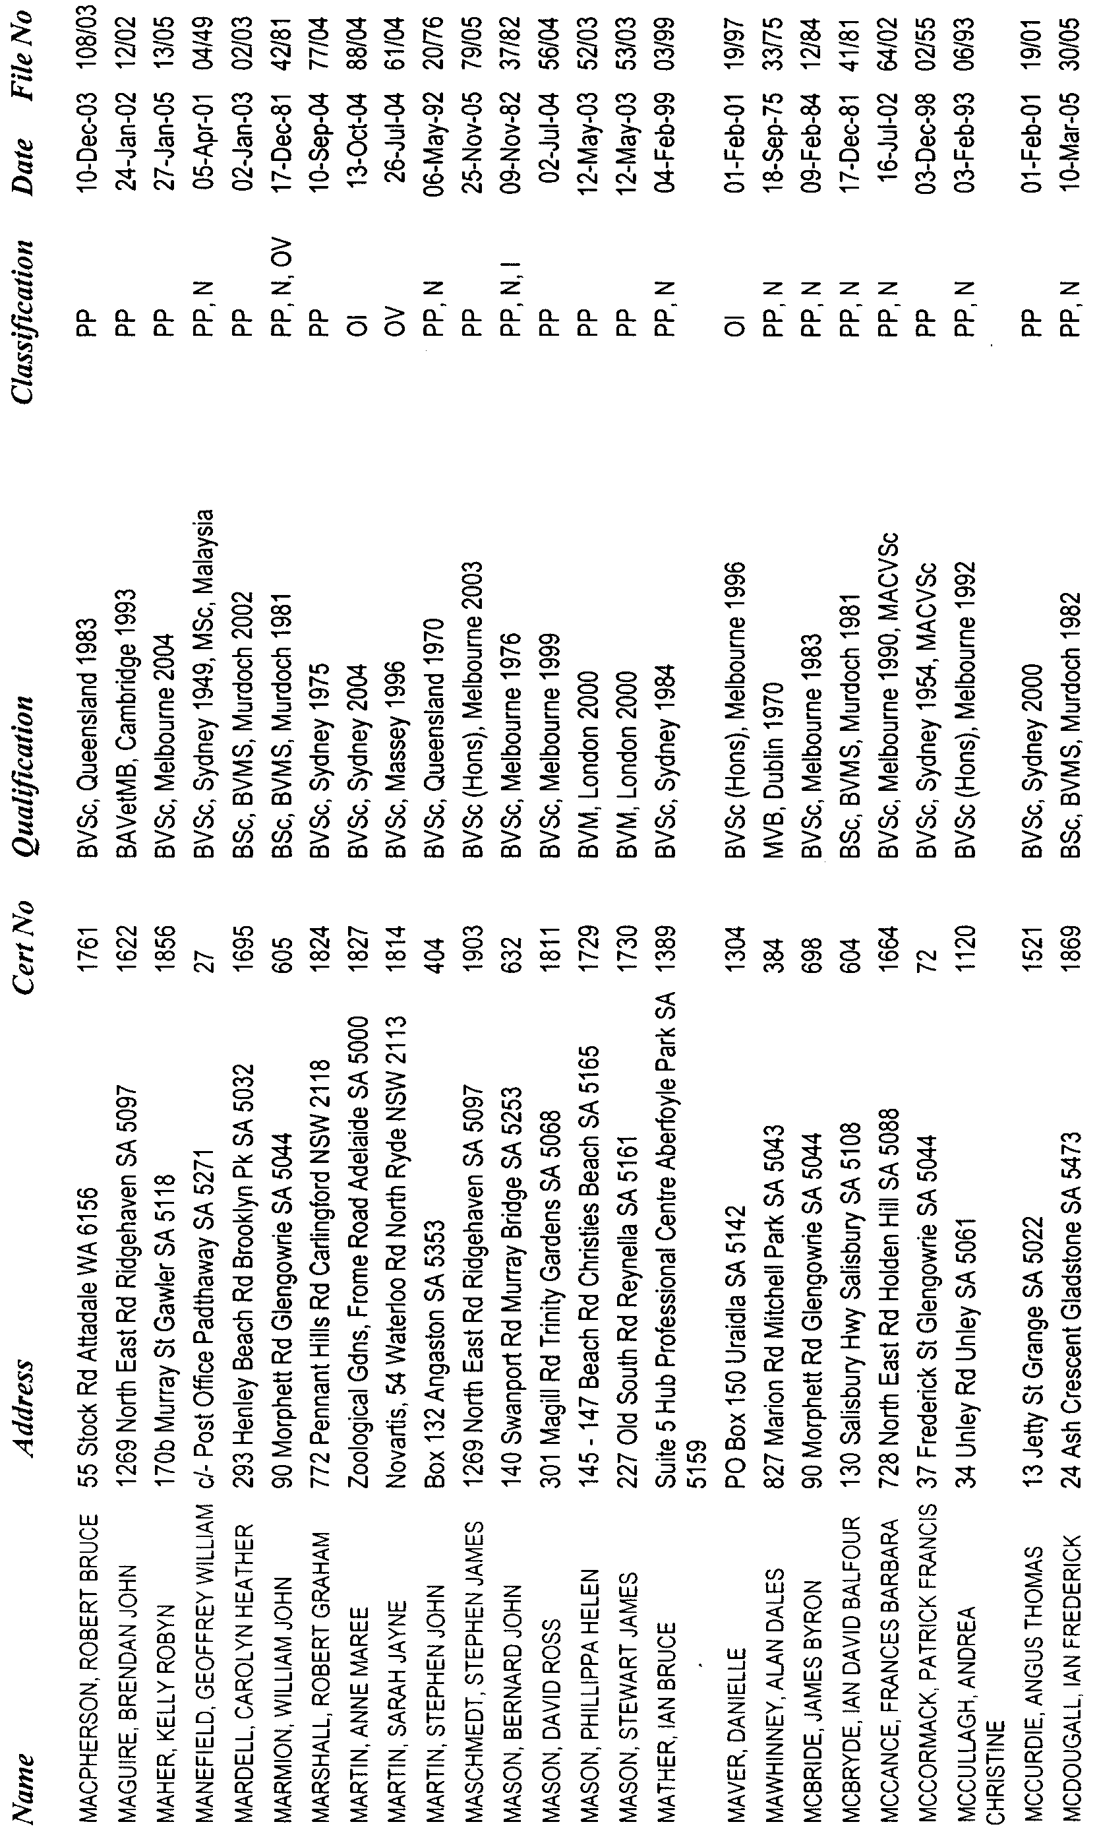
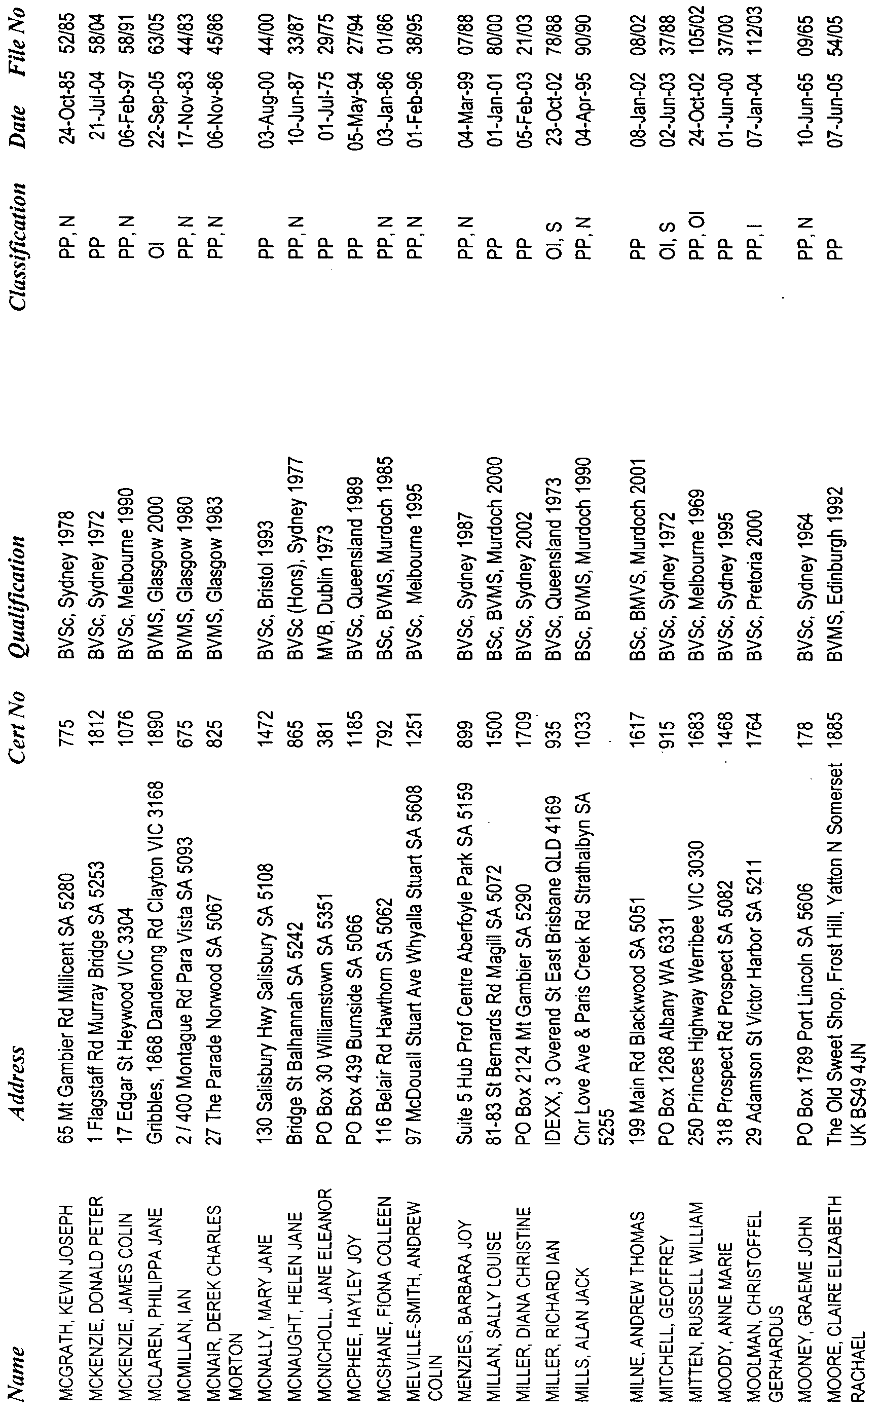
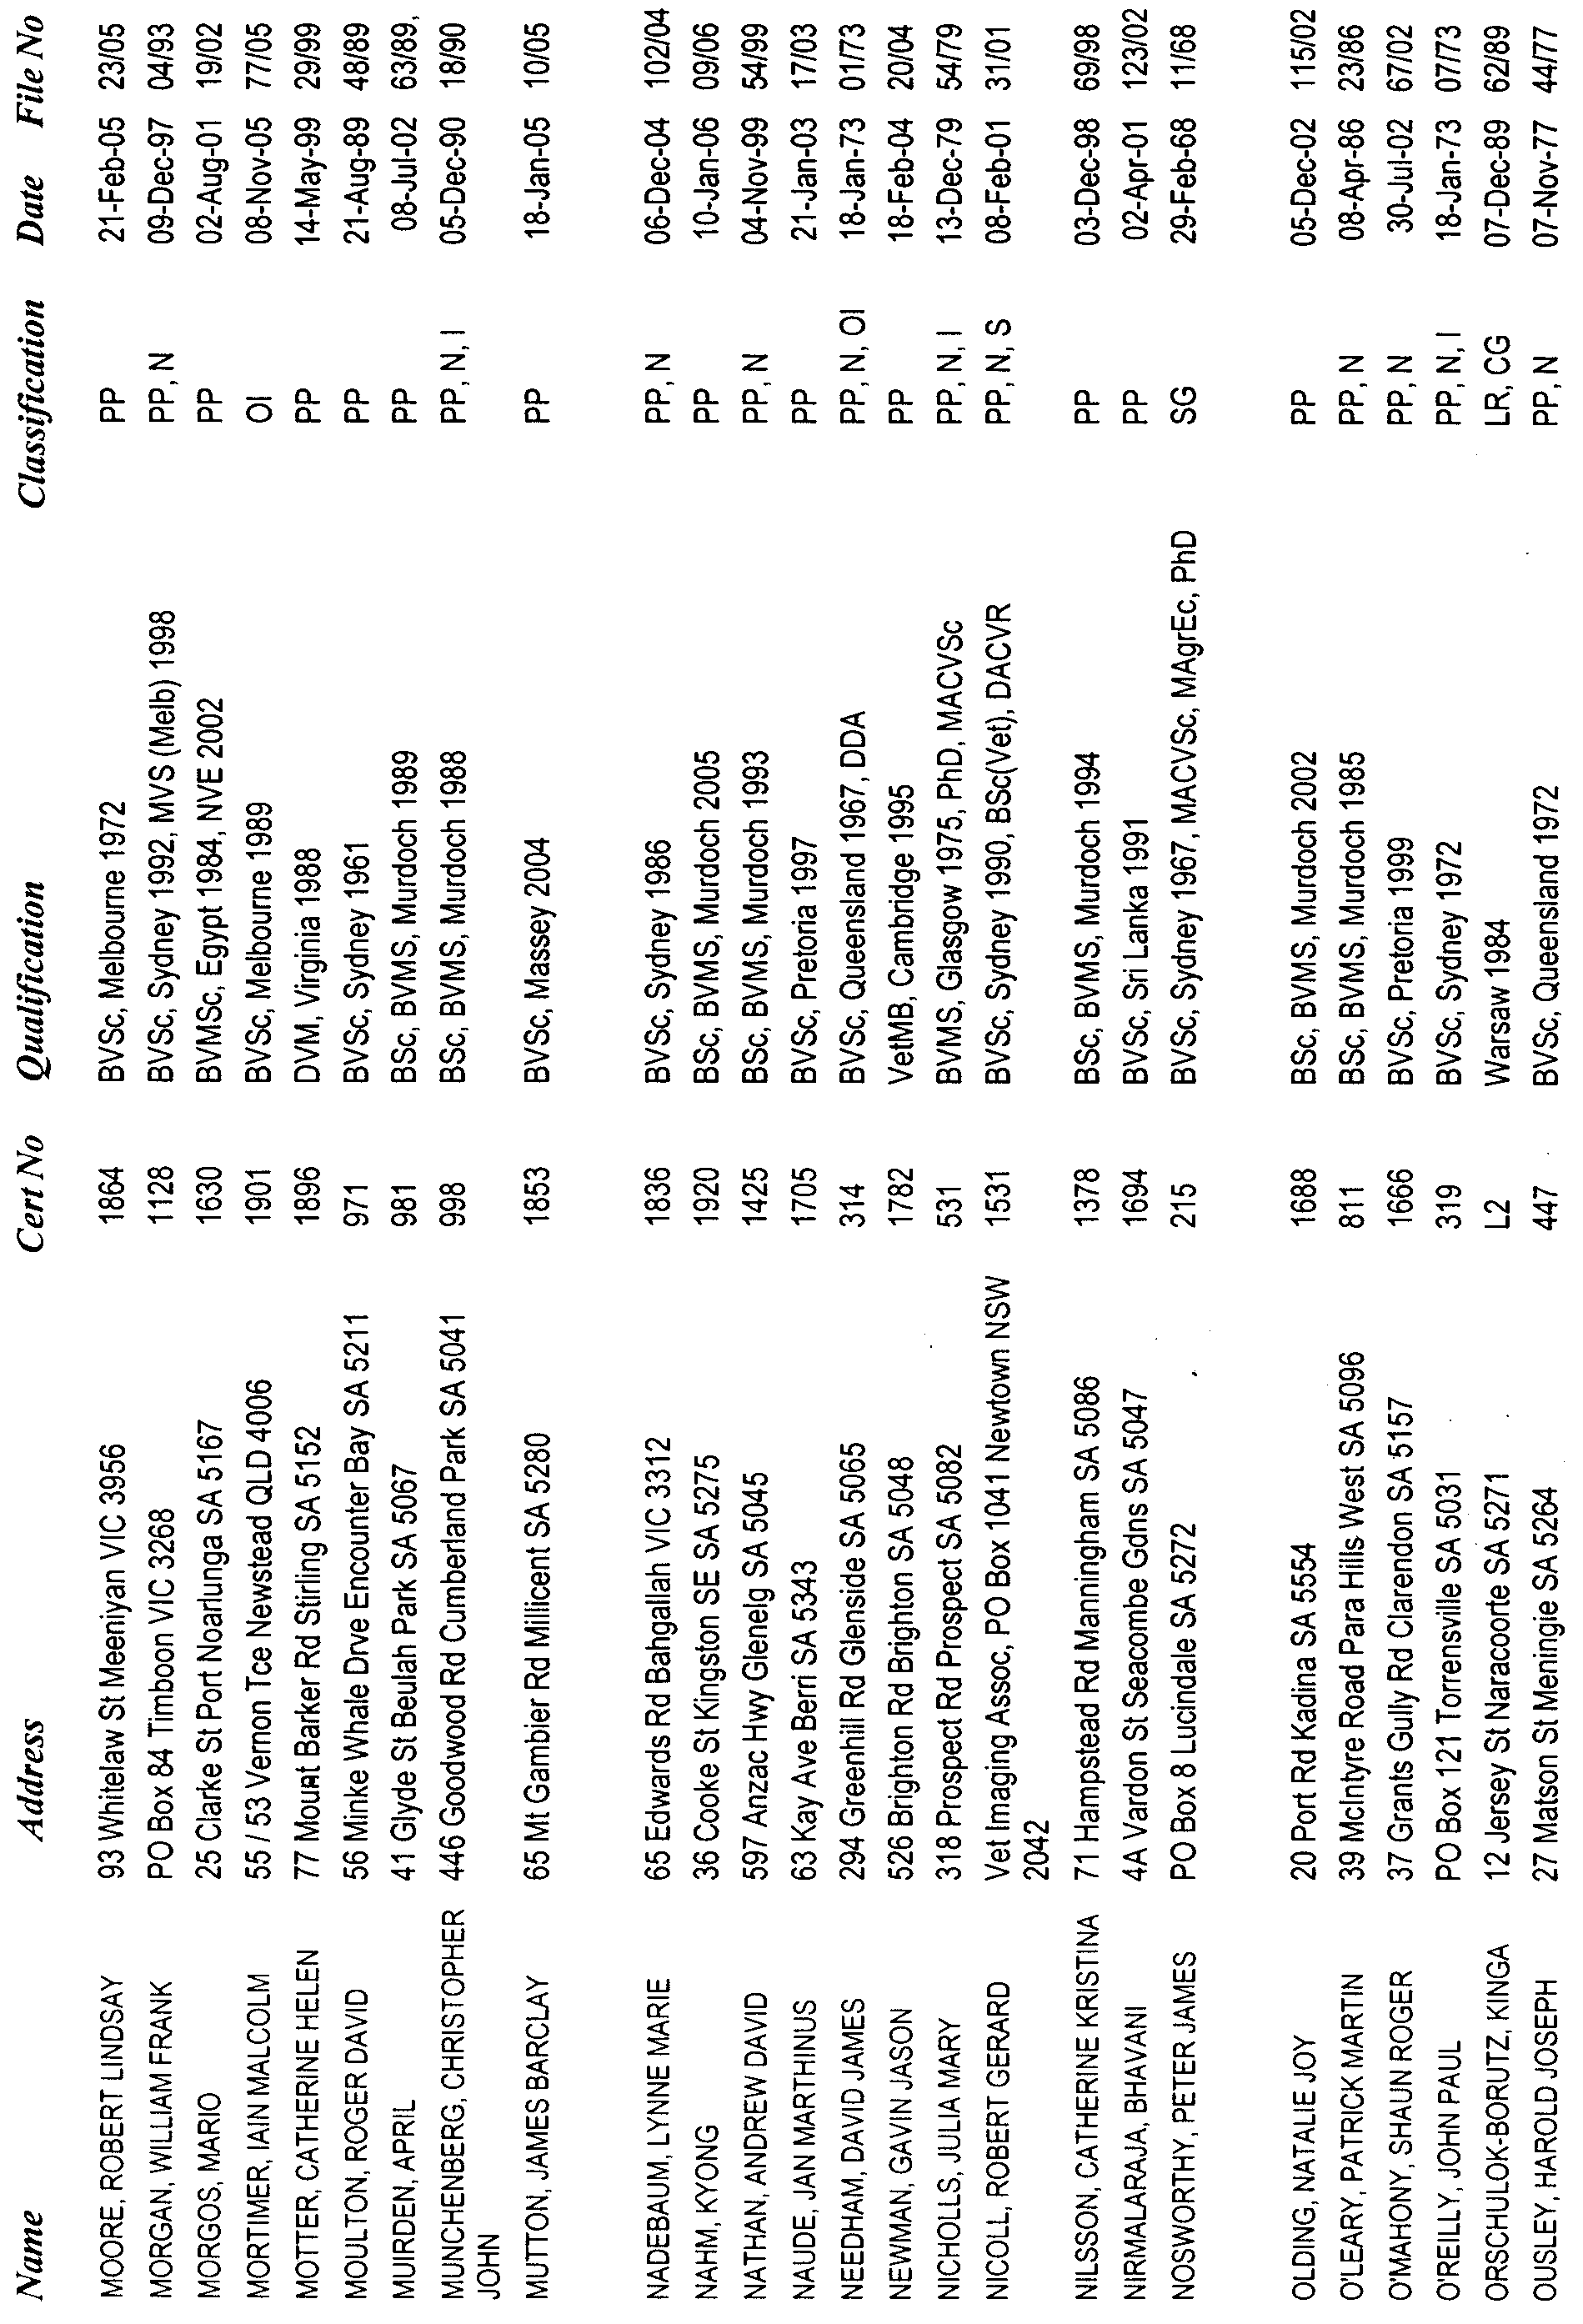
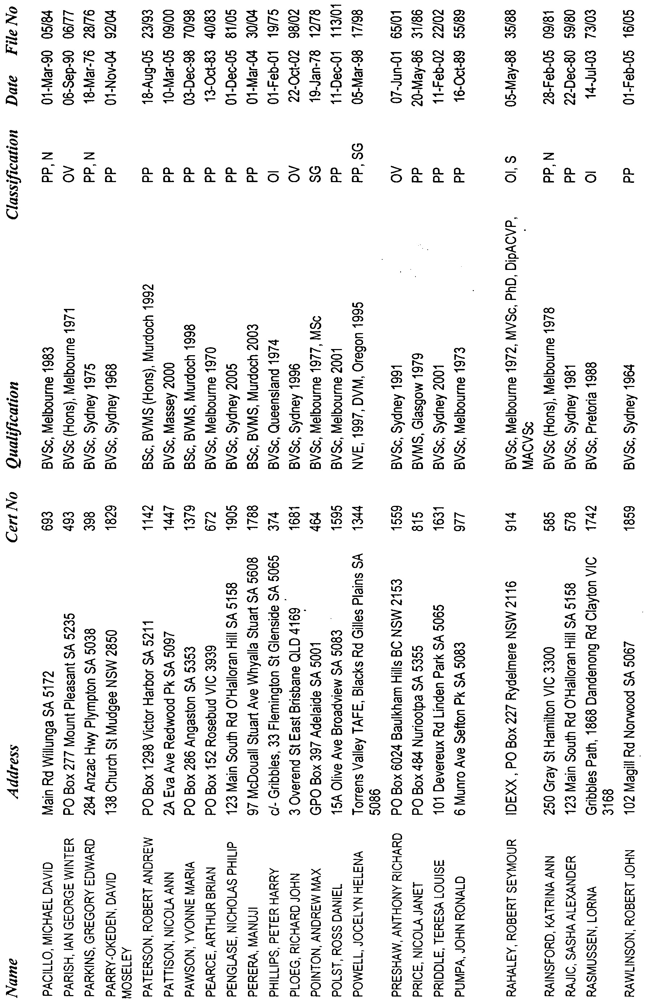
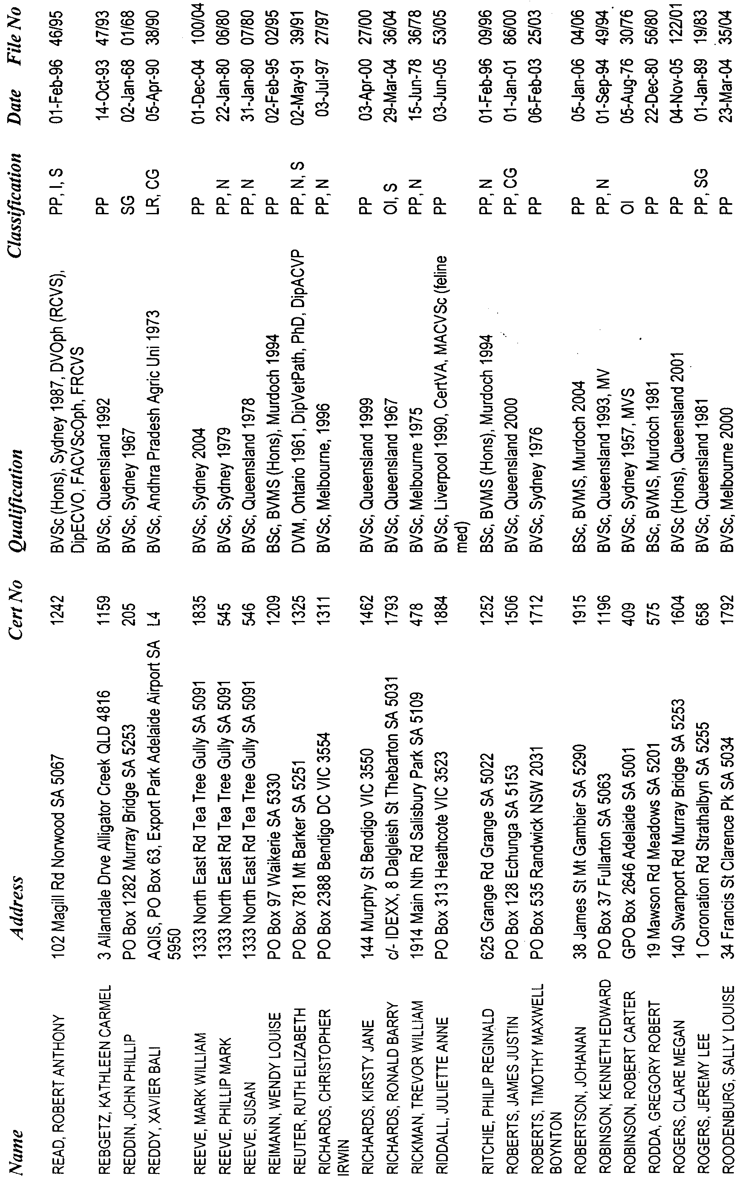
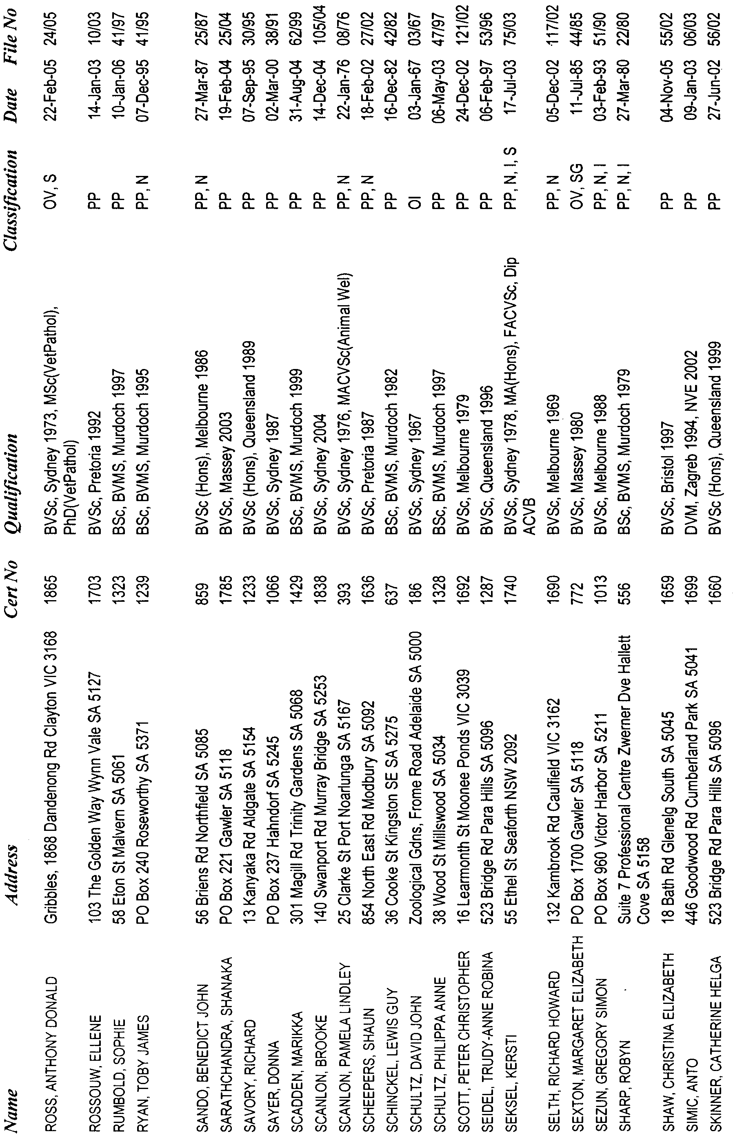
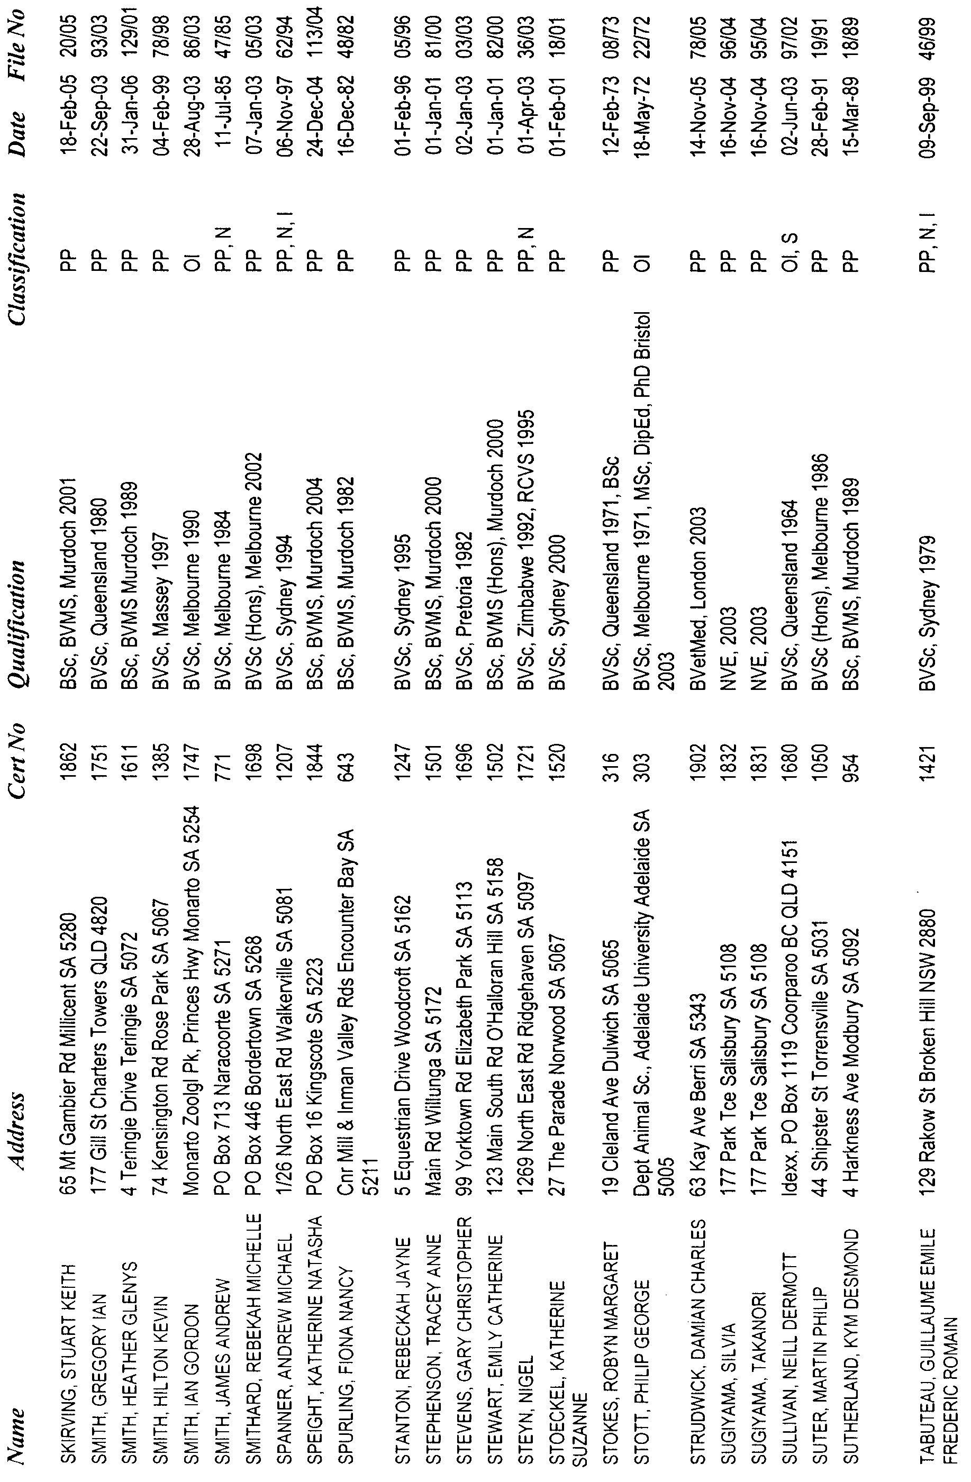
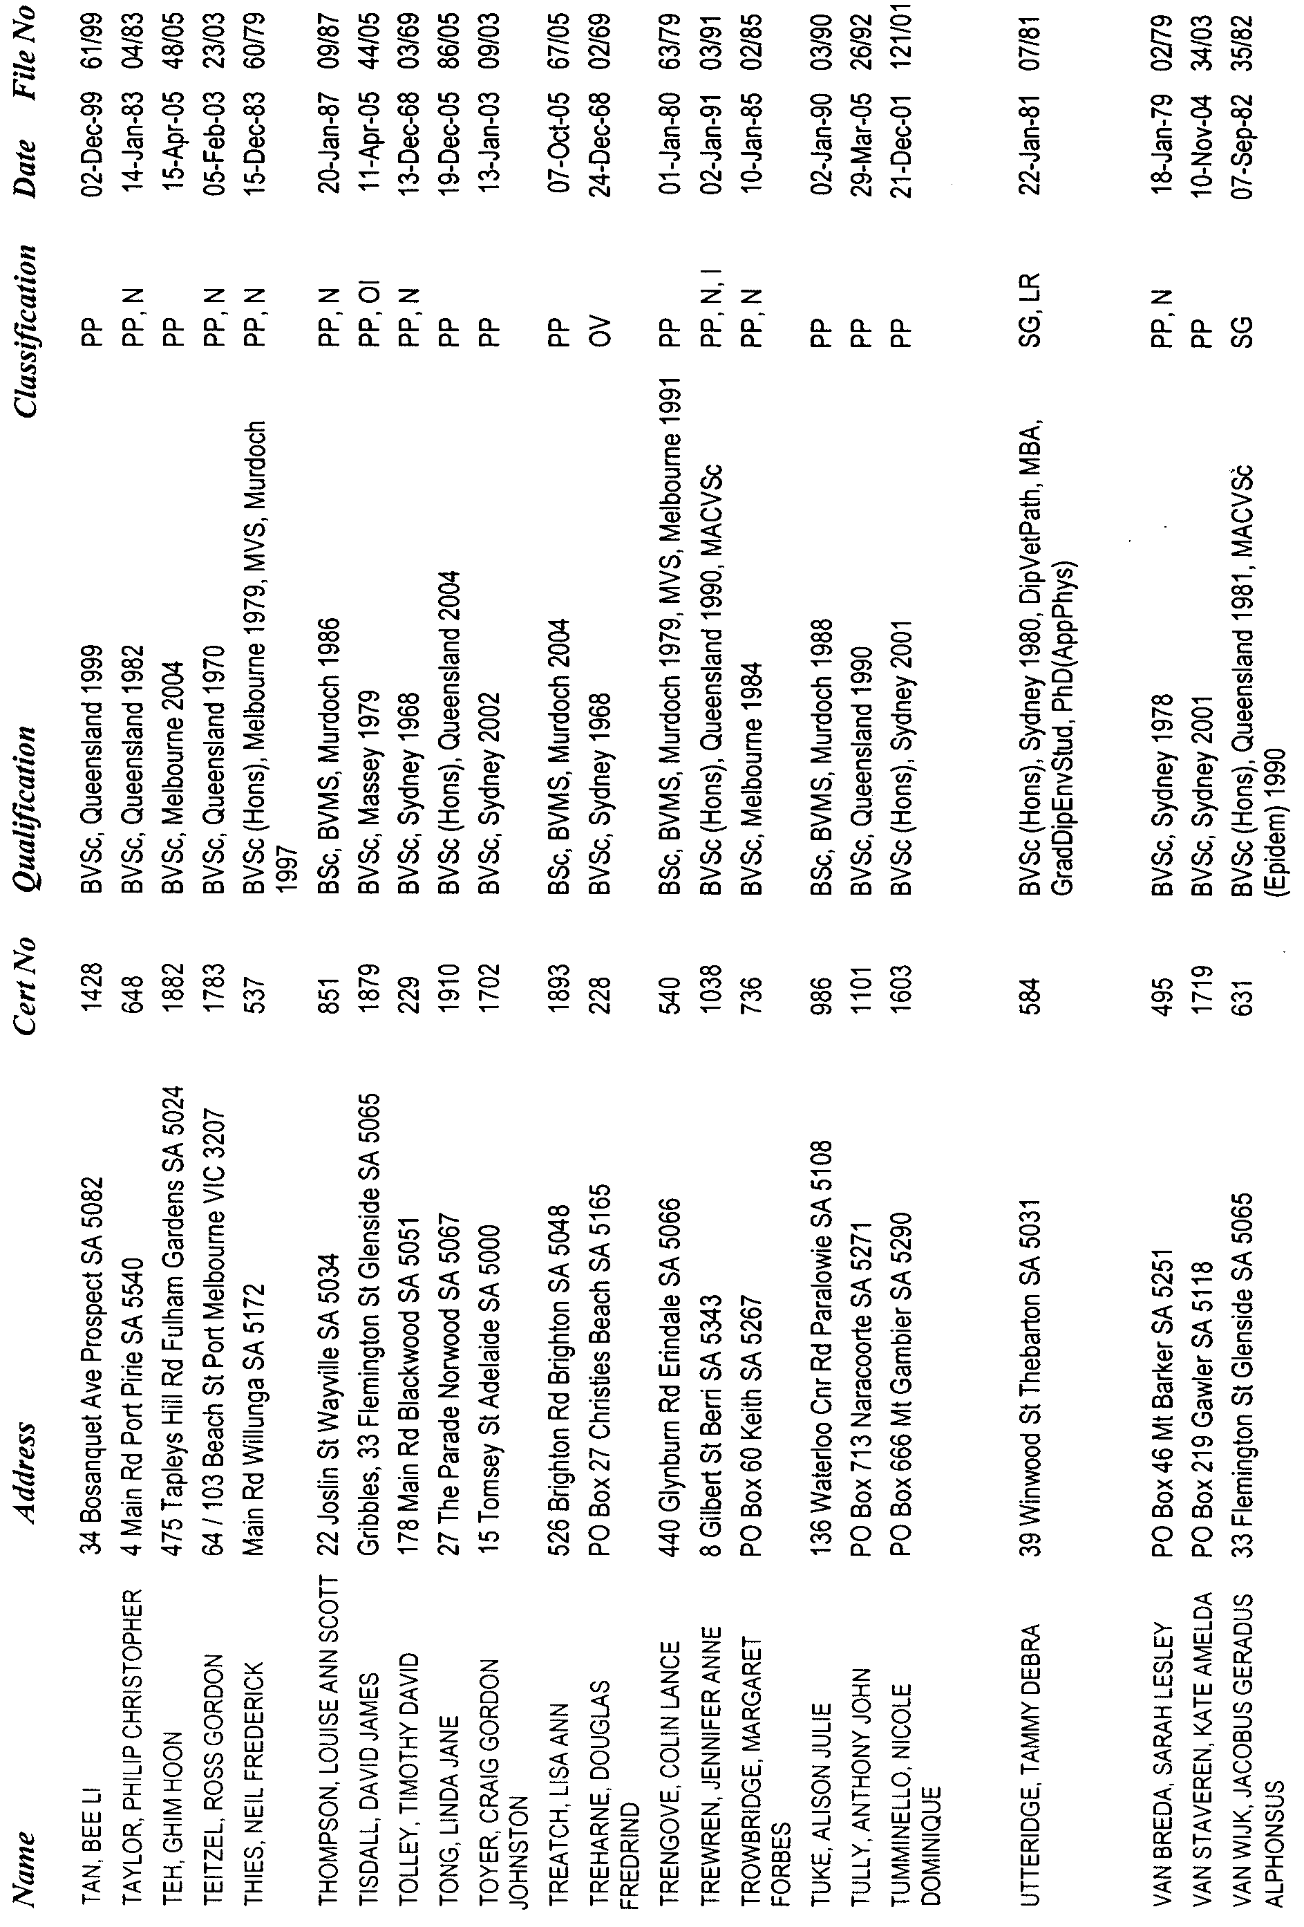
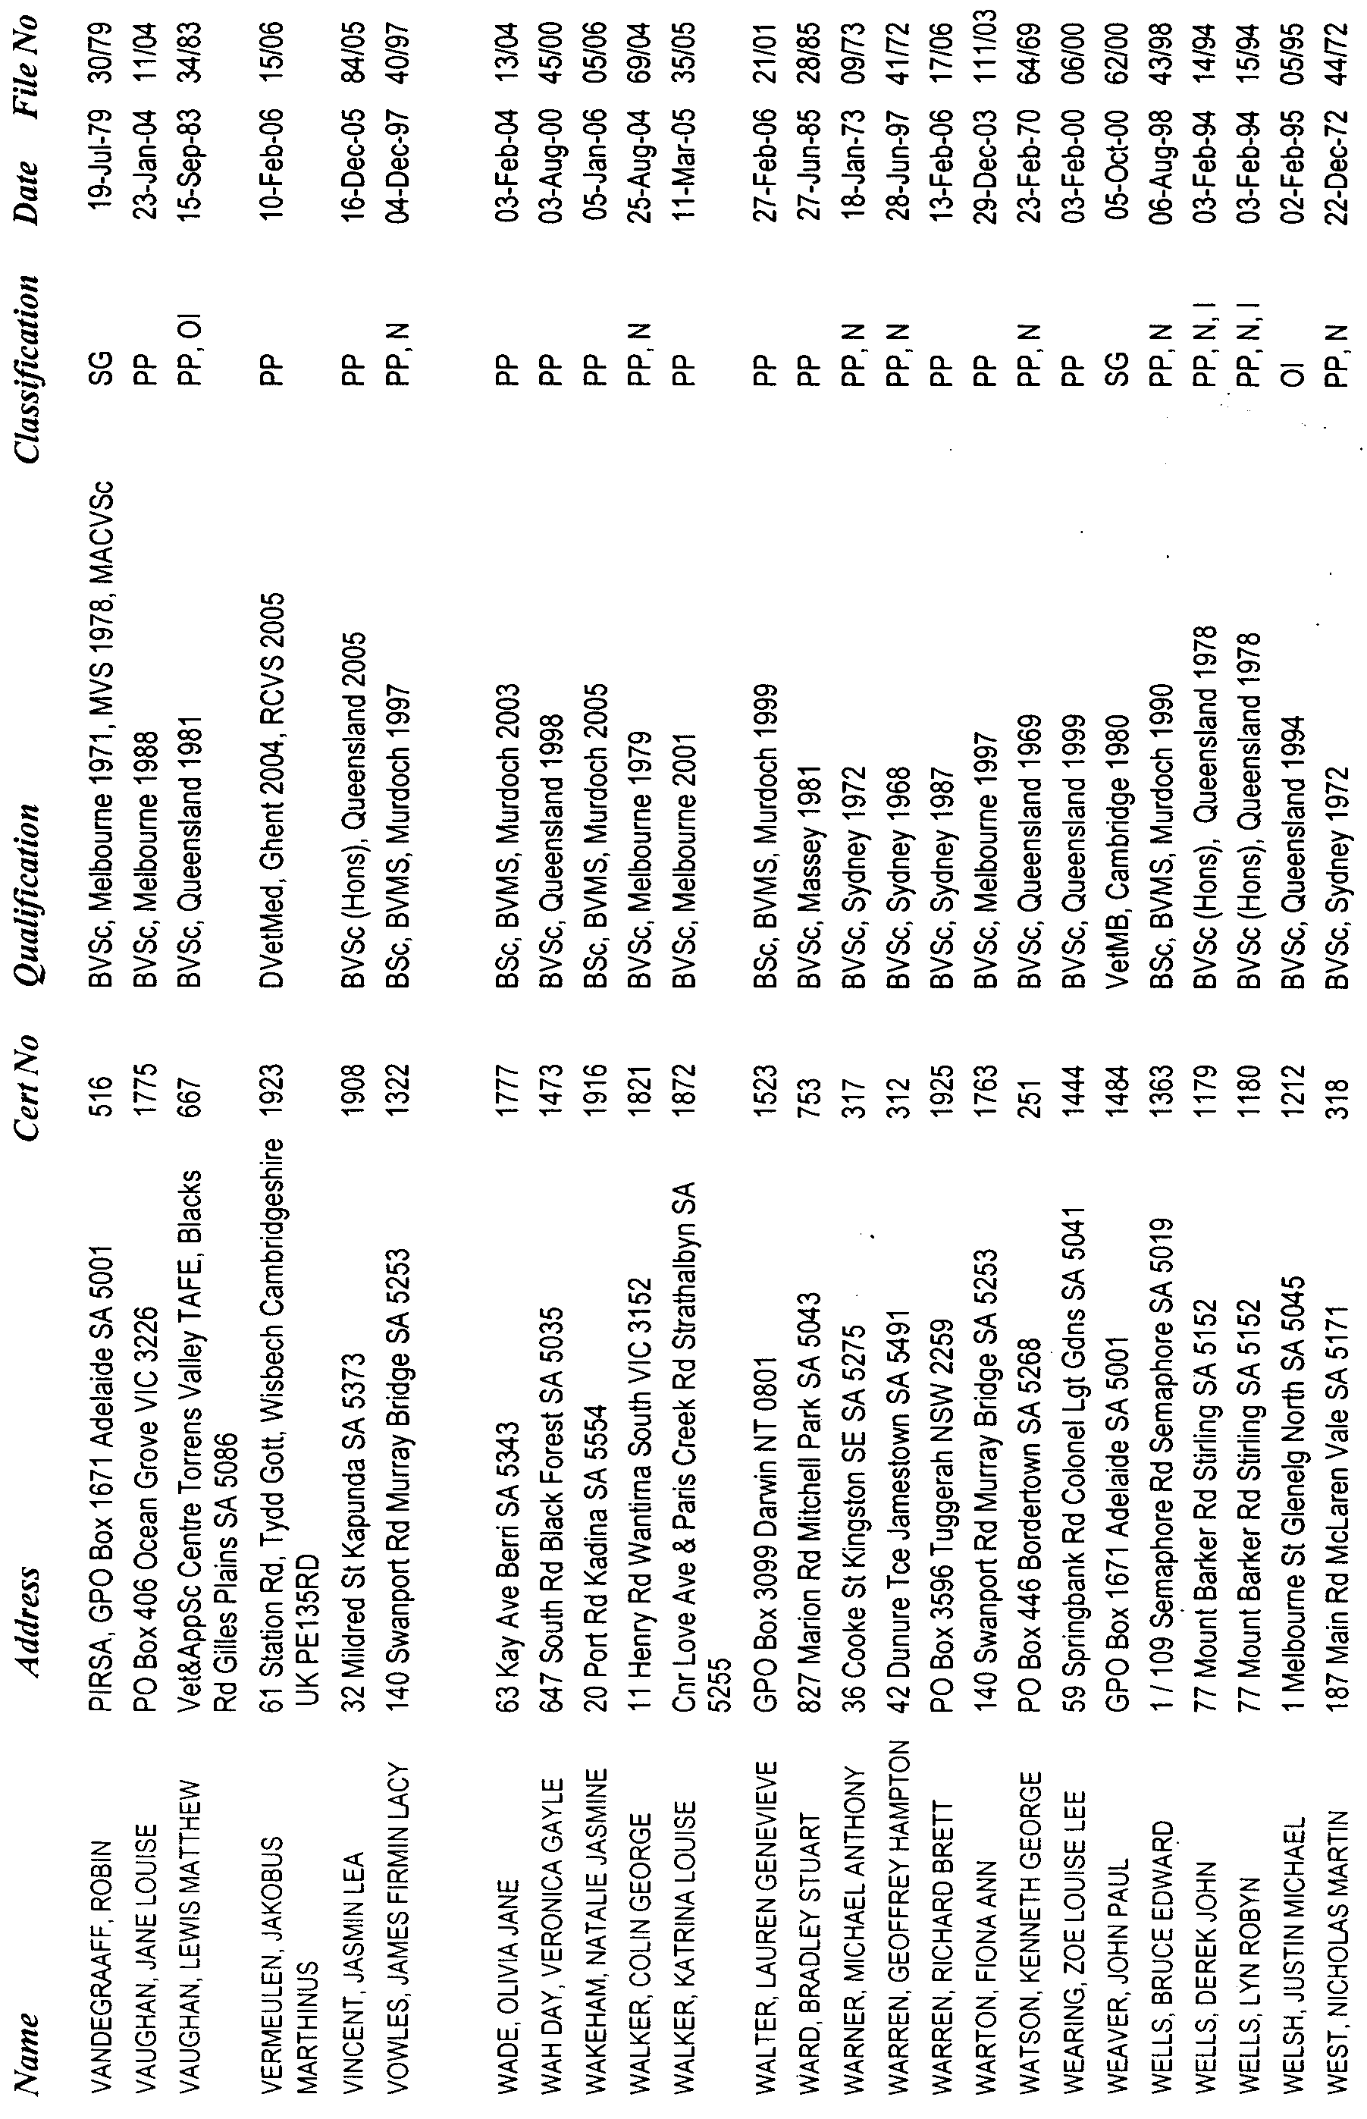
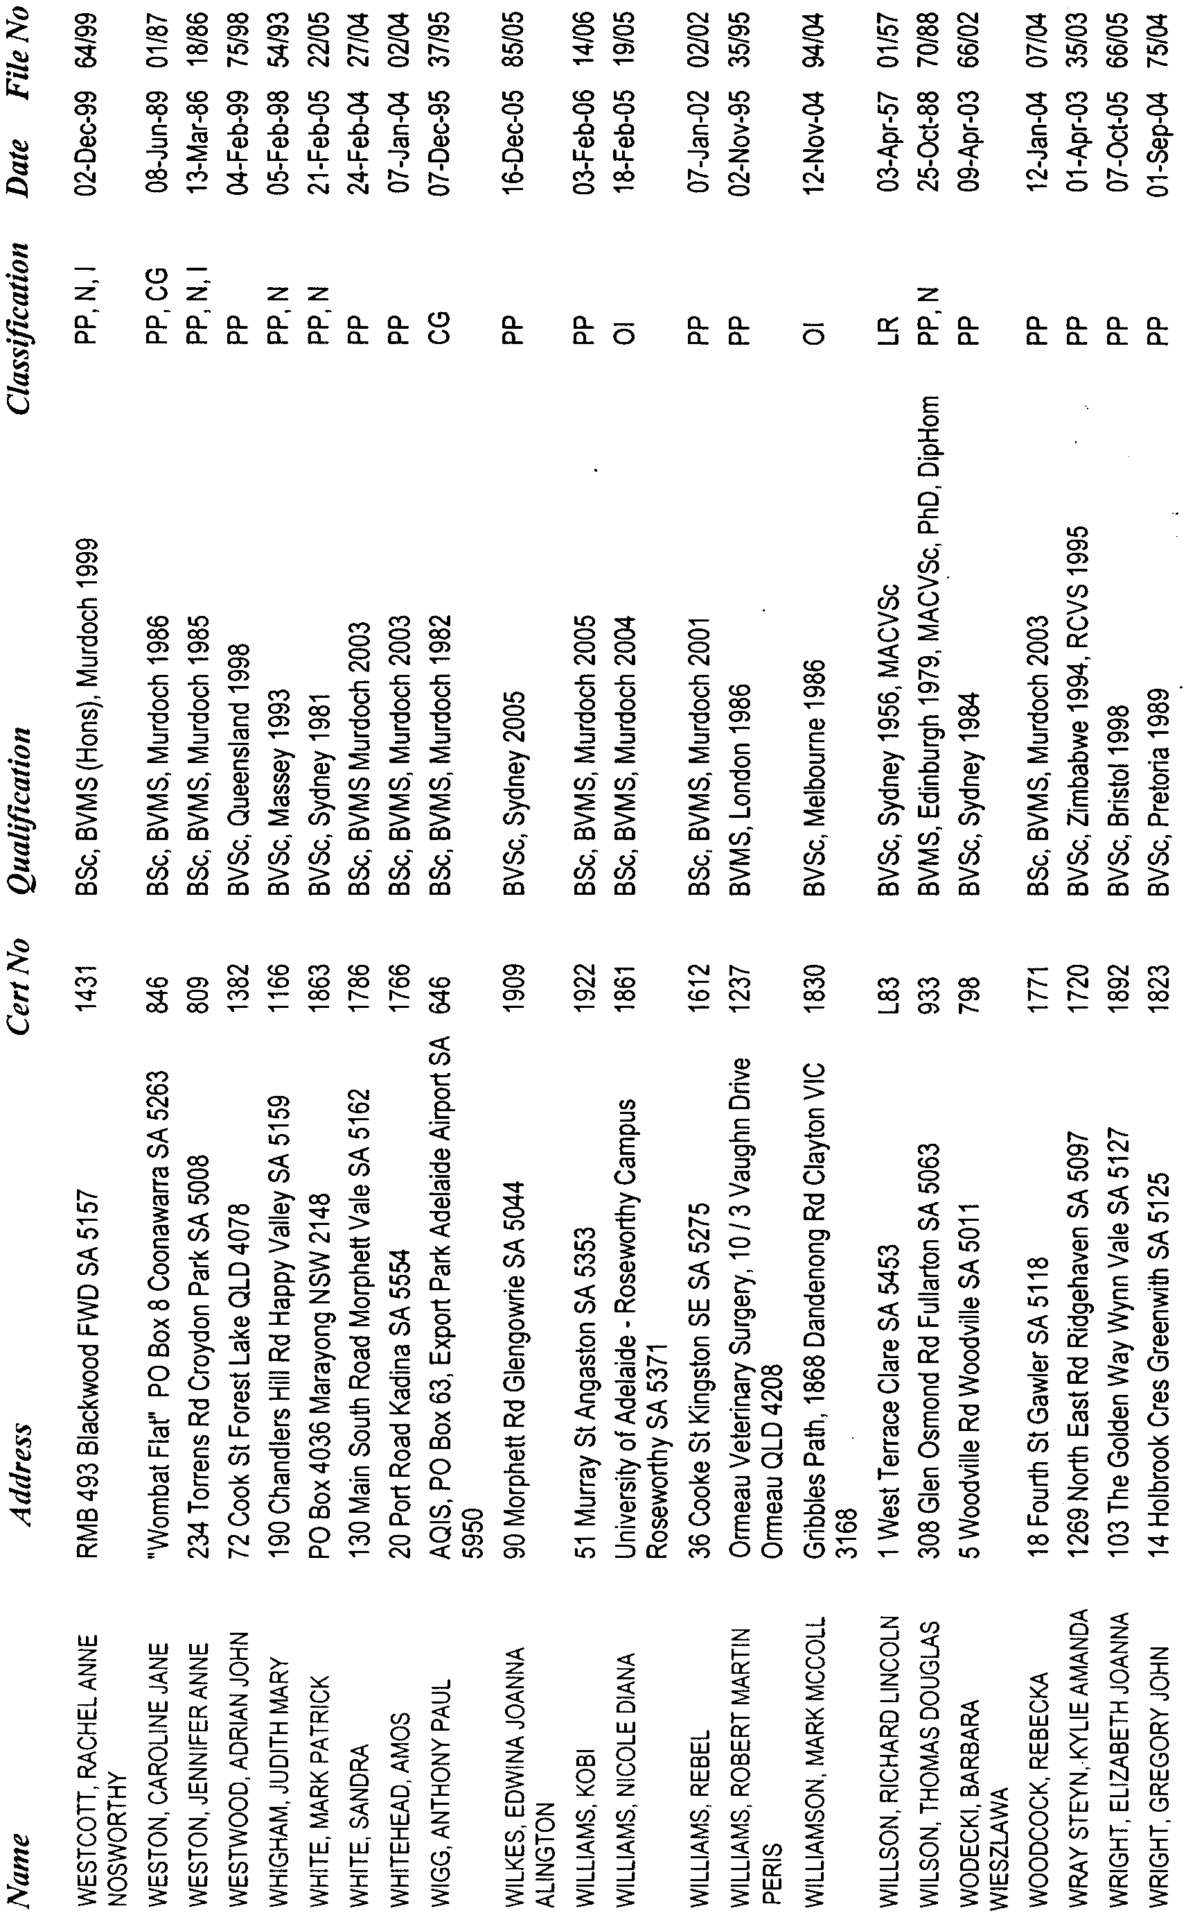
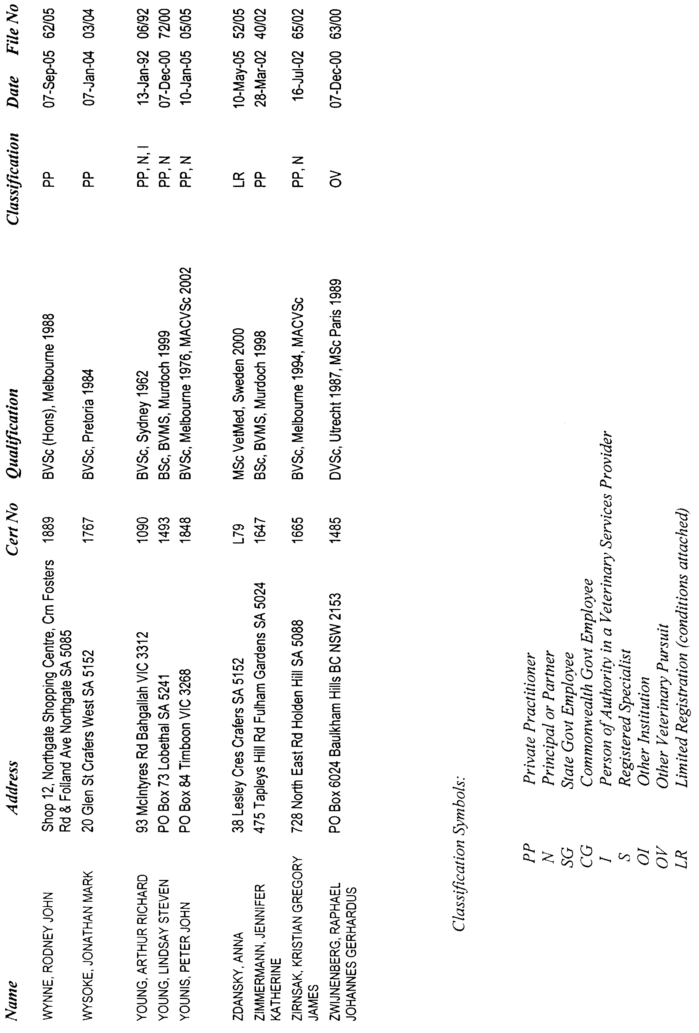
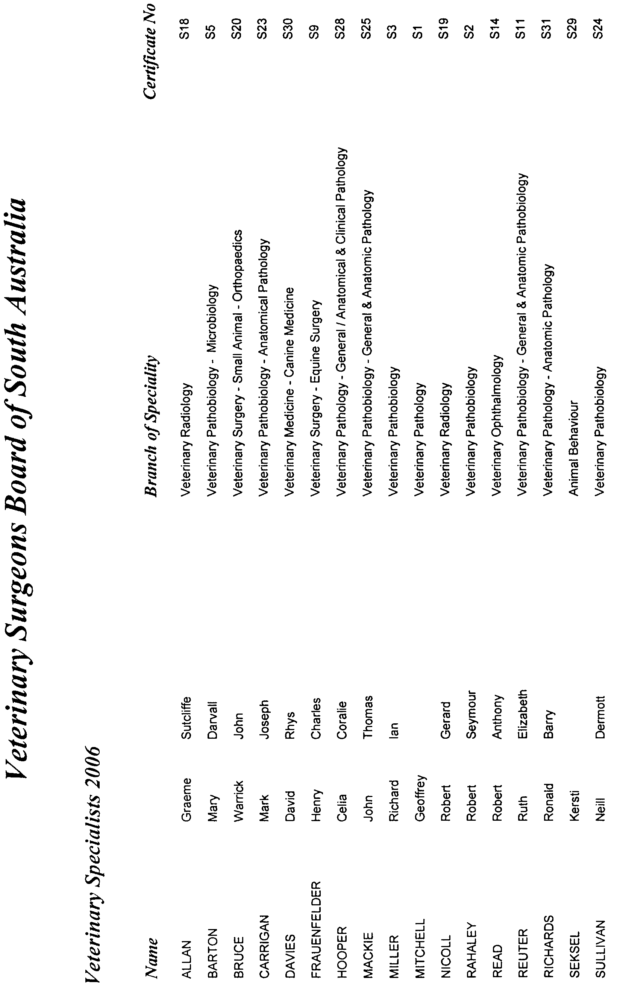
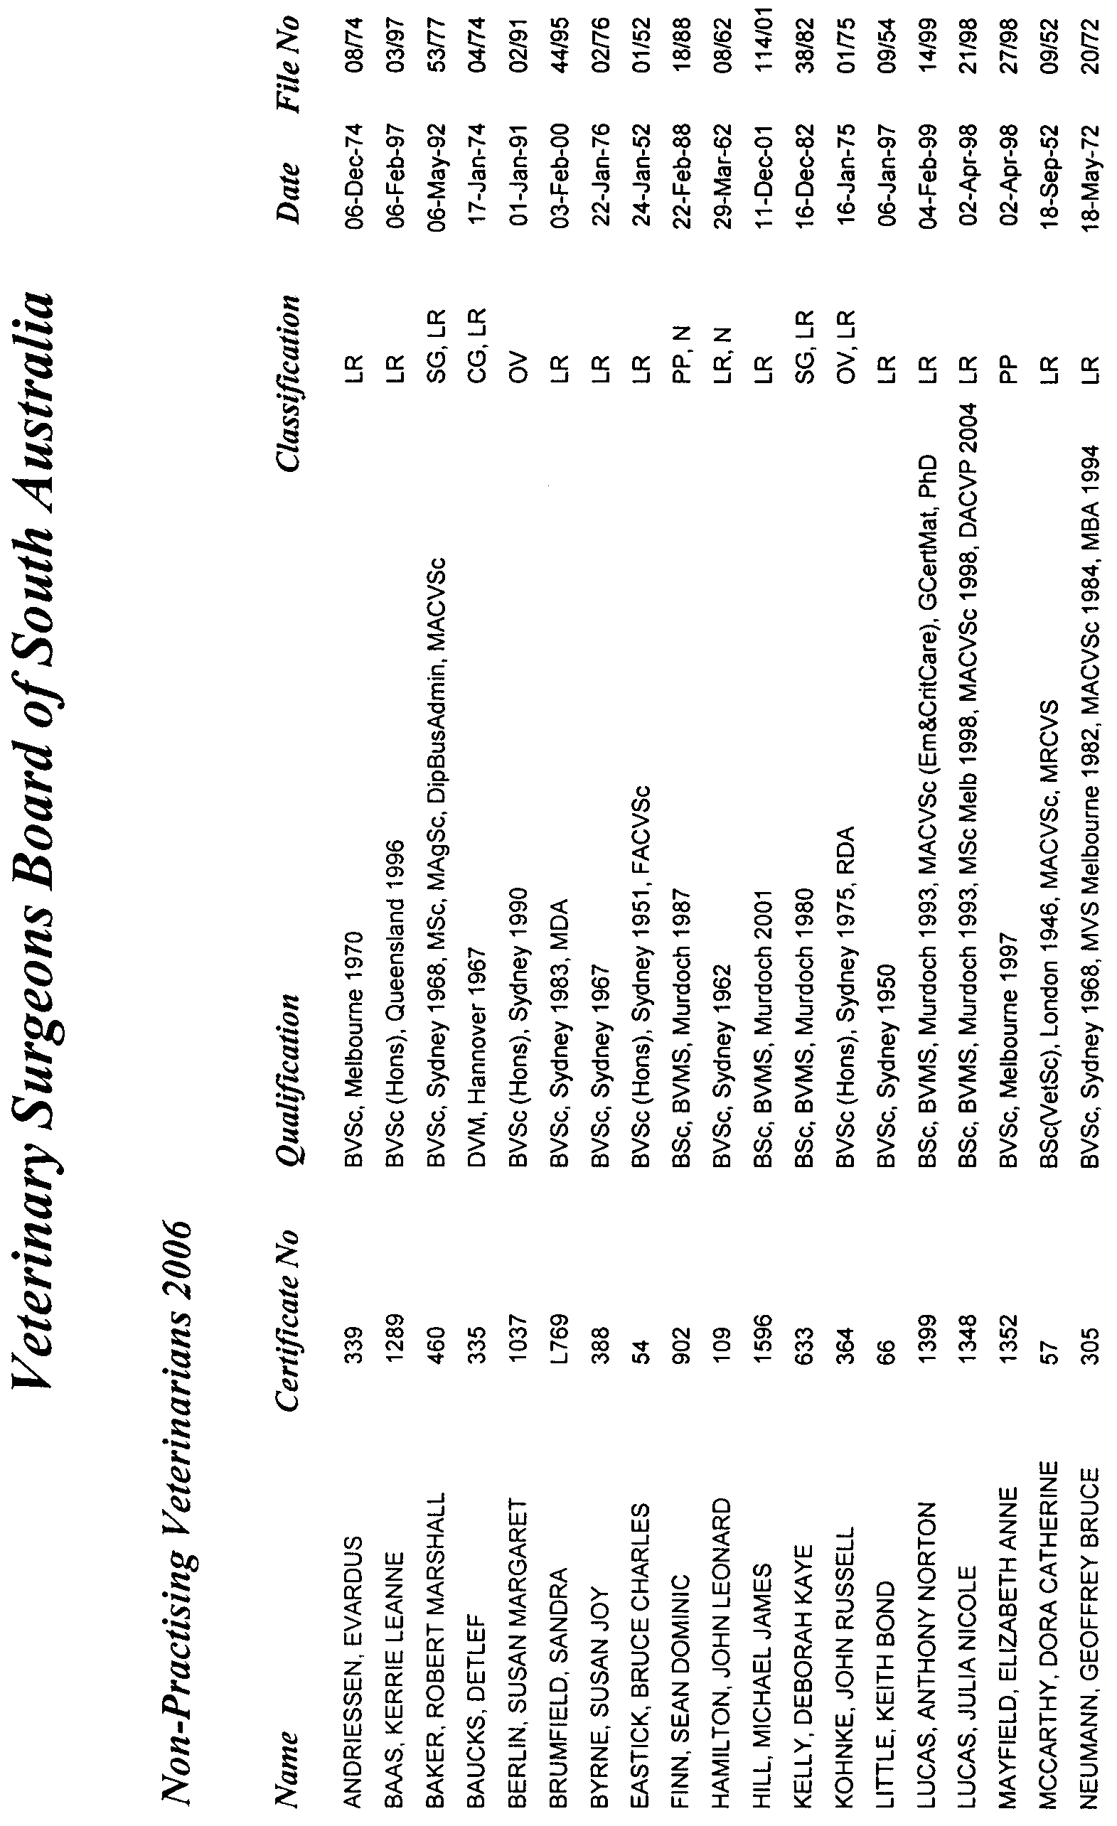
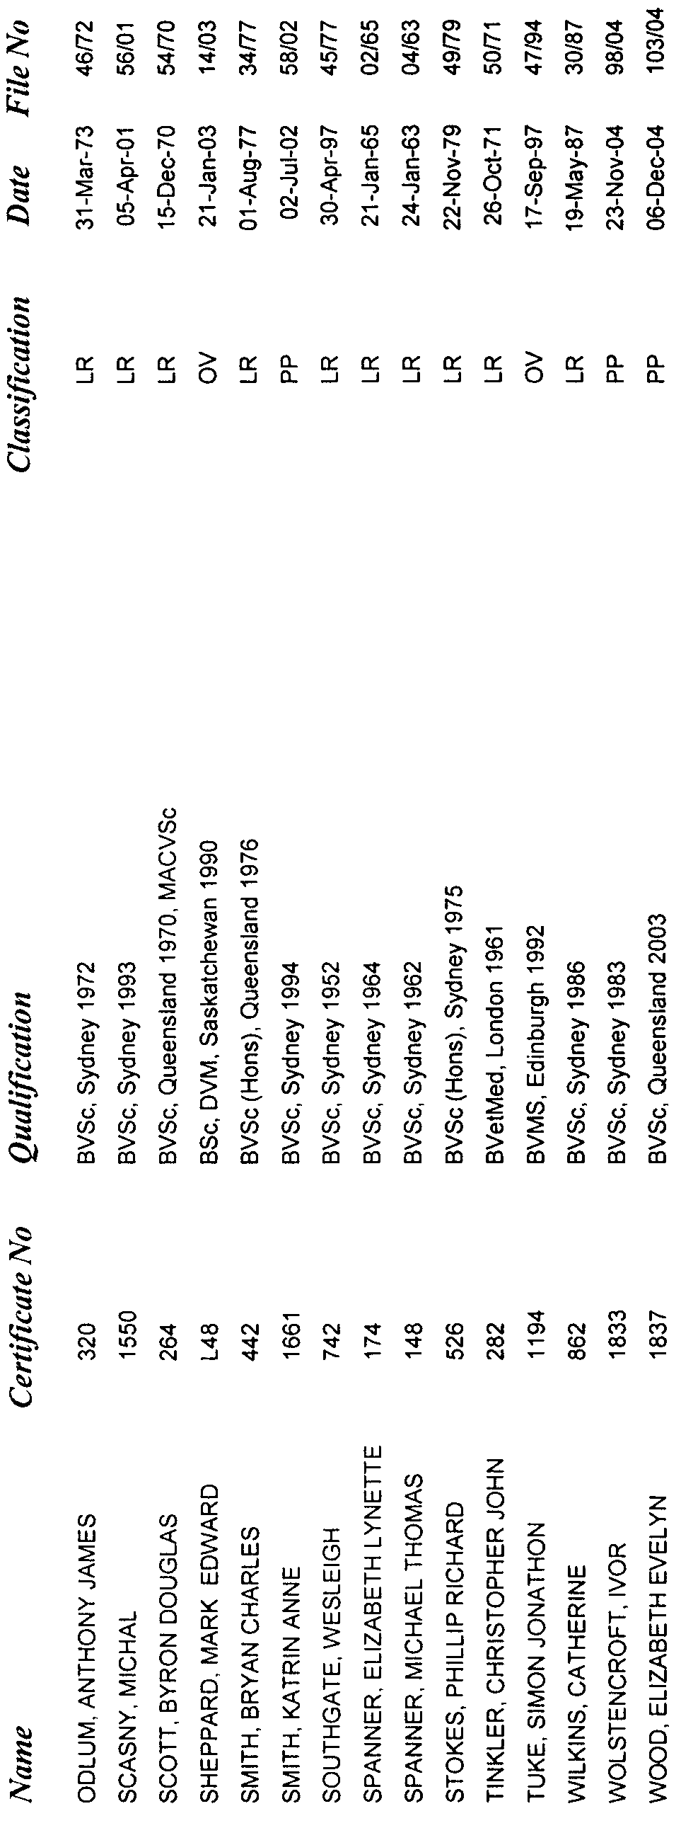
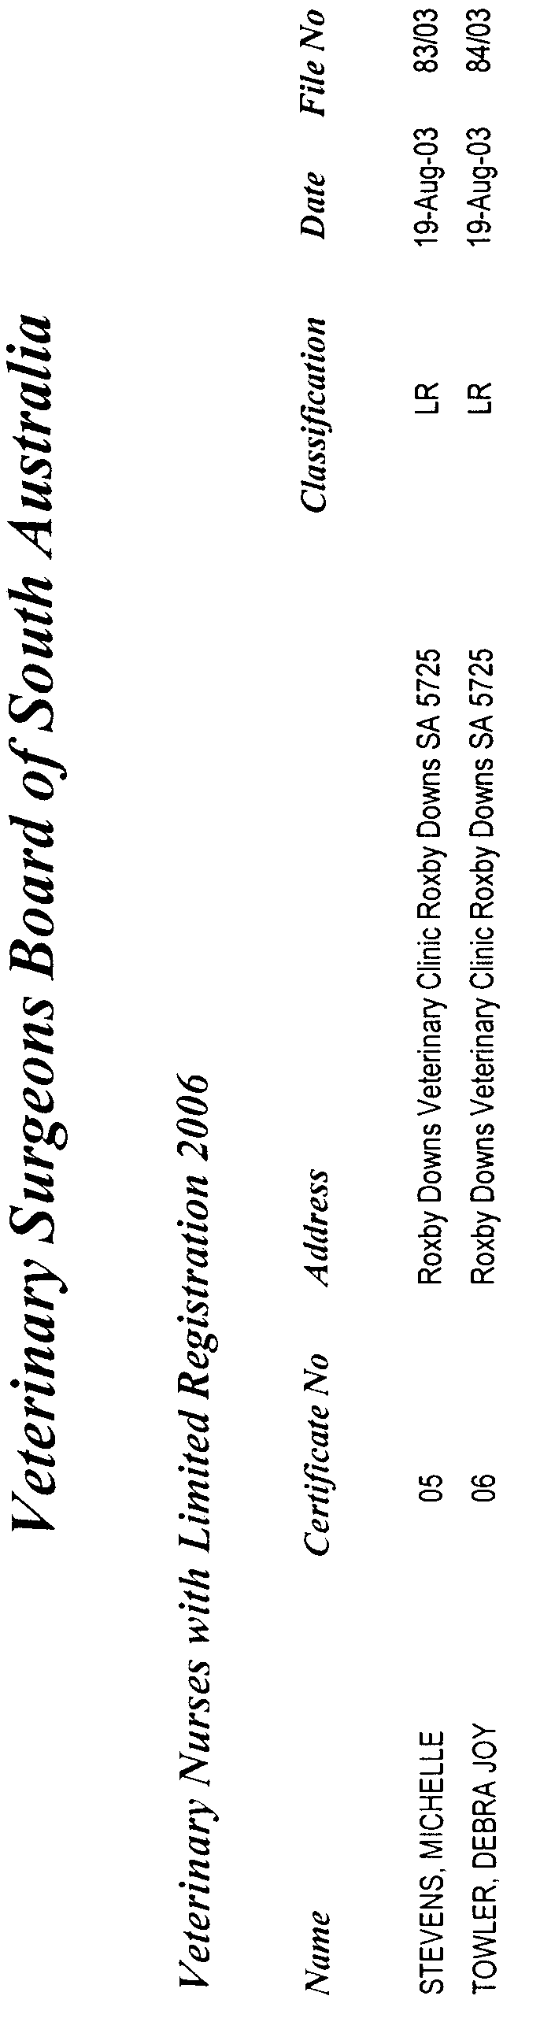

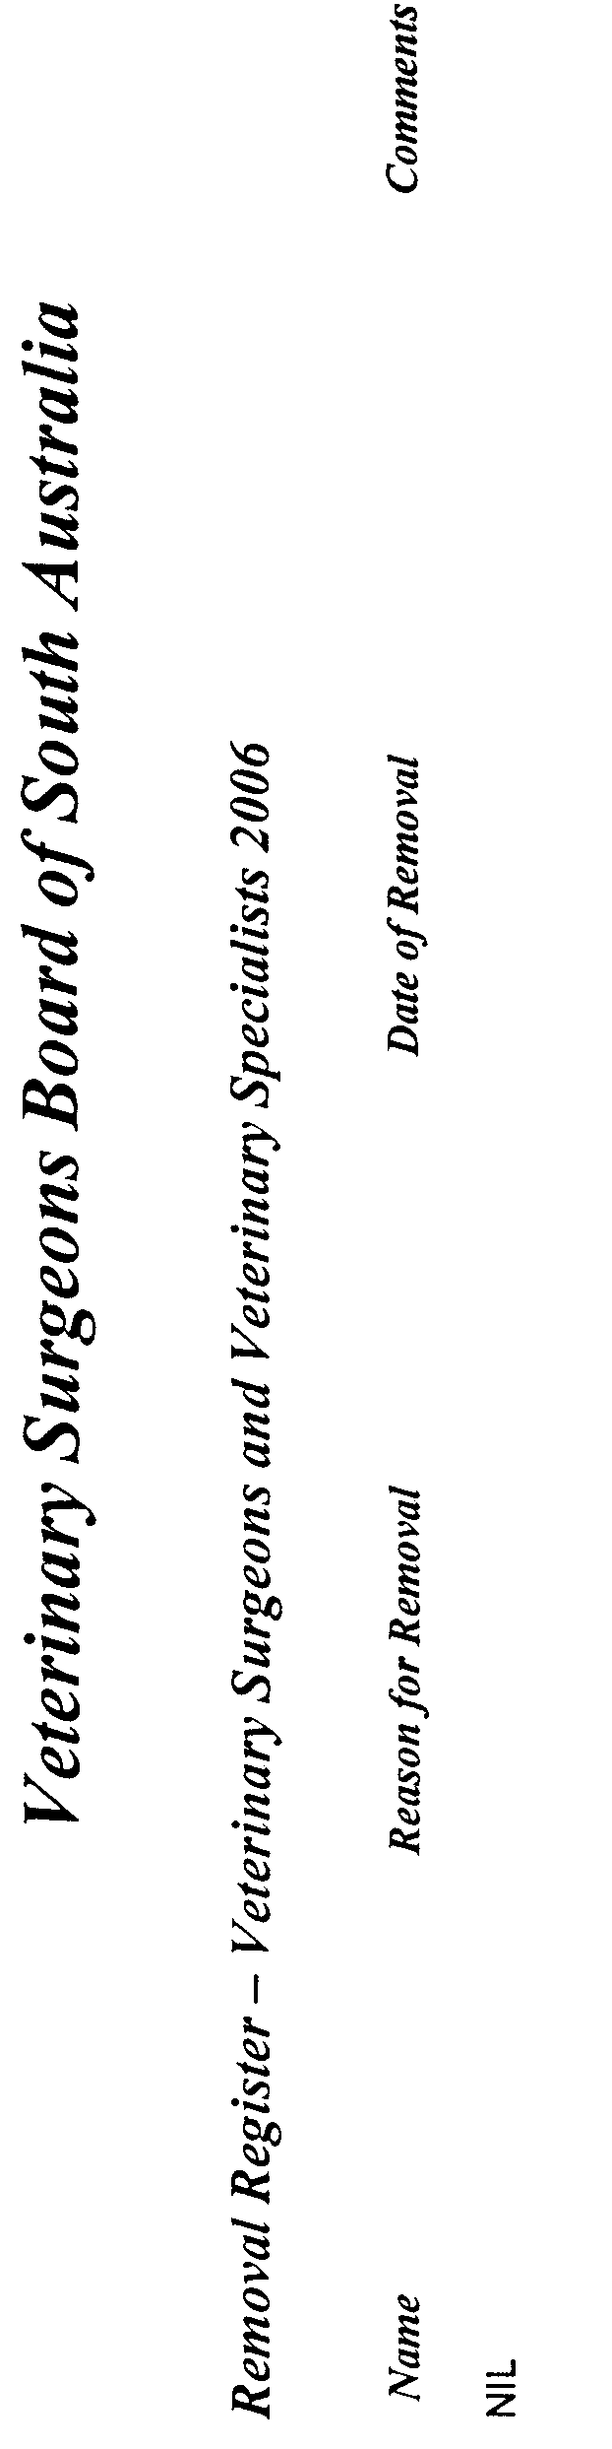

South Australia
Chiropractic and Osteopathy Practice Act (Commencement) Proclamation 2006
1—Short title
This proclamation may be cited as the Chiropractic and Osteopathy Practice Act (Commencement) Proclamation 2006.
2—Commencement of Act and suspension of certain provisions
(1) The Chiropractic and Osteopathy Practice Act 2005 (No 30 of 2005) will come into operation on 4 May 2006.
(2) The operation of the following provisions of the Act is suspended until a day or time or days or times to be fixed by subsequent proclamation or proclamations:
(a) sections 4 to 6 (inclusive);
(b) sections 8 to 75 (inclusive);
(c) Schedule 1 (other than clause 2(4) and clause 4).
Made by the Governor
with the advice and consent of the Executive Council
on 4 May 2006
HEACS/04/016

South Australia
Administrative Arrangements (Administration of Chiropractic and Osteopathy Practice Act) Proclamation 2006
under section 5 of the Administrative Arrangements Act 1994
1—Short title
This proclamation may be cited as the Administrative Arrangements (Administration of Chiropractic and Osteopathy Practice Act) Proclamation 2006.
2—Commencement
This proclamation comes into operation on the day on which it is made.
3—Administration of Act committed to Minister for Health
The administration of the Chiropractic and Osteopathy Practice Act 2005 is committed to the Minister for Health.
Made by the Governor
with the advice and consent of the Executive Council
on 4 May 2006
HEACS/04/016
South Australia
Liquor Licensing (Conferral of Authority) Proclamation 2006
under section 15 of the Liquor Licensing Act 1997
1—Short title
This proclamation may be cited as the Liquor Licensing (Conferral of Authority) Proclamation 2006.
2—Commencement
This proclamation comes into operation on the day on which it is made.
3—Conferral of authority on District Court Judge
Authority is conferred on the District Court Judge named in Schedule 1 to exercise the jurisdiction of the Licensing Court of South Australia.
Schedule 1—District Court Judge on whom authority is conferred
His Honour David Cameron Lovell
Made by the Governor
with the advice and consent of the Executive Council
on 4 May 2006
AGO0071/03CS

South Australia
Occupational Therapists (Fees) Variation Regulations 2006
under the Occupational Therapists Act 1974

Contents
Part 1—Preliminary
1 Short title
2 Commencement
3 Variation provisions
Part 2—Variation of Occupational Therapists Regulations 2003
4 Variation of Schedule 3—Fees

Part 1—Preliminary
1—Short title
These regulations may be cited as the Occupational Therapists (Fees) Variation Regulations 2006.
2—Commencement
These regulations come into operation on the day on which they are made.
3—Variation provisions
In these regulations, a provision under a heading referring to the variation of specified regulations varies the regulations so specified.
Part 2—Variation of Occupational Therapists Regulations 2003
4—Variation of Schedule 3—Fees
Schedule 3, clause 3—delete "$160" and substitute:
$180
Note—
As required by section 10AA(2) of the Subordinate Legislation Act 1978, the Minister has certified that, in the Minister's opinion, it is necessary or appropriate that these regulations come into operation as set out in these regulations.
Made by the Governor
on the recommendation of the Occupational Therapists Registration Board of South Australia and with the advice and consent of the Executive Council
on 4 May 2006
No 44 of 2006
HEACS/06/103

South Australia
Harbors and Navigation Variation Regulations 2006
under the Harbors and Navigation Act 1993

Contents
Part 1—Preliminary
1 Short title
2 Commencement
3 Variation provisions
Part 2—Variation of Harbors and Navigation Regulations 1994
4 Variation of Schedule 4—Restricted areas—controls
5 Variation of Schedule 5—Restricted areas—delineation

Part 1—Preliminary
1—Short title
These regulations may be cited as the Harbors and Navigation Variation Regulations 2006.
2—Commencement
These regulations come into operation on the day on which they are made.
3—Variation provisions
In these regulations, a provision under a heading referring to the variation of specified regulations varies the regulations so specified.
Part 2—Variation of Harbors and Navigation Regulations 1994
4—Variation of Schedule 4—Restricted areas—controls
Clause 2, entry relating to Thistle Island Areas 1 and 2—delete the entry and substitute:

Thistle Island Areas 1 and 2 | Control 10 but the prohibition on fishing does not apply in respect of the taking of abalone in Area 2 in accordance with a licence under the Fisheries Act 1982.
5—Variation of Schedule 5—Restricted areas—delineation
Schedule 5, entry relating to Thistle Island Area 2—delete the entry and substitute:
Area 2: the portion of the waters of Spencer Gulf bounded as follows: commencing at high water mark near Horny Point at a point at latitude 35°00'13.860" south, longitude 136°11'23.744" east, then east north east in a straight line to a point at latitude 35°00'00.000" south, longitude 136°12'42.495" east, being the intersection of that line with the western circumference of a circle of radius 2 nautical miles centred on a point at latitude 35°00'02.280" south, longitude 136°15'08.778" east, then clockwise from that intersection around the circumference to a point on the western circumference of the circle at latitude 35°01'02.251" south, longitude 136°13'01.891" east, then west in a straight line to high water mark at latitude 35°01'02.251" south, longitude 136°11'36.068" east, then north along high water mark to the point of commencement (all positions being in the WGS84 datum).
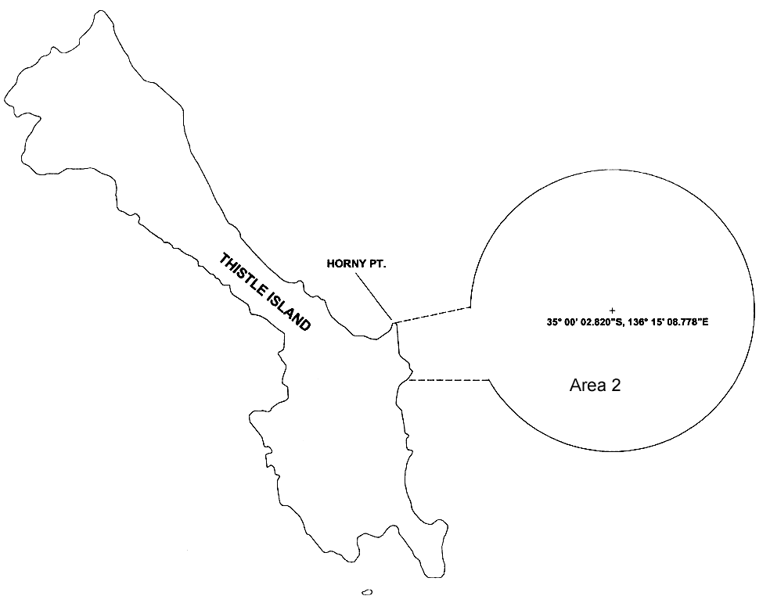
Note—
As required by section 10AA(2) of the Subordinate Legislation Act 1978, the Minister has certified that, in the Minister's opinion, it is necessary or appropriate that these regulations come into operation as set out in these regulations.
Made by the Governor
with the advice and consent of the Executive Council
on 4 May 2006
No 45 of 2006
MTR05/035CS

South Australia
Chiropodists (Fees) Variation Regulations 2006
under the Chiropodists Act 1950

Contents
Part 1—Preliminary
1 Short title
2 Commencement
3 Variation provisions
Part 2—Variation of Chiropodists Regulations 2004
4 Substitution of Schedule 2
Schedule 2—Fees

Part 1—Preliminary
1—Short title
These regulations may be cited as the Chiropodists (Fees) Variation Regulations 2006.
2—Commencement
These regulations will come into operation on 1 July 2006.
3—Variation provisions
In these regulations, a provision under a heading referring to the variation of specified regulations varies the regulations so specified.
Part 2—Variation of Chiropodists Regulations 2004
4—Substitution of Schedule 2
Schedule 2—delete the Schedule and substitute:
Schedule 2—Fees

1 | Application for registration | $200
2 | Annual subscription | $200
Note—
As required by section 10AA(2) of the Subordinate Legislation Act 1978, the Minister has certified that, in the Minister's opinion, it is necessary or appropriate that these regulations come into operation as set out in these regulations.
Made by the Governor
on the recommendation of The Chiropody Board of South Australia and with the advice and consent of the Executive Council
on 4 May 2006
No 46 of 2006
HEACS/06/104

South Australia
Zero Waste SA Regulations 2006
under the Zero Waste SA Act 2004

Contents
1 Short title
2 Commencement
3 Interpretation
4 Consultation with LGA in relation to Board appointments

1—Short title
These regulations may be cited as the Zero Waste SA Regulations 2006.
2—Commencement
These regulations come into operation on the day on which they are made.
3—Interpretation
In these regulations—
Act means the Zero Waste SA Act 2004;
LGA means the Local Government Association of South Australia.
4—Consultation with LGA in relation to Board appointments
For the purposes of section 9(4) of the Act, the Minister is to consult the LGA in relation to the selection of persons for appointment to the Board as follows:
(a) when appointments are to be made to fill 1 or more vacancies, an invitation is to be extended to the LGA to recommend suitable candidates within a specified period;
(b) the invitation is to specify the number of persons to be appointed and invite the LGA to recommend a number of suitable candidates equal to twice the number of persons to be appointed plus 1 and to recommend, as far as practicable, equal numbers of men and women;
(c) the invitation may specify areas of practical knowledge and experience listed in section 9(6) of the Act required of candidates and, if it does so, a recommendation of a candidate is to be accompanied by information about the knowledge and experience of the candidate;
(d) if the Minister proposes that none of the candidates recommended by the LGA in response to an initial invitation be appointed, 1 further invitation to make recommendations is to be extended to the LGA in accordance with this regulation;
(e) the period allowed for recommendations is to be—
(i) for an initial invitation—at least 6 weeks;
(ii) for a further invitation—at least 2 weeks;
(f) the Minister is to inform the LGA of persons selected for appointment to the Board, and invite the LGA to comment on the selection within a specified period (being at least 2 weeks);
(g) the Minister is to have regard to recommendations and comments of the LGA made in response to an invitation under this regulation.
Note—
As required by section 10AA(2) of the Subordinate Legislation Act 1978, the Minister has certified that, in the Minister's opinion, it is necessary or appropriate that these regulations come into operation as set out in these regulations.
Made by the Governor
with the advice and consent of the Executive Council
on 4 May 2006
No 47 of 2006
EC04/0084CS

South Australia
Chiropractic and Osteopathy Practice (Election) Regulations 2006
under the Chiropractic and Osteopathy Practice Act 2005

Contents
1 Short title
2 Commencement
3 Interpretation
4 Returning officer
5 Election to be conducted by returning officer
6 Appointment of closing day and polling day
7 Advertisement of election
8 Registrar to prepare roll
9 Nomination
10 Uncontested elections
11 Preparation of ballot papers
12 Issue of voting papers
13 Method of voting
14 Scrutineers
15 Arranging papers for counting
16 Method for counting based on principles of proportional representation
17 Death of candidate
18 Declaration of result of election
19 Computer counting
Schedule 1—Method of counting votes
1 Interpretation
2 Method of counting votes
Schedule 2—Transitional provision

1—Short title
These regulations may be cited as the Chiropractic and Osteopathy Practice (Election) Regulations 2006.
2—Commencement
These regulations will come into operation on the day on which section 76 of the Chiropractic and Osteopathy Practice Act 2005 comes into operation.
3—Interpretation
(1) In these regulations, unless the contrary intention appears—
Act means the Chiropractic and Osteopathy Practice Act 2005;
business day means any day other than a Saturday, Sunday or public holiday;
closing day, in relation to an election, means the day on which nomination of candidates for the election closes;
Electoral Commissioner means the person for the time being holding, or acting in, the office of the Electoral Commissioner under the Electoral Act 1985;
polling day, in relation to an election, means the day on which voting at the election closes;
returning officer—see regulation 4;
voter means a person entitled to vote at an election conducted under these regulations.
(2) The close of voting for an election is 9.30 am on polling day.
4—Returning officer
The returning officer for an election under these regulations will be the Electoral Commissioner.
5—Election to be conducted by returning officer
(1) An election for the purposes of section 6(1)(a) or (b) of the Act will be conducted by the returning officer—
(a) in accordance with these regulations; and
(b) to the extent that these regulations fail to deal with a matter that, in the opinion of the Electoral Commissioner, is necessary for the proper conduct of the election—in accordance with rules determined by the Electoral Commissioner in relation to that matter.
(2) The Board is responsible for the costs and expenses incurred by the returning officer in conducting an election.
6—Appointment of closing day and polling day
The returning officer will fix—
(a) a day as closing day for an election; and
(b) a day as polling day for an election.
7—Advertisement of election
(1) At least 14 days before the closing day for an election the returning officer must cause an advertisement relating to the election to be placed in a newspaper circulating generally throughout the State.
(2) The advertisement must set out—
(a) the day fixed as polling day; and
(b) the number of vacancies to be filled; and
(c) an invitation for nominations for the vacancies to be filled; and
(d) details about how a nomination may be made; and
(e) the day fixed as closing day.
8—Registrar to prepare roll
(1) The Registrar is responsible for the preparation of a voters roll for the purposes of an election.
Note—
Every person who is a chiropractor at the time the voters roll is prepared is entitled to vote in an election to choose chiropractors—see section 7(2) of the Act.
Every person who is an osteopath at the time the voters roll is prepared is entitled to vote an election to choose an osteopath—see section 7(3) of the Act.
(2) The voters roll to be used in a particular election must reflect entitlements to vote as they exist at 5 pm on the third business day after the day on which the advertisement relating to the election is published.
(3) The Registrar must supply the returning officer with sufficient copies of the voters roll, certified by the Registrar, for use at an election.
(4) The voters roll may be supplied to the returning officer in electronic form, or in another manner agreed between the Registrar and the returning officer.
9—Nomination
(1) The returning officer must prepare a nomination form for the purposes of an election (in a form determined by the returning officer).
Note—
Every chiropractor is eligible to be a candidate for an election to choose chiropractors—see section 6(1)(a) of the Act.
Every osteopath is eligible to be a candidate for an election to choose an osteopath—see section 6(1)(b) of the Act.
(2) A chiropractor or osteopath may be nominated as a candidate for an election by lodgement of a nomination form with the returning officer by 12 noon on closing day.
(3) A nomination must be made by 2 persons who are entitled to vote at the election.
(4) A candidate for election must—
(a) make a declaration on the nomination form that he or she is eligible to be elected at the election; and
(b) signify his or her consent by signing the nomination form.
(5) A nomination must be accompanied by—
(a) a profile of the candidate; and
(b) other information required by the returning officer.
(6) A profile must comply with the following requirements:
(a) the profile must be limited to relevant professional information about the candidate and other information directly relevant to the functions or operations of the Board under the Act;
(b) the profile must be in typed form or in legible handwriting and comply with other requirements as to form determined by the returning officer;
(c) the profile must not exceed 200 words;
(d) the profile must be signed and dated by the candidate (but this signature and date will not form part of the profile for the purposes of the election).
(7) The returning officer may reject a nomination if, in the opinion of the returning officer, the name under which the candidate is nominated—
(a) is obscene; or
(b) is frivolous; or
(c) appears to have been assumed for an ulterior purpose.
(8) A nomination is invalid if—
(a) the nomination is not made by the use of a nomination form under this regulation; or
(b) the nomination form is not completed—
(i) in accordance with instructions contained in the form; or
(ii) in accordance with the requirements of this regulation; or
(c) the nomination form, the candidate profile and any other required information are not received by the returning officer by 12 noon on closing day.
(9) A dispute as to the validity of a nomination will be determined summarily by the returning officer.
(10) A nominated candidate may at any time before the close of nominations, by written notice signed by the candidate and given to the returning officer, withdraw the nomination.
10—Uncontested elections
(1) If, after nominations have closed, it appears that the number of candidates nominated to contest the election does not exceed the number of persons required to be elected, the returning officer must declare the nominated candidate or candidates elected.
(2) Within 7 days after making the declaration, the returning officer must cause a notice of the declaration to be placed in a newspaper circulating generally throughout the State.
(3) The notice must set out—
(a) the date of the declaration; and
(b) the name of each successful candidate.
(4) If, after nominations have closed, it appears that the number of candidates nominated to contest the election is less than the number of persons required to be elected, the returning officer, in addition to making a declaration and publishing a notice under subregulations (1) and (2), must extend the period for nominations for the remaining vacancy or vacancies by a period (not exceeding 7 days) determined by the returning officer and may fix a new day as polling day.
(5) If the returning officer is required to take action under subregulation (4), the returning officer must at the earliest opportunity cause a notice relating to the matter to be placed in a newspaper circulating generally throughout the State.
(6) The notice must set out—
(a) the day fixed as polling day; and
(b) the number of vacancies left to be filled; and
(c) an invitation for nominations for those vacancies; and
(d) details about how a nomination may be made; and
(e) the day by which nominations must be received.
(7) These regulations will then apply in the same manner as they applied (or would have applied) to earlier nominations.
(8) If the number of candidates nominated exceeds the required number of candidates, an election will be held to fill the relevant vacancies.
11—Preparation of ballot papers
(1) If an election is to be held, the returning officer must prepare a ballot paper showing the names of all candidates for election (on the basis of information provided to the returning officer as part of the nomination process).
(2) The ballot paper must be prepared as soon as is reasonably practicable after the closing day for the election.
(3) The names of the candidates must be arranged on the ballot paper, 1 under the other, in an order determined by lot.
(4) A square must be placed to the left of each name appearing on the ballot paper.
(5) A ballot paper will otherwise be in a form determined by the returning officer.
12—Issue of voting papers
(1) The returning officer must, at least 14 days before polling day for an election, send by post to every voter—
(a) a ballot paper (authenticated to the satisfaction of the returning officer); and
(b) a statement in writing setting out—
(i) instructions for the completion of a ballot paper; and
(ii) the manner in which the ballot paper is to be returned; and
(c) a set of candidate profiles in a form determined by the returning officer; and
(d) an opaque envelope bearing a declaration in a form determined by the returning officer, to be completed by the voter, declaring that the ballot paper contained in the envelope contains his or her vote and that he or she has not already voted at the election.
(2) The declaration must appear on a tear-off extension to the envelope flap.
(3) The envelope must be—
(a) a pre-paid envelope addressed to the returning officer; or
(b) accompanied by a pre-paid envelope addressed to the returning officer.
(4) If a person to whom voting papers are issued desires to vote at the relevant election, the following procedures must be followed:
(a) the voter must mark his or her vote in the manner prescribed by these regulations on the ballot paper supplied;
(b) the voter must then fold the ballot paper and place the folded ballot paper in the envelope;
(c) the voter must then seal the envelope;
(d) the voter must then ensure that the declaration on the flap is completed and signed by the voter;
(e) the sealed envelope must then be delivered to the returning officer (by post or personally) not later than the close of voting on polling day.
(5) If the returning officer is satisfied that voting papers issued to a voter—
(a) have not been received by the voter; or
(b) have been lost; or
(c) have been inadvertently spoiled,
the returning officer may issue fresh voting papers to the voter (before the close of voting).
(6) The issue of fresh voting papers automatically cancels the original voting papers.
13—Method of voting
(1) To make a formal vote at an election a person must make a vote on the ballot paper—
(a) if only 1 candidate is required to be elected—by placing the number 1 in the square opposite the name of the candidate of the voter's first preference and, if the voter so desires, by placing the number 2 and consecutive numbers in the squares opposite the names of other candidates in the order of the voter's preference for them;
(b) if more than 1 candidate is required to be elected—by placing consecutive numbers beginning with the number 1 in the squares opposite the names of candidates in the order of the voter's preference for them until the voter has indicated a vote for a number of candidates equal to the number of candidates required to be elected and then, if the voter so desires, by continuing to place consecutive numbers for 1 or more additional candidates in the order of the voter's preference.
(2) A tick or cross appearing on a ballot paper is equivalent to the number 1.
(3) If—
(a) a series of numbers (starting from the number 1) appearing on a ballot paper is non-consecutive by reason only of the omission of 1 or more numbers from the series or the repetition of a number (not being the number 1); and
(b) if more than 1 candidate is required to be elected—the numbers are at least consecutive up to the number of candidates required to be elected,
the ballot paper is not informal and the votes are valid up to the point at which the omission or repetition occurs.
(4) A ballot paper is not informal by reason of non-compliance with this regulation if the voter's intention is clearly indicated on the ballot paper.
14—Scrutineers
(1) Each candidate at an election may appoint a person to be a scrutineer for the purposes of the election.
(2) A candidate in an election is not eligible for appointment as a scrutineer for the election (and a candidate may not be present at the scrutiny).
(3) No more than 1 scrutineer may be appointed for each candidate.
(4) The appointment of a scrutineer may be made by written notice served on the returning officer (personally or by post).
15—Arranging papers for counting
(1) The returning officer will, as soon as practicable after the close of voting for an election, with the assistance of persons appointed or nominated by the returning officer, and in the presence of scrutineers or officers of the Board who may be present, ensure that all voting papers returned for the purposes of the election in accordance with these regulations are made available under this regulation.
(2) The returning officer will, for the purposes of the election (and with such assistance as may be necessary and appropriate)—
(a) examine the declaration on each envelope validly returned under these regulations and determine which votes are to be accepted for further scrutiny; and
(b) tear off the extensions to the envelope flaps on the envelopes accepted; and
(c) rearrange the envelopes that no longer bear tear-off extensions so that the anonymity of voters is maintained; and
(d) remove the ballot papers from those envelopes; and
(e) examine the ballot papers and reject informal ballot papers; and
(f) arrange all unrejected ballot papers into appropriate parcels for counting.
16—Method for counting based on principles of proportional representation
The returning officer will conduct the counting of votes in an election in accordance with the method set out in Schedule 1.
17—Death of candidate
If a candidate dies between the close of nominations and polling day, the election will not fail and a vote indicated on a ballot paper opposite the name of the deceased candidate must be counted to the candidate next in order of the voter's preference, and the numbers indicating subsequent preferences will be altered accordingly.
18—Declaration of result of election
(1) When all vacancies have been filled by the making of provisional declarations under Schedule 1, the returning officer will formally declare the result of the election.
(2) Within 7 days after making a formal declaration the returning officer must—
(a) provide written notification of the result to the Minister; and
(b) cause a notice setting out the result to be published in a newspaper circulating generally throughout the State.
19—Computer counting
(1) The returning officer may decide to use a computer program to carry out steps involved in the recording, scrutiny or counting of votes in an election.
(2) However, the returning officer cannot do so unless the returning officer is reasonably satisfied that the proper use of the program would produce the same result in the recording, scrutiny or counting of votes as the result that would be achieved if the program were not to be used.
(3) If a computer program is used, the method of counting votes under Schedule 1 may be modified according to the determination of the returning officer.
Schedule 1—Method of counting votes
1—Interpretation
(1) In this Schedule—
continuing candidate means a candidate not already elected or excluded from the count;
election of a candidate means the making by the returning officer of a provisional declaration that the candidate has been elected, and elected has a corresponding meaning;
surplus votes of an elected candidate means the excess (if any) over the quota of the elected candidate's votes.
(2) For the purposes of clause 2, a reference to votes of or obtained or received by a candidate includes votes obtained or received by the candidate on transfer under that clause.
2—Method of counting votes
The conduct of the counting of the votes in an election will occur according to the following method:
(a) the number of first preference votes given for each candidate and the total number of all such votes must be ascertained and a quota determined by—
(i) dividing the total number of first preference votes by 1 more than the number of candidates required to be elected; and
(ii) increasing the quotient so obtained (disregarding any remainder) by 1,
and, if a candidate has received a number of first preference votes equal to or greater than the quota, the returning officer must make a provisional declaration that the candidate has been elected;
(b) if the total number of all first preference votes does not exceed 150, the number of votes of a particular kind contained in the ballot papers will, for the purposes of this clause (including paragraph (a)), be taken to be the number obtained by multiplying the number of votes of that kind contained in the ballot papers by 100;
(c) unless all the vacancies have been filled, the surplus votes of each elected candidate must be transferred to the continuing candidates as follows:
(i) the number of surplus votes of the elected candidate must be divided by the number of first preference votes received by that candidate and the resulting fraction will be the transfer value;
(ii) the total number of the first preference votes for the elected candidate that are contained in ballot papers that express the next available preference for a particular continuing candidate must be multiplied by the transfer value, the number so obtained (disregarding any fraction) must be added to the number of first preference votes of the continuing candidate and all those ballot papers must be transferred to the continuing candidate,
and, if a continuing candidate has received a number of votes equal to or greater than the quota on the completion of a transfer, the returning officer must make a provisional declaration that the candidate has been elected;
(d) unless all the vacancies have been filled, the surplus votes (if any) of a candidate elected under paragraph (c), or elected subsequently under this paragraph, must be transferred to the continuing candidates in accordance with paragraph (c)(i) and (ii) and, if a continuing candidate has received a number of votes equal to or greater than the quota on the completion of a transfer, the returning officer must make a provisional declaration that the candidate has been elected;
(e) if a continuing candidate has received a number of votes equal to or greater than the quota on the completion of a transfer under paragraph (c) or (d) of the surplus votes of a particular elected candidate, no votes of any other candidate may be transferred to the continuing candidate;
(f) for the purposes of the application of paragraph (c)(i) and (ii) in relation to a transfer under paragraph (d) or (h) of the surplus votes of an elected candidate, each ballot paper of the elected candidate that was obtained on a transfer under this clause must be dealt with as if any vote it expressed for the elected candidate were a first preference vote, as if the name of any other candidate previously elected or excluded had not been on the ballot paper and as if the numbers indicating subsequent preferences had been altered accordingly;
(g) if, after the counting of first preference votes or the election of a candidate and the transfer of the surplus votes (if any) of the elected candidate that are capable of being transferred, no candidate has, or less than the number of candidates required to be elected have, received a number of votes equal to the quota, the candidate who has the fewest votes must be excluded and all the excluded candidate's votes must be transferred to the continuing candidates as follows:
(i) the total number of the first preference votes for the excluded candidate that are contained in ballot papers that express the next available preference for a particular continuing candidate must be transferred, each first preference vote at a transfer value of 1, to the continuing candidate and added to the number of votes of the continuing candidate and all those ballot papers must be transferred to the continuing candidate;
(ii) the total number (if any) of other votes obtained by the excluded candidate on transfers under this clause must be transferred from the excluded candidate in the order of the transfers on which they were obtained, the votes obtained on the earliest transfer being transferred first, as follows:
(A) the total number of votes transferred to the excluded candidate from a particular candidate that are contained in ballot papers that express the next available preference for a particular continuing candidate must be multiplied by the transfer value at which the votes were so transferred to the excluded candidate;
(B) the number so obtained (disregarding any fraction) must be added to the number of votes of the continuing candidate;
(C) all those ballot papers must be transferred to the continuing candidate;
(h) if a continuing candidate has received a number of votes equal to or greater than the quota on the completion of a transfer under paragraph (g) or (i) of votes of an excluded candidate, the returning officer must make a provisional declaration that the candidate has been elected and, unless all the vacancies have been filled, the surplus votes (if any) of the candidate so elected must be transferred in accordance with paragraph (c)(i) and (ii), except that, if the candidate so elected is elected before all the votes of the excluded candidate have been transferred, the surplus votes (if any) of the candidate so elected must not be transferred until the remaining votes of the excluded candidate have been transferred in accordance with paragraph (g)(i) and(ii) to continuing candidates;
(i) subject to paragraph (k), if, after the exclusion of a candidate and the transfer of the votes (if any) of the excluded candidate that are capable of being transferred, no continuing candidate has received a number of votes greater than the quota, the continuing candidate who has the fewest votes must be excluded and his or her votes transferred in accordance with paragraph (g)(i) and (ii);
(j) if a candidate is elected as a result of a transfer of the first preference votes of an excluded candidate or a transfer of all the votes of an excluded candidate that were transferred to the excluded candidate from a particular candidate, no other votes of the excluded candidate may be transferred to the candidate so elected;
(k) in respect of the last vacancy for which 2 continuing candidates remain, the returning officer must make a provisional declaration that the continuing candidate who has the larger number of votes has been elected despite the fact that number is below the quota and, if those candidates have the same number of votes, the candidate with the larger number of votes at the last preceding count or transfer will be taken to be elected and, if the number of votes at that count or transfer was equal, the returning officer must, in the presence of any scrutineers who may be present, draw lots to determine which of the candidates is to be elected;
(l) despite any other provision of this clause, if, on the completion of a transfer of votes under this clause, the number of continuing candidates is equal to the number of remaining unfilled vacancies, the returning officer must make a provisional declaration that those candidates have been elected;
(m) for the purposes of this clause—
(i) the order of election of candidates will be taken to be in accordance with the order of the count or transfer as a result of which they were elected, the candidates (if any) elected on the count of first preference votes being taken to be the earliest elected; and
(ii) if 2 or more candidates are elected as a result of the same count or transfer, the order in which they will be taken to have been elected will be in accordance with the relative numbers of their votes, the candidate with the largest number of votes being taken to be the earliest elected but, if any 2 or more of those candidates each have the same number of votes, the order in which they will be taken to have been elected will be taken to be in accordance with the relative numbers of their votes at the last count or transfer before their election at which each of them had a different number of votes, the candidate with the largest number of votes at that count or transfer being taken to be the earliest elected and, if there has been no such count or transfer, the returning officer must, in the presence of any scrutineers who may be present, draw lots to determine the order in which they will be taken to have been elected;
(n) subject to paragraphs (o) and (p), if, after a count or transfer under this clause, 2 or more candidates have surplus votes, the order of transfers of the surplus votes of those candidates will be in accordance with the relative sizes of the surpluses, the largest surplus being transferred first;
(o) subject to paragraph (p), if, after a count or transfer under this clause, 2 or more candidates have equal surpluses, the order of transfers of the surplus votes of those candidates will be in accordance with the relative numbers of votes of those candidates at the last count or transfer at which each of those candidates had a different number of votes, the surplus of the candidate with the largest number of votes at that count or transfer being transferred first but, if there has been no such count or transfer, the returning officer must, in the presence of any scrutineers who may be present, draw lots to determine the order in which the surpluses will be dealt with;
(p) if, after a count or transfer under this clause, a candidate obtains surplus votes, those surplus votes will not be transferred before the transfer of surplus votes obtained by any other candidate on an earlier count or transfer;
(q) if the candidate who has the fewest votes is required to be excluded and 2 or more candidates each have the fewest votes, whichever of those candidates had the fewest votes at the last count or transfer at which each of those candidates had a different number of votes will be excluded but, if there has been no such count or transfer, the returning officer must, in the presence of any scrutineers who may be present, draw lots to determine which candidate will be excluded;
(r) if a candidate is elected by reason that the number of first preference votes received, or the aggregate of first preference votes received and all other votes obtained on transfers under this clause, is equal to the quota, all the ballot papers expressing those votes must be set aside as finally dealt with;
(s) a ballot paper must be set aside as exhausted where on a transfer it is found that the paper expresses no preference for a continuing candidate;
(t) for the purposes of this clause, a transfer under paragraph (c), (d) or (h) of the surplus votes of any elected candidate, a transfer in accordance with paragraph (g)(i) of all first preference votes of an excluded candidate or a transfer in accordance with paragraph (g)(ii) of all the votes of an excluded candidate that were transferred from a particular candidate will each be regarded as constituting a separate transfer.
Schedule 2—Transitional provision
An election may be held for the purposes of making appointments to the Board pursuant to the Acts Interpretation Act 1915 prior to the commencement of section 6 of the Act and for the purposes of such an election—
(a) a reference in these regulations to the Board is to be taken to be a reference to the Board as constituted under the repealed Act; and
(b) a reference in these regulations to a chiropractor is to be taken to be a reference to a person who is a registered chiropractor under the repealed Act; and
(c) a reference in these regulations to the Registrar is to be taken to be a reference to the person holding the office of Registrar of the Board under the repealed Act.
Note—
As required by section 10AA(2) of the Subordinate Legislation Act 1978, the Minister has certified that, in the Minister's opinion, it is necessary or appropriate that these regulations come into operation as set out in these regulations.
Made by the Governor
with the advice and consent of the Executive Council
on 4 May 2006
No 48 of 2006
HEACS/04/016

FAXING COPY?
IF you fax copy to Government Publishing SA for inclusion in the Government Gazette, there is no need to send a Confirmation Copy to us as well.
This creates confusion and may well result in your notice being printed twice.
Please use the following fax number:
Fax transmission: (08) 8207 1040
Phone Inquiries: (08) 8207 1045
Please include a contact person, phone number and order number so that we can phone back with any queries we may have regarding the fax copy.
NOTE: Closing time for lodging new copy (fax, hard copy or email) is 4 p.m. on Tuesday preceding the day of publication.

Government Gazette notices can be E-mailed.
The address is:
governmentgazette@saugov.sa.gov.au
Documents should be sent as attachments in Word format.
When sending a document via E-mail, please confirm your transmission with a faxed copy of your document, including the date the notice is to be published.
Fax transmission: (08) 8207 1040
Enquiries: (08) 8207 1045
NOTE: Closing time for lodging new copy (fax, hard copy or email) is 4 p.m. on Tuesday preceding the day of publication.

CITY OF ADELAIDE
Declaration as Public Road—Notice of Declaration
NOTICE is hereby given, that at its meeting held on 10 April 2006, Council declared the following:
In exercise of its powers in section 210 of the Local Government Act 1999, the Council of the Corporation of the City of Adelaide declares the following road to be Public Road:
That portion of Advertiser Place lettered ‘B’ on Lands Titles Office Deposited Plan 66654 upwards from the height of 4.27 m above the footpath level in Waymouth Street.
M. Hemmerling, Chief Executive Officer

CITY OF HOLDFAST BAY
Opening and Closing of Roads
NOTICE is hereby given that in accordance with section 10 of the Roads (Opening and Closing) Act 1991, the City of Holdfast Bay proposes to make a Road Process Order to close the following road in the Hundred of Noarlunga, being a rectangularly-shaped strip of public road in the area named Glenelg South generally situate dividing Strata Plan 1696 from Allotment 1302 in Filed Plan 15390 and marked ‘A’ on Preliminary Plan No. 06/0032.
It is proposed that the portion of road to be closed marked ‘A’ be transferred to J. T. and K. E. Blieschke and merged with Allotment 1301 in Filed Plan 15390.
A preliminary plan of the proposal and a statement are available for public inspection at the Holdfast Bay Council Office, 24 Jetty Road, Brighton between the hours of 9 a.m. and 4.45 p.m., Monday to Friday or at the Adelaide office of the Surveyor-General during normal office hours.
Any person may object to the proposal and any adjoining landowner or other person substantially affected by the proposed road closure may apply for an easement relative to the closure. Such objection or application for an easement must be made in writing to the City of Holdfast Bay within 28 days of the date of this notice. If a submission is made, the City of Holdfast Bay is required to give notice of a time and place at which a meeting will be held to consider the matter, so that the person making the sub-mission or a representative may attend to support the submission, if desired.
Any submission must set out the full name and address of the person making the submission and must be fully supported by reasons and any application for the grant of an easement must give full particulars of the nature and location of the easement and where made by a person as the owner of adjoining or nearby land, specify the land to which the easement is to be annexed. A copy of the submission must be forwarded to the Surveyor-General at Adelaide.
Dated 4 May 2006.
R. Donaldson, Chief Executive Officer
PP/06/0032

CITY OF SALISBURY
Roads (Opening and Closing) Act 1991
Road Closure—Portion of Maxwell Court and Jennier Crescent, Para Hills/Ingle Farm
NOTICE is hereby given pursuant to section 10 of the said Act, that Council proposes to make a Road Process Order to close an irregularly-shaped portion of Maxwell Court and Jennier Crescent, generally extending from Allotment 30 in Deposited Plan 7056 to Maxwell Road (adjacent Bridge Road) shown as ‘A’ to ‘B’ on Preliminary Plan No. 06/0027. Closed road ‘A’ to be transferred to The Salvation Army (SA) and ‘B’ to be retained by Council.
A copy of the plan and statement of persons affected are available for public inspection at Council’s Office, 12 James Street, Salisbury and the office of the Surveyor-General, 101 Grenfell Street, Adelaide, during normal office hours.
Any application for easement or objection must be made in writing within 28 days from Thursday, 4 May 2006, to the Council, P.O. Box 8, Salisbury, S.A. 5108 and the Surveyor-General, G.P.O. Box 1354, Adelaide, S.A. 5001, setting out full details.
Where a submission is made, Council will give notification of a meeting to deal with the matter. Enquiries may be directed to Michael McCarthy on 8406 8577 or Karen Pepe on 8406 8397.
S. Hains, City Manager

CITY OF SALISBURY
Roads (Opening and Closing) Act 1991
Road Opening, Piece 20 in Deposited Plan 44809, Burton Road, Salisbury
NOTICE is hereby given pursuant to section 10 of the said Act, that Council proposes to make a Road Process Order to open as road a triangularly-shaped portion of piece 20 in Deposited Plan 44809 (adjoining the north-western corner) forming a widening of Burton Road and shown numbered ‘4’ on Preliminary Plan No. 06/0033.
A copy of the plan and statement of persons affected are available for public inspection at Council’s Office, 12 James Street, Salisbury and the office of the Surveyor-General, 101 Grenfell Street, Adelaide, during normal office hours.
Any objection or representation must be made in writing within 28 days from Thursday, 4 May 2006, to the Council, P.O. Box 8, Salisbury, S.A. 5108 and the Surveyor-General, G.P.O. Box 1354, Adelaide, S.A. 5001, setting out full details.
Where a submission is made, Council will give notification of a meeting to deal with the matter. Enquiries may be directed to Milan Millison on 8406 8216 or Karen Pepe on 8406 8397.
S. Hains, City Manager

CLARE & GILBERT VALLEYS COUNCIL
Result of Supplementary Election for One Area Councillor
Conducted on Tuesday, 18 April 2006
Formal Ballot Papers: 2 622 Quota: 1 312
Informal Ballot Papers: 5
Candidates | First Preference Votes | Result after Distribution of Preferences
Perry, Helen | 665
Thomas, Wayne | 882 | Elected
Rye, Alan Robert | 390 | Excluded
Hutton, Roger | 269 | Excluded
Viant, Lynton Colin | 416 | Excluded
K. Mousley, Returning Officer

CLARE & GILBERT VALLEYS COUNCIL
Temporary Street Closure
NOTICE is hereby given that in the interest of traffic control and public safety and pursuant to powers contained in section 359 of the Local Government Act 1934, as amended, all classes of motor vehicles, with the exception of emergency vehicles, be excluded from Dominic Street, Clare (between Archer Place and East Terrace), between the hours of 10 a.m. to 6 p.m. on Sunday, 7 May 2006, for the purpose of holding the Gourmet Weekend event.
M. Goldstone, Chief Executive Officer

KINGSTON DISTRICT COUNCIL
Exclusion of Land from Community Land Classification
NOTICE is hereby given that Kingston District Council having complied with the requirements of section 194 (2) of the Local Government Act 1999 and having received approval from the Minister for Local Government, revoked the Community Land Classification of Lot 66, Scown Avenue, certificate of title book volume 2908, folio 35 and Allotment 83, Hundred of Lacepede, certificate of title book volume 482, folio 146.
M. McCarthy, Chief Executive Officer

MID MURRAY COUNCIL
Exclusion of Vehicles from Parker Street
NOTICE is hereby given that at the meeting of Council held on
10 April 2006, the Council resolved pursuant to section 359 of the Local Government Act 1934, as amended, that:
1. All motor vehicles, except those specified at Part 2 of this notice be excluded from portion of Parker Street, Mannum commencing at the southern boundary of Lot 1 of C22013 and ceasing at the south-western corner of Lot 13 in Deposited Plan 1932 as from the date of publication of this resolution in the South Australian Government Gazette and in a newspaper circulating within the Council’s area.
2. The following classes of vehicles be exempted from Part 1 of this notice:
• SA Water vehicles;
• ETSA Utilities vehicles;
• Country Fire Services vehicles;
• SA Ambulance vehicles;
• Telstra vehicles;
• Police vehicles; and
• any vehicles which are permitted (temporary) access to Parker Street from time to time by the Council.
3. The Chief Executive Officer be authorised to permit such motor vehicles to (temporarily) access Parker Street on such terms and conditions as the Chief Executive Officer may from time to time see fit.
4. The Works Manager be authorised to install and maintain the necessary traffic control devices to effect the road closure specified at Part 1 for and on behalf of the Council.
D. H. Gollan, Chief Executive Officer

DISTRICT COUNCIL OF MOUNT BARKER
Rename and Assign Road Names
NOTICE is hereby given that pursuant to section 219 of the Local Government Act 1999, Council has resolved to rename and assign road names within the District Council of Mount Barker to the following unnamed government roads:
The road name Spring Lane be assigned to a road running on north-east/south-west direction off Back Callington Road.
Segment of Searle Street, Hundred of Macclesfield located between Venables Street and Kingrose Street be renamed Lemar Close.
The road named Whittaker Road, Hundred of Macclesfield be renamed Scholz Court.
The road name Lewis Court at Kanmantoo, be assigned to two previously unknown public road segments.
All relevant government agencies and emergency services are being notified as are the residents affected by these changes. Should anyone need further clarification of these name changes, please contact Customer Services on 8391 7200 or in person at the Local Government Centre, 23 Mann Street, Mount Barker.
A. Stuart, Chief Executive Officer

NARACOORTE LUCINDALE COUNCIL
Revocation of Community Land Classification
NOTICE is hereby given that at a meeting of Council held on
28 February 2006, pursuant to the provisions contained in section 194 (3) (b) of the Local Government Act 1999, the Council hereby revokes the Classification as Community Land on Allotment 504 in Filed Plan 205850 as contained in certificate of title volume 5705, folio 624.
D. A. Hovenden, Chief Executive Officer

NARACOORTE LUCINDALE COUNCIL
Appointments
NOTICE is hereby given that at a meeting of Council held on 26 April 2006 it was resolved that:
The appointment of David John Johnstone as a Dog Management Officer, pursuant to section 27 of the Dog and Cat Management Act 1995, is revoked;
The appointment of David John Johnstone as a Ranger, pursuant to section 14 of the Impounding Act 1920, is revoked;
The appointment of David John Johnstone as an Authorised Officer, pursuant to section 260 of the Local Government Act 1999, is revoked.
Notice is hereby given that at a meeting of Council held on 26 April 2006, it was resolved that:
Grant Ferguson Loechel is appointed as a Dog Management Officer, pursuant to section 27 of the Dog and Cat Management Act 1995.
Grant Ferguson Loechel is appointed as a Ranger, pursuant to section 14 of the Impounding Act 1920.
Damon Timothy Stringer is appointed as a Dog Management Officer, pursuant to section 27 of the Dog and Cat Management Act 1995.
D. A. Hovenden, Chief Executive Officer

DISTRICT COUNCIL OF STREAKY BAY
Loading Zone
NOTICE is hereby given that Council approved the implementation of a fifteen minute loading zone, northern side of Wells Street between 446 m and 470 m west. This resolution was passed at the 19 April 2006 Council Meeting.
J. Rumbelow, Chief Executive Officer

IN the matter of the estates of the undermentioned deceased persons:
Binding, Annie Amelia, late of 27 Bridge Street, Tanunda, of no occupation, who died on 31 December 2005.
Bleckly, Shirley Jean, late of 53-59 Austral Terrace, Morphettville, retired typist, who died on 4 January 2006.
Cunningham, Gladys Ethel, late of 54 Woodcroft Drive, Morphett Vale, retired machinist, who died on 17 January 2006.
Fraser, Clarice Matilda, late of 39 Campus Drive, Aberfoyle Park, widow, who died on 20 January 2006.
Gillibrand, Ivy Lillian May, late of 51 Eve Road, Bellevue Heights, widow, who died on 2 February 2006.
Hodge, Edna, late of 14 Frew Street, Fullarton, widow, who died on 16 January 2006.
Meek, Brian Walter, late of 740 Torrens Road, Rosewater, retired sales representative, who died on 19 February 2006.
Reeve, Walter Ruthven, late of 35 Salisbury Crescent, Colonel Light Gardens, retired public servant, who died on 12 January 2006.
Sibly, Arlene Gertrude, late of 22 Clacton Road, Dover Gardens, retired school teacher, who died on 15 January 2006.
Temby, Florence Jean, late of 31 Fifth Avenue, St Morris, home duties, who died on 19 January 2006.
Torbuck, Dorothy Dawn, late of 6 Grevillia Drive, Parafield Gardens, home duties, who died on 1 March 2006.
Warren, Graham William, late of 17 Sturt Road, Bedford Park, storeman, who died on 18 April 2005.
Williams, Jean, late of 71 Stokes Terrace, Port Augusta West, widow, who died on 12 December 2005.
Notice is hereby given pursuant to the Trustee Act 1936, as amended, the Inheritance (Family Provision) Act 1972, and the Family Relationships Act 1975, that all creditors, beneficiaries, and other persons having claims against the said estates are required to send, in writing, to the Public Trustee, 25 Franklin Street, Adelaide, S.A. 5000, full particulars and proof of such claims, on or before 2 June 2006, otherwise they will be excluded from the distribution of the said estate; and notice is also hereby given that all persons who are indebted to the said estates are required to pay the amount of their debts to the Public Trustee or proceedings will be taken for the recovery thereof; and all persons having any property belonging to the said estates are forthwith to deliver the same to the Public Trustee.
Dated 4 May 2006.
C. J. O’Loughlin, Public Trustee

ATTENTION

CUSTOMERS requiring a proof of their notice for inclusion in the Government Gazette, please note that the onus is on you to inform Government Publishing SA of any subsequent corrections by 10 a.m. on Thursday, which is our publication deadline.

For any corrections to your notice please phone 8207 1045 or Fax 8207 1040 before 10 a.m. on Thursday.

If we do not receive any communication by 10 a.m. on Thursday (day of publication) we will presume the notice is correct and will print it as it is.

Remember—the onus is on you to inform us of any corrections necessary to your notice.

NOTE: Closing time for lodging new copy (electronically, fax or hard copy) is 4 p.m. on Tuesday preceding the day of publication. Phone 8207 1045—Fax 8207 1040.
Email: governmentgazette@saugov.sa.gov.au

Printed and published by authority every Thursday by K. O’CALLAGHAN, Government Printer, South Australia
Price: $5.00, plus postage; to subscribers, $254.00 per annum.
(The above prices are inclusive of GST)

