No. 64 3833

THE SOUTH AUSTRALIAN

GOVERNMENT GAZETTE
www.governmentgazette.sa.gov.au

PUBLISHED BY AUTHORITY

ALL PUBLIC ACTS appearing in this GAZETTE are to be considered official, and obeyed as such

ADELAIDE, THURSDAY, 2 NOVEMBER 2006

CONTENTS

Page
Appointments, Resignations, Etc. 3834
Aquaculture Act 2001—Notice 3835
Associations Incorporation Act 1985—Notice 3835
Corporations and District Councils—Notices 3894
Crown Lands Act 1929—Notice 3836
Development Act 1993—Notices 3838
Liquor Licensing Act 1997—Notices 3839
Mining Act 1971—Notices 3843
National Electricity Law—Notice 3844
Petroleum Act 2000—Notices 3844
Port Augusta Circuit Court—Notice 3836
Prevention of Cruelty to Animals Act 1985—Notice 3850
Proclamations 3884
Public Trustee Office—Administration of Estates 3899

REGULATION
Development Act 1993 (No. 241 of 2006) 3890
Roads (Opening and Closing) Act 1991—Notices 3850
Road Traffic Act 1961—Notices 3851
Sewerage Act 1929—Notice 3880
Transport, Department of—Notice to Mariners 3880
Water Mains and Sewers—Mains Laid, Replaced, Etc. 3880
Waterworks Act 1932—Notice 3880

GOVERNMENT GAZETTE NOTICES
ALL poundkeepers’ and private advertisements forwarded for publication in the South Australian Government Gazette must be PAID FOR PRIOR TO INSERTION; and all notices, from whatever source, should be legibly written on one side of the paper only and sent to Government Publishing SA so as to be received no later
than 4 p.m. on the Tuesday preceding the day of publication. Phone 8207 1045 or Fax 8207 1040. E-mail: governmentgazette@saugov.sa.gov.au. Send as attachments in Word format and please confirm your transmission with a faxed copy of your document, including the date the notice is to be published and to whom the notice will be charged. The Government Gazette is available online at: www.governmentgazette.sa.gov.au

Department of the Premier and Cabinet
Adelaide, 2 November 2006
HIS Excellency the Governor’s Deputy in Executive Council has been pleased to appoint the undermentioned to the South Australian Murray-Darling Basin Natural Resources Management Board, pursuant to the provisions of the Natural Resources Management Act 2004:
Member: (from 2 November 2006 until 13 April 2008)
Anne Louise Hartnett
By command,
J. M. Rankine, for Acting Premier
MRMCS06/026

Department of the Premier and Cabinet
Adelaide, 2 November 2006
HIS Excellency the Governor’s Deputy in Executive Council has been pleased to appoint the undermentioned to the Teachers Registration Board, pursuant to the provisions of the Teachers Registration and Standards Act 2004:
Member: (from 2 November 2006 until 30 March 2008)
Barry John Thompson
Ann Bliss
Deputy Member: (from 2 November 2006 until 30 March 2008)
Julie McIntyre (Deputy to Kelly)
Mardi Colleen Barry (Deputy to Thompson)
Jenice Zerna (Deputy to Bliss)
Temporary Member: (from 2 November 2006 until 24 March 2007)
Andrea McGuffog
By command,
J. M. Rankine, for Acting Premier
MECS06/007CS

Department of the Premier and Cabinet
Adelaide, 2 November 2006
HIS Excellency the Governor’s Deputy in Executive Council has been pleased to appoint the undermentioned to the South Australian Psychological Board, pursuant to the provisions of the Psychological Practices Act 1973:
Member: (from 4 November 2006 until 3 May 2008)
Meredith Gwendoline Dickson
Peter Nicholas Gilchrist
Anthony Harold Winefield
Angela Marie Davis
Anne Gannoni
Marie Jose O’Neill
Radomir Stratil
Chair: (from 4 November 2006 until 3 May 2008)
Meredith Gwendoline Dickson
By command,
J. M. Rankine, for Acting Premier
HEACS/06/156

Department of the Premier and Cabinet
Adelaide, 2 November 2006
HIS Excellency the Governor’s Deputy in Executive Council has been pleased to appoint the undermentioned to the Medical Professional Conduct Tribunal, pursuant to the provisions of the Medical Practice Act 2004:
Member: (from 2 November 2006 until 25 February 2007)
Margaret Wallace
By command,
J. M. Rankine, for Acting Premier
HEACS/06/155

Department of the Premier and Cabinet
Adelaide, 2 November 2006
HIS Excellency the Governor’s Deputy in Executive Council has been pleased to appoint the undermentioned to the Equal Opportunity Tribunal, pursuant to the provisions of the Equal Opportunity Act 1984:
Deputy Presiding Officer: (from 2 November 2006 until
1 November 2009)
Paul Rice
By command,
J. M. Rankine, for Acting Premier
AGO0266/02CSTEMP4

Department of the Premier and Cabinet
Adelaide, 2 November 2006
HIS Excellency the Governor’s Deputy in Executive Council has been pleased to appoint the undermentioned to the Child Death and Serious Injury Review Committee, pursuant to the provisions of the Children’s Protection Act 1993:
Member: (from 2 November 2006 until 1 February 2008)
Richenda Webb
By command,
J. M. Rankine, for Acting Premier
MFC/CS/06/030

Department of the Premier and Cabinet
Adelaide, 2 November 2006
HIS Excellency the Governor’s Deputy in Executive Council has revoked the appointment of the Honourable Paul Holloway, MLC, Minister for Police, Minister for Mineral Resources Development and Minister for Urban Development and Planning as Acting Premier, Acting Minister for Economic Development, Acting Minister for Social Inclusion and Acting Minister for Sustainability and Climate Change for the period 2 November 2006 to 3 November 2006 inclusive, during the absence of the Honourable Michael David Rann, MP.
By command,
J. M. Rankine, for Acting Premier
DPC082/94PT3CS

Department of the Premier and Cabinet
Adelaide, 2 November 2006
HIS Excellency the Governor’s Deputy in Executive Council has revoke the appointment of the Honourable Paul Holloway, MLC, Minister for Police, Minister for Mineral Resources Development and Minister for Urban Development and Planning as Acting Treasurer, Acting Minister for Industry and Trade and Acting Minister for Federal/State Relations for the period 2 November 2006 to 3 November 2006 inclusive, during the absence of the Honourable Kevin Owen Foley, MP.
By command,
J. M. Rankine, for Acting Premier
MIT06/012CS

Department of the Premier and Cabinet
Adelaide, 2 November 2006
HIS Excellency the Governor’s Deputy in Executive Council has been pleased to appoint the Honourable Kevin Owen Foley, MP, Deputy Premier, Treasurer, Minister for Industry and Trade and Minister for Federal/State Relations to be also Acting Premier, Acting Minister for Economic Development, Acting Minister for Social Inclusion and Acting Minister for Sustainability and Climate Change for the period 2 November 2006 to 3 November 2006 inclusive, during the absence of the Honourable Michael David Rann, MP.
By command,
J. M. Rankine, for Acting Premier
DPC082/94PT3CS

Department of the Premier and Cabinet
Adelaide, 2 November 2006
HIS Excellency the Governor’s Deputy in Executive Council has been pleased to appoint the Honourable Paul Caica, MP, Minister for Employment, Training and Further Education, Minister for Youth and Minister for Gambling to be also Acting Minister for Education and Children's Services, Acting Minister for Tourism and Acting Minister for the City of Adelaide for the period
4 November 2006 to 10 November 2006 inclusive, during the absence of the Honourable Jane Diane Lomax-Smith, MP.
By command,
J. M. Rankine, for Acting Premier
MECS06/016CS

Department of the Premier and Cabinet
Adelaide, 2 November 2006
HIS Excellency the Governor’s Deputy in Executive Council has revoked the appointment of the Honourable Michael John Wright, MP, Minister for Administrative Services and Government Enterprises, Minister for Industrial Relations and Minister for Recreation, Sport and Racing as Acting Minister for Emergency Services, Acting Minister for Correctional Services and Acting Minister for Road Safety for the period 3 November 2006 to
9 November 2006 inclusive, during the absence of the Honourable Carmel Zollo, MLC.
By command,
J. M. Rankine, for Acting Premier
MES06/012

Department of the Premier and Cabinet
Adelaide, 2 November 2006
HIS Excellency the Governor’s Deputy in Executive Council has been pleased to appoint the Honourable Jennifer Mary Rankine, MP, Minister for State/Local Government Relations, Minister for the Status of Women, Minister for Volunteers, Minister for Consumer Affairs and Minister Assisting in Early Childhood Development to be also Acting Minister for Emergency Services, Acting Minister for Correctional Services and Acting Minister for Road Safety for the period 3 November 2006 to 9 November 2006 inclusive, during the absence of the Honourable Carmel Zollo, MLC.
By command,
J. M. Rankine, for Acting Premier
MES06/012

Department of the Premier and Cabinet
Adelaide, 2 November 2006
HIS Excellency the Governor’s Deputy in Executive Council has been pleased to appoint Kevin Gordon Nicholson, Q.C. as a Judge of the District Court of South Australia from 2 November 2006, pursuant to Section 12 of the District Court Act 1991.
By command,
J. M. Rankine, for Acting Premier
AGO0071/03CSTEMP2

Department of the Premier and Cabinet
Adelaide, 2 November 2006
HIS Excellency the Governor’s Deputy in Executive Council has been pleased to designate Kevin Gordon Nicholson as a Judge of the Environment, Resources and Development Court of South Australia from 2 November 2006, pursuant to Section 8 (6) of the Environment, Resources and Development Court Act 1993.
By command,
J. M. Rankine, for Acting Premier
AGO0071/03CSTEMP2

Department of the Premier and Cabinet
Adelaide, 2 November 2006
HIS Excellency the Governor’s Deputy in Executive Council has been pleased to appoint Kevin Gordon Nicholson as a Deputy Presiding Officer of the Equal Opportunity Tribunal for a term of three years commencing on 2 November 2006, pursuant to Section 18 of the Equal Opportunity Act 1984.
By command,
J. M. Rankine, for Acting Premier
AGO0071/03CSTEMP2

Department of the Premier and Cabinet
Adelaide, 2 November 2006
HIS Excellency the Governor’s Deputy in Executive Council has been pleased to appoint Patricia Ann Rowe to the office of Magistrate on an auxiliary basis from 30 November 2006 to
30 June 2007, it being a condition of appointment that the powers and jurisdictions of office should only be exercised during the time or times the actual duties are being undertaken, but at no other time throughout the period of appointment, pursuant to Section 3 of the Judicial Administration (Auxiliary Appointments and Powers) Act 1988.
By command,
J. M. Rankine, for Acting Premier
AGO0089/03CSTEMP1

AQUACULTURE ACT 2001
Grant of Aquaculture Lease
PURSUANT to the provisions of section 22 of the Aquaculture Act 2001, Rory McEwen, Minister for Agriculture, Food and Fisheries, hereby gives notice of the grant of the following leases for the purposes of aquaculture in the waters of the State:
AL00403 | LA00010 | LA00032 | LA00043
AL00404 | LA00015 | LA00033 | LA00063
AL00405 | LA00016 | LA00034 | LA00064
AL00406 | LA00017 | LA00035 | LA00065
AL00409 | LA00018 | LA00037 | LA00066
AL00410 | LA00019 | LA00038
AL00411 | LA00027 | LA00039
LA00007 | LA00029 | LA00040
LA00008 | LA00030 | LA00041
LA00009 | LA00031 | LA00042
Further details are available for all of the above leases granted on the PIRSA Aquaculture Public Register, which can be found at:
https://info.pir.sa.gov.au/aquapr/page/gui3/map.html.
R. McEwen, Minister for Agriculture, Food and Fisheries

ASSOCIATIONS INCORPORATION ACT 1985
Deregistration of Associations
NOTICE is hereby given that the Corporate Affairs Commission approves the applications for deregistration received from the associations named below pursuant to section 43A of the Associations Incorporation Act 1985. Deregistration takes effect on the date of publication of this notice:
Agricultural & Horticultural Training Council of SA Incorporated
Carinya Homes Incorporated
Clan Cameron, South Australia Incorporated
Forest Users Group Incorporated
Jamestown Business Association Incorporated
Jamestown and District Homes for the Aged Incorporated
Jobs for Young Australians Incorporated
Just Rock Port Augusta SA Incorporated
Lions Club of Campbelltown Incorporated
Stirling District Aged Day Care Centre Incorporated
Sansbury Association Incorporated
Southern Goyder Telecommunications Network Incorporated
The Friends of Goolwa and Kumarangk Incorporated
The Australian National Flag Association of South Australia Incorporated
The Zimbabwe Connection Incorporated
The Playford Memorial Trust Incorporated
Given at Adelaide, 30 October 2006.
S. Everard, a delegate of the Corporate Affairs Commission

CROWN LANDS ACT 1929: SECTION 5
TAKE NOTICE that pursuant to the Crown Lands Act 1929, I, GAIL GAGO, Minister for Environment and Conservation, Minister of the Crown to whom the administration of the Crown Lands Act 1929 is committed DO HEREBY:
1. Resume the land defined in The First Schedule.
2. Dedicate the Crown Land defined in The Second Schedule as a Reserve for Public Utility Way Purposes and declare that such land shall be under the care, control and management of The Corporation of the City of Whyalla.
The First Schedule
Public Utility Way Reserve, Allotment 6745, Town of Whyalla, Hundred of Randell, County of York, the proclamation of which, together with other land was published in the Government Gazette of 11 April 1985 at page 1154, The Second Schedule, being portion of the land comprised in Crown Record Volume 5754, Folio 353.
The Second Schedule
Allotment 101 of Deposited Plan 71640, Town of Whyalla, Hundred of Randell, County of York, exclusive of all necessary roads.
Dated 2 November 2006.
Gail Gago, Minister for Environment and Conservation
DEH 13/1036

PORT AUGUSTA CIRCUIT COURT
DISTRICT COURT OF SOUTH AUSTRALIA
Sheriff’s Office, Adelaide, 23 October 2006
IN pursuance of a precept from the District Court of South Australia to me directed, I do hereby give notice that the said Court will sit as a Court of Oyer and Terminer and General Gaol Delivery at the Courthouse at Port Augusta on the day and time undermentioned and all parties bound to prosecute and give evidence and all jurors summoned and all others having business at the said Court are required to attend the sittings thereof and the order of such business will be unless a Judge otherwise orders, as follows:
Monday, 6 November 2006 at 10 a.m. on the first day of the sittings the only business taken will be the arraignment of prisoners in gaol and the passing of sentences on prisoners in gaol committed for sentence; the surrender of prisoners on bail committed for sentence; the surrender of persons in response to ex officio informations or of persons on bail and committed for trial who have signified their intention to plead guilty and the passing of sentences.
Juries will be summoned for Tuesday, 7 November 2006 and persons will be tried on this and subsequent days of the sittings.
Prisoners in H.M. Gaol and on Bail for Sentence and for Trial at the Sittings of the Port Augusta Courthouse, commencing Monday, 6 November 2006.
Pan, Mark Yainima |  | Application for enforcement of a breached bond; assault occasioning actual bodily harm; disorderly behaviour; commit common assault on member of own family; fail to comply with bail agreement | In gaol
Pan, Mark Yainima |  | Application for enforcement of a breached bond; assault occasioning actual bodily harm; disorderly behaviour; commit common assault on member of own family; fail to comply with bail agreement | In gaol
Astell, Desmond Fred |  | Taking part in the sale of methylamphetamine | On bail
Bastian, Nicole Alana |  | Taking part in the sale of methylamphetamine | On bail
Lamb, Edward A. |  | Taking part in the sale of methylamphetamine | On bail
Barlow, Jo-Anne Kay |  | Arson | On bail
Beare, Brentan Andrew |  | Taking part in the sale of methylamphetamine; possessing methylampheta-mine for sale; possessing cannabis for sale; producing cannabis; unlawful possession | On bail
Bridges, Ronald Edwin |  | Indecent assault (3); gross indecency; procuring an act of gross indecency (2) | On bail
Brown, Mark Geoffrey |  | Cause serious harm to another—aggravated offence; intentionally cause harm—aggravated offence | On bail
Cameron, David |  | Possessing a controlled substance for sale; possess a drug of dependance—amphetamine | On bail
C |  | Making an electronic record of child engaged in private act (2); disseminate child pornography; procuring a child to commit an indecent act (2) | On bail
Coulthard, Wayne Anthony |  | Intentionally cause harm—aggravated offence—other; commit assault causing harm—aggravated other—weapon used | On bail
Cox, Henry Lewis |  | Indecent assault | On bail
Crombie, Desmond John |  | Creating risk of grievous bodily harm | In gaol
Dixon, Graehme |  | Indecent assault; inciting a child to commit an indecent act; gross indecency | On bail
D |  | Indecent assault | On bail
Franks, Anthony Kym |  | Indecent assault | On bail
Fraser, Christopher Wade |  | Rape; indecent assault (5) | On bail
Gillespie, Ross Adam |  | Rape; unlawful sexual intercourse; indecent assault | On bail
Ginger, Norris |  | Arson; endangering life (2) | On bail
Glass, David Stewart |  | Cause harm (aggravated) against own child or spouse; aggravated assault (no weapon) against child or spouse | On bail
Gordon, James Raymond |  | Threatening life; threatening to cause harm | In gaol
Gray, David Raymond |  | Unlawful sexual intercourse (4); indecent assault | In gaol
Griffiths, Jarrod Rian |  | Aggravated serious criminal trespass—residence occupied; threatening to cause harm; common assault | On bail
Gurr, Shayne John |  | Drive or use motor vehicle without consent; fail to truly answer; fail to stop and give particulars to persons at crash scene; fail to give assistance after accident | In gaol
Guiney, John Paul |  | Drive or use motor vehicle without consent; fail to truly answer; fail to stop and give particulars to persons at crash scene; fail to give assistance after accident | On bail
Hallett, Phillip Trevor |  | Unlawful sexual intercourse; administer a controlled substance (3) | On bail
Hazell, Alex Baden |  | Unlawful sexual intercourse | On bail
Hill, Edward Eric |  | Wounding with intent to do grievous bodily harm | On bail
Hurley, Valerie Jassette |  | Taking part in the production of a controlled substance; possessing a controlled substance for sale | On bail
Hurley, Casey Ray |  | Taking part in the production of a controlled substance; possessing a controlled substance for sale | On bail
Ingomar, Daniel Justin |  | Inflicting grievous bodily harm; cause grievous bodily harm by act or omission; possess an object with intent to cause harm; assault occasioning actual bodily harm; fail to comply with bail agreement | In gaol
Jenkins, Gareth |  | Causing death by dangerous driving (2); drive at speed; due care | On bail
Jensen, Mark John |  | Possessing methylampheta-mine for sale | On bail
Malcolm, Michelle Coonie |  | Possessing methylampheta-mine for sale | On bail
Johns, Andrew Richard |  | Common assault; threatening harm; threatening life; damaging property | On bail
Keenan, Simon John |  | Producing a controlled substance | On bail
Kelly, Sonia Marie |  | Possessing a controlled substance for sale (2); taking part in the sale of a controlled substance (2) | On bail
Ken, Kenneth Mervyn |  | Assault with intent to commit offence; assault occasioning actual bodily harm; common assault on person other than family member; fail to comply with bail agreement | In gaol
Lamb, Edward Allan |  | Possessing methylampheta-mine for sale; unlawful possession | On bail
M |  | Unlawful sexual intercourse with a person under 12; indecent assault (2) | On bail
Martin, Malcolm James |  | Aggravated serious criminal trespass in place of residence (2); assault occasioning actual bodily harm (2) | On bail
McCormick, Keith Raymond |  | Producing a controlled substance | On bail
Mcleod, Kelly Elizabeth |  | Sacrilege; dishonestly take property without owner’s consent; arson (2); unlawfully on premises (2) | On bail
McNamee, Michael Wayne |  | Aggravated serious criminal trespass (non-residential); dishonestly take property without owner’s consent | On bail
Ralph, Jason Thomas |  | Aggravated serious criminal trespass (non-residential); dishonestly take property without owner’s consent | On bail
Mercer, Cody John |  | Unlawful sexual intercourse; taking part in the supply of a controlled substance | In gaol
Miller, Richard |  | Aggravated serious criminal trespass—residence occupied; indecent assault | On bail
Moat, Shilton Leigh |  | Commit theft using force (major indictable offence); dishonestly take property without owner’s consent | On bail
Newband, Troy Adam |  | Possess a firearm without a licence (2); possess unregistered firearm; possess equipment to administer cannabis; producing cannabis | On bail
Newband, Troy Adam |  | Producing a controlled substance | On bail
Stead, Pamela Joy |  | Producing a controlled substance | On bail
Pan, Mark |  | Causing grievous bodily harm with intent to do such harm | In gaol
Parker, Roger Lee |  | Aggravated serious criminal trespass in a place of residence; common assault (3) | In gaol
P |  | Rape (3); unlawful sexual intercourse with a person under 12 (3) | In gaol
Paterson, Denise Elizabeth |  | Attempted abduction of a child; attempting to dissuade witness | On bail
Pedlar, Nathan James |  | Aggravated serious criminal trespass—residence not occupied; dishonestly take property without owner’s consent | On bail
Potter, Arlan Ross |  | Fail to comply with bail agreement | On bail
Puckeridge, Adam James |  | Cause serious harm to another—basic offence | In gaol
Pym, Howard Ross |  | Indecent assault (2); unlawful sexual intercourse with a person under 12 (2) | In gaol
Reiss, Eric Wayne |  | Taking part in the sale of 3,4-methylenedioxymethyl-amphetamine (2); conspiracy take part in sale 3,4-methylenedioxymethyl-amphetamine; selling amphetamine (3) | On bail
Hall, Samuel Smykala |  | Selling 3,4-methylenedioxy-methylamphetamine | On bail
Grillett, Dylan Wayne |  | Conspiracy take part in sale 3,4-methylenedioxymethyl-amphetamine | On bail
Rawlins, Jesse Schuster |  | Taking part in the sale of 3,4-methylenedioxymethyl-amphetamine; selling amphetamine (2); possessing 3,4-methylene-dioxymethylamphetamine for sale; possessing amphetamine for sale | On bail
Rincon, Christian Francis |  | Aggravated serious criminal trespass in a place of residence; theft; threatening to cause harm; common assault | On bail
Young, Lisa Michelle |  | Aggravated serious criminal trespass in a place of residence; theft; threaten to cause harm | On bail
Ross, Peter Robert |  | Unlawful sexual intercourse (4) | On bail
Rule, Janet |  | Selling cannabis | On bail
Rule, Janet Lorraine |  | False imprisonment; common assault; threaten to cause harm | On bail
Mclean, Steven |  | False imprisonment; common assault; threaten to cause harm | On bail
Stead, Jane Eileen |  | Possessing a controlled substance for sale (2) | On bail
Steele, Douglas Andrew |  | Aggravated serious criminal trespass—residence occupied; dishonestly take property without owner’s consent | On bail
Taylor, Bryan John |  | Aggravated serious criminal trespass (place of residence); dishonestly deal with property without owner’s consent | On bail
Tieste, Dale |  | Arson | On bail
Turner, John Michael |  | Robbery; making off without payment; dishonestly take property without owner’s consent | On bail
Tyrrell, Lindsay Michelle |  | Attempt to damage property; aggravated serious criminal trespass—residence occupied | On bail
Ritson, Stacey Marie |  | Attempt to damage property; aggravated serious criminal trespass—residence occupied | On bail
Hockey, Ronald David |  | Attempt to damage property; aggravated serious criminal trespass—residence occupied | On bail
Uran, Ivia |  | Arson | On bail
Vandertuuk, Robert |  | Non-aggravated serious criminal trespass (place of residence); aggravated assault (no weapon) against child or spouse | On bail
Webb, Paul John |  | Possess a firearm without a licence; no firearm licence (2); fail store ammunition | On bail
White, David Gregory |  | Selling a controlled substance (4) | In gaol
Willis, Peter Darren |  | Indecent assault | In gaol
Wilton, Darren Michael |  | Rape | On bail
Woolford, Anthony Mark |  | Disseminate child porno-graphy; possess child pornography; indecent material | On bail
Zimmermann, Shane Elliott |  | Damaging property (2); assault occasioning actual bodily harm; resisting a police officer; threatening to cause harm (2); assaulting a police officer | On bail
Prisoners on bail must surrender at 10 a.m. of the day appointed for their respective trials. If they do not appear when called upon their recognizances and those of their bail will be estreated and a bench warrant will be issued forthwith.
By order of the Court,
M. A. Stokes, Sheriff

DEVELOPMENT ACT 1993
City of Charles Sturt
Royal Park Bulky Goods Plan Amendment Report
Prepared by The Minister—Draft For Public Consultation
NOTICE is hereby given that the Minister for Urban Development and Planning has, pursuant to sections 24 and 26 of the Development Act 1993, prepared a draft Plan Amendment Report (PAR) to amend the Charles Sturt (City) Development Plan.
The Minister agreed to the preparation of this draft PAR following a request by a landowner and proponent to review and amend the Development Plan as necessary to facilitate the establishment of a bulky goods retailing development on a site located at Old Port Road, Royal Park.
The draft PAR amends the Charles Sturt Development Plan by rezoning an area of land bounded by Old Port Road, Hardy Street and Dixon Street, Royal Park. The affected area is approximately 1.5 hectares in size and is currently occupied by industrial buildings. The PAR proposes to rezone all of the affected area from Industry Zone (Interface Policy Area 57) to be incorporated within the existing Industry Zone (Bulky Goods Policy Area 65).
The draft PAR will be on public consultation from Thursday, 2 November 2006 until 5 p.m. on Tuesday, 16 January 2006.
Copies of the draft PAR are available during normal office hours at the Department for Primary Industries and Resources SA (Planning SA), Level 5, 136 North Terrace, Adelaide, or can be viewed on the Internet at www.dpac.sa.gov.au. Alternatively the draft PAR can be viewed during normal office hours at the Offices of the City of Charles Sturt, 72 Woodville Road, Woodville.
Written submissions regarding the draft PAR should be submitted no later than 5 p.m. on Tuesday, 16 January 2007. All submissions should be addressed to the Presiding Member, Development Policy Advisory Committee, c/o Nicholas Buick, G.P.O. Box 1815, Adelaide, S.A. 5001 and should clearly indicate whether you wish to be heard in support of your submission at
the public hearing. If you wish to lodge your submission electronically, please email the electronic submission to plnsa.dpac@saugov.sa.gov.au.
Copies of all submissions will be available for inspection by interested persons at Planning SA, Level 5, 136 North Terrace, Adelaide, or can be viewed on the Internet at www.dpac.sa.gov.au from 17 January 2007 until the conclusion of the public hearing.
A public hearing will be held on Tuesday, 30 January 2007 at 7.30 p.m. at the Riverside Golf Club, 26 Lochside Drive, West Lakes at which time interested persons may appear to be heard in relation to the draft PAR and the submissions. The public hearing will not be held if no submissions are received or if no submission makes a request to be heard.
If you would like further information about the draft PAR, contact Nicholas Buick, Executive Officer of DPAC on telephone 8303 0666 or via email at plnsa.dpac@saugov.sa.gov.au.
Dated 2 November 2006.
Rocio Barua, Secretary, Development Policy Advisory Committee

DEVELOPMENT ACT 1993
Port Adelaide Enfield (City) and Salisbury (City)—Industrial Land Review (Gepps Cross and Pooraka)
Plan Amendment Report Prepared by The Minister—Draft for Public Consultation
NOTICE is hereby given that the Minister for Urban Development and Planning has, pursuant to sections 24 and 26 of the Development Act 1993, prepared a draft Plan Amendment Report (PAR) to amend the Port Adelaide Enfield (City) and Salisbury (City) Development Plans.
The draft PAR proposes to amend the Industry (Gepps Cross Gateway) Zone within the City of Port Adelaide Enfield and a portion of the Industry Zone, known as the ‘Pooraka Industrial Area’, within the City of Salisbury by providing additional business opportunities within those areas in the form of service trade premises and bulky goods type retail. It also removes outdated Concept Plans that no longer reflect likely outcomes in respect to road access.
The draft PAR will be on public consultation from Thursday, 2 November 2006 to Tuesday, 9 January 2007.
Copies of the draft PAR are available during normal office hours at Planning SA, Level 5, 136 North Terrace, Adelaide, or can be viewed on the Internet at:
www.planning.sa.gov.au/go/geppscrossPAR.
Alternatively the draft PAR can be viewed during normal office hours at the Port Adelaide Enfield Council, 163 St Vincent Street, Port Adelaide or Salisbury Council Offices, 12 James Street, Salisbury.
Written submissions regarding the draft PAR should be submitted no later than 5 p.m. on Tuesday, 9 January 2007. All submissions should be addressed to the Presiding Member, Development Policy Advisory Committee, c/o Daniel Clapp, G.P.O. Box 1815, Adelaide, S.A. 5001 and should clearly indicate whether you wish to be heard in support of your submission at the public hearing. If you wish to lodge your submission elec-tronically, please email it to the Presiding Member, Development Policy Advisory Committee, c/o clapp.daniel@saugov.sa.gov.au.
Copies of all submissions will be available for inspection by interested persons at Planning SA, Level 5, 136 North Terrace, Adelaide, or can be viewed on the Internet at:
www.planning.sa.gov.au/go/geppscrossPAR
from 10 January 2007 until the conclusion of the public hearing.
A public hearing will be held on Wednesday, 24 January 2007 at 7.30 p.m. at The South Australian Hockey Association—The Pines Stadium, Main North Road, Gepps Cross at which time interested persons may appear to be heard in relation to the draft PAR and the submissions. The public hearing will not be held if no submissions are received or if no submission makes a request to be heard.
If you would like further information about the draft PAR, contact Daniel Clapp of Planning SA on telephone 8303 0741 or via email at clapp.daniel@saugov.sa.gov.au.
Rocio Barua, Secretary, Development Policy Advisory Committee

LIQUOR LICENSING ACT 1997 AND GAMING MACHINES ACT 1992
Notice of Application
NOTICE is hereby given, pursuant to section 52 of the Liquor Licensing Act 1997 and section 29 of the Gaming Machines Act 1992, that Tungkillo District Hotel (S.A.) Pty Ltd as trustee for the C. Greening Family Trust has applied to the Licensing Authority for the transfer of a Hotel and Gaming Machine Licence with Redefinition and variation to Extended Trading Authorisation in respect of premises situated at Main Road, Tungkillo, S.A. 5236 and known as District Hotel.
The applications have been set down for callover on 1 December 2006 at 9 a.m.
Conditions
The following licence conditions are sought:
• Redefinition of the licensed premises to include the verandah and the beer garden as depicted on the plan.
• Variation to the Extended Trading Authorisation to include the areas sought in this application for the following hours:
Sunday: 9 a.m. to 11 a.m. and 8 p.m. to 10 p.m.
• Entertainment Consent is not sought for the new areas.
Any person may object to the application by lodging a notice of objection in the prescribed form with the Liquor and Gambling Commissioner, and serving a copy of the notice on the applicant at the applicant’s address given above, at least seven days before the hearing date (viz: 23 November 2006).
The applicant’s address for service is c/o Duncan Basheer Hannon Barristers and Solicitors, G.P.O. Box 2, Adelaide, S.A. 5000 (Attention: John Williams or David Tillett).
Plans in respect of the premises the subject of the application are open to public inspection without fee at the Office of the Liquor and Gambling Commissioner, 9th Floor, East Wing, 50 Grenfell Street, Adelaide, S.A. 5000. Phone 8226 8410, Fax: 8226 8512. Email: olgc@agd.sa.gov.au.
Dated 30 October 2006.
Applicant

LIQUOR LICENSING ACT 1997 AND GAMING MACHINES ACT 1992
Notice of Application
NOTICE is hereby given, pursuant to section 52 of the Liquor Licensing Act 1997 and section 29 of the Gaming Machines Act 1992, that One Two Eight Pty Ltd as trustee for the Richmond Hotel Unit Trust has applied to the Licensing Authority for the transfer of a Hotel and Gaming Machine Licence in respect of premises situated at 128 Rundle Mall, Adelaide, S.A. 5000 and known as Hotel Richmond.
The applications have been set down for hearing on 4 December 2006 at 10.30 a.m.
Any person may object to the application by lodging a notice of objection in the prescribed form with the Liquor and Gambling Commissioner, and serving a copy of the notice on the applicant at the applicant’s address given above, at least seven days before the hearing date (viz: 24 November 2006).
The applicant’s address for service is c/o Wallmans Lawyers, 173 Wakefield Street, Adelaide, S.A. 5000 (Attention: Ben Allen or Andrew Fowler-Walker).
Plans in respect of the premises the subject of the application are open to public inspection without fee at the Office of the Liquor and Gambling Commissioner, 9th Floor, East Wing, 50 Grenfell Street, Adelaide, S.A. 5000. Phone 8226 8410, Fax: 8226 8512. Email: olgc@agd.sa.gov.au.
Dated 30 October 2006.
Applicant

LIQUOR LICENSING ACT 1997 AND GAMING MACHINES ACT 1992
Notice of Application
NOTICE is hereby given, pursuant to section 52 of the Liquor Licensing Act 1997 and section 29 of the Gaming Machines Act 1992, that Helen Rose Campain has applied to the Licensing Authority for the transfer of a Hotel and Gaming Machine Licence in respect of premises situated at 17 Light Street, Hamley Bridge, S.A. 5401 and known as Hamley Bridge Hotel.
The applications have been set down for hearing on 6 December 2006 at 10 a.m.
Any person may object to the application by lodging a notice of objection in the prescribed form with the Liquor and Gambling Commissioner, and serving a copy of the notice on the applicant at the applicant’s address given above, at least seven days before the hearing date (viz: 28 November 2006).
The applicant’s address for service is c/o Geoff Forbes, 167 Flinders Street, Adelaide, S.A. 5000.
Plans in respect of the premises the subject of the application are open to public inspection without fee at the Office of the Liquor and Gambling Commissioner, 9th Floor, East Wing, 50 Grenfell Street, Adelaide, S.A. 5000. Phone 8226 8410, Fax: 8226 8512. Email: olgc@agd.sa.gov.au.
Dated 30 October 2006.
Applicant

LIQUOR LICENSING ACT 1997
Notice of Application
NOTICE is hereby given, pursuant to section 52 (2) (b) of the Liquor Licensing Act 1997, that Telmsbrook Pty Ltd has applied to the Licensing Authority for the transfer of a Special Circumstances Licence in respect of premises situated at 1-7 Moseley Street, Glenelg, S.A. 5045 and known as Glenelg Beach Hostel.
The application has been set down for hearing on 27 November 2006 at 10.30 a.m.
Any person may object to the application by lodging a notice of objection in the prescribed form with the Liquor and Gambling Commissioner, and serving a copy of the notice on the applicant at the applicant’s address given above, at least seven days before the hearing date (viz: 16 November 2006).
The applicant’s address for service is c/o Ian Rice, Level 14, 26 Flinders Street, Adelaide, S.A. 5000.
Plans in respect of the premises the subject of the application are open to public inspection without fee at the Office of the Liquor and Gambling Commissioner, 9th Floor, East Wing, 50 Grenfell Street, Adelaide, S.A. 5000. Phone 8226 8410, Fax:
8226 8512. Email: olgc@agd.sa.gov.au.
Dated 24 October 2006.
Applicant

LIQUOR LICENSING ACT 1997
Notice of Application
NOTICE is hereby given, pursuant to section 52 (2) (b) of the Liquor Licensing Act 1997, that B. & M. Group Pty Ltd has applied to the Licensing Authority for the transfer of a Restaurant Licence in respect of premises situated at 218 Port Road, Hindmarsh, S.A. 5007, known as Kisses and to be known as Diamonds & Pearls Restaurant.
The application has been set down for hearing on 27 November 2006 at 10 a.m.
Any person may object to the application by lodging a notice of objection in the prescribed form with the Liquor and Gambling Commissioner, and serving a copy of the notice on the applicant at the applicant’s address given above, on or before 24 November 2006.
The applicant’s address for service is c/o Meister Belperio Clark, 389 King William Street, Adelaide, S.A. 5000.
Plans in respect of the premises the subject of the application are open to public inspection without fee at the Office of the Liquor and Gambling Commissioner, 9th Floor, East Wing, 50 Grenfell Street, Adelaide, S.A. 5000. Phone 8226 8410, Fax:
8226 8512. Email: olgc@agd.sa.gov.au.
Dated 27 October 2006.
Applicant

LIQUOR LICENSING ACT 1997
Notice of Application
NOTICE is hereby given, pursuant to section 52 (2) (b) of the Liquor Licensing Act 1997, that DKSK Russell Pty Ltd as trustee for the Russell Family Trust has applied to the Licensing Authority for the transfer of a Residential Licence in respect of premises situated at 859 Main North Road, Pooraka, S.A. 5095 and known as Pavlos Motel.
The application has been set down for hearing on 30 November 2006 at 10 a.m.
Any person may object to the application by lodging a notice of objection in the prescribed form with the Liquor and Gambling Commissioner, and serving a copy of the notice on the applicant at the applicant’s address given above, before 29 November 2006.
The applicant’s address for service is c/o David Watts and Associates, 1 Cator Street, Glenside, S.A. 5065.
Plans in respect of the premises the subject of the application are open to public inspection without fee at the Office of the Liquor and Gambling Commissioner, 9th Floor, East Wing, 50 Grenfell Street, Adelaide, S.A. 5000. Phone 8226 8410, Fax:
8226 8512. Email: olgc@agd.sa.gov.au.
Dated 27 October 2006.
Applicant

LIQUOR LICENSING ACT 1997
Notice of Application
NOTICE is hereby given, pursuant to section 52 (2) (b) of the Liquor Licensing Act 1997, that Where Pty Ltd has applied to the Licensing Authority for a Restaurant Licence with Section 34 (1) (c) Authorisation, Extended Trading Authorisation and Entertain-ment Consent in respect of premises situated at Lot 6, 127 Rundle Mall, Adelaide, S.A. 5000 and to be known as Where @ Sarah’s.
The application has been set down for hearing on 1 December 2006 at 9 a.m.
Conditions
The following licence conditions are sought:
• Extended Trading Authorisation is sought for the whole of the licensed premises and to include the following times:
Monday to Saturday: Midnight to 3 a.m. the following day;
Sunday: 8 p.m. to midnight;
Good Friday: Midnight to 2 a.m.;
Christmas Eve: Midnight to 2 a.m. the following day;
Sunday Christmas Eve: 8 p.m. to 2 a.m. the following day;
New Year’s Eve: 2 a.m. to 3 a.m. the following day;
Days preceding other Public Holidays: Midnight to 3 a.m. the following day;
Sunday preceding Public Holidays: 8 p.m. to 3 a.m. the following day.
• Approval under Section 34 (1) (c) to sell liquor for con-sumption on the licensed premises by persons:
(a) seated at a table; or
(b) attending a function at which food is provided.
• Entertainment Consent is sought for the whole of the licensed premises.
Any person may object to the application by lodging a notice of objection in the prescribed form with the Liquor and Gambling Commissioner and serving a copy of the notice on the applicant at the applicant’s address given above, at least seven days before the hearing date (viz: 23 November 2006).
The applicant’s address for service is c/o Stuart Gifford, P.O. Box 3265, Rundle Mall, Adelaide, S.A. 5000.
Plans in respect of the premises the subject of the application are open to public inspection without fee at the Office of the Liquor and Gambling Commissioner, 9th Floor, East Wing, 50 Grenfell Street, Adelaide, S.A. 5000. Phone 8226 8410, Fax:
8226 8512. Email: olgc@agd.sa.gov.au.
Dated 24 October 2006.
Applicant

LIQUOR LICENSING ACT 1997
Notice of Application
NOTICE is hereby given, pursuant to section 52 (2) (b) of the Liquor Licensing Act 1997, that Beaut Holdings Pty Ltd as trustee for the Jamie Trigg Family Trust has applied to the Licensing Authority for the transfer of a Hotel Licence, Extended Trading Authorisation and variation to Entertainment Consent in respect of premises situated at Railway Terrace, Bute, S.A. 5560 and known as Bute Hotel.
The application has been set down for hearing on 1 December 2006 at 9 a.m.
Conditions
The following licence conditions are sought:
• Extended Trading Authorisation to include Areas 1, 2, 4 and 5 and for the following days and times:
Monday to Saturday: Midnight to 2 a.m. the following day;
Sunday: 8 a.m. to 11 a.m. and 8 p.m. to midnight;
Good Friday: Midnight to 2 a.m.;
Christmas Day: Midnight to 2 a.m.;
Sunday Christmas Eve: 8 p.m. to 2 a.m. the following day;
Days preceding other Public Holidays: Midnight to 2 a.m. the following day;
Sunday preceding Public Holidays: 8 p.m. to 2 a.m. the following day.
• Variation to Entertainment Consent to apply to the above-mentioned hours in respect of Areas 1, 2 and 4.
Any person may object to the application by lodging a notice of objection in the prescribed form with the Liquor and Gambling Commissioner and serving a copy of the notice on the applicant at the applicant’s address given above, at least seven days before the hearing date (viz: 23 November 2006).
The applicant’s address for service is c/o Philip Foreman, 69 Mount Barker Road, Stirling, S.A. 5152.
Plans in respect of the premises the subject of the application are open to public inspection without fee at the Office of the Liquor and Gambling Commissioner, 9th Floor, East Wing, 50 Grenfell Street, Adelaide, S.A. 5000. Phone 8226 8410, Fax:
8226 8512. Email: olgc@agd.sa.gov.au.
Dated 31 October 2006.
Applicant

LIQUOR LICENSING ACT 1997
Notice of Application
NOTICE is hereby given, pursuant to section 52 (2) (b) of the Liquor Licensing Act 1997, that Bomlitz Pty Ltd, Judy Munro and Bruce Munro as trustee for the Bruce Munro Family Trust, Rex Lipman, Gerald Lipman, Scipio Lipman, Louise Lipman, Josephine Lipman, Wendy Forwood and Michael Forwood have applied to the Licensing Authority for a Direct Sales Licence in respect of premises situated at 124 Hutt Street, Adelaide, S.A. 5000 and known as Manyara Vineyard.
The application has been set down for hearing on 1 December 2006 at 9 a.m.
Any person may object to the application by lodging a notice of objection in the prescribed form with the Liquor and Gambling Commissioner and serving a copy of the notice on the applicants at the applicants’ address given above, at least seven days before the hearing date (viz: 23 November 2006).
The applicants’ address for service is c/o Susie Herzberg, 124 Hutt Street, Adelaide, S.A. 5000.
Plans in respect of the premises the subject of the application are open to public inspection without fee at the Office of the Liquor and Gambling Commissioner, 9th Floor, East Wing, 50 Grenfell Street, Adelaide, S.A. 5000. Phone 8226 8410, Fax:
8226 8512. Email: olgc@agd.sa.gov.au.
Dated 25 October 2006.
Applicants

LIQUOR LICENSING ACT 1997
Notice of Application
NOTICE is hereby given, pursuant to section 52 (2) (b) of the Liquor Licensing Act 1997, that Australian Leisure and Hospitality Group Limited has applied to the Licensing Authority for a variation to Extended Trading Authorisation in respect of premises situated at 54-60 O’Connell Street, North Adelaide, S.A. 5006 and known as Archer Hotel.
The application has been set down for callover on 1 December 2006 at 9 a.m.
Conditions
The following licence conditions are sought:
• Variation to the current Extended Trading Authorisation on Christmas Day (including Sunday Christmas Day), mid-night to 2 a.m. the following day to apply to Areas 1 to 4 and Areas 6 to 9 as depicted on the plan.
Any person may object to the application by lodging a notice of objection in the prescribed form with the Liquor and Gambling Commissioner and serving a copy of the notice on the applicant at the applicant’s address given above, at least seven days before the hearing date (viz: 23 November 2006).
The applicant’s address for service is c/o Kelly & Co., Level 17, Santos House, 91 King William Street, Adelaide, S.A. 5000 (Attention: Jarrod Ryan or Ashley Thomson).
Plans in respect of the premises the subject of the application are open to public inspection without fee at the Office of the Liquor and Gambling Commissioner, 9th Floor, East Wing, 50 Grenfell Street, Adelaide, S.A. 5000. Phone 8226 8410, Fax:
8226 8512. Email: olgc@agd.sa.gov.au.
Dated 25 October 2006.
Applicant

LIQUOR LICENSING ACT 1997
Notice of Application
NOTICE is hereby given, pursuant to section 52 (2) (b) of the Liquor Licensing Act 1997, that Maslin Beach Caf ’e Pty Ltd as trustee for the Maslin Beach Trust has applied to the Licensing Authority for a Restaurant Licence with Entertainment Consent in respect of premises situated at Gulf Parade, Maslin Beach, S.A. 5170 and known as Maslin Beach Convenience Store.
The application has been set down for hearing on 1 December 2006 at 9 a.m.
Conditions
The following licence conditions are sought:
• Entertainment Consent is sought as per plans lodged with this office.
Any person may object to the application by lodging a notice of objection in the prescribed form with the Liquor and Gambling Commissioner, and serving a copy of the notice on the applicant at the applicant’s address given above, at least seven days before the hearing date (viz: 23 November 2006).
The applicant’s address for service is c/o Craig Vozzo, SGIC Building, Level 15, 211 Victoria Square, Adelaide, S.A. 5000.
Plans in respect of the premises the subject of the application are open to public inspection without fee at the Office of the Liquor and Gambling Commissioner, 9th Floor, East Wing, 50 Grenfell Street, Adelaide, S.A. 5000. Phone 8226 8410, Fax:
8226 8512. Email: olgc@agd.sa.gov.au.
Dated 25 October 2006.
Applicant

LIQUOR LICENSING ACT 1997
Notice of Application
NOTICE is hereby given, pursuant to section 52 (2) (b) of the Liquor Licensing Act 1997, that Lange Vintners (Australia) Pty Ltd has applied to the Licensing Authority for a Direct Sales Licence in respect of premises situated at 35 West Terrace, Laura, S.A. 5480 and known as Lange Vintner (Australia) Pty Ltd.
The application has been set down for hearing on 1 December 2006 at 9 a.m.
Any person may object to the application by lodging a notice of objection in the prescribed form with the Liquor and Gambling Commissioner, and serving a copy of the notice on the applicant at the applicant’s address given above, at least seven days before the hearing date (viz: 23 November 2006).
The applicant’s address for service is c/o Mark Lange, RSD Laura, Laura, S.A. 5480.
Plans in respect of the premises the subject of the application are open to public inspection without fee at the Office of the Liquor and Gambling Commissioner, 9th Floor, East Wing, 50 Grenfell Street, Adelaide, S.A. 5000. Phone 8226 8410, Fax:
8226 8512. Email: olgc@agd.sa.gov.au.
Dated 26 October 2006.
Applicant

LIQUOR LICENSING ACT 1997
Notice of Application
NOTICE is hereby given, pursuant to section 52 (2) (b) of the Liquor Licensing Act 1997, that Ringbolt Pty Ltd as trustee for the Ringbolt Trust No. 1 and Ringbolt Trust No. 2 has applied to the Licensing Authority for a Producer’s Licence in respect of premises situated at 29 Valley Road, Angaston, S.A. 5353 and to be known as Ringbolt.
The application has been set down for callover on 1 December 2006 at 9 a.m.
Any person may object to the application by lodging a notice of objection in the prescribed form with the Liquor and Gambling Commissioner, and serving a copy of the notice on the applicant at the applicant’s address given above, at least seven days before the hearing date (viz: 23 November 2006).
The applicant’s address for service is c/o Fisher Jeffries, Level 15, 211 Victoria Square, Adelaide, S.A. 5000 (Attention: Craig Vozzo or Adrian Battiston).
Plans in respect of the premises the subject of the application are open to public inspection without fee at the Office of the Liquor and Gambling Commissioner, 9th Floor, East Wing, 50 Grenfell Street, Adelaide, S.A. 5000. Phone 8226 8410, Fax:
8226 8512. Email: olgc@agd.sa.gov.au.
Dated 26 October 2006.
Applicant

LIQUOR LICENSING ACT 1997
Notice of Application
NOTICE is hereby given, pursuant to section 52 (2) (b) of the Liquor Licensing Act 1997, that The Adelaide Cleanskin Co. Pty Ltd has applied to the Licensing Authority for the transfer of a Direct Sales Licence in respect of premises situated at 6 Queen Street, Walkerville, S.A. 5081, known as Wine Innovation and to be known as The Adelaide Cleanskin Co.
The application has been set down for hearing on 4 December 2006 at 10 a.m.
Any person may object to the application by lodging a notice of objection in the prescribed form with the Liquor and Gambling Commissioner, and serving a copy of the notice on the applicant at the applicant’s address given above, at least seven days before the hearing date (viz: 24 November 2006).
The applicant’s address for service is c/o Rick Harley, Standard Chartered Centre, Level 12, 26 Flinders Street, Adelaide, S.A. 5000.
Plans in respect of the premises the subject of the application are open to public inspection without fee at the Office of the Liquor and Gambling Commissioner, 9th Floor, East Wing, 50 Grenfell Street, Adelaide, S.A. 5000. Phone 8226 8410, Fax:
8226 8512. Email: olgc@agd.sa.gov.au.
Dated 25 October 2006.
Applicant

LIQUOR LICENSING ACT 1997
Notice of Application
NOTICE is hereby given, pursuant to section 52 (2) (b) of the Liquor Licensing Act 1997, that S. & T. Bellis Investments Pty Ltd has applied to the Licensing Authority for a Wholesale Liquor Merchant’s Licence in respect of premises situated at 98-100 Gouger Street, Adelaide, S.A. 5000 and to be known as Adelaide Wine Merchant.
The application has been set down for callover on 1 December 2006 at 9 a.m.
Any person may object to the application by lodging a notice of objection in the prescribed form with the Liquor and Gambling Commissioner and serving a copy of the notice on the applicant at the applicant’s address given above, at least seven days before the hearing date (viz: 23 November 2006).
The applicant’s address for service is c/o David Watts and Associates, 1 Cator Street, Glenside, S.A. 5065.
Plans in respect of the premises the subject of the application are open to public inspection without fee at the Office of the Liquor and Gambling Commissioner, 9th Floor, East Wing, 50 Grenfell Street, Adelaide, S.A. 5000. Phone 8226 8410, Fax:
8226 8512. Email: olgc@agd.sa.gov.au.
Dated 27 October 2006.
Applicant

LIQUOR LICENSING ACT 1997
Notice of Application
NOTICE is hereby given, pursuant to section 52 (2) (b) of the Liquor Licensing Act 1997, that Bethany Creek Estate Pty Ltd has applied to the Licensing Authority for the transfer of a Producer’s Licence in respect of premises situated at Research Road, Tanunda, S.A. 5352, known as Genesis Wines and to be known as Bethany Creek Estate.
The application has been set down for hearing on 4 December 2006 at 9 a.m.
Any person may object to the application by lodging a notice of objection in the prescribed form with the Liquor and Gambling Commissioner and serving a copy of the notice on the applicant at the applicant’s address given above, at least seven days before the hearing date (viz: 24 November 2006).
The applicant’s address for service is c/o Wallmans Lawyers, 173 Wakefield Street, Adelaide, S.A. 5000 (Attention: Ben Allen or Andrew Fowler-Walker).
Plans in respect of the premises the subject of the application are open to public inspection without fee at the Office of the Liquor and Gambling Commissioner, 9th Floor, East Wing, 50 Grenfell Street, Adelaide, S.A. 5000. Phone 8226 8410, Fax:
8226 8512. Email: olgc@agd.sa.gov.au.
Dated 27 October 2006.
Applicant

LIQUOR LICENSING ACT 1997
Notice of Application
NOTICE is hereby given, pursuant to section 52 (2) (b) of the Liquor Licensing Act 1997, that Magyaraust Pty Ltd as trustee for the Polyak Family Trust has applied to the Licensing Authority for the transfer of a Residential Licence in respect of premises situated at the corner of Memorial and Ross Avenues, Keith, S.A. 5267, known as Keith Motor Inn and to be known as the Original Keith Motor Inn trading as Keith Motor Inn.
The application has been set down for hearing on 4 December 2006 at 9.30 a.m.
Any person may object to the application by lodging a notice of objection in the prescribed form with the Liquor and Gambling Commissioner and serving a copy of the notice on the applicant at the applicant’s address given above, at least seven days before the hearing date (viz: 24 November 2006).
The applicant’s address for service is c/o Zsolt Polyak, 81 Wavell Road, Port Lincoln, S.A. 5606.
Plans in respect of the premises the subject of the application are open to public inspection without fee at the Office of the Liquor and Gambling Commissioner, 9th Floor, East Wing, 50 Grenfell Street, Adelaide, S.A. 5000. Phone 8226 8410, Fax:
8226 8512. Email: olgc@agd.sa.gov.au.
Dated 27 October 2006.
Applicant

LIQUOR LICENSING ACT 1997
Notice of Application
NOTICE is hereby given, pursuant to section 52 (2) (b) of the Liquor Licensing Act 1997, that Allan Frederick Fuchs has applied to the Licensing Authority for the transfer of a Residential Licence in respect of premises situated at 153-157 Esplanade, Port Noarlunga South, S.A. 5167 and known as Coastview Motor Inn.
The application has been set down for hearing on 5 December 2006 at 9 a.m.
Any person may object to the application by lodging a notice of objection in the prescribed form with the Liquor and Gambling Commissioner and serving a copy of the notice on the applicant at the applicant’s address given above, at least seven days before the hearing date (viz: 27 November 2006).
The applicant’s address for service is c/o Terry Reilly Lawyer, 93 Goodwood Road, Goodwood, S.A. 5034.
Plans in respect of the premises the subject of the application are open to public inspection without fee at the Office of the Liquor and Gambling Commissioner, 9th Floor, East Wing, 50 Grenfell Street, Adelaide, S.A. 5000. Phone 8226 8410, Fax:
8226 8512. Email: olgc@agd.sa.gov.au.
Dated 25 October 2006.
Applicant

LIQUOR LICENSING ACT 1997
Notice of Application
NOTICE is hereby given, pursuant to section 52 (2) (b) of the Liquor Licensing Act 1997, that Olivia Bay Pty Ltd, M. J. Lunniss Investments Pty Ltd and Daly Waters Property Pty Ltd have applied to the Licensing Authority for the variation to Extended Trading Authorisation and variation to Entertainment Consent in respect of premises situated at 17 Hindley Street, Adelaide, S.A. 5000 and known as Jackpots on Hindley.
The application has been set down for callover on 1 December 2006 at 9 a.m.
Conditions
The following licence conditions are sought:
• Variation to the Current Extended Trading Authorisation to include the following hours:
Monday to Saturday: Midnight to 5 a.m. the following day (currently midnight to 2 a.m. Thursday to Saturday);
Sunday: 8 a.m. to 11 a.m. and 8 p.m. to 5 a.m. the following day (currently 8 p.m. to midnight);
Maundy Thursday: Midnight to 2 a.m. the following day;
Christmas Eve: Midnight to 2 a.m. the following day;
Sunday Christmas Eve: 8 p.m. to 2 a.m. the following day;
New Year’s Eve: 2 a.m. the following day to 5 a.m. the following day;
Days preceding other Public Holidays: Midnight to 5 a.m. the following day;
Sundays preceding Public Holidays: Midnight to 5 a.m. the following day.
• For consumption off the licensed premises:
Sundays: 8 a.m. to 11 a.m. and 8 p.m. to 9 p.m. (currently 8 p.m. to 9 p.m.).
• Variation to the current Entertainment Consent to include the abovementioned hours.
Any person may object to the application by lodging a notice of objection in the prescribed form with the Liquor and Gambling Commissioner, and serving a copy of the notice on the applicants at the applicants’ address given above, at least seven days before the hearing date (viz: 23 November 2006).
The applicants’ address for service is c/o Kelly & Co., Santos House, Level 17, 91 King William Street, Adelaide, S.A. 5000.
Plans in respect of the premises the subject of the application are open to public inspection without fee at the Office of the Liquor and Gambling Commissioner, 9th Floor, East Wing, 50 Grenfell Street, Adelaide, S.A. 5000. Phone 8226 8410, Fax:
8226 8512. Email: olgc@agd.sa.gov.au.
Dated 31 October 2006.
Applicants

LIQUOR LICENSING ACT 1997
Notice of Application
NOTICE is hereby given, pursuant to section 52 (2) (b) of the Liquor Licensing Act 1997, that Pattinson Pty Ltd has applied to the Licensing Authority for an Entertainment Venue Licence with Extended Trading Authorisation and Section 35 (1) (c) approval in respect of premises situated at 24A O’Connell Street, North Adelaide, S.A. 5006 and to be known as The Lane.
The application has been set down for callover on 1 December 2006 at 9 a.m.
Conditions
The following licence conditions are sought:
Extended Trading Authorisation is sought to include Section 35 (1) (c) approval for the following hours:
Friday and Saturday: Midnight to 3 a.m. the following day;
Sunday (including Sunday Christmas Eve): 8 p.m. to 1 a.m. the following day;
New Year’s Eve (automatically extended from midnight to 2 a.m. the following day): Midnight to 3 a.m. the following day in lieu of the automatic extension;
Days preceding other Public Holidays: Midnight to 2 a.m. the following day;
Sundays preceding Public Holidays: 8 p.m. to 2 a.m. the following day.
Approval under Section 35 (1) (c) to sell liquor for con-sumption on the licensed premises by persons:
(a) seated at a table; or
(b) attending a function at which food is provided.
Any person may object to the application by lodging a notice of objection in the prescribed form with the Liquor and Gambling Commissioner and serving a copy of the notice on the applicant at the applicant’s address given above, at least seven days before the hearing date (viz: 23 November 2006).
The applicant’s address for service is c/o Shaun Pattinson, 22 York Place, Woodville North, S.A. 5012.
Plans in respect of the premises the subject of the application are open to public inspection without fee at the Office of the Liquor and Gambling Commissioner, 9th Floor, East Wing, 50 Grenfell Street, Adelaide, S.A. 5000. Phone 8226 8410, Fax:
8226 8512. Email: olgc@agd.sa.gov.au.
Dated 31 October 2006.
Applicant

MINING ACT 1971
PURSUANT to section 15 (5) of the Mining Act 1971 (‘Act’), I advise that the Minerals and Energy Division of Primary Industries and Resources SA, will be undertaking geoscientific investigations over an area of 21 km² in the Sleaford area, approximately 15 km south-west of Port Lincoln. The investigations will commence on or after 1 November 2006 and the expected completion date will be 15 December 2006.
Pursuant to section 15 (7) of the Act, I hereby advise that applications for mining tenements may not be received or considered in respect of the land described above until the completion date of 15 December 2006.
Please note that the completion date may be extended by further notice in the Gazette. Copies of the plan are available by phoning the Mining Registrar on telephone (08) 8463 3097.
Reference: T02625.
H. Tyrteos, Mining Registrar

MINING ACT 1971
NOTICE is hereby given in accordance with section 28 (5) of the Mining Act 1971, that the Minister for Mineral Resources Development proposes to grant an Exploration Licence over the undermentioned area:
Applicant: Exchange Mineral Resources Pty Ltd
Location: Comet area⎯Approximately 110 km south-west of Coober Pedy.
Term: 1 year
Area in km²: 729
Ref.: 2006/00155
Plan and co-ordinates can be found on the PIRSA Sarig website: http://www.minerals.pir.sa.gov.au/sarig or by phoning Mineral Tenements on (08) 8463 3103.
H. Tyrteos, Mining Registrar

MINING ACT 1971
NOTICE is hereby given in accordance with section 28 (5) of the Mining Act 1971, that the Minister for Mineral Resources Development proposes to grant an Exploration Licence over the undermentioned area:
Applicant: Bemax Resources NL
Location: Watson area⎯Approximately 260 km north-west of Ceduna.
Term: 1 year
Area in km²: 259
Ref.: 2006/00280
Plan and co-ordinates can be found on the PIRSA Sarig website: http://www.minerals.pir.sa.gov.au/sarig or by phoning Mineral Tenements on (08) 8463 3103.
H. Tyrteos, Mining Registrar

MINING ACT 1971
NOTICE is hereby given in accordance with section 28 (5) of the Mining Act 1971, that the Minister for Mineral Resources Development proposes to grant an Exploration Licence over the undermentioned area:
Applicant: Black Range Minerals Pty Ltd
Location: Leigh Creek area⎯Approximately 110 km south-south-east of Marree.
Term: 1 year
Area in km²: 79
Ref.: 2006/00132
Plan and co-ordinates can be found on the PIRSA Sarig website: http://www.minerals.pir.sa.gov.au/sarig or by phoning Mineral Tenements on (08) 8463 3103.
H. Tyrteos, Mining Registrar

MINING ACT 1971
NOTICE is hereby given in accordance with section 28 (5) of the Mining Act 1971, that the Minister for Mineral Resources Development proposes to grant an Exploration Licence over the undermentioned area:
Applicant: Hesarejo Pty Ltd
Location: Nackara area⎯Approximately 50 km north-east of Peterborough.
Term: 1 year
Area in km²: 35
Ref.: 2006/00179
Plan and co-ordinates can be found on the PIRSA Sarig website: http://www.minerals.pir.sa.gov.au/sarig or by phoning Mineral Tenements on (08) 8463 3103.
H. Tyrteos, Mining Registrar

NATIONAL ELECTRICITY LAW
THE Australian Energy Market Commission (AEMC) gives notice under the National Electricity Law (NEL) of the following matters.
Under Sections 95 and 96:
• the National Generators Forum has requested the making of the proposed National Electricity Amendment (Resolution of existing generator performance standards) Rule 2006 to establish a process for resolving the content of performance standards for existing generating units; and
• NEMMCO has requested the making of the National Electricity Amendment (NEMMCO Participant Derogation (Extension of Cost Recovery of Regulation Services in Tasmania)) Rule 2006, which relates to the current derogation for the cost recovery of regulation services in Tasmania.
The AEMC intends to expedite the making of the proposed Rules subject to any objections (with written reasons). For both proposals:
• submissions must be received by 4 December 2006; and
• objections must be received by 16 November 2006.
The AEMC publishes all submissions on its website subject to a claim of confidentiality. All documents in relation to the above matters are published on the AEMC’s website www.aemc.gov.au and are available for inspection at the offices of the AEMC.
John Tamblyn
Chairman
Australian Energy Market Commission
Level 16, 1 Margaret Street
Sydney, N.S.W. 2000
Telephone: (02) 8296 7800
Facsimile: (02) 8296 7899
2 November 2006.

PETROLEUM ACT 2000
Application for Renewal of Associated Facilities Licence—
AFL 13
PURSUANT to section 65 (6) of the Petroleum Act 2000 (the Act) and Delegation dated 28 March 2002, Gazetted 11 April 2002, page 1573, notice is hereby given that an application for the renewal of Associated Facilities Licence 13 over the area described below has been received from Beach Petroleum Limited.
Description of Application Area
All that part of the State of South Australia, bounded as follows:
Commencing at point #1 as defined in the following table, thence east to point #2, thence south-easterly to point #3, thence southerly to point #4, thence north-westerly to point #5, thence westerly to point #6 and north to the point of commencement.
Boundary Point | Easting (GDA94) | Northing (GDA94)
1 | 352 400 | 6 899 350
2 | 353 367 | 6 899 350
3 | 354 412 | 6 898 728
4 | 354 412 | 6 898 612
5 | 353 339 | 6 899 250
6 | 352 400 | 6 899 250
Area: 0.2 km² approximately
Dated 31 October 2006.
B. A. Goldstein,
Director Petroleum and Geothermal
Minerals and Energy Resources
Primary Industries and Resources SA
Delegate of the Minister for Mineral
Resources Development

PETROLEUM ACT 2000
Grant of Petroleum Production Licences—PPL 200 and PPL 201
PURSUANT to section 92 (1) of the Petroleum Act 2000, notice is hereby given that the abovementioned Petroleum Production Licences have been granted with effect from 30 October 2006, under the provisions of the Petroleum Act 2000, pursuant to delegated powers dated 28 March 2002, Gazetted 11 April 2002, page 1573.
Description of Areas
No. of Licence | Licensees | Locality | Area in  km² | Reference
PPL 200 | Santos Limited  Origin Energy Resources Ltd  Delhi Petroleum Pty Ltd  Santos (NARNL Cooper) Pty Ltd  Vamgas Pty Ltd | Cooper Basin of South Australia | 1.7 | 27/02/248
PPL 201 | Santos Limited  Origin Energy Resources Ltd  Delhi Petroleum Pty Ltd  Santos (NARNL Cooper) Pty Ltd  Vamgas Pty Ltd | Cooper Basin of South Australia | 4.92 | 27/02/336

PPL 200
All that part of the State of South Australia, bounded as follows:
Commencing at a point being the intersection of latitude 27°19′30″S AGD66 and longitude 140°13′30″E AGD66, thence east to longitude 140°13′35″E AGD66, south to latitude 27°20′05″S AGD66, east to longitude 140°13′42.5″E AGD66, south to latitude 27°20′27.5″S AGD66, east to longitude 140°13′45″E AGD66, south to latitude 27°20′35″S AGD66, east to longitude 140°13′50″E AGD66, south to latitude 27°20′37.5″S AGD66, east to longitude 140°13′52.5″E AGD66, south to latitude 27°21′02.5″S AGD66, west to longitude 140°13′50″E AGD66, south to latitude 27°21′05″S AGD66, west to longitude 140°13′47.5″E AGD66, south to latitude 27°21′30″S AGD66, east to longitude 140°13′50″E AGD66, south to latitude 27°21′42.5″S AGD66, west to longitude 140°13′47.5″E AGD66, south to latitude 27°21′52.5″S AGD66, west to longitude 140°13′45″E AGD66, south to latitude 27°22′00″S AGD66, west to longitude 140°13′42.5″E AGD66, south to latitude 27°22′02.5″S AGD66, west to longitude 140°13′40″E AGD66, south to latitude 27°22′10″S AGD66, west to longitude 140°13′22.5″E AGD66, south to latitude 27°22′12.5″S AGD66, west to longitude 140°13′02.5″E AGD66, south to latitude 27°22′22.5″S AGD66, west to longitude 140°12′57.5″E AGD66, south to latitude 27°22′25″S AGD66, west to longitude 140°12′45″E AGD66, south to latitude 27°22′30″S AGD66, west to longitude 140°12′42.5″E AGD66, south to latitude 27°22′32.5″S AGD66, west to longitude 140°12′37.5″E AGD66, south to latitude 27°22′35″S AGD66, west to longitude 140°12′30″E AGD66, south to latitude 27°22′40″S AGD66, west to longitude 140°12′27.5″E AGD66, south to latitude 27°22′42.5″S AGD66, west to longitude 140°12′25″E AGD66, south to latitude 27°23′10″S AGD66, west to longitude 140°12′20″E AGD66, north to latitude 27°22′30″S AGD66, east to longitude 140°12′40″E AGD66, north to latitude 27°22′20″S AGD66, east to longitude 140°13′00″E AGD66, north to latitude 27°22′10″S AGD66, east to longitude 140°13′10″E AGD66, north to latitude 27°22′00″S AGD66, east to longitude 140°13′20″E AGD66, north to latitude 27°21′50″S AGD66, east to longitude 140°13′30″E AGD66, north to latitude 27°21′40″S AGD66, east to longitude 140°13′40″E AGD66, north to latitude 27°21′00″S AGD66, east to longitude 140°13′50″E AGD66, north to latitude 27°20′40″S AGD66, west to longitude 140°13′40″E AGD66, north to latitude 27°20′10″S AGD66, west to longitude 140°13′30″E AGD66 and north to the point of commencement.
Area: 1.7 km² approximately.
PPL 201
All that part of the State of South Australia, bounded as follows:
Commencing at a point being the intersection of latitude 27°24′00″S AGD66 and longitude 140°12′10″E AGD66, thence east to longitude 140°12′20″E AGD66, south to latitude 27°24′35″S AGD66, east to longitude 140°12′25″E AGD66, south to latitude 27°25′40″S AGD66, west to longitude 140°12′20″E AGD66, south to latitude 27°25′50″S AGD66, west to longitude 140°12′10″E AGD66, south to latitude 27°26′10″S AGD66, west to longitude 140°11′20″E AGD66, north to latitude 27°25′50″S AGD66, east to longitude 140°11′30″E AGD66, north to latitude 27°24′40″S AGD66, east to longitude 140°11′40″E AGD66, north to latitude 27°24′30″S AGD66, east to longitude 140°11′50″E AGD66, north to latitude 27°24′20″S AGD66, east to longitude 140°12′00″E AGD66, north to latitude 27°24′10″S AGD66, east to longitude 140°12′10″E AGD66 and north to the point of commencement.
Area: 4.92 km² approximately.
Dated 30 October 2006.
B. A. Goldstein, Director Petroleum
Minerals and Energy Resources
Primary Industries and Resources SA
Delegate of the Minister for Mineral Resources Development

PETROLEUM ACT 2000
Application for Grant of Associated Facilities Licences—AFLs 71, 72, 73, 74, 75, 76, 77, 78, 79, 80 and 81
PURSUANT to section 65 (6) of the Petroleum Act 2000 (the Act) and Delegation dated 28 March 2002, Gazetted 11 April 2002, page 1573, notice is hereby given that applications for the grant of Associated Facilities Licences over the areas described below have been received from Great Artesian Oil and Gas Limited and Beach Petroleum Limited.
Description of Application Areas
AFL 71
All that part of the State of South Australia, bounded as follows:
Commencing at a point being the intersection of latitude 27°46′30″S AGD66 and longitude 139°42′40″E AGD66, thence east to longitude 139°43′15″E AGD66, south to latitude 27°46′35″S AGD66, east to longitude 139°43′20″E AGD66, south to latitude 27°46′40″S AGD66, east to longitude 139°43′30″E AGD66, south to latitude 27°48′05″S AGD66, west to longitude 139°43′25″E AGD66, south to latitude 27°48′10″S AGD66, west to longitude 139°43′10″E AGD66, north to latitude 27°48′00″S AGD66, west to longitude 139°43′00″E AGD66, north to latitude 27°47′40″S AGD66, west to longitude 139°42′50″E AGD66, north to latitude 27°47′20″S AGD66, west to longitude 139°42′10″E AGD66, north to latitude 27°46′50″S AGD66, east to longitude 139°42′20″E AGD66, north to latitude 27°46′40″S AGD66, east to longitude 139°42′40″E AGD66 and north to the point of commencement.
Area: 4.25 km² approximately.
AFL 72
All that part of the State of South Australia, bounded as follows:
Commencing at a point being the intersection of latitude 27°46′30″S AGD66 and longitude 139°45′40″E AGD66, thence east to longitude 139°46′20″E AGD66, south to latitude 27°48′30″S AGD66, west to longitude 139°45′40″E AGD66, north to latitude 27°48′10″S AGD66, west to longitude 139°45′30″E AGD66, north to latitude 27°46′50″S AGD66, east to longitude 139°45′40″E AGD66 and north to the point of commencement.
Area: 4.72 km² approximately.
AFL 73
All that part of the State of South Australia, bounded as follows:
Commencing at a point being the intersection of latitude 27°46′40″S AGD66 and longitude 139°46′20″E AGD66, thence east to longitude 139°46′30″E AGD66, south to latitude 27°46′50″S AGD66, east to longitude 139°47′10″E AGD66, south to latitude 27°47′00″S AGD66, east to longitude 139°47′20″E AGD66, south to latitude 27°47′40″S AGD66, west to longitude 139°47′10″E AGD66, south to latitude 27°47′50″S AGD66, west to longitude 139°47′00″E AGD66, south to latitude 27°48′00″S AGD66, west to longitude 139°46′40″E AGD66, south to latitude 27°48′10″S AGD66, west to longitude 139°46′30″E AGD66, south to latitude 27°48′30″S AGD66, west to longitude 139°46′20″E AGD66 and north to the point of commencement.
Area: 3.62 km² approximately.
AFL 74
All that part of the State of South Australia, bounded as follows:
Commencing at a point being the intersection of latitude 27°47′40″S AGD66 and longitude 139°53′30″E AGD66, thence east to longitude 139°53′40″E AGD66, south to latitude 27°48′05″S AGD66, west to longitude 139°53′30″E AGD66, south to latitude 27°48′30″S AGD66, west to longitude 139°53′20″E AGD66, north to latitude 27°48′25″S AGD66, west to longitude 139°53′10″E AGD66, north to latitude 27°48′00″S AGD66, east to longitude 139°53′20″E AGD66, north to latitude 27°47′50″S AGD66, east to longitude 139°53′30″E AGD66 and north to the point of commencement.
Area: 0.76 km² approximately.
AFL 75
All that part of the State of South Australia, bounded as follows:
Commencing at a point being the intersection of latitude 27°55′50″S AGD66 and longitude 139°48′30″E AGD66, thence east to longitude 139°48′50″E AGD66, south to latitude 27°57′00″S AGD66, west to longitude 139°48′25″E AGD66, south to latitude 27°57′55″S AGD66, west to longitude 139°47′50″E AGD66, north to latitude 27°57′35″S AGD66, west to longitude 139°47′45″E AGD66, north to latitude 27°56′40″S AGD66, east to longitude 139°48′20″E AGD66, north to latitude 27°56′20″S AGD66, east to longitude 139°48′30″E AGD66 and north to the point of commencement.
Area: 3.87 km² approximately.
AFL 76
All that part of the State of South Australia, bounded as follows:
Commencing at a point being the intersection of latitude 27°59′40″S AGD66 and longitude 139°46′10″E AGD66, thence east to longitude 139°46′40″E AGD66, south to latitude 27°59′50″S AGD66, east to longitude 139°46′50″E AGD66, south to latitude 28°00′10″S AGD66, west to longitude 139°46′40″E AGD66, south to latitude 28°00′50″S AGD66, west to longitude 139°46′30″E AGD66, north to latitude 28°00′40″S AGD66, west to longitude 139°46′20″E AGD66, north to latitude 28°00′20″S AGD66, west to longitude 139°46′10″E AGD66 and north to the point of commencement.
Area: 1.60 km² approximately.
AFL 77
All that part of the State of South Australia, bounded as follows:
Commencing at a point being the intersection of latitude 28°00′50″S AGD66 and longitude 139°43′20″E AGD66, thence east to longitude 139°44′00″E AGD66, south to latitude 28°01′30″S AGD66, west to longitude 139°43′20″E AGD66, south to latitude 28°01′45″S AGD66, west to longitude 139°43′00″E AGD66, south to latitude 28°02′40″S AGD66, west to longitude 139°42′20″E AGD66, north to latitude 28°02′00″S AGD66, east to longitude 139°42′40″E AGD66, north to latitude 28°01′10″S AGD66, east to longitude 139°43′00″E AGD66, north to latitude 28°01′00″S AGD66, east to longitude 139°43′20″E AGD66 and north to the point of commencement.
Area: 4.29 km² approximately.
AFL 78
All that part of the State of South Australia, bounded as follows:
Commencing at a point being the intersection of latitude 27°39′45″S AGD66 and longitude 139°39′45″E AGD66, thence east to longitude 139°45′00″E AGD66, south to latitude 27°40′00″S AGD66, west to longitude 139°39′45″E AGD66 and north to the point of commencement.
Area: 3.98 km² approximately.
AFL 79
All that part of the State of South Australia, bounded as follows:
Commencing at a point being the intersection of latitude 27°39′45″S AGD66 and longitude 139°45′00″E AGD66, thence east to longitude 139°45′15″E AGD66, south to latitude 27°45′00″S Clarke1858, west to longitude 139°45′00″E AGD66 and north to the point of commencement.
Area: 3.98 km² approximately.
AFL 80
All that part of the State of South Australia, bounded as follows:
Commencing at a point being the intersection of latitude 27°44′45″S AGD66 and longitude 139°45′15″E AGD66, thence east to longitude 139°49′30″E AGD66, south to latitude 27°45′00″S Clarke1858, west to longitude 139°45′15″E AGD66 and north to the point of commencement.
Area: 3.17 km² approximately.
AFL 81
All that part of the State of South Australia, bounded as follows:
Commencing at a point being the intersection of latitude 27°44′45″S AGD66 and longitude 139°49′30″E AGD66, thence east to longitude 139°54′10″E AGD66, south to latitude 27°45′00″S Clarke1858, west to longitude 139°49′30″E AGD66 and north to the point of commencement.
Area: 3.48 km² approximately.
Dated 31 October 2006.
B. A. Goldstein, Director Petroleum and Geothermal
Minerals and Energy Resources
Primary Industries and Resources SA
Delegate of the Minister for Mineral Resources Development

GOVERNMENT GAZETTE ADVERTISEMENT RATES

To apply from 1 July 2006

$  Agents, Ceasing to Act as 38.00  Associations:  Incorporation 19.30  Intention of Incorporation 47.75  Transfer of Properties 47.75  Attorney, Appointment of 38.00  Bailiff’s Sale 47.75  Cemetery Curator Appointed 28.25  Companies:  Alteration to Constitution 38.00  Capital, Increase or Decrease of 47.75  Ceasing to Carry on Business 28.25  Declaration of Dividend 28.25  Incorporation 38.00  Lost Share Certificates:  First Name 28.25  Each Subsequent Name 9.70  Meeting Final 31.75  Meeting Final Regarding Liquidator’s Report on  Conduct of Winding Up (equivalent to ‘Final  Meeting’)  First Name 38.00  Each Subsequent Name 9.70  Notices:  Call 47.75  Change of Name 19.30  Creditors 38.00  Creditors Compromise of Arrangement 38.00  Creditors (extraordinary resolution that ‘the Com-pany be wound up voluntarily and that a liquidator be appointed’) 47.75  Release of Liquidator⎯Application⎯Large Ad. 75.50  ⎯Release Granted 47.75  Receiver and Manager Appointed 44.00  Receiver and Manager Ceasing to Act 38.00  Restored Name 35.75  Petition to Supreme Court for Winding Up 66.50  Summons in Action 56.50  Order of Supreme Court for Winding Up Action 38.00  Register of Interests⎯Section 84 (1) Exempt 85.50  Removal of Office 19.30  Proof of Debts 38.00  Sales of Shares and Forfeiture 38.00  Estates:  Assigned 28.25  Deceased Persons⎯Notice to Creditors, etc. 47.75  Each Subsequent Name 9.70  Deceased Persons⎯Closed Estates 28.25  Each Subsequent Estate 1.25  Probate, Selling of 38.00  Public Trustee, each Estate 9.70 |  | $  Firms:  Ceasing to Carry on Business (each insertion) 25.25  Discontinuance Place of Business 25.25  Land⎯Real Property Act:  Intention to Sell, Notice of 47.75  Lost Certificate of Title Notices 47.75  Cancellation, Notice of (Strata Plan) 47.75  Mortgages:  Caveat Lodgement 19.30  Discharge of 20.20  Foreclosures 19.30  Transfer of 19.30  Sublet 9.70  Leases⎯Application for Transfer (2 insertions) each 9.70  Lost Treasury Receipts (3 insertions) each 28.25  Licensing 56.50  Municipal or District Councils:  Annual Financial Statement⎯Forms 1 and 2 532.00  Electricity Supply⎯Forms 19 and 20 378.00  Default in Payment of Rates:  First Name 75.50  Each Subsequent Name 9.70  Noxious Trade 28.25  Partnership, Dissolution of 28.25  Petitions (small) 19.30  Registered Building Societies (from Registrar-  General) 19.30  Register of Unclaimed Moneys⎯First Name 28.25  Each Subsequent Name 9.70  Registers of Members⎯Three pages and over:  Rate per page (in 8pt) 242.00  Rate per page (in 6pt) 320.00  Sale of Land by Public Auction 48.25  Advertisements 2.70  ¼ page advertisement 113.00  ½ page advertisement 226.00  Full page advertisement 443.00  Advertisements, other than those listed are charged at $2.70 per column line, tabular one-third extra.  Notices by Colleges, Universities, Corporations and District Councils to be charged at $2.70 per line.  Where the notice inserted varies significantly in length from that which is usually published a charge of $2.70 per column line will be applied in lieu of advertisement rates listed.  South Australian Government publications are sold on the condition that they will not be reproduced without prior permission from the Government Printer.
All the above prices include GST

GOVERNMENT GAZETTE NOTICES
ALL private advertisements forwarded for publication in the South Australian Government Gazette must be PAID FOR PRIOR TO INSERTION; and all notices, from whatever source, should be legibly written on one side of the paper only and sent to Government Publishing SA so as to be received no later than 4 p.m. Tuesday preceding the day of publication. Phone 8207 1045 or Fax 8207 1040. E-mail: governmentgazette@saugov.sa.gov.au. Send as attachments in Word format. Please include date the notice is to be published and to whom the notice will be charged. The Government Gazette is available online at: www.governmentgazette.sa.gov.au.

MISCELLANEOUS LEGISLATION AND GOVERNMENT PUBLICATIONS PRICES AS FROM 1 JULY 2006

Acts, Bills, Rules, Parliamentary Papers and Regulations
Pages | Main | Amends | Pages | Main | Amends

1-16 | 2.30 | 1.05 | 497-512 | 32.25 | 31.25
17-32 | 3.10 | 1.95 | 513-528 | 33.25 | 32.00
33-48 | 4.05 | 2.90 | 529-544 | 34.25 | 33.25
49-64 | 5.10 | 3.90 | 545-560 | 35.25 | 34.25
65-80 | 6.00 | 4.95 | 561-576 | 36.00 | 35.25
81-96 | 6.95 | 5.75 | 577-592 | 37.00 | 35.75
97-112 | 7.90 | 6.75 | 593-608 | 38.25 | 36.75
113-128 | 8.90 | 7.75 | 609-624 | 39.00 | 38.00
129-144 | 9.95 | 8.80 | 625-640 | 40.00 | 38.50
145-160 | 10.90 | 9.70 | 641-656 | 41.00 | 40.00
161-176 | 11.90 | 10.70 | 657-672 | 41.50 | 40.50
177-192 | 12.90 | 11.70 | 673-688 | 43.25 | 41.50
193-208 | 13.90 | 12.80 | 689-704 | 44.00 | 42.50
209-224 | 14.70 | 13.60 | 705-720 | 44.75 | 43.50
225-240 | 15.70 | 14.50 | 721-736 | 46.50 | 44.50
241-257 | 16.80 | 15.30 | 737-752 | 47.00 | 45.50
258-272 | 17.70 | 16.30 | 753-768 | 48.00 | 46.25
273-288 | 18.70 | 17.50 | 769-784 | 48.50 | 47.75
289-304 | 19.50 | 18.40 | 785-800 | 49.50 | 48.75
305-320 | 20.70 | 19.40 | 801-816 | 50.50 | 49.25
321-336 | 21.50 | 20.30 | 817-832 | 51.50 | 50.50
337-352 | 22.60 | 21.40 | 833-848 | 52.50 | 51.50
353-368 | 23.50 | 22.40 | 849-864 | 53.50 | 52.00
369-384 | 24.50 | 23.40 | 865-880 | 54.50 | 53.50
385-400 | 25.50 | 24.30 | 881-896 | 55.00 | 54.00
401-416 | 26.50 | 25.00 | 897-912 | 56.50 | 55.00
417-432 | 27.50 | 26.25 | 913-928 | 57.00 | 56.50
433-448 | 28.50 | 27.25 | 929-944 | 58.00 | 57.00
449-464 | 29.25 | 28.00 | 945-960 | 59.00 | 57.50
465-480 | 29.75 | 29.00 | 961-976 | 60.50 | 58.50
481-496 | 31.25 | 29.75 | 977-992 | 61.50 | 59.00

Legislation—Acts, Regulations, etc: $
Subscriptions:
Acts 199.00
All Bills as Laid 477.00
Rules and Regulations 477.00
Parliamentary Papers 477.00
Bound Acts 221.00
Index 110.00
Government Gazette
Copy 5.20
Subscription 263.00
Hansard
Copy 14.50
Subscription—per session (issued weekly) 414.00
Cloth bound—per volume 178.00
Subscription—per session (issued daily) 414.00
Legislation on Disk
Whole Database 3063.00
Annual Subscription for fortnightly updates 941.00
Individual Act(s) including updates POA
Compendium
Subscriptions:
Subscriptions 1815.00
Updates 640.00
(All the above prices include GST)

All Legislation, Government Gazette, Hansard and Legislation on disk are available from:
Counter Sales Service SA, Government Legislation⁺ Outlet
and Mail Orders: Lands Titles Office, 101 Grenfell Street, Adelaide, S.A. 5000
Phone: 13 23 24 (local call cost), Fax: (08) 8204 1909
Postal: G.P.O. Box 1707, Adelaide, S.A. 5001

Online Shop: www.shop.service.sa.gov.au

Subscriptions and Government Publishing SA
Standing Orders: Box 9, Plaza Level, Riverside Centre, North Terrace, Adelaide, S.A. 5000
Phone: (08) 8207 1043, (08) 8207 0910, Fax: (08) 8207 1040

PREVENTION OF CRUELTY TO ANIMALS ACT 1985
Appointment
PURSUANT to section 28 of the Prevention of Cruelty to Animals Act 1985 (the ‘Act’), I, Gail Gago, Minister for Environment and Conservation, appoint the following person nominated by the Royal Society for the Prevention of Cruelty to Animals South Australia Incorporated to be an Inspector for the purpose of the Act:
Nerida Sweet
Dated 28 October 2006.
Gail Gago, Minister for Environment and Conservation

ROADS (OPENING AND CLOSING) ACT 1991:
SECTION 24
NOTICE OF CONFIRMATION OF ROAD
PROCESS ORDER
Road Closure—Old Sturt Highway, Nuriootpa
BY Road Process Order made on 23 May 2006, The Barossa Council ordered that:
1. Portion of Old Sturt Highway adjoining the intersection of Kalimna Road and allotment 3 in Filed Plan 108949, more particularly delineated and lettered ‘A’ in Preliminary Plan No. 05/0007 be closed.
2. The whole of the land subject to closure be transferred to Mark William Burton and Patricia Anne Burton in accordance with agreement for transfer dated 13 April 2006 entered into between The Barossa Council and M. W. and P. A. Burton.
3. The following easements are granted over portion of the land subject to that closure:
Grant to Distribution Lessor Corporation an easement for overhead electricity supply purposes.
Grant to Council an easement for drainage purposes.
On 3 August 2006 that order was confirmed by the Minister for Administrative Services and Government Enterprises con-ditionally upon the deposit by the Registrar-General of Deposited Plan 71504 being the authority for the new boundaries.
Pursuant to section 24 (5) of the Roads (Opening and Closing) Act 1991, NOTICE of the order referred to above and its confirmation is hereby given.
Dated 2 November 2006.
P. M. Kentish, Surveyor-General

ROADS (OPENING AND CLOSING) ACT 1991:
SECTION 24
NOTICE OF CONFIRMATION OF ROAD
PROCESS ORDER
Road Closure—Plympton
BY Road Process Order made on 19 June 2006, the City of West Torrens ordered that:
1. The whole of the unnamed public road adjoining Elizabeth Avenue and allotments 88 to 93 in Filed Plan 8107, more particularly delineated and lettered ‘A’ in Preliminary Plan No. 06/0026 be closed.
2. The whole of the land subject to closure be transferred to Highway Inn Hotel (SA) Pty Ltd in accordance with agreement for transfer dated 19 June 2006 entered into between the City of West Torrens and Highway Inn Hotel (SA) Pty Ltd.
On 27 October 2006 that order was confirmed by the Minister for Infrastructure conditionally upon the deposit by the Registrar-General of Deposited Plan 71863 being the authority for the new boundaries.
Pursuant to section 24 (5) of the Roads (Opening and Closing) Act 1991, NOTICE of the order referred to above and its confirmation is hereby given.
Dated 2 November 2006.
P. M. Kentish, Surveyor-General

ROAD TRAFFIC ACT 1961

SUPPLEMENTARY NOTICE OF APPROVAL
Pursuant to Section 161A of the Road Traffic Act 1961

OPERATION OF B-DOUBLE VEHICLES UP TO 25 M IN LENGTH
Information Note
This Notice adds additional routes to the network that can be used by B-Double Vehicles up to 25 m in Length and is a supplement to the Notice titled ‘Operation of B-Double Vehicles up to 25 m in Length’ dated 30 June 2005.

1. APPROVAL
1.1 In accordance with the powers delegated to me by the Minister for Transport under section 163AA of the Road Traffic Act 1961, I hereby vary the conditions of the Gazette Notice of Approval and Exemption titled, ‘Operation of B-Double Vehicles up to 25 m in Length’ dated 30 June 2005 as detailed below.
2. DEFINITIONS
2.1 In this Notice:
2.1.1 ‘Approved Vehicles’ means B-Double vehicles up to an overall length not exceeding 25 m;
2.1.2 ‘Supplementary routes’ means the approved routes specified in the maps ‘Route Network for B-Double Vehicles up to 25 m in Length’ attached to this Supplementary Notice;
2.1.3 ‘Supplementary Notice’ means this Notice;
2.1.4 ‘Primary Notice’ means the Gazette Notice ‘Operation of B-Double Vehicles up to 25 m in Length’ dated 30 June 2005; and
2.1.5 all other terms have the same meaning as in the Primary Notice.
3. APPLICATION OF SUPPLEMENTARY NOTICE
3.1 This Supplementary Notice must be read in conjunction with the Primary Notice and applies to all Approved Vehicles operating under the Primary Notice travelling on routes specified in the attached maps.
4. ROUTES AVAILABLE TO APPROVED VEHICLES
4.1 An Approved Vehicle may operate under the conditions of the Primary Notice on a Supplementary route specified hereunder:
4.1.1 ‘Route Network for B-Double Vehicles up to 25 m in Length General Mass Limits (GML)’ Map R5 (Carrara Hill Road, Stockwell Road, Penrice Road, Long Gully Road, Hurns Road, Crennis Mines Road, Eden Valley Road, Angaston Barossa Valley and Pareora Road, Port Wakefield);
4.1.2 ‘Route Network for B-Double Vehicles up to 25 m in Length Higher Mass Limits (HML)’ Map R5 (Carrara Hill Road, Stockwell Road, Penrice Road, Long Gully Road, Hurns Road, Crennis Mines Road, Eden Valley Road, Angaston Barossa Valley);
4.1.3 ‘Route Network for B-Double Vehicles up to 25 m in Length General Mass Limits (GML)’ Map U1 (Grainger Road and Kettering Road, Elizabeth South, Williams Circuit, Pooraka and Greenwith Road, Golden Grove);
4.1.4 ‘Route Network for B-Double Vehicles up to 25 m in Length Higher Mass Limits (HML)’ Map U1 (Grainger Road and Kettering Road, Elizabeth South, Williams Circuit, Pooraka and Greenwith Road, Golden Grove);
4.1.5 ‘Route Network for B-Double Vehicles up to 25 m in Length General Mass Limits (GML)’ Map U2 (Grainger Road and Kettering Road, Elizabeth South, Williams Circuit, Pooraka and Greenwith Road, Golden Grove);
4.1.6 ‘Route Network for B-Double Vehicles up to 25 m in Length Higher Mass Limits (HML)’ Map U2 (Grainger Road and Kettering Road, Elizabeth South, Williams Circuit, Pooraka and Greenwith Road, Golden Grove);
4.1.7 ‘Route Network for B-Double Vehicles up to 25 m in Length General Mass Limits (GML)’ Map U2_2 (Grainger Road and Kettering Road, Elizabeth South, Williams Circuit, Pooraka and Greenwith Road, Golden Grove);
4.1.8 ‘Route Network for B-Double Vehicles up to 25 m in Length Higher Mass Limits (HML)’ Map U2_2 (Grainger Road and Kettering Road, Elizabeth South, Williams Circuit, Pooraka and Greenwith Road, Golden Grove);
4.1.9 ‘Route Network for B-Double Vehicles up to 25 m in Length General Mass Limits (GML)’ Map U2_2_A (Williams Circuit, Pooraka);
4.1.10 ‘Route Network for B-Double Vehicles up to 25 m in Length Higher Mass Limits (HML)’ Map U2_2_A (Williams Circuit, Pooraka);
4.1.11 ‘Route Network for B-Double Vehicles up to 25 m in Length General Mass Limits (GML)’ Map U2_2_C (Grainger Road and Kettering Road, Elizabeth South);
4.1.12 ‘Route Network for B-Double Vehicles up to 25 m in Length Higher Mass Limits (HML)’ Map U2_2_C (Grainger Road and Kettering Road, Elizabeth South);
4.1.13 ‘Route Network for B-Double Vehicles up to 25 m in Length General Mass Limits (GML)’ Map Wallaroo (Magazine Road, Cresco Road, Chatfield Terrace and Abraham Rydeberg Drive, Wallaroo); and
4.1.14 ‘Route Network for B-Double Vehicles up to 25 m in Length Higher Mass Limits (HML)’ Map Wallaroo (Magazine Road, Cresco Road, Chatfield Terrace and Abraham Rydeberg Drive, Wallaroo).
5. CONDITIONS AND LIMITATIONS APPLYING TO THIS SUPPLEMENTARY NOTICE
5.1 When operating on a route specified in the attached maps, the driver of an Approved Vehicle must:
5.1.1 continue to comply with all conditions and requirements of the Primary Notice; and
5.1.2 carry a legible, current and complete copy of:
(i) this Supplementary Notice and attached maps;
(ii) the Primary Notice;
(iii) the ‘Code of Practice for B-Doubles’ dated June 2005;
(iv) the map book titled ‘Approved Route Network for B-Doubles’ dated June 2005; and
5.1.3 produce these documents when requested by a Department for Transport, Energy and Infrastructure, Transport Safety Compliance Officer appointed under the Road Traffic Act 1961 and/or the Motor Vehicles Act 1959 or a Police Officer.
6. COMMENCEMENT OF THIS NOTICE
6.1 This Notice is effective from 12.01 a.m. on 6 November 2006.
Executive Director,
Safety and Regulation Division

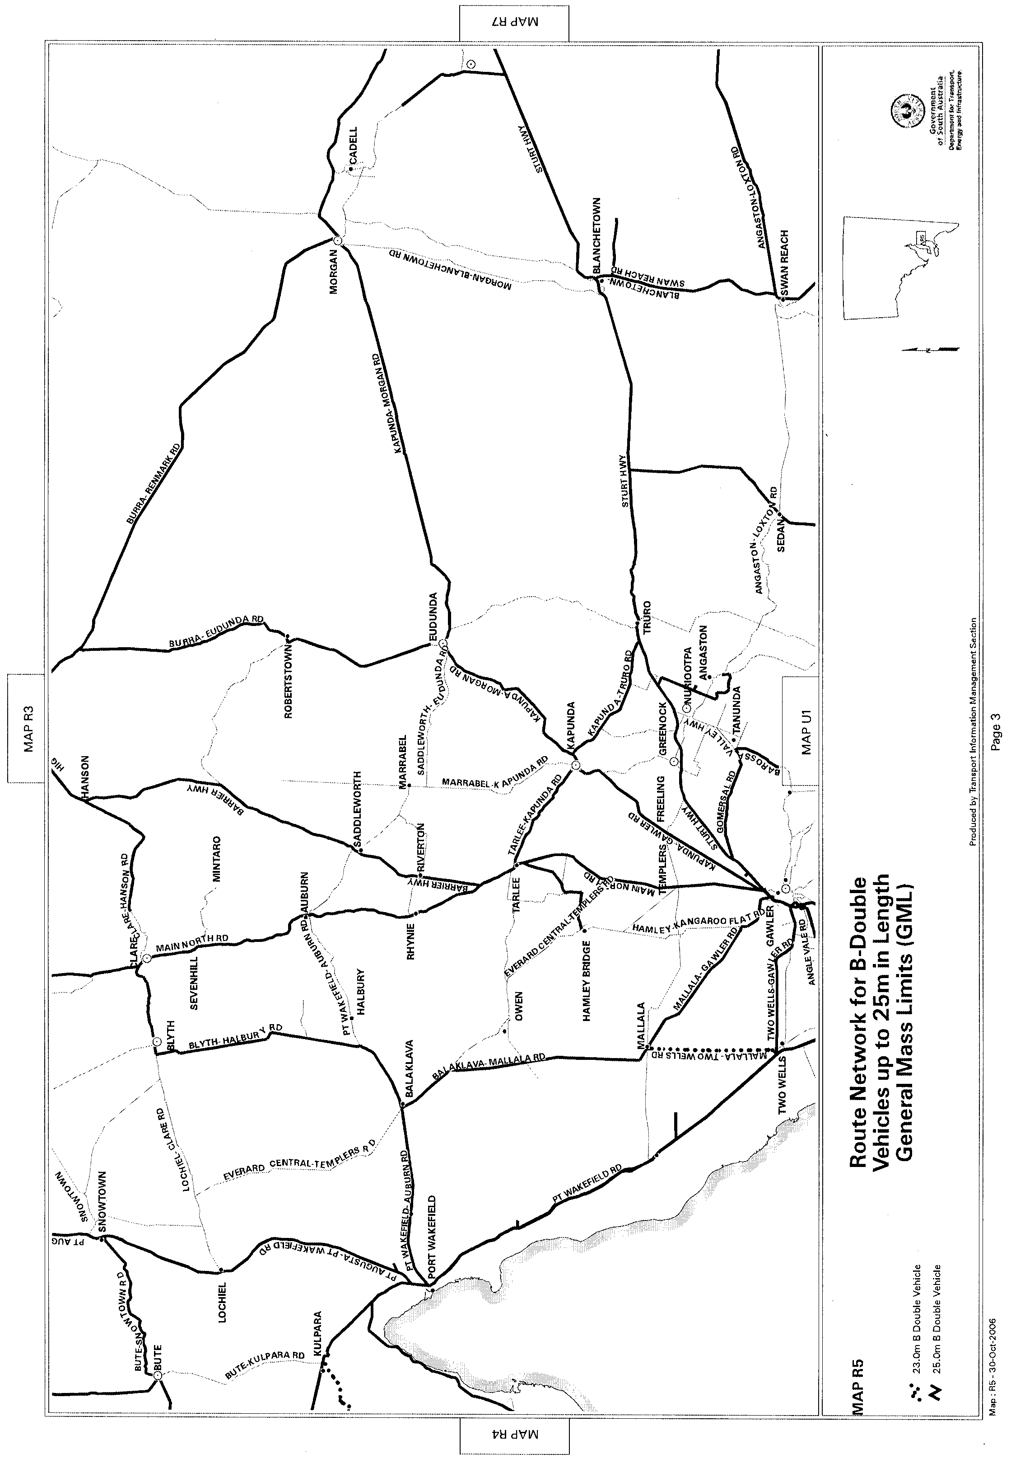
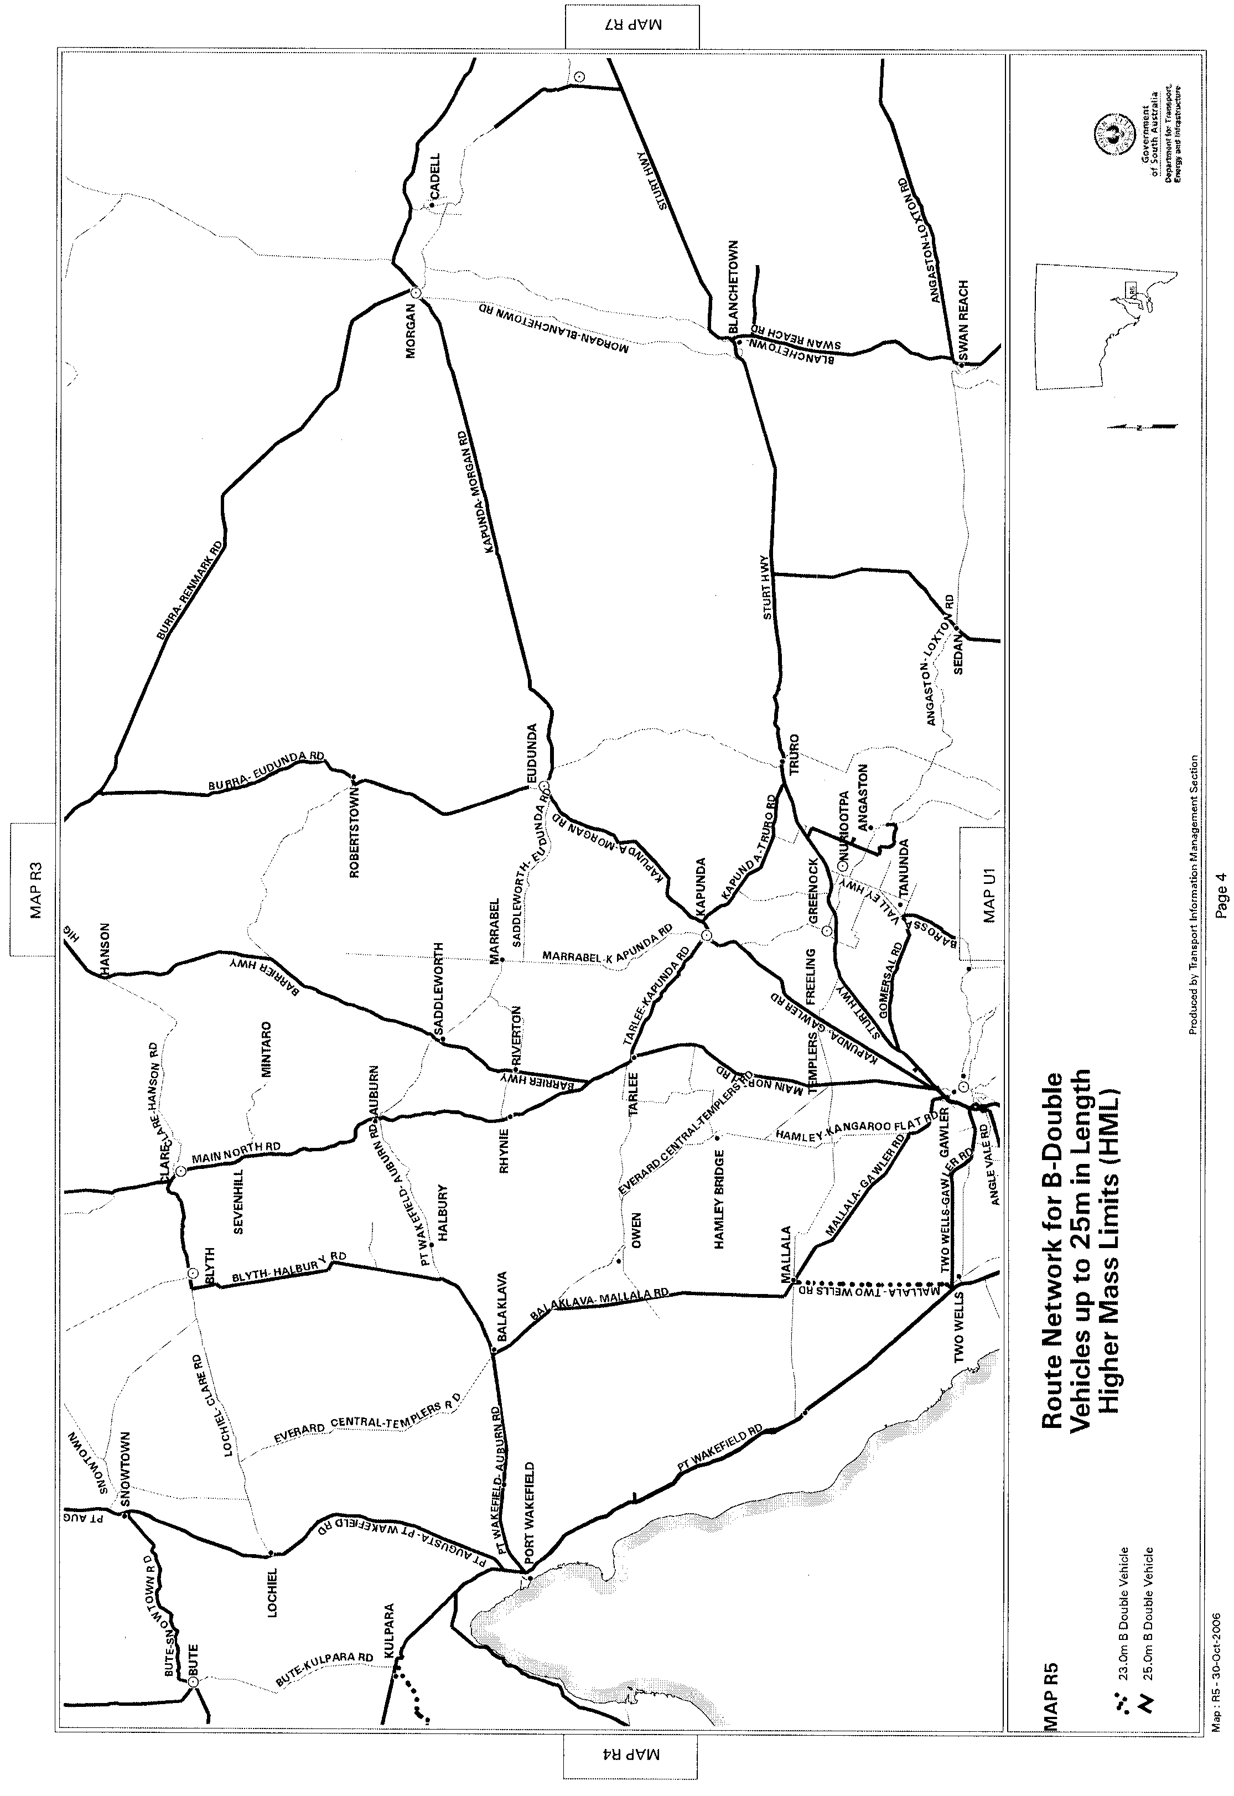
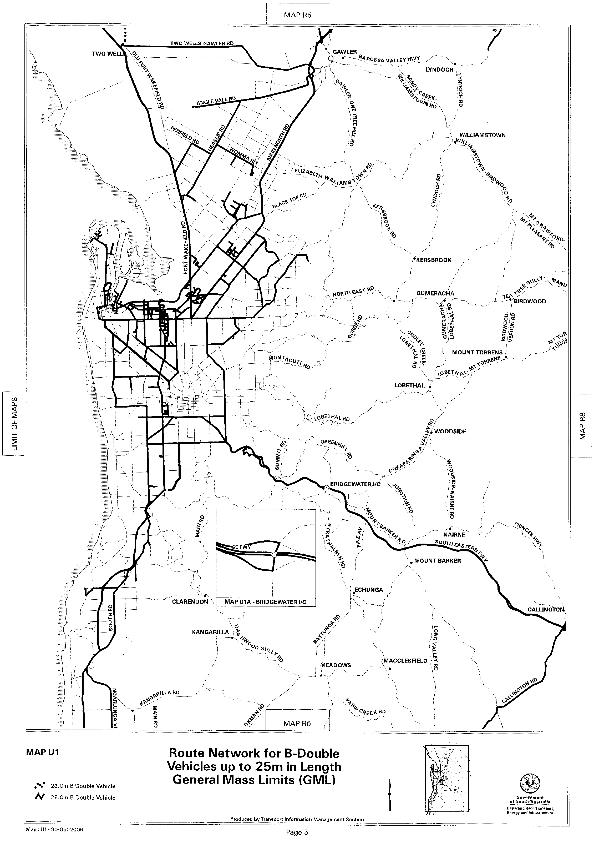
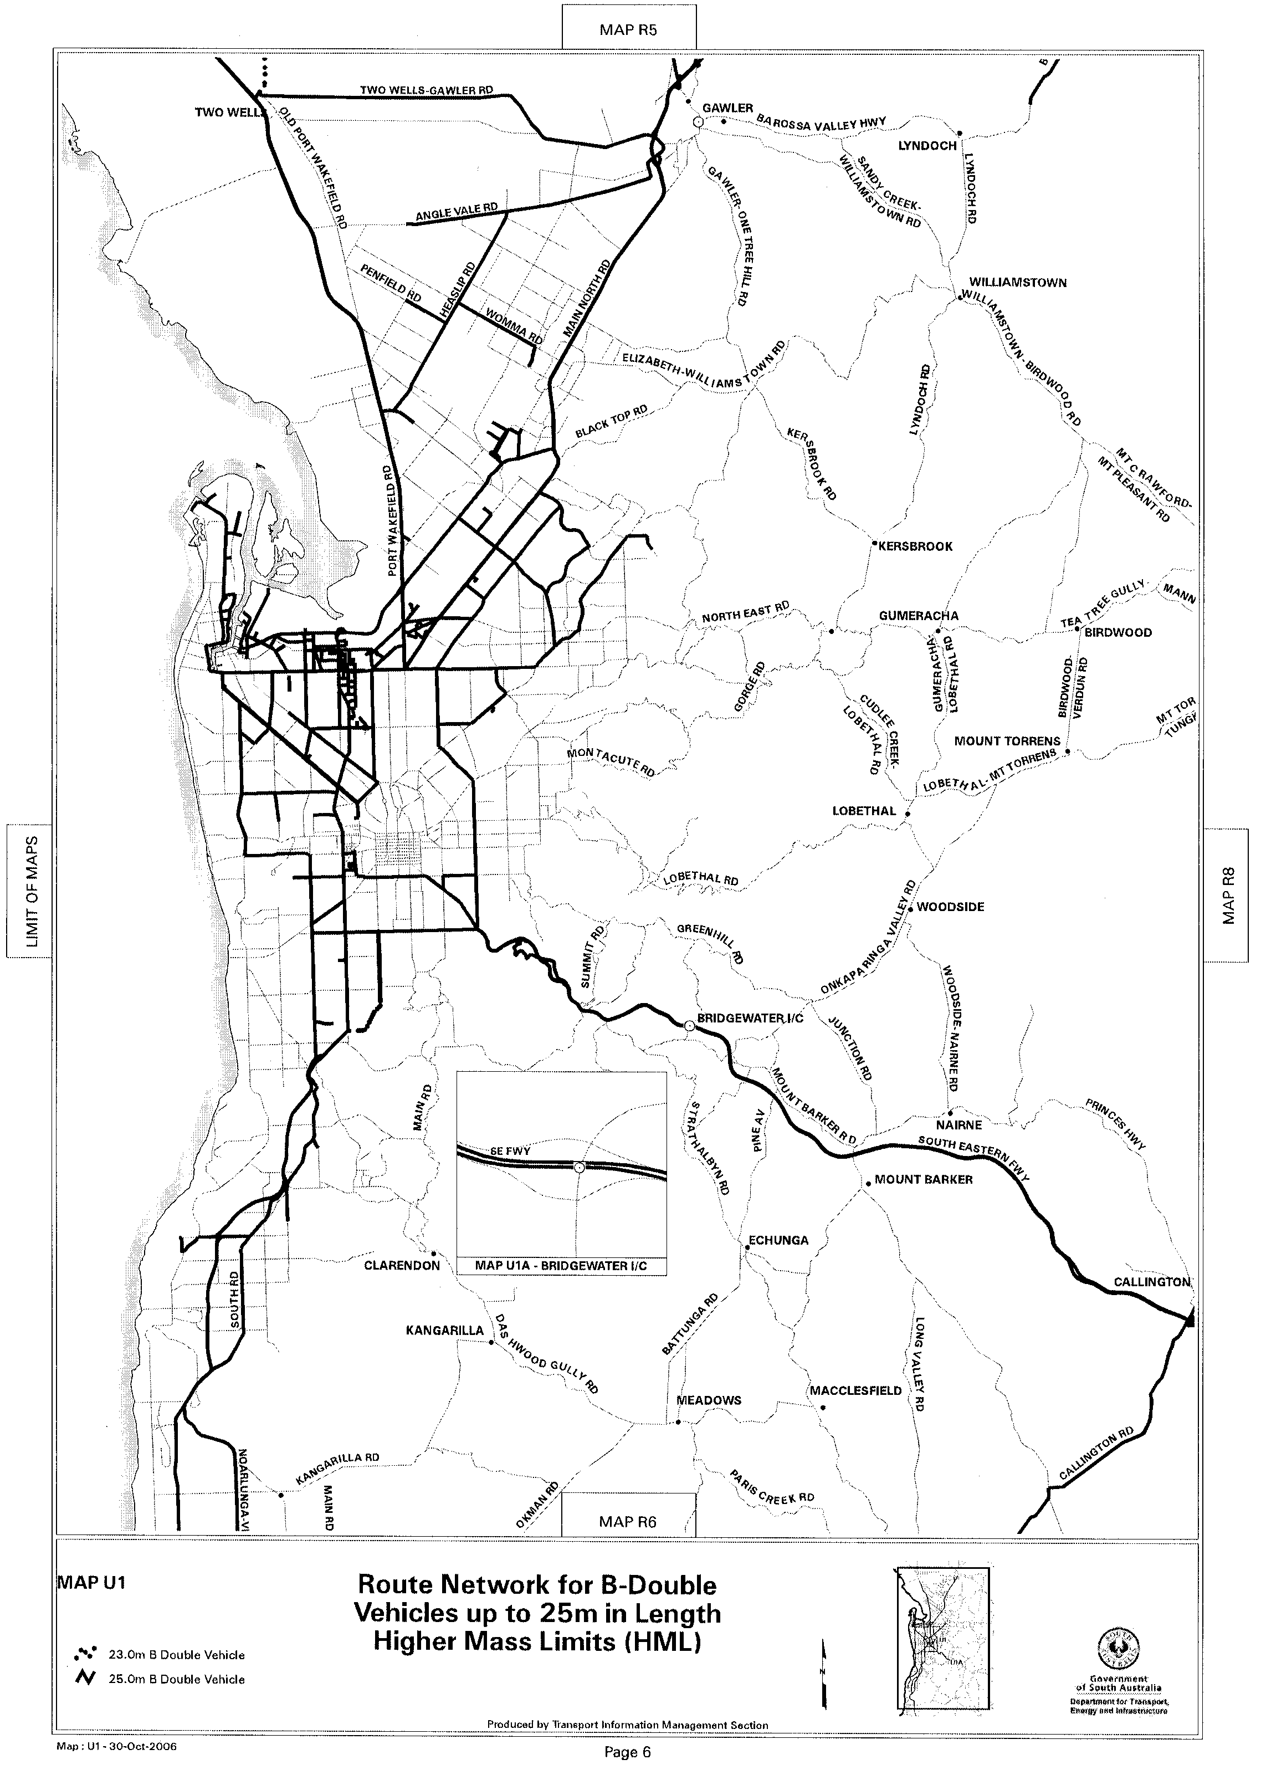
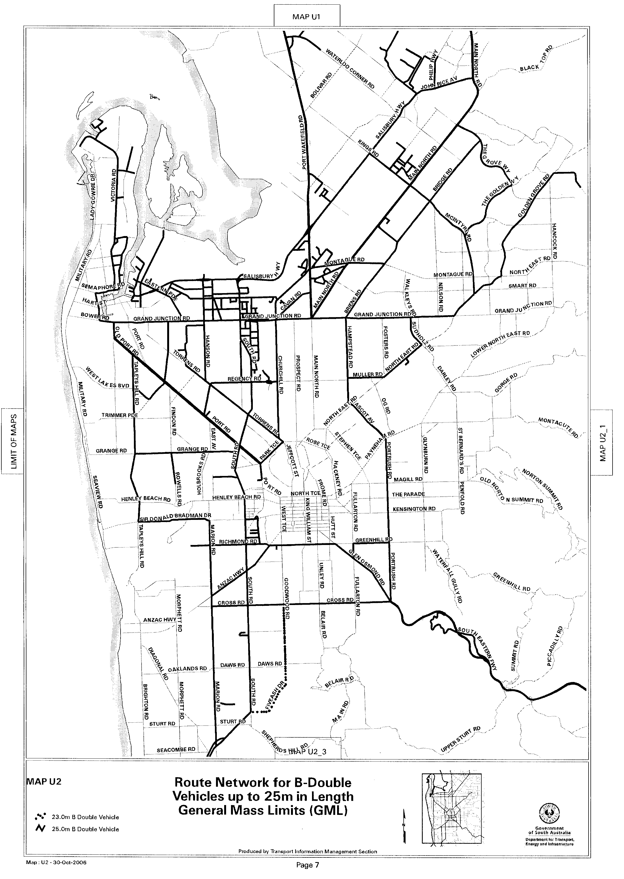
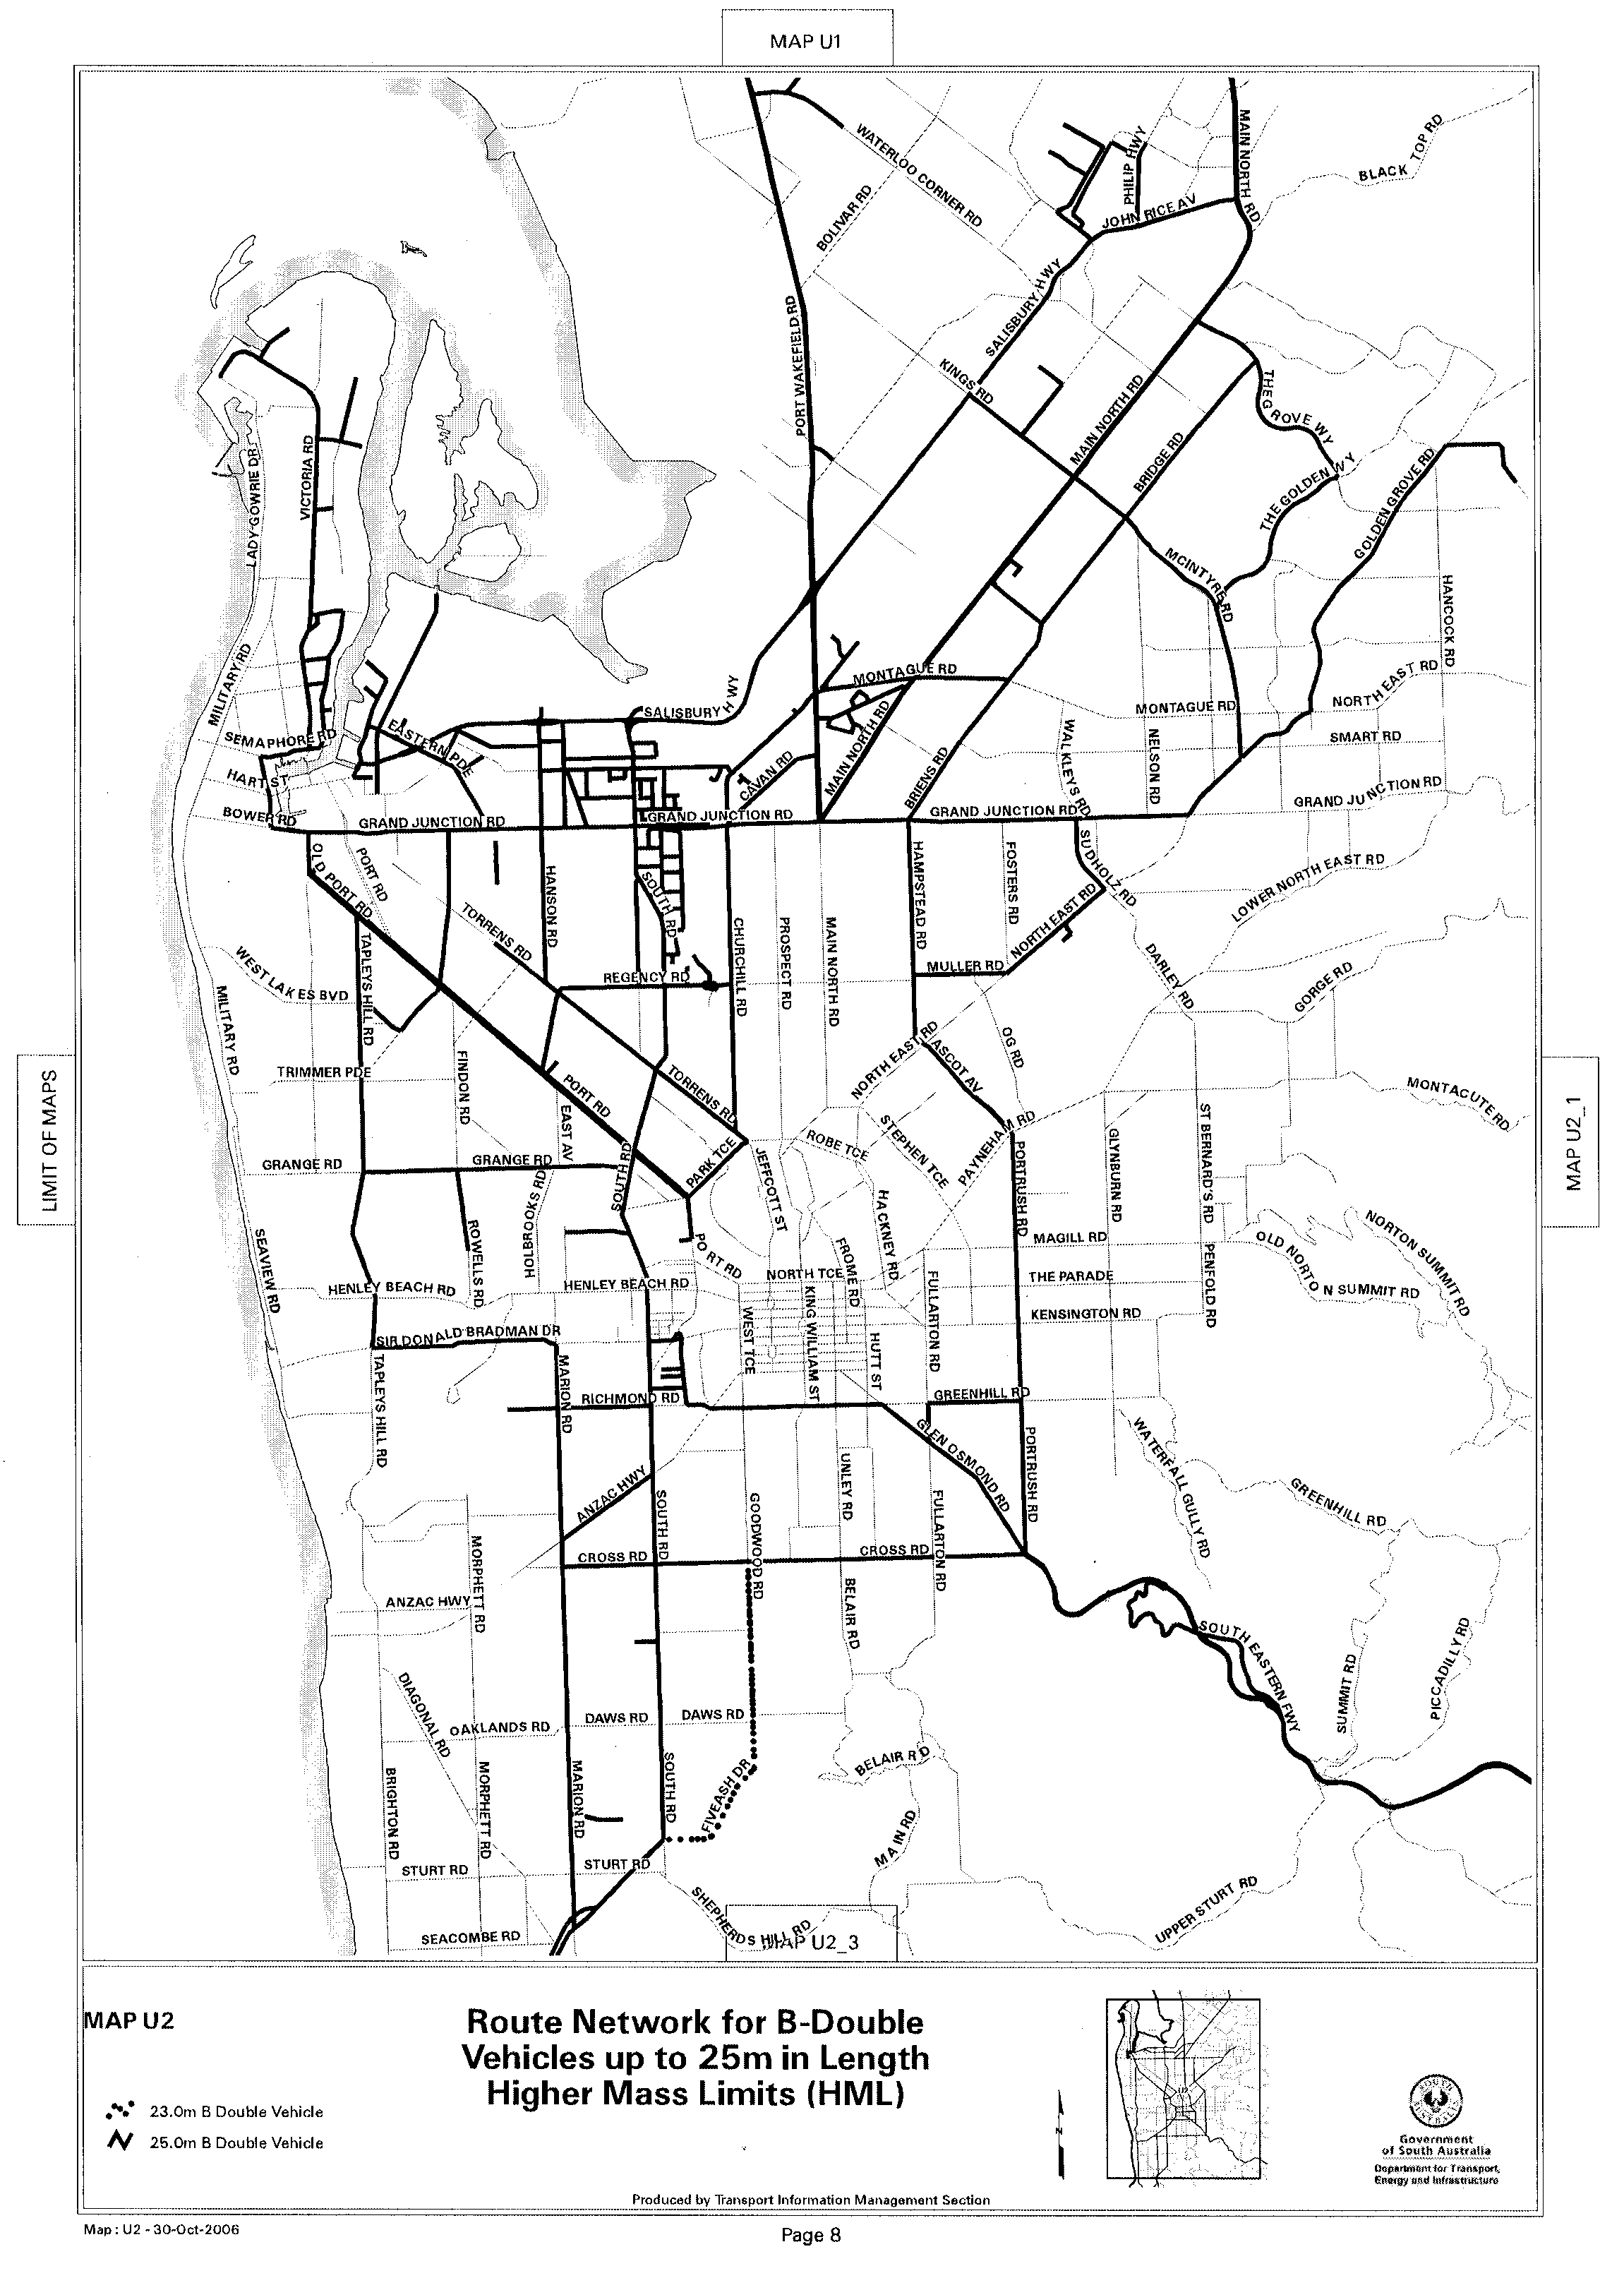
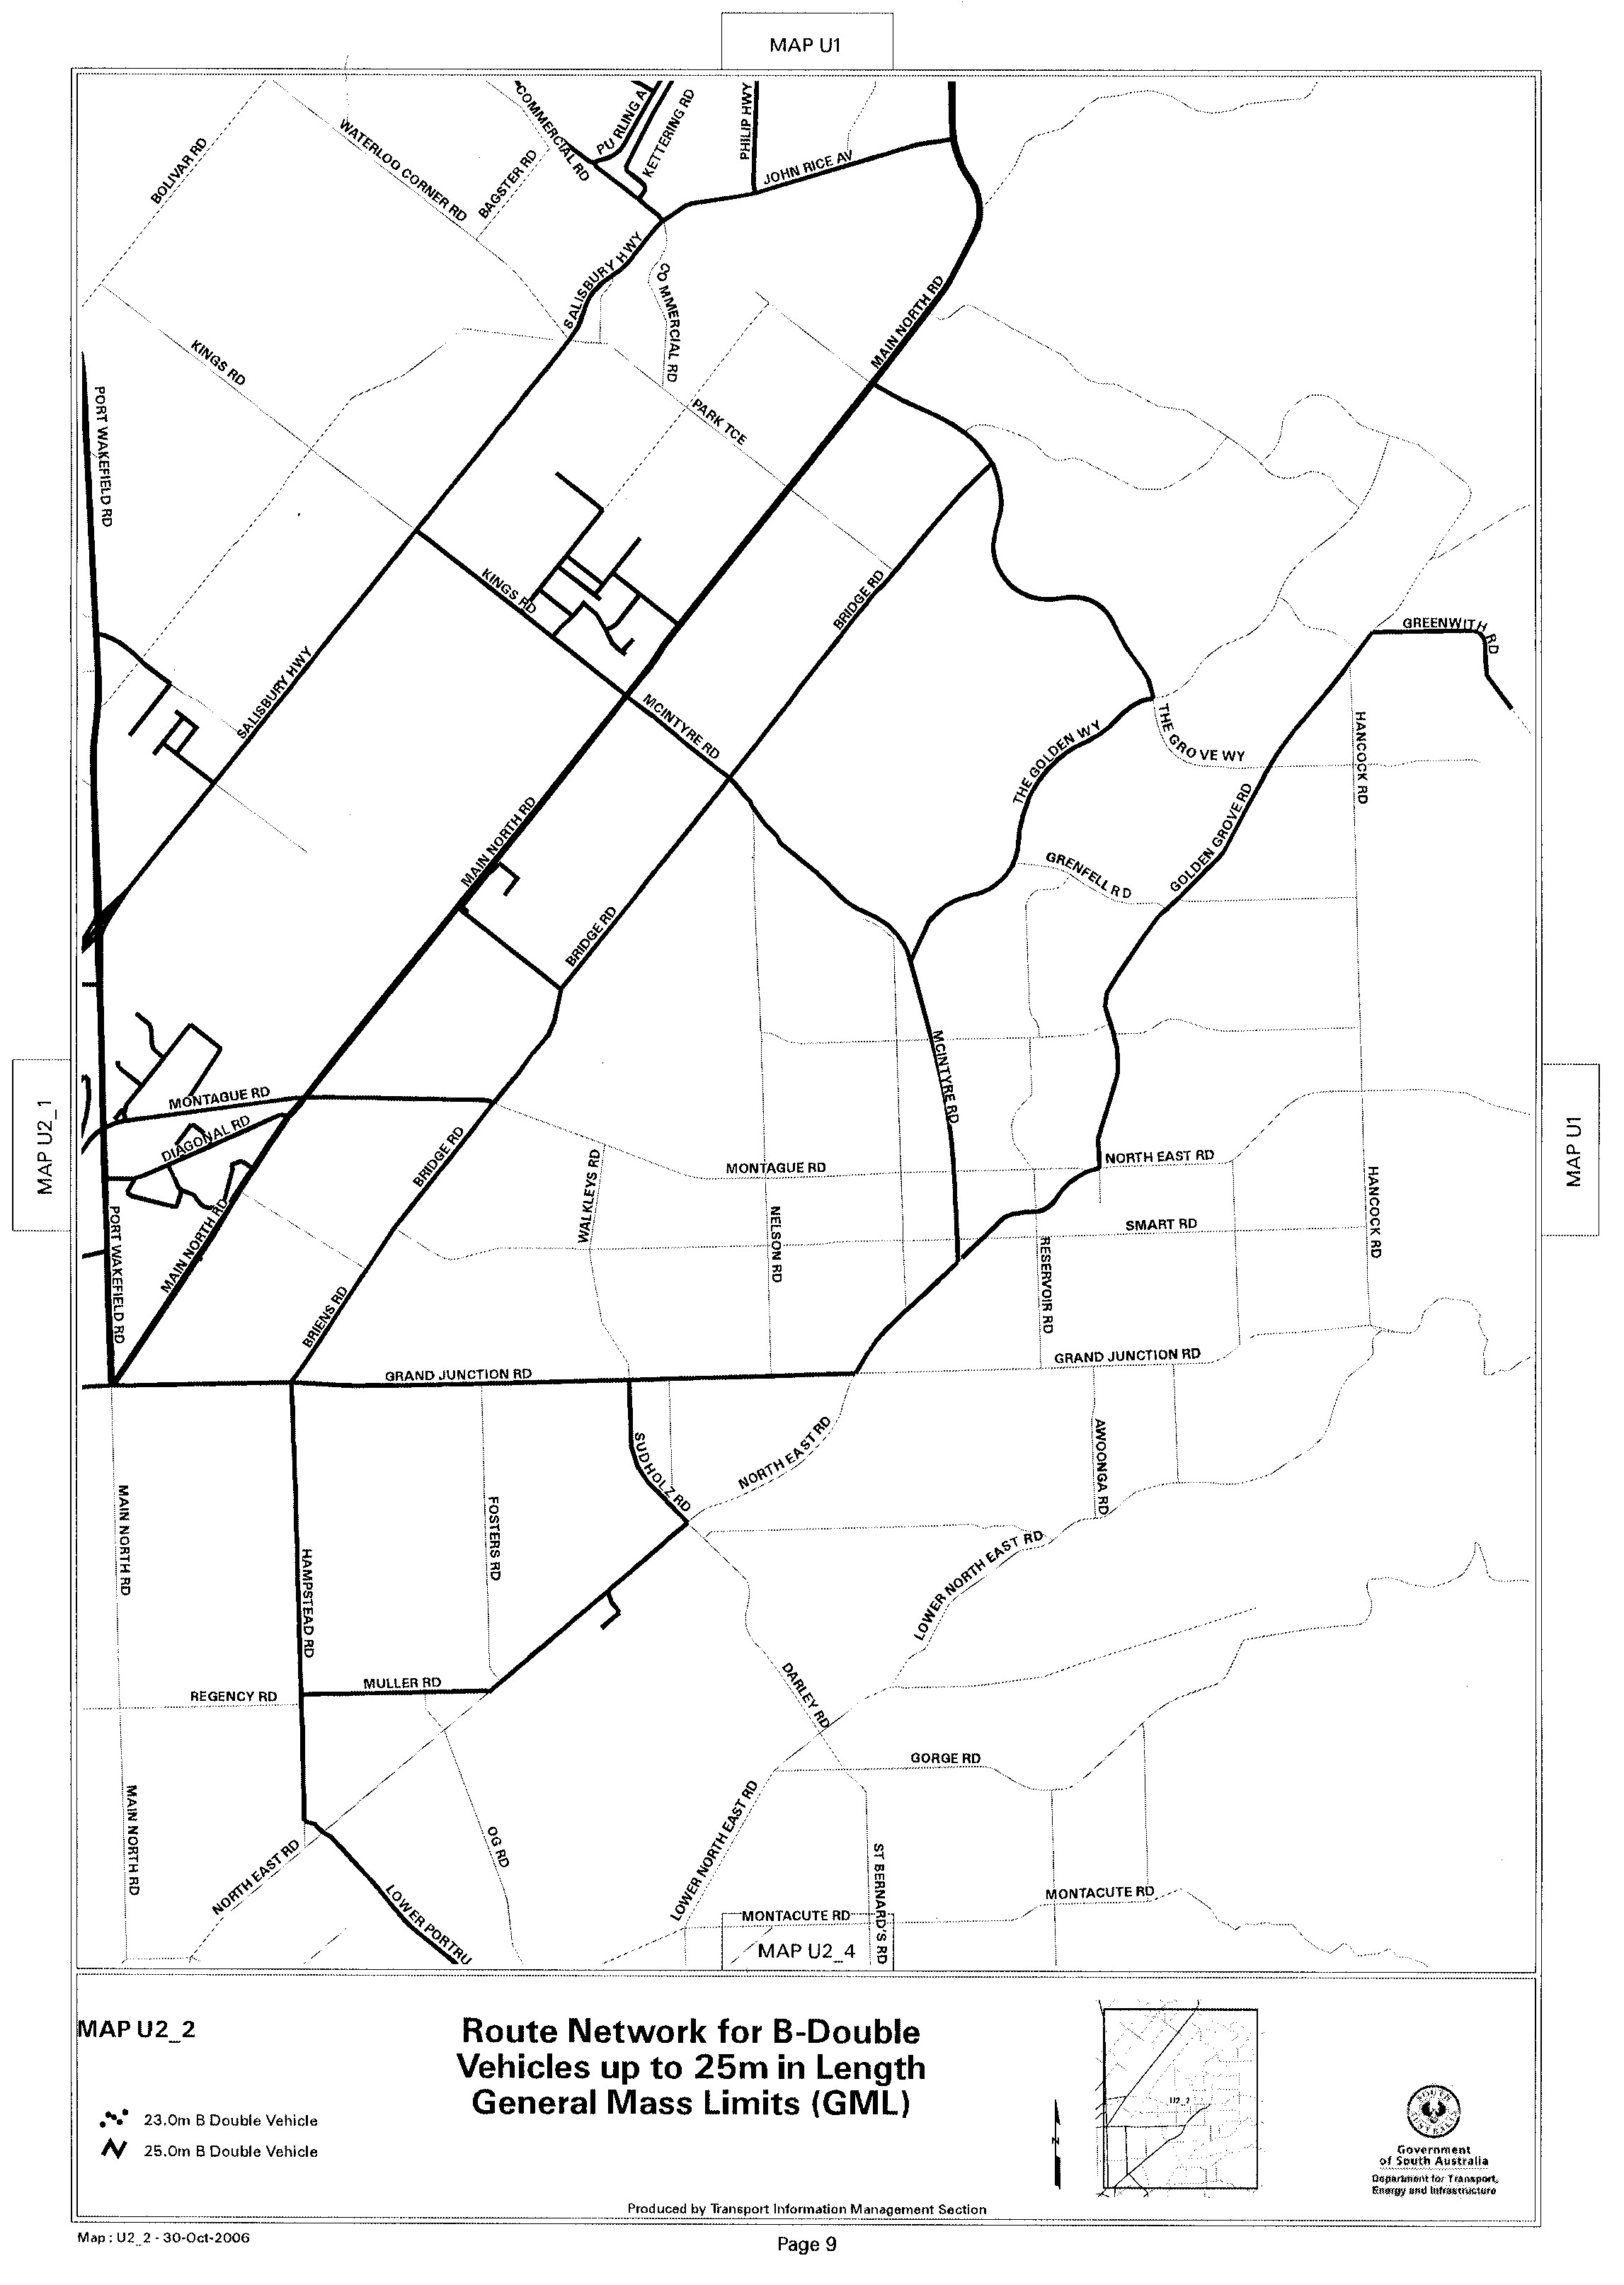
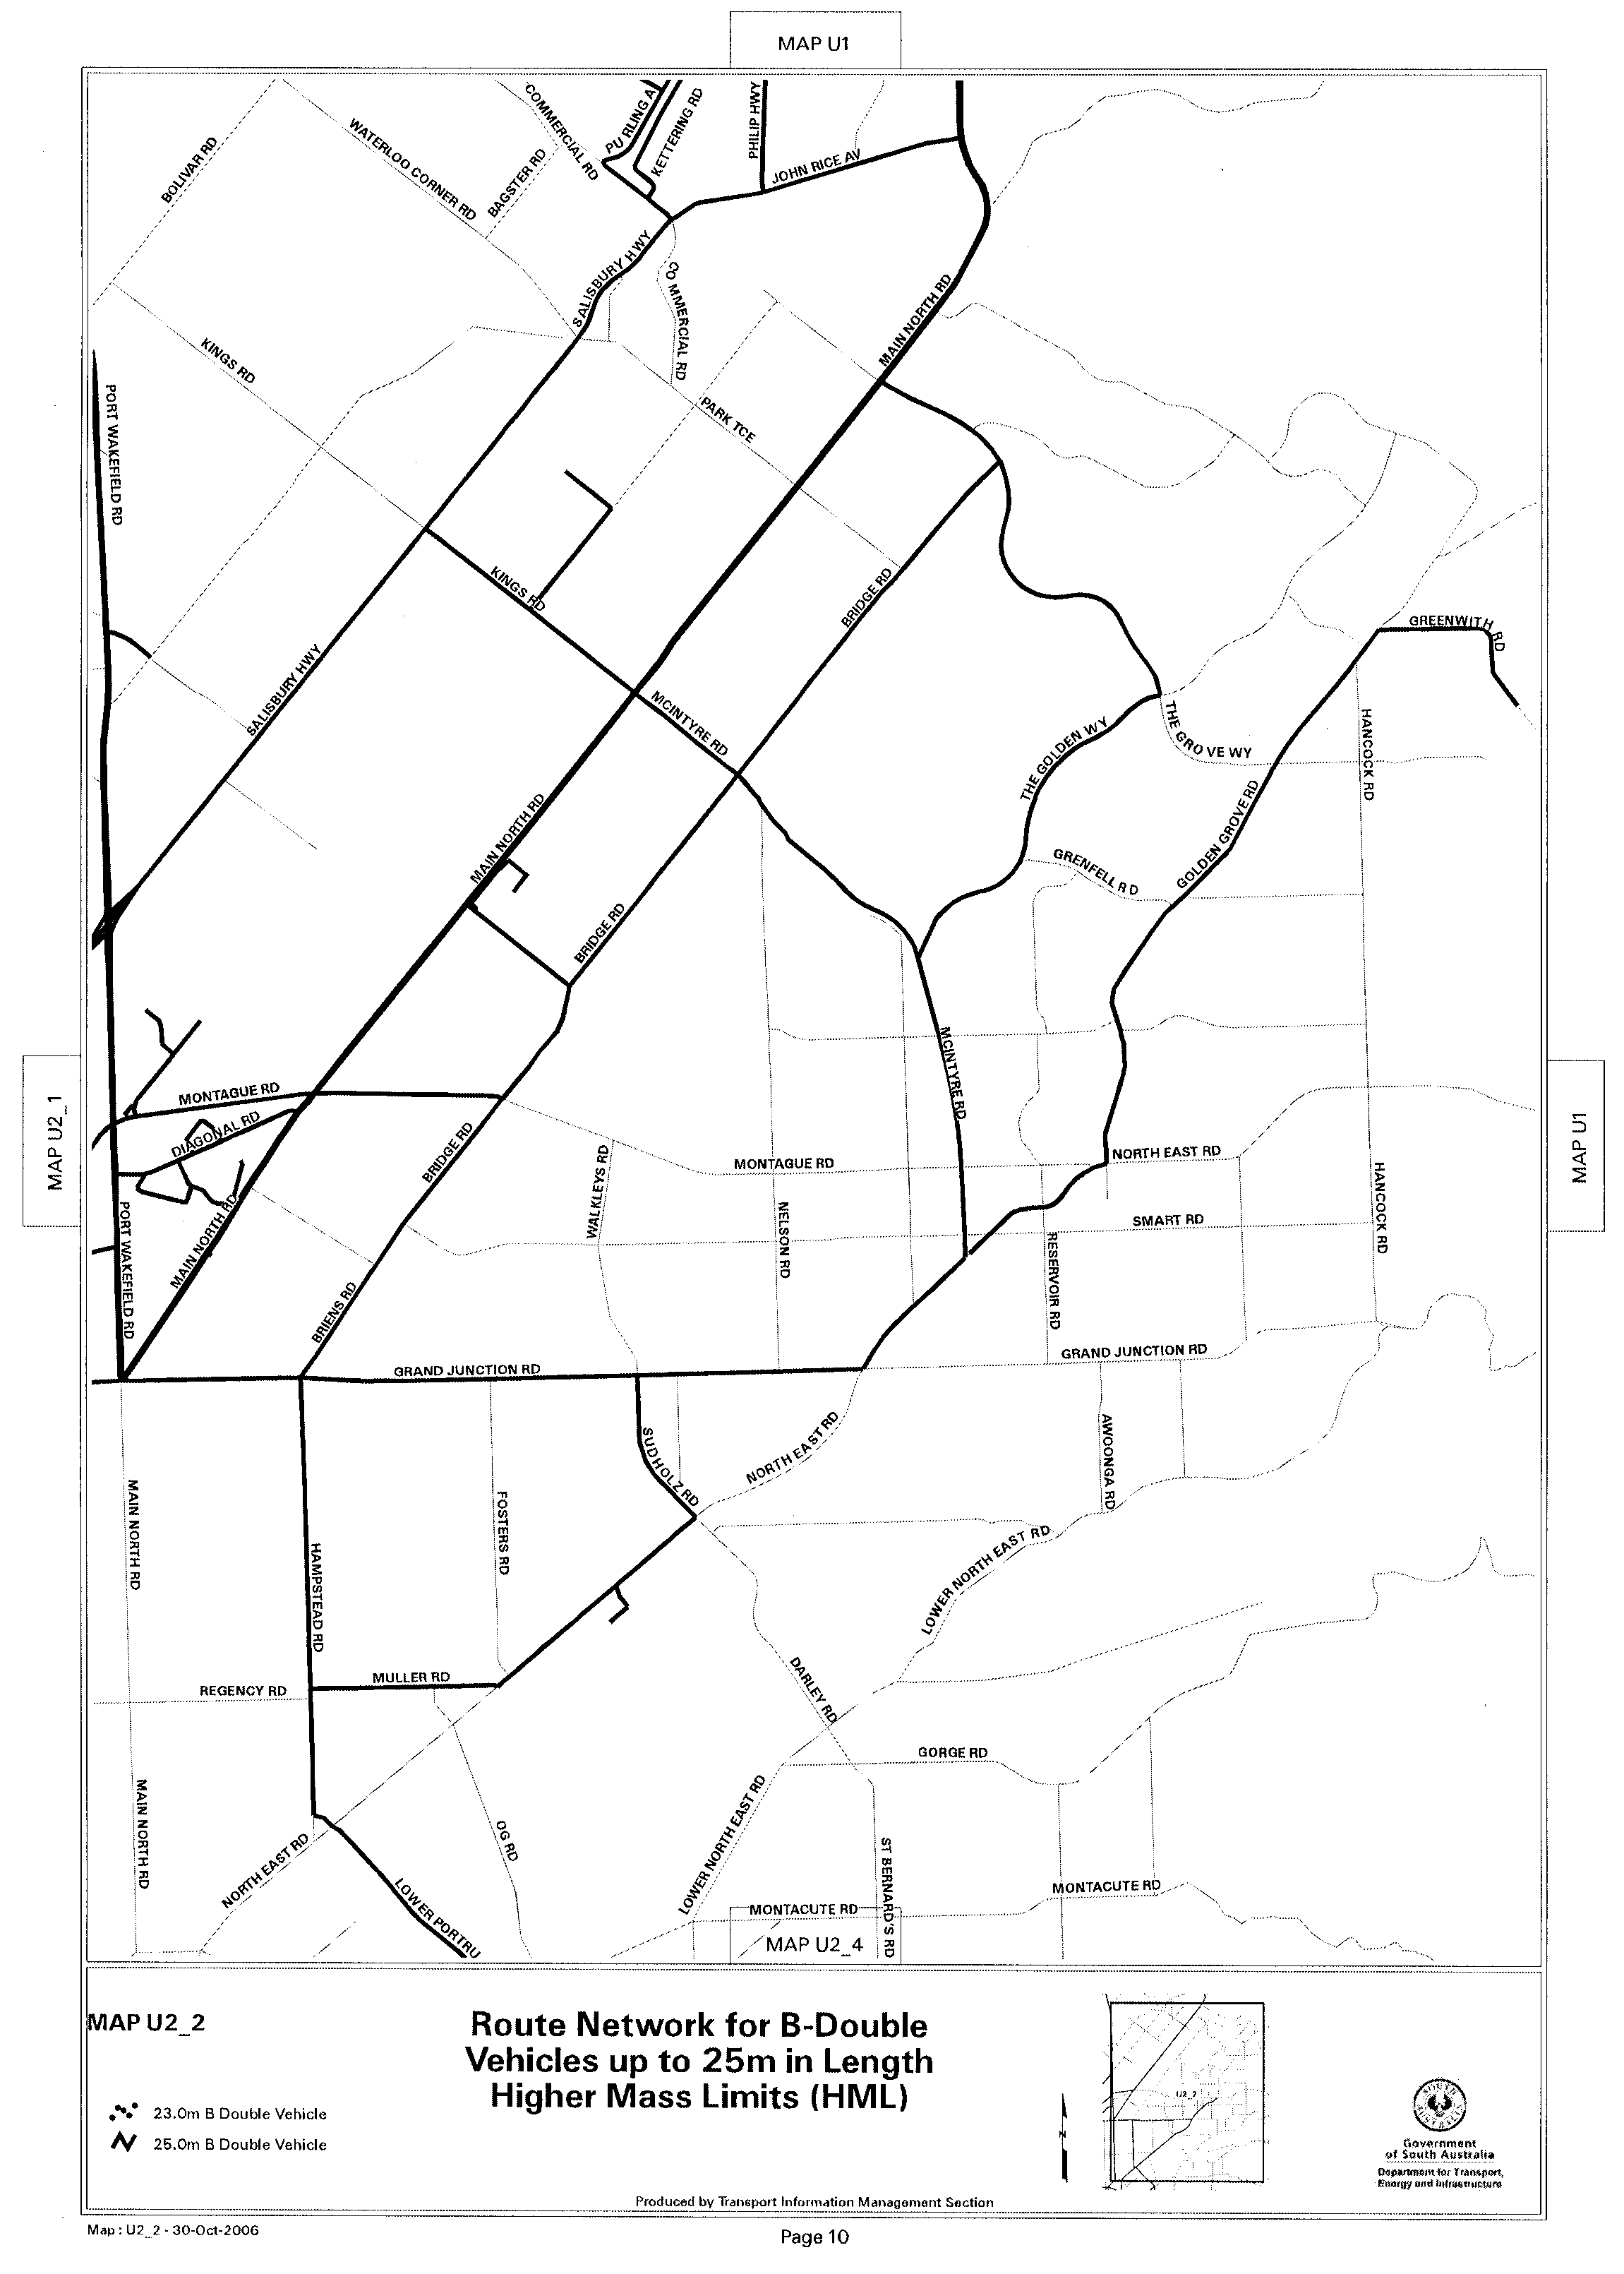
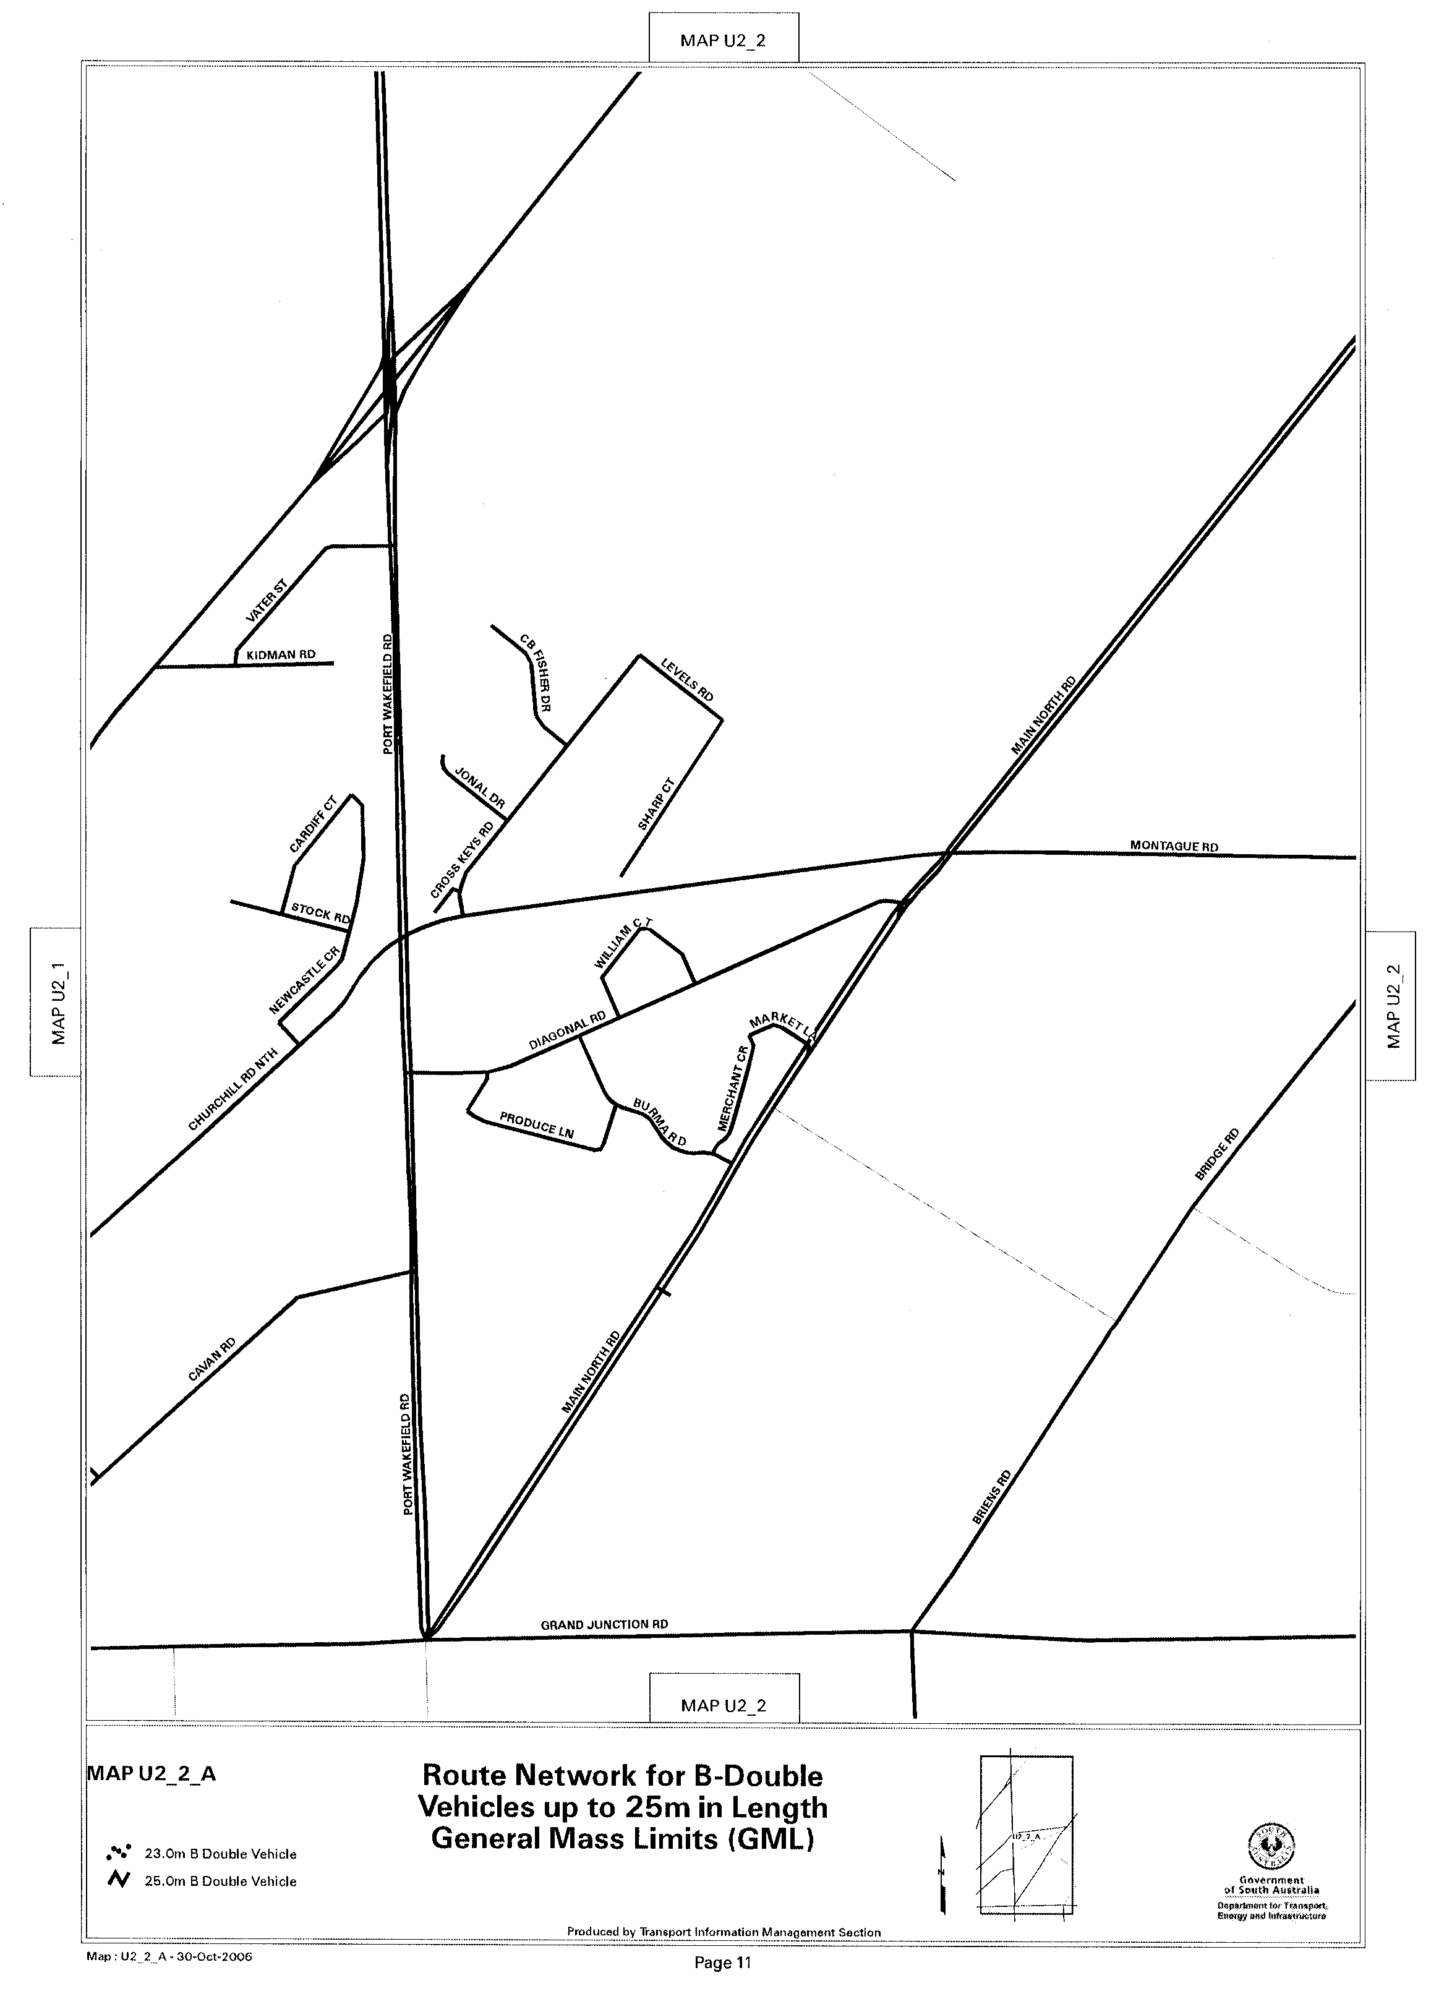
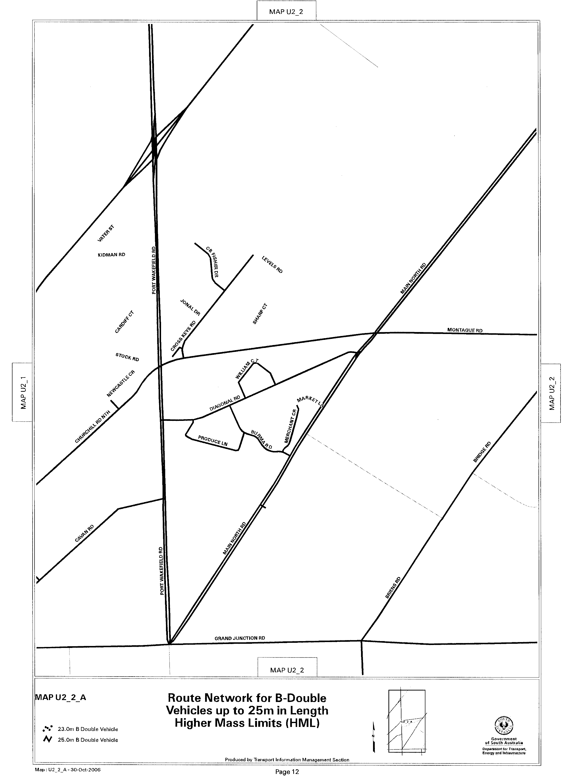
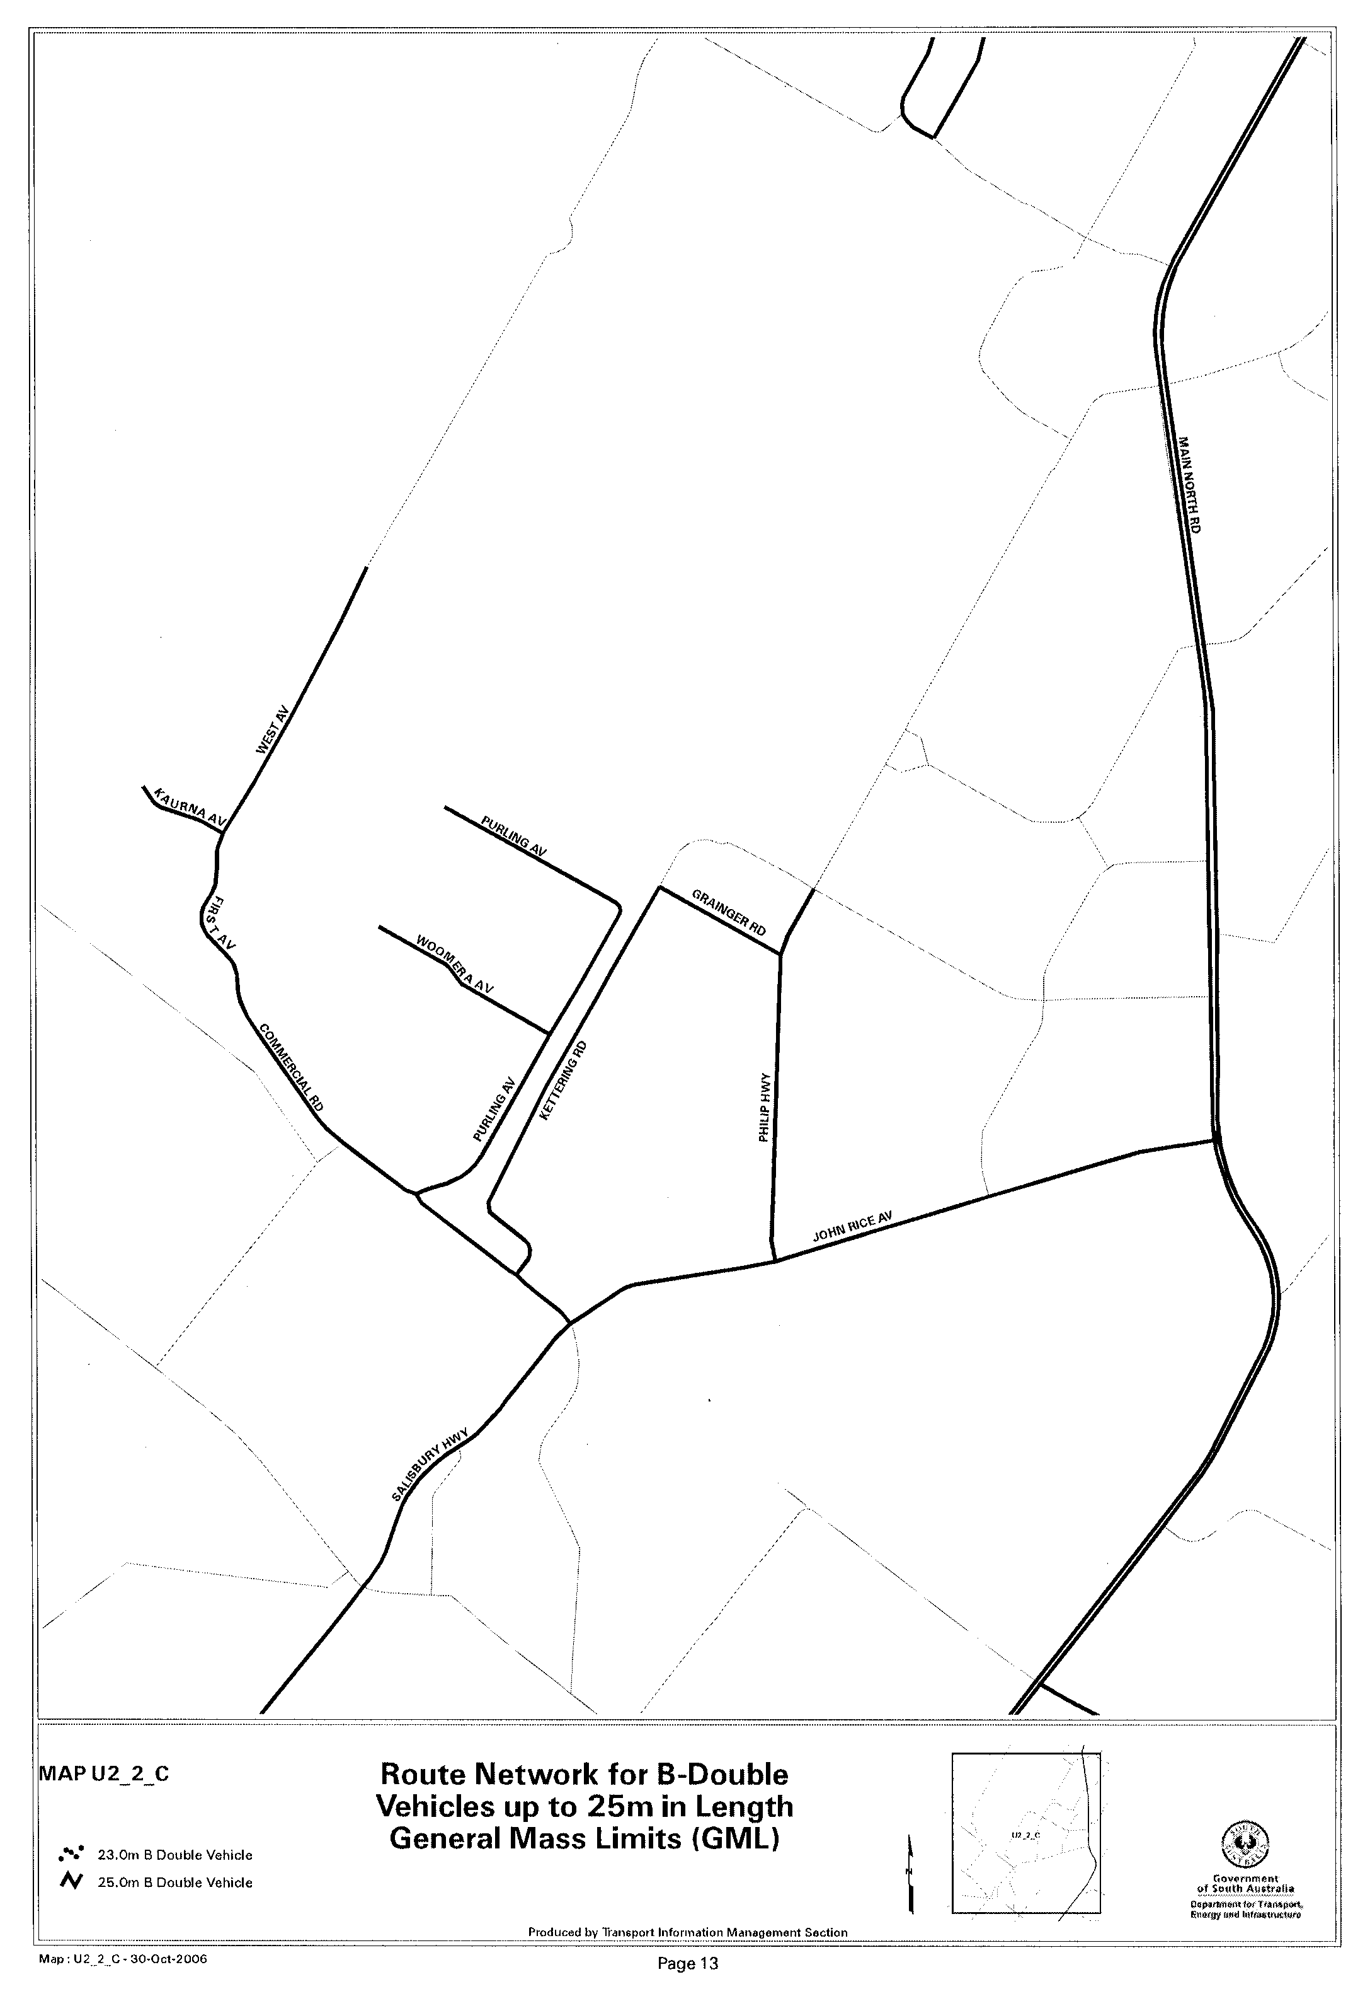
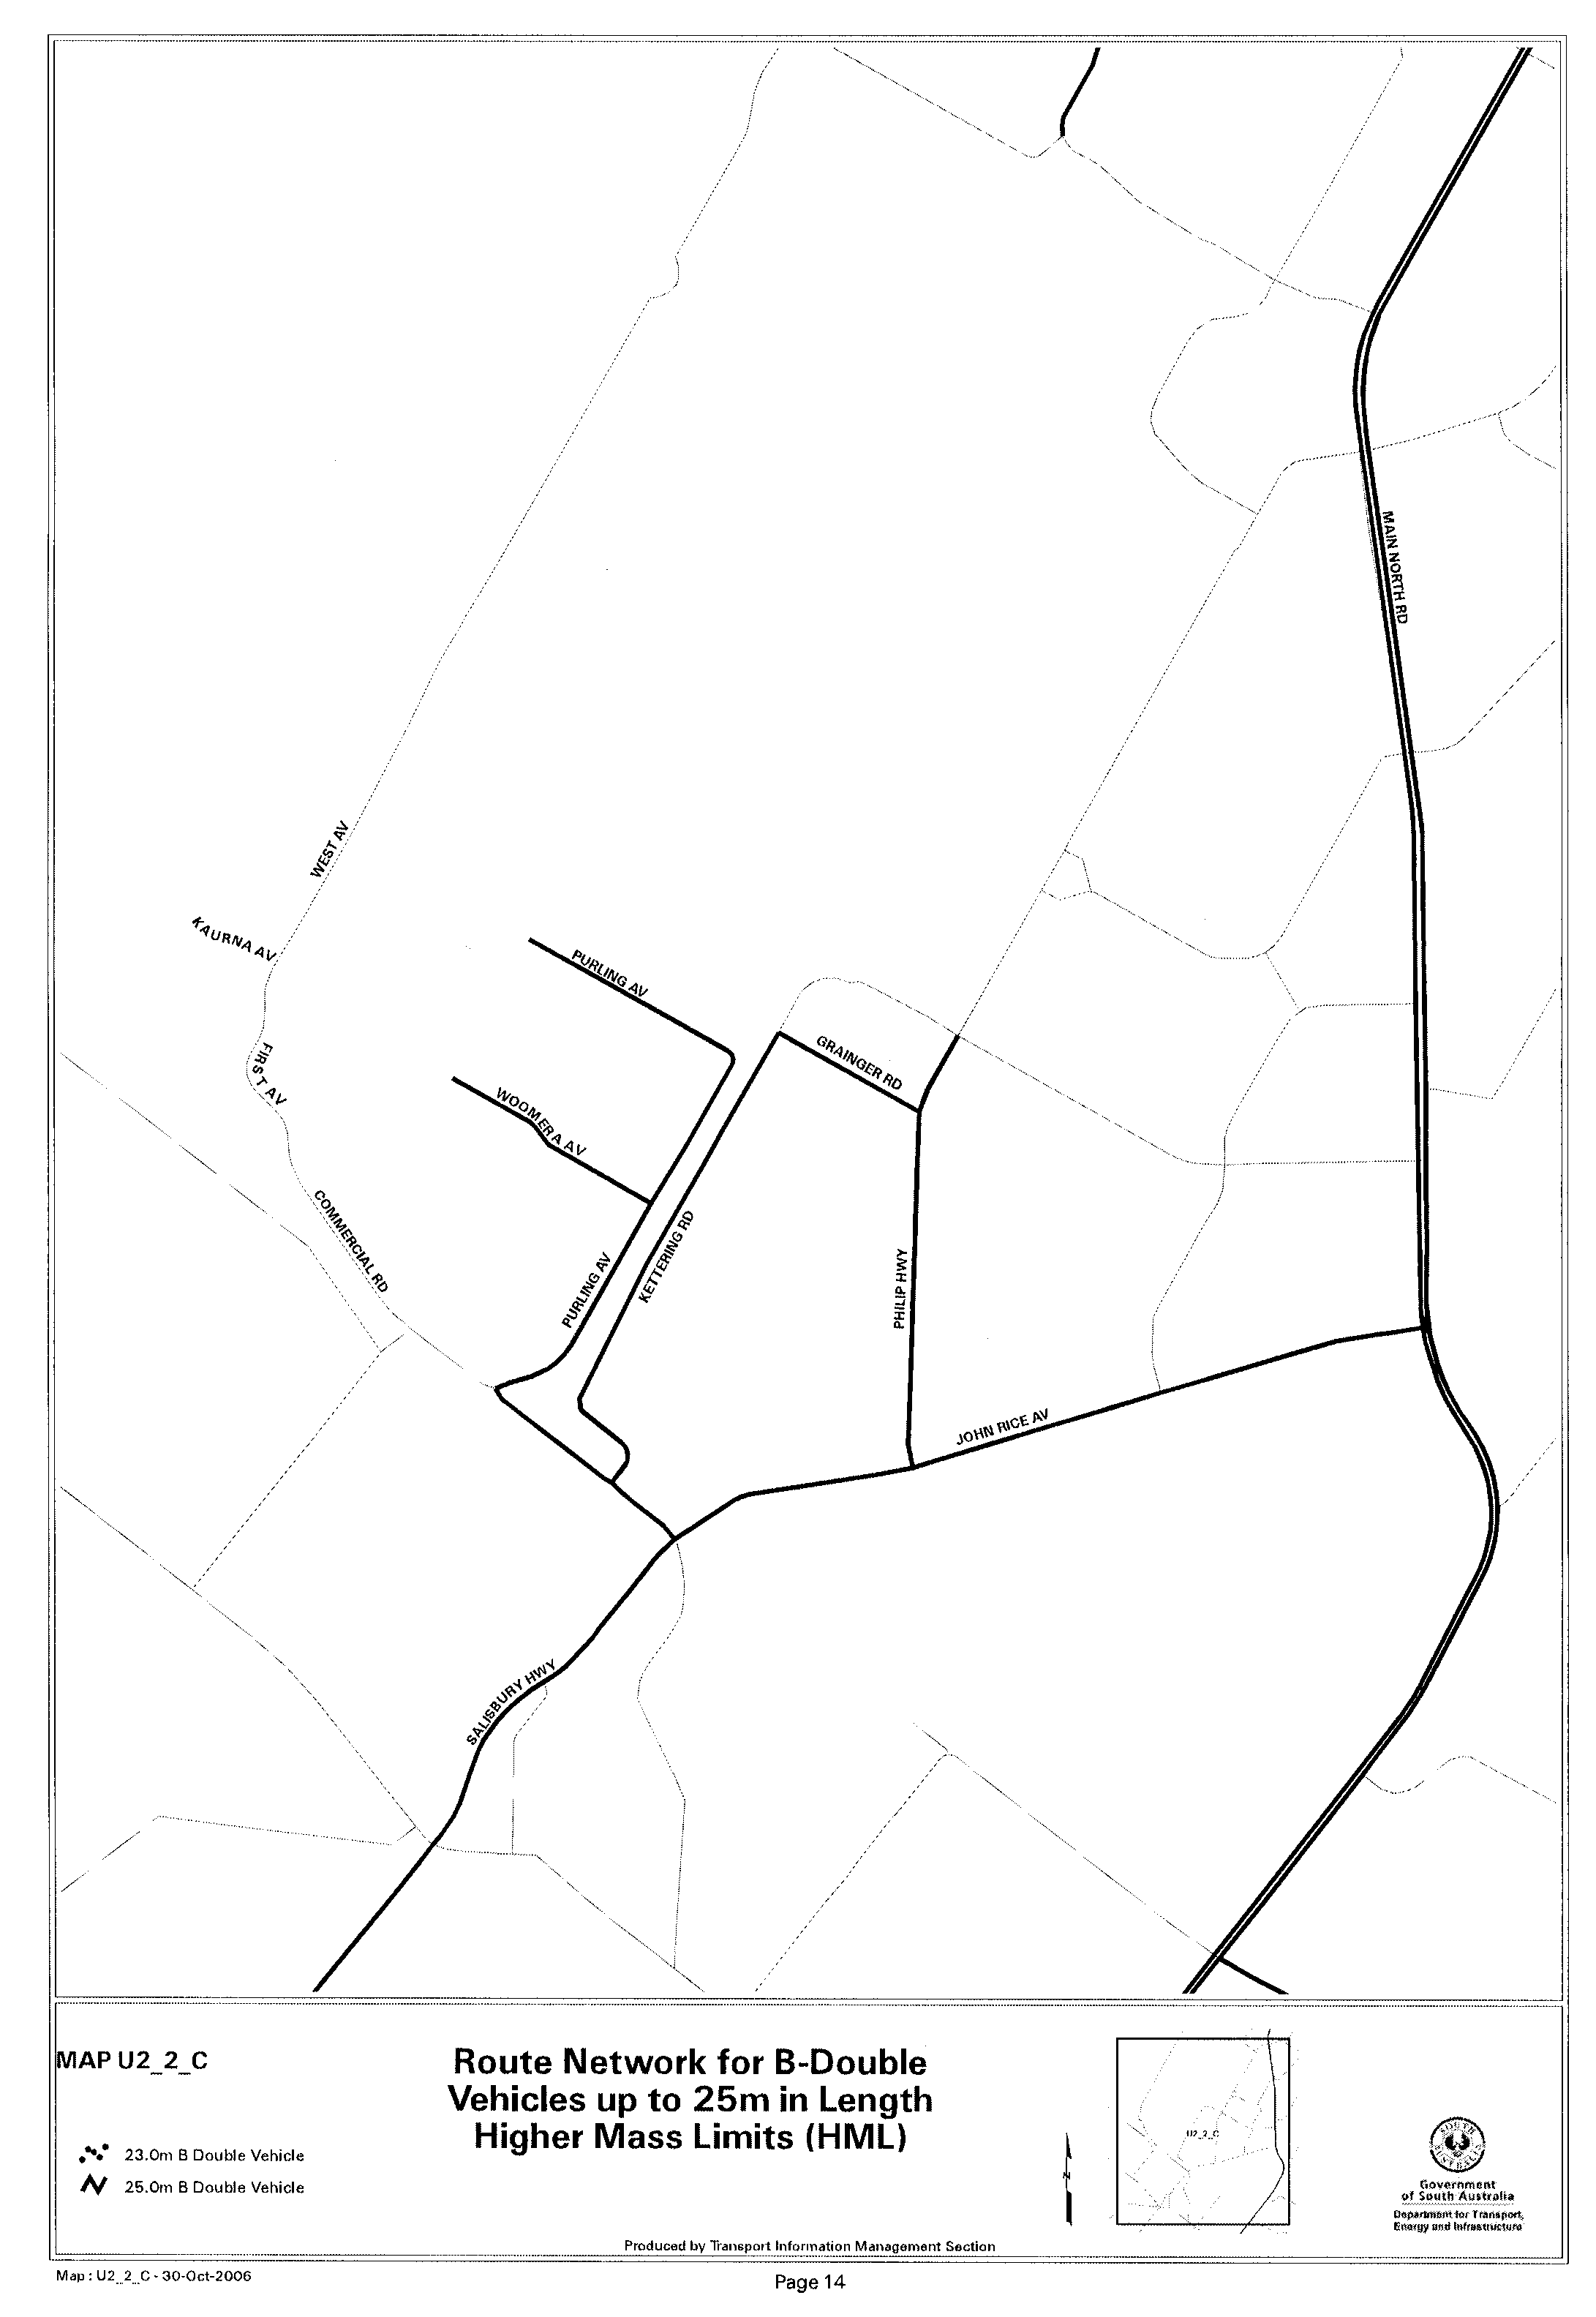
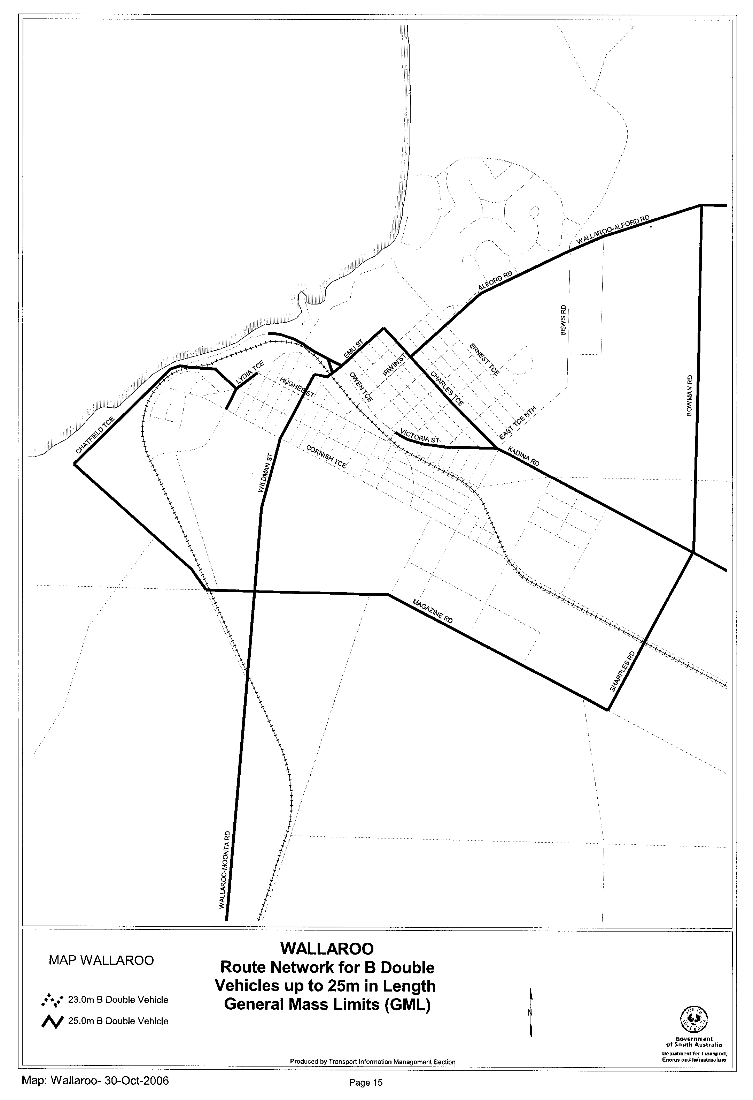
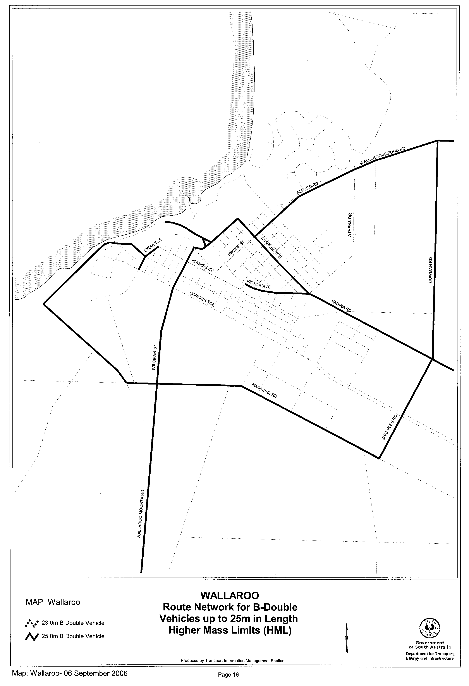

ROAD TRAFFIC ACT 1961

SUPPLEMENTARY NOTICE OF APPROVAL
Pursuant to Section 161A of the Road Traffic Act 1961

HIGHER MASS LIMITS FOR VEHICLES FITTED WITH ROAD FRIENDLY SUSPENSION
Information Note
This Notice adds additional routes to the network that can be used by vehicles fitted with Road Friendly Suspension and is a supplement to the Notice titled ‘Higher Mass Limits for Vehicles Fitted with Road Friendly Suspension’ dated 5 May 2005.

1. APPROVAL
1.1 In accordance with the powers delegated to me by the Minister for Transport under section 163AA of the Road Traffic Act 1961, I hereby vary the conditions of the Gazette Notice of Approval and Exemption titled, ‘Higher Mass Limits for Vehicles Fitted with Road Friendly Suspension’ dated 5 May 2005 as detailed below.
2. DEFINITIONS
2.1 In this Notice:
2.1.1 ‘Approved Vehicles’ means vehicles fitted with Road Friendly Suspension as described in Table 1 of the Primary Notice;
2.1.2 ‘Supplementary routes’ means the approved routes specified in the maps ‘Route Network for General Access Vehicles Fitted with Road Friendly Suspension’ attached to this Supplementary Notice;
2.1.3 ‘Supplementary Notice’ means this Notice;
2.1.4 ‘Primary Notice’ means the Gazette Notice ‘Higher Mass Limits for Vehicles Fitted with Road Friendly Suspension’ dated 5 May 2005; and
2.1.5 all other terms have the same meaning as in the Primary Notice.
3. APPLICATION OF SUPPLEMENTARY NOTICE
3.1 This Supplementary Notice must be read in conjunction with the Primary Notice and applies to all Approved Vehicles operating under the Primary Notice travelling on routes specified in the attached maps.
4. ROUTES AVAILABLE TO APPROVED VEHICLES
4.1 An Approved Vehicle may operate under the conditions of the Primary Notice on a supplementary route specified hereunder:
4.1.1 ‘Route Network for General Access Vehicles Fitted with Road Friendly Suspension’ Map R5 (Carrara Hill Road, Stockwell Road, Penrice Road, Long Gully Road, Hurns Road, Crennis Mines Road, Eden Valley Road, Angaston Barossa Valley);
4.1.2 ‘Route Network for General Access Vehicles Fitted with Road Friendly Suspension’ Map U1 (Grainger Road and Kettering Road, Elizabeth South, Williams Circuit, Pooraka and Greenwith Road, Golden Grove);
4.1.3 ‘Route Network for General Access Vehicles Fitted with Road Friendly Suspension’ Map U2 (Grainger Road and Kettering Road, Elizabeth South, Williams Circuit, Pooraka and Greenwith Road, Golden Grove);
4.1.4 ‘Route Network for General Access Vehicles Fitted with Road Friendly Suspension’ Map U2_2 (Grainger Road and Kettering Road, Elizabeth South, Williams Circuit, Pooraka and Greenwith Road, Golden Grove);
4.1.5 ‘Route Network for General Access Vehicles Fitted with Road Friendly Suspension’ Map U2_2_A (Williams Circuit, Pooraka);
4.1.6 ‘Route Network for General Access Vehicles Fitted with Road Friendly Suspension’ Map U2_2_C (Grainger Road and Kettering Road, Elizabeth South); and
4.1.7 ‘Route Network for General Access Vehicles Fitted with Road Friendly Suspension’ Map Wallaroo (Magazine Road, Cresco Road, Chatfield Terrace and Abraham Rydeberg Drive, Wallaroo);
5. CONDITIONS AND LIMITATIONS APPLYING TO THIS SUPPLEMENTARY NOTICE
5.1 When operating on a route specified in the attached maps, the driver of an Approved Vehicle must:
5.1.1 continue to comply with all conditions and requirements of the Primary Notice; and

5.1.2 carry a legible, current and complete copy of:
(i) this Supplementary Notice and attached maps;
(ii) the Primary Notice;
(iii) any combination specific documents as requested by the Primary Notice; and
5.1.3 produce these documents when requested by a Department for Transport, Energy and Infrastructure, Transport Safety Compliance Officer appointed under the Road Traffic Act 1961 and/or the Motor Vehicles Act 1959 or a Police Officer.
6. COMMENCEMENT OF THIS NOTICE
6.1 This Notice is effective from 12.01 a.m. on 6 November 2006.
Executive Director,
Safety and Regulation Division

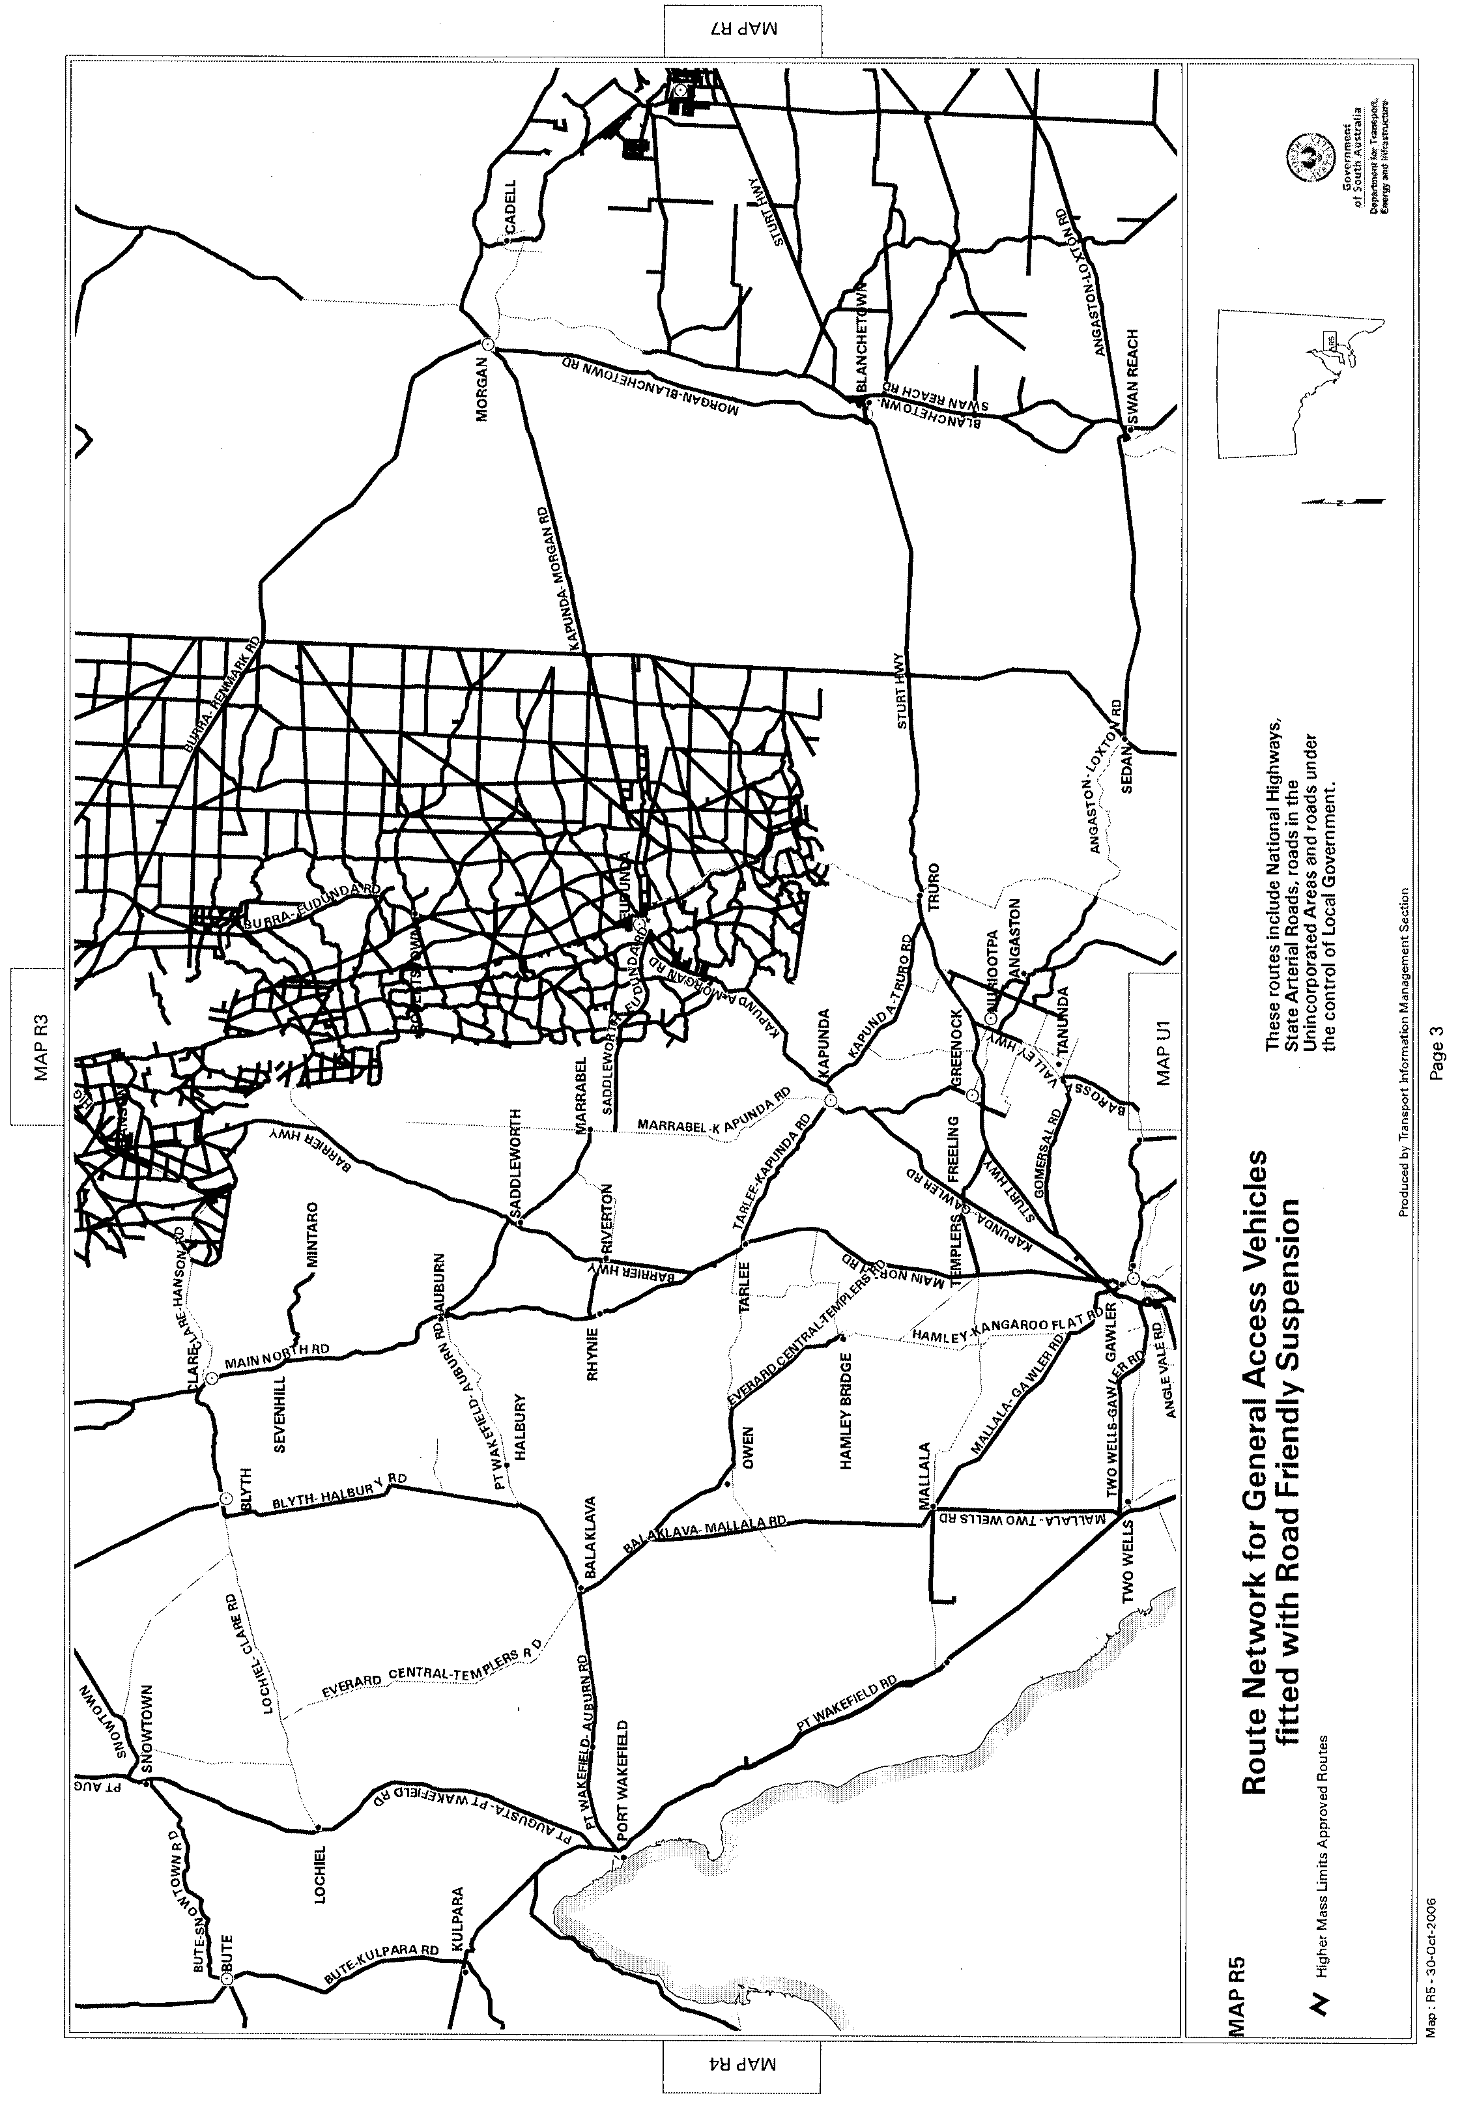
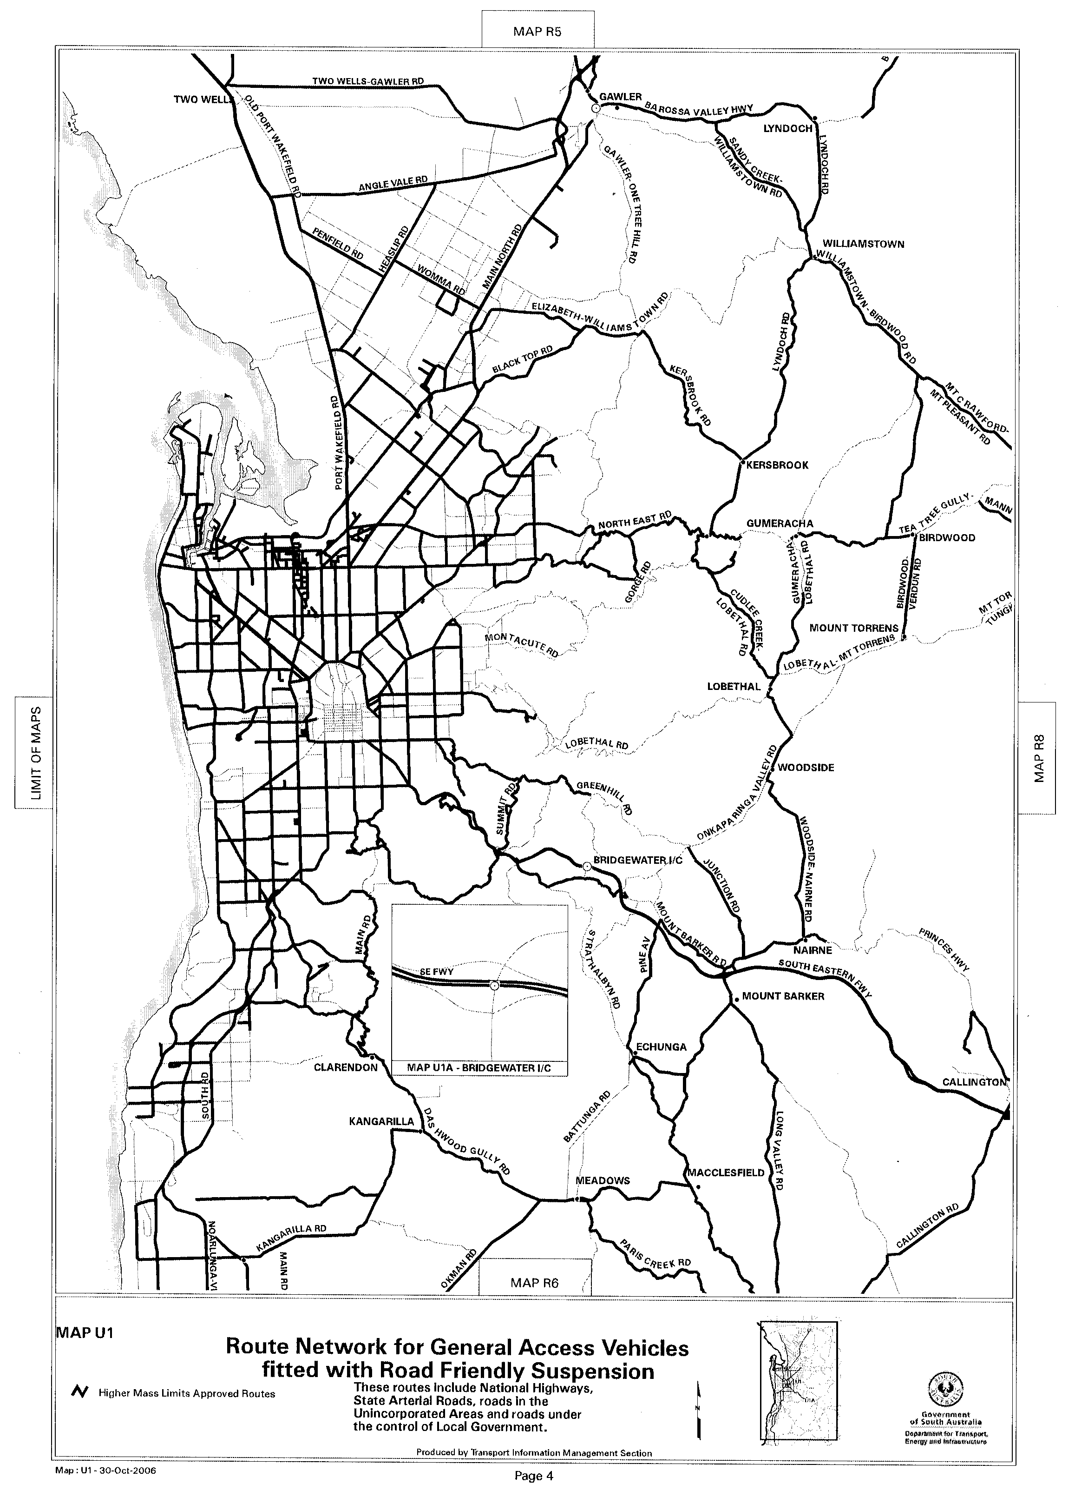
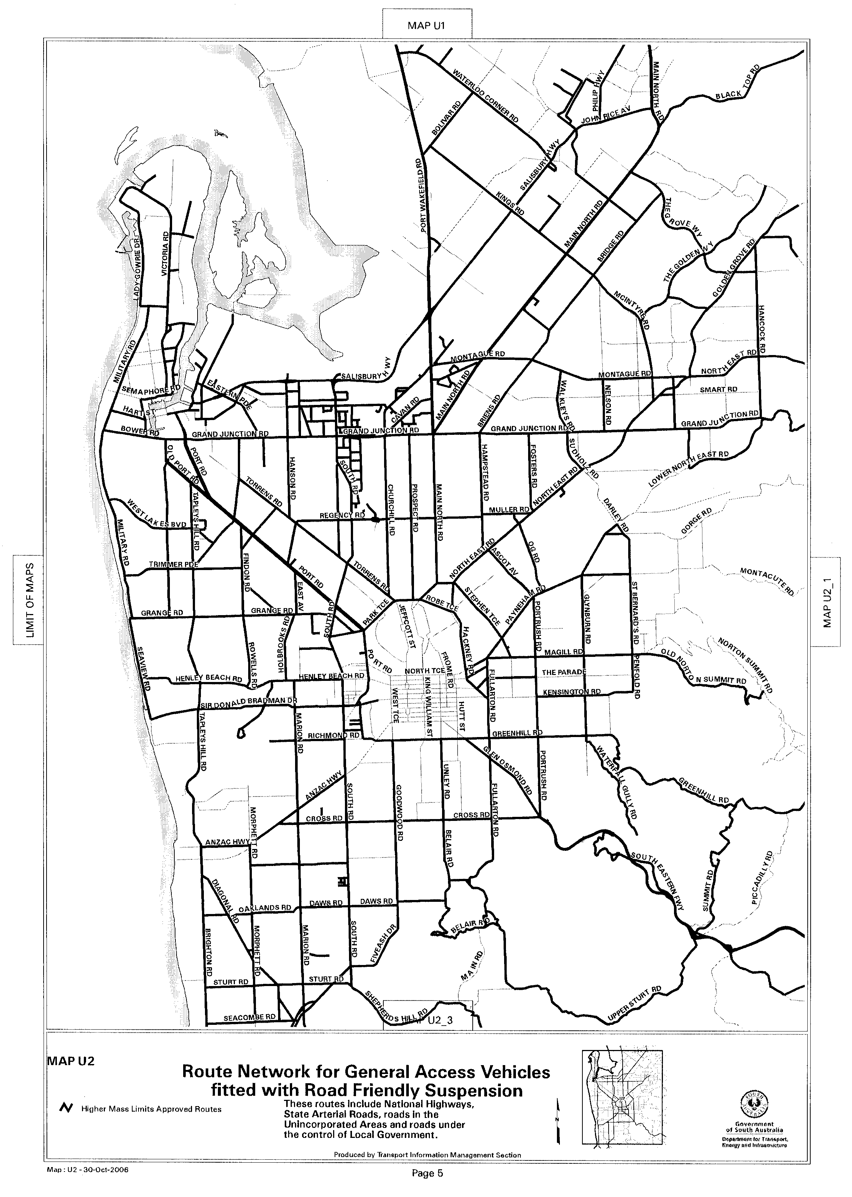
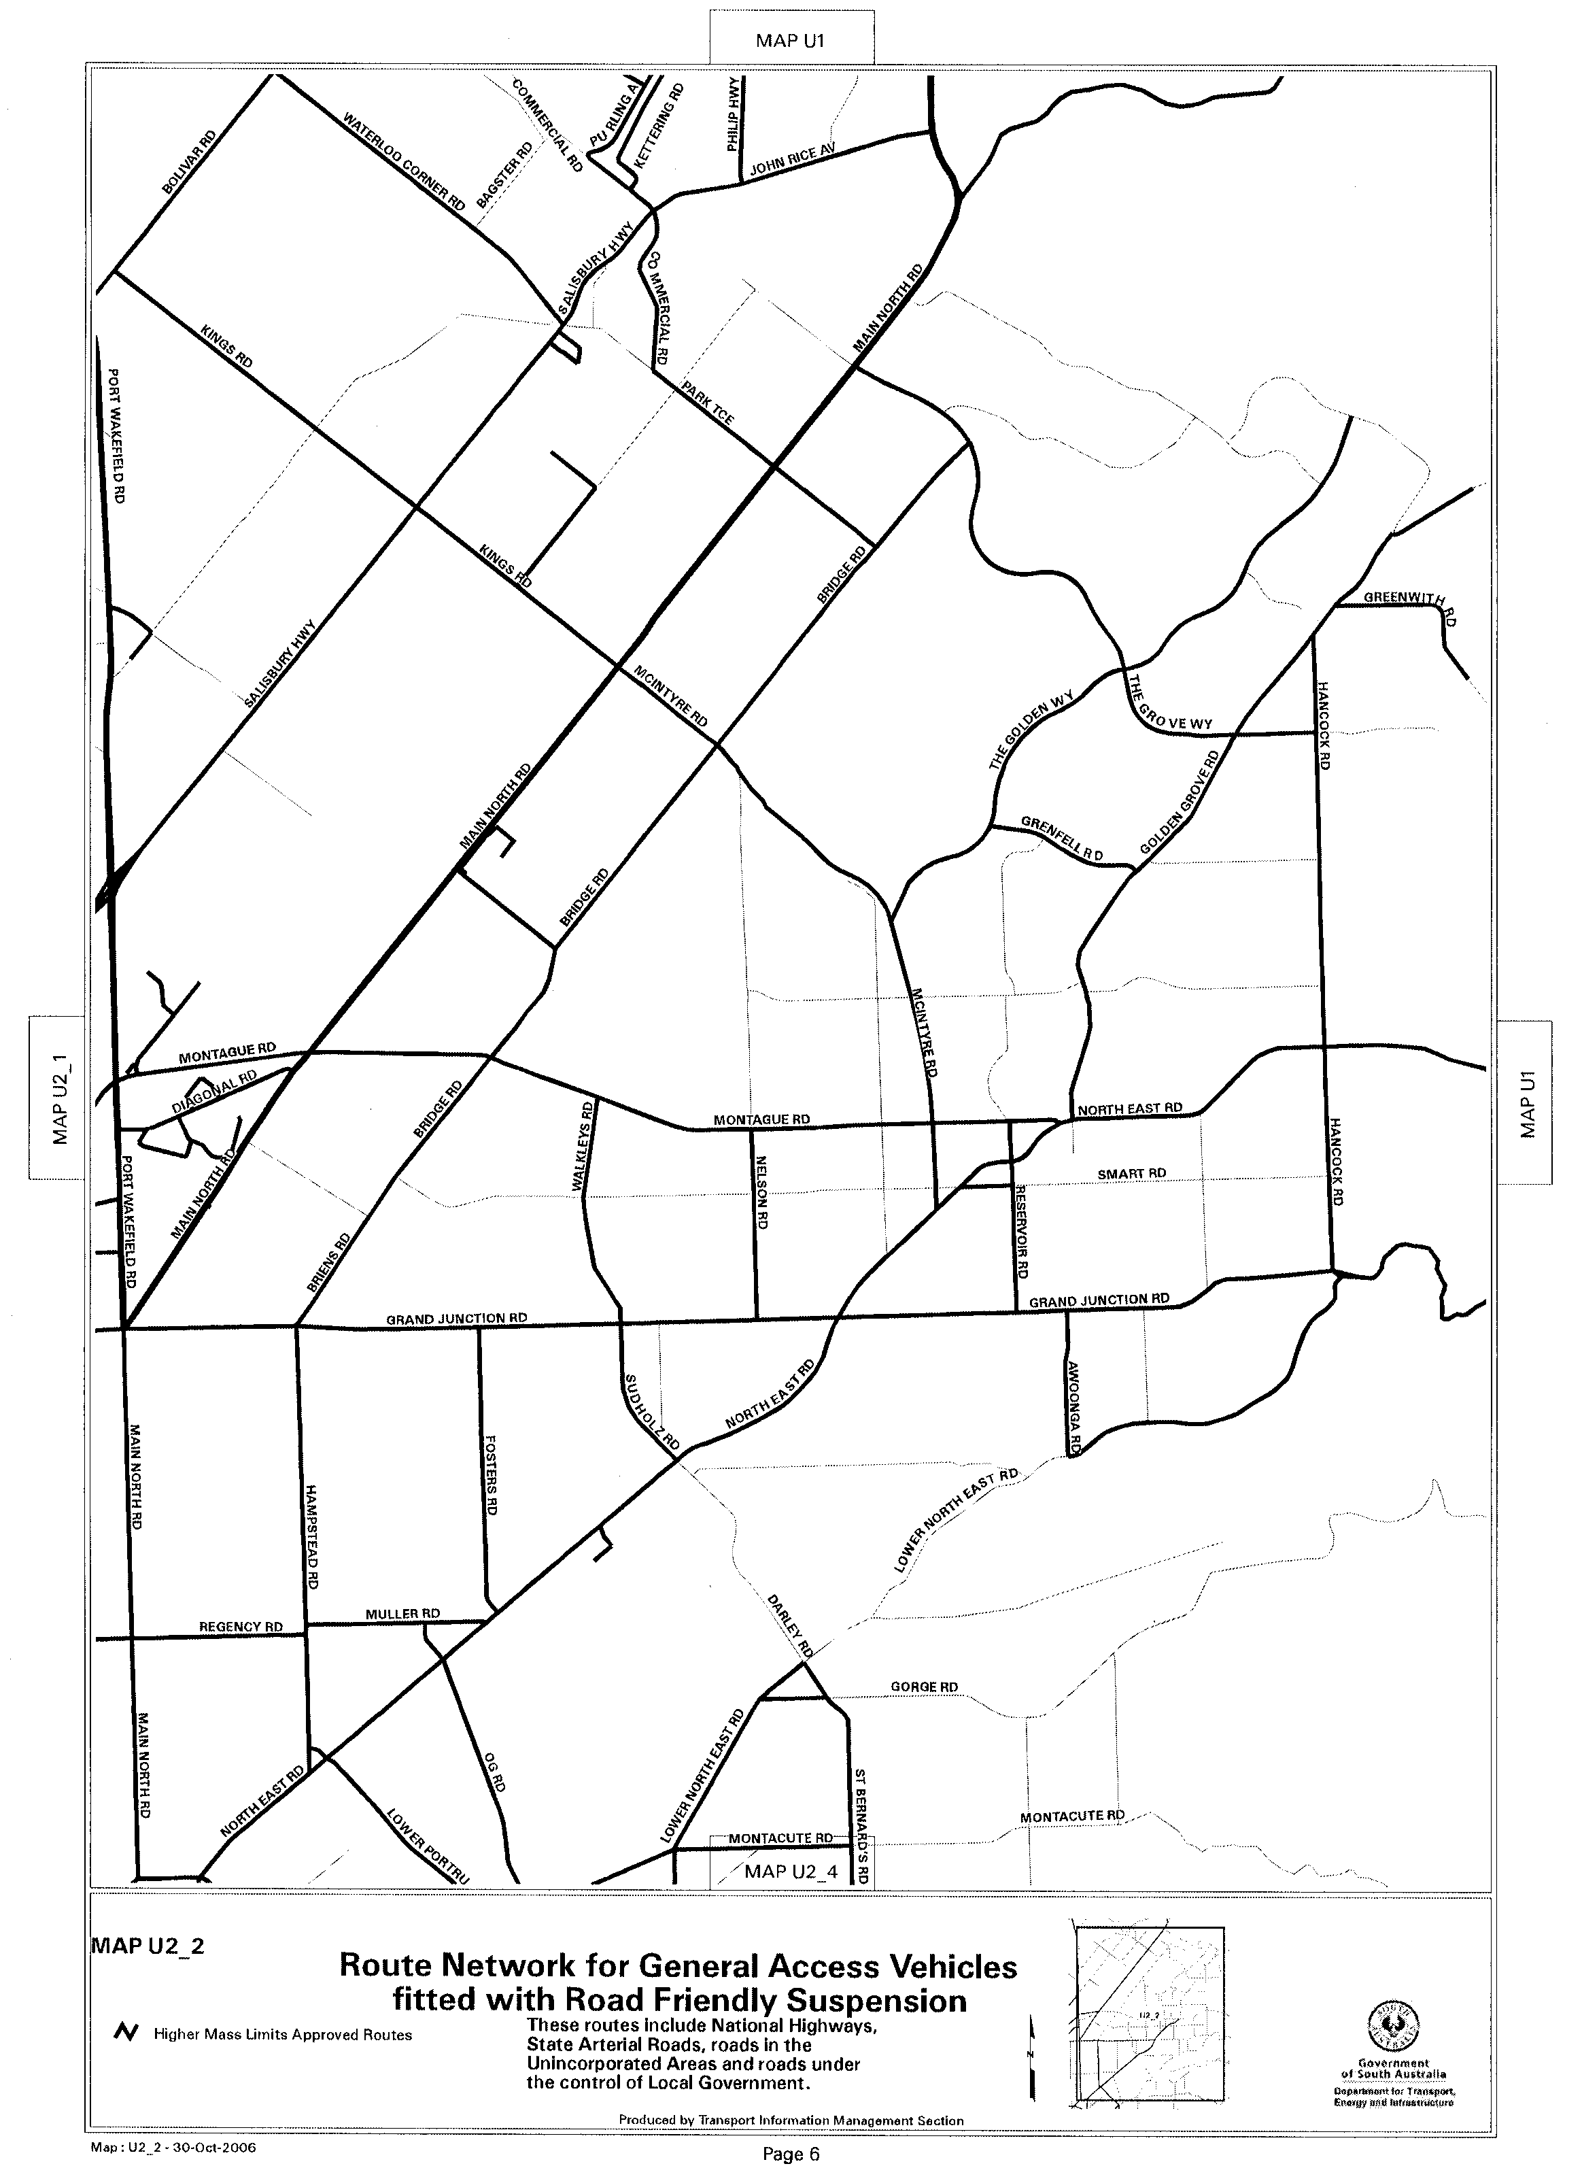
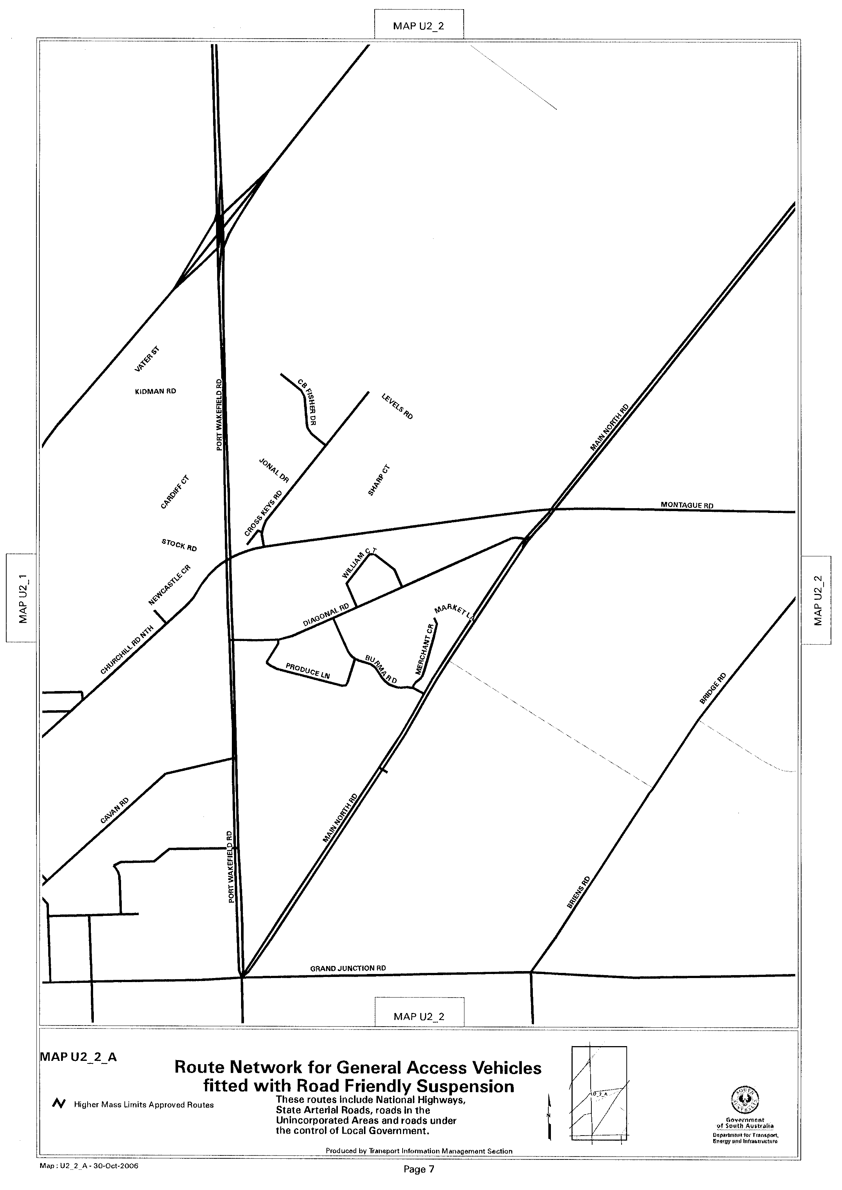
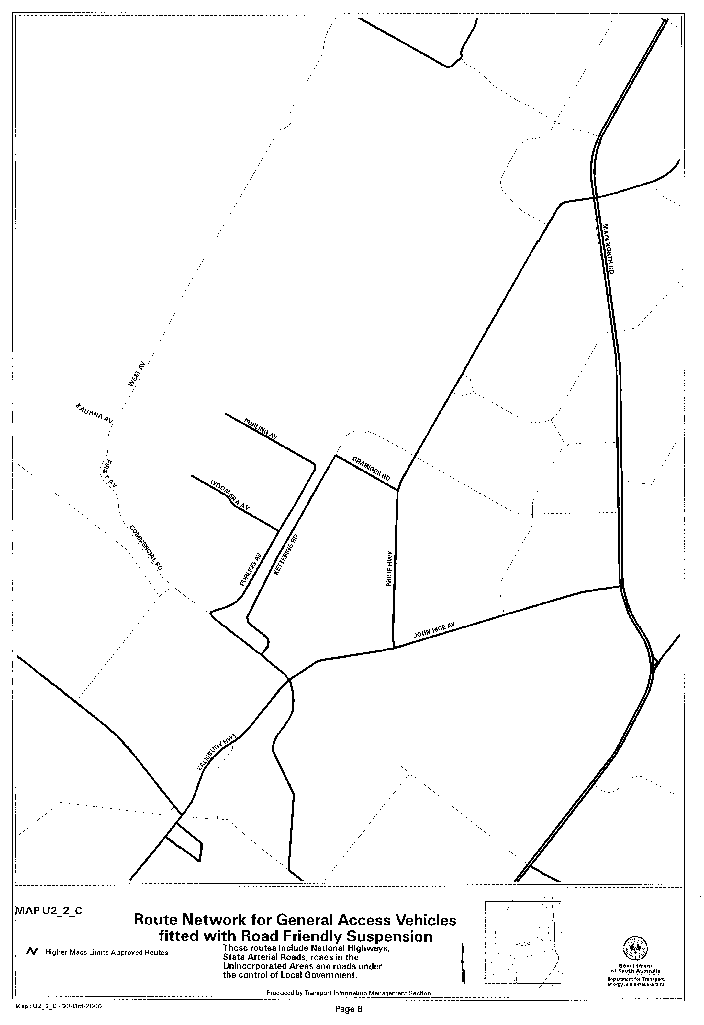
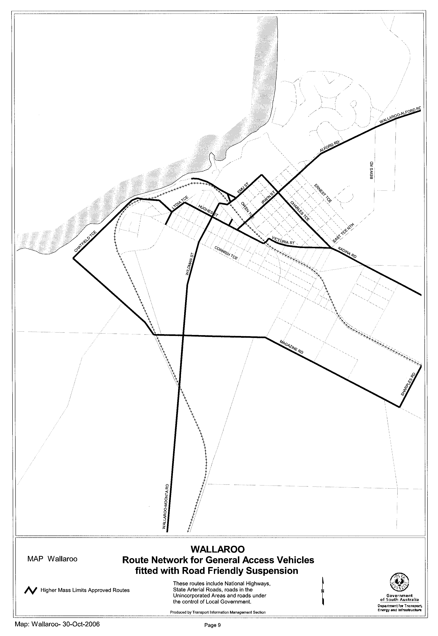

ROAD TRAFFIC ACT 1961

SUPPLEMENTARY NOTICE OF APPROVAL
Pursuant to Section 161A of the Road Traffic Act 1961
OPERATION OF CONTROLLED ACCESS BUSES IN SOUTH AUSTRALIA
Information Note
This Notice adds additional routes to the network that can be used by Controlled Access Buses and is a supplement to the Notice titled ‘Operation of Controlled Access Buses in South Australia’ dated 19 May 2005.

1. APPROVAL
1.1 In accordance with the powers delegated to me by the Minister for Transport under section 163AA of the Road Traffic Act 1961, I hereby vary the conditions of the Gazette Notice of Approval titled, ‘Operation of Controlled Access Buses in South Australia’ dated 19 May 2005 as detailed below.
2. DEFINITIONS
2.1 In this Notice:
2.1.1 ‘Approved Vehicle’ means a rigid bus, over 12.5 m in length, but not over 14.5 m in length;
2.1.2 ‘Supplementary routes’ means the approved routes specified in the maps ‘Approved Route Network Book for Controlled Access Buses’ attached to this Supplementary Notice;
2.1.3 ‘Supplementary Notice’ means this Notice;
2.1.4 ‘Primary Notice’ means the Gazette Notice ‘Operation of Controlled Access Buses in South Australia’ dated 19 May 2005; and
2.1.5 all other terms have the same meaning as in the Primary Notice.
3. APPLICATION OF SUPPLEMENTARY NOTICE
3.1 This Supplementary Notice must be read in conjunction with the Primary Notice and applies to all Approved Vehicles operating under the Primary Notice travelling on routes specified in the attached maps.
4. ROUTES AVAILABLE TO APPROVED VEHICLES
4.1 An Approved Vehicle may operate under the conditions of the Primary Notice on a supplementary route specified in the attached maps titled:
4.1.1 Approved Route Network Book for Controlled Access Buses, Map U1;
4.1.2 Approved Route Network Book for Controlled Access Buses, Map U2; and
4.1.3 Approved Route Network Book for Controlled Access Buses, Map U2_4
5. CONDITIONS AND LIMITATIONS APPLYING TO THIS SUPPLEMENTARY NOTICE
5.1 When operating on a route specified in the attached maps, the driver of an Approved Vehicle must:
5.1.1 continue to comply with all conditions and requirements of the Primary Notice; and
5.1.2 carry a legible, current and complete copy of:
(i) this Supplementary Notice and attached maps;
(ii) the Primary Notice;
(iii) any combination specific documents as required by the Primary Notice; and
5.1.3 produce these documents when requested by a DTEI Transport Safety Compliance Officer appointed under the Road Traffic Act 1961 and/or the Motor Vehicles Act 1959 or a Police Officer.
6. COMMENCEMENT OF THIS NOTICE
6.1 This Notice is effective from 12.01 a.m. on 6 November 2006.
Executive Director
Safety and Regulation Division

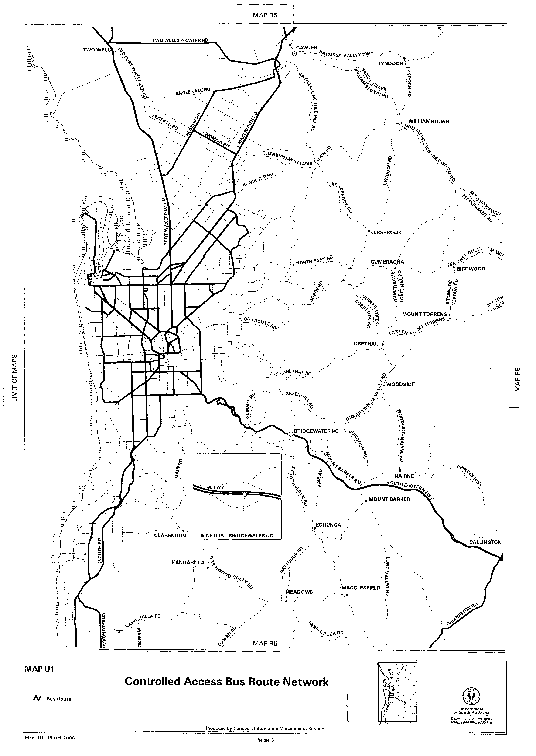
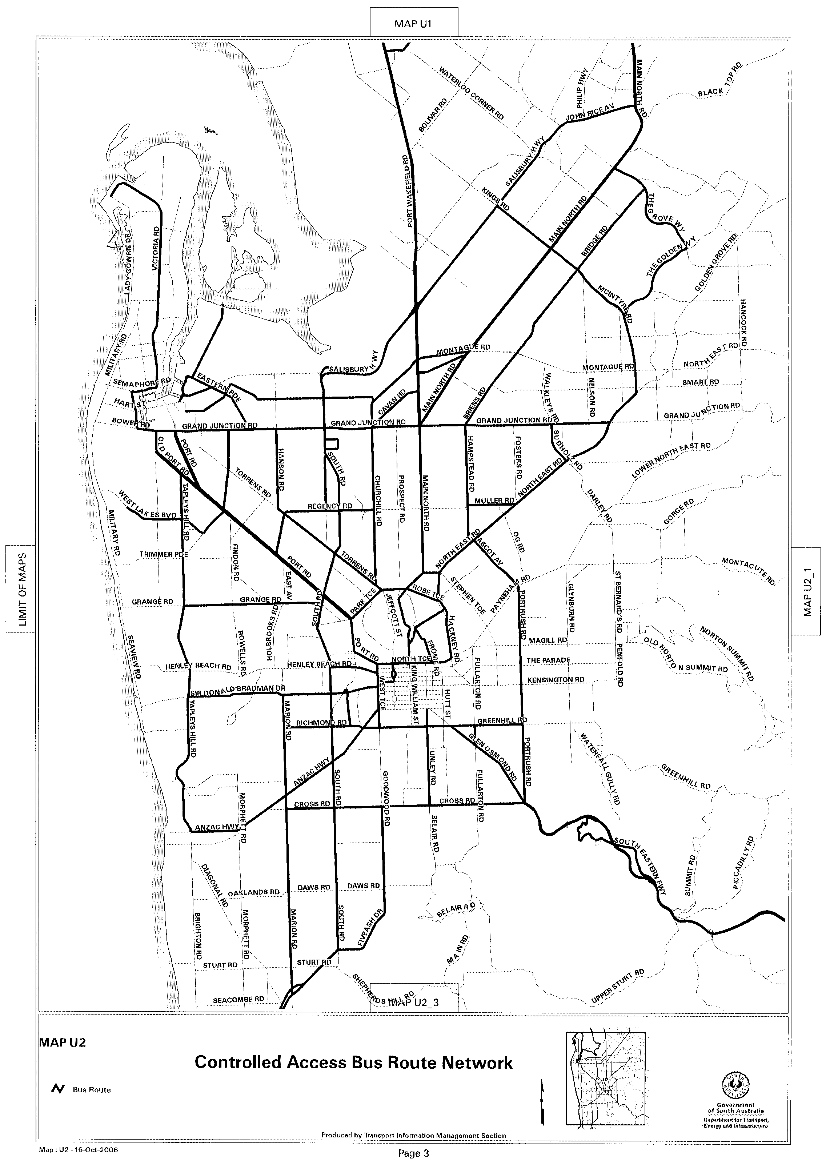
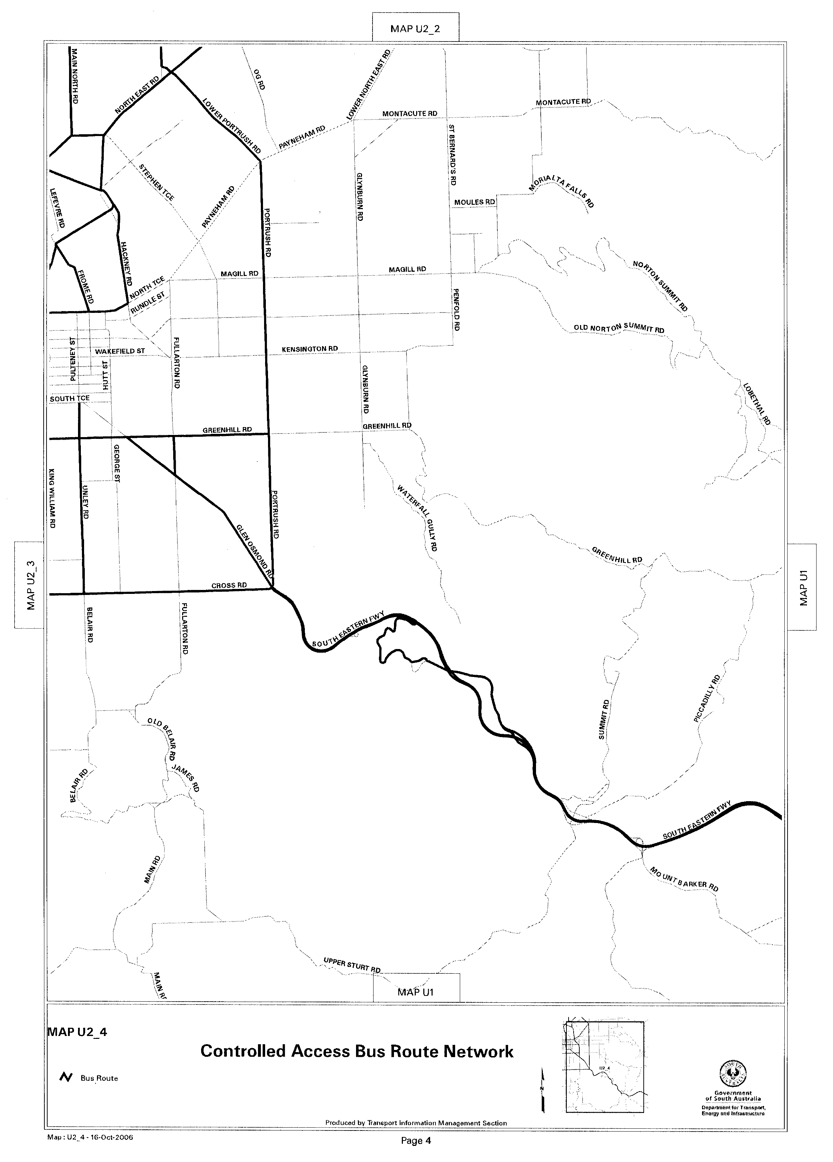

SEWERAGE ACT 1929
Addition of Land to Adelaide Drainage Area
PURSUANT to section 18 of the Sewerage Act 1929, the South Australian Water Corporation:
(a) adds to the Adelaide Drainage Area all the land con-tained in:
(i) allotments 4 and 5, 14 to 19 inclusive and 21 in Deposited Plan 50237 (except the portions of that land already in the Adelaide Drainage Area);
(ii) allotments 6 to 13 inclusive and 20 in Deposited Plan 50237;
(iii) allotments 50 and 51 (reserves) in Deposited Plan 50237 (except the portions of that land already in the Adelaide Drainage Area);
(iv) Beatrix Drive, Craigmore (except the portion of that road already in the Adelaide Drainage Area);
(v) the portion of Uley Road, Craigmore abutting allotment 51 (reserve) in Deposited Plan 50237 not already in the Adelaide Drainage Area; and
(b) declares that this notice has effect from the commence-ment of the financial year in which it is published in the Gazette.
Dated 31 October 2006.
Signed for and on behalf of the South Australian Water Corporation by a person duly authorised so to do:
A. Sheedy, Manager Shared Services
In the presence of:
C. J. McNamara, Billing Manager
SAWATER 06/01408 D1339

NOTICE TO MARINERS
No. 49 of 2006
Formerly Notice No. 23 of 2006
South Australia—Spencer Gulf—Port Bonython—Restricted Areas—Marker Buoys Laid
MARINERS are advised that following a number of reported intrusions of small craft into the restricted areas as set out in Schedule 5, No. 52 of the Harbors and Navigation Act Regulations of 1994:
Marker buoys have been laid in the following positions, to delineate the Restricted Area:
All positions are WGS 84:
Inshore West Side: 32°59′49.3″S, 137°45′35″E.
Offshore West Side: 33°00′31.02″S, 137°45′38.03″E.
Offshore East Side: 33°00′29.50″S, 137°46′10.48″E.
Inshore East Side: 32°59′46.04″S, 137°46′07.27″E.
Mariners are further advised that penalties apply to the breach of this regulation.
Charts affected: Aus 136.
Publications affected: Australia Pilot, Vol. 1, 2005 edition, page 364. South Australia’s Waters CW Map 9B, page 210.
Adelaide, 23 October 2006.
Patrick Conlon, Minister for Transport
TSA 2006/00419

WATERWORKS ACT 1932
Addition of Land to Adelaide Water District
PURSUANT to section 6 of the Waterworks Act 1932, the South Australian Water Corporation:
(a) adds to the Adelaide Water District all the land contained in Section 885 in the Hundred of Adelaide; and
(b) declares that this notice has effect from the commence-ment of the financial year in which it is published in the Gazette.
Dated 31 October 2006.
Signed for and on behalf of the South Australian Water Corporation by a person duly authorised so to do:
A. Sheedy, Manager Shared Services
In the presence of:
C. J. McNamara, Billing Manager
SAWATER 06/03207 W1340

WATER MAINS AND SEWERS

Office of the South Australian Water Corporation
Adelaide, 2 November 2006

WATER MAINS LAID

Notice is hereby given that the following main pipes or parts of main pipes have been laid down by the South Australian Water Corporation in or near the undermentioned water districts and are now available for a constant supply of water to adjacent land.

ADELAIDE WATER DISTRICT

ADELAIDE CITY COUNCIL
Across Rundle Mall, Adelaide. p44

CITY OF HOLDFAST BAY
Barton Avenue, Kingston Park. p35

CITY OF MARION
Encounter Road, Sheidow Park. p21
Carriage Avenue, Sheidow Park. p21
Ballast Court, Sheidow Park. p21

CITY OF NORWOOD PAYNEHAM & ST PETERS
Stephen Terrace, St Peters. p56
Second Avenue, St Peters. p56

CITY OF ONKAPARINGA
Shearer Drive, Seaford. p20
Easements in lot 2005 in LTRO DP 69768, Shearer Drive, Seaford. p20
Farrow Circuit, Seaford. p20
Corn Street, Old Reynella. p36

CITY OF PLAYFORD
Birmingham Drive, Craigmore. p1
Manchester Circuit, Craigmore. p1
Gloucester Drive, Craigmore. p1
Easements in allotment piece 1008 in LTRO DP 71806, Gloucester Drive, and lot 2004 in LTRO DP 70962, Chelmsford Street, Craigmore. p1 and 2

CITY OF SALISBURY
Sanctuary Drive, Mawson Lakes. p3
Lord Howe Crescent, Mawson Lakes. p3
Everglade Street, Mawson Lakes. p3
Heard Avenue, Mawson Lakes. p3
Warwick Court, Paralowie. p10
Queen Street, Paralowie. p10
Balmoral Court, Paralowie. p10
Across Kings Road, Paralowie. p17
Melvina Road, Paralowie. p17
Rochester Drive, Salisbury Heights. p19
Grant Avenue, Salisbury Downs. p40

CITY OF WEST TORRENS
Kenneth Avenue, Underdale. p57

BEETALOO COUNTRY LANDS WATER DISTRICT

DISTRICT COUNCIL OF THE COPPER COAST
Kadina-Bute Road, Kadina. p37

MYPONGA WATER DISTRICT

DISTRICT COUNCIL OF YANKALILLA
Main South Road, Normanville. p5
In and across Williss Drive, Normanville. p5-9
Jean Road, Normanville. p6
Allison Road, Normanville. p7

NARACOORTE WATER DISTRICT

NARACOORTE LUCINDALE COUNCIL
Across Grieve Avenue, Naracoorte. p4
Jubilee Crescent, Naracoorte. p4

PORT ELLIOT WATER DISTRICT

CITY OF VICTOR HARBOR
Across Cudmore Road, McCracken. p23
Laxton Street, McCracken. p23

PORT LINCOLN WATER DISTRICT

CITY OF PORT LINCOLN
Seaton Avenue, Sleaford. p18

PORT VICTOR WATER DISTRICT

CITY OF VICTOR HARBOR
Across White Crescent, Encounter Bay. p22
Twin Figs Court, Encounter Bay. p22

TRURO WATER DISTRICT

MID MURRAY COUNCIL
Sturt Highway, Truro. p39

WARREN COUNTRY LANDS WATER DISTRICT

BAROSSA COUNCIL
Kalimna Road, Light Pass. p52 and 53

YORKE PENINSULA COUNTRY LANDS WATER DISTRICT

DISTRICT COUNCIL OF YORKE PENINSULA
Old Boundary Road, Maitland. p16

WATER MAINS ABANDONED

Notice is hereby given that the undermentioned water mains have been abandoned by the South Australian Water Corporation.

ADELAIDE WATER DISTRICT

ADELAIDE CITY COUNCIL
Across Rundle Mall, Adelaide. p44
Easements in lot 2 in LTRO FP 47043, Rundle Mall, lot 11 in LTRO FP 111805, and lot 5 in LTRO FP 110006, Grenfell Street, Adelaide. p44

CITY OF NORWOOD PAYNEHAM & ST PETERS
Stephen Terrace, St Peters. p56
Second Avenue, St Peters. p56

CITY OF SALISBURY
Grant Avenue, Salisbury Downs. p40

CITY OF WEST TORRENS
Kenneth Avenue, Underdale. p57

BEETALOO COUNTRY LANDS WATER DISTRICT

DISTRICT COUNCIL OF THE COPPER COAST
Kadina-Bute Road, Kadina. p37

PORT LINCOLN WATER DISTRICT

CITY OF PORT LINCOLN
Seaton Avenue, Sleaford. p18

TRURO WATER DISTRICT

MID MURRAY COUNCIL
Sturt Highway, Truro. p39

WARREN COUNTRY LANDS WATER DISTRICT

BAROSSA COUNCIL
Kalimna Road, Light Pass. p52 and 53

YORKE PENINSULA COUNTRY LANDS WATER DISTRICT

DISTRICT COUNCIL OF YORKE PENINSULA
Old Boundary Road, Maitland. p16

WATER MAINS LAID

Notice is hereby given that the undermentioned water mains have been laid down by the South Australian Water Corporation and are not available for a constant supply of water to adjacent land.

ADELAIDE WATER DISTRICT

CITY OF SALISBURY
Waterworks land (lot 1 in LTRO DP 30456), Seville Avenue, Gulfview Heights. p11-14

CITY OF TEA TREE GULLY
Waterworks land (lot 199 in LTRO DP 30929), Lower North East Road, Vista. p45-51
Easement in lot 200 in LTRO DP 30929, Lower North East Road, Vista. p45, 46 and 48-51

ADDENDUM

Addendum to notice in “Government Gazette” of 21 September 2006

WATER MAINS LAID

“Notice is hereby given that the following main pipes or parts of main pipes have been laid down by the South Australian Water Corporation in or near the undermentioned water districts and are now available for a constant supply of water to adjacent land.”

“KIMBA WATER DISTRICT”

“DISTRICT COUNCIL OF KIMBA”

“Sampson Street, Kimba. p34”

“Frick Street, Kimba. p34”

To this notice add “Ferry Street, Kimba. p34”

SEWERS LAID

Notice is hereby given that the following sewers have been laid down by the South Australian Water Corporation in the under-mentioned drainage areas and are now available for house connections.

ADELAIDE DRAINAGE AREA

CITY OF CHARLES STURT
Gateshead Street, Athol Park. FB 1153 p43

CITY OF HOLDFAST BAY
Across Strickland Road, Kingston Park. FB 1153 p39
Barton Avenue, Kingston Park. FB 1153 p39

CITY OF MARION
Holdfast Drive, Sheidow Park. FB 1155 p1, 2 and 8
Easement in lot 308 in LTRO DP 60611, Blanche Court, and lot 303 in LTRO DP 60611, Steamranger Drive, Sheidow Park. FB 1155 p1-3 and 8
Across and in Steamranger Drive, Sheidow Park. FB 1155 p1-3, 6 and 8
Islington Drive, Sheidow Park. FB 1155 p1-4, and 6
Easements in lot 761 in LTRO DP 64271, Islington Drive, and allotment piece 510 in LTRO DP 49854, Mariner Drive, Sheidow Park. FB 1155 p1, 2, 4 and 6
In and across Platform Avenue, Sheidow Park. FB 1155 p1-4, 7 and 8
In and across Carriage Avenue, Sheidow Park. FB 1155 p1-3, 5, 7 and 8
Easements in lots 428 and 427 in LTRO DP 59987, 209-214 in LTRO DP 59789, Carriage Avenue, and 223 in LTRO DP 59789, Ballast Court, Sheidow Park. FB 1155 p1-3, 5 and 7
Easement in lots 208-202 in LTRO DP 59789, Carriage Avenue, Sheidow Park. FB 1155 p1, 2, 5 and 7
Ballast Court, Sheidow Park. FB 1155 p1, 2, 5 and 8
Encounter Road, Sheidow Park. FB 1155 p1, 2, 5 and 7
Dudley Crescent, Marino. FB 1153 p40

CITY OF ONKAPARINGA
Shearer Drive, Seaford. FB 1154 p49-52
Easements in lot 2005 in LTRO DP 69768, Shearer Drive, Seaford. FB 1154 p49-52
In and across Farrow Circuit, Seaford. FB 1154 p49, 50 and 52
Easement in lot 17 in LTRO DP 69768, Farrow Circuit, and lot 14 in LTRO DP 69768, Shearer Drive, Seaford. FB 1154 p49, 50 and 52
Easement in lot 500 in LTRO DP 24590, Honeypot Road, Noarlunga Downs and Huntfield Heights. FB 1153 p47

CITY OF PLAYFORD
In and across Manchester Circuit, Craigmore. FB 1154 p27, 28 and 30
Birmingham Drive, Craigmore. FB 1154 p27, 28 and 30
Gloucester Drive, Craigmore. FB 1154 p27, 28 and 30
Easements in allotment piece 1008 in LTRO DP 71806, Gloucester Drive, and lot 2004 in LTRO DP 70962, Chelmsford Street, Craigmore. FB 1154 p27-31
Easement in lot 61 in LTRO DP 71806, Gloucester Drive, Craigmore. FB 1154 p27, 28 and 31
Easement in lots 62-67 in LTRO DP 71806, Manchester Circuit, Craigmore. FB 1154 p27, 28 and 31
Chellaston Road, Munno Para West. FB 1152 p60

CITY OF SALISBURY
Balmoral Court, Paralowie. FB 1154 p46 and 47
Queen Street, Paralowie. FB 1154 p46 and 47
Warwick Court, Paralowie. FB 1154 p46 and 47
Melvina Road, Paralowie. FB 1154 p32
Rochester Drive, Salisbury Heights. FB 1154 p48

CITY OF TEA TREE GULLY
Watts Road, Dernancourt. FB 1154 p33
Oradala Court, Salisbury Heights. FB 1153 p41

NARACOORTE COUNTRY DRAINAGE AREA

NARACOORTE LUCINDALE COUNCIL
In and across Jubilee Crescent, Naracoorte. FB 1130 p53 and 54
Cedar Avenue, Naracoorte. FB 1130 p53 and 54
Easements in lot 17 in LTRO DP 70367, Jubilee Crescent, and lots 22-25 in LTRO DP 70367, Cedar Avenue, Naracoorte. FB 1130 p53 and 54

PORT LINCOLN COUNTRY DRAINAGE AREA

CITY OF PORT LINCOLN
Easements in lot 1 in LTRO FP 12657, Seaton Avenue, Sleaford. FB 1154 p53
Seaton Avenue, Sleaford. FB 1154 p53
Seaton Avenue, Sleaford. FB 1154 p54
South Point Drive, Sleaford. FB 1153 p42

STIRLING COUNTRY DRAINAGE AREA

ADELAIDE HILLS COUNCIL
Easement in lot 101 in LTRO DP 58249, Wycombe Road, Aldgate. FB 1150 p40 and 42
Across and in Wycombe Road, Aldgate. FB 1150 p40-43
Easement in lot 35 in LTRO FP 158681, Wycombe Road, Aldgate. FB 1150 p40 and 43
Easement in lot 52 in LTRO FP 30417, Wycombe Road, Aldgate. FB 1150 p41 and 43
Easement in lot 21 in LTRO DP 14676, Wycombe Road, Aldgate. FB 1150 p41 and 43
In and across Bracken Road, Stirling. FB 1154 p21, 22 and 24
Sewerage land (lot 17 in LTRO FP 158363), Bracken Road, Stirling. FB 1154 p21, 22 and 24
Easements in lot 12 in LTRO FP 159201, Ayers Court, Stirling. FB 1154 p21, 22, 24 and 25
Across and in Ayers Court, Stirling. FB 1154 p21-25
Easements in lots 50 and 52 in LTRO DP 28410, and 41 in LTRO DP 21552, Ayers Hill Road, Stirling. FB 1154 p21-24 and 26
Easements in lot 9 in LTRO FP 107985, Ayers Court, and lots 13 in LTRO FP 159202, and 35 in LTRO DP 18099, Ayers Hill Road, Stirling. FB 1154 p21, 22 and 25

VICTOR HARBOR COUNTRY DRAINAGE AREA

CITY OF VICTOR HARBOR
Sewerage land (lot 60 in LTRO DP 72219), Waitpinga Road, Encounter Bay. FB 1154 p34, 36 and 37
Easement in lots 20, 4 and 5 in LTRO DP 72219, Twin Figs Court, Encounter Bay. FB 1154 p34, 35, 37 and 38
Across and in Twin Figs Road, Encounter Bay. FB 1154 p34, 35, 37 and 38
Coleman Avenue, McCracken. FB 1153 p46
Laxton Street, McCracken. FB 1153 p46

SEWERS ABANDONED

Notice is hereby given that the undermentioned sewers have been abandoned by the South Australian Water Corporation.

ADELAIDE DRAINAGE AREA

CITY OF HOLDFAST BAY
Dudley Crescent, Marino. FB 1153 p40

CITY OF ONKAPARINGA
Easement in lot 500 in LTRO DP 24590, Honeypot Road, Noarlunga Downs and Huntfield Heights. FB 1153 p47

SEWERS LAID

Notice is hereby given that the undermentioned sewers have been laid down by the South Australian Water Corporation and are not available for house connections.

ADELAIDE DRAINAGE AREA

CITY OF MARION
Easements in allotment piece 510 in LTRO DP 49854, Mariner Drive, and lot 761 in LTRO DP 64271, Islington Drive, Sheidow Park—150 mm PVC pumping main. FB 1155 p1, 2, 4, 9 and 10
Islington Drive, Sheidow Park—150 mm PVC pumping main. FB 1155 p1, 2, 4, 3 and 10
Steamranger Drive, Sheidow Park—150 mm PVC pumping main. FB 1155 p1-3 and 10
Holdfast Drive, Sheidow Park—150 mm PVC pumping main. FB 1155 p1, 2, 4 and 11

VICTOR HARBOR COUNTRY DRAINAGE AREA

CITY OF VICTOR HARBOR
Sewerage land (lot 60 in LTRO DP 72219), Waitpinga Road, Encounter Bay—90 mm HDPE pumping main. FB 1154 p34, 36 and 39
Easements in lot 20 in LTRO DP 72219, Twin Figs Court, Encounter Bay—90 mm HDPE pumping main. FB 1154 p34 and 39
Twin Figs Court, Encounter Bay—90 mm HDPE pumping main. FB 1154 p34, 35 and 39
In and across White Crescent, Encounter Bay—90 mm HDPE pumping main. FB 1154 p35 and 39
Norma Crescent, Encounter Bay—90 mm HDPE pumping main. FB 1154 p35 and 39

A. Howe, Chief Executive Officer, South Australian Water Corporation.

South Australia
Administrative Arrangements (Administration of Aboriginal Heritage Act 1979) Proclamation 2006
under section 5 of the Administrative Arrangements Act 1994
1—Short title
This proclamation may be cited as the Administrative Arrangements (Administration of Aboriginal Heritage Act 1979) Proclamation 2006.
2—Commencement
This proclamation comes into operation on the day on which it is made.
3—Administration of Act committed to Minister for Aboriginal Affairs and Reconciliation
The administration of the Aboriginal Heritage Act 1979 is committed to the Minister for Aboriginal Affairs and Reconciliation.
Made by the Governor’s Deputy
with the advice and consent of the Executive Council
on 2 November 2006
MFC/CS/06/022

South Australia
Forestry (Forest Reserve—Mount Burr Forest District) Variation Proclamation 2006
under section 3(3) of the Forestry Act 1950

Preamble
1 The following land is forest reserve under the Forestry Act 1950 (see proclamation, Gazette 19.3.1992 p877, as varied) and forms part of the Mount Burr Forest District:
Section 237, Hundred of Riddoch.
2 It is intended that this land cease to be forest reserve.

Part 1—Preliminary
1—Short title
This proclamation may be cited as the Forestry (Forest Reserve—Mount Burr Forest District) Variation Proclamation 2006.
2—Commencement
This proclamation comes into operation on the day on which it is made.
3—Variation provisions
In this proclamation, a provision under a heading referring to the variation of a specified proclamation varies the proclamation so specified.
Part 2—Variation of proclamation under Forestry Act 1950 declaring forest reserve (Gazette 19.3.1992 p877) as varied
4—Variation of Schedule
Schedule, clause 7(e)—delete "234-237" and substitute:
234-236
Made by the Governor’s Deputy
with the advice and consent of the Executive Council
on 2 November 2006
MFOR06/002CS

South Australia
Liquor Licensing (Conferral of Authority) Proclamation 2006
under section 15 of the Liquor Licensing Act 1997
1—Short title
This proclamation may be cited as the Liquor Licensing (Conferral of Authority) Proclamation 2006.
2—Commencement
This proclamation comes into operation on the day on which it is made.
3—Conferral of authority on District Court Judge
Authority is conferred on the District Court Judge named in Schedule 1 to exercise the jurisdiction of the Licensing Court of South Australia.
Schedule 1—District Court Judge on whom authority is conferred
His Honour Kevin Gordon Nicholson
Made by the Governor’s Deputy
with the advice and consent of the Executive Council
on 2 November 2006
AGO0071/03CSTEMP2

South Australia
Youth Court (Designation and Classification of Magistrate) Proclamation 2006
under section 9 of the Youth Court Act 1993
1—Short title
This proclamation may be cited as the Youth Court (Designation and Classification of Magistrate) Proclamation 2006.
2—Commencement
This proclamation will come into operation on 30 November 2006.
3—Designation and classification of Magistrate
Patricia Ann Rowe, an auxiliary Magistrate is—
(a) designated as a Magistrate of the Youth Court of South Australia; and
(b) classified as a member of the Court's ancillary judiciary.
Made by the Governor’s Deputy
with the advice and consent of the Executive Council
on 2 November 2006
AGO0089/03CSTEMP1

South Australia
Youth Court (Designation and Classification of Magistrates) Proclamation 2006
under section 9 of the Youth Court Act 1993
1—Short title
This proclamation may be cited as the Youth Court (Designation and Classification of Magistrates) Proclamation 2006.
2—Commencement
This proclamation comes into operation on the day on which it is made.
3—Interpretation
In this proclamation—
Act means the Youth Court Act 1993;
Court means the Youth Court of South Australia.
4—Revocation of certain proclamations previously made under section 9 of Act
All proclamations previously made under section 9 of the Act that—
(a) designated a Magistrate as a Magistrate of the Court; and
(b) classified the Magistrate of the Court as a member of the Court's ancillary judiciary,
are revoked.
5—Designation and classification of Magistrates
(1) A Stipendiary Magistrate named in Schedule 1 is—
(a) designated as a Magistrate of the Court; and
(b) classified as a member of the Court's ancillary judiciary.
(2) An auxiliary Magistrate named in Schedule 1 is—
(a) designated as a Magistrate of the Court; and
(b) classified as a member of the Court's ancillary judiciary.
Schedule 1—Magistrates of the Court

Stipendiary Magistrates | Auxiliary Magistrates
William John Ackland | Gregory Ronald Alfred Clark
Teresa Marie Anderson | Charles Graham Eardley
Joseph Marcus Baldino | David Cyril Gurry
Elizabeth Mary Bolton | John Antoine Kiosoglous
Andrew James Cannon | Jacynth Elizabeth Sanders
Cathy Helen Deland | David Allan Swain
Kevin Phillip Edgecomb | Michael Ward
John Gerard Fahey
Frederick Robert Field
Paul Marvin Foley
Terence Frederick Forrest
Alfio Anthony Grasso
Gary Clive Gumpl
Grantley Bruce Harris
Jonathan Romilly Harry
Ruth Frances Hayes
Garry Francis Hiskey
Theodore Iuliano
Clynton Allan Johansen
Clive William Kitchin
Richard Henry Kleinig
Rosanne Helen McInnes
Kym Andrew Millard
Stefan Peter Metanomski
Anthony Ralph Newman
Susan Elizabeth O'Connor
Maria Panagiotidis
Victor Kent Patrick
Peter Barry Snopek
Derek Yorke Nevill Sprod
Peter Yelverton Wilson
Made by the Governor’s Deputy
with the advice and consent of the Executive Council
on 2 November 2006
AGO0089/03CSTEMP1

South Australia
Development (Bushfire Areas and Referrals) Variation Regulations 2006
under the Development Act 1993

Contents
Part 1—Preliminary
1 Short title
2 Commencement
3 Variation provisions
Part 2—Variation of Development Regulations 1993
4 Variation of regulation 78—Building Rules: bushfire prone areas
5 Variation of Schedule 8—Referrals and concurrences
6 Variation of Schedule 18—Bushfire Prone Areas
7 Variation of Schedule 21—Activities of environmental significance

Part 1—Preliminary
1—Short title
These regulations may be cited as the Development (Bushfire Areas and Referrals) Variation Regulations 2006.
2—Commencement
These regulations come into operation on the day on which they are made.
3—Variation provisions
In these regulations, a provision under a heading referring to the variation of specified regulations varies the regulations so specified.
Part 2—Variation of Development Regulations 1993
4—Variation of regulation 78—Building Rules: bushfire prone areas
(1) Regulation 78(1)(b)—delete paragraph (b) and substitute:
(b) it is an area identified as—
(i) a bushfire prone area; or
(ii) a medium or high bushfire risk area,
by the relevant Development Plan.
(2) Regulation 78(2)(b)—after "bushfire prone area" insert:
or a medium or high bushfire risk area
(3) Regulation 78(3)—after "bushfire prone area" insert:
or a medium or high bushfire risk area
5—Variation of Schedule 8—Referrals and concurrences
Schedule 8, clause 2, item 18—delete "in a CFS Referral Area in a Bushfire Prone Area identified by the relevant Development Plan" and substitute:

—
(a) in a CFS Referral Area in a Bushfire Prone Area; or
(b) in a High Bushfire Risk Area in a Bushfire Protection Area,
identified by the relevant Development Plan
6—Variation of Schedule 18—Bushfire Prone Areas
Schedule 18—after clause 2 insert:
South East, Kangaroo Island, Yorke Peninsula and Eyre Peninsula Bushfire Protection Areas
3 The whole of any Bushfire Protection Area identified as Medium Bushfire Risk or High Bushfire Risk in any of the following Development Plans:
Elliston (DC)
Grant (DC)
Kangaroo Island Council
Kingston (DC)
Lower Eyre Peninsula (DC)
Mount Gambier (City)
Naracoorte Lucindale (DC)
Port Lincoln (City)
Robe (DC)
Streaky Bay (DC)
Tatiara (DC)
Tumby Bay (DC)
Wattle Range Council
Yorke Peninsula (DC)
Metropolitan, Outer Metropolitan, Mid North and Riverland Bushfire Protection Areas
4 The whole of any Bushfire Protection Area identified as Medium Bushfire Risk or High Bushfire Risk in any of the following Development Plans:
Clare and Gilbert Valleys Council
Mt Remarkable (DC)
Northern Areas Council
Port Pirie Regional Council
Wakefield Regional Council
Light Regional Council
Mallala (DC)
Murray Bridge (RC)
Berri Barmera Council
Renmark Paringa (DC)
Gawler (CT)
Salisbury (City)
7—Variation of Schedule 21—Activities of environmental significance
(1) Schedule 21, clause 2(1)—delete subclause (1)
(2) Schedule 21, clause 2(5)(b)—delete paragraph (b)
(3) Schedule 21, clause 2(6)—delete subclause (6)
(4) Schedule 21, clause 4(1) to (3)—delete subclauses (1) to (3) (inclusive)
(5) Schedule 21, clause 4(7) to (9)—delete subclauses (7) to (9) (inclusive)
(6) Schedule 21, clause 5(3)—delete subclause (3)
(7) Schedule 21, clause 7(3) and (4)—delete subclauses (3) and (4)
(8) Schedule 21, clause 7(6)—delete subclause (6)
Note—
As required by section 10AA(2) of the Subordinate Legislation Act 1978, the Minister has certified that, in the Minister's opinion, it is necessary or appropriate that these regulations come into operation as set out in these regulations.
Made by the Governor’s Deputy
with the advice and consent of the Executive Council
on 2 November 2006
No 241 of 2006
MUDP06/039CS

FAXING COPY?
IF you fax copy to Government Publishing SA for inclusion in the Government Gazette, there is no need to send a Confirmation Copy to us as well.
This creates confusion and may well result in your notice being printed twice.
Please use the following fax number:
Fax transmission: (08) 8207 1040
Phone Inquiries: (08) 8207 1045
Please include a contact person, phone number and order number so that we can phone back with any queries we may have regarding the fax copy.
NOTE: Closing time for lodging new copy (fax, hard copy or email) is 4 p.m. on Tuesday preceding the day of publication.

Government Gazette notices can be E-mailed.
The address is:
governmentgazette@saugov.sa.gov.au
Documents should be sent as attachments in Word format.
When sending a document via E-mail, please confirm your transmission with a faxed copy of your document, including the date the notice is to be published.
Fax transmission: (08) 8207 1040
Enquiries: (08) 8207 1045
NOTE: Closing time for lodging new copy (fax, hard copy or email) is 4 p.m. on Tuesday preceding the day of publication.

ADELAIDE CITY COUNCIL
Public Consultation—Representation Review
NOTICE is hereby given that following public interest earlier this year, Council has initiated a Review of its representation structure which examines options including the election of the Lord Mayor, the number of Councillors, election of Councillors and the options for electoral divisions (i.e. Wards).
A paper detailing several options has just been released for public consultation. The public consultation will commence on Thursday, 2 November 2006 and conclude at 5 p.m. on Friday, 15 December 2006.
There are several ways to participate:
Read more:
A copy of the Representation Options Paper may be downloaded from www.adelaidecitycouncil.com or it may be viewed at Council’s Customer Centre or its Libraries.
Attend a workshop to learn more and share your views:
Residents: Monday, 13 November 2006 at 7.30 p.m. to 9.30 p.m. and Thursday, 16 November 2006 at 10 a.m. to noon.
Organisations, investors etc.: Tuesday, 14 November 2006 at 6 p.m. to 8 p.m. and Wednesday, 15 November 2006 at 10 a.m. to noon.
Venue:
Pilgrim Hall—Located in the Pilgrim Centre, 14 Flinders Street (rear of the Pilgrim Uniting Church and can be accessed via a walkway on the eastern side of the Church).
You will need to book your place in a workshop by ringing Council’s Customer Centre on 8203 7203 by 5 p.m. on Friday, 10 November 2006. Lodge a written submission, which should be addressed to the Chief Executive Officer, Adelaide City Council, G.P.O. Box 2252, Adelaide, S.A. 5001 or faxed to (08) 8203 7575 or emailed to city@adelaidecitycouncil.com. Submissions must be received at Council by 5 p.m. on Friday, 15 December 2006.
Any person who makes a written submission will be afforded an opportunity to appear before Council, to be heard in respect of the submission.
M. Hemmerling, Chief Executive Officer

CITY OF MITCHAM
Belair National Park—Barbecue Sites
NOTICE is hereby given that pursuant to Regulation 34 of the Fire and Emergency Services Act 2005, the City of Mitcham declares that persons may operate gas fires or electric elements for cooking proposed in the open air contrary to the terms of a total fire ban at the following barbecue sites in the Belair National Park:
• Two barbecue sites at the Pines 1 and 2 (not including the western barbecue site not adjoining the oval);
• Two barbecue sites at Government Farm 1 and 2.
To be an area where a person may, in accordance with the terms of the notice, operate a gas fire or electric elements for cooking purposes in the open air contrary to the terms of a total fire ban subject to the following conditions:
(a) The space immediately around and above the gas fire or electric element must be cleared of all flammable material to a distance of at least 4 m.
(b) A person who is able to control the gas fire or electric element must be present at all times while it is lighted or charged.
(c) An appropriate agent adequate to extinguish any fire must be at hand.
(d) That the conditions of the Gazettal be made clear in writing as part of conditions of use to any person hiring or using facilities to which they apply.
(e) That the extinguishing agent referred to be at a minimum of a 20 litre ‘knapsack’ or nine litre water extinguisher for which appropriate instructions for use are provided to the user and/or a hose connected to an adequate water supply that must be able to extend a minimum of 4 m around the barbecue.
(f) That on days of Total Fire Ban the gas supply to all barbecues not covered by this Gazettal be isolated.
(g) That on days of park closure for Total Fire Ban or when in the opinion of the Director of National Parks and Wildlife the park is closed in the interest of public safety associated with bushfire under section 7 of the National Parks and Wildlife Regulations 1990, the gas supply to all barbecues be isolated.
Dated 2 November 2006.
R. Malcolm, Chief Executive Officer

ALEXANDRINA COUNCIL
Local Government Act 1999
Declaration of Public Road—Christina Street, Ashbourne
NOTICE is hereby given that pursuant to section 208 of the Local Government Act 1999, the Alexandrina Council at its meeting held on 4 September 2006, declared that Christina Street, Ashbourne, be declared a public road.
J. Coombe, Chief Executive Officer

ALEXANDRINA COUNCIL
By-law Made Under the Local Government Act 1999
By-law No. 3—Local Government Land
FOR the management and regulation of the use of and access to local government land vested in or under the control of Council, including the prohibition and regulation of particular activities on local government land.
1. Definitions
In this by-law:
1.1 ‘local government land’ means land owned by the Council or under the Council’s care, control and manage-ment;
1.2 ‘foreshore’ means the area between the low water mark on the seashore and the nearest boundary of:
1.2.1 a road;
1.2.2 a section;
1.2.3 a public reserve; or
1.2.4 land comprised in a land grant, Crown Land or Crown Licence;
1.3 ‘low water mark’ means the lowest meteorological tide;
1.4 ‘liquor’ has the same meaning as defined in the Liquor Licensing Act 1997;
1.5 ‘sand dune’ and ‘coastal slope or cliff’ means the sand dunes, coastal slopes, cliffs and other geomorphological coastal forms under the care, control and management of the Council;
1.6 ‘open container’ means a container which:
1.6.1 after the contents thereof have been sealed at the time of manufacture and:
(a) being a bottle, has had its cap, cork or top removed (whether or not it has since been replaced);
(b) being a can, it has been opened or punctured;
(c) being a cask, has had its tap placed in a position to allow it to be used;
(d) being any form of container, it has been opened, broken, punctured or manipulated in such a way as to allow access to the contents thereof; or
1.6.2 is a flask, glass or mug or other container used for drinking purposes;
1.7 ‘electoral matter’ has the same meaning as in the Electoral Act 1985, provided that such electoral matter is not capable of causing physical damage or injury to any person within its immediate vicinity;
1.8 ‘the Council’ means the Alexandrina Council;
1.9 ‘authorised person’ means a person appointed an authorised person pursuant to section 260 of the Local Government Act 1999;
1.10 ‘permission’ means the permission of the Council given in writing;
1.11 ‘public place’ means a place (including a place on private land) to which the public has access (except a street or road) but does not include any part of a community parcel divided by a plan of community division under the Community Titles Act 1996;
1.12 ‘park’ means community land reserved or delineated as a park or designated by the Council as a park;
1.13 ‘reserve’ means community land reserved or dedicated as a reserve or designated by the Council as a reserve.
2. Activities Requiring Permission
No person shall without permission on any local government land:
2.1 Vehicles generally
2.1.1 being the driver of a vehicle, fail to obey the indications given by any traffic control device (as defined in the Road Traffic Act 1961) or any sign erected by or with the authority of the Council, for regulating traffic or indicating the direction or route to be followed by traffic on that land;
2.1.2 drive or propel a vehicle where the Council has excluded vehicles generally or of that class, pursuant to section 32 and/or section 33 of the Road Traffic Act 1961;
2.2 Vehicles on parks, etc.
2.2.1 drive, park or propel a motor vehicle unless on an area or road constructed or set aside by the Council for the parking or travelling of motor vehicles;
2.2.2 except on a properly constructed area for the purpose, promote, organise or take part in any race, test or trial of any kind in which motor vehicles, motor cycles, motor scooters or bicycles take part;
2.3 Working on vehicles
perform the work of repairing, washing, painting, panel beating or other work of any nature on or to any vehicle, except for running repairs in the case of breakdown;
2.4 Entertaining
sing, busk or play a musical instrument for the purpose of, or so as to appear to be for the purpose of, enter-taining others whether or not receiving money;
2.5 Preaching
preach or harangue;
2.6 Horses, cattle, etc.
ride, lead or drive any horse, cattle, sheep and other like animal except where the Council has set aside a track or other area for use by or in connection with the animal of that kind;
2.7 Donations
ask for or receive or indicate that he or she desires a donation of money or any other valuable item or thing;
2.8 Amplification
use an amplifier or other device whether mechanical or electrical for the purpose of amplifying sound;
2.9 Distributing
give out or distribute to any bystander or passer-by any handbill, book, notice, or other printed matter, provided that this restriction shall not apply to any handbill or leaflet given out or distributed by or with the authority of a candidate during the course of a Federal, State or Local Government election or to a handbill or leaflet given out or distributed during the course and for the purpose of a Referendum;
2.10 Handbills on cars
place or put on any vehicle any handbill, advertisement, notice or other printed matter except for any electoral matter posted on a building or structure with the authority of a candidate during the course of a Federal, State or Local Government election or Referendum;
2.11 Canvassing
convey any advertising, religious or other message to any bystander, passer-by or person except for any message or material conveyed for the purpose of a Local, State or Federal election;
2.12 Advertising
display any sign for the purpose of commercial adver-tising, other than a moveable sign which is displayed in accordance with Council’s moveable sign by-law;
2.13 Fires
light any fires except:
2.13.1 in a place provided by the Council for that purpose; or
2.13.2 in a portable barbeque, as long as the barbeque is used in an area that is clear of flammable material; and
2.13.3 in accordance with the provision of the Country Fires Act 1989;
2.14 Fireworks
ignite, explode or use any fireworks;
2.15 Attachments to trees
attach, hang or fix any rug, blanket, sheet, rope or other material to any tree, shrub, plant, tree guard, notice board, seat, fence, post or other item or structure which is the property of the Council;
2.16 Overhanging articles
suspend or hang any article or thing from any building, verandah, pergola, post or other structure where it might present a nuisance or danger to any person using local government land;
2.17 Removing soil or other materials
carry away or remove any soil, sand, clay, timber, stones, pebbles, gravel, other organic or inorganic materials or any part of the land;
2.18 Picking fruit
pick fruit, nuts or berries from any trees or bushes;
2.19 Flora and fauna
subject to the Native Vegetation Act 1991 and the National Parks and Wildlife Act 1972:
2.19.1 damage, pick or interfere with any plant or flower thereon; or
2.19.2 tease, interfere or cause harm to any animal, bird or marine creature or any burrow, nest or habitat of such animal;
2.20 Games
2.20.1 promote, organise, participate in any game recreation or amusement which involves the use of a ball missile or other object which by the use thereof may cause or be likely to cause injury or discomfort to any person being on or in the vicinity of that land or detract from or be likely to detract from another person’s lawful use and enjoyment of that land;
2.20.2 fly any model aircraft or operate any power model boat from or on any local government land;
2.21 Athletic and ball sports
2.21.1 promote, organise or take part in any organised athletic sport;
2.21.2 play any organised competition sport, as dis-tinct from organised social play;
2.21.3 play or practice the game of golf;
2.22 No liquor
2.22.1 consume, carry or be in possession or charge of any liquor (provided the land constitutes a park or reserve);
2.22.2 excepting sealed containers, consume, carry, be in possession or charge of any liquor in an open container (provided the land constitutes a park or reserve);
2.23 Weddings
conduct or participate in a marriage ceremony;
2.24 Encroachment
erect or place any fencing, posts or other structures or any other items or substance such as to encroach onto the land;
2.25 Closed lands
enter or remain on any part of local government land:
2.25.1 at any time during which the Council has declared that it shall be closed to the public and which is indicated by a sign to that effect;
2.25.2 where land is enclosed with fences and/or walls and gates, at any time when the gates have been closed and locked; or
2.25.3 where admission charges are payable, to enter without paying those charges;
2.26 Rubbish and rubbish dumps
2.26.1 interfere with, remove or take away any rubbish that has been discarded at any rubbish dump on local government land;
2.26.2 remove, disperse or interfere with any rubbish (including bottles, newspapers, cans, containers or packaging) that has been discarded in a Council rubbish bin on local government land;
2.27 Cemeteries
comprising a cemetery:
2.27.1 bury or inter any human or animal remains;
2.27.2 erect any memorial;
2.27.3 drive or propel any vehicle except on paths or roads constructed and set aside for that purpose and in compliance with any signs that have been erected;
2.28 Camping and tents
2.28.1 camp or stay overnight; or
2.28.2 erect any tent, booth, marquee or other structure (except entities authorised to do so under section 209 of the Act);
2.29 Smoking
smoke tobacco or any other substance in any building or part of any building;
2.30 Toilets
in any public convenience:
2.30.1 urinate other than in a urinal or pan or defecate other than in a pan set apart for that purpose:
2.30.2 smoke tobacco or any other substance;
2.30.3 deposit anything in a pan, urinal or drain which is likely to cause a blockage;
2.30.4 use it for a purpose for which it was not designed or constructed;
2.30.5 enter any toilet that is set aside for use of the opposite sex except where:
(a) a child under the age of five years accom-panied by an adult person of that other sex; and/or
(b) to provide assistance to a disabled person;
2.31 Swimming and aquatic activity
enter, swim or engage in any aquatic activity in or on any body of water except:
2.31.1 a body of water that the Council has set aside for that purpose; or
2.31.2 in an area where a nearby sign states that such activity is allowed and in accordance with any conditions stated in the sign;
2.32 Mooring
2.32.1 moor any boat, house boat, raft or other water craft on or to local government land or in any area that the Council has not set aside for the mooring of any boat, raft or other water craft; or
2.32.2 obstruct any boat, raft or other water craft or any mooring place, or any access to any boat, raft, object (either floating or sunk) whether that access is by water or by land;
2.33 Use of boats and boat ramps
2.33.1 use or launch a boat or other object in any body of water except:
(a) a body of water that the Council has set aside for that purpose; or
(b) in an area where a nearby sign states that such activity is allowed and in accordance with any conditions stated in the sign;
2.33.2 launch or retrieve a boat other than from a boat ramp constructed for that purpose;
2.33.3 allow any vehicle to remain stationary on any boat ramp longer than is necessary to launch or retrieve a boat;
2.33.4 drive or propel any vehicle on such a ramp or thoroughfare at a speed greater than 25 km/h;
2.33.5 hire out a boat on or from any part of a body of water;
2.34 Foreshore
2.34.1 drive or propel a vehicle onto or from the foreshore other than by a ramp or thoroughfare constructed or provided by the Council for that purpose;
2.34.2 launch or retrieve a boat other than from a boat ramp constructed for that purpose;
2.34.3 allow any vehicle to remain stationary on any boat ramp longer than is necessary to launch or retrieve a boat;
2.34.4 drive or propel any vehicle on such a ramp or thoroughfare or elsewhere on the foreshore at a speed greater than 25 km/h;
2.34.5 hire out a boat on or from any part of the foreshore;
2.34.6 ride, lead or drive any horse, cattle, sheep and other like animal on the foreshore except where the Council has set aside a track or other area for use by or in connection with the animal of that kind.
3. Posting of Bills, etc.
No person shall without the Council’s permission post any bills, advertisements or other papers or items on a building or structure on local government land or other public place except for any electoral matter posted on a building or structure with the authority of a candidate during the course of a Federal, State or Local Government election or Referendum.
4. Prohibited Activities
No person shall on local government land:
4.1 Use of equipment
use any item of equipment and/or facilities or other Council property:
4.1.1 other than in the manner and for the purpose for which it was designed or set aside; and
4.1.2 where any nearby sign states the conditions of use, except in accordance with such conditions.
4.2 Annoyances
4.2.1 annoy, commit any nuisance or unreasonably interfere with any other person’s use of local government land by making a noise or by creating a disturbance that has not been authorised by the Council;
4.2.2 spit, urinate or defecate other than in toilets provided on any local government land;
4.3 Interference with permitted use
interrupt or disrupt or interfere with any person’s use of parks or reserves for which permission has been granted;
4.4 Obstruction
obstruct:
4.4.1 any path in or on any local government land;
4.4.2 any door entrance stairway or aisle in any build-ing in or on any local government land; or
4.4.3 any gate or entrance to, in or on local government land;
4.5 Interference with land
4.5.1 interfere with the land such as levelling or flattening sand hills, planting grass, lawn or other vegetation, paving the land or otherwise use the land in a manner contrary to the purpose for which the land was designed to be used; or
4.5.2 destroy, damage or deface or cause or permit to be destroyed, damaged or defaced any article, struc-ture, building or thing fixed to local government land;
4.6 Defacing land
Deface, paint, write, make marks on or fix bills or advertisements to any tree, rock, gate, fence, building, sign or other property except for any electoral matter posted on a building or structure with the authority of a candidate during the course of a Federal, State or Local Government election or Referendum;
4.7 Missiles
throw, roll or discharge any stone, substance or missile to the danger of any person or animal therein;
4.8 Glass
wilfully break any glass, china or other brittle material;
4.9 Sand dunes
4.9.1 use a sand board or other item to slide down a sand dune, coastal slope or cliff;
4.9.2 destabilise sand on a sand dune, coastal slope or cliff so as to cause it to unnecessarily mass waste down slope;
4.9.3 ride a horse within the sand dunes or on a coastal slope at locations other than permitted by the Council;
4.9.4 destroy, remove or cause interference to live or dead vegetation within a sand dune, coastal slope or coastal cliff;
4.9.5 light or cause to be lit or permit to remain alight any fire within a sand dune or on a coastal slope or coastal cliff;
4.9.6 ride or operate a bicycle, motorcycle, vehicle or other mechanised apparatus in the sand dunes or on a coastal slope without the written prior approval of the Chief Executive, who may provide approval upon such terms and conditions and at such times and places as he or she thinks proper;
4.9.7 introduce non-indigenous flora and fauna or dump any material in the sand dunes or down coastal slopes or coastal cliffs;
4.9.8 carry out other activity which may threaten the integrity of sand dunes, coastal slopes and cliffs in the area.
5. Removal of Encroachment or Interference
Any person who encroaches onto or interferes with local government land contrary to this by-law must at the request in writing of an authorised person, cease the encroachment or interference and remove the source of the encroachment or inter-ference and reinstate the land to the same standard as the state of the land prior to the encroachment or interference.
6. Council May do Work
If a person fails to remove an encroachment or interference on local government land in accordance with a request of an Authorised Officer pursuant to Clause 5 of this by-law, then the Council may:
6.1 undertake the work itself; and
6.2 recover the cost of doing so from that person.
7. Directions
Any person on local government land must comply with any reasonable direction or request from an authorised person relating to:
7.1 that person’s use of the land;
7.2 that person’s conduct and behaviour on the land;
7.3 that person’s safety on the land;
7.4 the safety and enjoyment of the land by other persons.
8. Removal of Animals and Persons
8.1 If any animal is found on local government land in breach of a by-law:
8.1.1 any person in charge of the animal shall remove it on the request of an authorised person; and
8.1.2 an authorised person may remove the animal if a person fails to comply with the request, or if no person is in charge of the animal.
8.2 Any authorised person may direct any person found committing a breach of these by-laws to cease the action or to take specified action to remedy the breach.
9. Exemptions
9.1 The restrictions in this by-law do not apply to any Police Officer, Council Officer or employee acting in the course and within the scope of that person’s normal duties, or to a contractor while performing work for the Council and while acting under the supervision of a Council Officer, or to the drivers of Emergency Vehicles (as defined in the Road Traffic (Road Rules—Ancillary and Miscel-laneous Provisions) Regulations 1999 and the Australian Road Rules 1999) while driving that vehicle in relation to an emergency.
10. Application
10.1 Paragraphs 2.6, 2.21, 2.31 and 2.34.6 of this by-law shall apply only in such portion or portions of the area as the Council may by resolution direct in accordance with section 246 (3) (e) of the Local Government Act 1999.
The foregoing by-law was duly made and passed at a meeting of the Alexandrina Council held on 9 October 2006, by an absolute majority of the members for the time being constituting the Council, there being at least two-thirds of the members present.
J. Coombe, Chief Executive

ALEXANDRINA COUNCIL
By-law Made Under the Local Government Act 1999
By-law No. 4—Roads
FOR the management, control and regulation of activities on roads.
1. Definitions
In this by-law:
1.1 ‘road’ has the same meaning as in the Local Government Act 1999;
1.2 ‘authorised person’ means a person appointed an authorised person pursuant to section 260 of the Local Government Act 1999;
1.3 ‘electoral matter’ has the same meaning as in the Electoral Act 1995, provided that such electoral matter is not capable of causing physical damage or injury to any person within its immediate vicinity;
1.4 ‘the Council’ means the Alexandrina Council.
2. Activities Requiring Permission
No person shall without permission on any road:
2.1 Working on vehicles
perform the work of repairing, washing, painting, panel beating or other work of any nature on or to any vehicle, except for running repairs in the case of breakdown;
2.2 Horses, cattle, etc.
2.2.1 ride, lead or drive any horse, cattle, sheep and other like animal, except where the Council has set aside a track or other area for use by or in connection with the animal of that kind;
2.2.2 stand, draw up or allow to remain stationary any horse, cattle, sheep and other like animal whether attached to a vehicle or not;
2.3 Preaching
preach or harangue;
2.4 Donations
ask for or receive or indicate that he or she desires a donation of money or any other thing;
2.5 Amplification
use an amplifier or other device whether mechanical or electrical for the purpose of amplifying sound or broadcasting announcements or advertisements;
2.6 Canvassing
convey any advertising, religious or other message to any bystander, passer-by or other person except for any electoral matter posted on a building or structure with the authority of the candidate during the course of a Local, State or Federal election or Referendum;
2.7 Advertising
display any sign for the purpose of commercial adver-tising, other than a moveable sign which is displayed on a public road in accordance with Council’s moveable signs by-law;
2.8 Camping
camp or remain overnight;
2.9 Exhibition or display
conduct any public exhibition or display.
3. Posting of Bills, etc.
No person shall, without the Council’s permission, post any bills, advertisements or other papers or items on a building or structure on a road except for any electoral matter posted on a building or structure with the authority of a candidate during the course of a Federal, State or Local Government election or Referendum.
4. Removal of Animals and Persons
4.1 If any animal is found on a road in breach of a by-law:
4.1.1 any person in charge of the animal shall remove it on the request of an authorised person; and
4.1.2 an authorised person may remove the animal if a person fails to comply with the request or if no person is in charge of the animal.
4.2 An authorised person may direct any person found committing a breach of these by-laws to cease the action or to take specified action to remedy the breach.
5. Exemptions
The Restrictions in this by-law do not apply to any Police Officer, Council Officer or employee acting in the course and within the scope of that person’s normal duties, or to a contractor
while performing work for the Council and while acting under the supervision of a Council Officer, or to the driver of an emergency vehicle (within the meaning of the Australian Road Rules 1999 and the Road Traffic (Road Rules—Ancillary and Miscellaneous Provisions) Regulations 1999) while driving that vehicle in relation to an emergency.
6. Application
Paragraph 2.2 of this by-law shall apply only in such portion or portions of the area as the Council may by resolution direct in accordance with section 246 (3) (e) of the Local Government Act 1999.
The foregoing by-law was duly made and passed at a meeting of the Alexandrina Council held on 9 October 2006, by an absolute majority of the members for the time being constituting the Council, there being at least two-thirds of the members present.
J. Coombe, Chief Executive

DISTRICT COUNCIL OF CEDUNA
Assignment of Road Name
NOTICE is hereby given that the Council has resolved, pursuant to Division 5, Section 219 of the Local Government Act 1999, to assign the following name to Council’s road as per map below:
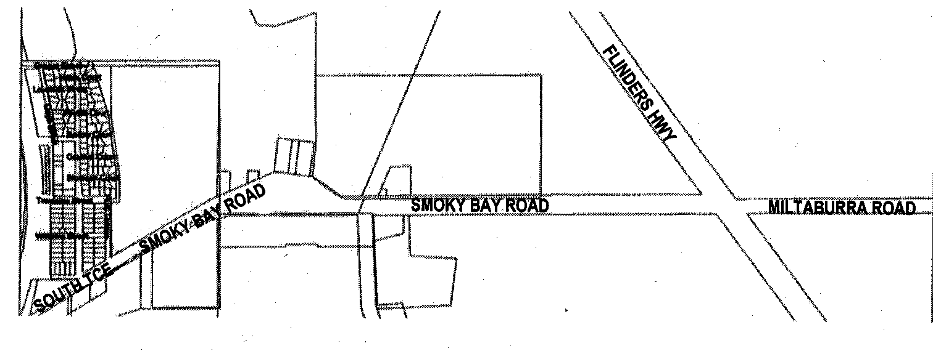
Name: Smoky Bay Road.

A copy of the plan identifying the road location is available at the District Council of Ceduna Office, 44 O’Loughlin Terrace, Ceduna, S.A. 5690.
T. Smart, Deputy Chief Executive Officer

DISTRICT COUNCIL OF LOXTON WAIKERIE
Roads (Opening and Closing) Act 1991
Public Road, Peebinga
NOTICE is hereby given pursuant to section 10 of the Act, that Council proposes to make a Road Process Order to open as road portion of Section 43, Hundred of Peebinga shown numbered ‘1’ on Preliminary Plan No. 02/0094 and to close a portion of public road adjoining Section 43, Hundred of Peebinga, shown marked ‘A’ on Preliminary Plan No. 02/0094.
A copy of the plan and statement of persons affected are available for public inspection at Council’s Office, East Terrace, Loxton and the office of the Surveyor-General, 101 Grenfell Street, Adelaide during normal office hours.
Any application for easement or objections must be made in writing within 28 days from Thursday, 2 November 2006, to the Council, P.O. Box 409, Loxton, S.A. 5333 and the Surveyor-General, G.P.O. Box 1354, Adelaide, S.A. 5001, setting out full details.
Where a submission is made, Council will give notification of a meeting to deal with the matter.
Dated 2 November 2006.
P. Ackland, Chief Executive Officer

DISTRICT COUNCIL OF MOUNT BARKER
Erratum
Assignment of Road Name
IN Government Gazette of 19 October 2006 on page 3759, in the first column, second notice appearing and the fifth paragraph, Blue Wren Lane Road should read Blue Wren Lane.
A. Stuart, Chief Executive Officer

NORTHERN AREAS COUNCIL
Roads (Opening And Closing) Act 1991
Agricultural Airstrip, Gladstone
NOTICE is hereby given, pursuant to section 10 of the Roads (Opening and Closing) Act 1991, that the Northern Areas Council hereby gives notice of its intent to implement a Road Process Order to close and retain the whole of the Public Road (adjacent Hollywood Drive) adjoining Sections 10, 11, 18E and 18W, Hundred of Yangya more particularly delineated and lettered ‘A’ on Preliminary Plan No. 06/0093.
The whole of the closed road lettered ‘A’ is to be subject to a free and unrestricted right of way appurtenant to Section 18E (certificate of title volume 5785, folio 358).
A copy of the plan and a statement of persons affected are available for public inspection at the office of the Council, 14 Fifth Street, Gladstone, S.A. 5473 and the Adelaide office of the Surveyor-General during normal office hours.
Any application for easement or objection must set out the full name, address and details of the submission and must be fully supported by reasons. The application for easement or objection must be made in writing to the Council, P.O. Box 120, Jamestown, S.A. 5491 within 28 days of this notice and a copy must be forwarded to the Surveyor-General, G.P.O. Box 1354, Adelaide, S.A. 5001. Where a submission is made, the Council will give notification of a meeting at which the matter will be considered.
P. McInerney, Chief Executive Officer

IN the matter of the estates of the undermentioned deceased persons:
Atkinson, Ivy, late of 160 Walkerville Terrace, Walkerville, of no occupation, who died on 23 August 2006.
Cufley, Jack Raymond, late of 3 Grant Avenue, Gilles Plains, retired labourer, who died on 3 June 2006.
Daly, Keith, late of 46 Lurline Street, Mile End, of no occupation, who died on 26 January 2006.
Gregory, Jennifer Myra, late of 72 Cambridge Street, Port Noarlunga South, swimming instructor, who died on 6 July 2006.
Hofmeyer, Eileen Augusta, late of 52 Dunrobin Road, Hove, widow, who died on 19 August 2006.
Holyoak, Donald John, late of 50 Davenport Terrace, Richmond, retired motor mechanic, who died on 28 February 2006.
Kirton, Lyrian Jean, late of 14-22 King William Road, Wayville, of no occupation, who died on 27 August 2006.
Kitson, Alfred John, late of 10 Morton Road, Christie Downs, retired plumber, who died on 6 September 2006.
McGregor, Bertha Selina, late of 6 Burnley Street, Henley Beach South, home duties, who died on 25 June 2006.
Millington, Lance Mortimer, late of 36 Aroona Road, West Croydon, retired manufacturing jeweller, who died on 3 September 2006.
Tilley, Dimity Ann Keyes, late of 22 Endeavour Street, Jindalee, Queensland, of no occupation, who died on 7 March 2005.
Notice is hereby given pursuant to the Trustee Act 1936, as amended, the Inheritance (Family Provision) Act 1972, and the Family Relationships Act 1975, that all creditors, beneficiaries, and other persons having claims against the said estates are required to send, in writing, to the Public Trustee, 25 Franklin Street, Adelaide, S.A. 5000, full particulars and proof of such claims, on or before 1 December 2006, otherwise they will be excluded from the distribution of the said estate; and notice is also hereby given that all persons who are indebted to the said estates are required to pay the amount of their debts to the Public Trustee or proceedings will be taken for the recovery thereof; and all persons having any property belonging to the said estates are forthwith to deliver the same to the Public Trustee.
Dated 2 November 2006.
C. J. O’Loughlin, Public Trustee

ATTENTION

CUSTOMERS requiring a proof of their notice for inclusion in the Government Gazette, please note that the onus is on you to inform Government Publishing SA of any subsequent corrections by 10 a.m. on Thursday, which is our publication deadline.

For any corrections to your notice please phone 8207 1045 or Fax 8207 1040 before 10 a.m. on Thursday.

If we do not receive any communication by 10 a.m. on Thursday (day of publication) we will presume the notice is correct and will print it as it is.

Remember—the onus is on you to inform us of any corrections necessary to your notice.

NOTE: Closing time for lodging new copy (electronically, fax or hard copy) is 4 p.m. on Tuesday preceding the day of publication. Phone 8207 1045—Fax 8207 1040.
Email: governmentgazette@saugov.sa.gov.au

Printed and published by authority every Thursday by K. O’CALLAGHAN, Government Printer, South Australia
Price: $5.20, plus postage; to subscribers, $263.00 per annum.
(The above prices are inclusive of GST)

