No. 69 4091

THE SOUTH AUSTRALIAN

GOVERNMENT GAZETTE
www.governmentgazette.sa.gov.au

PUBLISHED BY AUTHORITY

ALL PUBLIC ACTS appearing in this GAZETTE are to be considered official, and obeyed as such

ADELAIDE, THURSDAY, 30 NOVEMBER 2006

CONTENTS

Page
Acts Assented To 4092
Appointments, Resignations, Etc. 4092
Aquaculture (Zones—Cape D’Estrees) Policy
2006—Notices 4156
Corporations and District Councils—Notices 4181
Crown Lands Act 1929—Notices 4092
Development Act 1993—Notice 4092
Environment Protection Authority—Notice 4113
Fisheries Act 1982—Notices 4101
Genetically Modified Crops Management
Act 2004—Notice 4147
Housing Improvement Act 1940—Notices 4102
Liquor Licensing Act 1997—Notices 4104
Mining Act 1971—Notices 4108
Motor Vehicles Act 1959—Notice 4109
National Electricity Law—Notice 4107
Natural Resources Management Act 2004—Notices 4109

Page
Petroleum Act 2000—Notices 4112
Proclamations 4162
Public Trustee Office—Administration of Estates 4206
REGULATIONS
State Procurement Act 2004 (No. 256 of 2006) 4167
Travel Agents Act 1986 (No. 257 of 2006) 4169
State Theatre Company of South Australia Act 1972
(No. 258 of 2006) 4171
Liquor Licensing Act 1997 (No. 259 of 2006) 4178
Roads (Opening and Closing) Act 1991—Notices 4113
Road Traffic Act 1961—Notices 4118
Rules of Court 4133
South Australian Health Commission Act 1976—Notice 4114
Superannuation Act 1988—Notices 4114
Training and Skills Development Act 2003—Notices 4142
Transport, Department of—Notice to Mariners 4107
Water Mains and Sewers—Mains Laid, Replaced, Etc. 4144

GOVERNMENT GAZETTE NOTICES
ALL poundkeepers’ and private advertisements forwarded for publication in the South Australian Government Gazette must be PAID FOR PRIOR TO INSERTION; and all notices, from whatever source, should be legibly written on one side of the paper only and sent to Government Publishing SA so as to be received no later
than 4 p.m. on the Tuesday preceding the day of publication. Phone 8207 1045 or Fax 8207 1040. E-mail: governmentgazette@saugov.sa.gov.au. Send as attachments in Word format and please confirm your transmission with a faxed copy of your document, including the date the notice is to be published and to whom the notice will be charged. The Government Gazette is available online at: www.governmentgazette.sa.gov.au

Department of the Premier and Cabinet
Adelaide, 30 November 2006
Erratum
IN the Government Gazette of Thursday, 23 November 2006 on page 4022, the title of Act numbered 25 should read ‘Development (Development Plans) Amendment Act 2006’ and not ‘Development (Development Panels) Amendment Act 2006’.

Department of the Premier and Cabinet
Adelaide, 30 November 2006
HER Excellency the Governor directs it to be notified for general information that she has in the name and on behalf of Her Majesty The Queen, this day assented to the undermentioned Acts passed by the Legislative Council and House of Assembly in Parliament assembled, viz.:
No. 31 of 2006—Dental Practice (Miscellaneous) Amend-ment Act 2006. An Act to amend the Dental Practice Act 2001 and to make related amendments to the Chiropractic and Osteopathy Practice Act 2005, the Medical Practice Act 2004, the Occupational Therapy Practice Act 2005, the Physiotherapy Practice Act 2005 and the Podiatry Practice Act 2005.
No. 32 of 2006—Child Sex Offenders Registration Act 2006. An Act to establish a register of child sex offenders to prevent registered child sex offenders engaging in child-related work to make a related amendment to the Criminal Law (Sentencing) Act 1988 and for other purposes.
No. 33 of 2006—Evidence (Use of Audio and Audio Visual Links) Amendment Act 2006. An Act to amend the Evidence Act 1929.
By command,
Gail Gago, for Premier
DPC06/0875

Department of the Premier and Cabinet
Adelaide, 30 November 2006
HER Excellency the Governor in Executive Council has been pleased to appoint the undermentioned to the Physiotherapy Board of South Australia, pursuant to the provisions of the Physiotherapy Practice Act 2005:
Member: (from 30 November 2006 until 31 August 2009)
Kerry Jane Peek
By command,
Gail Gago, for Premier
HEACS06/165

Department of the Premier and Cabinet
Adelaide, 30 November 2006
HER Excellency the Governor in Executive Council has been pleased to appoint the Honourable Jay Wilson Weatherill, MP, Minister for Families and Communities, Minister for Aboriginal Affairs and Reconciliation, Minister for Housing, Minister for Ageing, Minister for Disability and Minister Assisting the Premier in Cabinet Business and Public Sector Management to be also Acting Minister for Transport, Acting Minister for Infrastructure and Acting Minister for Energy for the period 3 December 2006 to 8 December 2006 inclusive, during the absence of the Honourable Patrick Frederick Conlon, MP.
By command,
Gail Gago, for Premier
ICT06/002CSPT1

CROWN LANDS ACT 1929: SECTION 5
TAKE NOTICE that pursuant to the Crown Lands Act 1929, I, GAIL GAGO, Minister for Environment and Conservation, Minister of the Crown to whom the administration of the Crown Lands Act 1929 is committed DO HEREBY:
1. Resume the land defined in The First Schedule.
2. Dedicate the Crown Land defined in The Second Schedule as an Emergency Services Reserve and declare that such land shall be under the care, control and management of the Minister for Emergency Services.
The First Schedule
Country Fire Services Reserve, Section 177, Hundred of Coles, County of Robe, the notice of which was published in the Government Gazette of 29 September 1988, at page 1186, being the whole of the land comprised in Crown Record Volume 5616, Folio 515.
The Second Schedule
Allotment 2 of Deposited Plan 71425, Hundred of Coles, County of Robe, exclusive of all necessary roads.
Dated 30 November 2006.
Gail Gago, Minister for Environment and Conservation
DEHAA 09/2002

DEVELOPMENT ACT 1993, SECTION 48: DECISION BY THE DEVELOPMENT ASSESSMENT COMMISSION AS DELEGATE OF THE GOVERNOR
Preamble
1. The decision of the Governor under section 48 of the Development Act 1993, to approve the development of Holdfast Shores Stage 2B development located adjacent to Colley Terrace, Glenelg was published in the Gazette on 19 February 2004.
2. On 8 June 2000 and pursuant to section 48 of the Development Act 1993, the Governor granted a development approval for the Holdfast Shores 2A development, comprising a hotel, car parking, landscaping and associated works, adjacent to Chappell Drive, Glenelg. The development was subject to a Development Report and an Assessment Report, pursuant to section 46 of the Development Act 1993. Amendments to the Holdfast Shores Stage 2A proposal relating primarily to design, car parking, land division, signage issues and Building Rules, were subsequently granted approval by the Development Assessment Commission (as the Governor’s delegate) on 7 December 2000; 1 March 2001; 17 May 2001; 28 February 2002; 3 October 2002; 20 March 2003, and Stage 2B amendments dated 4 March 2004, 15 July 2004 and 26 August 2004.
3. A proposal for the development of the Holdfast Shores 2B proposal at Glenelg, comprising the construction of the Glenelg Surf Life Saving Club, demolition of the existing GSLSC building; the Magic Mountain building and the construction of a rock seawall, an apartment building, and an entertainment and retail precinct, has been considered under Division 2, Part 4 of the Development Act 1993.
4. The Governor was satisfied that an appropriate Amended Development Report and an Amended Assessment Report have been prepared in relation to the development, in accordance with the requirements of Division 2 of Part 4 of the Development Act 1993 and the proposed development was approved on 19 February 2004.
5. The Governor had, in considering the application, regard to all relevant matters under section 48 (5) of the Development Act 1993.
6. A number of amendments have been approved since the original decision date of 19 February 2004. The most recent amendments are contained in the following documents and drawings:
• Correspondence from Tania Lee dated 1 November 2006.
• Retail Building Elevations for the Holdfast Shores Stage 2B Entertainment Precinct (Drawing No. 02 0473 01 AR W388 Rev G) indicating location of signage.
• Various drawings and documents outlining the details of the proposed signage by ‘interior architecture’ dated 10 October 2006.
• Colour images of signage included in correspondence dated 26 October 2006.
7. Application has now been made to the Development Assessment Commission as delegate of the Governor under section 48 of the Development Act 1993, to grant an approval for signage for Tenancies T02/T16, adjacent to Moseley Square and Holdfast Walk.
8. The amendments to the development are contained in the correspondence by Tania Lee dated 1 November and 26 October 2006 and accompanying plans and images.
9. The Development Assessment Commission has in con-sidering the application had regard to all relevant matters under section 48 (5) of the Development Act 1993.
10. The Development Assessment Commission is satisfied that the variation does not require the preparation of a further amended Development Report.
Decision
PURSUANT to section 48 of the Development Act 1993, the Development Assessment Commission as delegate of the Governor, in relation to a proposal submitted by Holdfast Shores Consortium to develop the Holdfast Shores Stage 2B at Glenelg:
(a) grant provisional development authorisation for the Holdfast Shores Stage 2B development at Glenelg, subject to the conditions and notes to the applicant below;
(b) grant development authorisation for Building Rules Certification for the demolition of Magic Mountain and the use of the Police Station building by the Glenelg Surf Life Saving Club;
(c) grant development authorisation for Building Rules Certification for Early Works Package 2B of the development. These apply to bulk excavation, piling, footings, retaining walls, stormwater disposal system, rock seawall extension, base for site paving, car park entry and Hope Street entry, oil pipeline diversion around the basement car park and site utilities infrastructure;
(d) grant development authorisation for Building Rules Certification for Packages 3 and 4 of the development. These apply to early works for the Apartment Building and for the Entertainment and Retail Building, including excavation, piling, retaining walls, columns and in-ground services;
(e) grant development authorisation for Building Rules Certification for Packages 5 and 6 of the development, which applies to the Platinum Apartments Superstructure and parts of the Entertainment Precinct Superstructure, and for the temporary walkway;
(f) grant development authorisation for Building Rules Certification for Package 7 of the development, which applies to the Superstructure for the Entertainment Building and Surf Life Saving Club;
(g) grant provisional development authorisation for the variation relating to an additional underground car park in the Entertainment Building;
(h) grant development authorisation for the variation relating to modifications to the Entertainment Building;
(i) grant development authorisation for the variation relating to a beach observation tower for the Glenelg Surf Life Saving Club;
(j) grant provisional development authorisation for the variation relating to modifications to the Glenelg Town Hall;
(k) grant development authorisation for the amendment No. 4 relating to modifications to the Entertainment Building;
(l) specify all matters relating to this development plan authorisation as matters in respect of which conditions of this authorisation may be varied or revoked, or new conditions attached;
(m) pursuant to section 48 and Regulation 64 (1) of the Development Act 1993, reserve the following matters for further decision-making at a later stage (refer ‘Notes to Applicant’):
(i) further assessment and certification in respect of the Building Rules for components of the proposed development;
(ii) any external advertising signage;
(n) approve the land division application 110/D012/04, lodged on 4 February 2004;
(o) approve the land division application 110/D052/05, lodged electronically with the Development Assessment Commission on EDALA on 22 June 2005;
(p) grant provisional development authorisation for the variation relating to Amendment No. 5—Modifications to the Retail Building. (Windows to the western wall);
(q) grant provisional development authorisation for the variation relating to Amendment No. 6—Revision to retaining walls adjacent Glenelg Town Hall;
(r) grant development authorisation for Building Rules Certification for Building Rules Certificate for Packages 3 and 4 (Platinum Apartments Basement and Enter-tainment Precinct Basement) to reflect modifications to the retaining wall and for Package 7 to reflect the approved modification to the Entertainment Building, (Amendment No. 4);
(s) grant provisional development authorisation for the variation relating to—modifications to Level 3 of the Entertainment Building (Amendment No. 8);
(t) grant provisional development authorisation for the variation relating to—modifications to and signage for the Retail Tenancy T05 on Moseley Square (Amendment No. 9);
(u) approve the land division application 110/C053/05 in plans and associated documents uploaded electronically onto EDALA on 28 April 2006 and 15 May 2006 and a range of associated detailed documentation attached to a letter from Norman Waterhouse to the City of Holdfast Bay dated 11 May 2006;
(v) approve the land division applications 110/C061/05 and 110/C062/05 in plans and associated documents up-loaded electronically onto EDALA on 25 July 2005;
(w) approve the land division application 110/C101/05 in plans and associated documents uploaded electronically onto EDALA on 19 December 2005;
(x) grant provisional development authorisation for the variation relating to modifications to Level 3 and signage for the Entertainment Building (Amendment No. 12);
(y) grant provisional development authorisation for the variation relating to modifications to Retail Tenancy T01 adjacent to Moseley Square (Amendment No. 13);
(z) grant provisional development authorisation for further signage for Retail Tenancy T05 adjacent to Moseley Square (Amendment No. 18);
(aa) grant provisional development authorisation for the variation for façade modifications to Tenancies T02 (adjacent to Moseley Square) and T16 and an outdoor dining area in Holdfast Walk (Amendment No. 7);
(bb) grant provisional development authorisation for the variation for façade modifications to Retail Tenancy T03 adjacent to Moseley Square (Amendment No. 15);
(cc) grant development authorisation for Building Rules Certification for Tenancy T05 adjacent to Moseley Square;
(dd) grant provisional development authorisation for the variation relating to modifications to Retail Tenancy T04 adjacent to Moseley Square (Amendment No. 16);
(ee) grant development authorisation for Building Rules Certification for Tenancy T04 adjacent to Moseley Square;
(ff) grant development authorisation for the deletion of the screens at the southern end of the Platinum Apartments Building;
(gg) grant development authorisation for Building Rules Certification for Tenancy T01, adjacent to Moseley Square;
(hh) grant provisional development authorisation for the façade modification, signage and introduction of a mezzanine floor to Retail Tenancy T06 in Holdfast Walk (Amendment No. 19);
(ii) grant provisional development authorisation for additional signage for Retail Tenancy T03 (Amendment No. 20);
(jj) grant provisional development authorisation for the variation to install two structures (water tower and miners hut) in the Mini-Golf Course (Amendment No. 17);
(kk) grant provisional development authorisation for signage for Tenancy T01, adjacent to Moseley Square. (Amendment No. 21);
(ll) grant development authorisation for Building Rules Certification for Tenancy T06, in Holdfast Walk;
(mm) grant development authorisation for Building Rules Certification for Tenancy T11, in Holdfast Walk; and
(nn) grant provisional development authorisation for signage for Tenancies T02/T16, adjacent to Moseley Square and Holdfast Walk. (Amendment No. 22)
Conditions of Approval
1. Except where minor amendments may be required by other Acts and/or legislation or by conditions imposed herein, the Holdfast Shores 2B development shall be undertaken in strict accordance with:
• The following drawings contained in the Amended Development Report for Holdfast Shores Stage 2B, dated September 2003, except to the extent that they are varied by the plans described in paragraph 1 (b):
• Drawing Titled: ‘Site plan level B2’; Drawing Number: 111.
• Drawing Titled: ‘Site plan level 1’; Drawing Number: 112.
• Drawing Titled: ‘Site plan level 2’; Drawing Number: 113.
• Drawing Titled: ‘Entertainment building basement’; Drawing Number: 114.
• Drawing Titled: ‘Entertainment building level 1’; Drawing Number: 115.
• Drawing Titled: ‘Entertainment building level 2’; Drawing Number: 116.
• Drawing Titled: ‘Entertainment building levels 3 and 4’; Drawing Number: 117.
• Drawing Titled: ‘Entertainment building elevations’; Drawing Number: 118.
• Drawing Titled: ‘Entertainment building elevations’; Drawing Number: 119.
• Drawing Titled: ‘Entertainment building sections’; Drawing Number: 120.
• Drawing Titled: ‘Apartment Plans B2 and B1’; Drawing Number: 121.
• Drawing Titled: ‘Apartment Plans L1, L2, L3-4 and L5’; Drawing Number: 122.
• Drawing Titled: ‘Apartment Plans L6-8 and L9, roof plan’; Drawing Number: 123.
• Drawing Titled: ‘Apartment elevations—north and east’; Drawing Number: 124.
• Drawing Titled: ‘Apartment elevations—west and south’; Drawing Number: 125.
• Drawing Titled: ‘Apartment sections’; Drawing Number: 126.
• Drawing Titled: ‘Land use’; Drawing Number: 127.
• Drawing Titled: ‘Built form’; Drawing Number: 128.
• Drawing Titled: ‘Urban spaces’; Drawing Number: 129.
• Drawing Titled: ‘Open space/vegetation’; Drawing Number: 130.
• Drawing Titled: ‘View corridor’; Drawing Number: 131.
• Drawing Titled: ‘Climate’; Drawing Number: 132.
• Drawing Titled: ‘Microclimate’; Drawing Number: 133.
• Drawing Titled: ‘Links to surrounding areas’; Drawing Number: 134.
• Drawing Titled: ‘Pedestrian movement’; Drawing Number: 135.
• Drawing Titled: ‘Vehicle movement’; Drawing Number: 136.
• Drawing Titled: ‘Concourse study—pedestrian move-ment’; Drawing Number: 137.
• Drawing Titled: ‘Concourse study—vehicle move-ment’; Drawing Number: 138.
• Drawing Titled: ‘Moseley Square study’; Drawing Number: 139.
• Drawing Titled: ‘Town Hall opportunities’; Drawing Number: 140.
• Drawing Titled: ‘Foreshore open space study’; Drawing Number: 141.
• Drawing Titled: ‘Apartment building study’; Plan Number: 142.
• Drawing Titled: ‘Entertainment precinct—east plaza study’; Drawing Number: 143.
• Drawing Titled: ‘Sun diagrams summer’; Drawing Number: 144.
• Drawing Titled: ‘Sun diagrams winter’; Drawing Number: 145.
• Drawing Titled: ‘Landscaping’; Drawing Number: 146.
• Drawing Titled: ‘Construction Stage 1’; Drawing Number: 147.
• Drawing Titled: ‘Construction Stage 2’; Drawing Number: 148.
• Drawing Titled: ‘Construction Stage 3’; Drawing Number: 149.
• Drawing Titled: ‘Construction Stage 4’; Drawing Number: 150.
• The following drawings accompanying the Response by proponent to submissions, 3. City of Holdfast Bay Submission, dated 17 December 2003, as they relate to the proposal for Holdfast Shores Stage 2B, except to the extent that they are varied by the plans as described in paragraph (c):
• Drawing Titled: ‘Sun diagrams summer’; Drawing Number: 144 rev. A.
• Drawing Titled: ‘Sun diagrams winter’; Drawing Number: 145 rev. A.
• Drawing Titled: ‘Entertainment building basement supplementary plan’; Drawing Number: 151 rev. A.
• Drawing Titled: ‘Entertainment building level 1 supplementary plan’; Drawing Number: 152 rev. A.
• Drawing Titled: ‘Entertainment building level 2 supplementary plan’; Drawing Number: 153 rev. A.
• Drawing Titled: ‘Entertainment building levels 3 and 4 supplementary plan’; Drawing Number 154.
• Drawing Titled: ‘Entertainment building levels 3 and 4 supplementary plan’; Drawing Number: 154 rev. A.
• The following drawings accompanying the further information and clarification letter dated 22 January 2004, as they relate to the proposal for Holdfast Shores Stage 2B:
• Drawing Titled: ‘Car park ventilation supplementary plan’; Drawing Number: 155.
• Drawing Titled: ‘Civil stormwater supplementary plan’; Drawing Number: 156.
• Drawing Titled: ‘Civil stormwater supplementary plan’ Drawing Number: 157.
• Drawing Titled: ‘Oil pipeline supplementary plan’; Drawing Number: 158.
• The land division plan lodged with the Development Assessment Commission on 4 February 2004: Application number 110/D012/04.
• The land division plan lodged electronically on EDALA with the Development Assessment Commission on 22 June 2005: Application number 110/D052/054.
• The land division plans lodged electronically on EDALA with the Development Assessment Commission which include an amended final scheme description uploaded on 28 April 2006 and an amended final plan uploaded on 15 May 2006: Application number 110/C053/05.
• The land division plans lodged electronically on EDALA with the Development Assessment Commission on 25 July 2005: Application numbers 110/D061/05 and 110/D062/05.
• The land division plan lodged electronically on EDALA with the Development Assessment Commission on 19 December 2005: Application number 110/C101/05.
• The following documents, except to the extent that they are varied by the plans described in paragraphs (a) and (c):
• Amended Development Report for Stage 2B, Volumes 1 and 2 by the Holdfast Shores Consortium, dated 18 September 2003 (except to the extent that it may be varied by a subsequent document in this paragraph).
• The letter from Woodhead International to Planning SA, titled Response by proponent to submissions, 3. City of Holdfast Bay submission, dated 17 December 2003 (except to the extent that it may be varied by a subsequent document in this paragraph).
• The Amended Assessment Report prepared by the Minister for Aboriginal Affairs and Reconciliation (as delegate Minister for the Minister for Urban Develop-ment and Planning), for the Holdfast Shores 2B development, dated February 2004 (except to the extent that it may be varied by a subsequent document in this paragraph).
• The letter from Woodhead International to Planning SA, titled Further Information and Clarification, dated 22 January 2004.
• The letter from Woodhead International to Planning SA, titled Packages 1 and 2A Building Rules Certification, dated 21 June 2004.
• The letter from Woodhead International to Planning SA, titled Early Works Package 2B Building Rules Certification, dated 15 July 2004.
• The letter from Woodhead International to Planning SA, titled Amendment No. 1 to Provisional Develop-ment Authorisation (reserved matters), dated 1 June 2004.
• The letter from Woodhead International to Planning SA, titled Amendment No. 2 to Provisional Develop-ment Authorisation (reserved matters), dated 17 August 2004.
• The letter from Woodhead International to Planning SA, titled Building Rules Certification for Packages 3 and 4, dated 28 September 2004.
• The letter from Woodhead International to Planning SA, titled Amendment No. 3 to Development Authori-sation—Temporary Walkway, dated 24 January 2005.
• The letter from Woodhead International to Planning SA, Amendment No. 3 to Provisional Development Authorisation, dated 11 January 2005.
• The letter from Woodhead International to Planning SA, titled Packages 5 and 6 Building Rules Certification, dated 4 January 2005.
• The letter from Woodhead International to Planning SA, Amendment No. 2 of Provisional Development Authorisation, dated 27 October 2004.
• Letter from Woodhead International to Planning SA, titled Package 7 Building Rules Certification, dated 6 May 2005.
• Letter from Woodhead International to Planning SA, Holdfast Shores Stage 2B, Glenelg Town Hall Egress, dated 8 March 2005.
• Letter from Alexander Symonds to Planning SA titled Holdfast Shores Stage 2B—Land Division Application 110/D052/05 and 100/C053/05, dated 11 October 2005.
• Letter from Baulderstone Hornibrook Urban Construct Joint Venture, titled Holdfast Shores Stage 2B—Land Division, to Planning SA dated 14 December 2005.
• Letter from Connor Holmes, titled Holdfast Shores Stage 2B—Land Division Application 110/D052/05 and 110/C053/05, to Planning SA dated 6 January 2006.
• Letter from Norman Waterhouse to Planning SA, titled Holdfast Shores Stage 2B—Land Divisions—Glenent Pty Ltd, dated 20 January 2006.
• Letter from Woodhead International to Planning SA, Holdfast Shores Stage 2B, Amendment No. 5 to the Provisional Development Authorisation, dated 2 December 2005.
• Letter from Woodhead International to Planning SA, Holdfast Shores Stage 2B, Amendments to Packages 2B and 7 Building Rules Certification, dated 21 September 2005.
• Letter from Baulderstone Hornibrook to City of Holdfast Bay (copied to Planning SA) Holdfast Shores Stage 2B, excavation of basement, eastern side of Glenelg Town Hall, dated 7 November 2005.
• Letter from Harben Design included with e-mail dated 8 December 2005.
• Letter from QED Pty Ltd, on behalf of Starbucks Australia, dated 10 January 2006.
• Email from QED Pty Ltd, dated 27 January 2006, titled ‘Starbucks—Glenelg—Extra Information’.
• A range of associated detailed documentation (associated with 110/C053/05) attached to a letter from Norman Waterhouse to the City of Holdfast Bay dated 11 May 2006.
• Letter from Harben Design included with an email dated 16 May 2006.
• Facsimile from Harben Design dated 20 June 2006 (advising withdrawal of roof mounted signage).
• Facsimile from Galcon Developments on behalf of Souvlaki Bros dated 29 May 2006.
• Letter from QED Pty Ltd, on behalf of Starbucks Australia dated 2 August 2006.
• Letter from Whitehall Property Development to Planning SA, titled Holdfast Shores Stage 2B—Tenancies T02 and T16, dated 10 November 2005.
• Letter from Whitehall Property Development to Planning SA, titled Holdfast Shores Stage 2B—Tenancies T02 and T16, Re-Amended Planning Submission (Revision A), dated 28 February 2006.
• Letter from Whitehall Property Development to Planning SA, titled Holdfast Shores Stage 2B—Tenancies T02 and T16, Re-Amended Planning Submission (Revision B), dated 11 May 2006.
• Letter from Tania Lee to Planning SA, dated 16 May 2006.
• Letter from Whitehall Property Development to Planning SA, titled Holdfast Shores Stage 2B—Tenancies T02 and T16, Re-Amended Planning Submission (Revision B)—Omission of Canopy, dated 25 July 2006.
• Development Application form from Un Caffe Bar, dated 9 May 2006.
• Email from Un Caffe Bar to Planning SA, dated 22 August 2006.
• Building Rules documentation and accompanying plans from Katnich Dodd Private Certifier dated 7 July 2006 for Tenancy T01.
• Building Rules documentation and accompanying plans from HSA Consultants dated 14 August 2006 for Tenancy T05.
• Correspondence from RHAD on behalf of Nandos dated 17 July, 30 August and 8 September 2006.
• Building Rules documentation and accompanying plans from Katnich Dodd Private Certifier dated 11 September 2006 for Tenancy T04.
• Letter from Woodhead International to Planning SA, titled Platinum Apartments Screen, dated 27 June 2006.
• Building Rules documentation and accompanying plans from Katnich Dodd Private Certifier dated 7 July 2006 and 5 October 2006 for Tenancy T01, adjacent to Moseley Square.
• Correspondence from CARDS dated 22 September and 26 October 2006.
• Development Application form by Evan Drakos seeking approval for additional light box signage, dated 27 September 2006.
• Building Rules documentation and accompanying plans from Tecon Australia dated 10 November 2006.
• Building Rules documentation and accompanying plans from Evans & Brown Building Consultants dated 1 November 2006.
• Correspondence from Tania Lee dated 1 November 2006 and 26 October 2006.
2. A Construction Environmental Management Plan (CEMP) shall be prepared, in consultation with the Environment Protection Authority, Coast Protection Board and the City of Holdfast Bay, to address the management issues during construction. Matters to be addressed in the CEMP must include:
• traffic management during construction, including transport beyond the site;
• control and management of construction noise;
• dust and mud control;
• working hours;
• stormwater and groundwater management during con-struction;
• site security and fencing;
• disposal of building waste and refuse;
• protection and cleaning of roads and pathways;
• site clean-up;
• adherence to all relevant Environment Protection Authority policies and codes of practice for construction sites;
• identification and management of potential and actual acid sulphate soils (should these be encountered); and
• identification and management of contaminated soils and groundwater (should these be encountered).
3. The applicant shall submit further information and appli-cation(s) in relation to the matters that have been reserved for further decision-making by the Governor (or her delegate).
4. No building works shall commence on subsequent stages of the development until a decision has been made by the Governor (or her delegate), involving matters relating to the Building Rules assessment and certification requirements and any other reserved matters that are subject to further development application.
5. No works shall commence unless, and until, legal rights to develop the Magic Mountain site have been secured.
6. The car parking areas shall be designed in accordance with Australian Standards 2890 1-1993 and line markings shall be maintained in good and substantial condition at all times.
7. Access for service deliveries and waste disposal vehicles at the Holdfast Promenade shall only be allowed between 7 a.m. and 10 a.m. daily.
8. Stormwater from the Holdfast Shores Stage 2B site shall not be disposed of by way of a pipe or similar structure that conveys the stormwater to the beach.
9. Site works, construction work and truck movements to and from the site shall only be carried out between 7 a.m. and 6 p.m., Monday to Saturday, inclusive.
10. Pedestrian access ways, from Moseley Square to the Entertainment Plaza and from Hope Street through the ‘air lock’, shall remain open to the public at all times.
11. Landscaping shall be provided in accordance with the authorised plans and shall be maintained and nurtured, with any diseased or dying plants being replaced.
12. The waste storage and service area at the rear of the buildings shall be kept in a neat, tidy and healthy condition at all times and the service area access door shall remain closed at all times, other than when loading or unloading is taking place.
13. Machinery, plant operating equipment, lighting or sound devices shall not impair or impinge upon the enjoyment of adjoining properties or occupiers thereof.
14. All drainage, finished floor levels, and public works associated with the development, including the disposal of stormwater, shall be carried out in accordance with accepted engineering standards and to the reasonable satisfaction of the City of Holdfast Bay.
15. The period of time for which the building (the Police Station building) shall be used as clubrooms shall be 18 months from the date of Development Authorisation of 15 July 2004, after which period the building shall be vacated.
16. The clubrooms (in the Police Station building) will not be used as a nightclub or discotheque or the like.
17. The door to the accessible male toilet (in the Police Station building) shall be handed to provide latch side clearance in accordance with Fig. 12 of AS1428.1. BCA-Part D3.2.
18. The levels of any openings to the basement car park, including ventilation outlets, inlets and the like shall be in accord with those previously proposed in section 4.1Q of the Amended Development Report for Stage 2B dated 18 September 2003.
19. The fit-out of the public toilets shall be to the reasonable satisfaction of the City of Holdfast Bay.
20. Service plant/machinery associated with the Entertainment Building shall be appropriately concealed from public view.
21. The proposed transformer located on the southern elevation of the Entertainment Building shall be appropriately screened to minimise its visual impact on the public realm.
22. The applicant shall place outdoor showers along the back of the beach to the reasonable satisfaction of the City of Holdfast Bay.
23. The southern most waterslide shall not project over the walkway space located between the Town Hall and Entertainment Building and in any event, should not be located within 5 m of the Town Hall.
24. The modifications to the Glenelg Town Hall access shall be executed with minimum intervention to the historic fabric of the building.
25. The encumbrance dated 16 February 2006, shall be registered on the five Torrens titles, facing Moseley Square as soon as practicable after the land division No. 110/D052/05 is implemented.
26. The financial requirements of the SA Water Corporation shall be met for the provision of water supply and sewerage services, for land division application Nos 110/D052/05, 110/C053/05, 110/C061/05 110/C062/05 and 110/C101/05. (SA Water 90097/04 Water/Sewer).
27. The necessary easements shall be granted to the SA Water Corporation free of cost for land division application Nos 110/D052/05, 110/C053/05 and 110/C101/05.
28. Two copies of a certified survey plan shall be lodged for Certificate purposes for land division application Nos 110/D052/05, 110/C053/05, 110/C061/05, 110/C062/05 and 110/C101/05.
29. Vibration during construction is an issue which shall be addressed within a Construction Environmental Plan. A before and after dilapidation study of the former Glenelg Town Hall shall be prepared to note new cracking and other damage. The Plan shall also provide a maximum vibration reading during use of machinery, pile driving or other construction activities. Regular monitoring of the building shall be undertaken while work proceeds. (Note: a copy of this information shall be provided to Heritage SA.).
30. Heritage SA shall be consulted prior to any further develop-ment changes relating to building rules approval, for modifications to the retaining wall adjacent Glenelg Town Hall.
31. The proposed bi-fold doors and windows at the southern elevation of Retail Tenancies T05, T01, T02 and T03 shall be secured completely within the confines of the tenancy and not encroach onto the Council footpath/Moseley Square, when operated.
32. The signage for Retail Tenancy T05, T03, T04, T06 and T01 and the Entertainment Building, (including its structure and adver-tising material thereon) shall be maintained in good condition.
33. The signage for Retail Tenancy T05, T03, T04, T06 and T01 and the Entertainment Building shall not be of a light intensity as to cause light overspill, which results in unreasonable nuisance to adjoining land and buildings.
34. No roller doors or grilles shall be installed on the southern or eastern elevations of Tenancy T03.
35. Tenancies T02 and T16 shall not serve food between the hours of 2 a.m. and 8 a.m. of each day.
36. The applicant for Tenancies T02 and T16 shall ensure at all times that outdoor dining furniture remains within the areas defined on the submitted plans and does not obstruct Holdfast Walk/any public footway.
37. The applicant for Tenancies T02 and T16 shall ensure that at no time the number of persons consuming food or drink within the defined outdoor dining area exceed the number of seats specified on the submitted plans.
38. The applicant for Tenancies T02 and T16 shall at all times keep the boundaries of the defined outdoor dining area clearly marked in a manner satisfactory to the Governor or delegate.
39. The applicant for Tenancies T02 and T16 shall at all times keep the defined outdoor dining area and all approved furniture and equipment thereon clean and free from litter and waste materials and shall ensure that no waste material is swept or placed into the water table.
40. The applicant for Tenancies T02 and T16 shall remove all furniture from the defined outdoor dining area at the close of business on each day and if any such furniture and equipment remains in the outdoor dining area during the hours of darkness, it and all other obstructions must be illuminated to ensure adequate visibility to pedestrians.
41. The applicant for Tenancies T02 and T16 shall incorporate a self-closing mechanism into the design of the western side of the balcony (over Moseley Square) and ensure that is locked at all times (apart from when equipment is being shifted) to minimise risk to public/patron safety.
42. Disabled access, facilities and features for Tenancy T05 must be installed in accordance with AS1428.1.
43. Emergency lighting and exit signs for Tenancy T05 must be installed in accordance with AS2293.
44. Portable fire extinguishers for Tenancy T05 must be installed adjacent to hazard areas.
45. Services alterations for Tenancy T05 must be carried out in accordance with the applicable Australian Standards.
46. The door at the ground level serving as the required exit for Tenancy T04 shall be provided with a device required for holding the door in the open position BCA-D2.20.
47. Portable fire extinguishers for Tenancy T04 shall be selected and located in accordance with the requirements of Part E1.6 of the BCA and AS2444, BCA-E1.6.
48. The stair serving the upper level for Tenancy T04 shall be constructed in accordance with the requirements of AS1428.1—Design for access and mobility and be provided with the following:
• Handrails to both sides and extending one tread width plus 300 mm past the ends of the stair in accordance with BCA-D3.3 and Clause 9.2, AS1428.1.
• Stair tread nosings not less than 50 mm and not greater than 75 mm in a colour contrasting with the background and risers of opaque construction in accordance with BCA-D3.3 and AS1428.1, Clause 9.1.
• Tactile ground surface indicators in accordance with AS1428.4 to warn people with a vision impairment that they are approaching the public stair in accordance with BCA Clause D3.8.
• Braille and tactile signage required to identify the accessible features in accordance with BCA Clause D3.6-CA-Part D3.
49. The method of ventilating all rooms and spaces for Tenancy T04 and providing sufficient fresh air quality and quantity shall be in accordance with the minimum requirements of AS1668.2-BCA-F4.
50. The kitchen canopy and flue, including hood design and material thicknesses for Tenancy T04 shall be selected and installed in accordance with the requirements of AS1668 and have its flue discharge not less than 6 m from fresh air intakes—
BCA-F4.12.
51. The door opening, latch device and alarm system for the refrigerated/cooling chamber for Tenancy T04 shall be provided in accordance with BCA Clause G1.2, BCA-G1.2.
52. The first floor of Tenancy T01 is excluded from this decision and shall not be occupied (section 67 of the Development Act).
53. The kitchen exhaust flue for Tenancy T01 shall not protrude more than 1 m above the roof line.
54. The mezzanine floor of Tenancy T06 shall not be accessed by the public at any time.
55. The proposed bi-fold windows for Tenancy T06, shall be secured completely within the confines of the Tenancy and not encroach onto Holdfast Walk.
56. An emergency light complying with AS2293.1 shall be installed over the stair to the mezzanine in Tenancy T06.
57. The wet areas shall comply with AS3740 and the Minister’s Specification SA Fl.7. for Tenancy T11.
58. The owner of Tenancy T11 shall maintain the essential safety provisions in accordance with the Schedule of Essential Safety Provisions.
Notes on Building Rules Certification (for demolition of Magic Mountain and use of the Police Station Building by GSLSC)
The Early Fire Hazard Indices of wall, floor and ceiling linings, and air-handling ductwork shall comply with Clause C1.10 of the BCA.
Notes on Building Rules Certification (for the Platinum Apart-ments Basement and Entertainment Precinct Basement)
The application does not include the superstructure works which shall be the subject of a separate application.
This consent is issued on the understanding that the proprietary type materials and products as specified either on the architectural plans or specifications are to be selected and installed in accordance with the manufacturers’ recommendations and relevant standards.
Fire precautions must be taken during construction in accordance with BCA-E1.9. The builder must also ensure, once the method of construction has been determined, that the design of the building/structure adequately accommodates the anticipated construction activity actions.
The person proposing to undertake building work on land (or who is in charge of such work) is warned of their obligation to give Council notice at stages prescribed in Regulation 74.
Notes on Building Rules Certification (for the Platinum Apart-ments Superstructure and parts of the Entertainment Precinct Superstructure)
This application does not include the Entertainment Building superstructure which shall be the subject of a separate application.
The certified drawings/documents will be issued by the Council with the notification of development approval.
The drawings are stamped ‘Preliminary’. Future changes may require separate approval.
The propriety type materials and products as specified either on the architectural plans or specification are to be selected and installed in accordance with the manufacturers’ recommendation and relevant standards.
Fire precautions must be taken during construction in accordance with BCA-E1.9. The builder must ensure once the method of construction has been determined, that the design of the building/structure adequately accommodates the anticipated construction activity actions.
The person proposing to undertake building work on land (or who is in charge of such work) is warned of their obligation to give the Council notice at stages prescribed in Regulation 74.
Notes on Building Rules Certification (for the Entertainment Building Superstructure and Surf Life Saving Club)
The certified drawings/documents will be issued by the Council with the notification of development approval.
The proprietary type materials and products as specified either on the architectural plans or specifications are to be selected and installed in accordance with the manufacturers’ recommendations and relevant standards.
Fire precautions must be taken during construction in accordance with BCA-E1.9. The builder must also ensure, once the method of construction has been determined, that the design of the building/structure adequately accommodates the anticipated construction activity actions.
The person proposing to undertake building work on land (or who is in charge of such work) is warned of their obligation to give the Council notice at stages prescribed in Regulation 74.
SCHEDULE OF ESSENTIAL SAFETY PROVISIONS: Regulation 76 requires that the relevant authority on granting provisional building rules consent, issue a schedule that specifies the essential safety provisions for the building and the standards or requirements for the maintenance and testing in respect of each of those essential safety provisions set out in Minister’s Specification SA 76. The items to be inspected or tested will be detailed on a Schedule attached to the Building Rules Consent for the super-structures.
For building work prescribed in Regulation 75, the building owner must, at least 28 days before the building work is commenced cause to be served on the owner of the affected land or premises a notice of intention to perform the building work and the nature of that work as required by section 60.
Pursuant to section 53A of the Development Act 1993, the relevant authority must form an opinion as to whether the existing building is unsafe or structurally unsound. It is considered that although there are/may be items or matters that are not in strict conformity with the Building Rules, or other matters of non-compliance that cannot be identified from the information supplied by the applicant, that the proposed upgrading measures will render the building safe.
Wet areas details including floor grades, set-downs and impervious surfaces shall comply with Minister’s Specification SA F1.7 including provision of drainage flanges.
Existing glass in doors, side panels and other human impact areas shall be assessed by the glazier for compliance with section 5 of AS 1288-1994 Glass in Buildings. The applicant is advised that to comply with the Occupational Health, Safety and Welfare Act 1986, any glass that does not meet current requirements should be replaced.
IMPORTANT: The Building Rules Certification does not imply compliance with the Electricity Act 1996, (building within prescribed distances of adjacent power lines) or Occupational Health, Safety and Welfare Act 1986, the (State) Equal Opportunity Act 1984, or with the Commonwealth Disability Discrimination Act as amended or any of the regulations under those Acts. It is the responsibility of the owner and the person erecting the building to ensure compliance with same.
Proof of maintenance must be provided to Council each calendar year by the building owner.
CERTIFICATE OF OCCUPANCY: A new Certificate of Occupancy is required to be issued in relation to the proposed development. Katnich Dodd, will before granting a certificate of occupancy, require:
1. A Statement of Compliance from the licensed building work contractor who carried out the relevant work or who was in charge of carrying out the relevant work or if there is no such licensed building work contractor—from a registered building work supervisor or private certifier all in accordance with the pro forma attached to the building rules consent for Packages 5 and 6 which must also be signed by the owner of the relevant land, or by someone acting on his or her behalf.
2. A certificate of compliance for each essential provision, in the appropriate form under Schedule 16, signed by the installer of the safety provision, or where the installer is a company, signed by the manager responsible for the installation work.
3. Where a building is required by the Building Rules to be equipped with a booster assembly for use by fire-fighters or to have installed a fire alarm that transmits a signal to a fire station and facilities for fire detection, fire-fighting or the control of smoke must be installed in the building pursuant to an approval under the Act, the ‘wet’ and/or ‘dry’ report(s) from the fire authority as to whether those facilities have been installed and operate satisfactorily.
Storey | Portion | Classification | Area  m² | Max.  Occupants
Basement | All | 7a | — | —
Level 01  (Ground) | Tenancies  Entertainment  Boat store  Gymnasium | 5 and 6  (dual classification)  9b  7b  9b | —  — | —  900 persons  —
Level 02  (First) | Tenancies  Games  Functions | 5 and 6  (dual classification)  9b  9b | —  660  390 | —  660 persons  390 persons
Level 03  (Second) | Conference  Centre | 9b | 300 | 240 persons
Level 04  (Third) | Offices | 5 | 175 | 18 persons
Level 05  (Fourth) | Waterslide  Deck | 9b | 175 | 175 persons

For building work prescribed in Regulation 75, the building owner, must, at least 28 days before the building work is commenced cause to be served on the owner of the affected land or premises a notice of intention to perform the building work and the nature of that work, as required by section 60.
Pursuant to the Local Government Act 1999, the builder may be required to erect and maintain hoardings and platforms for the protection of the public on adjoining streets and footpaths as directed by the City of Holdfast Bay.
Wet area details including floor grades, set downs, and water resistant surfaces shall comply with Minister’s Specification SA F1.7-2004 and AS3740 Waterproofing of wet areas within residential buildings including provision of drainage flanges.
A person must not fill the pool with water unless the pool is enclosed by a fence that complies with Part 3.9.3 of the BCA.
IMPORTANT: The Building Rules Certification for Packages 5, 6 and 7 is for compliance with the Development Act 1993 and does not imply compliance with the Swimming Pools (Safety) Act 1972, as amended, or any of the regulations under this Act. It is the responsibility of the owner and the person erecting the building/structure to ensure compliance with same.
Notes to Applicant:
• A decision on the reserved matters relating to Building Rules assessment and certification requirements for further stages will only be made by the Governor (or her delegate) after a Building Rules assessment and certification has been under-taken and issued by the City of Holdfast Bay, or a private certifier, as required by the Development Act 1993 and after the Minister for Urban Development and Planning receives a copy of all relevant certification documentation, as outlined in Regulation 64 of the Development Regulations 1993.
• If the Building Rules assessment process demonstrates that the Holdfast Shores Stage 2B development complies with the Building Rules pursuant to the Development Act 1993 and Development Regulations 1993, the City of Holdfast Bay, or a private certifier conducting the Building Rules assessment, must:
(a) provide to the Minister the certification in the form set out in Schedule 12A of the Development Regulations 1993; and
(b) to the extent that may be relevant and appropriate:
(i) issue a schedule of essential safety provisions under Division 4 of Part 12;
(ii) assign a classification of the building under these regulations; and
(iii) ensure that the appropriate levy has been paid under the Construction Industry Training Fund 1993.
Regulation 64 of the Development Regulations 1993, provides further information about the type and quantity of all building certification documentation required for referral to the Minister:
• The City of Holdfast Bay, or a private certifier undertaking the Building Rules assessment and certification for the Holdfast Shores Stage 2B development, must ensure that any assessment and certification is consistent with this provisional development authorisation (including any conditions or notes that apply in relation to this provisional development authorisation).
• Should the applicant wish to vary the application or the staging of any reserved matters, as outlined in this provisional development authorisation, a variation to the application may be submitted, pursuant to section 48B of the Development Act 1993, provided that the development application variation remains within the ambit of the Amended Development Report and Amendment Assess-ment Report referred to in this provisional development authorisation.
• The applicant is advised of the requirement to comply with the Environment Protection Authority’s (EPA) ‘Stormwater Pollution Prevention Code of Practice for the Building and Construction Industry’ during demolition and construction of the development.
• Noise emissions from the Holdfast Shores Stage 2B development will be subject to the Environment Protection (Industrial Noise) Policy 1994 and the Environment Protection Authority (EPA) Guidelines and the Environ-ment Protection Act 1993.
• Prior to any construction, the applicant should consult with Adelaide Airport Ltd, about crane operations.
• The Heritage Branch of the Department for Environment and Heritage, should be consulted if there is to be any physical intervention to the structures on the adjacent State Heritage place (Glenelg Town Hall). Any such work must be executed in accordance with advice arising from such consultation.
• The proponent is reminded of the General Environmental Duty under section 25 of the Environment Protection Act 1993, which requires that a person must not undertake any activity, which pollutes, or may pollute, without taking all reasonable and practical measures to prevent or minimise harm to the environment.
• If the Holdfast Shores 2B development is not substantially commenced within two years of the date of any reserved matter decisions, the Governor may cancel this provisional development authorisation and any subsequent decisions on reserved matters (where relevant).
• The Minister has a specific power to require testing, monitoring and auditing under section 48C of the Develop-ment Act 1993.
• Final details on the size and construction of the beach tower and confirmation that ownership and maintenance is to be by the Surf Life Saving Club to be provided to the satisfaction of the City of Holdfast Bay.
• The precise location of the beach tower needs to allow for future volleyball courts and be to the satisfaction of Council’s Holdfast Shores Stage 2B Project Board Steering Committee.
• Visually attractive options, such as the incorporation of public art, should be considered for the screening of the proposed transformer located on the southern elevation of the Entertainment Building.
• Further details shall be provided to the City of Holdfast Bay regarding the waterslides and their support structures to ensure that:
(a) the proposed support structures do not dominate the built form and western and south-western face of the Entertainment Building; and
(b) adequate visual permeability is retained between the waterslide tubes.
• All land division documentation, including easement plans should be forwarded to Council for execution under the Real Property Act 1886.
• Variation No. 5 to the Retail Tenancy will be subject to meeting the requirements of the Building Code of Australia, particularly in terms of fire safety.
• External advertising and proposed colour schemes of the buildings adjacent to the former Town Hall shall be the subject of a separate approval.
• Applicants for Retail Tenancies which sell food and beverages (including the applicants for Retail Tenancies T05, T01, T02/T16, T03 and T04) are required to lodge a formal application for the internal fitout with Council’s Environmental Health Unit for assessment against the Food Act 2001 and Environmental Health Act 1987.
• Applicants for Retail Tenancies which incorporate outdoor dining areas (including the applicants for Retail Tenancies T05, T01, T02/T16, T03 and T04) are required to lodge a separate application for an Outdoor Dining Permit with Council for any proposed Outdoor Dining areas. (NB: this will be assessed in accordance with Council’s adopted Moseley Square Outdoor Dining Guidelines).
• Following completion of the retail buildings and associated balconies that encroach over Moseley Square, an Encroach-ment Permit and invoice for the annual encroachment fee will be forwarded to the building owner/s by Council. (NB: the annual fee is based on a valuation of the size of the encroachment and its use).
• The applicants for Retail Tenancy T01 and Tenancies T02 and T16 are required to lodge a separate Development Application for any external signage proposed on the buildings.
• The applicants for Retail Tenancies T02/T16 and T03 are advised that the proposed location of their service counters, directly adjacent to Moseley Square, may impact on the extent of outdoor dining that may be approved by Council in this location for these tenancies, due to a need to widen the pedestrian clearway to accommodate any queuing/ gathering of patrons at this service counter.
Notes that specifically apply to the applicant for Tenancies T02 and T16
That consideration is given to implementation of the following advice for the outdoor dining area in Holdfast Walk as recom-mended by the City of Holdfast Bay:
• The applicant at all times should ensure that:
• all food and drinks supplied in the defined outdoor dining area is served by waiters and/or waitresses to only such persons as are seated at tables in the dining area;
• all patrons purchasing take-away food and/or liquor are requested to inform the applicant as to whether or not they wish to consume the food and liquor in the defined outdoor dining area;
• all patrons who consume food and/or liquor at the tables in the defined outdoor dining area without crockery and cutlery are to be asked to leave immediately;
• if patrons purchasing take-away food and/or liquor wish to consume the same within the defined outdoor dining area they must do so at the tables provided therein using crockery and cutlery supplied by the applicant;
• crockery, cutlery and glassware is laid out at all tables for patrons who wish to consume food and/or liquor in the defined outdoor dining area only after a meal has been ordered by those patrons and that such cutlery, crockery and glassware is removed immediately upon the departure of those patrons; and
• an approved windproof ashtray must be present on the table whenever someone is smoking at that table.
• The applicant shall prepare in the adjoining premises all meals, food and liquid refreshments supplied at tables in the defined outdoor dining area.
• The applicant shall use mobile containers only for the purpose of conveying food, drink and tableware to and from the defined outdoor dining area and the adjoining premises and shall not permit the same to remain unattended in the defined outdoor dining area.
• The applicant shall at its cost in all things comply in all respects with the provisions of all Acts of Parliament, Regulations, Rules and By-laws for the time being in force and all notices, orders, requirements or directions which may be made or given by the Council or any other competent authority in respect of the same and, in particular and without limiting the generality of the foregoing, comply in all respects with the provisions of the Public and Environmental Health Act 1987, the Food Act 1985 and, if/when applicable, the Liquor Licensing Act 1985.
Notes that specifically apply to the applicant for Tenancy T04
• This consent does not include the external signage which shall be the subject of a separate application.
• This consent is issued on the understanding that the proprietary type materials and products as specified either on the architectural plans or specification are to be selected and installed in accordance with the manufacturers recom-mendations and relevant standards.
• The existing method of recording the maintenance of essential safety items shall be updated and extended as necessary to incorporate the following amended fire safety items and equipment:
• Fire Hazard Properties.
• Egress.
• Portable Fire Extinguishers.
• Internally Illuminated Exit Signs and Emergency Lighting.
• The Early Fire Hazard Indices of wall, floor and ceiling linings, and air-handling ductwork shall comply with Clause C1.10 of the BCA.
• The person proposing to undertake building work on land (or who is in charge of such work) is warned of their obligation to give the Council notice at stages prescribed in Regulation 74.
• SCHEDULE OF ESSENTIAL SAFETY PROVISIONS: Regulation 76 requires that the relevant authority on granting provisional rules consent, issue a schedule that specifies the essential safety provisions for the building and the standards or requirements for the maintenance and testing in respect each of those essential safety provisions set out in Minister’s Specification SA 76. The items to be inspected or tested are detailed on the attached schedule.
• Proof of maintenance must be provided to Council each calendar year by the building owner.
• CERTIFICATE OF OCCUPANCY: A new Certificate of Occupancy is required to be issued in relation to the proposed development. Katnich Dodd will, before granting a certificate of occupancy, require:
1. A Statement of Compliance from the licensed building work contractor who carried out the relevant work or who was in charge of carrying out the relevant work; or if there is no such licensed building work contractor—from a registered building work supervisor or private certifier all in accordance with the attached pro-forma, which must also be signed by the owner of the relevant land, or by someone acting on his or her behalf; and
2. A certificate of compliance for each essential safety provision, in the appropriate form under Schedule 16, signed by the installer of the safety provision, or where the installer is a company, signed by the manager responsible for the installation work; and
• PLEASE ENSURE THAT THESE FORMS ARE PASSED ON TO THE BUILDER.
• The certificate of occupancy will prescribe the following maximum number of occupants:
Portion | Classification | Persons
Nandos | 6 | 135
• Wet area details including floor grades, set-downs and impervious surfaces shall comply with Minister’s Specification SA F1.7; including provision of drainage flanges.
• Existing glass in doors, side panels and other human impact areas shall be assessed by the glazier for compliance with section 5 of AS1288-2005 Glass in Buildings. The applicant is advised that to comply with the Occupational Health, Welfare and Safety Act 1986, any glass that does not meet the current requirements should be replaced.
• IMPORTANT: This report does not imply compliance with the Electricity Act 1996, as amended, (building within pre-scribed distances of adjacent power lines), the Occupational Health, Safety and Welfare Act 1986, the (State) Equal Opportunity Act 1984, or with the Commonwealth Disability Discrimination Act 1993, as amended, or with any of the regulations under those Acts. It is the responsibility of the owner and the person erecting the building to ensure compliance with same.
Notes that specifically apply to the applicant for Tenancy T01
• This consent does not include the first floor which shall be the subject of a separate application.
• The certified drawings/documents will be issued by the Council with the notification of development approval.
• The proprietary type materials and products as specified either on the architectural plans or specification are to be selected and installed in accordance with the manufacturers recommendations and relevant standards.
• The Early Fire Hazard Indices of wall, floor and ceiling linings and air-handling ductwork shall comply with Clause C1.10 of the BCA.
• The person proposing to undertake building work on land (or who is in charge of such work) is warned of their obligation to give the Council notice at stages prescribed in Regulation 74.
• SCHEDULE OF ESSENTIAL SAFETY PROVISIONS—FORM 2: The attached Form 2 of Schedule 16 of the
Development Regulations shall be completed and signed by the contractor responsible for the installation or alteration of the particular item(s). The attached Statement of Compliance shall be completed by the builder and passed on, together with the completed Form(s) 2, to Council or Katnich Dodd at the completion of the work.
• Wet area details including floor grades, set-downs and water resistant surfaces shall comply with Minister’s Specification SA F1.7-2004 and AS3740 waterproofing of wet areas within residential buildings; including provision of drainage flanges.
• IMPORTANT: This report does not imply compliance with the Occupational Health, Safety and Welfare Act 1986, the (State) Equal Opportunity Act 1984, or with the Common-wealth Disability Discrimination Act 1993, as amended, or with any of the regulations under those Acts. It is the responsibility of the owner and the person erecting the building to ensure compliance with same.
Notes that specifically apply to the applicant for Tenancy T06
• Pursuant to Regulation 74 of the Development Regulations 1993 the applicant or builder proposing to undertake the development is advised of their obligation to give the Council one days notice of the commencement and completion of the development and at the stages notified by Council with the Development Approval. The notice of commencement shall include the names of the persons who will be signing the Statement of Compliance required by Regulation 83AB (8) of the Development Regulations 1993.
• The Certifier has formed the opinion that the building is not unsafe, structurally unsound and that access for people with disabilities has been considered as required by section 53A of the Development Act 1993.
• The stormwater disposal system must not allow the entry of water into any building or on to the land of any adjoining owner without their prior consent.
• This report based on the Building Rules Assessment only and does not suggest or infer compliance with any other legislation.
• A Schedule of Essential Safety Provisions Form 1, as required by Regulation 76 of the Development Regulations 1993, has been attached to the consent. The items to be inspected or tested are detailed in this Schedule.
• A certificate of occupation will not be required for this new work.
• A Schedule of Essential Safety Provisions Form 2 and a pro forma Builder’s Statement of Compliance have been attached to the consent. These forms shall be completed by the builder returned to Tecon Australia at the completion of the development.
• The existing method of recording the maintenance of the essential safety provisions shall be amended as necessary to include the alterations to the fire and life safety items.
Dated 30 November 2006.
R. Barua, Secretary, Development Assessment Commission

FISHERIES ACT 1982: SECTION 59
TAKE notice that pursuant to section 59 of the Fisheries Act 1982, Deborah Bower, of the University of Canberra, 2 Phillips Road, Berri, S.A. 5343 (the ‘exemption holder’) or a person acting as her agent is exempt from the Fisheries Act 1982, but only insofar as they may engage in the use of restricted gear in the River Murray system while attempting to research broad-shelled turtles (the ‘exempted activity’), subject to the conditions set out in Schedule 2, from 16 November 2006 until 1 November 2007, unless varied or revoked earlier.
Schedule 1
• Seine nets
• Fyke nets
• Gill nets (not to be installed)
• Cathedral traps (modified crab pots)
• Crab pots
Schedule 2
1. All native fish species collected during the exemption activity must be immediately returned to the water. Non-native species must not be released into the water alive.
2. The exemption holder must notify PIRSA Fisheries on 1800 065 522 at least two hours prior to conducting the exempted activity and answer a series of questions about the exempted activity. The exemption holder will need to have a copy of the exemption notice at the time of making the call and be able to provide information about the area and time of the exempted activity, the vehicles and boats involved, the number of agents undertaking the exempted activity and other related questions. Exemption No. 9901935.
3. While engaged in the exempted activity, the exemption holders must be in possession of a copy of this notice. Such notice must be produced to a PIRSA Fisheries Compliance Officer if requested.
4. The exemption holders must not contravene or fail to comply with the Fisheries Act 1982, or any regulations made under that Act, except where specifically exempted by this notice.
Dated 10 November 2006.
W. Zacharin, Director of Fisheries

FISHERIES ACT 1982: SECTION 43
TAKE note that the notice made under section 43 of the Fisheries Act 1982, published in the South Australian Government Gazette on page number 3958, dated 17 November 2005, being the third notice on that page, referring to the Spencer Gulf Prawn Fishery, is hereby varied such that it will be unlawful for a person fishing pursuant to a Spencer Gulf Prawn Fishery Licence to use prawn trawl nets in the closed areas specified in Schedule 1 during the period specified in Schedule 2.
Schedule 1
1. The waters of the Spencer Gulf Prawn Fishery that are north of the line commencing at position latitude 33°34.00′S, longitude 137°14.00′E, then to position latitude 33°34.00′S, longitude 137°31.00′E, then to position latitude 33°29.00′S, longitude 137°31.00′E, then to position latitude 33°29.00′S, longitude 137°34.00′E, then to position latitude 33°38.00′S, longitude 137°34.00′E, then to position latitude 33°46.00′S, longitude 137°44.00′E.
2. The waters of the Spencer Gulf Prawn Fishery that are within the area commencing at position latitude 33°41.00′S, longitude 137°06.00′E, then to position latitude 33°52.10′S, longitude 137°15.80′E, then to position latitude 33°53.50′S, longitude 137°12.00′E, then to position latitude 33°58.00′S, longitude 137°15.00′E, then to position latitude 34°13.00′S, longitude 137°00.00′E, then to position latitude 34°13.00′S, longitude 136°52.00′E, then to position latitude 33°17.00′S, longitude 136°52.00′E, then to position latitude 34°17.00′S, longitude 137°00.00′E, then to position latitude 34°29.00′S, longitude 136°57.00′E, then to position latitude 34°29.00′S, longitude 136°05.00′E.
3. The waters of the Spencer Gulf Prawn Fishery that are within the area commencing at position latitude 34°19.00′S, longitude 137°30.00′E, then to position latitude 34°19.00′S, longitude 137°20.00′E, then to position latitude 34°23.00′S, longitude 137°15.00′E, then to position latitude 34°54.00′S, longitude 137°15.00′E.
Schedule 2
From 2030 hours on 23 November 2006 to 0600 hours on 29 November 2006.
Dated 23 November 2006.
M. Smallridge, General Manager, Fisheries Policy

HOUSING IMPROVEMENT ACT 1940
WHEREAS by notice published in the Government Gazette on the dates mentioned in the following table the South Australian Housing Trust did declare the houses described in the said table to be substandard for the purposes of Part 7 of the Housing Improvement Act 1940, the South Australian Housing Trust in the exercise of the powers conferred by the said Part, does hereby fix as the maximum rental per week which shall be payable subject to section 55 of the Residential Tenancies Act 1995, in respect of each house described in the following table the amount shown in the said table opposite the description of such house and this notice shall come into force on the date of this publication in the Gazette.
Address of House | Allotment, Section, etc. | Certificate of Title  Volume Folio | Date and page of Government Gazette in which notice declaring house to be substandard published | Maximum rental per week payable in respect of each house  $

17 Gray Court, Adelaide |  | Allotment 462 in Filed Plan 182924, Hundred of Adelaide | 5707 | 746 |  | 12.12.68, page 2639 | 59.00
293-295 Waymouth Street, Adelaide |  | Allotment 413 in Filed Plan 181255, Hundred of Adelaide | 5789 | 894 |  | 31.1.02, page 423 | 247.00
8 George Street, Alberton |  | Allotment 45 in Deposited Plan 312, Hundred of Yatala | 5237 | 32 |  | 24.5.01, page 1868 | 118.00
Lot 43, Aldinga Road (also known as Lot 100, Main South Road), Aldinga |  | Allotment 43 in Deposited Plan 56601, Hundred of Willunga | 5847 | 491 |  | 27.7.06, page 2380 | 125.00
38 Clovelly Avenue, Christies Beach |  | Allotment 150 in Deposited Plan 3087, Hundred of Noarlunga | 5166 | 48 |  | 27.4.06, page 1157 | 93.00
1 Trevorten Avenue, Glenunga |  | Allotment 43 in Deposited Plan 2113, Hundred of Adelaide | 5559 | 837 |  | 15.12.05, page 4282 | 275.00
48 Gosfield Crescent, Hampstead Gardens |  | Allotment 299 in Deposited Plan 3045, Hundred of Yatala | 5573 | 334 |  | 27.7.06, page 2380 | 188.00
31 Christie Street, Kadina |  | Allotment 1 in Filed Plan 107272, Hundred of Wallaroo | 5180 | 589 |  | 25.9.03, page 3620 | 145.00
17 Waring Street, Kadina |  | Allotment 635 in Filed Plan 198006, Hundred of Wallaroo | 5556 | 824 |  | 28.11.96, page 1755 | 148.00
1 Farnham Road, Keswick |  | Allotment 350 in Deposited Plan 1288, Hundred of Adelaide | 5231 | 962 |  | 29.6.06, page 2074 | 140.00
Section 53368, Cudlee Creek Road (also known as Lot 4, Berry Hill Road), Lobethal |  | Allotment 4 in Deposited Plan 60166, Hundred of Adelaide Hills | 5883 | 475 |  | 27.7.06, page 2380 | 160.00
Section 727, White Hut Road, Mypolonga (timber-frame with weatherboard cladding) |  | Section 727, Hundred of Mobilong | 5939 | 201 |  | 30.10.03, page 3902 | 35.00
Section 727, White Hut Road, Mypolonga (timber-frame with fibrous cement sheeting) |  | Section 727, Hundred of Mobilong | 5939 | 201 |  | 29.1.04, page 274 | 158.00
22 Livingston Street, Naracoorte |  | Allotment 61 in Town Plan 441202, Hundred of Naracoorte | 5295 | 650 |  | 25.6.92, page 2054 | 121.00
60 Kadina Road, North Yelta |  | Section 2262, Hundred of Wallaroo | 5432 | 561 |  | 13.7.89, page 87 | 110.00  50.00 | house  flat
15 Sixth Street, Orroroo |  | Allotment 369 in Filed Plan 185261, Hundred of Walloway | 5803 | 588 |  | 3.8.95, page 351 | 42.00
46 Rosalie Terrace, Parafield Gardens |  | Allotment 50 in Deposited Plan 6422, Hundred of Yatala | 5179 | 647 |  | 27.7.06, page 2380 | 100.00
5 Birks Street, Parkside |  | Allotment 3 in Filed Plan 7972, Hundred of Adelaide | 5798 | 358 |  | 25.9.97, page 886 | 237.00
23 Scott Street, Parkside |  | Allotment 1000 in Deposited Plan 34121, Hundred of Adelaide | 5097 | 511 |  | 11.1.79, page 55 | 135.00
25 Scott Street, Parkside |  | Allotment 1000 in Deposited Plan 34121, Hundred of Adelaide | 5097 | 511 |  | 11.1.79, page 55 | 155.00
38 Simpson Street, Port Pirie South |  | Allotment 441 in Filed Plan 189383, Hundred of Pirie | 5711 | 201 |  | 28.9.95, page 831 | 50.00
68 York Road, Port Pirie West |  | Allotment 3 in Deposited Plan 1484, Hundred of Pirie | 5106 | 361 |  | 25.5.06, page 1384 | 126.00
24 Alfred Street, Risdon Park (also known as Port Pirie) |  | Allotment 28 in Deposited Plan 479, Hundred of Pirie | 5215 | 221 |  | 27.4.06, page 1157 | 124.00
12 Gordon Street, Risdon Park (also known as Port Pirie) |  | Allotment 19 in Deposited Plan 2191, Hundred of Pirie | 5726 | 457 |  | 27.7.06, page 2380 | 83.00

Address of House | Allotment, Section, etc. | Certificate of Title  Volume Folio | Date and page of Government Gazette in which notice declaring house to be substandard published | Maximum rental per week payable in respect of each house  $

25 Railway Terrace West, Snowtown |  | Allotment 174, Hundred of Barunga | 5809 | 381 |  | 27.8.92, page 970 | 80.00
60 Hounslow Avenue, Torrensville |  | Allotment 56 in Filed Plan 143784, Hundred of Adelaide | 5769 | 249 |  | 24.8.06, page 2862 | 200.00
Lot 37, Sowten Street, Waterloo |  | Allotment 37 in Deposited Plan 153, Hundred of Waterloo | 5928 | 999 |  | 24.8.06, page 2862 | 85.00
67A Main North Road, Willaston |  | Allotment 2 in Filed Plan 9109, Hundred of Mudla Wirra | 5898 | 134 |  | 4.11.76, page 1565 | 200.00

Dated at Adelaide, 30 November 2006. D. Huxley, Director, Corporate Services

HOUSING IMPROVEMENT ACT 1940
WHEREAS by notice published in the Government Gazette on the dates mentioned in the following table the South Australian Housing Trust did declare the houses described in the following table to be substandard for the purposes of Part 7 of the Housing Improvement Act 1940, and whereas the South Australian Housing Trust is satisfied that each of the houses described hereunder has ceased to be substandard, notice is hereby given that, in exercise of the powers conferred by the said Part, the South Australian Housing Trust does hereby revoke the said declaration in respect of each house.
Address of House | Allotment, Section, etc. | Certificate of Title  Volume Folio | Date and page of Government Gazette in which notice declaring house to be substandard published

9 Coburg Road, Alberton |  | Allotment 45 in Filed Plan 143209, Hundred of Yatala | 5460 | 170 |  | 12.7.79, page 144
39 Russell Road, Athelstone |  | Allotment 6 in Deposited Plan 6776, Hundred of Adelaide | 5581 | 594 |  | 26.10.06, page 3774
Section 65, Sturt Highway, Barmera |  | Section 65 in Hundred of Cobdogla Irrigation Area (Nookamka) | Cro  670 | wn Lease  106 |  | 24.3.94, page 799
122 Drayton Street, Bowden |  | Allotment 22 in Filed Plan 122069, Hundred of Yatala | 5607 | 294 |  | 9.5.68, page 1469
114 Churchill Road North, Dry Creek |  | Allotment 48 in Filed Plan 112082, Hundred of Port Adelaide | 5753 | 321 |  | 3.10.74, page 2562
12 Secombe Street, Elizabeth Grove |  | Allotment 74 in Deposited Plan 6184, Hundred of Munno Para | 5889 | 944 |  | 28.7.05, page 2512
44 King William Road, Goodwood |  | Allotment 2 in Filed Plan 1340, Hundred of Adelaide | 5458 | 410 |  | 25.8.05, page 3112
46 Gosfield Crescent, Hampstead Gardens |  | Allotment 300 in Deposited Plan 3045, Hundred of Yatala | 5690 | 406 |  | 29.8.02, page 3220
14 Downer Road, Kadina (also known as Wallaroo Mines) |  | Section 1572, Hundred of Wallaroo | 5141 | 594 |  | 2.2.95, page 207
2 Basnett Street, Kurralta Park |  | Allotment 33 in Deposited Plan 3023, Hundred of Adelaide | 5966 | 945 |  | 29.7.93, page 715
Flat 1, 39 Wehl Street North, Mount Gambier |  | Allotment 56 in Deposited Plan 1431, Hundred of Blanche | 5837 | 936 |  | 26.1.89, page 227
Flat 2, 39 Wehl Street North, Mount Gambier |  | Allotment 56 in Deposited Plan 1431, Hundred of Blanche | 5837 | 936 |  | 26.1.89, page 227
Lot 309, Kalimna Road, Nuriootpa |  | Allotment 309 in Deposited Plan 18689, Hundred of Moorooroo | 5914 | 228 |  | 29.6.06, page 2074
24 Ontario Avenue, Panorama |  | Allotment 48 in Deposited Plan 5513, Hundred of Adelaide | 5147 | 831 |  | 25.5.06, page 1384
16 Florence Street, Port Pirie (also known as 16-18) |  | Allotment 584 in Filed Plan 184666, Hundred of Pirie | 5382 | 662 |  | 25.6.92, page 2054
71 Railway Terrace West, Snowtown |  | Allotment 17 in Deposited Plan 26890, Hundred of Barunga | 5083 | 251 |  | 25.11.93, page 2605
3 Station Street, Wasleys |  | Allotment 394 in Filed Plan 174295, Hundred of Mudla Wirra | 5742 | 10 |  | 25.6.92, page 2055

Dated at Adelaide, 30 November 2006. D. Huxley, Director, Corporate Services

HOUSING IMPROVEMENT ACT 1940
NOTICE is hereby given that the South Australian Housing Trust in the exercise of the powers conferred by the Housing Improvement Act 1940, does hereby declare the houses described in the table hereunder to be substandard for the purposes of Part 7 of the Housing Improvement Act 1940.
No. of House and Street | Locality | Allotment, Section, etc. | Certificate of Title  Volume Folio

78 Morgan Avenue |  | Daw Park | Allotment 337 in Deposited Plan 746, Hundred of Adelaide | 5643 | 920
20 McLean Street |  | Elizabeth Park | Allotment 101 in Deposited Plan 6630, Hundred of Munno Para | 5695 | 259
403 The Parade |  | Kensington Gardens | Allotment 3 in Filed Plan 111900, Hundred of Adelaide | 5201 | 134
52 Jollytown Road |  | Lyndoch | Allotment 3 in Deposited Plan 63587, Hundred of Barossa | 5949 | 902
3 Bakara Street |  | Park Holme | Allotment 305 in Deposited Plan 3102, Hundred of Adelaide | 5432 | 796
Lot 1, Section 650, Oliver Road |  | Reeves Plains | Allotment 1 in Deposited Plan 70881, Hundred of Port Gawler | 5971 | 420
19 Berryman Road |  | Smithfield Plains | Allotment 318 in Deposited Plan 7888, Hundred of Munno Para | 5822 | 479
1 Goodchild Street |  | Waikerie | Allotment 199, Hundred of Waikerie | 5935 | 230
13 Mair Street |  | Wallaroo | Allotment 732 in Filed Plan 189674, Hundred of Wallaroo | 5617 | 680
13 Ponsonby Street |  | West Hindmarsh | Allotment 22 in Deposited Plan 1342, Hundred of Yatala | 5715 | 895

Dated at Adelaide, 30 November 2006. D. Huxley, Director, Corporate Services

LIQUOR LICENSING ACT 1997 AND GAMING MACHINES ACT 1992
Notice of Application
NOTICE is hereby given, pursuant to section 52 of the Liquor Licensing Act 1997 and section 29 of the Gaming Machines Act 1992, that Vahlano Hotels Pty Ltd as trustee for the Kalms Business Trust has applied to the Licensing Authority for the transfer of a Hotel and Gaming Machine Licence in respect of premises situated at Railway Terrace, Marree, S.A. 5733 and known as Marree Hotel.
The applications have been set down for hearing on 8 January 2007 at 10.30 a.m.
Any person may object to the application by lodging a notice of objection in the prescribed form with the Liquor and Gambling Commissioner and serving a copy of the notice on the applicant at the applicant’s address given above, at least seven days before the hearing date (viz: 1 January 2007).
The applicant’s address for service is c/o Clelands Lawyers, 208 Carrington Street, Adelaide, S.A. 5000 (Attention: Leon McEvoy).
Plans in respect of the premises the subject of the application are open to public inspection without fee at the Office of the Liquor and Gambling Commissioner, 9th Floor, East Wing, 50 Grenfell Street, Adelaide, S.A. 5000. Phone 8226 8410, Fax:
8226 8512. Email: olgc@agd.sa.gov.au.
Dated 22 November 2006.
Applicant

LIQUOR LICENSING ACT 1997
Notice of Application
NOTICE is hereby given, pursuant to section 52 (2) (b) of the Liquor Licensing Act 1997, that Susan Ann Partyka has applied to the Licensing Authority for the transfer of a Restaurant Licence in respect of premises situated at 2/120 Mount Barker Road, Stirling, S.A. 5152 and known as Autumn Gate Cafe.
The application has been set down for hearing on 9 January 2007 at 9.30 a.m.
Any person may object to the application by lodging a notice of objection in the prescribed form with the Liquor and Gambling Commissioner and serving a copy of the notice on the applicant at the applicant’s address given above, at least seven days before the hearing date (viz: 2 January 2007).
The applicant’s address for service is c/o Sue Partyka, 2/120 Mount Barker Road, Stirling, S.A. 5152.
Plans in respect of the premises the subject of the application are open to public inspection without fee at the Office of the Liquor and Gambling Commissioner, 9th Floor, East Wing, 50 Grenfell Street, Adelaide, S.A. 5000. Phone 8226 8410, Fax:
8226 8512. Email: olgc@agd.sa.gov.au.
Dated 27 November 2006.
Applicant

LIQUOR LICENSING ACT 1997
Notice of Application
NOTICE is hereby given, pursuant to section 52 (2) (b) of the Liquor Licensing Act 1997, that Nolan Wines Australia Pty Ltd has applied to the Licensing Authority for a Producer’s Licence in respect of premises situated at Section 415, Nolans Road, Hynam, S.A. 5262 and to be known as Nolan Wines Australia Pty Ltd.
The application has been set down for hearing on 5 January 2007 at 9 a.m.
Any person may object to the application by lodging a notice of objection in the prescribed form with the Liquor and Gambling Commissioner and serving a copy of the notice on the applicant at the applicant’s address given above, on or before 29 December 2006.
The applicant’s address for service is c/o Westley Di Giorgio Solicitors, P.O. Box 1265, Naracoorte, S.A. 5271.
Plans in respect of the premises the subject of the application are open to public inspection without fee at the Office of the Liquor and Gambling Commissioner, 9th Floor, East Wing, 50 Grenfell Street, Adelaide, S.A. 5000. Phone 8226 8410, Fax:
8226 8512. Email: olgc@agd.sa.gov.au.
Dated 27 November 2006.
Applicant

LIQUOR LICENSING ACT 1997
Notice of Application
NOTICE is hereby given, pursuant to section 52 (2) (b) of the Liquor Licensing Act 1997, that Sound Knowledge Pty Ltd has applied to the Licensing Authority for a Special Circumstances Licence in respect of premises situated at Lot 2, Knightswell Road, Mindarie, S.A. 5309 and to be known as Australian Camp Services.
The application has been set down for callover on 5 January 2007 at 9 a.m.
Conditions
The following licence conditions are sought:
• The sale of liquor is restricted for consumption on the licensed premises by Australian Zircon Mindarie Project Village Residents and other personnel associated with the operation of the Australian Zircon Mindarie, Mineral Sands, Construction Project.
Any person may object to the application by lodging a notice of objection in the prescribed form with the Liquor and Gambling Commissioner and serving a copy of the notice on the applicant at the applicant’s address given above, at least seven days before the hearing date (viz: 29 December 2006).
The applicant’s address for service is c/o Marc Russo, 80 Main South Road, Cape Jervis, S.A. 5204.
Plans in respect of the premises the subject of the application are open to public inspection without fee at the Office of the Liquor and Gambling Commissioner, 9th Floor, East Wing, 50 Grenfell Street, Adelaide, S.A. 5000. Phone 8226 8410, Fax:
8226 8512. Email: olgc@agd.sa.gov.au.
Dated 27 November 2006.
Applicant

LIQUOR LICENSING ACT 1997
Notice of Application
NOTICE is hereby given, pursuant to section 52 (2) (b) of the Liquor Licensing Act 1997, that Colonel Light West Tennis Club Inc. has applied to the Licensing Authority for a Limited Club Licence in respect of premises situated at 45A Penang Avenue, Colonel Light Gardens, S.A. 5041 and to be known as Colonel Light West Tennis Club.
The application has been set down for callover on 5 January 2007 at 9 a.m.
Any person may object to the application by lodging a notice of objection in the prescribed form with the Liquor and Gambling Commissioner and serving a copy of the notice on the applicant at the applicant’s address given above, at least seven days before the callover date (viz: 29 December 2006).
The applicant’s address for service is c/o Graeme Vom Berg, 45A Penang Avenue, Colonel Light Gardens, S.A. 5041.
Plans in respect of the premises the subject of the application are open to public inspection without fee at the Office of the Liquor and Gambling Commissioner, 9th Floor, East Wing, 50 Grenfell Street, Adelaide, S.A. 5000. Phone 8226 8410, Fax:
8226 8512. Email: olgc@agd.sa.gov.au.
Dated 23 November 2006.
Applicant

LIQUOR LICENSING ACT 1997
Notice of Application
NOTICE is hereby given, pursuant to section 52 (2) (b) of the Liquor Licensing Act 1997, that Timothy John Anstey and Helen Margaret Lacey have applied to the Licensing Authority for a Producer’s Licence in respect of premises situated at Lot 10, Willson Drive, Normanville, S.A. 5204 and to be known as Carrickalinga Creek Vineyard.
The application has been set down for callover on 5 January 2007 at 9 a.m.
Any person may object to the application by lodging a notice of objection in the prescribed form with the Liquor and Gambling Commissioner and serving a copy of the notice on the applicants at the applicants’ address given above, at least seven days before the callover date (viz: 29 December 2006).
The applicants’ address for service is c/o Tim Anstey, 7 Alexandra Avenue, Rose Park, S.A. 5067.
Plans in respect of the premises the subject of the application are open to public inspection without fee at the Office of the Liquor and Gambling Commissioner, 9th Floor, East Wing, 50 Grenfell Street, Adelaide, S.A. 5000. Phone 8226 8410, Fax:
8226 8512. Email: olgc@agd.sa.gov.au.
Dated 23 November 2006.
Applicants

LIQUOR LICENSING ACT 1997
Notice of Application
NOTICE is hereby given, pursuant to section 52 (2) (b) of the Liquor Licensing Act 1997, that Southern Vales Archery Club Inc. has applied to the Licensing Authority for a Limited Club Licence in respect of premises situated at corner of States Road and Wheatsheaf Road, Morphett Vale, S.A. 5162 and to be known as Southern Vales Archery Club.
The application has been set down for hearing on 5 January 2007 at 9 a.m.
Any person may object to the application by lodging a notice of objection in the prescribed form with the Liquor and Gambling Commissioner and serving a copy of the notice on the applicant at the applicant’s address given above, on or before 29 December 2006.
The applicant’s address for service is c/o Ann Carolyn Kruger, P.O. Box 46, Morphett Vale, S.A. 5162.
Plans in respect of the premises the subject of the application are open to public inspection without fee at the Office of the Liquor and Gambling Commissioner, 9th Floor, East Wing, 50 Grenfell Street, Adelaide, S.A. 5000. Phone 8226 8410, Fax:
8226 8512. Email: olgc@agd.sa.gov.au.
Dated 23 November 2006.
Applicant

LIQUOR LICENSING ACT 1997
Notice of Application
NOTICE is hereby given, pursuant to section 52 (2) (b) of the Liquor Licensing Act 1997, that Erica Ann Babage has applied to the Licensing Authority for a Direct Sales Licence in respect of premises situated at 9 Hardy Court, Tanunda, S.A. 5352 and to be known as Corporate Grape.
The application has been set down for hearing on 5 January 2007 at 9 a.m.
Any person may object to the application by lodging a notice of objection in the prescribed form with the Liquor and Gambling Commissioner and serving a copy of the notice on the applicant at the applicant’s address given above, at least seven days before the hearing date (viz: 29 December 2006).
The applicant’s address for service is c/o Erica Babbage, 9 Hardy Court, Tanunda, S.A. 5352.
Plans in respect of the premises the subject of the application are open to public inspection without fee at the Office of the Liquor and Gambling Commissioner, 9th Floor, East Wing, 50 Grenfell Street, Adelaide, S.A. 5000. Phone 8226 8410, Fax:
8226 8512. Email: olgc@agd.sa.gov.au.
Dated 22 November 2006.
Applicant

LIQUOR LICENSING ACT 1997
Notice of Application
NOTICE is hereby given, pursuant to section 52 (2) (b) of the Liquor Licensing Act 1997, that Salcot Pty Ltd as trustee for the Peter Tiong Family Trust has applied to the Licensing Authority for the transfer of a Restaurant Licence in respect of premises situated at 189-191 Glen Osmond Road, Frewville, S.A. 5063 and known as Pagoda Restaurant.
The application has been set down for hearing on 8 January 2007 at 11 a.m.
Any person may object to the application by lodging a notice of objection in the prescribed form with the Liquor and Gambling Commissioner, and serving a copy of the notice on the applicant at the applicant’s address given above, at least seven days before the hearing date (viz: 1 January 2007).
The applicant’s address for service is c/o Richard Lorbeer & Co., Chartered Accountant, Unit 1/212 Glen Osmond Road, Fullarton, S.A. 5063 (Attention: Richard Lorbeer).
Plans in respect of the premises the subject of the application are open to public inspection without fee at the Office of the Liquor and Gambling Commissioner, 9th Floor, East Wing, 50 Grenfell Street, Adelaide, S.A. 5000. Phone 8226 8410, Fax:
8226 8512. Email: olgc@agd.sa.gov.au.
Dated 20 November 2006.
Applicant

LIQUOR LICENSING ACT 1997
Notice of Application
NOTICE is hereby given, pursuant to section 52 (2) (b) of the Liquor Licensing Act 1997, that Fiji 7’s Family Bistro Pty Ltd has applied to the Licensing Authority for the transfer of a Residential Licence in respect of premises situated at 493 Portrush Road, Glenunga, S.A. 5064 and known as Adelaide Granada Motor Inn.
The application has been set down for hearing on 8 January 2007 at 10 a.m.
Any person may object to the application by lodging a notice of objection in the prescribed form with the Liquor and Gambling Commissioner, and serving a copy of the notice on the applicant at the applicant’s address given above, at least seven days before the hearing date (viz: 1 January 2007).
The applicant’s address for service is c/o Virinder Singh, 493 Portrush Road, Glenunga, S.A. 5064.
Plans in respect of the premises the subject of the application are open to public inspection without fee at the Office of the Liquor and Gambling Commissioner, 9th Floor, East Wing, 50 Grenfell Street, Adelaide, S.A. 5000. Phone 8226 8410, Fax:
8226 8512. Email: olgc@agd.sa.gov.au.
Dated 16 November 2006.
Applicant

LIQUOR LICENSING ACT 1997
Notice of Application
NOTICE is hereby given, pursuant to section 52 (2) (b) of the Liquor Licensing Act 1997, that ICA Woodlands Pty Ltd has applied to the Licensing Authority for the transfer of a Special Circumstances Licence in respect of premises situated at 375 Cross Road, Edwardstown, S.A. 5039 and known as Camden Indoor Sports.
The application has been set down for hearing on 8 January 2007 at 9.30 a.m.
Any person may object to the application by lodging a notice of objection in the prescribed form with the Liquor and Gambling Commissioner, and serving a copy of the notice on the applicant at the applicant’s address given above, at least seven days before the hearing date (viz: 1 January 2007).
The applicant’s address for service is c/o Darren Chapple, 375 Cross Road, Edwardstown, S.A. 5039.
Plans in respect of the premises the subject of the application are open to public inspection without fee at the Office of the Liquor and Gambling Commissioner, 9th Floor, East Wing, 50 Grenfell Street, Adelaide, S.A. 5000. Phone 8226 8410, Fax:
8226 8512. Email: olgc@agd.sa.gov.au.
Dated 14 November 2006.
Applicant

LIQUOR LICENSING ACT 1997
Notice of Application
NOTICE is hereby given, pursuant to section 52 (2) (b) of the Liquor Licensing Act 1997, that Fleurieu Beach Volleyball Pty Ltd has applied to the Licensing Authority for a Special Circum-stances Licence in respect of premises situated at Flinders Parade, Victor Harbor, S.A. 5211 and to be known as Fleurieu Beach Volleyball.
The application has been set down for callover on 5 January 2007 at 9 a.m.
Conditions
The following licence conditions are sought:
• Trading hours for consumption on the licensed premises (including Extended Trading Authorisation):
Sunday to Thursday: 11.30 a.m. to 11 p.m.;
Friday and Saturday: 11.30 a.m. to midnight;
Sundays preceding Public Holidays: 11.30 a.m. to mid-night.
There shall be no trading on Christmas Day.
• Liquor may be sold or supplied to players and spectators.
• Liquor may be sold to patrons with a meal in a designated area as per plans lodged.
Any person may object to the application by lodging a notice of objection in the prescribed form with the Liquor and Gambling Commissioner and serving a copy of the notice on the applicant at the applicant’s address given above, at least seven days before the callover date (viz: 29 December 2006).
The applicant’s address for service is c/o Andrew Saunderson, P.O. Box 1521, Victor Harbor, S.A. 5211.
Plans in respect of the premises the subject of the application are open to public inspection without fee at the Office of the Liquor and Gambling Commissioner, 9th Floor, East Wing, 50 Grenfell Street, Adelaide, S.A. 5000. Phone 8226 8410, Fax:
8226 8512. Email: olgc@agd.sa.gov.au.
Dated 23 November 2006.
Applicant

LIQUOR LICENSING ACT 1997
Notice of Application
NOTICE is hereby given, pursuant to section 52 (2) (b) of the Liquor Licensing Act 1997, that Oliviva Pty Ltd as trustee for the Oliviva Family Trust has applied to the Licensing Authority for a variation to Extended Trading Authorisation, variation to Enter-tainment Consent, Alterations and Redefinition in respect of premises situated at 32 East Terrace, Loxton, S.A. 5333 and known as the Country Bakehouse.
The application has been set down for callover on 5 January 2007 at 9 a.m.
Conditions
The following licence conditions are sought:
• Variation to the current Extended Trading Authorisation to include the areas as per plans lodged and to include the following hours:
Good Friday: Midnight to 2 a.m.;
Christmas Eve: Midnight to 2 a.m. the following day;
Sunday Christmas Eve: 8 p.m. to 2 a.m. the following day;
New Year’s Eve (automatically extended to 2 a.m. the following day): 2 a.m. the following day to 3 a.m. the following day;
Days preceding other Public Holidays: Midnight to 2 a.m. the following day.
• Variation to the current Entertainment Consent to include the areas as per plans lodged and to include the above-mentioned hours.
• Alterations and Redefinition as per plans lodged, including an outdoor dining area.
Any person may object to the application by lodging a notice of objection in the prescribed form with the Liquor and Gambling Commissioner and serving a copy of the notice on the applicant at the applicant’s address given above, at least seven days before the hearing date (viz: 29 December 2006).
The applicant’s address for service is c/o Tim Viviam, P.O. Box 545, Loxton, S.A. 5333.
Plans in respect of the premises the subject of the application are open to public inspection without fee at the Office of the Liquor and Gambling Commissioner, 9th Floor, East Wing, 50 Grenfell Street, Adelaide, S.A. 5000. Phone 8226 8410, Fax:
8226 8512. Email: olgc@agd.sa.gov.au.
Dated 21 November 2006.
Applicant

LIQUOR LICENSING ACT 1997
Notice of Application
NOTICE is hereby given, pursuant to section 52 (2) (b) of the Liquor Licensing Act 1997, that Jeanette Martin and Fernando Martin have applied to the Licensing Authority for a variation of Conditions in respect of premises situated at 290 Port Road, Hindmarsh, S.A. 5007 and known as Henry Martin Wines.
The application has been set down for callover on 15 December 2006 at 9 a.m.
Conditions
The following licence conditions are sought:
• Permission to conduct cellar door sales and tasting as per plans lodged.
Any person may object to the application by lodging a notice of objection in the prescribed form with the Liquor and Gambling Commissioner and serving a copy of the notice on the applicants at the applicants’ address given above, on or before 15 December 2006.
The applicants’ address for service is c/o Jeanette Martin and Fernando Martin, 18 Harbour Court, West Lakes, S.A. 5022.
Plans in respect of the premises the subject of the application are open to public inspection without fee at the Office of the Liquor and Gambling Commissioner, 9th Floor, East Wing, 50 Grenfell Street, Adelaide, S.A. 5000. Phone 8226 8410, Fax:
8226 8512. Email: olgc@agd.sa.gov.au.
Dated 17 November 2006.
Applicants

NATIONAL ELECTRICITY LAW
THE Australian Energy Market Commission (AEMC) gives notice under the National Electricity Law (NEL) of the following matters.
Under Sections 102 and 103 the making of the National Electricity Amendment (Reform of Regulatory Test Principles) Rule 2006 No. 19 and the corresponding final determination. All provisions commence on 30 November 2006.
Under Sections 95 and 96, Origin Energy has requested the making of the proposed National Electricity Amendment (Origin Energy Participant Derogation—Technical Standards for Mount Stuart Power Station) Rule 2006. The proposal relates to alternative technical requirements for the purpose of registration as a Generator.
The AEMC intends to expedite the making of the proposed Rule, subject to any objections (with written reasons) and:
• submissions must be received by 29 December 2006; and
• objections must be received by 14 December 2006.
The AEMC publishes all submissions received on its website subject to a claim of confidentiality.
Further details on the above matters are available on AEMC’s website www.aemc.gov.au.
John Tamblyn
Chairman
Australian Energy Market Commission
Level 16, 1 Margaret Street
Sydney, N.S.W. 2000
Telephone: (02) 8296 7800
Facsimile: (02) 8296 7899
30 November 2006.

NOTICE TO MARINERS
No. 51 of 2006
South Australia—Gulf St Vincent—Stansbury Spit—
Light Extinguished
MARINERS are advised that the Stansbury Spit Light Fl W 4 secs Vol. K 2029, off Beach Point in position:
Latitude: 34°52.83′S
Longitude: 137°50.94′E,
has been reported as being extinguished.
Mariners are further advised to use caution when navigating in this area.
Navy charts affected: Aus 780, 781.
Publications affected: Vol. K 2005-06, page 100—Australian Pilot, Volume 1 (First Edition, 2005), page 392, South Australian Waters CW Map 6, page 189.
Adelaide 24 November 2006.
Patrick Conlon, Minister for Transport
FP 2001/1439
DTEI 2006/00826

MINING ACT 1971
PURSUANT to section 15 (5) of the Mining Act 1971 (‘Act’), I advise that the Minerals and Energy Division of Primary Industries and Resources SA, will be undertaking stream geochemical and geophysical orientation surveys over an area of approximately 153 km² in the Myponga area, approximately 60 km south-south-west of Adelaide on the Fleurieu Peninsula. The investigations will commence from 30 November 2006 and the expected completion date will be 30 November 2007.
Pursuant to section 15 (7) of the Act, I hereby advise that applications for mining tenements may not be received or considered in respect of the land described above until the completion date of 30 November 2007. The completion date may be extended by further notice in the Gazette.
Copies of the plan are available by phoning the Mining Registrar on telephone (08) 8463 3097.
Reference: T02631.
H. Tyrteos, Mining Registrar

MINING ACT 1971
NOTICE is hereby given in accordance with section 28 (5) of the Mining Act 1971, that the Minister for Mineral Resources Development proposes to grant an Exploration Licence over the undermentioned area:
Applicant: Gingertom Resources Pty Ltd
Location: Malbrom area⎯Approximately 100 km north-east of Port Lincoln.
Term: 1 year
Area in km²: 37
Ref.: 2006/00147
Plan and co-ordinates can be found on the PIRSA Sarig website: http://www.minerals.pir.sa.gov.au/sarig or by phoning Mineral Tenements on (08) 8463 3103.
H. Tyrteos, Mining Registrar

MINING ACT 1971
NOTICE is hereby given in accordance with section 28 (5) of the Mining Act 1971, that the Minister for Mineral Resources Development proposes to grant an Exploration Licence over the undermentioned area:
Applicant: Dominion Gold Operations Pty Ltd, Coombedown Resources Pty Ltd
Location: Campfire Bore area⎯Approximately 100 km south-west of Coober Pedy.
Term: 1 year
Area in km²: 42
Ref.: 2006/00577
Plan and co-ordinates can be found on the PIRSA Sarig website: http://www.minerals.pir.sa.gov.au/sarig or by phoning Mineral Tenements on (08) 8463 3103.
H. Tyrteos, Mining Registrar

MINING ACT 1971
NOTICE is hereby given in accordance with section 28 (5) of the Mining Act 1971, that the Minister for Mineral Resources Development proposes to grant an Exploration Licence over the undermentioned area:
Applicant: Adelaide Exploration Ltd
Location: Moonta-Wallaroo area⎯Approximately 140 km north-west of Adelaide.
Term: 1 year
Area in km²: 873
Ref.: 2006/00651
Plan and co-ordinates can be found on the PIRSA Sarig website: http://www.minerals.pir.sa.gov.au/sarig or by phoning Mineral Tenements on (08) 8463 3103.
H. Tyrteos, Mining Registrar

MINING ACT 1971
NOTICE is hereby given in accordance with section 28 (5) of the Mining Act 1971, that the Minister for Mineral Resources Development proposes to grant an Exploration Licence over the undermentioned area:
Applicant: South Australian Iron Ore Group Pty Ltd
Location: Tumby Bay area⎯Approximately 50 km north-east of Port Lincoln.
Term: 1 year
Area in km²: 294
Ref.: 2006/00620
Plan and co-ordinates can be found on the PIRSA Sarig website: http://www.minerals.pir.sa.gov.au/sarig or by phoning Mineral Tenements on (08) 8463 3103.
H. Tyrteos, Mining Registrar

MINING ACT 1971
NOTICE is hereby given in accordance with section 28 (5) of the Mining Act 1971, that the Minister for Mineral Resources Development proposes to grant an Exploration Licence over the undermentioned area:
Applicant: Tawana Resources NL, Orogenic Exploration Pty Ltd
Location: Flinders Island Coast area⎯Approximately 35 km west-south-west of Elliston.
Term: 2 years
Area in km²: 24
Ref.: 2006/00648
Plan and co-ordinates can be found on the PIRSA Sarig website: http://www.minerals.pir.sa.gov.au/sarig or by phoning Mineral Tenements on (08) 8463 3103.
H. Tyrteos, Mining Registrar

MINING ACT 1971
NOTICE is hereby given in accordance with section 28 (5) of the Mining Act 1971, that the Minister for Mineral Resources Development proposes to grant an Exploration Licence over the undermentioned area:
Applicant: Platsearch NL
Location: Lake Callabonna area⎯Approximately 200 km east of Marree.
Term: 1 year
Area in km²: 726
Ref.: 2006/00653
Plan and co-ordinates can be found on the PIRSA Sarig website: http://www.minerals.pir.sa.gov.au/sarig or by phoning Mineral Tenements on (08) 8463 3103.
H. Tyrteos, Mining Registrar

MINING ACT 1971
NOTICE is hereby given in accordance with section 53 (2) of the Mining Act 1971, that an application for a Miscellaneous Purposes Licence has been received. Details of the proposal may be inspected at the Department of Primary Industries and Resources, Mineral Resources Group, Level 7, 101 Grenfell Street, Adelaide, S.A. 5000:
Applicant: Freehold Mining Pty Ltd
Location: In Pastoral Block 693, Out of Hundreds (Copley), Puttapa Station—Approximately 10 km south-east of Leigh Creek.
Area: 43.9 hectares
Purpose: Extension of the Beltana mine waste rock dump and access tracks for operations conducted on Mining Leases 4369-4371.
Reference: T02628
Written submissions in relation to the granting of the Miscellaneous Purposes Licence are invited to be received at the Department of Primary Industries and Resources, Mineral Resources Group, Level 7, 101 Grenfell Street, Adelaide, S.A. 5000 or G.P.O. Box 1671, Adelaide, S.A. 5001 no later than 15 December 2006.
Copies of all submissions will be forwarded to the applicant and may be made available for public inspection unless confidentiality is requested.
H. Tyrteos, Mining Registrar

MINING ACT 1971
NOTICE is hereby given in accordance with section 53 (2) of the Mining Act 1971, that an application for a Miscellaneous Purposes Licence has been received. Details of the proposal may be inspected at the Department of Primary Industries and Resources, Mineral Resources Group, Level 7, 101 Grenfell Street, Adelaide, S.A. 5000:
Applicant: Boral Resources (SA) Pty Ltd
Location: Sections 14 and 237, Hundred of Riddoch—Approximately 18 km east of Millicent.
Area: 4.4 Hectares
Purpose: For providing amenities, operating plant and ancillary operations.
Reference: T02458
A copy of the proposal has been provided to the District Council of Wattle Range.
Written submissions in relation to the granting of the Miscellaneous Purposes Licence are invited to be received at the Department of Primary Industries and Resources, Mineral Resources Group, Level 7, 101 Grenfell Street, Adelaide, S.A. 5000 or G.P.O. Box 1671, Adelaide, S.A. 5001 no later than 14 December 2006.
Copies of all submissions will be forwarded to the applicant and may be made available for public inspection unless confidentiality is requested.
H. Tyrteos, Mining Registrar

MINING ACT 1971
Declaration of a New Mine
PURSUANT to section 17A of the Mining Act 1971, I declare that Mineral Lease 6208 situated in sections 160 and 163, Hundred of Tarcowie, approximately 30 km north of Jamestown will be taken to be a new mine for the purposes of this section.
Reference: T02388
P. Holloway, Minister for Mineral Resources Development

MOTOR VEHICLES ACT 1959
Recognised Historic Motor Vehicle Club
NOTICE is hereby given that the undermentioned club is recognised as an Historic Motor Vehicle Club in accordance with Schedule 1, Clause 3 (3) (a) of the Motor Vehicles Regulations, for the purposes of section 25 of the Motor Vehicles Act 1959:
Club Standard and Triumphs of Victoria Inc. South Australian Branch.
Dated 21 November 2006.
R. J. Frisby, Registrar of Motor Vehicles

NATURAL RESOURCES MANAGEMENT ACT 2004
Revocation of Notice of Prohibition
PURSUANT to section 132 (9) of the Natural Resources Management Act 2004 (the Act), I, Gail Gago, Minister for Environment and Conservation in the State of South Australia and Minister to whom the administration of the Act is committed, revoke the notice of prohibition on taking of water from wells in the Hundred of Peake dated 3 February 2005 and published in the Government Gazette (pages 364-365) of 3 February 2005.
Dated 21 November 2006.
Gail Gago, Minister for Environment and Conservation

NATURAL RESOURCES MANAGEMENT ACT 2004
Notice of Prohibition on Taking Water From Wells in the
Hundred of Peake
PURSUANT to section 132 (1) of the Natural Resources Management Act 2004 (the Act), I, Gail Gago, Minister for Environment and Conservation in the State of South Australia and the Minister to whom the administration of the Act is committed, I, am of the opinion that:
(a) the rate at which water is taken from wells in the Hundred of Peake is such that there is a risk that the available water will not be sufficient to meet future demand, and that
(b) the rate at which water is taken from wells in the Hundred of Peake is likely to affect the quality of the water in the relevant aquifer, and that
(c) the rate at which water is taken from wells in the Hundred of Peake is such that the underground aquifer is likely to suffer damage.
For each of these reasons, independently of one another, I have decided to prohibit and hereby do prohibit the taking of water from all wells (whether prescribed or not) in the Hundred of Peake, otherwise than in the circumstances specified in Schedule 1 below.
Schedule 1
1. A person may take water from a well in the Hundred of Peake in accordance with the terms of a written authorisation granted under this Notice by me or my agent or delegate.
2. An authorisation under this Notice shall be granted to:
(a) A person (a Current User), who has been taking water from a well in the Hundred of Peake during the period 1 July 2001 to 3 February 2005 inclusive (the Relevant Period), entitling that person to take, from the source specified in the authorisation:
• where the water taken during the Relevant Period was to water a crop or crops, the amount of water reasonably necessary, in my opinion, to water that crop or those crops, the amount being determined taking into account the maximum area of each crop or crops irrigated, the water requirements of the respective crop or crops and the irrigation capacity of the irrigation equipment used to water the crop or crops; or
• where the water was taken during the Relevant Period for any other purpose, the amount of water which, in my opinion, is reasonably necessary to continue that purpose in the manner in which it had been undertaken during the Relevant Period.
The source specified will be the resource or resources from where water was taken during the Relevant Period.
(b) The transferee under a contract for the sale or other transfer of land where the transferor of the land is the holder of an authorisation under this notice, entitling that person to take the same amount of water from the same source as the transferor was authorised to take.
3. Subject to Clause 4, below, an authorisation under this Notice may, in my discretion or that of my agent or delegate, be granted on application to a person (‘a Prospective User’) who did not take any water from a well in the Hundred of Peake, but who needs water for a development, project or undertaking:
• to which that person was legally committed during the Relevant Period; or
• in respect of which that person had, in my opinion, committed significant financial or other resources during the Relevant Period;
which authorisation will, if granted, entitle that person to take an amount of water from a well or wells in the Hundred of Peake as endorsed on the licence, which amount shall be the amount that in my opinion, is reasonably necessary to undertake the development, project or undertaking to which that person was committed.
4. Without limiting the discretion to refuse an authorisation under Clause 3, a Prospective User must not be granted an authorisation (or must only be granted a restricted authorisation subject to conditions relating to the manner of taking water) where, in my opinion or that of my agent or delegate:
(a) the taking of water from wells will detrimentally affect the ability of other persons to take water from any well for domestic purposes or for watering of stock (other than stock being intensively farmed); or
(b) the taking of water from wells will detrimentally affect the capacity of any well to meet the current or future demand, including the demands of ecosystems dependent on that water resource.
5. Until authorised under this Notice, a Current User may continue to take an amount of water equivalent to the maximum amount taken in any one financial year during the Relevant Period, from the same sources and for the same purpose or purposes as that person took during the Relevant Period without a written authorisation.
6. This Notice does not apply:
(a) to the taking of water directly from a well pursuant to section 7 (5) of the Act for domestic purposes or for watering of stock (other than stock being intensively farmed); or
(b) to the taking of water for fire-fighting purposes or public road making purposes; or
(c) to the taking of water for the purpose of the application of chemicals to non-irrigated crops or non-irrigated pasture; or
(d) to the taking of water for the purpose of the application of chemicals to control a plant or animal belonging to a class of plants or animals to which a declaration by the Minister under Chapter 8, Part 1 of the Act applies.
In this Notice:
‘Maximum area’ for a particular crop means the maximum areas of land planted to a particular crop in any one financial year during the relevant period.
‘Water requirement’ of a crop means the reasonable rate of irrigation (expressed as a volume of water per hectare) to properly produce that crop.
‘Irrigation capacity’ of irrigation equipment means the amount of water that can be applied by the usual operation of that equipment in its condition at 3 February 2005 under usual pumping rates, hours of operation and seasonal fluctuations.
This Notice will remain in effect for two years unless earlier varied or revoked.
Dated 21 November 2006.
Gail Gago, Minister for Environment and Conservation

NATURAL RESOURCES MANAGEMENT ACT 2004
Declaration of Penalty in Relation to the Unauthorised
Taking of Water
I, GAIL GAGO, Minister for Environment and Conservation, to whom administration of the Natural Resources Management Act 2004 (the Act) is committed, hereby declare that pursuant to section 115 of the Act, the following penalties are payable in relation to the unauthorised or unlawful taking or use of water during the consumption period that corresponds to the financial year 1 July 2006 to 30 June 2007 inclusive:
1. Where a licensee takes water from a prescribed well in the Northern Adelaide Plains Prescribed Wells Area in excess of the water allocation endorsed on the water licence:
(a) a rate of 33 cents per kilolitre for all water taken in excess of the water allocation endorsed on the licence, up to and including a quantity equal to 10 per cent of the water allocation endorsed on the water licence; and
(b) a rate of $1.11 per kilolitre for all water taken in excess of the quantity of water referred to in paragraph (a).
2. Where, in the Barossa Prescribed Water Resources Area:
• water is taken by a licensee from a prescribed well or watercourse; or
• surface water is taken by a licensee,
in excess of the water allocation endorsed on the water licence:
(a) a rate of $1.13 per kilolitre for all water taken in excess of the water allocation endorsed on the licence, up to and including a quantity equal to 10 per cent of the water allocation endorsed on the licence; and
(b) a rate of $1.72 per kilolitre for all water taken in excess of the quantity of water referred to in paragraph (a).
3. Where a licensee takes water from the River Murray Prescribed Watercourse in excess of the water allocation endorsed on the water licence, or a person who takes water in excess of the amount authorised for use by a notice under section 132 of the Act:
(a) a rate of $1.03 per kilolitre for all water taken in excess of the water allocation endorsed on the licence or the amount authorised for use by a notice under section 132 of the Act, up to and including a quantity equal to 10 per cent of the water allocation endorsed on the licence or amount authorised by the notice; and
(b) a rate of $2.07 cents per kilolitre for all water taken in excess of the quantity referred to in paragraph (a).
4. Where a licensee takes water from a prescribed well in the Angas Bremer Prescribed Wells Area in excess of the water allocation endorsed on the water licence:
(a) a rate of 21 cents per kilolitre for all water taken in excess of the water allocation endorsed on the licence, up to and including a quantity equal to 10 per cent of the water allocation endorsed on the licence; and
(b) a rate of 41 cents per kilolitre for all water taken in excess of the quantity of water referred to in paragraph (a).
5. Where a licensee takes water from a prescribed well in the Mallee Prescribed Wells Area in excess of the water allocation endorsed on the water licence or a person who takes water in excess of the amount authorised for use by a notice under section 132 of the Act:
(a) a rate of 18 cents per kilolitre for all water taken in excess of the water allocation endorsed on the licence or the amount authorised for use by a notice under section 132 of the Act, up to and including a quantity equal to 10 per cent of the water allocation endorsed on the licence; and
(b) a rate of 33 cents per kilolitre for all water taken in excess of the quantity of water referred to in paragraph (a).
6. Where a licensee takes water from a prescribed well in the Peake, Roby and Sherlock Prescribed Wells Area in excess of the water allocation endorsed on the water licence or a person who takes water in excess of the amount authorised for use by a notice under section 132 of the Act:
(a) a rate of 18 cents per kilolitre for all water taken in excess of the water allocation endorsed on the licence or the amount authorised for use by a notice under section 132 of the Act, up to and including a quantity equal to 10 per cent of the water allocation endorsed on the licence; and
(b) a rate of 33 cents per kilolitre for all water taken in excess of the quantity of water referred to in paragraph (a).
7. Where a licensee takes water from a prescribed well in the Southern Basins Prescribed Wells Area or from the Musgrave Prescribed Wells Area in excess of the water allocation endorsed on the water licence:
(a) a rate of 18 cents per kilolitre for all water taken in excess of the water allocation endorsed on the licence, up to and including a quantity equal to 10 per cent of the water allocation endorsed on the licence; and
(b) a rate of $1.13 per kilolitre for all water taken in excess of the quantity of water referred to in paragraph (a).
8. Where a licensee takes water from a prescribed well in the McLaren Vale Prescribed Wells Area in excess of the water allocation endorsed on the water licence:
(a) a rate of $3.35 per kilolitre for all water taken in excess of the water allocation endorsed on the licence, up to and including a quantity equal to 10 per cent of the water allocation endorsed on the licence; and
(b) a rate of $11.06 per kilolitre for all water taken in excess of the quantity of water referred to in paragraph (a).
9. Where a licensee takes water from a prescribed well in the Lower Limestone Coast Prescribed Wells Area, or the Padthaway Prescribed Wells Area, or the Tatiara Prescribed Wells Area, or the Tintinara Coonalpyn Prescribed Wells Area, in excess of the water allocation endorsed on the water licence or a person who takes water in excess of the amount authorised for use by a notice under section 132 of the Act in the Padthaway Prescribed Wells Area:
(a) a rate of 56 cents per kilolitre for all water taken in excess of the water allocation endorsed on the licence or the amount authorised for use by a notice under section 132 of the Act, up to and including a quantity equal to 10 per cent of the water allocation endorsed on the licence; and
(b) a rate of $1.13 per kilolitre for all water taken in excess of the quantity of water referred to in paragraph (a).
10. Where water is taken from any prescribed water resource by a person who is not the holder of a water licence or who is not authorised under section 128 of the Act to take the water:
• a rate of $17.20 per kilolitre of water determined or assessed to have been taken in accordance with section 106 of the Act:
11. Where water is taken from any water resource in South Australia subject to a notice under section 132 of the Act, by a person who is not the holder of a water licence or who is not authorised under section 132 of the Act:
• a rate of $17.20 per kilolitre of water determined or assessed to have been taken in accordance with section 106 of the Act.
In this notice:
‘the Northern Adelaide Plains Prescribed Wells Area’ means the area declared to be the Northern Adelaide Plains Proclaimed Region by proclamation under section 41 of the Water Resources Act 1976 (see Gazette, 13 May 1976, page 2459), and as further proclaimed under section 125 of the Natural Resources Management Act 2004 (see Gazette, 22 July 2004, page 2600);
‘the River Murray Prescribed Watercourse’ means the watercourses and lakes declared to be the River Murray Proclaimed Watercourse by proclamation under section 25 of the Water Resources Act 1976 (see Gazette, 10 August 1978, page 467);
‘the Angas Bremer Prescribed Wells Area’ means the area declared to be the Angas Bremer Proclaimed Region by proclamation under section 41 of the Water Resources Act 1976 (see Gazette, 23 October 1980, page 1192);
‘the Mallee Prescribed Wells Area’ means the area declared to be the Mallee Prescribed Wells Area by proclamation under section 41 of the Water Resources Act 1997 (see Gazette, 28 July 1983, page 205 and varied on 9 January 1986, page 19) and as further proclaimed under section 125 of the Natural Resources Management Act 2004 (see Gazette, 27 October 2005, page 3833);
‘the Barossa Prescribed Water Resources Area’ means the area declared by proclamation under section 125 of the Natural Resources Management Act 2004 (see Gazette, 19 May 2005, page 1295);
‘the Southern Basins Prescribed Wells Area’ means the area declared to be the Southern Basins Proclaimed Region by proclamation under section 41 of the Water Resources Act 1976 (see Gazette, 12 March 1987, page 596);
‘the Musgrave Prescribed Wells Area’ means the area declared to be the Musgrave Proclaimed Region by proclamation under section 41 of the Water Resources Act 1976 (see Gazette, 12 March 1987, page 596);
‘the McLaren Vale Prescribed Wells Area’ means the area Gazetted on 7 January 1999, page 13, under the provisions of the Water Resources Act 1997;
‘the Clare Prescribed Water Resources Area’ means the area bounded by the bold unbroken line in GRO Plan No. 368/96, prescribed on 25 July 1996 under the provisions of the Water Resources Act 1990;
‘the Lower Limestone Coast Prescribed Wells Area’ means the area declared by proclamation under section 8 of the Water Resources Act 1997 (see Gazette, 2 December 2004, page 4462);
‘the Padthaway Prescribed Wells Area’ means the area declared to be the Padthaway Proclaimed Region by proclamation under section 41 of the Water Resources Act 1976 (see Gazette, 13 May 1976);
‘the Peake, Roby and Sherlock Prescribed Wells Area’ means the area declared by proclamation under section 125 of the Natural Resources Management Act 2004 (see Gazette, 27 October 2005, page 3836);
‘the Tatiara Prescribed Wells Area’ means the area declared to be the Tatiara Proclaimed Region by proclamation under section 41 of the Water Resources Act 1976 (see Gazette, 12 July 1984, page 134, as varied on 9 January 1986, page 64 and varied on 30 January 1986, page 206); and
‘the Tintinara Coonalpyn Prescribed Wells Area’ means the area declared to be the Tintinara Coonalpyn Prescribed Wells Area by proclamation under section 41 of the Water Resources Act 1997 (see Gazette, 2 November 1999, page 2933).
A reference in this notice to the water allocation endorsed on the water licence is a reference to a water (taking) or water (holding) allocation in respect of the water resource to which the reference relates.
Dated 19 November 2006.
Gail Gago, Minister for Environment and Conservation

PETROLEUM ACT 2000
Grant of Geothermal Exploration Licence—GEL 254
NOTICE is hereby given that the undermentioned Geothermal Exploration Licence has been granted under the provisions of the Petroleum Act 2000, pursuant to delegated powers dated 28 March 2002, Gazetted 11 April 2002, page 1573.

No. of Licence | Licensee | Locality | Expiry
GEL 254 | MGNI Pty Ltd | Arrowie Basin | 22 November 2011

Description of Area
All that part of the State of South Australia, bounded as follows: Commencing at a point being the intersection of latitude 30°00′00″S GDA94 and longitude 139°42′00″E GDA94, thence east to longitude 139°53′00″E GDA94, south to latitude 30°22′00″S GDA94, west to longitude 139°51′00″E GDA94, south to latitude 30°24′00″S GDA94, west to longitude 139°45′00″E GDA94, south to latitude 30°28′00″S GDA94, west to longitude 139°36′00″E GDA94, north to latitude 30°26′00″S GDA94, east to longitude 139°37′00″E GDA94, north to latitude 30°25′00″S GDA94, east to longitude 139°38′00″E GDA94, north to latitude 30°23′00″S GDA94, east to longitude 139°39′00″E GDA94, north to latitude 30°21′00″S GDA94, east to longitude 139°41′00″E GDA94, north to latitude 30°20′00″S GDA94, east to longitude 139°50′00″E GDA94, north to latitude 30°03′00″S GDA94, west to longitude 139°42′00″E GDA94, and north to the point of commencement.
Area: 498 km² approximately.
Dated 23 November 2006.
B. A. Goldstein, Director Petroleum and Geothermal
Minerals and Energy Resources
Primary Industries and Resources SA
Delegate of the Minister for Mineral Resources Development

PETROLEUM ACT 2000
Section 25 (5) (b)
Variation of Petroleum Exploration Licence—PEL 105
NOTICE is hereby given that under the provisions of the Petroleum Act 2000, pursuant to delegated powers dated 28 March 2002, Gazetted, 11 April 2002, page 1573, the conditions of the abovementioned Petroleum Exploration Licence have been varied as follows:
Condition 1 of the licence is omitted and the following substituted:
‘1. During the term of the licence, the Licensee shall carry out or cause to be carried out exploratory operations on the area comprised in the licence in accordance with such work programs as are approved by the Minister from time to time. Years one to four exploratory operations are guaranteed and any subsequent licence year becomes guaranteed upon entry into that year. These exploratory operations shall include but not necessarily be limited to:
 | Year of Term of Licence | Minimum Work Requirements
 | One | Geological and Geophysical Studies
 | Two | Drill 1 well
 | Three | Drill 2 wells
 | Four | Drill 1 well  100 km 2D Seismic
 | Five | Drill 2 wells
 |  |  | ’
The revised work requirements as a result of this variation would not have altered the outcome of the original competitive tender process.
Dated 22 November 2006.
B. A. Goldstein,
Director Petroleum and Geothermal
Minerals and Energy Resources
Primary Industries and Resources SA
Delegate of the Minister for Mineral
Resources Development

PETROLEUM ACT 2000
Application for Grant of an Associated Facilities Licence—
AFL 82
PURSUANT to section 65 (6) of the Petroleum Act 2000 (the Act) and Delegation dated 28 March 2002, Gazetted 11 April 2002, page 1573, notice is hereby given that an application for the grant of an Associated Facilities Licence over the area described below has been received from Beach Petroleum Limited and Cooper Energy Limited.
Description of Application Area
All that part of the State of South Australia, bounded as follows:
Commencing at a point being the intersection of latitude 28°01′22″S GDA94 and longitude 139°29′50″E AGD66, thence east to longitude 139°30′30″E GDA94, south-easterly to a point latitude 28°01′35″S GDA94 and longitude 139°30′55″E GDA94, north to latitude 28°01′30″S GDA94, east to longitude 139°31′15″E GDA94, south to latitude 28°01′45″S GDA94, east to longitude 139°32′00″E GDA94, south to latitude 28°02′10″S GDA94, west to longitude 139°31′50″E GDA94, south to latitude 28°02′15″S GDA94, west to longitude 139°31′10″E GDA94, north to latitude 28°02′05″S GDA94, west to longitude 139°30′55″E GDA94, north to latitude 28°01′42.5″S GDA94, north-westerly to a point latitude 28°01′26.5″S GDA94 and longitude 139°30′28.5″E GDA94, west to longitude 139°29′50″E AGD66, and north to the point of commencement.
Area: 1.97 km² approximately.
Dated 28 November 2006.
B. A. Goldstein,
Director Petroleum and Geothermal
Minerals and Energy Resources
Primary Industries and Resources SA
Delegate of the Minister for Mineral
Resources Development

PETROLEUM ACT 2000
Section 25 (5) (b)
Variation of Geothermal Exploration Licences—GELs 156, 178 and 180
NOTICE is hereby given that under the provisions of the Petroleum Act 2000, pursuant to delegated powers dated 28 March 2002, Gazetted, 11 April 2002, page 1573, the conditions of the abovementioned Geothermal Exploration Licences have been varied as follows:
Condition 1 of the licence is omitted and the following substituted:
‘1. During the term of the licence, the Licensee shall carry out or cause to be carried out exploratory operations on the area comprised in the licence in accordance with such work programs as are approved by the Minister from time to time. Year one exploratory operations are guaranteed and any subsequent licence year becomes guaranteed upon entry into that year. These exploratory operations shall include but not necessarily be limited to:
Year of Term of Licence |  | Minimum Work Requirements
One |  | • Geological and Geophysical Review  • Modelling and interpretation of geophysical data  • Historical bore hole thermal data collection (where possible) and analysis  • Shallow geothermal gradient test well (500 m depth)  • Down hole temperature gradient and wireline logging
Two |  | • Commercial negotiations for funding  • Magneto-tellurics trial survey  • Diamond tail extension to geothermal gradient test well (1 500 m TD approximately)  • Down hole temperature and wireline logging  • Injection well design process underway
Three |  | • Injection well design completed  • Drill first injection well  • Down hole thermal analysis  (The year three work program may be conducted anywhere within the boundaries of GELs 156, 178, 180 and 254)
Four |  | • Reservoir development  • Reservoir modelling  • Drill first production well (3.5 km)  • Circulation Testing  • Commercial feasibility and development study  • Commercial negotiation for further funding  (The year four work program may be conducted anywhere within the boundaries of GELs 156, 178, 180 and 254)
Five |  | • Drill second production well to complete triplet (3.5 km)  • Reservoir stimulation  • Circulation testing  • Commercial feasibility and development study  (The year five work program may be conducted anywhere within the boundaries of GELs 156, 178, 180 and 254)
 |  |  | ’
Dated 23 November 2006.
B. A. Goldstein,
Director Petroleum and Geothermal
Minerals and Energy Resources
Primary Industries and Resources SA
Delegate of the Minister for Mineral
Resources Development

ENVIRONMENT PROTECTION AUTHORITY
Granting of Exemptions
THE Environment Protection Authority has issued two exemptions to Pompoota Private Irrigation District Trust Inc. and Bob Neindorf for an exemption from the Lower Murray Reclaimed Irrigation Area as defined in Part 2 of Schedule 1 of the Environment Protection (Exempt Classes of Persons and Activities) Regulations 2001 from 12 August 2006 to 31 July 2016 inclusive.
S. Behrendt, Delegate, Environment Protection Authority

ROADS (OPENING AND CLOSING) ACT 1991:
SECTION 24
NOTICE OF CONFIRMATION OF ROAD
PROCESS ORDER
Road Closure—Wedgewood Road, Parndana
BY Road Process Order made on 10 October 2006, the Kangaroo Island Council ordered that:
1. Portions of Wedgewood Road adjoining allotments 57, 83, 85, 86 and 92 in Town of Parndana, more particularly delineated and lettered ‘A’ and ‘B’ in Preliminary Plan No. 04/0042 be closed.
2. The whole of the land subject to closure lettered ‘A’ be transferred to the Minister for Education and Children’s Services in accordance with agreement for transfer dated 9 September 2005 entered into between the Kangaroo Island Council and Minister for Education and Children’s Services.
3. The whole of the land subject to closure lettered ‘B’ be transferred to the Kangaroo Island Community Club Inc. in accordance with agreement for transfer dated 2 December 2004 entered into between the Kangaroo Island Council and Kangaroo Island Community Club Inc.
4. The following easements are granted over portions of the land subject to that closure:
Grant to the South Australian Water Corporation an easement for water supply purposes.
Grant to Distribution Lessor Corporation an easement for electricity supply purposes.
On 13 November 2006 that order was confirmed by the Minister for Infrastructure conditionally upon the deposit by the Registrar-General of Deposited Plan 69991 being the authority for the new boundaries.
Pursuant to section 24 (5) of the Roads (Opening and Closing) Act 1991, notice of the order referred to above and its confirmation is hereby given.
Dated 30 November 2006.
P. M. Kentish, Surveyor-General

ROADS (OPENING AND CLOSING) ACT 1991:
SECTION 24
NOTICE OF CONFIRMATION OF ROAD
PROCESS ORDER
Road Opening and Closing—Simpson Road, Kyancutta
BY Road Process Order made on 9 May 2006, The District Council of Le Hunte ordered that:
1. Portion of land dissecting section 45 in the Hundred of Wannamana, more particularly delineated and numbered ‘1’ on Preliminary Plan No. 04/0100 be opened as road, forming a re-alignment of the adjoining Simpson Road.
2. Portion of Simpson Road between sections 45 and 46 in the Hundred of Wannamana, more particularly delineated and lettered ‘A’ on Preliminary Plan No. 04/0100 be closed.
3. The whole of the land subject to closure be transferred to Christopher Gerard Heath, Denis Ignatius Heath and Paul Anthony Heath in accordance with agreement for exchange dated 25 October 2005 entered into between The District Council of Le Hunte and C. G., D. I. and P. A. Heath.
On 24 November 2006 that order was confirmed by the Minister for Infrastructure conditionally upon the deposit by the Registrar-General of Deposited Plan 71537 being the authority for the new boundaries.
Pursuant to section 24 (5) of the Roads (Opening and Closing) Act 1991, notice of the order referred to above and its confirmation is hereby given.
Dated 30 November 2006.
P. M. Kentish, Surveyor-General

SOUTH AUSTRALIAN HEALTH COMMISSION ACT 1976
Direction
I, JOHN HILL, Minister for Health, pursuant to section 29C of the South Australian Health Commission Act 1976, direct as follows:
1. That the Riverland Regional Health Service Incorporated (‘the Health Service’) co-operate fully with reviews to be conducted by the Communicable Disease Control Branch (‘CDCB’) of the Department of Health into the procedures for cleaning and disinfection of clinical equipment used to undertake colonoscopies at the Riverland Regional Health Service Incorporated (Berri Campus), such reviews to be conducted at times determined by CDCB, the first to be conducted before 31 December 2006 and thereafter on two occasions in each calendar year until 31 December 2008.
2. That the Health Service co-operate fully with action taken by Country Health SA Inc. to monitor and/or review infection control practices at the Berri Campus of the Health Service, including staffing levels, training and experience, structural and workplace arrangements and any other matters considered by Country Health SA to be relevant to infection control at the Health Service, such reviews and monitoring to be carried out in a manner determined by the Board of Country Health SA Inc.
3. That, in relation to the above directions, the Board of the Health Service:
(a) co-operate with any persons nominated by CDCB or Country Health SA Inc. respectively to assist the review and monitoring processes;
(b) take all necessary steps to make available documentation, equipment and any other relevant material and information to enable the review and monitoring processes to be undertaken; and
(c) issue such instructions and directions to its employees, officers, servants or agents and such requests to its service providers as are necessary to ensure total co-operation by them with the review and monitoring processes.
Dated 24 November 2006.
J. Hill, Minister for Health

SUPERANNUATION ACT 1988
Notice by the Acting Treasurer
I, PAUL HOLLOWAY, Acting Treasurer of South Australia hereby give notice pursuant to Clause 3 of Schedule 3 to the Superannuation Act 1988 (‘the Act’), that the trust deed and the rules of the S.A. Metropolitan Fire Service Superannuation Scheme that shall apply with effect from 1 December 2006, shall be the trust deed and rules recommended to me on 4 October 2006, in the instruments accompanying the application by the Trustee of the S.A. Metropolitan Fire Service Superannuation Fund to be declared a scheme and fund established under the Act with effect from 1 December 2006.
Dated 21 November 2006.
Paul Holloway, Acting Treasurer

SUPERANNUATION ACT 1988
Notice by the Acting Treasurer
I, PAUL HOLLOWAY, Acting Treasurer of South Australia hereby give notice pursuant to Clause 2 of Schedule 3 to the Superannuation Act 1988 (‘the Act’), that with effect from 1 December 2006, the S.A. Metropolitan Fire Service Super-annuation Fund will be a scheme and fund established under the Act.
A condition of this declaration shall be that as from 1 December 2006, the S.A. Metropolitan Fire Service Superannuation Fund shall adopt the name S.A. Metropolitan Fire Service Super-annuation Scheme.
Dated 21 November 2006.
Paul Holloway, Acting Treasurer

GOVERNMENT GAZETTE ADVERTISEMENT RATES

To apply from 1 July 2006

$  Agents, Ceasing to Act as 38.00  Associations:  Incorporation 19.30  Intention of Incorporation 47.75  Transfer of Properties 47.75  Attorney, Appointment of 38.00  Bailiff’s Sale 47.75  Cemetery Curator Appointed 28.25  Companies:  Alteration to Constitution 38.00  Capital, Increase or Decrease of 47.75  Ceasing to Carry on Business 28.25  Declaration of Dividend 28.25  Incorporation 38.00  Lost Share Certificates:  First Name 28.25  Each Subsequent Name 9.70  Meeting Final 31.75  Meeting Final Regarding Liquidator’s Report on  Conduct of Winding Up (equivalent to ‘Final  Meeting’)  First Name 38.00  Each Subsequent Name 9.70  Notices:  Call 47.75  Change of Name 19.30  Creditors 38.00  Creditors Compromise of Arrangement 38.00  Creditors (extraordinary resolution that ‘the Com-pany be wound up voluntarily and that a liquidator be appointed’) 47.75  Release of Liquidator⎯Application⎯Large Ad. 75.50  ⎯Release Granted 47.75  Receiver and Manager Appointed 44.00  Receiver and Manager Ceasing to Act 38.00  Restored Name 35.75  Petition to Supreme Court for Winding Up 66.50  Summons in Action 56.50  Order of Supreme Court for Winding Up Action 38.00  Register of Interests⎯Section 84 (1) Exempt 85.50  Removal of Office 19.30  Proof of Debts 38.00  Sales of Shares and Forfeiture 38.00  Estates:  Assigned 28.25  Deceased Persons⎯Notice to Creditors, etc. 47.75  Each Subsequent Name 9.70  Deceased Persons⎯Closed Estates 28.25  Each Subsequent Estate 1.25  Probate, Selling of 38.00  Public Trustee, each Estate 9.70 |  | $  Firms:  Ceasing to Carry on Business (each insertion) 25.25  Discontinuance Place of Business 25.25  Land⎯Real Property Act:  Intention to Sell, Notice of 47.75  Lost Certificate of Title Notices 47.75  Cancellation, Notice of (Strata Plan) 47.75  Mortgages:  Caveat Lodgement 19.30  Discharge of 20.20  Foreclosures 19.30  Transfer of 19.30  Sublet 9.70  Leases⎯Application for Transfer (2 insertions) each 9.70  Lost Treasury Receipts (3 insertions) each 28.25  Licensing 56.50  Municipal or District Councils:  Annual Financial Statement⎯Forms 1 and 2 532.00  Electricity Supply⎯Forms 19 and 20 378.00  Default in Payment of Rates:  First Name 75.50  Each Subsequent Name 9.70  Noxious Trade 28.25  Partnership, Dissolution of 28.25  Petitions (small) 19.30  Registered Building Societies (from Registrar-  General) 19.30  Register of Unclaimed Moneys⎯First Name 28.25  Each Subsequent Name 9.70  Registers of Members⎯Three pages and over:  Rate per page (in 8pt) 242.00  Rate per page (in 6pt) 320.00  Sale of Land by Public Auction 48.25  Advertisements 2.70  ¼ page advertisement 113.00  ½ page advertisement 226.00  Full page advertisement 443.00  Advertisements, other than those listed are charged at $2.70 per column line, tabular one-third extra.  Notices by Colleges, Universities, Corporations and District Councils to be charged at $2.70 per line.  Where the notice inserted varies significantly in length from that which is usually published a charge of $2.70 per column line will be applied in lieu of advertisement rates listed.  South Australian Government publications are sold on the condition that they will not be reproduced without prior permission from the Government Printer.
All the above prices include GST

GOVERNMENT GAZETTE NOTICES
ALL private advertisements forwarded for publication in the South Australian Government Gazette must be PAID FOR PRIOR TO INSERTION; and all notices, from whatever source, should be legibly written on one side of the paper only and sent to Government Publishing SA so as to be received no later than 4 p.m. Tuesday preceding the day of publication. Phone 8207 1045 or Fax 8207 1040. E-mail: governmentgazette@saugov.sa.gov.au. Send as attachments in Word format. Please include date the notice is to be published and to whom the notice will be charged. The Government Gazette is available online at: www.governmentgazette.sa.gov.au.

MISCELLANEOUS LEGISLATION AND GOVERNMENT PUBLICATIONS PRICES AS FROM 1 JULY 2006

Acts, Bills, Rules, Parliamentary Papers and Regulations
Pages | Main | Amends | Pages | Main | Amends

1-16 | 2.30 | 1.05 | 497-512 | 32.25 | 31.25
17-32 | 3.10 | 1.95 | 513-528 | 33.25 | 32.00
33-48 | 4.05 | 2.90 | 529-544 | 34.25 | 33.25
49-64 | 5.10 | 3.90 | 545-560 | 35.25 | 34.25
65-80 | 6.00 | 4.95 | 561-576 | 36.00 | 35.25
81-96 | 6.95 | 5.75 | 577-592 | 37.00 | 35.75
97-112 | 7.90 | 6.75 | 593-608 | 38.25 | 36.75
113-128 | 8.90 | 7.75 | 609-624 | 39.00 | 38.00
129-144 | 9.95 | 8.80 | 625-640 | 40.00 | 38.50
145-160 | 10.90 | 9.70 | 641-656 | 41.00 | 40.00
161-176 | 11.90 | 10.70 | 657-672 | 41.50 | 40.50
177-192 | 12.90 | 11.70 | 673-688 | 43.25 | 41.50
193-208 | 13.90 | 12.80 | 689-704 | 44.00 | 42.50
209-224 | 14.70 | 13.60 | 705-720 | 44.75 | 43.50
225-240 | 15.70 | 14.50 | 721-736 | 46.50 | 44.50
241-257 | 16.80 | 15.30 | 737-752 | 47.00 | 45.50
258-272 | 17.70 | 16.30 | 753-768 | 48.00 | 46.25
273-288 | 18.70 | 17.50 | 769-784 | 48.50 | 47.75
289-304 | 19.50 | 18.40 | 785-800 | 49.50 | 48.75
305-320 | 20.70 | 19.40 | 801-816 | 50.50 | 49.25
321-336 | 21.50 | 20.30 | 817-832 | 51.50 | 50.50
337-352 | 22.60 | 21.40 | 833-848 | 52.50 | 51.50
353-368 | 23.50 | 22.40 | 849-864 | 53.50 | 52.00
369-384 | 24.50 | 23.40 | 865-880 | 54.50 | 53.50
385-400 | 25.50 | 24.30 | 881-896 | 55.00 | 54.00
401-416 | 26.50 | 25.00 | 897-912 | 56.50 | 55.00
417-432 | 27.50 | 26.25 | 913-928 | 57.00 | 56.50
433-448 | 28.50 | 27.25 | 929-944 | 58.00 | 57.00
449-464 | 29.25 | 28.00 | 945-960 | 59.00 | 57.50
465-480 | 29.75 | 29.00 | 961-976 | 60.50 | 58.50
481-496 | 31.25 | 29.75 | 977-992 | 61.50 | 59.00

Legislation—Acts, Regulations, etc: $
Subscriptions:
Acts 199.00
All Bills as Laid 477.00
Rules and Regulations 477.00
Parliamentary Papers 477.00
Bound Acts 221.00
Index 110.00
Government Gazette
Copy 5.20
Subscription 263.00
Hansard
Copy 14.50
Subscription—per session (issued weekly) 414.00
Cloth bound—per volume 178.00
Subscription—per session (issued daily) 414.00
Legislation on Disk
Whole Database 3063.00
Annual Subscription for fortnightly updates 941.00
Individual Act(s) including updates POA
Compendium
Subscriptions:
Subscriptions 1815.00
Updates 640.00
(All the above prices include GST)

All Legislation, Government Gazette, Hansard and Legislation on disk are available from:
Counter Sales Service SA, Government Legislation⁺ Outlet
and Mail Orders: Lands Titles Office, 101 Grenfell Street, Adelaide, S.A. 5000
Phone: 13 23 24 (local call cost), Fax: (08) 8204 1909
Postal: G.P.O. Box 1707, Adelaide, S.A. 5001

Online Shop: www.shop.service.sa.gov.au

Subscriptions and Government Publishing SA
Standing Orders: Box 9, Plaza Level, Riverside Centre, North Terrace, Adelaide, S.A. 5000
Phone: (08) 8207 1043, (08) 8207 0910, Fax: (08) 8207 1040

Christmas/New Year Holiday Publishing Information

Last Gazette for 2006 will be Thursday, 21 December 2006

Closing date for notices for publication will be
4 p.m. Tuesday, 19 December 2006

First Gazette for 2007 will be Thursday, 4 January 2007

Closing date for notices for publication will be
4 p.m. Tuesday, 2 January 2007

(There will NOT be a Gazette in the period between these two dates)

It would be appreciated if Government Gazette notices for publication be addressed to:

Email address for Government Gazette notices:

governmentgazette@saugov.sa.gov.au

When sending a document via Email please confirm your transmission with a faxed copy, including the date the notice is to be published.

Facsimile transmission of notices:
(08) 8207 1040
Attention: Government Gazette Section

Inquiries telephone: 8207 1045

AusDoc subscribers:

Government Publishing SA
DX 56508

Postal address:

Government Publishing SA
Box 9
Plaza Level
Riverside Centre
North Terrace, Adelaide, S.A. 5000

ROAD TRAFFIC ACT 1961

SUPPLEMENTARY NOTICE OF APPROVAL
Pursuant to Section 161A of the Road Traffic Act 1961

Operation of B-DOUBLE VEHICLES UP TO 25 m IN LENGTH
Information Note
This Notice adds additional routes to the network that can be used by B-Double Vehicles up to 25 m in Length and is a supplement to the Notice titled ‘Operation of B-Double Vehicles up to 25 m in Length’ dated 30 June 2005.

1. APPROVAL

1.1 In accordance with the powers delegated to me by the Minister for Transport under Section 163AA of the Road Traffic Act 1961, I hereby vary the conditions of the Gazette Notice of Approval and Exemption titled, ‘Operation of B-Double Vehicles up to 25 m in Length’ dated 30 June 2005 as detailed below.

2. Definitions

2.1 In this Notice:

2.1.1 ‘Approved Vehicles’ means B-Double vehicles up to an overall length not exceeding 25 m;
2.1.2 ‘Supplementary routes’ means the approved routes specified in the maps ‘Route Network for B-Double Vehicles up to 25 m in Length’ attached to this Supplementary Notice;
2.1.3 ‘Supplementary Notice’ means this Notice;
2.1.4 ‘Primary Notice’ means the Gazette Notice ‘Operation of B-Double Vehicles up to 25 m in Length’ dated 30 June 2005; and
2.1.5 all other terms have the same meaning as in the Primary Notice.

3. Application of Supplementary Notice

3.1 This Supplementary Notice must be read in conjunction with the Primary Notice and applies to all Approved Vehicles operating under the Primary Notice travelling on routes specified in the attached maps.

4. Routes available to APPROVED VEHICLES

4.1 An Approved Vehicle may operate under the conditions of the Primary Notice on a Supplementary route specified hereunder:
4.1.1 ‘Route Network for B-Double Vehicles up to 25 m in Length General Mass Limits (GML)’ Map U1 (Edinburgh Road, Purling Avenue and Woomera Road, Edinburgh);
4.1.2 ‘Route Network for B-Double Vehicles up to 25 m in Length Higher Mass Limits (HML)’ Map U1 (Edinburgh Road, Purling Avenue and Woomera Road, Edinburgh);
4.1.3 ‘Route Network for B-Double Vehicles up to 25 m in Length General Mass Limits (GML)’ Map U2 (Edinburgh Road, Purling Avenue and Woomera Road, Edinburgh);
4.1.4 ‘Route Network for B-Double Vehicles up to 25 m in Length Higher Mass Limits (HML)’ Map U2 (Edinburgh Road, Purling Avenue and Woomera Road, Edinburgh);
4.1.5 ‘Route Network for B-Double Vehicles up to 25 m in Length General Mass Limits (GML)’ Map U2_2 (Purling Avenue and Woomera Road, Edinburgh);
4.1.6 ‘Route Network for B-Double Vehicles up to 25 m in Length Higher Mass Limits (HML)’ Map U2_2 (Purling Avenue and Woomera Road, Edinburgh);
4.1.7 ‘Route Network for B-Double Vehicles up to 25 m in Length General Mass Limits (GML)’ Map U3_2 (Edinburgh Road, Purling Avenue and Woomera Road, Edinburgh); and
4.1.8 ‘Route Network for B-Double Vehicles up to 25 m in Length Higher Mass Limits (HML)’ Map U3_2 (Edinburgh Road, Purling Avenue and Woomera Road, Edinburgh).

5. Conditions and Limitations Applying to this Supplementary Notice

5.1 When operating on a route specified in the attached maps, the driver of an Approved Vehicle must:
5.1.1 continue to comply with all conditions and requirements of the Primary Notice; and
5.1.2 carry a legible, current and complete copy of:
(i) this Supplementary Notice and attached maps;
(ii) the Primary Notice;
(iii) the ‘Code of Practice for B-Doubles’ dated June 2005;
(iv) the map book titled ‘Approved Route Network for B-Doubles’ dated June 2005; and
5.1.3 produce these documents when requested by a Department for Transport, Energy and Infrastructure, Transport Safety Compliance Officer appointed under the Road Traffic Act 1961 and/or the Motor Vehicles Act 1959 or a Police Officer.

6. COMMENCEMENT OF THIS NOTICE

6.1 This Notice is effective from 12.01 a.m. on 4 December 2006.
Executive Director,
Safety and Regulation Division

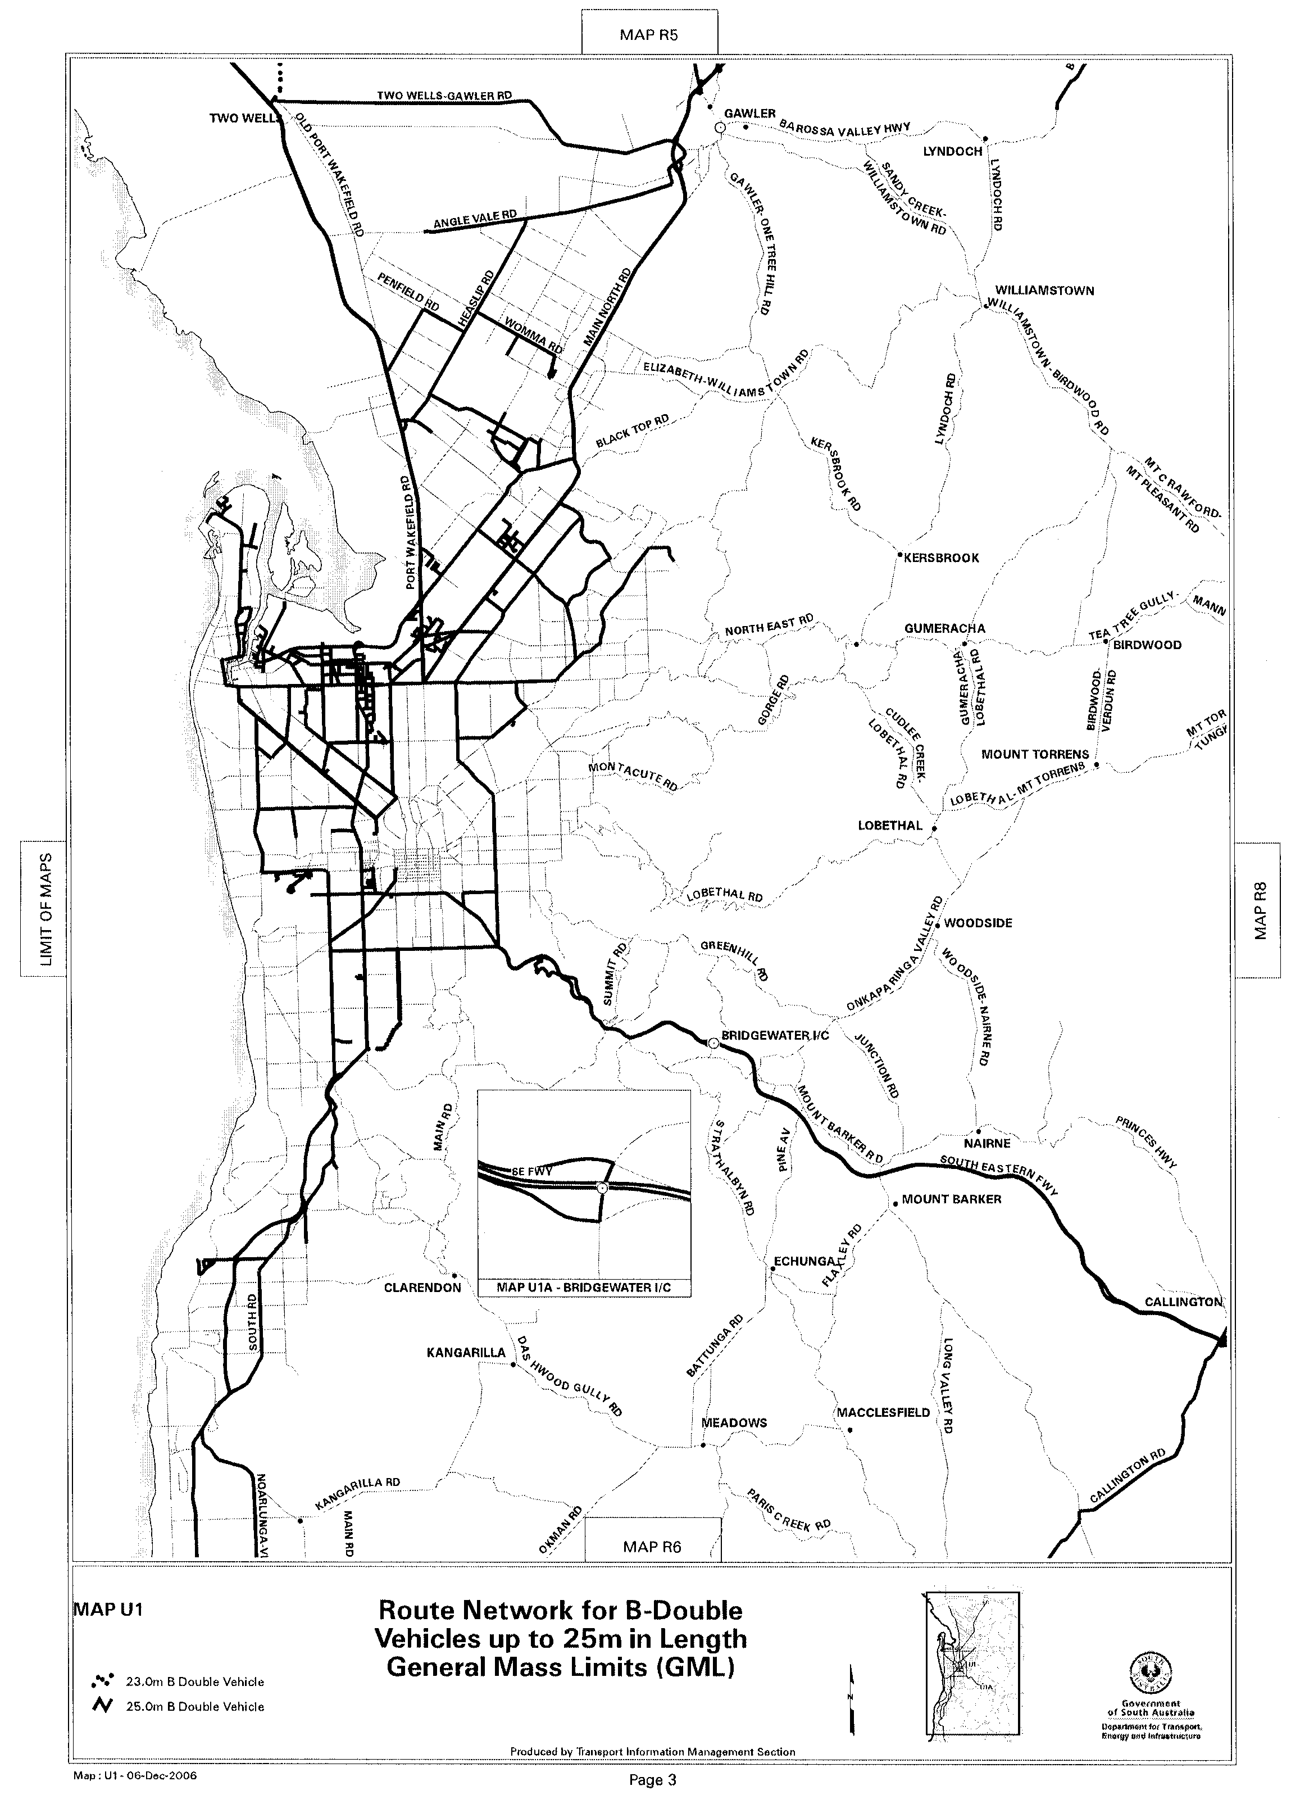
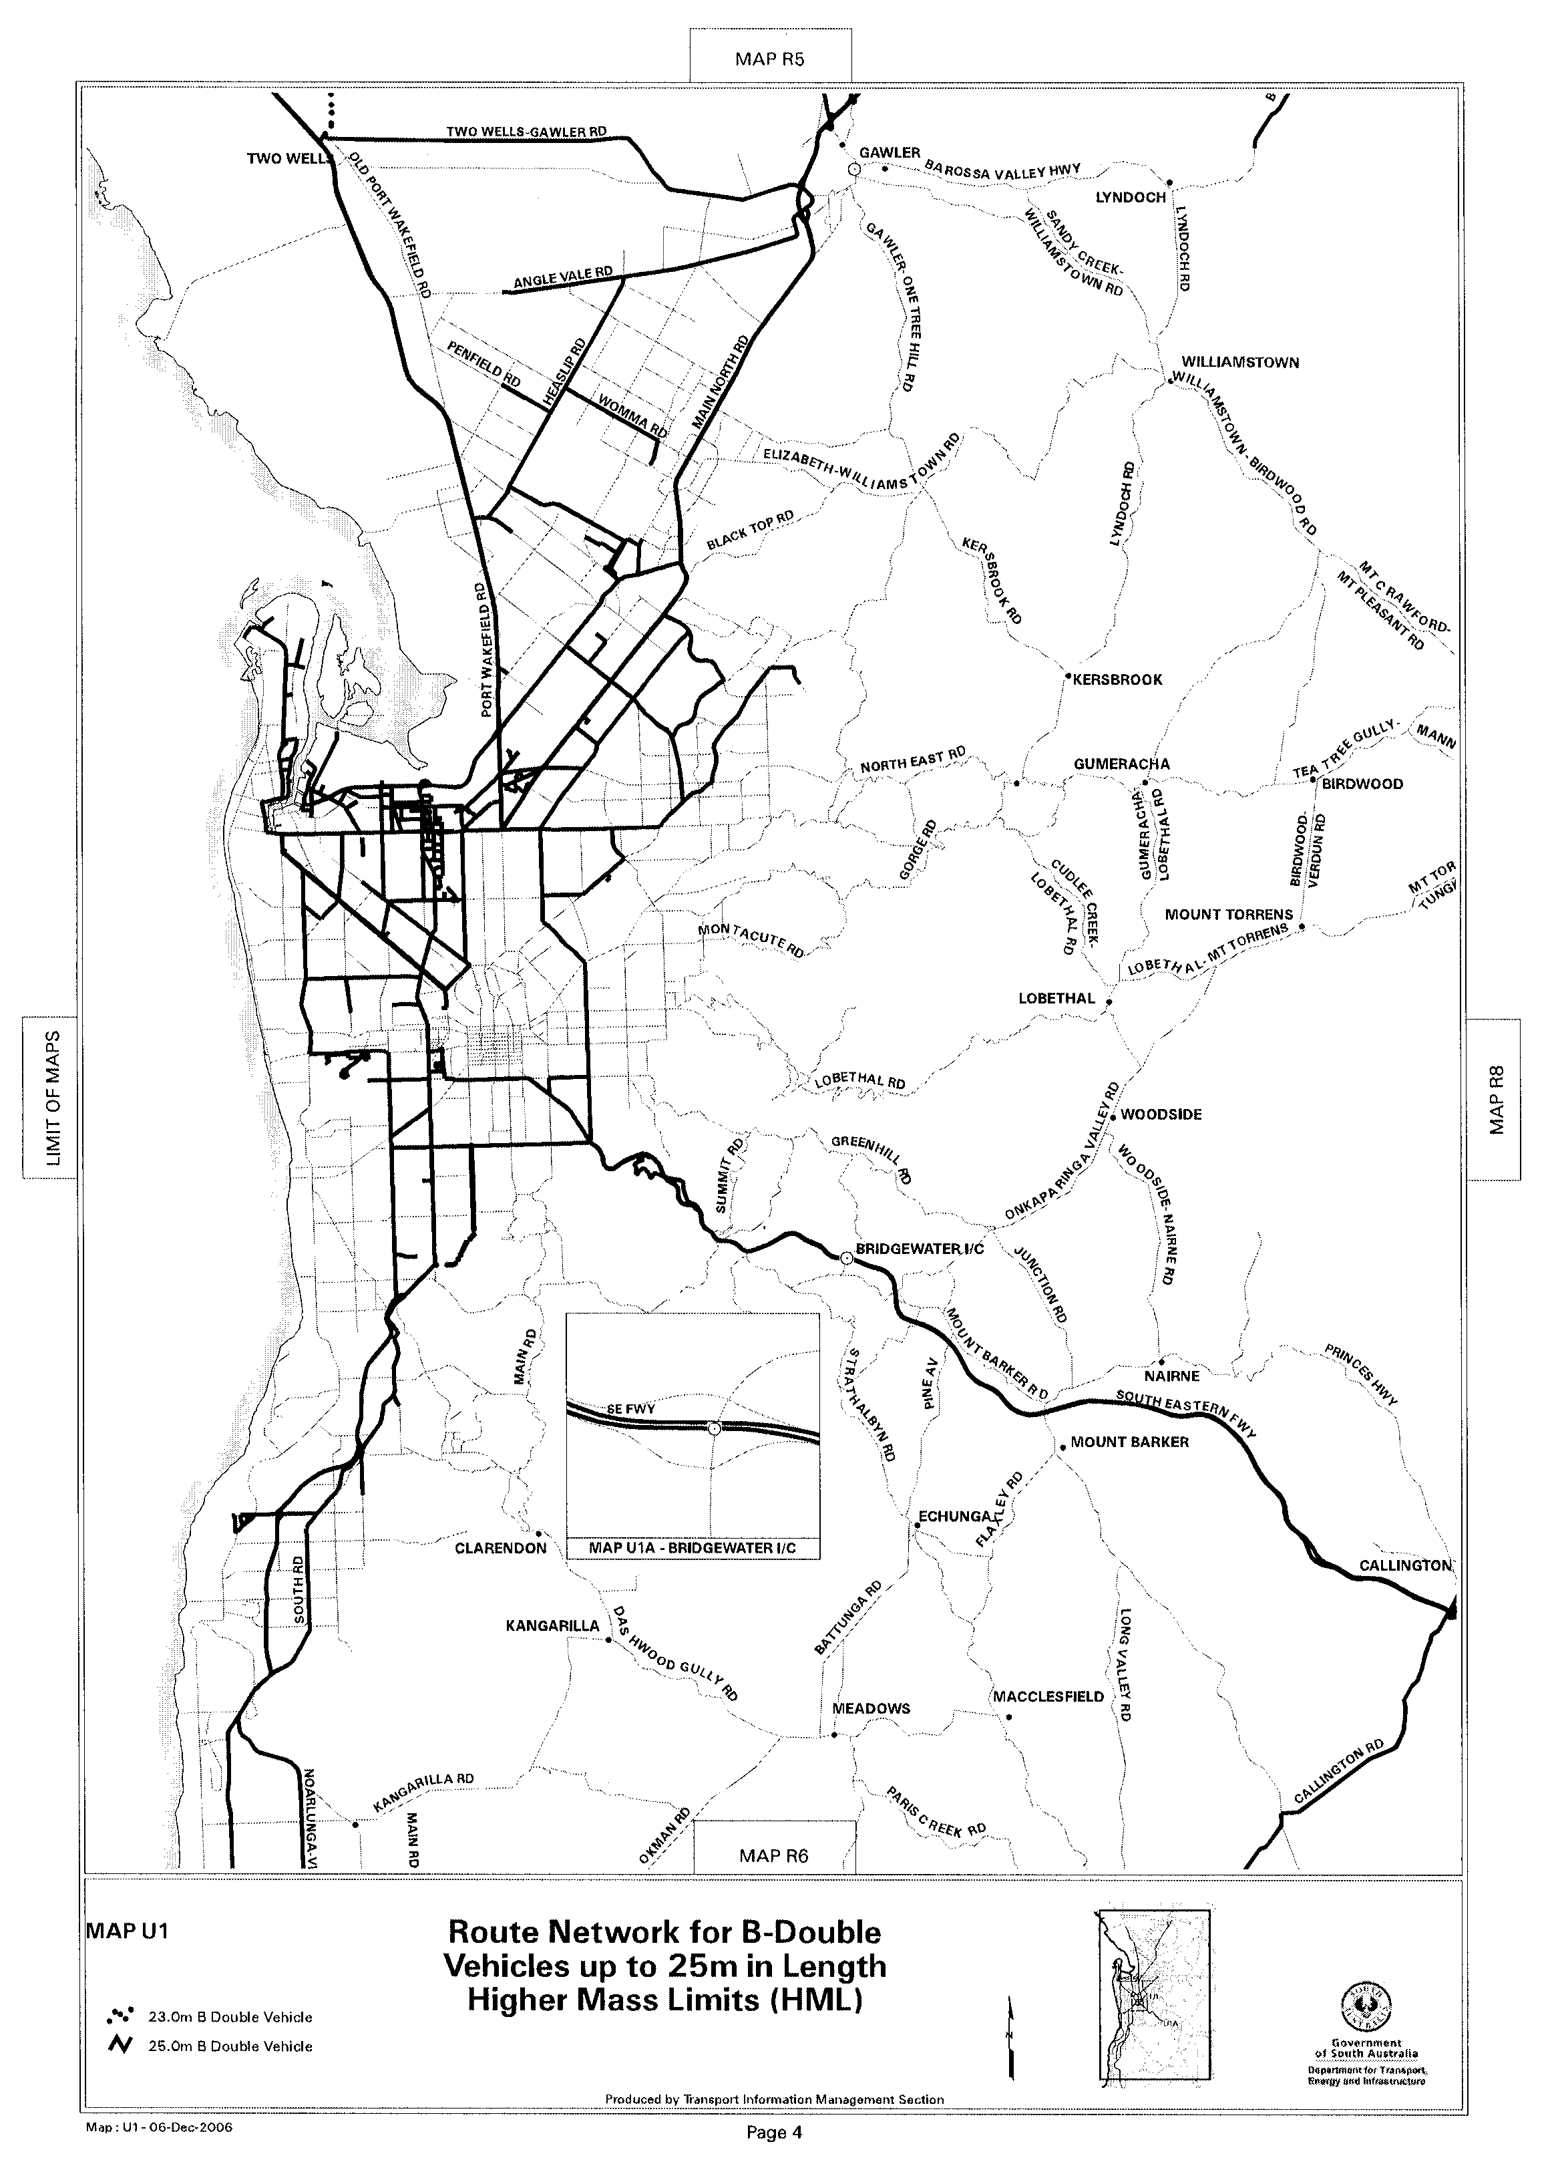
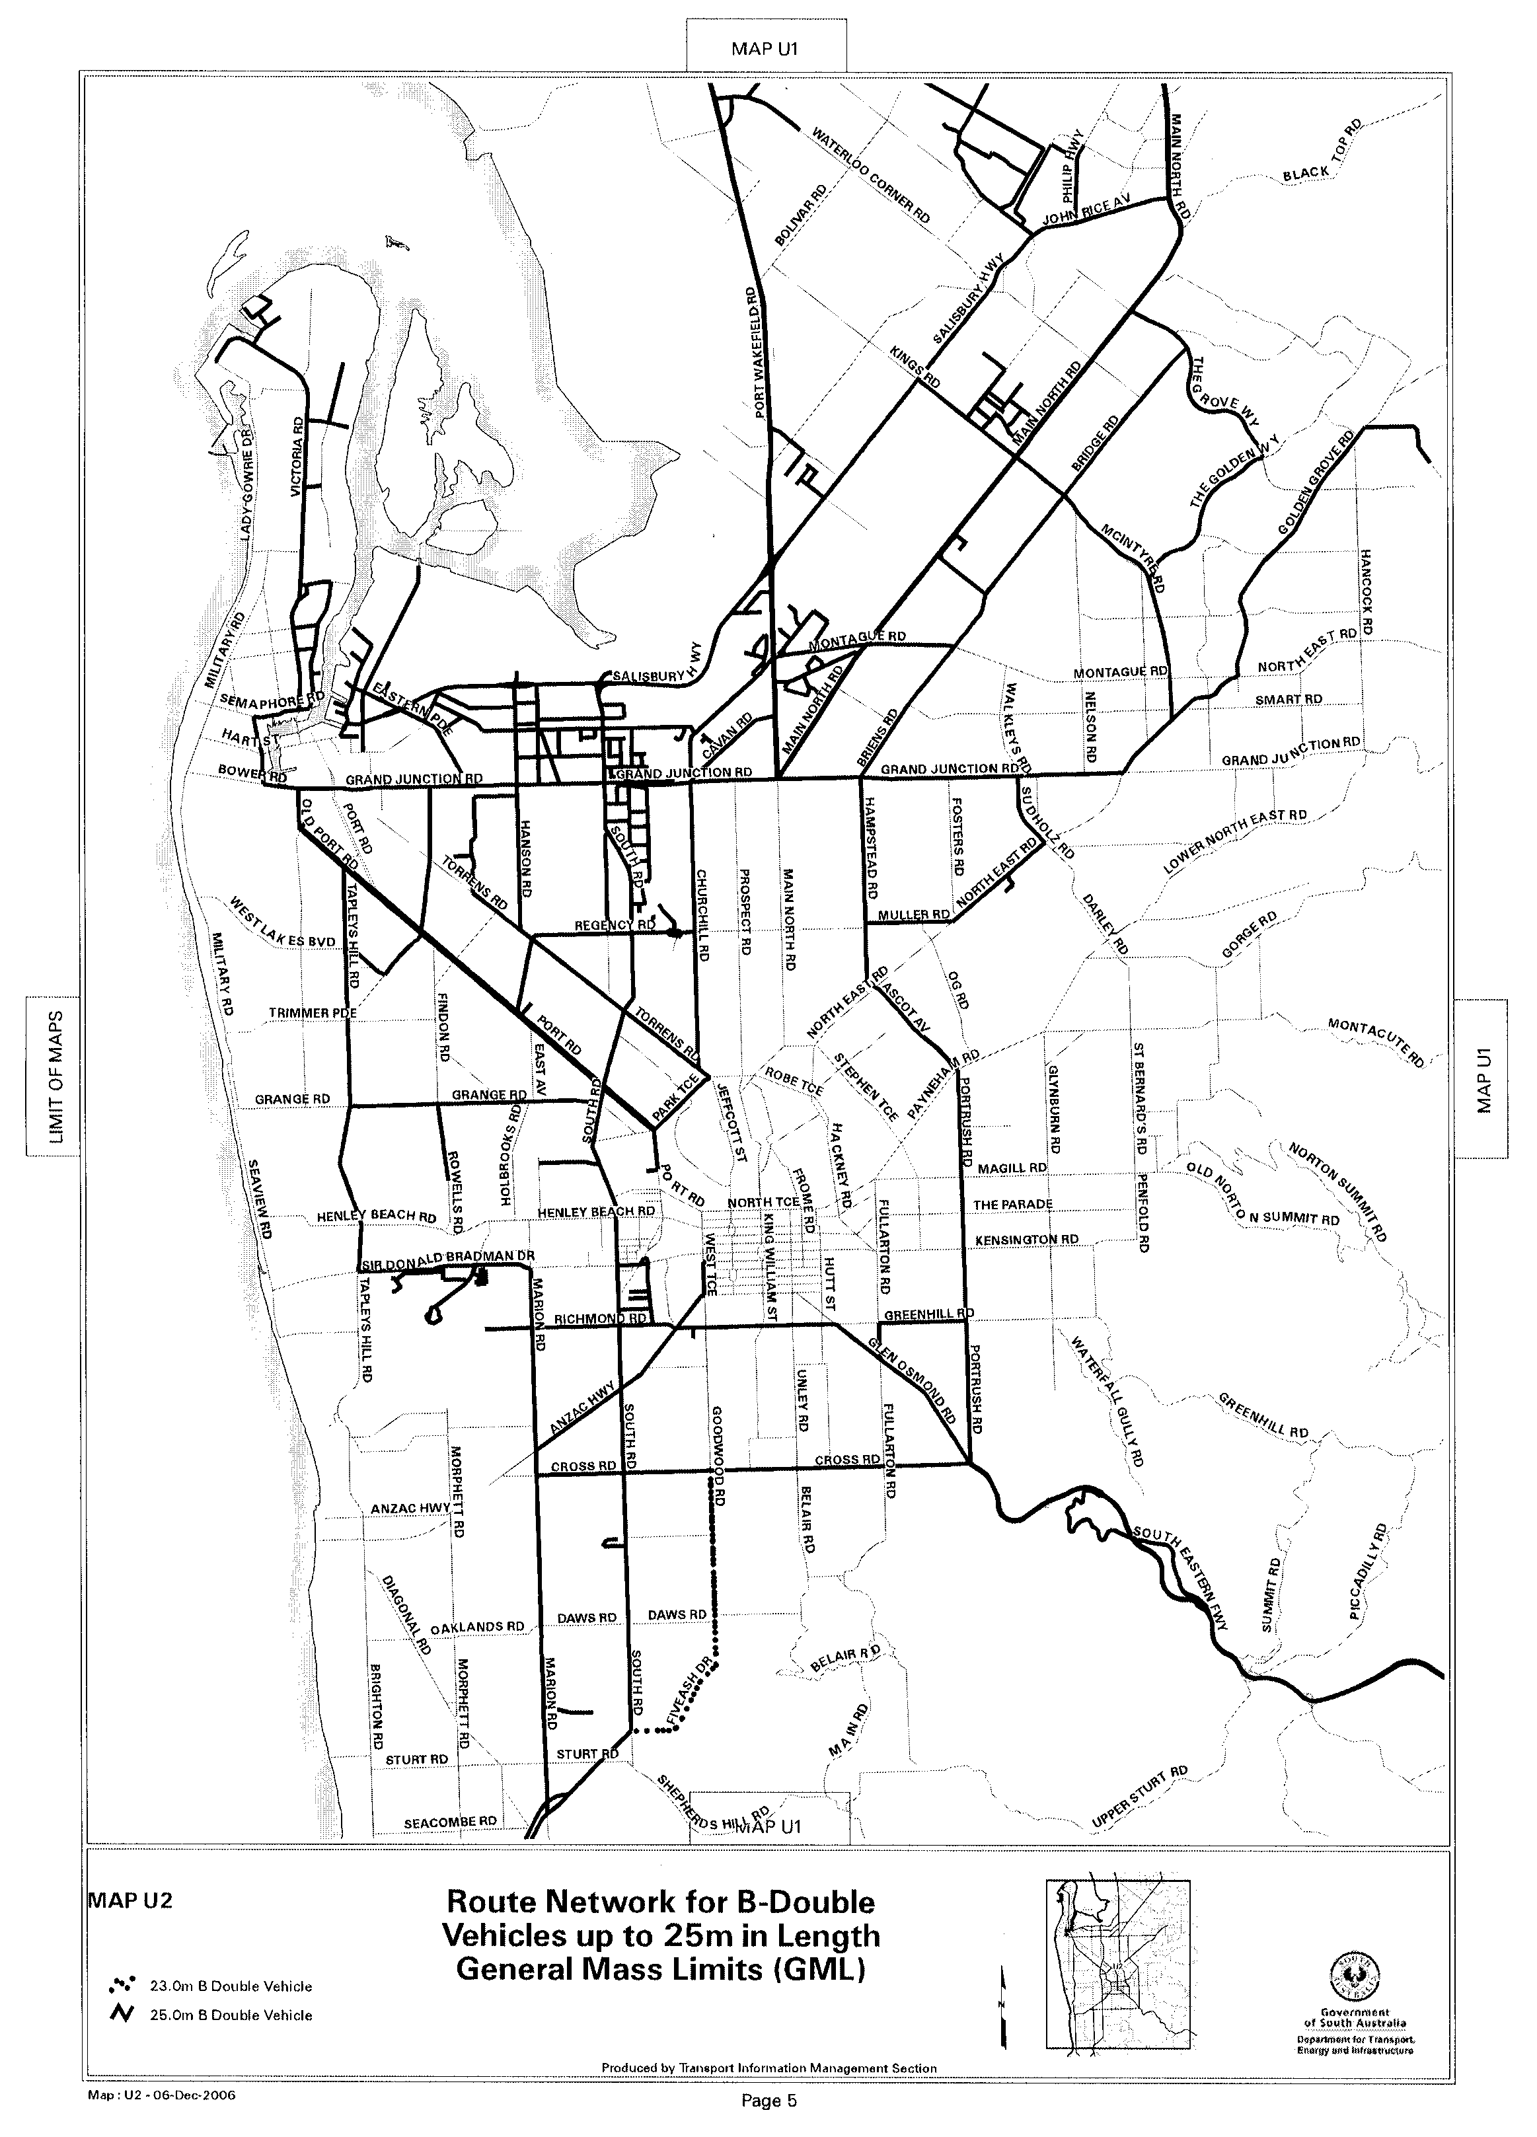
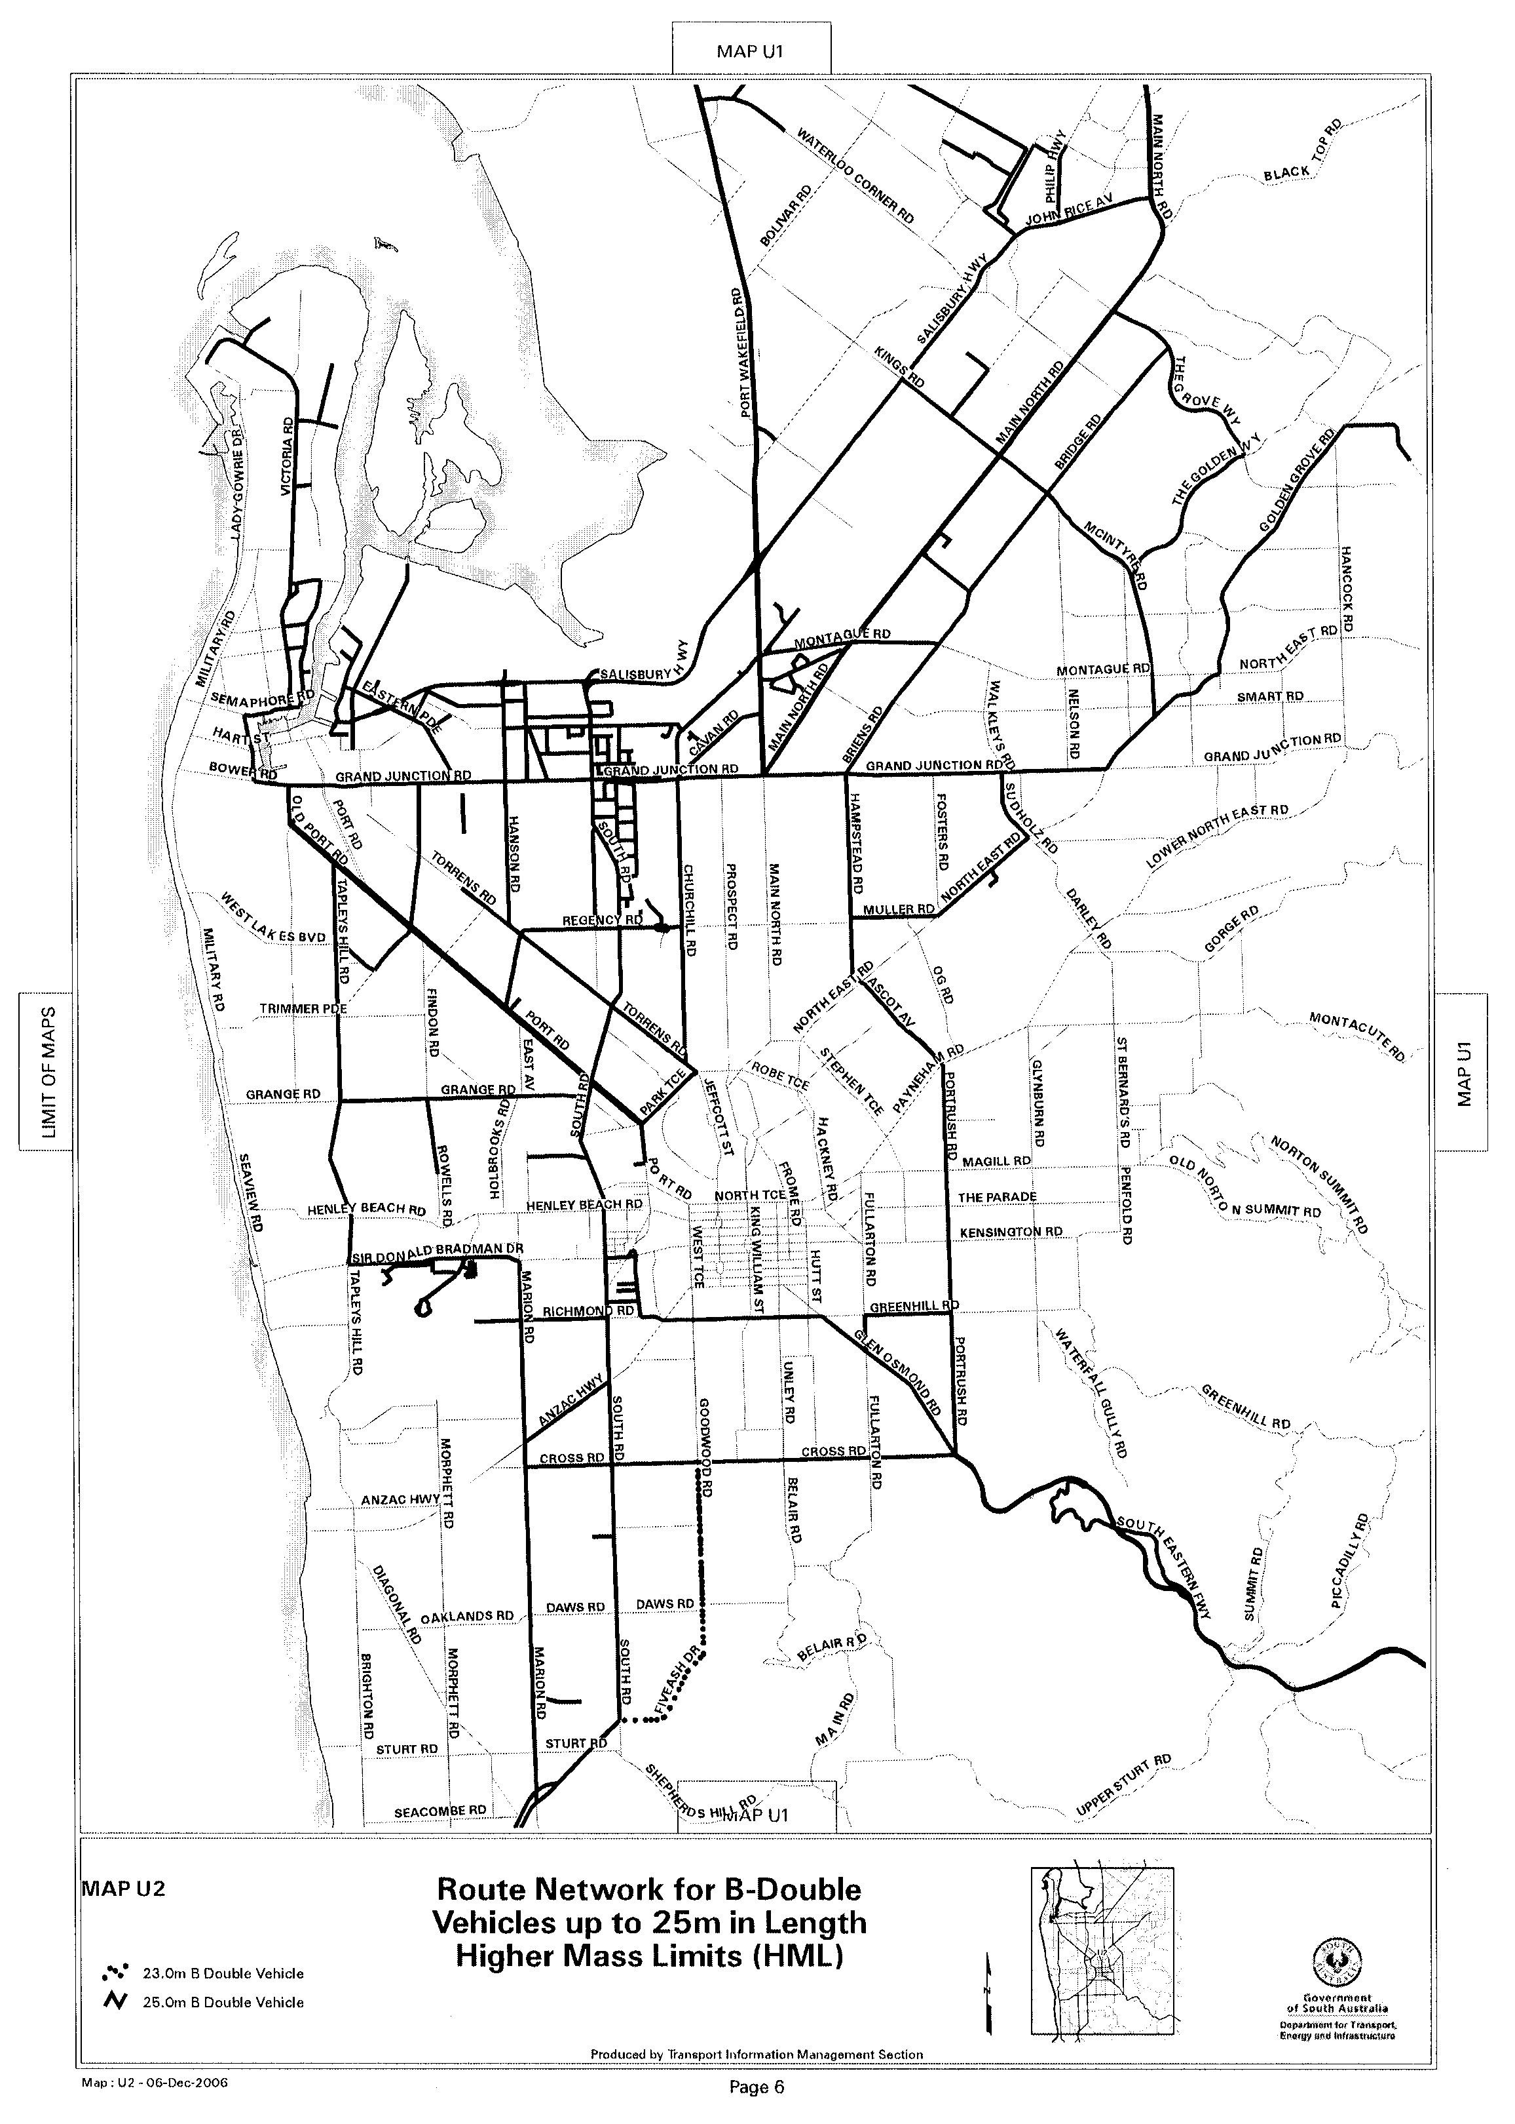
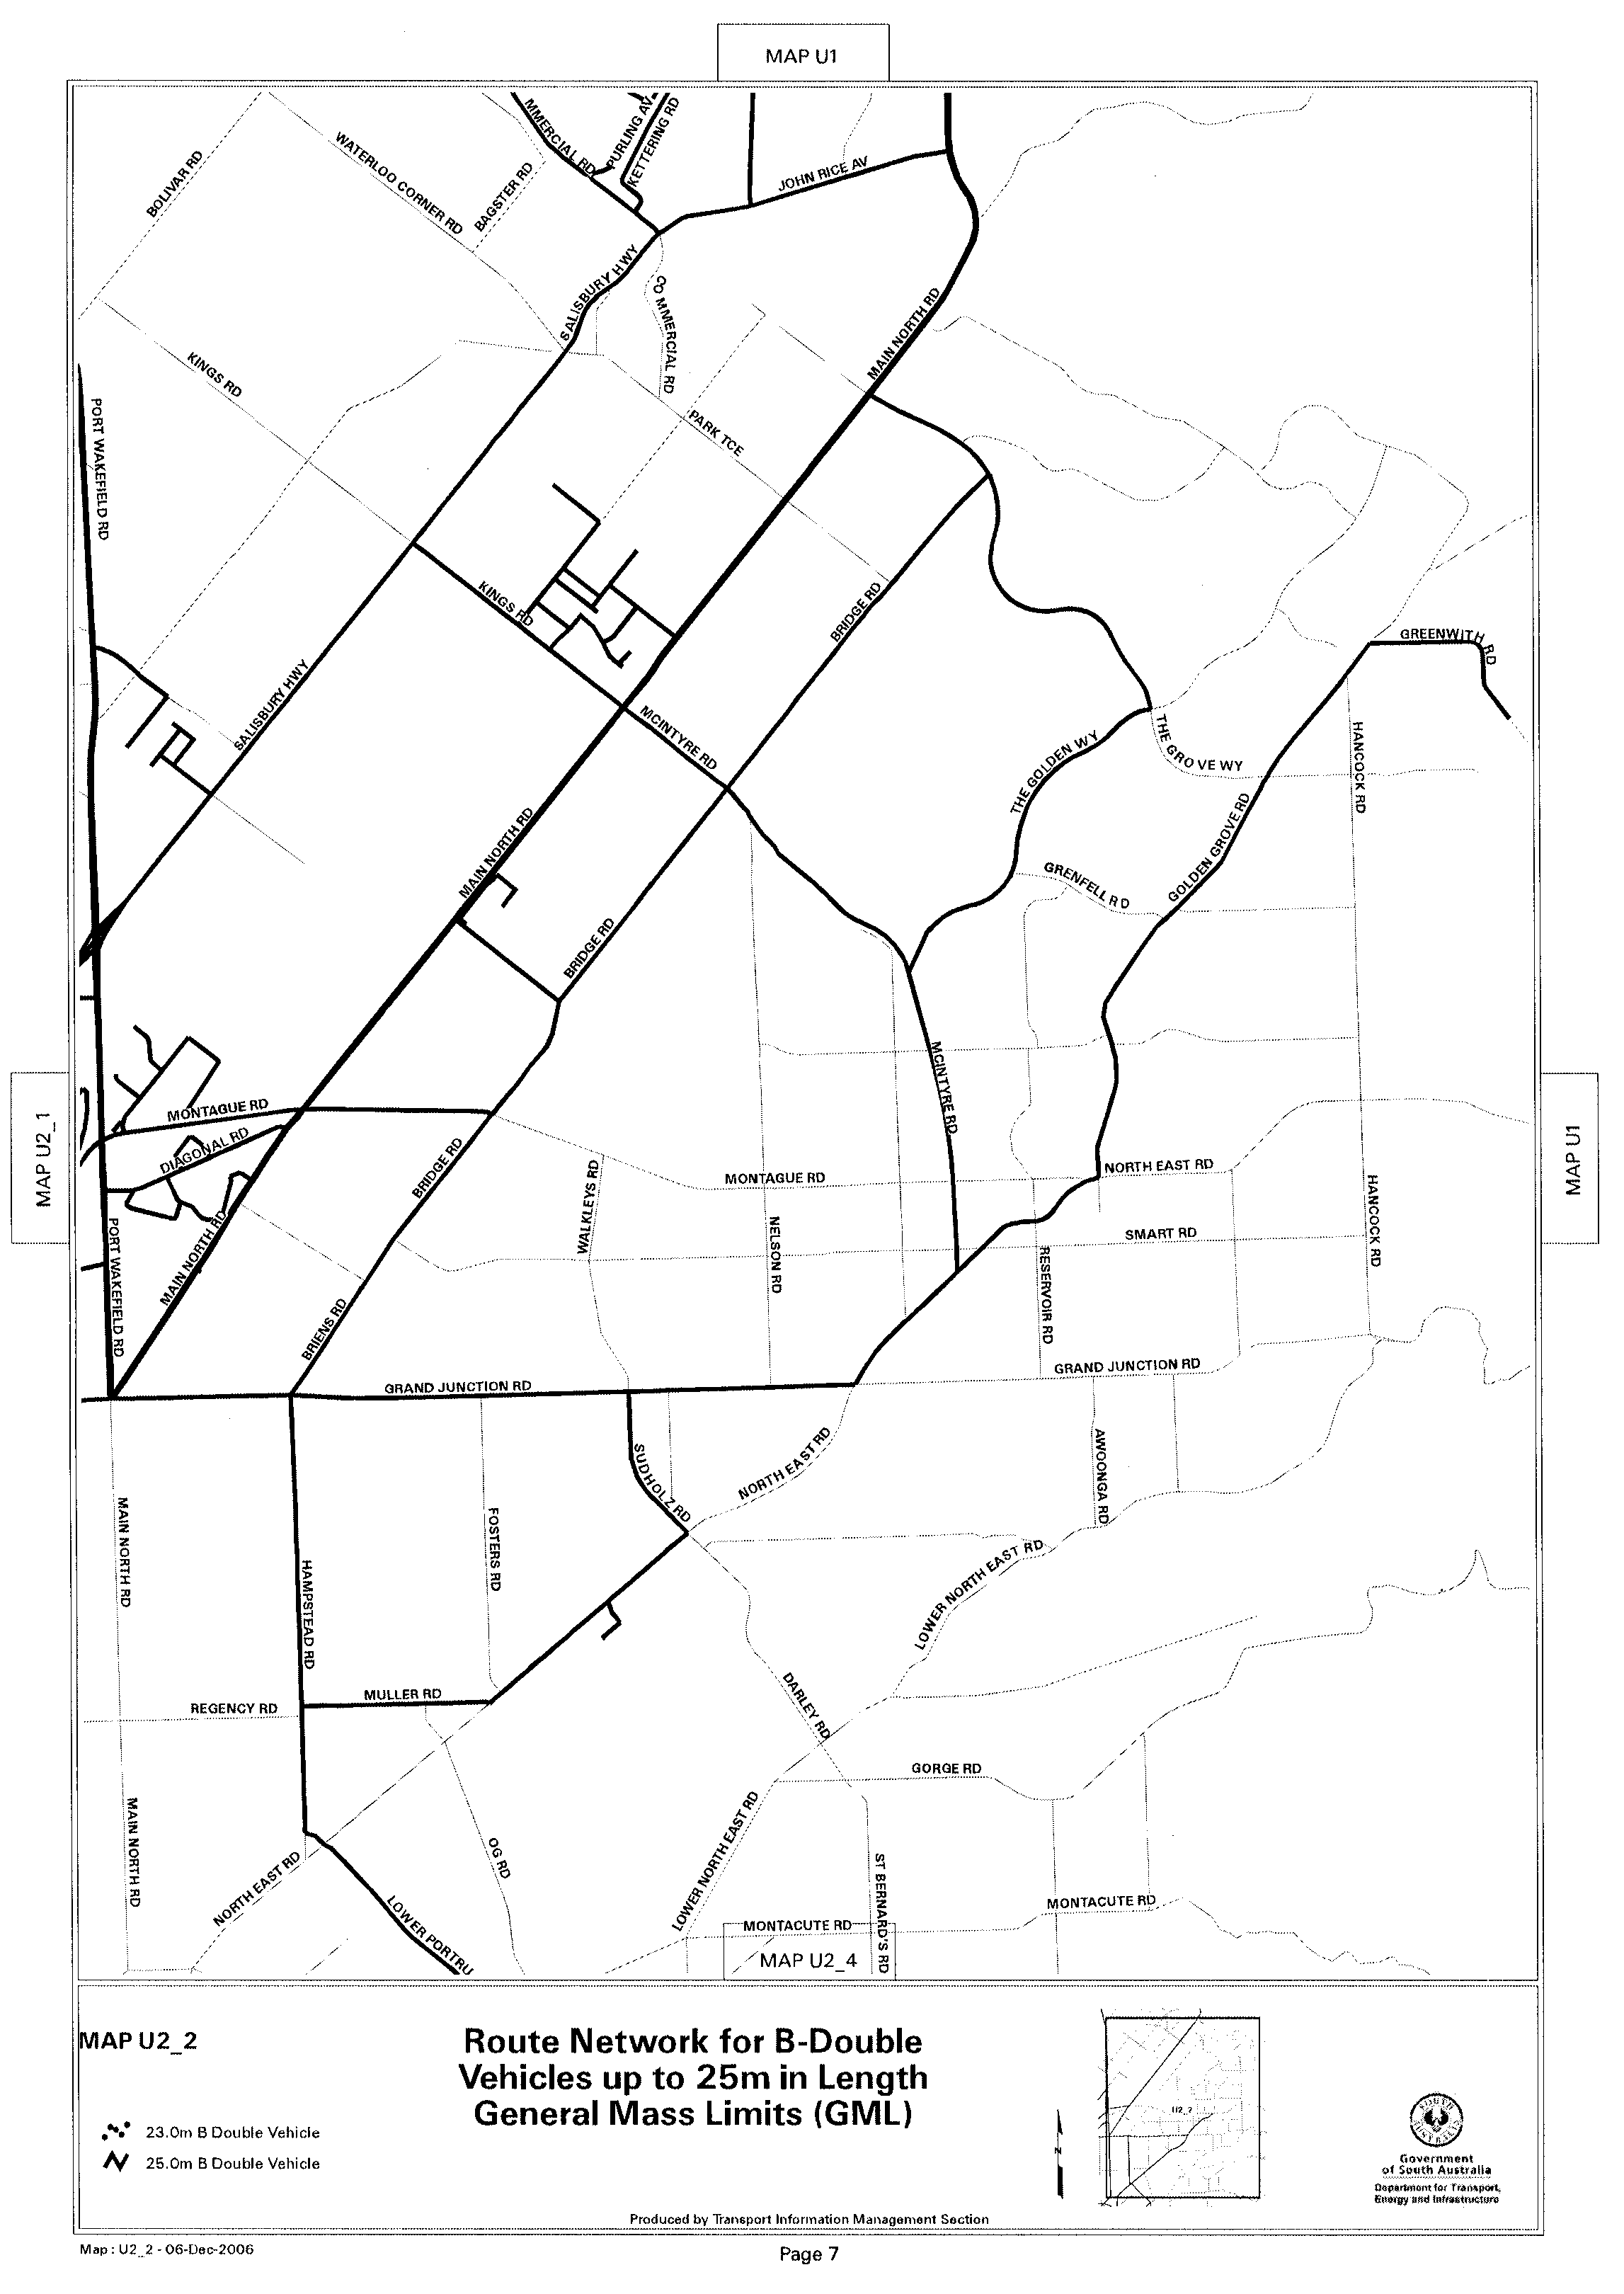

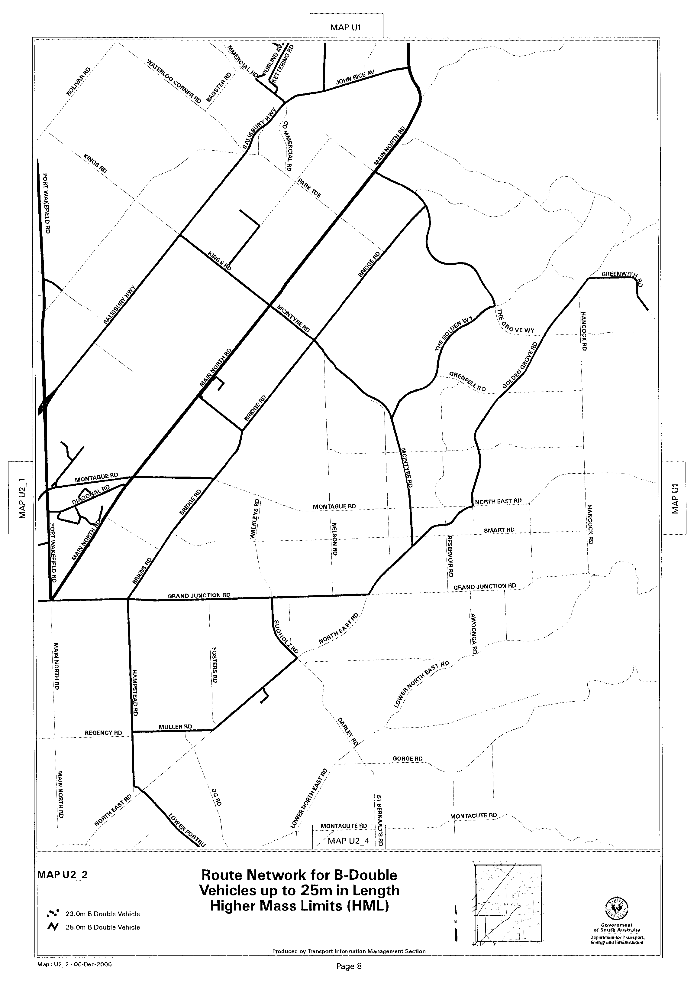
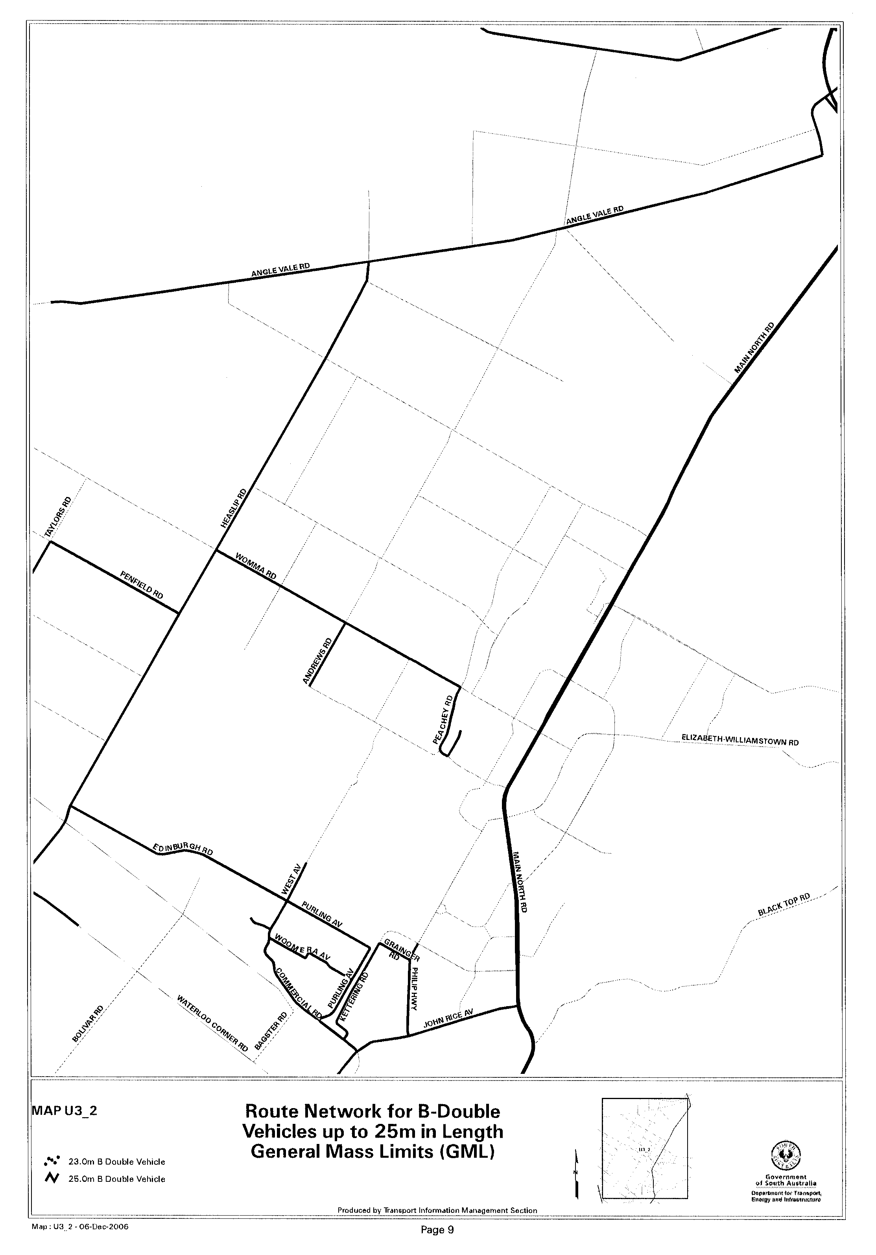
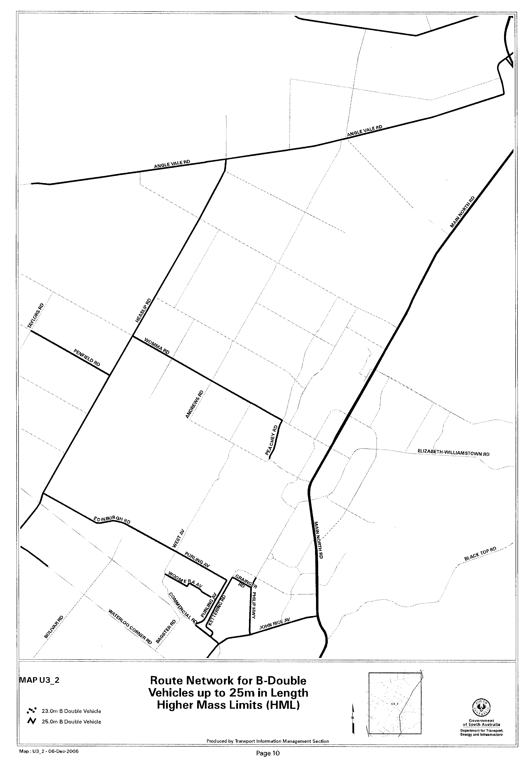

ROAD TRAFFIC ACT 1961

SUPPLEMENTARY NOTICE OF APPROVAL
Pursuant to Section 161A of the Road Traffic Act 1961

Higher mass limits for vehicles fitted with road friendly suspension
Information Note
This Notice adds additional routes to the network that can be used by vehicles fitted with Road Friendly Suspension and is a supplement to the Notice titled ‘Higher Mass Limits for Vehicles Fitted with Road Friendly Suspension’ dated 5 May 2005.

1. APPROVAL

1.1 In accordance with the powers delegated to me by the Minister for Transport under Section 163AA of the Road Traffic Act 1961, I hereby vary the conditions of the Gazette Notice of Approval and Exemption titled, ‘Higher Mass Limits for Vehicles Fitted with Road Friendly Suspension’ dated 5 May 2005 as detailed below.

2. Definitions

2.1 In this Notice:
2.1.1 ‘Approved Vehicles’ means vehicles fitted with Road Friendly Suspension as described in Table 1 of the Primary Notice;
2.1.2 ‘Supplementary routes’ means the approved routes specified in the maps ‘Route Network for General Access Vehicles Fitted with Road Friendly Suspension’ attached to this Supplementary Notice;
2.1.3 ‘Supplementary Notice’ means this Notice;
2.1.4 ‘Primary Notice’ means the Gazette Notice ‘Higher Mass Limits for Vehicles Fitted with Road Friendly Suspension’ dated 5 May 2005; and
2.1.5 all other terms have the same meaning as in the Primary Notice.

3. Application of Supplementary Notice

3.1 This Supplementary Notice must be read in conjunction with the Primary Notice and applies to all Approved Vehicles operating under the Primary Notice travelling on routes specified in the attached maps.

4. Routes available to APPROVED VEHICLES

4.1 An Approved Vehicle may operate under the conditions of the Primary Notice on a Supplementary route specified hereunder:
4.1.1 ‘Route Network for General Access Vehicles Fitted with Road Friendly Suspension’ Map U1 (Edinburgh Road, Purling Avenue and Woomera Road, Edinburgh);
4.1.2 ‘Route Network for General Access Vehicles Fitted with Road Friendly Suspension’ Map U2 (Edinburgh Road, Purling Avenue and Woomera Road, Edinburgh);
4.1.3 ‘Route Network for General Access Vehicles Fitted with Road Friendly Suspension’ Map U2_2 (Purling Avenue and Woomera Road, Edinburgh); and
4.1.4 ‘Route Network for General Access Vehicles Fitted with Road Friendly Suspension’ Map U3_2 (Edinburgh Road, Purling Avenue and Woomera Road, Edinburgh).

5. Conditions and Limitations Applying to this Supplementary Notice

5.1 When operating on a route specified in the attached maps, the driver of an Approved Vehicle must:
5.1.1 continue to comply with all conditions and requirements of the Primary Notice; and
5.1.2 carry a legible, current and complete copy of:
(i) this Supplementary Notice and attached maps;
(ii) the Primary Notice;
(iii) any combination specific documents as requested by the Primary Notice; and
5.1.3 produce these documents when requested by a Department for Transport, Energy and Infrastructure, Transport Safety Compliance Officer appointed under the Road Traffic Act 1961 and/or the Motor Vehicles Act 1959 or a Police Officer.

6. COMMENCEMENT OF THIS NOTICE

6.1 This Notice is effective from 12.01 a.m. on 4 December 2006.

Executive Director,
Safety and Regulation Division

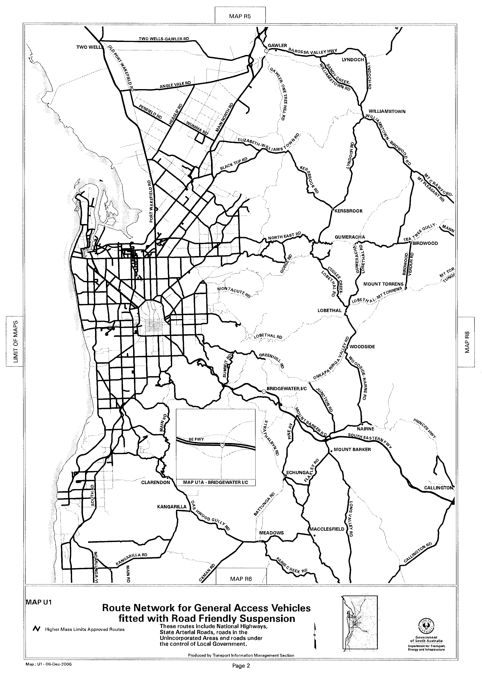
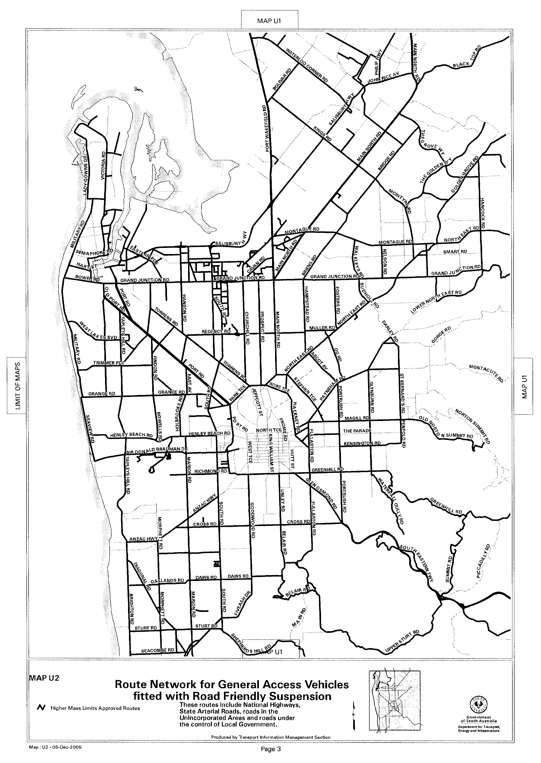
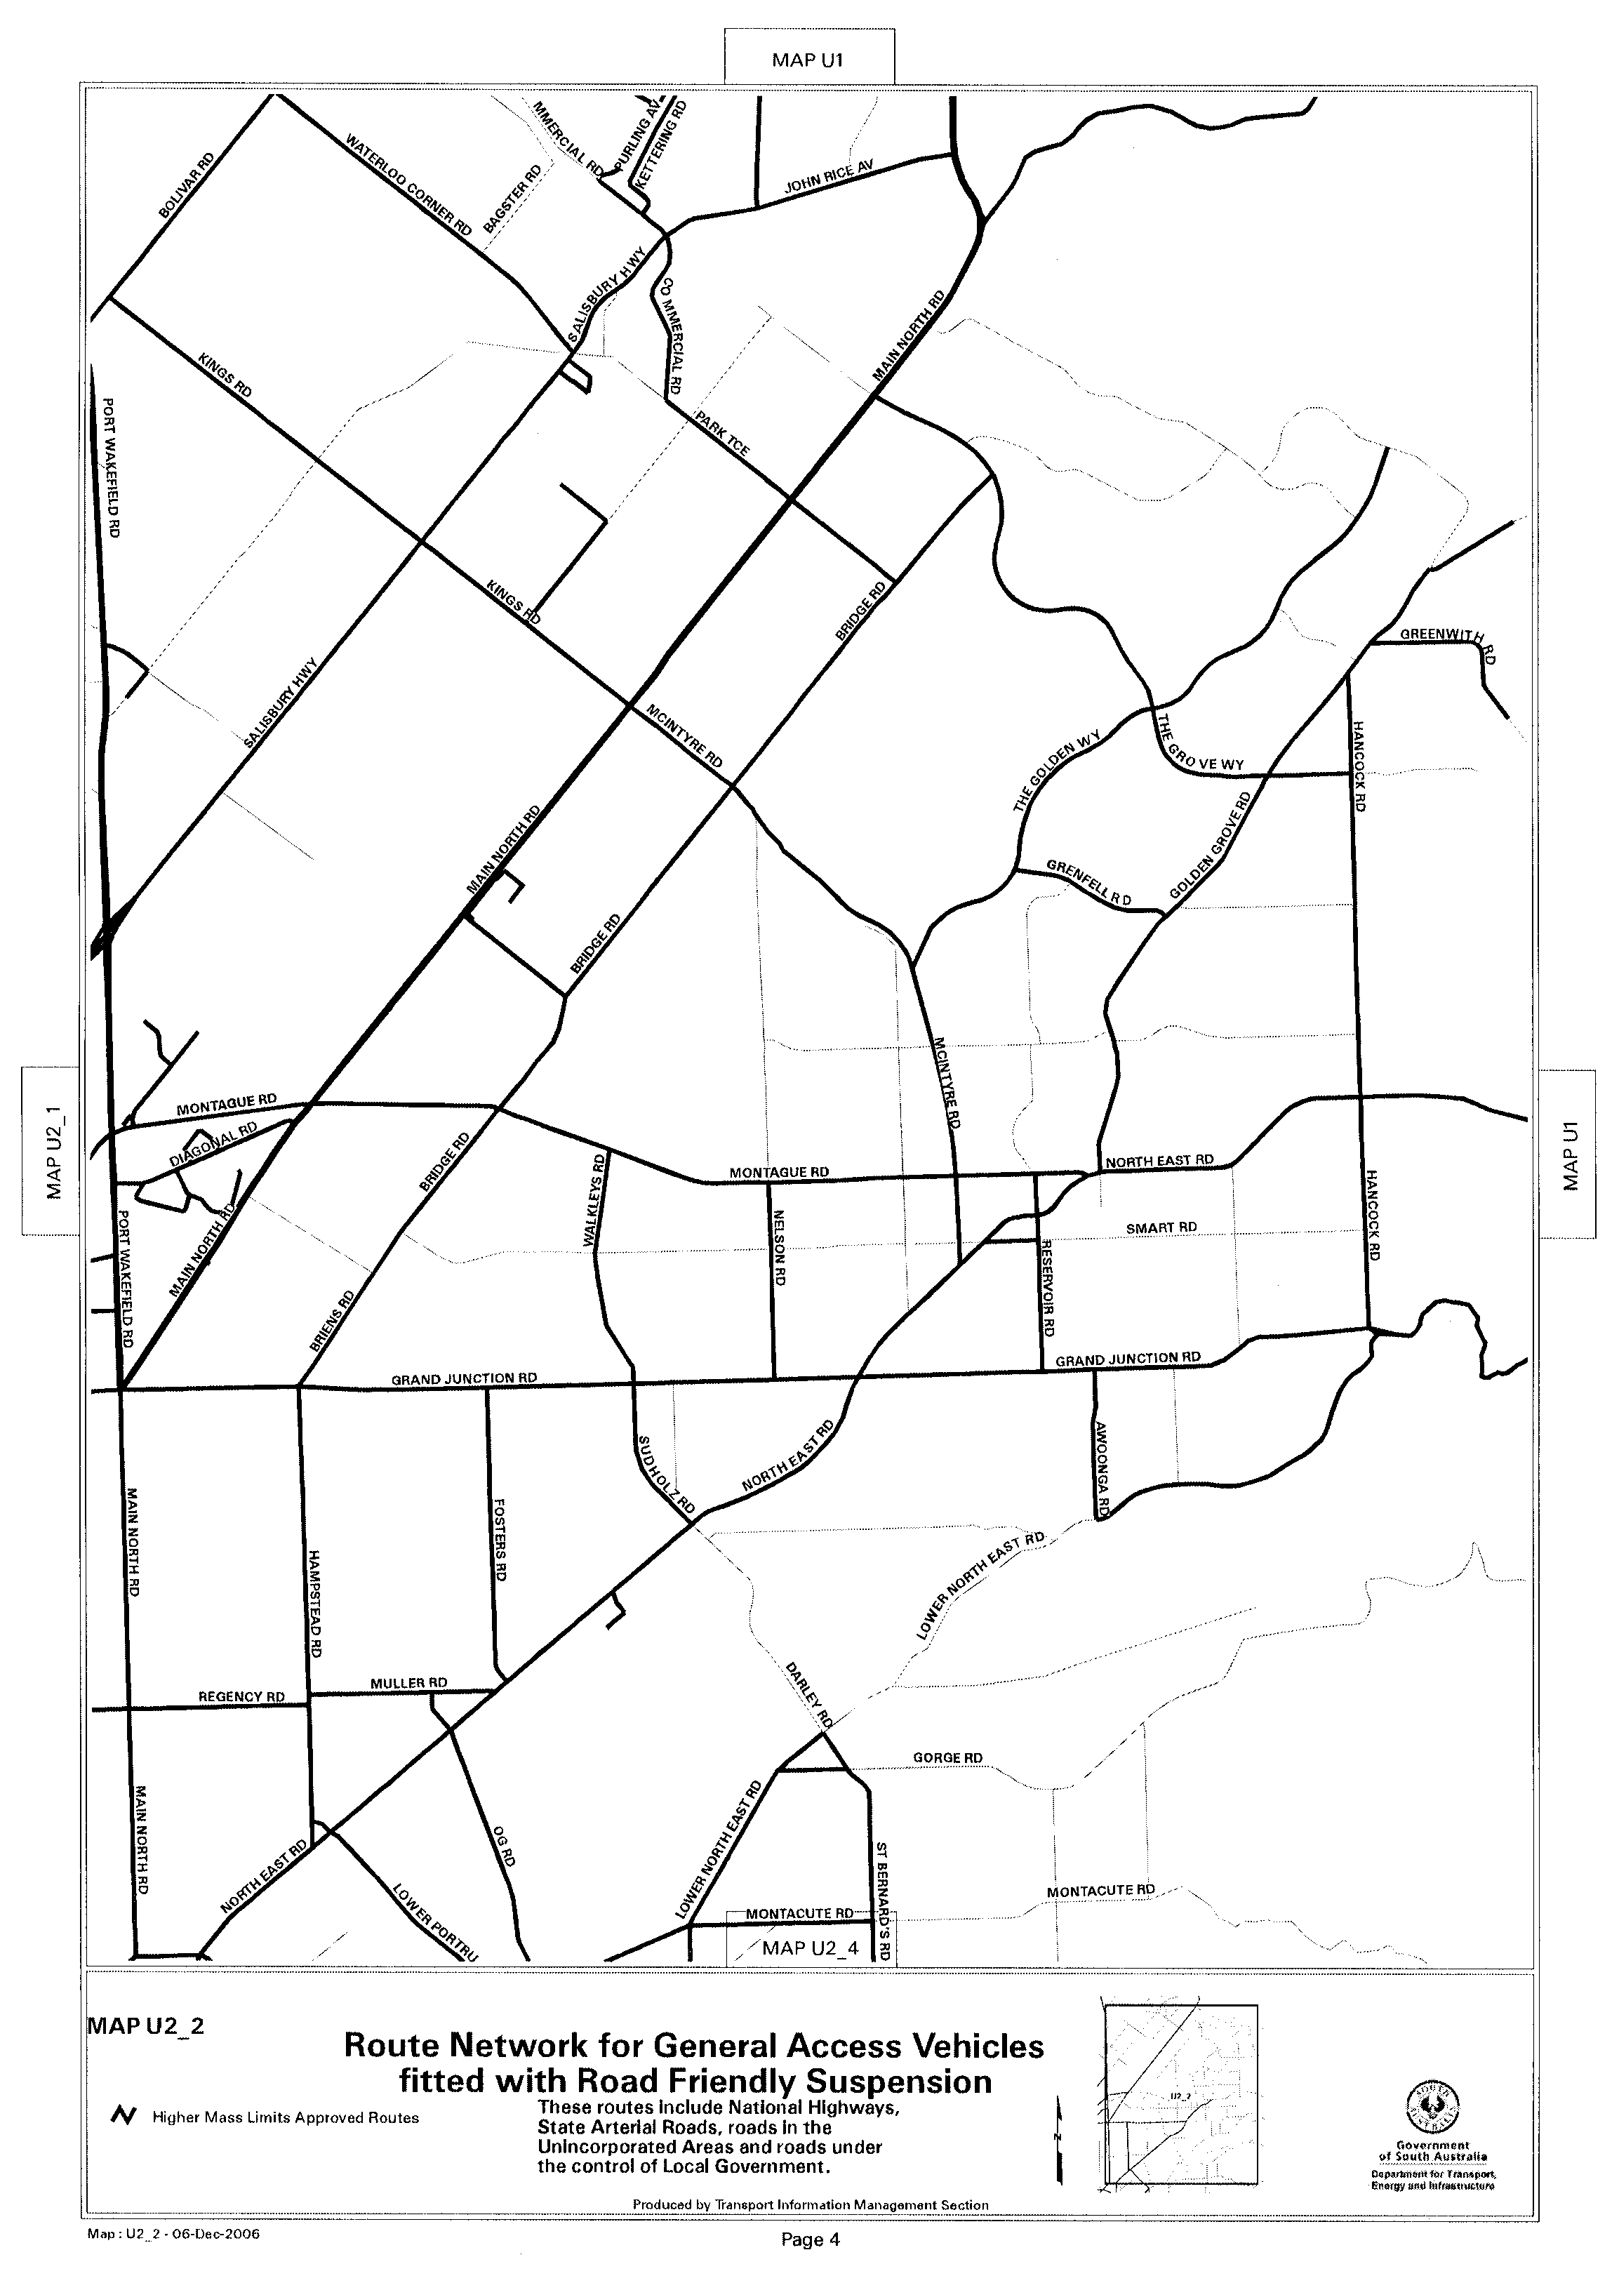
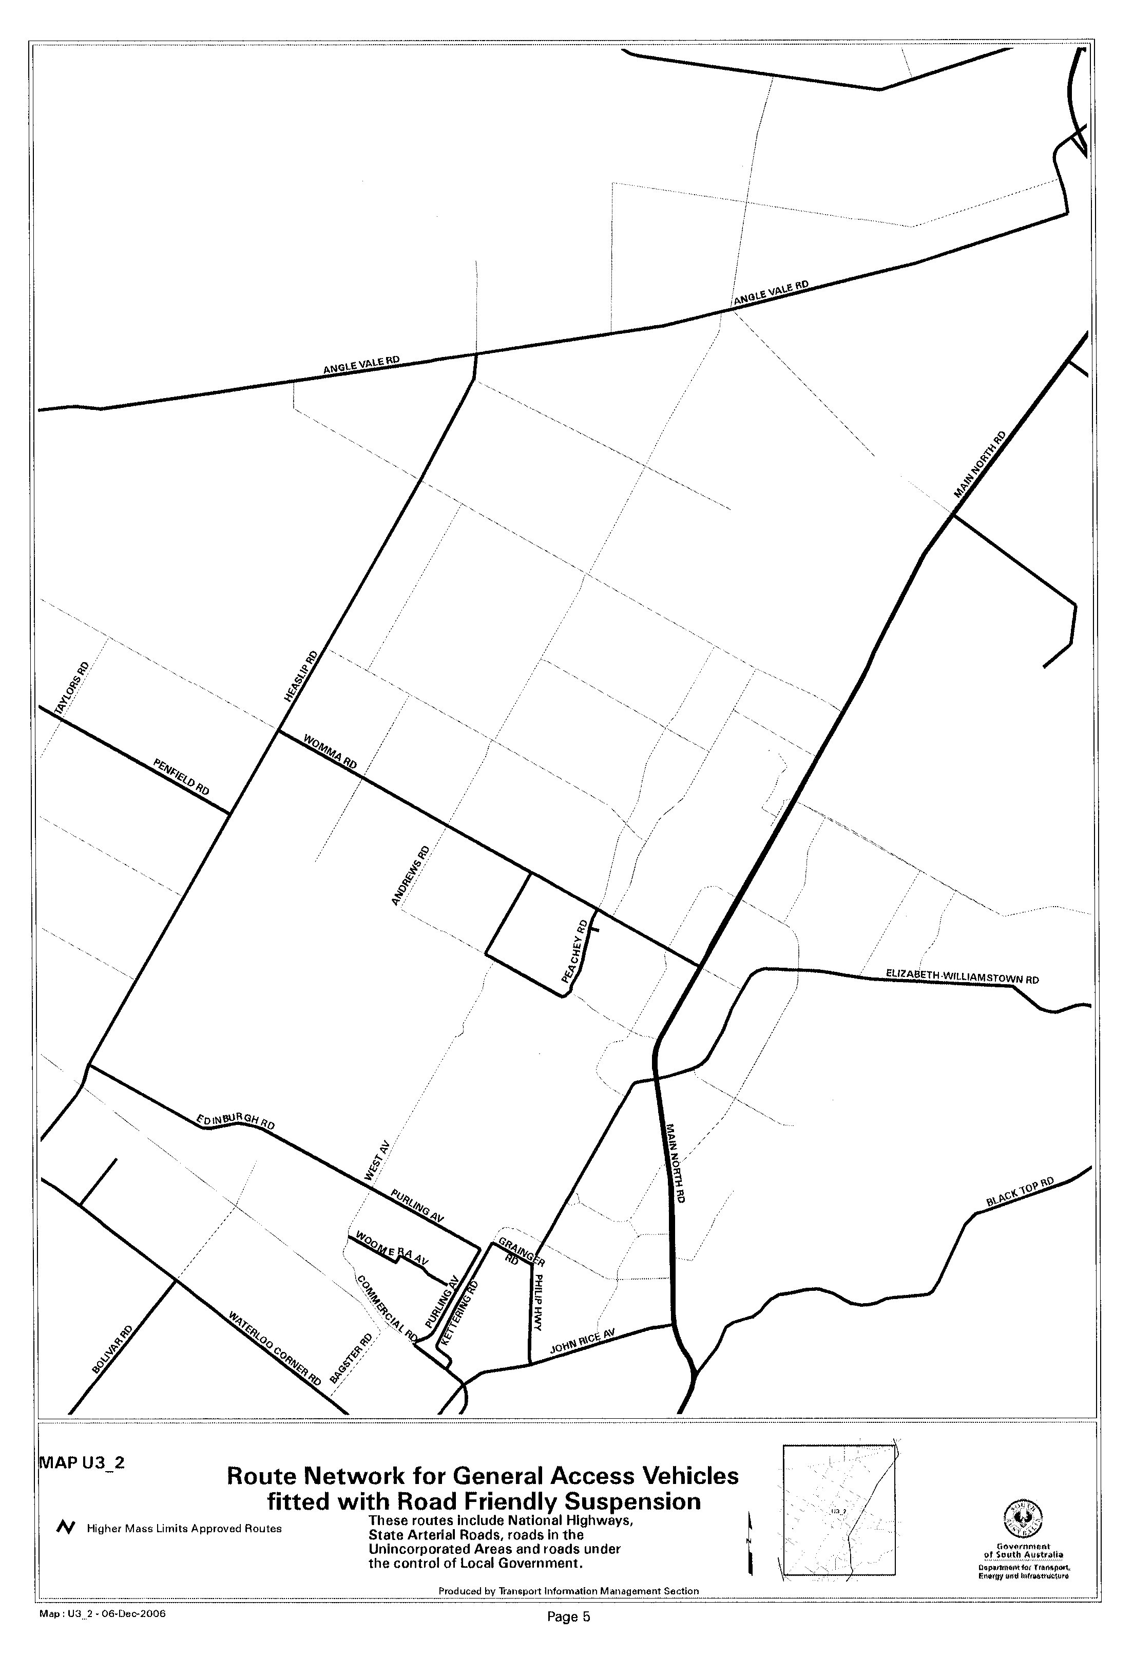

RULES OF COURT
Amending the Supreme Court Criminal Rules 1992
Amendment No. 19 to the Supreme Court
Criminal Rules
BY virtue and in pursuance of section 72 of the Supreme Court Act 1935, and all other enabling powers, We, Judges of the Supreme Court of South Australia, make the following Rules to take effect as amendments to the Supreme Court Criminal Rules 1992, as amended:
1. These Rules may be cited as the ‘Supreme Court Criminal Rules 1992, Amend-ment No. 19’.
2. The Supreme Court Criminal Rules 1992, as amended by these Rules may be cited as the ‘Supreme Court Criminal Rules 1992’.
3. This Amendment No. 19 is to take effect on and from 1 January 2007.
4. Rule 6.07 (1) (e) is amended by adding after Rule 6.07 (1) (e) (iii) the following:
(iiiA) abridgment or extension of the time for service of a subpoena.
5. Rule 11 of the Supreme Court Criminal Rules 1992, is deleted and in its place the following Rule is inserted:
‘11.01 (1) In this Rule, unless the contrary intention appears:
addressee means a person who is the subject of the order expressed in a subpoena;
business day means a day on which the Registry is ordinarily open for business;
conduct money means a sum of money or its equivalent, such as pre-paid travel, sufficient to meet the reasonable expenses of the addressee of attending Court as required by the subpoena and returning after so attending;
issuing party means the party at whose request a subpoena is issued;
subpoena means an order in writing requiring a person (an addressee):
(a) to attend to give evidence; or
(b) to produce the subpoena or a copy of it and a document or thing; or
(c) to do both those things.
(2) To the extent that a subpoena requires an addressee to attend to give evidence, it is called a subpoena to attend to give evidence.
(3) To the extent that a subpoena requires an addressee to produce the subpoena or a copy of it and a document or thing, it is called a subpoena to produce.
11.02 (1) The Court may, in any proceeding, by subpoena order an addressee:
(a) to attend to give evidence as directed by the subpoena; or
(b) to produce the subpoena or a copy of it and any document or thing as directed by the subpoena; or
(c) to do both those things.
(2) The Registrar is empowered to issue subpoenas on the Court’s behalf.
(3) The Registrar:
(a) may issue a subpoena if requested by a party to a proceeding to do so;
(b) may refuse to issue a subpoena which is vexatious, oppressive or an abuse of the process of the Court;
(c) may refer to a Judge for consideration any subpoena which the Registrar considers may be vexatious, oppressive or an abuse of the process of the Court;
(d) must issue a subpoena if directed by the Court to do so.
(4) A subpoena which is vexatious, oppressive or an abuse of the process of the Court may be set aside by a Judge.
(5) A subpoena is not to issue:
(a) if the Court has made an order, or there is a Rule of the Court, having the effect of requiring that the proposed subpoena:
(i) not be issued; or
(ii) not be issued without permission of the Court and that permission has not been given; or
(b) requiring the production of a document or thing in the custody of the Court or another Court.
(6) A subpoena is not to issue to compel the production of a public document, unless a Judge authorises the issue of the subpoena.
(7) On issuing a subpoena, the Court will authenticate it by affixing its seal or in some other appropriate manner.
11.03 (1) A subpoena must be in Form 8.
(2) A subpoena:
(a) may be addressed to one or more persons; and
(b) must, unless the Court otherwise orders, identify the addressee or addressees by name, or by description of office or position.
(3) A subpoena to produce must:
(a) identify the document or thing to be produced; and
(b) specify the date, time and place for production.
(4) A subpoena to attend to give evidence must specify, for each addressee who is required to attend, the date, time and place for attendance.
(5) If a subpoena requires an addressee’s personal attendance at a particular date, time and place to produce a document or thing, or to give evidence (or both):
(a) the date, time and place for attendance must be the date, time and place at which the trial is scheduled to commence or some other date, time and place permitted by the Court; but
(b) if the course of the Court’s business makes it necessary or expedient to change the date, time or place for attendance:
(i) the issuing party may amend the date, time or place by serving notice of the amendment in an approved form on the addressee personally and tendering any additional con-duct money that may be reasonable in the light of the amendment; and
(ii) the subpoena then operates in its amended form.
(6) The last date for service of a subpoena:
(a) is the date falling 14 days before the earliest date on which an addressee is required to comply with the subpoena or an earlier or later date fixed by a Judge; and
(b) must be specified in the subpoena.
(7) If an addressee is a company, the company must comply with the subpoena by its appropriate or proper officer.
(8) If there is a mistake in the terms in which a subpoena is issued, and the mistake is discovered before the subpoena is served, the issuing party may correct the mistake and, after filing a corrected copy of the subpoena in the Court, proceed with service of the subpoena in its corrected form.
11.04 (1) The Court may on the application of a party or any person having a sufficient interest, set aside a subpoena in whole or in part, or grant other relief in respect of it.
(2) Any application under Rule 11.04 (1) must be made on notice to the issuing party.
(3) The Court may order that the applicant give notice of the application to any other party or to any other person having a sufficient interest.
11.05 (1) A subpoena must be served personally on the addressee on or before the last day for service specified in the subpoena.
(2) The issuing party must serve a copy of a subpoena to produce on each other party as soon as practicable after the subpoena has been served on the addressee or addressees.
11.06 (1) An addressee need not comply with the requirement of a subpoena to attend to give evidence unless conduct money has been handed or tendered to the addressee a reasonable time before the date on which attendance is required.
(2) An addressee need not comply with the requirements of a subpoena unless it is served on or before the date specified in the subpoena as the last date for service of the subpoena.
(3) Despite Rule 11.05 (1), an addressee must comply with the require-ments of a subpoena even if it has not been served personally on that addressee if the addressee has, by the last date for service of the subpoena, actual knowledge of the subpoena and of its requirements.
(4) An addressee who is required to comply with a subpoena to produce must comply with the subpoena:
(a) by attending at the date, time and place specified for production and producing the subpoena or a copy of it and the document or thing to the Court; or
(b) by delivering or sending the subpoena or a copy of it and the document or thing to the Registrar at the address specified for the purpose in the subpoena, so that they are received not less than two business days before the date specified in the subpoena for attendance and production.
(5) In the case of a subpoena that is both a subpoena to attend to give evidence and a subpoena to produce, production of the subpoena or a copy of it and of the document or thing in any of the ways permitted by Rule 11.06 (4) does not discharge an addressee who is required to give evidence from the obligation to attend to give evidence.
(6) The Registrar must take custody of documents and things produced to the Court in response to a subpoena, and of all exhibits tendered in proceedings before the Court, and deal with them:
(i) if they have not become, and it is apparent that they will not become, exhibits in proceedings—as authorised by these Rules; or
(ii) if they have become exhibits in proceedings—as required by Rule 15.
11.07 (1) This Rule applies if an addressee produces a document or thing in accordance with Rule 11.06 (4) (b).
(2) The Registrar must, if requested by the addressee, give a receipt for the document or thing to the addressee.
(3) If the addressee produces more than one document or thing, the addressee must, if requested by the Registrar, provide a list of the documents or things produced.
(4) The addressee may, with the consent of the issuing party, produce a copy, instead of the original, of any document required to be produced.
(5) The addressee may at the time of production inform the Registrar in writing that any document or copy of a document produced need not be returned and may be destroyed.
11.08 The Court may give directions in relation to the removal from and return to the Court, and the inspection, copying and disposal, of any document or thing that has been produced to the Court in response to a subpoena.
11.09 (1) On request in writing of a party, the Registrar must inform the party whether production in response to a subpoena has occurred in accordance with Rule 11.06 (4) (b) and, if so, include a description, in general terms, of the documents and things produced.
(2) The following provisions of this Rule apply if an addressee produces a document or thing in accordance with Rule 11.06 (4) (b).
(3) Subject to this Rule, no person may inspect a document or thing produced unless the Court has granted permission and the inspection is in accordance with that permission.
(4) Unless the Court otherwise orders, the Registrar may permit the parties to inspect at the Registry any document or thing produced unless the addressee, a party or any person having a sufficient interest objects to the inspection under this Rule.
(5) If the addressee objects to a document or thing being inspected by any party to the proceeding, the addressee must, at the time of production, notify the Registrar in writing of the objection and of the grounds of the objection.
(6) If a party or person having a sufficient interest objects to a document or thing being inspected by a party to the proceeding, the objector may notify the Registrar in writing of the objection and of the grounds of the objection.
(7) On receiving notice of an objection under this Rule, the Registrar:
(a) must not permit any, or any further, inspection of the document or thing the subject of the objection; and
(b) must refer the objection to the Court for hearing and deter-mination.
(8) The Registrar must notify the issuing party of the objection and of the date, time and place at which the objection will be heard, and the issuing party must notify the addressee, the objector and each other party accordingly.
(9) The Registrar must not permit any document or thing produced to be removed from the Registry except on application in writing signed by the solicitor for a party.
(10) A solicitor who signs an application under Rule 11.09 (9) and removes a document or thing from the Registry undertakes to the Court by force of this Rule that:
(a) the document or thing will be kept in the personal custody of the solicitor or a barrister briefed by the solicitor in the proceeding; and
(b) the document or thing will be returned to the Registry in the same condition, order and packaging in which it was removed, as and when directed by the Registrar.
(11) The Registrar may, in the Registrar’s discretion, grant an application under Rule 11.09 (9) subject to conditions or refuse to grant the application.
11.10 (1) Unless the Court otherwise orders, the Registrar may, in the Registrar’s discretion, return to an addressee any document or thing produced in response to the subpoena.
Note—
It should be noted however that if the document or thing has been tendered as an exhibit, the Registrar is to deal with the exhibit as required by Rule 15.
(2) Unless the Court otherwise orders, the Registrar must not return any document or thing under Rule 11.10 (1) unless the Registrar has given to the issuing party at least 14 days’ notice of the intention to do so and that period has expired.
(3) If the addressee has informed the Court that a document or a copy of a document need not be returned and may be destroyed, the Registrar may, unless the Court otherwise orders, destroy the document or copy instead of returning it.
(4) The Registrar must not destroy a document or a copy of a document unless the Registrar has first given to the issuing party and to the addressee at least 14 days’ notice of the intention to destroy the document or copy.
11.11 (1) The Court may order the issuing party to pay the amount of any reasonable loss or expense incurred in complying with the subpoena.
(2) If an order is made under Rule 11.11 (1), the Court must fix the amount or direct that it be fixed in accordance with the Court’s usual procedure in relation to costs.
(3) An amount referred to in this Rule is separate from and in addition to:
(a) any conduct money paid to the addressee; or
(b) any witness expenses payable to the addressee.
11.12 (1) An addressee who fails to comply with a subpoena without lawful excuse is in contempt of Court and may be dealt with accordingly.
(2) Despite Rule 11.05 (1), if a subpoena has not been served personally on an addressee, the addressee may be dealt with for contempt of Court as if the addressee had been so served if it is proved that the addressee had, by the last date for service of the subpoena, actual knowledge of the subpoena and its requirements.
(3) Rules 11.12 (1) and (2) are without prejudice to any power of the Court under any Rules of the Court (including any Rules of the Court providing for the arrest of an addressee who defaults in attendance in accordance with a subpoena) or otherwise, to enforce compliance with a subpoena.
11.13 (1) A party who seeks production of a document or thing in the custody of the Court or of another Court may inform the Registrar in writing accordingly, identifying the document or thing.
(2) If the document or thing is in the custody of the Court, the Registrar must produce the document or thing:
(a) in Court; or
(b) as the Court directs.
(3) If the document or thing is in the custody of another Court, the Registrar must, unless the Court has otherwise ordered:
(a) request the other Court to send the document or thing to the Registrar; and
(b) after receiving it, produce the document or thing:
(i) in Court; or
(ii) as the Court directs.
6. Insert after Form 7 new Form 8 as follows:

FORM 8
SUBPOENA
To: [name]
[address]

YOU ARE ORDERED:
*to attend to give evidence—see Section A of this form; or
*to produce this subpoena or a copy of it and the documents or things specified in the Schedule—see Section B of this form; or
*to attend to give evidence and to produce this subpoena or a copy of it and the documents or things specified in the Schedule—see Section C of this form.
* Select one only of these three options.
Failure to comply with this subpoena without lawful excuse is a contempt of Court and may result in your arrest.
The last date for service of this subpoena is: (See Note 1)
Please read Notes 1 to 15 at the end of this subpoena.

[Seal or authentication]

A Details of subpoena to attend to give evidence only

Date, time and place at which you must attend to give evidence:

Date:
Time:
Place:

You must continue to attend from day to day unless excused by the Court or the person authorised to take evidence in this proceeding or until the hearing of the matter is completed.

B Details of subpoena to produce only

You must comply with this subpoena:
(a) by attending to produce this subpoena or a copy of it and the documents and things specified in the Schedule below at the date, time and place specified for attendance and production; or
(b) by delivering or sending this subpoena or a copy of it and the documents or things specified in the Schedule below to the Registrar at the address below so that they are received not less than two business days before the date specified for attendance and production. (See Notes 5-11)
Date, time and place at which you must attend to produce the subpoena or a copy of it and documents or things:

Date:
Time:
Place:
Address to which the subpoena (or copy) and documents or things may be delivered or posted:
The Registrar
[Name of Court … etc. as the case may be]

Schedule
The documents and things you must produce are as follows:
[If insufficient space attach list]
C Details of subpoena both to attend to give evidence and to produce

Insofar as you are required by this subpoena to attend to give evidence, you must attend as follows:
Date:
Time:
Place:
You must continue to attend from day to day unless excused by the Court or the person authorised to take evidence in this proceeding or until the hearing of the matter is completed.

Insofar as you are required by this subpoena to produce the subpoena or a copy of it and documents or things, you must comply with this subpoena:
(a) by attending to produce this subpoena or a copy of it and the documents or things specified in the Schedule below at the date, time and place specified for attendance and production; or
(b) by delivering or sending this subpoena or a copy of it and the documents or things specified in the Schedule below to the Registrar at the address below so that they are received not less than two business days before the date specified for attendance and production. (See Notes 5-11)
Date, time and place at which you must attend to produce the subpoena or a copy of it and the documents or things:
Date:
Time:
Place:
Address to which the subpoena or a copy of it and documents or things may be delivered or posted:
The Registrar
[Name of Court … etc. as the case may be]

Schedule
The documents and things you must produce are as follows:
[If insufficient space attach list]
NOTES
Last day for service
1. You need not comply with the subpoena unless it is served on you on or before the date specified in the subpoena as the last date for service of the subpoena.
Informal service
2. Even if this subpoena has not been served personally on you, you must, nevertheless, comply with its requirements, if you have, by the last date for service of the subpoena, actual knowledge of the subpoena and of its requirements.
Addressee a corporation
3. If the subpoena is addressed to a corporation, the corporation must comply with the subpoena by its appropriate or proper officer.
Conduct money
4. You need not comply with the subpoena insofar as it requires you to attend to give evidence unless conduct money sufficient to meet your reasonable expenses of attending as required by the subpoena is handed or tendered to you a reasonable time before the date on which your attendance is required.
Production of subpoena or copy of it and documents or things by delivery or post
5. Insofar as this subpoena requires production of the subpoena or a copy of it and a document or thing, instead of attending to produce the subpoena or a copy of it and the document or thing, you may comply with the subpoena by delivering or sending the subpoena or a copy of it and the document or thing to the Registrar at the address specified in the subpoena for the purpose so that they are received not less than two business days before the date specified in the subpoena for attendance and production.
6. If you object to a document or thing produced in response to this subpoena being inspected by a party to the proceeding or any other person, you must, at the time of production, notify the Registrar in writing of your objection and of the grounds of your objection.
7. Unless the Court otherwise orders, if you do not object to a document or thing produced by you in response to the subpoena being inspected by any party to the proceeding, the Registrar may permit the parties to the proceeding to inspect the document or thing.
Production of a number of documents or things
8. If you produce more than one document or thing, you must, if requested by the Registrar, produce a list of the documents or things produced.
Production of copy instead of original
9. You may, with the consent of the issuing party, produce a copy, instead of the original, of any document that the subpoena requires you to produce.
Return or destruction of documents or copies
10. You may, at the time of production, inform the Court that any document or copy of a document produced need not be returned and may be destroyed.
11. If you have so informed the Court, the Registrar may destroy the document or copy instead of returning it to you.
Applications in relation to subpoena
12. You have the right to apply to the Court:
12.1 for an order setting aside the subpoena (or a part of it) or for relief in respect of the subpoena; and
12.2 for an order with respect to your claim for privilege, public interest immunity or confidentiality in relation to any document or thing the subject of the subpoena.
Loss or expense of compliance
13. If you are not a party to the proceeding, you may apply to the Court for an order that the issuing party pay an amount (in addition to conduct money and any witness’ expenses) in respect of the loss or expense, including legal costs, reasonably incurred in complying with the subpoena.
Contempt of court—arrest
14. Failure to comply with the subpoena without lawful excuse is a contempt of Court and may be dealt with accordingly.
15. Note 14 is without prejudice to any power of the Court under any Rules of the Court (including any Rules of the Court providing for the arrest of an addressee who defaults in attendance in accordance with a subpoena) or otherwise, to enforce compliance with a subpoena.

GIVEN under our hands and the Seal of the Supreme Court of South Australia this 20th day of November 2006.
(l.s.) J. DOYLE, CJ
K. P. DUGGAN, J
B. M. DEBELLE, J
D. J. BLEBY, J
T. A. GRAY, J
J. R. SULAN, J
A. M. VANSTONE, J
J. ANDERSON, J
R. C. WHITE, J
M. DAVID, J

TRAINING AND SKILLS DEVELOPMENT ACT 2003

Part 4 – Apprenticeships/Traineeships

Pursuant to the provision of the Training and Skills Development Act 2003, the Training and Skills Commission (TaSC) gives notice that determines the following:
Trades, Declared Vocations or Other Occupations

The following schedule is additional to the gazettals of:

- 5 February 2004 | - 19 February 2004 | - 11 March 2004 | - 1 April 2004
- 1 July 2004 | - 15 July 2004 | - 22 July 2004 | - 30 September 2004
- 16 December 2004 | - 27 January 2005 | - 3 February 2005 | - 10 February 2005
- 10 March 2005 | - 24 March 2005 | - 5 May 2005 | - 12 May 2005
- 2 June 2005 | - 16 June 2005 | - 7 July 2005 | - 4 August 2005
- 18 August 2005 | - 1 September 2005 | - 15 September 2005 | - 22 September 2005
- 6 October 2005 | - 20 October 2005 | - 27 October 2005 | - 8 December 2005
- 22 December 2005 | - 9 March 2006 | - 6 April 2006 | - 20 April 2006
- 4 May 2006 | - 18 May 2006 | - 25 May 2006 | - 1 June 2006
- 3 August 2006 | - 10 August 2006 | - 31 August 2006 | - 7 September 2006
- 21 September 2006 | - 29 September 2006 | - 12 October 2006 | - 9 November 2006
- 23 November 2006

which set out the Trades, Declared Vocations or Other Occupations and the terms and conditions applicable to the Trades, Declared Vocations or Other Occupations.

Trades, Declared Vocations or Other Occupations, required Qualifications and
Contract of Training Conditions for the
Property Development and Management Training Package (PRD01)

Errata

Government Gazette issue number 117 of 16 December 2004 made provision for traineeships in the Real Estate industry from 1 January 2005 to 31 December 2006.

This time constraint has now been removed. All other conditions still apply.

*Trade/#Declared  Vocation/Other  Occupation | National Code | Training Package Qualification | Nominal Term  of Contract of  Training | Probationary  Period
#Clerical  Processing (Office  Administration) | PRD30101 | Certificate III in Property (Real Estate) | 12 months | 1 month
#Customer  Servicing (Real  Estate Operations –  Sales) | PRD40101 | Certificate IV in Property (Real Estate) | 12 months | 1 month
The Commission has determined that the following ratio will apply for employers respondent to awards or registered enterprise agreements in the real estate sales sector as follows:
- One to one relationship between a trainer* and a trainee.

* Trainer is to have a minimum of two years experience as a qualified sales representative.

TRAINING AND SKILLS DEVELOPMENT ACT 2003

Part 4 – Apprenticeships/Traineeships

Pursuant to the provision of the Training and Skills Development Act 2003, the Training and Skills Commission (TaSC) gives notice that determines the following:
Trades, Declared Vocations or Other Occupations

The following schedule is additional to the gazettals of:

- 5 February 2004 | - 19 February 2004 | - 11 March 2004 | - 1 April 2004
- 1 July 2004 | - 15 July 2004 | - 22 July 2004 | - 30 September 2004
- 16 December 2004 | - 27 January 2005 | - 3 February 2005 | - 10 February 2005
- 10 March 2005 | - 24 March 2005 | - 5 May 2005 | - 12 May 2005
- 2 June 2005 | - 16 June 2005 | - 7 July 2005 | - 4 August 2005
- 18 August 2005 | - 1 September 2005 | - 15 September 2005 | - 22 September 2005
- 6 October 2005 | - 20 October 2005 | - 27 October 2005 | - 8 December 2005
- 22 December 2005 | - 9 March 2006 | - 6 April 2006 | - 20 April 2006
- 4 May 2006 | - 18 May 2006 | - 25 May 2006 | - 1 June 2006
- 3 August 2006 | - 10 August 2006 | - 31 August 2006 | - 7 September 2006
- 21 September 2006 | - 29 September 2006 | - 12 October 2006 | - 9 November 2006
- 23 November 2006

which set out the Trades, Declared Vocations or Other Occupations and the terms and conditions applicable to the Trades, Declared Vocations or Other Occupations.

Trades, Declared Vocations or Other Occupations, required Qualifications and
Contract of Training Conditions for the
Local Government Training Package (LGA04)

*Trade/#Declared  Vocation/Other  Occupation | Code | Title | Term of  Contract of  Training | Probationary  Period
#Local Government Officer | LGA40204 | Certificate IV in Local Government Administration | 24 months | 2 months

WATER MAINS AND SEWERS

Office of the South Australian Water Corporation
Adelaide, 30 November 2006

WATER MAINS LAID

Notice is hereby given that the following main pipes or parts of main pipes have been laid down by the South Australian Water Corporation in or near the undermentioned water districts and are now available for a constant supply of water to adjacent land.

ADELAIDE WATER DISTRICT

TOWN OF GAWLER
In and across Penrith Avenue, Gawler West. p59
Para Para Close, Gawler West. p59

CITY OF ONKAPARINGA
Across and in Perry Road, Noarlunga Downs. p62
Corrimal Avenue, Noarlunga Downs. p62 and 63
Easements in lot 5000 in LTRO DP 71516, River Road, Noarlunga Downs. p62 and 63
Cascabel Way, Noarlunga Downs. p62
Tintara Walk, Noarlunga Downs. p62
Sylvan Circuit, Noarlunga Downs. p62 and 63
Sameden Drive, Noarlunga Downs. p62

CITY OF PLAYFORD
Hampshire Drive, Craigmore. p55
Surrey Court, Craigmore. p55
Manchester Circuit, Craigmore. p55

CITY OF PORT ADELAIDE ENFIELD
Francis Street, Port Adelaide. p1 and 2
Palmer Avenue, Kilburn. p11
Marine Terrace, Rosewater. p13
Florence Terrace, Rosewater. p14
Florence Terrace, Rosewater. p15
Florence Terrace, Rosewater. p16
Brister Street, Angle Park. p49
Cowan Street, Angle Park. p50
Cowan Street, Angle Park. p51
Cowan Street, Angle Park. p52

BALAKLAVA WATER DISTRICT

WAKEFIELD REGIONAL COUNCIL
Across Edith Terrace, Balaklava. p53
In and across Thompson Street, Balaklava. p53
In and across Boronia Circuit, Balaklava. p53 and 54
In and across Tea Tree Terrace, Balaklava. p54
Honeysuckle Drive, Balaklava. p54
Fisher Street, Balaklava. p54

BAROSSA COUNTRY LANDS WATER DISTRICT

DISTRICT COUNCIL OF MALLALA
Port Wakefield Road, Lower Light. p10
Port Wakefield Road, Korunye. p56
Port Wakefield Road, Korunye. p57

BEETALOO COUNTRY LANDS WATER DISTRICT

DISTRICT COUNCIL OF BARUNGA WEST
Government road east of section 177, hundred of Kulpara, Kulpara. p5

PORT ELLIOT WATER DISTRICT

ALEXANDRINA COUNCIL
Albatross Avenue, Hayborough. p61
Sixth Avenue, Hayborough. p61
Butterfly Court, Hayborough. p61
Gahnia Court, Hayborough. p61

PORT LINCOLN WATER DISTRICT

CITY OF PORT LINCOLN
Bligh Street, Sleaford. p17

TANUNDA WATER DISTRICT

BAROSSA COUNCIL
Bilyara Road, Tanunda. p12

WARREN COUNTRY LANDS WATER DISTRICT

LIGHT REGIONAL COUNCIL
Stonewell Road, Marananga. p8

WHYALLA WATER DISTRICT

THE CORPORATION OF THE CITY OF WHYALLA
In public utility reserve (lot 6974), Whyalla Playford. p58

WATER MAINS ABANDONED

Notice is hereby given that the undermentioned water mains have been abandoned by the South Australian Water Corporation.

ADELAIDE WATER DISTRICT

CITY OF ONKAPARINGA
Across Barcelona Road, Noarlunga Downs. p6
Easement in lot 52 in LTRO DP 40593, Honeypot Road, Noarlunga Downs. p6
Honeypot Road, Noarlunga Downs and Huntfield Heights. p6

CITY OF PORT ADELAIDE ENFIELD
Francis Street, Port Adelaide. p1 and 2
Palmer Avenue, Kilburn. p11
Marine Terrace, Rosewater. p13
Florence Terrace, Rosewater. p14
Florence Terrace, Rosewater. p15
Florence Terrace, Rosewater. p16
Brister Street, Angle Park. p49
Cowan Street, Angle Park. p50
Cowan Street, Angle Park. p51
Cowan Street, Angle Park. p52

BAROSSA COUNTRY LANDS WATER DISTRICT

DISTRICT COUNCIL OF MALLALA
Port Wakefield Road, Lower Light. p10
Port Wakefield Road, Korunye. p56
Port Wakefield Road, Korunye. p57

BEETALOO COUNTRY LANDS WATER DISTRICT

DISTRICT COUNCIL OF BARUNGA WEST
Government road east of section 177, hundred of Kulpara, Kulpara. p5

PORT LINCOLN WATER DISTRICT

CITY OF PORT LINCOLN
Bligh Street, Sleaford. p17

TANUNDA WATER DISTRICT

BAROSSA COUNCIL
Bilyara Road, Tanunda. p12

WARREN COUNTRY LANDS WATER DISTRICT

LIGHT REGIONAL COUNCIL
Stonewell Road, Marananga. p8

WHYALLA WATER DISTRICT

THE CORPORATION OF THE CITY OF WHYALLA
In public utility reserve (lot 6974), Whyalla Playford. p58

WATER MAINS LAID

Notice is hereby given that the undermentioned water mains have been laid down by the South Australian Water Corporation and are not available for a constant supply of water to adjacent land.

ADELAIDE WATER DISTRICT

ADELAIDE HILLS COUNCIL
Waterworks land (lot 17 in LTRO FP 158363), Bracken Road, Stirling. p18-23
Bracken Road, Stirling. p19

CITY OF ONKAPARINGA
Waterworks land ( section 466, hundred of Noarlunga, and lot 92 in LTRO FP 209648, Chandlers Hill Road, and allotment piece 602 in LTRO DP 56823, Black Road), Happy Valley. p24-26
Across Happy Valley Drive, Happy Valley. p26
Easements in lot 1000 in LTRO DP 59704, Daveys Road, Happy Valley and Flagstaff Hill. p26-28
Across and in Daveys Road, Happy Valley and Flagstaff Hill. p27-30
Easement in reserve (lot 1073 in LTRO DP 9942), Daveys Road, Flagstaff Hill. p30
Across and in Manning Road, Flagstaff Hill and Aberfoyle Park. p30 and 31
Across and in Black Road, Aberfoyle Park, Flagstaff Hill and Coromandel Valley. p31-34
Across Main Road, Coromandel Valley. p34
Waterworks land (lot 1 in LTRO FP 151056, lot 21 in LTRO FP 151076, sections 79 and 80, hundred of Noarlunga, and lot 65 in LTRO FP 151120, Flagstaff Hill and Darlington. p35-42 and 44-48
Elly Court, Flagstaff Hill and Darlington. p42
Flagstaff Road, Darlington. p42 and 43
Seacombe Road, Darlington. p43

OUTSIDE ELLISTON WATER DISTRICT

THE DISTRICT COUNCIL OF ELLISTON
Government road south of section 91, hundred of Ward, Elliston. p9

SEWERS LAID

Notice is hereby given that the following sewers have been laid down by the South Australian Water Corporation in the undermentioned drainage area and are now available for house connections.

ADELAIDE DRAINAGE AREA

ADELAIDE CITY COUNCIL
Across Wilson Street, Adelaide. FB 1153 p54
Easements in lots 22-24 in LTRO DP 66895, Wilson Street, Adelaide. FB 1153 p54

TOWN OF GAWLER
In and across Brigalo Street, Gawler West. FB 1155 p28 and 29
Easements in lots 132 and 131 in LTRO DP 27330, Argent Lane, and lot 7 in LTRO DP 72503, Para Para Close, Gawler West. FB 1155 p28 and 29
Across and in Para Para Close, Gawler West. FB 1155 p28 and 29

CITY OF ONKAPARINGA
Easements in allotment piece 3 in LTRO DP 61413, and lot 5000 in LTRO DP 71516, River Road, and lot 602 in LTRO DP 71516, Corrimal Avenue, Noarlunga Downs. FB 1155 p34, 35, 38 and 39
Across and in Corrimal Avenue, Noarlunga Downs. FB 1155 p34-36 and 39
In and across Sylvan Circuit, Noarlunga Downs. FB 1155 p34-36, 38 and 40
Tintara Walk, Noarlunga Downs. FB 1155 p34 and 36-38
Easement in lot 536 in LTRO DP 71516, Sylvan Circuit, Noarlunga Downs. FB 1155 p34, 36 and 40
Easements in lots 560-562 in LTRO DP 71516, Sylvan Circuit, Noarlunga Downs. FB 1155 p34, 36 and 40
Across Sameden Drive, Noarlunga Downs. FB 1155 p34, 36 and 40
Across and in Perry Road, Noarlunga Downs. FB 1155 p34, 37 and 40
Easements in lots 626-632 in LTRO DP 71516, Corrimal Avenue, Noarlunga Downs. FB 1155 p34, 37, 36 and 40
Easements in reserve (lot 385 in LTRO DP 6369), Madeira Drive, and Common Property in LTRO CP 22660, States Road, Morphett Vale. FB 1154 p60

CITY OF PLAYFORD
Hampshire Drive, Craigmore. FB 1155 p25-27
Manchester Circuit, Craigmore. FB 1155 p25-27
Surrey Court, Craigmore. FB 1155 p25-27
Easement in lot 331 in LTRO DP 65833, Beckham Rise, and lots 333-337 in LTRO DP 71805, Hampshire Drive, Craigmore. FB 1155 p25-27

SEWERS ABANDONED

Notice is hereby given that the undermentioned sewers have been abandoned by the South Australian Water Corporation.

ADELAIDE DRAINAGE AREA

ADELAIDE CITY COUNCIL
Across Post Office Place, Adelaide. FB 1153 p53
Easements in lot 500 in LTRO DP 66654, Waymouth Street, Adelaide. FB 1153 p53
Across and in Advertiser Lane, Adelaide. FB 1153 p53
Across Wilson Street, Adelaide. FB 1153 p54
Easements in lots 24-22 in LTRO DP 66895, Wilson Street, Adelaide. FB 1153 p54

TOWN OF GAWLER
Brigalo Street, Gawler West. FB 1155 p28 and 29

CITY OF ONKAPARINGA
Easement in lot 1001 in LTRO DP 20560, Perry Road, Noarlunga Downs and Huntfield Heights. FB 1153 p59

SEWERS LAID

Notice is hereby given that the undermentioned sewers have been laid down by the South Australian Water Corporation and are not available for house connections.

ADELAIDE DRAINAGE AREA

CITY OF ONKAPARINGA
Easement in lot 1001 in LTRO DP 20560, Perry Road, Noarlunga Downs and Huntfield Heights. FB 1153 p59

WHYALLA COUNTRY DRAINAGE AREA

THE CORPORATION OF THE CITY OF WHYALLA
Sewerage land (section 285, hundred of Randell), Racecourse Road, Whyalla Norrie—375 mm PVC sludge main. FB 1154 p55-58
Across and in Racecourse Road, Whyalla Norrie—375 mm PVC sludge main. FB 1154 p55-59
Sewerage land (lot 7 in LTRO DP 65947), Story Street, Whyalla Norrie—200 mm PVC pumping main. FB 1155 p12 and 16
Across and in Story Street, Whyalla Norrie—200 mm PVC pumping main. FB 1155 p12 and 16
Mills Street, Whyalla Norrie—200 mm PVC pumping main. FB 1155 p12 and 16-14
In and across Racecourse Road, Whyalla Norrie—200 mm PVC pumping main. FB 1155 p12 and 14
Sewerage land (section 285, hundred of Randell), Racecourse Road, Whyalla Norrie—200 mm PVC pumping main. FB 1155 p12, 14 and 13
Sewerage land (lot 19 in LTRO DP 48169), Mills Street, Whyalla Norrie—200 mm PVC pumping main. FB 1155 p12 and 16
Across and in Oborn Street, Whyalla Norrie—200 mm PVC pumping main. FB 1155 p12, 16 and 15

CORRECTION

Correction to notice in “Government Gazette” of 16 November 2006.

“SEWERS LAID”

“Notice is hereby given that the undermentioned sewers have been laid down by the South Australian Water Corporation and are not available for house connections.”

“ADELAIDE DRAINAGE AREA”

“CITY OF ONKAPARINGA”
“Across and in Victor Harbor Road, Old Noarlunga—60 mm HDPE and 40 mm HDPE pressure sewer system. FB 1153 p51”

For “60 mm HDPE” read “63 mm HDPE”.

A. Howe, Chief Executive Officer, South Australian Water Corporation.

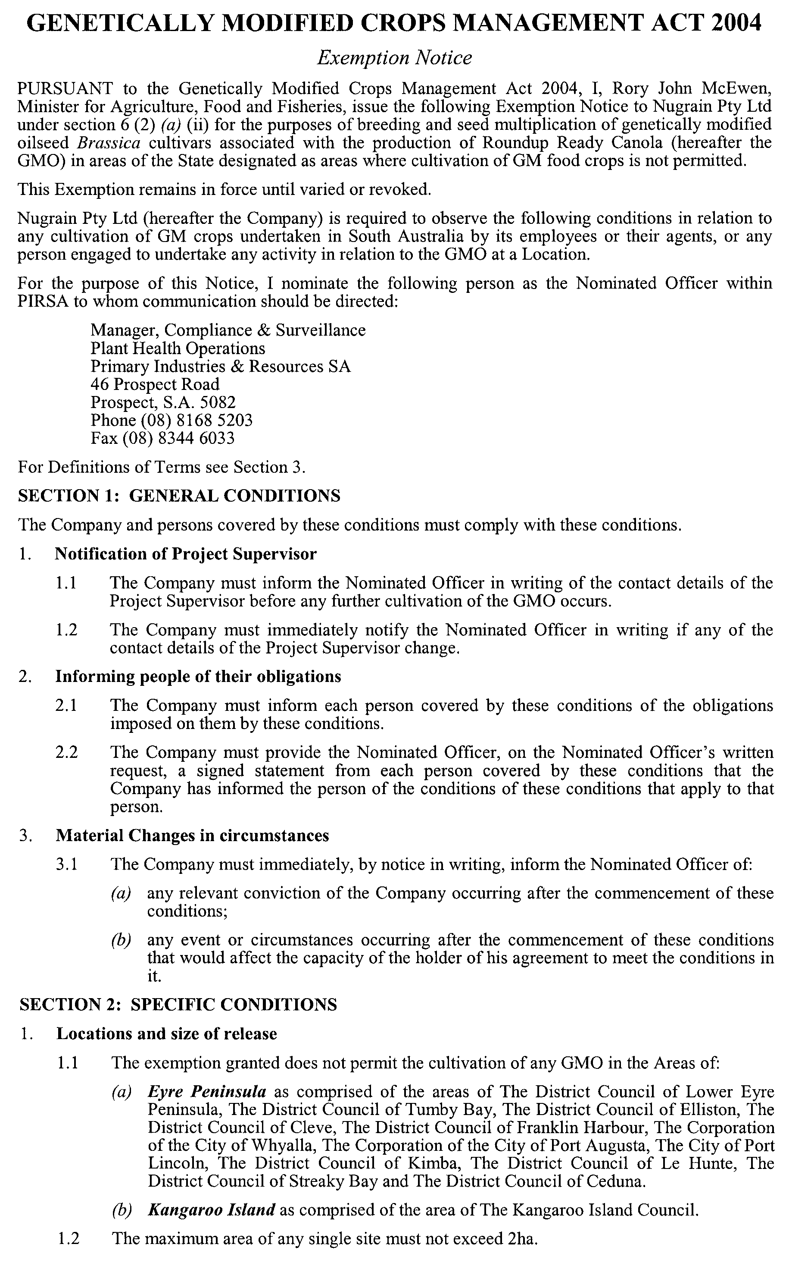
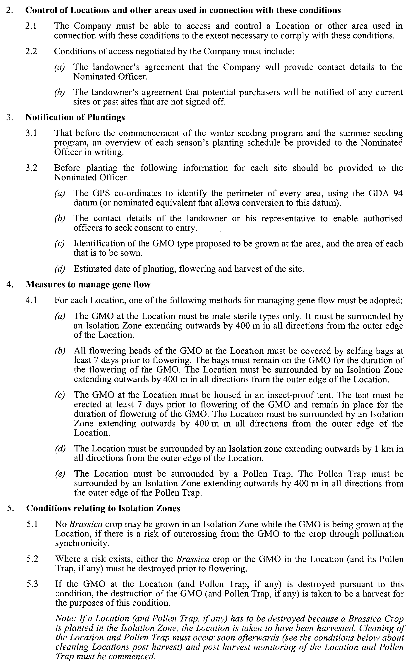
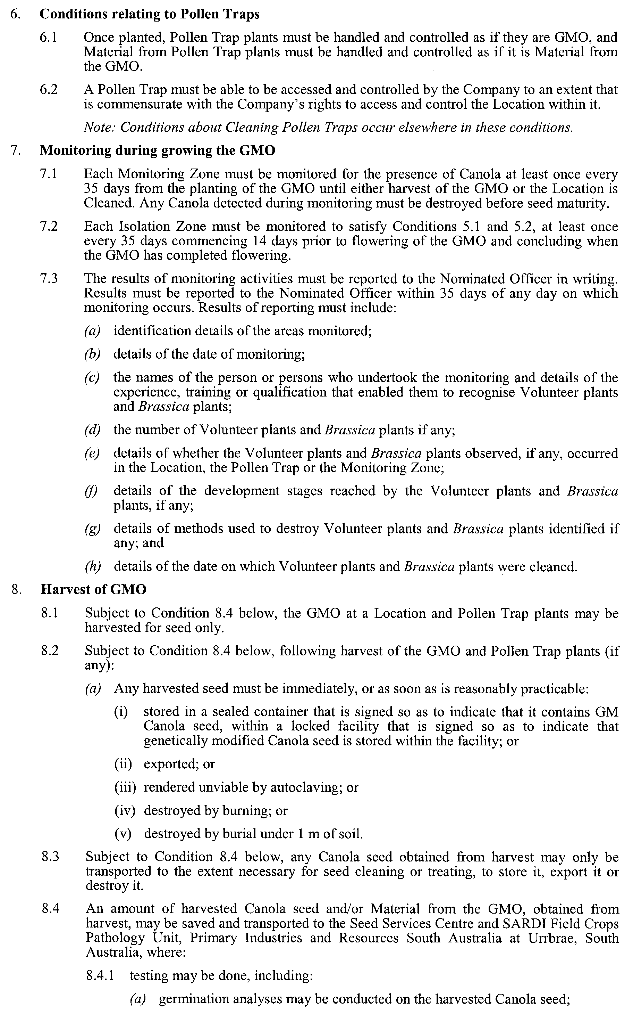
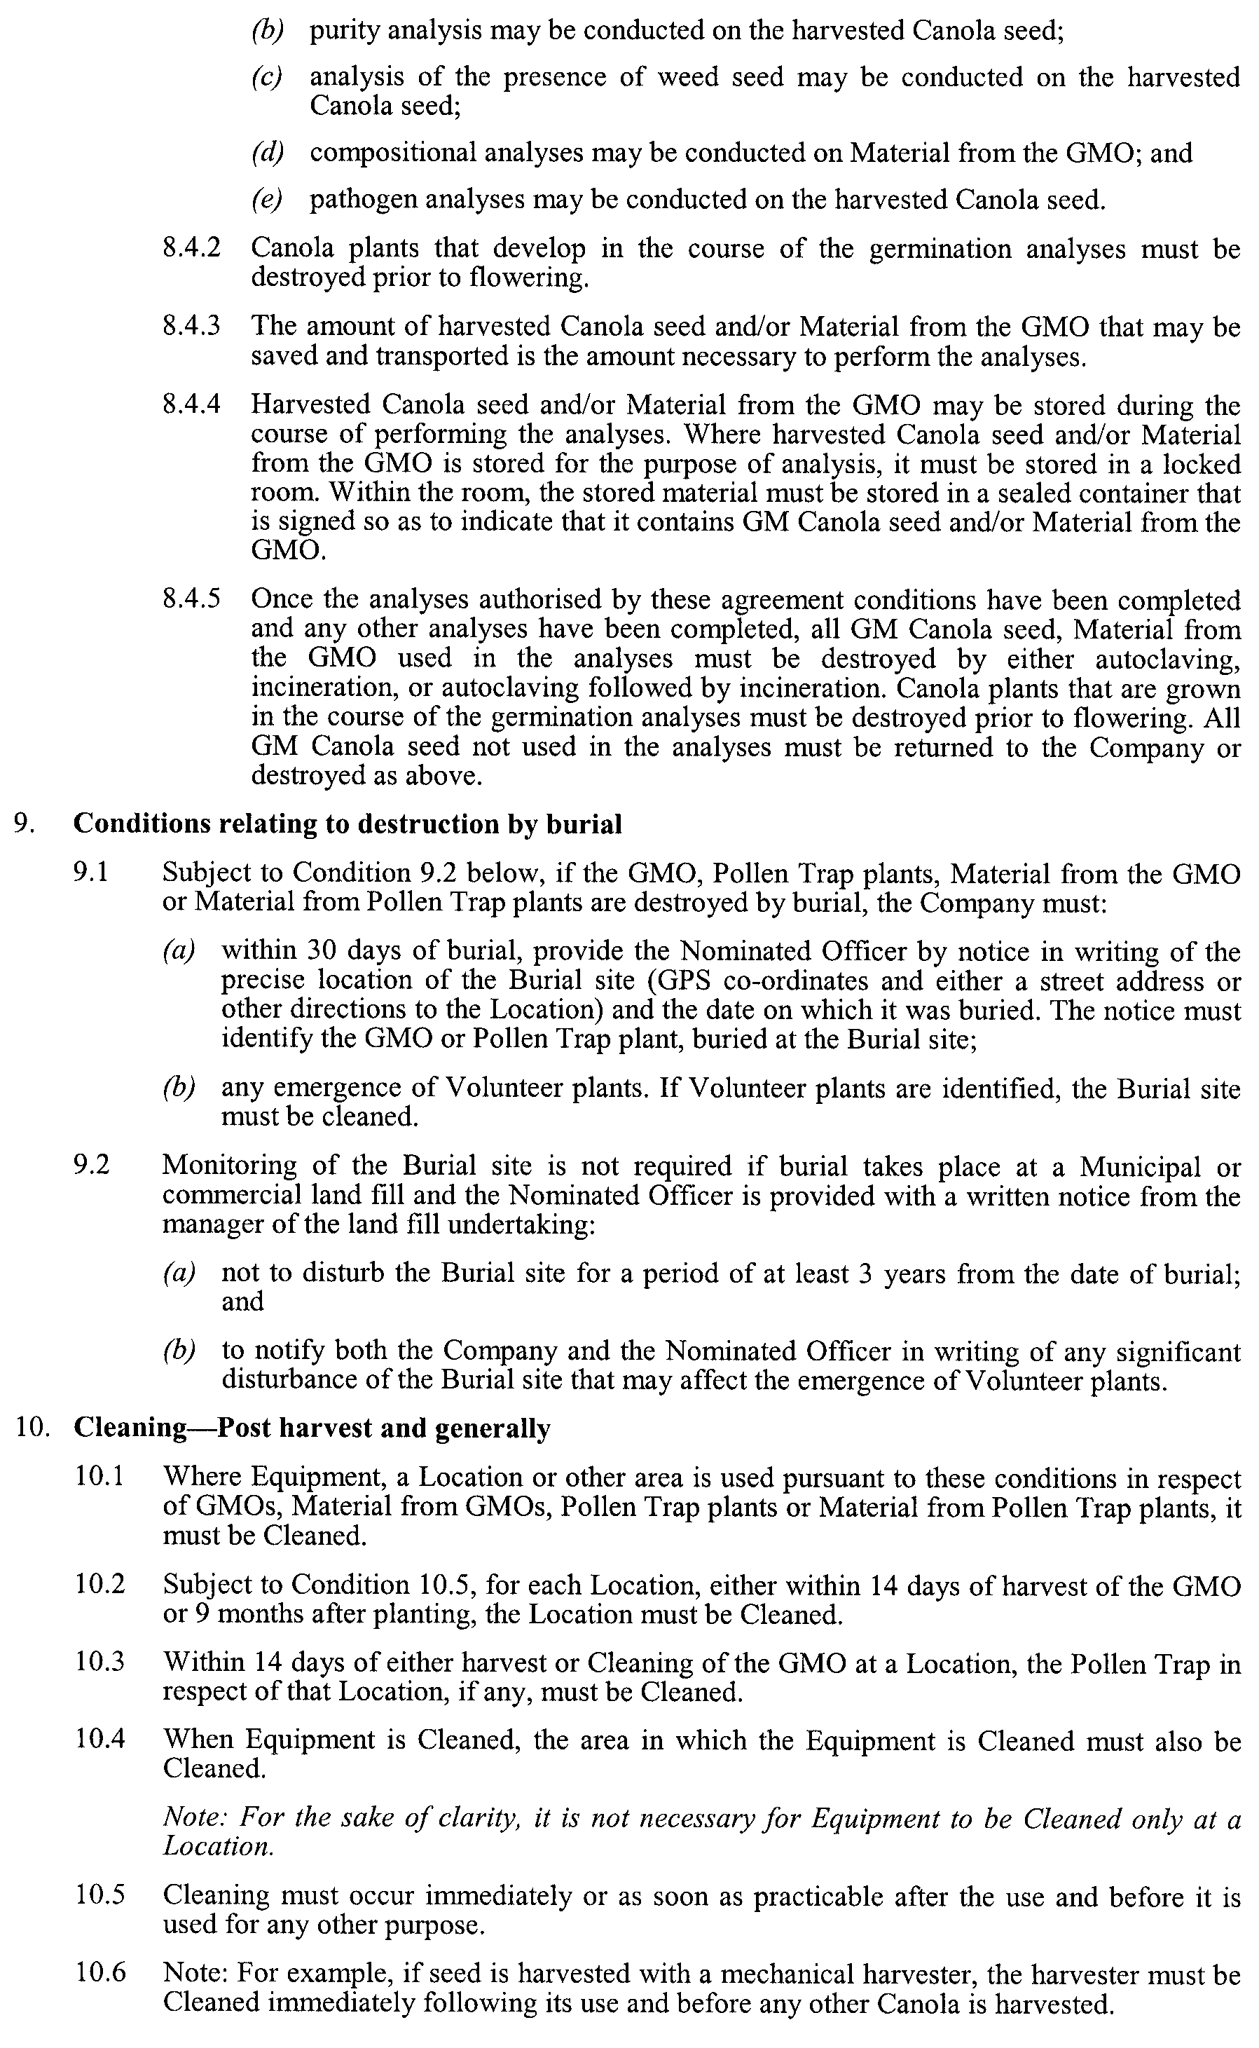
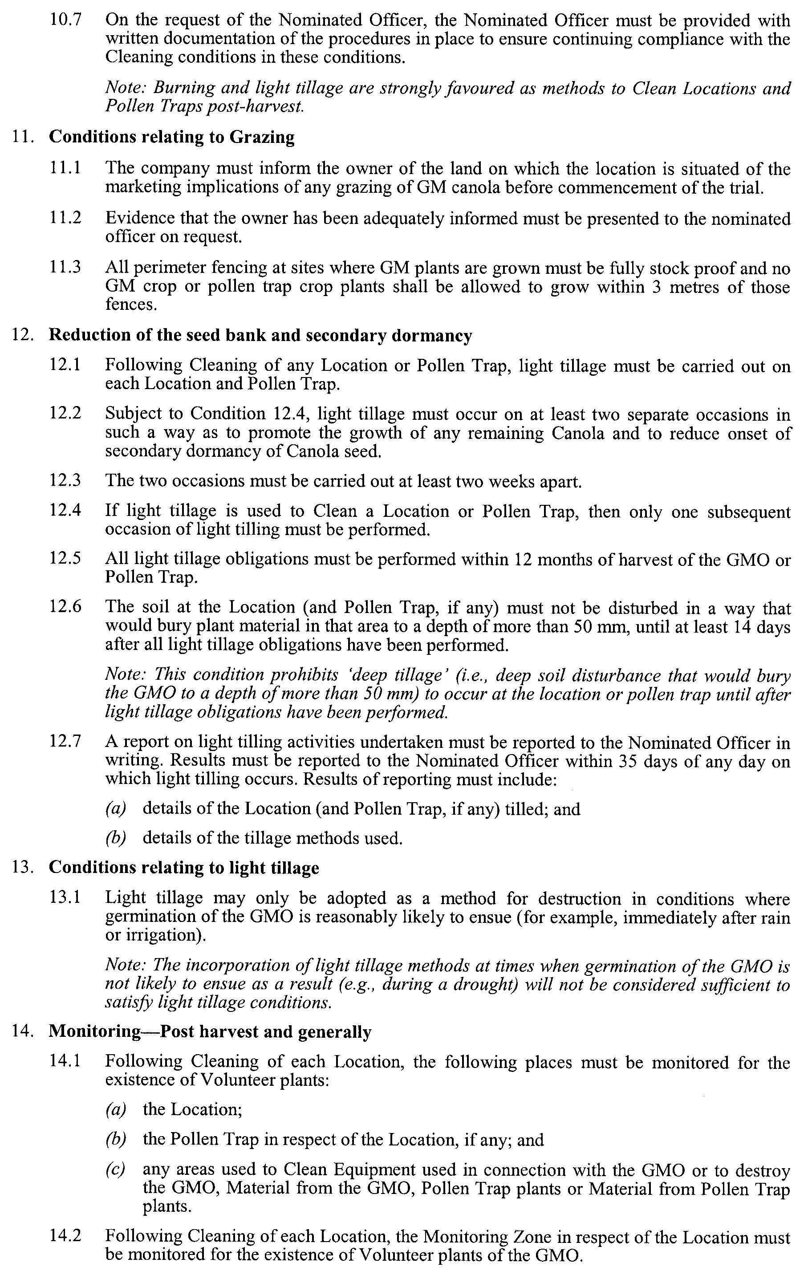
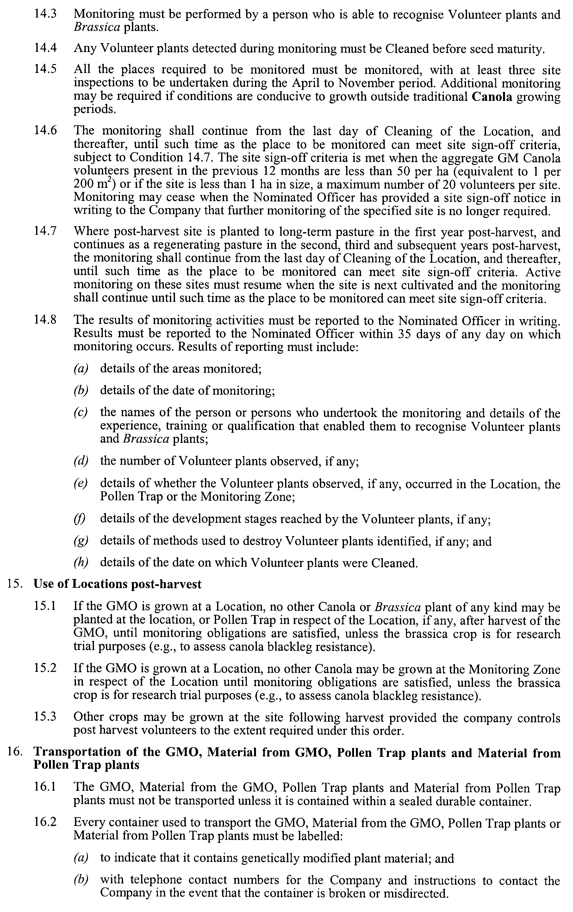
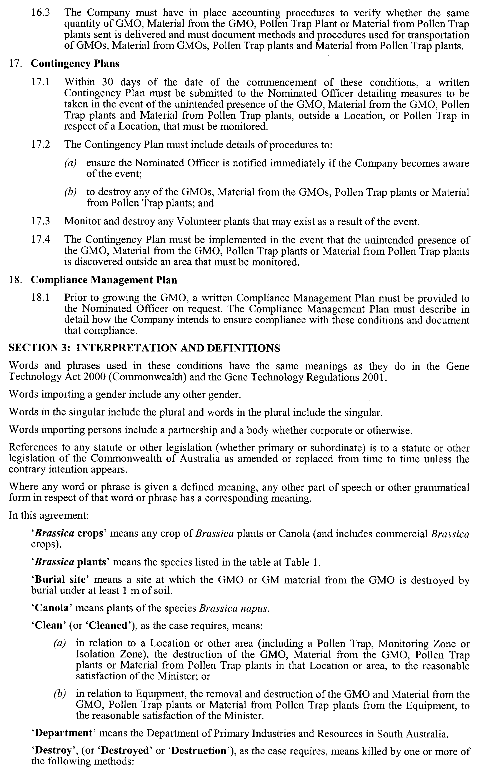
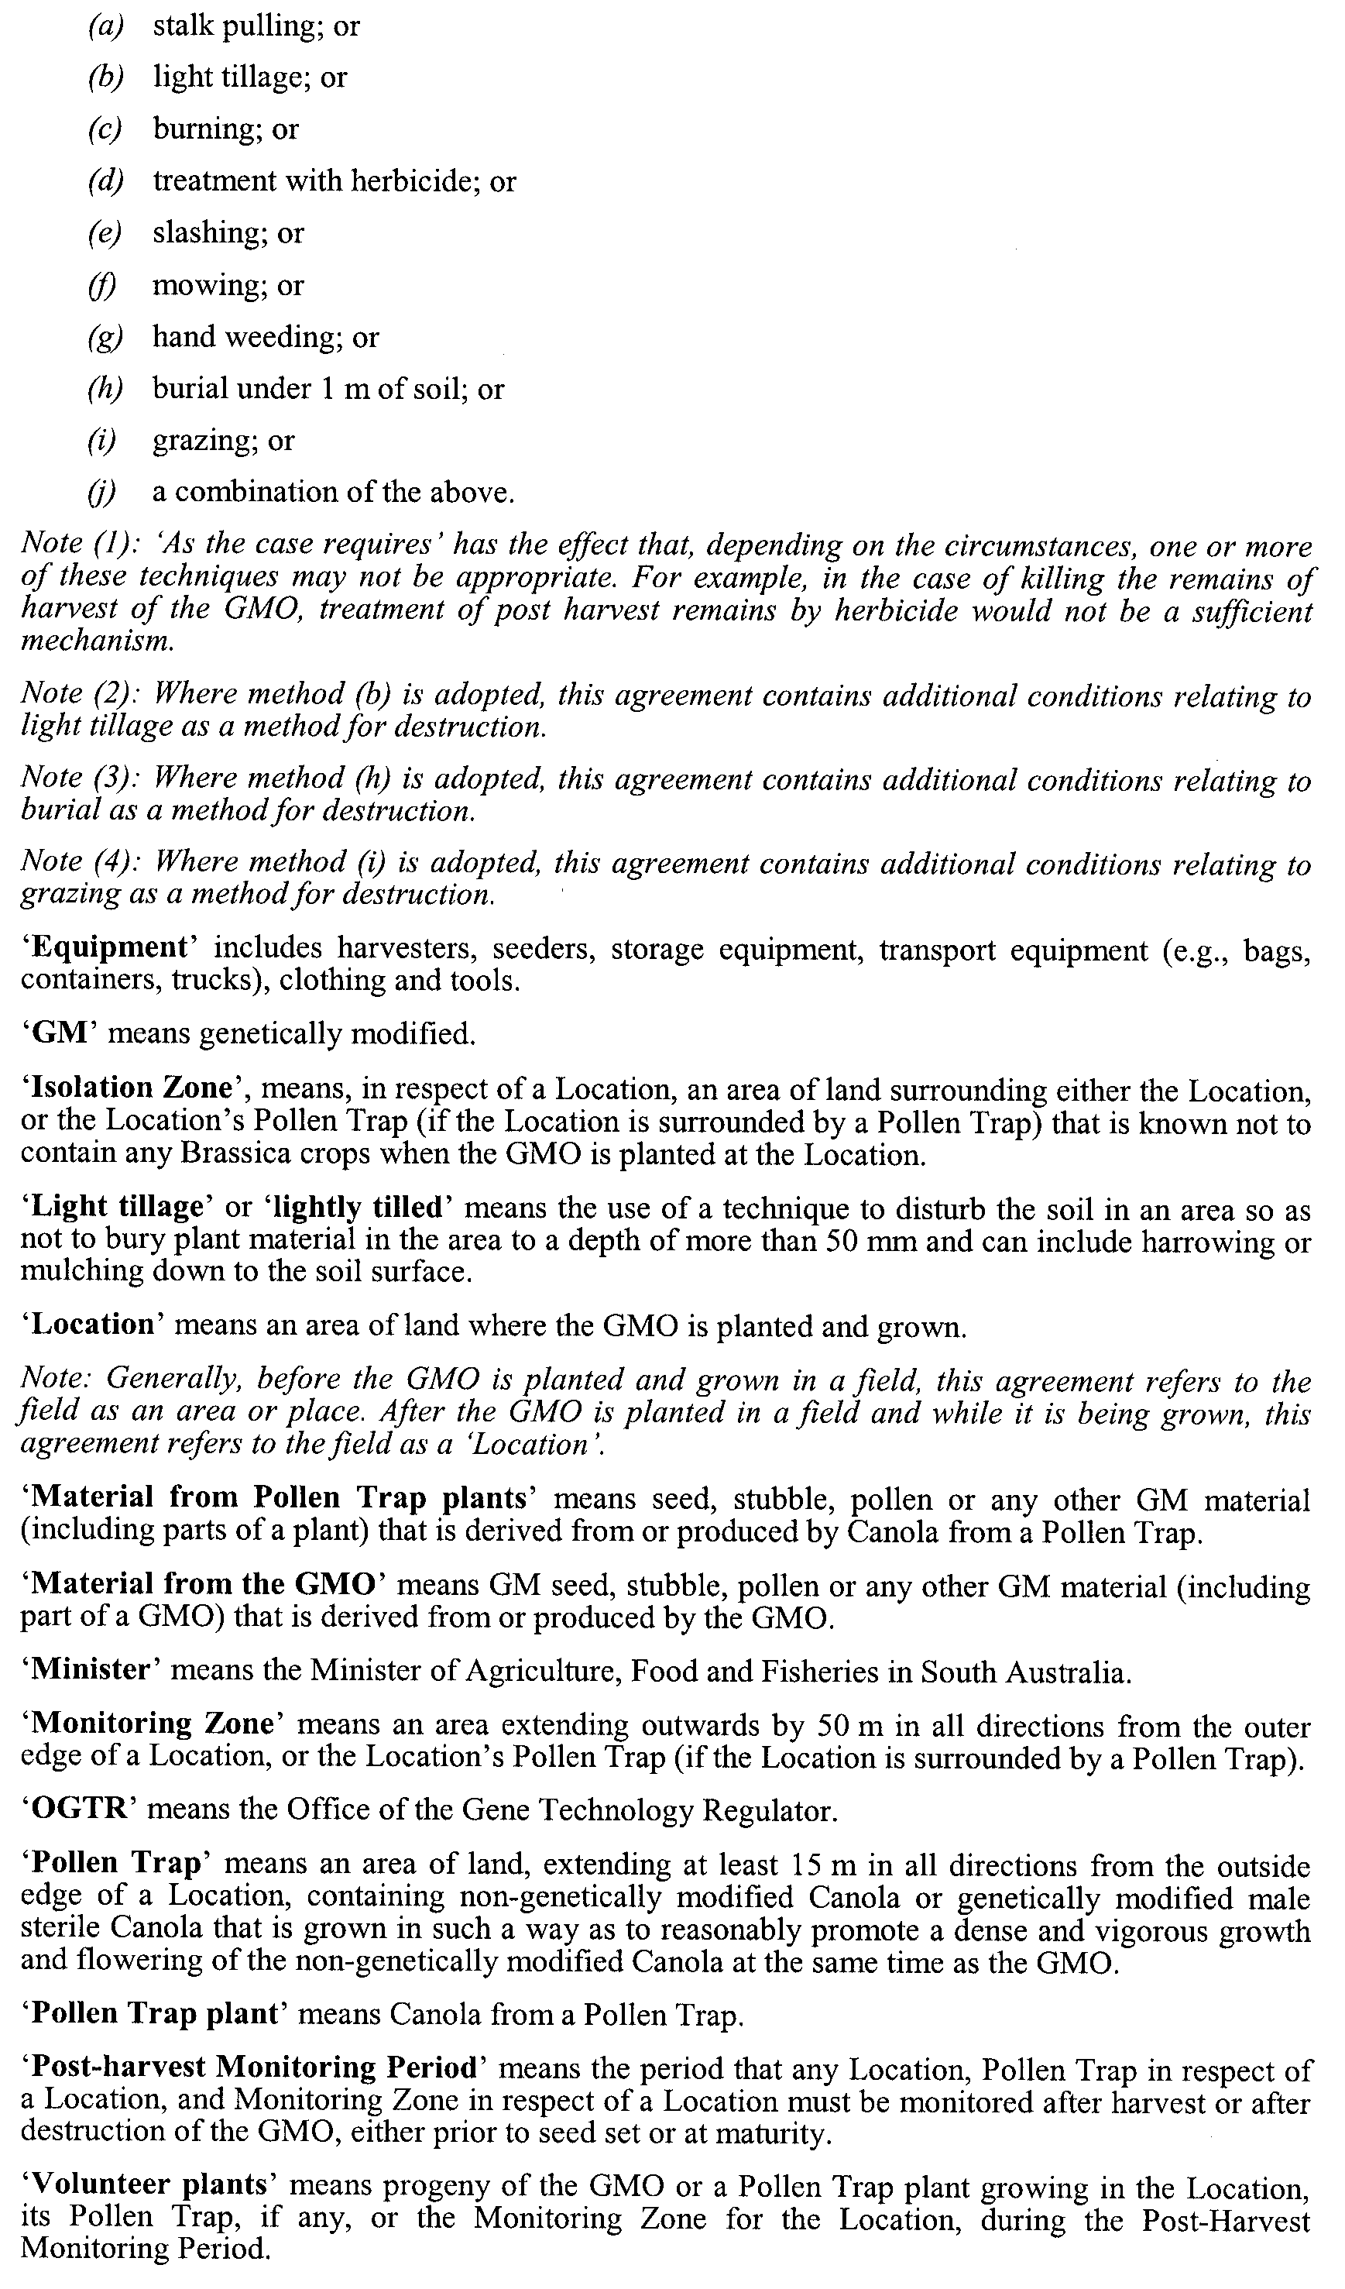
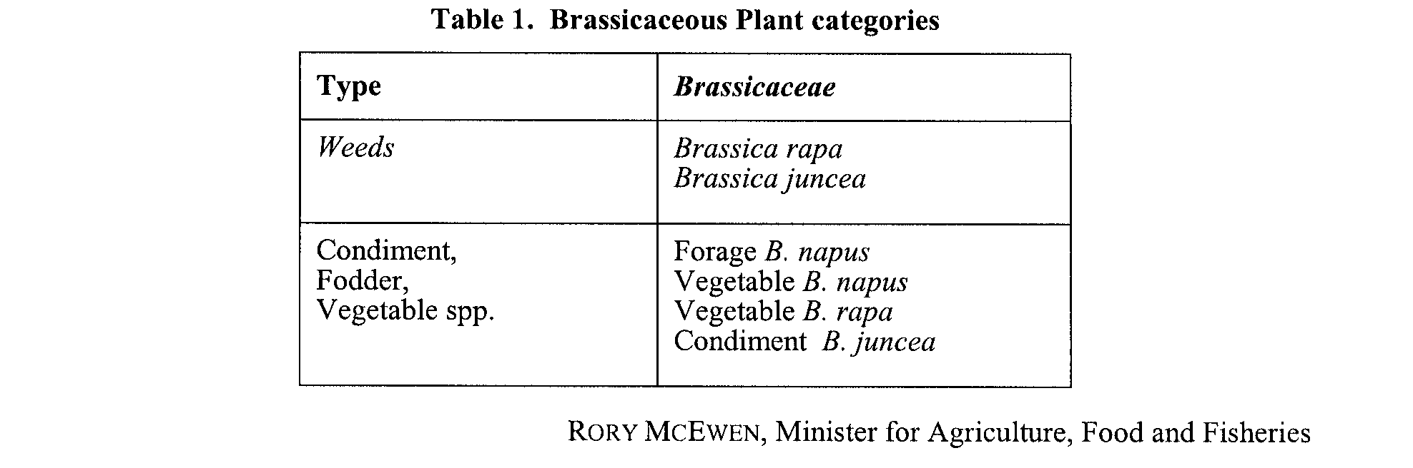

Aquaculture (Zones—Cape D’Estrees) Policy 2006

THE Aquaculture (Approval of Cape D’Estrees Zones Policy) Notice 2006 was published in the Gazette on 23 November 2006 at page 4077. The following is the Aquaculture (Zones—Cape D’Estrees) Policy 2006 referred to in that notice.

South Australia
Aquaculture (Zones—Cape D'Estrees) Policy 2006
under the Aquaculture Act 2001

Contents
Part 1—Preliminary
1 Short title
2 Interpretation
3 Zones
4 Prescribed criteria for all aquaculture zones
Part 2—Cape D'Estrees aquaculture zones
Division 1—Cape D'Estrees (inner) subtidal aquaculture zone
5 Identification of aquaculture zone
6 Class of permitted aquaculture
7 Prescribed criteria
Division 2—Cape D'Estrees (middle) subtidal aquaculture zone
8 Identification of aquaculture zone
9 Class of permitted aquaculture
10 Prescribed criteria
Division 3—Cape D'Estrees (outer) subtidal aquaculture zone
11 Identification of aquaculture zone
12 Class of permitted aquaculture
13 Prescribed criteria
Part 3—Laura Bay aquaculture exclusion zone
14 Identification of aquaculture exclusion zone
Schedule 1—Map

Part 1—Preliminary
1—Short title
This policy may be cited as the Aquaculture (Zones—Cape D'Estrees) Policy 2006.
2—Interpretation
In this policy—
Act means the Aquaculture Act 2001;
filter-feeding molluscs includes cockles, mussels, oysters and scallops;
leased area means an area subject to an aquaculture lease;
licence means an aquaculture licence.
Note—
Unless the contrary intention appears, terms used in this policy that are defined in the Act have the respective meanings assigned to those terms by the Act.
3—Zones
(1) Pursuant to section 11 of the Act, this policy—
(a) identifies aquaculture zones and an aquaculture exclusion zone; and
(b) specifies for an aquaculture zone—
(i) the classes of aquaculture permitted in the zone; and
(ii) prescribed criteria to be taken into account in the determination of applications for licences or in the making of other decisions under the Act in relation to the zone.
(2) This policy does not limit the matters that may be taken into account in the determination of applications for licences or in the making of other decisions under the Act.
4—Prescribed criteria for all aquaculture zones
In the determination of applications for licences and in the making of other decisions under the Act in relation to the aquaculture zones in this policy, it must be taken into account that, of the aggregated area leased or available for lease in those zones, 5 hectares must be reserved for the farming of aquatic organisms for the purposes of research.
Part 2—Cape D'Estrees aquaculture zones
Division 1—Cape D'Estrees (inner) subtidal aquaculture zone
5—Identification of aquaculture zone
The Cape D'Estrees (inner) subtidal aquaculture zone is comprised of the waters delineated in the map in Schedule 1 as the Cape D'Estrees (inner) subtidal aquaculture zone.
6—Class of permitted aquaculture
The classes of aquaculture permitted in the Cape D'Estrees (inner) subtidal aquaculture zone are—
(a) the farming of molluscs other than filter-feeding molluscs; and
(b) the farming of algae.
7—Prescribed criteria
In the determination of applications for licences and in the making of other decisions under the Act in relation to the Cape D'Estrees (inner) subtidal aquaculture zone, it must be taken into account that the zone must not contain more than 60 hectares of leased area.
Division 2—Cape D'Estrees (middle) subtidal aquaculture zone
8—Identification of aquaculture zone
The Cape D'Estrees (middle) subtidal aquaculture zone is comprised of the waters delineated in the map in Schedule 1 as the Cape D'Estrees (middle) subtidal aquaculture zone.
9—Class of permitted aquaculture
The classes of aquaculture permitted in the Cape D'Estrees (middle) subtidal aquaculture zone are—
(a) the farming of molluscs other than filter-feeding molluscs; and
(b) the farming of algae.
10—Prescribed criteria
In the determination of applications for licences and in the making of other decisions under the Act in relation to the Cape D'Estrees (middle) subtidal aquaculture zone, it must be taken into account that the zone must not contain more than 60 hectares of leased area.
Division 3—Cape D'Estrees (outer) subtidal aquaculture zone
11—Identification of aquaculture zone
The Cape D'Estrees (outer) subtidal aquaculture zone is comprised of the waters delineated in the map in Schedule 1 as the Cape D'Estrees (outer) subtidal aquaculture zone.
12—Class of permitted aquaculture
The classes of aquaculture permitted in the Cape D'Estrees (outer) subtidal aquaculture zone are—
(a) the farming of molluscs other than filter-feeding molluscs; and
(b) the farming of algae.
13—Prescribed criteria
In the determination of applications for licences and in the making of other decisions under the Act in relation to the Cape D'Estrees (outer) subtidal aquaculture zone, it must be taken into account that the zone must not contain more than 60 hectares of leased area.
Part 3—Laura Bay aquaculture exclusion zone
14—Identification of aquaculture exclusion zone
The Laura Bay aquaculture exclusion zone is comprised of the waters delineated in the map in Schedule 1 as the Laura Bay aquaculture exclusion zone.
Schedule 1—Map
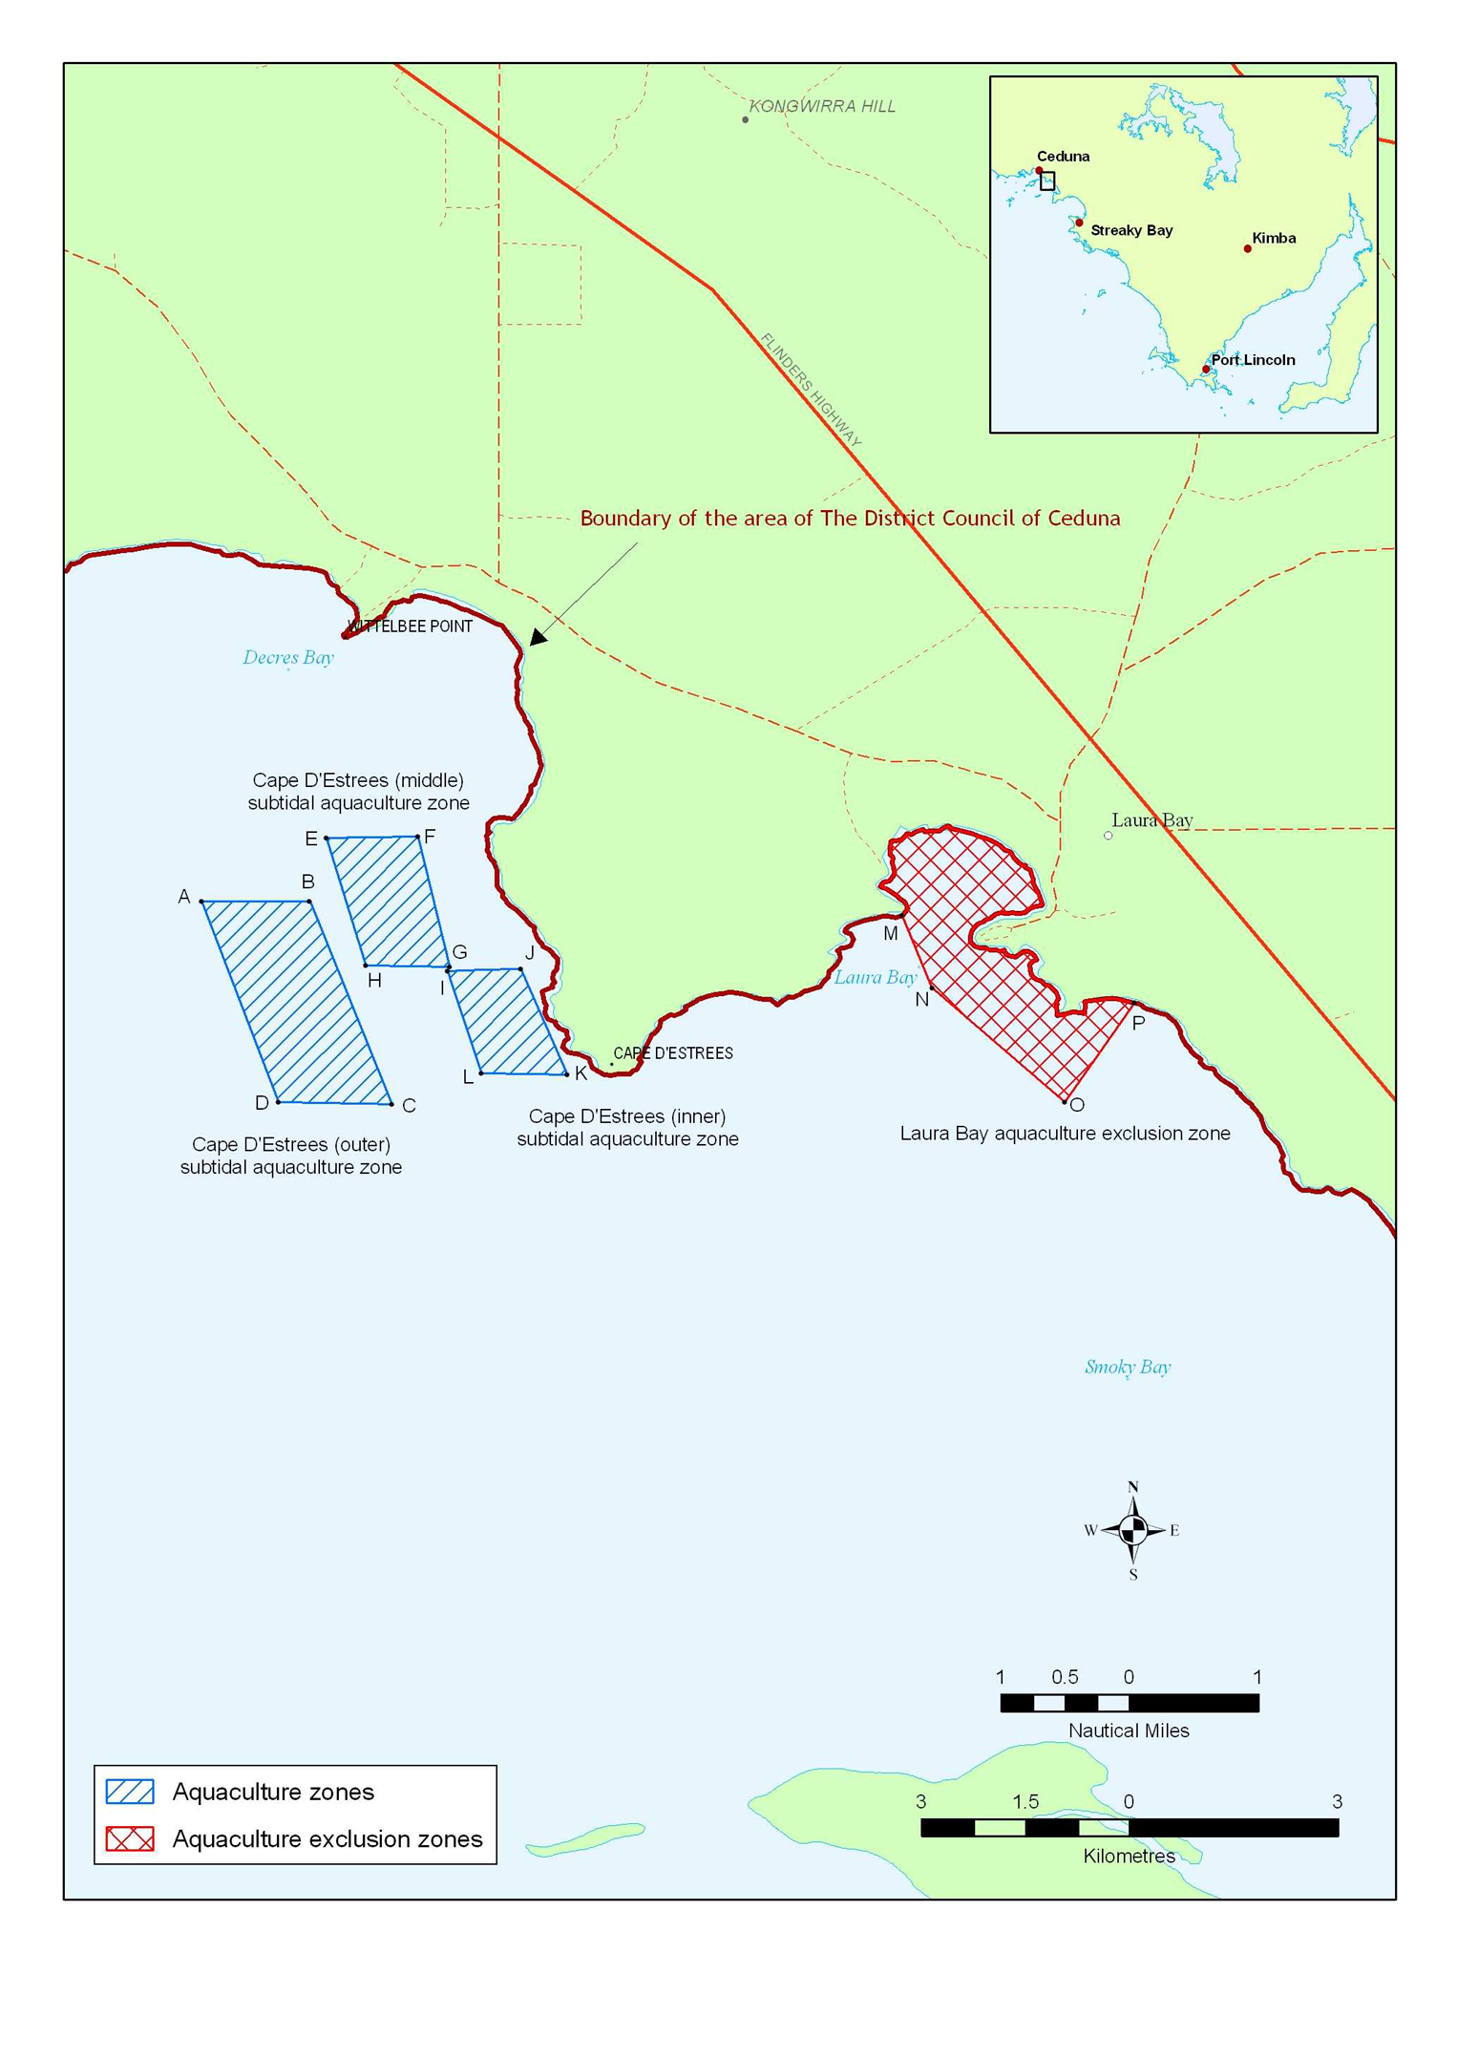

Coordinates—Cape D'Estrees (outer) subtidal aquaculture zone (GDA94)
Point | Longitude | Latitude
A | 133°43'03.14″ east | 32°14′30.52″ south
B | 133°43′53.56″ east | 32°14′30.54″ south
C | 133°44′32.02″ east | 32°16′05.35″ south
D | 133°43′39.1″ east | 32°16′04.37″ south

Coordinates—Cape D'Estrees (middle) subtidal aquaculture zone (GDA94)
Point | Longitude | Latitude
E | 133°44'01.28″ east | 32°14′01.22″ south
F | 133°44′44.07″ east | 32°14′00.52″ south
G | 133°44′58.94″ east | 32°15′01.33″ south
H | 133°44′19.82″ east | 32°15′00.59″ south

Coordinates—Cape D'Estrees (inner) subtidal aquaculture zone (GDA94)
Point | Longitude | Latitude
I | 133°44'57.79″ east | 32°15′03.25″ south
J | 133°45′31.98″ east | 32°15′02.13″ south
K | 133°45′53.74″ east | 32°15′51.65″ south
L | 133°45′13.75″ east | 32°15′50.88″ south

Coordinates—Laura Bay aquaculture exclusion zone (GDA94)
Point | Longitude | Latitude
M | 133°48′30.02″ east | 32°14′37.3″ south
N | 133°48'44.09″ east | 32°15′11.15″ south
O | 133°49′45.86″ east | 32°16′04.48″ south
P | 133°50′18.33″ east | 32°15′18.04″ south

South Australia
National Parks and Wildlife (Fowlers Bay Conservation Park—Mining Rights) Proclamation 2006
under section 43 of the National Parks and Wildlife Act 1972

Preamble
1 The Crown land described in Schedule 1, together with other land, is, by another proclamation made on this day, constituted as a conservation park under section 30(1) of the National Parks and Wildlife Act 1972 and assigned the name Fowlers Bay Conservation Park.
2 It is intended that, by this proclamation, certain existing and future rights of entry, prospecting, exploration or mining be preserved in relation to the portion of the land constituting the conservation park that is described in Schedule 1.

1—Short title
This proclamation may be cited as the National Parks and Wildlife (Fowlers Bay Conservation Park—Mining Rights) Proclamation 2006.
2—Commencement
This proclamation comes into operation on the day on which it is made.
3—Interpretation
In this proclamation—
Environment Minister means the Minister for the time being administering the National Parks and Wildlife Act 1972;
Mining Minister means the Minister for the time being administering the Mining Act 1971.
4—Existing rights to continue
Subject to clause 6, existing rights of entry, prospecting, exploration or mining under the Mining Act 1971 may continue to be exercised in respect of the land described in Schedule 1.
5—New rights may be acquired
Rights of entry, prospecting, exploration or mining may, with the approval of the Mining Minister and the Environment Minister, be acquired pursuant to the Mining Act 1971 in respect of the land described in Schedule 1 and may, subject to clause 6, be exercised in respect of that land.
6—Conditions for exercise of rights
A person in whom rights of entry, prospecting, exploration or mining are vested pursuant to the Mining Act 1971 (whether those rights were acquired before or after the making of this proclamation) must not exercise those rights in respect of the land described in Schedule 1 unless the person complies with the following conditions:
(a) if work to be carried out in relation to the land in the exercise of those rights has not previously been authorised, the person must give at least 3 months notice of the proposed work to the Mining Minister and the Environment Minister and must supply each Minister with such information relating to the proposed work as the Minister may require;
(b) if directions are agreed between the Mining Minister and the Environment Minister and given to the person in writing in relation to—
(i) carrying out work in relation to the land in a manner that minimises damage to the land (including the land's vegetation and wildlife) and the environment generally; or
(ii) preserving objects, structures or sites of historical, scientific or cultural interest; or
(iii) rehabilitating the land (including the land's vegetation and wildlife) on completion of the work; or
(iv) (where the work is being carried out in the exercise of rights acquired after the making of this proclamation) prohibiting or restricting access to any specified area of the land that the Ministers believe would suffer significant detriment as a result of carrying out the work,
the person must comply with those directions in carrying out the work;
(c) if a plan of management is in operation under section 38 of the National Parks and Wildlife Act 1972 in respect of the land, the person must have regard to the provisions of the plan of management;
(d) in addition to complying with the other requirements of this proclamation, the person—
(i) must take such steps as are reasonably necessary to ensure that objects, structures and sites of historical, scientific or cultural interest and the land's vegetation and wildlife are not unduly affected by any work; and
(ii) must maintain all work areas in a clean and tidy condition; and
(iii) must, on the completion of any work, obliterate or remove all installations and structures (other than installations and structures designated by the Mining Minister and the Environment Minister as suitable for retention) used exclusively for the purposes of that work;
(e) if no direction has been given by the Mining Minister and the Environment Minister under paragraph (b)(iii), the person must rehabilitate the land (including its vegetation and wildlife) on completion of any work to the satisfaction of the Environment Minister.
7—Governor may give approvals, directions
If the Mining Minister and the Environment Minister cannot agree as to whether—
(a) approval should be granted or refused under clause 5; or
(b) a direction should be given under clause 6(b),
the Governor may, with the advice and consent of the Executive Council—
(c) grant or refuse the necessary approval under clause 5; or
(d) give a direction in writing under clause 6(b).
Schedule 1—Description of land
Allotment 100 of Deposited Plan 35535, Hundred of Caldwell.
Made by the Governor
with the advice and consent of the Executive Council
on 30 November 2006
EHCS06/0030

South Australia
National Parks and Wildlife (Fowlers Bay Conservation Park) Proclamation 2006
under section 30(1) of the National Parks and Wildlife Act 1972
1—Short title
This proclamation may be cited as the National Parks and Wildlife (Fowlers Bay Conservation Park) Proclamation 2006.
2—Commencement
This proclamation comes into operation on the day on which it is made.
3—Constitution of Fowlers Bay Conservation Park
The following Crown land is constituted as a conservation park and assigned the name Fowlers Bay Conservation Park:
Allotments 62 and 64 of Deposited Plan 35363, Hundred of Caldwell;
Allotment 100 of Deposited Plan 35535, Hundred of Caldwell;
Allotment 101 of Deposited Plan 35535, Hundreds of Caldwell and Sturdee.
Made by the Governor
being of the opinion that the Crown land described in clause 3 should be protected and preserved for the purpose of conserving any wildlife and the natural and historic features of the land and with the advice and consent of the Executive Council
on 30 November 2006
EHCS06/0030

South Australia
National Parks and Wildlife (Unnamed Conservation Park) Proclamation 2006
under section 29(3) of the National Parks and Wildlife Act 1972
1—Short title
This proclamation may be cited as the National Parks and Wildlife (Mamungari Conservation Park) Proclamation 2006.
2—Commencement
This proclamation comes into operation on the day on which it is made.
3—Alteration of name of Unnamed Conservation Park
The name assigned to the Unnamed Conservation Park (North out of Hundreds, Section 50) is altered to Mamungari Conservation Park.
Made by the Governor
with the agreement of the registered proprietor of the land and with the advice and consent of the Executive Council
on 30 November 2006
EHCS06/0029

South Australia
State Procurement Variation Regulations 2006
under the State Procurement Act 2004

Contents
Part 1—Preliminary
1 Short title
2 Commencement
3 Variation provisions
Part 2—Variation of State Procurement Regulations 2005
4 Variation of regulation 4—Bodies declared to be prescribed public authorities (section 4 of Act)

Part 1—Preliminary
1—Short title
These regulations may be cited as the State Procurement Variation Regulations 2006.
2—Commencement
These regulations come into operation on the day on which they are made.
3—Variation provisions
In these regulations, a provision under a heading referring to the variation of specified regulations varies the regulations so specified.
Part 2—Variation of State Procurement Regulations 2005
4—Variation of regulation 4—Bodies declared to be prescribed public authorities (section 4 of Act)
(1) Regulation 4—before "Local Government Finance Authority" insert:
Land Management Corporation
(2) Regulation 4—after "Local Government Superannuation Board" insert:
Motor Accident Commission
South Australian Centre for Trauma and Injury Recovery Incorporated
(3) Regulation 4—after "TransAdelaide" insert:
WorkCover Corporation of South Australia
Note—
As required by section 10AA(2) of the Subordinate Legislation Act 1978, the Minister has certified that, in the Minister's opinion, it is necessary or appropriate that these regulations come into operation as set out in these regulations.
Made by the Governor
with the advice and consent of the Executive Council
on 30 November 2006
No 256 of 2006
MAS06/013CS

South Australia
Travel Agents Variation Regulations 2006
under the Travel Agents Act 1986

Contents
Part 1—Preliminary
1 Short title
2 Commencement
3 Variation provisions
Part 2—Variation of Travel Agents Regulations 1996
4 Variation of regulation 6—Exemptions

Part 1—Preliminary
1—Short title
These regulations may be cited as the Travel Agents Variation Regulations 2006.
2—Commencement
These regulations come into operation on the day on which they are made.
3—Variation provisions
In these regulations, a provision under a heading referring to the variation of specified regulations varies the regulations so specified.
Part 2—Variation of Travel Agents Regulations 1996
4—Variation of regulation 6—Exemptions
Regulation 6—after its present contents (now to be designated as subregulation (1)) insert:
(2) A person who is authorised by a licence to carry on business as a travel agent under a law of a reciprocating State or Territory is exempt from section 7 of the Act to the extent that the person—
(a) advertises in South Australia, if the person states in the advertisement—
(i) the person's name; and
(ii) the number of the licence issued to the person under the law of the reciprocating State or Territory; and
(iii) the name of the reciprocating State or Territory in which the licence was issued; or
(b) provides information to prospective customers in connection with the person's business as a travel agent.
(3) Subregulation (2) does not authorise the person to carry on business as a travel agent if—
(a) the person is physically present in South Australia; or
(b) the person operates through another person who is physically present in South Australia.
(4) In subregulation (2) a reciprocating State or Territory means—
(a) Australian Capital Territory;
(b) New South Wales;
(c) Queensland;
(d) Tasmania;
(e) Victoria;
(f) Western Australia.
Note—
As required by section 10AA(2) of the Subordinate Legislation Act 1978, the Minister has certified that, in the Minister's opinion, it is necessary or appropriate that these regulations come into operation as set out in these regulations.
Made by the Governor
with the advice and consent of the Executive Council
on 30 November 2006
No 257 of 2006
CSMCA06/019

South Australia
State Theatre Company of South Australia Regulations 2006
under the State Theatre Company of South Australia Act 1972

Contents
1 Short title
2 Commencement
3 Interpretation
4 Rolls of subscribers and employees
5 Requirement for holding election
6 Nominations
7 Method of election of candidates
8 Close of rolls
9 Ballot papers
10 Provision of ballot papers
11 Voting
12 Informal ballot papers
13 Scrutineers
14 Counting of votes
15 Notice of election results
16 Validity of elections
17 Subscription fees
Schedule 1—Revocation of State Theatre Company of South Australia Regulations 1994

1—Short title
These regulations may be cited as the State Theatre Company of South Australia Regulations 2006.
2—Commencement
These regulations will come into operation 4 months after the day on which they are made (see Subordinate Legislation Act 1978 section 10AA).
3—Interpretation
In these regulations, unless the contrary intention appears—
Act means the State Theatre Company of South Australia Act 1972;
election includes a by-election;
employee governor means the governor referred to in section 6(2)(c) of the Act;
official mark means a mark approved by the secretary for the purpose of authenticating ballot papers;
secretary means the secretary to the Board appointed under section 22 of the Act;
subscriber governor means a governor referred to in section 6(2)(b) of the Act.
4—Rolls of subscribers and employees
(1) The secretary must maintain—
(a) the roll of subscribers to the Company; and
(b) the roll of employees of the Company.
(2) The secretary must enter on the roll of subscribers the name and address of a person—
(a) who applies in writing to the secretary to be enrolled as a subscriber and pays the annual subscription fee fixed by the Board; or
(b) who, in the opinion of the Board, has given distinguished and outstanding service to the Company and is nominated by the Board as an honorary subscriber.
(3) A person may not be enrolled on the roll of subscribers unless he or she is of or above the age of 18 years.
(4) The secretary must enter on the roll of employees the names and addresses of all employees of the Company.
(5) The secretary must remove from the roll of subscribers the name and address of a person (not being an honorary subscriber) who refuses or fails to pay the annual subscription fee.
(6) If a subscriber notifies the secretary in writing that the subscriber—
(a) has changed his or her name or address; or
(b) wishes to cancel his or her subscription,
the secretary must vary the roll of subscribers accordingly.
(7) The secretary must remove from the roll of employees the name and address of a person who ceases to be an employee of the Company.
(8) The roll of subscribers must be made available at the Board's offices for inspection by subscribers during ordinary office hours.
(9) The roll of employees must be made available at the Board's offices for inspection by employees during ordinary office hours.
5—Requirement for holding election
An election must be conducted by the secretary whenever required under section 6 of the Act.
6—Nominations
(1) If it is necessary to hold an election for subscriber governors, the secretary must, by notice published in a daily newspaper circulating throughout the State, call for the nomination of candidates for the election.
(2) If it is necessary to hold an election for an employee governor, the secretary must, by notice affixed in a prominent place in a part of the Company's premises to which all employees of the Company have access, call for the nomination of candidates for the election.
(3) A notice under subregulation (1) or (2) must specify—
(a) the number of candidates required to be elected; and
(b) the date and hour by which nominations must be received by the secretary.
(4) The date for the close of nominations must be—
(a) in the case of an election of subscriber governors—at least 14 days after the date of publication of the notice under subregulation (1); or
(b) in the case of an election of an employee governor—at least 14 days after the date of the posting of the notice under subregulation (2).
(5) A nomination of a candidate for election must—
(a) be in writing; and
(b) contain a statement, signed by the candidate, to the effect that he or she consents to stand as a candidate in the election; and
(c) be signed by—
(i) in the case of a nomination for election as a subscriber governor—at least 3 subscribers other than the candidate; or
(ii) in the case of a nomination for election as an employee governor—at least 2 employees other than the candidate; and
(d) be delivered to the secretary not later than the date and hour specified in the notice for the close of nominations.
(6) A nomination is invalid if it is not made in accordance with this regulation.
7—Method of election of candidates
(1) If the number of candidates nominated is not greater than the number of subscribers or employees required to be elected, the secretary must declare the candidate or candidates duly elected.
(2) A declaration under subregulation (1) must be made immediately after the close of nominations.
(3) The secretary must, as soon as practicable after the making of a declaration under this regulation, notify in writing each successful candidate of his or her election.
(4) If the number of candidates nominated is greater than the number of subscribers or employees required to be elected, the secretary must cause ballot papers to be prepared for an election.
8—Close of rolls
(1) If an election is to be held, the secretary must—
(a) in the case of an election of subscriber governors—close the roll of subscribers 7 days after the day on which a notice under regulation 6(1) is published; or
(b) in the case of an election of an employee governor—close the roll of employees 7 days after the day on which a notice under regulation 6(2) is posted,
until the completion of the election.
(2) The secretary must ensure that the roll of subscribers or employees, as the case may require, has been made up in accordance with regulation 4 at the date of the close of the roll.
9—Ballot papers
Ballot papers must be in a form determined by the secretary.
10—Provision of ballot papers
(1) If an election of subscriber governors is to be held, the secretary must provide each subscriber recorded on the roll of subscribers at the close of the roll with a ballot paper and envelopes by posting them to the subscriber at his or her address last recorded in the roll.
(2) If an election of an employee governor is to be held, the secretary must provide each employee recorded on the roll of employees at the close of the roll with a ballot paper and envelopes by posting them to the employee at his or her address last recorded in the roll.
(3) If a ballot paper is provided to a subscriber or employee, that person must also be provided with—
(a) an unmarked envelope suitable for holding the ballot paper; and
(b) a second envelope suitable for holding the first envelope, addressed to the secretary and bearing on the side on which the address is written the words "ballot paper" and a place for the signature of the subscriber or employee.
(4) Every ballot paper must be authenticated by the official mark.
11—Voting
(1) A person who wishes to vote at an election must—
(a) indicate—
(i) his or her first preference for a candidate by placing the number 1 in the square opposite the name of the candidate on the ballot paper; and
(ii) his or her preference for the other candidates by placing consecutive numbers (commencing with the number 2) in the squares opposite the names of the candidates on the ballot paper; and
(b) place the ballot paper in the unmarked envelope provided, place the envelope inside the second envelope addressed to the secretary, seal the second envelope and sign it; and
(c) return the envelope to the secretary not later than the date and hour fixed by the secretary and specified on the ballot paper.
(2) A ballot paper is invalid if it is received by the secretary after the date and hour specified for its return.
12—Informal ballot papers
A ballot paper is informal if—
(a) it is not authenticated by the official mark; or
(b) it has not been completed in accordance with regulation 11; or
(c) it has on it any mark or writing by which the voter can be identified.
13—Scrutineers
(1) Each candidate for election may, by instrument in writing, appoint 1 scrutineer to be present when the votes at an election are counted.
(2) A candidate for election is not eligible to be appointed as a scrutineer for the purposes of that election.
(3) The secretary must notify a scrutineer appointed under subregulation (1) of the time and place at which the votes are to be counted.
14—Counting of votes
(1) Votes must be counted by the secretary in the presence of any scrutineers appointed under regulation 13 who seek to be present.
(2) The following provisions apply to the counting of votes at an election:
(a) the secretary must open all the unmarked envelopes, extract the ballot papers, reject all ballot papers that are informal and count the number of ballot papers remaining;
(b) the secretary must conduct the count for an election in which only 1 vacancy is to be filled, or for the filling of the first vacancy in an election, as follows:
(i) the secretary must count to each candidate the ballot papers indicating a first preference vote for that candidate and, if the candidate with the largest number of ballot papers counted to him or her has an absolute majority, declare that candidate to be elected;
(ii) if no candidate has an absolute majority on the first count, the secretary must exclude the candidate with the fewest ballot papers counted to him or her from the count and count each of the excluded candidate's ballot papers to a continuing candidate according to the next preference indicated on the ballot paper;
(iii) if a candidate then has an absolute majority, the secretary must declare that candidate to be elected, but, if not, the secretary must repeat the process of excluding the candidate with the fewest ballot papers from the count and counting each of the excluded candidate's ballot papers to a continuing candidate according to the next preference indicated on the ballot paper until a candidate has an absolute majority;
(iv) the secretary must, when an absolute majority of the ballot papers is counted to a candidate, declare that candidate to be elected;
(c) the secretary must conduct the count for the filling of the second vacancy in an election as follows:
(i) the secretary must count to each candidate (other than the elected candidate) each ballot paper indicating a first preference vote for that candidate and count each ballot paper indicating a first preference vote for the elected candidate to another candidate according to the next preference indicated on the ballot paper;
(ii) if the candidate with the largest number of ballot papers counted to him or her has an absolute majority, the secretary must declare that candidate to be elected, but, if not, the secretary must proceed with the count as provided by paragraph (b)(ii) and (iii) and, when an absolute majority of the ballot papers is counted to a candidate, declare that candidate to be elected.
(3) For the purposes of subregulation (2)—
(a) a reference to an absolute majority is a reference to more than one-half of the ballot papers other than those that have been rejected as informal; and
(b) a reference to a continuing candidate is a reference to a candidate—
(i) who has not been excluded from the count; and
(ii) in relation to a count for the filling of a second vacancy, who has not been declared to be elected on the count for the filling of the first vacancy; and
(c) if at any stage of the count 2 or more candidates have an equal number of ballot papers counted to them and 1 is required to be excluded from the count, the secretary must decide, by lot, which of them is to be excluded; and
(d) if 2 candidates remain in the count but have an equal number of ballot papers counted to them, the secretary must decide, by lot, which of them is to be elected.
(4) The secretary may not vote in an election.
15—Notice of election results
The secretary must, as soon as practicable after the counting of votes is completed—
(a) notify the Board; and
(b) cause a notice setting out the results of the election—
(i) in the case of an election of subscriber governors—to be published in a daily newspaper circulating throughout the State; or
(ii) in the case of an election of an employee governor—to be affixed in a prominent place in a part of the Company's premises to which all employees of the Company have access.
16—Validity of elections
An election is not invalid by reason only of minor non-compliance with, or a minor breach of, these regulations unless the result of the election was affected by the non-compliance or breach.
17—Subscription fees
(1) The Board may fix—
(a) annual subscription fees to be paid by subscribers, including different fees for different classes of subscriptions; and
(b) the mode and time of payment of those fees.
(2) A fee, or the mode or time of payment of a fee, fixed under subregulation (1) may be varied but the Board cannot alter the amount of a subscription fee, or the mode or time for its payment, after the commencement of the period of 12 months to which the fee relates.
Schedule 1—Revocation of State Theatre Company of South Australia Regulations 1994
The State Theatre Company of South Australia Regulations 1994 are revoked.
Made by the Governor
on the recommendation of the State Theatre Company of South Australia and with the advice and consent of the Executive Council
on 30 November 2006
No 258 of 2006
ASA CAB 001/06

South Australia
Liquor Licensing (Dry Areas—Long Term) Variation Regulations 2006
under the Liquor Licensing Act 1997

Contents
Part 1—Preliminary
1 Short title
2 Commencement
3 Variation provisions
Part 2—Variation of Liquor Licensing (Dry Areas—Long Term) Regulations 1997
4 Variation of Schedule 1—Long term dry areas

Part 1—Preliminary
1—Short title
These regulations may be cited as the Liquor Licensing (Dry Areas—Long Term) Variation Regulations 2006.
2—Commencement
These regulations come into operation on the day on which they are made.
3—Variation provisions
In these regulations, a provision under a heading referring to the variation of specified regulations varies the regulations so specified.
Part 2—Variation of Liquor Licensing (Dry Areas—Long Term) Regulations 1997
4—Variation of Schedule 1—Long term dry areas
(1) Schedule 1, item headed "Port Augusta—Area 1", column headed "Period"—delete "2006" and substitute:
2007
(2) Schedule 1, item headed "Port Augusta—Area 2", column headed "Period"—delete "2006" and substitute:
2007
(3) Schedule 1, item headed "Port Augusta—Area 3", column headed "Period"—delete "2006" and substitute:
2007
(4) Schedule 1, item headed "Stirling North—Area 1", column headed "Period"—delete "2006" and substitute:
2007
Note—
As required by section 10AA(2) of the Subordinate Legislation Act 1978, the Minister has certified that, in the Minister's opinion, it is necessary or appropriate that these regulations come into operation as set out in these regulations.
Made by the Governor
with the advice and consent of the Executive Council
on 30 November 2006
No 259 of 2006
MCA06/012CS

FAXING COPY?
IF you fax copy to Government Publishing SA for inclusion in the Government Gazette, there is no need to send a Confirmation Copy to us as well.
This creates confusion and may well result in your notice being printed twice.
Please use the following fax number:
Fax transmission: (08) 8207 1040
Phone Inquiries: (08) 8207 1045
Please include a contact person, phone number and order number so that we can phone back with any queries we may have regarding the fax copy.
NOTE: Closing time for lodging new copy (fax, hard copy or email) is 4 p.m. on Tuesday preceding the day of publication.

Government Gazette notices can be E-mailed.
The address is:
governmentgazette@saugov.sa.gov.au
Documents should be sent as attachments in Word format.
When sending a document via E-mail, please confirm your transmission with a faxed copy of your document, including the date the notice is to be published.
Fax transmission: (08) 8207 1040
Enquiries: (08) 8207 1045
NOTE: Closing time for lodging new copy (fax, hard copy or email) is 4 p.m. on Tuesday preceding the day of publication.

CITY OF BURNSIDE
Results of Council Elections
MAYOR (1 vacancy):
Formal Ballot Papers: 11 462
Informal Ballot Papers: 56
Quota: 5 732
Candidates | First  Preference  Votes | Result after Distribution  of Preferences
Morley, Ruth | 3 150
Greiner, Wendy | 5 308 | Elected (1)
Jacobsen, Jim | 3 004

COUNCILLOR Beaumont Ward (2 vacancies):
Formal Ballot Papers: 1 960
Informal Ballot Papers: 30
Quota: 654
Candidates | First  Preference  Votes | Result after Distribution  of Preferences
Fraser, Joylene | 134
Ward, Allan Albert | 357
Quirke, Davina | 420 | Elected (1)
Shearn, Viv | 100
Power, Lindsay | 182
Hillier, Andrew | 475 | Elected (2)
Kershaw, Hollie | 171
Gabrielsen, Michael | 121
COUNCILLOR Burnside Ward (2 vacancies):
Formal Ballot Papers: 2 068
Informal Ballot Papers: 25
Quota: 690
Candidates | First  Preference  Votes | Result after Distribution  of Preferences
Connolly, Elizabeth | 322
Bills, Graham Maynard | 265
Lincoln, David Jeremy | 678 | Elected (1)
Clark, Liz | 347
Gilbert, Rob | 456 | Elected (2)
COUNCILLOR Eastwood and Glenunga Ward (2 vacancies):
Failed Election—Supplementary Election Required
COUNCILLOR Kensington Gardens & Magill Ward (2 vacancies):
Formal Ballot Papers: 1 889
Informal Ballot Papers: 35
Quota: 630
Candidates | First  Preference  Votes | Result after Distribution  of Preferences
Howard, Joanne | 478 | Elected (1)
Chance, Ian | 169
Mill, Robert James Henry | 39
Obst, Corey | 334
Scinto, Grace | 346
Fisher, Anne | 43
Duffy, Kevin | 40
Collins, Christopher | 369 | Elected (2)
Rich, Cheyne | 71

COUNCILLOR Kensington Park Ward (2 vacancies):
Formal Ballot Papers: 1 915
Informal Ballot Papers: 43
Quota: 639
Candidates | First  Preference  Votes | Result after Distribution  of Preferences
Pavan, Peter | 552 | Elected (1)
Bianco, Ellena | 120
Milios, Chris M. | 39
Alchin, Vicki | 136
Harris, Peter | 179
Galanis, George | 140
Carbone, Julian Mark | 452 | Elected (2)
Davey, Jane | 297
COUNCILLOR Rose Park & Toorak Gardens Ward (2 vacancies):
Formal Ballot Papers: 1 757
Informal Ballot Papers: 24
Quota: 586
Candidates | First  Preference  Votes | Result after Distribution  of Preferences
Steinwedel, Andrew John | 278
Morley, Chris | 394 | Elected (1)
Stott, Barbara | 261
Zacharakis, Con | 318 | Elected (2)
Foenander, Stephen | 194
Lord, Felicity | 211
Cornish, Peter | 101
K. Mousley, Returning Officer

CAMPBELLTOWN CITY COUNCIL
Results of Council Elections
MAYOR (1 vacancy):
Formal Ballot Papers: 10 179
Informal Ballot Papers: 48
Quota: 5 090
Candidates | First  Preference  Votes | Result after Distribution  of Preferences
Brewer, Simon | 5 890 | Elected (1)
Woodcock, Steve | 4 289

AREA COUNCILLOR (4 vacancies):
Formal Ballot Papers: 9 856
Informal Ballot Papers: 293
Quota: 1 972
Candidates | First  Preference  Votes | Result after Distribution  of Preferences
Nichols, Helen | 2 221 | Elected (1)
Pronol, Claude | 400
Woods, William Ashley | 646
Fitzharris, Anne | 1 946 | Elected (2)
Amber, Max | 1 734 | Elected (3)
Durden, Jim | 767
Lang, Justin | 1 143 | Elected (4)
Bria, Remo | 999

COUNCILLOR Hectorville Ward (2 vacancies):
Formal Ballot Papers: 2 059
Informal Ballot Papers: 34
Quota: 687
Candidates | First  Preference  Votes | Result after Distribution  of Preferences
Moffa, Angela | 235
Brown, Lily | 131
Barrett, Michael | 131
Ryan, Marijka | 292
Kennedy, John | 533 | Elected (2)
Black, Judy | 737 | Elected (1)
COUNCILLOR Gorge Ward (2 vacancies):
Formal Ballot Papers: 2 188
Informal Ballot Papers: 24
Quota: 730
Candidates | First  Preference  Votes | Result after Distribution  of Preferences
Nicol, Margaret | 984 | Elected (1)
Cody, Terence | 633 | Elected (2)
Centofanti, Sante | 247
Aldenhoven, Lee | 324
COUNCILLOR Newton Ward (2 vacancies):
Formal Ballot Papers: 1 951
Informal Ballot Papers: 54
Quota: 651
Candidates | First  Preference  Votes | Result after Distribution  of Preferences
Di Fede, John | 800 | Elected (1)
Matthews, Marilyn | 377
Whittaker, Jill | 591 | Elected (2)
Hinkins, Paul | 183
COUNCILLOR River Ward (2 vacancies):
Formal Ballot Papers: 1 858
Informal Ballot Papers: 39
Quota: 620
Candidates | First  Preference  Votes | Result after Distribution  of Preferences
Jakacic, Renato | 258
Sewell, Margaret | 675 | Elected (1)
Dymit, Tony | 229
Matzick, Jeanne | 420 | Elected (2)
Vagnarelli, Athos | 276
COUNCILLOR Woodforde Ward (2 vacancies):
Formal Ballot Papers: 2 019
Informal Ballot Papers: 52
Quota: 674
Candidates | First  Preference  Votes | Result after Distribution  of Preferences
Muras, Jane F. R. | 917 | Elected (1)
Grigg, Neville | 538 | Elected (2)
Boyle, Michael David | 564
K. Mousley, Returning Officer

CITY OF CHARLES STURT
Results of Council Elections
MAYOR (1 vacancy):
Formal Ballot Papers: 21 798
Informal Ballot Papers: 171
Quota: 10 900
Candidates | First  Preference  Votes | Result after Distribution  of Preferences
Rossi, Joe | 3 701
Meschino, Carlo | 2 891
Anderson, Harold Frank | 10 829 | Elected (1)
Russo, Rina | 4 377

COUNCILLOR Semaphore Park Ward (2 vacancies):
Ferrao, Gerard | Elected Unopposed
Ghent, Stuart | Elected Unopposed
COUNCILLOR Grange Ward (2 vacancies):
Formal Ballot Papers: 2 693
Informal Ballot Papers: 104
Quota: 898
Candidates | First  Preference  Votes | Result after Distribution  of Preferences
Shipp, Peter | 303
Sykes, Paul | 639 | Elected (2)
Newble, David Ian | 308
Howland, John Hartley | 523
Scheffler, Tom | 920 | Elected (1)
COUNCILLOR Henley Ward (2 vacancies):
Formal Ballot Papers: 3 158
Informal Ballot Papers: 92
Quota: 1 053
Candidates | First  Preference  Votes | Result after Distribution  of Preferences
Manuelrayan, Arunamarie | 106
Fitzpatrick, Jim | 982 | Elected (1)
Phillips, Bernie | 342
Smith, Tony | 228
Randall, Bob | 577
Rau, Anna | 793 | Elected (2)
Mauk, Georg | 130
COUNCILLOR Woodville Ward (2 vacancies):
Formal Ballot Papers: 2 514
Informal Ballot Papers: 123
Quota: 839
Candidates | First  Preference  Votes | Result after Distribution  of Preferences
Grant, Robert Hugh | 724 | Elected (2)
Galmesa, Imelda | 94
Freak, Brian Noel | 1 054 | Elected (1)
Taylor, Jenny | 379
Smith, John Donald | 263

COUNCILLOR West Woodville Ward (2 vacancies):
Formal Ballot Papers: 2 713
Informal Ballot Papers: 188
Quota: 905
Candidates | First  Preference  Votes | Result after Distribution  of Preferences
Wilson, Garry Ernest | 536
Keneally, Angela | 1 088 | Elected (2)
Wasylenko, Tolley | 1 089 | Elected (1)
COUNCILLOR Findon Ward (2 vacancies):
Formal Ballot Papers: 2 732
Informal Ballot Papers: 166
Quota: 911
Candidates | First  Preference  Votes | Result after Distribution  of Preferences
Pinto, John | 1 227 | Elected (1)
Angelino, Raffaele | 911 | Elected (2)
Hirkic, Senada | 594
COUNCILLOR Hindmarsh Ward (2 vacancies):
Formal Ballot Papers: 2 331
Informal Ballot Papers: 117
Quota: 778
Candidates | First  Preference  Votes | Result after Distribution  of Preferences
Luscri, Carmela | 459 | Elected (2)
Tsavaridis, John | 606
Wallis, Christopher | 622 | Elected (1)
Good, Jodi | 337
Russo, Maria | 307
COUNCILLOR Beverley Ward (2 vacancies):
Formal Ballot Papers: 2 516
Informal Ballot Papers: 103
Quota: 839
Candidates | First  Preference  Votes | Result after Distribution  of Preferences
Harley, Mick | 854 | Elected (2)
Hall, Phillip | 441
Agius, Edgar | 950 | Elected (1)
Heinrich, Anne Lorraine | 271
K. Mousley, Returning Officer

CITY OF HOLDFAST BAY
Results of Council Elections
MAYOR (1 vacancy):
Formal Ballot Papers: 10 782
Informal Ballot Papers: 44
Quota: 5 392
Candidates | First  Preference  Votes | Result after Distribution  of Preferences
Ferdinands, Kingsley | 145
Edwards, Rod | 1 923
Lush, Cheryl | 1 752
Rollond, Ken | 6 962 | Elected (1)

COUNCILLOR Glenelg Ward (3 vacancies):
Formal Ballot Papers: 2 280
Informal Ballot Papers: 40
Quota: 571
Candidates | First  Preference  Votes | Result after Distribution  of Preferences
Dixon, Peter | 276
Bonfiglio, Frances | 93
Fisk, Bob | 287 | Elected (3)
Tsouleas, John | 208
Beh, Rowan Dean | 517 | Elected (1)
Heysen, Peter | 372 | Elected (2)
Nancarrow, David | 195
Lawrence, Julie | 144
Riordan, John | 117
Stefanac, Mark A. | 71
COUNCILLOR Somerton Ward (3 vacancies):
Formal Ballot Papers: 2 683
Informal Ballot Papers: 72
Quota: 671
Candidates | First  Preference  Votes | Result after Distribution  of Preferences
Looker, Tim | 607 | Elected (2)
Crutchett, Philip N. | 575 | Elected (3)
Challans, Garth James | 383
Brown, Denis Hackett | 322
Bouchée, Mikki | 796 | Elected (1)
COUNCILLOR Brighton Ward (3 vacancies):
Formal Ballot Papers: 2 927
Informal Ballot Papers: 64
Quota: 732
Candidates | First  Preference  Votes | Result after Distribution  of Preferences
Lonie, Susan | 450 | Elected (2)
Kinnear, David Henry | 218
Donaldson, John | 356
Norton, Alan C. | 541 | Elected (3)
Swiderczuk, Dariusz Jan | 97
Clancy, Rosemary Anne | 1 115 | Elected (1)
Moorman, Keith T. | 150
COUNCILLOR Seacliff Ward (3 vacancies):
Formal Ballot Papers: 2 687
Informal Ballot Papers: 38
Quota: 672
Candidates | First  Preference  Votes | Result after Distribution  of Preferences
Deakin, Jon | 591 | Elected (2)
Glazbrook, Dick | 343
Huckstepp, James D. | 775 | Elected (1)
van Camp, Lissa | 266 | Elected (3)
Jones, Melanie | 182
Yates, Lynda | 257
Mann, John | 273
K. Mousley, Returning Officer

CITY OF MARION
Results of Council Elections
MAYOR (1 vacancy):
Formal Ballot Papers: 17 027
Informal Ballot Papers: 89
Quota: 8 514
Candidates | First  Preference  Votes | Result after Distribution  of Preferences
Cole, Andrew | 1 992
Lewis, Felicity-ann | 7 709 | Elected (1)
Hull, Bruce William | 7 326
COUNCILLOR East Ward (3 vacancies):
Formal Ballot Papers: 4 001
Informal Ballot Papers: 115
Quota: 1 001
Candidates | First  Preference  Votes | Result after Distribution  of Preferences
Grzeskowiak, Natalie Jane | 924 | Elected (2)
Satterthwaite, Michael Dean | 419
Tilbrook, Christopher | 1 076 | Elected (1)
Burton, Marilyn Ann | 299
Veliskou, Vicky | 842 | Elected (3)
Najar, Kathy | 441
COUNCILLOR West Ward (3 vacancies):
Formal Ballot Papers: 4 567
Informal Ballot Papers: 108
Quota: 1 142
Candidates | First  Preference  Votes | Result after Distribution  of Preferences
Veliskou, Jason | 1 286 | Elected (1)
Mudge, Steven | 475 | Elected (3)
Peikert, James | 300
Woodifield, David | 352
Woolley, Ray | 180
Murphy, Dan | 412
Brown, Vincent Neil | 597
Whennan, Irene M. | 965 | Elected (2)
COUNCILLOR Central Ward (3 vacancies):
Formal Ballot Papers: 4 485
Informal Ballot Papers: 131
Quota: 1 122
Candidates | First  Preference  Votes | Result after Distribution  of Preferences
Crilly, Kath | 384
Bouwens, Carol | 1 027 | Elected (3)
Verrall, Frank | 1 032 | Elected (2)
Telfer, Raelene June | 1 326 | Elected (1)
Southern, Fran | 359
Hall, Beryl | 357

COUNCILLOR South Ward (3 vacancies):
Formal Ballot Papers: 3 493
Informal Ballot Papers: 78
Quota: 874
Candidates | First  Preference  Votes | Result after Distribution  of Preferences
Durward, Rob | 611 | Elected (3)
Bayliss, Joel Baden | 739 | Elected (2)
Borst, René | 316
Westwood, Nick | 495
Connor, Cheryl | 1 332 | Elected (1)
K. Mousley, Returning Officer

CITY OF MITCHAM
Results of Council Elections
MAYOR (1 vacancy):
Formal Ballot Papers: 13 577
Informal Ballot Papers: 36
Quota: 6 789
Candidates | First  Preference  Votes | Result after Distribution  of Preferences
David, Reynold | 3 583
Marshall, Bob | 4 534
Brooks, Ivan Murray | 5 460 | Elected (1)
COUNCILLOR Boorman Ward (2 vacancies):
Formal Ballot Papers: 2 292
Informal Ballot Papers: 45
Quota: 765
Candidates | First  Preference  Votes | Result after Distribution  of Preferences
Weaver, Judith | 795 | Elected (2)
Nechvoglod, Victor | 358
Farooqi, Khalid Mahmood | 119
McGrath, Damien | 171
Picton, Michael | 849 | Elected (1)
COUNCILLOR Gault Ward (2 vacancies):
Formal Ballot Papers: 1 971
Informal Ballot Papers: 73
Quota: 658
Candidates | First  Preference  Votes | Result after Distribution  of Preferences
Hudson, Grant | 928 | Elected (1)
Fisher, Stephen | 580 | Elected (2)
Annells, Stephen James | 463

COUNCILLOR Overton Ward (2 vacancies):
Formal Ballot Papers: 1 827
Informal Ballot Papers: 51
Quota: 610
Candidates | First  Preference  Votes | Result after Distribution  of Preferences
Munchenberg, Ashley James | 311
Young, Zane | 426 | Elected (2)
Hain, John | 292
Sanderson, John Liddell | 516 | Elected (1)
Hart, Greg | 282
COUNCILLOR Babbage Ward (2 vacancies):
Formal Ballot Papers: 2 149
Informal Ballot Papers: 64
Quota: 717
Candidates | First  Preference  Votes | Result after Distribution  of Preferences
Warren, Richard | 521 | Elected (2)
Gibbs Ludbrook, Diana | 771 | Elected (1)
Wilson, Shaun | 392
Gellie, Christopher | 465
COUNCILLOR Craigburn Ward (3 vacancies):
Formal Ballot Papers: 2 782
Informal Ballot Papers: 41
Quota: 696
Candidates | First  Preference  Votes | Result after Distribution  of Preferences
Perry, Ian | 531 | Elected (2)
Hawkins, Robert J. | 173
Grimm, Elaine | 679 | Elected (1)
Elliott, Nat | 428
Foley, Julie | 203
Woolhouse, Steven | 230
Chennell, Heather Rose | 422 | Elected (3)
Jacobs, Robert Bruce | 116
COUNCILLOR The Park Ward (2 vacancies):
Formal Ballot Papers: 2 171
Informal Ballot Papers: 58
Quota: 724
Candidates | First  Preference  Votes | Result after Distribution  of Preferences
Ward, Mark | 548 | Elected (2)
Saunders, Robert Charles | 234
Davidson, Michael James | 338
Campbell, Colin | 1 051 | Elected (1)
K. Mousley, Returning Officer

CITY OF MOUNT GAMBIER
Results of Council Elections
MAYOR (1 vacancy):
Formal Ballot Papers: 8 355
Informal Ballot Papers: 28
Quota: 4 178
Candidates | First  Preference  Votes | Result after Distribution  of Preferences
Perryman, Steve | 7 211 | Elected (1)
Newell, Martin | 1 144
COUNCILLOR East Ward (5 vacancies):
Formal Ballot Papers: 4 276
Informal Ballot Papers: 91
Quota: 713
Candidates | First  Preference  Votes | Result after Distribution  of Preferences
Moody, Neville | 505
Mustafa, Gala | 425
Maher, Jim | 511 | Elected (5)
Pasin, Tony | 1 190 | Elected (1)
McDonough, Daniel | 770 | Elected (2)
Smith, Allen | 526 | Elected (4)
Kyrimis, John | 349 | Elected (3)
COUNCILLOR West Ward (5 vacancies):
Formal Ballot Papers: 3 962
Informal Ballot Papers: 75
Quota: 661
Candidates | First  Preference  Votes | Result after Distribution  of Preferences
Harfield, Byron | 1 296 | Elected (1)
Mutton, Des | 473 | Elected (4)
Fairweather, Penny | 812 | Elected (3)
White, Mervyn Robert | 920 | Elected (2)
Drinkell, Owen | 187
Coscarelli, Eugene | 274 | Elected (5)
K. Mousley, Returning Officer

RURAL CITY OF MURRAY BRIDGE
Results of Council Elections
MAYOR (1 vacancy):
Formal Ballot Papers: 5 143
Informal Ballot Papers: 20
Quota: 2 572
Candidates | First  Preference  Votes | Result after Distribution  of Preferences
Coventry, Ken | 1 939
Arbon, Allan Ernest | 3 204 | Elected (1)

COUNCILLOR Mobilong Ward (3 vacancies):
Formal Ballot Papers: 1 773
Informal Ballot Papers: 37
Quota: 444
Candidates | First  Preference  Votes | Result after Distribution  of Preferences
Leyland, Kath | 186
Schubert, Clem | 461 | Elected (3)
Wilson, Jerry | 467 | Elected (2)
Codrington, Martyn | 97
Weinmann, Theo | 562 | Elected (1)
COUNCILLOR Brinkley Ward (3 vacancies):
Formal Ballot Papers: 1 768
Informal Ballot Papers: 49
Quota: 443
Candidates | First  Preference  Votes | Result after Distribution  of Preferences
Cheeseman, Wayne Dean | 154
Laubsch, Barry Douglas | 494 | Elected (1)
Taylor, Debra Fay | 297
Weinert, Milton | 430 | Elected (2)
England, Bob | 393 | Elected (3)
COUNCILLOR Monarto Ward (3 vacancies):
Formal Ballot Papers: 1 632
Informal Ballot Papers: 39
Quota: 409
Candidates | First  Preference  Votes | Result after Distribution  of Preferences
Phillips, June Irene | 538 | Elected (1)
Simmons, Keith William | 400 | Elected (3)
Nutt, Phil | 435 | Elected (2)
Sanders, Fred | 259
K. Mousley, Returning Officer

CITY OF NORWOOD, PAYNEHAM & ST PETERS
Results of Council Elections
MAYOR (1 vacancy):
Bria, Robert | Elected Unopposed
COUNCILLOR East Adelaide/Kent Town Ward (2 vacancies):
Frogley, John | Elected Unopposed
Pasalidis, Isaac | Elected Unopposed

COUNCILLOR Stepney/Maylands Ward (2 vacancies):
Formal Ballot Papers: 1 038
Informal Ballot Papers: 35
Quota: 347
Candidates | First  Preference  Votes | Result after Distribution  of Preferences
Marcuccitti, Lucy | 462 | Elected (1)
Moore, Evonne | 368 | Elected (2)
Aylward, Joe | 110
Lilley, Dawn | 24
Villios, Nik | 74
COUNCILLOR Torrens Ward (3 vacancies):
Formal Ballot Papers: 1 454
Informal Ballot Papers: 47
Quota: 364
Candidates | First  Preference  Votes | Result after Distribution  of Preferences
Minney, John | 604 | Elected (1)
Sims, Scott | 241 | Elected (3)
Garner, Paul | 129
Knoblauch, Garry John | 480 | Elected (2)
COUNCILLOR Payneham Ward (2 vacancies):
Formal Ballot Papers: 1 216
Informal Ballot Papers: 13
Quota: 406
Candidates | First  Preference  Votes | Result after Distribution  of Preferences
Duke, Kevin John | 480 | Elected (1)
Winderlich, David | 192
Baldassi, Deborah | 134
Dottore, Carlo | 410 | Elected (2)
COUNCILLOR Trinity Ward (2 vacancies):
Formal Ballot Papers: 1 197
Informal Ballot Papers: 17
Quota: 400
Candidates | First  Preference  Votes | Result after Distribution  of Preferences
Granozio, Connie | 602 | Elected (1)
Murada, David | 186
Manser, Lance | 263 | Elected (2)
Eyers-White, Arna | 146

COUNCILLOR West Norwood Ward (2 vacancies):
Formal Ballot Papers: 889
Informal Ballot Papers: 16
Quota: 297
Candidates | First  Preference  Votes | Result after Distribution  of Preferences
Hatch, Karin | 187
Whitington, Sue | 276 | Elected (2)
Wormald, Paul | 426 | Elected (1)
COUNCILLOR Kensington Ward (2 vacancies):
Election Failed—Supplementary Election Required.
K. Mousley, Returning Officer

CITY OF ONKAPARINGA
Results of Council Elections
MAYOR (1 vacancy):
Formal Ballot Papers: 24 222
Informal Ballot Papers: 142
Quota: 12 112
Candidates | First  Preference  Votes | Result after Distribution  of Preferences
Parslow, Darryl | 7 002
Glass, Stewart | 1 599
Becker, Barry J. | 705
Reilly, R. M. | 512
Rosenberg, Lorraine Florence | 8 680 | Elected (1)
Greaves, Heidi Lee | 2 758
Kusznir, Alex | 788
McClelland, Mike | 785
Morgan, Tommy | 1 393
COUNCILLOR Wine Coast Ward (4 vacancies):
Formal Ballot Papers: 6 075
Informal Ballot Papers: 323
Quota: 1 216
Candidates | First  Preference  Votes | Result after Distribution  of Preferences
Arbon, David Edward | 768 | Elected (4)
Pratt, Graham | 509
Houlahan, John | 366
Peat, Richard | 1 455 | Elected (2)
Apap, George | 1 653 | Elected (1)
Wenham, Yvonne | 883 | Elected (3)
Mathwin, John | 441
COUNCILLOR Mid South Coast Ward (4 vacancies):
Formal Ballot Papers: 4 898
Informal Ballot Papers: 283
Quota: 980
Candidates | First  Preference  Votes | Result after Distribution  of Preferences
Manson, Rex | 577 | Elected (4)
Swann, Nick | 974 | Elected (2)
Hammond, Alan | 531
Jamieson, Bill | 848 | Elected (3)
Campbell, Bob | 294
Allen, Brian John | 370
Douglas, Colin George | 304
Ferguson, Artie | 1 000 | Elected (1)

COUNCILLOR Knox Ward (4 vacancies):
Formal Ballot Papers: 4 087
Informal Ballot Papers: 241
Quota: 818
Candidates | First  Preference  Votes | Result after Distribution  of Preferences
Brown, Rodney Arthur | 1 139 | Elected (1)
Oakes, Alan | 807 | Elected (3)
Alford, Nigel | 564 | Elected (4)
Erwin, Doreen | 1 068 | Elected (2)
Bridgland, Graham S. | 509
COUNCILLOR Pimpala Ward (4 vacancies):
Formal Ballot Papers: 3 951
Informal Ballot Papers: 195
Quota: 791
Candidates | First  Preference  Votes | Result after Distribution  of Preferences
Olbrich, Greg | 470 | Elected (4)
Dormand, Charles Edington | 334
Gillett, Dennis Norman | 247
Barnes, Damien | 377
Brown, Sandra | 873 | Elected (2)
Schulze, Peter | 890 | Elected (1)
Nash, Sharon | 760 | Elected (3)
COUNCILLOR Thalassa Ward (4 vacancies):
Formal Ballot Papers: 4 172
Informal Ballot Papers: 164
Quota: 835
Candidates | First  Preference  Votes | Result after Distribution  of Preferences
de Jonge, Robert Leendert | 644 | Elected (3)
Mazzachi, Dale | 541 | Elected (4)
Coomans, Bill | 622 | Elected (2)
Fletcher, Trevor Paul | 1 244 | Elected (1)
Hughes, Anthony | 129
Sanderson, Roger | 443
Overduin, Jan-Paul | 202
Chadwick, Helen | 347
K. Mousley, Returning Officer

CITY OF PLAYFORD
Results of Council Elections
MAYOR (1 vacancy):
Formal Ballot Papers: 13 260
Informal Ballot Papers: 77
Quota: 6 631
Candidates | First  Preference  Votes | Result after Distribution  of Preferences
Baker, Marilyn | 6 623
Lindsell, Martin David | 6 637 | Elected (1)

COUNCILLOR Ward 1 (3 vacancies):
Formal Ballot Papers: 2 598
Informal Ballot Papers: 70
Quota: 650
Candidates | First  Preference  Votes | Result after Distribution  of Preferences
Musolino, Dino | 571 | Elected (1)
Wilson, Kevin | 224
Nguyen, Thuan | 359
Arharidis, Terry | 100
Eyndhoven, John | 175
Boundy, Geoff | 577 | Elected (2)
Norris, Julie Ann | 356 | Elected (3)
Centofanti, Rina | 84
Morris, Mick | 152
COUNCILLOR Ward 2 (3 vacancies):
Formal Ballot Papers: 2 504
Informal Ballot Papers: 80
Quota: 627
Candidates | First  Preference  Votes | Result after Distribution  of Preferences
Sutton, Nicky | 374
Smallwood-Smith, Gay | 383 | Elected (3)
Cava, Nick | 511 | Elected (2)
Webb, Jack | 316
Wissell, Shirley | 359
Hamilton, Kerree | 561 | Elected (1)
COUNCILLOR Ward 3 (2 vacancies):
Formal Ballot Papers: 2 020
Informal Ballot Papers: 106
Quota: 674
Candidates | First  Preference  Votes | Result after Distribution  of Preferences
Federico, Joe | 681 | Elected (2)
Craig, Andrew | 883 | Elected (1)
Withers, Craig | 456
COUNCILLOR Ward 4 (3 vacancies):
Formal Ballot Papers: 2 425
Informal Ballot Papers: 101
Quota: 607
Candidates | First  Preference  Votes | Result after Distribution  of Preferences
Menzel, Nikko | 361
Gooley, Coral | 547 | Elected (1)
Penney, Barry Charles | 237
Levitt, Don | 446 | Elected (3)
Hoppo, Peter James | 288
Dostal, Andrew | 92
O’Rielly, Max | 454 | Elected (2)

COUNCILLOR Ward 5 (2 vacancies):
Formal Ballot Papers: 1 713
Informal Ballot Papers: 89
Quota: 572
Candidates | First  Preference  Votes | Result after Distribution  of Preferences
Hochwald, Hans | 65
Ryan, Dennis | 725 | Elected (1)
Shaw, Iris | 379 | Elected (2)
Salamon, Peter | 282
Toonen, Monika | 262
COUNCILLOR Ward 6 (2 vacancies):
Formal Ballot Papers: 1 590
Informal Ballot Papers: 43
Quota: 531
Candidates | First  Preference  Votes | Result after Distribution  of Preferences
Curnow, Neville | 270
Cowell, John | 152
Polanco, Antonio | 131
Docherty, Glenn | 661 | Elected (1)
MacMillan Duncan | 376 | Elected (2)
K. Mousley, Returning Officer

CITY OF PORT ADELAIDE ENFIELD
Results of Council Elections
MAYOR (1 vacancy):
Formal Ballot Papers: 21 616
Informal Ballot Papers: 220
Quota: 10 809
Candidates | First  Preference  Votes | Result after Distribution  of Preferences
Barr, Fiona | 8 003
McDougall, Meryl | 3 449
Johanson, Gary | 7 640 | Elected (1)
Grant, Hanna | 2 524
COUNCILLOR Outer Harbour Ward (2 vacancies):
Formal Ballot Papers: 3 086
Informal Ballot Papers: 193
Quota: 1 029
Candidates | First  Preference  Votes | Result after Distribution  of Preferences
Jamieson, Peter Andrew | 1 443 | Elected (1)
Knight, Greville | 373
Johansen, Bruce | 1 270 | Elected (2)

COUNCILLOR Semaphore Ward (2 vacancies):
Formal Ballot Papers: 2 777
Informal Ballot Papers: 69
Quota: 926
Candidates | First  Preference  Votes | Result after Distribution  of Preferences
Nicholls, Peter | 575 | Elected (2)
Thorn, Colin Leslie | 306
Roumeliotis, Peter | 125
Hansen, Patrick | 470
Thomas, Colin | 272
Wright, Helen | 523 | Elected (1)
Hockley, Julie | 187
James, Sarah | 319
COUNCILLOR Port Adelaide Ward (2 vacancies):
Formal Ballot Papers: 2 557
Informal Ballot Papers: 140
Quota: 853
Candidates | First  Preference  Votes | Result after Distribution  of Preferences
Guscott, Ray | 924 | Elected (1)
Harding, Trevor Graham | 310
Rees, Graham Bernard | 366
Tagliaferro, Tony | 332
Snadden, Joyce | 625 | Elected (2)
COUNCILLOR Parks Ward (3 vacancies):
Formal Ballot Papers: 3 662
Informal Ballot Papers: 210
Quota: 916
Candidates | First  Preference  Votes | Result after Distribution  of Preferences
Croci, John Alexander | 564 | Elected (2)
Amer, Roy | 208
Ngo, Tung | 1 703 | Elected (1)
Cockatoo-Collins, Che Leslie | 321
Jensen, Janice | 653 | Elected (3)
Tonkin, Jasmine | 213
COUNCILLOR Enfield Ward (3 vacancies):
Formal Ballot Papers: 3 363
Informal Ballot Papers: 214
Quota: 841
Candidates | First  Preference  Votes | Result after Distribution  of Preferences
Martin, Carol | 1 277 | Elected (1)
McKay, Peter | 842 | Elected (3)
McLuskey, Johanna | 924 | Elected (2)
Pilch, Leszek | 320

COUNCILLOR Klemzig Ward (2 vacancies):
Formal Ballot Papers: 2 088
Informal Ballot Papers: 102
Quota: 697
Candidates | First  Preference  Votes | Result after Distribution  of Preferences
Sloper, Tricia D. | 347
Bradbrook, Jenny Ann | 517 | Elected (2)
Russell, Aaron | 306
Barca, Tony | 918 | Elected (1)
COUNCILLOR Northfield Ward (3 vacancies):
Formal Ballot Papers: 3 456
Informal Ballot Papers: 137
Quota: 865
Candidates | First  Preference  Votes | Result after Distribution  of Preferences
Basham, Mark | 1 226 | Elected (1)
McCarthy, Kevin James | 672 | Elected (2)
Wyld, Damian | 488
Rai, Felicity | 418
Hubycz, Anne-Marie | 652 | Elected (3)
K. Mousley, Returning Officer

CITY OF PORT AUGUSTA
Results of Council Elections
MAYOR (1 vacancy):
Formal Ballot Papers: 4 319
Informal Ballot Papers: 16
Quota: 2 160
Candidates | First  Preference  Votes | Result after Distribution  of Preferences
Baluch, N. Joy | 3 961 | Elected (1)
Wright, David | 358
AREA COUNCILLOR (9 vacancies):
Formal Ballot Papers: 4 152
Informal Ballot Papers: 149
Quota: 416
Candidates | First  Preference  Votes | Result after Distribution  of Preferences
Morgan, Allan Alfred | 194
Mitchell, Tony | 551 | Elected (1)
Morris, Alan | 214 | Elected (8)
Broughton, Graham | 230
Paynter, Fran | 301 | Elected (3)
Simes, Malcolm | 79
Newman, Peter | 147
Ellis, Renee Simone | 275 | Elected (9)
Williams, Rob | 48
Johnson, Sam | 266 | Elected (7)
Fennell, Leita | 63
McLean, Ken | 440 | Elected (2)
Veen, John | 168
Pycroft, Chris | 238 | Elected (6)
Solomon, Peter William | 317 | Elected (5)
Clark, Geoff | 257
Greagen, Phil | 364 | Elected (4)
K. Mousley, Returning Officer

CITY OF PORT LINCOLN
Results of Council Elections
MAYOR (1 vacancy):
Davis, Peter Woodley | Elected Unopposed
AREA COUNCILLOR (10 vacancies):
Formal Ballot Papers: 3 796
Informal Ballot Papers: 187
Quota: 346
Candidates | First  Preference  Votes | Result after Distribution  of Preferences
Hartley, Gordon Charles | 357 | Elected (3)
Ware, Mary Jane | 352 | Elected (4)
Bascombe, Mick | 575 | Elected (1)
Chludil, Tanya | 154 | Elected (10)
Bartlett, Danny | 197 | Elected (7)
Parker, Jillian | 543 | Elected (2)
Rayson, Geoff | 85
Papazoglov, Jim | 201 | Elected (6)
Wisseman, Lisa | 51
Clark, Mary Estelle | 84
Argent, Margaret | 57
Reynolds, Allan George | 142 | Elected (9)
Richardson, Robert George | 145
Starke, Neville David | 185 | Elected (8)
Karatzovalis, Mary | 121
Papps, Judy | 107
Catt, Malcolm | 270 | Elected (5)
Hunwick, John | 84
Harvey, Wayne Francis | 86
K. Mousley, Returning Officer

CITY OF PROSPECT
Results of Council Elections
MAYOR (1 vacancy):
Formal Ballot Papers: 4 744
Informal Ballot Papers: 17
Quota: 2 373
Candidates | First  Preference  Votes | Result after Distribution  of Preferences
Harris, Allen | 959
O’Loughlin, David | 2 593 | Elected (1)
Barnett, Kristina | 1 192
COUNCILLOR Nailsworth Ward (2 vacancies):
Formal Ballot Papers: 1 031
Informal Ballot Papers: 46
Quota: 344
Candidates | First  Preference  Votes | Result after Distribution  of Preferences
Grant, Barnaby Hugh | 295
Stock, Frank | 303 | Elected (2)
Mulvihill, Mike | 433 | Elected (1)

COUNCILLOR Kingston Ward (2 vacancies):
Formal Ballot Papers: 945
Informal Ballot Papers: 22
Quota: 316
Candidates | First  Preference  Votes | Result after Distribution  of Preferences
Groote, Mark | 161
Dixon, Ashley | 347 | Elected (1)
Fitzpatrick, Grace Miriam | 220 | Elected (2)
Betterman, Cynthia | 217
COUNCILLOR Fitzroy Ward (2 vacancies):
Mitchell, Matthew | Elected Unopposed
Karahalios, Sheron | Elected Unopposed
COUNCILLOR St Johns Wood Ward (2 vacancies):
Formal Ballot Papers: 870
Informal Ballot Papers: 35
Quota: 291
Candidates | First  Preference  Votes | Result after Distribution  of Preferences
Preece, Bruce Raymond | 341 | Elected (1)
Newall, Timothy Frederick | 307 | Elected (2)
Grubisa, Carol | 222
COUNCILLOR Highbury Ward (2 vacancies):
Formal Ballot Papers: 788
Informal Ballot Papers: 31
Quota: 263
Candidates | First  Preference  Votes | Result after Distribution  of Preferences
Mussared, Fran | 110
Wellby, Brian | 262 | Elected (2)
Amamoo, Damian | 276 | Elected (1)
Shepherd, Christina | 140
K. Mousley, Returning Officer

CITY OF SALISBURY
Results of Council Elections
MAYOR (1 vacancy):
Formal Ballot Papers: 23 818
Informal Ballot Papers: 216
Quota: 11 910
Candidates | First  Preference  Votes | Result after Distribution  of Preferences
Pilkington, Keith | 4 351
Zappia, Tony | 19 467 | Elected (1)

COUNCILLOR Central Ward (2 vacancies):
Formal Ballot Papers: 3 258
Informal Ballot Papers: 174
Quota: 1 087
Candidates | First  Preference  Votes | Result after Distribution  of Preferences
Balaza, David | 1 081 | Elected (1)
Pearson, Neil | 653
Hamilton, Cathryn May | 558
Gill, Betty | 833 | Elected (2)
Dockerty, Michael | 133
COUNCILLOR East Ward (2 vacancies):
Formal Ballot Papers: 2 652
Informal Ballot Papers: 109
Quota: 885
Candidates | First  Preference  Votes | Result after Distribution  of Preferences
McGee, Barry | 438
Pilkington, Damien | 772 | Elected (1)
Caruso, Joe | 757 | Elected (2)
Deane, Mathew | 321
Jobson, Phillip Scott | 76
Bailey, Betty | 288
COUNCILLOR South Ward (2 vacancies):
Formal Ballot Papers: 2 906
Informal Ballot Papers: 183
Quota: 969
Candidates | First  Preference  Votes | Result after Distribution  of Preferences
Javor, Tom | 940 | Elected (2)
Cotton, John E. | 546
Noack, Paul | 1 420 | Elected (1)
COUNCILLOR Hills Ward (2 vacancies):
Formal Ballot Papers: 2 631
Informal Ballot Papers: 106
Quota: 878
Candidates | First  Preference  Votes | Result after Distribution  of Preferences
Sims, Kristine | 363
Reardon, Shiralee Ann | 1 117 | Elected (1)
Irving, Ann | 614 | Elected (2)
Taylor, Cameron | 537

COUNCILLOR Para Ward (2 vacancies):
Formal Ballot Papers: 3 134
Informal Ballot Papers: 216
Quota: 1 045
Candidates | First  Preference  Votes | Result after Distribution  of Preferences
Pinnegar, Phil | 515
Edwards, Patricia Ann | 279
Aldridge, Gillian Mary | 1 520 | Elected (1)
Zahra, Riccardo | 820 | Elected (2)
COUNCILLOR North Ward (2 vacancies):
Formal Ballot Papers: 2 547
Informal Ballot Papers: 119
Quota: 850
Candidates | First  Preference  Votes | Result after Distribution  of Preferences
Caruso, Linda | 942 | Elected (1)
Coates, Alex | 683 | Elected (2)
Loxton, Ian | 253
Pennington, Jane | 310
Reyntjes, Michael George | 135
Curtis, Stephen John | 99
Bovingdon, Stephen F. | 125
COUNCILLOR Levels Ward (2 vacancies):
Formal Ballot Papers: 3 252
Informal Ballot Papers: 161
Quota: 1 085
Candidates | First  Preference  Votes | Result after Distribution  of Preferences
Lawrence, David | 159
Isemonger, Jana | 1 347 | Elected (2)
Goodall, Brian | 1 355 | Elected (1)
Smith, Bob | 391
COUNCILLOR West Ward (2 vacancies):
Formal Ballot Papers: 2 571
Informal Ballot Papers: 182
Quota: 858
Candidates | First  Preference  Votes | Result after Distribution  of Preferences
Abela, Donna Margaret | 640 | Elected (2)
Karapanayiotis, Angelo | 289
Buchanan, Chad | 1 383 | Elected (1)
Heasman, Silvana | 259
K. Mousley, Returning Officer

CITY OF TEA TREE GULLY
Results of Council Elections
MAYOR (1 vacancy):
Formal Ballot Papers: 18 364
Informal Ballot Papers: 70
Quota: 9 183
Candidates | First  Preference  Votes | Result after Distribution  of Preferences
Purdom, Lesley Denise | 6 456
Hermann, Aaron | 639
Smith, Miriam | 6 657 | Elected (1)
Knight, Kevin | 4 612
COUNCILLOR Pedare Ward (2 vacancies):
Formal Ballot Papers: 2 896
Informal Ballot Papers: 99
Quota: 966
Candidates | First  Preference  Votes | Result after Distribution  of Preferences
Keane, Bernie | 1 143 | Elected (1)
Winter, Barry | 498 | Elected (2)
Cunningham, Barbara | 247
Haskell, Anthony John | 402
Frances, Andy | 434
Keane, Sandy | 172
COUNCILLOR Drumminor Ward (2 vacancies):
Formal Ballot Papers: 2 778
Informal Ballot Papers: 133
Quota: 927
Candidates | First  Preference  Votes | Result after Distribution  of Preferences
Marshall, Phil | 511
Trainor, Pat | 1 213 | Elected (1)
Mitchell, William Mark | 218
Gallasch, Gordon | 836 | Elected (2)
COUNCILLOR Hillcott Ward (2 vacancies):
Formal Ballot Papers: 2 799
Informal Ballot Papers: 59
Quota: 934
Candidates | First  Preference  Votes | Result after Distribution  of Preferences
Barbaro, Paul | 1 069 | Elected (1)
Dewell, Ashley | 133
Osterstock, Mark | 646 | Elected (2)
Hacking, Todd | 502
Thorn, Lachlan Philip | 217
Wood, Kevin John | 232
COUNCILLOR Balmoral Ward (2 vacancies):
Formal Ballot Papers: 3 136
Informal Ballot Papers: 151
Quota: 1 046
Candidates | First  Preference  Votes | Result after Distribution  of Preferences
Clegg, Dale | 1 279 | Elected (2)
Jensen, Svend | 368
Denholm, Graeme | 1 489 | Elected (1)

COUNCILLOR Steventon Ward (2 vacancies):
Formal Ballot Papers: 3 069
Informal Ballot Papers: 118
Quota: 1 024
Candidates | First  Preference  Votes | Result after Distribution  of Preferences
Ivan, Anne | 772
McLafferty, Jim | 699 | Elected (2)
Lees, Brian | 1 057 | Elected (1)
Bruggemann, Lawrie | 541
COUNCILLOR Water Gully Ward (2 vacancies):
Formal Ballot Papers: 3 090
Informal Ballot Papers: 145
Quota: 1 031
Candidates | First  Preference  Votes | Result after Distribution  of Preferences
Posta, Christine | 385
Leue, Peter Kym | 1 243 | Elected (1)
Ricci, Joy | 719 | Elected (2)
Panagaris, Peter | 743
K. Mousley, Returning Officer

CITY OF UNLEY
Results of Council Elections
MAYOR (1 vacancy):
Formal Ballot Papers: 8 814
Informal Ballot Papers: 40
Quota: 4 408
Candidates | First  Preference  Votes | Result after Distribution  of Preferences
Keenan, Michael | 4 004
Zschorn, Darryl | 947
Thorne, Richard | 3 863 | Elected (1)
COUNCILLOR Unley Ward (2 vacancies):
Formal Ballot Papers: 1 435
Informal Ballot Papers: 73
Quota: 479
Candidates | First  Preference  Votes | Result after Distribution  of Preferences
Salaman, Rufus | 431
Hewitson, Michael | 535 | Elected (1)
Rowe, Anthony | 469 | Elected (2)
COUNCILLOR Parkside Ward (2 vacancies):
Formal Ballot Papers: 1 390
Informal Ballot Papers: 47
Quota: 464
Candidates | First  Preference  Votes | Result after Distribution  of Preferences
Hudson, Mike | 544 | Elected (1)
Storrie, Cecile | 258
Psevdos, Spiros (Pip) | 244
Koumi, John | 344 | Elected (2)

COUNCILLOR Fullarton Ward (2 vacancies):
Lapidge, Anthony | Elected Unopposed
Reed, Joan | Elected Unopposed
COUNCILLOR Goodwood Ward (2 vacancies):
Formal Ballot Papers: 1 281
Informal Ballot Papers: 51
Quota: 428
Candidates | First  Preference  Votes | Result after Distribution  of Preferences
Schnell, Bob | 534 | Elected (1)
Brown, Heather Annie | 368
Tipper, Denise | 379 | Elected (2)
COUNCILLOR Goodwood South Ward (2 vacancies):
Boisvert, Jennie | Elected Unopposed
Birch, Les | Elected Unopposed
COUNCILLOR Unley Park Ward (2 vacancies):
Sangster, Rob | Elected Unopposed
Clyne, Lachlan | Elected Unopposed
K. Mousley, Returning Officer

CITY OF VICTOR HARBOR
Results of Council Elections
MAYOR (1 vacancy):
Formal Ballot Papers: 5 604
Informal Ballot Papers: 15
Quota: 2 803
Candidates | First  Preference  Votes | Result after Distribution  of Preferences
Bond, Barbara | 1 195
Sinclair, Grahame | 1 562
Corcoran, Mary-Lou | 2 847 | Elected (1)
AREA COUNCILLORS (10 vacancies):
Formal Ballot Papers: 5 266
Informal Ballot Papers: 266
Quota: 479
Candidates | First  Preference  Votes | Result after Distribution  of Preferences
Rose, Trevor | 802 | Elected (1)
Cooper, Liz | 316 | Elected (6)
Lewis, Peter David | 430 | Elected (3)
Ruciak, Penny | 212 | Elected (10)
Williams, Rob | 167
Burton, Adrian | 118
Trezise, Craig Michael | 145
Loeser, Keith | 262
Ewens, Kay | 281 | Elected (8)
Brown, Barry | 165
Allison, Mary | 236
Chigwidden, Pat | 257 | Elected (5)
Sinclair-Warren, Dianne | 309 | Elected (7)
Trezise, Kerry | 298 | Elected (4)
Dunsmuir, Nadia | 184
Pegler, Geoff | 57
Ruciak, John | 96
Michelmore, Deane | 516 | Elected (2)
White, Rod | 151
Richards, Mark | 264 | Elected (9)
K. Mousley, Returning Officer

CITY OF WEST TORRENS
Results of Council Elections
MAYOR (1 vacancy):
Trainer, John Patrick | Elected Unopposed
COUNCILLOR Keswick Ward (2 vacancies):
Formal Ballot Papers: 1 248
Informal Ballot Papers: 27
Quota: 417
Candidates | First  Preference  Votes | Result after Distribution  of Preferences
Eichner, Kieran | 181
Maros, Con | 120
Iannone, Francesco (Frank) | 81
Clarke, Neale Trevor | 76
Crossing, David | 12
Michael, Lia | 39
Farnden, Michael | 66
Fantasia, Curley Amerigo | 43
Pilkington, John | 196 | Elected (2)
Verrall, Jacqueline | 109
Blackwell, Barry | 325 | Elected (1)
COUNCILLOR Hilton Ward (2 vacancies):
Formal Ballot Papers: 1 609
Informal Ballot Papers: 38
Quota: 537
Candidates | First  Preference  Votes | Result after Distribution  of Preferences
Christopoulos, Adriana | 632 | Elected (1)
Ferguson, Kathryn | 323
Vlahos, George | 505 | Elected (2)
Jobson, Christopher | 149
COUNCILLOR Plympton Ward (2 vacancies):
Formal Ballot Papers: 1 846
Informal Ballot Papers: 49
Quota: 616
Candidates | First  Preference  Votes | Result after Distribution  of Preferences
Mangos, Arthur Con | 685 | Elected (2)
Owen, Trevor | 778 | Elected (1)
Johnstone, Andy | 383
COUNCILLOR Lockleys Ward (2 vacancies):
Formal Ballot Papers: 1 728
Informal Ballot Papers: 42
Quota: 577
Candidates | First  Preference  Votes | Result after Distribution  of Preferences
Koch, Andrew | 442
McKay, Kym | 554 | Elected (2)
O’Rielley, Annette | 732 | Elected (1)

COUNCILLOR Airport Ward (2 vacancies):
Formal Ballot Papers: 2 028
Informal Ballot Papers: 29
Quota: 677
Candidates | First  Preference  Votes | Result after Distribution  of Preferences
Haese, Rosalie | 755 | Elected (1)
Banham, Brent | 654 | Elected (2)
Palmer, Garth R. | 619
COUNCILLOR Morphett Ward (2 vacancies):
Formal Ballot Papers: 1 918
Informal Ballot Papers: 35
Quota: 640
Candidates | First  Preference  Votes | Result after Distribution  of Preferences
Coxon, Michael Stuart | 681 | Elected (2)
Costanzo, Emilio | 371
Demetriou, George | 866 | Elected (1)
COUNCILLOR Thebarton Ward (2 vacancies):
Formal Ballot Papers: 1 819
Informal Ballot Papers: 35
Quota: 607
Candidates | First  Preference  Votes | Result after Distribution  of Preferences
Wilkins, David | 67
Marks, Sue | 178
Flabouris, Nick | 238
Robinson, Josephine | 161
Angelopoulos, Chris | 149
Lindner, John | 260 | Elected (2)
Sarris, Spiros | 170
Polito, Antonio | 596 | Elected (1)
K. Mousley, Returning Officer

CITY OF WHYALLA
Results of Council Elections
MAYOR (1 vacancy):
Formal Ballot Papers: 5 852
Informal Ballot Papers: 10
Quota: 2 927
Candidates | First  Preference  Votes | Result after Distribution  of Preferences
Pardo, Nadira | 962
Pollock, Jim | 4 890 | Elected (1)

AREA COUNCILLOR (10 vacancies):
Formal Ballot Papers: 5 592
Informal Ballot Papers: 205
Quota: 509
Candidates | First  Preference  Votes | Result after Distribution  of Preferences
Scheide, Gunter | 781 | Elected (2)
Waters, Jo-anne | 220 | Elected (8)
Hodge, Merton | 516 | Elected (5)
Carter, Colin | 612 | Elected (4)
Vrtielka, Jan | 75
Hughes, Eddie | 1 528 | Elected (1)
Ledo, Bruce | 148 | Elected (10)
McGinniss, Ruby | 377 | Elected (6)
Velthuizen, Jack | 242 | Elected (9)
Herring, John | 95
Santucci, Rick | 327 | Elected (7)
Free, Natasha | 671 | Elected (3)
K. Mousley, Returning Officer

TOWN OF GAWLER
Results of Council Elections
MAYOR (1 vacancy):
Formal Ballot Papers: 4 948
Informal Ballot Papers: 11
Quota: 2 475
Candidates | First  Preference  Votes | Result after Distribution  of Preferences
Sambell, Brian Donald | 2 689 | Elected (1)
Dawkins, Helena | 2 259
AREA COUNCILLORS (10 vacancies):
Formal Ballot Papers: 4 620
Informal Ballot Papers: 236
Quota: 421
Candidates | First  Preference  Votes | Result after Distribution  of Preferences
Morris, Gregory | 509 | Elected (2)
Russell, Peter | 206 | Elected (10)
Shackley, Adrian David | 459 | Elected (3)
Hinton, Janine | 137
Bartlett, Lillian Ivy | 280 | Elected (5)
Douglas, Jenni | 90
Rosier, Stephen | 163
Strauss, David Garnett Angrave | 244 | Elected (6)
Rogers, Heather (nee Bergen) | 101
Ferguson, David | 162
Woollatt, John Whitford | 76
Johnston, Penny | 144 | Elected (9)
Pettina, Heather | 141
Zorich, Tom | 378 | Elected (4)
Drewett, Phillip Maxwell | 106
Dent, Patricia Anne | 213 | Elected (8)
Fischer, Kevin | 141
Dibben, Warren Frederick | 262 | Elected (7)
Thom, Brian | 667 | Elected (1)
Mutton, Debra | 141
K. Mousley, Returning Officer

CORPORATION OF THE TOWN OF WALKERVILLE
Results of Council Elections
MAYOR (1 vacancy):
Formal Ballot Papers: 2 607
Informal Ballot Papers: 9
Quota: 1 304
Candidates | First  Preference  Votes | Result after Distribution  of Preferences
Pederick, Tony | 1 084
Whiting, David | 1 523 | Elected (1)
COUNCILLOR Medindie/Gilbert Ward (3 vacancies):
Formal Ballot Papers: 856
Informal Ballot Papers: 7
Quota: 215
Candidates | First  Preference  Votes | Result after Distribution  of Preferences
Adams, Rex | 165 | Elected (3)
Starrs, Janine | 25
Williams, James Henry | 96
Wigg, Carolyn | 329 | Elected (1)
Hedges, Alan | 134
Wilkins, Paul | 107 | Elected (2)
COUNCILLOR Walkerville Ward (3 vacancies):
Formal Ballot Papers: 891
Informal Ballot Papers: 16
Quota: 223
Candidates | First  Preference  Votes | Result after Distribution  of Preferences
Rich, John David | 258 | Elected (2)
Eady, Pat | 119 | Elected (3)
Cheesman, Philip | 343 | Elected (1)
Mazure, Vicky Berenice | 44
Linn, Jeanette | 127
COUNCILLOR Vale Park Ward (3 vacancies):
Formal Ballot Papers: 856
Informal Ballot Papers: 10
Quota: 215
Candidates | First  Preference  Votes | Result after Distribution  of Preferences
Busato, Gianni | 96
Wright, Heather | 219 | Elected (2)
Reade, A. J. (Tony) | 220 | Elected (1)
Rossis, Helen | 177 | Elected (3)
Colwell, Bruce | 144
K. Mousley, Returning Officer

ADELAIDE HILLS COUNCIL
Results of Council Elections
MAYOR (1 vacancy):
Formal Ballot Papers: 9 227
Informal Ballot Papers: 41
Quota: 4 614
Candidates | First  Preference  Votes | Result after Distribution  of Preferences
Cooksley, Bill | 4 807 | Elected (1)
Wiedeman, Tony | 4 420
COUNCILLOR Manoah Ward (2 vacancies):
Formal Ballot Papers: 1 874
Informal Ballot Papers: 34
Quota: 625
Candidates | First  Preference  Votes | Result after Distribution  of Preferences
Taylor, Leone Ann | 698 | Elected (1)
Evans, Stan | 565
Nelson, Ron | 611 | Elected (2)
COUNCILLOR Mount Lofty Ward (3 vacancies):
Formal Ballot Papers: 2 147
Informal Ballot Papers: 33
Quota: 537
Candidates | First  Preference  Votes | Result after Distribution  of Preferences
Kemp, John | 409 | Elected (3)
Purdie, Geoff | 399 | Elected (2)
McDonald, Jason Paul | 294
Hosking, Kate | 729 | Elected (1)
van der Moolen, Joslyn | 316
COUNCILLOR Marble Hill Ward (2 vacancies):
Formal Ballot Papers: 1 367
Informal Ballot Papers: 47
Quota: 456
Candidates | First  Preference  Votes | Result after Distribution  of Preferences
Spragg, Bill | 656 | Elected (1)
Bailey, Ian | 400 | Elected (2)
McEwen, Terry | 311
COUNCILLOR Torrens Valley Ward (2 vacancies):
Formal Ballot Papers: 1 446
Informal Ballot Papers: 33
Quota: 483
Candidates | First  Preference  Votes | Result after Distribution  of Preferences
Hall, Val | 653 | Elected (1)
Rose, Jasemin | 280
Brinkley, Lisa | 513 | Elected (2)

COUNCILLOR Onkaparinga Valley Ward (3 vacancies):
Formal Ballot Papers: 2 265
Informal Ballot Papers: 37
Quota: 567
Candidates | First  Preference  Votes | Result after Distribution  of Preferences
Stratford, Andrew Mark | 650 | Elected (2)
Gale, R. J. (Bill) | 739 | Elected (1)
Tons, John Gerard | 260
Paschke, David Charles Henry | 616 | Elected (3)
K. Mousley, Returning Officer

ALEXANDRINA COUNCIL
Results of Council Elections
MAYOR (1 vacancy):
Formal Ballot Papers: 7 280
Informal Ballot Papers: 33
Quota: 3 641
Candidates | First  Preference  Votes | Result after Distribution  of Preferences
McHugh, Kym | 6 010 | Elected (1)
Stokes, Ben | 1 270
COUNCILLOR Nangkita-Kuitpo Ward (1 vacancy):
Gartrell, Grant | Elected Unopposed
COUNCILLOR Strathalbyn Ward (2 vacancies):
Formal Ballot Papers: 1 362
Informal Ballot Papers: 28
Quota: 455
Candidates | First  Preference  Votes | Result after Distribution  of Preferences
Rusby, Trent | 279 | Elected (2)
Jettner, Susan Faye | 123
Fitzgerald, Kieran | 183
Woolford, Anne | 504 | Elected (1)
Fox, Roly | 139
Smith, Bec | 134
COUNCILLOR Angas-Bremer Ward (2 vacancies):
Potter, Rod | Elected Unopposed
Featherston, Barry James | Elected Unopposed
COUNCILLOR Port Elliot-Middleton Ward (2 vacancies):
Beckett, Mary | Elected Unopposed
Oliver, Alan Joseph | Elected Unopposed

COUNCILLOR Goolwa-Hindmarsh Island Ward (4 vacancies):
Formal Ballot Papers: 2 801
Informal Ballot Papers: 57
Quota: 561
Candidates | First  Preference  Votes | Result after Distribution  of Preferences
Tuckwell, Frank | 1 148 | Elected (1)
Mizzi, Gregory Paul | 91
Medlyn, Rick | 374 | Elected (2)
Reedman, Peter | 297
Saunders, Ian | 285 | Elected (4)
Tye, Allan Alexander | 180
Davis, Jim | 426 | Elected (3)
K. Mousley, Returning Officer

THE BAROSSA COUNCIL
Results of Council Elections
MAYOR (1 vacancy):
Hurn, Brian Morgan | Elected Unopposed
AREA COUNCILLOR (13 vacancies):
Formal Ballot Papers: 5 671
Informal Ballot Papers: 378
Quota: 406
Candidates | First  Preference  Votes | Result after Distribution  of Preferences
Morris, Bev | 375 | Elected (7)
Dunning, Janet | 187 | Elected (9)
Linke, Christopher John | 316 | Elected (6)
Biscoe, Patsy | 626 | Elected (2)
Paterson, Russell James | 87
Seager, Michael | 473 | Elected (3)
Miller, Richard | 439 | Elected (5)
Vaughan, Steve | 95
Angas, John | 1 041 | Elected (1)
Milne, Scotty | 139 | Elected (10)
de Vries, Dave | 172 | Elected (8)
Abbott, Michael | 135
Stewart, Barrie James | 243 | Elected (11)
Wright, Garth Wayne | 226
Eidam, Ingrid | 148 | Elected (13)
Wiese, Joerg | 70
Barraclough, Gregory | 102
Lykke, David | 472 | Elected (4)
Armstrong, David | 97 | Elected (12)
Grossman, Mark | 71
Dalton, Graham | 89
Humphrey, Shirley | 68
K. Mousley, Returning Officer

DISTRICT COUNCIL OF BARUNGA WEST
Temporary Road Closures
NOTICE is hereby given that at Council’s meeting of 21 November 2006, that pursuant to section 33 of the Road Traffic Act 1961, the following temporary road closures were approved:
• Aitchison Road and Arbon Road, Port Broughton, between the hours of 9 a.m. and 5 p.m. on Tuesday, 12 December 2006, for the purpose of conducting a Defensive Driving Program.
• Bay Street (from West Terrace to East Terrace), East Terrace (from Bay Street to James Street) and West Terrace (from Bay Street to McKay Street), McKay Street (from James Street to Bay Street) and James Street (from West Terrace to McKay Street), between the hours of 6 p.m. and 10 p.m. on Saturday, 16 December 2006, for the purpose of conducting the Port Broughton Christmas Pageant.
• South Terrace, Mundoora (between Main Street and Cross Street), between the hours of 5 p.m. and 1 a.m. on Saturday, 23 December 2006, for the purpose of the Mundoora Street Christmas Party.
Dated 24 November 2006.
N. Hand, District Manager

DISTRICT COUNCIL OF BARUNGA WEST
Title of Principal Members
NOTICE is hereby given that Council, at its meeting of 21 November 2006, resolved that in accordance with the provisions of section 60 of the Local Government Act 1999, resolved that the Principal Member shall be called Mayor.
Appointments
Notice is hereby given that the following appointments were made at a meeting of Council held on 21 November 2006:
Mayor: Councillor Dean C. Dolling;
Deputy Mayor: Councillor Ian D. Burgess.
Time and Place of Council Meetings
Notice is hereby given that Council, at its meeting of 21 November 2006, resolved that all meetings of Council are to be held on the second Tuesday of each month, commencing at 7 p.m. and to be held in the Chambers at the Bute office of the Council.
N. Hand, District Manager

BERRI BARMERA COUNCIL
Results of Council Elections
MAYOR (1 vacancy):
Formal Ballot Papers: 3 973
Informal Ballot Papers: 6
Quota: 1 987
Candidates | First  Preference  Votes | Result after Distribution  of Preferences
Millington, Pat | 647
Nelsson, Josie | 994
Hunt, Peter R. | 2 332 | Elected (1)

AREA COUNCILLOR (10 vacancies):
Formal Ballot Papers: 3 709
Informal Ballot Papers: 190
Quota: 338
Candidates | First  Preference  Votes | Result after Distribution  of Preferences
Higgs, Geoff | 597 | Elected (2)
Beech, Vicki | 242 | Elected (4)
Centofanti, Rhonda Louise | 609 | Elected (1)
Casey, Bruce | 173 | Elected (6)
Rolfe, Jim | 150 | Elected (10)
Richardson, Bruce Graeme | 212 | Elected (7)
Dunstone, Kevin | 133
Markow, Anthony James | 141
Thornley, Greg | 68
Kanakaris, Bill | 252 | Elected (5)
Stribley, Lisa | 71
Menzel, John | 39
Hill, Les | 222 | Elected (8)
Chapple, Trevor Allan | 181 | Elected (9)
Fletcher, Barry John | 516 | Elected (3)
Cinc, Rudolf (Rudi) | 103
K. Mousley, Returning Officer

CLARE & GILBERT VALLEYS COUNCIL
Results of Council Elections
MAYOR (1 vacancy):
Formal Ballot Papers: 3 637
Informal Ballot Papers: 10
Quota: 1 819
Candidates | First  Preference  Votes | Result after Distribution  of Preferences
Benger, Don | 746
Aughey, Allan | 1 776 | Elected (1)
Jacka, Patricia | 1 115

AREA COUNCILLORS (9 vacancies):
Formal Ballot Papers: 3 469
Informal Ballot Papers: 140
Quota: 347
Candidates | First  Preference  Votes | Result after Distribution  of Preferences
Wurst, Sue | 628 | Elected (1)
Burns, Elizabeth Mary | 416 | Elected (3)
Perry, Helen Ruth | 196 | Elected (6)
Golding, Nedd | 547 | Elected (2)
Rye, Alan Robert | 144 | Elected (8)
Schwarz, Dianne | 336 | Elected (5)
Thomas, Wayne Michael | 400 | Elected (4)
Calvert, Elizabeth | 173 | Elected (9)
Doroch, Peter | 18
Hutton, Roger | 109
Ackland, Trevor | 271 | Elected (7)
Viant, Lynton Colin | 202
Kroon, Peter | 29
K. Mousley, Returning Officer

DISTRICT COUNCIL OF COOBER PEDY
Results of Council Elections
MAYOR (1 vacancy):
Baines, Steve | Elected Unopposed
AREA COUNCILLOR (8 vacancies):
Formal Ballot Papers: 563
Informal Ballot Papers: 41
Quota: 63
Candidates | First  Preference  Votes | Result after Distribution  of Preferences
Morgan, Alex | 96 | Elected (3)
Rapaic, Boro | 128 | Elected (1)
Woon, Kevin | 22 | Elected (8)
Maylin, Mike | 77 | Elected (4)
Sykes, Geoffrey Norman | 32 | Elected (7)
Staines, Beverley Ann | 47 | Elected (6)
Wardle, Roanna | 14
Doulgeris, Tina Maria | 50 | Elected (5)
Athanasiadis, Paul | 97 | Elected (2)
K. Mousley, Returning Officer

COORONG DISTRICT COUNCIL
Results of Council Elections
COUNCILLOR Parks Ward (2 vacancies):
Formal Ballot Papers: 749
Informal Ballot Papers: 6
Quota: 250
Candidates | First  Preference  Votes | Result after Distribution  of Preferences
Fairbairn, James Cook | 169
Richardson, Denise Kaye | 237 | Elected (2)
Mattner, Peter K. | 78
Harkness, Richard James | 265 | Elected (1)

COUNCILLOR Mallee Ward (4 vacancies):
Formal Ballot Papers: 986
Informal Ballot Papers: 20
Quota: 198
Candidates | First  Preference  Votes | Result after Distribution  of Preferences
Jaensch, Alison Margaret | 287 | Elected (1)
Freak, Edward (Ted) | 205 | Elected (3)
Woidt, Dianne | 110
Wright, Peter | 133 | Elected (4)
Moore, Heather Lillian | 251 | Elected (2)

COUNCILLOR Lakes Ward (3 vacancies):
Formal Ballot Papers: 634
Informal Ballot Papers: 5
Quota: 159
Candidates | First  Preference  Votes | Result after Distribution  of Preferences
Scobie, Keith L. | 297 | Elected (1)
Simmons, Paul | 85 | Elected (3)
Strother, Roger | 192 | Elected (2)
Jaensch, Neville Ross | 60
K. Mousley, Returning Officer

DISTRICT COUNCIL OF THE COPPER COAST
Results of Council Elections
MAYOR (1 vacancy):
Thomas, Paul David Kyffin | Elected Unopposed
COUNCILLOR Kadina Ward (3 vacancies):
Newbold, Scott | Elected Unopposed
Rodda, Dean Wayne | Elected Unopposed
Costello, Craig | Elected Unopposed
COUNCILLOR Paskeville Ward (1 vacancy):
Formal Ballot Papers: 434
Informal Ballot Papers: 6
Quota: 218
Candidates | First  Preference  Votes | Result after Distribution  of Preferences
Penna, Rod | 165
Bussenschutt, Brian | 269 | Elected (1)
COUNCILLOR Moonta Ward (3 vacancies):
Formal Ballot Papers: 1 524
Informal Ballot Papers: 22
Quota: 382
Candidates | First  Preference  Votes | Result after Distribution  of Preferences
Schmidt, Bruce | 700 | Elected (1)
Tonkin, Tommy | 403 | Elected (2)
Davis, Richard Hasse | 130
Hancock, Graham Lawrence | 291 | Elected (3)
COUNCILLOR Wallaroo Ward (3 vacancies):
Formal Ballot Papers: 1 401
Informal Ballot Papers: 32
Quota: 351
Candidates | First  Preference  Votes | Result after Distribution  of Preferences
Clarke, Bill | 509 | Elected (1)
Sims, Peter | 338 | Elected (3)
Male, Geoff | 466 | Elected (2)
Short, Robert | 88
K. Mousley, Returning Officer

DISTRICT COUNCIL OF ELLISTON
Results of Council Elections
AREA COUNCILLOR (8 vacancies):
Formal Ballot Papers: 713
Informal Ballot Papers: 14
Quota: 80
Candidates | First  Preference  Votes | Result after Distribution  of Preferences
Tesselaar, Thomas | 37 | Elected (7)
Burrows, Karen | 110 | Elected (2)
Dandy, Brian | 60 | Elected (5)
Hancock, Malcolm | 79 | Elected (3)
Ridgway, Richard Wakefield | 31 | Elected (8)
Kouwenhoven, Theo | 12
Wandel, Michael Rodney | 217 | Elected (1)
Seaman, Ross | 50 | Elected (6)
Manners, Gary Bernell | 14
Watson, Amanda | 15
Hitchcock, Peter William | 46 | Elected (4)
Clark, Patrick | 42
K. Mousley, Returning Officer

DISTRICT COUNCIL OF ELLISTON
Temporary Road Closure for Port Kenny Christmas Street Party
NOTICE is hereby given that at the meeting held on 13 November 2006, Council resolved, pursuant to section 33 of the Road Traffic Act 1961, to temporarily close part of the section of road between 29 Main Street and 24 Main Street, Port Kenny between 2 p.m. and midnight on 16 December 2006 for the Port Kenny Christmas Party. Resolution No. 334.2006
R. Gregor, Chief Executive Officer

REGIONAL COUNCIL OF GOYDER
Results of Council Elections
COUNCILLOR Hallett Ward (1 vacancy):
Mattey, Peter | Elected Unopposed
COUNCILLOR Burra Ward (3 vacancies):
Formal Ballot Papers: 846
Informal Ballot Papers: 5
Quota: 212
Candidates | First  Preference  Votes | Result after Distribution  of Preferences
Bradley, Bob | 161 | Elected (3)
Woodgate, Colleen Y. | 105
Gill, Adrian (Gilly) | 122 | Elected (2)
Wright, Maureen | 131
Reilly, Peter | 327 | Elected (1)
COUNCILLOR Eudunda Ward (2 vacancies):
Formal Ballot Papers: 664
Informal Ballot Papers: 6
Quota: 222
Candidates | First  Preference  Votes | Result after Distribution  of Preferences
Partington, Judy | 252 | Elected (1)
Simper, Stan | 76
Schiller, Paul Arthur | 134
Pfitzner, Don | 177 | Elected (2)
Parker, Roger | 25

COUNCILLOR Robertstown Ward (1 vacancy):
Formal Ballot Papers: 311
Informal Ballot Papers: 0
Quota: 156
Candidates | First  Preference  Votes | Result after Distribution  of Preferences
Mosey, Warren Steward | 183 | Elected (1)
Niemz, Peter John | 128
K. Mousley, Returning Officer

DISTRICT COUNCIL OF GRANT
Results of Council Elections
MAYOR (1 vacancy):
Pegler, Don | Elected Unopposed
COUNCILLOR Central Ward (7 vacancies):
Formal Ballot Papers: 2 032
Informal Ballot Papers: 47
Quota: 255
Candidates | First  Preference  Votes | Result after Distribution  of Preferences
Taylor, Shane R. | 262 | Elected (3)
Deak, Alex | 211 | Elected (6)
Morgan, Jeanenne | 164 | Elected (7)
Hill, Alan Henry | 360 | Elected (2)
Porter, Malcolm R. | 217 | Elected (5)
Bain, Bruce James | 232 | Elected (4)
McEwen, Pat | 86
Spehr, Alan L. | 67
Collins, Brian | 433 | Elected (1)
COUNCILLOR Tarpeena Ward (1 vacancy):
Little, Shirley Elizabeth | Elected Unopposed
COUNCILLOR Port MacDonnell Ward (1 vacancy):
Sage, Richard John | Elected Unopposed
K. Mousley, Returning Officer

KANGAROO ISLAND COUNCIL
Results of Council Elections
MAYOR (1 vacancy):
Formal Ballot Papers: 2 061
Informal Ballot Papers: 12
Quota: 1 031
Candidates | First  Preference  Votes | Result after Distribution  of Preferences
Bates, Jayne | 1 731 | Elected (1)
Fowler, Matthew Robert | 330

AREA COUNCILLOR (9 vacancies):
Formal Ballot Papers: 2 033
Informal Ballot Papers: 57
Quota: 204
Candidates | First  Preference  Votes | Result after Distribution  of Preferences
Davis, Bec | 395 | Elected (1)
Turner, Milton | 148 | Elected (5)
de Rohan, Susan | 121 | Elected (7)
Morris, Jenny | 59
Connell, Graeme Crawford | 125 | Elected (8)
Morris, Mark John | 362 | Elected (2)
Wickham, Craig Lindsay | 257 | Elected (4)
Draysey, Trevor Charles | 82 | Elected (9)
Harris, Ants | 66
Boxall, Malcolm Robert | 147 | Elected (6)
Willson, Joy | 271 | Elected (3)
K. Mousley, Returning Officer

DISTRICT COUNCIL OF KAROONDA EAST MURRAY
Results of Council Elections
MAYOR (1 vacancy):
Burdett, Kevin John | Elected Unopposed
COUNCILLOR Hooper Ward (2 vacancies):
Stapledon, Gary | Elected Unopposed
Pope, Barbara Mary | Elected Unopposed
COUNCILLOR East Murray Ward (2 vacancies):
Pfitzner, Jeff | Elected Unopposed
Zadow, Colin Henderson | Elected Unopposed
COUNCILLOR Molineux Ward (2 vacancies):
Formal Ballot Papers: 148
Informal Ballot Papers: 2
Quota: 50
Candidates | First  Preference  Votes | Result after Distribution  of Preferences
Clothier, Mandy | 17 | Elected (2)
Kerley, Trevor | 121 | Elected (1)
Philips, Sharon Ann | 10
COUNCILLOR Karoonda Ward (2 vacancies):
Wooldridge, W. John | Elected Unopposed
Size, Margaret | Elected Unopposed
K. Mousley, Returning Officer

LIGHT REGIONAL COUNCIL
Results of Council Elections
MAYOR (1 vacancy):
Formal Ballot Papers: 3 417
Informal Ballot Papers: 6
Quota: 1 709
Candidates | First  Preference  Votes | Result after Distribution  of Preferences
Reddie, Len | 1 127
Kerin, Rob | 691
Hornsey, Robert | 1 599 | Elected (1)

COUNCILLOR Dutton Ward (3 vacancies):
Rohrlach, Deane | Elected Unopposed
Carrick, Bill | Elected Unopposed
Alcorn, Jane | Elected Unopposed
COUNCILLOR Light Ward (2 vacancies):
Formal Ballot Papers: 832
Informal Ballot Papers: 25
Quota: 278
Candidates | First  Preference  Votes | Result after Distribution  of Preferences
Sparks, Terry | 98
Fyfe, Natalie Gwynn | 113
Standish, Wayne | 310 | Elected (2)
Reichstein, Lynette Elizabeth | 311 | Elected (1)
COUNCILLOR Laucke Ward (2 vacancies):
Skevington, Mike | Elected Unopposed
Kennelly, Peter | Elected Unopposed
COUNCILLOR Mudla Wirra Ward (3 vacancies):
Formal Ballot Papers: 653
Informal Ballot Papers: 14
Quota: 164
Candidates | First  Preference  Votes | Result after Distribution  of Preferences
Graham, Peter Alan | 272 | Elected (1)
Close, Bill | 250 | Elected (2)
Duczek, John Charles | 61
Kubisch, Ron | 70 | Elected (3)
K. Mousley, Returning Officer

LIGHT REGIONAL COUNCIL
Change of Date for December Council Meeting
NOTICE is hereby given that the December meeting of Council will be held on Tuesday, 12 December 2006, commencing at 4.30 p.m. and will be held in the Council Chamber, 93 Main Street, Kapunda.
R. Michael, Acting Chief Executive Officer

DISTRICT COUNCIL OF LOXTON WAIKERIE
Results of Council Elections
MAYOR (1 vacancy):
Formal Ballot Papers: 4 487
Informal Ballot Papers: 6
Quota: 2 244
Candidates | First  Preference  Votes | Result after Distribution  of Preferences
Maywald, Dean Richard | 2 397 | Elected (1)
Petch, John | 2 090

AREA COUNCILLOR (12 vacancies):
Formal Ballot Papers: 4 228
Informal Ballot Papers: 234
Quota: 326
Candidates | First  Preference  Votes | Result after Distribution  of Preferences
Flavel, Jody | 521 | Elected (3)
Rogers, Barry | 165 | Elected (12)
Simes, Frances | 423 | Elected (5)
Crothers, Ali | 107
Kimber, Ben | 119 | Elected (10)
Malthouse, Margaret | 113 | Elected (11)
Hillier, Alan | 132
Copeland, Ross | 551 | Elected (2)
Stasinowsky, Leon | 715 | Elected (1)
Haslam, Bert | 313 | Elected (6)
Ward, Mark Leslie | 141 | Elected (9)
Webber, Kym | 236 | Elected (7)
Clark, George | 198 | Elected (8)
Claydon, John | 15
Vowles, Michael John | 479 | Elected (4)
K. Mousley, Returning Officer

DISTRICT COUNCIL OF MALLALA
Results of Council Elections
COUNCILLOR Dublin Ward (2 vacancies):
Formal Ballot Papers: 387
Informal Ballot Papers: 13
Quota: 130
Candidates | First  Preference  Votes | Result after Distribution  of Preferences
Keen, Terry-Anne | 119 | Elected (2)
Trestrail, Norman Leslie | 103
Jones, Stephen Edward | 165 | Elected (1)
COUNCILLOR Mallala Ward (2 vacancies):
Formal Ballot Papers: 452
Informal Ballot Papers: 7
Quota: 151
Candidates | First  Preference  Votes | Result after Distribution  of Preferences
Howard, Yvonne | 94 | Elected (2)
Parsons, Dave | 37
Strudwicke, Marcus | 281 | Elected (1)
Cordon, Carolyn | 40
COUNCILLOR Two Wells Ward (3 vacancies):
Formal Ballot Papers: 579
Informal Ballot Papers: 15
Quota: 145
Candidates | First  Preference  Votes | Result after Distribution  of Preferences
Daniele, Joe | 285 | Elected (1)
Heley, Shane | 32
Flaherty, Tony | 90 | Elected (2)
Picard, Michael | 60
Kennedy, Steve | 72 | Elected (3)
Godfrey, Dean Herbert | 40

COUNCILLOR Lewiston Ward (4 vacancies):
Formal Ballot Papers: 597
Informal Ballot Papers: 23
Quota: 120
Candidates | First  Preference  Votes | Result after Distribution  of Preferences
Summerton, Tom | 106 | Elected (3)
Fabrici, Rudi | 179 | Elected (1)
Picard, Anne | 140 | Elected (2)
Kennington, Duncan | 112 | Elected (4)
Lloyd, Melissa | 60
K. Mousley, Returning Officer

MID MURRAY COUNCIL
Results of Council Elections
MAYOR (1 vacancy):
Formal Ballot Papers: 4 134
Informal Ballot Papers: 30
Quota: 2 068
Candidates | First  Preference  Votes | Result after Distribution  of Preferences
Mann, Ian R. | 2 400 | Elected (1)
Eversham, Tony | 1 734
COUNCILLOR Randell Ward (3 vacancies):
Formal Ballot Papers: 1 503
Informal Ballot Papers: 15
Quota: 376
Candidates | First  Preference  Votes | Result after Distribution  of Preferences
Taylor, Brian | 256 | Elected (3)
Morrissey, Mick | 266 | Elected (2)
Smith-Rowe, Christine | 76
Smith, Peter R. | 107
Drinkwater, Gabrielle Liane | 59
Mead, Rosalie | 84
Yeates, Kerry | 655 | Elected (1)
COUNCILLOR River South Ward (2 vacancies):
Formal Ballot Papers: 655
Informal Ballot Papers: 14
Quota: 219
Candidates | First  Preference  Votes | Result after Distribution  of Preferences
Heinrich, Kenneth George | 142
Burgess, Dave | 286 | Elected (1)
Milsom, Peter | 227 | Elected (2)
COUNCILLOR Sturt Ward (2 vacancies):
Formal Ballot Papers: 644
Informal Ballot Papers: 17
Quota: 215
Candidates | First  Preference  Votes | Result after Distribution  of Preferences
Schultz, Ros | 297 | Elected (1)
Bormann, Inez | 178 | Elected (2)
Rothe, Allan John | 169

COUNCILLOR River North Ward (3 vacancies):
Formal Ballot Papers: 979
Informal Ballot Papers: 27
Quota: 245
Candidates | First  Preference  Votes | Result after Distribution  of Preferences
Sayers, Ken | 324 | Elected (1)
Myers, Kevin Paul | 315 | Elected (2)
Hashemi, Sayed | 65
Harris, Ross Stephen | 275 | Elected (3)
COUNCILLOR Reedy Creek Ward (1 vacancy):
Formal Ballot Papers: 391
Informal Ballot Papers: 2
Quota: 196
Candidates | First  Preference  Votes | Result after Distribution  of Preferences
Townsend, David | 77
Kenny, Michael | 65
Howie, Jeff | 138 | Elected (1)
Cocker, David | 111
K. Mousley, Returning Officer

DISTRICT COUNCIL OF MOUNT BARKER
Results of Council Elections
MAYOR (1 vacancy):
Formal Ballot Papers: 5 783
Informal Ballot Papers: 30
Quota: 2 892
Candidates | First  Preference  Votes | Result after Distribution  of Preferences
Scalamera, Gary Enrico | 944
Wales, Tony | 1 895
Ferguson, Ann | 2 944 | Elected (1)
COUNCILLOR North Ward (4 vacancies):
Formal Ballot Papers: 2 258
Informal Ballot Papers: 39
Quota: 452
Candidates | First  Preference  Votes | Result after Distribution  of Preferences
Campbell, Lindsay Charles | 317 | Elected (3)
Stokes, Lyn | 270 | Elected (4)
Brazher-De Laine, Kathy | 349 | Elected (2)
Skey, David | 179
Kuchel, Jason Gregory | 449 | Elected (1)
Allen, Jeannette | 306
Chester, Peter | 176
Clarke, Colin | 212
COUNCILLOR Central Ward (4 vacancies):
Formal Ballot Papers: 2 375
Informal Ballot Papers: 56
Quota: 476

Candidates | First  Preference  Votes | Result after Distribution  of Preferences
Fulbrook, John | 190
Zanker, Joan | 372 | Elected (4)
Rogers, Nathan | 215
Caruana, Lawrie | 202
Mead, Darren Scott | 98
Bails, Michael | 336 | Elected (2)
Gamble, Bruce | 408 | Elected (1)
McCarty, Douglas | 200
Hamilton, Susan | 354 | Elected (3)
COUNCILLOR South Ward (2 vacancies):
Formal Ballot Papers: 1 120
Informal Ballot Papers: 22
Quota: 374
Candidates | First  Preference  Votes | Result after Distribution  of Preferences
Kelman, Alison Caroline | 102
Irvine, Roger Stuart | 405 | Elected (1)
Dowding, Jenni | 173
Rigby, Mike | 207
Wilksch, Margaret | 233 | Elected (2)
K. Mousley, Returning Officer

NARACOORTE LUCINDALE COUNCIL
Results of Council Elections
MAYOR (1 vacancy):
Formal Ballot Papers: 3 747
Informal Ballot Papers: 14
Quota: 1 874
Candidates | First  Preference  Votes | Result after Distribution  of Preferences
Grundy, Ken | 2 255 | Elected (1)
Cobbledick, Bill | 1 492
AREA COUNCILLOR (10 vacancies):
Formal Ballot Papers: 3 641
Informal Ballot Papers: 111
Quota: 332
Candidates | First  Preference  Votes | Result after Distribution  of Preferences
Davies, Joe | 193
McLachlan, Scott | 242 | Elected (6)
Jared, Ashley | 424 | Elected (2)
Bell, Ann | 192 | Elected (10)
Rayner, Trevor Gordon | 326 | Elected (5)
Ludwig, Judy | 75
Roberts, Ellis Leonard | 81
James, Jim | 171 | Elected (9)
Wisbey, Jenny | 216 | Elected (7)
McGuire, Craig William | 212 | Elected (8)
Kelly, Jamie | 386 | Elected (3)
Davidson, Andy | 18
Vickery, Erika | 384 | Elected (4)
Hood, David Murray | 508 | Elected (1)
Travers, Liz | 104
Schultz, Helen | 109
K. Mousley, Returning Officer

NORTHERN AREAS COUNCIL
Results of Council Elections
COUNCILLOR Jamestown Ward (4 vacancies):
Formal Ballot Papers: 913
Informal Ballot Papers: 13
Quota: 183
Candidates | First  Preference  Votes | Result after Distribution  of Preferences
Clark, Denis Vincent | 301 | Elected (1)
Robinson, Merv | 202 | Elected (2)
Cooke, Annette May | 78
Catford, Malcolm | 162 | Elected (3)
Sparks, Fred (Twink) | 170 | Elected (4)
COUNCILLOR Spalding Ward (1 vacancy):
Scott, Geoff | Elected Unopposed
COUNCILLOR Rocky River Ward (3 vacancies):
Wheatley, Dennis | Elected Unopposed
McPherson, Donald F. | Elected Unopposed
Woolford, Allan | Elected Unopposed
COUNCILLOR Georgetown Ward (1 vacancy):
Formal Ballot Papers: 310
Informal Ballot Papers: 0
Quota: 156
Candidates | First  Preference  Votes | Result after Distribution  of Preferences
Burgess, Jeff | 141
Lang, Roger | 169 | Elected (1)
K. Mousley, Returning Officer

DISTRICT COUNCIL OF ORROROO/CARRIETON
Results of Council Elections
AREA COUNCILLOR (9 vacancies):
Formal Ballot Papers: 544
Informal Ballot Papers: 6
Quota: 55
Candidates | First  Preference  Votes | Result after Distribution  of Preferences
Schmidt, Lorna A. | 46 | Elected (6)
Bowman, Kathie | 170 | Elected (1)
Shackleford, Murray | 29 | Elected (9)
Rowe, Gay | 24 | Elected (7)
Luckraft, Warren Noel | 37 | Elected (4)
Solly, Ray | 17
Case, Faye | 24 | Elected (8)
Byerlee, J. Malcolm | 68 | Elected (3)
Parkyn, Col | 31 | Elected (5)
White, Anthony J. | 98 | Elected (2)
K. Mousley, Returning Officer

DISTRICT COUNCIL OF PETERBOROUGH
Results of Council Elections
MAYOR (1 vacancy):
Whittle, Ruth | Elected Unopposed

AREA COUNCILLOR (8 vacancies):
Formal Ballot Papers: 916
Informal Ballot Papers: 19
Quota: 102
Candidates | First  Preference  Votes | Result after Distribution  of Preferences
Mills, Shane | 89 | Elected (4)
McCready, John | 85 | Elected (5)
Mesecke, Scott | 228 | Elected (2)
Lock, Lyn | 70 | Elected (6)
Hardbottle, Frank William | 27
Barnett, Leslie Robert | 4
Gladwell, Bob | 44 | Elected (7)
Clapp, Leon | 56 | Elected (3)
Kempen, Judith | 23 | Elected (8)
Sandland, John | 290 | Elected (1)
K. Mousley, Returning Officer

PORT PIRIE REGIONAL COUNCIL
Results of Council Elections
MAYOR (1 vacancy):
Brock, Geoff | Elected Unopposed
AREA COUNCILLOR (10 vacancies):
Formal Ballot Papers: 4 791
Informal Ballot Papers: 174
Quota: 436
Candidates | First  Preference  Votes | Result after Distribution  of Preferences
Hortin, Shirley | 713 | Elected (1)
Gadaleta, Dino | 348 | Elected (9)
Carwana, David Mark | 259 | Elected (10)
Wilson, Neville | 590 | Elected (3)
Haldane, David Donald | 302 | Elected (8)
Stumpf, Richard August | 72
Paparella, Joseph Anthony | 352 | Elected (6)
Magor, John | 645 | Elected (2)
Vanstone, Brenton | 374 | Elected (4)
Werfel, Trevor | 269
Bone, Ellei | 231
Legg, John | 380 | Elected (5)
Devlin, Debbie | 256 | Elected (7)
K. Mousley, Returning Officer

RENMARK PARINGA COUNCIL
Results of Council Elections
MAYOR (1 vacancy):
Formal Ballot Papers: 3 802
Informal Ballot Papers: 14
Quota: 1 902
Candidates | First  Preference  Votes | Result after Distribution  of Preferences
Eckermann, Alan | 493
Papageorgiou, Jack | 892
Martinson, Neil | 2 417 | Elected (1)

AREA COUNCILLOR (8 vacancies):
Formal Ballot Papers: 3 703
Informal Ballot Papers: 101
Quota: 412
Candidates | First  Preference  Votes | Result after Distribution  of Preferences
Dimou, Louis | 421 | Elected (3)
Daniel, Graeme | 555 | Elected (1)
Dunhill, Peter | 85
Campbell, Paul | 246 | Elected (8)
Hersey, Tony | 378 | Elected (4)
Stewart, Richard | 140
Twyford, Robert, Sydney | 462 | Elected (2)
Rogers, Jacky | 55
Phillips, Pam | 178
Spano, Maria | 346 | Elected (5)
Chown, Mark | 141
Nattrass, Neville | 306 | Elected (6)
McDonald, Mark | 92
Petersen, Terry | 298 | Elected (7)
K. Mousley, Returning Officer

DISTRICT COUNCIL OF ROBE
Results of Council Elections
MAYOR (1 vacancy):
Formal Ballot Papers: 1 280
Informal Ballot Papers: 2
Quota: 641
Candidates | First  Preference  Votes | Result after Distribution  of Preferences
Boylan, Frank | 536
Peden, William | 744 | Elected (1)
COUNCILLOR Rural Ward (2 vacancies):
Loxton, David | Elected Unopposed
Riseley, Peter | Elected Unopposed
COUNCILLOR Town Ward (4 vacancies):
Formal Ballot Papers: 928
Informal Ballot Papers: 10
Quota: 186
Candidates | First  Preference  Votes | Result after Distribution  of Preferences
Denton, Mark | 238 | Elected (1)
Petrovic, Rolf | 109 | Elected (4)
Domaschenz, Claire | 68
Mathews, Jenny | 185 | Elected (2)
Smith, Andrew | 94
Dell’Antonio, Rino | 90
Clements, Graeme | 144 | Elected (3)
K. Mousley, Returning Officer

SOUTHERN MALLEE DISTRICT COUNCIL
Results of Council Elections
COUNCILLOR Price Cotton Ward (2 vacancies):
Sexton, Robert James | Elected Unopposed
Pfeiffer, Neville Kenneth | Elected Unopposed
COUNCILLOR Bews Ward (3 vacancies):
Formal Ballot Papers: 359
Informal Ballot Papers: 7
Quota: 90
Candidates | First  Preference  Votes | Result after Distribution  of Preferences
Dunsford, Allan | 120 | Elected (2)
Ramke, John | 172 | Elected (1)
Toogood, Brian Clive | 61 | Elected (3)
Walker, Alfred | 6
COUNCILLOR Gray Ward (1 vacancy):
Hancock, Gordon Dudley | Elected Unopposed
COUNCILLOR Kelly/Scales Ward (3 vacancies):
Angel, Ann Margaret | Elected Unopposed
Nickolls, Jeffrey Gordon | Elected Unopposed
Gum, George | Elected Unopposed
K. Mousley, Returning Officer

DISTRICT COUNCIL OF STREAKY BAY
Results of Council Elections
COUNCILLOR Flinders Ward (4 vacancies):
Formal Ballot Papers: 548
Informal Ballot Papers: 1
Quota: 110
Candidates | First  Preference  Votes | Result after Distribution  of Preferences
Wharff, John | 102 | Elected (2)
Pearce, Graham | 95 | Elected (3)
Minnican, Robert | 92
Kemp, Trevor Dudley | 83 | Elected (4)
Schreiber, Greg | 176 | Elected (1)
COUNCILLOR Eyre Ward (4 vacancies):
Baldock, Angela | Elected Unopposed
Hull, Geoff | Elected Unopposed
Gunn, Ian | Elected Unopposed
Cotton, Karen | Elected Unopposed
K. Mousley, Returning Officer

DISTRICT COUNCIL OF TATIARA
Results of Council Elections
COUNCILLOR East Ward (7 vacancies):
Formal Ballot Papers: 2 173
Informal Ballot Papers: 20
Quota: 272
Candidates | First  Preference  Votes | Result after Distribution  of Preferences
Maney, Vida | 119
Penniment, Diana Elizabeth | 149 | Elected (4)
Ross, John | 607 | Elected (1)
Edwards, Jo | 213 | Elected (3)
Hunt, William Donald | 107
Wei, Tim | 147 | Elected (6)
Murphy, Mark | 229 | Elected (5)
McInerney, Kenneth John | 93
Excell, Graham John | 241 | Elected (2)
Wurst, Christopher | 59
Gersch, Ronald | 80
Noonan, Geoffrey Paul | 20
McLellan, Jan | 109 | Elected (7)
COUNCILLOR West Ward (3 vacancies):
Davis, Russell | Elected Unopposed
Vickery, Richard | Elected Unopposed
Allen, Janet | Elected Unopposed
K. Mousley, Returning Officer

TATIARA DISTRICT COUNCIL
New Council Chairman
NOTICE is hereby given that Council at its meeting held on 21 November 2006, elected Councillor Richard Vickery as its new Chairman. Councillor Vickery has exchanged roles with Councillor John Ross who has taken on the role of Deputy Chairman.
R. J. Harkness, Chief Executive Officer

DISTRICT COUNCIL OF TUMBY BAY
Appointments
NOTICE is hereby given that at an ordinary meeting of the District Council of Tumby Bay, held on 22 November 2006 and with the approval of the Minister, appointed Councillor Robin Wilson, Councillor Bob Lawrie, Janene Piip, Dale Burford and Leith Blacker (Presiding Member) as the Tumby Bay Council Development Assessment Panel for a period of two years.
E. A. Roberts. Chief Executive Officer

WAKEFIELD REGIONAL COUNCIL
Results of Council Elections
MAYOR (1 vacancy):
Formal Ballot Papers: 2 478
Informal Ballot Papers: 13
Quota: 1 240
Candidates | First  Preference  Votes | Result after Distribution  of Preferences
Beaumont-Clark, Lyn | 689
Maitland, James | 1 789 | Elected (1)

COUNCILLOR Northern Ward (2 vacancies):
Beare, Trevor (Ted) Alan | Elected Unopposed
Ottens, Darryl | Elected Unopposed
COUNCILLOR Western Ward (2 vacancies):
Kelly, Scott Patrick | Elected Unopposed
Nottle, Barry John | Elected Unopposed
COUNCILLOR Central Ward (3 vacancies):
Formal Ballot Papers: 960
Informal Ballot Papers: 9
Quota: 241
Candidates | First  Preference  Votes | Result after Distribution  of Preferences
McQuire, Roger | 121
Bickle, Kelly | 250 | Elected (2)
Hudson, Avon | 199 | Elected (3)
Tiller, Maurice Gerald | 315 | Elected (1)
Hennig, Jeff | 75
COUNCILLOR Southern Ward (2 vacancies):
Formal Ballot Papers: 474
Informal Ballot Papers: 11
Quota: 159
Candidates | First  Preference  Votes | Result after Distribution  of Preferences
Dale, Don | 202 | Elected (1)
Reid, Rodney John | 173 | Elected (2)
Lilith, Jo | 99
COUNCILLOR Eastern Ward (2 vacancies):
Lamond, David John | Elected Unopposed
Wood, John Stewart | Elected Unopposed
K. Mousley, Returning Officer

WAKEFIELD REGIONAL COUNCIL
Appointment
NOTICE is hereby given that at a meeting of the Council held on 22 November 2006, David Phillip Bavington was appointed as an Authorised Officer, pursuant to the Public and Environmental Health Act 1987 (section 7 (1)), Food Act 2001 (section 94), Dog and Cat Management Act 1995 (section 27), Local Government Act 1999 (section 260), Environment Protection Act 1999 (Burning Policy) and Development Act 1993 (section 18) and cancels the authorisations of Craig Darrell Martin.
P. Barry, Chief Executive Officer

WATTLE RANGE COUNCIL
Roads (Opening and Closing) Act 1991
Road Closures—German Flat and Tantanoola Areas
NOTICE is hereby given pursuant to section 10 of the said Act, that the Wattle Range Council proposes to make Road Process Orders to close and dispose of the following:
German Flat:
(i) The whole of the un-named public road dividing allotment 94 in Filed Plan 208421 from allotments 1 and 2 in Deposited Plan 62854 shown delineated as ‘A’ on Preliminary Plan No. 06/0102:
Closed road ‘A’ to be sold to Marlex Nominees Pty Ltd.
(ii) The whole of the un-named public road extending from Poonanda Road to Canunda Frontage Road shown delineated as ‘A’, ‘B’ and ‘C’ on Preliminary Plan No. 06/0098:
Closed road ‘A’ to be sold to Marlex Nominees Pty Ltd;
Closed road ‘B’ to be sold to Lucieton Holdings Pty Ltd; and
Closed road ‘C’ to be sold to Raymore Holdings Pty Ltd.
(iii) That portion of the un-named road east of Talbot Road and adjoining section 128 in Hundred of Benara, shown delineated as ‘A’ on Preliminary Plan No. 06/0099:
Closed road ‘A’ to be sold to P. R. and B. Searle.
Tantanoola:
(iv) The whole of the un-named road east of section 54 in Hundred of Mayurra, shown delineated as ‘A’ on Preliminary Plan No. 06/0101:
Closed road ‘A’ to be sold to P. R. Altschwager.
(v) The greater portion of the un-named roads between Thiele Road and Glens Road shown delineated as ‘A’ and ‘B’ on Preliminary Plan No. 06/0100:
Closed road ‘A’ to be retained by Council; and
Closed road ‘B’ sold to K. L. Altschwager.
A copy of each plan and statement of persons affected are available for public inspection at the Civic Centre, George Street Millicent, and the office of the Surveyor-General, 101 Grenfell Street, Adelaide, during normal office hours.
Any application for easement or objection must set out the full name, address and give details of the submission with fully supported reasons.
Any submissions must be made in writing within 28 days from 30 November 2006, to the Council, P.O. Box 27, Millicent, S.A. 5280 and the Surveyor-General, G.P.O. Box 1354, Adelaide, S.A. 5001.
Where submissions are made, Council will give notification of a meeting to deal with the matter.
F. N. Brennan, Chief Executive Officer

DISTRICT COUNCIL OF YANKALILLA
Results of Council Elections
COUNCILLOR Flinders Ward (2 vacancies):
Jones, Janet Margaret | Elected Unopposed
Brand, Nigel | Elected Unopposed
COUNCILLOR Bungala Ward (3 vacancies):
Formal Ballot Papers: 877
Informal Ballot Papers: 13
Quota: 220
Candidates | First  Preference  Votes | Result after Distribution  of Preferences
Byers, Vanessa | 84
Otte, Marinus (Murray) | 42
Sanderson, John | 166 | Elected (3)
Aistrope, Mandy | 201 | Elected (1)
Perry, Ron | 18
Coulter, Philip William | 60
Spilsbury, Bruce | 180 | Elected (2)
Barnes, Allan | 97
Hudleston, Deryck Michael | 29

COUNCILLOR Hewett Ward (2 vacancies):
Formal Ballot Papers: 514
Informal Ballot Papers: 7
Quota: 172
Candidates | First  Preference  Votes | Result after Distribution  of Preferences
Beckmann, Andrew | 131
Hughes, John | 143 | Elected (2)
Whitford, Peter | 240 | Elected (1)
COUNCILLOR Carrickalinga Ward (2 vacancies):
Formal Ballot Papers: 425
Informal Ballot Papers: 5
Quota: 142
Candidates | First  Preference  Votes | Result after Distribution  of Preferences
Gebhardt, Andrew | 194 | Elected (1)
Schlein, Malcolm | 193 | Elected (2)
Webb, Barry | 38
K. Mousley, Returning Officer

DISTRICT COUNCIL OF YORKE PENINSULA
Appointments
NOTICE is hereby given that the District Council of Yorke Peninsula in accordance with the requirements of section 56A (5) of the Development Act 1993, of the appointment and term of appointment of the following persons as members of the Development Assessment Panel established pursuant to section 56A (1) of the Development Act 1993 on 22 November 2006:
Name Term of Appointment
Rodney William Button 22 November 2006-13 February 2007
Gary Ernest Brown 22 November 2006-13 February 2007
Jeffrey Gordon Cook 22 November 2006-13 February 2007
Mary Hamilton Davey 22 November 2006-13 February 2007
James Ross Edlington 22 November 2006-13 February 2007
Trevor Maxwell Davey 22 November 2006-13 February 2007
Joyce Marie Yeomans 22 November 2006-13 February 2007
R. Bruhn, Chief Executive Officer

IN the matter of the estates of the undermentioned deceased persons:
Beaumont, Bernice Valmai, late of 34 Molesworth Street, North Adelaide, retired baker, who died on 24 September 2006.
Carter, Eric John, late of 2 Jelley Street, Woodville, retired storeman packer, who died on 9 July 2005.
Carter, Marjorie Edna, late of 38 Taylors Road, Aberfoyle Park, home duties, who died on 28 August 2006.
Chamberlayne, Phillip Arthur, late of 1217 Grand Junction Road, Hope Valley, retired mail officer, who died on 19 September 2006.
Curnow, Dorothy Irene, late of 19 Aldersey Street, McLaren Vale, of no occupation, who died on 12 October 2006.
Davies, Steven John, late of 16 Heathersett Drive, Salisbury Park, cleaner, who died on 14 March 2006.
Hartgen, Jeremy Ben, late of 16 Gleneagles Road, Aberfoyle Park, of no occupation, who died on 27 September 2006.
Hudson, Frances Joy, late of Pridham Boulevard, Aldinga Beach, widow, who died on 27 September 2006.
James, Glenda, late of Riverview Drive, Port Noarlunga, retired clerk, who died on 10 September 2006.
Millington, Barbara Frances, late of 34 Grange Road, West Hindmarsh, of no occupation, who died on 12 September 2006.
Parrott, Daphne Martha Evelyn, late of 18 Cross Road, Myrtle Bank, widow, who died on 4 October 2006.
Pearce-Taylor, Jean Elizabeth, late of 7 Lancelot Drive, Daw Park, of no occupation, who died on 17 July 2006.
Remphrey, Jestina, late of 14-22 King William Road, Wayville, widow, who died on 21 September 2006.
Stadlmaier, Regina, late of 1A Mount Barker Road, Hahndorf, of no occupation, who died on 12 August 2006.
Ween, Betty Marie, late of 7 Benjamin Street, Manningham, retired sales assistant, who died on 26 September 2006.
Notice is hereby given pursuant to the Trustee Act 1936, as amended, the Inheritance (Family Provision) Act 1972, and the Family Relationships Act 1975, that all creditors, beneficiaries, and other persons having claims against the said estates are required to send, in writing, to the Public Trustee, 25 Franklin Street, Adelaide, S.A. 5000, full particulars and proof of such claims, on or before 5 January 2007, otherwise they will be excluded from the distribution of the said estate; and notice is also hereby given that all persons who are indebted to the said estates are required to pay the amount of their debts to the Public Trustee or proceedings will be taken for the recovery thereof; and all persons having any property belonging to the said estates are forthwith to deliver the same to the Public Trustee.
Dated 30 November 2006.
C. J. O’Loughlin, Public Trustee

ATTENTION

CUSTOMERS requiring a proof of their notice for inclusion in the Government Gazette, please note that the onus is on you to inform Government Publishing SA of any subsequent corrections by 10 a.m. on Thursday, which is our publication deadline.

For any corrections to your notice please phone 8207 1045 or Fax 8207 1040 before 10 a.m. on Thursday.

If we do not receive any communication by 10 a.m. on Thursday (day of publication) we will presume the notice is correct and will print it as it is.

Remember—the onus is on you to inform us of any corrections necessary to your notice.

NOTE: Closing time for lodging new copy (electronically, fax or hard copy) is 4 p.m. on Tuesday preceding the day of publication. Phone 8207 1045—Fax 8207 1040.
Email: governmentgazette@saugov.sa.gov.au

Printed and published by authority every Thursday by T. GOODES, Government Printer, South Australia
Price: $5.20, plus postage; to subscribers, $263.00 per annum.
(The above prices are inclusive of GST)

