No. 62 3761

THE SOUTH AUSTRALIAN

GOVERNMENT GAZETTE
www.governmentgazette.sa.gov.au

PUBLISHED BY AUTHORITY

ALL PUBLIC ACTS appearing in this GAZETTE are to be considered official, and obeyed as such

ADELAIDE, THURSDAY, 26 OCTOBER 2006

CONTENTS

Page
Appointments, Resignations, Etc. 3762
Building Work Contractors Act 1995—Notices 3762
Classification (Publications, Films and Computer
Games) Act 1995—Notices 3763
Corporations and District Councils—Notices 3828
Crown Lands Act 1929—Notice 3763
Dangerous Substances Act 1979—Notice 3764
Development Act 1993—Notices 3764
Fair Work Act 1994—Notice 3773
Fisheries Act 1982—Notice 3773
Housing Improvement Act 1940—Notices 3774
Liquor Licensing Act 1997—Notices 3776
Local Government Act 1999—Notices 3781
Mining Act 1971—Notices 3798
Motor Vehicles (Control of Medical Services and
Charges) Notice Number Two 2006—Notice 3800
National Electricity Law—Notice 3801

Page
Natural Resources Management Act 2004—Notice 3801
Occupational Health, Safety and Welfare
Act 1986—Notice 3802
Petroleum Act 2000—Notices 3802
Petroleum Products Regulation Act 1995—Notice 3802
Private Advertisement 3829
Proclamations 3810
Public Trustee Office—Administration of Estates 3829

REGULATIONS
Adelaide Park Lands Act 2005 (No. 237 of 2006) 3813
Passenger Transport Act 1994 (No. 238 of 2006) 3815
Development Act 1993 (No. 239 of 2006) 3819
Liquor Licensing Act 1997 (No. 240 of 2006) 3825
Roads (Opening and Closing) Act 1991—Notice 3802
State Lotteries Act 1966—Rules 3806
Transport, Department of—Notices to Mariners 3807

GOVERNMENT GAZETTE NOTICES
ALL poundkeepers’ and private advertisements forwarded for publication in the South Australian Government Gazette must be PAID FOR PRIOR TO INSERTION; and all notices, from whatever source, should be legibly written on one side of the paper only and sent to Government Publishing SA so as to be received no later
than 4 p.m. on the Tuesday preceding the day of publication. Phone 8207 1045 or Fax 8207 1040. E-mail: governmentgazette@saugov.sa.gov.au. Send as attachments in Word format and please confirm your transmission with a faxed copy of your document, including the date the notice is to be published and to whom the notice will be charged. The Government Gazette is available online at: www.governmentgazette.sa.gov.au

Department of the Premier and Cabinet
Adelaide, 26 October 2006
HER Excellency the Governor in Executive Council has been pleased to appoint the undermentioned to the Development Policy Advisory Committee, pursuant to the provisions of the Development Act 1993:
Member: (from 26 October 2006 until 30 June 2007)
Leanne Muffet
By command,
Gail Gago, for Premier
MUDP06/037CS

Department of the Premier and Cabinet
Adelaide, 26 October 2006
HER Excellency the Governor in Executive Council has been pleased to appoint the undermentioned to the Libraries Board of South Australia, pursuant to the provisions of the Libraries Act 1982:
Member: (from 7 November 2006 until 6 November 2010)
Peter Goldsworthy
Presiding Member: (from 7 November 2006 until 6 November 2010)
Peter Goldsworthy
By command,
Gail Gago, for Premier
ASACAB002/02

Department of the Premier and Cabinet
Adelaide, 26 October 2006
HER Excellency the Governor in Executive Council has been pleased to appoint Bruno Krumins, Member of the Order of Australia, as Governor’s Deputy of South Australia for the period from 9 a.m. on Friday, 27 October 2006 until 4 p.m. on Tuesday,
7 November 2006.
By command,
Gail Gago, for Premier

Department of the Premier and Cabinet
Adelaide, 26 October 2006
HER Excellency the Governor in Executive Council has been pleased to appoint the Honourable Michael John Atkinson, MP, Attorney-General, Minister for Justice and Minister for Multicultural Affairs to be also Acting Minister for Police, Acting Minister for Mineral Resources Development and Acting Minister for Urban Development and Planning for the period 4 November 2006 to 14 November 2006 inclusive, during the absence of the Honourable Paul Holloway, MLC.
By command,
Gail Gago, for Premier
MPOL06/013CS

Department of the Premier and Cabinet
Adelaide, 26 October 2006
HER Excellency the Governor in Executive Council has been pleased to appoint the Honourable John David Hill, MP, Minister for Health, Minister for the Southern Suburbs and Minister Assisting the Premier in the Arts to be also Acting Minister for Administrative Services and Government Enterprises, Acting Minister for Industrial Relations and Acting Minister for Recreation, Sport and Racing for the period 28 October 2006 to 12 November 2006 inclusive, during the absence of the Honourable Michael John Wright, MP.
By command,
Gail Gago, for Premier
MAS06/018CS

Department of the Premier and Cabinet
Adelaide, 26 October 2006
HER Excellency the Governor in Executive Council has revoked the appointment as officers of the Crown for the purpose of providing the range of custodial services for the management of the Mount Gambier Prison, the former staff of GSL Custodial Services Pty Ltd listed, pursuant to Section 68 of the Constitution Act 1934 and the Acts Interpretation Act 1915:
Nadine Serdarovic
Mignon Bruce
Michael Neill
Darren McPhail
Ian Hill
John Wootton
Patrick Golding
Leanne Shouksmith
Michael Dawe
By command,
Gail Gago, for Premier
MCS06/011

BUILDING WORK CONTRACTORS ACT 1995
Exemption
TAKE notice that, pursuant to section 45 of the Building Work Contractors Act 1995, I, Mark Bodycoat, Commissioner for Consumer Affairs, do hereby exempt the licensee named in Schedule 1 from the application of Division 3 of Part 5 of the above Act in relation to domestic building work described in Schedule 2 and subject to the conditions specified in Schedule 3.
Schedule 1
Raymond McMillan, BLD 38502.
Schedule 2
Construction of a steel-framed house performed by the licensee at the property described as 44 Penneys Hill Road, Hackham, South Australia.
Schedule 3
1. This exemption is limited to the domestic building work personally performed by the licensee for the construction of a steel-framed house situated at 44 Penneys Hill Road, Hackham, South Australia (‘the property’).
2. This exemption does not apply to any domestic building work on the property that the licensee contracts to another building work contractor, for which that contractor is required by law to hold building indemnity insurance.
3. The licensee does not transfer his interest in the property prior to five years from the date of completion of the building work the subject of this exemption, without the prior authorisation of the Commissioner for Consumer Affairs. Before giving such authorisation, the Commissioner for Consumer Affairs may require the licensee to take any reasonable steps to protect the future purchaser(s) of the property, including but not limited to:
• providing evidence that an adequate policy of building indemnity insurance is in force to cover the balance of the five-year period from the date of completion of the building work the subject of this exemption;
• providing evidence of an independent expert inspection of the building work the subject of this exemption;
• making an independent expert report available to prospective purchasers of the property; and
• giving prospective purchasers of the property notice of the absence of a policy of building indemnity insurance.
Dated 18 October 2006.
M. Bodycoat, Commissioner for Consumer Affairs, Officer of Consumer and Business Affairs, Delegate of the Minister for Consumer Affairs
Ref.: 610/06-00062

BUILDING WORK CONTRACTORS ACT 1995
Exemption
TAKE notice that, pursuant to section 45 of the Building Work Contractors Act 1995, I, Mark Bodycoat, Commissioner for Consumer Affairs, do hereby exempt the licensee named in Schedule 1 from the application of Division 3 of Part 5 of the above Act in relation to domestic building work described in Schedule 2 and subject to the conditions specified in Schedule 3.
Schedule 1
Steven Watson, BLD 113993.
Schedule 2
Construction of a house and a garage performed by the licensee at the property described as Lot 10, Brolga Way, Hewett, South Australia.
Schedule 3
1. This exemption is limited to the domestic building work personally performed by the licensee for the construction of a house and a garage situated at Lot 10, Brolga Way, Hewett, South Australia (‘the property’).
2. This exemption does not apply to any domestic building work on the property that the licensee contracts to another building work contractor, for which that contractor is required by law to hold building indemnity insurance.
3. The licensee does not transfer his interest in the property prior to five years from the date of completion of the building work the subject of this exemption, without the prior authorisation of the Commissioner for Consumer Affairs. Before giving such authorisation, the Commissioner for Consumer Affairs may require the licensee to take any reasonable steps to protect the future purchaser(s) of the property, including but not limited to:
• providing evidence that an adequate policy of building indemnity insurance is in force to cover the balance of the five-year period from the date of completion of the building work the subject of this exemption;
• providing evidence of an independent expert inspection of the building work the subject of this exemption;
• making an independent expert report available to prospective purchasers of the property; and
• giving prospective purchasers of the property notice of the absence of a policy of building indemnity insurance.
Dated 18 October 2006.
M. Bodycoat, Commissioner for Consumer Affairs, Officer of Consumer and Business Affairs, Delegate of the Minister for Consumer Affairs
Ref.: 610/06-00062

CROWN LANDS ACT 1929: SECTION 5
TAKE NOTICE that pursuant to the Crown Lands Act 1929, I, GAIL GAGO, Minister for Environment and Conservation, Minister of the Crown to whom the administration of the Crown Lands Act 1929 is committed DO HEREBY:
1. Resume the land defined in The First Schedule.
2. Dedicate the Crown Land defined in The Second Schedule as a Reserve for Caravan Park Purposes and declare that such land shall be under the care, control and management of the District Council of Yorke Peninsula.
3. Dedicate the Crown Land defined in The Third Schedule as a Reserve for Recreation, Jetty and Access Purposes and declare that such land shall be under the care, control and management of the District Council of Yorke Peninsula, subject to the Jetty Structure located on portion of the said land being subject to the same terms and conditions as comprised in Memorandum of Lease No. 8914343 dated 17 May 2000.
The First Schedule
Caravan Park Reserve, Section 219, Hundred of Koolywurtie, County of Fergusson, the proclamation of which was published in the Government Gazette of 20 September 1984 at page 903, The Seventh Schedule, being the whole of the land comprised in Crown Record Volume 5757, Folio 185.
The Second Schedule
Allotment 10 of Deposited Plan 70808, Hundred of Koolywurtie, County of Fergusson, exclusive of all necessary roads.
The Third Schedule
Allotment 11 of Deposited Plan 70808, Hundred of Koolywurtie, County of Fergusson, exclusive of all necessary roads.
Dated 26 October 2006.
Gail Gago, Minister for Environment and Conservation
DEHAA 10/1038

CLASSIFICATION (PUBLICATIONS, FILMS AND COMPUTER GAMES) ACT 1995
Classification of Magazine
TAKE notice that the South Australian Classification Council has considered the film described in the Schedule hereto and has classified it pursuant to section 16 of the Classification (Publications, Films and Computer Games) Act 1995, as follows:
Title | Media | Publisher | Classification | Consumer Advice
Zoo Weekly dated 28 August 2006 | Publication | EMAP Australia Pty Ltd | Unrestricted | M—Not recommended for readers under 15 years
W. Chapman, Registrar, South Australian Classification Council

CLASSIFICATION (PUBLICATIONS, FILMS AND COMPUTER GAMES) ACT 1995
Classification of Magazine
TAKE notice that the South Australian Classification Council has considered the film described in the Schedule hereto and has classified it pursuant to section 19A of the Classification (Publications, Films and Computer Games) Act 1995, as follows:
Title | Media | Publisher | Classification | Consumer Advice
Zoo Weekly All future issues of the series | Publication | EMAP Australia Pty Ltd | Unrestricted | M—Not recommended for readers under 15 years
W. Chapman, Registrar, South Australian Classification Council

DANGEROUS SUBSTANCES ACT 1979
Appointments
I, JOHN DAVID HILL, Acting Minister for Industrial Relations in and for the State of South Australia, hereby appoint each of the following persons as an Authorised Officer for the purposes of the Dangerous Substances Act 1979, pursuant to section 7 (1) of the Dangerous Substances Act 1979:
Sotirios Mangas
Glyn Thomas Duggan
Dated 17 October 2006.
J. Hill, Acting Minister for Industrial Relations

DEVELOPMENT ACT 1993, SECTION 26 (9): GAWLER URBAN BOUNDARY PLAN AMENDMENT
Preamble
1. The Development Plan amendment entitled ‘Gawler Urban Boundary Plan Amendment’ (the Plan Amendment) has been finalised in accordance with the provisions of the Development Act 1993.
2. The Minister for Urban Development and Planning has decided to approve the Plan Amendment.
Notice
PURSUANT to section 26 of the Development Act 1993, I—
(a) approve the Plan Amendment; and
(b) fix the day on which this notice is published in the Gazette as the day on which the Plan Amendment will come into operation.
Dated 12 October 2006.
Paul Holloway, Minister for Urban Development and Planning

DEVELOPMENT ACT 1993, SECTION 26 (9): NORTH BRIGHTON COASTAL PLAN AMENDMENT
Preamble
1. The Development Plan amendment entitled ‘North Brighton Coastal Plan Amendment’ (the Plan Amendment) has been finalised in accordance with the provisions of the Development Act 1993.
2. The Minister for Urban Development and Planning has decided to approve the Plan Amendment.
Notice
PURSUANT to section 26 of the Development Act 1993, I—
(a) approve the Plan Amendment; and
(b) fix the day on which this notice is published in the Gazette as the day on which the Plan Amendment will come into operation.
Dated 11 October 2006.
Paul Holloway, Minister for Urban Development and Planning

DEVELOPMENT ACT 1993, SECTION 25 (17): THE BAROSSA COUNCIL—RESIDENTIAL—PART 1 OF 2 PARTS PLAN AMENDMENT
Preamble
1. The Development Plan amendment entitled ‘The Barossa Council—Residential—Part 1 of 2 Parts Plan Amendment’ (the Plan Amendment) has been finalised in accordance with the provisions of the Development Act 1993.
2. The Minister for Urban Development and Planning has decided to approve the Plan Amendment.
Notice
PURSUANT to section 25 of the Development Act 1993, I—
(a) approve the Plan Amendment; and
(b) fix the day on which this notice is published in the Gazette as the day on which the Plan Amendment will come into operation.
Dated 17 October 2006.
Paul Holloway, Minister for Urban Development and Planning
PLN/03/0172

DEVELOPMENT ACT 1993, SECTION 25 (17): CITY OF NORWOOD PAYNEHAM AND ST PETERS—HERITAGE (ST PETERS, KENSINGTON AND NORWOOD) PLAN AMENDMENT
Preamble
1. The Development Plan amendment entitled ‘City of Norwood Payneham and St Peters—Heritage (St Peters, Kensington and Norwood) Plan Amendment’ (the Plan Amendment) has been finalised in accordance with the provisions of the Development Act 1993.
2. The Minister for Urban Development and Planning has decided to approve the Plan Amendment.
Notice
PURSUANT to section 25 of the Development Act 1993, I—
(a) approve the Plan Amendment; and
(b) fix the day on which this notice is published in the Gazette as the day on which the Plan Amendment will come into operation.
Dated 19 October 2006.
Paul Holloway, Minister for Urban Development and Planning

DEVELOPMENT ACT 1993, SECTION 25 (17): CITY OF NORWOOD PAYNEHAM AND ST PETERS—HERITAGE (PAYNEHAM) PLAN AMENDMENT
Preamble
1. The Development Plan amendment entitled ‘City of Norwood Payneham and St Peters—Heritage (Payneham) Plan Amendment’ (the Plan Amendment) has been finalised in accordance with the provisions of the Development Act 1993.
2. The Minister for Urban Development and Planning has decided to approve the Plan Amendment.
Notice
PURSUANT to section 25 of the Development Act 1993, I—
(a) approve the Plan Amendment; and
(b) fix the day on which this notice is published in the Gazette as the day on which the Plan Amendment will come into operation.
Dated 19 October 2006.
Paul Holloway, Minister for Urban Development and Planning

DEVELOPMENT ACT 1993, SECTION 48: DECISION BY THE DEVELOPMENT ASSESSMENT COMMISSION AS DELEGATE OF THE GOVERNOR
Preamble
1. The decision of the Governor under section 48 of the Development Act 1993, to approve the development of Holdfast Shores Stage 2B development located adjacent to Colley Terrace, Glenelg was published in the Gazette on 19 February 2004.
2. On 8 June 2000 and pursuant to section 48 of the Development Act 1993, the Governor granted a development approval for the Holdfast Shores 2A development, comprising a hotel, car parking, landscaping and associated works, adjacent to Chappell Drive, Glenelg. The development was subject to a Development Report and an Assessment Report, pursuant to section 46 of the Development Act 1993. Amendments to the Holdfast Shores Stage 2A proposal relating primarily to design, car parking, land division, signage issues and Building Rules, were subsequently granted approval by the Development
Assessment Commission (as the Governor’s delegate) on 7
December 2000; 1 March 2001; 17 May 2001; 28 February 2002;
3 October 2002; 20 March 2003, and Stage 2B amendments dated
4 March 2004, 15 July 2004 and 26 August 2004.
3. A proposal for the development of the Holdfast Shores 2B proposal at Glenelg, comprising the construction of the Glenelg Surf Life Saving Club, demolition of the existing GSLSC building; the Magic Mountain building and the construction of a rock seawall, an apartment building, and an entertainment and retail precinct, has been considered under Division 2, Part 4 of the Development Act 1993.
4. The Governor was satisfied that an appropriate Amended Development Report and an Amended Assessment Report have been prepared in relation to the development, in accordance with the requirements of Division 2 of Part 4 of the Development Act 1993 and the proposed development was approved on 19 February 2004.
5. The Governor had, in considering the application, regard to all relevant matters under section 48 (5) of the Development Act 1993.
6. A number of amendments have been approved since the original decision date of 19 February 2004. The most recent amendments are contained in the following documents and drawings:
• Letter from Woodhead International to Planning SA, titled Platinum Apartments Screen, dated 27 June 2006.
• Building Rules documentation and accompanying plans from Katnich Dodd Private Certifier dated 7 July 2006 and 5 October 2006 for Tenancy T01.
7. Application has now been made to the Development Assessment Commission as delegate of the Governor under section 48 of the Development Act 1993, to grant an approval for the deletion of screens at the southern end of the Platinum Apartments Building.
8. The amendments to the development are contained in the correspondence by Woodhead International dated 27 June 2006 and accompanying plans.
9. Application has also been made to the Development Assessment Commission as delegate of the Governor under section 48 of the Development Act 1993, to grant an approval for the Building Rules Certification for Tenancy T01, adjacent to Moseley Square.
10. The amendments to the development are contained in the correspondence by Katnich Dodd dated 7 July 2006 and 5 October 2006 and accompanying plans.
11. The Development Assessment Commission has in con-sidering the application had regard to all relevant matters under section 48 (5) of the Development Act 1993.
12. The Development Assessment Commission is satisfied that the variation does not require the preparation of a further amended Development Report.
Decision
PURSUANT to section 48 of the Development Act 1993, the Development Assessment Commission as delegate of the Governor, in relation to a proposal submitted by Holdfast Shores Consortium to develop the Holdfast Shores Stage 2B at Glenelg:
(a) grant provisional development authorisation for the Holdfast Shores Stage 2B development at Glenelg, subject to the conditions and notes to the applicant below;
(b) grant development authorisation for Building Rules Certification for the demolition of Magic Mountain and the use of the Police Station building by the Glenelg Surf Life Saving Club;
(c) grant development authorisation for Building Rules Certification for Early Works Package 2B of the development. These apply to bulk excavation, piling, footings, retaining walls, stormwater disposal system, rock seawall extension, base for site paving, car park entry and Hope Street entry, oil pipeline diversion around the basement car park and site utilities infrastructure;
(d) grant development authorisation for Building Rules Certification for Packages 3 and 4 of the development. These apply to early works for the Apartment Building and for the Entertainment and Retail Building, including excavation, piling, retaining walls, columns and in-ground services;
(e) grant development authorisation for Building Rules Certification for Packages 5 and 6 of the development, which applies to the Platinum Apartments Superstructure and parts of the Entertainment Precinct Superstructure, and for the temporary walkway;
(f) grant development authorisation for Building Rules Certification for Package 7 of the development, which applies to the Superstructure for the Entertainment Building and Surf Life Saving Club;
(g) grant provisional development authorisation for the variation relating to an additional underground car park in the Entertainment Building;
(h) grant development authorisation for the variation relating to modifications to the Entertainment Building;
(i) grant development authorisation for the variation relating to a beach observation tower for the Glenelg Surf Life Saving Club;
(j) grant provisional development authorisation for the variation relating to modifications to the Glenelg Town Hall;
(k) grant development authorisation for the amendment No. 4 relating to modifications to the Entertainment Building;
(l) specify all matters relating to this development plan authorisation as matters in respect of which conditions of this authorisation may be varied or revoked, or new conditions attached;
(m) pursuant to section 48 and Regulation 64 (1) of the Development Act 1993, reserve the following matters for further decision-making at a later stage (refer ‘Notes to Applicant’):
(i) further assessment and certification in respect of the Building Rules for components of the proposed development;
(ii) any external advertising signage;
(n) approve the land division application 110/D012/04, lodged on 4 February 2004;
(o) approve the land division application 110/D052/05, lodged electronically with the Development Assessment Commission on EDALA on 22 June 2005;
(p) grant provisional development authorisation for the variation relating to Amendment No. 5—Modifications to the Retail Building. (Windows to the western wall);
(q) grant provisional development authorisation for the variation relating to Amendment No. 6—Revision to retaining walls adjacent Glenelg Town Hall;
(r) grant development authorisation for Building Rules Certification for Building Rules Certificate for Packages 3 and 4 (Platinum Apartments Basement and Enter-tainment Precinct Basement) to reflect modifications to the retaining wall and for Package 7 to reflect the approved modification to the Entertainment Building, (Amendment No. 4);
(s) grant provisional development authorisation for the variation relating to—modifications to Level 3 of the Entertainment Building (Amendment No. 8);
(t) grant provisional development authorisation for the variation relating to—modifications to and signage for the Retail Tenancy T05 on Moseley Square (Amendment No. 9);
(u) approve the land division application 110/C053/05 in plans and associated documents uploaded electronically onto EDALA on 28 April 2006 and 15 May 2006 and a range of associated detailed documentation attached to a letter from Norman Waterhouse to the City of Holdfast Bay dated 11 May 2006;
(v) approve the land division applications 110/C061/05 and 110/C062/05 in plans and associated documents up-loaded electronically onto EDALA on 25 July 2005;
(w) approve the land division application 110/C101/05 in plans and associated documents uploaded electronically onto EDALA on 19 December 2005;
(x) grant provisional development authorisation for the variation relating to modifications to Level 3 and signage for the Entertainment Building (Amendment No. 12);
(y) grant provisional development authorisation for the variation relating to modifications to Retail Tenancy T01 adjacent to Moseley Square (Amendment No. 13);
(z) grant provisional development authorisation for further signage for Retail Tenancy T05 adjacent to Moseley Square (Amendment No. 18);
(aa) grant provisional development authorisation for the variation for façade modifications to Tenancies T02 (adjacent to Moseley Square) and T16 and an outdoor dining area in Holdfast Walk (Amendment No. 7);
(bb) grant provisional development authorisation for the variation for façade modifications to Retail Tenancy T03 adjacent to Moseley Square (Amendment No. 15);
(cc) grant development authorisation for Building Rules Certification for Tenancy T05 adjacent to Moseley Square;
(dd) grant provisional development authorisation for the variation relating to modifications to Retail Tenancy T04 adjacent to Moseley Square (Amendment No. 16);
(ee) grant development authorisation for Building Rules Certification for Tenancy T04 adjacent to Moseley Square;
(ff) grant development authorisation for the deletion of the screens at the southern end of the Platinum Apartments Building; and
(gg) grant development authorisation for Building Rules Certification for Tenancy T01, adjacent to Moseley Square.
Conditions of Approval
1. Except where minor amendments may be required by other Acts and/or legislation or by conditions imposed herein, the Holdfast Shores 2B development shall be undertaken in strict accordance with:
(a) The following drawings contained in the Amended Development Report for Holdfast Shores Stage 2B, dated September 2003, except to the extent that they are varied by the plans described in paragraph 1 (b):
• Drawing Titled: ‘Site plan level B2’; Drawing Number: 111.
• Drawing Titled: ‘Site plan level 1’; Drawing Number: 112.
• Drawing Titled: ‘Site plan level 2’; Drawing Number: 113.
• Drawing Titled: ‘Entertainment building basement’; Drawing Number: 114.
• Drawing Titled: ‘Entertainment building level 1’; Drawing Number: 115.
• Drawing Titled: ‘Entertainment building level 2’; Drawing Number: 116.
• Drawing Titled: ‘Entertainment building levels 3 and 4’; Drawing Number: 117.
• Drawing Titled: ‘Entertainment building elevations’; Drawing Number: 118.
• Drawing Titled: ‘Entertainment building elevations’; Drawing Number: 119.
• Drawing Titled: ‘Entertainment building sections’; Drawing Number: 120.
• Drawing Titled: ‘Apartment Plans B2 and B1’; Drawing Number: 121.
• Drawing Titled: ‘Apartment Plans L1, L2, L3-4 and L5’; Drawing Number: 122.
• Drawing Titled: ‘Apartment Plans L6-8 and L9, roof plan’; Drawing Number: 123.
• Drawing Titled: ‘Apartment elevations—north and east’; Drawing Number: 124.
• Drawing Titled: ‘Apartment elevations—west and south’; Drawing Number: 125.
• Drawing Titled: ‘Apartment sections’; Drawing Number: 126.
• Drawing Titled: ‘Land use’; Drawing Number: 127.
• Drawing Titled: ‘Built form’; Drawing Number: 128.
• Drawing Titled: ‘Urban spaces’; Drawing Number: 129.
• Drawing Titled: ‘Open space/vegetation’; Drawing Number: 130.
• Drawing Titled: ‘View corridor’; Drawing Number: 131.
• Drawing Titled: ‘Climate’; Drawing Number: 132.
• Drawing Titled: ‘Microclimate’; Drawing Number: 133.
• Drawing Titled: ‘Links to surrounding areas’; Drawing Number: 134.
• Drawing Titled: ‘Pedestrian movement’; Drawing Number: 135.
• Drawing Titled: ‘Vehicle movement’; Drawing Number: 136.
• Drawing Titled: ‘Concourse study—pedestrian move-ment’; Drawing Number: 137.
• Drawing Titled: ‘Concourse study—vehicle move-ment’; Drawing Number: 138.
• Drawing Titled: ‘Moseley Square study’; Drawing Number: 139.
• Drawing Titled: ‘Town Hall opportunities’; Drawing Number: 140.
• Drawing Titled: ‘Foreshore open space study’; Drawing Number: 141.
• Drawing Titled: ‘Apartment building study’; Plan Number: 142.
• Drawing Titled: ‘Entertainment precinct—east plaza study’; Drawing Number: 143.
• Drawing Titled: ‘Sun diagrams summer’; Drawing Number: 144.
• Drawing Titled: ‘Sun diagrams winter’; Drawing Number: 145.
• Drawing Titled: ‘Landscaping’; Drawing Number: 146.
• Drawing Titled: ‘Construction Stage 1’; Drawing Number: 147.
• Drawing Titled: ‘Construction Stage 2’; Drawing Number: 148.
• Drawing Titled: ‘Construction Stage 3’; Drawing Number: 149.
• Drawing Titled: ‘Construction Stage 4’; Drawing Number: 150.
(b) The following drawings accompanying the Response by proponent to submissions, 3. City of Holdfast Bay Submission, dated 17 December 2003, as they relate to the proposal for Holdfast Shores Stage 2B, except to the extent that they are varied by the plans as described in paragraph (c):
• Drawing Titled: ‘Sun diagrams summer’; Drawing Number: 144 rev. A.
• Drawing Titled: ‘Sun diagrams winter’; Drawing Number: 145 rev. A.
• Drawing Titled: ‘Entertainment building basement supplementary plan’; Drawing Number: 151 rev. A.
• Drawing Titled: ‘Entertainment building level 1 supplementary plan’; Drawing Number: 152 rev. A.
• Drawing Titled: ‘Entertainment building level 2 supplementary plan’; Drawing Number: 153 rev. A.
• Drawing Titled: ‘Entertainment building levels 3 and 4 supplementary plan’; Drawing Number 154.
• Drawing Titled: ‘Entertainment building levels 3 and 4 supplementary plan’; Drawing Number: 154 rev. A.
(c) The following drawings accompanying the further information and clarification letter dated 22 January 2004, as they relate to the proposal for Holdfast Shores Stage 2B:
• Drawing Titled: ‘Car park ventilation supplementary plan’; Drawing Number: 155.
• Drawing Titled: ‘Civil stormwater supplementary plan’; Drawing Number: 156.
• Drawing Titled: ‘Civil stormwater supplementary plan’ Drawing Number: 157.
• Drawing Titled: ‘Oil pipeline supplementary plan’; Drawing Number: 158.
(d) The land division plan lodged with the Development Assessment Commission on 4 February 2004: Application number 110/D012/04.
(e) The land division plan lodged electronically on EDALA with the Development Assessment Commission on 22 June 2005: Application number 110/D052/054.
(f) The land division plans lodged electronically on EDALA with the Development Assessment Commission which include an amended final scheme description uploaded on 28 April 2006 and an amended final plan uploaded on 15 May 2006: Application number 110/C053/05.
(g) The land division plans lodged electronically on EDALA with the Development Assessment Commission on 25 July 2005: Application numbers 110/D061/05 and 110/D062/05.
(h) The land division plan lodged electronically on EDALA with the Development Assessment Commission on 19 December 2005: Application number 110/C101/05.
(i) The following documents, except to the extent that they are varied by the plans described in paragraphs (a) and (c):
• Amended Development Report for Stage 2B, Volumes 1 and 2 by the Holdfast Shores Consortium, dated 18 September 2003 (except to the extent that it may be varied by a subsequent document in this paragraph).
• The letter from Woodhead International to Planning SA, titled Response by proponent to submissions, 3. City of Holdfast Bay submission, dated 17 December 2003 (except to the extent that it may be varied by a subsequent document in this paragraph).
• The Amended Assessment Report prepared by the Minister for Aboriginal Affairs and Reconciliation (as delegate Minister for the Minister for Urban Develop-ment and Planning), for the Holdfast Shores 2B development, dated February 2004 (except to the extent that it may be varied by a subsequent document in this paragraph).
• The letter from Woodhead International to Planning SA, titled Further Information and Clarification, dated 22 January 2004.
• The letter from Woodhead International to Planning SA, titled Packages 1 and 2A Building Rules Certification, dated 21 June 2004.
• The letter from Woodhead International to Planning SA, titled Early Works Package 2B Building Rules Certification, dated 15 July 2004.
• The letter from Woodhead International to Planning SA, titled Amendment No. 1 to Provisional Develop-ment Authorisation (reserved matters), dated 1 June 2004.
• The letter from Woodhead International to Planning SA, titled Amendment No. 2 to Provisional Develop-ment Authorisation (reserved matters), dated 17 August 2004.
• The letter from Woodhead International to Planning SA, titled Building Rules Certification for Packages 3 and 4, dated 28 September 2004.
• The letter from Woodhead International to Planning SA, titled Amendment No. 3 to Development Authori-sation—Temporary Walkway, dated 24 January 2005.
• The letter from Woodhead International to Planning SA, Amendment No. 3 to Provisional Development Authorisation, dated 11 January 2005.
• The letter from Woodhead International to Planning SA, titled Packages 5 and 6 Building Rules Certification, dated 4 January 2005.
• The letter from Woodhead International to Planning SA, Amendment No. 2 of Provisional Development Authorisation, dated 27 October 2004.
• Letter from Woodhead International to Planning SA, titled Package 7 Building Rules Certification, dated 6 May 2005.
• Letter from Woodhead International to Planning SA, Holdfast Shores Stage 2B, Glenelg Town Hall Egress, dated 8 March 2005.
• Letter from Alexander Symonds to Planning SA titled Holdfast Shores Stage 2B—Land Division Application 110/D052/05 and 100/C053/05, dated 11 October 2005.
• Letter from Baulderstone Hornibrook Urban Construct Joint Venture, titled Holdfast Shores Stage 2B—Land Division, to Planning SA dated 14 December 2005.
• Letter from Connor Holmes, titled Holdfast Shores Stage 2B—Land Division Application 110/D052/05 and 110/C053/05, to Planning SA dated 6 January 2006.
• Letter from Norman Waterhouse to Planning SA, titled Holdfast Shores Stage 2B—Land Divisions—Glenent Pty Ltd, dated 20 January 2006.
• Letter from Woodhead International to Planning SA, Holdfast Shores Stage 2B, Amendment No. 5 to the Provisional Development Authorisation, dated 2 December 2005.
• Letter from Woodhead International to Planning SA, Holdfast Shores Stage 2B, Amendments to Packages 2B and 7 Building Rules Certification, dated 21 September 2005.
• Letter from Baulderstone Hornibrook to City of Holdfast Bay (copied to Planning SA) Holdfast Shores Stage 2B, excavation of basement, eastern side of Glenelg Town Hall, dated 7 November 2005.
• Letter from Harben Design included with e-mail dated 8 December 2005.
• Letter from QED Pty Ltd, on behalf of Starbucks Australia, dated 10 January 2006.
• E-mail from QED Pty Ltd, dated 27 January 2006, titled ‘Starbucks—Glenelg—Extra Information’.
• A range of associated detailed documentation (associated with 110/C053/05) attached to a letter from Norman Waterhouse to the City of Holdfast Bay dated 11 May 2006.
• Letter from Harben Design included with an e-mail dated 16 May 2006.
• Facsimile from Harben Design dated 20 June 2006 (advising withdrawal of roof mounted signage).
• Facsimile from Galcon Developments on behalf of Souvlaki Bros dated 29 May 2006.
• Letter from QED Pty Ltd, on behalf of Starbucks Australia dated 2 August 2006.
• Letter from Whitehall Property Development to Planning SA, titled Holdfast Shores Stage 2B—Tenancies T02 and T16, dated 10 November 2005.
• Letter from Whitehall Property Development to Planning SA, titled Holdfast Shores Stage 2B—Tenancies T02 and T16, Re-Amended Planning Submission (Revision A), dated 28 February 2006.
• Letter from Whitehall Property Development to Planning SA, titled Holdfast Shores Stage 2B—Tenancies T02 and T16, Re-Amended Planning Submission (Revision B), dated 11 May 2006.
• Letter from Tania Lee to Planning SA, dated 16 May 2006.
• Letter from Whitehall Property Development to Planning SA, titled Holdfast Shores Stage 2B—Tenancies T02 and T16, Re-Amended Planning Submission (Revision B)—Omission of Canopy, dated 25 July 2006.
• Development Application form from Un Caffe Bar, dated 9 May 2006.
• Email from Un Caffe Bar to Planning SA, dated 22 August 2006.
• Building Rules documentation and accompanying plans from Katnich Dodd Private Certifier dated 7 July 2006 for Tenancy T01.
• Building Rules documentation and accompanying plans from HSA Consultants dated 14 August 2006 for Tenancy T05.
• Correspondence from RHAD on behalf of Nandos dated 17 July, 30 August and 8 September 2006.
• Building Rules documentation and accompanying plans from Katnich Dodd Private Certifier dated 11 September 2006 for Tenancy T04.
• Letter from Woodhead International to Planning SA, titled Platinum Apartments Screen, dated 27 June 2006.
• Building Rules documentation and accompanying plans from Katnich Dodd Private Certifier dated 7 July 2006 and 5 October 2006 for Tenancy T01, adjacent to Moseley Square.
2. A Construction Environmental Management Plan (CEMP) shall be prepared, in consultation with the Environment Protection Authority, Coast Protection Board and the City of Holdfast Bay, to address the management issues during construction. Matters to be addressed in the CEMP must include:
• traffic management during construction, including transport beyond the site;
• control and management of construction noise;
• dust and mud control;
• working hours;
• stormwater and groundwater management during con-struction;
• site security and fencing;
• disposal of building waste and refuse;
• protection and cleaning of roads and pathways;
• site clean-up;
• adherence to all relevant Environment Protection Authority policies and codes of practice for construction sites;
• identification and management of potential and actual acid sulphate soils (should these be encountered); and
• identification and management of contaminated soils and groundwater (should these be encountered).
3. The applicant shall submit further information and appli-cation(s) in relation to the matters that have been reserved for further decision-making by the Governor (or her delegate).
4. No building works shall commence on subsequent stages of the development until a decision has been made by the Governor (or her delegate), involving matters relating to the Building Rules assessment and certification requirements and any other reserved matters that are subject to further development application.
5. No works shall commence unless, and until, legal rights to develop the Magic Mountain site have been secured.
6. The car parking areas shall be designed in accordance with Australian Standards 2890 1-1993 and line markings shall be maintained in good and substantial condition at all times.
7. Access for service deliveries and waste disposal vehicles at the Holdfast Promenade shall only be allowed between 7 a.m. and 10 a.m. daily.
8. Stormwater from the Holdfast Shores Stage 2B site shall not be disposed of by way of a pipe or similar structure that conveys the stormwater to the beach.
9. Site works, construction work and truck movements to and from the site shall only be carried out between 7 a.m. and 6 p.m., Monday to Saturday, inclusive.
10. Pedestrian access ways, from Moseley Square to the Entertainment Plaza and from Hope Street through the ‘air lock’, shall remain open to the public at all times.
11. Landscaping shall be provided in accordance with the authorised plans and shall be maintained and nurtured, with any diseased or dying plants being replaced.
12. The waste storage and service area at the rear of the buildings shall be kept in a neat, tidy and healthy condition at all times and the service area access door shall remain closed at all times, other than when loading or unloading is taking place.
13. Machinery, plant operating equipment, lighting or sound devices shall not impair or impinge upon the enjoyment of adjoining properties or occupiers thereof.
14. All drainage, finished floor levels, and public works associated with the development, including the disposal of stormwater, shall be carried out in accordance with accepted engineering standards and to the reasonable satisfaction of the City of Holdfast Bay.
15. The period of time for which the building (the Police Station building) shall be used as clubrooms shall be 18 months from the date of Development Authorisation of 15 July 2004, after which period the building shall be vacated.
16. The clubrooms (in the Police Station building) will not be used as a nightclub or discotheque or the like.
17. The door to the accessible male toilet (in the Police Station building) shall be handed to provide latch side clearance in accordance with Fig. 12 of AS1428.1. BCA-Part D3.2.
18. The levels of any openings to the basement car park, including ventilation outlets, inlets and the like shall be in accord with those previously proposed in section 4.1Q of the Amended Development Report for Stage 2B dated 18 September 2003.
19. The fit-out of the public toilets shall be to the reasonable satisfaction of the City of Holdfast Bay.
20. Service plant/machinery associated with the Entertainment Building shall be appropriately concealed from public view.
21. The proposed transformer located on the southern elevation of the Entertainment Building shall be appropriately screened to minimise its visual impact on the public realm.
22. The applicant shall place outdoor showers along the back of the beach to the reasonable satisfaction of the City of Holdfast Bay.
23. The southern most waterslide shall not project over the walkway space located between the Town Hall and Entertainment Building and in any event, should not be located within 5 m of the Town Hall.
24. Structures or ornaments in the mini-golf course shall be arranged and sited to ensure that:
(a) no individual structure or ornament exceeds a height of 1.5 m within the southern section of the mini-golf course so as to obscure western and north-western views from the Town Hall; and
(b) structures or ornaments are not grouped in a manner that creates visual bulk to the southern or western elevations of the Entertainment Building or obscures western and north-western views from the Town Hall.
25. The modifications to the Glenelg Town Hall access shall be executed with minimum intervention to the historic fabric of the building.
26. The encumbrance dated 16 February 2006, shall be registered on the five Torrens titles, facing Moseley Square as soon as practicable after the land division No. 110/D052/05 is implemented.
27. The financial requirements of the SA Water Corporation shall be met for the provision of water supply and sewerage services, for land division application Nos 110/D052/05, 110/C053/05, 110/C061/05 110/C062/05 and 110/C101/05. (SA Water 90097/04 Water/Sewer).
28. The necessary easements shall be granted to the SA Water Corporation free of cost for land division application Nos 110/D052/05, 110/C053/05 and 110/C101/05.
29. Two copies of a certified survey plan shall be lodged for Certificate purposes for land division application Nos 110/D052/05, 110/C053/05, 110/C061/05, 110/C062/05 and 110/C101/05.
30. Vibration during construction is an issue which shall be addressed within a Construction Environmental Plan. A before and after dilapidation study of the former Glenelg Town Hall shall be prepared to note new cracking and other damage. The Plan shall also provide a maximum vibration reading during use of machinery, pile driving or other construction activities. Regular monitoring of the building shall be undertaken while work proceeds. (Note: a copy of this information shall be provided to Heritage SA.).
31. Heritage SA shall be consulted prior to any further development changes relating to building rules approval, for modifications to the retaining wall adjacent Glenelg Town Hall.
32. The proposed bi-fold doors and windows at the southern elevation of Retail Tenancies T05, T01, T02 and T03 shall be secured completely within the confines of the tenancy and not encroach onto the Council footpath/Moseley Square, when operated.
33. The signage for Retail Tenancy T05, T03 and T04 and the Entertainment Building, (including its structure and advertising material thereon) shall be maintained in good condition.
34. The signage for Retail Tenancy T05, T03 and T04 and the Entertainment Building shall not be of a light intensity as to cause light overspill, which results in unreasonable nuisance to adjoining land and buildings.
35. No roller doors or grilles shall be installed on the southern or eastern elevations of Tenancy T03.
36. Tenancies T02 and T16 shall not serve food between the hours of 2 a.m. and 8 a.m. of each day.
37. The applicant for Tenancies T02 and T16 shall ensure at all times that outdoor dining furniture remains within the areas defined on the submitted plans and does not obstruct Holdfast Walk/any public footway.
38. The applicant for Tenancies T02 and T16 shall ensure that at no time the number of persons consuming food or drink within the defined outdoor dining area exceed the number of seats specified on the submitted plans.
39. The applicant for Tenancies T02 and T16 shall at all times keep the boundaries of the defined outdoor dining area clearly marked in a manner satisfactory to the Governor or delegate.
40. The applicant for Tenancies T02 and T16 shall at all times keep the defined outdoor dining area and all approved furniture and equipment thereon clean and free from litter and waste materials and shall ensure that no waste material is swept or placed into the water table.
41. The applicant for Tenancies T02 and T16 shall remove all furniture from the defined outdoor dining area at the close of business on each day and if any such furniture and equipment remains in the outdoor dining area during the hours of darkness, it and all other obstructions must be illuminated to ensure adequate visibility to pedestrians.
42. The applicant for Tenancies T02 and T16 shall incorporate a self-closing mechanism into the design of the western side of the balcony (over Moseley Square) and ensure that is locked at all times (apart from when equipment is being shifted) to minimise risk to public/patron safety.
43. Disabled access, facilities and features for Tenancy T05 must be installed in accordance with AS1428.1.
44. Emergency lighting and exit signs for Tenancy T05 must be installed in accordance with AS2293.
45. Portable fire extinguishers for Tenancy T05 must be installed adjacent to hazard areas.
46. Services alterations for Tenancy T05 must be carried out in accordance with the applicable Australian Standards.
47. The door at the ground level serving as the required exit for Tenancy T04 shall be provided with a device required for holding the door in the open position BCA-D2.20.
48. Portable fire extinguishers for Tenancy T04 shall be selected and located in accordance with the requirements of Part E1.6 of the BCA and AS2444, BCA-E1.6.
49. The stair serving the upper level for Tenancy T04 shall be constructed in accordance with the requirements of AS1428.1—Design for access and mobility and be provided with the following:
• Handrails to both sides and extending one tread width plus 300 mm past the ends of the stair in accordance with BCA-D3.3 and Clause 9.2, AS1428.1.
• Stair tread nosings not less than 50 mm and not greater than 75 mm in a colour contrasting with the background and risers of opaque construction in accordance with BCA-D3.3 and AS1428.1, Clause 9.1.
• Tactile ground surface indicators in accordance with AS1428.4 to warn people with a vision impairment that they are approaching the public stair in accordance with BCA Clause D3.8.
• Braille and tactile signage required to identify the accessible features in accordance with BCA Clause D3.6-CA-Part D3.
50. The method of ventilating all rooms and spaces for Tenancy T04 and providing sufficient fresh air quality and quantity shall be in accordance with the minimum requirements of AS1668.2-BCA-F4.
51. The kitchen canopy and flue, including hood design and material thicknesses for Tenancy T04 shall be selected and installed in accordance with the requirements of AS1668 and have its flue discharge not less than 6 m from fresh air intakes—
BCA-F4.12.
52. The door opening, latch device and alarm system for the refrigerated/cooling chamber for Tenancy T04 shall be provided in accordance with BCA Clause G1.2, BCA-G1.2.
53. The first floor of Tenancy T01 is excluded from this decision and shall not be occupied (section 67 of the Development Act).
54. The kitchen exhaust flue for Tenancy T01 shall not protrude more than 1 m above the roof line.
Notes on Building Rules Certification (for demolition of Magic Mountain and use of the Police Station Building by GSLSC)
The Early Fire Hazard Indices of wall, floor and ceiling linings, and air-handling ductwork shall comply with Clause C1.10 of the BCA.
Notes on Building Rules Certification (for the Platinum Apart-ments Basement and Entertainment Precinct Basement)
The application does not include the superstructure works which shall be the subject of a separate application.
This consent is issued on the understanding that the proprietary type materials and products as specified either on the architectural plans or specifications are to be selected and installed in accordance with the manufacturers’ recommendations and relevant standards.
Fire precautions must be taken during construction in accordance with BCA-E1.9. The builder must also ensure, once the method of construction has been determined, that the design of the building/structure adequately accommodates the anticipated construction activity actions.
The person proposing to undertake building work on land (or who is in charge of such work) is warned of their obligation to give Council notice at stages prescribed in Regulation 74.
Notes on Building Rules Certification (for the Platinum Apart-ments Superstructure and parts of the Entertainment Precinct Superstructure)
This application does not include the Entertainment Building superstructure which shall be the subject of a separate application.
The certified drawings/documents will be issued by the Council with the notification of development approval.
The drawings are stamped ‘Preliminary’. Future changes may require separate approval.
The propriety type materials and products as specified either on the architectural plans or specification are to be selected and installed in accordance with the manufacturers’ recommendation and relevant standards.
Fire precautions must be taken during construction in accordance with BCA-E1.9. The builder must ensure once the method of construction has been determined, that the design of the building/structure adequately accommodates the anticipated construction activity actions.
The person proposing to undertake building work on land (or who is in charge of such work) is warned of their obligation to give the Council notice at stages prescribed in Regulation 74.
Notes on Building Rules Certification (for the Entertainment Building Superstructure and Surf Life Saving Club)
The certified drawings/documents will be issued by the Council with the notification of development approval.
The proprietary type materials and products as specified either on the architectural plans or specifications are to be selected and installed in accordance with the manufacturers’ recommendations and relevant standards.
Fire precautions must be taken during construction in accordance with BCA-E1.9. The builder must also ensure, once the method of construction has been determined, that the design of the building/structure adequately accommodates the anticipated construction activity actions.
The person proposing to undertake building work on land (or who is in charge of such work) is warned of their obligation to give the Council notice at stages prescribed in Regulation 74.
SCHEDULE OF ESSENTIAL SAFETY PROVISIONS: Regulation 76 requires that the relevant authority on granting provisional building rules consent, issue a schedule that specifies the essential safety provisions for the building and the standards or requirements for the maintenance and testing in respect of each of those essential safety provisions set out in Minister’s Specification SA 76. The items to be inspected or tested will be detailed on a Schedule attached to the Building Rules Consent for the super-structures.
For building work prescribed in Regulation 75, the building owner must, at least 28 days before the building work is commenced cause to be served on the owner of the affected land or premises a notice of intention to perform the building work and the nature of that work as required by section 60.
Pursuant to section 53A of the Development Act 1993, the relevant authority must form an opinion as to whether the existing building is unsafe or structurally unsound. It is considered that although there are/may be items or matters that are not in strict conformity with the Building Rules, or other matters of non-compliance that cannot be identified from the information supplied by the applicant, that the proposed upgrading measures will render the building safe.
Wet areas details including floor grades, set-downs and impervious surfaces shall comply with Minister’s Specification SA F1.7 including provision of drainage flanges.
Existing glass in doors, side panels and other human impact areas shall be assessed by the glazier for compliance with section 5 of AS 1288-1994 Glass in Buildings. The applicant is advised that to comply with the Occupational Health, Safety and Welfare Act 1986, any glass that does not meet current requirements should be replaced.
IMPORTANT: The Building Rules Certification does not imply compliance with the Electricity Act 1996, (building within prescribed distances of adjacent power lines) or Occupational Health, Safety and Welfare Act 1986, the (State) Equal Opportunity Act 1984, or with the Commonwealth Disability Discrimination Act as amended or any of the regulations under those Acts. It is the responsibility of the owner and the person erecting the building to ensure compliance with same.
Proof of maintenance must be provided to Council each calendar year by the building owner.
CERTIFICATE OF OCCUPANCY: A new Certificate of Occupancy is required to be issued in relation to the proposed development. Katnich Dodd, will before granting a certificate of occupancy, require:
1. A Statement of Compliance from the licensed building work contractor who carried out the relevant work or who was in charge of carrying out the relevant work or if there is no such licensed building work contractor—from a registered building work supervisor or private certifier all in accordance with the pro forma attached to the building rules consent for Packages 5 and 6 which must also be signed by the owner of the relevant land, or by someone acting on his or her behalf.
2. A certificate of compliance for each essential provision, in the appropriate form under Schedule 16, signed by the installer of the safety provision, or where the installer is a company, signed by the manager responsible for the installation work.
3. Where a building is required by the Building Rules to be equipped with a booster assembly for use by fire-fighters or to have installed a fire alarm that transmits a signal to a fire station and facilities for fire detection, fire-fighting or the control of smoke must be installed in the building pursuant to an approval under the Act, the ‘wet’ and/or ‘dry’ report(s) from the fire authority as to whether those facilities have been installed and operate satisfactorily.
Storey | Portion | Classification | Area  m² | Max.  Occupants
Basement | All | 7a | — | —
Level 01  (Ground) | Tenancies  Entertainment  Boat store  Gymnasium | 5 and 6  (dual classification)  9b  7b  9b | —  — | —  900 persons  —
Level 02  (First) | Tenancies  Games  Functions | 5 and 6  (dual classification)  9b  9b | —  660  390 | —  660 persons  390 persons
Level 03  (Second) | Conference  Centre | 9b | 300 | 240 persons
Level 04  (Third) | Offices | 5 | 175 | 18 persons
Level 05  (Fourth) | Waterslide  Deck | 9b | 175 | 175 persons

For building work prescribed in Regulation 75, the building owner, must, at least 28 days before the building work is commenced cause to be served on the owner of the affected land or premises a notice of intention to perform the building work and the nature of that work, as required by section 60.
Pursuant to the Local Government Act 1999, the builder may be required to erect and maintain hoardings and platforms for the protection of the public on adjoining streets and footpaths as directed by the City of Holdfast Bay.
Wet area details including floor grades, set downs, and water resistant surfaces shall comply with Minister’s Specification SA F1.7-2004 and AS3740 Waterproofing of wet areas within residential buildings including provision of drainage flanges.
A person must not fill the pool with water unless the pool is enclosed by a fence that complies with Part 3.9.3 of the BCA.
IMPORTANT: The Building Rules Certification for Packages 5, 6 and 7 is for compliance with the Development Act 1993 and does not imply compliance with the Swimming Pools (Safety) Act 1972, as amended, or any of the regulations under this Act. It is the responsibility of the owner and the person erecting the building/structure to ensure compliance with same.
Notes to Applicant:
• A decision on the reserved matters relating to Building Rules assessment and certification requirements for further stages will only be made by the Governor (or her delegate) after a Building Rules assessment and certification has been under-taken and issued by the City of Holdfast Bay, or a private certifier, as required by the Development Act 1993 and after the Minister for Urban Development and Planning receives a copy of all relevant certification documentation, as outlined in Regulation 64 of the Development Regulations 1993.
• If the Building Rules assessment process demonstrates that the Holdfast Shores Stage 2B development complies with the Building Rules pursuant to the Development Act 1993 and Development Regulations 1993, the City of Holdfast Bay, or a private certifier conducting the Building Rules assessment, must:
(a) provide to the Minister the certification in the form set out in Schedule 12A of the Development Regulations 1993; and
(b) to the extent that may be relevant and appropriate:
(i) issue a schedule of essential safety provisions under Division 4 of Part 12;
(ii) assign a classification of the building under these regulations; and
(iii) ensure that the appropriate levy has been paid under the Construction Industry Training Fund 1993.
Regulation 64 of the Development Regulations 1993, provides further information about the type and quantity of all building certification documentation required for referral to the Minister:
• The City of Holdfast Bay, or a private certifier undertaking the Building Rules assessment and certification for the Holdfast Shores Stage 2B development, must ensure that any assessment and certification is consistent with this provisional development authorisation (including any conditions or notes that apply in relation to this provisional development authorisation).
• Should the applicant wish to vary the application or the staging of any reserved matters, as outlined in this provisional development authorisation, a variation to the application may be submitted, pursuant to section 48B of the Development Act 1993, provided that the development application variation remains within the ambit of the Amended Development Report and Amendment Assess-ment Report referred to in this provisional development authorisation.
• The applicant is advised of the requirement to comply with the Environment Protection Authority’s (EPA) ‘Stormwater Pollution Prevention Code of Practice for the Building and Construction Industry’ during demolition and construction of the development.
• Noise emissions from the Holdfast Shores Stage 2B development will be subject to the Environment Protection (Industrial Noise) Policy 1994 and the Environment Protection Authority (EPA) Guidelines and the Environ-ment Protection Act 1993.
• Prior to any construction, the applicant should consult with Adelaide Airport Ltd, about crane operations.
• The Heritage Branch of the Department for Environment and Heritage, should be consulted if there is to be any physical intervention to the structures on the adjacent State Heritage place (Glenelg Town Hall). Any such work must be executed in accordance with advice arising from such consultation.
• The proponent is reminded of the General Environmental Duty under section 25 of the Environment Protection Act 1993, which requires that a person must not undertake any activity, which pollutes, or may pollute, without taking all reasonable and practical measures to prevent or minimise harm to the environment.
• If the Holdfast Shores 2B development is not substantially commenced within two years of the date of any reserved matter decisions, the Governor may cancel this provisional development authorisation and any subsequent decisions on reserved matters (where relevant).
• The Minister has a specific power to require testing, monitoring and auditing under section 48C of the Develop-ment Act 1993.
• Final details on the size and construction of the beach tower and confirmation that ownership and maintenance is to be by the Surf Life Saving Club to be provided to the satisfaction of the City of Holdfast Bay.
• The precise location of the beach tower needs to allow for future volleyball courts and be to the satisfaction of Council’s Holdfast Shores Stage 2B Project Board Steering Committee.
• Visually attractive options, such as the incorporation of public art, should be considered for the screening of the proposed transformer located on the southern elevation of the Entertainment Building.
• Further details shall be provided to the City of Holdfast Bay regarding the waterslides and their support structures to ensure that:
(a) the proposed support structures do not dominate the built form and western and south-western face of the Entertainment Building; and
(b) adequate visual permeability is retained between the waterslide tubes.
• All land division documentation, including easement plans should be forwarded to Council for execution under the Real Property Act 1886.
• Variation No. 5 to the Retail Tenancy will be subject to meeting the requirements of the Building Code of Australia, particularly in terms of fire safety.
• External advertising and proposed colour schemes of the buildings adjacent to the former Town Hall shall be the subject of a separate approval.
• Applicants for Retail Tenancies which sell food and beverages (including the applicants for Retail Tenancies T05, T01, T02/T16, T03 and T04) are required to lodge a formal application for the internal fitout with Council’s Environmental Health Unit for assessment against the Food Act 2001 and Environmental Health Act 1987.
• Applicants for Retail Tenancies which incorporate outdoor dining areas (including the applicants for Retail Tenancies T05, T01, T02/T16, T03 and T04) are required to lodge a separate application for an Outdoor Dining Permit with Council for any proposed Outdoor Dining areas. (NB: this will be assessed in accordance with Council’s adopted Moseley Square Outdoor Dining Guidelines).
• Following completion of the retail buildings and associated balconies that encroach over Moseley Square, an Encroach-ment Permit and invoice for the annual encroachment fee will be forwarded to the building owner/s by Council. (NB: the annual fee is based on a valuation of the size of the encroachment and its use).
• The applicants for Retail Tenancy T01 and Tenancies T02 and T16 are required to lodge a separate Development Application for any external signage proposed on the buildings.
• The applicants for Retail Tenancies T02/T16 and T03 are advised that the proposed location of their service counters, directly adjacent to Moseley Square, may impact on the extent of outdoor dining that may be approved by Council in this location for these tenancies, due to a need to widen the pedestrian clearway to accommodate any queuing/ gathering of patrons at this service counter.
Notes that specifically apply to the applicant for Tenancies T02 and T16
That consideration is given to implementation of the following advice for the outdoor dining area in Holdfast Walk as recom-mended by the City of Holdfast Bay:
• The applicant at all times should ensure that:
• all food and drinks supplied in the defined outdoor dining area is served by waiters and/or waitresses to only such persons as are seated at tables in the dining area;
• all patrons purchasing take-away food and/or liquor are requested to inform the applicant as to whether or not they wish to consume the food and liquor in the defined outdoor dining area;
• all patrons who consume food and/or liquor at the tables in the defined outdoor dining area without crockery and cutlery are to be asked to leave immediately;
• if patrons purchasing take-away food and/or liquor wish to consume the same within the defined outdoor dining area they must do so at the tables provided therein using crockery and cutlery supplied by the applicant;
• crockery, cutlery and glassware is laid out at all tables for patrons who wish to consume food and/or liquor in the defined outdoor dining area only after a meal has been ordered by those patrons and that such cutlery, crockery and glassware is removed immediately upon the departure of those patrons; and
• an approved windproof ashtray must be present on the table whenever someone is smoking at that table.
• The applicant shall prepare in the adjoining premises all meals, food and liquid refreshments supplied at tables in the defined outdoor dining area.
• The applicant shall use mobile containers only for the purpose of conveying food, drink and tableware to and from the defined outdoor dining area and the adjoining premises and shall not permit the same to remain unattended in the defined outdoor dining area.
• The applicant shall at its cost in all things comply in all respects with the provisions of all Acts of Parliament, Regulations, Rules and By-laws for the time being in force and all notices, orders, requirements or directions which may be made or given by the Council or any other competent authority in respect of the same and, in particular and without limiting the generality of the foregoing, comply in all respects with the provisions of the Public and Environmental Health Act 1987, the Food Act 1985 and, if/when applicable, the Liquor Licensing Act 1985.
Notes that specifically apply to the applicant for Tenancy T04
• This consent does not include the external signage which shall be the subject of a separate application.
• This consent is issued on the understanding that the proprietary type materials and products as specified either on the architectural plans or specification are to be selected and installed in accordance with the manufacturers recom-mendations and relevant standards.
• The existing method of recording the maintenance of essential safety items shall be updated and extended as necessary to incorporate the following amended fire safety items and equipment:
• Fire Hazard Properties.
• Egress.
• Portable Fire Extinguishers.
• Internally Illuminated Exit Signs and Emergency Lighting.
• The Early Fire Hazard Indices of wall, floor and ceiling linings, and air-handling ductwork shall comply with Clause C1.10 of the BCA.
• The person proposing to undertake building work on land (or who is in charge of such work) is warned of their obligation to give the Council notice at stages prescribed in Regulation 74.
• SCHEDULE OF ESSENTIAL SAFETY PROVISIONS: Regulation 76 requires that the relevant authority on granting provisional rules consent, issue a schedule that specifies the essential safety provisions for the building and the standards or requirements for the maintenance and testing in respect each of those essential safety provisions set out in Minister’s Specification SA 76. The items to be inspected or tested are detailed on the attached schedule.
• Proof of maintenance must be provided to Council each calendar year by the building owner.
• CERTIFICATE OF OCCUPANCY: A new Certificate of Occupancy is required to be issued in relation to the proposed development. Katnich Dodd will, before granting a certificate of occupancy, require:
1. A Statement of Compliance from the licensed building work contractor who carried out the relevant work or who was in charge of carrying out the relevant work; or if there is no such licensed building work contractor—from a registered building work supervisor or private certifier all in accordance with the attached pro-forma, which must also be signed by the owner of the relevant land, or by someone acting on his or her behalf; and
2. A certificate of compliance for each essential safety provision, in the appropriate form under Schedule 16, signed by the installer of the safety provision, or where the installer is a company, signed by the manager responsible for the installation work; and
• PLEASE ENSURE THAT THESE FORMS ARE PASSED ON TO THE BUILDER.
• The certificate of occupancy will prescribe the following maximum number of occupants:
Portion | Classification | Persons
Nandos | 6 | 135
• Wet area details including floor grades, set-downs and impervious surfaces shall comply with Minister’s Specification SA F1.7; including provision of drainage flanges.
• Existing glass in doors, side panels and other human impact areas shall be assessed by the glazier for compliance with section 5 of AS1288-2005 Glass in Buildings. The applicant is advised that to comply with the Occupational Health Welfare and Safety Act 1986, any glass that does not meet the current requirements should be replaced.
• IMPORTANT: This report does not imply compliance with the Electricity Act 1996, as amended, (building within pre-scribed distances of adjacent power lines), the Occupational Health, Safety and Welfare Act 1986, the (State) Equal Opportunity Act 1984, or with the Commonwealth Disability Discrimination Act 1993, as amended, or with any of the regulations under those Acts. It is the responsibility of the owner and the person erecting the building to ensure compliance with same.
Notes that specifically apply to the applicant for Tenancy T01
• This consent does not include the first floor which shall be the subject of a separate application.
• The certified drawings/documents will be issued by the Council with the notification of development approval.
• The proprietary type materials and products as specified either on the architectural plans or specification are to be selected and installed in accordance with the manufacturers recommendations and relevant standards.
• The Early Fire Hazard Indices of wall, floor and ceiling linings and air-handling ductwork shall comply with Clause C1.10 of the BCA.
• The person proposing to undertake building work on land (or who is in charge of such work) is warned of their obligation to give the Council notice at stages prescribed in Regulation 74.
• SCHEDULE OF ESSENTIAL SAFETY PROVISIONS—FORM 2: The attached Form 2 of Schedule 16 of the Development Regulations shall be completed and signed by the contractor responsible for the installation or alteration of the particular item(s). The attached Statement of Compliance shall be completed by the builder and passed on, together with the completed Form(s) 2, to Council or Katnich Dodd at the completion of the work.
• Wet area details including floor grades, set-downs and water resistant surfaces shall comply with Minister’s Specification SA F1.7-2004 and AS3740 waterproofing of wet areas within residential buildings; including provision of drainage flanges.
• IMPORTANT: This report does not imply compliance with the Occupational Health, Safety and Welfare Act 1986, the (State) Equal Opportunity Act 1984, or with the Common-wealth Disability Discrimination Act 1993, as amended, or with any of the regulations under those Acts. It is the responsibility of the owner and the person erecting the building to ensure compliance with same.
Dated 26 October 2006.
R. Barua, Secretary, Development Assessment Commission

FAIR WORK ACT 1994
Appointments
I, JOHN DAVID HILL, Acting Minister for Industrial Relations in and for the State of South Australia, hereby appoint each of the following persons to be an Inspector for the purposes of the Fair Work Act 1994, pursuant to section 64 (1) (b) of the Fair Work Act 1994:
Sotirios Mangas
Glyn Thomas Duggan
David John Clinton
Stephen Joseph Brennan
Dated 17 October 2006.
J. Hill, Acting Minister for Industrial Relations

FISHERIES ACT 1982: SECTION 59
TAKE notice that, pursuant to section 59 of the Fisheries Act 1982, Australian Bight Abalone Management Pty Ltd, 29 Beach Terrace, Elliston, S.A. 5670 (the ‘exemption holder’) or an agent are exempt from the Fisheries Act 1982, but only insofar as allowing the use of ONE mud crab trap within each aquaculture sea cage for the purpose of removing predatory crabs (the ‘exempted activity’) in the waters specified in Schedule 1, subject to the conditions in Schedule 2, from 1 November 2006 until 31 October 2007.
Schedule 1
Aquaculture site FA00019.
Schedule 2
1. A maximum of ONE mud crab trap may be placed within each abalone sea cage and must be fastened securely as not to be dislodged.
2. The mud crab traps may have a maximum diameter of 600 mm.
3. All specimens taken pursuant to this exemption must not be sold or transferred to another party and must be released as soon as possible within 1 km of Aquaculture site FA00019.
4. The exemption holder must record details of any crabs and by-catch species encountered in the traps and send a short report into PIRSA Fisheries (Attention: Alex Chalupa, G.P.O. Box 1625, Adelaide, S.A. 5001) at the end of each quarter.
5. While engaged in the exempted activity the exemption holder must carry or have about or near his person a copy of this notice. Such notice must be produced to a PIRSA Fisheries Officer upon request.
6. The exemption holder must not contravene or fail to comply with the Fisheries Act 1982, or any regulations made under that Act, except where specifically exempted by this notice.
Dated 24 October 2006.
W. Zacharin, Director of Fisheries

HOUSING IMPROVEMENT ACT 1940
NOTICE is hereby given that the South Australian Housing Trust in the exercise of the powers conferred by the Housing Improvement Act 1940, does hereby declare the houses described in the table hereunder to be substandard for the purposes of Part 7 of the Housing Improvement Act 1940.
No. of House and Street | Locality | Allotment, Section, etc. | Certificate of Title  Volume Folio

9 Nardoo Road |  | Aldinga Beach | Allotment 140 in Deposited Plan 6804, Hundred of Willunga | 5500 | 720
39 Russell Road |  | Athelstone | Allotment 6 in Deposited Plan 6776, Hundred of Adelaide | 5581 | 594
9 Meadow Avenue |  | Campbelltown | Allotment 145 in Deposited Plan 3766, Hundred of Adelaide | 5354 | 832
5 Ryan Avenue |  | Firle | Allotment 35 in Deposited Plan 3327, Hundred of Adelaide | 5700 | 51
59 Hectorville Road |  | Hectorville | Allotment 14 in Deposited Plan 6556, Hundred of Adelaide | 5338 | 944
6-8 Johns Street |  | Jerusalem (also known  as Kadina) | Section 2557, Hundred of Wallaroo | Crow  5745 | n Record  903
313 Esplanade |  | Moana | Allotment 60 in Deposited Plan 3752, Hundred of Willunga | 5720 | 695
124 Milne Road |  | Para Hills | Allotment 9 in Deposited Plan 8529, Hundred of Yatala | 5575 | 79
Section 297, Parawa Road |  | Parawa | Section 297, Hundred of Yankalilla | Cro  1136 | wn Lease  26
27 Bourke Street |  | Peterborough | Allotment 90 in Deposited Plan 1047, Hundred of Yongala | 5357 | 124
9 Hallam Street |  | Port Pirie West | Allotment 47 in Deposited Plan 1575, Hundred of Pirie | 5152 | 693
11 Wright Street |  | Salisbury | Allotment 25 in Filed Plan 114029, Hundred of Munno Para | 5708 | 873
12 Edith Road |  | Salisbury North | Allotment 268 in Deposited Plan 7214, Hundred of Munno Para | 5601 | 802
Lot 24, Ellis Road |  | Two Wells | Allotment 24 in Filed Plan 106053, Hundred of Port Gawler | 5167 | 818

Dated at Adelaide, 26 October 2006. D. Huxley, Director, Corporate Services

HOUSING IMPROVEMENT ACT 1940
WHEREAS by notice published in the Government Gazette on the dates mentioned in the following table the South Australian Housing Trust did declare the houses described in the following table to be substandard for the purposes of Part 7 of the Housing Improvement Act 1940, and whereas the South Australian Housing Trust is satisfied that each of the houses described hereunder has ceased to be substandard, notice is hereby given that, in exercise of the powers conferred by the said Part, the South Australian Housing Trust does hereby revoke the said declaration in respect of each house.
Address of House | Allotment, Section, etc. | Certificate of Title  Volume Folio | Date and page of Government Gazette in which notice declaring house to be substandard published

Section 68, Jury Road, Berri (also known as Curren Road) |  | Section 68, Hundred of Berri Irrigation Area | 5959 | 703 |  | 7.5.92, page 1352
15-17 Green Street, Brompton |  | Allotment 50 in Deposited Plan 40951, Hundred of Yatala | 5240 | 628 |  | 30.7.81, page 347
36 Darlington Street, Enfield |  | Allotment 9 in Deposited Plan 4654, Hundred of Yatala | 5612 | 706 |  | 29.6.06, page 2074
33 Manningford Road, Elizabeth South |  | Allotment 278 in Deposited Plan 6002, Hundred of Munno Para | 5335 | 54 |  | 25.2.99, page 1158
23 Westralia Street, Greenacres |  | Allotment 297 in Deposited Plan 4944, Hundred of Yatala | 5655 | 968 |  | 27.7.06, page 2380
24 Elliott Avenue, Holden Hill |  | Allotment 48 in Deposited Plan 4835, Hundred of Yatala | 5116 | 954 |  | 29.7.99, page 587
166 Moscow Street, Peterborough |  | Allotment 238 in Deposited Plan 3224, Hundred of Yongala | 5967 | 874 |  | 29.7.93, page 716
189 Queen Street, Peterborough |  | Allotment 391 in Deposited Plan 3443, Hundred of Yongala | 5450 | 189 |  | 24.3.05, page 698
24 Third Street, Port Pirie |  | Allotment 38 in Deposited Plan 403, Hundred of Pirie | 5098 | 754 |  | 11.2.88, page 359
43 Nineteenth Street, Renmark |  | Allotments 74-77 in Filed Plan 18507, Hundred of Renmark Irrigation District | 5309  5309  5310 | 951  885  204 |  | 7.7.94, page 21

Dated at Adelaide, 24 October 2006. D. Huxley, Director, Corporate Services

HOUSING IMPROVEMENT ACT 1940
WHEREAS by notice published in the Government Gazette on the dates mentioned in the following table the South Australian Housing Trust did declare the houses described in the said table to be substandard for the purposes of Part 7 of the Housing Improvement Act 1940, the South Australian Housing Trust in the exercise of the powers conferred by the said Part, does hereby fix as the maximum rental per week which shall be payable subject to section 55 of the Residential Tenancies Act 1995, in respect of each house described in the following table the amount shown in the said table opposite the description of such house and this notice shall come into force on the date of this publication in the Gazette.
Address of House | Allotment, Section, etc. | Certificate of Title  Volume Folio | Date and page of Government Gazette in which notice declaring house to be substandard published | Maximum rental per week payable in respect of each house  $

10 Gray Court, Adelaide |  | Allotment 468 in Filed Plan 182930, Hundred of Adelaide | 5851 | 941 |  | 18.9.41, page 583 | 237.00
48 King Street, Clare |  | Allotment 700 in Deposited Plan 65247, Hundred of Clare | 5923 | 851 |  | 29.7.93, page 715 | 160.00
Lot 8, Hawthorn Street, Dawesley |  | Allotment 662 in Filed Plan 211448, Hundred of Kanmantoo | 5786 | 241 |  | 29.6.78, page 2246 | 72.00
48 Gosfield Crescent, Hampstead Gardens |  | Allotment 299 in Deposited Plan 3045, Hundred of Yatala | 5573 | 334 |  | 27.7.06, page 2380 | 148.00
32 Dublin Road, Mallala |  | Allotment 1 in Deposited Plan 27485, Hundred of Grace | 5117 | 5 |  | 27.7.06, page 2380 | 75.00
Unit 3, 266 Main South Road, Morphett Vale |  | Unit 3, Strata Plan 2413, Hundred of Noarlunga | 5039 | 221 |  | 2.3.06, page 766 | 90.00
124 Sherriffs Road, Morphett Vale (flat at right side of shop) |  | Allotment 5 in Deposited Plan 5912, Hundred of Noarlunga | 5169 | 912 |  | 27.4.06, page 1157 | 140.00
5 Birks Street, Parkside |  | Allotment 3 in Filed Plan 7972, Hundred of Adelaide | 5798 | 358 |  | 25.9.97, page 886 | 220.00
33 Bourke Street, Peterborough |  | Allotment 87 in Deposited Plan 1047, Hundred of Yongala | 5837 | 756 |  | 27.11.80, page 1995 | 50.00
20 Vera Street, Port Pirie West |  | Allotment 70 in Deposited Plan 1480, Hundred of Pirie | 5799 | 256 |  | 2.3.89, page 637 | 50.00
9 York Road, Port Pirie West |  | Allotment 6 in Deposited Plan 1552, Hundred of Pirie | 5505 | 393 |  | 27.7.06, page 2380 | 95.00
29A Torrens Road, Riverton |  | Allotment 133 in Filed Plan 168262, Hundred of Gilbert | 5544 | 637 |  | 29.6.06, page 2074 | 122.00
26 Belvidere Road, Saddleworth |  | Allotment 10 in Deposited Plan 225, Hundred of Saddleworth | 5397 | 7 |  | 6.2.03, page 468 | 140.00
Lot 94, Prescott Street, Tarlee |  | Allotment 94 in Deposited Plan 251, Hundred of Gilbert | 5132 | 665 |  | 29.4.93, page 1556 | 153.00
81 Main North Road, Willaston |  | Allotment 38 in Filed Plan 154739, Hundred of Mudla Wirra | 5503 | 501 |  | 8.5.69, page 1375 | 190.00

Dated at Adelaide, 26 October 2006. D. Huxley, Director, Corporate Services

LIQUOR LICENSING ACT 1997 AND GAMING MACHINES ACT 1992
Notice of Application
NOTICE is hereby given, pursuant to section 52 of the Liquor Licensing Act 1997 and section 29 of the Gaming Machines Act 1992, that Lennon Park Pty Ltd has applied to the Licensing Authority for the transfer of a Hotel and Gaming Machine Licence in respect of premises situated at Main Street, Mount Torrens, S.A. 5244 and known as Mount Torrens Hotel.
The applications have been set down for hearing on 27 November 2006 at 10 a.m.
Any person may object to the application by lodging a notice of objection in the prescribed form with the Liquor and Gambling Commissioner, and serving a copy of the notice on the applicant at the applicant’s address given above, at least seven days before the hearing date (viz: 17 November 2006).
The applicant’s address for service is c/o Alf Strappazzon, P.O. Box 2001, Port Adelaide, S.A. 5015.
Plans in respect of the premises the subject of the application are open to public inspection without fee at the Office of the Liquor and Gambling Commissioner, 9th Floor, East Wing, 50 Grenfell Street, Adelaide, S.A. 5000. Phone 8226 8410, Fax: 8226 8512. Email: olgc@agd.sa.gov.au.
Dated 17 October 2006.
Applicant

LIQUOR LICENSING ACT 1997 AND GAMING MACHINES ACT 1992
Notice of Application
NOTICE is hereby given, pursuant to section 52 of the Liquor Licensing Act 1997 and section 29 of the Gaming Machines Act 1992, that Avinacrak Pty Ltd has applied to the Licensing Authority for the transfer of a Hotel and Gaming Machine Licence in respect of premises situated at Blanche Street, Edithburgh, S.A. 5583 and known as Troubridge Hotel.
The applications have been set down for hearing on 27 November 2006 at 10.30 a.m.
Any person may object to the application by lodging a notice of objection in the prescribed form with the Liquor and Gambling Commissioner, and serving a copy of the notice on the applicant at the applicant’s address given above, at least seven days before the hearing date (viz: 17 November 2006).
The applicant’s address for service is c/o Philip Foreman, 69 Mount Barker Road, Stirling, S.A. 5152.
Plans in respect of the premises the subject of the application are open to public inspection without fee at the Office of the Liquor and Gambling Commissioner, 9th Floor, East Wing, 50 Grenfell Street, Adelaide, S.A. 5000. Phone 8226 8410, Fax: 8226 8512. Email: olgc@agd.sa.gov.au.
Dated 23 October 2006.
Applicant

LIQUOR LICENSING ACT 1997
Notice of Application
NOTICE is hereby given, pursuant to section 52 (2) (b) of the Liquor Licensing Act 1997, that Christopher Grant Kennedy and Christine Kennedy have applied to the Licensing Authority for a Restaurant Licence in respect of premises situated at 25 Onkaparinga Valley Road, Verdun, S.A. 5245 and to be known as Verdun Cafe Plus.
The application has been set down for callover on 24 November 2006 at 9 a.m.
Any person may object to the application by lodging a notice of objection in the prescribed form with the Liquor and Gambling Commissioner, and serving a copy of the notice on the applicants at the applicants’ address given above, at least seven days before the hearing date (viz: 16 November 2006).
The applicants’ address for service is c/o Bronwyn Zanker, 20 Stephen Street, Mount Barker, S.A. 5251.
Plans in respect of the premises the subject of the application are open to public inspection without fee at the Office of the Liquor and Gambling Commissioner, 9th Floor, East Wing, 50 Grenfell Street, Adelaide, S.A. 5000. Phone 8226 8410, Fax:
8226 8512. Email: olgc@agd.sa.gov.au.
Dated 17 October 2006.
Applicants

LIQUOR LICENSING ACT 1997
Notice of Application
NOTICE is hereby given, pursuant to section 52 (2) (b) of the Liquor Licensing Act 1997, that Giuseppe Grande has applied to the Licensing Authority for the Redefinition and variation to an Entertainment Consent in respect of premises situated at 107 King William Street, Adelaide, S.A. 5000 and known as Ambassadors.
The application has been set down for hearing on 24 November 2006 at 9 a.m.
Conditions
The following licence conditions are sought:
• Redefinition of the licensed premises to include the area previously approved under the Restaurant Licence known as Sushi Restaurant as per plans lodged.
• Variation to Entertainment Consent to include the proposed areas.
Any person may object to the application by lodging a notice of objection in the prescribed form with the Liquor and Gambling Commissioner, and serving a copy of the notice on the applicant at the applicant’s address given above, at least seven days before the hearing date (viz: 16 November 2006).
The applicant’s address for service is c/o Giuseppe Grande, 107 King William Street, Adelaide, S.A. 5000.
Plans in respect of the premises the subject of the application are open to public inspection without fee at the Office of the Liquor and Gambling Commissioner, 9th Floor, East Wing, 50 Grenfell Street, Adelaide, S.A. 5000. Phone 8226 8410, Fax:
8226 8512. Email: olgc@agd.sa.gov.au.
Dated 17 October 2006.
Applicant

LIQUOR LICENSING ACT 1997
Notice of Application
NOTICE is hereby given, pursuant to section 52 (2) (b) of the Liquor Licensing Act 1997, that Tyrone’s Estate Pty Ltd has applied to the Licensing Authority for a Producer’s Licence in respect of premises situated at Berri-Loxton Road, Loxton, S.A. 5333 and known as Tyrone’s Estate.
The application has been set down for hearing on 24 November 2006 at 9 a.m.
Any person may object to the application by lodging a notice of objection in the prescribed form with the Liquor and Gambling Commissioner and serving a copy of the notice on the applicant at the applicant’s address given above, at least seven days before the hearing date (viz: 16 November 2006).
The applicant’s address for service is c/o Scott Lumsden, 173 Wakefield Street, Adelaide, S.A. 5000.
Plans in respect of the premises the subject of the application are open to public inspection without fee at the Office of the Liquor and Gambling Commissioner, 9th Floor, East Wing, 50 Grenfell Street, Adelaide, S.A. 5000. Phone 8226 8410, Fax:
8226 8512. Email: olgc@agd.sa.gov.au.
Dated 17 October 2006.
Applicant

LIQUOR LICENSING ACT 1997
Notice of Application
NOTICE is hereby given, pursuant to section 52 (2) (b) of the Liquor Licensing Act 1997, that Hattrick Wines Pty Ltd has applied to the Licensing Authority for a Wholesale Liquor Merchant’s Licence in respect of premises situated at Level 1, 468 North East Road, Windsor Gardens, S.A. 5087 and known as Hattrick Wines.
The application has been set down for hearing on 24 November 2006 at 9 a.m.
Any person may object to the application by lodging a notice of objection in the prescribed form with the Liquor and Gambling Commissioner and serving a copy of the notice on the applicant at the applicant’s address given above, at least seven days before the hearing date (viz: 16 November 2006).
The applicant’s address for service is c/o David Watts, 1 Cator Street, Glenside, S.A. 5065.
Plans in respect of the premises the subject of the application are open to public inspection without fee at the Office of the Liquor and Gambling Commissioner, 9th Floor, East Wing, 50 Grenfell Street, Adelaide, S.A. 5000. Phone 8226 8410, Fax:
8226 8512. Email: olgc@agd.sa.gov.au.
Dated 18 October 2006.
Applicant

LIQUOR LICENSING ACT 1997
Notice of Application
NOTICE is hereby given, pursuant to section 52 (2) (b) of the Liquor Licensing Act 1997, that Trico Pty Ltd as trustee for the Mele Family Trust has applied to the Licensing Authority for a Special Circumstances Licence with Entertainment Consent in respect of premises situated at 33 Old Sturt Highway, Berri, S.A. 5343 and to be known as Berri Bowland.
The application has been set down for callover on 24 November 2006 at 9 a.m.
Conditions
The following licence conditions are sought:
• To sell liquor in accordance with section 40 of the Liquor Licensing Act 1997 and any other conditions of this licence.
• For consumption on the premises only:
Monday to Thursday: 9 a.m. to 11.30 p.m.;
Friday to Saturday: 9 a.m. to 12.30 a.m. the following day;
Sunday: 9 a.m. to 11 p.m.
• Entertainment Consent is sought and will be limited to the provision of a large TV/video screen.
Any person may object to the application by lodging a notice of objection in the prescribed form with the Liquor and Gambling Commissioner and serving a copy of the notice on the applicant at the applicant’s address given above, at least seven days before the hearing date (viz: 16 November 2006).
The applicant’s address for service is c/o Steven Mele, P.O. Box 784, Berri, S.A. 5343.
Plans in respect of the premises the subject of the application are open to public inspection without fee at the Office of the Liquor and Gambling Commissioner, 9th Floor, East Wing, 50 Grenfell Street, Adelaide, S.A. 5000. Phone 8226 8410, Fax:
8226 8512. Email: olgc@agd.sa.gov.au.
Dated 18 October 2006.
Applicant

LIQUOR LICENSING ACT 1997
Notice of Application
NOTICE is hereby given, pursuant to section 52 (2) (b) of the Liquor Licensing Act 1997, that Trade Asset Management Pty Ltd has applied to the Licensing Authority for a Special Circumstances Licence in respect of premises situated at 33 East Terrace, Adelaide, S.A. 5000 and known as 33 On East.
The application has been set down for hearing on 24 November 2006 at 9 a.m.
Conditions
The following licence conditions are sought:
For consumption on the licensed premises:
• To sell or supply wine and fortified wine by way of sample for consumption on the licensed premises for the purpose of wine appreciation and food matching courses conducted by the licensee on any day between the hours of Noon and 11 p.m.
• To sell or supply wine and fortified wine for consumption on the licensed premises for the purpose of wine appreciation and food matching courses conducted by the licensee on any day between the hours of Noon and 11 p.m.
• The sale and supply of wine and fortified wine for consumption on the licensed premises for the purpose of pre-booked tasting functions on any day between the hours of Noon and 11 p.m.
For consumption off the licensed premises:
• The sale and trade of wines by the licensee for consumption off the licensed premises on any day between the hours of Noon and 11 p.m.
• The sale and trade of wines by the licensee through direct sales transactions at any time on any day.
Any person may object to the application by lodging a notice of objection in the prescribed form with the Liquor and Gambling Commissioner and serving a copy of the notice on the applicant at the applicant’s address given above, at least seven days before the hearing date (viz: 16 November 2006).
The applicant’s address for service is c/o Atheena Rebecca Handley, 1 Waratah Close, Belair, S.A. 5052.
Plans in respect of the premises the subject of the application are open to public inspection without fee at the Office of the Liquor and Gambling Commissioner, 9th Floor, East Wing, 50 Grenfell Street, Adelaide, S.A. 5000. Phone 8226 8410, Fax:
8226 8512. Email: olgc@agd.sa.gov.au.
Dated 17 October 2006.
Applicant

LIQUOR LICENSING ACT 1997
Notice of Application
NOTICE is hereby given, pursuant to section 52 (2) (b) of the Liquor Licensing Act 1997, that Peter Ivan Bosworth has applied to the Licensing Authority for a Wholesale Liquor Merchant’s Licence; in respect of premises situated at Part Section 440, Gaffney Road, Willunga, S.A. 5172.
The application has been set down for callover on 24 November 2006 at 9 a.m.
Any person may object to the application by lodging a notice of objection in the prescribed form with the Liquor and Gambling Commissioner, and serving a copy of the notice on the applicant at the applicant’s address given above, at least seven days before the hearing date (viz: 16 November 2006).
The applicant’s address for service is c/o David Watts and Associates, 1 Cator Street, Glenside, S.A. 5065.
Plans in respect of the premises the subject of the application are open to public inspection without fee at the Office of the Liquor and Gambling Commissioner, 9th Floor, East Wing, 50 Grenfell Street, Adelaide, S.A. 5000. Phone 8226 8410, Fax:
8226 8512. Email: olgc@agd.sa.gov.au.
Dated 18 October 2006.
Applicant

LIQUOR LICENSING ACT 1997
Notice of Application
NOTICE is hereby given, pursuant to section 52 (2) (b) of the Liquor Licensing Act 1997, that Beston Parks Management Pty Ltd has applied to the Licensing Authority for a Residential Licence in respect of premises situated at Military Road, Semaphore, S.A. 5019 and known as Adelaide Beachfront Tourist Park.
The application has been set down for hearing on 24 November 2006 at 9 a.m.
Any person may object to the application by lodging a notice of objection in the prescribed form with the Liquor and Gambling Commissioner, and serving a copy of the notice on the applicant at the applicant’s address given above, at least seven days before the hearing date (viz: 16 November 2006).
The applicant’s address for service is c/o Ben Allen, 173 Wakefield Street, Adelaide, S.A. 5000.
Plans in respect of the premises the subject of the application are open to public inspection without fee at the Office of the Liquor and Gambling Commissioner, 9th Floor, East Wing, 50 Grenfell Street, Adelaide, S.A. 5000. Phone 8226 8410, Fax:
8226 8512. Email: olgc@agd.sa.gov.au.
Dated 20 October 2006.
Applicant

LIQUOR LICENSING ACT 1997
Notice of Application
NOTICE is hereby given, pursuant to section 52 (2) (b) of the Liquor Licensing Act 1997, that Beston Parks Management Pty Ltd has applied to the Licensing Authority for a Residential Licence in respect of premises situated at Nookamka Terrace, Barmera, S.A. 5345 and known as Lake Bonney Holiday Park.
The application has been set down for hearing on 24 November 2006 at 9 a.m.
Any person may object to the application by lodging a notice of objection in the prescribed form with the Liquor and Gambling Commissioner, and serving a copy of the notice on the applicant at the applicant’s address given above, at least seven days before the hearing date (viz: 16 November 2006).
The applicant’s address for service is c/o Ben Allen, 173 Wakefield Street, Adelaide, S.A. 5000.
Plans in respect of the premises the subject of the application are open to public inspection without fee at the Office of the Liquor and Gambling Commissioner, 9th Floor, East Wing, 50 Grenfell Street, Adelaide, S.A. 5000. Phone 8226 8410, Fax:
8226 8512. Email: olgc@agd.sa.gov.au.
Dated 20 October 2006.
Applicant

LIQUOR LICENSING ACT 1997
Notice of Application
NOTICE is hereby given, pursuant to section 52 (2) (b) of the Liquor Licensing Act 1997, that Corinthian Society of S.A. Inc. has applied to the Licensing Authority for a variation to Conditions and Entertainment Consent in respect of premises situated at 146 Frederick Street, Welland, S.A. 5007 and known as Corinthian Club.
The application has been set down for hearing on 24 November 2006 at 9 a.m.
Conditions
The following licence conditions are sought:
• Variation to current trading hours to include the following (including Extended Trading Authorisation):
Day Functions:
One Saturday per month: Noon to 5 p.m.;
Two Sundays per month: Noon to 6 p.m.;
Public Holidays: Noon to 6 p.m.
Night Functions:
Two Tuesdays per month: 7 p.m. to 10 p.m.;
Friday: 6 p.m. to midnight;
Saturday: 6 p.m. to 12.30 a.m. the following day;
Sundays preceding Public Holidays: 6 p.m. to 12.30 a.m. the following day.
• Entertainment Consent is to apply during the above-mentioned hours.
Any person may object to the application by lodging a notice of objection in the prescribed form with the Liquor and Gambling Commissioner, and serving a copy of the notice on the applicant at the applicant’s address given above, at least seven days before the hearing date (viz: 16 November 2006).
The applicant’s address for service is c/o Peter Kiriakoppulos, P.O. Box 466, Marleston, S.A. 5033.
Plans in respect of the premises the subject of the application are open to public inspection without fee at the Office of the Liquor and Gambling Commissioner, 9th Floor, East Wing, 50 Grenfell Street, Adelaide, S.A. 5000. Phone 8226 8410, Fax:
8226 8512. Email: olgc@agd.sa.gov.au.
Dated 17 October 2006.
Applicant

LIQUOR LICENSING ACT 1997
Notice of Application
NOTICE is hereby given, pursuant to section 52 (2) (b) of the Liquor Licensing Act 1997, that Beston Parks Management Pty Ltd has applied to the Licensing Authority for a Residential Licence in respect of premises situated at Esplanade, Robe, S.A. 5276 and known as Long Beach Holiday Park.
The application has been set down for hearing on 24 November 2006 at 9 a.m.
Any person may object to the application by lodging a notice of objection in the prescribed form with the Liquor and Gambling Commissioner and serving a copy of the notice on the applicant at the applicant’s address given above, at least seven days before the hearing date (viz: 16 November 2006).
The applicant’s address for service is c/o Ben Allen, 173 Wakefield Street, Adelaide, S.A. 5000.
Plans in respect of the premises the subject of the application are open to public inspection without fee at the Office of the Liquor and Gambling Commissioner, 9th Floor, East Wing, 50 Grenfell Street, Adelaide, S.A. 5000. Phone 8226 8410, Fax:
8226 8512. Email: olgc@agd.sa.gov.au.
Dated 20 October 2006.
Applicant

LIQUOR LICENSING ACT 1997
Notice of Application
NOTICE is hereby given, pursuant to section 52 (2) (b) of the Liquor Licensing Act 1997, that Henry Hudson Wines Pty Ltd has applied to the Licensing Authority for the removal of a Producer’s Licence in respect of premises situated at 12 Main North Road, Clare, S.A. 5453, to be situated at Lot 11, Spring Farm Road, Sevenhill, S.A. 5450 and to be known as Henry Hudson Wines Pty Ltd.
The application has been set down for hearing on 24 November 2006 at 9 a.m.
Any person may object to the application by lodging a notice of objection in the prescribed form with the Liquor and Gambling Commissioner and serving a copy of the notice on the applicant at the applicant’s address given above, at least seven days before the hearing date (viz: 16 November 2006).
The applicant’s address for service is c/o Ben Allen, 173 Wakefield Street, Adelaide, S.A. 5000.
Plans in respect of the premises the subject of the application are open to public inspection without fee at the Office of the Liquor and Gambling Commissioner, 9th Floor, East Wing, 50 Grenfell Street, Adelaide, S.A. 5000. Phone 8226 8410, Fax:
8226 8512. Email: olgc@agd.sa.gov.au.
Dated 20 October 2006.
Applicant

LIQUOR LICENSING ACT 1997
Notice of Application
NOTICE is hereby given, pursuant to section 52 (2) (b) of the Liquor Licensing Act 1997, that Beston Parks Management Pty Ltd has applied to the Licensing Authority for a Residential Licence in respect of premises situated at Broadbent Terrace, Whyalla, S.A. 5600 and known as Whyalla Foreshore Caravan Park.
The application has been set down for hearing on 24 November 2006 at 9 a.m.
Any person may object to the application by lodging a notice of objection in the prescribed form with the Liquor and Gambling Commissioner and serving a copy of the notice on the applicant at the applicant’s address given above, at least seven days before the hearing date (viz: 16 November 2006).
The applicant’s address for service is c/o Ben Allen, 173 Wakefield Street, Adelaide, S.A. 5000.
Plans in respect of the premises the subject of the application are open to public inspection without fee at the Office of the Liquor and Gambling Commissioner, 9th Floor, East Wing, 50 Grenfell Street, Adelaide, S.A. 5000. Phone 8226 8410, Fax:
8226 8512. Email: olgc@agd.sa.gov.au.
Dated 20 October 2006.
Applicant

LIQUOR LICENSING ACT 1997
Notice of Application
NOTICE is hereby given, pursuant to section 52 (2) (b) of the Liquor Licensing Act 1997, that Draze Coosit Pty Ltd has applied to the Licensing Authority for the variation of an Extended Trading Authorisation and Entertainment Consent in respect of premises situated at 493 Henley Beach Road, Fulham, S.A. 5024 and known as Lockleys Hotel.
The application has been set down for callover on 24 November 2006 at 9 a.m.
Conditions
The following licence conditions are sought:
• Variation to Extended Trading Authorisation with Entertainment Consent to permit trading for on licence consumption until 2 a.m. on the mornings following Sunday to Wednesday (inclusive) in areas 1-6 as shown on the plans deposited with the application.
Any person may object to the application by lodging a notice of objection in the prescribed form with the Liquor and Gambling Commissioner and serving a copy of the notice on the applicant at the applicant’s address given above, at least seven days before the hearing date (viz: 16 November 2006).
The applicant’s address for service is c/o Wallmans Lawyers, 173 Wakefield Street, Adelaide, S.A. 5000. (Attention: Ben Allen or Peter Hoban).
Plans in respect of the premises the subject of the application are open to public inspection without fee at the Office of the Liquor and Gambling Commissioner, 9th Floor, East Wing, 50 Grenfell Street, Adelaide, S.A. 5000. Phone 8226 8410, Fax:
8226 8512. Email: olgc@agd.sa.gov.au.
Dated 20 October 2006.
Applicant

LIQUOR LICENSING ACT 1997
Notice of Application
NOTICE is hereby given, pursuant to section 52 (2) (b) of the Liquor Licensing Act 1997, that Schwarz Wine Company Pty Ltd has applied to the Licensing Authority for the transfer and removal of a Producer’s Licence in respect of premises situated at Bethany Road, Tanunda, S.A. 5352, to be situated at Lot 661, Biscay Road, Tanunda S.A. 5352 and to be known as Schwarz Wine Company.
The application has been set down for hearing on 27 November 2006 at 9.30 a.m.
Any person may object to the application by lodging a notice of objection in the prescribed form with the Liquor and Gambling Commissioner, and serving a copy of the notice on the applicant at the applicant’s address given above, at least seven days before the hearing date (viz: 17 November 2006).
The applicant’s address for service is c/o David Watts, 1 Cator Street, Glenside, S.A. 5065.
Plans in respect of the premises the subject of the application are open to public inspection without fee at the Office of the Liquor and Gambling Commissioner, 9th Floor, East Wing, 50 Grenfell Street, Adelaide, S.A. 5000. Phone 8226 8410, Fax:
8226 8512. Email: olgc@agd.sa.gov.au.
Dated 20 October 2006.
Applicant

LIQUOR LICENSING ACT 1997
Notice of Application
NOTICE is hereby given, pursuant to section 52 (2) (b) of the Liquor Licensing Act 1997, that Benjamin Johnston as trustee for The Bondom Family Trust has applied to the Licensing Authority for the transfer of a Restaurant Licence in respect of premises situated at 12-14 Elizabeth Street, Croydon, S.A. 5008 and known as Queen Street Cafe.
The application has been set down for hearing on 27 November 2006 at 11 a.m.
Any person may object to the application by lodging a notice of objection in the prescribed form with the Liquor and Gambling Commissioner, and serving a copy of the notice on the applicant at the applicant’s address given above, at least seven days before the hearing date (viz: 17 November 2006).
The applicant’s address for service is c/o Ben Johnston, 12-14 Elizabeth Street, Croydon, S.A. 5008.
Plans in respect of the premises the subject of the application are open to public inspection without fee at the Office of the Liquor and Gambling Commissioner, 9th Floor, East Wing, 50 Grenfell Street, Adelaide, S.A. 5000. Phone 8226 8410, Fax:
8226 8512. Email: olgc@agd.sa.gov.au.
Dated 23 October 2006.
Applicant

LIQUOR LICENSING ACT 1997
Notice of Application
NOTICE is hereby given, pursuant to section 52 (2) (b) of the Liquor Licensing Act 1997, that Lau Brothers Pty Ltd as trustee for The Lau Brothers Unit Trust has applied to the Licensing Authority for the transfer of a Restaurant Licence in respect of premises situated at 74 Belair Road, Hawthorn, S.A. 5062 and known as My Yen Chinese Restaurant.
The application has been set down for hearing on 28 November 2006 at 9 30 a.m.
Any person may object to the application by lodging a notice of objection in the prescribed form with the Liquor and Gambling Commissioner, and serving a copy of the notice on the applicant at the applicant’s address given above, at least seven days before the hearing date (viz: 20 November 2006).
The applicant’s address for service is c/o Claudia Cream and Co., P.O. Box 177, Park Holme, S.A. 5043.
Plans in respect of the premises the subject of the application are open to public inspection without fee at the Office of the Liquor and Gambling Commissioner, 9th Floor, East Wing, 50 Grenfell Street, Adelaide, S.A. 5000. Phone 8226 8410, Fax:
8226 8512. Email: olgc@agd.sa.gov.au.
Dated 23 October 2006.
Applicant

LIQUOR LICENSING ACT 1997
Notice of Application
NOTICE is hereby given, pursuant to section 52 (2) (b) of the Liquor Licensing Act 1997, that A. & C. Plush Investments Pty Ltd has applied to the Licensing Authority for the variation to an Extended Trading Authorisation and variation to Licence Condition in respect of premises situated at 51 Murray Street, Tanunda, S.A. 5352 and known as Tanunda Hotel.
The application has been set down for hearing on 24 November 2006 at 9 a.m.
Conditions
The following licence conditions are sought:
• Extended Trading Authorisation for consumption off the premises:
Sunday: 8 a.m. to 11 a.m. and 8 p.m. to 9 p.m.
• Variation of the following Licence Condition:
On Friday and Saturday nights from 11 p.m. until the premises close and all patrons have left the adjacent area the licensee shall engage two licensed security persons to patrol Murray Street to Mill Street, Murray Street in front of the hotel to 63-67 Murray Street, Mill Street to Edward Street and along Edward Street to the end of the hotel carpark.
• The New Licence Condition shall read:
On Friday and Saturday nights from 11 p.m. until the premises close and all patrons have left the adjacent area the licensee shall engage two licensed security persons and/or responsible persons to patrol Murray Street to Mill Street, Murray Street in front of the hotel to 63-67 Murray Street, Mill Street to Edward Street and along Edward Street to the end of the hotel carpark.
Any person may object to the application by lodging a notice of objection in the prescribed form with the Liquor and Gambling Commissioner, and serving a copy of the notice on the applicant at the applicant’s address given above, at least seven days before the hearing date (viz: 16 November 2006).
The applicant’s address for service is c/o Jarrod Ryan, Santos House, Level 17, 91 King William Street, Adelaide, S.A. 5000.
Plans in respect of the premises the subject of the application are open to public inspection without fee at the Office of the Liquor and Gambling Commissioner, 9th Floor, East Wing, 50 Grenfell Street, Adelaide, S.A. 5000. Phone 8226 8410, Fax:
8226 8512. Email: olgc@agd.sa.gov.au.
Dated 23 October 2006.
Applicant

LIQUOR LICENSING ACT 1997
Notice of Application
NOTICE is hereby given, pursuant to section 52 (2) (b) of the Liquor Licensing Act 1997, that Colin Gilbert Ackland and Christine Gail Ackland have applied to the Licensing Authority for the transfer of a Restaurant Licence in respect of premises situated at 89 Railway Terrace, Tailem Bend, S.A. 5260 and known as Dalt’s Bistro to be known as Helgas Cafe.
The application has been set down for hearing on 28 November 2006 at 10 a.m.
Any person may object to the application by lodging a notice of objection in the prescribed form with the Liquor and Gambling Commissioner and serving a copy of the notice on the applicants at the applicants’ address given above, at least seven days before the hearing date (viz: 20 November 2006).
The applicants’ address for service is c/o Kylie Edwards, 25 Pretoria Street, Tailem Bend, S.A. 5260.
Plans in respect of the premises the subject of the application are open to public inspection without fee at the Office of the Liquor and Gambling Commissioner, 9th Floor, East Wing, 50 Grenfell Street, Adelaide, S.A. 5000. Phone 8226 8410, Fax:
8226 8512. Email: olgc@agd.sa.gov.au.
Dated 19 October 2006.
Applicants

LIQUOR LICENSING ACT 1997
Notice of Application
NOTICE is hereby given, pursuant to section 52 (2) (b) of the Liquor Licensing Act 1997, that Bastens Investments SA Pty Ltd has applied to the Licensing Authority for the transfer of a Restaurant Licence in respect of premises situated at 70 Main South Road, Reynella, S.A. 5162 and known as Fasta Pasta Reynella.
The application has been set down for hearing on 29 November 2006 at 9.30 a.m.
Any person may object to the application by lodging a notice of objection in the prescribed form with the Liquor and Gambling Commissioner and serving a copy of the notice on the applicant at the applicant’s address given above, at least seven days before the hearing date (viz: 21 November 2006).
The applicant’s address for service is c/o Maria Donohue, 68A Sheffield Street, Malvern, S.A. 5061.
Plans in respect of the premises the subject of the application are open to public inspection without fee at the Office of the Liquor and Gambling Commissioner, 9th Floor, East Wing, 50 Grenfell Street, Adelaide, S.A. 5000. Phone 8226 8410, Fax:
8226 8512. Email: olgc@agd.sa.gov.au.
Dated 23 October 2006.
Applicant

LIQUOR LICENSING ACT 1997
Notice of Application
NOTICE is hereby given, pursuant to section 52 (2) (b) of the Liquor Licensing Act 1997, that Malcolm Whittingham and Robert Lyell Malcolm Argent have applied to the Licensing Authority for the transfer of a Hotel Licence in respect of premises situated at 2 South Terrace, Eudunda, S.A. 5374 and known as Eudunda Motel Hotel.
The application has been set down for hearing on 29 November 2006 at 10 a.m.
Any person may object to the application by lodging a notice of objection in the prescribed form with the Liquor and Gambling Commissioner and serving a copy of the notice on the applicants at the applicants’ address given above, at least seven days before the hearing date (viz: 21 November 2006).
The applicants’ address for service is c/o Bill Moody, Seventh Floor, 185 Victoria Square, Adelaide, S.A. 5000.
Plans in respect of the premises the subject of the application are open to public inspection without fee at the Office of the Liquor and Gambling Commissioner, 9th Floor, East Wing, 50 Grenfell Street, Adelaide, S.A. 5000. Phone 8226 8410, Fax:
8226 8512. Email: olgc@agd.sa.gov.au.
Dated 23 October 2006.
Applicants

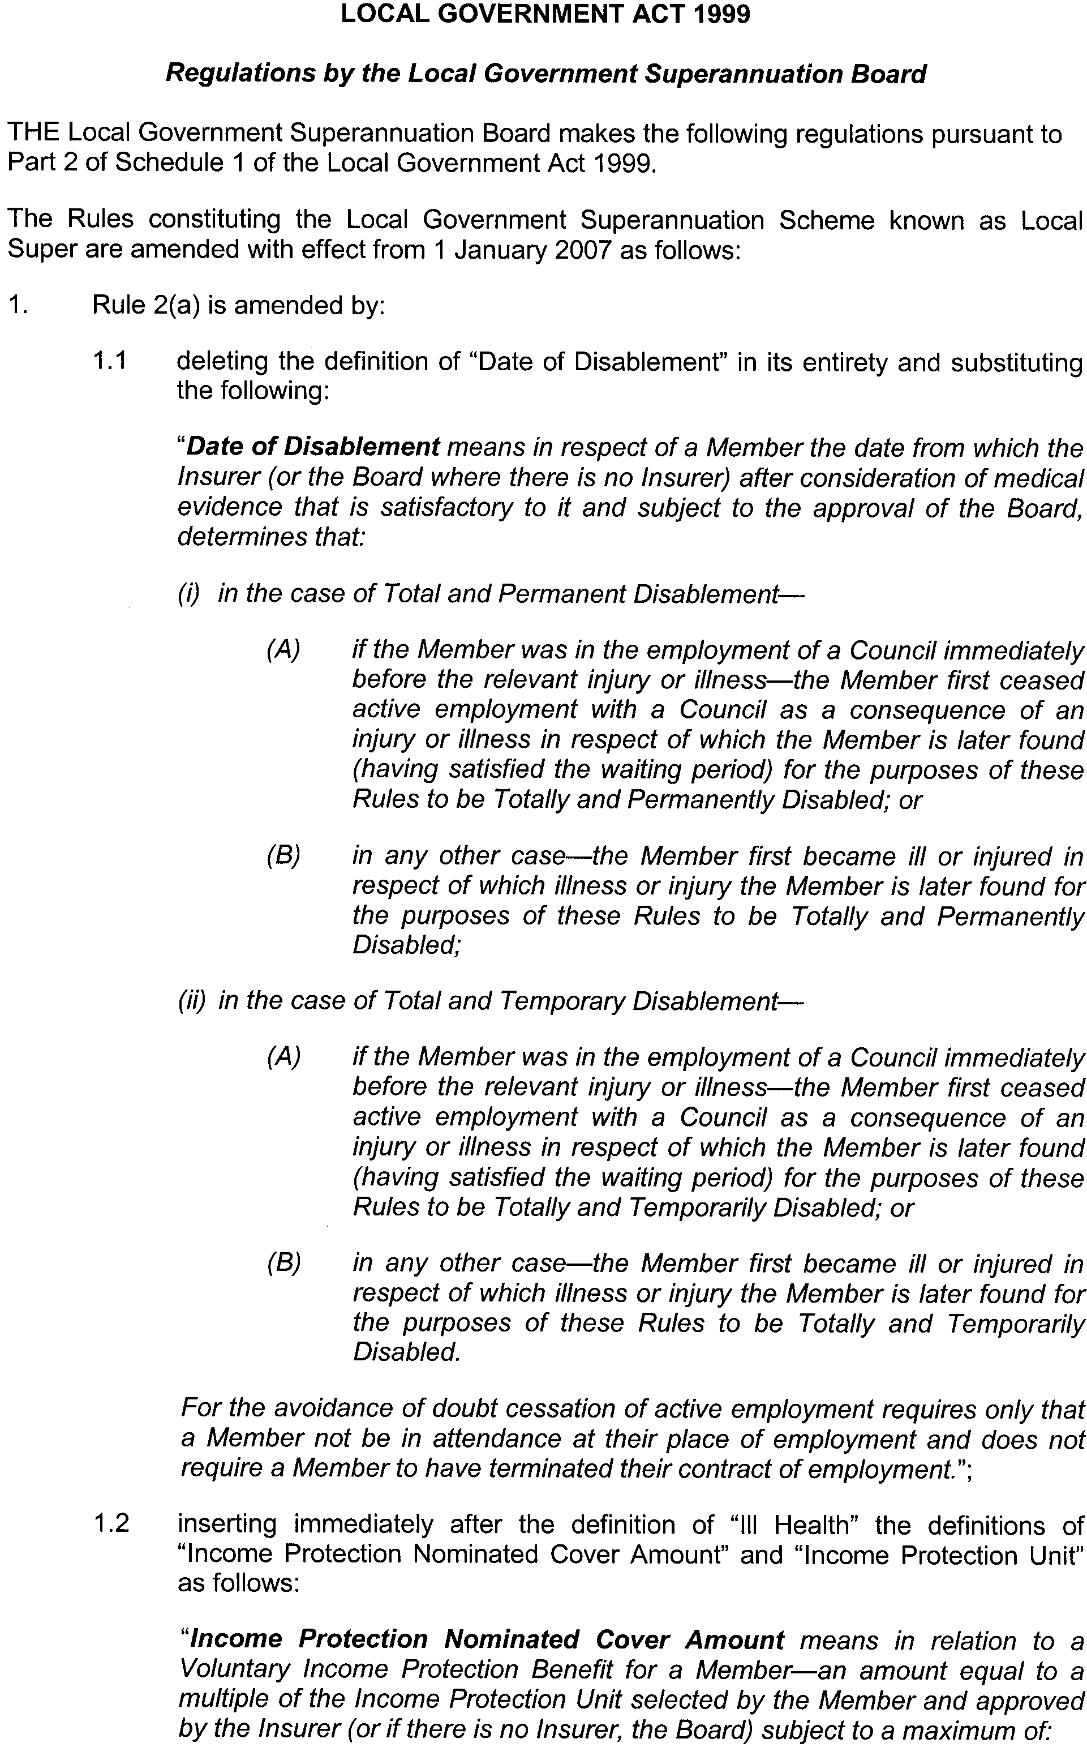

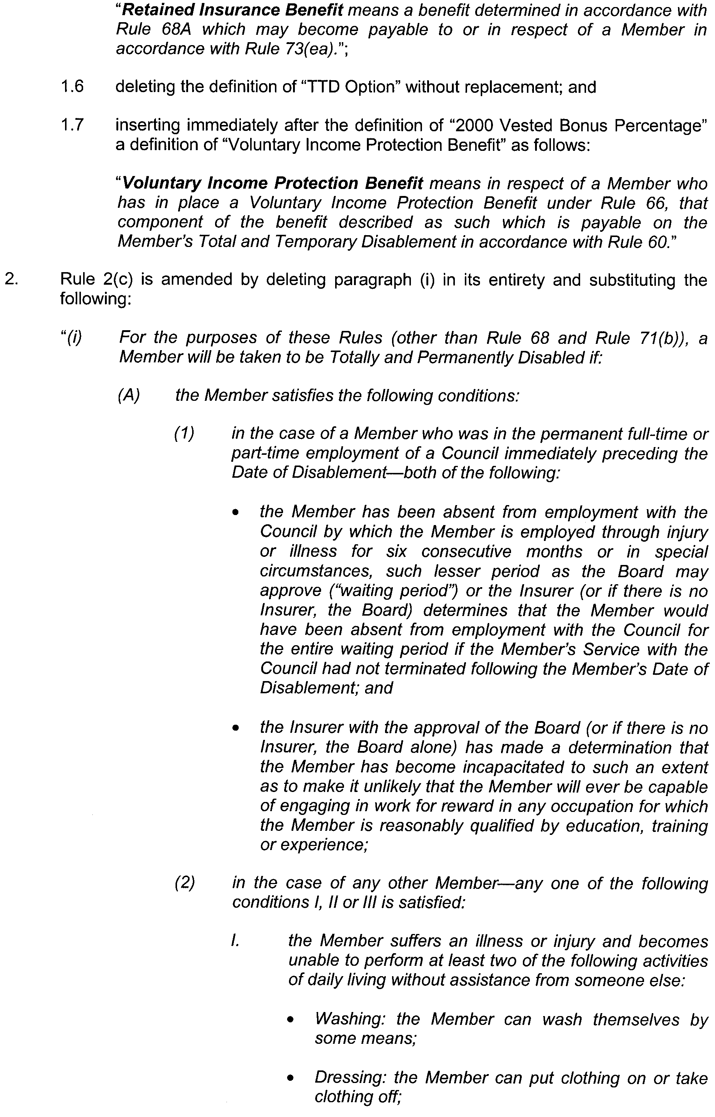
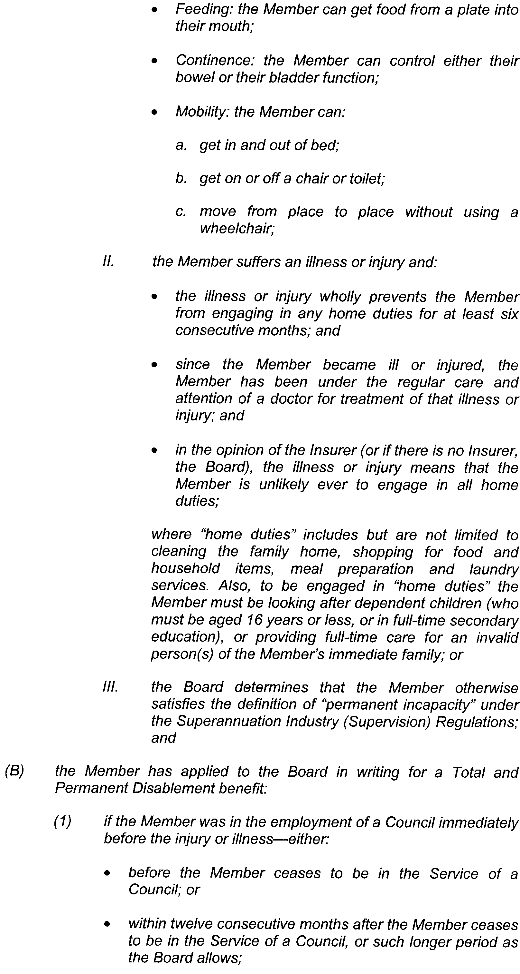
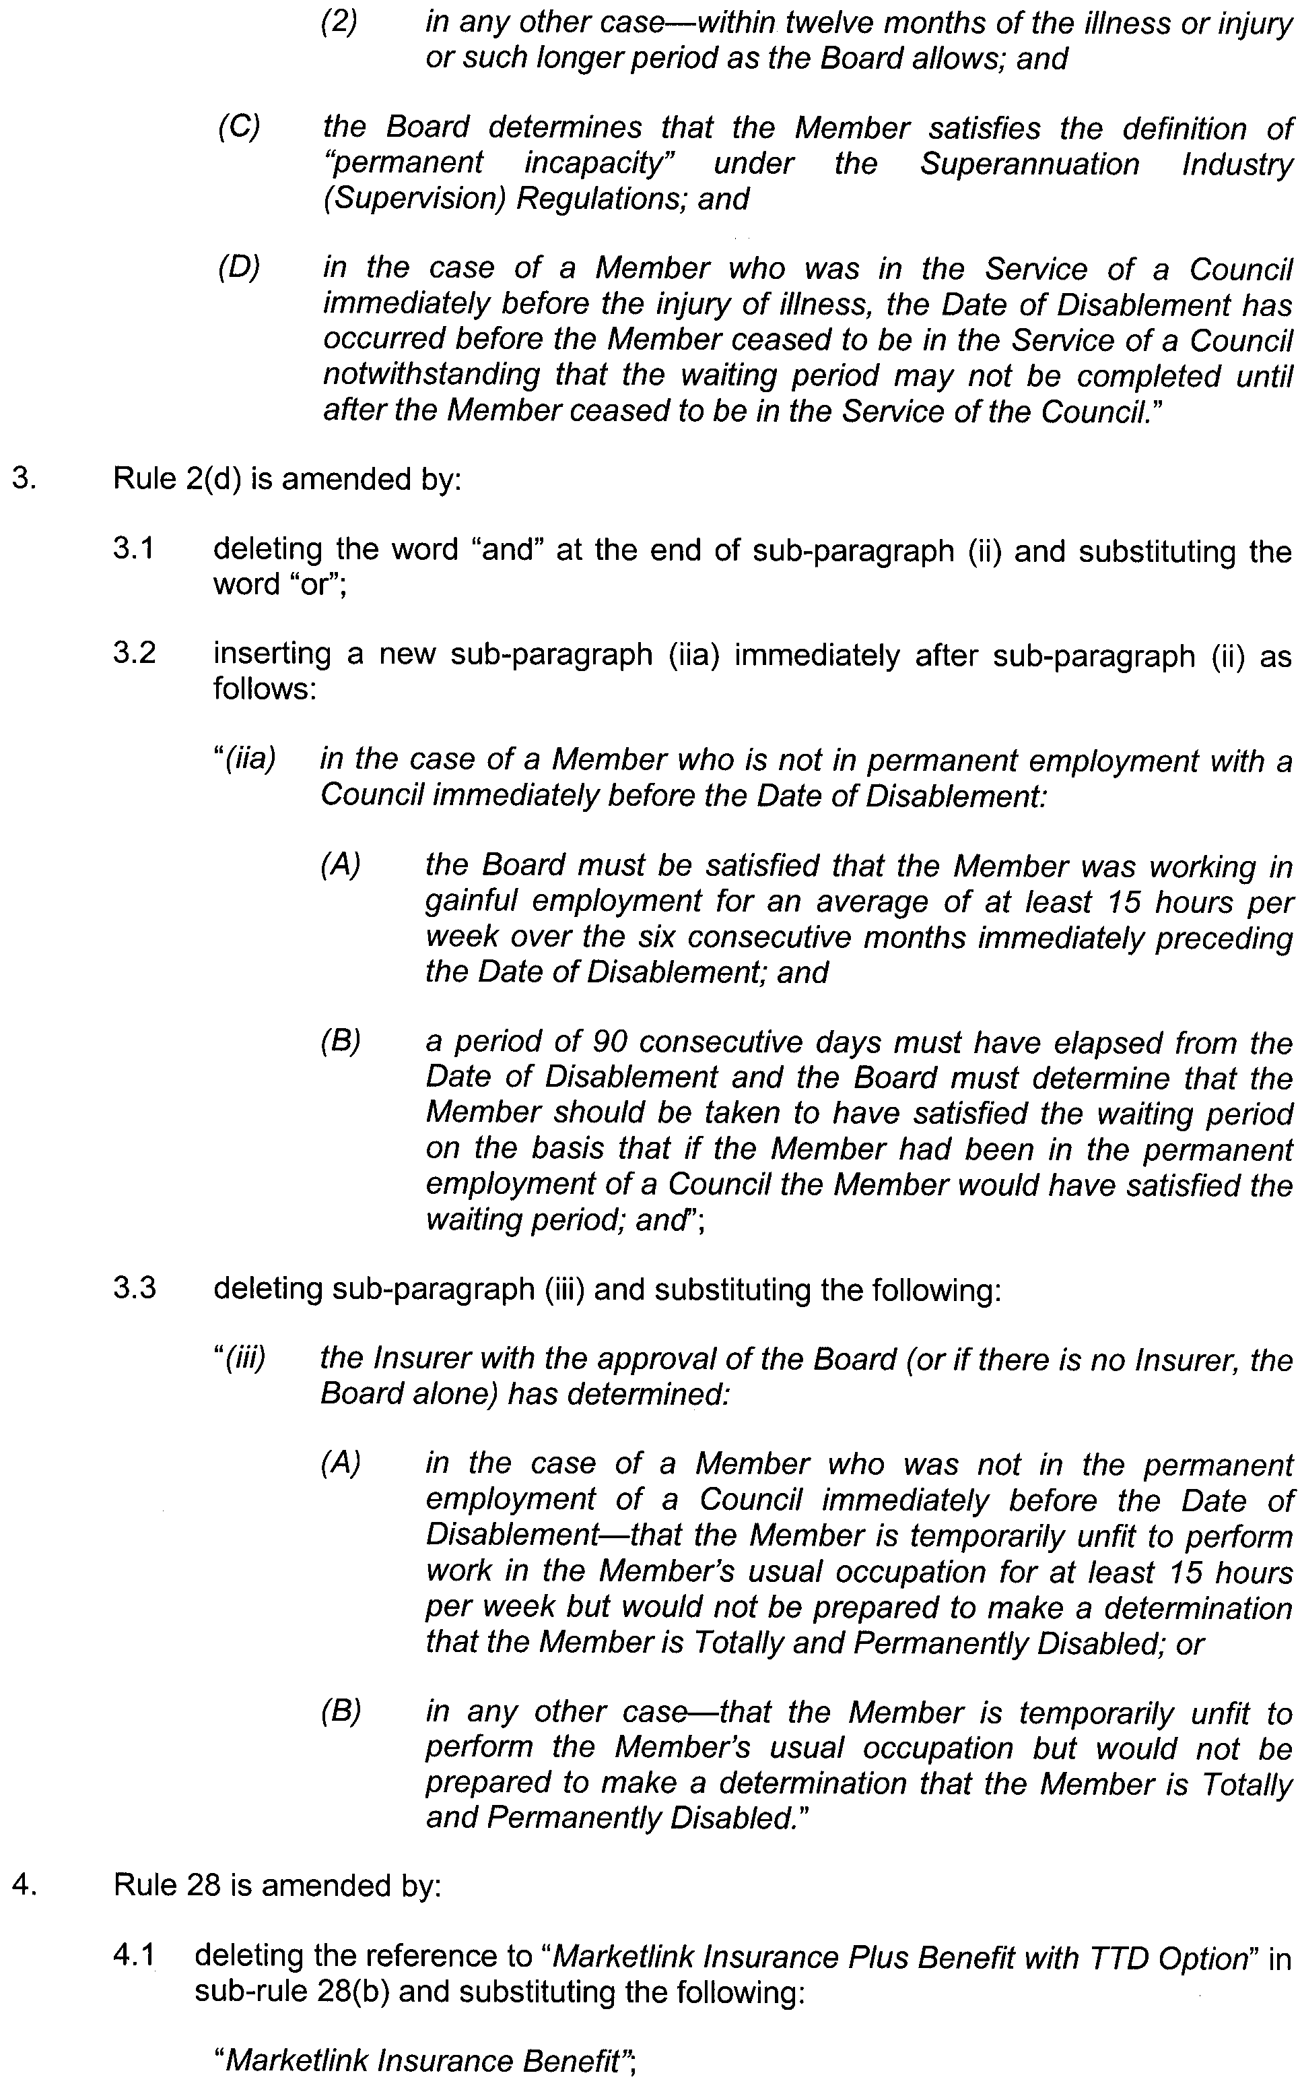
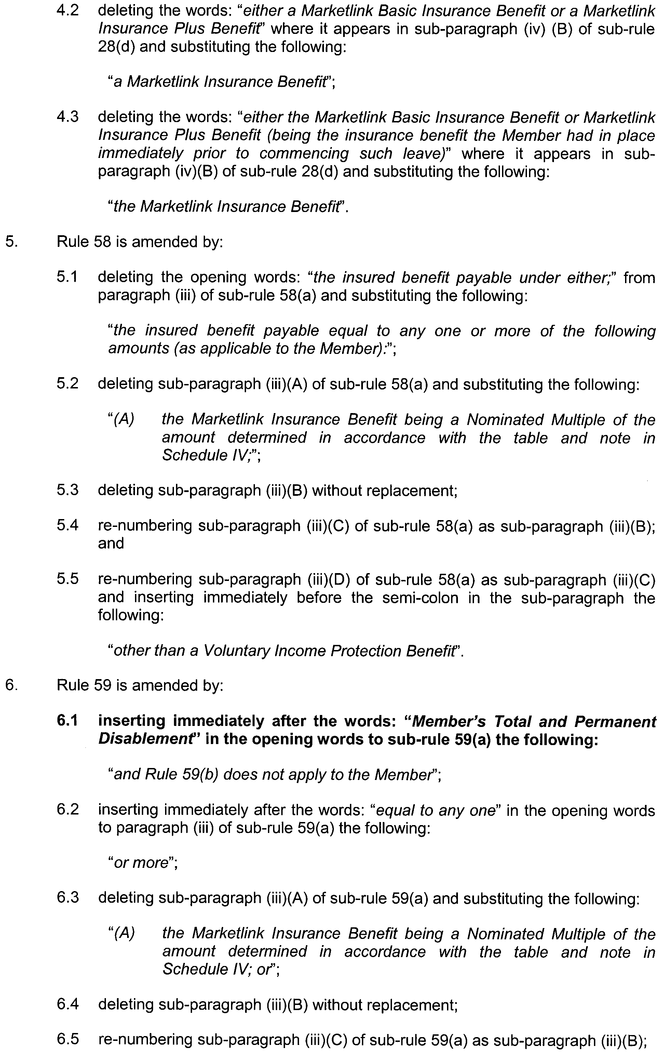
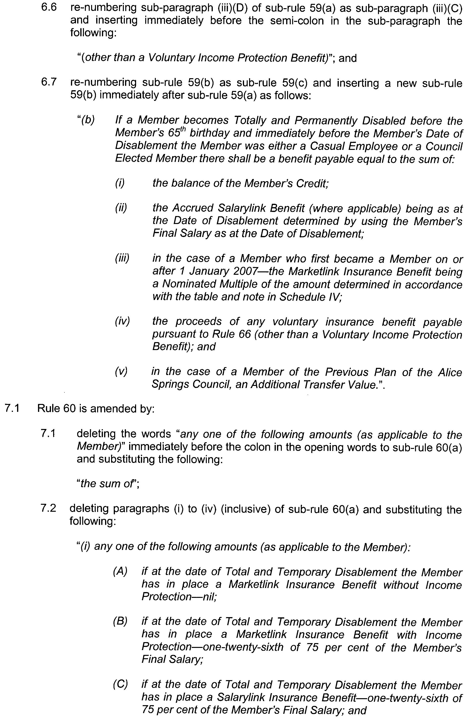
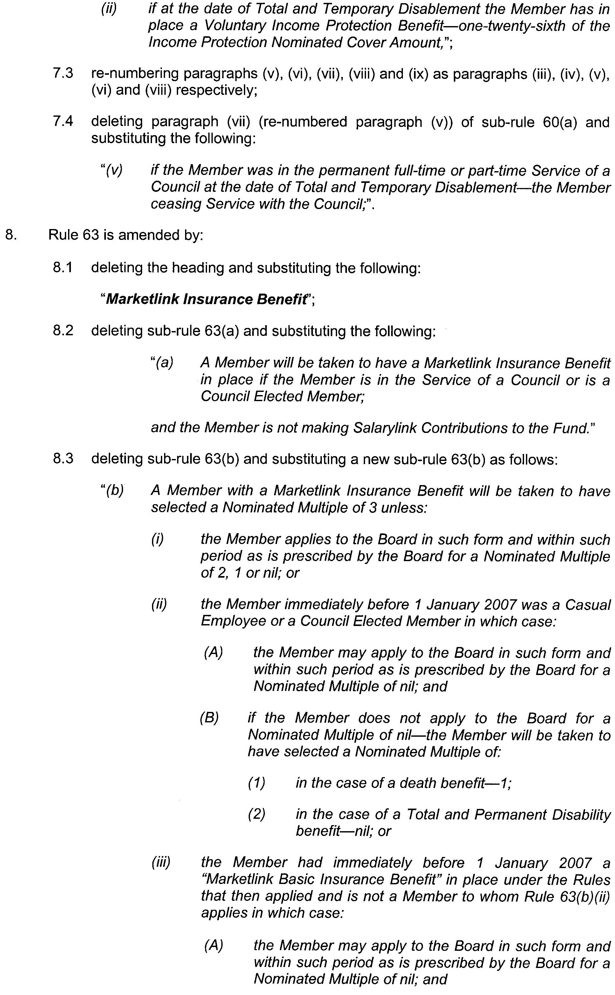
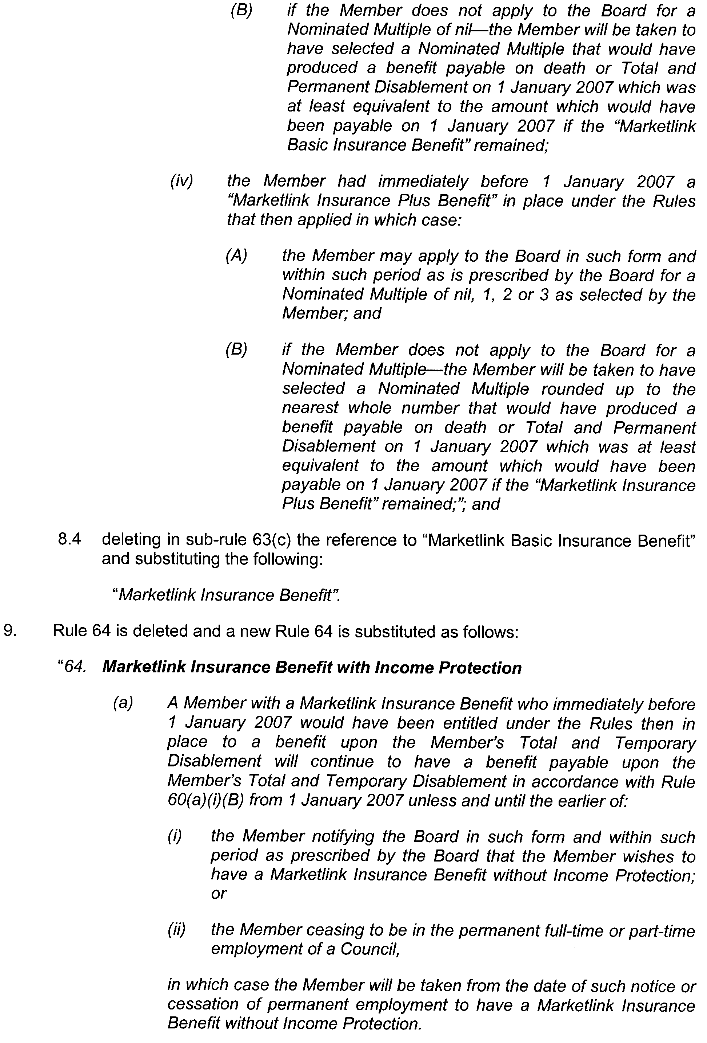
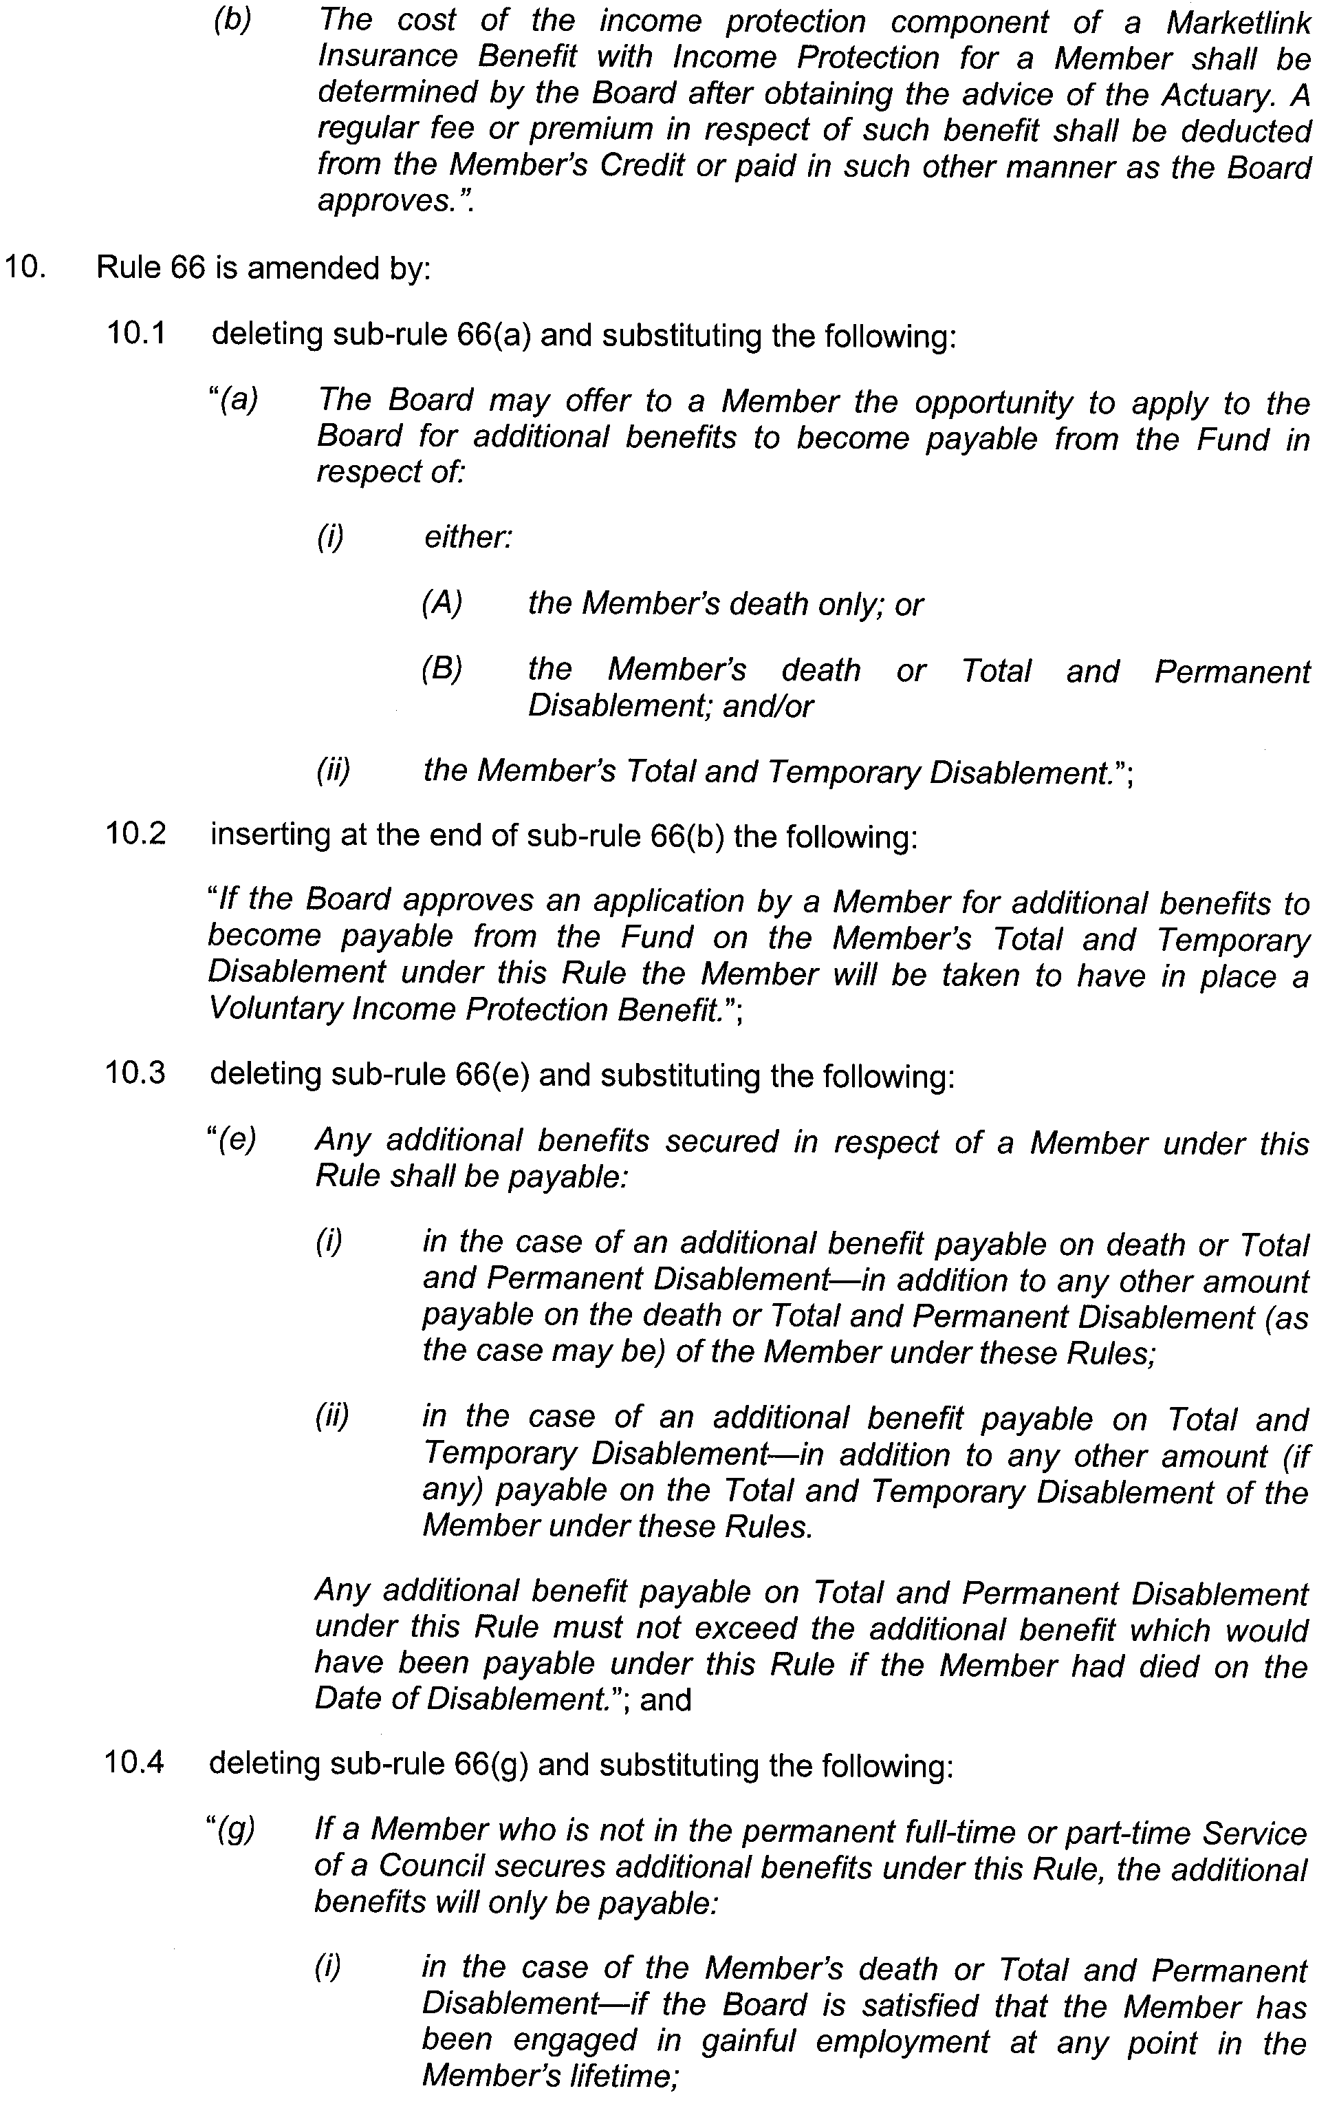
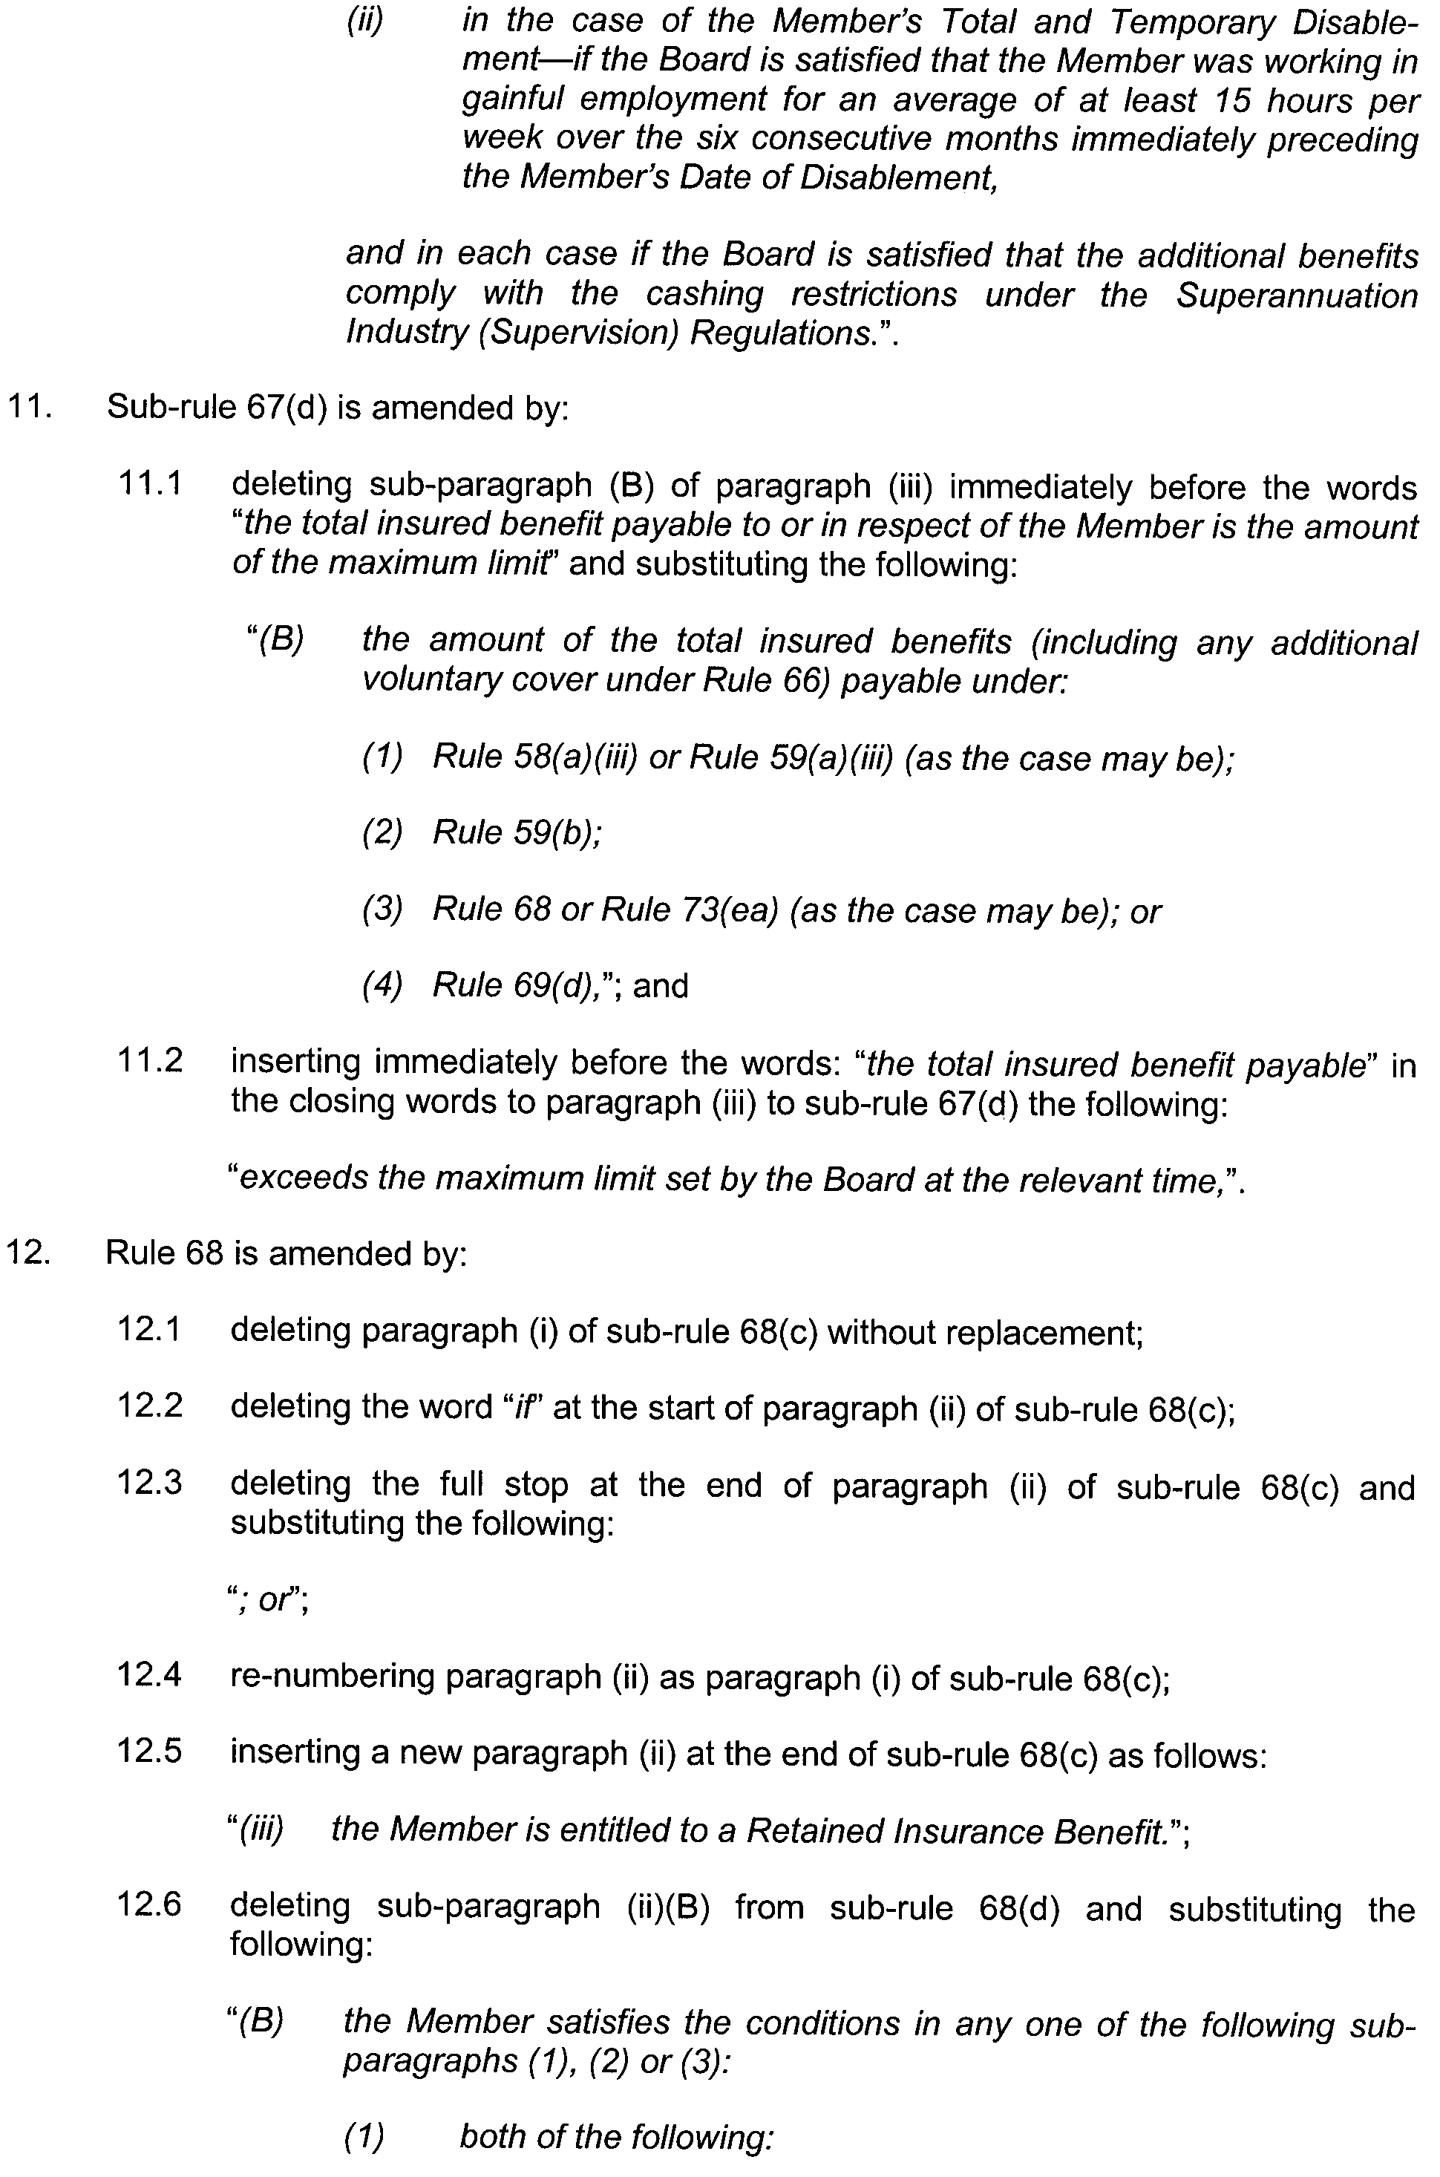
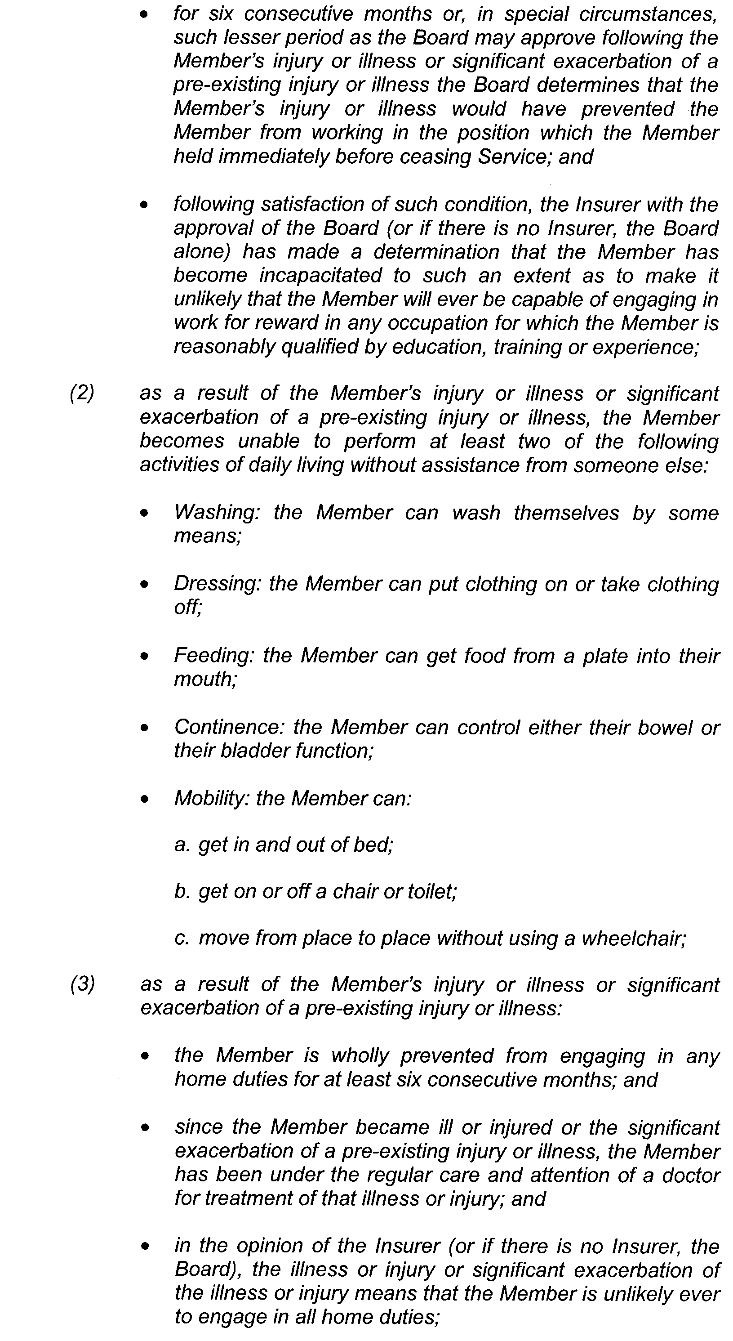
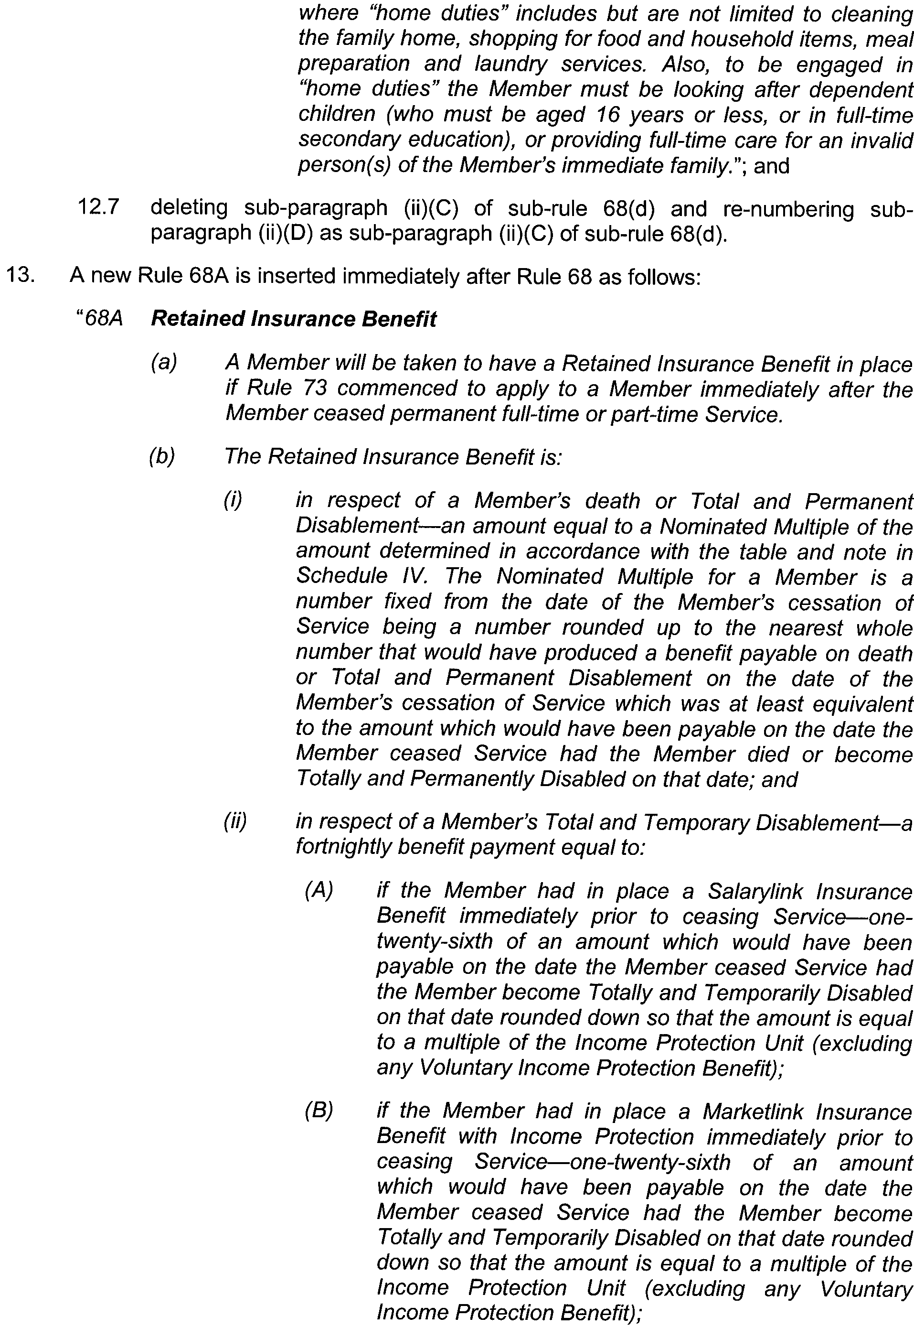
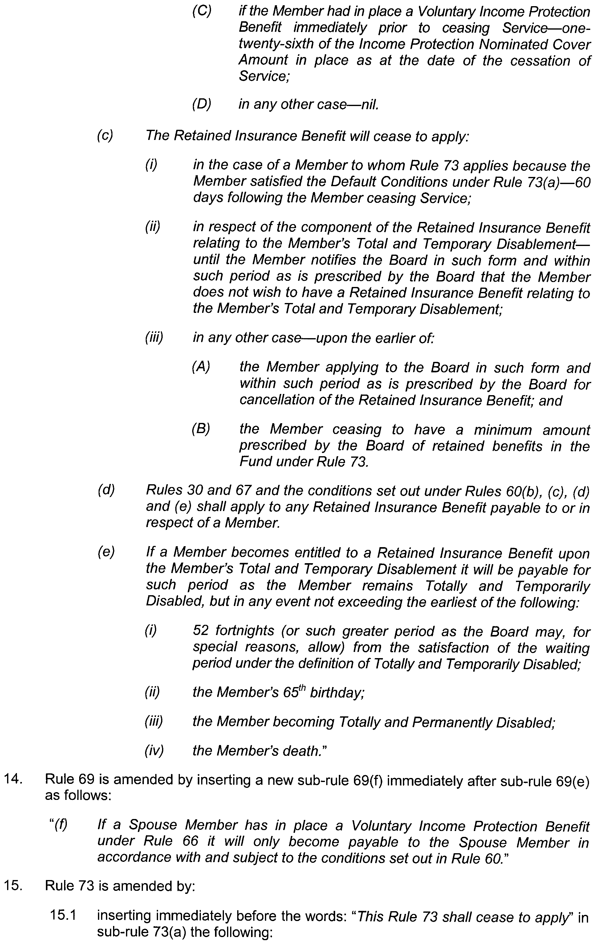
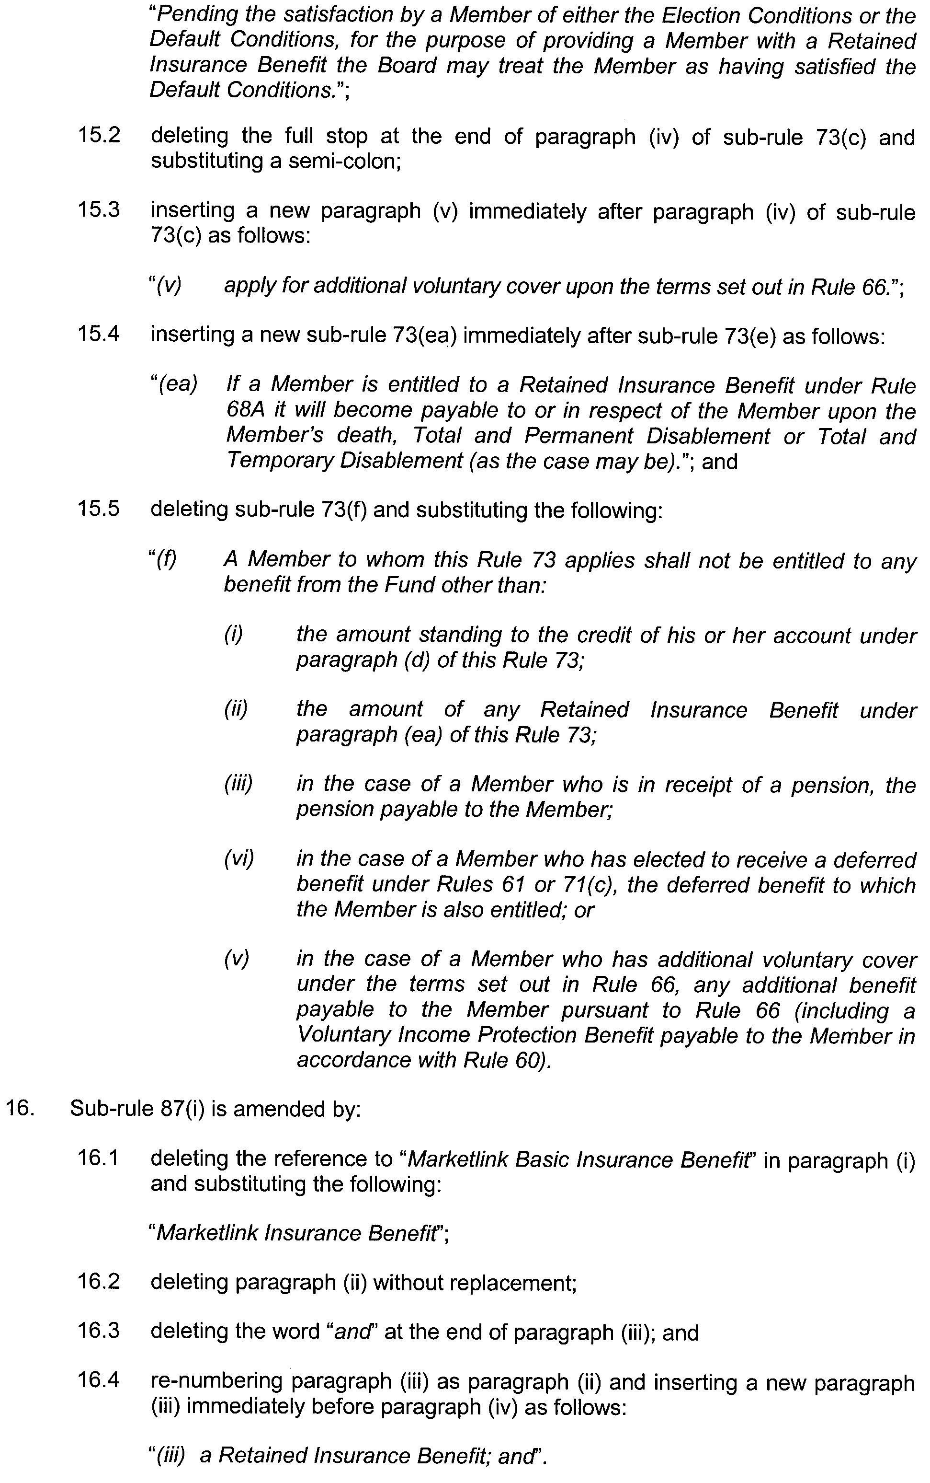
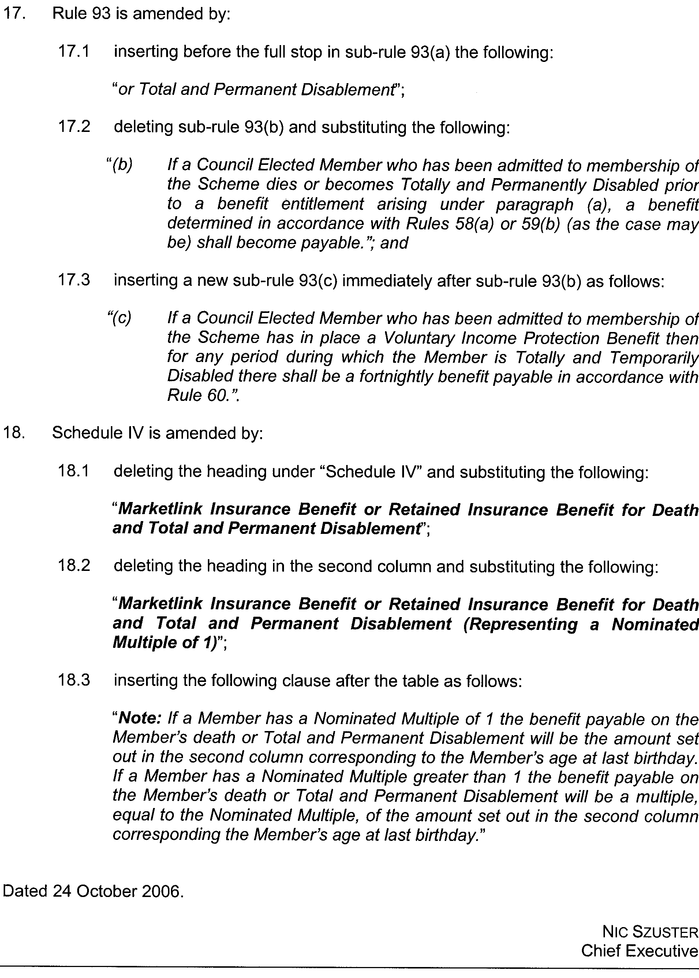
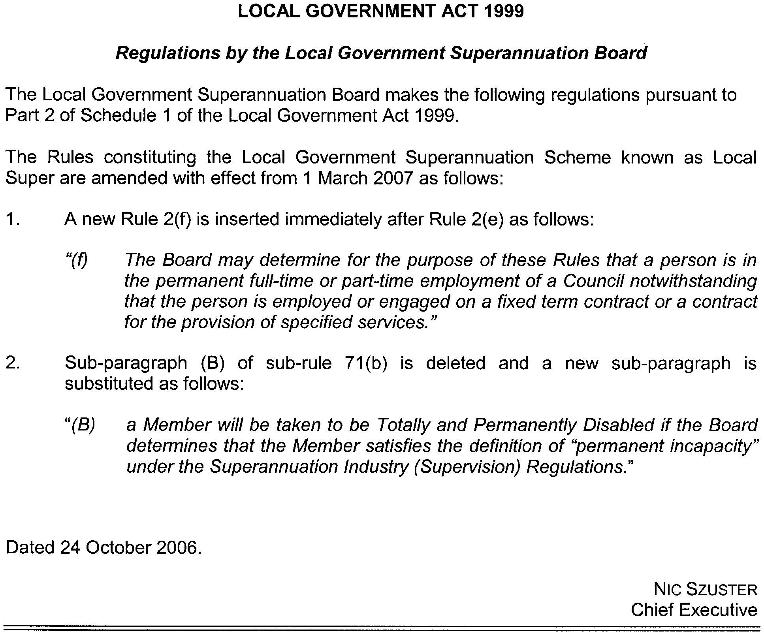
MINING ACT 1971
NOTICE is hereby given in accordance with section 28 (5) of the Mining Act 1971, that the Minister for Mineral Resources Development proposes to grant an Exploration Licence over the undermentioned area:
Applicant: Metex Resources Limited
Location: Brooker area⎯Approximately 75 km north-north-east of Port Lincoln.
Term: 1 year
Area in km²: 237
Ref.: 2006/00182
Plan and co-ordinates can be found on the PIRSA Sarig website: http://www.minerals.pir.sa.gov.au/sarig or by phoning Mineral Tenements on (08) 8463 3103.
H. Tyrteos, Mining Registrar

MINING ACT 1971
NOTICE is hereby given in accordance with section 28 (5) of the Mining Act 1971, that the Minister for Mineral Resources Development proposes to grant an Exploration Licence over the undermentioned area:
Applicant: InterMet Resources Ltd
Location: Lake Malata area⎯Approximately 65 km north-north-west of Port Lincoln.
Term: 1 year
Area in km²: 23
Ref.: 2006/00084
Plan and co-ordinates can be found on the PIRSA Sarig website: http://www.minerals.pir.sa.gov.au/sarig or by phoning Mineral Tenements on (08) 8463 3103.
H. Tyrteos, Mining Registrar

MINING ACT 1971
NOTICE is hereby given in accordance with section 28 (5) of the Mining Act 1971, that the Minister for Mineral Resources Development proposes to grant an Exploration Licence over the undermentioned area:
Applicant: Meningie Gypsum Pty Ltd
Location: Meningie area⎯Approximately 70 km south-east of Strathalbyn.
Term: 1 year
Area in km²: 61
Ref.: 2006/00540
Plan and co-ordinates can be found on the PIRSA Sarig website: http://www.minerals.pir.sa.gov.au/sarig or by phoning Mineral Tenements on (08) 8463 3103.
H. Tyrteos, Mining Registrar

MINING ACT 1971
NOTICE is hereby given in accordance with section 28 (5) of the Mining Act 1971, that the Minister for Mineral Resources Development proposes to grant an Exploration Licence over the undermentioned area:
Applicant: Adelaide Exploration Ltd
Location: Waddikee Rocks area⎯Approximately 160 km south-east of Streaky Bay.
Term: 1 year
Area in km²: 700
Ref.: 2006/00339
Plan and co-ordinates can be found on the PIRSA Sarig website: http://www.minerals.pir.sa.gov.au/sarig or by phoning Mineral Tenements on (08) 8463 3103.
H. Tyrteos, Mining Registrar

MINING ACT 1971
NOTICE is hereby given in accordance with section 28 (5) of the Mining Act 1971, that the Minister for Mineral Resources Development proposes to grant an Exploration Licence over the undermentioned area:
Applicant: Adelaide Exploration Ltd
Location: Warramboo area⎯Approximately 160 km south-east of Streaky Bay.
Term: 1 year
Area in km²: 663
Ref.: 2006/00541
Plan and co-ordinates can be found on the PIRSA Sarig website: http://www.minerals.pir.sa.gov.au/sarig or by phoning Mineral Tenements on (08) 8463 3103.
H. Tyrteos, Mining Registrar

MINING ACT 1971
NOTICE is hereby given in accordance with section 28 (5) of the Mining Act 1971, that the Minister for Mineral Resources Development proposes to grant an Exploration Licence over the undermentioned area:
Applicant: Sunthe Uranium Pty Ltd
Location: Mount Sam area⎯Approximately 120 km south-east of Tarcoola.
Term: 1 year
Area in km²: 652
Ref.: 2006/00180
Plan and co-ordinates can be found on the PIRSA Sarig website: http://www.minerals.pir.sa.gov.au/sarig or by phoning Mineral Tenements on (08) 8463 3103.
H. Tyrteos, Mining Registrar

MINING ACT 1971
NOTICE is hereby given in accordance with section 28 (5) of the Mining Act 1971, that the Minister for Mineral Resources Development proposes to grant an Exploration Licence over the undermentioned area:
Applicant: Globe Resources Pty Ltd
Location: Pimba area⎯Immediately south of Woomera.
Term: 1 year
Area in km²: 1 024
Ref.: 2006/00156
Plan and co-ordinates can be found on the PIRSA Sarig website: http://www.minerals.pir.sa.gov.au/sarig or by phoning Mineral Tenements on (08) 8463 3103.
H. Tyrteos, Mining Registrar

MINING ACT 1971
NOTICE is hereby given in accordance with section 28 (5) of the Mining Act 1971, that the Minister for Mineral Resources Development proposes to grant an Exploration Licence over the undermentioned area:
Applicant: Globe Resources Pty Ltd
Location: Lake Hanson area⎯Approximately 40 km north-west of Woomera.
Term: 1 year
Area in km²: 1 057
Ref.: 2006/00157
Plan and co-ordinates can be found on the PIRSA Sarig website: http://www.minerals.pir.sa.gov.au/sarig or by phoning Mineral Tenements on (08) 8463 3103.
H. Tyrteos, Mining Registrar

MINING ACT 1971
NOTICE is hereby given in accordance with section 28 (5) of the Mining Act 1971, that the Minister for Mineral Resources Development proposes to grant an Exploration Licence over the undermentioned area:
Applicant: Globe Resources Pty Ltd
Location: Parakylia area⎯Approximately 70 km west-north-west of Andamooka.
Term: 1 year
Area in km²: 893
Ref.: 2006/00158
Plan and co-ordinates can be found on the PIRSA Sarig website: http://www.minerals.pir.sa.gov.au/sarig or by phoning Mineral Tenements on (08) 8463 3103.
H. Tyrteos, Mining Registrar

MINING ACT 1971
NOTICE is hereby given in accordance with section 28 (5) of the Mining Act 1971, that the Minister for Mineral Resources Development proposes to grant an Exploration Licence over the undermentioned area:
Applicant: Globe Resources Pty Ltd
Location: Port Augusta area⎯Immediately north and west of Port Augusta.
Term: 1 year
Area in km²: 735
Ref.: 2006/00159
Plan and co-ordinates can be found on the PIRSA Sarig website: http://www.minerals.pir.sa.gov.au/sarig or by phoning Mineral Tenements on (08) 8463 3103.
H. Tyrteos, Mining Registrar

MINING ACT 1971
PURSUANT to section 15 (5) of the Mining Act 1971 (‘Act’), I advise that the Minerals and Energy Division of Primary Industries and Resources SA, will be undertaking geoscientific investigations over Allotments 1 and 2, plan 11452, Port Pirie West in the Hundred of Port Pirie. The investigations will commence on or after 30 November 2006, and the expected completion date will be 30 November 2009.
Pursuant to section 15 (7) of the Act, I hereby advise that applications for mining tenements may not be received or considered in respect of the land described above until the completion date of 30 November 2009.
Please note that the completion date may be extended by further notice in the Gazette. Copies of the plan are available by phoning the Mining Registrar on telephone (08) 8463 3097.
Reference: T02534
H. Tyrteos, Mining Registrar

Motor Vehicles (Control of Medical Services and Charges) Notice Number Two 2006

under section 127A (2) (a) of the Motor Vehicles Act 1959

1⎯Short title

This notice may be cited as the Motor Vehicles (Control of Medical Services and Charges) Notice Number Two 2006.

2⎯Commencement

This notice comes into operation on 28 October 2006 or the day on which it is made, whichever is later.

3⎯Modification to the Workers Rehabilitation and Compensation (Scales of Medical and Other Charges) Regulations 1995

For the purposes of section 127A of the Motor Vehicles Act 1959, the Workers Rehabilitation and Compensation (Scales of Medical and Other Charges) Regulations 1995 are to be read as if:

a reference to a “claims agent” includes the Motor Accident Commission or its Claims Manager as appointed from time to time.

4—Modification to the Workers Rehabilitation and Compensation (Scales of Charges—Medical Practitioners) Regulations 1999

For the purposes of section 127A of the Motor Vehicles Act 1959, the Workers Rehabilitation and Compensation (Scales of Charges—Medical Practitioners) Regulations 1999 are to be read as if:

a reference to a “claims agent” includes the Motor Accident Commission or its Claims Manager as appointed from time to time.

5⎯Revocation of previous notices

The Motor Vehicles (Control of Medical Services and Charges) Notice 2005 (published in the Government Gazette on 28 July 2005) and the Motor Vehicles (Control of Medical Services and Charges) Notice 2006 (published in the Government Gazette on 20 July 2006) are hereby revoked.

Made by the Minister for Transport

after consultation with professional associations representing the providers of services to which this notice relates.

Dated 24 October 2006.

Patrick Conlon, Minister for Transport

NATIONAL ELECTRICITY LAW
THE Australian Energy Market Commission (AEMC) gives notice under the National Electricity Law (NEL) of the following matters.
Under Section 107, the time period has been extended for the making of the final determination for the National Electricity Amendment (Economic Regulation of Transmission Services) Rule 2006 to 16 November 2006.
Under Section 99, the making of the draft determination and draft National Electricity Amendment (Transmission network replacement and reconfiguration) Rule 2006. A copy of the draft determination and draft Rule are published on the AEMC’s website and are available for inspection at the offices of the AEMC. Submissions and any requests for a hearing should be forwarded to submissions@aemc.gov.au:
• submissions must be received by 21 December 2006; and
• requests for a hearing must be received by 2 November 2006.
The AEMC publishes all submissions received on its website subject to a claim of confidentiality.
Further details on the above matters are available on AEMC’s website www.aemc.gov.au.
John Tamblyn
Chairman
Australian Energy Market Commission
Level 16, 1 Margaret Street
Sydney, N.S.W. 2000
Telephone: (02) 8296 7800
Facsimile: (02) 8296 7899
26 October 2006.

NATURAL RESOURCES MANAGEMENT ACT 2004
Notice of Prohibition on Taking Surface Water, Water from Watercourses and Wells in the Western Mount Lofty Ranges Area
PURSUANT to section 132 (1) of the Natural Resources Manage-ment Act 2004 (‘the Act’), I, Gail Gago, Minister for Environment and Conservation in the State of South Australia, and Minister to whom the administration of the Act, is committed, being of the opinion that:
• the rate at which surface water is taken in the area described in Schedule 1 (Area 1) is such that the surface water available can no longer meet the demand, or is having a serious effect on a watercourse or lake, or the level of water in an underground aquifer, that depends on the surface water for replenishment;
• the rate at which water is taken from watercourses described in Area 1 and in Schedule 3 (Area 3) is such that there is a risk that the available water will not be sufficient to meet future demand; and
• the rate at which water is being taken from wells in the area described in Schedule 2 (Area 2) is such that there is a risk that the available water will not be sufficient to meet future demand, or is likely to affect the quality of water in the underground aquifer,
hereby prohibit the taking of:
• surface water and water from watercourses in Area 1;
• water from wells in Area 2; and
• water from watercourses in Area 3,
except in the circumstances specified in Schedule 4.
This Notice does not apply to the taking of:
(a) water from a watercourse or well, or surface water, for domestic purposes or for watering stock (other than stock subject to intensive farming), provided that:
• in respect of the taking of water by a person from any of the watercourses described as the Swamps of the Fleurieu Peninsula that are listed as a Critically Endangered Ecological Community under the Environment Protection and Biodiversity Act 1999 (Commonwealth) the taking of that water for those purposes commenced before 20 October 2005; or
• where the water is collected in a dam for those purposes, the dam does not have a capacity of 5ML or greater; or
(b) water for fire-fighting purposes or public road making purposes; or
(c) water for the purpose of chemical application on crops; or
(d) water from a watercourse, lake or well or surface water by a person who is a native title holder in relation to the land or waters on or in which that watercourse, lake or well, or surface water is situated, and the taking is for the purpose of satisfying that person’s personal, domestic, cultural, spiritual or non-commercial communal needs where they are doing so in the exercise or enjoyment of their native title rights and interests, provided that the taking does not involve stopping, impeding or diverting the flow of water for the purpose of collecting the water or diverting the flow of water from a watercourse; or
(e) water from a well, pursuant to a water licence, from the McLaren Vale Prescribed Wells Area or the Northern Adelaide Plains Prescribed Wells Area; or
(f) surface water or water from a well or watercourse, pursuant to a water licence, from the Barossa Prescribed Water Resources Area or the Marne Saunders Prescribed Water Resources Area, or pursuant to an authorisation in the Eastern Mount Lofty Ranges Area.
Schedule 1: Area 1
The area bounded by the bold red line as shown in the GRO Plan No. 241/04.
Schedule 2: Area 2
The areas bounded by the bold red lines as shown in the GRO Plan No. 242/04.
Schedule 3: Area 3
The River Torrens/Karrawirra Parri downstream of Gorge Weir, the Onkaparinga River downstream of Clarendon Weir and the Gawler River downstream of the confluence of the North Para River and the South Para River as indicated by the bold red lines in GRO Plan No. 243/04.
Schedule 4
1. A person may take surface water and water from a watercourse in Area 1, or water from a well in Area 2, or water from a watercourse in Area 3, in accordance with the terms of a written authorisation granted under this Notice by me or my authorised agent.
2. An authorisation under this Notice may be granted to:
(a) A Current User entitling that person to take, from the source specified in the authorisation:
• where the water taken during the Relevant Period was to water a crop or crops, the amount of water reasonably necessary, in my opinion or the opinion of my authorised agent, to water that crop or those crops, the amount being determined taking into account the maximum area of each crop or crops grown, the water requirements of the respective crop or crops and the irrigation capacity of the irrigation equipment used to water the crop or crops; or
• where the water was taken during the Relevant Period for any other purpose, the amount of water which, in my opinion or the opinion of my authorised agent, is reasonably necessary to continue that purpose in the manner in which it had been undertaken during the Relevant Period.
The source specified will be the resource or resources from which water was taken during the Relevant Period:
(b) The transferee under a contract for the sale or other transfer of land where the transferor of the land is the holder of an authorisation under this notice, entitling that person to take the same amount of water from the same source as the transferor was authorised to take.
(c) Subject to Clause 3, a Prospective User entitling that person to take the amount of surface water or water from a watercourse in Area 1, or water from a well in Area 2, or water from a watercourse in Area 3, which in my opinion or the opinion of my authorised agent, is reasonably necessary to undertake the development, project or undertaking to which that person was committed.
3. A Prospective User may not be granted an authorisation or may only be granted an authorisation subject to conditions relating to the manner of taking water where, in my opinion or the opinion of my authorised agent:
(a) the taking of surface water, or water from watercourses or wells, will detrimentally affect the ability of other persons to take water from any watercourse, well or dam for domestic purposes or for watering of stock (other than stock being intensively farmed); or
(b) the taking of surface water, or water from watercourses or wells, will detrimentally affect the capacity of surface water or any watercourse or well to meet the current or future demand, including the demands of ecosystems dependent on that water resource.
4. Until authorised under this Notice, a Current User may continue to take an amount of water equivalent to the maximum amount taken in any one financial year during the Relevant Period, from the same sources and for the same purpose or purposes as that person took during the Relevant Period without a written authorisation.
In this notice:
‘Current User’ is a person who has been taking surface water or water from a watercourse in Area 1, or water from a well in Area 2, or water from a watercourse in Area 3, during the Relevant Period.
‘Relevant Period’ is the period 1 July 2001 to 13 October 2004, inclusive.
‘Prospective User’ is a person who did not take any surface water or water from a watercourse in Area 1, or water from a well in Area 2, or water from a watercourse in Area 3, but who needs water for a development, project or undertaking:
• to which that person was legally committed during the Relevant Period; or
• in respect of which that person had, in my opinion or the opinion of my authorised agent, committed significant financial or other resources during the Relevant Period.
‘Maximum area’ for a particular crop means the maximum areas of land planted to a particular crop in any one financial year during the Relevant Period.
‘Water requirement’ of a crop means the reasonable rate of irrigation (expressed as a volume of water per hectare) to properly produce that crop.
‘Irrigation capacity’ of irrigation equipment means the amount of water that can be applied by the usual operation of that equipment in its condition at 13 October 2004 under usual pumping rates, hours of operation and seasonal fluctuations.
This notice will remain in effect for two years unless earlier varied or revoked.
Dated 24 October 2006.
Gail Gago, Minister for Environment and Conservation

OCCUPATIONAL HEALTH, SAFETY AND WELFARE
ACT 1986
Appointments
I, JOHN DAVID HILL, Acting Minister for Industrial Relations in and for the State of South Australia, hereby under the Occupational Health, Safety and Welfare Act 1986, authorise the following Public Service employees to exercise the powers of an Inspector pursuant to the Occupational Health, Safety and Welfare Act 1986:
Sotirios Mangas
Glyn Thomas Duggan
Dated 17 October 2006.
J. Hill, Acting Minister for Industrial Relations

ROADS (OPENING AND CLOSING) ACT 1991:
SECTION 24
NOTICE OF CONFIRMATION OF ROAD
PROCESS ORDER
Road Closure—Blackfellows Caves
BY Road Process Order made on 20 March 2006, the District Council of Grant ordered that:
1. Portion of the unnamed public road adjoining Pelican Point Road and between pieces 1 and 2 in Filed Plan 125096, more particularly delineated and lettered ‘A’ in the Preliminary Plan No. 04/0105 be closed.
2. The whole of the land subject to closure be transferred to Margaret Kay Millard and Dale Alexander Millard in accordance with agreement for transfer dated 4 October 2005 entered into between the District Council of Grant and M. K. and D. A. Millard.
On 15 September 2006 that order was confirmed by the Minister for Administrative Services and Government Enterprises conditionally upon the deposit by the Registrar-General of Deposited Plan 71031 being the authority for the new boundaries.
Pursuant to section 24 (5) of the Roads (Opening and Closing) Act 1991, NOTICE of the order referred to above and its confirmation is hereby given.
Dated 26 October 2006.
P. M. Kentish, Surveyor-General

PETROLEUM PRODUCTS REGULATION ACT 1995
Appointments
I, JOHN DAVID HILL, Acting Minister for Industrial Relations in and for the State of South Australia, hereby appoint each of the following persons as an Authorised Officer for the purposes of the Petroleum Products Regulation Act 1995, in accordance with my delegated authority under section 49 of the Petroleum Products Regulation Act 1995:
Sotirios Mangas
Glyn Thomas Duggan
Dated 17 October 2006.
J. Hill, Acting Minister for Industrial Relations

PETROLEUM ACT 2000
Application for Grant of Associated Facilities Licence—AFL 70
PURSUANT to section 65 (6) of the Petroleum Act 2000 (the Act) and Delegation dated 28 March 2002, Gazetted 11 April 2002, page 1573, notice is hereby given that an application for the grant of an Associated Facilities Licence over the area described below has been received from Beach Petroleum Limited and Magellan Petroleum (NT) Pty Ltd.
Description of Application Area
A 50 m buffer around line segments defined by the following pairs of coordinates (GDA 94), adjacent to Petroleum Exploration Licence PEL 95:
From |  | To
467518E | 6841998N | 469385E | 6843046N
462990E | 6848471N | 463474E | 6847515N
467518E | 6839518N | 468136E | 6838296N
470200E | 6838295N | 471080E | 6838732N
467995E | 6838295N | 469493E | 6839129N
467518E | 6840204N | 468424E | 6840747N
467518E | 6841052N | 469523E | 6842182N
467518E | 6842780N | 468943E | 6843556N

Dated 18 October 2006.
B. A. Goldstein,
Director Petroleum and Geothermal
Minerals and Energy Resources
Primary Industries and Resources SA
Delegate of the Minister for Mineral
Resources Development

PETROLEUM ACT 2000
Application for Grant of a Petroleum Production Licence—
PPL 215
PURSUANT to section 65 (6) of the Petroleum Act 2000 (the Act) and Delegation dated 28 March 2002, Gazetted 11 April 2002, page 1573, notice is hereby given that an application for the
grant of a production licence over the area described below, which falls within the area of Petroleum Exploration Licence PEL 113 has been received from Stuart Petroleum Limited.
Description of Application Area
All that part of the State of South Australia, bounded as follows:
Commencing at a point being the intersection of latitude 28°30′50″S GDA94 and longitude 140°15′00″E GDA94, thence east to longitude 140°15′00″E AGD66, south to latitude 28°31′00″S GDA94, west to longitude 140°15′00″E GDA94, south to latitude 28°31′05″S GDA94, west to longitude 140°14′55″E GDA94, south to latitude 28°31′10″S GDA94, west to longitude 140°14′50″E GDA94, south to latitude 28°31′20″S GDA94, west to longitude 140°14′45″E GDA94, south to latitude 28°31′25″S GDA94, east to longitude 140°15′00″E AGD66, south to latitude 28°31′32.5″S GDA94, west to longitude 140°14′55″E GDA94, south to latitude 28°31′50″S GDA94, west to longitude 140°14′35″E GDA94, north to latitude 28°31′45″S GDA94, west to longitude 140°14′30″E GDA94, north to latitude 28°31′15″S GDA94, east to longitude 140°14′37.5″E GDA94, north to latitude 28°31′10″S GDA94, east to longitude 140°14′45″E GDA94, north to latitude 28°31′05″S GDA94, east to longitude 140°14′52.5″E GDA94, north to latitude 28°31′00″S GDA94, east to longitude 140°14′55″E GDA94, north to latitude 28°30′55″S GDA94, east to longitude 140°15′00″E GDA94, and north to the point of commencement.
Area: 0.89 km² approximately.
Dated 18 October 2006.
B. A. Goldstein,
Director Petroleum and Geothermal
Minerals and Energy Resources
Primary Industries and Resources SA
Delegate of the Minister for Mineral
Resources Development

PETROLEUM ACT 2000
Grant of Geothermal Exploration Licences—GEL 251 and GEL 252
NOTICE is hereby given that the undermentioned Geothermal Exploration Licences have been granted under the provisions of the Petroleum Act 2000, pursuant to delegated powers dated 28 March 2002, Gazetted 11 April 2002, page 1573.

No. of Licence | Licensees | Locality | Expiry
GEL 251 | Proactive Energy Developments Ltd | Arckargina Basin, South Australia | 16 October 2011
GEL 252 | Proactive Energy Developments Ltd | Arckargina Basin, South Australia | 16 October 2011
Description of Area—GEL 251
All that part of the State of South Australia, bounded as follows:
Commencing at a point being the intersection of latitude 29°42′00″S GDA94 and longitude 135°33′00″E GDA94, thence east to longitude 135°56′00″E GDA94, south to latitude 29°49′00″S GDA94, west to longitude 135°33′00″E GDA94 and north to the point of commencement.
Area: 479 km² approximately.
Description of Area—GEL 252
All that part of the State of South Australia, bounded as follows:
Commencing at a point being the intersection of latitude 29°49′00″S GDA94 and longitude 135°38′00″E GDA94, thence east to longitude 135°45′00″E GDA94, south to latitude 30°01′00″S GDA94, west to longitude 135°32′00″E GDA94, north to latitude 29°55′00″S GDA94, west to longitude 135°30′00″E GDA94, north to latitude 29°51′00″S GDA94, east to longitude 135°38′00″E GDA94 and north to the point of commencement.
Area: 452 km² approximately.
Dated 17 October 2006.
B. A. Goldstein, Director Petroleum and Geothermal
Minerals and Energy Resources
Primary Industries and Resources SA
Delegate of the Minister for Mineral Resources Development

GOVERNMENT GAZETTE ADVERTISEMENT RATES

To apply from 1 July 2006

$  Agents, Ceasing to Act as 38.00  Associations:  Incorporation 19.30  Intention of Incorporation 47.75  Transfer of Properties 47.75  Attorney, Appointment of 38.00  Bailiff’s Sale 47.75  Cemetery Curator Appointed 28.25  Companies:  Alteration to Constitution 38.00  Capital, Increase or Decrease of 47.75  Ceasing to Carry on Business 28.25  Declaration of Dividend 28.25  Incorporation 38.00  Lost Share Certificates:  First Name 28.25  Each Subsequent Name 9.70  Meeting Final 31.75  Meeting Final Regarding Liquidator’s Report on  Conduct of Winding Up (equivalent to ‘Final  Meeting’)  First Name 38.00  Each Subsequent Name 9.70  Notices:  Call 47.75  Change of Name 19.30  Creditors 38.00  Creditors Compromise of Arrangement 38.00  Creditors (extraordinary resolution that ‘the Com-pany be wound up voluntarily and that a liquidator be appointed’) 47.75  Release of Liquidator⎯Application⎯Large Ad. 75.50  ⎯Release Granted 47.75  Receiver and Manager Appointed 44.00  Receiver and Manager Ceasing to Act 38.00  Restored Name 35.75  Petition to Supreme Court for Winding Up 66.50  Summons in Action 56.50  Order of Supreme Court for Winding Up Action 38.00  Register of Interests⎯Section 84 (1) Exempt 85.50  Removal of Office 19.30  Proof of Debts 38.00  Sales of Shares and Forfeiture 38.00  Estates:  Assigned 28.25  Deceased Persons⎯Notice to Creditors, etc. 47.75  Each Subsequent Name 9.70  Deceased Persons⎯Closed Estates 28.25  Each Subsequent Estate 1.25  Probate, Selling of 38.00  Public Trustee, each Estate 9.70 |  | $  Firms:  Ceasing to Carry on Business (each insertion) 25.25  Discontinuance Place of Business 25.25  Land⎯Real Property Act:  Intention to Sell, Notice of 47.75  Lost Certificate of Title Notices 47.75  Cancellation, Notice of (Strata Plan) 47.75  Mortgages:  Caveat Lodgement 19.30  Discharge of 20.20  Foreclosures 19.30  Transfer of 19.30  Sublet 9.70  Leases⎯Application for Transfer (2 insertions) each 9.70  Lost Treasury Receipts (3 insertions) each 28.25  Licensing 56.50  Municipal or District Councils:  Annual Financial Statement⎯Forms 1 and 2 532.00  Electricity Supply⎯Forms 19 and 20 378.00  Default in Payment of Rates:  First Name 75.50  Each Subsequent Name 9.70  Noxious Trade 28.25  Partnership, Dissolution of 28.25  Petitions (small) 19.30  Registered Building Societies (from Registrar-  General) 19.30  Register of Unclaimed Moneys⎯First Name 28.25  Each Subsequent Name 9.70  Registers of Members⎯Three pages and over:  Rate per page (in 8pt) 242.00  Rate per page (in 6pt) 320.00  Sale of Land by Public Auction 48.25  Advertisements 2.70  ¼ page advertisement 113.00  ½ page advertisement 226.00  Full page advertisement 443.00  Advertisements, other than those listed are charged at $2.70 per column line, tabular one-third extra.  Notices by Colleges, Universities, Corporations and District Councils to be charged at $2.70 per line.  Where the notice inserted varies significantly in length from that which is usually published a charge of $2.70 per column line will be applied in lieu of advertisement rates listed.  South Australian Government publications are sold on the condition that they will not be reproduced without prior permission from the Government Printer.
All the above prices include GST

GOVERNMENT GAZETTE NOTICES
ALL private advertisements forwarded for publication in the South Australian Government Gazette must be PAID FOR PRIOR TO INSERTION; and all notices, from whatever source, should be legibly written on one side of the paper only and sent to Government Publishing SA so as to be received no later than 4 p.m. Tuesday preceding the day of publication. Phone 8207 1045 or Fax 8207 1040. E-mail: governmentgazette@saugov.sa.gov.au. Send as attachments in Word format. Please include date the notice is to be published and to whom the notice will be charged. The Government Gazette is available online at: www.governmentgazette.sa.gov.au.

MISCELLANEOUS LEGISLATION AND GOVERNMENT PUBLICATIONS PRICES AS FROM 1 JULY 2006

Acts, Bills, Rules, Parliamentary Papers and Regulations
Pages | Main | Amends | Pages | Main | Amends

1-16 | 2.30 | 1.05 | 497-512 | 32.25 | 31.25
17-32 | 3.10 | 1.95 | 513-528 | 33.25 | 32.00
33-48 | 4.05 | 2.90 | 529-544 | 34.25 | 33.25
49-64 | 5.10 | 3.90 | 545-560 | 35.25 | 34.25
65-80 | 6.00 | 4.95 | 561-576 | 36.00 | 35.25
81-96 | 6.95 | 5.75 | 577-592 | 37.00 | 35.75
97-112 | 7.90 | 6.75 | 593-608 | 38.25 | 36.75
113-128 | 8.90 | 7.75 | 609-624 | 39.00 | 38.00
129-144 | 9.95 | 8.80 | 625-640 | 40.00 | 38.50
145-160 | 10.90 | 9.70 | 641-656 | 41.00 | 40.00
161-176 | 11.90 | 10.70 | 657-672 | 41.50 | 40.50
177-192 | 12.90 | 11.70 | 673-688 | 43.25 | 41.50
193-208 | 13.90 | 12.80 | 689-704 | 44.00 | 42.50
209-224 | 14.70 | 13.60 | 705-720 | 44.75 | 43.50
225-240 | 15.70 | 14.50 | 721-736 | 46.50 | 44.50
241-257 | 16.80 | 15.30 | 737-752 | 47.00 | 45.50
258-272 | 17.70 | 16.30 | 753-768 | 48.00 | 46.25
273-288 | 18.70 | 17.50 | 769-784 | 48.50 | 47.75
289-304 | 19.50 | 18.40 | 785-800 | 49.50 | 48.75
305-320 | 20.70 | 19.40 | 801-816 | 50.50 | 49.25
321-336 | 21.50 | 20.30 | 817-832 | 51.50 | 50.50
337-352 | 22.60 | 21.40 | 833-848 | 52.50 | 51.50
353-368 | 23.50 | 22.40 | 849-864 | 53.50 | 52.00
369-384 | 24.50 | 23.40 | 865-880 | 54.50 | 53.50
385-400 | 25.50 | 24.30 | 881-896 | 55.00 | 54.00
401-416 | 26.50 | 25.00 | 897-912 | 56.50 | 55.00
417-432 | 27.50 | 26.25 | 913-928 | 57.00 | 56.50
433-448 | 28.50 | 27.25 | 929-944 | 58.00 | 57.00
449-464 | 29.25 | 28.00 | 945-960 | 59.00 | 57.50
465-480 | 29.75 | 29.00 | 961-976 | 60.50 | 58.50
481-496 | 31.25 | 29.75 | 977-992 | 61.50 | 59.00

Legislation—Acts, Regulations, etc: $
Subscriptions:
Acts 199.00
All Bills as Laid 477.00
Rules and Regulations 477.00
Parliamentary Papers 477.00
Bound Acts 221.00
Index 110.00
Government Gazette
Copy 5.20
Subscription 263.00
Hansard
Copy 14.50
Subscription—per session (issued weekly) 414.00
Cloth bound—per volume 178.00
Subscription—per session (issued daily) 414.00
Legislation on Disk
Whole Database 3063.00
Annual Subscription for fortnightly updates 941.00
Individual Act(s) including updates POA
Compendium
Subscriptions:
Subscriptions 1815.00
Updates 640.00
(All the above prices include GST)

All Legislation, Government Gazette, Hansard and Legislation on disk are available from:
Counter Sales Service SA, Government Legislation⁺ Outlet
and Mail Orders: Lands Titles Office, 101 Grenfell Street, Adelaide, S.A. 5000
Phone: 13 23 24 (local call cost), Fax: (08) 8204 1909
Postal: G.P.O. Box 1707, Adelaide, S.A. 5001

Online Shop: www.shop.service.sa.gov.au

Subscriptions and Government Publishing SA
Standing Orders: Box 9, Plaza Level, Riverside Centre, North Terrace, Adelaide, S.A. 5000
Phone: (08) 8207 1043, (08) 8207 0910, Fax: (08) 8207 1040

STATE LOTTERIES ACT 1966
LOTTERIES (SUPER 66) RULES
1. Preliminary
1.1 These Rules may be cited as the Lotteries (Super 66) Amendment Rules, 2006 (No. 2).
1.2 The Lotteries (Super 66) Rules made under the State Lotteries Act 1966 and published in the Government Gazette on 19 July 1999, as amended by the amendments published in the Government Gazette on 27 March 2003, 26 February 2004, 21 April 2005 and 13 April 2006 are hereinafter referred to as the ‘Principal Rules’.
1.3 The Principal Rules are hereby amended effective from 7 p.m. on 20 January 2007 and these Rules will take effect immediately thereafter, except as provided in these Rules.
2. Amendment of Rule 9.1
Rule 9.1 of the Principal Rules is deleted and the following is substituted therefor:
Subject to Rules 9.2 and 11.2, the following prizes will be payable:
Division 1—$16 666 per prize.
Division 2—$6 666 per prize.
Division 3—$666 per prize.
Division 4—$66 per prize.
Division 5—$6.60 per prize.
3. Amendment of Rule 11
Rule 11 of the Principal Rules is deleted and the following is substituted therefor:
11. Jackpots
11.1 If there is no Division 1 prize winner, that portion of the prize pool that would have been payable to a single Division 1 winner in that draw will be added to or jackpotted with the Division 1 prize money in the next draw. This jackpotting will continue for no more than 25 consecutive draws. If there is no Division 1 prize winner in the next (or 26th) consecutive draw, the total amount of the jackpot and the Division 1 prize that would have been payable to a single winner in that 26th draw will be added to the prize money allocated to the next lower division in which there is a winner.
11.2 (a) If the Commission guarantees a minimum prize payout in Division 1 of a super draw and the prize is not won, the amount by which the Commission augmented the prize pool allocated to Division 1 in that super draw will be taken into account in determining the amount of any subsequent jackpot paid in respect of a Division 1 prize.
(b) For the purpose of this Rule, the Commission may from time to time declare a draw to be a super draw and fix a minimum guaranteed Division 1 prize pool for that draw.
(c) If the prize pool is insufficient to pay the jackpot under this Rule, the amount of the insufficiency will be paid from the Prize Reserve Fund.
The Common Seal of the Lotteries Commission of South Australia was affixed pursuant to a resolution of the Commission in the presence of:
Dated 21 September 2006.
(l.s.) Wayne Jackson, Commission Member
Suzanne Mackenzie, Commission Member
Approved,
John Hill, Acting Minister for Administrative Services and Government Enterprises

NOTICE TO MARINERS
No. 37 of 2006
Formerly Notice No. 27A of 2006
South Australia—Gulf St Vincent—Port Adelaide—Port River—Port River Expressway Construction—Pile Driving Operations—New Temporary Channel Operational
MARINERS are advised that construction activity for the Port River Expressway Project has commenced in the Inner Harbour, adjacent to Berths 10-12. The construction activities will continue until late 2007.
Exclusion zones are currently established that prohibit unauthorised marine activity either side of the current navigation channel allowing traffic through the centre of the river. This navigation channel will be moved West to the next span to allow for construction works to continue in the middle of the river.
The change in the temporary channel will be in place:
From: 0900 hours (9 a.m.) on 11 September 2006,
Until: 1700 hours (5 p.m.) on 25 September 2006 (approximately).
After this, the channel will covert back to its current position in the centre of the Port River with similar channel markings. A new Notice will be issued at this time.
The temporary channel, construction plant and equipment will exhibit the appropriate lights and shapes required by the International Regulations.
Mariners are advised to proceed with caution whilst in the vicinity of the construction operations at a speed of no more than 4 knots and be wary of on-coming traffic possibly using the channel.
Navy Charts affected: Aus 137.
Publications affected: Australian Pilot, Volume 1 (Seventh Edition, 1992) pages 125-130.
Vessels wishing to pass through the construction zone must do so via the temporary channel which has an approximate width of 28 m and will be delineated by Starboard Hand Marks S1 and S2 and Port Hand Marks P1 and P2. The coordinates of the above points are nominated in the following table:
Point | Description | WGS 1984 Datum |  | Flash Sequence
Point | Description | Latitude | Longitude | Flash Sequence
CS1 | Cardinal South Mark (Western Side Exclusion Zone) | 34°50′19″S | 138°30′21″E | Quick flash 6 + 1 long flash 10 sec.
CN1 | Cardinal North Mark (Western Side Exclusion Zone) | 34°50′15″S | 138°30′21″E | Uninterrupted quick flash
S1 | Starboard hand channel Mark (North) | 34°50′15″S | 138°30′22″E | Uninterrupted quick flash Green
S2 | Starboard hand channel Mark (South) | 34°50′18″S | 138°30′21″E | Uninterrupted quick flash Green
P1 | Port hand channel Mark (North) | 34°50′16″S | 138°30′23″E | Uninterrupted quick flash Red
P2 | Port hand channel Mark (South) | 34°50′18″S | 138°30′23″E | Uninterrupted quick flash Red
CS2 | Cardinal South Mark (Eastern Side Exclusion Zone) | 34°50′19″S | 138°30′25″E | Quick flash 6 + 1 long flash 10 sec.
CN2 | Cardinal North Mark (Eastern Side Exclusion Zone) | 34°50′16″S | 138°30′26″E | Uninterrupted quick flash
Navy Chart affected: Aus 137.
Publications affected: Australian Pilot, Volume 1 (First Edition, 2005) pages 389-390. South Australian Waters CW map 6F, page 196.
Adelaide, 6 September 2006.
Patrick Conlon, Minister for Transport
FP 2001/1439
DTEI 2006/00826

NOTICE TO MARINERS
No. 48 of 2006
Formerly Notice No. 37 of 2006
South Australia—Gulf St Vincent—Port Adelaide—Port River—Port River Expressway Construction—Pile Driving Operations—New Temporary Channel Operational
MARINERS are advised that construction activity for the Port River Expressway Project will require all river users passing through the construction zone to use the temporary channel as set out in the plan below from:
0900 hours (9 a.m.) on Thursday, 26 October 2006.
Exclusion zones are currently established that prohibit unauthorised marine activity either side of the current navigation channel allowing traffic through the centre of the river. The new exclusion zone will prohibit unauthorised marine activity on the east side and the new navigation channel will be on the west side of the river.
The change in the temporary channel will be in place:
From: 0900 hours (9 a.m.) on 26 October 2006,
Until: further notice.
The temporary channel, construction plant and equipment will exhibit the appropriate lights and shapes required by the International Regulations.
Mariners are advised to proceed with caution whilst in the vicinity of the construction operations at a speed of no more than 4 knots and be wary of on-coming traffic possibly using the channel.
Navy Charts affected: Aus 137.
Publications affected: Australian Pilot, Volume 1 (Seventh Edition, 1992) pages 125-130.
Vessels wishing to pass through the construction zone must do so via the temporary channel which has an approximate width of 28 m and will be delineated by Starboard Hand Marks S1 and S2 and Port Hand Marks P1 and P2. The coordinates of the above points are nominated in the following table and as shown on the accompanying Plan:
Point | Description | WGS 1984 Datum |  | Flash Sequence
Point | Description | Latitude | Longitude | Flash Sequence
CS1 | Cardinal South Mark (Western Side Exclusion Zone) | 34°50′19″S | 138°30′21″E | Quick flash 6 + 1 long flash 10 sec.
CN1 | Cardinal North Mark (Western Side Exclusion Zone) | 34°50′15″S | 138°30′22″E | Uninterrupted quick flash
S1 | Starboard hand channel Mark (South) | 34°50′19″S | 138°30′22″E | Flash 3 every 5 sec.
S2 | Starboard hand channel Mark (Middle) | 34°50′17″S | 138°30′23″E | Flash 2 every 5 sec.
P1 | Port hand channel Mark (South) | 34°50′20″S | 138°30′23″E | Flash 3 every 5 sec.
P2 | Port hand channel Mark (Middle) | 34°50′18″S | 138°30′24″E | Flash 2 every 5 sec.
CS2 | Cardinal South Mark (Eastern Side Exclusion Zone) | 34°50′20″S | 138°30′25″E | Quick flash 6 + 1 long flash 10 sec.
CN2 | Cardinal North Mark (Eastern Side Exclusion Zone) | 34°50′16″S | 138°30′26″E | Uninterrupted quick flash
Navy Chart affected: Aus 137.
Publications affected: Australian Pilot, Volume 1 (First Edition, 2005) pages 389-390. South Australian Waters CW map 6F, page 196.
Adelaide, 23 October 2006.
Patrick Conlon, Minister for Transport
FP 2001/1439
DTEI 2006/00826

NOTICE TO MARINERS
No. 38 of 2006
Formerly Notice No. 54 of 2003
South Australia—Spencer Gulf—Wallaroo—Depth Information
MARINERS are advised that the available depth for both the
No. 2 North Berth and the No. 1 South Berth at Wallaroo is 8.7 m referred to Lowest Astronomical Tide (LAT) as at 12 September 2006.
Note: The declared depths of these two berths are 9.4 m and 9.2 m respectively as referred to LAT.
Navy Chart affected: AUS 777 (Note: this chart is referred to Indian Spring Low Water (ISLW) and is due to be superseded in the next eighteen months by LAT chart AUS 133).
Publications affected: Australian Pilot, Volume 1 (First Edition, 2005) pages 359-360. South Australia’s Waters—An Atlas & Guide—page 206, CW Map 8B.
Adelaide, 13 September 2006.
Patrick Conlon, Minister for Transport
FP 2001/1439
DTEI 2006/00826

NOTICE TO MARINERS
No. 39 of 2006
South Australia—South East Coast—Cape Jaffa—Margaret Brock Reef Light—Light Extinguished
MARINERS are advised that the Margaret Brock Reef Light Fl W 5 secs, Vol. K, No. 2121, latitude 36°57.11′S, longitude 139°35.71′E, is extinguished.
Weather permitting, the light will be repaired and operational on 27 September 2006.
Mariners are further advised to use extreme caution when navigating within the vicinity of this position.
Charts affected: AUS 347.
Publications affected: Australian Pilot, Vol. 1, 2005 edition, page 397, Vol. K, 2005-06, page 106, SA Waters CW 2, page 180.
Adelaide, 21 September 2006.
Patrick Conlon, Minister for Transport
TSA 2006/00419

NOTICE TO MARINERS
No. 40 of 2006
Formerly Notice No. 40 of 2004
South Australia—Warning—Access Past River Murray Mouth
MARINERS are advised to exercise extreme caution as restrictions on access through the Murray Mouth dredging Exclusion Zone will be temporarily lifted during daylight hours from 8 a.m. on Friday, 29 September 2006 until 5 p.m. on Monday, 9 April 2007.
Boat operators should be aware of the possibility of varying water depths, strong tidal currents, waves, shifting sandbars and shallow water. Existing channels may shift or close in the course of a single day making return passage impossible. Dangerous conditions may prevail.
Dredging of the Murray Mouth area has been undertaken to protect the Coorong ecosystem and NOT to facilitate navigation. The dredges have been moved to one side of the dredge area for this period and must be avoided. Dredging may have caused parts of the area to have different depths and may have created steeply shelved sections.
Mariners are further advised that Anchoring is prohibited in the area, and will be strictly enforced, non-compliance will result in a prosecution, in accordance with Harbors and Navigation Act 1993 and Regulations. A speed limit of 4 knots and restrictions on boating activities, apply in accordance with the Harbors Regulations 1994.
Adelaide, 27 September 2006.
Patrick Conlon, Minister for Transport
DTEI 2006/00826

South Australia
Adelaide Park Lands Act (Commencement) Proclamation 2006
1—Short title
This proclamation may be cited as the Adelaide Park Lands Act (Commencement) Proclamation 2006.
2—Commencement of certain provisions
The following provisions of the Adelaide Park Lands Act 2005 will come into operation on 1 December 2006:
(a) Schedule 1 Part 5;
(b) Schedule 1 Part 10;
(c) Schedule 1 clause 29.
Made by the Governor
with the advice and consent of the Executive Council
on 26 October 2006
EHCS06/0022

South Australia
Groundwater (Border Agreement) (Amending Agreement) Amendment Act (Commencement) Proclamation 2006
1—Short title
This proclamation may be cited as the Groundwater (Border Agreement) (Amending Agreement) Amendment Act (Commencement) Proclamation 2006.
2—Commencement of Act
The Groundwater (Border Agreement) (Amending Agreement) Amendment Act 2006 (No 20 of 2006) will come into operation on 31 October 2006.
Made by the Governor
with the advice and consent of the Executive Council
on 26 October 2006
WBCS06/0001

South Australia
Youth Court (Designation of Magistrates) Proclamation 2006
under section 9 of the Youth Court Act 1993
1—Short title
This proclamation may be cited as the Youth Court (Designation of Magistrates) Proclamation 2006.
2—Commencement
This proclamation comes into operation on the day on which it is made.
3—Designation of Magistrates
The Magistrates named in Schedule 1 are—
(a) designated as Magistrates of the Youth Court of South Australia; and
(b) classified as members of the Court's principal judiciary; and
(c) declared to be members of the Court's principal judiciary for a term of 1 year.
Schedule 1—Magistrates designated as Magistrates of Youth Court
Penelope Anne Eldridge
Kym Boxall
Made by the Governor
with the advice and consent of the Executive Council
on 26 October 2006
AGO0089/03CS

South Australia
Adelaide Park Lands Regulations 2006
under the Adelaide Park Lands Act 2005

Contents
1 Short title
2 Commencement
3 Interpretation
4 Definition of State authority
5 Public notice—section 16(5)
6 Management strategy—section 18(3)
7 Availability of management plans—section 20(8)
8 Prescribed period—section 23(1)

1—Short title
These regulations may be cited as the Adelaide Park Lands Regulations 2006.
2—Commencement
These regulations will come into operation on the day on which section 14 of the Adelaide Park Lands Act 2005 comes into operation.
3—Interpretation
In these regulations—
Act means the Adelaide Park Lands Act 2005.
4—Definition of State authority
For the purposes of paragraph (d) of the definition of State authority in section 3(1) of the Act, the Royal Zoological Society of South Australia Incorporated is a State authority.
5—Public notice—section 16(5)
For the purposes of section 16(5) of the Act, the Minister may give public notice by publishing a notice in the Gazette.
6—Management strategy—section 18(3)
For the purposes of paragraph (b) of section 18(3) of the Act, the management strategy is not required to identify:
(a) an individual interment or memorial right at the West Terrace Cemetery; or
(b) land subject to a sub-lease where the head lease is identified under the management strategy.
7—Availability of management plans—section 20(8)
For the purposes of section 20(8) of the Act, a management plan must be made available for public inspection without charge—
(a) during normal office hours at an office nominated by the State authority; and
(b) on the Internet within a reasonable period of time after it has been made available under paragraph (a).
8—Prescribed period—section 23(1)
For the purposes of section 23(1) of the Act, the prescribed period is 18 months.
Note—
As required by section 10AA(2) of the Subordinate Legislation Act 1978, the Minister has certified that, in the Minister's opinion, it is necessary or appropriate that these regulations come into operation as set out in these regulations.
Made by the Governor
with the advice and consent of the Executive Council
on 26 October 2006
No 237 of 2006
EHCS06/0024

South Australia
Passenger Transport (General) Variation Regulations 2006
under the Passenger Transport Act 1994

Contents
Part 1—Preliminary
1 Short title
2 Commencement
3 Variation provisions
Part 2—Variation of Passenger Transport (General) Regulations 1994
4 Variation of regulation 3—Interpretation
5 Variation of regulation 7—Conditions
6 Variation of regulation 11—Conditions
7 Variation of regulation 12—Centralised booking services—Eligibility
8 Variation of regulation 13—Conditions
9 Variation of Schedule 9—Code of practice: taxi drivers

Part 1—Preliminary
1—Short title
These regulations may be cited as the Passenger Transport (General) Variation Regulations 2006.
2—Commencement
These regulations will come into operation on 1 November 2006.
3—Variation provisions
In these regulations, a provision under a heading referring to the variation of specified regulations varies the regulations so specified.
Part 2—Variation of Passenger Transport (General) Regulations 1994
4—Variation of regulation 3—Interpretation
(1) Regulation 3(1)—after the definition of the Act insert:
Adelaide centralised booking service means a centralised booking service that operates wholly or partly within Metropolitan Adelaide;
(2) Regulation 3(1)—after the definition of business day insert:
central control station, in relation to a centralised booking service, means a place approved by the Minister as the central control station for the booking service;
(3) Regulation 3(1)—after the definition of legal fare insert:
log onto a computerised telecommunications system means carry out a process (which must include entry of the person's personal identification number) approved by the Minister for logging onto the system;
log out of a computerised telecommunications system means carry out a process approved by the Minister for logging out of the system;
(4) Regulation 3(1)—after the definition of off-road passenger vehicle insert:
personal identification number is a unique code assigned to the driver of a taxi participating in a centralised booking service by the operator of the booking service in a manner approved by the Minister;
5—Variation of regulation 7—Conditions
Regulation 7(1)—after paragraph (f) insert:
(fa) that the accredited person will, if using a taxi for the service that participates in an Adelaide centralised booking service—
(i) ensure that the taxi is fitted with equipment by which the driver of the taxi may log onto and out of a computerised telecommunications system connecting the taxi and the central control station for the booking service; and
(ii) ensure that the taxi is fitted with equipment, approved by the Minister, by which a global positioning system may operate connecting the taxi and the central control station; and
(iii) ensure that the equipment fitted to the taxi for the operation of the computerised telecommunications system or the global positioning system connecting the taxi and the central control station is maintained in proper working order at all times the taxi is plying for hire;
6—Variation of regulation 11—Conditions
Regulation 11(1)—after paragraph (g) insert:
(h) that the accredited person will, if driving a taxi participating in an Adelaide centralised booking service—
(i) not accept a hiring unless the person has, by operating the equipment fitted to the taxi, logged onto the computerised telecommunications system connecting the taxi and the central control station for the booking service; and
(ii) by operating the equipment fitted to the taxi, log out of the system prior to any other person driving the taxi; and
(iii) not misuse or interfere with the equipment fitted to the taxi for the operation of the computerised telecommunications system or the global positioning system connecting the taxi and the central control station;
(i) that, if the accredited person has been assigned a personal identification number, the person will not disclose the personal identification number to any other person;
7—Variation of regulation 12—Centralised booking services—Eligibility
Regulation 12(2)—after paragraph (a) insert:
(ab) an Adelaide centralised booking service must have a computerised telecommunications system, approved by the Minister, connecting the central control station for the booking service and each taxi participating in the booking service that—
(i) enables a driver of the taxi to log onto and out of the system by operating the equipment fitted to the taxi; and
(ii) records, at the central control station, the taxi, the driver's personal identification number and the times and dates the driver has logged onto and out of the system;
(ac) an Adelaide centralised booking service must have a global positioning system, approved by the Minister, that enables the location of each taxi participating in the booking service to be recorded at the central control station for the booking service at all times the taxi is plying for hire;
8—Variation of regulation 13—Conditions
Regulation 13(1)—before paragraph (a) insert:
(aaaa) that the accredited person must ensure compliance with the standards prescribed under regulation 12;
(aaa) that the accredited person must, if operating an Adelaide centralised booking service, keep secure from unauthorised access, at the central control station for the booking service, for a period determined by the Minister—
(i) a record of all drivers of taxis participating in the booking service and the personal identification number of each of those drivers; and
(ii) a record of all taxis participating in the booking service; and
(iii) the records generated each time a driver logs onto or out of the computerised telecommunications system; and
(iv) the records generated by the global positioning system;
(aa) that the accredited person must, if operating an Adelaide centralised booking service, ensure that the booking service does not issue a booking to a driver of a taxi if the driver has not, by operating the equipment fitted to the taxi, logged onto the computerised telecommunications system connecting the central control station for the booking service and the taxi;
9—Variation of Schedule 9—Code of practice: taxi drivers
Schedule 9—after clause 16 insert:
16a Not, if the driver has been issued a booking by the centralised booking service, pass the booking onto another driver except through the booking service.
Note—
As required by section 10AA(2) of the Subordinate Legislation Act 1978, the Minister has certified that, in the Minister's opinion, it is necessary or appropriate that these regulations come into operation as set out in these regulations.
Made by the Governor
with the advice and consent of the Executive Council
on 26 October 2006
No 238 of 2006
MTR06/044CS

South Australia
Development (Adelaide Park Lands) Variation Regulations 2006
under the Development Act 1993

Contents
Part 1—Preliminary
1 Short title
2 Commencement
3 Variation provisions
Part 2—Variation of Development Regulations 1993
4 Variation of regulation 67—Development excluded from approval and notice
5 Variation of regulation 69—Development excluded from approval and notice
6 Variation of Schedule 9—Public notice categories
7 Variation of Schedule 10—Decisions by Development Assessment Commission
4A Adelaide Park Lands
8 Variation of Schedule 14—State agency development exempt from approval
9 Variation of Schedule 14A—Development involving electricity infrastructure exempt from approval

Part 1—Preliminary
1—Short title
These regulations may be cited as the Development (Adelaide Park Lands) Variation Regulations 2006.
2—Commencement
These regulations will come into operation on the day on which Part 3 of Schedule 1 of the Adelaide Park Lands Act 2005 comes into operation.
3—Variation provisions
In these regulations, a provision under a heading referring to the variation of specified regulations varies the regulations so specified.
Part 2—Variation of Development Regulations 1993
4—Variation of regulation 67—Development excluded from approval and notice
Regulation 67—after subregulation (1) insert:
(1a) For the purposes of section 49(19)(a) of the Act, the various forms of development set out in clause 4 of Schedule 14 are declared to be minor works of a prescribed kind.
5—Variation of regulation 69—Development excluded from approval and notice
Regulation 69—after subregulation (1) insert:
(1a) For the purposes of section 49A(23) of the Act, the various forms of development set out in clause 2 of Schedule 14A are declared to be minor works of a prescribed kind.
6—Variation of Schedule 9—Public notice categories
(1) Schedule 9, clause 8—delete "Parklands District" and substitute:
Park Lands Zone
(2) Schedule 9, clause 18—delete "Parklands District" and substitute:
Park Lands Zone
7—Variation of Schedule 10—Decisions by Development Assessment Commission
Schedule 10—after clause 4 insert:
4A—Adelaide Park Lands
(1) The following classes of development within the Adelaide Park Lands:
(a) development undertaken by a State agency (other than in partnership or joint venture with a person or body that is not a State agency);
(b) development undertaken by a State agency for the purposes of public infrastructure (whether or not in partnership or joint venture with a person or body that is not a State agency);
(c) development undertaken by a person where the development is initiated or supported by a State agency for the purposes of the provision of public infrastructure and specifically endorsed by the State agency for the purposes of this clause;
(d) without limiting a preceding paragraph, development undertaken by a prescribed person for the purposes of the provision of electricity infrastructure.
(2) In subclause (1)—
electricity infrastructure has the same meaning as in the Electricity Act 1996;
prescribed person means a prescribed person under regulation 68;
public infrastructure has the same meaning as in section 49 of the Act;
State agency has the same meaning as in section 49 of the Act.
8—Variation of Schedule 14—State agency development exempt from approval
(1) Schedule 14, clause 1—after "State heritage place" insert:
or within the Adelaide Park Lands
(2) Schedule 14—after clause 3 insert:
4 The following forms of development within the Adelaide Park Lands, other than in relation to a State heritage place, are excluded from the provisions of section 49 of the Act:
(a) —
(i) the alteration, repair or maintenance of a road, bridge, railway or weir, or the reconstruction of a road where there is no increase in the area of road; or
(ii) the maintenance of a levee bank; or
(iii) the maintenance of the bank of the River Torrens or of any creek;
(b) if the work is certified by a private certifier, or by some person nominated by the Minister for the purposes of this provision, as complying with the Building Rules (or the Building Rules to the extent that is appropriate in the circumstances after taking into account the requirements of the Building Rules and, insofar as may be relevant, the matters prescribed under regulation 70 for the purposes of section 49 of the Act)—
(i) the alteration of a local water treatment station, pressure regulating station or pumping station; or
(ii) the alteration of a building or equipment used for or associated with the supply, conversion, transformation or control of electricity (other than an electricity generating station or an electricity substation); or
(iii) the alteration of, or addition to, a building contained within the existing security-fenced area of an existing electricity substation; or
(iv) the alteration of, or addition to, a building—
(A) which is to be located wholly underground; and
(B) which will not result in a material change to the existing landform at the site of the development; or
(v) without limiting subparagraph (iv), the construction or reconstruction of a building—
(A) which is to be located wholly underground; and
(B) which is intended only to house public infrastructure (as defined in section 49(1) of the Act); and
(C) which has a total floor area not exceeding 15 square metres and a depth (determined according to the distance below ground level of the base of the building) not exceeding 4 metres; and
(D) which will not result in a material change to the existing landform at the site of the development; or
(vi) building work associated with the alteration of, or addition to, a building within the area of an existing school, other than—
(A) where the work will result in the building exceeding one storey in height; or
(B) where the building is, or will be when the building work is completed, within 20 metres of a boundary of the area of the school; or
(C) where the building work would affect a local heritage place; or
(D) where the relevant work would affect a significant tree;
(c) the construction, reconstruction, alteration, repair or maintenance of any drain, pipe or underground cable, other than the construction of a drain with a width or depth exceeding 1.5 metres or a pipe with a diameter exceeding 1.5 metres;
(d) the undertaking of any temporary development which is required in an emergency situation in order to—
(i) prevent loss of life or injury; or
(ii) prevent loss or damage to land or buildings; or
(iii) maintain essential public services; or
(iv) prevent a health or safety hazard; or
(v) protect the environment where authority to undertake the development is given by or under another Act;
(e) an alteration to the cadastre arising from the administration of the Adelaide Park Lands Act 2005;
(f) a division of land arising out of, or reasonably incidental to, the implementation of any matter referred to above;
(g) an alteration, or repairs, to a building—
(i) which are predominantly internal; and
(ii) which do not change the external appearance or total floor area of the building; and
(iii) which will not adversely affect the structural soundness of the building or the safety of any person occupying or using it;
(h) the construction, reconstruction or alteration of a fire hydrant, fire plug or location indicator in a public place that is not connected with the performance of any other building work that requires approval under the Act;
(i) the construction, reconstruction or alteration of an electricity power line, other than a transmission line of 33 000 volts or more;
(j) the construction of information or directional signs (whether attached to a structure or freestanding) that are associated with a development approved by the Development Assessment Commission under clause 4A of Schedule 10, and directly related to an activity carried out at the site of the development, or on account of the development.
9—Variation of Schedule 14A—Development involving electricity infrastructure exempt from approval
(1) Schedule 14A—after "State heritage place" insert:
or within the Adelaide Park Lands
(2) Schedule 14A—after its present contents as varied by this regulation (now to be designated as clause 1) insert:
2 The following forms of development within the Adelaide Park Lands, other than in relation to a State heritage place, are excluded from the provisions of section 49A of the Act:
(a) if the work is certified by a private certifier, or by some person nominated by the Minister for the purposes of this provision, as complying with the Building Rules (or the Building Rules to the extent that is appropriate in the circumstances after taking into account the requirements of the Building Rules and, insofar as may be relevant, the matters prescribed under regulation 70 for the purposes of section 49A of the Act)—
(i) the alteration of a building or equipment used for or associated with the supply, conversion, transformation or control of electricity (other than an electricity generating station or an electricity substation); or
(ii) the alteration of, or addition to, a building contained within the existing security-fenced area of an existing electricity substation; or
(iii) the alteration of, or addition to, a building—
(A) which is to be located wholly underground; and
(B) which will not result in a material change to the existing landform at the site of the development; or
(iv) without limiting subparagraph (iii), the construction or reconstruction of a building—
(A) which is to be located wholly underground; and
(B) which is intended only to house electricity infrastructure (within the meaning of the Electricity Act 1996); and
(C) which has a total floor area not exceeding 15 square metres and a depth (determined according to the distance below ground level of the base of the building) not exceeding 4 metres; and
(D) which will not result in a material change to the existing landform at the site of the development;
(b) the construction, reconstruction, alteration, repair or maintenance of any underground cable;
(c) the undertaking of any temporary development which is required in an emergency situation in order to—
(i) prevent loss of life or injury; or
(ii) prevent loss or damage to land or buildings; or
(iii) maintain essential public services; or
(iv) prevent a health or safety hazard; or
(v) protect the environment where authority to undertake the development is given by or under another Act;
(d) a division of land arising out of, or reasonably incidental to, the implementation of any matter referred to above;
(e) an alteration, or repairs, to a building—
(i) which are predominantly internal; and
(ii) which do not change the external appearance or total floor area of the building; and
(iii) which will not adversely affect the structural soundness of the building or the safety of any person occupying or using it;
(f) the construction, reconstruction or alteration of an electricity power line, other than a transmission line of 33 000 volts or more.
Note—
As required by section 10AA(2) of the Subordinate Legislation Act 1978, the Minister has certified that, in the Minister's opinion, it is necessary or appropriate that these regulations come into operation as set out in these regulations.
Made by the Governor
with the advice and consent of the Executive Council
on 26 October 2006
No 239 of 2006
EHCS206/0023

South Australia
Liquor Licensing (Dry Areas—Long Term) Variation Regulations 2006
under the Liquor Licensing Act 1997

Contents
Part 1—Preliminary
1 Short title
2 Commencement
3 Variation provisions
Part 2—Variation of Liquor Licensing (Dry Areas—Long Term) Regulations 1997
4 Variation of Schedule 1—Long term dry areas

Part 1—Preliminary
1—Short title
These regulations may be cited as the Liquor Licensing (Dry Areas—Long Term) Variation Regulations 2006.
2—Commencement
These regulations come into operation on the day on which they are made.
3—Variation provisions
In these regulations, a provision under a heading referring to the variation of specified regulations varies the regulations so specified.
Part 2—Variation of Liquor Licensing (Dry Areas—Long Term) Regulations 1997
4—Variation of Schedule 1—Long term dry areas
(1) Schedule 1, item headed "Adelaide—Area 1", column headed "Period"—delete "29 October 2006" and substitute:
30 October 2008
(2) Schedule 1, item headed "North Adelaide—Area 1", column headed "Period"—delete "29 October 2006" and substitute:
30 October 2008
Note—
As required by section 10AA(2) of the Subordinate Legislation Act 1978, the Minister has certified that, in the Minister's opinion, it is necessary or appropriate that these regulations come into operation as set out in these regulations.
Made by the Governor
with the advice and consent of the Executive Council
on 26 October 2006
No 240 of 2006
MCA06/003CS

FAXING COPY?
IF you fax copy to Government Publishing SA for inclusion in the Government Gazette, there is no need to send a Confirmation Copy to us as well.
This creates confusion and may well result in your notice being printed twice.
Please use the following fax number:
Fax transmission: (08) 8207 1040
Phone Inquiries: (08) 8207 1045
Please include a contact person, phone number and order number so that we can phone back with any queries we may have regarding the fax copy.
NOTE: Closing time for lodging new copy (fax, hard copy or email) is 4 p.m. on Tuesday preceding the day of publication.

Government Gazette notices can be E-mailed.
The address is:
governmentgazette@saugov.sa.gov.au
Documents should be sent as attachments in Word format.
When sending a document via E-mail, please confirm your transmission with a faxed copy of your document, including the date the notice is to be published.
Fax transmission: (08) 8207 1040
Enquiries: (08) 8207 1045
NOTE: Closing time for lodging new copy (fax, hard copy or email) is 4 p.m. on Tuesday preceding the day of publication.

ALEXANDRINA COUNCIL
Roads (Opening and Closing) Act 1991
Mentone Road, Hayborough
PURSUANT to section 10 of the Roads (Opening and Closing) Act 1991, the Alexandrina Council hereby gives notice of its intention to implement a Road Process Order to close portion of Mentone Road, Hayborough, that bisects piece allotments 19 and 20 in Deposited Plan 65965, more particularly delineated and lettered ‘A’ on Preliminary Plan No. 06/0044. The closed road is to be transferred to Grove One Pty Ltd and merged with piece allotments 19 and 20 in Deposited Plan 65965.
A statement of persons affected by the process together with a copy of the preliminary plan is available for public inspection at the offices of the Alexandrina Council at Cadell Street, Goolwa and at the Adelaide offices of the Surveyor-General during normal office hours.
Any person who may wish to object to the proposed Road Process Order, or any person who may wish to apply for an easement to be granted in that person’s favour over the land subject to the proposed closure must lodge with the said Council a notice of objection or an application for easement within 28 days of the date of the publication of this notice.
All objections shall be in writing stating the objector’s full name and address and the reasons for the objection and whether the objector wishes to appear in person or be represented at a meeting convened by the Council for the determination of objections.
An application for easement shall be in writing stating the applicant’s full name and address, the reasons for the application for the grant of easement, full details of the nature and location of the easement applied for and whether the easement will be in favour of adjoining or nearby land, and if so, specifying the land to which the easement will be annexed.
Where a submission is made the Council will give notification of a meeting at which the matter will be considered so that the person making the submission or their representative may attend if so desired.
A copy of any notice or application shall, at the same time it is lodged with the Alexandrina Council, c/o P.O. Box 21, Goolwa, S.A. 5214 be forwarded to the Adelaide office of the Surveyor-General, c/o P.O. Box 1354, Adelaide, S.A. 5001.
Dated 26 October 2006.
J. Coombe, Chief Executive Officer

THE BAROSSA COUNCIL
Renaming of Charles Street and Auguste Street, Nuriootpa
NOTICE is hereby given that pursuant to section 219 of the Local Government Act 1999, Council on 20 April 2004, resolved that Charles Street and Auguste Street, Nuriootpa, be renamed John Harris Drive, Nuriootpa.
D. Morcom, Chief Executive Officer

THE BAROSSA COUNCIL
Renaming of Road
NOTICE is hereby given that pursuant to section 219 of the Local Government Act 1999, Council on 3 October 2006, resolved to rename Yatana Crescent, Nuriootpa. The road will be known as Yattarna Crescent.
D. Morcom, Chief Executive Officer

DISTRICT COUNCIL OF STREAKY BAY
Roads (Opening and Closing) Act 1991
Baird Bay Road, Baird Bay
PURSUANT to section 10 of the Roads (Opening and Closing) Act 1991, the District Council of Streaky Bay hereby gives notice of its intention to implement a Road Process Order to close the portions of Baird Bay Road that abut sections 26, 29 and 31 in the Hundred of Wrenfordsley, more particularly delineated and lettered ‘A’ and ‘B’ on Preliminary Plan No. 06/0090. The closed road is to be transferred to The Crown and merged with section 186.
A statement of persons affected by the process together with a copy of the preliminary plan is available for public inspection at the offices of the District Council of Streaky Bay, 29 Alfred Terrace, Streaky Bay and at the Adelaide offices of the Surveyor-General during normal office hours.
Any person who may wish to object to the proposed Road Process Order, or any person who may wish to apply for an easement to be granted in that person’s favour over the land subject to the proposed closure must lodge with the said Council a notice of objection or an application for easement within 28 days of the date of the publication of this notice.
All objections shall be in writing stating the objector’s full name and address and the reasons for the objection and whether the objector wishes to appear in person or be represented at a meeting convened by the Council for the determination of objections.
An application for easement shall be in writing stating the applicant’s full name and address, the reasons for the application for the grant of easement, full details of the nature and location of the easement applied for and whether the easement will be in favour of adjoining or nearby land, and if so, specifying the land to which the easement will be annexed.
Where a submission is made the Council will give notification of a meeting at which the matter will be considered so that the person making the submission or their representative may attend if so desired.
A copy of any notice or application shall, at the same time it is lodged with the District Council of Streaky Bay, c/o P.O. Box 179, Streaky Bay, S.A. 5680, be forwarded to the Adelaide office of the Surveyor-General, c/o P.O. Box 1354, Adelaide, S.A. 5001.
Dated 26 October 2006.
J. Rumbelow, Chief Executive Officer

DISTRICT COUNCIL OF TUMBY BAY
Urban Areas Plan Amendment Report
NOTICE is hereby given that the District Council of Tumby Bay has prepared a draft Plan Amendment Report to amend the Tumby Bay District Council Development Plan. The Plan Amendment Report seeks to amend the zones and policies affecting the Tumby Bay and Port Neill townships and immediate surrounding localities. The proposed amendments aim to provide for the future growth and development of two of the regions major service centres, Tumby Bay and Port Neill.
The draft Plan Amendment Report (PAR) will be available for public inspection during normal office hours at Council’s Tumby Bay offices, and on the Council website www.tumbybay.sa.gov.au from Thursday, 26 October 2006 to Saturday, 30 December 2006. A copy of the report can be purchased from the Council for $15 or it can be downloaded from the website.
Written submissions regarding the draft PAR will be accepted by the Council until Saturday, 30 December 2006 and should be addressed to the District Clerk, District Council of Tumby Bay, P.O. Box 61, Tumby Bay, S.A. 5605, (Marked Attention: Laurie Collins). The submission should clearly indicate whether you or a representative, wish to speak on the submission at a public hearing for the PAR. The submission may be lodged electronically at:
dctblaurie@bigpond.com.
Copies of all public submissions will be made available for inspection by interested persons at Council’s offices from Saturday, 30 December 2006 to the conclusion of the public hearings. The public hearings will be held at 7.30 p.m. in the Tumby Bay Hall, West Terrace, Tumby Bay on Wednesday, 17 January 2007 and at 7.30 p.m. in the Port Neill Hall, Wallis Street, Port Neill on Thursday, 18 January 2007.
The hearings may not be held if no submission makes a request to be heard.
If you would like further information about the draft Plan Amendment Report, please contact Laurie Collins, Manager, Environmental and Engineering Services, District Council of Tumby Bay on 8688 2101 or via email at:
dctblaurie@bigpond.com.
Dated 26 October 2006.
E. A. Roberts, District Clerk

IN the matter of the estates of the undermentioned deceased persons:
Batt, Leslie Ernest, late of 43A Flinders Avenue, Whyalla Stuart, retired boilermaker, who died on 12 August 2006.
Bedford, Vera Dorothy, late of 150 Adams Road, Craigmore, of no occupation, who died on 4 July 2006.
Bernard, Dorothy Adele James, late of 160 O.G. Road, Felixstow, retired school teacher, who died on 15 August 2006.
Brown, Dorothy, late of 32 Knighton Road, Elizabeth North, home duties, who died on 2 September 2006.
Ellery, Lorna Jean, late of corner of Fort Street and Sylvan Way, Grange, of no occupation, who died on 4 July 2006.
Fewsdale, Norman Henry, late of 38 Sixth Avenue, St Peters, retired fork lift driver, who died on 3 July 2006.
Fishlock, Violet Lorraine, late of 437 Salisbury Highway, Parafield Gardens, of no occupation, who died on 15 August 2006.
Hocking, Olga Myrtle, late of 39 Wilkins Street, Glengowrie, retired receptionist, who died on 17 June 2006.
Khan, Najib, late of 51 Eighth Avenue, St Peters, retired labourer, who died on 10 January 2006.
Nicolle, Shirley Valda, late of 6 Greenlees Parade, Aldinga Beach, retired accounts clerk, who died on 8 August 2006.
Price, Mervyn, late of 1 Treasure Place, Seaford Rise, retired business proprietor, who died on 2 September 2006.
Richards, Glenda Eva Jean, late of 39 Finniss Street, Marion, widow, who died on 1 September 2006.
Scott, Jean Dorothea, late of 56 High Street, Grange, of no occupation, who died on 24 August 2006.
Sherry, Hazel Evelyn, late of 15 Halliday Street, Risdon Park, retired dressmaker and cleaner, who died on 11 September 2006.
Smith, Mary, late of 50 Kesters Road, Para Hills West, of no occupation, who died on 28 August 2006.
Stewart, Marion Olive, late of Grainger Road, Somerton Park, of no occupation, who died on 23 September 2006.
Strath, Francis Charles, late of 3 Moresby Street, Lockleys, retired boilermaker and welder, who died on 19 August 2006.
Williams, Willy, late of Hospital Road, Coober Pedy, of no occupation, who died on 22 January 2006.
Notice is hereby given pursuant to the Trustee Act 1936, as amended, the Inheritance (Family Provision) Act 1972, and the Family Relationships Act 1975, that all creditors, beneficiaries, and other persons having claims against the said estates are required to send, in writing, to the Public Trustee, 25 Franklin Street, Adelaide, S.A. 5000, full particulars and proof of such claims, on or before 24 November 2006, otherwise they will be excluded from the distribution of the said estate; and notice is also hereby given that all persons who are indebted to the said estates are required to pay the amount of their debts to the Public Trustee or proceedings will be taken for the recovery thereof; and all persons having any property belonging to the said estates are forthwith to deliver the same to the Public Trustee.
Dated 26 October 2006.
C. J. O’Loughlin, Public Trustee

IN the matter of the estate of the undermentioned deceased person:
Sutton, Brian Leslie, late of 32 East Terrace, Kadina, groundsman, who died on 22 October 2004.
Notice is hereby given pursuant to the Trustee Act 1936, as amended, the Inheritance (Family Provision) Act 1972 and the Family Relationships Act 1975, that all creditors, beneficiaries, and other persons having claims against the said estate are required to send, in writing, to Heuzenroeder & Heuzenroeder,
49 Murray Street, Tanunda, S.A. 5352, full particulars and proof of such claims, on or before 26 November 2006, otherwise they will be excluded from the distribution of the said estate and notice is also hereby given that all persons who are indebted to the said estate are required to pay the amount of their debts to Heuzenroeder & Heuzenroeder or proceedings will be taken for the recovery thereof and all persons having any property belonging to the said estate are forthwith to deliver the same to Heuzenroeder & Heuzenroeder.
Dated 26 October 2006.
Heuzenroeder & Heuzenroeder, Solicitors for the Administrator, Adam Sutton

ATTENTION

CUSTOMERS requiring a proof of their notice for inclusion in the Government Gazette, please note that the onus is on you to inform Government Publishing SA of any subsequent corrections by 10 a.m. on Thursday, which is our publication deadline.

For any corrections to your notice please phone 8207 1045 or Fax 8207 1040 before 10 a.m. on Thursday.

If we do not receive any communication by 10 a.m. on Thursday (day of publication) we will presume the notice is correct and will print it as it is.

Remember—the onus is on you to inform us of any corrections necessary to your notice.

NOTE: Closing time for lodging new copy (electronically, fax or hard copy) is 4 p.m. on Tuesday preceding the day of publication. Phone 8207 1045—Fax 8207 1040.
Email: governmentgazette@saugov.sa.gov.au

Printed and published by authority every Thursday by K. O’CALLAGHAN, Government Printer, South Australia
Price: $5.20, plus postage; to subscribers, $263.00 per annum.
(The above prices are inclusive of GST)

