No. 55 3243

THE SOUTH AUSTRALIAN

GOVERNMENT GAZETTE
www.governmentgazette.sa.gov.au

PUBLISHED BY AUTHORITY

ALL PUBLIC ACTS appearing in this GAZETTE are to be considered official, and obeyed as such

ADELAIDE, THURSDAY, 21 SEPTEMBER 2006

CONTENTS

Page
Appointments, Resignations, Etc. 3244
Aquaculture (Approval of Eyre Region—Lincoln Sub
Region Zone Amendment Policy) Notice 2006 3272
Building Work Contractors Act 1995—Notices 3244
Corporations and District Councils—Notices 3279
Crown Lands Act 1929—Notice 3245
Development Act 1993—Notice 3245
Gaming Machines Act 1992—Notice 3253
Geographical Names Act 1991—Notice 3252
Land and Business (Sale and Conveyancing) Act 1994—
Notice 3255
Liquor Licensing Act 1997—Notices 3253
Mining Act 1971—Notices 3255
National Electricity Law—Notice 3256
Natural Resources Management Act 2004—Notice 3256
Passenger Transport Act 1994—Notice 3257
Petroleum Act 2000—Notices 3256
Proclamations 3273
Public Trustee Office—Administration of Estates 3282

REGULATION
Professional Standards Act 2004 (No. 226 of 2006) 3275
Roads (Opening and Closing) Act 1991—Notices 3257
Road Traffic Act 1961—Notices 3264
Training and Skills Development Act 2003—Notice 3261
Water Mains and Sewers—Mains Laid, Replaced, Etc. 3258

GOVERNMENT GAZETTE NOTICES
ALL poundkeepers’ and private advertisements forwarded for publication in the South Australian Government Gazette must be PAID FOR PRIOR TO INSERTION; and all notices, from whatever source, should be legibly written on one side of the paper only and sent to Government Publishing SA so as to be received no later
than 4 p.m. on the Tuesday preceding the day of publication. Phone 8207 1045 or Fax 8207 1040. E-mail: governmentgazette@saugov.sa.gov.au. Send as attachments in Word format and please confirm your transmission with a faxed copy of your document, including the date the notice is to be published and to whom the notice will be charged. The Government Gazette is available online at: www.governmentgazette.sa.gov.au

Department of the Premier and Cabinet
Adelaide, 21 September 2006
HIS Excellency the Governor’s Deputy in Executive Council has been pleased to appoint the Honourable John David Hill, MP, Minister for Health, Minister for the Southern Suburbs and Minister Assisting the Premier in the Arts to be also Acting Minister for Education and Children’s Services, Acting Minister for Tourism and Acting Minister for the City of Adelaide for the period 1 October 2006 to 8 October 2006 inclusive, during the absence of the Honourable Jane Diane Lomax-Smith, MP.
By command,
Gail Gago, for Premier
MECS06/012CS

Department of the Premier and Cabinet
Adelaide, 21 September 2006
HIS Excellency the Governor’s Deputy in Executive Council has been pleased to appoint the Honourable Paul Holloway, MLC, Minister for Police, Minister for Mineral Resources Development and Minister for Urban Development and Planning to be also Acting Minister for Agriculture, Food and Fisheries and Acting Minister for Forests for the period 29 September 2006 to 17 October 2006 inclusive, during the absence of the Honourable Rory John McEwen, MP.
By command,
Gail Gago, for Premier
MAFF06/0013CS

Department of the Premier and Cabinet
Adelaide, 21 September 2006
HIS Excellency the Governor’s Deputy in Executive Council has been pleased to appoint Christopher James Robinson to the position of Chief Executive, Department of Education and Children’s Services, for a term of five years, commencing on 9 October 2006 and expiring on 8 October 2011, pursuant to Part 4 of the Public Sector Management Act 1995.
By command,
Gail Gago, for Premier
DPC029/02CS

Department of the Premier and Cabinet
Adelaide, 21 September 2006
HIS Excellency the Governor’s Deputy in Executive Council has been pleased to appoint Christopher James Robinson to the position of Director of Children’s Services for such time as he remains appointed as Chief Executive, Department of Education and Children’s Services, pursuant to section 11 of the Children’s Services Act 1985 and section 68 of the Constitution Act 1934.
By command,
Gail Gago, for Premier
MECS06/014CS

Department of the Premier and Cabinet
Adelaide, 21 September 2006
HIS Excellency the Governor’s Deputy in Executive Council has been pleased to appoint as officers of the Department for Correctional Services the persons named below for the purpose of performing the duties of a Community Correctional Officer in relation only to the supervision of offenders in the community as staff of the Young Offenders Breaking the Cycle Program conducted by Families SA, pursuant to section 68 of the Constitution Act 1934:
Maureen Dawn Armstrong
Bruce Haskard
Fiona Mary Cichon
Diana Margaret Massey
Rachel Yeaman
By command,
Gail Gago, for Premier
MCS06/010CS

Department of the Premier and Cabinet
Adelaide, 21 September 2006
HIS Excellency the Governor’s Deputy in Executive Council has been pleased to appoint Chloe Catienne Fox, MP and Thomas Richard Kenyon, MP, as Justices of the Peace for South Australia effective from 21 September 2006, for the term during which they also hold office as a Member of the Parliament of South Australia, pursuant to section 5 of the Justices of the Peace Act 2005.
By command,
Gail Gago, for Premier
AGO0135/06CS

Department of the Premier and Cabinet
Adelaide, 21 September 2006
HIS Excellency the Governor’s Deputy in Executive Council has been pleased to approve the appointment of Margaret Linda Keukenmeester as a Trustee of the Da Costa Samaritan Fund Trust with effect from 21 September 2006, pursuant to section 6 of the Da Costa Samaritan Fund (Incorporation of Trustees) Act 1953.
By command,
Gail Gago, for Premier
AGO0274/04CS

BUILDING WORK CONTRACTORS ACT 1995
Exemption
TAKE notice that, pursuant to section 45 of the Building Work Contractors Act 1995, I, Mark Bodycoat, Commissioner for Consumer Affairs, do hereby exempt the licensee named in Schedule 1 from the application of Division 3 of Part 5 of the above Act in relation to domestic building work described in Schedule 2 and subject to the conditions specified in Schedule 3.
Schedule 1
Geoffrey Jewell, BLD 26650.
Schedule 2
Construction of a two-storey extension, performed by the licensee at the property described as 25 Vernon Crescent, Maslin Beach, S.A.
Schedule 3
1. This exemption is limited to the domestic building work personally performed by the licensee for the construction of a two-storey extension, situated at 25 Vernon Crescent, Maslin Beach, S.A. (‘the property’).
2. This exemption does not apply to any domestic building work on the property that the licensee contracts to another building work contractor, for which that contractor is required by law to hold building indemnity insurance.
3. The licensee does not transfer his interest in the property prior to five years from the date of completion of the building work the subject of this exemption, without the prior authorisation of the Commissioner for Consumer Affairs. Before giving such authorisation, the Commissioner for Consumer Affairs may require the licensee to take any reasonable steps to protect the future purchaser(s) of the property, including but not limited to:
• providing evidence that an adequate policy of building indemnity insurance is in force to cover the balance of the five-year period from the date of completion of the building work the subject of this exemption;
• providing evidence of an independent expert inspection of the building work the subject of this exemption;
• making an independent expert report available to pros-pective purchasers of the property; and
• giving prospective purchasers of the property notice of the absence of a policy of building indemnity insurance.
Dated 16 September 2006.
M. Bodycoat, Commissioner for Consumer Affairs, Office of Consumer and Business Affairs, Delegate of the Minister for Consumer Affairs
Ref.: 610/06-000035

BUILDING WORK CONTRACTORS ACT 1995
Exemption
TAKE notice that, pursuant to section 45 of the Building Work Contractors Act 1995, I, Mark Bodycoat, Commissioner for Consumer Affairs, do hereby exempt the licensee named in Schedule 1 from the application of Division 3 of Part 5 of the above Act in relation to domestic building work described in Schedule 2 and subject to the conditions specified in Schedule 3.
Schedule 1
Michael Mullan, BLD 174287.
Schedule 2
Construction of a four-bedroom home, performed by the licensee at the property described as Allotment 12, Penola Road, Mount Gambier, S.A.
Schedule 3
1. This exemption is limited to the domestic building work personally performed by the licensee for the construction of a four-bedroom home, situated at Allotment 12, Penola Road, Mount Gambier, S.A. (‘the property’).
2. This exemption does not apply to any domestic building work on the property that the licensee contracts to another building work contractor, for which that contractor is required by law to hold building indemnity insurance.
3. The licensee does not transfer his interest in the property prior to five years from the date of completion of the building work the subject of this exemption, without the prior authorisation of the Commissioner for Consumer Affairs. Before giving such authorisation, the Commissioner for Consumer Affairs may require the licensee to take any reasonable steps to protect the future purchaser(s) of the property, including but not limited to:
• providing evidence that an adequate policy of building indemnity insurance is in force to cover the balance of the five-year period from the date of completion of the building work the subject of this exemption;
• providing evidence of an independent expert inspection of the building work the subject of this exemption;
• making an independent expert report available to pros-pective purchasers of the property; and
• giving prospective purchasers of the property notice of the absence of a policy of building indemnity insurance.
Dated 16 September 2006.
M. Bodycoat, Commissioner for Consumer Affairs, Office of Consumer and Business Affairs, Delegate of the Minister for Consumer Affairs
Ref.: 610/06-000031

BUILDING WORK CONTRACTORS ACT 1995
Exemption
TAKE notice that, pursuant to section 45 of the Building Work Contractors Act 1995, I, Mark Bodycoat, Commissioner for Consumer Affairs, do hereby exempt the licensee named in Schedule 1 from the application of Division 3 of Part 5 of the above Act in relation to domestic building work described in Schedule 2 and subject to the conditions specified in Schedule 3.
Schedule 1
Geoffrey Bone, BLD 5572.
Schedule 2
Construction of a two part, timber-framed transportable home, performed by the licensee at the property described as Lot No. 765, Government Road, Andamooka, S.A.
Schedule 3
1. This exemption is limited to the domestic building work personally performed by the licensee for the construction of a two part, timber-framed transportable home, situated at Lot No. 765, Government Road, Andamooka, S.A. (‘the property’).
2. This exemption does not apply to any domestic building work on the property that the licensee contracts to another building work contractor, for which that contractor is required by law to hold building indemnity insurance.
3. The licensee does not transfer his interest in the property prior to five years from the date of completion of the building work the subject of this exemption, without the prior authorisation of the Commissioner for Consumer Affairs. Before giving such authorisation, the Commissioner for Consumer Affairs may require the licensee to take any reasonable steps to protect the future purchaser(s) of the property, including but not limited to:
• providing evidence that an adequate policy of building indemnity insurance is in force to cover the balance of the five-year period from the date of completion of the building work the subject of this exemption;
• providing evidence of an independent expert inspection of the building work the subject of this exemption;
• making an independent expert report available to pros-pective purchasers of the property; and
• giving prospective purchasers of the property notice of the absence of a policy of building indemnity insurance.
Dated 16 September 2006.
M. Bodycoat, Commissioner for Consumer Affairs, Office of Consumer and Business Affairs, Delegate of the Minister for Consumer Affairs
Ref.: 610/06-000032

CROWN LANDS ACT 1929: SECTION 5
TAKE NOTICE that pursuant to the Crown Lands Act 1929, I, GAIL GAGO, Minister for Environment and Conservation, Minister of the Crown to whom the administration of the Crown Lands Act 1929 is committed DO HEREBY resume the land defined in The Schedule.
The Schedule
Reserve for the purposes of a Youth Hostel, Section 526, Nookamka Division, Cobdogla Irrigation Area, County of Hamley, the proclamation of which was published in the Government Gazette of 15 May 1980 at page 1314, The Second Schedule, being the whole of the land comprised in Crown Record Volume 5700, Folio 696.
Dated 21 September 2006.
Gail Gago, Minister for Environment and Conservation
DEH 11/3285

DEVELOPMENT ACT 1993, SECTION 48: DECISION BY THE DEVELOPMENT ASSESSMENT COMMISSION AS DELEGATE OF THE GOVERNOR
Preamble
1. The decision of the Governor under section 48 of the Development Act 1993, to approve the development of Holdfast Shores Stage 2B development located adjacent to Colley Terrace, Glenelg was published in the Gazette on 19 February 2004.
2. On 8 June 2000 and pursuant to section 48 of the Development Act 1993, the Governor granted a development approval for the Holdfast Shores 2A development, comprising a hotel, car parking, landscaping and associated works, adjacent to Chappell Drive, Glenelg. The development was subject to a Development Report and an Assessment Report, pursuant to section 46 of the Development Act 1993. Amendments to the Holdfast Shores Stage 2A proposal relating primarily to design, car parking, land division, signage issues and Building Rules, were subsequently granted approval by the Development Assessment Commission (as the Governor’s delegate) on 7 December 2000; 1 March 2001; 17 May 2001; 28 February 2002; 3 October 2002; 20 March 2003, and Stage 2B amendments dated 4 March 2004, 15 July 2004 and 26 August 2004.
3. A proposal for the development of the Holdfast Shores 2B proposal at Glenelg, comprising the construction of the Glenelg Surf Life Saving Club, demolition of the existing GSLSC building; the Magic Mountain building and the construction of a rock seawall, an apartment building, and an entertainment and retail precinct, has been considered under Division 2, Part 4 of the Development Act 1993.
4. The Governor was satisfied that an appropriate Amended Development Report and an Amended Assessment Report have been prepared in relation to the development, in accordance with the requirements of Division 2 of Part 4 of the Development Act 1993 and the proposed development was approved on 19 February 2004.
5. The Governor had, in considering the application, regard to all relevant matters under section 48 (5) of the Development Act 1993.
6. A number of amendments have been approved since the original decision date of 19 February 2004. The most recent amendments are contained in the following documents and drawings:
• Building Rules documentation and accompanying plans from HSA Consultants dated 14 August 2006 for Tenancy T05.
• Correspondence from RHAD on behalf of Nandos dated 17 July, 30 August and 8 September 2006.
• Drawing Titled: ‘Tenancy T4, Holdfast Shores Glenelg SA—Plans/Shopfront’; Drawing Number: 061117WD1 Rev A, dated 8 September 2006.
• Drawing Titled: ‘Tenancy T4, Holdfast Shores Glenelg SA—RCP/Elevations’; Drawing Number: 061117WD2 Rev C, dated 8 September 2006.
• Drawing Titled: ‘Tenancy T4, Holdfast Shores Glenelg SA—Elevations/Sections’; Drawing Number: 061117WD3 Scale 1:100, 1:40 and 1:20, dated 30 August 2006.
• Drawing Titled: ‘Tenancy T4, Holdfast Shores Glenelg SA—Elevations/Sections’; Drawing Number: 061117WD4, dated 17 July 2006.
• Drawing Titled: ‘Tenancy T4, Holdfast Shores Glenelg SA—Kitchen Layout’; Drawing Number: 061117WD5, dated 17 July 2006.
• Drawing Titled: ‘Tenancy T4, Holdfast Shores Glenelg SA—Elevations/Sections’; Drawing Number: 061117WD6, dated 17 July 2006.
7. Application has now been made to the Development Assess-ment Commission as delegate of the Governor under section 48 of the Development Act 1993, to grant an approval for the Building Rules Certification for Tenancy T05.
8. The amendments to the development are contained in the correspondence by HSA Consultants dated 14 August 2006 and accompanying plans.
9. Application has also been made to the Development Assess-ment Commission as delegate of the Governor under section 48 of the Development Act 1993, to grant an approval for modifications to Retail Tenancy T04 on Moseley Square. (Amendment No. 16).
10. The amendments to the development are contained in the Correspondence from RHAD on behalf of Nandos dated 17 July, 30 August and 8 September 2006.
11. The Development Assessment Commission has in con-sidering the application had regard to all relevant matters under section 48 (5) of the Development Act 1993.
12. The Development Assessment Commission is satisfied that the variation does not require the preparation of a further amended Development Report.
Decision
PURSUANT to section 48 of the Development Act 1993, the Development Assessment Commission as delegate of the Governor, in relation to a proposal submitted by Holdfast Shores Consortium to develop the Holdfast Shores Stage 2B at Glenelg:
(a) grant provisional development authorisation for the Holdfast Shores Stage 2B development at Glenelg, subject to the conditions and notes to the applicant below;
(b) grant development authorisation for Building Rules Certification for the demolition of Magic Mountain and the use of the Police Station building by the Glenelg Surf Life Saving Club;
(c) grant development authorisation for Building Rules Certification for Early Works Package 2B of the development. These apply to bulk excavation, piling, footings, retaining walls, stormwater disposal system, rock seawall extension, base for site paving, car park entry and Hope Street entry, oil pipeline diversion around the basement car park and site utilities infrastructure;
(d) grant development authorisation for Building Rules Certification for Packages 3 and 4 of the development. These apply to early works for the Apartment Building and for the Entertainment and Retail Building, including excavation, piling, retaining walls, columns and in-ground services;
(e) grant development authorisation for Building Rules Certification for Packages 5 and 6 of the development, which applies to the Platinum Apartments Superstructure and parts of the Entertainment Precinct Superstructure, and for the temporary walkway;
(f) grant development authorisation for Building Rules Certification for Package 7 of the development, which applies to the Superstructure for the Entertainment Building and Surf Life Saving Club;
(g) grant provisional development authorisation for the variation relating to an additional underground car park in the Entertainment Building;
(h) grant development authorisation for the variation relating to modifications to the Entertainment Building;
(i) grant development authorisation for the variation relating to a beach observation tower for the Glenelg Surf Life Saving Club;
(j) grant provisional development authorisation for the variation relating to modifications to the Glenelg Town Hall;
(k) grant development authorisation for the amendment No. 4 relating to modifications to the Entertainment Building;
(l) specify all matters relating to this development plan authorisation as matters in respect of which conditions of this authorisation may be varied or revoked, or new conditions attached;
(m) pursuant to section 48 and Regulation 64 (1) of the Development Act 1993, reserve the following matters for further decision-making at a later stage (refer ‘Notes to Applicant’):
(i) further assessment and certification in respect of the Building Rules for components of the proposed development;
(ii) any external advertising signage;
(n) approve the land division application 110/D012/04, lodged on 4 February 2004;
(o) approve the land division application 110/D052/05, lodged electronically with the Development Assessment Commission on EDALA on 22 June 2005;
(p) grant provisional development authorisation for the variation relating to Amendment No. 5—Modifications to the Retail Building. (Windows to the western wall);
(q) grant provisional development authorisation for the variation relating to Amendment No. 6—Revision to retaining walls adjacent Glenelg Town Hall;
(r) grant development authorisation for Building Rules Certification for Building Rules Certificate for Packages 3 and 4 (Platinum Apartments Basement and Enter-tainment Precinct Basement) to reflect modifications to the retaining wall and for Package 7 to reflect the approved modification to the Entertainment Building, (Amendment No. 4);
(s) grant provisional development authorisation for the variation relating to—modifications to Level 3 of the Entertainment Building (Amendment No. 8);
(t) grant provisional development authorisation for the variation relating to—modifications to and signage for the Retail Tenancy T05 on Moseley Square (Amendment No. 9);
(u) approve the land division application 110/C053/05 in plans and associated documents uploaded electronically onto EDALA on 28 April 2006 and 15 May 2006 and a range of associated detailed documentation attached to a letter from Norman Waterhouse to the City of Holdfast Bay dated 11 May 2006;
(v) approve the land division applications 110/C061/05 and 110/C062/05 in plans and associated documents up-loaded electronically onto EDALA on 25 July 2005;
(w) approve the land division application 110/C101/05 in plans and associated documents uploaded electronically onto EDALA on 19 December 2005;
(x) grant provisional development authorisation for the variation relating to modifications to Level 3 and signage for the Entertainment Building (Amendment No. 12);
(y) grant provisional development authorisation for the variation relating to modifications to Retail Tenancy T01 on Moseley Square (Amendment No. 13);
(z) grant provisional development authorisation for further signage for Retail Tenancy T05 on Moseley Square (Amendment No. 18);
(aa) grant provisional development authorisation for the variation for façade modifications to Tenancies T02 and T16 and an outdoor dining area in Holdfast Walk (Amendment No. 7);
(bb) grant provisional development authorisation for the variation for façade modifications to Retail Tenancy T03 (Amendment No. 15);
(cc) grant development authorisation for Building Rules Certification for Tenancy T05;
(dd) grant provisional development authorisation for the variation for modifications to Retail Tenancy T04 on Moseley Square (Amendment No. 16).
Conditions of Approval
1. Except where minor amendments may be required by other Acts and/or legislation or by conditions imposed herein, the Holdfast Shores 2B development shall be undertaken in strict accordance with:
(a) The following drawings contained in the Amended Development Report for Holdfast Shores Stage 2B, dated September 2003, except to the extent that they are varied by the plans described in paragraph 1 (b):
• Drawing Titled: ‘Site plan level B2’; Drawing Number: 111.
• Drawing Titled: ‘Site plan level 1’; Drawing Number: 112.
• Drawing Titled: ‘Site plan level 2’; Drawing Number: 113.
• Drawing Titled: ‘Entertainment building basement’; Drawing Number: 114.
• Drawing Titled: ‘Entertainment building level 1’; Drawing Number: 115.
• Drawing Titled: ‘Entertainment building level 2’; Drawing Number: 116.
• Drawing Titled: ‘Entertainment building levels 3 and 4’; Drawing Number: 117.
• Drawing Titled: ‘Entertainment building elevations’; Drawing Number: 118.
• Drawing Titled: ‘Entertainment building elevations’; Drawing Number: 119.
• Drawing Titled: ‘Entertainment building sections’; Drawing Number: 120.
• Drawing Titled: ‘Apartment Plans B2 and B1’; Drawing Number: 121.
• Drawing Titled: ‘Apartment Plans L1, L2, L3-4 and L5’; Drawing Number: 122.
• Drawing Titled: ‘Apartment Plans L6-8 and L9, roof plan’; Drawing Number: 123.
• Drawing Titled: ‘Apartment elevations—north and east’; Drawing Number: 124.
• Drawing Titled: ‘Apartment elevations—west and south’; Drawing Number: 125.
• Drawing Titled: ‘Apartment sections’; Drawing Number: 126.
• Drawing Titled: ‘Land use’; Drawing Number: 127.
• Drawing Titled: ‘Built form’; Drawing Number: 128.
• Drawing Titled: ‘Urban spaces’; Drawing Number: 129.
• Drawing Titled: ‘Open space/vegetation’; Drawing Number: 130.
• Drawing Titled: ‘View corridor’; Drawing Number: 131.
• Drawing Titled: ‘Climate’; Drawing Number: 132.
• Drawing Titled: ‘Microclimate’; Drawing Number: 133.
• Drawing Titled: ‘Links to surrounding areas’; Drawing Number: 134.
• Drawing Titled: ‘Pedestrian movement’; Drawing Number: 135.
• Drawing Titled: ‘Vehicle movement’; Drawing Number: 136.
• Drawing Titled: ‘Concourse study—pedestrian move-ment’; Drawing Number: 137.
• Drawing Titled: ‘Concourse study—vehicle move-ment’; Drawing Number: 138.
• Drawing Titled: ‘Moseley Square study’; Drawing Number: 139.
• Drawing Titled: ‘Town Hall opportunities’; Drawing Number: 140.
• Drawing Titled: ‘Foreshore open space study’; Drawing Number: 141.
• Drawing Titled: ‘Apartment building study’; Plan Number: 142.
• Drawing Titled: ‘Entertainment precinct—east plaza study’; Drawing Number: 143.
• Drawing Titled: ‘Sun diagrams summer’; Drawing Number: 144.
• Drawing Titled: ‘Sun diagrams winter’; Drawing Number: 145.
• Drawing Titled: ‘Landscaping’; Drawing Number: 146.
• Drawing Titled: ‘Construction Stage 1’; Drawing Number: 147.
• Drawing Titled: ‘Construction Stage 2’; Drawing Number: 148.
• Drawing Titled: ‘Construction Stage 3’; Drawing Number: 149.
• Drawing Titled: ‘Construction Stage 4’; Drawing Number: 150.
(b) The following drawings accompanying the Response by proponent to submissions, 3. City of Holdfast Bay Submission, dated 17 December 2003, as they relate to the proposal for Holdfast Shores Stage 2B, except to the extent that they are varied by the plans as described in paragraph (c):
• Drawing Titled: ‘Sun diagrams summer’; Drawing Number: 144 rev. A.
• Drawing Titled: ‘Sun diagrams winter’; Drawing Number: 145 rev. A.
• Drawing Titled: ‘Entertainment building basement supplementary plan’; Drawing Number: 151 rev. A.
• Drawing Titled: ‘Entertainment building level 1 supplementary plan’; Drawing Number: 152 rev. A.
• Drawing Titled: ‘Entertainment building level 2 supplementary plan’; Drawing Number: 153 rev. A.
• Drawing Titled: ‘Entertainment building levels 3 and 4 supplementary plan’; Drawing Number 154.
• Drawing Titled: ‘Entertainment building levels 3 and 4 supplementary plan’; Drawing Number: 154 rev. A.
(c) The following drawings accompanying the further information and clarification letter dated 22 January 2004, as they relate to the proposal for Holdfast Shores Stage 2B:
• Drawing Titled: ‘Car park ventilation supplementary plan’; Drawing Number: 155.
• Drawing Titled: ‘Civil stormwater supplementary plan’; Drawing Number: 156.
• Drawing Titled: ‘Civil stormwater supplementary plan’ Drawing Number: 157.
• Drawing Titled: ‘Oil pipeline supplementary plan’; Drawing Number: 158.
(d) The land division plan lodged with the Development Assessment Commission on 4 February 2004: Application number 110/D012/04.
(e) The land division plan lodged electronically on EDALA with the Development Assessment Commission on 22 June 2005: Application number 110/D052/054.
(f) The land division plans lodged electronically on EDALA with the Development Assessment Commission which include an amended final scheme description uploaded on 28 April 2006 and an amended final plan uploaded on 15 May 2006: Application number 110/C053/05.
(g) The land division plans lodged electronically on EDALA with the Development Assessment Commission on 25 July 2005: Application numbers 110/D061/05 and 110/D062/05.
(h) The land division plan lodged electronically on EDALA with the Development Assessment Commission on 19 December 2005: Application number 110/C101/05.
(i) The following documents, except to the extent that they are varied by the plans described in paragraphs (a) and (c):
• Amended Development Report for Stage 2B, Volumes 1 and 2 by the Holdfast Shores Consortium, dated 18 September 2003 (except to the extent that it may be varied by a subsequent document in this paragraph).
• The letter from Woodhead International to Planning SA, titled Response by proponent to submissions, 3. City of Holdfast Bay submission, dated 17 December 2003 (except to the extent that it may be varied by a subsequent document in this paragraph).
• The Amended Assessment Report prepared by the Minister for Aboriginal Affairs and Reconciliation (as delegate Minister for the Minister for Urban Develop-ment and Planning), for the Holdfast Shores 2B development, dated February 2004 (except to the extent that it may be varied by a subsequent document in this paragraph).
• The letter from Woodhead International to Planning SA, titled Further Information and Clarification, dated 22 January 2004.
• The letter from Woodhead International to Planning SA, titled Packages 1 and 2A Building Rules Certification, dated 21 June 2004.
• The letter from Woodhead International to Planning SA, titled Early Works Package 2B Building Rules Certification, dated 15 July 2004.
• The letter from Woodhead International to Planning SA, titled Amendment No. 1 to Provisional Develop-ment Authorisation (reserved matters), dated 1 June 2004.
• The letter from Woodhead International to Planning SA, titled Amendment No. 2 to Provisional Develop-ment Authorisation (reserved matters), dated 17 August 2004.
• The letter from Woodhead International to Planning SA, titled Building Rules Certification for Packages 3 and 4, dated 28 September 2004.
• The letter from Woodhead International to Planning SA, titled Amendment No. 3 to Development Authori-sation—Temporary Walkway, dated 24 January 2005.
• The letter from Woodhead International to Planning SA, Amendment No. 3 to Provisional Development Authorisation, dated 11 January 2005.
• The letter from Woodhead International to Planning SA, titled Packages 5 and 6 Building Rules Certification, dated 4 January 2005.
• The letter from Woodhead International to Planning SA, Amendment No. 2 of Provisional Development Authorisation, dated 27 October 2004.
• Letter from Woodhead International to Planning SA, titled Package 7 Building Rules Certification, dated 6 May 2005.
• Letter from Woodhead International to Planning SA, Holdfast Shores Stage 2B, Glenelg Town Hall Egress, dated 8 March 2005.
• Letter from Alexander Symonds to Planning SA titled Holdfast Shores Stage 2B—Land Division Application 110/D052/05 and 100/C053/05, dated 11 October 2005.
• Letter from Baulderstone Hornibrook Urban Construct Joint Venture, titled Holdfast Shores Stage 2B—Land Division, to Planning SA dated 14 December 2005.
• Letter from Connor Holmes, titled Holdfast Shores Stage 2B—Land Division Application 110/D052/05 and 110/C053/05, to Planning SA dated 6 January 2006.
• Letter from Norman Waterhouse to Planning SA, titled Holdfast Shores Stage 2B—Land Divisions—Glenent Pty Ltd, dated 20 January 2006.
• Letter from Woodhead International to Planning SA, Holdfast Shores Stage 2B, Amendment No. 5 to the Provisional Development Authorisation, dated 2 December 2005.
• Letter from Woodhead International to Planning SA, Holdfast Shores Stage 2B, Amendments to Packages 2B and 7 Building Rules Certification, dated 21 September 2005.
• Letter from Baulderstone Hornibrook to City of Holdfast Bay (copied to Planning SA) Holdfast Shores Stage 2B, excavation of basement, eastern side of Glenelg Town Hall, dated 7 November 2005.
• Letter from Harben Design included with e-mail dated 8 December 2005.
• Letter from QED Pty Ltd, on behalf of Starbucks Australia, dated 10 January 2006.
• E-mail from QED Pty Ltd, dated 27 January 2006, titled ‘Starbucks—Glenelg—Extra Information’.
• A range of associated detailed documentation (associated with 110/C053/05) attached to a letter from Norman Waterhouse to the City of Holdfast Bay dated 11 May 2006.
• Letter from Harben Design included with an e-mail dated 16 May 2006.
• Facsimile from Harben Design dated 20 June 2006 (advising withdrawal of roof mounted signage).
• Facsimile from Galcon Developments on behalf of Souvlaki Bros dated 29 May 2006.
• Letter from QED Pty Ltd, on behalf of Starbucks Australia dated 2 August 2006.
• Letter from Whitehall Property Development to Planning SA, titled Holdfast Shores Stage 2B—Tenancies T02 and T16, dated 10 November 2005.
• Letter from Whitehall Property Development to Planning SA, titled Holdfast Shores Stage 2B—Tenancies T02 and T16, Re-Amended Planning Submission (Revision A), dated 28 February 2006.
• Letter from Whitehall Property Development to Planning SA, titled Holdfast Shores Stage 2B—Tenancies T02 and T16 Re-Amended Planning Submission (Revision B), dated 11 May 2006.
• Letter from Tania Lee to Planning SA, dated 16 May 2006.
• Letter from Whitehall Property Development to Planning SA, titled Holdfast Shores Stage 2B—Tenancies T02 and T16, Re-Amended Planning Submission (Revision B)—Omission of Canopy, dated 25 July 2006.
• Development Application form from Un Caffe Bar, dated 9 May 2006.
• Email from Un Caffe Bar to Planning SA, dated 22 August 2006.
• Building Rules documentation and accompanying plans from HSA Consultants dated 14 August 2006 for Tenancy T05.
• Correspondence from RHAD on behalf of Nandos dated 17 July, 30 August and 8 September 2006.
2. A Construction Environmental Management Plan (CEMP) shall be prepared, in consultation with the Environment Protection Authority, Coast Protection Board and the City of Holdfast Bay, to address the management issues during construction. Matters to be addressed in the CEMP must include:
• traffic management during construction, including transport beyond the site;
• control and management of construction noise;
• dust and mud control;
• working hours;
• stormwater and groundwater management during con-struction;
• site security and fencing;
• disposal of building waste and refuse;
• protection and cleaning of roads and pathways;
• site clean-up;
• adherence to all relevant Environment Protection Authority policies and codes of practice for construction sites;
• identification and management of potential and actual acid sulphate soils (should these be encountered); and
• identification and management of contaminated soils and groundwater (should these be encountered).
3. The applicant shall submit further information and appli-cation(s) in relation to the matters that have been reserved for further decision-making by the Governor (or her delegate).
4. No building works shall commence on subsequent stages of the development until a decision has been made by the Governor (or her delegate), involving matters relating to the Building Rules assessment and certification requirements and any other reserved matters that are subject to further development application.
5. No works shall commence unless, and until, legal rights to develop the Magic Mountain site have been secured.
6. The car parking areas shall be designed in accordance with Australian Standards 2890 1-1993 and line markings shall be maintained in good and substantial condition at all times.
7. Access for service deliveries and waste disposal vehicles at the Holdfast Promenade shall only be allowed between 7 a.m. and 10 a.m. daily.
8. Stormwater from the Holdfast Shores Stage 2B site shall not be disposed of by way of a pipe or similar structure that conveys the stormwater to the beach.
9. Site works, construction work and truck movements to and from the site shall only be carried out between 7 a.m. and 6 p.m., Monday to Saturday, inclusive.
10. Pedestrian access ways, from Moseley Square to the Entertainment Plaza and from Hope Street through the ‘air lock’, shall remain open to the public at all times.
11. Landscaping shall be provided in accordance with the authorised plans and shall be maintained and nurtured, with any diseased or dying plants being replaced.
12. The waste storage and service area at the rear of the buildings shall be kept in a neat, tidy and healthy condition at all times and the service area access door shall remain closed at all times, other than when loading or unloading is taking place.
13. Machinery, plant operating equipment, lighting or sound devices shall not impair or impinge upon the enjoyment of adjoining properties or occupiers thereof.
14. All drainage, finished floor levels, and public works associated with the development, including the disposal of stormwater, shall be carried out in accordance with accepted engineering standards and to the reasonable satisfaction of the City of Holdfast Bay.
15. The period of time for which the building (the Police Station building) shall be used as clubrooms shall be 18 months from the date of Development Authorisation of 15 July 2004, after which period the building shall be vacated.
16. The clubrooms (in the Police Station building) will not be used as a nightclub or discotheque or the like.
17. The door to the accessible male toilet (in the Police Station building) shall be handed to provide latch side clearance in accordance with Fig. 12 of AS1428.1. BCA-Part D3.2.
18. The levels of any openings to the basement car park, including ventilation outlets, inlets and the like shall be in accord with those previously proposed in section 4.1Q of the Amended Development Report for Stage 2B dated 18 September 2003.
19. The fit-out of the public toilets shall be to the reasonable satisfaction of the City of Holdfast Bay.
20. Service plant/machinery associated with the Entertainment Building shall be appropriately concealed from public view.
21. The proposed transformer located on the southern elevation of the Entertainment Building shall be appropriately screened to minimise its visual impact on the public realm.
22. The applicant shall place outdoor showers along the back of the beach to the reasonable satisfaction of the City of Holdfast Bay.
23. The southern most waterslide shall not project over the walkway space located between the Town Hall and Entertainment Building and in any event, should not be located within 5 m of the Town Hall.
24. Structures or ornaments in the mini-golf course shall be arranged and sited to ensure that:
(a) no individual structure or ornament exceeds a height of 1.5 m within the southern section of the mini-golf course so as to obscure western and north-western views from the Town Hall; and
(b) structures or ornaments are not grouped in a manner that creates visual bulk to the southern or western elevations of the Entertainment Building or obscures western and north-western views from the Town Hall.
25. The modifications to the Glenelg Town Hall access shall be executed with minimum intervention to the historic fabric of the building.
26. The encumbrance dated 16 February 2006, shall be registered on the five Torrens titles, facing Moseley Square as soon as practicable after the land division No. 110/D052/05 is implemented.
27. The financial requirements of the SA Water Corporation shall be met for the provision of water supply and sewerage services, for land division application Nos 110/D052/05, 110/C053/05, 110/C061/05 110/C062/05 and 110/C101/05. (SA Water 90097/04 Water/Sewer).
28. The necessary easements shall be granted to the SA Water Corporation free of cost for land division application Nos 110/D052/05, 110/C053/05 and 110/C101/05.
29. Two copies of a certified survey plan shall be lodged for Certificate purposes for land division application Nos 110/D052/05, 110/C053/05, 110/C061/05, 110/C062/05 and 110/C101/05.
30. Vibration during construction is an issue which shall be addressed within a Construction Environmental Plan. A before and after dilapidation study of the former Glenelg Town Hall shall be prepared to note new cracking and other damage. The Plan shall also provide a maximum vibration reading during use of machinery, pile driving or other construction activities. Regular monitoring of the building shall be undertaken while work proceeds. (Note: a copy of this information shall be provided to Heritage SA.).
31. Heritage SA shall be consulted prior to any further development changes relating to building rules approval, for modifications to the retaining wall adjacent Glenelg Town Hall.
32. The proposed bi-fold doors and windows at the southern elevation of Retail Tenancies T05, T01, T02 and T03 shall be secured completely within the confines of the tenancy and not encroach onto the Council footpath/Moseley Square, when operated.
33. The signage for Retail Tenancy T05, T03 and T04 and the Entertainment Building, (including its structure and advertising material thereon) shall be maintained in good condition.
34. The signage for Retail Tenancy T05, T03 and T04 and the Entertainment Building shall not be of a light intensity as to cause light overspill, which results in unreasonable nuisance to adjoining land and buildings.
35. No roller doors or grilles shall be installed on the southern or eastern elevations of Tenancy T03.
36. Tenancies T02 and T16 shall not serve food between the hours of 2 a.m. and 8 a.m. of each day.
37. The applicant for Tenancies T02 and T16 shall ensure at all times that outdoor dining furniture remains within the areas defined on the submitted plans and does not obstruct Holdfast Walk/any public footway.
38. The applicant for Tenancies T02 and T16 shall ensure that at no time the number of persons consuming food or drink within the defined outdoor dining area exceed the number of seats specified on the submitted plans.
39. The applicant for Tenancies T02 and T16 shall at all times keep the boundaries of the defined outdoor dining area clearly marked in a manner satisfactory to the Governor or delegate.
40. The applicant for Tenancies T02 and T16 shall at all times keep the defined outdoor dining area and all approved furniture and equipment thereon clean and free from litter and waste materials and shall ensure that no waste material is swept or placed into the water table.
41. The applicant for Tenancies T02 and T16 shall remove all furniture from the defined outdoor dining area at the close of business on each day and if any such furniture and equipment remains in the outdoor dining area during the hours of darkness, it and all other obstructions must be illuminated to ensure adequate visibility to pedestrians.
42. The applicant for Tenancies T02 and T16 shall incorporate a self-closing mechanism into the design of the western side of the balcony (over Moseley Square) and ensure that is locked at all times (apart from when equipment is being shifted) to minimise risk to public/patron safety.
43. Disabled access, facilities and features for Tenancy T05 must be installed in accordance with AS1428.1.
44. Emergency lighting and exit signs for Tenancy T05 must be installed in accordance with AS2293.
45. Portable fire extinguishers for Tenancy T05 must be installed adjacent to hazard areas.
46. Services alterations for Tenancy T05 must be carried out in accordance with the applicable Australian Standards.
Notes on Building Rules Certification (for demolition of Magic Mountain and use of the Police Station Building by GSLSC)
The Early Fire Hazard Indices of wall, floor and ceiling linings, and air-handling ductwork shall comply with Clause C1.10 of the BCA.
Notes on Building Rules Certification (for the Platinum Apart-ments Basement and Entertainment Precinct Basement)
The application does not include the superstructure works which shall be the subject of a separate application.
This consent is issued on the understanding that the proprietary type materials and products as specified either on the architectural plans or specifications are to be selected and installed in accordance with the manufacturers’ recommendations and relevant standards.
Fire precautions must be taken during construction in accordance with BCA-E1.9. The builder must also ensure, once the method of construction has been determined, that the design of the building/structure adequately accommodates the anticipated construction activity actions.
The person proposing to undertake building work on land (or who is in charge of such work) is warned of their obligation to give Council notice at stages prescribed in Regulation 74.
Notes on Building Rules Certification (for the Platinum Apart-ments Superstructure and parts of the Entertainment Precinct Superstructure)
This application does not include the Entertainment Building superstructure which shall be the subject of a separate application.
The certified drawings/documents will be issued by the Council with the notification of development approval.
The drawings are stamped ‘Preliminary’. Future changes may require separate approval.
The propriety type materials and products as specified either on the architectural plans or specification are to be selected and installed in accordance with the manufacturers’ recommendation and relevant standards.
Fire precautions must be taken during construction in accordance with BCA-E1.9. The builder must ensure once the method of construction has been determined, that the design of the building/structure adequately accommodates the anticipated construction activity actions.
The person proposing to undertake building work on land (or who is in charge of such work) is warned of their obligation to give the Council notice at stages prescribed in Regulation 74.
Notes on Building Rules Certification (for the Entertainment Building Superstructure and Surf Life Saving Club)
The certified drawings/documents will be issued by the Council with the notification of development approval.
The proprietary type materials and products as specified either on the architectural plans or specifications are to be selected and installed in accordance with the manufacturers’ recommendations and relevant standards.
Fire precautions must be taken during construction in accordance with BCA-E1.9. The builder must also ensure, once the method of construction has been determined, that the design of the building/structure adequately accommodates the anticipated construction activity actions.
The person proposing to undertake building work on land (or who is in charge of such work) is warned of their obligation to give the Council notice at stages prescribed in Regulation 74.
SCHEDULE OF ESSENTIAL SAFETY PROVISIONS: Regulation 76 requires that the relevant authority on granting provisional building rules consent, issue a schedule that specifies the essential safety provisions for the building and the standards or requirements for the maintenance and testing in respect of each of those essential safety provisions set out in Minister’s Specification SA 76. The items to be inspected or tested will be detailed on a Schedule attached to the Building Rules Consent for the super-structures.
For building work prescribed in Regulation 75, the building owner must, at least 28 days before the building work is commenced cause to be served on the owner of the affected land or premises a notice of intention to perform the building work and the nature of that work as required by section 60.
Pursuant to section 53A of the Development Act 1993, the relevant authority must form an opinion as to whether the existing building is unsafe or structurally unsound. It is considered that although there are/may be items or matters that are not in strict conformity with the Building Rules, or other matters of non-compliance that cannot be identified from the information supplied by the applicant, that the proposed upgrading measures will render the building safe.
Wet areas details including floor grades, set-downs and impervious surfaces shall comply with Minister’s Specification SA F1.7 including provision of drainage flanges.
Existing glass in doors, side panels and other human impact areas shall be assessed by the glazier for compliance with section 5 of AS 1288-1994 Glass in Buildings. The applicant is advised that to comply with the Occupational Health, Safety and Welfare Act 1986, any glass that does not meet current requirements should be replaced.
IMPORTANT: The Building Rules Certification does not imply compliance with the Electricity Act 1996, (building within prescribed distances of adjacent power lines) or Occupational Health, Safety and Welfare Act 1986, the (State) Equal Opportunity Act 1984, or with the Commonwealth Disability Discrimination Act as amended or any of the regulations under those Acts. It is the responsibility of the owner and the person erecting the building to ensure compliance with same.
Proof of maintenance must be provided to Council each calendar year by the building owner.
CERTIFICATE OF OCCUPANCY: A new Certificate of Occupancy is required to be issued in relation to the proposed development. Katnich Dodd, will before granting a certificate of occupancy, require:
1. A Statement of Compliance from the licensed building work contractor who carried out the relevant work or who was in charge of carrying out the relevant work or if there is no such licensed building work contractor—from a registered building work supervisor or private certifier all in accordance with the pro forma attached to the building rules consent for Packages 5 and 6 which must also be signed by the owner of the relevant land, or by someone acting on his or her behalf.
2. A certificate of compliance for each essential provision, in the appropriate form under Schedule 16, signed by the installer of the safety provision, or where the installer is a company, signed by the manager responsible for the installation work.
3. Where a building is required by the Building Rules to be equipped with a booster assembly for use by fire-fighters or to have installed a fire alarm that transmits a signal to a fire station and facilities for fire detection, fire-fighting or the control of smoke must be installed in the building pursuant to an approval under the Act, the ‘wet’ and/or ‘dry’ report(s) from the fire authority as to whether those facilities have been installed and operate satisfactorily.
Storey | Portion | Classification | Area  m² | Max.  Occupants
Basement | All | 7a | — | —
Level 01  (Ground) | Tenancies  Entertainment  Boat store  Gymnasium | 5 and 6  (dual classification)  9b  7b  9b | —  — | —  900 persons  —
Level 02  (First) | Tenancies  Games  Functions | 5 and 6  (dual classification)  9b  9b | —  660  390 | —  660 persons  390 persons
Level 03  (Second) | Conference  Centre | 9b | 300 | 240 persons
Level 04  (Third) | Offices | 5 | 175 | 18 persons
Level 05  (Fourth) | Waterslide  Deck | 9b | 175 | 175 persons

For building work prescribed in Regulation 75, the building owner, must, at least 28 days before the building work is commenced cause to be served on the owner of the affected land or premises a notice of intention to perform the building work and the nature of that work, as required by section 60.
Pursuant to the Local Government Act 1999, the builder may be required to erect and maintain hoardings and platforms for the protection of the public on adjoining streets and footpaths as directed by the City of Holdfast Bay.
Wet area details including floor grades, set downs, and water resistant surfaces shall comply with Minister’s Specification SA F1.7-2004 and AS3740 Waterproofing of wet areas within residential buildings including provision of drainage flanges.
A person must not fill the pool with water unless the pool is enclosed by a fence that complies with Part 3.9.3 of the BCA.
IMPORTANT: The Building Rules Certification for Packages 5, 6 and 7 is for compliance with the Development Act 1993 and does not imply compliance with the Swimming Pools (Safety) Act 1972, as amended, or any of the regulations under this Act. It is the responsibility of the owner and the person erecting the building/structure to ensure compliance with same.
Notes to Applicant:
• A decision on the reserved matters relating to Building Rules assessment and certification requirements for further stages will only be made by the Governor (or her delegate) after a Building Rules assessment and certification has been under-taken and issued by the City of Holdfast Bay, or a private certifier, as required by the Development Act 1993 and after the Minister for Urban Development and Planning receives a copy of all relevant certification documentation, as outlined in Regulation 64 of the Development Regulations 1993.
• If the Building Rules assessment process demonstrates that the Holdfast Shores Stage 2B development complies with the Building Rules pursuant to the Development Act 1993 and Development Regulations 1993, the City of Holdfast Bay, or a private certifier conducting the Building Rules assessment, must:
(a) provide to the Minister the certification in the form set out in Schedule 12A of the Development Regulations 1993; and
(b) to the extent that may be relevant and appropriate:
(i) issue a schedule of essential safety provisions under Division 4 of Part 12;
(ii) assign a classification of the building under these regulations; and
(iii) ensure that the appropriate levy has been paid under the Construction Industry Training Fund 1993.
Regulation 64 of the Development Regulations 1993, provides further information about the type and quantity of all building certification documentation required for referral to the Minister:
• The City of Holdfast Bay, or a private certifier undertaking the Building Rules assessment and certification for the Holdfast Shores Stage 2B development, must ensure that any assessment and certification is consistent with this provisional development authorisation (including any conditions or notes that apply in relation to this provisional development authorisation).
• Should the applicant wish to vary the application or the staging of any reserved matters, as outlined in this provisional development authorisation, a variation to the application may be submitted, pursuant to section 48B of the Development Act 1993, provided that the development application variation remains within the ambit of the Amended Development Report and Amendment Assess-ment Report referred to in this provisional development authorisation.
• The applicant is advised of the requirement to comply with the Environment Protection Authority’s (EPA) ‘Stormwater Pollution Prevention Code of Practice for the Building and Construction Industry’ during demolition and construction of the development.
• Noise emissions from the Holdfast Shores Stage 2B development will be subject to the Environment Protection (Industrial Noise) Policy 1994 and the Environment Protection Authority (EPA) Guidelines and the Environ-ment Protection Act 1993.
• Prior to any construction, the applicant should consult with Adelaide Airport Ltd, about crane operations.
• The Heritage Branch of the Department for Environment and Heritage, should be consulted if there is to be any physical intervention to the structures on the adjacent State Heritage place (Glenelg Town Hall). Any such work must be executed in accordance with advice arising from such consultation.
• The proponent is reminded of the General Environmental Duty under section 25 of the Environment Protection Act 1993, which requires that a person must not undertake any activity, which pollutes, or may pollute, without taking all reasonable and practical measures to prevent or minimise harm to the environment.
• If the Holdfast Shores 2B development is not substantially commenced within two years of the date of any reserved matter decisions, the Governor may cancel this provisional development authorisation and any subsequent decisions on reserved matters (where relevant).
• The Minister has a specific power to require testing, monitoring and auditing under section 48C of the Develop-ment Act 1993.
• Final details on the size and construction of the beach tower and confirmation that ownership and maintenance is to be by the Surf Life Saving Club to be provided to the satisfaction of the City of Holdfast Bay.
• The precise location of the beach tower needs to allow for future volleyball courts and be to the satisfaction of Council’s Holdfast Shores Stage 2B Project Board Steering Committee.
• Visually attractive options, such as the incorporation of public art, should be considered for the screening of the proposed transformer located on the southern elevation of the Entertainment Building.
• Further details shall be provided to the City of Holdfast Bay regarding the waterslides and their support structures to ensure that:
(a) the proposed support structures do not dominate the built form and western and south-western face of the Entertainment Building; and
(b) adequate visual permeability is retained between the waterslide tubes.
• All land division documentation, including easement plans should be forwarded to Council for execution under the Real Property Act 1886.
• Variation No. 5 to the Retail Tenancy will be subject to meeting the requirements of the Building Code of Australia, particularly in terms of fire safety.
• External advertising and proposed colour schemes of the buildings adjacent to the former Town Hall shall be the subject of a separate approval.
• Applicants for Retail Tenancies which sell food and beverages (including the applicants for Retail Tenancies T05, T01, T02/T16, T03 and T04) are required to lodge a formal application for the internal fitout with Council’s Environmental Health Unit for assessment against the Food Act 2001 and Environmental Health Act 1987.
• Applicants for Retail Tenancies which incorporate outdoor dining areas (including the applicants for Retail Tenancies T05, T01, T02/T16, T03 and T04) are required to lodge a separate application for an Outdoor Dining Permit with Council for any proposed Outdoor Dining areas. (NB: this will be assessed in accordance with Council’s adopted Moseley Square Outdoor Dining Guidelines).
• Following completion of the retail buildings and associated balconies that encroach over Moseley Square, an Encroach-ment Permit and invoice for the annual encroachment fee will be forwarded to the building owner/s by Council. (NB: the annual fee is based on a valuation of the size of the encroachment and its use).
• The applicants for Retail Tenancy T01 and Tenancies T02 and T16 are required to lodge a separate Development Application for any external signage proposed on the buildings.
• The applicants for Retail Tenancies T02/T16 and T03 are advised that the proposed location of their service counters, directly adjacent to Moseley Square, may impact on the extent of outdoor dining that may be approved by Council in this location for these tenancies, due to a need to widen the pedestrian clearway to accommodate any queuing/ gathering of patrons at this service counter.
Notes that specifically apply to the applicant for Tenancies T02 and T16
That consideration is given to implementation of the following advice for the outdoor dining area in Holdfast Walk as recommended by the City of Holdfast Bay:
• The applicant at all times should ensure that:
• all food and drinks supplied in the defined outdoor dining area is served by waiters and/or waitresses to only such persons as are seated at tables in the dining area;
• all patrons purchasing take-away food and/or liquor are requested to inform the applicant as to whether or not they wish to consume the food and liquor in the defined outdoor dining area;
• all patrons who consume food and/or liquor at the tables in the defined outdoor dining area without crockery and cutlery are to be asked to leave immediately;
• if patrons purchasing take-away food and/or liquor wish to consume the same within the defined outdoor dining area they must do so at the tables provided therein using crockery and cutlery supplied by the applicant;
• crockery, cutlery and glassware is laid out at all tables for patrons who wish to consume food and/or liquor in the defined outdoor dining area only after a meal has been ordered by those patrons and that such cutlery, crockery and glassware is removed immediately upon the departure of those patrons; and
• an approved windproof ashtray must be present on the table whenever someone is smoking at that table.
• The applicant shall prepare in the adjoining premises all meals, food and liquid refreshments supplied at tables in the defined outdoor dining area.
• The applicant shall use mobile containers only for the purpose of conveying food, drink and tableware to and from the defined outdoor dining area and the adjoining premises and shall not permit the same to remain unattended in the defined outdoor dining area.
• The Applicant shall at its cost in all things comply in all respects with the provisions of all Acts of Parliament, Regulations, Rules and By-laws for the time being in force and all notices, orders, requirements or directions which may be made or given by the Council or any other competent authority in respect of the same and, in particular and without limiting the generality of the foregoing, comply in all respects with the provisions of the Public and Environmental Health Act 1987, the Food Act 1985 and, if/when applicable, the Liquor Licensing Act 1985.
Dated 21 September 2006.
R. Barua, Secretary, Development Assessment Commission

GEOGRAPHICAL NAMES ACT 1991
Notice to Alter Boundaries of Places
NOTICE is hereby given pursuant to section 11B (4) of the Geographical Names Act 1991, that I, PETER MACLAREN KENTISH, Surveyor-General and Delegate appointed by Michael Wright, Minister for Administrative Services and Government Enterprises, Minister of the Crown to whom the administration of the Geographical Names Act 1991, is committed DO HEREBY exclude from ASHBOURNE and include into McHARG CREEK the area marked (A) on the plan below.

The Plan
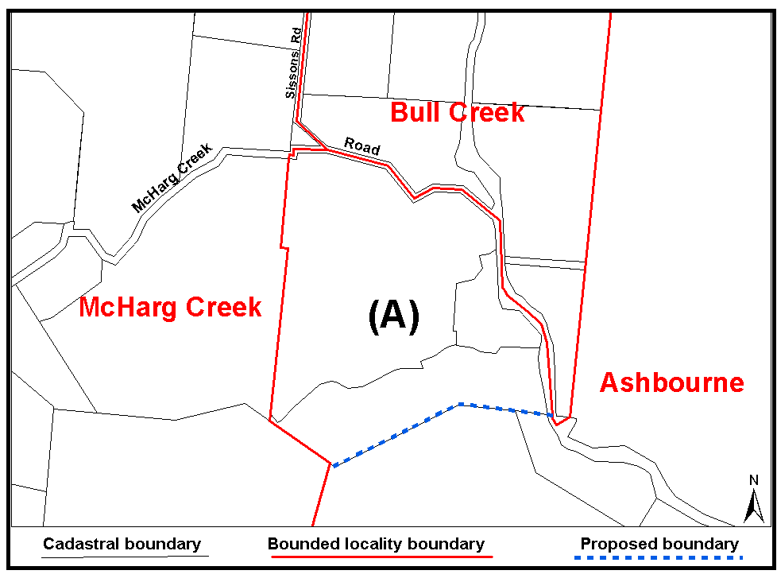
Dated 18 September 2006.
P. M. Kentish, Surveyor-General, Department for Administrative and Information Services
DAIS 22-413/06/0009

GAMING MACHINES ACT 1992
Notice of Application for Grant of Gaming Machine
Service Licence
NOTICE is hereby given, pursuant to section 29 of the Gaming Machines Act 1992, that Supreme Gaming Services Pty Ltd, 46 Palm Valley Road, Tumbi Umbi, N.S.W. 2261 has applied to the Liquor and Gambling Commissioner for a Gaming Machine Service Licence in respect of premises situated at 46 Palm Valley Road, Tumbi Umbi, N.S.W. 2261 and to be known as Supreme Gaming Services.
The application has been set down for callover on 20 October 2006.
Any person may object to the application by lodging a notice of objection in the prescribed form with the Liquor and Gambling Commissioner, and serving a copy of the notice on the applicant at the applicant’s address given above, at least seven days before the hearing date (viz: 12 October 2006).
The applicant’s address for service is c/o Supreme Gaming Services Pty Ltd, 46 Palm Valley Road, Tumbi Umbi, N.S.W. 2261.
Dated 13 September 2006.
Applicant

LIQUOR LICENSING ACT 1997 AND GAMING MACHINES ACT 1992
Notice of Application
NOTICE is hereby given, pursuant to section 52 of the Liquor Licensing Act 1997 and section 29 of the Gaming Machines Act 1992, that Clark Hotel Group Pty Ltd as trustee for the David Clark Leasehold Trust and Ricky Clark Leasehold Trust has applied to the Licensing Authority for the transfer of a Hotel and Gaming Machine Licence in respect of premises situated at 29 Commercial Road, Port Adelaide, S.A. 5015 and known as First Commercial Inn.
The application has been set down for hearing on 24 October 2006 at 9 a.m.
Any person may object to the application by lodging a notice of objection in the prescribed form with the Liquor and Gambling Commissioner and serving a copy of the notice on the applicant at the applicant’s address given above, at least seven days before the hearing date (viz: 16 October 2006).
The applicant’s address for service is c/o Tony Britten-Jones, 167 Flinders Street, Adelaide, S.A. 5000.
Plans in respect of the premises the subject of the application are open to public inspection without fee at the Office of the Liquor and Gaming Commissioner, 9th Floor, East Wing, 50 Grenfell Street, Adelaide, S.A. 5000. Phone 8226 8410, Fax: 8226 8512. Email: olgc@agd.sa.gov.au.
Dated 15 September 2006.
Applicant

LIQUOR LICENSING ACT 1997
Notice of Application
NOTICE is hereby given, pursuant to section 52 (2) (b) of the Liquor Licensing Act 1997, that Portia Valley Wines Pty Ltd has applied to the Licensing Authority for a Producer’s Licence in respect of premises situated at 21 Aitken Street, Berri, S.A. 5343 and known as Portia Valley Wines.
The application has been set down for hearing on 20 October 2006 at 9 a.m.
Any person may object to the application by lodging a notice of objection in the prescribed form with the Liquor and Gambling Commissioner, and serving a copy of the notice on the applicant at the applicant’s address given above, at least seven days before the hearing date (viz: 12 October 2006).
The applicant’s address for service is c/o Chris Grigoriou, P.O. Box 759, Berri, S.A. 5343.
Plans in respect of the premises the subject of the application are open to public inspection without fee at the Office of the Liquor and Gambling Commissioner, 9th Floor, East Wing, 50 Grenfell Street, Adelaide, S.A. 5000. Phone 8226 8410, Fax: 8226 8512. Email: olgc@agd.sa.gov.au.
Dated 12 September 2006.
Applicant

LIQUOR LICENSING ACT
Notice of Application
NOTICE is hereby given, pursuant to section 52 (2) (b) of the Liquor Licensing Act 1997, that D. A. and K. J. Tuck and Murtfam Pty Ltd as trustees for the Murtfam Pty Ltd Family Trust have applied to the Licensing Authority for a Producer’s Licence in respect of premises situated at Section 334, Warren Road, Mount Crawford, S.A. 5351 and known as Murray Vale Vineyards.
The application has been set down for hearing on 20 October 2006 at 9 a.m.
Any person may object to the application by lodging a notice of objection in the prescribed form with the Liquor and Gambling Commissioner, and serving a copy of the notice on the applicants at the applicants’ address given above, at least seven days before the hearing date (viz: 12 October 2006).
The applicants’ address for service is c/o Katherine Tuck, P.O. Box 895, Williamstown, S.A. 5351.
Plans in respect of the premises the subject of the application are open to public inspection without fee at the Office of the Liquor and Gambling Commissioner, 9th Floor, East Wing, 50 Grenfell Street, Adelaide, S.A. 5000. Phone 8226 8410, Fax: 8226 8512. Email: olgc@agd.sa.gov.au.
Dated 13 September 2006.
Applicants

LIQUOR LICENSING ACT 1997
Notice of Application
NOTICE is hereby given, pursuant to section 52 (2) (b) of the Liquor Licensing Act 1997, that George Marinus Wilson has applied to the Licensing Authority for a Retail Liquor Merchant’s Licence in respect of premises situated at 3 Warramboo Road, Lock, S.A. 5633 and to be known as Boomerang Motel.
The application has been set down for callover on 20 October 2006 at 9 a.m.
Any person may object to the application by lodging a notice of objection in the prescribed form with the Liquor and Gambling Commissioner, and serving a copy of the notice on the applicant at the applicant’s address given above, at least seven days before the hearing date (viz: 12 October 2006).
The applicant’s address for service is c/o George Marinus Wilson, P.O. Box 350, Lock, S.A. 5633.
Plans in respect of the premises the subject of the application are open to public inspection without fee at the Office of the Liquor and Gambling Commissioner, 9th Floor, East Wing, 50 Grenfell Street, Adelaide, S.A. 5000. Phone 8226 8410, Fax:
8226 8512. Email: olgc@agd.sa.gov.au.
Dated 13 September 2006.
Applicant

LIQUOR LICENSING ACT 1997
Notice of Application
NOTICE is hereby given, pursuant to section 52 (2) (b) of the Liquor Licensing Act 1997, that Australasian Liquor Merchants Pty Ltd as trustee for the PJP Family Trust and the Mark Pradun Family Trust has applied to the Licensing Authority for a Direct Sales Licence in respect of premises situated at 10 Ballantyne Street, Thebarton, S.A. 5031 and known as the Metro Wine Company.
The application has been set down for hearing on 20 October 2006 at 9 a.m.
Any person may object to the application by lodging a notice of objection in the prescribed form with the Liquor and Gambling Commissioner and serving a copy of the notice on the applicant at the applicant’s address given above, at least seven days before the hearing date (viz: 12 October 2006).
The applicant’s address for service is c/o Peter Pradun, P.O. Box 6163, Halifax Street, Adelaide, S.A. 5000.
Plans in respect of the premises the subject of the application are open to public inspection without fee at the Office of the Liquor and Gambling Commissioner, 9th Floor, East Wing, 50 Grenfell Street, Adelaide, S.A. 5000. Phone 8226 8410, Fax:
8226 8512. Email: olgc@agd.sa.gov.au.
Dated 14 September 2006.
Applicant

LIQUOR LICENSING ACT 1997
Notice of Application
NOTICE is hereby given, pursuant to section 52 (2) (b) of the Liquor Licensing Act 1997, that Franzon’s Hilton Hotel Pty Ltd has applied to the Licensing Authority for a variation to Extended Trading Authorisation, variation to Entertainment Consent, Redefinition and Alterations in respect of premises situated at 264 South Road, Hilton, S.A. 5033 and known as Hilton Hotel.
The application has been set down for hearing on 20 October 2006 at 9 a.m.
Conditions
The following licence conditions are sought:
• Variation to Extended Trading Authorisation to include the following hours:
Monday to Wednesday: Midnight to 3 a.m. the following day;
Sunday: 8 p.m. to 3 a.m. the following day;
Days preceding other Public Holidays: Midnight to 3 a.m. the following day;
Sundays preceding Public Holidays: 8 p.m. to 3 a.m. the following day.
• Variation to Entertainment Consent to include the following hours:
Sunday: Midnight to 2 a.m. the following day;
Christmas Eve: Midnight to 2 a.m. the following day;
Sunday Christmas Eve: Midnight to 2 a.m. the following day;
Days preceding other Public Holidays: Midnight to 2 a.m. the following day;
Good Friday: Midnight to 2 a.m.
• Alterations and Redefinition to licensed premises as per plans lodged with the office.
• The abovementioned application for variation to current Extended Trading Authorisation and current Entertainment Consent are to apply to the redefined areas as per plans lodged.
Any person may object to the application by lodging a notice of objection in the prescribed form with the Liquor and Gambling Commissioner and serving a copy of the notice on the applicant at the applicant’s address given above, at least seven days before the hearing date (viz: 12 October 2006).
The applicant’s address for service is c/o Meister Belperio Clark Lawyers and Mediators, 389 King William Street, Adelaide, S.A. 5000 (Attention: Steve Salandra).
Plans in respect of the premises the subject of the application are open to public inspection without fee at the Office of the Liquor and Gambling Commissioner, 9th Floor, East Wing, 50 Grenfell Street, Adelaide, S.A. 5000. Phone 8226 8410, Fax:
8226 8512. Email: olgc@agd.sa.gov.au.
Dated 15 September 2006.
Applicant

LIQUOR LICENSING ACT 1997
Notice of Application
NOTICE is hereby given, pursuant to section 52 (2) (b) of the Liquor Licensing Act 1997, that A.P.V.C. Ltd has applied to the Licensing Authority for the transfer of a Residential Licence in respect of premises situated at 76 Summit Road, Crafers, S.A. 5152 and known as Mount Lofty House.
The application has been set down for hearing on 23 October 2006 at 9.30 a.m.
Any person may object to the application by lodging a notice of objection in the prescribed form with the Liquor and Gambling Commissioner and serving a copy of the notice on the applicant at the applicant’s address given above, at least seven days before the hearing date (viz: 13 October 2006).
The applicant’s address for service is c/o Clelands Lawyers, 208 Carrington Street, Adelaide, S.A. 5000.
Plans in respect of the premises the subject of the application are open to public inspection without fee at the Office of the Liquor and Gambling Commissioner, 9th Floor, East Wing, 50 Grenfell Street, Adelaide, S.A. 5000. Phone 8226 8410, Fax:
8226 8512. Email: olgc@agd.sa.gov.au.
Dated 13 September 2006.
Applicant

LIQUOR LICENSING ACT 1997
Notice of Application
NOTICE is hereby given, pursuant to section 52 (2) (b) of the Liquor Licensing Act 1997, that J. & A. Reed Pty Ltd has applied to the Licensing Authority for the transfer of a Residential Licence in respect of premises situated at 74A Main North Road, Clare, S.A. 5453 and known as Clare Valley Motel.
The application has been set down for hearing on 23 October 2006 at 9.30 a.m.
Any person may object to the application by lodging a notice of objection in the prescribed form with the Liquor and Gambling Commissioner, and serving a copy of the notice on the applicant at the applicant’s address given above, at least seven days before the hearing date (viz: 13 October 2006).
The applicant’s address for service is c/o Fisher Jeffries, Level 15, 211 Victoria Square, Adelaide, S.A. 5000 (Attention: Craig Vozzo or Adrian Battiston).
Plans in respect of the premises the subject of the application are open to public inspection without fee at the Office of the Liquor and Gambling Commissioner, 9th Floor, East Wing, 50 Grenfell Street, Adelaide, S.A. 5000. Phone 8226 8410, Fax:
8226 8512. Email: olgc@agd.sa.gov.au.
Dated 18 September 2006.
Applicant

LIQUOR LICENSING ACT 1997
Notice of Application
NOTICE is hereby given, pursuant to section 52 (2) (b) of the Liquor Licensing Act 1997, that The Prince Albert Hotel (Gawler) Pty Ltd has applied to the Licensing Authority for the transfer of a Hotel Licence in respect of premises situated at Murray Street, Gawler, S.A. 5118 and known as Fibber Magee’s.
The application has been set down for hearing on 23 October 2006 at 10 a.m.
Any person may object to the application by lodging a notice of objection in the prescribed form with the Liquor and Gambling Commissioner, and serving a copy of the notice on the applicant at the applicant’s address given above, at least seven days before the hearing date (viz: 13 October 2006).
The applicant’s address for service is c/o Loretta Polson, 186 Tynte Street, North Adelaide, S.A. 5006.
Plans in respect of the premises the subject of the application are open to public inspection without fee at the Office of the Liquor and Gambling Commissioner, 9th Floor, East Wing, 50 Grenfell Street, Adelaide, S.A. 5000. Phone 8226 8410, Fax:
8226 8512. Email: olgc@agd.sa.gov.au.
Dated 15 September 2006.
Applicant

LIQUOR LICENSING ACT 1997
Notice of Application
NOTICE is hereby given, pursuant to section 52 (2) (b) of the Liquor Licensing Act 1997, that William Craig Swearse and Margaret Ann Swearse as trustees for the W. C. and M. A. Swearse Family Trust have applied to the Licensing Authority for the transfer of a Hotel Licence in respect of premises situated at Main North Road, Watervale, S.A. 5452 and known as Watervale Hotel.
The application has been set down for hearing on 23 October 2006 at 10.30 a.m.
Any person may object to the application by lodging a notice of objection in the prescribed form with the Liquor and Gambling Commissioner, and serving a copy of the notice on the applicants at the applicants’ address given above, at least seven days before the hearing date (viz: 13 October 2006).
The applicants’ address for service is c/o David Tillett, 66 Wright Street, Adelaide, S.A. 5000.
Plans in respect of the premises the subject of the application are open to public inspection without fee at the Office of the Liquor and Gambling Commissioner, 9th Floor, East Wing, 50 Grenfell Street, Adelaide, S.A. 5000. Phone 8226 8410, Fax:
8226 8512. Email: olgc@agd.sa.gov.au.
Dated 15 September 2006.
Applicants

LIQUOR LICENSING ACT 1997
Notice of Application
NOTICE is hereby given, pursuant to section 52 (2) (b) of the Liquor Licensing Act 1997, that Stables Hahndorf Pty Ltd has applied to the Licensing Authority for the transfer of a Residential Licence in respect of premises situated at 74 Main Street, Hahndorf, S.A. 5245, known as Hahndorf Motel & Restaurant and to be known as Stables Inn Hahndorf.
The application has been set down for hearing on 24 October 2006 at 9.30 a.m.
Any person may object to the application by lodging a notice of objection in the prescribed form with the Liquor and Gambling Commissioner, and serving a copy of the notice on the applicant at the applicant’s address given above, at least seven days before the hearing date (viz: 16 October 2006).
The applicant’s address for service is c/o Kristie St John, 74 Main Street, Hahndorf, S.A. 5245.
Plans in respect of the premises the subject of the application are open to public inspection without fee at the Office of the Liquor and Gambling Commissioner, 9th Floor, East Wing, 50 Grenfell Street, Adelaide, S.A. 5000. Phone 8226 8410, Fax:
8226 8512. Email: olgc@agd.sa.gov.au.
Dated 18 September 2006.
Applicant

LAND AND BUSINESS (SALE AND CONVEYANCING)
ACT 1994
Exemption
TAKE notice that, pursuant to section 23 (3) of the Land and Business (Sale and Conveyancing) Act 1994, I, Jennifer Rankine, Minister for Consumer Affairs, do hereby exempt the person named in Schedule 1 from the application of section 23 (2) of the Act in relation to the purchase of the land specified in Schedule 2.
Schedule 1
Nicholas John Redden, an officer of Jack Redden Real Estate Pty Ltd.
Schedule 2
The whole of the land described in certificate of title register book volume 5936, folio 570, situated at Lot 3, Brogan Road, Jamestown, S.A. 5491.
Dated 21 September 2006.
J. Rankine, Minister for Consumer Affairs

MINING ACT 1971
NOTICE is hereby given in accordance with section 28 (5) of the Mining Act 1971, that the Minister for Mineral Resources Development proposes to grant an Exploration Licence over the undermentioned area:
Applicant: Copper Range (SA) Pty Ltd
Location: Holowilena South area—Approximately 115 km north-east of Port Augusta.
Term: 1 year
Area in km²: 73
Ref.: 2006/00091
Plan and co-ordinates can be found on the PIRSA Sarig website: http://www.minerals.pir.sa.gov.au/sarig or by phoning Mineral Tenements on (08) 8463 3103.
H. Tyrteos, Mining Registrar

MINING ACT 1971
NOTICE is hereby given in accordance with section 35A (1) of the Mining Act 1971, that an application for a mining lease over the undermentioned mineral claim has been received. Details of the proposal may be inspected at the Department of Primary Industries and Resources, Mineral Resources Group, Level 7, 101 Grenfell Street, Adelaide, S.A. 5000:
Applicant: David Robert Hamlyn
Claim No.: 3560
Location: Allotment 201, Filed Plan 27144, Hundred of Lacepede—Approximately 6 km south-south-west of Kingston SE.
Area: 1.8 hectares.
Purpose: For the recovery of sand.
Reference: T02533
A copy of the proposal has been provided to the District Council of Kingston.
Written submissions in relation to the granting of the mining lease are invited to be received at the Department of Primary Industries and Resources, Mineral Resources Group, Level 7, 101 Grenfell Street, Adelaide, S.A. 5000 or G.P.O. Box 1671, Adelaide, S.A. 5001 no later than 6 October 2006.
Copies of all submissions will be forwarded to the applicant and may be made available for public inspection unless confidentiality is requested.
H. Tyrteos, Mining Registrar

MINING ACT 1971
NOTICE is hereby given in accordance with section 35A (1) of the Mining Act 1971, that an application for a mining lease over the undermentioned mineral claim has been received. Details of the proposal may be inspected at the Department of Primary Industries and Resources, Mineral Resources Group, Level 7, 101 Grenfell Street, Adelaide, S.A. 5000:
Applicant: David Charles Henry Halloran
Claim No.: 3562
Location: Section 79, Hundred of Newland—Approximately 13 km south-west of Parndana.
Area: 10 hectares.
Purpose: For the recovery of rubble.
Reference: T02541
A copy of the proposal has been provided to the Kangaroo Island Council.
Written submissions in relation to the granting of the mining lease are invited to be received at the Department of Primary Industries and Resources, Mineral Resources Group, Level 7, 101 Grenfell Street, Adelaide, S.A. 5000 or G.P.O. Box 1671, Adelaide, S.A. 5001 no later than 6 October 2006.
Copies of all submissions will be forwarded to the applicant and may be made available for public inspection unless confidentiality is requested.
H. Tyrteos, Mining Registrar

NATIONAL ELECTRICITY LAW
THE Australian Energy Market Commission (AEMC) gives notice under the National Electricity Law (NEL) of the following matters.
Under Section 107, the period of time for the making of the draft determination for the proposed National Electricity Amendment (Reallocations) Rule 2006 has been extended to 30 November 2006.
Under Section 99, the making of the draft determination for the proposed National Electricity Amendment (Reform of Regulatory Test Principles) Rule 2006. A copy of the draft determination
and draft Rule are published on the AEMC’s website and are available for inspection at the offices of the AEMC. Submissions and any requests for a hearing should be forwarded to submissions@aemc.gov.au:
• submissions must be received by 3 November 2006; and
• requests for a hearing must be received by 28 September 2006.
The AEMC publishes all submissions received on its website subject to a claim of confidentiality.
Further details on the above matters are available on AEMC’s website www.aemc.gov.au.
John Tamblyn
Chairman
Australian Energy Market Commission
Level 16, 1 Margaret Street
Sydney, N.S.W. 2000
Telephone: (02) 8296 7800
Facsimile: (02) 8296 7899
21 September 2006.

NATURAL RESOURCES MANAGEMENT ACT 2004
Notice of Authorisation to Take Water in the Mallee
Prescribed Wells Area
PURSUANT to section 128 of the Natural Resources Management Act 2004, I, Gail Gago, Minister for Environment and Conservation, hereby authorise the taking of water from wells within the Mallee Prescribed Wells Area prescribed under the Natural Resources Management (Mallee Prescribed Wells Area) Regulations 2005, within the area specified in Schedule A for the purposes set out in Schedule B, and subject to the conditions specified in Schedule C. This authorisation will commence on the date of gazettal and will remain in effect for a period of one year unless earlier varied or revoked.
Schedule A
Area
1. The Hundreds of Mindarie and Chesson.
Schedule B
Purpose
2. For the construction of Stage 1—Early works of the Mineral Separation Plant as per the Development Application (513/15/05) as approved by the District Council of Karoonda East Murray on
8 August 2006 (which includes road pavement and hardstand construction/compaction and dust suppression).
Schedule C
Conditions
3. Only 41 megalitres (or a lessor amount) shall be taken from the Murray Group Limestone Aquifer.
4. The water user must not take water except through a meter, fitted to the satisfaction of the Minister.
5. The water user must immediately report any fault or suspected fault with the meter or meters.
6. The user must not cause, suffer or permit any interference with a meter used for the purposes of measuring the quantity of water used under this Notice or any interference with pipes or fittings that may affect the accuracy of a meter, without the Minister’s authority.
7. The water user must not adjust or alter the meter without the Minister’s authority.
8. The water user must not permit sand, soil or any other material to be deposited on or around a meter.
9. The water user must not permit deposits of sand, soil or any other material to build up around a meter.
10. The water user must keep vegetation cleared away from the meter.
11. The water user must not damage or destroy the meter.
Dated 20 September 2006.
Gail Gago, Minister for Environment and Conservation

PETROLEUM ACT 2000
Temporary Cessation of Suspension of Exploration
Licence—PEL 107
PURSUANT to section 90 of the Petroleum Act 2000, notice is hereby given that the suspension dated 18 January 2006 of the abovementioned Exploration Licence has been temporarily ceased under the provisions of the Petroleum Act 2000, from and including 19 September 2006 to 21 September 2006, pursuant to delegated powers dated 28 March 2002, Gazetted 11 April 2002, page 1573.
The suspension dated 18 January 2006 will resume with effect from and including 22 September 2006 until 26 October 2006.
Dated 18 September 2006.
B. A. Goldstein,
Director Petroleum and Geothermal
Minerals and Energy Resources
Primary Industries and Resources SA
Delegate of the Minister for Mineral
Resources Development

PETROLEUM ACT 2000
Section 25 (5) (b)
Variation of Petroleum Exploration Licence—PEL 104
NOTICE is hereby given that under the provisions of the Petroleum Act 2000, pursuant to delegated powers dated 28 March 2002, Gazetted 11 April 2002, page 1573, the conditions of the abovementioned Exploration Licence have been varied as follows:
Condition 1 of the licence is omitted and the following substituted:
‘1. During the term of the licence, the Licensee shall carry out or cause to be carried out exploratory operations on the area comprised in the licence in accordance with such work programs as are approved by the Minister from time to time. Years one to four exploratory operations are guaranteed and any subsequent licence year becomes guaranteed upon entry into that year. These exploratory operations shall include but not necessarily be limited to:

Year of Term of Licence |  | Minimum Work Requirements
One |  | Data Review; 250 km Seismic Reprocessing
Two |  | 550 km Seismic Reprocessing
Three |  | 120 km Seismic; 550 km Seismic Reprocessing
Four |  | 4 wells; 150 km Seismic; 200 km Seismic Reprocessing
Five |  | 1 well
 |  |  | ’
This variation provides for the 2 wells originally programmed for Year 3 to be drilled in Year 4. The revised work requirements as a result of this variation would not have altered the outcome of the original competitive tender process.
Dated 13 September 2006.
D. Cockshell, Acting Director
Petroleum and Geothermal
Minerals and Energy Resources
Primary Industries and Resources SA
Delegate of the Minister for Mineral Resources Development

PASSENGER TRANSPORT ACT 1994
Appointment
NOTICE is hereby given that the following person has been appointed by the Minister for Transport as a Prescribed Officer under section 57 of the Passenger Transport Act 1994:
Robert Hobson
Dated 4 September 2006.
J. Hallion, Chief Executive, Department for Transport, Energy and Infrastructure

ROADS (OPENING AND CLOSING) ACT 1991:
SECTION 24
NOTICE OF CONFIRMATION OF ROAD
PROCESS ORDER
Road Closure—St Anton Street, Marleston
BY Road Process Order made on 5 September 2005, the City of West Torrens ordered that:
1. Portion of St Anton Street situated between Aldridge Terrace and Cudmore Street and adjoining allotments 134 and 135 in Filed Plan 19271, being portion of the land lettered ‘A’ and ‘B’ in Preliminary Plan No. 03/0052 be closed.
2. Issue a Certificate of Title to the City of West Torrens for the whole of the land subject to closure which land is being retained by Council for merging with the adjoining Council owned land.
3. The following easement be granted over portion of the land subject to that closure:
Grant to the South Australian Water Corporation an ease-ment for sewerage purposes.
On 27 April 2006 that order was confirmed by the Minister for Administrative Services and Government Enterprises con-ditionally upon the deposit by the Registrar-General of Deposited Plan 69083 being the authority for the new boundaries.
Pursuant to section 24 (5) of the Roads (Opening and Closing) Act 1991, NOTICE of the order referred to above and its con-firmation is hereby given.
Dated 21 September 2006.
P. M. Kentish, Surveyor-General

ROADS (OPENING AND CLOSING) ACT 1991:
SECTION 24
NOTICE OF CONFIRMATION OF ROAD
PROCESS ORDER
Road Closure—Milroy Road, Mingbool
BY Road Process Order made on 27 June 2006, the District Council of Grant ordered that:
1. The whole of Milroy Road and the whole of the unnamed public road adjoining sections 247 and 302 in Hundred of Mingbool, more particularly delineated and lettered ‘C’ and ‘D’ in Preliminary Plan No. 06/0004 be closed.
2. The whole of the land subject to closure be transferred to Peter Maxwell Collins in accordance with agreement for transfer dated 24 May 2006 entered into between the District Council of Grant and P. M. Collins.
On 4 September 2006 that order was confirmed by the Minister for Administrative Services and Government Enterprises con-ditionally upon the deposit by the Registrar-General of Deposited Plan 71734 being the authority for the new boundaries.
Pursuant to section 24 (5) of the Roads (Opening and Closing) Act 1991, NOTICE of the order referred to above and its con-firmation is hereby given.
Dated 21 September 2006.
P. M. Kentish, Surveyor-General

ROADS (OPENING AND CLOSING) ACT 1991:
SECTION 24
NOTICE OF CONFIRMATION OF ROAD
PROCESS ORDER
Road Opening and Closing—Cape Jaffa
BY Road Process Order made on 22 May 2006, the Kingston District Council ordered that:
1. Portion of allotment 123 in Deposited Plan 55486, more particularly delineated and numbered ‘1’ in Preliminary Plan No. 06/0012 be opened as road, forming a realignment of King Drive.
2. A strip of Rothalls Road adjoining the southern boundaries of allotment 123 in Deposited Plan 55486, portions of Cape Jaffa Road adjoining the western and southern boundaries of allotment 2 in Deposited Plan 68590 and portion of King Drive adjoining the southern boundary of section 306 in Hundred of Mount Benson, more particularly delineated and lettered ‘A’, ‘B’, ‘C’ and ‘D’ on Preliminary Plan No. 06/0012 be closed.
3. Issue a Certificate of Title to the Kingston District Council for the whole of the land subject to closure which land is being retained by Council for public purposes.
On 12 September 2006 that order was confirmed by the Minister for Administrative Services and Government Enterprises con-ditionally upon the deposit by the Registrar-General of Deposited Plan 71441 being the authority for the new boundaries.
Pursuant to section 24 (5) of the Roads (Opening and Closing) Act 1991, NOTICE of the order referred to above and its con-firmation is hereby given.
Dated 21 September 2006.
P. M. Kentish, Surveyor-General

WATER MAINS AND SEWERS

Office of the South Australian Water Corporation
Adelaide, 21 September 2006

WATER MAINS LAID

Notice is hereby given that the following main pipes or parts of main pipes have been laid down by the South Australian Water Corporation in or near the undermentioned water districts and are now available for a constant supply of water to adjacent land.

ADELAIDE WATER DISTRICT

CITY OF CHARLES STURT
Surrey Street, Grange. p30
Elizabeth Street, Findon. p51

TOWN OF GAWLER
Bond Street, Willaston. p14

CITY OF HOLDFAST BAY
Shannon Avenue, Glenelg North. p56

CITY OF MARION
Rotorua Avenue, Park Holme. p59

DISTRICT COUNCIL OF MOUNT BARKER
Across Alexandrina Road, Mount Barker. p20
In and across Railway Terrace, Mount Barker. p20
Easements in crown land (lot 8 in LTRO DP 47944), Railway Terrace, Mount Barker. p20

CITY OF PLAYFORD
St George Court, Andrews Farm. p40
Enterprise Circuit, Andrews Farm. p40
Easement in lot 2007 in LTRO DP 71654, Enterprise Circuit, Andrews Farm. p40

CITY OF PORT ADELAIDE ENFIELD
Margaret Terrace, Rosewater. p43
Devon Street, Enfield. p53

CITY OF UNLEY
Northgate Street, Unley Park. p12
Grove Street, Unley Park. p12
Omar Place, Unley Park. p12
George Street, Unley Park. p12
Young Street, Parkside. p45 and 46
Stamford Street, Parkside. p46
Across Greenhill Road, Parkside. p46

BUNDALEER COUNTRY LANDS WATER DISTRICT

NORTHERN AREAS COUNCIL
Easement in lot 766 in LTRO FP 188088, Watts Range Road, Yacka. p61

WAKEFIELD REGIONAL COUNCIL
Kadina-Whitwarta Road, Whitwarta. p15-17

KADINA WATER DISTRICT

DISTRICT COUNCIL OF THE COPPER COAST
Digby Street, Kadina. p18 and 19
Across Frances Terrace, Kadina. p18 and 19
Graves Street, Kadina. p18 and 19
No. 5 Lane, Kadina. p18 and 19
Forster Street, Kadina. p18 and 19
David Street, Kadina. p37-39
Thyer Street, Kadina. p37 and 38
Measday Crescent, Kadina. p37 and 38
Across Port Road, Kadina. p39

KIMBA WATER DISTRICT

DISTRICT COUNCIL OF KIMBA
Sampson Street, Kimba. p34
Frick Street, Kimba. p34

LAMEROO WATER DISTRICT

SOUTHERN MALLEE DISTRICT COUNCIL
Ficken Lane, Lameroo. p9

MOONTA WATER DISTRICT

DISTRICT COUNCIL OF THE COPPER COAST
Chapple Street, Moonta Bay. p42

PENOLA WATER DISTRICT

WATTLE RANGE COUNCIL
Miamba Close, Penola. p6

ROBE WATER DISTRICT

DISTRICT COUNCIL OF ROBE
Main South Eastern Road, Robe. p7
Colin’s Court, Robe. p7
Mary Ellen Court, Robe. p7

WARREN COUNTRY LANDS WATER DISTRICT

LIGHT REGIONAL COUNCIL
Sturt Highway, Daveyston. p52

WHYALLA WATER DISTRICT

THE CORPORATION OF THE CITY OF WHYALLA
In public utility reserve (lot 6988), Whyalla Playford. p1
In public utility reserve (lot 6942), Whyalla Norrie. p2

WATER MAINS ABANDONED

Notice is hereby given that the undermentioned water mains have been abandoned by the South Australian Water Corporation.

ADELAIDE WATER DISTRICT

CITY OF CHARLES STURT
Surrey Street, Grange. p30

TOWN OF GAWLER
Bond Street, Willaston. p14

CITY OF HOLDFAST BAY
Shannon Avenue, Glenelg North. p56
CITY OF ONKAPARINGA
Across Shearer Drive, Seaford. p58

CITY OF PORT ADELAIDE ENFIELD
Margaret Terrace, Rosewater. p43

CITY OF UNLEY
Northgate Street, Unley Park. p12
Grove Street, Unley Park. p12
Omar Place, Unley Park. p12
George Street, Unley Park. p12

BUNDALEER COUNTRY LANDS WATER DISTRICT

NORTHERN AREAS COUNCIL
Easement in lot 766 in LTRO FP 188088, Watts Range Road, Yacka. p61

WAKEFIELD REGIONAL COUNCIL
Kadina-Whitwarta Road, Whitwarta. p15-17

KADINA WATER DISTRICT

DISTRICT COUNCIL OF THE COPPER COAST
Digby Street, Kadina. p18 and 19
Across Frances Terrace, Kadina. p18 and 19
Graves Street, Kadina. p18 and 19
No. 5 Lane, Kadina. p18 and 19
Forster Street, Kadina. p18 and 19

TEROWIE WATER DISTRICT

REGIONAL COUNCIL OF GOYDER
Across and in Railway Terrace, Terowie. p32
Across Third Street, Terowie. p32
Easements in lots 104 and 100 in LTRO DP 30773, Railway Terrace, Terowie. p32
Barrier Highway, Terowie. p33

WARREN COUNTRY LANDS WATER DISTRICT

LIGHT REGIONAL COUNCIL
Sturt Highway, Daveyston. p52
In and across Sturt Highway, Greenock. p54

WHYALLA WATER DISTRICT

THE CORPORATION OF THE CITY OF WHYALLA
In public utility reserve (lot 6988), Whyalla Playford. p1
In public utility reserve (lot 6942), Whyalla Norrie. p2

OUTSIDE WATER DISTRICTS

TATIARA DISTRICT COUNCIL
Across and in Cannawigara Road, Cannawigara. p55

WATER MAINS LAID

Notice is hereby given that the undermentioned water mains have been laid down by the South Australian Water Corporation and are not available for a constant supply of water to adjacent land.

ADELAIDE WATER DISTRICT

ADELAIDE HILLS COUNCIL
Waterworks land (section 1545, hundred of Noarlunga), Heathfield Road, Heathfield. p26-29
Across and in Heathfield Road, Heathfield. p26-29

TEROWIE WATER DISTRICT

REGIONAL COUNCIL OF GOYDER
Third Street, Terowie. p32
Railway Terrace, Terowie. p32
Across and in Barrier Highway, Terowie. p33

OUTSIDE WATER DISTRICTS

TATIARA DISTRICT COUNCIL
Across and in Cannawigara Road, Cannawigara. p55

DELETION

Deletion of notice in “Government Gazette” of 24 August 2006.

“WATER MAINS LAID”

“Notice is hereby given that the undermentioned water mains have been laid down by the South Australian Water Corporation and are not available for a constant supply of water to adjacent land.”

“ADELAIDE WATER DISTRICT”

“CITY OF TEA TREE GULLY”
“Waterworks land (lot 100 in LTRO DP 35444), Grand Junction Road, Hope Valley. p61-65”

Delete this notice.

DELETION

Deletion of notices in “Government Gazette” of 23 March 2006.

“WATER MAINS LAID”

“Notice is hereby given that the following main pipes or parts of main pipes have been laid down by the South Australian Water Corporation in or near the undermentioned water districts and are now available for a constant supply of water to adjacent land.”

“TEROWIE WATER DISTRICT”

“REGIONAL COUNCIL OF GOYDER”
“Third Street, Terowie. p53
Railway Terrace, Terowie. p53
Across and in Barrier Highway, Terowie. This main is available on the east side by application only. p54”

Delete these notices.

“DELETION”

“Deletion of notices in “Government Gazette” of 23 March 2006.”

“WATER MAINS ABANDONED”

“Notice is hereby given that the undermentioned water mains have been abandoned by the South Australian Water Corporation.”

“TEROWIE WATER DISTRICT”

“REGIONAL COUNCIL OF GOYDER”
“Across and in Railway Terrace, Terowie. p53
Across Third Street, Terowie. p53
Easements in lots 104 and 100 in LTRO DP 30773, Railway Terrace, Terowie. p53
Barrier highway, Terowie. p54”

Delete these notices.

SEWERS LAID

Notice is hereby given that the following sewers have been laid down by the South Australian Water Corporation in the under-mentioned drainage areas and are now available for house connections.

ADELAIDE DRAINAGE AREA

ADELAIDE HILLS COUNCIL
Baroota Avenue, Rostrevor. FB 1153 p7

CITY OF CHARLES STURT
Ruby Avenue, Seaton. FB 1153 p2
Elizabeth Street, Findon. FB 1153 p9
Easements in lot 198 in LTRO DP 6123, Halsey Road, and lot 2 in LTRO DP 71330, Bode Street, Henley Beach South. FB 1153 p10

CITY OF ONKAPARINGA
Chandlers Hill Road, Happy Valley. FB 1153 p4

CITY OF PLAYFORD
St George Court, Andrews Farm. FB 1152 p40-42
Enterprise Circuit, Andrews Farm. FB 1152 p40-42
Easement in lot 2007 in LTRO DP 71654, Enterprise Circuit, Andrews Farm. FB 1152 p40-42

CITY OF PORT ADELAIDE ENFIELD
Easement in lot 2 in LTRO DP 69521, Devon Street, Enfield. FB 1153 p11

MOUNT GAMBIER COUNTRY DRAINAGE AREA

CITY OF MOUNT GAMBIER
Easement in lot 34 in LTRO DP 69239, Patricia Court, and lot 101 in LTRO DP 48564, Allison Street, Mount Gambier. FB 1130 p40
Easements in lot 36 in LTRO DP 69239, Patricia Court, and lots 2-4 in LTRO DP 70202, Allison Street, Mount Gambier. FB 1130 p40

SEWERS ABANDONED

Notice is hereby given that the undermentioned sewers have been abandoned by the South Australian Water Corporation.

ADELAIDE DRAINAGE AREA

ADELAIDE CITY COUNCIL
Easement in lot 858 in LTRO FP 182510, Princess Street, Adelaide. FB 1153 p3

ADELAIDE HILLS COUNCIL
Baroota Avenue, Rostrevor. FB 1153 p7

DELETION

Deletion of notice in “Government Gazette” of 24 August 2006.

“SEWERS LAID”

“Notice is hereby given that the following sewers have been laid down by the South Australian Water Corporation in the under-mentioned drainage areas and are now available for house connections.”

“ADELAIDE DRAINAGE AREA”

“CITY OF SALISBURY”
“Tullamore Court, Greenwith. FB 1151 p47”

Delete this notice.

DELETION

Deletion of notices in “Government Gazette” of 7 September 2006.

“SEWERS LAID”

“Notice is hereby given that the following sewers have been laid down by the South Australian Water Corporation in the under-mentioned drainage areas and are now available for house connections.”

“ADELAIDE DRAINAGE AREA”

“CITY OF MARION”
“In and across Elizabeth Crescent, Hallett Cove. FB 1152 p40, 41, 43 and 44
Easements in lots 142-145 in LTRO DP 68409, Stuart Court, Hallett Cove. FB 1152 p40, 41, and 43
Easements in lots 151-154, 157, 155, 156, 177, 158 and 159 in LTRO DP 68409, Elizabeth Crescent, Hallett Cove. FB 1152 p40, 41, and 44
Stuart Court, Hallett Cove. FB 1152 p40, 41, and 43
Thomas Way, Hallett Cove. FB 1152 p40, 42 and 44
Easements in lots 509 and 510 in LTRO DP 68409, Thomas Way, and lots 129-132 in LTRO DP 68409, Elizabeth Crescent, Hallett Cove. FB 1152 p40, 42 and 44”

Delete these notices.

A. Howe, Chief Executive Officer, South Australian Water Corporation.

TRAINING AND SKILLS DEVELOPMENT ACT 2003

Part 4—Apprenticeships/Traineeships

Pursuant to the provision of the Training and Skills Development Act 2003, the Training and Skills Commission (TaSC) gives notice that determines the following:
Trades, Declared Vocations or Other Occupations

The following schedule is additional to the gazettals of:

- 5 February 2004 | - 19 February 2004 | - 11 March 2004 | - 1 April 2004
- 1 July 2004 | - 15 July 2004 | - 22 July 2004 | - 30 September 2004
- 16 December 2004 | - 27 January 2005 | - 3 February 2005 | - 10 February 2005
- 10 March 2005 | - 24 March 2005 | - 5 May 2005 | - 12 May 2005
- 2 June 2005 | - 16 June 2005 | - 7 July 2005 | - 4 August 2005
- 18 August 2005 | - 1 September 2005 | - 15 September 2005 | - 22 September 2005
- 6 October 2005 | - 20 October 2005 | - 27 October 2005 | - 8 December 2005
- 22 December 2005 | - 9 March 2006 | - 6 April 2006 | - 20 April 2006
- 4 May 2006 | - 18 May 2006 | - 25 May 2006 | - 1 June 2006
- 3 August 2006 | - 10 August 2006 | - 31 August 2006 | - 7 September 2006

which set out the Trades, Declared Vocations or Other Occupations and the terms and conditions applicable to the Trades, Declared Vocations or other Occupations.

Trades, Declared Vocations or Other Occupations, required Qualifications and
Contract of Training Conditions for the
Public Sector Training Package (PSP04)

*Trade/  #Declared  Vocation/  Other  Occupation | National Code | Qualification | Nominal Term  of Contract of Training | Probationary Period
#School Services Officer | PSP30604 | Certificate III in Government  (School Support Services) | 12 months | 1 month
#School Services Officer | PSP41904 | Certificate IV in Government (School Support Services) | 24 months | 2 months

Bold denotes new declared vocation

GOVERNMENT GAZETTE ADVERTISEMENT RATES

To apply from 1 July 2006

$  Agents, Ceasing to Act as 38.00  Associations:  Incorporation 19.30  Intention of Incorporation 47.75  Transfer of Properties 47.75  Attorney, Appointment of 38.00  Bailiff’s Sale 47.75  Cemetery Curator Appointed 28.25  Companies:  Alteration to Constitution 38.00  Capital, Increase or Decrease of 47.75  Ceasing to Carry on Business 28.25  Declaration of Dividend 28.25  Incorporation 38.00  Lost Share Certificates:  First Name 28.25  Each Subsequent Name 9.70  Meeting Final 31.75  Meeting Final Regarding Liquidator’s Report on  Conduct of Winding Up (equivalent to ‘Final  Meeting’)  First Name 38.00  Each Subsequent Name 9.70  Notices:  Call 47.75  Change of Name 19.30  Creditors 38.00  Creditors Compromise of Arrangement 38.00  Creditors (extraordinary resolution that ‘the Com-pany be wound up voluntarily and that a liquidator be appointed’) 47.75  Release of Liquidator⎯Application⎯Large Ad. 75.50  ⎯Release Granted 47.75  Receiver and Manager Appointed 44.00  Receiver and Manager Ceasing to Act 38.00  Restored Name 35.75  Petition to Supreme Court for Winding Up 66.50  Summons in Action 56.50  Order of Supreme Court for Winding Up Action 38.00  Register of Interests⎯Section 84 (1) Exempt 85.50  Removal of Office 19.30  Proof of Debts 38.00  Sales of Shares and Forfeiture 38.00  Estates:  Assigned 28.25  Deceased Persons⎯Notice to Creditors, etc. 47.75  Each Subsequent Name 9.70  Deceased Persons⎯Closed Estates 28.25  Each Subsequent Estate 1.25  Probate, Selling of 38.00  Public Trustee, each Estate 9.70 |  | $  Firms:  Ceasing to Carry on Business (each insertion) 25.25  Discontinuance Place of Business 25.25  Land⎯Real Property Act:  Intention to Sell, Notice of 47.75  Lost Certificate of Title Notices 47.75  Cancellation, Notice of (Strata Plan) 47.75  Mortgages:  Caveat Lodgement 19.30  Discharge of 20.20  Foreclosures 19.30  Transfer of 19.30  Sublet 9.70  Leases⎯Application for Transfer (2 insertions) each 9.70  Lost Treasury Receipts (3 insertions) each 28.25  Licensing 56.50  Municipal or District Councils:  Annual Financial Statement⎯Forms 1 and 2 532.00  Electricity Supply⎯Forms 19 and 20 378.00  Default in Payment of Rates:  First Name 75.50  Each Subsequent Name 9.70  Noxious Trade 28.25  Partnership, Dissolution of 28.25  Petitions (small) 19.30  Registered Building Societies (from Registrar-  General) 19.30  Register of Unclaimed Moneys⎯First Name 28.25  Each Subsequent Name 9.70  Registers of Members⎯Three pages and over:  Rate per page (in 8pt) 242.00  Rate per page (in 6pt) 320.00  Sale of Land by Public Auction 48.25  Advertisements 2.70  ¼ page advertisement 113.00  ½ page advertisement 226.00  Full page advertisement 443.00  Advertisements, other than those listed are charged at $2.70 per column line, tabular one-third extra.  Notices by Colleges, Universities, Corporations and District Councils to be charged at $2.70 per line.  Where the notice inserted varies significantly in length from that which is usually published a charge of $2.70 per column line will be applied in lieu of advertisement rates listed.  South Australian Government publications are sold on the condition that they will not be reproduced without prior permission from the Government Printer.
All the above prices include GST

GOVERNMENT GAZETTE NOTICES
ALL private advertisements forwarded for publication in the South Australian Government Gazette must be PAID FOR PRIOR TO INSERTION; and all notices, from whatever source, should be legibly written on one side of the paper only and sent to Government Publishing SA so as to be received no later than 4 p.m. Tuesday preceding the day of publication. Phone 8207 1045 or Fax 8207 1040. E-mail: governmentgazette@saugov.sa.gov.au. Send as attachments in Word format. Please include date the notice is to be published and to whom the notice will be charged. The Government Gazette is available online at: www.governmentgazette.sa.gov.au.

MISCELLANEOUS LEGISLATION AND GOVERNMENT PUBLICATIONS PRICES AS FROM 1 JULY 2006

Acts, Bills, Rules, Parliamentary Papers and Regulations
Pages | Main | Amends | Pages | Main | Amends

1-16 | 2.30 | 1.05 | 497-512 | 32.25 | 31.25
17-32 | 3.10 | 1.95 | 513-528 | 33.25 | 32.00
33-48 | 4.05 | 2.90 | 529-544 | 34.25 | 33.25
49-64 | 5.10 | 3.90 | 545-560 | 35.25 | 34.25
65-80 | 6.00 | 4.95 | 561-576 | 36.00 | 35.25
81-96 | 6.95 | 5.75 | 577-592 | 37.00 | 35.75
97-112 | 7.90 | 6.75 | 593-608 | 38.25 | 36.75
113-128 | 8.90 | 7.75 | 609-624 | 39.00 | 38.00
129-144 | 9.95 | 8.80 | 625-640 | 40.00 | 38.50
145-160 | 10.90 | 9.70 | 641-656 | 41.00 | 40.00
161-176 | 11.90 | 10.70 | 657-672 | 41.50 | 40.50
177-192 | 12.90 | 11.70 | 673-688 | 43.25 | 41.50
193-208 | 13.90 | 12.80 | 689-704 | 44.00 | 42.50
209-224 | 14.70 | 13.60 | 705-720 | 44.75 | 43.50
225-240 | 15.70 | 14.50 | 721-736 | 46.50 | 44.50
241-257 | 16.80 | 15.30 | 737-752 | 47.00 | 45.50
258-272 | 17.70 | 16.30 | 753-768 | 48.00 | 46.25
273-288 | 18.70 | 17.50 | 769-784 | 48.50 | 47.75
289-304 | 19.50 | 18.40 | 785-800 | 49.50 | 48.75
305-320 | 20.70 | 19.40 | 801-816 | 50.50 | 49.25
321-336 | 21.50 | 20.30 | 817-832 | 51.50 | 50.50
337-352 | 22.60 | 21.40 | 833-848 | 52.50 | 51.50
353-368 | 23.50 | 22.40 | 849-864 | 53.50 | 52.00
369-384 | 24.50 | 23.40 | 865-880 | 54.50 | 53.50
385-400 | 25.50 | 24.30 | 881-896 | 55.00 | 54.00
401-416 | 26.50 | 25.00 | 897-912 | 56.50 | 55.00
417-432 | 27.50 | 26.25 | 913-928 | 57.00 | 56.50
433-448 | 28.50 | 27.25 | 929-944 | 58.00 | 57.00
449-464 | 29.25 | 28.00 | 945-960 | 59.00 | 57.50
465-480 | 29.75 | 29.00 | 961-976 | 60.50 | 58.50
481-496 | 31.25 | 29.75 | 977-992 | 61.50 | 59.00

Legislation—Acts, Regulations, etc: $
Subscriptions:
Acts 199.00
All Bills as Laid 477.00
Rules and Regulations 477.00
Parliamentary Papers 477.00
Bound Acts 221.00
Index 110.00
Government Gazette
Copy 5.20
Subscription 263.00
Hansard
Copy 14.50
Subscription—per session (issued weekly) 414.00
Cloth bound—per volume 178.00
Subscription—per session (issued daily) 414.00
Legislation on Disk
Whole Database 3063.00
Annual Subscription for fortnightly updates 941.00
Individual Act(s) including updates POA
Compendium
Subscriptions:
Subscriptions 1815.00
Updates 640.00
(All the above prices include GST)

All Legislation, Government Gazette, Hansard and Legislation on disk are available from:
Counter Sales Service SA, Government Legislation⁺ Outlet
and Mail Orders: Lands Titles Office, 101 Grenfell Street, Adelaide, S.A. 5000
Phone: 13 23 24 (local call cost), Fax: (08) 8204 1909
Postal: G.P.O. Box 1707, Adelaide, S.A. 5001

Online Shop: www.shop.service.sa.gov.au

Subscriptions and Government Publishing SA
Standing Orders: Box 9, Plaza Level, Riverside Centre, North Terrace, Adelaide, S.A. 5000
Phone: (08) 8207 1043, (08) 8207 0910, Fax: (08) 8207 1040

ROAD TRAFFIC ACT 1961

SUPPLEMENTARY NOTICE OF APPROVAL
Pursuant to Section 161A of the Road Traffic Act 1961

OPERATION OF B-DOUBLE VEHICLES UP TO 25 M IN LENGTH

1. APPROVAL
Information Note
This Notice adds additional routes to the network that can be used by B-Double Vehicles up to 25 m in Length and is a supplement to the Notice titled ‘Operation of B-Double Vehicles up to 25 m in Length’ dated 30 June 2005.

1.1 In accordance with the powers delegated to me by the Minister for Transport under Section 163AA and of the Road Traffic Act 1961, I hereby vary the conditions of the Gazette Notice of Approval and Exemption titled, ‘Operation of B-Double Vehicles up to 25 m in Length’ dated 30 June 2005 as detailed below.

2. DEFINITIONS

2.1 In this Notice:

2.1.1 ‘Approved Vehicles’ means B-Double vehicles up to an overall length not exceeding 25 m;

2.1.2 ‘Supplementary routes’ means the approved routes specified in the maps ‘Route Network for B-Double Vehicles up to 25 m in Length’ attached to this Supplementary Notice;

2.1.3 ‘Supplementary Notice’ means this Notice;

2.1.4 ‘Primary Notice’ means the Gazette Notice ‘Operation of B-Double Vehicles up to 25 m in Length’ dated 30 June 2005; and

2.1.5 all other terms have the same meaning as in the Primary Notice.

3. APPLICATION OF SUPPLEMENTARY NOTICE

3.1 This Supplementary Notice must be read in conjunction with the Primary Notice and applies to all Approved Vehicles operating under the Primary Notice travelling on routes specified in the attached maps.

4. ROUTES AVAILABLE TO APPROVED VEHICLES

4.1 An Approved Vehicle may operate under the conditions of the Primary Notice on a supplementary route specified hereunder:

4.1.1 ‘Route Network for B-Double Vehicles up to 25 m in Length General Mass Limits’ (GML) Map U2_1, 15 September 2006;

4.1.2 ‘Route Network for B-Double Vehicles up to 25 m in Length Higher Mass Limits’ (HML) Map U2_1, 15 September 2006.

5. CONDITIONS AND LIMITATIONS APPLYING TO THIS SUPPLEMENTARY NOTICE

5.1 When operating on a route specified in the attached maps, the driver of an Approved Vehicle must:

5.1.1 continue to comply with all conditions and requirements of the Primary Notice; and

5.1.2 carry a legible, current and complete copy of:

(i) this Supplementary Notice and attached maps;
(ii) the Primary Notice;
(iii) the ‘Code of Practice for B-Doubles’ dated June 2005;
(iv) the map book titled ‘Approved Route Network for B-Doubles’ dated June 2005; and

5.1.3 produce these documents when requested by a DTEI Transport Safety Compliance Officer appointed under the Road Traffic Act 1961 and/or the Motor Vehicles Act 1959 or a Police Officer;

5.1.4 comply with the following additional conditions:

(i) this temporary route extension is only to provide access to Gates 10 and 11 at the Symons and Clark Yard and also Gate 6 at the Incitec Pivot Plant; and
(ii) be directed by the flagman, qualified in work zone traffic management, while he is on the construction site between 7 a.m. and 7 p.m.

6. COMMENCEMENT OF THIS NOTICE

6.1 This Notice is effective from 12.01 a.m. on 25 September 2006 until 12 a.m. on 13 November 2006.

Executive Director,
Safety and Regulation Division
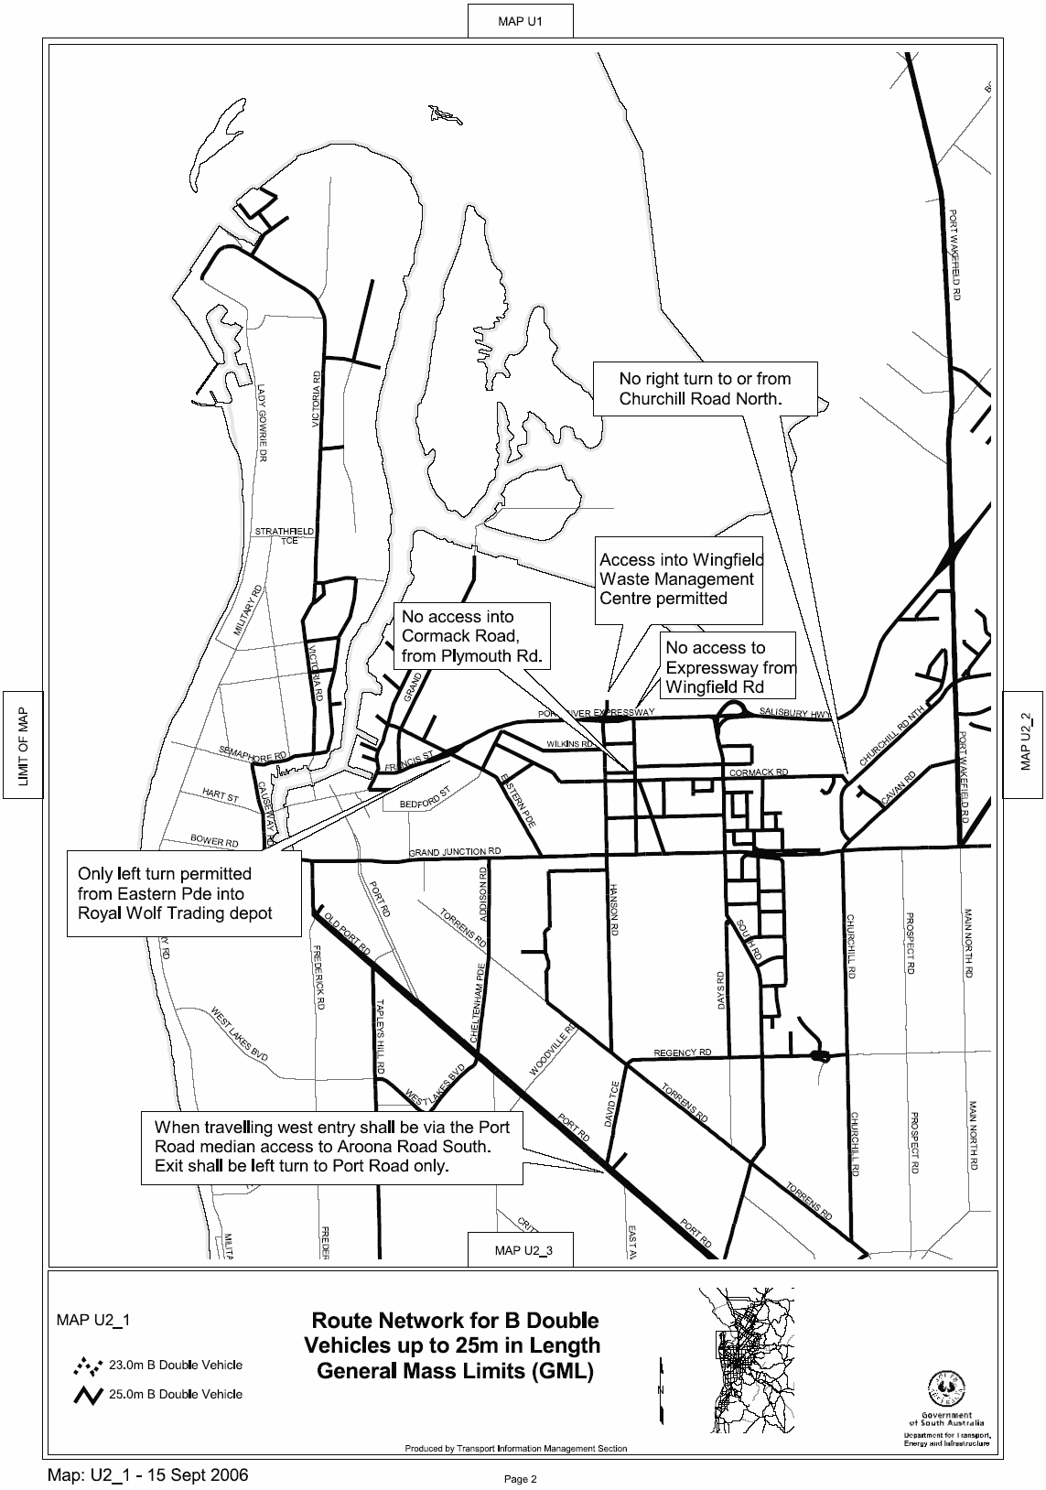
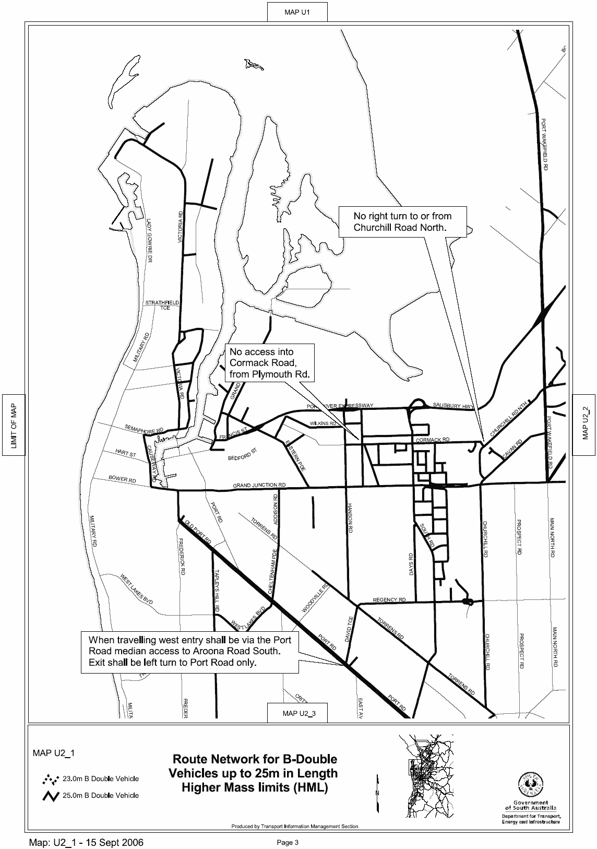

ROAD TRAFFIC ACT 1961

SUPPLEMENTARY NOTICE OF APPROVAL
Pursuant to Section 161A of the Road Traffic Act 1961

OPERATION OF ROAD TRAIN VEHICLES IN SOUTH AUSTRALIA

Information Note
This Notice adds additional routes to the network that can be used by Road Train Vehicles and is a supplement to the Notice titled ‘Operation of Road Train Vehicles in South Australia’ dated 24 November 2005.
1. APPROVAL

1.1 In accordance with the powers delegated to me by the Minister for Transport under Section 163AA of the Road Traffic Act 1961, I hereby vary the conditions of the Gazette Notice of Approval and Exemption titled, ‘Operation of Road Train Vehicles in South Australia’ dated 24 November 2005 as detailed below.

2. DEFINITIONS

2.1 In this Notice:

2.1.1 ‘Approved Vehicles’ means Road Train Vehicles (including articulated vehicles towing converter dollies);

2.1.2 ‘Supplementary routes’ means the approved routes specified in the maps ‘Route Network for Road Train Vehicles’ attached to this Supplementary Notice;

2.1.3 ‘Supplementary Notice’ means this Notice;

2.1.4 ‘Primary Notice’ means the Gazette Notice ‘Operation of Road Train Vehicles in South Australia’ dated 24 November 2005 and;

2.1.5 all other terms have the same meaning as in the Primary Notice.

3. APPLICATION OF SUPPLEMENTARY NOTICE

3.1 This Supplementary Notice must be read in conjunction with the Primary Notice and applies to all Approved Vehicles operating under the Primary Notice travelling on routes specified in the attached maps.

4. ROUTES AVAILABLE TO APPROVED VEHICLES

4.1 An Approved Vehicle may operate under the conditions of the Primary Notice on a supplementary route specified hereunder:

4.1.1 ‘Route Network for Road Train Vehicles General Mass Limits (GML)’ Map U2_1, 15 September 2006;

4.1.2 ‘Route Network for Road Train Vehicles Higher Mass Limits (HML)’ Map U2_1, 15 September 2006;

4.1.3 ‘Route Network for Converter Dolly General Mass Limits (GML)’ Map U2_1, 15 September 2006;

4.1.4 ‘Route Network for Converter Dolly Higher Mass Limits (HML)’ Map U2_1, 15 September 2006.

5. CONDITIONS AND LIMITATIONS APPLYING TO THIS SUPPLEMENTARY NOTICE

5.1 When operating on a route specified in the attached maps, the driver of an Approved Vehicle must:

5.1.1 continue to comply with all conditions and requirements of the Primary Notice; and

5.1.2 carry a legible, current and complete copy of:

(i) this Supplementary Notice and attached maps;
(ii) the Primary Notice;
(iii) the ‘Code of Practice for Road Trains’ dated November 2005;
(iv) the map book titled ‘Approved Route Network for Road Trains’ dated November 2005; and

5.1.3 produce these documents when requested by a Department for Transport, Energy and Infrastructure, Transport Safety Compliance Officer appointed under the Road Traffic Act 1961 and/or the Motor Vehicles Act 1959 or a Police Officer;

5.1.4 comply with the following additional conditions:

(i) this temporary route extension is only to provide access to Gates 10 and 11 at the Symons and Clark Yard and also Gate 6 at the Incitec Pivot Plant; and
(ii) be directed by the flagman, qualified in work zone management, while he is on the construction site between 7 a.m. and 7 p.m.

6. COMMENCEMENT OF THIS NOTICE

6.1 This Notice is effective from 12.01 a.m. on 25 September 2006 until 12 a.m. on 13 November 2006.

Executive Director,
Safety and Regulation Division
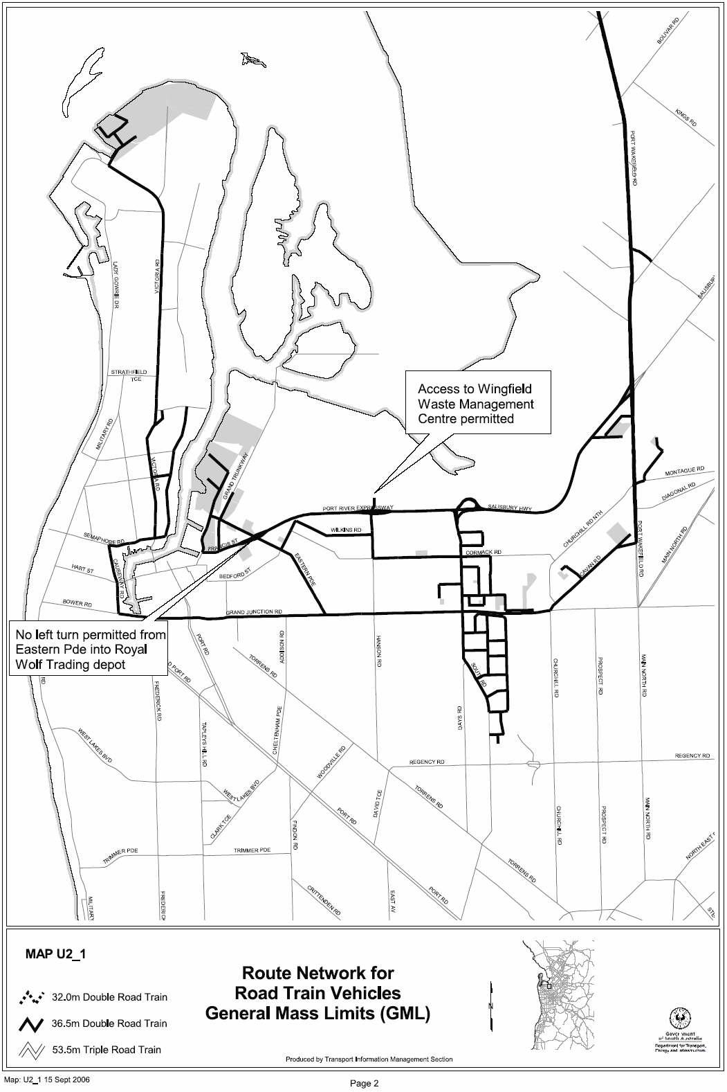
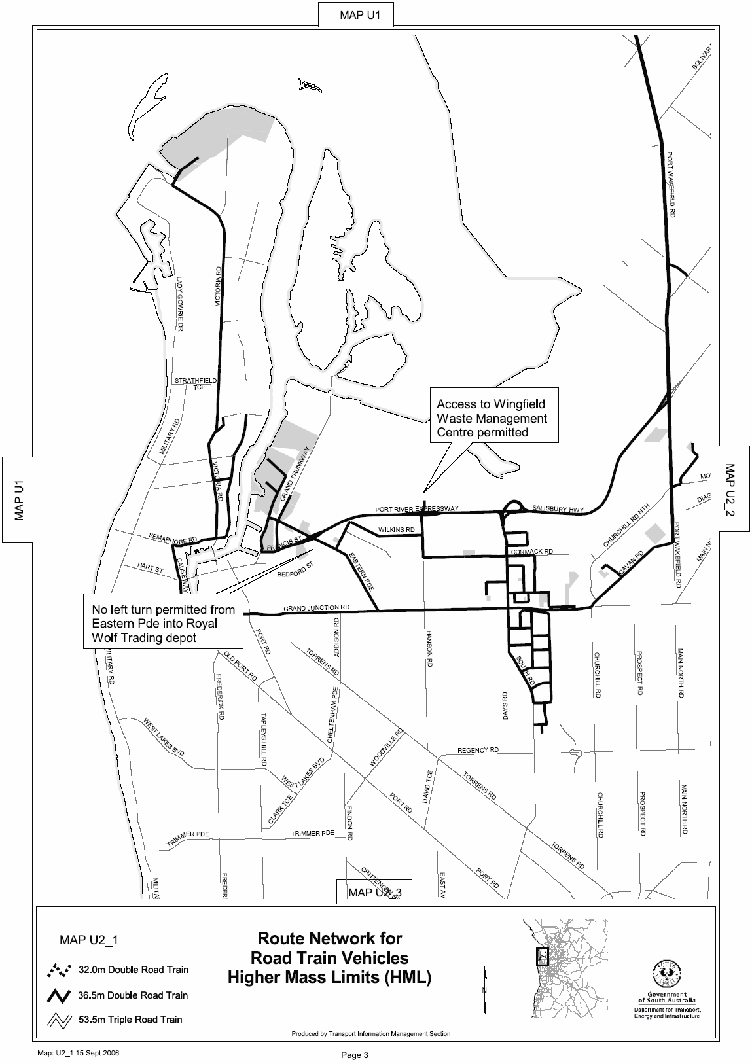
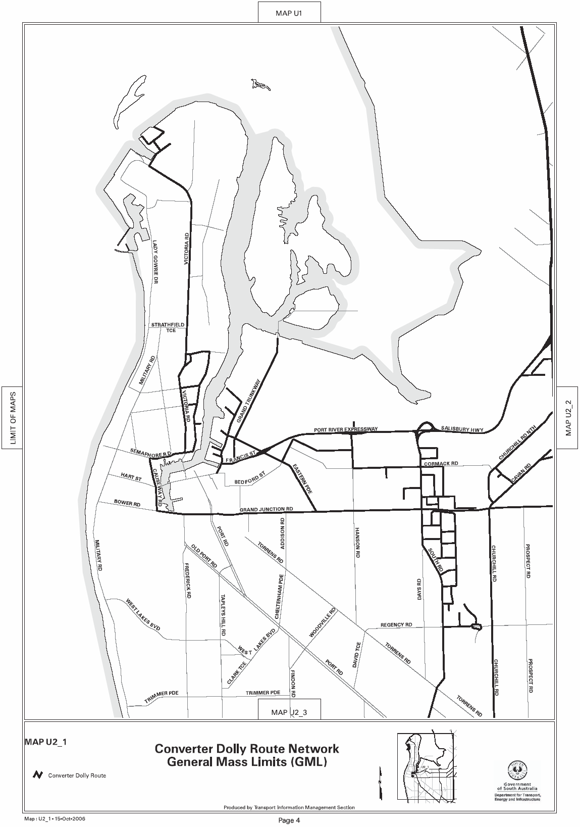
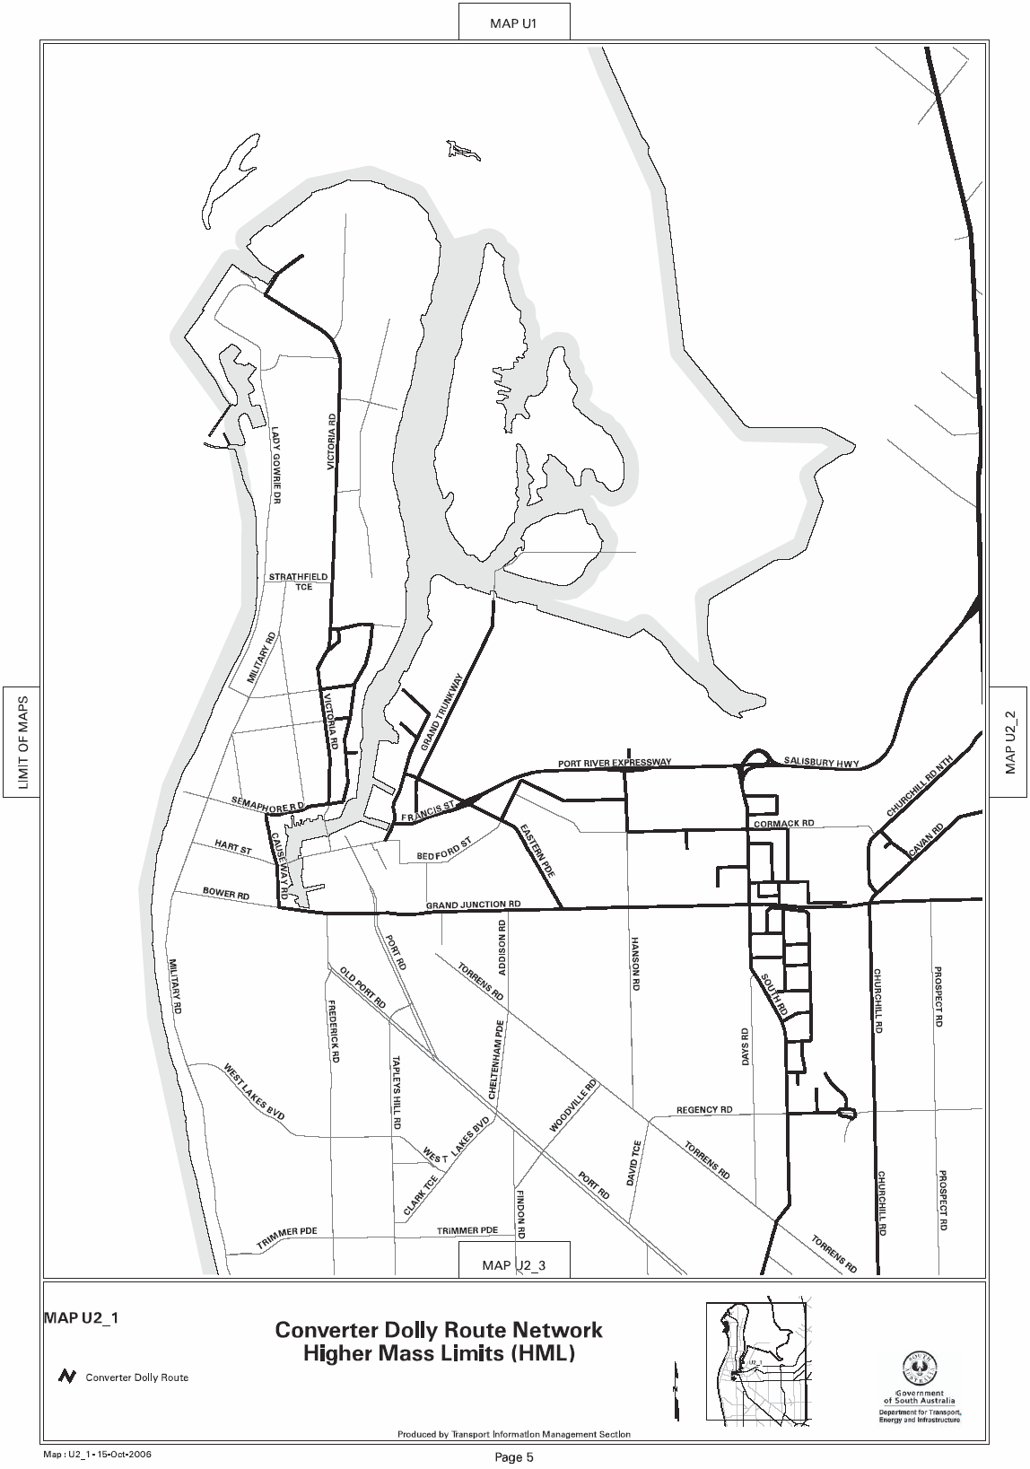

South Australia
Aquaculture (Approval of Eyre Region—Lincoln Sub
Region Zone Amendment Policy) Notice 2006
under section 12 of the Aquaculture Act 2001
1—Short title
This notice may be cited as the Aquaculture (Approval of Eyre Region—Lincoln Sub Region Zone Amendment Policy) Notice 2006.
2—Approval of aquaculture policy
(1) The Aquaculture (Eyre Region—Lincoln Sub Region Zone) Amendment Policy 2006 is approved.
(2) The policy comes into operation on the day on which this notice is published in the
Gazette.
Made by the Minister for Agriculture, Food and Fisheries
on 15 August 2006

South Australia
Children's Protection (Miscellaneous) Amendment Act (Commencement) Proclamation 2006
1—Short title
This proclamation may be cited as the Children's Protection (Miscellaneous) Amendment Act (Commencement) Proclamation 2006.
2—Commencement of suspended provisions
Sections 13 to 16 (inclusive) of the Children's Protection (Miscellaneous) Amendment Act 2005 (No 76 of 2005) will come into operation on 1 October 2006.
Made by the Governor’s Deputy
with the advice and consent of the Executive Council
on 21 September 2006
MFC/CS/06/023

South Australia
Professional Standards Act (Commencement) Proclamation 2006
1—Short title
This proclamation may be cited as the Professional Standards Act (Commencement) Proclamation 2006.
2—Commencement of Act
The Professional Standards Act 2004 (No 45 of 2004) will come into operation on 1 October 2006.
Made by the Governor’s Deputy
with the advice and consent of the Executive Council
on 21 September 2006
AGO0219/03CS
South Australia
Administrative Arrangements (Transfer of Assets, Rights and Liabilities) Proclamation 2006
under section 7 of the Administrative Arrangements Act 1994

Preamble
1 On 31 December 2005, the administrative unit known as the Emergency Services Administrative Unit was abolished by proclamation made under section 7 of the Public Sector Management Act 1995.
2 It is expedient that the assets, rights and liabilities of the former administrative unit be transferred to the South Australian Fire and Emergency Services Commission and the South Australian State Emergency Service.

1—Short title
This proclamation may be cited as the Administrative Arrangements (Transfer of Assets, Rights and Liabilities) Proclamation 2006.
2—Commencement
This proclamation comes into operation on the day on which it is made.
3—Transfer of assets, rights and liabilities
The assets, rights and liabilities of the former administrative unit known as the Emergency Services Administrative Unit are transferred as follows:
(a) assets, rights and liabilities to the following values are transferred to the South Australian Fire and Emergency Services Commission:
(i) receivables—$84 558;
(ii) property, plant and equipment—$492 092;
(iii) payables—$106 875;
(b) assets and rights to the following values are transferred to the South Australian State Emergency Service:
(i) receivables—$121 250;
(ii) property, plant and equipment—$15 459 790.
Made by the Governor’s Deputy
with the advice and consent of the Executive Council
on 21 September 2006
MES06/010
South Australia
Professional Standards Regulations 2006
under the Professional Standards Act 2004

Contents
1 Short title
2 Commencement
3 Interpretation
4 Fees
5 Period within which scheme may be challenged
6 Notification of limitation of liability
Schedule 1—Fees

1—Short title
These regulations may be cited as the Professional Standards Regulations 2006.
2—Commencement
These regulations will come into operation on the day on which the Professional Standards Act 2004 comes into operation.
3—Interpretation
In these regulations—
Act means the Professional Standards Act 2004;
professional standards legislation means the Act or a law of another State that is similar in effect to the Act.
4—Fees
(1) The fees fixed by Schedule 1 are payable to the Council.
(2) An occupational association whose members are subject to a scheme in force under the Act must pay the annual fee in respect of each member of the association—
(a) if the relevant scheme commences during the period of 3 months ending on 31 March in any year—not later than 31 March in each year; or
(b) if the relevant scheme commences during the period of 3 months ending on 30 June in any year—not later than 30 June in each year; or
(c) if the relevant scheme commences during the period of 3 months ending on 30 September in any year—not later than 30 September in each year; or
(d) if the relevant scheme commences during the period of 3 months ending on 31 December in any year—not later than 31 January of each following year.
(3) However, if at any time a scheme in force under the Act becomes applicable to an additional member of an occupational association, the association must pay the annual fee in respect of the additional member—
(a) if the scheme becomes applicable to the member during the period of 3 months ending on 31 March in a year—not later than 31 March in the year; or
(b) if the scheme becomes applicable to the member during the period of 3 months ending on 30 June in a year—not later than 30 June in the year; or
(c) if the scheme becomes applicable to the member during the period of 3 months ending on 30 September in a year—not later than 30 September in the year; or
(d) if the scheme becomes applicable to the member during the period of 3 months ending on 31 December in a year—not later than 31 January of the following year.
(4) If any part of the annual fee (including a payment required under subregulation (3)) is not paid within 30 days after it is due, simple interest at the rate of 0.05% per day is payable to the Council on the outstanding balance until the balance is paid.
(5) The Council may, if it considers that there are special reasons for doing so in a particular case, remit (in whole or in part) either or both of the following:
(a) a fee fixed by Schedule 1;
(b) interest payable under subregulation (4).
(6) However, if the Council delegates its power under subregulation (5) to the Secretary of the Council, the maximum amount of a fee or interest that may be remitted is $250.
5—Period within which scheme may be challenged
For the purposes of subsection (1) of section 16 of the Act, the prescribed period within which a person may apply to the Supreme Court for an order that a scheme referred to in that subsection is void is 2 months after the date on which the scheme comes into operation.
6—Notification of limitation of liability
For the purposes of section 35(2) of the Act, the prescribed form of statement is as follows:
Liability limited by a scheme approved under professional standards legislation.
Schedule 1—Fees

1 | For an application by an occupational association—
 | (a) for approval of a scheme prepared under section 8 of the Act | $5 000
 | (b) for an amendment to, or revocation of, such a scheme | $5 000
2 | Annual fee payable in respect of each member of an occupational association subject to a scheme in force under the Act | $50
Note—
As required by section 10AA(2) of the Subordinate Legislation Act 1978, the Minister has certified that, in the Minister's opinion, it is necessary or appropriate that these regulations come into operation as set out in these regulations.
Made by the Governor’s Deputy
with the advice and consent of the Executive Council
on 21 September 2006
No 226 of 2006
AGO0219/03CS

FAXING COPY?
IF you fax copy to Government Publishing SA for inclusion in the Government Gazette, there is no need to send a Confirmation Copy to us as well.
This creates confusion and may well result in your notice being printed twice.
Please use the following fax number:
Fax transmission: (08) 8207 1040
Phone Inquiries: (08) 8207 1045
Please include a contact person, phone number and order number so that we can phone back with any queries we may have regarding the fax copy.
NOTE: Closing time for lodging new copy (fax, hard copy or email) is 4 p.m. on Tuesday preceding the day of publication.

Government Gazette notices can be E-mailed.
The address is:
governmentgazette@saugov.sa.gov.au
Documents should be sent as attachments in Word format.
When sending a document via E-mail, please confirm your transmission with a faxed copy of your document, including the date the notice is to be published.
Fax transmission: (08) 8207 1040
Enquiries: (08) 8207 1045
NOTE: Closing time for lodging new copy (fax, hard copy or email) is 4 p.m. on Tuesday preceding the day of publication.

CITY OF CAMPBELLTOWN
Roads (Opening and Closing) Act 1991
Road Closure—Ambrose Avenue, Campbelltown
NOTICE is hereby given, pursuant to section 10 of the Roads (Opening and Closing) Act 1991, that the City of Campbelltown proposes to make a Road Process Order to close and merge portion of the public road (intersection of Ambrose Avenue and Karatta Avenue) with the adjoining Allotment 8 in Deposited Plan 10004, as more particularly delineated and lettered ‘A’ on Preliminary Plan No. 06/0047.
A copy of the plan and a statement of persons affected are available for public inspection at the offices of the Council, 172 Montacute Road, Rostrevor and the Adelaide office of the Surveyor-General during normal office hours.
Any application for easement or objection must set out the full name, address and details of the submission and must be fully supported by reasons.
The application for easement or objection must be made in writing to the Council, P.O. Box 1, Campbelltown, S.A. 5074, within 28 days of this notice and a copy must be forwarded to the Surveyor-General, G.P.O. Box 1354, Adelaide, S.A. 5001. Where a submission is made, the Council will give notification of a meeting at which the matter will be considered.
Dated 21 September 2006.
P. Vlatko, Chief Executive Officer

CITY OF MARION
Roads (Opening and Closing) Act 1991
Osman Avenue and Braeside Avenue, Seacombe Heights
NOTICE is hereby given, pursuant to section 10 of the Roads (Opening and Closing) Act 1991, that the Corporation of the City of Marion proposes to make a Road Process Order to close and transfer to Jason Peter Eitel and Lucrezia Rita Anna Toffoli portion of the Public Road (Osman Avenue) adjoining the western boundary of Allotment 401 in Deposited Plan 53421 and portion of the Public Road (Braeside Avenue) adjoining the eastern boundary of Allotment 401 in Deposited Plan 53421, shown more particularly delineated and lettered ‘A’ and ‘B’ in Preliminary Plan No. 06/0086.
A copy of the plan and a statement of persons affected are available for public inspection at the offices of the Council, 245 Sturt Road, Sturt and the Adelaide office of the Surveyor-General during normal office hours.
Any application for easement or objection must set out the full name, address and details of the submission and must be fully supported by reasons.
The application for easement or objection must be made in writing to the Council, P.O. Box 21, Oaklands Park, S.A. 5046 within 28 days of this notice and a copy must be forwarded to the Surveyor-General, G.P.O. Box 1354, Adelaide, S.A. 5001. Where a submission is made, the Council will give notification of a meeting at which the matter will be considered.
Dated 20 September 2006.
M. Searle, Chief Executive Officer

CITY OF ONKAPARINGA
Roads (Opening and Closing) Act 1991
NOTICE is hereby given pursuant to section 10 of the Roads (Opening and Closing) Act 1991, that the City of Onkaparinga proposes to make a Road Process Order to close and transfer the whole of Gray Street marked ‘A’ on Preliminary Plan No. 06/0077:
Issue a certificate of title to the City of Onkaparinga for ‘A’ which land is being retained by the Council for public purposes.
A statement of persons affected by the proposed Road Process Order together with a copy of the preliminary plan is available for inspection at the offices of the City of Onkaparinga, Ramsay Place, Noarlunga Centre, during normal office hours. Copies may also be inspected at the Adelaide office of the Surveyor-General, 101 Grenfell Street, Adelaide, during normal office hours.
Any person is entitled to object to the proposed Road Process Order, or any person affected by the proposed closure is entitled to apply for an easement to be granted in that person’s favour over the land subject to the proposed closure. Such objection or application for an easement must set out the full name and address of the person making the objection of application and must be fully supported by reasons. Any application for an easement must give full particulars of the nature and location of the easement land, where made by a person as the owner of adjoining land or nearby land, specify the land to which the easement is to be annexed.
The objection or application for an easement must be made in writing to the City of Onkaparinga, P.O. Box 1, Noarlunga Centre, S.A. 5168, within 28 days of this notice and a copy shall be forwarded to the Adelaide office of the Surveyor-General, G.P.O. Box 1354, Adelaide, S.A. 5001. Where a submission is made, the City of Onkaparinga will give notification of a meeting at which the matter will be considered, so that the person making the sub-mission or a representative may attend, if desired.
Dated 21 September 2006.
J. Tate, Chief Executive Officer

CITY OF PORT ADELAIDE ENFIELD
Change of Name of Portion of a Public Road
NOTICE is hereby given that the Council of the City of Port Adelaide Enfield at its meeting held on Tuesday, 5 September 2006, passed a resolution that required in effect that pursuant to section 219 (1) of the Local Government Act 1999, a portion of a certain public road in the suburb of Oakden be changed as detailed below:
• Portion of Trinity Way as marked ‘A’ and shown as Allotment 75 on Deposited Plan 70794 be changed to Whistler Drive.
The Deposit Plan which delineates the area of public road which is subject to the change of street name, together with a copy of the Council’s resolution and the report referred to in the resolution are available for inspection at the Council’s Principal Office, 163 St Vincent Street, Port Adelaide, The Parks Library Council Office, 2-46 Cowan Street, Angle Park, Enfield Library Council Office,
1-9 Kensington Crescent, Enfield and Greenacres Library Council Office, 2 Fosters Road, Greenacres, during their normal business hours.
H. J. Wierda, City Manager

CITY OF WEST TORRENS
Roads (Opening and Closing) Act 1991
Road Closure—Portion of Beare Avenue, North Plympton
NOTICE is hereby given pursuant to section 10 of the said Act, that Council proposes to make a Road Process Order to close and vest in V. I. and M. A. Buick portion of the Beare Avenue/ Hawson Avenue intersection adjoining allotment 87 in Filed Plan 13421 shown as ‘C’ on Preliminary Plan No. 06/0085.
A copy of the plan and statement of persons affected are available for public inspection at Council’s Office, 165 Sir Donald Bradman Drive, Hilton, S.A. 5033 and the office of the Surveyor-General, 101 Grenfell Street, Adelaide during normal office hours.
Any application for easement or objections must be made in writing within 28 days from 21 September 2006, to the Council at the above address and the Surveyor-General, G.P.O. Box 1354, Adelaide, S.A. 5001, setting out full details.
Where a submission is made, Council will give notification of a meeting to deal with the matter.
T. Starr, Chief Executive Officer

CITY OF WEST TORRENS
Roads (Opening and Closing) Act 1991
Road Closure—Portion of Riverside Drive, Fulham
NOTICE is hereby given pursuant to section 10 of the said Act, that Council proposes to make a Road Process Order to close and sell to M. and A. Kiriakakis and P. I. Tyner the un-made portions of Riverside Drive adjoining allotments 62 and 63 in Deposited Plan 4923 shown as ‘A’ and ‘B’ (respectively) on Preliminary Plan No. 06/0084.
A copy of the plan and statement of persons affected are available for public inspection at Council’s Office, 165 Sir Donald Bradman Drive, Hilton, S.A. 5033 and the office of the Surveyor-General, 101 Grenfell Street, Adelaide during normal office hours.
Any application for easement or objections must be made in writing within 28 days from 21 September 2006, to the Council at the above address and the Surveyor-General, G.P.O. Box 1354, Adelaide, S.A. 5001, setting out full details.
Where a submission is made, Council will give notification of a meeting to deal with the matter.
T. Starr, Chief Executive Officer

DISTRICT COUNCIL OF BARUNGA WEST
Close of Nominations
NOTICE is hereby given that at the close of nominations at 12 noon on Tuesday, 19 September 2006, the following people have been accepted as candidates and are listed in the order in which they will appear on the ballot papers.
Nominations Received
Councillor (10 vacancies)
Kerley, Leonie Helen
Schkabaryn, Tony
Simmons, Georgie
Aslin, Betty
Smith, Russel (Rusty)
Burgess, Ian David
Ireland, Stacey Lee
Rooney, Brian Dennis
Stuart, Debra
Harris, Wendy June
McDonald, Margaret
Weedon, Mark Andrew
Harper, Scott
Dolling, Dean Charles
Postal Voting
The election will be conducted by post. Ballot papers and pre-paid envelopes for each entitlement will be mailed out between Monday, 23 October 2006 and Friday, 27 October 2006 to every person, body corporate and group listed on the voters roll at roll close on 11 August 2006.
Voting is Voluntary
A person who has not received voting material by Friday, 27 October 2006 and who believes they are entitled to vote should contact the Principal Council Office, Bay Street, Port Broughton on 8635 2107.
Completed voting material must be returned to reach the Deputy Returning Officer no later than 5 p.m. on Friday, 10 November 2006.
A ballot box will be provided at the Council Offices for electors wishing to hand deliver their completed voting material during office hours.
Place of Counting Votes
The scrutiny and count will take place in the Council Chambers, Bay Street, Port Broughton, from 9 a.m. on Saturday, 11 November 2006. A provisional declaration will be made at the conclusion of each count.
Campaign Donations Return
Candidates must forward a Campaign Donations Return to the Council Chief Executive Officer within six weeks after the conclusion of the election.
K. Mousley, Returning Officer

DISTRICT COUNCIL OF CLEVE
Exclusion of Land from Classification as Community Land
NOTICE is hereby given that at its meeting held on 8 September 2006, the Council in accordance with section 193 (4) of the Local Government Act 1999, resolved that the land comprising of Lot 179, 12 Third Street, Cleve, Certificate of Title 5729/544, be excluded from Classification as Community Land.
A. Siviour, Chief Executive Officer

REGIONAL COUNCIL OF GOYDER
Development Act 1993
Goyder Council Better Development Plan (BDP) General Plan Amendment Report—Draft for Public Consultation
NOTICE is hereby given that the Regional Council of Goyder has prepared a draft Better Development Plan (BDP) General Plan Amendment Report to amend the Goyder Council Development Plan.
The Plan Amendment Report (PAR) will significantly amend the Goyder Council Development Plan by introducing a series of new zones and general policies, using the Better Development Plan policy modules. Desired Character Statements are included for all Zones and the two new Policy Areas.
The draft PAR will be available for public inspection during normal office hours at the Regional Council of Goyder Offices,
1 Market Square, Burra and 25 Bruce Street, Eudunda, from Friday, 22 September 2006 to Friday, 24 November 2006. The draft PAR will also be available for inspection at the Burra Community Library and the Eudunda Robertstown Districts School Community Library and can also be viewed on Council’s website: www.goyder.sa.gov.au. A copy of the PAR can be purchased from the Council for $50.
Written submissions regarding the draft amendment will be accepted by the Regional Council of Goyder, until 5 p.m. on Friday, 24 November 2006. The written submission should also clearly indicate whether you wish to speak at the public hearing on your submission. All submissions should be addressed to the Chief Executive Officer, Regional Council of Goyder, 1 Market Square, Burra, S.A. 5417.
Copies of all submissions received will be available for inspection by interested persons at the abovementioned Council offices during normal office hours from Monday, 27 November 2006 until the date of the public hearing.
A public hearing will be held at 8 p.m. on Tuesday, 12 December 2006 in the Regional Council of Goyder Council Chambers, 1 Market Square, Burra.
The public hearing may not be held if no submission indicates an interest in speaking at the public hearing.
Any queries can be directed to John Brak, Planner, Regional Council of Goyder, 1 Market Square, Burra, S.A. 5417, phone (08) 8892 0109, fax (08) 8892 2467, email jbrak@goyder.sa.gov.au.
Dated 21 September 2006.
S. J. Kerrigan, Chief Executive Officer

KINGSTON DISTRICT COUNCIL
Renaming of Public Road
NOTICE is hereby given that pursuant to section 219 of the Local Government Act 1999, Council, at its monthly meeting held on 18 August 2006, resolved to rename the following road:
• That the section of road currently officially known as First Street, which runs between the intersection of Cooke Street and First Street to the intersection of Bellevue Drive and First Street, be renamed to Bellevue Drive.
M. McCarthy, Chief Executive Officer

DISTRICT COUNCIL OF MOUNT REMARKABLE
Nominations Received—Uncontested
NOTICE is hereby given that at the close of nominations at 12 noon on Tuesday, 19 September 2006, the following people were nominated and elected as candidates unopposed:
Ranges Ward (two vacancies)
Pearce, Mike—Elected Unopposed
Storey, Marie Anne—Elected Unopposed
Plains Ward (two vacancies)
Roocke, Trevor Clarence—Elected Unopposed
Nottle, Colin Edward—Elected Unopposed
No elections will be necessary in the above two wards.
Nominations Received—Contested
At the close of nominations at 12 noon on Tuesday, 19 September 2006, the following people have been accepted as candidates and are listed in the order in which they will appear on the ballot papers:
Coastal Ward (two vacancies)
Hodgson, Bill
Leue, Gordon Albert
Vormister, Stephen
Forest Ward (one vacancy)
Kretschmer, Paul Raymond
O’Donnell, Pat
Postal Voting
The election will be conducted by post. Ballot papers and pre-paid envelopes for each entitlement will be mailed out between Monday, 23 October 2006 and Friday, 27 October 2006 to every person, body corporate and group listed on the voters roll at roll close on 11 August 2006. Voting is voluntary.
A person who has not received voting material by Friday, 27 October 2006 and who believes they are entitled to vote should contact the Council Office, Stuart Street, Melrose, telephone (08) 8666 2014.
Completed voting material must be returned to reach the Deputy Returning Officer no later than 5 p.m. on Friday, 10 November 2006.
A ballot box will be provided at the Council office for electors wishing to hand deliver their completed voting material during office hours.
Place and Counting of Votes
The scrutiny and count will take place in the Council Chambers, Stuart Street, Melrose from 9 a.m. on Saturday, 11 November 2006. A provisional declaration will be made at the conclusion of each count.
Campaign Donations Return
Candidates must forward a Campaign Donations Return to the Council Chief Executive Officer within six weeks after the conclusion of the election.
K. Mousley, Returning Officer

DISTRICT COUNCIL OF TATIARA
Revocation of Community Land Classification
NOTICE is hereby given that at a meeting of Council held on 12 September 2006, the District Council of Tatiara, after obtaining the approval of the Minister of Local Government/State Govern-ment Relations, resolved that pursuant to section 194 (3) (b) of the Local Government Act 1999, the Community Land Classification of allotment 11 in Deposited Plan 13037 comprised in certificate of title volume 5465, folio 744 (section 11, Hundred of Stirling via Mount Monster) is revoked.
R. J. Harkness, Chief Executive Officer

DISTRICT COUNCIL OF TATIARA
Appointments of Authorised Officers
NOTICE is hereby given that at a meeting of Council held on 12 September 2006, Council revoked all previous appointments and resolved to appoint the following officers as Authorised Officers for the District Council of Tatiara:
Community Titles Act 1996
Rocco Callisto (Manager Development and Inspectorial Services)
Development Act 1993 (Section 18)
Robert Harkness (Chief Executive Officer)
Kingsley Green (Manager Corporate and Community Services)
Richard Pym (Manager Technical Services)
Rocco Callisto (Manager Development and Inspectorial Services)
Robert Netherton (Environmental Health Officer)
Adrian Packer (General Inspector)
Ian Hentschke (Operations Manager)
Frank Mastrangelo (Senior Technical Officer)
How-Seng Su (Development Officer)
Dog and Cat Management Act 1995 (Sections 27 (1) and 68 (1))
Robert Harkness (Chief Executive Officer)
Kingsley Green (Manager Corporate and Community Services)
Richard Pym (Manager Technical Services)
Rocco Callisto (Manager Development and Inspectorial Services)
Ian Hentschke (Operations Manager)
Adrian Packer (General Inspector)
Malcolm Crombie (Parks and Gardens Supervisor)
Colin Hunt (West Ward Supervisor)
Tim Collins (Dog Control Officer)
Keith Braun (Dog Control Officer)
Tony Lee (Dog Control Officer)
Ty Devitt (Dog Control Officer)
Environmental Protection Act 1993 (Part 10, Division 1)
Robert Harkness (Chief Executive Officer)
Kingsley Green (Manager Corporate and Community Services)
Richard Pym (Manager Technical Services)
Rocco Callisto (Manager Development and Inspectorial Services)
Robert Netherton (Environmental Health Officer)
Adrian Packer (General Inspector)
Ian Hentschke (Operations Manager)
How-Seng Su (Development Officer)
Expiation of Offences Act 1996
Robert Harkness (Chief Executive Officer)
Kingsley Green (Manager Corporate and Community Services)
Richard Pym (Manager Technical Services)
Rocco Callisto (Manager Development and Inspectorial Services)
Robert Netherton (Environmental Health Officer)
Adrian Packer (General Inspector)
Ian Hentschke (Operations Manager)
Fire and Emergency Services Act 2005 (Part 3—Division 8 and Part 4—Divisions 7 and 8)
Robert Harkness (Chief Executive Officer)
Kingsley Green (Manager Corporate and Community Services)
Richard Pym (Manager Technical Services)
Rocco Callisto (Manager Development and Inspectorial Services)
Adrian Packer (General Inspector)
Ian Hentschke (Operations Manager)
Food Act 1991 (Section 94)
Robert Netherton (Environmental Health Officer)
Housing Improvement Act 1940 (Section 67)
Rocco Callisto (Manager Development and Inspectorial Services)
Robert Netherton (Environmental Health Officer)
Impounding Act 1920
Robert Harkness (Chief Executive Officer)
Kingsley Green (Manager Corporate and Community Services)
Richard Pym (Manager Technical Services)
Rocco Callisto (Manager Development and Inspectorial Services)
Adrian Packer (General Inspector)
Ian Hentschke (Operations Manager)
Malcolm Crombie (Parks and Gardens Supervisor)
Brian Jarrett (Works Supervisor East)
Colin Hunt (Works Supervisor West)
Land and Business (Sale and Conveyancing) Act 1994
(Section 12)
Robert Harkness (Chief Executive Officer)
Richard Pym (Manager Technical Services)
Kingsley Green (Manager Corporate and Community Services)
Rocco Callisto (Manager Development and Inspectorial Services)
Judi Molineux (Senior Finance Officer)
Sally Bywater (Rates Officer)
Local Government Act 1999 (Section 260)
Robert Harkness (Chief Executive Officer)
Kingsley Green (Manager Corporate and Community Services)
Richard Pym (Manager Technical Services)
Rocco Callisto (Manager Development and Inspectorial Services)
Robert Netherton (Environmental Health Officer)
Adrian Packer (General Inspector)
Ian Hentschke (Operations Manager)
Frank Mastrangelo (Senior Technical Officer)
Malcolm Crombie (Parks and Gardens Supervisor)
Brian Jarrett (Works Supervisor East)
Colin Hunt (Works Supervisor West)
Public and Environmental Health Act 1987 (Section 7 (1))
Robert Netherton (Environmental Health Officer)
Road Traffic Act 1961 (Section 35 (1A))
Robert Harkness (Chief Executive Officer)
Kingsley Green (Manager Corporate and Community Services)
Richard Pym (Manager Technical Services)
Adrian Packer (General Inspector)
Ian Hentschke (Operations Manager)
Frank Mastrangelo (Senior Technical Officer)
Malcolm Crombie (Parks and Gardens Supervisor)
Brian Jarrett (Works Supervisor East)
Colin Hunt (Works Supervisor West)
R. J. Harkness, Chief Executive Officer

WAKEFIELD REGIONAL COUNCIL
Alteration to Council Meeting Date
NOTICE is hereby given that, taking into account upcoming Local Government Council elections, the final ordinary meeting of Wakefield Regional Council in its current term will be scheduled for Wednesday, 25 October 2006 at 6.30 p.m. in the Council’s Civic Centre, Balaklava.
Thereafter the new Council will set its future ordinary meeting arrangements including providing public notice on the matter.
P. Barry, Chief Executive Officer

IN the matter of the estates of the undermentioned deceased persons:
Boehm, Barbara Annette, late of 333 Marion Road, North Plympton, retired aged care worker, who died on 8 August 2006.
Bott, Irving Francis, late of 43 Marlborough Street, Malvern, retired cabinet maker, who died on 5 August 2006.
Cahill, James William Patrick, late of 336 Marion Road, North Plympton, retired police officer, who died on 12 May 2006.
Cavatorta, Americo, late of 85 Hindley Street, Adelaide, retired press operator, who died on 13 June 2006.
Collett, Nancy Aileen, late of 30 Campbell Road, Parkside, home duties, who died on 4 July 2006.
Frey, Margareta, late of 146 Moscow Street, Peterborough, of no occupation, who died on 23 January 2006.
Gridley, Minnie Elizabeth, late of 5 Bradford Court, Enfield, retired nursing home assistant, who died on 10 January 2006.
Heap, Christine Mary, late of 42 Gover Street, North Adelaide, library manager, who died on 3 June 2006.
Hole, Judith Pamela, late of 3 Quebec Avenue, Clapham, home duties, who died on 21 July 2006.
Johnston, Daphne Jean, late of 24-34 Avenue Road, Glynde, retired shop assistant, who died on 5 August 2006.
Kroll, George Victor, late of 181-193 Days Road, Regency Park, retired labourer, who died on 5 June 2006.
Lee, Clare Hamlyn, late of 84 Valley View Drive, McLaren Vale, retired registered nurse, who died on 21 July 2006.
Megaw, Gwenda Raelene, late of Manning Street, Stansbury, home duties, who died on 4 March 2006.
Probyn, Idina Lesley Imelda, late of 345 Fullarton Road, Fullarton, of no occupation, who died on 20 March 2006.
Rankin, Vera Andeline Grace, late of 66 Nelson Road, Valley View, of no occupation, who died on 1 August 2006.
Shard, Muriel Mavis, late of 1099 Grand Junction Road, Hope Valley, of no occupation, who died on 31 July 2006.
Stewart, John Samuel, late of 13 Invergowrie Avenue, Highgate, retired medical practitioner, who died on 21 June 2006.
Uden, Donald Clarence, late of 23 Lacrington Street, Goolwa Beach, retired company director, who died on 1 June 2006.
von Koeppl, Katerina, late of 172 Trimmer Parade, Seaton, of no occupation, who died on 31 July 2005.
Waugh, Peggy Frances, late of 326 St Vincents Road, Banyo, Queensland, home duties, who died on 28 June 1999.
Notice is hereby given pursuant to the Trustee Act 1936, as amended, the Inheritance (Family Provision) Act 1972 and the Family Relationships Act 1975, that all creditors, beneficiaries, and other persons having claims against the said estates are required to send, in writing, to the Public Trustee, 25 Franklin Street, Adelaide, S.A. 5000, full particulars and proof of such claims, on or before 20 October 2006, otherwise they will be excluded from the distribution of the said estate; and notice is also hereby given that all persons who are indebted to the said estates are required to pay the amount of their debts to the Public Trustee or proceedings will be taken for the recovery thereof; and all persons having any property belonging to the said estates are forthwith to deliver the same to the Public Trustee.
Dated 21 September 2006.
C. J. O’Loughlin, Public Trustee

ATTENTION

CUSTOMERS requiring a proof of their notice for inclusion in the Government Gazette, please note that the onus is on you to inform Government Publishing SA of any subsequent corrections by 10 a.m. on Thursday, which is our publication deadline.

For any corrections to your notice please phone 8207 1045 or Fax 8207 1040 before 10 a.m. on Thursday.

If we do not receive any communication by 10 a.m. on Thursday (day of publication) we will presume the notice is correct and will print it as it is.

Remember—the onus is on you to inform us of any corrections necessary to your notice.

NOTE: Closing time for lodging new copy (electronically, fax or hard copy) is 4 p.m. on Tuesday preceding the day of publication. Phone 8207 1045—Fax 8207 1040.
Email: governmentgazette@saugov.sa.gov.au

Printed and published by authority every Thursday by K. O’CALLAGHAN, Government Printer, South Australia
Price: $5.20, plus postage; to subscribers, $263.00 per annum.
(The above prices are inclusive of GST)

