No. 19 1081

THE SOUTH AUSTRALIAN

GOVERNMENT GAZETTE
www.governmentgazette.sa.gov.au

PUBLISHED BY AUTHORITY

ALL PUBLIC ACTS appearing in this GAZETTE are to be considered official, and obeyed as such

ADELAIDE, THURSDAY, 5 APRIL 2007

CONTENTS

Page
Acts Assented To 1082
Appointments, Resignations, Etc. 1082
Associations Incorporation Act 1985—Notice 1083
Authorised Betting Operations Act 2000—Notice 1084
Building Work Contractors Act 1995—Notice 1084
Corporations and District Councils—Notices 1146
Development Act 1993—Notices 1086
Environment Protection Act 1993—Notices 1094
Environment Protection Authority—Notice 1093
Fair Work Act 1994—Notice 1099
Fisheries Act 1982—Notices 1109
Geographical Names Act 1991—Notices 1114
Harbors and Navigation Act 1993—Notices 1113
Land and Business (Sale and Conveyancing) Act 1994—
Notices 1115
Liquor Licensing Act 1997—Notices 1115

Page
Mining Act 1971—Notices 1121
National Electricity Law—Notice 1122
Passenger Transport Act 1994—Notices 1123
Port Augusta Circuit Court—Notice 1084
Private Advertisement 1148
Proclamations 1135
Public Trustee Office—Administration of Estates 1148
REGULATIONS
Environment Protection Act 1993 (No. 31 of 2007) 1137
Liquor Licensing Act 1997—
(No. 32 of 2007) 1139
(No. 33 of 2007) 1143
Remuneration Tribunal—Determinations 1128
Renmark Irrigation Trust, The—Notice 1123
Transport, Department of—Notice to Mariners 1122
Water Mains and Sewers—Mains Laid, Replaced, Etc. 1123

GOVERNMENT GAZETTE NOTICES
ALL poundkeepers’ and private advertisements forwarded for publication in the South Australian Government Gazette must be PAID FOR PRIOR TO INSERTION; and all notices, from whatever source, should be legibly written on one side of the paper only and sent to Government Publishing SA so as to be received no later
than 4 p.m. on the Tuesday preceding the day of publication. Phone 8207 1045 or Fax 8207 1040. E-mail: governmentgazette@saugov.sa.gov.au. Send as attachments in Word format and please confirm your transmission with a faxed copy of your document, including the date the notice is to be published and to whom the notice will be charged. The Government Gazette is available online at: www.governmentgazette.sa.gov.au

Department of the Premier and Cabinet
Adelaide, 5 April 2007
HER Excellency the Governor directs it to be notified for general information that she has in the name and on behalf of Her Majesty The Queen, this day assented to the undermentioned Acts passed by the Legislative Council and House of Assembly in Parliament assembled, viz.:
No. 6 of 2007—Barley Exporting Act 2007. An Act relating to exporting of barley; to repeal the Barley Marketing Act 1993; to make a related amendment to the Essential Services Commission Act 2002; and for other purposes.
No. 7 of 2007—Pharmacy Practice Act 2007. An Act to protect the health and safety of the public by providing for the registration of pharmacists, pharmacy students, pharmacies and pharmacy depots; to regulate the provision of pharmacy services for the purpose of maintaining high standards of competence and conduct by the persons who provide it; to make related amendments to the Dental Practice Act 2001; to repeal the Pharmacists Act 1991; and for other purposes.
No. 8 of 2007—Local Government (Stormwater Manage-ment) Amendment Act 2007. An Act to amend the Local Government Act 1999; and to make related amendments to the Natural Resources Management Act 2004.
No. 9 of 2007—Tobacco Products Regulation (Smoking in Cars) Amendment Act 2007. An Act to amend the Tobacco Products Regulation Act 1997.
No. 10 of 2007—Terrorism (Preventative Detention) (Mis-cellaneous) Amendment Act 2007. An Act to amend the Terrorism (Preventative Detention) Act 2005.
No. 11 of 2007—Optometry Practice Act 2007. An Act to protect the health and safety of the public by providing for the registration of optometrists and optometry students; to regulate the provision of optometry treatment for the purpose of maintaining high standards of competence and conduct by those who provide it; to repeal the Optometrists Act 1920; and for other purposes.
No. 12 of 2007—Public Finance and Audit (Refund or Recovery of Small Amounts) Amendment Act 2007. An Act to amend the Public Finance and Audit Act 1987.
No. 13 of 2007—State Lotteries (Miscellaneous) Amendment Act 2007. An Act to amend the State Lotteries Act 1966.
No. 14 of 2007—Motor Vehicles (National Transport Commission) Amendment Act 2007. An Act to amend the Motor Vehicles Act 1959; and to make a related amendment to the National Environment Protection Council (South Australia) Act 1995.
No. 15 of 2007—Tobacco Products Regulation (Miscel-laneous Offences) Amendment Act 2007. An Act to amend the Tobacco Products Regulation Act 1997.
No. 16 of 2007—Motor Vehicles (Third Party Insurance) Amendment Act 2007. An Act to amend the Motor Vehicles Act 1959.
No. 17 of 2007—Development (Assessment Procedures) Amendment Act 2007. An Act to amend the Development Act 1993; to make related amendments to the Highways Act 1926 and the Local Government Act 1999; and to repeal the Swimming Pools (Safety) Act 1972.
By command,
C. Zollo, for Acting Premier
DPC06/0875

Department of the Premier and Cabinet
Adelaide, 5 April 2007
HER Excellency the Governor in Executive Council has been pleased to appoint the undermentioned to the Board of the Environment Protection Authority, pursuant to the provisions of the Environment Protection Act 1993:
Member: (from 21 April 2007 until 20 April 2010)
Andrew Fletcher
Megan Dyson
Allan Holmes
Katherine Wells
By command,
C. Zollo, for Acting Premier
EPCS07/0006

Department of the Premier and Cabinet
Adelaide, 5 April 2007
HER Excellency the Governor in Executive Council has been pleased to appoint the undermentioned to the Eyre Peninsula Natural Resources Management Board, pursuant to the provisions of the Natural Resources Management Act 2004:
Member: (from 5 April 2007 until 13 April 2008)
Bronwyn Sleep
By command,
C. Zollo, for Acting Premier
WBCS07/0005

Department of the Premier and Cabinet
Adelaide, 5 April 2007
HER Excellency the Governor in Executive Council has been pleased to appoint the undermentioned to the Genetically Modified Crop Advisory Committee, pursuant to the provisions of the Genetically Modified Crops Management Act 2004:
Member: (from 5 April 2007 until 28 April 2008)
Lyn Cummins
By command,
C. Zollo, for Acting Premier
MAFF07/007CS

Department of the Premier and Cabinet
Adelaide, 5 April 2007
HER Excellency the Governor in Executive Council has been pleased to appoint the undermentioned to the South Australian Murray-Darling Basin Natural Resources Management Board, pursuant to the provisions of the Natural Resources Management Act 2004:
Member: (from 14 April 2007 until 13 April 2008)
David Ingerson
William Paterson
Elizabeth Nicholls
By command,
C. Zollo, for Acting Premier
MRMCS07/017

Department of the Premier and Cabinet
Adelaide, 5 April 2007
HER Excellency the Governor in Executive Council has been pleased to appoint Bruno Krumins, Member of the Order of Australia, as Governor’s Deputy of South Australia for the period from 10 a.m. on Wednesday, 11 April 2007 until 8 a.m. on Monday, 7 May 2007.
By command,
C. Zollo, for Acting Premier

Department of the Premier and Cabinet
Adelaide, 5 April 2007
HER Excellency the Governor in Executive Council has been pleased to appoint the Honourable Jay Wilson Weatherill, MP, Minister for Families and Communities, Minister for Aboriginal Affairs and Reconciliation, Minister for Housing, Minister for Ageing, Minister for Disability and Minister Assisting the Premier in Cabinet Business and Public Sector Management to be also Acting Minister for Transport, Acting Minister for Infrastructure and Acting Minister for Energy for the period 5 May 2007 to 27 May 2007 inclusive, during the absence of the Honourable Patrick Frederick Conlon, MP.
By command,
C. Zollo, for Acting Premier
MTR07/009CS

Department of the Premier and Cabinet
Adelaide, 5 April 2007
HER Excellency the Governor in Executive Council has been pleased to appoint the people listed as Special Justices of the Peace for South Australia for the terms specified below, pursuant to section 7 (1) of the Justices of the Peace Act 2005:
For the period commencing on 5 April 2007 and expiring on 4 April 2012:
Carlo Phillip Mancini
John McPhail
Sylvia Henrica Johanna Wimshurst
For the period commencing on 5 April 2007 and expiring on 10 September 2009:
Leslie Buckley
For the period commencing on 5 April 2007 and expiring on 29 April 2008:
Georgina Kay Darter
For the period commencing on 5 April 2007 and expiring on 20 April 2008:
Bryan Kenneth Hearn
For the period commencing on 5 April 2007 and expiring on 13 May 2009:
Domenic Remo Patroni
For the period commencing on 5 April 2007 and expiring on 4 April 2008:
Geoffrey Kenneth Penhall
Margot Ross Radford
For the period commencing on 5 April 2007 and expiring on 29 October 2008:
Robert John Peebles Shaw
By command,
C. Zollo, for Acting Premier
AGO0142/06CS

Department of the Premier and Cabinet
Adelaide, 5 April 2007
HER Excellency the Governor in Executive Council has been pleased to appoint the Members to the Regional Natural Resources
Management Boards set out below for the period commencing on 14 April 2007 and expiring on 13 April 2008, pursuant to the Natural Resources Management Act 2004:
Adelaide and Mount Lofty Ranges Natural Resources Management Board:
Wayne Alwyn Cornish
Roy David Blight
Jason Gregory Kuchel
Anthony Cheshire
Eyre Peninsula Natural Resources Management Board:
Anthony John Irvine
James Nelson Pollock
Sean Gregory O’Brien
Kangaroo Island Natural Resources Management Board:
Graham Bruce Allison
Charles Rodney Bell
David Minchin Ball
Fraser James Vickery
Northern and Yorke Natural Resources Management Board:
John Malcolm Byerlee
Richard Arnold Wilkinson
Neville Kevin Wilson
Sydney Marcus Strudwicke
South Australian Arid Lands Natural Resources Management Board:
Geoffrey Mills
Ronald Trevor Whitelaw
Brenton Kenneth Arnold
South East Natural Resources Management Board:
James Leonard Osborne
Richard John Vickery
Robert James Mock
Dale Colin Lewis
By command,
C. Zollo, for Acting Premier
WBCS07/0010

ASSOCIATIONS INCORPORATION ACT 1985
Dissolution of Association
NOTICE is hereby given that the Corporate Affairs Commission approves the application for transferring of undertaking received from the association named below, pursuant to section 42 (2) of the Associations Incorporation Act 1985. Dissolution takes effect on the date of publication of this notice.
Take notice that the Corporate Affairs Commission (‘the Commission’), pursuant to subsection 42 (2) of the Associations Incorporation Act 1985 (‘the Act’), orders that the undertakings of the Association shown in Schedule 1, be transferred to a body corporate as shown in Schedule 2 and that on 5 April 2007, the date of publication in the Government Gazette, the Association will be dissolved. The property of the Association becomes the property of the body corporate and the rights and liabilities of the Association become the rights and liabilities of the body corporate referred to in Schedule 2.
Schedule 1
International College of Hotel Management Incorporated.
Schedule 2
ICHM Pty Ltd.
Given under the common seal of the Corporate Affairs Commission in Adelaide, 29 March 2007.
(l.s.) G. Close, a Delegate of the Corporate Affairs Commission

AUTHORISED BETTING OPERATIONS ACT 2000
Section 4 (1) (b)
Notice of Approval of Contingencies
No. 2 of 2007
INDEPENDENT GAMBLING AUTHORITY, by this notice, approves contingencies relating to sporting or other events within Australia:
1. Citation
This notice may be cited as the Approved Contingencies (Roxby Downs Picnic Racing—Galloping) Notice 2007.
2. Approval
(1) The contingencies listed in the table are approved in respect of fixed odds betting by licensed bookmakers.
(2) This approval is subject to the provisions of the Authorised Betting Operations Act 2000 (‘Act’), the Bookmakers Licensing Rules 2000, any other rules made under section 62 of the Act, and the conditions to which a licence or permit are subject.
(3) This approval of contingencies may be amended or revoked by further notice.
3. Definitions
In this notice—
‘Event’—
(a) means a race on the flat for horses where each animal is ridden by a person;
(b) includes, in relation to an event mentioned in paragraph (a) for which there were more accepters than places, a division of that event offering the same prize as the event.
‘Place’ means the contingency that a specified Entrant will place either first, second or third (or, if applicable, fourth) in a specified Event (including where different odds are offered by a bookmaker for first place vis-a-vis any of second, third or, if applicable, fourth place).
‘Race’, with respect to horses, includes—
(a) a race conducted by a licensed racing club; and
(b) a race at a picnic race meeting or a gymkhana.
‘Win’ means the contingency that a specified Entrant will place first in or win a specified Event.
Table
Picnic race meeting conducted by or on behalf of the Roxby Downs Gymkhana and Picnic Race Club at the Roxby Downs Racecourse on 14 April 2007 and such later date to which the meeting may be adjourned
No. | Description of Event | Prizes | Approved  Contingencies
1. | Open race over 800 metres for horses | First—$1 100  Second—$300  Third—$100 | Win, place or derivative
2. | Improvers handicap open race over 1 000 metres for horses | First—$800  Second—$300  Third—$100 | Win, place or derivative
3. | Open race over 1 000 metres for horses | First—$1 350  Second—$500  Third—$150 | Win, place or derivative
4. | Roxby Cup open race over 1 600 metres for horses | First—$6 000  Second—$1 200  Third—$800 | Win, place or derivative
5. | Consolation race over 1 000 metres for horses—open only to horses that have not placed 1st, 2nd or 3rd on the day | First—$1 200  Second—$200  Third—$100 | Win, place or derivative
6. | Open race over 500 metres for camels | First—$1 200  Second—$300 | Win, place or derivative
Dated 2 April 2007.
R. C. J. Chappell, Secretary to the Independent Gambling Authority

BUILDING WORK CONTRACTORS ACT 1995
Exemption
TAKE notice that, pursuant to section 45 of the Building Work Contractors Act 1995, I, Mark Bodycoat, Commissioner for Consumer Affairs, do hereby exempt the licensee named in Schedule 1 from the application of Division 3 of Part 5 of the above Act in relation to domestic building work described in Schedule 2 and subject to the conditions specified in Schedule 3.
Schedule 1
Theodorus Petrus Wilhelmus Van Heeswyk, BLD 30993.
Schedule 2
Construction of a house at Lot 806, Filed Plan 194608, in the area named Moorak, Hundred of Blanche, South Australia.
Schedule 3
1. This exemption is limited to domestic building work personally performed by the licensee for the construction of a house, intended to be the residential home of the licensee, on land situated at Lot 806, Filed Plan 194608, in the area named Moorak, Hundred of Blanche in the State of South Australia.
2. This exemption does not apply to any domestic building work the licensee sub-contracts to another building work contractor, for which that contractor is required by law to hold building indemnity insurance.
3. That the licensee does not transfer his interest in the land prior to five years from the date of completion of the building work the subject of this exemption, without the prior authorisation of the Commissioner for Consumer Affairs. Before giving such authorisation, the Commissioner for Consumer Affairs may require the licensee to take any reasonable steps to protect the future purchaser(s) of the property, including but not limited to:
• providing evidence that an adequate policy of building indemnity insurance is in force to cover the balance of the five-year period from the date of completion of the building work the subject of this exemption;
• providing evidence of an independent expert inspection of the building work the subject of this exemption;
• making an independent expert report available to pros-pective purchasers of the property;
• giving prospective purchasers of the property notice of the absence of a policy of building indemnity insurance.
Dated 27 March 2007.
M. Bodycoat, Commissioner for Consumer Affairs

THE DISTRICT COURT OF SOUTH AUSTRALIA
PORT AUGUSTA CIRCUIT COURT
Sheriff’s Office, Adelaide, 22 March 2007
IN pursuance of a precept from the District Court of South Australia to me directed, I do hereby give notice that the said court will sit as a Court of Oyer and Terminer and General Gaol Delivery at the Courthouse at Port Augusta on the day and time undermentioned and all parties bound to prosecute and give evidence and all jurors summoned and all others having business at the said Court are required to attend the sittings thereof and the order of such business will be unless a Judge otherwise orders as follows:
Monday, 2 April 2007 at 10 a.m. on the first day of the sittings the only business taken will be the arraignment of prisoners in gaol and the passing of sentences on prisoners in gaol committed for sentence; the surrender of prisoners on bail committed for sentence; the surrender of persons in response to ex officio informations or of persons on bail and committed for trial who have signified their intentions to plead guilty and the passing of sentences.
Juries will be summoned for Wednesday, 4 April 2007 and persons will be tried on this and subsequent days of the sittings.
Prisoners in HM Gaol and on Bail for Sentence and for Trial at the sittings of the Port Augusta Courthouse, commencing Monday, 2 April 2007.
Radley, Jason Dean |  | Carry offensive weapon | On bail
Astell, Desmond Fred |  | Taking part in the sale of methylamphetamine | On bail
Bastian, Nicole Alana |  | Taking part in the sale of methylamphetamine | On bail
Lamb, Edward A. |  | Taking part in the sale of methylamphetamine; possessing methylamphetamine for sale; unlawful possession | On bail
White, David |  | Selling methylamphetamine (4) | In gaol
Powell, Darren |  | Taking part in the sale of methylamphetamine | On bail
Barlow, Jo-Anne Kay |  | Arson | On bail
Beare, Brentan Andrew |  | Taking part in the sale of methylamphetamine; possessing methylamphetamine for sale; possessing cannabis for sale; producing cannabis | On bail
Dixon, Graehme |  | Indecent assault; inciting a child to commit an indecent act; gross indecency | On bail
Dunne, Michael |  | Endanger life—aggravated offence (5); endanger life—basic offence; damage property not by marking graffiti; damage type unknown | On bail
Franks, Anthony Kym |  | Indecent Assault | On bail
Fraser, Christopher Wade |  | Indecent assault (5); gross indecency; attempting to procure a child to commit an indecent act; attempted indecent assault | On bail
Goodrick, Kathleen Veronica |  | Arson | On bail
Gray, David Raymond |  | Unlawful sexual intercourse (4); indecent assault | In gaol
Griffiths, Jarrod Rian |  | Aggravated serious criminal trespass—residence occupied; threatening to cause harm; common assault | On bail
Gurr, Shayne John |  | Drive or use motor vehicle without consent; fail to truly answer; fail to stop and give particulars to persons at crash scene; fail to give assistance after accident | In gaol
Guiney, Jon Paul |  | Drive or use motor vehicle without consent; fail to truly answer; fail to stop and give particulars to persons at crash scene; fail to give assistance after accident | On bail
Hansen, Shaun Robin |  | Aggravated assault (no weapon) against child or spouse; commit assault—aggravated offence other—no weapon; damage property not by marking graffiti; damage type unknown; threaten to kill or endanger life | On bail
Hawley, John William |  | Non aggravated serious criminal trespass (non-residential); damage property not by marking with graffiti; damage type unknown; dishonestly take property without owner’s consent; drive or use motor vehicle without consent | On bail
Ingomar, Winkie |  | Indecent assault; unlawful sexual intercourse; rape (2) | In gaol
Jackson, Allan Wayne |  | Robbery; aggravated threatening life; rape; kidnapping | In gaol
Johns, Andrew Richard |  | Common assault; threatening harm; threatening life; damaging property | On bail
Kelly, Kingsley Thomas |  | Aggravated serious criminal trespass in a place of residence; indecent assault; unlawful sexual intercourse | In gaol
Klingberg, Heath |  | Causing bodily harm by dangerous driving (3) | On bail
Mace, Tracey Anne |  | Aggravated serious criminal trespass—residence occupied; assault occasioning actual bodily harm; dishonestly take property without owner’s consent | On bail
Mahomed, Trevor John |  | Aggravated assault (no weapon) against child or spouse; threaten to kill or endanger life—basic offence; fail to comply—domestic; foreign violence restraining order | On bail
Martin, Malcolm James |  | Aggravated serious criminal trespass in a place of residence (2); assault occasioning actual bodily harm (2) | On bail
McCluckie, Ricky Edward |  | Aggravated serious criminal trespass (non-residential); dishonestly take property without owner’s consent | On bail
Mumu, Michael |  | Escape from custody | In gaol
P |  | Unlawful sexual intercourse with a person under 12 (3) | In gaol
Phillips, Leon Bruce |  | Rape; sexual intercourse with intellectually disabled person | On bail
Radley, Jason Dean |  | Threaten to kill or endanger life—aggravated offence | On bail
Ralph, Dooley Brendan |  | Aggravated serious criminal trespass—residence occupied; commit assault aggravated other by use of offensive weapon | On bail
Morley, Duane Daniel |  | Aggravated serious criminal trespass—residence occupied; commit assault aggravated other by use of offensive weapon | In gaol
McCormick, Keith Raymond |  | Taking part in the production of a controlled substance | On bail
McMillan, Anthony |  | Aggravated serious criminal trespass—residence occupied; aggravated assault with weapon against own child or spouse; fail to comply with bail agreement | In gaol
Meaney, Alicia Marie |  | Aggravated serious criminal trespass—residence occupied; commit assault causing harm—aggravated other—weapon used; commit assault; aggravated other by use of offensive weapon | On bail
Miller, Richard |  | Aggravated serious criminal trespass; indecent assault | On bail
Moore, Robert Henry |  | Indecent assault | On bail
Roberts, Timothy |  | Gross indecency; indecent assault | In gaol
Roffey, Shane David |  | Unlawful sexual intercourse with a person under 12; unlawful sexual intercourse (4) | On bail
Rule, Janet Lorraine |  | False imprisonment; common assault; threatening to cause harm | On bail
McLean, Steven |  | False imprisonment; common assault; threatening to cause harm | On bail
Scrutton, Wayne Joe |  | Aggravated serious criminal trespass in a place of residence; aggravated unlawfully causing harm | On bail
Singleton, Brian John |  | Gross indecency; aggravated attempting to induce a child to expose her body | On bail
Tieste, Dale |  | Arson | On bail
Tyrrell, Lindsey Michelle |  | Arson; aggravated serious criminal trespass in a place of residence | On bail
Ritson, Stacey Marie |  | Arson; Aggravated serious criminal trespass in a place of residence | On bail
Hockey, Ronald David |  | Arson; aggravated serious criminal trespass in a place of residence | On bail
Tyrrell, Roger Charles |  | Producing a controlled substance | On bail
Vallarent, Michael Lee |  | Assault with intent to rape | On bail
Voss, Ralf Franz |  | Causing bodily harm by dangerous driving; driving without due care | On bail
Watts, Nicholas Ra |  | Possessing a controlled substance for sale; possessing amphetamines | In gaol
Green, Scott Richard |  | Possessing a controlled substance for sale; possessing amphetamines | On bail
Watts, Nicholas Ra |  | Possessing a controlled substance for sale; hinder police; aggravated assault without weapon against a police office (3); resist police | In gaol
Wilton, Xavier Leslie Simon |  | Aggravated unlawfully causing harm with intent to cause; aggravated threatening life | In gaol
Woodward, Ashley Mark |  | Commit assault that causes harm—aggravated other—no weapon; threaten to kill or endanger life—aggravated offence | In gaol
Gordon, James Raymond |  | Attempted aggravated serious criminal trespass (residence); damaging property (3) | On bail
Calliss, Joshua |  | Attempted aggravated serious criminal trespass (residence); damaging property | On bail
Collins, Darren Michael |  | Aggravated serious criminal trespass—residence occupied; assault occasioning actual bodily harm; dishonestly take property without owner’s consent | On bail
Naylon, Felicity Hanna |  | Resist police; assault police | On bail
Carpio, Louis Vincent |  | Endanger life—aggravated offence; attempted arson; attempt to damage property | On bail
Coulthard, Daniel Edward |  | Aggravated unlawfully causing harm with intent to cause harm | In gaol
Coulthard, Malcolm Leo |  | Rape; indecent assault | On bail
Naylon, Felicity Hanna |  | Application for enforcement of a breached bond; unlawful wounding; fail to comply with bail agreement | On bail
Taylor, Layton George |  | Rape | On bail
Wilson, Lloyd Nicholas |  | Possessing a controlled substance for sale; producing a controlled substance | On bail
Wilson, Lloyd Thomas |  | Possessing cannabis for sale; producing cannabis | On bail
Crombie, Desmond John |  | Creating risk of grievous bodily harm | In gaol
Ford, Matthew Jack |  | Attempted aggravated inducing a child to expose her body | On bail
Jackson, Samantha Gaylle |  | Detain person to commit indictable offence—aggravated | On bail
Muscat, Jerone Lucas |  | Aggravated serious criminal trespass—residence occupied (2); dishonestly take property without owner’s consent (2) | In gaol
Stewart, Lisa Marie |  | Robbery (2) | On bail
Wallace, Allan Neil |  | Cause harm (aggravated) against own spouse | On bail
Adamson, Sandy |  | Aggravated unlawfully causing serious harm with intent to; threatening life | In gaol
Ingomar, Daniel Justin |  | Common assault; causing grievous bodily harm; creating risk of grievous bodily harm | In gaol
Prisoners on bail must surrender at 10 a.m. of the day appointed for the respective trials. If they do not appear when called upon their recognizances and those of their bail will be estreated and a bench warrant issued forthwith.
By Order of the Court,
M. A. Stokes, Sheriff

DEVELOPMENT ACT 1993, SECTION 26 (9): CITY OF PORT ADELAIDE ENFIELD—LIGHT INDUSTRY (2) ZONE—COMMERCIAL/EDUCATION PRECINCT PLAN AMEND-MENT
Preamble
1. The Development Plan amendment entitled ‘City of Port Adelaide Enfield—Light Industry (2) Zone—Commercial/Educa-tion Precinct Plan Amendment’ (the Plan Amendment) has been finalised in accordance with the provisions of the Development Act 1993.
2. The Minister for Urban Development and Planning has decided to approve the Plan Amendment.
Notice
PURSUANT to section 26 of the Development Act 1993, I—
(a) approve the Plan Amendment; and
(b) fix the day on which this notice is published in the Gazette as the day on which the Plan Amendment will come into operation.
Dated 5 April 2007.
Paul Holloway, Minister for Urban Development and Planning

DEVELOPMENT ACT 1993: SECTION 46 (1)
Preamble
Subsection (1) of section 46 of the Development Act 1993, allows the Minister for Urban Development and Planning to apply that section to a specified kind of development or project if the Minister is of the opinion that a declaration under that section is appropriate or necessary for the proper assessment of development or a project of major environmental, social or economic importance.
Notice
PURSUANT to section 46 (1) of the Development Act 1993, being of the opinion that a declaration under section 46 of the Act is appropriate for the proper assessment of development of major environmental, social or economic importance, I declare that section 46 of the Act applies to any development of a kind specified in Schedule 1, in that part of the State specified under Schedule 2.
Schedule 1—Specified Kinds of Development
Development for the purposes of establishing or operating a marina facility and boat harbour, including any or all of the following elements:
(a) a change in the use of land, or any building work, related to:
(i) the excavation of an entrance channel and any continuation of such a channel into Gulf St Vincent;
(ii) the excavation of a marina basin or waterways;
(iii) the construction of a breakwater;
(iv) the excavation or filling, or the excavation and filling, of any land, or the formation of land for allotments;
(v) the construction or installation of edge treatments or navigational aids;
(vi) the construction or installation of moorings or pontoons;
(b) the division of land into allotments and any associated excavation or filling, or excavation and filling of land, formation of land, or construction or provision of infrastructure for water supply, electricity, telecommunications, stormwater, effluent disposal, roads or parking;
(c) any related or ancillary development associated with development within the ambit of a preceding paragraph, excluding dwellings and associated outbuildings.
Schedule 2—Specified Part of the State
All of the land delineated by the bold line in Schedule 3 is specified for the purposes of Schedule 1, including an area adjacent to the coastline extending into Gulf St Vincent and including land incidental or nearby to land specified in Schedule 3 if required for a purpose related to or ancillary to the kinds of development specified in Schedule 1.
Schedule 3
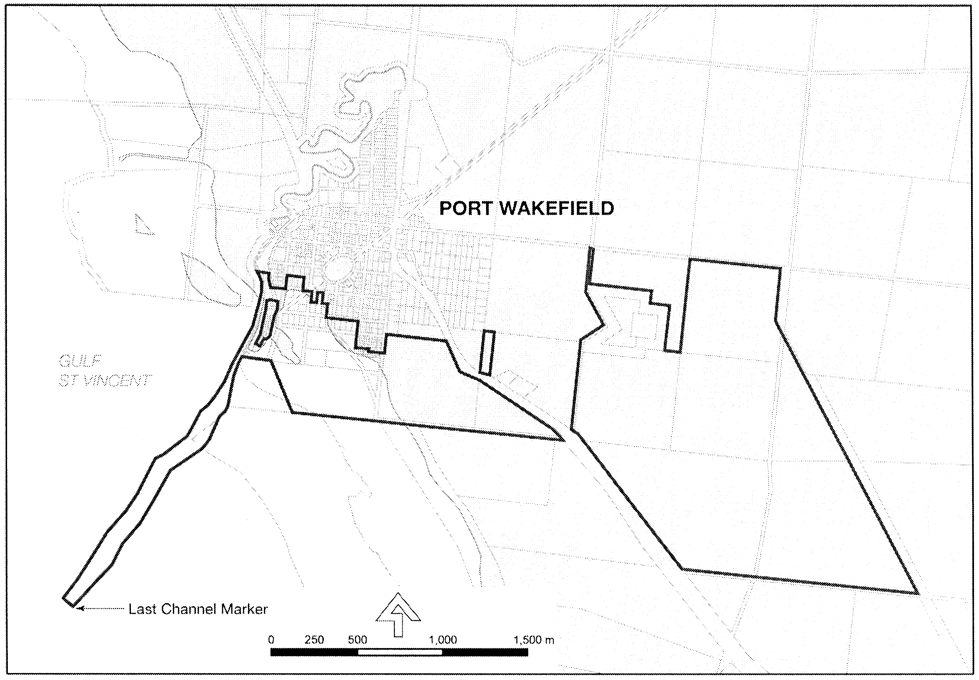
Dated 4 April 2007.
Paul Holloway, Minister for Urban Development and Planning

DEVELOPMENT ACT 1993: SECTION 48
Decision by the Development Assessment Commission as Delegate of the Governor
Preamble
1. A proposal from Baillie Lodges (hereafter ‘the applicant’) to develop a nature based tourism resort at Hanson Bay, Kangaroo Island has been under consideration under Division 2 of Part 4 of the Development Act 1993.
2. The proposal has been the subject of a Public Environmental Report (PER) and an Assessment Report under sections 46 and 46C of the Development Act 1993, and is hereafter referred to as the ‘proposed Major Development’.
3. The proposed Major Development was the subject of a development application lodged in February 2005 by the applicant. The said application has been amended and expanded upon by the applicant’s Public Environmental Report, dated 24 March 2006 and the applicant’s Response Document, dated 4 July 2006.
4. The Governor was satisfied that an appropriate Public Environmental Report and an Assessment Report have been prepared in relation to the proposed Major Development, in accordance with sections 46 and 46C, Division 2 of Part 4 of the Development Act 1993, and have had regard, when considering the proposed Major Development, to all relevant matters under section 48 (5) of the Development Act 1993.
5. Recent amendments that have been approved are contained in the following documents and drawings:
• An application for the Building Rules approval for the Staff Village Stage 1 construction was made on 4 December 2006.
• An application for approval for the Construction Environmental Management and Monitoring Plan (CEMMP) was made on 11 December 2006.
• An application for approval for the revised Construction Environmental Management and Monitoring Plan (CEMMP) was made on 30 January 2007.
6. Application has now been made to the Development Assessment Commission as Delegate of the Governor under section 48 of the Development Act 1993, to grant approval for the Building Rules for the spa retreat (stage 2) and the footings of the accommodation suites (stage 3) dated 20 February 2007.
7. The Development Assessment Commission has in considering the application had regard to all relevant matters under section 48 (5) of the Development Act 1993.
8. The Development Assessment Commission is satisfied that the variation does not require the preparation of a further amended Public Environmental Report.
Decision
PURSUANT to section 48 of the Development Act 1993 and with the advice and consent of the Executive Council and having due regard to the matters set out in section 48 (5) and all other relevant matters, the Development Assessment Commission, as delegate of the Governor:
(a) grant a provisional development authorisation in relation to the proposed major development, subject to the conditions and Notes to Applicant below;
(b) specify all matters relating to this provisional development authorisation as matters in respect of which conditions of this authorisation may be varied or revoked, or new conditions attached;
(c) specify for the purposes of section 48 (11) (b) the period of two years from the date hereof as the time within which substantial work must be commenced on-site failing which the Governor may cancel this authorisation.
Pursuant to section 48 and Regulation 64 (1) of the Development Act 1993, reserve the decision on the following matter:
(a) compliance with the Building Rules in relation to the remaining components of Stage 3 of the proposed major development (refer to Notes to the applicant below for further information).
Conditions of Approval
1. Except where minor amendments may be required by other legislation, or by conditions imposed herein, the proposed major development shall be undertaken in strict accordance with:
(a) the following drawings contained with the Public Environmental Report for Southern Ocean Lodge dated 24 March 2006, except to the extent that they are varied by the plans described in paragraph 1 (b):
• Drawing Titled: ‘Location Plan’; Drawing Number 392-M-1, dated March 2006.
• Drawing Titled: ‘Site Plan’; Drawing Number 392-M-2, dated March 2006.
• Drawing Titled: ‘Lodge Plan’; Drawing Number 392-M-3, dated March 2006.
• Drawing Titled: ‘Lodge’; Drawing Number 392-M-4, dated March 2006.
• Drawing Titled: ‘Lodge Elevations’; Drawing Number 392-M-5, dated March 2006.
• Drawing Titled: ‘Typical Suites 1 to 24’; Drawing Number 392-M-6, dated March 2006.
• Drawing Titled: ‘Lodge and Suites’; Drawing Number 392-M-7, dated March 2006.
• Drawing Titled: ‘Spa Retreat’; Drawing Number 392-M-9, dated March 2006.
• Drawing Titled: ‘Detailed Site Plan’; Drawing Number 392-M-10, dated March 2006.
• Drawing Titled: ‘Fire Protection System’; Drawing Number 392-M-12, dated March 2006.
• Drawing Titled: ‘Entrance Walkway to Lodge’; Drawing Number 392-M-13, dated March 2006.
• Drawing Titled: ‘Restaurant and Lounge’; Drawing Number 392-M-14, dated March 2006.
• Drawing Titled: ‘Suites Elevation’; Drawing Number 392-M-15, dated March 2006.
• Drawing Titled: ‘Great Room’; Drawing Number 392-M-16, dated March 2006.
• Drawing Titled: ‘Guest Suite’; Drawing Number 392-M-17, dated March 2006.
(b) the following drawings contained within the applicant’s Response Document, dated 4 July 2006:
• Drawing Titled ‘Walking Trails’.
(c) the following documents:
• Development application, dated February 2005 (except to the extent that it may be varied by a subsequent document in this paragraph).
• Public Environmental Report, Southern Ocean Lodge prepared by Baillie Lodges and Parsons Brinckerhoff, dated 24 March 2006 (except to the extent that it may be varied by a subsequent document in this paragraph).
• Response Document, prepared by Baillie Lodges and Parsons Brinckerhoff, dated 4 July 2006 (except to the extent that it may be varied by a subsequent document in this paragraph).
• Assessment Report prepared by the Minister for Urban Development and Planning, dated September 2006 (except to the extent that it may be varied by a subsequent document in this paragraph).
• Building Rules Certification dated 4 December 2006 by Rocco Ciancio Private Certifier and Building Surveyor.
• Construction Environmental Management and Monitoring Plan (CEMMP) dated 11 December 2006.
• Revised Construction Environmental Management and Monitoring Plan (CEMMP/Rev A) dated 30 January 2007.
• Building Rules Certification dated 20 February 2007 by Rocco Ciancio Private Certifier and Building Surveyor in regards to the spa retreat (Stage 2) and the substructure of the accommodation suites (Stage 3).
2. The applicant shall submit further information and application(s) in relation to the matters that have been reserved.
3. No building works on any part of the development may commence until a favourable decision has been notified to the applicant by the Governor or the Governor’s delegate in respect of the reserved matters referred to above and until a development authorisation under section 48 (2) is granted.
4. An Operational Environmental Management and Monitoring Plan (OEMMP) for the operational phase of the development shall be prepared to the satisfaction of the Governor or her delegate, prior to commencement of operations. (Refer to Notes to Applicant below).
5. All works and site activities shall be undertaken in accordance with the approved Construction Environmental Management and Monitoring Plan.
6. Normal operating hours for construction activities and truck movements to and from the site shall be from 7 a.m. to 7 p.m., Monday to Sunday inclusive. (Refer to Notes to Applicant relating to Environment Protection Authority noise emission policies).
7. The wastewater collection and treatment system shall be designed to ensure that the obligations of the Environment Protection (Water Quality) Policy 2004 are met, and to ensure that effluent does not overflow or escape from drains, pipes, sumps, tanks, storage/treatment basins into any watercourse, or into stormwater drains which do not drain into the effluent collection, treatment and disposal system, except where the effluent complies with criteria in the above policy.
8. The level of wastewater generated and consequent irrigation rates shall be closely monitored and if greater than 8 500 L/day then irrigation area and rates modified to ensure compliance with this limit.
9. Information on all signage (directional and interpretative) including detail on size, colour and content, shall be prepared to the satisfaction of the Governor or delegate, prior to its installation.
10. Pedestrian access arrangements over Crown land and management of its impacts shall be agreed with the Department for Environment and Heritage prior to opening of the Lodge. The beach shall remain unobstructed for public access.
11. A raised timber boardwalk shall be provided along the walking trail to the east of the suites as indicated in Figure 3.1 of the Response Document. Detail on the dimensions and the precise location of the boardwalk shall be prepared to the satisfaction of the Governor or delegate prior to its installation.
12. A strategy to minimise impact on fauna from vehicle traffic using the private entrance road shall be prepared to the satisfaction of the Governor or delegate.
13. Clearing of vegetation shall not exceed that indicated in the PER. Revegetation of impacted areas shall be undertaken as soon as possible following construction.
14. Biomatting or mulching on cleared areas shall occur until such time that revegetation is established.
15. Aboveground fuel tanks shall be bunded and sealed in a manner which will provide capacity for a minimum of 30 000 litres.
16. All stormwater run-off from car parking areas, driveways and other hard surfaced areas shall be collected, contained, treated as necessary, and disposed of in a stormwater management system so that there is no contamination of water resources (surface or underground).
17. Storage of any material with the potential to degrade water quality shall be within a bunded area constructed in accordance with Australian Standard 1940.
18. The helipad shall only be used in emergencies.
19. In keeping with its commitment in the PER, the proponent and any subsequent operator shall not clear boundary vegetation, whether or not such clearance is permitted under the Native Vegetation Act 1991.
20. Revegetation of the site, with locally indigenous species, shall be undertaken if the operation fails and the site is decommissioned.
21. The restaurant shall not be open to the general public.
22. A Bushfire Management Plan, prepared in consultation with the Country Fire Service, shall be submitted for approval by the Governor or delegate.
23. Public and Environmental Health Act 1987, approval of the method of disposal of sewage and sullage from the building shall be obtained from Council prior to work being commenced. (Regulation 77).
24. For buildings within one km of the coastline all external metal roof cladding shall be corrosion protected and all connectors used in timber fixings shall be corrosion protected with a protective coating in accordance with the requirements of AS1214, AS1397, AS1562, AS1684, AS1720, AS/NZS2179, AS/NZS2699, AS3623, AS4100, AS/NZS4534, AS/NZS4600 and AS/NZS4791. (BCA B1.3).
25. Water storage tank calculations and details shall be submitted to the private certifier for approval prior to this work commencing. (BCA B1.3).
26. Materials and assemblies in the building shall have Fire Hazard Properties that comply with the requirements of Specification C1.10 and in accordance with the requirements of this part of the BCA. (BCA C1.10).
27. Water storage tanks overflow shall be discharged at least 5 m away from buildings and site boundaries or piped to the street watertable or site drainage easement in accordance with the requirements of AS/NZS3500.3.2 or AS/NZS3500.5 (BCA F1.1).
28. An additional washing/drying machine (total of three required) shall be installed in the laundry for the use of the residents of the Bed-sit units in accordance with the requirements of this part of the BCA. (BCA F2.1).
29. This consent does not include the cabins, service buildings, reception/restaurant and spa retreat, which shall form the basis of further staged application(s) for Building Rules assessment. Note that there are timeframes for which the proposal must be substantially completed from the dated of issue of the staged Development Approval. Sufficient time must be allowed for the lodging, processing, issue of future staged consents and Development Approvals, including the construction of future stage(s) prior to the expiration of the validity of the Development Approval (section 39 and Regulation 46).
30. The building works proposed shall conform to the provisional development plan consent requirements (section 93).
31. The disposal of sewage and sullage from the spa retreat shall be undertaken in accordance with the Public and Environmental Health Act approval obtained from the SA Health Commission. (Regulation 77).
32. The door to the WC must have demountable hinges and be removable from outside the WC in the event that an emergency removal of the occupant is required. (BCA F2.5).
33. The heater and flue/chimney must be constructed and installed to comply with the requirements of AS/NZS2918. (BCA G2.2 and G2.3).
34. Portable fire extinguishers and fire blankets (if applicable) must be installed in the building in accordance with the requirements of this part of the BCA (BCA E1.6).
35. Exit lights must be installed adjacent doors D01 and D02 in the path of egress from the building in accordance with AS 2444 and in accordance with this part of the BCA (BCA B1.3).
36. The finished paving level around the masonry wall must be set down at least 75 mm below the external wall damp proof course. (BCA B1.3).
37. The Building Rules Certification dated 20 February 2007, does not include the staff village, staff accommodation, cabin superstructure, service building and reception/restaurant, which shall form the basis of further staged application(s) for Building Rules assessment. (Note that there are timeframes for which the proposal must be substantially completed from the date of issue of the staged Development Approval. Sufficient time must be allowed for the lodging, processing, issue of future staged consents and Development Approvals, including the construction of future stage(s) prior to the expiration of the validity of the Development Approval section 39 and Regulation 46.)
38. The timber durability and weather exposure requirements for exposed structural timbers, including supporting timber members must be in accordance with Clause 1.10 of AS 1684 National Timber Framing Code. (BCA B1.3).
Notes to Applicant
1. All matters relating to this provisional development authorisation are matters in respect of which conditions of this authorisation may be varied or revoked, or new conditions attached.
2. A decision on building rules will only be made after a Building Rules assessment and certification has been undertaken and issued by the Kangaroo Island Council or a private certifier, in accordance with the provisions of the Development Act 1993 and after the Minister for Urban Development and Planning receives a copy of all relevant certification documentation, as outlined in Regulation 64 of the Development Regulations 1993.
3. Pursuant to Development Regulation 64, the applicant is advised that the Kangaroo Island Council or private certifier conducting a Building Rules assessment must:
(a) provide to the Minister a certification in the form set out in Schedule 12A of the Development Regulations 1993 in relation to the building works in question; and
(b) to the extent that may be relevant and appropriate:
(i) issue a Schedule of Essential Safety Provisions under Division 4 of Part 12;
(ii) assign a classification of the building under these regulations; and
(iii) ensure that the appropriate levy has been paid under the Construction Industry Training Fund 1993.
Regulation 64 of the Development Regulations 1993 provides further information about the type and quantity of all Building Rules certification documentation for Major Developments required for referral to the Minister for Urban Development and Planning.
4. The Kangaroo Island Council or private certifier undertaking the Building Rules assessment must ensure that the assessment and certification are consistent with this provisional development authorisation (including Conditions or Notes that apply in relation to this provisional development authorisation).
5. An application to vary the Major Development or any of its components may be submitted. Whether a new PER and Assessment Report need to be prepared will depend on the nature of the variation and the lapse of time since the preparation of the PER.
6. The applicant’s CEMMP and OEMMP should be prepared taking into consideration, and with explicit reference to, relevant Environment Protection Authority policies and guideline documents, including but not limited to:
• the Environment Protection (Air Quality) Policy 1994;
• the Environment Protection (Water Quality) Policy 2003;
• the Occupational Health and Safety Regulations;
• EPA Guidelines on Odour Assessment, using odour source modelling 2003;
• EPA Handbook for Pollution Avoidance on Commercial and Residential Building Sites 2004;
• EPA Bunding and Spill Management Guidelines 2004; and
• EPA Stormwater Pollution Prevention Codes of Practice, in addition to other legislative requirements and Guidelines/ Australian Standards requiring compliance.
The following management and monitoring plans may be incorporated into the CEMMP or OEMMP as appropriate:
• Vegetation Monitoring and Management Plan.
• Site Construction Monitoring and Management Plan.
• Stormwater Monitoring and Management Plan.
7. The proponent is advised of the General Environmental Duty under section 25 of the Environment Protection Act 1993, which requires that a person must not undertake any activity, which pollutes, or may pollute; without taking all reasonable and practical measures to prevent or minimise harm to the environment.
8. Any information sheets, guidelines documents, codes of practice, technical bulletins, etc. that are referenced in this decision notice have been provided to the planning authority or may be accessed on the following website:
http://www.environment.sa.gov.au/epa/pub.html.
9. The Minister has a specific power to require testing, monitoring and auditing under section 48C of the Development Act 1993.
10. For the purposes of section 48 (11) (b) the period of two years from the dated hereof as the time within which substantial work must be commenced on-site failing which the Governor may cancel this authorisation.
11. The applicant is reminded of its obligations under the Aboriginal Heritage Act 1988 whereby any ‘clearance’ work, which may require permission to disturb damage or destroy Aboriginal Sites, must be undertaken with the full authorisation of the Minister for Aboriginal Affairs and Reconciliation, according to section 23 of the Aboriginal Heritage Act 1988. Construction staff should be trained in the recognition of potential objects or remains.
12. The Aboriginal Affairs and Reconciliation Division of the Department of the Premier and Cabinet (AARD) strongly recommends that the proponent contact representatives of the Kaurna, Ngarrindjeri and Ramindjeri peoples before the project proceeds, to ensure respect for their heritage interests and well being.
13. The applicant is required to obtain a separate approval from the Department of Health (Wastewater Management Unit) for the other elements of the on-site collection, treatment and disposal of wastewater.
14. A disposal path for the spa water shall be designed to comply with the requirements of the relevant authority under the Public and Environmental Health Act 1987.
15. All community drinking water supplies shall comply with the Food Act 2001 which requires compliance with the NH&MRC’s Australian Drinking Water Guidelines (2004).
16. In relation to the operation of the spa, reference should be made to the South Australian Health Commission Code ‘Standard for the operation of swimming pools and spa pools in South Australia’ and ‘Supplement C, Bromine disinfection of swimming pool, spa pool, hydrotherapy pool and waterslide pool’.
17. This decision does not include approval for use of bore water. A separate application to vary the Governor’s approval is required in the instance that any proposal to use the bore water is put forward.
18. Should surface irrigation be desired, then the effluent must be disinfected to meet the requirements of the South Australian Reclaimed Water Guidelines (1999).
19. NH&MRC’s Australian Drinking Water Guidelines (2004) may be accessed at:
http://www.nhmrc.gov.au/publications/_files/awgfull.pdf.
Compliance with the Guidelines requires that a risk management plan must be developed and the implementation of such a plan will require the application of the NH&MRC’s Community Water Planner, which may be accessed at:
http://www.nhmrc.gov.au/publications/_files/awg0.pdf.
20. The proponent is required to develop a Phytophthora hygiene strategy, which shall include washdown procedures for heavy machinery, graders, bulldozers prior to entry to the site. A trailer-mounted Phytophthora Washdown Unit is available for hire from Kangaroo Island Council.
21. The proponent needs to consult with the NRM Board over arrangements to minimise the risk of spreading weeds during works.
22. Diesel motors shall conform to the mandatory provisions of the Environmental Protection (Air Quality) Policy 1994 (SA) for particulates and carbon monoxide in exhaust gas.
23. A separate approval is required under the Environment Protection and Biodiversity Conservation Act 1999.
Notes on Building Rules Certification (Stage 1)
24. Consent is for work carried out within the site boundaries and does not cover work carried out in an adjoining public space. Approval for any work within the road reserve needs to be obtained from Council, including landscaping, paving, crossovers, the location, design and capacity of the stormwater discharge at the property alignment.
25. The owner’s attention should be drawn to the landscaping and tree planting restrictions required by the engineer’s construction report and AS2870.
26. It is advisable to contact authorities responsible for the supply of services such as water, electricity, telephone, gas; the Department of Transport, Australia Post, Environment Protection Authority (EPA) and easement owners/holders, where applicable, seeking their requirements prior to building work commencing on-site.
27. ESSENTIAL SAFETY PROVISIONS: An essential safety provisions Schedule in the form set out in Form 1 of Schedule 1, which specifies the essential safety provisions set out in Minister’s Specification SA 76 has been provided with this certification. The items to be inspected or tested are detailed on the attached Schedule. The building owner must record proof of maintenance of these items for future reference.
28. The building classification and approved number of occupants is as follows:
Building | Floor | Portion | Classification(s) | Approved Number of Persons
Manager’s Residence | Ground | All | 2 | 4
Duplex Units | Ground | All | 2 | 2 per unit
Bed-sit Units | Ground | All | 2 | 2 per unit
Staff Centre | Ground | All | 10a | N/A

29. All building work must be performed in accordance with the approved documents. Any variations to the building materials, or the systems that affect the structural soundness or the safety of the building must be approved by the private certifier prior to such alteration occurring. Alternate and/or substitute building products must meet the Deemed-To Satisfy provisions of the Performance Requirements of the BCA.
30. The building contains materials that are susceptible to termite attack. The details provided indicate that physical barriers, in accordance with AS3660.1 requirements, are to be used to protect the building. The building owner/tenant is advised that an important part of this protection involves regular inspections for termite activity and appropriate action as and when required.
31. Proprietary materials and products specified in the approved documents must be selected and installed in accordance with the manufacturers’ written recommendations, specifications and with the relevant standards.
32. For cut or fill sites, retaining walls are required to be installed on the boundary to retain any cut or fill within the property boundaries.
33. The building work proposed has been checked for compliance with the minimum allowable requirements contained within the legislation and standards. The owner/applicant/builder are advised to seek advice from the designers, suppliers and manufacturers involved to determine the implications of the design criteria chosen for this project.
34. The building work proposed includes elements of design and construction that require on-going maintenance and regular inspection regimes. The owner/applicant/builder are advised to seek advice from the designers, suppliers and manufacturers involved to determine the implications of the maintenance/inspection required for this project.
35. This consent does not include any existing structures. Separate professional advice may be required to ensure that the existing structures are safe and structurally adequate.
36. The performance of the designs chosen for the proposed building work have obligations on to ensure that the design parameters are not compromised by a lack of attention, maintenance or misuse. The owner/applicant/builder/tenant of the building works are advised to refer to the designers/manufacturers/standards associated with this building to ensure that their obligations to ensuring the design parameters are not compromised exceeded or are met.
37. The owner/applicant/builder are advised to ensure that ancillary works are completed in a timely manner to ensure that the health of persons and damage to structures do not occur. This includes any air-conditioning works, paving, plumbing (both septic and water), landscaping, fences, soil retention or activity.
38. The legislation provides that defined activities are complying. It is the owner/applicant/builder/tenant’s responsibilities to ensure that any such activity is carried out in a manner that is not detrimental to persons or structures.
39. Where articulation of the walls of the building are required, these must be installed in accordance with the manufacturers’ requirements or as specified within the Engineers Footing Construction Report.
40. The installation of glazing must be in accordance with AS1288 and is to include safety glass for glazed doors, side panels, full height windows and glass located over or adjacent bath/showers.
41. This consent does not imply compliance with the Equal Opportunity Act 1984 (State Legislation), nor with the Disability Discrimination Act 1993 (Commonwealth Legislation), including the Regulations under those legislative Acts and each as amended. It is the responsibility of the owner and the person erecting the structure to ensure compliance with these legislative requirements.
Notes on Building Rules Certification (Stage 2 and 3)
42. Consent is for work carried out within the site boundaries and does not cover work carried out in an adjoining public space. Approval for any work within the road reserve needs to be obtained from Council, including landscaping, paving, crossovers, the location, design and capacity of the storm water discharge at the property alignment.
43. It is advisable to contact authorities responsible for the supply of services such as water, electricity, telephone, gas; the Department of Transport, Australia Post, Environment Protection Authority (EPA) and easement owners/holders, where applicable, seeking their requirements prior to building work commencing on site.
44. All building work must be performed in accordance with the approved documents. Any variations to the building materials, or the systems that affect the structural soundness or the safety of the building must be approved by the private certifier prior to such alteration occurring. Alternate and/or substitute building products must meet the Deemed-To Satisfy provisions of the Performance Requirements of the BCA.
45. The building contains materials that are susceptible to termite attack. The details provided indicate that physical barriers, in accordance with AS3660.1 requirements, are to be used to protect the building. The building owner/tenant is advised that an important part of this protection involves regular inspections for termite activity and appropriate action as and when required.
46. Proprietary materials and products specified in the approved documents must be selected and installed in accordance with the manufacturers’ written recommendations, specifications and with the relevant standards.
47. For cut or fill sites, retaining walls are required to be installed on the boundary to retain any cut or fill within the property boundaries.
48. The building work proposed has been checked for compliance with the minimum allowable requirements contained within the legislation and standards. The owner/applicant/builder are advised to seek advice from the designers, suppliers and manufacturers involved to determine the implications of the design criteria chosen for this project.
49. The building work proposed includes elements of design and construction that require on-going maintenance and regular inspection regimes. The owner/applicant/builder are advised to seek advice from the designers, suppliers and manufacturers involved to determine the implications of the maintenance/inspection required for this project.
50. This consent does not include any existing structures. Separate professional advice may be required to ensure that the existing structures are safe and structurally adequate.
51. The performance of the designs chosen for the proposed building work have obligations on to ensure that the design parameters are not compromised by a lack of attention, maintenance or misuse. The owner/applicant/builder/tenant of the building works are advised to refer to the designers/manufacturers/standards associated with this building to ensure that their obligations to ensuring the design parameters are not compromised exceeded or are met.
52. The owner/applicant/builder are advised to ensure that ancillary works are completed in a timely manner to ensure that the health of persons and damage to structures do not occur. This includes any air-conditioning works, paving, plumbing (both septic and water), landscaping, fences, soil retention or activity.
53. The legislation provides that defined activities are complying. It is the owner/applicant/builder/tenant’s responsibilities to ensure that any such activity is carried out in a manner that is not detrimental to persons or structures.
54. Where articulation of the walls of the building are required, these must be installed in accordance with the manufacturers’ requirements or as specified within the engineers Footing Construction Report.
55. The installation of glazing must be in accordance with AS1288 and is to include safety glass for glazed doors, side panels, full height windows and glass located over or adjacent bath/showers.
56. This consent does not imply compliance with the Equal Opportunity Act 1984 (State Legislation), nor with the Disability Discrimination Act 1993 (Commonwealth Legislation), including the Regulations under those legislative Acts and each as amended. It is the responsibility of the owner and the person erecting the structure to ensure compliance with these legislative requirements.
Additional Notes on Building Rules Certification (Stage 2)
57. ESSENTIAL SAFETY PROVISIONS: An essential safety provisions schedule in the form set out in Form 1 of Schedule 1, which specifies the essential safety provisions set out in Minister’s Specification SA 76 has been provided with this certification. The items to be inspected or tested are detailed on the attached schedule. The building owner must record proof of maintenance of these items for future reference.
58. The building classification and approved number of occupants is as follows:
Floor | Portion | Classification(s) | Approved Number of Persons
Ground | All | 5 | 6

Additional Notes on Building Rules Certification (Stage 3)
59. The owner’s attention should be drawn to the landscaping and tree planting restrictions required by the engineer’s construction report and AS2870.
Given under my hand at Adelaide, 5 April 2007.
R. Barua, Secretary Development Assessment Commission

ENVIRONMENT PROTECTION AUTHORITY
Granting of Exemptions
THE Environment Protection Authority has issued exemptions from section 34 of the Environment Protection Act 1993, in respect of the requirements of Clause 10 of the Environment Protection (Motor Vehicle Fuel Quality) Policy 2002, to the following applications:
• United Petroleum Pty Ltd (17528 and 17529);
• Liberty Oil South Australia Pty Ltd (17304).
S. Behrendt, Delegate, Environment Protection Authority

ENVIRONMENT PROTECTION ACT 1993
Approval of Category A Containers
I, STEPHEN RICHARD SMITH, Senior Adviser, Container Deposit Legislation and Delegate of the Environment Protection Authority (‘the Authority’), pursuant to section 69 of the Environment Protection Act 1993 (SA) (‘the Act’) hereby:
Approval of Category A Containers:
Approve as Category A Containers, as identified in Column 5 of the Schedule, subject to the conditions in subclauses (i) and (ii) below, each of the classes of containers identified by reference to the following matters described in the first 4 columns of Schedule 1 of this Notice which are sold in South Australia:
(a) the product which each class of containers shall contain;
(b) the size of the containers;
(c) the type of containers;
(d) the name of the holders of these approvals.
(i) Subsection 69 (3) Arrangements:
The holders of these approvals must ensure that the empty containers which belong to their respective class of containers hereby approved as Category A Containers are collected from the retailers that sell them, and recycled in an appropriate manner. Disposal at landfill is not considered an appropriate method of disposal.
(ii) Approved Refund Markings:
(a) The holders of these approvals must ensure that each container which belongs to their respective class of containers hereby approved as Category A Containers bears the refund marking approved by the Authority in respect of that class of containers.
(b) The refund marking that appears on each container that belongs to the class of containers hereby approved, must be a minimum 1.5 mm for the smallest letter in the statement and a minimum 3 mm for the numeric (‘5’) in the statement.
(c) The holder of these approvals must ensure that if a sticker bearing the refund marking has been approved, and is applied to the container, then the sticker must not be placed on any portion of the opening mechanism or in any other place that would require complete or partial removal of the sticker before the contents may be consumed.

Column 1 | Column 2 | Column 3 | Column 4 | Column 5
Product Name | Container  Size (mL) | Container Type | Approval Holder | Collection  Arrangements
Damavand Natural Mineral Water | 500 | PET | Persian Grocery | N/A—See Notes
Damavand Natural Mineral Water | 1 500 | PET | Persian Grocery | N/A—See Notes
Delster Lemon Non Alcoholic Beer | 330 | Glass | Persian Grocery | N/A—See Notes
Delster Non Alcoholic Beer Malt | 330 | Glass | Persian Grocery | N/A—See Notes
Delster Non Alcoholic Beer Malt | 330 | Can—Aluminium | Persian Grocery | N/A—See Notes
Zam Zam Cola | 300 | PET | Persian Grocery | N/A—See Notes
Zam Zam Lemonade | 300 | PET | Persian Grocery | N/A—See Notes
Zam Zam Orange | 300 | PET | Persian Grocery | N/A—See Notes

ENVIRONMENT PROTECTION ACT 1993
Approval of Category B Containers
I, STEPHEN RICHARD SMITH, Senior Adviser, Container Deposit Legislation and Delegate of the Environment Protection Authority (‘the Authority’), pursuant to section 69 of the Environment Protection Act 1993 (SA) (‘the Act’) hereby:
Approval of Category B Containers:
Approve as Category B Containers, subject to the conditions in subclauses (i) and (ii) below, each of the classes of containers identified by reference to the following matters described in the first 4 columns of Schedule 1 of this Notice which are sold in South Australia:
(a) the product which each class of containers shall contain;
(b) the size of the containers;
(c) the type of containers;
(d) the name of the holders of these approvals.
(i) Subsection 69 (3) Arrangements:
The holders of these approvals must ensure that the empty containers which belong to their respective class of containers hereby approved as Category B Containers are collected from collection depots approved under section 69 of the Act by the party named in Column 5 of Schedule 1 of this Notice; and
(ii) Approved Refund Markings:
(a) The holders of these approvals must ensure that each container which belongs to their respective class of containers hereby approved as Category B Containers bears the refund marking approved by the Authority in respect of that class of containers.
(b) The refund marking that appears on each container that belongs to the class of containers hereby approved, must be a minimum 1.5 mm for the smallest letter in the statement and a minimum 3 mm for the numeric (‘5’) in the statement.
(c) The holder of these approvals must ensure that if a sticker bearing the refund marking has been approved, and is applied to the container, then the sticker must not be placed on any portion of the opening mechanism or in any other place that would require complete or partial removal of the sticker before the contents may be consumed.

Column 1 | Column 2 | Column 3 | Column 4 | Column 5
Product Name | Container  Size (mL) | Container Type | Approval Holder | Collection  Arrangements
Imperial Beer | 355 | Glass | Australian Wine & Liquor Wholesalers Pty Ltd | Marine Stores Ltd
Stella Artois | 330 | Glass | Australian Wine & Liquor Wholesalers Pty Ltd | Marine Stores Ltd
The Barossa Brewing Company Greenock Dark Ale | 640 | Glass | Barossa Brewing Company Pty Ltd | Statewide Recycling
Sinha Lager | 330 | Glass | Beer Importers & Distributors Pty Ltd | Statewide Recycling
Hi NRG Vodka & Energy Drink With Guarana & Taurine | 250 | Can—Aluminium | Bickfords Australia Pty Ltd | Statewide Recycling
Vodka Infused Rush Blood Orange | 275 | Glass | Bickfords Australia Pty Ltd | Statewide Recycling
Vodka Infused Rush Iced Lime Lemon | 275 | Glass | Bickfords Australia Pty Ltd | Statewide Recycling
Vodka Infused Rush Tropical Passion | 275 | Glass | Bickfords Australia Pty Ltd | Statewide Recycling
Vodka Infused Rush Wild Raspberry | 275 | Glass | Bickfords Australia Pty Ltd | Statewide Recycling
Bluetongue Alcoholic Ginger Beer | 330 | Glass | BlueTongue Brewery | Statewide Recycling
Bluetongue Premium Lager | 330 | Glass | BlueTongue Brewery | Statewide Recycling
Bluetongue Traditional Pilsner | 330 | Glass | BlueTongue Brewery | Statewide Recycling
Bondi Blonde Low Carb Lager | 330 | Glass | BlueTongue Brewery | Statewide Recycling
Spring Valley Twist Springwater Lemon & Lime Juice | 600 | PET | Cadbury Schweppes | Statewide Recycling
V8 Fruit & Veg Juice Summer Fruits With Mint | 250 | LPB—Aseptic | Campbells Soups Australia | Visy Recycling CDL Services
A & W Root Beer | 355 | Can—Aluminium | Chocolates on Parade | Statewide Recycling
A & W Creme Soda | 355 | Can—Aluminium | Chocolates on Parade | Statewide Recycling
Cherry 7 Up | 355 | Can—Aluminium | Chocolates on Parade | Statewide Recycling
Cherry Coke | 355 | Can—Aluminium | Chocolates on Parade | Statewide Recycling
Classic Coke | 355 | Can—Aluminium | Chocolates on Parade | Statewide Recycling
Dr Pepper | 355 | Can—Aluminium | Chocolates on Parade | Statewide Recycling
Dr Pepper Diet | 355 | Can—Aluminium | Chocolates on Parade | Statewide Recycling
Stars & Stripes Red | 355 | Can—Aluminium | Chocolates on Parade | Statewide Recycling
Goulburn Valley GV To Go! Apple & Blackcurrant Juice | 250 | Glass | Coca Cola Amatil (Aust) Pty Ltd | Statewide Recycling
Goulburn Valley GV To Go! Apple & Blackcurrant Juice | 350 | PET | Coca Cola Amatil (Aust) Pty Ltd | Statewide Recycling
Goulburn Valley GV To Go! Apple Juice | 250 | Glass | Coca Cola Amatil (Aust) Pty Ltd | Statewide Recycling
Goulburn Valley GV To Go! Apple Juice | 350 | PET | Coca Cola Amatil (Aust) Pty Ltd | Statewide Recycling
Goulburn Valley GV To Go! Orange Juice | 250 | Glass | Coca Cola Amatil (Aust) Pty Ltd | Statewide Recycling
Goulburn Valley GV To Go! Orange Juice | 350 | PET | Coca Cola Amatil (Aust) Pty Ltd | Statewide Recycling
Goulburn Valley GV To Go! Pineapple Juice | 250 | Glass | Coca Cola Amatil (Aust) Pty Ltd | Statewide Recycling
Goulburn Valley GV To Go! Tomato Juice | 250 | Glass | Coca Cola Amatil (Aust) Pty Ltd | Statewide Recycling
Goulburn Valley GV To Go! Tropical Juice | 250 | Glass | Coca Cola Amatil (Aust) Pty Ltd | Statewide Recycling
Goulburn Valley GV To Go! Tropical Juice | 350 | PET | Coca Cola Amatil (Aust) Pty Ltd | Statewide Recycling
Elevate Alcoholic Cola With Guarana & Taurine 8% | 300 | Can—Aluminium | Creative Beverages Pty Ltd | Statewide Recycling
Daioni Banana Flavoured Welsh Organic Milk | 250 | LPB—Aseptic | Croftminster | Marine Stores Ltd
Daioni Chocolate Flavoured Welsh Organic Milk | 250 | LPB—Aseptic | Croftminster | Marine Stores Ltd
Daioni Strawberry Flavoured Welsh Organic Milk | 250 | LPB—Aseptic | Croftminster | Marine Stores Ltd
Penta Ultra Purified Premium Drinking H2O | 500 | PET | Croftminster | Marine Stores Ltd
Steaz Energy Organic Fuel | 355 | Can—Aluminium | Croftminster | Marine Stores Ltd
Fuji KK Ramune Blue Hawaii | 200 | Glass | Daiwa Food Corporation Pty Ltd | Statewide Recycling
Fuji KK Ramune Lychee | 200 | Glass | Daiwa Food Corporation Pty Ltd | Statewide Recycling
Fuji KK Ramune Melon | 200 | Glass | Daiwa Food Corporation Pty Ltd | Statewide Recycling
Fuji KK Ramune Orange | 200 | Glass | Daiwa Food Corporation Pty Ltd | Statewide Recycling
Fuji KK Ramune Original | 200 | Glass | Daiwa Food Corporation Pty Ltd | Statewide Recycling
Fuji KK Ramune Strawberry | 200 | Glass | Daiwa Food Corporation Pty Ltd | Statewide Recycling
Red Devil Energy Drink | 250 | Can—Aluminium | Devilish Beverages Pty Ltd | Statewide Recycling
Moosehead Lager Canadian Beer | 345 | Glass | Empire Liquor | Statewide Recycling
Castello Premium Birra Friulana | 330 | Glass | Festival City Wines & Spirits Pty Ltd | Statewide Recycling
Menabrea Birra | 330 | Glass | Festival City Wines & Spirits Pty Ltd | Statewide Recycling
Mythos Hellenic Lager Beer | 330 | Glass | Flox Wines & Spirits Pty Ltd | Marine Stores Ltd
Svyturys Ekstra Beer | 500 | Glass | Flox Wines & Spirits Pty Ltd | Marine Stores Ltd
Victoria Bitter VB Original Ale | 345 | Glass | Fosters Australia | Statewide Recycling
Youll Love Coles Apple & Berry Mineral Water | 1 250 | PET | Fosters Australia | Statewide Recycling
Youll Love Coles Diet Dry Ginger Ale Sparkling Mixer | 1 250 | PET | Fosters Australia | Statewide Recycling
Youll Love Coles Diet Tonic Water Sparkling Mixer | 1 250 | PET | Fosters Australia | Statewide Recycling
Youll Love Coles Dry Ginger Ale Sparkling Mixer | 1 250 | PET | Fosters Australia | Statewide Recycling
Youll Love Coles Lemon & Lime Mineral Water | 1 250 | PET | Fosters Australia | Statewide Recycling
Youll Love Coles Natural Mineral Water | 1 250 | PET | Fosters Australia | Statewide Recycling
Youll Love Coles Orange & Mango Mineral Water | 1 250 | PET | Fosters Australia | Statewide Recycling
Youll Love Coles Pineapple & Mango Mineral Water | 1 250 | PET | Fosters Australia | Statewide Recycling
Youll Love Coles Soda Water Sparkling Mixer | 1 250 | PET | Fosters Australia | Statewide Recycling
Youll Love Coles Tonic Water Sparkling Mixer | 1 250 | PET | Fosters Australia | Statewide Recycling
V Berry Invigoration Guarana Energy & Fruit Juice | 350 | Glass | Frucor Beverage Ltd | Statewide Recycling
V Berry Invigoration Guarana Energy & Fruit Juice | 250 | Can—Aluminium | Frucor Beverage Ltd | Statewide Recycling
A & W Sparkling Vanilla Cream Soda | 355 | Can—Aluminium | Funworks | Flagcan Distributors
Ben Shaws Bitter Shandy | 330 | Can—Aluminium | Funworks | Flagcan Distributors
Ben Shaws Cream Soda | 330 | Can—Aluminium | Funworks | Flagcan Distributors
Old Jamaica Ginger Beer | 330 | Can—Aluminium | Funworks | Flagcan Distributors
Milkis | 1 500 | PET | Happy Mart | Marine Stores Ltd
Milkis | 250 | Can—Aluminium | Happy Mart | Marine Stores Ltd
Milkis | 500 | PET | Happy Mart | Marine Stores Ltd
Holgate Brewhouse ESB | 330 | Glass | Holgate Brewhouse Pty Ltd | Marine Stores Ltd
Holgate Brewhouse Mt Macedon Ale | 330 | Glass | Holgate Brewhouse Pty Ltd | Marine Stores Ltd
Holgate Brewhouse Old Pale Ale | 330 | Glass | Holgate Brewhouse Pty Ltd | Marine Stores Ltd
Holgate Brewhouse Pilsner | 330 | Glass | Holgate Brewhouse Pty Ltd | Marine Stores Ltd
Holgate Brewhouse White Ale | 330 | Glass | Holgate Brewhouse Pty Ltd | Marine Stores Ltd
L & P Lemon & Paeroa | 600 | PET | Impulse Products | Statewide Recycling
New Zealand Eternal Artesian Water Silica Rich | 600 | PET | Impulse Products | Statewide Recycling
New Zealand Eternal Artesian Water Silica Rich | 1 500 | PET | Impulse Products | Statewide Recycling
Pulse No Added Sugar Vodka Soda & Guarana | 300 | Can—Aluminium | Independent Distillers (Aust) Pty Ltd | Statewide Recycling
ZETA Premium Organic Sparkling Juice Apple | 330 | Glass | Kevron Australia Pty Ltd | Marine Stores Ltd
ZETA Premium Organic Sparkling Juice Apple & Berry | 330 | Glass | Kevron Australia Pty Ltd | Marine Stores Ltd
ZETA Premium Organic Sparkling Juice Apple & Orange | 330 | Glass | Kevron Australia Pty Ltd | Marine Stores Ltd
Maes | 330 | Glass | Liquorland Aust Pty Ltd | Visy Recycling CDL Services
Berri Apple Juice | 250 | PET | National Foods Milk Limited | Statewide Recycling
Berri Multi V Juice | 250 | PET | National Foods Milk Limited | Statewide Recycling
Berri Orange Juice | 250 | PET | National Foods Milk Limited | Statewide Recycling
IRN BRU Original & Best | 1 250 | PET | Occasio Australia Pty Ltd | Visy Recycling CDL Services
IRN BRU Original & Best | 500 | PET | Occasio Australia Pty Ltd | Visy Recycling CDL Services
IRN BRU Original & Best Diet | 500 | PET | Occasio Australia Pty Ltd | Visy Recycling CDL Services
IRN BRU Original & Best Diet | 1 250 | PET | Occasio Australia Pty Ltd | Visy Recycling CDL Services
Tizer | 1 250 | PET | Occasio Australia Pty Ltd | Visy Recycling CDL Services
Tizer | 500 | PET | Occasio Australia Pty Ltd | Visy Recycling CDL Services
Oracle Organic Apple & Blackcurrant Juice | 275 | Glass | Oracle Organic Pty Ltd | Marine Stores Ltd
Oracle Organic Apple & Strawberry Juice | 275 | Glass | Oracle Organic Pty Ltd | Marine Stores Ltd
Oracle Organic Apple Juice | 275 | Glass | Oracle Organic Pty Ltd | Marine Stores Ltd
Oracle Organic Carrot Apple & Celery Juice | 275 | Glass | Oracle Organic Pty Ltd | Marine Stores Ltd
Oracle Organic Carrot Apple & Ginger Juice | 275 | Glass | Oracle Organic Pty Ltd | Marine Stores Ltd
Oracle Organic Carrot, Beetroot & Apple Juice | 275 | Glass | Oracle Organic Pty Ltd | Marine Stores Ltd
Oracle Organic Cola | 275 | Glass | Oracle Organic Pty Ltd | Marine Stores Ltd
Oracle Organic Lemon Crush | 275 | Glass | Oracle Organic Pty Ltd | Marine Stores Ltd
Oracle Organic Lemonade | 275 | Glass | Oracle Organic Pty Ltd | Marine Stores Ltd
Oracle Organic Orange Crush | 275 | Glass | Oracle Organic Pty Ltd | Marine Stores Ltd
Oracle Organic Orange Juice | 275 | Glass | Oracle Organic Pty Ltd | Marine Stores Ltd
Oracle Organic Sparkling Spring Water | 275 | Glass | Oracle Organic Pty Ltd | Marine Stores Ltd
Oracle Organic Still Spring Water | 600 | PET | Oracle Organic Pty Ltd | Marine Stores Ltd
Oracle Organic Still Spring Water | 1 500 | PET | Oracle Organic Pty Ltd | Marine Stores Ltd
t ism Organic | 355 | Glass | Orient Beverage Company Pty Ltd | Marine Stores Ltd
Diet Rite Lemon | 600 | PET | P & N Beverages Australia Pty Ltd | Flagcan Distributors
Diet Rite Lemonade | 600 | PET | P & N Beverages Australia Pty Ltd | Flagcan Distributors
Diet Rite Orange | 600 | PET | P & N Beverages Australia Pty Ltd | Flagcan Distributors
Diet Rite Passionfruit | 600 | PET | P & N Beverages Australia Pty Ltd | Flagcan Distributors
Diet Rite Roze | 600 | PET | P & N Beverages Australia Pty Ltd | Flagcan Distributors
P & N Club Soda Water | 300 | PET | P & N Beverages Australia Pty Ltd | Flagcan Distributors
P & N Pure & Natural Water | 350 | PET | P & N Beverages Australia Pty Ltd | Flagcan Distributors
Badoit Naturelle | 1000 | Glass | Pernod Ricard Pacific formerly Orlando Wyndham Group | Marine Stores Ltd
Pimpjuice Energy Drink | 250 | Can—Aluminium | Pimpjuice | Statewide Recycling
Gourmet Farm Prune Juice | 250 | Glass | Prune Products | Statewide Recycling
Gourmet Farm Prune Juice | 750 | Glass | Prune Products | Statewide Recycling
Vitaminka Forest Fruit Ice Tea | 1 000 | LPB—Aseptic | Ras Trade Pty Ltd | Statewide Recycling
Vitaminka Lemon Ice Tea | 1 000 | LPB—Aseptic | Ras Trade Pty Ltd | Statewide Recycling
Vitaminka Peach Ice Tea | 1 000 | LPB—Aseptic | Ras Trade Pty Ltd | Statewide Recycling
Sanpellegrino BBTHE Lemon Ice Tea | 330 | Can—Aluminium | Rio Coffee Pty Ltd | Statewide Recycling
Sanpellegrino BBTHE Peach Ice Tea | 330 | Can—Aluminium | Rio Coffee Pty Ltd | Statewide Recycling
Speights Gold Medal Ale | 330 | Glass | South Australian Brewing Company Pty Ltd | Marine Stores Ltd
Springleaf Lemon Organic Ice | 750 | Glass | Teavolution Pty Ltd trading as Springleaf Iced Tea | Statewide Recycling
Springleaf Lemon Organic Ice | 300 | Glass | Teavolution Pty Ltd trading as Springleaf Iced Tea | Statewide Recycling
Springleaf Organic Green Tea Lime & Ginger | 750 | Glass | Teavolution Pty Ltd trading as Springleaf Iced Tea | Statewide Recycling
Springleaf Organic Green Tea Lime & Ginger | 300 | Glass | Teavolution Pty Ltd trading as Springleaf Iced Tea | Statewide Recycling
Springleaf Organic Leaf Tea with Honey & Ginseng | 300 | Glass | Teavolution Pty Ltd trading as Springleaf Iced Tea | Statewide Recycling
Springleaf Organic Tea with Pineapple & Mint | 300 | Glass | Teavolution Pty Ltd trading as Springleaf Iced Tea | Statewide Recycling
Springleaf Organic White Tea | 300 | Glass | Teavolution Pty Ltd trading as Springleaf Iced Tea | Statewide Recycling
Springleaf Raspberry Organic Ice | 750 | Glass | Teavolution Pty Ltd trading as Springleaf Iced Tea | Statewide Recycling
Springleaf Raspberry Organic Ice | 300 | Glass | Teavolution Pty Ltd trading as Springleaf Iced Tea | Statewide Recycling
Lipton Green Tea Apple Flavour | 325 | Glass | Unilever Australia Ltd | Statewide Recycling
Lipton Green Tea Apple Flavour | 1 250 | PET | Unilever Australia Ltd | Statewide Recycling
Lipton Green Tea Apple Flavour | 500 | PET | Unilever Australia Ltd | Statewide Recycling
Lipton Green Tea Citrus Flavour | 325 | Glass | Unilever Australia Ltd | Statewide Recycling
Lipton Green Tea Citrus Flavour | 1 250 | PET | Unilever Australia Ltd | Statewide Recycling
Lipton Green Tea Citrus Flavour | 500 | PET | Unilever Australia Ltd | Statewide Recycling
Lipton Ice Tea Lemon Flavour | 250 | PET | Unilever Australia Ltd | Statewide Recycling
Lipton Ice Tea Mango Flavour | 250 | PET | Unilever Australia Ltd | Statewide Recycling
Lipton Ice Tea Peach Flavour | 250 | PET | Unilever Australia Ltd | Statewide Recycling

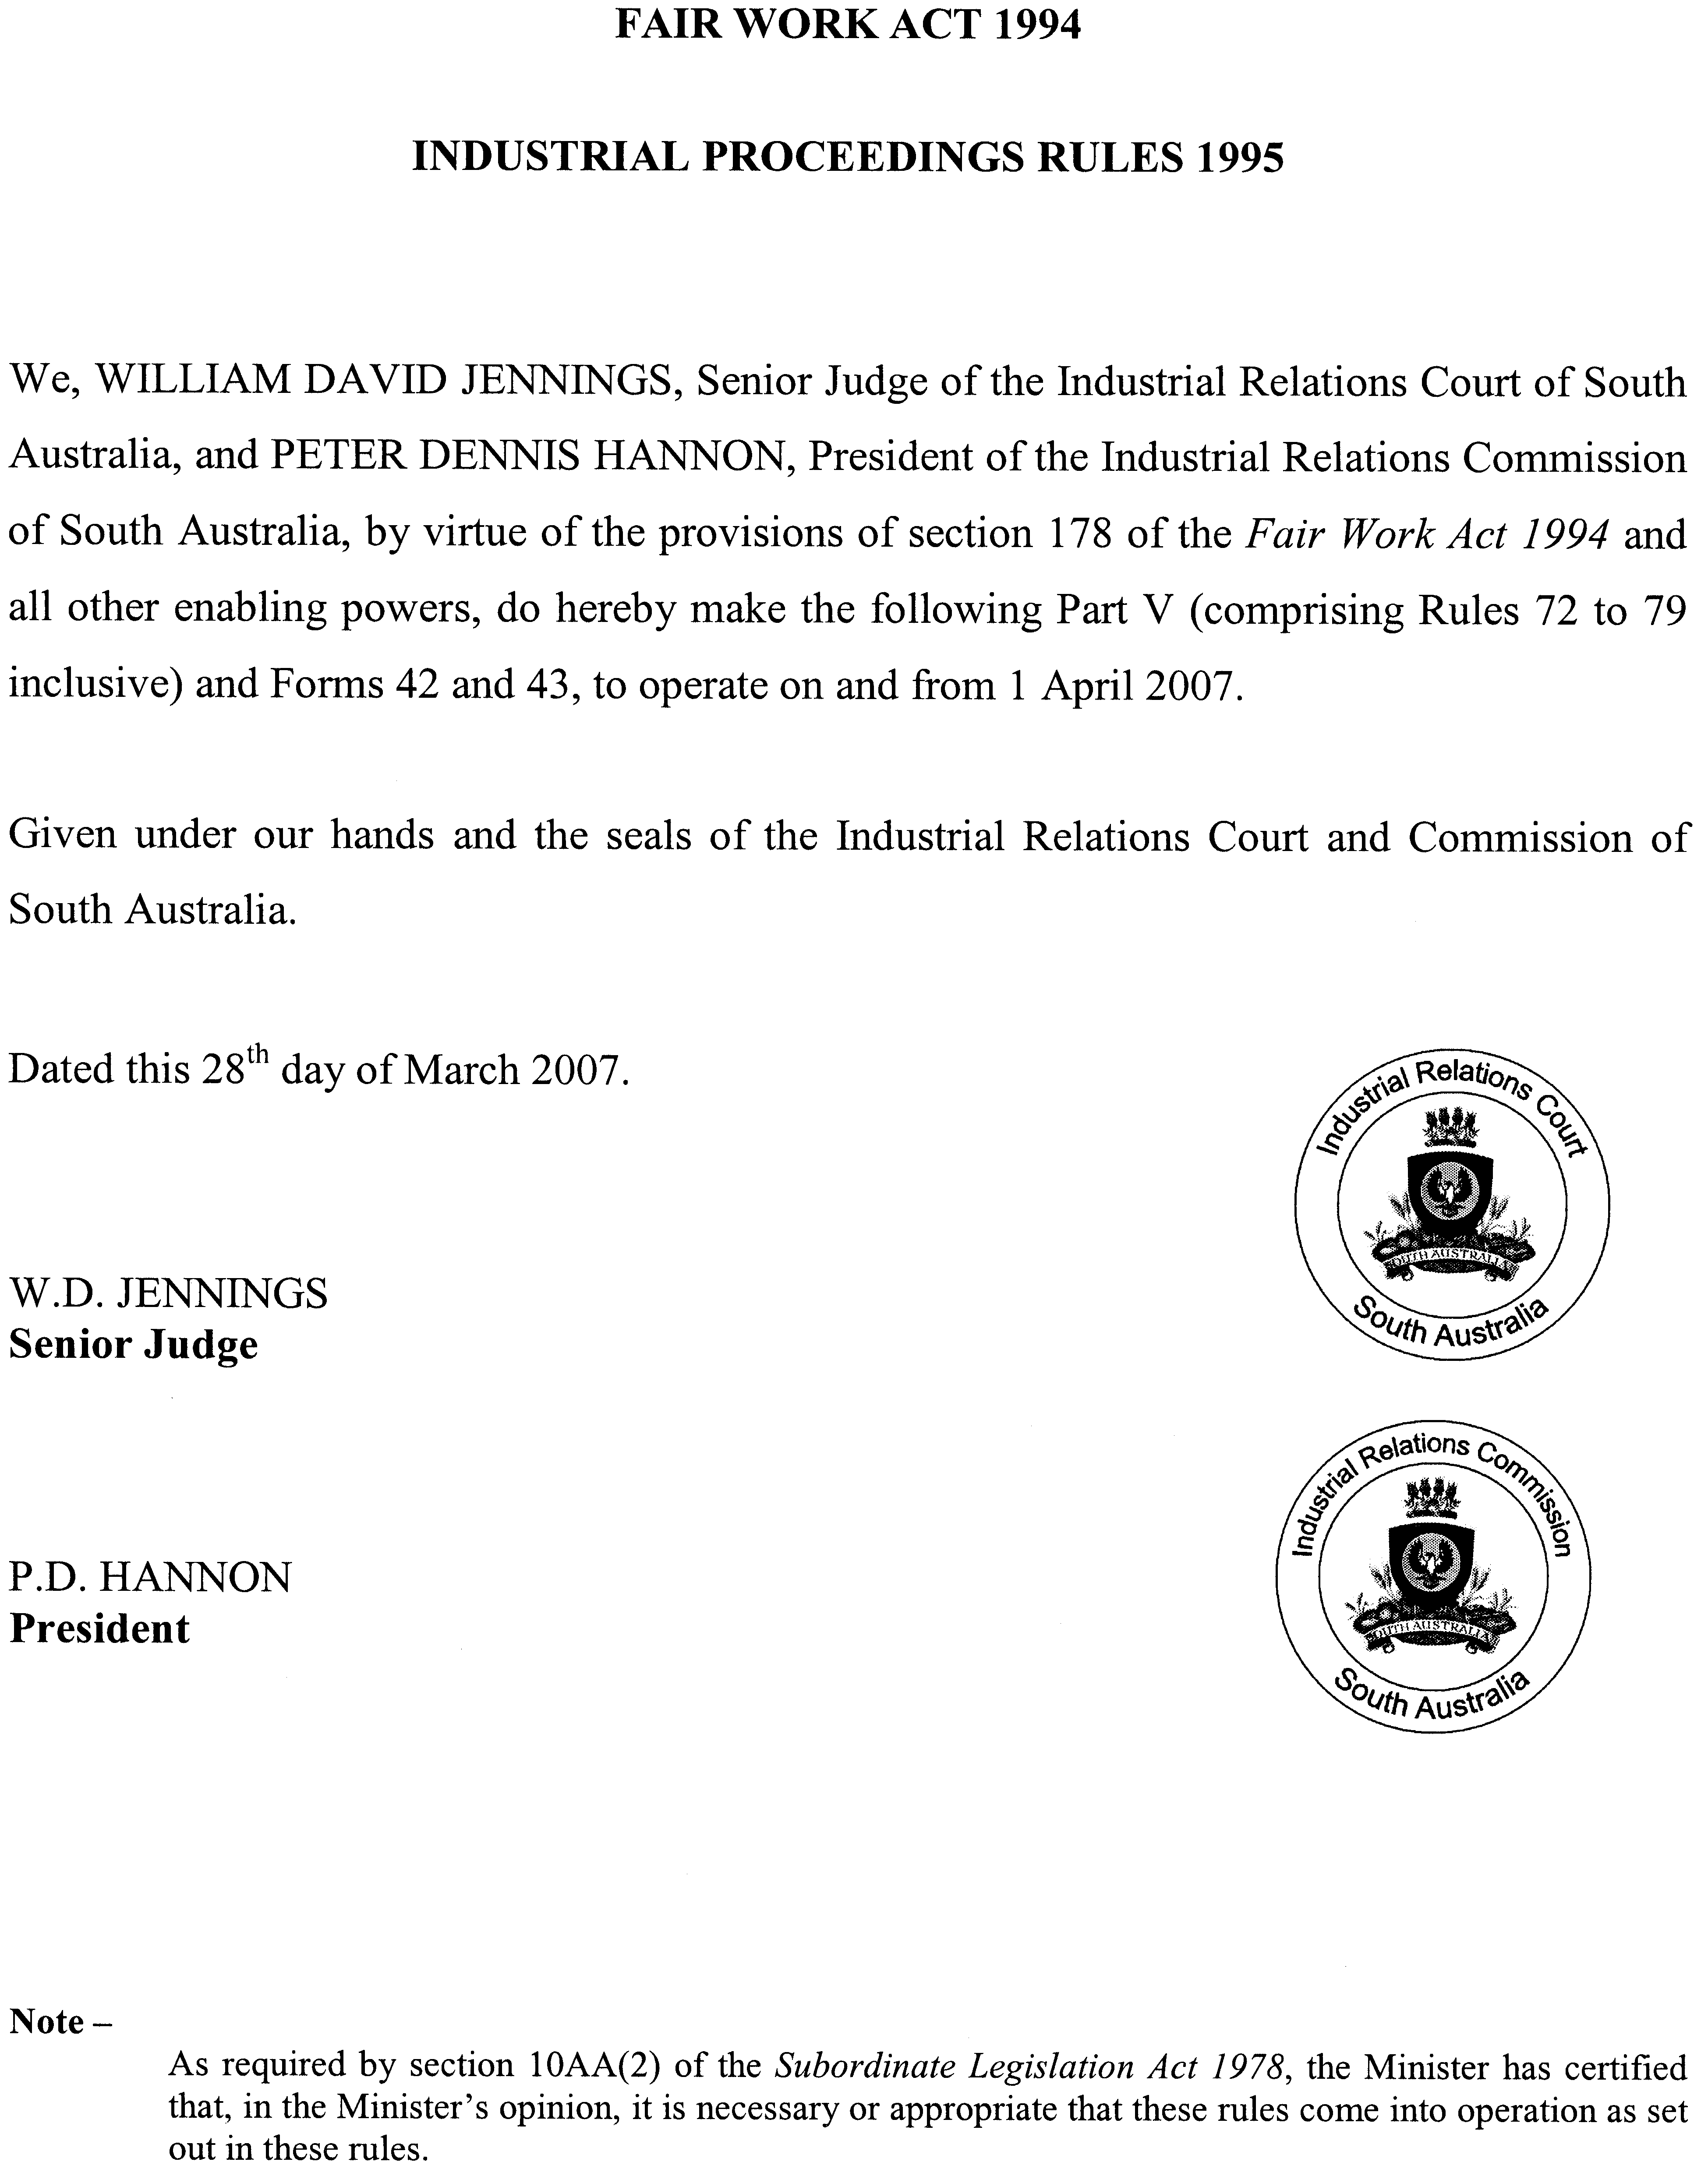
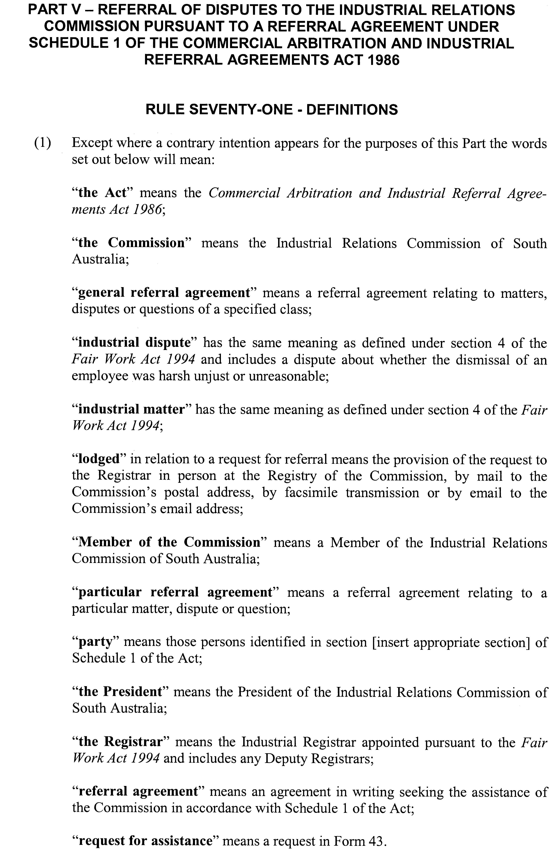
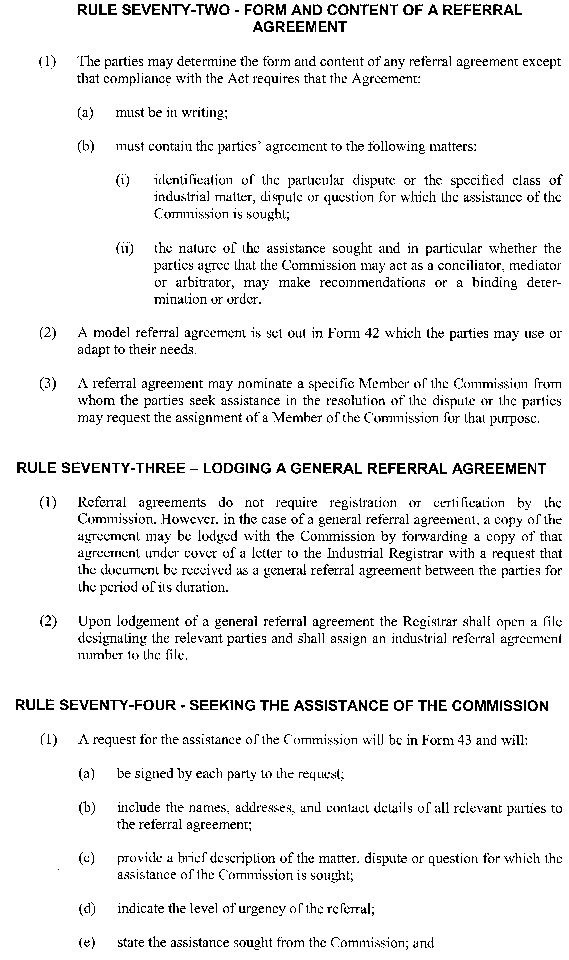
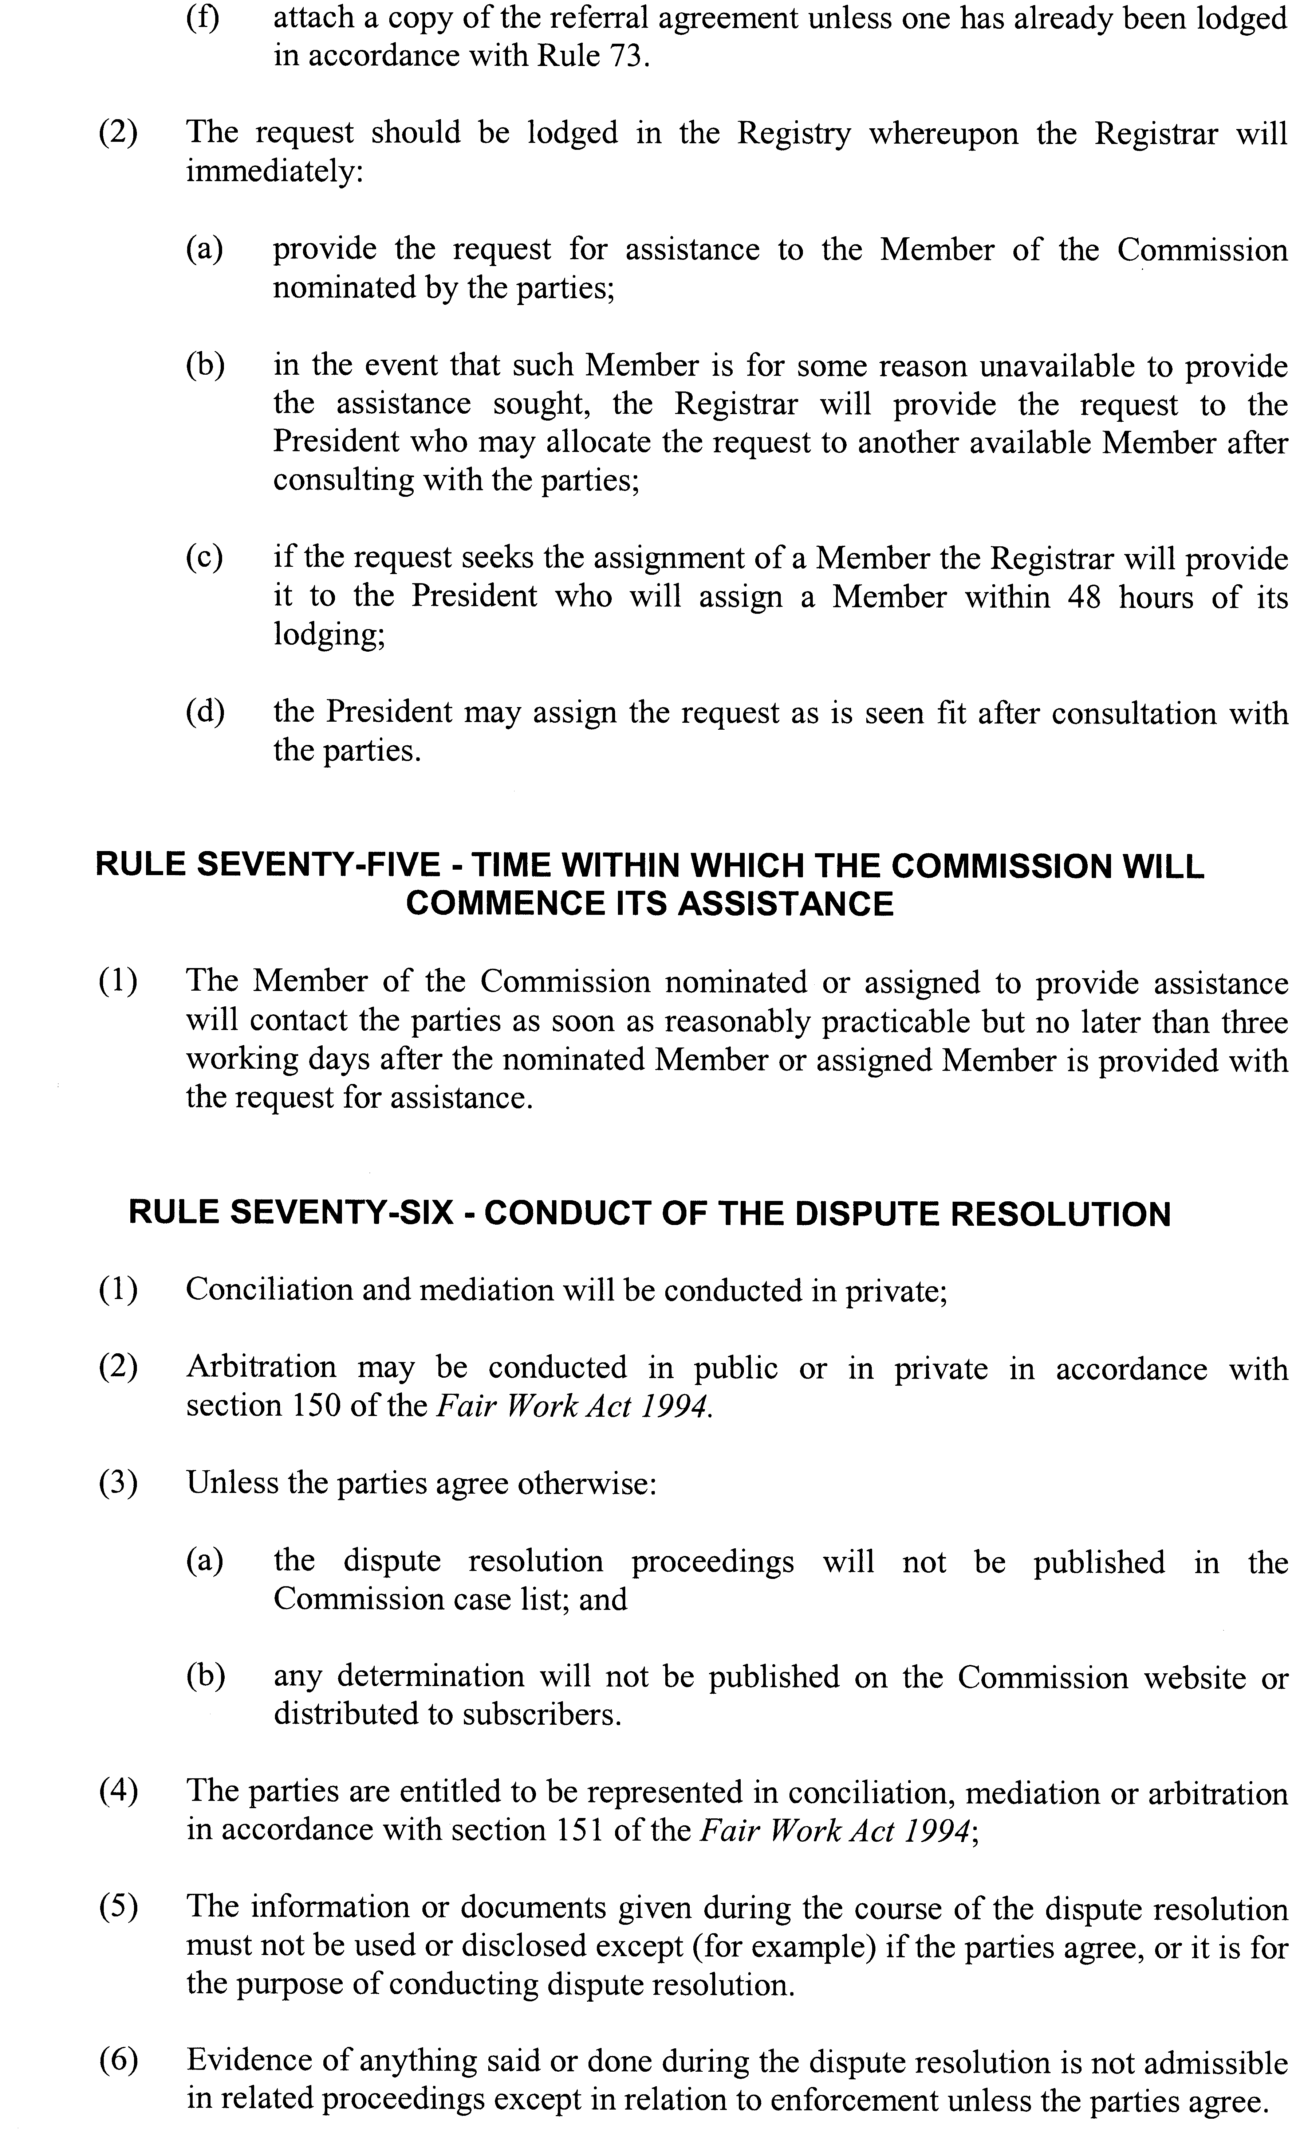
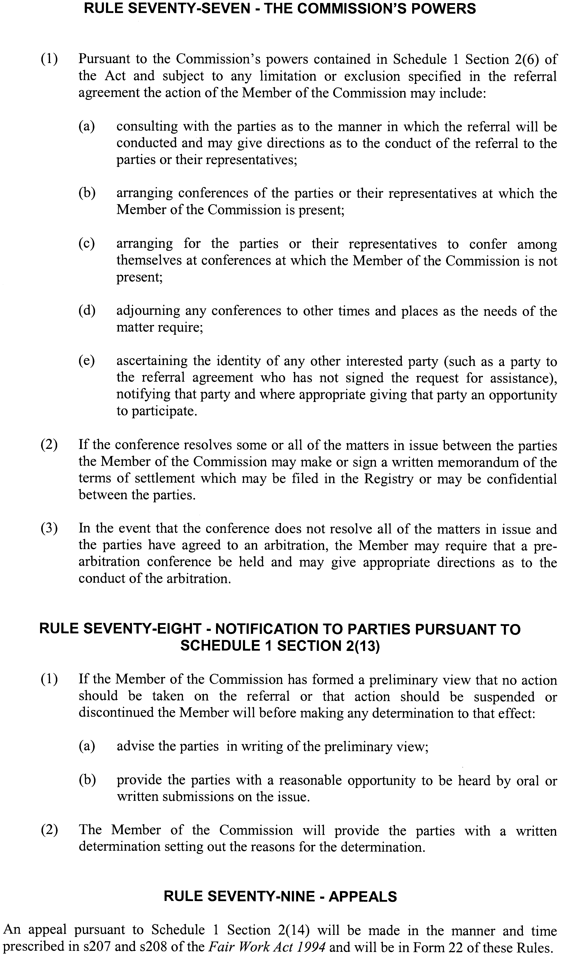
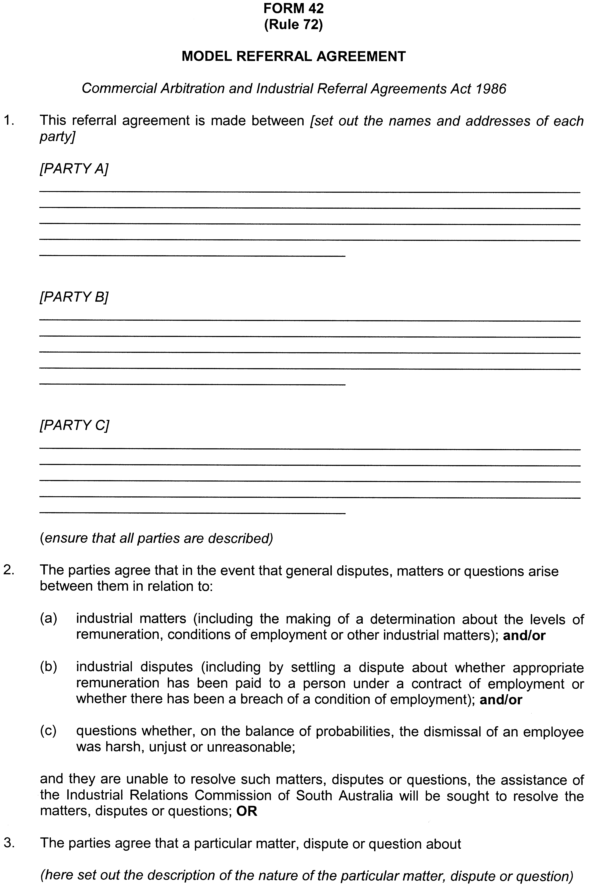
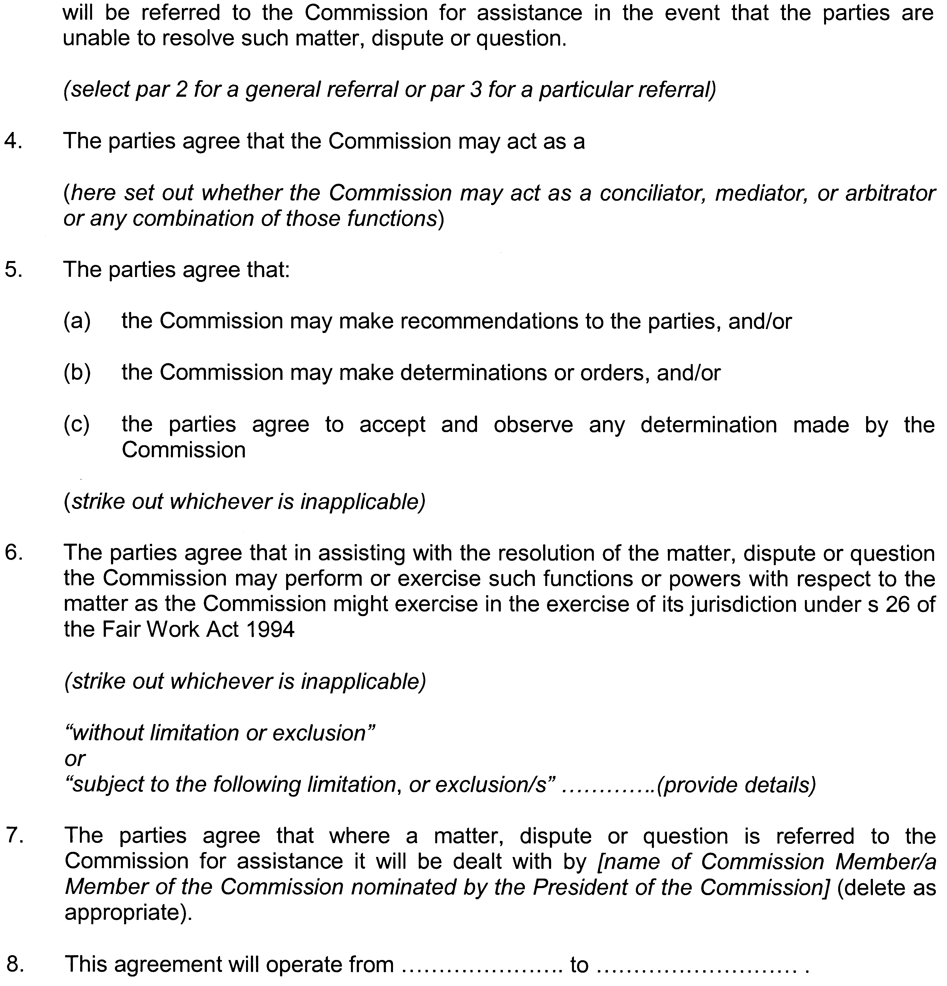
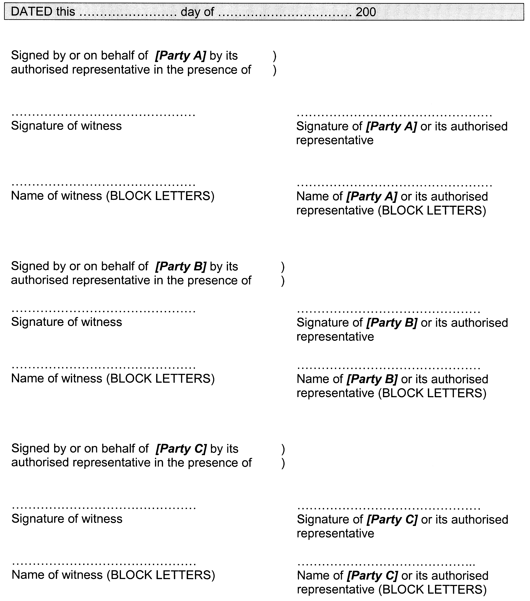
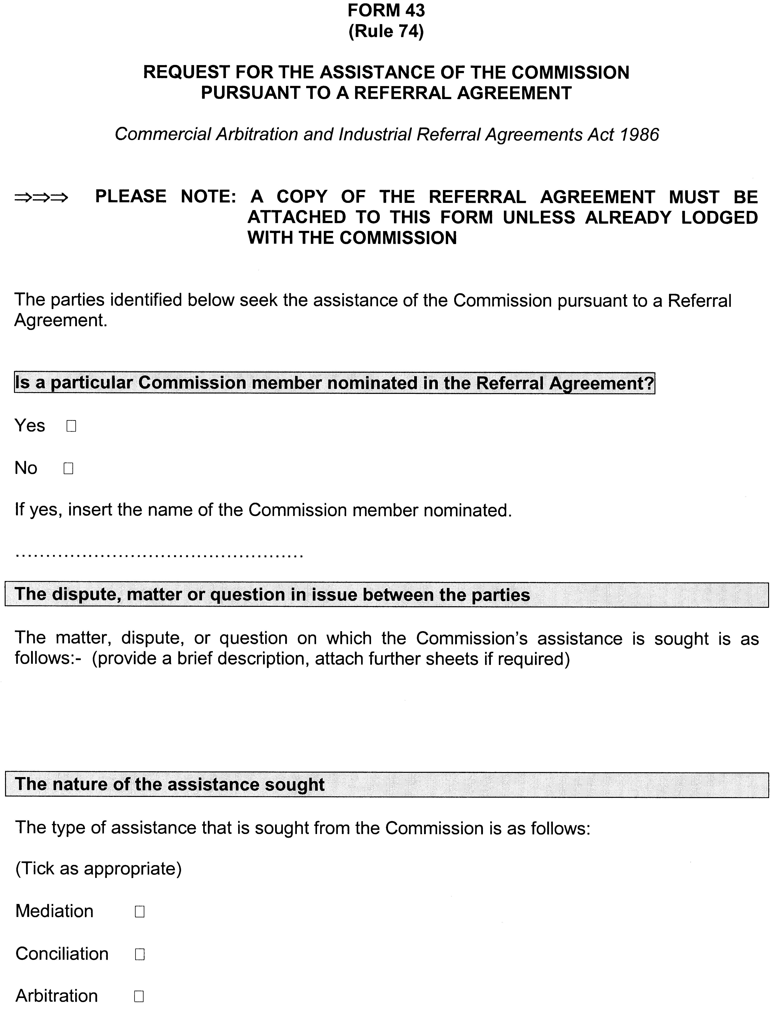

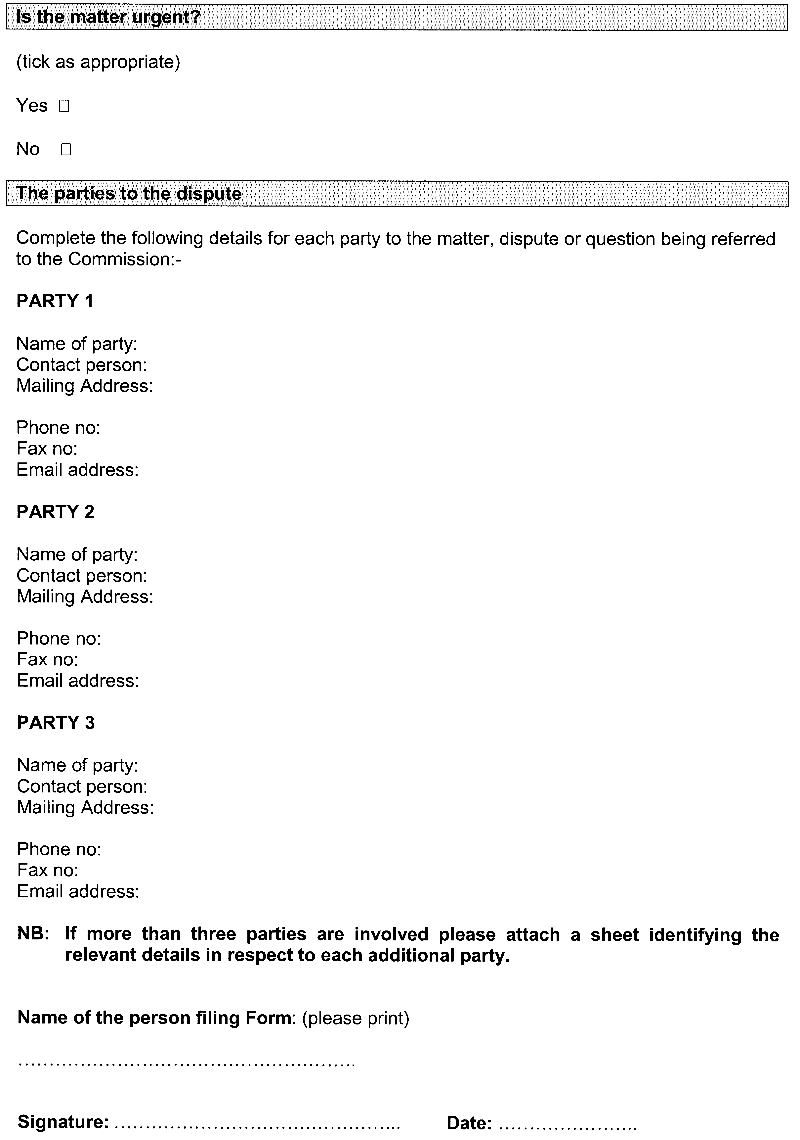

FISHERIES ACT 1982: SECTION 59
TAKE notice that pursuant to section 59 of the Fisheries Act 1982, the class of persons described in Schedule 1 (the ‘exemption holders’) are exempted from the provisions of Regulation 27 and Clause 4 of Schedule 5 to the Fisheries (General) Regulations 2000, in that they may apply to vary the endorsements on their fishery licence in relation to a boat used pursuant to the licence and/or to the person registered as the master of a boat used pursuant to the licence without paying the fee prescribed for that application (the ‘exempted activity’), subject to the conditions specified in Schedule 2, from 2 April 2007 until 30 April 2007 inclusive, unless this notice is varied or revoked earlier.
Schedule 1
The holder of a licence issued pursuant to the Fisheries (Scheme of Management—Marine Scalefish Fisheries) Regulations 2006, the Fisheries (Scheme of Management—Miscellaneous Fishery) Regulations 2000, the Fisheries (Scheme of Management—Blue Crab Fishery) Regulations 1998, the Fisheries (Scheme of Management—Prawn Fisheries) Regulations 2006, the Fisheries (Scheme of Management—Abalone Fisheries) Regulations 2006, the Fisheries (Scheme of Management—River Fishery) Regulations 2006, the Fisheries (Scheme of Management—Lakes and Coorong Fishery) Regulations 2006, the Fisheries (Scheme of Management—Charter Boat Fishery) Regulations 2005 and the Fisheries (Scheme of Management—Rock Lobster Fisheries) Regulations 2006, or any regulations that replace these regulations.
Schedule 2
1. The exempted activity does not extend to applications to alter or vary quota or gear entitlements on the licence.
2. An exemption holder must not contravene or fail to comply with the Fisheries Act 1982, or any other regulations made under that Act, except where specifically exempted by this notice.
Dated 2 April 2007.
W. Zacharin, Director of Fisheries

FISHERIES ACT 1982: SECTION 59
TAKE notice that pursuant to section 59 of the Fisheries Act 1982, Michael Hammer of Native Fish Australia (SA), 15A King Edward Avenue, Hawthorn, S.A. 5062 (the ‘exemption holder’), or a person acting as his agent, is exempt from sections 42 and 44 of the Fisheries Act 1982, but only insofar as the exemption holder may take and be in possession of protected fish species specified in Schedule 1 (the ‘exempted activity’), subject to the conditions specified in Schedule 2, from 30 March 2007 until 31 December 2007, unless varied or revoked earlier.
Schedule 1
• Fish of the Genus Nannoperca—up to 200 individuals.
• Fish of the Genus Mogurnda—up to 100 individuals.
Schedule 2
1. The exemption holder must not sell or trade species collected pursuant to this exemption notice.
2. Specimens collected under this exemption may be given to the SA Museum where appropriate for scientific purposes.
3. The locations for take of the species specified in Schedule 1 and the sites they are kept are registered with PIRSA Fisheries and may only be varied with the approval of the Director of Fisheries.
4. While engaging in the exempted activity, the exemption holder must be in possession of a copy of this notice. Such notice must be produced to a PIRSA Fisheries Compliance Officer if requested.
5. The exemption holder must not contravene or fail to comply with the Fisheries Act 1982, or any regulations made under that Act, except where specifically exempted by this notice.
Dated 30 March 2007.
W. Zacharin, Director of Fisheries

DEPARTMENT OF PRIMARY INDUSTRIES AND RESOURCES SA—FISHERIES DIVISION
NOTICE is hereby given pursuant to section 28 (10) of the Fisheries Act 1982, that the following items have been seized by officers of the Department of Primary Industries and Resources SA, Fisheries Division at 1145 hours on 3 January 2007:
1 rock lobster pot with red neck and chicken wire mesh
1 black bait basket
1 red/white 4 L float
1 orange rope
1 white rope
The above items were suspected to have been used or intended to be used, in contravention of the Fisheries Act 1982, and were taken into possession at Gerloff Bay, near Carpenter Rocks, S.E.
After the expiration of one month from the date of this notice the items listed above shall, on the order of the Minister for Primary Industries, be forfeited to the Crown and shall be either disposed of by sale or destruction.
The above items may be viewed at the Mount Gambier office of the Department of Primary Industries and Resources SA, Fisheries Division.
Dated 23 March 2007.
M. Lewis, General Manager, Fisheries Services

DEPARTMENT OF PRIMARY INDUSTRIES AND RESOURCES SA—FISHERIES DIVISION
NOTICE is hereby given pursuant to section 28 (10) of the Fisheries Act 1982, that the following items have been seized by officers of the Department of Primary Industries and Resources SA, Fisheries Division at Mount Gambier on 31 December 2006:
1 rock lobster pot with red plastic neck
1 red bait basket
1 red 4 L float with ‘pw’ inscribed on it
1 length of white rope
1 2 L white float cut in half
The above items were suspected to have been used or intended to be used, in contravention of the Fisheries Act 1982, and were taken into possession at Cape Douglas.
After the expiration of one month from the date of this notice the items listed above shall, on the order of the Minister for Primary Industries, be forfeited to the Crown and shall be either disposed of by sale or destruction.
The above items may be viewed at the Mount Gambier office of the Department of Primary Industries and Resources SA, Fisheries Division.
Dated 23 March 2007.
M. Lewis, General Manager, Fisheries Services

DEPARTMENT OF PRIMARY INDUSTRIES AND RESOURCES SA—FISHERIES DIVISION
NOTICE is hereby given pursuant to section 28 (10) of the Fisheries Act 1982, that the following items have been seized by officers of the Department of Primary Industries and Resources SA, Fisheries Division at Mount Gambier on 31 December 2006:
1 rock lobster pot with white plastic cane neck
1 red 4 L buoy
1 red 2 L buoy
1 black bait basket
1 length of white rope
The above items were suspected to have been used or intended to be used, in contravention of the Fisheries Act 1982, and were taken into possession at Cape Douglas.
After the expiration of one month from the date of this notice the items listed above shall, on the order of the Minister for Primary Industries, be forfeited to the Crown and shall be either disposed of by sale or destruction.
The above items may be viewed at the Mount Gambier office of the Department of Primary Industries and Resources SA, Fisheries Division.
Dated 23 March 2007.
M. Lewis, General Manager, Fisheries Services

DEPARTMENT OF PRIMARY INDUSTRIES AND RESOURCES SA—FISHERIES DIVISION
NOTICE is hereby given pursuant to section 28 (10) of the Fisheries Act 1982, that the following items have been seized by officers of the Department of Primary Industries and Resources SA, Fisheries Division at Mount Gambier on 31 December 2006:
1 rock lobster pot with red plastic neck
1 red 4 L float
1 black bait basket
1 black berley bucket
1 length of orange rope
The above items were suspected to have been used or intended to be used, in contravention of the Fisheries Act 1982, and were taken into possession at Cape Douglas.
After the expiration of one month from the date of this notice the items listed above shall, on the order of the Minister for Primary Industries, be forfeited to the Crown and shall be either disposed of by sale or destruction.
The above items may be viewed at the Mount Gambier office of the Department of Primary Industries and Resources SA, Fisheries Division.
Dated 23 March 2007.
M. Lewis, General Manager, Fisheries Services

DEPARTMENT OF PRIMARY INDUSTRIES AND RESOURCES SA—FISHERIES DIVISION
NOTICE is hereby given pursuant to section 28 (10) of the Fisheries Act 1982, that the following items have been seized by officers of the Department of Primary Industries and Resources SA, Fisheries Division at Cape Elizabeth on 15 May 2006:
1 recreational mesh net 15 m long, 2 m drop and orange floats
1 green catch bag
1 trolly
The above items were suspected to have been used or intended to be used, in contravention of the Fisheries Act 1982, and were taken into possession at Cape Elizabeth.
After the expiration of one month from the date of this notice the items listed above shall, on the order of the Minister for Primary Industries, be forfeited to the Crown and shall be either disposed of by sale or destruction.
The above items may be viewed at the Kadina office of the Department of Primary Industries and Resources SA, Fisheries Division.
Dated 23 March 2007.
M. Lewis, General Manager, Fisheries Services

DEPARTMENT OF PRIMARY INDUSTRIES AND RESOURCES SA—FISHERIES DIVISION
NOTICE is hereby given pursuant to section 28 (10) of the Fisheries Act 1982, that the following items have been seized by officers of the Department of Primary Industries and Resources SA, Fisheries Division at Cape Elizabeth on 29 April 2006:
1 orange floated set mesh net 15 m long and 1 m drop
The above items were suspected to have been used or intended to be used, in contravention of the Fisheries Act 1982, and were taken into possession at Cape Elizabeth.
After the expiration of one month from the date of this notice the items listed above shall, on the order of the Minister for Primary Industries, be forfeited to the Crown and shall be either disposed of by sale or destruction.
The above items may be viewed at the Kadina office of the Department of Primary Industries and Resources SA, Fisheries Division.
Dated 23 March 2007.
M. Lewis, General Manager, Fisheries Services

DEPARTMENT OF PRIMARY INDUSTRIES AND RESOURCES SA—FISHERIES DIVISION
NOTICE is hereby given pursuant to section 28 (10) of the Fisheries Act 1982, that the following items have been seized by officers of the Department of Primary Industries and Resources SA, Fisheries Division at Streaky Bay on 6 August 2006:
1 hoop net, green rope with 1.25 L coke bottle float attached
The above items were suspected to have been used or intended to be used, in contravention of the Fisheries Act 1982, and were taken into possession at Streaky Bay.
After the expiration of one month from the date of this notice the items listed above shall, on the order of the Minister for Primary Industries, be forfeited to the Crown and shall be either disposed of by sale or destruction.
The above items may be viewed at the Streaky Bay office of the Department of Primary Industries and Resources SA, Fisheries Division.
Dated 23 March 2007.
M. Lewis, General Manager, Fisheries Services

DEPARTMENT OF PRIMARY INDUSTRIES AND RESOURCES SA—FISHERIES DIVISION
NOTICE is hereby given pursuant to section 28 (10) of the Fisheries Act 1982, that the following items have been seized by officers of the Department of Primary Industries and Resources SA, Fisheries Division at Cape Jaffa on 15 May 2006:
1 rock lobster pot with red neck, stainless steel mesh, white strop, white weed covered popper, black head float with orange trailer and cream rope
The above items were suspected to have been used or intended to be used, in contravention of the Fisheries Act 1982, and were taken into possession at Cape Jaffa.
After the expiration of one month from the date of this notice the items listed above shall, on the order of the Minister for Primary Industries, be forfeited to the Crown and shall be either disposed of by sale or destruction.
The above items may be viewed at the Kingston S.E. office of the Department of Primary Industries and Resources SA, Fisheries Division.
Dated 23 March 2007.
M. Lewis, General Manager, Fisheries Services

DEPARTMENT OF PRIMARY INDUSTRIES AND RESOURCES SA—FISHERIES DIVISION
NOTICE is hereby given pursuant to section 28 (10) of the Fisheries Act 1982, that the following items have been seized by officers of the Department of Primary Industries and Resources SA, Fisheries Division at Port Lincoln on 19 May 2006:
2 black Opera House nets and 2 white buoys attached with green rope
The above items were suspected to have been used or intended to be used, in contravention of the Fisheries Act 1982, and were taken into possession at Thistle Island.
After the expiration of one month from the date of this notice the items listed above shall, on the order of the Minister for Primary Industries, be forfeited to the Crown and shall be either disposed of by sale or destruction.
The above items may be viewed at the Port Lincoln office of the Department of Primary Industries and Resources SA, Fisheries Division.
Dated 23 March 2007.
M. Lewis, General Manager, Fisheries Services

DEPARTMENT OF PRIMARY INDUSTRIES AND RESOURCES SA—FISHERIES DIVISION
NOTICE is hereby given pursuant to section 28 (10) of the Fisheries Act 1982, that the following items have been seized by officers of the Department of Primary Industries and Resources SA, Fisheries Division at Port Lincoln on 19 May 2006:
3 rectangular crab pots with black mesh
3 1 L white floats
3 10 m of green rope
The above items were suspected to have been used or intended to be used, in contravention of the Fisheries Act 1982, and were taken into possession at Thistle Island.
After the expiration of one month from the date of this notice the items listed above shall, on the order of the Minister for Primary Industries, be forfeited to the Crown and shall be either disposed of by sale or destruction.
The above items may be viewed at the Port Lincoln office of the Department of Primary Industries and Resources SA, Fisheries Division.
Dated 23 March 2007.
M. Lewis, General Manager, Fisheries Services

DEPARTMENT OF PRIMARY INDUSTRIES AND RESOURCES SA—FISHERIES DIVISION
NOTICE is hereby given pursuant to section 28 (10) of the Fisheries Act 1982, that the following items have been seized by officers of the Department of Primary Industries and Resources SA, Fisheries Division at Robe on 24 March 2006:
1 stainless steel mesh rock lobster pot with red neck, white strop rope, orange rope, 4 L orange buoy and white popper buoy
The above items were suspected to have been used or intended to be used, in contravention of the Fisheries Act 1982, and were taken into possession at Robe.
After the expiration of one month from the date of this notice the items listed above shall, on the order of the Minister for Primary Industries, be forfeited to the Crown and shall be either disposed of by sale or destruction.
The above items may be viewed at the Kingston S.E. office of the Department of Primary Industries and Resources SA, Fisheries Division.
Dated 23 March 2007.
M. Lewis, General Manager, Fisheries Services

DEPARTMENT OF PRIMARY INDUSTRIES AND RESOURCES SA—FISHERIES DIVISION
NOTICE is hereby given pursuant to section 28 (10) of the Fisheries Act 1982, that the following items have been seized by officers of the Department of Primary Industries and Resources SA, Fisheries Division at North Shields on 12 October 2006:
1 17 m cotton mesh net fitted with cork headline and weighted lead line and 2 heavy iron bars placed at each end on an extended line to act as an anchor
The above items were suspected to have been used or intended to be used, in contravention of the Fisheries Act 1982, and were taken into possession at North Shields.
After the expiration of one month from the date of this notice the items listed above shall, on the order of the Minister for Primary Industries, be forfeited to the Crown and shall be either disposed of by sale or destruction.
The above items may be viewed at the Port Lincoln office of the Department of Primary Industries and Resources SA, Fisheries Division.
Dated 23 March 2007.
M. Lewis, General Manager, Fisheries Services

DEPARTMENT OF PRIMARY INDUSTRIES AND RESOURCES SA—FISHERIES DIVISION
NOTICE is hereby given pursuant to section 28 (10) of the Fisheries Act 1982, that the following items have been seized by officers of the Department of Primary Industries and Resources SA, Fisheries Division at Beachport on 28 December 2006:
1 drop net with white/green-yellow rope attached to a 2 L white buoy
The above items were suspected to have been used or intended to be used, in contravention of the Fisheries Act 1982, and were taken into possession at Beachport.
After the expiration of one month from the date of this notice the items listed above shall, on the order of the Minister for Primary Industries, be forfeited to the Crown and shall be either disposed of by sale or destruction.
The above items may be viewed at the Kingston S.E. office of the Department of Primary Industries and Resources SA, Fisheries Division.
Dated 23 March 2007.
M. Lewis, General Manager, Fisheries Services

DEPARTMENT OF PRIMARY INDUSTRIES AND RESOURCES SA—FISHERIES DIVISION
NOTICE is hereby given pursuant to section 28 (10) of the Fisheries Act 1982, that the following items have been seized by officers of the Department of Primary Industries and Resources SA, Fisheries Division at Beachport on 28 December 2006:
1 rock lobster pot with wire mesh, red plastic neck, white strop and blue-green rope
1 faded orange float
2 black plastic bait baskets
1 black plastic berley bucket
The above items were suspected to have been used or intended to be used, in contravention of the Fisheries Act 1982, and were taken into possession at Beachport.
After the expiration of one month from the date of this notice the items listed above shall, on the order of the Minister for Primary Industries, be forfeited to the Crown and shall be either disposed of by sale or destruction.
The above items may be viewed at the Kingston S.E. office of the Department of Primary Industries and Resources SA, Fisheries Division.
Dated 23 March 2007.
M. Lewis, General Manager, Fisheries Services

DEPARTMENT OF PRIMARY INDUSTRIES AND RESOURCES SA—FISHERIES DIVISION
NOTICE is hereby given pursuant to section 28 (10) of the Fisheries Act 1982, that the following items have been seized by officers of the Department of Primary Industries and Resources SA, Fisheries Division at Beachport on 28 December 2006:
1 rock lobster pot with wire mesh and red plastic neck
1 plastic bait basket, yellow and orange rope and white strop
1 4 L red buoy
1 4 L white buoy
The above items were suspected to have been used or intended to be used, in contravention of the Fisheries Act 1982, and were taken into possession at Beachport.
After the expiration of one month from the date of this notice the items listed above shall, on the order of the Minister for Primary Industries, be forfeited to the Crown and shall be either disposed of by sale or destruction.
The above items may be viewed at the Kingston S.E. office of the Department of Primary Industries and Resources SA, Fisheries Division.
Dated 23 March 2007.
M. Lewis, General Manager, Fisheries Services

DEPARTMENT OF PRIMARY INDUSTRIES AND RESOURCES SA—FISHERIES DIVISION
NOTICE is hereby given pursuant to section 28 (10) of the Fisheries Act 1982, that the following items have been seized by officers of the Department of Primary Industries and Resources SA, Fisheries Division at Beachport on 28 December 2006:
1 rock lobster pot with red painted wire mesh, white rope/strop and red plastic neck
1 black plastic bait basket
1 2 L yellow buoy
The above items were suspected to have been used or intended to be used, in contravention of the Fisheries Act 1982, and were taken into possession at Beachport.
After the expiration of one month from the date of this notice the items listed above shall, on the order of the Minister for Primary Industries, be forfeited to the Crown and shall be either disposed of by sale or destruction.
The above items may be viewed at the Kinston S.E. office of the Department of Primary Industries and Resources SA, Fisheries Division.
Dated 23 March 2007.
M. Lewis, General Manager, Fisheries Services

DEPARTMENT OF PRIMARY INDUSTRIES AND RESOURCES SA—FISHERIES DIVISION
NOTICE is hereby given pursuant to section 28 (10) of the Fisheries Act 1982, that the following items have been seized by officers of the Department of Primary Industries and Resources SA, Fisheries Division at Beachport on 28 December 2006:
1 rock lobster pot with wire mesh, red plastic neck with some woven cane, green/yellow and black/yellow ropes
1 white buoy
1 orange buoy with white stripe
1 black plastic bait basket
The above items were suspected to have been used or intended to be used, in contravention of the Fisheries Act 1982, and were taken into possession at Beachport.
After the expiration of one month from the date of this notice the items listed above shall, on the order of the Minister for Primary Industries, be forfeited to the Crown and shall be either disposed of by sale or destruction.
The above items may be viewed at the Kingston S.E. office of the Department of Primary Industries and Resources SA, Fisheries Division.
Dated 23 March 2007.
M. Lewis, General Manager, Fisheries Services

DEPARTMENT OF PRIMARY INDUSTRIES AND RESOURCES SA—FISHERIES DIVISION
NOTICE is hereby given pursuant to section 28 (10) of the Fisheries Act 1982, that the following items have been seized by officers of the Department of Primary Industries and Resources SA, Fisheries Division at Port MacDonnell on 20 February 2007:
1 rock lobster pot with red plastic neck, chicken wire mesh, white strop line and yellow/red rope
The above items were suspected to have been used or intended to be used, in contravention of the Fisheries Act 1982, and were taken into possession at Port MacDonnell.
After the expiration of one month from the date of this notice the items listed above shall, on the order of the Minister for Primary Industries, be forfeited to the Crown and shall be either disposed of by sale or destruction.
The above items may be viewed at the Mount Gambier office of the Department of Primary Industries and Resources SA, Fisheries Division.
Dated 23 March 2007.
M. Lewis, General Manager, Fisheries Services

DEPARTMENT OF PRIMARY INDUSTRIES AND RESOURCES SA—FISHERIES DIVISION
NOTICE is hereby given pursuant to section 28 (10) of the Fisheries Act 1982, that the following items have been seized by officers of the Department of Primary Industries and Resources SA, Fisheries Division at Anxious Bay near Elliston on 22 February 2007:
1 rock lobster pot with red plastic neck, green rope, orange float and half white float
The above items were suspected to have been used or intended to be used, in contravention of the Fisheries Act 1982, and were taken into possession at Anxious Bay, near Elliston.
After the expiration of one month from the date of this notice the items listed above shall, on the order of the Minister for Primary Industries, be forfeited to the Crown and shall be either disposed of by sale or destruction.
The above items may be viewed at the Streaky Bay office of the Department of Primary Industries and Resources SA, Fisheries Division.
Dated 23 March 2007.
M. Lewis, General Manager, Fisheries Services

DEPARTMENT OF PRIMARY INDUSTRIES AND RESOURCES SA—FISHERIES DIVISION
NOTICE is hereby given pursuant to section 28 (10) of the Fisheries Act 1982, that the following items have been seized by officers of the Department of Primary Industries and Resources SA, Fisheries Division at Anxious Bay, Elliston on 22 February 2007:
1 rock lobster pot with cane neck, green rope and black and white float
The above items were suspected to have been used or intended to be used, in contravention of the Fisheries Act 1982, and were taken into possession at Anxious Bay, Elliston.
After the expiration of one month from the date of this notice the items listed above shall, on the order of the Minister for Primary Industries, be forfeited to the Crown and shall be either disposed of by sale or destruction.
The above items may be viewed at the Streaky Bay office of the Department of Primary Industries and Resources SA, Fisheries Division.
Dated 23 March 2007.
M. Lewis, General Manager, Fisheries Services

DEPARTMENT OF PRIMARY INDUSTRIES AND RESOURCES SA—FISHERIES DIVISION
NOTICE is hereby given pursuant to section 28 (10) of the Fisheries Act 1982, that the following items have been seized by officers of the Department of Primary Industries and Resources SA, Fisheries Division at Robe on 18 January 2007:
1 rock lobster pot with red plastic neck covered by chicken wire attached by black zip ties (corf)
1 4 L yellow plastic float
1 4 L white plastic float
1 4 L red plastic float with white stripe rope and white/orange rope with blue flecks
The above items were suspected to have been used or intended to be used, in contravention of the Fisheries Act 1982, and were taken into possession at Robe.
After the expiration of one month from the date of this notice the items listed above shall, on the order of the Minister for Primary Industries, be forfeited to the Crown and shall be either disposed of by sale or destruction.
The above items may be viewed at the Kingston S.E. office of the Department of Primary Industries and Resources SA, Fisheries Division.
Dated 23 March 2007.
M. Lewis, General Manager, Fisheries Services

DEPARTMENT OF PRIMARY INDUSTRIES AND RESOURCES SA—FISHERIES DIVISION
NOTICE is hereby given pursuant to section 28 (10) of the Fisheries Act 1982, that the following items have been seized by officers of the Department of Primary Industries and Resources SA, Fisheries Division at Boozy Gulley on 26 January 2007:
1 rock lobster pot with red plastic neck, wire mesh, blue/pink rope, no floats and metal clip attaching strop
The above items were suspected to have been used or intended to be used, in contravention of the Fisheries Act 1982, and were taken into possession at Boozy Gulley.
After the expiration of one month from the date of this notice the items listed above shall, on the order of the Minister for Primary Industries, be forfeited to the Crown and shall be either disposed of by sale or destruction.
The above items may be viewed at the Kingston S.E. office of the Department of Primary Industries and Resources SA, Fisheries Division.
Dated 23 March 2007.
M. Lewis, General Manager, Fisheries Services

DEPARTMENT OF PRIMARY INDUSTRIES AND RESOURCES SA—FISHERIES DIVISION
NOTICE is hereby given pursuant to section 28 (10) of the Fisheries Act 1982, that the following items have been seized by officers of the Department of Primary Industries and Resources SA, Fisheries Division at Gordon Court, Port Augusta on 30 January 2007:
1 mesh net approximately 40 m long x 1.8 m deep
1 iron star dropper
The above items were suspected to have been used or intended to be used, in contravention of the Fisheries Act 1982, and were taken into possession at Port Augusta.
After the expiration of one month from the date of this notice the items listed above shall, on the order of the Minister for Primary Industries, be forfeited to the Crown and shall be either disposed of by sale or destruction.
The above items may be viewed at the Whyalla office of the Department of Primary Industries and Resources SA, Fisheries Division.
Dated 23 March 2007.
M. Lewis, General Manager, Fisheries Services

DEPARTMENT OF PRIMARY INDUSTRIES AND RESOURCES SA—FISHERIES DIVISION
NOTICE is hereby given pursuant to section 28 (10) of the Fisheries Act 1982, that the following items have been seized by officers of the Department of Primary Industries and Resources SA, Fisheries Division at 0900 hours on 4 February 2007:
3 drop nets with black mesh approximately 700 mm diameter
3 white ½ L buoys
3 6 m of green rope
The above items were suspected to have been used or intended to be used, in contravention of the Fisheries Act 1982, and were taken into possession at offshore, Whyalla.
After the expiration of one month from the date of this notice the items listed above shall, on the order of the Minister for Primary Industries, be forfeited to the Crown and shall be either disposed of by sale or destruction.
The above items may be viewed at the Whyalla office of the Department of Primary Industries and Resources SA, Fisheries Division.
Dated 23 March 2007.
M. Lewis, General Manager, Fisheries Services

DEPARTMENT OF PRIMARY INDUSTRIES AND RESOURCES SA—FISHERIES DIVISION
NOTICE is hereby given pursuant to section 28 (10) of the Fisheries Act 1982, that the following items have been seized by officers of the Department of Primary Industries and Resources SA, Fisheries Division at Cape Jaffa on 14 February 2007:
1 rock lobster pot (commercial make) with red plastic neck, yellow rope and orange nylon mesh
1 ‘pinky’ float with ‘YBB 95’ marked on it
The above items were suspected to have been used or intended to be used, in contravention of the Fisheries Act 1982, and were taken into possession at Cape Jaffa.
After the expiration of one month from the date of this notice the items listed above shall, on the order of the Minister for Primary Industries, be forfeited to the Crown and shall be either disposed of by sale or destruction.
The above items may be viewed at the Kingston S.E. office of the Department of Primary Industries and Resources SA, Fisheries Division.
Dated 23 March 2007.
M. Lewis, General Manager, Fisheries Services

DEPARTMENT OF PRIMARY INDUSTRIES AND RESOURCES SA—FISHERIES DIVISION
NOTICE is hereby given pursuant to section 28 (10) of the Fisheries Act 1982, that the following items have been seized by officers of the Department of Primary Industries and Resources SA, Fisheries Division at Robe on 13 February 2007:
1 rock lobster pot with cane neck, orange rope, stainless steel mesh, red plastic bait basket and three white floats
The above items were suspected to have been used or intended to be used, in contravention of the Fisheries Act 1982, and were taken into possession at Robe.
After the expiration of one month from the date of this notice the items listed above shall, on the order of the Minister for Primary Industries, be forfeited to the Crown and shall be either disposed of by sale or destruction.
The above items may be viewed at the Kingston S.E. office of the Department of Primary Industries and Resources SA, Fisheries Division.
Dated 23 March 2007.
M. Lewis, General Manager, Fisheries Services

HARBORS AND NAVIGATION ACT 1993
Determination of the State Crewing Committee
THE following determination is made by the State Crewing Committee pursuant to part 6, section 45 of the Harbors and Navigation Act 1993 was convened on 22 September 2006.
Patrick Conlon, Minister for Transport
TSA V29137

HARBORS AND NAVIGATION ACT 1993
Determination of the State Crewing Committee in respect of the M.V. ‘FPV Sea Eagle’
THE following determination is made by the State Crewing Committee pursuant to part 6, section 45 of the Harbors and Navigation Act 1993, in respect of the FPV Sea Eagle whilst operating within the following limits:
Operational Limits
Limit 1—15 nautical miles from the South Australian Coast.
Limit 2—30 nautical miles from the South Australian Coast.
Minimum Complement
Limit 1—One person: Coxswain.
Limit 2—One person: Master.
The Master to be the holder of a Marine Engine Driver
Grade 3.
Minimum Qualifications of Crew
Limit 1—Master, Certificate of Competency as a Coxswain.
Limit 2—Master, Certificate of Competency as a Master Class 5.
The Master to be the holder of a Marine Engine Driver
Grade 3.
Capt. W. Ferrao, Presiding Member, State Crewing Committee

HARBORS AND NAVIGATION ACT 1993
Determination of the State Crewing Committee
THE following determination is made by the State Crewing Committee pursuant to part 6, section 45 of the Harbors and Navigation Act 1993 was convened on 5 August 2005.
Patrick Conlon, Minister for Transport
TSA V28872

HARBORS AND NAVIGATION ACT 1993
Determination of the State Crewing Committee in respect of the M.V. ‘K & R Charters’
THE following determination is made by the State Crewing Committee pursuant to part 6, section 45 of the Harbors and Navigation Act 1993, in respect of the K & R Charters whilst operating within the following limits:
Operational Limits
15 nautical miles from the South Australian Coast line.
Minimum Complement
Normal Operations
Master—One person.
Diving Operations
Master—Two persons and GP (General Purpose Person).
Minimum Qualifications of Crew
Master—Certificate of Competency as a Coxswain.
GP—General Purpose Person, an able-bodied person not less than 16 years of age with not less than three months experience and has successfully completed an approved Occupational Health and Safety at Sea Course.
Capt. W. Ferrao, Presiding Member, State Crewing Committee

HARBORS AND NAVIGATION ACT 1993
Determination of the State Crewing Committee
Addendum
THE following determination is made by the State Crewing Committee pursuant to part 6, section 45 of the Harbors and Navigation Act 1993 was convened on 20 March 2007.
Patrick Conlon, Minister for Transport
TSA V20094

HARBORS AND NAVIGATION ACT 1993
Determination of the State Crewing Committee in respect of the M.V. ‘Gallantry’
THE following determination is made by the State Crewing Committee pursuant to part 6, section 45 of the Harbors and Navigation Act 1993, in respect of the Gallantry whilst operating within the following limits:
Operational Limits
Limit 1—Coast of South Australia offshore operational areas out to 200 nautical miles.
Limit 2—Coast of South Australia offshore operational area out to 100 nautical miles.
Limit 3—15 nautical miles from the Coast of South Australia.
Minimum Complement
Limit 1—Two Persons: Master endorsed to 200 nautical miles, Mate.
Both Master and Mate to be the holder of a Marine Engine Driver Grade 2.
Limit 2—Two Persons: Master, Mate.
Both Master and Mate to be the holder of a Marine Engine Driver Grade 2.
Operations under 12 hours
Limit 3—Two Persons: Master, Engineer.
Minimum Qualifications of Crew
Limit 1:
Master—Certificate of Competency as a Master Class 5 endorsed to 200 nautical miles.
Mate—Certificate of Competency as a Master Class 5.
Both Master and Mate to be the holder of a Marine Engine Driver Grade 2.
Limit 2:
Master—Certificate of Competency as a Master Class 5.
Mate—Certificate of Competency as a Master Class 5.
Both Master and Mate to be the holder of a Marine Engine Driver Grade 2.
Limit 3:
Master—Certificate of Competency as a Master 5.
Engineer—Marine Engine Driver Grade 2.
Capt. W. Ferrao, Presiding Member, State Crewing Committee

GEOGRAPHICAL NAMES ACT 1991
Notice to Alter Boundaries of Places
NOTICE is hereby given pursuant to the provisions of the above Act that I, PETER MACLAREN KENTISH, Surveyor-General and Delegate appointed by Patrick Conlon, Minister for Infrastructure, Minister of the Crown to whom the administration of the Geographical Names Act 1991 is committed DO HEREBY exclude from SEACOMBE HEIGHTS and include into DARLINGTON the area marked (A) on the plan below.
The Plan
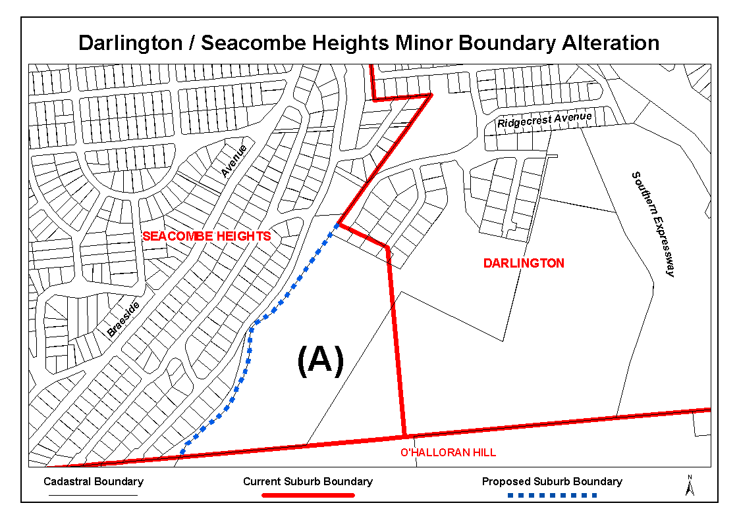
Dated 29 March 2007.
P. M. Kentish, Surveyor-General, Department for Transport Energy and Infrastructure
DAIS 22-413/07/0005

GEOGRAPHICAL NAMES ACT 1991
Notice to Assign a Name to a Place
NOTICE is hereby given pursuant to the provisions of the above Act that I, PETER MACLAREN KENTISH, Surveyor-General and Delegate appointed by Patrick Conlon, Minister for Infrastructure, Minister of the Crown to whom the administration of the Geographical Names Act 1991 is committed DO HEREBY assign the name YURALYPILA AWI URTU LAGOON to that feature located in the vicinity on the 1:50 000 Mapsheet Hawker (6534-2) at latitude -31°53′17″ and longitude 138°20′16″.
Dated 29 March 2007.
P. M. Kentish, Surveyor-General, Department for Transport, Energy and Infrastructure

LAND AND BUSINESS (SALE AND CONVEYANCING)
ACT 1994
Exemption
TAKE notice that, pursuant to section 23 (3) of the Land and Business (Sale and Conveyancing) Act 1994, I, Michael Atkinson, Acting Minister for Consumer Affairs, do hereby exempt the person named in Schedule 1 from the application of section 23 (2) of the Act in relation to the purchase of the land specified in Schedule 2.
Schedule 1
Lee Nathan McVicar, an employee of Potter Valley Pty Ltd.
Schedule 2
The land described in certificate of title register book volume 5024, folio 578, situated at 5/164 Esplanade, Brighton, S.A. 5048.
Dated 28 March 2007.
M. J. Atkinson, Acting Minister for Consumer Affairs

LAND AND BUSINESS (SALE AND CONVEYANCING)
ACT 1994
Exemption
TAKE notice that, pursuant to section 23 (3) of the Land and Business (Sale and Conveyancing) Act 1994, I, Michael Atkinson, Acting Minister for Consumer Affairs, do hereby exempt the person named in Schedule 1 from the application of section 23 (2) of the Act in relation to the purchase of the land specified in Schedule 2.
Schedule 1
Teresa Caminiti, an employee of Toop Real Estate Group Pty Ltd.
Schedule 2
The land described in certificate of title register book volume 5546, folio 28, situated at 4 Dovecote Street, Oakden, S.A. 5086.
Dated 28 March 2007.
M. J. Atkinson, Acting Minister for Consumer Affairs

LAND AND BUSINESS (SALE AND CONVEYANCING)
ACT 1994
Exemption
TAKE notice that, pursuant to section 23 (3) of the Land and Business (Sale and Conveyancing) Act 1994, I, Michael Atkinson, Acting Minister for Consumer Affairs, do hereby exempt the person named in Schedule 1 from the application of section 23 (2) of the Act in relation to the purchase of the land specified in Schedule 2.
Schedule 1
Russell Harry Osborne, an employee of Gawler Real Estate Pty Ltd.
Schedule 2
The whole of the land described in certificate of title register book volume 5577, folio 604, situated at 6 Lewis Avenue, Gawler East, S.A. 5118.
Dated 28 March 2007.
M. J. Atkinson, Acting Minister for Consumer Affairs

LIQUOR LICENSING ACT 1997 AND GAMING MACHINES ACT 1992
Notice of Application
NOTICE is hereby given, pursuant to section 52 of the Liquor Licensing Act 1997 and section 29 of the Gaming Machines Act 1992, that Ramjet Hotels Pty Ltd as trustee for Ramjet Trust has applied to the Licensing Authority for the transfer of a Hotel and Gaming Machine Licence in respect of premises situated at Main Road, Balhannah, S.A. 5242 and known as Hotel Balhannah.
The applications have been set down for hearing on 9 May 2007 at 11 a.m.
Any person may object to the application by lodging a notice of objection in the prescribed form with the Liquor and Gambling Commissioner and serving a copy of the notice on the applicant at the applicant’s address given above, at least seven days before the hearing date (viz: 2 May 2007).
The applicant’s address for service is c/o Piper Alderman Lawyers, 167 Flinders Street, Adelaide, S.A. 5000 (Attention: Geoff Forbes).
Plans in respect of the premises the subject of the application are open to public inspection without fee at the Office of the Liquor and Gambling Commissioner, 9th Floor, East Wing, 50 Grenfell Street, Adelaide, S.A. 5000. Phone 8226 8410, Fax:
8226 8512. Email: olgc@agd.sa.gov.au.
Dated 29 March 2007.
Applicant

LIQUOR LICENSING ACT 1997 AND GAMING MACHINES ACT 1992
Notice of Application
NOTICE is hereby given, pursuant to section 52 of the Liquor Licensing Act 1997 and section 29 of the Gaming Machines Act 1992, that Arthur James Langley and Ursula Langley have applied to the Licensing Authority for the transfer of a Hotel and Gaming Machine Licence in respect of premises situated at Jamestown Road, Hallett, S.A. 5419 and known as Wildongoleechie Hotel.
The applications have been set down for hearing on 7 May 2007 at 10.30 a.m.
Any person may object to the application by lodging a notice of objection in the prescribed form with the Liquor and Gambling Commissioner and serving a copy of the notice on the applicants at the applicants’ address given above, at least seven days before the hearing date (viz: 30 April 2007).
The applicants’ address for service is c/o Geoff Adams, Level 6, 185 Victoria Square, Adelaide, S.A. 5000.
Plans in respect of the premises the subject of the application are open to public inspection without fee at the Office of the Liquor and Gambling Commissioner, 9th Floor, East Wing, 50 Grenfell Street, Adelaide, S.A. 5000. Phone 8226 8410, Fax:
8226 8512. Email: olgc@agd.sa.gov.au.
Dated 29 March 2007.
Applicants

LIQUOR LICENSING ACT 1997 AND GAMING MACHINES ACT 1992
Notice of Application
NOTICE is hereby given, pursuant to section 52 of the Liquor Licensing Act 1997 and section 29 of the Gaming Machines Act 1992, that Saracens Investments Pty Ltd as trustee for the Saracens Head Tavern Unit Trust has applied to the Licensing Authority for the transfer of a Hotel and Gaming Machine Licence, alteration and redefinition of Licensed Area and variation to Extended Trading Authorisation and variation to Entertainment Consent in respect of premises situated at 82 Carrington Street, Adelaide, S.A. 5000 and known as Saracen’s Head.
The applications have been set down for callover on 4 May 2007 at 9 a.m.
Conditions
The following licence conditions are sought:
• The redefinition involves creating a Smoking Area at the rear of the premises.
• Entertainment Consent is not sought for this area.
• Extended Trading Authorisation is sought in this area:
Thursday to Saturday: Midnight to 3 a.m. the following day.
• Variation to Extended Authorisation for Areas 1 to 5:
Sunday: 8 a.m. to 11 a.m. and 8 p.m. to midnight.
Good Friday: Midnight to 2 a.m.
Christmas Day: Midnight to 2 a.m.
Days preceeding a Public Holiday: Midnight to 3 a.m. the following day.
• Variation for consumption off the premises:
Sunday: 8 a.m. to 11 a.m. and 8 p.m. to 9 p.m.
• Entertainment Consent for Areas 1 to 5 for the following hours:
Good Friday: Midnight to 2 a.m.
Christmas Day: Midnight to 2 a.m.
Days preceeding a Public Holiday: Midnight to 3 a.m. the following day.
Any person may object to the application by lodging a notice of objection in the prescribed form with the Liquor and Gambling Commissioner and serving a copy of the notice on the applicant at the applicant’s address given above, at least seven days before the callover date (viz: 27 May 2007).
The applicant’s address for service is c/o Kelly & Co., Level 17, Santos House, 91 King William Street, Adelaide, S.A. 5000 (Attention: Jarrod Ryan).
Plans in respect of the premises the subject of the application are open to public inspection without fee at the Office of the Liquor and Gambling Commissioner, 9th Floor, East Wing, 50 Grenfell Street, Adelaide, S.A. 5000. Phone 8226 8410, Fax:
8226 8512. Email: olgc@agd.sa.gov.au.
Dated 30 March 2007.
Applicant

LIQUOR LICENSING ACT 1997
Notice of Application
NOTICE is hereby given, pursuant to section 52 (2) (b) of the Liquor Licensing Act 1997, that The Wine Underground Pty Ltd has applied to the Licensing Authority for the transfer of a Hotel Licence, Alterations, Redefinition, Extended Trading Author-isation, variation to Entertainment Consent and variation to Conditions in respect of premises situated at 121 Pirie Street, Adelaide, S.A. 5000 and known as The Wine Underground.
The application has been set down for callover on 4 May 2007 at 9 a.m.
Conditions
The following licence conditions are sought:
• Alterations and Redefinition of Trading Area as per plans lodged with this office.
• Extended Trading Authorisation to include all indoor areas and for the following days and times:
Thursday to Saturday: Midnight to 2 a.m. the following day;
Sunday: 8 a.m. to 11 a.m. and 8 p.m. to midnight;
Good Friday: Midnight to 2 a.m.;
Christmas Day: Midnight to 2 a.m.;
Sunday Christmas Eve: 8 p.m. to 2 a.m. the following day;
Days preceding other Public Holidays: Midnight to 2 a.m. the following day;
Sunday preceding Public Holidays: 8 p.m. to 2 a.m. the following day.
• Variation of Entertainment Consent to apply to the above-mentioned hours and areas.
• An order deleting Condition 6 of the licence.
• An order permitting DJs and Rock Bands (excluding Heavy Rock or Heavy Metal) as required for private functions.
Any person may object to the application by lodging a notice of objection in the prescribed form with the Liquor and Gambling Commissioner and serving a copy of the notice on the applicant at the applicant’s address given above, at least seven days before the callover date (viz: 27 April 2007).
The applicant’s address for service is c/o Foreman Legal, 69 Mount Barker Road, Stirling, S.A. 5152.
Plans in respect of the premises the subject of the application are open to public inspection without fee at the Office of the Liquor and Gambling Commissioner, 9th Floor, East Wing, 50 Grenfell Street, Adelaide, S.A. 5000. Phone 8226 8410, Fax:
8226 8512. Email: olgc@agd.sa.gov.au.
Dated 30 March 2007.
Applicant

LIQUOR LICENSING ACT 1997
Notice of Application
NOTICE is hereby given, pursuant to section 52 (2) (b) of the Liquor Licensing Act 1997, that Watervale Wine Assets Pty Ltd (as agent for the Crabtree Watervale Wines Joint Venture) has applied to the Licensing Authority for the transfer of a Producer’s Licence in respect of premises situated at Fairview, North Terrace, Watervale, S.A. 5452, known as Watervale Cellars and to be known as Crabtree Watervale Wines.
The application has been set down for hearing on 23 April 2007 at 10 a.m.
Any person may object to the application by lodging a notice of objection in the prescribed form with the Liquor and Gambling Commissioner and serving a copy of the notice on the applicant at the applicant’s address given above, on or before 20 April 2007.
The applicant’s address for service is c/o Thomson Playford, 101 Pirie Street, Adelaide, S.A. 5000.
Plans in respect of the premises the subject of the application are open to public inspection without fee at the Office of the Liquor and Gambling Commissioner, 9th Floor, East Wing, 50 Grenfell Street, Adelaide, S.A. 5000. Phone 8226 8410, Fax:
8226 8512. Email: olgc@agd.sa.gov.au.
Dated 30 March 2007.
Applicant

LIQUOR LICENSING ACT 1997
Notice of Application
NOTICE is hereby given, pursuant to section 52 (2) (b) of the Liquor Licensing Act 1997, that Michaela Karin Bassett has applied to the Licensing Authority for a Redefinition, variation to Extended Trading Authorisation and variation to Entertainment Consent in respect of premises situated at 32 Saltfleet Street, Port Noarlunga, S.A. 5167 and known as Manoli’s Mezes Mediteranean Cafe.
The application has been set down for hearing on 4 May 2007 at 9 a.m.
Conditions
The following licence conditions are sought:
• The extension of Area 2 (outside) as per plans lodged with this office. This extended area is to include the current Entertainment Consent and Extended Trading Authorisation.
Any person may object to the application by lodging a notice of objection in the prescribed form with the Liquor and Gambling Commissioner and serving a copy of the notice on the applicant at the applicant’s address given above, at least seven days before the hearing date (viz: 27 April 2007).
The applicant’s address for service is c/o Mickey Bassett, P.O. Box 16, Port Noarlunga, S.A. 5167.
Plans in respect of the premises the subject of the application are open to public inspection without fee at the Office of the Liquor and Gambling Commissioner, 9th Floor, East Wing, 50 Grenfell Street, Adelaide, S.A. 5000. Phone 8226 8410, Fax:
8226 8512. Email: olgc@agd.sa.gov.au.
Dated 26 March 2007.
Applicant

LIQUOR LICENSING ACT 1997
Notice of Application
NOTICE is hereby given, pursuant to section 52 (2) (b) of the Liquor Licensing Act 1997, that Ian Christopher and Cathryn Alice Gregory have applied to the Licensing Authority for a variation to Extended Trading Authorisation in respect of premises situated at Main Street, Owen, S.A. 5460 and known as Owen Arms Hotel.
The application has been set down for callover on 4 May 2007 at 9 a.m.
Conditions
The following licence conditions are sought:
• A variation to the Extended Trading Authorisation to include both the outside veranda area and the proposed gaming area as per plans lodged with this office.
Any person may object to the application by lodging a notice of objection in the prescribed form with the Liquor and Gambling Commissioner and serving a copy of the notice on the applicants at the applicants’ address given above, at least seven days before the callover date (viz: 27 April 2007).
The applicants’ address for service is c/o Ian Gregory, Main Street, Owen, S.A. 5460.
Plans in respect of the premises the subject of the application are open to public inspection without fee at the Office of the Liquor and Gambling Commissioner, 9th Floor, East Wing, 50 Grenfell Street, Adelaide, S.A. 5000. Phone 8226 8410, Fax:
8226 8512. Email: olgc@agd.sa.gov.au.
Dated 26 March 2007.
Applicants

LIQUOR LICENSING ACT 1997
Notice of Application
NOTICE is hereby given, pursuant to section 52 (2) (b) of the Liquor Licensing Act 1997, that Byrne & Smith Wines Pty Ltd has applied to the Licensing Authority for a Wholesale Liquor Merchant’s Licence in respect of premises situated at Level 1, 214 Greenhill Road, Eastwood, S.A. 5063 and to be known as Byrne & Smith Wines.
The application has been set down for callover on 4 May 2007 at 9 a.m.
Any person may object to the application by lodging a notice of objection in the prescribed form with the Liquor and Gambling Commissioner and serving a copy of the notice on the applicant at the applicant’s address given above, at least seven days before the callover date (viz: 27 April 2007).
The applicant’s address for service is c/o DLA Phillips Fox, 100 King William Street, Adelaide, S.A. 5000.
Plans in respect of the premises the subject of the application are open to public inspection without fee at the Office of the Liquor and Gambling Commissioner, 9th Floor, East Wing, 50 Grenfell Street, Adelaide, S.A. 5000. Phone 8226 8410, Fax:
8226 8512. Email: olgc@agd.sa.gov.au.
Dated 26 March 2007.
Applicant

LIQUOR LICENSING ACT 1997
Notice of Application
NOTICE is hereby given, pursuant to section 52 (2) (b) of the Liquor Licensing Act 1997, that Tungkillo District Hotel (S.A.) Pty Ltd as trustee for the C. Greening Family Trust has applied to the Licensing Authority for Redefinition, variation to Extended Trading Authorisation and variation to Entertainment Consent in respect of premises situated at Main Road, Tungkillo, S.A. 5236 and known as District Hotel.
The application has been set down for callover on 4 May 2007 at 9 a.m.
Conditions
The following licence conditions are sought:
• Redefinition to include a Beer Garden at the rear of the premises as per plans lodged with this office.
• Variation to Extended Trading Authorisation to include the abovementioned area.
• Variation to Entertainment Consent to include the above-mentioned area.
Any person may object to the application by lodging a notice of objection in the prescribed form with the Liquor and Gambling Commissioner and serving a copy of the notice on the applicant at the applicant’s address given above, at least seven days before the callover date (viz: 27 April 2007).
The applicant’s address for service is c/o District Hotel, Main Road, Tungkillo, S.A. 5236.
Plans in respect of the premises the subject of the application are open to public inspection without fee at the Office of the Liquor and Gambling Commissioner, 9th Floor, East Wing, 50 Grenfell Street, Adelaide, S.A. 5000. Phone 8226 8410, Fax:
8226 8512. Email: olgc@agd.sa.gov.au.
Dated 3 April 2007.
Applicant

LIQUOR LICENSING ACT 1997
Notice of Application
NOTICE is hereby given, pursuant to section 52 (2) (b) of the Liquor Licensing Act 1997, that Hurley Hotels Pty Ltd has applied to the Licensing Authority for a variation to the Extended Trading Authorisation which is in force in respect of premises situated at 95 Belair Road, Kingswood, S.A. 5062 and known as Torrens Arms Hotel.
The application has been set down for callover on 4 May 2007 at 9 a.m.
Conditions
The following licence conditions are sought:
• That the licensee be permitted to sell liquor for con-sumption in the area referred to on the plan held in the Liquor and Gambling Commission as Area 4 each Tuesday from midnight to 2 a.m. the following morning, and each Sunday from 8 a.m. to 11 a.m. and 8 p.m. to midnight.
• Entertainment Consent is not sought for this area.
Any person may object to the application by lodging a notice of objection in the prescribed form with the Liquor and Gambling Commissioner and serving a copy of the notice on the applicant at the applicant’s address given above, at least seven days before the callover date (viz: 27 April 2007).
The applicant’s address for service is c/o The Australian Hotels Association (S.A. Branch), 4th Floor, 60 Hindmarsh Square, Adelaide, S.A. 5000.
Plans in respect of the premises the subject of the application are open to public inspection without fee at the Office of the Liquor and Gambling Commissioner, 9th Floor, East Wing, 50 Grenfell Street, Adelaide, S.A. 5000. Phone 8226 8410, Fax:
8226 8512. Email: olgc@agd.sa.gov.au.
Dated 27 March 2007.
Applicant

LIQUOR LICENSING ACT 1997
Notice of Application
NOTICE is hereby given, pursuant to section 52 (2) (b) of the Liquor Licensing Act 1997, that K. J. Beswick Pty Ltd, P. M. J. Investments Pty Ltd and Tiffean Nominees Pty Ltd have applied to the Licensing Authority for a variation of Conditions of Entertain-ment Consent in respect of premises situated at 505 Bridge Road, Para Hills, S.A. 5096 and known as Somerset Hotel.
The application has been set down for callover on 4 May 2007 at 9 a.m.
Conditions
The following licence conditions are sought:
• The licensees are seeking approval to conduct entertain-ment in the area referred to on the plan held in the Liquor and Gaming Commission as Area 6.
Any person may object to the application by lodging a notice of objection in the prescribed form with the Liquor and Gambling Commissioner and serving a copy of the notice on the applicants at the applicants’ address given above, at least seven days before the callover date (viz: 27 April 2007).
The applicants’ address for service is c/o The Australian Hotels Association (S.A. Branch), 4th Floor, 60 Hindmarsh Square, Adelaide, S.A. 5000.
Plans in respect of the premises the subject of the application are open to public inspection without fee at the Office of the Liquor and Gambling Commissioner, 9th Floor, East Wing, 50 Grenfell Street, Adelaide, S.A. 5000. Phone 8226 8410, Fax:
8226 8512. Email: olgc@agd.sa.gov.au.
Dated 27 March 2007.
Applicants

LIQUOR LICENSING ACT 1997
Notice of Application
NOTICE is hereby given, pursuant to section 52 (2) (b) of the Liquor Licensing Act 1997, that The Eels Rugby League Club Inc. has applied to the Licensing Authority for a Limited Club Licence in respect of premises situated at Lindblom Park, Quinlivan Road, Pooraka, S.A. 5095 and to be known as The Eels Rugby League Club.
The application has been set down for callover on 4 May 2007 at 9 a.m.
Any person may object to the application by lodging a notice of objection in the prescribed form with the Liquor and Gambling Commissioner and serving a copy of the notice on the applicant at the applicant’s address given above, at least seven days before the callover date (viz: 27 April 2007).
The applicant’s address for service is c/o The Eels Rugby League Club Inc., P.O. Box 1129, Golden Grove, S.A. 5125.
Plans in respect of the premises the subject of the application are open to public inspection without fee at the Office of the Liquor and Gambling Commissioner, 9th Floor, East Wing, 50 Grenfell Street, Adelaide, S.A. 5000. Phone 8226 8410, Fax:
8226 8512. Email: olgc@agd.sa.gov.au.
Dated 28 March 2007.
Applicant

LIQUOR LICENSING ACT 1997
Notice of Application
NOTICE is hereby given, pursuant to section 52 (2) (b) of the Liquor Licensing Act 1997, that Rogwil Investments Pty Ltd has applied to the Licensing Authority for approval of Alterations and a variation of the Conditions of Extended Trading Authorisation and Entertainment Consent in respect of premises situated at 423 Churchill Road, Kilburn, S.A. 5084 and known as Albion Hotel.
The application has been set down for callover on 4 May 2007 at 9 a.m.
Conditions
The following licence conditions are sought:
The alterations involve the conversion of the front bar into a dining room, relocation of the gaming room to the area adjacent to the new dining room, creation of a front bar in the old gaming room area and the creation of two outdoor dining areas and a smoking area on the western site of the premises.
The Entertainment Consent is sought to apply to Area 8 on the southern side of the new dining area (to become a function room), the Extended Trading Authorisation is sought to include the new outdoor dining areas, the smoking area and the courtyard, there will be no entertainment in those areas.
All existing licence conditions will remain in force.
Any person may object to the application by lodging a notice of objection in the prescribed form with the Liquor and Gambling Commissioner and serving a copy of the notice on the applicant at the applicant’s address given above, at least seven days before the callover date (viz: 27 April 2007).
The applicant’s address for service is c/o The Australian Hotels Association (S.A. Branch), 4th Floor, 60 Hindmarsh Square, Adelaide, S.A. 5000.
Plans in respect of the premises the subject of the application are open to public inspection without fee at the Office of the Liquor and Gambling Commissioner, 9th Floor, East Wing, 50 Grenfell Street, Adelaide, S.A. 5000. Phone 8226 8410, Fax:
8226 8512. Email: olgc@agd.sa.gov.au.
Dated 28 March 2007.
Applicant

LIQUOR LICENSING ACT 1997
Notice of Application
NOTICE is hereby given, pursuant to section 52 (2) (b) of the Liquor Licensing Act 1997, that Taste of Robe Pty Ltd has applied to the Licensing Authority for a Restaurant Licence in respect of premises situated at 6 Victoria Street, Robe, S.A. 5276 and to be known as Imaj Cafe.
The application has been set down for callover on 4 May 2007 at 9 a.m.
Any person may object to the application by lodging a notice of objection in the prescribed form with the Liquor and Gambling Commissioner and serving a copy of the notice on the applicant at the applicant’s address given above, at least seven days before the callover date (viz: 27 April 2007).
The applicant’s address for service is c/o Westley Digiorgio, 90 Ormerod Street, Naracoorte, S.A. 5271.
Plans in respect of the premises the subject of the application are open to public inspection without fee at the Office of the Liquor and Gambling Commissioner, 9th Floor, East Wing, 50 Grenfell Street, Adelaide, S.A. 5000. Phone 8226 8410, Fax:
8226 8512. Email: olgc@agd.sa.gov.au.
Dated 27 March 2007.
Applicant

LIQUOR LICENSING ACT 1997
Notice of Application
NOTICE is hereby given, pursuant to section 52 (2) (b) of the Liquor Licensing Act 1997, that Platinum Wine Brands Australia Pty Ltd has applied to the Licensing Authority for a Producer’s Licence in respect of premises situated at Lot 23, Mary Street, Coonawarra, S.A. 5263 and to be known as Platinum Wine Brands Australia.
The application has been set down for callover on 4 May 2007 at 9 a.m.
Any person may object to the application by lodging a notice of objection in the prescribed form with the Liquor and Gambling Commissioner and serving a copy of the notice on the applicant at the applicant’s address given above, at least seven days before the callover date (viz: 27 April 2007).
The applicant’s address for service is c/o David Watts, 1 Cator Street, Glenside, S.A. 5065.
Plans in respect of the premises the subject of the application are open to public inspection without fee at the Office of the Liquor and Gambling Commissioner, 9th Floor, East Wing, 50 Grenfell Street, Adelaide, S.A. 5000. Phone 8226 8410, Fax:
8226 8512. Email: olgc@agd.sa.gov.au.
Dated 29 March 2007.
Applicant

LIQUOR LICENSING ACT 1997
Notice of Application
NOTICE is hereby given, pursuant to section 52 (2) (b) of the Liquor Licensing Act 1997, that Michael William Robinson and Carol Robinson have applied to the Licensing Authority for the transfer of a Residential Licence in respect of premises situated at 5 Hackett Street, Port Augusta West, S.A. 5700 and known as Augusta Courtyard Motel.
The application has been set down for hearing on 7 May 2007 at 10 a.m.
Any person may object to the application by lodging a notice of objection in the prescribed form with the Liquor and Gambling Commissioner and serving a copy of the notice on the applicants at the applicants’ address given above, at least seven days before the hearing date (viz: 30 April 2007).
The applicants’ address for service is c/o David Watts and Associates, 1 Cator Street, Glenside, S.A. 5065.
Plans in respect of the premises the subject of the application are open to public inspection without fee at the Office of the Liquor and Gambling Commissioner, 9th Floor, East Wing, 50 Grenfell Street, Adelaide, S.A. 5000. Phone 8226 8410, Fax:
8226 8512. Email: olgc@agd.sa.gov.au.
Dated 27 March 2007.
Applicants

LIQUOR LICENSING ACT 1997
Notice of Application
NOTICE is hereby given, pursuant to section 52 (2) (b) of the Liquor Licensing Act 1997, that Bowling Centres Australia Pty Limited has applied to the Licensing Authority for the transfer of a Special Circumstances Licence in respect of premises situated at The Golden Way, Golden Grove, S.A. 5125 and known as Village Bowl—Golden Grove.
The application has been set down for hearing on 7 May 2007 at 11 a.m.
Any person may object to the application by lodging a notice of objection in the prescribed form with the Liquor and Gambling Commissioner and serving a copy of the notice on the applicant at the applicant’s address given above, at least seven days before the hearing date (viz: 30 April 2007).
The applicant’s address for service is c/o Bowling Centres Australia Pty Limited, P.O. Box 594, Milsons Point, N.S.W. 1565.
Plans in respect of the premises the subject of the application are open to public inspection without fee at the Office of the Liquor and Gambling Commissioner, 9th Floor, East Wing, 50 Grenfell Street, Adelaide, S.A. 5000. Phone 8226 8410, Fax:
8226 8512. Email: olgc@agd.sa.gov.au.
Dated 27 March 2007.
Applicant

LIQUOR LICENSING ACT 1997
Notice of Application
NOTICE is hereby given, pursuant to section 52 (2) (b) of the Liquor Licensing Act 1997, that K. J. Beswick Pty Ltd, P. M. J. Investments Pty Ltd and Tiffean Nominees Pty Ltd have applied to the Licensing Authority for an alteration to the Hotel Licence in respect of premises situated at 505 Bridge Road, Para Hills, S.A. 5096 and known as Somerset Hotel.
The application has been set down for callover on 4 May 2007 at 9 a.m.
Conditions
The following licence conditions are sought:
• The Beer Garden will be established in the area referred to as Area 7 on the plan held in the office of the Liquor and Gambling Commissioner and will be covered with a raised polycarbonate central roof with a canvas roof covering each side of the central roof.
• The licensees are not seeking approval to conduct enter-tainment in the proposed Beer Garden.
Any person may object to the application by lodging a notice of objection in the prescribed form with the Liquor and Gambling Commissioner and serving a copy of the notice on the applicants at the applicants’ address given above, at least seven days before the callover date (viz: 27 April 2007).
The applicants’ address for service is c/o Michael Jeffries, Australian Hotels Association, P.O. Box Rundle Mall, Adelaide, S.A. 5000.
Plans in respect of the premises the subject of the application are open to public inspection without fee at the Office of the Liquor and Gambling Commissioner, 9th Floor, East Wing, 50 Grenfell Street, Adelaide, S.A. 5000. Phone 8226 8410, Fax:
8226 8512. Email: olgc@agd.sa.gov.au.
Dated 30 March 2007.
Applicants

LIQUOR LICENSING ACT 1997
Notice of Application
NOTICE is hereby given, pursuant to section 52 (2) (b) of the Liquor Licensing Act 1997, that Brien Marmion Pty Ltd and John Raymond Jennings have applied to the Licensing Authority for a redefinition and variation to Extended Trading Authorisation in respect of premises situated at 20 Robertson Street, Naracoorte, S.A. 5271 and known as Bushman’s Arms Hotel.
The application has been set down for callover on 4 May 2007 at 9 a.m.
Conditions
The following licence conditions are sought:
• To extend Area 6 (outside) as per plans lodged with this office and incorporating the Extended Trading Authori-sation.
Any person may object to the application by lodging a notice of objection in the prescribed form with the Liquor and Gambling Commissioner and serving a copy of the notice on the applicants at the applicants’ address given above, at least seven days before the callover date (viz: 27 April 2007).
The applicants’ address for service is c/o Jack Jennings, 20 Robertson Street, Naracoorte, S.A. 5271.
Plans in respect of the premises the subject of the application are open to public inspection without fee at the Office of the Liquor and Gambling Commissioner, 9th Floor, East Wing, 50 Grenfell Street, Adelaide, S.A. 5000. Phone 8226 8410, Fax:
8226 8512. Email: olgc@agd.sa.gov.au.
Dated 28 March 2007.
Applicants

LIQUOR LICENSING ACT 1997
Notice of Application
NOTICE is hereby given, pursuant to section 52 (2) (b) of the Liquor Licensing Act 1997, that Chapati House 2 Pty Ltd has applied to the Licensing Authority for the transfer of a Restaurant Licence in respect of premises situated at 6A, 715/727 South Road, Black Forest, S.A. 5035 and known as Chapati House 2.
The application has been set down for hearing on 9 May 2007 at 10 a.m.
Any person may object to the application by lodging a notice of objection in the prescribed form with the Liquor and Gambling Commissioner and serving a copy of the notice on the applicant at the applicant’s address given above, at least seven days before the hearing date (viz: 2 May 2007).
The applicant’s address for service is c/o Vishal Rawat, 17 Marleston Avenue, Ashford, S.A. 5035.
Plans in respect of the premises the subject of the application are open to public inspection without fee at the Office of the Liquor and Gambling Commissioner, 9th Floor, East Wing, 50 Grenfell Street, Adelaide, S.A. 5000. Phone 8226 8410, Fax:
8226 8512. Email: olgc@agd.sa.gov.au.
Dated 30 March 2007.
Applicant

LIQUOR LICENSING ACT 1997
Notice of Application
NOTICE is hereby given, pursuant to section 52 (2) (b) of the Liquor Licensing Act 1997, that Deep Blue Cafe Pty Ltd has applied to the Licensing Authority for a Restaurant Licence in respect of premises situated at 324 Esplanade, Moana, S.A. 5169 and to be known as Deep Blue Cafe.
The application has been set down for callover on 4 May 2007 at 9 a.m.
Any person may object to the application by lodging a notice of objection in the prescribed form with the Liquor and Gambling Commissioner and serving a copy of the notice on the applicant at the applicant’s address given above, at least seven days before the callover date (viz: 27 April 2007).
The applicant’s address for service is c/o 10A Castleton Avenue, Port Noarlunga, S.A. 5167.
Plans in respect of the premises the subject of the application are open to public inspection without fee at the Office of the Liquor and Gambling Commissioner, 9th Floor, East Wing, 50 Grenfell Street, Adelaide, S.A. 5000. Phone 8226 8410, Fax:
8226 8512. Email: olgc@agd.sa.gov.au.
Dated 29 March 2007.
Applicant

LIQUOR LICENSING ACT 1997
Notice of Application
NOTICE is hereby given, pursuant to section 52 (2) (b) of the Liquor Licensing Act 1997, that Woolworths Limited has applied to the Licensing Authority for the removal of a Retail Liquor Merchant’s Licence in respect of premises situated at Tenancy M1, Colonnades Shopping Centre, Noarlunga Centre, S.A. 5168 and to be situated at Pad Site 7, Centro Colonnades Shopping Centre, Noalunga Centre, S.A. 5168, known as Woolworth Liquor, and to be known as Dan Murphy’s.
The application has been set down for callover on 4 May 2007 at 9 a.m.
Any person may object to the application by lodging a notice of objection in the prescribed form with the Liquor and Gambling Commissioner and serving a copy of the notice on the applicant at the applicant’s address given above, at least seven days before the callover date (viz: 27 April 2007).
The applicant’s address for service is c/o Clelands Lawyers, 208 Carrington Street, Adelaide, S.A. 5000 (Attention: Leon McEvoy).
Plans in respect of the premises the subject of the application are open to public inspection without fee at the Office of the Liquor and Gambling Commissioner, 9th Floor, East Wing, 50 Grenfell Street, Adelaide, S.A. 5000. Phone 8226 8410, Fax:
8226 8512. Email: olgc@agd.sa.gov.au.
Dated 30 March 2007.
Applicant

LIQUOR LICENSING ACT 1997
Notice of Application
NOTICE is hereby given, pursuant to section 52 (2) (b) of the Liquor Licensing Act 1997, that Adelaide Juventus Sports & Social Club Inc. has applied to the Licensing Authority for variation to Conditions, variation to Extended Trading Authori-sation and variation to Entertainment Consent in respect of the premises situated at 246-256 Fosters Road, Oakden, S.A. 5086 and known as The Oakden Central.
The application has been set down for hearing on 4 May 2007 at 9 a.m.
Conditions
The following licence conditions are sought:
• Variation to Conditions:
• Variation to Trading Times (including Extended Trading Authorisation from:
Areas 1 to 4:
Sunday to Thursday: 9 a.m. to midnight;
Friday and Saturday: 9 a.m. to 1 a.m. the following day.
Areas 5 and 6:
Sunday to Thursday: 9 a.m. to 9 p.m.;
Friday and Saturday: 9 a.m. to 11 p.m.
• To the following Trading Times (including Extended Trading Authorisation):
Monday to Thursday: 9 a.m. to 1 a.m. the following day;
Friday and Saturday: 9 a.m. to 2 a.m. the following day;
Sunday: 9 a.m. to 1 a.m. the following day.
• To apply to the whole of the Licensed Premises (Areas 1 to 6) as per plans lodged with this office.
• Variation to Entertainment Consent to apply to the abovementioned hours.
Any person may object to the application by lodging a notice of objection in the prescribed form with the Liquor and Gambling Commissioner and serving a copy of the notice on the applicant at the applicant’s address given above, at least seven days before the hearing date (viz: 27 April 2007).
The applicant’s address for service is c/o Adelaide Juventus Sports & Social Club Inc., P.O. Box 579, Greenacres, S.A. 5086.
Plans in respect of the premises the subject of the application are open to public inspection without fee at the Office of the Liquor and Gambling Commissioner, 9th Floor, East Wing, 50 Grenfell Street, Adelaide, S.A. 5000. Phone 8226 8410, Fax:
8226 8512. Email: olgc@agd.sa.gov.au.
Dated 27 March 2007.
Applicant

MINING ACT 1971
NOTICE is hereby given in accordance with section 28 (5) of the Mining Act 1971, that the Minister for Mineral Resources Development proposes to grant an Exploration Licence over the undermentioned area:
Applicant: Monax Mining Limited
Location: Indooroopilly Outstation area—Approximately 170 km south-west of Coober Pedy.
Term: 1 year
Area in km²: 570
Ref.: 2006/00315
Plan and co-ordinates can be found on the PIRSA Sarig website: http://www.minerals.pir.sa.gov.au/sarig or by phoning Mineral Tenements on (08) 8463 3103.
H. Tyrteos, Mining Registrar

MINING ACT 1971
NOTICE is hereby given in accordance with section 28 (5) of the Mining Act 1971, that the Minister for Mineral Resources Development proposes to grant an Exploration Licence over the undermentioned area:
Applicant: Ochre Resources Ltd
Location: Maggie Hill area—Approximately 100 km south-south-east of Leigh Creek.
Term: 1 year
Area in km²: 674
Ref.: 2006/00383
Plan and co-ordinates can be found on the PIRSA Sarig website: http://www.minerals.pir.sa.gov.au/sarig or by phoning Mineral Tenements on (08) 8463 3103.
H. Tyrteos, Mining Registrar

MINING ACT 1971
NOTICE is hereby given in accordance with section 28 (5) of the Mining Act 1971, that the Minister for Mineral Resources Development proposes to grant an Exploration Licence over the undermentioned area:
Applicant: Ochre Resources Ltd
Location: Mount Frome area—Approximately 90 km south-east of Leigh Creek.
Term: 1 year
Area in km²: 256
Ref.: 2006/00384
Plan and co-ordinates can be found on the PIRSA Sarig website: http://www.minerals.pir.sa.gov.au/sarig or by phoning Mineral Tenements on (08) 8463 3103.
H. Tyrteos, Mining Registrar

MINING ACT 1971
NOTICE is hereby given in accordance with section 28 (5) of the Mining Act 1971, that the Minister for Mineral Resources Development proposes to grant an Exploration Licence over the undermentioned area:
Applicant: Coombedown Resources Pty Ltd
Location: Aurora Tank area—Approximately 100 km south-west of Coober Pedy.
Term: 1 year
Area in km²: 30
Ref.: 2006/00415
Plan and co-ordinates can be found on the PIRSA Sarig website: http://www.minerals.pir.sa.gov.au/sarig or by phoning Mineral Tenements on (08) 8463 3103.
H. Tyrteos, Mining Registrar

MINING ACT 1971
NOTICE is hereby given in accordance with section 28 (5) of the Mining Act 1971, that the Minister for Mineral Resources Development proposes to grant an Exploration Licence over the undermentioned area:
Applicant: Southern Exploration Pty Ltd
Location: Aurora Tank area—Approximately 100 km south-west of Coober Pedy.
Term: 1 year
Area in km²: 15
Ref.: 2006/00427
Plan and co-ordinates can be found on the PIRSA Sarig website: http://www.minerals.pir.sa.gov.au/sarig or by phoning Mineral Tenements on (08) 8463 3103.
H. Tyrteos, Mining Registrar

MINING ACT 1971
NOTICE is hereby given in accordance with section 28 (5) of the Mining Act 1971, that the Minister for Mineral Resources Development proposes to grant an Exploration Licence over the undermentioned area:
Applicant: Coombedown Resources Pty Ltd
Location: Sandstone South area—Approximately 115 km south-west of Coober Pedy.
Term: 1 year
Area in km²: 101
Ref.: 2006/00477
Plan and co-ordinates can be found on the PIRSA Sarig website: http://www.minerals.pir.sa.gov.au/sarig or by phoning Mineral Tenements on (08) 8463 3103.
H. Tyrteos, Mining Registrar

MINING ACT 1971
NOTICE is hereby given in accordance with section 28 (5) of the Mining Act 1971, that the Minister for Mineral Resources Development proposes to grant an Exploration Licence over the undermentioned area:
Applicant: Chesser Resources Ltd
Location: Cedric Bore area—Approximately 80 km north of Tarcoola.
Term: 1 year
Area in km²: 228
Ref.: 2007/00122
Plan and co-ordinates can be found on the PIRSA Sarig website: http://www.minerals.pir.sa.gov.au/sarig or by phoning Mineral Tenements on (08) 8463 3103.
H. Tyrteos, Mining Registrar

MINING ACT 1971
NOTICE is hereby given in accordance with section 28 (5) of the Mining Act 1971, that the Minister for Mineral Resources Development proposes to grant an Exploration Licence over the undermentioned area:
Applicant: Caldera Resources Pty Ltd; Ellendale Resources NL
Location: Mount Sarah Homestead area—Approximately 70 km north-west of Oodnadatta.
Term: 1 year
Area in km²: 128
Ref.: 2007/00129
Plan and co-ordinates can be found on the PIRSA Sarig website: http://www.minerals.pir.sa.gov.au/sarig or by phoning Mineral Tenements on (08) 8463 3103.
H. Tyrteos, Mining Registrar

MINING ACT 1971
NOTICE is hereby given in accordance with section 28 (5) of the Mining Act 1971, that the Minister for Mineral Resources Development proposes to grant an Exploration Licence over the undermentioned area:
Applicant: Goldsearch Ltd
Location: De Rose Hill area—Approximately 80 km north of Marla.
Term: 1 year
Area in km²: 782
Ref.: 2007/00134
Plan and co-ordinates can be found on the PIRSA Sarig website: http://www.minerals.pir.sa.gov.au/sarig or by phoning Mineral Tenements on (08) 8463 3103.
H. Tyrteos, Mining Registrar

MINING ACT 1971
Invitation to Submit Exploration Licence Applications
NOTICE is hereby given that the Minister for Mineral Resources Development will be considering Exploration Licence applications over the undermentioned areas. The application period has been extended for a further two weeks from 5 April 2007 up to and including 20 April 2007.
Each application area must quote the reference, and must incorporate the whole of the area (as specified below):
Area 1
Ref.: T02648
Location: McDouall Peak area
Area: 678 km²
Area 2
Ref.: T02649
Location: Bulgunnia area
Area: 522 km²
Area 3
Ref.: T02650
Location: Johns Outstation area
Area: 27 km²
Area 4
Ref.: T02651
Location: Giffen Well area
Area: 30 km²
Applications may be submitted through the PIRSA Sarig website: http://www.minerals.pir.sa.gov.au/sarig; in person (Level 7, 101 Grenfell Street, Adelaide, S.A. 5000); by facsimile (08) 8463 3101 or by email: pirsa.tenements@saugov.sa.gov.au using the Application for Mineral Exploration Licence Form 29.
Plan and co-ordinates can be found on the PIRSA Sarig website: http://www.minerals.pir.sa.gov.au/sarig or by phoning Mineral Tenements on (08) 8463 3103.
H. Tyrteos, Mining Registrar

NATIONAL ELECTRICITY LAW
THE Australian Energy Market Commission (AEMC) gives notice under the National Electricity Law (NEL) of the following matters.
Under section 107, the period of time for the making of the draft determination on the proposed National Electricity Amendment (Cost Recovery of Localised Regulation Services) Rule 2007 has been extended to 17 May 2007.
Under section 95, EnergyAustralia has requested the making of the proposed National Electricity Amendment (Economic Regulation of Transmission Services undertaken by Distributors) Rule 2007. The proposal seeks to amend the approach to economic regulation of transmission assets owned by distribution network service providers. Submissions must be received by 7 May 2007 and forwarded to submissions@aemc.gov.au.
The AEMC publishes all submissions on its website subject to a claim of confidentiality.
Further details on the above matters are available on the AEMC’s website: wwww.aemc.gov.au. All documents in relation to the above matters are published on the AEMC’s website and are available for inspection at the offices of the AEMC.
John Tamblyn
Chairman
Australian Energy Market Commission
Level 16, 1 Margaret Street
Sydney, N.S.W. 2000
Telephone: (02) 8296 7800
Facsimile: (02) 8296 7899
5 April 2007.

NOTICE TO MARINERS
No. 11 of 2007
South Australia—River Murray—Lakes Alexandrina and Albert—Lowered Water Levels—Navigation Hazards
MARINERS are advised that due to the prevailing drought conditions the water levels in the waters of the Murray and Lakes has lowered considerably, particular attention is drawn to the following locations:
• Goolwa upstream of the barrage, including the Finnis and Currency Creek areas, outside of marked channels, shoaling has taken place.
• Lakes in the area around Point Sturt and the Narrows where shoaling is reported to have extended further into the lake, with known sand bars extending much further into the lake.
• From Brinkley to Swan Reach, mariners are advised to stay further out into the river, particularly near long breaks in the willows, or entrances to backwaters.
• From Swan Reach to Blanchetown, many sand bars have formed, and further shoaling of shallow areas has occurred.
Mariners are further advised that the following should be observed when undertaking any water borne activities in these waters:
• Skiing or high speed activities, ensure that the depth available be carefully checked before proceeding.
• When navigating the Narrows, only very shallow drafts with local knowledge should attempt the passage.
• There are no tell tale signs of shoaling. Extreme caution to be used.
• Slow Speed should be observed at all times where water depth is unknown.
• If navigating in unfamiliar waters seek local knowledge before proceeding.
That Mariners note that serious injury or loss of life can occur, by excessive speed or not navigating with caution at any time.
Publications affected: South Australia’s Waters all river charts.
Adelaide, 20 March 2007.
Patrick Conlon, Minister for Transport
DTEI 2007/00313

NOTICE TO MARINERS
No. 12 of 2007
South Australia—River Murray—Renmark, Loxton, Cobdogla, Kingston-on-Murray and Swan Reach—SA Water
Off-takes Boomed
MARINERS are advised that SA Water will be installing algal booms along the River Murray at Renmark, Loxton, Cobdogla, Kingston-on-Murray and Swan Reach Water Treatment Plants.
The booms at Renmark, Cobdogla, Kingston-on-Murray and Swan Reach will be attached to SA Water’s permanent off-take structures and will not be an obstruction to vessel operators.
The boom at Loxton will be positioned a few metres upstream of the SA Water off-take. This should not be an obstruction to River users as it will be located in a shallow area confined by the River bank and the off-take structure.
Easily visible from the River surface the booms are bright orange and will act as a barrier for algal scum which usually floats on the surface of the water. They will remain in place until the risk of algal blooms recedes.
For further information please contact SA Water’s Customer Contact Centre on 1300 650 950.
Mariners are further advised to use extreme caution when navigating in the vicinity of these off-takes.
Publications affected: South Australian Waters River Murray Maps.
Adelaide, 2 April 2007.
Patrick Conlon, Minister for Transport
DTEI 2007/00313

PASSENGER TRANSPORT ACT 1994
Authorisation of Persons to Issue Expiation Notices
NOTICE is hereby given that the following persons have been authorised by the Minister for Transport to issue expiation notices under Regulation 90A of the Passenger Transport (General) Regulations 1994:
Scott Warren Knowles
Rebecca Jayne Kuss
Peter Bawden
Peter McDonald
Phillip Stewart
Dated 23 March 2007.
P. T. Allan, Executive Director, Safety and Regulation Division

PASSENGER TRANSPORT ACT 1994
Appointment of Prescribed Officers
NOTICE is hereby given that the following persons have been authorised by the Minister for Transport as Prescribed Officers under section 57 of the Passenger Transport Act 1994:
Scott Warren Knowles
Rebecca Jayne Kuss
Peter Bawden
Peter McDonald
Phillip Stewart
Dated 23 March 2007.
P. T. Allan, Executive Director, Safety and Regulation Division

THE RENMARK IRRIGATION TRUST
Notice of Water Supply Rate No. 14
AT a meeting of the Renmark Irrigation Trust, duly held on 26 February 2007, a Water Supply Rate incorporating an Access Charge of $126.40 per hectare on all rateable land within the district, and a Delivery Fee of 3.26 cents per kilolitre was declared for the half year ending 30 June 2007. All persons liable are required to pay the amount of the rate, according to the assessment, to the Secretary at the Trust Office.
Dated 3 April 2007.
W. D. Morris, Chief Executive Officer/Secretary

WATER MAINS AND SEWERS

Office of the South Australian Water Corporation
Adelaide, 5 April 2007

WATER MAINS LAID

Notice is hereby given that the following main pipes or parts of main pipes have been laid down by the South Australian Water Corporation in or near the undermentioned water districts and are now available for a constant supply of water to adjacent land.

ADELAIDE WATER DISTRICT

CITY OF ONKAPARINGA
Pine View Close, Old Reynella. p8

CITY OF PLAYFORD
Diment Road, Burton. p11

CITY OF SALISBURY
Diment Road, Burton. p11

WALLAROO WATER DISTRICT

DISTRICT COUNCIL OF THE COPPER COAST
Thompson Street, Wallaroo. p9

WATER MAINS ABANDONED

Notice is hereby given that the undermentioned water mains have been abandoned by the South Australian Water Corporation.

ADELAIDE WATER DISTRICT

CITY OF PLAYFORD
Diment Road, Burton. p11

CITY OF SALISBURY
Diment Road, Burton. p11

BEETALOO COUNTRY LANDS WATER DISTRICT

PORT PIRIE REGIONAL COUNCIL
Across North Bungama Road, Napperby and Bungama. p12
Easement in lots 2 and 1 in LTRO DP 52978, Gulf View Road, Bungama. p12

SEWERS LAID

Notice is hereby given that the following sewers have been laid down by the South Australian Water Corporation in the under-mentioned drainage areas and are now available for house connections.

ADELAIDE DRAINAGE AREA

CITY OF ONKAPARINGA
Across Randell Road, Morphett Vale. FB 1158 p21
Easement in lot 303 in LTRO DP 66580, Randell Road, Morphett Vale. FB 1158 p21

CITY OF TEA TREE GULLY
Hancock Road, Ridgehaven. FB 1158 p20

ALDINGA DRAINAGE AREA

CITY OF ONKAPARINGA
Ryan Avenue, Aldinga Beach. FB 1158 p18
Shelly Avenue, Port Willunga. FB 1158 p19
Coral Avenue, Port Willunga. FB 1158 p19

MURRAY BRIDGE COUNTRY DRAINAGE AREA

THE RURAL CITY OF MURRAY BRIDGE
Easement in lot 6 in LTRO DP 65444, Meyer Road, and lot 527 in LTRO FP 167342, Caroline Street, Murray Bridge. FB 1161 p1

CORRECTIONS

Correction to notices in “Government Gazette” of 8 March 2007.

“SEWERS LAID”

“Notice is hereby given that the undermentioned sewers have been laid down by the South Australian Water Corporation and are not available for house connections.”

“ADELAIDE DRAINAGE AREA”

“CITY OF PORT ADELAIDE ENFIELD”
“Sewerage land (lot 1100 in LTRO DP 54002), Dumfries Avenue, Northgate—100 mm PVC pumping main. FB 1157 p32, 33 and 35-37”
“Across and in Dumfries Avenue, Northgate—100 mm PVC pumping main. FB 1157 p32, 33 and 35-37”
“Folland Avenue, Northgate—100 mm PVC pumping main. FB 1157 p32, 33, 49 and 35”
For “100 mm PVC pumping main” read “150 mm PVC pumping main”

DELETION

Deletion of notice in “Government Gazette” of 22 March 2007.

“SEWERS LAID”

“Notice is hereby given that the following sewers have been laid down by the South Australian Water Corporation in the under-mentioned drainage areas and are now available for house connections.”

“ADELAIDE DRAINAGE AREA”

“CITY OF PORT ADELAIDE ENFIELD”
“Argyle Terrace, Klemzig. FB 1158 p7”

Delete this notice.

A. Howe, Chief Executive Officer, South Australian Water Corporation

IMPORTANT NOTICE
Government Gazette Publication

********************

Anzac Day Holiday Week Publishing Information

Government Gazette Notices
Publishing Date: Thursday, 26 April 2007

Closing date for notices for publication will be
4 p.m. on Monday, 23 April 2007

********************

GOVERNMENT GAZETTE ADVERTISEMENT RATES

To apply from 1 July 2006

$  Agents, Ceasing to Act as 38.00  Associations:  Incorporation 19.30  Intention of Incorporation 47.75  Transfer of Properties 47.75  Attorney, Appointment of 38.00  Bailiff’s Sale 47.75  Cemetery Curator Appointed 28.25  Companies:  Alteration to Constitution 38.00  Capital, Increase or Decrease of 47.75  Ceasing to Carry on Business 28.25  Declaration of Dividend 28.25  Incorporation 38.00  Lost Share Certificates:  First Name 28.25  Each Subsequent Name 9.70  Meeting Final 31.75  Meeting Final Regarding Liquidator’s Report on  Conduct of Winding Up (equivalent to ‘Final  Meeting’)  First Name 38.00  Each Subsequent Name 9.70  Notices:  Call 47.75  Change of Name 19.30  Creditors 38.00  Creditors Compromise of Arrangement 38.00  Creditors (extraordinary resolution that ‘the Com-pany be wound up voluntarily and that a liquidator be appointed’) 47.75  Release of Liquidator⎯Application⎯Large Ad. 75.50  ⎯Release Granted 47.75  Receiver and Manager Appointed 44.00  Receiver and Manager Ceasing to Act 38.00  Restored Name 35.75  Petition to Supreme Court for Winding Up 66.50  Summons in Action 56.50  Order of Supreme Court for Winding Up Action 38.00  Register of Interests⎯Section 84 (1) Exempt 85.50  Removal of Office 19.30  Proof of Debts 38.00  Sales of Shares and Forfeiture 38.00  Estates:  Assigned 28.25  Deceased Persons⎯Notice to Creditors, etc. 47.75  Each Subsequent Name 9.70  Deceased Persons⎯Closed Estates 28.25  Each Subsequent Estate 1.25  Probate, Selling of 38.00  Public Trustee, each Estate 9.70 |  | $  Firms:  Ceasing to Carry on Business (each insertion) 25.25  Discontinuance Place of Business 25.25  Land⎯Real Property Act:  Intention to Sell, Notice of 47.75  Lost Certificate of Title Notices 47.75  Cancellation, Notice of (Strata Plan) 47.75  Mortgages:  Caveat Lodgement 19.30  Discharge of 20.20  Foreclosures 19.30  Transfer of 19.30  Sublet 9.70  Leases⎯Application for Transfer (2 insertions) each 9.70  Lost Treasury Receipts (3 insertions) each 28.25  Licensing 56.50  Municipal or District Councils:  Annual Financial Statement⎯Forms 1 and 2 532.00  Electricity Supply⎯Forms 19 and 20 378.00  Default in Payment of Rates:  First Name 75.50  Each Subsequent Name 9.70  Noxious Trade 28.25  Partnership, Dissolution of 28.25  Petitions (small) 19.30  Registered Building Societies (from Registrar-  General) 19.30  Register of Unclaimed Moneys⎯First Name 28.25  Each Subsequent Name 9.70  Registers of Members⎯Three pages and over:  Rate per page (in 8pt) 242.00  Rate per page (in 6pt) 320.00  Sale of Land by Public Auction 48.25  Advertisements 2.70  ¼ page advertisement 113.00  ½ page advertisement 226.00  Full page advertisement 443.00  Advertisements, other than those listed are charged at $2.70 per column line, tabular one-third extra.  Notices by Colleges, Universities, Corporations and District Councils to be charged at $2.70 per line.  Where the notice inserted varies significantly in length from that which is usually published a charge of $2.70 per column line will be applied in lieu of advertisement rates listed.  South Australian Government publications are sold on the condition that they will not be reproduced without prior permission from the Government Printer.
All the above prices include GST

GOVERNMENT GAZETTE NOTICES
ALL private advertisements forwarded for publication in the South Australian Government Gazette must be PAID FOR PRIOR TO INSERTION; and all notices, from whatever source, should be legibly written on one side of the paper only and sent to Government Publishing SA so as to be received no later than 4 p.m. Tuesday preceding the day of publication. Phone 8207 1045 or Fax 8207 1040. E-mail: governmentgazette@saugov.sa.gov.au. Send as attachments in Word format. Please include date the notice is to be published and to whom the notice will be charged. The Government Gazette is available online at: www.governmentgazette.sa.gov.au.

MISCELLANEOUS LEGISLATION AND GOVERNMENT PUBLICATIONS PRICES AS FROM 1 JULY 2006

Acts, Bills, Rules, Parliamentary Papers and Regulations
Pages | Main | Amends | Pages | Main | Amends

1-16 | 2.30 | 1.05 | 497-512 | 32.25 | 31.25
17-32 | 3.10 | 1.95 | 513-528 | 33.25 | 32.00
33-48 | 4.05 | 2.90 | 529-544 | 34.25 | 33.25
49-64 | 5.10 | 3.90 | 545-560 | 35.25 | 34.25
65-80 | 6.00 | 4.95 | 561-576 | 36.00 | 35.25
81-96 | 6.95 | 5.75 | 577-592 | 37.00 | 35.75
97-112 | 7.90 | 6.75 | 593-608 | 38.25 | 36.75
113-128 | 8.90 | 7.75 | 609-624 | 39.00 | 38.00
129-144 | 9.95 | 8.80 | 625-640 | 40.00 | 38.50
145-160 | 10.90 | 9.70 | 641-656 | 41.00 | 40.00
161-176 | 11.90 | 10.70 | 657-672 | 41.50 | 40.50
177-192 | 12.90 | 11.70 | 673-688 | 43.25 | 41.50
193-208 | 13.90 | 12.80 | 689-704 | 44.00 | 42.50
209-224 | 14.70 | 13.60 | 705-720 | 44.75 | 43.50
225-240 | 15.70 | 14.50 | 721-736 | 46.50 | 44.50
241-257 | 16.80 | 15.30 | 737-752 | 47.00 | 45.50
258-272 | 17.70 | 16.30 | 753-768 | 48.00 | 46.25
273-288 | 18.70 | 17.50 | 769-784 | 48.50 | 47.75
289-304 | 19.50 | 18.40 | 785-800 | 49.50 | 48.75
305-320 | 20.70 | 19.40 | 801-816 | 50.50 | 49.25
321-336 | 21.50 | 20.30 | 817-832 | 51.50 | 50.50
337-352 | 22.60 | 21.40 | 833-848 | 52.50 | 51.50
353-368 | 23.50 | 22.40 | 849-864 | 53.50 | 52.00
369-384 | 24.50 | 23.40 | 865-880 | 54.50 | 53.50
385-400 | 25.50 | 24.30 | 881-896 | 55.00 | 54.00
401-416 | 26.50 | 25.00 | 897-912 | 56.50 | 55.00
417-432 | 27.50 | 26.25 | 913-928 | 57.00 | 56.50
433-448 | 28.50 | 27.25 | 929-944 | 58.00 | 57.00
449-464 | 29.25 | 28.00 | 945-960 | 59.00 | 57.50
465-480 | 29.75 | 29.00 | 961-976 | 60.50 | 58.50
481-496 | 31.25 | 29.75 | 977-992 | 61.50 | 59.00

Legislation—Acts, Regulations, etc: $
Subscriptions:
Acts 199.00
All Bills as Laid 477.00
Rules and Regulations 477.00
Parliamentary Papers 477.00
Bound Acts 221.00
Index 110.00
Government Gazette
Copy 5.20
Subscription 263.00
Hansard
Copy 14.50
Subscription—per session (issued weekly) 414.00
Cloth bound—per volume 178.00
Subscription—per session (issued daily) 414.00
Legislation on Disk
Whole Database 3063.00
Annual Subscription for fortnightly updates 941.00
Individual Act(s) including updates POA
Compendium
Subscriptions:
Subscriptions 1815.00
Updates 640.00
(All the above prices include GST)

All Legislation, Government Gazette, Hansard and Legislation on disk are available from:
Counter Sales Service SA, Government Legislation⁺ Outlet
and Mail Orders: Lands Titles Office, 101 Grenfell Street, Adelaide, S.A. 5000
Phone: 13 23 24 (local call cost), Fax: (08) 8204 1909
Postal: G.P.O. Box 1707, Adelaide, S.A. 5001

Online Shop: www.shop.service.sa.gov.au

Subscriptions and Government Publishing SA
Standing Orders: Box 9, Plaza Level, Riverside Centre, North Terrace, Adelaide, S.A. 5000
Phone: (08) 8207 1043, (08) 8207 0910, Fax: (08) 8207 1040

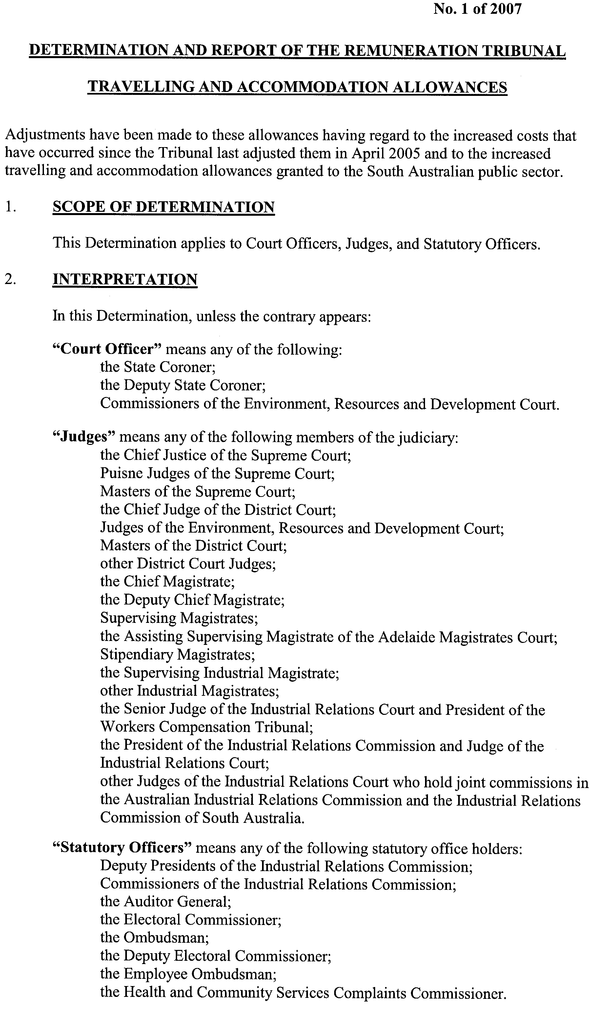

Dated 30 March 2007.
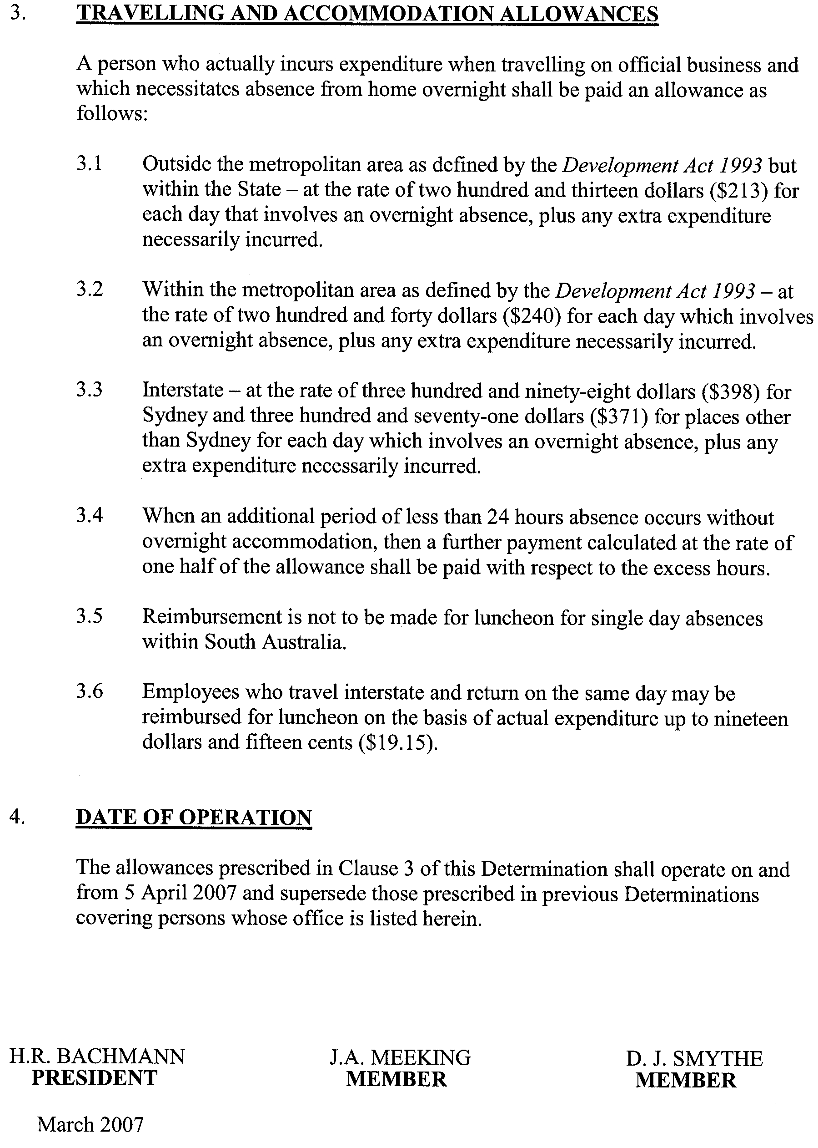
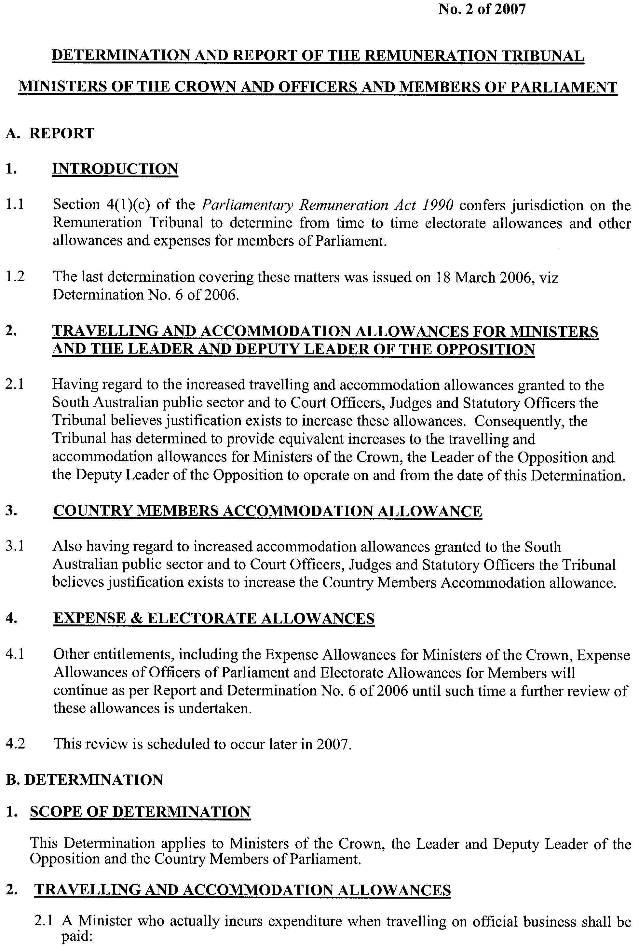

Dated 30 March 2007.

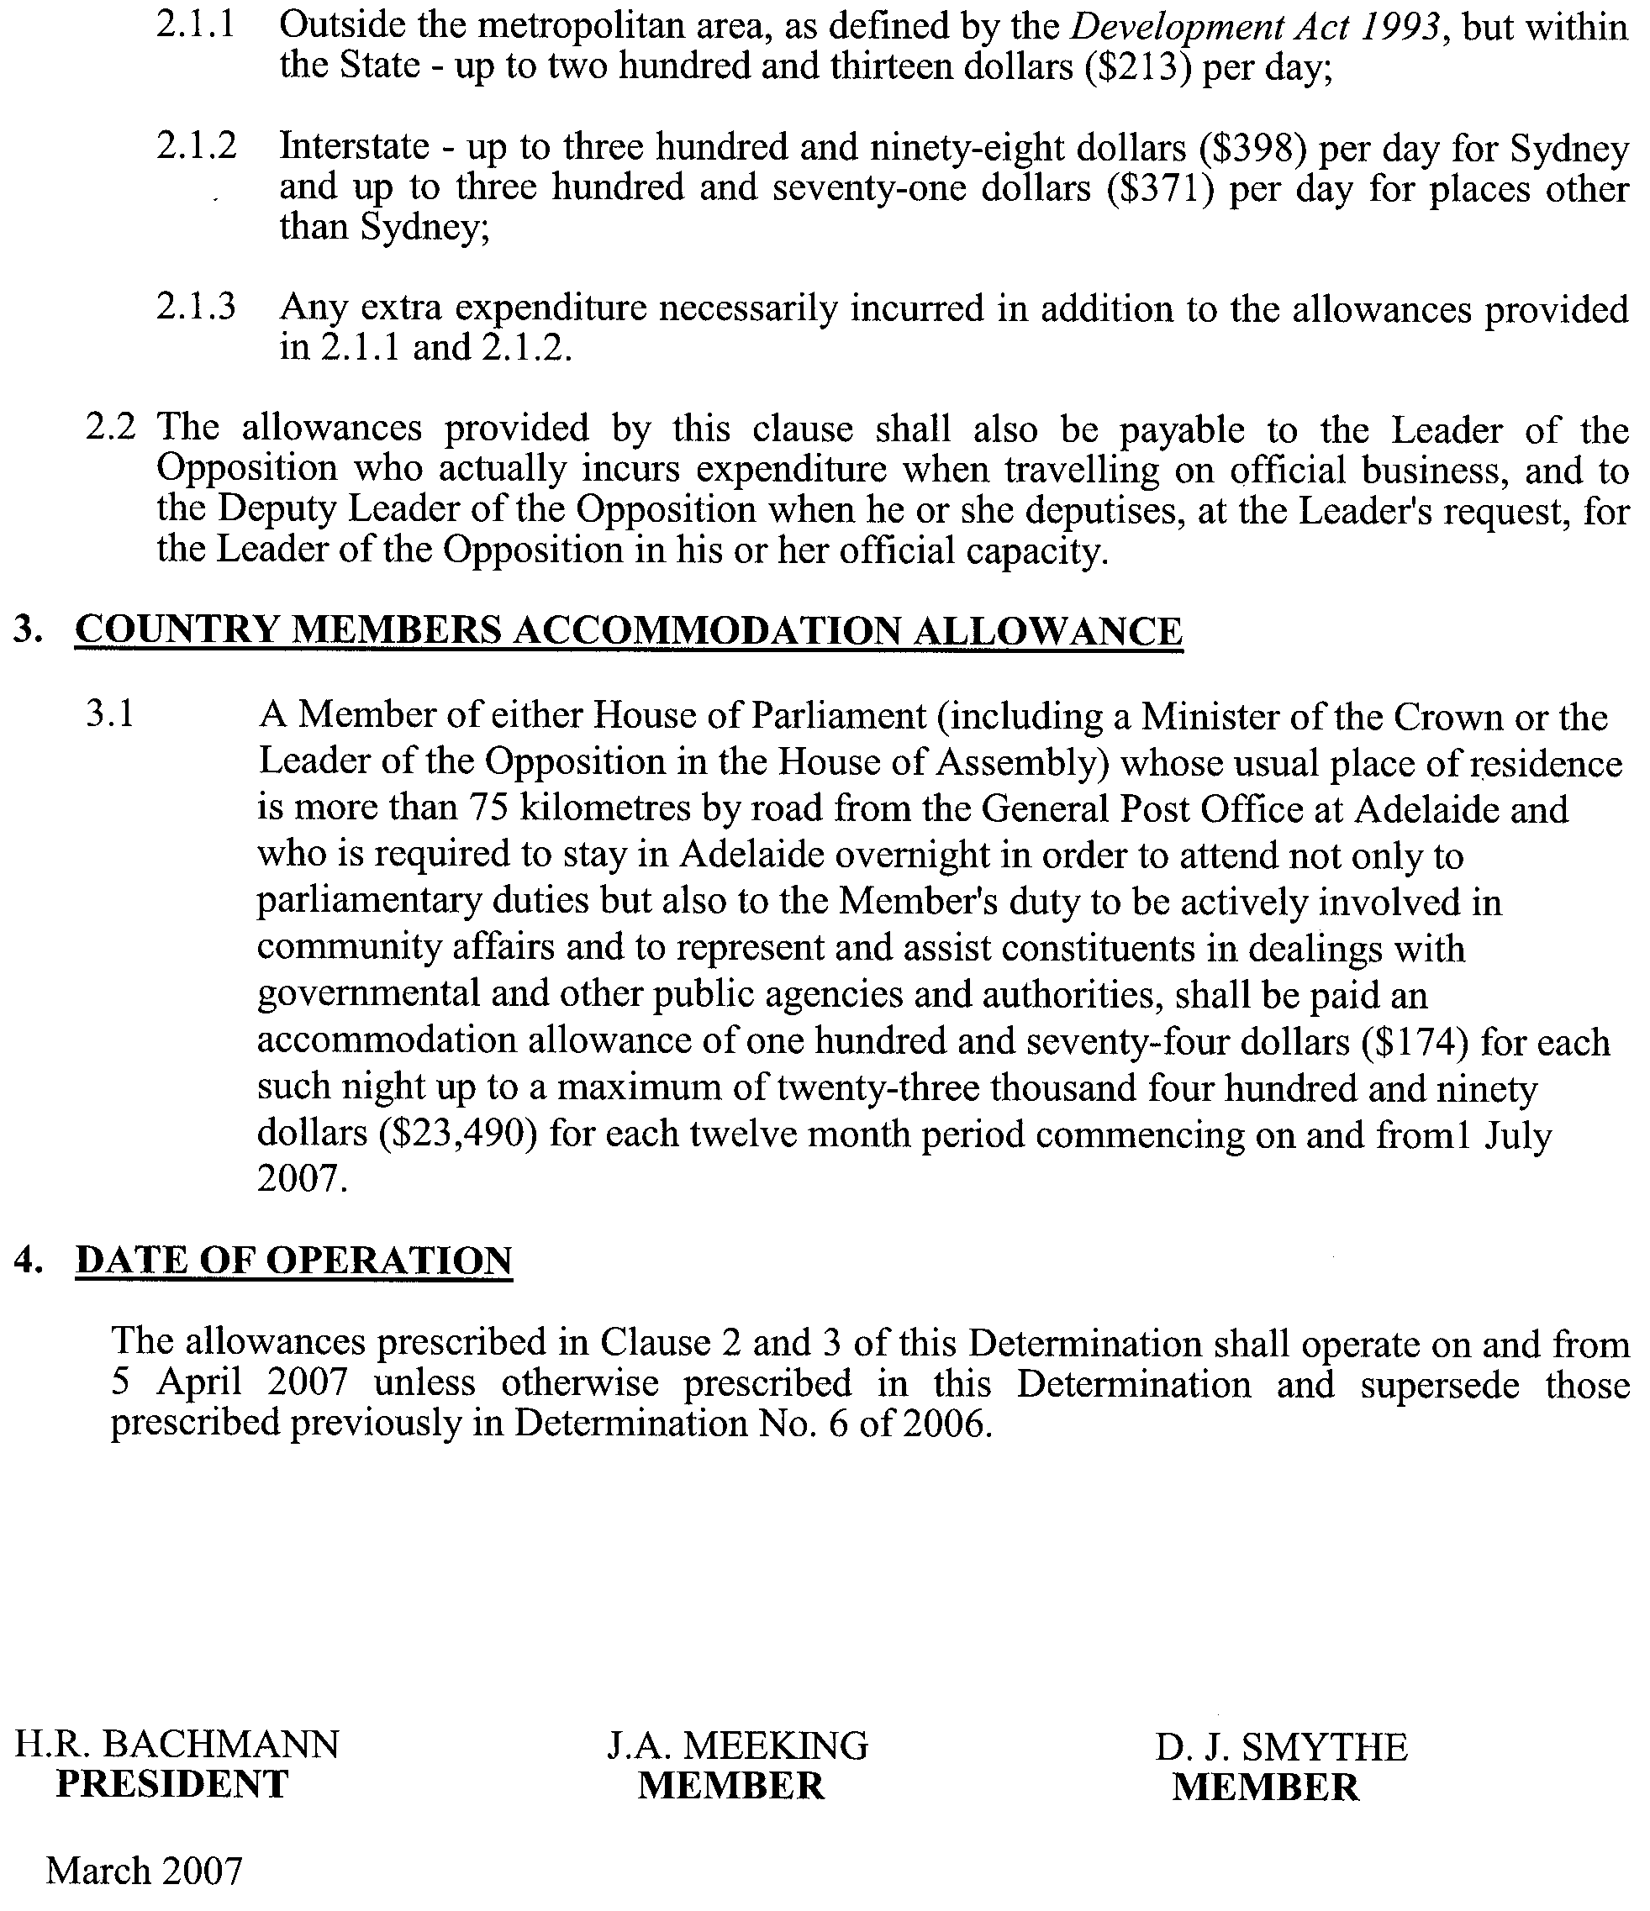
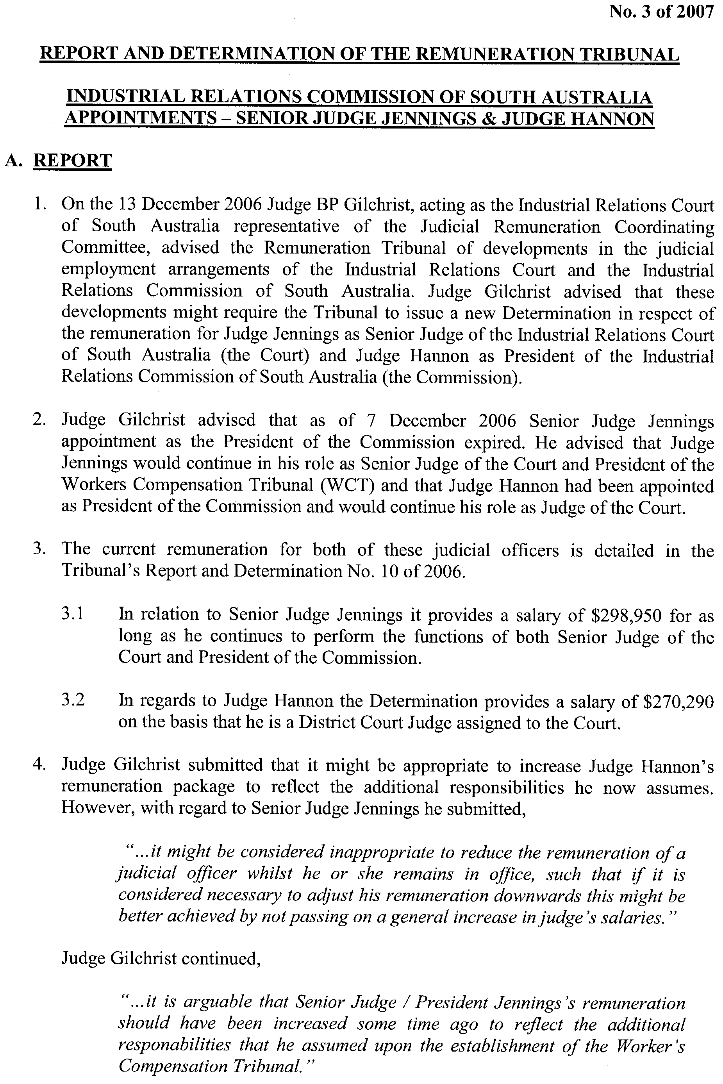
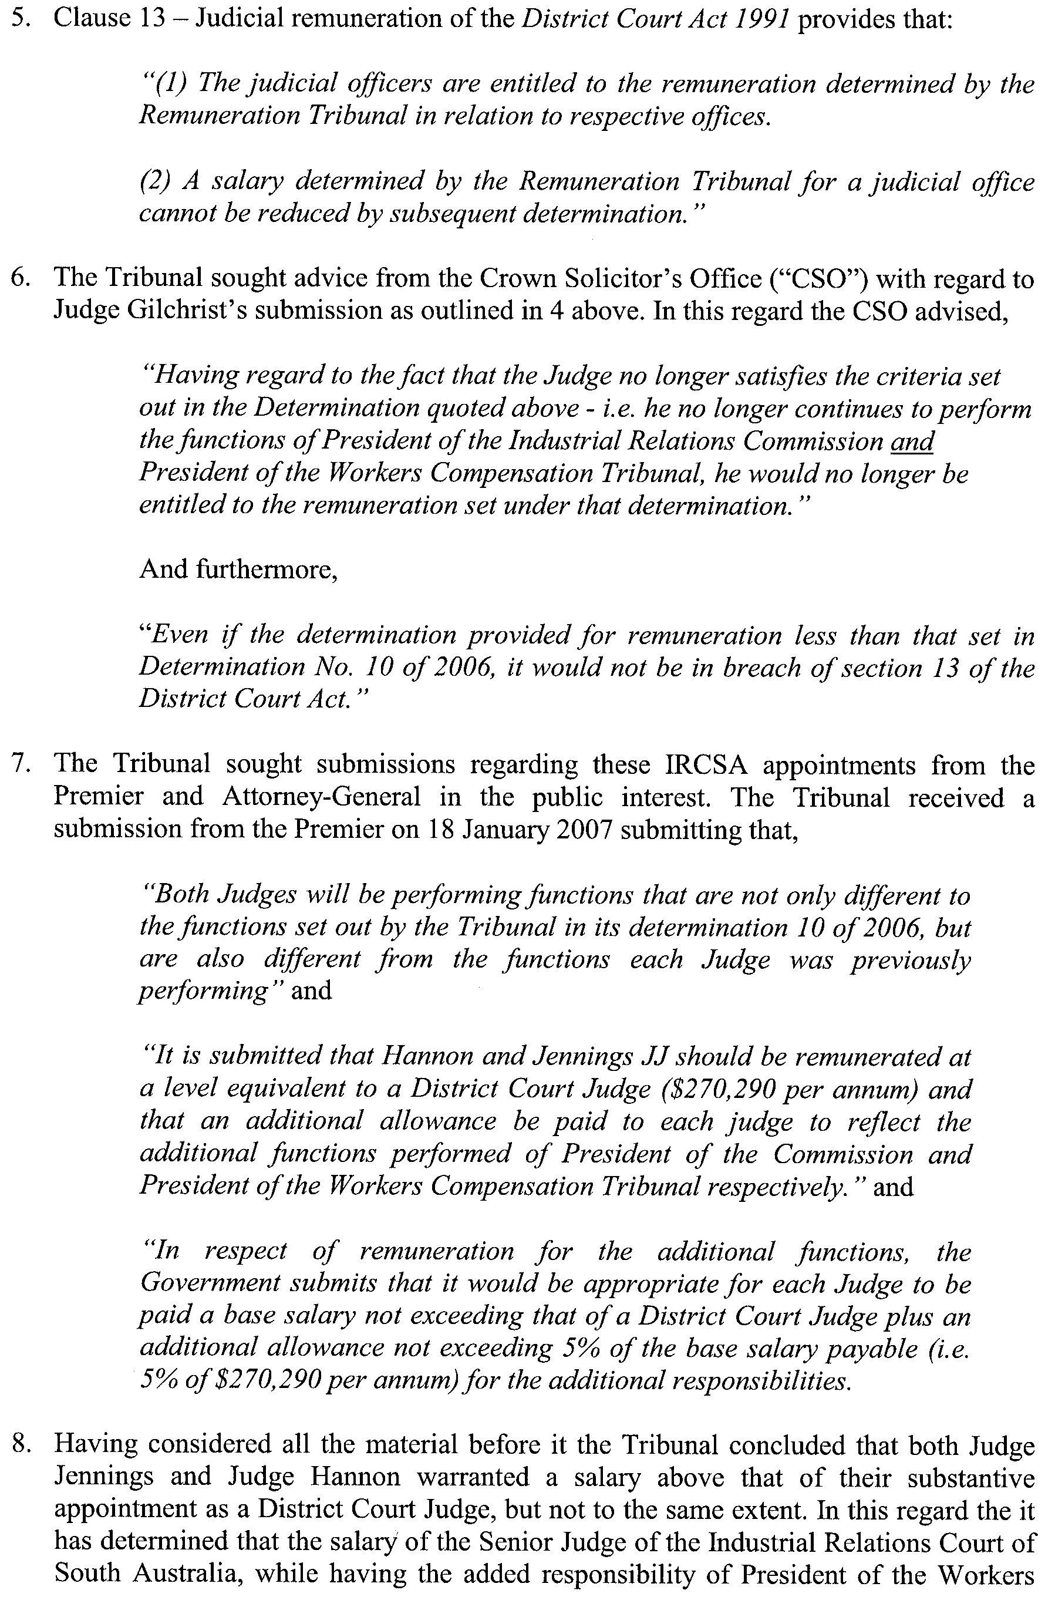
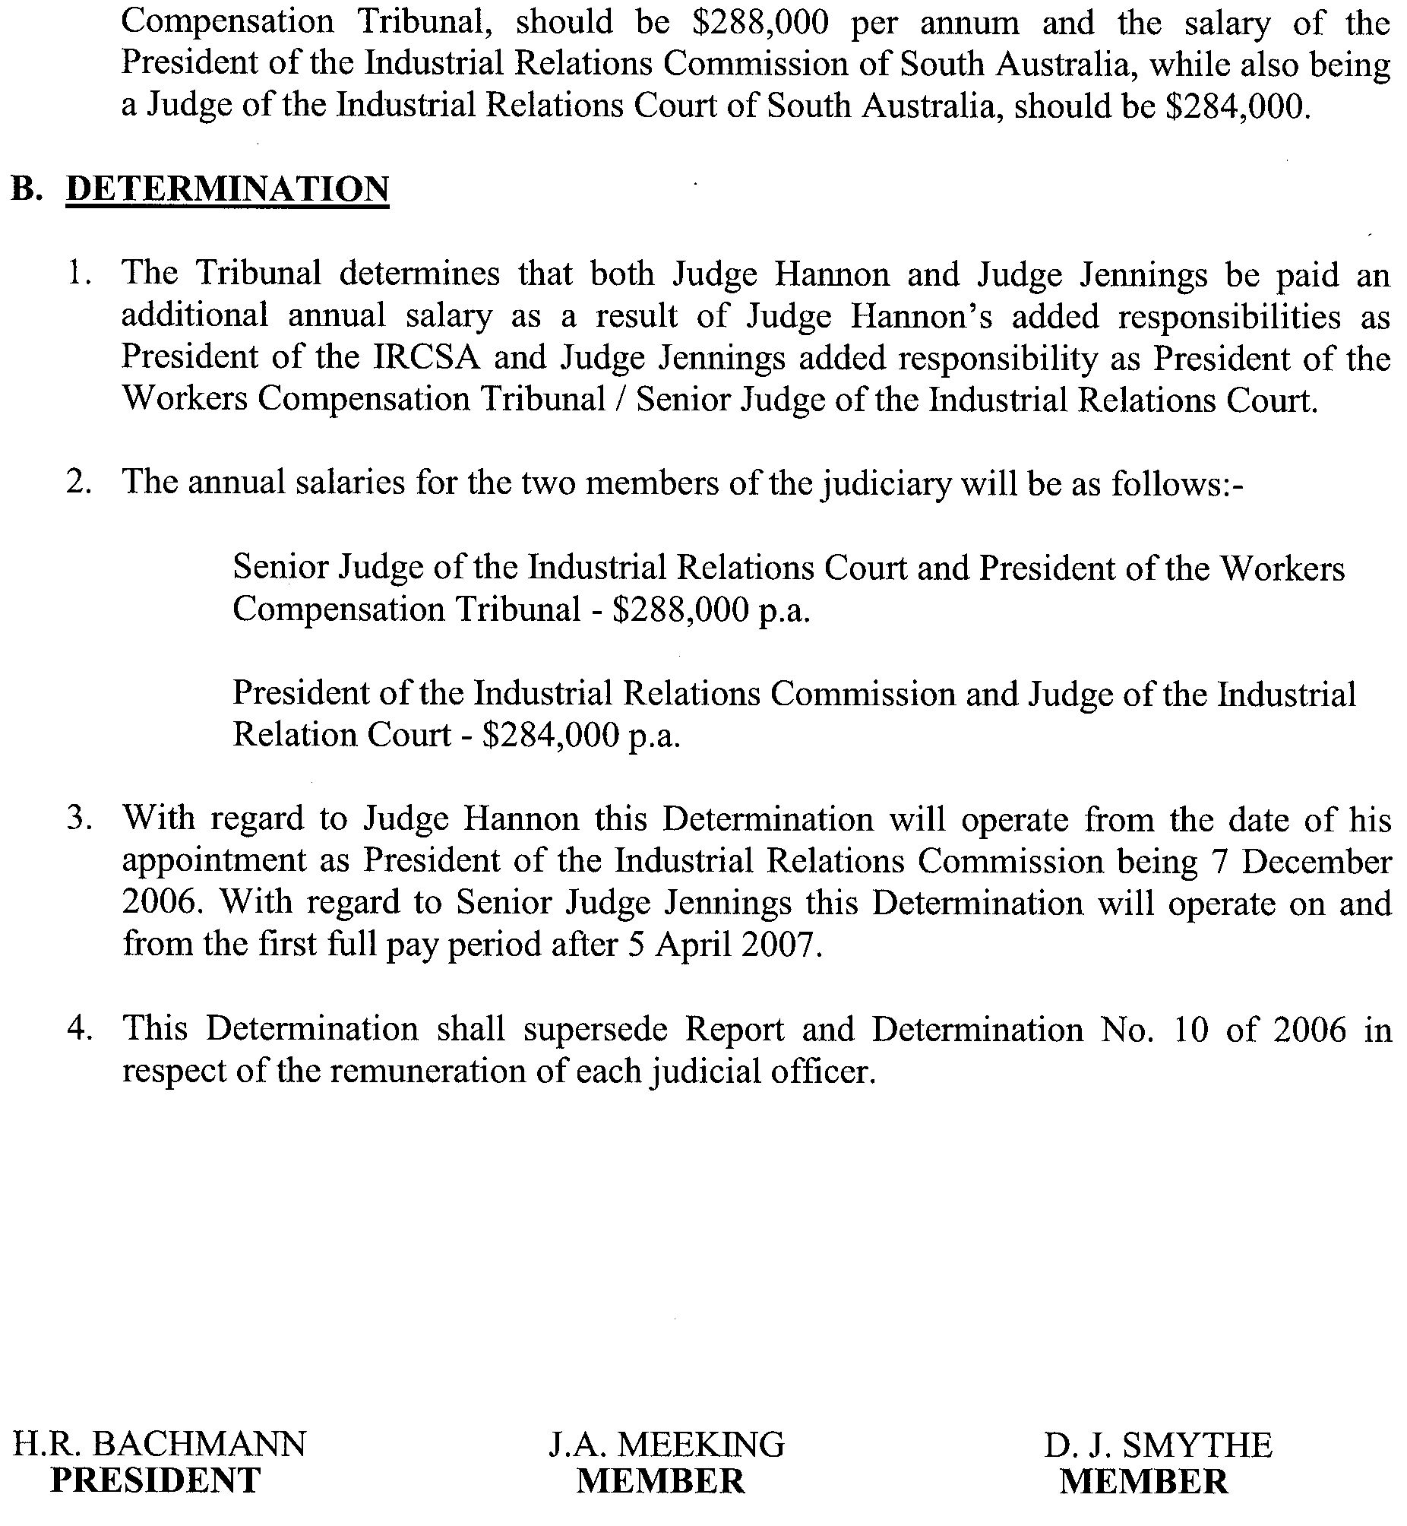
Dated 30 March 2007.

South Australia
Administrative Arrangements (Committal of Acts) Proclamation 2007
under section 5 of the Administrative Arrangements Act 1994
1—Short title
This proclamation may be cited as the Administrative Arrangements (Committal of Acts) Proclamation 2007.
2—Commencement
This proclamation comes into operation on the day on which it is made.
3—Committal of Acts
The administration of an Act referred to in Schedule 1 is committed to the Minister whose title appears at the head of the list in which the Act appears.
Schedule 1—Acts committed to Ministers

Minister for Finance
Freedom of Information Act 1991
State Procurement Act 2004
State Records Act 1997
Minister for Infrastructure
Public Employees Housing Act 1987
Minister for Water Security
Rates and Land Tax Remission Act 1986
Made by the Governor
with the advice and consent of the Executive Council
on 5 April 2007
DPC050/96Pt13CS

South Australia
Constitution (Second Session of 51st Parliament) Proclamation 2007
under section 6 of the Constitution Act 1934
1—Short title
This proclamation may be cited as the Constitution (Second Session of 51st Parliament) Proclamation 2007.
2—Commencement
This proclamation comes into operation on the day on which it is made.
3—Prorogation of Parliament
I prorogue the Parliament of South Australia.
4—Second session of 51st Parliament
(1) I fix 12 noon on 24 April 2007 as the time for holding the second session of the 51st Parliament.
(2) I declare that the place for holding the Parliament will be the building known as Parliament House at North Terrace, Adelaide.
(3) I summon the Parliament to meet for the dispatch of business at the time and place stated above and require all honourable members of the Legislative Council and the House of Assembly, and all officers of the Parliament, to attend accordingly.
Made by the Governor
with the advice and consent of the Executive Council
on 5 April 2007
DPC037/99CS

South Australia
Environment Protection (General) Variation Regulations 2007
under the Environment Protection Act 1993

Contents
Part 1—Preliminary
1 Short title
2 Commencement
3 Variation provisions
Part 2—Variation of Environment Protection (General) Regulations 1994
4 Variation of regulation 4—Environment Protection Fund (section 24)

Part 1—Preliminary
1—Short title
These regulations may be cited as the Environment Protection (General) Variation Regulations 2007.
2—Commencement
These regulations come into operation on the day on which they are made.
3—Variation provisions
In these regulations, a provision under a heading referring to the variation of specified regulations varies the regulations so specified.
Part 2—Variation of Environment Protection (General) Regulations 1994
4—Variation of regulation 4—Environment Protection Fund (section 24)
Regulation 4—after subregulation (2) insert:
(2a) For the purposes of section 24(3)(ba) of the Act, the prescribed percentage of amounts recovered by the Authority, by negotiation or as a result of civil proceedings, in respect of a contravention of this Act to be paid into the Environment Protection Fund is 100 per cent.
Note—
As required by section 10AA(2) of the Subordinate Legislation Act 1978, the Minister has certified that, in the Minister's opinion, it is necessary or appropriate that these regulations come into operation as set out in these regulations.
Made by the Governor
with the advice and consent of the Executive Council
on 5 April 2007
No 31 of 2007
EP07/0001

South Australia
Liquor Licensing (Dry Areas—Long Term) Variation Regulations 2007
under the Liquor Licensing Act 1997

Contents
Part 1—Preliminary
1 Short title
2 Commencement
3 Variation provisions
Part 2—Variation of Liquor Licensing (Dry Areas—Long Term) Regulations 1997
4 Variation of Schedule 1—Long term dry areas
5 Variation of Schedule 2—Plans of long term dry areas
Schedule 1—Plan to be substituted

Part 1—Preliminary
1—Short title
These regulations may be cited as the Liquor Licensing (Dry Areas—Long Term) Variation Regulations 2007.
2—Commencement
These regulations come into operation on the day on which they are made.
3—Variation provisions
In these regulations, a provision under a heading referring to the variation of specified regulations varies the regulations so specified.
Part 2—Variation of Liquor Licensing (Dry Areas—Long Term) Regulations 1997
4—Variation of Schedule 1—Long term dry areas
(1) Schedule 1, item headed "Grange—Area 1", column headed "Period"—delete "2007" and substitute:
2010
(2) Schedule 1, item headed "Henley Beach—Area 1", column headed "Period"—delete "2007" and substitute:
2010
(3) Schedule 1, item headed "Henley Beach—Area 2", column headed "Area"—delete "South Street" wherever occurring and substitute in each case:
Gilmore Road
(4) Schedule 1, item headed "Henley Beach—Area 2", column headed "Period"—delete "2007" and substitute:
2010
(5) Schedule 1, item headed "Henley Beach South—Area 1", column headed "Period"—delete "2007" and substitute:
2010
(6) Schedule 1, item headed "West Beach—Area 1", column headed "Period"—delete "2007" and substitute:
2010
5—Variation of Schedule 2—Plans of long term dry areas
Schedule 2, plan headed "Henley Beach—Plan No 1"—delete the plan and substitute the plan headed "Henley Beach—Plan No 1" in Schedule 1 of these regulations
Schedule 1—Plan to be substituted
Henley Beach—Plan No 1
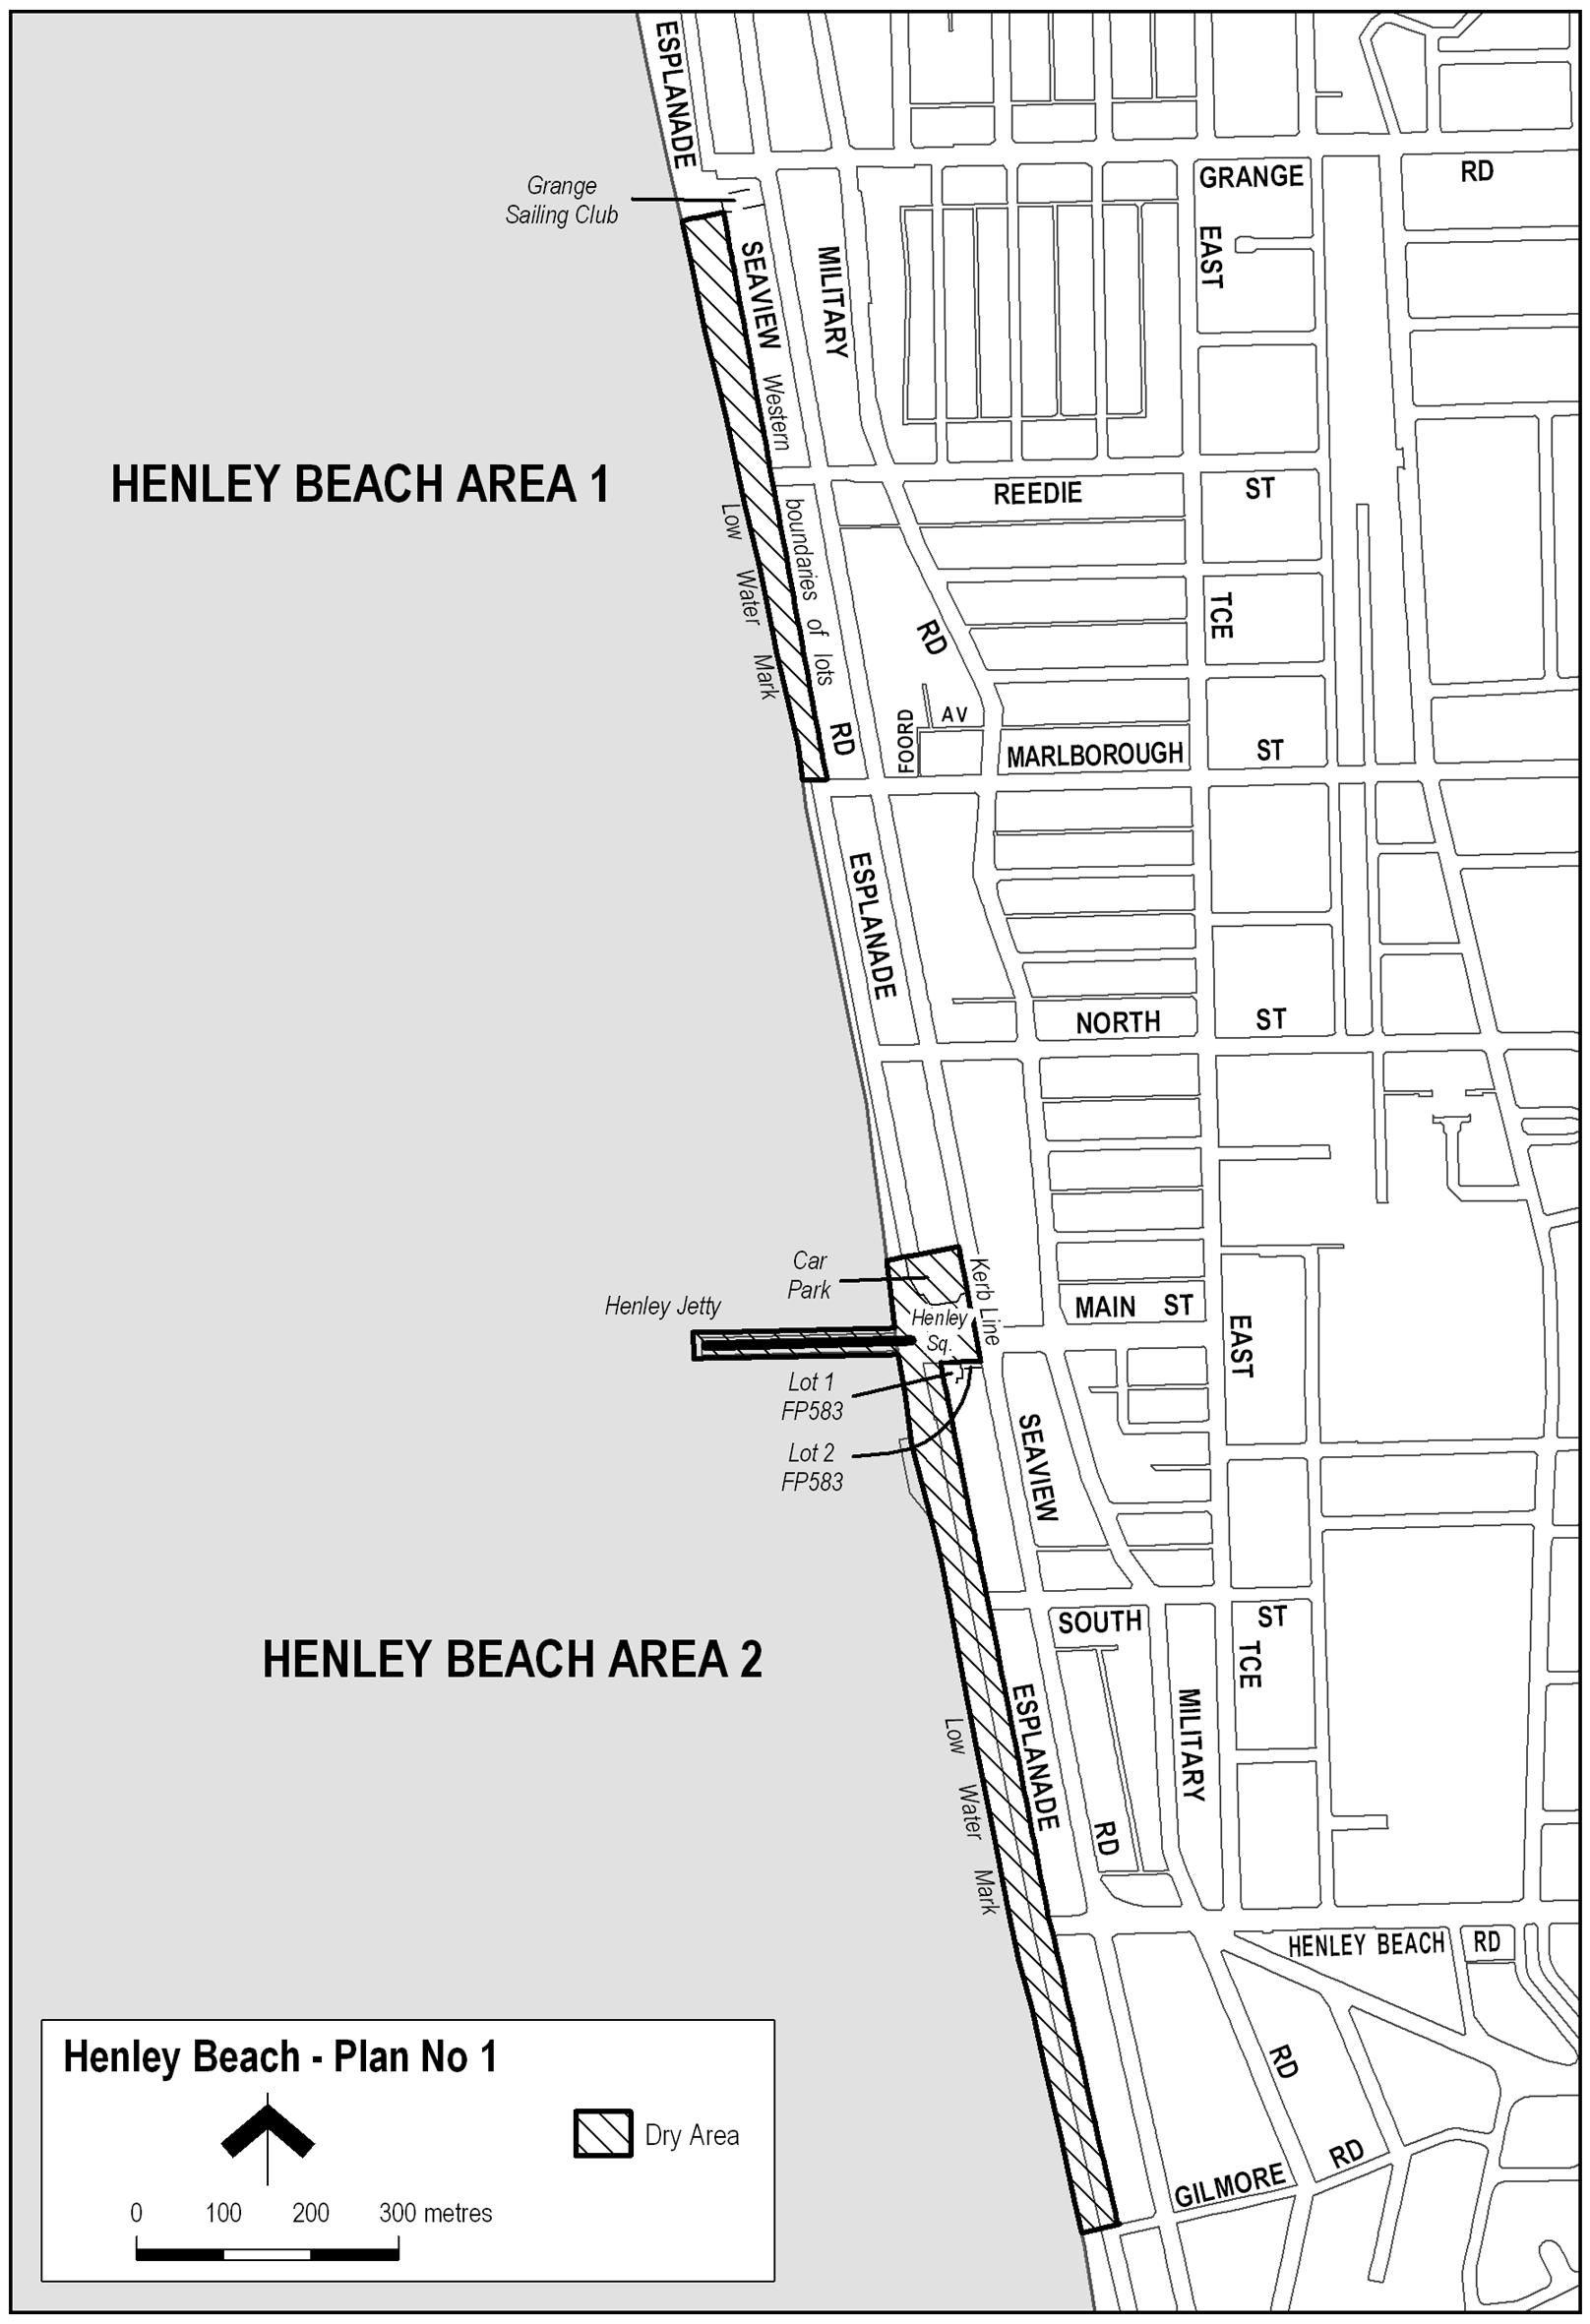
Note—
As required by section 10AA(2) of the Subordinate Legislation Act 1978, the Minister has certified that, in the Minister's opinion, it is necessary or appropriate that these regulations come into operation as set out in these regulations.
Made by the Governor
with the advice and consent of the Executive Council
on 5 April 2007
No 32 of 2007
MCA07/012CS

South Australia
Liquor Licensing (Dry Areas—Long Term) Variation Regulations 2007
under the Liquor Licensing Act 1997

Contents
Part 1—Preliminary
1 Short title
2 Commencement
3 Variation provisions
Part 2—Variation of Liquor Licensing (Dry Areas—Long Term) Regulations 1997
4 Variation of Schedule 1—Long term dry areas

Part 1—Preliminary
1—Short title
These regulations may be cited as the Liquor Licensing (Dry Areas—Long Term) Variation Regulations 2007.
2—Commencement
These regulations come into operation on the day on which they are made.
3—Variation provisions
In these regulations, a provision under a heading referring to the variation of specified regulations varies the regulations so specified.
Part 2—Variation of Liquor Licensing (Dry Areas—Long Term) Regulations 1997
4—Variation of Schedule 1—Long term dry areas
Schedule 1, item headed "Millicent—Area 1", column headed "Period"—delete "1 March 2007" and substitute:
12 April 2008
Note—
As required by section 10AA(2) of the Subordinate Legislation Act 1978, the Minister has certified that, in the Minister's opinion, it is necessary or appropriate that these regulations come into operation as set out in these regulations.
Made by the Governor
with the advice and consent of the Executive Council
on 5 April 2007
No 33 of 2007
MCA 07/011CS

FAXING COPY?
IF you fax copy to Government Publishing SA for inclusion in the Government Gazette, there is no need to send a Confirmation Copy to us as well.
This creates confusion and may well result in your notice being printed twice.
Please use the following fax number:
Fax transmission: (08) 8207 1040
Phone Inquiries: (08) 8207 1045
Please include a contact person, phone number and order number so that we can phone back with any queries we may have regarding the fax copy.
NOTE: Closing time for lodging new copy (fax, hard copy or email) is 4 p.m. on Tuesday preceding the day of publication.

Government Gazette notices can be E-mailed.
The address is:
governmentgazette@saugov.sa.gov.au
Documents should be sent as attachments in Word format.
When sending a document via E-mail, please confirm your transmission with a faxed copy of your document, including the date the notice is to be published.
Fax transmission: (08) 8207 1040
Enquiries: (08) 8207 1045
NOTE: Closing time for lodging new copy (fax, hard copy or email) is 4 p.m. on Tuesday preceding the day of publication.

CITY OF PLAYFORD
Roads (Opening and Closing) Act 1991
Road Closure—Tatura Road, Munno Para West
NOTICE is hereby given, pursuant to section 10 of the Roads (Opening and Closing) Act 1991, that the City of Playford proposes to make a Road Process Order to close and retain portion of the public road (Tatura Road) adjoining Curtis Road between allotment 64 in Deposited Plan 6438 and allotment 38 in Deposited Plan 66345 shown and more particularly delineated and lettered ‘A’ in Preliminary Plan No. 07/0028. This closed road is to be excluded from classification as community land.
A copy of the plan and a statement of persons affected are available for public inspection at the offices of the Council, Warooka Drive, Smithfield, S.A. 5114 and at the Adelaide office of the Surveyor-General during normal working hours.
Any application for easement or objection must set out the full name, address and details of the submission and must be fully supported by reasons.
The application for easement or objection must be made in writing to the Council, 12 Bishopstone Road, Davoren Park, S.A. 5113 within 28 days of this notice and a copy must be forwarded to the Surveyor-General, G.P.O. Box 1354, Adelaide, S.A. 5001. Where a submission is made, the Council will give notification of a meeting at which time the matter will be considered.
Dated 8 January 2007.
T. Jackson, Chief Executive Officer

CITY OF PORT ADELAIDE ENFIELD
Roads (Opening and Closing) Act 1991
Road Closure—Wingfield Road, Wingfield
NOTICE is hereby given, pursuant to section 10 of the Roads (Opening and Closing) Act 1991, that the City of Port Adelaide Enfield proposes to make a Road Process Order to close the greater portion of Wingfield Road between South Terrace and Railway Terrace and adjoining allotment 702 in Deposited Plan 67923 and piece 517 in Deposited Plan 58861 as delineated and lettered ‘A’ and ‘B’ on Preliminary Plan No. 06/0037.
A copy of the plan and a statement of persons affected are available for public inspection at the Civic Centre, 163 St Vincent Street, Port Adelaide, S.A. 5015, the Council offices situated in the Enfield, Greenacres and Parks Libraries and the office of the Surveyor-General, 101 Grenfell Street, Adelaide, during normal office hours.
Any application for easement or objection must set out the full name, address and details of the submission and must be fully supported by reasons.
The application for easement or objection must be made in writing to the Council, P.O. Box 110, Port Adelaide, S.A. 5015 within 28 days of this notice and a copy must be forwarded to the Surveyor-General, G.P.O. Box 1354, Adelaide, S.A. 5001. Where a submission is made, the Council will give notification of a meeting at which the matter will be considered.
Dated 5 April 2007.
H. J. Wierda, City Manager

PORT AUGUSTA CITY COUNCIL
Declaration of Public Road
NOTICE is hereby given, pursuant to section 208 (4) of the Local Government Act 1999, that Council at its meeting held on Monday, 26 March 2007, resolved to declare Mathews Street, Port Augusta West as delineated within Deposited Plan 873, as a public road.
J. G. Stephens, City Manager

CITY OF WHYALLA
Allocation of Road Names
NOTICE is hereby given that the Council of the City of Whyalla at its meeting held on Monday, 19 March 2007, passed a resolution, pursuant to section 219 (1) of the Local Government Act 1999, to allocate the following:
For the road created in subdivision 850/D033/06 on Lot 28 (bounded by Mirambeena Drive and Essington Lewis Avenue), certificate of title volume 5938, folio 740, to be named Darmody Place.
For the road created in subdivision 850/C001/98 on Lot 51 (bounded by Bean and Lacey Streets) certificate of title volume 5396, folio 202, to be named O’Brien Close.
P. Cameron, Chief Executive Officer

CLARE & GILBERT VALLEYS COUNCIL
Development Act 1993
Clare & Gilbert Valleys Council Development Plan—Mintaro Plan Amendment Report—Draft for Public Consultation
NOTICE is hereby given that the Clare & Gilbert Valleys Council has prepared a draft Plan Amendment Report to update the planning policies contained in the Clare & Gilbert Valleys Development Plan. The area affected is the Mintaro State Heritage Area, covering the township of Mintaro and surrounds.
The main changes to the Clare & Gilbert Valleys Development Plan are:
• creation of desired character statements for each of the land use zones in Mintaro, with better definition of the ‘open character’ to be conserved;
• rationalisation of the number of Policy Areas within the Residential (Mintaro) Zone;
• increasing the minimum lot size in some parts of the Residential (Mintaro) Zone;
• expanding the Residential (Mintaro) Zone on the western side of Mintaro;
• minimising repetition within the planning guidelines; and
• expanding the design guidelines relating to new residential development.
The draft Plan Amendment Report including the Statement of Investigations will be available for public inspection during normal office hours at:
Clare & Gilbert Valleys Council
4 Gleeson Street
Clare, S.A. 5453
www.claregilbertvalleys.sa.gov.au
The draft Plan Amendment Report is also available at Council’s library and website from Wednesday, 28 March 2007 to Friday,
8 June 2007. A copy of the Plan Amendment Report can be purchased from the Council or library for $10 each.
During the statutory consultation process, interested persons can attend a community information session to be held on Friday,
4 May 2007 at the Mintaro Institute between 7.30 p.m. and 9.30 p.m.
Written submissions regarding the draft Plan Amendment Report may be made to Council up until 5 p.m. on Friday, 8 June 2007. Interested persons making written submissions should clearly indicate whether they wish to speak at a public hearing. All submissions should be addressed to the Chief Executive Officer of the Clare & Gilbert Valleys Council at the abovementioned address.
Copies of all submissions received will be available for inspection by interested persons at the Clare & Gilbert Valleys Council Office from Monday, 11 June 2007 until the date of the public hearing.
A public hearing will be held at the Clare & Gilbert Valleys Council Chambers at the abovementioned address on Monday,
25 June 2007 at 7 p.m. The public hearing may not be held if persons making submissions indicate no interest in speaking at the public hearing.
Dated 28 March 2007.
M. Goldstone, Chief Executive Officer

THE FLINDERS RANGES COUNCIL
Temporary Road Closure
NOTICE is hereby given that pursuant to section 33 of the Road Traffic Act 1961, that part of Stokes Road, from its intersection with Altmann Road to the eastern side of the railway crossing near the Railway Workshops, Quorn, will be closed from 4 p.m. on Friday, 20 April 2007 until 8 a.m. on Monday, 23 April 2007, for the Pichi Richi Railway Preservation Society Incorporated’s ‘Steam Up Weekend’ event.
L. E. Connors, Chief Executive Officer

LIGHT REGIONAL COUNCIL
Development Act 1993
Light Regional Council Development Plan—Industry (Kingsford Regional Estate) Zone Plan Amendment Report—
Draft for Public Consultation
NOTICE is hereby given that the Light Regional Council has prepared a draft Industry (Kingsford Regional Estate) Zone Plan Amendment Report (PAR) to amend the Light Regional Council Development Plan.
The Industry (Kingsford Regional Estate) Zone PAR will amend the Light Regional Council Development Plan by amending the policy framework relating to industrial development within the existing industrial estate known as Kingsford and its surrounds. Specific policy amendments relate to appropriate land uses, scale of development, minimum allotment sizes in the event of land division, integrated stormwater management, potential stormwater re-use, potential future expansion of the zone, internal traffic movements as well as a consistent approach to signage and landscaping.
The draft Plan Amendment Report will be available for public inspection and purchase during normal office hours at the Council offices being the Principal Office, 93 Main Street, Kapunda, or the Branch Office, 12 Hanson Street, Freeling. The draft Plan Amendment Report is also available at Council’s library and on Council’s website www.light.sa.gov.au from 4 April 2007 to
13 June 2007.
A copy of the Plan Amendment Report can be purchased from the Council office at $45 each.
Written submissions regarding the draft amendment will be accepted by Council until 5 p.m. on 13 June 2007. Written sub-mission should also clearly indicate whether you wish to speak at the public hearing on your submission. All submissions should be addressed to the Chief Executive Officer of the Light Regional Council with mailing address P.O. Box 72, Kapunda, S.A. 5373.
Copies of all submissions received will be available for inspection by interested persons at the Light Regional Council offices from 15 June 2007 until the date of the public hearing.
A public hearing will be held at 7.30 p.m. at the Council Chamber, 93 Main Street, Kapunda, S.A. 5373 on Wednesday,
20 June 2007.
A public hearing may not be held if submissions indicate no interest in speaking at the public hearing.
Dated 4 April 2007.
B. Carr, Acting Chief Executive Officer

DISTRICT COUNCIL OF MOUNT BARKER
Rates Review Committee
NOTICE is hereby given that the District Council of Mount Barker advises of the appointment of the following persons as members of the Rates Review Committee:
Councillor Gamble
Councillor Hamilton
Councillor Irvine
Councillor Stokes
Councillor Wilksch
Andrew Stuart, Chief Executive Officer
Narelle Jeffery, General Manager, Corporate and Community Services
The Committee will meet at the Local Government Centre, 23 Mann Street, Mount Barker, fortnightly on the second and fourth Tuesday of the month at 9 a.m. and as required.
A. Stuart Chief Executive Officer

NARACOORTE LUCINDALE COUNCIL
Change of Council/Key Committee Meeting Date and Venue
NOTICE is hereby given that at a meeting held on 27 March 2007, it was resolved that the Council/Key Committee meeting for April 2007 be held on Tuesday, 24 April 2007, commencing at 4.30 p.m. in the Lucindale War Memorial Hall, Centenary Avenue, Lucindale.
T. Tol, Acting Chief Executive Officer

NARACOORTE LUCINDALE COUNCIL
Appointment
NOTICE is hereby given that at a meeting of Council held on 27 March 2007 and pursuant to section 102 of the Local Government Act 1999, Daryl Ian Smith was appointed Acting Chief Executive Officer for the period from Thursday, 5 April 2007 to Monday, 30 April 2007, while the Chief Executive Officer is on annual leave.
T. Tol, Acting Chief Executive Officer

PORT PIRIE REGIONAL COUNCIL
Roads (Opening and Closing) Act 1991
Portion of Public Road—Redhill
NOTICE is hereby given that pursuant to section 10 of the Roads (Opening and Closing) Act 1991, the Port Pirie Regional Council proposes to make a Road Process Order to close portion of public road adjacent to allotment 170 in Filed Plan 216587 and allotment 93 in Filed Plan 199934 and more particularly delineated and marked ‘A’ in Preliminary Plan No. 07/0018.
The portion marked ‘A’, is to be transferred and merged with adjoining allotment 93 in Filed Plan 199934.
A copy of the preliminary plan and statement of persons affected is available for public inspection at the Council Office, 115 Ellen Street, Port Pirie or at the Adelaide office of the Surveyor-General, during normal office hours.
Any person affected may object to the proposed road process, or apply for an easement to be granted in that person’s favour over the land subject to the proposed road closure. Such objection, or application for an easement, must set out the full name and address of the person and reason for making the objection or application. Any application for an easement must give full particulars of the nature and location of the easement and, where made by a person as the owner of adjoining or nearby land, specify the land to which the easement is to be annexed.
An objection, or application for an easement, must be lodged in writing to the Port Pirie Regional Council, 115 Ellen Street, Port Pirie, S.A. 5540 and a copy lodged with the Surveyor-General, G.P.O. Box 1354, Adelaide, S.A. 5001, within 28 days of this notice.
Where an objection, or application for an easement is made, the Council will give notification of a meeting at which the matter will be considered, so that the person making the objection or application may attend, if so desired, personally or by a representative.
I. L. Burfitt, Chief Executive Officer

WATTLE RANGE COUNCIL
Development Act 1993
Wattle Range Council Development Plan—Better Development Plan (BDP) Conversion and General Plan Amendment Report—Draft for Public Consultation
NOTICE is hereby given that Wattle Range Council has prepared a draft Plan Amendment Report (PAR) to amend the Wattle Range Council Development Plan.
The PAR converts the existing Development Plan policy by adopting the relevant planning modules, structure and format of the Better Development Plan (BDP) project promoted by Planning SA. The PAR will, as a result, be easier to navigate and com-prehend and thereby help improve the clarity and understanding of Development Plan policy. The PAR also deals with residential and rural living issues in Millicent, residential and industrial issues in Beachport, residential and rural living issues in Southend and rural living issues in Penola.
The draft Plan Amendment Report and statement will be available for public inspection and purchase during normal office hours at Wattle Range Council Offices, Civic Centre, George Street, Millicent, Millicent Road, Beachport and 27 Arthur Street, Penola and will be available on Council’s website at www.wattlerange.sa.gov.au from Thursday, 5 April 2007 until 5 p.m. on Thursday, 7 June 2007. A CD-ROM copy of the Plan Amendment Report can be purchased from Council’s offices for $5.
Written submissions regarding the draft amendment will be accepted by Wattle Range Council until 5 p.m. on Thursday,
7 June 2007. All submissions should be addressed to the Chief Executive Officer, Wattle Range Council, P.O. Box 27, Millicent, S.A. 5280. The written submission should clearly indicate whether or not you wish to speak at the public hearing on your submission.
Copies of all written submissions received will be available for inspection by interested persons at Council’s offices from Monday, 11 June 2007 until the public hearings. Public hearings will be held at the Millicent Civic and Arts Centre on Tuesday,
19 June 2007, commencing at 5.30 p.m. and at the Penola Sports Club on Wednesday, 20 June 2007 at 5.30 p.m.
The public hearing may not be held if no submission indicates an interest in speaking at the public hearing.
Dated 5 April 2007.
F. N. Brennan, Chief Executive Officer

IN the matter of the estates of the undermentioned deceased persons:
Anderson, Thane Anhony, late of 296 Military Road, Largs Bay, storekeeper, who died on 14 June 2006.
Bartsch, Wilhelmine Candace, late of 50 Gulfview Road, Christies Beach, widow, who died on 7 January 2007.
Crowhurst, Cyril Murray, late of Grand Junction Road, Oakden, of no occupation, who died on 14 August 1998.
Garnaut, Lily May, late of 324 Military Road, Semaphore, of no occupation, who died on 24 December 2006.
Inns, Violet Annie, late of 20-36 Gardenia Drive, Parafield Gardens, widow, who died on 20 February 2007.
Jackson, Effie Dawn, late of 150 Reynell Road, Woodcroft, of no occupation, who died on 11 January 2007.
McGee, Sophie Marguerite Marie, late of 27 Celtic Avenue, Clovelly Park, registered nurse, who died on 15 December 2005.
Piwonski, Lech Ludwik, late of 9 Sabre Street, Netley, retired train guard, who died on 20 August 2006.
Sands, Mary Edna, late of 33 High Street, Cheltenham, of no occupation, who died on 10 January 2007.
Teague, Edwin Valentine, late of 29 Austral Terrace, Morphettville, retired leather cutter, who died on 12 January 2007.
Willsmore, Hazel Kathleen, late of Albert Street, Gumeracha, retired teacher, who died on 4 February 2007.
Young, Lorna Eunice, late of 14 Frew Street, Fullarton, of no occupation, who died on 13 January 2007.
Notice is hereby given pursuant to the Trustee Act 1936, as amended, the Inheritance (Family Provision) Act 1972, and the Family Relationships Act 1975, that all creditors, beneficiaries, and other persons having claims against the said estates are required to send, in writing, to the Public Trustee, 25 Franklin Street, Adelaide, S.A. 5000, full particulars and proof of such claims, on or before 4 May 2007, otherwise they will be excluded from the distribution of the said estate; and notice is also hereby given that all persons who are indebted to the said estates are required to pay the amount of their debts to the Public Trustee or proceedings will be taken for the recovery thereof; and all persons having any property belonging to the said estates are forthwith to deliver the same to the Public Trustee.
Dated 5 April 2007.
C. J. O’Loughlin, Public Trustee

EQUITY TREE (1973) CO-OPERATIVE LIMITED
(In Voluntary Liquidation)
NOTICE is hereby given that by special postal ballot, it was resolved on 20 March 2007, that the co-operative be wound up voluntarily in accordance with the provisions of the Co-operatives Act 1997 and the Corporations Act relating to members voluntary winding up and that George Divitkos be appointed liquidator for the purpose of such winding up.
Dated 20 March 2007.
G. Divitkos, Liquidator

ATTENTION

CUSTOMERS requiring a proof of their notice for inclusion in the Government Gazette, please note that the onus is on you to inform Government Publishing SA of any subsequent corrections by 10 a.m. on Thursday, which is our publication deadline.

For any corrections to your notice please phone 8207 1045 or Fax 8207 1040 before 10 a.m. on Thursday.

If we do not receive any communication by 10 a.m. on Thursday (day of publication) we will presume the notice is correct and will print it as it is.

Remember—the onus is on you to inform us of any corrections necessary to your notice.

NOTE: Closing time for lodging new copy (electronically, fax or hard copy) is 4 p.m. on Tuesday preceding the day of publication. Phone 8207 1045—Fax 8207 1040.
Email: governmentgazette@saugov.sa.gov.au

Printed and published by authority every Thursday by T. GOODES, Government Printer, South Australia
Price: $5.20, plus postage; to subscribers, $263.00 per annum.
(The above prices are inclusive of GST)

