No. 21 1179

THE SOUTH AUSTRALIAN

GOVERNMENT GAZETTE
www.governmentgazette.sa.gov.au

PUBLISHED BY AUTHORITY

ALL PUBLIC ACTS appearing in this GAZETTE are to be considered official, and obeyed as such

ADELAIDE, THURSDAY, 19 APRIL 2007

CONTENTS

Page
Appointments, Resignations, Etc. 1180
Aquaculture Act 2001—Notice 1180
Associations Incorporation Act 1985—Notice 1180
Corporations and District Councils—Notices 1255
Dangerous Substances Act 1979—Notice 1181
Development Act 1993—Notices 1181
Environment Protection Authority—Notices 1182
Fair Work Act 1994—Notice 1182
Firearms Act 1977—Notice 1182
Fisheries Act 1982—Notices 1182
Geographical Names Act 1991—Notice 1184
Liquor Licensing Act 1997—Notices 1185
Mining Act 1971—Notices 1216
Motor Vehicles Act 1959—Notice 1192
Natural Resources Management Act 2004—Notices 1217
Occupational Health, Safety and Welfare Act 1986—
Notice 1219
Optometrists Act 1920—Notice 1219

Page
Petroleum Act 2000—Notice 1222
Petroleum Products Regulation Act 1995—Notice 1222
Proclamation 1233
Public Trustee Office—Administration of Estates 1256
Radiation Protection and Control Act 1982—Notice 1222

REGULATIONS
Electricity Act 1996—
(No. 36 of 2007) 1234
(No. 37 of 2007) 1245
Workers Rehabilitation and Compensation Act 1986
(No. 38 of 2007) 1252

RULES OF COURT
District Court Civil (Amendment No. 1) Rules 2006 1223
South Australia Fire and Emergency Services Act 2005—
Notice 1222
Training and Skills Development Act 2003—Notices 1229
Water Mains and Sewers—Mains Laid, Replaced, Etc. 1231

GOVERNMENT GAZETTE NOTICES
ALL poundkeepers’ and private advertisements forwarded for publication in the South Australian Government Gazette must be PAID FOR PRIOR TO INSERTION; and all notices, from whatever source, should be legibly written on one side of the paper only and sent to Government Publishing SA so as to be received no later
than 4 p.m. on the Tuesday preceding the day of publication. Phone 8207 1045 or Fax 8207 1040. E-mail: governmentgazette@saugov.sa.gov.au. Send as attachments in Word format and please confirm your transmission with a faxed copy of your document, including the date the notice is to be published and to whom the notice will be charged. The Government Gazette is available online at: www.governmentgazette.sa.gov.au

Department of the Premier and Cabinet
Adelaide, 19 April 2007
HIS Excellency the Governor’s Deputy in Executive Council has revoked the appointment of Monica Redden as a Deputy Member to Janice Connolly of the Dental Board of South Australia effective from 19 April 2007, pursuant to the provisions of the Dental Practice Act 2001 and section 36 of the Acts Interpretation Act 1915.
By command,
Gail Gago, for Premier
HEACS/07/188

Department of the Premier and Cabinet
Adelaide, 19 April 2007
HIS Excellency the Governor in Executive Council has been pleased to appoint the undermentioned to the Institute of Medical and Veterinary Science Council, pursuant to the provisions of the Institute of Medical and Veterinary Science Act 1982:
Member: (from 19 April 2007 until 18 April 2011)
Mary Barton
Peter Geoffrey Devitt
By command,
Gail Gago, for Premier
HEACS/07/193

Department of the Premier and Cabinet
Adelaide, 19 April 2007
HIS Excellency the Governor in Executive Council has been pleased to appoint the undermentioned to the Adelaide Cemeteries Authority Board, pursuant to the provisions of the Adelaide Cemeteries Authority Act 2001:
Director: (from 19 April 2007 until 31 December 2010)
Catherine Mary Schultz
Chair: (from 19 April 2007 until 31 December 2010)
Catherine Mary Schultz
By command,
Gail Gago, for Premier
MUDP07/008CS

Department of the Premier and Cabinet
Adelaide, 19 April 2007
HIS Excellency the Governor in Executive Council has been pleased to appoint the undermentioned to the Libraries Board of South Australia, pursuant to the provisions of the Libraries Act 1982:
Member: (from 24 April 2007 until 23 April 2011)
Fiona Catherine Adler
John McDonnell
By command,
Gail Gago, for Premier
ASACAB002/02

Department of the Premier and Cabinet
Adelaide, 19 April 2007
HIS Excellency the Governor in Executive Council has been pleased to appoint the undermentioned to the Genetically Modified Crop Advisory Committee, pursuant to the provisions of the Genetically Modified Crops Management Act 2004:
Member: (from 19 April 2007 until 28 April 2008)
Robert Wicks
By command,
Gail Gago, for Premier
MAFF07/007CS

Department of the Premier and Cabinet
Adelaide, 19 April 2007
HIS Excellency the Governor in Executive Council has been pleased to appoint the undermentioned to the Dental Board of South Australia, pursuant to the provisions of the Dental Practice Act 2001:
Member: (from 19 April 2007 until 18 April 2010)
Roger Antoniazzi
Monica Redden
By command,
Gail Gago, for Premier
HEACS/07/188

ASSOCIATIONS INCORPORATION ACT 1985
Deregistration of Associations
NOTICE is hereby given that the Corporate Affairs Commission approves the applications for deregistration received from the associations named below pursuant to section 43A of the Associations Incorporation Act 1985. Deregistration takes effect on the date of publication of this notice:
Justice for Refugees SA Incorporated
Birubi Services Incorporated
The Sappers Club Incorporated
Australian Regional Winemakers’ Forum Incorporated
Australian Wine and Brandy Producers’ Association Incor-porated
Murray Bridge and Districts Lutheran Secondary School Association Incorporated
2/9th Australian Armoured Regimental Group Association (S.A.) Incorporated
Association D’aide Sociale Des Francais De L’autralie Du Sud Incorporated
The Port Pirie Ballet Society Incorporated
South Australian Field Crop Association Incorporated
Playford Youth Network Incorporated
The Corner Store Incorporated
Siena College Rowing Club Incorporated
Professional Artists’ Network Incorporated
Dated at Adelaide, 16 April 2007.
G. Close, a Delegate of the Corporate Affairs Commission

AQUACULTURE ACT 2001
Primary Industries and Resources South Australia
Aquaculture (Zones—Lower Eyre Peninsula No. 2) Policy 2007
Aquaculture (Zones—Coffin Bay) Policy 2007—
Call for Submissions
PURSUANT to section 12 of the Aquaculture Act 2001, notice is hereby given that the Minister for Agriculture, Food and Fisheries has released the abovementioned draft aquaculture policies for public consultation. The policies have been developed in accordance with the provisions of Part 4 of the Aquaculture Act 2001.
With the introduction of the Aquaculture Act 2001, there is an opportunity to develop planning practices that better reflect the needs of the aquaculture industry, government and the community in South Australia.
The Draft Aquaculture (Zones—Lower Eyre Peninsula No. 2) Policy 2007, and the Aquaculture (Zones—Coffin Bay) Policy 2007, have been developed to ensure the ecologically sustainable development of aquaculture and associated activities in the Lower Eyre Peninsula and Coffin Bay Regions. The policies aim to provide certainty for industry stakeholders, improve community confidence and facilitate the consolidation of existing industry and opportunities for moderate aquaculture development.
Section 29 of the Development Act 1993, enables the Minister for Urban Development and Planning to amend a development plan in accordance with an approved aquaculture policy under the Aquaculture Act 2001.
It is proposed to amend the Land Not Within A Council Area (Coastal Waters) Development Plan, subject to the approval of the Draft Aquaculture (Zones—Lower Eyre Peninsula No. 2) Policy 2007 and the Aquaculture (Zones—Coffin Bay) Policy 2007, by establishing new aquaculture zones with associated Objectives and Principles of Development Control.
The draft policies and policy reports will be available as at Friday, 20 April 2007 from PIRSA Aquaculture, 14th Floor, 25 Grenfell Street (G.P.O. Box 1625), Adelaide, S.A. 5001, on the internet at www.pir.sa.gov.au/aquaculture, by telephoning (08) 8226 0314 or by faxing (08) 8226 0330.
Written submissions in relation to the draft policies and/or proposed amendments to the Land Not Within A Council Area (Coastal Waters) Development Plan are invited from the public and should be made to PIRSA Aquaculture, G.P.O. Box 1625, Adelaide, S.A. 5001.
Submissions should be made on the policy submission template also available through the above contacts. Submissions must be received by 5 p.m. on Tuesday, 19 June 2007.
Dated 16 April 2007.
Rory McEwen, Minister for Agriculture Food and Fisheries

DANGEROUS SUBSTANCES ACT 1979
Appointments
I, MICHAEL JOHN WRIGHT, Minister for Industrial Relations in and for the State of South Australia, hereby appoint each of the following persons as an Authorised Officer for the purposes of the Dangerous Substances Act 1979, pursuant to section 7 (1) of the Dangerous Substances Act 1979:
Marie Antoinette Liddle
Kym James Wakefield
Dated 15 April 2007.
M. Wright, Minister for Industrial Relations

DEVELOPMENT ACT 1993, SECTION 26 (9): CITY OF CHARLES STURT—ROYAL PARK BULKY GOODS PLAN AMENDMENT
Preamble
1. The Development Plan amendment entitled ‘City of Charles Sturt—Royal Park Bulky Goods Plan Amendment’ (the Plan Amendment) has been finalised in accordance with the provisions of the Development Act 1993.
2. The Minister for Urban Development and Planning has decided to approve the Plan Amendment.
Notice
PURSUANT to section 26 of the Development Act 1993, I—
(a) approve the Plan Amendment; and
(b) fix the day on which this notice is published in the Gazette as the day on which the Plan Amendment will come into operation.
Dated 19 April 2007.
Paul Holloway, Minister for Urban Development and Planning

DEVELOPMENT ACT 1993, SECTION 25 (17): CITY OF WEST TORRENS—GENERAL PLAN AMENDMENT
Preamble
1. The Development Plan amendment entitled ‘City of West Torrens—General Plan Amendment’ (the Plan Amendment) has been finalised in accordance with the provisions of the Development Act 1993.
2. The Minister for Urban Development and Planning has decided to approve the Plan Amendment.
Notice
PURSUANT to section 25 of the Development Act 1993, I—
(a) approve the Plan Amendment; and
(b) fix the day on which this notice is published in the Gazette as the day on which the Plan Amendment will come into operation.
Dated 19 April 2007.
Paul Holloway, Minister for Urban Development and Planning

DEVELOPMENT ACT 1993, SECTION 28 (1): DECLAR-ATION OF INTERIM OPERATION OF ROXBY DOWNS (MUNICIPALITY)—TOWN CENTRE ZONE PLAN AMENDMENT
Notice
PURSUANT to section 28 (1) of the Development Act 1993, I, Paul Holloway, Minister for Urban Development and Planning, am of the opinion that it is necessary in the interest of the orderly and proper development of the area affected by the ‘Roxby Downs (Municipality)—Town Centre Zone Plan Amendment’ that the Plan Amendment should come into operation without delay on an interim basis on 19 April 2007.
Paul Holloway, Minister for Urban Development and Planning

DEVELOPMENT ACT 1993, SECTION 26 (9): PORT ADELAIDE ENFIELD (CITY) AND SALISBURY (CITY) DEVELOPMENT PLANS—INDUSTRIAL LAND REVIEW—GEPPS CROSS AND POORAKA—PLAN AMENDMENT
Preamble
1. The Development Plan amendment entitled ‘Port Adelaide Enfield (City) and Salisbury (City) Development Plans—Industrial Land Review—Gepps Cross and Pooraka Plan Amendment’ (the Plan Amendment) has been finalised in accordance with the provisions of the Development Act 1993.
2. The Minister for Urban Development and Planning has decided to approve the Plan Amendment.
Notice
PURSUANT to section 26 of the Development Act 1993, I—
(a) approve the Plan Amendment; and
(b) fix the day on which this notice is published in the Gazette as the day on which the Plan Amendment will come into operation.
Dated 19 April 2007.
Paul Holloway, Minister for Urban Development and Planning

DEVELOPMENT ACT 1993
Roxby Downs (Municipality)—Roxby Downs Town Centre Plan Amendment Report—Prepared by the Minister—Draft for Public Consultation
NOTICE is hereby given that the Minister for Urban Development and Planning has, pursuant to sections 24 and 26 of the Development Act 1993, prepared a draft Plan Amendment Report (PAR) to amend the Roxby Downs (Municipality) Development Plan.
The Minister agreed to the preparation of this draft PAR following a request by the Council to amend the Development Plan to update planning policy applying to the Town Centre so that development in this area can be well managed, given current and potential future pressures.
The draft PAR amends the Roxby Downs (Municipality) Development Plan by:
• deleting the whole of the Community Zone and including that portion of the zone fronting Burgoyne Street and generally south of Stuart Road into the Special Use Zone and the remainder into the new Town Centre Zone;
• deleting the whole of the District Business Zone and replacing it with a new Town Centre Zone;
• dividing the Town Centre Zone into a number of policy areas;
• including a new Desired Character Statement, Objectives and Principles of Development Control into the new Town Centre Zone, along with detailed Objectives and Principles of Development Control for the policy areas;
• including land fronting Burgoyne Street currently in the Residential Zone in the new Town Centre Zone.
The draft PAR will be on public consultation from Thursday, 19 April 2007 until Tuesday, 19 June 2007.
The Roxby Downs Town Centre PAR has been declared by the Minister to come into interim effect on Thursday, 19 April 2007, pursuant to section 28 of the Development Act 1993.
Copies of the draft PAR are available during normal office hours at the Department for Primary Industries and Resources SA (Planning SA), Level 5, 136 North Terrace, Adelaide, or can be viewed on the Internet at www.planning.sa.gov.au/go/roxbyPAR. Alternatively the draft PAR can be viewed during normal office hours at the Offices of the Roxby Downs Council, Richardson Place, Roxby Downs.
Written submissions regarding the draft PAR should be received no later than 5 p.m. on Tuesday, 19 June 2007. All submissions should be addressed to the Presiding Member, Development Policy Advisory Committee, c/o Andrew Humby, Senior Project Officer, G.P.O. Box 1815, Adelaide, S.A. 5001 and should clearly indicate whether you wish to be heard in support of your submission at the public hearing. If you wish to lodge your submission electronically, please email the electronic submission to plnsa.dpac@saugov.sa.gov.au.
Copies of all submissions will be available for inspection by interested persons at Planning SA, Level 5, 136 North Terrace, Adelaide, or can be viewed on the Internet at www.dpac.sa.gov.au from Wednesday, 20 June 2007 until the conclusion of the public hearing.
A public hearing will be held on Wednesday, 4 July 2007 at 6 p.m. at the Roxby Downs Cultural Precinct, Richardson Place, Roxby Downs at which time interested persons may appear to be heard in relation to the draft PAR and the submissions. The public hearing will not be held if no submissions are received or if no submission includes a request to be heard. Please check Planning SA’s website at www.planning.sa.gov.au/go/roxbyPAR before the scheduled date of the hearing to find out whether it is being held.
If you would like further information about the draft PAR, contact Andrew Humby, Senior Project Officer on telephone 8303 0882 or via email at humby.andrew@saugov.sa.gov.au.
Dated 19 April 2007.
S. Underwood, Secretary, Development Policy Advisory Committee

ENVIRONMENT PROTECTION AUTHORITY
Granting of Exemptions
THE Environment Protection Authority has issued eight exemptions for an exemption from the Lower Murray Reclaimed Irrigation Area as defined in Part 2 of Schedule 1 of the Environment Protection (Exempt Classes of Persons and Activities) Regulations 2001 from 1 April 2007 to 31 March 2017 inclusive to the following applicants:
• Joseph Gazzola, Jan Gazzola (15867)
• Ron and Irene Darling (15942)
• Hix Nominees Pty Ltd (16009)
• Wall Flat Private Irrigation District Trust Inc. (16064)
• Owen and Kathryn Rothe (16295)
• Woods Point Irrigation Trust (16310)
• Neeta North Private Irrigation District Trust (16311)
• Frahn Peter (15989)
S. Behrendt, Delegate, Environment Protection Authority

ENVIRONMENT PROTECTION AUTHORITY
Granting of Exemption
THE Environment Protection Authority has issued an exemption to South Australian Farmers Fuel Pty Ltd to be exempted from section 34 of the Environment Protection Act 1993, in respect of the requirements of Clause 10 of the Environment Protection (Motor Vehicle Fuel Quality) Policy 2002.
S. Behrendt, Delegate, Environment Protection Authority

FAIR WORK ACT 1994
Appointments
I, MICHAEL JOHN WRIGHT, Minister for Industrial Relations in and for the State of South Australia, hereby appoint each of the following persons to be an Inspector for the purposes of the Fair Work Act 1994, pursuant to section 64 (1) (b) of the Fair Work Act 1994:
Marie Antoinette Liddle
Kym James Wakefield
Dated 15 April 2007.
M. Wright, Minister for Industrial Relations

FIREARMS ACT 1977
Recognised Firearms Club
I, THE HONOURABLE PAUL HOLLOWAY, the Minister of the Crown to whom the administration of the Firearms Act 1977 (the Act), is for the time being committed by the Governor, pursuant to section 26A of the Act, do hereby revoke the declaration of the Karkoo Pistol Club Incorporated as a recognised Firearms Club.
Dated 17 April 2007.
Paul Holloway, Minister for Police

FISHERIES ACT 1982: SECTION 43
TAKE notice that it is hereby declared that it shall be unlawful for any person to engage in the class of fishing activity specified in Schedule 1 during the period specified in Schedule 2.
Schedule 1
The act of taking or an act preparatory to or involved in the taking of all bivalve mollusc species in the waters of Franklin Harbour contained within the geodesic from Germein Point situated at latitude 33°44.63′S, longitude 136°58.0′E, to Victoria Point situated at latitude 33°43.65′S, longitude 136°59.31′E.
Schedule 2
From 0000 hours on 15 April 2007 until 0000 hours on 29 April 2007 inclusive.
Dated 11 April 2007.
M. Smallridge, Director of Fisheries

FISHERIES ACT 1982: SECTION 59
TAKE notice that pursuant to section 59 of the Fisheries Act 1982, Pang Quong, PQ Aquatics, 4 Burrawong Avenue, Seaford, Vic. 3198 (the ‘exemption holder’), or a person acting as his agent, is exempt from Regulation 6 (e) of the Fisheries (General) Regulations 2000, but only insofar as the exemption holder shall not be guilty of an offence when taking one egg-bearing male leafy seadragon (the ‘exempted activity’) from the waters described in Schedule 1, subject to the conditions specified in Schedule 2, during the period commencing 18 April 2007 and ending 31 March 2008, unless varied or revoked earlier.
Schedule 1
South Australian coastal waters excluding waters within one nautical mile of the jetties at Rapid Bay and Second Valley.
Schedule 2
1. The specimen collected pursuant to this exemption must be retained by the exemption holder.
2. The exemption holder or an agent must notify PIRSA Fisheries on 1800 065 522 at least two hours prior to conducting the exempted activity and answer a series of questions about the exempted activity. The exemption holder will need to have a copy of the exemption at the time of making the call, and be able to provide information about the area and time of the exempted activity, the vehicles and boats involved, the number of agents undertaking the exempted activity and other related questions. Exemption No. 9901985.
3. The exemption holder must provide a written report to the Director of Fisheries (G.P.O. Box 1625, Adelaide, S.A. 5001) within seven days of collecting a leafy sea dragon pursuant to this exemption, providing details of the location, time and conditions of the collection.
4. The exemption holder must also provide a written report to the Director of Fisheries (G.P.O. Box 1625, Adelaide, S.A. 5001) by 30 April 2006, providing the following information:
• The number of eggs hatched from the specimen collected pursuant to this notice.
• The number of animals hatched from these eggs and an indication of survival rate.
• The number of surviving animals kept as broodstock and the number of animals sold domestically, exported or given away.
• A status report on the breeding program of the leafy sea dragon.
5. While engaged in the exempted activity the exemption holder or his agents must be in possession of a copy of this notice and must be produced to a PIRSA Fisheries Compliance Officer, if requested.
6. The exemption holder must not contravene or fail to comply with the Fisheries Act 1982, or any regulations made under that Act, except where specifically exempted by this notice.
Dated 12 April 2007.
M. Smallridge, Director of Fisheries

FISHERIES ACT 1982: SECTION 59
TAKE notice that pursuant to section 59 of the Fisheries Act 1982, Sime Sarin, P.O. Box 1073, Port Lincoln, S.A. 5607, holder of Licence Nos M433, M262 and M491, or a registered master endorsed on that licence, (the ‘exemption holder’), is exempt from Clause 30 of Schedule 1 of the Fisheries (General) Regulations 2000, but only insofar as the exemption holder may use a pilchard net for the purposes of trade or business in the waters described in Schedule 1 (the ‘exempted activity’), subject to the conditions set out in Schedule 2, from 1 May 2007 until 30 April 2008, unless varied or revoked earlier.
Schedule 1
• Waters of Coffin Bay northerly of the geodesic 34°31′ (Point Longnose).
• Waters adjacent to Port Lincoln contained within the geodesic from Point Bolingbroke, (latitude 34°32.51’S and longitude 136°05.33’E), to Cape Donington (latitude 34°43.73’S and longitude 135°59.63’E)—excluding those waters adjacent to Port Lincoln bounded as follows: commencing at a point at the high water mark at the shore end of the North Shields jetty, thence in a generally east-south-east direction to Maria Point on Boston Island, thence following the high water make in a southerly direction to the light at Point Fanny, thence in a direction of 249°T to the most northerly part of Billy Lights Point, thence along the high water mark to the point of commencement.
Schedule 2
1. The exemption holder may only undertake fishing activity pursuant to this exemption when fishing from a registered boat that is endorsed on Licence Nos M433, M262 and M491.
2. The exempted activity may only be undertaken using a pilchard net with a maximum depth of 80 m.
3. The exemption holder must comply with all conditions of Licence Nos M433, M262 and M491 while engaged in the exempted activity.
4. While engaged in the exempted activity the exemption holder must be in possession of a copy of this notice. Such notice must be produced to a PIRSA Fisheries Compliance Officer, if requested.
5. The exemption holder must not contravene or fail to comply with the Fisheries Act 1982, or any regulations made under that Act, except where specifically permitted by this notice.
Dated 12 April 2007.
M. Smallridge, Director of Fisheries

FISHERIES ACT 1982: SECTION 59
TAKE notice that pursuant to section 59 of the Fisheries Act 1982, Elida Sarin, P.O. Box 1073, Port Lincoln, S.A. 5607, holder of Licence No. M329, or a registered master endorsed on that licence, (the ‘exemption holder’), is exempt from Clause 30 of Schedule 1 of the Fisheries (General) Regulations 2000, but only insofar as the exemption holder may use a pilchard net for the purposes of trade or business in the waters described in Schedule 1 (the ‘exempted activity’), subject to the conditions set out in Schedule 2, from
1 May 2007 until 30 April 2008, unless varied or revoked earlier.
Schedule 1
• Waters of Coffin Bay northerly of the geodesic 34°31′ (Point Longnose).
• Waters adjacent to Port Lincoln contained within the geodesic from Point Bolingbroke, (latitude 34°32.51′S and longitude 136°05.33′E), to Cape Donington (latitude 34°43.73′S and longitude 135°59.63′E)—excluding those waters adjacent to Port Lincoln bounded as follows: commencing at a point at the high water mark at the shore end of the North Shields jetty, thence in a generally east-south-east direction to Maria Point on Boston Island, thence following the high water make in a southerly direction to the light at Point Fanny, thence in a direction of 249°T to the most northerly part of Billy Lights Point, thence along the high water mark to the point of commencement.
Schedule 2
1. The exemption holder may only undertake fishing activity pursuant to this exemption when fishing from a registered boat that is endorsed on Licence No. M329.
2. The exempted activity may only be undertaken using a pilchard net with a maximum depth of 80 m.
3. The exemption holder must comply with all conditions of Licence No. M329 while engaged in the exempted activity.
4. While engaged in the exempted activity the exemption holder must be in possession of a copy of this notice. Such notice must be produced to a PIRSA Fisheries Compliance Officer, if requested.
5. The exemption holder must not contravene or fail to comply with the Fisheries Act 1982, or any regulations made under that Act, except where specifically permitted by this notice.
Dated 12 April 2007.
M. Smallridge, Director of Fisheries

FISHERIES ACT 1982: SECTION 43
TAKE note that the notice made under section 43 of the Fisheries Act 1982, published in the South Australian Government Gazette on page number 3958, dated 17 November 2005, being the third notice on that page, referring to the Spencer Gulf Prawn Fishery, is hereby varied such that it will be unlawful for a person fishing pursuant to a Spencer Gulf Prawn Fishery Licence to use prawn trawl nets outside of the areas specified in Schedule 1 during the period specified in Schedule 2.
Schedule 1
1. The waters of the Spencer Gulf Prawn Fishery that are within the area commencing at position latitude 33°46.00′S, longitude 137°44.00′E, then to position latitude 33°37.00′S, longitude 137°33.00′E, then to position latitude 33°44.00′S, longitude 137°30.00′E, then to position latitude 33°46.00′S, longitude 137°30.00′E, then to position latitude 33°48.00′S, longitude 137°33.00′E, then to position latitude 33°54.00′S, longitude 137°28.00′E, then to position latitude 33°50.00′S, longitude
137°21.00′E, then to position latitude 33°54.00′S, longitude 137°12.00′E, then to position latitude 33°57.00′S, longitude 137°14.00′E, then to position latitude 34°07.00′S, longitude 137°05.00′E, then to position latitude 34°07.00′S, longitude 137°33.00′E.
2. The waters of the Spencer Gulf Prawn Fishery that are south and west of the following co-ordinates commencing at position latitude 33°52.00′S, longitude 136°41.00′E, then to position latitude 34°04.00′S, longitude 136°50.00′E, then to position latitude 34°17.00′S, longitude 136°43.00′E, then to position latitude 34°17.00′S, longitude 136°49.00′E, then to position latitude 34°08.00′S, longitude 136°54.00′E, then to position latitude 34°08.00′S, longitude 137°28.00′E, then to position latitude 34°19.00′S, longitude 137°30.00′E, then to position latitude 34°19.00′S, longitude 137°20.00′E, then to position latitude 34°23.00′S, longitude 137°15.00′E, then to position latitude 34°54.00′S, longitude 137°15.00′E.
Schedule 2
From 2000 hours on 13 April 2007 to 0600 hours on 16 April 2007.
Dated 13 April 2007.
M. Smallridge, General Manager, Fisheries Policy

FISHERIES ACT 1982: SECTION 59
TAKE notice that pursuant to section 59 of the Fisheries Act 1982, Bob Wong, School of Biological Sciences, Monash University, Vic. 3800 (the ‘exemption holder’), or a person acting as his agent, is exempt from the Fisheries Act 1982 and the Fisheries (General) Regulations 2000, but only insofar as the exemption holder may collect Desert gobies (Chlamydogobius eremius) from the waters of the Lake Eyre Basin for research purposes (the ‘exempted activity’), using the gear specified in Schedule 1, subject to the conditions specified in Schedule 2, from 17 April 2007 until 30 April 2008 unless varied or revoked earlier.
Schedule 1
• Dip nets
• One seine net (maximum 7 m x 2 m x 6 mm mesh)
Schedule 2
1. All organisms collected pursuant to this exemption are for research purposes and must not be sold.
2. Dead specimens must be lodged with either the South Australian Museum or Museum Victoria.
3. The exempted activity may only be conducted on the exemption holder’s behalf by Andreas Svensson, Topi Lehtonen and Michael Hammer.
4. The exemption holder must notify PIRSA Fishwatch on 1800 065 522 at least two hours prior to conducting the exempted activity and answer a series of questions about the exempted activity. The exemption holder will need to have a copy of the exemption at the time of making the call, and be able to provide information about the area and time of the exempted activity, the vehicles and boats involved, the number of agents undertaking the exempted activity and other related questions. Exemption No. 9901984.
5. While engaged in the exempted activity, the exemption holder must be in possession of a copy of this notice. Such notice must be produced to a PIRSA Fisheries Compliance Officer, if requested.
6. The exemption holder must not contravene or fail to comply with the Fisheries Act 1982, or any regulations made under that Act, except where specifically exempted by this notice.
Dated 13 April 2007.
M. Smallridge, Director of Fisheries

FISHERIES ACT 1982: SECTION 43
TAKE note that the notice made under section 43 of the Fisheries Act 1982, dated 23 March 2007, referring to Gulf St Vincent Prawn Fishery, is hereby varied such that it will be unlawful for a person fishing pursuant to a Gulf St Vincent Prawn Fishery licence to use prawn trawl nets outside of the area specified in Schedule 1 during the period specified in Schedule 2.
Schedule 1
1. The waters of the Gulf St Vincent Prawn Fishery within the following co-ordinates, starting at position latitude 34°51.00′S, longitude 138°21.40′E, then to position latitude 34°56.40′S, longitude 138°23.20′E, then to position latitude 34°58.50′S, longitude 138°12.40′E, then to position latitude 34°53.10′S, longitude 138°12.20′E, then return to position latitude 34°51.00′S, longitude 138°21.40′E
Schedule 2
From 1830 hours on 16 April 2007 to 0630 hours on 19 April 2007.
Dated 16 April 2007.
M. Smallridge, General Manager, Fisheries Policy

GEOGRAPHICAL NAMES ACT 1991
For Public Consultation
Notice of Intention to Alter Suburb Boundaries and Assign a New Suburb Name
NOTICE is hereby given pursuant to the provisions of the above Act, that the Surveyor-General seeks public comment on a proposal to alter the boundaries of the following suburbs:
1. Exclude from BIRKENHEAD, GLANVILLE, ETHELTON and SEMAPHORE PARK those areas marked (A), (B), (C) and (D) shown on the plan below and assign the name NEW PORT to those areas.
2. Exclude from the suburb of SEMAPHORE PARK that area marked (E) as shown on the plan below as it is part of the Port Adelaide River.
The Plan
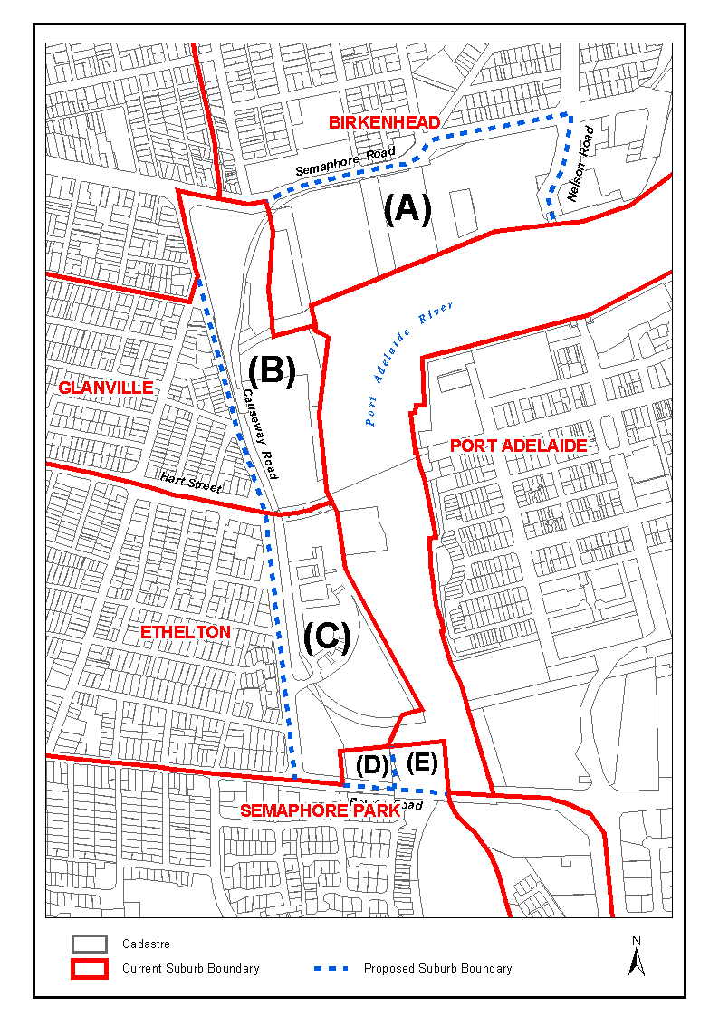
Submissions in writing regarding this proposal may be lodged with the Surveyor-General, G.P.O. Box 1354, Adelaide, S.A. 5001, within one month of the publication of this notice.
Dated 12 April 2007.
P. M. Kentish, Surveyor-General, Department for Transport, Energy and Infrastructure
DAIS 22-413/05/0011

LIQUOR LICENSING ACT 1997
Notice of Application
NOTICE is hereby given, pursuant to section 52 (2) (b) of the Liquor Licensing Act 1997, that Sporting Car Club of Port Pirie Inc. has applied to the Licensing Authority for a Limited Club Licence in respect of premises situated at Lot 26938, Germein Road, Port Pirie, S.A. 5540 and to be known as Sporting Car Club of Port Pirie.
The application has been set down for hearing on 18 May 2007 at 9 a.m.
Any person may object to the application by lodging a notice of objection in the prescribed form with the Liquor and Gambling Commissioner and serving a copy of the notice on the applicant at the applicant’s address given above, at least seven days before the hearing date (viz: 11 May 2007).
The applicant’s address for service is c/o Neville Coe, P.O. Box 21, Port Pirie, S.A. 5540.
Plans in respect of the premises the subject of the application are open to public inspection without fee at the Office of the Liquor and Gambling Commissioner, 9th Floor, East Wing, 50 Grenfell Street, Adelaide, S.A. 5000. Phone 8226 8410, Fax:
8226 8512. Email: olgc@agd.sa.gov.au.
Dated 5 April 2007.
Applicant

LIQUOR LICENSING ACT 1997
Notice of Application
NOTICE is hereby given, pursuant to section 52 (2) (b) of the Liquor Licensing Act 1997, that Tony Tesoro and Amporn Tesoro have applied to the Licensing Authority for Alterations and Redefinition of the licensed premises and a variation to an Extended Trading Authorisation in respect of premises situated at 37 Hindmarsh Square, Adelaide, S.A. 5000 and known as Thai in a Wok.
The application has been set down for callover on 18 May 2007 at 9 a.m.
Conditions
The following licence conditions are sought:
• Alterations and Redefinition of the licensed area to include the adjacent premises as per plans lodged including the current Extended Trading Authorisation.
Any person may object to the application by lodging a notice of objection in the prescribed form with the Liquor and Gambling Commissioner and serving a copy of the notice on the applicants at the applicants’ address given above, at least seven days before the callover date (viz: 11 May 2007).
The applicants’ address for service is c/o Tony and Amporn Tesoro, 81 Ann Street, Campbelltown, S.A. 5074.
Plans in respect of the premises the subject of the application are open to public inspection without fee at the Office of the Liquor and Gambling Commissioner, 9th Floor, East Wing, 50 Grenfell Street, Adelaide, S.A. 5000. Phone 8226 8410, Fax:
8226 8512. Email: olgc@agd.sa.gov.au.
Dated 10 April 2007.
Applicants

LIQUOR LICENSING ACT 1997
Notice of Application
NOTICE is hereby given, pursuant to section 52 (2) (b) of the Liquor Licensing Act 1997, that Gwynne Corporation Pty Ltd as trustee for the Lachlan Gwynne Investment Trust has applied to
the Licensing Authority for a Wholesale Liquor Merchant’s Licence in respect of premises situated at 90 Military Road, West Beach, S.A. 5024 and to be known as Gwynne Wines.
The application has been set down for callover on 18 May 2007 at 9 a.m.
Any person may object to the application by lodging a notice of objection in the prescribed form with the Liquor and Gambling Commissioner and serving a copy of the notice on the applicant at the applicant’s address given above, at least seven days before the callover date (viz: 11 May 2007).
The applicant’s address for service is c/o Duncan Basheer Hannon, Barrister and Solicitors, G.P.O. Box 2 Adelaide, S.A. 5001 (Attention: Max Basheer or David Tillett).
Plans in respect of the premises the subject of the application are open to public inspection without fee at the Office of the Liquor and Gambling Commissioner, 9th Floor, East Wing, 50 Grenfell Street, Adelaide, S.A. 5000. Phone 8226 8410, Fax:
8226 8512. Email: olgc@agd.sa.gov.au.
Dated 11 April 2007.
Applicant

LIQUOR LICENSING ACT 1997
Notice of Application
NOTICE is hereby given, pursuant to section 52 (2) (b) of the Liquor Licensing Act 1997, that the Mount Barker Football Club Inc. has applied to the Licensing Authority for a Limited Club Licence, Extended Trading Authorisation and Entertainment Consent in respect of premises situated at 2 Howard Lane, Mount Barker, S.A. 5251 and to be known as the Mount Barker Football Club.
The application has been set down for callover on 18 May 2007 at 9 a.m.
Conditions
The following licence conditions are sought:
• Extended Trading Authorisation:
Saturday: Midnight to 1 a.m. the following day.
• Entertainment Consent:
Thursday: 6 p.m. to midnight;
Friday: 6 p.m. to midnight;
Saturday: 6 p.m. to 1 a.m. the following day.
Any person may object to the application by lodging a notice of objection in the prescribed form with the Liquor and Gambling Commissioner and serving a copy of the notice on the applicant at the applicant’s address given above, at least seven days before the callover date (viz: 11 May 2007).
The applicant’s address for service is c/o The Mount Barker Football Club Inc., P.O. Box 31, Mount Barker, S.A. 5251.
Plans in respect of the premises the subject of the application are open to public inspection without fee at the Office of the Liquor and Gambling Commissioner, 9th Floor, East Wing, 50 Grenfell Street, Adelaide, S.A. 5000. Phone 8226 8410, Fax:
8226 8512. Email: olgc@agd.sa.gov.au.
Dated 13 April 2007.
Applicant

LIQUOR LICENSING ACT 1997
Notice of Application
NOTICE is hereby given, pursuant to section 52 (2) (b) of the Liquor Licensing Act 1997, that P. & C. O. Holdings Pty Ltd as trustee for the Peter Ormsby Family Trust has applied to the Licensing Authority for a Special Circumstances Licence, Extended Trading Authorisation and Entertainment Consent in respect of premises situated at Military Road, West Beach, S.A. 5024.
The application has been set down for callover on 18 May 2007 at 9 a.m.
Conditions
The following licence conditions are sought:
For consumption on the licensed premises:
• On the whole of the Adelaide Shores Golf Park (as depicted on the plan) from the Pro Shop, Gazebo, Golf Cart Refreshment Vehicle and liquor served on the course.
• The hours of operation shall be 8 a.m. until 10 p.m. on each day of the week.
• The licence shall not authorise the sale of liquor for consumption off the licensed premises.
• Entertainment Consent is to apply on corporate/pro-motional days only.
Any person may object to the application by lodging a notice of objection in the prescribed form with the Liquor and Gambling Commissioner and serving a copy of the notice on the applicant at the applicant’s address given above, at least seven days before the callover date (viz: 11 May 2007).
The applicant’s address for service is c/o Duncan Basheer Hannon, Barrister and Solicitors, G.P.O. Box 2, Adelaide, S.A. 5001 (Attention: Max Basheer or David Tillett).
Plans in respect of the premises the subject of the application are open to public inspection without fee at the Office of the Liquor and Gambling Commissioner, 9th Floor, East Wing, 50 Grenfell Street, Adelaide, S.A. 5000. Phone 8226 8410, Fax:
8226 8512. Email: olgc@agd.sa.gov.au.
Dated 12 April 2007.
Applicant

LIQUOR LICENSING ACT 1997
Notice of Application
NOTICE is hereby given, pursuant to section 52 (2) (b) of the Liquor Licensing Act 1997, that Nikolaos Sotiroulis has applied to the Licensing Authority for a Producer’s Licence in respect of premises situated at Lot 100, Tarcoola Street, Renmark, S.A. 5341 and to be known as Tarcoola Wines.
The application has been set down for callover on 18 May 2007 at 9 a.m.
Any person may object to the application by lodging a notice of objection in the prescribed form with the Liquor and Gambling Commissioner and serving a copy of the notice on the applicant at the applicant’s address given above, at least seven days before the callover date (viz: 11 May 2007).
The applicant’s address for service is c/o Stuart Andrew Solicitors, 11 Ahern Street, Berri, S.A. 5343.
Plans in respect of the premises the subject of the application are open to public inspection without fee at the Office of the Liquor and Gambling Commissioner, 9th Floor, East Wing, 50 Grenfell Street, Adelaide, S.A. 5000. Phone 8226 8410, Fax:
8226 8512. Email: olgc@agd.sa.gov.au.
Dated 13 April 2007.
Applicant

LIQUOR LICENSING ACT 1997
Notice of Application
NOTICE is hereby given, pursuant to section 52 (2) (b) of the Liquor Licensing Act 1997, that Rudderless Wines Pty Ltd as trustee for the Rudderless Wines Trust has applied to the Licensing Authority for a Producer’s Licence in respect of premises situated at Main South Road, Sellicks Hill, S.A. 5174 and to be known as Rudderless Wines.
The application has been set down for callover on 18 May 2007 at 9 a.m.
Any person may object to the application by lodging a notice of objection in the prescribed form with the Liquor and Gambling Commissioner and serving a copy of the notice on the applicant at the applicant’s address given above, at least seven days before the callover date (viz: 11 May 2007).
The applicant’s address for service is c/o Duncan Basheer Hannon, Barrister and Solicitors, G.P.O. Box 2, Adelaide, S.A. 5001 (Attention: Max Basheer or David Tillett).
Plans in respect of the premises the subject of the application are open to public inspection without fee at the Office of the Liquor and Gambling Commissioner, 9th Floor, East Wing, 50 Grenfell Street, Adelaide, S.A. 5000. Phone 8226 8410, Fax:
8226 8512. Email: olgc@agd.sa.gov.au.
Dated 13 April 2007.
Applicant

LIQUOR LICENSING ACT 1997
Notice of Application
NOTICE is hereby given, pursuant to section 52 (2) (b) of the Liquor Licensing Act 1997, that Andreas Marantos and Nicholas Paul Panos have applied to the Licensing Authority for a Direct Sales Licence in respect of premises situated at 59 Gwynne Street, Firle, S.A. 5070 and known as Off Tap Mobile Bar Hire.
The application has been set down for callover on 18 May 2007 at 9 a.m.
Any person may object to the application by lodging a notice of objection in the prescribed form with the Liquor and Gambling Commissioner and serving a copy of the notice on the applicants at the applicants’ address given above, at least seven days before the callover date (viz: 11 May 2007).
The applicants’ address for service is c/o Andreas Marantos, 59 Gwynne Street, Firle, S.A. 5070.
Plans in respect of the premises the subject of the application are open to public inspection without fee at the Office of the Liquor and Gambling Commissioner, 9th Floor, East Wing, 50 Grenfell Street, Adelaide, S.A. 5000. Phone 8226 8410, Fax:
8226 8512. Email: olgc@agd.sa.gov.au.
Dated 13 April 2007.
Applicants

LIQUOR LICENSING ACT 1997
Notice of Application
NOTICE is hereby given, pursuant to section 52 (2) (b) of the Liquor Licensing Act 1997, that Benjamin John as trustee for the Bendom Trust has applied to the Licensing Authority for a Restaurant Licence in respect of premises situated at 24-28 Waymouth Street, Adelaide, S.A. 5000 and to be known as Cafe Dom.
The application has been set down for callover on 18 May 2007 at 9 a.m.
Any person may object to the application by lodging a notice of objection in the prescribed form with the Liquor and Gambling Commissioner and serving a copy of the notice on the applicant at the applicant’s address given above, at least seven days before the callover date (viz: 11 May 2007).
The applicant’s address for service is c/o Ben Johnston, 14 Alexandra Street, Prospect, S.A. 5082.
Plans in respect of the premises the subject of the application are open to public inspection without fee at the Office of the Liquor and Gambling Commissioner, 9th Floor, East Wing, 50 Grenfell Street, Adelaide, S.A. 5000. Phone 8226 8410, Fax:
8226 8512. Email: olgc@agd.sa.gov.au.
Dated 16 April 2007.
Applicant

LIQUOR LICENSING ACT 1997
Notice of Application
NOTICE is hereby given, pursuant to section 52 (2) (b) of the Liquor Licensing Act 1997, that Mont Agricultural Development Pty Ltd has applied to the Licensing Authority for Redefinition, variation to Extended Trading Authorisation and variation to Entertainment Consent in respect of premises situated at 49 Owen Terrace, Wallaroo, S.A. 5556 and known as Cornucopia Hotel.
The application has been set down for callover on 18 May 2007 at 9 a.m.
Conditions
The following licence conditions are sought:
• Redefinition to include the first floor of the premises as per plans lodged with this office.
• Variation to Extended Trading Authorisation to include the outside area at the rear of the premises as per plans lodged with this office.
• Variation to Extended Trading Authorisation for the Ground Floor and the outdoor area for the following hours:
Friday and Saturday: Midnight to 3 a.m. the following day;
Sunday: 8 a.m. to 11 a.m. and 8 p.m. to midnight;
Days preceding other Public Holidays: Midnight to 2 a.m. the following day;
Sundays preceding Public Holidays: 8 p.m. to midnight.
• Variation to Entertainment Consent to include Area 4 as per plans lodged with this office.
• Variation to Entertainment Consent to apply to the above-mentioned hours.
Any person may object to the application by lodging a notice of objection in the prescribed form with the Liquor and Gambling Commissioner, and serving a copy of the notice on the applicant at the applicant’s address given above, at least seven days before the callover date (viz: 11 May 2007).
The applicant’s address for service is c/o Mont Agricultural Development Pty Ltd, 49 Owen Terrace, Wallaroo, S.A. 5556.
Plans in respect of the premises the subject of the application are open to public inspection without fee at the Office of the Liquor and Gambling Commissioner, 9th Floor, East Wing, 50 Grenfell Street, Adelaide, S.A. 5000. Phone 8226 8410, Fax:
8226 8512. Email: olgc@agd.sa.gov.au.
Dated 16 April 2007.
Applicant

LIQUOR LICENSING ACT 1997
Notice of Application
NOTICE is hereby given, pursuant to section 52 (2) (b) of the Liquor Licensing Act 1997, that Jusuda Pty Ltd has applied to the Licensing Authority for the transfer of a Special Circumstances Licence in respect of premises situated at 273 Rundle Street, Adelaide, S.A. 5000, known as The Establishment Restaurant and to be known as Amarin Thai Restaurant 2.
The application has been set down for hearing on 21 May 2007 at 9.30 a.m.
Any person may object to the application by lodging a notice of objection in the prescribed form with the Liquor and Gambling Commissioner, and serving a copy of the notice on the applicant at the applicant’s address given above, at least seven days before the hearing date (viz: 14 May 2007).
The applicant’s address for service is c/o Yapp Hau Pehn, 1st Floor, 149 Flinders Street, Adelaide, S.A. 5000.
Plans in respect of the premises the subject of the application are open to public inspection without fee at the Office of the Liquor and Gambling Commissioner, 9th Floor, East Wing, 50 Grenfell Street, Adelaide, S.A. 5000. Phone 8226 8410, Fax:
8226 8512. Email: olgc@agd.sa.gov.au.
Dated 12 April 2007.
Applicant

LIQUOR LICENSING ACT 1997
Notice of Application
NOTICE is hereby given, pursuant to section 52 (2) (b) of the Liquor Licensing Act 1997, that David Bruce Munro and Gail-Bronwyn Munro have applied to the Licensing Authority for the transfer of a Hotel Licence in respect of premises situated at
Railway Terrace, Paskeville, S.A. 5552 and known as Paskeville Hotel.
The application has been set down for hearing on 21 May 2007 at 10 a.m.
Any person may object to the application by lodging a notice of objection in the prescribed form with the Liquor and Gambling Commissioner, and serving a copy of the notice on the applicants at the applicants’ address given above, at least seven days before the hearing date (viz: 14 May 2007).
The applicants’ address for service is c/o Giles Kahl, Nicholls Gervasi, 231 The Parade, Norwood, S.A. 5067.
Plans in respect of the premises the subject of the application are open to public inspection without fee at the Office of the Liquor and Gambling Commissioner, 9th Floor, East Wing, 50 Grenfell Street, Adelaide, S.A. 5000. Phone 8226 8410, Fax:
8226 8512. Email: olgc@agd.sa.gov.au.
Dated 10 April 2007.
Applicants

LIQUOR LICENSING ACT 1997
Notice of Application
NOTICE is hereby given, pursuant to section 52 (2) (b) of the Liquor Licensing Act 1997, that Artron International Pty Ltd as trustee for the Helyard Family Trust has applied to the Licensing Authority for the transfer of a Restaurant Licence in respect of premises situated at Moseley Square, Glenelg, S.A. 5045, known as La Vecchia Roma Restaurant and to be known as Caffe Fratelli.
The application has been set down for hearing on 21 May 2007 at 10.30 a.m.
Any person may object to the application by lodging a notice of objection in the prescribed form with the Liquor and Gambling Commissioner, and serving a copy of the notice on the applicant at the applicant’s address given above, at least seven days before the hearing date (viz: 14 May 2007).
The applicant’s address for service is c/o Artron International Pty Ltd, 33 Watermans Avenue, Vale Park, S.A. 5081.
Plans in respect of the premises the subject of the application are open to public inspection without fee at the Office of the Liquor and Gambling Commissioner, 9th Floor, East Wing, 50 Grenfell Street, Adelaide, S.A. 5000. Phone 8226 8410, Fax:
8226 8512. Email: olgc@agd.sa.gov.au.
Dated 11 April 2007.
Applicant

LIQUOR LICENSING ACT 1997
Notice of Application
NOTICE is hereby given, pursuant to section 52 (2) (b) of the Liquor Licensing Act 1997, that Christopher Alan Pennington and Kirsten Michelle Pennington have applied to the Licensing Authority for the transfer of a Restaurant Licence in respect of premises situated at 6 Semaphore Road, Semaphore, S.A. 5019, known as Cafe Saltwater and to be known as The Flying Knife.
The application has been set down for hearing on 21 May 2007 at 11 a.m.
Any person may object to the application by lodging a notice of objection in the prescribed form with the Liquor and Gambling Commissioner, and serving a copy of the notice on the applicants at the applicants’ address given above, at least seven days before the hearing date (viz: 14 May 2007).
The applicants’ address for service is c/o 12 Gaskin Road, Flinders Park, S.A. 5025.
Plans in respect of the premises the subject of the application are open to public inspection without fee at the Office of the Liquor and Gambling Commissioner, 9th Floor, East Wing, 50 Grenfell Street, Adelaide, S.A. 5000. Phone 8226 8410, Fax:
8226 8512. Email: olgc@agd.sa.gov.au.
Dated 10 April 2007.
Applicants

LIQUOR LICENSING ACT 1997
Notice of Application
NOTICE is hereby given, pursuant to section 52 (2) (b) of the Liquor Licensing Act 1997, that Hospitality Group Pty Ltd as trustee for the Hospitality Group Trust has applied to the Licensing Authority for the transfer of a Special Circumstances Licence in respect of premises situated at Nicholson Avenue, Whyalla, S.A. 5600, known as University of S.A.—Whyalla Campus and to be known as Rob’s Aroma Cafe Whyalla Campus.
The application has been set down for hearing on 23 May 2007 at 11 a.m.
Any person may object to the application by lodging a notice of objection in the prescribed form with the Liquor and Gambling Commissioner, and serving a copy of the notice on the applicant at the applicant’s address given above, at least seven days before the hearing date (viz: 16 May 2007).
The applicant’s address for service is c/o Patsouris & Associates, 82 Halifax Street, Adelaide, S.A. 5000.
Plans in respect of the premises the subject of the application are open to public inspection without fee at the Office of the Liquor and Gambling Commissioner, 9th Floor, East Wing, 50 Grenfell Street, Adelaide, S.A. 5000. Phone 8226 8410, Fax:
8226 8512. Email: olgc@agd.sa.gov.au.
Dated 12 April 2007.
Applicant

LIQUOR LICENSING ACT 1997
Notice of Application
NOTICE is hereby given, pursuant to section 52 (2) (b) of the Liquor Licensing Act 1997, that Gumhaven Pty Ltd as trustee for the Gumhaven Family Trust has applied to the Licensing Authority for the transfer of a Special Circumstances Licence in respect of premises situated at Hill Road, Kersbrook, S.A. 5231 and known as Gumhaven Restaurant.
The application has been set down for hearing on 23 May 2007 at 10 a.m.
Any person may object to the application by lodging a notice of objection in the prescribed form with the Liquor and Gambling Commissioner, and serving a copy of the notice on the applicant at the applicant’s address given above, at least seven days before the hearing date (viz: 16 May 2007).
The applicant’s address for service is c/o Wylie Gilmore-Johnstone, P.O. Box 3, Stepney, S.A. 5069.
Plans in respect of the premises the subject of the application are open to public inspection without fee at the Office of the Liquor and Gambling Commissioner, 9th Floor, East Wing, 50 Grenfell Street, Adelaide, S.A. 5000. Phone 8226 8410, Fax:
8226 8512. Email: olgc@agd.sa.gov.au.
Dated 11 April 2007.
Applicant

IMPORTANT NOTICE
Government Gazette Publication

********************

Anzac Day Holiday Week Publishing Information

Government Gazette Notices
Publishing Date: Thursday, 26 April 2007

Closing date for notices for publication will be
4 p.m. on Monday, 23 April 2007

********************

GOVERNMENT GAZETTE ADVERTISEMENT RATES

To apply from 1 July 2006

$  Agents, Ceasing to Act as 38.00  Associations:  Incorporation 19.30  Intention of Incorporation 47.75  Transfer of Properties 47.75  Attorney, Appointment of 38.00  Bailiff’s Sale 47.75  Cemetery Curator Appointed 28.25  Companies:  Alteration to Constitution 38.00  Capital, Increase or Decrease of 47.75  Ceasing to Carry on Business 28.25  Declaration of Dividend 28.25  Incorporation 38.00  Lost Share Certificates:  First Name 28.25  Each Subsequent Name 9.70  Meeting Final 31.75  Meeting Final Regarding Liquidator’s Report on  Conduct of Winding Up (equivalent to ‘Final  Meeting’)  First Name 38.00  Each Subsequent Name 9.70  Notices:  Call 47.75  Change of Name 19.30  Creditors 38.00  Creditors Compromise of Arrangement 38.00  Creditors (extraordinary resolution that ‘the Com-pany be wound up voluntarily and that a liquidator be appointed’) 47.75  Release of Liquidator⎯Application⎯Large Ad. 75.50  ⎯Release Granted 47.75  Receiver and Manager Appointed 44.00  Receiver and Manager Ceasing to Act 38.00  Restored Name 35.75  Petition to Supreme Court for Winding Up 66.50  Summons in Action 56.50  Order of Supreme Court for Winding Up Action 38.00  Register of Interests⎯Section 84 (1) Exempt 85.50  Removal of Office 19.30  Proof of Debts 38.00  Sales of Shares and Forfeiture 38.00  Estates:  Assigned 28.25  Deceased Persons⎯Notice to Creditors, etc. 47.75  Each Subsequent Name 9.70  Deceased Persons⎯Closed Estates 28.25  Each Subsequent Estate 1.25  Probate, Selling of 38.00  Public Trustee, each Estate 9.70 |  | $  Firms:  Ceasing to Carry on Business (each insertion) 25.25  Discontinuance Place of Business 25.25  Land⎯Real Property Act:  Intention to Sell, Notice of 47.75  Lost Certificate of Title Notices 47.75  Cancellation, Notice of (Strata Plan) 47.75  Mortgages:  Caveat Lodgement 19.30  Discharge of 20.20  Foreclosures 19.30  Transfer of 19.30  Sublet 9.70  Leases⎯Application for Transfer (2 insertions) each 9.70  Lost Treasury Receipts (3 insertions) each 28.25  Licensing 56.50  Municipal or District Councils:  Annual Financial Statement⎯Forms 1 and 2 532.00  Electricity Supply⎯Forms 19 and 20 378.00  Default in Payment of Rates:  First Name 75.50  Each Subsequent Name 9.70  Noxious Trade 28.25  Partnership, Dissolution of 28.25  Petitions (small) 19.30  Registered Building Societies (from Registrar-  General) 19.30  Register of Unclaimed Moneys⎯First Name 28.25  Each Subsequent Name 9.70  Registers of Members⎯Three pages and over:  Rate per page (in 8pt) 242.00  Rate per page (in 6pt) 320.00  Sale of Land by Public Auction 48.25  Advertisements 2.70  ¼ page advertisement 113.00  ½ page advertisement 226.00  Full page advertisement 443.00  Advertisements, other than those listed are charged at $2.70 per column line, tabular one-third extra.  Notices by Colleges, Universities, Corporations and District Councils to be charged at $2.70 per line.  Where the notice inserted varies significantly in length from that which is usually published a charge of $2.70 per column line will be applied in lieu of advertisement rates listed.  South Australian Government publications are sold on the condition that they will not be reproduced without prior permission from the Government Printer.
All the above prices include GST

GOVERNMENT GAZETTE NOTICES
ALL private advertisements forwarded for publication in the South Australian Government Gazette must be PAID FOR PRIOR TO INSERTION; and all notices, from whatever source, should be legibly written on one side of the paper only and sent to Government Publishing SA so as to be received no later than 4 p.m. Tuesday preceding the day of publication. Phone 8207 1045 or Fax 8207 1040. E-mail: governmentgazette@saugov.sa.gov.au. Send as attachments in Word format. Please include date the notice is to be published and to whom the notice will be charged. The Government Gazette is available online at: www.governmentgazette.sa.gov.au.

MISCELLANEOUS LEGISLATION AND GOVERNMENT PUBLICATIONS PRICES AS FROM 1 JULY 2006

Acts, Bills, Rules, Parliamentary Papers and Regulations
Pages | Main | Amends | Pages | Main | Amends

1-16 | 2.30 | 1.05 | 497-512 | 32.25 | 31.25
17-32 | 3.10 | 1.95 | 513-528 | 33.25 | 32.00
33-48 | 4.05 | 2.90 | 529-544 | 34.25 | 33.25
49-64 | 5.10 | 3.90 | 545-560 | 35.25 | 34.25
65-80 | 6.00 | 4.95 | 561-576 | 36.00 | 35.25
81-96 | 6.95 | 5.75 | 577-592 | 37.00 | 35.75
97-112 | 7.90 | 6.75 | 593-608 | 38.25 | 36.75
113-128 | 8.90 | 7.75 | 609-624 | 39.00 | 38.00
129-144 | 9.95 | 8.80 | 625-640 | 40.00 | 38.50
145-160 | 10.90 | 9.70 | 641-656 | 41.00 | 40.00
161-176 | 11.90 | 10.70 | 657-672 | 41.50 | 40.50
177-192 | 12.90 | 11.70 | 673-688 | 43.25 | 41.50
193-208 | 13.90 | 12.80 | 689-704 | 44.00 | 42.50
209-224 | 14.70 | 13.60 | 705-720 | 44.75 | 43.50
225-240 | 15.70 | 14.50 | 721-736 | 46.50 | 44.50
241-257 | 16.80 | 15.30 | 737-752 | 47.00 | 45.50
258-272 | 17.70 | 16.30 | 753-768 | 48.00 | 46.25
273-288 | 18.70 | 17.50 | 769-784 | 48.50 | 47.75
289-304 | 19.50 | 18.40 | 785-800 | 49.50 | 48.75
305-320 | 20.70 | 19.40 | 801-816 | 50.50 | 49.25
321-336 | 21.50 | 20.30 | 817-832 | 51.50 | 50.50
337-352 | 22.60 | 21.40 | 833-848 | 52.50 | 51.50
353-368 | 23.50 | 22.40 | 849-864 | 53.50 | 52.00
369-384 | 24.50 | 23.40 | 865-880 | 54.50 | 53.50
385-400 | 25.50 | 24.30 | 881-896 | 55.00 | 54.00
401-416 | 26.50 | 25.00 | 897-912 | 56.50 | 55.00
417-432 | 27.50 | 26.25 | 913-928 | 57.00 | 56.50
433-448 | 28.50 | 27.25 | 929-944 | 58.00 | 57.00
449-464 | 29.25 | 28.00 | 945-960 | 59.00 | 57.50
465-480 | 29.75 | 29.00 | 961-976 | 60.50 | 58.50
481-496 | 31.25 | 29.75 | 977-992 | 61.50 | 59.00

Legislation—Acts, Regulations, etc: $
Subscriptions:
Acts 199.00
All Bills as Laid 477.00
Rules and Regulations 477.00
Parliamentary Papers 477.00
Bound Acts 221.00
Index 110.00
Government Gazette
Copy 5.20
Subscription 263.00
Hansard
Copy 14.50
Subscription—per session (issued weekly) 414.00
Cloth bound—per volume 178.00
Subscription—per session (issued daily) 414.00
Legislation on Disk
Whole Database 3063.00
Annual Subscription for fortnightly updates 941.00
Individual Act(s) including updates POA
Compendium
Subscriptions:
Subscriptions 1815.00
Updates 640.00
(All the above prices include GST)

All Legislation, Government Gazette, Hansard and Legislation on disk are available from:
Counter Sales Service SA, Government Legislation⁺ Outlet
and Mail Orders: Lands Titles Office, 101 Grenfell Street, Adelaide, S.A. 5000
Phone: 13 23 24 (local call cost), Fax: (08) 8204 1909
Postal: G.P.O. Box 1707, Adelaide, S.A. 5001

Online Shop: www.shop.service.sa.gov.au

Subscriptions and Government Publishing SA
Standing Orders: Box 9, Plaza Level, Riverside Centre, North Terrace, Adelaide, S.A. 5000
Phone: (08) 8207 1043, (08) 8207 0910, Fax: (08) 8207 1040


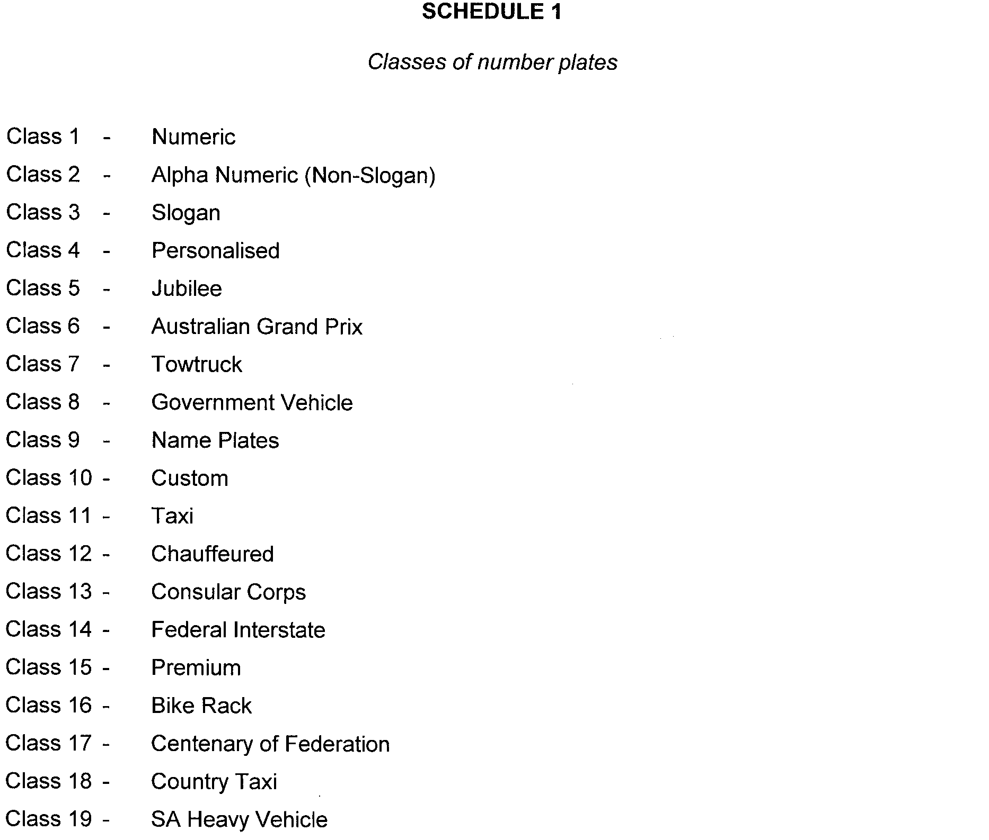


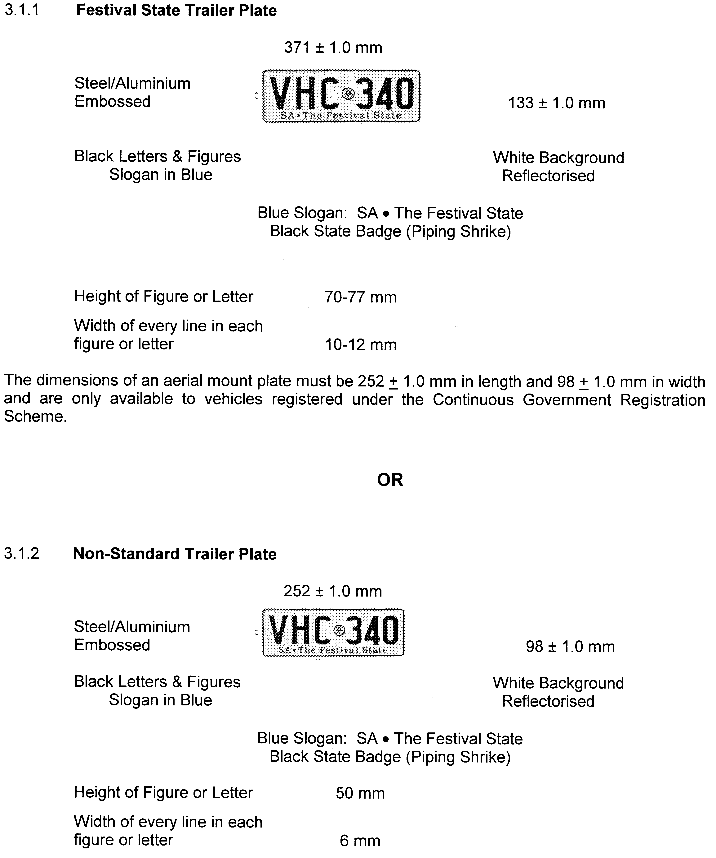
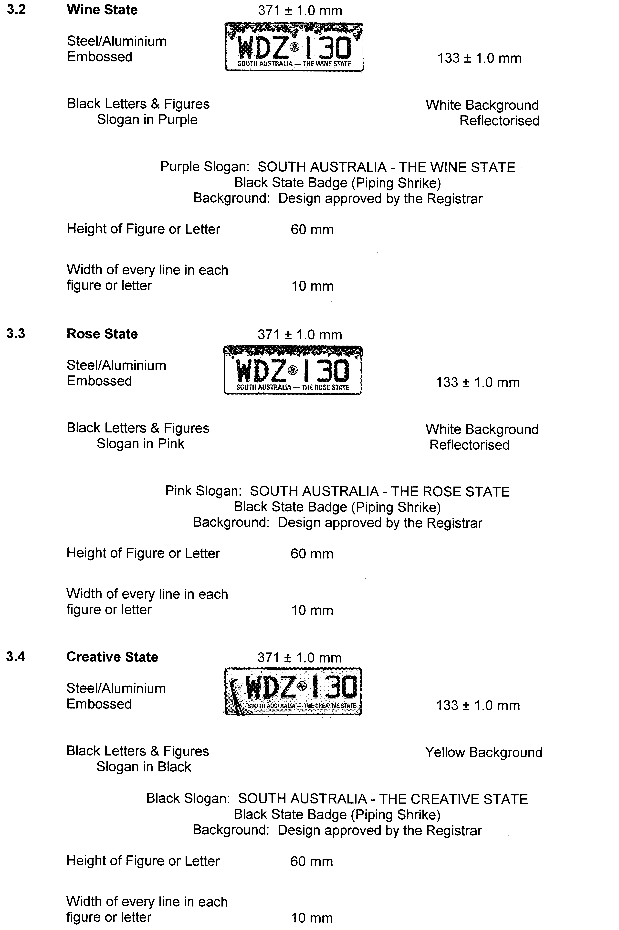
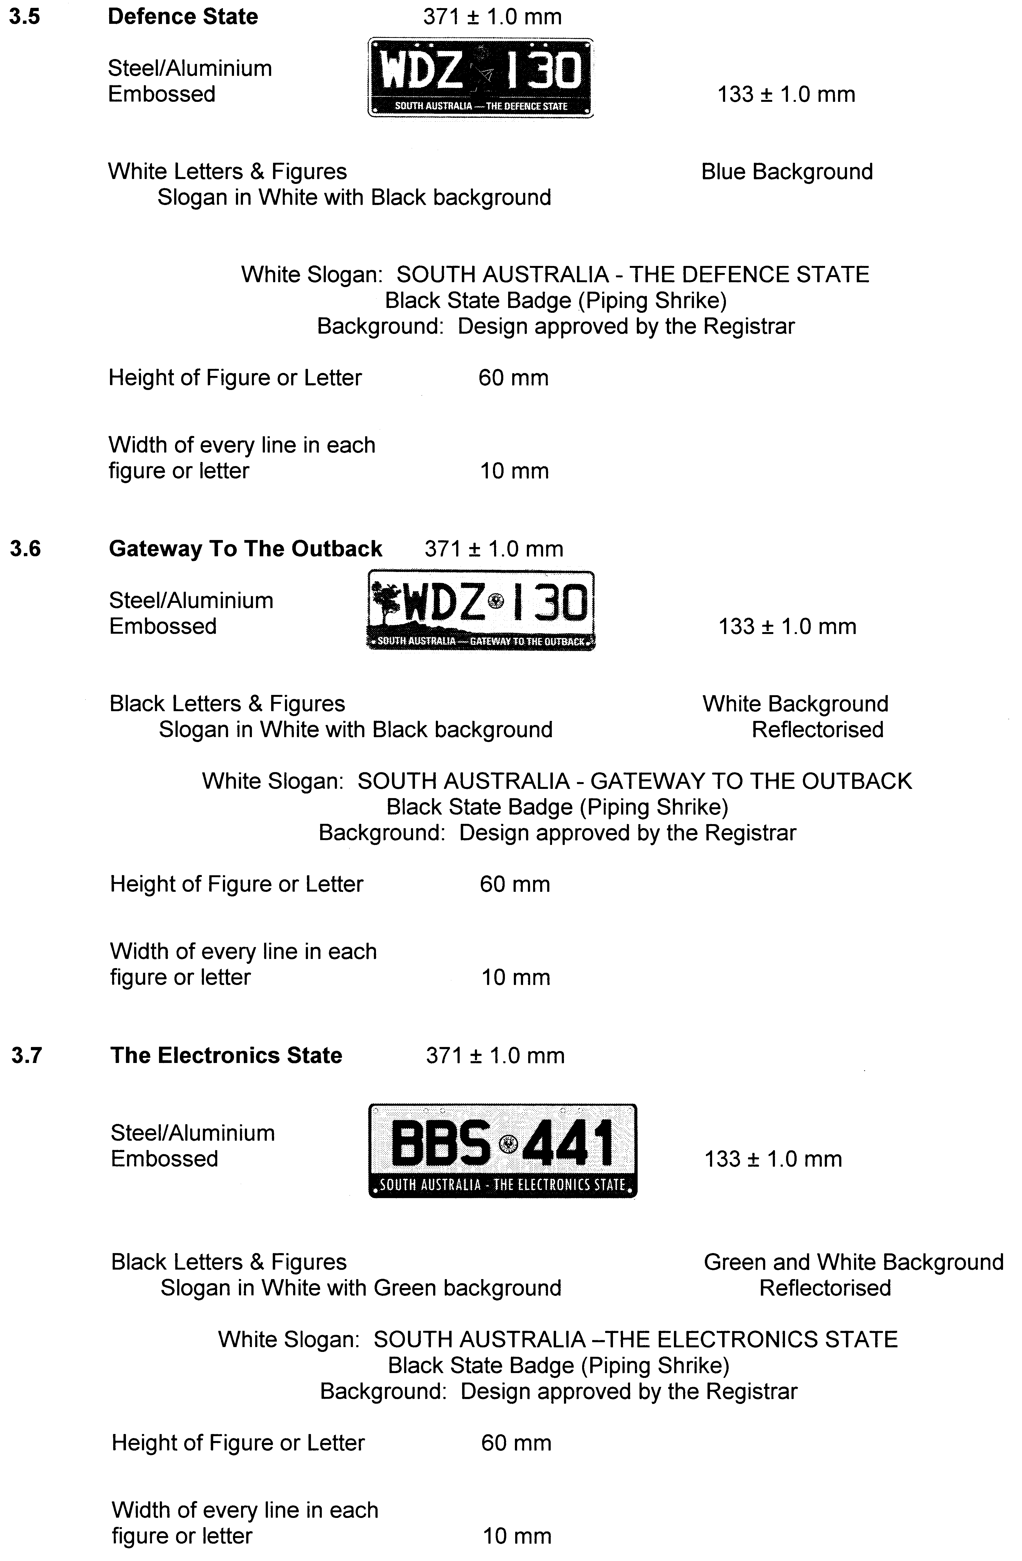






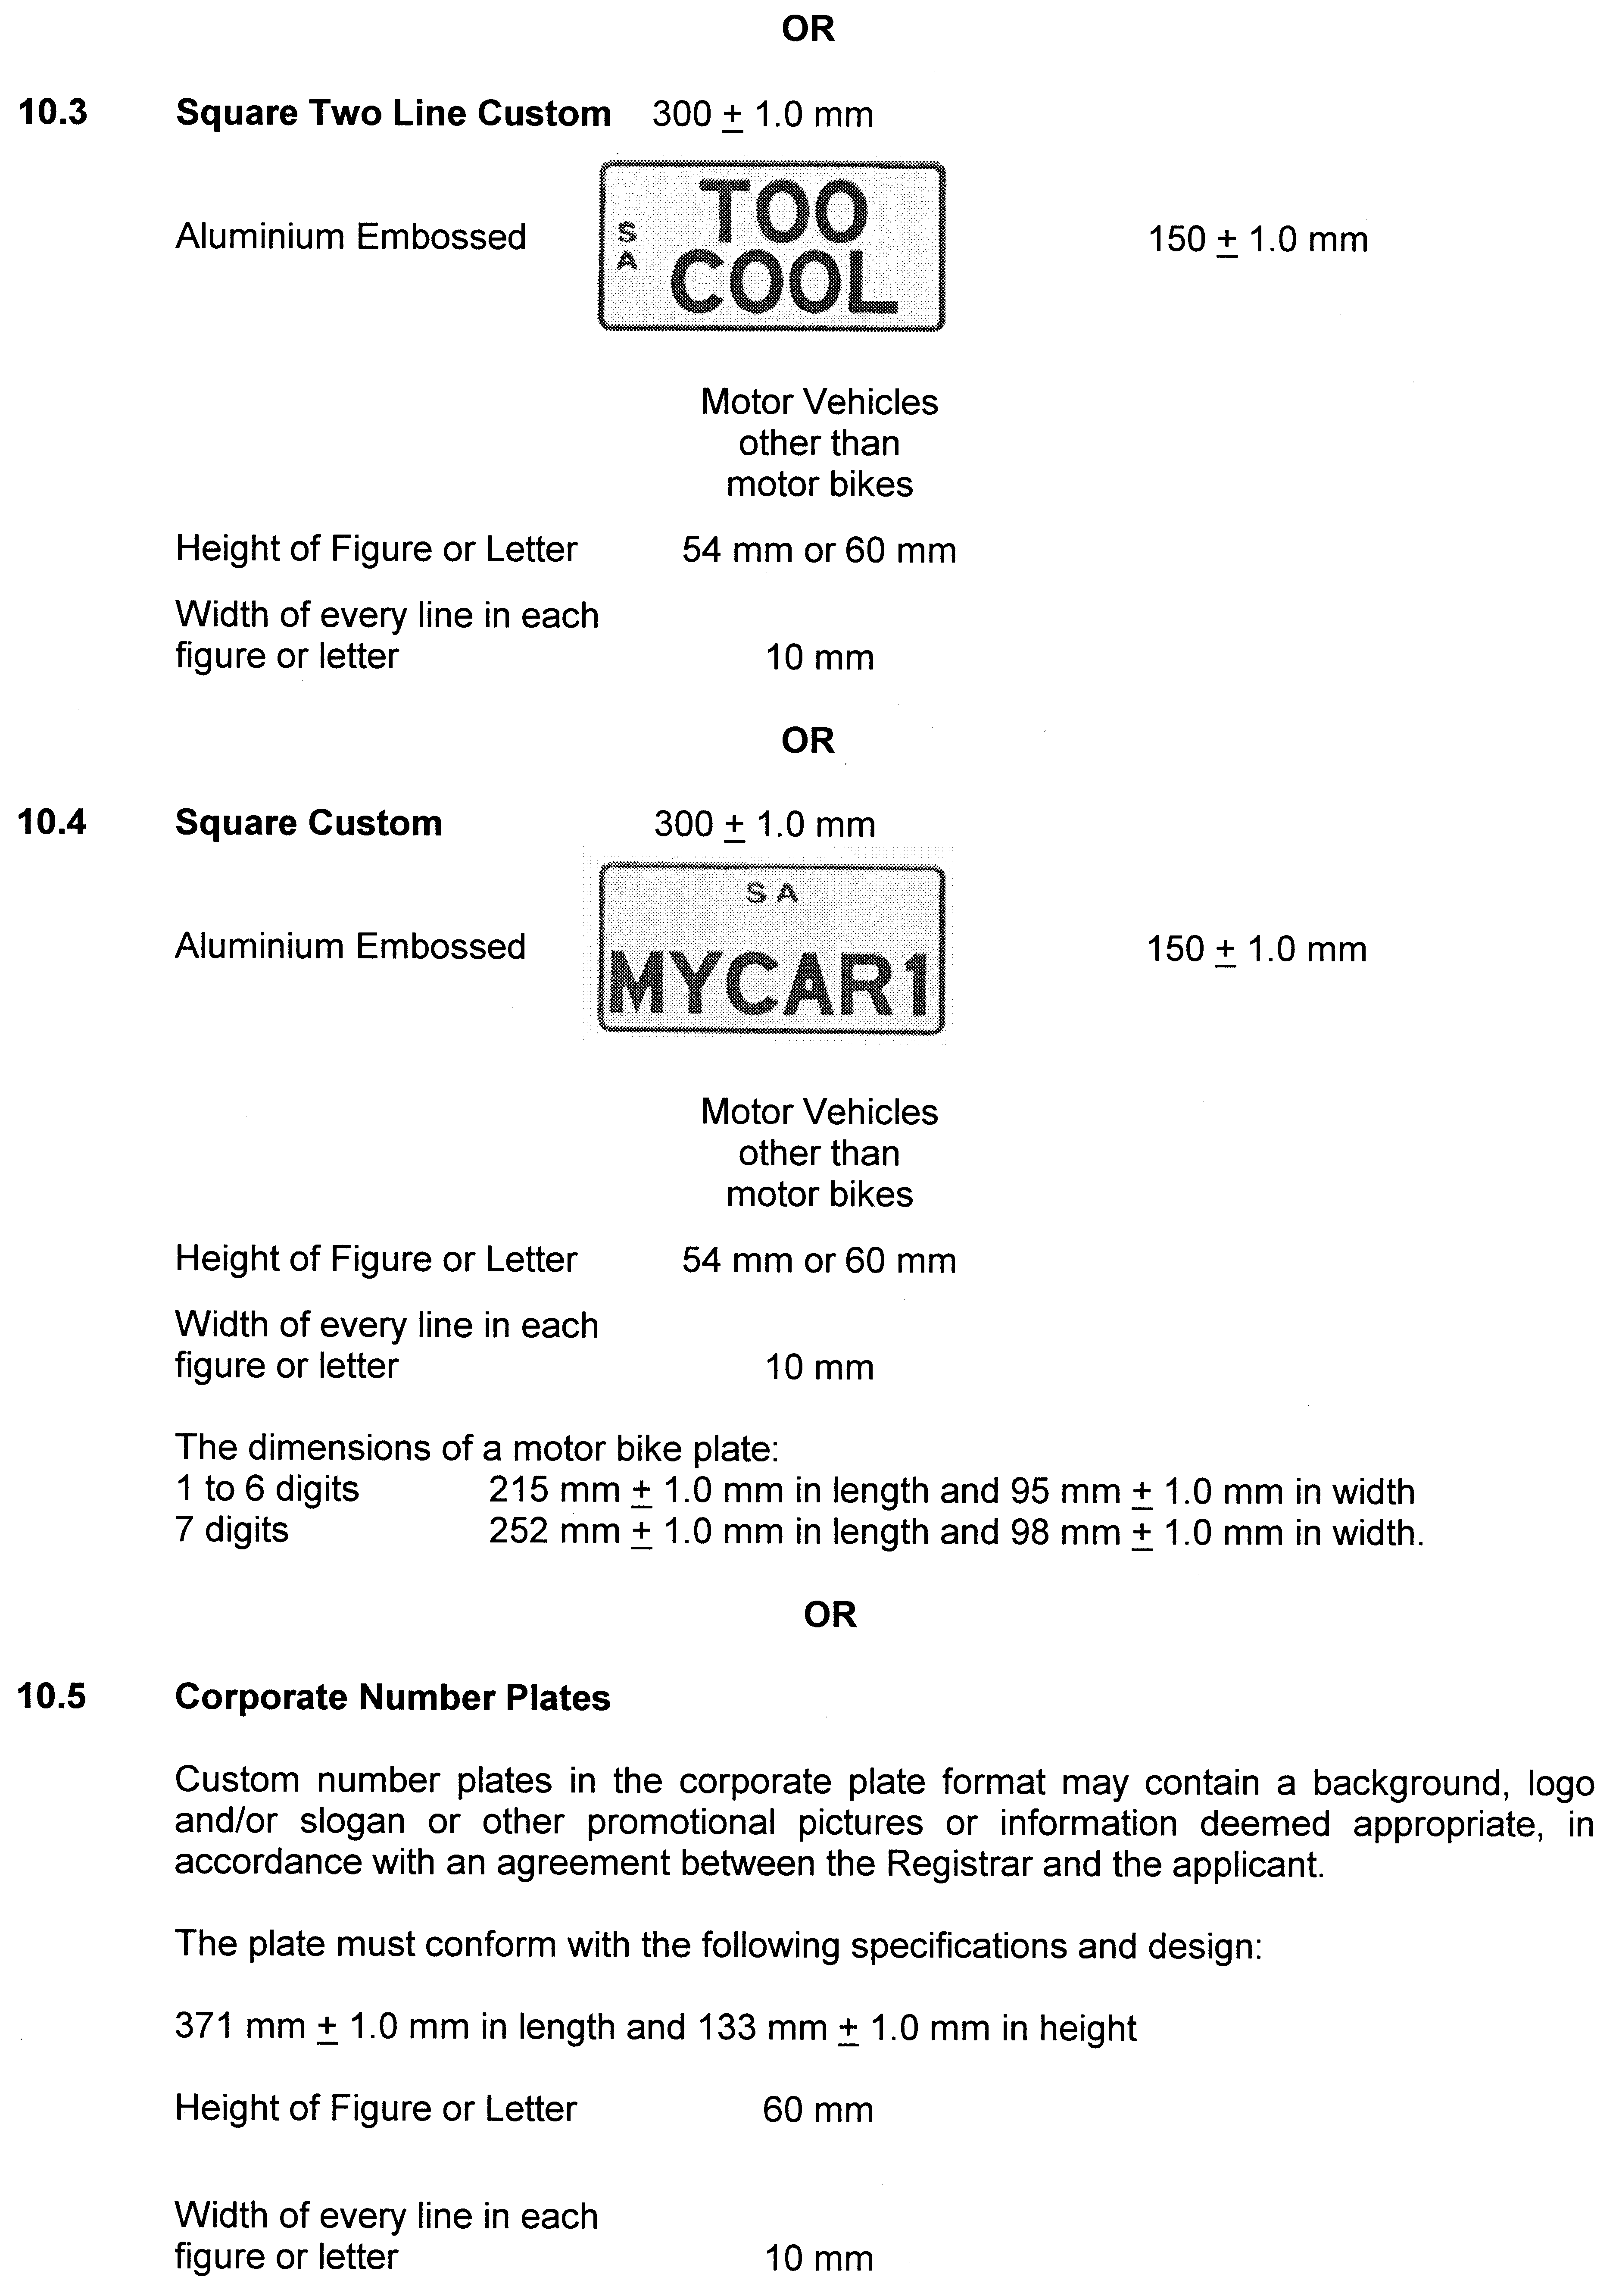




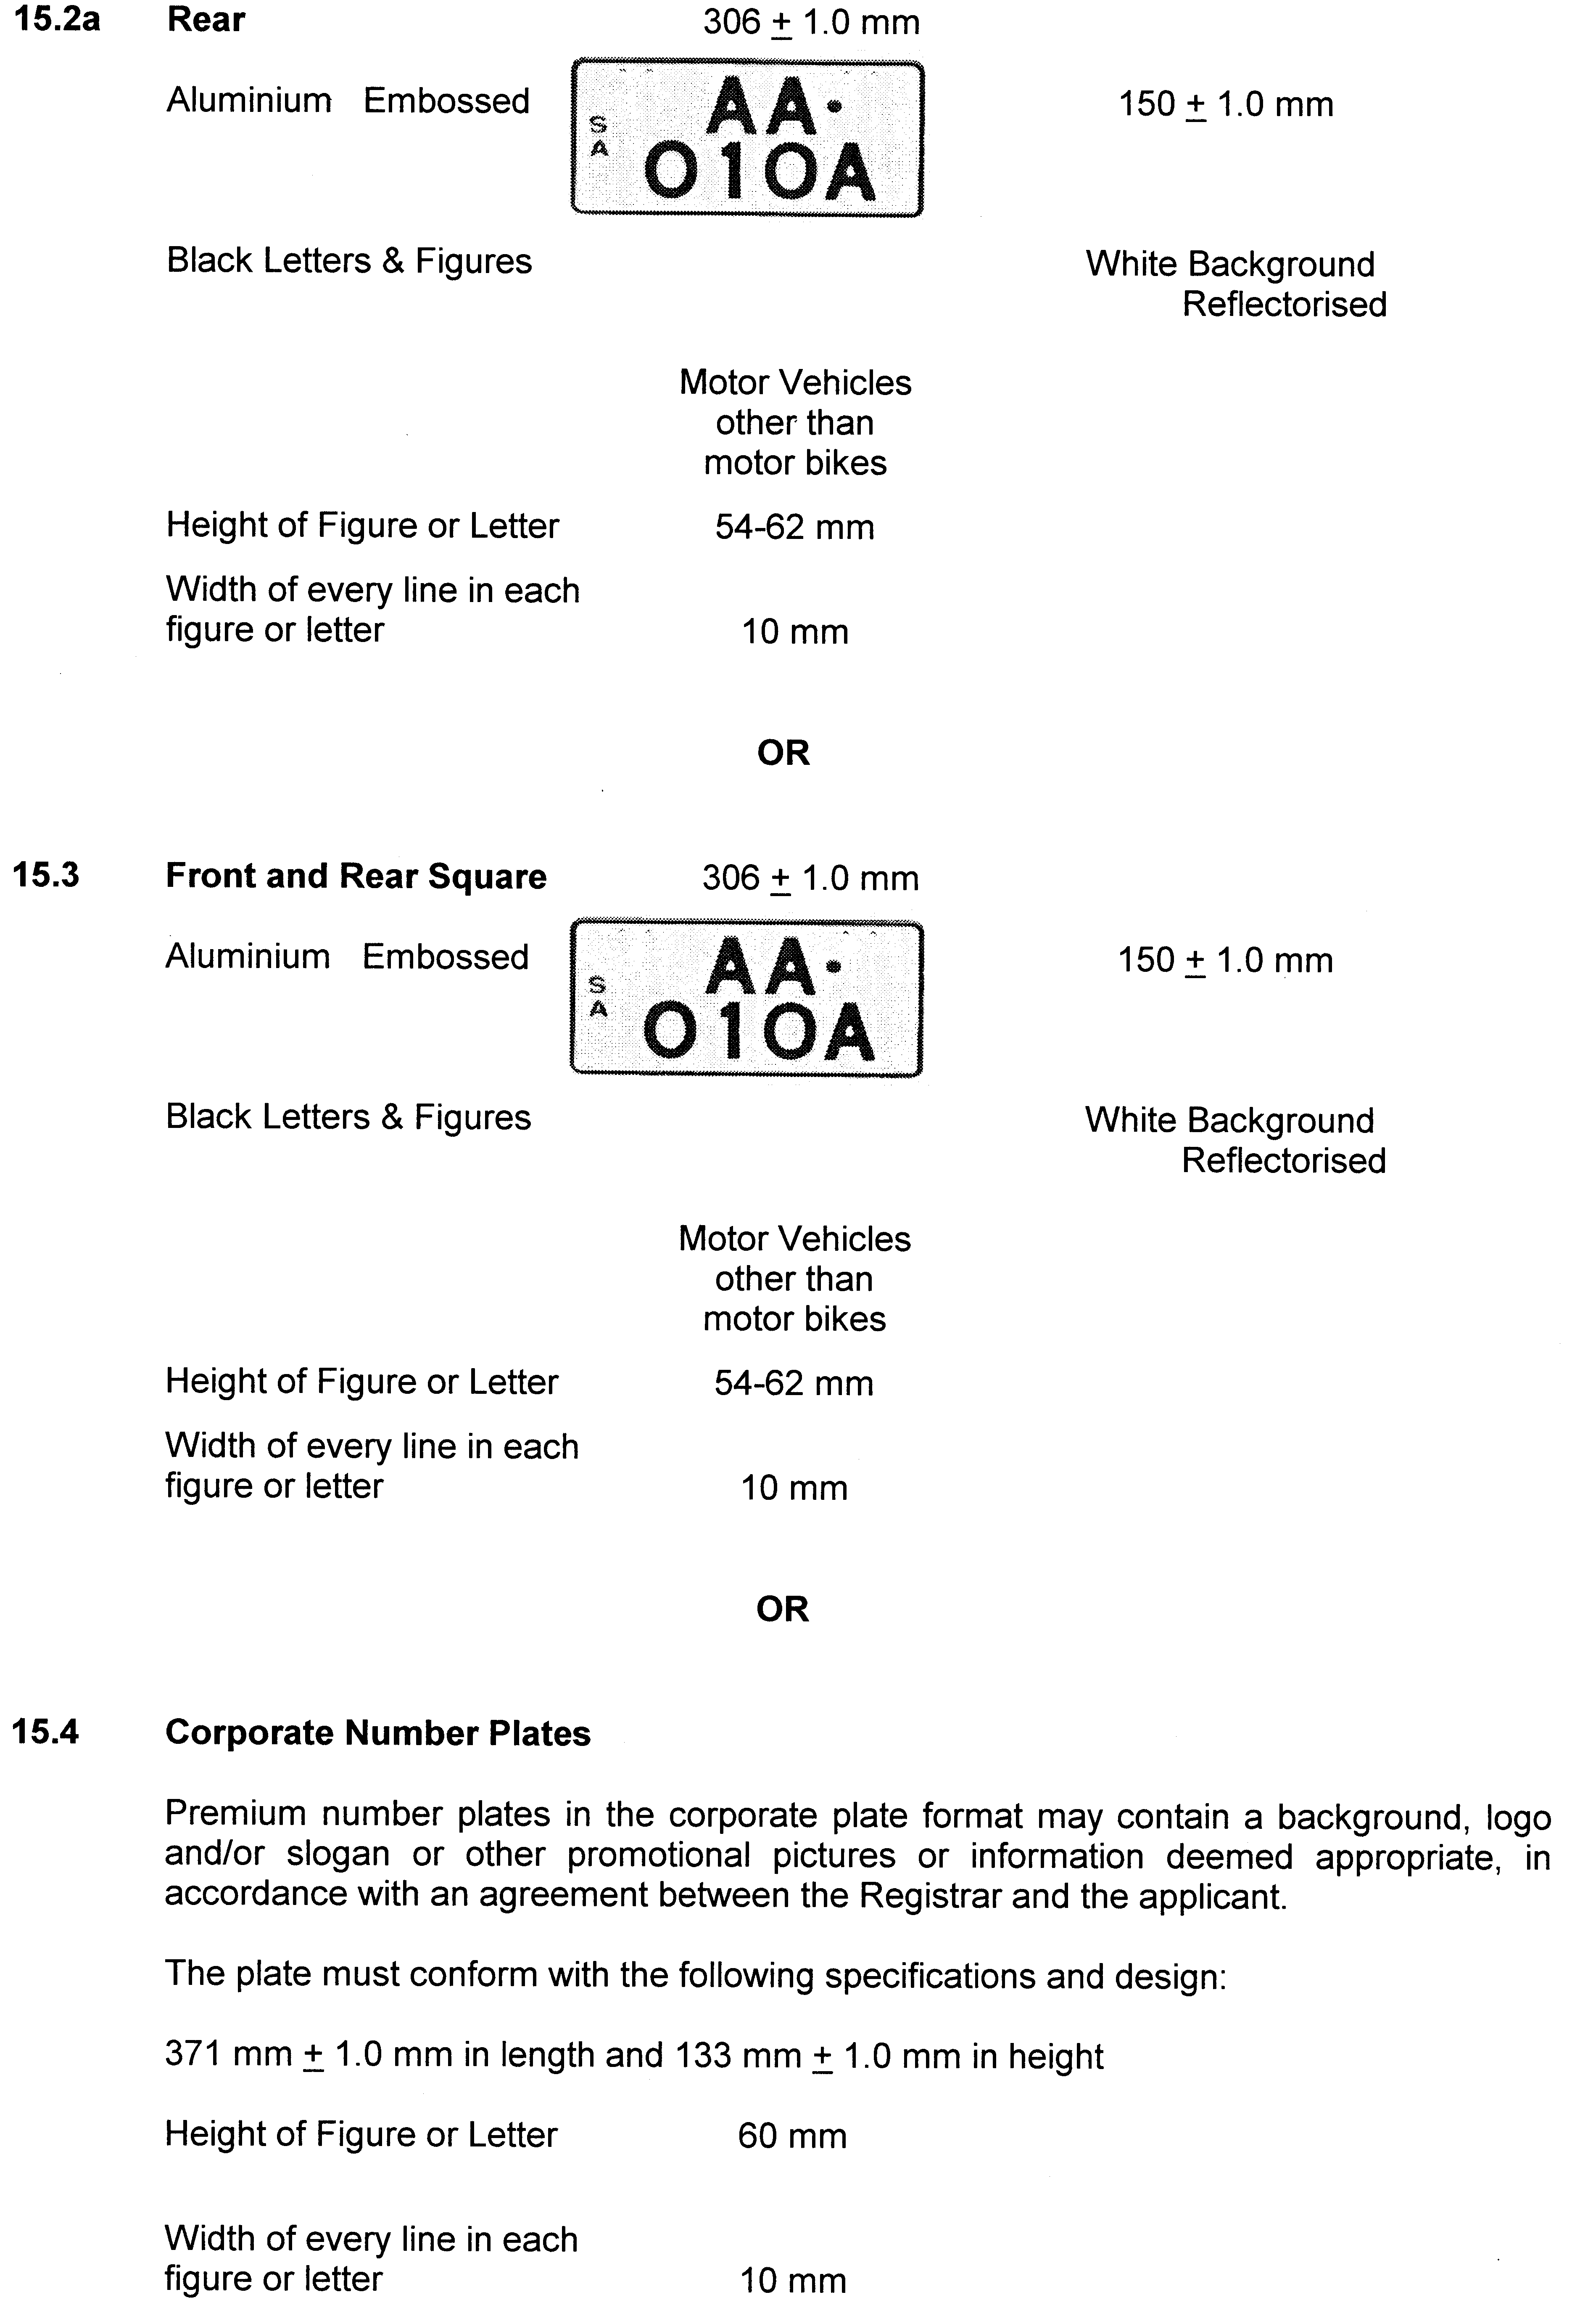



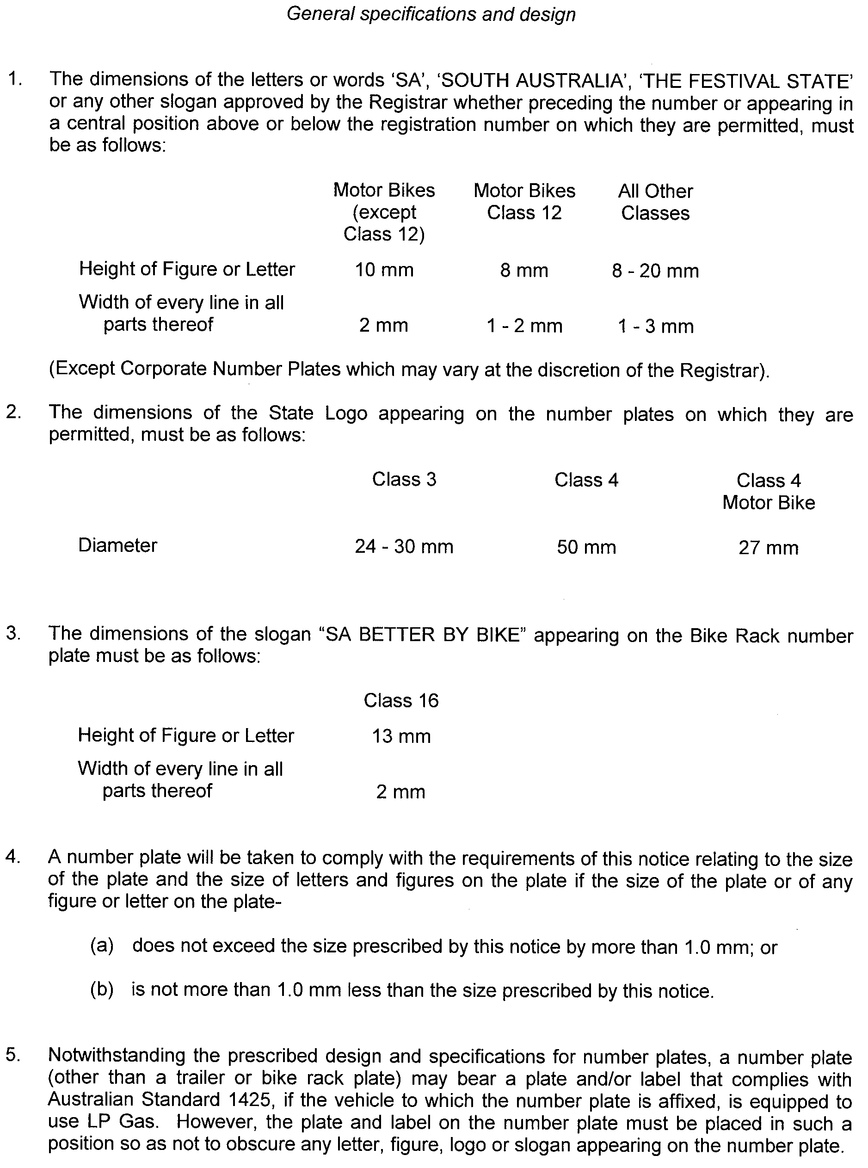
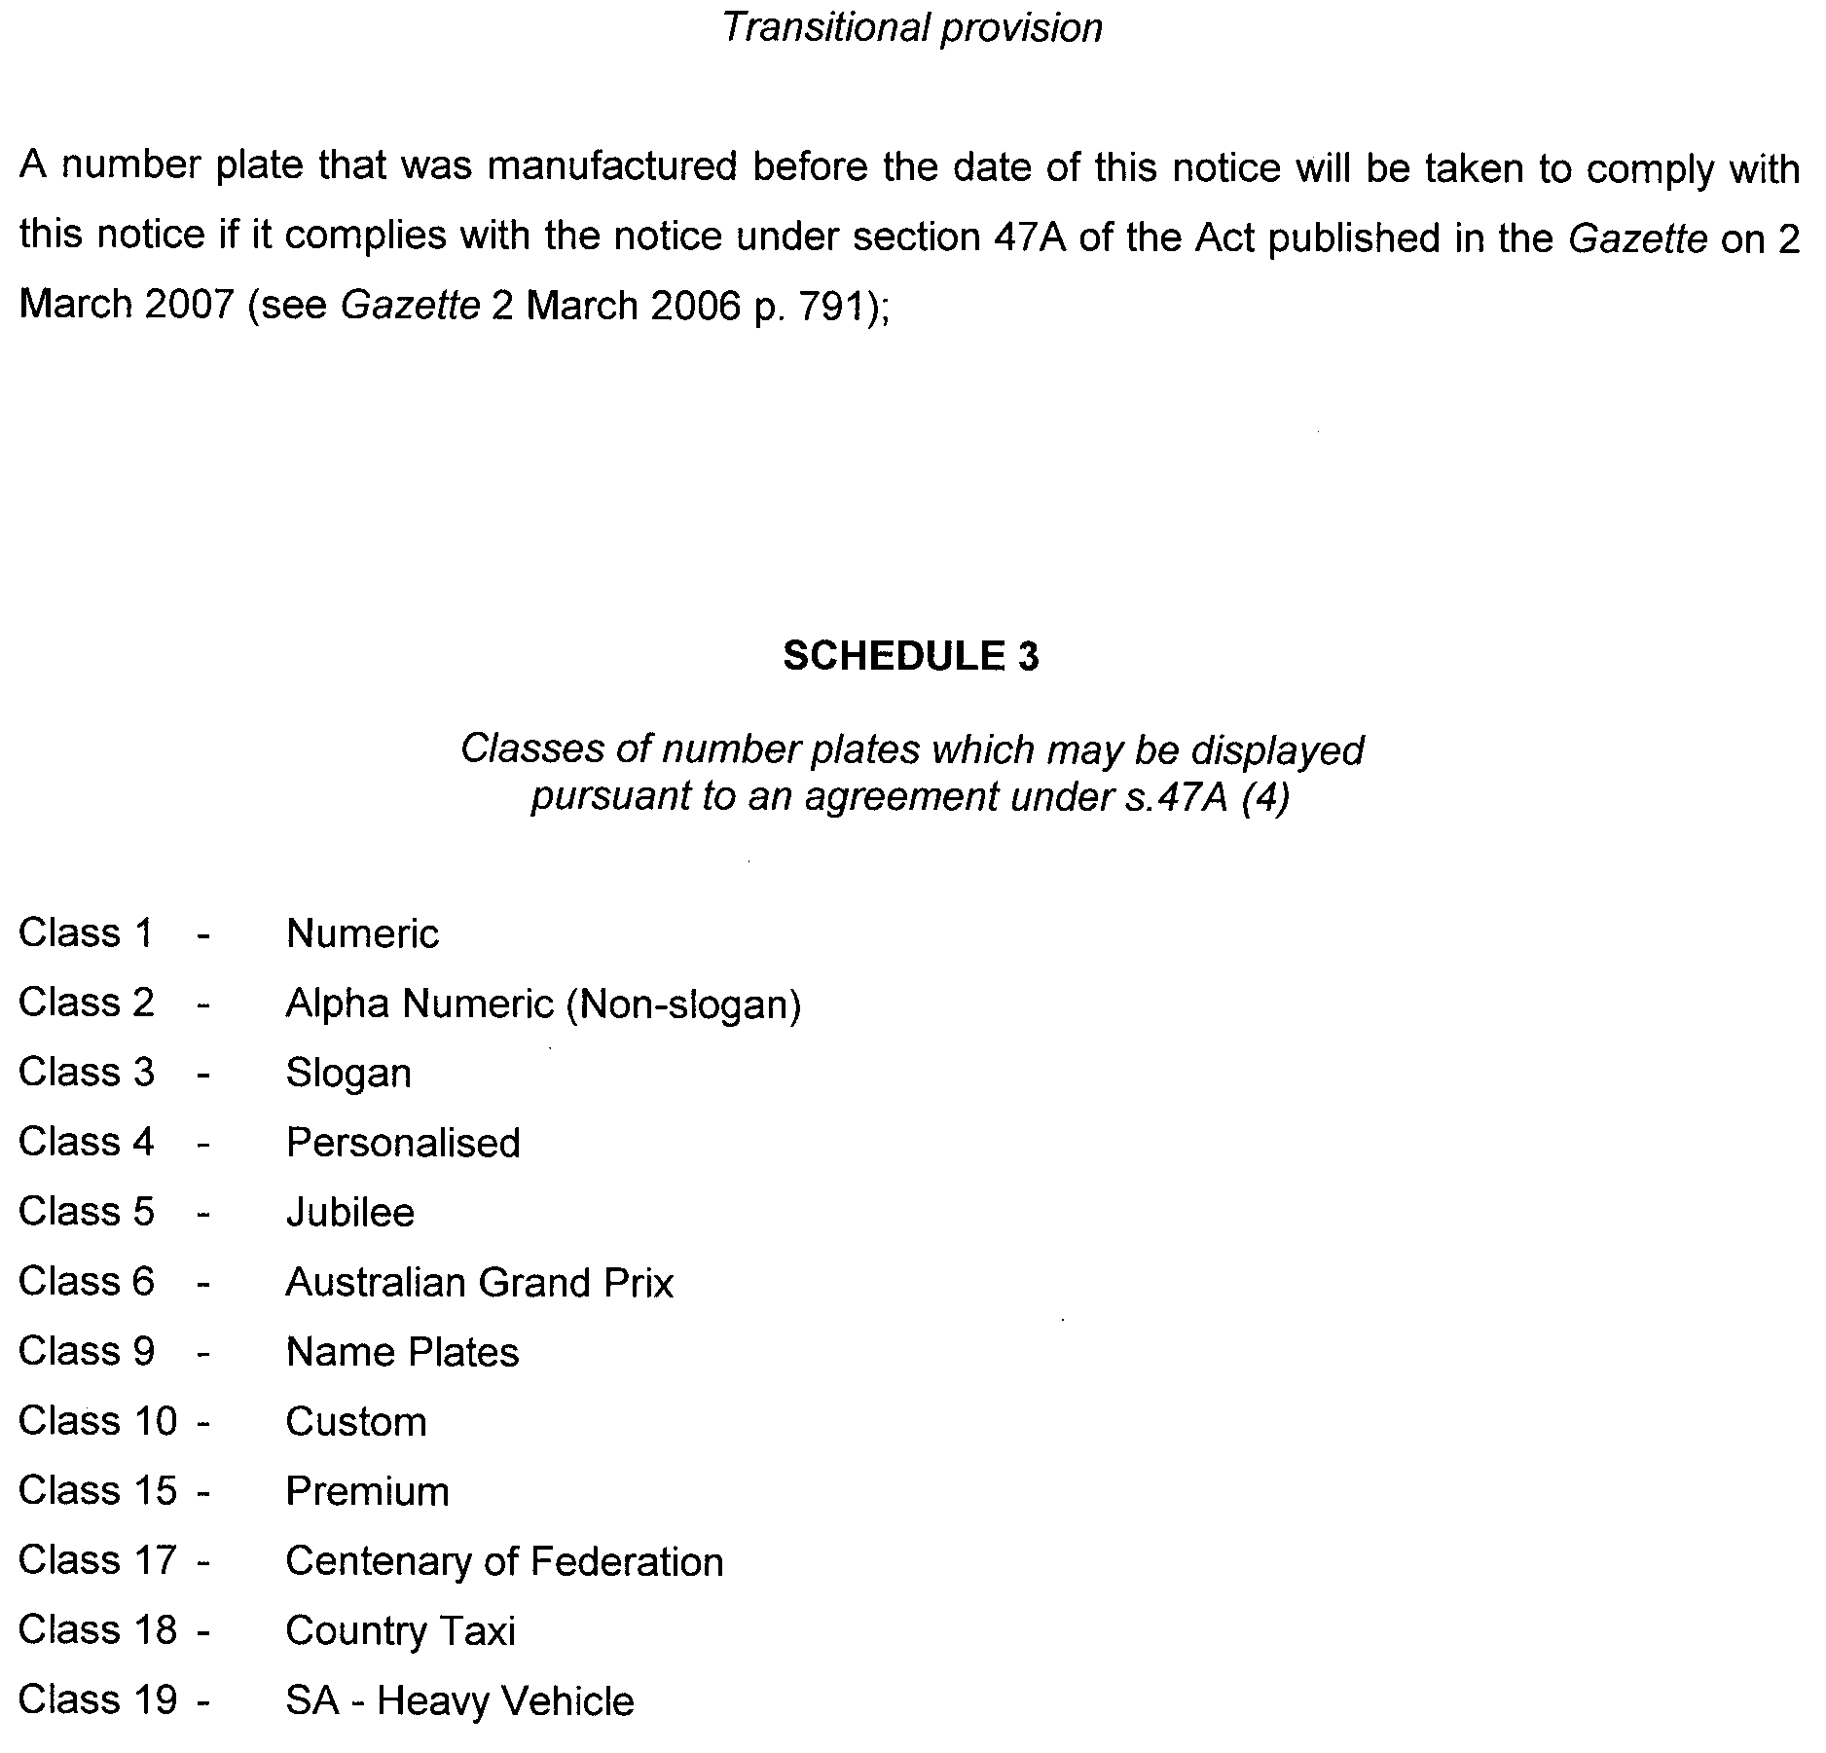

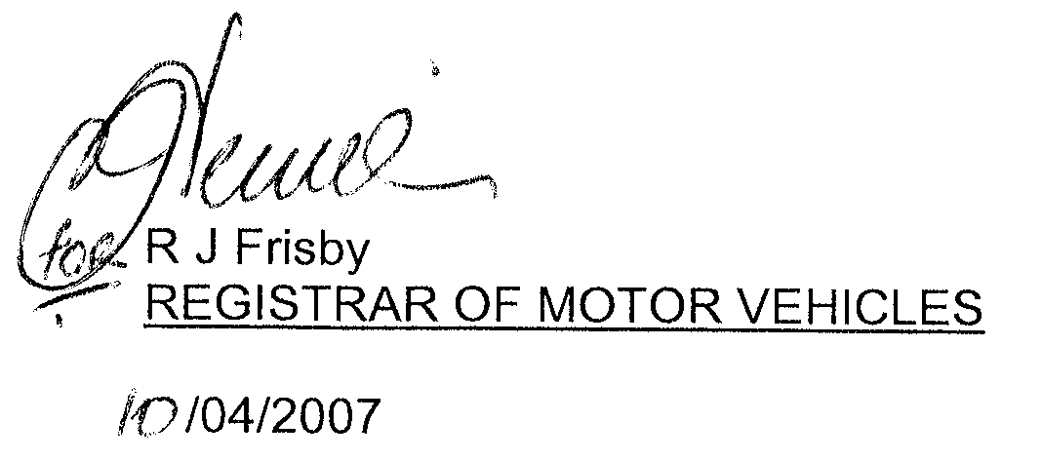

MINING ACT 1971
NOTICE is hereby given in accordance with section 28 (5) of the Mining Act 1971, that the Minister for Mineral Resources Development proposes to grant an Exploration Licence over the undermentioned area:
Applicant: Avoca Resources Ltd
Location: Ardrossan area⎯Approximately 70 km north-west of Adelaide.
Term: 1 year
Area in km²: 1 265
Ref.: 2007/00142
Plan and co-ordinates can be found on the PIRSA Sarig website: http://www.minerals.pir.sa.gov.au/sarig or by phoning Mineral Tenements on (08) 8463 3103.
H. Tyrteos, Mining Registrar

MINING ACT 1971
NOTICE is hereby given in accordance with section 28 (5) of the Mining Act 1971, that the Minister for Mineral Resources Development proposes to grant an Exploration Licence over the undermentioned area:
Applicant: Uranium One Australia Pty Ltd
Location: Yarramba area⎯Approximately 90 km north-east of Olary.
Term: 2 years
Area in km²: 452
Ref.: 2007/00146
Plan and co-ordinates can be found on the PIRSA Sarig website: http://www.minerals.pir.sa.gov.au/sarig or by phoning Mineral Tenements on (08) 8463 3103.
H. Tyrteos, Mining Registrar

MINING ACT 1971
NOTICE is hereby given in accordance with section 28 (5) of the Mining Act 1971, that the Minister for Mineral Resources Development proposes to grant an Exploration Licence over the undermentioned area:
Applicant: Uranium One Australia Pty Ltd
Location: South Eagle area⎯Approximately 80 km north-east of Olary.
Term: 2 years
Area in km²: 379
Ref.: 2007/00147
Plan and co-ordinates can be found on the PIRSA Sarig website: http://www.minerals.pir.sa.gov.au/sarig or by phoning Mineral Tenements on (08) 8463 3103.
H. Tyrteos, Mining Registrar

MINING ACT 1971
NOTICE is hereby given in accordance with section 28 (5) of the Mining Act 1971, that the Minister for Mineral Resources Development proposes to grant an Exploration Licence over the undermentioned area:
Applicant: Uranium One Australia Pty Ltd
Location: Goulds Dam area⎯Approximately 100 km north-west of Olary.
Term: 2 years
Area in km²: 334
Ref.: 2007/00153
Plan and co-ordinates can be found on the PIRSA Sarig website: http://www.minerals.pir.sa.gov.au/sarig or by phoning Mineral Tenements on (08) 8463 3103.
H. Tyrteos, Mining Registrar

MINING ACT 1971
NOTICE is hereby given in accordance with section 28 (5) of the Mining Act 1971, that the Minister for Mineral Resources Development proposes to grant an Exploration Licence over the undermentioned area:
Applicant: Copper Range (SA) Pty Ltd
Location: Lake Torrens area⎯Approximately 50 km east of Olympic Dam.
Term: 1 year
Area in km²: 344
Ref.: 2006/00419
Plan and co-ordinates can be found on the PIRSA Sarig website: http://www.minerals.pir.sa.gov.au/sarig or by phoning Mineral Tenements on (08) 8463 3103.
H. Tyrteos, Mining Registrar

MINING ACT 1971
NOTICE is hereby given in accordance with section 28 (5) of the Mining Act 1971, that the Minister for Mineral Resources Development proposes to grant an Exploration Licence over the undermentioned area:
Applicant: Copper Range (SA) Pty Ltd
Location: Lake Torrens area⎯Approximately 75 km east of Olympic Dam.
Term: 1 year
Area in km²: 355
Ref.: 2006/00420
Plan and co-ordinates can be found on the PIRSA Sarig website: http://www.minerals.pir.sa.gov.au/sarig or by phoning Mineral Tenements on (08) 8463 3103.
H. Tyrteos, Mining Registrar

MINING ACT 1971
NOTICE is hereby given in accordance with section 28 (5) of the Mining Act 1971, that the Minister for Mineral Resources Development proposes to grant an Exploration Licence over the undermentioned area:
Applicant: Copper Range (SA) Pty Ltd
Location: Lake Torrens area⎯Approximately 80 km east of Olympic Dam.
Term: 1 year
Area in km²: 103
Ref.: 2006/00421
Plan and co-ordinates can be found on the PIRSA Sarig website: http://www.minerals.pir.sa.gov.au/sarig or by phoning Mineral Tenements on (08) 8463 3103.
H. Tyrteos, Mining Registrar

MINING ACT 1971
NOTICE is hereby given in accordance with section 28 (5) of the Mining Act 1971, that the Minister for Mineral Resources Development proposes to grant an Exploration Licence over the undermentioned area:
Applicant: Steiner Holdings Pty Ltd
Location: Wynarka area⎯Approximately 120 km east-south-east of Adelaide.
Term: 1 year
Area in km²: 999
Ref.: 2006/00494
Plan and co-ordinates can be found on the PIRSA Sarig website: http://www.minerals.pir.sa.gov.au/sarig or by phoning Mineral Tenements on (08) 8463 3103.
H. Tyrteos, Mining Registrar

NATURAL RESOURCES MANAGEMENT ACT 2004
Notice of Prohibition on Taking Water from Wells in Area A
PURSUANT to section 132 (1) of the Natural Resources Manage-ment Act 2004 (the Act), I, Gail Gago, Minister for Environment and Conservation in the State of South Australia and the Minister to whom the administration of the Act is committed, being of the opinion that the rate at which water is taken from wells in Area A is such that there is a risk that the available water will not be sufficient to meet future demand, hereby prohibit, the taking of water from all wells in the shaded area shown in GRO Plan No. 14/2007 (Area A), other than in the circumstances specified in Schedule 1 below.
Schedule 1
1. Subject to Clauses 4 and 5 of this Schedule a person authorised in writing by the Minister responsible for administering the Act (the Minister) or delegate pursuant to the notice published in the Government Gazette on 3 March 2005 at page 564 under section 132 of the Act may take water for the same purpose and subject to the same conditions as specified in the authorisation.
2. An authorisation may be granted by the Minister or delegate under this notice to:
(a) A person (a Current User), who took water from a well in Area A during the period 1 July 2001 to 3 March 2005 inclusive (the Relevant Period), entitling that person to take, from the source specified in the authorisation:
• where the water taken during the Relevant Period was to water a crop or crops, the amount of water reasonably necessary, in my opinion, to water that crop or those crops, the amount being determined taking into account the maximum area of each crop or crops grown, the water requirements of the respective crop or crops and the irrigation capacity of the irrigation equipment used to water the crop or crops; or
• where the water was taken during the Relevant Period for any other purpose, the amount of water which, in my opinion, is reasonably necessary to continue that purpose in the manner in which it had been undertaken during the Relevant Period.
The source specified will be the resource or resources where water was taken during the Relevant Period.
(b) The transferee under a contract for the sale or other transfer of land where the transferor of the land is the holder of an authorisation under this notice, entitling that person to take the same amount of water from the same source as the transferor was authorised to take.
(c) Subject to Clause 3, a person (a Prospective User) who did not take any water from a well in the Area A but who needs water for a development, project or undertaking:
• to which that person was legally committed during the Relevant Period; or
• in respect of which that person had, in my opinion, committed significant financial or other resources during the Relevant Period;
entitling that person to take the amount of water from a well in Area A, which in my opinion, is reasonably necessary to undertake the development, project or undertaking to which that person was committed.
3. A Prospective User may not be granted an authorisation or may only be granted an authorisation subject to conditions relating to the manner of taking water where, in my opinion:
(a) the taking of water from wells will detrimentally affect the ability of other persons to take water from any well for domestic purposes or for watering of stock (other than stock being intensively farmed); or
(b) the taking of water from wells will detrimentally affect the capacity of any well to meet the current or future demand, including the demands of ecosystems dependent on that water resource.
4. Where a person has been issued with more than one authorisation, that person may only take water for the purpose and subject to the same conditions as specified in the latest authorisation issued to that person.
5. Any authorisation referred to in Clauses 1 or 2 of this Schedule may be varied by the Minister or delegate by the issue of a further written authorisation granted in accordance with this notice or cancelled where a person authorised to take water has transferred his or her land and the transferee of that land has been authorised to take water in accordance with Clause 2 (b).
6. This notice does not apply:
(a) to the taking of water directly from a well pursuant to section 124 (4) of the Act for domestic purposes or for watering of stock (other than stock being intensively farmed); or
(b) to the taking of water for fire-fighting purposes or public road making purposes; or
(c) to the taking of water for the purpose of the application of chemicals to non-irrigated crops or non-irrigated pasture or the application of chemicals to control a plant or animal belonging to a class of plants or animals to which a declaration by the Minister under Chapter 8,
Part 1 of the Act applies.
In this notice:
‘Maximum area’ for a particular crop means the maximum areas of land planted to a particular crop in any one financial year during the relevant period.
‘Water requirement’ of a crop means the reasonable rate of irrigation (expressed as a volume of water per hectare) to properly produce that crop.
‘Irrigation capacity’ of irrigation equipment means the amount of water that can be applied by the usual operation of that equipment in its condition at 3 March 2005 under usual pumping rates, hours of operation and seasonal fluctuations.
This notice will remain in effect for two years unless earlier varied or revoked.
Dated 13 April 2007.
Gail Gago, Minister for Environment and Conservation

NATURAL RESOURCES MANAGEMENT ACT 2004
Notice of Prohibition on Taking Water from Wells in the
Hundreds of Roby and Sherlock
PURSUANT to section 132 (1) of the Natural Resources Manage-ment Act 2004 (the Act), I, Gail Gago, Minister for Environment and Conservation in the State of South Australia and the Minister to whom the administration of the Act is committed, being of the opinion that the rate at which water is taken from wells in the Hundreds of Roby and Sherlock is such that it is likely to affect the quality of the water in the relevant underground aquifer, hereby prohibit, the taking of water from all wells in the Hundreds of Roby and Sherlock, other than in the circumstances specified in Schedule 1 below.
Schedule 1
1. Subject to Clauses 4 and 5 of this Schedule a person authorised in writing by the Minister responsible for administering the Act (the Minister) or delegate pursuant to the notice published in the Government Gazette on 3 March 2005 at page 564 under section 132 of the Act may take water for the same purpose and subject to the same conditions as specified in the authorisation.
2. An authorisation may be granted by the Minister or delegate under this notice to:
(a) A person (a Current User), who took water from a well in the Hundreds of Roby and/or Sherlock during the period 1 July 2001 to 3 March 2005 inclusive (the Relevant Period), entitling that person to take, from the source specified in the authorisation:
• where the water taken during the Relevant Period was to water a crop or crops, the amount of water reasonably necessary, in my opinion, to water that crop or those crops, the amount being determined taking into account the maximum area of each crop or crops grown, the water requirements of the respective crop or crops and the irrigation capacity of the irrigation equipment used to water the crop or crops; or
• where the water was taken during the Relevant Period for any other purpose, the amount of water which, in my opinion, is reasonably necessary to continue that purpose in the manner in which it had been undertaken during the Relevant Period.
The source specified will be the resource or resources where water was taken during the Relevant Period.
(b) The transferee under a contract for the sale or other transfer of land where the transferor of the land is the holder of an authorisation under this notice, entitling that person to take the same amount of water from the same source as the transferor was authorised to take.
(c) Subject to Clause 3, a person (a Prospective User) who did not take any water from a well in the Hundreds of Roby and/or Sherlock but who needs water for a development, project or undertaking:
• to which that person was legally committed during the Relevant Period; or
• in respect of which that person had, in my opinion, committed significant financial or other resources during the Relevant Period;
entitling that person to take the amount of water from a well in the Hundreds of Roby and/or Sherlock, which in my opinion, is reasonably necessary to undertake the development, project or undertaking to which that person was committed.
3. A Prospective User may not be granted an authorisation or may only be granted an authorisation subject to conditions relating to the manner of taking water where, in my opinion:
(a) the taking of water from wells will detrimentally affect the ability of other persons to take water from any well for domestic purposes or for watering of stock (other than stock being intensively farmed); or
(b) the taking of water from wells will detrimentally affect the capacity of any well to meet the current or future demand, including the demands of ecosystems dependent on that water resource.
4. Where a person has been issued with more than one authorisation, that person may only take water for the purpose and subject to the same conditions as specified in the latest authorisation issued to that person.
5. Any authorisation referred to in Clauses 1 or 2 of this Schedule may be varied by the Minister or delegate by the issue of a further written authorisation granted in accordance with this notice or cancelled where a person authorised to take water has transferred his or her land and the transferee of that land has been authorised to take water in accordance with Clause 2 (b).
6. This notice does not apply:
(a) to the taking of water directly from a well pursuant to section 124 (4) of the Act for domestic purposes or for watering of stock (other than stock being intensively farmed); or
(b) to the taking of water for fire-fighting purposes or public road making purposes; or
(c) to the taking of water for the purpose of the application of chemicals to non-irrigated crops or non-irrigated pasture or the application of chemicals to control a plant or animal belonging to a class of plants or animals to which a declaration by the Minister under Chapter 8,
Part 1 of the Act applies.
In this notice:
‘Maximum area’ for a particular crop means the maximum areas of land planted to a particular crop in any one financial year during the relevant period.
‘Water requirement’ of a crop means the reasonable rate of irrigation (expressed as a volume of water per hectare) to properly produce that crop.
‘Irrigation capacity’ of irrigation equipment means the amount of water that can be applied by the usual operation of that equipment in its condition at 3 March 2005 under usual pumping rates, hours of operation and seasonal fluctuations.
This notice will remain in effect for two years unless earlier varied or revoked.
Dated 13 April 2007.
Gail Gago, Minister for Environment and Conservation

NATURAL RESOURCES MANAGEMENT ACT 2004
Declaration of Penalty in Relation to the Unauthorised
Taking of Water
I, GAIL GAGO, Minister for Environment and Conservation, to whom administration of the Natural Resources Management Act 2004 (the Act) is committed, hereby declare that pursuant to section 115 (1) (c) and (d) of the Act, the following rate will apply during the financial year commencing on 1 July 2006 in relation to the taking of water by a person who is not the holder of a water licence and is not authorised under section 128 of the Act to take water from a prescribed water resource, or a person who uses water in contravention of a notice declared under section 132 of the Act:
• a rate of $17 per kilolitre of water determined or assessed to have been taken in accordance with section 106 of the Act.
Dated 14 April 2007.
Gail Gago, Minister for Environment and Conservation

NATURAL RESOURCES MANAGEMENT ACT 2004
Notice of Assessment of Quantity of Water Taken
When Meter Readings Are Not Used
PURSUANT to section 106 of the Natural Resources Management Act 2004, I, Gail Gago, Minister for Environment and Con-servation, hereby declare that the basis of assessment of water use rates and the method by which the assessment of water use where meter readings are not used or when water is taken without licence or authorisation will be as set out in Schedule 1.
Schedule 1
The basis of the assessment of water use will be the estimation of water requirements for a crop.
The method by which the estimation of water requirements for crops will be used is the methodology of Doorenbos and Pruitt (1977), as refined by Allen et al, (1998) and set out in the PIRSA Technical Report No. 263, second edition (the Report). Crop factors will be calculated from Kc (crop co-efficient) values from Food and Agriculture Organisation of the United Nations, Rome Irrigation and Drainage Paper 56 (Allen, Pereira et al, 1998) (FAO 56) and using site specific monthly Kp (pan co-efficient) values and average monthly Kg values (bird guard co-efficient) set out in the Report.
The methodology incorporates the use of Bureau of Meteorology evaporation data, the application of crop specific factors to evaporation figures to calculate crop evapotranspiration for the crop and location in question, subtraction of effective rainfall and an allowance for leaching for salinity control and irrigation efficiency.
The water requirement calculated by this method is expressed as depth of water required in millimetres for a particular crop grown over a particular season. Depth multiplied by the number of hectares of that crop grown (in each specified season for short season crops), multiplied by 10 gives the volume of water required for each crop in kilolitres.
A copy of each of the Report and FAO 56 is obtained through the GEO Science Library at the Department of Primary Industries and Resources South Australia. The reference number for the Report is ISBN No. 07308-4349-1 and the reference number for FAO 56 is Kinetica/Amicus No. 000020037000 or ISBN No. 92-5-104219-5.
This notice has effect in relation to the financial year commencing on 1 July 2007.
Dated 14 April 2007.
Gail Gago, Minister for Environment and Conservation

OCCUPATIONAL HEALTH, SAFETY AND WELFARE
ACT 1986
Appointments
I, MICHAEL JOHN WRIGHT, Minister for Industrial Relations in and for the State of South Australia, hereby under the Occupational Health, Safety and Welfare Act 1986, authorise the following public service employees to exercise the powers of an Inspector, pursuant to the Occupational Health, Safety and Welfare Act 1986:
Marie Antoinette Liddle
Kym James Wakefield
Dated 15 April 2007.
M. Wright, Minister for Industrial Relations

OPTOMETRISTS ACT 1920
Registered Optometrists as at 13 March 2007
Addison, Ben
Aitchison, Stuart William
Allen, Claudius
Altmann, John Murray
Ames, Robert Lionel
Andrew, Lauren Marie
Ankjell, Lien Thi Bach Tran
Bailey, Neville
Barnett, Duncan Lindsay
Barry, John Peter
Barton, Daniel
Bell, Paul Clayton
Benjamin, Eric Werner
Bennett, Reginald Frederick Garget
Berry, Caroline Isobel
Berry, Mark Boyd
Bhoola, Ashok
Bluntish, Ian Stanford
Bolton, Antony Laurence Blacker
Booth, Jason Mathew
Bosland, John Derek
Bosland, Kathryn Jane
Bottrill, Antoinette Diane Louise
Bottrill, David James
Brand, Amanda Ruth
Brown, Paul Anthony
Buchanan, David Scott
Bull, Benjamin Anthony
Burnside, Michael Edward
Butler, Graeme Andrew
Capper, Elizabeth Jane
Carlisle, Karen Jane
Carpenter, Paul Anthony
Carroll, Tamara Leigh
Chang, Hsin-Tsai
Chenery, Kenneth Desmond
Cheung, Ching Pui
Chin, William
Christiansen, Andrew Richard
Clayfield-Hoskin, Annette
Clem, Philip Martin
Clifford, Allan-Jon Phillip
Condon, Wilfred Peter
Constantine, Stephen Mark
Coorey, David Michael
Cunningham, Michael Gerard
Debock, Jelle Feike
Delaney, Peter John
Dickenson, Jennifer
Dickenson, William Arthur
Dini, Katherine Anne
Dini, Paul James
Dixon, Peter James
Do, Phuong Dang Mai
Donovan, Rebecca
Drewitt-Smith, Robert Bruce
Du Preez, Candice
Dunsford, Nigel Emery
Emsley, John Gordon
Evans, Colin Glyn
Fieldhouse, Ronald Horace
Fotkou, Paul
Gaterell, Lori Leanne
Gonsalves, Jose Anthony
Grace, Ashley Anthony
Grace, Ruth Margaret
Gregory, Kenneth Baden
Griffiths, Andrew Charles
Gunawan, Bee Buan
Gunawan, Handani
Guppy, Kristin Leigh
Hancock, Mitchell John
Heaney, Lesley Anne
Hocking, Ian Leslie
Holden, Stuart Lindsay James
Holding, Leigh James
Holland, Jason John
Hoo, Li Ting
Hook, Mark John
Horne, Chau Han
Hume, John Bryce
Hunt, Philip Andrew
Huynh, Charles To
Jenkins, Graeme Skene
Johnston, Erica Jane
Johnston, Kirsty Lee
Jolley, Paul
Jolley, Paula Jane
Kavanagh, Rosemarie
Kawecki, Christopher
Keary, Peter Michael
Keen, Helen Elizabeth
Keipert, Lewis Douglas
Kenefick, James David
Khalaf, Hayssam
Kinchington, David Patrick
Kirkman, Margaret Anne
Kong, Aimee Chui-Yee
Koutavas, Harry
Kruszewski, Henry John
Ku, Janice Jung-Yeon
Lake, Donald Derek
Lam, Lee Choon
Lanham, Jennifer Anne
Larsen, Kurt Christopher
Lee, Linda
Lewry, Allan John
Li, Loretta Man Yung
Lim, Ee Tatt
Lim, Grace Weiping
Lim, Vincent Ghee Tiong
Lin, Jui-Chieh (Jerry)
Lo, Jennifer Pui Yan
Mackay, Stuart John
Macri, Joseph
Mak, Connie Koon Lui
Malingre, Rene Marcel Pierre
Mann, Stanley Bradshaw
Mann, Veronica Louise
Martin, Frederick Wayne
Martin, Jann Elizabeth
Mayhew, Susan
McCreery, Grant Bruce
McGartland, Michelle Teresa
McGowan, Stephen Laurence
McGregor, Robert Bruce
McIvor, William John Stephen
McLarty, Anthony Matthew
McMurrich, Amanda Jane
McTaggart, Christopher Mark
Michaels, Renee Irene
Milford, Philip Kendall
Mistry, Dipika
Mohseni, Abdul-Azim
Morris, Philip Andrew
Murphy, Siobhan Grainne
Murray, Andrea Dorne
Murray, Neil Bruce
Musson, Christine Anne
Nabhani, Nawras
Naidoo-Bhoola, Venotha
Ng, Toh Sang
Ngo, Phuc Quang
Nguyen, Chan Nu-Thien
Nguyen, Marilyn Hong Hanh
Nguyen, Quynh Nu Ngol
Nguyen, Tho
Nguyen-Duc, Annie Tu-An
Nikanjam, Neda
Noach, Louis
Nolan, Lawrence Michael
Norynberg, Lisa Marie
Oakey, Geoffrey Gordon
O’Brien, David Anthony
O’Brien, Kelly Marie
O’Callaghan, Gavin Joseph
O’Connor, David Christopher
O’Connor, Mark John
Olechnowicz, Adam
Ooi, Chuan Seng
O’Neill, Andrew Paul
Oswald, Peter James
Overduin, Kristin Kayne
Parsons, Mark Philip William
Pesudovs, Konrad
Phillips, Anthony John
Pissas, Helen
Pocknee, Elise
Povolny, Monika
Prentice, Jackelyn Olivia
Preston, Suzanne Marie
Pritchard, Robert
Rayner, Jennifer May
Richardson, Lorna Yvonne
Riley, Martin Anthony
Rivett, Ashley Gordon
Rooney, Kevin Francis
Royle, Lisa Marie
Russell, Ian Charles
Sanun, Bhupinder Singh
Sara, Donald Edward
Schoneveld, Paul Gregory Anthony
Schultz, Glen Phillip
Scott-Hoy, Stephen
Seeto, Karen Angela
Selby, Nigel
Sharma, Nisha Kumari
Shin, Hyo Chul
Shin, May
Sian, Pek Eng
Sibbin, Derek Richard
Simpson, Michael Crawford
Singh, Sailendra Ram
Slater, Brian Gerard
Smith, Leanne
So, Amy
Sommer, Rachel Leanne
Sotiropoulos, Oriana
Sprumont, Kylie Carita
Stanbury, Dion Neville
Stanley, Murray David
Stokes, Clive Robert
Sutton, Kay Louise
Tan, Boon Yuen
Tan, Jessie Yee-Ling
Tan, Kok Chong
Targett, Allan Peter
Tayler, Brian Oswald
Thomas, Andrew Roy Scott
Thomson, Christopher Wyville
Thornton, Penelope Rae
Ting, Check Nguong
Trimper, Mervyn Stanley
Trinh, Anh Hoang-Oanh
Trinh, Tien Thuy
Truong, Phuong Bich
Tsigounis, Adamandia
Tsui, Henry Yuk Hang
Upton, George Mostyn
Van Schalkwyk, Leon
Vasilj, Boris Anthony
Verney, Stephen John
Viz, Rashi
Vo, Annalise Anh Hoang
Voice, Jessica Rosalyn
Wallis, Annette
Wallis, Eric Robert
Wallis, Rex Burton
Wang, Bob Zhongqi
Wang, Lei
Watkins, Rodney Dennis
Watling, Mark Edward Austin
Welch, David John
Wheeler, Ian Robert
Wijaya, Sonya
Wilden, Stefanie Barbara
Willmore, Melvin Robert
Wilson, Mandy
Wojt, Jacinta
Wojt, Marek Jan
Wojt, Naima Kate
Wong, Ming Ming
Woodcock, Jennifer Margaret
Woollard, Christopher Leslie
Wright, Sarah Louise
Wyatt, Simone Lynette
Wynn, Ian Leslie
Yapp, Michael James
Yee, Basil
Yee, Marie
Yip, Anita
Zhang, Han
Zhang, Lona

Optometrists to be Removed from the Register from
1 January 2007
Anning, David Andrew
Blanch, Christopher Ronald
Box, David Peter
Chau, Judy Thao
Chowdhury, Nandita
Chung, Jenny Jee Hye
Collett, Katherine Jane
Dang, Susan
Dave, Bhargav
Day, Samantha Elizabeth
Dingle, Carolyn Emma
Gardner, Peter Raymond
Ho, Wendy Voon Di
Holland, Lee Joseph
Hua, Hue
Huang, Yun-Ching Jenny
Jessop, Donald Scott
Kemp, David William
Knight, Damien John
Kwok, Julia Tsz Ha
Kwok, Lance Stephen
Le, Ivy Kim
Lin, Cassie
Liu, Wendy Yi-Lan
Ly, Frances
Macpherson, Ann Faith
Mattner, Kristen Lea
McFadzean, Alison Joan
Milhinch, Peter
Napthali, Amanda
Nguyen, Tran (John)
Nguyen, Khan Ha Duy
Pappageorgiou, Louica Helen
Perera, Rachithri Danupama
Phillips, Joanna Kate
Pochanke, Bartosz
Pritchard, Carolyn Deborah
Psarakis, Dean Terrence
Savidis, Anastasios
Schoeman, Maria Margaretha
Shannon, Naomi Ann
Singh, Adeline Ashika Devi
Sluyter, Diana Marre
Smith, Christopher Adam
Smith, Murray George Elcoate
Tam, Norman
Tang, Han Vi
Tang, Jason Wai Mun
Thaker, Adam Ramesh
Todd, Russell Nathan
Toomey, Melinda Louise
Travis, Mary Elizabeth
Trevor, Tasha Brooke
Tuon, Michelle Eming
Valev, Irina
Vong, Jenny
Wainwright, Sara Emily
Walkom, Aaron John
Whiting, Matthew Richard
Wu, June
Yeow, Darran Lizong
Yeung, Jamilla Wan-Lai

Registered Optical Dispensers as at 13 March 2007
Acheson, Janette Ellen
Adams, Christine
Adams, Ronald Maurice
Allen, David Jeffrey
Anderson, Kevin Francis
Ashford, Ian Patrick
Bailey, Barbara Frances
Bell, Anne
Binney, Kirsty Marie
Blain, Michele
Breuker, Linda Joan
Brown, Kylie Lyn
Browne, Robert Geoffrey
Bullen, Gillian Patricia
Bushell, Keith Neville
Butcher, Robert Richard
Butcher, Scott Kendall
Catterall, Julie Elizabeth
Champion, Keith Thomas
Clarke, Sandra Jayne
Coker, Suzanne Gillian
Cole, Mary Edith
Condello-Quilliam, Sarinella
Conroy, Vincent Robin
Coope, Paul
Cottle, Dennis Lindsay
Crook, Lance Owen
Crossley, Charles Eric
Cummings, Graham Malcolm
Dartnall, Shirley
Deacon, Richard John
Dean, Natasha Lisa
Del-Bono, Joseph Felice
Dickins, Karren Jane
Dinos, Elizabeth
Dixon, Michelle Kim
Dorman, John Francis
Dorman, Mark John
Drew, Virginia Anne
Eckermann, Gregory John
Eckert, Peter John
Eckstein, Silvia
Ewer, Trevor Max
Fenton, Suzanne Gloria
Fisk, Denis Andrew
Fletcher, Julie Margaret
Foreman, Sandra
Freeman, Royce Annette
Fury, Dianne Lesley
Gallagher, Peter Emmett
Gauci, Vincent
Gelios, Dianne
Georgopoulos, Nicholas
Golding (nee Van der Zalm), Jacqueline Frances Elizabeth
Goldsworthy, Karen Anne
Goodwin, Merilyn Jean
Guest, Jillian Ada
Hadley, Robin Harrington
Hague, Leanne Gale
Hanisch, David Paul
Harriott, Toni Anne
Harris, Trafford John
Hartshorne, David Ralph
Henley, Beverley Anne
Hilder, Eunice Marie
Hogan, Martin Xavier
Holmes, Martin Scott
Holmes, Sharon Ann
Honey, Kerry Bentley
Hosking, Jillian Patricia
Hull, Tracey Maree
Hutton, Steven Andrew
Isaacs, Warren
Jacobs, David George
Johnston, Denise June
Jones, Andrew Lucas
Kehoe, Jane
Kemp, Josephine Lee
Keogh, Kym Harold
Kingsmill, Carolyn Jane
Kirsten, Robert Thomas
Kovaliski, Zita
Langford, Donna-Maree
Lausberg, Werner Hubert
Lewry, Tonia-Ann
Liddiard, Sally Elizabeth
Lienert, Dianne Margret
Lo, Oi King Alice
Lockwood, Renee Louise
Longbottom, Wendy Jean
Lowery Jnr, Dewey Lee
Macolino, Maria
Mangelsdorf, Rebecca Elizabeth
Mann, Julie Veronica
Martin, Helena
Martin, Murray Charles
Martin, Penelope Jane
Mason, Nicola Jane
Matulick, Kathryn Leanne
McFall, Jacqueline Claire
McGibbon, Vanessa Lee
McInerney, Paul Kevin
Medcalf, Jennifer Merle
Miller, Christopher John
Milton, Karen Mary Jane
Monksfield, Michelle Lee
Monteiro, Jigna Cyril
Moran, Timothy James
Morishita, Masayasu
Odgers, Mary Rose
O’Neill, Robert Anthony
Ortmann, Louise Joanne
Ouzman, Michele
Paech, Janine Mary
Paraschos, Fotini
Parry, Julie Fay
Peake (formerly Crosby), Evelyn Joan
Pethick, Prudence Rosalind
Phillips, Brett Don
Phillips, Kylie Megan
Pritchard, Taslim
Przibilla, Timothy Clarence
Pullen, John Russell
Purling, Joanne
Rake, Meredith Phyllis May
Richter, Shelley Ann
Robjohns, Peter John
Rogers, Jeffrey Adrian
Rogers, John Allan
Schneider, Peter Hans
Seneca, Carolina
Simon, Mark Allen
Sims, Kerrie Anne
Smith, Brian Norman
Smith, Cobi Christine
Smith, Rodney Donald
Smith, Sheila
Smithson, Louise May
Spencer, Narah Lee
Spencer, Todd Stuart
Stanes, Cynthia Lois
Stansborough, Amanda Gaye
Stansborough, Jason Glenn
Stanyer, Elinor May
Stevens, Rosemary Ann
Stone, Lesley Alison
Taintey, Robert James
Teivans, Robert James
Ten Voorde, Lucia Johanna
Thompson, Shilo Arlene
Tilke, Glenn Lawrence
Timmins, Susan Ann
Tsoutsouras, Susan Jane
Vears, Teresa Vicki
Viant, Brendan Thomas
Vozzo, Andrew
Walter, Cheryl Kaye
Waugh, Debra Valerie
Webber, Marie Anne
Whittaker, Karen Michelle
Whittall, Michael John
Williamson, Clare Louise
Willington, Grant Scott

Optical Dispensers to be Removed as at 1 January 2007
Balaza, Stephen
Briggs, Brian Charles
Butcher, Wendy Lilian
Cheesman, Graham Athelstan
Cooper, Gail
Davies, Heather Margaret
Dungey, Leigh Anthony
Godden, Deborah
Grace, Jennifer Anne
Hutton, Margaret Ruth
Jarrett, Sally Ann
Kubler, Sascha Harald
Mate, Michael John
Murugappa, Meyyappan Senthil
Przibilla, Heather Jean
Reid, Sharon Kaye
Robjohns, Ruth Marie
Tilke, Leanne Dorothy
Trueack, Natasha Louise
Van Sprang, Jan Cornelis
Westall, Margaret Christina
N. J. Storer, Registrar

PETROLEUM PRODUCTS REGULATION ACT 1995
Appointments
I, MICHAEL JOHN WRIGHT, Minister for Industrial Relations in and for the State of South Australia, hereby appoint each of the following persons as an Authorised Officer for the purposes of the Petroleum Products Regulation Act 1995, in accordance with my delegated authority under section 49 of the Petroleum Products Regulation Act 1995:
Marie Antoinette Liddle
Kym James Wakefield
Dated 15 April 2007.
M. Wright, Minister for Industrial Relations

RADIATION PROTECTION AND CONTROL ACT 1982
Section 44
Notice by Delegate of the Minister for Environment
and Conservation
THE exemption from the requirements of Regulation 18 of the Radiation Protection and Control (Ionising Radiation) Regulations 2000 granted on 13 April 1995 to Dr Anne Kathleen Lovell, Veterinary Surgeon, insofar as that regulation applies to staff at the Veterinary Clinic, 8 Avenue Road, Stirling, who carry out or assist with animal radiography at the clinic, is hereby revoked.
Dated 16 April 2007.
G. Palmer, Delegate of the Minister for Environment and Conservation

SOUTH AUSTRALIA FIRE AND EMERGENCY
SERVICES ACT 2005
Constitution of Brigade
NOTICE is hereby given pursuant to Division 5, section 68 (1) (a) of the South Australia Fire and Emergency Services Act 2005 that the Chief Officer, constitutes the Nepabunna CFS Brigade, effective from 30 March 2007.
Dated 11 April 2007.
E. Ferguson, Chief Officer

PETROLEUM ACT 2000
Grant of Petroleum Exploration Licence—PEL 139
NOTICE is hereby given that the undermentioned Petroleum Exploration Licence has been granted under the provisions of the Petroleum Act 2000, pursuant to delegated powers dated 28 March 2002, Gazetted 11 April 2002, page 1573.
No. of  Licence | Licensee | Locality | Date of  Expiry | Area in  km² | Reference

139 | Standard Oil Pty Ltd  Dawnpark Holdings Pty Ltd |  | Officer Basin of South Australia | 12 April 2012 | 9 861 | 27/02/235

Description of Area
All that part of the State of South Australia, bounded as follows:
Commencing at a point being the intersection of longitude 134°00′00″E GDA94 and latitude 27°00′00″S GDA94, thence south to latitude 27°20′00″S GDA94, east to longitude 134°10′00″E AGD66, south to latitude 27°54′00″S GDA94, west to longitude 134°00′00″E GDA94, south to latitude 28°10′00″S AGD66, west to longitude 133°31′00″E AGD66, south to latitude 28°35′00″S AGD66, west to longitude 133°30′00″E GDA94, south to latitude 28°35′00″S GDA94, west to longitude 133°00′00″E AGD66, north to the southern boundary of the Pitjantjatjara Lands, thence generally northerly and easterly along the boundary of the said Lands to latitude 27°00′00″S GDA94 and east to the point of commencement.
Area: 9 861 km² approximately.
Dated 13 April 2007.
B. A. Goldstein, Director Petroleum and Geothermal
Minerals and Energy Resources
Primary Industries and Resources SA
Delegate of the Minister for Mineral Resources Development

RULES OF COURT
District Court Civil (Amendment No. 1)
Rules 2006
BY virtue and in pursuance of section 51 of the District Court Act 1991 and all other enabling powers, We, Terence Anthony Worthington, Chief Judge, Andrea Simpson and Dean Ernest Clayton, Judges of the District Court of South Australia, do hereby make the following Rules of Court:
1. These Rules may be cited as the District Court Civil (Amendment No. 1) Rules 2006.
2. The District Court Civil Rules 2006, are amended as set out below.
3. These amendments are to come into effect on the later of 1 May 2007 or their gazettal.
4. In subrule 8 (2) (a) for ‘taxation of costs’ substitute ‘adjudication on costs’.
5. In subrule 33 (9) for ‘the action is stayed’ substitute ‘the Court may stay the action’.
6. At the end of subrule 38 (3) add a new subrule (4):
‘(4) Every person whose interests may be directly and adversely affected by the terms of a judgment, and whose presence before the Court is required for a judgment to be entered in those terms, is to be made a defendant to the originating process.’
7. Rule 40 (1) is amended by:
(1) at the end of subparagraph (j) deleting ‘.’ and adding ‘; or’
(2) inserting a new subparagraph (k) after subparagraph (j) as follows:
‘(k) the action is for an injunction as to anything to be done in the State or against the doing of anything in the State, whether damages are sought or not.’
8. At the end of subrule 98 (2) add a new subparagraph (d):
‘(d) must plead such facts as give fair notice of the party’s case at trial.’
9. At the end of subrule 106 (1) delete ‘.’ and add ‘in the form of an affidavit’.
10. After subrule 140 (6) add a new subrule (7):
‘(7) A party is not required to produce any document which is subject to privilege from production.’
11. Rule 148 is deleted and replaced by a new Rule 148:
‘Search Order
148. (1) Interpretation
In this Rule, unless the contrary intention appears:
applicant means an applicant for a search order.
described includes described generally whether by reference to a class or otherwise.
premises includes a vehicle or vessel of any kind.
respondent means a person against whom a search order is sought or made.
search order has the meaning given by subrule (2).

(2) Search order
The Court may make an order (a search order), in any proceeding or in anticipation of any proceeding in the Court, with or without notice to the respondent, for the purpose of securing or preserving evidentiary material and requiring a respondent to permit persons to enter premises for the purpose of securing the preservation of evidentiary material which is, or may be, relevant to an issue in the proceeding or anticipated proceeding.
(3) Requirements for grant of search order
The Court may make a search order if the Court is satisfied that:
(a) an applicant seeking the order has a strong prima facie case on an accrued cause of action; and
(b) the potential or actual loss or damage to the applicant will be serious if the search order is not made; and
(c) there is sufficient evidence in relation to a respondent that:
(i) the respondent possesses important evidentiary material; and
(ii) there is a real possibility that the respondent might destroy such material or cause it to be unavailable for use in evidence in a proceeding or anticipated proceeding before the Court.
(4) Jurisdiction
Nothing in this Rule diminishes the inherent, implied or statutory jurisdiction of the Court to make a search order.
(5) Terms of search order
(a) A search order may direct each person who is named or described in the order:
(i) to permit, or arrange to permit, such other persons as are named or described in the order:
(A) to enter premises specified in the order, and
(B) to take any steps that are in accordance with the terms of the order; and
(ii) to provide, or arrange to provide, such other persons named or described in the order with any information, thing or service described in the order; and
(iii) to allow such other persons named or described in the order to take and retain in their custody any thing described in the order; and
(iv) not to disclose any information about the order, for up to three days after the date on which the order was served, except for the purposes of obtaining legal advice or legal representation; and
(v) to do or refrain from doing any act as the Court considers appropriate.
(b) Without limiting the generality of subparagraph (a) (i) (B), the steps that may be taken in relation to a thing specified in a search order include:
(i) searching for, inspecting or removing the thing; and
(ii) making or obtaining a record of the thing or any information it may contain.
(c) A search order may contain such other provisions as the Court considers appropriate.
(d) In subrule (b):
record includes a copy, photograph, film or sample.

(6) Independent lawyers
(a) If the Court makes a search order, the Court must appoint one or more lawyers, each of whom is independent of the applicant’s lawyers, (the independent lawyers) to supervise the execution of the order, and to do such other things in relation to the order as the Court considers appropriate.
(b) The Court may appoint an independent lawyer to supervise execution of the order at any one or more premises, and a different independent lawyer or lawyers to supervise execution of the order at other premises, with each independent lawyer having power to do such other things in relation to the order as the Court considers appropriate.
(7) Costs
(a) The Court may make any order as to costs that it considers appropriate in relation to an order made under this Rule.
(b) Without limiting the generality of subrule (1), an order as to costs includes an order as to the costs of any person affected by a search order.’
12. In subrule 162 (3) for ‘authorised witness’ substitute ‘authorised person’.
13. After subrule 162 (10) add a new subrule (11):
‘(11) An affidavit is to be sworn or affirmed:
(a) if made in this State, in accordance with section 6 of the Evidence Act 1929; or
(b) if made elsewhere, in accordance with the law for the taking of oaths or the making of affirmations in that place.’
14. In Rule 163 delete the heading ‘Authorised witness’ and replace it with ‘Taking of affidavits’.
15. In subrule 163 (1) for ‘witness who may witness the making of’ substitute ‘person who may take’.
16. In subrule 187 (2) (a) for ‘the date fixed for the trial to commence’ substitute ‘the first, or any subsequent, date fixed for the trial to commence’.
17. In subrule 187 (2) (b) for ‘2’ substitute ‘4’.
18. After subrule 187 (6) add a new subrule (7):
‘(7) A formal offer of settlement may be withdrawn at any time by the filing of a notice of withdrawal and in such cases, subject to any Court order to the contrary, the offer will be treated as if it had never been made.’
19. In subrule 188 (2) (a) for ‘the date fixed for the trial to commence’ substitute ‘the first, or any subsequent, date fixed for the trial to commence.’
20. In subrule 188 (6) (b) (ii) delete ‘.’ and add at the end ‘and the defendant is not entitled to any costs not otherwise ordered.’
21. In subrule 191 (1) for ‘in a manner approved by the Auditor-General’ substitute ‘pursuant to section 21 of the Public Finance and Audit Act 1987’.
22. Subrule 191 (3) is deleted and replaced by subrules 191 (3), (4) and (5):
‘(3) As soon as practicable after the last days of June and December in each year the Registrar is to fix the rate of interest payable in respect of funds in Court for the preceding half-year and to credit interest to the common fund or any special fund at those times.
(4) When money is paid out during any half-yearly period the rate of interest applicable to the previous half-year shall apply unless the Registrar otherwise directs.
(5) Interest accrues from day to day up to the date when the cheque for payment out is signed.’
23. In subrule 194 (3) for ‘ the action is stayed’ substitute ‘the action may be stayed’ and delete ‘unless the Court otherwise directs.’

24. After subrule 209 (4) add a new subrule (5):
‘(5) Rule 209 extends to any hearing conducted by the Court.’
25. Rule 247 is deleted and replaced by a new Rule 247:
‘Freezing Orders
247. (1) Interpretation
In this Rule, unless the contrary intention appears:
ancillary order has the meaning given by subrule (3).
another Court means a Court outside Australia or a Court in Australia other than the Court.
applicant means a person who applies for a freezing order or an ancillary order.
freezing order has the meaning given by subrule (2).
judgment includes an order.
respondent means a person against whom a freezing order or an ancillary order is sought or made.
(2) Freezing order
(a) The Court may make an order (a freezing order), upon or without notice to a respondent, for the purpose of preventing the frustration or inhibition of the Court’s process by seeking to meet a danger that a judgment or prospective judgment of the Court will be wholly or partly unsatisfied.
(b) A freezing order may be an order restraining a respondent from removing any assets located in or outside Australia or from disposing of, dealing with, or diminishing the value of, those assets.
(3) Ancillary order
(a) The Court may make an order (an ancillary order) ancillary to a freezing order or prospective freezing order as the Court considers appropriate.
(b) Without limiting the generality of subrule (a), an ancillary order may be made for either or both of the following purposes:
(i) eliciting information relating to assets relevant to the freezing order or prospective freezing order;
(ii) determining whether the freezing order should be made.
(4) Respondent need not be party to proceeding
The Court may make a freezing order or an ancillary order against a respondent even if the respondent is not a party to a proceeding in which substantive relief is sought against the respondent.
(5) Order against judgment debtor or prospective judgment debtor or third party
(a) This Rule applies if:
(i) judgment has been given in favour of an applicant by:
(A) the Court; or
(B) in the case of a judgment to which subrule (b) applies—another Court; or
(ii) an applicant has a good arguable case on an accrued or prospective cause of action that is justiciable in:
(A) the Court; or
(B) in the case of a cause of action to which subrule (c) applies—another Court.

(b) This subrule applies to a judgment if there is a sufficient prospect that the judgment will be registered in or enforced by the Court.
(c) This subrule applies to a cause of action if:
(i) there is a sufficient prospect that the other Court will give judgment in favour of the applicant; and
(ii) there is a sufficient prospect that the judgment will be registered in or enforced by the Court.
(d) The Court may make a freezing order or an ancillary order or both against a judgment debtor or prospective judgment debtor if the Court is satisfied, having regard to all the circumstances, that there is a danger that a judgment or prospective judgment will be wholly or partly unsatisfied because any of the following might occur:
(i) the judgment debtor, prospective judgment debtor or another person absconds; or
(ii) the assets of the judgment debtor, prospective judgment debtor or another person are:
(A) removed from Australia or from a place inside or outside Australia; or
(B) disposed of, dealt with or diminished in value.
(e) The Court may make a freezing order or an ancillary order or both against a person other than a judgment debtor or prospective judgment debtor (a third party) if the Court is satisfied, having regard to all the circumstances, that:
(i) there is a danger that a judgment or prospective judgment will be wholly or partly unsatisfied because:
(A) the third party holds or is using, or has exercised or is exercising, a power of disposition over assets (including claims and expectancies) of the judgment debtor or prospective judgment debtor; or
(B) the third party is in possession of, or in a position of control or influence concerning, assets (including claims and expectancies) of the judgment debtor or prospective judgment debtor; or
(ii) a process in the Court is or may ultimately be available to the applicant as a result of a judgment or prospective judgment, under which process the third party may be obliged to disgorge assets or contribute toward satisfying the judgment or prospective judgment.
(f) Nothing in this Rule affects the power of the Court to make a freezing order or ancillary order if the Court considers it is in the interests of justice to do so.
(6) Jurisdiction
Nothing in this Rule diminishes the inherent, implied or statutory jurisdiction of the Court to make a freezing order or ancillary order.
(7) Service outside Australia of application for freezing order or ancillary order
An application for a freezing order or an ancillary order may be served on a person who is outside Australia (whether or not the person is domiciled or resident in Australia) if any of the assets to which the order relates are within the jurisdiction of the Court.
(8) Costs
(a) The Court may make any order as to costs as it considers appropriate in relation to an order made under this Rule.
(b) Without limiting the generality of subrule (1), an order as to costs includes an order as to the costs of any person affected by a freezing order or ancillary order.’
26. In subrule 265 (2) (a) for ‘a bill of costs is not to be taxed’ substitute ‘a Schedule of costs is not to be adjudicated upon’.
27. In the heading to Chapter 12, Part 3 for ‘Taxation of’ substitute ‘Adjudication upon’.
28. In subrule 270 (2) for ‘a taxing officer’ substitute ‘an adjudicating officer’.
29. In the heading to Rule 271 for ‘taxation of’ substitute ‘adjudication upon’.
30. In each of subrules 271 (1), (3), (6) (c) and (6) (d) for ‘taxation’ substitute ‘adjudication’.
31. In the heading to Rule 272 for ‘Taxation of costs where right to taxation’ substitute ‘Adjudication of costs when right to adjudication’.
32. In subrule 272 (1) for ‘taxation of’ substitute ‘an adjudication of’ and at the end for ‘taxation’ substitute ‘adjudication’.
33. In each of subrules 272 (4) (b) and (c) for ‘taxation’ substitute ‘adjudication’.
34. In the heading to Rule 273 and in subrule 273 (1) for ‘taxation’ substitute ‘adjudication’.
35. In the heading to Rule 274 and in subrule 274 (1) for ‘taxation of’ substitute ‘adjudication upon’.
36. In Example 3 to subrule 274 (2) for ‘taxation’ substitute ‘adjudication’.
37. In the heading to Rule 276 for ‘Taxation’ substitute ‘Adjudication’.
38. In Rule 276 for ‘taxed’ and ‘taxation’ substitute ‘adjudicated upon’ and ‘adjudication’ respectively.
39. In the heading to Rule 277 for ‘Taxation’ substitute ‘Adjudication’.
40. In Rule 277 for ‘a taxing officer’ wherever it appears substitute ‘an adjudicating officer’ and in subrule 277 (4) for ‘taxing officer’ substitute ‘adjudicating officer’.
41. In subrule 277 (1) for ‘taxed’ substitute ‘adjudicated upon’.
42. In subrule 277 (2) for ‘taxation’ substitute ‘adjudication’.
43. In subrule 277 (3) for ‘taxation of costs’ substitute ‘adjudication of costs’.
44. In subrule 277 (4) for ‘taxation’ twice appearing, substitute in each case ‘adjudication’.
45. In subrule 278 (2) for ‘taxation’ substitute ‘adjudication’.
46. In the heading to Schedule 1 delete ‘as between party and party’.
47. In each of Schedule 1, Item 21 and Notes A (twice), D (twice), E, H and J for ‘taxing officer’ substitute in each case ‘adjudicating officer’.
48. In each of Schedule 1, Paragraph 22 and Notes B and G for ‘short form bill of costs’ substitute in each case ‘short form Claim for costs’.
49. In Schedule 1, Note G for ‘bill of costs’ substitute ‘Schedule of costs’.
50. In Schedule 1, Note M for ‘party/party bill of Costs’ (twice appearing) and ‘party/party bill’ substitute in each case ‘party/party Schedule of costs’.

Dated 4 April 2007.
T. A. WORTHINGTON, Chief Judge
A. SIMPSON, Judge
D. E. CLAYTON, Judge

TRAINING AND SKILLS DEVELOPMENT ACT 2003

Part 4 – Apprenticeships/Traineeships

Pursuant to the provision of the Training and Skills Development Act 2003, the Training and Skills Commission (TaSC) gives notice that determines the following:
Trades, Declared Vocations or Other Occupations

The following schedule is additional to the gazettals of:

- 5 February 2004 | - 19 February 2004 | - 11 March 2004 | - 1 April 2004
- 1 July 2004 | - 15 July 2004 | - 22 July 2004 | - 30 September 2004
- 16 December 2004 | - 27 January 2005 | - 3 February 2005 | - 10 February 2005
- 10 March 2005 | - 24 March 2005 | - 5 May 2005 | - 12 May 2005
- 2 June 2005 | - 16 June 2005 | - 7 July 2005 | - 4 August 2005
- 18 August 2005 | - 1 September 2005 | - 15 September 2005 | - 22 September 2005
- 6 October 2005 | - 20 October 2005 | - 27 October 2005 | - 8 December 2005
- 22 December 2005 | - 9 March 2006 | - 6 April 2006 | - 20 April 2006
- 4 May 2006 | - 18 May 2006 | - 25 May 2006 | - 1 June 2006
- 3 August 2006 | - 10 August 2006 | - 31 August 2006 | - 7 September 2006
- 21 September 2006 | - 12 October 2006 | - 2 November 2006 | - 9 November 2006
- 23 November 2006 | - 30 November 2006 | - 7 December 2006 | - 4 January 2007
- 11 January 2007 | - 1 February 2007 | - 8 February 2007 | - 15 February 2007

which set out the Trades, Declared Vocations or Other Occupations and the terms and conditions applicable to the Trades, Declared Vocations or other Occupations.

Trades, Declared Vocations or Other Occupations, required Qualifications and Contract of Training Conditions for the
Metal and Engineering Training Package (MEM05)

*Trade/  #Declared Vocation/ Other Occupation | National Code | Qualification Title | Nominal Term of Contract of Training | Probationary Period
*Advanced Engineering Tradesperson Level II | MEM50105 | Diploma of Engineering—Advanced Trade | 48 months | 3 months
*Boat Builder | MEM30705 | Certificate III in Marine Craft Construction | 48 months | 3 months
#Boating Operator and Management Assistant | MEM40205 | Certificate IV in Boating Services | 36 months | 3 months
#Engineering Associate Level II | MEM60105 | Advanced Diploma of Engineering | 36 months | 3 months
#Engineering Technician Level V | MEM50205 | Diploma of Engineering—Technical | 24 months | 2 months
*Engineering Tradesperson Special Class Level II | MEM40105 | Certificate IV in Engineering | 48 months | 3 months
*Locksmith | MEM30805 | Certificate III in Locksmithing | 48 months | 3 months
*Silversmith | MEM30305 | Certificate III in Engineering—Fabrication Trade | 48 months | 3 months
Bold denotes both new and varied Trades/Declared Vocations, and changes in duration and/or probationary period.

TRAINING AND SKILLS DEVELOPMENT ACT 2003

Part 4 – Apprenticeships/Traineeships

Errata

Government Gazette issue number 87, 1 July 1999 pages 26-37 relating to the Metal and Engineering Training Package.

The following occupations were gazetted as Trades and are now revoked:

*Office Machine Tradesperson (Electrical/Electronics), *Scale Making Tradesperson (Electrical/Electronics), and *Watch and Clock Making.

WATER MAINS AND SEWERS

Office of the South Australian Water Corporation
Adelaide, 19 April 2007

WATER MAINS LAID

Notice is hereby given that the following main pipes or parts of main pipes have been laid down by the South Australian Water Corporation in or near the undermentioned water districts and are now available for a constant supply of water to adjacent land.

ADELAIDE WATER DISTRICT

TOWN OF GAWLER
Mitchell Drive, Evanston Park. p16
Easements in lots 17 and 16 in LTRO DP 36063, Bentley Road, and lot 14 in LTRO DP 30078, Alexander Drive, Evanston Park. p16

CITY OF ONKAPARINGA
Nickel Drive, Aberfoyle Park. p1
Edithburgh Avenue, Seaford Rise. p6
Daintree Drive, Seaford Rise. p6
Easements in lot 2000 in LTRO DP 72788, Daintree Drive, Seaford Rise. p6
Noosa Court, Seaford Rise. p6
In and across Goldsmith Drive, Noarlunga Centre. p15
Easement in lot 304 in LTRO DP 54637, Goldsmith Drive, Noarlunga Centre. p15
Across public road south of lot 1101 in LTRO DP 47797, Seaford Rise. p18
Easements in lot 1101 in LTRO DP 47797, public road, Seaford Rise. p18

CITY OF PLAYFORD
Easements in lot 1009 in LTRO DP 72818, Kent Place, Craigmore. p17

CITY OF SALISBURY
Atiu Street, Mawson Lakes. p4
Evia Court, Mawson Lakes. p4

BAROSSA COUNTRY LANDS WATER DISTRICT

LIGHT REGIONAL DISTRICT
Across Mallala Road, Reeves Plains. p25-27
Haydon Road, Reeves Plains. p25-27

NARACOORTE WATER DISTRICT

NARACOORTE LUCINDALE COUNCIL
Panorama Crescent, Naracoorte. p5

PORT ELLIOT WATER DISTRICT

CITY OF VICTOR HARBOR
Wandeen Avenue, Hayborough. p3

STRATHALBYN WATER DISTRICT

ALEXANDRINA COUNCIL
Avenue Road, Strathalbyn. p7

WARREN COUNTRY LANDS WATER DISTRICT

LIGHT REGIONAL COUNCIL
Wild Dog Hill Road, Tarlee. p23 and 24

WATER MAINS ABANDONED

Notice is hereby given that the undermentioned water mains have been abandoned by the South Australian Water Corporation.

ADELAIDE WATER DISTRICT

CITY OF ONKAPARINGA
Across Goldsmith Drive, Noarlunga Centre. p15

BAROSSA COUNTRY LANDS WATER DISTRICT

LIGHT REGIONAL COUNCIL
Haydon Road, Reeves Plains. p25 and 26

WARREN COUNTRY LANDS WATER DISTRICT

LIGHT REGIONAL COUNCIL
Wild Dog Hill Road, Tarlee. p23 and 24

WATER MAINS LAID

Notice is hereby given that the undermentioned water mains have been laid down by the South Australian Water Corporation and are not available for a constant supply of water to adjacent land.

BEETALOO COUNTRY LANDS WATER DISTRICT

NORTHERN AREAS COUNCIL
Easement in lot 106 in LTRO FP 213209, Langs Road, Georgetown. p19-22

BARMERA WATERWORKS

OUTSIDE BARMERA WATER DISTRICT

THE BERRI BARMERA COUNCIL
Across and in Anderson Street, Barmera. p2
Easther Court, Barmera. p2
Wills Court, Barmera. p2
Hill Street, Barmera. p2
Brooke Street, Barmera. p2

GEORGETOWN WATER DISTRICT

NORTHERN AREAS COUNCIL
Easements in section 597, hundred of Bundaleer, Langs Road, Georgetown. p19-22
Across Langs Road, Georgetown. p19-22

SEWERS LAID

Notice is hereby given that the following sewers have been laid down by the South Australian Water Corporation in the undermentioned drainage areas and are now available for house connections.

ADELAIDE DRAINAGE AREA

CITY OF CHARLES STURT
Across Rosetta Street, West Croydon. FB 1158 p25

TOWN OF GAWLER
Easements in lot 2 in LTRO DP 65835, Barnet Street, Evanston. FB 1158 p22 and 23
Mitchell Drive, Evanston Park. FB 1157 p58 and 59
Easements in lots 17 and 16 in LTRO DP 36063, Bentley Road, and lot 14 in LTRO DP 30078, Alexander Avenue, Evanston Park. FB 1157 p58 and 59

CITY OF MARION
The Cove Road, Hallett Cove. FB 1158 p24

CITY OF ONKAPARINGA
Nickel Drive, Aberfoyle Park. FB 1157 p56 and 57
Across Tania Drive, Aberfoyle Park. FB 1157 p56 and 57
Easement in lot 18 in LTRO DP 55195, Tania Drive, Aberfoyle Park. FB 1157 p56 and 57
Easements in allotment piece 2002 and lots 48-51 in LTRO DP 72788, Edithburgh Avenue, and lots 52-56 in LTRO DP 72788, Noosa Court, Seaford Rise. FB 1159 p10-12
Across and in Edithburgh Drive, Seaford Rise. FB 1159 p10-13
Easements in lot 2000 in LTRO DP 72788, Esperance Boulevard, Seaford Rise. FB 1159 p10-13
In and across Noosa Court, Seaford Rise. FB 1159 p10-13
Easement in lots 101-103 in LTRO DP 72788, Daintree Drive, Seaford Rise. FB 1159 p10-12
In and across Daintree Drive, Seaford Rise. FB 1159 p10, 11 and 13
Easements in lot 63 in LTRO DP 72788, Noosa Court, and lots 66-69 in LTRO DP 72788, Edithburgh Avenue, Seaford Rise. FB 1159 p10, 11 and 13
Across Goldsmith Drive, Noarlunga Centre. FB 1159 p7
Easements in lot 304 in LTRO DP 54637, Goldsmith Drive, Noarlunga Centre. FB 1159 p7
Easements in lot 1030 in LTRO DP 62561, and lot 1101 in LTRO DP 47797, public road, Seaford Rise. FB 1159 p8 and 9

CITY OF PLAYFORD
Easements in lot 1009 in LTRO DP 72818, Kent Place, Craigmore. FB 1159 p1-4

CITY OF SALISBURY
Atiu Street, Mawson Lakes. FB 1159 p5 and 6
Evia Court, Mawson Lakes. FB 1159 p5 and 6

VICTOR HARBOR COUNTRY DRAINAGE AREA

CITY OF VICTOR HARBOR
Wandeen Avenue, Hayborough. FB 1157 p60

SEWERS ABANDONED

Notice is hereby given that the undermentioned sewer has been abandoned by the South Australian Water Corporation

ADELAIDE DRAINAGE AREA

CITY OF ONKAPARINGA
Across Goldsmith Drive, Noarlunga Centre. FB 1159 p7

A. Howe, Chief Executive Officer, South Australian Water Corporation

South Australia
Statutes Amendment (Electricity and Gas) Act (Commencement) Proclamation 2007
1—Short title
This proclamation may be cited as the Statutes Amendment (Electricity and Gas) Act (Commencement) Proclamation 2007.
2—Commencement of Act
The Statutes Amendment (Electricity and Gas) Act 2006 (No 21 of 2006) will come into operation on 1 September 2007.
Made by the Governor’s Deputy
with the advice and consent of the Executive Council
on 19 April 2007
MEN04/021CS

South Australia
Electricity (Principles of Vegetation Clearance) Variation Regulations 2007
under the Electricity Act 1996

Contents
Part 1—Preliminary
1 Short title
2 Commencement
3 Variation provisions
Part 2—Variation of Electricity (Principles of Vegetation Clearance) Regulations 1996
4 Substitution of regulation 8
8 Objections relating to vegetation clearance
5 Variation of regulation 11—Exemptions from principles of vegetation clearance
6 Variation of Schedule 1—Clearance and buffer zones around overhead powerlines
7 Variation of Schedule 2—Planting or nurturing vegetation near public powerlines

Part 1—Preliminary
1—Short title
These regulations may be cited as the Electricity (Principles of Vegetation Clearance) Variation Regulations 2007.
2—Commencement
These regulations will come into operation on the day on which the Statutes Amendment (Electricity and Gas) Act 2006 comes into operation.
3—Variation provisions
In these regulations, a provision under a heading referring to the variation of specified regulations varies the regulations so specified.
Part 2—Variation of Electricity (Principles of Vegetation Clearance) Regulations 1996
4—Substitution of regulation 8
Regulation 8—delete the regulation and substitute:
8—Objections relating to vegetation clearance
(1) An occupier or owner of private land may lodge an objection with the Technical Regulator concerning a matter set out in a notice of intention to enter land to carry out work received from an electricity entity or council under Part 5 of the Act.
(2) An objection under this regulation must—
(a) be made to the Technical Regulator in writing; and
(b) be lodged with the Technical Regulator within 21 days after receipt of the notice to which the objection relates or such further time as the Technical Regulator allows.
(3) The Technical Regulator must, on receipt of an objection, notify the electricity entity or council, as the case may require, of the objection.
(4) On receiving notification of the objection, the electricity entity or council is prohibited from carrying out the clearance of vegetation to which the objection relates until the objection has been determined by the Technical Regulator.
(5) The Technical Regulator may—
(a) dismiss the objection; or
(b) direct the electricity entity or council to take or to refrain from taking any specified action in relation to the matter; or
(c) if the objector and the electricity entity or council have reached an agreement as to how the objection might be resolved, and the agreement does not involve a breach of these regulations—determine the objection so as to reflect the agreement.
(6) The Technical Regulator may dismiss the objection—
(a) on the ground that—
(i) the subject matter of the objection is substantially the same as the subject matter of an objection previously considered; or
(ii) the objection is frivolous or vexatious or without reasonable basis; or
(iii) the objector has not made a reasonable attempt to resolve the matter by agreement with the electricity entity or council; or
(b) if satisfied that the objector and the electricity entity or council have entered into an agreement under regulation 6 that relates to the subject matter of the objection; or
(c) if satisfied for any other reason that the objection should not be allowed.
(7) The Technical Regulator must, as soon as practicable, notify the objector and the electricity entity or council, as the case may require, of the Technical Regulator's determination of the objection.
(8) An electricity entity or council must, when giving notice of an intention to enter private land to carry out work under Part 5 of the Act, include in or with the notice a statement of the rights of the owner or occupier to lodge an objection under this regulation.
5—Variation of regulation 11—Exemptions from principles of vegetation clearance
Regulation 11—after subregulation (4) insert:
(5) A person who contravenes, or fails to comply with, a condition of an exemption under this regulation is guilty of an offence.
Maximum penalty: $5 000.
Expiation fee: $315.
6—Variation of Schedule 1—Clearance and buffer zones around overhead powerlines
(1) Schedule 1, Part A, Diagram A, note 1—after "insulated" insert:
(eg aerial bundled cables)
(2) Schedule 1, Part A, Diagram C, note 1—delete "This diagram applies" and substitute:
These diagrams apply
(3) Schedule 1, Part A, Diagram C, note 2—delete "this pole" and substitute:
the pole
(4) Schedule 1, Part A, Diagram D, note 1—delete "of 33kV or more" and substitute:
from 33kV to 66kV inclusive
(5) Schedule 1, Part A, Diagram D, note 5—delete "Tables 3 and 4" and substitute:
Table 3
(6) Schedule 1, Part A, Diagram D.1, D.2 and D.4—after "No ceiling" insert:
on Clearance Zone
(7) Schedule 1, Part A—after Diagram D insert:
Diagram E
1. These diagrams apply to a powerline, the conductors of which are not insulated, constructed to operate at a voltage from 132kV to 275kV inclusive.
2. Diagram E.1 shows the clearance zone at the pole or other support at the end of each span of the powerline.
3. Diagram E.2 shows the clearance zone at mid span (as shown in diagrams E.3 and E.4) for each span of the powerline.
4. Diagrams E.3 and E.4 show the manner in which the clearance zone extends along the length of each span of the powerline.
5. The values of V, H, S and P are set out in Table 4 in Part D.
6. The 45° component of the clearance zone is determined as being 3 metres from the 45° cutoff line.
E.1—At each end of a span
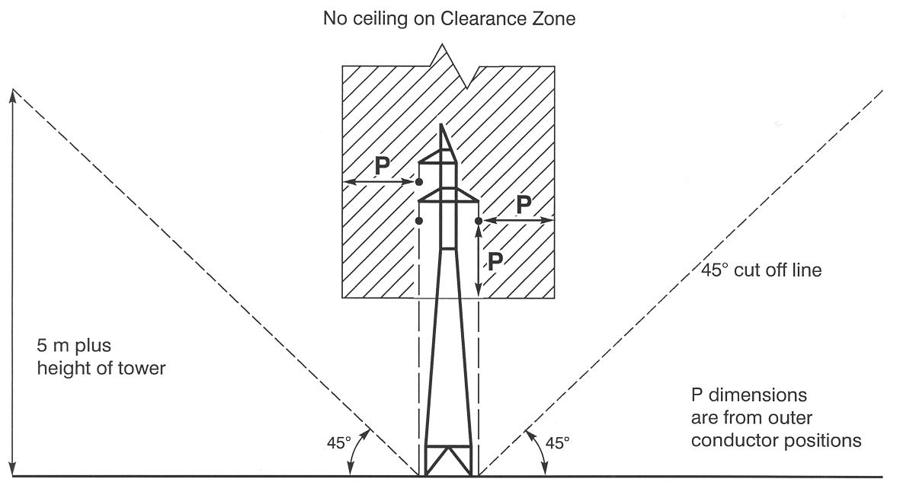
E.2—Mid span (as shown in diagrams E.3 and E.4)
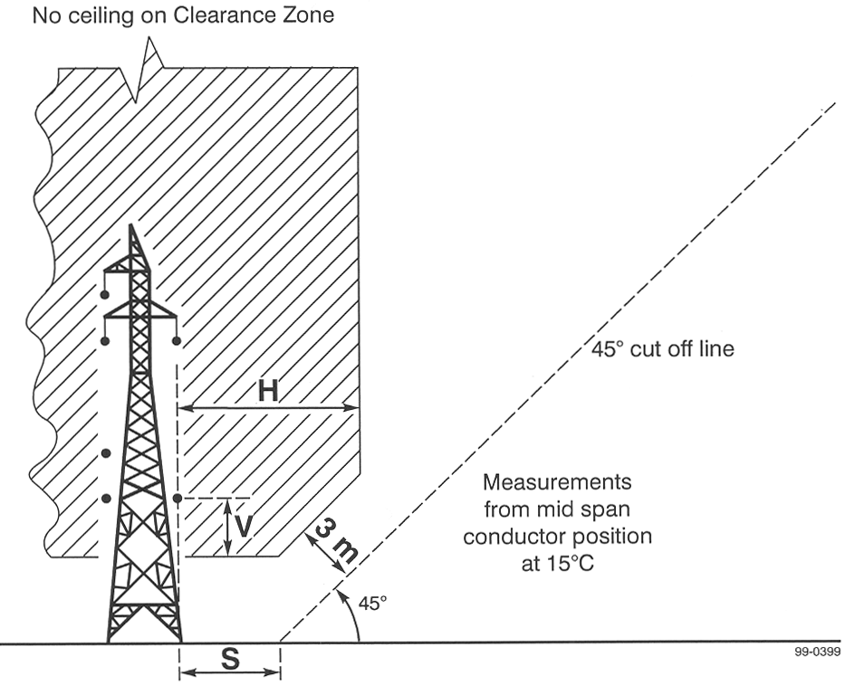
E.3—View of clearance zone from above
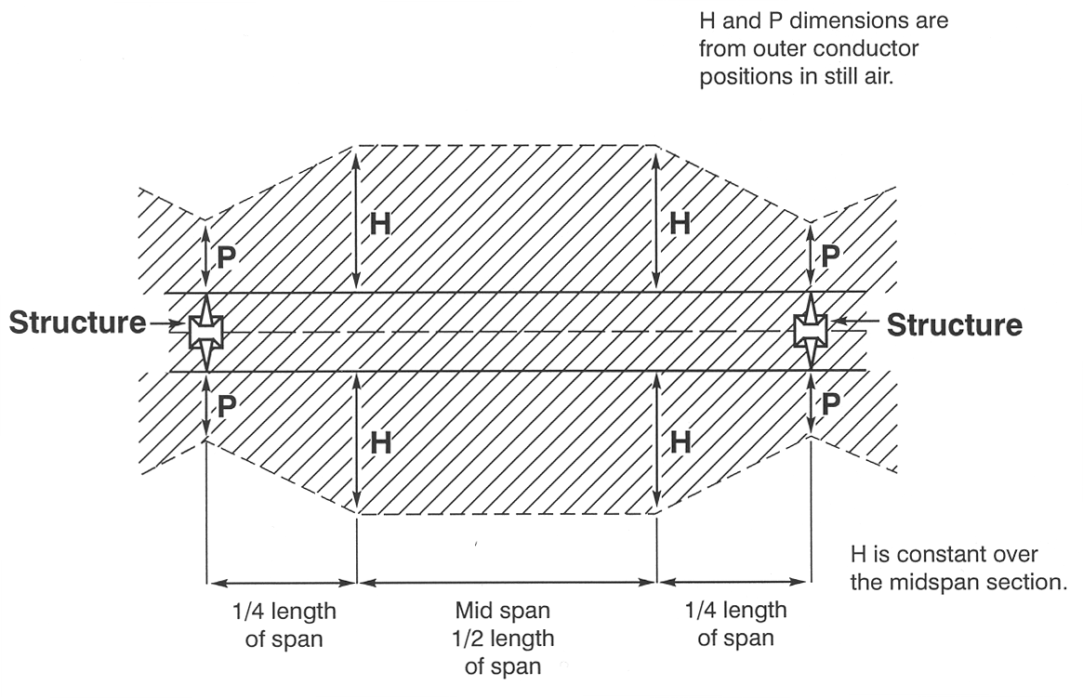
E.4—View of clearance zone from side
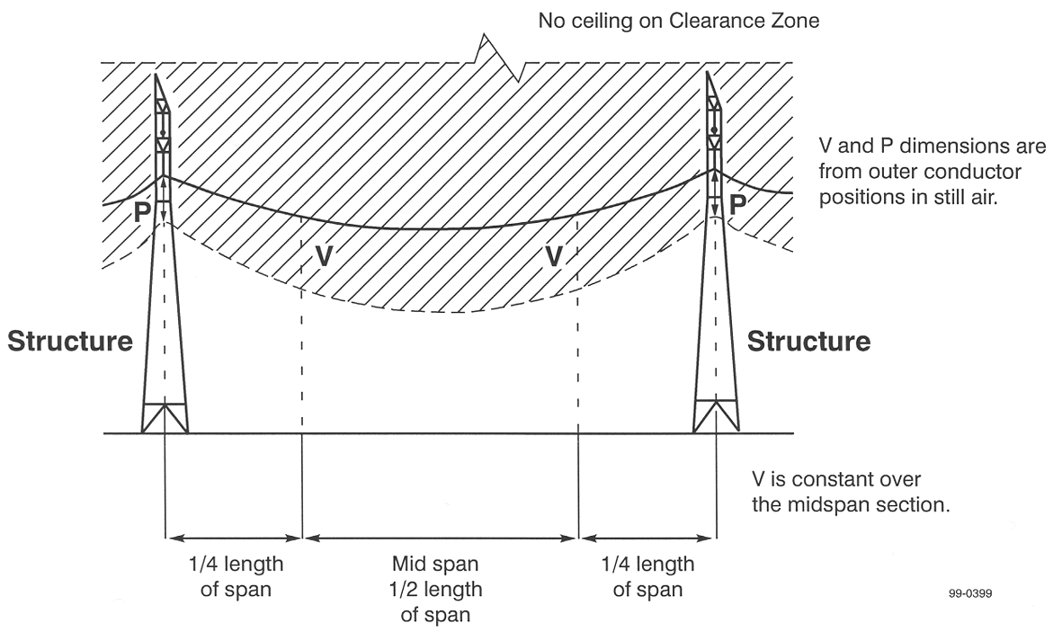
(8) Schedule 1, Heading to Part B—delete "zone around overhead powerline" and substitute:
zones around overhead powerlines
(9) Schedule 1, Part B, Diagram A, note 1—after "insulated" insert:
(eg aerial bundled cables)
(10) Schedule 1, Part B, Diagram C, note 1—delete "This diagram applies" and substitute:
These diagrams apply
(11) Schedule 1, Part B, Diagram D, note 1—delete "of 33kV or more" and substitute:
from 33kV to 66kV inclusive
(12) Schedule 1, Part B, Diagram D, note 6—delete "Tables 3 and 4" and substitute:
Table 3
(13) Schedule 1, Part B, Diagram D.4—after "No ceiling" insert:
on Clearance Zone
(14) Schedule 1, Part B—after Diagram D insert:
Diagram E
1. These diagrams apply to a powerline, the conductors of which are not insulated, constructed to operate at a voltage from 132kV to 275kV inclusive.
2. Diagram E.1 shows the zones at the pole or other support at the end of each span of the powerline.
3. Diagram E.2 shows the zones at mid span (as shown in diagrams E.3 and E.4) for each span of the powerline.
4. Diagrams E.3 and E.4 show the manner in which the clearance zone extends along the length of each span of the powerline.
5. Although not shown in diagrams E.3 and E.4, the buffer zone as shown in diagrams E.1 and E.2 extends along the length of each span of the powerline.
6. The values of V, H, S, B and P are set out in Table 4 in Part D.
7. The 45° component of the clearance zone is determined as being 3 metres inside the buffer zone.
E.1—At each end of a span
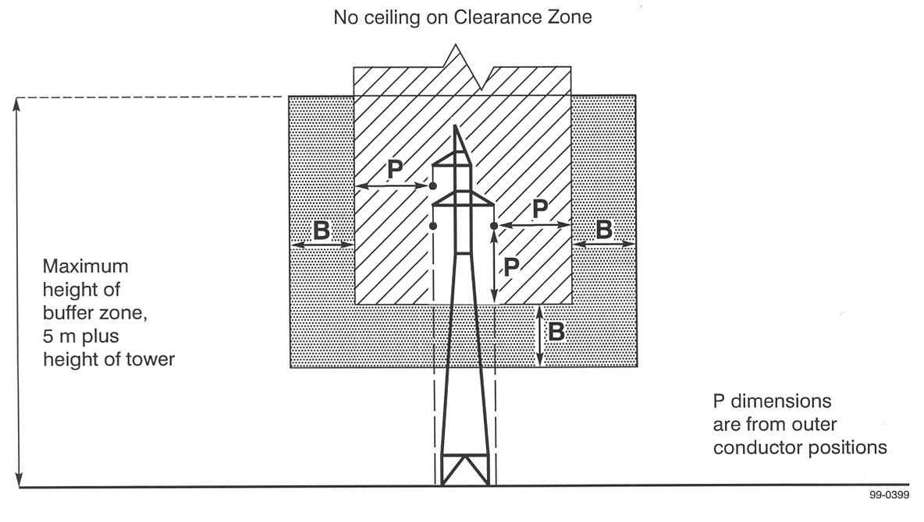
E.2—Mid span (as shown in diagrams E.3 and E.4)
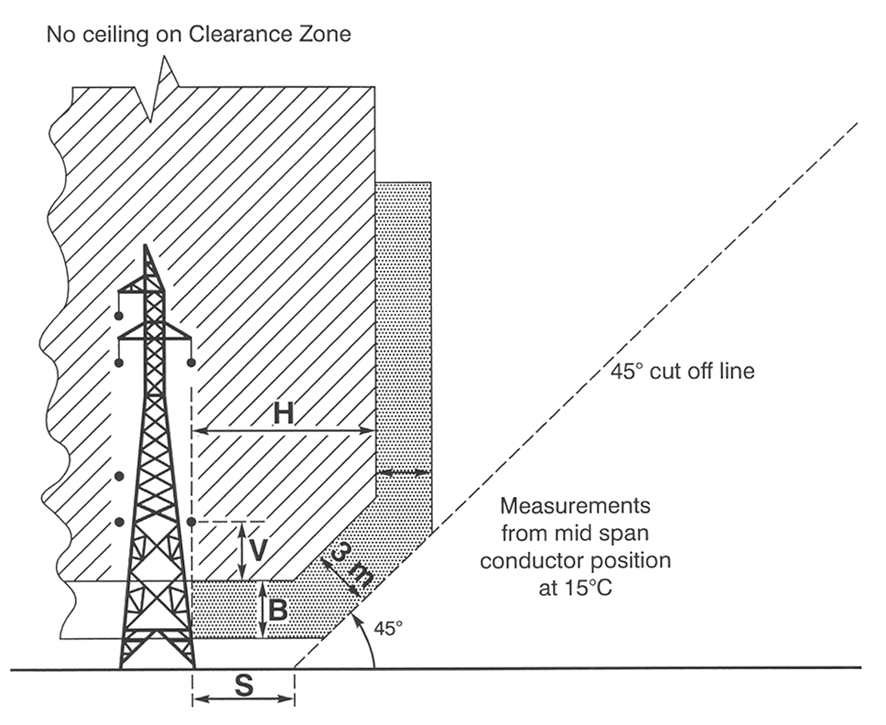
E.3—View of clearance zone from above
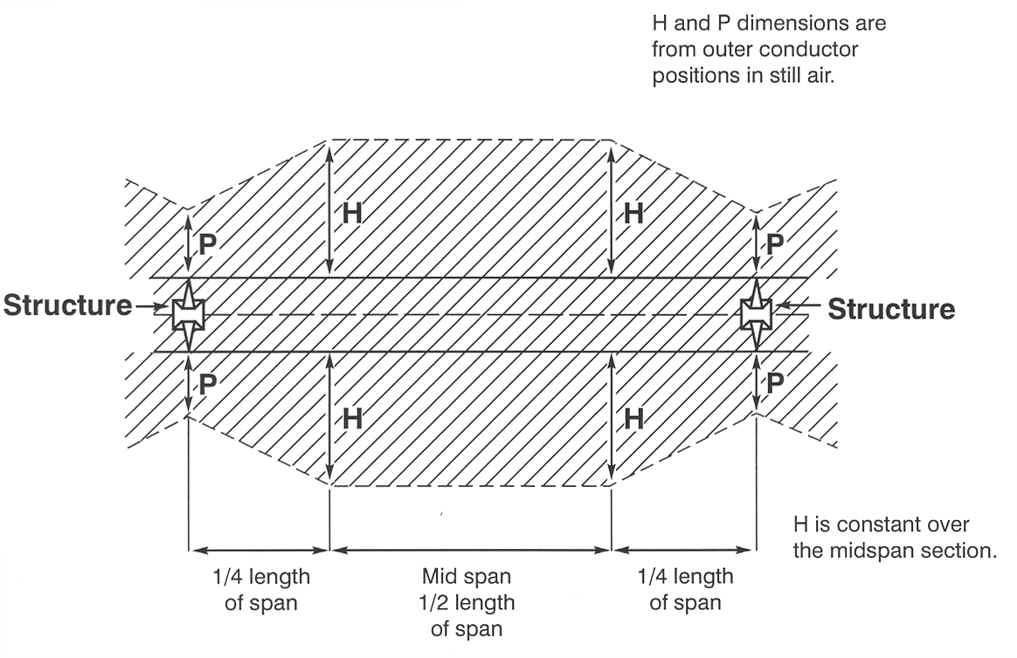
E.4—View of clearance zone from side
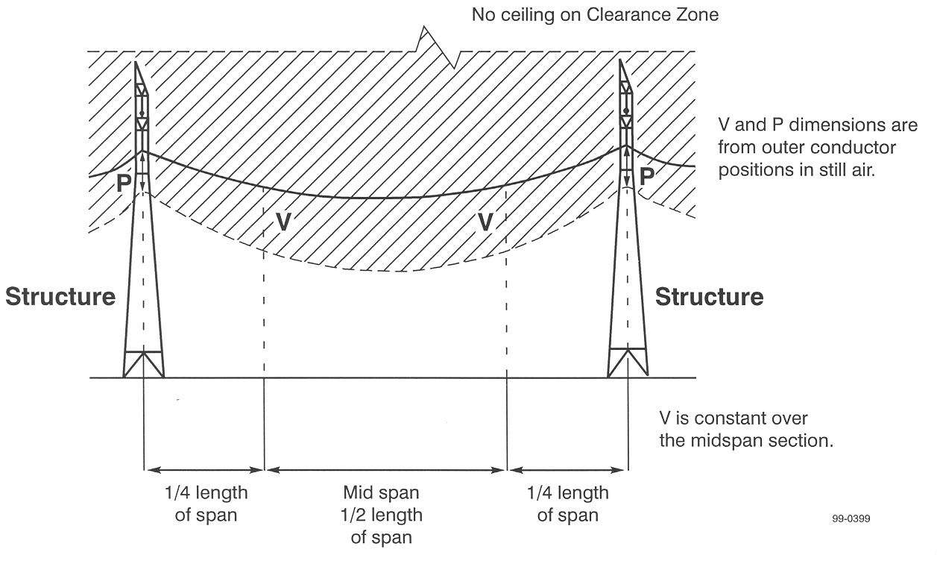
(15) Schedule 1, Heading to Part C—delete "zone around overhead powerline" and substitute:
zones around overhead powerlines
(16) Schedule 1, Part C, Diagram A, note 1—after "insulated" insert:
(eg aerial bundled cables)
(17) Schedule 1, Part C, Diagram B, note 1—delete "These diagrams apply" and substitute:
This diagram applies
(18) Schedule 1, Part C, Diagrams C.1, C.2 and C.4—after "No ceiling" insert:
on Clearance Zone
(19) Schedule 1, Part C, Diagrams C.1 and C.2—before "5m plus height of pole" insert:
Maximum height of buffer zone
(20) Schedule 1, Part C, Diagram D, note 1—delete "fully"
(21) Schedule 1, Part C, Diagrams D.1, D.2 and D.4—after "No ceiling" insert:
on Clearance Zone
(22) Schedule 1, Part C, Diagrams D.1 and D.2—before "5m plus height of pole" insert:
Maximum height of buffer zone
(23) Schedule 1, Part C, Diagram E, note 1—delete "fully"
(24) Schedule 1, Part C, Diagram E, note 5—delete "D.1 and D.2" and substitute:
E.1 and E.2
(25) Schedule 1, Part C, Diagram E, note 6—after "S" insert:
, B
(26) Schedule 1, Part C, Diagrams E.1, E.2 and E.4—after "No Ceiling" insert:
on Clearance Zone
(27) Schedule 1, Part C, Diagrams E.1 and E.2—before "5m" insert:
Maximum height of buffer zone
(28) Schedule 1, Part C, Diagram E.2—delete "& 15ºC"
(29) Schedule 1, Part D, note 5—delete "support" and substitute:
supports
(30) Schedule 1, Part D, Table 1—delete "1480V" and substitute:
480V
(31) Schedule 1, Part D, Table 3—delete "33kV to 66kV" and substitute:
33kV and 66kV
(32) Schedule 1, Part D, Table 4—delete Table 4 and substitute:
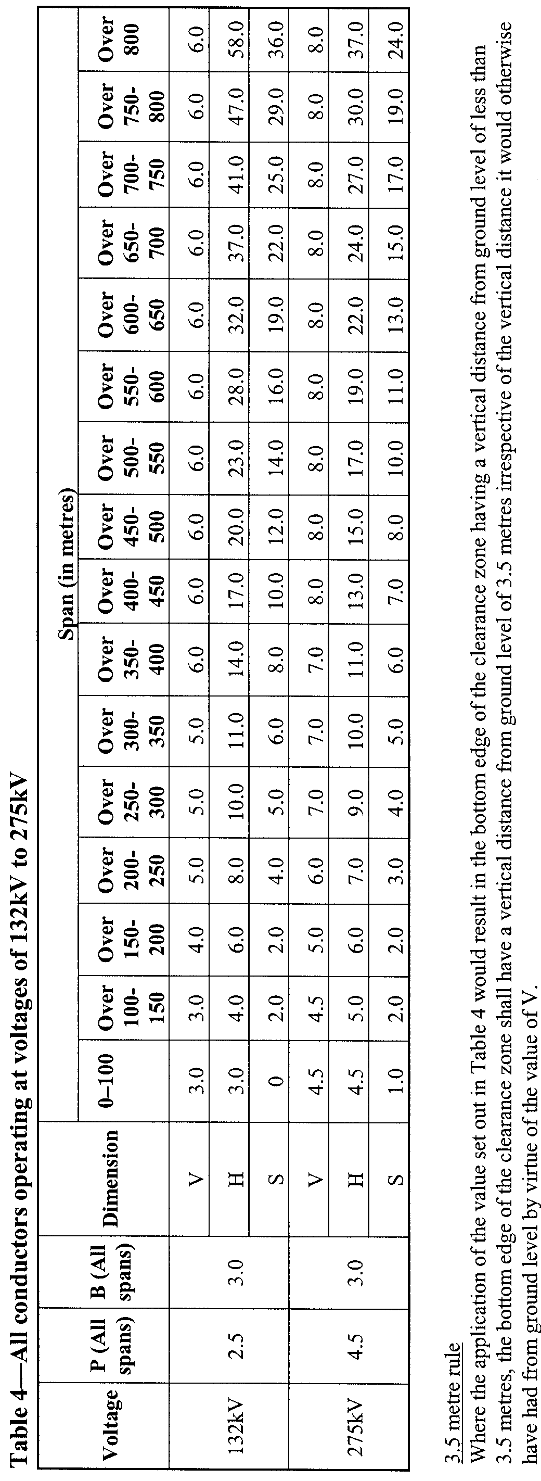

7—Variation of Schedule 2—Planting or nurturing vegetation near public powerlines
(1) Schedule 2, clause 3, definition of prescribed distance, (a)—delete "10.0" and substitute:
15.0
(2) Schedule 2, clause 3, definition of prescribed distance, (a)—delete "7.5" and substitute:
10.0
Note—
As required by section 10AA(2) of the Subordinate Legislation Act 1978, the Minister has certified that, in the Minister's opinion, it is necessary or appropriate that these regulations come into operation as set out in these regulations.
Made by the Governor’s Deputy
after consultation with the Minister for Environment and Conservation and with the advice and consent of the Executive Council
on 19 April 2007
No 36 of 2007
MEN07/005CS

South Australia
Electricity (General) Variation Regulations 2007
under the Electricity Act 1996

Contents
Part 1—Preliminary
1 Short title
2 Commencement
3 Variation provisions
Part 2—Variation of Electricity (General) Regulations 1997
4 Variation of regulation 4—Interpretation
5 Insertion of regulations 4AB, 4AC and 4AD
4AB Interpretation—definition of electrical installation
4AC Interpretation—definition of electricity infrastructure
4AD Interpretation—definition of generation
6 Variation of regulation 8—Carrying out certain work on public land
7 Variation of regulation 10—Quality of electricity supply
8 Insertion of regulation 17A
17A Connection testing and inspection procedures
9 Variation of regulation 18—Certain electrical installation work and certificates of compliance
10 Insertion of regulation 18A
18A Prescribed work (section 61(4))
11 Variation of regulation 31—Reporting of accidents
12 Variation of regulation 31A—Investigation of accidents
13 Insertion of regulation 34
34 Preparation, publication and purchase of installation rules
14 Variation of regulation 40—Prohibition of certain activities in proximity to aerial lines and other cable systems
15 Insertion of regulation 40A
40A Erection of conductors or other cable systems so as to cross or be attached to existing aerial lines or their supports etc
16 Variation of Schedule 2—Requirements for aerial lines
17 Variation of Schedule 3—Requirements for underground lines and certain other powerlines
18 Variation of Schedule 4—Requirements for substations
19 Variation of Schedule 5—Requirements for earthing and electrical protection systems
20 Variation of Schedule 6—Clearance from aerial lines

Part 1—Preliminary
1—Short title
These regulations may be cited as the Electricity (General) Variation Regulations 2007.
2—Commencement
(1) Subject to subregulation (2), these regulations come into operation on the day on which they are made.
(2) Regulations 4 to 13 (inclusive) will come into operation on the day on which the Statutes Amendment (Electricity and Gas) Act 2006 comes into operation.
3—Variation provisions
In these regulations, a provision under a heading referring to the variation of specified regulations varies the regulations so specified.
Part 2—Variation of Electricity (General) Regulations 1997
4—Variation of regulation 4—Interpretation
(1) Regulation 4(1), after the definition of high voltage or HV insert:
installation rules of the operator of a transmission or distribution network means the requirements of the operator relating to electrical installations that must be complied with if electricity supply from the network is to be connected to the installations;
(2) Regulation 4(1), definition of nominal system voltage—after "AS 2926" insert:
(as in force immediately before it was superseded)
5—Insertion of regulations 4AB, 4AC and 4AD
After regulation 4A insert:
4AB—Interpretation—definition of electrical installation
For the purposes of the definition of electrical installation in section 4 of the Act, a set of wires and associated fittings, equipment and accessories installed for the conveyance, control, measurement or use of electricity for general power and lighting in a place used for electricity generating operations, or incidental or related operations, is an electrical installation.
4AC—Interpretation—definition of electricity infrastructure
For the purposes of the definition of electricity infrastructure in section 4 of the Act, a set of wires and associated fittings, equipment and accessories installed for the conveyance, control, measurement or use of electricity for general power and lighting in a place used for electricity generating operations, or incidental or related operations, does not form part of electricity infrastructure.
4AD—Interpretation—definition of generation
For the purposes of the definition of generation in section 4 of the Act, the operation of a set of wires and associated fittings, equipment and accessories installed for the conveyance, control, measurement or use of electricity for general power and lighting in a place used for electricity generating operations, or incidental or related to an electrical installation is not the generation of electricity.
6—Variation of regulation 8—Carrying out certain work on public land
Regulation 8(1)—after paragraph (b) insert:
or
(c) minor works to connect electricity supply from a transmission or distribution network to an electrical installation or proposed electrical installation.
7—Variation of regulation 10—Quality of electricity supply
(1) Regulation 10(a)—after "AS 2926" insert:
(as in force immediately before it was superseded)
(2) Regulation 10(a)—after "AS 2279" insert:
(as in force immediately before it was superseded)
8—Insertion of regulation 17A
After regulation 17 insert:
17A—Connection testing and inspection procedures
(1) For the purposes of section 59(1b)(b), (1d)(d) and (1g)(b) of the Act, electricity supply from a transmission or distribution network must not be connected to an electrical installation unless the connection testing and inspection procedures of the operator of the network have been complied with.
(2) The connection testing and inspection procedures of a network operator relating to the connection of electricity supply from powerlines designed to operate at a voltage of less than 11kV must be procedures that have been approved by the Technical Regulator.
(3) A person who personally carries out the work of connecting electricity supply from a transmission or distribution network to an electrical installation must—
(a) make and sign a written record that—
(i) specifies the place and date at which the work has been carried out and sets out the person's full name; and
(ii) states that the person has complied with the connection testing and inspection procedures of the network operator relating to the work; and
(b) provide the record—
(i) to the network operator; or
(ii) in the case of work carried out on behalf of a prescribed person (as defined in section 59 of the Act) other than the network operator, to that prescribed person.
Maximum penalty: $2 500.
Expiation fee: $210.
(4) A network operator or other prescribed person who receives a record referred to in subregulation (3) must keep the record for at least 2 years.
Maximum penalty: $2 500.
Expiation fee: $210.
9—Variation of regulation 18—Certain electrical installation work and certificates of compliance
(1) Regulation 18(1)(a)(ii)—delete "any requirements specified by" and substitute:
the installation rules of
(2) Regulation 18(1)(e)—delete "61" and substitute:
61(1)
(3) Regulation 18(1)(f)—delete "61" and substitute:
61(1)
(4) Regulation 18—after subregulation (1) insert:
(1a) If a licensed electrical contractor, licensed building work contractor or registered electrical worker acquires a book of official forms that have been published or produced under the authority of the Technical Regulator for use by that person as certificates of compliance, the contractor or worker must ensure that notice of the contractor's or worker's acquisition of the book of forms is given to the Technical Regulator in accordance with the directions of the Technical Regulator, as set out in the book of forms.
Maximum penalty: $750.
Expiation fee: $105.
10—Insertion of regulation 18A
After regulation 18 insert:
18A—Prescribed work (section 61(4))
(1) For the purposes of section 61(4) of the Act, work of a kind referred to in AS/NZS 3000 or any other Australian Standard or Australian/New Zealand Standard called up by AS/NZS 3000 is prescribed.
(2) For the purposes of section 61(4) of the Act, work on an electrical installation or proposed electrical installation that is work of a kind prescribed by subregulation (1) must be carried out—
(a) in accordance with AS/NZS 3000 and any other Australian Standard or Australian/New Zealand Standard called up by AS/NZS 3000; and
(b) in accordance with the installation rules of the operator of the transmission or distribution network to which the installation is or is to be connected.
11—Variation of regulation 31—Reporting of accidents
Regulation 31(1)—after "electric shock" insert:
or electrical burns
12—Variation of regulation 31A—Investigation of accidents
(1) Regulation 31A(1)—after "electric shock" insert:
or electrical burns
(2) Regulation 31A(2)—delete "was" and substitute:
or electrical burns were
13—Insertion of regulation 34
Part 6—before regulation 35 insert:
34—Preparation, publication and purchase of installation rules
The operator of a distribution network must prepare installation rules and—
(a) publish the rules on an internet site to which the public has access free of charge; and
(b) make copies of the rules available for purchase by the public for a reasonable fee (which must not exceed an amount fixed by the Commission).
14—Variation of regulation 40—Prohibition of certain activities in proximity to aerial lines and other cable systems
Regulation 40(d) and (e)—delete paragraphs (d) and (e)
15—Insertion of regulation 40A
After regulation 40 insert:
40A—Erection of conductors or other cable systems so as to cross or be attached to existing aerial lines or their supports etc
(1) A person must not erect any conductors of circuits, or other cable system—
(a) so as to cross the circuit of any existing aerial line, or other cable system (whether or not they are to be attached to the same support as the existing aerial line or other cable system); or
(b) so as to be attached to the same support as, or share any portion of the same span as, any existing aerial line, or other cable system,
unless—
(c) the clearances specified in the Energy Networks Association Limited Guidelines for design and maintenance of overhead distribution and transmission lines C(b)1, as published from time to time, will be achieved and maintained; and
(d) the reasonable operational requirements of the operator of the existing aerial line or other cable system will not be adversely affected; and
(e) the person has, before erecting the conductors of circuits, or other cable system, lodged detailed work proposals with the operator of the existing aerial line or other cable system and the operator has approved the proposals as indicating that the work would, if carried out in accordance with the proposals, meet the requirements of paragraphs (c) and (d).
(2) The operator must, on receipt of detailed work proposals from the person (the proponent), consider the proposals and decide within a reasonable period whether or not to approve the proposals.
(3) If the operator decides that the proposals should not be approved, the operator must, if requested to do so by the proponent—
(a) prepare written reasons for that decision; and
(b) provide the reasons to the proponent; and
(c) provide the reasons and the proponent's detailed work proposals to the Technical Regulator.
(4) The Technical Regulator must, on receipt of the proponent's proposals and the operator's reasons, review the operator's decision.
(5) If, on reviewing the operator's decision, the Technical Regulator decides that the proponent's proposals should be approved (with or without the imposition of conditions by the Technical Regulator), the proponent will be taken to have the approval required under subregulation (1)(e), subject to compliance with the conditions (if any) imposed by the Technical Regulator.
(6) The Technical Regulator must allow the operator and the proponent a reasonable opportunity to make written or oral submissions before deciding on the review whether or not the proponent's proposals should be approved.
16—Variation of Schedule 2—Requirements for aerial lines
(1) Schedule 2, Appendix, definition of ESAA—delete the definition and substitute:
ENA means Energy Networks Association Limited.
(2) Schedule 2, Appendix—delete "ESAA C(b)1" wherever occurring and substitute in each case:
ENA C(b)1
(3) Schedule 2, Appendix—delete "ESAA D(b)5" and substitute:
ENA D(b)5
17—Variation of Schedule 3—Requirements for underground lines and certain other powerlines
(1) Schedule 3, Appendix, definition of ESAA—delete the definition
(2) Schedule 3, Appendix—delete "ESAA Guide to the Installation of Cables Underground........C(b)2"
(3) Schedule 3, Appendix—delete "ESAA Guide to the Use of Separable Connectors............D(b)30"
(4) Schedule 3, Appendix—delete the heading "Maintenance"
(5) Schedule 3, Appendix—delete "ESAA Guide for the Maintenance of High Voltage Paper/Oil Insulated Cables and Accessories............D(b)31"
18—Variation of Schedule 4—Requirements for substations
Schedule 4, Appendix, definition of ESAA—delete the definition
19—Variation of Schedule 5—Requirements for earthing and electrical protection systems
(1) Schedule 5, clause 1, definition of ESAA—delete the definition and substitute:
ENA means Energy Networks Association Limited;
(2) Schedule 5, clause 8—delete "ESAA" and substitute:
ENA
(3) Schedule 5, Appendix, definition of ESAA—delete the definition and substitute:
ENA means Energy Networks Association Limited;
(4) Schedule 5, Appendix—delete "Stay wires..............................ESAA C(b)1" and substitute:
Stay wires...........................ENA C(b)1
(5) Schedule 5, Appendix—delete "Step and touch potentials..............................ESAA C(b)1" and substitute:
Step and touch potentials...........................ENA C(b)1
(6) Schedule 5, Appendix—delete "ESAA - Earth Potential Rise Code of Practice" wherever occurring and substitute in each case:
AS/NZS 3835 Earth potential rise - Protection of telecommunications network users, personnel and plant
(7) Schedule 5, Appendix—delete "ESAA - Earth Return High Voltage Power Lines Code of Practice" wherever occurring
(8) Schedule 5, Appendix—delete "ESAA Guidelines for the design and maintenance of overhead distribution and transmission lines.....................ESAA C(b)1" and substitute:
ENA Guidelines for design and maintenance of overhead distribution and transmission lines......................ENA C(b)1
20—Variation of Schedule 6—Clearance from aerial lines
Schedule 6, Tables 3 and 4—delete the tables
Note—
As required by section 10AA(2) of the Subordinate Legislation Act 1978, the Minister has certified that, in the Minister's opinion, it is necessary or appropriate that these regulations come into operation as set out in these regulations.
Made by the Governor’s Deputy
with the advice and consent of the Executive Council
on 19 April 2007
No 37 of 2007
MEN06/011CS
South Australia
Workers Rehabilitation and Compensation (Claims and Registration) Variation Regulations 2007
under the Workers Rehabilitation and Compensation Act 1986

Contents
Part 1—Preliminary
1 Short title
2 Commencement
3 Variation provisions
Part 2—Variation of Workers Rehabilitation and Compensation (Claims and Registration) Regulations 1999
4 Variation of regulation 4—Interpretation
5 Variation of regulation 5—Legislative definitions

Part 1—Preliminary
1—Short title
These regulations may be cited as the Workers Rehabilitation and Compensation (Claims and Registration) Variation Regulations 2007.
2—Commencement
These regulations will come into operation on 1 June 2007.
3—Variation provisions
In these regulations, a provision under a heading referring to the variation of specified regulations varies the regulations so specified.
Part 2—Variation of Workers Rehabilitation and Compensation (Claims and Registration) Regulations 1999
4—Variation of regulation 4—Interpretation
(1) Regulation 4—after the definition of industrial agreement insert:
licensed jockey means a jockey, an interstate jockey, or an apprentice jockey, licensed by TRSA;
licensed trainer means a trainer licensed by TRSA;
(2) Regulation 4—after the definition of prime bank rate insert:
thoroughbred riding work means mounting, dismounting or riding a thoroughbred horse—
(a) in the course of a race meeting conducted and controlled by TRSA; or
(b) in the course of a barrier trial conducted and controlled by TRSA; or
(c) in the course of a training session conducted and controlled by a licensed trainer;
TRSA means—
(a) Thoroughbred Racing SA Ltd (ACN 094 475 939); or
(b) if a body other than Thoroughbred Racing SA Ltd is designated under section 6 of the Authorised Betting Operations Act 2000 as the racing controlling authority for horse racing—that body;
5—Variation of regulation 5—Legislative definitions
Regulation 5(1)—after paragraph (f) insert:
(g) thoroughbred riding work where the work is performed by a licensed jockey (and, for the purposes of the application of the Act to a licensed jockey as a worker, TRSA will be taken to be his or her employer).
Note—
As required by section 10AA(2) of the Subordinate Legislation Act 1978, the Minister has certified that, in the Minister's opinion, it is necessary or appropriate that these regulations come into operation as set out in these regulations.
Made by the Governor’s Deputy
with the advice and consent of the Executive Council
on 19 April 2007
No 38 of 2007
07WKC001CS

FAXING COPY?
IF you fax copy to Government Publishing SA for inclusion in the Government Gazette, there is no need to send a Confirmation Copy to us as well.
This creates confusion and may well result in your notice being printed twice.
Please use the following fax number:
Fax transmission: (08) 8207 1040
Phone Inquiries: (08) 8207 1045
Please include a contact person, phone number and order number so that we can phone back with any queries we may have regarding the fax copy.
NOTE: Closing time for lodging new copy (fax, hard copy or email) is 4 p.m. on Tuesday preceding the day of publication.

Government Gazette notices can be E-mailed.
The address is:
governmentgazette@saugov.sa.gov.au
Documents should be sent as attachments in Word format.
When sending a document via E-mail, please confirm your transmission with a faxed copy of your document, including the date the notice is to be published.
Fax transmission: (08) 8207 1040
Enquiries: (08) 8207 1045
NOTE: Closing time for lodging new copy (fax, hard copy or email) is 4 p.m. on Tuesday preceding the day of publication.

ADELAIDE CITY COUNCIL
Roads (Opening and Closing) Act 1991
Road Closure—Public Road, Adelaide
NOTICE is hereby given, pursuant to section 10 of the Roads (Opening and Closing) Act 1991, that the Adelaide City Council proposes to make a Road Process Order to close and transfer to Coles Group Properties Holdings Ltd the unnamed public road adjoining the southern boundaries of allotment 629 in Filed Plan 183091 and allotment 630 in Filed Plan 183092, more particularly delineated and lettered ‘A’ on the Preliminary Plan No. 07/0027.
A copy of the plan and a statement of persons affected are available for public inspection at the offices of the Council, Customer Centre, 25 Pirie Street, Adelaide and the Adelaide office of the Surveyor-General, 101 Grenfell Street, Adelaide during normal office hours.
Any person is entitled to object to the proposed road process, or any person affected by the proposed closure is entitled to apply for an easement to be granted in that person’s favour over the land subject to the proposed closure. Such objection or application for an easement must set out the full name and address of the person making the objection or application and must be fully supported by reasons. Any application for an easement must give full particulars of the nature and location of the easement and where made by a person as the owner of adjoining or nearby land, specify the land to which the easement is to be annexed.
The objection or application for an easement must be made in writing to the Council, G.P.O. Box 2252, Adelaide, S.A. 5001, within 28 days of this notice and a copy shall be forwarded to the Surveyor-General, G.P.O. Box 1354, Adelaide, S.A. 5001. Where a submission is made, the Council will give notification of a meeting at which the matter will be considered, so that the person making the submission or a representative may attend, if so desired.
S. Moseley, Chief Executive Officer

CITY OF PORT LINCOLN
Road Name Change
NOTICE is hereby given that pursuant to section 219 of the Local Government Act 1999, that the Council has resolved to make the following road name change:
To change the name of the section of roadway on the northern side of the reserve bounded by Shaen Street and Flaxman Street known as Smith Street, Port Lincoln be re-named O’Connor Lane.
G. P. Dodd, Chief Executive Officer

CITY OF SALISBURY
Roads (Opening and Closing) Act 1991
Shepherdson Road, Parafield Gardens
NOTICE is hereby given pursuant to section 10 of the Roads (Opening and Closing) Act 1991, that the City of Salisbury proposes to make a Road Process Order to close a portion of public road subject to any easements that may be required. The portion of public road to be closed is situated at Shepherdson Road, Parafield Gardens.
The portion of public road to be closed marked ‘A’ on Preliminary Plan No. 07/0029 is to be merged with the adjoining land (Allotment 2 in Filed Plan 13780, certificate of title volume 5484, folio 915) held by Distribution Lessor Corporation.
A copy of the plan and statement of persons affected are available for public inspection at the Offices, 12 James Street, Salisbury, S.A. 5108, between the hours of 8.30 a.m. and 5 p.m. weekdays only and the Adelaide Office, Surveyor-General, 101 Grenfell Street, Adelaide, S.A. 5000, during normal office hours.
Any application for easement or objection must set out the full name, address and details of the submission and must be fully supported by reasons.
The application for easement or objection must be made in writing to the Council, P.O. Box 8, Salisbury, S.A. 5108, within 28 days of the public notice of 18 April 2007 and a copy must be forwarded to the Surveyor-General, G.P.O. Box 1354, Adelaide, S.A. 5001. Where a submission is made, the Council will give notification of a meeting at which the matter will be considered.
Enquiries relating to this matter can be directed to Julie Bond on 8406 8306.
Dated 18 April 2007.
S. Hains, City Manager

CITY OF ONKAPARINGA
Notice of Road Closure
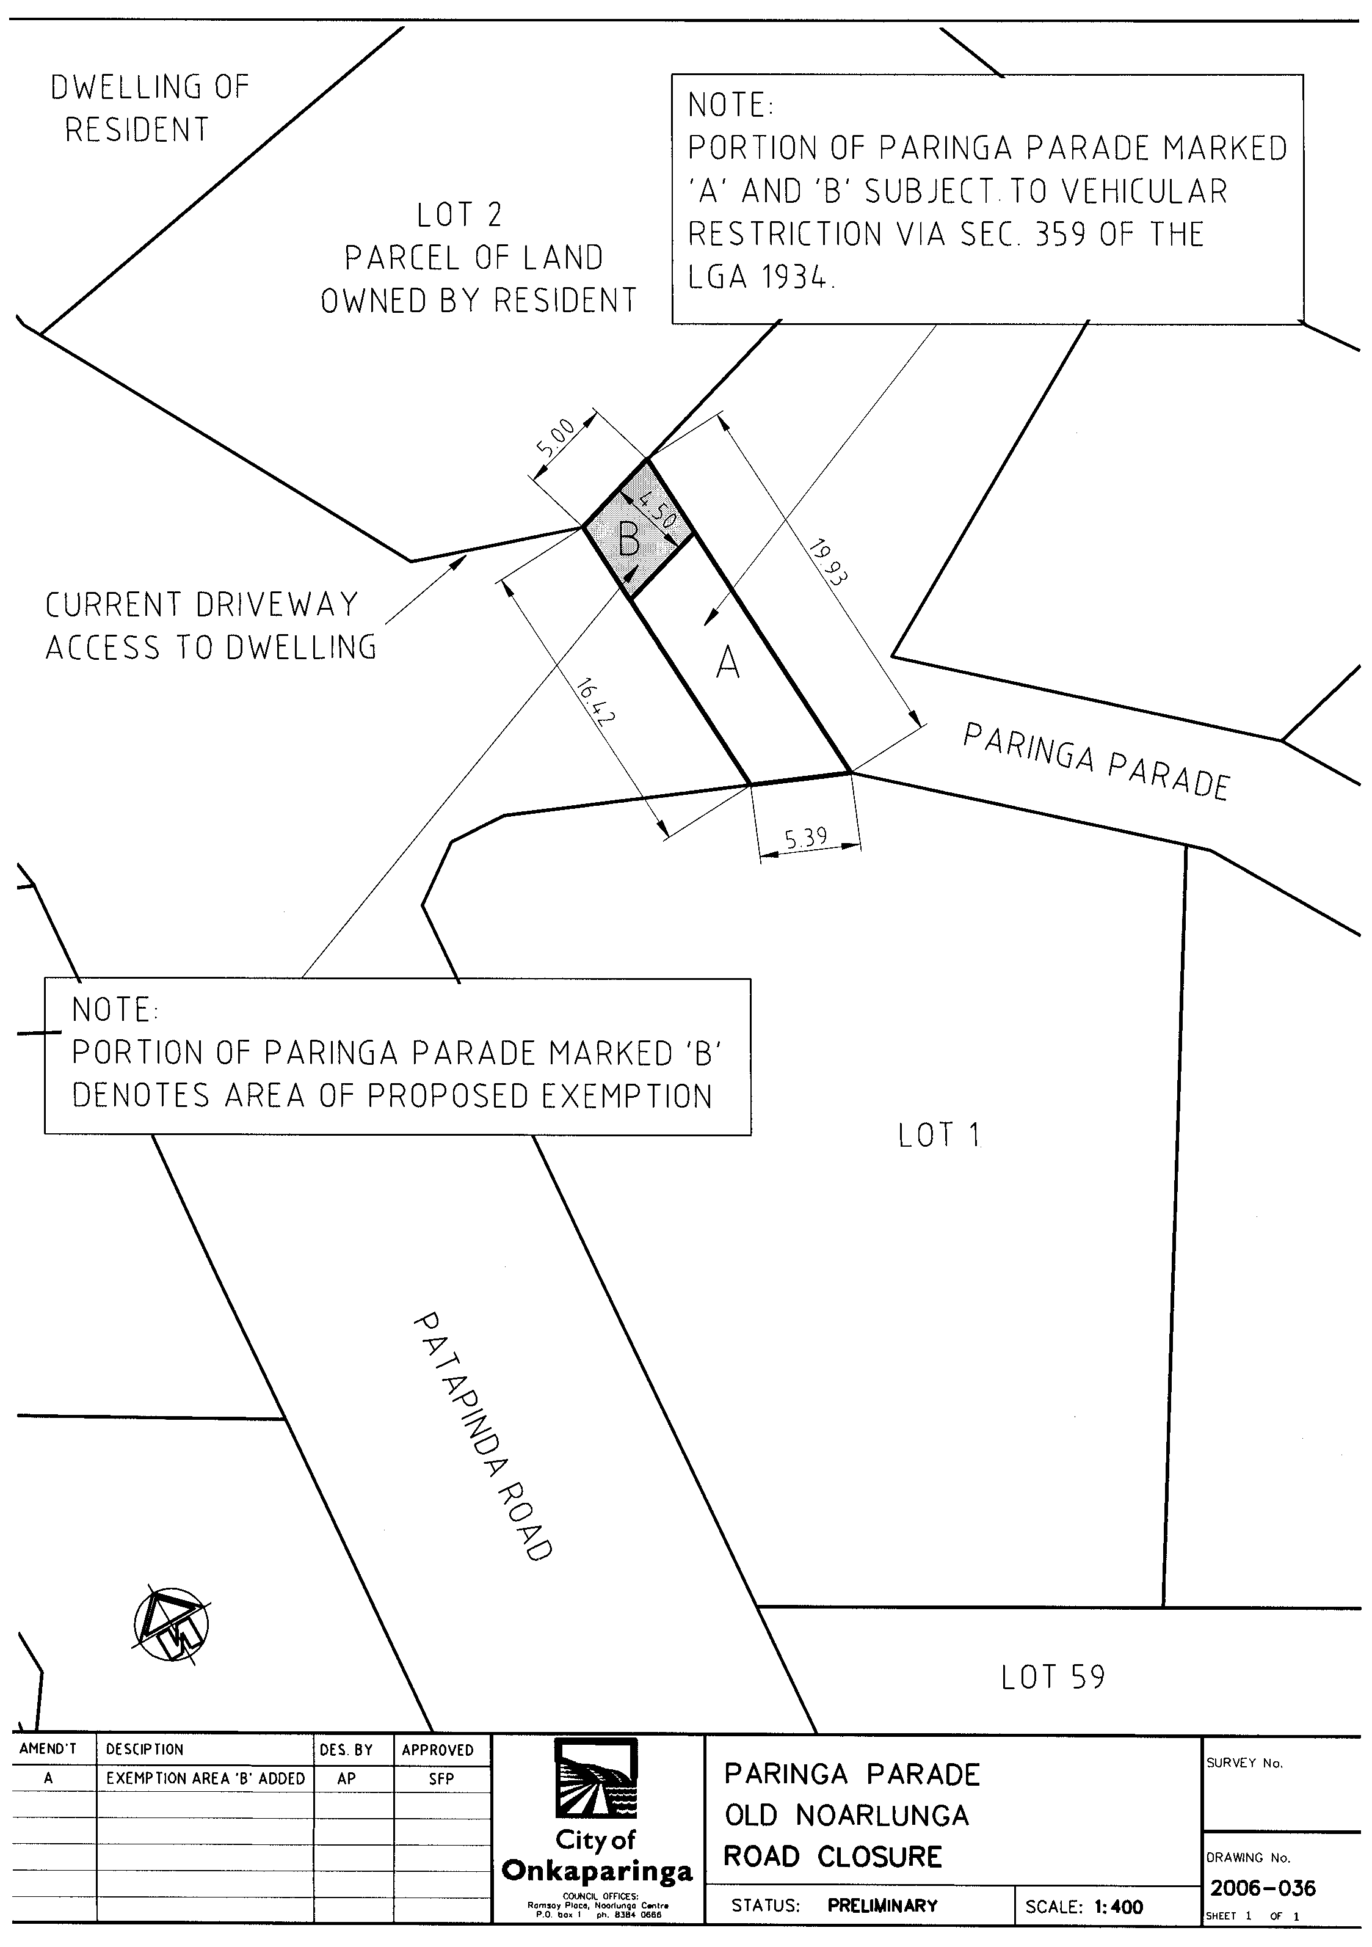
NOTICE is hereby given that the Council of the City of Onkaparinga at its meeting held on 6 March 2007 resolved pursuant to section 359 of the Local Government Act 1934, as amended, that the registered owner, occupier or lessee of the whole of the land comprised in certificate of title volume 5905, folio 864, allotment 2, section 61, Filed Plan 36990, 66 Paringa Parade, Old Noarlunga be exempt from complying with the order made, pursuant to section 359 of the Local Government Act 1934, resolved at the Council meeting held on 16 May 2006, to the extent that the said owner, occupier or lessee be authorised to permit all classes of motor vehicles belonging to the owner, occupier or lessee or any invitee or contractor thereof to access allotment 2 by a strip of land 4.5 m in width on the road reserve marked ‘B’ on Drawing No. 2006-036 Revision A.
J. Tate, City Manager

TOWN OF WALKERVILLE
Supplementary Election for Councillor in Walkerville Ward
NOMINATIONS will be received at the Council Office located at 66 Walkerville Terrace, Gilberton from Thursday, 26 April 2007 until 12 noon on Thursday, 10 May 2007, from any person eligible to be a candidate for election to the vacancy.
Nomination forms and candidate’s handbooks are available from the Council Office, 66 Walkerville Terrace, Gilberton.
A candidate must submit a profile of not more than 150 words with the nomination form and may also provide a photograph, predominantly head and shoulders, taken within the previous 12 months.
A briefing session for intending candidates will be held at 7 p.m. on Tuesday, 1 May 2007, at the Town Hall, 66 Walkerville Terrace, Gilberton (enter from Stephen Terrace carpark).
K. Mousley, Returning Officer

DISTRICT COUNCIL OF GRANT
Roads (Opening and Closing) Act 1991
Pelican Point Road, Pelican Point
NOTICE is hereby given, pursuant to section 10 of the said Act, that Council proposes to make a Road Process Order to close and transfer to the adjoining owners, portions of Pelican Point Road adjoining allotments 23 to 45 in Deposited Plan 52958 and sections 727 to 741 in the Hundred of Kongorong, shown as ‘A’ to ‘Y’ and ‘AA’ to ‘AT’ on Preliminary Plan No. 07/0011.
Copies of the plans and statements of persons affected are available for public inspection at Council’s Office, 324 Commercial Street West, Mount Gambier and the office of the Surveyor-General, 101 Grenfell Street, Adelaide during normal office hours.
Any applications for easements or objections must be made in writing within 28 days from this notice, to the Council, P.O. Box 724, Mount Gambier, S.A. 5290 and the Surveyor-General, G.P.O. Box 1354, Adelaide, S.A. 5001, setting out full details.
Where a submission is made, Council will give notification of a meeting to deal with the matters. Any enquiries may be directed to the Project Manager, Gayle Watson on 8721 0444.
Dated 19 April 2007.
R. Peate, Chief Executive Officer

DISTRICT COUNCIL OF KIMBA
Change of Council Meeting Time
NOTICE is hereby given that the District Council of Kimba, at its meeting held on 4 April 2007, resolved that Council meetings will be held on the second Wednesday of every month, and that these meetings be held in the Kimba Council Chambers, Cross Street, Kimba, commencing at 2 p.m.
D. A. Cearns, Chief Executive Officer

WATTLE RANGE COUNCIL
Revocation of Community Land Classification—
Penola Commonage—Penola By-pass Road Corridor
NOTICE is hereby given that at a meeting of Wattle Range Council held on Tuesday, 10 April 2007 and following approval of the Minister for State/Local Government Relations, pursuant to section 194 (1) (d) of the Local Government Act 1999, the Council resolved to revoke the following land from Classification as Community Land in accordance with section 194 (3) (b) of the Local Government Act 1999:
• portion of Pieces 21 and 22 in Deposited Plan 54642, Hundred of Penola (Penola Commonage) as contained in certificate of title volume 5821, folio 562 (approximately 2.180 hectares); and
• portion of allotment 23 in Deposited Plan 54642, Hundred of Penola (Penola Commonage) as contained in certificate of title volume 618, folio 14 (approximately 0.465 hectares).
The revocation of this land from Classification as Community Land is to provide land to form part of the corridor for the Penola By-pass Road. The balance of the Penola Commonage land is retained as ‘Community Land’.
F. N. Brennan, Chief Executive Officer

WATTLE RANGE COUNCIL
Public Officer—Development Assessment Panel
NOTICE is hereby given that at the meeting of the Wattle Range Council held on Tuesday, 10 April 2007, pursuant to section 56A (22) of the Development Act 1993, Council appointed Francis Newman Brennan as the Public Officer of the Wattle Range Council Development Assessment Panel.
The Public Officer can be contacted at the Civic Centre, George Street, Millicent, S.A. 5280 or (08) 8733 0900.
F. N. Brennan, Chief Executive Officer

WATTLE RANGE COUNCIL
Declaration of Public Road—Skeer Street, Millicent
NOTICE is hereby given that the Wattle Range Council at its meeting held on 10 April 2007, in accordance with the provisions of section 208 of the Local Government Act 1999, declared allotment 17 in Deposited Plan 39060, Skeer Street as contained in certificate of title volume 5179, folio 150 to be public road.
This land is required as road to form part of the cul-de-sac at the end of the road known as Skeer Street, Millicent.
F. N. Brennan, Chief Executive Officer

IN the matter of the estates of the undermentioned deceased persons:
Birbeck, Fay Eileen, late of 388 Fullarton Road, Fullarton, of no occupation, who died on 19 January 2007.
Brady, Laurel Rosemary, late of 200-208 Adams Road, Craigmore, of no occupation, who died on 5 February 2007.
Dani, George, late of Hutchison Street, Coober Pedy, retired business owner, who died on 9 June 2006.
Flanagan, Margaret Anne, late of 205 St Bernards Road, Rostrevor, widow, who died on 31 December 2006.
Gourlay, Alma Priscilla Amelia, late of 110 Strathfield Terrace, Largs North, retired assembly worker, who died on 18 December 2006.
Griffin, Winston Wayne, late of 3 Ernest Street, Taperoo, of no occupation, who died on 12 April 2006.
Rich, Robert Brissenden, late of 31 North Street, Henley Beach, retired truck driver, who died on 14 January 2007.
Spurden, Elma Elsie, late of 27 Oleander Street, South Brighton, widow, who died on 26 February 2007.
Stratton, Jean Mary, late of 760 Anzac Highway, Glenelg, retired small business operator, who died on 10 February 2007.
Sykes, Sarah Elizabeth, late of 18 Wandana Avenue, Gilles Plains, retired cleaner, who died on 1 March 2007.
Notice is hereby given pursuant to the Trustee Act 1936, as amended, the Inheritance (Family Provision) Act 1972, and the Family Relationships Act 1975, that all creditors, beneficiaries, and other persons having claims against the said estates are required to send, in writing, to the Public Trustee, 25 Franklin Street, Adelaide, S.A. 5000, full particulars and proof of such claims, on or before 18 May 2007, otherwise they will be excluded from the distribution of the said estate; and notice is also hereby given that all persons who are indebted to the said estates are required to pay the amount of their debts to the Public Trustee or proceedings will be taken for the recovery thereof; and all persons having any property belonging to the said estates are forthwith to deliver the same to the Public Trustee.
Dated 19 April 2007.
C. J. O’Loughlin, Public Trustee

ATTENTION

CUSTOMERS requiring a proof of their notice for inclusion in the Government Gazette, please note that the onus is on you to inform Government Publishing SA of any subsequent corrections by 10 a.m. on Thursday, which is our publication deadline.

For any corrections to your notice please phone 8207 1045 or Fax 8207 1040 before 10 a.m. on Thursday.

If we do not receive any communication by 10 a.m. on Thursday (day of publication) we will presume the notice is correct and will print it as it is.

Remember—the onus is on you to inform us of any corrections necessary to your notice.

NOTE: Closing time for lodging new copy (electronically, fax or hard copy) is 4 p.m. on Tuesday preceding the day of publication. Phone 8207 1045—Fax 8207 1040.
Email: governmentgazette@saugov.sa.gov.au

Printed and published by authority every Thursday by T. GOODES, Government Printer, South Australia
Price: $5.20, plus postage; to subscribers, $263.00 per annum.
(The above prices are inclusive of GST)

