No. 49 3223

THE SOUTH AUSTRALIAN

GOVERNMENT GAZETTE
www.governmentgazette.sa.gov.au

PUBLISHED BY AUTHORITY

ALL PUBLIC ACTS appearing in this GAZETTE are to be considered official, and obeyed as such

ADELAIDE, THURSDAY, 2 AUGUST 2007

CONTENTS

Page
Acts Assented To 3224
Appointments, Resignations, Etc. 3224
Associations Incorporation Act 1985—Notice 3225
Corporations and District Councils—Notices 3251
Crown Lands Act 1929—Notices 3227
Development Act 1993—Notices 3228
Environment Protection Act 1993—Notice 3229
Gaming Machines Act 1992—Notice 3232
Land and Business (Sale and Conveyancing) Act 1994—
Notices 3232
Liquor Licensing Act 1997—Notices 3232
Local Government (Elections) Act 1999—Notice 3235
Mining Act 1971—Notices 3244
Natural Resources Management Act 2004—Notices 3244
Partnership Act 1891—Notice 3258
Port Augusta Circuit Court—Notice 3225
Proclamations 3247
Public Trustee Office—Administration of Estates 3257
Roads (Opening and Closing) Act 1991—Notice 3245
Training and Skills Development Act 2003—Notice 3246

GOVERNMENT GAZETTE NOTICES
ALL poundkeepers’ and private advertisements forwarded for publication in the South Australian Government Gazette must be PAID FOR PRIOR TO INSERTION; and all notices, from whatever source, should be legibly written on one side of the paper only and sent to Government Publishing SA so as to be received no later
than 4 p.m. on the Tuesday preceding the day of publication. Phone 8207 1045 or Fax 8207 1040. E-mail: governmentgazette@dpc.sa.gov.au. Send as attachments in Word format and please confirm your transmission with a faxed copy of your document, including the date the notice is to be published and to whom the notice will be charged. The Government Gazette is available online at: www.governmentgazette.sa.gov.au

Department of the Premier and Cabinet
Adelaide, 2 August 2007
HIS Excellency the Governor’s Deputy directs it to be notified for general information that she has in the name and on behalf of Her Majesty The Queen, this day assented to the undermentioned Acts passed by the Legislative Council and House of Assembly in Parliament assembled, viz.:
No. 26 of 2007—Correctional Services (Miscellaneous) Amendment Act 2007. An Act to amend the Correctional Services Act 1982.
No. 27 of 2007—Criminal Law (Sentencing) (Dangerous Offenders) Amendment Act 2007. An Act to amend the Criminal Law (Sentencing) Act 1988.
No. 28 of 2007—Statutes Amendment (Real Estate Industry Reform) Act 2007. An Act to amend the Conveyancers Act 1994, the Land Agents Act 1994 and the Land and Business (Sale and Conveyancing) Act 1994.
No. 29 of 2007—Criminal Law (Clamping, Impounding and Forfeiture of Vehicles) Act 2007. An Act to provide certain powers to seize and deal with motor vehicles in connection with certain offences and alleged offences; to make a related amendment to the Summary Offences Act 1953 and for other purposes.
By command,
P. Caica, for Premier
DPC06/0875

Department of the Premier and Cabinet
Adelaide, 2 August 2007
HIS Excellency the Governor’s Deputy in Executive Council has revoked the appointment of Don Sleath and Debby Barton as Members of the State Crewing Committee, pursuant to the Harbors and Navigation Act 1993 and section 36 of the Acts Interpretation Act 1915.
By command,
P. Caica, for Premier
MTR07/014CS

Department of the Premier and Cabinet
Adelaide, 2 August 2007
HIS Excellency the Governor’s Deputy in Executive Council has been pleased to appoint the undermentioned to the South Australian Local Government Grants Commission, pursuant to the provisions of the South Australian Local Government Grants Commission Act 1992:
Member: (from 8 August 2007 until 31 July 2012)
Mary Patetsos
By command,
P. Caica, for Premier
MSLGR07/009CS

Department of the Premier and Cabinet
Adelaide, 2 August 2007
HIS Excellency the Governor’s Deputy in Executive Council has been pleased to appoint the undermentioned to the State Crewing Committee, pursuant to the provisions of the Harbors and Navigation Act 1993:
Member: (from 10 August 2007 until 30 June 2009)
Walter Ferrao
Ian Woollard
Jamie Newlyn
Mary-Anne Stacey
Proxy Member: (from 10 August 2007 until 30 June 2009)
Walter James Stuart (Proxy to Ferrao)
Susan Mattsson (Proxy to Stacey)
Presiding Member: (from 10 August 2007 until 30 June 2009)
Walter Ferrao
By command,
P. Caica, for Premier
MTR07/014CSTEMP1

Department of the Premier and Cabinet
Adelaide, 2 August 2007
HIS Excellency the Governor’s Deputy in Executive Council has been pleased to appoint the undermentioned to the Workcover Corporation of South Australia Board of Management, pursuant to the provisions of the Workcover Corporation Act 1994:
Member: (from 7 August 2007 until 6 August 2010)
Peter Vaughan
Barbara Rajkowska
Janet Giles
James Watson
Philip Roy Bentley
Sandra De Poi
Jane Anne Tongs
Bruce James Carter
Thomas Robin Phillips
Chair: (from 7 August 2007 until 6 August 2010)
Bruce James Carter
By command,
P. Caica, for Premier
MIR07/014CS

Department of the Premier and Cabinet
Adelaide, 2 August 2007
HIS Excellency the Governor’s Deputy in Executive Council has been pleased to appoint the Honourable Kevin Owen Foley, MP, Deputy Premier, Treasurer, Minister for Industry and Trade and Minister for Federal/State Relations to be also Acting Minister for Industrial Relations, Acting Minister for Finance, Acting Minister for Government Enterprises and Acting Minister for Recreation, Sport and Racing for the period 6 August 2007 to 12 August 2007 inclusive, during the absence of the Honourable Michael John Wright, MP.
By command,
P. Caica, for Premier
MIR07/016CS

Department of the Premier and Cabinet
Adelaide, 2 August 2007
HIS Excellency the Governor’s Deputy in Executive Council has been pleased to appoint the Honourable John David Hill, MP, Minister for Health, Minister for the Southern Suburbs and Minister Assisting the Premier in the Arts to be also Acting Minister for Industrial Relations, Acting Minister for Finance, Acting Minister for Government Enterprises and Acting Minister for Recreation, Sport and Racing for the period 13 August 2007 to 19 August 2007 inclusive, during the absence of the Honourable Michael John Wright, MP.
By command,
P. Caica, for Premier
MIR07/016CS

Department of the Premier and Cabinet
Adelaide, 2 August 2007
HIS Excellency the Governor’s Deputy in Executive Council has been pleased to appoint the Honourable Paul Caica, MP, Minister for Employment, Training and Further Education, Minister for Science and Information Economy, Minister for Youth and Minister for Gambling to be also Acting Minister for Industrial Relations, Acting Minister for Finance, Acting Minister for
Government Enterprises and Acting Minister for Recreation, Sport and Racing for the period 20 August 2007 to 26 August 2007 inclusive, during the absence of the Honourable Michael John Wright, MP.
By command,
P. Caica, for Premier
MIR07/016CS

Department of the Premier and Cabinet
Adelaide, 2 August 2007
HIS Excellency the Governor’s Deputy in Executive Council has been pleased to appoint the Honourable Paul Holloway, MLC, Minister for Police, Minister for Mineral Resources Development and Minister for Urban Development and Planning to be also Acting Minister for Emergency Services, Acting Minister for Correctional Services, Acting Minister for Road Safety and Acting Minister Assisting the Minister for Multicultural Affairs, for the period from 6 August 2007 to 19 August 2007 inclusive, during the absence of the Honourable Carmel Zollo, MLC.
By command,
P. Caica, for Premier
MES07/009

Department of the Premier and Cabinet
Adelaide, 2 August 2007
HIS Excellency the Governor’s Deputy in Executive Council has been pleased to appoint the Honourable John David Hill, MP, Minister for Health, Minister for the Southern Suburbs and Minister Assisting the Premier in the Arts to be also Acting Minister for Environment and Conservation and Acting Minister for Mental Health and Substance Abuse for the period 8 August 2007 to 12 August 2007 inclusive, during the absence of the Honourable Gail Elizabeth Gago, MLC.
By command,
P. Caica, for Premier
EHCS07/0019

Department of the Premier and Cabinet
Adelaide, 2 August 2007
HIS Excellency the Governor’s Deputy in Executive Council has revoked the appointment of Michelle Nesta Virgo as a Justice of the Peace for South Australia, pursuant to the Justices of the Peace Act 2005 and section 36 of the Acts Interpretation Act 1915.
By command,
P. Caica, for Premier
AGO0029/07CS

Department of the Premier and Cabinet
Adelaide, 2 August 2007
HIS Excellency the Governor’s Deputy in Executive Council has been pleased to appoint Michele Nesta Virgo as a Justice of the Peace for South Australia for a term of 10 years commencing on
2 August 2007 and expiring on 1 August 2017, pursuant to section 4 of the Justices of the Peace Act 2005.
By command,
P. Caica, for Premier
AGO0029/07CS

ASSOCIATIONS INCORPORATION ACT 1985
Deregistration of Associations
NOTICE is hereby given that the Corporate Affairs Commission approves the applications for deregistration received from the associations named below, pursuant to section 43A of the Associations Incorporation Act 1985. Deregistration takes effect on the date of publication of this notice:
Adelaide Metro Women’s Apex Club Incorporated
Women’s Apex Club of Adelaide Northern Districts Incorporated
Apex Club of Balaklava Incorporated
Apex Club of Blackwood Incorporated
The Apex Club of Burnside Incorporated
Apex Club of Burra Incorporated
Apex Club of Ceduna Incorporated
Apex Club of Campbelltown Incorporated
Apex Club of Eudunda Incorporated
Apex Club of Flagstaff Hill Incorporated
Gilbert Valley Apex Club Incorporated
Apex Club of Goolwa Incorporated
The Gully Women’s Apex Club Incorporated
Apex Club of Hamley Bridge Incorporated
Apex Club of Happy Valley Incorporated
Apex Club of Kangaroo Island Incorporated
Apex Club of Kingston S.E. Incorporated
Apex Club of Marion Incorporated
The Apex Club of Minlaton and District Incorporated
Apex Club of Minnipa Incorporated
Apex Club of Morphett Vale Incorporated
Apex Club of Mount Gambier Incorporated
Murray Bridge Women’s Apex Club Incorporated
Apex Club of Norwood Incorporated
Apex Club of Penola-Kalangadoo Incorporated
Prospect-Enfield Apex Club Incorporated
Apex Club of Quorn Incorporated
Apex Club of Robe Incorporated
Apex Club of Rocky River Incorporated
Apex Club of Salisbury Incorporated
Apex Club of Streaky Bay Incorporated
Apex Club of Tintinara Incorporated
Apex Club of Torrens Valley Incorporated
The Apex Club of Two Wells Incorporated
Apex Club of Unley Incorporated
Willunga-McLaren Vale Apex Club Incorporated
The Women’s Apex Club of Adelaide Hills Incorporated
Women’s Apex Club of Whyalla Incorporated
Apex Club of Woodville Incorporated
Wudinna Apex Club Incorporated
Apex Club of Yankalilla Incorporated
Barossa and Districts Mental Health Support Association Incorporated
Beltana Memorial Association Incorporated
Friends of the Tom Roberts Horse Trail Incorporated
Green Triangle Coloured Sheep Owners Association Incorporated
Henley and Grange Senior Citizens Club Incorporated
Leukaemia Foundation of South Australia Incorporated
Merseysider’s & Friends Australian Social Club Incorporated
Onkaparinga Aqueduct Landcare Group Incorporated
Palmer Lutheran Church Incorporated
Powerlifting Australia South Australia Incorporated
Probus Club of Hyde Park Incorporated
Retirement Village Association of South Australia Incorporated
Rotary Club of Morphettville Incorporated
Saint James’ Anglican School Incorporated
South Australian Workplace Assessor Network Incorporated
Thalia Progress Association Incorporated
The Cambrian Welsh Society of South Australia Incorporated
Yorke Peninsula Tourism Association Incorporated
Given at Adelaide, 31 July 2007.
G. Close, a Delegate of the Corporate Affairs Commission

THE DISTRICT COURT OF SOUTH AUSTRALIA
PORT AUGUSTA CIRCUIT COURT
Sheriff’s Office, Adelaide, 24 July 2007
IN pursuance of a precept from the District Court of South Australia to me directed, I do hereby give notice that the said Court will sit as a Court of Oyer and Terminer and Gaol Delivery at the Courthouse at Port Augusta on the day and time under-mentioned and all parties bound to prosecute and give evidence and all jurors summoned and all others having business at the said Court are required to attend the sittings thereof and the order of such business will be, unless a Judge otherwise orders, as follows:
Monday, 6 August 2007, at 10 a.m. on the first day of the sittings the only business taken will be the arraignment of prisoners in gaol and the passing of sentences on prisoners in gaol committed for sentence; the surrender of prisoners on bail committed for sentence; the surrender of persons in response to ex officio informations or of persons on bail and committed for trial who have signified their intentions to plead guilty and the passing of sentences.
Juries will be summoned for Tuesday, 7 August 2007 and persons will be tried on this and subsequent days of the sittings.
Prisoners in HM Gaol and on bail for sentence and for trial at the sittings of the Port Augusta Courthouse, commencing Monday, 6 August 2007.
Zukowski, Jai Anthony |  | Fail to truly answer | On bail
Lennon, Clifton John James |  | Damage property not by marking graffiti; damage type unknown; carry offensive weapon | On bail
McLuckie, Rick Edward |  | Dishonestly take property without owner’s consent | In gaol
Zukowski, Jai Anthony |  | Hinder police; resist police | On bail
Zukowski, Jai Anthony |  | Disturbing the peace | On bail
Molling, Timothy John |  | Drive unregistered motor vehicle on road; drive uninsured motor vehicle on road; drive under disqualification; drive with excess blood alcohol | In gaol
Appleby, David Lindsay |  | Producing cannabis | On bail
Astell, Desmond Fred |  | Taking part in the sale of methylamphetamine | On bail
Bastian, Nicole Alana |  | Taking part in the sale of methylamphetamine | On bail
Lamb, Edward A. |  | Taking part in the sale of methylamphetamine; possessing methylamphetamine for sale; unlawful possession | On bail
White, David |  | Selling methylamphetamine | In gaol
Powell, Darren |  | Taking part in the sale of methylamphetamine | On bail
Beare, Brenton Andrew |  | Taking part in the sale of methylamphetamine; possessing methylamphetamine for sale; possessing cannabis for sale; producing cannabis | On bail
Borgas, Jarrod Oscar |  | Possessing a controlled substance for sale | On bail
Brown, David Litja |  | Aggravated causing harm with intent to cause harm (2) | In gaol
Brumby, Irban Shannon |  | Rape | On bail
Carpio, Louis Vincent |  | Aggravated threatening to cause harm; attempted arson; damaging property | On bail
Coulthard, Corey Steven |  | Rape; have sexual intercourse with a person under 14 years | In gaol
Coulthard, Malcom Leo |  | Rape; indecent assault | On bail
Cousins, Robert Lindsay |  | Rape; aggravated assault causing harm | In gaol
Cox, Daniel Gwyn |  | Threaten to kill or endanger life—aggravated offence (5); possess a firearm without a licence; possess unregistered firearm | On bail
Riessen, Ivan |  | Threaten to kill or endanger life—aggravated offence (14); possess a firearm without a licence; possess unregistered firearm | On bail
Darch, Michale John |  | Use carriage to access child pornography; possess child pornography (basic offence) | On bail
Dendunnen, Joost |  | Threaten to kill or endanger life—basic offence; aggravated causing harm with intent to cause harm | On bail
Dunne, Michael |  | Aggravated creating risk of harm (5); creating risk of harm; damaging property | On bail
Evans, Trevor John |  | Aggravated serious criminal trespass (non-residential); dishonestly take property without owner’s consent | On bail
Finn, Jamie Patricia |  | Aggravated serious criminal trespass in a place of residence; theft; dishonestly take property without owner’s consent | On bail
Franks, Anthony Kym |  | Indecent assault (2) | On bail
Goodrick, Kathleen Veronica |  | Arson | On bail
Gordon, James Raymond |  | Attempted serious criminal trespass (residence); damaging property | On bail
Calliss, Joshua |  | Attempted aggravated serious criminal trespass (residence); damaging property (3) | On bail
Gurr, Shayne John |  | Drive or use motor vehicle without consent; fail to truly answer; fail to stop and give particulars to person at crash scene; fail to give assistance after accident | On bail
Guiney, Jon Paul |  | Drive or use motor vehicle without consent; fail to truly answer; fail to stop and give particulars to person at crash scene; fail to give assistance after accident | On bail
Head, Andrew Philip |  | Persistent sexual abuse of a child; unlawful sexual intercourse; gross indecency (3); possession of child pornography | On bail
H |  | Indecent assault | On bail
Ingomar, Justin Daniel |  | Aggravated serious criminal trespass—residence occupied; unlawful wounding | In gaol
Jackson, Allan Wayne |  | Robbery; aggravated threatening life; rape; kidnapping | In gaol
James, Ricky |  | Rape; assault causing harm | In gaol
Johnson, Rowan |  | Robbery | On bail
Joslyn, Jason Craig |  | Aggravated threatening to cause harm (2); aggravated assault; damaging property; theft | On bail
Kelly, Kingsley Thomas |  | Aggravated serious criminal trespass in a place of residence; indecent assault; unlawful sexual intercourse | In gaol
Klingberg, Heath |  | Causing bodily harm by dangerous driving | On bail
Lennon, Clifton John James |  | Application for enforcement of a breached bond; aggravated serious criminal trespass (non-residential) (2); theft (2) | On bail
Mace, Tracey Anne |  | Aggravated serious criminal trespass in a place of residence; assault occasioning actual bodily harm; theft | On bail
Collins, Darren Michael |  | Aggravated serious criminal trespass in a place of residence; assault occasioning actual bodily harm; theft | On bail
Mangnoson, Peter John |  | Aggravated possessing child pornography (2) | On bail
McCluckie, Ricky Edward |  | Aggravated serious criminal trespass (non-residential); dishonestly take property without owner’s consent | On bail
McEwan, Anthony Noel |  | Aggravated serious trespass in a place of residence | On bail
McKitterick, Mark |  | Attempted dissuading a witness from giving evidence (2) | On bail
McRae, Matthew John |  | Possessing methylamphetamine for sale | On bail
Mercer, Mark |  | Indecently assault a person—aggravated  offence (2) | On bail
Mercer, Mark |  | Indecently assault a person—basic offence | On bail
Michell, Shaun Gordon |  | Indecent assault; unlawful sexual intercourse with a person under 12; unlawful sexual intercourse | On bail
Miller, Richard |  | Aggravated serious criminal trespass; indecent assault | On bail
Naylon, Johnny Robert |  | Wounding with intent to do grievous bodily harm; unlawful wounding | On bail
Pedlar, Nathan James |  | False imprisonment; assault | On bail
Phillips, Leon Bruce |  | Rape; unlawful sexual intercourse; indecent assault | On bail
Pollock, Robert James |  | Threaten to harm person—aggravated offence | On bail
Ralph, Dooley Brendan |  | Attempted aggravated serious criminal trespass in  a place of residence; aggravated assault | On bail
Morley, Duane Brendan |  | Attempted aggravated serious criminal trespass in  a place of residence; aggravated assault | On bail
Roberts, Timothy |  | Gross indecency; indecent assault | On bail
Roffey, Shane David Fredrick |  | Unlawful sexual intercourse with a person under 12; unlawful sexual intercourse | On bail
Rule, Janet Lorraine |  | False imprisonment; common assault; threatening to cause harm | On bail
McLaen, Steven |  | False imprisonment; common assault; threatening to cause harm | On bail
Sands, Robert William |  | Threaten to kill or endanger life—basic offence; aggravating assault causing harm (with weapon)  against spouse | On bail
Saunders, Josephine Eve |  | Arson | On bail
Scrutton, Wayne Joe |  | Aggravated serious criminal trespass in a place of residence; aggravated unlawfully causing harm | On bail
Singleton, Brian John |  | Gross indecency; aggravated attempting to induce a child to expose her body | On bail
Stewart, Lisa Marie |  | Robbery; theft | On bail
Strangways, Terry John |  | Aggravated causing harm with intent to cause harm; aggravated assault  causing harm | On bail
Lennon, Clifton John James |  | Aggravated causing harm with intent to cause harm; aggravated assault  causing harm | On bail
Tieste, Dale |  | Arson | On bail
Treloar, Arthur Leonard |  | Attempted aggravated robbery | In gaol
Turner, John Michael |  | Dishonestly take property without owner’s consent; assault (2); aggravated serious criminal trespass in a place of residence; theft | In gaol
Voss, Ralf Franz |  | Causing bodily harm by dangerous driving; driving without due care | On bail
Wallace, Allan Neil |  | Aggravated unlawfully causing harm with intent to cause harm | In gaol
Watson, Peter |  | Possessing an unlicensed firearm; possessing an unregistered firearm; discharging a firearm to injure, annoy or frighten any person; damaging property; aggravated assault | On bail
Wilson, Lloyd Thomas Robin |  | Possessing a controlled substance for sale; producing cannabis | On bail
Wilson, Lloyd Nicholas |  | Possessing a controlled substance for sale; producing cannabis | On bail
Windlass, Timothy John |  | Fail to comply—domestic; foreign violence restraining order; rape (2) | On bail
Wounters, Glade Galen |  | Aggravated serious criminal trespass in a non-residential; theft (2); aggravated serious criminal trespass in a place of residence; damaging property | On bail
Granger, Terry Leigh |  | Aggravated serious criminal trespass in a non-residential; theft (2); aggravated serious criminal trespass in a place of residence; damaging property | On bail
Zimmermann, Shane Elliott |  | Damaging property (2); assault occasional actual bodily harm; resisting a police officer; threatening to cause harm (2); assaulting a police officer | On bail
Zukowski, Jai Anthony |  | Application for enforcement of breach of bond; trespassing on premises; common assault;  damaging property | On bail
Prisoners on bail must surrender at 10 a.m. of the day appointed for their respective trials. If they do not appear when called upon their recognizances and those of their bail will be estreated and a bench warrant will be issued forthwith.
By order of the Court,
M. A. Stokes, Sheriff

CROWN LANDS ACT 1929: SECTION 5
TAKE NOTICE that pursuant to the Crown Lands Act 1929, I, GAIL GAGO, Minister for Environment and Conservation, Minister of the Crown to whom the administration of the Crown Lands Act 1929 is committed DO HEREBY:
1. Declare that the Town of Pichi Richi as defined in The Schedule shall cease to exist.
2. Declare that all the roads in the Town of Pichi Richi so ceasing to exist shall be closed.
The Schedule
The whole of the Town of Pichi Richi, Hundred of Pichi Richi as laid out in Deposited Plan 705.
Dated 2 August 2007.
Gail Gago, Minister for Environment and Conservation
DEH 13/0854

CROWN LANDS ACT 1929: SECTION 5
TAKE NOTICE that pursuant to the Crown Lands Act 1929, I, GAIL GAGO, Minister for Environment and Conservation, Minister of the Crown to whom the administration of the Crown Lands Act 1929 is committed DO HEREBY resume the land defined in The Schedule.
The Schedule
1. Portion of Reserve for University Purposes, portion of Section 1538, now identified as portion of Allotment 4
of Deposited Plan 71485, Hundred of Adelaide, County of Adelaide, the proclamation of which was published in the Government Gazette of 4 February 1982 at page 304, The Second Schedule, being portion of the land comprised in Crown Record Volume 5762, Folio 314.
2. Reserve for University Purposes, Section 6036, Hundred of Adelaide, County of Adelaide, the notice of which was published in the Government Gazette of 25 June 1992 at page 1895, being the whole of the land comprised in Crown Record Volume 5877, Folio 343.
Dated 2 August 2007.
Gail Gago, Minister for Environment and Conservation
DEH 17/1633

CROWN LANDS ACT 1929: SECTION 5
TAKE NOTICE that pursuant to the Crown Lands Act 1929, I, GAIL GAGO, Minister for Environment and Conservation, Minister of the Crown to whom the administration of the Crown Lands Act 1929 is committed DO HEREBY:
1. Resume the land defined in The First Schedule.
2. Dedicate the Crown Land defined in The Second Schedule as a Reserve for Recreation Purposes and declare that such land shall be under the care, control and management of The Corporation of the City of Whyalla.
The First Schedule
Reserve for Recreation Purposes, Allotment 3621, Town of Whyalla, Hundred of Randell, County of York, the proclamation of which was published in the Government Gazette of 5 March 1970 at page 925, The Second Schedule, being the whole of the land comprised in Crown Record Volume 5959, Folio 911.
The Second Schedule
Allotment 2 of Deposited Plan 74508, Town of Whyalla, Hundred of Randell, County of York, exclusive of all necessary roads, subject nevertheless to an existing easement over the land marked ‘B’, ‘C’ and ‘D’ on Filed Plan 39213 to Distribution Lessor Corporation (subject to Lease 8890000) (RLG 8607106).
Dated 2 August 2007.
Gail Gago, Minister for Environment and Conservation
DEH 13/0922

DEVELOPMENT ACT 1993, SECTION 25 (17): CITY OF PROSPECT—COMMERCIAL USES PLAN AMENDMENT
Preamble
1. The Development Plan amendment entitled ‘City of Prospect—Commercial Uses Plan Amendment’ (the Plan Amend-ment) has been finalised in accordance with the provisions of the Development Act 1993.
2. The Minister for Urban Development and Planning has decided to approve the Plan Amendment.
Notice
PURSUANT to section 25 of the Development Act 1993, I—
(a) approve the Plan Amendment; and
(b) fix the day on which this notice is published in the Gazette as the day on which the Plan Amendment will come into operation.
Dated 2 August 2007.
Paul Holloway, Minister for Urban Development and Planning

DEVELOPMENT ACT 1993, SECTION 25 (17): TUMBY BAY DISTRICT COUNCIL—URBAN AREAS PLAN AMEND-MENT
Preamble
1. The Development Plan amendment entitled ‘Tumby Bay District Council—Urban Areas Plan Amendment’ (the Plan Amendment) has been finalised in accordance with the provisions of the Development Act 1993.
2. The Minister for Urban Development and Planning has decided to approve the Plan Amendment.
Notice
PURSUANT to section 25 of the Development Act 1993, I—
(a) approve the Plan Amendment; and
(b) fix the day on which this notice is published in the Gazette as the day on which the Plan Amendment will come into operation.
Dated 2 August 2007.
Paul Holloway, Minister for Urban Development and Planning

DEVELOPMENT ACT 1993, SECTION 25 (17): CITY OF WEST TORRENS—MILE END SOUTH/KESWICK PLAN AMENDMENT
Preamble
1. The Development Plan amendment entitled ‘City of West Torrens—Mile End South/Keswick Plan Amendment’ (the Plan Amendment) has been finalised in accordance with the provisions of the Development Act 1993.
2. The Minister for Urban Development and Planning has decided to approve the Plan Amendment.
Notice
PURSUANT to section 25 of the Development Act 1993, I—
(a) approve the Plan Amendment; and
(b) fix the day on which this notice is published in the Gazette as the day on which the Plan Amendment will come into operation.
Dated 2 August 2007.
Paul Holloway, Minister for Urban Development and Planning

DEVELOPMENT ACT 1993, SECTION 25 (17): RURAL CITY OF MURRAY BRIDGE—RESIDENTIAL (NAROOMA) PLAN AMENDMENT
Preamble
1. The Development Plan amendment entitled ‘Rural City of Murray Bridge—Residential (Narooma) Plan Amendment’ (the Plan Amendment) has been finalised in accordance with the provisions of the Development Act 1993.
2. The Minister for Urban Development and Planning has decided to approve the Plan Amendment.
Notice
PURSUANT to section 25 of the Development Act 1993, I—
(a) approve the Plan Amendment; and
(b) fix the day on which this notice is published in the Gazette as the day on which the Plan Amendment will come into operation.
Dated 2 August 2007.
Paul Holloway, Minister for Urban Development and Planning

ENVIRONMENT PROTECTION ACT 1993
Approval of Additional Collection Depot
I, STEPHEN RICHARD SMITH, Senior Adviser, Container Deposit Legislation and Delegate of the Environment Protection Authority (‘the Authority’), pursuant to section 69 of the Environment Protection Act 1993 (SA) (‘the Act’) hereby:
Approval of Additional Collection Depot
(i) Approval of Collection Depot
Approve the collection depot identified by reference to the following matters to receive all containers belonging to a class of containers which is, at or subsequent to the date of this Notice, approved as Category B Containers:
(a) the name of the collection depot described in Column 1 of Schedule 1 of this Notice;
(b) the name of the proprietor of the depot identified in Column 3 of Schedule 1 of this Notice;
(c) the location of the depot described in Columns 4-6 of Schedule 1 of this Notice; and
(d) the collection area in relation to which the collection depot is approved referred to in Column 7 of Schedule 1 of this Notice.
(ii) Conditions of Approval
Impose the following conditions of these approvals:
(a) The person in charge of a collection depot shall ensure the depot premises complies with Council planning regulations and shall be kept in an orderly condition.
(b) The person in charge of a collection depot who wishes to transfer the operation of a depot to another person or intends to change the location of a depot shall notify the Authority in writing within one month of the change occurring.
(c) The person in charge of a collection depot who wishes to cease operation of that depot shall give notice in writing to the Authority.
(d) The person in charge of a collection depot shall take such measures as are necessary in the operation and maintenance of the depot to prevent or control:
(i) a nuisance or offensive condition;
(ii) a risk to health or safety; and
(iii) damage to the environment.
(e) The person in charge of a collection depot is reminded of the general environmental duty, as required by section 25 of the Environment Protection Act 1993, to take all reasonable and practical measures to ensure that the activities on the whole site, do not pollute the environment in a way which causes or may cause environmental harm.
Schedule 1

Column 1 | Column 2 | Column 3 | Column 4 | Column 5 | Column 6 | Column 7
Depot Name | Company/Trading Name | Proprietors | Depot Location  Street | Depot Location  Suburb | Certificate of Title No. Volume/Folio No. | Collection  Area
Golden Grove and Tea Tree Gully Recycling  Depot | Golden Grove and Tea Tree Gully Recycling Depot | Paul Holmes and Geoffrey Holmes | 101-105 Greenwith Road | Golden Grove | 5485/918 | Southern

GOVERNMENT GAZETTE ADVERTISEMENT RATES

To apply from 1 July 2007

$  Agents, Ceasing to Act as 39.60  Associations:  Incorporation 20.10  Intention of Incorporation 49.75  Transfer of Properties 49.75  Attorney, Appointment of 39.60  Bailiff’s Sale 49.75  Cemetery Curator Appointed 29.45  Companies:  Alteration to Constitution 39.60  Capital, Increase or Decrease of 49.75  Ceasing to Carry on Business 29.45  Declaration of Dividend 29.45  Incorporation 39.60  Lost Share Certificates:  First Name 29.45  Each Subsequent Name 10.10  Meeting Final 33.10  Meeting Final Regarding Liquidator’s Report on  Conduct of Winding Up (equivalent to ‘Final  Meeting’)  First Name 39.60  Each Subsequent Name 10.10  Notices:  Call 49.75  Change of Name 20.10  Creditors 39.60  Creditors Compromise of Arrangement 39.60  Creditors (extraordinary resolution that ‘the Com-pany be wound up voluntarily and that a liquidator be appointed’) 49.75  Release of Liquidator⎯Application⎯Large Ad. 78.65  ⎯Release Granted 49.75  Receiver and Manager Appointed 45.85  Receiver and Manager Ceasing to Act 39.60  Restored Name 37.25  Petition to Supreme Court for Winding Up 69.30  Summons in Action 58.85  Order of Supreme Court for Winding Up Action 39.60  Register of Interests⎯Section 84 (1) Exempt 89.10  Removal of Office 20.10  Proof of Debts 39.60  Sales of Shares and Forfeiture 39.60  Estates:  Assigned 29.45  Deceased Persons⎯Notice to Creditors, etc. 49.75  Each Subsequent Name 10.10  Deceased Persons⎯Closed Estates 29.45  Each Subsequent Estate 1.30  Probate, Selling of 39.60  Public Trustee, each Estate 10.10 |  | $  Firms:  Ceasing to Carry on Business (each insertion) 26.30  Discontinuance Place of Business 26.30  Land⎯Real Property Act:  Intention to Sell, Notice of 49.75  Lost Certificate of Title Notices 49.75  Cancellation, Notice of (Strata Plan) 49.75  Mortgages:  Caveat Lodgement 20.10  Discharge of 21.05  Foreclosures 20.10  Transfer of 20.10  Sublet 10.10  Leases⎯Application for Transfer (2 insertions) each 10.10  Lost Treasury Receipts (3 insertions) each 29.45  Licensing 58.85  Municipal or District Councils:  Annual Financial Statement⎯Forms 1 and 2 554.35  Electricity Supply⎯Forms 19 and 20 393.90  Default in Payment of Rates:  First Name 78.65  Each Subsequent Name 10.10  Noxious Trade 29.45  Partnership, Dissolution of 29.45  Petitions (small) 20.10  Registered Building Societies (from Registrar-  General) 20.10  Register of Unclaimed Moneys⎯First Name 29.45  Each Subsequent Name 10.10  Registers of Members⎯Three pages and over:  Rate per page (in 8pt) 252.15  Rate per page (in 6pt) 333.45  Sale of Land by Public Auction 50.30  Advertisements 2.80  ¼ page advertisement 117.75  ½ page advertisement 235.50  Full page advertisement 461.60  Advertisements, other than those listed are charged at $2.80 per column line, tabular one-third extra.  Notices by Colleges, Universities, Corporations and District Councils to be charged at $2.80 per line.  Where the notice inserted varies significantly in length from that which is usually published a charge of $2.80 per column line will be applied in lieu of advertisement rates listed.  South Australian Government publications are sold on the condition that they will not be reproduced without prior permission from the Government Printer.
All the above prices include GST

GOVERNMENT GAZETTE NOTICES
ALL private advertisements forwarded for publication in the South Australian Government Gazette must be PAID FOR PRIOR TO INSERTION; and all notices, from whatever source, should be legibly written on one side of the paper only and sent to Government Publishing SA so as to be received no later than 4 p.m. Tuesday preceding the day of publication. Phone 8207 1045 or Fax 8207 1040. E-mail: governmentgazette@dpc.sa.gov.au. Send as attachments in Word format. Please include date the notice is to be published and to whom the notice will be charged. The Government Gazette is available online at: www.governmentgazette.sa.gov.au.

MISCELLANEOUS LEGISLATION AND GOVERNMENT PUBLICATIONS PRICES AS FROM 1 JULY 2007

Acts, Bills, Rules, Parliamentary Papers and Regulations
Pages | Main | Amends | Pages | Main | Amends

1-16 | 2.40 | 1.10 | 497-512 | 33.60 | 32.55
17-32 | 3.25 | 2.05 | 513-528 | 34.65 | 33.35
33-48 | 4.20 | 3.00 | 529-544 | 35.70 | 34.65
49-64 | 5.30 | 4.05 | 545-560 | 36.75 | 35.70
65-80 | 6.25 | 5.15 | 561-576 | 37.50 | 36.75
81-96 | 7.25 | 6.00 | 577-592 | 38.55 | 37.25
97-112 | 8.25 | 7.05 | 593-608 | 39.85 | 38.30
113-128 | 9.25 | 8.10 | 609-624 | 40.65 | 39.60
129-144 | 10.35 | 9.15 | 625-640 | 41.70 | 40.10
145-160 | 11.35 | 10.10 | 641-656 | 42.70 | 41.70
161-176 | 12.40 | 11.15 | 657-672 | 43.25 | 42.20
177-192 | 13.45 | 12.20 | 673-688 | 45.05 | 43.25
193-208 | 14.50 | 13.35 | 689-704 | 45.85 | 44.30
209-224 | 15.30 | 14.15 | 705-720 | 46.65 | 45.35
225-240 | 16.35 | 15.10 | 721-736 | 48.45 | 46.35
241-257 | 17.50 | 15.95 | 737-752 | 48.95 | 47.40
258-272 | 18.45 | 17.00 | 753-768 | 50.00 | 48.20
273-288 | 19.50 | 18.25 | 769-784 | 50.55 | 49.75
289-304 | 20.30 | 19.15 | 785-800 | 51.60 | 50.80
305-320 | 21.55 | 20.20 | 801-816 | 52.60 | 51.30
321-336 | 22.40 | 21.15 | 817-832 | 53.65 | 52.60
337-352 | 23.55 | 22.30 | 833-848 | 54.70 | 53.65
353-368 | 24.50 | 23.35 | 849-864 | 55.75 | 54.20
369-384 | 25.55 | 24.40 | 865-880 | 56.80 | 55.75
385-400 | 26.55 | 25.30 | 881-896 | 57.30 | 56.25
401-416 | 27.60 | 26.05 | 897-912 | 58.85 | 57.30
417-432 | 28.65 | 27.35 | 913-928 | 59.40 | 58.85
433-448 | 29.70 | 28.40 | 929-944 | 60.45 | 59.40
449-464 | 30.50 | 29.20 | 945-960 | 61.50 | 59.90
465-480 | 31.00 | 30.20 | 961-976 | 63.05 | 60.95
481-496 | 32.55 | 31.00 | 977-992 | 64.10 | 61.50

Legislation—Acts, Regulations, etc: $
Subscriptions:
Acts 207.00
All Bills as Laid 497.00
Rules and Regulations 497.00
Parliamentary Papers 497.00
Bound Acts 230.00
Index 115.00
Government Gazette
Copy 5.40
Subscription 274.00
Hansard
Copy 15.10
Subscription—per session (issued weekly) 431.00
Cloth bound—per volume 185.00
Subscription—per session (issued daily) 431.00
Legislation on Disk
Whole Database 3192.00
Annual Subscription for fortnightly updates 981.00
Individual Act(s) including updates POA
Compendium
Subscriptions:
Subscriptions 1891.00
Updates 667.00
(All the above prices include GST)

All Legislation, Government Gazette, Hansard and Legislation on disk are available from:
Counter Sales Service SA, Government Legislation⁺ Outlet
and Mail Orders: Lands Titles Office, 101 Grenfell Street, Adelaide, S.A. 5000
Phone: 13 23 24 (local call cost), Fax: (08) 8204 1909
Postal: G.P.O. Box 1707, Adelaide, S.A. 5001

Online Shop: www.shop.service.sa.gov.au

Subscriptions and Government Publishing SA
Standing Orders: Box 9, Plaza Level, Riverside Centre, North Terrace, Adelaide, S.A. 5000
Phone: (08) 8207 1043, (08) 8207 0910, Fax: (08) 8207 1040

GAMING MACHINES ACT 1992
Notice of Application
NOTICE is hereby given, pursuant to section 29 of the Gaming Machines Act 1992, that Saturno’s Oxford Hotel Pty Ltd has applied to the Licensing Authority for an increase in the approved number of gaming machines from 20 to 30 in respect of premises situated at 101 O’Connell Street, North Adelaide, S.A. 5006 and known as The Oxford Hotel.
The application has been set down for hearing on 31 August 2007 at 9 a.m.
Any person may object to the application by lodging a notice of objection in the prescribed form with the Liquor Licensing Commissioner, and serving a copy of the notice on the applicant at the applicant’s address given above, at least seven days before the hearing date (viz: 24 August 2007).
The applicant’s address for service is c/o Clelands Lawyers, Rinaldo D’Aloia, 208 Carrington Street, Adelaide, S.A. 5000.
Plans in respect of the premises the subject of the application are open to public inspection without fee at the Office of the Liquor Licensing Commissioner, 9th Floor, East Wing, G.R.E. Building, 50 Grenfell Street, Adelaide 5000.
Dated 25 July 2007.
Applicant

LAND AND BUSINESS (SALE AND CONVEYANCING)
ACT 1994
Exemption
TAKE notice that, pursuant to section 23 (3) of the Land and Business (Sale and Conveyancing) Act 1994, I, Jennifer Rankine, Minister for Consumer Affairs, do hereby exempt the person named in Schedule 1 from the application of section 23 (2) of the Act in relation to the purchase of the land specified in Schedule 2.
Schedule 1
Glen Jeffrey Keast, an employee of Stephen Paul Redden (trading as Landmark Redden).
Schedule 2
The whole of the land described in certificate of title register book volume 5442, folio 885, situated at 11 Strickland Street, Riverton, S.A. 5412.
Dated 26 July 2007.
Jennifer Rankine, Minister for Consumer Affairs

LAND AND BUSINESS (SALE AND CONVEYANCING)
ACT 1994
Exemption
TAKE notice that, pursuant to section 23 (3) of the Land and Business (Sale and Conveyancing) Act 1994, I, Jennifer Rankine, Minister for Consumer Affairs, do hereby exempt the person named in Schedule 1 from the application of section 23 (2) of the Act in relation to the purchase of the land specified in Schedule 2.
Schedule 1
Daniel Robert Turner, an employee of Reg Kemp Real Estate Pty Ltd.
Schedule 2
The land described in a portion of certificate of title register book volume 5164, folio 587, situated at Lot 96, to be known as Point Boston, Port Lincoln, S.A. 5606.
Dated 26 July 2007.
Jennifer Rankine, Minister for Consumer Affairs

LAND AND BUSINESS (SALE AND CONVEYANCING)
ACT 1994
Exemption
TAKE notice that, pursuant to section 23 (3) of the Land and Business (Sale and Conveyancing) Act 1994, I, Jennifer Rankine, Minister for Consumer Affairs, do hereby exempt the person named in Schedule 1 from the application of section 23 (2) of the Act in relation to the purchase of the land specified in Schedule 2.
Schedule 1
Kevin Philip Walter, an officer of K.P. Walter Estates Pty Ltd.
Schedule 2
The whole of the land described in certificate of title register book volume 5042, folio 341, situated at 3/19 Marlborough Street, Malvern, S.A. 5061.
Dated 26 July 2007.
Jennifer Rankine, Minister for Consumer Affairs

LIQUOR LICENSING ACT 1997
Notice of Application
NOTICE is hereby given, pursuant to section 52 (2) (b) of the Liquor Licensing Act 1997, that Craig Ashley Roberts and Nicolle Leanne Roberts as trustee for Roberts Family Trust have applied to the Licensing Authority for the transfer of a Hotel Licence in respect of premises situated at Arthur Street, Booleroo Centre, S.A. 5482 and known as Booleroo Centre Hotel.
The application has been set down for hearing on 4 September 2007 at 10.30 a.m.
Any person may object to the application by lodging a notice of objection in the prescribed form with the Liquor and Gambling Commissioner and serving a copy of the notice on the applicants at the applicants’ address, at least seven days before the hearing date (viz: 28 August 2007).
The applicants’ address for service is c/o Foreman Legal, 69 Mount Barker Road, Stirling, S.A. 5152.
Plans in respect of the premises the subject of the application are open to public inspection without fee at the Office of the Liquor and Gambling Commissioner, 9th Floor, East Wing, 50 Grenfell Street, Adelaide, S.A. 5000. Phone 8226 8410, Fax:
8226 8512. Email: olgc@agd.sa.gov.au.
Dated 31 July 2007.
Applicants

LIQUOR LICENSING ACT 1997
Notice of Application
NOTICE is hereby given, pursuant to section 52 (2) (b) of the Liquor Licensing Act 1997, that Caltowie Nominees Pty Ltd as trustee for Dickins Family Trust has applied to the Licensing Authority for the transfer of a Hotel Licence in respect of premises situated at 6 Charles Street, Caltowie, S.A. 5490 and known as Caltowie Hotel.
The application has been set down for hearing on 15 August 2007 at 11.30 a.m.
Any person may object to the application by lodging a notice of objection in the prescribed form with the Liquor and Gambling Commissioner and serving a copy of the notice on the applicant at the applicant’s address, at least seven days before the hearing date (viz: 14 August 2007).
The applicant’s address for service is c/o Craig Vozzo, SGIC Building, Level 15, 211 Victoria Square, Adelaide, S.A. 5000.
Plans in respect of the premises the subject of the application are open to public inspection without fee at the Office of the Liquor and Gambling Commissioner, 9th Floor, East Wing, 50 Grenfell Street, Adelaide, S.A. 5000. Phone 8226 8410, Fax:
8226 8512. Email: olgc@agd.sa.gov.au.
Dated 24 July 2007.
Applicant

LIQUOR LICENSING ACT 1997
Notice of Application
NOTICE is hereby given, pursuant to section 52 (2) (b) of the Liquor Licensing Act 1997, that Goolwa and Port Elliot Football Club Inc. has applied to the Licensing Authority for a Limited Club Licence with an Extended Trading Authorisation and Enter-tainment Consent in respect of premises situated at Goyder Street, Goolwa, S.A. 5214 and to be known as Goolwa and Port Elliot Football Club Inc.
The application has been set down for callover on 31 August 2007 at 9 a.m.
Conditions
The following licence conditions are sought:
• Extended Trading Authorisation as per plans lodged with this office is sought in the following hours:
Saturday: Midnight to 1 a.m. the following day.
• Entertainment Consent as per plans lodged with this office is sought during the following hours:
Saturday: 8 p.m. to 1 a.m. the following day.
Any person may object to the application by lodging a notice of objection in the prescribed form with the Liquor and Gambling Commissioner and serving a copy of the notice on the applicant at the applicant’s address, at least seven days before the callover date (viz: 24 August 2007).
The applicant’s address for service is c/o Heidi Faulkner, Goyder Street, Goolwa, S.A. 5214.
Plans in respect of the premises the subject of the application are open to public inspection without fee at the Office of the Liquor and Gambling Commissioner, 9th Floor, East Wing, 50 Grenfell Street, Adelaide, S.A. 5000. Phone 8226 8410, Fax:
8226 8512. Email: olgc@agd.sa.gov.au.
Dated 25 July 2007.
Applicant

LIQUOR LICENSING ACT 1997
Notice of Application
NOTICE is hereby given, pursuant to section 52 (2) (b) of the Liquor Licensing Act 1997, that Nirina Pty Ltd has applied to the Licensing Authority for the removal of a Special Circumstances Licence with Entertainment Consent and Extended Trading Authorisation in respect of premises situated at 100 O’Connell Street, North Adelaide, S.A. 5006 and known as Caffe Paesano. The proposed address will be 81 O’Connell Street, North Adelaide, S.A. 5006.
The application has been set down for callover on 31 August 2007 at 9 a.m.
Conditions
The following licence conditions are sought:
• Variation to the current Extended Trading Authorisation as per plans lodged with this office is sought during the following hours:
Wednesday to Saturday: Midnight to 3 a.m. the follow-ing day;
Sunday: 8 p.m. to 3 a.m. the following day;
Maunday Thursday: Midnight to 2 a.m. the following day;
Sunday Christmas Eve: 8 p.m. to 2 a.m. the following day;
New Year’s Eve: 2 a.m. the following day to 4 a.m. the following day;
Days preceding Public Holidays: 8 p.m. to 2 a.m. the following day;
Sundays preceding Public Holidays: 8 p.m. to 3 a.m. the following day.
• Entertainment Consent is sought as per plans lodged in this office during the following hours:
Monday and Tuesday: 11 a.m. to midnight;
Wednesday to Sunday: 11 a.m. to 2 a.m. the following day;
Maunday Thursday: 11 a.m. to 2 a.m. the following day;
Christmas Eve: 11 a.m. to 2 a.m. the following day;
New Year’s Eve: 11 a.m. to 4 a.m. the following day;
Days preceding Public Holidays: 11 a.m. to 3 a.m. the following day;
Sundays preceding Public Holidays: 11 a.m. to 3 a.m. the following day.
Any person may object to the application by lodging a notice of objection in the prescribed form with the Liquor and Gambling Commissioner and serving a copy of the notice on the applicant at the applicant’s address, at least seven days before the callover date (viz: 24 August 2007).
The applicant’s address for service is c/o Walid Najjar, 100 O’Connell Street, North Adelaide, S.A. 5006.
Plans in respect of the premises the subject of the application are open to public inspection without fee at the Office of the Liquor and Gambling Commissioner, 9th Floor, East Wing, 50 Grenfell Street, Adelaide, S.A. 5000. Phone 8226 8410, Fax:
8226 8512. Email: olgc@agd.sa.gov.au.
Dated 30 July 2007.
Applicant

LIQUOR LICENSING ACT 1997
Notice of Application
NOTICE is hereby given, pursuant to section 52 (2) (b) of the Liquor Licensing Act 1997, that K-Generation Pty Ltd has applied to the Licensing Authority for an Entertainment Venue Licence with Extended Trading Authorisation, Entertainment Consent and Section 35 (1) (c) Authorisation in respect of premises situated at 362-366 King William Street, Adelaide, S.A. 5000 and to be known as Sky Lounge KTV.
The application has been set down for hearing on 31 August 2007 at 9 a.m.
Conditions
The following licence conditions are sought:
• Approval under Section 35 (1) (c) to sell liquor for con-sumption on the licensed premises by persons:
(a) seated at a table; or
(b) attending a function at which food is provided.
• Extended Trading Authorisation to apply to the whole of the licensed premises at the following times:
Monday to Wednesday: Midnight to 3 a.m. the following day;
Thursday to Saturday: Midnight to 5 a.m. the following day;
Sunday: 8 p.m. to 3 a.m. the following day.
• Entertainment Consent is sought for the whole of the licensed premises during the following hours:
Sunday to Wednesday: 2 p.m. to 3 a.m. the following day;
Thursday to Saturday: 2 p.m. to 5 a.m. the following day.
Any person may object to the application by lodging a notice of objection in the prescribed form with the Liquor and Gambling Commissioner and serving a copy of the notice on the applicant at the applicant’s address, at least seven days before the hearing date (viz: 24 August 2007).
The applicant’s address for service is c/o David Starke, 28 Hurtle Street, Adelaide, S.A. 5081.
Plans in respect of the premises the subject of the application are open to public inspection without fee at the Office of the Liquor and Gambling Commissioner, 9th Floor, East Wing, 50 Grenfell Street, Adelaide, S.A. 5000. Phone 8226 8410, Fax:
8226 8512. Email: olgc@agd.sa.gov.au.
Dated 30 July 2007.
Applicant

LIQUOR LICENSING ACT 1997
Notice of Application
NOTICE is hereby given, pursuant to section 52 (2) (b) of the Liquor Licensing Act 1997, that Saltbush Bistro Pty Ltd as trustee for Saltbush Bistro Trust has applied to the Licensing Authority for the transfer of a Restaurant Licence in respect of premises situated at 163 Esplanade, Aldinga Beach, S.A. 5123, known as Salsaz Seafood and Grill and to be known as Saltbush Bistro.
The application has been set down for hearing on 3 September 2007 at 11 a.m.
Any person may object to the application by lodging a notice of objection in the prescribed form with the Liquor and Gambling Commissioner and serving a copy of the notice on the applicant at the applicant’s address, at least seven days before the hearing date (viz: 27 August 2007).
The applicant’s address for service is c/o Kane Ellis, P.O. Box 1183, Aldinga Beach, S.A. 5173.
Plans in respect of the premises the subject of the application are open to public inspection without fee at the Office of the Liquor and Gambling Commissioner, 9th Floor, East Wing, 50 Grenfell Street, Adelaide, S.A. 5000. Phone 8226 8410, Fax:
8226 8512. Email: olgc@agd.sa.gov.au.
Dated 31 July 2007.
Applicant

LIQUOR LICENSING ACT 1997
Notice of Application
NOTICE is hereby given, pursuant to section 52 (2) (b) of the Liquor Licensing Act 1997, that Nigist Tensay and Estifanas Hailu have applied to the Licensing Authority for the transfer of a Restaurant Licence in respect of premises situated at 199 Port Road, Hindmarsh, S.A. 5007, known as Dyonsios Greek Family Restaurant and to be known as Zagol East African Cafe Restaurant.
The application has been set down for hearing on 4 September 2007 at 10 a.m.
Any person may object to the application by lodging a notice of objection in the prescribed form with the Liquor and Gambling Commissioner and serving a copy of the notice on the applicants at the applicants’ address, at least seven days before the hearing date (viz: 28 August 2007).
The applicants’ address for service is c/o Nigist Tensay, 199 Port Road, Hindmarsh, S.A. 5007.
Plans in respect of the premises the subject of the application are open to public inspection without fee at the Office of the Liquor and Gambling Commissioner, 9th Floor, East Wing, 50 Grenfell Street, Adelaide, S.A. 5000. Phone 8226 8410, Fax:
8226 8512. Email: olgc@agd.sa.gov.au.
Dated 31 July 2007.
Applicants

LOCAL GOVERNMENT (ELECTIONS) ACT 1999
PURSUANT to the Local Government (Elections) Act 1999, section 92A, and after consultation with the Local Government Association, I, K. M. Mousley, Electoral Commissioner, determine that, for the purpose of the conduct of the Adelaide City Council elections, the following forms be gazetted.

K. M. Mousley, Electoral Commissioner



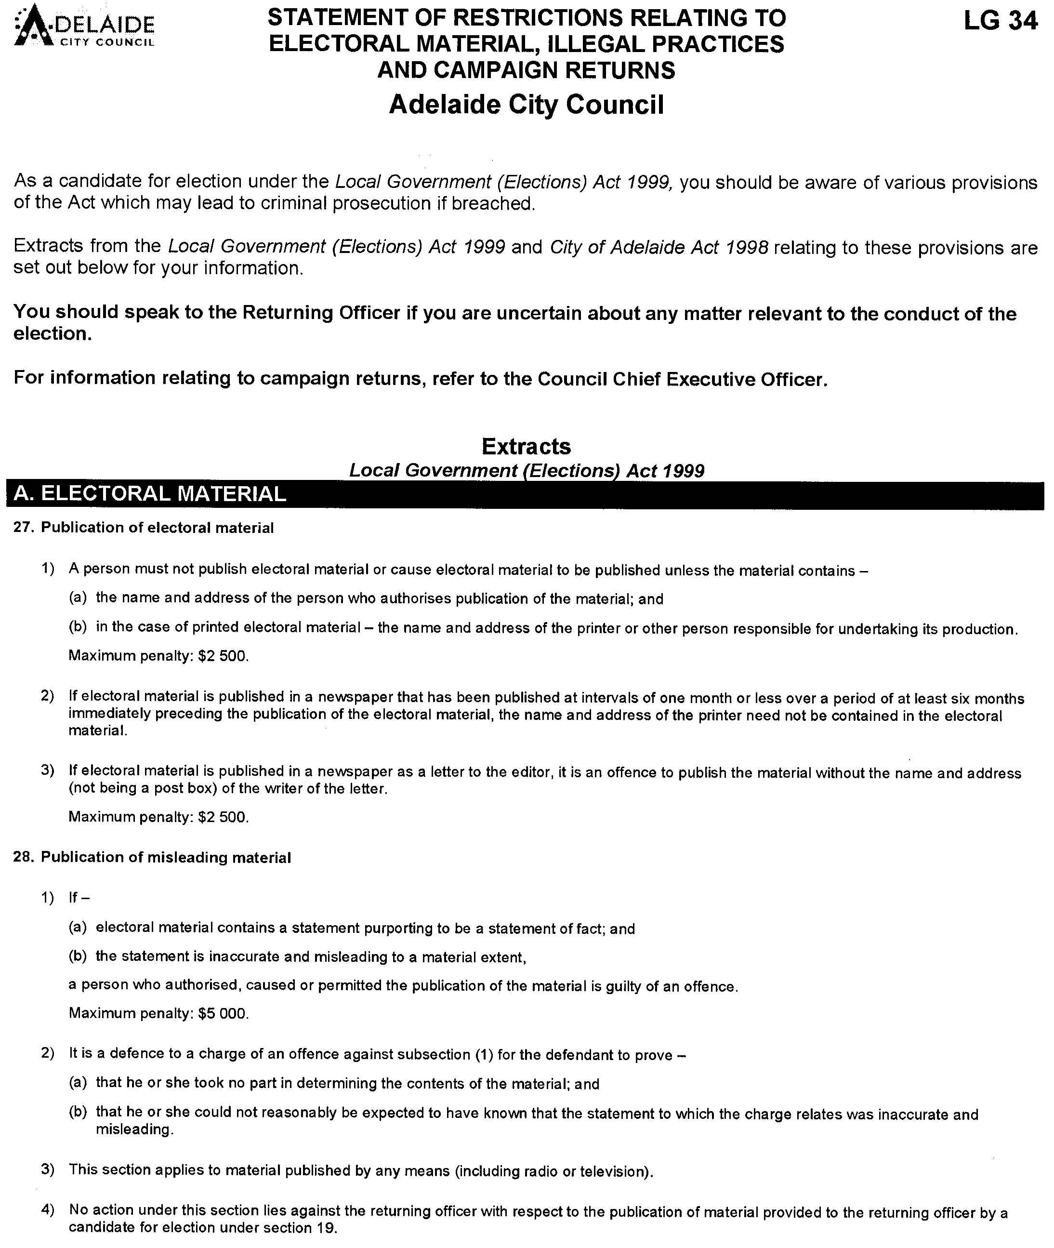
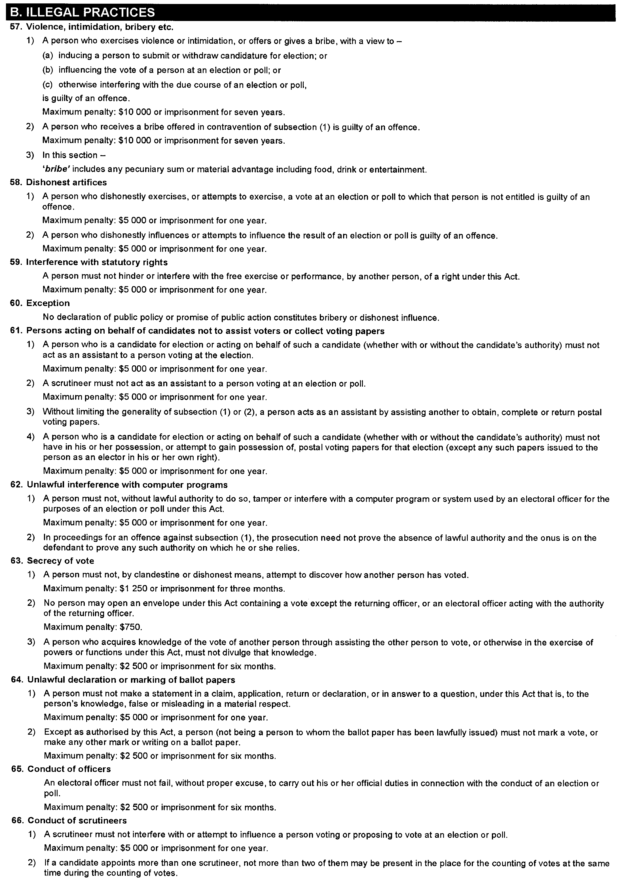
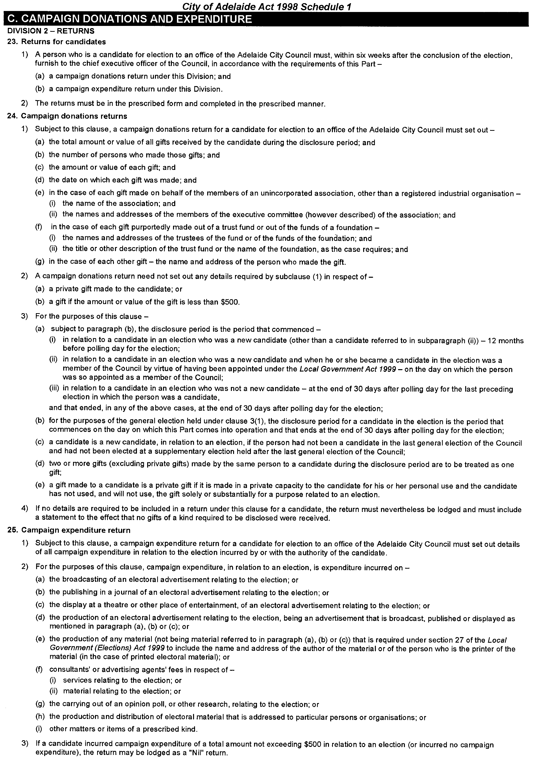
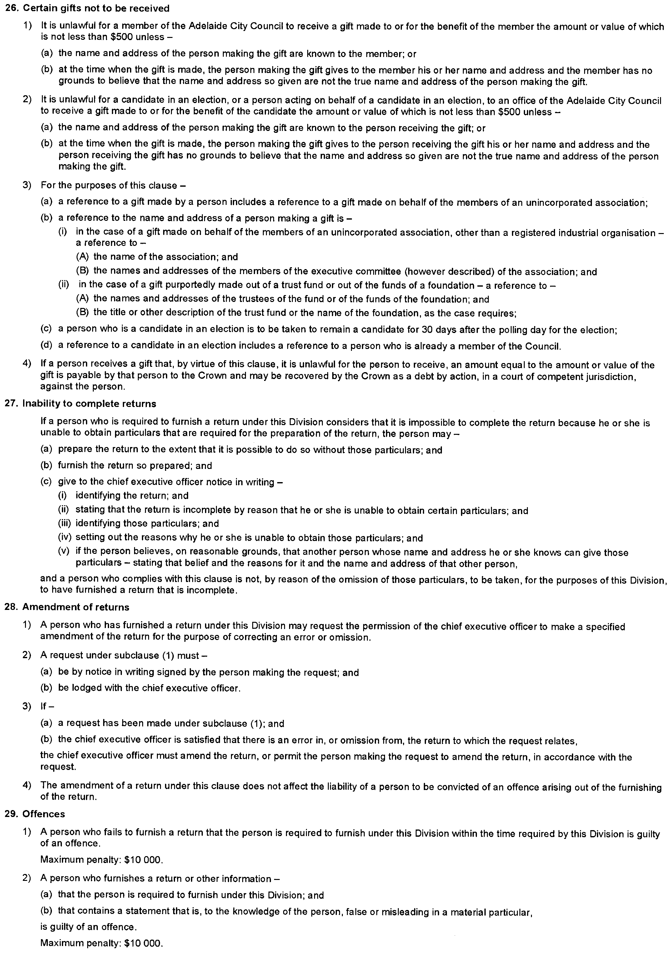
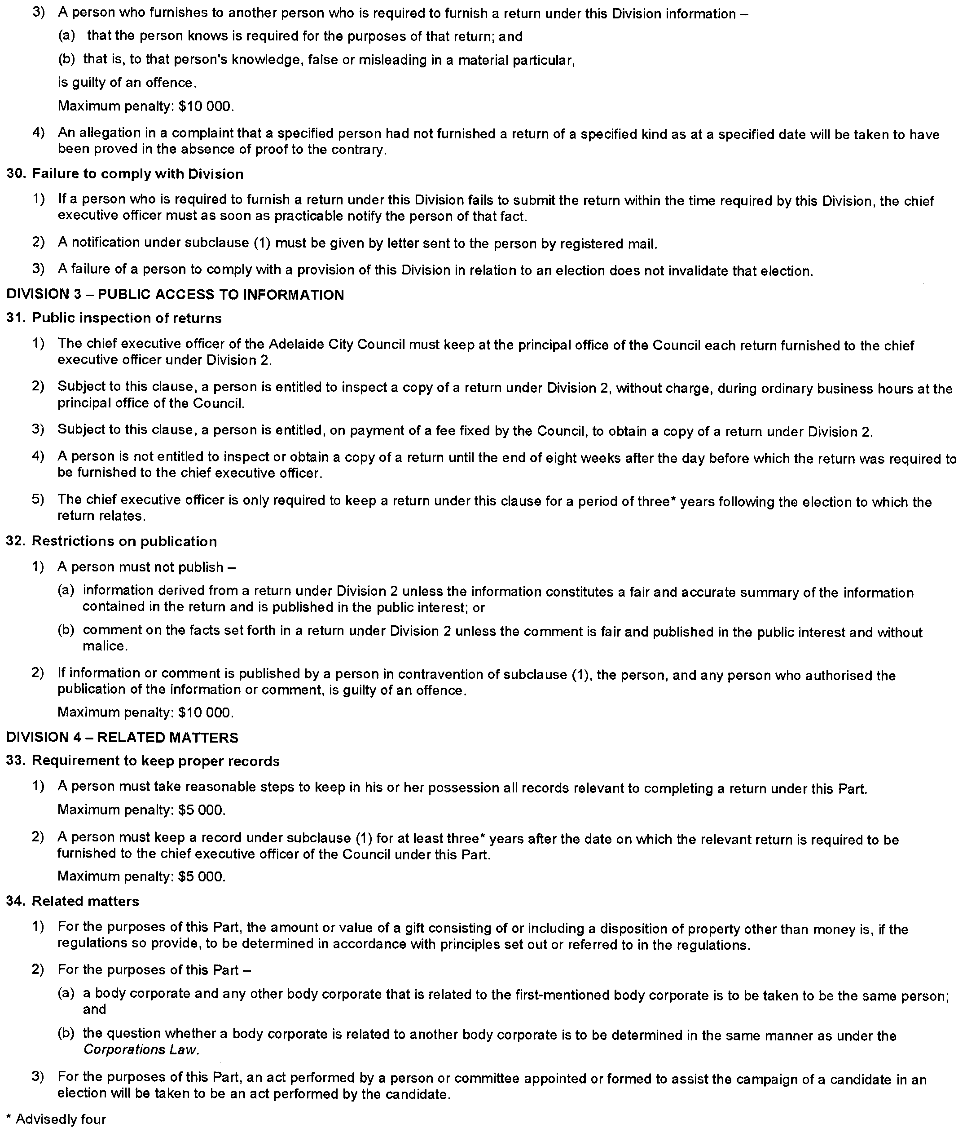
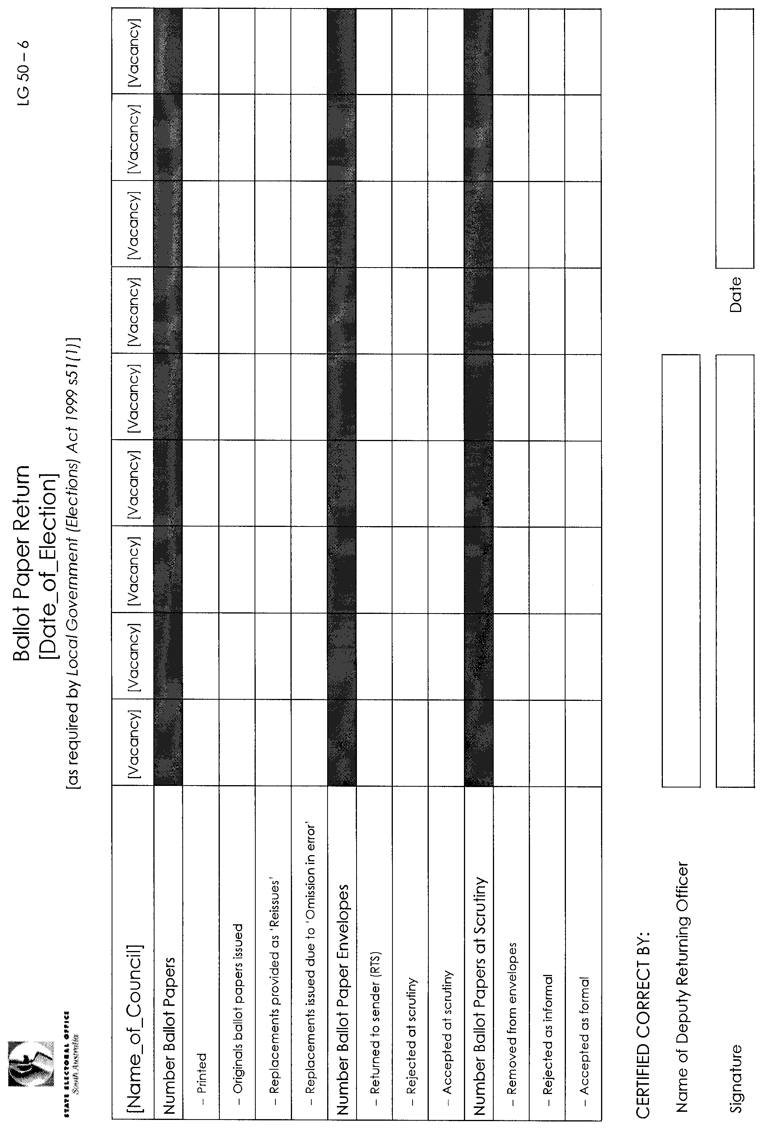

MINING ACT 1971
NOTICE is hereby given in accordance with section 28 (5) of the Mining Act 1971, that the Minister for Mineral Resources Development proposes to grant an Exploration Licence over the undermentioned area:
Applicant: Quasar Resources Pty Ltd
Location: Tallaringa South area—Approximately 110 km west-south-west of Coober Pedy.
Term: 1 year
Area in km²: 623
Ref.: 2006/00318
Plan and co-ordinates can be found on the PIRSA Sarig website: http://www.minerals.pir.sa.gov.au/sarig or by phoning Mineral Tenements on (08) 8463 3103.
H. Tyrteos, Mining Registrar

MINING ACT 1971
NOTICE is hereby given in accordance with section 28 (5) of the Mining Act 1971, that the Minister for Mineral Resources Development proposes to grant an Exploration Licence over the undermentioned area:
Applicant: Millridge Holdings Pty Ltd
Location: Riverton area—Approximately 90 km north-north-east of Adelaide.
Term: 1 year
Area in km²: 188
Ref.: 2007/00234
Plan and co-ordinates can be found on the PIRSA Sarig website: http://www.minerals.pir.sa.gov.au/sarig or by phoning Mineral Tenements on (08) 8463 3103.
H. Tyrteos, Mining Registrar

MINING ACT 1971
NOTICE is hereby given in accordance with section 28 (5) of the Mining Act 1971, that the Minister for Mineral Resources Development proposes to grant an Exploration Licence over the undermentioned area:
Applicant: Rosscraft Minerals Pty Ltd
Location: Marcollat area—Approximately 50 km west of Bordertown.
Term: 1 year
Area in km²: 364
Ref.: 2007/00405
Plan and co-ordinates can be found on the PIRSA Sarig website: http://www.minerals.pir.sa.gov.au/sarig or by phoning Mineral Tenements on (08) 8463 3103.
H. Tyrteos, Mining Registrar

MINING ACT 1971
NOTICE is hereby given in accordance with section 28 (5) of the Mining Act 1971, that the Minister for Mineral Resources Development proposes to grant an Exploration Licence over the undermentioned area:
Applicant: Avoca Resources Ltd
Location: Cowell area—Approximately 100 km south-west of Whyalla.
Term: 1 year
Area in km²: 840
Ref.: 2007/00410
Plan and co-ordinates can be found on the PIRSA Sarig website: http://www.minerals.pir.sa.gov.au/sarig or by phoning Mineral Tenements on (08) 8463 3103.
H. Tyrteos, Mining Registrar

MINING ACT 1971
Declaration of a New Mine
PURSUANT to section 17A of the Mining Act 1971, I declare that the Mineral Leases ML 6137, ML 6219, ML 6220, ML 6221, ML 6222, ML 6223, ML 6224, ML 6225 and ML 6226, situated near Mindarie will be taken to be new mines for the purposes of this section.
Reference: T02341, T02340, T02342, T02381, T02382, T02383, T02384, T02482, T02385.
Paul Holloway, Minister for Mineral Resources Development

MINING ACT 1971
NOTICE is hereby given in accordance with section 35A (1) of the Mining Act 1971, that an application for a mining lease over the undermentioned mineral claim has been received. Details of the proposal may be inspected at the Department of Primary Industries and Resources, Mineral Resources Group, Level 7, 101 Grenfell Street, Adelaide, S.A. 5000:
Applicant: Garwood Contractors Pty Ltd
Claim Number: 3778
Location: Section 1331, Hundred of Strathalbyn—Approximately 2-3 km east of Strathalbyn.
Area: 47.3 hectares
Purpose: For the recovery of limestone and sand.
Reference: T02638
A copy of the proposal has been provided to the District Council of Alexandrina.
Written submissions in relation to the granting of the mining lease are invited to be received at the Department of Primary Industries and Resources, Mineral Resources Group, Level 7, 101 Grenfell Street, Adelaide, S.A. 5000 or G.P.O. Box 1671, Adelaide, S.A. 5001, no later than 7 September 2007.
Copies of all submissions will be forwarded to the applicant and may be made available for public inspection unless confidentiality is requested.
H. Tyrteos, Mining Registrar

NATURAL RESOURCES MANAGEMENT ACT 2004
Notice of Prohibition on Taking Water from Wells in the Central Adelaide Area ‘Area A’
PURSUANT to section 132 (1) of the Natural Resources Manage-ment Act 2004 (the Act), I, Gail Gago, Minister for Environment and Conservation in the State of South Australia, to whom the administration of the Act is committed, being of the opinion that the rate at which water is being taken from wells in the area bounded by the bold solid line in GRO Plan No. 327/2005
(Area A) is such that there is a risk that the available water will not be sufficient to meet future demand, hereby prohibit the taking of water from wells in Area A except in the circumstances specified in Schedule 1.
Schedule 1
1. A person may take water from a well in Area A in accordance with the terms of a written authorisation granted under this Notice by me or my authorised agent.
2. An authorisation under this Notice may be granted to:
(a) A person (a Current User), who has been taking water from a well in Area A during the period 1 July 2002 to 30 November 2005 inclusive (the Relevant Period), entitling that person to take from the source specified in the authorisation:
• where the water taken during the Relevant Period was to water a crop or crops, the amount of water that, in my opinion, would have been reasonably required annually to water that crop or those crops, taking into account the maximum area of each crop or crops grown, the water requirements of the respective crop or crops and the irrigation capacity of the irrigation equipment used to water the crop or crops; or
• where the water was taken during the Relevant Period was used for any other purpose, the amount of water that, in my opinion, would have been reasonably required annually to undertake that purpose.
The source specified will be the resource or resources where water was taken during the Relevant Period.
(b) The transferee of a freehold title, lease or other interest in land, where the transferor of that title, lease or interest is the holder of an authorisation under this notice to take water from a source on that land but as a result of the transfer no longer has legal access to that source of water. The authorisation will entitle that person to take the same amount of water from the same source as the transferor was authorised to take.
(c) Subject to Clause 3, a person (a Prospective User) who did not take any water from a well in Area A during the Relevant Period, but who needs water for a development, project or undertaking:
• to which that person was legally committed during the Relevant Period; or
• in respect of which that person had, in my opinion, committed significant financial or other resources during the Relevant Period,
entitling that person to take the amount of water from a well in Area A, which in my opinion, is reasonably necessary to undertake the development, project or undertaking to which that person was committed.
3. A Prospective User may not be granted an authorisation where, in my opinion:
(a) the taking of water from wells will detrimentally affect the ability of other persons to take water from any watercourse, well or dam for domestic purposes or for watering of stock (other than stock being intensively farmed); or
(b) the taking of water from wells will detrimentally affect the capacity of surface water or any watercourse or well to meet the current or future demand, including the demands of ecosystems dependent on that water resource.
4. Until authorised under this Notice, a Current User may continue to take an amount of water equivalent to the maximum amount taken in any one financial year during the relevant period, from the same sources and for the same purpose or purposes as that person took during the Relevant Period without a written authorisation.
5. This notice does not apply:
(a) to the taking of water directly from a well pursuant to section 124 (4) of the Act for domestic purposes or for watering of stock (other than stock being intensively farmed);
(b) the taking of water for fire-fighting purposes or public road making purposes; or
(c) to the taking of water for the purpose of chemical application on crops.
6. The following condition applies to the taking of water in accordance with an authorisation granted under this Notice:
• The water may only be taken through a meter which accurately measures the quantity of water taken and is at all times in good working condition.
In this notice:
‘Maximum area’ for a particular crop means the maximum area of land planted to a particular crop in any one financial year during the relevant period.
‘Water requirement’ of a crop means the reasonable rate of irrigation (expressed as a volume of water per hectare) to properly produce that crop.
‘Irrigation capacity’ of irrigation equipment means the amount of water that can be applied by the usual operation of that equipment in good condition at 30 November 2005 under usual pumping rates, hours of operation and seasonal fluctuations.
This notice will remain in effect for two years unless earlier varied or revoked.
Dated 1 August 2007.
Gail Gago, Minister for Environment and Conservation

NATURAL RESOURCES MANAGEMENT ACT 2004
Revocation of Notice of Prohibition
PURSUANT to section 132 (9) of the Natural Resources Manage-ment Act 2004 (the Act), I, Gail Gago, Minister for Environment and Conservation in the State of South Australia and Minister to whom the administration of the Act is committed, revoke the notice of prohibition on taking of water from wells in the Central Adelaide Area dated 1 December 2005 and published in the Government Gazette (page 4060-4061) of 1 December 2005.
Dated 1 August 2007.
Gail Gago, Minister for Environment and Conservation

ROADS (OPENING AND CLOSING) ACT 1991:
SECTION 24
NOTICE OF CONFIRMATION OF ROAD
PROCESS ORDER
Road Closure—Webbe Street, Norwood
BY Road Process Order made on 30 April 2007, The Corporation of the City of Norwood, Payneham & St Peters ordered that:
1. Portion of Webbe Street between allotment 135 in Filed Plan 47093 and allotment 100 in Deposited Plan 59663, more particularly delineated and lettered ‘A’ in Preliminary Plan No. 06/0018 be closed. The road will be closed from a height of 65.20 AHD and 66.50 AHD and below a height of 70.55 AHD and 71.85 AHD.
2. Issue a Certificate of Title to The Corporation of the City of Norwood, Payneham & St Peters for the whole of the land subject to closure which land is being retained by the Council for public purposes.
On 21 June 2007, that order was confirmed by the Minister for Infrastructure conditionally upon the deposit by the Registrar-General of Deposited Plan 74380 being the authority for the new boundaries.
Pursuant to section 24 (5) of the Roads (Opening and Closing) Act 1991, NOTICE of the order referred to above and its confir-mation is hereby given.
Dated 2 August 2007.
P. M. Kentish, Surveyor-General

TRAINING AND SKILLS DEVELOPMENT ACT 2003

Part 4 – Apprenticeships/Traineeships

Pursuant to the provision of the Training and Skills Development Act 2003, the Training and Skills Commission (TaSC) gives notice that determines the following:
Trades, Declared Vocations or Other Occupations

The following schedule is additional to the gazettals of:

- 5 February 2004 | - 19 February 2004 | - 11 March 2004 | - 1 April 2004
- 1 July 2004 | - 15 July 2004 | - 22 July 2004 | - 30 September 2004
- 16 December 2004 | - 27 January 2005 | - 3 February 2005 | - 10 February 2005
- 10 March 2005 | - 24 March 2005 | - 5 May 2005 | - 12 May 2005
- 2 June 2005 | - 16 June 2005 | - 7 July 2005 | - 4 August 2005
- 18 August 2005 | - 1 September 2005 | - 15 September 2005 | - 22 September 2005
- 6 October 2005 | - 20 October 2005 | - 27 October 2005 | - 8 December 2005
- 22 December 2005 | - 9 March 2006 | - 6 April 2006 | - 20 April 2006
- 4 May 2006 | - 18 May 2006 | - 25 May 2006 | - 1 June 2006
- 3 August 2006 | - 10 August 2006 | - 31 August 2006 | - 7 September 2006
- 21 September 2006 | - 29 September 2006 | - 12 October 2006 | - 9 November 2006
- 23 November 2006 | - 30 November 2006 | - 7 December 2006 | - 21 December 2006
- 4 January 2007 | - 11 January 2007 | - 1 February 2007 | - 8 February 2007
- 15 February 2007 | - 19 April 2007 | - 10 May 2007 | - 26 July 2007

which set out the Trades, Declared Vocations or Other Occupations and the terms and conditions applicable to the Trades, Declared Vocations or Other Occupations.

Trades, Declared Vocations or Other Occupations, required Qualifications and
Contract of Training Conditions for the
Forest and Forest Products Training Package (FPI05)

*Trade  #Declared Vocation  Other  Occupation | Code | Title | Nominal Term of Contract of Training | Probationary Period
* Saw Doctor | FPI30705 | Certificate III in Sawdoctoring | 48 months | 3 months
* Wood  Machinist | FPI30805 | Certificate III in Woodmachining | 48 months | 3 months

Bold denotes variation to titles.

South Australia
Aboriginal Lands Trust (Yalata Reserve—Mining Rights) Proclamation 2007
under section 16(9) of the Aboriginal Lands Trust Act 1966
1—Short title
This proclamation may be cited as the Aboriginal Lands Trust (Yalata Reserve—Mining Rights) Proclamation 2007.
2—Commencement
This proclamation comes into operation on the day on which it is made.
3—Interpretation
In this proclamation—
Aboriginal Lands Trust means the Aboriginal Lands Trust constituted under the Aboriginal Lands Trust Act 1966;
affects native title —see Part 9B of the Mining Act 1971;
Mining Minister means the Minister for the time being administering the Mining Act 1971;
native title land has the same meaning as in the Native Title (South Australia) Act 1994.
4—Mining rights may be exercised
Subject to clauses 5 and 6, rights of entry, prospecting, exploration or mining conferred by the Mining Act 1971 may be exercised in respect of the whole or any part of the land described in Schedule 1.
5—Special condition for exercise of rights under exploration licence
A person in whom rights of entry, prospecting, exploration or mining are vested by an exploration licence under the Mining Act 1971 granted after the commencement of this proclamation must not exercise those rights in respect of the whole or any part of the land described in Schedule 1 unless notice of the proposed licence was given by the Mining Minister to the Aboriginal Lands Trust prior to the grant of the licence.
6—Conditions for exercise of mining rights generally
A person in whom rights of entry, prospecting, exploration or mining are vested under the Mining Act 1971 (whether those rights were acquired before or after the commencement of this proclamation and whether pursuant to an exploration licence or otherwise) must not exercise those rights in respect of the whole or any part of the land described in Schedule 1 unless the following conditions are complied with:
(a) no work or other activity may be undertaken on the land in the exercise of those rights until Yalata Community Incorporated has been notified of, and consulted in relation to, the proposed work or other activity;
(b) if any work or other activity in the exercise of those rights is undertaken on native title land and affects native title, the work or other activity on the land must be undertaken in accordance with any applicable—
(i) indigenous land use agreement registered under the Native Title Act 1993 of the Commonwealth; or
(ii) agreement or determination under Part 9B of the Mining Act 1971.
Schedule 1—Description of land (Yalata Reserve)
The land comprised in Certificate of Title Register Book Volume 5834 Folio 851.
Made by the Governor’s Deputy
with the advice and consent of the Executive Council
on 2 August 2007
MMRD07/009CS

South Australia
Youth Court (Designation and Classification of Special Justices) Proclamation 2007
under section 9 of the Youth Court Act 1993
1—Short title
This proclamation may be cited as the Youth Court (Designation and Classification of Special Justices) Proclamation 2007.
2—Commencement
This proclamation comes into operation on the day on which it is made.
3—Designation and classification of special justices
The special justices named in Schedule 1 are—
(a) designated as special justices of the Youth Court of South Australia; and
(b) classified as members of the Court's ancillary judiciary.
Schedule 1—Special justices of the Court
John William Ames
Paul Davos
John Francis Genovese
Brian Roger Gitsham
Allan Wayne Jones
Terry James McEvoy
Carlo Phillip Mancini
Elena Laima Naujokas
Clifford John Pinkard
Michael Anthony James Sergi
Annette Louise Tsouris
Made by the Governor’s Deputy
with the advice and consent of the Executive Council
on 2 August 2007
AGO0035/07CS

FAXING COPY?
IF you fax copy to Government Publishing SA for inclusion in the Government Gazette, there is no need to send a Confirmation Copy to us as well.
This creates confusion and may well result in your notice being printed twice.
Please use the following fax number:
Fax transmission: (08) 8207 1040
Phone Inquiries: (08) 8207 1045
Please include a contact person, phone number and order number so that we can phone back with any queries we may have regarding the fax copy.
NOTE: Closing time for lodging new copy (fax, hard copy or email) is 4 p.m. on Tuesday preceding the day of publication.

Government Gazette notices can be E-mailed.
The address is:
governmentgazette@dpc.sa.gov.au
Documents should be sent as attachments in Word format.
When sending a document via E-mail, please confirm your transmission with a faxed copy of your document, including the date the notice is to be published.
Fax transmission: (08) 8207 1040
Enquiries: (08) 8207 1045
NOTE: Closing time for lodging new copy (fax, hard copy or email) is 4 p.m. on Tuesday preceding the day of publication.

CITY OF MOUNT GAMBIER
Adoption of Valuations and Declaration of Rates
NOTICE is hereby given that at a meeting of the Council of the City of Mount Gambier held on Tuesday, 24 July 2007, the Council resolved:
Adoption of Capital Valuations
Pursuant to section 167 (2) (a) of the Local Government Act 1999, the Council adopts for rating purposes for the 2007-2008 financial year, the Valuer-General’s most recent valuations of the capital values applicable to land within the area of the Council, totalling $2 478 998 578 and that the date of adoption of the valuations is 24 July 2007.
Declaration of the Attribution of Land Uses and Codes
In exercise of the powers contained in Chapter 10 of the Local Government Act 1999, the attribution of the land uses in the Assessment Record will be in accordance with the categories of land use prescribed by Regulation 10 of the Local Government (General) Regulations 1999.
Declaration of Rates
Pursuant to sections 153 (1) (b) and 156 (1) (a) of the Local Government Act 1999 and in order to raise rates in the amount of $11 029 000 for the 2007-2008 financial year the Council hereby declares that differential general rates will vary according to the use of the land and declares the differential general rates for rateable land within the Council area as follows:
(1) 0.1869 of a cent per dollar of assessed capital value on rateable land of Category 1 (Residential) use;
(2) 0.5046 of a cent per dollar of assessed capital value on rateable land of Category 2 (Commercial—Shop) use;
(3) 0.5046 of a cent per dollar of assessed capital value on rateable land of Category 3 (Commercial—Office) use;
(4) 0.5046 of a cent per dollar of assessed capital value on rateable land of Category 4 (Commercial—Other) use;
(5) 0.4392 of a cent per dollar of assessed capital value on rateable land of Category 5 (Industry—Light) use;
(6) 0.4392 of a cent per dollar of assessed capital value on rateable land of Category 6 (Industry—Other) use;
(7) 0.1869 of a cent per dollar of assessed capital value on rateable land of Category 7 (Primary Production) use;
(8) 0.7476 of a cent per dollar of assessed capital value on rateable land of Category 8 (Vacant Land) use; and
(9) 0.1869 of a cent per dollar of assessed capital value on rateable land of Category 9 (Other) use.
Declaration of a Fixed Charge
Pursuant to section 152 (1) of the Local Government Act 1999, the Council hereby declares in respect of the 2007-2008 financial year a fixed charge on rateable land within the Council area in the sum of $400.
Declaration of Separate Rate
In exercise of the powers contained in section 95 of the Natural Resources Management Act 2004 and section 154 of the Local Government Act 1999 and in order to reimburse to the Council the amount contributed to the South East Natural Resources Management Board being a net $429 968, a separate rate of $34.90 per assessment be declared based on a fixed charge of the same amount on all rateable land in the Council’s area and in the area of the said Board for the 2007-2008 financial year.
Payment of Council Rates
Pursuant to section 181 (2) of the Local Government Act 1999, the Council declares that rates and charges in respect of the 2007-2008 financial year be by quarterly instalments due and payable on or before:
14 September 2007;
7 December 2007;
7 March 2008; and
6 June 2008.
Dated 25 July 2007.
G. Muller, Chief Executive Officer

CITY OF PORT ADELAIDE ENFIELD
Adoption of Valuation and Declaration of Rates
NOTICE is hereby given that at its meeting held on 24 July 2007, the Council:
1. Adopted the capital valuations that are to apply in its area for rating purposes for the 2007-2008 financial year, totalling $16 963 615 109.
2. Declared differential general rates on rateable land within its area as follows:
• Residential—A differential general rate of $0.00294 in the dollar on the value of the land subject to the rate.
• Commercial—Shop—A differential general rate of $0.00559 in the dollar on the value of the land subject to the rate.
• Commercial—Office—A differential general rate of $0.00559 in the dollar on the value of the land subject to the rate.
• Commercial—Other—A differential general rate of $0.00559 in the dollar on the value of the land subject to the rate.
• Industry—Light—A differential general rate of $0.00559 in the dollar on the value of the land subject to the rate.
• Industry—Other—A differential general rate of $0.00559 in the dollar on the value of the land subject to the rate.
• Primary Production—A differential general rate of $0.00559 in the dollar on the value of the land subject to the rate.
• Vacant Land—A differential general rate of $0.00559 in the dollar on the value of the land subject to the rate.
• Other—A differential general rate of $0.00559 in the dollar on the value of the land subject to the rate.
3. Fixed a minimum amount payable by way of rates, pursuant to section 158 of the Local Government Act 1999, in respect of the 2007-2008 financial year, in respect of rateable land within all parts of its area of $630, excluding the following:
• The area defined as Industry (Port) Zone by the Port Adelaide Enfield (City) Development Plan dated 26 April 2007.
• The Business Policy Area of the Marina (North Haven) Zone in the City of Port Adelaide Enfield Development Plan Map PAdE/43, dated 26 April 2007.
• The Boat Haven and Coast Policy Area of the Marina (North Haven) Zone in the City of Port Adelaide Enfield Development Plan Map PAdE/43, dated 26 April 2007.
4. Declared a separate rate in respect to the 2007-2008 financial year of $0.0000624 in the dollar on the value of rateable land in the area of the Adelaide and Mount Lofty Ranges Natural Resources Management Board.
5. Declared a separate rate in respect to the 2007-2008 financial year of $0.00148 in the dollar on the value of rateable land for each allotment contained within Deposited Plan No. 42580 comprising the New Haven Village at North Haven.
6. Declared that all rates declared or payable in respect of or during the 2007-2008 financial year will fall due (unless otherwise agreed with the Principal Ratepayer) in four equal or approximately equal instalments payable on 5 September 2007,
5 December 2007, 5 March 2008 and 5 June 2008,
with reference to categories of uses being the categories of uses as differentiating factors referred to in the Local Government (General) Regulations 1999.
H. J. Wierda, City Manager

CITY OF SALISBURY
Renaming of Road
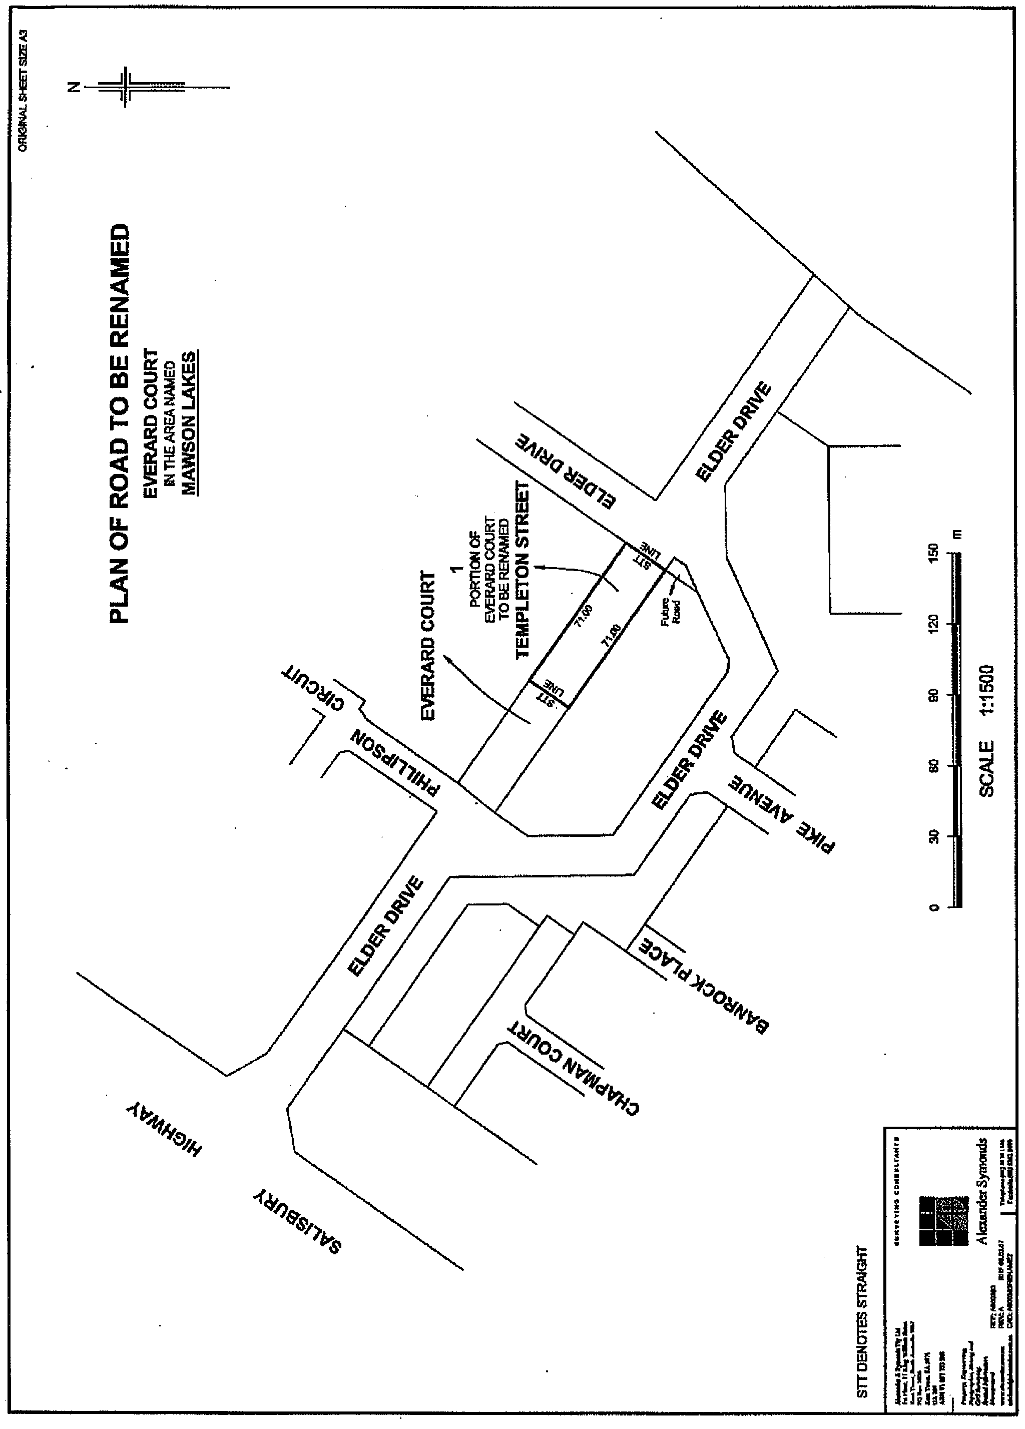
NOTICE is hereby given pursuant to section 219 of the Local Government Act 1999, the City of Salisbury resolved that at its meeting held on 25 June 2007, portion of Elder Road, Mawson Lakes, as referred to in attached plan, be amended to show Elder Drive, Everard Court and Templeton Street and the necessary statutory notifications take place.
S. Hains, City Manager

CITY OF SALISBURY
Renaming of Road
NOTICE is hereby given pursuant to section 219 of the Local Government Act 1999, the City of Salisbury resolved that at its meeting held on 25 June 2007, Deposited Plan 10304 dated 11 November 1976, be amended to show portion of Dean Street, as referred to in attached plan, as Vivian Court, Para Hills West and the necessary statutory notifications take place.
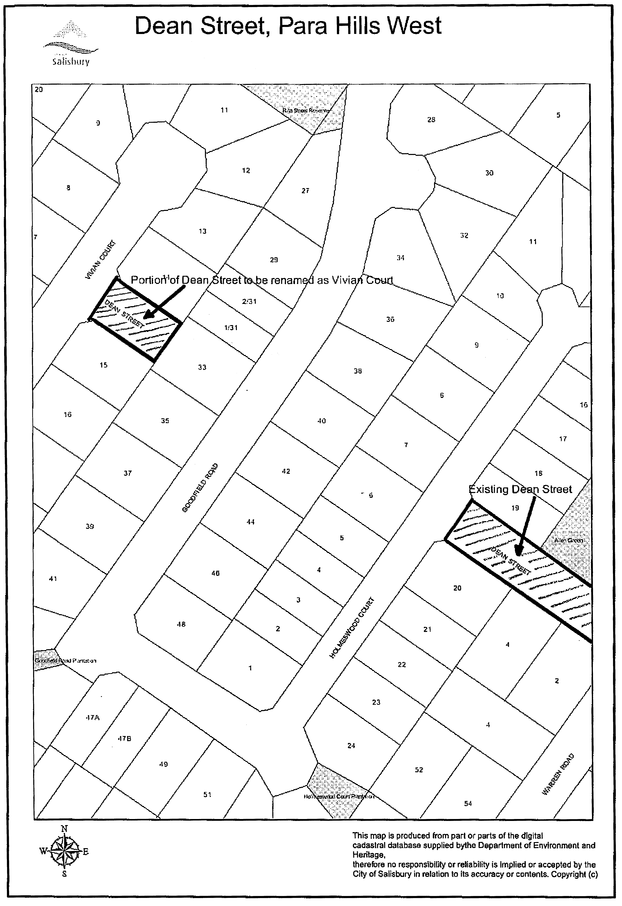
S. Hains, City Manager

CITY OF VICTOR HARBOR
Adoption of Valuation and Declaration of Rates
NOTICE is hereby given that the Council of the City of Victor Harbor, at a meeting held on 9 July 2007, in exercise of the powers contained in Chapter 10 of the Local Government Act 1999, resolved as follows:
Adoption of Valuation
Pursuant to section 167 (2) (a) of the Local Government Act 1999, adopted for rating purposes for the year ending 30 June 2008, the Valuer-General’s valuation of capital value of land within the area of the Council totalling $2 941 910.
Declaration of Rates
Pursuant to sections 153 (1) (b) and 156 (1) of the Local Government Act 1999, declared the following differential general rates on rateable land within the area of the Council for the year ending 30 June 2008, based on the capital value of the land and varying by reference to land use as categorised within Regulation 10 of the Local Government (General) Regulations 1999:
• In respect of rateable land with Land Use Category 1 (Residential) and Category 9 (Other), a differential general rate of 0.3033 cents in the dollar.
• In respect of rateable land with Land Use Category 2 (Commercial—Shop), Category 3 (Commercial—Office) and Category 4 (Commercial—Other), a differential rate of 0.3336 cents in the dollar.
• In respect of rateable land with Land Use Category 5 (Industry—Light) and Category 6 (Industry—Other), a differential general rate of 0.3185 cents in the dollar.
• In respect of rateable land with Land Use Category 7 (Primary Production), a differential general rate of 0.2426 cents in the dollar.
• In respect of rateable land with Land Use Category 8 (Vacant Land), a differential general rate of 0.3640 cents in the dollar.
Regional Natural Resources Management Levy
Pursuant to section 95 of the Natural Resources Management Act 2004 and section 154 of the Local Government Act 1999, declared separate rates for the year ending 30 June 2008, based on the capital value of all rateable properties, to recover amounts payable to Natural Resources Management Boards as follows:
• In respect of all rateable properties located within the area of the Council and of the Adelaide and Mount Lofty Natural Resources Management Board, a separate rate of 0.0013 cents in the dollar.
• In respect of all rateable properties located within the area of the Council and of the South Australian Murray-Darling Basin Natural Resources Management Board, a separate rate of 0.0050 cents in the dollar.
Fixed Charge
Pursuant to section 151 (1) (c) (ii) and in accordance with section 152 (2) of the Local Government Act 1999, imposed a fixed charge of $210 on each separate piece of rateable land within the area of the Council.
Rebates—Rate Relief
Pursuant to section 166 (1) (l) of the Act, rebates on rates will be offered as follows:
• in respect of residential properties which are the rate-payer’s principal place of residence a rebate of the amount by which the general rates payable exceeds the 2006-2007 general rates payable by more than 15%; and
• in respect of Primary Production properties which are the ratepayer’s principal source of income and who can demonstrate financial hardship (e.g. where the owner has been the recipient of an Exceptional Circumstances Drought Relief Grant): a rebate of the amount by which the general rates payable exceeds the 2006-2007 general rates payable by more than 15%, to a maximum rebate of $500.
Such rebates would not apply where: the property has been acquired by the ratepayer or has become their principal place of residence (or principal source of income as applicable) after
1 January 2006; the increase in general rates payable is due in whole or in part to an increase in valuation of the property attributable to improvements made after 1 January 2006, the increase in general rates payable is due in whole or in part to an increase in valuation of the property attributable to a change in the zoning of the land under the Development Act 1993.
Payment of Rates
Pursuant to section 181 (1) of the Local Government Act 1999, rates for the year ending 30 June 2008 are payable by quarterly instalments on the eighth day of the months of September 2007, December 2007, March 2008 and June 2008.
G. K. Maxwell, City Manager

TOWN OF GAWLER
Adoption of Valuation
NOTICE is hereby given that the Town of Gawler, at its meeting held on Tuesday, 10 July 2007 and for the fiscal year ending 30 June 2008, adopted, for rating purposes, the most recent valuations of the Valuer-General available to Council, of the capital value
of rateable land within the area of the Council totalling $2 269 285 500.
Declaration of Rates
1. Declared a single general rate of 0.376 cents in the dollar on all rateable land in the Council area.
2. Fixed a minimum amount payable by a way of rates of $600 in respect of rateable land in the Council area.
3. Imposed an annual waste management service charge of $120 for the prescribed service of waste management on each separate assessment, of occupied land to which the service is provided.
4. Declared a separate differential rate of business development and marketing on land within that part of the Council area shown hatched in the map on page 30, figure 1 of the Town of Gawler Annual Business Plan, for land uses—Category 2 (Commercial—Shop), Category 3 (Commercial—Office), Category 4 (Com-mercial—Other), Category 5 (Industry—Light), Category 6 (Industry—Other), of 0.0703 cents in the dollar.
5. Declared a separate differential rate for business development on all land within that part of the Council area, other than the hatched area defined in the map on page 30, figure 1 of the Town of Gawler Annual Business Plan, on land uses—Category 2 (Com-mercial—Shop), Category 3 (Commercial—Office), Category 4 (Commercial—Other), Category 5 (Industry—Light), Category 6 (Industry—Other), of 0.0450 cents in the dollar.
6. Declared a separate rate for the provision of additional car parking on land within the hatched area defined in the map on page 30, figure 1 of the Town of Gawler Annual Business Plan, for land uses—Category 2 (Commercial—Shop), Category 3 (Commercial—Office), Category 4 (Commercial—Other), Category 5 (Industry—Light), Category 6 (Industry—Other), of 0.2760 cents in the dollar.
Natural Resources Management Levy
In order to reimburse to the Council the amount of $192 490 contributed to the Adelaide and Mount Lofty Ranges Natural Resources Management Board declared a separate rate of 0.008620 cents in the dollar based upon the capital value of rateable land, on all rateable land in the Council’s area, within the Adelaide and Mount Lofty Ranges Natural Resources Manage-ment Board area for the year ending 30 June 2008.
Payment
Determined that all rates and services charges will be payable in four instalments on 21 September 2007, 7 December 2007, 7 March 2008 and 6 June 2008.
N. Jacobs, Chief Executive Officer

ALEXANDRINA COUNCIL
Roads (Opening and Closing) Act 1991
Road Closure, Un-named Road Adjacent Callington
Road, Strathalbyn
NOTICE is hereby given pursuant to section 10 of the said Act, that Council proposes to make a Road Process Order to close and sell to Terramin Aust Ltd the road dividing section 830 from sections 828 and 829, Hundred of Strathalbyn shown as ‘A’ on Preliminary Plan No. 07/0047.
A copy of the plan and statement of persons affected are available for public inspection at Council’s Office, 1 Colman Terrace, Strathalbyn, and the office of the Surveyor-General, 101 Grenfell Street, Adelaide during normal office hours.
Any application for easement or objections must be made in writing within 28 days from 2 August 2007 to the Council, P.O. Box 21, Goolwa, S.A. 5214 and the Surveyor-General, G.P.O. Box 1354, Adelaide, S.A. 5001, setting out full details.
Where a submission is made, Council will give notification of a meeting to deal with the matter.
J. L. Coombe, Chief Executive Officer

ALEXANDRINA COUNCIL
Roads (Opening and Closing) Act 1991
Road Closure, Portion Mark Lane, Goolwa
NOTICE is hereby given pursuant to section 10 of the said Act, that the Council proposes to make a Road Process Order to close and retain as reserve (subject to ETSA and SA Water easements), the un-made portion of Mark Lane situate west of the formed road shown as ‘A’ on Preliminary Plan No. 07/0045.
A copy of the plan and statement of persons affected are available for public inspection at Council’s Office, 11 Cadell Street, Goolwa, and the office of the Surveyor-General, 101 Grenfell Street, Adelaide during normal office hours.
Any application for easement or objections must be made in writing within 28 days from 2 August 2007 to the Council, P.O. Box 21, Goolwa, S.A. 5214 and the Surveyor-General, G.P.O. Box 1354, Adelaide, S.A. 5001, setting out full details.
Where a submission is made, Council will give notification of a meeting to deal with the matter.
J. L. Coombe, Chief Executive Officer

THE BERRI BARMERA COUNCIL
Adoption of Valuation and Declaration of Rates
NOTICE is hereby given that at a meeting of the Council held on Tuesday, 24 July 2007 and for the year ending 30 June 2008, it was resolved:
Adoption of Valuation
To adopt for rating purposes, the capital values made by
the Valuer-General totalling $1 228 249 400 of which $1 161 030 260 is in respect to rateable land, and that 24 July 2007 shall be the day as and from which such valuation shall become the valuation of the Council.
Declaration of Rates
To declare the following differential rates based upon the locality of the land and its use on all rateable land within its area:
(1) Townships of Barmera, Berri, Cobdogla, Glossop, Loveday and Monash as defined:
(a) Residential—0.4855 cents in the dollar on the capital value of such rateable property;
(b) Commercial—0.5834 cents in the dollar on the capital value of such rateable property;
(c) Industrial—0.6022 cents in the dollar on the capital value of such rateable property;
(d) Other—0.4376 cents in the dollar on the capital value of such rateable property.
(2) Outside the aforesaid townships as defined:
(a) Residential—0.4780 cents in the dollar on the capital value of such rateable property;
(b) Primary Production—0.4350 cents in the dollar on the capital value of such rateable property;
(c) Vacant—0.4376 cents in the dollar on the capital value of such rateable property;
(d) Other—0.4376 cents in the dollar on the capital value of such rateable property;
(e) Commercial—0.5645 cents in the dollar on the capital value of such rateable property;
(f) Industrial—0.5834 cents in the dollar on the capital value of such rateable property.
Declaration of Minimum Rates
To fix a minimum amount payable by way of general rates of $500.
Declaration of Service Charges—Community Wastewater Management System (Effluent Disposal Scheme)
To impose an annual service charge for all properties serviced by the Berri Barmera Community Wastewater Management System (effluent disposal) that includes the Community Wastewater Management System of Berri, Barmera, Glossop, Monash, Cobdogla and Loveday, as follows:
$400 per unit on each occupied allotment;
$200 per unit on each vacant allotment.
Declaration of Separate Rate—Natural Resources
Management Levy
To declare a separate rate of 0.0055 cents in the dollar based on the capital value of rateable land in the Council’s area in order to recover the amount payable to the SA Murray Darling Basin Natural Resources Management Board and to fix a minimum amount payable by way of this separate rate of $6.
Payment of Rates
That rates will fall due and in four equal or approximately equal instalments on the following dates:
14 September 2007
14 December 2007
14 March 2008
13 June 2008.
S. J. Rufus, Chief Executive Officer

DISTRICT COUNCIL OF GRANT
Adoption of Valuations and Declaration of Rates
NOTICE is hereby given that at its meeting held on 16 July 2007, Council in exercise of the powers contained in Part 1 of Chapter 10 of the Local Government Act 1999, for the financial year ending 30 June 2008:
1. Pursuant to section 167 (2) (a) of the Local Government Act 1999, adopted for rating purposes capital valuations of land within the Council’s area made by the Valuer-General, totalling $2 077 623 100 comprising $2 015 221 554 in respect of rate-able land and $62 401 546 in respect of non-rateable land before alteration.
2. Pursuant to section 153 (1) (a) of the Local Government Act 1999, declared a general rate on all rateable land within the Council’s area of 0.237 cents in the dollar based on the capital value of rateable land.
3. Pursuant to section 158 (1) (a) of the Local Government Act 1999, declared a minimum amount of $415 payable by way of general rates on rateable land in the Council’s area.
4. Pursuant to section 155 of the Local Government Act 1999, declared an annual service charge based on the nature of the service of $155 for the collection and disposal (including recycling) of domestic waste (Mobile Garbage Bins) on all land to which it provides or makes available the service as follows:
(a) in the townships of Port MacDonnell, Racecourse Bay, Donovans, Caveton, Carpenter Rocks, Blackfellows Caves, Nene Valley, Kongorong, Allendale East and the Pelican Point/Carpenter Rocks Shacks area;
(b) in the following streets and roads at Moorak: Kilsby Road, Orchard Road, Florence Street, Berkefeld Road, Johnston Road, Thompson Court, Northumberland Avenue and Bay Road (from the boundary of the City of Mount Gambier to Tarrant Road);
(c) in the following streets and roads at Yahl: Brim Brim Road, Church Street, Yahl Road (from Square Mile Road to Yahl Hall Road), Yahl Hall Road (from Brim Brim Road to Yahl Road), Lange Road (from Yahl Road to the eastern Boundary of property A5325, Lot 1, FP9406);
(d) in the following streets and roads at Tarpeena: bounded by McEnroe Road (from Riddoch Highway to Bailey Road), Bailey Road (from McEnroe Road to Clezy Road), Clezy Road (from Bailey Road to Quarry Road), Quarry Road (from Clezy Road to Medhurst Road), Medhurst Road (from Quarry Road to Riddoch Highway), Riddoch Highway (from Medhurst Road to Albinia Terrace West), Albinia Terrace West (from Riddoch Highway to Marion Terrace), Marion Terrace (from Albinia Terrace West to Boully Road) and Boully Road (from Marion Terrace to Riddoch Highway);
(e) in the following streets and roads at Worrolong: bounded by Hawkins Road (from Worrolong Road to Buchanan Road), Buchanan Road (from Hawkins Road to Triangle Road), Triangle Road (from Buchanan Road to Worrolong Road), Worrolong Road (from Triangle Road to Hawkins Road), including Williams Road, Kavanagh Road, Cutting Court, Billing Road, McMahon Road, Leggett Road and O’Neil Road (from Triangle Road to Worrolong Road); and
(f) in the following streets and roads at Cafpirco Road area including Cafpirco Road (from Princes Highway to Burnda Road), Burnda Road (from Mitchell Road to Railway line), Bells Lane, Alie Drive, John Fallas Drive, Bill James Court, and Mulwala Road (from Cafpirco Road to the southern boundary of Lot 11 in division of Lots 22 and 23, DPI755).
5. Pursuant to section 155 of the Local Government Act 1999, imposed an annual service charge based on the nature of the service on any land to which the Council provides or makes available the Community Wastewater Management Systems being services for the collection, treatment and disposal of waste as follows:
(a) $121 per annum on all vacant units and $335 per annum on all occupied units in that part of the town-ship of Port MacDonnell served by the Community Wastewater Management System;
(b) $113 per annum on all vacant units and $182 per annum on all occupied units in that part of the township of Tarpeena served by the Community Wastewater Management System;
(c) $1 380 per annum on all occupied units in that part of the Pelican Point area from sections 690 to 700, sections 702 to 726, Hundred of Kongorong, Lot 8, (DP5111) Newton Road and Lot 651, Newton Road, served by the Community Wastewater Management System; and
(d) $330 per annum on all vacant units and $380 per annum on all occupied units in that part of the township of Allendale East served by the Community Wastewater Management System.
6. Pursuant to section 95 of the Natural Resources Manage-ment Act 2004 and section 152 of the Local Government Act 1999, in order to reimburse the Council for amounts contributed to the South East Natural Resources Management Board, declared a separate rate (Regional Natural Resources Manage-ment Levy) of $35.30 on all rateable land in the region of the Board and within the Council area, based on a fixed charge of the same amount on all rateable land.
7. Pursuant to section 181 (1) of the Local Government Act 1999, declared that all rates shall be payable in four equal or approximately equal instalments with the first instalment payable on or before 7 September 2007, the second instalment payable on or before 7 December 2007, the third instalment payable on or before 7 March 2008, and the fourth instalment payable on or before 6 June 2008.
Dated 17 July 2007.
R. J. Peate, Chief Executive Officer

DISTRICT COUNCIL OF GRANT
Roads (Opening And Closing) Act 1991
Pelican Point Road, In the Area Named Carpenter Rocks
NOTICE is hereby given pursuant to section 10 of the Roads (Opening and Closing) Act 1991, that the District Council of Grant proposes to make a Road Process Order to close and merge portion of Pelican Point Road with adjoining section 668, Hundred of Kongorong, more particularly delineated and lettered as ‘A’ on Preliminary Plan No. 07/0026.
A copy of the plan and a statement of persons affected are available for public inspection at the office of the Council, 324 Commercial Street West, Mount Gambier and the Adelaide office of the Surveyor-General during normal office hours.
Any application for easement or objection must set out the full name, address and details of the submission and must be fully supported by reasons.
The application for easement or objection must be made in writing to the Council, P.O. Box 724, Mount Gambier, S.A. 5290 within 28 days of this notice and a copy must be forwarded to the Surveyor-General, G.P.O. Box 1354, Adelaide, S.A. 5001. Where a submission is made, the Council will give notification of a meeting at which the matter will be considered.
Dated 2 August 2007.
R. Peate, Chief Executive Officer

DISTRICT COUNCIL OF GRANT
Roads (Opening And Closing) Act 1991
McBrides Lane, Caveton
NOTICE is hereby given pursuant to section 10 of the Roads (Opening and Closing) Act 1991, that the District Council of Grant proposes to make a Road Process Order to close portion of McBrides Lane (junction of Bellum Lane and Mount Sinai Road) and merge with the adjoining section 16, Hundred of Caroline, more particularly delineated and lettered ‘A’ in Preliminary Plan No. 07/0033.
A copy of the plan and a statement of persons affected are available for public inspection at the office of the Council, 324 Commercial Street West, Mount Gambier and the Adelaide office of the Surveyor-General during normal office hours.
Any application for easement or objection must set out the full name, address and details of the submission and must be fully supported by reasons. The application for easement or objection must be made in writing to the Council, P.O. Box 724, Mount Gambier, S.A. 5290 within 28 days of this notice and a copy must be forwarded to the Surveyor-General, G.P.O. Box 1354, Adelaide, S.A. 5001. Where a submission is made, the Council will give notification of a meeting at which the matter will be considered.
R. Peate, Chief Executive Officer

DISTRICT COUNCIL OF LOWER EYRE PENINSULA
Adoption of Valuation and Declaration of Rates
NOTICE is hereby given that on 20 July 2007, the District Council of Lower Eyre Peninsula, pursuant to Chapter 10 of the Local Government Act 1999 and for the financial year ending 30 June 2008:
1. Pursuant to section 167 (2) (a) of the Local Government Act 1999, adopted for rating purposes the most recent capital valuations made by the Valuer-General and available to
Council that apply to rateable land within its area totalling $1 208 201 960.
2. Pursuant to section 153 (1) (b) of the Local Government Act 1999, declared differential general rates varying according to the locality of land as follows:
• 0.2120 cents in the dollar in respect of rateable land within the Gazetted townships of Cummins, Coffin Bay, North Shields, Louth Bay and Boston;
• 0.1876 cents in the dollar in respect of rateable land within the Gazetted townships of Stamford, Edillilie, Yeelanna, Coulta, Mount Hope, Wanilla and Lake Wangary; and
• 0.1876 cents in the dollar in respect of all other rateable land outside of those Gazetted townships and within the area of the Council.
3. Pursuant to section 152 (1) (c) (ii) of the Local Government Act 1999 and in accordance with the provisions of section 152 of the Local Government Act 1999, a fixed charge of $260 in respect of all rateable land within the area of the Council.
4. Pursuant to section 95 of the Natural Resources Manage-ment Act 2004 and section 154 of the Local Government Act 1999 and in order to reimburse the Council the amount con-tributed to the Eyre Peninsula Natural Resources Management Board, declared a separate rate based on a fixed charge of $48.20 in respect of all rateable land within the area of the Board and within the area of the Council.
5. Pursuant to section 155 of the Local Government Act 1999, declared the following annual service charges based on the nature of the service in respect of all land to which it provides or makes available Community Wastewater Management Systems within the Council area:
$
Occupied Allotment Charge—
Cummins Township 326
Vacant Allotment Charge—
Cummins Township 230
Occupied Allotment Charge—
North Shields Township 303
Vacant Allotment Charge—
North Shields Township 275
Occupied Allotment Charge—
Coffin Bay Township 340
Vacant Allotment Charge—
Coffin Bay Township 227
Occupied Pump Reduction Charges—
Coffin Bay Township 232
Vacant Pump Reduction Charges—
Coffin Bay Township 102
Extra Pump Out Charge—
Coffin Bay Township 28
Occupied Allotment Charges—
Tulka Settlement 220
Vacant Allotment Charges—
Tulka Settlement 62
P. Aird, Chief Executive Officer

DISTRICT COUNCIL OF STREAKY BAY
Appointment of Acting Chief Executive Officer
NOTICE is hereby given that Corporate Services Manager, Francois d’Hotman de Villiers has been appointed Acting Chief Executive Officer for the period 3 August 2007 to 21 August 2007, both dates inclusive, whilst the Chief Executive Officer is on annual leave.
J. Rumbelow, Chief Executive Officer

DISTRICT COUNCIL OF STREAKY BAY
Alteration to Meeting Arrangements
NOTICE is hereby given that at its meeting held on 19 July 2007, Council resolved to hold their 20 September 2007 Council Meeting at the Poochera Sports Club.
J. Rumbelow, Chief Executive Officer

DISTRICT COUNCIL OF TATIARA
Roads (Opening and Closing) Act 1991
Road Closure, adjacent Golf Course Road, Bordertown
Erratum
IN relation to the notice published 26 July 2007 for the proposed road closure, the Preliminary Plan number should read 07/0050.
R. Harkness, Chief Executive Officer

IN the matter of the estates of the undermentioned deceased persons:
Armitt, Barbara, late of 7 Haldane Street, Elizabeth Downs, retired school assistant, who died on 24 May 2007.
Bean, Murray Clarence, late of 41 Clifton Street, Camden Park, retired radio technician, who died on 18 June 2007.
Bradshaw, Doris Grant, late of 2 Kandahar Crescent, Colonel Light Gardens, retired secretary, who died on 5 June 2007.
Burns, Dulcie Ellen, late of 56 Hill Street, Gawler South, of no occupation, who died on 14 June 2007.
Crookall, Anouska, late of 27 Gamble Crescent, Hawthorndene, functions manager, who died on 13 April 2007.
Cugley, Irene Dawn, late of 38 Collingwood Street, Risdon Park, of no occupation, who died on 1 May 2007.
Cusack, Sylvia Gwendoline, late of 30 Shillabeer Road, Elizabeth Park, of no occupation, who died on 6 June 2007.
Eglinton, Beryl Florence, late of Leighton Avenue, Klemzig, of no occupation, who died on 11 June 2007.
Fairlie, Dorothy Wilhelmina, late of 452 Portrush Road, Linden Park, retired hospital domestic, who died on 3 June 2007.
Gollner, Rupert, late of 376 Victoria Road, Taperoo, retired boilermaker, who died on 5 May 2007.
Green, Marjorie Hamilton, late of 30 Sussex Terrace, Westbourne Park, widow, who died on 19 May 2007.
Hillier, Albert James Thomas, late of 29 Saint Barbe Street, Quorn, retired fisherman, who died on 29 July 1981.
Hoppo, Harold, late of 59-67 Joyce Street, Murray Bridge, retired labourer, who died on 15 June 2007.
Keenan, Margaret Fleeting, late of 53-59 Austral Terrace, Morphettville, retired cook, who died on 9 June 2007.
Kennedy, Marjorie Jean, late of 20 Cranbrook Avenue, Underdale, widow, who died on 11 June 2007.
Marshall, Joan, late of 437 Salisbury Highway, Parafield Gardens, of no occupation, who died on 4 June 2007.
Mortuzans, Katharina, late of 200 Fosters Road, Oakden, of no occupation, who died on 11 October 2006.
Moxham, Lorna Phyllis, late of 6 Rotorua Court, Noarlunga Downs, retired housekeeper, who died on 14 May 2007.
Owens, James Markham, late of 9 Winchester Street, St Peters, of no occupation, who died on 17 August 2006.

Parker, Roger John, late of 78-96 Dumphries Avenue, Northgate, of no occupation, who died on 10 January 2007.
Pupkiewicz, Jan, late of 172 Trimmer Parade, Seaton, retired linesman, who died on 7 April 2007.
Robertson, Ronald Gavin, late of 39 Campus Drive, Aberfoyle Park, retired foreman, who died on 19 June 2007.
Scougall, Alexander, late of 95-97 Awoonga Road, Hope Valley, retired French polisher, who died on 18 May 2006.
Struck, Anne, late of 206 Sir Donald Bradman Drive, Cowandilla, of no occupation, who died on 20 May 2007.
Symonds, John Clive, late of Delabole Road, Willunga South, welder first class, who died on 18 January 2007.
Szorcsik, Lewis, late of 2 Fiveash Drive, Pasadena, retired labourer, who died on 16 April 2007.
Vella, Mary Lucy Victorina, late of 181-193 Days Road, Regency Park, of no occupation, who died on 1 May 2007.
Wareing, Theresa Carmel, late of 320 Victoria Road, Largs North, of no occupation, who died on 8 May 2007.
Williams, Helen, late of Newton Street, Whyalla, of no occupation, who died on 22 May 2007.
Witek, Gerda, late of 22 Harrow Terrace, Kingswood, of no occupation, who died on 2 May 2007.
Notice is hereby given pursuant to the Trustee Act 1936, as amended, the Inheritance (Family Provision) Act 1972, and the Family Relationships Act 1975, that all creditors, beneficiaries, and other persons having claims against the said estates are required to send, in writing, to the Public Trustee, 25 Franklin Street, Adelaide 5000, full particulars and proof of such claims, on or before 31 August 2007, otherwise they will be excluded from the distribution of the said estate; and notice is also hereby given that all persons who are indebted to the said estates are required to pay the amount of their debts to the Public Trustee or proceedings will be taken for the recovery thereof; and all persons having any property belonging to the said estates are forthwith to deliver the same to the Public Trustee.
Dated 2 August 2007.
C. J. O’Loughlin, Public Trustee

PARTNERSHIP ACT 1891
Dissolution of Partnership
TAKE notice that the partnership existing between Swingara Pty Ltd (A.C.N. 078 025 304) and Brian Baxter Cox, Michelle Ann Cox and John Allan Good, as trustee for the BMC Unit Trust, doing business under the name of Charlie’s Patch, Business No. BN03699341 at Allotment 7, Springhead Road, Charleston, S.A. 5244, has been dissolved as of 31 July 2007.
Dated 31 July 2007.
B. A. Donnelly, Conveyancer

ATTENTION

CUSTOMERS requiring a proof of their notice for inclusion in the Government Gazette, please note that the onus is on you to inform Government Publishing SA of any subsequent corrections by 10 a.m. on Thursday, which is our publication deadline.

For any corrections to your notice please phone 8207 1045 or Fax 8207 1040 before 10 a.m. on Thursday.

If we do not receive any communication by 10 a.m. on Thursday (day of publication) we will presume the notice is correct and will print it as it is.

Remember—the onus is on you to inform us of any corrections necessary to your notice.

NOTE: Closing time for lodging new copy (electronically, fax or hard copy) is 4 p.m. on Tuesday preceding the day of publication. Phone 8207 1045—Fax 8207 1040.
Email: governmentgazette@dpc.sa.gov.au

Printed and published by authority every Thursday by T. GOODES, Government Printer, South Australia
Price: $5.40, plus postage; to subscribers, $274.00 per annum.
(The above prices are inclusive of GST)

