No. 53 3327

THE SOUTH AUSTRALIAN

GOVERNMENT GAZETTE
www.governmentgazette.sa.gov.au

PUBLISHED BY AUTHORITY

ALL PUBLIC ACTS appearing in this GAZETTE are to be considered official, and obeyed as such

ADELAIDE, THURSDAY, 16 AUGUST 2007

CONTENTS

Page
Appointments, Resignations, Etc. 3328
Classification (Publications, Films and Computer Games)
Act 1995—Notice 3330
Controlled Substances Act 1984—Notice 3329
Corporations and District Councils—Notices 3404
Crown Lands Act 1929—Notice 3329
Development Act 1993—Notices 3330
Environment Protection Authority—Notice 3335
Government Land Sale—Notice 3329
Governors’ Pensions Act 1976—Notice 3329
Land and Business (Sale and Conveyancing) Act 1994—
Notices 3335
Liquor Licensing Act 1997—Notices 3336
Local Government Act 1999—Notice 3342
Mining Act 1971—Notices 3342
National Electricity Law—Notice 3342
National Parks Regulations 2001—Notice 3343
Native Title (South Australia) Act 1994—Notice 3343
Petroleum Act 2000—Notices 3344

Page
Private Advertisements 3407
Public Trustee Office—Administration of Estates 3407
Real Property Act 1886—Notices 3350

REGULATIONS
Development Act 1993 (No. 210 of 2007) 3374
Adelaide Festival Centre Trust Act 1971
(No. 211 of 2007) 3378
National Parks and Wildlife Act 1972
(No. 212 of 2007) 3385
Liquor Licensing Act 1997 (No. 213 of 2007) 3392
Justices of the Peace Act 2005 (No. 214 of 2007) 3393
Prevention of Cruelty to Animals Act 1985
(No. 215 of 2007) 3395
Roads (Opening and Closing) Act 1991—Notices 3343
South Australian Local Government Grants Commission
Act 1992—Notice 3373
Stormwater Management Authority—Notice 3351
Survey Act 1992—Notice 3371

GOVERNMENT GAZETTE NOTICES
ALL poundkeepers’ and private advertisements forwarded for publication in the South Australian Government Gazette must be PAID FOR PRIOR TO INSERTION; and all notices, from whatever source, should be legibly written on one side of the paper only and sent to Government Publishing SA so as to be received no later
than 4 p.m. on the Tuesday preceding the day of publication. Phone 8207 1045 or Fax 8207 1040. E-mail: governmentgazette@dpc.sa.gov.au. Send as attachments in Word format and please confirm your transmission with a faxed copy of your document, including the date the notice is to be published and to whom the notice will be charged. The Government Gazette is available online at: www.governmentgazette.sa.gov.au

Department of the Premier and Cabinet
Adelaide, 16 August 2007
HIS Excellency the Governor in Executive Council has been pleased to appoint the undermentioned to the Equal Opportunity Tribunal, pursuant to the provisions of the Equal Opportunity Act 1984:
Presiding Member: (from 30 August 2007 until 29 August 2010)
Terence Anthony Worthington
Deputy Presiding Member: (from 19 August 2007 until 18 August 2010)
Steven Millsteed
By command,
Paul Caica, for Premier
AGO0266/02CS

Department of the Premier and Cabinet
Adelaide, 16 August 2007
HIS Excellency the Governor in Executive Council has been pleased to appoint the undermentioned to the South Australian Tourism Commission Board, pursuant to the provisions of the South Australian Tourism Commission Act 1993:
Director: (from 16 August 2007 until 30 September 2008)
Jane Jeffreys
By command,
Paul Caica, for Premier
MECS07/015CS

Department of the Premier and Cabinet
Adelaide, 16 August 2007
HIS Excellency the Governor in Executive Council has been pleased to appoint the undermentioned to the Native Vegetation Council, pursuant to the provisions of the Native Vegetation Act 1991:
Member: (from 18 August 2007 until 17 August 2009)
Dennis Ray Mutton
Mark Dennis
Ali Ben Kahn
Penelope Ann Paton
Bruce Conrad Munday
Deputy Member: (from 18 August 2007 until 17 August 2009)
Kent Martin (Deputy to Dennis)
Fraser James Vickery (Deputy to Ben Kahn)
Evelyn Grace Poole (Deputy to Paton)
Janice Rosyln Kelly (Deputy to Munday)
Presiding Member: (from 18 August 2007 until 17 August 2009)
Dennis Ray Mutton
By command,
Paul Caica, for Premier
WBCS07/0029

Department of the Premier and Cabinet
Adelaide, 16 August 2007
HIS Excellency the Governor in Executive Council has been pleased to appoint the undermentioned to the Board of The Royal Zoological Society of South Australia Inc., pursuant to the provisions of the Associations Incorporation Act 1985:
Member: (from 16 August 2007 until 30 June 2009)
Rodney Hobbs
Maria Toscano
By command,
Paul Caica, for Premier
EHCS07/0025

Department of the Premier and Cabinet
Adelaide, 16 August 2007
HIS Excellency the Governor in Executive Council has been pleased to appoint the undermentioned to the Independent Gambling Authority, pursuant to the provisions of the Independent Gambling Authority Act 1995:
Presiding Member: (from 16 August 2007 until 30 September 2007)
Margaret Julia Kelly
By command,
Paul Caica, for Premier
MGA06/07CS

Department of the Premier and Cabinet
Adelaide, 16 August 2007
HIS Excellency the Governor in Executive Council has been pleased to appoint the Honourable Paul Caica, MP, Minister for Employment, Training and Further Education, Minister for Science and Information Economy, Minister for Youth and Minister for Gambling to also be Acting Minister for Environment and Conservation, Acting Minister for Mental Health and Substance Abuse and Acting Minister Assisting the Minister for Health for the period from 19 August 2007 to 2 September 2007 inclusive, during the absence of the Honourable Gail Elizabeth Gago, MLC.
By command,
Paul Caica, for Premier
EHCS07/0020

Department of the Premier and Cabinet
Adelaide, 16 August 2007
HIS Excellency the Governor in Executive Council has revoked the appointment of Dr John Quinton Brayley as Chief Advisor in Psychiatry, effective from 16 August 2007, pursuant to the provisions of the Mental Health Act 1993 and section 36 of the Acts Interpretation Act 1915.
By command,
Paul Caica for Premier
HEACS/07/214

Department of the Premier and Cabinet
Adelaide, 16 August 2007
HIS Excellency the Governor in Executive Council has been pleased to appoint Dr Darryl Peter Watson as Chief Advisor in Psychiatry for a term of six months commencing on 16 August 2007 and expiring on 16 November 2007 or until he ceases to hold a position within the Department of Health, pursuant to section 6 of the Mental Health Act 1993.
By command,
Paul Caica, for Premier
HEACS/07/214

Department of the Premier and Cabinet
Adelaide, 16 August 2007
HIS Excellency the Governor in Executive Council has been pleased to appoint as officers of the Crown for the purpose of providing the range of custodial services for the management of the Mount Gambier Prison, in accordance with the South Australian Prisoner Movement and In-Court Management contract, without pay or other industrial entitlement, staff of GSL Custodial Services Pty Ltd listed, pursuant to section 68 of the Constitution Act 1934:
Andrea Knight
Brenton Primmer
Ian Forbes
Peter Watson
By command,
Paul Caica, for Premier
MCS07/010

GOVERNORS’ PENSIONS ACT 1976
Authorisation of Governors’ Pension
I, THE HONOURABLE KEVIN OWEN FOLEY, MP, Treasurer of South Australia (the ‘Treasurer’), pursuant to sections 3 and 4 of the Governors’ Pensions Act 1976, hereby provide for and authorise the payment of an annual pension on and from
9 August 2007, for life of the sum of $68 866 to Marjorie Jackson-Nelson, a former Governor.
Dated 9 August 2007.
The Common Seal of the Treasurer was hereunto affixed by authority of the Treasurer and in the presence of:
(l.s.) K. Foley, Treasurer
Tina O’Grady, Witness

CONTROLLED SUBSTANCES ACT 1984
Revocation of Order
TAKE notice that on 13 August 2007, I, Keith Evans, Executive Director of the Drug and Alcohol Services South Australia, exercised the authority delegated by the Minister for Mental Health and Substance Abuse under section 62A of the Controlled Substances Act 1984 and order, under section 57 (2) of the Act, that the previous order made under section 57 (1) in relation to
Dr Jacek Wlodzimierz Charytonow, Unit 2/56 Cuming Street, Mile End, S.A. 5031 on 17 September 2004, be revoked.
K. Evans, Delegate for the Minister for Mental Health and Substance Abuse

CROWN LANDS ACT 1929: SECTION 5
TAKE NOTICE that pursuant to the Crown Lands Act 1929, I,
Gail Gago, Minister for Environment and Conservation, Minister of the Crown to whom the administration of the Crown Lands Act 1929 is committed DO HEREBY:
1. Resume the land defined in The First Schedule.
2. Dedicate the Crown Land defined in The Second Schedule as Public Road.
3. Dedicate the Crown Land defined in The Third Schedule as a Scenic Lookout and Telecommunication Reserve and declare that such land shall be under the care, control and management of the City of Onkaparinga.
The First Schedule
Scenic Lookout Reserve, Section 1645, Hundred of Noarlunga, County of Adelaide, the proclamation of which was published in the Government Gazette of 5 February 1981 at page 304, being the whole of the land comprised in Crown Record Volume 5753, Folio 984.
The Second Schedule
Allotment 200 of Deposited Plan 74250, Hundred of Noarlunga, County of Adelaide, being within the municipality of the City of Onkaparinga.
The Third Schedule
Allotment 201 of Deposited Plan 74250, Hundred of Noarlunga, County of Adelaide, exclusive of all necessary roads, subject nevertheless to a free and unrestricted right of way over the land marked A on Deposited Plan 74250.
Dated 16 August 2007.
Gail Gago, Minister for Environment and Conservation
DEH 17/0400

GOVERNMENT LAND SALE
Under the Crown Lands Act 1929
Section 228
Department for Environment and Heritage
Adelaide, 13 August 2007
NOTICE is hereby given that the undermentioned Crown Lands will be offered individually for sale by public auction to be held at the Napperby Hall, Napperby, S.A. on Friday, 21 September 2007, at 11 a.m.
Conditions of Sale
Subject to a reserve price the allotments shall be sold at the highest bid.
If any dispute arises at the fall of the hammer, a parcel may be put up again at the discretion of the auctioneer.
No allotment will be sold to any person under the age of 18 years and no such person shall be entitled to obtain a Land Grant.
All biddings must be made in an audible voice and the name of the purchaser as declared by the highest bidder will be announced by the auctioneer, and immediately entered by him, against the allotment sold. Such entry shall be taken as conclusive evidence of the allotment having been bought by the person whose name has been so announced and entered and the Land Grant shall issue accordingly.
No advance of less than one dollar will be taken as a bid by the auctioneer.
If at the conclusion of the sale any deposit that is unpaid the allotment may be at once re-offered.
Time shall be deemed to be of the essence of the contract.
The sale is also subject to all Acts and Regulations now in force relating to the sale of Crown Lands.
The purchaser shall pay to the Department for Environment and Heritage the full purchase money or a deposit of at least 20 per centum thereof at the time of the sale and the balance, if any, within one calendar month.
The purchaser shall also pay within one calendar month of the date of sale the fee for the preparation and registration of each Land Grant.
Gail Gago, Minister for Environment and Conservation

The Schedule
Allotment 12 Town of Napperby
Allotment 32 Town of Napperby
Allotment 56 Town of Napperby
Allotment 58 Town of Napperby
Allotments 31-64 (Inclusive) Town of Napperby
Allotment 96 Town of Napperby
Allotment 152 Town of Napperby
Allotments 177-185 (Inclusive) Town of Napperby
All In The Hundred of Napperby
County of Victoria
Limitation: Nil
In the event of expenses being incurred by the Department for Environment and Heritage, pursuant to the Fences Act 1975, in regard to the above Land such amounts will be added to the purchase money of the Land and will be payable with the deposit.
A. Holmes, Chief Executive, Department for Environment and Heritage
DEH 13/1161

CLASSIFICATION (PUBLICATIONS, FILMS AND COMPUTER GAMES) ACT 1995
Classification of Film
TAKE notice that the South Australian Classification Council has considered the film described in the Schedule hereto and has classified it pursuant to section 16 of the Classification (Publications, Films and Computer Games) Act 1995, as follows:
Schedule
Title | Director | Classification | Consumer Advice
Georgia Rule | Garry Marshall | M | Child Abuse Theme  Alcohol Abuse Theme  Sexual References  Moderate Coarse Language
W. Chapman, Registrar, South Australian Classification Council

DEVELOPMENT ACT 1993, SECTION 25 (17): DISTRICT COUNCIL OF GRANT—COUNTRY TOWNSHIP EXPAN-SION PLAN AMENDMENT
Preamble
1. The Development Plan amendment entitled ‘District Council of Grant—Country Township Expansion Plan Amendment’ (the Plan Amendment) has been finalised in accordance with the provisions of the Development Act 1993.
2. The Minister for Urban Development and Planning has decided to approve the Plan Amendment.
Notice
PURSUANT to section 25 of the Development Act 1993, I—
(a) approve the Plan Amendment; and
(b) fix the day on which this notice is published in the Gazette as the day on which the Plan Amendment will come into operation.
Dated 16 August 2007.
Paul Holloway, Minister for Urban Development and Planning

DEVELOPMENT ACT 1993: SECTION 48
Preamble
1. The decision of the Governor under section 51 of the Planning Act 1982 to approve the development of the Marina Goolwa including a marina extension and stages of waterfront development situated on the south-western end of Hindmarsh Island was made on 12 April 1990.
2. Following various amendments to the proposal for the development of a marina extension and stages of waterfront development, approval for Stages 2-6 of the Marina Goolwa, now known as The Marina Hindmarsh Island, was granted by the Governor on 1 July 1993.
3. Application to amend the design of the original proposal was approved by the Governor as a Major Development, pursuant to section 48 of the Development Act 1993, on 21 December 2000. The proposal was the subject of an amended Environmental Impact Statement and an amended Assessment Report, pursuant to section 47 of the Act.
4. Further applications for amendments to The Marina Hind-marsh Island were approved by the Development Assessment Commission, as delegate of the Governor, pursuant to section 48 of the Development Act 1993, on 10 July 2003, 28 April 2005 and 9 February 2006.
5. Application has now been made to the Development Assessment Commission, as delegate of the Governor, pursuant to section 48 of the Development Act 1993, for approval of further amendments to The Marina Hindmarsh Island.
6. The proposed amendments are for minor changes to the approved land division, layout plans and conceptual building designs for the proposed Active Aged Retirement Village, Marina Frontage Villa Allotments and the Standard Residential Allot-ments along Princess Royal Parade.
7. The proposed amendments to the development are contained in letters from The Marina Hindmarsh Island to Planning SA dated 9 May 2006, 11 December 2006 and 15 December 2006.
8. The Development Assessment Commission is satisfied that the amended development does not require the preparation of a further or amended Environmental Impact Statement, and that the amended proposal does not change the essential nature of the development.
9. The Development Assessment Commission has, in con-sidering the application, had regard to all relevant matters under section 48 (5) of the Development Act 1993.
Decision
PURSUANT to section 48 of the Development Act 1993, the Development Assessment Commission, as delegate of the Governor:
(a) grants provisional development authorisation for the amended Marina Hindmarsh Island and waterfront development proposal situated on the south-western end of Hindmarsh Island, subject to the conditions and notes to the applicant below;
(b) specifies all matters relating to this provisional development plan authorisation as matters in respect of which conditions of this authorisation may be varied or revoked, or new conditions attached; and
(c) pursuant to section 48 and Regulation 64 (1) of the Development Act 1993, and as noted in the Preamble to this provisional development authorisation, reserves the following matters for further decision-making at a later stage (refer ‘notes to the applicant’):
(i) further assessment and certification in respect of the Building Rules, in relation to construction of the:
• three-storey apartment building;
• residential apartment buildings;
• residential buildings;
• the Central building facility in the Active Aged Community Development;
• the Residential Units Types A, AA, B, C, D, E, F, F 3 Bedroom, Special (Lot 62) and the two-storey Units in the Active Aged Community Develop-ment;
• the boat servicing and repair shed;
• the Enviro Shed; and
• the Yacht Club Building.
Conditions of Approval
1. The Marina Hindmarsh Island proposal shall be undertaken in accordance with:
(a) the following drawings contained in the application by Binalong Pty Ltd dated March 1990, except to the extent that they are varied by the drawings described in Conditions 1 (b)-(i) and the documents described in Condition 1 (j):

(i) Site Plan, Project No. 86.1512A Sheet P1 dated March 1990;
(ii) Land Division Application plans, Job No. 88A7091 Sheets 1A, 2A and 21 dated 16 March 1990;
(iii) Land Division Application plans, Job No. 88A7091 Sheets 3-20 dated 29 July 1988;
(iv) Marina Administration and Sales. Boat Brokerage, Marine Retail Services, Plan, Project No. 86.1512A Sheet P3;
(v) Marina Administration and Sales. Boat Brokerage, Marine Retail Services, elevations, Project No. 86.1512A Sheet P4;
(vi) Tavern, Bottle Shop and Convention Centre. Plan and Elevations, Project No. 86.1512A Sheet P5;
(vii) Resort Village. Site Plan, Project No. 86.1512A Sheet P7;
(viii) Resort Village—Typical Villa. Plans and Elevations, Project No. 86.1512A Sheet P8;
(ix) Resort Village. Elevations, Project No. 86.1512A Sheet P9;
(x) Resort Recreation Facility. Plan and Elevations, Project No. 86.1512A Sheet P10;
(xi) Marina Constructions and Operations Depot. Plan and Elevations, Project No. 86.1512A Sheet P11;
(xii) Heli-Port, Project No. 86.1512A Sheet P12;
(xiii) Caretakers Residence. Dry Stand Control Toilet and Shower Block, Yacht Club, Plans and Elevations, Project No. 86.1512A Sheet P13;
(xiv) Undercover Boat Storage and Lockers. Plan and Elevations, Project No. 86.1512A Sheet P14;
(xv) Marine Service and Boat Construction Facility. Marine Dry-Stand Servicing and Fuel Dock. Plan and Elevations, Project No. 86.1512A Sheet P15;
(xvi) Marine Village (Stage One). Plan and Elevations, Project No. 86.1512A Sheet P16;
(xvii) Residential Apartments. Plan and Elevations, Project No. 86.1512A Sheet P17;
(xviii) Goolwa Marina Sewage Treatment Works, Job No. AFT 0172, Drawing No. 01, Issue A dated 14 June 1989;
(xix) the drawing entitled ‘Marina Entry’ and marked as having a 1:200 scale within the report entitled ‘Marina Goolwa Landscape Guidelines’ and dated July 1989 prepared by Land Systems Pty Ltd;
(xx) the drawing entitled ‘Marina Entry’ and marked as having a 1:500 scale within the report entitled ‘Marina Goolwa Landscape Guidelines’ and dated July 1989 prepared by Land Systems Pty Ltd;
(xxi) the drawing entitled ‘Typical Road Edge Treatment’ within the report entitled ‘Marina Goolwa Landscape Guidelines’ and dated July 1989 prepared by Land Systems Pty Ltd;
(xxii) the drawing entitled ‘Screen Mounding on Roads’ within the report entitled ‘Marina Goolwa Land-scape Guidelines’ and dated July 1989 prepared by Land Systems Pty Ltd;
(xxiii) the drawing entitled ‘Marina Complex’ within the report entitled ‘Marina Goolwa Landscape Guide-lines’ and dated July 1989 prepared by Land Systems Pty Ltd;
(xxiv) the drawing entitled ‘Marina Apartments’ and marked as having a 1:500 scale within the report entitled ‘Marina Goolwa Landscape Guidelines’ and dated July 1989 prepared by Land Systems Pty Ltd;
(xxv) the drawing entitled ‘Marina Apartments’ and marked as having a 1:100 scale within the report entitled ‘Marina Goolwa Landscape Guidelines’ and dated July 1989 prepared by Land Systems Pty Ltd;
(xxvi) the drawing entitled ‘Waterfront Residential’ within the report entitled ‘Marina Goolwa Land-scape Guidelines’ and dated July 1989 prepared by Land Systems Pty Ltd;
(xxvii) the drawing entitled ‘Coastal Area’ within the report entitled ‘Marina Goolwa Landscape Guide-lines’ and dated July 1989 prepared by Land Systems Pty Ltd;
(xxviii) the drawing entitled ‘Resort Development’ within the report entitled ‘Marina Goolwa Landscape Guidelines’ and dated July 1989 prepared by Land Systems Pty Ltd; and
(xxix) the drawing entitled ‘Landscaped Precincts’ within the report entitled ‘Marina Goolwa Land-scape Guidelines’ and dated July 1989 prepared by Land Systems Pty Ltd;
(b) the following drawings contained in the draft Environ-mental Impact Statement by Binalong Pty Ltd dated January 1990, except to the extent that they are varied by the drawings described in Conditions 1 (c)-(f) and the documents described in Condition 1 (g):
(i) Figure 8: Open space and public access;
(ii) Figure 9: Site earthworks;
(iii) Figure 10: Typical section through lagoon and allotments;
(iv) Figure 11: Design guidelines for islands;
(v) Figure 12: Design guidelines for woodlot;
(vi) Figure 13: Design guidelines for the entrance; and
(vii) Figure 14: Design guidelines for the recreation area;
(c) the drawing entitled ‘Marina Goolwa. Proposed Lagoon Development Stage 2. Hindmarsh Island’ granted approval by the Governor on 22 April 1993, except to the extent that it is amended by the drawings in Conditions 1 (d)-(f);
(d) the following drawings contained in the amended EIS:
(i) Part Site Plan, Project No. 86-1512K Sheet No. P2A dated 26 October 1999;
(ii) Part Site Plan, Project No. 86-1512K Sheet No. P18A dated 26 October 1999;
(iii) Residential Sales Centre. Plan and Elevation, Project No. 86-1512K Sheet No. P18 dated 26 October 1999; and
(iv) Redesign of Stages 4 and 5, Reference No. G20037 Revision 01 dated May 2000;
(e) the following drawings contained in the amended Assessment Report dated November 2000:
(i) Figure 3: Proposed Amended Staging Plan (General Layout); and
(ii) Figure 4: Amended Staging Plan (Residential Component);
(f) the following drawings contained in the letters from The Marina Hindmarsh Island to Planning SA dated 7 April 2003, 9 April 2003 and 8 May 2003:
(i) Part Site Plan, Project No. 86-1512K Sheet No. P2D dated 7 April 2003;
(ii) Boat Repair Facility, Project No. 86-1512K Sheet No. P19 dated March 2003;
(iii) Boat Storage Shed Elevations & Section, Project No. 86-1512K Sheet No. P18 dated 10 March 2003;
(iv) Boat Storage Shed, Project No. 86-1512K Sheet No. P18 dated April 2003;
(v) Jetty Construction Facility, Project No. 86-1512K Sheet No. P20 dated April 2003;
(vi) Marine Dry Stand Servicing, Project No. 86-1512K Sheet No. P15 dated April 2003;
(vii) Proposed Retirement Estate Development, Project No. 86-1512K Sheet No. SD01 dated 25 March 2003;
(viii) Proposed Retirement Estate Development, Project No. 86-1512K Sheet No. SD02 dated 1 April 2003;
(ix) Hindmarsh Island Marina—Stage 7 Roadworks and Drainage Overall Layout Plan, Job No. 2100250A Drawing No. SK1 dated March 2003;
(x) The Marina Hindmarsh Island Stages 6 and 8 Lagoon Residential Area, Cad File MRN2003C dated April 2003;
(xi) The Marina Hindmarsh Island—Stage 7 Proposed New Design, Cad File STAGE7NEW dated May 2003; and
(xii) The Marina Hindmarsh Island Staging Plan, Cad File STAGEPLAN dated May 2003;
(g) the following drawings contained in the letters from The Marina Hindmarsh Island to Planning SA dated 9 June 2004, 16 August 2004, 9 December 2004, 16 December 2004, 3 January 2005 and 5 April 2005:
(i) Location Plan, Proposed Design amendments. Drawn by L. Veska dated June 2004;
(ii) Amendment A—Plan showing proposed adjust-ment of boundaries of Allotment 1 in Develop-ment Plan 28183. Drawn by L. Veska dated June 2004;
(iii) Amendment B—Proposed Land Division Allot-ment 2036 in Development Plan 60446 of Nangkita. Drawn by L. Veska Version 3—July 2004;
(iv) Amendment C—Stage 7, Proposed New Design. Drawn by L. Veska dated May 2004;
(v) Amendment D—Proposed Land Division, Stage 9. Drawn by L. Veska dated May 2004;
(vi) Proposed Apartment Complex Vesta Drive, Hind-marsh Island. South and north elevation. Walter Brooke dated 24 August 2004;
(vii) Proposed Apartment Complex Vesta Drive, Hind-marsh Island. East and west elevation. Walter Brooke dated 24 August 2004;
(viii) Proposed Apartment Complex Vesta Drive, Hind-marsh Island. Typical Apartment Plans. Walter Brooke dated 24 August 2004;
(ix) Proposed Apartment Complex Vesta Drive, Hind-marsh Island. Floor Plans. Walter Brooke dated 24 August 2004;
(x) Proposed Apartment Complex Vesta Drive, Hind-marsh Island. Site Plan. Walter Brooke dated 24 August 2004;
(xi) Proposed Retirement Estate Vesta Drive, Hind-marsh Island. Overall Site Plan. Walter Brooke dated 24 August 2004;
(xii) Proposed Retirement Estate Vesta Drive, Hind-marsh Island. Site Plan—Central Facility. Walter Brooke dated 24 August 2004;
(xiii) Proposed Retirement Estate Vesta Drive, Hind-marsh Island. Ground Floor and First Floor Plan and West Elevation—Central Facility. Walter Brooke dated 24 August 2004;
(xiv) Proposed Retirement Estate Vesta Drive, Hind-marsh Island. Part Site Plan-1. Walter Brooke dated 24 August 2004;
(xv) Proposed Retirement Estate Vesta Drive, Hind-marsh Island. Part Site Plan-2. Walter Brooke dated 24 August 2004;
(xvi) Proposed Yacht Club Facility Vesta Drive, Hind-marsh Island. Site Plan, Ground Floor and Upper Floor Plan and south-east elevation. Walter Brooke dated 24 August 2004;
(xvii) Marine Servicing Area. Part Site Plan. Walter Brooke dated 27 May 2004;
(xviii) Proposed Marine Servicing. Section AA, Floor Plan, south, north and west elevations. Walter Brooke dated 24 August 2004;
(xix) Proposed Enviro Shed. Section AA, Floor Plan, south and east elevations. Walter Brooke dated 24 August 2004;
(xx) Amendment D—Proposed Land Division, Stage 9/Section Locations. Parsons Brinckerhoff/Drawn by L. Veska dated May 2004;
(xxi) Sections A and B—Amendment D—Proposed Land Division, Stage 9. Parsons Brinckerhoff. December 2004;
(xxii) Retirement Estate Typical Residential Units. Unit Type A. Walter Brooke—undated;
(xxiii) Retirement Estate Typical Residential Units. Unit Type B. Walter Brooke—undated;
(xxiv) Retirement Estate Typical Residential Units. Unit Type C. Walter Brooke—undated;
(xxv) Retirement Estate Typical Residential Units. Unit Type D. Walter Brooke—undated;
(xxvi) Retirement Estate Typical Residential Units. Unit Type E. Walter Brooke—undated;
(xxvii) Retirement Estate Typical Residential Units. Unit Type F. Walter Brooke—undated;
(xxviii) Retirement Estate Typical Residential Units. Two-storey Unit. Walter Brooke—undated;
(xxix) Plan Showing Possible Exchange of Reserves. Drawn by L. Veska dated November 2004;
(xxx) Staging Plan. Drawn by L. Veska dated April 2005; and
(xxxi) Current Reserve Areas—Ownership status on Staging Plan. Drawn by L. Veska—undated;
(h) the following drawing contained in the letters from The Marina Hindmarsh Island to Planning SA dated 9 June 2004:
(i) Amendment C—The Marina Hindmarsh Island, Stage 7, Proposed New Design. Drawn by L. Veska dated May 2004;
(i) the following drawings and plans contained in the letters from The Marina Hindmarsh Island to Planning SA dated 9 May 2006, 11 December 2006 and 15 December 2006:
(i) The Marina Hindmarsh Island, Plan of Proposed Amendment—Portion of Stage 7. Drawn by L. Veska dated May 2006;
(ii) The Marina Hindmarsh Island, Proposed Retire-ment Estate—Vesta Drive, Hindmarsh Island. Overall Site Plan. Walter Brooke dated 24 November 2006;
(iii) Retirement Estate—Typical Residential Units. Unit Type A. Walter Brooke—undated;
(iv) Retirement Estate—Typical Residential Units. Unit Type B. Walter Brooke—undated;
(v) Retirement Estate—Typical Residential Units. Unit Type C. Walter Brooke—undated;
(vi) Retirement Estate—Typical Residential Units. Unit Type D. Walter Brooke—undated;
(vii) Retirement Estate—Typical Residential Units. Unit Type F. Walter Brooke—undated;
(viii) Retirement Estate—Typical Residential Units. Two-storey Unit—Front Elevation. Walter Brooke—undated;
(ix) Retirement Estate—Typical Residential Units. Two-storey Unit. Walter Brooke—undated;
(x) Retirement Estate—Typical Residential Units. Unit Type F—Three Bedroom. Walter Brooke—undated;
(xi) Retirement Estate—Typical Residential Units. Two-storey four Bedroom Unit—Front Elevation/ Upper Floor. Walter Brooke—undated;
(xii) Retirement Estate—Typical Residential Units. Two-storey Unit. Walter Brooke—undated;
(xiii) The Marina Hindmarsh Island, Amended Land Division of Allotments 128 to 140 in Stage 7. Drawn by L. Veska dated June 2006;
(xiv) Plan Titled: ‘WAREHOUSE UNITS’—undated;
(xv) Plan Titled: ‘DUELLED KEY UNITS’—undated;
(xvi) Plan Titled: Marina Apartment, Hindmarsh Island. Walter Brooke—undated;
(xvii) Retirement Estate—Typical Residential Units. Two-storey four Bedroom Unit—Front Elevation. Walter Brooke—undated;
(xviii) Retirement Estate—Typical Residential Units. Two-storey four Bedroom Unit. Walter Brooke—undated;
(xix) Retirement Estate—Typical Residential Units. Unit—Special (Lot 62). Walter Brooke—undated; and
(xx) Retirement Estate—Typical Residential Units. Unit Type AA. Walter Brooke—undated;
(j) the following documents as they relate to the marina extension and waterfront development except to the extent that they are varied by the drawings described in Conditions 1 (c)-(i):
(i) the Draft Environmental Impact Statement by Binalong Pty Ltd dated November 1989;
(ii) the Supplement to the Draft Environmental Impact Statement by Binalong Pty Ltd dated January 1990;
(iii) the application by Binalong Pty Ltd dated March 1990;
(iv) the letter from QED Pty Ltd, on behalf of Kebaro Pty Ltd, to Planning SA dated 16 June 2000;
(v) the document entitled ‘Review and Amendment of the Environmental Impact Statement on the Hindmarsh Island Bridge Marina Extensions and Waterfront Development’ dated 16 June 2000 (‘the amended EIS’);
(vi) the letter from the Marina Hindmarsh Island to Planning SA dated 2 October 2000;
(vii) the letter from the Marina Hindmarsh Island to Planning SA dated 1 December 2000;
(viii) the letter from The Marina Hindmarsh Island to Planning SA dated 7 April 2003;
(ix) the letter from The Marina Hindmarsh Island to Planning SA dated 9 April 2003;
(x) the letter from The Marina Hindmarsh Island to Planning SA dated 8 May 2003;
(xi) the letter from The Marina Hindmarsh Island to Planning SA dated 9 June 2004;
(xii) the letter from The Marina Hindmarsh Island to Planning SA dated 16 August 2004;
(xiii) the letter from Lynch Meyer to Planning SA dated 25 November 2004;
(xiv) the letter from The Marina Hindmarsh Island to Planning SA dated 9 December 2004;
(xv) the letter from The Marina Hindmarsh Island to Planning SA dated 16 December 2004;
(xvi) the letter from The Marina Hindmarsh Island to Planning SA dated 3 January 2005;
(xvii) the letter from QED Pty Ltd to Tom Chapman, dated 1 April 2005;
(xviii) the letter from The Marina Hindmarsh Island to Planning SA dated 5 April 2005;
(xix) the letter from QED Pty Ltd to Planning SA dated 28 May 2004;
(xx) the letter from The Marina Hindmarsh Island to Planning SA dated 20 December 2005;
(xxi) the letter from The Marina Hindmarsh Island to Planning SA dated 9 May 2006;
(xxii) the letter from The Marina Hindmarsh Island to Planning SA dated 11 December 2006; and
(xxiii) the letter from The Marina Hindmarsh Island to Planning SA dated 15 December 2006.
2. No works shall be commenced on a particular Stage of the proposal as depicted on the drawing entitled ‘The Marina Hind-marsh Island Staging Plan’ in the letter from The Marina Hindmarsh Island to Planning SA dated 8 May 2003 unless and until:
(a) a building certifier or the Alexandrina Council has certified to the Development Assessment Commission that any work in the Stage that constitutes building work under the Development Act 1993, complies with the Building Rules;
(b) a registered engineer has produced to the Development Assessment Commission a certificate as to the structural soundness of any boat ramp, slip-way facilities, travel-lift jetty and boat effluent pump-out facilities in the Stage (unless such work has been certified under Condition 2 (b));
(c) compaction specifications (certified by a registered engineer) for the areas for any residential allotments, commercial development, carpark, dry stand and boat ramp and slip-way facilities in the Stage have been produced to the Development Assessment Commission; and
(d) binding arrangements (to the reasonable satisfaction of the Development Assessment Commission) have been made for the permanent management and maintenance of any public reserves in the Stage.
3. No works shall commence on the undertaking of the boating hub area until a Soil Erosion and Drainage Management Plan for the construction and operational stages of the boating hub area has been prepared to the reasonable satisfaction of the Development Assessment Commission in consultation with the Environment Protection Authority. The Soil Erosion and Drainage Management Plan shall ensure that drainage practices are based on the principles outlined in the Stormwater Pollution Prevention Code of Practice for the Building and Construction Industry (1997) and the Stormwater Pollution Prevention Code of Practice for General Industry, Retail and Commercial Premises (1998) prepared by the Environment Protection Authority and shall include appropriate strategies for the collection, treatment, storage and disposal of stormwater from the boating hub area.
4. An application pursuant to the Real Property Act 1886, for the deposit of a plan of division shall not be submitted for:
(a) Stage 3 until at least 50% of Stage 2 allotments have been sold and transferred;
(b) Stage 6 until at least 50% of Stage 3 allotments have been sold and transferred; and
(c) Stage 8 until at least 50% of Stage 6 allotments have been sold and transferred.
5. All water supply connections within the development shall satisfy the requirements of the South Australian Water Corporation.
6. Water contained in the marina basin and residential lagoons shall be maintained at not less than the quality of the water of the River Murray adjacent to the site at all times.
7. Edge treatments and the channel and basin depths shall be maintained to the specifications depicted on the plans in the application by Binalong Pty Ltd dated March 1990.
8. Any population of Wilsonia backhousei on the site shall be either:
(i) clearly identified by signposting and protected from damage; or
(ii) transplanted, at the applicant’s cost, to another location or locations on Hindmarsh Island specified in writing by the Chief Executive Officer of the Department for Environment and Heritage.
9. The woodlot depicted on the drawing entitled ‘Figure 3: Proposed Amended Staging Plan (General Layout)’ in the amended Assessment Report dated November 2000 and the drawing entitled ‘Figure 12: Design guidelines for woodlot’ in the draft Environmental Impact Statement by Binalong Pty Ltd dated January 1990 shall be established in the first growing season occurring after wastewater levels are sufficient, in the opinion of the Development Assessment Commission, to enable adequate irrigation of plantings.
10. Public access shall be provided from the entrance road to the reserve depicted as allotment 909 on Land Division Application plans, Job No. 88A7091, Sheets 20 and 21 dated 29 July 1988.
11. Public access shall be provided to the marina basin.
12. Public access shall be provided to Council owned or managed reserves along the Island foreshore.
13. A Waste Management Plan to cater for the existing marina facilities and the boating hub area that incorporates the findings of the Marine Wastes Reception Facilities Needs Analysis—Site Needs Analysis for the Marina Hindmarsh Island (2000) prepared by Sinclair Knight Merz for the Marine Group of Environment Australia (Commonwealth Government) shall be prepared and submitted to Planning SA (a branch of the Department for Transport, Urban Planning and the Arts) by 30 June 2001. The waste management plan shall detail the different waste streams generated, outline any opportunities for recycling, and allocate responsibilities for the collection and disposal of waste and recyclable materials. The Waste Management Plan shall be prepared in consultation with the Environment Protection Agency (a branch of the Department for Environment and Heritage) and the Alexandrina Council.
14. A salinity monitoring program for the marina basin and residential lagoons shall be prepared and submitted to Planning SA (a branch of the Department for Transport, Urban Planning and the Arts) by 30 June 2001.
15. All work shall be undertaken in accordance with:
(a) the Soil Erosion and Drainage Management Plan referred to in Condition 3;
(b) the Waste Management Plan referred to in Condition 13; and
(c) the salinity monitoring program referred to in Condition 14.
In respect of Conditions 3 and 13, the boating hub area means the following elements of the approved development as depicted on the drawing entitled Part Site Plan, Project No. 86-1512K Sheet No. P2D dated 7 April 2003, in the letter from The Marina Hindmarsh Island to Planning SA dated 7 April 2003:
(a) marine service and boat construction facility;
(b) dry stand and parking area;
(c) marine dry stand servicing facility;
(d) dry stand control centre;
(e) under cover boat storage and lockers;
(f) slip shed;
(g) trailer/boat storage and parking area;
(h) boat repair facility; and
(i) marine village commercial and retail precinct.
For the purposes of section 48 (7) of the Development Act 1993, I specify water quality, stormwater management and waste management to be matters in relation to which the Governor may vary, revoke or attach new conditions.
16. In lieu of exchanging reserve land, a hard court area shall be provided in the vicinity of the proposed carpark for the purpose of tennis and basketball activities. This shall be constructed and maintained by Kebaro Pty Ltd or an alternative body that Kebaro Pty Ltd chooses, other than Council.
17. Differential pavement texture and colour shall be installed at three locations immediately east, north and west of the T-Junction of Vesta Drive, to emphasise the pedestrian crossing between:
• the Yacht Club and the carpark;
• the car park and the Active Aged Development; and
• the Active Aged Development and eastern end of the Yacht Club.
18. Suitable bunding shall be installed to ensure that any storm-water run-off from development in the Country Living Estate, is captured within the bounds of the development site. The bund shall be established prior to any construction activity.
19. Native vegetation shall be established in order to provide a buffer area between the Country Living Estate and the samphire community. The vegetation shall be established within three months of the installation of the stormwater bund.
20. A monitoring program shall be established to ensure that there is no weed spread from properties in the Country Living Estate to the samphire community. The program shall be commenced following the construction of dwellings.
21. In relation to the amended land division components, that the financial, easement and internal drain requirements for water and sewerage services of the SA Water Corporation, if any, shall be met.
22. That two copies of a certified survey plan shall be lodged for certificate purposes, for each of the land divisions.
Notes:
1. Although the general concept of each of the following elements as amended is considered acceptable, no development approval is hereby granted for:
• the division of the land comprised in proposed allotments numbered 1272 to 1677 inclusive as depicted on the drawing entitled ‘The Marina Hindmarsh Island—Stages 6 and 8 Lagoon Residential Area’ in the letter from The Marina Hindmarsh Island to the Assessment Branch, Planning SA dated 8 May 2003;
• the trailer storage building;
• the jetty construction facility;
• the boat storage shed and dry standing/parking area;
• offices;
• the two caretaker accommodation dwellings;
• the additional slipway storage shed;
• the second storey on the marina office;
• the enlargement of buildings 7A, 7B and 7C in the marine service and boat construction facility area;
• the revised building design in the tree nursery, bulk store and marina construction and operations area; and
• the additional timeshare unit building.
These elements will require the approval of an amendment of the development hereby approved. Detailed plans and, except in relation to the land division, elevations of each of these elements will be required for assessment.
2. A common building scheme encumbrance or equivalent device for development on residential allotments with similar terms to the current Memorandum of Encumbrance between Kebaro Pty Ltd and purchasers of allotments in Stages 1 and 2 should be made with purchasers for each further stage to ensure compliance with consistent design standards.
3. Development approval under the Development Act 1993 only has been granted for the marina extension and waterfront development as amended. Compliance is still required with all other relevant legislation, including the Environment Protection Act 1993 (SA) and the Aboriginal Heritage Act 1988 (SA).
4. A decision on the reserved matters relating to Building Rules assessment and certification requirements will only be made by the Governor (or a delegate) after a Building Rules assessment and certification has been undertaken and issued by the Alexandrina Council, or a private certifier, as required by the Development Act 1993; and after the Minister for Urban Development and Planning receives a copy of all relevant certification documentation, as outlined in Regulation 64 of the Development Regulations 1993.
5. If the Building Rules assessment process demonstrates that the Hindmarsh Island Marina development complies with the Building Rules pursuant to the Development Act 1993 and Development Regulations 1993, the Alexandrina Council or private certifier conducting the Building Rules assessment, must:
(a) provide to the Minister the certification in the form set out in Schedule 12A of the Development Regulations 1993; and
(b) to the extent that may be relevant and appropriate:
(i) issue a schedule of essential safety provisions under Division 4 of Part 12;
(ii) assign a classification of the building under these regulations; and
(iii) ensure that the appropriate levy has been paid under the Construction Industry Training Fund 1993.
6. Regulation 64 of the Development Regulations1993, provides further information about the type and quantity of all building certification documentation required for referral to the Minister.
7. Alexandrina Council or private certifier undertaking the Building Rules assessment and certification for the Hindmarsh Island Marina development, must ensure that any assessment and certification is consistent with this provisional development authorisation (including any conditions or notes that apply in relation to this provisional development authorisation).
Dated 16 August 2007.
T. Smith, Secretary, Development Assessment Commission

ENVIRONMENT PROTECTION AUTHORITY
Granting of Exemptions
THE Environment Protection Authority has issued an exemption to DF Allen Nominees Pty Ltd and DFA Pty Ltd to be exempted from section 36 of the Environment Protection Act 1993, the requirement to hold a licence to undertake a prescribed activity, namely the undertaking of ‘Tannery and/or Fellmongery’ as defined in Clause 6 (9) of Part A of Schedule 1 of the Environ-ment Protection Act 1993.
DF Allen Nominees Pty Ltd and DFA Pty Ltd are issued an Exemption subject to conditions of this Authorisation.
J. Dunsford, Delegate, Environment Protection Authority

LAND AND BUSINESS (SALE AND CONVEYANCING)
ACT 1994
Exemption
TAKE notice that, pursuant to section 23 (3) of the Land and Business (Sale and Conveyancing) Act 1994, I, Jennifer Rankine, Minister for Consumer Affairs, do hereby exempt the person named in Schedule 1 from the application of section 23 (2) of the Act in relation to the purchase of the business specified in Schedule 2.
Schedule 1
Christopher John Marshall, an officer of P. & C. Marshall Pty Ltd.
Schedule 2
The business known as Belair Post Office, which is situated at Shop 10, Belair Vines Shopping Centre, 6-10 Main Road, Belair, S.A. 5052.
Dated 13 August 2007.
Jennifer Rankine, Minister for Consumer Affairs

LAND AND BUSINESS (SALE AND CONVEYANCING)
ACT 1994
Exemption
TAKE notice that, pursuant to section 23 (3) of the Land and Business (Sale and Conveyancing) Act 1994, I, Jennifer Rankine, Minister for Consumer Affairs, do hereby exempt the person named in Schedule 1 from the application of section 23 (2) of the Act in relation to the purchase of the land specified in Schedule 2.
Schedule 1
Richard Gordon Murrie, an employee of Venn Blaik Pty Ltd.
Schedule 2
The land described in certificate of title register book volume 5636, folio 19, situated at 535 Fullarton Road, Netherby, S.A. 5062.
Dated 29 July 2007.
Jennifer Rankine, Minister for Consumer Affairs

LAND AND BUSINESS (SALE AND CONVEYANCING)
ACT 1994
Exemption
TAKE notice that, pursuant to section 23 (3) of the Land and Business (Sale and Conveyancing) Act 1994, I, Jennifer Rankine, Minister for Consumer Affairs, do hereby exempt the person named in Schedule 1 from the application of section 23 (2) of the Act in relation to the purchase of the land specified in Schedule 2.
Schedule 1
Pamela Ann Burden, an employee of Elders Ltd.
Schedule 2
The land described in certificate of title register book volume 5955, folio 841, situated at 12 Railway Terrace, Thevenard, S.A. 5690.
Dated 7 August 2007.
Jennifer Rankine, Minister for Consumer Affairs

LAND AND BUSINESS (SALE AND CONVEYANCING)
ACT 1994
Exemption
TAKE notice that, pursuant to section 23 (3) of the Land and Business (Sale and Conveyancing) Act 1994, I, Jennifer Rankine, Minister for Consumer Affairs, do hereby exempt the person named in Schedule 1 from the application of section 23 (2) of the Act in relation to the purchase of the land specified in Schedule 2.
Schedule 1
Domenico Antonio Colosi, an employee of WB Real Estate Pty Ltd.
Schedule 2
The land described in a portion of certificate of title register book volume 5291, folio 130, situated at 65 Crittenden Road, Smithfield Plains, S.A. 5114.
Dated 7 August 2007.
Jennifer Rankine, Minister for Consumer Affairs

LAND AND BUSINESS (SALE AND CONVEYANCING)
ACT 1994
Exemption
TAKE notice that, pursuant to section 23 (3) of the Land and Business (Sale and Conveyancing) Act 1994, I, Jennifer Rankine, Minister for Consumer Affairs, do hereby exempt the person named in Schedule 1 from the application of section 23 (2) of the Act in relation to the purchase of the land specified in Schedule 2.
Schedule 1
Richard George Mostyn Amey, an employee of Elders Ltd.
Schedule 2
The whole of the land described in certificate of title register book volume 5436, folio 71, situated at 14A Muirkirk Street, Jamestown, S.A. 5491.
Dated 7 August 2007.
Jennifer Rankine, Minister for Consumer Affairs

LIQUOR LICENSING ACT 1997
Notice of Application
NOTICE is hereby given, pursuant to section 52 (2) (b) of the Liquor Licensing Act 1997, that Dowley Family Hotels has applied to the Licensing Authority the approval to establish a Smokers’ Terrace at the front of the premises in respect of premises situated at Railway Terrace, Beachport, S.A. 5280 and known as Beachport Hotel.
The application has been set down for callover on 14 September 2007 at 9 a.m.
Conditions
The following licence conditions are sought:
Approval is also sought to vary the Extended Trading Authorisation to permit trading in the Smokers’ Terrace on the days and during the times, currently authorised for Extended Trading in other areas of the premises being:
Monday to Thursday inclusive: midnight to 1 a.m. the following morning;
Friday and Saturday: Midnight to 2 a.m. the following morning;
Sunday: 8 a.m. to 11 a.m. and 8 p.m. to midnight; and
Christmas Day: Midnight to 2 a.m. (an extension of Christmas Eve trading).
Entertainment will not be provided in the Smokers’ Terrace.
Any person may object to the application by lodging a notice of objection in the prescribed form with the Liquor and Gambling Commissioner and serving a copy of the notice on the applicant at the applicant’s address, at least seven days before the callover date (viz: 7 September 2007).
The applicant’s address for service is c/o Australian Hotels Association, 4th Floor, 60 Hindmarsh Square, Adelaide, S.A. 5000 (Attention: Michael Jeffries).
Plans in respect of the premises the subject of the application are open to public inspection without fee at the Office of the Liquor and Gambling Commissioner, 9th Floor, East Wing, 50 Grenfell Street, Adelaide, S.A. 5000. Phone 8226 8410, Fax:
8226 8512. Email: olgc@agd.sa.gov.au.
Dated 14 August 2007.
Applicant

LIQUOR LICENSING ACT 1997
Notice of Application
NOTICE is hereby given, pursuant to section 52 (2) (b) of the Liquor Licensing Act 1997, that Golden Grove Gateway Tavern Pty Ltd has applied to the Licensing Authority for the approval to
establish a Small Beer Garden and Smoking Court adjacent to the Front Bar and Gaming Room in respect of premises situated at the corner of Golden Grove and Grenfell Roads, Surrey Downs, S.A. 5126 and known as Golden Grove Tavern.
The application has been set down for callover on 21 September 2007 at 9 a.m.
Conditions
The following licence conditions are sought:
Approval is also sought to vary the Extended Trading Authorisation to include these areas on the days and during the times, currently approved for other areas of the premises, namely:
Monday to Wednesday inclusive: Midnight to 2 a.m. the following morning;
Thursday to Saturday inclusive: Midnight to 3 a.m. the following morning;
Sunday: 8 a.m. to 11 a.m. and 8 p.m. to midnight;
Christmas Day: Midnight to 2 a.m. (an extension of Christmas Eve trading); and
Good Friday: Midnight to 2 a.m. (an extension of Maundy Thursday trading).
Any person may object to the application by lodging a notice of objection in the prescribed form with the Liquor and Gambling Commissioner and serving a copy of the notice on the applicant at the applicant’s address, at least seven days before the callover date (viz: 14 September 2007).
The applicant’s address for service is c/o Australian Hotels Association, 4th Floor, 60 Hindmarsh Square, Adelaide, S.A. 5000 (Attention: Michael Jeffries).
Plans in respect of the premises the subject of the application are open to public inspection without fee at the Office of the Liquor and Gambling Commissioner, 9th Floor, East Wing, 50 Grenfell Street, Adelaide, S.A. 5000. Phone 8226 8410, Fax:
8226 8512. Email: olgc@agd.sa.gov.au.
Dated 14 August 2007.
Applicant

LIQUOR LICENSING ACT 1997
Notice of Application
NOTICE is hereby given, pursuant to section 52 (2) (b) of the Liquor Licensing Act 1997, that Thomas Hardy Wines Pty Ltd has applied to the Licensing Authority for a Direct Sales Licence in respect of premises situated at 40-62 Seaview Avenue, Warrina Cove, S.A. 5204 and to be known as Thomas K. Hardy Wines.
The application has been set down for callover on 21 September 2007 at 9 a.m.
Any person may object to the application by lodging a notice of objection in the prescribed form with the Liquor and Gambling Commissioner and serving a copy of the notice on the applicant at the applicant’s address, at least seven days before the callover date (viz: 14 September 2007).
The applicant’s address for service is c/o Christian Haebich Meister Melperio Clark, 389 King William Street, Adelaide, S.A. 5000.
Plans in respect of the premises the subject of the application are open to public inspection without fee at the Office of the Liquor and Gambling Commissioner, 9th Floor, East Wing, 50 Grenfell Street, Adelaide, S.A. 5000. Phone 8226 8410, Fax:
8226 8512. Email: olgc@agd.sa.gov.au.
Dated 14 August 2007.
Applicant

LIQUOR LICENSING ACT 1997
Notice of Application
NOTICE is hereby given, pursuant to section 52 (2) (b) of the Liquor Licensing Act 1997, that Nigist Tensay and Estifanas Hailu have applied to the Licensing Authority for the transfer of a Restaurant Licence in respect of premises situated at 199 Port Road, Hindmarsh, S.A. 5007, known as Dionysos Greek Family Restaurant and to be known as Zagol East African Café Restaurant.
The application has been set down for hearing on 19 September 2007 at 10.30 a.m.
Any person may object to the application by lodging a notice of objection in the prescribed form with the Liquor and Gambling Commissioner and serving a copy of the notice on the applicants at the applicants’ address, at least seven days before the hearing date (viz: 13 September 2007).
The applicants’ address for service is c/o Nigist Tensay, 199 Port Road, Hindmarsh, S.A. 5007.
Plans in respect of the premises the subject of the application are open to public inspection without fee at the Office of the Liquor and Gambling Commissioner, 9th Floor, East Wing, 50 Grenfell Street, Adelaide, S.A. 5000. Phone 8226 8410, Fax:
8226 8512. Email: olgc@agd.sa.gov.au.
Dated 10 August 2007.
Applicants

LIQUOR LICENSING ACT 1997
Notice of Application
NOTICE is hereby given, pursuant to section 52 (2) (b) of the Liquor Licensing Act 1997, that Ten Jetty Road Pty Ltd acts as Manager of Crema on Jetty Joint Venture for Shadma Pty Ltd as trustee for MAS Family Trust and John Simlesa have applied to the Licensing Authority for the transfer of a Special Circumstances Licence in respect of premises situated at 8-10 Jetty Road, Glenelg, S.A. 5045, known as Cafe Miramare and to be known as Crema on Jetty.
The application has been set down for hearing on 19 September 2007 at 9 a.m.
Any person may object to the application by lodging a notice of objection in the prescribed form with the Liquor and Gambling Commissioner and serving a copy of the notice on the applicants at the applicants’ address, at least seven days before the hearing date (viz: 12 September 2007).
The applicants’ address for service is c/o Clelands Solicitors, 208 Carrington Street, Adelaide, S.A. 5000 (Attention: Charles Beresford).
Plans in respect of the premises the subject of the application are open to public inspection without fee at the Office of the Liquor and Gambling Commissioner, 9th Floor, East Wing, 50 Grenfell Street, Adelaide, S.A. 5000. Phone 8226 8410, Fax:
8226 8512. Email: olgc@agd.sa.gov.au.
Dated 10 August 2007.
Applicants

LIQUOR LICENSING ACT 1997
Notice of Application
NOTICE is hereby given, pursuant to section 52 (2) (b) of the Liquor Licensing Act 1997, that Jodie Renee Herron has applied to the Licensing Authority for a Direct Sales Licence in respect of premises situated at 31 Elgin Avenue, Christies Beach, S.A. 5165 and to be known as Sawineonline.
The application has been set down for callover on 14 September 2007 at 9 a.m.
Any person may object to the application by lodging a notice of objection in the prescribed form with the Liquor and Gambling Commissioner and serving a copy of the notice on the applicant at the applicant’s address, at least seven days before the hearing date (viz: 7 September 2007).
The applicant’s address for service is c/o Jodie Herron, 31 Elgin Avenue, Christies Beach, S.A. 5165.
Plans in respect of the premises the subject of the application are open to public inspection without fee at the Office of the Liquor and Gambling Commissioner, 9th Floor, East Wing, 50 Grenfell Street, Adelaide, S.A. 5000. Phone 8226 8410, Fax:
8226 8512. Email: olgc@agd.sa.gov.au.
Dated 10 August 2007.
Applicant

LIQUOR LICENSING ACT 1997
Notice of Application
NOTICE is hereby given, pursuant to section 52 (2) (b) of the Liquor Licensing Act 1997, that Pennyfield Wines Pty Ltd has applied to the Licensing Authority for a Special Circumstances Licence in respect of premises situated at Riverview Drive, Berri, S.A. 5343 and known as Cragg’s Creek Cafe.
The application has been set down for hearing on 14 September 2007 at 9 a.m.
Conditions
The following licence conditions are sought:
• To sell liquor on any day except Good Friday and Christmas Day for consumption on the licensed premises by persons:
(a) seated at a table; or
(b) attending a function at which food is provided,
only between 5 a.m. and midnight on Monday to Saturday and between 8 a.m. and midnight on Sunday.
• To sell the licensee’s products on the licensed premises at anytime for consumption off the licensed premises.
• To sell the licensee’s products at anytime through direct sales transactions.
• To sell or supply liquor by way of sample for consumption on the licensed premises.
Any person may object to the application by lodging a notice of objection in the prescribed form with the Liquor and Gambling Commissioner and serving a copy of the notice on the applicant at the applicant’s address, at least seven days before the hearing date (viz: 7 September 2007).
The applicant’s address for service is c/o O’Briens Solicitors, Riverview Drive, Berri, S.A. 5343.
Plans in respect of the premises the subject of the application are open to public inspection without fee at the Office of the Liquor and Gambling Commissioner, 9th Floor, East Wing, 50 Grenfell Street, Adelaide, S.A. 5000. Phone 8226 8410, Fax:
8226 8512. Email: olgc@agd.sa.gov.au.
Dated 10 August 2007.
Applicant

LIQUOR LICENSING ACT 1997
Notice of Application
NOTICE is hereby given, pursuant to section 52 (2) (b) of the Liquor Licensing Act 1997, that Skybrew Pty Ltd has applied to the Licensing Authority for Alterations, Redefinition and variation to Extended Trading Authorisation in respect of premises situated at 76 Commercial Street West, Mount Gambier, S.A. 5290 and known as Commercial Hotel.
The application has been set down for callover on 14 September 2007 at 9 a.m.
Conditions
The following licence conditions are sought:
• Alterations and Redefinition to the Drive Thru/Bottle Shop and to create a new outdoor area adjacent to Area 1 as per plans lodged with this office.
• Variation to Extended Trading Authorisation to include the abovementioned areas.
Any person may object to the application by lodging a notice of objection in the prescribed form with the Liquor and Gambling Commissioner and serving a copy of the notice on the applicant at the applicant’s address, at least seven days before the callover date (viz: 7 September 2007).
The applicant’s address for service is c/o Skybrew Pty Ltd, 76 Commercial Street West, Mount Gambier, S.A. 5290.
Plans in respect of the premises the subject of the application are open to public inspection without fee at the Office of the Liquor and Gambling Commissioner, 9th Floor, East Wing, 50 Grenfell Street, Adelaide, S.A. 5000. Phone 8226 8410, Fax:
8226 8512. Email: olgc@agd.sa.gov.au.
Dated 7 August 2007.
Applicant

LIQUOR LICENSING ACT 1997
Notice of Application
NOTICE is hereby given, pursuant to section 52 (2) (b) of the Liquor Licensing Act 1997, that Cajetan Amadio has applied to the Licensing Authority for a Wholesale Liquor Merchant’s Licence in respect of premises situated at Allotment 6, corner of Payneham Road and Hilltop Avenue, Felixstow, S.A. 5070 and to be known as Amadio Vineyards Kersbrook.
The application has been set down for callover on 14 September 2007 at 9 a.m.
Any person may object to the application by lodging a notice of objection in the prescribed form with the Liquor and Gambling Commissioner and serving a copy of the notice on the applicant at the applicant’s address, at least seven days before the callover date (viz: 7 September 2007).
The applicant’s address for service is c/o David Watts & Associates, 1 Cator Street, Glenside, S.A. 5065.
Plans in respect of the premises the subject of the application are open to public inspection without fee at the Office of the Liquor and Gambling Commissioner, 9th Floor, East Wing, 50 Grenfell Street, Adelaide, S.A. 5000. Phone 8226 8410, Fax:
8226 8512. Email: olgc@agd.sa.gov.au.
Dated 9 August 2007.
Applicant

LIQUOR LICENSING ACT 1997
Notice of Application
NOTICE is hereby given, pursuant to section 52 (2) (b) of the Liquor Licensing Act 1997, that Rumours Espresso Pty Ltd has applied to the Licensing Authority for the transfer of a Restaurant Licence in respect of premises situated at 101-103 Murray Street, Tanunda, S.A. 5352 and known as Rumours Espresso.
The application has been set down for hearing on 19 September 2007 at 10 a.m.
Any person may object to the application by lodging a notice of objection in the prescribed form with the Liquor and Gambling Commissioner and serving a copy of the notice on the applicant at the applicant’s address, at least seven days before the hearing date (viz: 10 September 2007).
The applicant’s address for service is c/o David Tillett, Duncan Basheer Hannon, 66 Wright Street, Adelaide, S.A. 5000.
Plans in respect of the premises the subject of the application are open to public inspection without fee at the Office of the Liquor and Gambling Commissioner, 9th Floor, East Wing, 50 Grenfell Street, Adelaide, S.A. 5000. Phone 8226 8410, Fax:
8226 8512. Email: olgc@agd.sa.gov.au.
Dated 9 August 2007.
Applicant

LIQUOR LICENSING ACT 1997
Notice of Application
NOTICE is hereby given, pursuant to section 52 (2) (b) of the Liquor Licensing Act 1997, that Raffles Room Pty Ltd as trustee for Ky Thai Lu Family Trust and Vicki and Yank Family Trust has applied to the Licensing Authority for the transfer of a Special Circumstances Licence in respect of premises situated at 1362 North East Road, Tea Tree Gully, S.A. 5091, known as Steventon Lodge and to be known as Raffles Room at Steventon Lodge.
The application has been set down for hearing on 18 September 2007 at 10 a.m.
Any person may object to the application by lodging a notice of objection in the prescribed form with the Liquor and Gambling Commissioner and serving a copy of the notice on the applicant at the applicant’s address, at least seven days before the hearing date (viz: 11 September 2007).
The applicant’s address for service is c/o Vicki Hua, P.O. Box 7085, Hutt Street, Adelaide, S.A. 5000.
Plans in respect of the premises the subject of the application are open to public inspection without fee at the Office of the Liquor and Gambling Commissioner, 9th Floor, East Wing, 50 Grenfell Street, Adelaide, S.A. 5000. Phone 8226 8410, Fax:
8226 8512. Email: olgc@agd.sa.gov.au.
Dated 8 August 2007.
Applicant

LIQUOR LICENSING ACT 1997
Notice of Application
NOTICE is hereby given, pursuant to section 52 (2) (b) of the Liquor Licensing Act 1997, that Five Bob Pty Ltd as trustee for Christina’s Trust has applied to the Licensing Authority for the transfer of a Restaurant Licence in respect of premises situated at 27 High Street, Willunga, S.A. 5172, known as Willy Hill Café and to be known as Christina’s On High Street.
The application has been set down for hearing on 18 September 2007 at 11 a.m.
Any person may object to the application by lodging a notice of objection in the prescribed form with the Liquor and Gambling Commissioner and serving a copy of the notice on the applicant at the applicant’s address, at least seven days before the hearing date (viz: 11 September 2007).
The applicant’s address for service is c/o Michael Randle, 204 Carrington Street, Adelaide, S.A. 5000.
Plans in respect of the premises the subject of the application are open to public inspection without fee at the Office of the Liquor and Gambling Commissioner, 9th Floor, East Wing, 50 Grenfell Street, Adelaide, S.A. 5000. Phone 8226 8410, Fax:
8226 8512. Email: olgc@agd.sa.gov.au.
Dated 8 August 2007.
Applicant

LIQUOR LICENSING ACT 1997
Notice of Application
NOTICE is hereby given, pursuant to section 52 (2) (b) of the Liquor Licensing Act 1997, that Louise Vadasz has applied to the Licensing Authority for a Restaurant Licence in respect of premises situated at 61A Gouger Street, Adelaide, S.A. 5000 and to be known as Wish On Gouger.
The application has been set down for callover on 14 September 2007 at 9 a.m.
Any person may object to the application by lodging a notice of objection in the prescribed form with the Liquor and Gambling Commissioner and serving a copy of the notice on the applicant at the applicant’s address, at least seven days before the callover date (viz: 7 September 2007).
The applicant’s address for service is c/o Louise Vadasz, 61A Gouger Street, Adelaide, S.A. 5000.
Plans in respect of the premises the subject of the application are open to public inspection without fee at the Office of the Liquor and Gambling Commissioner, 9th Floor, East Wing, 50 Grenfell Street, Adelaide, S.A. 5000. Phone 8226 8410, Fax:
8226 8512. Email: olgc@agd.sa.gov.au.
Dated 8 August 2007.
Applicant

LIQUOR LICENSING ACT 1997
Notice of Application
NOTICE is hereby given, pursuant to section 52 (2) (b) of the Liquor Licensing Act 1997, that Roland Golledge Floyd has applied to the Licensing Authority for the transfer of a Restaurant Licence in respect of premises situated at 1/11 Goolwa Terrace, Goolwa, S.A. 5214 and known as Cafe Lime & Gourmet Foodstore.
The application has been set down for hearing on 17 September 2007 at 11 a.m.
Any person may object to the application by lodging a notice of objection in the prescribed form with the Liquor and Gambling Commissioner and serving a copy of the notice on the applicant at the applicant’s address, at least seven days before the hearing date (viz: 7 September 2007).
The applicant’s address for service is c/o Roland Floyd, P.O. Box 213, Willunga, S.A. 5172.
Plans in respect of the premises the subject of the application are open to public inspection without fee at the Office of the Liquor and Gambling Commissioner, 9th Floor, East Wing, 50 Grenfell Street, Adelaide, S.A. 5000. Phone 8226 8410, Fax:
8226 8512. Email: olgc@agd.sa.gov.au.
Dated 7 August 2007.
Applicant

LIQUOR LICENSING ACT 1997 AND GAMING MACHINES ACT 1992
Notice of Application
NOTICE is hereby given, pursuant to section 52 of the Liquor Licensing Act 1997 and section 29 of the Gaming Machines Act 1992, that Jolei Pty Ltd as trustee for Encounter Trust has applied to the Licensing Authority for the transfer of a Special Circum-stances and a Gaming Machine Licence in respect of premises situated at 1 Albert Place, Victor Harbor, S.A. 5211 and known as Victor Resort Hotel.
The applications have been set down for hearing on 20 September 2007 at 11 a.m.
Any person may object to the application by lodging a notice of objection in the prescribed form with the Liquor and Gambling Commissioner and serving a copy of the notice on the applicant at the applicant’s address, at least seven days before the hearing date (viz: 13 September 2007).
The applicant’s address for service is c/o Piper Alderman, 167 Flinders Street, Adelaide, S.A. 5000 (Attention: Geoff Forbes).
Plans in respect of the premises the subject of the application are open to public inspection without fee at the Office of the Liquor and Gambling Commissioner, 9th Floor, East Wing, 50 Grenfell Street, Adelaide, S.A. 5000. Phone 8226 8410, Fax:
8226 8512. Email: olgc@agd.sa.gov.au.
Dated 13 August 2007.
Applicant

LIQUOR LICENSING ACT 1997 AND GAMING MACHINES ACT 1992
Notice of Application
NOTICE is hereby given, pursuant to section 52 of the Liquor Licensing Act 1997 and section 29 of the Gaming Machines Act 1992, that Jung Hospitality Pty Ltd as trustee for Jung Hospitality Trust has applied to the Licensing Authority for the transfer of a Hotel and a Gaming Machine Licence in respect of premises situated at 401 King William Street, Adelaide, S.A. 5000 and known as Brecknock Hotel.
The applications have been set down for hearing on 19 September 2007 at 11 a.m.
Any person may object to the application by lodging a notice of objection in the prescribed form with the Liquor and Gambling Commissioner and serving a copy of the notice on the applicant at the applicant’s address, at least seven days before the hearing date (viz: 12 September 2007).
The applicant’s address for service is c/o Mellor Olsson Lawyers, Helen Stratford, 5th Floor, 80 King William Street, Adelaide, S.A. 5000.
Plans in respect of the premises the subject of the application are open to public inspection without fee at the Office of the Liquor and Gambling Commissioner, 9th Floor, East Wing, 50 Grenfell Street, Adelaide, S.A. 5000. Phone 8226 8410, Fax:
8226 8512. Email: olgc@agd.sa.gov.au.
Dated 13 August 2007.
Applicant

LIQUOR LICENSING ACT 1997 AND GAMING MACHINES ACT 1992
Notice of Application
NOTICE is hereby given, pursuant to section 52 of the Liquor Licensing Act 1997 and section 29 of the Gaming Machines Act 1992, that Gerald Danny O’Conner and Zona Wendy Holmes have applied to the Licensing Authority for the transfer of a Hotel and Gaming Machine Licence in respect of premises situated at Park Lane, Burra North, S.A. 5417 and known as Bon Accord Hotel.
The applications have been set down for hearing on 18 September 2007 at 10.30 a.m.
Any person may object to the application by lodging a notice of objection in the prescribed form with the Liquor and Gambling Commissioner and serving a copy of the notice on the applicants at the applicants’ address, at least seven days before the hearing date (viz: 11 September 2007).
The applicants’ address for service is c/o Jarrod Ryan, Kelly and Co. Lawyers, Santos House, Level 17, 91 King William Street, Adelaide, S.A. 5000.
Plans in respect of the premises the subject of the application are open to public inspection without fee at the Office of the Liquor and Gambling Commissioner, 9th Floor, East Wing, 50 Grenfell Street, Adelaide, S.A. 5000. Phone 8226 8410, Fax:
8226 8512. Email: olgc@agd.sa.gov.au.
Dated 7 August 2007.
Applicants

LIQUOR LICENSING ACT 1997 AND GAMING MACHINES ACT 1992
Notice of Application
NOTICE is hereby given, pursuant to section 52 of the Liquor Licensing Act 1997 and section 29 of the Gaming Machines Act 1992, that S. J. Webb Nominees Pty Ltd as trustee for the Simon Webb Family Trust has applied to the Licensing Authority for the transfer of a Hotel and Gaming Machine Licence in respect of premises situated at 17 Bay Street, Port Broughton, S.A. 5522 and known as Port Broughton Sunnyside Motel Hotel.
The applications have been set down for hearing on 17 September 2007 at 10.30 a.m.
Any person may object to the application by lodging a notice of objection in the prescribed form with the Liquor and Gambling Commissioner and serving a copy of the notice on the applicant at the applicant’s address, at least seven days before the hearing date (viz: 10 September 2007).
The applicant’s address for service is c/o Arwed Turon, 162 Halifax Street, Adelaide, S.A. 5000.
Plans in respect of the premises the subject of the application are open to public inspection without fee at the Office of the Liquor and Gambling Commissioner, 9th Floor, East Wing, 50 Grenfell Street, Adelaide, S.A. 5000. Phone 8226 8410, Fax:
8226 8512. Email: olgc@agd.sa.gov.au.
Dated 7 August 2007.
Applicant

GOVERNMENT GAZETTE ADVERTISEMENT RATES

To apply from 1 July 2007

$  Agents, Ceasing to Act as 39.60  Associations:  Incorporation 20.10  Intention of Incorporation 49.75  Transfer of Properties 49.75  Attorney, Appointment of 39.60  Bailiff’s Sale 49.75  Cemetery Curator Appointed 29.45  Companies:  Alteration to Constitution 39.60  Capital, Increase or Decrease of 49.75  Ceasing to Carry on Business 29.45  Declaration of Dividend 29.45  Incorporation 39.60  Lost Share Certificates:  First Name 29.45  Each Subsequent Name 10.10  Meeting Final 33.10  Meeting Final Regarding Liquidator’s Report on  Conduct of Winding Up (equivalent to ‘Final  Meeting’)  First Name 39.60  Each Subsequent Name 10.10  Notices:  Call 49.75  Change of Name 20.10  Creditors 39.60  Creditors Compromise of Arrangement 39.60  Creditors (extraordinary resolution that ‘the Com-pany be wound up voluntarily and that a liquidator be appointed’) 49.75  Release of Liquidator⎯Application⎯Large Ad. 78.65  ⎯Release Granted 49.75  Receiver and Manager Appointed 45.85  Receiver and Manager Ceasing to Act 39.60  Restored Name 37.25  Petition to Supreme Court for Winding Up 69.30  Summons in Action 58.85  Order of Supreme Court for Winding Up Action 39.60  Register of Interests⎯Section 84 (1) Exempt 89.10  Removal of Office 20.10  Proof of Debts 39.60  Sales of Shares and Forfeiture 39.60  Estates:  Assigned 29.45  Deceased Persons⎯Notice to Creditors, etc. 49.75  Each Subsequent Name 10.10  Deceased Persons⎯Closed Estates 29.45  Each Subsequent Estate 1.30  Probate, Selling of 39.60  Public Trustee, each Estate 10.10 |  | $  Firms:  Ceasing to Carry on Business (each insertion) 26.30  Discontinuance Place of Business 26.30  Land⎯Real Property Act:  Intention to Sell, Notice of 49.75  Lost Certificate of Title Notices 49.75  Cancellation, Notice of (Strata Plan) 49.75  Mortgages:  Caveat Lodgement 20.10  Discharge of 21.05  Foreclosures 20.10  Transfer of 20.10  Sublet 10.10  Leases⎯Application for Transfer (2 insertions) each 10.10  Lost Treasury Receipts (3 insertions) each 29.45  Licensing 58.85  Municipal or District Councils:  Annual Financial Statement⎯Forms 1 and 2 554.35  Electricity Supply⎯Forms 19 and 20 393.90  Default in Payment of Rates:  First Name 78.65  Each Subsequent Name 10.10  Noxious Trade 29.45  Partnership, Dissolution of 29.45  Petitions (small) 20.10  Registered Building Societies (from Registrar-  General) 20.10  Register of Unclaimed Moneys⎯First Name 29.45  Each Subsequent Name 10.10  Registers of Members⎯Three pages and over:  Rate per page (in 8pt) 252.15  Rate per page (in 6pt) 333.45  Sale of Land by Public Auction 50.30  Advertisements 2.80  ¼ page advertisement 117.75  ½ page advertisement 235.50  Full page advertisement 461.60  Advertisements, other than those listed are charged at $2.80 per column line, tabular one-third extra.  Notices by Colleges, Universities, Corporations and District Councils to be charged at $2.80 per line.  Where the notice inserted varies significantly in length from that which is usually published a charge of $2.80 per column line will be applied in lieu of advertisement rates listed.  South Australian Government publications are sold on the condition that they will not be reproduced without prior permission from the Government Printer.
All the above prices include GST

GOVERNMENT GAZETTE NOTICES
ALL private advertisements forwarded for publication in the South Australian Government Gazette must be PAID FOR PRIOR TO INSERTION; and all notices, from whatever source, should be legibly written on one side of the paper only and sent to Government Publishing SA so as to be received no later than 4 p.m. Tuesday preceding the day of publication. Phone 8207 1045 or Fax 8207 1040. E-mail: governmentgazette@dpc.sa.gov.au. Send as attachments in Word format. Please include date the notice is to be published and to whom the notice will be charged. The Government Gazette is available online at: www.governmentgazette.sa.gov.au.

MISCELLANEOUS LEGISLATION AND GOVERNMENT PUBLICATIONS PRICES AS FROM 1 JULY 2007

Acts, Bills, Rules, Parliamentary Papers and Regulations
Pages | Main | Amends | Pages | Main | Amends

1-16 | 2.40 | 1.10 | 497-512 | 33.60 | 32.55
17-32 | 3.25 | 2.05 | 513-528 | 34.65 | 33.35
33-48 | 4.20 | 3.00 | 529-544 | 35.70 | 34.65
49-64 | 5.30 | 4.05 | 545-560 | 36.75 | 35.70
65-80 | 6.25 | 5.15 | 561-576 | 37.50 | 36.75
81-96 | 7.25 | 6.00 | 577-592 | 38.55 | 37.25
97-112 | 8.25 | 7.05 | 593-608 | 39.85 | 38.30
113-128 | 9.25 | 8.10 | 609-624 | 40.65 | 39.60
129-144 | 10.35 | 9.15 | 625-640 | 41.70 | 40.10
145-160 | 11.35 | 10.10 | 641-656 | 42.70 | 41.70
161-176 | 12.40 | 11.15 | 657-672 | 43.25 | 42.20
177-192 | 13.45 | 12.20 | 673-688 | 45.05 | 43.25
193-208 | 14.50 | 13.35 | 689-704 | 45.85 | 44.30
209-224 | 15.30 | 14.15 | 705-720 | 46.65 | 45.35
225-240 | 16.35 | 15.10 | 721-736 | 48.45 | 46.35
241-257 | 17.50 | 15.95 | 737-752 | 48.95 | 47.40
258-272 | 18.45 | 17.00 | 753-768 | 50.00 | 48.20
273-288 | 19.50 | 18.25 | 769-784 | 50.55 | 49.75
289-304 | 20.30 | 19.15 | 785-800 | 51.60 | 50.80
305-320 | 21.55 | 20.20 | 801-816 | 52.60 | 51.30
321-336 | 22.40 | 21.15 | 817-832 | 53.65 | 52.60
337-352 | 23.55 | 22.30 | 833-848 | 54.70 | 53.65
353-368 | 24.50 | 23.35 | 849-864 | 55.75 | 54.20
369-384 | 25.55 | 24.40 | 865-880 | 56.80 | 55.75
385-400 | 26.55 | 25.30 | 881-896 | 57.30 | 56.25
401-416 | 27.60 | 26.05 | 897-912 | 58.85 | 57.30
417-432 | 28.65 | 27.35 | 913-928 | 59.40 | 58.85
433-448 | 29.70 | 28.40 | 929-944 | 60.45 | 59.40
449-464 | 30.50 | 29.20 | 945-960 | 61.50 | 59.90
465-480 | 31.00 | 30.20 | 961-976 | 63.05 | 60.95
481-496 | 32.55 | 31.00 | 977-992 | 64.10 | 61.50

Legislation—Acts, Regulations, etc: $
Subscriptions:
Acts 207.00
All Bills as Laid 497.00
Rules and Regulations 497.00
Parliamentary Papers 497.00
Bound Acts 230.00
Index 115.00
Government Gazette
Copy 5.40
Subscription 274.00
Hansard
Copy 15.10
Subscription—per session (issued weekly) 431.00
Cloth bound—per volume 185.00
Subscription—per session (issued daily) 431.00
Legislation on Disk
Whole Database 3192.00
Annual Subscription for fortnightly updates 981.00
Individual Act(s) including updates POA
Compendium
Subscriptions:
Subscriptions 1891.00
Updates 667.00
(All the above prices include GST)

All Legislation, Government Gazette, Hansard and Legislation on disk are available from:
Counter Sales Service SA, Government Legislation⁺ Outlet
and Mail Orders: Lands Titles Office, 101 Grenfell Street, Adelaide, S.A. 5000
Phone: 13 23 24 (local call cost), Fax: (08) 8204 1909
Postal: G.P.O. Box 1707, Adelaide, S.A. 5001

Online Shop: www.shop.service.sa.gov.au

Subscriptions and Government Publishing SA
Standing Orders: Box 9, Plaza Level, Riverside Centre, North Terrace, Adelaide, S.A. 5000
Phone: (08) 8207 1043, (08) 8207 0910, Fax: (08) 8207 1040

LOCAL GOVERNMENT ACT 1999
Regulation 16A—Independence of Council Auditor
Notice of Exemption
PURSUANT to subregulation (6) of Regulation 16A of the Local Government (Financial Management) Regulations 1999, I hereby grant the District Council of Franklin Harbour an exemption from the operation of subregulation (1) of that regulation.
The exemption is subject to the following conditions:
1. The District Council of Franklin Harbour’s audit committee must approve any non-audit work undertaken by the Council’s auditor during the period of the exemption and, in so doing, must certify that the independence of the auditor will not be compromised by undertaking services outside the scope of the auditor’s functions under the Act.
2. The exemption will cease to have effect on 31 December 2007.
Dated 29 July 2007.
Jennifer Rankine, Minister for State/Local Government Relations

NATIONAL ELECTRICITY LAW
THE Australian Energy Market Commission (AEMC) gives notice under the National Electricity Law (NEL) of the following matters.
Under section 102, the making of the final determination for the ‘Dispatch of Scheduled Network Services’ proposal.
Under sections 102 and 103, the making of the National Electricity Amendment (NEMMCO Participant Derogation (Deferral of Settlement Payments due to APEC)) Rule 2007 No. 4 and corresponding final determination. All provisions commence on 16 August 2007.
Further details on the above matters are available on the AEMC’s website www.aemc.gov.au. All documents in relation to the above matters are published on the AEMC’s website and are available for inspection at the offices of the AEMC.
John Tamblyn
Chairman
Australian Energy Market Commission
Level 16, 1 Margaret Street
Sydney, N.S.W. 2000
Telephone: (02) 8296 7800
Facsimile: (02) 8296 7899
16 August 2007.

MINING ACT 1971
NOTICE is hereby given in accordance with section 28 (5) of the Mining Act 1971, that the Minister for Mineral Resources Development proposes to grant an Exploration Licence over the undermentioned area:
Applicant: Delta Gold Exploration Pty Ltd
Location: Hanging Knoll area—Approximately 330 km west-north-west of Marla.
Term: 1 year
Area in km²: 764
Ref.: 1996/00391
Plan and co-ordinates can be found on the PIRSA Sarig website: http://www.minerals.pir.sa.gov.au/sarig or by phoning Mineral Tenements on (08) 8463 3103.
H Tyrteos, Mining Registrar

MINING ACT 1971
NOTICE is hereby given in accordance with section 28 (5) of the Mining Act 1971, that the Minister for Mineral Resources Development proposes to grant an Exploration Licence over the undermentioned area:
Applicant: Delta Gold Limited
Location: Mount Davies area—Approximately 460 km west-north-west of Marla.
Term: 1 year
Area in km²: 473
Ref.: 2004/00038
Plan and co-ordinates can be found on the PIRSA Sarig website: http://www.minerals.pir.sa.gov.au/sarig or by phoning Mineral Tenements on (08) 8463 3103.
H. Tyrteos, Mining Registrar

MINING ACT 1971
NOTICE is hereby given in accordance with section 28 (5) of the Mining Act 1971, that the Minister for Mineral Resources Development proposes to grant an Exploration Licence over the undermentioned area:
Applicant: Lynka Pty Ltd
Location: Tindelpina Hut area—Approximately 100 km east-north-east of Copley.
Term: 1 year
Area in km²: 460
Ref.: 2007/00107
Plan and co-ordinates can be found on the PIRSA Sarig website: http://www.minerals.pir.sa.gov.au/sarig or by phoning Mineral Tenements on (08) 8463 3103.
H. Tyrteos, Mining Registrar

MINING ACT 1971
NOTICE is hereby given in accordance with section 28 (5) of the Mining Act 1971, that the Minister for Mineral Resources Development proposes to grant an Exploration Licence over the undermentioned area:
Applicant: Allender, James Fraser (50%), Lebrun, Anthony Frances Greve (50%).
Location: Bopeechee area—Approximately 40 km west of Marree.
Term: 1 year
Area in km²: 797
Ref.: 2007/00179
Plan and co-ordinates can be found on the PIRSA Sarig website: http://www.minerals.pir.sa.gov.au/sarig or by phoning Mineral Tenements on (08) 8463 3103.
H Tyrteos, Mining Registrar

MINING ACT 1971
NOTICE is hereby given in accordance with section 28 (5) of the Mining Act 1971, that the Minister for Mineral Resources Development proposes to grant an Exploration Licence over the undermentioned area:
Applicant: Brooks, Colin Charles
Location: Hallett area—Approximately 50 km north of Burra
Term: 1 year
Area in km²: 525
Ref.: 2007/00388
Plan and co-ordinates can be found on the PIRSA Sarig website: http://www.minerals.pir.sa.gov.au/sarig or by phoning Mineral Tenements on (08) 8463 3103.
H. Tyrteos, Mining Registrar

MINING ACT 1971
NATIVE TITLE (SOUTH AUSTRALIA) ACT 1994
NOTICE is hereby given in accordance with section 35A (1) of the Mining Act 1971 and Part 5 of the Native Title (South Australia) Act 1994 and the Regulations thereunder that an application for a mining lease has been received. Details of the proposal may be inspected at the Department of Primary Industries and Resources, Mineral Resources Group, Level 5, 101 Grenfell Street, Adelaide, S.A. 5000:
Applicant: Southern Iron Pty Ltd
Retention Lease: 103
Location: Block 473, Out of Hundred (Billakalina), McDouall Station—Approximately 85 km south-east of Coober Pedy.
Area: 249.5 hectares
Purpose: For the recovery of Iron Ore
Reference: T02277
The Minister for Mineral Resources Development is required to have regard to any representations received from owners of the land (including native title holders) to which the application relates and/or any interested members of the public in determining the application or in fixing the conditions to be attached to the lease if granted.
Written submissions in relation to the granting of the mining lease are invited to be received at the Department of Primary Industries and Resources, Mineral Resources Group, Level 5, 101 Grenfell Street, Adelaide, S.A. 5000 or G.P.O. Box 1671, Adelaide, S.A. 5001 no later than 28 September 2007.
Copies of all submissions will be forwarded to the applicant and may be made available for public inspection unless confidentiality is requested.
H. Tyrteos, Mining Registrar

NATIONAL PARKS REGULATIONS 2001
Closure of Brookfield Conservation Park
PURSUANT to Regulation 8 (3) (d) of the National Parks Regulations 2001, I, Edward Gregory Leaman, the Director of National Parks and Wildlife, close to the public the whole of Brookfield Conservation Park from 12 p.m. on Friday, 24 August 2007 until 6 p.m. on Sunday, 26 August 2007.
The purpose of the closure is to ensure the safety of the public during a pest control and monitoring program within the reserve during the period indicated.
Use of Firearms within the Reserve
Pursuant to Regulations 8 (4), 20 (1) and 41 of the National Parks Regulations 2001, I, Edward Gregory Leaman, Director of National Parks and Wildlife grant permission to members of the Sporting Shooters Association of South Australia (S.A. Branch), in possession of both a current Hunting Permit and a Firearm to enter and remain in Brookfield Conservation Park from 12 p.m. on Friday, 24 August 2007 until 6 p.m. on Sunday, 26 August 2007, for the purpose of taking feral animals.
This permission is conditional upon the observance by each of those persons of the requirements of the National Parks and Wildlife Act 1972, National Parks Regulations 2001 and the National Parks and Wildlife (Hunting) Regulations 1996, including those requiring compliance with the Director’s requests, requirements and orders of a Warden.
Dated 13 August 2007.
E. G. Leaman, Director of National Parks and Wildlife

ROADS (OPENING AND CLOSING) ACT 1991:
SECTION 24
NOTICE OF CONFIRMATION OF ROAD
PROCESS ORDER
Road Opening and Closing—Padthaway
BY Road Process Order made on 15 November 2005, The District Council of Tatiara ordered that:
1. Portion of allotments 12 and 13 in Filed Plan 1073 more particularly delineated and numbered ‘1’ and ‘2’ in Preliminary Plan No. 03/0098, be opened as road.
2. The whole of the unnamed road between Bell’s Road and Grubbed Road adjoining allotments 5, 6 and 7 in Filed Plan 1101, more particularly delineated and lettered ‘A’, ‘B’ and ‘C’ in Preliminary Plan No. 03/0098 be closed.
3. The whole of the land subject to closure lettered ‘A’ be transferred to Roger Gregory Vogelsang and Jennifer Kaye Vogelsang in accordance with the agreement for transfer dated 14 November 2005, entered into between The District Council of Tatiara and R. G. and J. K. Vogelsang.
4. The whole of the land subject to closure lettered ‘B’ and ‘C’ be transferred to Keppoch Park Pty Ltd in accordance with the agreements for transfer dated 15 November 2005, entered into between The District Council of Tatiara and Keppoch Park Pty Ltd.
5. The following easement be granted over portion of the land subject to that closure:
Grant to Distribution Lessor Corporation (subject to L8890000) an easement for overhead electricity supply purposes.
On 13 November 2006 that order was confirmed by the Minister for Infrastructure conditionally upon the deposit by the Registrar-General of Deposited Plan 69933 being the authority for the new boundaries.
Pursuant to section 24 (5) of the Roads (Opening and Closing) Act 1991, NOTICE of the order referred to above and its confirmation is hereby given.
Dated 16 August 2007.
P. M. Kentish, Surveyor-General

ROADS (OPENING AND CLOSING) ACT 1991:
SECTION 24
NOTICE OF CONFIRMATION OF ROAD
PROCESS ORDER
Road Closure
Rattei Road, Flaxman Valley/Mount Crawford
BY Road Process Order made on 23 March 2007, The Barossa Council ordered that:
1. The whole of the Public Road (Western end of Rattei Road) adjoining Cowell Road and the northern boundary of Section 660 in the Hundred of Para Wirra, more particularly delineated and lettered ‘A’ in Preliminary Plan No. 05/0021 be closed.
2. The whole of the land subject to closure be transferred to Adelaide Blue Gum Pty Ltd in accordance with agreement for transfer dated 23 March 2007 entered into between The Barossa Council and Adelaide Blue Gum Pty Ltd.
On 31 July 2007 that order was confirmed by the Minister for Infrastructure conditionally upon the deposit by the Registrar-General of Deposited Plan 74617 being the authority for the new boundaries.
Pursuant to section 24 (5) of the Roads (Opening and Closing) Act 1991, NOTICE of the order referred to above and its confirmation is hereby given.
Dated 16 August 2007.
P. M. Kentish, Surveyor-General

ROADS (OPENING AND CLOSING) ACT 1991
[Corrigendum]
NOTICE OF CONFIRMATION OF ROAD
PROCESS ORDER
Road Closure
Brand Road, Cobdogla
In NOTICE appearing in Government Gazette dated 9 August 2007 on page 3294, pursuant to section 24 (5) of the Roads (Opening and Closing) Act 1991 for the Berri Barmera Council Paragraph 10. should read:
10. Vest in the Crown the whole of the land subject to closure marked ‘K’ and ‘L’ and add that land to Sections 33 and 440, Cobdogla Irrigation Area, Cobdogla Division held by Lucerne Vineyards Pty Ltd under Crown Lease Volume 1414, Folio 16 and Crown Lease Volume 1414, Folio 18 (respectively) in accordance with agreement for transfer dated 17 January 2007 entered into between the Berri Barmera Council and Lucerne Vineyards Pty Ltd.
Dated 16 August 2007.
P. M. Kentish, Surveyor-General

PETROLEUM ACT 2000
Statement of Environmental Objectives for Ground Geophysical Operations (Non-Seismic) in South Australia
PURSUANT to section 104 (1) of the Petroleum Act 2000 (the Act) Barry Alan Goldstein, Director, Petroleum and Geothermal, Minerals and Energy Resources, Department of Primary Industries and Resources SA, and Delegate of the Minister for Minerals and Energy Resources, pursuant to Delegation dated 28 March 2002, Gazetted 11 April 2002, do hereby publish the following document as having been approved as a statement of environ-mental objectives under the Act.
Document
Statement of Environmental Objectives for Ground Geo-physical Operations (Non-Seismic) in South Australia, August 2007.
This document is available for public inspection on the Environ-mental Register section of the Petroleum and Geothermal Group’s website:
http://www.pir.sa.gov.au/petroleum/environment/register
or at the Public Office determined pursuant to section 107 (1) of the Act to be at:
Customer Services
Primary Industries and Resources SA
Level 7
101 Grenfell Street
Adelaide, S.A. 5000
Dated 16 August 2007.
B. A. Goldstein,
Director Petroleum and Geothermal
Minerals and Energy Resources
Primary Industries and Resources SA
Delegate of the Minister for Mineral
Resources Development

PETROLEUM ACT 2000
Grant of Petroleum Production Licences—PPL 217 and PPL 218
PURSUANT to section 92 (1) of the Petroleum Act 2000, notice is hereby given that the undermentioned Petroleum Production Licences have been granted with effect from 8 August 2007 under the provisions of the Petroleum Act 2000, pursuant to delegated powers dated 28 March 2002, Gazetted 11 April 2002, page 1573.
Description of Area
No. of  Licence | Licensees | Locality | Area in  km² | Reference
PPL 217 | Stuart Petroleum Limited | Cooper Basin of South Australia | 0.81 | 28/01/410
PPL 218 | Stuart Petroleum Limited | Cooper Basin of South Australia | 0.62 | 28/01/411
PPL 217
All that part of the State of South Australia, bounded as follows:
Commencing at a point being the intersection of latitude 28°15′00"S AGD66 and longitude 139°25′00"E AGD66, thence east to longitude 139°50′00"E AGD66, south to latitude 28°40′00"S AGD66, west to longitude 139°38′00"E GDA94, north to latitude 28°32′00"S GDA94, west to longitude 139°37′00"E GDA94, north to latitude 28°27′00"S GDA94, west to longitude 139°31′00"E GDA94, north to latitude 28°20′00"S GDA94, west to longitude 139°30′00"E GDA94, north to latitude 28°19′00"S GDA94, west to longitude 139°25′00"E AGD66 and north to the point of commencement but excluding the areas bounded as follows:
Commencing at a point being the intersection of latitude 28°24′05"S GDA94 and longitude 139°48′15"E GDA94 thence east to longitude 139°48′55"E GDA94, south to latitude 28°24′10″S GDA94, east to longitude 139°49′05″E GDA94, south to latitude 28°24′30″S GDA94, east to longitude 139°49′30″E GDA94, south to latitude 28°24′35″S GDA94, east to longitude 139°49′40″E GDA94, south to latitude 28°24′55″S GDA94, west to longitude 139°49′35″E GDA94, south to latitude 28°25′00″S GDA94, west to longitude 139°49′30″E GDA94, south to latitude 28°25′10″S GDA94, west to longitude 139°49′25″E GDA94, south to latitude 28°25′15″S GDA94, west to longitude 139°49′20″E GDA94, south to latitude 28°25′20″S GDA94, west to longitude 139°49′10″E GDA94, south to latitude 28°25′25″S GDA94, west to longitude 139°49′00″E GDA94, south to latitude 28°25′30″S GDA94, west to longitude 139°48′50″E GDA94, south to latitude 28°25′35″S GDA94, west to longitude 139°48′25″E GDA94, south to latitude 28°25′40″S GDA94, west to longitude 139°47′55″E GDA94, north to latitude 28°25′35″S GDA94, west to longitude 139°47′50″E GDA94, north to latitude 28°25′25″S GDA94, east to longitude 139°47′55″E GDA94, north to latitude 28°25′15″S GDA94, west to longitude 139°47′45″E GDA94, north to latitude 28°24′45″S GDA94, east to longitude 139°47′50″E GDA94, north to latitude 28°24′40″S GDA94, east to longitude 139°47′55″E GDA94, north to latitude 28°24′35″S GDA94, east to longitude 139°48′00″E GDA94, north to latitude 28°24′30″S GDA94, east to longitude 139°48′05″E GDA94, north to latitude 28°24′25″S GDA94, east to longitude 139°48′10″E GDA94, north to latitude 28°24′20″S GDA94, east to longitude 139°48′15″E GDA94 and north to the point of commencement; and
Commencing at a point being the intersection of latitude 28°24′00″S GDA94 and longitude 139°49′50″E GDA94, thence east to longitude 139°50′00″E AGD66, south to latitude 28°24′50.75″S GDA94, west to longitude 139°49′45″E GDA94, north to latitude 28°24′05″S GDA94, east to longitude 139°49′50″E GDA94 and north to the point of commencement.
Area: 1 249 km² approximately.
PPL 218
Area 1
Commencing at a point being the intersection of latitude 28°15′00″S AGD66 and longitude 139°50′00″E AGD66, thence east to longitude 139°51′40″E AGD66, south to latitude 28°16′00″S AGD66, east to longitude 139°52′00″E AGD66, south to latitude 28°16′40″S AGD66, east to longitude 139°52′20″E AGD66, south to latitude 28°19′00″S Clarke1858, west to longitude 139°52′00″E Clarke1858, south to latitude 28°23′00″S Clarke1858, east to longitude 139°53′00″E Clarke1858, south to latitude 28°24′00″S Clarke1858, east to longitude 139°55′00″E Clarke1858, south to latitude 28°25′00″S Clarke1858, east to longitude 139°57′00″E AGD66, south to latitude 28°25′35″S AGD66, east to longitude 139°57′35″E AGD66, south to latitude 28°26′00″S AGD66, west to longitude 139°57′25″E AGD66, south to latitude 28°26′45″S AGD66, west to longitude 139°57′20″E AGD66, south to latitude 28°27′30″S AGD66, west to longitude 139°57′10″E AGD66, south to latitude 28°28′35″S AGD66, east to longitude 139°57′30″E AGD66, north to latitude 28°28′30″S AGD66, east to longitude 139°57′40″E AGD66, north to latitude 28°28′20″S AGD66, east to longitude 139°57′50″E AGD66, north to latitude 28°28′15″S AGD66, east to longitude 139°58′00″E AGD66, north to latitude 28°28′10″S AGD66, east to longitude 139°58′20″E AGD66, north to latitude 28°27′50″S AGD66, east to longitude 139°58′30″E AGD66, north to latitude 28°27′35″S AGD66, east to longitude 139°58′45″E AGD66, north to latitude 28°27′25″S AGD66, east to longitude 139°59′40″E AGD66, north to latitude 28°26′35″S AGD66, west to longitude 139°59′35″E AGD66, north to latitude 28°26′20″S AGD66, west to longitude 139°59′25″E AGD66, north to latitude 28°26′10″S AGD66, west to longitude 139°59′15″E AGD66, north to latitude 28°25′50″S AGD66, west to longitude 139°59′05″E AGD66, north to latitude 28°25′25″S AGD66, west to longitude 139°58′40″E AGD66, north to latitude 28°25′15″S AGD66, west to longitude 139°58′30″E AGD66, north to latitude 28°25′10″S AGD66, west to longitude 139°58′15″E AGD66, north to latitude 28°25′00″S Clarke1858, east to longitude 139°59′20″E AGD66, south to latitude 28°25′50″S AGD66, east to longitude 139°59′30″E AGD66, south to latitude 28°26′10″S AGD66, east to longitude 139°59′40″E AGD66, south to latitude 28°26′30″S AGD66, east to longitude 139°59′50″E AGD66, south to latitude 28°26′50″S AGD66, east to longitude 139°59′55″E AGD66, south to latitude 28°27′05″S AGD66, east to longitude 140°00′10″E AGD66, south to latitude 28°27′10″S AGD66, east to longitude 140°00′20″E AGD66,
south to latitude 28°27′15″S AGD66, east to longitude 140°00′40″E AGD66, north to latitude 28°27′10″S AGD66, east to longitude 140°00′45″E AGD66, north to latitude 28°27′00″S AGD66, east to longitude 140°00′50″E AGD66, north to latitude 28°26′50″S AGD66, east to longitude 140°01′20″E AGD66, north to latitude 28°26′40″S AGD66, east to longitude 140°01′30″E AGD66, north to latitude 28°26′30″S AGD66, east to longitude 140°01′40″E AGD66, north to latitude 28°26′25″S AGD66, east to longitude 140°01′50″E AGD66, north to latitude 28°26′20″S AGD66, east to longitude 140°01′55″E AGD66, north to latitude 28°26′15″S AGD66, east to longitude 140°02′00″E AGD66, north to latitude 28°25′50″S AGD66, west to longitude 140°01′20″E AGD66, north to latitude 28°25′30″S AGD66, west to longitude 140°01′10″E AGD66, north to latitude 28°25′20″S AGD66, west to longitude 140°01′00″E AGD66, north to latitude 28°25′10″S AGD66, west to longitude 140°00′50″E AGD66, north to latitude 28°25′00″S Clarke1858, east to longitude 140°02′00″E Clarke1858, north to latitude 28°24′00″S Clarke1858, east to longitude 140°02′30″E AGD66, south to latitude 28°24′30″S AGD66, east to longitude 140°02′40″E AGD66, south to latitude 28°24′40″S AGD66, east to longitude 140°03′40″E AGD66, north to latitude 28°24′30″S AGD66, east to longitude 140°03′50″E AGD66, north to latitude 28°24′00″S Clarke1858, east to longitude 140°04′00″E Clarke1858, north to latitude 28°23′10″S AGD66, east to longitude 140°04′20″E AGD66, north to latitude 28°22′40″S AGD66, east to longitude 140°05′00″E AGD66, south to latitude 28°22′55″S AGD66, west to longitude 140°04′55″E AGD66, south to latitude 28°23′05″S AGD66, west to longitude 140°04′40″E AGD66, south to latitude 28°23′50″S AGD66, east to longitude 140°04′50″E AGD66, south to latitude 28°24′40″S AGD66, east to longitude 140°05′25″E AGD66, north to latitude 28°24′35″S AGD66, east to longitude 140°05′30″E AGD66, north to latitude 28°24′25″S AGD66, east to longitude 140°05′35″E AGD66, north to latitude 28°24′20″S AGD66, east to longitude 140°05′45″E AGD66, north to latitude 28°24′00″S AGD66, east to longitude 140°05′55″E AGD66, north to latitude 28°23′35″S AGD66, west to longitude 140°05′45″E AGD66, north to latitude 28°23′25″S AGD66, east to longitude 140°05′50″E AGD66, north to latitude 28°23′15″S AGD66, east to longitude 140°05′55″E AGD66, north to latitude 28°23′10″S AGD66, east to longitude 140°06′00″E AGD66, north to latitude 28°22′50″S AGD66, west to longitude 140°05′50″E AGD66, north to latitude 28°22′30″S AGD66, east to longitude 140°06′20″E AGD66, south to latitude 28°22′40″S AGD66, east to longitude 140°06′50″E AGD66, south to latitude 28°22′50″S AGD66, east to longitude 140°07′20″E AGD66, south to latitude 28°23′10″S AGD66, east to longitude 140°07′50″E AGD66, south to latitude 28°23′20″S AGD66, east to longitude 140°08′20″E AGD66, south to latitude 28°23′30″S AGD66, east to longitude 140°08′50″E AGD66, south to latitude 28°23′40″S AGD66, east to longitude 140°09′30″E AGD66, south to latitude 28°23′50″S AGD66, east to longitude 140°10′00″E AGD66, south to latitude 28°24′10″S AGD66, east to longitude 140°10′30″E AGD66, south to latitude 28°24′20″S AGD66, east to longitude 140°11′00″E AGD66, south to latitude 28°24′30″S AGD66, east to longitude 140°11′30″E AGD66, south to latitude 28°24′40″S AGD66, east to longitude 140°12′00″E AGD66, south to latitude 28°25′00″S AGD66, east to longitude 140°12′40″E AGD66, south to latitude 28°25′10″S AGD66, east to longitude 140°13′10″E AGD66, south to latitude 28°25′20″S AGD66, east to longitude 140°13′40″E AGD66, south to latitude 28°25′30″S AGD66, east to longitude 140°14′10″E AGD66, south to latitude 28°25′40″S AGD66, east to longitude 140°14′40″E AGD66, south to latitude 28°26′00″S AGD66, east to longitude 140°15′00″E AGD66, south to latitude 28°30′50″S GDA94, west to longitude 140°15′00″E GDA94, south to latitude 28°30′55″S GDA94, west to longitude 140°14′55″E GDA94, south to latitude 28°31′00″S GDA94, west to longitude 140°14′52.5″E GDA94, south to latitude 28°31′05″S GDA94, west to longitude 140°14′45″E GDA94, south to latitude 28°31′10″S GDA94, west to longitude 140°14′37.5″E GDA94, south to latitude 28°31′15″S GDA94, west to longitude 140°14′30″E GDA94, south to latitude 28°31′45″S GDA94, east to longitude 140°14′35″E GDA94, south to latitude 28°31′50″S GDA94, east to longitude 140°14′55″E GDA94, north to latitude 28°31′32.5″S GDA94, east to longitude 140°15′00″E AGD66, south to latitude 28°40′00″S AGD66, west to longitude 139°50′00″E AGD66 and north to the point of commencement but excluding the areas bounded as follows:
Commencing at a point being the intersection of latitude 28°27′55″S AGD66 and longitude 140°04′00″E AGD66, thence east to longitude 140°04′30″E AGD66, south to latitude 28°28′00″S AGD66, east to longitude 140°04′50″E AGD66, south to latitude 28°28′20″S AGD66, west to longitude 140°04′45″E AGD66, south to latitude 28°28′30″S AGD66, west to longitude 140°04′40″E AGD66, south to latitude 28°28′40″S AGD66, west to longitude 140°04′30″E AGD66, south to latitude 28°28′50″S AGD66, west to longitude 140°04′20″E AGD66, south to latitude 28°29′00″S AGD66, west to longitude 140°03′25″E AGD66, north to latitude 28°28′50″S AGD66, west to longitude 140°03′20″E AGD66, north to latitude 28°28′30″S AGD66, east to longitude 140°03′30″E AGD66, north to latitude 28°28′15″S AGD66, east to longitude 140°03′40″E AGD66, north to latitude 28°28′05″S AGD66, east to longitude 140°03′50″E AGD66, north to latitude 28°28′00″S AGD66, east to longitude 140°04′00″E AGD66 and north to the point of commencement; and
Commencing at a point being the intersection of latitude 28°28′30″S AGD66 and longitude 140°08′00″E AGD66, thence east to longitude 140°09′40″E AGD66, south to latitude 28°29′45″S AGD66, east to longitude 140°12′10″E AGD66, north to latitude 28°29′35″S AGD66, east to longitude 140°12′20″E AGD66, north to latitude 28°29′25″S AGD66, east to longitude 140°12′45″E AGD66, south to latitude 28°29′45″S AGD66, west to longitude 140°12′40″E AGD66, south to latitude 28°29′55″S AGD66, west to longitude 140°12′35″E AGD66, south to latitude 28°30′10″S AGD66, west to longitude 140°12′25″E AGD66, south to latitude 28°31′20″S AGD66, west to longitude 140°12′10″E AGD66, south to latitude 28°31′30″S AGD66, west to longitude 140°12′00″E AGD66, south to latitude 28°31′45″S AGD66, west to longitude 140°11′30″E AGD66, south to latitude 28°31′50″S AGD66, west to longitude 140°11′05″E AGD66, south to latitude 28°31′55″S AGD66, west to longitude 140°09′30″E AGD66, north to latitude 28°31′50″S AGD66, west to longitude 140°09′10″E AGD66, north to latitude 28°31′45″S AGD66, west to longitude 140°08′50″E AGD66, north to latitude 28°31′35″S AGD66, west to longitude 140°08′35″E AGD66, north to latitude 28°31′30″S AGD66, west to longitude 140°08′15″E AGD66, north to latitude 28°31′05″S AGD66, east to longitude 140°08′20″E AGD66, north to latitude 28°30′30″S AGD66, east to longitude 140°08′40″E AGD66, north to latitude 28°30′25″S AGD66, east to longitude 140°08′50″E AGD66, north to latitude 28°30′05″S AGD66, west to longitude 140°08′45″E AGD66, south to latitude 28°30′10″S AGD66, west to longitude 140°08′35″E AGD66, north to latitude 28°30′02″S AGD66, west to longitude 140°08′33″E AGD66, north to latitude 28°30′02″S AGD66, west to longitude 140°08′28″E AGD66, north to latitude 28°30′00″S AGD66, west to longitude 140°08′15″E AGD66, north to latitude 28°29′58″S AGD66, west to longitude 140°08′05″E AGD66, north to latitude 28°29′55″S AGD66, west to longitude 140°08′00″E AGD66, north to latitude 28°29′53″S AGD66, west to longitude 140°07′55″E AGD66, north to latitude 28°29′50″S AGD66, west to longitude 140°07′20″E AGD66, north to latitude 28°29′00″S AGD66, east to longitude 140°07′30″E AGD66, north to latitude 28°28′45″S AGD66, east to longitude 140°08′00″E AGD66 and north to the point of commencement; and
Commencing at a point being the intersection of latitude 28°29′05″S AGD66 and longitude 139°59′30″E AGD66, thence east to longitude 140°00′05″E AGD66, south to latitude 28°29′15″S AGD66, west to longitude 140°00′00″E AGD66, south to latitude 28°29′20″S AGD66, west to longitude 139°59′55″E AGD66, south to latitude 28°29′25″S AGD66, west to longitude 139°59′45″E AGD66, south to latitude 28°29′35″S AGD66, west to longitude 139°59′40″E AGD66, south to latitude 28°29′40″S AGD66, west to longitude 139°59′30″E AGD66, south to latitude 28°30′00″S AGD66, west to longitude 139°59′20″E AGD66, south to latitude 28°30′10″S AGD66, west to longitude 139°59′10″E AGD66, south to latitude 28°30′40″S AGD66, west to longitude 139°58′00″E AGD66, north to latitude 28°30′30″S AGD66, west to longitude 139°57′50″E AGD66, north to latitude 28°30′20″S AGD66, west to longitude 139°57′40″E AGD66, north to latitude 28°29′30″S AGD66, east to longitude 139°58′00″E AGD66, north to latitude 28°29′20″S AGD66, east to longitude 139°58′40″E AGD66, north to latitude 28°29′07.5″S AGD66, east to longitude 139°59′00″E AGD66, south to latitude 28°29′15″S AGD66, east to longitude 139°59′30″E AGD66 and north to the point of commencement; and
Commencing at a point being the intersection of latitude 28°30′10″S AGD66 and longitude 140°01′40″E AGD66, thence east to longitude 140°02′30″E AGD66, south to latitude 28°30′20″S AGD66, east to longitude 140°03′00″E AGD66, south to latitude 28°31′20″S AGD66, west to longitude 140°02′50″E AGD66, south to latitude 28°32′10″S AGD66, west to longitude 140°02′10″E AGD66, north to latitude 28°31′50″S AGD66, west to longitude 140°02′00″E AGD66, north to latitude 28°31′40″S AGD66, west to longitude 140°01′20″E AGD66, north to latitude 28°31′30″S AGD66, west to longitude 140°00′50″E AGD66, north to latitude 28°31′20″S AGD66, west to longitude 140°00′30″E AGD66, north to latitude 28°30′50″S AGD66, east to longitude 140°00′40″E AGD66, north to latitude 28°30′40″S AGD66, east to longitude 140°00′50″E AGD66, north to latitude 28°30′30″S AGD66, east to longitude 140°01′10″E AGD66, north to latitude 28°30′20″S AGD66, east to longitude 140°01′40″E AGD66 and north to the point of commencement; and
Commencing at a point being the intersection of latitude 28°30′20″S AGD66 and longitude 140°04′30″E AGD66, thence east to longitude 140°05′40″E AGD66, south to latitude 28°31′30″S AGD66, west to longitude 140°05′20″E AGD66, south to latitude 28°31′50″S AGD66, west to longitude 140°05′10″E AGD66, south to latitude 28°32′10″S AGD66, west to longitude 140°04′00″E AGD66, south to latitude 28°32′20″S AGD66, west to longitude 140°03′00″E AGD66, north to latitude 28°31′40″S AGD66, east to longitude 140°03′25″E AGD66, north to latitude 28°31′35″S AGD66, east to longitude 140°03′30″E AGD66, north to latitude 28°31′30″S AGD66, east to longitude 140°03′35″E AGD66, north to latitude 28°31′25″S AGD66, east to longitude 140°03′40″E AGD66, north to latitude 28°31′20″S AGD66, east to longitude 140°03′45″E AGD66, north to latitude 28°31′15″S AGD66, east to longitude 140°03′50″E AGD66, north to latitude 28°30′40″S AGD66, east to longitude 140°04′20″E AGD66, north to latitude 28°30′30″S AGD66, east to longitude 140°04′30″E AGD66 and north to the point of commencement; and
Commencing at a point being the intersection of latitude 28°31′50″S AGD66 and longitude 139°59′10″E AGD66, thence east to longitude 140°00′10″E AGD66, south to latitude 28°32′20″S AGD66, west to longitude 140°00′00″E AGD66, south to latitude 28°32′30″S AGD66, west to longitude 139°59′50″E AGD66, south to latitude 28°32′40″S AGD66, west to longitude 139°59′40″E AGD66, south to latitude 28°32′50″S AGD66, west to longitude 139°59′30″E AGD66, south to latitude 28°33′00″S AGD66, west to longitude 139°59′10″E AGD66, south to latitude 28°33′10″S AGD66, west to longitude 139°58′10″E AGD66, north to latitude 28°32′20″S AGD66, east to longitude 139°58′30″E AGD66, north to latitude 28°32′10″S AGD66, east to longitude 139°58′50″E AGD66, north to latitude 28°32′00″S AGD66, east to longitude 139°59′10″E AGD66 and north to the point of commencement; and
Commencing at a point being the intersection of latitude 28°36′39″S GDA94 and longitude 140°06′40″E GDA94, thence east to longitude 140°07′44″E GDA94, south to latitude 28°36′55″S GDA94, west to longitude 140°07′40″E GDA94, south to latitude 28°36′57″S GDA94, west to longitude 140°07′35″E GDA94, south to latitude 28°37′00″S GDA94, west to longitude 140°07′32″E GDA94, south to latitude 28°37′02″S GDA94, west to longitude 140°07′30″E GDA94, south to latitude 28°37′15″S GDA94, west to longitude 140°07′27″E GDA94, south to latitude 28°37′40″S GDA94, west to longitude 140°06′22″E GDA94, north to latitude 28°37′10″S GDA94, west to longitude 140°06′20″E GDA94, north to latitude 28°36′50″S GDA94, east to longitude 140°06′25″E GDA94, north to latitude 28°36′45″S GDA94, east to longitude 140°06′35″E GDA94, north to latitude 28°36′40″S GDA94, east to longitude 140°06′40″E GDA94 and north to the point of commencement; and
Commencing at a point being the intersection of latitude 28°24′00″S GDA94 and longitude 139°50′00″E AGD66, thence east to longitude 139°50′10″E GDA94, south to latitude 28°24′05″S GDA94, east to longitude 139°50′30″E GDA94, south to latitude 28°24′20″S GDA94, west to longitude 139°50′25″E GDA94, south to latitude 28°24′30″S GDA94, west to longitude 139°50′20″E GDA94, south to latitude 28°24′35″S GDA94, west to longitude 139°50′15″E GDA94, south to latitude 28°24′40″S GDA94, west to longitude 139°50′00″E AGD66 and north to the point of commencement.
Area 2
Commencing at a point being the intersection of latitude 28°15′20″S AGD66 and longitude 139°56′40″E AGD66, thence east to longitude 139°57′10″E AGD66, south to latitude 28°16′30″S AGD66, west to longitude 139°55′30″E AGD66, south to latitude 28°16′40″S AGD66, west to longitude 139°53′30″E AGD66, north to latitude 28°16′30″S AGD66, east to longitude 139°54′40″E AGD66, north to latitude 28°16′20″S AGD66, east to longitude 139°54′50″E AGD66, north to latitude 28°16′00″S AGD66, east to longitude 139°55′10″E AGD66, north to latitude 28°15′50″S AGD66, east to longitude 139°56′10″E AGD66, north to latitude 28°15′40″S AGD66, east to longitude 139°56′20″E AGD66, north to latitude 28°15′30″S AGD66, east to longitude 139°56′40″E AGD66 and north to the point of commencement.
Area 3
Commencing at a point being the intersection of latitude 28°15′50″S AGD66 and longitude 139°58′50″E AGD66, thence east to longitude 139°59′00″E AGD66, south to latitude 28°16′00″S AGD66, east to longitude 139°59′10″E AGD66, south to latitude 28°16′10″S AGD66, east to longitude 139°59′20″E AGD66, south to latitude 28°16′20″S AGD66, east to longitude 139°59′40″E AGD66, south to latitude 28°16′30″S AGD66, east to longitude 139°59′50″E AGD66, south to latitude 28°16′40″S AGD66, east to longitude 140°00′00″E AGD66, south to latitude 28°16′50″S AGD66, east to longitude 140°00′10″E AGD66, south to latitude 28°17′00″S Clarke1858, west to longitude 140°00′00″E Clarke1858, south to latitude 28°18′00″S Clarke1858, west to longitude 139°59′25″E AGD66, north to latitude 28°17′20″S AGD66, west to longitude 139°59′00″E AGD66, south to latitude 28°17′25″S AGD66, west to longitude 139°58′55″E AGD66, south to latitude 28°17′35″S AGD66, west to longitude 139°58′50″E AGD66, south to latitude 28°17′40″S AGD66, west to longitude 139°58′45″E AGD66, south to latitude 28°17′50″S AGD66, west to longitude 139°58′40″E AGD66, south to latitude 28°18′00″S Clarke1858, west to longitude 139°56′40″E AGD66, north to latitude 28°17′40″S AGD66, east to longitude 139°57′00″E AGD66, north to latitude 28°17′30″S AGD66, east to longitude 139°57′10″E AGD66, north to latitude 28°17′20″S AGD66, east to longitude 139°58′40″E AGD66, north to latitude 28°16′30″S AGD66, west to longitude 139°58′00″E AGD66, north to latitude 28°16′10″S AGD66, east to longitude 139°58′30″E AGD66, north to latitude 28°16′00″S AGD66, east to longitude 139°58′50″E AGD66 and north to the point of commencement.
Area 4
Commencing at a point being the intersection of latitude 28°16′00″S AGD66 and longitude 140°03′10″E AGD66, thence east to longitude 140°03′20″E AGD66, south to latitude 28°16′10″S AGD66, east to longitude 140°03′30″E AGD66, south to latitude 28°16′20″S AGD66, east to longitude 140°03′40″E AGD66, south to latitude 28°16′50″S AGD66, east to longitude 140°04′10″E AGD66, north to latitude 28°16′20″S AGD66, east to longitude 140°04′20″E AGD66, south to latitude 28°16′40″S AGD66, east to longitude 140°04′30″E AGD66, south to latitude 28°17′00″S AGD66, east to longitude 140°04′40″E AGD66, south to latitude 28°17′20″S AGD66, east to longitude 140°04′50″E AGD66, south to latitude 28°17′40″S AGD66, east to longitude 140°05′00″E AGD66, south to latitude 28°18′00″S AGD66, east to longitude 140°05′10″E AGD66, south to latitude 28°18′20″S AGD66, west to longitude 140°04′50″E AGD66, south to latitude 28°18′30″S AGD66, west to longitude 140°04′30″E AGD66, south to latitude 28°18′50″S AGD66, west to longitude 140°04′10″E AGD66, south to latitude 28°19′10″S AGD66, west to longitude 140°04′00″E Clarke1858, north to latitude 28°18′00″S Clarke1858, west to longitude 140°01′00″E Clarke1858, north to latitude 28°17′30″S AGD66, east to longitude 140°01′00″E AGD66, south to latitude 28°17′40″S AGD66, east to longitude 140°01′10″E AGD66, south to latitude 28°17′50″S AGD66, east to longitude 140°01′50″E AGD66, north to latitude 28°17′40″S AGD66, east to longitude 140°02′00″E AGD66, north to latitude 28°17′30″S AGD66, east to longitude 140°02′10″E AGD66, north to latitude 28°17′20″S AGD66, east to longitude 140°02′30″E AGD66, north to latitude 28°17′00″S AGD66, east to longitude 140°02′50″E AGD66, north to latitude 28°16′50″S AGD66, east to longitude 140°03′00″E AGD66, north to latitude 28°16′10″S AGD66, east to longitude 140°03′10″E AGD66 and north to the point of commencement.
Area: 1 158 km² approximately.
Dated 8 August 2007.
B. A. Goldstein,
Director Petroleum and Geothermal
Minerals and Energy Resources
Primary Industries and Resources SA
Delegate of the Minister for Mineral Resources Development

PETROLEUM ACT 2000
Application for a Pipeline Licence—PL 17
PURSUANT to section 65 (6) of the Petroleum Act 2000 (the Act) and Delegation dated 25 September 2000, Gazetted 28 September 2000, page 2289, notice is hereby given that an application for the grant of a pipeline licence has been received from Santos Limited, Vamgas Pty Ltd, Bridgefield Pty Ltd, Moonie Pipeline Company Pty Ltd, Delhi Petroleum Pty Ltd and Origin Energy CSG Limited.
General Description of Application
The South Australian portion of the proposed pipeline will commence at the South Australia/Queensland border and travel westerly via Dullingari to the Moomba plant. The proposed pipeline will cover a distance of approximately 80 km within South Australia.
Map of Proposed Pipeline Route
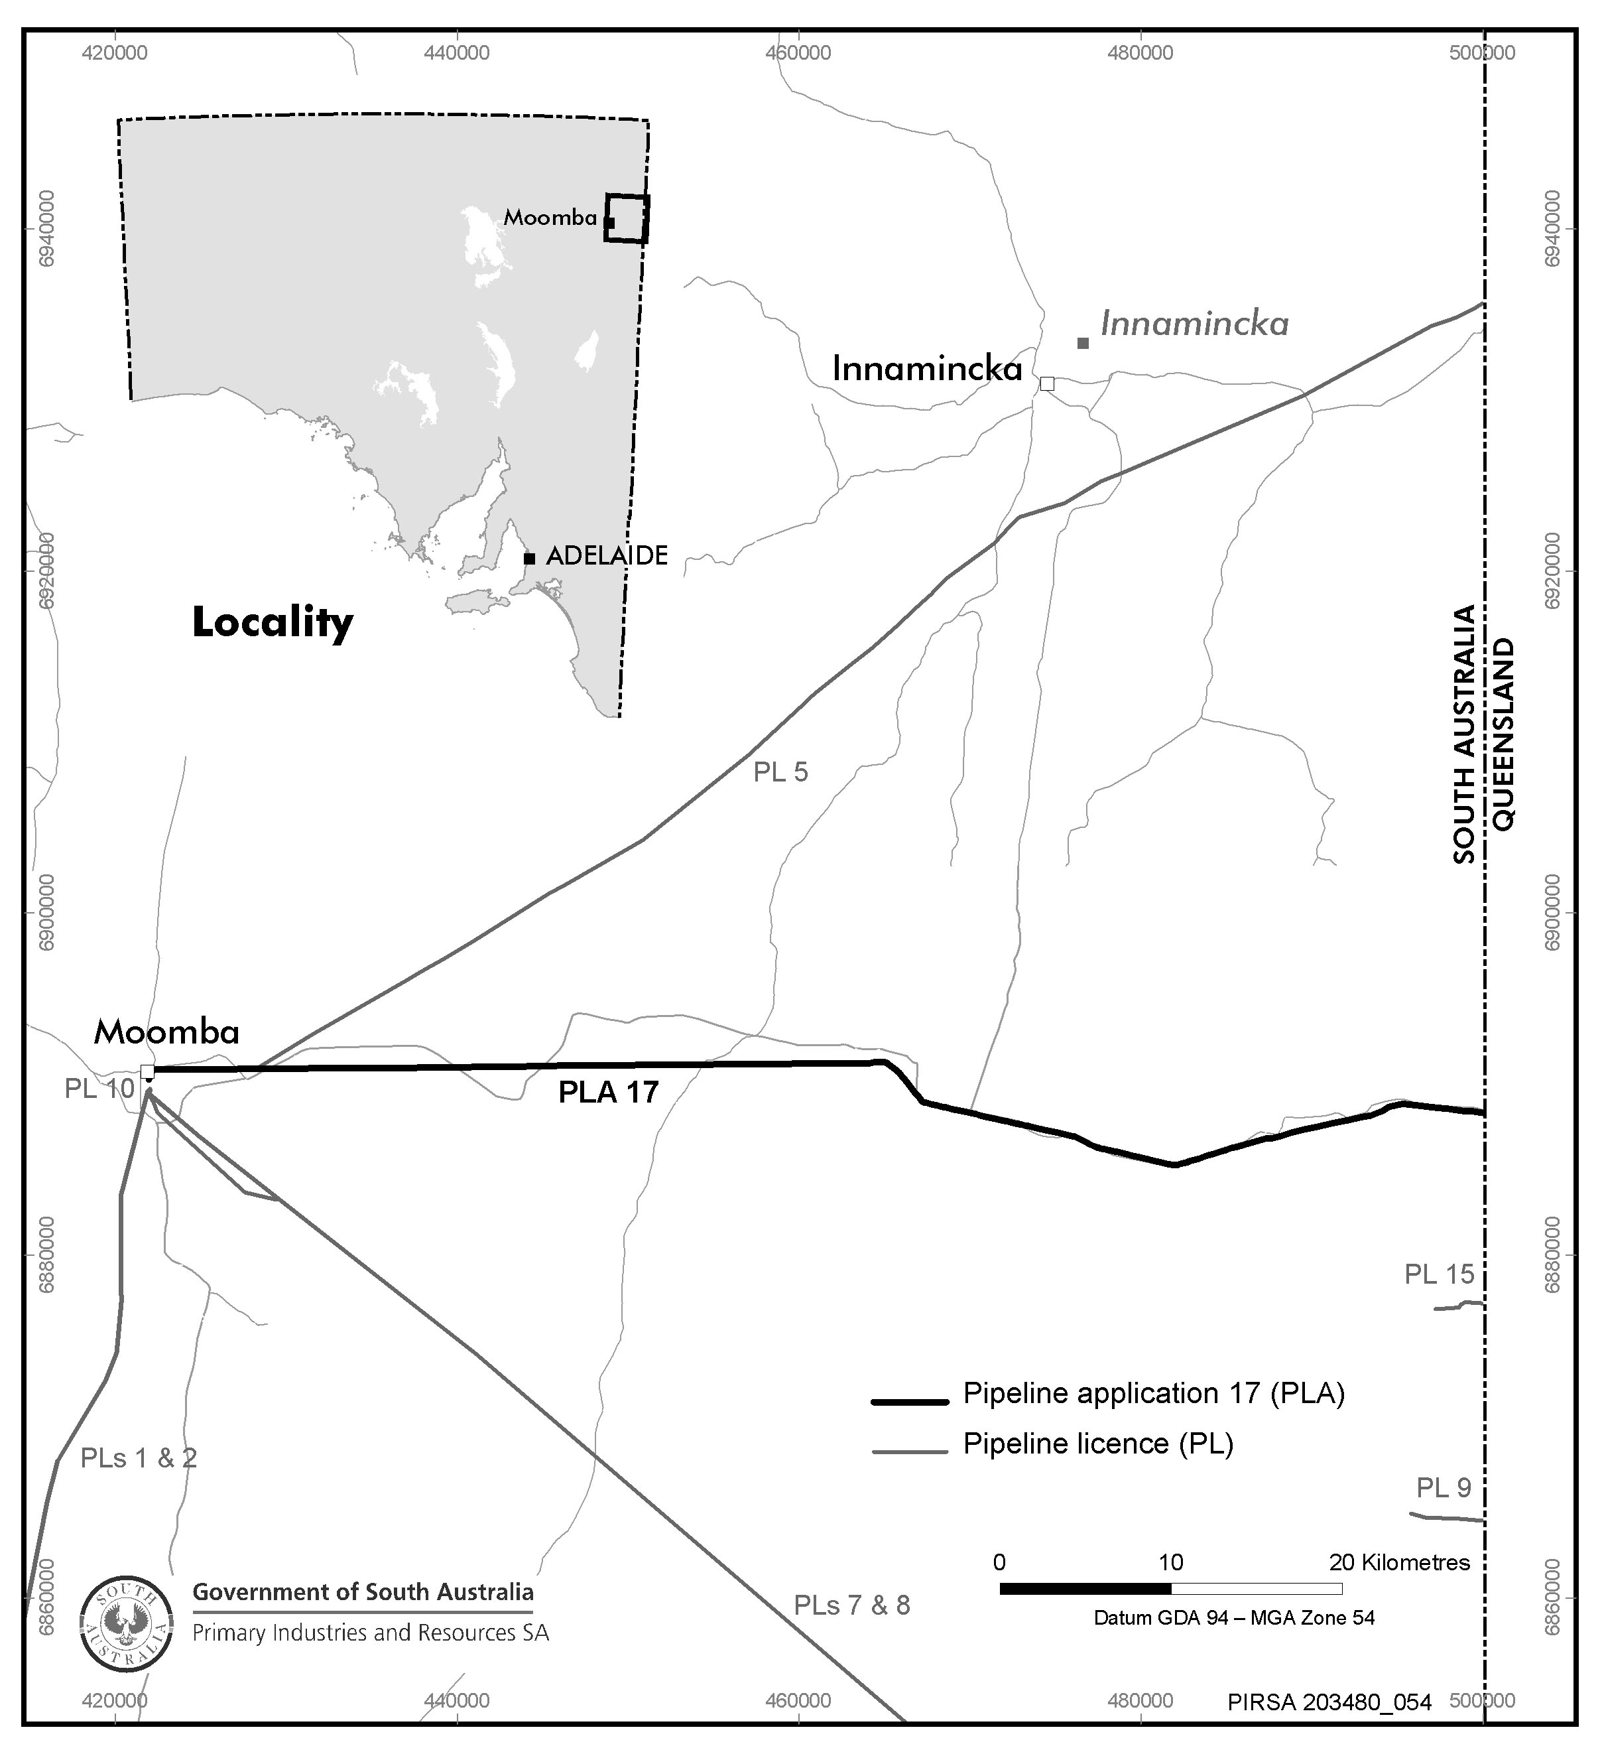

Dated 14 August 2007.
B. A. Goldstein,
Director Petroleum and Geothermal
Minerals and Energy Resources
Primary Industries and Resources SA
Delegate of the Minister for Mineral Resources Development

PETROLEUM ACT 2000
Surrender of Geothermal Exploration Licences—GELs 251, 252, 256, 257, 258 and 259
NOTICE is hereby given that I have accepted the surrender of the abovementioned Geothermal Exploration Licences under the provisions of the Petroleum Act 2000, pursuant to delegated powers dated 28 March 2002, Gazetted 11 April 2002, page 1573.

No. of  Licence | Licensees | Date of Surrender | Area in  km² | Reference
251 | Granite Power Limited | 10 July 2007 | 479 | 27/2/410
252 | Granite Power Limited | 10 July 2007 | 452 | 27/2/411
256 | Granite Power Limited | 10 July 2007 | 452 | 27/2/414
257 | Granite Power Limited | 10 July 2007 | 451 | 27/2/415
258 | Granite Power Limited | 10 July 2007 | 491 | 27/2/416
259 | Granite Power Limited | 10 July 2007 | 489 | 27/2/417

Description of Area—GEL 251
All that part of the State of South Australia, bounded as follows:
Commencing at a point being the intersection of latitude 29°42′00″S GDA94 and longitude 135°33′00″E GDA94, thence east to longitude 135°56′00″E GDA94, south to latitude 29°49′00″S GDA94, west to longitude 135°33′00″E GDA94 and north to the point of commencement.
Area: 479 m² approximately.
Description of Area—GEL 252
All that part of the State of South Australia, bounded as follows:
Commencing at a point being the intersection of latitude 29°49′00″S GDA94 and longitude 135°38′00″E GDA94, thence east to longitude 135°45′00″E GDA94, south to latitude 30°01′00″S GDA94, west to longitude 135°32′00″E GDA94, north to latitude 29°55′00″S GDA94, west to longitude 135°30′00″E GDA94, north to latitude 29°51′00″S GDA94, east to longitude 135°38′00″E GDA94 and north to the point of commencement.
Area: 452 m² approximately.
Description of Area—GEL 256
All that part of the State of South Australia, bounded as follows:
Commencing at a point being the intersection of latitude 28°18′00″S GDA94 and longitude 133°54′00″E GDA94, thence east to longitude 134°04′00″E GDA94, south to latitude 28°33′00″S GDA94, west to longitude 133°54′00″E GDA94 and north to the point of commencement.
Area: 452 m² approximately.
Description of Area—GEL 257
All that part of the State of South Australia, bounded as follows:
Commencing at a point being the intersection of latitude 28°30′00″S GDA94 and longitude 135°28′00″E GDA94, thence east to longitude 135°38′00″E GDA94, south to latitude 28°45′00″S GDA94, west to longitude 135°28′00″E GDA94 and north to the point of commencement.
Area: 451 m² approximately.
Description of Area—GEL 258
All that part of the State of South Australia, bounded as follows:
Commencing at a point being the intersection of latitude 29°28′20″S GDA94 and longitude 134°30′00″E GDA94, thence east to longitude 134°43′00″E GDA94, south to latitude 29°35′00″S GDA94, east to longitude 134°47′00″E GDA94, south to latitude 29°41′00″S GDA94, west to longitude 134°34′00″E GDA94, north to latitude 29°35′00″S GDA94, west to longitude 134°30′00″E GDA94 and north to the point of commencement.
Area: 491 m² approximately.
Description of Area—GEL 259
All that part of the State of South Australia, bounded as follows:
Commencing at a point being the intersection of latitude 28°28′53″S GDA94 and longitude 133°30′53″E GDA94, thence east to longitude 133°42′07″E GDA94, south to latitude 28°43′21″S GDA94, west to longitude 133°30′53″E GDA94 and north to the point of commencement.
Area: 489 m² approximately.
Dated 10 August 2007.
C. D. Cockshell,
Acting Director Petroleum and Geothermal
Minerals and Energy Resources
Primary Industries and Resources SA
Delegate of the Minister for Mineral Resources Development

REAL PROPERTY ACT NOTICE
WHEREAS the persons named at the foot hereof have each respectively for himself made application to have the land set forth and described before his name at the foot hereof brought under the operation of the Real Property Act: Notice is hereby given that unless caveat be lodged with the Registrar-General by some person having estate or interest in the said lands on or before the expiration of the period herein below for each case specified, the said several pieces of land will be brought under the operation of the said Act as by law directed. Diagrams delineating these parcels of land may be inspected at the Lands Titles Registration Office, Adelaide, and in the offices of the several corporations or district councils in which the lands are situated.

The Schedule
No. of  Applica-  tion | Description of Property |  | Name |  | Residence | Date up to and  inclusive of which  caveat may be  lodged

31121 | Portion of Section 4414, Hundred of Kanmantoo in the area named Dawesley, more particularly defined as Allotment 302 in Filed Plan No. 49191 |  | Desmond John Ayres and Joy Elizabeth Ayres |  | Bower Street, Dawesley, S.A. 5252 | 16 October 2007

Dated 8 August 2007, at the Lands Titles Registration Office, Adelaide. J. Zaccaria, Deputy Registrar-General

REAL PROPERTY ACT NOTICE
WHEREAS the persons named at the foot hereof have each respectively for himself made application to have the land set forth and described before his name at the foot hereof brought under the operation of the Real Property Act: Notice is hereby given that unless caveat be lodged with the Registrar-General by some person having estate or interest in the said lands on or before the expiration of the period herein below for each case specified, the said several pieces of land will be brought under the operation of the said Act as by law directed. Diagrams delineating these parcels of land may be inspected at the Lands Titles Registration Office, Adelaide, and in the offices of the several corporations or district councils in which the lands are situated.

The Schedule
No. of  Applica-  tion | Description of Property |  | Name |  | Residence | Date up to and  inclusive of which  caveat may be  lodged

31117 | Portion of Allotment 701, defined in L.T.R.O. Deposited Plan No. 72249 being portion of Section 5299, Hundred of Kanmantoo |  | Michele Janette Cureton |  | 8 Sydney Place, Adelaide, S.A. 5000 | 17 September 2007

Dated 8 August 2007, at the Lands Titles Registration Office, Adelaide. J. Zaccaria, Deputy Registrar-General

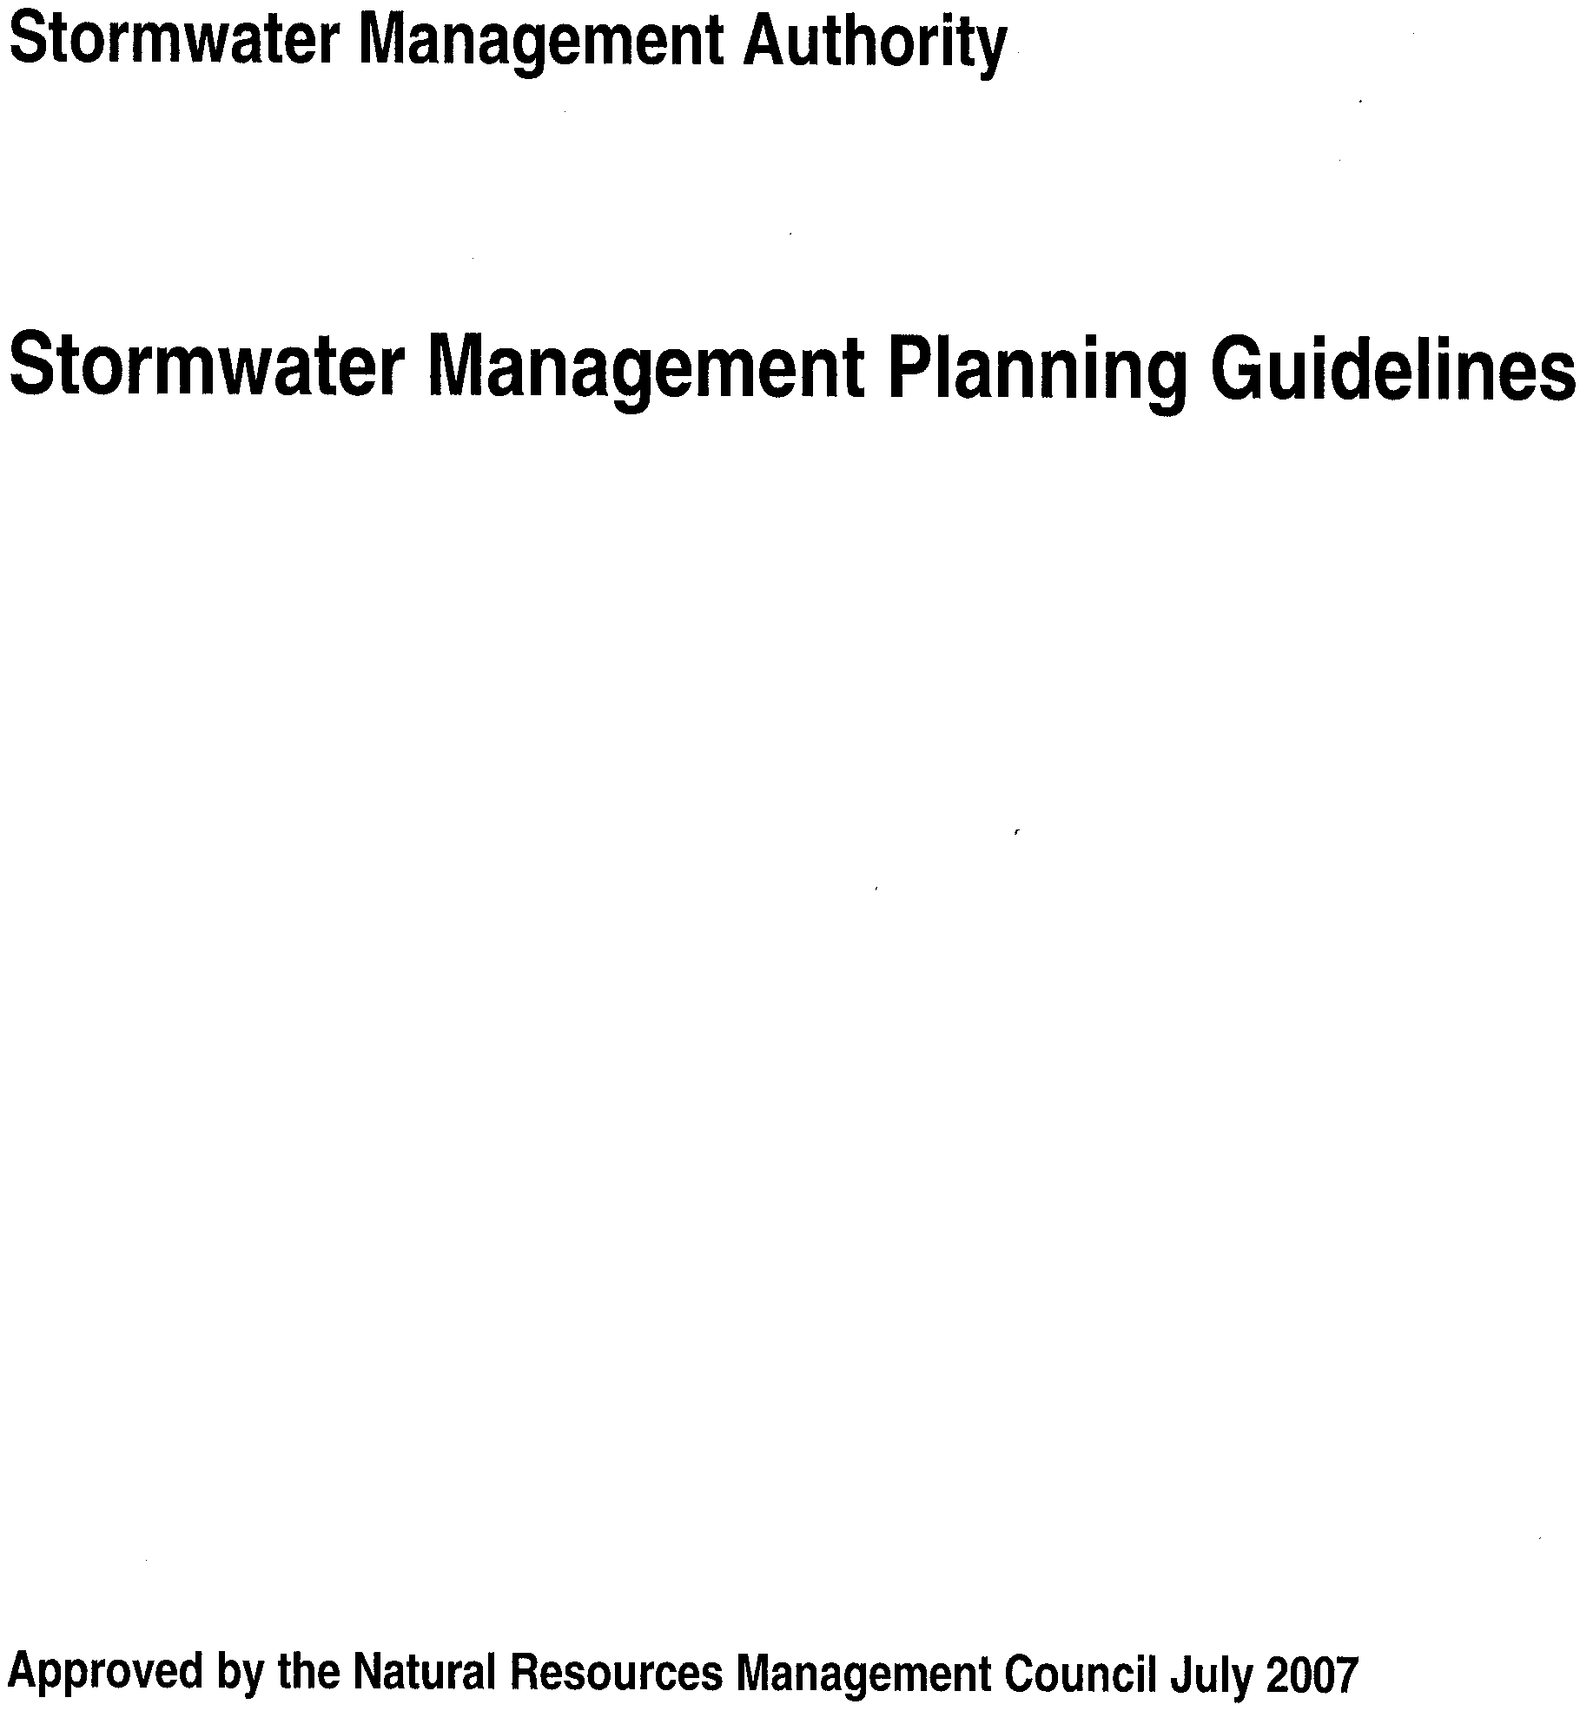
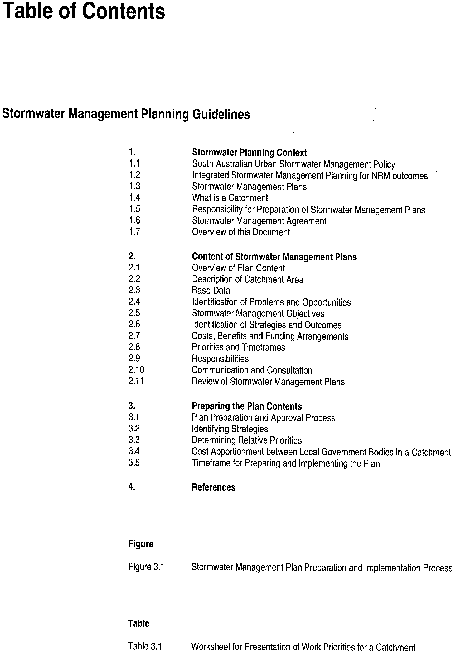
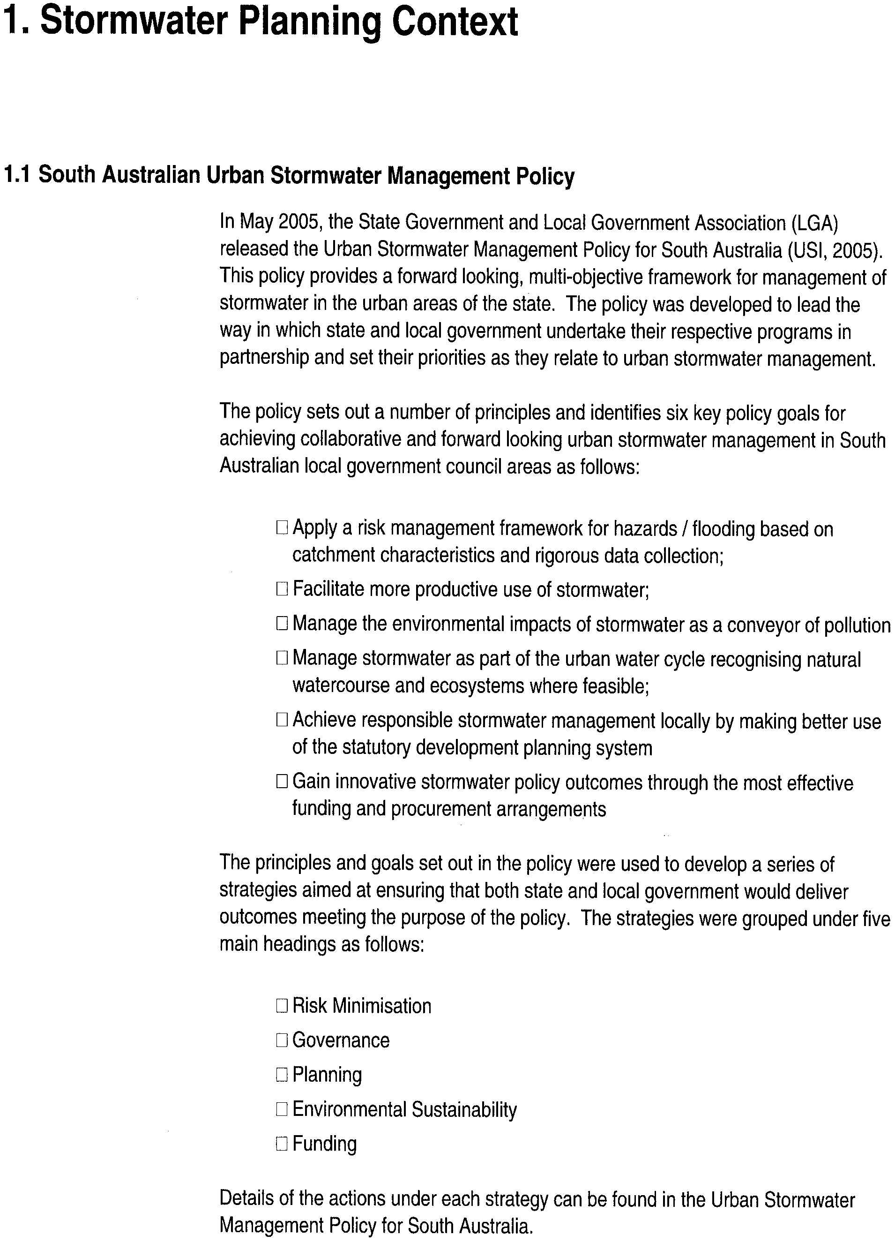
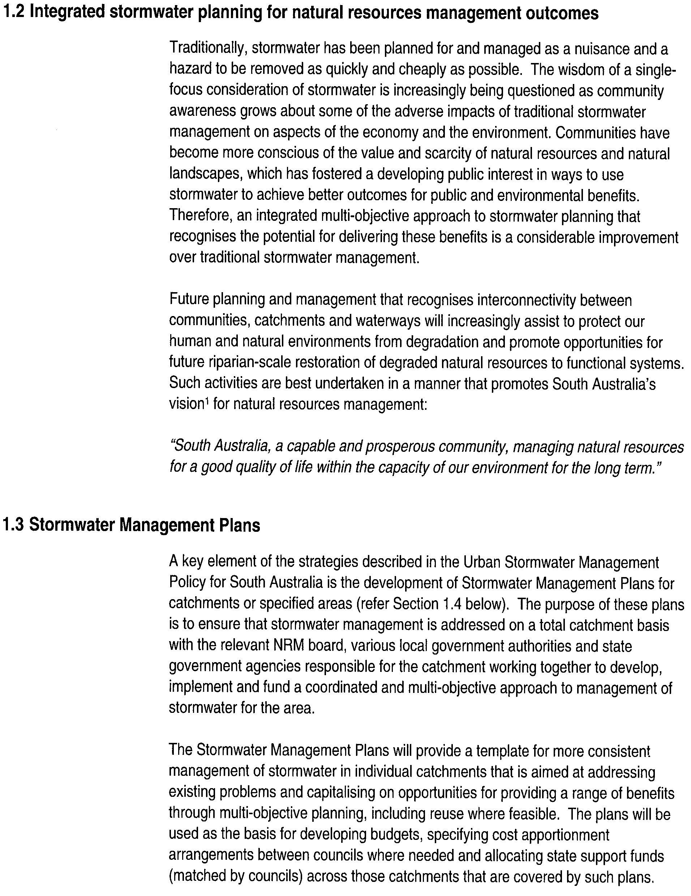
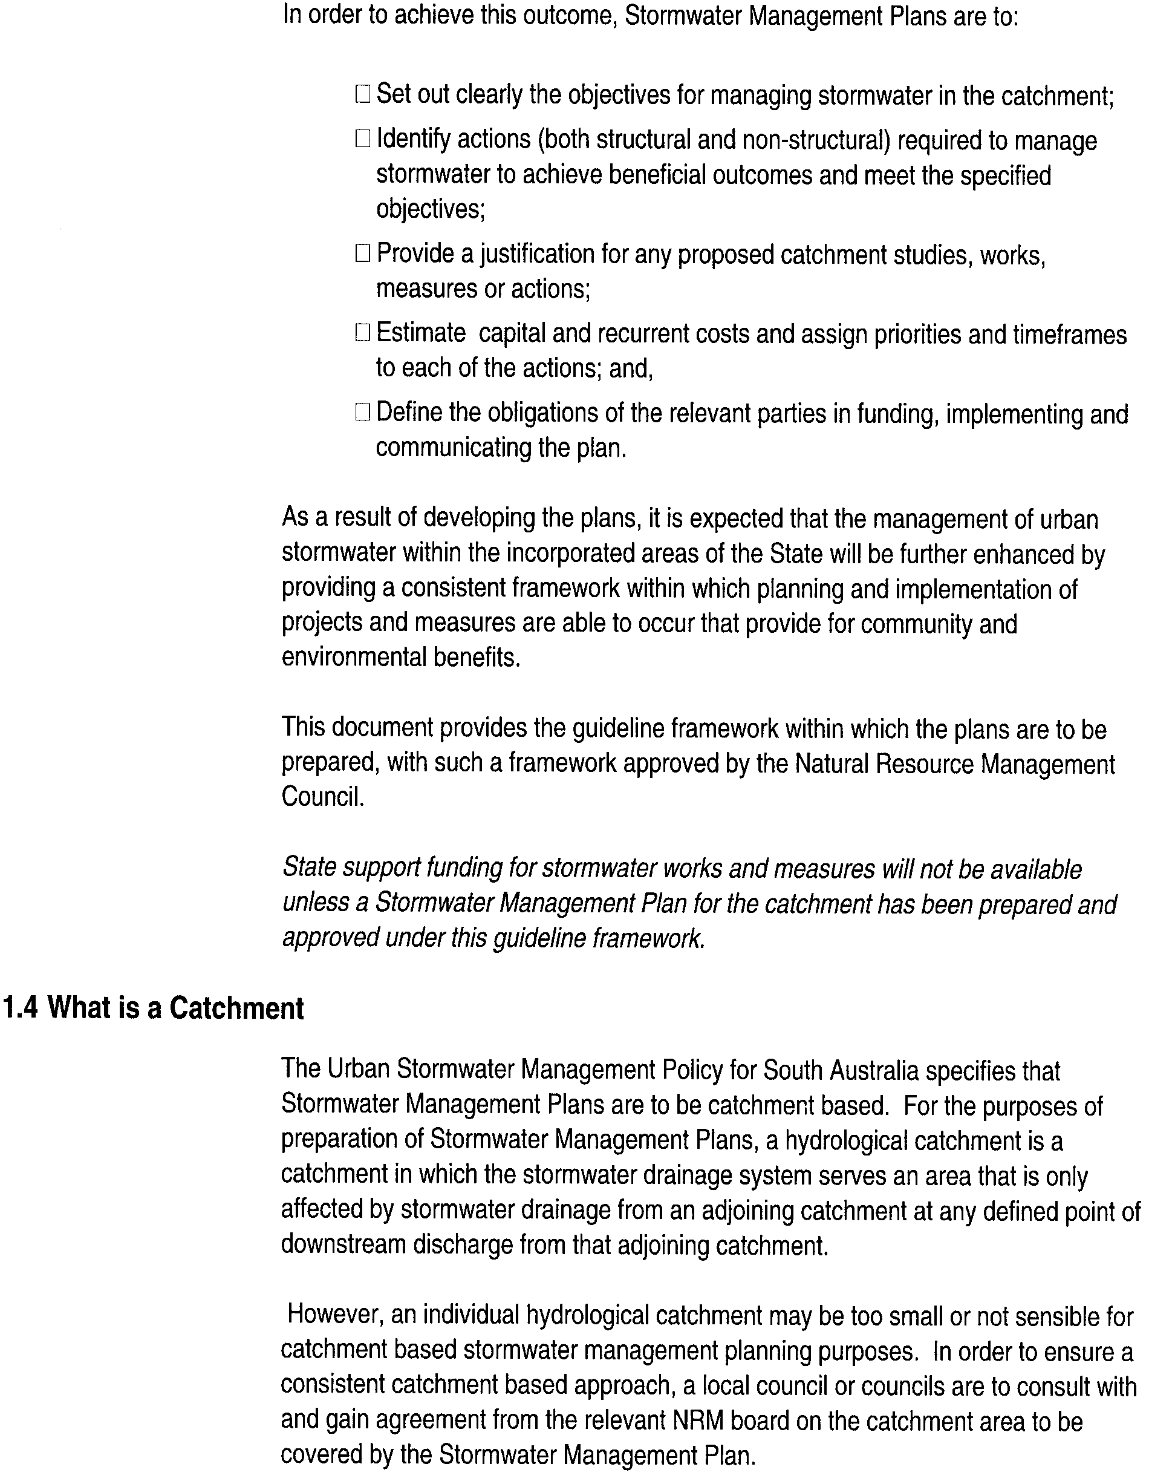
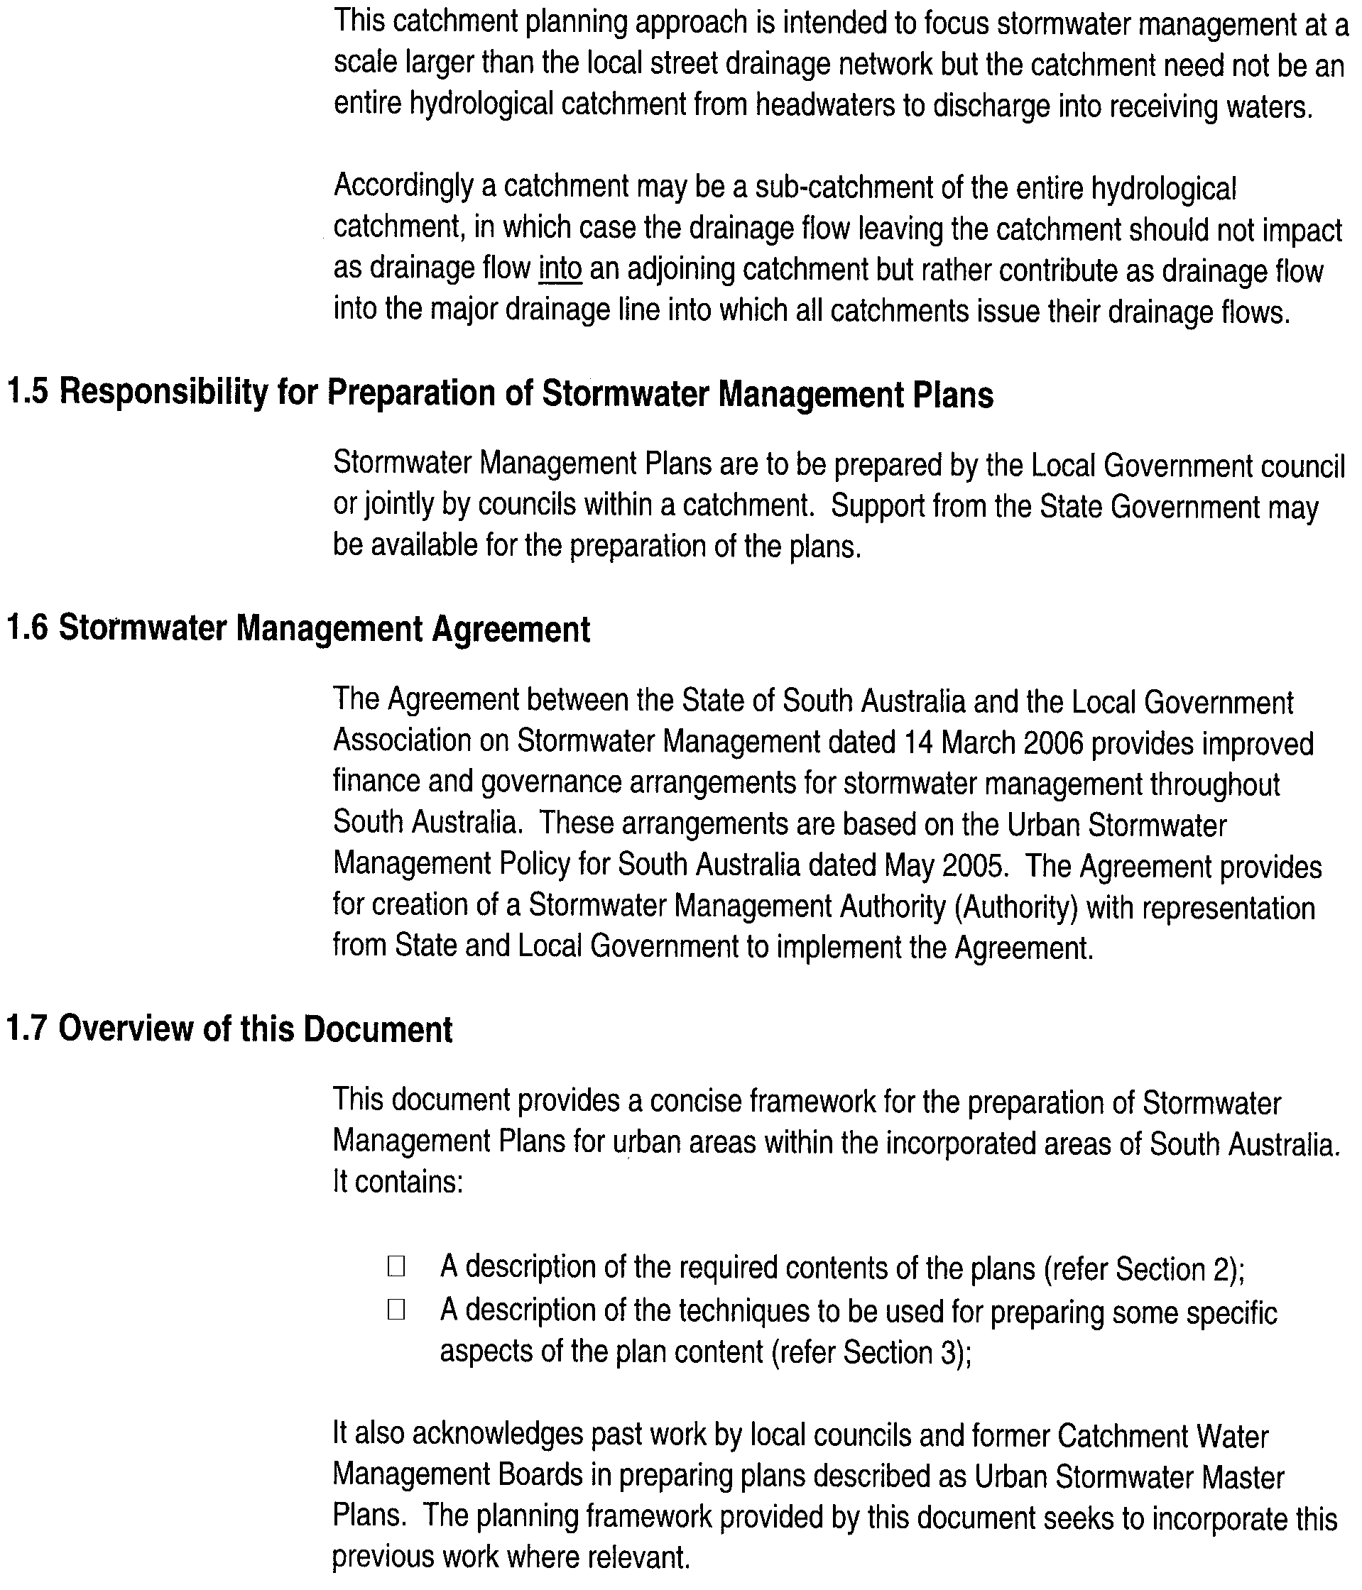
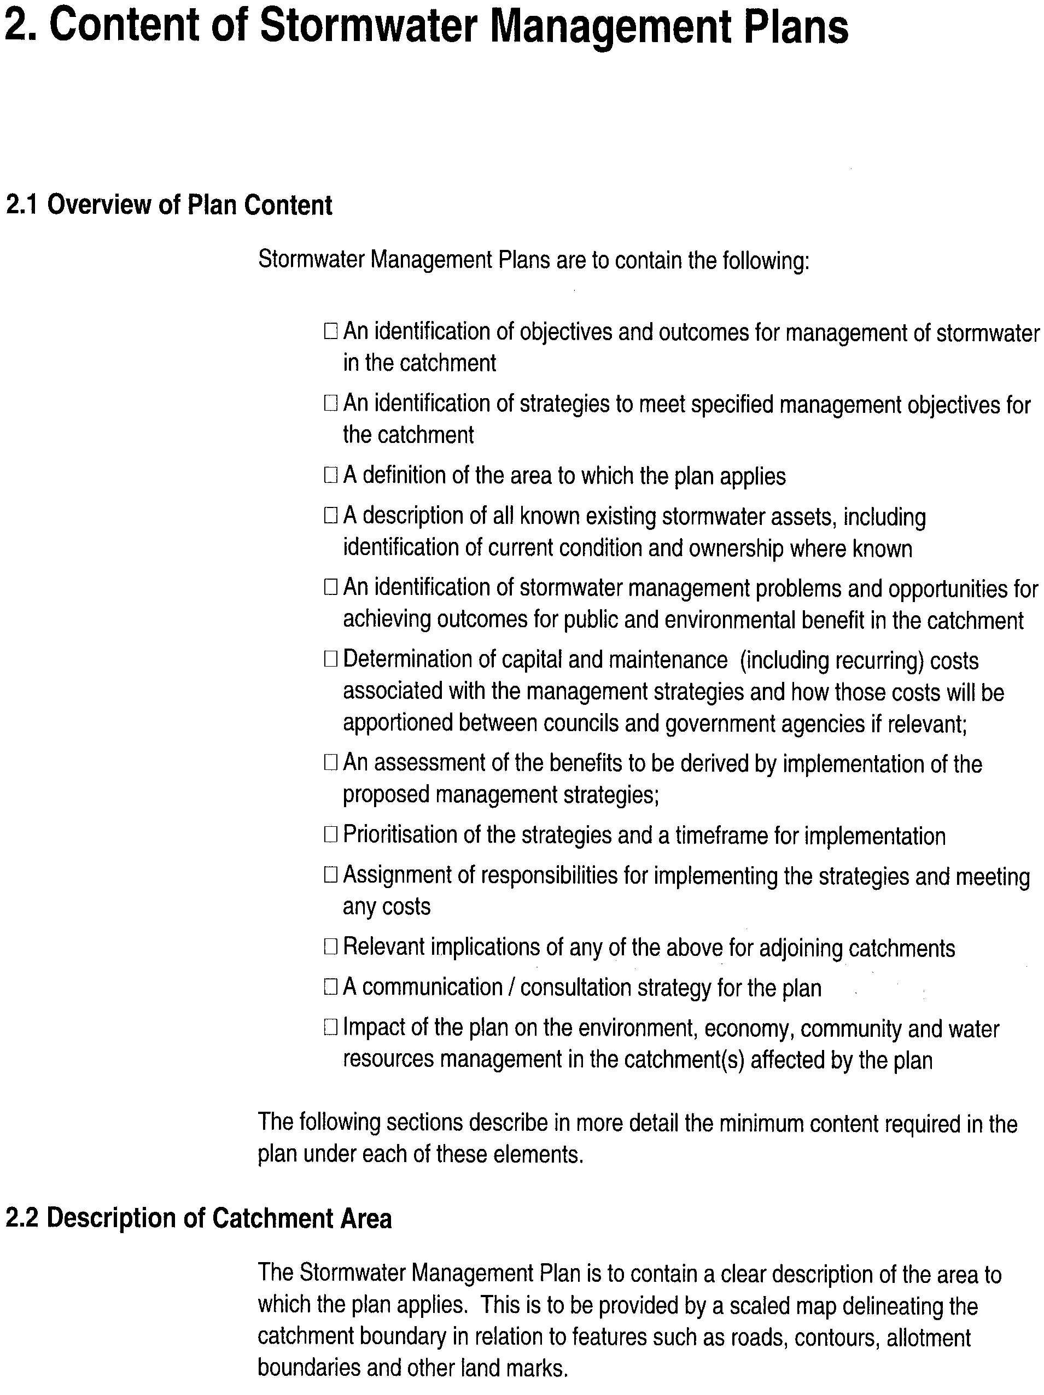
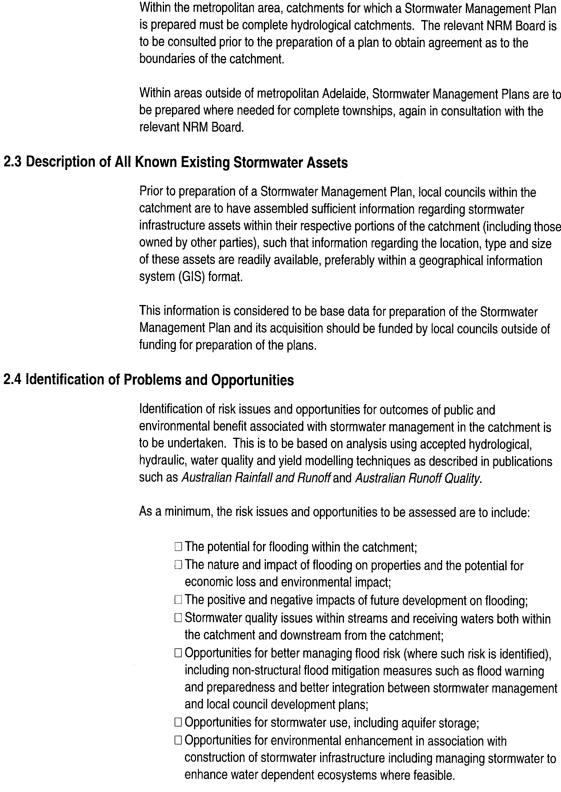
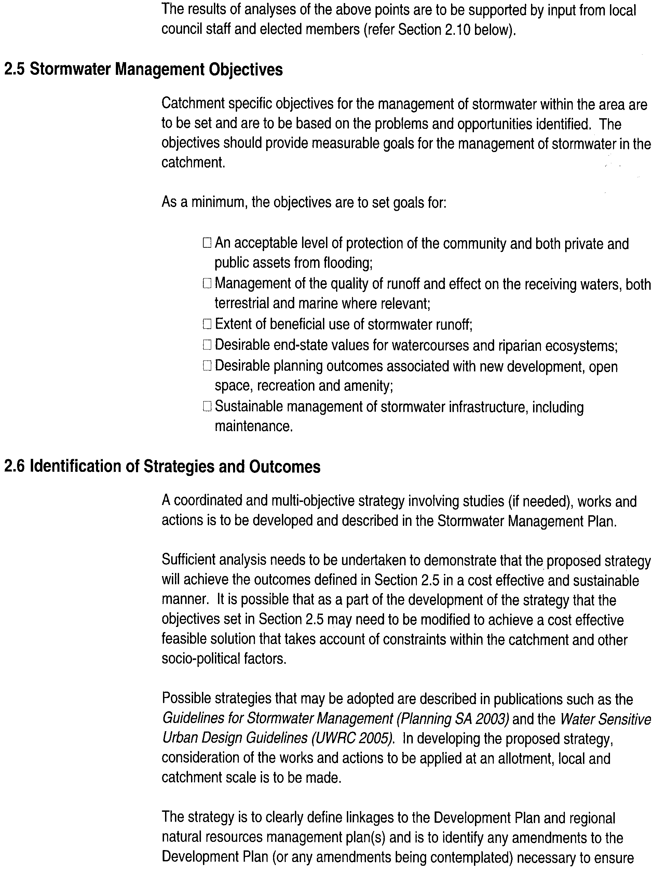
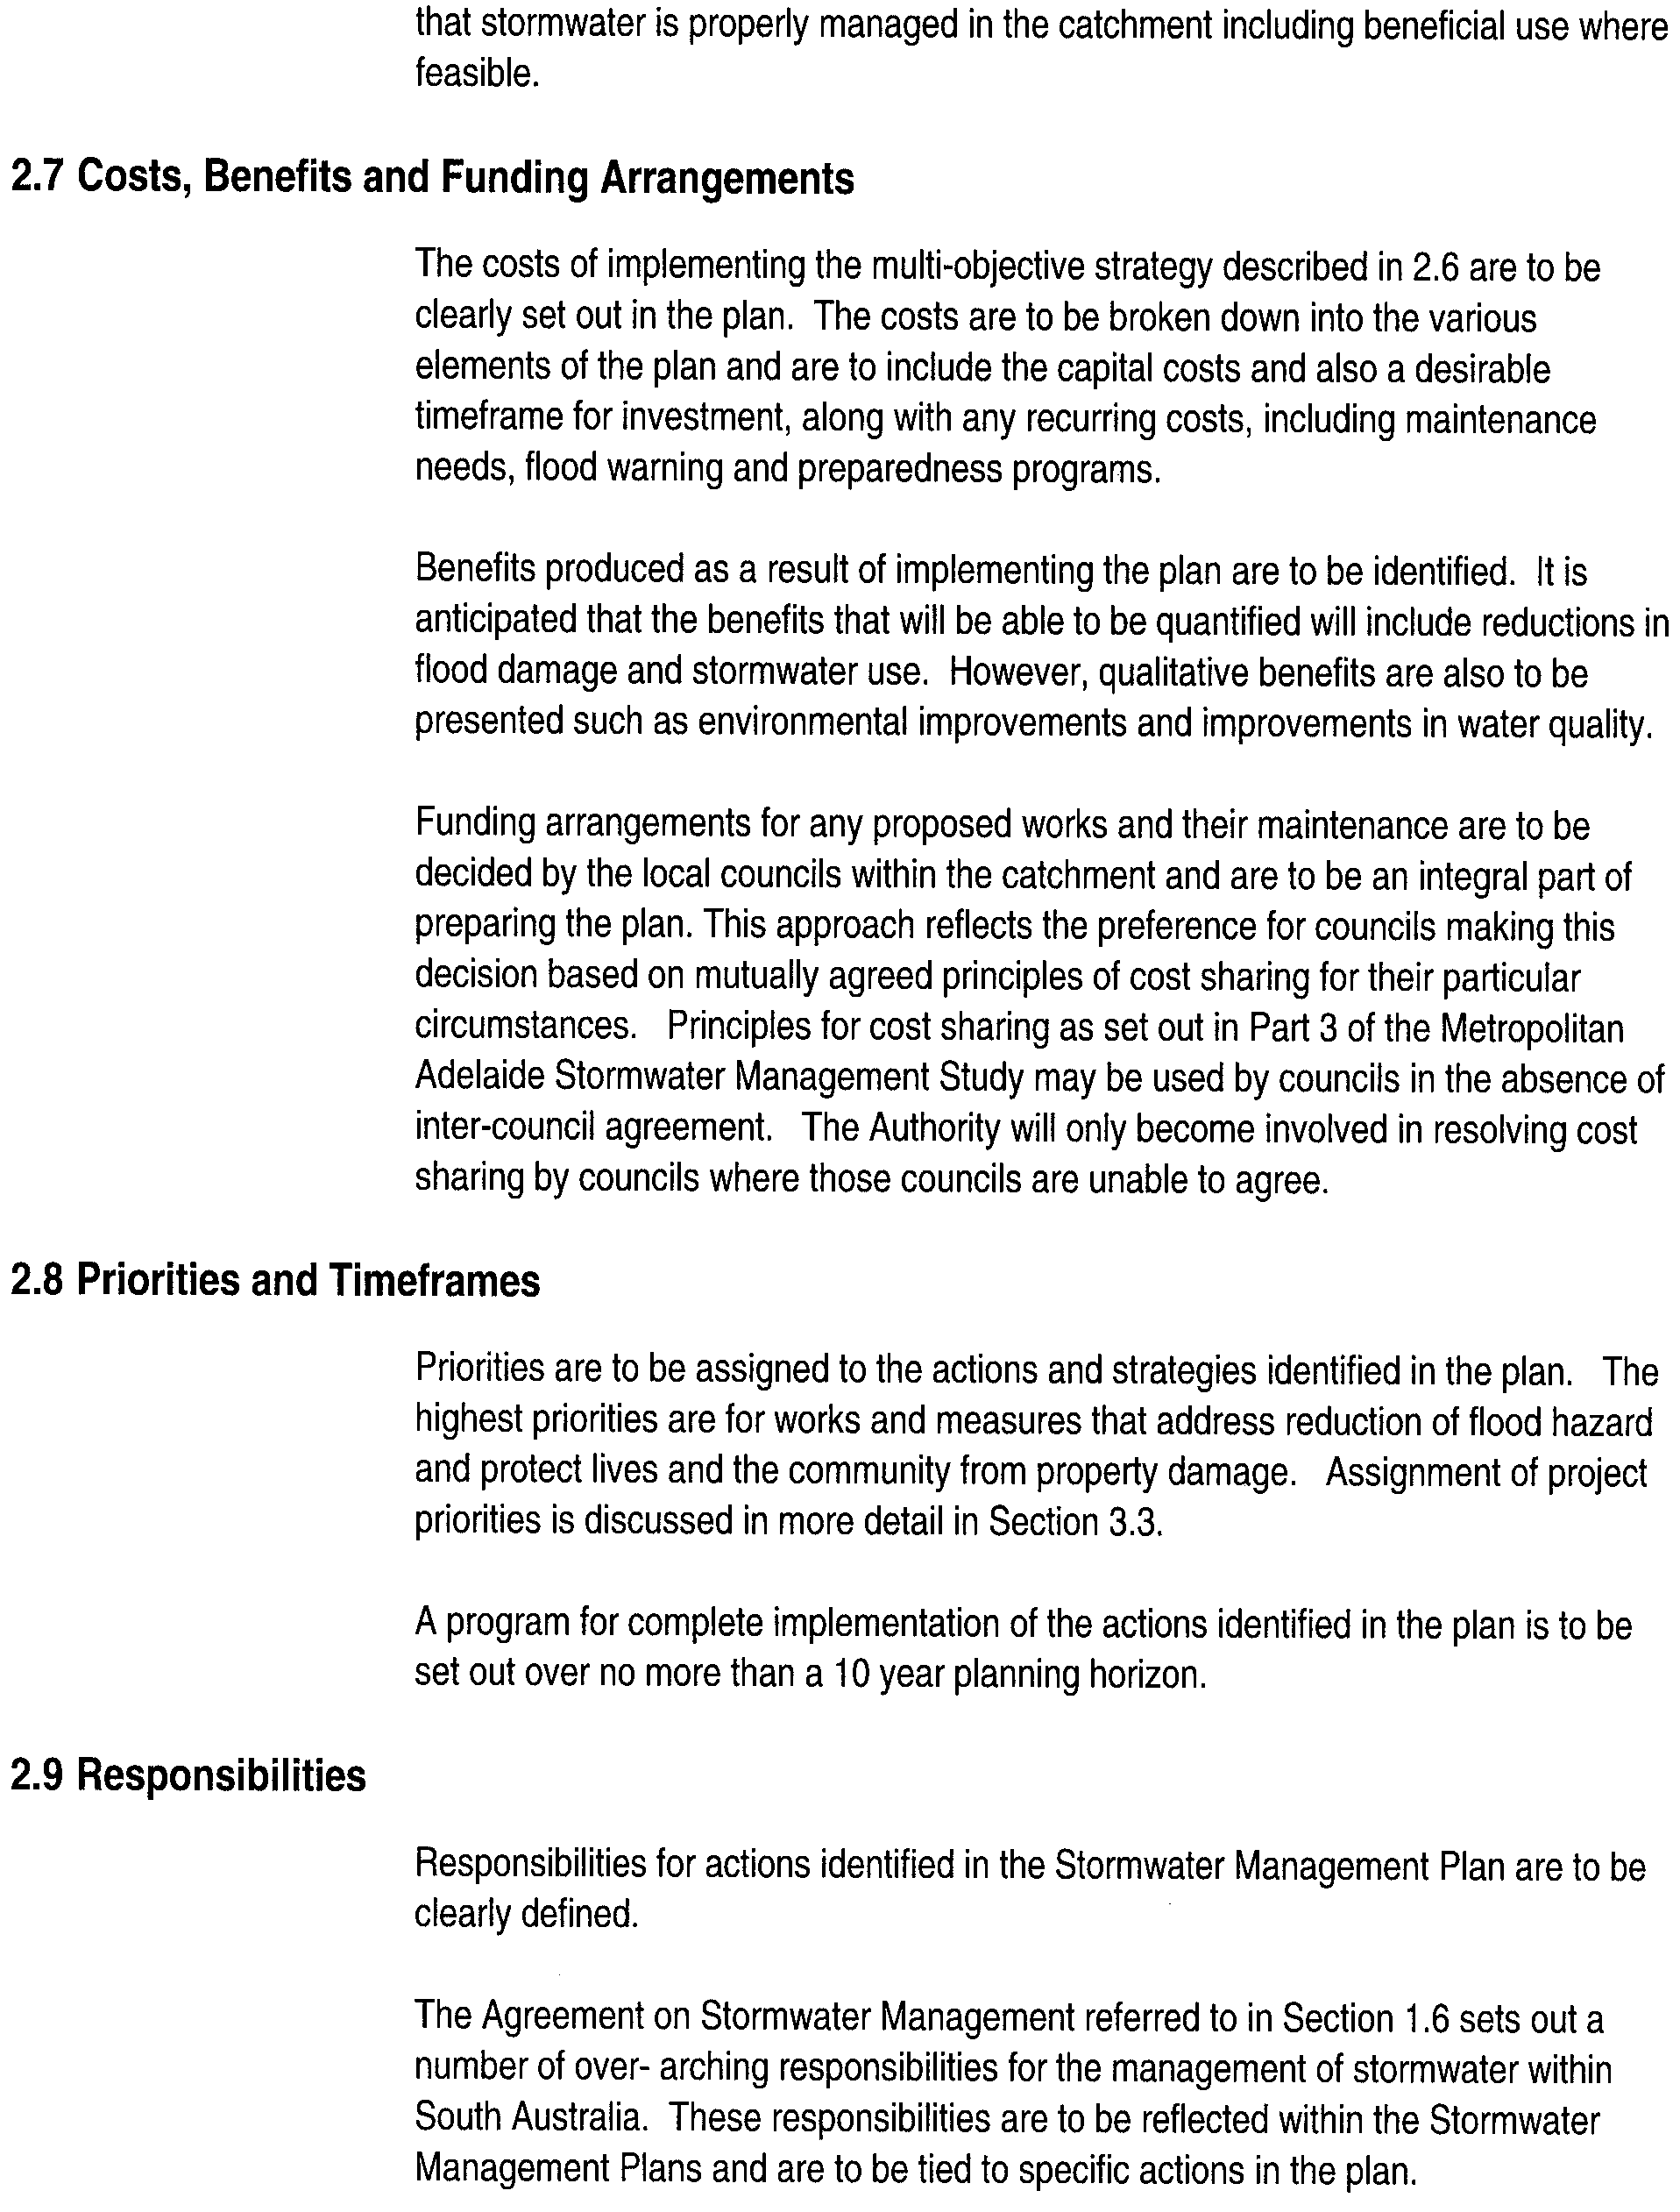
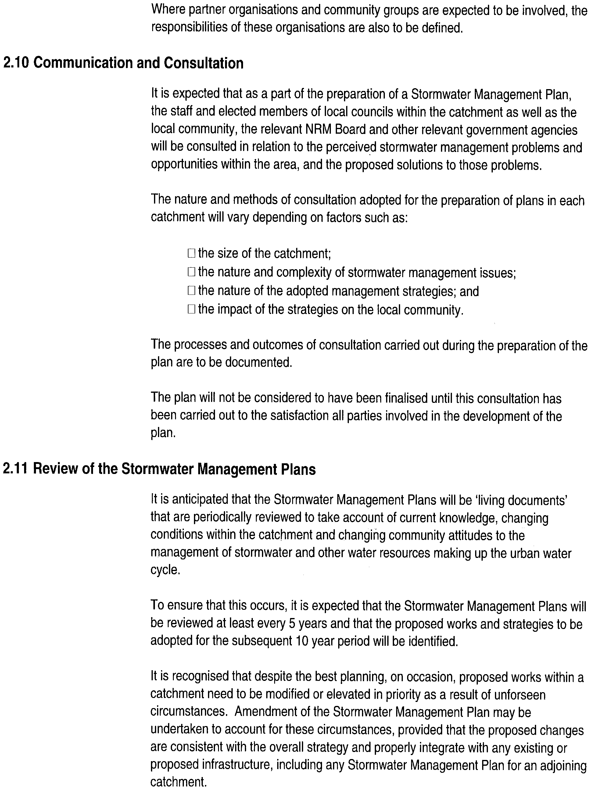
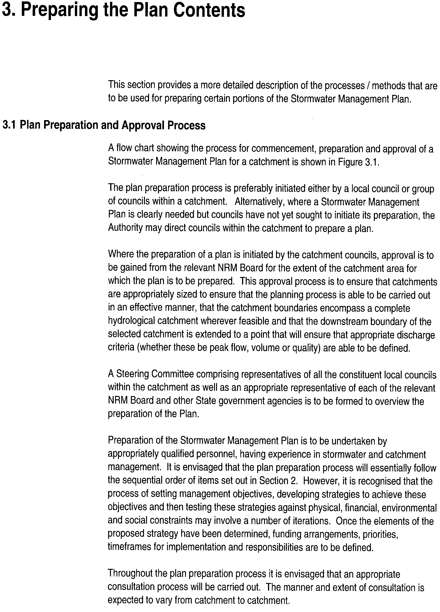
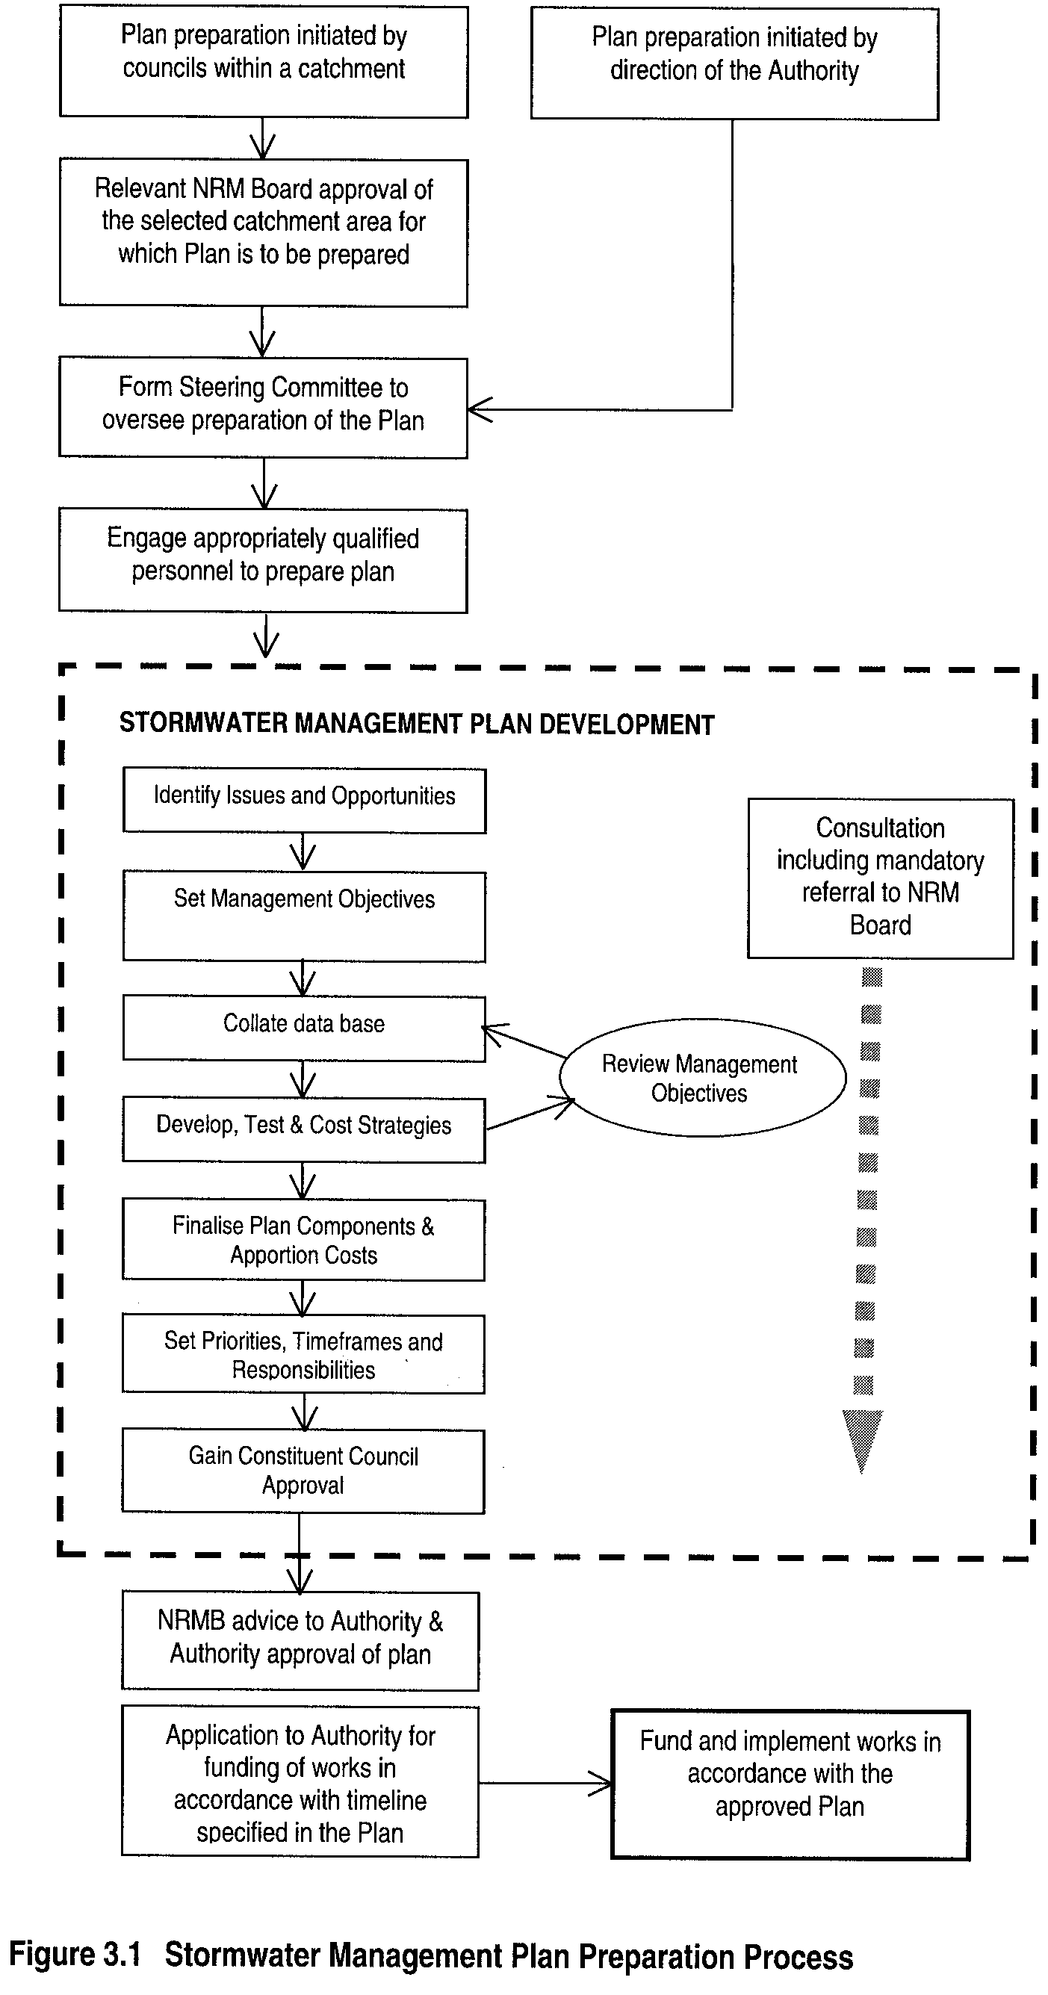
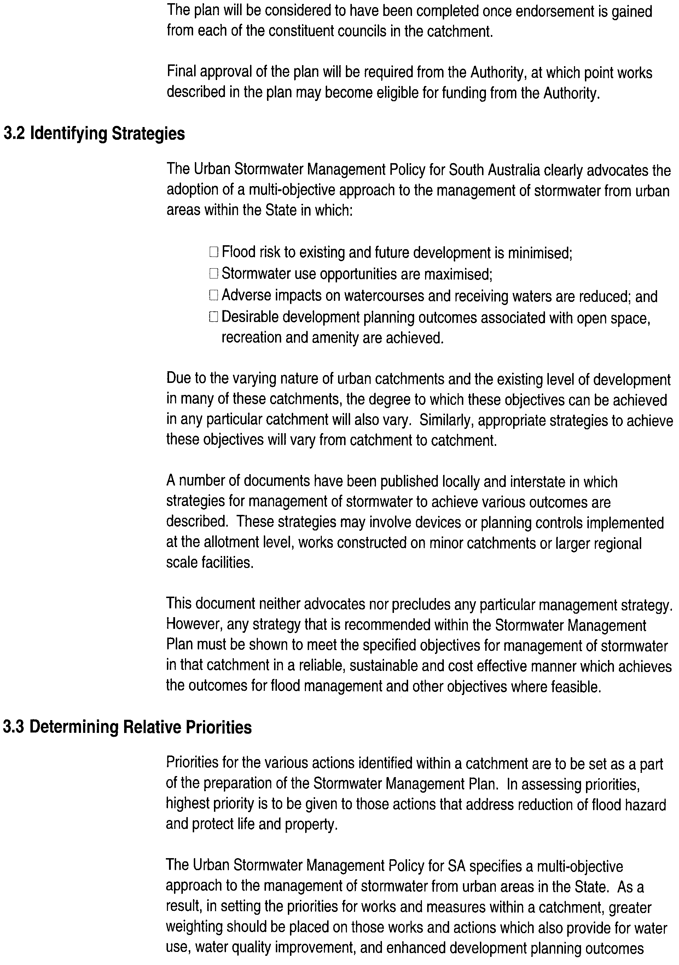
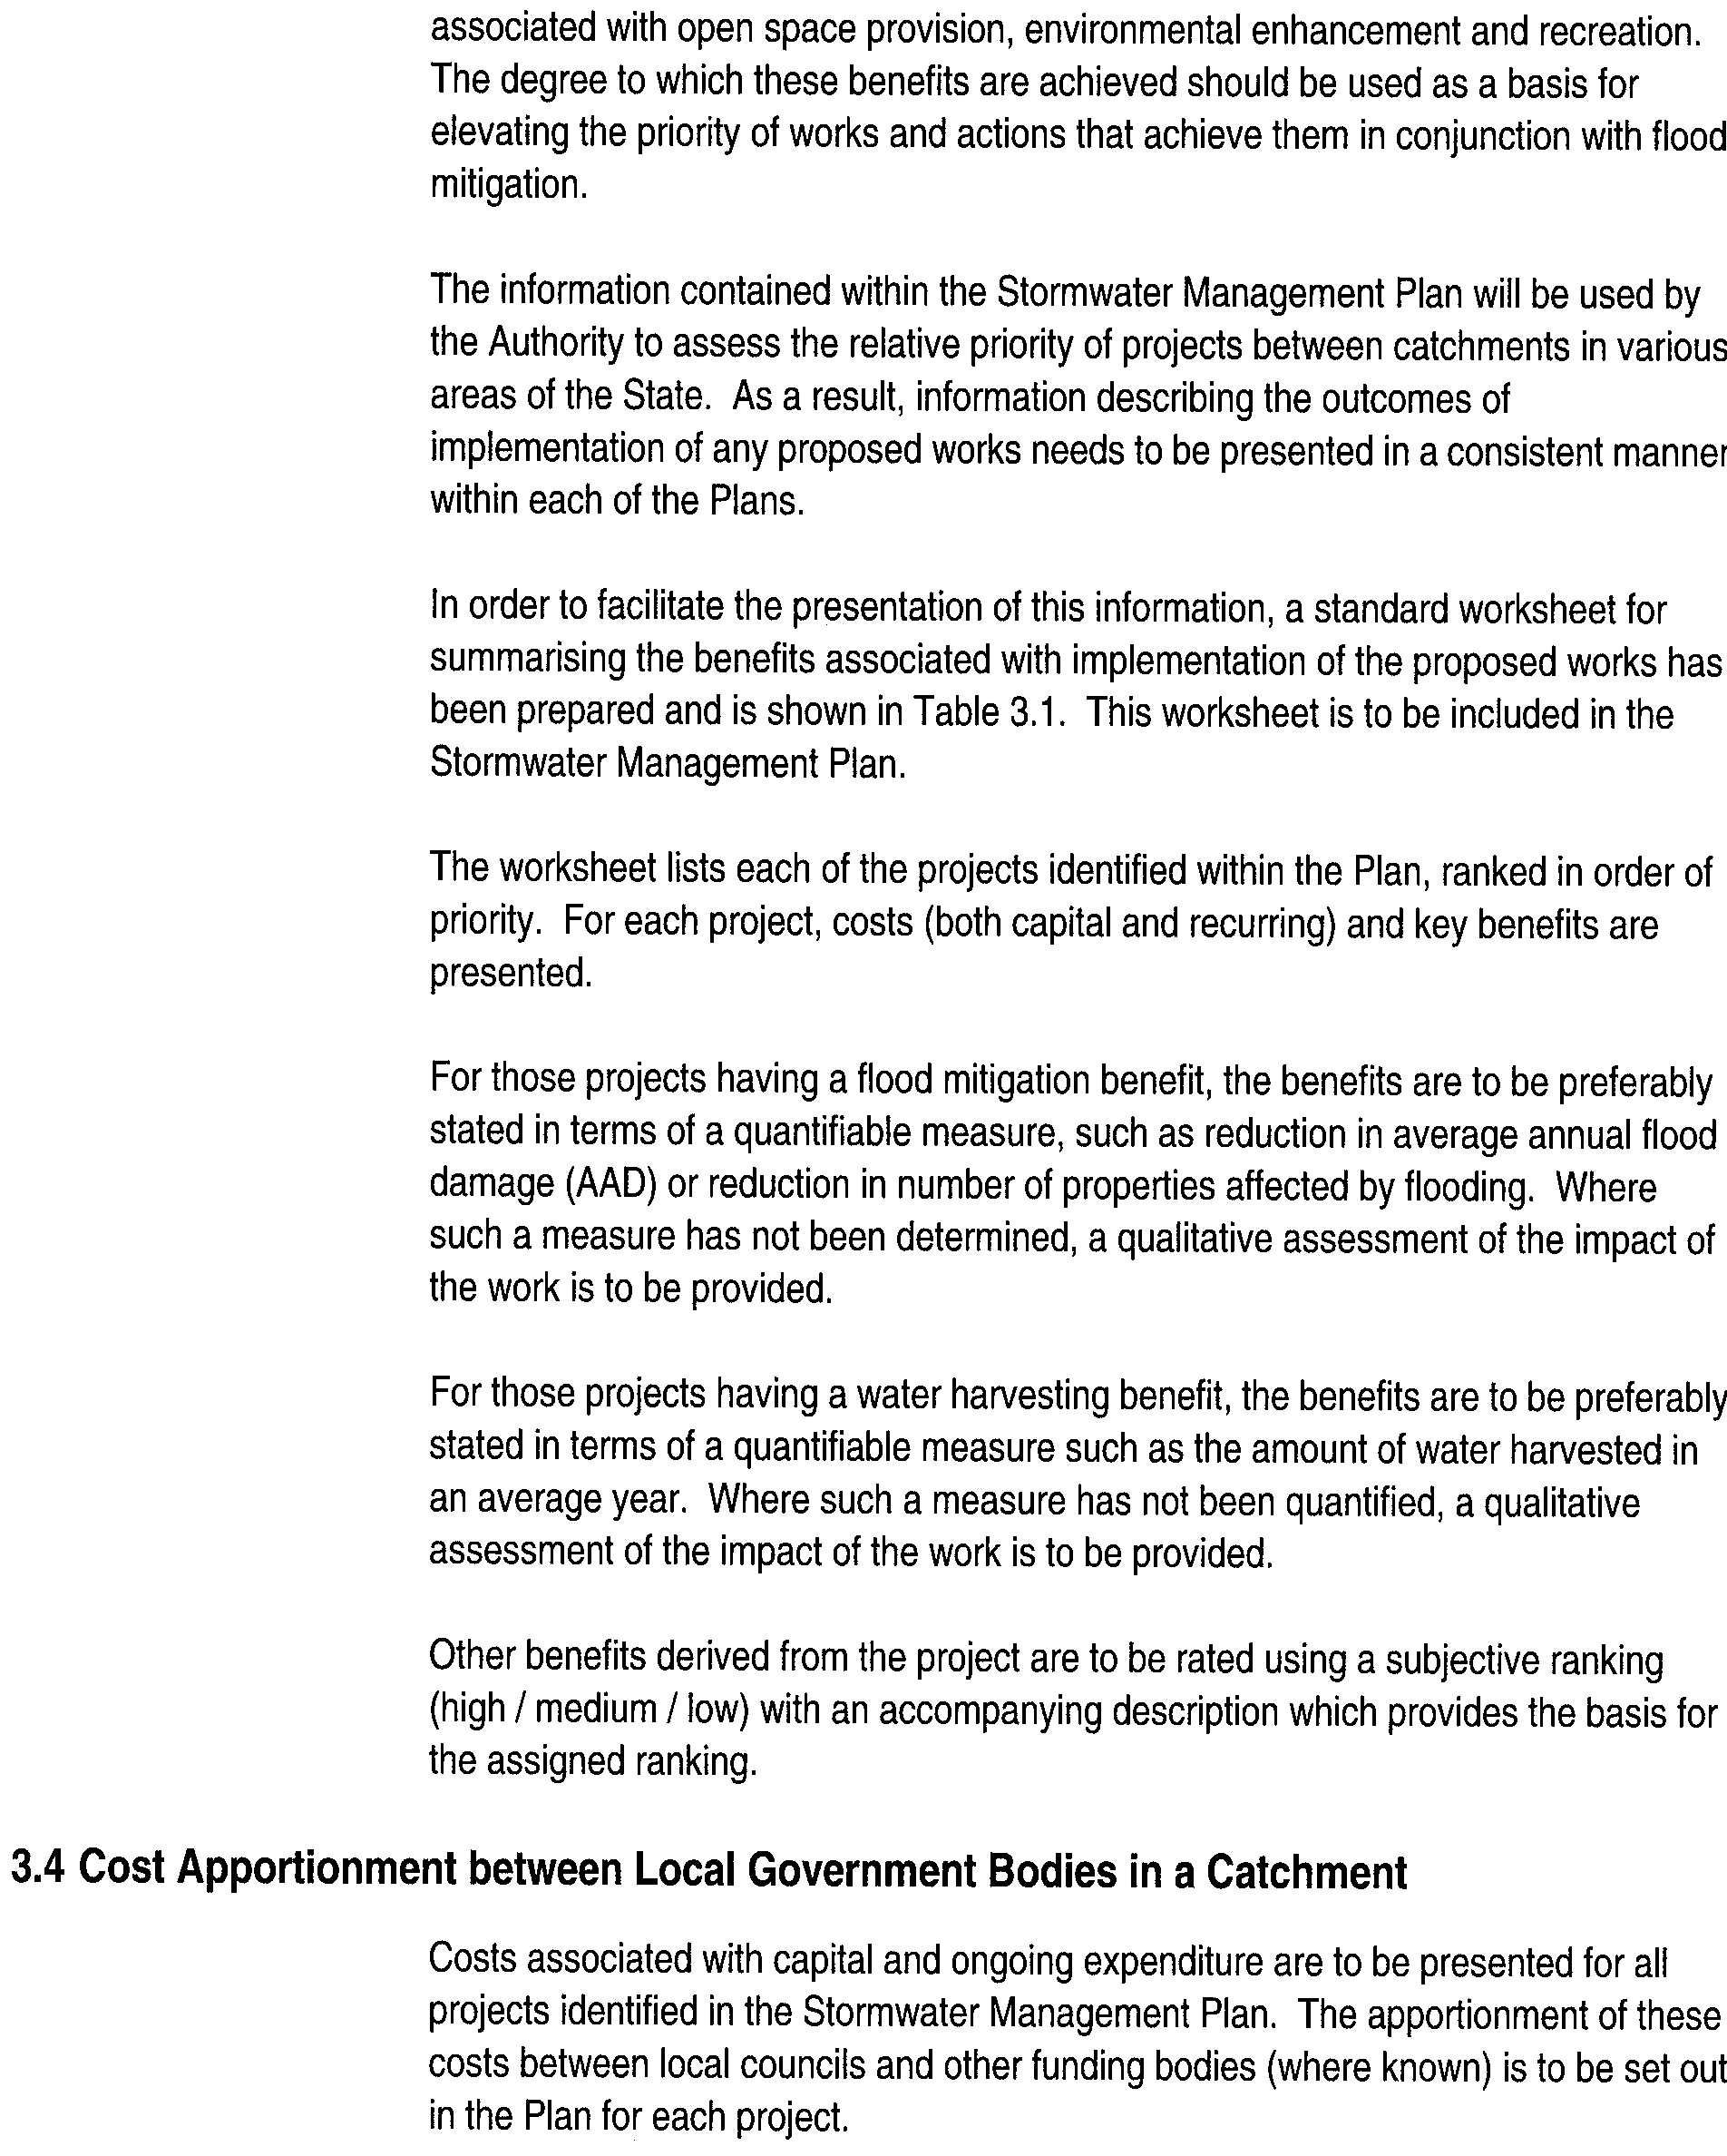
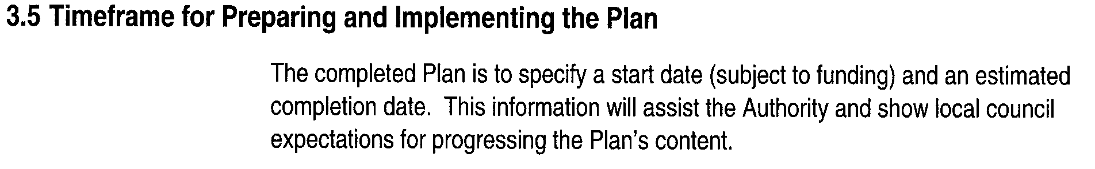
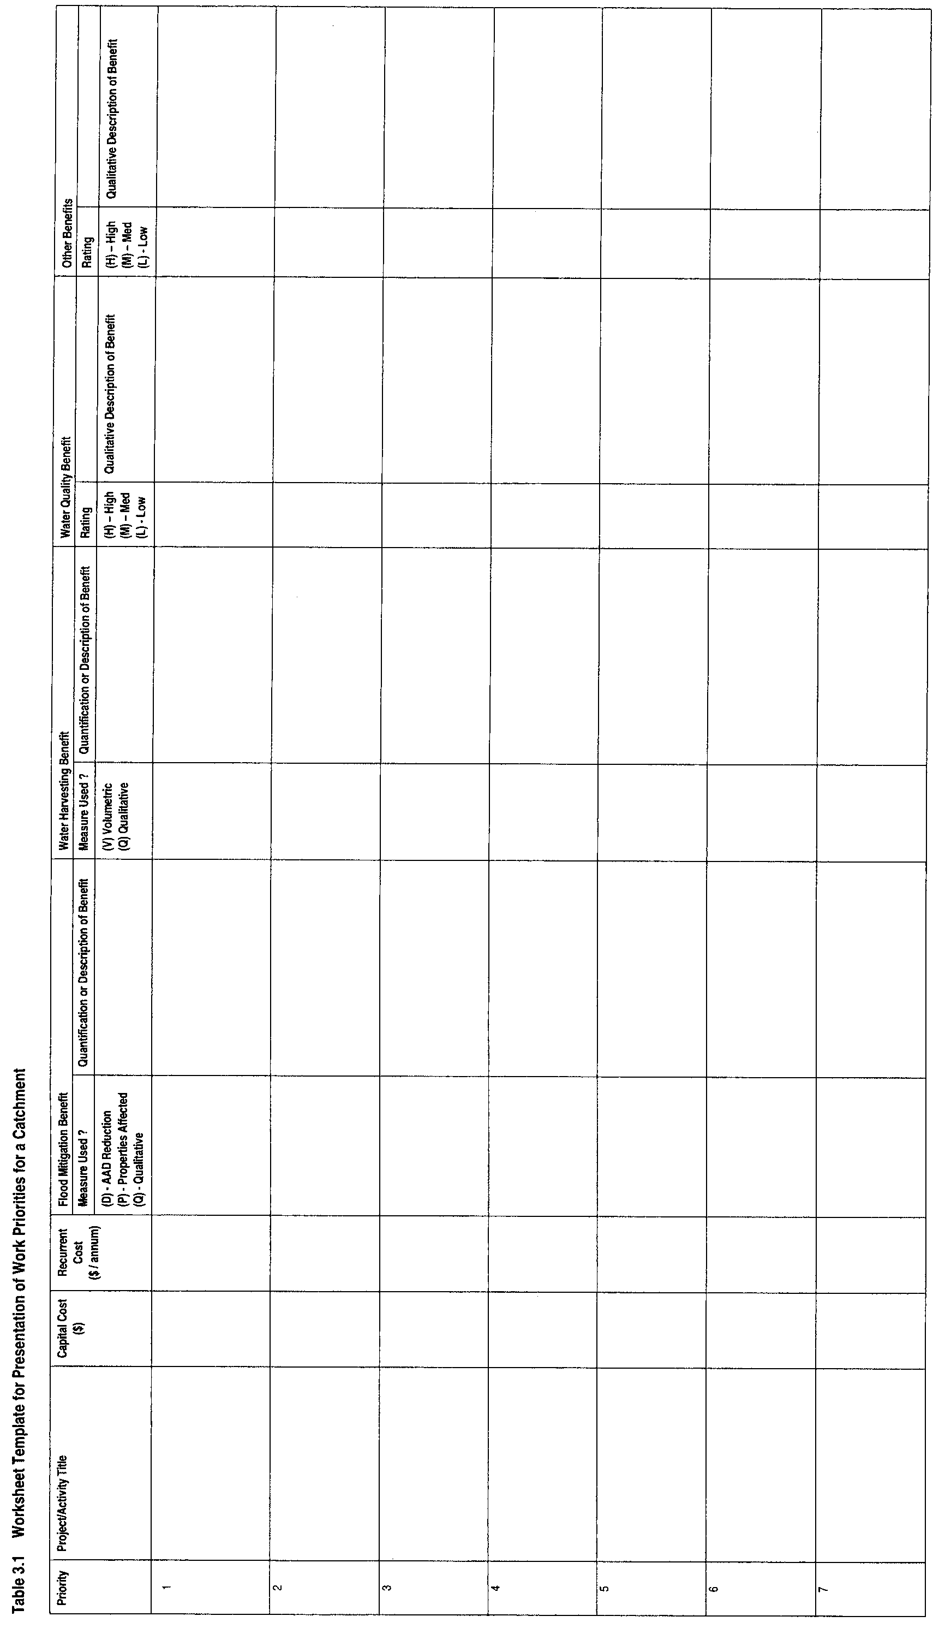
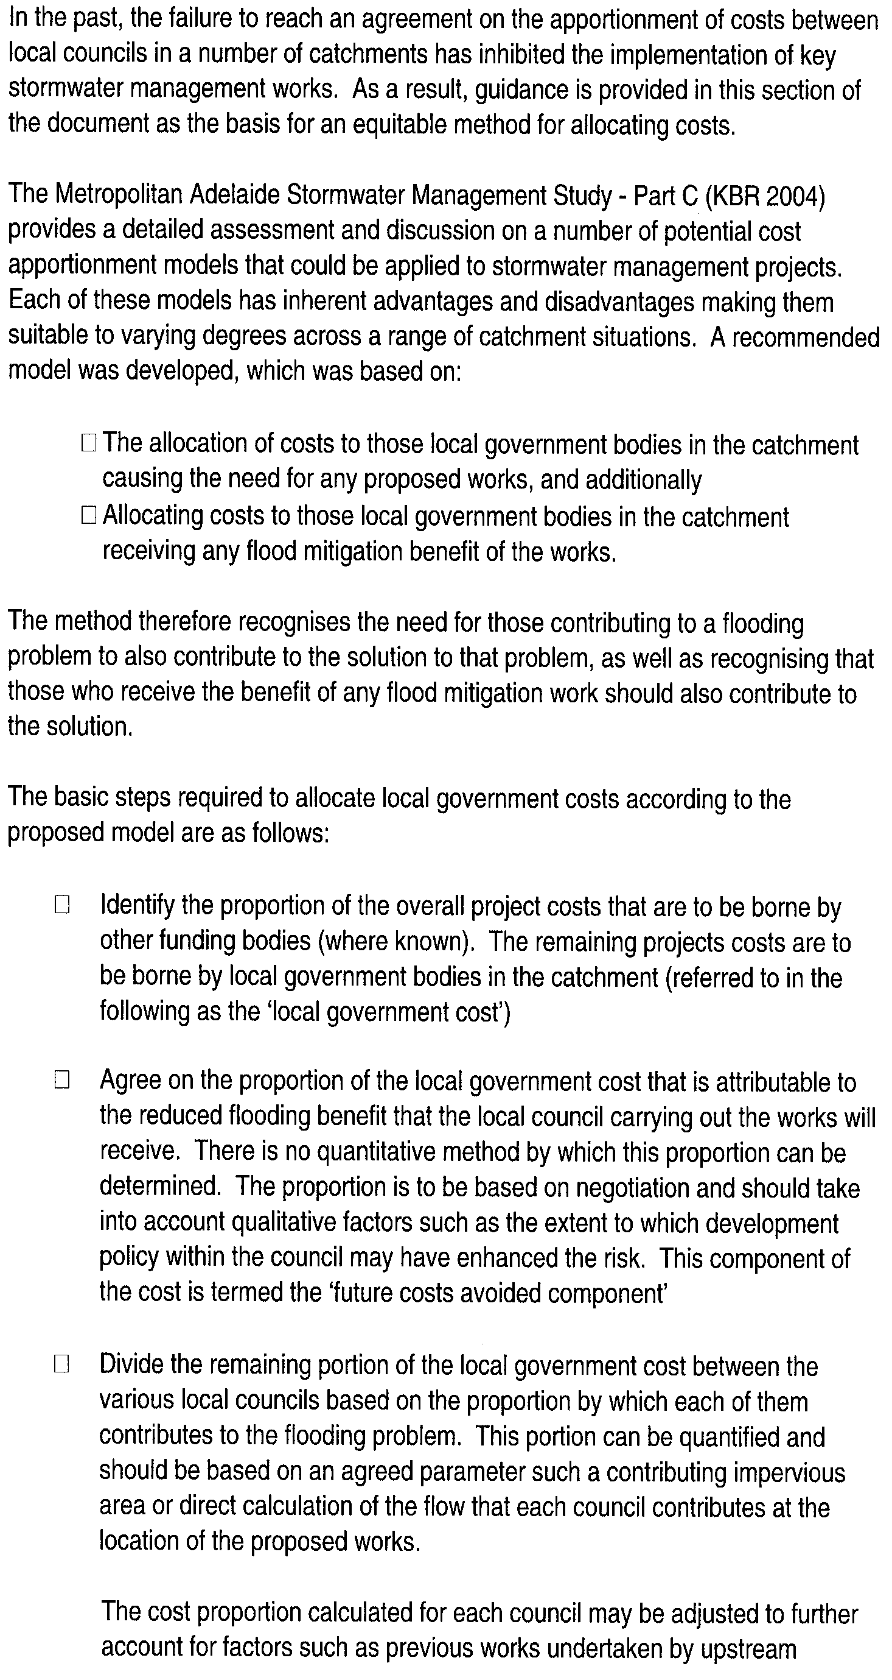
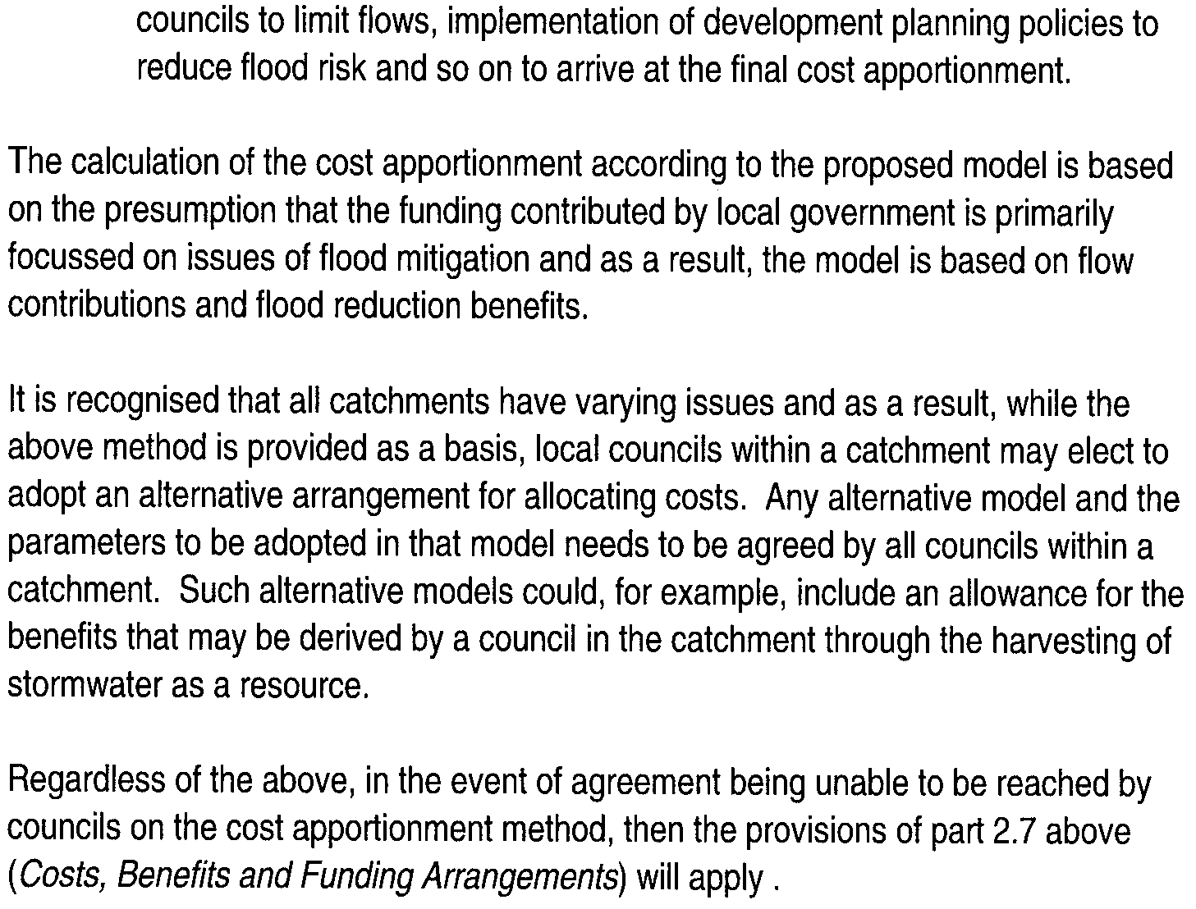

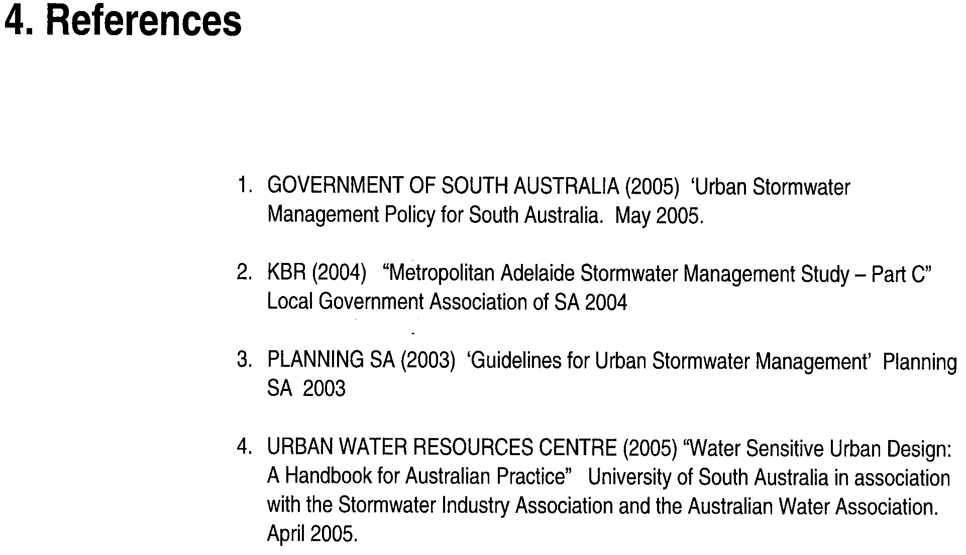

SURVEY ACT 1992
Register of Surveyors
IT is hereby notified for general information that the undermentioned surveyors are duly registered or licensed under the above Act.
List of Licensed Surveyors

 | Name |  | Address | Date of  Licence
 | Abbott, Richard Poole |  | 366 Halifax Street, Adelaide, S.A. 5000 | 13.6.85
 | Afnan, Ruhi |  | 19 Dunn Street, Bridgewater, S.A. 5155 | 9.4.92
 | Allen, Scott Lewis |  | 21 Telford Street, Ovingham, S.A. 5082 | 8.5.86
 | Anderson, Ralph Ian |  | 78 Twentieth Street, Renmark, S.A. 5341 | 10.5.90
 | Andrew, Robert Lindsay |  | 29 Fowler Street, Seaview Downs, S.A. 5049 | 23.10.74
 | Andrews, Richard George |  | P.O. Box 113, Parndana, S.A. 5220 | 19.6.80
 | Bacchus, Scott John |  | 33 Turners Avenue, Hawthorndene, S.A. 5051 | 3.8.06
 | Banks, Alan David |  | 33 Carlisle Road, Westbourne Park, S.A. 5041 | 10.11.90
 | Barnes, Lyall Bruce |  | 7 Boronia Court, Paradise, S.A. 5075 | 14.4.94
 | Barwick, Craig |  | P.O. Box 1000, Kent Town, S.A. 5071 | 15.11.01
 | Bennett, Mark Nicholas |  | 10A Brook Street, Torrens Park, S.A. 5062 | 18.11.04
 | Bested, Antony John |  | 362 Magill Road, Kensington Park, S.A. 5068 | 1.1.92
 | Bested, John Charles |  | 362 Magill Road, Kensington Park, S.A. 5068 | 16.3.67
 | Birkett, Peter Mark |  | 57 Burtonia Way, Forrestfield, W.A. 6058 | 17.3.05
 | Bleeze, Denis Robert |  | 18 Range Road South, Houghton, S.A. 5131 | 16.7.81
 | Blok, Timothy |  | 5 Seventh Avenue, Hove, S.A. 5048 | 13.9.90
 | Blundell, Marc John Pole |  | 8 Belmont Close, Clovelly Park, S.A. 5042 | 17.7.03
 | Borchardt, David Allan John |  | 44 Parcoola Avenue, Hope Valley, S.A. 5090 | 1.1.90
 | Brogden, Damian John |  | 176 Prospect Road, Prospect, S.A. 5082 | 13.7.89
 | Bryant, Warwick Kelvin |  | 10 Harvey Street, Darwin, N.T. 0800 | 28.10.05
 | Burdett, Michael Paul |  | P.O. Box 1000, Kent Town, S.A. 5071 | 12.8.82
 | Burford, Rodney Neil |  | P.O. Box 67, Unley, S.A. 5061 | 13.1.76
 | Burgess, Gregory Stephen |  | 76 Hutchinson Street, Mount Barker, S.A. 5251 | 6.7.95
 | Burgess, Kevin Trevor |  | 46 Second Avenue, St Peters, S.A. 5069 | 8.7.82
NP | Cameron, Donald Roderick |  | 94 Wills Street, Peterhead, S.A. 5016 | 14.5.92
 | Cameron, Michael Leigh |  | 45 Helen Street, Mount Gambier, S.A. 5290 | 20.4.06
 | Campbell, John Robert |  | P.O. Box 246, Nambour, Qld 4560 | 19.6.03
 | Carn, Brenton Allen |  | 16 Chester Street, Henley Beach, S.A. 5022 | 19.9.96
NP | Campbell-Kennedy, George Harry |  | 37/38 Taylors Road, Aberfoyle Park, S.A. 5159 | 14.3.42
 | Castelanelli, Carmelo |  | 62 Carlton Parade, Torrensville, S.A. 5031 | 11.3.93
 | Cavallo, Rocco |  | 77 East Avenue, Clarence Park, S.A. 5034 | 13.9.90
 | Christie, Brenton Andrew |  | 4 Topaz Court, Hope Valley, S.A. 5090 | 21.7.05
 | Cooke, Geoffrey Bernard |  | 3 Clifton Court, Stonyfell, S.A. 5066 | 15.7.76
 | Cornish, John Leslie |  | 5 Horsell Road, Belair, S.A. 5052 | 12.3.79
 | Coultas, Geoffrey Bruce |  | 59 Myrtle Road, Seacliff, S.A. 5049 | 1.1.87
NP | Cullen, John Grant |  | 47 Beach Road, Brighton, S.A. 5048 | 14.2.85
 | Curnow, James |  | 4 Goyder Street, Erindale, S.A. 5066 | 10.12.76
 | D’Aloia, Giuseppe |  | 9 Cassia Crescent, Kidman Park, S.A. 5025 | 20.6.02
 | Dansie, Phillip Alan |  | 3 Angas Street, Port Lincoln, S.A. 5606 | 26.4.77
 | Dellatorre, Wade Christopher |  | 33 Olive Parade, Kadina, S.A. 5554 | 16.5.02
NP | Dillon, John Graham |  | 20B Durant Avenue, Rostrevor, S.A. 5073 | 6.6.51
 | Donaghey, Francis Andrew |  | 17 Windermere Avenue, Novar Gardens, S.A. 5040 | 15.7.76
 | Donaghey, Shaun Bernard |  | 1 Leak Avenue, Glenelg North, S.A. 5045 | 17.10.02
 | Driver, Malcolm John |  | 7 Highland Avenue, Rostrevor, S.A. 5073 | 9.8.84
 | Dyson, Andrew |  | 42 Regent Street, Kensington, S.A. 5068 | 13.2.78
 | Falkenberg, Andrew John |  | 17 Dame Pattie Circuit, West Lakes, S.A. 5021 | 6.12.90
 | Feller, Raymond Leslie |  | 40 Outlook Drive, Aberfoyle Park, S.A. 5159 | 23.11.66
NP | Filmer, Michael Shaun |  | 25 Melbourne Street, St James, W.A. 6102 | 3.8.06
NP | Forgan, Trevor Stewart |  | 85 Kintore Avenue, Prospect, S.A. 5082 | 19.2.75
 | Frankiw, Jaroslaw |  | P.O. Box 53, McLaren Vale, S.A. 5171 | 4.6.75
 | Fryar, Rockland Neil |  | 7 Panorama Drive, Panorama, S.A. 5041 | 8.9.94
 | Fryters, Christianus Wilhelmus |  | 20 Bourlang Avenue, Camden Park, S.A. 5038 | 22.3.71
 | Fudge, Jeffrey Charles |  | 108 Gilles Street, Adelaide, S.A. 5000 | 11.8.78
 | Fyfe, Alister Ross |  | P.O. Box 114, Kent Town, S.A. 5071 | 4.3.80
 | Gibson, Gordon John Colin |  | 4 Waverley Terrace, Hove, S.A. 5048 | 18.11.55
 | Gilbert, Peter Mark |  | 2 Cremorne Street, Fullarton, S.A. 5063 | 8.9.94
 | Goedecke, Mark Robert |  | 23 Sydenham Road, Norwood, S.A. 5067 | 30.7.84
 | Grant, Trevor Donald |  | 18 Valley View Drive, Highbury, S.A. 5089 | 1.3.84
 | Grear, Michael Stuart |  | 24B Willunga Street, Eden Hills, S.A. 5050 | 1.1.92
 | Harris, John Mills |  | P.O. Box 150, Oaklands Park, S.A. 5046 | 23.12.74
 | Hawkins, Thomas Bernard |  | 14 Conigrave Street, Oaklands Park, S.A. 5046 | 15.9.05
 | Heanes, Robert Allan |  | 33 Mount Osmond Road, Mount Osmond, S.A. 5064 | 16.10.63
 | Henley, John Edward |  | 256 Gilbert Street, Adelaide, S.A. 5000 | 12.10.89
 | Hennig, Bryan Ronald |  | 108 Gilles Street, Adelaide, S.A. 5000 | 1.7.68
 | Hennig, Shayne Bryan |  | 108 Gilles Street, Adelaide, S.A. 5000 | 14.6.90
 | Hewett, Bruce Allan |  | 54 Coromandel Parade, Blackwood, S.A. 5051 | 31.10.78
 | Hopkins, Michael Jessop |  | 16 Frederick Street, Adelaide, S.A. 5000 | 17.4.84
 | Hordacre, Glenn Ian |  | P.O. Box 1000, Kent Town, S.A. 5071 | 12.11.92
NP | Hutchinson, Gary Mark |  | 76 Battams Road, Marden, S.A. 5070 | 8.3.84
 | Hynes, Matthew David |  | 161 Upper Sturt Road, Upper Sturt, S.A. 5156 | 20.5.04
 | Jeanes, Peter Ian |  | P.O. Box 215, Lonsdale, S.A. 5160 | 3.7.79
 | Jericho, David Allan |  | 48 Lawrence Street, Kadina, S.A. 5554 | 19.7.01
NP | Jones, Andrew Charles |  | 3 Jasper Street, Salisbury East, S.A. 5109 | 20.4.79
 | Jones, Keith Robert |  | 1/263 Belmore Road, Balwyn North, Vic. 3104 | 20.7.00
NP | Kennedy, Ross Alexander |  | 2 Longbridge, Willesborough, Kent TN 240TA, U.K. | 14.5.92
 | Kentish, Peter Maclaren |  | 101 Grenfell Street, Adelaide, S.A. 5000 | 12.9.78
 | Klau, Timothy David |  | 50A Normandy Place, Port Lincoln, S.A. 5606 | 18.5.06
 | Klitscher, Simon Martin |  | P.O. Box 226, Brooklyn Park, S.A. 5032 | 15.6.00
 | Koch, Robin Barry |  | 86 Mawson Road, Meadows, S.A. 5201 | 10.9.92
 | Lambis, Haralambos Michael |  | 30 Farrant Street, Prospect, S.A. 5082 | 21.4.05
 | Lane, Gregory Charles |  | 4 Light Road, Coromandel Valley, S.A. 5051 | 15.6.06
 | Lange, Robert Harry |  | P.O. Box 422, Port Adelaide, S.A. 5015 | 13.9.84
 | Leaker, Martin John |  | 17 College Road, Somerton Park, S.A. 5044 | 10.11.94
 | Leith, Grantley David |  | 12 Walsh Street, Vista, S.A. 5091 | 10.5.90
 | Lewis, Gregory Wayne |  | 5 Parkview Court, Aberfoyle Park, S.A. 5159 | 1.1.83
 | Liebelt, Michael John |  | 32 Ewing Street, Kadina, S.A. 5554 | 11.6.92
 | Liebelt, Susan Marie |  | 32 Ewing Street, Kadina, S.A. 5554 | 10.9.92
 | Lock, Craig James |  | 45 Helen Street, Mount Gambier, S.A. 5290 | 8.3.84
 | Lock, Michael Grant |  | 87 Springbank Road, Clapham, S.A. 5062 | 13.2.86
 | Loechel, Robin Everard |  | 16 St Andrews Terrace, Willunga, S.A. 5172 | 12.3.79
 | Lohmeyer, Michael John |  | 13 Dillon Road, Aldgate, S.A. 5154 | 9.3.89
NP | Lunnay, Christopher William |  | P.O. Box 798, Wollongong, N.S.W. 2520 | 23.2.77
 | Mann, Grant Glenn |  | 11 Island View Crescent, Victor Harbor, S.A. 5211 | 11.3.93
 | Mattsson, Jeffrey Ian |  | 10 Braeside Avenue, Seacombe Heights, S.A. 5047 | 14.9.79
 | McCarthy, Alan John |  | P.O. Box 28, Tanunda, S.A. 5352 | 17.4.84
 | McDonnell-Smith, David |  | 4 Samoa Court, West Lakes, S.A. 5021 | 1.1.84
NP | McGilp, Neil Gehlert |  | 88 Capella Street, Coorparoo, Qld 4151 | 9.9.82
 | Millett, Christopher John |  | 143 Fullarton Road, Rose Park, S.A. 5067 | 1.1.92
 | Minchin, Christopher George |  | 87 Third Avenue, Joslin, S.A. 5070 | 14.6.84
 | Mullins, Stephen Bernard |  | 3 McPharlin Avenue, Redwood Park, S.A. 5097 | 17.2.81
 | Neale, Graeme Edward |  | 27 Dover Street, Malvern, S.A. 5061 | 15.5.80
 | Nichols, Gary William |  | 10 Tester Drive, Blackwood, S.A. 5051 | 1.1.84
 | Nietschke, Michael Dean |  | 13 Michael Street, Lockleys, S.A. 5032 | 16.10.97
 | Nisbet, Kim Alan |  | Stock Road, Mylor, S.A. 5153 | 15.5.80
 | O’Callaghan, Michael Patrick |  | P.O. Box 1277, Main Road, Mylor, S.A. 5153 | 14.3.85
 | Oldfield, Mark Howard |  | P.O. Box 981, Mount Gambier, S.A. 5290 | 11.9.86
NP | Perry, Geoffrey Robert |  | P.O. Box 76, Hahndorf, S.A. 5245 | 14.7.83
 | Petersen, John Fredrick |  | 71 Riverway, Kidman Park, S.A. 5025 | 17.5.73
 | Petrilli, Kevin John |  | Suite 5/13-23 Unley Road, Parkside, S.A. 5063 | 19.7.90
 | Phillips, David Graham |  | P.O. Box 1818, Renmark, S.A. 5341 | 24.5.72
 | Phillips, Perry Mark |  | 171 Cross Road, Westbourne Park, S.A. 5041 | 13.12.84
 | Pittman, Mark Roger |  | 6 Moore Street, Somerton Park, S.A. 5044 | 21.8.97
 | Pohl, Henry Michael |  | 23 Sydenham Road, Norwood, S.A. 5067 | 31.3.83
 | Pyper, David Edward |  | 5 Wokurna Avenue, Mitcham, S.A. 5062 | 1.1.91
 | Rea, Franco |  | 11 King William Street, Kent Town, S.A. 5071 | 15.6.00
 | Retallack, Richard Alan |  | 25 Narinna Avenue, Cumberland Park, S.A. 5041 | 9.4.92
 | Rigon, Dario |  | P.O. Box 370, Campbelltown, S.A. 5074 | 10.3.88
 | Rosko, Sime |  | 7/30 Frederick Road, West Lakes, S.A. 5021 | 9.7.87
 | Sandford, Geoffrey Richard |  | 11 Bray Avenue, Klemzig, S.A. 5087 | 17.3.77
 | Sargent, Mark Christopher |  | P.O. Box 926, Shepparton, Vic. 3632 | 20.7.00
 | Sarneckis, Kostas |  | 32 Wattle Crescent, Tea Tree Gully, S.A. 5091 | 3.8.77
 | Sayer, Max Alfred Michael |  | 176 Prospect Road, Prospect, S.A. 5082 | 12.10.89
 | Scutchings, Craig Allen |  | P.O. Box 135, Langhorne Creek, S.A. 5255 | 16.12.04
 | Slape, Bradley James |  | 5 Dinham Road, Athelstone, S.A. 5076 | 20.4.06
 | Smith, Peter Stuart |  | G.P.O. Box 1354, Adelaide, S.A. 5001 | 12.3.79
 | Smith, Trevor John Gee |  | 11 Mitchell Street, Seaview Downs, S.A. 5049 | 14.6.84
 | Sommerville, Peter Thomas |  | P.O. Box 655, McLaren Vale, S.A. 5171 | 16.10.79
 | Standley, Mark Brenton |  | 16B Kareda Drive, Campbelltown, S.A. 5074 | 15.6.00
 | Stolz, Peter Georg Hermann |  | 13 Atlanta Avenue, Ingle Farm, S.A. 5098 | 1.1.91
 | Summers, Clayton Myles |  | 9 St Georges Street, Willunga, S.A. 5172 | 12.6.86
 | Teakle, Mark Ronald Bray |  | P.O. Box 981, Mount Gambier, S.A. 5290 | 8.11.84
 | Tennant, Alistair Charles |  | 8 Sexton Road, Brighton, S.A. 5048 | 13.10.83
 | Townsend, Steven James |  | 8 Beaver Court, Port Lincoln, S.A. 5606 | 18.8.05
 | Tripodi, Alfredo |  | 10 Paula Street, Athelstone, S.A. 5076 | 15.3.07
 | Tucker, Paul |  | P.O. Box 884, Barmera, S.A. 5345 | 31.5.73
 | Turnbull, Shaun William |  | Unit 11, 83 Lochside Drive, West Lakes, S.A. 5021 | 15.2.07
 | Turner, Steven Miles |  | 23 Raymond Grove, Warradale, S.A. 5046 | 28.9.77
 | van Senden, Geoffrey Clifton |  | 11 Chapel Street, Strathalbyn, S.A. 5255 | 11.10.90
 | Weber, John Leslie |  | 178 Main Road, McLaren Vale, S.A. 5171 | 12.3.79
 | Weston, David Arthur Giles |  | 78 Castle Street, Parkside, S.A. 5063 | 12.3.92
 | Williams, Mark Antony Peter |  | 24 York Drive, Flagstaff Hill, S.A. 5159 | 17.6.04
 | Wood, Adam Browning |  | 24 Hakea Avenue, Athelstone, S.A. 5076 | 17.8.06
NP | Wood, Simon Neville |  | 12 Pine Grove, Belair, S.A. 5052 | 19.12.77

NP Denotes non-practising
List of Registered Surveyors

Name |  |  |  | Address |  | Date of  Registration
 | Chivers, John Henry |  |  |  | c/o SMEC, P.O. Box 356, Cooma, N.S.W. 2630 |  | 5.10.79
 | Latham, James Stephen |  |  |  | P.O. Box 574, Marleston, S.A. 5032 |  | 1.1.98
 | Millett, Alec John |  |  |  | P.O. Box 561, Cottesloe, W.A. 6911 |  | 12.3.92
 | McFarlane, John Alexander |  |  |  | 25A Prince Street, Alberton, S.A. 5014 |  | 19.7.07
 | Pickett, Richard Bruce |  |  |  | 3A Fuller Street, Parkside, S.A. 5063 |  | 1.1.00
NP | Rutter, Gregory Thomas |  |  |  | P.O. Box 133, Mena Creek, Qld 4871 |  | 14.5.92

NP Denotes non-practising Surveyors

SOUTH AUSTRALIAN LOCAL GOVERNMENT GRANTS COMMISSION ACT 1992
Payment of Grants
I, JENNIFER RANKINE, Minister for State/Local Government Relations, being the Minister responsible for the administration of the South Australian Local Government Grants Commission Act 1992, hereby state, pursuant to section 6 of the Act that:
(a) the total amount available for payment of grants pursuant to this Act for 2007-2008 is $122 095 970;
(b) the amount available for payment of general pupose financial assistance grants within the total amount for 2007-2008 is $92 310 159;
(c) the amount available for payment of identified local
road grants within the total amount for 2007-2008 is $29 785 811; and
(d) an amount of $464 374 relating to the underpayment of grants for 2006-2007 (following adjustment for actual CPI, in accordance with Commonwealth legislation), will be added to the funds to be paid to Councils during 2007-2008, using the grant relativities applied in 2006-2007.
Dated 1 August 2007.
Jennifer Rankine, Minister for State/Local Government Relations

South Australia
Development (Division of Land) Variation Regulations 2007
under the Development Act 1993

Contents
Part 1—Preliminary
1 Short title
2 Commencement
3 Variation provisions
Part 2—Variation of Development Regulations 1993
4 Variation of regulation 5A—Presumption with respect to the division of certain buildings
5 Variation of regulation 21—Certification of building indemnity insurance
6 Variation of regulation 24—Referrals
7 Variation of regulation 28—Special provision relating to fire authorities
8 Variation of regulation 34—Public inspection of certain applications
9 Variation of regulation 39—Assessment in respect of the Building Rules referred to the council
10 Variation of regulation 40—Issue of building rules consent other than by a council
11 Variation of regulation 41—Time within which a decision must be made
12 Variation of regulation 42—Notification of decision to an applicant (including conditions)
13 Variation of regulation 47—Endorsed plans
14 Variation of regulation 64—Referral of assessment of building work
15 Variation of regulation 76—Essential safety provisions
16 Variation of regulation 78—Building Rules: bushfire prone areas
17 Variation of regulation 79—Construction Industry Training Fund
18 Variation of regulation 83(AB)—Statement of Compliance
19 Variation of regulation 89—Private certification—authorised functions
20 Variation of regulation 92—Provision of information
21 Variation of regulation 98—Register of applications
22 Variation of regulation 99A—Documents to be provided by a private certifier
23 Variation of Schedule 2—Additional acts and activities constituting development
24 Variation of Schedule 5—Requirements as to plans and specifications
25 Variation of Schedule 6—Fees
26 Variation of Schedule 25—System indicators

Part 1—Preliminary
1—Short title
These regulations may be cited as the Development (Division of Land) Variation Regulations 2007.
2—Commencement
These regulations come into operation on the day on which they are made.
3—Variation provisions
In these regulations, a provision under a heading referring to the variation of specified regulations varies the regulations so specified.
Part 2—Variation of Development Regulations 1993
4—Variation of regulation 5A—Presumption with respect to the division of certain buildings
Regulation 5A—delete "(and a development authorisation cannot be issued unless or until such compliance exists)" and substitute:
(and the Development Assessment Commission may not issue a certificate in respect of the division under section 51 of the Act unless or until it is satisfied (in such manner as it thinks fit) that such compliance exists)
5—Variation of regulation 21—Certification of building indemnity insurance
Regulation 21(2)(a)—delete "provisional" wherever occurring
6—Variation of regulation 24—Referrals
Regulation 24(2)—delete "provisional" wherever occurring
7—Variation of regulation 28—Special provision relating to fire authorities
Regulation 28(1)—delete "provisional"
8—Variation of regulation 34—Public inspection of certain applications
Regulation 34(3)(a)—delete "provisional"
9—Variation of regulation 39—Assessment in respect of the Building Rules referred to the council
Regulation 39—delete "provisional"
10—Variation of regulation 40—Issue of building rules consent other than by a council
Regulation 40—delete "provisional"
11—Variation of regulation 41—Time within which a decision must be made
(1) Regulation 41(1)(a)(i)—delete "provisional"
(2) Regulation 41(1)(b)—delete "provisional"
(3) Regulation 41(1)(c)—delete "provisional" wherever occurring
12—Variation of regulation 42—Notification of decision to an applicant (including conditions)
(1) Regulation 42(3a)—delete "provisional"
(2) Regulation 42(4)—delete "provisional"
13—Variation of regulation 47—Endorsed plans
Regulation 47—delete "provisional"
14—Variation of regulation 64—Referral of assessment of building work
(1) Regulation 64(2)—delete "provisional"
(2) Regulation 64(3)—delete "provisional"
15—Variation of regulation 76—Essential safety provisions
Regulation 76(3)—delete "provisional"
16—Variation of regulation 78—Building Rules: bushfire prone areas
Regulation 78(2)(a)—delete "provisional"
17—Variation of regulation 79—Construction Industry Training Fund
(1) Regulation 79(2)—delete "provisional"
(2) Regulation 79(3)(b)—delete "provisional"
(3) Regulation 79(4)—delete "provisional"
18—Variation of regulation 83(AB)—Statement of Compliance
(1) Regulation 83(AB)(2)—delete "provisional"
(2) Regulation 83(AB)(7)—delete "provisional"
19—Variation of regulation 89—Private certification—authorised functions
(1) Regulation 89(1)(a)—delete "provisional"
(2) Regulation 89(1)(e)—delete "provisional"
(3) Regulation 89(1)(f)—delete "provisional"
(4) Regulation 89(2)—delete "provisional" wherever occurring
(5) Regulation 89(3)—delete "provisional"
20—Variation of regulation 92—Provision of information
(1) Regulation 92(1)—delete "provisional"
(2) Regulation 92(2)(ab)—delete "provisional"
(3) Regulation 92(2)(c)—delete "provisional" wherever occurring
(4) Regulation 92(3)(a)—delete "provisional" wherever occurring
21—Variation of regulation 98—Register of applications
(1) Regulation 98(2)(i)—delete "provisional"
(2) Regulation 98(3)(g)—delete "provisional"
22—Variation of regulation 99A—Documents to be provided by a private certifier
(1) Regulation 99A(c)—delete "provisional"
(2) Regulation 99A(d)—delete "provisional"
23—Variation of Schedule 2—Additional acts and activities constituting development
Schedule 2—after clause 8 insert:
9 (1) The division of land subject to a lease under a prescribed Crown Lands Act where an application has been made to the Minister responsible for the administration of the relevant Act to surrender the lease for freehold title on the basis that the land will be granted in fee simple and then divided.
(2) In subclause (1)—
prescribed Crown Lands Act means—
(a) the Crown Lands Act 1929; and
(b) the Irrigation (Land Tenure) Act 1930; and
(c) the Discharged Soldiers Settlement Act 1934; and
(d) the Marginal Lands Act 1940; and
(e) the War Service Land Settlement Agreement Act 1945.
24—Variation of Schedule 5—Requirements as to plans and specifications
(1) Schedule 5, clause 1(1)—delete "provisional" wherever occurring
(2) Schedule 5, clause 1(2)—delete "provisional"
(3) Schedule 5, clause 1(3)—delete "provisional"
25—Variation of Schedule 6—Fees
Schedule 6—delete "provisional" wherever occurring
26—Variation of Schedule 25—System indicators
Schedule 25—delete "provisional" wherever occurring
Note—
As required by section 10AA(2) of the Subordinate Legislation Act 1978, the Minister has certified that, in the Minister's opinion, it is necessary or appropriate that these regulations come into operation as set out in these regulations.
Made by the Governor
with the advice and consent of the Executive Council
on 16 August 2007
No 210 of 2007
PLN07/0322

South Australia
Adelaide Festival Centre Trust Regulations 2007
under the Adelaide Festival Centre Trust Act 1971

Contents
Part 1—Preliminary
1 Short title
2 Commencement
3 Interpretation
Part 2—Administration
4 Authorised persons
5 Identification of authorised persons
6 Immunity from liability
7 Powers of authorised persons
8 Acting with approval of Trust or authorised persons
Part 3—Regulation of conduct
9 Behaviour
10 Protection of property
11 Restricted areas
12 Photographs and recordings
13 Prohibition against riding wheeled recreational devices in Centre
14 Other prohibited activities
Part 4—Special provisions relating to vehicles
15 Public vehicular access to Centre
16 Driving or bringing vehicles into the Centre
17 Liability of vehicle owners and expiation of certain offences
Schedule 1—Revocation and transitional provision
Part 1—Revocation of Adelaide Festival Centre Trust Regulations 1992
1 Revocation of Adelaide Festival Centre Trust Regulations 1992
Part 2—Transitional provision
2 Authorised persons

Part 1—Preliminary
1—Short title
These regulations may be cited as the Adelaide Festival Centre Trust Regulations 2007.
2—Commencement
These regulations will come into operation on 1 September 2007.
3—Interpretation
In these regulations, unless the contrary intention appears—
Act means the Adelaide Festival Centre Trust Act 1971;
authorised person—see regulation 4;
drive has the same meaning as in the Road Traffic Act 1961;
owner, in relation to a vehicle, has the same meaning as in the Road Traffic Act 1961;
theatre or associated theatre area means a theatre within the Centre, or a foyer, restaurant, convenience or other facility associated with that theatre;
vehicle has the same meaning as in the Road Traffic Act 1961;
wheeled recreational device has the same meaning as in the Road Traffic Act 1961.
Part 2—Administration
4—Authorised persons
(1) The Trust may appoint suitable persons to be authorised persons for the purposes of these regulations.
(2) An appointment may be made subject to conditions specified in the instrument of appointment.
(3) The Trust may, at any time, revoke an appointment of an authorised person or vary or revoke a condition of appointment or impose a further condition of appointment.
(4) All police officers are authorised persons for the purposes of these regulations.
5—Identification of authorised persons
(1) An authorised person appointed under these regulations must be issued with an identity card—
(a) containing the person's name and a photograph of the person; and
(b) stating that the person is an authorised person under these regulations.
(2) If the powers of an authorised person have been limited by conditions, the identity card issued to the authorised person must indicate those limitations.
(3) An authorised person must, at the request of a person in relation to whom the authorised person intends to exercise powers under these regulations, produce for the inspection of the person—
(a) in the case of an authorised person who is a police officer and is not in uniform—his or her certificate of authority; or
(b) in the case of an authorised person appointed under these regulations—his or her identity card.
6—Immunity from liability
(1) No personal liability attaches to an authorised person for an honest act or omission in the exercise or discharge or purported exercise or discharge of a power or function under these regulations.
(2) A liability that would, but for subregulation (1), lie against the authorised person lies instead against the Trust.
7—Powers of authorised persons
(1) If an authorised person reasonably suspects that a person, while in the Centre, has committed, is committing or is about to commit an offence against these regulations or any Act or would, by entering the Centre, commit an offence against these regulations, the authorised person may do any 1 or more of the following:
(a) require the person to state his or her full name and usual place of residence;
(b) if the authorised person suspects on reasonable grounds that the name or place of residence stated is false—require the person to produce evidence of his or her full name or usual place of residence;
(c) require the person to leave the Centre immediately and not to return for a stated period not exceeding 24 hours or not to enter the Centre;
(d) use such force as is reasonably necessary for the purpose of removing or excluding a person who refuses or fails to comply with a requirement under paragraph (c).
(2) If a person has brought an object or thing into the Centre in contravention of these regulations, an authorised person may require the person to leave the object or thing in the possession of the authorised person (or another person indicated by the authorised person) until such time as the person leaves the Centre.
(3) An authorised person may give reasonable directions to persons driving vehicles, or to pedestrians, in the Centre that are considered necessary by the authorised person for the safe and efficient regulation of vehicular or pedestrian traffic in the Centre or for the maintenance of order in the Centre.
(4) A person who—
(a) hinders or obstructs an authorised person in the exercise of powers conferred by these regulations; or
(b) refuses or fails to comply with a requirement or direction of an authorised person under this regulation,
is guilty of an offence.
Maximum penalty: $200.
8—Acting with approval of Trust or authorised persons
(1) These regulations do not prevent a person from doing anything with the approval of the Trust or an authorised person or otherwise with lawful authority.
(2) An approval given by the Trust or an authorised person for the purposes of these regulations—
(a) must be in writing or, if given orally, must be confirmed in writing as soon as practicable; and
(b) may relate to a particular person or matter or persons or matters of a class specified by the Trust or authorised person; and
(c) may be subject to conditions (including a condition requiring payment of a fee) specified by the Trust or authorised person; and
(d) may be varied or revoked by the Trust or authorised person at any time.
(3) If the Trust or an authorised person gives approval subject to a condition, the person to whom the approval is given must not contravene or fail to comply with the condition.
Maximum penalty: $200.
Part 3—Regulation of conduct
9—Behaviour
A person must not—
(a) disturb or interfere with a performance or activity being carried on in the Centre with lawful authority; or
(b) intentionally obstruct, disturb, interrupt or annoy any other person making proper use of the Centre; or
(c) throw, roll or discharge a stone, substance or missile or engage in any other activity that may endanger the safety of a person or animal in the Centre.
Maximum penalty: $200.
10—Protection of property
A person must not—
(a) remove, damage, deface or interfere with property owned by or under the care or control of the Trust, including vegetation in the grounds of the Centre; or
(b) interfere with an exhibit or display in the Centre or a case containing an exhibit or display; or
(c) climb on a building, fixture, flora or property owned by or under the care or control of the Trust; or
(d) walk on or over a garden bed in the Centre.
Maximum penalty: $200.
11—Restricted areas
A person must not enter or remain in an area of the Centre that is, at the direction of the Trust, closed to public access.
Maximum penalty: $200.
12—Photographs and recordings
A person must not take a photograph or make a film, videotape or sound or other recording of any kind—
(a) in a theatre within the Centre; or
(b) of the whole or a part of a rehearsal, performance, exhibition or other activity taking place within a theatre or associated area.
Maximum penalty: $200.
13—Prohibition against riding wheeled recreational devices in Centre
A person must not travel in or on a wheeled recreational device in the Centre.
Maximum penalty: $200.
Expiation fee: $25.
14—Other prohibited activities
A person must not—
(a) bring an animal other than a guide dog into the Centre; or
(b) bring alcohol into the Centre or consume alcohol in the Centre except in licensed premises; or
(c) bathe in or take (or attempt to take) fish from a fountain or pool in the Centre; or
(d) foul or pollute a fountain or pool in the Centre; or
(e) light or maintain a fire in the Centre, other than in a place set aside for that purpose by the Trust; or
(f) play a musical instrument or operate a radio receiver or sound producing electronic device in the Centre; or
(g) sell or offer for sale any goods in the Centre; or
(h) collect or seek money or other donations in the Centre; or
(i) engage in advertising or marketing activities for commercial purposes in the Centre; or
(j) distribute or leave for collection in the Centre any pamphlets or leaflets; or
(k) display or erect a flag, banner, sign, placard or similar object in the Centre.
Maximum penalty: $200.
Part 4—Special provisions relating to vehicles
15—Public vehicular access to Centre
The Trust may, from time to time, determine areas of the Centre that are closed to public vehicular access.
16—Driving or bringing vehicles into the Centre
A person must not—
(a) bring a vehicle into, or drive a vehicle in, any part of the Centre closed to public vehicular access; or
(b) drive a vehicle in the Centre except on an area specifically set aside for the driving or parking of vehicles; or
(c) bring into the Centre a tracked motor vehicle or a motor vehicle the mass of which with or without its load exceeds 5 tonnes or drive such a vehicle in the Centre.
Maximum penalty: $200.
Expiation fee: $50.
17—Liability of vehicle owners and expiation of certain offences
(1) Without derogating from the liability of any other person, but subject to this regulation, if a vehicle is involved in an offence against regulation 16, the owner of the vehicle is guilty of an offence and liable to the same penalty as is prescribed for the principal offence and the expiation fee that is fixed for the principal offence applies in relation to an offence against this regulation.
(2) The owner and driver of a vehicle are not both liable through the operation of this regulation to be convicted of an offence arising out of the same circumstances, and consequently conviction of the owner exonerates the driver and conversely conviction of the driver exonerates the owner.
(3) An expiation notice or expiation reminder notice given under the Expiation of Offences Act 1996 to the owner of a vehicle for an alleged offence against this regulation involving the vehicle must be accompanied by a notice inviting the owner, if he or she was not the driver at the time of the alleged offence against regulation 16, to provide the Trust, within the period specified in the notice, with a statutory declaration—
(a) setting out the name and address of the driver; or
(b) if he or she had transferred ownership of the vehicle to another prior to the time of the alleged offence against regulation 16 and has complied with the Motor Vehicles Act 1959 in respect of the transfer—setting out details of the transfer (including the name and address of the transferee).
(4) Before proceedings are commenced against the owner of a vehicle for an offence against this regulation involving the vehicle, the complainant must send the owner a notice—
(a) setting out particulars of the alleged offence against regulation 16; and
(b) inviting the owner, if he or she was not the driver at the time of the alleged offence against regulation 16, to provide the complainant, within 21 days of the date of the notice, with a statutory declaration setting out the matters referred to in subregulation (3).
(5) Subregulation (4) does not apply to—
(a) proceedings commenced where an owner has elected under the Expiation of Offences Act 1996 to be prosecuted for the offence; or
(b) proceedings commenced against an owner of a vehicle who has been named in a statutory declaration under this regulation as the driver of the vehicle.
(6) Subject to subregulation (7), in proceedings against the owner of a vehicle for an offence against this regulation, it is a defence to prove—
(a) that, in consequence of some unlawful act, the vehicle was not in the possession or control of the owner at the time of the alleged offence against regulation 16; or
(b) that the owner provided the complainant with a statutory declaration in accordance with an invitation under this regulation.
(7) The defence in subregulation (6)(b) does not apply if it is proved that the owner made the declaration knowing it to be false in a material particular.
(8) If—
(a) an expiation notice is given to a person named as the alleged driver in a statutory declaration under this regulation; or
(b) proceedings are commenced against a person named as the alleged driver in such a statutory declaration,
the notice or summons, as the case may be, must be accompanied by a notice setting out particulars of the statutory declaration that named the person as the alleged driver.
(9) The particulars of the statutory declaration provided to the person named as the alleged driver must not include the address of the person who provided the statutory declaration.
(10) In proceedings against a person named in a statutory declaration under this regulation for the offence to which the declaration relates, it will be presumed, in the absence of proof to the contrary, that the person was the driver of the vehicle at the time at which the alleged offence was committed.
(11) In proceedings against the owner or driver of a vehicle for an offence against this Part, an allegation in the complaint that a notice was given under this regulation on a specified day will be accepted as proof, in the absence of proof to the contrary, of the facts alleged.
Schedule 1—Revocation and transitional provision
Part 1—Revocation of Adelaide Festival Centre Trust Regulations 1992
1—Revocation of Adelaide Festival Centre Trust Regulations 1992
The Adelaide Festival Centre Trust Regulations 1992 are revoked.
Part 2—Transitional provision
2—Authorised persons
A person appointed and holding office as an authorised person under the Adelaide Festival Centre Trust Regulations 1992 immediately before the commencement of these regulations will be taken to be an authorised person appointed under these regulations.
Note—
As required by section 10AA(2) of the Subordinate Legislation Act 1978, the Minister has certified that, in the Minister's opinion, it is necessary or appropriate that these regulations come into operation as set out in these regulations.
Made by the Governor
on the recommendation of the Adelaide Festival Centre Trust and with the advice and consent of the Executive Council
on 16 August 2007
No 211 of 2007
ASACAB004/04

South Australia
National Parks and Wildlife (Witjira National Park) Regulations 2007
under the National Parks and Wildlife Act 1972

Contents
Preamble
Part 1—Preliminary
1 Short title
2 Commencement
3 Interpretation
Part 2—Witjira National Park Co-management Board
4 Establishment of co-management board
5 Composition of Board
6 Terms and conditions
7 Chairperson and Deputy Chairperson
8 Vacancies or defects in appointment of members
9 Remuneration
10 Functions and powers of Board
11 Delegations
12 Board's procedures
13 Minister may call meetings
14 Suspension of Board (section 43I of the Act)
15 Conflict of interest
16 Annual report (section 43L of the Act)
Schedule 1—Transitional provision
1 Transitional provision

Preamble
1 Witjira National Park was constituted as a national park by proclamation on 21 November 1985.
2 The Lower Southern Arrernte people and Wangkangurru people have a traditional association with the land constituting the national park.
3 It is now intended that the national park be co-managed pursuant to a co-management agreement under the National Parks and Wildlife Act 1972 between the Minister and the Irrwanyere Aboriginal Corporation representing the Lower Southern Arrernte people and Wangkangurru people.

Part 1—Preliminary
1—Short title
These regulations may be cited as the National Parks and Wildlife (Witjira National Park) Regulations 2007.
2—Commencement
These regulations will come into operation on 1 October 2007.
3—Interpretation
In these regulations, unless the contrary intention appears—
Act means the National Parks and Wildlife Act 1972;
Board means the Witjira National Park Co-management Board established by regulation 4;
co-management agreement means the co-management agreement for the Witjira National Park;
Department means the administrative unit that is responsible for the administration of the National Parks and Wildlife Act 1972;
IAC means the Irrwanyere Aboriginal Corporation incorporated under the Aboriginal Councils and Associations Act 1976 of the Commonwealth;
Lower Southern Arrernte person means a person who is a member of a native title claim group in the Eringa (SAD 6010/98) or Eringa No 2 (SAD 6002/99) native title claims;
Minister means the Minister to whom the administration of the National Parks and Wildlife Act 1972 is committed;
Park means the Witjira National Park;
Wangkangurru person means a person who is a member of a native title claim group in the Wangkangurru/Yarlulandi (SAD 6016/98) native title claim.
Part 2—Witjira National Park Co-management Board
4—Establishment of co-management board
The Witjira National Park Co-management Board is established as the co-management board for the Park.
5—Composition of Board
(1) Subject to subregulation (2), the Board consists of 7 members appointed by the Minister of whom—
(a) 2 must be Lower Southern Arrernte persons appointed on the nomination of the IAC; and
(b) 2 must be Wangkangurru persons appointed on the nomination of the IAC; and
(c) 2 must be officers of the Department; and
(d) 1 must be a person nominated by the Minister who has qualifications or experience that may, in the opinion of the Minister, be of benefit to the Board.
(2) If the IAC refuses or fails to nominate a Lower Southern Arrernte person in relation to a particular office under subregulation (1)(a), or a Wangkangurru person in relation to a particular office under subregulation (1)(b), the Minister may, after consultation with the IAC, appoint a suitable Lower Southern Arrernte person or Wangkangurru person (as the case requires) to fill the office.
(3) At least 1 member of the Board must be a woman and 1 a man.
(4) The Minister may appoint a person to be a deputy of a member appointed under subregulation (1) and a person so appointed may act as a member of the Board in the absence of the member.
(5) The requirements of qualification made by this regulation in relation to an appointment of a member extend to an appointment of a deputy of that member.
6—Terms and conditions
(1) A member of the Board will be appointed on conditions determined by the Minister and for a term, not exceeding 4 years, specified in the instrument of appointment and, at the expiration of a term of appointment, is eligible for reappointment.
(2) The Minister may remove a member of the Board from office—
(a) for breach of, or non-compliance with, a condition of appointment; or
(b) for misconduct; or
(c) for failure or incapacity to carry out official duties satisfactorily.
(3) However, the Minister may only remove a member of the Board appointed under regulation 5(1)(a) or (b) after consultation with the IAC.
(4) The office of a member of the Board becomes vacant if the member—
(a) dies; or
(b) completes a term of office and is not reappointed; or
(c) resigns by written notice to the Minister; or
(d) ceases to satisfy the qualification by virtue of which the member was eligible for appointment to the Board; or
(e) is removed from office under subregulation (2).
(5) If a casual vacancy occurs in the office of a member, the Minister may appoint a suitable person to fill the vacancy, and that person will hold office for the balance of the term of his or her predecessor.
7—Chairperson and Deputy Chairperson
The Minister must appoint 2 of the members of the Board as Chairperson and Deputy Chairperson of the Board respectively.
8—Vacancies or defects in appointment of members
An act or proceeding of the Board is not invalid by reason only of a vacancy in its membership or a defect in the appointment of a member.
9—Remuneration
A member of the Board (other than a member appointed under regulation 5(1)(c) or a member appointed under regulation 5(1)(d) who is a member of the Public Service) is entitled to remuneration, allowances and expenses determined by the Minister.
10—Functions and powers of Board
(1) The functions of the Board are—
(a) to carry out the functions assigned to the Board by or under the National Parks and Wildlife Act 1972; and
(b) to carry out the functions assigned to the Board by the co-management agreement; and
(c) to carry out other functions assigned to the Board by the Minister.
(2) The Board has the power to do anything necessary, expedient or incidental to the performance of its functions.
(3) Without limiting the generality of subsection (2), the Board may enter into any form of contract, agreement or arrangement.
(4) The Board must perform its functions, or exercise a power, in a manner that is consistent with the co-management agreement.
11—Delegations
(1) The Board may delegate any of its functions or powers (other than this power of delegation)—
(a) to a member of the Board; or
(b) to an officer of the Department.
(2) A delegation—
(a) must be in writing; and
(b) may be made subject to conditions and limitations specified in the instrument of delegation; and
(c) is revocable at will and does not derogate from the power of the Board to act in a matter.
12—Board's procedures
(1) Subject to these regulations, 5 members (of whom at least 3 must be Lower Southern Arrernte or Wangkangurru persons and at least 2 must be members appointed under regulation 5(1)(c) or (d)) constitute a quorum of the Board.
(2) The Board must meet at least twice in each calender year (not including any conference or conferences held in accordance with subregulation (9)).
(3) A meeting of the Board will be chaired by the Chairperson or, in the absence of the Chairperson, by the Deputy Chairperson or, in the absence of both, the members present at a meeting of the Board must choose 1 of their number to preside at the meeting.
(4) Subject to this regulation, a decision carried by a majority of the votes cast by members of the Board at a meeting is a decision of the Board.
(5) Each member present at a meeting of the Board has 1 vote on any question arising for decision.
(6) If the Board is unable to decide a question arising for decision, the question must be referred to the Minister for decision (and the decision of the Minister will be taken to be a decision of the Board).
(7) In making a decision under subregulation (6), the Minister—
(a) must have regard to any written submission made by the IAC that is received by the Minister not more than 30 days after the date of the meeting at which the Board was unable to decide the question; and
(b) must have regard to any submission made by a member appointed under regulation 5(1)(a) or (b); and
(c) may have regard to any other matter the Minister thinks fit.
(8) The Minister may direct the Board to implement, or cause to be implemented, a decision of the Minister under subregulation (6).
(9) A conference by telephone or other electronic means between the members of the Board will, for the purposes of this regulation, be taken to be a meeting of the Board at which the participating members are present if—
(a) notice of the conference is given to all members in the manner determined by the Board for the purpose; and
(b) each participating member is capable of communicating with every other participating member during the conference.
(10) A proposed resolution of the Board at a conference held in accordance with subregulation (9) becomes a valid decision of the Board if the following procedures are complied with:
(a) notice of the proposed resolution must be given to all members of the Board in accordance with procedures determined by the Board;
(b) a majority comprised of not less than 5 members (of whom at least 3 must be Lower Southern Arrernte persons or Wangkangurru persons and at least 2 must be members appointed under regulation 5(1)(c) or (d)) must express concurrence in the proposed resolution by letter, facsimile transmission, electronic mail or other written communication setting out the terms of the resolution.
(11) The Board must have accurate minutes kept of its meetings.
(12) Subject to these regulations, the Board may determine its own procedures.
13—Minister may call meetings
(1) If 2 or more successive meetings are inquorate then the Minister may call a meeting of the Board.
(2) The Minister may direct the members of the Board to attend a meeting called under subregulation (1).
14—Suspension of Board (section 43I of the Act)
(1) Subject to this regulation, during the period of any suspension of the Board under section 43I, the Park—
(a) is under the control of the Minister; and
(b) is under the management of the Director.
(2) The Minister and the Director must, during any period of suspension of the Board, endeavour, where appropriate, to give effect to the objects set out in section 43E of the Act.
15—Conflict of interest
(1) A member of the Board who has a direct or indirect personal or pecuniary interest in a matter decided or under consideration by the Board—
(a) must, as soon as reasonably practicable, disclose in writing to the Board full and accurate details of the interest; and
(b) must not take part in any discussion by the Board relating to that matter; and
(c) must not vote in relation to that matter; and
(d) must be absent from the meeting room when any such discussion or voting is taking place.
Maximum penalty: $2 000.
(2) This regulation does not apply to a member of the Board—
(a) in respect of an interest that is shared in common with Lower Southern Arrernte persons or Wangkangurru persons generally, or a substantial section of Lower Southern Arrernte persons or Wangkangurru persons; and
(b) in relation to a matter in which the member has an interest while the member remains unaware that he or she has an interest in the matter (but in any proceedings against the member the burden will lie on the member to prove that he or she was not, at the material time, aware of his or her interest).
(3) The Minister may, by notice published in the Gazette, exempt a member (conditionally or unconditionally) from the application of a provision of this regulation, and may, by further notice published in the Gazette, vary or revoke such an exemption.
(4) Non-compliance by a member with a duty imposed by this regulation constitutes a ground for removal of the member from office.
(5) If a member or former member is convicted of an offence for a contravention of this regulation, the court by which the person is convicted may, in addition to imposing a penalty, order the convicted person to pay to the Minister—
(a) if the court is satisfied that the person or any other person made a profit as a result of the contravention—an amount equal to the profit; and
(b) if the court is satisfied that any loss or damage has been suffered as a result of the contravention—compensation for the loss or damage.
(6) If a member or former member is guilty of a contravention of this regulation, the Minister may (whether or not proceedings have been brought for the offence) recover from the person by action in a court of competent jurisdiction—
(a) if the person or any other person made a profit as a result of the contravention—an amount equal to the profit; and
(b) if any loss or damage has been suffered as a result of the contravention—compensation for the loss or damage.
16—Annual report (section 43L of the Act)
For the purposes of section 43L of the Act, the annual report of the Board must include the following:
(a) information relating to traditional hunting activities in the Park carried out in accordance with section 68D of the National Parks and Wildlife Act 1972;
(b) information relating to the effect of traditional hunting activities in the Park carried out in accordance with section 68D of the National Parks and Wildlife Act 1972 on native plants and protected animals, or the eggs of protected animals (and in particular those species that are scheduled as rare, endangered or vulnerable under the National Parks and Wildlife Act 1972);
(c) information relating to the operations and work programs undertaken by or on behalf of the Board;
(d) information relating to Park infrastructure;
(e) any other information required by the Minister.
Schedule 1—Transitional provision
1—Transitional provision
A licence, permit or written permission issued under the Act or the National Parks and Wildlife (National Parks) Regulations 2001 in relation to the Park, or any other licence, permit, written permission or agreement issued or entered by the Minister in relation to the land constituting the Park, continues in force in accordance with its terms.
Note—
As required by section 10AA(2) of the Subordinate Legislation Act 1978, the Minister has certified that, in the Minister's opinion, it is necessary or appropriate that these regulations come into operation as set out in these regulations.
Made by the Governor
with the advice and consent of the Executive Council
on 16 August 2007
No 212 of 2007
EHCS07/0013

South Australia
Liquor Licensing (General) Variation Regulations 2007
under the Liquor Licensing Act 1997

Contents
Part 1—Preliminary
1 Short title
2 Commencement
3 Variation provisions
Part 2—Variation of Liquor Licensing (General) Regulations 1997
4 Variation of regulation 8—Cases where licence is not required

Part 1—Preliminary
1—Short title
These regulations may be cited as the Liquor Licensing (General) Variation Regulations 2007.
2—Commencement
These regulations come into operation on the day on which they are made.
3—Variation provisions
In these regulations, a provision under a heading referring to the variation of specified regulations varies the regulations so specified.
Part 2—Variation of Liquor Licensing (General) Regulations 1997
4—Variation of regulation 8—Cases where licence is not required
Regulation 8(2)(j)—after "Blackfriars Priory School," insert:
Clare High School,
Note—
As required by section 10AA(2) of the Subordinate Legislation Act 1978, the Minister has certified that, in the Minister's opinion, it is necessary or appropriate that these regulations come into operation as set out in these regulations.
Made by the Governor
with the advice and consent of the Executive Council
on 16 August 2007
No 213 of 2007
MCA07/025CS
South Australia
Justices of the Peace Variation Regulations 2007
under the Justices of the Peace Act 2005

Contents
Part 1—Preliminary
1 Short title
2 Commencement
3 Variation provisions
Part 2—Variation of Justices of the Peace Regulations 2006
4 Variation of regulation 5—Additional prescribed requirements for appointment as special justice
5 Revocation of regulation 8

Part 1—Preliminary
1—Short title
These regulations may be cited as the Justices of the Peace Variation Regulations 2007.
2—Commencement
These regulations come into operation on the day on which they are made.
3—Variation provisions
In these regulations, a provision under a heading referring to the variation of specified regulations varies the regulations so specified.
Part 2—Variation of Justices of the Peace Regulations 2006
4—Variation of regulation 5—Additional prescribed requirements for appointment as special justice
(1) Regulation 5(2)—delete "appoint a special justice" and substitute:
recommend for appointment as a special justice a justice
(2) Regulation 5(3)—delete "appoint a special justice" and substitute:
recommend for appointment as a special justice a justice
5—Revocation of regulation 8
Regulation 8—delete the regulation
Note—
As required by section 10AA(2) of the Subordinate Legislation Act 1978, the Minister has certified that, in the Minister's opinion, it is necessary or appropriate that these regulations come into operation as set out in these regulations.
Made by the Governor
with the advice and consent of the Executive Council
on 16 August 2007
No 214 of 2007
AGO0203/03CS
South Australia
Prevention of Cruelty to Animals Variation Regulations 2007
under the Prevention of Cruelty to Animals Act 1985

Contents
Part 1—Preliminary
1 Short title
2 Commencement
3 Variation provisions
Part 2—Variation of Prevention of Cruelty to Animals Regulations 2000
4 Variation of regulation 8—Use of certain other electrical devices for controlling animals
5 Insertion of Part 3A
Part 3A—Regulation of rodeos
13C Interpretation
13D Only horses and cattle to be used in rodeo events
13E Permit to conduct rodeo
13F General requirements for conducting rodeos
13G Inspections by designated rodeo judge
13H Regulation of use and care of rodeo animals
13I Requirements and prohibitions relating to equipment
13J Special restrictions relating to use of electrical prods and goads
13K Reports to Minister on conduct of rodeo
6 Revocation of regulation 17
7 Variation of Schedule 2—Codes of practice

Part 1—Preliminary
1—Short title
These regulations may be cited as the Prevention of Cruelty to Animals Variation Regulations 2007.
2—Commencement
These regulations will come into operation on 1 September 2007.
3—Variation provisions
In these regulations, a provision under a heading referring to the variation of specified regulations varies the regulations so specified.
Part 2—Variation of Prevention of Cruelty to Animals Regulations 2000
4—Variation of regulation 8—Use of certain other electrical devices for controlling animals
(1) Regulation 8(b) and (c)—delete paragraphs (b) and (c) and substitute:
(b) subject to these regulations, apply an electrical prod or goad to an animal.
(2) Regulation 8—after its present contents as amended by this regulation (now to be designated as subregulation (1)) insert:
(2) A person may only apply an electrical prod or goad (whether or not switched on) to an animal in the following circumstances:
(a) if the animal is to be used or is being used in a rodeo event and the prod or goad complies with, and is applied to the animal in accordance with, Part 3A;
(b) in any other case—
(i) the animal is of the genus Sus, Bos or Bubalus; and
(ii) the prod or goad is not applied to the face, udders or genitals of the animal; and
(iii) the prod or goad is applied as sparingly as possible and (in any event) with restraint.
5—Insertion of Part 3A
After regulation 13B insert:
Part 3A—Regulation of rodeos
13C—Interpretation
In this Part—
animal handling equipment means bridles, whips, prods and goads (whether electrical or not), ropes and any other article used to handle or direct an animal or to get an animal to move;
application means an application for a permit to conduct a rodeo;
designated permit holder means the person designated in an application as the person who will be conducting the rodeo;
designated person, in relation to a rodeo, means—
(a) the designated permit holder; or
(b) the designated rodeo judge; or
(c) the designated rodeo veterinary surgeon; or
(d) the designated stock contractor;
designated rodeo judge means the person designated in an application as the person who will officiate as the judge at the rodeo, or, if that person does not do so, the person who acts in the place of that person;
designated rodeo veterinary surgeon means the veterinary surgeon designated in an application as the veterinary surgeon who will provide veterinary treatment at the rodeo, or, if that veterinary surgeon does not do so, the veterinary surgeon who acts in the place of that veterinary surgeon;
designated stock contractor means the person designated in an application as the stock contractor who will provide horses and cattle for the rodeo events, or, if that stock contractor does not do so, the person who acts in the place of that stock contractor;
rodeo event means any of the following events:
(a) saddle bronc riding;
(b) bareback bronc riding;
(c) bull riding;
(d) steer riding;
(e) roping or tying;
(f) team roping;
(g) steer wrestling.
13D—Only horses and cattle to be used in rodeo events
It is an offence to use an animal other than a horse or cattle in a rodeo event.
Maximum penalty: $1 250.
13E—Permit to conduct rodeo
(1) An application for a permit to conduct a rodeo must be made at least 28 days before the day on which it is proposed to conduct the rodeo.
(2) The application must contain the name and address of—
(a) the designated permit holder; and
(b) the designated rodeo judge; and
(c) the designated rodeo veterinary surgeon; and
(d) the designated stock contractor,
and be signed by the designated permit holder.
13F—General requirements for conducting rodeos
(1) A person must not conduct a rodeo at a venue at which there is not sufficient fixed fencing so as to ensure (so far as is reasonably practicable) the safety of competitors and other participants, spectators and animals at the rodeo.
Maximum penalty: $1 250.
(2) A person conducting a rodeo must ensure that the fencing (whether fixed or portable) erected at the venue where the rodeo is to be conducted is designed, constructed and maintained so that—
(a) it minimises the risk of injury to animals at the rodeo; and
(b) it is clearly visible to animals at the rodeo; and
(c) each chute is at least 0.75 metres wide at the gate end of the chute; and
(d) it facilitates the quiet and efficient handling of animals at the rodeo.
Maximum penalty: $1 250.
(3) A person conducting a rodeo must ensure that no rodeo event is conducted unless the arena and arena surface at the venue where the rodeo is to be conducted are suitable for the purposes of the event.
Maximum penalty: $1 250.
(4) A person conducting a rodeo must ensure that no rodeo event is conducted at the rodeo unless—
(a) the designated rodeo veterinary surgeon is in attendance during the event; and
(b) appropriate transport is available to transport sick, lame or injured animals from the rodeo.
Maximum penalty: $1 250.
(5) A person conducting a rodeo must ensure that a copy of these regulations is made available free of charge at the rodeo for inspection by the competitors, the designated rodeo judge, the designated rodeo veterinary surgeon and the designated stock contractor.
Maximum penalty: $1 250.
Expiation fee: $160.
13G—Inspections by designated rodeo judge
The designated rodeo judge for a rodeo must, before the rodeo is conducted, carry out the following inspections at the venue where the rodeo is to be conducted to ensure compliance with this Part:
(a) an inspection of the animals to be used in the rodeo events;
(b) an inspection of the arena and arena surface;
(c) an inspection of the fencing (both fixed and portable).
Maximum penalty: $1 250.
13H—Regulation of use and care of rodeo animals
(1) The designated stock contractor for a rodeo must ensure that each animal supplied by the stock contractor that is to be used in a rodeo event complies with the following requirements:
(a) the animal must have a body weight of at least 200 kilograms;
(b) the animal must not be sick, lame, injured or suffering from defective eyesight;
(c) the animal, if female, must not have dependant offspring at foot;
(d) any horse to be used in a rodeo event that involves bucking must be at least 3 years of age;
(e) any animal to be used in a rodeo event that involves wrestling, roping or tying the animal must have a body weight of at least 200 kilograms but less than 300 kilograms;
(f) the animal must be otherwise fit to be used in the rodeo event.
Maximum penalty: $1 250.
(2) The designated stock contractor for a rodeo must also ensure that—
(a) horses supplied by the stock contractor are penned and managed in separate enclosures from cattle supplied by the stock contractor during transport to and from the rodeo; and
(b) an animal is removed from the arena immediately following the rodeo event in which the animal is used; and
(c) an animal is immediately removed from a chute if—
(i) the animal fails to enter the arena from the chute within 60 seconds after the chute gate to the arena is opened; or
(ii) more than once, the animal goes down on a knee in the chute or part of the animal's hindquarters from or above the animal's hock touches the ground in the chute; or
(iii) more than once, the animal attempts to jump from, climb out of, or otherwise escape from, the chute; or
(iv) the animal is obviously distressed; or
(v) the designated rodeo judge or designated veterinary surgeon so orders; and
(d) no animal supplied by the stock contractor is used in more than 3 rodeo events in a day; and
(e) an animal supplied by the stock contractor that is used in a day in 1 of the following rodeo events is not used on the same day in either of the other 2 rodeo events:
(i) roping or tying;
(ii) team roping;
(iii) steer wrestling; and
(f) an aggressive animal or an animal that is injured is managed in such a manner as to minimise harm (or further harm) occurring to the animal, a person or any other animal; and
(g) the attention of the designated rodeo veterinary surgeon is immediately drawn to any sick or injured animal.
Maximum penalty: $1 250.
(3) Without limiting the generality of subregulation (1)(f), an animal will be taken not to be fit to be used in a rodeo event if, in the opinion of the designated rodeo judge or designated rodeo veterinary surgeon, the animal is not fit to be so used.
13I—Requirements and prohibitions relating to equipment
(1) A person must not attach a flank strap to an animal that is to be used or is being used in a rodeo event unless the flank strap—
(a) is lined, soft and flexible, with a quick release mechanism; and
(b) is set such that the lined portion of the strap covers the flanks and the belly of the animal.
Maximum penalty: $1 250.
Expiation fee: $160.
(2) A person must not use an animal in a rodeo event that involves roping, tying or wrestling the animal unless the animal's horns are properly wrapped to protect the animal's ears, eyes and horn base from injury.
Maximum penalty: $1 250.
Expiation fee: $160.
(3) A person must not use on an animal, or include in the equipment worn by or attached to an animal, that is to be used or is being used in a rodeo event, any sharp or cutting object.
Maximum penalty: $1 250.
Expiation fee: $160.
(4) A person must not—
(a) use animal handling equipment with the intent to excite an animal before the animal enters the arena for a rodeo event; or
(b) otherwise misuse animal handling equipment on an animal at a rodeo (whether or not during a rodeo event).
Maximum penalty: $1 250.
13J—Special restrictions relating to use of electrical prods and goads
(1) A person must not apply an electrical prod or goad (whether or not switched on) to the face, udders or genitals of an animal that is to be used or is being used in a rodeo event.
(2) A person must not apply an electrical prod or goad (whether or not switched on) to an animal that is to be used or is being used in a rodeo event unless—
(a) the prod or goad is more than 30 centimetres in length; and
(b) the prod or goad is not connected to an external power source; and
(c) the prod or goad is applied as sparingly as possible and (in any event) with restraint; and
(d) in the case where the animal is in a chute prior to entering the arena—the prod or goad is only applied if—
(i) the animal fails to leave the chute immediately the chute gate to the arena is opened; or
(ii) the animal goes down on a knee in the chute; or
(iii) part of the animal's hindquarters from or above the animal's hock touches the ground in the chute; or
(iv) the animal is leaning on the side of the chute or the chute gate; or
(v) the use of the prod or goad is otherwise necessary to protect the animal or a person from injury.
13K—Reports to Minister on conduct of rodeo
(1) Within 21 days after the completion of a rodeo, the designated permit holder must forward to the Minister a written report about the conduct of the rodeo, including—
(a) the name and address of any person who acted in the place of a designated person at the rodeo; and
(b) the report of the designated rodeo judge; and
(c) the report of the designated rodeo veterinary surgeon.
Maximum penalty: $1 250.
Expiation fee: $160.
(2) The report of the designated rodeo judge must include details—
(a) of the number and type of rodeo events and the animals used at the rodeo; and
(b) of any contravention of or non-compliance with these regulations that has come to his or her attention; and
(c) of any action taken to correct any such contravention or non-compliance.
(3) The report of the designated rodeo veterinary surgeon must include details—
(a) of any injury to an animal that occurred at the rodeo; and
(b) of any veterinary treatment for sickness or injury provided to an animal at the rodeo; and
(c) of any contravention of or non-compliance with these regulations that has come to his or her attention; and
(d) of any action taken to correct any such contravention or non-compliance.
6—Revocation of regulation 17
Regulation 17—delete the regulation
7—Variation of Schedule 2—Codes of practice
Schedule 2, item 25—delete item 25
Note—
As required by section 10AA(2) of the Subordinate Legislation Act 1978, the Minister has certified that, in the Minister's opinion, it is necessary or appropriate that these regulations come into operation as set out in these regulations.
Made by the Governor
with the advice and consent of the Executive Council
on 16 August 2007
No 215 of 2007
EHCS07/0024

FAXING COPY?
IF you fax copy to Government Publishing SA for inclusion in the Government Gazette, there is no need to send a Confirmation Copy to us as well.
This creates confusion and may well result in your notice being printed twice.
Please use the following fax number:
Fax transmission: (08) 8207 1040
Phone Inquiries: (08) 8207 1045
Please include a contact person, phone number and order number so that we can phone back with any queries we may have regarding the fax copy.
NOTE: Closing time for lodging new copy (fax, hard copy or email) is 4 p.m. on Tuesday preceding the day of publication.

Government Gazette notices can be E-mailed.
The address is:
governmentgazette@dpc.sa.gov.au
Documents should be sent as attachments in Word format.
When sending a document via E-mail, please confirm your transmission with a faxed copy of your document, including the date the notice is to be published.
Fax transmission: (08) 8207 1040
Enquiries: (08) 8207 1045
NOTE: Closing time for lodging new copy (fax, hard copy or email) is 4 p.m. on Tuesday preceding the day of publication.

CITY OF CAMPBELLTOWN
Adoption of Valuation and Declaration of Rates
NOTICE is hereby given that at its meeting held on 26 June 2007 the Corporation of the City of Campbelltown passed the following resolutions:
Adoption of Valuation
Pursuant to section 167 (2) (a) of the Local Government Act 1999, the Council adopts for rating purposes for the year ending 30 June 2008, the most recent valuations supplied by the Valuer-General of the capital value of land within the Council’s area, totalling $6 999 870 900.
Declaration of General Rate for the Year 2007-2008
Pursuant to section 153 (1) (a) of the Local Government Act 1999, the Council declares a general rate of 0.3043589 cents in the dollar on the assessed capital value of rateable property within the Council’s area for the year ending 30 June 2008.
Minimum Rate
Pursuant to section 158 (1) (a) of the Local Government Act 1999, the Council fixes a minimum amount payable by way of rates of $609 in respect of rateable land within the Council’s area for the year ending 30 June 2008.
Natural Resources Management Levy
Pursuant to section 95 of the Natural Resources Management Act 2004 and section 154 of the Local Government Act 1999, the Council declares a separate rate of 0.006622 cents in the dollar on the capital value of all rateable land within the Council’s area to reimburse the Council for amounts contributed to the Adelaide and Mount Lofty Ranges Natural Resources Management Board totalling $441 755.
P. Di Iulio, Acting Chief Executive Officer

CITY OF MARION
Revocation and Disposal of Community Land—
Railway Terrace, Edwardstown
NOTICE is hereby given pursuant to section 194 of the Local Government Act 1999, the Corporation of the City of Marion proposes to revoke the classification as Community Land of 92 m² of land located at allotment 159 in Deposited Plan 3689 being a 1 m wide drainage reserve between Railway Terrace and Robert Street, Edwardstown subject to the Minister’s approval.
Any interested person may inspect the plan of the area to be disposed of along with the report containing a description of the land, the reasons for the proposal, any Dedication, Reservation or Trust to which the land is subject, the intention of Council once revocation has occurred and its affect on the community at the Council’s offices.
Any representations in relation to this matter must be lodged in writing at the Corporation of the City of Marion Administration Offices, 245 Sturt Road, Sturt within 21 days of the publication of this notice.
Dated 9 August 2007.
M. Searle, Chief Executive

CITY OF SALISBURY
Roads (Opening And Closing) Act 1991
Portion of Everard Court and Templeton Street, Mawson Lakes
NOTICE is hereby given, pursuant to section 10 of the Roads (Opening and Closing) Act 1991, that Council proposes to make a Road Process Order to close and retain a portion of Everard Court and Templeton Street and sell a portion of Templeton Street adjoining allotment 501 in Deposited Plan 65776, allotment 1010 in Deposited Plan 66480 and allotment 603 in Deposited
Plan 72737 shown marked ‘A’, ‘B’ and ‘C’ on Preliminary Plan No. 07/0006.
Copies of the plans and statements of persons affected are available for public inspection at Council’s Office, 12 James Street, Salisbury and the office of the Surveyor-General, 101 Grenfell Street, Adelaide, during normal office hours.
Any applications for easements or objections must be made in writing within 28 days from 16 August 2007, to the Council, P.O. Box 8, Salisbury, S.A. 5108 and the Surveyor-General, G.P.O. Box 1354, Adelaide, S.A. 5001, setting out full details.
Where a submission is made, Council will give notification of a meeting to deal with the matters.
Any enquiries may be directed to Council’s Property Officer, Julie Bond on 8406 8306.
Dated 16 August 2007.
S. Hains, City Manager

ALEXANDRINA COUNCIL
Change of Council Meeting Venue
NOTICE is hereby given that the Alexandrina Council will hold its Council Meeting, being held on Monday, 3 September 2007, in the following venue:
Milang Institute
Coxe Street
Milang
The Council Meeting will commence at 1.30 p.m. and agendas for this meeting will be available from Council after Wednesday, 29 August 2007, on Council’s website or Council offices.
M. Shelley, Acting Chief Executive

DISTRICT COUNCIL OF COOBER PEDY
Adoption of Valuation
NOTICE is hereby given that at its meeting held on 6 August 2007, the District Council of Coober Pedy, pursuant to section 167 of the Local Government Act 1999, adopted for the year ending 30 June 2008, the Valuer-General’s valuation of capital values relating to property within the Council district totalling $93 004 500.
Declaration of Rates
Pursuant to section 156 of the Local Government Act 1999, declared differential rates on land within its area for the year ending 30 June 2008, according to the use of the land as follows:
Cents in the
dollar
Land Use 1 | Residential | 0.3312
Land Use 2 | Commercial—Shop | 1.0154
Land Use 3 | Commercial—Office | 1.0154
Land Use 4 | Commercial—Other | 1.0494
Land Use 5 | Industry—Light | 1.0494
Land Use 6 | Industry—Other | 1.0494
Land Use 8 | Vacant Land | 0.1632
Land Use 9 | Child Care Centre | 1.0494
Land Use 10 | Charity | 1.0494
and pursuant to section 152 of the Local Government Act 1999, declared that a fixed charge of $302 to apply to all rateable properties.
Sewerage Rate
In exercise of the powers contained in section 154 of the Local Government Act 1999, declared a separate rate in that part of the District Council of Coober Pedy within the ‘Defined Area’ for the year ending 30 June 2008, for the purposes of the Coober Pedy Sewerage Scheme, of 0.4161 cents in the dollar of the capital value of the rateable land, with the exception of those properties that cannot be connected.
Water Supply Charge
Pursuant to section 155 of the Local Government Act 1999, declared that the tariffs in relation to water service charges for the year ending 30 June 2008 are as follows:
Access Charges $
• Vacant Land 110
• Residential 135
• Business with usage last year less than 300 kL 270
• Commercial with usage last year over 300 kL 530
Usage Charges $
• Up to 50 kL 3.35 per kL
• 50 kL to 300 kL 4.18 per kL
• 300 kL and over 5.10 per kL
Payment of Rates
Pursuant to section 181 of the Local Government Act 1999, rates will be payable in four instalments to be received on or before 7 September 2007, 7 December 2007, 7 March 2008 and
6 June 2008.
T. McLeod, Chief Executive Officer

DISTRICT COUNCIL OF GRANT
Roads (Opening and Closing) Act 1991
Road Closure—Earls Road, Wye
NOTICE is hereby given, pursuant to section 10 of the Roads (Opening and Closing) Act 1991, that the District Council of Grant proposes to make a Road Process Order to close and vest in the Crown the portion of the public roads adjoining the western side of section 692, Hundred of Caroline, and pieces 12 and 13 in Deposited Plan 69812 and add to Crown records volume 5637, folio 168 and volume 5976, folio 575 (respectively), more particularly delineated and lettered ‘A’ and ‘B’ in Preliminary Plan No. 07/0034.
A copy of the plan and a statement of persons affected are available for public inspection at the office of the District Council of Grant, 324 Commercial Street West, Mount Gambier and the office of the Surveyor-General, 101 Grenfell Street, Adelaide, during normal office hours.
Any application for easement or objections must be made in writing within 28 days of the last notice to the Council, P.O. Box 724, Mount Gambier, S.A. 5290 and the Surveyor-General, G.P.O. Box 1354, Adelaide, S.A. 5001, setting out full details. Where a submission is made, Council will give notification of a meeting to deal with the matter.
Dated 16 August 2007.
R. Peate, Chief Executive Officer

KANGAROO ISLAND COUNCIL
Adoption of Valuation and Declaration of Rates
NOTICE is hereby given that the Kangaroo Island Council, at a meeting held on 10 August 2007, in exercise of the powers con-tained in Chapter 10 of the Local Government Act 1999 and for the financial year ending 30 June 2008 resolved as follows:
Adoption of Annual Business Plan and Annual Budget
The Council adopts the Annual Business Plan and the Annual Budget, pursuant to section 123 (2) (b) of the Local Government Act 1999 and Regulation 5B of the Local Government (Finan-cial Management) Regulations, comprising the following documents:
• Budgeted Income Statement;
• Budgeted Cash Flow Statement;
• Budgeted Balance Sheet;
• Budgeted Changes in Equity Statement;
• Budgeted Uniform Presentation of Finances;
• Financial Indicators Statement.
Adoption of Valuation
Pursuant to section 167 (2) (a) of the Local Government Act 1999, the Council adopts, for rating purposes, the Valuer-General’s most recent valuations for the financial year ending 30 June 2008 of the capital values for all land within the area of the Council totalling $1 439 005 880.
Fixed Charge
Pursuant to section 151 (1) (c) (ii) and in accordance with section 152 2 (1) (c) of the Local Government Act 1999, the Council imposes, as a component of general rates, a fixed charge of $270 in respect of each separate piece of rateable land in its area.
Differential General Rates
That having taken into account the general principles of rating contained in section 150 of the Local Government Act 1999 and the requirements of section 153 (2) of the Local Government Act 1999, the Council declares pursuant to and in accordance with sections 152 (1) (c), 153 (1) (b) and 156 (1) (a) of the Local Government Act 1999, differential general rates on the
capital value of all rateable land in the area of the Council and varying according to the use of the land for the financial year ending 30 June 2008 as follows:
Residential (Land use 1)—0.20 of a cent in the dollar;
Commercial—Shop (Land use 2)—0.32 of a cent in the dollar;
Commercial—Office (Land use 3)—0.32 of a cent in the dollar;
Commercial—Other (Land use 4)—0.32 of a cent in the dollar;
Industry—Light (Land use 5)—0.32 of a cent in the dollar;
Industry—Other (Land use 6)—0.32 of a cent in the dollar;
Primary Production (Land use 7)—0.19 of a cent in the dollar;
Vacant Land (Land use 8)—0.33 of a cent in the dollar; and
Other Rateable Land (Land use 9)—0.32 of a cent in the dollar.
Waste Management Service Charge
Pursuant to sections 155 (1) (b) and 155 (2) of the Local Government Act 1999, the Council imposes an annual service charge based on the nature of the service on all land to which it provides or makes available the service in respect of the collection, treatment or disposal (including by recycling) of waste for the year ending 30 June 2008 as follows:
Vacant Land—$185
Occupied Land—$285
Waste Management Service Charge of $285 per occupied property and Waste Management Service Charge of $185 per vacant property.
Community Wastewater Management Service Charge (CWMS)
Pursuant to sections 155 (1) (b) and 155 (2) (b) of the Local Government Act 1999, the Council imposes an annual service charge based on the nature of the service on all land to which it provides or makes available the services in respect of effluent disposal being services in respect of the collection, treatment and disposal of effluent waste within the townships of Kings-cote and Parndana and within the extend of the Community Wastewater Management Service Schemes within these and adjacent areas, for the year ending 30 June 2008 as follows:
(1) within the townships of Kingscote and Brownlow:
$
Vacant Land 450
Occupied Land 450
(2) within the township of Parndana:
Vacant Land 450
Occupied Land 450
(3) within the settlement of Parndana East:
Vacant Land 450
Occupied Land 450
(4) within the township of American River:
Vacant Land 450
Occupied Land 450
From practical completion of the scheme.
Payment of Rates
That pursuant to section 181 (2) of the Local Government Act 1999, the Council determines that rates for the year ending 30 June 2008, are payable in four equal quarterly instalments due on 20 September 2007, 20 December 2007, 20 March 2008 and 20 June 2008, respectively.
Rebates (Capping)
That pursuant to section 166 (1) (l) (ii) of the Local Govern-ment Act 1999, the Council will grant a rebate of general rates for the year ending 30 June 2008 to provide relief against what would otherwise amount to a substantial change in rates payable by a ratepayer due to rapid changes in valuations.
The rebate will be provided to the Principal Ratepayer of an Assessment where the amount of general rates imposed for the year ending 30 June 2007 and the amount of general rates imposed for the year ending 30 June 2008 is greater than 10 per cent.
The amount of the rebate will be the difference between the amount of the general rates payable for the year ending 30 June 2008 (after any applicable rebate is applied) and the amount of general rates payable for the year ending 30 June 2007 (after any rebate was applied, but prior to deducting any pensioner or other concessions) plus 10 per cent of those rates.
The 10 per cent rate cap will be calculated collectively on adjoining properties under identical ownership and the rate rebate will be applied to the first assessment listed.
Natural Resources Management Levy
That pursuant to section 95 of the Natural Resources Management Act 2004 and section 154 of the Local Govern-ment Act 1999, the Council declares a separate rate of $25.50 on each separate assessment of rateable land in the Council’s area and in the area of the Kangaroo Island Natural Resources Management Board in order to reimburse the Council the amount contributed to the Kangaroo Island Natural Resources Management Board for the year ending 30 June 2008.
N. Brown, Chief Executive Officer

DISTRICT COUNCIL OF LOXTON WAIKERIE
Adoption of Valuation, Annual Business Plan and Budget and Declaration of Rates for 2007-2008
NOTICE is hereby given that at its meeting held on 7 August 2007, the District Council of Loxton Waikerie for the financial year ending 30 June 2008 and in exercise of the powers contained in Chapter 10 of the Local Government Act 1999, resolved as follows:
1. Adoption of Valuation
1.1 Rates will be based on the capital value of land.
1.2 To adopt, for rating purposes, the most recent valuations of the Valuer-General available to the Council of the capital value of land within the Council’s area, totalling $1 510 077 260.
2. Declaration of the Differential General Rates
To declare differential general rates by reference to both the locality and to the land use of the rateable land, as follows:
(1) For all land uses located within the township of Loxton within the following planning zones under the Loxton Waikerie (DC) Development Plan:
• Residential;
• Town Centre;
• Public Purpose;
• Industry,
a rate of 0.4461 cents in the dollar.
(2) For all land uses located within the township of Waikerie within the following planning zones under the Loxton Waikerie (DC) Development Plan:
• Residential;
• Town Centre;
• Public Purpose;
• Industry,
a rate of 0.4461 cents in the dollar.
(3) For all other land of any land use in the Council area rate of 0.4327 cents in the dollar.
3. Fixed Charge
To impose a fixed charge of $100 as part of the general rate upon each separate piece of rateable land.
4. Service Charges
Council declared the following annual service charges on rateable land and non-rateable land where a common effluent connection point is provided:
• for the Waikerie Community Wastewater Management System Scheme—$400 per unit on each occupied allot-ment and $380 per unit on each vacant allotment;
• for the Loxton Community Wastewater Management Scheme System—$310 per unit on each occupied allot-ment and $290 per unit on each vacant allotment;
• for the Moorook Community Wastewater Management System Scheme—$330 per unit on each occupied allot-ment and $310 per unit on each vacant allotment;
• for the Kingston-on-Murray Community Wastewater Management System Scheme—$400 per unit on each occupied allotment and $380 per unit on each vacant allotment.
5. Separate Rate
In order to raise the amount of $80 838 (being the amount of $80 838 payable to the SA Murray Darling Basin Natural Resources Management Board net of applicable rebates) the Council:
• declared a separate rate of $0.00598 cents in the dollar, on all rateable land in the Council area; and
• fixed a minimum amount payable by way of this separate rate of $7.
6. Payment of Rates
Council declared that all rates and charges by payable on
24 September 2007, 14 December 2007, 14 March 2008 and
13 June 2008.
P. D. Ackland, Chief Executive Officer

DISTRICT COUNCIL OF TATIARA
Roads (Opening And Closing) Act 1991
Road Closure—Bob Mortons Road, Keith
NOTICE is hereby given, pursuant to section 10 of the Roads (Opening and Closing) Act 1991, that the Tatiara District Council proposes to make a Road Process Order to close, sell and transfer to Sutto Pty Ltd the public road (Bob Mortons Road) north of Bunker Road adjoining sections 174 and 178, Hundred of Stirling, more particularly delineated and lettered ‘A’ and ‘B’ in Preliminary Plan No. 07/0036.
A copy of the plan and a statement of persons affected are available for public inspection at the office of the Tatiara District Council, 43 Woolshed Street, Bordertown and the office of the Surveyor-General, 101 Grenfell Street, Adelaide, during normal office hours.
Any application for easement or objections must be made in writing within 28 days of the last notice to the Council, P.O. Box 346, Bordertown, S.A. 5268 and the Surveyor-General, G.P.O. Box 1354, Adelaide, S.A. 5001, setting out full details. Where a submission is made, Council will give notification of a meeting to deal with the matter.
Dated 16 August 2007.
R. Harkness, Chief Executive Officer

WATTLE RANGE COUNCIL
Roads (Opening and Closing) Act 1991
Road Closure—Public Road, Wattle Range East/Monbulla
NOTICE is hereby given, pursuant to section 10 of the Roads (Opening and Closing) Act 1991, that the Wattle Range Council proposes to make a Road Process Order to:
(i) Close, sell and transfer to I. E and L. M Teakle portions of the public road starting at the intersection of Old Millicent Road and Moore Road, continuing north until the intersection of Atlantic Heath Road and Cave Range Road, more particularly delineated and lettered ‘A’, ‘B’, ‘C’, ‘E’ and ‘F’ in Preliminary Plan No. 07/0012.
(ii) Close and vest in the Crown under the control of the South Eastern Water Conservation and Drainage Board a portion of the public road adjoining section 323, Hundred of Monbulla, more particularly delineated and lettered ‘D’ in Preliminary Plan No. 07/0012.
A copy of the plan and a statement of persons affected are available for public inspection at the office of the Wattle Range Council, George Street, Millicent and the office of the Surveyor-General, 101 Grenfell Street, Adelaide, during normal office hours.
Any application for easement or objections must be made in writing within 28 days of the last notice to the Council, P.O. Box 27, Millicent, S.A. 5280 and the Surveyor-General, G.P.O. Box 1354, Adelaide, S.A. 5001, setting out full details. Where a sub-mission is made, Council will give notification of a meeting to deal with the matter.
Dated 16 August 2007.
F. Brennan, Chief Executive Officer

IN the matter of the estates of the undermentioned deceased persons:
Alchin, Jeanette, late of 7 Edwards Avenue, Park Holme, retired secretary, who died on 26 August 2006.
Cassar, Anthony, late of 11 Ward Street, Davoren Park, of no occupation, who died on 18 March 2007.
Friedrichs, Mavis Margaret, late of 51 Eve Road, Bellevue Heights, of no occupation, who died on 27 June 2007.
Goodall, Marjorie, late of 14 Frew Street, Fullarton, widow, who died on 1 July 2007.
Heartfield, Frederick Arthur, late of 160 O.G. Road, Felixstow, retired plasterer, who died on 25 June 2007.
Hooper, Lloyd Garfield, late of 44 Wattle Avenue, Hove, retired mine foreman, who died on 23 June 2007.
Matos, Raymond, late of 11 Smith Road, Gawler Belt, retired miner, who died on 13 April 2007.
McSorley, Dermott James, late of 74 Weaver Street, Edwards-town, maintenance worker, who died on 23 March 2007.
Minns, John Spottiswood, late of 30 Brooking Street, Goolwa, retired clerk, who died on 29 May 2007.
Molloy, Hannah, late of 54 Vincent Street, South Plympton, home duties, who died on 10 June 2007.
Nemesvolgyi, Robert John, late of Fifth Street, Dublin, truck driver, who died on 23 April 2007.
Noyce, Grace, late of 7 Railway Terrace, Old Reynella, of no occupation, who died on 11 June 2007.
Paech, Paul, late of 1 Vailima Court, Hackney, financial administrator, who died on 3 February 2007.
Procter, Thomas William, late of 71 Stokes Terrace, Port Augusta West, retired service station proprietor, who died on 14 June 2007.
Rankin, Robert Hunter, late of 276 Portrush Road, Beaulah Park, retired jockey, who died on 4 January 2007.
Spiller, Nancy Alison, late of 251 Payneham Road, Joslin, of no occupation, who died on 13 June 2007.
Tagirara, Theresa, late of 13 Paramount Road, Salisbury Downs, retired secretary, who died on 6 January 2006.
Thomson, Marjorie McDonald, late of 47 Eve Road, Bellevue Heights, of no occupation, who died on 24 June 2007.
Vaughan-Williams, Heather Lilian, late of 34 County Street, Hillcrest, widow, who died on 3 February 2007.
West, Olive Audrey, late of 150 Reynell Road, Woodcroft, of no occupation, who died on 22 June 2007.
Notice is hereby given pursuant to the Trustee Act 1936, as amended, the Inheritance (Family Provision) Act 1972, and the Family Relationships Act 1975, that all creditors, beneficiaries, and other persons having claims against the said estates are required to send, in writing, to the Public Trustee, 25 Franklin Street, Adelaide, S.A. 5000, full particulars and proof of such claims, on or before 14 September 2007, otherwise they will be excluded from the distribution of the said estate; and notice is also hereby given that all persons who are indebted to the said estates are required to pay the amount of their debts to the Public Trustee or proceedings will be taken for the recovery thereof; and all persons having any property belonging to the said estates are forthwith to deliver the same to the Public Trustee.
Dated 16 August 2007.
C. J. O’Loughlin, Public Trustee

IN the matter of the estate of the undermentioned deceased person:
Dermody, Melva Joan, late of 22 Hare Street, Kapunda, widow, who died on 14 July 2007.
Notice is hereby given pursuant to the Trustee Act 1936, as amended, the Inheritance (Family Provision) Act 1972, and the Family Relationships Act 1975, that all creditors, beneficiaries, and other persons having claims against the said estate are directed to send full particulars and evidence of such claims to the undersigned on or before Friday, 31 August 2007, otherwise they will be excluded from the distribution of the said estate; and notice is also hereby given that all persons who are indebted to the said estate are required to pay the amount of their debt to the undersigned or proceedings will be taken for the recovery thereof; and all persons having any property belonging to the said estate are forthwith to deliver the same to the undersigned.
Dated 10 August 2007.
John Sexton, Executor, 10 McCormack Street, Kapunda, S.A. 5373. Telephone: (08) 8566 3217

AINT PTY LTD (IN LIQUIDATION)
(ACN 008 017 909)
Notice of Final Meeting
NOTICE is hereby given that the final meeting of the company will be held at the offices of PPB, 10th Floor, 26 Flinders Street, Adelaide, S.A. 5000 on 24 September 2007 at 9.30 a.m. for the purpose of receiving an account of how the winding up has been conducted and the property of the company disposed of.
Dated 10 August 2007.
T. J. Clifton and M. C. Hall, Liquidators

MALLEE FINANCIAL AND INFORMATION SERVICE INCORPORATED (IN LIQUIDATION) No. A38246
Notice of Intention to Declare a First and Final Dividend
NOTICE is hereby given that a first and final dividend is to be declared to priority creditors on 20 September 2007 for the company. Creditors whose debts or claims have not already been admitted are required on or before 6 September 2007, formally to prove their debts or claims. If they do not, they will be excluded from the benefit of the dividend.
Dated 9 August 2007.
R. C. Parker, Liquidator, Freer Parker & Associates, P.O. Box 6238, Halifax Street, Adelaide, S.A. 5000. Telephone (08) 8211 7177.

G.F. WOOD & ASSOCIATES PTY LIMITED
(IN LIQUIDATION)
(ACN 106 887 889)
Notice of Intention to Declare a Dividend
NOTICE is hereby given that a first and final dividend to creditors is to be declared on 18 October 2007 for the company. Creditors whose debts or claims have not already been admitted are required on or before 18 September 2007, formally to provide their debts or claims. If they do not, they will be excluded from the benefit of the dividend.
Dated 13 August 2007.
M. C. Hall, Liquidator, PPB Chartered Accountants, 10th Floor, 26 Flinders Street, Adelaide, S.A. 5000. Telephone (08) 8211 7800.

ATTENTION

CUSTOMERS requiring a proof of their notice for inclusion in the Government Gazette, please note that the onus is on you to inform Government Publishing SA of any subsequent corrections by 10 a.m. on Thursday, which is our publication deadline.

For any corrections to your notice please phone 8207 1045 or Fax 8207 1040 before 10 a.m. on Thursday.

If we do not receive any communication by 10 a.m. on Thursday (day of publication) we will presume the notice is correct and will print it as it is.

Remember—the onus is on you to inform us of any corrections necessary to your notice.

NOTE: Closing time for lodging new copy (electronically, fax or hard copy) is 4 p.m. on Tuesday preceding the day of publication. Phone 8207 1045—Fax 8207 1040.
Email: governmentgazette@dpc.sa.gov.au

Printed and published by authority every Thursday by T. GOODES, Government Printer, South Australia
Price: $5.40, plus postage; to subscribers, $274.00 per annum.
(The above prices are inclusive of GST)

