SUPPLEMENTARY GAZETTE



THE SOUTH AUSTRALIAN

GOVERNMENT GAZETTE
www.governmentgazette.sa.gov.au

PUBLISHED BY AUTHORITY

ALL PUBLIC ACTS appearing in this GAZETTE are to be considered official, and obeyed as such

ADELAIDE, WEDNESDAY, 29 AUGUST 2007

LIVESTOCK ACT 1997, SECTION 37: VARIATION TO THE DECLARATION OF A LIVESTOCK STANDSTILL IN RELATION TO HORSES, DONKEYS, ASSES AND MULES
Notice under the Livestock Act 1997 for Preventing the Introduction and Spread of Equine Influenza
Notice by Minister for Agriculture, Food and Fisheries
Preamble
1. On 28 August 2007 the Minister, by notice in the Gazette (dated 28 August 2007, page 3451), prohibited the travelling or movement of any horses, donkeys, asses or mules within the State of South Australia except as provided in any written authority given by an Inspector duly appointed under the Livestock Act 1997.
2. It is necessary to vary this prohibition in the following manner:
Notice
PURSUANT to section 37 of the Livestock Act 1997, I, Patrick Conlon, Acting Minister for Agriculture, Food and Fisheries, vary the notice referred to in Clause 1 of the Preamble by:
1. Permitting the free movement of horses for the purposes of exercise and training within the prescribed areas described in Schedule 1 (Morphettville) and Schedule 2 (Globe Derby) of this notice subject to the following conditions:
(a) no horses may enter or leave the prescribed areas without the written permission of an inspector of stock;
(b) used equipment or articles used in relation to horses is not permitted to enter the prescribed areas. Equipment or articles used in relation to horses must not be shared between owners/trainers;
(c) only fodder purchased within South Australia may be introduced into the prescribed areas;
(d) farriers and veterinarians must only enter the prescribed areas wearing freshly laundered clothing and prior to exiting the prescribed areas must change into freshly laundered clothing. Boots, farrier’s tools and veterinary equipment must be cleaned and disinfected prior to entry and exit of the prescribed areas; and
(e) persons within the prescribed areas must disinfect their hands and footwear and change into freshly laundered clothing prior to exiting the prescribed areas.
2. Entry into the Morphettville prescribed area (Schedule 1) is prohibited excepting through the Bray Street entrance.
3. Entry into the Globe Derby prescribed area (Schedule 2) is prohibited excepting through the Globe Derby Drive entrance.
This Notice shall remain in force from the time of publication until 12.30 p.m. on Friday, 31 August 2007.

Schedule 1
The Morphettville prescribed area comprises that area of the State as indicated by the shaded area on the plan in this Schedule and is generally bounded by Park Terrace to the east to the intersection of Park Terrace and Bray Street, thence in a westerly direction along Bray Terrace to the intersection of Bray Terrace and Grafton Avenue, thence in a southerly direction to the intersection of Grafton Avenue and Austral Terrace, thence in a westerly direction, crossing over Morphett Road to the Sturt River, thence following the Sturt River in a generally northerly direction to the intersection of the river and the Glenelg to Adelaide tramline, thence in a north-easterly direction following the tramline to the intersection of Wattle Terrace and Park Terrace.
Plan
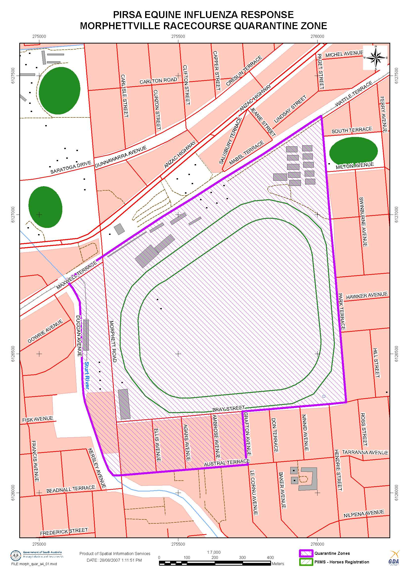
Schedule 2
The Globe Derby prescribed area comprises that area of the State as indicated by the shaded area on the plan in this Schedule and is generally bounded by Globe Derby Drive to the intersection of Globe Derby Drive and Whites Road, thence in a north-easterly direction along White’s Road to the intersection of Whites Road and Port Wakefield Road, thence in a generally southerly direction to the intersection of Globe Derby Drive and Port Wakefield Road.
Plan
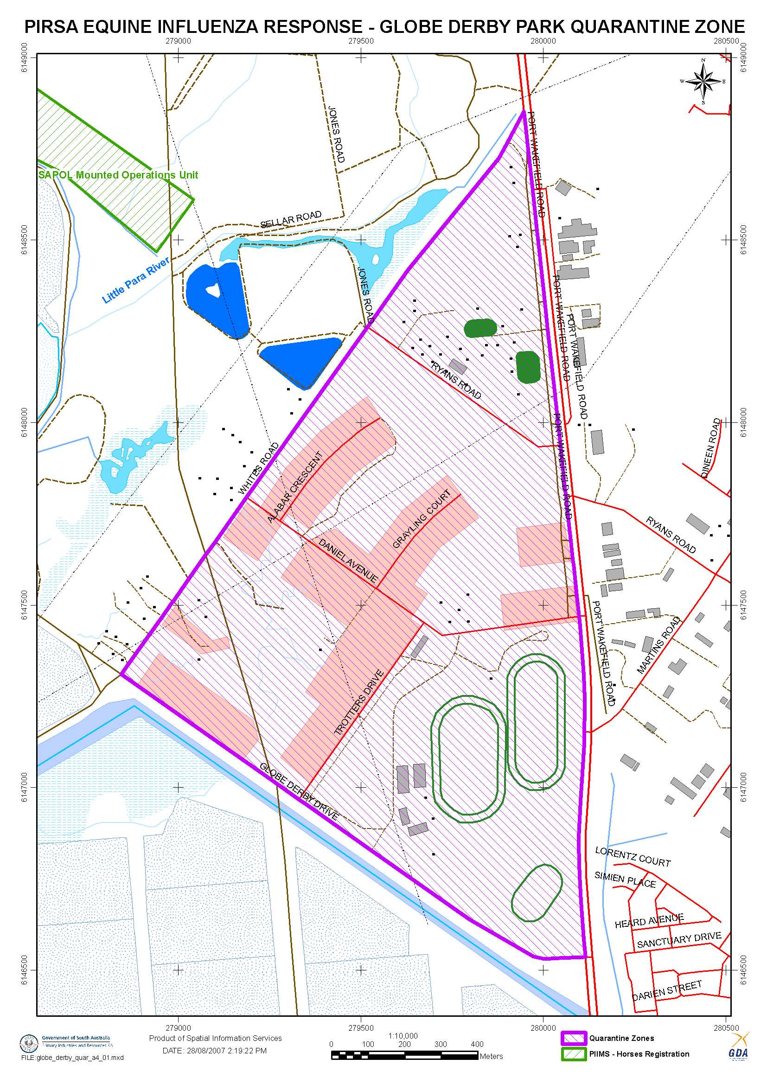
Dated 29 August 2007.
Patrick Conlon, Acting Minister for Agriculture, Food and Fisheries

T. GOODES, Government Printer, South Australia

