No. 59 3457

THE SOUTH AUSTRALIAN

GOVERNMENT GAZETTE
www.governmentgazette.sa.gov.au

PUBLISHED BY AUTHORITY

ALL PUBLIC ACTS appearing in this GAZETTE are to be considered official, and obeyed as such

ADELAIDE, THURSDAY, 30 AUGUST 2007

CONTENTS

Page
Appointments, Resignations, Etc. 3458
Corporations and District Councils—Notices 3590
Crown Lands Act 1929—Notices 3459
Development Act 1993—Notices 3460
Fisheries Act 1982—Notices 3467
Housing Improvement Act 1940—Notices 3469
Land and Business (Sale and Conveyancing) Act 1994—
Notices 3472
Liquor Licensing Act 1997—Notices 3472
Mining Act 1971—Notices 3476
National Electricity Law—Notice 3479
Native Title (South Australia) Act 1994—Notices 3479
Partnership Act 1891—Notice 3596
Petroleum Act 2000—Notices 3479
Port Augusta Circuit Court—Notice 3482
Prevention of Cruelty to Animals Act 1985—Notice 3482
Private Advertisement 3596
Proclamations 3547
Public Trustee Office—Administration of Estates 3596
Radiation Protection and Control Act 1982—Notice 3483

REGULATIONS
Development Act 1993 (No. 219 of 2007) 3549
Summary Procedure Act 1921 (No. 220 of 2007) 3551

Page
Summary Procedure Act 1921 (No. 221 of 2007) 3553
Electricity Act 1996 (No. 222 of 2007) 3555
Gas Act 1997 (No. 223 of 2007) 3557
Firearms Act 1977 (No. 224 of 2007) 3559
Subordinate Legislation Act 1978 (No. 225 of 2007) 3561
South Australian Housing Trust Act 1995
(No. 226 of 2007) 3568
Workers Rehabilitation and Compensation
Act 1986 (No. 227 of 2007) 3570
Workers Rehabilitation and Compensation
(Territorial Application of Act) Amendment
Act 2006 (No. 228 of 2007) 3573
Survey Act 1992 (No. 229 of 2007) 3575
Public Corporations Act 1993 (No. 230 of 2007) 3587
Roads (Opening and Closing) Act 1991—Notice 3483
Road Traffic Act 1961—Notices 3490
Road Traffic Act (Operation of Certain Photographic
Detection Devices—Approved Locations) Notice 2006 3484

RULES OF COURT
Supreme Court Bail Review Rules 1985
(Amendment No. 2) 3545
Survey Act 1992—Notice 3483
Training and Skills Development Act 2003—Notice 3546

GOVERNMENT GAZETTE NOTICES
ALL poundkeepers’ and private advertisements forwarded for publication in the South Australian Government Gazette must be PAID FOR PRIOR TO INSERTION; and all notices, from whatever source, should be legibly written on one side of the paper only and sent to Government Publishing SA so as to be received no later
than 4 p.m. on the Tuesday preceding the day of publication. Phone 8207 1045 or Fax 8207 1040. E-mail: governmentgazette@dpc.sa.gov.au. Send as attachments in Word format and please confirm your transmission with a faxed copy of your document, including the date the notice is to be published and to whom the notice will be charged. The Government Gazette is available online at: www.governmentgazette.sa.gov.au

Department of the Premier and Cabinet
Adelaide, 30 August 2007
HIS Excellency the Governor in Executive Council has been pleased to appoint the undermentioned to the Public and Environmental Health Council, pursuant to the provisions of the Public and Environmental Health Act 1987:
Member: (from 9 September 2007 until 8 September 2010)
John Cugley
Ian Hawkins
Deputy Member: (from 9 September 2007 until 27 January 2008)
Christopher William Minto Lease (Deputy to Buckett)
Kaye Arnold (Deputy to Cromar)
Deputy Member: (from 9 September 2007 until 8 September 2010)
Fiona Louise Harvey (Deputy to Cugley)
Deborah Hemmes (Deputy to Hawkins)
By command,
Paul Caica, for Premier
HEACS/07/222

Department of the Premier and Cabinet
Adelaide, 30 August 2007
HIS Excellency the Governor in Executive Council has been pleased to appoint the undermentioned to the Independent Gambling Authority, pursuant to the provisions of the Independent Gambling Authority Act 1995:
Member: (from 1 October 2007 until 30 September 2010)
Robyn Lee Buckler
Dale Peter West
By command,
Paul Caica, for Premier
MGA07/07CS

Department of the Premier and Cabinet
Adelaide, 30 August 2007
HIS Excellency the Governor in Executive Council has been pleased to appoint the undermentioned to the Medical Professional Conduct Tribunal, pursuant to the provisions of the Medical Practice Act 2004:
Member: (from 30 August 2007 until 29 August 2010)
Maree O’Keefe
By command,
Paul Caica, for Premier
HEACS/07/182

Department of the Premier and Cabinet
Adelaide, 30 August 2007
HIS Excellency the Governor in Executive Council has been pleased to appoint the undermentioned to the Controlled Substances Advisory Council, pursuant to the provisions of the Controlled Substances Act 1984:
Member: (from 30 August 2007 until 29 August 2010)
Keith Robert Evans
Penelope Anne Briscoe
Thomas Ian Osborn
Karen Marie Hannon
Jason White
Caroline Mary Ward
Julia Nicholls
Lloyd Norman Sansom
Christopher Simon Reynolds
Judy Carol Gillett-Ferguson
Deputy Member: (from 30 August 2007 until 29 August 2010)
Geoffrey Donald Anderson (Deputy to Evans)
Timothy James Semple (Deputy to Briscoe)
Peter John Harvey (Deputy to Osborn)
Matthew Russell Goode (Deputy to Hannon)
Robert Leonard Ali (Deputy to White)
Matthew Oliver Cox (Deputy to Ward)
Kate Elizabeth Carracher (Deputy to Nicholls)
David Leslie Simon (Deputy to Sansom)
Elizabeth Anne Hender (Deputy to Reynolds)
Judy Smith (Deputy to Gillett-Ferguson)
Presiding Member: (from 30 August 2007 until 29 August 2010)
Keith Robert Evans
By command,
Paul Caica, for Premier
HEACS/07/220

Department of the Premier and Cabinet
Adelaide, 30 August 2007
HIS Excellency the Governor in Executive Council has been pleased to appoint the undermentioned to the Residential Tenancies Tribunal, pursuant to the provisions of the Residential Tenancies Act 1995:
Bailiff: (from 30 August 2007 until 30 June 2012)
Michael John Martin
By command,
Paul Caica, for Premier
MCA07/028CS

Department of the Premier and Cabinet
Adelaide, 30 August 2007
HIS Excellency the Governor in Executive Council has been pleased to appoint the undermentioned to the Trade Standards Advisory Council, pursuant to the provisions of the Trade Standards Act 1979:
Member: (from 30 August 2007 until 29 August 2010)
Giulia Bernardi
Ronald Somers
Brendon John Hore
Julie Bradshaw
David Colin Schomburgk
Jean Hutchinson
Presiding Member: (from 30 August 2007 until 29 August 2010)
Giulia Bernardi
By command,
Paul Caica, for Premier
MCA07/30CS

Department of the Premier and Cabinet
Adelaide, 30 August 2007
HIS Excellency the Governor in Executive Council has been pleased to appoint the undermentioned to the South Australian Multicultural and Ethnic Affairs Commission, pursuant to the provisions of the South Australian Multicultural and Ethnic Affairs Commission Act 1980:
Member: (from 30 August 2007 until 29 August 2010)
Antonio Simeone
Promila Gupta
By command,
Paul Caica, for Premier
AGO0433/02CSTEMP1

Department of the Premier and Cabinet
Adelaide, 30 August 2007
HIS Excellency the Governor in Executive Council has been pleased to appoint the undermentioned to the South Australian Multicultural and Ethnic Affairs Commission, pursuant to the provisions of the South Australian Multicultural and Ethnic Affairs Commission Act 1980:
Member: (from 1 January 2008 until 31 December 2010)
Hieu Van Le
Peter Ppiros
Chair: (from 1 January 2008 until 31 December 2010)
Hieu Van Le
Deputy Chair: (from 1 January 2008 until 31 December 2010)
Peter Ppiros
By command,
Paul Caica, for Premier
AGO0082/07CS

Department of the Premier and Cabinet
Adelaide, 30 August 2007
HIS Excellency the Governor in Executive Council has been pleased to appoint the Honourable Paul Holloway, MLC, Minister for Police, Minister for Mineral Resources Development and Minister for Urban Development and Planning to be also Acting Deputy Premier, Acting Treasurer, Acting Minister for Industry and Trade and Acting Minister for Federal/State Relations for the period from 7 September 2007 to 24 September 2007 inclusive, during the absence of the Honourable Kevin Owen Foley, MP.
By command,
Paul Caica, for Premier
TF07/070CS

Department of the Premier and Cabinet
Adelaide, 30 August 2007
HIS Excellency the Governor in Executive Council has suspended from office the Justices of the Peace listed for the periods specified, with effect from 30 August 2007, pursuant to section 10 of the Justices of the Peace Act 2005:
Name Suspension until
Angela Gaye Curtis 7 January 2008
Thomas Frank Easling 29 March 2008
Gregory James Humphries 26 February 2009
David James Lightfoot 31 August 2007
Joan Carmel Weber 30 March 2009
By command,
Paul Caica, for Premier
AGO0079/07CS

CROWN LANDS ACT 1929: SECTION 5
TAKE NOTICE that pursuant to the Crown Lands Act 1929, I, GAIL GAGO, Minister for Environment and Conservation, Minister of the Crown to whom the administration of the Crown Lands Act 1929 is committed DO HEREBY:
1. Resume the land defined in The First Schedule.
2. Dedicate the Crown Land defined in The Second Schedule as Public Road.
The First Schedule
Reserve for District Council Purposes, now identified as Allotment 135, Town of Freeling, Hundred of Nuriootpa, the proclamation of which was published in the Government Gazette of 7 March 1907 at page 553, The Second Paragraph, being the whole of the land comprised in Crown Record Volume 5755, Folio 153.
The Second Schedule
Allotment 135, Town of Freeling, Hundred of Nuriootpa, County of Light, being within the district of the Light Regional Council.
Dated 30 August 2007.
Gail Gago, Minister for Environment and Conservation
DEH 10/1300

CROWN LANDS ACT 1929: SECTION 5
TAKE NOTICE that pursuant to the Crown Lands Act 1929, I, GAIL GAGO, Minister for Environment and Conservation, Minister of the Crown to whom the administration of the Crown Lands Act 1929 is committed DO HEREBY:
1. Dedicate the Crown Land defined in The First Schedule as a Camping Ground Reserve and declare that such land shall be under the care, control and management of The District Council of Streaky Bay.
2. Dedicate the Crown Land defined in The Second Schedule as Public Road.
The First Schedule
Allotment 4 of Deposited Plan 73266, Hundred of Wren-fordsley, County of Robinson, exclusive of all necessary roads.
The Second Schedule
Allotments 5, 6 and 7 of Deposited Plan 73266, Hundred of Wrenfordsley, County of Robinson, being within the district of Streaky Bay.
Dated 30 August 2007.
Gail Gago, Minister for Environment and Conservation
DENR 08/0731

DEVELOPMENT ACT 1993: SECTION 48
Decision by the Development Assessment Commission as Delegate of the Governor
Preamble
1. A proposal from Baillie Lodges (hereafter ‘the applicant’) to develop a nature based tourism resort at Hanson Bay, Kangaroo Island has been under consideration under Division 2 of Part 4 of the Development Act 1993.
2. The proposal has been the subject of a Public Environmental Report (PER) and an Assessment Report under sections 46 and 46C of the Development Act 1993, and is hereafter referred to as the ‘proposed Major Development’.
3. The proposed Major Development was the subject of a development application lodged in February 2005 by the applicant. The said application has been amended and expanded upon by the applicant’s Public Environmental Report, dated 24 March 2006 and the applicant’s Response Document, dated 4 July 2006.
4. The Governor was satisfied that an appropriate Public Environmental Report and an Assessment Report have been prepared in relation to the proposed Major Development, in accordance with sections 46 and 46C, Division 2 of Part 4 of the Development Act 1993, and have had regard, when considering the proposed Major Development, to all relevant matters under section 48 (5) of the Development Act 1993.
5. Recent amendments that have been approved are contained in the following documents and drawings:
• An application for the Building Rules approval for the Staff Village Stage 1 construction was made on 4 December 2006.
• An application for approval for the Construction Environmental Management and Monitoring Plan (CEMMP) was made on 11 December 2006.
• An application for approval for the revised Construction Environmental Management and Monitoring Plan (CEMMP) was made on 30 January 2007.
• An application for the Building Rules approval for the spa retreat (Stage 2) and the footings of the accommodation suites (Stage 3) was made on 20 February 2007.
• An application for the building rules approval for the guest units and verandahs (Stage 4 superstructure) and for the lodge (Stage 5 substructure), retaining walls and pool was made on 25 May 2007.
• An application for the construction of a telecommunications tower (Stage 6) on 15 May 2007.
6. Application has now been made to the Development Assessment Commission as Delegate of the Governor under section 48 of the Development Act 1993, to grant Building Rules approval for the superstructure framework (Stage 7).
7. The Development Assessment Commission has in considering the application had regard to all relevant matters under section 48 (5) of the Development Act 1993.
8. The Development Assessment Commission is satisfied that the variation does not require the preparation of a further amended Public Environmental Report.
Decision
PURSUANT to section 48 of the Development Act 1993 and with the advice and consent of the Executive Council and having due regard to the matters set out in section 48 (5) and all other relevant matters, the Development Assessment Commission, as delegate of the Governor:
(a) grant a provisional development authorisation in relation to the proposed major development, subject to the conditions and Notes to Applicant below;
(b) specify all matters relating to this provisional development authorisation as matters in respect of which conditions of this authorisation may be varied or revoked, or new conditions attached;
(c) specify for the purposes of section 48 (11) (b) the period of two years from the date hereof as the time within which substantial work must be commenced on-site failing which the Governor may cancel this authorisation.
Pursuant to section 48 and Regulation 64 (1) of the Development Act 1993, reserve the decision on the following matter:
(a) compliance with the Building Rules in relation to the remaining components of Stage 8 of the proposed major development (refer to Notes to the applicant below for further information);
(b) further assessment and certification in respect of the Building Rules for components of the proposed development.
Conditions of Approval
1. Except where minor amendments may be required by other legislation, or by conditions imposed herein, the proposed major development shall be undertaken in strict accordance with:
(a) the following drawings contained with the Public Environmental Report for Southern Ocean Lodge dated 24 March 2006, except to the extent that they are varied by the plans described in paragraph 1 (b):
• Drawing Titled: ‘Location Plan’; Drawing Number 392-M-1, dated March 2006.
• Drawing Titled: ‘Site Plan’; Drawing Number 392-M-2, dated March 2006.
• Drawing Titled: ‘Lodge Plan’; Drawing Number 392-M-3, dated March 2006.
• Drawing Titled: ‘Lodge’; Drawing Number 392-M-4, dated March 2006.
• Drawing Titled: ‘Lodge Elevations’; Drawing Number 392-M-5, dated March 2006.
• Drawing Titled: ‘Typical Suites 1 to 24’; Drawing Number 392-M-6, dated March 2006.
• Drawing Titled: ‘Lodge and Suites’; Drawing Number 392-M-7, dated March 2006.
• Drawing Titled: ‘Spa Retreat’; Drawing Number 392-M-9, dated March 2006.
• Drawing Titled: ‘Detailed Site Plan’; Drawing Number 392-M-10, dated March 2006.
• Drawing Titled: ‘Fire Protection System’; Drawing Number 392-M-12, dated March 2006.
• Drawing Titled: ‘Entrance Walkway to Lodge’; Drawing Number 392-M-13, dated March 2006.
• Drawing Titled: ‘Restaurant and Lounge’; Drawing Number 392-M-14, dated March 2006.
• Drawing Titled: ‘Suites Elevation’; Drawing Number 392-M-15, dated March 2006.
• Drawing Titled: ‘Great Room’; Drawing Number 392-M-16, dated March 2006.
• Drawing Titled: ‘Guest Suite’; Drawing Number 392-M-17, dated March 2006.
(b) the following drawings contained within the applicant’s Response Document, dated 4 July 2006:
• Drawing Titled ‘Walking Trails’.
(c) the following documents:
• Development application, dated February 2005 (except to the extent that it may be varied by a subsequent document in this paragraph).
• Public Environmental Report, Southern Ocean Lodge prepared by Baillie Lodges and Parsons Brinckerhoff, dated 24 March 2006 (except to the extent that it may be varied by a subsequent document in this paragraph).
• Response Document, prepared by Baillie Lodges and Parsons Brinckerhoff, dated 4 July 2006 (except to the extent that it may be varied by a subsequent document in this paragraph).
• Assessment Report prepared by the Minister for Urban Development and Planning, dated September 2006 (except to the extent that it may be varied by a subsequent document in this paragraph).
• Building Rules Certification dated 4 December 2006 by Rocco Ciancio Private Certifier and Building Surveyor.
• Construction Environmental Management and Monitoring Plan (CEMMP) dated 11 December 2006.
• Revised Construction Environmental Management and Monitoring Plan (CEMMP/Rev A) dated 30 January 2007.
• Building Rules Certification dated 20 February 2007 by Rocco Ciancio Private Certifier and Building Surveyor in regards to the spa retreat (Stage 2) and the substructure of the accommodation suites (Stage 3).
• Building Rules Certification dated 25 May 2007 by Rocco Ciancio Private Certifier and Building Surveyor in regards to the guest units and verandahs (Stage 4).
• Building Rules Certification dated 25 May 2007 by Rocco Ciancio Private Certifier and Building Surveyor in regards to the lodge (Stage 5 substructure), retaining walls and pool (Stage 5).
• Report and accompanying plans on Proposed Antenna Support Structure, 12 m triad telecommunications tower—Hanson Bay Lodge.
• Building Rules Certification dated 27 July 2007 by Rocco Ciancio Private Certifier and Building Surveyor in regards to the telecommunications tower—Hanson Bay Lodge.
• Building Rules Certification dated 20 August 2007 by Rocco Ciancio Private Certifier and Building Surveyor in regards to the superstructure framework—Hanson Bay Lodge.
2. The applicant shall submit further information and application(s) in relation to the matters that have been reserved.
3. No building works on any part of the development may commence until a favourable decision has been notified to the applicant by the Governor or the Governor’s delegate in respect of the reserved matters referred to above and until a development authorisation under section 48 (2) is granted.
4. An Operational Environmental Management and Monitoring Plan (OEMMP) for the operational phase of the development shall be prepared to the satisfaction of the Governor or her delegate, prior to commencement of operations. (Refer to Notes to Applicant below).
5. All works and site activities shall be undertaken in accordance with the approved Construction Environmental Management and Monitoring Plan.
6. Normal operating hours for construction activities and truck movements to and from the site shall be from 7 a.m. to 7 p.m., Monday to Sunday inclusive. (Refer to Notes to Applicant relating to Environment Protection Authority noise emission policies).
7. The wastewater collection and treatment system shall be designed to ensure that the obligations of the Environment Protection (Water Quality) Policy 2004 are met, and to ensure that effluent does not overflow or escape from drains, pipes, sumps, tanks, storage/treatment basins into any watercourse, or into stormwater drains which do not drain into the effluent collection, treatment and disposal system, except where the effluent complies with criteria in the above policy.
8. The level of wastewater generated and consequent irrigation rates shall be closely monitored and if greater than 8 500 L/day then irrigation area and rates modified to ensure compliance with this limit.
9. Information on all signage (directional and interpretative) including detail on size, colour and content, shall be prepared to the satisfaction of the Governor or delegate, prior to its installation.
10. Pedestrian access arrangements over Crown land and management of its impacts shall be agreed with the Department for Environment and Heritage prior to opening of the Lodge. The beach shall remain unobstructed for public access.
11. A raised timber boardwalk shall be provided along the walking trail to the east of the suites as indicated in Figure 3.1 of the Response Document. Detail on the dimensions and the precise location of the boardwalk shall be prepared to the satisfaction of the Governor or delegate prior to its installation.
12. A strategy to minimise impact on fauna from vehicle traffic using the private entrance road shall be prepared to the satisfaction of the Governor or delegate.
13. Clearing of vegetation shall not exceed that indicated in the PER. Revegetation of impacted areas shall be undertaken as soon as possible following construction.
14. Biomatting or mulching on cleared areas shall occur until such time that revegetation is established.
15. Aboveground fuel tanks shall be bunded and sealed in a manner which will provide capacity for a minimum of 30 000 litres.
16. All stormwater run-off from car parking areas, driveways and other hard surfaced areas shall be collected, contained, treated as necessary, and disposed of in a stormwater management system so that there is no contamination of water resources (surface or underground).
17. Storage of any material with the potential to degrade water quality shall be within a bunded area constructed in accordance with Australian Standard 1940.
18. The helipad shall only be used in emergencies.
19. In keeping with its commitment in the PER, the proponent and any subsequent operator shall not clear boundary vegetation, whether or not such clearance is permitted under the Native Vegetation Act 1991.
20. Revegetation of the site, with locally indigenous species, shall be undertaken if the operation fails and the site is decommissioned.
21. The restaurant shall not be open to the general public.
22. A Bushfire Management Plan, prepared in consultation with the Country Fire Service, shall be submitted for approval by the Governor or delegate.
23. Public and Environmental Health Act 1987, approval of the method of disposal of sewage and sullage from the building shall be obtained from Council prior to work being commenced. (Regulation 77).
24. For buildings within 1 km of the coastline all external metal roof cladding shall be corrosion protected and all connectors used in timber fixings shall be corrosion protected with a protective coating in accordance with the requirements of AS1214, AS1397, AS1562, AS1684, AS1720, AS/NZS2179, AS/NZS2699, AS3623, AS4100, AS/NZS4534, AS/NZS4600 and AS/NZS4791. (BCA B1.3).
25. Water storage tank calculations and details shall be submitted to the private certifier for approval prior to this work commencing. (BCA B1.3).
26. Materials and assemblies in the building shall have Fire Hazard Properties that comply with the requirements of Specification C1.10 and in accordance with the requirements of this part of the BCA. (BCA C1.10).
27. Water storage tanks overflow shall be discharged at least 5 m away from buildings and site boundaries or piped to the street watertable or site drainage easement in accordance with the requirements of AS/NZS3500.3.2 or AS/NZS3500.5. (BCA F1.1).
28. An additional washing/drying machine (total of three required) shall be installed in the laundry for the use of the residents of the Bed-sit units in accordance with the requirements of this part of the BCA. (BCA F2.1).
29. The Building Rules Certification dated 14 December 2006, does not include the cabins, service buildings, reception/restaurant and spa retreat, which shall form the basis of further staged application(s) for Building Rules assessment. Note that there are timeframes for which the proposal must be substantially completed from the dated of issue of the staged Development Approval. Sufficient time must be allowed for the lodging, processing, issue of future staged consents and Development Approvals, including the construction of future stage(s) prior to the expiration of the validity of the Development Approval (section 39 and Regulation 46).
30. The building works proposed shall conform to the provisional development plan consent requirements (section 93).
31. The disposal of sewage and sullage from the spa retreat shall be undertaken in accordance with the Public and Environmental Health Act approval obtained from the SA Health Commission. (Regulation 77).
32. The door to the WC must have demountable hinges and be removable from outside the WC in the event that an emergency removal of the occupant is required. (BCA F2.5).
33. The heater and flue/chimney must be constructed and installed to comply with the requirements of AS/NZS2918. (BCA G2.2 and G2.3).
34. Portable fire extinguishers and fire blankets (if applicable) must be installed in the building in accordance with the requirements of this part of the BCA. (BCA E1.6).
35. Exit lights must be installed adjacent doors D01 and D02 in the path of egress from the building in accordance with AS 2444 and in accordance with this part of the BCA. (BCA B1.3).
36. The finished paving level around the masonry wall must be set down at least 75 mm below the external wall damp proof course. (BCA B1.3).
37. The Building Rules Certification dated 20 February 2007, does not include the staff village, staff accommodation, cabin superstructure, service building and reception/restaurant, which shall form the basis of further staged application(s) for Building Rules assessment. (Note that there are timeframes for which the proposal must be substantially completed from the date of issue of the staged Development Approval. Sufficient time must be allowed for the lodging, processing, issue of future staged consents and Development Approvals, including the construction of future stage(s) prior to the expiration of the validity of the Development Approval section 39 and Regulation 46).
38. The timber durability and weather exposure requirements for exposed structural timbers, including supporting timber members must be in accordance with Clause 1.10 of AS 1684 National Timber Framing Code. (BCA B1.3).
39. Roof stormwater during the construction phase must be piped to water storage tanks or discharged at least 5 m away from buildings, any septic systems or site boundaries with the requirements of AS/NZS3500.3.2 or AS/NZS3500.5 and without damage to the surrounding land and flora. (BCA B1.3). Note that the permanent storm water disposal system will be assessed as part of the completion consent stage.
40. The public corridor serving the units must be divided with smoke proof doors at intervals of not more than 40 m in accordance with BCA Clause C2.14 and this part of the BCA. (BCA CP1, CP2). Note this will be reviewed as part of the completion consent stage.
41. Doors to the storerooms and equipment cupboards opening into the public corridor must be self-closing, tight fitting, solid core, not less than 35 mm thick in accordance with BCA Clause 3.11. (BCA CP1, CP2, CP8).
42. The floor above the ‘sub-floor’ plant room must be fire separated from the unit above with a floor having at least FRL30/30/30 or with a fire-protective covering ceiling directly below the floor structure of the units in accordance with BCA Spec. C1.1-5.1. (BCA CP1, CP6).
43. The ‘sub-floor’ plant room must be enclosed with walls having a fire rating of not less than FRL60/60/60 in accordance with BCA Spec. C1.1-5.1. (BCA CP1, CP6).
44. The corridor widths must be at least 1 000 mm adjacent to the storeroom door positions in accordance with this part of the BCA. (BCA DP1, DP2, D1.6).
45. The public corridor must be fitted with exits leading to the open space located such that unit entrance doors are not more than 6 m to the nearest single exit in accordance with BCA Clause D1.4 and exits shall be spaced not further than 45 m apart in accordance with BCA Clause D1.5. (BCA DP1, DP2).
46. The entrance door-sets to the units must be sound insulated to at least Rw30 in accordance with the requirements of this part of the BCA. (BCA FP5.3, F5.5).
47. The ‘sub-floor’ plant room must be sound insulated from the adjoining units with walls with at least Rw50 (airborne) and floors with at least Rw+Ctr50 (airborne) in accordance with BCA Clauses F5.4 and F5.5. (BCA FP5.1, FP5.2).
48. For buildings within 1 km of the coastline all external metal roof cladding must be corrosion protected, any external leaf brick lintels must be hot dip galvanised, internal and external steelwork and all connectors used in timber fixings must be corrosion protected with a protective coating in accordance with the requirements of AS1214, AS1397, AS1562, AS1684, AS1720, AS/NZS2179, AS/NZS2699, AS3623, AS4100, AS/NZS4534, AS/NZS4600 and AS/NZS4791. (BCA B1.3).
49. The building area must be treated and continuously protected and maintained against attack from termites in accordance with the requirements of AS3660.1. (BCA B1.3).
50. The finished paving level around the masonry wall must be set down at least 75 mm below the external wall damp proof course. (BCA B1.3).
51. The slab edge rebate must be constructed to have a depth of at least 20 mm and a width of at least the thickness of the masonry external leaf plus the cavity gap in accordance with the BCA. (BCA B1.3).
52. A person must not fill the swimming pool with water, unless, the pool is enclosed by a fence that complies with AS1926 and Performance Requirement P2.5.3. (Regulation 83B).
53. The building loads used in this consent stage are required to be reaffirmed by the design engineer as part of the superstructure consent stage. Alterations to the building loads in the superstructure design, including the structural adequacy of the footings and foundation forming part of this staged consent will also need to be confirmed by the design engineer during the superstructure consent stage application. (Section 39 and Regulation 46).
54. The clearance for the telecommunications tower shall be undertaken using handheld equipment to minimise the impact of machinery on native vegetation on the actual site.
55. Any necessary cables for the telecommunications tower shall be located within the existing road surface to minimise vegetation clearance.
56. For structures within 1 km of the coastline all metal must be corrosion protected with a protective coating in accordance with the requirements of this part of the Building Code of Australia (BCA). (BCA P2.1).
57. This consent does not include the lodge superstructure cladding/walling enclosure, building fit-out, building services or building occupancy, which shall form the basis of a future staged application for Provisional Building Rules assessment. (Note that there are timeframes for which the proposal must be substantially completed from the date of issue of the staged Development Approval. Sufficient time must be allowed for the lodging, processing, issue of future staged consents and Development Approvals, including the construction of future stage prior to the expiration of the validity of the Development Approval. (Section 39 and Regulation 46)).
Notes to Applicant
1. All matters relating to this provisional development authorisation are matters in respect of which conditions of this authorisation may be varied or revoked, or new conditions attached.
2. A decision on building rules will only be made after a Building Rules assessment and certification has been undertaken and issued by the Kangaroo Island Council or a private certifier, in accordance with the provisions of the Development Act 1993 and after the Minister for Urban Development and Planning receives a copy of all relevant certification documentation, as outlined in Regulation 64 of the Development Regulations 1993.
3. Pursuant to Development Regulation 64, the applicant is advised that the Kangaroo Island Council or private certifier conducting a Building Rules assessment must:
(a) provide to the Minister a certification in the form set out in Schedule 12A of the Development Regulations 1993 in relation to the building works in question; and
(b) to the extent that may be relevant and appropriate:
(i) issue a Schedule of Essential Safety Provisions under Division 4 of Part 12;
(ii) assign a classification of the building under these regulations; and
(iii) ensure that the appropriate levy has been paid under the Construction Industry Training Fund 1993.
Regulation 64 of the Development Regulations 1993 provides further information about the type and quantity of all Building Rules certification documentation for Major Developments required for referral to the Minister for Urban Development and Planning.
4. The Kangaroo Island Council or private certifier undertaking the Building Rules assessment must ensure that the assessment and certification are consistent with this provisional development authorisation (including Conditions or Notes that apply in relation to this provisional development authorisation).
5. An application to vary the Major Development or any of its components may be submitted. Whether a new PER and Assessment Report need to be prepared will depend on the nature of the variation and the lapse of time since the preparation of the PER.
6. The applicant’s CEMMP and OEMMP should be prepared taking into consideration, and with explicit reference to, relevant Environment Protection Authority policies and guideline documents, including but not limited to:
• the Environment Protection (Air Quality) Policy 1994;
• the Environment Protection (Water Quality) Policy 2003;
• the Occupational Health and Safety Regulations;
• EPA Guidelines on Odour Assessment, using odour source modelling 2003;
• EPA Handbook for Pollution Avoidance on Commercial and Residential Building Sites 2004;
• EPA Bunding and Spill Management Guidelines 2004; and
• EPA Stormwater Pollution Prevention Codes of Practice, in addition to other legislative requirements and Guidelines/ Australian Standards requiring compliance.
The following management and monitoring plans may be incorporated into the CEMMP or OEMMP as appropriate:
• Vegetation Monitoring and Management Plan.
• Site Construction Monitoring and Management Plan.
• Stormwater Monitoring and Management Plan.
7. The proponent is advised of the General Environmental Duty under section 25 of the Environment Protection Act 1993, which requires that a person must not undertake any activity, which pollutes, or may pollute; without taking all reasonable and practical measures to prevent or minimise harm to the environment.
8. Any information sheets, guidelines documents, codes of practice, technical bulletins, etc. that are referenced in this decision notice have been provided to the planning authority or may be accessed on the following website:
http://www.environment.sa.gov.au/epa/pub.html.
9. The Minister has a specific power to require testing, monitoring and auditing under section 48C of the Development Act 1993.
10. For the purposes of section 48 (11) (b) the period of two years from the dated hereof as the time within which substantial work must be commenced on-site failing which the Governor may cancel this authorisation.
11. The applicant is reminded of its obligations under the Aboriginal Heritage Act 1988 whereby any ‘clearance’ work, which may require permission to disturb damage or destroy Aboriginal Sites, must be undertaken with the full authorisation of the Minister for Aboriginal Affairs and Reconciliation, according to section 23 of the Aboriginal Heritage Act 1988. Construction staff should be trained in the recognition of potential objects or remains.
12. The Aboriginal Affairs and Reconciliation Division of the Department of the Premier and Cabinet (AARD) strongly recommends that the proponent contact representatives of the Kaurna, Ngarrindjeri and Ramindjeri peoples before the project proceeds, to ensure respect for their heritage interests and well being.
13. The applicant is required to obtain a separate approval from the Department of Health (Wastewater Management Unit) for the other elements of the on-site collection, treatment and disposal of wastewater.
14. A disposal path for the spa water shall be designed to comply with the requirements of the relevant authority under the Public and Environmental Health Act 1987.
15. All community drinking water supplies shall comply with the Food Act 2001 which requires compliance with the NH&MRC’s Australian Drinking Water Guidelines (2004).
16. In relation to the operation of the spa, reference should be made to the South Australian Health Commission Code ‘Standard for the operation of swimming pools and spa pools in South Australia’ and ‘Supplement C, Bromine disinfection of swimming pool, spa pool, hydrotherapy pool and waterslide pool’.
17. This decision does not include approval for use of bore water. A separate application to vary the Governor’s approval is required in the instance that any proposal to use the bore water is put forward.
18. Should surface irrigation be desired, then the effluent must be disinfected to meet the requirements of the South Australian Reclaimed Water Guidelines (1999).
19. NH&MRC’s Australian Drinking Water Guidelines (2004) may be accessed at:
http://www.nhmrc.gov.au/publications/_files/awgfull.pdf.
Compliance with the Guidelines requires that a risk management plan must be developed and the implementation of such a plan will require the application of the NH&MRC’s Community Water Planner, which may be accessed at:
http://www.nhmrc.gov.au/publications/_files/awg0.pdf.
20. The proponent is required to develop a Phytophthora hygiene strategy, which shall include washdown procedures for heavy machinery, graders, bulldozers prior to entry to the site. A trailer-mounted Phytophthora Washdown Unit is available for hire from Kangaroo Island Council.
21. The proponent needs to consult with the NRM Board over arrangements to minimise the risk of spreading weeds during works.
22. Diesel motors shall conform to the mandatory provisions of the Environmental Protection (Air Quality) Policy 1994 (SA) for particulates and carbon monoxide in exhaust gas.
23. A separate approval is required under the Environment Protection and Biodiversity Conservation Act 1999.
24. The Building Rules certification dated 25 May 2007, does not include the building occupancy, fire services, ‘smoke control’ systems and permanent storm water disposal system, which shall form the basis of a future staged application for Provisional Building Rules assessment. Note that there are time frames for which the proposal must be substantially completed from the data of issue of the staged Development Approval. Sufficient time must be allowed for the lodging, processing, issue of future staged consents and Development Approvals, including the construction of future stage prior to the expiration of the validity of the Development Approval. (Section 39 and Regulation 46).
25. This consent does not include the lodge superstructure or building occupancy, which shall form the basis of a future staged application for Provisional Building Rules assessment. Note that there are timeframes for which the proposal must be substantially completed from the date of issue of the staged Development Approval. Sufficient time must be allowed for the lodging, processing, issue of future staged consents and Development Approvals, including the construction of future stage prior to the expiration of the validity of the Development Approval. (Section 39 and Regulation 46).
Notes on Building Rules Certification (Stages 1, 2, 3, 4, 5, 6 and 7)
26. It is advisable to contact authorities responsible for the supply of services such as water, electricity, telephone, gas, the Department of Transport, Australia Post, Environment Protection Authority (EPA) and easement owners/holders, where applicable, seeking their requirements prior to building work commencing on site.
27. All building work must be performed in accordance with the approved documents. Any variations to building design, materials or systems that affect the structural soundness of the safety of the building must be approved by the private certifier prior to such alteration occurring. Alternate and/or substitute building products must meet the Deemed- To Satisfy provisions or the Performance Requirements of the BCA.
28. The building contains materials that are susceptible to termite attack. The details provided indicate that physical barriers, in accordance with AS3660.1 requirements are to be used to protect the building. The building owner and the tenant are advised that an important part of the protection involves regular inspections for termite activity and appropriate action as and when required.
29. Propriety materials and products specified in the approved documents must be selected and installed in accordance with the manufacturers written recommendations, specifications and with the relevant standards.
30. For cut and fill sites, retaining walls are required to be installed on the boundary to retain any cut or fill within the property boundaries.
31. The building work proposed has been checked for compliance with the minimum allowable requirements contained within the legislation and standards. The owner, the applicant and the builder are advised to seek advice from the designers involved to determine the implications of the design criteria chosen for this project.
32. The owner, the applicant and the builder are advised to ensure that ancillary works are completed in a timely manner to ensure that the health of persons and damage to structures do not occur. This includes any air-conditioning works, paving, plumbing (both septic and water), landscaping, fences, soil retention or activity.
33. The legislation provides that defined activities are complying. It is the owner, the applicant, the builder and the tenant’s responsibilities to ensure that any such activity is carried out in a manner that is not detrimental to persons or structures.
34. Where articulation of the walls of the building are required, these must be installed in accordance with the manufacturer requirements or as specified within the Engineers Footing Construction Report.
35. The installation of glazing must be in accordance with AS1288 and is to include safety glass for glazed doors, side panels, full height windows and glass located over or adjacent bath/showers.
36. The consents covering Stages 1, 2, 3, 4, 5, 6 and 7 do not imply compliance with the Equal Opportunity Act 1984 (State Legislation), nor with the Disability Discrimination Act 1993 (Commonwealth Legislation), including the Regulations under those legislative Acts and each as amended. It is the responsibility of the owner and the person erecting the structure/s to ensure compliance with these legislative requirements.
Additional Notes on Building Rules Certification (Stage 1)
37. Consent is for work carried out within the site boundaries and does not cover work carried out in an adjoining public space. Approval for any work within the road reserve needs to be obtained from Council, including landscaping, paving, crossovers, the location, design and capacity of the stormwater discharge at the property alignment.
38. The owner’s attention should be drawn to the landscaping and tree planting restrictions required by the engineer’s construction report and AS2870.
39. ESSENTIAL SAFETY PROVISIONS: An essential safety provisions Schedule in the form set out in Form 1 of Schedule 1, which specifies the essential safety provisions set out in Minister’s Specification SA 76 has been provided with this certification. The items to be inspected or tested are detailed on the attached Schedule. The building owner must record proof of maintenance of these items for future reference.
40. The building classification and approved number of occupants is as follows:
Building | Floor | Portion | Classification(s) | Approved Number of Persons
Manager’s Residence | Ground | All | 2 | 4
Duplex Units | Ground | All | 2 | 2 per unit
Bed-sit Units | Ground | All | 2 | 2 per unit
Staff Centre | Ground | All | 10a | N/A

Notes on Building Rules Certification (Stages 2 and 3)
41. The building work proposed has been checked for compliance with the minimum allowable requirements contained within the legislation and standards. The owner/applicant/builder are advised to seek advice from the designers, suppliers and manufacturers involved to determine the implications of the design criteria chosen for this project.
42. This consent does not include any existing structures. Separate professional advice may be required to ensure that the existing structures are safe and structurally adequate.
Additional Notes on Building Rules Certification (Stage 2)
43. ESSENTIAL SAFETY PROVISIONS: An essential safety provisions schedule in the form set out in Form 1 of Schedule 1, which specifies the essential safety provisions set out in Minister’s Specification SA 76 has been provided with this certification. The items to be inspected or tested are detailed on the attached schedule. The building owner must record proof of maintenance of these items for future reference.
44. The building classification and approved number of occupants is as follows:
Floor | Portion | Classification(s) | Approved Number of Persons
Ground | All | 5 | 6

Additional Notes on Building Rules Certification (Stage 3)
45. The owner’s attention should be drawn to the landscaping and tree planting restrictions required by the engineer’s construction report and AS2870.
Additional Notes on Building Rules Certification (Stage 4)
46. Consent is for work carried out within site boundaries and does not cover work carried out in an adjoining public space. Approval for any work within the road reserve needs to be obtained from Council, including landscaping, paving, crossovers, the location, design and capacity of the storm water discharge at the property alignment.
47. This consent does not include any existing structures. Separate professional advice may be required to ensure that the existing structures are safe and structurally adequate.
48. The building work proposed includes elements of design and construction that require on-going maintenance and regular inspection regimes. The owner, the applicant and the builder are advised to seek advice from the designers, suppliers and manufacturers involved to determine the implications of the maintenance/inspection required for this project.
49. The performance of the designs chosen for the proposed building work have obligations on the owner, the applicant, the builder and the tenant to ensure that the design parameters are not compromised by a lack of attention, maintenance or misuse. The owner, the applicant, the builder and the tenant of the building works are advised to refer to the designers, the manufacturers and the standards associated with this building to ensure that their obligations to ensuring the design parameters are not compromised or exceeded and that the design parameters are met.
Additional Notes on Building Rules Certification (Stage 5)
50. Consent is for work carried out within the site boundaries and does not cover work carried out in an adjoining public space. Approval for any work within the road reserve needs to be obtained from Council, including landscaping, paving, crossovers, the location, design and capacity of the storm water discharge at the property alignment.
51. The building work proposed includes elements of design and construction that require on-going maintenance and regular inspection regimes. The owner, the applicant and the builder are advised to seek advice from the designers, suppliers and manufacturers involved to determine the implications of the maintenance/inspection required for this project.
52. This consent does not include any existing structures. Separate professional advice may be required to ensure that the existing structures are safe and structurally adequate.
53. The performance of the designs chosen for building work have obligations on the owner, the applicant, the builder and the tenant to ensure that the design parameters are not compromised by a lack of attention, maintenance or misuse. The owner, the applicant, the builder or the tenant of the building works are advised to refer to the designers, the manufacturers and the standards associated with this building to ensure that their obligations to ensuring the design parameters are not compromised or exceeded and that the design parameters are met.
Additional Notes on Building Rules Certification—telecommunications tower (Stage 6)
54. This consent does not include any development plan (‘planning’) matters, including matters specified and required by any conditions of the provisional development plan consent authority. Their approval must be sought and obtained for such matters.
55. Consent is for work carried out within the site boundaries and does not cover work carried out in an adjoining public space.
56. Approval for any work within the road reserve needs to be obtained from Council, including landscaping, paving, crossovers, the location, design and capacity of the storm water discharge at the property alignment.
57. The owner’s attention should be drawn to the landscaping and tree planting restrictions required by the engineer’s construction report and AS2870.
58. It is advisable to contact authorities responsible for the supply of services such as water, electricity, telephone, gas; the Department of Transport, Australia Post, Environment Protection Authority (EPA) and easement owners/holders, where applicable, seeking their requirements prior to building work commencing on site.
59. The building work proposed includes elements of design and construction that require on-going maintenance and regular inspection regimes. The owner, the applicant and the builder are advised to seek advice from the designers, suppliers and manufacturers involved to determine the implications of the maintenance/inspection required for this project.
60. This consent does not include any existing structures. Separate professional advice may be required to ensure that the existing structures are safe and structurally adequate.
61. The performance of the designs chosen for the proposed building work have obligations on the owner, the applicant, the builder and the tenant to ensure that the design parameters are not compromised by a lack of attention, maintenance or misuse. The owner, the applicant, the builder and the tenant of the building works are advised to refer to the designers, the manufacturers and the standards associated with this building to ensure that their obligations to ensuring the design parameters are not compromised or exceeded and that the design parameters are met.
Additional Notes on Building Rules Certification (Stage 7)
62. This consent does not include any development plan (‘planning’) matters specified within and as required by any conditions of the Provisional Development Plan Consent authority, for which their approval must be sought and obtained.
63. Consent is for work carried out within the site boundaries and does not cover work carried out in an adjoining public space. Approval for any work within the road reserve needs to be obtained from Council, including landscaping, paving, crossovers, the location, design and capacity of the storm water discharge at the property alignment. The owner’s attention should be drawn to the landscaping and tree planting restrictions required by the engineer’s construction report and AS2870.
64. It is advisable to contact authorities responsible for the supply of services such as water, electricity, telephone, gas; the Department of Transport, Australia Post, Environment Protection Authority (EPA) and easement owners/holders, where applicable, seeking their requirements prior to building work commencing on site.
65. The building work proposed has been checked for compliance with the minimum allowable requirements contained within the legislation and standards. The owner, the applicant and the builder are advised to seek advice from the designers involved to determine the implications of the design criteria chosen for this project.
66. The building work proposed includes elements of design and construction that require on-going maintenance and regular inspection regimes. The owner, the applicant and the builder are advised to seek advice from the designers, suppliers and manufacturers involved to determine the implications of the maintenance/inspection required for this project.
67. This consent does not include any existing structures. Separate professional advice may be required to ensure that the existing structures are safe and structurally adequate.
68. The performance of the designs chosen for the proposed building work have obligations on the owner, the applicant, the builder and the tenant to ensure that the design parameters are not compromised by a lack of attention, maintenance or misuse. The owner, the applicant, the builder and the tenant of the building works are advised to refer to the designers, the manufacturers and the standards associated with this building to ensure that their obligations to ensuring the design parameters are not compromised or exceeded and that the design parameters are met.
Given under my hand at Adelaide, 30 August 2007.
T. Smith, Secretary Development Assessment Commission

DEVELOPMENT ACT 1993, SECTION 25 (17): LIGHT REGIONAL COUNCIL—HERITAGE PLAN AMENDMENT
Preamble
1. The Development Plan amendment entitled ‘Light Regional Council—Heritage Plan Amendment’ (the Plan Amendment) has been finalised in accordance with the provisions of the Development Act 1993.
2. The Acting Minister for Urban Development and Planning has decided to approve the Plan Amendment.
Notice
PURSUANT to section 25 of the Development Act 1993, I—
(a) approve the Plan Amendment; and
(b) fix the day on which this notice is published in the Gazette as the day on which the Plan Amendment will come into operation.
Dated 28 August 2007.
Carmel Zollo, Acting Minister for Urban Development and Planning

DEVELOPMENT ACT 1993, SECTION 29 (2) (b) (ii): AMEND-MENT TO THE CITY OF ADELAIDE DEVELOPMENT PLAN
Preamble
It is necessary to amend the Adelaide (City) Development Plan dated 17 May 2007.
Notice
PURSUANT to section 29 (2) (b) (ii) of the Development Act 1993, I, Paul Holloway, being the Minister administering the Act, amend The Adelaide (City) Development Plan dated 17 May 2007 as follows:
1. In Hill Street Policy Area 1, delete reference to local heritage place at ‘8-10 Buxton Street, CT 5445/412’ and amend Map Adel/38 accordingly.
2. In Margaret Street Policy Area 6, insert after ‘75-77 Tynte Street’, ‘79 Tynte Street’ and amend Map Adel/39 accordingly.
3. In Lefevre Policy Area 7, delete reference to ‘7-9 Lefevre Terrace, CT 5262/773’ and amend Map Adel/39 accordingly.
Dated 30 August 2007.
Paul Holloway, Minister for Urban Development and Planning

FISHERIES ACT 1982: SECTION 59
TAKE notice that pursuant to section 59 of the Fisheries Act 1982, Anne Tapley, Lot 21, Pine Freezer Road, Port Lincoln, S.A. 5606, holder of M273, or a registered master endorsed on that licence, (the ‘exemption holder’), is exempt from Clause 30 of Schedule 1 of the Fisheries (General) Regulations 2000, but only insofar as the exemption holder may use a registered pilchard net for the purposes of trade or business in the waters described in Schedule 1 (the ‘exempted activity’), subject to the conditions set out in Schedule 2, from 24 August 2007 until 31 August 2008, unless varied or revoked earlier.
Schedule 1
• Waters of Coffin Bay northerly of the geodesic 34°31′ (Point Longnose).
• Waters adjacent to Port Lincoln contained within the geodesic from Point Bolingbroke (latitude 34°32.51′S and longitude 136°05.33′E), to Cape Donington (latitude 34°43.73′S and longitude 135°59.63′E), excluding those waters adjacent to Port Lincoln bounded as follows:
Commencing at a point at the high water mark at the shore end of the North Shields jetty, thence in a generally east-south-east direction to Maria Point on Boston Island, thence following the high water mark in a southerly direction to the light at Point Fanny, thence in a direction of 249°t to the most northerly part of Billy Lights Point, thence along the high water mark to the point of com-mencement.
Schedule 2
1. The exemption holder may only undertake fishing activity pursuant to this exemption when fishing from a registered boat that is endorsed on Licence No. M273.
2. The exempted activity may only be undertaken using a pilchard net with a maximum depth of 80 m.
3. The exemption holder must comply with all conditions of Licence No. M273 while engaging in the exempted activity.
4. While engaged in the exempted activity the exemption holder must be in possession of a copy of this notice. Such notice must be produced to a PIRSA Fisheries Compliance Officer if requested.
5. The exemption holder must not contravene or fail to comply with the Fisheries Act 1982, or any regulations made under that Act, except where specifically permitted by this notice.
Dated 27 August 2007.
W. Zacharin, Director of Fisheries

FISHERIES ACT 1982: SECTION 59
TAKE notice that pursuant to section 59 of the Fisheries Act 1982, Mark Short of Port Vincent Primary School and Aquatic Centre (the ‘exemption holder’), or a person acting as his agent, P.O. Box 1165, Port Vincent, S.A. 5581, is exempt from the Fisheries (General) Regulations 2000, in that the exemption holder shall not be guilty of an offence when engaging in the activity specified in Schedule 1, in the waters specified in Schedule 2, subject to the conditions specified in Schedule 3, from 1 January 2008 until 31 December 2008.
Schedule 1
Activities involving the taking, possessing and subsequent release of aquatic organisms (not including species protected pursuant to section 42 of the Fisheries Act 1982) from the waters specified in Schedule 2 for education purposes at the Port Vincent Primary School and Aquatic Centre (the ‘exempted activity’).
Schedule 2
South Australian marine coastal waters of Gulf St Vincent, including intertidal ‘rocky’ reef areas but excluding aquatic reserves.
Schedule 3
1. All organisms taken by the exemption holder are for display purposes only and must not be sold.
2. An employee of the Port Vincent Primary School and Aquatic Centre must be present at all times while conducting the exempted activity.
3. No more than five of any species may be taken or possessed at any one time.
4. The exemption holder must ensure that organisms taken pursuant to this notice are kept only with specimens taken from the same location.
5. All organisms taken pursuant to this notice must be released as near as practicable to the point of capture.
6. Within 14 days of the collection of organisms pursuant to this notice, the exemption holder must provide a report in writing to the Director of Fisheries (Attention: Alex Chalupa, G.P.O. Box 1625, Adelaide, S.A. 5001), giving the following details:
• the date and time of collection;
• the name and number of each species taken, including any mortalities resulting from collecting; and
• details of any organisms released.
7. The exemption holder must notify PIRSA Fishwatch on 1800 065 522 at least two hours prior to conducting the exempted activity and answer a series of questions about the exempted activity. The exemption holder will need to have a copy of the exemption at the time of making the call and be able to provide information about the area and time of the exempted activity, the vehicles and boats involved, the number of agents undertaking the exempted activity and other related questions. Exemption No. 9902029.

8. The exempted activity must be undertaken in a manner that ensures minimal disturbance of the reef.
9. While engaged in the exempted activity, the exemption holder must have in their possession of a copy of this notice and produce a copy of the notice if required by a PIRSA Fisheries Compliance Officer.
10. The exemption holder shall not contravene or fail to comply with the Fisheries Act 1982, or any regulations made under that Act, except where specifically exempted by the notice.
Dated 27 August 2007.
W. Zacharin, Director of Fisheries

FISHERIES ACT 1982: SECTION 59
TAKE notice that pursuant to section 59 of the Fisheries Act 1982, Terry Scott, P.O. Box 251, Coffin Bay, S.A. 5607 (the ‘exemption holder’) or a person acting as his agent is exempt from sections 34 and 41 of the Fisheries Act 1982, but only insofar as the exemption holder may take turbo (Turbo undulatis) from South Australian coastal waters for the purpose of trade or business (the ‘exempted activity’) subject to the conditions in Schedule 1, from 30 August 2007 until 31 August 2008, unless this notice is revoked or varied earlier.
Schedule 1
1. The exemption holder may only take turbo (Turbo undulatis) by diving and collection by hand.
2. The exemption holder may take no more than 200 kilograms of Turbo (Turbo undulatis) in any one calendar week.
3. The exempted activity may only be conducted by David Corston and/or the permitted agent of the exemption holder, Rockne Little, 2-39 Marino Avenue, Port Lincoln, S.A. 5606. Only one person may conduct the exempted activity at any time.
4. The exemption holder must provide the Director of Fisheries separate statistical catch and effort information, in the form of a log sheet as provided by the Director. The exemption holder must complete the log sheet every day and submit a completed monthly log to the Director no later than the fifteenth day of the month following the month to which the log sheet relates (G.P.O. Box 1625, Adelaide, S.A. 5001). The log sheet must be submitted to the Director at the address specified on the approved log sheet. If no fishing activity was undertaken or no fish were taken on a day or during a month, a nil return must still be completed and submitted to the Director.
5. The exemption holder or a person acting as his agent must notify the PIRSA Fisheries Compliance Unit on 1800 065 522 prior to conducting the exempted activity with the following information:
• Details of the boat that will be used to engage in the exempted activity.
• The intended area of conducting the exempted activity.
• The intended place and time of launching and retrieval of the nominated boat for that day.
• Please quote your Exemption Number which is 9902023.
6. A PIRSA Fisheries Departmental Officer may accompany the exemption holder at any time during fishing operations.
7. While engaged in the exempted activity the exemption holder or a person acting as his agent must carry or have in their possession a copy of this notice. If undertaking fishing activities from a boat, a copy of this notice must be on the boat. If undertaking fishing activities from shore, a copy of this notice must be in the vehicle used in conjunction with the fishing activity.
8. The exemption holder must not contravene or fail to comply with the Fisheries Act 1982, or any regulations made under that Act, except where specifically exempted by this notice.
Dated 29 August 2007.
M. Smallridge, Director of Fisheries

HOUSING IMPROVEMENT ACT 1940
WHEREAS by notice published in the Government Gazette on the dates mentioned in the following table the South Australian Housing Trust did declare the houses described in the said table to be substandard for the purposes of Part 7 of the Housing Improvement Act 1940, the South Australian Housing Trust in the exercise of the powers conferred by the said Part, does hereby fix as the maximum rental per week which shall be payable subject to section 55 of the Residential Tenancies Act 1995, in respect of each house described in the following table the amount shown in the said table opposite the description of such house and this notice shall come into force on the date of this publication in the Gazette.
Address of House | Allotment, Section, etc. | Certificate of Title  Volume Folio | Date and page of Government Gazette in which notice declaring house to be substandard published | Maximum rental per week payable in respect of each house  $

28 Kate Court, Adelaide |  | Allotment 806 of portion of Town Acre 511, Hundred of Adelaide | 5980 | 458 |  | 13.9.90, page 860 | 210.00
5 McLaren Street, Adelaide |  | Allotment 678 of portion of Town Acre 517, Hundred of Adelaide | 5814 | 172 |  | 11.2.88, page 359 | 345.00
23 Penzance Avenue, Christies Beach |  | Allotment 404 in Deposited Plan 4516, Hundred of Noarlunga | 5370 | 344 |  | 27.4.06, page 1157 | 73.00
16 Corconda Street, Clearview |  | Allotment 66 in Deposited Plan 3418, Hundred of Yatala | 5295 | 725 |  | 24.11.05, page 3997 | 146.00
Unit 5/6 Adelaide Terrace, Edwardstown |  | Unit 5, Strata Plan 2077, Hundred of Adelaide | 5041 | 658 |  | 24.5.07, page 2143 | 130.00
28 Wingate Street, Greenacres |  | Common Property Strata Plan 13176, Hundred of Yatala | 5221 | 403 |  | 26.4.07, page 1226 | 100.00
Lot 30, Chellaston Road, Munno Para West |  | Allotment 30 in Deposited Plan 6347, Hundred of Munno Para | 5644 | 846 |  | 24.5.07, page 2143 | 132.00
21 Gray Street, Murray Bridge |  | Allotment 7 in Filed Plan 105510, Hundred of Mobilong | 5160 | 835 |  | 22.2.07, page 555 | 135.00
12 Myall Avenue, Murray Bridge |  | Allotment 25 in Filed Plan 29421, Hundred of Mobilong | 5981 | 717 |  | 22.3.07, page 848 | 190.00
1 Cleve Street, Norwood (also known as 3 Cleve Street) |  | Allotment 70 of Section 261 in Filed Plan 100041, Hundred of Adelaide | 5083 | 584 |  | 26.3.70, page 1250 | 120.00
128 Railway Terrace, Peterborough |  | Allotment 19 of portion of Section 209 in Deposited Plan 1471, Hundred of Yongala | 5486 | 900 |  | 28.4.88, page 1098 | 63.00
17 Farley Grove, Salisbury North |  | Allotment 26 in Filed Plan 38912, Hundred of Munno Para | 5520 | 910 |  | 27.4.06, page 1157 | 175.00
53 Fifth Avenue, St Peters |  | Allotment 62 in Filed Plan 135713, Hundred of Adelaide | 5446 | 269 |  | 24.5.07, page 2143 | 240.00
74 George Street, Moonta |  | Allotment 510 in Filed Plan 198691, Hundred of Wallaroo | 5497 | 623 |  | 24.8.95, page 508 | 135.00
10 King Street, Port Pirie (Solomontown) |  | Allotment 4 in Filed Plan 104649, Hundred of Pirie | 5148 | 341 |  | 19.1.78, page 342 | 100.00
Lot 29, East Street, Port Wakefield |  | Allotment 29 in Deposited Plan 383, Hundred of Inkerman | 5221 | 181 |  | 22.2.07, page 555 | 135.00
Allotment 1, Section 650, Oliver Road, Reeves Plains (also known as Korunye) |  | Allotment 1 in Deposited Plan 70881, Hundred of Port Gawler | 5971 | 420 |  | 30.11.06, page 4104 | 132.00
3 Lee Terrace, Rosewater |  | Allotment 303 in Filed Plan 210279, Hundred of Port Adelaide | 5613 | 821 |  | 26.11.98, page 1638 | 160.00
4 Hunt Street, Salisbury |  | Allotment 24 in Deposited Plan 4454, Hundred of Yatala | 5675 | 52 |  | 24.5.07, page 2143 | 118.00
23 Southan Street, Smithfield Plains |  | Allotment 68 in Deposited Plan 7870, Hundred of Munno Para | 5343 | 121 |  | 21.6.07, page 2639 | 200.00
61 Cornish Terrace, Wallaroo |  | Allotment 610 in Filed Plan 189552, Hundred of Wallaroo | 5934 | 505 |  | 15.12.05, page 4282 | 168.00

Dated at Adelaide, 30 August 2007. D. Huxley, Director, Corporate and Board Services

HOUSING IMPROVEMENT ACT 1940
WHEREAS by notice published in the Government Gazette on the dates mentioned in the following table the South Australian Housing Trust did declare the houses described in the said table to be substandard for the purposes of Part 7 of the Housing Improvement Act 1940, and whereas the South Australian Housing Trust is satisfied that each of the houses described hereunder has ceased to be substandard, notice is hereby given that, in exercise of the powers conferred by the said Part, the South Australian Housing Trust does hereby revoke the said declaration in respect of each house.
Address of House | Allotment, Section, etc. | Certificate of Title  Volume Folio | Date and page of Government Gazette in which notice declaring house to be substandard published

17 Gray Court, Adelaide |  | Allotment 462 in Filed Plan 182924, Hundred of Adelaide | 5707 | 746 |  | 12.12.68, page 2639
18 Eleventh Street, Bowden |  | Allotment 25 in Filed Plan 121972, Hundred of Yatala | 5446 | 453 |  | 30.5.68, page 1698
25 Windsor Avenue, Clearview |  | Allotment 89 in Deposited Plan 3418, Hundred of Yatala | 5665 | 49 |  | 24.8.06, page 2862
6 Blight Street, Davoren Park |  | Allotment 9 in Deposited Plan 42936, Hundred of Munno Para | 5289 | 578 |  | 27.4.06, page 1157
83 Hamblynn Road, Elizabeth Downs |  | Allotment 1086 in Deposited Plan 7707, Hundred of Munno Para | 5565 | 858 |  | 22.2.07, page 555
5 Ryan Avenue, Firle |  | Allotment 35 in Deposited Plan 3327, Hundred of Adelaide | 5700 | 51 |  | 26.10.06, page 3774
11 Cowra Avenue, Gilles Plains |  | Allotment 212 in Deposited Plan 7660, Hundred of Yatala | 5413 | 989 |  | 26.7.07, page 3177
54 Wembley Avenue, Hectorville |  | Allotment 124 in Deposited Plan 3304, Hundred of Adelaide | 5424 | 537 |  | 25.11.04, page 4390
59 Hectorville Road, Hectorville |  | Allotment 14 in Deposited Plan 6556, Hundred of Adelaide | 5338 | 944 |  | 26.10.06, page 3774
Unit 2/1Cranbrook Avenue, Millswood |  | Allotment 79 in Filed Plan 9175, Hundred of Adelaide | 5794 | 442 |  | 29.8.02, page 3220
1 Kingston Avenue, Naracoorte |  | Allotment 20 in Deposited Plan 5002, Hundred of Naracoorte  Allotment 13 of portion of Block 15, Hundred of Naracoorte | 5360  5360 | 33  36 |  | 25.6.98, page 2691
35 Second Street, Nuriootpa |  | Allotment 3 of portion of Block 15, Hundred of Naracoorte | 5269 | 712 |  | 29.7.76, page 296
Unit 5/608 Magill Road, Magill |  | Unit 5 in Strata Plan 1843, Hundred of Adelaide | 5057 | 552 |  | 14.12.06, page 4321
14 Culvert Street, Parkside |  | Allotment 194 in Filed Plan 14657, Hundred of Adelaide | 5829 | 132 |  | 22.2.07, page 555
101 Kenilworth Street, Parkside (main house including old shop front) |  | Allotment 51 in Filed Plan 14669, Hundred of Adelaide | 5261 | 643 |  | 3.8.95, page 351
46 Afford Road, Port Pirie South |  | Allotment 365 of portion of Section 157, Hundred of Pirie | 5801 | 514 |  | 24.9.92, page 1183
52 Vincent Road, Smithfield Plains |  | Allotment 6 in Deposited Plan 50860, Hundred of Munno Para | 5849 | 375 |  | 6.2.03, page 468
54 Vincent Road, Smithfield Plains |  | Allotment 9 in Deposited Plan 51474, Hundred of Munno Para | 5674 | 117 |  | 25.8.05, page 3112
Flat 2, 12 Williams Road, Two Wells (also known as 12-14) |  | Allotment 101 of portion of Section 1, Hundred of Port Gawler | 5067 | 372 |  | 28.4.88, page 1098
Flat 3, 12 Williams Road, Two Wells (also known as 12-14) |  | Allotment 101 of portion of Section 1, Hundred of Port Gawler | 5067 | 372 |  | 28.4.88, page 1098
16 Tania Avenue, Windsor Gardens |  | Allotment 21 in Deposited Plan 4692, Hundred of Yatala | 5663 | 135 |  | 24.2.05, page 523
Left hand side, Flat 80-82 West Terrace, North Wirrabara |  | Allotment 176 of portion of Allotment 1, Hundred of Appila | 5391 | 286 |  | 25.11.93, page 2605
Right hand side, Flat 80-82 West Terrace, North Wirrabara |  | Allotment 177 of portion of Allotment 1, Hundred of Appila | 5391 | 215 |  | 25.11.93, page 2605

Dated at Adelaide, 30 August 2007. D. Huxley, Director, Corporate and Board Services

HOUSING IMPROVEMENT ACT 1940
NOTICE is hereby given that the South Australian Housing Trust in the exercise of the powers conferred by the Housing Improvement Act 1940, does hereby declare the houses described in the table hereunder to be substandard for the purposes of Part 7 of the Housing Improvement Act 1940.
No. of House and Street | Locality | Allotment, Section, etc. | Certificate of Title  Volume Folio

33 Campbell Road |  | Elizabeth Downs | Allotment 497 in Deposited Plan 7221, Hundred of Munno Para | 5967 | 318
32 Ramsay Avenue |  | Hillcrest | Allotment 11 in Deposited Plan 6854, Hundred of Yatala | 5627 | 532
Unit 5/34 Ashford Road |  | Keswick | Allotment 236 in Deposited Plan 1288, Hundred of Adelaide | 5770 | 802
25 Sturt Street |  | Mount Gambier | Allotment 725 in Filed Plan 193717, Hundred of Blanche | 5728 | 955
124 Galloway Road |  | O’Sullivan Beach | Allotment 50 in Plan 152626, Hundred of Noarlunga | 5545 | 416
26 Pilton Street |  | Port Augusta | Allotment 18 in Deposited Plan 6112, Hundred of Davenport | 5885 | 283
Unit 1/21 Argyle Street |  | Prospect | Allotment 301 in Deposited Plan 33933, Hundred of Yatala | 5071 | 88
62 Anderson Walk |  | Smithfield | Allotment 1, Primary Community Plan 20527, Hundred of Munno Para | 5785 | 162
63 Henry Street |  | Stepney | Unit 5, Strata Plan 10727, portion of Section 259, Hundred of Adelaide | 5000 | 753
241 Belair Road |  | Torrens Park | Allotment 121 in Filed Plan 19614, Hundred of Adelaide | 5185 | 979
813 Grand Junction Road |  | Valley View | Allotment 83 in Deposited Plan 6631, Hundred of Yatala | 5091 | 583

Dated at Adelaide, 30 August 2007. D. Huxley, Director, Corporate and Board Services

LAND AND BUSINESS (SALE AND CONVEYANCING)
ACT 1994
Exemption
TAKE notice that, pursuant to section 23 (3) of the Land and Business (Sale and Conveyancing) Act 1994, I, Jennifer Rankine, Minister for Consumer Affairs, do hereby exempt the person named in Schedule 1 from the application of section 23 (2) of the Act in relation to the purchase of the land specified in Schedule 2.
Schedule 1
Lynn Evans-D’Angelo, an employee of Gawler Real Estate Pty Ltd.
Schedule 2
The whole of the land described in certificate of title register book volume 5420, folio 917, situated at 6 Chichester Court, Salisbury Heights, S.A. 5109.
Dated 22 August 2007.
Jennifer Rankine, Minister for Consumer Affairs

LAND AND BUSINESS (SALE AND CONVEYANCING)
ACT 1994
Exemption
TAKE notice that, pursuant to section 23 (3) of the Land and Business (Sale and Conveyancing) Act 1994, I, Jennifer Rankine, Minister for Consumer Affairs, do hereby exempt the persons named in Schedule 1 from the application of section 23 (2) of the Act in relation to the purchase of the land specified in Schedule 2.
Schedule 1
Mark Adam West and Narelle Lea Arnold, officers of Adtomana Pty Ltd.
Schedule 2
The land described in certificate of title register book volume 5291, folio 715, situated at 4 Earls Court, Clare, S.A. 5453.
Dated 22 August 2007.
Jennifer Rankine, Minister for Consumer Affairs

LAND AND BUSINESS (SALE AND CONVEYANCING)
ACT 1994
Exemption
TAKE notice that, pursuant to section 23 (3) of the Land and Business (Sale and Conveyancing) Act 1994, I, Jennifer Rankine, Minister for Consumer Affairs, do hereby exempt the person named in Schedule 1 from the application of section 23 (2) of the Act in relation to the purchase of the land specified in Schedule 2.
Schedule 1
Louise Mary Sexton, an employee of Sexton Glover Pty Ltd.
Schedule 2
The land described in a portion of certificate of title register book volume 5930, folio 711, situated at 38 East Terrace, Callington, S.A. 5254.
Dated 22 August 2007.
Jennifer Rankine, Minister for Consumer Affairs

LAND AND BUSINESS (SALE AND CONVEYANCING)
ACT 1994
Exemption
TAKE notice that, pursuant to section 23 (3) of the Land and Business (Sale and Conveyancing) Act 1994, I, Jennifer Rankine, Minister for Consumer Affairs, do hereby exempt the person named in Schedule 1 from the application of section 23 (2) of the Act in relation to the purchase of the land specified in Schedule 2.
Schedule 1
Shirley Frances Morgan, an employee of Mazzeo Real Estate Pty Ltd.
Schedule 2
The whole of the land described in certificate of title register book volume 5142, folio 408, situated at 16 Omega Drive, Blakeview, S.A. 5114.
Dated 20 August 2007.
Jennifer Rankine, Minister for Consumer Affairs

LIQUOR LICENSING ACT 1997 AND GAMING MACHINES ACT 1992
Notice of Application
NOTICE is hereby given, pursuant to section 52 of the Liquor Licensing Act 1997 and section 29 of the Gaming Machines Act 1992, that Mullan Pty Ltd as trustee for Steven Mullan Trust has applied to the Licensing Authority for the transfer of a Hotel and Gaming Machine Licence in respect of premises situated at 1 Government Road, Carpenter Rocks, S.A. 5291 and known as Rocks Tavern.
The applications have been set down for hearing on 25 September 2007 at 9.30 a.m.
Any person may object to the application by lodging a notice of objection in the prescribed form with the Liquor and Gambling Commissioner and serving a copy of the notice on the applicant at the applicant’s address, at least seven days before the hearing date (viz: 18 September 2007).
The applicant’s address for service is c/o Clelands Lawyers, 208 Carrington Street, Adelaide, S.A. 5000 (Attention: Rinaldo D’Aloia).
Plans in respect of the premises the subject of the application are open to public inspection without fee at the Office of the Liquor and Gambling Commissioner, 9th Floor, East Wing, 50 Grenfell Street, Adelaide, S.A. 5000. Phone 8226 8410, Fax:
8226 8512. Email: olgc@agd.sa.gov.au.
Dated 22 August 2007.
Applicant

LIQUOR LICENSING ACT 1997 AND GAMING MACHINES ACT 1992
Notice of Application
NOTICE is hereby given, pursuant to section 52 of the Liquor Licensing Act 1997 and section 29 of the Gaming Machines Act 1992, that Craig Curtis Investments Pty Ltd as trustee for Craig Curtis Investment Trust has applied to the Licensing Authority for the transfer of a Hotel and Gaming Machine Licence in respect of premises situated at corner of Shepherd Avenue and Jubilee Drive, Coffin Bay, S.A. 5607 and known as Bay Hotel.
The applications have been set down for hearing on 2 October 2007 at 9 a.m.
Any person may object to the application by lodging a notice of objection in the prescribed form with the Liquor and Gambling Commissioner and serving a copy of the notice on the applicant at the applicant’s address, at least seven days before the hearing date (viz: 25 September 2007).
The applicant’s address for service is c/o Nicholls Gervasi, P.O. Box 3123, Norwood, S.A. 5067.
Plans in respect of the premises the subject of the application are open to public inspection without fee at the Office of the Liquor and Gambling Commissioner, 9th Floor, East Wing, 50 Grenfell Street, Adelaide, S.A. 5000. Phone 8226 8410, Fax:
8226 8512. Email: olgc@agd.sa.gov.au.
Dated 24 August 2007.
Applicant

LIQUOR LICENSING ACT 1997 AND GAMING MACHINES ACT 1992
Notice of Application
NOTICE is hereby given, pursuant to section 52 of the Liquor Licensing Act 1997 and section 29 of the Gaming Machines Act 1992, that Chelsea Bay Pty Ltd, M. J. Lunniss Investments Pty Ltd and Daly Waters Property have applied to the Licensing Authority for the transfer of a Hotel and Gaming Machine Licence in respect of premises situated at 30 Jubilee Place, Port Pirie, S.A. 5540 and known as Central Hotel.
The applications have been set down for hearing on 2 October 2007 at 10.30 a.m.
Any person may object to the application by lodging a notice of objection in the prescribed form with the Liquor and Gambling Commissioner and serving a copy of the notice on the applicants at the applicants’ address, at least seven days before the hearing date (viz: 25 September 2007).
The applicants’ address for service is c/o Graham Hobbs Kelly & Co., Lawyers, Santos House, Level 17, 91 King William Street, Adelaide, S.A. 5000.
Plans in respect of the premises the subject of the application are open to public inspection without fee at the Office of the Liquor and Gambling Commissioner, 9th Floor, East Wing, 50 Grenfell Street, Adelaide, S.A. 5000. Phone 8226 8410, Fax:
8226 8512. Email: olgc@agd.sa.gov.au.
Dated 24 August 2007.
Applicants

LIQUOR LICENSING ACT 1997 AND GAMING MACHINES ACT 1992
Notice of Application
NOTICE is hereby given, pursuant to section 52 of the Liquor Licensing Act 1997 and section 29 of the Gaming Machines Act 1992, that Niley Pty Ltd as trustee for the McCauley Family Trust has applied to the Licensing Authority for the transfer of a Hotel and Gaming Machine Licence in respect of premises situated at 52 Railway Terrace East, Snowtown, S.A. 5520 and known as Snowtown Hotel.
The applications have been set down for hearing on 3 October 2007 at 9.30 a.m.
Any person may object to the application by lodging a notice of objection in the prescribed form with the Liquor and Gambling Commissioner and serving a copy of the notice on the applicant at the applicant’s address, at least seven days before the hearing date (viz: 26 September 2007).
The applicant’s address for service is c/o Max Basheer, G.P.O. Box 2, Adelaide, S.A. 5001.
Plans in respect of the premises the subject of the application are open to public inspection without fee at the Office of the Liquor and Gambling Commissioner, 9th Floor, East Wing, 50 Grenfell Street, Adelaide, S.A. 5000. Phone 8226 8410, Fax:
8226 8512. Email: olgc@agd.sa.gov.au.
Dated 24 August 2007.
Applicant

LIQUOR LICENSING ACT 1997 AND GAMING MACHINES ACT 1992
Notice of Application
NOTICE is hereby given, pursuant to section 52 of the Liquor Licensing Act 1997 and section 29 of the Gaming Machines Act 1992, that Bacar Investments Pty Ltd as trustee for C. & R. Van Londen Trust has applied to the Licensing Authority for the transfer of a Hotel and Gaming Machine Licence in respect of premises situated at Blacktop Road, One Tree Hill, S.A. 5114 and known as Blacksmiths Inn.
The applications have been set down for hearing on 3 October 2007 at 10 a.m.
Any person may object to the application by lodging a notice of objection in the prescribed form with the Liquor and Gambling Commissioner and serving a copy of the notice on the applicant at the applicant’s address, at least seven days before the hearing date (viz: 26 September 2007).
The applicant’s address for service is c/o Jeff Stevens, Level 1, 86 Pirie Street, Adelaide, S.A. 5000.
Plans in respect of the premises the subject of the application are open to public inspection without fee at the Office of the Liquor and Gambling Commissioner, 9th Floor, East Wing, 50 Grenfell Street, Adelaide, S.A. 5000. Phone 8226 8410, Fax:
8226 8512. Email: olgc@agd.sa.gov.au.
Dated 24 August 2007.
Applicant

LIQUOR LICENSING ACT 1997
Notice of Application
NOTICE is hereby given, pursuant to section 52 (2) (b) of the Liquor Licensing Act 1997, that Harkin Hotels Pty Ltd as trustee for Harkin Nicholls Family Trust has applied to the Licensing Authority for the transfer of a Hotel Licence in respect of premises situated at Section 90, Stenhouse Bay Road, Marion Bay, S.A. 5575 and known as Marion Bay Tavern.
The application has been set down for hearing on 10 September 2007 at 10 a.m.
Any person may object to the application by lodging a notice of objection in the prescribed form with the Liquor and Gambling Commissioner and serving a copy of the notice on the applicant at the applicant’s address, at least seven days before the hearing date (viz: 9 September 2007).
The applicant’s address for service is c/o O’Loughlin Lawyers, Level 2, 99 Frome Street, Adelaide, S.A. 5000.
Plans in respect of the premises the subject of the application are open to public inspection without fee at the Office of the Liquor and Gambling Commissioner, 9th Floor, East Wing, 50 Grenfell Street, Adelaide, S.A. 5000. Phone 8226 8410, Fax:
8226 8512. Email: olgc@agd.sa.gov.au.
Dated 22 August 2007.
Applicant

LIQUOR LICENSING ACT 1997
Notice of Application
NOTICE is hereby given, pursuant to section 52 (2) (b) of the Liquor Licensing Act 1997, that Cavallaro Group Pty Ltd as trustee for Cafe Il Mondo Trust has applied to the Licensing Authority for a Restaurant Licence, Section 34 (1) (c) and Extended Trading Authorisation in respect of premises situated at Shop 12, 34-36 Heaslip Road, Angle Vale, S.A. 5117 and to be known as Cafe Il Mondo.
The application has been set down for callover on 28 September 2007 at 9 a.m.
Conditions
The following licence conditions are sought:
• Approval under Section 34 (1) (c) to sell liquor for con-sumption on the licensed premises by persons:
(a) seated at at a table; or
(b) attending a function at which food is provided.
• Extended Trading Authorisation:
Friday: Midnight to 1 a.m. the following day;
Saturday: Midnight to 1 a.m. the following day;
Sunday: 8 a.m. to 11 a.m. and 8 p.m. to 10 p.m.;
Sundays preceding Public Holidays: 8 p.m. to 10 p.m.
Any person may object to the application by lodging a notice of objection in the prescribed form with the Liquor and Gambling Commissioner and serving a copy of the notice on the applicant at the applicant’s address, at least seven days before the callover date (viz: 21 September 2007).
The applicant’s address for service is c/o Cavallaro Group Pty Ltd as trustee for Cafe Il Mondo Trust, 25 Strangways Road, Angle Vale, S.A. 5117.
Plans in respect of the premises the subject of the application are open to public inspection without fee at the Office of the Liquor and Gambling Commissioner, 9th Floor, East Wing, 50 Grenfell Street, Adelaide, S.A. 5000. Phone 8226 8410, Fax:
8226 8512. Email: olgc@agd.sa.gov.au.
Dated 23 August 2007.
Applicant

LIQUOR LICENSING ACT 1997
Notice of Application
NOTICE is hereby given, pursuant to section 52 (2) (b) of the Liquor Licensing Act 1997, that Australian Leisure and Hospitality Group Limited has applied to the Licensing Authority for Alterations, Redefinition and variation to an Extended Trading Authorisation in respect of premises situated at 560 Main North Road, Blair Athol, S.A. 5084 and known as Gepps Cross Hotel.
The application has been set down for callover on 28 September 2007 at 9 a.m.
Conditions
The following licence conditions are sought:
• Alterations and Redefinition to create two new outdoor areas as per plans lodged with this office.
• Variation to Extended Trading Authorisation to include the abovementioned areas for the following hours:
Monday to Thursday: Midnight to 2 a.m. the following day;
Friday: Midnight to 3 a.m. the following day;
Saturday: Midnight to 3 a.m. the following day;
Sunday: 8 a.m. to 11 a.m. and 8 p.m. to midnight.
Any person may object to the application by lodging a notice of objection in the prescribed form with the Liquor and Gambling Commissioner and serving a copy of the notice on the applicant at the applicant’s address, at least seven days before the callover date (viz: 21 September 2007).
The applicant’s address for service is c/o Australian Leisure and Hospitality Group Limited, Level 1, 660-668 Port Road, Beverley, S.A. 5009.
Plans in respect of the premises the subject of the application are open to public inspection without fee at the Office of the Liquor and Gambling Commissioner, 9th Floor, East Wing, 50 Grenfell Street, Adelaide, S.A. 5000. Phone 8226 8410, Fax:
8226 8512. Email: olgc@agd.sa.gov.au.
Dated 24 August 2007.
Applicant

LIQUOR LICENSING ACT 1997
Notice of Application
NOTICE is hereby given, pursuant to section 52 (2) (b) of the Liquor Licensing Act 1997, that Gaowei Shi has applied to the Licensing Authority for the transfer of a Restaurant Licence in respect of premises situated at 73A Hindley Street, Adelaide, S.A. 5000, known as D-Tox Me and to be known as Shushan Legend—Sichuan Hotpot.
The application has been set down for hearing on 2 October 2007 at 11 a.m.
Any person may object to the application by lodging a notice of objection in the prescribed form with the Liquor and Gambling Commissioner and serving a copy of the notice on the applicant at the applicant’s address, at least seven days before the hearing date (viz: 25 September 2007).
The applicant’s address for service is c/o Gaowei Shi, 23 Stephens Avenue, Torrensville, S.A. 5031.
Plans in respect of the premises the subject of the application are open to public inspection without fee at the Office of the Liquor and Gambling Commissioner, 9th Floor, East Wing, 50 Grenfell Street, Adelaide, S.A. 5000. Phone 8226 8410, Fax:
8226 8512. Email: olgc@agd.sa.gov.au.
Dated 24 August 2007.
Applicant

LIQUOR LICENSING ACT 1997
Notice of Application
NOTICE is hereby given, pursuant to section 52 (2) (b) of the Liquor Licensing Act 1997, that Gary Whaite and Anthony Whaite as trustees for Whaite Family Trust have applied to the Licensing Authority for a Producer’s Licence in respect of premises situated at RSD 503, Schuller Road, Blewitt Springs, S.A. 5171 and to be known as Springs Hill Vineyard.
The application has been set down for callover on 28 September 2007 at 9 a.m.
Any person may object to the application by lodging a notice of objection in the prescribed form with the Liquor and Gambling Commissioner and serving a copy of the notice on the applicants at the applicants’ address, at least seven days before the callover date (viz: 21 September 2007).
The applicants’ address for service is c/o Gary Whaite, RSD 503, Schuller Road, Blewitt Springs, S.A. 5171.
Plans in respect of the premises the subject of the application are open to public inspection without fee at the Office of the Liquor and Gambling Commissioner, 9th Floor, East Wing, 50 Grenfell Street, Adelaide, S.A. 5000. Phone 8226 8410, Fax:
8226 8512. Email: olgc@agd.sa.gov.au.
Dated 23 August 2007.
Applicants

LIQUOR LICENSING ACT 1997
Notice of Application
NOTICE is hereby given, pursuant to section 52 (2) (b) of the Liquor Licensing Act 1997, that Broadway Pub Pty Ltd has applied to the Licensing Authority for approval to establish a Smokers’ Courtyard on the north-western corner of the premises adjacent to the Gaming Room in respect of premises situated at 61 The Broadway, Glenelg, S.A. 5045 and known as Broadway Hotel.
The application has been set down for callover on 28 September 2007 at 9 a.m.
Conditions
The following licence conditions are sought:
• Approval is also sought to vary the Extended Trading Authorisation to permit trading in this area on the days, and during the times, currently authorised in other areas of the premises, namely:
Monday to Thursday: 5 a.m. to 1 a.m. the following day;
Friday and Saturday: 5 a.m. to 2 a.m. the following day;
Sunday: 11 a.m. to 11 p.m.;
New Year’s Day: Midnight to 2 a.m.; and
New Year’s Eve being a Sunday: 11 a.m. to midnight.
• Entertainment will not be provided in the Smokers’ Courtyard and all existing licence conditions will remain in force.
Any person may object to the application by lodging a notice of objection in the prescribed form with the Liquor and Gambling Commissioner and serving a copy of the notice on the applicant at the applicant’s address, at least seven days before the callover date (viz: 21 September 2007).
The applicant’s address for service is c/o Australian Hotels Association, (S.A. Branch), 4th Floor, 60 Hindmarsh Square, Adelaide, S.A. 5000.
Plans in respect of the premises the subject of the application are open to public inspection without fee at the Office of the Liquor and Gambling Commissioner, 9th Floor, East Wing, 50 Grenfell Street, Adelaide, S.A. 5000. Phone 8226 8410, Fax:
8226 8512. Email: olgc@agd.sa.gov.au.
Dated 24 August 2007.
Applicant

LIQUOR LICENSING ACT 1997
Notice of Application
NOTICE is hereby given, pursuant to section 52 (2) (b) of the Liquor Licensing Act 1997, that Port Anchor Hotel Pty Ltd has applied to the Licensing Authority for Alterations, Redefinition and variation to an Extended Trading Authorisation in respect of premises situated at 15 Church Place, Port Adelaide, S.A. 5015 and known as Port Anchor.
The application has been set down for callover on 28 September 2007 at 9 a.m.
Conditions
The following licence conditions are sought:
• Alterations and Redefinition to undertake an extension of the premises and to create a new outdoor smoking area.
• Variation to Extended Trading Authorisation to include the new outdoor smoking area for the following hours:
Monday to Saturday: Midnight to 2 a.m. the following day;
Sunday: 10 a.m. to 11 a.m. and 8 p.m. to midnight;
Christmas Day: Midnight to 1 a.m.
Any person may object to the application by lodging a notice of objection in the prescribed form with the Liquor and Gambling Commissioner and serving a copy of the notice on the applicant at the applicant’s address, at least seven days before the callover date (viz: 21 September 2007).
The applicant’s address for service is c/o Hume Taylor & Co., Solicitors, 84 Flinders Street, Adelaide, S.A. 5000 (Attention: Brendan Bowler).
Plans in respect of the premises the subject of the application are open to public inspection without fee at the Office of the Liquor and Gambling Commissioner, 9th Floor, East Wing, 50 Grenfell Street, Adelaide, S.A. 5000. Phone 8226 8410, Fax:
8226 8512. Email: olgc@agd.sa.gov.au.
Dated 27 August 2007.
Applicant

LIQUOR LICENSING ACT 1997
Notice of Application
NOTICE is hereby given, pursuant to section 52 (2) (b) of the Liquor Licensing Act 1997, that Loxton Club Inc. has applied to the Licensing Authority for a variation to an Extended Trading Authorisation in respect of premises situated at 27 Bookpurnong Terrace, Loxton, S.A. 5333 and known as Loxton Club.
The application has been set down for callover on 28 September 2007 at 9 a.m.
Conditions
The following licence conditions are sought:
• Varying the Extended Trading Authorisation to include the Area 8 (outside), as shown in the plans lodged with this office.
Any person may object to the application by lodging a notice of objection in the prescribed form with the Liquor and Gambling Commissioner and serving a copy of the notice on the applicant at the applicant’s address, at least seven days before the callover date (viz: 21 September 2007).
The applicant’s address for service is c/o Tim Lawson, P.O. Box 323, Loxton, S.A. 5333.
Plans in respect of the premises the subject of the application are open to public inspection without fee at the Office of the Liquor and Gambling Commissioner, 9th Floor, East Wing, 50 Grenfell Street, Adelaide, S.A. 5000. Phone 8226 8410, Fax:
8226 8512. Email: olgc@agd.sa.gov.au.
Dated 24 August 2007.
Applicant

LIQUOR LICENSING ACT 1997
Notice of Application
NOTICE is hereby given, pursuant to section 52 (2) (b) of the Liquor Licensing Act 1997, that Ten Jetty Road Pty Ltd acts as Manager of Crema On Jetty Joint Venture for Shadma Pty Ltd as trustee for Mas Family Trust and John Simlesa have applied to the Licensing Authority for the transfer of a Special Circumstances Licence in respect of premises situated at 8-10 Jetty Road, Glenelg, S.A. 5045, known as Cafe Miramare and to be known as Crema On Jetty.
The application has been set down for hearing on 19 September 2007 at 9 a.m.
Any person may object to the application by lodging a notice of objection in the prescribed form with the Liquor and Gambling Commissioner and serving a copy of the notice on the applicants at the applicants’ address, at least seven days before the hearing date (viz: 12 September 2007).
The applicants’ address for service is c/o Clelands Solicitors, 208 Carrington Street, Adelaide, S.A. 5000 (Attention: Charles Beresford).
Plans in respect of the premises the subject of the application are open to public inspection without fee at the Office of the Liquor and Gambling Commissioner, 9th Floor, East Wing, 50 Grenfell Street, Adelaide, S.A. 5000. Phone 8226 8410, Fax:
8226 8512. Email: olgc@agd.sa.gov.au.
Dated 10 August 2007.
Applicants

LIQUOR LICENSING ACT 1997
Notice of Application
NOTICE is hereby given, pursuant to section 52 (2) (b) of the Liquor Licensing Act 1997, that Ten Jetty Road Pty Ltd as Manager of Mint On Moseley Joint Venture for Shadma Pty Ltd as trustee for Mas Family Trust and John Simlesa have applied to the Licensing Authority for the transfer of a Restaurant Licence in respect of premises situated at 8-10 Jetty Road, Glenelg, S.A. 5045, known as Liquid Lounge, Glenelg and to be known as Mint On Moseley.
The application has been set down for hearing on 3 October 2007 at 9 a.m.
Any person may object to the application by lodging a notice of objection in the prescribed form with the Liquor and Gambling Commissioner and serving a copy of the notice on the applicants at the applicants’ address, at least seven days before the hearing date (viz: 26 September 2007).
The applicants’ address for service is c/o Clelands Lawyers, 208 Carrington Street, Adelaide, S.A. 5000 (Attention: Charles Beresford).
Plans in respect of the premises the subject of the application are open to public inspection without fee at the Office of the Liquor and Gambling Commissioner, 9th Floor, East Wing, 50 Grenfell Street, Adelaide, S.A. 5000. Phone 8226 8410, Fax:
8226 8512. Email: olgc@agd.sa.gov.au.
Dated 24 August 2007.
Applicants

LIQUOR LICENSING ACT 1997
Notice of Application
NOTICE is hereby given, pursuant to section 52 (2) (b) of the Liquor Licensing Act 1997, that Buddha On Gouger Pty Ltd as trustee for Buddah On Gouger Unit Trust has applied to the Licensing Authority for the transfer of a Restaurant Licence in respect of premises situated at Shop 3, 31-39 Gouger Street, Adelaide, S.A. 5000, known as Cicconii Ristorante and to be known as Jumping Buddha.
The application has been set down for hearing on 3 October 2007 at 11 a.m.
Any person may object to the application by lodging a notice of objection in the prescribed form with the Liquor and Gambling Commissioner and serving a copy of the notice on the applicant at the applicant’s address, at least seven days before the hearing date (viz: 26 September 2007).
The applicant’s address for service is c/o Camatta Lempens Pty Ltd, 1st Floor, 345 King William Street, Adelaide, S.A. 5000 (Attention: Penelope Wells).
Plans in respect of the premises the subject of the application are open to public inspection without fee at the Office of the Liquor and Gambling Commissioner, 9th Floor, East Wing, 50 Grenfell Street, Adelaide, S.A. 5000. Phone 8226 8410, Fax:
8226 8512. Email: olgc@agd.sa.gov.au.
Dated 27 August 2007.
Applicant

LIQUOR LICENSING ACT 1997
Notice of Application
NOTICE is hereby given, pursuant to section 52 (2) (b) of the Liquor Licensing Act 1997, that Michael Richard Lewin has applied to the Licensing Authority for the transfer of a Hotel Licence in respect of premises situated at Railway Terrace, Gulnare, S.A. 5471 and known as Gulnare Hotel.
The application has been set down for hearing on 4 October 2007 at 10 a.m.
Any person may object to the application by lodging a notice of objection in the prescribed form with the Liquor and Gambling Commissioner and serving a copy of the notice on the applicant at the applicant’s address, at least seven days before the hearing date (viz: 27 September 2007).
The applicant’s address for service is c/o Boltons Lawyers, McKinlay Chambers, 12 Union Street, Gawler, S.A. 5118 (Attention: Peter Whimpress).
Plans in respect of the premises the subject of the application are open to public inspection without fee at the Office of the Liquor and Gambling Commissioner, 9th Floor, East Wing, 50 Grenfell Street, Adelaide, S.A. 5000. Phone 8226 8410, Fax:
8226 8512. Email: olgc@agd.sa.gov.au.
Dated 28 August 2007.
Applicant

MINING ACT 1971
NOTICE is hereby given in accordance with section 28 (5) of the Mining Act 1971, that the Minister for Mineral Resources Development proposes to grant an Exploration Licence over the undermentioned area:
Applicant: Goldsearch Ltd
Location: Everard Park H.S. area—Approximately 90 km north-west of Marla.
Term: 1 year
Area in km²: 714
Ref.: 1996/00198
Plan and co-ordinates can be found on the PIRSA Sarig website: http://www.minerals.pir.sa.gov.au/sarig or by phoning Mineral Tenements on (08) 8463 3103.
H. Tyrteos, Mining Registrar

MINING ACT 1971
NOTICE is hereby given in accordance with section 28 (5) of the Mining Act 1971, that the Minister for Mineral Resources Development proposes to grant an Exploration Licence over the undermentioned area:
Applicant: Goldsearch Ltd
Location: Echo Hill area—Approximately 100 km north-west of Marla.
Term: 1 year
Area in km²: 1 906
Ref.: 1996/00343
Plan and co-ordinates can be found on the PIRSA Sarig website: http://www.minerals.pir.sa.gov.au/sarig or by phoning Mineral Tenements on (08) 8463 3103.
H. Tyrteos, Mining Registrar

MINING ACT 1971
NOTICE is hereby given in accordance with section 28 (5) of the Mining Act 1971, that the Minister for Mineral Resources Development proposes to grant an Exploration Licence over the undermentioned area:
Applicant: Delta Gold Limited
Location: Mount Woodward area—Approximately 280 km north-west of Marla.
Term: 1 year
Area in km²: 22
Ref.: 2006/00012
Plan and co-ordinates can be found on the PIRSA Sarig website: http://www.minerals.pir.sa.gov.au/sarig or by phoning Mineral Tenements on (08) 8463 3103.
H. Tyrteos, Mining Registrar

MINING ACT 1971
NOTICE is hereby given in accordance with section 28 (5) of the Mining Act 1971, that the Minister for Mineral Resources Development proposes to grant an Exploration Licence over the undermentioned area:
Applicant: Delta Gold Limited
Location: Mount Woodroffe area—Approximately 220 km north-west of Marla.
Term: 1 year
Area in km²: 424
Ref.: 2006/00013
Plan and co-ordinates can be found on the PIRSA Sarig website: http://www.minerals.pir.sa.gov.au/sarig or by phoning Mineral Tenements on (08) 8463 3103.
H. Tyrteos, Mining Registrar

MINING ACT 1971
NOTICE is hereby given in accordance with section 28 (5) of the Mining Act 1971, that the Minister for Mineral Resources Development proposes to grant an Exploration Licence over the undermentioned area:
Applicant: Red Metal Ltd
Location: Woolatchie area—Approximately 175 km east of Marree.
Term: 1 year
Area in km²: 6
Ref.: 2007/00001
Plan and co-ordinates can be found on the PIRSA Sarig website: http://www.minerals.pir.sa.gov.au/sarig or by phoning Mineral Tenements on (08) 8463 3103.
H. Tyrteos, Mining Registrar

MINING ACT 1971
NOTICE is hereby given in accordance with section 28 (5) of the Mining Act 1971, that the Minister for Mineral Resources Development proposes to grant an Exploration Licence over the undermentioned area:
Applicant: International Metals Ltd
Location: Lake Malata area—Approximately 30 km north-west of Port Lincoln.
Term: 1 year
Area in km²: 94
Ref.: 2007/00082
Plan and co-ordinates can be found on the PIRSA Sarig website: http://www.minerals.pir.sa.gov.au/sarig or by phoning Mineral Tenements on (08) 8463 3103.
H. Tyrteos, Mining Registrar

MINING ACT 1971
NOTICE is hereby given in accordance with section 28 (5) of the Mining Act 1971, that the Minister for Mineral Resources Development proposes to grant an Exploration Licence over the undermentioned area:
Applicant: International Metals Ltd
Location: Glyde Hill area—Approximately 100 km south-east of Tarcoola.
Term: 1 year
Area in km²: 778
Ref.: 2007/00083
Plan and co-ordinates can be found on the PIRSA Sarig website: http://www.minerals.pir.sa.gov.au/sarig or by phoning Mineral Tenements on (08) 8463 3103.
H. Tyrteos, Mining Registrar

MINING ACT 1971
NOTICE is hereby given in accordance with section 28 (5) of the Mining Act 1971, that the Minister for Mineral Resources Development proposes to grant an Exploration Licence over the undermentioned area:
Applicant: Delta Gold Exploration Pty Ltd
Location: Hanging Knoll area—Approximately 350 km west-north-west of Marla.
Term: 1 year
Area in km²: 427
Ref.: 2007/00104
Plan and co-ordinates can be found on the PIRSA Sarig website: http://www.minerals.pir.sa.gov.au/sarig or by phoning Mineral Tenements on (08) 8463 3103.
H. Tyrteos, Mining Registrar

MINING ACT 1971
NOTICE is hereby given in accordance with section 28 (5) of the Mining Act 1971, that the Minister for Mineral Resources Development proposes to grant an Exploration Licence over the undermentioned area:
Applicant: Delta Gold Exploration Pty Ltd
Location: Mount Hardy area—Approximately 380 km west-north-west of Marla.
Term: 1 year
Area in km²: 565
Ref.: 2007/00105
Plan and co-ordinates can be found on the PIRSA Sarig website: http://www.minerals.pir.sa.gov.au/sarig or by phoning Mineral Tenements on (08) 8463 3103.
H. Tyrteos, Mining Registrar

MINING ACT 1971
NOTICE is hereby given in accordance with section 28 (5) of the Mining Act 1971, that the Minister for Mineral Resources Development proposes to grant an Exploration Licence over the undermentioned area:
Applicant: Gold Fields Australasia Pty Ltd
Location: Braemar area—Approximately 220 km north-east of Adelaide.
Term: 1 year
Area in km²: 996
Ref.: 2007/00140
Plan and co-ordinates can be found on the PIRSA Sarig website: http://www.minerals.pir.sa.gov.au/sarig or by phoning Mineral Tenements on (08) 8463 3103.
H. Tyrteos, Mining Registrar

MINING ACT 1971
NOTICE is hereby given in accordance with section 28 (5) of the Mining Act 1971, that the Minister for Mineral Resources Development proposes to grant an Exploration Licence over the undermentioned area:
Applicant: Quasar Resources Pty Ltd
Location: McDouall Peak area—Approximately 100 km south-south-east of Coober Pedy
Term: 1 year
Area in km²: 678
Ref.: 2007/00160
Plan and co-ordinates can be found on the PIRSA Sarig website: http://www.minerals.pir.sa.gov.au/sarig or by phoning Mineral Tenements on (08) 8463 3103.
H. Tyrteos, Mining Registrar

MINING ACT 1971
NOTICE is hereby given in accordance with section 28 (5) of the Mining Act 1971, that the Minister for Mineral Resources Development proposes to grant an Exploration Licence over the undermentioned area:
Applicant: Quasar Resources Pty Ltd
Location: Bulgunnia area—Approximately 70 km north-east of Tarcoola.
Term: 1 year
Area in km²: 522
Ref.: 2007/00172
Plan and co-ordinates can be found on the PIRSA Sarig website: http://www.minerals.pir.sa.gov.au/sarig or by phoning Mineral Tenements on (08) 8463 3103.
H. Tyrteos, Mining Registrar

MINING ACT 1971
NOTICE is hereby given in accordance with section 28 (5) of the Mining Act 1971, that the Minister for Mineral Resources Development proposes to grant an Exploration Licence over the undermentioned area:
Applicant: Millridge Holdings Pty Ltd
Location: Statton Hill area—Approximately 130 km north-west of Olary.
Term: 1 year
Area in km²: 283
Ref.: 2007/00232
Plan and co-ordinates can be found on the PIRSA Sarig website: http://www.minerals.pir.sa.gov.au/sarig or by phoning Mineral Tenements on (08) 8463 3103.
H. Tyrteos, Mining Registrar

MINING ACT 1971
NOTICE is hereby given in accordance with section 28 (5) of the Mining Act 1971, that the Minister for Mineral Resources Development proposes to grant an Exploration Licence over the undermentioned area:
Applicant: Millridge Holdings Pty Ltd
Location: One Tree Hill area—Approximately 60 km south-west of Olary.
Term: 1 year
Area in km²: 330
Ref.: 2007/00233
Plan and co-ordinates can be found on the PIRSA Sarig website: http://www.minerals.pir.sa.gov.au/sarig or by phoning Mineral Tenements on (08) 8463 3103.
H. Tyrteos, Mining Registrar

MINING ACT 1971
NOTICE is hereby given in accordance with section 28 (5) of the Mining Act 1971, that the Minister for Mineral Resources Development proposes to grant an Exploration Licence over the undermentioned area:
Applicant: Millridge Holdings Pty Ltd
Location: Red Range area—Approximately 45 km north-east of Leigh Creek.
Term: 1 year
Area in km²: 148
Ref.: 2007/00235
Plan and co-ordinates can be found on the PIRSA Sarig website: http://www.minerals.pir.sa.gov.au/sarig or by phoning Mineral Tenements on (08) 8463 3103.
H. Tyrteos, Mining Registrar

MINING ACT 1971
NOTICE is hereby given in accordance with section 28 (5) of the Mining Act 1971, that the Minister for Mineral Resources Development proposes to grant an Exploration Licence over the undermentioned area:
Applicant: Australian Zircon NL
Location: Mantung area—Approximately 160 km east-north-east of Adelaide.
Term: 1 year
Area in km²: 2 535
Ref.: 2007/00452
Plan and co-ordinates can be found on the PIRSA Sarig website: http://www.minerals.pir.sa.gov.au/sarig or by phoning Mineral Tenements on (08) 8463 3103.
H. Tyrteos, Mining Registrar

MINING ACT 1971
NOTICE is hereby given in accordance with section 28 (5) of the Mining Act 1971, that the Minister for Mineral Resources Development proposes to grant an Exploration Licence over the undermentioned area:
Applicant: South Australian Iron Ore Group Pty Ltd
Location: Kimba Gap area—Approximately 45 km west of Whyalla.
Term: 1 year
Area in km²: 106
Ref.: 2007/00453
Plan and co-ordinates can be found on the PIRSA Sarig website: http://www.minerals.pir.sa.gov.au/sarig or by phoning Mineral Tenements on (08) 8463 3103.
H. Tyrteos, Mining Registrar

MINING ACT 1971
NOTICE is hereby given in accordance with section 28 (5) of the Mining Act 1971, that the Minister for Mineral Resources Development proposes to grant an Exploration Licence over the undermentioned area:
Applicant: Trafford Resources Ltd
Location: Eurilla Dam area—Approximately 80 km west of Whyalla.
Term: 1 year
Area in km²: 115
Ref.: 2007/00470
Plan and co-ordinates can be found on the PIRSA Sarig website: http://www.minerals.pir.sa.gov.au/sarig or by phoning Mineral Tenements on (08) 8463 3103.
H. Tyrteos, Mining Registrar

MINING ACT 1971
NOTICE is hereby given in accordance with section 35A (1) of the Mining Act 1971, that an application for a mining lease over the undermentioned mineral claim has been received. Details of the proposal may be inspected at the Department of Primary Industries and Resources, Mineral Resources Group, Level 7, 101 Grenfell Street, Adelaide, S.A. 5000:
Applicant: Stephen Brian Paddick
Claim Number: MC 3792
Location: Section 919, Hundred of Wallaroo—Approximately 3 km north-east of Wallaroo.
Area: 9.3 hectares
Purpose: For the recovery of Granite/Dimension Stone
Reference: T02659
A copy of the proposal has been provided to the District Council of Copper Coast.
Written submissions in relation to the granting of the mining lease are invited to be received at the Department of Primary Industries and Resources, Mineral Resources Group, Level 7, 101 Grenfell Street, Adelaide, S.A. 5000 or G.P.O. Box 1671, Adelaide, S.A. 5001 no later than 20 September 2007.
Copies of all submissions will be forwarded to the applicant and may be made available for public inspection unless confidentiality is requested.
H. Tyrteos, Mining Registrar

MINING ACT 1971
NATIVE TITLE (SOUTH AUSTRALIA) ACT 1994
NOTICE is hereby given in accordance with section 35A (1) of the Mining Act 1971 and Part 5 of the Native Title (South Australia) Act 1994 and the Regulations thereunder that applications for 16 mining leases have been received. Details of the proposal may be inspected at the Department of Primary Industries and Resources, Mineral Resources Group, Level 5, 101 Grenfell Street, Adelaide, S.A. 5000:
Applicant: Oxiana Prominent Hill Operations Pty Ltd
Claim Numbers: 3793-3808 inclusive
Location: Pastoral Blocks 473, 1139 and 1269, Out of Hundreds (Billa Kalina)—Balta Baltana, Ingomar and Mount Penrhyn Stations.
Area: 31.10 hectares in total
Purpose: For the recovery of Gravel
Reference: T02633
The Minister for Mineral Resources Development is required to have regard to any representations received from owners of the land (including native title holders) to which the applications relate and/or any interested members of the public in determining the application or in fixing the conditions to be attached to the leases if granted.
Written submissions in relation to the granting of the mining lease are invited to be received at the Department of Primary Industries and Resources, Mineral Resources Group, Level 5, 101 Grenfell Street, Adelaide, S.A. 5000 or G.P.O. Box 1671, Adelaide, S.A. 5001 no later than 14 September 2007.
Copies of all submissions will be forwarded to the applicant and may be made available for public inspection unless confidentiality is requested.
H. Tyrteos, Mining Registrar

MINING ACT 1971
NATIVE TITLE (SOUTH AUSTRALIA) ACT 1994
NOTICE is hereby given in accordance with section 35A (1) of the Mining Act 1971 and Part 5 of the Native Title (South Australia) Act 1994 and the Regulations thereunder that applications for six mining leases have been received. Details of the proposal may be inspected at the Department of Primary Industries and Resources, Mineral Resources Group, Level 5, 101 Grenfell Street, Adelaide, S.A. 5000:
Applicant: Oxiana Prominent Hill Operations Pty Ltd
Claim Numbers: 3812-3817 inclusive
Location: Pastoral Block 1269, Out of Hundreds (Coober Pedy)—Mount Penrhyn Station—Approximately 60 km south of Coober Pedy.
Area: 12 hectares in total
Purpose: For the recovery of Rubble
Reference: T02687
The Minister for Mineral Resources Development is required to have regard to any representations received from owners of the land (including native title holders) to which the applications relate and/or any interested members of the public in determining the application or in fixing the conditions to be attached to the leases if granted.
Written submissions in relation to the granting of the mining lease are invited to be received at the Department of Primary Industries and Resources, Mineral Resources Group, Level 5, 101 Grenfell Street, Adelaide, S.A. 5000 or G.P.O. Box 1671, Adelaide, S.A. 5001 no later than 14 September 2007.
Copies of all submissions will be forwarded to the applicant and may be made available for public inspection unless confidentiality is requested.
H. Tyrteos, Mining Registrar

NATIONAL ELECTRICITY LAW
THE Australian Energy Market Commission (AEMC) gives notice under the National Electricity Law (NEL) of the following matters.
Under section 107, the period of time for the preparation of the draft determination for the Ministerial Council on Energy’s proposed National Electricity Amendment (Process for Region Change) Rule 2007 has been extended to 20 September 2007.
Under sections 102 and 103, the making of the National Electricity Amendment (Abolition of Snowy Region) Rule 2007 No. 7 and corresponding final determination. All provisions com-mence on 30 August 2007.
Under sections 93 and 99, the making of the draft deter-minations for the ‘Split Snowy Region’ and ‘Congestion Pricing and Negative Residue Management Arrangements for the Snowy Region’ Rule change proposals. In relation to the draft deter-minations:
• written requests for a pre-determination hearing must be received by 6 September 2007; and
• submissions must be received by 16 October 2007.
Under sections 91 (2), 95 and 96, the AEMC has initiated the making of the proposed National Electricity Amendment (Minor Changes) Rule 2007. The proposed Rule seeks to make various minor corrections to the National Electricity Rules. The AEMC intends to expedite the making of the Rule subject to written objections. In relation to this proposal:
• written objections must be received by 13 September 2007; and
• submissions must be received by 2 October 2007.
Submissions, written objections and requests for a pre-determination hearing should be forwarded to:
submissions@aemc.gov.au.
All submissions will be published on the AEMC’s website subject to a claim of confidentiality.
Further details on the above matters are available on the AEMC’s website www.aemc.gov.au. All documents in relation to the above matters are published on the AEMC’s website and are available for inspection at the offices of the AEMC.
John Tamblyn
Chairman
Australian Energy Market Commission
Level 16, 1 Margaret Street
Sydney, N.S.W. 2000
Telephone: (02) 8296 7800
Facsimile: (02) 8296 7899
30 August 2007.

PETROLEUM ACT 2000
Temporary Cessation of Suspension of Petroleum Exploration Licence—PEL 111
PURSUANT to section 90 of the Petroleum Act 2000, notice is hereby given that the suspension dated 20 March 2007, of the abovementioned Exploration Licence has been temporarily ceased under the provisions of the Petroleum Act 2000, from and including 22 August 2007, pursuant to delegated powers dated 28 March 2002, Gazetted 11 April 2002, page 1573.
The expiry date of PEL 111 is now determined to be 15 October 2009.
Dated 22 August 2007.
B. A. Goldstein,
Director Petroleum and Geothermal
Minerals and Energy Resources
Primary Industries and Resources SA
Delegate of the Minister for Mineral
Resources Development

PETROLEUM ACT 2000
Amendment of ‘Description of Area’ of Petroleum Production Licence—PPL 205
NOTICE is hereby given that under the provisions of section 82 of the Petroleum Act 2000, pursuant to delegated powers dated 28 March 2002, Gazetted 11 April 2002, page 1573, the ‘Description of Area’ of the abovementioned Petroleum Production Licence held by Beach Petroleum Limited and Cooper Energy Limited has been amended to consolidate the area of Petroleum Production Licence Application PPLA 219 as follows:
The Petroleum Production Licence granted on 12 October 2004 is hereby amended by substituting the ‘Description of Area’ with the following:
‘All that part of the State of South Australia, bounded as follows:
Commencing at a point being the intersection of latitude 27°58′35″S GDA94 and longitude 139°22′00″E GDA94, thence east to longitude 139°23′00″E GDA94, south to latitude 27°58′50″S GDA94, east to longitude 139°23′25″E GDA94, south to latitude 27°59′00″S GDA94, east to longitude 139°23′30″E GDA94, south to latitude 27°59′10″S GDA94, east to longitude 139°23′35″E GDA94, south to latitude 27°59′30″S GDA94, west to longitude 139°23′30″E GDA94, south to latitude 27°59′35″S GDA94, west to longitude 139°23′25″E GDA94, south to latitude 27°59′40″S GDA94, west to longitude 139°23′20″E GDA94, south to latitude 27°59′45″S GDA94, west to longitude 139°23′05″E GDA94, north to latitude 27°59′35″S GDA94, west to longitude 139°22′45″E GDA94, north to latitude 27°59′30″S GDA94, west to longitude 139°22′40″E GDA94, north to latitude 27°59′15″S GDA94, west to longitude 139°22′30″E GDA94, south to latitude 27°59′25″S GDA94, west to longitude 139°22′00″E GDA94, north to latitude 27°59′10″S GDA94, west to longitude 139°21′40″E GDA94, north to latitude 27°58′45″S GDA94, east to longitude 139°22′00″E GDA94 and north to the point of commencement.
Area: 4.33 km² approximately.’
Dated 14 August 2007.
B. A. Goldstein, Director Petroleum and Geothermal
Minerals and Energy Resources
Primary Industries and Resources SA
Delegate of the Minister for Mineral Resources Development

PETROLEUM ACT 2000
Grant of Petroleum Exploration Licence—PEL 132
NOTICE is hereby given that the undermentioned Petroleum Exploration Licence has been granted under the provisions of the Petroleum Act 2000, pursuant to delegated powers dated 28 March 2002, Gazetted 11 April 2002, page 1573.
No. of  Licence | Licensee | Locality | Expiry
PEL 132 | Meridian Resources Pty Ltd | Arrowie Basin | 22 August 2012

Description of Area—PEL 132
All that part of the State of South Australia, bounded as follows:
Commencing at a point being the intersection of latitude 30°00′00″S GDA94 and longitude 139°0′00″E GDA94, thence east to longitude 140°00′00″E GDA94, south to latitude 31°25′00″S GDA94, west to longitude 139°25′00″E GDA94, south to latitude 31°30′00″S GDA94, west to longitude 139°15′00″E GDA94, north to latitude 30°45′00″S GDA94, east to longitude 139°20′00″E GDA94, north to a southern boundary of the Gammon Ranges National Park, thence generally south-easterly, north-easterly and north-westerly along the boundary of the said National Park to longitude 139°20′00″E GDA94, north to latitude 30°30′00″S GDA94, east to longitude 139°25′00″E GDA94, north to latitude 30°25′00″S GDA94, east to longitude 139°30′00″E GDA94 and north to the point of commencement.
Area: 9 718 km² approximately.
Dated 23 August 2007.
B. A. Goldstein, Director Petroleum and Geothermal
Minerals and Energy Resources
Primary Industries and Resources SA
Delegate of the Minister for Mineral Resources Development

PETROLEUM ACT 2000
Grant of Preliminary Survey Licence—PSL 17
NOTICE is hereby given that the abovementioned Preliminary Survey Licence has been granted with effect from 24 July 2007, under the provisions of the Petroleum Act 2000, pursuant to delegated powers dated 28 March 2002, Gazetted 11 April 2002, page 1573.
No. of Licence | Licensee | Locality | Date of Expiry | Approximate Area in km² | Reference
PSL 17 | Epic Energy South Australia Pty Ltd | The land bounded by a line joining the points of co-ordinates set out in the following table:  MGA Zone 54:  499706mE 6936076mN  498242mE 6935295mN  496722mE 6934775mN  489248mE 6930700mN  477477mE 6925707mN  475331mE 6924430mN  472639mE 6923580mN  471020mE 6921957mN  468226mE 6919909mN  463916mE 6915856mN  460537mE 6913177mN  456722mE 6909672mN  450588mE 6904670mN  445167mE 6901607mN  437837mE 6897142mN  428107mE 6891404mN  424137mE 6890580mN  422856mE 6888507mN  421481mE 6888484mN  421498mE 6887488mN  423389mE 6887579mN  424735mE 6889723mN  428429mE 6890453mN  438327mE 6896274mN  445655mE 6900736mN  451170mE 6903857mN  457388mE 6908929mN  461212mE 6912440mN  464575mE 6915106mN  468895mE 6919167mN  471678mE 6921204mN  473156mE 6922713mN  475690mE 6923498mN  477895mE 6924801mN  489709mE 6929815mN  497169mE 6933882mN  498659mE 6934388mN  500218mE 6935220mN  499706mE 6936076mN | 21 August 2008 | 92.5 | 27/2/483
Dated 22 August 2007.
B. A. Goldstein, Director Petroleum and Geothermal
Minerals and Energy Resources
Primary Industries and Resources SA
Delegate of the Minister for Mineral Resources Development

PREVENTION OF CRUELTY TO ANIMALS ACT 1985
Appointments
PURSUANT to section 28 of the Prevention of Cruelty to Animals Act 1985 (the Act), I, Paul Caica, Acting Minister for Environ-ment and Conservation, appoint the following persons nominated by the Royal Society for the Prevention of Cruelty to Animals South Australia Incorporated to be Inspectors for the purposes of the Act:
Sonia Tracy Wellings
Christine Joy Baverstock
Verity Ann Otto
Soraya Lee Megaw
Christy-Lee Annette Tonkin
Brigitte Christine Ann Pitman
Allan Michael Bradicich
Dated 28 August 2007.
Paul Caica, Acting Minister for Environment and Conservation

THE DISTRICT COURT OF SOUTH AUSTRALIA
PORT AUGUSTA CIRCUIT COURT
Sheriff’s Office, Adelaide, 22 August 2007
IN pursuance of a precept from the District Court of South Australia to me directed, I do hereby give notice that the said Court will sit as a Court of Oyer and Terminer and Gaol Delivery at the Courthouse at Port Augusta on the day and time under-mentioned and all parties bound to prosecute and give evidence and all jurors summoned and all others having business at the said Court are required to attend the sittings thereof and the order of such business will be, unless a Judge otherwise orders, as follows:
Monday, 3 September 2007 at 10 a.m. on the first day of the sittings the only business taken will be the arraignment of prisoners in gaol and the passing of sentences on prisoners in gaol committed for sentence; the surrender of prisoners on bail committed for sentence; the surrender of persons in response to ex officio informations or of persons on bail and committed for trial who have signified their intentions to plead guilty and the passing of sentences.
Juries will be summoned for Tuesday, 4 September 2007 and persons will be tried on this and subsequent days of the sittings.
Prisoners in HM Gaol and on bail for sentence and for trial at the sittings of the Port Augusta Courthouse, commencing Monday, 3 September 2007.
Edge, Jamie Robert |  | Application for enforcement of a breached bond; dishonestly take property without owners consent (3); non-aggravated serious criminal trespass (place of residence) | On bail
Lennon, Clifford John James |  | Damage property not by marking graffiti; damage type unknown; carry offensive weapon | On bail
Brown, David Lilja |  | Aggravated causing harm with intent to cause  harm (2) | In gaol
Carpio, Louis Vincent |  | Aggravated threatening to cause harm; attempted arson; damaging  property | On bail
Carroll, Chriswell |  | Aggravated serious criminal trespass (non-residential) | On bail
Coulthard, James Michael |  | Intentionally cause harm—aggravated offence—other; commit assault causing harm—aggravated other weapon used; refuse name and address | In gaol
Cox, Matthew Troy |  | Carry offensive weapon; threaten to harm person—aggravated offence (4); damage property not by making graffiti; damage type unknown; commit assault aggravated other by use of offensive weapon | In gaol
Doolan, Derek |  | Rape (2) | In goal
Gates, John William |  | Indecently assault a person—aggravated offence | On bail
Glastonbury, Geoffrey Roland |  | Intentionally cause harm—basic offence; aggravated assault against own child or spouse—no weapon; threaten to kill or endanger life—basic offence; aggravated assault without weapon against police | On bail
Goodrick, Kathleen Veronica |  | Arson | On bail
Gurr, Shayne John |  | Drive or use motor vehicle without consent; fail to truly answer; fail to stop and give particulars to persons at crash scene; fail to give assistance after accident | On bail
Guiney, Jon Paul |  | Drive or use motor vehicle without consent; fail to truly answer; fail to stop and give particulars to persons at crash scene; fail to give assistance after accident | On bail
Head, Andrew Phillip |  | Persistent sexual abuse of a child; unlawful sexual intercourse; gross indecency (3); possession of child pornography | On bail
Hodgson, Kim |  | Produce child pornography (basic offence); posses child pornography (basic offence); unlawful possession | On bail
Johnson, Rowan |  | Robbery | On bail
Klingberg, Heath |  | Causing bodily harm by dangerous driving (3) | On bail
Lennon, Clifton John James |  | Application for enforcement of a breached bond; aggravated serious criminal trespass (non-residential) (2); theft (2) | On bail
McEwan, Anthony Noel |  | Aggravated serious trespass in a place of residence | On bail
McKitterick, Mark |  | Attempted dissuading a witness from giving evidence (2) | On bail
McMahon, Darcey Darby |  | Application for enforcement of a breached bond; assault occasioning actual bodily harm | On bail
Miller, Richard |  | Aggravated serious criminal trespass; indecent assault | On bail
Phillips, Leon Bruce |  | Rape; unlawful sexual intercourse; indecent assault | On bail
Roffey, Shane David Fredrick |  | Unlawful sexual intercourse with a person under 12; unlawful sexual  intercourse (4) | On bail
Saunders, Josephine Eve |  | Arson | On bail
Starkey, Harold Joseph |  | Possess a firearm without a licence; possess unregistered firearm; fail to keep prescribed firearm secured | On bail
Strangways, Terry John |  | Aggravated causing harm with intent to cause harm; aggravated assault causing harm | On bail
Lennon, Clifton John James |  | Aggravated causing harm with intent to cause harm; aggravated assault causing harm | On bail
Taylor, Layton George |  | Rape | On bail
Watson, Peter |  | Possessing an unlicensed firearm; possessing an unregistered firearm; discharging a firearm to injure, annoy or frighten any person; damaging property; aggravated assault | On bail
Williamson, Wilton John |  | Cause harm (aggravated) against own child or spouse | On bail
Prisoners on bail must surrender at 10 a.m. of the day appointed for their respective trials. If they do not appear when called upon their recognizances and those of their bail will be estreated and a bench warrant will be issued forthwith.
By order of the Court,
M. A. Stokes, Sheriff

SURVEY ACT 1992
Declaration of Confused Boundary Area
NOTICE is hereby given that pursuant to section 50 of the Survey Act 1992, a Confused Boundary Area is declared for the area bounded by Princes Street, Regency Road, King Street and allotments 13 and 14 in Deposited Plan 991 in the area of Prospect.
Dated 30 August 2007.
P. M. Kentish, Surveyor-General
REF: LTO 57/2007

RADIATION PROTECTION AND CONTROL ACT 1982
Section 44
Notice by Delegate of the Minister for Environment and Conservation
PURSUANT to section 44 of the Radiation Protection and Control Act 1982, I, Keith Baldry, Director of the Radiation Protection Division of the Environment Protection Authority, being a person to whom the powers of the Minister under that section have been delegated under the Act, exempt Dr Vito Rubino, MBBS, FRACP, from the requirement of Regulation 40 of the Radiation Protection and Control (Ionising Radiation) Regulations 2000, to the extent that he may authorise the treatment with radionuclides of patients suffering from the disorders listed in Column 1 of the Schedule provided that:
(1) the type and maximum activity of the radionuclides to be used in the treatment shall conform with those listed in Column 2 of the Schedule;
(2) authorisation for treatment of malignant disorders shall only be given following consultation with a radiation oncologist;
(3) the treatments shall only be carried out at premises registered under section 29 of the Radiation Protection and Control Act 1982; and
(4) the treatment of malignant disorders using I-131 shall only be carried out at the following hospitals: Central Northern Adelaide Health Service (RAH), North Western Adelaide Health Service (TQEH), Southern Adelaide Health Service (FMC) and The Children, Youth and Women’s Health Service (Women’s and Children’s Hospital).
The Schedule
Column 1 |  | Column 2
Polycythaemia rubra vera |  | P-32 | 200 MBq
Thrombocytosis |  | P-32 | 200 MBq
Painful bone metastases |  | Sr-89 | 200 MBq
Rheumatoid arthritis and related diseases |  | Y-90 | 500 MBq
Haemophiliac arthropathy |  | Y-90 | 500 MBq
Neuroendocrine tumours |  | Y-90 | 7 GBq
Hepatocellular carcinoma |  | Y-90 | 10 GBq
Hepatic metastases |  | Y-90 | 10 GBq
Neuroendocrine tumours |  | In-111 | 7 GBq
Thyrotoxicosis |  | I-131 | 600 MBq
Non-toxic multinodular goitre |  | I-131 | 600 MBq
Non-Hodgkins lymphoma |  | I-131 | 6 GBq
Advanced malignant phaeochromocytoma, neuroblastoma or other endocrine tumours with active uptake |  | I-131 | 7.4 GBq
Thyroid malignancy |  | I-131 | 7.4 GBq
Painful bone metastases |  | Sm-153 | 5 GBq
Dated 23 August 2007.
K. Baldry, Delegate of the Minister for Environment and Conservation

ROADS (OPENING AND CLOSING) ACT 1991:
SECTION 24
NOTICE OF CONFIRMATION OF ROAD
PROCESS ORDER
Road Closure—Baird Bay Road, Baird Bay
BY Road Process Order made on 15 December 2006, The District Council of Streaky Bay ordered that:
1. Portions of Baird Bay Road adjoining sections 26, 29 and 31 in the Hundred of Wrenfordsley, more particularly delineated and lettered ‘A’ and ‘B’ in Preliminary Plan No. 06/0090 be closed.
2. Vest the whole of the land subject to closure in the Crown.
On 21 June 2007 that order was confirmed by the Minister for Infrastructure conditionally upon the deposit by the Registrar-General of Deposited Plan 73266 being the authority for the new boundaries.
Pursuant to section 24 (5) of the Roads (Opening and Closing) Act 1991, NOTICE of the order referred to above and its confirmation is hereby given.
Dated 30 August 2007.
P. M. Kentish, Surveyor-General

South Australia
Road Traffic Act (Operation of Certain Photographic Detection Devices—Approved Locations) Notice 2007
under section 79B(9a) of the Road Traffic Act 1961
1—Short title
This notice may be cited as the Road Traffic Act (Operation of Certain Photographic Detection Devices—Approved Locations) Notice 2007.
2—Commencement
This notice will come into operation on the date upon which it is published in the Gazette.
3—Approval of locations at which photographic detection devices may be operated to obtain evidence of the commission of a red light offence and a speeding offence arising out of the same incident
The locations specified in Schedule 1 are approved, until further notice, for the operation of photographic detection devices for the purpose of obtaining evidence of the commission of a red light offence and a speeding offence arising out of the same incident.
Schedule 1—Approved locations
The intersection between King William Street, King William Road and North Terrace, Adelaide
The intersection between North Terrace, Frome Road and Frome Street, Adelaide
The intersection between West Terrace, South Terrace, Goodwood Road and Anzac Highway, Adelaide
The intersection between West Terrace and Anzac Highway, Adelaide
The intersection between Brighton Road, Sturt Road and Old Beach Road, Brighton
The intersection between Dyson Road and Beach Road, Christies Beach
The intersection between Main North Road and Regency Road, Enfield
The intersection between Findon Road, Balcombe Avenue and Crittenden Road, Findon
The intersection between Fitzroy Terrace and Prospect Road, Fitzroy
The intersection between The Golden Way and The Grove Way, Golden Grove
The intersection between Montacute Road, Glynburn Road, Payneham Road and Lower North East Road, Hectorville
The intersection between Glynburn Road and The Parade, Kensington Park
The intersection between South Road and Daws Road, Melrose Park
The intersection between Marion Road and Sturt Road, Mitchell Park
The intersection between North East Road and Reservoir Road, Modbury
The intersection between Golden Grove Road and Milne Road, Modbury Heights
The intersection between Main South Road, Wheatsheaf Road and Flaxmill Road, Morphett Vale
The intersection between Portrush Road and Magill Road, Norwood
The intersection between Lower North East Road and Gorge Road, Paradise
The intersection between Marion Road and Cross Road, Plympton Park
The intersection between South Road and Torrens Road, Renown Park
The intersection between Montacute Road, St Bernard’s Road and Newton Road, Rostrevor
The intersection between Kings Road and Salisbury Highway, Salisbury Downs
The intersection between Cross Road and Goodwood Road, Westbourne Park
The intersection between South Road, Grange Road and Manton Street, West Hindmarsh
The intersection between Kensington Road and Portrush Road, Marryatville
The Pedestrian Crossing on Park Terrace adjacent to the eastern side of the Salisbury Railway Crossing, Salisbury
The Pedestrian Crossing on Park Terrace adjacent to the western side of the Salisbury Railway Crossing, Salisbury
The Pedestrian Crossing on Portrush Road near Phillips Street, Kensington
The Pedestrian Crossing on Portrush Road near Watson Avenue, Toorak Gardens
The intersection between North East Road and Sudholz Road, Gilles Plains
The intersection between Sudholz Road and North East Road, Gilles Plains
The intersection between Regency Road and South Road, Regency Park
The intersection between Lower North East Road and Darley Road, Paradise
The intersection between South Road and Grand Junction Road, Wingfield
The intersection between Grand Junction Road, Walkleys Road and Sudholz Road, Walkley Heights
The intersection between The Grove Way, Atlantis Drive and Aeolian Drive, Golden Grove
The intersection between West Terrace and Hindley Street, Adelaide
The intersection between Grand Junction Road, Main North Road and Port Wakefield Road, Enfield
The intersection between Henley Beach Road and Holbrooks Road, Underdale
The intersection between Grand Junction Road and Hanson Road, Ottoway
The intersection between Glover Avenue, West Terrace and Currie Street, Adelaide
The intersection between Grand Junction Road and Addison Road, Pennington
The intersection between Goodwood Road and Cross Road, Cumberland Park
The intersection between South Road and Cormack Road, Wingfield
The intersection between Henley Beach Road and Tapleys Hill Road, Fulham
The intersection between Panalatinga Road and Pimpala Road, Woodcroft
The intersection between Main South Road, Bains Road and O’Sullivan Beach Road, Morphett Vale
The intersection between North East Road, Ascot Avenue and Taunton Road, Vale Park
The intersection between Anzac Highway and Marion Road, Plympton
The intersection between South Road and Richmond Road, Mile End South
The intersection between Grenfell Street and Frome Street, Adelaide
The intersection between Grote Street, West Terrace and Sir Donald Bradman Drive, Adelaide
The intersection between King William Road, Sir Edwin Smith Avenue and War Memorial Drive, North Adelaide
The intersection between Tapleys Hill Road and West Lakes Boulevard, Seaton
The intersection between Greenhill Road, Hutt Road and George Street, Adelaide
The intersection between Main South Road, Doctors Road and Beach Road, Morphett Vale
The intersection between Main North Road, Yorktown Road and Philip Highway, Elizabeth Park
The intersection between Diagonal Road and Oaklands Road, Glengowrie
The intersection between Payneham Road, Nelson Street and Stephen Terrace, Stepney
The intersection between Payneham Road, Lower Portrush Road and Portrush Road, Marden
The intersection between South Road, Ashwin Parade and West Thebarton Road, Torrensville
The intersection between Adelaide Road and the northern access ramps to the South Eastern Freeway (also known as Princes Highway), Littlehampton
The intersection between Adelaide Road and Maurice Road, Murray Bridge
The intersection between Adelaide Road, Mannum Road and Swanport Road, Murray Bridge
The intersection between Playford Avenue and Elliot Street, Whyalla
The intersection between Norrie Avenue and Nicolson Avenue, Whyalla Playford
The intersection between Victoria Parade and Flinders Terrace, Port Augusta
The intersection between Victoria Parade and Carlton Parade, Port Augusta
The intersection between Commercial Street West, Wehl Street South and Wehl Street North, Mount Gambier
The intersection between Commercial Street East and Crouch Street North, Mount Gambier
The intersection between Sturt Street, Bay Road and Helen Street, Mount Gambier
The intersection between Main South Road and Black Road, O’Halloran Hill
The intersection between Anzac Highway, Cross Road and Stonehouse Avenue, Plympton
The intersection between Glynburn Road and Kensington Road, Kensington Gardens
The intersection between Richmond Road, Brooker Terrace and Grove Avenue, Richmond
The intersection between Sir Donald Bradman Drive, Brooker Terrace and Bagot Avenue, Hilton
The intersection between Waterloo Corner Road, Bagster Road and Martins Road, Salisbury North
The intersection between Bridge Road and Montague Road, Ingle Farm
The intersection between Montefiore Road and War Memorial Drive, North Adelaide
The intersection between South Road and Regency Road, Regency Park
The intersection between Main North Road, Fairfield Road and Midway Road, Elizabeth Grove
The intersection between Commercial Road, Grand Junction Road and Port Road, Port Adelaide
The intersection between Churchill Road and Regency Road, Prospect

Made by the Minister for Transport

On 23 August 2007.

GOVERNMENT GAZETTE ADVERTISEMENT RATES

To apply from 1 July 2007

$  Agents, Ceasing to Act as 39.60  Associations:  Incorporation 20.10  Intention of Incorporation 49.75  Transfer of Properties 49.75  Attorney, Appointment of 39.60  Bailiff’s Sale 49.75  Cemetery Curator Appointed 29.45  Companies:  Alteration to Constitution 39.60  Capital, Increase or Decrease of 49.75  Ceasing to Carry on Business 29.45  Declaration of Dividend 29.45  Incorporation 39.60  Lost Share Certificates:  First Name 29.45  Each Subsequent Name 10.10  Meeting Final 33.10  Meeting Final Regarding Liquidator’s Report on  Conduct of Winding Up (equivalent to ‘Final  Meeting’)  First Name 39.60  Each Subsequent Name 10.10  Notices:  Call 49.75  Change of Name 20.10  Creditors 39.60  Creditors Compromise of Arrangement 39.60  Creditors (extraordinary resolution that ‘the Com-pany be wound up voluntarily and that a liquidator be appointed’) 49.75  Release of Liquidator⎯Application⎯Large Ad. 78.65  ⎯Release Granted 49.75  Receiver and Manager Appointed 45.85  Receiver and Manager Ceasing to Act 39.60  Restored Name 37.25  Petition to Supreme Court for Winding Up 69.30  Summons in Action 58.85  Order of Supreme Court for Winding Up Action 39.60  Register of Interests⎯Section 84 (1) Exempt 89.10  Removal of Office 20.10  Proof of Debts 39.60  Sales of Shares and Forfeiture 39.60  Estates:  Assigned 29.45  Deceased Persons⎯Notice to Creditors, etc. 49.75  Each Subsequent Name 10.10  Deceased Persons⎯Closed Estates 29.45  Each Subsequent Estate 1.30  Probate, Selling of 39.60  Public Trustee, each Estate 10.10 |  | $  Firms:  Ceasing to Carry on Business (each insertion) 26.30  Discontinuance Place of Business 26.30  Land⎯Real Property Act:  Intention to Sell, Notice of 49.75  Lost Certificate of Title Notices 49.75  Cancellation, Notice of (Strata Plan) 49.75  Mortgages:  Caveat Lodgement 20.10  Discharge of 21.05  Foreclosures 20.10  Transfer of 20.10  Sublet 10.10  Leases⎯Application for Transfer (2 insertions) each 10.10  Lost Treasury Receipts (3 insertions) each 29.45  Licensing 58.85  Municipal or District Councils:  Annual Financial Statement⎯Forms 1 and 2 554.35  Electricity Supply⎯Forms 19 and 20 393.90  Default in Payment of Rates:  First Name 78.65  Each Subsequent Name 10.10  Noxious Trade 29.45  Partnership, Dissolution of 29.45  Petitions (small) 20.10  Registered Building Societies (from Registrar-  General) 20.10  Register of Unclaimed Moneys⎯First Name 29.45  Each Subsequent Name 10.10  Registers of Members⎯Three pages and over:  Rate per page (in 8pt) 252.15  Rate per page (in 6pt) 333.45  Sale of Land by Public Auction 50.30  Advertisements 2.80  ¼ page advertisement 117.75  ½ page advertisement 235.50  Full page advertisement 461.60  Advertisements, other than those listed are charged at $2.80 per column line, tabular one-third extra.  Notices by Colleges, Universities, Corporations and District Councils to be charged at $2.80 per line.  Where the notice inserted varies significantly in length from that which is usually published a charge of $2.80 per column line will be applied in lieu of advertisement rates listed.  South Australian Government publications are sold on the condition that they will not be reproduced without prior permission from the Government Printer.
All the above prices include GST

GOVERNMENT GAZETTE NOTICES
ALL private advertisements forwarded for publication in the South Australian Government Gazette must be PAID FOR PRIOR TO INSERTION; and all notices, from whatever source, should be legibly written on one side of the paper only and sent to Government Publishing SA so as to be received no later than 4 p.m. Tuesday preceding the day of publication. Phone 8207 1045 or Fax 8207 1040. E-mail: governmentgazette@dpc.sa.gov.au. Send as attachments in Word format. Please include date the notice is to be published and to whom the notice will be charged. The Government Gazette is available online at: www.governmentgazette.sa.gov.au.

MISCELLANEOUS LEGISLATION AND GOVERNMENT PUBLICATIONS PRICES AS FROM 1 JULY 2007

Acts, Bills, Rules, Parliamentary Papers and Regulations
Pages | Main | Amends | Pages | Main | Amends

1-16 | 2.40 | 1.10 | 497-512 | 33.60 | 32.55
17-32 | 3.25 | 2.05 | 513-528 | 34.65 | 33.35
33-48 | 4.20 | 3.00 | 529-544 | 35.70 | 34.65
49-64 | 5.30 | 4.05 | 545-560 | 36.75 | 35.70
65-80 | 6.25 | 5.15 | 561-576 | 37.50 | 36.75
81-96 | 7.25 | 6.00 | 577-592 | 38.55 | 37.25
97-112 | 8.25 | 7.05 | 593-608 | 39.85 | 38.30
113-128 | 9.25 | 8.10 | 609-624 | 40.65 | 39.60
129-144 | 10.35 | 9.15 | 625-640 | 41.70 | 40.10
145-160 | 11.35 | 10.10 | 641-656 | 42.70 | 41.70
161-176 | 12.40 | 11.15 | 657-672 | 43.25 | 42.20
177-192 | 13.45 | 12.20 | 673-688 | 45.05 | 43.25
193-208 | 14.50 | 13.35 | 689-704 | 45.85 | 44.30
209-224 | 15.30 | 14.15 | 705-720 | 46.65 | 45.35
225-240 | 16.35 | 15.10 | 721-736 | 48.45 | 46.35
241-257 | 17.50 | 15.95 | 737-752 | 48.95 | 47.40
258-272 | 18.45 | 17.00 | 753-768 | 50.00 | 48.20
273-288 | 19.50 | 18.25 | 769-784 | 50.55 | 49.75
289-304 | 20.30 | 19.15 | 785-800 | 51.60 | 50.80
305-320 | 21.55 | 20.20 | 801-816 | 52.60 | 51.30
321-336 | 22.40 | 21.15 | 817-832 | 53.65 | 52.60
337-352 | 23.55 | 22.30 | 833-848 | 54.70 | 53.65
353-368 | 24.50 | 23.35 | 849-864 | 55.75 | 54.20
369-384 | 25.55 | 24.40 | 865-880 | 56.80 | 55.75
385-400 | 26.55 | 25.30 | 881-896 | 57.30 | 56.25
401-416 | 27.60 | 26.05 | 897-912 | 58.85 | 57.30
417-432 | 28.65 | 27.35 | 913-928 | 59.40 | 58.85
433-448 | 29.70 | 28.40 | 929-944 | 60.45 | 59.40
449-464 | 30.50 | 29.20 | 945-960 | 61.50 | 59.90
465-480 | 31.00 | 30.20 | 961-976 | 63.05 | 60.95
481-496 | 32.55 | 31.00 | 977-992 | 64.10 | 61.50

Legislation—Acts, Regulations, etc: $
Subscriptions:
Acts 207.00
All Bills as Laid 497.00
Rules and Regulations 497.00
Parliamentary Papers 497.00
Bound Acts 230.00
Index 115.00
Government Gazette
Copy 5.40
Subscription 274.00
Hansard
Copy 15.10
Subscription—per session (issued weekly) 431.00
Cloth bound—per volume 185.00
Subscription—per session (issued daily) 431.00
Legislation on Disk
Whole Database 3192.00
Annual Subscription for fortnightly updates 981.00
Individual Act(s) including updates POA
Compendium
Subscriptions:
Subscriptions 1891.00
Updates 667.00
(All the above prices include GST)

All Legislation, Government Gazette, Hansard and Legislation on disk are available from:
Counter Sales Service SA, Government Legislation⁺ Outlet
and Mail Orders: Lands Titles Office, 101 Grenfell Street, Adelaide, S.A. 5000
Phone: 13 23 24 (local call cost), Fax: (08) 8204 1909
Postal: G.P.O. Box 1707, Adelaide, S.A. 5001

Online Shop: www.shop.service.sa.gov.au

Subscriptions and Government Publishing SA
Standing Orders: Box 9, Plaza Level, Riverside Centre, North Terrace, Adelaide, S.A. 5000
Phone: (08) 8207 1043, (08) 8207 0910, Fax: (08) 8207 1040

ROAD TRAFFIC ACT 1961

SUPPLEMENTARY NOTICE OF APPROVAL
Pursuant to Section 161A of the Road Traffic Act 1961

OPERATION OF ROAD TRAIN VEHICLES IN SOUTH AUSTRALIA
1. APPROVAL
Information Note
This Notice adds additional routes to the network that can be used by Road Train Vehicles and is a supplement to the Notice titled ‘Operation of Road Train Vehicles in South Australia’ dated 24 November 2005.

1.1 In accordance with the powers delegated to me by the Minister for Transport under section 163AA of the Road Traffic Act 1961, I hereby vary the conditions of the Gazette Notice of Approval and Exemption titled, ‘Operation of Road Train Vehicles in South Australia’ dated 24 November 2005 as detailed below.
2. DEFINITIONS
2.1 In this Notice:
2.1.1 ‘Approved Vehicles’ means Road Train Vehicles (including articulated vehicles towing converter dollies);
2.1.2 ‘Supplementary routes’ means the approved routes specified in the maps ‘Route Network for Road Train Vehicles’ attached to this Supplementary Notice;
2.1.3 ‘Supplementary Notice’ means this Notice;
2.1.4 ‘Primary Notice’ means the Gazette Notice ‘Operation of Road Train Vehicles in South Australia’ dated 24 November 2005; and
2.1.5 all other terms have the same meaning as in the Primary Notice.
3. APPLICATION OF SUPPLEMENTARY NOTICE
3.1 This Supplementary Notice must be read in conjunction with the Primary Notice and applies to all Approved Vehicles operating under the Primary Notice travelling on routes specified in the attached maps.
4. ROUTES AVAILABLE TO APPROVED VEHICLES
4.1 An Approved Vehicle may operate under the conditions of the Primary Notice on the supplementary route map specified hereunder:
4.1.1 ‘Commodity Routes for Road Trains—District Council of Ceduna—30 August 2007’ Map;
4.1.2 ‘Commodity Routes for Road Trains—District Council of Kimba—30 August 2007’ Map;
5. CONDITIONS AND LIMITATIONS APPLYING TO THIS SUPPLEMENTARY NOTICE
5.1 When operating on a route specified in the attached maps, the driver of an Approved Vehicle must:
5.1.1 continue to comply with all conditions and requirements of the Primary Notice; and
5.1.2 carry a legible, current and complete copy of:
(i) this Supplementary Notice and attached maps;
(ii) the Primary Notice;
(iii) the ‘Code of Practice for Road Trains’ dated November 2005;
(iv) the map book titled ‘Approved Route Network for Road Trains’ dated November 2005; and
5.1.3 produce these documents when requested by a Department for Transport, Energy & Infrastructure, Transport Safety Compliance Officer appointed under the Road Traffic Act 1961 and/or the Motor Vehicles Act 1959 or a Police Officer.
6. COMMENCEMENT OF THIS NOTICE
6.1 This Notice is effective from 12.01 a.m. on 3 September 2007.

Executive Director,
Safety and Regulation Division
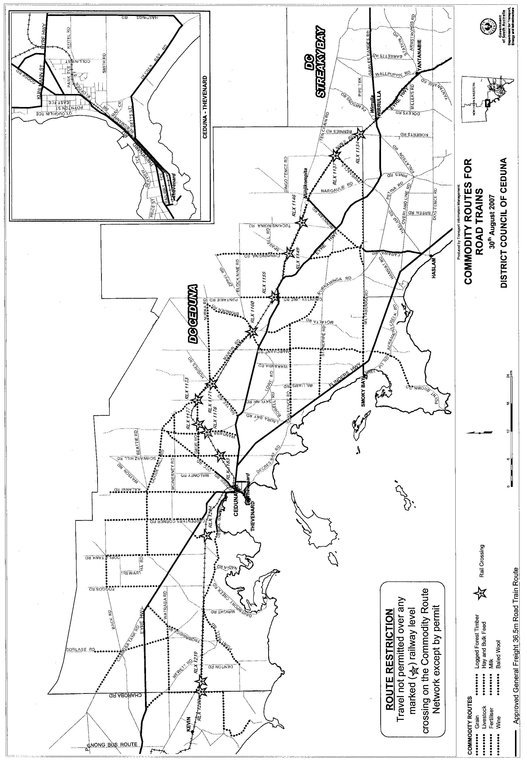
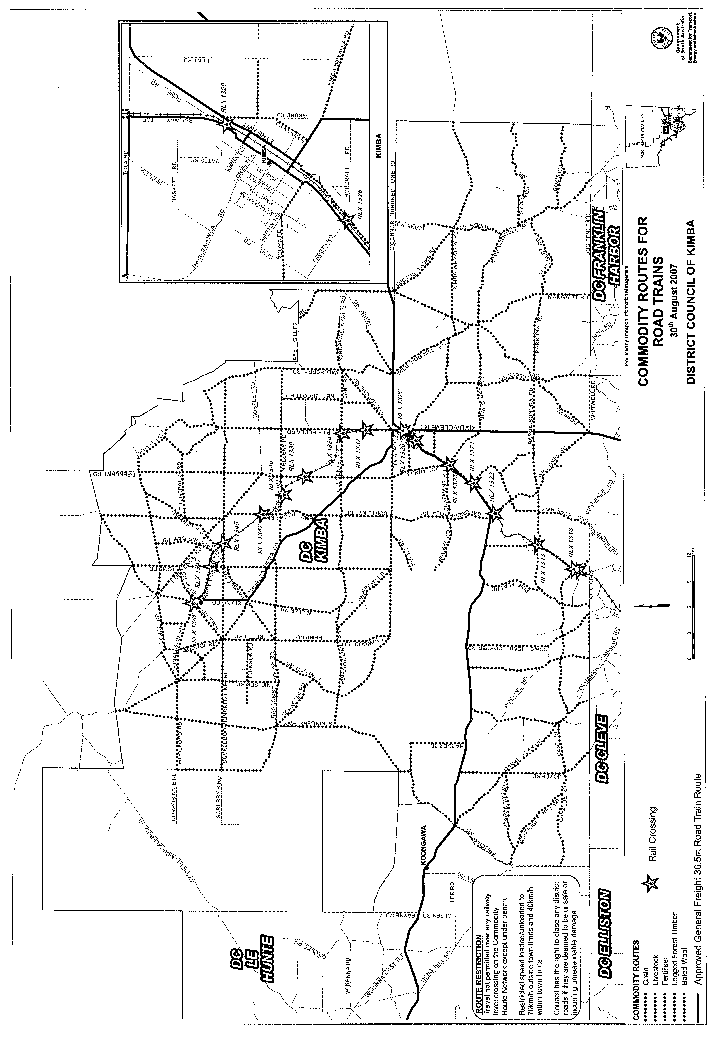

ROAD TRAFFIC ACT 1961

SUPPLEMENTARY NOTICE OF APPROVAL
Pursuant to Section 161A of the Road Traffic Act 1961

OPERATION OF B-DOUBLE VEHICLES UP TO 25 M IN LENGTH
1. APPROVAL
Information Note
This Notice adds additional routes to the network that can be used by B-Double Vehicles up to 25 m in Length and is a supplement to the Notice titled ‘Operation of B-Double Vehicles up to 25 m in Length’ dated 30 June 2005.

1.1 In accordance with the powers delegated to me by the Minister for Transport under section 163AA of the Road Traffic Act 1961, I hereby vary the conditions of the Gazette Notice of Approval and Exemption titled, ‘Operation of B-Double Vehicles up to 25 m in Length’ dated 30 June 2005 as detailed below.
2. DEFINITIONS
2.1 In this Notice:
2.1.1 ‘Approved Vehicles’ means B-Double vehicles up to an overall length not exceeding 25 m;
2.1.2 ‘Supplementary routes’ means the approved routes specified in the maps ‘Route Network for B-Double Vehicles up to 25 m in Length’ attached to this Supplementary Notice;
2.1.3 ‘Supplementary Notice’ means this Notice;
2.1.4 ‘Primary Notice’ means the Gazette Notice ‘Operation of B-Double Vehicles up to 25 m in Length’ dated 30 June 2005; and
2.1.5 all other terms have the same meaning as in the Primary Notice.
3. APPLICATION OF SUPPLEMENTARY NOTICE
3.1 This Supplementary Notice must be read in conjunction with the Primary Notice and applies to all Approved Vehicles operating under the Primary Notice travelling on routes specified in the attached maps.
4. ROUTES AVAILABLE TO APPROVED VEHICLES
4.1 An Approved Vehicle may operate under the conditions of the Primary Notice on the supplementary route map specified hereunder:
4.1.1 ‘Commodity Routes for B-Doubles—District Council of Ceduna—30 August 2007’ Map;
4.1.2 ‘Commodity Routes for B-Doubles—District Council of Kimba—30 August 2007’ Map;
4.1.3 ‘Commodity Routes for B-Doubles—District Council of Mount Remarkable—30 August 2007’ Map;
4.1.4 ‘Commodity Routes for B-Doubles—District Council of Southern Mallee—30 August 2007’ Map;
5. CONDITIONS AND LIMITATIONS APPLYING TO THIS SUPPLEMENTARY NOTICE
5.1 When operating on a route specified in the attached maps, the driver of an Approved Vehicle must:
5.1.1 continue to comply with all conditions and requirements of the Primary Notice; and
5.1.2 carry a legible, current and complete copy of:
(i) this Supplementary Notice and attached maps;
(ii) the Primary Notice;
(iii) the ‘Code of Practice for B-Doubles’ dated June 2005;
(iv) the map book titled ‘Approved Route Network for B-Doubles’ dated June 2005; and
5.1.3 produce these documents when requested by a Department for Transport, Energy and Infrastructure, Transport Safety Compliance Officer appointed under the Road Traffic Act 1961 and/or the Motor Vehicles Act 1959 or a Police Officer.
6. COMMENCEMENT OF THIS NOTICE
6.1 This Notice is effective from 12.01 a.m. on 3 September 2007.

Executive Director,
Safety and Regulation Division
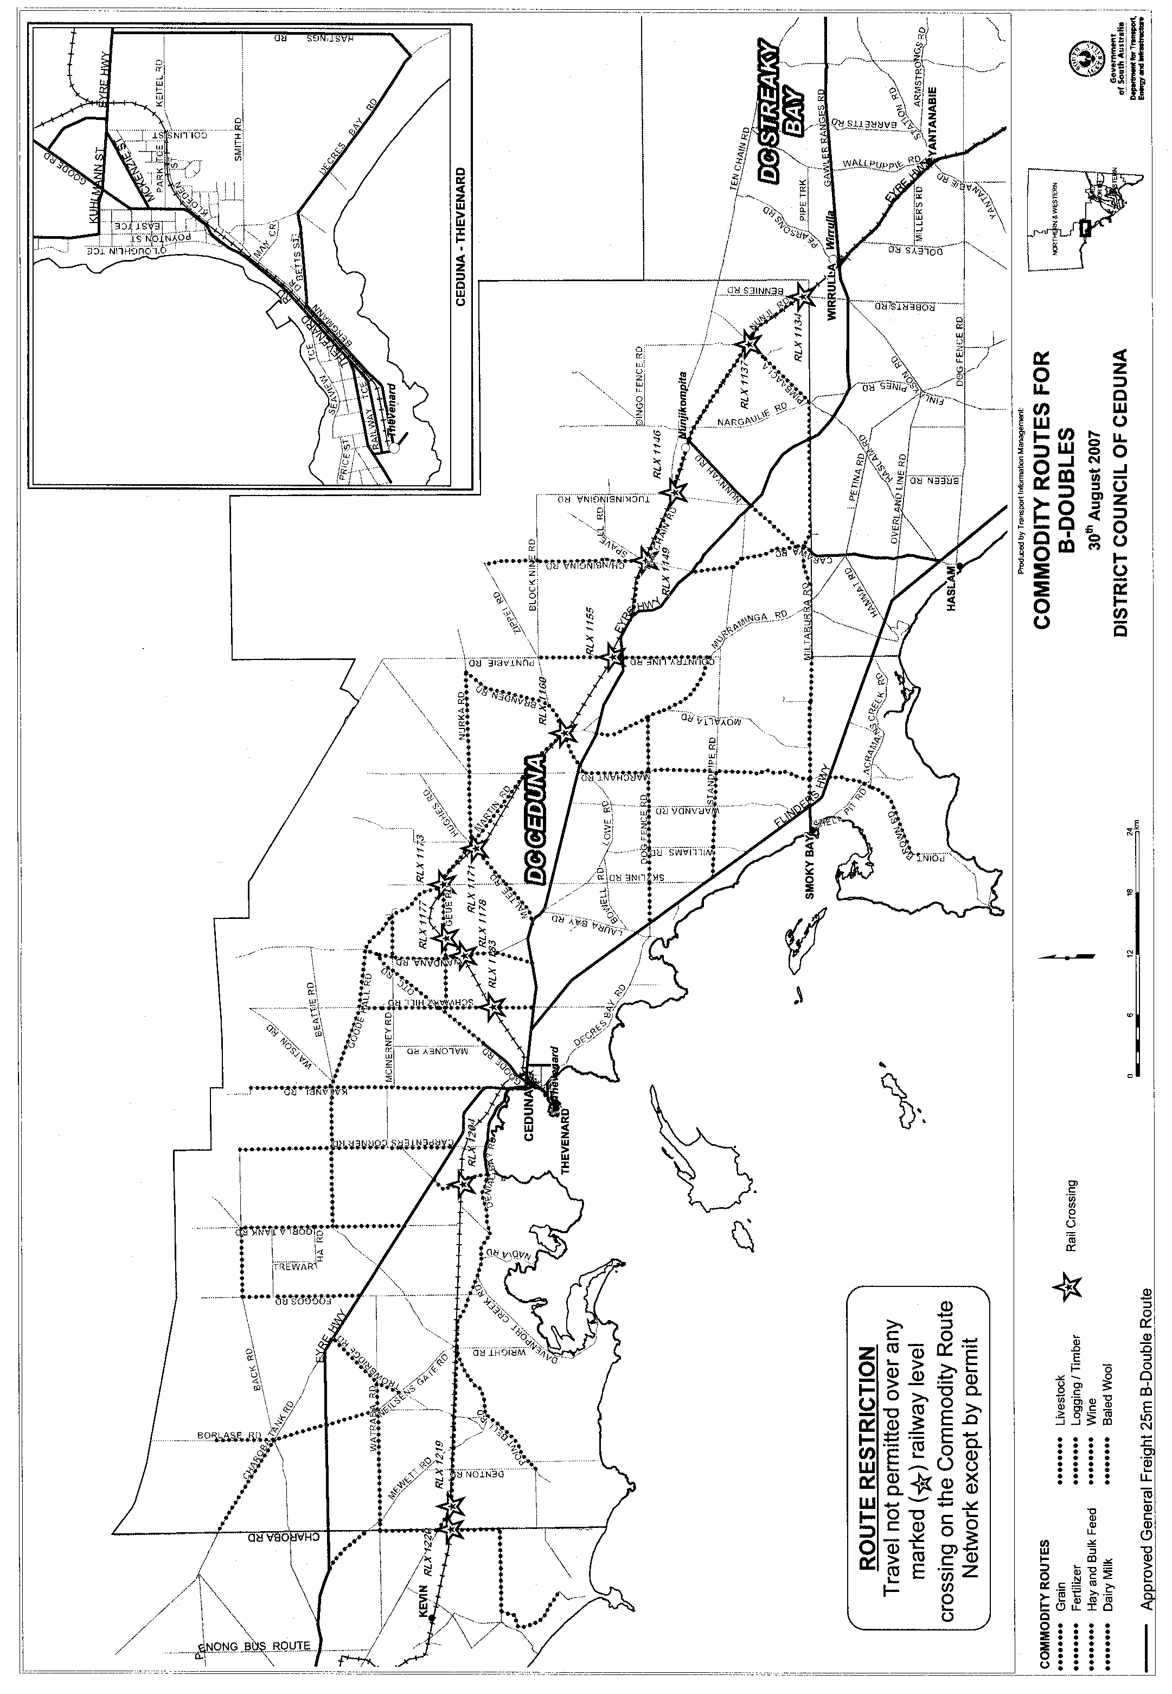
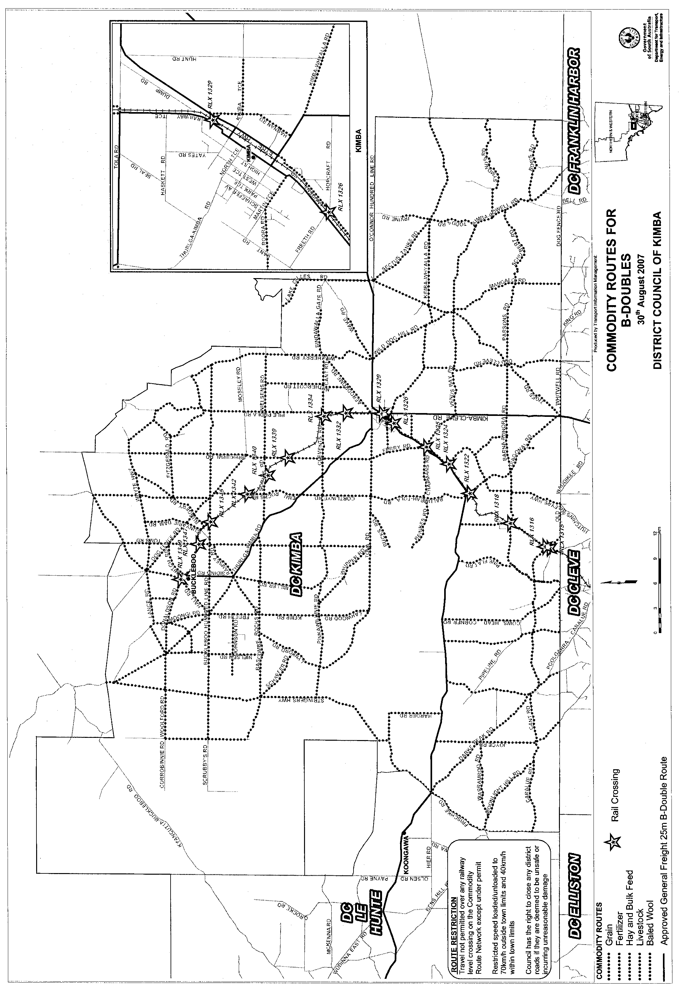
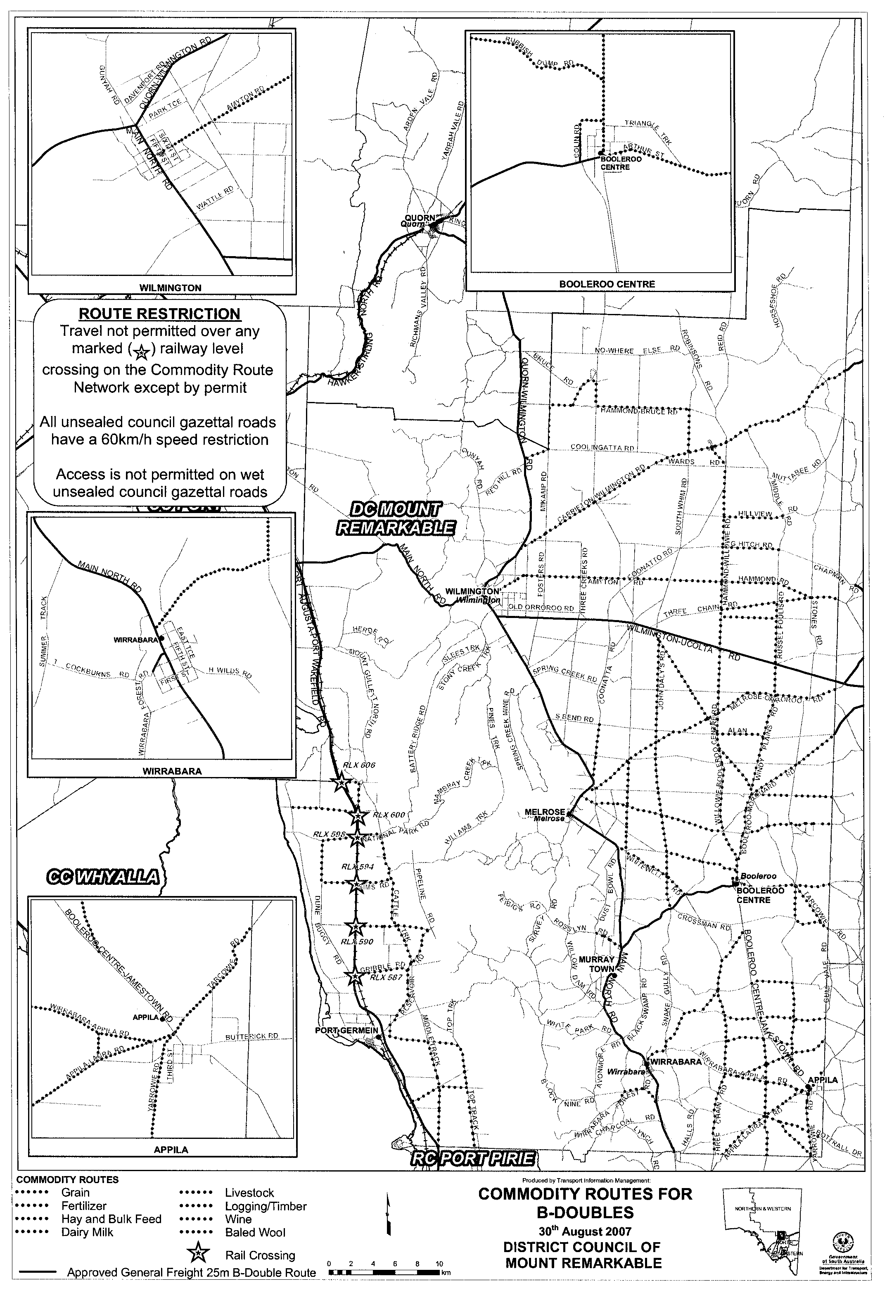
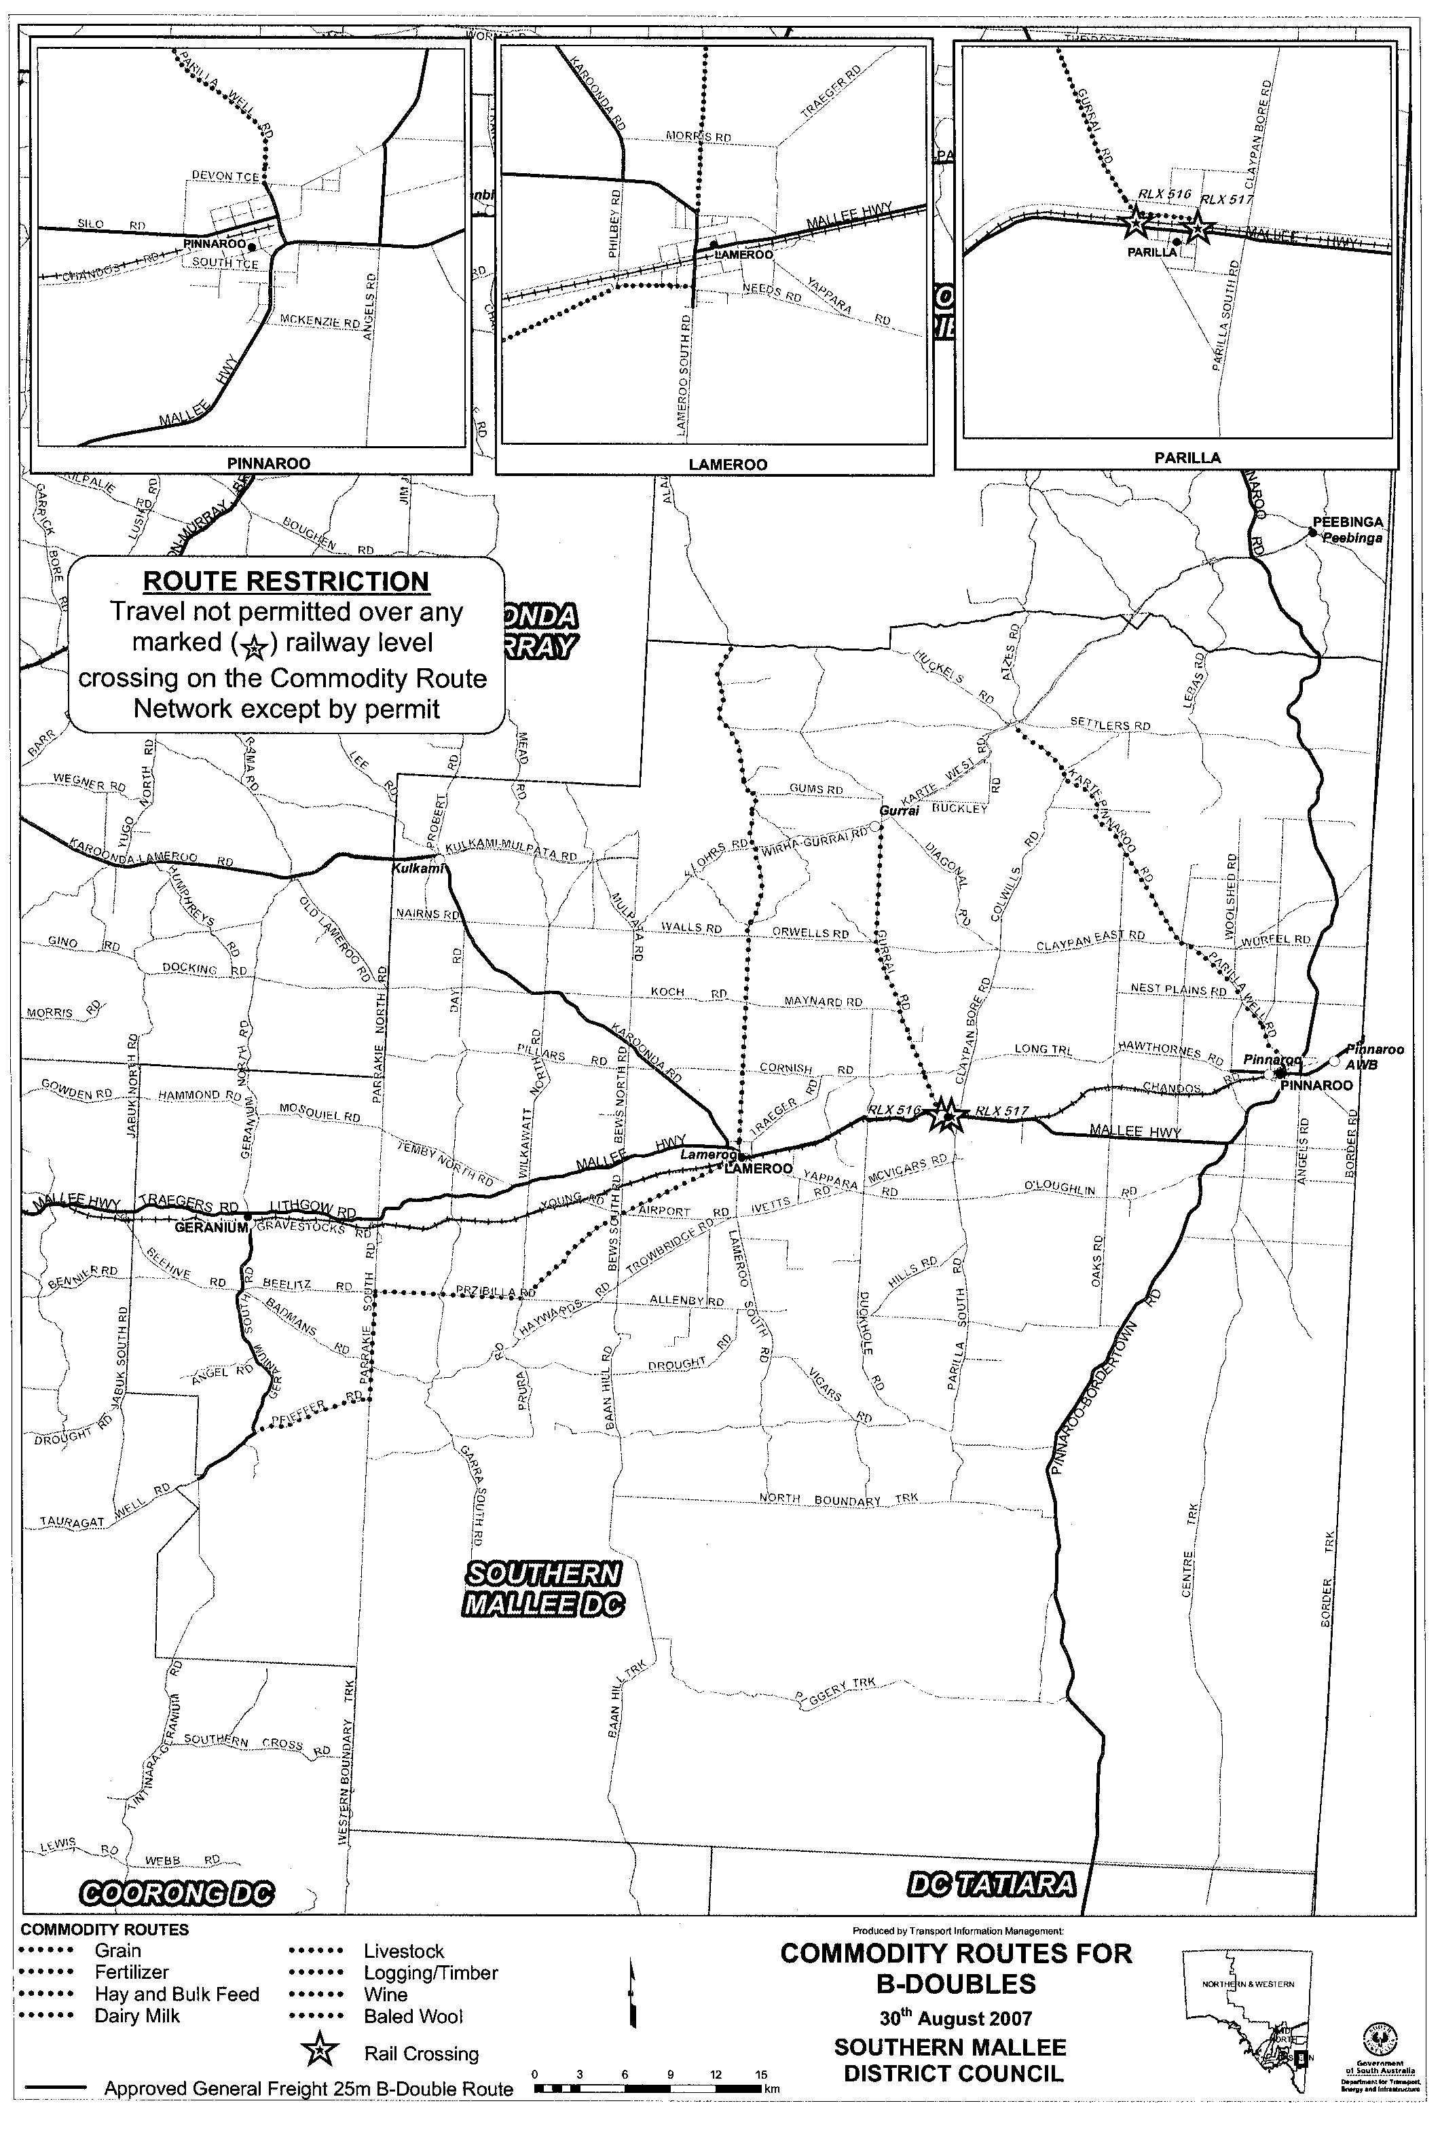

ROAD TRAFFIC ACT 1961

SUPPLEMENTARY NOTICE OF APPROVAL
Pursuant to Section 161A of the Road Traffic Act 1961

OPERATION OF ROAD TRAIN VEHICLES IN SOUTH AUSTRALIA
1. APPROVAL
Information Note
This Notice adds additional routes to the network that can be used by Road Train Vehicles and is a supplement to the Notice titled ‘Operation of Road Train Vehicles in South Australia’ dated 24 November 2005.

1.1 In accordance with the powers delegated to me by the Minister for Transport under section 163AA of the Road Traffic Act 1961, I hereby vary the conditions of the Gazette Notice of Approval and Exemption titled, ‘Operation of Road Train Vehicles in South Australia’ dated 24 November 2005 as detailed below.
2. DEFINITIONS
2.1 In this Notice:
2.1.1 ‘Approved Vehicles’ means Road Train Vehicles (including articulated vehicles towing converter dollies);
2.1.2 ‘Supplementary routes’ means the approved routes specified in the maps ‘Route Network for Road Train Vehicles’ attached to this Supplementary Notice;
2.1.3 ‘Supplementary Notice’ means this Notice;
2.1.4 ‘Primary Notice’ means the Gazette Notice ‘Operation of Road Train Vehicles in South Australia’ dated 24 November 2005; and
2.1.5 all other terms have the same meaning as in the Primary Notice.
3. APPLICATION OF SUPPLEMENTARY NOTICE
3.1 This Supplementary Notice must be read in conjunction with the Primary Notice and applies to all Approved Vehicles operating under the Primary Notice travelling on routes specified in the attached maps.
4. ROUTES AVAILABLE TO APPROVED VEHICLES
4.1 An Approved Vehicle may operate under the conditions of the Primary Notice on a supplementary route specified hereunder:
4.1.1 ‘Route Network for Road Train Vehicles General Mass Limits (GML)’ Map R1 (Siding Road, Thurlga-Kimba Road, Tola Road, Railway Terrace, Kimba Terrace and Donaldson Road, Kimba and Hastings Road, Smoky Bay Road, Nunji Road, Decres Bay Road and Carawa Road, Ceduna);
4.1.2 ‘Route Network for Road Train Vehicles General Mass Limits (GML)’ Map U2 (Thompson Road, Burton);
4.1.3 ‘Route Network for Road Train Vehicles General Mass Limits (GML)’ Map Waterloo Corner (Thompson Road, Burton);
4.1.4 ‘Route Network for Road Train Vehicles Higher Mass Limits (HML)’ Map Waterloo Corner (Thompson Road, Burton);
4.1.5 ‘Converter Dolly Route Network General Mass Limits (GML)’ Map R1 (Siding Road, Thurlga-Kimba Road, Tola Road, Railway Terrace, Kimba Terrace and Donaldson Road, Kimba and Hastings Road, Smoky Bay Road, Nunji Road, Decres Bay Road and Carawa Road, Ceduna);
4.1.6 ‘Converter Dolly Route Network General Mass Limits (GML)’ Map U1 (Thompson Road, Burton); and
4.1.7 ‘Converter Dolly Route Network General Mass Limits (GML)’ Map U2 (Thompson Road, Burton).
5. CONDITIONS AND LIMITATIONS APPLYING TO THIS SUPPLEMENTARY NOTICE
5.1 When operating on a route specified in the attached maps, the driver of an Approved Vehicle must:
5.1.1 continue to comply with all conditions and requirements of the Primary Notice; and
5.1.2 carry a legible, current and complete copy of:
(i) this Supplementary Notice and attached maps;
(ii) the Primary Notice;
(iii) the ‘Code of Practice for Road Trains’ dated November 2005;
(iv) the map book titled ‘Approved Route Network for Road Trains’ dated November 2005; and
5.1.3 produce these documents when requested by a Department for Transport, Energy and Infrastructure, Transport Safety Compliance Officer appointed under the Road Traffic Act 1961 and/or the Motor Vehicles Act 1959 or a Police Officer.
6. COMMENCEMENT OF THIS NOTICE
6.1 This Notice is effective from 12.01 a.m. on 3 September 2007.

Executive Director,
Safety and Regulation Division
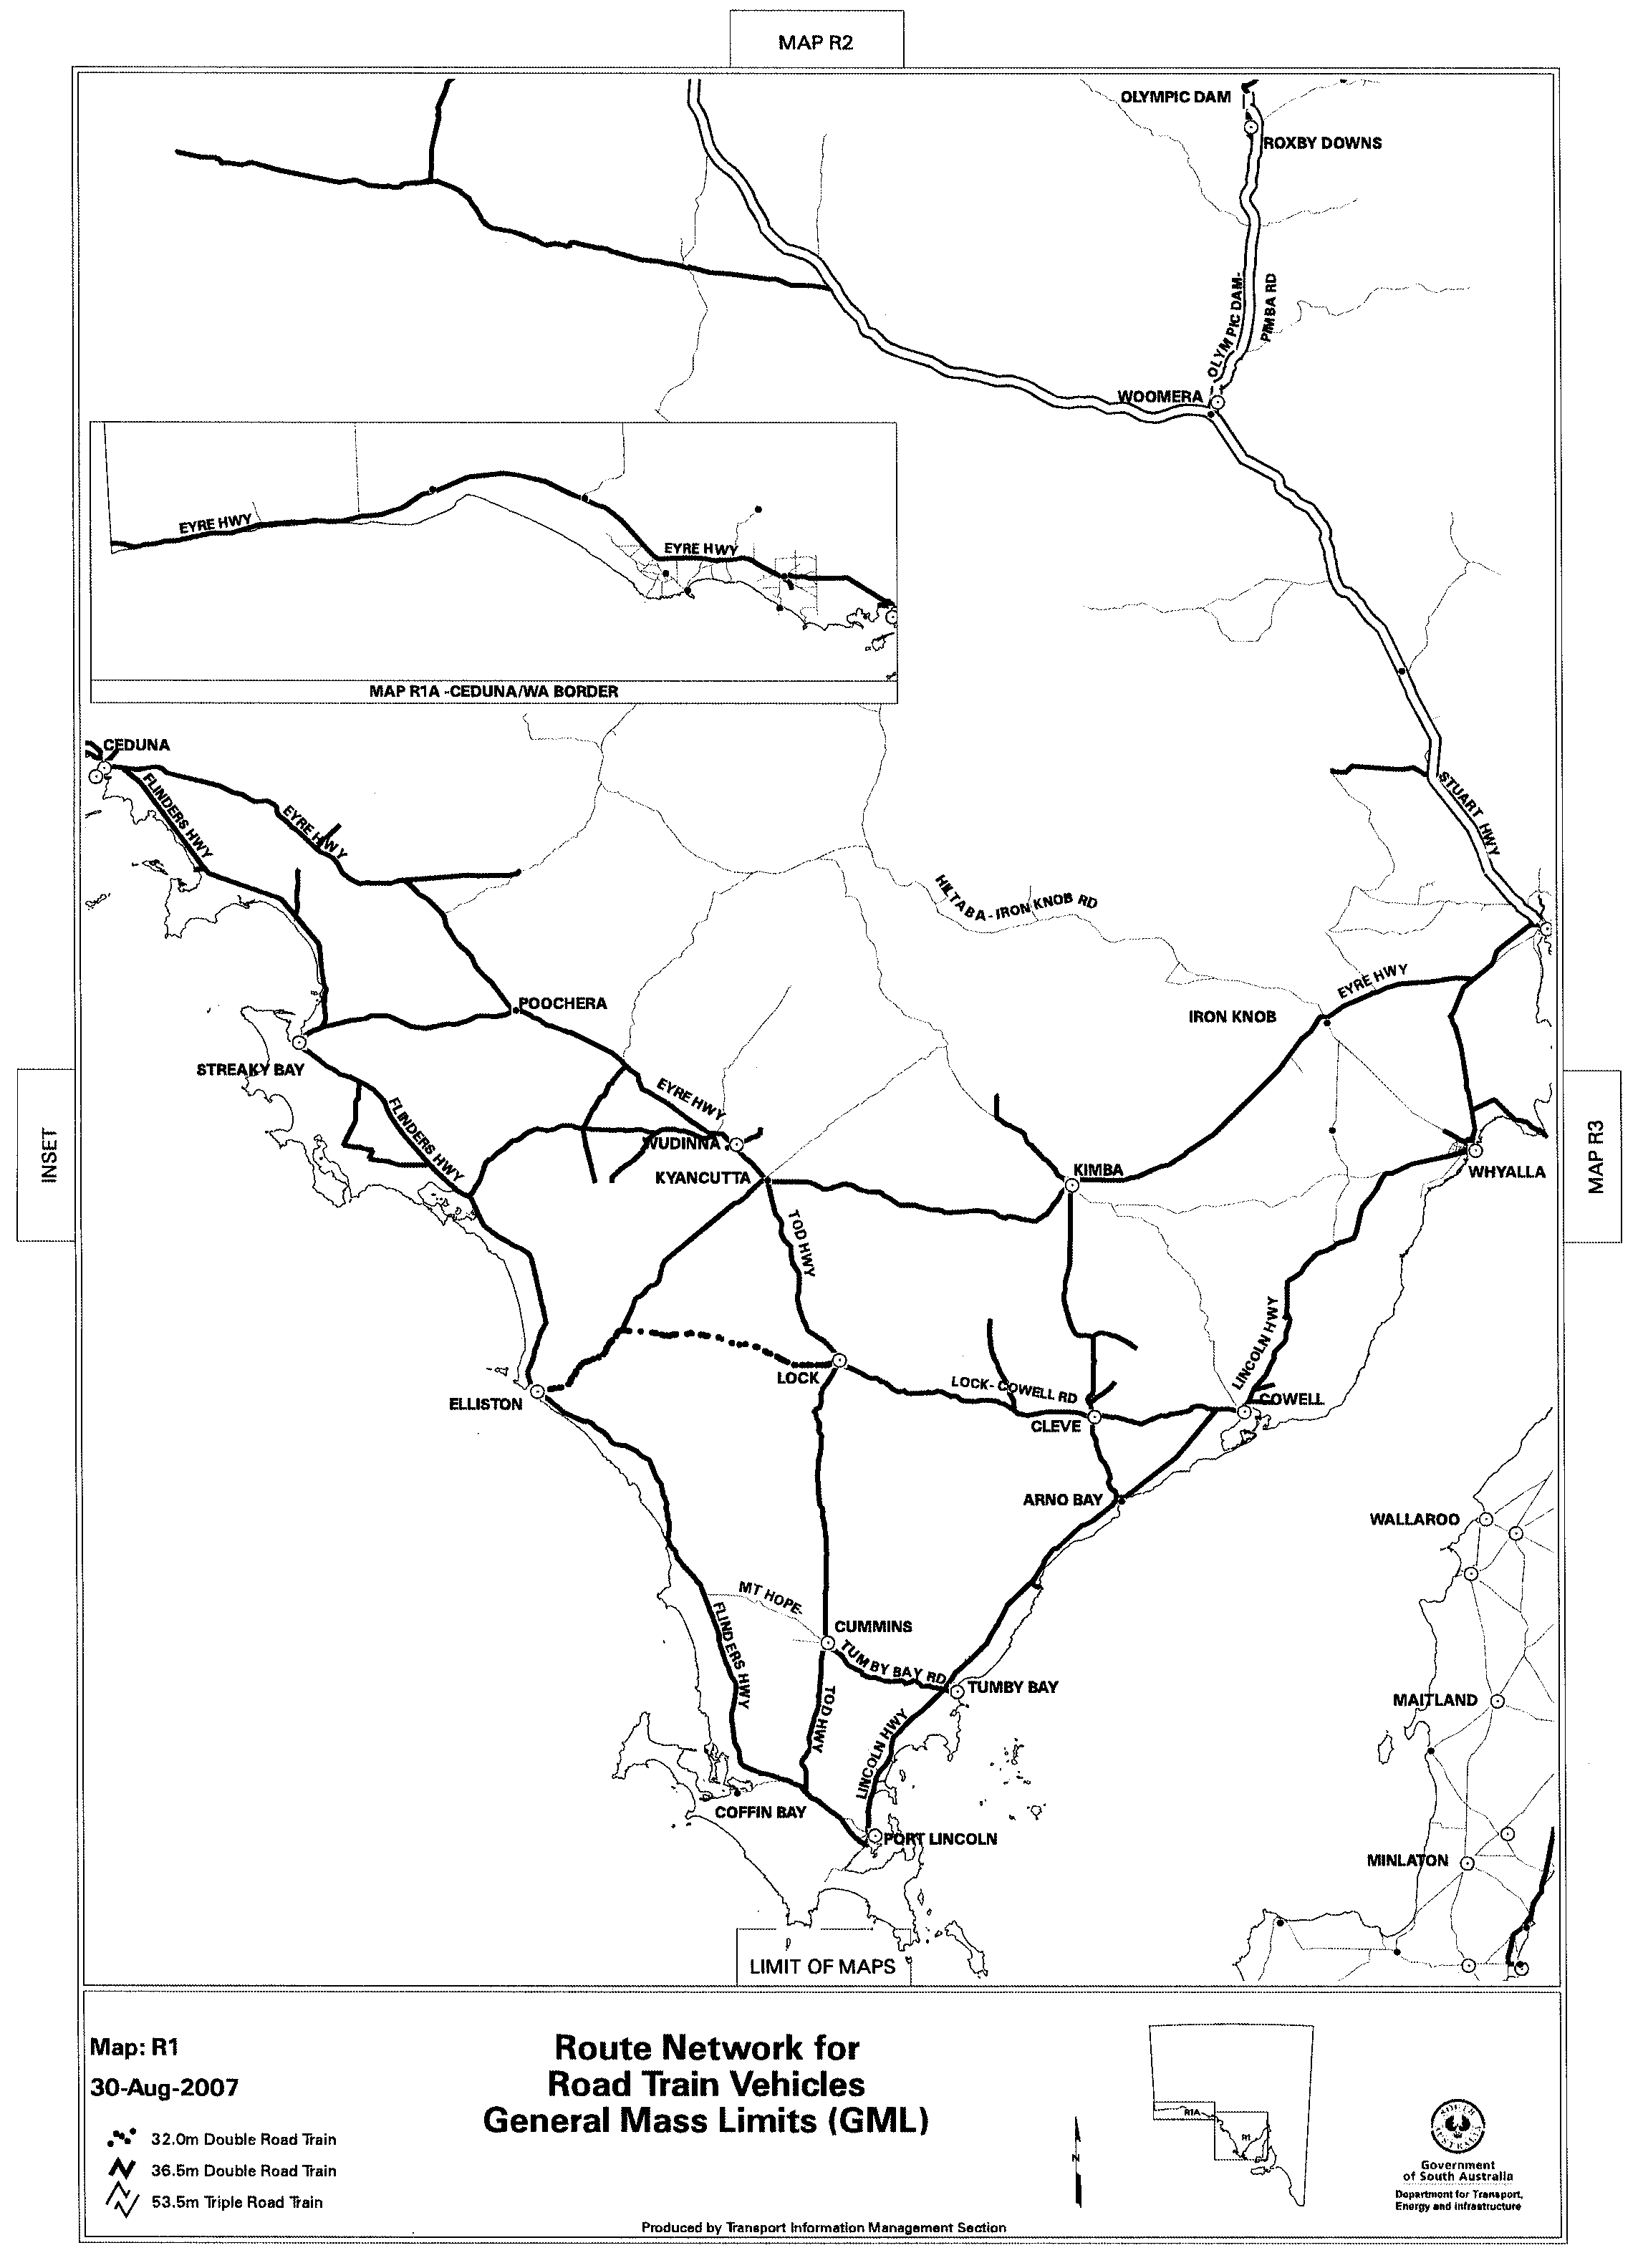
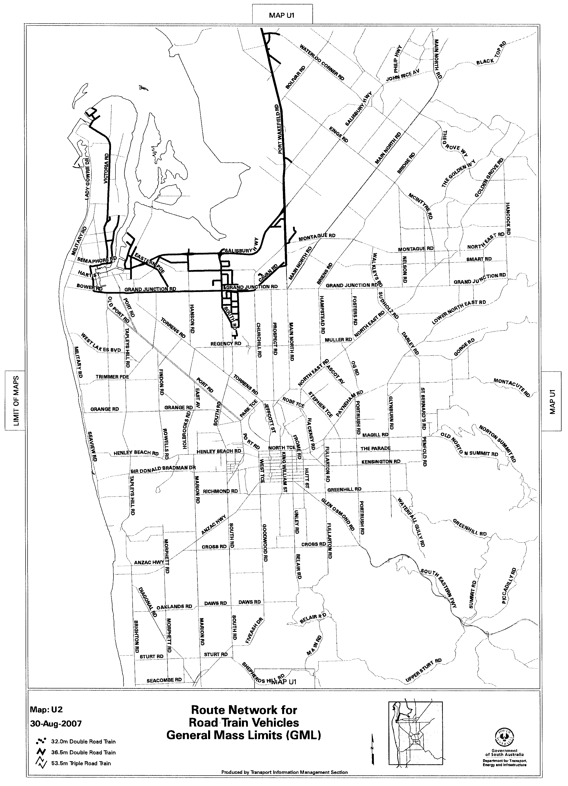
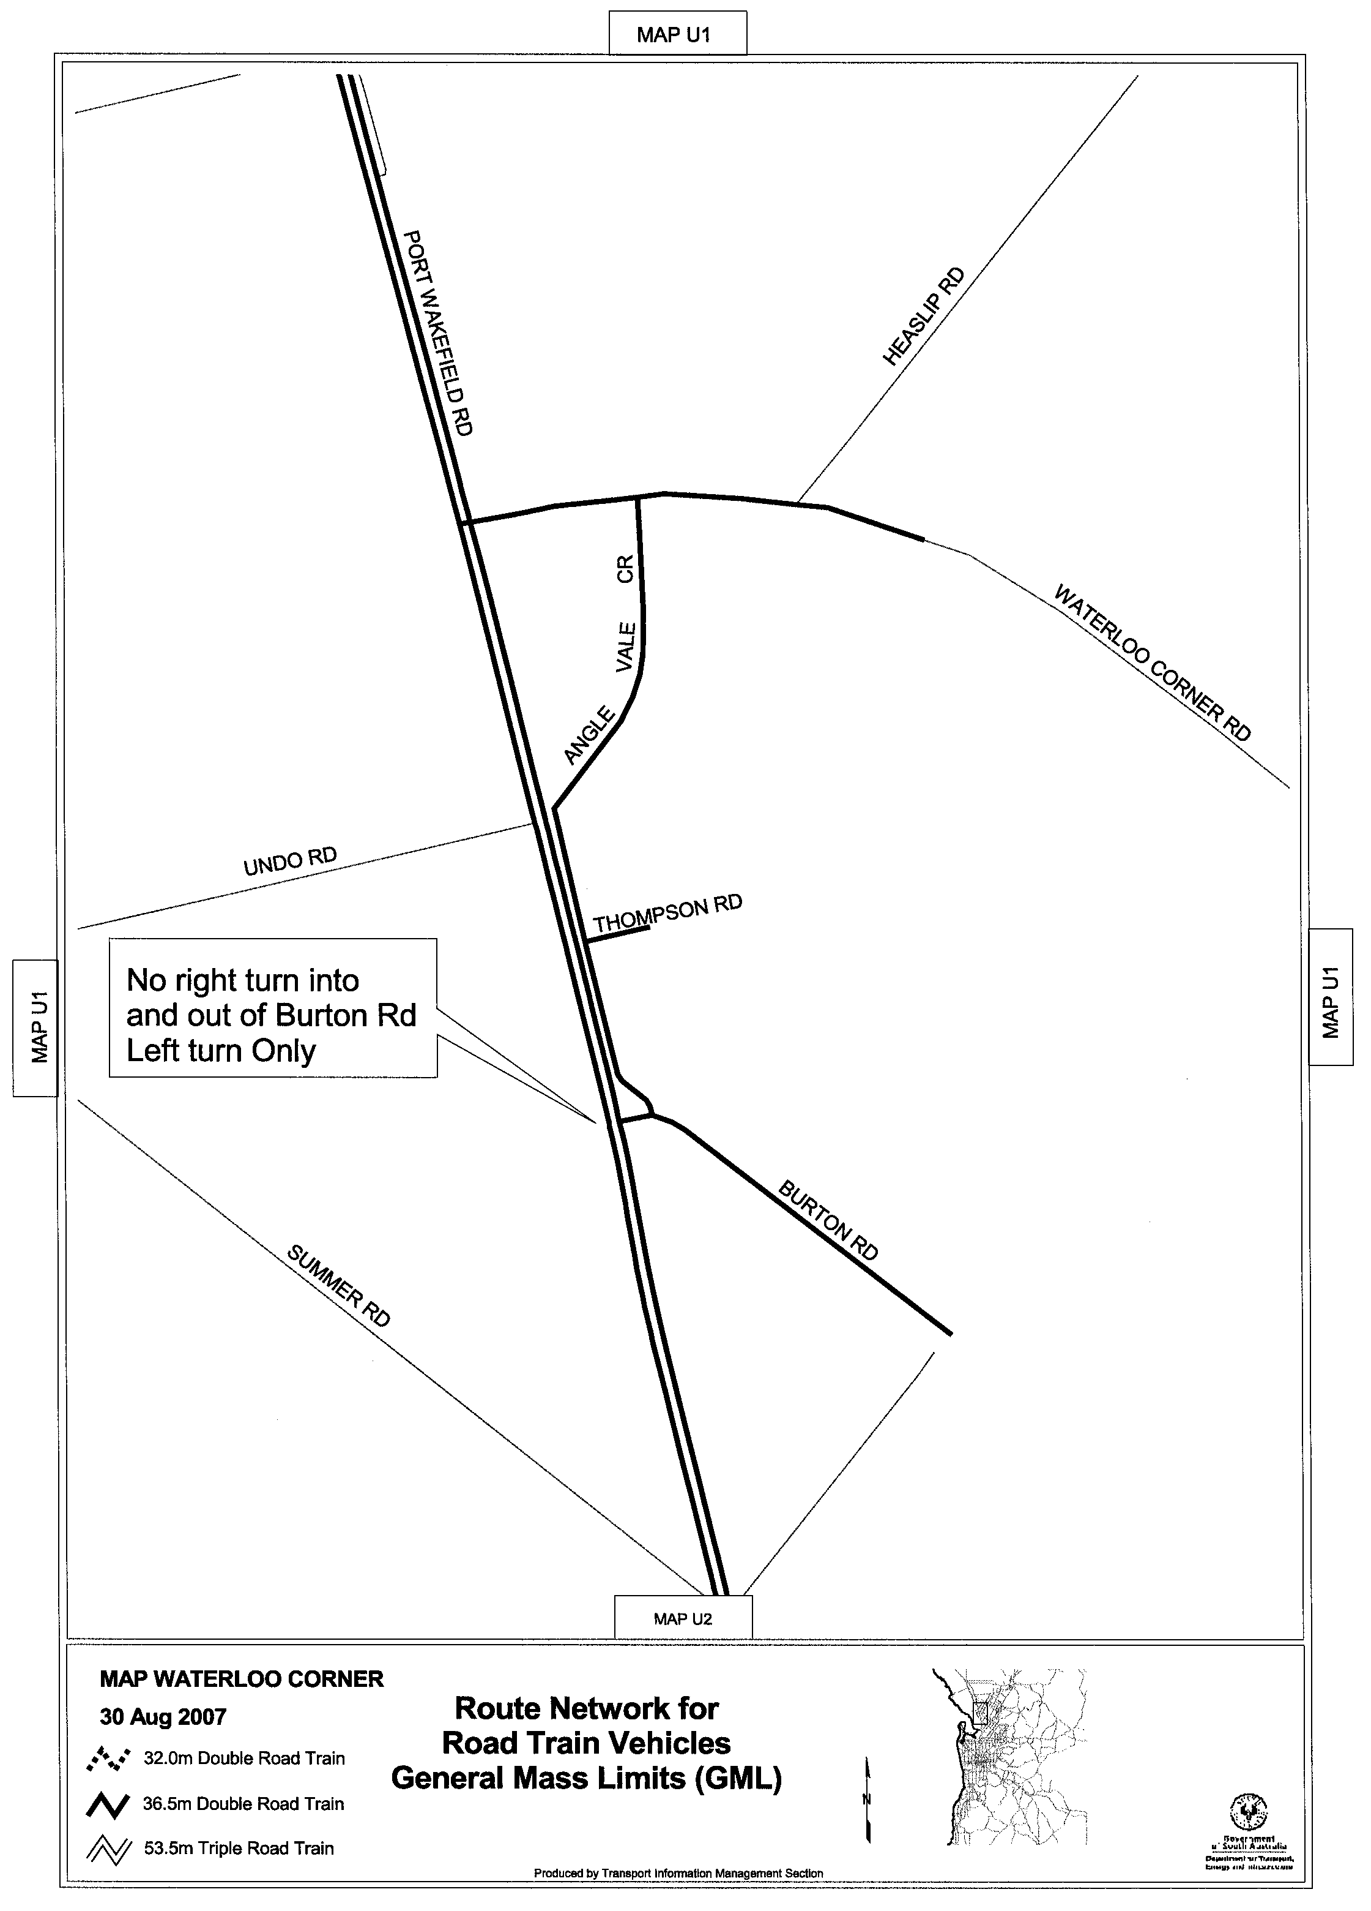
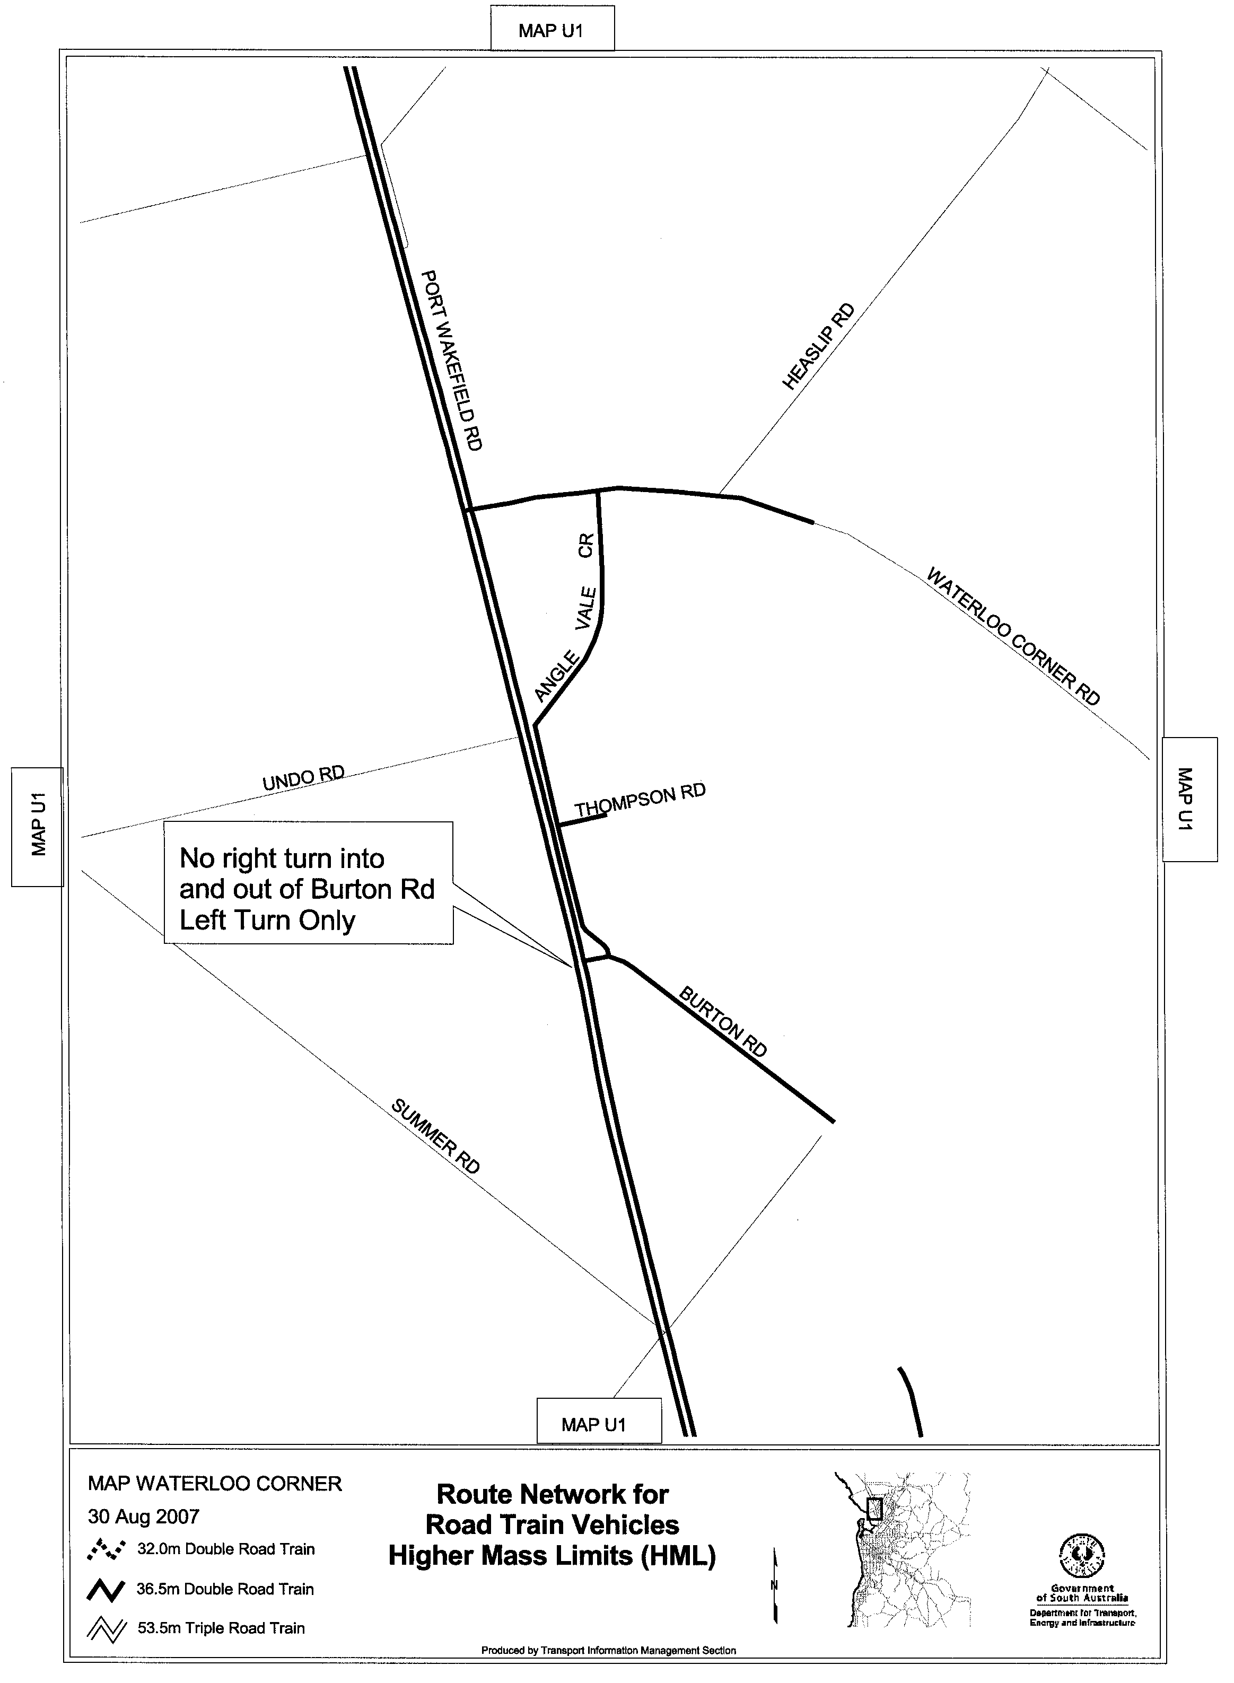
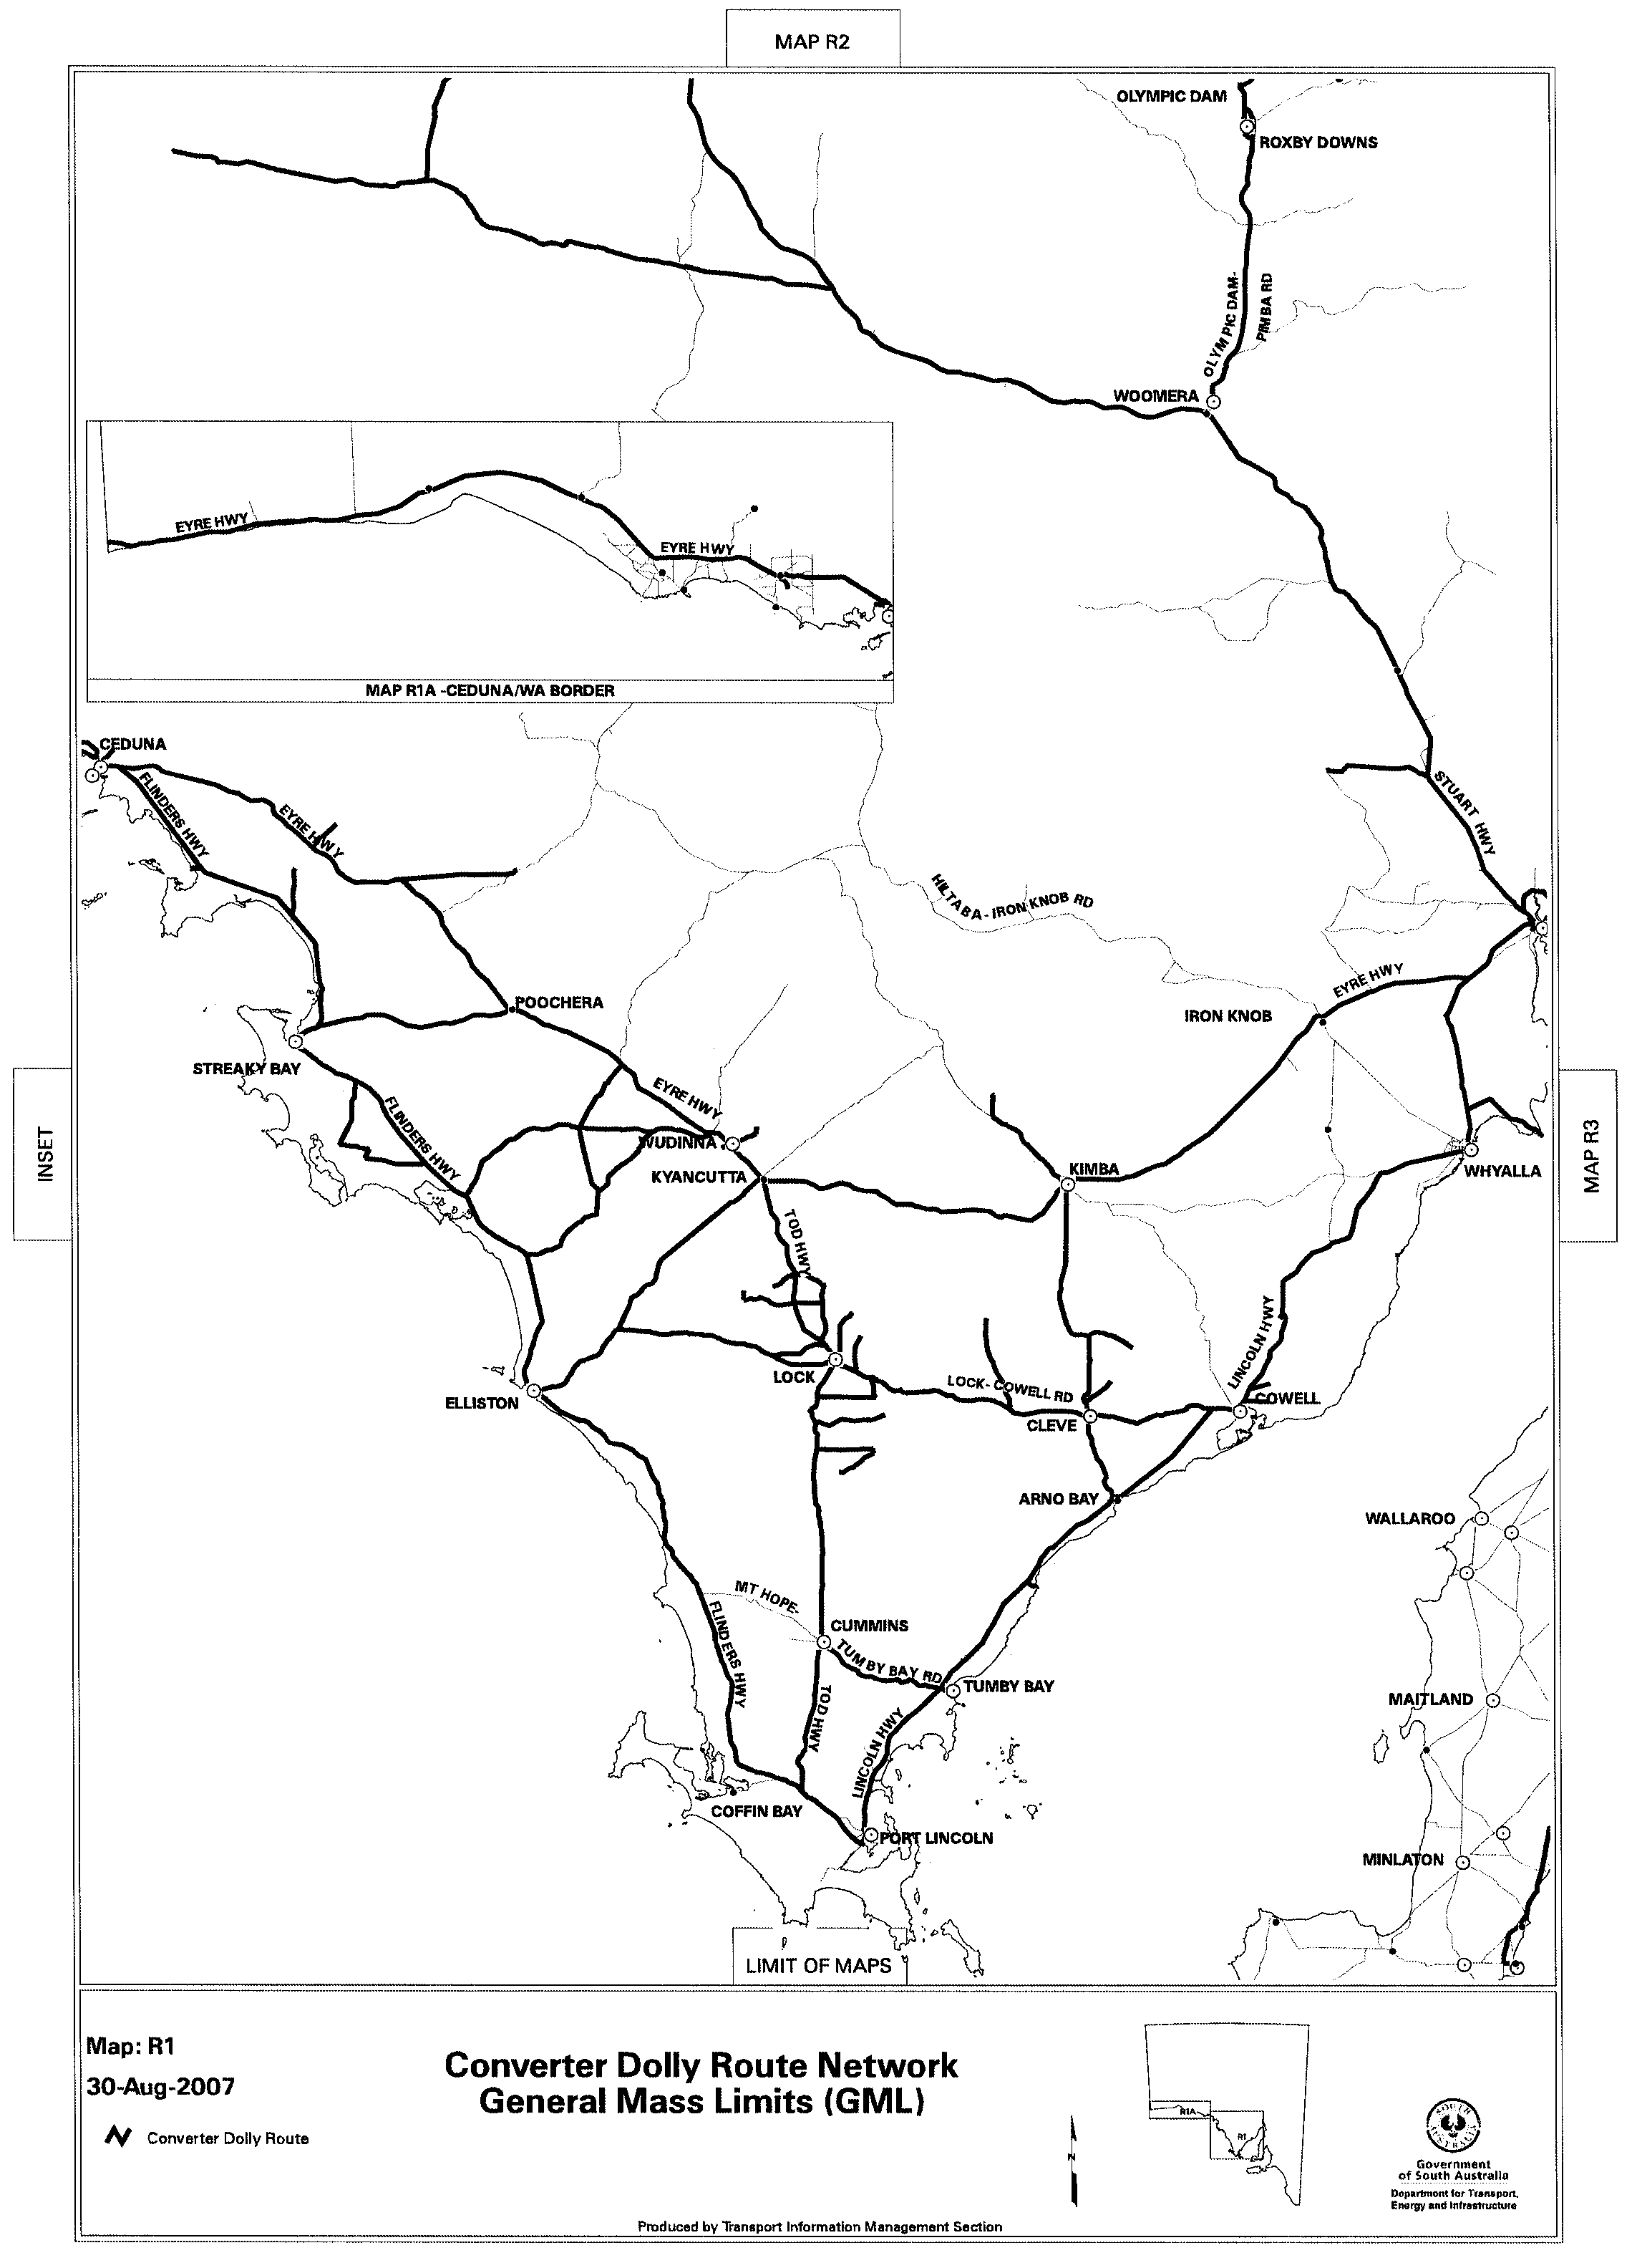
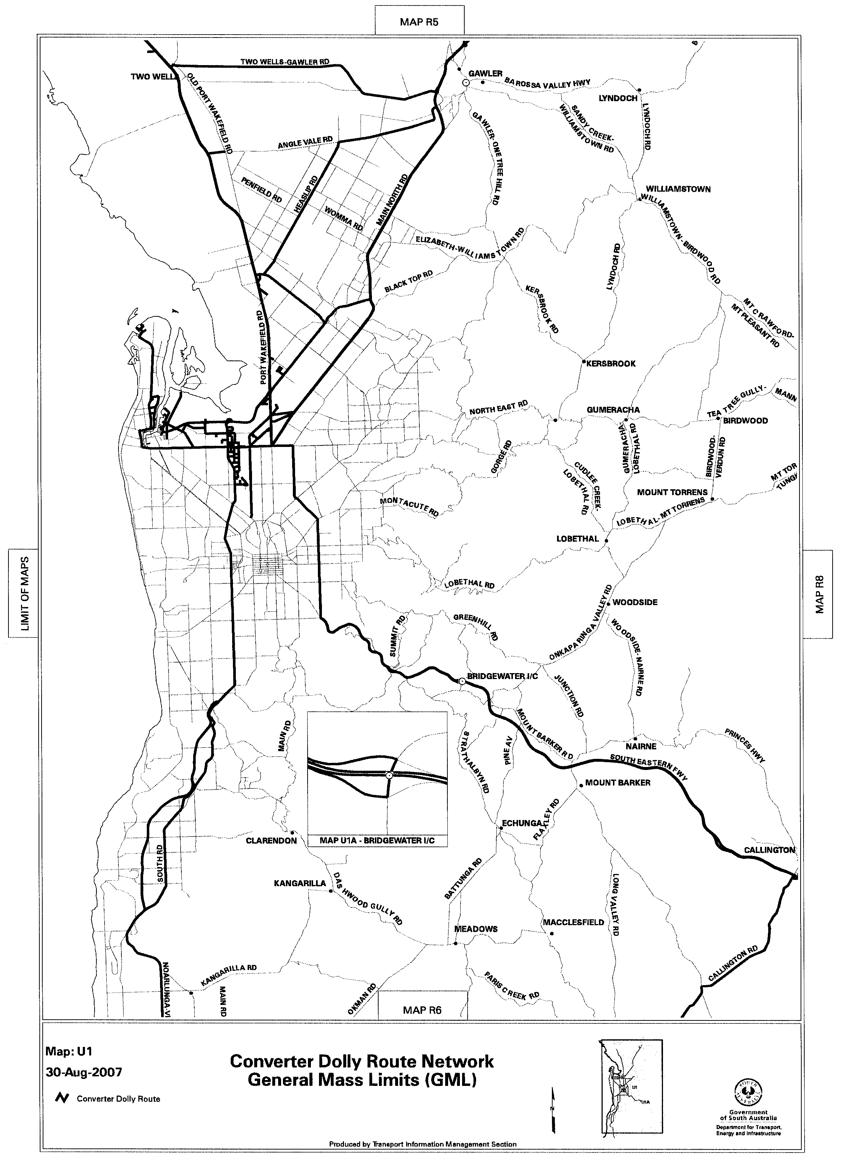
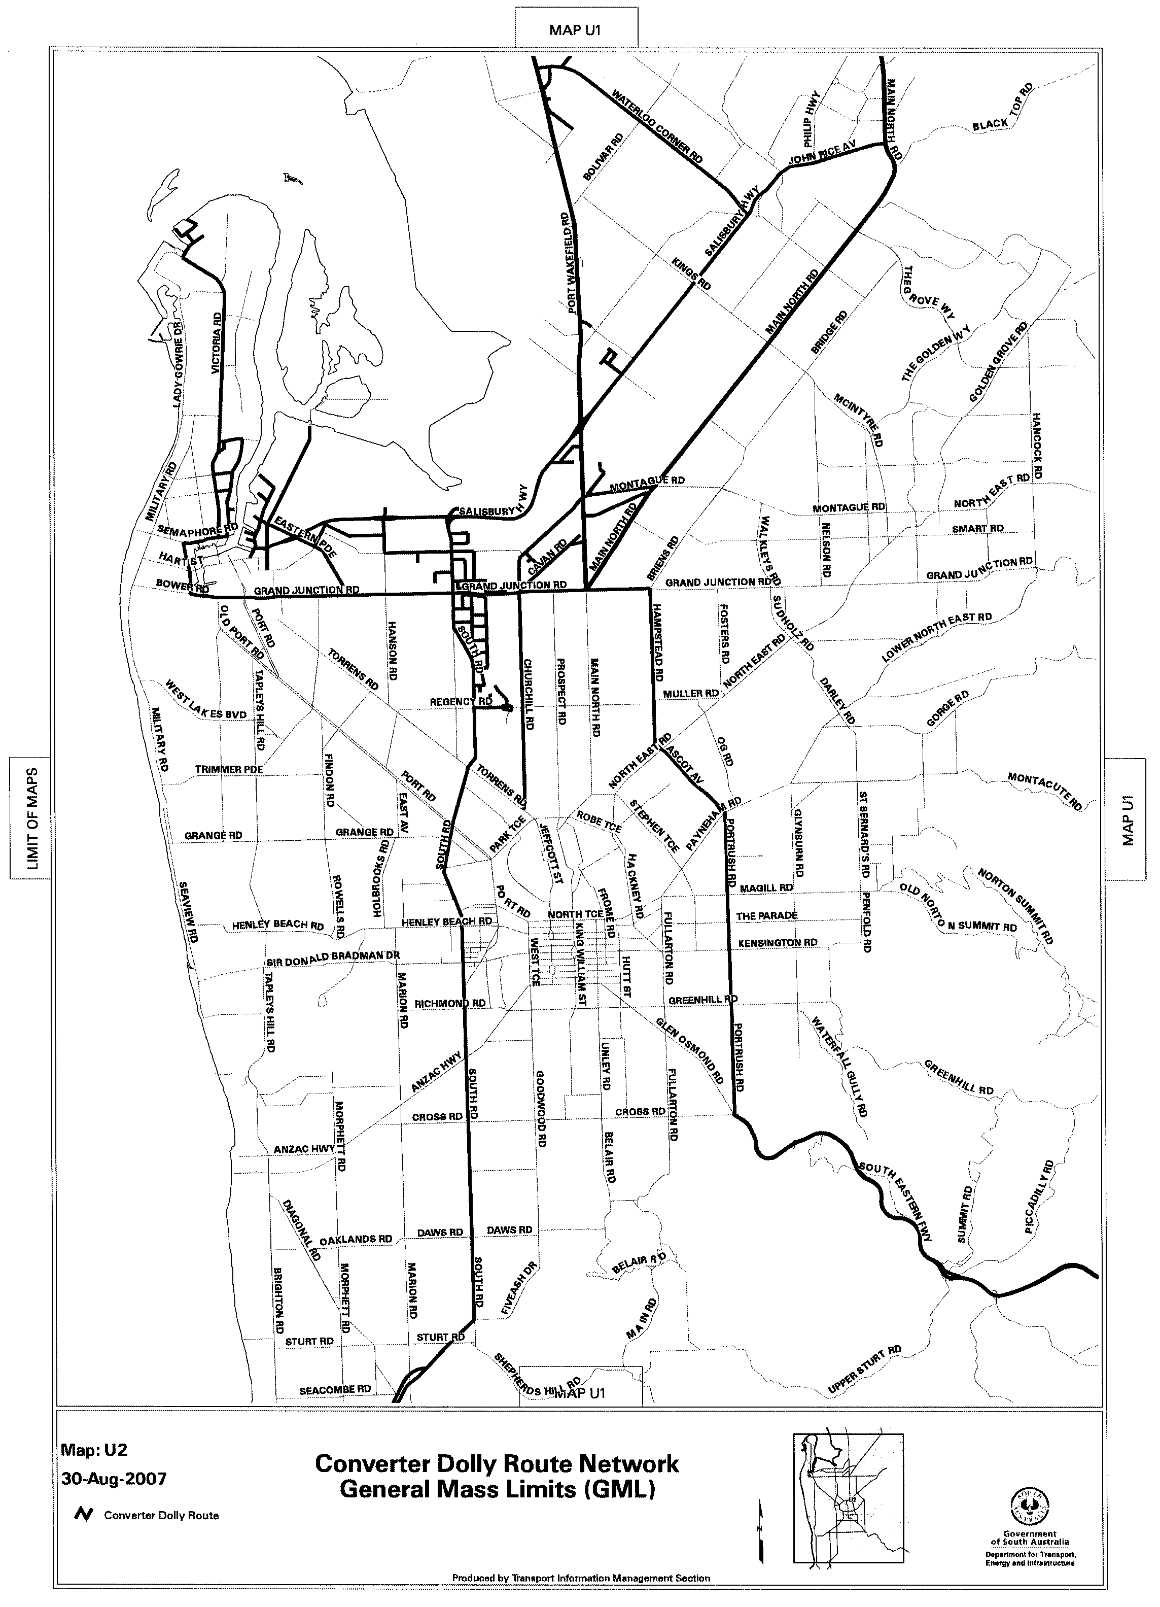

ROAD TRAFFIC ACT 1961

SUPPLEMENTARY NOTICE OF APPROVAL
Pursuant to Section 161A of the Road Traffic Act 1961

OPERATION OF B-DOUBLE VEHICLES UP TO 25 M IN LENGTH
1. APPROVAL
Information Note
This Notice adds additional routes to the network that can be used by B-Double Vehicles up to 25 m in Length and is a supplement to the Notice titled ‘Operation of B-Double Vehicles up to 25 m in Length’ dated 30 June 2005.

1.1 In accordance with the powers delegated to me by the Minister for Transport under section 163AA of the Road Traffic Act 1961, I hereby vary the conditions of the Gazette Notice of Approval and Exemption titled, ‘Operation of B-Double Vehicles up to 25 m in length’ dated 30 June 2005 as detailed below.
2. DEFINITIONS
2.1 In this Notice:
2.1.1 ‘Approved Vehicles’ means B-Double vehicles up to an overall length not exceeding 25 m;
2.1.2 ‘Supplementary routes’ means the approved routes specified in the maps ‘Route Network for B-Double Vehicles up to 25 m in Length’ attached to this Supplementary Notice;
2.1.3 ‘Supplementary Notice’ means this Notice;
2.1.4 ‘Primary Notice’ means the Gazette Notice ‘Operation of B-Double Vehicles up to 25 m in Length’ dated 30 June 2005; and
2.1.5 all other terms have the same meaning as in the Primary Notice.
3. APPLICATION OF SUPPLEMENTARY NOTICE
3.1 This Supplementary Notice must be read in conjunction with the Primary Notice and applies to all Approved Vehicles operating under the Primary Notice travelling on routes specified in the attached maps.
4. ROUTES AVAILABLE TO APPROVED VEHICLES
4.1 An Approved Vehicle may operate under the conditions of the Primary Notice on a supplementary route specified hereunder:
4.1.1 ‘Route Network for B-Double Vehicles up to 25 m in Length General Mass Limits (GML)’ Map R1 (Siding Road, Thurlga-Kimba Road, Tola Road, Railway Terrace, Kimba Terrace and Donaldson Road, Kimba and Hastings Road, Smoky Bay Road, Nunji Road, Decres Bay Road and Carawa Road, Ceduna);
4.1.2 ‘Route Network for B-Double Vehicles up to 25 m in Length General Mass Limits (GML)’ Map R2 (Main North Road, High Street, Stuart Street, Murray Town-Orroroo Road, Nott Street, Forest Road, Arthur Street and Colin Road, Mount Remarkable);
4.1.3 ‘Route Network for B-Double Vehicles up to 25 m in Length General Mass Limits (GML)’ Map R3 (Main North Road, High Street, Stuart Street, Murray Town-Orroroo Road, Nott Street, Forest Road, Arthur Street and Colin Road, Mount Remarkable);
4.1.4 ‘Route Network for B-Double Vehicles up to 25 m in Length General Mass Limits (GML)’ Map R3A (Main North Road, High Street, Stuart Street, Murray Town-Orroroo Road, Nott Street, Forest Road, Arthur Street and Colin Road, Mount Remarkable);
4.1.5 ‘Route Network for B-Double Vehicles up to 25 m in Length General Mass Limits (GML)’ Map R8 (Homburg Terrace, Chandos Terrace, Karoonda Road, Railway Terrace, Karoonda-Lameroo Road, Coonaplyn-Lamaroo Road, Tintinara-Geranium Road, Silo Road, Railway Terrace North, Geranium South Road and Lameroo Road, Southern Mallee);
4.1.6 ‘Township Maps Route Network for B-Double Vehicles up to 25 m in Length General Mass Limits (GML)’ (Kimba);
4.1.7 ‘Township Maps Route Network for B-Double Vehicles up to 25 m in Length General Mass Limits (GML)’ (Pinnaroo);
4.1.8 ‘Route Network for B-Double Vehicles up to 25 m in Length General Mass Limits (GML)’ Map Waterloo Corner (Thompson Road, Burton); and
4.1.9 ‘Route Network for B-Double Vehicles up to 25 m in Length Higher Mass Limits (HML)’ Map Waterloo Corner (Thompson Road, Burton).
5. CONDITIONS AND LIMITATIONS APPLYING TO THIS SUPPLEMENTARY NOTICE
5.1 When operating on a route specified in the attached maps, the driver of an Approved Vehicle must:
5.1.1 continue to comply with all conditions and requirements of the Primary Notice; and
5.1.2 carry a legible, current and complete copy of:
(i) this Supplementary Notice and attached maps;
(ii) the Primary Notice;
(iii) the ‘Code of Practice for B-Doubles’ dated June 2005;
(iv) the map book titled ‘Approved Route Network for B-Doubles’ dated June 2005; and
5.1.3 produce these documents when requested by a Department for Transport, Energy and Infrastructure, Transport Safety Compliance Officer appointed under the Road Traffic Act 1961 and/or the Motor Vehicles Act 1959 or a Police Officer.
6. COMMENCEMENT OF THIS NOTICE
6.1 This Notice is effective from 12.01 a.m. on 3 September 2007.

Executive Director,
Safety and Regulation Division
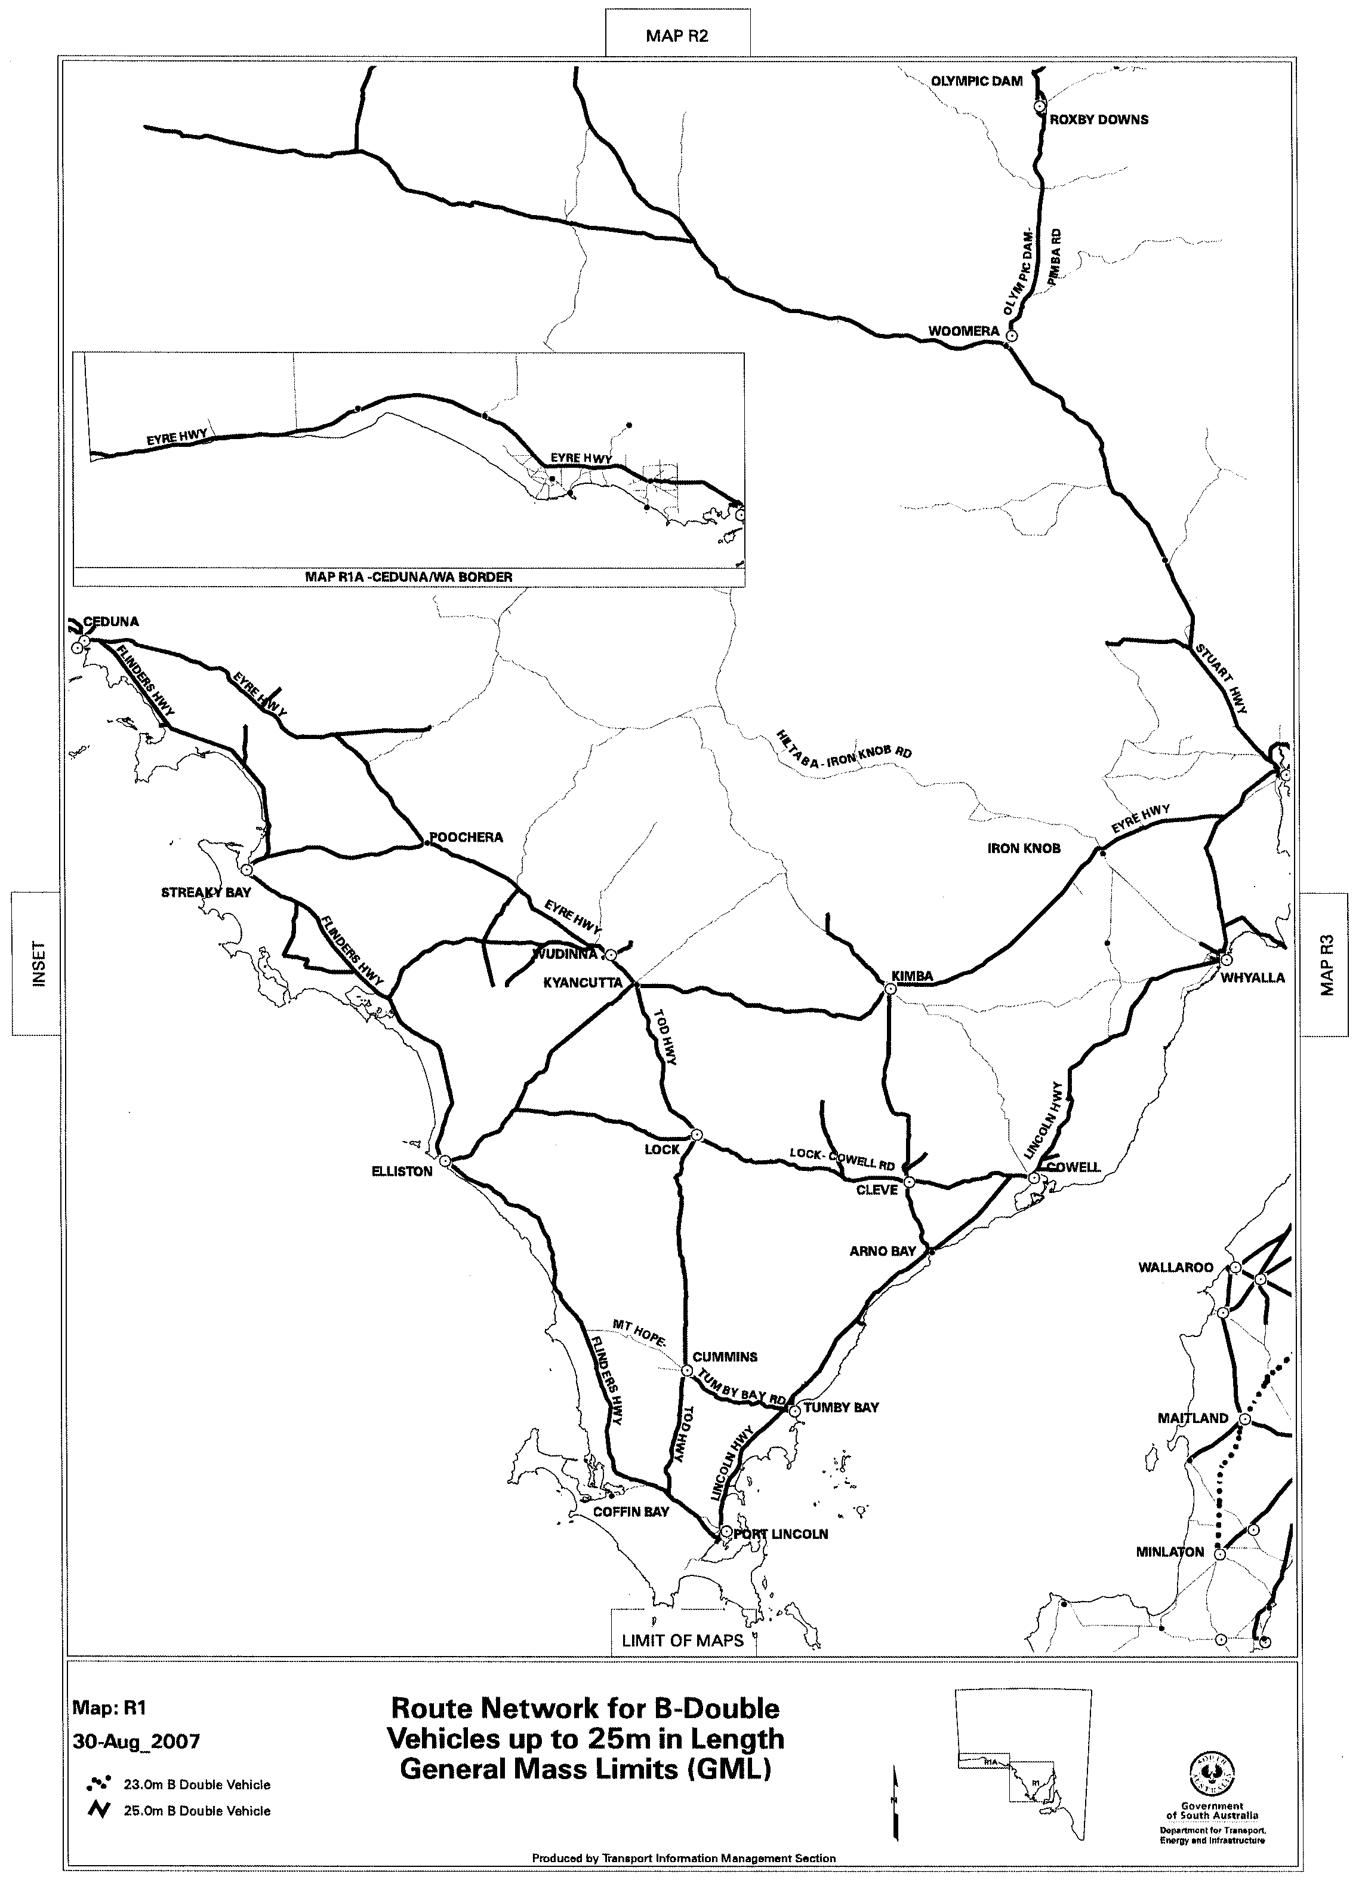
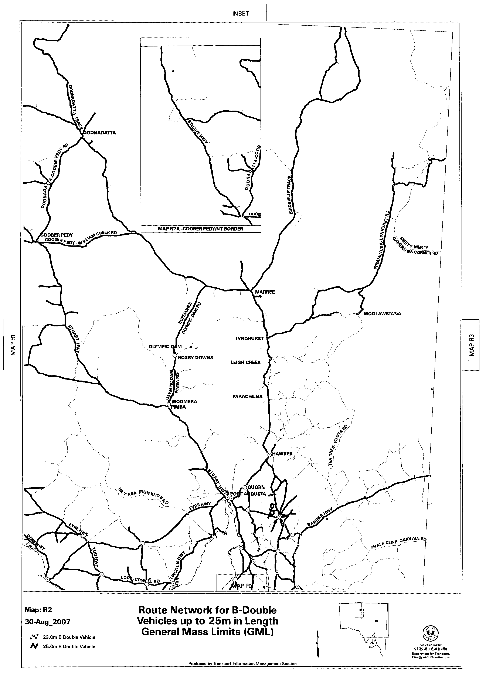
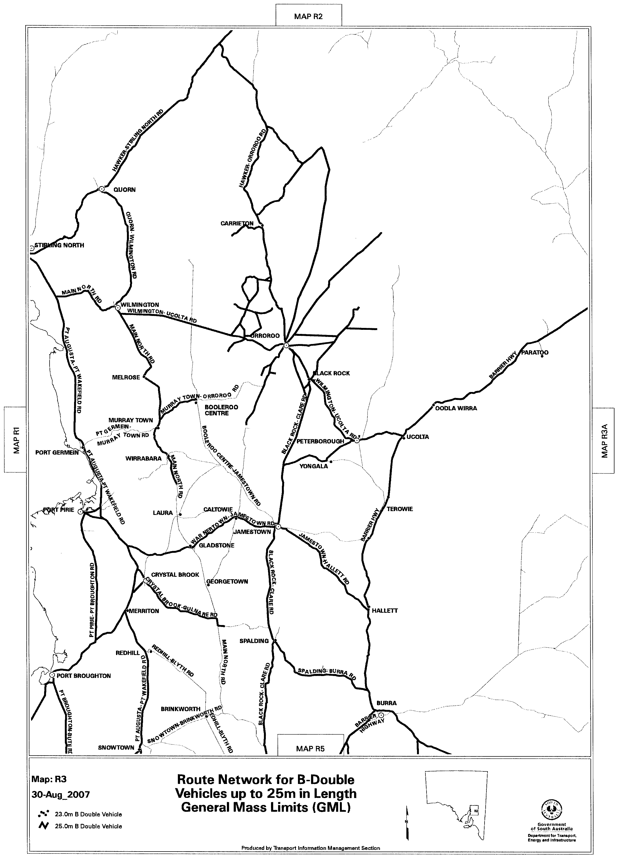
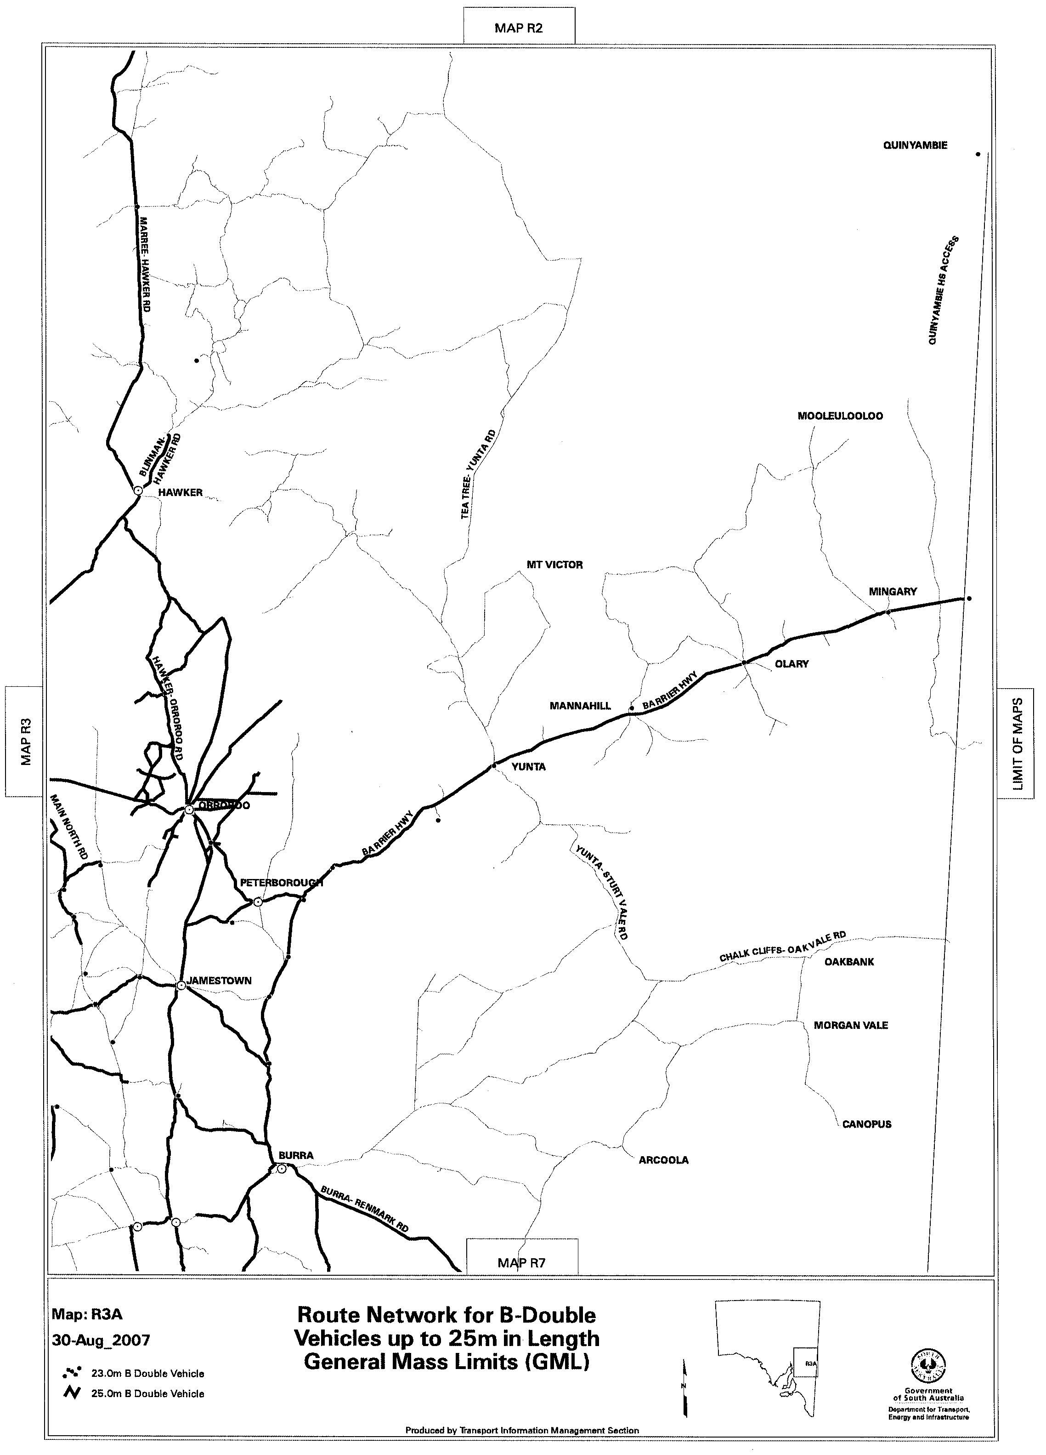
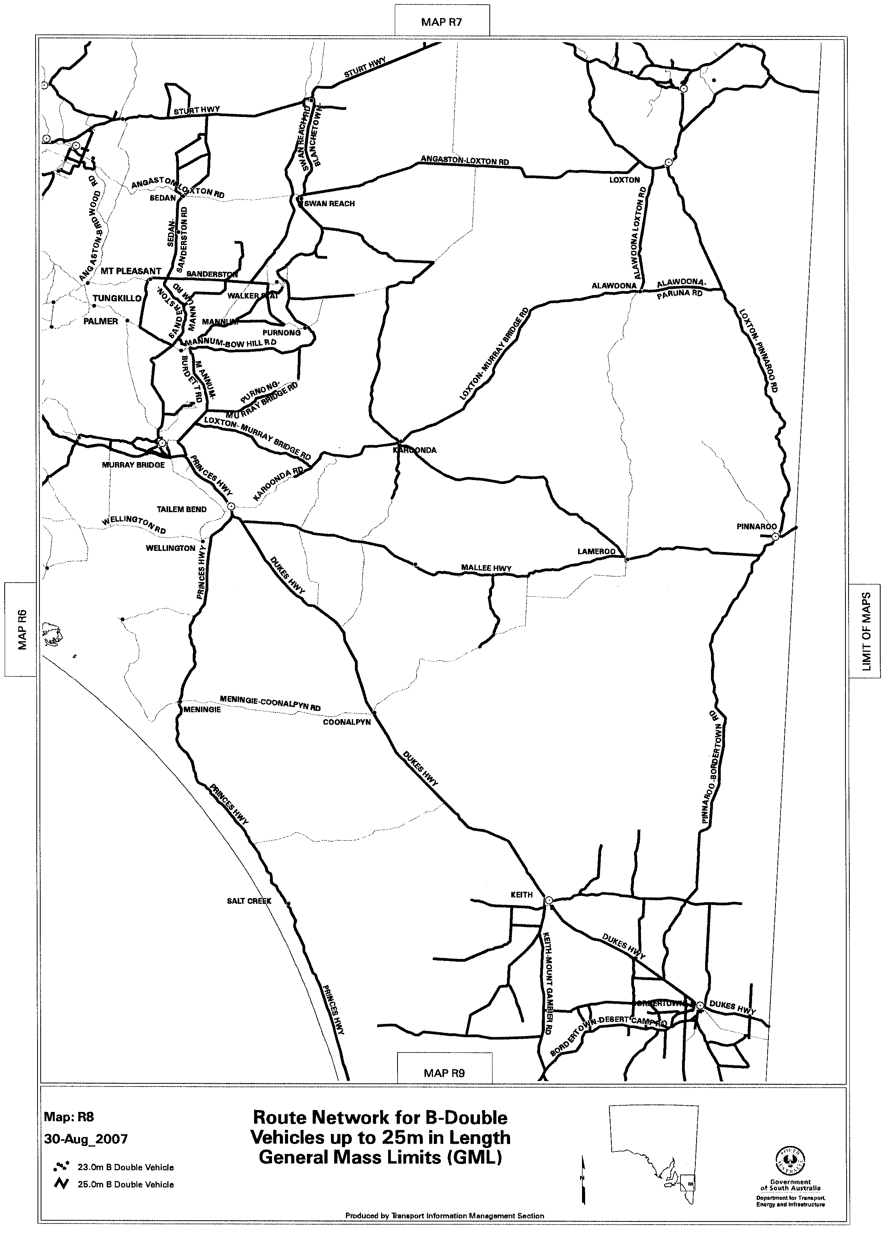
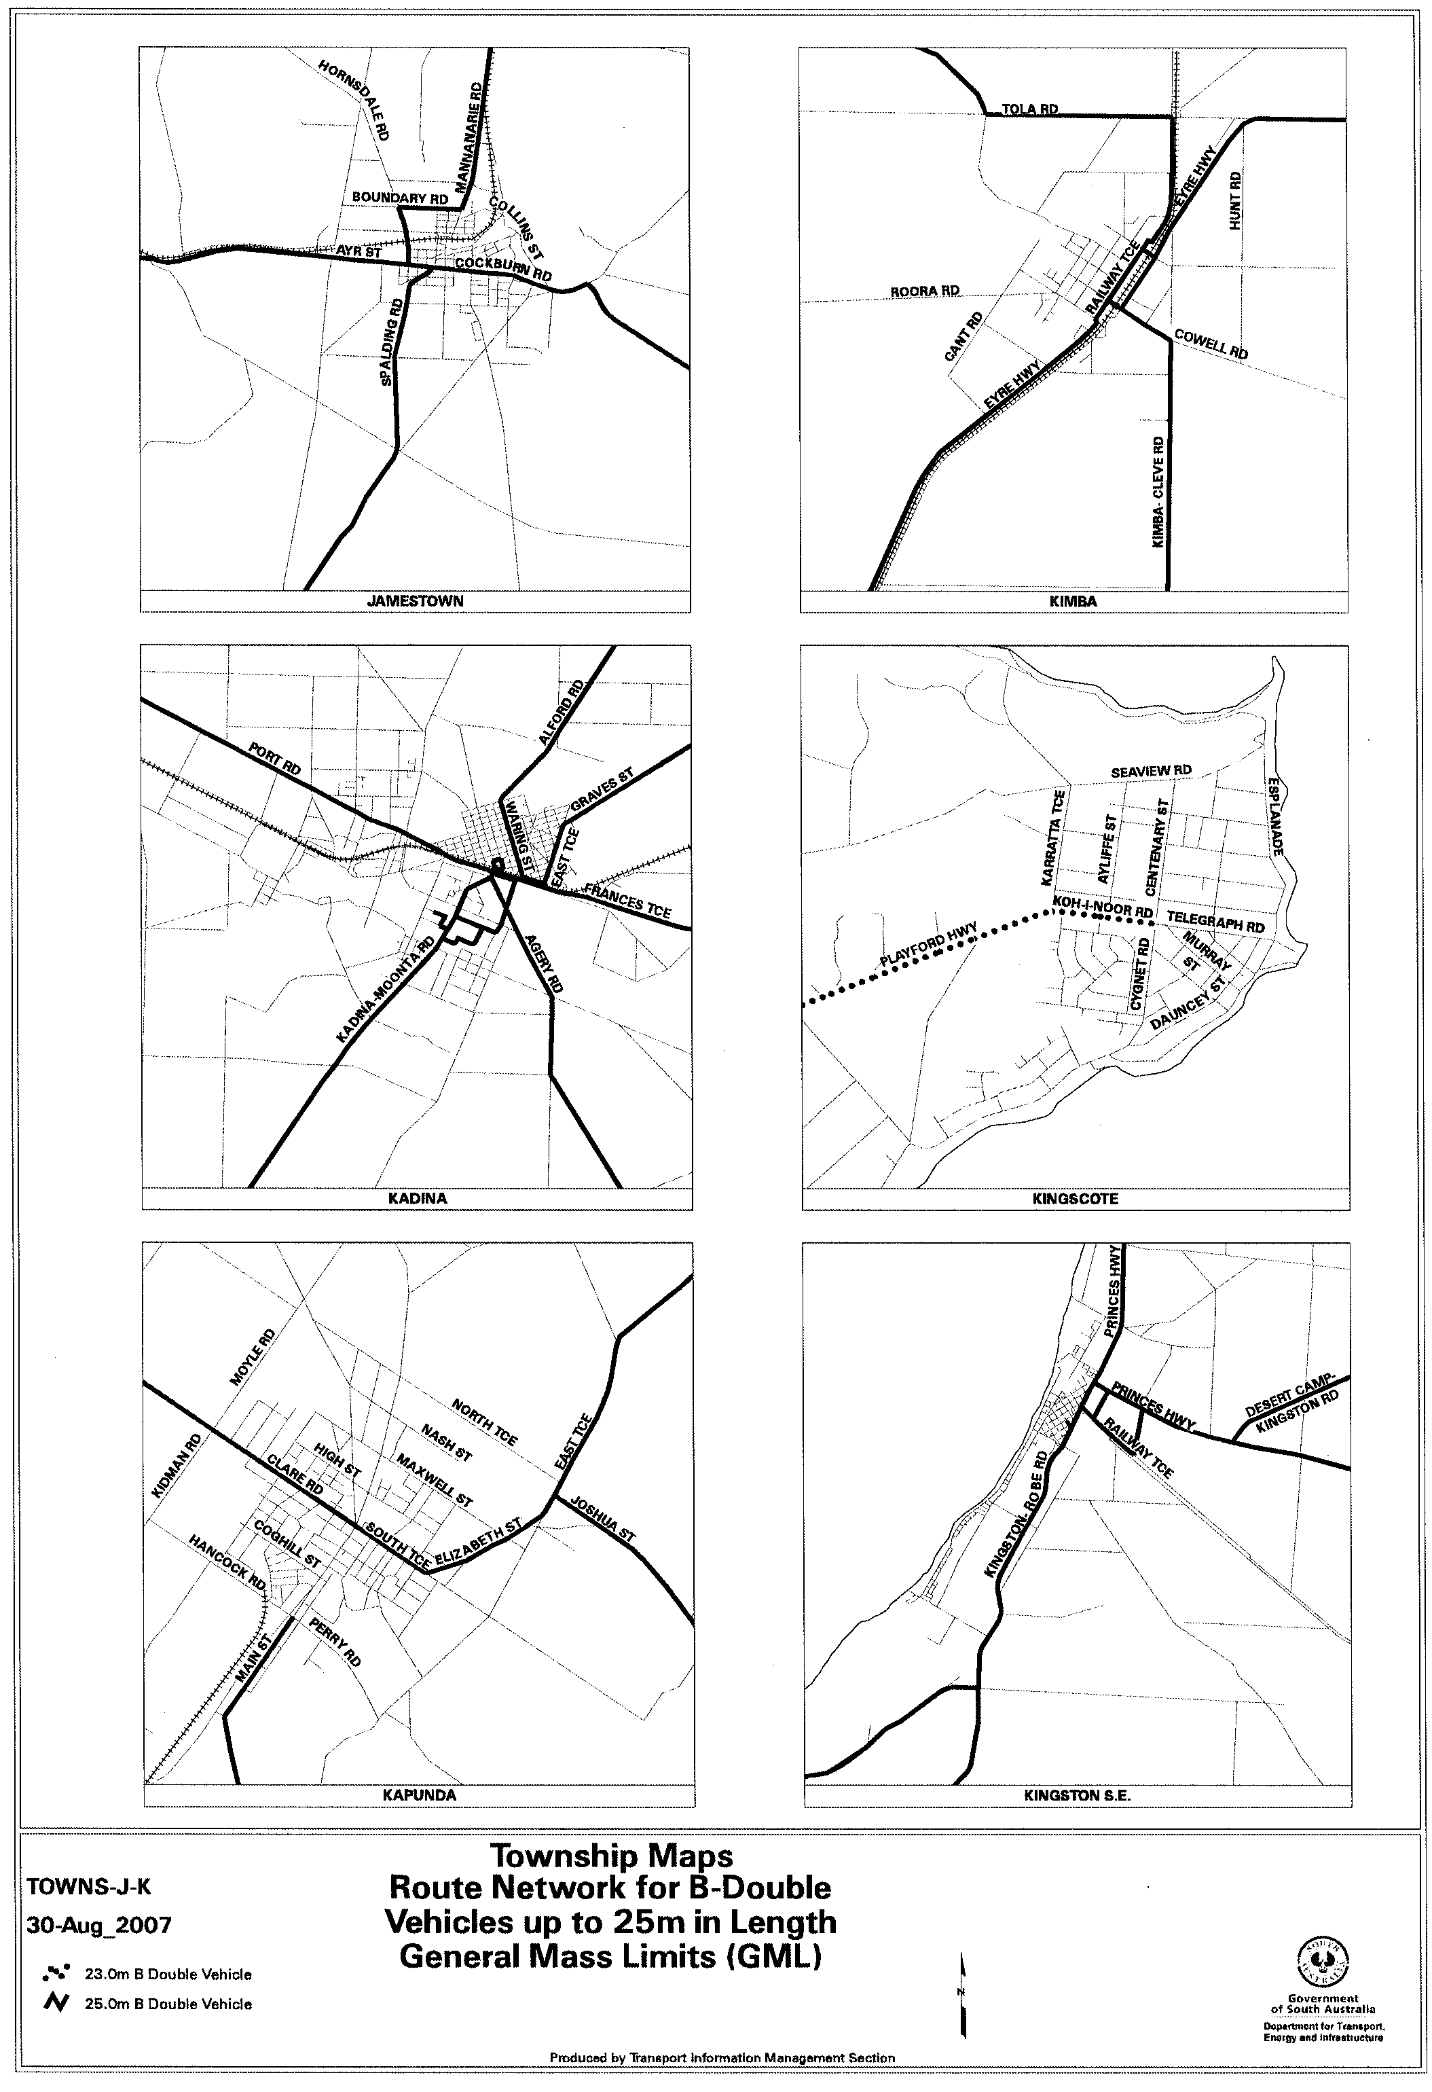
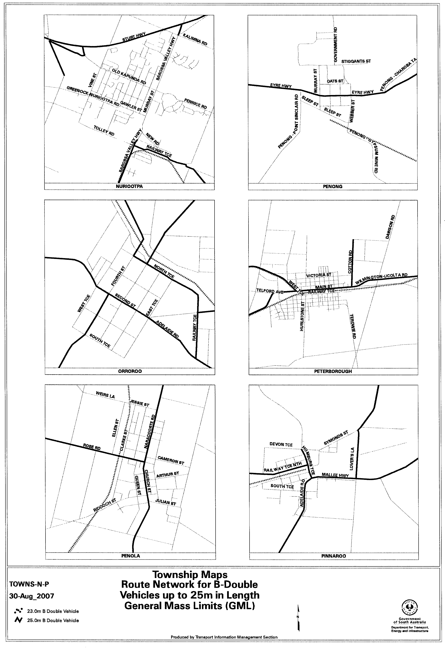
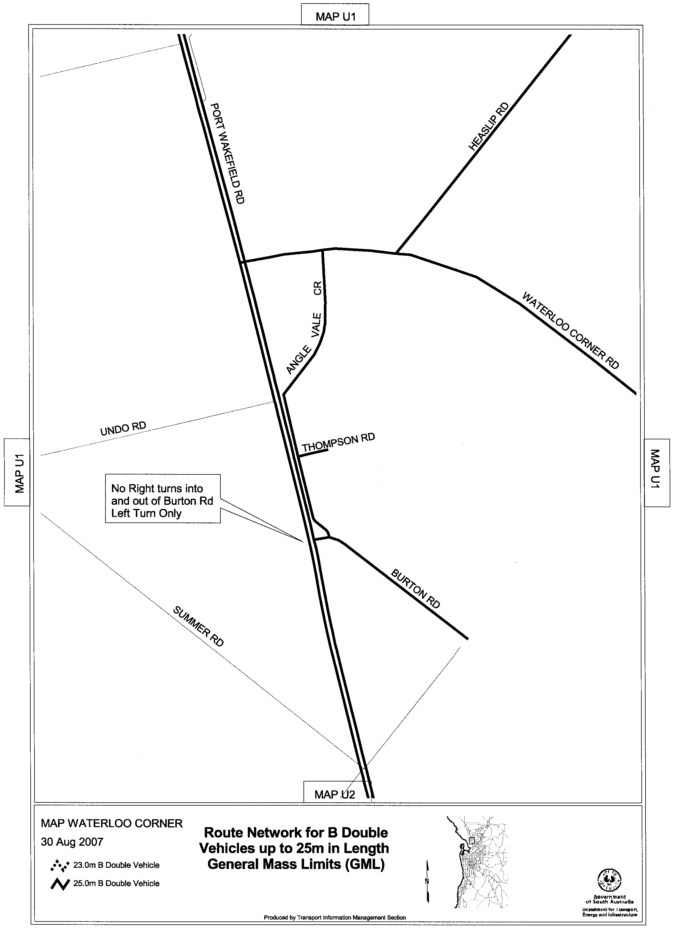
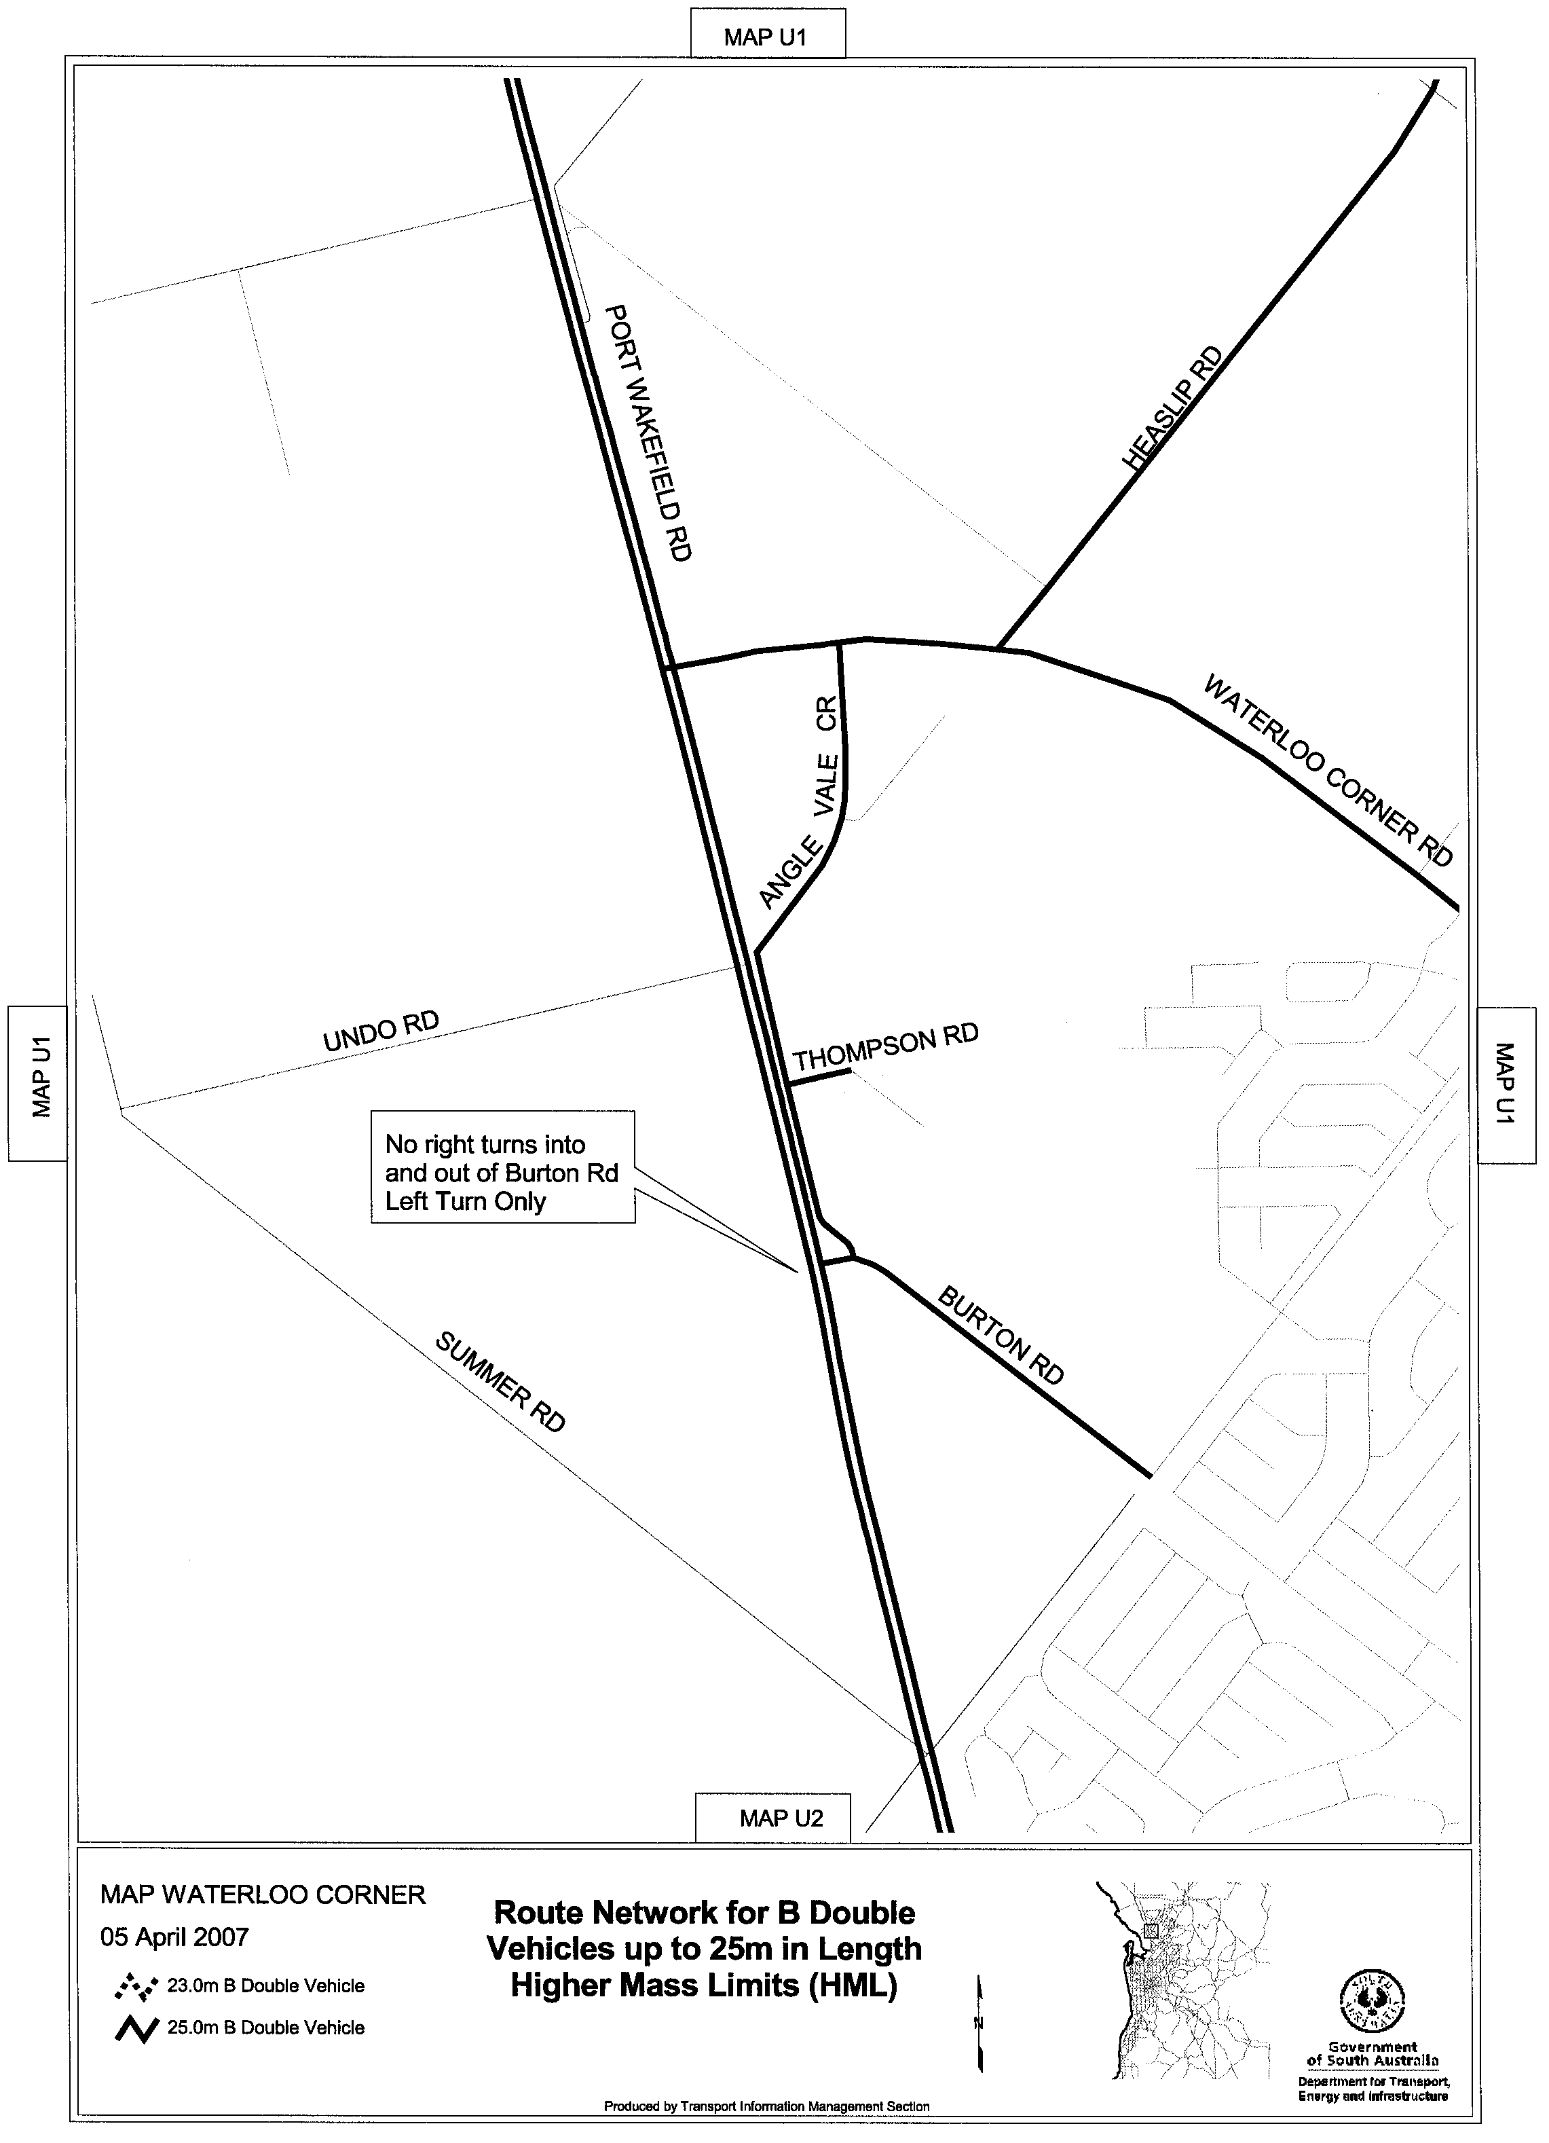

ROAD TRAFFIC ACT 1961

SUPPLEMENTARY NOTICE OF APPROVAL
Pursuant to Section 161A of the Road Traffic Act 1961

HIGHER MASS LIMITS FOR VEHICLES FITTED WITH ROAD FRIENDLY SUSPENSION
1. APPROVAL
Information Note
This Notice adds additional routes to the network that can be used by vehicles fitted with Road Friendly Suspension and is a supplement to the Notice titled ‘Higher Mass Limits for Vehicles Fitted with Road Friendly Suspension’ dated 5 May 2005.

1.1 In accordance with the powers delegated to me by the Minister for Transport under section 163AA of the Road Traffic Act 1961, I hereby vary the conditions of the Gazette Notice of Approval and Exemption titled, ‘Higher Mass Limits for Vehicles Fitted with Road Friendly Suspension’ dated 5 May 2005 as detailed below.
2. DEFINITIONS
2.1 In this Notice:
2.1.1 ‘Approved Vehicles’ means vehicles fitted with Road Friendly Suspension as described in Table 1 of the Primary Notice;
2.1.2 ‘Supplementary routes’ means the approved routes specified in the maps ‘Route Network for General Access Vehicles fitted with Road Friendly Suspension attached to this Supplementary Notice;
2.1.3 ‘Supplementary Notice’ means this Notice;
2.1.4 ‘Primary Notice’ means the Gazette Notice ‘Higher Mass Limits for Vehicles Fitted with Road Friendly Suspension’ dated 5 May 2005; and
2.1.5 all other terms have the same meaning as in the Primary Notice.
3. APPLICATION OF SUPPLEMENTARY NOTICE
3.1 This Supplementary Notice must be read in conjunction with the Primary Notice and applies to all Approved Vehicles operating under the Primary Notice travelling on routes specified in the attached maps.
4. ROUTES AVAILABLE TO APPROVED VEHICLES
4.1 An Approved Vehicle may operate under the conditions of the Primary Notice on a supplementary route specified hereunder:
4.1.1 ‘Route Network for General Access Vehicles fitted with Road Friendly Suspension’ Map R6A (Kingscote-Penneshaw Road (Hog Bay Road));
4.1.2 ‘Route Network for General Access Vehicles fitted with Road Friendly Suspension’ Map R5 (Smith Road, Kapunda—Gawler Road and Bernard Court, Gawler Belt);
4.1.3 ‘Route Network for General Access Vehicles fitted with Road Friendly Suspension’ Map U1 (Thompson Road, Burton; Smith Road, Kapunda—Gawler Road and Bernard Court, Gawler Belt; Ross Road, Golden Grove; Pentland Road, Cross Keys Road, Cheviot Road and Acrylon Road, Salisbury South);
4.1.4 ‘Route Network for General Access Vehicles fitted with Road Friendly Suspension’ Map U2 (Thompson Road, Burton; Ross Road, Golden Grove; Pentland Road, Cross Keys Road, Cheviot Road and Acrylon Road, Salisbury South);
4.1.5 ‘Route Network for General Access Vehicles fitted with Road Friendly Suspension’ Map U2_2 (Ross Road, Golden Grove; Pentland Road, Cross Keys Road, Cheviot Road and Acrylon Road, Salisbury South); and
4.1.6 ‘Township Maps Route Network for General Access Vehicles fitted with Road Friendly Suspension’ Map Gawler (Smith Road, Kapunda—Gawler Road and Bernard Court, Gawler Belt).
5. CONDITIONS AND LIMITATIONS APPLYING TO THIS SUPPLEMENTARY NOTICE
5.1 When operating on a route specified in the attached maps, the driver of an Approved Vehicle must:
5.1.1 continue to comply with all conditions and requirements of the Primary Notice; and
5.1.2 carry a legible, current and complete copy of:
(i) this Supplementary Notice and attached maps;
(ii) the Primary Notice;
(iii) any combination specific documents as requested by the Primary Notice; and
5.1.3 produce these documents when requested by a Department for Transport, Energy and Infrastructure, Transport Safety Compliance Officer appointed under the Road Traffic Act 1961 and/or the Motor Vehicles Act 1959 or a Police Officer.
6. COMMENCEMENT OF THIS NOTICE
6.1 This Notice is effective from 12.01 a.m. on 3 September 2007.

Executive Director,
Safety and Regulation Division
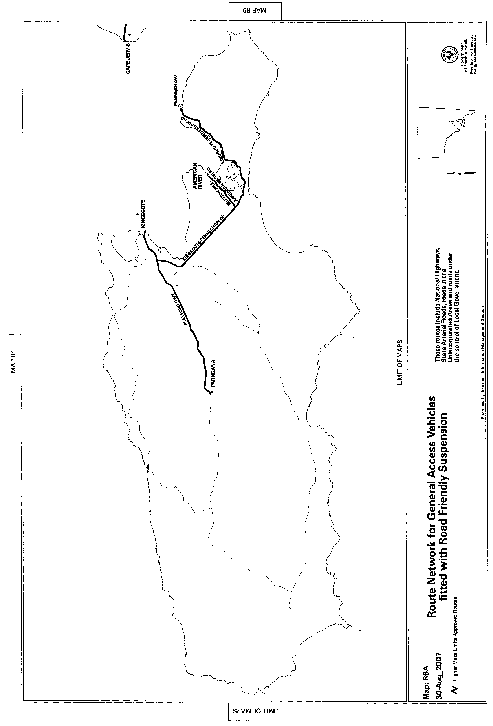
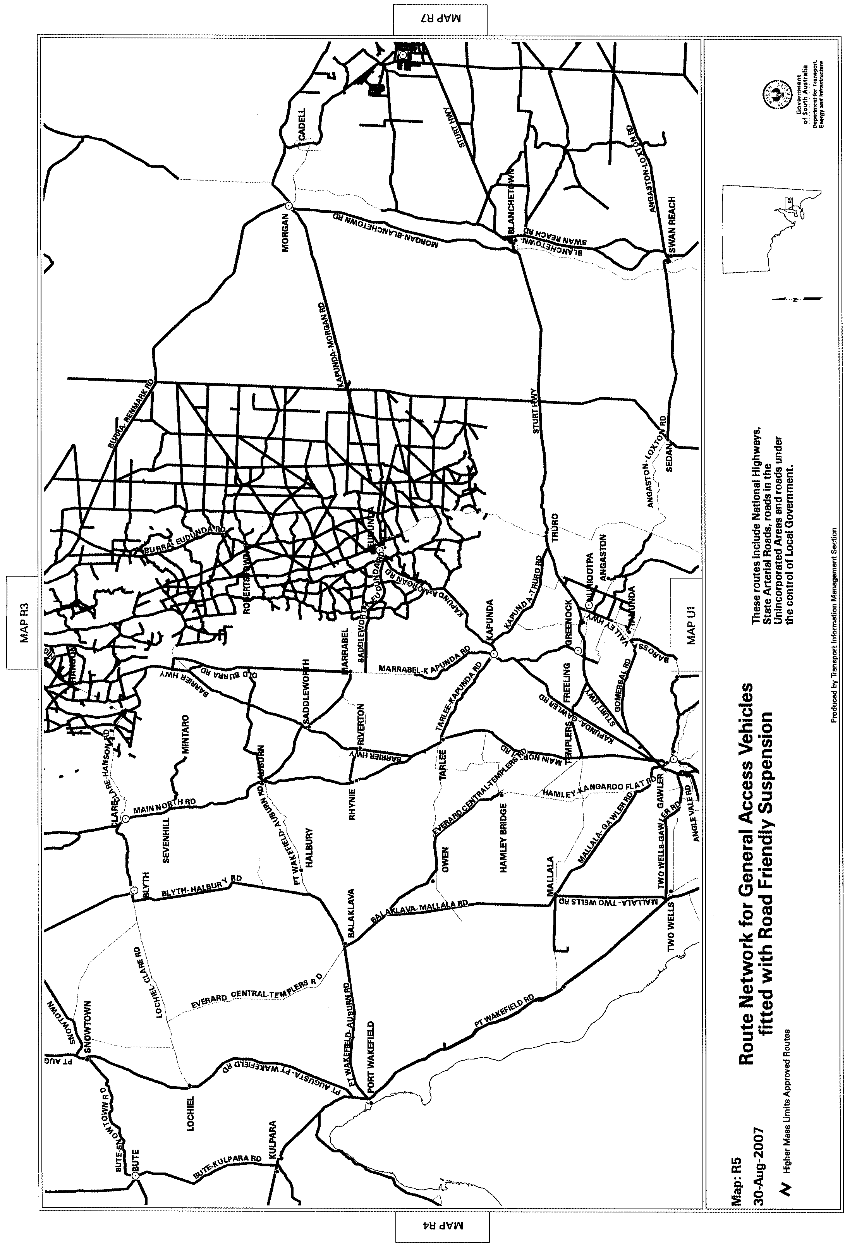
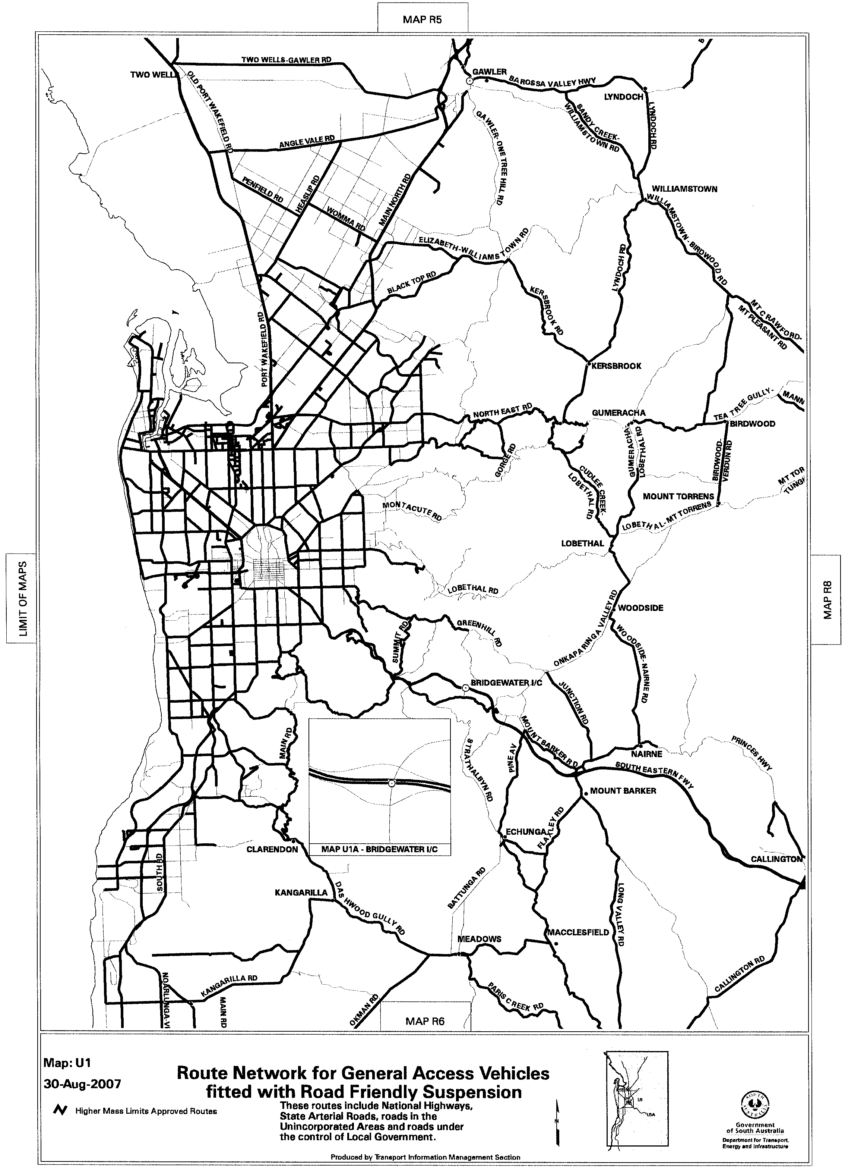
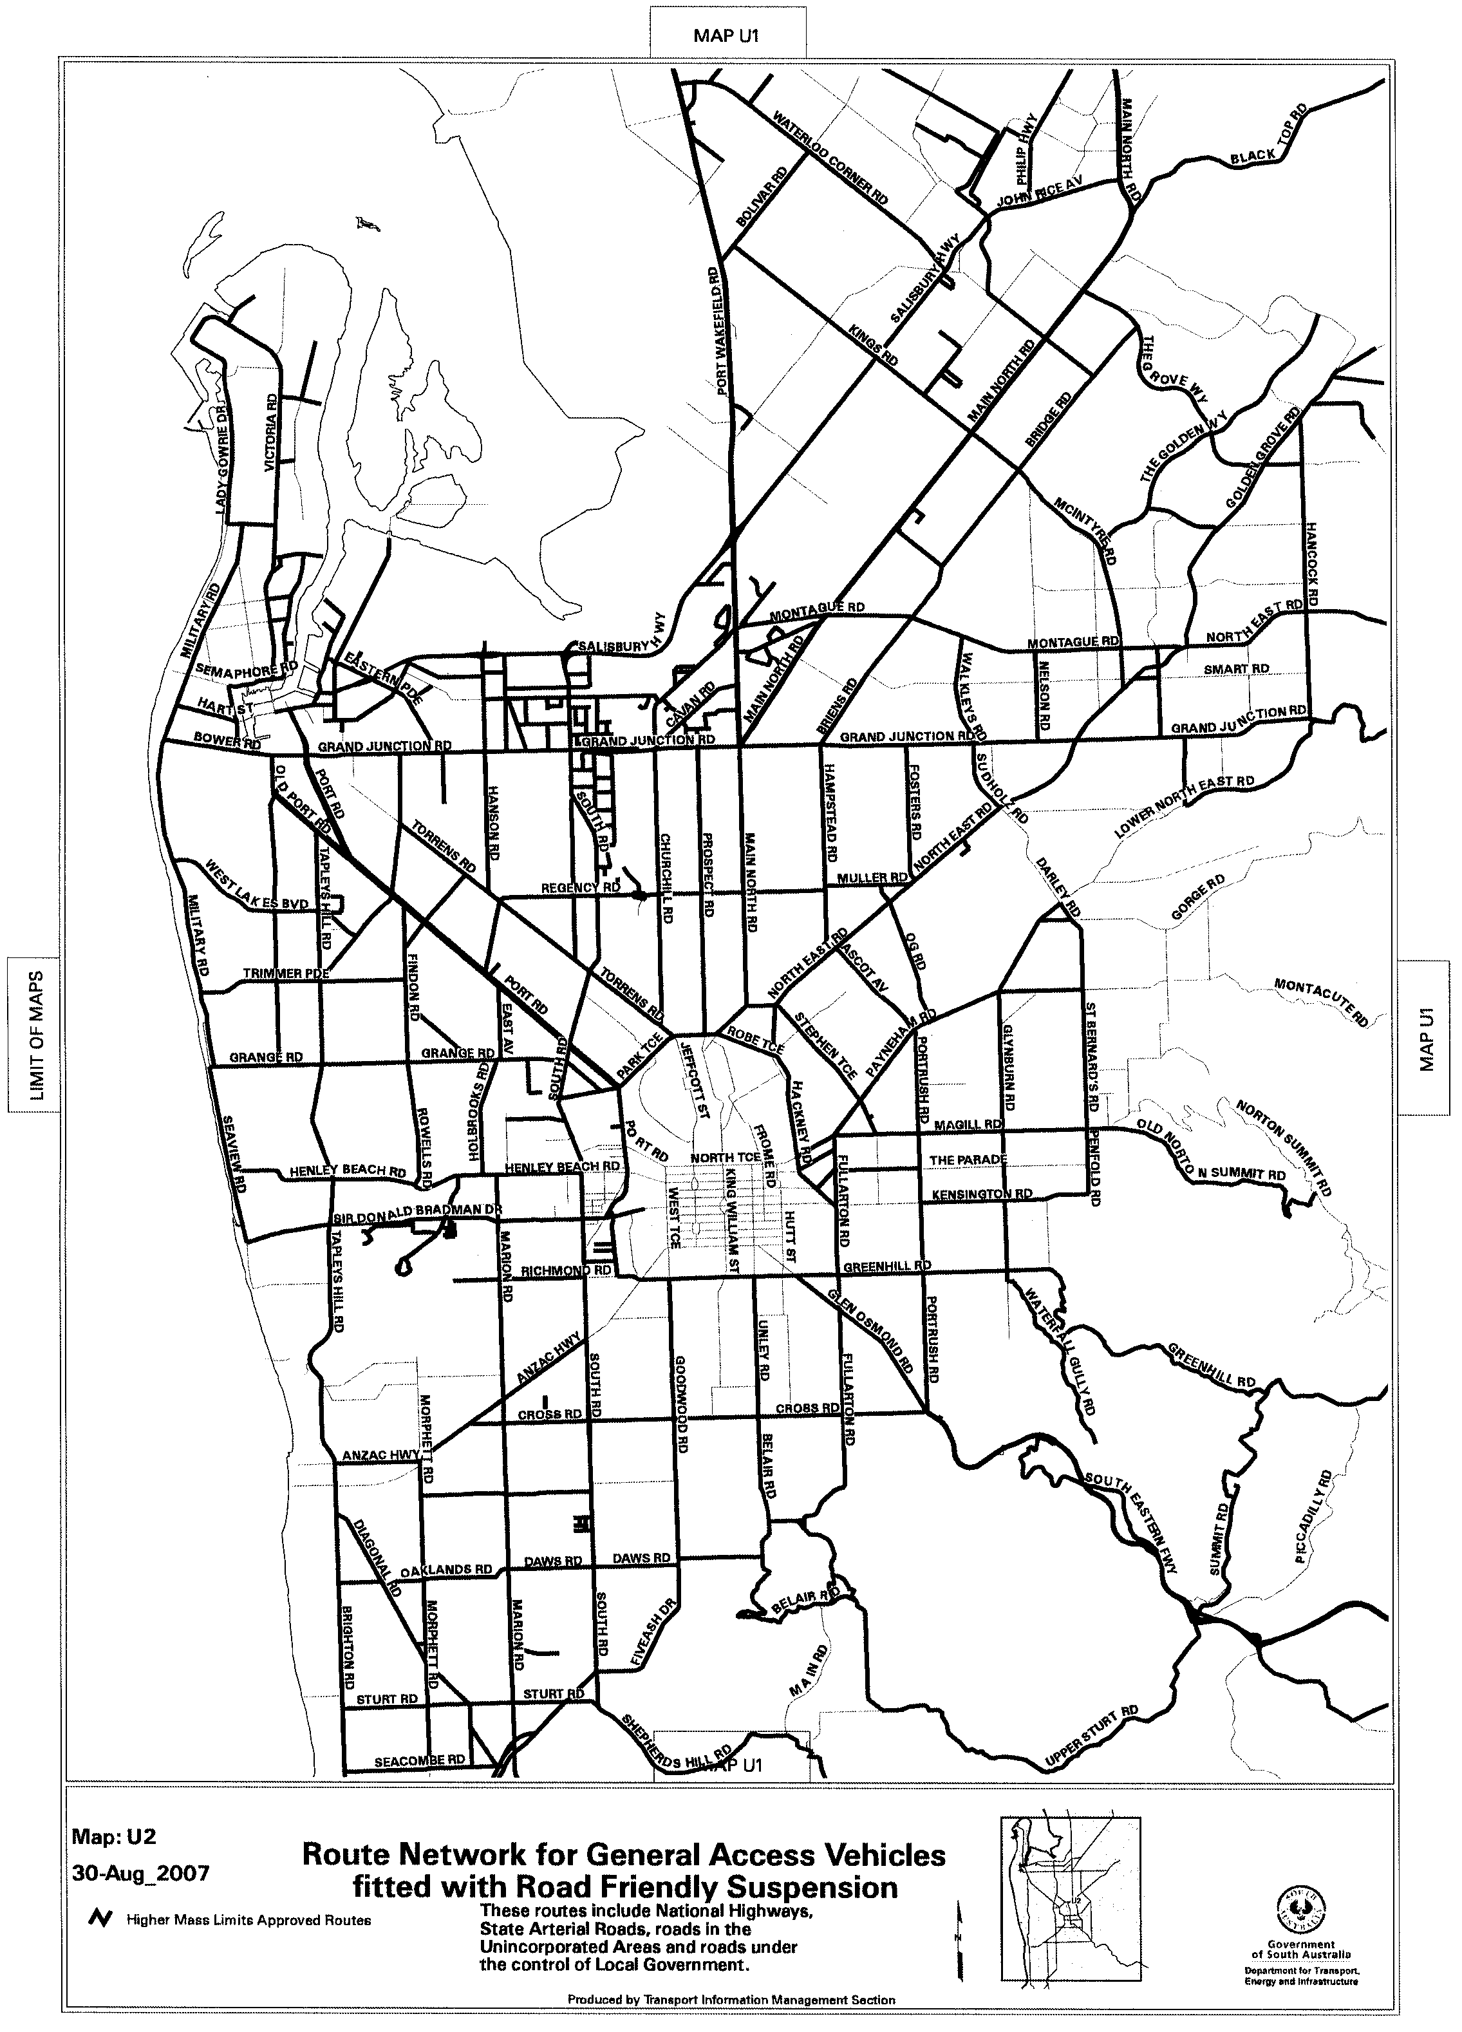
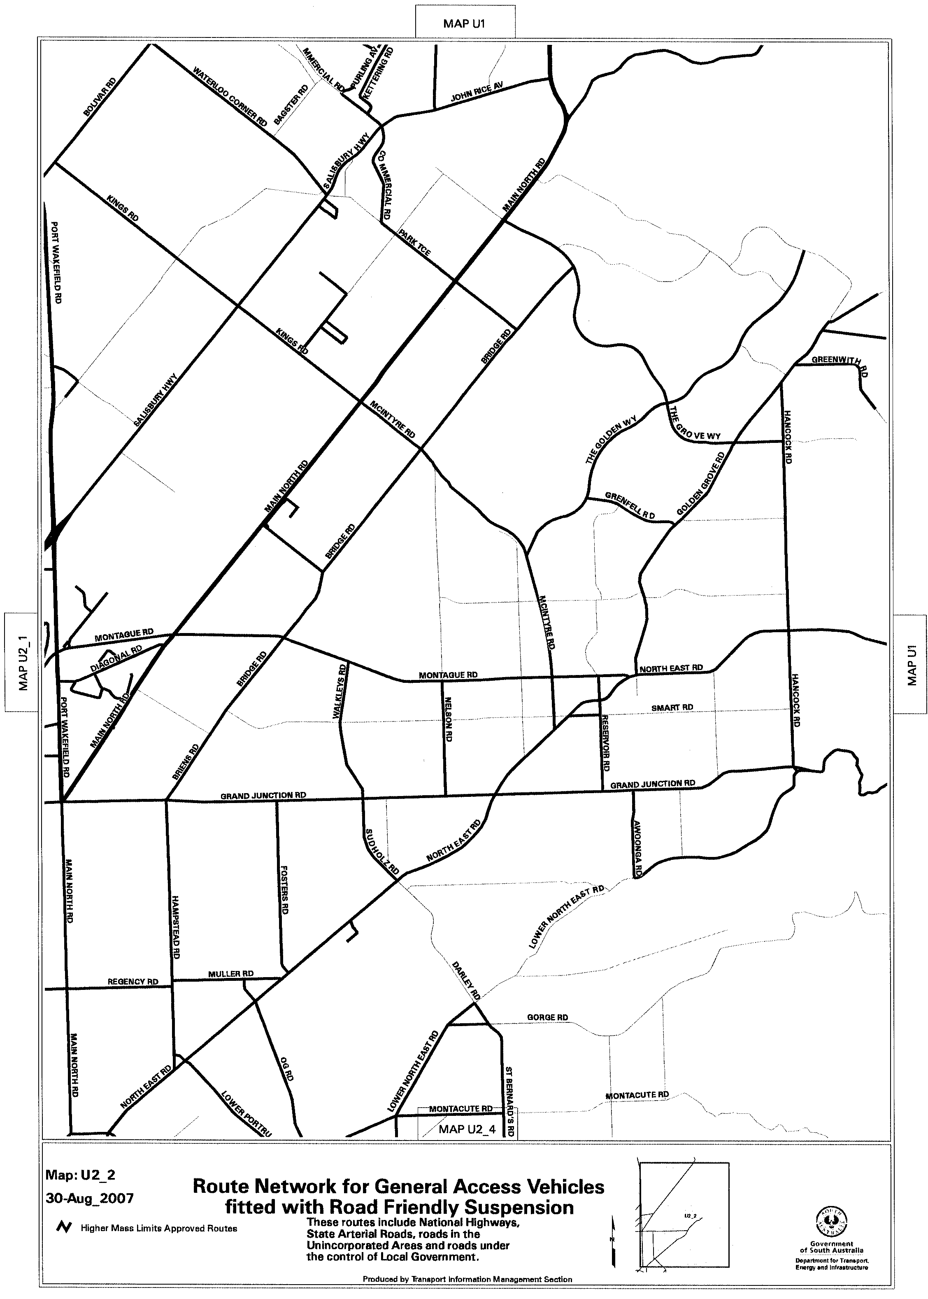
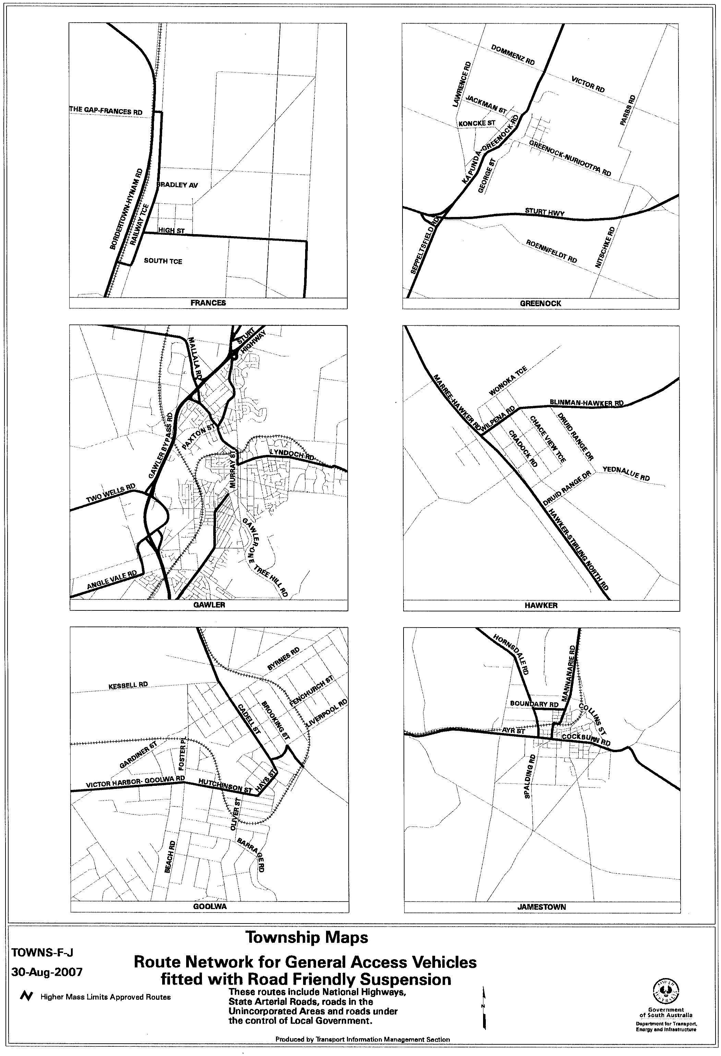

ROAD TRAFFIC ACT 1961

SUPPLEMENTARY NOTICE OF APPROVAL
Pursuant to Section 161A of the Road Traffic Act 1961

OPERATION OF CONTROLLED ACCESS BUSES IN SOUTH AUSTRALIA
1. APPROVAL
Information Note
This Notice adds additional routes to the network that can be used by Controlled Access Buses and is a supplement to the Notice titled ‘Operation of Controlled Access Buses in South Australia’ dated 19 May 2005.

1.1 In accordance with the powers under section 161A of the Road Traffic Act 1961 delegated to me by the Minister for Transport, I hereby vary the conditions of the Gazette Notice of Approval titled, ‘Operation of Controlled Access Buses in South Australia’ dated 19 May 2005 as detailed below.
2. DEFINITIONS
2.1 In this Notice:
2.1.1 ‘Approved Vehicle’ means a rigid bus, over 12.5 m in length, but not over 14.5 m in length.
2.1.2 ‘Supplementary routes’ means the approved routes specified in the maps titled ‘Controlled Access Bus Route Network’ attached to this Supplementary Notice.
2.1.3 ‘Supplementary Notice’ means this Notice.
2.1.4 ‘Primary Notice’ means the Gazette Notice ‘Operation of Controlled Access Buses in South Australia’ dated 19 May 2005; and
2.1.5 all other terms have the same meaning as in the Primary Notice.
3. APPLICATION OF SUPPLEMENTARY NOTICE
3.1 This Supplementary Notice must be read in conjunction with the Primary Notice and applies to all Approved Vehicles operating under the Primary Notice travelling on routes specified in the attached maps.
4. ROUTES AVAILABLE TO APPROVED VEHICLES
4.1 An Approved Vehicle may operate under the conditions of the Primary Notice on a supplementary route specified in the attached maps titled:
4.1.1 Controlled Access Bus Route Network, Map U1;
4.1.2 Controlled Access Bus Route Network, Map U2; and
4.1.3 Controlled Access Bus Route Network, Map CBD.
5. CONDITIONS AND LIMITATIONS APPLYING TO THIS SUPPLEMENTARY NOTICE
5.1 When operating on a route specified in the attached maps, the driver of an Approved Vehicle must:
5.1.1 continue to comply with all conditions and requirements of the Primary Notice; and
5.1.2 carry a legible, current and complete copy of:
(i) this Supplementary Notice and attached maps;
(ii) the Primary Notice;
(iii) any combination specific documents as required by the Primary Notice; and
5.1.3 produce these documents when requested by a DTEI Authorised Officer appointed under the Road Traffic Act 1961 or a Police Officer.
6. COMMENCEMENT OF THIS NOTICE
6.1 This Notice is effective from 12.01 a.m. on 1 September 2007.

Executive Director
Safety and Regulation Division
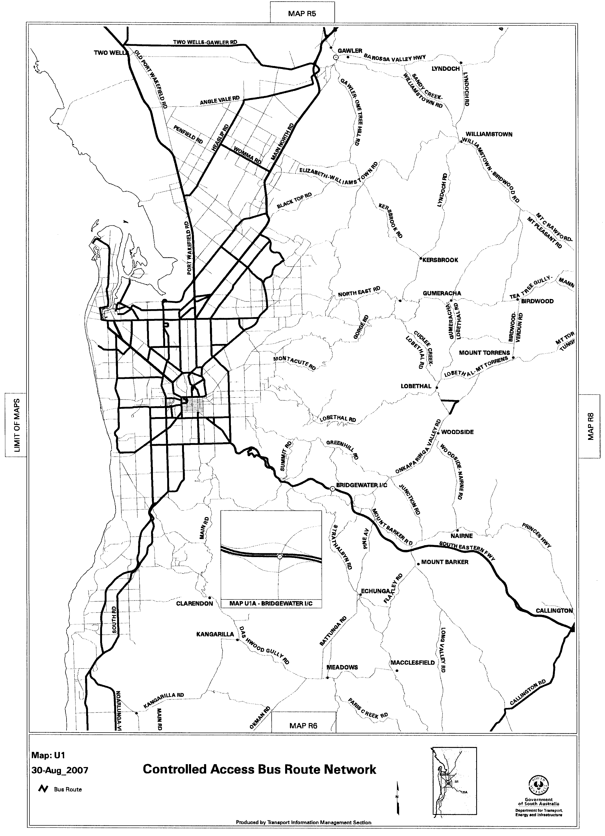
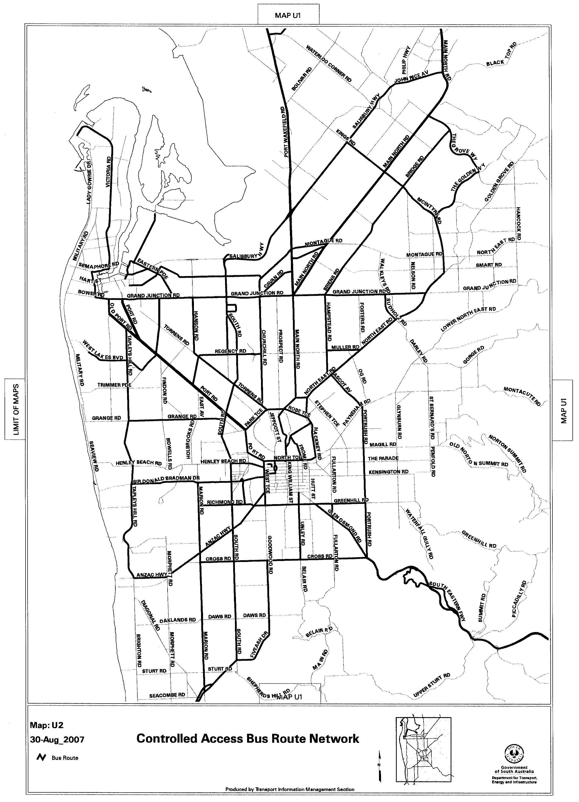
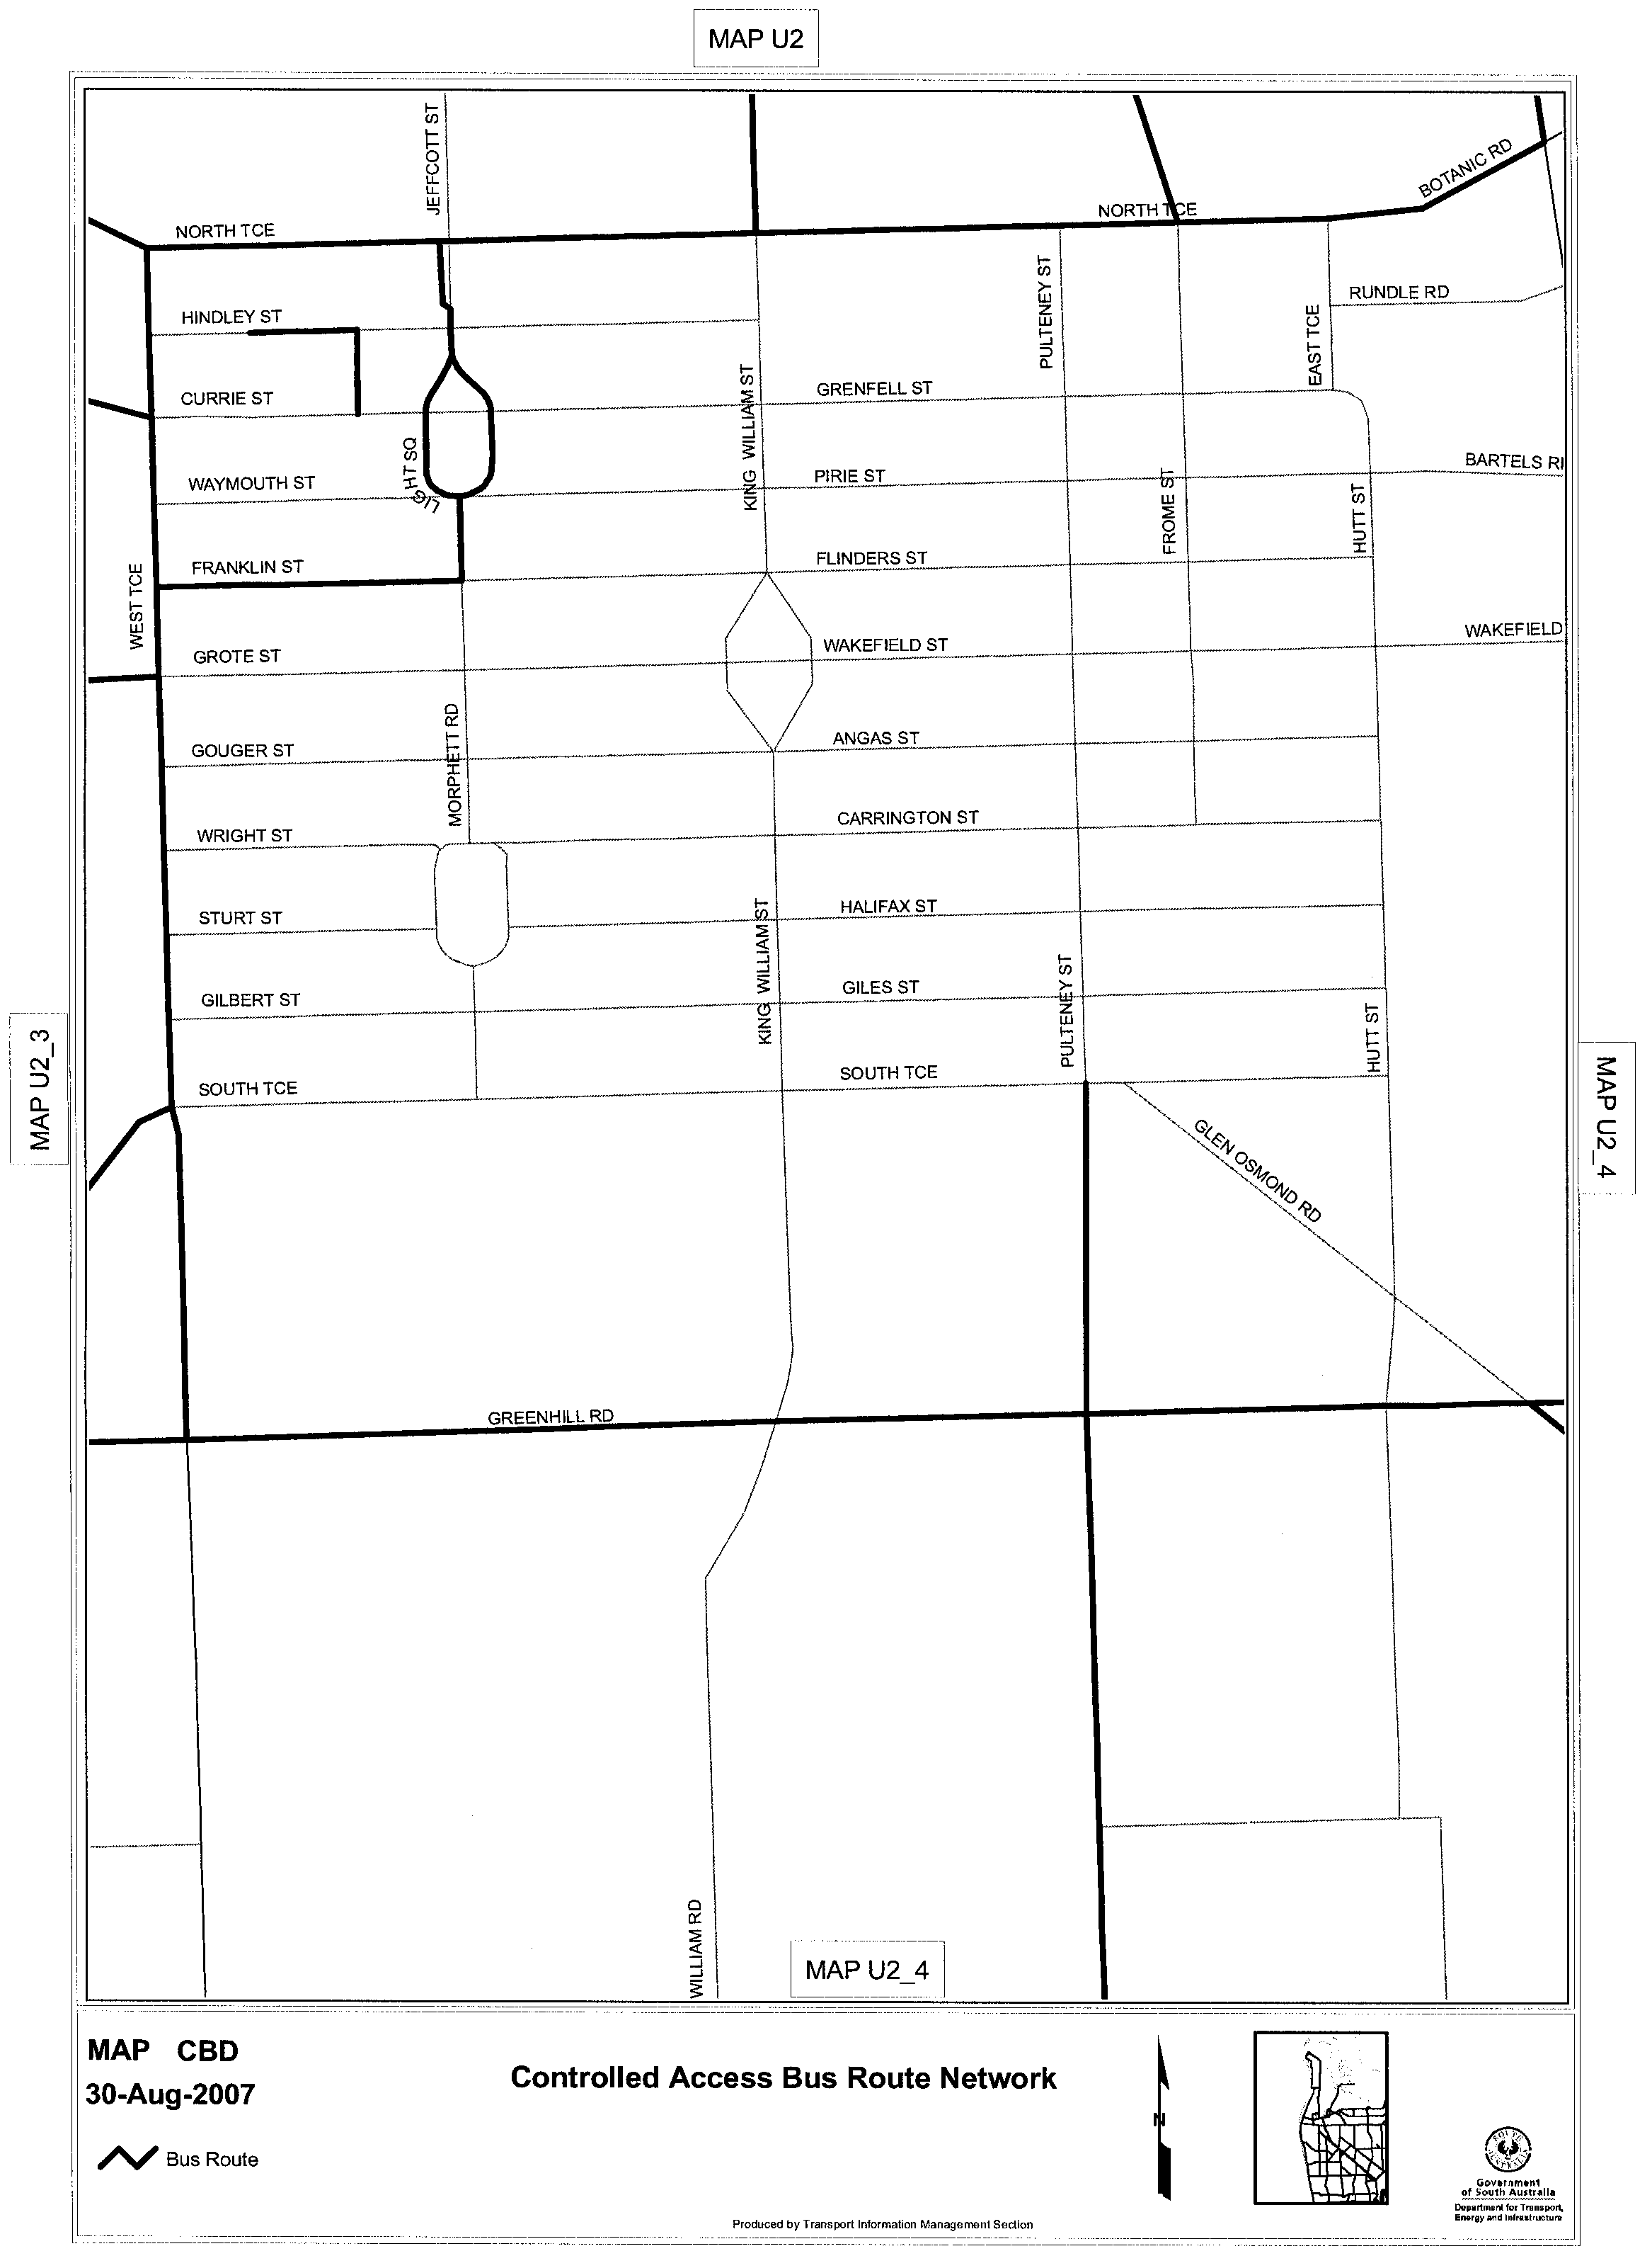

ROAD TRAFFIC ACT 1961

NOTICE OF APPROVAL
Pursuant to Section 161A of the Road Traffic Act 1961

OPERATION OF 14.5 M TRANSITPLUS CONTROLLED ACCESS BUSES PROVIDING A ROUTE SERVICE IN SOUTH AUSTRALIA
1. REVOCATION OF PREVIOUS NOTICE
Information Note
This Notice provides a route network that can be used by 14.5 m Controlled Access Buses used for Metroticket route services operated by Transitplus and may be used in conjunction with the Notice titled ‘Operation of Controlled Access Buses in South Australia’.

1.1 I hereby revoke the Notice of Approval titled ‘Operation of 14.5 m Transitplus Controlled Access Buses providing a Route Service in South Australia’ published in the South Australian Government Gazette, dated 29 March 2007.
2. APPROVAL
2.1 In accordance with the powers delegated to me by the Minister for Transport under section 161A of the Road Traffic Act 1961, I hereby approve Controlled Access Buses to travel on roads in South Australia subject to the conditions and limitations specified in this Notice.
3. DEFINITIONS
3.1 In this Notice:
3.1.1 ‘Approved Vehicle’ means a Controlled Access Bus, which is jointly defined in the Road Traffic (Vehicle Standards) Rules 1999 and the Road Traffic (Miscellaneous) Regulations 1999 as being a ‘rigid bus, over 12.5 m long but not over 14.5 m long’, and that is being operated by Australian Transit Enterprises Pty Ltd (Transitplus).
3.1.2 ‘Routes’ means the approved roads and conditions specified in the maps ‘Transitplus Bus Route Network’ attached to this Notice.
4. CONDITIONS AND LIMITATIONS APPLYING TO THIS NOTICE
4.1 When operating on a route specified in the attached maps, the driver of an Approved Vehicle must:
4.1.1 be accredited by Transitplus for operation of 14.5 m Controlled Access Buses;
4.1.2 have demonstrated to a Transitplus accredited Driver Training Officer route familiarity and experience in operating 12.5 m general access buses along the routes prior to operating 14.5 m Controlled Access Buses;
4.1.3 have undertaken route familiarisation and training (i.e. driving the routes) in a 14.5 m Controlled Access Bus with a Transitplus accredited Driver Training Officer prior to the transporting of passengers;
4.1.4 continue to comply with all conditions and requirements of applicable legislation, this Notice and all methods and procedures of operation on the routes as identified by Transitplus and detailed in the document titled ‘14.5 m Controlled Access Bus Conditions of Operation’;
4.1.5 carry a legible, current and complete copy of this Notice, the attached maps and the document titled ‘14.5 m Controlled Access Bus Conditions of Operation’; and
4.1.6 produce these documents when requested by a Department for Transport, Energy and Infrastructure Authorised Officer appointed under the Road Traffic Act 1961 or a Police Officer.
5. COMMENCEMENT OF THIS NOTICE
5.1 This Notice is effective from 12.01 a.m. on 1 September 2007.

Executive Director, Safety and Regulation Division
Authorised Delegate of the Minister for Transport
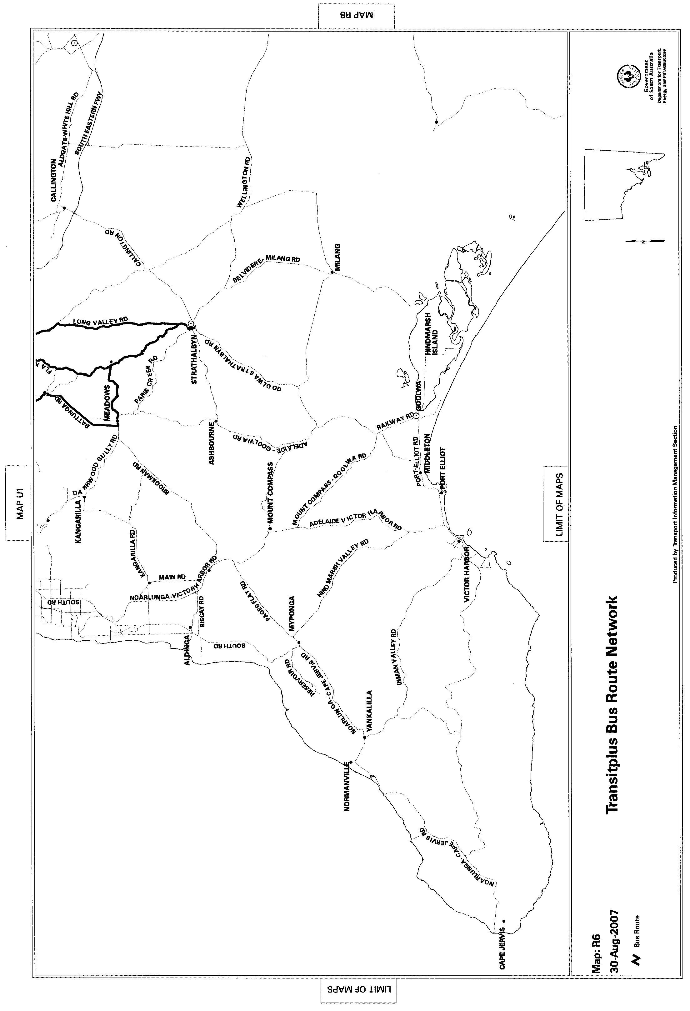
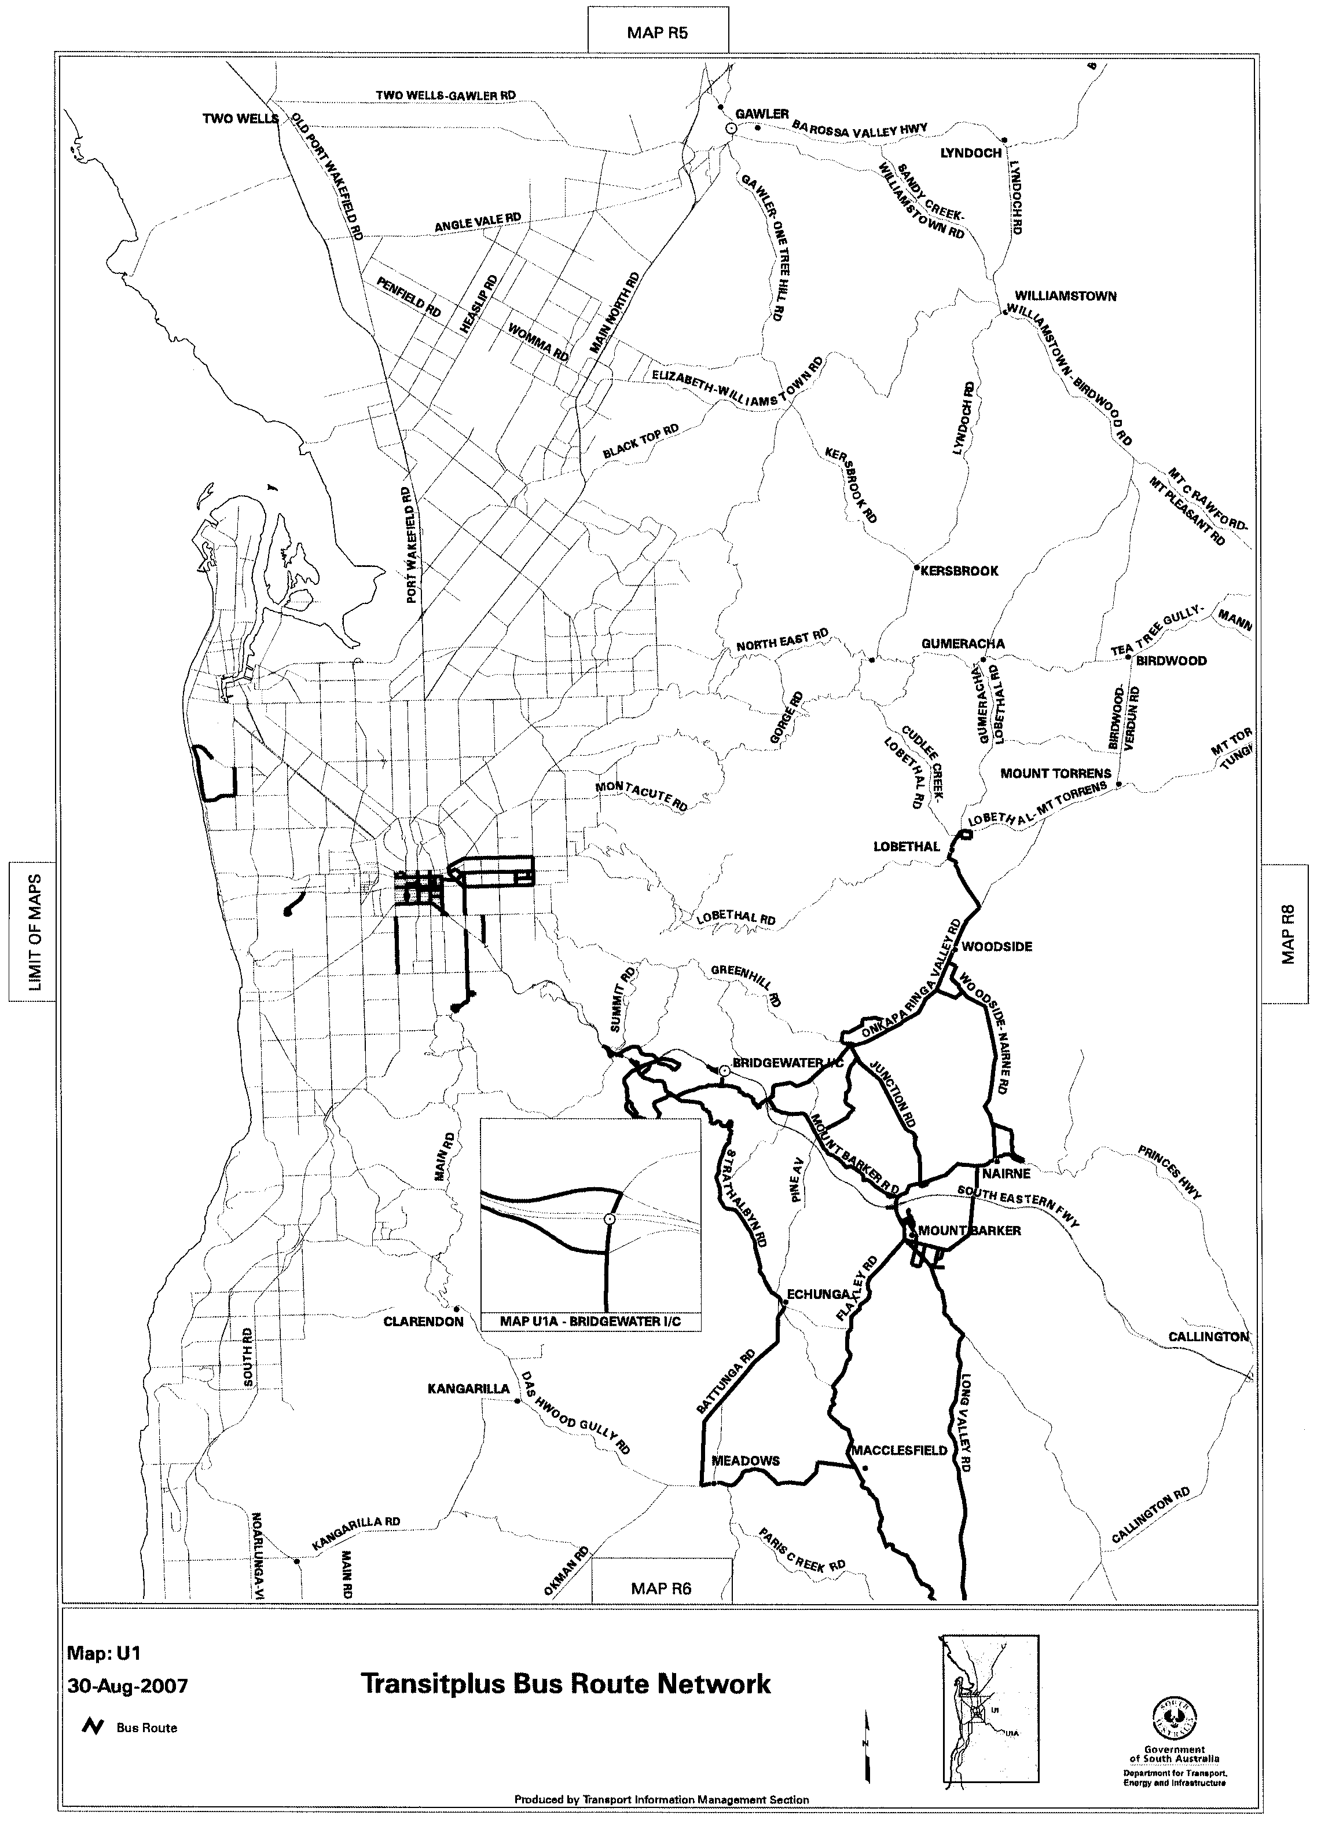
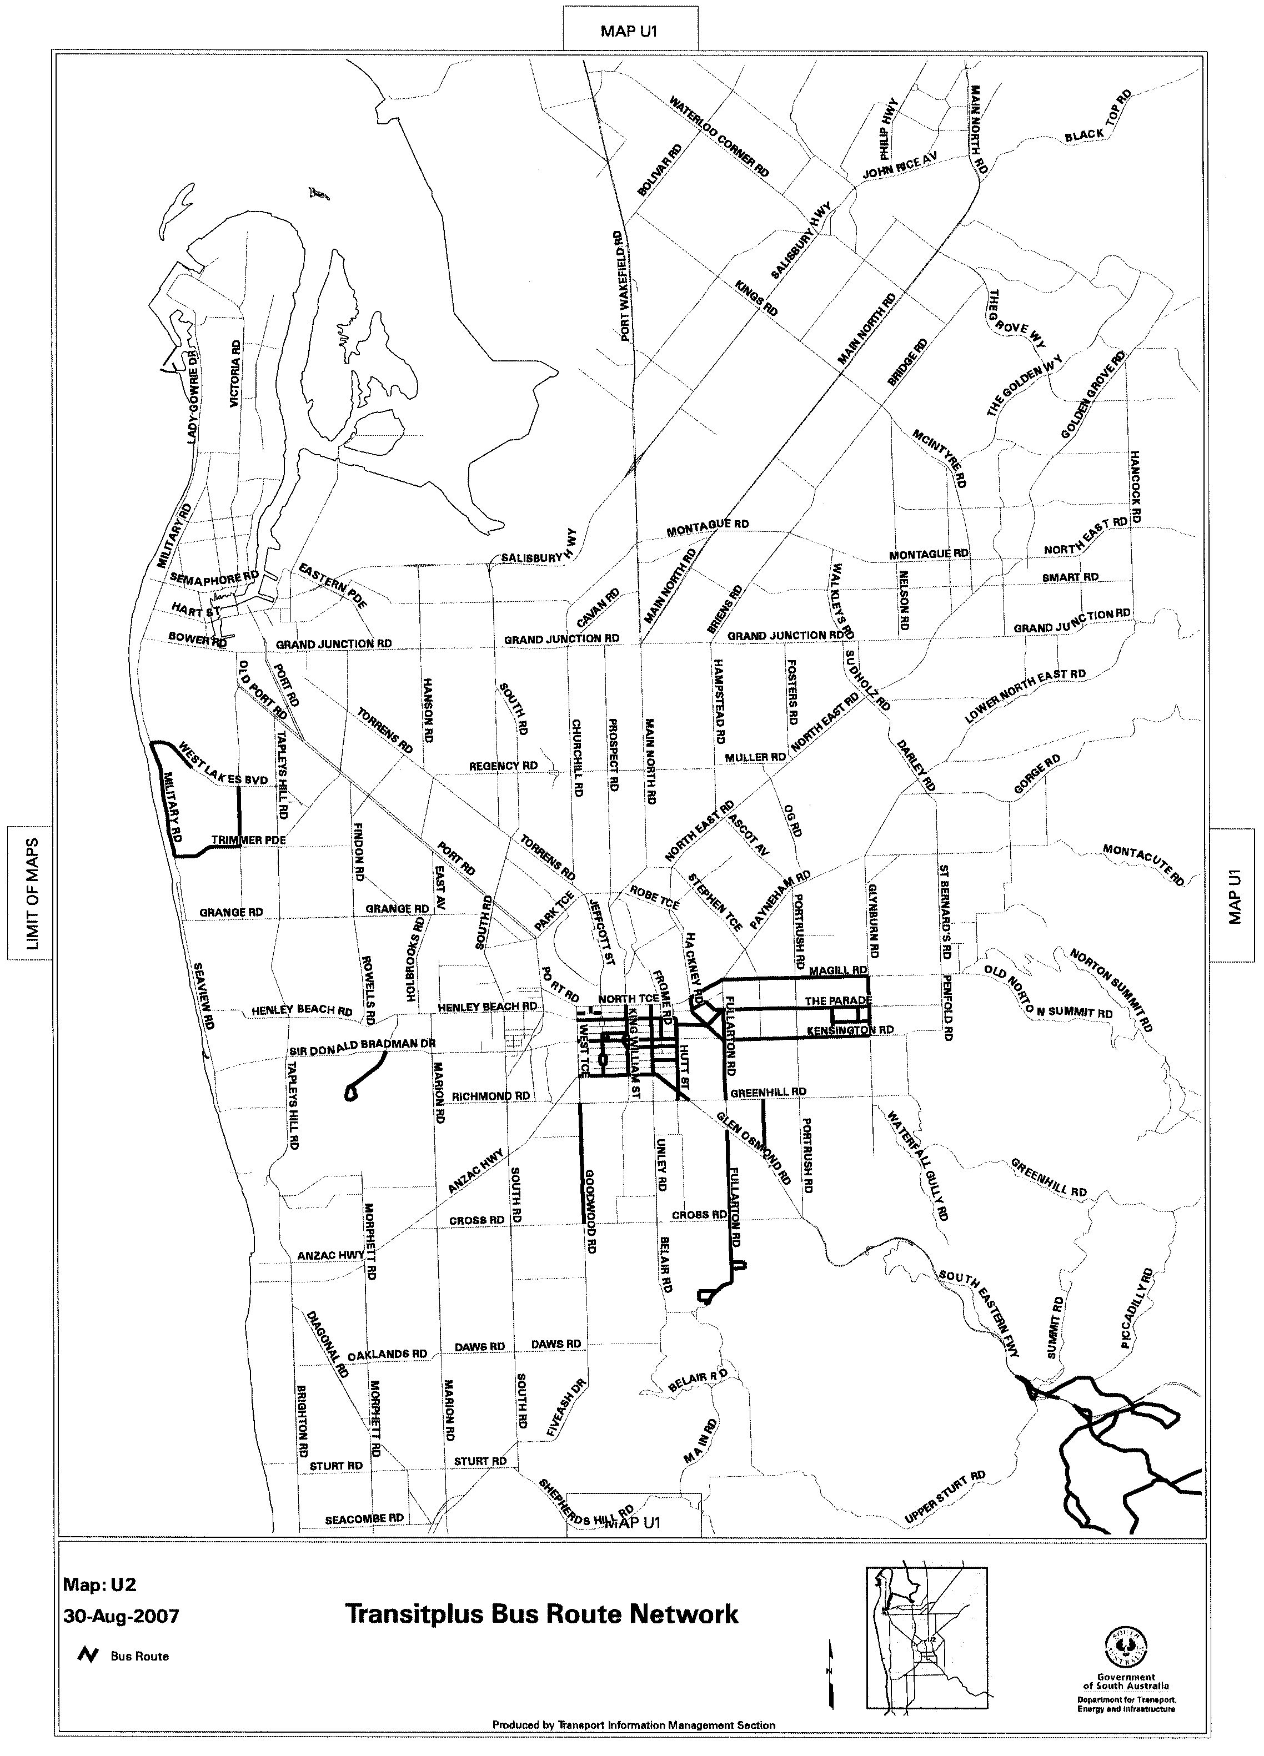
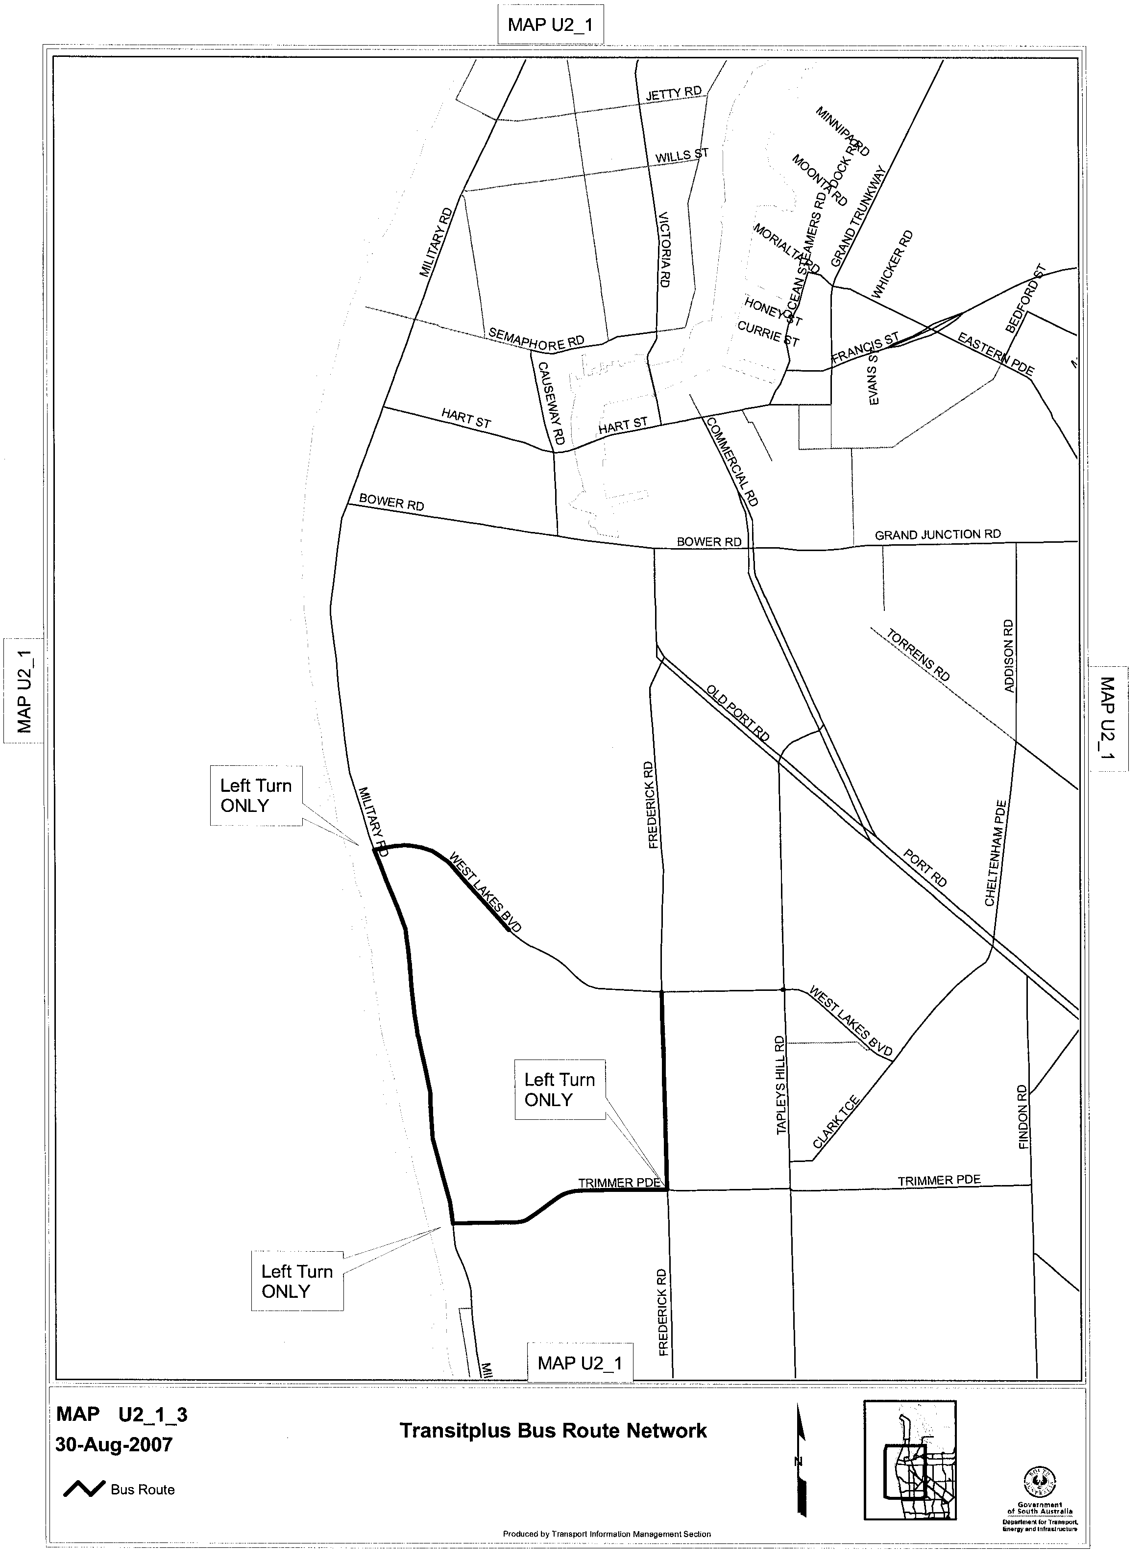
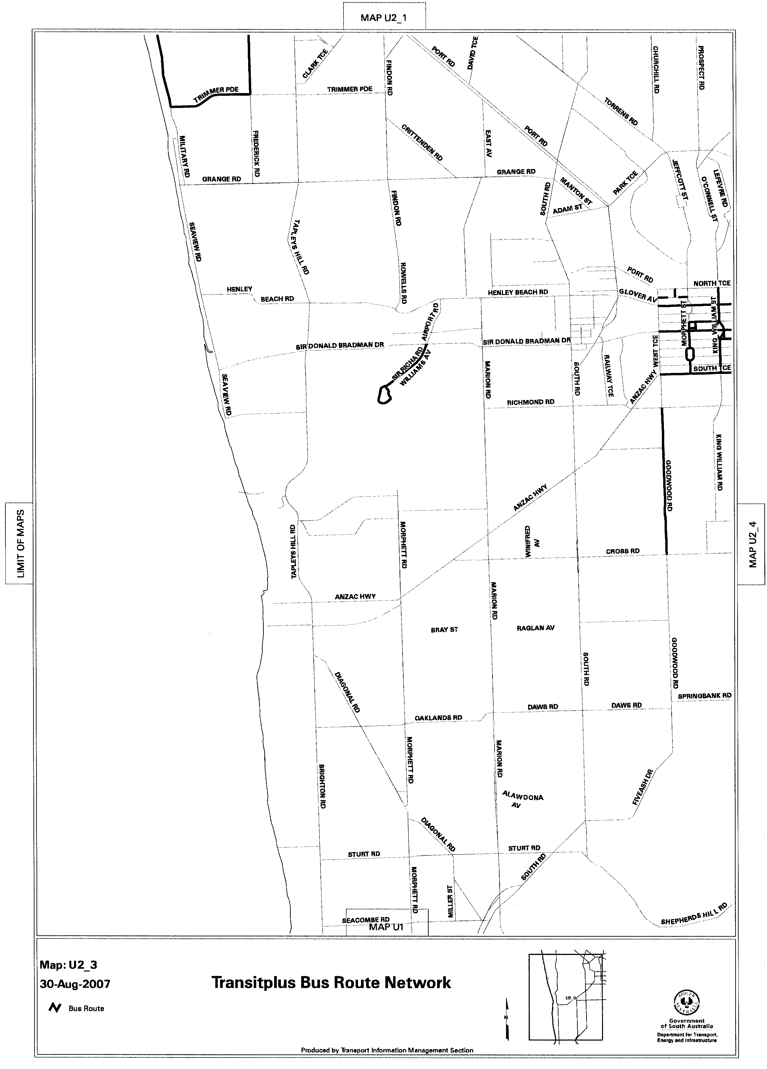
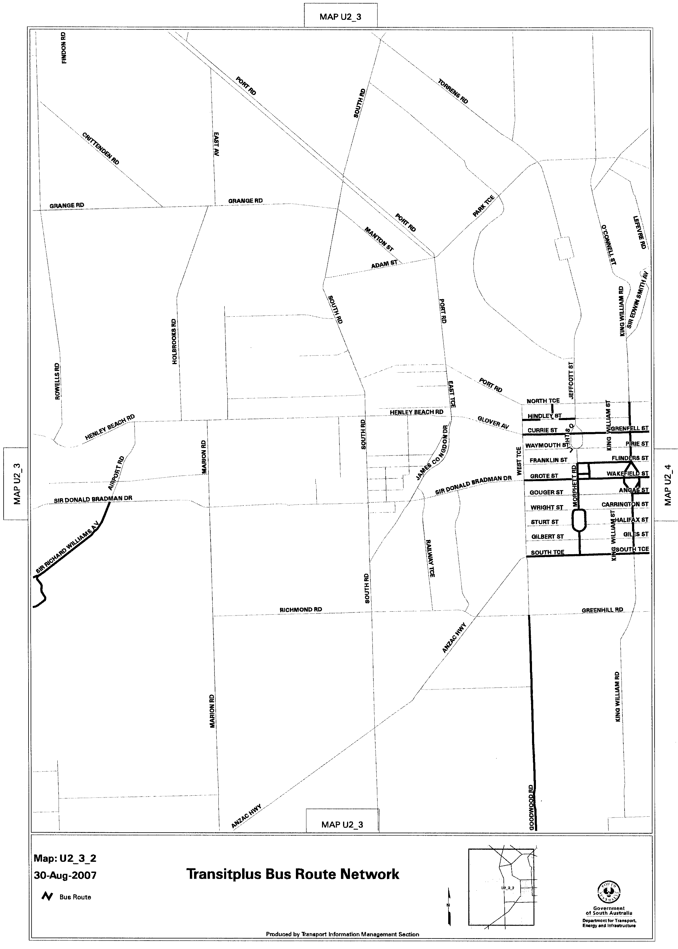
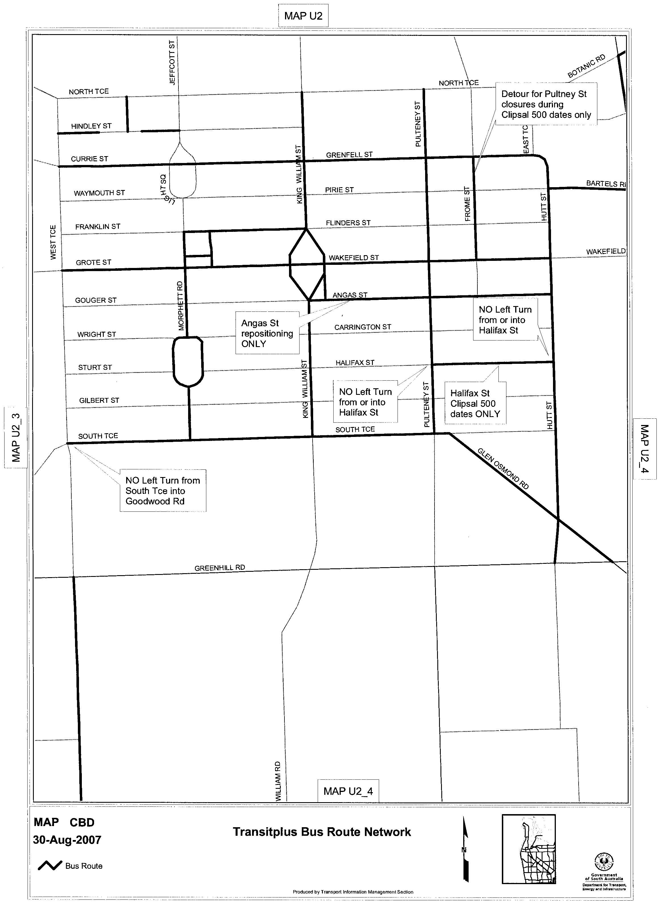
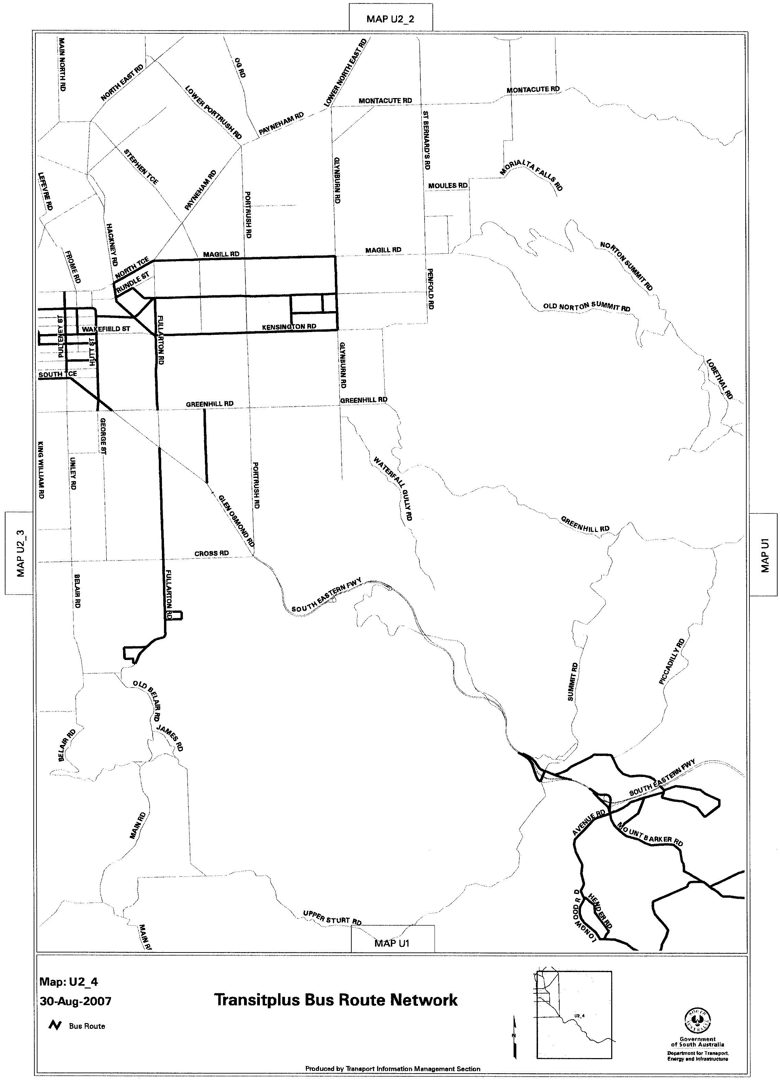
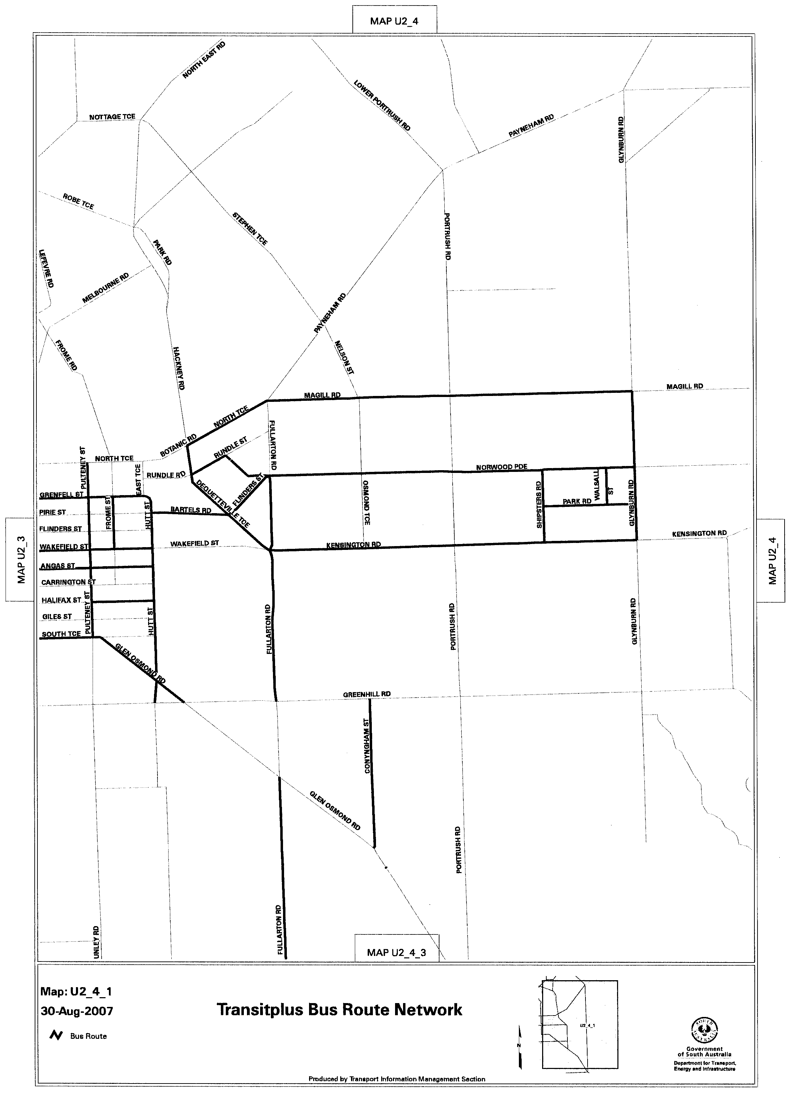
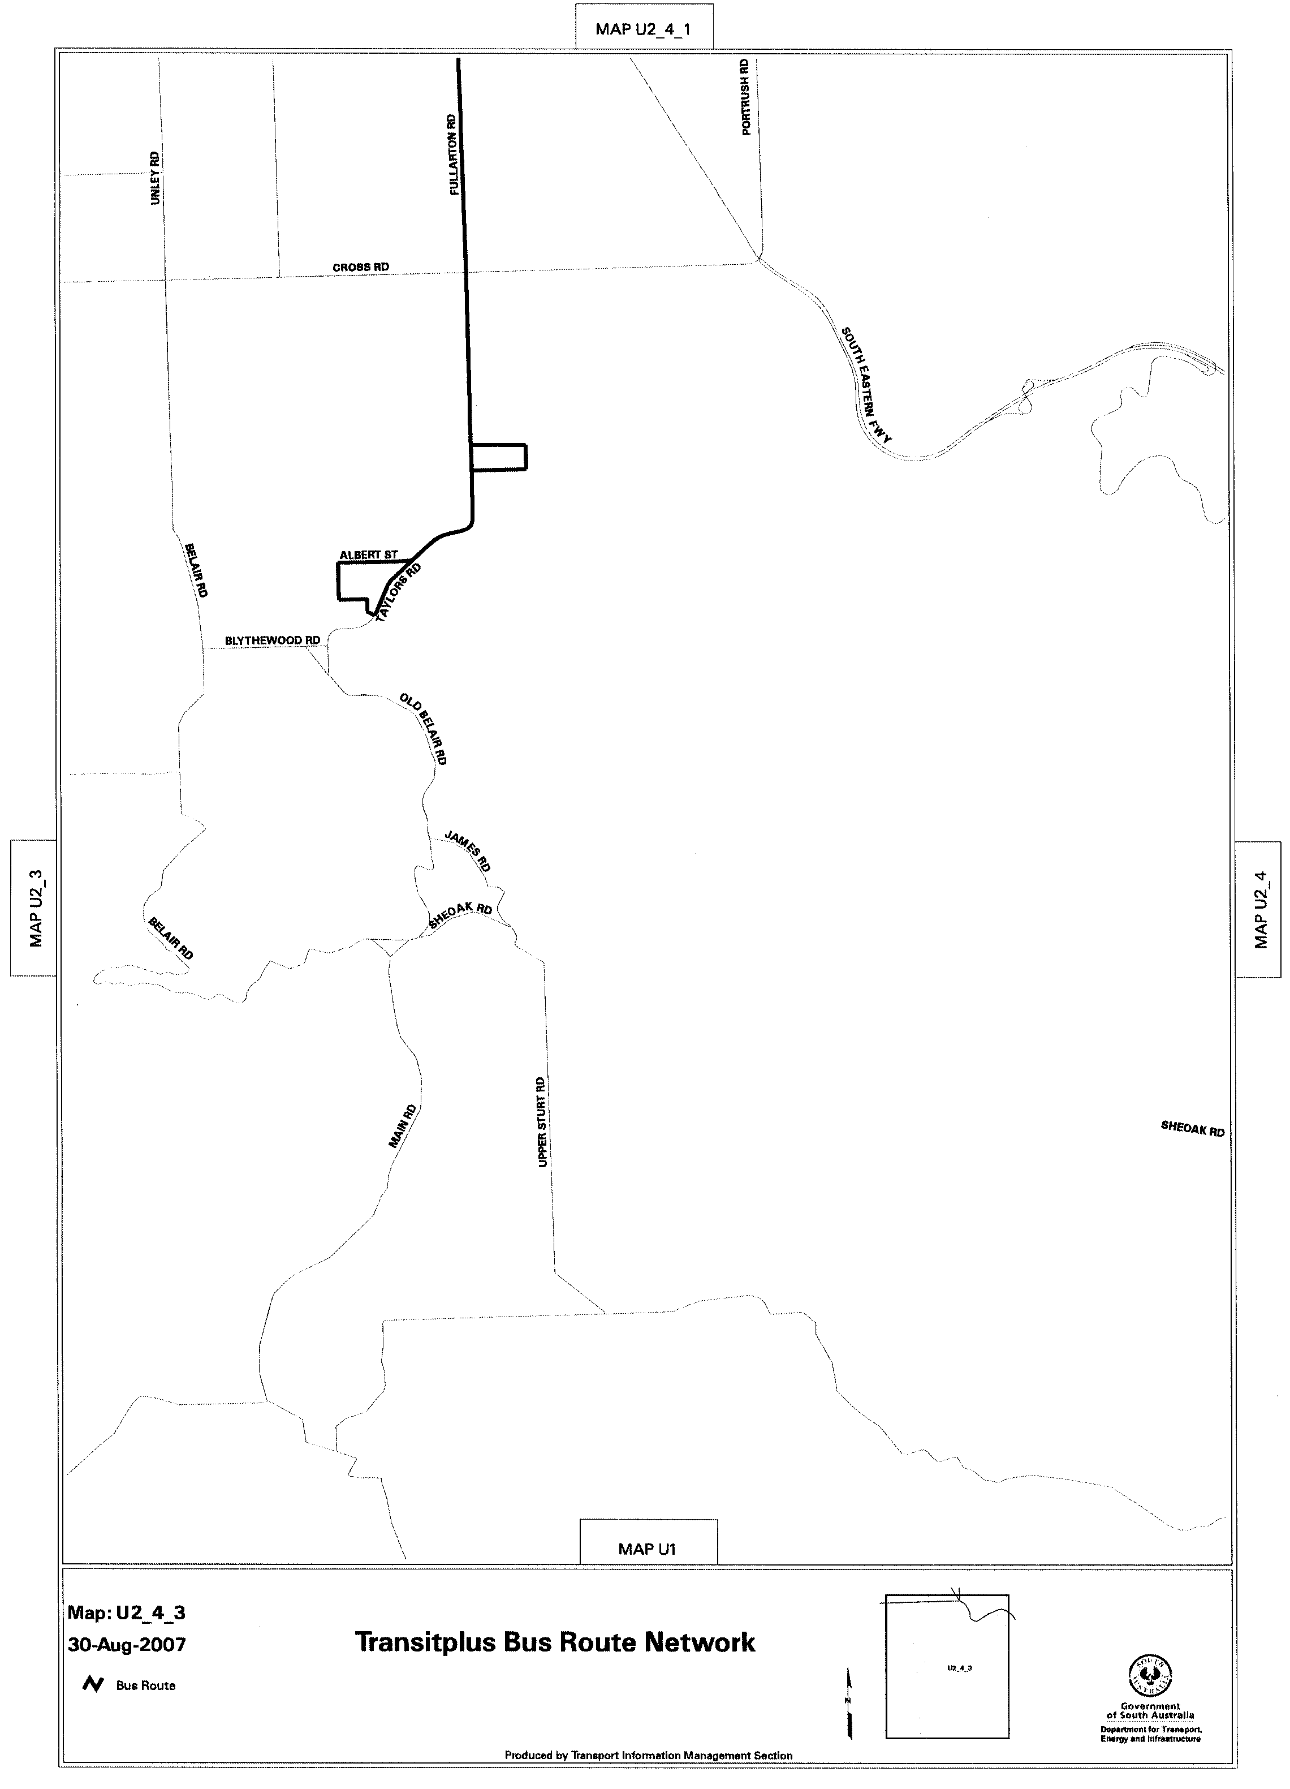
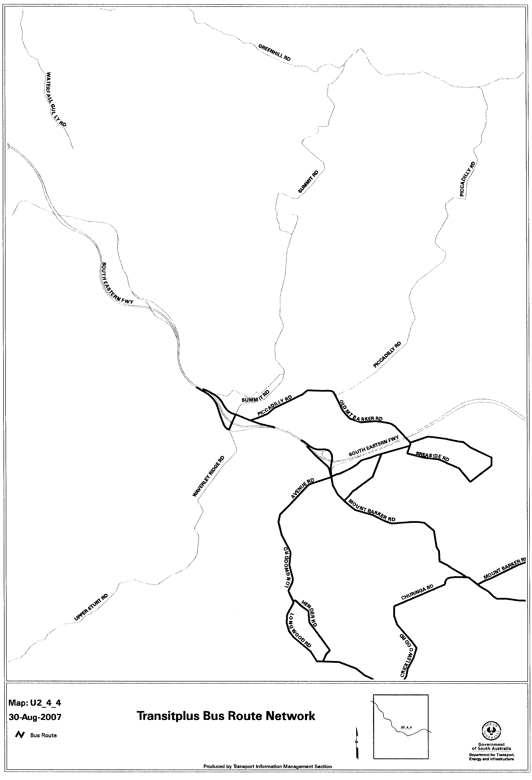
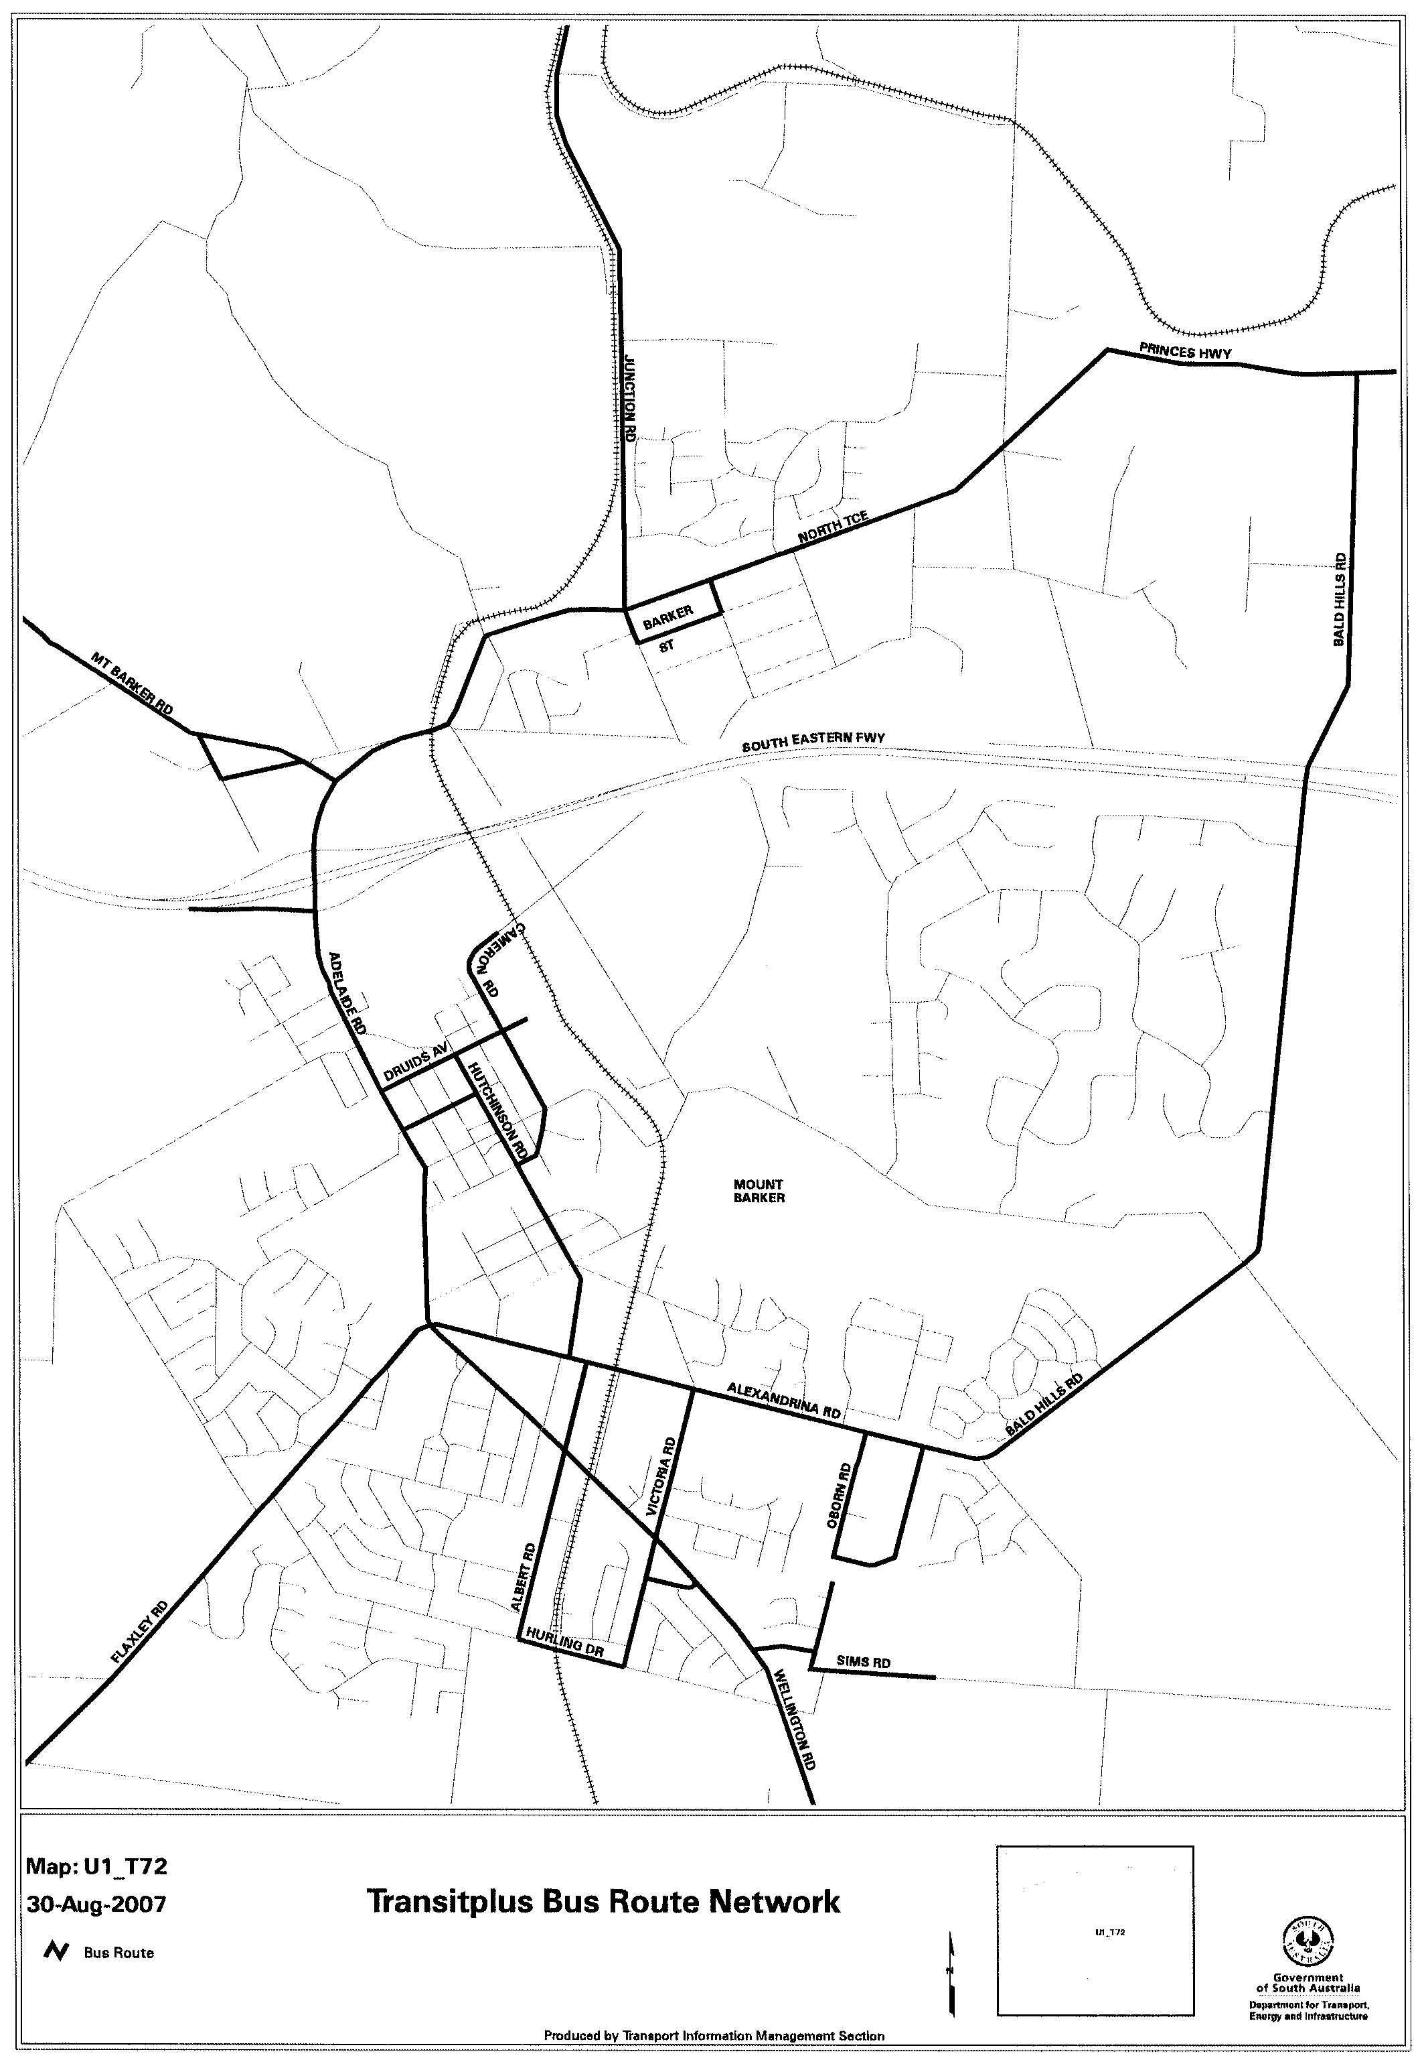
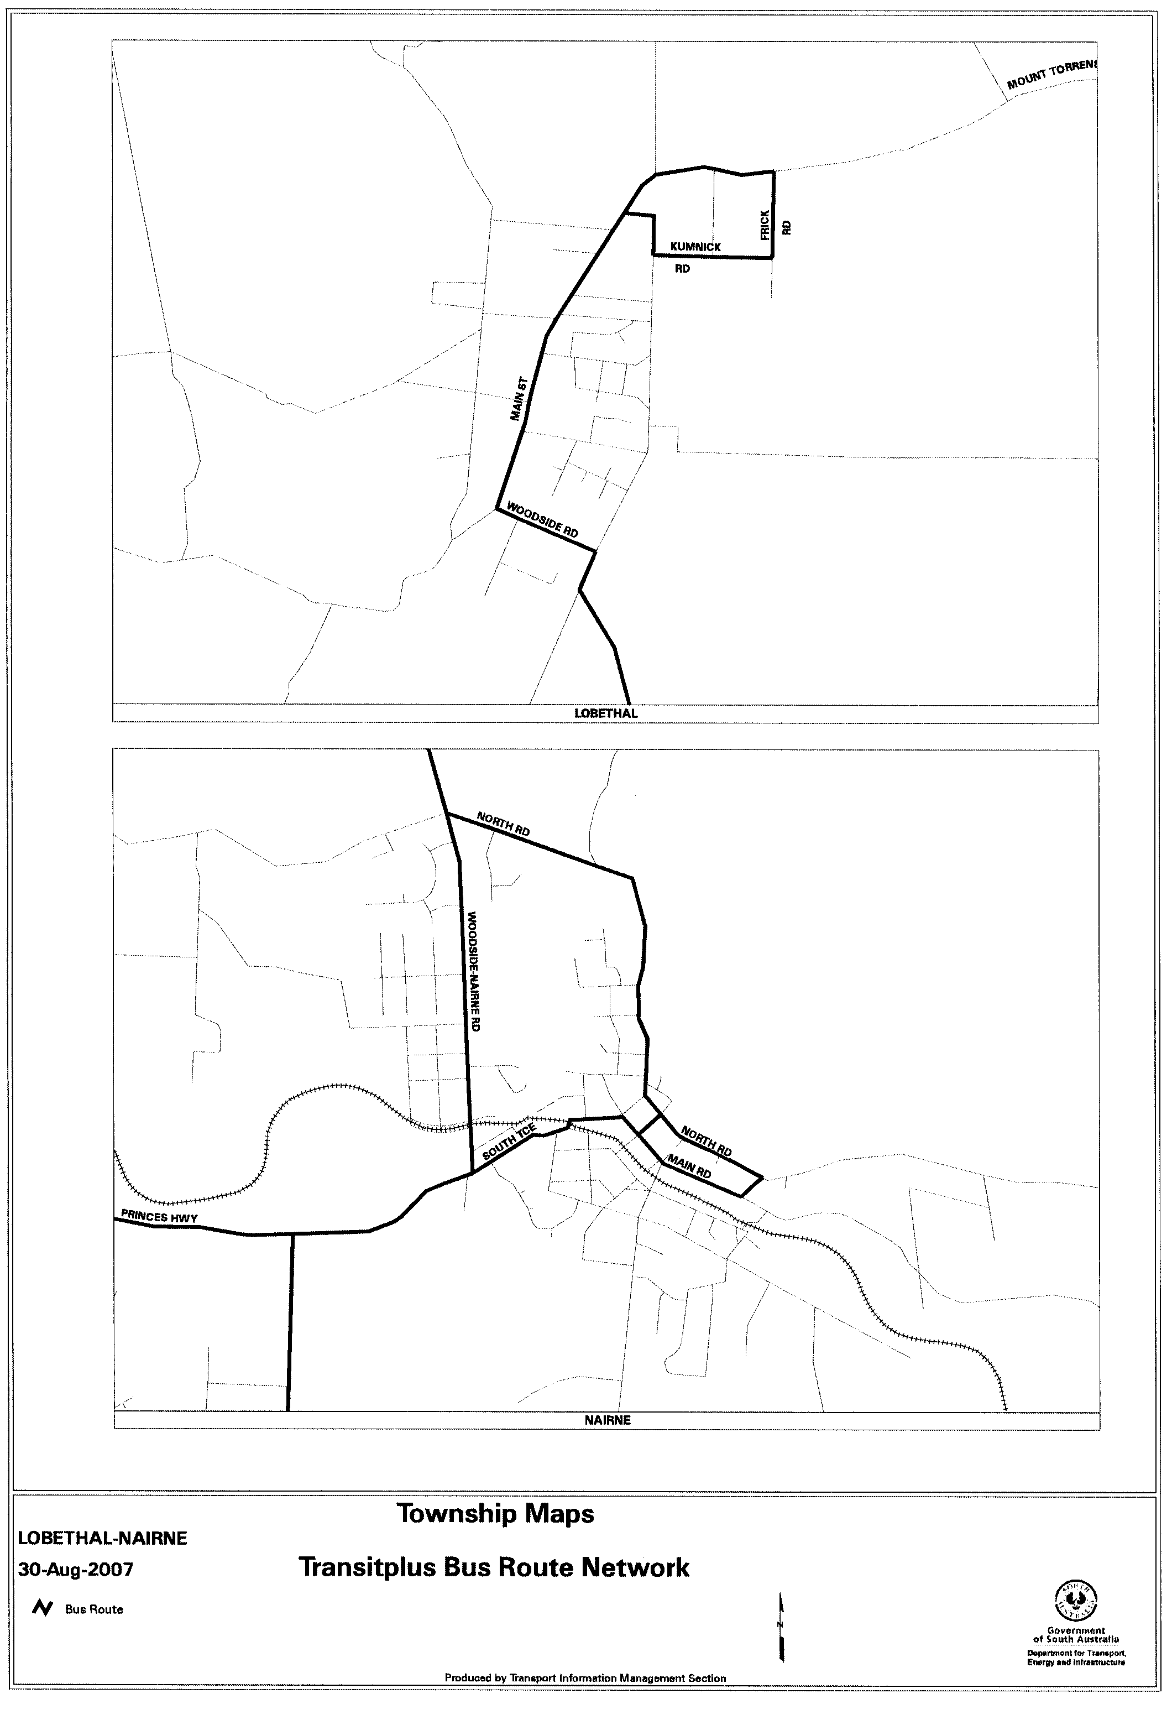
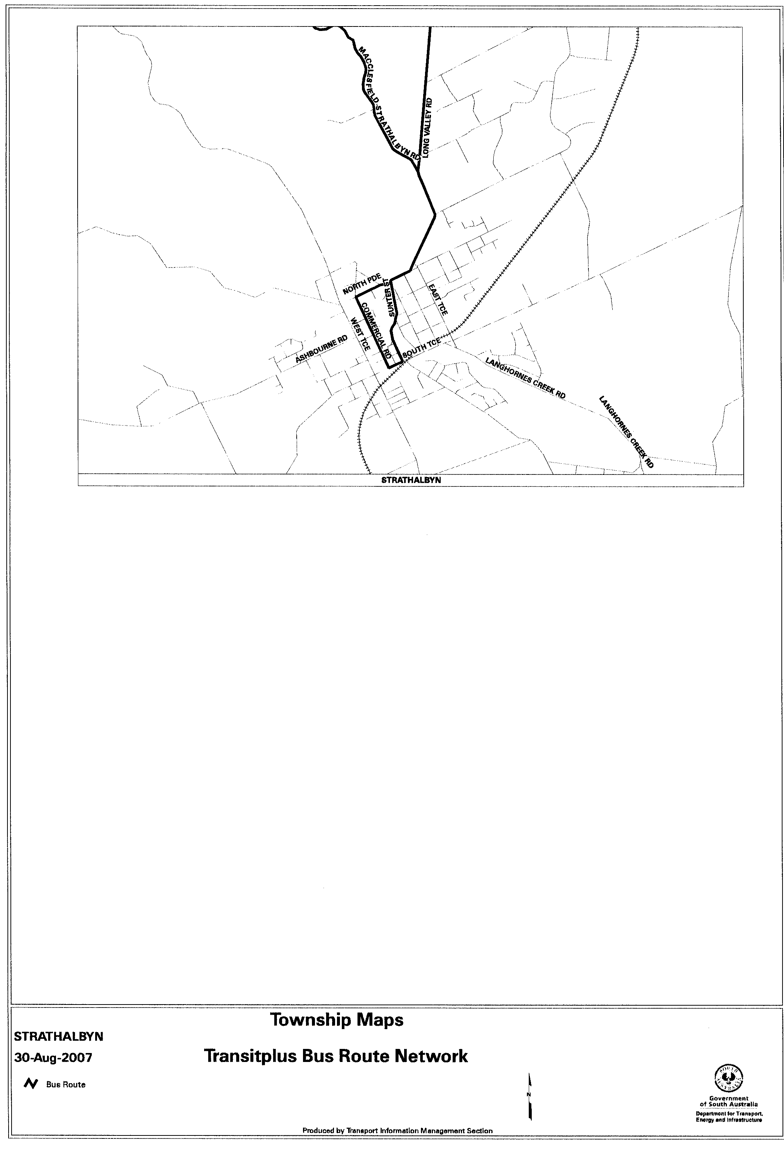

RULES OF COURT
Supreme Court Bail Review Rules 1985 (Amendment No. 2)
BY virtue and in pursuance of section 72 of the Supreme Court Act 1935 and all other enabling powers, We, Judges of the Supreme Court of South Australia, make the following Supreme Court Bail Review Rules 1985 (Amendment No. 2).
1. These Rules may be cited as the ‘Supreme Court Bail Review Rules 1985 (Amendment No. 2)’.
2. The Supreme Court Bail Review Rules 1985 are amended as set out below.
3. These amendments to come into effect on the later of 1 September 2007 or their Gazettal.
4. The whole of Rule 2 (2) is deleted.
5. The words ‘Clerk of Arraigns’ wherever appearing in the Rules and in the Schedule to the Rules are deleted and the words ‘Deputy Registrar (Criminal)’ are, in each case, inserted in their place.
GIVEN under our hands and the Seal of the Supreme Court of South Australia this 30th day of July 2007.
(l.s.) J. DOYLE, CJ
K. P. DUGGAN, J
B. M. DEBELLE, J
M. J. NYLAND, J
T. A. GRAY, J
J. R. SULAN, J
A. M. VANSTONE, J
T. R. ANDERSON, J
R. C. WHITE, J
R. A. LAYTON, J

TRAINING AND SKILLS DEVELOPMENT ACT 2003

Part 4 – Apprenticeships/Traineeships

Pursuant to the provision of the Training and Skills Development Act 2003, the Training and Skills Commission (TaSC) gives notice that determines the following:
Trades, Declared Vocations or Other Occupations

The following schedule is additional to the gazettals of:

- 5 February 2004 | - 19 February 2004 | - 11 March 2004 | - 1 April 2004
- 1 July 2004 | - 15 July 2004 | - 22 July 2004 | - 30 September 2004
- 16 December 2004 | - 27 January 2005 | - 3 February 2005 | - 10 February 2005
- 10 March 2005 | - 24 March 2005 | - 5 May 2005 | - 12 May 2005
- 2 June 2005 | - 16 June 2005 | - 7 July 2005 | - 4 August 2005
- 18 August 2005 | - 1 September 2005 | - 15 September 2005 | - 22 September 2005
- 6 October 2005 | - 20 October 2005 | - 27 October 2005 | - 8 December 2005
- 22 December 2005 | - 9 March 2006 | - 6 April 2006 | - 20 April 2006
- 4 May 2006 | - 18 May 2006 | - 25 May 2006 | - 1 June 2006
- 3 August 2006 | - 10 August 2006 | - 31 August 2006 | - 7 September 2006
- 21 September 2006 | - 29 September 2006 | - 12 October 2006 | - 9 November 2006
- 23 November 2006 | - 30 November 2006 | - 7 December 2006 | - 21 December 2006
- 4 January 2007 | - 11 January 2007 | - 1 February 2007 | - 8 February 2007
- 15 February 2007 | - 19 April 2007 | - 10 May 2007 | - 26 July 2007
- 2 August 2007

which set out the Trades, Declared Vocations or Other Occupations and the terms and conditions applicable to the Trades, Declared Vocations or Other Occupations.

Trades, Declared Vocations or Other Occupations, required Qualifications and
Contract of Training Conditions for the
Metal and Engineering Training Package (MEM05)

*Trade  #Declared  Vocation  Other Occupation | Code | Title | Nominal Term of Contract of Training | Probationary  Period
*Manufacturing Jeweller | MEM30605 | Certificate III in Jewellery Manufacture | 48 months | 3 months

South Australia
Workers Rehabilitation and Compensation (Territorial Application of Act) Amendment Act (Commencement) Proclamation 2007
1—Short title
This proclamation may be cited as the Workers Rehabilitation and Compensation (Territorial Application of Act) Amendment Act (Commencement) Proclamation 2007.
2—Commencement of suspended provisions
The remaining provisions of the Workers Rehabilitation and Compensation (Territorial Application of Act) Amendment Act 2006 (No 23 of 2006) will come into operation on 13 September 2007.
Made by the Governor
with the advice and consent of the Executive Council
on 30 August 2007
07WKC004CS

South Australia
National Parks and Wildlife (Giles Conservation Park and Horsnell Gully Conservation Park) Proclamation 2007
under sections 29(3) and 30(1) of the National Parks and Wildlife Act 1972

Preamble
1 The land defined in Schedule 1 was added to the Horsnell Gully Conservation Park by proclamation under the National Parks and Wildlife Act 1972 in 1985 (Gazette 28.11.1985 p1612).
2 It is now intended that that land be constituted separately as a conservation park under the name Giles Conservation Park (without any land ceasing to be, or to be included in, a conservation park).

1—Short title
This proclamation may be cited as the National Parks and Wildlife (Giles Conservation Park and Horsnell Gully Conservation Park) Proclamation 2007.
2—Commencement
This proclamation comes into operation on the day on which it is made.
3—Alteration of boundaries of Horsnell Gully Conservation Park to constitute Giles Conservation Park
The boundaries of Horsnell Gully Conservation Park are altered so as to exclude the land defined in Schedule 1 from the conservation park and the land so excluded is constituted as a conservation park and assigned the name Giles Conservation Park.
Schedule 1—Definition of land
Sections 1118 and 1119, Hundred of Adelaide.
Made by the Governor
being of the opinion that the Crown land defined in Schedule 1 should be protected and preserved for the purpose of conserving any wildlife and the natural and historic features of the land and with the advice and consent of the Executive Council
on 30 August 2007
EHCS07/0026
South Australia
Development (Schedule 10) Variation Regulations 2007
under the Development Act 1993

Contents
Part 1—Preliminary
1 Short title
2 Commencement
3 Variation provisions
Part 2—Variation of Development Regulations 1993
4 Variation of Schedule 10—Decisions by Development Assessment Commission
3A Commercial forestry—prescribed areas

Part 1—Preliminary
1—Short title
These regulations may be cited as the Development (Schedule 10) Variation Regulations 2007.
2—Commencement
These regulations come into operation on the day on which they are made.
3—Variation provisions
In these regulations, a provision under a heading referring to the variation of specified regulations varies the regulations so specified.
Part 2—Variation of Development Regulations 1993
4—Variation of Schedule 10—Decisions by Development Assessment Commission
After clause 3 insert:
3A—Commercial forestry—prescribed areas
(1) Development that involves a change in use of land for the purposes of establishing or expanding a commercial forest within a prescribed area where the area to be planted pursuant to the development equals or exceeds 20 hectares.
(2) In subclause (1)—
commercial forest means a forest plantation where the forest vegetation is grown or maintained so that it can be harvested or used for commercial purposes (including through the commercial exploitation of the carbon absorption capacity of the forest vegetation);
prescribed area means—
(a) the areas of any of the following councils:
(i) Adelaide Hills Council;
(ii) Alexandrina Council;
(iii) The Barossa Council;
(iv) The District Council of Mount Barker;
(v) City of Victor Harbor;
(vi) The District Council of Yankalilla; or
(b) any part of the area of the City of Onkaparinga outside Metropolitan Adelaide; or
(c) any part of the area of the City of Onkaparinga within Metropolitan Adelaide that is in Policy Area 61 (Primary Production), or Policy Area 62 (Watershed) in the Rural Zone delineated by the relevant Development Plan.
Note—
As required by section 10AA(2) of the Subordinate Legislation Act 1978, the Minister has certified that, in the Minister's opinion, it is necessary or appropriate that these regulations come into operation as set out in these regulations.
Made by the Governor
with the advice and consent of the Executive Council
on 30 August 2007
No 219 of 2007
PLN 02194/07

South Australia
Summary Procedure (Industrial Offences) Regulations 2007
under the Summary Procedure Act 1921

Contents
1 Short title
2 Commencement
3 Industrial offences
Schedule 1—Revocation of Summary Procedure (Industrial Offences) Regulations 1992

1—Short title
These regulations may be cited as the Summary Procedure (Industrial Offences) Regulations 2007.
2—Commencement
These regulations will come into operation on 1 September 2007.
3—Industrial offences
(1) A summary offence against any of the following Acts is declared to be an industrial offence for the purposes of the Summary Procedure Act 1921:
(a) Construction Industry Long Service Leave Act 1987;
(b) Dangerous Substances Act 1979;
(c) Employment Agents Registration Act 1993;
(d) Explosives Act 1936;
(e) Fair Work Act 1994;
(f) Long Service Leave Act 1987;
(g) Occupational Health, Safety and Welfare Act 1986 (except an offence against section 59);
(h) Petroleum Products Regulation Act 1995;
(i) Shop Trading Hours Act 1977;
(j) Workers Rehabilitation and Compensation Act 1986 (except an offence against section 69, 110, 119 or 120).
(2) The following summary offences against the sections of the Training and Skills Development Act 2003 listed below are declared to be industrial offences for the purposes of the Summary Procedure Act 1921:
(a) section 37;
(b) section 41;
(c) section 43;
(d) section 44;
(e) section 46;
(f) section 48.
Schedule 1—Revocation of Summary Procedure (Industrial Offences) Regulations 1992
The Summary Procedure (Industrial Offences) Regulations 1992 are revoked.
Note—
As required by section 10AA(2) of the Subordinate Legislation Act 1978, the Minister has certified that, in the Minister's opinion, it is necessary or appropriate that these regulations come into operation as set out in these regulations.
Made by the Governor
with the advice and consent of the Executive Council
on 30 August 2007
No 220 of 2007
AGO0073/07CS

South Australia
Summary Procedure (Witness Fees) Regulations 2007
under the Summary Procedure Act 1921

Contents
1 Short title
2 Commencement
3 Prosecution witness fees
Schedule 1—Revocation of Summary Procedure (Witness Fees) Regulations 1992

1—Short title
These regulations may be cited as the Summary Procedure (Witness Fees) Regulations 2007.
2—Commencement
These regulations will come into operation on 1 September 2007.
3—Prosecution witness fees
(1) Subject to this regulation, the following amounts may be certified by a magistrate or justice as payable in respect of a witness for the prosecution (including a witness who attended court but was not called to give evidence):
(a) the actual amount lost, or the expenses necessarily incurred, by the witness by reason of his or her absence from home or business for the purpose of attending court or $100 per day, whichever is the lesser;
(b) an allowance for the travelling expenses of the witness in attending court, calculated on the basis of travel by public transport to and from court, or, if the use of public transport by the witness is not reasonably practicable, $0.20 per kilometre necessarily travelled to and from court;
(c) if the witness is necessarily absent from home overnight—the accommodation and meal expenses reasonably incurred by the witness;
(d) if the witness is necessarily accompanied by another person—an amount equal to that which could be certified in accordance with these regulations in respect of that other person if he or she were a witness for the prosecution.
(2) If—
(a) the amount lost, or the expenses incurred by the witness exceed the amount determined in accordance with subregulation (1)(a); or
(b) the travelling expenses incurred by the witness exceed the amount determined in accordance with subregulation (1)(b),
the amount certified may include such further amount as the magistrate or justice thinks just and reasonable in the circumstances.
(3) No amount is to be certified in respect of a witness who is an officer or employee of the State or Commonwealth, including a police officer but excluding an officer or employee who is on leave during the period of attendance at court.
Schedule 1—Revocation of Summary Procedure (Witness Fees) Regulations 1992
The Summary Procedure (Witness Fees) Regulations 1992 are revoked.
Note—
As required by section 10AA(2) of the Subordinate Legislation Act 1978, the Minister has certified that, in the Minister's opinion, it is necessary or appropriate that these regulations come into operation as set out in these regulations.
Made by the Governor
with the advice and consent of the Executive Council
on 30 August 2007
No 221 of 2007
AGO0074/07CS

South Australia
Electricity (General) Variation Regulations 2007
under the Electricity Act 1996

Contents
Part 1—Preliminary
1 Short title
2 Commencement
3 Variation provisions
Part 2—Variation of Electricity (General) Regulations 1997
4 Variation of regulation 7—Licence fees and returns

Part 1—Preliminary
1—Short title
These regulations may be cited as the Electricity (General) Variation Regulations 2007.
2—Commencement
These regulations will come into operation on 31 August 2007.
3—Variation provisions
In these regulations, a provision under a heading referring to the variation of specified regulations varies the regulations so specified.
Part 2—Variation of Electricity (General) Regulations 1997
4—Variation of regulation 7—Licence fees and returns
Regulation 7(4)—after paragraph (b) insert:
(c) the costs of administration of the Australian Energy Market Commission in relation to the electricity supply industry in South Australia in the financial year to which the licence relates.
Note—
As required by section 10AA(2) of the Subordinate Legislation Act 1978, the Minister has certified that, in the Minister's opinion, it is necessary or appropriate that these regulations come into operation as set out in these regulations.
Made by the Governor
with the advice and consent of the Executive Council
on 30 August 2007
No 222 of 2007
MEN07/001CS

South Australia
Gas Variation Regulations 2007
under the Gas Act 1997

Contents
Part 1—Preliminary
1 Short title
2 Commencement
3 Variation provisions
Part 2—Variation of Gas Regulations 1997
4 Variation of regulation 8—Licence fees and returns

Part 1—Preliminary
1—Short title
These regulations may be cited as the Gas Variation Regulations 2007.
2—Commencement
These regulations will come into operation on 31 August 2007.
3—Variation provisions
In these regulations, a provision under a heading referring to the variation of specified regulations varies the regulations so specified.
Part 2—Variation of Gas Regulations 1997
4—Variation of regulation 8—Licence fees and returns
Regulation 8—after subregulation (3) insert:
(4) For the purposes of paragraph (d) of the definition of administrative costs in section 24(9) of the Act, the costs of administration of the Australian Energy Market Commission relating to the gas supply industry in South Australia in the financial year to which the licence relates is a prescribed cost.
Note—
As required by section 10AA(2) of the Subordinate Legislation Act 1978, the Minister has certified that, in the Minister's opinion, it is necessary or appropriate that these regulations come into operation as set out in these regulations.
Made by the Governor
with the advice and consent of the Executive Council
on 30 August 2007
No 223 of 2007
MEN07/001CS

South Australia
Firearms (Exemption for Certain Exhibitors) Variation Regulations 2007
under the Firearms Act 1977

Contents
Part 1—Preliminary
1 Short title
2 Commencement
3 Variation provisions
Part 2—Variation of Firearms (Exemption for Certain Exhibitors) Regulations 2003
4 Substitution of regulations 3
3 Exemption for certain exhibitors

Part 1—Preliminary
1—Short title
These regulations may be cited as the Firearms (Exemption for Certain Exhibitors) Variation Regulations 2007.
2—Commencement
These regulations come into operation on the day on which they are made.
3—Variation provisions
In these regulations, a provision under a heading referring to the variation of specified regulations varies the regulations so specified.
Part 2—Variation of Firearms (Exemption for Certain Exhibitors) Regulations 2003
4—Substitution of regulations 3
Regulation 3—delete the regulation and substitute:
3—Exemption for certain exhibitors
Pursuant to section 39(2)(e) of the Firearms Act 1977, the holder of a dealer's licence who exhibits firearms at the Land Warfare Conference at the Adelaide Convention Centre from 22 October 2007 to 26 October 2007 (inclusive) is, for the purposes of so exhibiting firearms, exempt from section 17(4)(a) of the Act.
Note—
As required by section 10AA(2) of the Subordinate Legislation Act 1978, the Minister has certified that, in the Minister's opinion, it is necessary or appropriate that these regulations come into operation as set out in these regulations.
Made by the Governor
with the advice and consent of the Executive Council
on 30 August 2007
No 224 of 2007
MPOL07/009CS

South Australia
Subordinate Legislation (Postponement of Expiry) Regulations 2007
under the Subordinate Legislation Act 1978

Contents
1 Short title
2 Commencement
3 Interpretation
4 Postponement of expiry for 1 year—Regulations made before 1 January 1997
5 Expiry of obsolete regulations
Schedule 1—Postponement of expiry
Schedule 2—Expiry of obsolete regulations
Schedule 3—Revocation of Subordinate Legislation (Postponement of Expiry) Regulations 2006

1—Short title
These regulations may be cited as the Subordinate Legislation (Postponement of Expiry) Regulations 2007.
2—Commencement
These regulations will come into operation on 1 September 2007.
3—Interpretation
In these regulations, unless the contrary intention appears—
Act means the Subordinate Legislation Act 1978.
4—Postponement of expiry for 1 year—Regulations made before 1 January 1997
The expiry under Part 3A of the Act of the regulations listed in Schedule 1 is postponed for a period of 1 year commencing on 1 September 2007.
5—Expiry of obsolete regulations
The regulations listed in Schedule 2 will expire under the Act on 1 September 2007.
Schedule 1—Postponement of expiry
Administration and Probate (Interest on Pecuniary Legacies) Regulations 1994 made under the Administration and Probate Act 1919 (see Gazette 2.6.1994 p1590)
Ambulance Services Regulations 1993 made under the Ambulance Services Act 1992 (see Gazette 25.2.1993 p727)
Associations Incorporation Regulations 1993 made under the Associations Incorporation Act 1985 (see Gazette 20.5.1993 p1709)
Bank Merger (BankSA and Advance Bank) Regulations 1996 made under the Bank Merger (BankSA and Advance Bank) Act 1996 (see Gazette 28.11.1996 p1769)
Bills of Sale (Fees) Regulations 1995 made under the Bills of Sale Act 1886 (see Gazette 10.5.1995 p2080)
Bills of Sale (Requirements as to Instruments) Regulations 1995 made under the Bills of Sale Act 1886 (see Gazette 31.8.1995 p615)
Births, Deaths and Marriages Registration Regulations 1996 made under the Births, Deaths and Marriages Registration Act 1996 (see Gazette 30.5.1996 p2675)
Building Work Contractors Regulations 1996 made under the Building Work Contractors Act 1995 (see Gazette 23.5.1996 p2547)
Business Names Regulations 1996 made under the Business Names Act 1996 (see Gazette 18.7.1996 p151)
Children's Services (Appeals) Regulations 1993 made under the Children's Services Act 1985 (see Gazette 14.1.1993 p191)
Classification of Theatrical Performances Regulations 1993 made under the Classification of Theatrical Performances Act 1978 (see Gazette 19.8.1993 p888)
Community Titles Regulations 1996 made under the Community Titles Act 1996 (see Gazette 31.10.1996 p1559)
Construction Industry Training Fund Regulations 1993 made under the Construction Industry Training Fund Act 1993 (see Gazette 5.8.1993 p753)
Consumer Credit (South Australia) (Savings and Transitional) Regulations 1996 made under the Consumer Credit (South Australia) Act 1995 (see Gazette 17.10.1996 p1388)
Consumer Transactions Regulations (No. 2) 1996 made under the Consumer Transactions Act 1972 (see Gazette 17.10.1996 p1392)
Controlled Substances (Poisons) Regulations 1996 made under the Controlled Substances Act 1984 (see Gazette 4.1.1996 p36)
Controlled Substances (Volatile Solvents) Regulations 1996 made under the Controlled Substances Act 1984 (see Gazette 4.1.1996 p32)
Conveyancers Regulations 1995 made under the Conveyancers Act 1994 (see Gazette 25.5.1995 p2479)
Courts Administration Regulations 1993 made under the Courts Administration Act 1993 (see Gazette 1.7.1993 p358)
Criminal Law Consolidation (Medical Termination of Pregnancy) Regulations 1996 made under the Criminal Law Consolidation Act 1935 (see Gazette 29.8.1996 p835)
Crown Lands Regulations 1996 made under the Crown Lands Act 1929 (see Gazette 29.8.1996 p1007)
Crown Proceedings Regulations 1993 made under the Crown Proceedings Act 1992 (see Gazette 4.11.1993 p2205)
Development Regulations 1993 made under the Development Act 1993 (see Gazette 27.10.1993 p1954)
Dog and Cat Management Regulations 1995 made under the Dog and Cat Management Act 1995 (see Gazette 15.6.1995 p2861)
Electricity (Principles of Vegetation Clearance) Regulations 1996 made under the Electricity Act 1996 (see Gazette 19.12.1996 p2045)
Employment Agents Registration Regulations 1995 made under the Employment Agents Registration Act 1993 (see Gazette 14.12.1995 p1678)
Environment Protection (Beverage Container) Regulations 1995 made under the Environment Protection Act 1993 (see Gazette 27.4.1995 p1658)
Environment Protection (Fees and Levy) Regulations 1994 made under the Environment Protection Act 1993 (see Gazette 15.12.1994 p2202)
Environment Protection (General) Regulations 1994 made under the Environment Protection Act 1993 (see Gazette 27.10.1994 p1346)
Evidence (Reproduction of Documents) Regulations 1993 made under the Evidence Act 1929 (see Gazette 8.4.1993 p1273)
Expiation of Offences Regulations 1996 made under the Expiation of Offences Act 1996 (see Gazette 23.12.1996 p2237)
Explosives Regulations 1996 made under the Explosives Act 1936 (see Gazette 15.8.1996 p578)
Fair Trading (Pre-paid Funerals Code of Practice) Regulations 1996 made under the Fair Trading Act 1987 (see Gazette 23.5.1996 p2571)
Family and Community Services Regulations 1996 made under the Family and Community Services Act 1972 (see Gazette 22.2.1996 p1250)
Fees Regulation (Proof of Age Card) Regulations 1996 made under the Fees Regulation Act 1927 (see Gazette 30.5.1996 p2750)
Firearms Regulations 1993 made under the Firearms Act 1977 (see Gazette 29.4.1993 p1482)
Firearms (Compensation) Regulations 1996 made under the Firearms Act 1977 (see Gazette 5.9.1996 p1094)
Freedom of Information (Exempt Agency) Regulations 1993 made under the Freedom of Information Act 1991 (see Gazette 21.1.1993 p409)
Fruit and Plant Protection Regulations 1996 made under the Fruit and Plant Protection Act 1992 (see Gazette 31.10.1996 p1586)
Guardianship and Administration Regulations 1995 made under the Guardianship and Administration Act 1993 (see Gazette 2.3.1995 p797)
Harbors and Navigation Regulations 1994 made under the Harbors and Navigation Act 1993 (see Gazette 20.10.1994 p988)
History Trust of South Australia Regulations 1995 made under the History Trust of South Australia Act 1981 (see Gazette 1.6.1995 p2578)
Industrial and Employee Relations (General) Regulations 1994 made under the Fair Work Act 1994 (see Gazette 4.8.1994 p380)
Industrial and Employee Relations (Representation) Regulations 1994 made under the Fair Work Act 1994 (see Gazette 4.8.1994 p366)
Land Agents Regulations 1995 made under the Land Agents Act 1994 (see Gazette 25.5.1995 p2464)
Land and Business (Sale and Conveyancing) Regulations 1995 made under the Land and Business (Sale and Conveyancing) Act 1994 (see Gazette 27.4.1995 p1577)
Land Valuers Regulations 1995 made under the Land Valuers Act 1994 (see Gazette 25.5.1995 p2477)
Legal Practitioners Regulations 1994 made under the Legal Practitioners Act 1981 (see Gazette 1.9.1994 p636)
Local Government (Cemetery) Regulations 1995 made under the Local Government Act 1934 (see Gazette 25.5.1995 p2503)
Lottery and Gaming Regulations 1993 made under the Lottery and Gaming Act 1936 (see Gazette 27.10.1993 p1901)
Members of Parliament (Register of Interests) Regulations 1993 made under the Members of Parliament (Register of Interests) Act 1983 (see Gazette 1.7.1993 p409)
Mental Health Regulations 1995 made under the Mental Health Act 1993 (see Gazette 2.3.1995 p763)
Motor Vehicles Regulations 1996 made under the Motor Vehicles Act 1959 (see Gazette 30.5.1996 p2751)
National Parks and Wildlife (Hunting) Regulations 1996 made under the National Parks and Wildlife Act 1972 (see Gazette 29.8.1996 p984)
Natural Gas Authority Regulations 1995 made under the Natural Gas Authority Act 1967 (see Gazette 1.6.1995 p2570)
Occupational Health, Safety and Welfare Regulations 1995 made under the Occupational Health, Safety and Welfare Act 1986 (see Gazette 23.2.1995 p423)
Optometrists Regulations 1996 made under the Optometrists Act 1920 (see Gazette 29.8.1996 p864)
Passenger Transport (General) Regulations 1994 made under the Passenger Transport Act 1994 (see Gazette 28.7.1994 p254)
Passenger Transport (Regular Passenger Services; Conduct of Passengers) Regulations 1994 made under the Passenger Transport Act 1994 (see Gazette 30.6.1994 p1930)
Passenger Transport (Regular Passenger Services; Fares and Charges) Regulations 1994 made under the Passenger Transport Act 1994 (see Gazette 30.6.1994 p1928)
Petroleum Products Regulations 1995 made under the Petroleum Products Regulation Act 1995 (see Gazette 1.6.1995 p2574)
Plumbers, Gas Fitters and Electricians Regulations 1995 made under the Plumbers, Gas Fitters and Electricians Act 1995 (see Gazette 29.6.1995 p3085)
Psychological Practices Regulations 1996 made under the Psychological Practices Act 1973 (see Gazette 29.8.1996 p875)
Public and Environmental Health (Waste Control) Regulations 1995 made under the Public and Environmental Health Act 1987 (see Gazette 10.5.1995 p1802)
Public Corporations (Fire Equipment Services South Australia) Regulations 1996 made under the Public Corporations Act 1993 (see Gazette 6.6.1996 p2897)
Public Corporations (Minister for Industry, Manufacturing, Small Business and Regional Development) Regulations 1995 made under the Public Corporations Act 1993 (see Gazette 16.3.1995 p885)
Public Corporations (Playford Centre) Regulations 1996 made under the Public Corporations Act 1993 (see Gazette 4.7.1996 p30)
Public Corporations (Transmission Lessor Corporation) Regulations 1995 made under the Public Corporations Act 1993 (see Gazette 29.6.1995 p3122)
Public Sector Management Regulations 1995 made under the Public Sector Management Act 1995 (see Gazette 13.7.1995 p85)
Public Trustee Regulations 1995 made under the Public Trustee Act 1995 (see Gazette 3.8.1995 p368)
Real Property (Certification of Instruments) Regulations 1995 made under the Real Property Act 1886 (see Gazette 31.8.1995 p613)
Real Property (Land Division) Regulations 1995 made under the Real Property Act 1886 (see Gazette 31.8.1995 p616)
Recreation Grounds Regulations 1996 made under the Recreation Grounds (Regulations) Act 1931 (see Gazette 29.8.1996 p856)
Reproductive Technology (Code of Ethical Clinical Practice) Regulations 1995 made under the Reproductive Technology (Clinical Practices) Act 1988 (see Gazette 5.10.1995 p922)
Residential Tenancies (General) Regulations 1995 made under the Residential Tenancies Act 1995 (see Gazette 23.11.1995 p1427)
Residential Tenancies (Water Rates) Regulations 1995 made under the Residential Tenancies Act 1995 (see Gazette 24.8.1995 p527)
Retail and Commercial Leases Regulations 1995 made under the Retail and Commercial Leases Act 1995 (see Gazette 29.6.1995 p3101)
Second-hand Vehicle Dealers Regulations 1995 made under the Second-hand Vehicle Dealers Act 1995 (see Gazette 2.11.1995 p1258)
Security and Investigation Agents Regulations 1996 made under the Security and Investigation Agents Act 1995 (see Gazette 28.3.1996 p1857)
Sewerage Regulations 1996 made under the Sewerage Act 1929 (see Gazette 22.8.1996 p733)
South Australian Co-operative and Community Housing (Housing Associations) Regulations 1996 made under the South Australian Co-operative and Community Housing Act 1991 (see Gazette 15.2.1996 p1157)
South Australian Housing Trust (Abandoned Goods) Regulations 1995 made under the South Australian Housing Trust Act 1995 (see Gazette 21.12.1995 p1806)
South Australian Housing Trust (General) Regulations 1995 made under the South Australian Housing Trust Act 1995 (see Gazette 21.12.1995 p1808)
South Australian Housing Trust (Water Rates) Regulations 1995 made under the South Australian Housing Trust Act 1936 (see Gazette 4.5.1995 p1726)
Southern State Superannuation Regulations 1995 made under the Southern State Superannuation Act 1994 (see Gazette 29.6.1995 p3070)
Succession Duties Regulations 1996 made under the Succession Duties Act 1929 (see Gazette 28.3.1996 p1823)
Superannuation Funds Management Corporation of South Australia Regulations 1995 made under the Superannuation Funds Management Corporation of South Australia Act 1995 (see Gazette 25.5.1995 p2459)
Supported Residential Facilities Regulations 1994 made under the Supported Residential Facilities Act 1992 (see Gazette 8.12.1994 p1969)
Trade Measurement (Measuring Instruments) Regulations 1993 made under the Trade Measurement Act 1993 (see Gazette 30.9.1993 p1411)
Trade Measurement (Miscellaneous) Regulations 1993 made under the Trade Measurement Act 1993 (see Gazette 30.9.1993 p1387)
Trade Measurement (Pre-Packed Articles) Regulations 1993 made under the Trade Measurement Act 1993 (see Gazette 30.9.1993 p1422)
Trade Measurement (Weighbridges) Regulations 1993 made under the Trade Measurement Act 1993 (see Gazette 30.9.1993 p1390)
Trade Measurement Administration Regulations 1993 made under the Trade Measurement Administration Act 1993 (see Gazette 30.9.1993 p1445)
Travel Agents Regulations 1996 made under the Travel Agents Act 1986 (see Gazette 27.6.1996 p3140)
Trustee Regulations 1996 made under the Trustee Act 1936 (see Gazette 29.8.1996 p844)
Waterworks Regulations 1996 made under the Waterworks Act 1932 (see Gazette 22.8.1996 p702)
WorkCover Corporation (Statutory Reserve and Insurance Assistance Funds—Contractual Arrangements) Regulations 1996 made under the WorkCover Corporation Act 1994 (see Gazette 14.3.1996 p1638)
Workers Rehabilitation and Compensation (Dispute Resolution) Regulations 1996 made under the Workers Rehabilitation and Compensation Act 1986 (see Gazette 30.5.1996 p2704)
Workers Rehabilitation and Compensation (Rehabilitation Standards and Requirements) Regulations 1996 made under the Workers Rehabilitation and Compensation Act 1986 (see Gazette 11.1.1996 p122)
Workers Rehabilitation and Compensation (Scales of Medical and Other Charges) Regulations 1995 made under the Workers Rehabilitation and Compensation Act 1986 (see Gazette 16.11.1995 p1370)
Young Offenders Regulations 1993 made under the Young Offenders Act 1993 (see Gazette 9.12.1993 p2897)
Youth Court (Fees) Regulations 1996 made under the Youth Court Act 1993 (see Gazette 30.5.1996 p2695)
Schedule 2—Expiry of obsolete regulations
Competition Policy Reform (South Australia) Savings and Transitional Regulations 1996 made under the Competition Policy Reform (South Australia) Act 1996 (see Gazette 18.7.1996 p153)
Fisheries (Management Committees) Regulations 1995 made under the Fisheries Act 1982 (see Gazette 12.10.1995 p1100)
Schedule 3—Revocation of Subordinate Legislation (Postponement of Expiry) Regulations 2006
The Subordinate Legislation (Postponement of Expiry) Regulations 2006 are revoked.
Note—
As required by section 10AA(2) of the Subordinate Legislation Act 1978, the Minister has certified that, in the Minister's opinion, it is necessary or appropriate that these regulations come into operation as set out in these regulations.
Made by the Governor
with the advice and consent of the Executive Council
on 30 August 2007
No 225 of 2007
DPC023/97Pt.2CS

South Australia
South Australian Housing Trust (General) (Affordable Housing) Variation Regulations 2007
under the South Australian Housing Trust Act 1995

Contents
Part 1—Preliminary
1 Short title
2 Commencement
3 Variation provisions
Part 2—Variation of South Australian Housing Trust (General) Regulations 1995
4 Insertion of regulation 4
4 Criteria—affordable housing

Part 1—Preliminary
1—Short title
These regulations may be cited as the South Australian Housing Trust (General) (Affordable Housing) Variation Regulations 2007.
2—Commencement
These regulations come into operation on the day on which they are made.
3—Variation provisions
In these regulations, a provision under a heading referring to the variation of specified regulations varies the regulations so specified.
Part 2—Variation of South Australian Housing Trust (General) Regulations 1995
4—Insertion of regulation 4
After regulation 3 insert:
4—Criteria—affordable housing
The Minister may, by notice in the Gazette, determine criteria that are to be applied for the purpose of determining whether a policy, strategy, program, application or other matter falls within the concept of affordable housing.
Note—
As required by section 10AA(2) of the Subordinate Legislation Act 1978, the Minister has certified that, in the Minister's opinion, it is necessary or appropriate that these regulations come into operation as set out in these regulations.
Made by the Governor
with the advice and consent of the Executive Council
on 30 August 2007
No 226 of 2007
DFCCS06/034

South Australia
Workers Rehabilitation and Compensation (General) Variation Regulations 2007
under the Workers Rehabilitation and Compensation Act 1986

Contents
Part 1—Preliminary
1 Short title
2 Commencement
3 Variation provisions
Part 2—Variation of Workers Rehabilitation and Compensation (General) Regulations 1999
4 Insertion of regulation 3A
3A Designated courts
5 Insertion of regulation 18A
18A Substantive law

Part 1—Preliminary
1—Short title
These regulations may be cited as the Workers Rehabilitation and Compensation (General) Variation Regulations 2007.
2—Commencement
These regulations come into operation on the day on which they are made.
3—Variation provisions
In these regulations, a provision under a heading referring to the variation of specified regulations varies the regulations so specified.
Part 2—Variation of Workers Rehabilitation and Compensation (General) Regulations 1999
4—Insertion of regulation 3A
After regulation 3 insert:
3A—Designated courts
For the purposes of paragraph (b) of the definition of designated court in section 6B(3) of the Act, the following are declared to be designated courts:
(a) Magistrates Court of the Australian Capital Territory;
(b) Workers Compensation Commission of New South Wales;
(c) Work Health Court of the Northern Territory;
(d) Industrial Magistrates Court of Queensland;
(e) Industrial Court of Queensland;
(f) Queensland Industrial Relations Commission;
(g) Workers Rehabilitation and Compensation Tribunal of Tasmania;
(h) County Court of Victoria;
(i) Magistrates' Court of Victoria;
(j) District Court of Western Australia.
5—Insertion of regulation 18A
After regulation 18 insert:
18A—Substantive law
For the purposes of paragraph (b) of the definition of a State's legislation about damages for a work related disability in section 58AE of the Act—
(a) the Workers Compensation Act 1951 (ACT) is declared to be the legislation of the Australian Capital Territory about damages for a work related disability; and
(b) the Workers Compensation Act 1987 (NSW) and the Workplace Injury Management and Workers Compensation Act 1998 (NSW) are declared to be the legislation of New South Wales about damages for a work related disability; and
(c) the Work Health Act (NT) is declared to be the legislation of the Northern Territory about damages for a work related disability; and
(d) the Workers Compensation and Rehabilitation Act 2003 (Qld) is declared to be the legislation of Queensland about damages for a work related disability; and
(e) the Workers Rehabilitation and Compensation Act 1988 (Tas) is declared to be the legislation of Tasmania about damages for a work related disability; and
(f) the Accident Compensation Act 1985 (Vic) and the Accident Compensation (WorkCover Insurance) Act 1993 (Vic) are declared to be the legislation of Victoria about damages for a work related disability; and
(g) the Workers' Compensation and Injury Management Act 1981 (WA) is declared to be the legislation of Western Australia about damages for a work related disability.
Note—
As required by section 10AA(2) of the Subordinate Legislation Act 1978, the Minister has certified that, in the Minister's opinion, it is necessary or appropriate that these regulations come into operation as set out in these regulations.
Made by the Governor
with the advice and consent of the Executive Council
on 30 August 2007
No 227 of 2007
07WKC004CS

South Australia
Workers Rehabilitation and Compensation (Territorial Application of Act) Regulations 2007
under the Workers Rehabilitation and Compensation (Territorial Application of Act) Amendment Act 2006

Contents
1 Short title
2 Commencement
3 Interpretation
4 Transitional arrangements
5 Ex gratia payments—prescribed period

1—Short title
These regulations may be cited as the Workers Rehabilitation and Compensation (Territorial Application of Act) Regulations 2007.
2—Commencement
These regulations will come into operation on 13 September 2007.
3—Interpretation
In these regulations—
CPI means the Consumer Price Index within the meaning of the principal Act;
principal Act means the Workers Rehabilitation and Compensation Act 1986;
Schedule 1 means Schedule 1 of the Workers Rehabilitation and Compensation (Territorial Application of Act) Amendment Act 2006.
4—Transitional arrangements
(1) For the purposes of clause 4(2)(a)(i)(B) of Schedule 1, an adjustment must be made to the worker's notional weekly earnings at the time of the incapacity based on—
(a) changes in the rates of remuneration payable to workers generally or to workers engaged in the kind of employment from which the worker's disability arose; or
(b) if the worker applies, in a form approved by the Corporation, for the adjustment to be made on the basis of changes in rates of remuneration prescribed by an award or enterprise agreement payable to a group of workers of which the worker was a member at the time of the occurrence of the disability—changes in those rates of remuneration,
between the time of the incapacity and the commencement of that clause.
(2) For the purposes of subparagraph (i)(C) of clause 4(2)(a) of Schedule 1, any factor that applies to the calculation of weekly payments under section 35 of the principal Act applies to weekly payments payable under that subparagraph.
(3) For the purposes of clause 4(2)(a)(ii)(B) of Schedule 1, an adjustment is to be made to the worker's notional weekly earnings at the time of death based on—
(a) changes in the rates of remuneration payable to workers generally or to workers engaged in the kind of employment from which the worker's disability arose; or
(b) if the claimant applies, in a form approved by the Corporation, for the adjustment to be made on the basis of changes in rates of remuneration prescribed by an award or enterprise agreement payable to a group of workers of which the worker was a member at the time of the occurrence of the disability—changes in those rates of remuneration,
between the time of death and the commencement of that clause.
(4) For the purposes of subparagraph (ii)(C) of clause 4(2)(a) of Schedule 1, any factor that applies to the calculation of weekly payments under section 44 of the principal Act applies to weekly payments payable under that subparagraph.
(5) For the purposes of clause 4(2)(c) and (d) of Schedule 1—
(a) compensation in the form of a funeral benefit under section 44(1)(a) of the principal Act; and
(b) compensation in the form of a lump sum under section 44(1)(b)(i) of the principal Act,
must be adjusted by the percentage variation (to 2 decimal points) between the CPI for the quarter immediately preceding the death of the worker and the CPI for the quarter immediately preceding the commencement of that clause and rounded to the nearest dollar.
5—Ex gratia payments—prescribed period
For the purposes of clause 5(2) of Schedule 1, a person seeking an ex gratia payment under clause 5 of Schedule 1 must make an application within 6 months after the commencement of that clause.
Note—
As required by section 10AA(2) of the Subordinate Legislation Act 1978, the Minister has certified that, in the Minister's opinion, it is necessary or appropriate that these regulations come into operation as set out in these regulations.
Made by the Governor
with the advice and consent of the Executive Council
on 30 August 2007
No 228 of 2007
07WKC004CS

South Australia
Survey Regulations 2007
under the Survey Act 1992

Contents
Part 1—Preliminary
1 Short title
2 Commencement
3 Interpretation
Part 2—Licences and registrations
4 Purpose of Part
5 Qualifications
6 Practical experience
7 Other requirements—standards of competence
8 Other requirements—refresher courses for former licensed or registered surveyors
Part 3—Survey instructions
9 Purpose of Part
10 Interpretation
11 Survey evidence
12 Survey marks
13 Placing or accepting survey marks
14 Permanent survey marks
15 State survey marks
16 Accuracy
17 Field notes
18 Survey reports
19 Plans
20 Certification of plans
21 Boundaries of land within coordinated cadastre
22 Survey of land within designated survey area
23 Reinstatement of marks after land division complete
24 Removal of marks
25 Exemptions by Surveyor-General
26 Additional work required by Surveyor-General
27 Directions of Surveyor-General
Schedule 1—Revocation of Survey Regulations 1992

Part 1—Preliminary
1—Short title
These regulations may be cited as the Survey Regulations 2007.
2—Commencement
These regulations will come into operation on 1 September 2007.
3—Interpretation
In these regulations—
Act means the Survey Act 1992.
Note—
For definition of divisional penalties (and divisional expiation fees) see Appendix.
Part 2—Licences and registrations
4—Purpose of Part
This Part is made for the purposes of section 22 of the Act.
5—Qualifications
An applicant for a licence or registration as a surveyor must have either of the following qualifications:
(a) a Bachelor of Geoinformatics and Surveying from the University of South Australia; or
(b) qualifications, or qualifications and experience, accredited as being equivalent to the qualifications referred to in paragraph (a) by the Institution of Surveyors.
6—Practical experience
(1) Subject to this regulation—
(a) an applicant for a licence as a surveyor who has not previously been a licensed surveyor must have a total of at least 2 years of practical experience in surveying including at least 12 months practical experience in cadastral surveying; and
(b) an applicant for registration as a surveyor who has not previously been a registered surveyor must have a total of at least 2 years of practical experience in surveying.
(2) The practical experience may comprise discrete periods each of which must be at least 4 weeks in duration unless the Institution is satisfied that a shorter period is justified in the particular circumstances of a case.
(3) Each period of practical experience must be approved by the Institution of Surveyors.
(4) The Institution of Surveyors—
(a) must approve a period of practical experience for an applicant whose proposal of intention to obtain practical experience has been agreed to by the Institution under subregulation (6) if—
(i) the Institution is satisfied, after taking into account progress reports provided to the Institution in relation to the applicant under subregulation (7), that the practical experience was undertaken in accordance with that proposal; and
(ii) the prescribed supervisor has certified (in a form approved by the Institution) that the applicant has satisfactorily completed the period of practical experience; and
(b) may, in any other case, approve a period of practical experience if—
(i) the Institution is satisfied that—
(A) the practical experience was supervised by a prescribed supervisor; and
(B) the prescribed supervisor did not, at any time during the period of supervision, supervise the practical experience of any other person for the purposes of this Part (or, if he or she did, the supervision was of 1 other person only and that other person had already completed at least 1 year of supervised practical experience); and
(C) the practical experience was not so specialised or elementary as to restrict the development of the competence of the applicant; and
(ii) the prescribed supervisor has certified (in a form approved by the Institution) that the applicant has satisfactorily completed the period of practical experience.
(5) An applicant under this regulation may, before undertaking a period of practical experience, submit to the Institution of Surveyors for its agreement, a written proposal (in a form approved by the Institution) of the applicant's intention to obtain such practical experience, signed by the applicant and the proposed prescribed supervisor and containing the following information:
(a) the expected nature and duration of the practical experience;
(b) the qualifications held by the supervisor during the 2 years immediately before the proposed commencement of the practical experience;
(c) a statement to the effect that the supervisor agrees—
(i) to supervise the applicant for the duration of the proposed period of practical experience; and
(ii) not to supervise the practical experience of any other person for the purposes of this Part during that period (unless it is supervision of 1 other person only and that other person will, at the proposed commencement of the period, have already completed at least 1 year of supervised practical experience).
(6) On receipt of a proposal under subregulation (5), the Institution of Surveyors must decide whether or not it agrees to the proposal and give notice of that decision to the applicant as soon as reasonably practicable.
(7) A person who supervises an applicant's practical experience in accordance with a proposal under subregulation (5) must report to the Institution of Surveyors (in a manner approved by the Institution) on the progress of the applicant—
(a) if the period of practical experience exceeds 6 months—within 28 days after the completion of each 6 month period; and
(b) in any case—within 28 days after the completion of the period of practical experience.
Penalty: Division 10 fine.
(8) In this regulation—
prescribed supervisor, in relation to the supervision of a period of practical experience undertaken by an applicant under this regulation means—
(a) a licensed surveyor who has been licensed for at least 2 years immediately before the commencement of that period; or
(b) a person holding qualifications approved by the Institution of Surveyors as relevant to the practical experience who has held those qualifications for at least 2 years immediately before the commencement of that period.
7—Other requirements—standards of competence
(1) An applicant for a licence as a surveyor who has not previously been a licensed surveyor must—
(a) complete a project, or series of projects, in cadastral surveying in accordance with these regulations; and
(b) demonstrate a satisfactory level of competence in the completion of each project.
(2) An applicant for registration as a surveyor who has not previously been a registered surveyor must—
(a) complete a project, or series of projects, in a category of surveying in which he or she has gained practical experience in accordance with these regulations; and
(b) demonstrate a satisfactory level of competence in the completion of each project.
(3) Each project must be—
(a) set by a person appointed, with the approval of the Minister, by the Institution of Surveyors; and
(b) of moderate complexity and sufficiently broad to enable the applicant to demonstrate an application of his or her knowledge and skills in the relevant category of surveying.
(4) The applicant's level of competence in relation to a project must be assessed by a person appointed, with the approval of the Minister, by the Institution of Surveyors.
(5) The assessment of an applicant's level of competence in the completion of a project in a particular category of surveying must be based on the following considerations:
(a) whether the applicant's level of competence equates to the standards of competence expected in such a category of surveying in the workplace;
(b) any relevant guidelines published by the Institution of Surveyors and in force from time to time.
8—Other requirements—refresher courses for former licensed or registered surveyors
(1) A former licensed surveyor who applies for a licence as a surveyor must—
(a) undertake a refresher course in cadastral surveying in accordance with this regulation; and
(b) demonstrate a satisfactory level of competence in the completion of the course.
(2) A former registered surveyor who applies for registration as a surveyor must—
(a) undertake a refresher course in surveying other than cadastral surveying in accordance with this regulation; and
(b) demonstrate a satisfactory level of competence in the completion of the course.
(3) Each refresher course must be—
(a) set by a person appointed, with the approval of the Minister, by the Institution of Surveyors; and
(b) sufficient to enable the applicant to update his or her knowledge and skills in the relevant category of surveying after taking into account—
(i) the applicant's qualifications and experience in that category of surveying; and
(ii) the length of time that the applicant has not practised in that category of surveying.
(4) The applicant's level of competence in relation to a course must be assessed by a person appointed, with the approval of the Minister, by the Institution of Surveyors.
(5) The assessment of an applicant's level of competence in the completion of a course in a particular category of surveying must be based on the following considerations:
(a) whether the applicant's level of competence equates to the standards of competence expected in such a category of surveying in the workplace;
(b) any relevant guidelines published by the Institution of Surveyors and in force from time to time.
(6) In this regulation—
former licensed surveyor means a former licensed surveyor in respect of whom a period of 5 or more years has elapsed since he or she was last licensed;
former registered surveyor means a former registered surveyor in respect of whom a period of 5 or more years has elapsed since he or she was last registered.
Part 3—Survey instructions
9—Purpose of Part
This Part is made for the purposes of section 43 of the Act.
10—Interpretation
In this Part—
allotment has the same meaning as in Part 19AB of the Real Property Act 1886;
coordinated cadastre—see Part 5 Division 1 of the Act;
division of land has the same meaning as in Part 19AB of the Real Property Act 1886;
improvement means a permanent improvement (including a building, fence or wall) situated on or near the boundary of land;
reference mark means—
(a) a metal pin, being a length of metal pipe or rod of at least 10 millimetres in diameter and 300 millimetres in length driven at or below ground level; or
(b) a steel dropper of at least 300 millimetres in length driven at or below ground level; or
(c) a masonry nail or screw firmly secured to a concrete footpath or kerb or a building or other immovable object; or
(d) a drill hole and wings in concrete; or
(e) a lead core or plastic plug set into concrete; or
(f) the corner of a building or other immovable object that may be re-established without ambiguity; or
(g) a durable mark on a building or other immovable object; or
(h) any other mark approved as a reference mark by the Surveyor-General;
State survey mark means—
(a) a brass plaque inscribed survey mark set in a concrete block measuring at least 150 millimetres square on the top, 250 millimetres square at the base and 300 millimetres in depth; or
(b) a beacon being a wooden or metal tripod or quadripod fixed to the ground, or a stone cairn supporting a wooden, metal or plastic vane or cap, constructed for survey observations; or
(c) any other mark approved by the Surveyor-General as a State survey mark,
permanently placed on land for use in surveying;
survey mark—see regulation 12;
survey peg means—
(a) a peg of a durable nature, composed of wood, metal, plastic or other material approved for the purpose by the Surveyor-General, measuring at least 300 millimetres in length and 50 millimetres square at the top and coloured white; or
(b) a metal spike of a least 300 millimetres in length to which is mounted a metal or plastic top of durable material, at least 50 millimetres square and coloured white; or
(c) a star dropper of at least 300 millimetres in length and coloured white.
11—Survey evidence
(1) A surveyor must, before carrying out a cadastral survey, obtain all information—
(a) that is likely to provide evidence of the boundaries of the land to be surveyed; and
(b) that is reasonably accessible.
(2) A surveyor must, in carrying out a cadastral survey—
(a) locate all existing survey marks, reference marks, improvements and natural features likely to provide evidence of the boundaries of the land; and
(b) connect the survey to all existing surveys of land in the vicinity likely to provide evidence of the boundaries of the land by—
(i) connecting to at least 2 apparently sound survey marks or reference marks placed or accepted in the existing survey; or
(ii) if there are not 2 apparently sound survey marks or reference marks to which the survey may be connected—by connecting to such apparently sound survey marks as are available and to improvements in a manner that enables the existing survey to be re-established; and
(c) if significant differences in the data from an existing survey are revealed—carry out such further work as may be necessary to establish whether or not the difference results from an error in measurement in the existing survey, the placement or acceptance of the survey mark in the existing survey or the siting of the improvement.
12—Survey marks
For the purposes of the Act and these regulations, State survey marks and survey pegs are specified as survey marks.1
Note—
1 Permanent survey marks are included within the definition of survey mark in section 4 of the Act.
13—Placing or accepting survey marks
(1) A surveyor must, in carrying out a cadastral survey—
(a) ensure that each new boundary of the land is marked with survey pegs or, if that is not practicable, reference marks so that the boundary is readily and unambiguously discernible on the ground after completion of the survey; and
(b) mark each boundary of the land in accordance with any applicable directions issued by the Surveyor-General; and
(c) if a reference mark is placed or accepted in the survey—note on the plan of survey the type of mark used.
(2) A surveyor must ensure that each survey mark placed or accepted in a cadastral survey is secure and reasonably protected from accidental disturbance.
14—Permanent survey marks
A surveyor must, in carrying out a cadastral survey of land within a designated survey area or the coordinated cadastre, comply with any directions of the Surveyor-General as to the placing of permanent survey marks and the provision to the Surveyor-General of information relating to the marks once placed.
15—State survey marks
A surveyor must, in carrying out a cadastral survey of land that is not within the coordinated cadastre or a designated survey area, comply with any directions of the Surveyor-General as to the placing of State survey marks and the provision to the Surveyor-General of information relating to the marks once placed.
16—Accuracy
(1) A surveyor must, in carrying out a cadastral survey—
(a) ensure that the survey meets the following standards of accuracy:
(i) the perimeter misclosure of the survey must not exceed the tolerances fixed by directions issued by the Surveyor-General;
(ii) if the survey is connected to permanent or State survey marks (and linear misclosure and displacement may be tested)—the linear misclosure of the survey and the linear displacement (caused by angular misclosure) between the survey and the relevant Map Grid of Australia coordinates must not exceed the tolerances fixed by directions issued by the Surveyor-General;
(iii) if the survey is carried out using coordinate based techniques or verified radiations (where linear misclosure and displacement cannot be tested) and the survey is connected to permanent or State survey marks the Map Grid of Australia coordinates of which are known—the difference in the position of survey marks as placed or accepted in the survey and the position of those marks as determined from their Map Grid of Australia coordinates must not exceed the tolerances fixed by directions issued by the Surveyor-General;
(iv) if the survey is carried out using coordinate based techniques or verified radiations (where linear misclosure and displacement cannot be tested) and the survey is connected to State survey marks the Map Grid of Australia coordinates of which are not known—the difference in the position of survey marks as placed or accepted in the survey and the position of those marks as determined from measurements shown on the plan (including measurements relating to the State survey marks) must not exceed the tolerances fixed by directions issued by the Surveyor-General; and
(b) use equipment and techniques that will enable the required standard of accuracy to be met; and
(c) carry out adequate checks of the survey to ensure that the required standard of accuracy is met.
(2) A surveyor must provide the Surveyor-General with satisfactory evidence of compliance with subregulation (1) in relation to a specified cadastral survey within 14 days of receiving a written request from the Surveyor-General for such evidence (or such longer period as is allowed by the Surveyor-General).
17—Field notes
(1) A surveyor must ensure that records or notes of survey are made in the course of a cadastral survey carried out or supervised by the surveyor and must retain those records or notes for a period of at least 10 years after completion of the survey.
(2) A surveyor must provide the Surveyor-General with a copy of the records or notes made in relation to a specified cadastral survey within 14 days of receiving a written request from the Surveyor-General for such copy (or such longer period as is allowed by the Surveyor-General).
18—Survey reports
(1) A surveyor must provide the Surveyor-General with a report under this regulation in relation to a cadastral survey in respect of which the surveyor has certified a plan—
(a) in the case of a written request made by the Surveyor-General to the surveyor to provide such a report—within 14 days of receiving the request; or
(b) in the case of a prescribed cadastral survey—immediately after certifying the plan (or such longer period as is allowed by the Surveyor-General).
(2) A report under this regulation must include the information required, and be in a form approved, by the Surveyor-General.
(3) In this regulation—
prescribed cadastral survey means a cadastral survey of a class specified in a direction issued by the Surveyor-General.
19—Plans
A plan of a cadastral survey lodged in the Lands Titles Registration Office must comply with the plan presentation guidelines published by the Surveyor-General and the Registrar and in force from time to time.
20—Certification of plans
(1) A surveyor must not certify a plan of a cadastral survey unless satisfied that—
(a) the survey has been carried out in accordance with this Part; and
(b) the plan complies with the requirements of this Part.
(2) A surveyor must certify a plan of a cadastral survey by completing and signing a certificate, in a form approved by the Surveyor-General.
21—Boundaries of land within coordinated cadastre
In carrying out a cadastral survey of land within the coordinated cadastre, a surveyor must accept the Map Grid of Australia coordinates describing the boundaries of the land, as recorded in the plan of the area filed in the Lands Titles Registration Office pursuant to Part 5 Division 1 of the Act.
22—Survey of land within designated survey area
In carrying out a cadastral survey of land within a designated survey area, a surveyor must comply with the following additional requirements:
(a) the survey must connect to at least 3 permanent survey marks or 2 permanent survey marks and 1 State survey mark for which the Map Grid of Australia coordinates are known;
(b) the survey must be adjusted to the scale and orientation dictated by the coordinates of the permanent and State survey marks to which the survey is connected;
(c) if the survey does not agree with the coordinates of the permanent or State survey marks to which the survey is connected within the standards of accuracy required by the Surveyor-General under this Part, the matter must be reported to the Surveyor-General and any directions of the Surveyor-General in relation to the matter followed.
23—Reinstatement of marks after land division complete
(1) A surveyor who has carried out a cadastral survey for a division of land into more than 5 allotments must, not later than 90 days after completion of works for the provision of roads, drains or other services in association with the division of land, place in position all survey pegs, reference marks and State survey marks required in relation to the survey by the Surveyor-General.
(2) If a surveyor fails to comply with subregulation (1), the Surveyor-General—
(a) may, after giving the surveyor not less than 14 days notice in writing—
(i) undertake any additional survey work that may be required; and
(ii) place any survey pegs, reference marks and State survey marks required in relation to the survey; and
(b) may, after taking any action under paragraph (a)—
(i) amend a survey plan; and
(ii) recover as a debt from the surveyor the costs of undertaking the additional survey work, placing the required survey pegs, reference marks and State survey marks and amending a survey plan.
24—Removal of marks
If the Surveyor-General is satisfied that a survey mark or reference mark has been incorrectly or unlawfully placed by a person, the Surveyor-General may—
(a) remove the mark; and
(b) if the Surveyor-General considers it appropriate—reinstate the mark in the correct position; and
(c) recover the costs of so removing the mark, or removing and reinstating the mark, from the person.
25—Exemptions by Surveyor-General
(1) The Surveyor-General may, on application by a surveyor, exempt the surveyor from any specified requirement of this Part in relation to a specified cadastral survey if compliance is not practicable or the surveyor wishes to use an alternative method of survey and the Surveyor-General is satisfied that the accuracy of the survey will not be jeopardised.
(2) The Surveyor-General may issue directions exempting a class of surveys from any specified requirement of this Part.
(3) An exemption under this regulation may be subject to conditions and may be subsequently varied or revoked.
26—Additional work required by Surveyor-General
(1) If the Surveyor-General believes on reasonable grounds that the definition of boundaries as shown on a survey plan may not be accurate by reason of the survey not being carried out in accordance with these regulations or directions in force under these regulations, the Surveyor-General may require the surveyor by whom or under whose supervision the survey was carried out to undertake additional work, or to provide additional information, in relation to the survey in order to enable the Surveyor-General to verify the definition of boundaries.
(2) The surveyor must comply with any such requirement within 14 days or such longer period as is allowed by the Surveyor-General.
27—Directions of Surveyor-General
(1) The Surveyor-General may issue written directions in relation to cadastral surveys and records of cadastral surveys for the purposes of this Part.
(2) The directions may, for example—
(a) approve a class of marks as reference marks or State survey marks;
(b) approve a class of materials as materials of which survey pegs may be composed;
(c) regulate the marking of boundaries of land in cadastral surveys, including the placement or acceptance of survey marks or reference marks in cadastral surveys;
(d) regulate the placement of permanent survey marks or State survey marks in the course of cadastral surveys (including the number and position of the marks and the standard of accuracy that must be achieved in placing the marks) and regulate the provision to the Surveyor-General of information relating to the marks once placed (including the location of the marks and, in the case of permanent survey marks, sufficient measurements to allow the Map Grid of Australia coordinates of the marks to be determined);
(e) fix tolerances in relation to the standard of accuracy of cadastral surveys required to be met for the purposes of these regulations;
(f) require and regulate the provision to the Surveyor-General or any other specified authority of information relating to mathematical checking of cadastral surveys prior to lodging a survey plan;
(g) require reports to be provided in relation to specified classes of survey;
(h) approve forms for the purposes of this Part;
(i) grant exemptions (which may be absolute or conditional) from compliance with the directions or any specified provision of the directions;
(j) otherwise regulate the performance of cadastral surveys.
(3) A direction under these regulations may be of general or limited application according to the class of surveys to which it applies, the circumstances of the application or any other specified factor.
(4) The Survey Advisory Committee must be consulted before directions are promulgated under this Part.
(5) Directions under these regulations must be promulgated in a manner approved by the Minister.
(6) A surveyor must comply with directions of the Surveyor-General promulgated under this Part.
Schedule 1—Revocation of Survey Regulations 1992
The Survey Regulations 1992 are revoked.
Note—
As required by section 10AA(2) of the Subordinate Legislation Act 1978, the Minister has certified that, in the Minister's opinion, it is necessary or appropriate that these regulations come into operation as set out in these regulations.
Made by the Governor
the Survey Advisory Committee and the Registrar having been consulted as required by section 43 of the Act and with the advice and consent of the Executive Council
on 30 August 2007
No 229 of 2007
MFI07/014

South Australia
Public Corporations (Port Adelaide Maritime Corporation) (Dissolution and Revocation) Regulations 2007
under the Public Corporations Act 1993

Contents
1 Short title
2 Commencement
3 Dissolution of Port Adelaide Maritime Corporation
4 Disposition of assets and liabilities of Port Adelaide Maritime Corporation
Schedule 1—Revocation of Public Corporations (Port Adelaide Maritime Corporation) Regulations 2005

1—Short title
These regulations may be cited as the Public Corporations (Port Adelaide Maritime Corporation) (Dissolution and Revocation) Regulations 2007.
2—Commencement
These regulations will come into operation on 1 September 2007.
3—Dissolution of Port Adelaide Maritime Corporation
Port Adelaide Maritime Corporation, established by the Public Corporations (Port Adelaide Maritime Corporation) Regulations 2005 as a subsidiary of the Minister for Economic Development, is dissolved.
4—Disposition of assets and liabilities of Port Adelaide Maritime Corporation
(1) The assets and liabilities of Port Adelaide Maritime Corporation immediately before its dissolution are vested in or attached to the Minister for Economic Development.
(2) The following provisions apply in connection with the operation of subregulation (1):
(a) nothing in that subregulation—
(i) constitutes a breach of, or default under, an Act or other law; or
(ii) constitutes a breach of, or default under, a contract, agreement, understanding or undertaking; or
(iii) constitutes a breach of a duty of confidence (whether arising by contract, in equity or by custom or in any other way); or
(iv) constitutes a civil or criminal wrong; or
(v) terminates an agreement or obligation or fulfils any condition that allows a person to terminate an agreement or obligation, or gives rise to any other right or remedy; or
(vi) releases a surety or other obligee wholly or in part from an obligation;
(b) that subregulation will have effect despite the terms of any contract, agreement, understanding or undertaking and without the need for any other act or consent.
Schedule 1—Revocation of Public Corporations (Port Adelaide Maritime Corporation) Regulations 2005
The Public Corporations (Port Adelaide Maritime Corporation) Regulations 2005 are revoked.
Note—
As required by section 10AA(2) of the Subordinate Legislation Act 1978, the Minister has certified that, in the Minister's opinion, it is necessary or appropriate that these regulations come into operation as set out in these regulations.
Made by the Governor
with the advice and consent of the Executive Council
on 30 August 2007
No 230 of 2007
PAMC07/009CS

FAXING COPY?
IF you fax copy to Government Publishing SA for inclusion in the Government Gazette, there is no need to send a Confirmation Copy to us as well.
This creates confusion and may well result in your notice being printed twice.
Please use the following fax number:
Fax transmission: (08) 8207 1040
Phone Inquiries: (08) 8207 1045
Please include a contact person, phone number and order number so that we can phone back with any queries we may have regarding the fax copy.
NOTE: Closing time for lodging new copy (fax, hard copy or email) is 4 p.m. on Tuesday preceding the day of publication.

Government Gazette notices can be E-mailed.
The address is:
governmentgazette@dpc.sa.gov.au
Documents should be sent as attachments in Word format.
When sending a document via E-mail, please confirm your transmission with a faxed copy of your document, including the date the notice is to be published.
Fax transmission: (08) 8207 1040
Enquiries: (08) 8207 1045
NOTE: Closing time for lodging new copy (fax, hard copy or email) is 4 p.m. on Tuesday preceding the day of publication.

CITY OF CHARLES STURT
By-law Made Under the Local Government Act 1999
By-law No. 1—Permits and Penalties
TO provide for a permit system and penalties in Council by-laws, to clarify the construction of such by-laws, and to repeal by-laws.
A. All previous by-laws made or adopted by the Council, prior to the date this by-law is made, are hereby repealed.
Permits
1. (1) In any by-law of the Council unless the contrary intention is clearly indicated the word ‘permission’ means the permission of the Council given in a permit. The form of such a permit will be determined by the Council.
(2) The Council may attach such conditions to a grant of permission as it thinks fit, and may vary or revoke such conditions or impose new conditions by notice in writing to the permit holder.
(3) A permit holder will comply with every such condition. Failure to do so constitutes a breach of this by-law.
(4) The Council may revoke such grant of permission at any time by notice in writing to the permit holder.
Penalties
2. Any person who commits a breach of any by-law of the Council, including of a continuing nature, will be guilty of an offence and, in addition to any other penalty that may be imposed, will be liable to a further penalty for every day on which the offence is continued. Penalties for any breach of a by-law are set at the maximum amount that can be prescribed by by-law.
Construction
3. Every by-law of the Council shall be subject to any Act of Parliament and Regulations made thereunder.
The foregoing by-law was duly made and passed at a meeting of the Council of the City of Charles Sturt held on 27 August 2007, by an absolute majority of the members for the time being constituting the Council, there being at least two-thirds of the members present.
M. Withers, Chief Executive

CITY OF CHARLES STURT
By-law Made Under the Local Government Act 1999
By-law No. 2—Moveable Signs
TO set standards for moveable signs on streets and roads and to provide conditions for and the placement of such signs.
Definitions
1. In this by-law:
(1) ‘approved construction’ means a moveable sign which:
(a) is not more than 1 m high, 600 mm in length and 600 mm in width;
(b) when placed on a footpath in a display position is not more than 600 mm in length;
(c) is constructed so as not to be (or be likely to be) a hazard to a member of the public using the footpath upon which the moveable sign has been placed;
(d) is constructed so as to be (and to be likely to be) stable when displayed upon a footpath including being stable during adverse weather conditions;
(e) does not rotate, contain flashing lights or is illuminated internally or externally; and
(f) does not have balloons, flags, streamers or other things attached to it;
(2) ‘authorised person’ means a person appointed an authorised person pursuant to section 260 of the Local Government Act 1999;
(3) ‘business premises’ means the premises from which a business, trade or calling is conducted;
(4) ‘footpath’ means:
(a) a footway, lane or other place made or constructed for the use of pedestrians and not for the use of vehicles;
(b) that part of a street or road between the edge of the carriageway and the boundary between the street or road and the adjoining land on the same side of the carriageway as that edge;
(5) ‘moveable sign’ has the same meaning as in the Local Government Act 1999;
(6) ‘the Council’ means the City of Charles Sturt.
Placement
2. A moveable sign displayed on a public street or road:
(1) must not be placed anywhere except on the footpath;
(2) must not be placed on a footpath that is less than 2.5 m wide;
(3) must not be placed on the sealed part of a footpath unless the sealed part is wide enough to contain the moveable sign and still leave a clear thoroughfare of at least 1.2 m wide;
(4) must not be placed on a landscaped area (other than when landscaping comprises only lawn);
(5) must not be placed on a designated parking area or within 1 m of an entrance to or exit from premises;
(6) must not, without the Council’s permission, be fixed to, or leaned against any bus shelter;
(7) must not be placed within 10 m of the far curb of an intersection;
(8) must not, without the Council’s permission, be fixed, leaned against or placed closer than 2 m to any other structure, object or plant (including another moveable sign) or tree;
(9) must not be displayed to advertise a business while the business is providing outdoor dining facilities on a public street or road; and
(10) must not unreasonably restrict the use of the footpath or road or endanger the safety of members of the public.
Restrictions
3. A moveable sign displayed on a public street or road is subject to the following restrictions:
(1) the moveable sign must only contain material which advertises a business being conducted on premises adjacent to the sign;
(2) only one moveable sign is to be displayed in relation to a business premises;
(3) the moveable sign must not be displayed unless the business to which it relates is open to the public;
(4) the moveable sign must be clearly visible during the hours of darkness; and
(5) the moveable sign must be of an approved construction.
Exemptions
4. This by-law does not apply to a moveable sign which:
(1) directs people to premises that are open for inspection, for sale or lease;
(2) directs people to a charitable function;
(3) on the day of a garage sale, advertises a garage sale taking place from residential premises provided the sign does not restrict the use of the road or endanger the safety of members of the public;
(4) is a flat sign containing only the banner or headlines of a newspaper or magazine provided:
(a) the sign does not restrict the use of the road or endanger members of the public; and
(b) only three such signs are displayed in relation to a business premises;
(5) is a movable sign in a location for which the permission of the Council has first been obtained;
(6) is related to a State or Commonwealth election and is displayed during the period commencing on the issue of the writ or writs for the election and ending at the close of polls on polling day;
(7) is related to an election held under the Local Government Act 1999 or the Local Government (Elections) Act 1999 and is displayed during the period commencing four weeks immediately before the date that has been set (either by or under either Act) for polling day.
Removal of Unauthorised Moveable Signs
5. (1) If a moveable sign has been placed on any public street, road or footpath in contravention of this by-law or of section 226 of the Local Government Act 1999, an authorised person may order the owner of the sign to remove the moveable sign from the street, road or footpath.
(2) If the authorised person cannot find the owner, or the owner fails to comply immediately with the order, the authorised person may remove the sign.
(3) If a moveable sign is removed under subparagraph (2) of this by-law and is not claimed within 30 days of such removal the authorised person may sell, destroy or otherwise dispose of the moveable sign as the authorised person thinks fit.
(4) Any person who displays an unauthorised moveable sign or who is the owner of an unauthorised moveable sign which has been removed under subparagraph (2) of this by-law must pay the Council any reasonable costs incurred in removing, storing or attempting to dispose of the moveable sign before being entitled to recover the moveable sign.
Removal of Authorised Moveable Signs
6. (1) A moveable sign must be removed or relocated by the person who placed the moveable sign on a street, road or footpath or the owner of the moveable sign, at the request of an authorised officer if, in the opinion of the authorised person, and notwith-standing compliance with this by-law, there is any hazard or obstruction or there is likely to be a hazard or obstruction arising out of the location of the moveable sign.
(2) A moveable sign must be removed or relocated by the person who placed the movable sign on a street, road or public place or the owner of the sign, at the request of an authorised person if so required by the authorised person for the purpose of special events, parades, road or footpath works or any other circumstances which, in the opinion of the authorised person, requires relocation or removal of the moveable sign.
The foregoing by-law was duly made and passed at a meeting of the Council of the City of Charles Sturt held on 27 August 2007, by an absolute majority of the members for the time being constituting the Council, there being at least two-thirds of the members present.
M. Withers, Chief Executive

CITY OF CHARLES STURT
By-law Made Under the Local Government Act 1999
By-law No. 3—Local Government Land
FOR the management and regulation of the use of and access to local government land vested in or under the control of the Council and public places (other than streets and roads), including the prohibition and regulation of particular activities on local government land and in public places.
Definitions
1. In this by-law:
(1) ‘authorised person’ means a person appointed an authorised person pursuant to section 260 of the Local Government Act 1999;
(2) ‘liquor’ has the same meaning as defined in the Liquor Licensing Act 1997;
(3) ‘local government land’ means land owned by the Council or under the Council’s care, control and manage-ment (except streets and roads);
(4) ‘open container’ means a container which:
(a) after the contents thereof have been sealed at the time of manufacture and:
(i) being a bottle, has had its cap, cork or top removed (whether or not it has since been replaced);
(ii) being a can, it has been opened or punctured;
(iii) being a cask, has had its tap placed in a position to allow it to be used;
(iv) being any form of container, it has been opened, broken, punctured or manipulated in such a way as to allow access to the contents thereof; or
(b) is a flask, glass or mug or other container used for drinking purposes;
(5) ‘public place’ means a place (including a place on private land) to which the public has access (except a street or road) but does not include any part of a community parcel divided by a plan of community division under the Community Titles Act 1996;
(6) ‘the Council’ means the City of Charles Sturt.
Activities requiring permission
2. No person will without permission on any local government land:
Vehicles on Foreshore
(1) Comprising the foreshore:
(a) launch or retrieve a boat other than from a boat ramp constructed for that purpose;
(b) allow any vehicle to remain stationary on any boat ramp longer than is necessary to launch or retrieve a boat.
Working on Vehicles
(2) perform the work of repairing, washing, painting, panel beating or other work of any nature on or to any vehicle, except for running repairs in the case of breakdown.
Busking
(3) sing, busk or play a musical instrument for the purpose of or so as to appear to be for the purpose of entertaining others or receiving money.
Preaching
(4) preach or harangue.
Donations
(5) ask for or receive or indicate that he or she desires a donation of money or any other thing.
Amplification
(6) use an amplifier or other device whether mechanical or electrical for the purpose of amplifying sound.
Distribution
(7) distribute anything to any bystander, passer-by or other person provided that this restriction will not apply to any handbill or leaflet given out or distributed by or with the authority of a candidate during the course of a Federal, State or Local Government election or to a handbill or leaflet given out or distributed during the course of and for the purposes of a Referendum.
Canvassing
(8) convey any advertising, religious or other message to any bystander, passer-by or other person except for any message or material conveyed with the authority of a candidate during the course of a Federal, State or Local Government election or conveyed during the course of and for the purposes of a Referendum.
Advertising
(9) display any sign for the purpose of advertising.
Fires
(10) light any fire except:
(a) in a place provided by the Council for that purpose; or
(b) in a portable barbeque, as long as the barbeque is used in an area that is clear of flammable material.
Animals in Ponds
(11) comprising a pond or lake, to which this subparagraph applies, allow or suffer any animal to enter or remain therein.
Animals on Foreshore
(12) (a) allow or suffer any animal under his or her control to swim or bathe in the sea or any other open public water to the inconvenience, annoyance, or danger of any other person bathing or swimming;
(b) exercise any horse in such manner as to endanger the safety of any other person.
Animals
(13) (a) enter with any type of animal identified by Council resolution other than land which has been set aside for such animals in accordance with paragraph 10;
(b) exercise any animal in such a manner as to endanger the safety of any other person.
Attachments to Trees, etc.
(14) attach, hang or fix any item to any tree, shrub, plant, tree guard, tree stake, notice board, seat, fence, post or other item or structure which is the property of the Council.
Removing Soil, etc.
(15) carry away or remove any soil, sand, seaweed, timber, stones, pebbles, other organic or inorganic materials or any part of the land.
Picking Fruit, etc.
(16) pick fruit, nuts or berries from any trees or bushes.
Digging Soil, etc.
(17) to which this subparagraph applies, dig the soil, or collect worms, shellfish, grubs or insects.
Flora and Fauna
(18) subject to the Native Vegetation Act 1991 and the National Parks and Wildlife Act 1972:
(a) damage, pick, or interfere with any plant or flower thereon; or
(b) tease, or cause any harm to any animal, bird or marine creature.
Athletic and Ball Sports
(19) (a) promote, organise or take part in any organised athletic sport;
(b) to which this subparagraph applies, play or practice the game of golf.
Swimming
(20) swim or bathe in any pond or lake to which this sub-paragraph applies.
Bridge Jumping
(21) jump or dive from any bridge.
Boat Ramps
(22) launch or retrieve a boat to or from any pond or lake to which this subparagraph applies.
Use of Boats
(23) use a boat in any pond or lake to which this subparagraph applies.
Hiring Boats
(24) (a) hire out a boat or otherwise use it for commercial purposes in any pond or lake; or
(b) hire out a boat on or from any part of the foreshore.
Buoys, etc.
(25) place a buoy, cable, chain, hawser, rope or net in, on or across any pond or lake.
Pontoons
(26) install or maintain a pontoon, fixed floating jetty or other jetty (whether temporary or permanent) in or on any pond or lake to which this subparagraph applies.
Fishing
(27) (a) fish in any pond or lake to which this subparagraph applies;
(b) fish from any bridge or structure;
(c) fish in any pond or lake which signage indicates has been closed for health reasons.
No Liquor
(28) (a) consume, carry or be in possession or charge of any liquor on any local government land to which this subparagraph applies (provided the land constitutes parklands or reserves);
(b) excepting sealed containers, consume, carry, be in possession or charge of any liquor in an open con-tainer on any local government land to which this subparagraph applies (provided the land constitutes parklands or reserves).
Weddings
(29) conduct or participate in a marriage ceremony on any parkland or reserve.
Closed Lands
(30) enter or remain on any part of local government land:
(a) at any time during which the Council has declared that it will be closed to the public and which is indicated by a sign to that effect;
(b) where the land is enclosed with fences and/or walls, and gates, at any time when the gates have been closed and locked; or
(c) where admission charges are payable, to enter with-out paying those charges.
Cemeteries
(31) comprising a cemetery:
(a) bury or inter any human or animal remains;
(b) erect any memorial.
Camping
(32) camp.
Toilets
(33) in any public convenience on local government land:
(a) urinate other than in a urinal or pan or defecate other than in a pan set apart for that purpose;
(b) smoke tobacco or any other substance;
(c) deposit anything in a pan, urinal or drain which is likely to cause a blockage;
(d) use it for a purpose for which it was not designed or constructed;
(e) enter any toilet that is set aside for use of the opposite sex except where:
(i) a child under the age of five years accompanied by an adult person of that other sex; and/or
(ii) to provide assistance to a disabled person.
Launching and Retrieval of Motorised Personal Watercraft
(34) launch or retrieve a motorised personal watercraft from or onto the beach into or from the sea except such part or parts of the Council area as are set aside in accordance with paragraph 10.
Posting of Bills etc.
3. No person will without the Council’s permission post any bills, advertisements or other papers or items on a building or structure on local government land or other public place.
Prohibited Activities
4. No person will on local government land:
Smoking
(1) smoke tobacco or any other substance in any building or part of any building to which this subparagraph applies.
Use of Equipment
(2) use any item of equipment and/or facilities or other Council property other than in the manner and for the purpose for which it was designed or set aside.
Annoyances
(3) annoy or unreasonably interfere with any other person’s use of the land by making a noise or by creating a disturbance that has not been authorised by the Council.
Interference with Permitted Use
(4) interrupt or disrupt or interfere with any person’s use of parklands, reserves or the foreshore for which permission has been granted.
Encroachment
(5) erect or place any fencing, posts or other structures or any other items or substances such as to encroach onto the land.
Interference with Land
(6) interfere with or alter the land (whether or not such land is a pond or lake) including:
(a) altering the construction or arrangement of the land to permit or facilitate access from an adjacent property;
(b) erecting or installing a structure (including pipes, wires, cables, fixtures, fittings and other objects) in, on, across, under or over the land;
(c) changing or interfering with the construction, arrangement or materials of the land;
(d) changing, interfering with or removing a structure (including pipes, wires, cables, fixtures, fittings or other objects) associated with the land;
(e) planting a tree or other vegetation on the land, inter-fering with the vegetation on the land or removing vegetation from the land; or
(f) otherwise use the land in a manner contrary to the purpose for which the land was designed to be used.
Removal of Encroachment or Interference
5. Any person who encroaches onto, interferes with, or alters local government land contrary to this by-law must at the request in writing of an authorised person, cease the encroachment or interference and remove the source of the encroachment or inter-ference and reinstate the land to the same standard as the state of the land prior to the encroachment, interference or alteration.
Council may do work
6. If a person fails to remove an encroachment or interference on local government land in accordance with a request of an authorised officer pursuant to paragraph 5 of this by-law, then the Council may:
(1) undertake the work itself; and
(2) recover the cost of doing so from that person.
Directions
7. Any person on local government land must comply with any reasonable direction or request from an authorised person relating to:
(1) that person’s use of the land;
(2) that person’s conduct and behaviour on the land;
(3) that person’s safety on the land;
(4) the safety and enjoyment of the land by other persons.
Removal of Animals and Persons
8. If any animal is found on local government land in breach of a by-law:
(1) any person in charge of the animal will remove it on the request of an authorised person; and
(2) an authorised person may remove the animal if a person fails to comply with the request, or if no person is in charge of the animal.
Exemptions
9. The restrictions in this by-law do not apply to any Police Officer, Emergency Services Officer, Council Officer or employee acting in the course and within the scope of that person’s normal duties, or to a contractor while performing work for the Council and while acting under the supervision of a Council Officer.
Application of Paragraphs
10. (1) Any of paragraphs 2 (11), 2 (17), 2 (19) (b), 2 (20), 2 (22), 2 (23), 2 (26), 2 (27) (a), 2 (28) and 4 (1) of this by-law will apply only in such portion or portions of the area as the Council may by resolution direct (in accordance with section 246 (3) (e) of the Local Government Act 1999).
(2) Any of paragraphs 2 (13) (a) and 2 (34) of this by-law will apply except in such portion or portions of the area as the Council may by resolution direct (in accordance with section 246 (3) (e) of the Local Government Act 1999).
The foregoing by-law was duly made and passed at a meeting of the Council of the City of Charles Sturt held on 27 August 2007, by an absolute majority of the members for the time being constituting the Council, there being at least two-thirds of the members present.
M. Withers, Chief Executive

CITY OF CHARLES STURT
By-law made under the Local Government Act 1999
By-law No. 4—Streets and Roads
FOR the management, control and regulation of activities (other than those relating to vehicles) on streets and roads.
Definitions
1. In this by-law:
(1) ‘authorised person’ means a person appointed an authorised person pursuant to section 260 of the Local Government Act 1999;
(2) ‘the Council’ means the City of Charles Sturt.
Activities requiring permission
2. No person will without permission on any street or road:
Working on Vehicles
(1) perform the work of repairing, washing, painting, panel beating or other work of any nature on or to any vehicle, except for running repairs in the case of breakdown.
Preaching
(2) preach or harangue.
Animals
(3) exercise any animal in such a manner as to endanger the safety of another person.
Donations
(4) ask for or receive or indicate that he or she desires a donation of money or any other thing.
Amplification
(5) use an amplifier or other device whether mechanical or electrical for the purpose of amplifying sound or broad-casting announcements or advertisements.
Canvassing
(6) convey any advertising, religious or other message to any bystander, passer by or other person except for any message or material conveyed with the authority of a candidate during the course of a Federal, State or Local Government election or during the course of and for the purposes of a Referendum.
Advertising
(7) display any sign for the purpose of advertising, other than a moveable sign which is displayed on a public street or road in accordance with the Council’s moveable signs by-law.
Posting of Bills etc.
3. No person will, without the Council’s permission, post any bills, advertisements or other papers or items on a building or structure on a street or road.
Exemptions
4. The restrictions in this by-law do not apply to any Police Officer, Emergency Services Officer, Council Officer or employee acting in the course and within the scope of that person’s normal duties, or to a contractor while performing work for the Council and while acting under the supervision of a Council Officer.
The foregoing by-law was duly made and passed at a meeting of the Council of the City of Charles Sturt held on 27 August 2007, by an absolute majority of the members for the time being constituting the Council, there being at least two-thirds of the members present.
M. Withers, Chief Executive

CITY OF CHARLES STURT
By-law Made Under the Dog and Cat Management Act 1995 and the Local Government Act 1999
By-law No. 6—Dogs and Cats
FOR the control of dogs within the area, to limit the number of dogs and cats kept in premises and to require dogs to be effectively secured.
Definitions
1. In this by-law:
(1) ‘approved kennel establishment’ means a building, structure or area approved by the relevant authority, pursuant to the Development Act 1993, for the keeping of dogs or cats on a temporary or permanent basis;
(2) ‘cat’ has the same meaning as in the Dog and Cat Management Act 1995. However, this by-law will only apply to a cat of the age of three months or older;
(3) ‘dog’ has the same meaning as in the Dog and Cat Management Act 1995. However, this by-law will only apply to a dog of the age of three months or older;
(4) ‘keep’ includes the provision of food or shelter;
(5) ‘public place’ means a place to which the public has access (whether an admission fee is charged or not);
(6) ‘sufficient open space area’ means 20 square metres of private, fenced land that is accessible to a dog from the premises and suitable for the purpose of exercise;
(7) ‘the Council’ means the City of Charles Sturt.
Limit on Dog Numbers
2. (1) The limit on the number of dogs kept will be:
(a) one dog per premises; or
(b) in premises with sufficient open space area, two dogs.
(2) No person will, without obtaining the permission of the Council, keep any dog on any premises where the number of dogs on those premises exceeds the limit unless the premises are an approved kennel establishment.
Limit on Cat Numbers
3. (1) The limit on the number of cats kept will be two cats per premises.
(2) No person will, without obtaining the permission of the Council, keep any cat on any premises where the number of cats on those premises exceeds the limit unless the premises are an approved kennel establishment.
(3) Paragraph 3 (1) does not apply if the person has obtained the permission of the Council. Such permission may be given if the Council is satisfied that:
(a) no insanitary condition exists on the premises as a result of keeping the cats;
(b) a nuisance is not caused to any neighbour as a result of keeping the cats on the premises;
(c) the keeping of the cats is not contrary to the general interests of the neighbouring community;
(d) the keeping of the cats does not breach any provisions of section 258 of the Local Government Act 1999, or any other legislation relating to the keeping of animals.
Dog Free Areas
4. No person will in a public place to which this paragraph applies cause, suffer or permit any dog under that person’s control, charge or authority to be in, or remain in that place.
Dogs on Leash Areas
5. No person will in a public place to which this paragraph applies, cause, suffer or permit any dog under that person’s control, charge or authority to be or remain in that public place unless such dog is secured by a strong leash not exceeding 2 m in length and either tethered securely to a fixed object or held by a person capable of controlling the dog and preventing it from being a nuisance or a danger to other persons.
Dog Exercise Areas
6. (1) Any person may enter upon any public place to which this paragraph applies for the purpose of exercising a dog under his or her control.
(2) Where a person enters upon such public place for that purpose, he or she will ensure that the dog or dogs under his or her control remain under effective control (within the meaning of the Dog and Cat Management Act 1995) while on the land.
(3) Signs will be erected to denote the public places to which this paragraph applies and information will be provided in a manner determined by the Chief Executive Officer of the Council to inform the public about such public places.
Dog Faeces
7. No person will cause, suffer or permit a dog under that person’s control, charge or authority to be on or to remain in a public place unless that person has in their possession a bag or other suitable container on their person for the collection of any faeces from that dog for the purpose of complying with their obligation under section 45A (6) of the Dog and Cat Management Act 1995.
Application of Paragraphs
8. Any of paragraphs 4, 5 and 6 (1) of this by-law will apply only in such portion or portions of a public place as the Council may by resolution direct (in accordance with section 246 (3) (e) of the Local Government Act 1999).
The foregoing by-law was duly made and passed at a meeting of the Council of the City of Charles Sturt held on 27 August 2007, by an absolute majority of the members for the time being constituting the Council, there being at least two-thirds of the members present.
M. Withers, Chief Executive

CITY OF PORT ADELAIDE ENFIELD
Adoption of Amendment to Community Land Management Plan—Active Recreation Reserve
NOTICE is hereby given that following relevant consultation under section 198 (2) of the Local Government Act 1999, the City of Port Adelaide Enfield, at its meeting held on 14 August 2007, resolved to adopt proposed amendments to the Community Land Management Plan for Active Recreation Reserves.
H. J. Wierda, City Manager

THE COORONG DISTRICT COUNCIL
Supplementary Election of One Councillor for Mallee Ward Conducted on Monday, 13 August 2007
Formal Ballot Papers: 938
Informal Ballot Papers: 5
Quota: 470
Candidates | First  Preference  Votes | Result after Distribution  of Preferences
Jaensch, Neville Ross | 465
Klitscher, Jeff | 473 | Elected
K. Mousley, Returning Officer

LIGHT REGIONAL COUNCIL
Adoption of Valuation and Declaration of Rates and Charges
NOTICE is hereby given that at its meeting held on 14 August 2007, in relation to the financial year ending 30 June 2008, the Light Regional Council, in exercise of the powers contained within Chapters 8 and 10 of the Local Government Act 1999, made the following resolutions:
Adoption of Valuation
Pursuant to section 167 (2) (a) of the Local Government Act 1999, to adopt for rating purposes the most recent valuations of the Valuer-General of capital value in relation to all land within the area of the Council, such valuations to apply to that land from 1 July 2007 and specifies that the total of the values that are to apply within the area of the Council is $2 214 602 460 of which $2 179 782 134 is rateable.
Declaration of Differential General Rates
Pursuant to sections 153 (1) (b) and 156 (1) of the Local Government Act 1999, to declare the following differential general rates in respect of rateable land within its area based upon the capital value of rateable land, varying according to Land Use Category:
(a) on rateable land attributed Land Use Category 1 (Residential) or Land Use Category 9 (Other), a rate of 0.357 cents in the dollar of the capital value of such land;
(b) on rateable land attributed Land Use Category 2 (Commercial—Shop) or Land Use Category 3 (Commercial—Office), a rate of 0.62475 cents in the dollar of the capital value of such land;
(c) on rateable land attributed Land Use Category 4 (Commercial—Other), a rate of 0.714 cents in the dollar of the capital value of such land;
(d) on rateable land attributed Land Use Category 5 (Industry—Light), or Category 6 (Industry—Other), a rate of 0.98175 cents in the dollar of the capital value of such land;
(e) on rateable land attributed Land Use Category 7 (Primary Production), a rate of 0.2856 cents in the dollar of the capital value of such land;
(f) on rateable land attributed Land Use Category 8 (Vacant Land), a rate of 0.44625 cents in the dollar of the capital value of such land.
Imposition of a Minimum Rate
Pursuant to section 158 (1) (a) of the Local Government Act 1999, to declare that the minimum amount payable by way of general rates in respect of all rateable land within the Council area shall be $580.
Imposition of Waste Collection Service Charge
Pursuant to section 155 of the Local Government Act 1999, to impose an annual service charge based on the nature of the service for refuse collection and recycling of $196.80 on each assessment in respect of all land to which the Council provides or makes available the service.
Imposition of Community Wastewater Management System
Annual Service Charge
Pursuant to section 155 of the Local Government Act 1999, to impose the following annual service charges based on the nature of the service on each assessment in respect of all land to which the Council provides or makes available a Community Wastewater Management System:
$
Kapunda 358
Freeling 358
Greenock 358
Roseworthy 358
Declaration of Separate Rate for Natural Resources
Management Board Levies
Pursuant to section 95 of the Natural Resources Management Act 2004 and section 154 of the Local Government Act 1999, to declare the following separate rates in order to reimburse the Council for amounts contributed to the Regional Natural Resources Management Boards based upon the capital value of the land, as follows:
(a) in respect of all rateable land within the area of the Council and the area of the Adelaide and Mount Lofty Ranges Natural Resources Management Board, 0.007560 cents in the dollar of the capital value of such land; and
(b) in respect of all rateable land within the area of the Northern and Yorke Peninsula Natural Resources Management Board, 0.016709 cents in the dollar of the capital value of such land.
B. Carr, Chief Executive Officer

DISTRICT COUNCIL OF LOXTON WAIKERIE
Resignation of Elected Member
NOTICE is hereby given, pursuant to section 54 (6) of the Local Government Act 1999, that the District Council of Loxton Waikerie at its meeting held on 17 August 2007, accepted the resignation of Barry Rogers as elected member of the District Council of Loxton Waikerie for reasons of ill health, effective 24 July 2007.
That pursuant to Council’s Supplementary Election policy,
Part 2 of the Local Government (Elections) Act 1999, Council will not fill the casual vacancy occurring as a result of the resignation of Barry Rogers.
P. D. Ackland, Chief Executive Officer

NARACOORTE LUCINDALE COUNCIL
Appointment
NOTICE is hereby given that at a meeting of Council held on 28 July 2007, Andrew Evans was appointed as:
• Registrar of Dogs pursuant to section 26 (1) of the Dog and Cat Management Act 1995;
• Curator of Cemeteries within the Naracoorte Lucindale Council area pursuant to the Local Government Act 1999 and the Local Government (Cemetery) Regulations 1995;
• an Authorised Person pursuant to section 260 (1) of the Local Government Act 1999.
A. Evans, Chief Executive Officer

DISTRICT COUNCIL OF ROBE
Adoption of Capital Valuation and Declaration of General Rates and Service Charges
NOTICE is hereby given that at its meeting held on 21 August 2007, the District Council of Robe for the financial year ending 30 June 2008 and in exercise of the powers contained in Chapter 10 of the Local Government Act 1999, resolved as follows:
Adoption of Valuation
That pursuant to sections 168, 169 and 170 of the Local Government Act 1999, the most recent valuation of the Valuer-General as at 21 August 2007, within the Council’s area of $736 303 740 be adopted for the 2007-2008 financial year.
Declaration of Rates
That pursuant to section 153 of the Local Government Act 1999, for the fiscal year ending 30 June 2008, a single general rate of 0.003188 cents in the dollar be declared for rateable land for all categories of land use in the Council’s area.
Fixed Charge
That pursuant to section 158 (1) (a) of the Local Government Act 1999, for the fiscal year ending 30 June 2008, a minimum amount payable by a way of rates of $515 be fixed in respect of rateable land in the Council’s area.
Waste Management Services Levy
That pursuant to section 155 of the Local Government Act 1999, for the fiscal year ending 30 June 2008, an annual Waste Management unit charge of $234.50 for the prescribed service of waste management be imposed on each separate assessment, with the exception of vacant land.
Payment of Rates
That pursuant to section 181 (2) (a) of the Local Government Act 1999, for the fiscal year ending 30 June 2008, rates and services charges will be payable in four instalments. The instalments will be payable in the months of September, December, March and June of the financial year for which the rates are declared.
South East Natural Resources Management Levy
That a separate rate of $33.80 per property be imposed for collection on behalf of the South East Natural Resources Management Board area for the year ending 30 June 2008.
Service Charge
That separate rates for the provision of STEDS services be provided as follows:
$
Occupied with desludging 287.50
Occupied without desludging 252.50
Unoccupied 190.00
M. D. Crout, Chief Executive Officer

IN the matter of the estates of the undermentioned deceased persons:
Champion, Margaret, late of 45 Angas Road, Hawthorn, home duties, who died on 3 May 2007.
Claxton, Betty Maureen Jean, late of 50 Kesters Road, Para Hills West, retired auditor, who died on 4 May 2007.
Edwards, Marjorie, late of 580 Brighton Road, South Brighton, retired sales assistant, who died on 26 May 2007.
Evans, George Hugh, late of 23 Bailey Road, Two Wells, retired farmer, who died on 5 May 2007.
Gregory, Janese Elizabeth, late of 10 Yorkshire Street, Grange, home duties, who died on 28 June 2007.
Hoenig, Josef, late of 12 Hutley Road, North Haven, retired barber, who died on 15 June 2007.
Horewood, Keith Milton, late of 10 Ruse Court, Golden Grove, retired bus driver, who died on 7 June 2007.
Mackie, Audrey Ruth, late of 50 Woodcroft Drive, Morphett Vale, widow, who died on 3 July 2007.
Wakefield, Rhonda Alice, late of 9 Oliver Street, Goolwa, retired waitress, who died on 4 June 2007.
Notice is hereby given pursuant to the Trustee Act 1936, as amended, the Inheritance (Family Provision) Act 1972, and the Family Relationships Act 1975, that all creditors, beneficiaries, and other persons having claims against the said estates are required to send, in writing, to the Public Trustee, 25 Franklin Street, Adelaide, S.A. 5000, full particulars and proof of such claims, on or before 28 September 2007, otherwise they will be excluded from the distribution of the said estate; and notice is also hereby given that all persons who are indebted to the said estates are required to pay the amount of their debts to the Public Trustee or proceedings will be taken for the recovery thereof; and all persons having any property belonging to the said estates are forthwith to deliver the same to the Public Trustee.
Dated 30 August 2007.
C. J. O’Loughlin, Public Trustee

NONOWIE INVESTMENTS PTY LTD
(IN LIQUIDATION)
(ACN 007 567 419)
Notice of Final Meeting
NOTICE is hereby given that the final meeting of the company will be held at the offices of PPB, 10th Floor, 26 Flinders Street, Adelaide, S.A. 5000 on Tuesday, 2 October 2007 at 9.30 a.m. for the purpose of receiving an account of how the winding up has been conducted and the property of the company disposed of.
Dated 22 August 2007.
T. J. Clifton and M. C. Hall, Liquidators, c/o PPB Chartered Accountants, 10th Floor, 26 Flinders Street, Adelaide, S.A. 5000. Telephone 8211 7800.

PARTNERSHIP ACT 1891
Dissolution of Partnership
NOTICE is hereby served that as of 30 June 2007, the partnership between Mark Raymond Burns, Lia Christine Burns and Wayne Robert Burns trading from premises situated at Lot 12, Lolands Road, Salisbury Plains, S.A. 5109, trading as Burns Tilt Tray and Low Loader Servive has ceased.
All enquiries to:
C. Belperio, Meister Belperio & Clark
389 King William Street
Adelaide, S.A. 5000
Telephone 8212 1322.

ATTENTION

CUSTOMERS requiring a proof of their notice for inclusion in the Government Gazette, please note that the onus is on you to inform Government Publishing SA of any subsequent corrections by 10 a.m. on Thursday, which is our publication deadline.

For any corrections to your notice please phone 8207 1045 or Fax 8207 1040 before 10 a.m. on Thursday.

If we do not receive any communication by 10 a.m. on Thursday (day of publication) we will presume the notice is correct and will print it as it is.

Remember—the onus is on you to inform us of any corrections necessary to your notice.

NOTE: Closing time for lodging new copy (electronically, fax or hard copy) is 4 p.m. on Tuesday preceding the day of publication. Phone 8207 1045—Fax 8207 1040.
Email: governmentgazette@dpc.sa.gov.au

Printed and published by authority every Thursday by T. GOODES, Government Printer, South Australia
Price: $5.40, plus postage; to subscribers, $274.00 per annum.
(The above prices are inclusive of GST)

