EXTRAORDINARY GAZETTE



THE SOUTH AUSTRALIAN

GOVERNMENT GAZETTE
www.governmentgazette.sa.gov.au

PUBLISHED BY AUTHORITY

ALL PUBLIC ACTS appearing in this GAZETTE are to be considered official, and obeyed as such

ADELAIDE, THURSDAY, 19 JULY 2007

CONTENTS

Page
Appointments, Resignations, Etc. 3152
Proclamation 3153

REGULATIONS
Passenger Transport Act 1994 (No. 202 of 2007) 3154
Fair Trading Act 1987 (No. 203 of 2007) 3156
Liquor Licensing Act 1997 (No. 204 of 2007) 3162

Department of the Premier and Cabinet
Adelaide, 19 July 2007
HER Excellency the Governor in Executive Council has revoked the appointment of John Braithwaite as a Member of the Local Government Superannuation Board, pursuant to the Local Government Act 1999 and section 36 of the Acts Interpretation Act 1915.
By command,
Paul Caica, for Premier
MSLGR07/008CS

Department of the Premier and Cabinet
Adelaide, 19 July 2007
HER Excellency the Governor in Executive Council has been pleased to appoint the undermentioned to the South Australian Asset Management Corporation Board, pursuant to the provisions of the State Bank of South Australia Act 1983:
Director: (from 26 August 2007 until 25 August 2010)
Kathryn Ann Moore
Director: (from 1 October 2007 until 30 September 2010)
Nicolle Shelley Rantanen
By command,
Paul Caica, for Premier
TF07/047CS

Department of the Premier and Cabinet
Adelaide, 19 July 2007
HER Excellency the Governor in Executive Council has been pleased to appoint the undermentioned to the Administrative and Disciplinary Division of the District Court, pursuant to the provisions of the Guardianship and Administration Act 1993:
Section 66 (3) Panel Assessor: (from 19 July 2007 until 18 July 2010
Lyn English
Jean Carin Hutchinson
By command,
Paul Caica, for Premier
AGO0320/04CSTEMP1

Department of the Premier and Cabinet
Adelaide, 19 July 2007
HER Excellency the Governor in Executive Council has been pleased to appoint the undermentioned to the Local Government Superannuation Board, pursuant to the provisions of the Local Government Act 1999:
Member: (from 19 July 2007)
Frank Mateos
By command,
Paul Caica, for Premier
MSLGR07/008CS

Department of the Premier and Cabinet
Adelaide, 19 July 2007
HER Excellency the Governor in Executive Council has been pleased to appoint Simon James Smart and Lydia Makiv as Stipendiary Magistrates from 24 July 2007, pursuant to the provisions of the Magistrates Act 1983.
By command,
Paul Caica, for Premier
AGO0203/02CS

Department of the Premier and Cabinet
Adelaide, 19 July 2007
HER Excellency the Governor in Executive Council has been pleased to appoint Garry Francis Hiskey to the office of Magistrate on an auxiliary basis from 1 September 2007 to 30 June 2008, it being a condition of appointment that the powers and jurisdictions of office should only be exercised during the time or times the actual duties are being undertaken, but at no other time throughout the period of appointment, pursuant to Section 3 of the Judicial Administration (Auxiliary Appointments and Powers) Act 1988.
By command,
Paul Caica, for Premier
AGO0203/02CS

South Australia
Youth Court (Designation and Classification of Magistrates) Proclamation 2007
under section 9 of the Youth Court Act 1993
1—Short title
This proclamation may be cited as the Youth Court (Designation and Classification of Magistrates) Proclamation 2007.
2—Commencement
This proclamation will come into operation on 24 July 2007.
3—Designation and classification of Magistrates
The Stipendiary Magistrates named in Schedule 1 are—
(a) designated as Magistrates of the Youth Court of South Australia; and
(b) classified as members of the Court's ancillary judiciary.
Schedule 1—Magistrates of the Court
Lydia Makiv
Simon James Smart
Made by the Governor
with the advice and consent of the Executive Council
on 19 July 2007
AGO0203/02CS

South Australia
Passenger Transport (General) Variation
Regulations 2007
under the Passenger Transport Act 1994

Contents
Part 1—Preliminary
1 Short title
2 Commencement
3 Variation provisions
Part 2—Variation of Passenger Transport (General) Regulations 1994
4 Variation of Schedule 2—Maximum fares chargeable by taxis

Part 1—Preliminary
1—Short title
These regulations may be cited as the Passenger Transport (General) Variation Regulations 2007.
2—Commencement
These regulations will come into operation on 23 July 2007.
3—Variation provisions
In these regulations, a provision under a heading referring to the variation of specified regulations varies the regulations so specified.
Part 2—Variation of Passenger Transport (General) Regulations 1994
4—Variation of Schedule 2—Maximum fares chargeable by taxis
(1) Schedule 2, clause 1(1)(a)(i)—delete "$2.80" and substitute:
$2.90
(2) Schedule 2, clause 1(1)(a)(ii)—delete "$4.40" and substitute:
$4.50
(3) Schedule 2, clause 1(1)(b)(i)—delete "73.03" and substitute:
70.22
(4) Schedule 2, clause 1(1)(b)(ii)—delete "65.34" and substitute:
64.06
(5) Schedule 2, clause 1(1)(c)—delete "11.65" wherever occurring and substitute in each case:
11.20
(6) Schedule 2, clause 2(1)—delete "$0.90" and substitute:
$0.93
(7) Schedule 2, clause 2(1) and (3)—delete "11.65" wherever occurring and substitute in each case:
11.20
Note—
As required by section 10AA(2) of the Subordinate Legislation Act 1978, the Minister has certified that, in the Minister's opinion, it is necessary or appropriate that these regulations come into operation as set out in these regulations.
Made by the Governor
with the advice and consent of the Executive Council
on 19 July 2007
No 202 of 2007
MTR07/026

South Australia
Fair Trading (Health and Fitness Industry Code of
Practice) Regulations 2007
under the Fair Trading Act 1987

Contents
1 Short title
2 Commencement
3 Compliance with code of practice
Schedule 1—Fair Trading (Health and Fitness Industry) Code of Practice
1 Citation
2 Interpretation
3 Application
4 Membership agreements
5 Trader not to renegotiate if fixed term has more than 3 months to run
6 Trader not to accept periodic payment more than 12 months in advance
7 Trader to give copy of agreement to consumer
8 Transitional arrangement until 1 January 2008
Schedule 2—Revocation of Fair Trading (Health and Fitness Industry Code of Practice) Regulations 1992

1—Short title
These regulations may be cited as the Fair Trading (Health and Fitness Industry Code of Practice) Regulations 2007.
2—Commencement
These regulations will come into operation on 1 September 2007.
3—Compliance with code of practice
A trader to whom the Fair Trading (Health and Fitness Industry) Code of Practice 2007 applies according to its terms must not contravene or fail to comply with the code of practice.
Maximum penalty: $1 250.
Schedule 1—Fair Trading (Health and Fitness Industry) Code of Practice
1—Citation
This code may be cited as the Fair Trading (Health and Fitness Industry) Code of Practice 2007.
2—Interpretation
In this code—
aerobic fitness programme includes aerobic exercise, aquarobics and cardio-vascular training;
fixed term—see clause 4(4)(b);
fixed term agreement—see clause 4(2)(d)(ii);
individualised exercise programme includes information or advice given to a consumer (whether orally or in writing) with respect to a new or existing exercise programme;
membership agreement means an agreement entered into between a trader and a consumer for the supply of prescribed goods or prescribed services but does not include an agreement under which payments by the consumer for such goods or services are required to be made only at the time of visits by the consumer when the goods or services are supplied by the trader;
periodic agreement—see clause 4(2)(d)(i);
pre-exercise evaluations includes screening, testing, and the collection of information, by the trader for the purpose of providing advice or making recommendations to the consumer with respect to the consumer’s fitness training;
prescribed goods means goods referred to in clause 3(1);
prescribed service means a service referred to in clause 3(1);
sporting club means a sporting club or organisation that is not established for the purpose of securing pecuniary profit for its members;
supervised fitness programme includes advice given during an individualised exercise programme (whether to an individual or a group of persons) and includes super circuit workouts;
supply period—see clause 4(3)(b);
visit means a visit by a consumer, for the purpose of obtaining prescribed goods or prescribed services, to premises occupied by the trader at which such goods or services are supplied.
3—Application
(1) Subject to subclause (2), this code applies to a trader who supplies or offers to supply any 1 or more of the following goods or services:
(a) the use of fitness equipment at premises occupied by the trader;
(b) a physical fitness programme that is to be undertaken at premises occupied by the trader and includes any 1 or more of the following services:
(i) pre-exercise evaluations;
(ii) individualised exercise programmes;
(iii) supervised fitness programmes;
(iv) aerobic fitness programmes;
(c) the use of fitness facilities at premises occupied by the trader.
(2) This code does not apply to—
(a) a sporting club; or
(b) a person engaged in the business of providing only the use of a spa or sauna bath, solarium, swimming pool or other similar facility; or
(c) a person engaged in the business of providing only instruction in martial arts; or
(d) a person registered as a medical practitioner under the law of this State, in the practice of his or her profession; or
(e) a person registered as a physiotherapist under the law of this State, in the practice of his or her profession.
4—Membership agreements
(1) A trader must not be a party to a membership agreement with a consumer unless the agreement complies with this clause.
(2) A membership agreement must—
(a) be in writing; and
(b) be signed by the consumer; and
(c) set out the following:
(i) the full name and address of the trader;
(ii) particulars of the prescribed goods or prescribed services to be supplied under the agreement;
(iii) the address of the premises at which those goods or services are to be supplied; and
(d) be—
(i) an agreement for the ongoing supply of prescribed goods or prescribed services on a periodic basis (a periodic agreement) that complies with subclause (3); or
(ii) an agreement for the supply of prescribed goods or prescribed services for a specified period (a fixed term agreement) that complies with subclause (4).
(3) A periodic agreement—
(a) must clearly state in a prominent position at the beginning of the document that the agreement is a periodic agreement that will continue until the trader or the consumer terminates it; and
(b) must provide for periodic payments for the supply of prescribed goods or prescribed services, specify the period for which the consumer is entitled to receive goods or services for each payment and clearly identify that period as the supply period for the purposes of the agreement; and
(c) must not specify a supply period that exceeds 3 months; and
(d) must specify the amount of each periodic payment and any joining fee and any other amount payable under the agreement; and
(e) must set out the method by which the trader will inform the consumer of any increase in future periodic payments and the amount of notice of an increase that will be given (which must be at least 2 weeks); and
(f) must—
(i) provide that, if the consumer gives written notice of termination of the agreement to the trader, the agreement is terminated with effect for the supply period that next commences 2 weeks or later after the date of the notice and subsequent supply periods; or
(ii) allow the consumer to terminate the agreement by written notice to the trader with earlier effect (in which case, the agreement must specify whether or not the consumer is entitled to a refund for the remainder of the current supply period or for a supply period commencing less than 2 weeks after the date of the notice and, if the consumer is entitled to a refund, the amount or the method for calculating the amount of the refund); and
(g) must not impose any financial penalty for termination of the agreement by the consumer; and
(h) must provide that, on termination of the agreement by the consumer in circumstances in which the consumer has paid in advance for future supply periods (in respect of which the agreement is terminated), the consumer is entitled to a refund of the amount paid in advance; and
(i) must clearly warn the consumer to cancel any direct debit authorisation for payments under the agreement on termination of the agreement.
(4) A fixed term agreement—
(a) must clearly state in a prominent position at the beginning of the document that the agreement is a fixed term agreement and that, if the consumer requires goods or services for a further term, a new agreement will be required; and
(b) must provide for the supply of prescribed goods or prescribed services for a specified period not exceeding 12 months (the fixed term); and
(c) must not provide for the supply of prescribed goods or prescribed services at a time later than 12 months from its execution; and
(d) must specify the total amount payable under the agreement, including any joining fee; and
(e) must, if any amount is to be paid by instalment, specify the consequences of failure to make a payment; and
(f) must, if the consumer is to be entitled to a refund or release from the obligation to make further payments on early termination of the agreement, specify—
(i) the action that must be taken by the consumer to terminate the agreement before the end of the fixed term; and
(ii) the amount, or the basis for calculating the amount, to which the consumer is to be entitled, or from which the consumer is released from the obligation to pay, on such early termination; and
(g) must clearly warn the consumer to cancel any direct debit authorisation for payments under the agreement at the end of the fixed term or on earlier termination of the agreement.
(5) This clause applies only to agreements entered into on or after 1 September 2007.
Note—
Clause 8 provides special arrangements for agreements entered into before 1 January 2008.
5—Trader not to renegotiate if fixed term has more than 3 months to run
(1) A trader who is party to a fixed term agreement with a fixed term of more than 3 months must not—
(a) extend or offer to extend the fixed term; or
(b) offer to supply prescribed goods or prescribed services for a further period commencing on or after the end of the fixed term,
unless the fixed term has less than 3 months to run.
(2) A trader who is party to a membership agreement entered into before 1 September 2007 must not—
(a) extend or offer to extend the period during which prescribed goods or prescribed services are to be supplied; or
(b) offer to supply prescribed goods or prescribed services for a further period commencing on or after the expiry of the agreement,
unless the agreement has less than 3 months to run to expiry.
6—Trader not to accept periodic payment more than 12 months in advance
A trader who is a party to a periodic agreement must not accept payment for a supply period more than 12 months in advance of the commencement of the supply period.
7—Trader to give copy of agreement to consumer
A trader who enters into a membership agreement with a consumer must, as soon as practicable after the consumer signs the agreement, provide the consumer with a copy of the agreement.
8—Transitional arrangement until 1 January 2008
(1) A membership agreement entered into on or after 1 September 2007 but before 1 January 2008 may, instead of complying with clause 4, comply with the Fair Trading (Health and Fitness Industry) Code of Practice 1992 as in force immediately before 1 September 2007 (as if that code had remained in force at the time of execution of the agreement).
(2) If a membership agreement is entered into as contemplated by subclause (1), the trader must not—
(a) extend or offer to extend the period during which prescribed goods or prescribed services are to be supplied; or
(b) offer to supply prescribed goods or prescribed services for a further period commencing on or after the expiry of the agreement,
unless the agreement has less than 3 months to run to expiry.
Schedule 2—Revocation of Fair Trading (Health and Fitness Industry Code of Practice) Regulations 1992
The Fair Trading (Health and Fitness Industry Code of Practice) Regulations 1992 are revoked.
Note—
As required by section 10AA(2) of the Subordinate Legislation Act 1978, the Minister has certified that, in the Minister's opinion, it is necessary or appropriate that these regulations come into operation as set out in these regulations.
Made by the Governor
with the advice and consent of the Executive Council
on 19 July 2007
No 203 of 2007
MCA06/001CS

South Australia
Liquor Licensing (Dry Areas—Long Term) Variation Regulations 2007
under the Liquor Licensing Act 1997

Contents
Part 1—Preliminary
1 Short title
2 Commencement
3 Variation provisions
Part 2—Variation of Liquor Licensing (Dry Areas—Long Term) Regulations 1997
4 Variation of Schedule 1—Long term dry areas
5 Variation of Schedule 2—Plans of long term dry areas
Schedule 1—Plan to be substituted

Part 1—Preliminary
1—Short title
These regulations may be cited as the Liquor Licensing (Dry Areas—Long Term) Variation Regulations 2007.
2—Commencement
These regulations come into operation on the day on which they are made.
3—Variation provisions
In these regulations, a provision under a heading referring to the variation of specified regulations varies the regulations so specified.
Part 2—Variation of Liquor Licensing (Dry Areas—Long Term) Regulations 1997
4—Variation of Schedule 1—Long term dry areas
(1) Schedule 1, item headed "Coober Pedy—Area 1", column headed "Area", description of area—delete "commencing at the point at which the prolongation in a straight line of the southern boundary of Flinders Street intersects the western boundary of Hutchison Street, then north-westerly along that boundary of Hutchison Street to the southern boundary of Malliotis Boulevard, then south-westerly along that boundary of Malliotis Boulevard" and substitute:
commencing at the point at which the prolongation in a straight line of the southern boundary of Flinders Street intersects the western boundary of Hutchison Street, then southerly along that boundary of Hutchison Street to the northern boundary of the Stuart Highway, then generally westerly along that boundary of the Stuart Highway to the south-eastern boundary of Malliotis Boulevard, then generally north-easterly along that boundary of Malliotis Boulevard
(2) Schedule 1, item headed "Coober Pedy—Area 1", column headed "Area", description of area—after "to the point of commencement" insert:
, but excluding the following areas:
(a) Lots 2126 and 2127 Deposited Plan No. 38624;
(b) Section 454 Out of Hundreds (Coober Pedy);
(c) Oxiana Oval and the adjacent change rooms on Lot 1 Deposited Plan No. 32949, being the oval and change room area on that Lot that is enclosed by a metal fence and by the northern, eastern and southern outer walls of the adjacent change rooms
(3) Schedule 1, item headed "Coober Pedy—Area 1", column headed "Period"—delete "2007" and substitute:
2010
5—Variation of Schedule 2—Plans of long term dry areas
Schedule 2, plan headed "Coober Pedy—Plan No 1"—delete the plan and substitute the plan headed "Coober Pedy—Plan No 1" in Schedule 1 of these regulations
Schedule 1—Plan to be substituted
Coober Pedy—Plan No 1
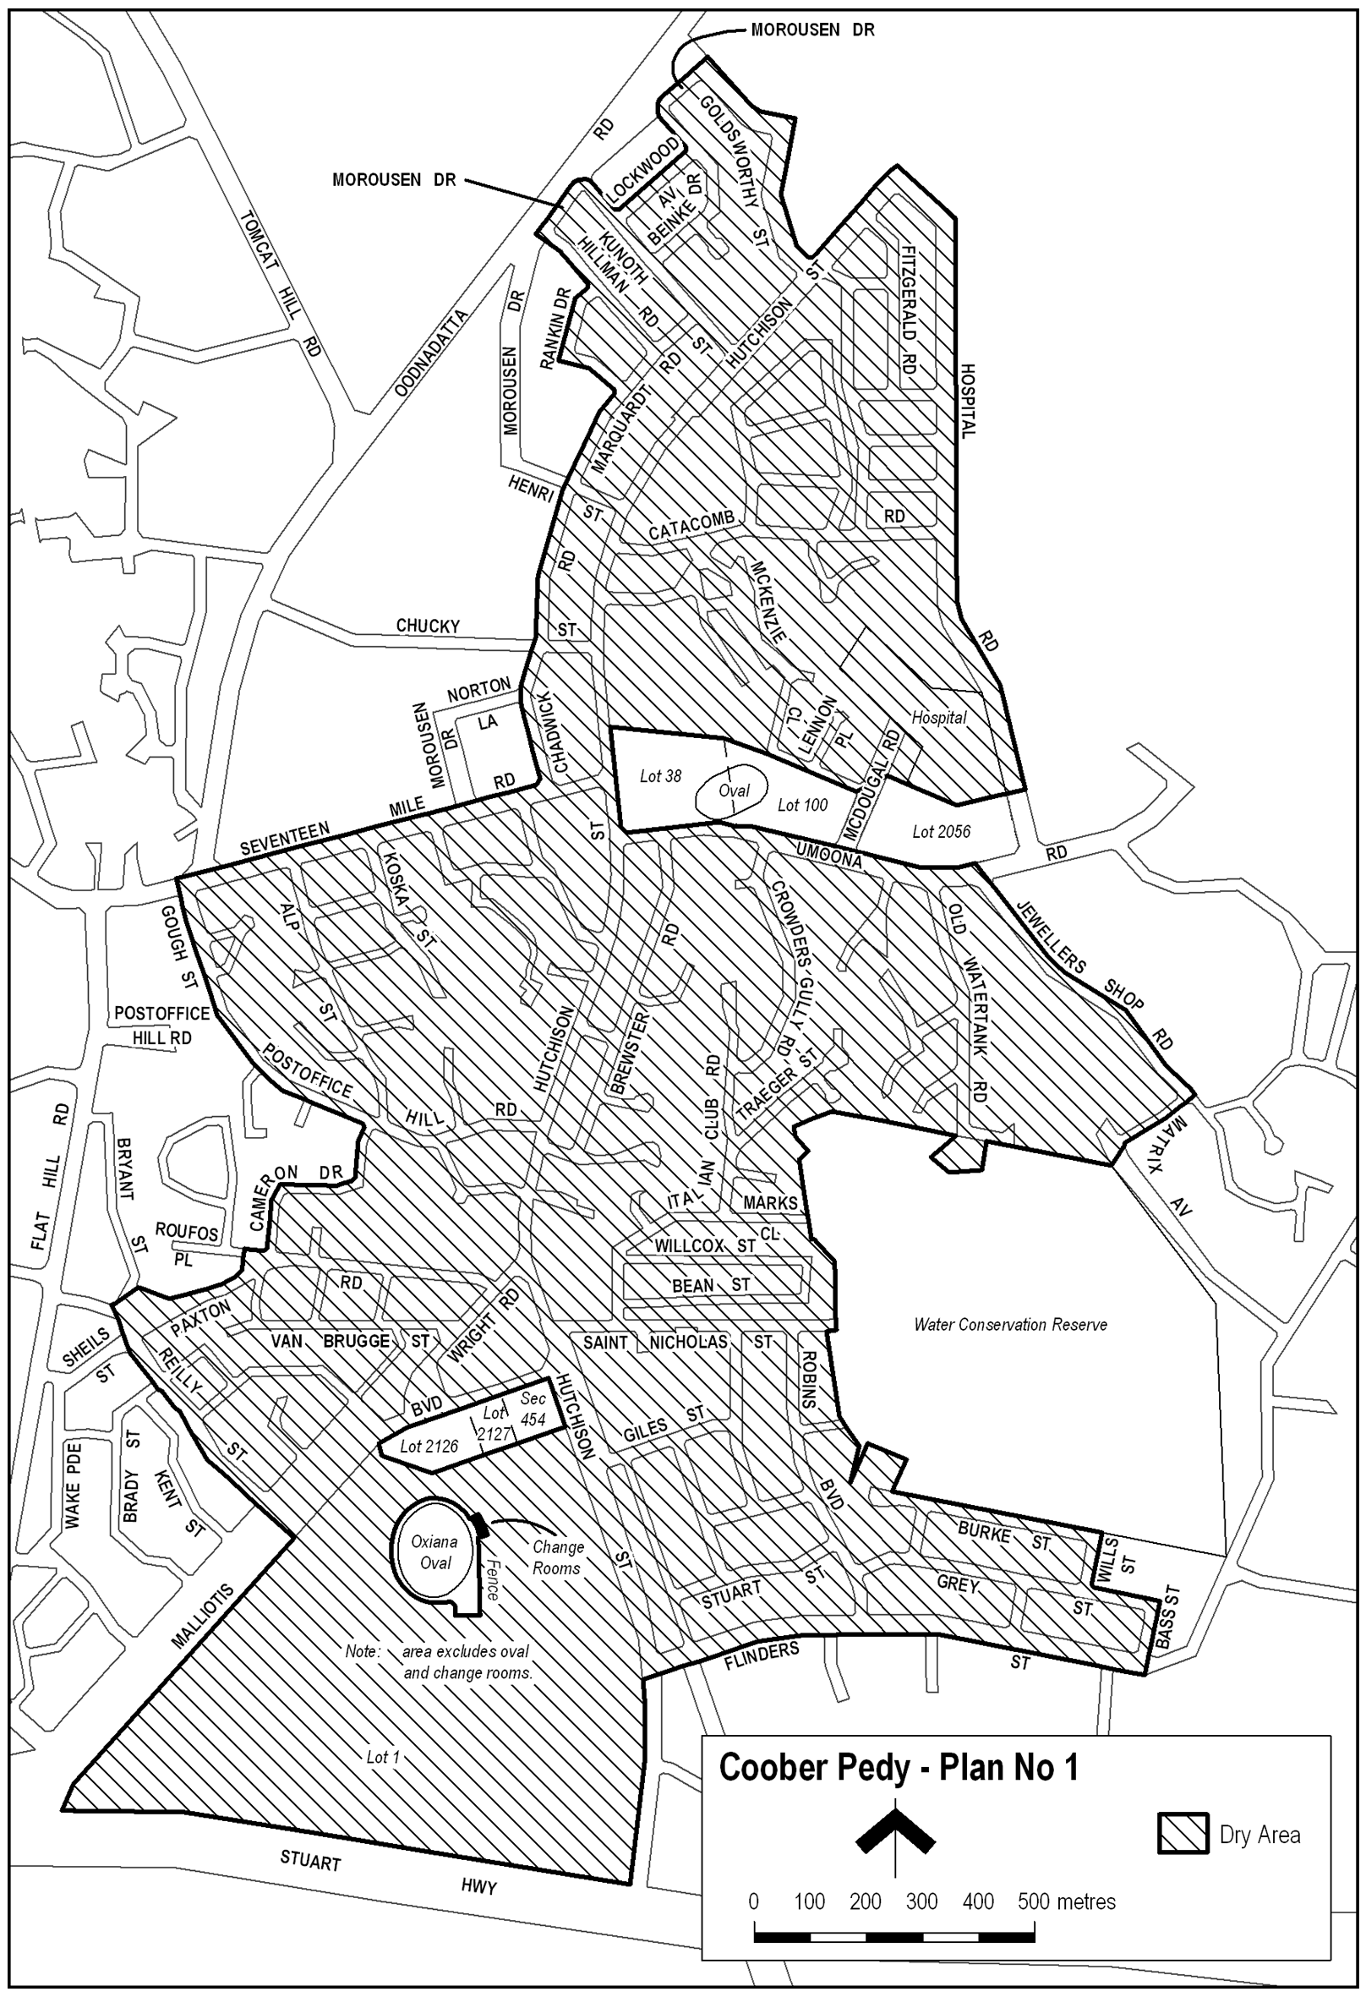
Note—
As required by section 10AA(2) of the Subordinate Legislation Act 1978, the Minister has certified that, in the Minister's opinion, it is necessary or appropriate that these regulations come into operation as set out in these regulations.
Made by the Governor
with the advice and consent of the Executive Council
on 19 July 2007
No 204 of 2007
MCA07/026CS

T. GOODES, Government Printer, South Australia

