No. 48 3169

THE SOUTH AUSTRALIAN

GOVERNMENT GAZETTE
www.governmentgazette.sa.gov.au

PUBLISHED BY AUTHORITY

ALL PUBLIC ACTS appearing in this GAZETTE are to be considered official, and obeyed as such

ADELAIDE, THURSDAY, 26 JULY 2007

CONTENTS

Page
Acts Assented To 3170
Adelaide Airport LTD (AAL)—Schedule of Charges 3171
Appointments, Resignations, Etc. 3170
Corporations and District Councils—Notices 3209
Crown Lands Act 1929—Notices 3174
Development Act 1993—Notice 3174
Environment Protection Act 1993—Notice 3173
Fisheries Act 1982—Notices 3174
Housing Improvement Act 1940—Notices 3177
Land and Business (Sale and Conveyancing) Act 1994—
Notice 3176
Liquor Licensing Act 1997—Notices 3179
Mining Act 1971—Notices 3183
Motor Vehicles Act 1959—Notices 3184
National Electricity Law—Notice 3184
Petroleum Act 2000—Notice 3185
Proclamations 3206
Public Trustee Office—Administration of Estates 3221
Roads (Opening and Closing) Act 1991—Notices 3184
Sale of Property 3221
Training and Skills Development Act 2003—Notices 3190
Transport, Department of—Notices to Mariners 3185
Water Mains and Sewers—Mains Laid, Replaced, Etc. 3186
Workers Rehabilitation and Compensation Act 1986—
Notice 3191

GOVERNMENT GAZETTE NOTICES
ALL poundkeepers’ and private advertisements forwarded for publication in the South Australian Government Gazette must be PAID FOR PRIOR TO INSERTION; and all notices, from whatever source, should be legibly written on one side of the paper only and sent to Government Publishing SA so as to be received no later
than 4 p.m. on the Tuesday preceding the day of publication. Phone 8207 1045 or Fax 8207 1040. E-mail: governmentgazette@dpc.sa.gov.au. Send as attachments in Word format and please confirm your transmission with a faxed copy of your document, including the date the notice is to be published and to whom the notice will be charged. The Government Gazette is available online at: www.governmentgazette.sa.gov.au

Department of the Premier and Cabinet
Adelaide, 26 July 2007
HER Excellency the Governor directs it to be notified for general information that she has in the name and on behalf of Her Majesty The Queen, this day assented to the undermentioned Acts passed by the Legislative Council and House of Assembly in Parliament assembled, viz.:
No. 24 of 2007—Natural Resources Management (Water Resources and Other Matters) Amendment Act 2007. An Act to amend the Natural Resources Management Act 2004 and to make related amendments to the Ground Water (Qualco-Sunlands) Control Act 2000.
No. 25 of 2007—Protective Security Act 2007. An Act to make provision for the security of public buildings, places and officials and for the appointment, management and responsibilities of protective security officers; to make related amendments to various other Acts; and for other purposes.
By command,
Gail Gago, for Premier
DPC06/0875

Department of the Premier and Cabinet
Adelaide, 26 July 2007
HER Excellency the Governor in Executive Council has been pleased to appoint the undermentioned to the South Australian Museum Board, pursuant to the provisions of the South Australian Museum Act 1976:
Member: (from 26 July 2007 until 25 July 2010)
Susan Mary Carthew
Elizabeth Diana Perry
Antony Simpson
Member: (from 23 August 2007 until 22 August 2010)
Nyra Bensimon
Robert Edwards
By command,
Gail Gago, for Premier
CASA2002/00003

Department of the Premier and Cabinet
Adelaide, 26 July 2007
HER Excellency the Governor in Executive Council has been pleased to appoint the undermentioned to the Legal Practitioners Disciplinary Tribunal, pursuant to the provisions of the Legal Practitioners Act 1981:
Member: (from 26 July 2007 until 25 July 2010)
Jonathan Charles Clarke
Member: (from 9 August 2007 until 8 August 2010)
Neville Wayne Morcombe
Malcolm George Montgomery
Presiding Member: (from 9 August 2007 until 8 August 2010)
Neville Wayne Morcombe
By command,
Gail Gago, for Premier
AGO0067/07CS

Department of the Premier and Cabinet
Adelaide, 26 July 2007
HER Excellency the Governor in Executive Council has been pleased to appoint the undermentioned to the Remuneration Tribunal, pursuant to the provisions of the Remuneration Act 1990:
Member: (from 8 August 2007 until 7 August 2010)
David Smythe
By command,
Gail Gago, for Premier
DPC027/02CS

Department of the Premier and Cabinet
Adelaide, 26 July 2007
HER Excellency the Governor in Executive Council has been pleased to appoint the Honourable Jay Wilson Weatherill, MP, Minister for Families and Communities, Minister for Aboriginal Affairs and Reconciliation, Minister for Housing, Minister for Ageing, Minister for Disability and Minister Assisting the Premier in Cabinet Business and Public Sector Management to be appointed as Acting Minister for Health, Acting Minister for the Southern Suburbs and Acting Minister Assisting the Premier in the Arts for the period 19 August 2007 to 8 September 2007 inclusive, during the absence of the Honourable John David Hill, MP.
By command,
Gail Gago, for Premier
HEACS/07/211

Department of the Premier and Cabinet
Adelaide, 26 July 2007
HER Excellency the Governor in Executive Council has been pleased to appoint Mark Ian Bodycoat as Public Trustee for a term of five years commencing on 4 September 2007 and expiring on
3 September 2012, pursuant to the provisions of the Public Trustee Act 1995.
By command,
Gail Gago, for Premier
AGO0068/07CS

Department of the Premier and Cabinet
Adelaide, 26 July 2007
HER Excellency the Governor in Executive Council has been pleased to appoint Carolyn Anne Sladden as Personal Assistant and Aide to the Governor of South Australia for a term commencing on 29 October 2007 and expiring on 8 February 2008, pursuant to the provisions of the Constitution Act 1934.
By command,
Gail Gago, for Premier
DPC036/97PT2CS

Department of the Premier and Cabinet
Adelaide, 26 July 2007
HER Excellency the Governor in Executive Council has been pleased to appoint Bruno Krumins, Member of the Order of Australia, as Governor’s Deputy of South Australia for the period from 5 p.m. on Tuesday, 31 July 2007 until the next Governor of the State of South Australia assumes office.
By command,
Gail Gago, for Premier

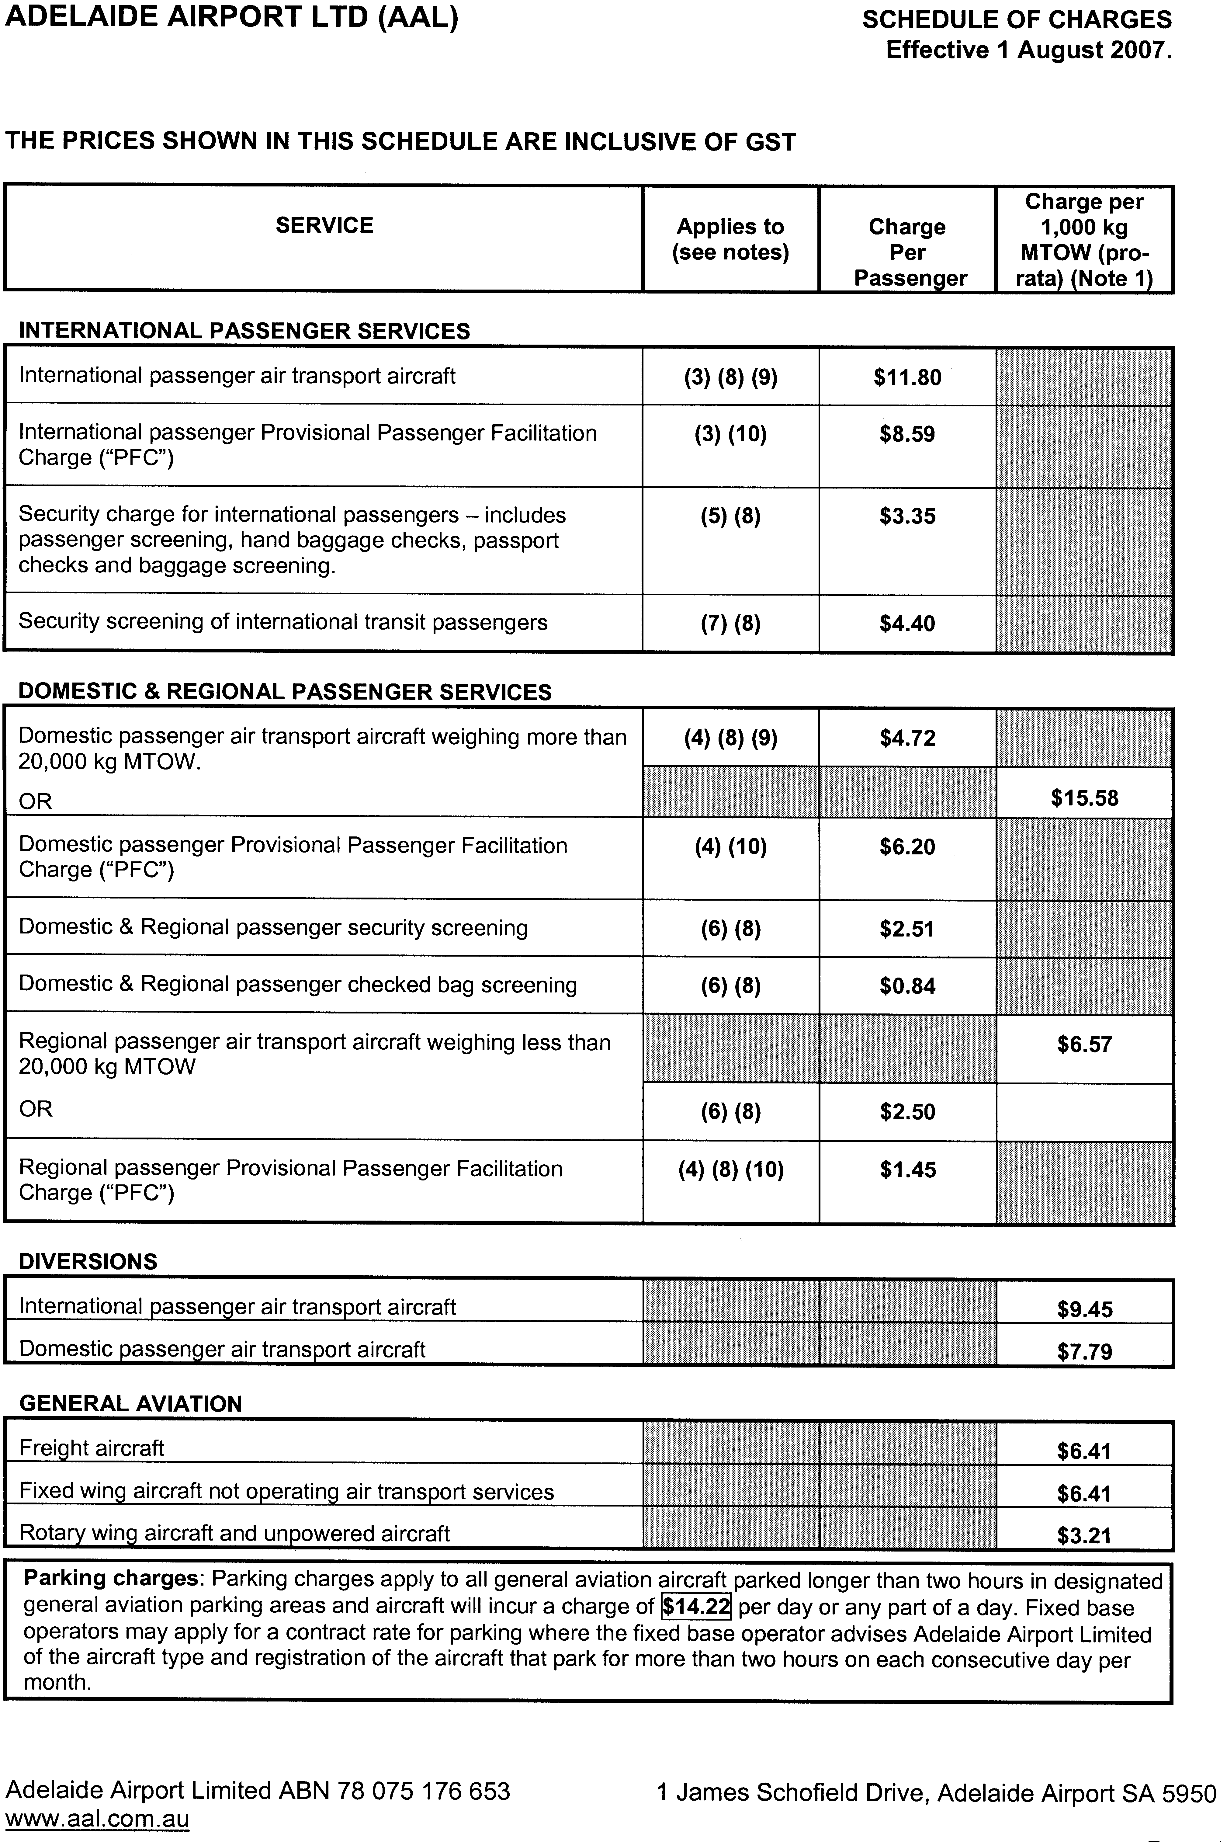

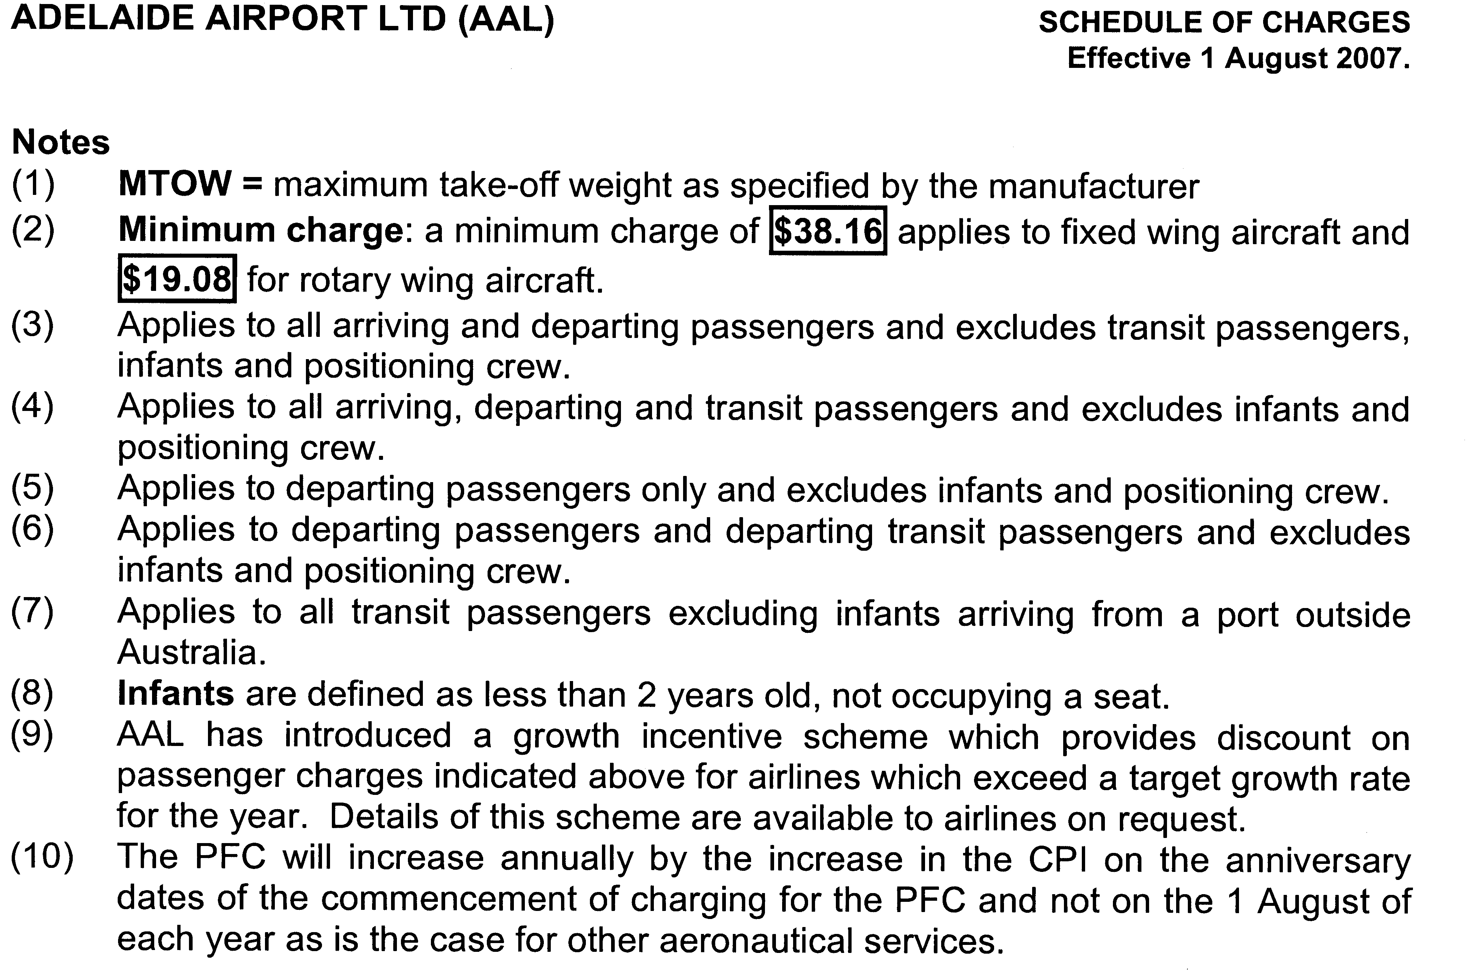

ENVIRONMENT PROTECTION ACT 1993
Variation to Existing Approval of Collection Depot
I, STEPHEN RICHARD SMITH, Senior Adviser, Container Deposit Legislation and Delegate of the Environment Protection Authority (‘the Authority’), pursuant to section 69 of the Environment Protection Act 1993 (SA) (‘the Act’) hereby:
Variation to Existing Approval of Collection Depot
Vary the approval of the collection depot, listed at Schedule 1 of this Notice, that was granted under the Act prior to the date of this Notice and impose the conditions of this approval to be as follows:
Approval of Collection Depot
The collection depot identified by reference to the following matters is approved:
(a) the name of the collection depot described in Column 1 of Schedule 1 of this Notice;
(b) the name of the proprietor of the depot identified in Column 3 of Schedule 1 of this Notice;
(c) the location of the depot described in Columns 4-5 of Schedule 1 of this Notice; and
(d) the collection area in relation to which the collection depot is approved referred to in Column 6 of Schedule 1 of this Notice.
The collection depot listed at Schedule 1 of this Notice is approved in relation to all classes of containers which were approved under the Act, at or subsequent to the date of this Notice, as Category B Containers.
Conditions of Approval
Impose the following conditions on the approval:
(a) The person in charge of the collection depot shall ensure the depot premises complies with Council Planning Regulations and shall be kept in an orderly condition.
(b) The person in charge of the collection depot who wishes to transfer the operation of a depot to another person or intends to change the location of a depot shall notify the Authority in writing within one month of the change occurring.
(c) The person in charge of the collection depot who wishes to cease operation of that depot shall give notice in writing to the Authority.
(d) The person in charge of the collection depot shall take such measures as are necessary in the operation and maintenance of the depot to prevent or control:
(i) a nuisance or offensive condition;
(ii) a risk to health or safety; and
(iii) damage to the environment.
(e) The person in charge of the collection depot is reminded of the general environmental duty, as required by section 25 of the Environment Protection Act 1993, to take all reasonable and practical measures to ensure that the activities on the whole site, do not pollute the environment in a way which causes or may cause environmental harm.
Schedule 1

Column 1 | Column 2 | Column 3 | Column 4 | Column 5 | Column 6 | Column 7
Depot Name | Company/Trading Name | Proprietors | Depot Location  Street | Depot Location  Suburb | Certificate of Title No. Volume/Folio No. | Collection  Area
Aldinga Recycle Centre | South Coast Recyclers Pty Ltd | Andrew Charles Bowden and Steven Nicholas James | Lot 2, How Road | Aldinga | 5238/333 | Southern

CROWN LANDS ACT 1929: SECTION 5
TAKE NOTICE that pursuant to the Crown Lands Act 1929, I, GAIL GAGO, Minister for Environment and Conservation, Minister of the Crown to whom the administration of the Crown Lands Act 1929 is committed DO HEREBY:
1. Resume the land defined in The First Schedule.
2. Dedicate the Crown Land defined in The Second Schedule as an Emergency Services Reserve and declare that such land shall be under the care, control and management of the Minister for Emergency Services.
The First Schedule
Portion of Park Lands, portion of Section 661, now identified as Allotment 32 of Deposited Plan 74335, adjacent to the Town of Alford, Hundred of Tickera, County of Daly, the proclamation of which, together with other land was published in the Government Gazette of 20 November 1980 at page 1922, The Second Schedule, being portion of the land comprised in Crown Record Volume 5755, Folio 706.
The Second Schedule
Allotment 32 of Deposited Plan 74335, Hundred of Tickera, County of Daly, exclusive of all necessary roads.
Dated 26 July 2007.
Gail Gago, Minister for Environment and Conservation
DEHAA 10/1075

CROWN LANDS ACT 1929: SECTION 5
TAKE NOTICE that pursuant to the Crown Lands Act 1929, I, GAIL GAGO, Minister for Environment and Conservation, Minister of the Crown to whom the administration of the Crown Lands Act 1929 is committed DO HEREBY:
1. Resume the land defined in The First Schedule.
2. Dedicate the Crown Land defined in The Second Schedule as an Emergency Services Reserve and declare that such land shall be under the care, control and management of the Minister for Emergency Services.
The First Schedule
Portion of Recreation Reserve, portion of Section 444, now identified as Allotment 26 of Deposited Plan 74332, Hundred of Terowie, the proclamation of which was published in the Government Gazette of 8 February 1923 at page 286, The Second Schedule, being portion of the land comprised in Crown Record Volume 5758, Folio 819.
The Second Schedule
Allotment 26 of Deposited Plan 74332, Hundred of Terowie, County of Kimberley, exclusive of all necessary roads.
Dated 26 July 2007.
Gail Gago, Minister for Environment and Conservation
DEH 10/1106

DEVELOPMENT ACT 1993, SECTION 25 (17): DISTRICT COUNCIL OF MOUNT REMARKABLE—PORT GERMEIN TOWNSHIP PLAN AMENDMENT
Preamble
1. The Development Plan amendment entitled ‘District Council of Mount Remarkable—Port Germein Township Plan Amend-ment’ (the Plan Amendment) has been finalised in accordance with the provisions of the Development Act 1993.
2. The Minister for Urban Development and Planning has decided to approve the Plan Amendment.
Notice
PURSUANT to section 25 of the Development Act 1993, I—
(a) approve the Plan Amendment; and
(b) fix the day on which this notice is published in the Gazette as the day on which the Plan Amendment will come into operation.
Dated 26 July 2007.
Paul Holloway, Minister for Urban Development and Planning

FISHERIES ACT 1982: SECTION 59
TAKE notice that pursuant to section 59 of the Fisheries Act 1982, Trevor Bell, c/o P.O. Box 3, Kingscote, S.A. 5223, holder of Marine Scalefish Fishery Licence No. M041 (the ‘exemption holder’), is exempt from the provisions of section 41 of the Fisheries Act 1982, Regulation 7 and Schedule 6 of the Fisheries (General) Regulations 2000, but only insofar as the exemption holder shall not be guilty of an offence when taking undersized fish of the species cockles (Katelysia spp.) (the ‘exempted activity’), within those waters specified in Schedule 1, subject to the conditions specified in Schedule 2, from 24 July 2007 until 30 June 2008, unless varied or revoked earlier.
Schedule 1
The waters in the vicinity of Kingscote bounded as follows:
Commencing at a point at high water mark at Cape Rouge, latitude 35°35′52″S, longitude 137°37′32″E, then along the geodesic (190°T), to a point at high water mark on the south coast on the Bay of Shoals, latitude 35°38′18″S, longitude 137°37′05″E, then following the line of high water mark in a generally easterly and southerly direction to a point at high water mark at the landward end of the Kingscote jetty, latitude 35°39′15″S, longitude 137°38′32″E, then along the geodesic (133°T) for a distance of 2.3 nautical miles to position latitude 35°40′32″S, longitude 137°41′00″E, then along the geodesic (033°T) for a distance of 2.1 nautical miles to a position latitude 35°38′50″S longitude 137°42′15″E, then along the geodesic (325°T) to a point at high water mark on Marsden Point, latitude 35°33′55″S, longitude 137°38′07″E, then following the line of high water mark in a generally southerly direction back to the point of commencement.
Schedule 2
1. Any fish taken by the exemption holder pursuant to this notice must be not less than 27 mm in length measured at the greatest dimension.
2. Any fish taken by the exemption holder pursuant to this notice must be used for bait only and must not be sold.
3. The exemption holder must include all cockles taken pursuant to this exemption on the monthly catch and effort summary provided to the South Australian Research and Development Institute (SARDI).
4. While engaged in the exempted activity, the exemption holder must have in his possession, a copy of this notice and produce a copy of the notice if requested by a PIRSA Fisheries Compliance Officer.
5. The exemption holder shall not contravene or fail to comply with the Fisheries Act 1982, or any regulation made under that Act, except where specifically exempted by this notice.
Dated 24 July 2007.
W. Zacharin, Director of Fisheries

FISHERIES ACT 1982: SECTION 59
TAKE notice that pursuant to section 59 of the Fisheries Act 1982, Robert Chirgwin, 9 Seaview Road, Kingscote, S.A. 5223, holder of Marine Scalefish Fishery Licence No. M039 (the ‘exemption holder’), is exempt from the provisions of section 41 of the Fisheries Act 1982, Regulation 7 and Schedule 6 of the Fisheries (General) Regulations 2000, but only insofar as the exemption holder shall not be guilty of an offence when taking
undersized fish of the species cockles (Katelysia spp.) (the ‘exempted activity’), within those waters specified in Schedule 1, subject to the conditions specified in Schedule 2, from 24 July 2007 until 30 June 2008, unless varied or revoked earlier.
Schedule 1
The waters in the vicinity of Kingscote bounded as follows:
Commencing at a point at high water mark at Cape Rouge, latitude 35°35′52″S, longitude 137°37′32″E, then along the geodesic (190°T), to a point at high water mark on the south coast on the Bay of Shoals, latitude 35°38′18″S, longitude 137°37′05″E, then following the line of high water mark in a generally easterly and southerly direction to a point at high water mark at the landward end of the Kingscote jetty, latitude 35°39′15″S, longitude 137°38′32″E, then along the geodesic (133°T) for a distance of 2.3 nautical miles to position latitude 35°40′32″S, longitude 137°41′00″E, then along the geodesic (033°T) for a distance of 2.1 nautical miles to a position latitude 35°38′50″S, longitude 137°42′15″E, then along the geodesic (325°T) to a point at high water mark on Marsden Point, latitude 35°33′55″S, longitude 137°38′07″E, then following the line of high water mark in a generally southerly direction back to the point of commencement.
Schedule 2
1. Any fish taken by the exemption holder pursuant to this notice must be not less than 27 mm in length measured at the greatest dimension.
2. Any fish taken by the exemption holder pursuant to this notice must be used for bait only and must not be sold.
3. The exemption holder must include all cockles taken pursuant to this exemption on the monthly catch and effort summary provided to the South Australian Research and Development Institute (SARDI).
4. While engaged in the exempted activity, the exemption holder must have in his possession, a copy of this notice and produce a copy of the notice if requested by a PIRSA Fisheries Compliance Officer.
5. The exemption holder must not contravene or fail to comply with the Fisheries Act 1982, or any regulation made under that Act, except where specifically exempted by this notice.
Dated 24 July 2007.
W. Zacharin, Director of Fisheries

FISHERIES ACT 1982: SECTION 59
TAKE notice that pursuant to section 59 of the Fisheries Act 1982, Adrienne Frears of the SA Murray-Darling Basin Natural Resources Management Board, P.O. Box 2056, Murray Bridge, S.A. 5253, (the ‘exemption holder’) or a person acting as her agent, is exempt from the provision of section 41 of the Fisheries Act 1982 and the Fisheries (General) Regulations 2000 insofar as she may engage in the collection of fish (the ‘exempted activity’) from the waters described in Schedule 1, using the gear specified in Schedule 2, subject to the conditions set out in Schedule 3 from 24 July 2007 until 30 June 2008, unless varied or revoked earlier.
Schedule 1
The backwaters and wetlands of the River Murray between Lock 1 and the Coorong.
Schedule 2
• 8 fine mesh (9 mm mesh size) fyke nets
• 20 shrimp traps
• 2 seine nets
• 2 dip nets
Schedule 3
1. The specimens collected by the exemption holders are for scientific and research purposes only and must not be sold.
2. A maximum of five fish of any species per location may be taken for the purpose of species identification.
3. All other native fish taken pursuant to the exempted activity must be immediately returned to the water unless retained for the purpose of species identification.
4. Before conducting the exempted activity, the exemption holder or a person acting as her agent must contact the PIRSA Fisheries Compliance Unit on 1800 065 522 and answer a series of questions about the exempted activity. You will need to have a copy of your exemption with you at the time of making the call, and be able to provide information about the area and time of the exempted activity, the vehicles and/or boats involved, the number of agents undertaking the exempted activity and other related issues. Exemption No. 9902013.
5. The exemption holder must provide a report in writing detailing the outcomes of the research and the collection of organisms pursuant to this notice to the Director of Fisheries, G.P.O. Box 1625, Adelaide, S.A. 5001 within 14 days of the expiry of this notice, giving the following details:
• the date, time and location of collection;
• the description of all species collected; and
• the number of each species collected.
6. While engaged in the exempted activity, the exemption holder must be in possession of a copy of this notice. Such notice must be produced to a PIRSA Fisheries Compliance Officer if requested.
7. The exemption holder must not contravene or fail to comply with the Fisheries Act 1982 or any regulations made under that Act, except where specifically exempted by this notice.
Dated 24 July 2007.
W. Zacharin, Director of Fisheries

FISHERIES ACT 1982: SECTION 59
TAKE notice that pursuant to section 59 of the Fisheries Act 1982, Antony Smith (the ‘exemption holder’) is exempt from Clause 22 of Schedule 1 of the Fisheries (General) Regulations 2000, but only insofar as he may use the device described in Schedule 1 to take carp, bony bream and other non-native species in the areas specified in Schedule 2 for the purpose of trade or business
(the ‘exempted activity’), subject to the conditions set out in Schedule 3, from 24 July 2007 until 30 June 2008, unless varied or revoked earlier.
Schedule 1
‘Carp net’—a gill net with a ply greater than 5, having a maximum length of 50 m and a minimum mesh size of 10 cm and a maximum mesh size not exceeding 18 cm.
Schedule 2
(1) Subject to paragraph (2), the licence holder may conduct fishing activities pursuant to this licence in all backwaters of the River Murray excluding the following areas during the corresponding period set out in the following table:
Area Excluded | Period of Closure
Lake Littra and outflow channel | Permanent—all year
Clover Lake | Permanent—all year
Coombool Swamp | Permanent—all year
Lake Limbra and outflow channel | Permanent—all year
Lake Woolpolool | Permanent—all year
Ral Ral Creek below Chaffey Pump and entrance waters to Lake Merreti | Permanent—all year
Katarapko Creek and Eckert Creek, including The Splash | Permanent—all year
Bulyong Creek | Permanent—all year
Pilby Creek | Permanent—all year
Hancock Creek | Permanent—all year
Mundic Creek | Permanent—all year
Pike Creek | Permanent—all year
Punkah Creek | Permanent—all year
Slaney Creek | Permanent—all year
Loch Luna | Permanent—all year
Cobdogla Swamp | 1 August to 30 April (inclusive)
Loveday Swamp/Mussel Lagoons | 1 August to 30 April (inclusive)
Lake Merreti | 1 August to 31 January (inclusive)

(2) The licence holder may conduct fishing operations within the closure areas and periods listed above if given written approval by the Director of Fisheries to undertake specified carp eradication work in a specified area for a specified period.
Schedule 3
1. The exemption holder must not use more than 30 carp nets at any one time in permitted backwaters of the River Murray.
2. The exemption holder must not have more than 30 carp nets in his possession at any time when he is deploying carp nets in the backwaters of the River Murray.
3. The exemption holder may only engage in the exempted activity when also fishing pursuant to River Fishery Licence No. R54, and may only use a boat to engage in the exempted activity if that boat is registered by endorsement on River Fishery Licence No. R54.
4. The exemption holder must not cause or permit a person to act as his agent when engaging in the exempted activity unless that person may lawfully act as an agent for the exemption holder in relation to River Fishery Licence No. R54.
5. All native fish (excluding bony bream and yabbies) taken in the course of the exempted activity must be immediately returned to the water.
6. Immediately prior to commencing the exempted activity, the exemption holder must contact the PIRSA Fisheries Compliance Unit on 1800 065 522 and provide the following details:
• The licence number and person(s) conducting the activity.
• The exact location(s) of the fishing activities.
• The number of carp nets being used.
• Exemption No. 9902011.
7. The exemption holder must ensure that the carp nets are checked and all fish removed at least once during each 24 hour period.
8. When the exemption holder moves the carp nets more than 3 km from the reported location of the nets under condition 6, or removes the nets from the River completely, the exemption holder must again report to the PIRSA Fisheries Compliance Unit on 1800 065 522 and provide either details, as required under con-dition 6 of this exemption, or report that fishing with carp nets has ceased.
9. While engaged in the exempted activity, the exemption holders must be in possession of a copy of this notice. Such notice must be produced to a PIRSA Fisheries Compliance Officer as requested.
10. The exemption holder must not contravene or fail to comply with the Fisheries Act 1982, or any regulations made under that Act, except where specifically exempted by this notice.
Dated 24 July 2007.
W. Zacharin, Director of Fisheries

LAND AND BUSINESS (SALE AND CONVEYANCING)
ACT 1994
Exemption
TAKE notice that, pursuant to section 23 (3) of the Land and Business (Sale and Conveyancing) Act 1994, I, Jennifer Rankine, Minister for Consumer Affairs, do hereby exempt the person named in Schedule 1 from the application of section 23 (2) of the Act in relation to the purchase of the land specified in Schedule 2.
Schedule 1
Steven John Prout, an officer of Haarsmas Real Estate Pty Ltd.
Schedule 2
The land described in certificate of title register book volume 5982, folio 677, situated at 1/13 Calais Avenue, Port Lincoln, S.A. 5606.
Dated 26 July 2007.
Jennifer Rankine, Minister for Consumer Affairs

HOUSING IMPROVEMENT ACT 1940
NOTICE is hereby given that the South Australian Housing Trust in the exercise of the powers conferred by the Housing Improvement Act 1940, does hereby declare the houses described in the table hereunder to be substandard for the purposes of Part 7 of the Housing Improvement Act 1940.
No. of House and Street | Locality | Allotment, Section, etc. | Certificate of Title  Volume Folio

1 Bridges Street |  | Broadview | Allotment 59 in Filed Plan 111367, Hundred of Yatala | 5805 | 127
65 Ramsgate Avenue |  | Christies Beach | Allotment 307 in Deposited Plan 7459, Hundred of Noarlunga | 5072 | 732
3 Bartel Boulevard |  | Encounter Bay | Allotment 3 in Plan 3600, Hundred of Encounter Bay | 5733 | 495
11 Cowra Avenue |  | Gilles Plains | Allotment 212 in Deposited Plan 7660, Hundred of Yatala | 5413 | 989
239 Portrush Road |  | Norwood | Allotment 14 in Deposited Plan 3266, Hundred of Adelaide | 5789 | 268
63 Porter Street |  | Parkside | Allotment 35 in Filed Plan 14658, Hundred of Adelaide | 5313 | 135
6-8 Pamir Court (also known as 6 Pamir Street) |  | Port Lincoln | Allotment 225 in Deposited Plan 7972, Area of Port Lincoln, Hundred of Lincoln | 5443 | 96
Unit 3/9 Irwin Street |  | Wallaroo | Allotment 3 in Filed Plan 158872, Hundred of Wallaroo | 5287 | 975
Unit 4/9 Irwin Street |  | Wallaroo | Allotment 3 in Filed Plan 158872, Hundred of Wallaroo | 5287 | 975
Unit 7/9 Irwin Street |  | Wallaroo | Allotment 3 in Filed Plan 158872, Hundred of Wallaroo | 5287 | 975
Unit 9/9 Irwin Street |  | Wallaroo | Allotment 3 in Filed Plan 158872, Hundred of Wallaroo | 5287 | 975
Unit 10/ 9 Irwin Street |  | Wallaroo | Allotment 3 in Filed Plan 158872, Hundred of Wallaroo | 5287 | 975
12 Jones Street |  | Wallaroo | Allotment 271 in Filed Plan 190023, Hundred of Wallaroo  Allotment 272 in Filed Plan 190024, Hundred of Wallaroo | 5772  5772 | 208  209
68 Main Street |  | Yankalilla | Allotment 442 in Filed Plan 165161, Hundred of Yankalilla | 5872 | 362
95 Main South Road |  | Yankalilla | Allotment 412 in Filed Plan 211198, Hundred of Yankalilla | 5571 | 817

Dated at Adelaide, 26 July 2007. D. Huxley, Director, Corporate and Board Services

HOUSING IMPROVEMENT ACT 1940
WHEREAS by notice published in the Government Gazette on the dates mentioned in the following table the South Australian Housing Trust did declare the houses described in the said table to be substandard for the purposes of Part 7 of the Housing Improvement Act 1940, the South Australian Housing Trust in the exercise of the powers conferred by the said Part, does hereby fix as the maximum rental per week which shall be payable subject to section 55 of the Residential Tenancies Act 1995, in respect of each house described in the following table the amount shown in the said table opposite the description of such house and this notice shall come into force on the date of this publication in the Gazette.
Address of House | Allotment, Section, etc. | Certificate of Title  Volume Folio | Date and page of Government Gazette in which notice declaring house to be substandard published | Maximum rental per week payable in respect of each house  $

247 Carrington Street, Adelaide |  | Allotment 2 in Filed Plan 101860, Hundred of Adelaide |  | 5114 |  | 537 |  |  | 11.11.76, page 1612 | 297.00
9 Queens Avenue, Burnside |  | Allotment 1 of portion of section 903, Hundred of Adelaide |  | 5482 |  | 796 |  |  | 27.2.97, page 1054 | 223.00
6 Harriet Street, Clare (also known as Lot 117) |  | Allotments 117 and 118 in Filed Plan 212766, Hundred of Clare |  | 5889 |  | 164 |  |  | 27.1.05, page 293 | 141.00
Flat 1/6 Wilson Avenue, Felixstow |  | Allotment 15 in Deposited Plan 6762, Hundred of Adelaide |  | 5634 |  | 133 |  |  | 26.1.89, page 227 | 70.00
Flat 2/6 Wilson Avenue, Felixstow |  | Allotment 15 in Deposited Plan 6762, Hundred of Adelaide |  | 5634 |  | 133 |  |  | 26.1.89, page 227 | 59.00
Lot 1, Section 391, Main Road, Forest Range |  | Allotment 1 of portion of section 391, Hundred of Onkaparinga |  | 5513 |  | 323 |  |  | 26.7.90, page 426 | 60.00
70 Orsmond Street, Hindmarsh |  | Allotment 93 in Filed Plan 120212, Hundred of Yatala |  | 5711 |  | 628 |  |  | 5.9.74, page 1702 | 287.00
Address of House |  |  | Allotment, Section, etc. |  | Certificate of Title  Volume Folio |  |  | Date and page of Government Gazette in which notice declaring house to be substandard published |  |  | Maximum rental per week payable in respect of each house  $

72 Orsmond Street, Hindmarsh |  | Allotment 92 in Filed Plan 120212, Hundred of Yatala | 5543 | 641 |  | 25.3.93, page 1081 | 287.00
63 Rosewater Terrace, Ottoway |  | Allotment 98 of portion of section 1168, Hundred of Port Adelaide | 5741 | 272 |  | 30.11.89, page 1635 | 185.00
34 Marine Parade, Kingston, South East |  | Allotment 653 in Filed Plan 204989, Hundred of Lacepede | 5422 | 601 |  | 28.9.06, page 3308 | 156.00
Lot 51, Saddleworth Road, Riverton (also known as Government Road) |  | Allotment 51 in Deposited Plan 32985, Hundred of Gilbert | 5060 | 677 |  | 28.9.95, page 831 | 138.00
262A Henley Beach Road, Underdale |  | Allotment 9 in Filed Plan 122803, Hundred of Adelaide | 5333 | 747 |  | 22.2.07, page 555 | 234.00

Dated at Adelaide, 26 July 2007. D. Huxley, Director, Corporate and Board Services

HOUSING IMPROVEMENT ACT 1940
WHEREAS by notice published in the Government Gazette on the dates mentioned in the following table the South Australian Housing Trust did declare the houses described in the said table to be substandard for the purposes of Part 7 of the Housing Improvement Act 1940, and whereas the South Australian Housing Trust is satisfied that each of the houses described hereunder has ceased to be substandard, notice is hereby given that, in exercise of the powers conferred by the said Part, the South Australian Housing Trust does hereby revoke the said declaration in respect of each house.
Address of House | Allotment, Section, etc. | Certificate of Title  Volume Folio | Date and page of Government Gazette in which notice declaring house to be substandard published

215 Wright Street, Adelaide |  | Allotment 100 in Filed Plan 41072, Hundred of Adelaide | 5700 | 683 |  | 29.7.93, page 715
18 South Terrace, Blanchetown, (previously 192 South Terrace) |  | Allotment 192, Town of Blanchetown, Hundred of Skurray, County of Eyre | 5213 | 40 |  | 25.11.93, page 2605
38 Clovelly Avenue, Christies Beach |  | Allotment 100 in Deposited Plan 73788  Allotment 101 in Deposited Plan 73788, Hundred of Noarlunga | 5984  5984 | 624  625 |  | 27.4.06, page 1157
9 MacFarlane Street, Cummins |  | Allotments 34 and 35 in Deposited Plan 1861, Hundred of Cummins | 5583 | 354 |  | 23.12.93, page 3049
31 Hope Street, Encounter Bay |  | Allotment 91 in Filed Plan 208347, Hundred of Encounter Bay | 5491 | 143 |  | 27.7.06, page 2380
9 Barrage Road (also known as 16 Oliver Street) Goolwa |  | Allotments 46 and 47 in Filed Plan 11292, Hundred of Goolwa | 5451 | 859 |  | 14.2.91, page 580
Section 424, Magdalla Road, Magdalla (also known as Hamley Bridge Road, Wasleys) |  | Section 424, Hundred of Mudla Wirra | 5170 | 115 |  | 2.3.06, page 766
828 North East Road, Modbury |  | Allotment 34 in Deposited Plan 7086, Hundred of Yatala | 5732 | 715 |  | 21.6.07, page 2639
Allotment 1, Part Section 23, Wireless Road East, Mount Gambier |  | Allotment 1 in Filed Plan 14852, Hundred of Gambier | 5156 | 923 |  | 24.8.95, page 508
Flat 6/195 Anzac Highway, Plympton |  | Allotment 46 in Filed Plan 8369, Hundred of Adelaide | 5573 | 161 |  | 29.6.95, page 3061
68 York Road, Port Pirie West |  | Allotment 3 in Deposited Plan 1484, Hundred of Pirie | 5106 | 361 |  | 25.5.06, page 1384
45 Langsford Street, Port Augusta |  | Allotment 14 in Deposited Plan 2353, Hundred of Davenport | 5784 | 232 |  | 4.5.95, page 1714
113 Hawker Street, Ridleyton |  | Allotment 12 in Filed Plan 107702 in the area named Ridleyton, Hundred of Yatala | 5189 | 32 |  | 21.9.00, page 2147
35 Nineteenth Street, Renmark |  | Allotment 8 in Filed Plan 5969, Hundred of Renmark Irrigation District | 5602 | 751 |  | 29.10.92, page 1439
8 Mott Street, Tailem Bend |  | Allotment 666 in Deposited Plan 4650, Hundred of Seymour | 5236 | 989 |  | 22.2.07, page 555
6 Elizabeth Street, Wallaroo |  | Allotments 11, 12 and 13 in Deposited Plan 70241, Hundred of Wallaroo | 5962  5962  5962 | 219  220  221 |  | 23.12.93, page 3050

Dated at Adelaide, 26 July 2007. D. Huxley, Director, Corporate and Board Services

LIQUOR LICENSING ACT 1997 AND GAMING MACHINES ACT 1992
Notice of Application
NOTICE is hereby given, pursuant to section 52 of the Liquor Licensing Act 1997 and section 29 of the Gaming Machines Act 1992, that Hedz No. 19 Pty Ltd has applied to the Licensing Authority for the transfer of a Hotel and Gaming Machine Licence in respect of premises situated at 108 Main South Road, Hackham S.A. 5163 and known as Aussie Inn.
The applications have been set down for callover on 27 August 2007 at 11 a.m.
Any person may object to the application by lodging a notice of objection in the prescribed form with the Liquor and Gambling Commissioner and serving a copy of the notice on the applicant at the applicant’s address, at least seven days before the hearing date (viz: 20 August 2007).
The applicant’s address for service is c/o Jarrod Ryan, Santos House, Level 17, 91 King William Street, Adelaide, S.A. 5000.
Plans in respect of the premises the subject of the application are open to public inspection without fee at the Office of the Liquor and Gambling Commissioner, 9th Floor, East Wing, 50 Grenfell Street, Adelaide, S.A. 5000. Phone 8226 8410, Fax:
8226 8512. Email: olgc@agd.sa.gov.au.
Dated 18 July 2007.
Applicant

LIQUOR LICENSING ACT 1997 AND GAMING MACHINES ACT 1992
Notice of Application
NOTICE is hereby given, pursuant to section 52 of the Liquor Licensing Act 1997 and section 29 of the Gaming Machines Act 1992, that Naracoorte Kincraig Pty Ltd has applied to the Licensing Authority for the transfer of a Hotel and Gaming Machine Licence in respect of premises situated at 158 Smith Street, Naracoorte, S.A. 5271 and known as Kincraig Hotel.
The applications have been set down for hearing on
3 September 2007 at 9.30 a.m.
Any person may object to the application by lodging a notice of objection in the prescribed form with the Liquor and Gambling Commissioner and serving a copy of the notice on the applicant at the applicant’s address, at least seven days before the hearing date (viz: 24 August 2007).
The applicant’s address for service is c/o Richard Phillips, Roper Street Chambers, Ground Floor, 21 Roper Street, Adelaide, S.A. 5000.
Plans in respect of the premises the subject of the application are open to public inspection without fee at the Office of the Liquor and Gambling Commissioner, 9th Floor, East Wing, 50 Grenfell Street, Adelaide, S.A. 5000. Phone 8226 8410, Fax:
8226 8512. Email: olgc@agd.sa.gov.au.
Dated 24 July 2007.
Applicant

LIQUOR LICENSING ACT 1997 AND GAMING MACHINES ACT 1992
Notice of Application
NOTICE is hereby given, pursuant to section 52 of the Liquor Licensing Act 1997 and section 29 of the Gaming Machines Act 1992, that Hackham Community Sports & Social Club Inc. has applied to the Licensing Authority for removal of a Club Licence and approval of a Gaming Machine Licence, variation to Extended Trading Authorisation and variation to Entertainment Consent in respect of premises situated at the corner of Doctors and States Roads, Hackham, S.A. 5163 and to be situated at 118-120 Main South Road, Morphett Vale, S.A. 5162, known as Hackham Community Sports & Social Club.
The applications have been set down for callover on 24 August 2007 at 9 a.m.
Conditions
The following licence conditions are sought:
• Approval is sought for Gaming Machine Licence to operate 40 machines.
• Variation to Extended Trading Authorisation:
Friday: Midnight to 2 a.m. the following day;
Saturday: Midnight to 2 a.m. the following day;
Sunday: 8 p.m. to midnight;
Good Friday: Midnight to 2 a.m.;
Christmas Day: Midnight to 2 a.m;
Sunday Christmas Eve: 8 p.m. to 2 a.m. the following day;
Days preceding other Public Holidays: Midnight to 2 a.m. the following day; and
Sundays preceding Public Holidays: 8 p.m. to 2 a.m. the following day.
• Variation to Entertainment Consent to apply to the above-mentioned hours.
Any person may object to the application by lodging a notice of objection in the prescribed form with the Liquor and Gambling Commissioner and serving a copy of the notice on the applicant at the applicant’s address, at least seven days before the callover date (viz: 10 August 2007).
The applicant’s address for service is c/o Clelands Solicitors, 208 Carrington Street, Adelaide, S.A. 5000 (Attention: Rinaldo D’Aloia).
Plans in respect of the premises the subject of the application are open to public inspection without fee at the Office of the Liquor and Gambling Commissioner, 9th Floor, East Wing, 50 Grenfell Street, Adelaide, S.A. 5000. Phone 8226 8410, Fax:
8226 8512. Email: olgc@agd.sa.gov.au.
Dated 17 July 2007.
Applicant

LIQUOR LICENSING ACT 1997
Notice of Application
NOTICE is hereby given, pursuant to section 52 (2) (b) of the Liquor Licensing Act 1997, that Wine Cellars Direct Pty Ltd has applied to the Licensing Authority for a Direct Sales Licence in respect of premises situated at 15 Wycombe Road, Aldgate, S.A. 5154 and to be known as Wine Cellars Direct.
The application has been set down for hearing on 24 August 2007 at 9 a.m.
Any person may object to the application by lodging a notice of objection in the prescribed form with the Liquor and Gambling Commissioner and serving a copy of the notice on the applicant at the applicant’s address, at least seven days before the hearing date (viz: 17 August 2007).
The applicant’s address for service is c/o Alex Meijnen, 15 Wycombe Road, Aldgate, S.A. 5154.
Plans in respect of the premises the subject of the application are open to public inspection without fee at the Office of the Liquor and Gambling Commissioner, 9th Floor, East Wing, 50 Grenfell Street, Adelaide, S.A. 5000. Phone 8226 8410, Fax:
8226 8512. Email: olgc@agd.sa.gov.au.
Dated 18 July 2007.
Applicant

LIQUOR LICENSING ACT 1997
Notice of Application
NOTICE is hereby given, pursuant to section 52 (2) (b) of the Liquor Licensing Act 1997, that Hedz No. 19 Pty Ltd has applied to the Licensing Authority for the transfer of a Wholesale Liquor Merchant’s Licence in respect of premises situated at 108 Main South Road, Hackham, S.A. 5163 and known as Graeme Macartney & Associates Pty Ltd.
The application has been set down for hearing on 27 August 2007 at 9.30 a.m.
Any person may object to the application by lodging a notice of objection in the prescribed form with the Liquor and Gambling Commissioner and serving a copy of the notice on the applicant at the applicant’s address, at least seven days before the hearing date (viz: 20 August 2007).
The applicant’s address for service is c/o Jarrod Ryan, Santos House, Level 17, 91 King William Street, Adelaide, S.A. 5000.
Plans in respect of the premises the subject of the application are open to public inspection without fee at the Office of the Liquor and Gambling Commissioner, 9th Floor, East Wing, 50 Grenfell Street, Adelaide, S.A. 5000. Phone 8226 8410, Fax:
8226 8512. Email: olgc@agd.sa.gov.au.
Dated 17 July 2007.
Applicant

LIQUOR LICENSING ACT 1997
Notice of Application
NOTICE is hereby given, pursuant to section 52 (2) (b) of the Liquor Licensing Act 1997, that Peter John Seppelt as trustee for Peter Seppelt Family Trust has applied to the Licensing Authority for a Special Circumstances Licence in respect of premises situated at Laubes Road, Springton, S.A. 5235 and to be known as Peter Seppelt Wines.
The application has been set down for callover on 24 August 2007 at 9 a.m.
Conditions
The following licence conditions are sought:
1. To sell liquor for consumption off the licensed premises of wine produced by the licensee or a related entity between the hours of 10 a.m. and midnight on any day.
2. To sell liquor for consumption on the licensed premises between the hours of 10 a.m. and midnight on any day.
3. To supply liquor produced by the licensee or a related entity by way of sample for consumption on the licensed premises between the hours of 10 a.m. and midnight on any day.
4. Under Section 42 (2) (b) of the Act, authority to dispatch liquor from premises other than the licensed premises.
Any person may object to the application by lodging a notice of objection in the prescribed form with the Liquor and Gambling Commissioner and serving a copy of the notice on the applicant at the applicant’s address, at least seven days before the callover date (viz: 17 August 2007).
The applicant’s address for service is c/o Jamison & Associates, 31 Dequetteville Terrace, Kent Town, S.A. 5067.
Plans in respect of the premises the subject of the application are open to public inspection without fee at the Office of the Liquor and Gambling Commissioner, 9th Floor, East Wing, 50 Grenfell Street, Adelaide, S.A. 5000. Phone 8226 8410, Fax:
8226 8512. Email: olgc@agd.sa.gov.au.
Dated 17 July 2007.
Applicant

LIQUOR LICENSING ACT 1997
Notice of Application
NOTICE is hereby given, pursuant to section 52 (2) (b) of the Liquor Licensing Act 1997, that Laxmi Devi has applied to the Licensing Authority for the transfer of a Restaurant Licence in respect of premises situated at 16 Main Road, Belair, S.A. 5052 and known as Skewers Restaurant.
The application has been set down for hearing on 29 August 2007 at 9.30 a.m.
Any person may object to the application by lodging a notice of objection in the prescribed form with the Liquor and Gambling Commissioner and serving a copy of the notice on the applicant at the applicant’s address, at least seven days before the hearing date (viz: 22 August 2007).
The applicant’s address for service is c/o Bob Betterman, Shop 1A/16 Main Road, Belair, S.A. 5052.
Plans in respect of the premises the subject of the application are open to public inspection without fee at the Office of the Liquor and Gambling Commissioner, 9th Floor, East Wing, 50 Grenfell Street, Adelaide, S.A. 5000. Phone 8226 8410, Fax:
8226 8512. Email: olgc@agd.sa.gov.au.
Dated 19 July 2007.
Applicant

LIQUOR LICENSING ACT 1997
Notice of Application
NOTICE is hereby given, pursuant to section 52 (2) (b) of the Liquor Licensing Act 1997, that Hira Lal Rajput and Raljeet Kaur have applied to the Licensing Authority for a Restaurant Licence in respect of premises situated at 93 Days Road, Croydon, S.A. 5008 and to be known as Punjabi Tandoori.
The application has been set down for callover on 24 August 2007 at 9 a.m.
Any person may object to the application by lodging a notice of objection in the prescribed form with the Liquor and Gambling Commissioner and serving a copy of the notice on the applicants at the applicants’ address, at least seven days before the callover date (viz: 17 August 2007).
The applicants’ address for service is c/o Hira Lal Rajput, 93 Days Road, Croydon, S.A. 5008.
Plans in respect of the premises the subject of the application are open to public inspection without fee at the Office of the Liquor and Gambling Commissioner, 9th Floor, East Wing, 50 Grenfell Street, Adelaide, S.A. 5000. Phone 8226 8410, Fax:
8226 8512. Email: olgc@agd.sa.gov.au.
Dated 19 July 2007.
Applicants

LIQUOR LICENSING ACT 1997
Notice of Application
NOTICE is hereby given, pursuant to section 52 (2) (b) of the Liquor Licensing Act 1997, that Mannum Club Inc. has applied to the Licensing Authority for a variation to Extended Trading Authorisation, Alterations and Redefinitions in respect of premises situated at 66 Randell Street, Mannum, S.A. 5238 and known as Mannum Club.
The application has been set down for callover on 24 August 2007 at 9 a.m.
Conditions
The following licence conditions are sought:
• Alterations to the licensed premises, including a new outside area as per plans lodged with this office, current Extended Trading Authorisation is to continue in these areas:
Thursday to Saturday: Midnight to 2 a.m. the following day; and
Sunday: 8 p.m. till midnight.
• Redefinition to the current licensed area as per plans lodged with this office.
Any person may object to the application by lodging a notice of objection in the prescribed form with the Liquor and Gambling Commissioner and serving a copy of the notice on the applicant at the applicant’s address, at least seven days before the callover date (viz: 17 August 2007).
The applicant’s address for service is c/o John Wallace, 66 Randell Street, Mannum, S.A. 5238.
Plans in respect of the premises the subject of the application are open to public inspection without fee at the Office of the Liquor and Gambling Commissioner, 9th Floor, East Wing, 50 Grenfell Street, Adelaide, S.A. 5000. Phone 8226 8410, Fax:
8226 8512. Email: olgc@agd.sa.gov.au.
Dated 18 July 2007.
Applicant

LIQUOR LICENSING ACT 1997
Notice of Application
NOTICE is hereby given, pursuant to section 52 (2) (b) of the Liquor Licensing Act 1997, that Liu Zhiying, Li Guifen and Liu Jin have applied to the Licensing Authority for the transfer of a Restaurant Licence in respect of premises situated at Shop 11, 329-331 Henley Beach Road, Brooklyn Park, S.A. 5032 and known as Nizam’s Indian Curry Bar.
The application has been set down for hearing on 3 September 2007 at 10.30 a.m.
Any person may object to the application by lodging a notice of objection in the prescribed form with the Liquor and Gambling Commissioner and serving a copy of the notice on the applicants at the applicants’ address, at least seven days before the hearing date (viz: 27 August 2007).
The applicants’ address for service is c/o Shawna, Shop 11, 329 Henley Beach Road, Brooklyn Park, S.A. 5032.
Plans in respect of the premises the subject of the application are open to public inspection without fee at the Office of the Liquor and Gambling Commissioner, 9th Floor, East Wing, 50 Grenfell Street, Adelaide, S.A. 5000. Phone 8226 8410, Fax:
8226 8512. Email: olgc@agd.sa.gov.au.
Dated 23 July 2007.
Applicants

LIQUOR LICENSING ACT 1997
Notice of Application
NOTICE is hereby given, pursuant to section 52 (2) (b) of the Liquor Licensing Act 1997, that Parker Brothers Wines Pty Ltd has applied to the Licensing Authority for a Producer’s Licence in respect of premises situated at Rocland Winery, Lot 147, Sturt Highway, Nuriootpa, S.A. 5355 and known as Parker Brothers Wines.
The application has been set down for hearing on 31 August 2007 at 9 a.m.
Any person may object to the application by lodging a notice of objection in the prescribed form with the Liquor and Gambling Commissioner and serving a copy of the notice on the applicant at the applicant’s address, at least seven days before the hearing date (viz: 24 August 2007).
The applicant’s address for service is c/o Penelope Wells, Camatta Lempens Lawyers, 1st Floor, 345 King William Street, Adelaide, S.A. 5000.
Plans in respect of the premises the subject of the application are open to public inspection without fee at the Office of the Liquor and Gambling Commissioner, 9th Floor, East Wing, 50 Grenfell Street, Adelaide, S.A. 5000. Phone 8226 8410, Fax:
8226 8512. Email: olgc@agd.sa.gov.au.
Dated 23 July 2007.
Applicant

LIQUOR LICENSING ACT 1997
Notice of Application
NOTICE is hereby given, pursuant to section 52 (2) (b) of the Liquor Licensing Act 1997, that Distill—The Health Bar Pty Ltd has applied to the Licensing Authority for a variation to Licence Conditions and variation to an Extended Trading Authorisation in respect of premises situated at 286-288 Rundle Street, Adelaide, S.A. 5000 and known as Distill Health.
The application has been set down for mention on 24 August 2007 at 9 a.m.
Conditions
The following licence conditions are sought:
• Variation to Condition 17 of the licence:
Currently: The licensee shall not advertise or use the name ‘Bar’, ‘Tavern’, ‘Pub’ or ‘Inn’.
Proposed: The licensee shall not advertise or use the name ‘Bar’, ‘Tavern’, ‘Pub’ or ‘Inn’ provided that the licensee may advertise and use the term ‘Health Bar’ in the operation of the licensed premises.
• Variation to an Extended Trading Authorisation in relation to Area 3:
Currently:
Monday to Sunday: 10 a.m. to midnight.
Proposed:
Monday to Sunday: 10 a.m. to 3 a.m. the following day.
Any person may object to the application by lodging a notice of objection in the prescribed form with the Liquor and Gambling Commissioner and serving a copy of the notice on the applicant at the applicant’s address, at least seven days before the mention date (viz: 17 August 2007).
The applicant’s address for service is c/o Craig Vozzo, Fisher Jeffries, SGIC Building, Level 15, 211 Victoria Square, Adelaide, S.A. 5000.
Plans in respect of the premises the subject of the application are open to public inspection without fee at the Office of the Liquor and Gambling Commissioner, 9th Floor, East Wing, 50 Grenfell Street, Adelaide, S.A. 5000. Phone 8226 8410, Fax:
8226 8512. Email: olgc@agd.sa.gov.au.
Dated 20 July 2007.
Applicant

LIQUOR LICENSING ACT 1997
Notice of Application
NOTICE is hereby given, pursuant to section 52 (2) (b) of the Liquor Licensing Act 1997, that Hackham Community Sports & Social Club Inc. has applied to the Licensing Authority for a Club Licence with Extended Trading Authorisation and Entertainment Consent in respect of premises situated at the corner of Doctors and States Roads, Hackham, S.A. 5163 and to be known as Hackham Community Sports & Social Club Inc.
The application has been set down for hearing on 24 August 2007 at 9 a.m.
Conditions
The following licence conditions are sought:
• Extended Trading Authorisation:
Saturday: Midnight to 1 a.m. the following day;
Sunday: 10.30 a.m. to 11 a.m. and 8 p.m. to 10 p.m.;
Good Friday: Midnight to 1 a.m.;
Christmas Day: Midnight to 1 a.m.;
Sunday Christmas Eve: 8 p.m. to 1 a.m. the following day;
Days preceding other Public Holidays: Midnight to 1 a.m. the following day; and
Sundays preceding Public Holidays: 8 p.m. to 1 a.m. the following day.
• Entertainment Consent is sought for the abovementioned hours in areas shown on the plan lodged with this office.
Any person may object to the application by lodging a notice of objection in the prescribed form with the Liquor and Gambling Commissioner and serving a copy of the notice on the applicant at the applicant’s address, at least seven days before the hearing date (viz: 17 August 2007).
The applicant’s address for service is c/o Clelands Solicitors, Rinaldo D’Aloia, 208 Carrington Street, Adelaide, S.A. 5000.
Plans in respect of the premises the subject of the application are open to public inspection without fee at the Office of the Liquor and Gambling Commissioner, 9th Floor, East Wing, 50 Grenfell Street, Adelaide, S.A. 5000. Phone 8226 8410, Fax:
8226 8512. Email: olgc@agd.sa.gov.au.
Dated 18 July 2007.
Applicant

LIQUOR LICENSING ACT 1997
Notice of Application
NOTICE is hereby given, pursuant to section 52 (2) (b) of the Liquor Licensing Act 1997, that Arrival Marketing Australia Pty Ltd has applied to the Licensing Authority for a Direct Sales Licence in respect of premises situated at 6 Todd Place, Adelaide, S.A. 5000 and to be known as Smartvisit Solutions Australia.
The application has been set down for callover on 24 August 2007 at 9 a.m.
Any person may object to the application by lodging a notice of objection in the prescribed form with the Liquor and Gambling Commissioner and serving a copy of the notice on the applicant at the applicant’s address, at least seven days before the callover date (viz: 17 August 2007).
The applicant’s address for service is c/o Andrew Williams, 81 Flinders Street, Adelaide, S.A. 5000.
Plans in respect of the premises the subject of the application are open to public inspection without fee at the Office of the Liquor and Gambling Commissioner, 9th Floor, East Wing, 50 Grenfell Street, Adelaide, S.A. 5000. Phone 8226 8410, Fax:
8226 8512. Email: olgc@agd.sa.gov.au.
Dated 23 July 2007.
Applicant

LIQUOR LICENSING ACT 1997
Notice of Application
NOTICE is hereby given, pursuant to section 52 (2) (b) of the Liquor Licensing Act 1997, that Woolworths Limited has applied to the Licensing Authority for a Retail Liquor Merchant’s Licence in respect of premises situated at Springbank Plaza corner Waterloo Corner Road and Kensington Way, Burton, S.A. 5110 and to be known as Woolworths Liquor.
The application has been set down for callover on 24 August 2007 at 9 a.m.
Any person may object to the application by lodging a notice of objection in the prescribed form with the Liquor and Gambling Commissioner and serving a copy of the notice on the applicant at the applicant’s address, at least seven days before the callover date (viz: 17 August 2007).
The applicant’s address for service is c/o Leon McEvoy, 208 Carrington Street, Adelaide, S.A. 5000.
Plans in respect of the premises the subject of the application are open to public inspection without fee at the Office of the Liquor and Gambling Commissioner, 9th Floor, East Wing, 50 Grenfell Street, Adelaide, S.A. 5000. Phone 8226 8410, Fax:
8226 8512. Email: olgc@agd.sa.gov.au.
Dated 23 July 2007.
Applicant

LIQUOR LICENSING ACT 1997
Notice of Application
NOTICE is hereby given, pursuant to section 52 (2) (b) of the Liquor Licensing Act 1997, that Gurjit Singh Toor and Sarbjit Kaur have applied to the Licensing Authority for the transfer of a Retail Liquor Merchant’s Licence in respect of premises situated at 6 Alamein Avenue, Loxton, S.A. 5333 and known as Loxton North General Store.
The application has been set down for hearing on 3 September 2007 at 10 a.m.
Any person may object to the application by lodging a notice of objection in the prescribed form with the Liquor and Gambling Commissioner and serving a copy of the notice on the applicants at the applicants’ address, at least seven days before the hearing date (viz: 24 August 2007).
The applicants’ address for service is c/o Gurjit Singh Toor, 6 Alamein Avenue, Loxton, S.A. 5333.
Plans in respect of the premises the subject of the application are open to public inspection without fee at the Office of the Liquor and Gambling Commissioner, 9th Floor, East Wing, 50 Grenfell Street, Adelaide, S.A. 5000. Phone 8226 8410, Fax:
8226 8512. Email: olgc@agd.sa.gov.au.
Dated 23 July 2007.
Applicants

LIQUOR LICENSING ACT 1997
Notice of Application
NOTICE is hereby given, pursuant to section 52 (2) (b) of the Liquor Licensing Act 1997, that Taminga Hotel (S.A.) Pty Ltd as trustee for Taminga Hotel Trust has applied to the Licensing Authority for approval of alterations to provide a new Bottle Shop and Drive-In, additional Dining facilities, a new Gaming Room and Courtyard and an Outdoor Dining Area in respect of premises situated at 302 Main North Road, Clare, S.A. 5453 and known as Taminga Hotel.
The application has been set down for hearing on 24 August 2007 at 9 a.m.
Conditions
The following licence conditions are sought:
• Approval is also sought for the Extended Trading Authori-sation to include the new areas on the days and during the times currently authorised for Extended Trading in other areas of the premises.
• The Entertainment Consent is sought to be varied to include all of the Ground Floor areas of the premises but excluding the Outdoor Dining Area and Gaming Room Courtyard.
Any person may object to the application by lodging a notice of objection in the prescribed form with the Liquor and Gambling Commissioner and serving a copy of the notice on the applicant at the applicant’s address, at least seven days before the hearing date (viz: 17 August 2007).
The applicant’s address for service is c/o Michael Jeffries, 4th Floor, 60 Hindmarsh Square, Adelaide, S.A. 5000.
Plans in respect of the premises the subject of the application are open to public inspection without fee at the Office of the Liquor and Gambling Commissioner, 9th Floor, East Wing, 50 Grenfell Street, Adelaide, S.A. 5000. Phone 8226 8410, Fax:
8226 8512. Email: olgc@agd.sa.gov.au.
Dated 23 July 2007.
Applicant

LIQUOR LICENSING ACT 1997
Notice of Application
NOTICE is hereby given, pursuant to section 52 (2) (b) of the Liquor Licensing Act 1997, that Craig Doe and Amie Bell have applied to the Licensing Authority for a Restaurant Licence with Entertainment Consent, Extended Trading Authorisation and Section 34 (1) (c) Authorisation in respect of premises situated at 60 Main Road, Port Pirie, S.A. 5540 and to be known as The Fox Hat Cafe.
The application has been set down for callover on 24 August 2007 at 9 a.m.
Conditions
The following licence conditions are sought:
• Approval under Section 34 (1) (c) to sell liquor on the licensed premises by persons:
(a) seated at a table; or
(b) attending a function at which food is provided.
• Extended Trading Authorisation is sought during the following hours:
Friday and Saturday: Midnight to 1 a.m. the following day; and
Sunday: 8 p.m. to 10.30 p.m.
• Entertainment Consent as per plans lodged with this office:
Entertainment Consent is not sought during the above-mentioned Extended Trading Authorisation.
Entertainment Consent will consist of 1, 2 or 3 piece bands only.
Any person may object to the application by lodging a notice of objection in the prescribed form with the Liquor and Gambling Commissioner and serving a copy of the notice on the applicants at the applicants’ address, at least seven days before the callover date (viz: 17 August 2007).
The applicants’ address for service is c/o Amie Bell, 60 Main Road, Port Pirie, S.A. 5540.
Plans in respect of the premises the subject of the application are open to public inspection without fee at the Office of the Liquor and Gambling Commissioner, 9th Floor, East Wing, 50 Grenfell Street, Adelaide, S.A. 5000. Phone 8226 8410, Fax:
8226 8512. Email: olgc@agd.sa.gov.au.
Dated 17 July 2007.
Applicants

LIQUOR LICENSING ACT 1997
Notice of Application
NOTICE is hereby given, pursuant to section 52 (2) (b) of the Liquor Licensing Act 1997, that Roger Spencer Haynes and Sally Patricia Haynes have applied to the Licensing Authority for a Producer’s Licence in respect of premises situated at 2 Crooked Lane, Stewarts Range, Naracoorte, S.A. 5271 and to be known as Mustering Paddock Wines.
The application has been set down for callover on 24 August 2007 at 9 a.m.
Any person may object to the application by lodging a notice of objection in the prescribed form with the Liquor and Gambling Commissioner and serving a copy of the notice on the applicants at the applicants’ address, at least seven days before the callover date (viz: 17 August 2007).
The applicants’ address for service is c/o Peter Westley, 90 Ormerod Street, Naracoorte, S.A. 5271.
Plans in respect of the premises the subject of the application are open to public inspection without fee at the Office of the Liquor and Gambling Commissioner, 9th Floor, East Wing, 50 Grenfell Street, Adelaide, S.A. 5000. Phone 8226 8410, Fax:
8226 8512. Email: olgc@agd.sa.gov.au.
Dated 20 July 2007.
Applicants

LIQUOR LICENSING ACT 1997
Notice of Application
NOTICE is hereby given, pursuant to section 52 (2) (b) of the Liquor Licensing Act 1997, that Adam John Manno and Damien James Manno have applied to the Licensing Authority for a Producer’s Licence in respect of premises situated at 25 Harris Road, Angle Vale, S.A. 5117 and to be known as John Manno Wines.
The application has been set down for callover on 24 August 2007 at 9 a.m.
Any person may object to the application by lodging a notice of objection in the prescribed form with the Liquor and Gambling Commissioner and serving a copy of the notice on the applicants at the applicants’ address, at least seven days before the hearing date (viz: 17 August 2007).
The applicants’ address for service is c/o Damien Manno, 282 Heaslip Road, Angle Vale, S.A. 5117.
Plans in respect of the premises the subject of the application are open to public inspection without fee at the Office of the Liquor and Gambling Commissioner, 9th Floor, East Wing, 50 Grenfell Street, Adelaide, S.A. 5000. Phone 8226 8410, Fax:
8226 8512. Email: olgc@agd.sa.gov.au.
Dated 20 July 2007.
Applicants

MINING ACT 1971
NOTICE is hereby given in accordance with section 28 (5) of the Mining Act 1971, that the Minister for Mineral Resources Development proposes to grant an Exploration Licence over the undermentioned area:
Applicant: Goldrap Pty Ltd
Location: Anabama area—Approximately 130 km east-north-east of Peterborough.
Term: 1 year
Area in km²: 182
Ref.: 2000/00076
Plan and co-ordinates can be found on the PIRSA Sarig website: http://www.minerals.pir.sa.gov.au/sarig or by phoning Mineral Tenements on (08) 8463 3103.
H. Tyrteos, Mining Registrar

MINING ACT 1971
NOTICE is hereby given in accordance with section 28 (5) of the Mining Act 1971, that the Minister for Mineral Resources Development proposes to grant an Exploration Licence over the undermentioned area:
Applicant: Minotaur Operations Pty Ltd
Location: Mount James area—Approximately 40 km south-west of Leigh Creek.
Term: 1 year
Area in km²: 681
Ref.: 2006/00225
Plan and co-ordinates can be found on the PIRSA Sarig website: http://www.minerals.pir.sa.gov.au/sarig or by phoning Mineral Tenements on (08) 8463 3103.
H. Tyrteos, Mining Registrar

MINING ACT 1971
NOTICE is hereby given in accordance with section 28 (5) of the Mining Act 1971, that the Minister for Mineral Resources Development proposes to grant an Exploration Licence over the undermentioned area:
Applicant: Maximus Resources Ltd
Location: Mount Rufus area—Approximately 90 km north-east of Adelaide.
Term: 1 year
Area in km²: 102
Ref.: 2007/00170
Plan and co-ordinates can be found on the PIRSA Sarig website: http://www.minerals.pir.sa.gov.au/sarig or by phoning Mineral Tenements on (08) 8463 3103.
H. Tyrteos, Mining Registrar

MINING ACT 1971
Declaration of a New Mine
PURSUANT to section 17A of the Mining Act 1971, I declare that the Mineral Lease ML 6229, situated near Strathalbyn will be taken to be a new mine for the purposes of this section.
Reference: T02538
P. Holloway, Minister for Mineral Resources Development

MOTOR VEHICLES ACT 1959
Withdrawn from Recognition as an Historic Motor Vehicle Club
NOTICE is hereby given that the undermentioned club is withdrawn from recognition as an historic motor vehicle club in accordance with Schedule 1, Clause 3 (3) (b) of the Motor Vehicles Regulations, for the purposes of section 25 of the Motor Vehicles Act 1959:
55-56-57 Classic Chevrolet Club of South Australia Incorporated.
Dated 19 July 2007.
M. Small, Registrar of Motor Vehicles

MOTOR VEHICLES ACT 1959
Recognised as an Historic Motor Vehicle Club
NOTICE is hereby given that the undermentioned club is recognised as an historic motor vehicle club in accordance with Schedule 1, Clause 3 (3) (a) of the Motor Vehicles Regulations, for the purposes of section 25 of the Motor Vehicles Act 1959:
Tri Five Classics Association Incorporated.
Dated 19 July 2007.
M. Small, Registrar of Motor Vehicles

NATIONAL ELECTRICITY LAW
THE Australian Energy Market Commission (AEMC) gives notice under the National Electricity Law (NEL) of the following matters.
Under Section 107, the period of time for the making of the final determinations on:
• the National Electricity Amendment (Cost Recovery of Localised Regulation Services) Rule 2007; and
• the National Electricity Amendment (Efficient Dispatch of Regulation Services) Rule 2007,
has been extended to 23 August 2007.
Further details on the above matters are available on AEMC’s website www.aemc.gov.au. All documents in relation to the above matters are published on the AEMC’s website and are available for inspection at the offices of the AEMC.
John Tamblyn
Chairman
Australian Energy Market Commission
Level 16, 1 Margaret Street
Sydney, N.S.W. 2000
Telephone: (02) 8296 7800
Facsimile: (02) 8296 7899
26 July 2007.

ROADS (OPENING AND CLOSING) ACT 1991:
SECTION 24
NOTICE OF CONFIRMATION OF ROAD
PROCESS ORDER
Road Closure—Hillcrest
BY Road Process Order made on 28 February 2007, the City of Port Adelaide Enfield ordered that:
1. The greater portion of the unnamed public road between Melville Street and Harman Street and adjoining allotments 1 and 2 in Filed Plan 129082, more particularly delineated and lettered ‘A’ in Preliminary Plan No. 06/0091 be closed.
2. Issue a Certificate of Title to the City of Port Adelaide Enfield for the whole of the land subject to closure which land is being retained by the Council for merging with the adjoining reserve.
3. The following easement be granted over portion of the land subject to that closure:
Grant to Distribution Lessor Corporation an easement for overhead electricity supply purposes.
On 4 July 2007 that order was confirmed by the Minister for Infrastructure conditionally upon the deposit by the Registrar-General of Deposited Plan 74035 being the authority for the new boundaries.
Pursuant to section 24 (5) of the Roads (Opening and Closing) Act 1991, NOTICE of the order referred to above and its confirmation is hereby given.
Dated 26 July 2007.
P. M. Kentish, Surveyor-General

ROADS (OPENING AND CLOSING) ACT 1991:
SECTION 24
NOTICE OF CONFIRMATION OF ROAD
PROCESS ORDER
Road Closure—Ingle Farm/Para Hills
BY Road Process Order made on 26 February 2007, the City of Salisbury ordered that:
1. An irregularly-shaped portion of Maxwell Court and Jennier Crescent generally extending from allotment 30 in Deposited Plan 7056 to Maxwell Road (adjacent to Bridge Road), more particularly delineated and lettered ‘A’ and ‘B’ in Preliminary Plan No. 06/0027 be closed.
2. The whole of the land subject to closure lettered ‘A’ be transferred to The Salvation Army (SA) Property Trust in accordance with agreement for transfer dated 26 February 2007 entered into between the City of Salisbury and The Salvation Army (SA) Property Trust.
3. Issue a Certificate of Title to the City of Salisbury for the whole of the land subject to closure lettered ‘B’ which land is being retained by the Council for public purposes.
4. The following easements are granted over portions of the land subject to that closure:
Grant to the South Australian Water Corporation easements for water supply and sewerage purposes.
Grant to Distribution Lessor Corporation (subject to L8890000) an easement for underground electricity supply purposes.
Grant to Envestra (SA) Limited an easement for gas supply purposes.
Grant to the City of Salisbury an easement for drainage purposes.
Grant to the City of Salisbury a right of way.
On 4 July 2007 that order was confirmed by the Minister for Infrastructure conditionally upon the deposit by the Registrar-General of Deposited Plan 73894 being the authority for the new boundaries.
Pursuant to section 24 (5) of the Roads (Opening and Closing) Act 1991, NOTICE of the order referred to above and its confirmation is hereby given.
Dated 26 July 2007.
P. M. Kentish, Surveyor-General

PETROLEUM ACT 2000
Grant of Preliminary Survey Licence—PSL 16
NOTICE is hereby given that the abovementioned Preliminary Survey Licence has been granted with effect from 24 July 2007, under the provisions of the Petroleum Act 2000, pursuant to delegated powers dated 28 March 2002, Gazetted 11 April 2002, page 1573.
No. of Licence | Licensee | Locality | Date of Expiry | Approximate  Area in km² | Reference
 |  | The land bounded by a line joining the points of co-ordinates set out in the following table:
 |  | MGA Zone 54
PSL 16 | Epic Energy Queensland Pty Ltd | 423094mE 6893990mN  426777mE 6894666mN  429586mE 6896386mN  433785mE 6889598mN  429706mE 6887096mN  426907mE 6886588mN  425364mE 6883976mN  420401mE 6883953mN  423094mE 6893990mN | 23 July 2008 | 94.1 | 27/2/471
Dated 24 July 2007.
B. A. Goldstein, Director Petroleum and Geothermal
Minerals and Energy Resources
Primary Industries and Resources SA
Delegate of the Minister for Mineral Resources Development

NOTICE TO MARINERS
No. 27 of 2007
South Australia—Port MacDonnell—Rear Lead Light
Not Working
MARINERS are advised that the rear lead light (F.Bu) in position latitude 38°03.2′S, longitude 40°41.9′E is currently not working.
Restoration of the light is likely to be delayed for a few weeks. Please exercise extreme caution when navigating in the vicinity.
Charts affected: Aus 348
List of lights; Volume K, No. 2133.1
Adelaide, 18 July 2007.
Patrick Conlon, Minister for Transport
DTEI 2007/00313

NOTICE TO MARINERS
No. 28 of 2007
South Australia—Spencer Gulf—Port Germein—Navigation Marker Not Working
MARINERS are advised that the port hand marker (Q R) in position latitude 33°02.43′S, longitude 137°57.87′E is temporarily out of order. Please exercise extreme caution when navigating in the vicinity.
Charts affected: Aus 136
Adelaide, 18 July 2007.
Patrick Conlon, Minister for Transport
DTEI 2007/00313

WATER MAINS AND SEWERS

Office of the South Australian Water Corporation
Adelaide, 26 July 2007

WATER MAINS LAID

Notice is hereby given that the following main pipes or parts of main pipes have been laid down by the South Australian Water Corporation in or near the undermentioned water districts and are now available for a constant supply of water to adjacent land.

ADELAIDE WATER DISTRICT

DISTRICT COUNCIL OF MOUNT BARKER
Murray Avenue, Mount Barker. p12
Sims Road, Mount Barker. p12

CITY OF ONKAPARINGA
Black Road, Flagstaff Hill. p36

CITY OF SALISBURY
Harcourt Terrace, Salisbury North. p32
Harcourt Terrace, Salisbury North. p33

CITY OF TEA TREE GULLY
Modbury Avenue, Modbury. p14
Modbury Avenue, Modbury. p15

BEETALOO COUNTRY LANDS WATER DISTRICT

DISTRICT COUNCIL OF THE COPPER COAST
Across Moonta-Wallaroo Road, Moonta Bay. p4
Easements in lot 1000 in LTRO DP 66104, Patrick Street, Kadina. p47

TOWNSHIP OF CLARE WATER DISTRICT

CLARE AND GILBERT VALLEYS COUNCIL
In and across Farrell Flat Road, Clare. p46
White Hut Road, Clare. p46

CUMMINS WATER DISTRICT

DISTRICT COUNCIL OF LOWER EYRE PENINSULA
Cooper Street, Cummins. p6

JAMESTOWN COUNTRY LANDS WATER DISTRICT

NORTHERN AREAS COUNCIL
In and across Yarrowie Road, North Caltowie. p17 and 18

KADINA WATER DISTRICT

DISTRICT COUNCIL OF THE COPPER COAST
Easements in section 722, hundred of Kadina, East Terrace, Kadina. p47

KAPUNDA WATER DISTRICT

LIGHT REGIONAL COUNCIL
Across Kapunda Street, Kapunda. p7
Day Street, Kapunda. p7
Clifford Street, Kapunda. p8 and 9

TOWNSHIP OF LOXTON WATER DISTRICT

DISTRICT COUNCIL OF LOXTON WAIKERIE
Kingdom Place, Loxton. p58
View Street, Loxton. p58
Hilltop Drive, Loxton. p58

MIDDLETON WATER DISTRICT

ALEXANDRINA COUNCIL
Dover Road, Middleton. p56

MOONTA WATER DISTRICT

DISTRICT COUNCIL OF THE COPPER COAST
North Terrace, Moonta Bay. p3
In and across Reynolds Street, Moonta Bay. p3
Hall Way, Moonta Bay. p3
Crutchett Road, Moonta Bay. p4

MOUNT GAMBIER WATER DISTRICT

CITY OF MOUNT GAMBIER
Lumidin Boulevard, Mount Gambier. p1 and 2
Across and in Peppermint Drive, Mount Gambier. p2
Across North Terrace, Mount Gambier. p2
Iron Stone Court, Mount Gambier. p1
Easements in lot 306 in LTRO DP 73641, Peppermint Drive, Mount Gambier. p1
Granite Court, Mount Gambier. p1
Rustic Court, Mount Gambier. p2

MOUNT PLEASANT WATER DISTRICT

THE BAROSSA COUNCIL
Williamstown Road, Mount Pleasant. p5

PORT LINCOLN WATER DISTRICT

CITY OF PORT LINCOLN
Coral Street, Port Lincoln. p10

RENMARK WATER DISTRICT

RENMARK PARINGA COUNCIL
Nineteenth Street, Renmark. p20
Renmark Avenue, Renmark. p21

TANUNDA WATER DISTRICT

THE BAROSSA COUNCIL
Langmeil Road, Tanunda. p22

TARPEENA WATER DISTRICT

DISTRICT COUNCIL OF GRANT
Mosquito Terrace, Tarpeena. p11

WHYALLA WATER DISTRICT

THE CORPORATION OF THE CITY OF WHYALLA
In public utility reserve (lot 7054), Whyalla. p35
Across and in Brimage Street, Whyalla. p35

YORKE PENINSULA COUNTRY LANDS WATER DISTRICT

DISTRICT COUNCIL OF YORKE PENINSULA
Minlaton-Maitland Road, Maitland. p48

WATER MAINS ABANDONED

Notice is hereby given that the undermentioned water mains have been abandoned by the South Australian Water Corporation.

ADELAIDE WATER DISTRICT

DISTRICT COUNCIL OF MOUNT BARKER
Sims Road, Mount Barker. p12

CITY OF ONKAPARINGA
Black Road, Flagstaff Hill. p36

CITY OF PORT ADELAIDE ENFIELD
Easement in lots 44-46 in LTRO DP 28143, Mersey Road, Osborne. p57

CITY OF SALISBURY
Harcourt Terrace, Salisbury North. p32
Harcourt Terrace, Salisbury North. p33

BEETALOO COUNTRY LANDS WATER DISTRICT

DISTRICT COUNCIL OF THE COPPER COAST
Easement in lot 1000 in LTRO DP 66104, Patrick Street, Kadina. p47

TOWNSHIP OF CLARE WATER DISTRICT

CLARE AND GILBERT VALLEYS COUNCIL
Farrell Flat Road, Clare. p46
White Hut Road, Clare. p46

JAMESTOWN COUNTRY LANDS WATER DISTRICT

NORTHERN AREAS COUNCIL
Yarrowie Road, North Caltowie. p17 and 18

KADINA WATER DISTRICT

DISTRICT COUNCIL OF THE COPPER COAST
Easement in section 722, hundred of Kadina, East Terrace, Kadina. p47

TOWNSHIP OF LOXTON WATER DISTRICT

DISTRICT COUNCIL OF LOXTON WAIKERIE
Kingdom Place, Loxton. p58
View Street, Loxton. p58
Hilltop Drive, Loxton. p58

MIDDLETON WATER DISTRICT

ALEXANDRINA COUNCIL
Dover Road, Middleton. p56
Higgins Terrace, Middleton. p56

RENMARK WATER DISTRICT

RENMARK PARINGA COUNCIL
Nineteenth Street, Renmark. p20
Renmark Avenue, Renmark. p21

TANUNDA WATER DISTRICT

THE BAROSSA COUNCIL
Langmeil Road, Tanunda. p22

WHYALLA WATER DISTRICT

THE CORPORATION OF THE CITY OF WHYALLA
In public utility reserve (lot 7054), Whyalla. p35
Across and in Brimage Street, Whyalla. p35

YORKE PENINSULA COUNTRY LANDS WATER DISTRICT

DISTRICT COUNCIL OF YORKE PENINSULA
Minlaton-Maitland Road, Maitland. p48

WATER MAINS LAID

Notice is hereby given that the undermentioned water mains have been laid down by the South Australian Water Corporation and are not available for a constant supply of water to adjacent land.

ADELAIDE WATER DISTRICT

CITY OF TEA TREE GULLY
Waterworks land (lot 614 in LTRO DP 40825), Lyons Road, Hope Valley. p49-55

OUTSIDE ORROROO WATER DISTRICT

DISTRICT COUNCIL OF ORROROO/CARRIETON
In and across Minburra Road, Orroroo. p31

OUTSIDE WATER DISTRICTS

KANGAROO ISLAND COUNCIL
Waterworks land (section 79, hundred of Duncan), Middle River. p41-43

SEWERS LAID

Notice is hereby given that the following sewers have been laid down by the South Australian Water Corporation in the undermentioned drainage areas and are now available for house connections.

ALDINGA DRAINAGE AREA

CITY OF ONKAPARINGA
Aldam Avenue, Aldinga Beach. FB 1146 p2

MOUNT GAMBIER COUNTRY DRAINAGE AREA

CITY OF MOUNT GAMBIER
Noojee Street, Mount Gambier. FB 1114 p16
Easement in lot 60 in LTRO DP 62741, Hastings Avenue, Mount Gambier. FB 1114 p17 and 18
Across and in Hastings Avenue, Mount Gambier. FB 1114 p17 and 18
Easement in lot 40 in LTRO DP 58957, and lots 51 and 52 in LTRO DP 62741, Hastings Avenue, Mount Gambier. FB 1114 p17 and 18
Kaleo Court, Mount Gambier. FB 1114 p56 and 57
Aquarius Court, Mount Gambier. FB 1114 p56 and 57
Saxon Court, Mount Gambier. FB 1114 p56 and 57
Gilmore Close, Mount Gambier. FB 1114 p34

MURRAY BRIDGE COUNTRY DRAINAGE AREA

THE RURAL CITY OF MURRAY BRIDGE
Caroline Street, Murray Bridge. FB 1161 p2
Roper Road, Murray Bridge. FB 1161 p3
Christian Road, Murray Bridge. FB 1161 p4
Roper Road, Murray Bridge. FB 1161 p5

NARACOORTE COUNTRY DRAINAGE AREA

NARACOORTE LUCINDALE COUNCIL
Brighton Drive, Naracoorte. FB 1114 p59 and 60
Easements in lot 106 in LTRO DP 53046, Moyhall Road, and lots 25 and 26 in LTRO DP 65651, Brighton Drive, Naracoorte. FB 1114 p59 and 60
Across Brighton Drive, Naracoorte. FB 1114 p59 and 60

PORT LINCOLN COUNTRY DRAINAGE AREA

CITY OF PORT LINCOLN
In and across Thomas Court, Port Lincoln. FB 1148 p21
Easement in lot 242 in LTRO DP 71868, Thomas Court, and lot 13 in LTRO DP 58823, Bel-Air Drive, Port Lincoln. FB 1148 p21

A. Howe, Chief Executive Officer, South Australian Water Corporation

GOVERNMENT GAZETTE ADVERTISEMENT RATES

To apply from 1 July 2007

$  Agents, Ceasing to Act as 39.60  Associations:  Incorporation 20.10  Intention of Incorporation 49.75  Transfer of Properties 49.75  Attorney, Appointment of 39.60  Bailiff’s Sale 49.75  Cemetery Curator Appointed 29.45  Companies:  Alteration to Constitution 39.60  Capital, Increase or Decrease of 49.75  Ceasing to Carry on Business 29.45  Declaration of Dividend 29.45  Incorporation 39.60  Lost Share Certificates:  First Name 29.45  Each Subsequent Name 10.10  Meeting Final 33.10  Meeting Final Regarding Liquidator’s Report on  Conduct of Winding Up (equivalent to ‘Final  Meeting’)  First Name 39.60  Each Subsequent Name 10.10  Notices:  Call 49.75  Change of Name 20.10  Creditors 39.60  Creditors Compromise of Arrangement 39.60  Creditors (extraordinary resolution that ‘the Com-pany be wound up voluntarily and that a liquidator be appointed’) 49.75  Release of Liquidator⎯Application⎯Large Ad. 78.65  ⎯Release Granted 49.75  Receiver and Manager Appointed 45.85  Receiver and Manager Ceasing to Act 39.60  Restored Name 37.25  Petition to Supreme Court for Winding Up 69.30  Summons in Action 58.85  Order of Supreme Court for Winding Up Action 39.60  Register of Interests⎯Section 84 (1) Exempt 89.10  Removal of Office 20.10  Proof of Debts 39.60  Sales of Shares and Forfeiture 39.60  Estates:  Assigned 29.45  Deceased Persons⎯Notice to Creditors, etc. 49.75  Each Subsequent Name 10.10  Deceased Persons⎯Closed Estates 29.45  Each Subsequent Estate 1.30  Probate, Selling of 39.60  Public Trustee, each Estate 10.10 |  | $  Firms:  Ceasing to Carry on Business (each insertion) 26.30  Discontinuance Place of Business 26.30  Land⎯Real Property Act:  Intention to Sell, Notice of 49.75  Lost Certificate of Title Notices 49.75  Cancellation, Notice of (Strata Plan) 49.75  Mortgages:  Caveat Lodgement 20.10  Discharge of 21.05  Foreclosures 20.10  Transfer of 20.10  Sublet 10.10  Leases⎯Application for Transfer (2 insertions) each 10.10  Lost Treasury Receipts (3 insertions) each 29.45  Licensing 58.85  Municipal or District Councils:  Annual Financial Statement⎯Forms 1 and 2 554.35  Electricity Supply⎯Forms 19 and 20 393.90  Default in Payment of Rates:  First Name 78.65  Each Subsequent Name 10.10  Noxious Trade 29.45  Partnership, Dissolution of 29.45  Petitions (small) 20.10  Registered Building Societies (from Registrar-  General) 20.10  Register of Unclaimed Moneys⎯First Name 29.45  Each Subsequent Name 10.10  Registers of Members⎯Three pages and over:  Rate per page (in 8pt) 252.15  Rate per page (in 6pt) 333.45  Sale of Land by Public Auction 50.30  Advertisements 2.80  ¼ page advertisement 117.75  ½ page advertisement 235.50  Full page advertisement 461.60  Advertisements, other than those listed are charged at $2.80 per column line, tabular one-third extra.  Notices by Colleges, Universities, Corporations and District Councils to be charged at $2.80 per line.  Where the notice inserted varies significantly in length from that which is usually published a charge of $2.80 per column line will be applied in lieu of advertisement rates listed.  South Australian Government publications are sold on the condition that they will not be reproduced without prior permission from the Government Printer.
All the above prices include GST

GOVERNMENT GAZETTE NOTICES
ALL private advertisements forwarded for publication in the South Australian Government Gazette must be PAID FOR PRIOR TO INSERTION; and all notices, from whatever source, should be legibly written on one side of the paper only and sent to Government Publishing SA so as to be received no later than 4 p.m. Tuesday preceding the day of publication. Phone 8207 1045 or Fax 8207 1040. E-mail: governmentgazette@dpc.sa.gov.au. Send as attachments in Word format. Please include date the notice is to be published and to whom the notice will be charged. The Government Gazette is available online at: www.governmentgazette.sa.gov.au.

MISCELLANEOUS LEGISLATION AND GOVERNMENT PUBLICATIONS PRICES AS FROM 1 JULY 2007

Acts, Bills, Rules, Parliamentary Papers and Regulations
Pages | Main | Amends | Pages | Main | Amends

1-16 | 2.40 | 1.10 | 497-512 | 33.60 | 32.55
17-32 | 3.25 | 2.05 | 513-528 | 34.65 | 33.35
33-48 | 4.20 | 3.00 | 529-544 | 35.70 | 34.65
49-64 | 5.30 | 4.05 | 545-560 | 36.75 | 35.70
65-80 | 6.25 | 5.15 | 561-576 | 37.50 | 36.75
81-96 | 7.25 | 6.00 | 577-592 | 38.55 | 37.25
97-112 | 8.25 | 7.05 | 593-608 | 39.85 | 38.30
113-128 | 9.25 | 8.10 | 609-624 | 40.65 | 39.60
129-144 | 10.35 | 9.15 | 625-640 | 41.70 | 40.10
145-160 | 11.35 | 10.10 | 641-656 | 42.70 | 41.70
161-176 | 12.40 | 11.15 | 657-672 | 43.25 | 42.20
177-192 | 13.45 | 12.20 | 673-688 | 45.05 | 43.25
193-208 | 14.50 | 13.35 | 689-704 | 45.85 | 44.30
209-224 | 15.30 | 14.15 | 705-720 | 46.65 | 45.35
225-240 | 16.35 | 15.10 | 721-736 | 48.45 | 46.35
241-257 | 17.50 | 15.95 | 737-752 | 48.95 | 47.40
258-272 | 18.45 | 17.00 | 753-768 | 50.00 | 48.20
273-288 | 19.50 | 18.25 | 769-784 | 50.55 | 49.75
289-304 | 20.30 | 19.15 | 785-800 | 51.60 | 50.80
305-320 | 21.55 | 20.20 | 801-816 | 52.60 | 51.30
321-336 | 22.40 | 21.15 | 817-832 | 53.65 | 52.60
337-352 | 23.55 | 22.30 | 833-848 | 54.70 | 53.65
353-368 | 24.50 | 23.35 | 849-864 | 55.75 | 54.20
369-384 | 25.55 | 24.40 | 865-880 | 56.80 | 55.75
385-400 | 26.55 | 25.30 | 881-896 | 57.30 | 56.25
401-416 | 27.60 | 26.05 | 897-912 | 58.85 | 57.30
417-432 | 28.65 | 27.35 | 913-928 | 59.40 | 58.85
433-448 | 29.70 | 28.40 | 929-944 | 60.45 | 59.40
449-464 | 30.50 | 29.20 | 945-960 | 61.50 | 59.90
465-480 | 31.00 | 30.20 | 961-976 | 63.05 | 60.95
481-496 | 32.55 | 31.00 | 977-992 | 64.10 | 61.50

Legislation—Acts, Regulations, etc: $
Subscriptions:
Acts 207.00
All Bills as Laid 497.00
Rules and Regulations 497.00
Parliamentary Papers 497.00
Bound Acts 230.00
Index 115.00
Government Gazette
Copy 5.40
Subscription 274.00
Hansard
Copy 15.10
Subscription—per session (issued weekly) 431.00
Cloth bound—per volume 185.00
Subscription—per session (issued daily) 431.00
Legislation on Disk
Whole Database 3192.00
Annual Subscription for fortnightly updates 981.00
Individual Act(s) including updates POA
Compendium
Subscriptions:
Subscriptions 1891.00
Updates 667.00
(All the above prices include GST)

All Legislation, Government Gazette, Hansard and Legislation on disk are available from:
Counter Sales Service SA, Government Legislation⁺ Outlet
and Mail Orders: Lands Titles Office, 101 Grenfell Street, Adelaide, S.A. 5000
Phone: 13 23 24 (local call cost), Fax: (08) 8204 1909
Postal: G.P.O. Box 1707, Adelaide, S.A. 5001

Online Shop: www.shop.service.sa.gov.au

Subscriptions and Government Publishing SA
Standing Orders: Box 9, Plaza Level, Riverside Centre, North Terrace, Adelaide, S.A. 5000
Phone: (08) 8207 1043, (08) 8207 0910, Fax: (08) 8207 1040

TRAINING AND SKILLS DEVELOPMENT ACT 2003

Part 4 – Apprenticeships/Traineeships

Pursuant to the provision of the Training and Skills Development Act 2003, the Training and Skills Commission (TaSC) gives notice that determines the following:
Trades, Declared Vocations or Other Occupations

The following schedule is additional to the gazettals of:

- 5 February 2004 | - 19 February 2004 | - 11 March 2004 | - 1 April 2004
- 1 July 2004 | - 15 July 2004 | - 22 July 2004 | - 30 September 2004
- 16 December 2004 | - 27 January 2005 | - 3 February 2005 | - 10 February 2005
- 10 March 2005 | - 24 March 2005 | - 5 May 2005 | - 12 May 2005
- 2 June 2005 | - 16 June 2005 | - 7 July 2005 | - 4 August 2005
- 18 August 2005 | - 1 September 2005 | - 15 September 2005 | - 22 September 2005
- 6 October 2005 | - 20 October 2005 | - 27 October 2005 | - 8 December 2005
- 22 December 2005 | - 9 March 2006 | - 6 April 2006 | - 20 April 2006
- 4 May 2006 | - 18 May 2006 | - 25 May 2006 | - 1 June 2006
- 3 August 2006 | - 10 August 2006 | - 31 August 2006 | - 7 September 2006
- 21 September 2006 | - 29 September 2006 | - 12 October 2006 | - 9 November 2006
- 23 November 2006 | - 30 November 2006 | - 7 December 2006 | - 21 December 2006
- 4 January 2007 | - 11 January 2007 | - 1 February 2007 | - 8 February 2007
- 15 February 2007 | - 19 April 2007 | - 10 May 2007

which set out the Trades, Declared Vocations or Other Occupations and the terms and conditions applicable to the Trades, Declared Vocations or other Occupations.

Trades, Declared Vocations or Other Occupations, required Qualifications and Contract of Training Conditions for the
Automotive Industry Retail, Service and Repair Training Package (AUR05)

*Trade/  #Declared Vocation/  Other Occupation | National  Code | Qualification Title | Nominal Term of  Contract of  Training | Probationary  Period
#Marine Serviceperson | AUR20605 | Certificate II in Marine | 12 months | 1 month

Bold denotes new declared vocation

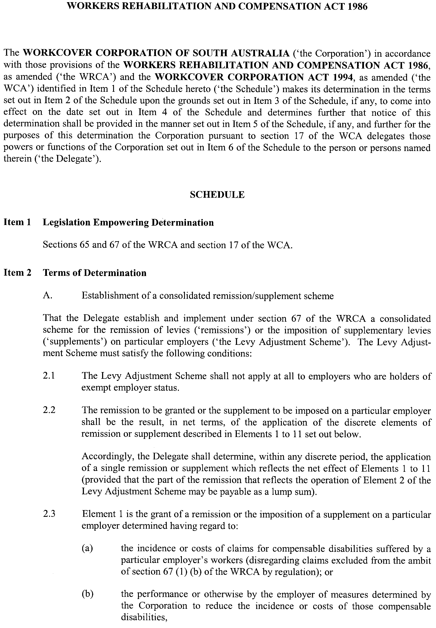
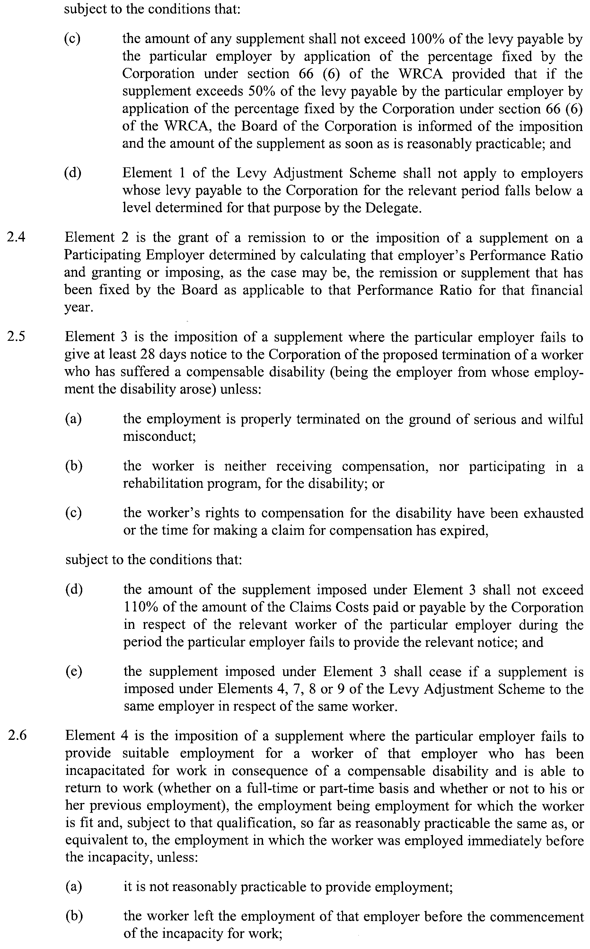
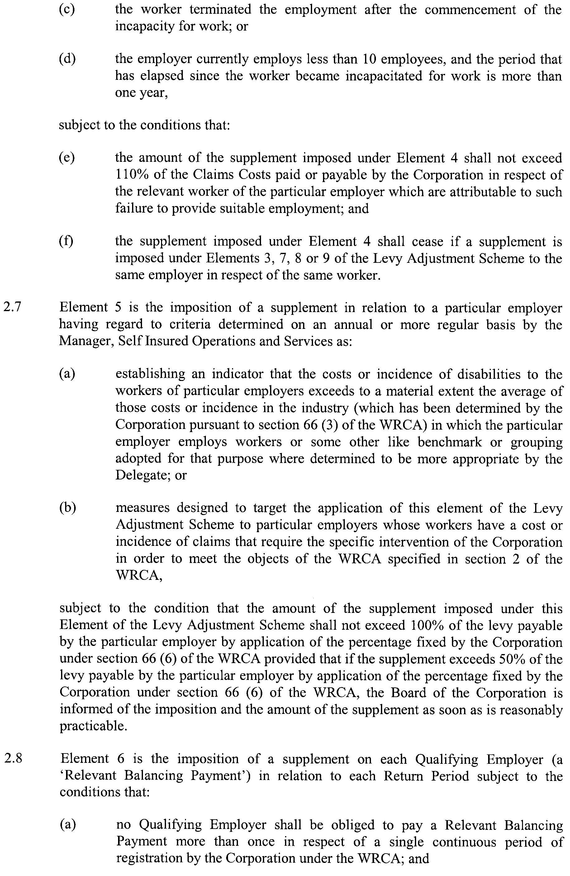
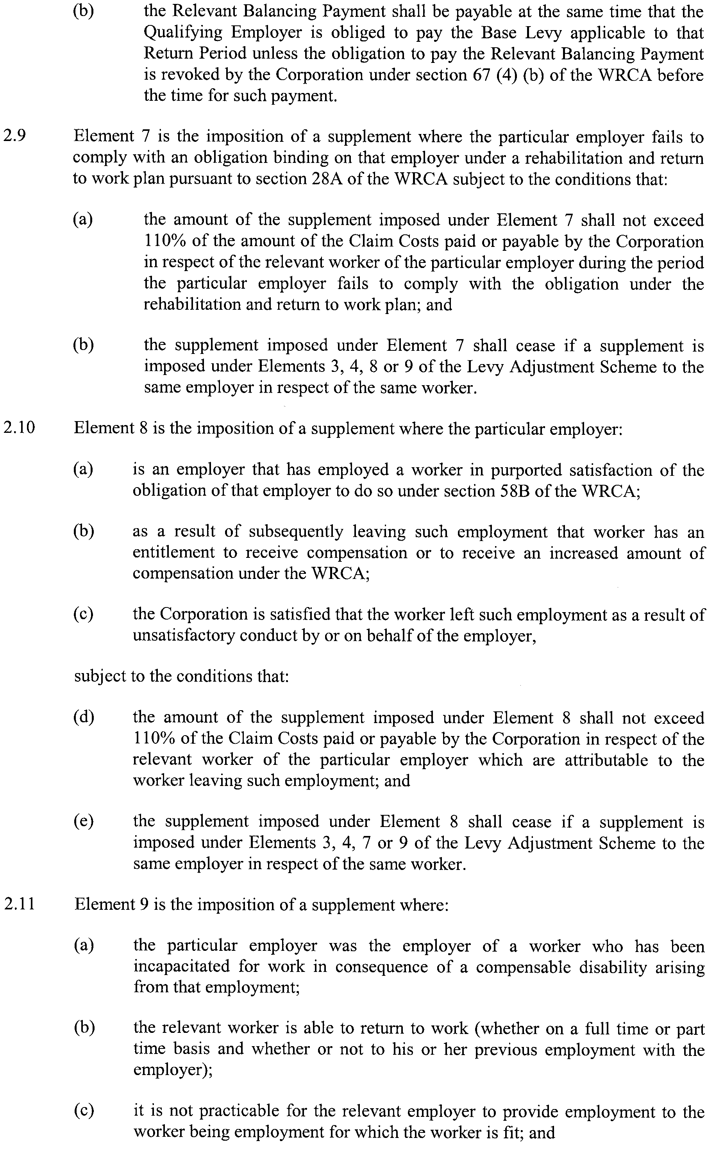
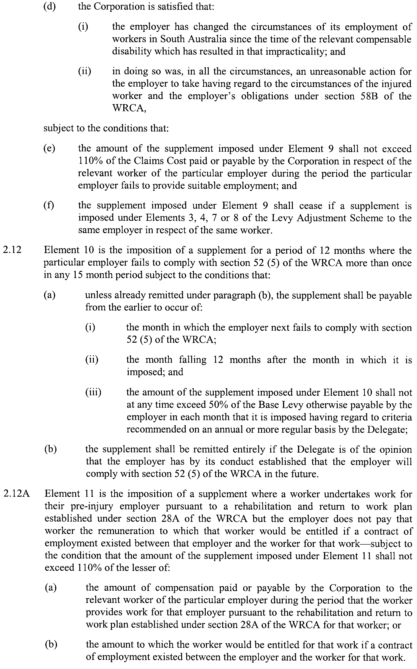
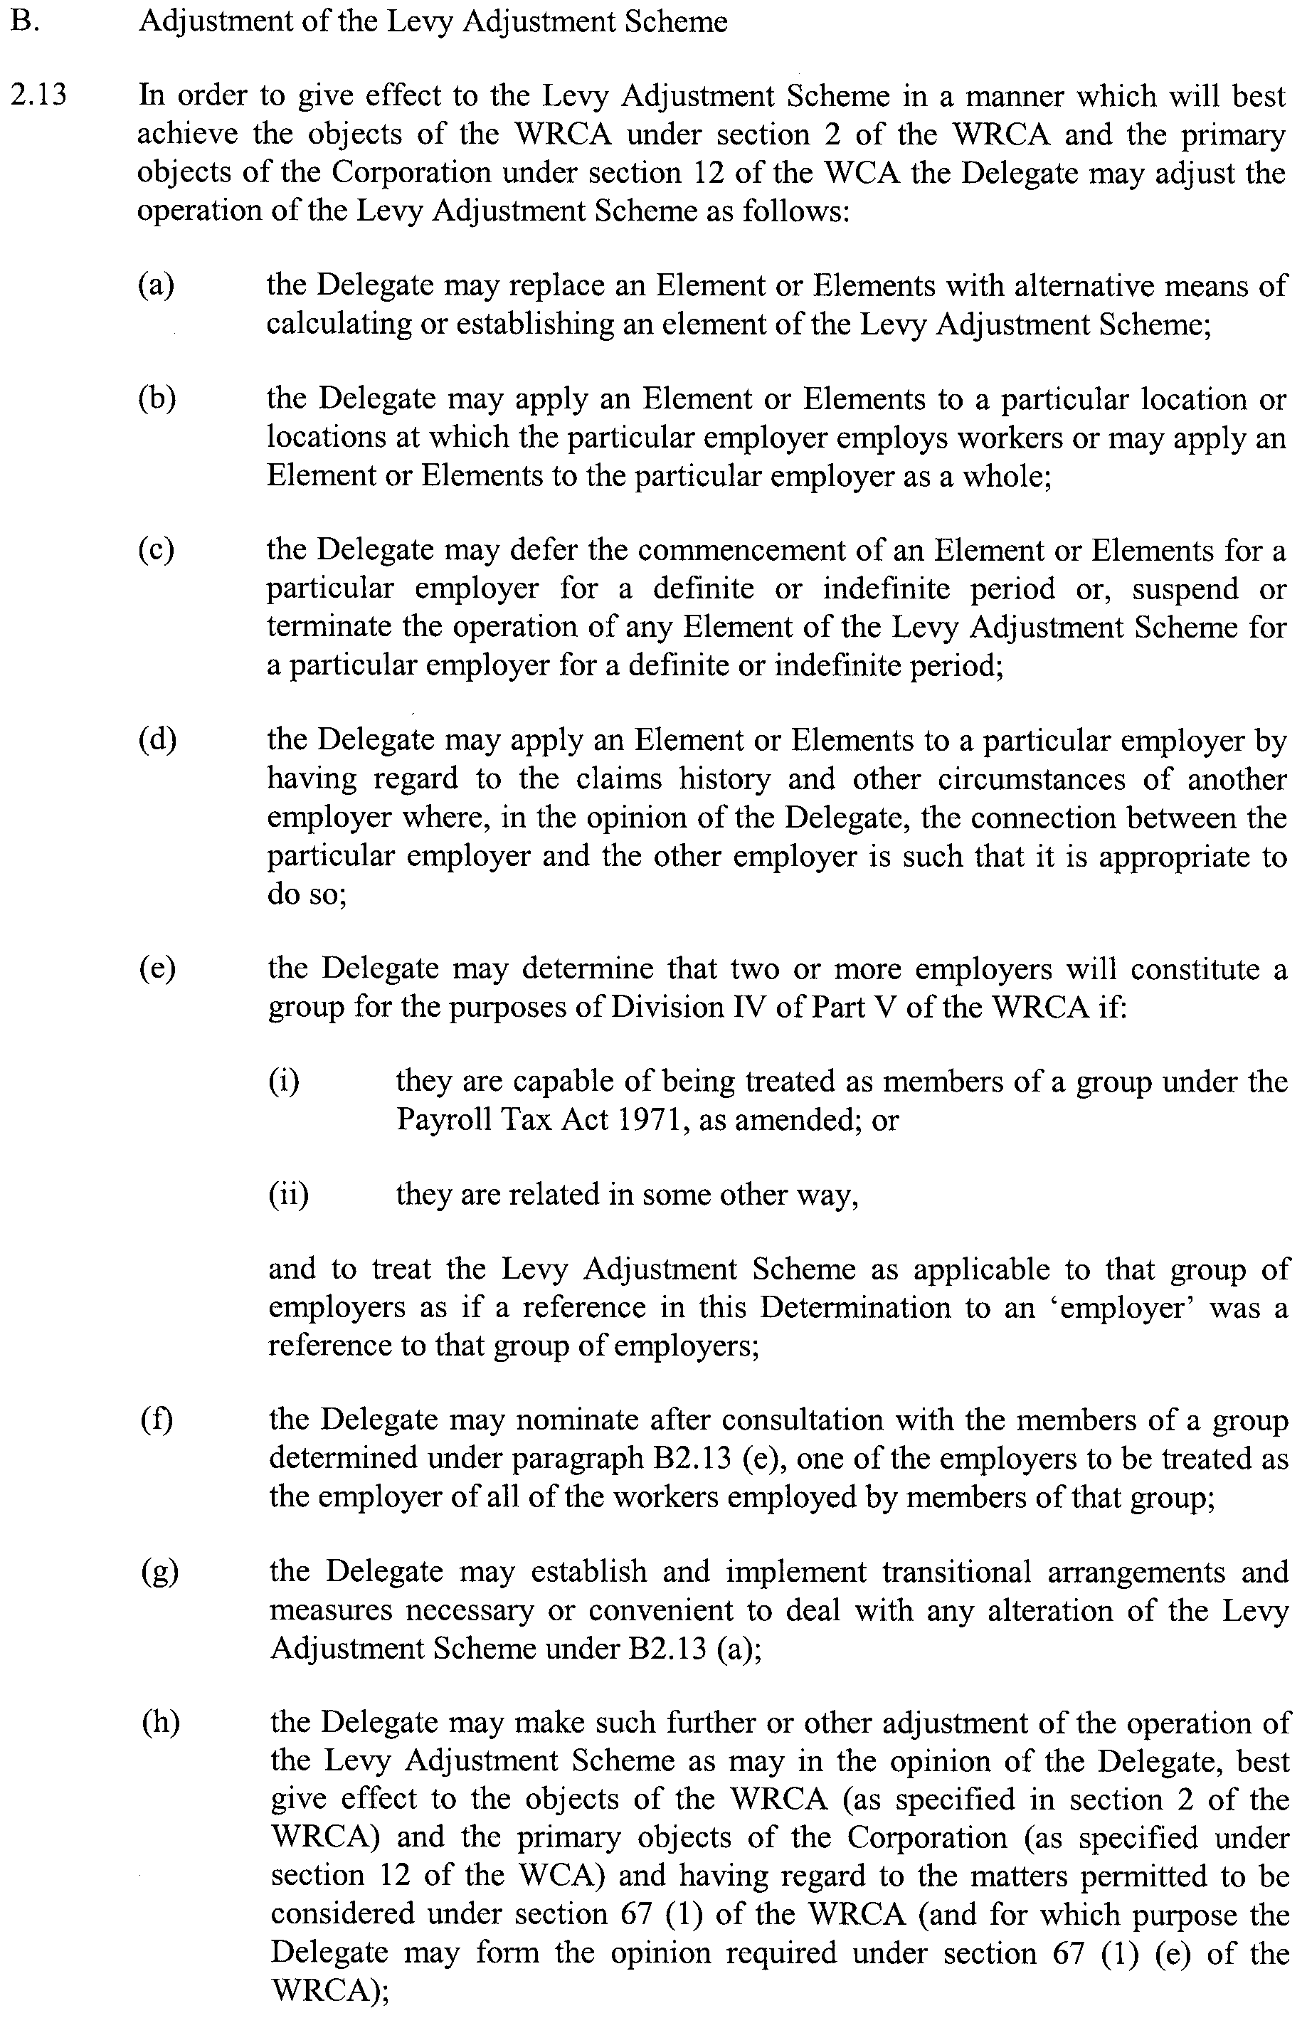
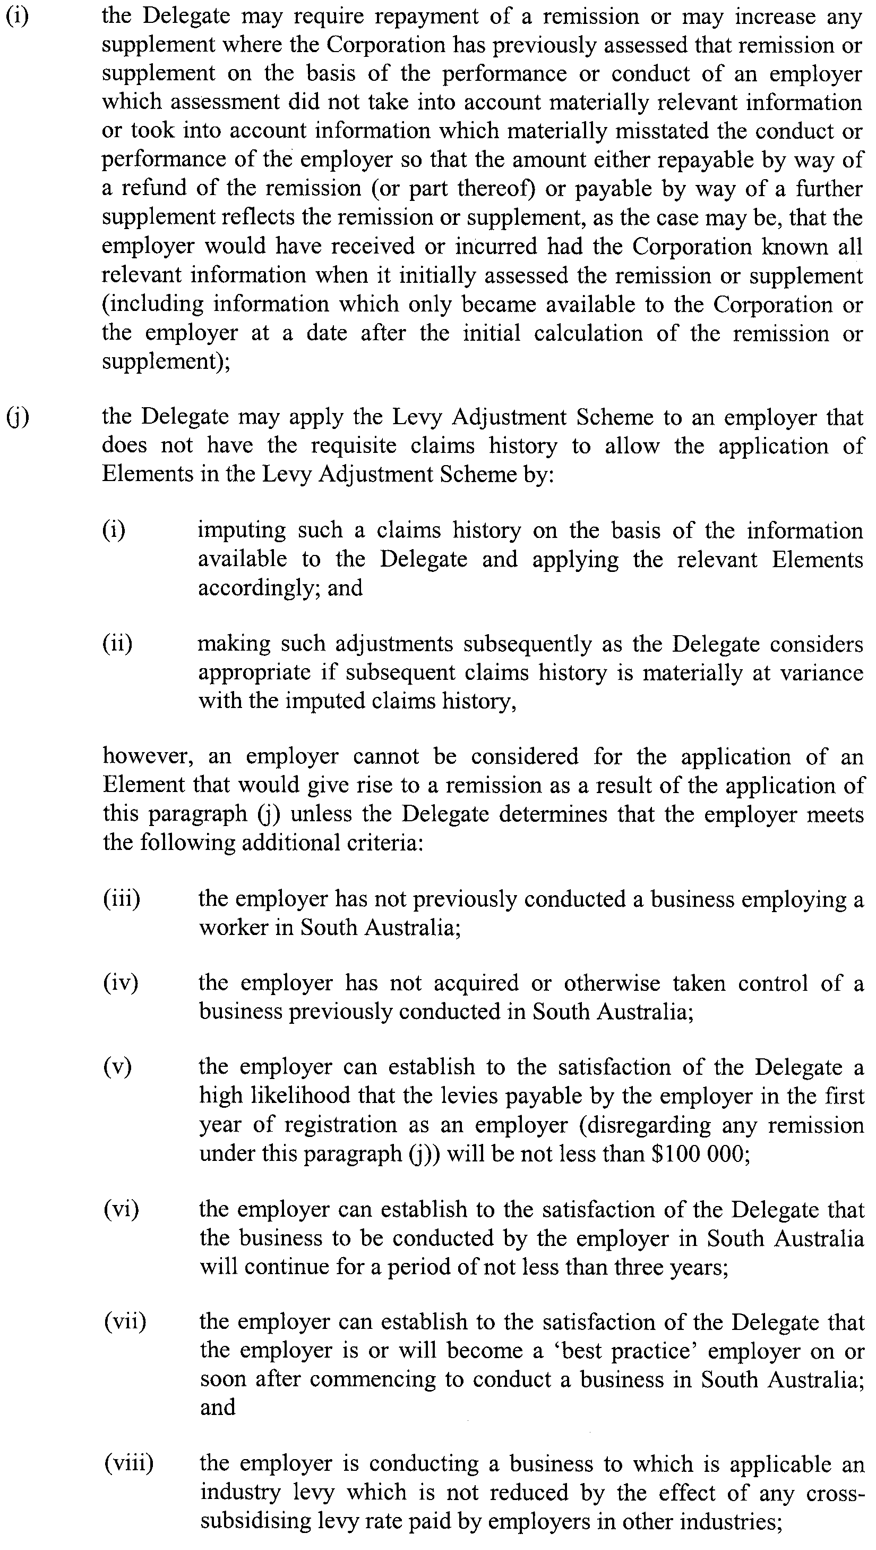
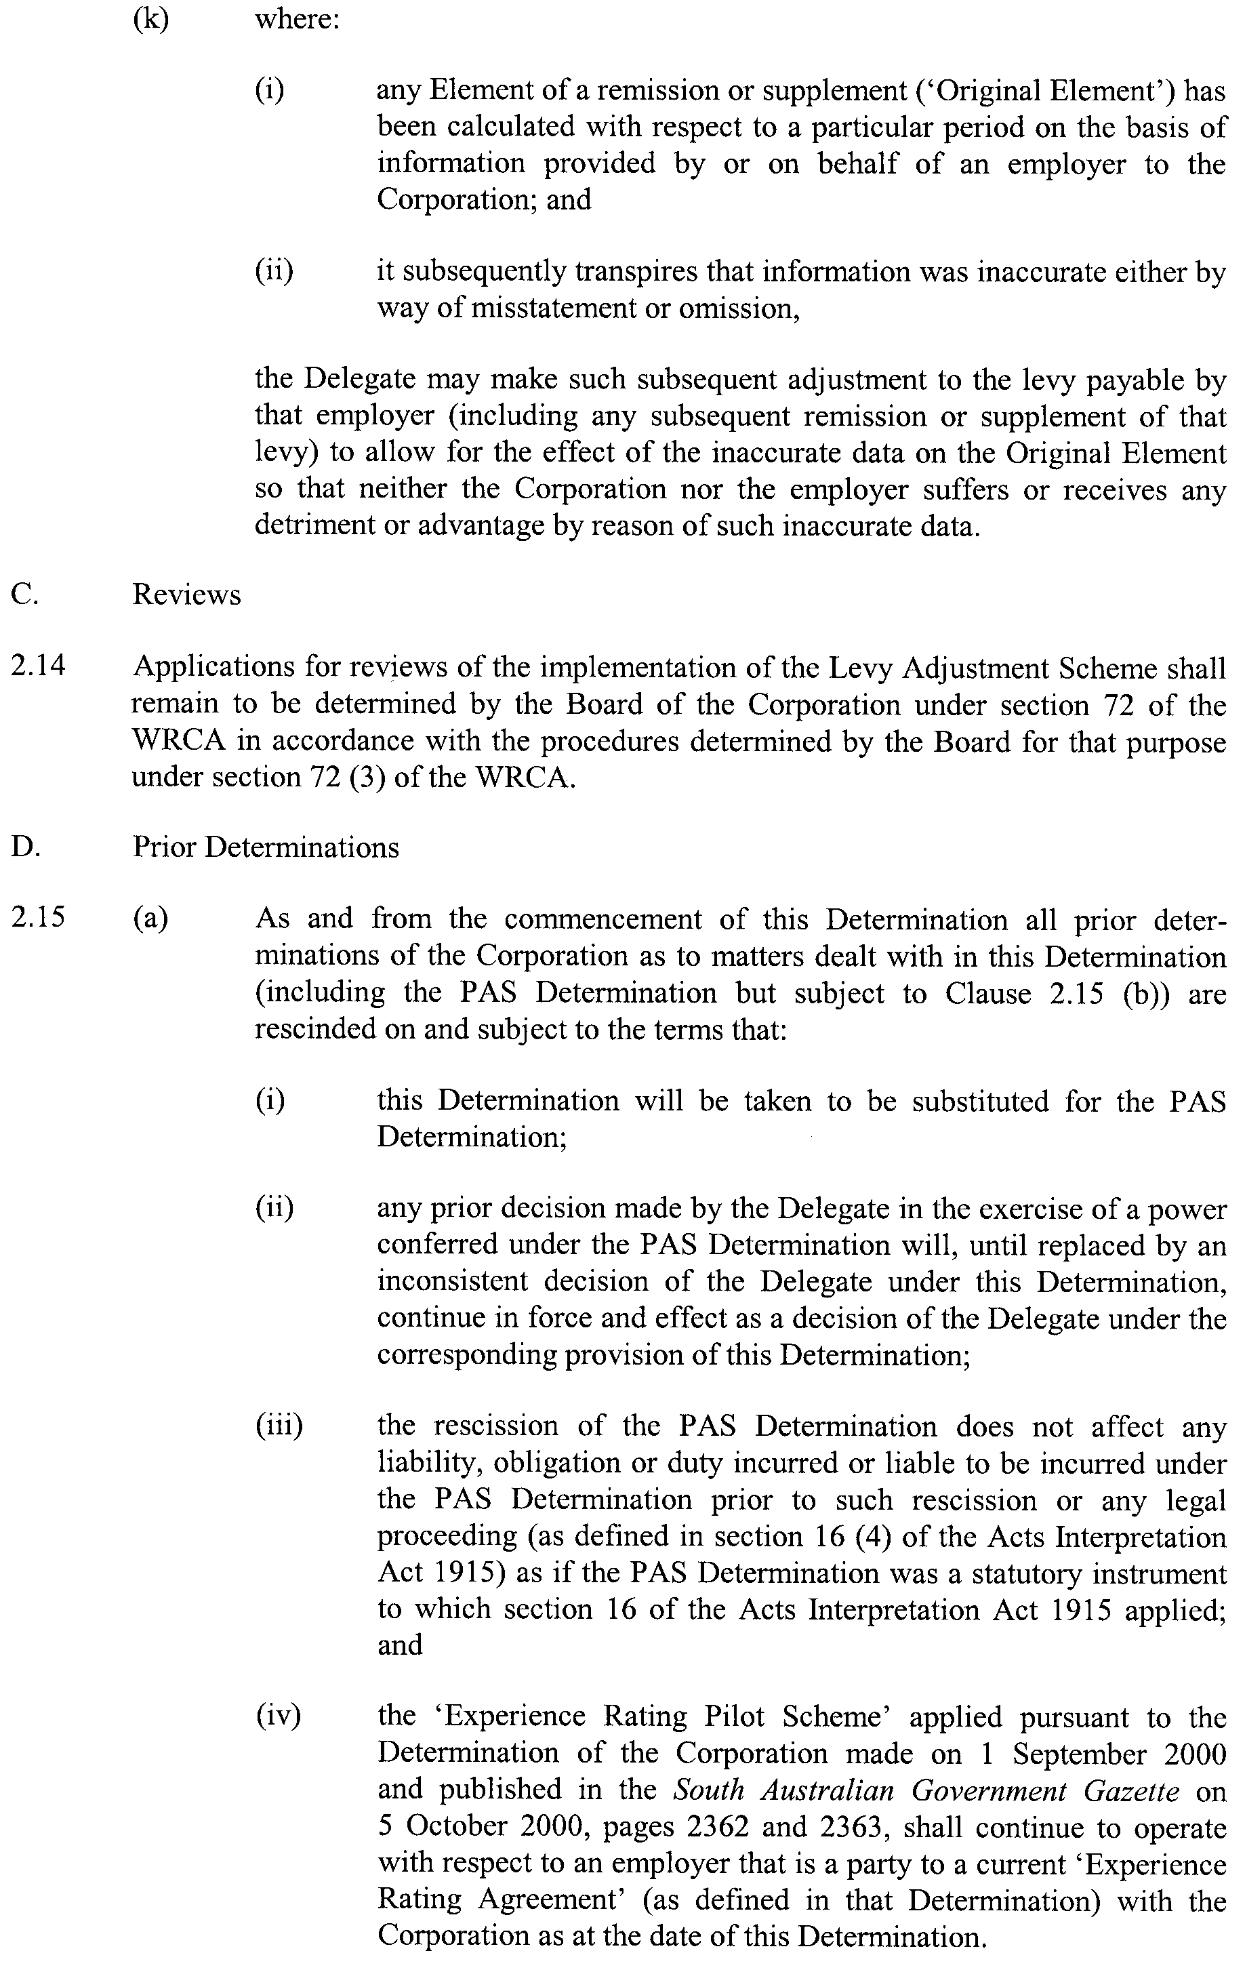
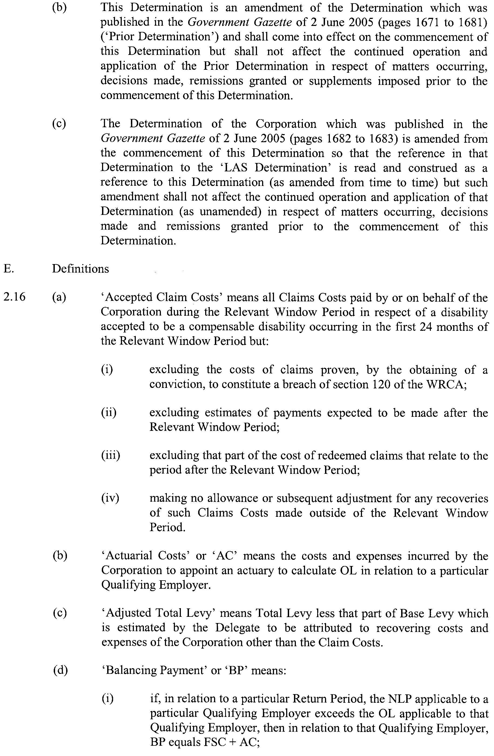
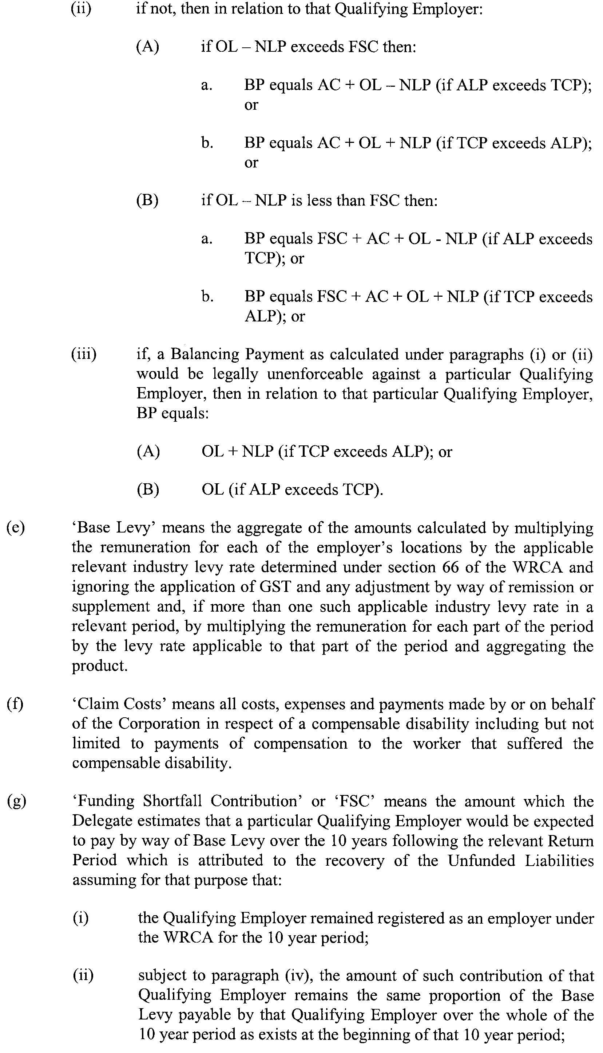
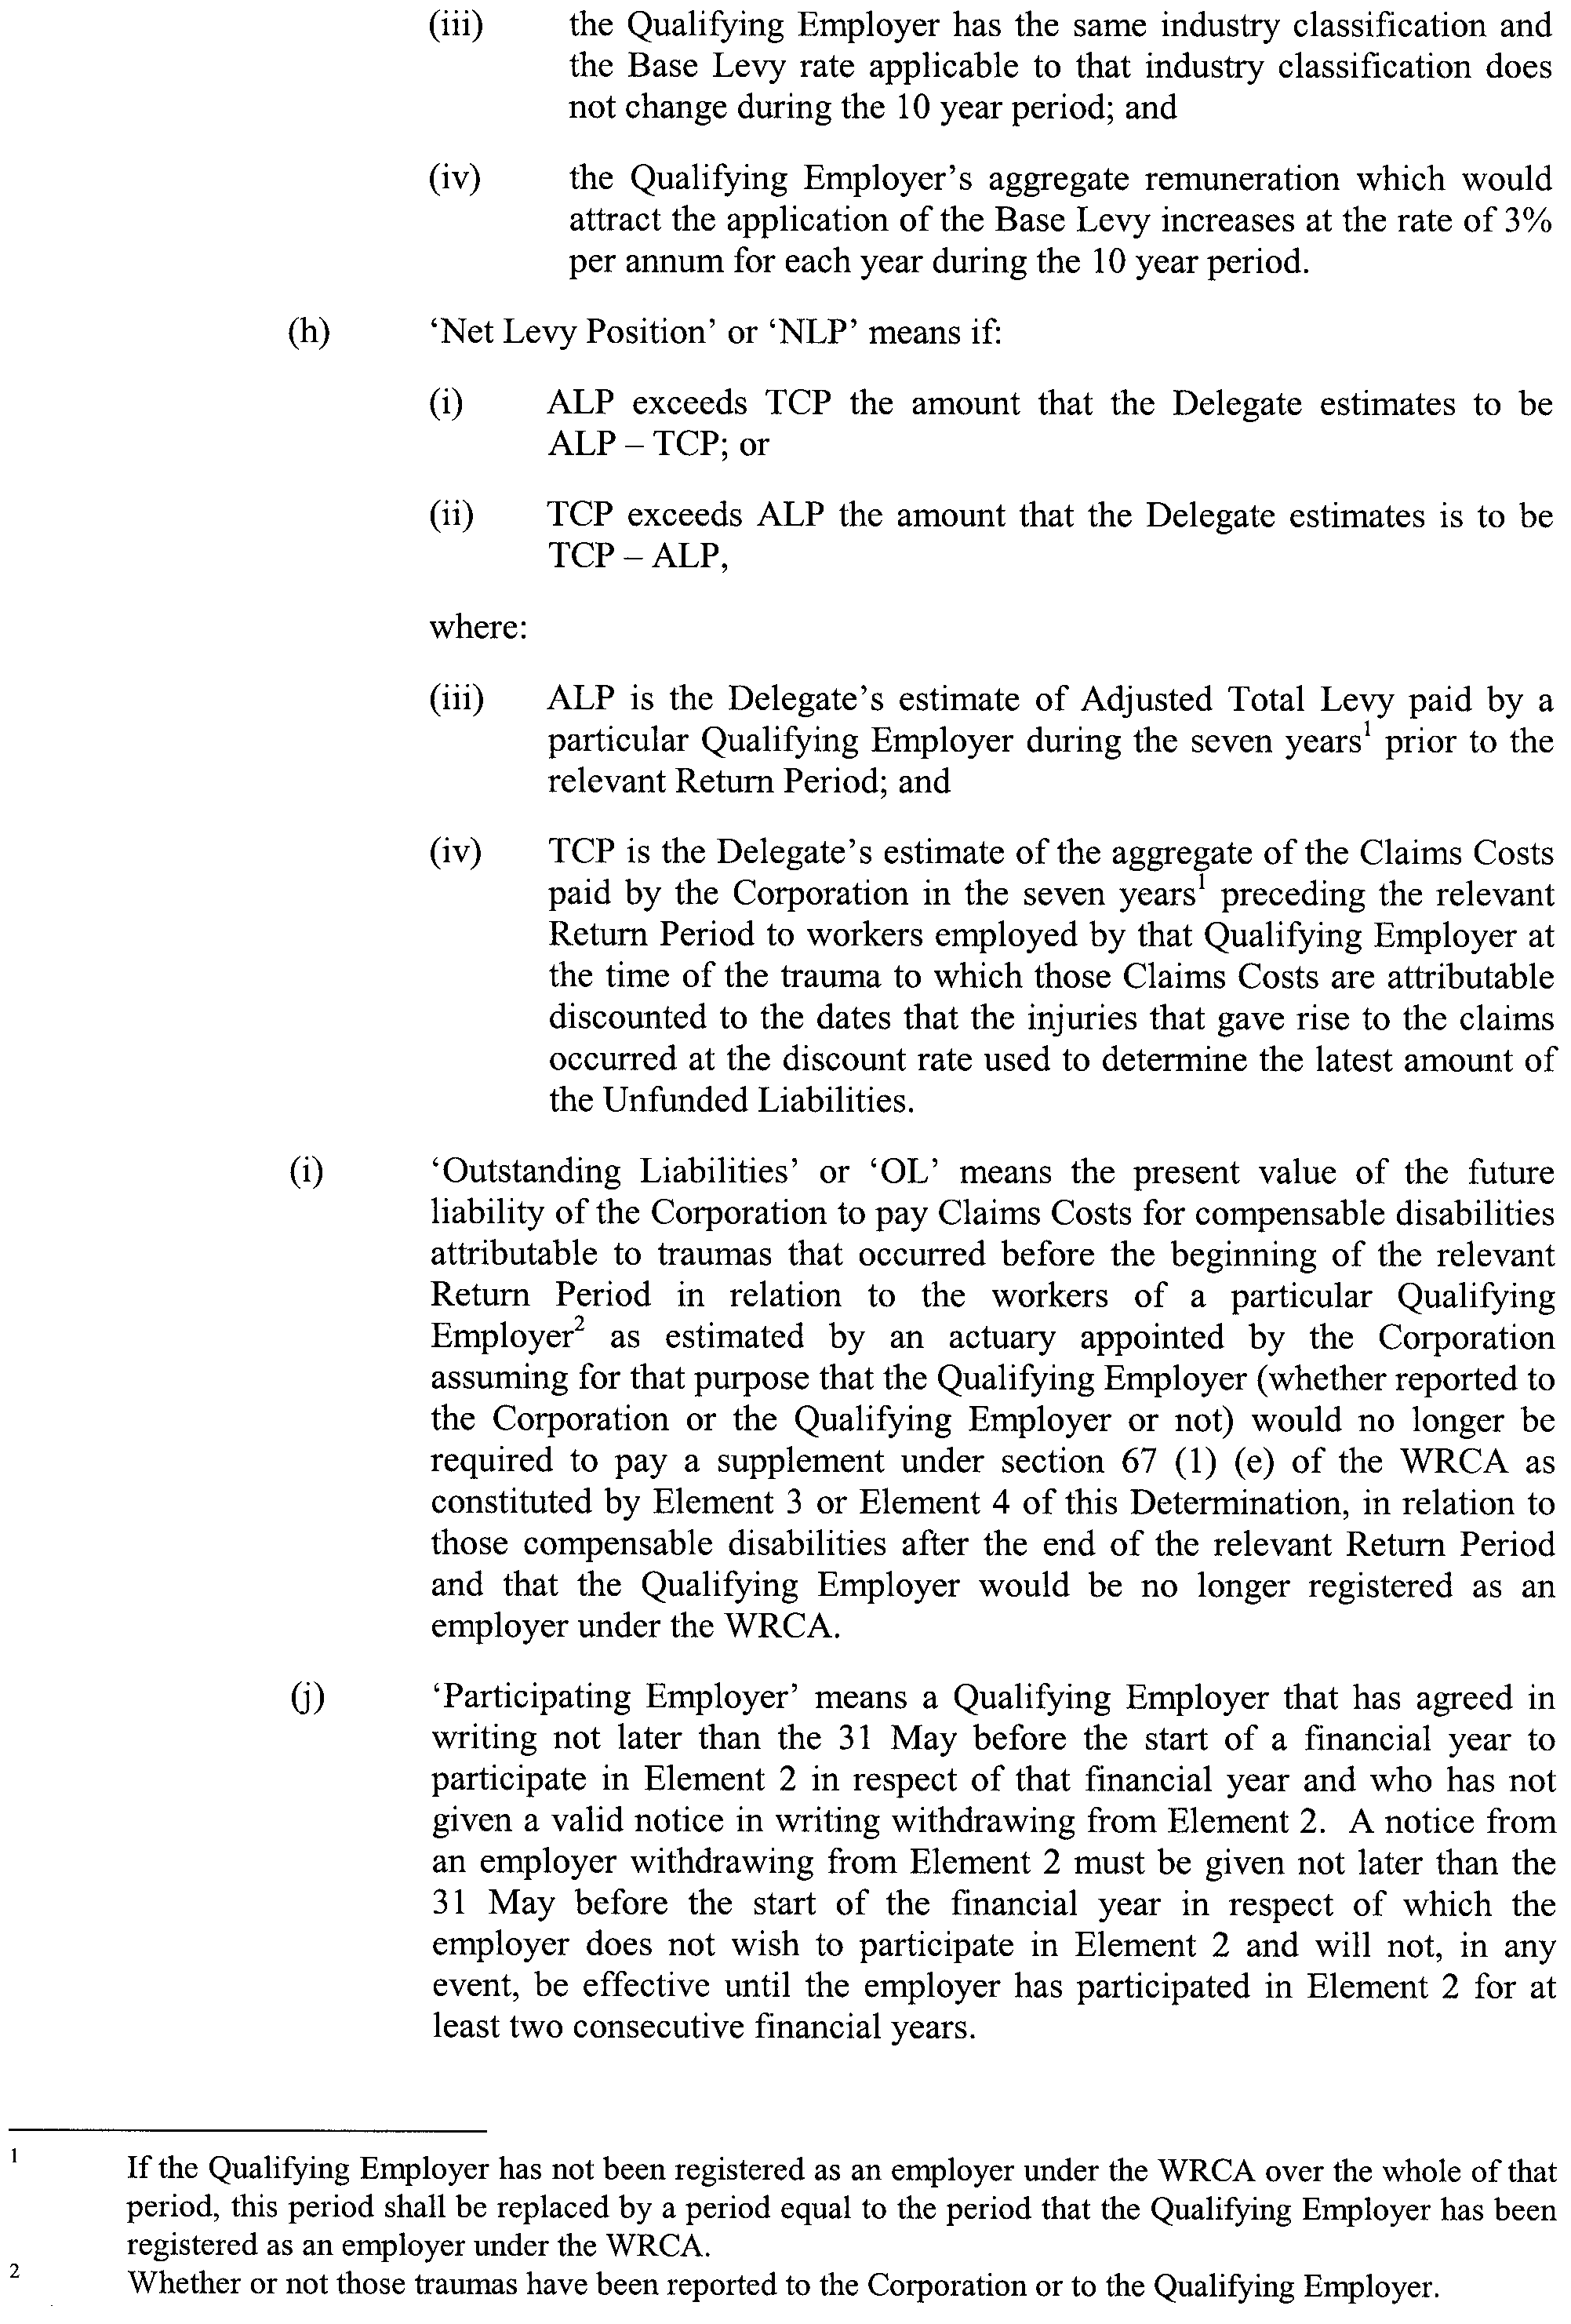
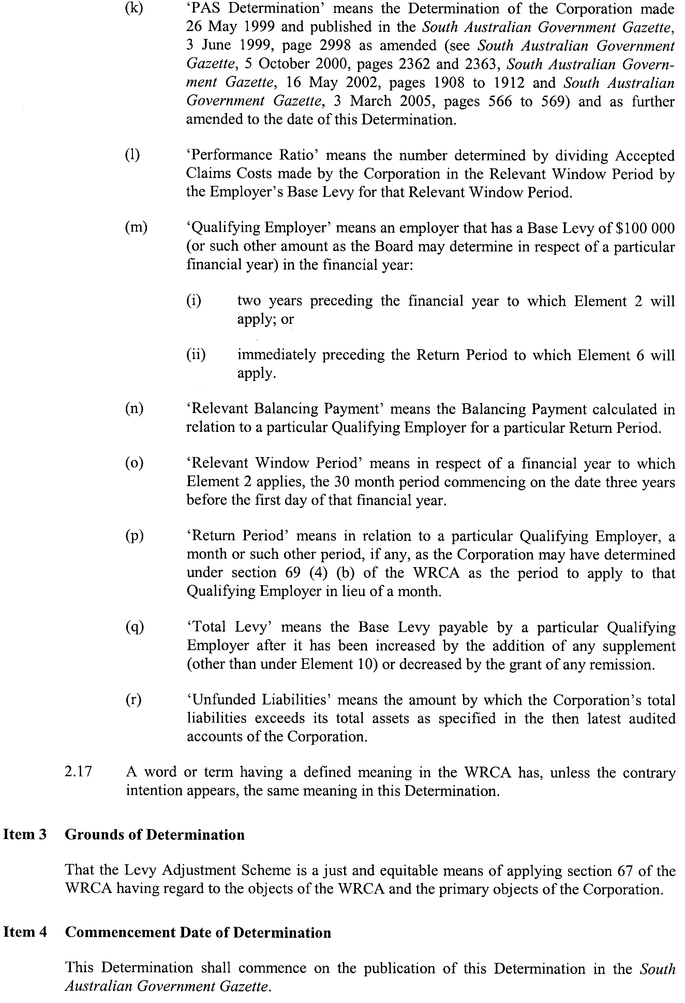
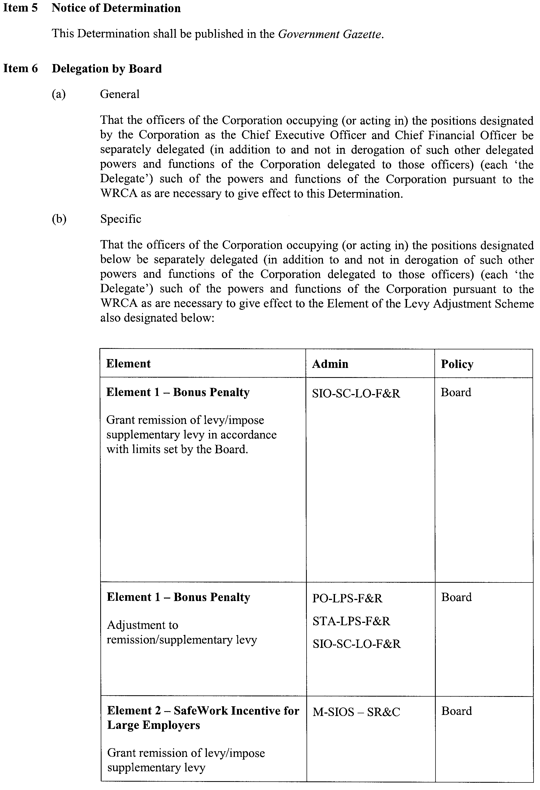
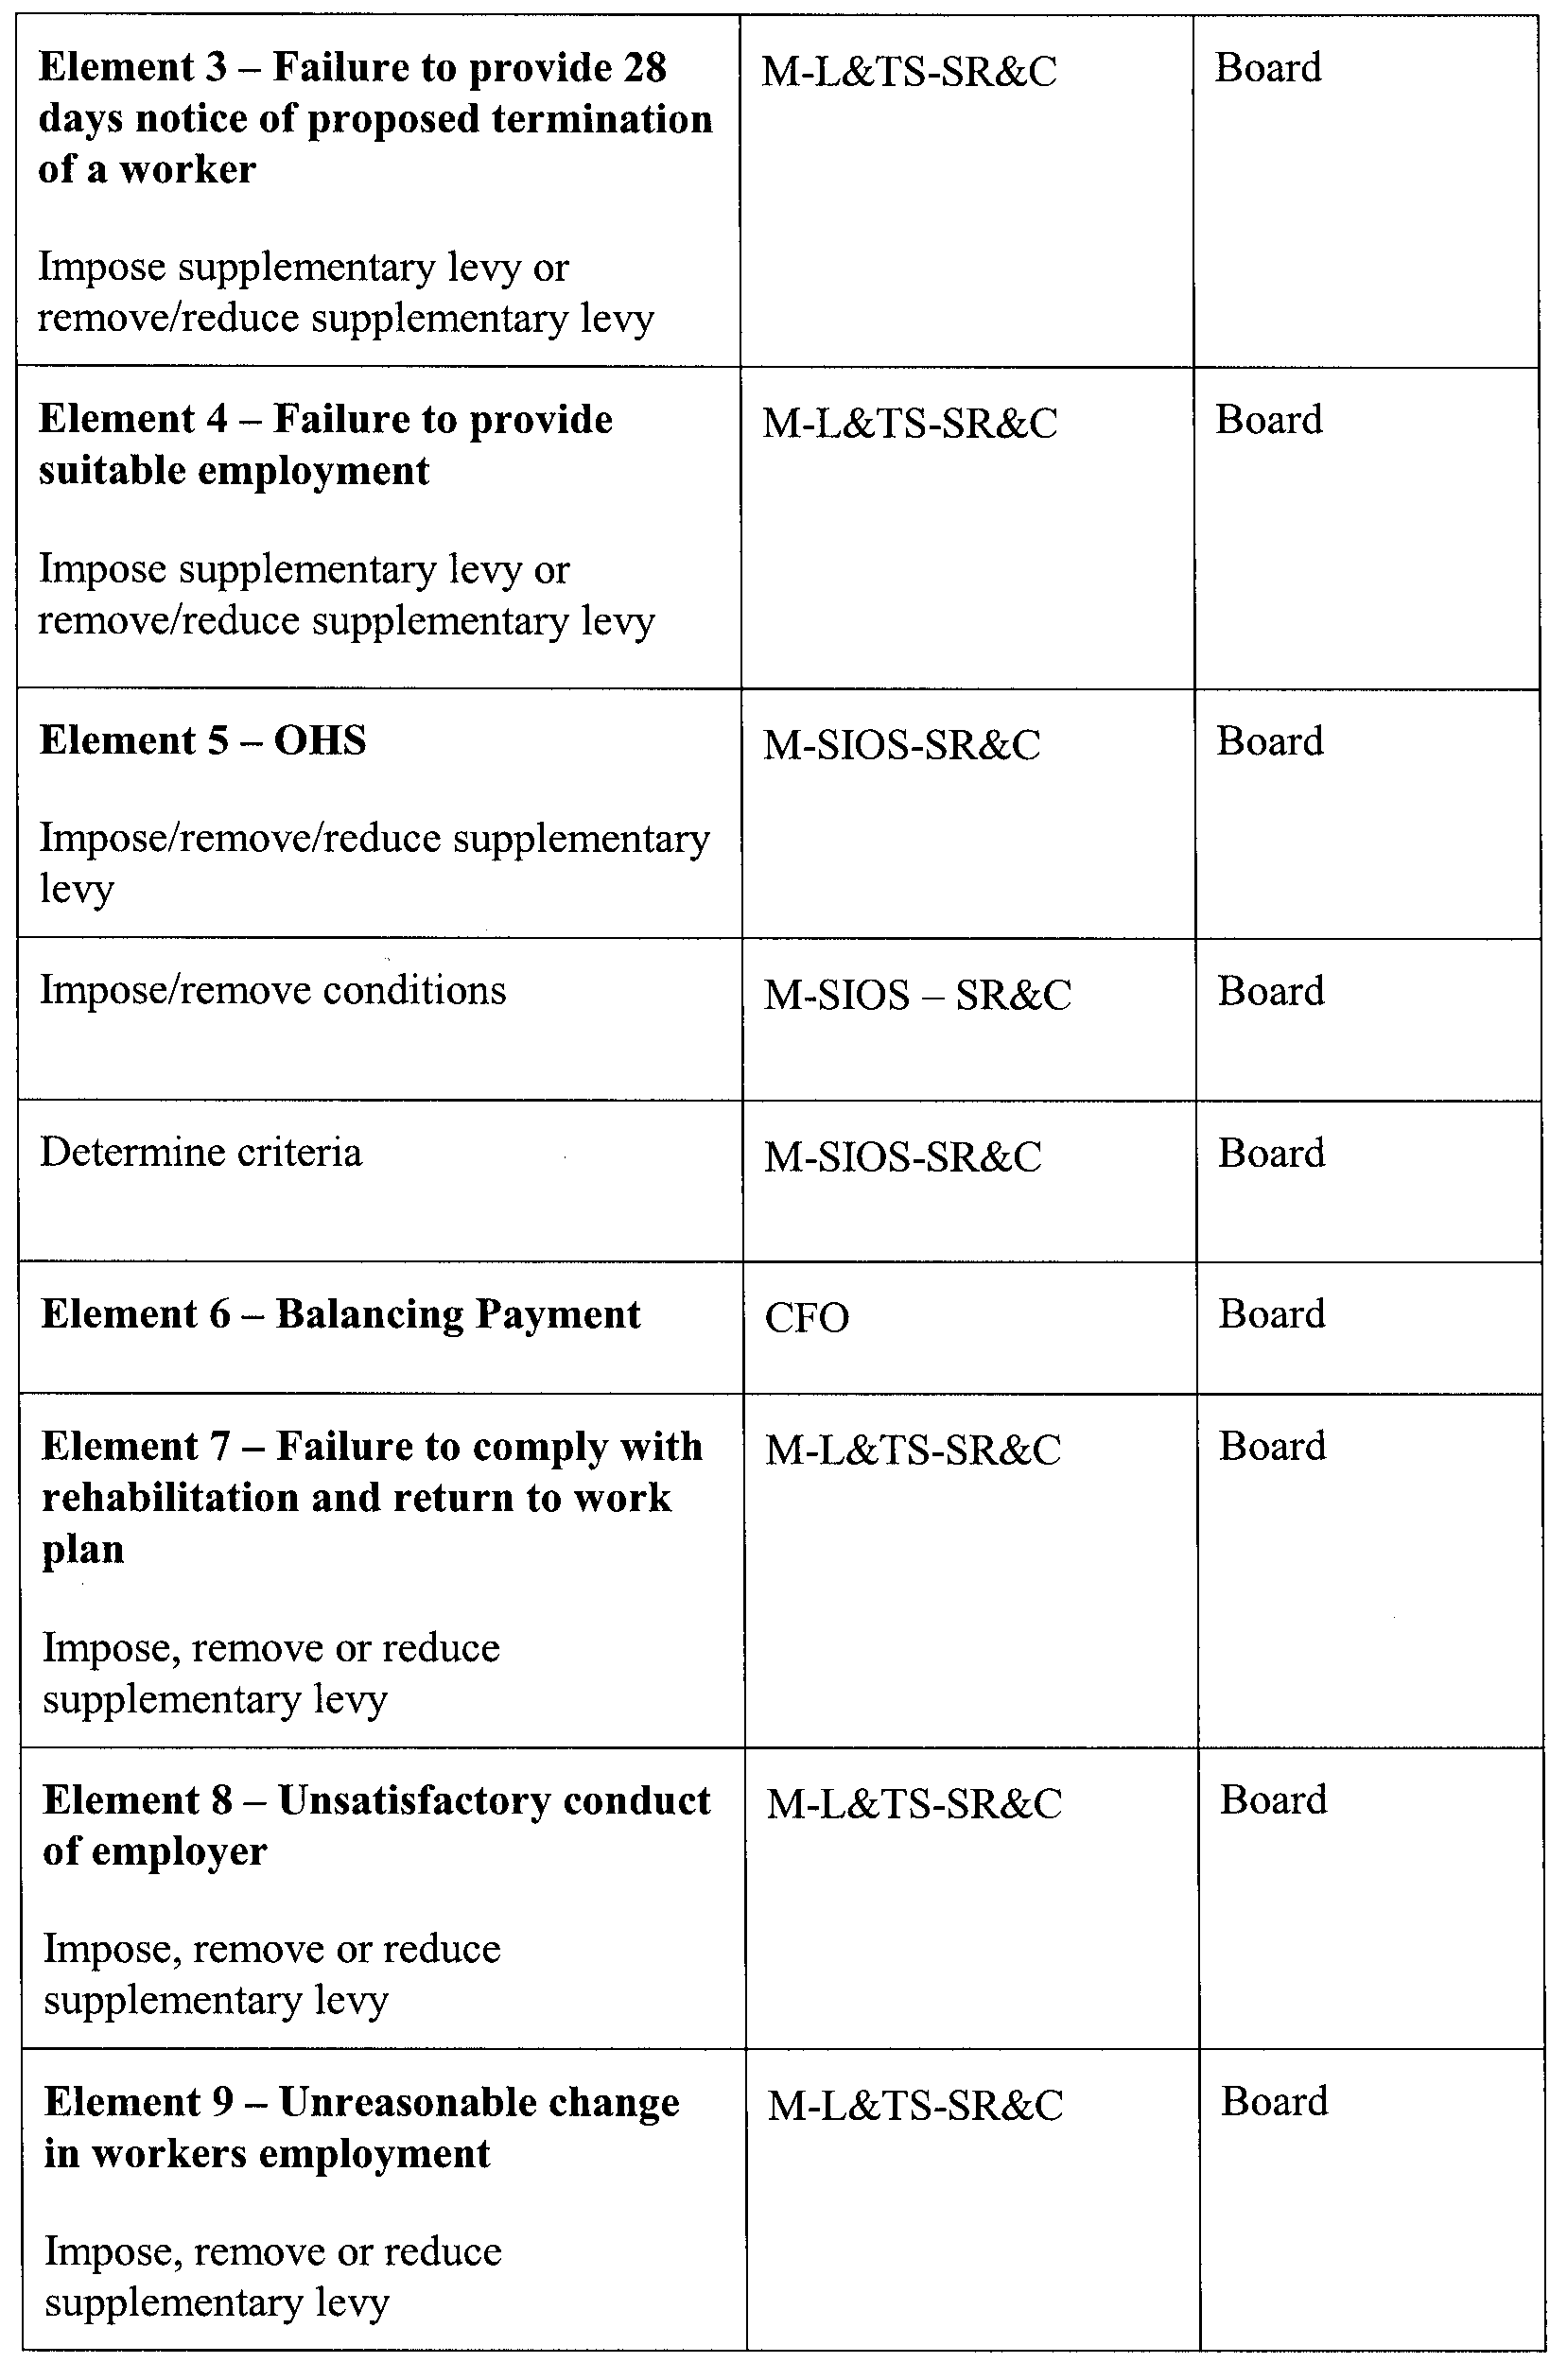
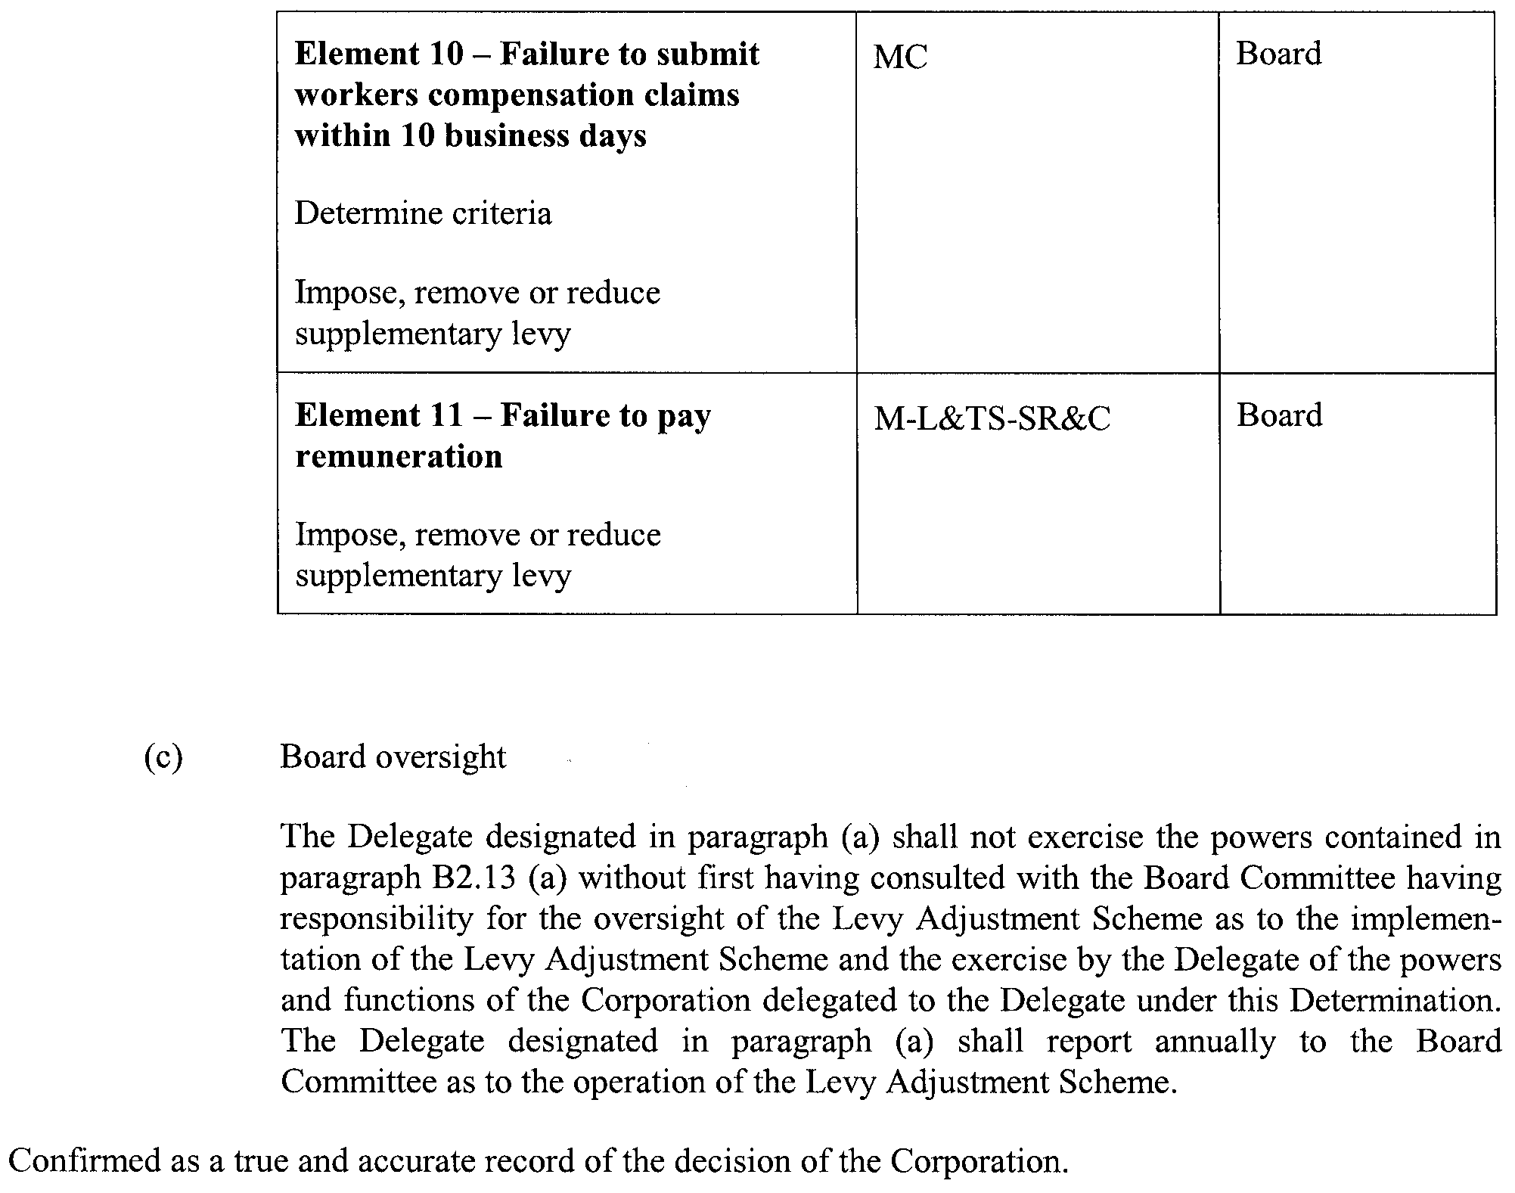
Dated 5 July 2007.
Bruce Carter, Chairperson

South Australia
Natural Resources Management (Water Resources and Other Matters) Amendment Act (Commencement) Proclamation 2007
1—Short title
This proclamation may be cited as the Natural Resources Management (Water Resources and Other Matters) Amendment Act (Commencement) Proclamation 2007.
2—Commencement of Act and suspension of certain provisions
(1) The Natural Resources Management (Water Resources and Other Matters) Amendment Act 2007 (No 24 of 2007) will come into operation on 26 July 2007.
(2) The operation of the following provisions is suspended until a day or time or days or times to be fixed by subsequent proclamation or proclamations:
(a) sections 12, 18, 21(2) and (3), 23, 24(1), (3), (4), (5) and (6), 25, 26, 27, 28(2), 29, 30, 31, 32, 33, 34, 35(1), (2), (3), (8), (9), (10), (11) and (12), 36, 37, 39, 40, 41, 45, 46, 47 and 48;
(b) Schedule 1.
Made by the Governor
with the advice and consent of the Executive Council
on 26 July 2007
WBCS06/0020

South Australia
Local Government (Implementation) (Repeal of Certain Provisions) Proclamation 2007
under section 46 of the Local Government (Implementation) Act 1999
1—Short title
This proclamation may be cited as the Local Government (Implementation) (Repeal of Certain Provisions) Proclamation 2007.
2—Commencement
This proclamation comes into operation on the day on which it is made.
3—Repeal of certain provisions of 1934 Act
The following provisions of the Local Government Act 1934 are repealed:
(a) section 720;
(b) section 735;
(c) section 743;
(d) sections 747 and 748;
(e) sections 792, 793 and 794;
(f) sections 873 and 873A.
Made by the Governor
with the advice and consent of the Executive Council
on 26 July 2007
MSLGR07/006CS

FAXING COPY?
IF you fax copy to Government Publishing SA for inclusion in the Government Gazette, there is no need to send a Confirmation Copy to us as well.
This creates confusion and may well result in your notice being printed twice.
Please use the following fax number:
Fax transmission: (08) 8207 1040
Phone Inquiries: (08) 8207 1045
Please include a contact person, phone number and order number so that we can phone back with any queries we may have regarding the fax copy.
NOTE: Closing time for lodging new copy (fax, hard copy or email) is 4 p.m. on Tuesday preceding the day of publication.

Government Gazette notices can be E-mailed.
The address is:
governmentgazette@dpc.sa.gov.au
Documents should be sent as attachments in Word format.
When sending a document via E-mail, please confirm your transmission with a faxed copy of your document, including the date the notice is to be published.
Fax transmission: (08) 8207 1040
Enquiries: (08) 8207 1045
NOTE: Closing time for lodging new copy (fax, hard copy or email) is 4 p.m. on Tuesday preceding the day of publication.

ADELAIDE CITY COUNCIL
Call for Nominations
NOMINATIONS will be received between Tuesday, 14 August until 12 noon on 28 August 2007 from any person eligible and wishing to be a candidate for election to any of the positions below.
Candidates must submit a profile of not more than 150 words with their nomination form and may also provide a photograph, predominantly head and shoulders, taken within the previous 12 months.
Vacancies:
1 Vacancy—Lord Mayor
5 Vacancies—Area Councillor
2 Vacancies—Councillor for North Ward
2 Vacancies—Councillor for Central Ward
2 Vacancies—Councillor for South Ward
Nomination kits are available from:
Council Office—Customer Service Centre
25 Pirie Street, Adelaide
Phone (08) 8203 7203
Briefing sessions for intending candidates will be held at:
12.30 p.m. on Tuesday, 7 August 2007
David Spence Room, Adelaide Town Hall
6.30 p.m. on Wednesday, 8 August 2007
David Spence Room, Adelaide Town Hall
7 p.m. on Thursday, 16 August 2007
Prince Alfred Room, Adelaide Town Hall
K. Mousley, Returning Officer

CITY OF MOUNT GAMBIER
Renaming of Road
NOTICE is hereby given pursuant to section 219 of the Local Government Act 1999 (‘the Act’) that the City of Mount Gambier at its meeting held on Tuesday, 17 July 2007, resolved to change the name of the street from Sir James Cook Avenue to James Cook Avenue.
G. Muller, Chief Executive Officer

CITY OF ONKAPARINGA
Roads (Opening and Closing) Act 1991
Road Closure—Dyson Road, Lonsdale
NOTICE is hereby given, pursuant to section 10 of the Roads (Opening and Closing) Act 1991, that the City of Onkaparinga proposes to make a Road Process Order to close and transfer to
D. J., M. E. F. and A. A. A. Barrett, portion of the public road adjoining allotment 102 in Deposited Plan 31175, shown more particularly delineated and lettered ‘A’ in Preliminary Plan No. 07/0048.
A copy of the plan and a statement of persons affected are available for public inspection at the offices of the Council at City of Onkaparinga, Ramsay Place, Noarlunga Centre and the Adelaide office of the Surveyor-General during normal office hours.
Any application for easement or objection must set out the full name, address and details of the submission and must be fully supported by reasons.
The application for easement or objection must be made in writing to the Council, City of Onkaparinga, P.O. Box 1, Noarlunga Centre, S.A. 5168, within 28 days of this notice and a copy must be forwarded to the Surveyor-General, G.P.O. Box 1354, Adelaide, S.A. 5001. Where a submission is made, the Council will give notification of a meeting at which the matter will be considered.
Dated 25 July 2007.
J. Tate, Chief Executive Officer

CITY OF PORT ADELAIDE ENFIELD
Assignment of Names For New Roads
NOTICE is hereby given that the Council of the City of Port Adelaide Enfield at its meeting held on 12 June 2007, resolved that pursuant to section 219 (1) of the Local Government Act 1999, that certain new roads all located in the suburb of Glanville be assigned the street names, as detailed below:
• New road marked ‘A’ on the map be assigned the street name Wirra Drive.
• New road marked ‘B’ on the map be assigned the street name Tarni Court.
• New road marked ‘C’ on the map be assigned the street name Pilla Avenue.
• New road marked ‘D’ on the map be assigned the street name Karka Cove.
A map which delineates the new roads that have been assigned the street names, together with a copy of the Council’s resolution are both available for inspection at the Council’s Principal Office, 163 St Vincent Street, Port Adelaide, The Parks Library Council Office, 2-46 Cowan Street, Angle Park, Enfield Library Council Office, 1-9 Kensington Crescent, Enfield and Greenacres Library Council Office, 2 Fosters Road, Greenacres, during their normal business hours.
H. J. Wierda, City Manager

PORT AUGUSTA CITY COUNCIL
Adoption of Valuation and Declaration of Rates
NOTICE is hereby given that at a Special Meeting of the Council held on 11 July 2007, it was resolved that the Council of the Corporation of the City of Port Augusta for the 2007-2008 financial year:
Adoption of Valuation
Council adopts the valuations of the Valuer-General of site values for all rateable property in the area of the Council which amounts in total to an estimated value of $249 111 425 and specifies 11 July 2007, as the day upon which such valuations shall become the valuations of the Council.
Declaration of Rates
1. Council, declares differential general rates according to the locality and the use of the land based upon the site value of the land as follows:
(a) In that area of the City zoned in the Development Plan as Residential, Highway Services, Residential Stables, Neighbourhood Centre, Urban Coastal, District Centre, Local Centre, Industry, Airport, Recreation:
(i) 4.18 cents in the dollar on rateable land with land use Categories 1, 8 and 9;
(ii) 5.9 cents in the dollar on all rateable land with land use Categories 2, 3, 4, 5 and 6; and
(iii) 0.41 cents in the dollar for all rateable land with a land use Category 7.
(b) In that area of the City zoned in the Development Plan as Public Purposes, Defence, Conservation, Rural Living, Coastal Conservation, Primary Industry:
(i) 2.66 cents in the dollar on rateable land with land use Categories 1 and 9.
(ii) 5.9 cents in the dollar on all rateable land with land use Categories 2, 3, 4, 5 and 6.
(iii) 0.41 cents in the dollar for all rateable land within a land use Category 7.
(iv) 1.33 cents in the dollar on all rateable land with a land use Category 8.
(c) In the area of the City zoned in the Development Plan as Coastal Holiday Settlement:
(i) 0.5643 cents in the dollar on all rateable land with land use Categories 1, 2, 3, 4, 5 and 6.
(ii) 0.41 cents in the dollar on all rateable land with a land use Category 7.
(iii) 1.33 cents in the dollar on all rateable land with a land use Category 8.
(iv) 2.66 cents in the dollar on all rateable land with a land use Category 9.
(d) In all other areas not specifically referred to in sub-paragraphs (a), (b) and (c) above, 4.18 cents in the dollar on all other rateable land irrespective of its land use Category.
2. Council, fixes a minimum amount payable by way of general rates of $778 in respect of all rateable land except rateable land with land use Categories 7 or 8 located in the Development Plan Zones of Public Purposes, Defence, Con-servation, Coastal Conservation, Coastal Holiday Settlement, Primary Industry or Rural Living.
3. Council, declares an annual service charge of $245 per unit for all vacant and occupied properties connected to the Effluent Drainage Disposal Services within the City of Port Augusta for the 2007-2008 financial year in the Willsden, Augusta Park, Hospital Road, Zanuckville, Conwaytown, Transcontinental Estate and Stirling North Effluent Disposal Schemes.
J. G. Stephens, City Manager

CITY OF PORT LINCOLN
Appointment of Acting Chief Executive Officer
NOTICE is hereby given that pursuant to section 102 (b) of the Local Government Act 1999, Council concurs with the appointment of Geoffrey R. Dodd, Director of Operations to act in the position of Chief Executive Officer from 6 August 2007 to 14 September 2007.
G. Dodd, Chief Executive Officer

CITY OF PORT LINCOLN
Renaming of Road
NOTICE is hereby given that pursuant to section 219 of the Local Government Act 1999, the Council has resolved to make the following road name changes:
Change a Name—City of Port Lincoln
To change the name of the section of roadway known as Stamford Terrace between St Andrews Terrace and Marina Drive to be renamed Wingard Terrace.
G. P. Dodd, Chief Executive Officer

THE BAROSSA COUNCIL
Adoption of Valuation and Declaration of Rates and Charges
Adoption of Valuation
1. Notice is hereby given that at its meeting held on 17 July 2007 and in relation to the 2007-2008 Financial Year, Council in accordance with section 167 (2) (a) of the Local Government Act 1999, adopts for rating purposes the Valuer-General’s valuations of Capital Value in relation to the area of the Council, which specifies that the total of the values that are to apply within the area is $3 656 417 340 of which $3 563 917 692 is rateable.
Declaration of Differential General Rates
2. That Council, pursuant to sections 153 (1) (b) and 156 (1) (a) of the Local Government Act 1999, declares the following differential general rates on rateable land within its area, for the year ending 30 June 2008, based upon the capital value of the land which rates vary by reference to land use categories as per Regulation 10 of the Local Government Act (General) Regulations 1999:
(1) on rateable land of Category 1 use (Residential), a rate of 0.218 cents in the dollar of the capital value of such land;
(2) on rateable land of Category 2 use (Commercial—Shop), Category 3 use (Commercial—Office) and Category 4 use (Commercial—Other), a rate of 0.365 cents in the dollar of the capital value of such land;
(3) on rateable land of Category 5 use (Industry—Light), a rate of 0.388 cents in the dollar of the capital value of such land;
(4) on rateable land of Category 6 use (Industry—Other), a rate of 1.085 cents in the dollar of the capital value of such land;
(5) on rateable land of Category 7 use (Primary Production), a rate of 0.27 cents in the dollar of the capital value of such land;
(6) on rateable land of Category 8 use (Vacant Land), a rate of 0.42 cents in the dollar of the capital value of such land; and
(7) on rateable land of Category 9 use (Other), a rate of 0.38 cents in the dollar of the capital value of such land.
Fixed Charge
3. That Council, pursuant to section 152 (1) (c) (ii) of the Local Government Act 1999, declare a fixed charge of $220 on each separately valued piece of rateable land within the Council area for the year ending 30 June 2008.
Waste Collection Service Rate
4. That Council, pursuant to section 155 of the Local Government Act 1999 and in order to provide the service of waste collection in those parts of the Council’s area described in (3) below, declare the following service charges for the year ending 30 June 2008:
(1) Non-recyclable Waste Collection:
(a) An annual service charge of $88.40 (63.15 cents per litre capacity of 140 L collection receptacles).
(b) An annual service charge of $120.83 (50.35 cents per litre capacity of 240 L collection receptacles):
except in instances where, subject to written application to and approved by the Council, residential households with six or more permanent residents may receive a 240 L receptacle at the same service rate cost of a 140 L receptacle.
(2) Recyclable Waste Collection:
An annual service charge of $43.41 (18.05 cents per litre capacity of 240 L collection receptacles).
(3) Parts of the Area:
(a) the townships of Angaston, Lyndoch, Moculta, Mount Pleasant, Nuriootpa, Stockwell, Tanunda and Williamstown;
(b) the policy areas of Eden Valley and Springton;
(c) land in the Council’s area between Altona Road and Barossa Valley Way known as ‘Altona’; and
(d) any other part of the Council area not otherwise described in this section to which the Council makes available (as at this date) a waste collection service.
Community Wastewater Management Systems (CWMS) Rate and Service Charge
5. That Council, pursuant to section 155 of the Local Government Act 1999, declare a service rate and service charge in the following areas to which Council makes available a Community Wastewater Management System (CWMS):
(1) Stockwell CWMS (commissioned from the 2001-2002 rating year):
(a) a service rate of 0.118 cents in the dollar of the capital value of land and an annual service charge of $160 on assessments of occupied rateable land;
(b) an annual service charge of $160 on assessments of occupied non-rateable land; and
(c) an annual service charge of $240 on each assessment of vacant rateable and non-rateable land.
(2) Lyndoch, Mount Pleasant, Nuriootpa, Penrice, Tanunda, Williamstown and Stockwell (Peppertree Grove) CWMS:
(a) a service rate of 0.118 cents in the dollar of the Capital Value of land on assessments of occupied rateable and non-rateable land; and
(b) an annual service charge of $100 on each assessment of vacant rateable and non-rateable land.
Natural Resources Management Levies
6. That Council in exercise of the powers contained in section 154 of the Local Government Act 1999:
(1) in order to reimburse the Council for the amount contributed to the Adelaide and Mount Lofty Ranges Natural Resources Management Board, a levy be imposed comprising of 0.0074 cents in the dollar of the capital value of land, on all rateable land in the Council’s area in the area of that Board in accordance with section 95 of the Natural Resources Management Act 2004;
(2) in order to reimburse the Council for the amount contributed to the SA Murray-Darling Basin Natural Resources Management Board, a levy be imposed comprising of 0.006 cents in the dollar of the Capital Value of land, on all rateable land in the Council’s area in the area of that Board in accordance with section 95 of the Natural Resources Management Act 2004; and
(3) in order to reimburse the Council for the amount contributed to the Northern and Yorke Natural Resources Management Board, a levy be imposed comprising of 0.019 cents in the dollar of the Capital Value of land, on all rateable land in the Council’s area in the area of that Board in accordance with section 95 of the Natural Resources Management Act 2004.
Payment of Rates
7. (1) Pursuant to section 181 (1) of the Local Government Act 1999, all rates and charges will be payable in four quarterly instalments due on 14 September 2007, 7 December 2007, 7 March 2008 and 6 June 2008 provided that in cases where the initial account requiring payment of rates is not sent at least 30 days prior to these dates, or an amended account is required to be sent, authority to fix the date by which rates must be paid in respect of those assessments affected is hereby delegated to the Chief Executive Officer.
(2) Pursuant to section 44 of the Local Government Act 1999, the Chief Executive Officer be delegated power under section 181 (5) of the Act to enter into agreements with ratepayers relating to the payment of rates in any case where the Chief Executive Officer thinks it necessary or desirable to do so.
(3) Pursuant to section 181 (11) of the Local Government Act 1999, all rates and charges paid in full on or before 14 September 2007 (first instalment date) will attract a discount of 2% (net of Council rebates if applicable).
Rebate of General Rates
8. That Council pursuant to section 166 (1) (b) of the Local Government Act 1999, grants a rebate of 25% on the general rate to the principal ratepayer of rateable land within the land use Category 6 (Industry—Other), for all land with the following State Valuation Office land use codes: 3110-3113 and 3121 (food manufacturing); 3200-3240 (textiles); 3311 (sawmills); 3410-3420 (paper and paper products, printing and publishing); 3560 (plastic products); 3720 (non-ferrous metal basic industries); 3810-3819 (fabricated metal products except machinery and equipment); 3824 (special industrial machinery and equipment); 3909 (other manufacturing industries); 6540-6550 (motor vehicle trans-portation); 8230 (dimension stone); 8240 (crushed stone); 8250-8259 (sand and gravel); 8260 (clay) and 8290 (non-metals).
Residential Rates Cap
9. That Council, pursuant to section 153 (3) and (4) of the Local Government Act 1999, has determined to fix a maximum increase in general rates levied upon a property which constitutes the principal place of residence of a principal ratepayer at 15% over and above the general rates levied for the 2006-2007 financial year, provided that:
(a) the property has been the principal place of residence of the principal ratepayer since at least 1 July 2006; and
(b) the property has not been subject to improvements with a value of more than $20 000 since 1 July 2006.
D. Morcom, Chief Executive Officer

CLARE & GILBERT VALLEYS COUNCIL
Roads (Opening and Closing) Act 1991
Portion of Buchanan Street, Clare
NOTICE is hereby given that pursuant to section 10 of the Roads (Opening and Closing) Act 1991, the Clare & Gilbert Valleys Council proposes to make a Road Process Order to close portion of public road (Buchanan Street) adjacent to Allotment 4 in Filed Plan 14299, Hundred of Clare, more particularly delineated and marked ‘A’ in Preliminary Plan No. 07/0049.
The portion marked ‘A’ is to be transferred and merged with adjoining Allotment 4 in Filed Plan 14299.
A copy of the preliminary plan and statement of persons affected is available for public inspection at the Council Office, 4 Gleeson Street, Clare or at the Adelaide office of the Surveyor-General, during normal office hours.
Any person affected may object to the proposed road process order, or apply for an easement to be granted in that person’s favour over land subject to the proposed road closure. Such objection, or application for an easement, must set out the full name and address of the person, and reason for making the objection or application. Any application for an easement must give full particulars of the nature and location of the easement and, where made by a person as the owner of adjoining or nearby land, specify the land to which the easement is to be annexed.
An objection, or application for an easement, must be lodged in writing to the Clare & Gilbert Valleys Council, 4 Gleeson Street, Clare, S.A. 5453, and a copy lodged with the Surveyor-General, G.P.O. Box 1354, Adelaide, S.A. 5001, within 28 days of this notice.
Where an objection, or application for an easement is made, the Council will give notification of a meeting at which the matter will be considered, so that the person making the objection or applica-tion may attend, if desired, personally or by a representative.
M. A. Goldstone, Chief Executive Officer

DISTRICT COUNCIL OF CLEVE
Development Act 1993
Cleve General Plan Amendment Report Prepared by the Council—Draft for Public Consultation
NOTICE is hereby given that the District Council of Cleve has, pursuant to section 24 of the Development Act 1993, prepared a draft Plan Amendment Report to amend the District Council of Cleve Development Plan.
The Plan Amendment Report will amend the District Council of Cleve Development Plan by:
• Expanding the Industry Zone at Cleve to include land to the north of Rudall Road to provide for small scale industrial, rural industry servicing and commercial activities.
• Enlarging the present Rural Living Zone on the western boundary of the town to include disused land adjacent to the Cleve Field Days site and additional land to the south of the present zone to meet current demand.
• Creating a Rural Living Zone to the north of the proposed Industry Zone adjacent to the town of Cleve to meet additional demand.
• Creating a Rural Living Zone to the west of the town of Arno Bay to meet current demand.
• Changing the average allotment size as a result of a plan of division from 2 ha to 1 ha in the Rural Living Zone.
• Including policy related to the proposed Rural Living Zone covering the scrubland patch south of the Lincoln Highway adjacent to the Arno Bay township which would prevent the creation of more than two allotments in this area.
• Expanding the Residential Zone to the south of the town of Cleve to meet current demand.
• Reverting land zoned for Rural Living on the eastern boundary of the town of Cleve back to Rural Fringe to provide a long-term option for residential expansion.
• Reverting land zoned for Tourist Accommodation on the eastern boundary of the town back to Rural Fringe to provide a long-term option for residential expansion.
Copies of the draft Plan Amendment Report will be available for public inspection and purchase during normal office hours at the Council Office, 10 Main Street, Cleve.
The draft Plan Amendment Report will be on display from Friday, 27 July 2007 until Friday, 28 September 2007.
Written submissions regarding the draft Plan Amendment Report should be submitted no later that 5 p.m. on Friday, 28 September 2007. All submissions should be addressed to Tony Siviour, Chief Executive Officer, District Council of Cleve, P.O. Box 36, Cleve, S.A. 5640 and should clearly indicate whether you wish to be heard in support of your submission.
Copies of all submissions will be available for inspection by interested persons at the District Council of Cleve, 10 Main Street, Cleve from Monday, 1 October 2007.
A public hearing will be held on Wednesday, 10 October 2007 at the Council offices, at which time interested persons may appear to be heard in relation to the draft Plan Amendment Report and the submissions. The public hearing will not be held if no submissions are received or if no submission makes a request to be heard.
T. Siviour, Chief Executive Officer

DISTRICT COUNCIL OF FRANKLIN HARBOUR
Adoption of Valuation
NOTICE is hereby given that the District Council of Franklin Harbour at a meeting held on 11 July 2007, by virtue of the powers contained in section 167 (2) (a) of the Local Government Act 1999, resolved to adopt, for rating purposes for the financial year ending 30 June 2008, the Valuer-General’s valuation of site values applicable to land within the Council, totalling $108 358 400 and that 11 July 2007 is specified as the date on which such values are adopted.
Declaration of Rates
Notice is hereby given that in exercise of the powers contained in sections 153, 156 (1) (b) and 158 of the Local Government Act 1999, the District Council of Franklin Harbour at a meeting held on 11 July 2007, resolved to declare the following rates for the financial year ending 30 June 2008:
1. Differential general rates:
(a) within the township of Cowell—0.608 cents in the dollar;
(b) within the Lucky Bay Shack area, being sections 38 to 44, Hundred of Wilton and within the Port Gibbon Shack area, being Part Block 1 and sections 566 to 571, Hundred of Hawker—0.755 cents in the dollar;
(c) within the remainder of the district—0.888 cents in the dollar.
2. A minimum amount payable by way of rates on any one assessment throughout the whole of the district of $270.
Separate Rate—Natural Resources Management Levy
Notice is hereby given that in exercise of the powers contained in section 92 of the Natural Resources Management Act 2004 and section 154 of the Local Government Act 1999, the District Council of Franklin Harbour at a meeting held on 11 July 2007, declared a separate rate, being a fixed Natural Resources Management Levy of $59.50 upon all rateable property in the Council area. The fixed Natural Resources Management Levy was declared in order to reimburse the Council the amount of $51 077 which Council is required to contribute towards the cost of operating the Eyre Peninsula Natural Resources Management Board for the 2007-2008 financial year.
Payment of Rates
Pursuant to section 181 (1) (a) of the Local Government Act 1999, the Council declared that rates for the year ending 30 June 2008, will fall due in four equal or approximately equal instalments, payable on 15 September 2007, 15 December 2007, 15 March 2008 and 15 June 2008.
B. A. Francis, District Clerk

REGIONAL COUNCIL OF GOYDER
Adoption of Valuations and Declaration of Rates
NOTICE is hereby given that at a meeting of Council held on Tuesday, 17 July 2007, the Council resolved as follows:
Adoption of Valuations
1. Pursuant to section 167 (2) (a) of the Local Government Act 1999, Council adopted for the financial year ending 30 June 2008, capital valuations made by the Valuer-General being $818 143 200 in relation to the area of the Council for the purpose of rating.
Annual Service Charge—Community Wastewater
Management Systems
2. Pursuant to section 155 of the Local Government Act 1999, Council adopted the following annual service charges for the year ending 30 June 2008:
(a) for all properties included in the area serviced by the Burra Community Wastewater Management System, an annual service charge of $260 per property unit for occupied property and $195 per property unit for vacant allotments;
(b) for all properties included in the Upper Thames Street and Welsh Place extensions in 2005 serviced by the Burra Community Wastewater Management System, an annual service charge of $410 per property unit for occupied property;
(c) for all properties included in the area serviced by
the Eudunda Community Wastewater Management System, an annual service charge of $260 per property unit for occupied property and $195 per property unit for vacant allotments.
Annual Service Rate—Waste Collection
3. Pursuant to section 155 of the Local Government Act 1999, Council adopted the following annual service rate for the year ending 30 June 2008, for Waste Collection Services:
(a) for all residences and businesses in the townships of Terowie, Whyte Yarcowie, Hallett, Mount Bryan, Burra, Robertstown, Point Pass, Eudunda, Farrell Flat and Booborowie, an annual service rate of $80 per property unit for occupied property and an annual service rate of $0.00 per unit for unoccupied properties;
(b) for all properties outside of the above townships that have made application and have access to the waste collection service, an annual service rate of $80 per property unit.
Natural Resources Management Levy
4. Pursuant to section 154 of the Local Government Act 1999 and section 95 of the Natural Resources Management Act 2004, Council adopted the following Natural Resources Management Levies for the year ending 30 June 2008, based upon the capital value of the land:
(a) for all properties located within the boundaries (as defined by the Minister for Environment and Conser-vation) of the South Australian Murray-Darling Basin Natural Resources Management Region, a levy of 0.0058 cents in the dollar;
(b) for all properties located within the boundaries (as defined by the Minister for Environment and Conser-vation) of the Northern and Yorke Natural Resources Management Region, a levy of 0.0171 cents in the dollar.
Fixed Charge
5. Pursuant to sections 151 and 152 of the Local Government Act 1999, Council declares a fixed charge of $225 for the 2007-2008 financial year.
Differential General Rates
6. Pursuant to section 156 of the Local Government Act 1999, the following differential general rates for the year ending 30 June 2008, were declared with reference to the locality and use of the land:
(a) 0.4997 cents in the dollar for land located within the Burra township area (as defined by gazettal notice);
(b) 0.2570 cents in the dollar for land located within the Farrell Flat township area (as defined);
(c) 0.2714 cents in the dollar for land located within the Booborowie township area (as defined);
(d) 0.2570 cents in the dollar for land located within the Mount Bryan township area (as defined);
(e) 0.2570 cents in the dollar for land located outside the Burra, Farrell Flat, Booborowie and Mount Bryan township areas, but within the Burra Ward area (excluding land use 1—Residential);
(f) 0.2570 cents in the dollar for land located outside the Burra, Farrell Flat, Booborowie and Mount Bryan township areas, but within the Burra Ward area with a land use 1—Residential;
(g) 0.3321 cents in the dollar for land located within the Eudunda township area (as defined by gazettal notice dated 10 March 1994);
(h) 0.2618 cents in the dollar for land located within the Hampden township area (as defined);
(i) 0.2570 cents in the dollar for land located outside the Eudunda and Hampden township areas but within
the Eudunda Ward area (excluding land use 1—Residential);
(j) 0.2570 cents in the dollar for land located outside the Eudunda and Hampden township areas but within the Eudunda Ward area with a land use 1—Residential;
(k) 0.3530 cents in the dollar for land located within the Hallett township area (as defined);
(l) 0.3501 cents in the dollar for land located within the Terowie township area (as defined);
(m) 0.3648 cents in the dollar for land located within the Whyte Yarcowie township area (as defined);
(n) 0.2570 cents in the dollar for land located outside the Hallett, Terowie and Whyte Yarcowie township areas but within the Hallett Ward area (excluding land use 1—Residential);
(o) 0.2570 cents in the dollar for land located outside the Hallett, Terowie and Whyte Yarcowie township areas but within the Hallett Ward area with a land use 1—Residential;
(p) 0.2871 cents in the dollar for all land located within the Robertstown township area (as defined);
(q) 0.2962 cents in the dollar for all land located within the Point Pass township area (as defined);
(r) 0.2570 cents in the dollar for all land located outside the Robertstown and Point Pass township areas but within the Robertstown Ward area (excluding land use 1—Residential); and
(s) 0.2570 cents in the dollar for all land located outside the Robertstown and Point Pass township areas but within the Robertstown Ward area with a land use 1—Residential.
Payment of Rates
7. Pursuant to section 181 (1) of the Local Government Act 1999, rates are payable by four instalments due on 7 September 2007, 7 December 2007, 7 March 2008 and 6 June 2008.
Early Payment Discount
8. That pursuant to section 181 (1) of the Local Government Act 1999, all rates (general, separate and service) for 2007-2008 paid in full on or before the due date of the first instalment date (7 September 2007) will attract a 3.5% discount.
S. Kerrigan, Chief Executive Officer

KANGAROO ISLAND COUNCIL
Car Parking Fund
NOTICE is hereby given that at a meeting of Kangaroo Island Council held on 13 July 2007, Council resolved to increase the Kingscote District Centre car parking fund contributions to $15 000 (plus GST) per car park.
N. M. Brown, Chief Executive Officer

KANGAROO ISLAND COUNCIL
Appointments of Authorised Officers
NOTICE is hereby given that at a meeting of Council held on 13 July 2007, Council resolved to appoint the following officers as Authorised Officers for the Kangaroo Island Council and revokes all previous appointments:
Development Act 1993: Sections 18 and 19
Paul Emes (Planning Manager)
Aaron Wilksch (Environmental Services Co-ordinator)
Holger Welz (Building Officer)
Peter Moors (Environmental Health Officer)
Dog and Cat Management Act 1995: Section 26
Les Gullickson (General Inspector)
Ray Louth (General Inspector)
Dog and Cat Management Act 1995: Section 27
Les Gullickson (General Inspector)
Ray Louth (General Inspector)
William Stevens (Assistant General Inspector)
Travis Coppins (Assistant General Inspector)
John Fernandez (Technical Services Works Manager)
Daniel Rowley (Community Facilities Manager)
Dog and Cat Management Act 1995: Section 68
Les Gullickson (General Inspector)
Ray Louth (General Inspector)
William Stevens (Assistant General Inspector)
Travis Coppins (Assistant General Inspector)
John Fernandez (Technical Services Works Manager)
Daniel Rowley (Community Facilities Manager)
Food Act 2001: Section 94
Peter Moors (Environmental Health Officer)
Holger Welz (Building Officer)
Freedom of Information Act 1991
Nick Brown (Chief Executive Officer)
Housing Improvement Act 1940: Section 67
Paul Emes (Planning Manager)
Aaron Wilksch (Environmental Services Co-ordinator)
Holger Welz (Building Officer)
Peter Moors (Environmental Health Officer)
Land and Business (Sale and Conveyancing) Act 1994
Aaron Wilksch (Environmental Services Co-ordinator)
Paul Duka (Finance Officer)
Leanne Parker (Rates Officer)
Nicki Putland (Rates Officer)
Jacqui Gripton (Customer Service Officer)
Nick Brown (Chief Executive Officer)
Chris Francis (Corporate and Community Services Manager)
Local Government Act 1999: Section 260
Nick Brown (Chief Executive Officer)
Chris Francis (Corporate and Community Services Manager)
Les Gullickson (General Inspector)
Ray Louth (General Inspector)
William Stevens (Assistant General Inspector)
Travis Coppins (Assistant General Inspector)
John Fernandez (Technical Services Works Manager)
Daniel Rowley (Community Facilities Manager)
Paul Emes (Planning Manager)
Aaron Wilksch (Environmental Services Co-ordinator)
Holger Welz (Building Officer)
Paul Duka (Finance Officer)
Leanne Parker (Rates Officer)
Nicki Putland (Rates Officer)
Jacqui Gripton (Customer Service Officer)
Sharon Gullickson (Library Manager)
Vaughn Clarke (Airport Manager)
David West (Assistant Airport Manager)
Cristian Barrios (Works Co-ordinator Community Facilities)
William Stevens (Cleaning Officer)
Bevan Letton (Cleaning Officer)
Haydon Turner (Airport Officer)
Mark Haby (Airport Officer)
Grant Bates (Airport Officer)
Anthea Howard (Fire Prevention Officer)
Local Government Act 1999: Section 260 (for the purpose of policing Council By-Laws)
Les Gullickson (General Inspector)
Ray Louth (General Inspector)
William Stevens (Assistant General Inspector)
Travis Coppins (Assistant General Inspector)
John Fernandez (Technical Services Works Manager)
Daniel Rowley (Community Facilities Manager)
Nick Brown (Chief Executive Officer)
Chris Francis (Corporate and Community Services Manager)
Paul Emes (Planning Manager)
Aaron Wilksch (Environmental Services Co-ordinator)
Holger Welz (Building Officer)
Peter Moors (Environmental Health Officer)
Cristian Barrios (Works Co-ordinator Community Facilities)
William Stevens (Cleaning Officer)
Bevan Letton (Cleaning Officer)
Public and Environmental Health Act 1987: Section 7
Peter Moors (Environmental Health Officer)
Holger Welz (Building Officer)
Public and Environmental Health (Waste Control) Regulation 1995
Peter Moors (Environmental Health Officer)
Holger Welz (Building Officer)
Daniel Rowley (Community Facilities Manager)
Supported Residential Facilities Act 1992
Paul Emes (Planning Manager)
Aaron Wilksch (Environmental Services Co-ordinator)
Holger Welz (Building Officer)
Peter Moors (Environmental Health Officer) Section 21
Road Traffic Act 1961 and Road Traffic (Road Rules—Ancillary and Miscellaneous Provisions) Regulations 1999
John Fernandez (Technical Services Works Manager)
Daniel Rowley (Community Facilities Manager)
Les Gullickson (General Inspector)
Ray Louth (General Inspector)
William Stevens (Assistant General Inspector)
Travis Coppins (Assistant General Inspector)
Fire and Emergency Services Act 2005
Anthea Howard (Fire Prevention Officer)
Les Gullickson (General Inspector)
Ray Louth (General Inspector)
Roads (Opening and Closing) Act 1991
John Fernandez (Technical Services Works Manager)
Daniel Rowley (Community Facilities Manager)
Nick Brown (Chief Executive Officer)
Chris Francis (Corporate and Community Services Manager)
Natural Resources Management Act 2004: Section 67
Les Gullickson (General Inspector)
Ray Louth (General Inspector)
William Stevens (Assistant General Inspector)
Travis Coppins (Assistant General Inspector)
Environmental Protection Act 1993: Section 85
Peter Moors (Environmental Health Officer)
Aaron Wilksch (Environmental Services Co-ordinator)
Fences Act 1975
John Fernandez (Technical Services Works Manager)
Daniel Rowley (Community Facilities Manager)
Paul Emes (Planning Manager)
Aaron Wilksch (Environmental Services Co-ordinator)
Holger Welz (Building Officer)
Les Gullickson (General Inspector)
Ray Louth (General Inspector)
Anthea Howard (Fire Prevention Officer)
Liquor Licensing Act 1997
Nick Brown (Chief Executive Officer)
Paul Emes (Planning Manager)
N. M. Brown, Chief Executive Officer

DISTRICT COUNCIL OF LE HUNTE
Adoption of Assessment
NOTICE is hereby given that the District Council of Le Hunte in accordance with section 167 of the Local Government Act 1999, at a meeting held on 17 July 2007, adopted for rating purposes for the year ending 30 June 2008, the Valuer-General’s valuation of capital value in relation to the area of the Council.
Declaration of Rates
Notice is hereby given that the District Council of Le Hunte at a meeting held on 17 July 2007, pursuant to section 156 of the Local Government Act 1999, declared differential general rates on rateable land within its area, which rates vary by reference to land use and locality as follows:
(a) In respect of land within the Township of Minnipa the boundaries of which were defined by notice in the Government Gazette of 24 August 1989, a rate of 0.525 cents in the dollar on land which is designated by Regulation 10 of the Local Government (General) Regulations 1999, as residential and a rate of 0.525 cents in the dollar on land which is designated by Regulation 10 of the Local Government (General) Regulations 1999, as all categories other than residential.
(b) In respect of land within the Township of Wudinna the boundaries of which were defined by notice in the Government Gazette of 22 October 1981, a rate of 0.525 cents in the dollar in respect of land which is designated by Regulation 10 of the Local Government (General) Regulations 1999, as residential and a rate of 0.525 cents in the dollar on land which is designated by Regulation 10 of the Local Government (General) Regulations 1999, as all categories other than residential.
Notice is hereby given that the District Council of Le Hunte at a meeting held on 17 July 2007, pursuant to section 156 of the Local Government Act 1999, declared differential general rates on rateable land within its area, which rates vary by reference to locality as follows:
(1) The whole of the Town of Kyancutta, Hundred of Wannamana, County of Le Hunte, the boundaries of which were proclaimed in the Government Gazette of 31 May 1917, at page 886 a differential rate of 0.525 cents in the dollar.
(2) The whole of the Town of Warramboo, Hundred of Warramboo, County of Le Hunte, the boundaries of which were proclaimed in the Government Gazette
of 19 July 1917, at page 109 a differential general rate of 0.525 cents in the dollar.
(3) The whole of the Town of Yaninee, Hundred of Yaninee, County of Le Hunte, the boundaries of which were proclaimed in the Government Gazette of 21 May 1987, at page 568 a differential general rate of 0.525 cents in the dollar.
(4) The whole of the Town of Pygery, Hundred of Pygery, County of Le Hunte, the boundaries of which were proclaimed in the Government Gazette of 22 May 1922, at page 1161 and amended by proclamation published in the Government Gazette of 7 December 1944, at pages 779 and 780 a differential general rate of 0.525 cents in the dollar.
(5) In respect of all land within the area of the Council not otherwise included as above, a differential general rate of 0.5494 cents in the dollar.
Minimum Rate
Notice is hereby given that pursuant to powers vested in it under section 158 of the Local Government Act 1999, the Council at the aforesaid meeting fixed $257 as a minimum amount that shall be payable by way of rates on rateable land within the area of the Council in respect of the year ending 30 June 2008.
Annual Service Charge
Notice is hereby given that pursuant to section 155 of the Local Government Act 1999 and in accordance with the CWMS Property Units Code as provided at Regulation 9A of the Act, Council hereby imposes an annual service charge in respect to rateable and non-rateable land where a septic effluent disposal connection is provided within the Township of Wudinna. The annual service charge of $125 per unit in respect of land serviced by the scheme and further fixes an annual service charge of $100 in respect of each vacant allotment to which the scheme is available for the year ending 30 June 2008.
Separate Rate
Notice is hereby given that in accordance with section 154 (2) (b) of the Local Government Act 1999 and the prescribed authority of the Minister for Local Government, the District Council of Le Hunte at a meeting held on 17 July 2007 imposed a separate rate of $150 based on a proportional basis of expenditure incurred in maintaining the area. The cottage home units within portion of section 175, Hundred of Pygery—Wudinna Homes for the Aged identified as being assessments:
9270269019; 927027001*; 9270271012; 9270272015;
9270278318; 9270274010; 9270275013; 9270276016;
9270277019; 9270278011; 9270278118; 9270278214;
9270278310; 9270278417; 927027861*.
Natural Resources Management Levy
Notice is hereby given that pursuant to section 95 of the Natural Resources Management Act 2004 and section 154 of the Local Government Act 1999, the Council declared a separate rate being a fixed Natural Resources Management Levy of $77.50 upon all rateable property in the Council area. The fixed Natural Resources Management Levy was declared in order to reimburse the Council the amount of $53 308 which Council is required to contribute towards the costs of operating the Eyre Peninsula Natural Resources Management Board for the 2007-2008 financial year.
A. F. McGuire, Chief Executive Officer

LIGHT REGIONAL COUNCIL
Change of Road Names
NOTICE is hereby given that, pursuant to section 219 of the Local Government Act 1999, Light Regional Council, at its meeting held on 17 July 2007, passed a resolution to change the name of the following public roads:
1. Public road generally situate between the Thiele Highway and the Sturt Highway, (Hundred of Nuriootpa) in the locality of Freeling and Shea-Oak Log, currently named Wandell Road and that this road be renamed Wandel Road.
2. Public road generally situate between Main North Road and the Thiele Highway, (Hundred of Nuriootpa) in the locality of Templers, Roseworthy and Freeling, currently named Bamann Road and that this road be renamed Bammann Road.
B. Carr, Acting Chief Executive Officer

DISTRICT COUNCIL OF MOUNT BARKER
Adoption of Valuations and Declaration of Rates
NOTICE is hereby given that at its meeting held on 2 July 2007, the Council in exercise of the powers contained in Chapter 10 of the Local Government Act 1999:
Adoption of Statement of Estimated Annual Expenditure and Income for the Year ending 30 June 2008
That the statement of estimated annual expenditure and income, including estimates of cash flow, statement of changes in equity, funding statement, statement of operating expenditure and income and statement of financial position for the 2007-2008 financial year as distributed in Attachments 1 and 2 providing for:
• an expenditure of a total sum of $32 155 904;
• estimated income other than rates of $18 353 935; and
• the amount required to be raised by rates of $14 121 407,
be adopted.
Adoption of Valuation
That the most recent valuation of the Valuer-General available to the Council of the capital value of land within the Council’s area totalling $3 948 173 020 be adopted for the 2007-2008 financial year.
NB: Valuation as at 23 June 2007.
Declaration of Differential General Rates
That Differential General Rates be declared according to the following land use categories in the Council area (Local Government Act 1999, section 156 (1)) as follows:
1. For land within Local Government Code 1—Residential, 0.3822 cents in the dollar on the capital value of rateable land.
2. For land within Local Government Code 1—Residential 2, 0.3371 cents in the dollar on the capital value of rateable land.
3. For land within Local Government Code 2—Commercial (Shop), 0.3822 cents in the dollar on the capital value of rateable land.
4. For land within Local Government Code 3—Commercial (Office), 0.3822 cents in the dollar on the capital value of rateable land.
5. For land within Local Government Code 4—Commercial (Other), 0.3822 cents in the dollar on the capital value of rateable land.
6. For land within Local Government Code 5—Industry (Light), 0.3822 cents in the dollar on the capital value of rateable land.
7. For land within Local Government Code 6—Industry (Other), 0.3822 cents in the dollar on the capital value of rateable land.
8. For land within Local Government Code 7—Primary Production, 0.3109 cents in the dollar on the capital value of rateable land.
9. For land within Local Government Code 8—Vacant Land, 0.3822 cents in the dollar on the capital value of rateable land.
10. For land within Local Government Code 9—Other, 0.3822 cents in the dollar on the capital value of rateable land.
Pursuant to section 158 (1) (a) of the Local Government Act 1999, that a minimum amount payable by way of rates of $494 be fixed in respect of rateable land in the Council’s area.
Pursuant to section 181 (2) (a) all rates will be payable in four instalments. The instalments will be payable in the months of September, December, March and June of the financial year for which the rates are declared.
Declaration of Service Charges—CWMS Service Charge
That pursuant to section 155 of the Local Government Act 1999, the Council declares for the financial year ending 30 June 2008, the following service charges payable by ratepayers benefited by the common effluent drainage scheme authorised by the Minister in those portions of the area as follows:
(i) a charge of $307 per unit in Mount Barker;
(ii) a charge of $307 per unit in Littlehampton;
(iii) a charge of $307 per unit in Brukunga;
(iv) a charge of $307 per unit in Meadows;
(v) a charge of $307 per unit in Echunga;
(vi) a charge of $307 per unit in Nairne;
(vii) a charge of $307 per unit in Macclesfield;
(viii) a connection fee of $2 834 per unit in all areas.
Refuse Charge
That a refuse charge for the kerbside waste collection service and disposal for the 2007-2008 year be fixed at $120 to all ratepayers who have access to the service to be charged pro rata, irrespective of whether or not the service is utilised. The exception is vacant land.
It is proposed that in the instance that the service expands into rural areas not currently receiving the service, the respective proportion of service provided will be charged, therefore for the 2007-2008 financial year the following will apply:
Existing users to pay the full $120 to receive the existing service for the remainder of 2007 and the new service for the first half of 2008.
New additions as a result of an expanded (or new) collection area would pay on a pro rata basis from the time they receive the new rolled out service.
As per current practice, any other new additions to the collection service (e.g. as part of new developments etc.) will be progressively billed on a pro rata basis as they are added to the collection route.
Meadows Water Service Charge
That Meadows water service charge for the 2007-2008 financial year be fixed at $244.
Separate Rate—Hahndorf
That pursuant to section 154 of the Local Government Act 1999, for the fiscal year ending 30 June 2008 and in order to undertake the project of promoting and enhancing business viability, profitability, trade and commerce in that part of the Council’s area.
Comprising land within Historical Township of Hahndorf (HT1) as described in the Development Plan applicable to the District Council of Mount Barker, the following differential separate rates are declared on all rateable land based upon capital value of the land subject to the rate as follows:
Land Uses—Category 2 (Commercial—Shop), Category 3 (Commercial—Office), Category 4 (Commercial—Other), Category 5 (Industry—Light) and Category 6 (Industry—Other), 0.1371 cents in the dollar.
Separate Rate—Mount Barker
That pursuant to section 154 of the Local Government Act 1999, for the fiscal year ending 30 June 2008, for enhancing the commercial and business viability of the Regional Town Centre as determined by the Mount Barker Town Centre Development Association, when formed.
Comprising land within Mount Barker Regional Town Centre Zone as described in the Development Plan applicable to the District Council of Mount Barker, the following differential separate rates are declared on all rateable land based upon capital value of the land subject to the rate as follows:
Land Uses—Category 2 (Commercial—Shop), Category 3 (Commercial—Office), Category 4 (Commercial—Other), Category 5 (Industry—Light), Category 6 (Industry—Other) and Category 8 (Vacant Land), 0.0737 cents in the dollar.
Separate Rate—Natural Resources Management Levy
That in exercise of the powers contained in the Natural Resources Management Act 2004 and section 155 of the Local Government Act 1999, in order to reimburse to the Council the amount of $91 795 contributed to the Adelaide and Mount Lofty Ranges Natural Resources Management Board.
A separate rate of 0.0135 cents in the dollar based upon the capital value of rateable land, is declared on all rateable land in the Council’s area, within the Adelaide and Mount Lofty Ranges Natural Resources Management Board area for the year ending 30 June 2008.
That in exercise of the powers contained in Natural Resources Management Act 2004 and section 155 of the Local Govern-ment Act 1999, in order to reimburse to the Council the amount of $165 524 contributed to the SA Murray-Darling Basin Natural Resources Management Board.
A separate rate of 0.0053 cents in the dollar based upon the capital value of rateable land, is declared on all rateable land in the Council’s area, within the SA Murray-Darling Basin Natural Resources Management Board area for the year ending 30 June 2008.
Separate Rate—Developer Contributions
Pursuant to section 154 of the Local Government Act 1999, the Council declares a separate rate on each of the development sites listed below:
Sims Road West—CT 5704/106, Allotment 101, DP 51577;
Gum Tree Drive—CT 5931/823, Allotment 1, DP 65900.
Of an amount comprising a fixed charge which has been agreed with the principal ratepayer and is set out in an agreement entered into between the Council and the principal ratepayer dated 30 November 2006, which separate rate is for the purpose of securing the construction of direct infrastructure works located directly adjacent or within or near to the develop-ment site at the cost of the principal ratepayer being works of particular benefit to the land and to the occupiers of the land that is the subject of the proposed development and to visitors to that part of the Council area; and
Hurling Drive—CT 5798/189, Allotment 98, FP 215216;
Hurling Drive—CT 5807/442, Allotments 104 and 105, DP 53125;
Hurling Drive—CT 5411/888, Allotment 1001, DP 31638;
Hurling Drive—CT 5406/172, Allotment 14, DP 46774;
Hurling Drive—CT 5818/898, Allotment 28, HP 160105;
Hurling Drive—CT 5162/448, Allotment 1, FP 8847;
Sims Road East—CT 5144/868, Allotment 3, FP 10713;
Hallet Road—CT 5792/224, Allotment 42, FP 157277;
Gardner Street—CT 5902/341, Allotment 101, DP 62247;
Matthew Road—CT 5918/382, Allotments 124 and 125, DP 62889.
Of an amount comprising a fixed charge which has been agreed with the principal ratepayer and is set out in an agreement entered into between the Council and the principal ratepayer dated 8 December 2006, which separate rate is for the purpose of securing the construction of required infrastructure works located directly adjacent or within or near to the develop-ment site at the cost of the principal ratepayer being works of particular benefit to the land and to the occupiers of the land that is the subject of the proposed development and to visitors to that part of the Council area; and
Meadows East—CT 5346/571, Allotment 99, DP 27399;
Meadows West—CT 5334/230, Allotment 25, DP 44616.
Of an amount comprising a fixed charge which has been agreed with the principal ratepayer and is set out in an agreement entered into between the Council and the principal ratepayer dated 28 December 2006, which separate rate is for the purpose of securing the construction of direct infrastructure works located directly adjacent or within or near to the develop-ment site at the cost of the principal ratepayer being works of particular benefit to the land and to the occupiers of the land that is the subject of the proposed development and to visitors to that part of the Council area; and
Hawthorn Road—CT 5888/156, Allotment 98, DP 60057;
Hawthorn Road—CT 5875/791, Allotment 69, FP 159946.
Of an amount comprising a fixed charge to be agreed with the principal ratepayer that will be set out in an agreement between the Council and the principal ratepayer which separate rate is for the purpose of securing the construction of direct infrastructure works located directly adjacent or within or near to the develop-ment site at the cost of the principal ratepayer being works of particular benefit to the land and to the occupiers of the land that is the subject of the proposed development and to visitors to that part of the Council area.
A. Stuart, Chief Executive Officer

NORTHERN AREAS COUNCIL
Adoption of Valuations and Declaration of Rates
NOTICE is hereby given that on 17 July 2007, the Northern Areas Council made the following resolutions for the year ending 30 June 2008:
1. Adopted capital valuations to apply in its area for rating purposes for the 2007-2008 financial year as supplied by the Valuer-General as at 16 July 2007, totalling $1 063 261 720 ($1 043 530 040 in respect of rateable land).
2. Declared differential general rates by reference to the locality of rateable land as follows:
2.1 0.2525 cents in the dollar on rateable land in the ‘Rural’ location, being all land zoned as ‘General Farming’ or ‘Rangelands’ in the Council’s develop-ment plan; and
2.2 0.2525 cents in the dollar on rateable land in the ‘Urban’ location being all land not zoned as ‘General Farming’ or ‘Rangelands’.
3. Declared a fixed charge of $190 on each piece of separately assessed rateable land.
4. Declared an annual service charge of $60 per mobile garbage bin in respect of all land to which the Council provides the service of collection and disposal of domestic and com-mercial waste.
5. Declared annual service charges for all properties serviced by Council’s Community Waste Water Management Schemes (CWMS) as follows:
5.1 Jamestown CWMS—$115 per unit for occupied land and $90 per unit for vacant land.
5.2 Laura CWMS—$194 per unit for occupied land and $179 per unit for vacant land.
5.3 Moyletown CWMS—$193 per unit for occupied land and $86 per unit for vacant land.
5.4 Gladstone CWMS—$336 per unit for occupied land and $292 per unit for vacant land.
6. Declared separate rates to reimburse Council for the amount contributed to the Natural Resources Management Boards as follows:
6.1 0.0059 cents in the dollar on the capital value of all rateable land within the area of the Council and of the SA Murray-Darling Basin Natural Resources Manage-ment Board; and
6.2 0.0169 cents in the dollar on the capital value of all rateable land within the area of the Council and the Northern Yorke Natural Resources Management Board.
7. Determined that rates will fall due on the first day of September and December 2007 and March and June 2008.
K. A. Hope, Chief Executive Officer

DISTRICT COUNCIL OF PETERBOROUGH
Adoption of Valuations and Declaration of Rates
NOTICE is hereby given that the District Council of Peterborough at its meeting held on 16 July 2007, for the financial year ending 30 June 2008, in exercise of the powers contained in the Local Government Act 1999 and Natural Resources Act 2004, resolved as follows:
Adoption of Valuations
Adopts for the year ending 30 June 2008 for rating purposes, the valuations made by the Valuer-General of capital values in relation to all land in the area of the Council, with the total of the valuations being $146 510 620 comprising $142 461 300 in respect of rateable land and $4 049 320 in respect of non-rateable land before alteration.
Adoption of 2007-2008 Annual Business Plan
After considering all submissions made in accordance with section 123 (6) of the Local Government Act, 1999, Council adopts the 2007-2008 Annual Business Plan dated 16 July 2007, for the financial year 2007-2008.
Adoption of 2007-2008 Budget
Council, adopts the 2007-2008 Budget comprising of:
• Budgeted Income Statement;
• Balance Sheet;
• Statement of Changes in Equity;
• Statement of Cash Flows;
• Uniform Presentation of Finances;
• Statement Financial Indicators;
having considered the annual budget in conjunction with, and determined it to be consistent with, the Annual Business Plan.
Differential General Rates
Council, declares the following differential general rates on the assessed capital values of all rateable properties within the Council area for the year ended 30 June 2008, the said differential general rates to vary by reference to locality in which the rateable land is situated, and the use of the rateable land.
The said differential general rates declared are as follows:
Peterborough township 0.4150 cents in the dollar
Oodlawirra township 0.2000 cents in the dollar
Yongala township 0.1000 cents in the dollar
Rural property 0.2700 cents in the dollar
Service Charge
Council, declares an Annual Service Charge of $70 per Mobile Garbage Bin (Wheelie Bin) upon the land to which it provides the service of the collection and disposal of domestic and commercial waste.
Fixed Charge
Council, declares a fixed charge of $280 on each separate assessed rateable property.
Separate Rates
In order to reimburse the Council for amounts contributed to the SA Murray-Darling Basin Natural Resources Management Board, being $659, and to the Northern Yorke Natural Resources Management Board, being $20 595, Council, declare:
(a) a separate rate of 0.00570 cents in the dollar, based on the assessed capital value of all rateable properties in the area of the Council and of the SA Murray-Darling Basin Natural Resources Management Board; and
(b) a separate rate of 0.01610 cents in the dollar, based on the assessed capital value of all rateable properties in the area of the Council and of the Northern Yorke Natural Resources Management Board.
Payment of Rates
Council, declares that all rates be payable by four instalments, with the:
first instalment payable on 3 September 2007;
second instalment payable on 3 December 2007;
third instalment payable on 3 March 2008; and
fourth instalment payable on 3 June 2008.
T. D. Barnes, Chief Executive Officer

RENMARK PARINGA COUNCIL
Adoption of Valuations and Declaration of Rates 2007-2008
NOTICE is hereby given that at its Special Council Meeting held on Tuesday, 17 July 2007, the Renmark Paringa Council for the financial year ending 30 June 2008 and in exercise of powers contained in Chapter 10 of the Local Government Act 1999, passed the following resolutions:
1. Adoption of Valuations
1.1 The rates assessed on rateable land in the area of the Council will be based on the site value of land for all rateable land.
1.2 Pursuant to section 167 (2) (a) of the Act, the most recent valuations of the Valuer-General available to Council of the site value of land within the Council’s area, totalling $430 486 220 are adopted for rating purposes for the 2007-2008 financial year.
2. Declaration of General Rates
Pursuant to section 156 (1) (b) the following differential general rates are hereby declared on rateable land within the Council area for the 2007-2008 financial year, which general rates vary according to the locality of the land as defined by the zones established pursuant to the Development Act 1993, Development Plan and Renmark Paringa (DC) Development Plan:

Zone | Zone Description | Cents in $
1 | Residential | 0.930
2 | District Business | 1.005
3 | General Industry | 1.005
4 | Horticulture (Deferred Urban) | 0.860
5 | Horticulture | 0.860
6 | Dryland Calperum | 0.860
7 | Flood | 0.860
8 | Tourist Accommodation | 1.005
9 | Community | 0.930
10 | Country Living | 0.631
11 | Town Centre | 1.005
12 | Local Centre | 1.005
13 | Residential Waterfront | 0.610
14 | Residential 2 | 0.930
18 | Waterfront | 0.930
30 | Business | 1.005
31 | Commercial | 1.005
32 | Country Living | 0.631
33 | Dryland | 0.860
34 | Flood Plain | 0.860
35 | Fringe | 0.860
36 | Industrial | 1.005
37 | Lyrup Residential | 0.930
38 | Paringa Residential | 0.930
3. Minimum Amount of General Rate
Pursuant to section 158 of the Local Government Act 1999, the Council fixes a minimum amount payable by way of general rates of $400 upon all rateable land within its area in respect of the financial year ending 30 June 2008.
4. Separate Rate—Natural Resources Management Levy
In order to raise the amount of $66 374 (being the amount of $64 725 payable to the SA Murray-Darling Basin Natural Resources Management Board plus applicable rebates) the Council:
• pursuant to the powers contained in section 95 of the Natural Resources Management Act 2004 and section 154 of the Local Government Act 1999, a separate rate of 0.0154 cents in the dollar, based on the site value of rateable land, be declared on all rateable land in the Council area; and
• pursuant to the powers contained in section 95 of the Natural Resources Management Act 2004 and section 158 of the Local Government Act 1999, a minimum amount payable by way of this separate rate of $7 be fixed for rateable land in the Council area.
5. Service Charges
Pursuant to section 155 of the Act and in accordance with the CWMS Property Units Code as provided at Regulation 9A of the Local Government (General) Regulations 1999, the Council declares the following service charges payable in respect to rateable and non-rateable land where a septic tank effluent disposal connection point is provided:
• Within the Township of Renmark—an annual service charge of $230 per unit.
• Those properties within the Township of Paringa—an annual service charge of $270 per unit.
6. Rebate Arrangements
The Council has resolved, pursuant to section 166 (1) (l) of the Local Government Act 1999, for the purpose of providing relief against what would otherwise amount to a substantial change in rates payable due to anomalies in valuations, to provide a rebate of 50% to the principal ratepayer of land without the need for the principal ratepayer to make written application in the following circumstances:
• the rateable land is zoned Dryland Farming;
• the predominant and actual land use is farming as defined in the Development Act Regulations 1993, as amended; and
• the rebate shall not apply to any properties paying less than the minimum rate of $400.
7. Maximum Increase
Pursuant to section 153 (3) of the Local Government Act 1999, the Council has resolved not to fix a maximum increase in the general rate to be charged on rateable land that constitutes the principal place of residence of a principal ratepayer.
8. Payment by Instalments
Pursuant to section 181 of the Local Government Act 1999, general rates, minimum rates and service charges shall be payable in four equal or approximately equal instalments on the following dates:
4 September 2007;
4 December 2007;
4 March 2008; and
3 June 2008.
9. Delegations
The Council delegates to the Chief Executive Officer, pursuant to section 44 of the Local Government Act 1999, the power pursuant to section 181 (5) to enter into arrangements on behalf of Council with ratepayers regarding the payment of rates at times other than those specified in paragraph 7 of this Declaration.
B. C. Hurst, Chief Executive Officer

TATIARA DISTRICT COUNCIL
Adoption of Valuations and Declaration of Rates
NOTICE is hereby given that the Tatiara District Council at its meeting held on 10 July 2007, resolved the following:
Adoption of 2007-2008 Budget
That Council adopts the budget for the financial year ending 30 June 2008, having considered the budget in conjunction with the Council’s annual business plan and determined it to be consistent with that plan, with a deficit of $5 440 comprising the following documents, pursuant to section 123 (2) (b) of the Local Government Act 1999 and Regulation 5B of the Local Government (Financial Management) Regulations 1999:
• Budgeted Income Statement.
• Budgeted Cash Flow Statement.
• Budgeted Balance Sheet.
• Budgeted Changes in Equity Statement.
• Budgeted Uniform Presentation of Finances.
• Financial Indicators Statement.
Adoption of Valuations
That in accordance with the provisions of section 167 (2) (a) of the Local Government Act 1999, that Council adopt for rating purposes for the year ending 30 June 2008, the Valuer-General’s valuations of the capital values applicable to land within the area of the Council, totalling $1 650 163 760 and that the date of adoption of the valuations be 10 July 2007.
Declaration of Rates
That pursuant to section 153 (1) (b) and section 156 (1) (b) of the Local Government Act 1999, Council declares the following differential general rates for the 2007-2008 financial year, on rateable land within its area, by reference to the locality of the land:
• 0.5614 cents in the dollar within the townships of Bordertown, Keith, Mundulla, Padthaway and Wolseley;
• 0.3590 cents in the dollar in the area outside the town-ships of Bordertown, Keith, Mundulla, Padthaway and Wolseley.
Declaration of Minimum Rate
That pursuant to section 158 (1) (a) of the Local Government Act 1999, the Council hereby fixes in respect of the year ending 30 June 2008, a minimum amount of $280 that shall be payable by way of general rate on rateable land in the Council’s area.
Declaration of Separate Rate—Natural Resources
Management Levy
That pursuant to section 95 of the Natural Resources Manage-ment Act 2004 and section 154 of the Local Government Act 1999, in order to reimburse to the Council the amount contributed to the South East Natural Resources Management Board, in the 2007-2008 financial year, the Council declares a separate rate based on a fixed charge of the same amount on all rateable land in the area of the Council of $35.05.
Rebate Arrangements
That pursuant to section 166 (1) (1) (ii) of the Local Govern-ment Act 1999, for the purpose of providing relief against what would otherwise amount to a substantial change in rates payable by a ratepayer due to a rapid change in valuations, a rebate of general rates for the year ending 30 June 2008, will be granted to the Principal Ratepayer of an assessment where the amount of any increase in rates in respect of that assessment between the amount of the general rates imposed for the financial year ended 30 June 2007 and the amount of the general rates payable for the financial year ending 30 June 2008, is greater than 20% provided however that the rebate will not apply where:
(1) The property has been acquired by the principal rate-payer after 1 June 2005.
(2) The increase in the general rate payable is due in whole or in part to an increase in the valuation of the property attributable to improvements made to it valued in excess of $10 000.
(3) The increase in the general rate payable is due in whole or in part to an increase in the valuation of the property attributable to a change in the zoning of the land under the Development Act 1993.
(4) The general rates payable in respect of an assessment for the financial year ending 30 June 2008, is equal to or less than the minimum rate payable as set out in Resolution No. 155.
The amount of the rebate being the difference between the amount of the general rates in monetary terms imposed for the financial year ending 30 June 2008 and the amount of general rates in monetary terms payable (prior to deducting any pensioner concession or other concessions) for the financial year ending 30 June 2008, plus 20% of those rates.
The rebate will be automatically calculated by Council and recorded on the 2007-2008 rate notice.
Payment of Rates
That pursuant to section 181 (2) of the Local Government Act 1999, the Council declares that the rates and charges payable in respect of the 2007-2008 financial year, are payable in four instalments due on:
3 September 2007;
3 December 2007;
3 March 2008; and
3 June 2008.
Community Wastewater Management Schemes (STEDS)
That pursuant to section 155 of the Local Government Act 1999, in respect of the year ending 30 June 2008, the Council imposes:
(1) An annual service charge, based on the nature of service, on rateable and non-rateable land within its area, which is serviced by Community Wastewater Management Schemes (STEDS).
(2) In the area serviced by the Bordertown, Keith, Mundulla and Wolseley Community Wastewater Management Schemes, an annual service charge of $160 on each vacant allotment and an annual service charge of $230 on all other serviced properties.
Bin Refuse Collection System Service Charge
That pursuant to section 155 of the Local Government Act 1999, in respect of the year ending 30 June 2008, the Council imposes:
(1) An annual service charge, based on the nature of service, on rateable and non-rateable land within its area, which is serviced by the new Bin Refuse Collection System.
(2) In the area covered by Bordertown, Keith, Mundulla, Padthaway and Wolseley Bin Refuse Collection System an annual service charge of $90 on all land that have access to the Bin Refuse Collection.
R. J. Harkness, Chief Executive Officer

DISTRICT COUNCIL OF TATIARA
Roads (Opening And Closing) Act 1991
Road Closure, Un-made Road Adjacent Golf Course Road, Bordertown
NOTICE is hereby given pursuant to section 10 of the said Act, that Council proposes to make Road Process Orders to formalise the closure and transfer of the un-made road between Railway land and Golf Course Road shown as ‘A’ and ‘B’ on Preliminary Plan No. 07/0051.
‘A’ to be transferred to B. E. Paech.
‘B’ to be transferred to W. G. and H. M. Bainger.
A copy of the plan and statement of persons affected are available for public inspection at 43 Woolshed Street, Bordertown and the office of the Surveyor-General, 101 Grenfell Street, Adelaide, during normal office hours.
Any application for easement or objection must set out the full name, address and give details of the submission and be fully supported by reasons.
Any submissions must be made in writing within 28 days from 26 July 2007, to the Council, P.O. Box 346, Bordertown, S.A. 5268 and the Surveyor-General, G.P.O. Box 1354, Adelaide, S.A. 5001.
Where submissions are made, Council will give notification of a meeting to deal with the matter.
R. Harkness, Chief Executive Officer

WAKEFIELD REGIONAL COUNCIL
Adoption of Valuation and Declaration of Rates
NOTICE is hereby given that at its meeting held on 11 July 2007, Wakefield Regional Council, in exercise of its powers contained in Chapter 10 of the Local Government Act 1999:
Adoption of Valuation
In accordance with the provisions of section 167 of the Local Government Act 1999, adopted for the year ending 30 June 2008, the most recent valuation made by the Valuer-General of capital value in relation to the area of the Council, that being the valuation listing of 27 June 2007, showing a total assessment for the district of $1 430 404 260.
Fixed Charge
In accordance with the provisions of sections 151 and 152 of the Local Government Act 1999, Council declares a fixed charge of $250 on rateable property within its area for the financial year ending 30 June 2008.
Declaration of Differential General Rates
Pursuant to the provisions of sections 151 and 156 of the Local Government Act 1999, Council declared differential general rates on property within its area for the financial year ending 30 June 2008, based on land use as follows:
• 0.2443 cents in the dollar on rateable land of Category 1 (Residential) and Category 9 (Other) use;
• 0.3665 cents in the dollar on rateable land of Category 2 (Commercial—Shop), Category 3 (Commercial—Office), Category 4 (Commercial—Other), Category 5 (Industry—Light) and Category 6 (Industry—Other) use;
• 0.2199 cents in the dollar on rateable land of Category 7 (Primary Production) use; and
• 0.99772 cents in the dollar on rateable land of Category 8 (Vacant) use,
and further that pursuant to the provisions of section 166 (1) (l) of the Local Government Act 1999, rebates shall be granted to provide relief against what would otherwise amount to a substantial change in rates payable by individual ratepayers due to rapid changes in valuations or anomalies in valuations to the extent that the general rate raised on each assessment shall not incur an increase of greater than 20% on the previous year’s (2006-2007) general rate amount so raised, except where an increase is the result of changes in rebates or concessions or is the result of valuation increases as a result of new building work or development activity or where a change of ownership has occurred in the previous 18 months.
Community Wastewater Management Schemes
Service Charges
Pursuant to the provisions of section 155 of the Local Government Act 1999, Council declared service charges for the year ending 30 June 2008, for the purposes of recovering from ratepayers who will be benefited by the authorised Community Wastewater Management Schemes for the disposal of sewerage effluent the capital cost of the work and the cost of the maintenance and operation thereof, of $250 for each occupied unit and $200 for each unoccupied unit.
Waste Collection Charge
Pursuant to the provisions of section 155 of the Local Government Act 1999, Council declares a service charge for the year ending 30 June 2008, of $112 for the purpose of recovering from ratepayers who will be benefited by the collection of waste, the full cost of providing that service.
Natural Resources Management Levy
Pursuant to the provisions of section 154 of the Local Government Act 1999, Council declared a separate rate of 0.0167 cents in the dollar on rateable land within its area for the financial year ending 30 June 2008, for the purpose of raising its contribution to the Natural Resources Management Levy, as required by the Northern and Yorke Natural Resources Management Board and proclaimed by the State Minister for Environment and Conservation.
Payment of Rates
Pursuant to section 181 of the Local Government Act 1999, determined that all rates imposed in respect of the year ending 30 June 2008, will fall due in four instalments and further that the instalments will fall due on Friday, 7 September 2007, Friday, 7 December 2007, Friday, 7 March 2008 and Friday, 6 June 2008.
P. J. Barry, Chief Executive Officer

DISTRICT COUNCIL OF YORKE PENINSULA
Adoption of Valuations and Declaration of Rates
NOTICE is hereby given that the District Council of Yorke Peninsula at a meeting held on 10 July 2007, for the financial year ending 30 June 2008:
1. Adopted, for rating purposes and effective from 1 July 2007, the Valuer-General’s valuation of capital values in the Council area totalling $4 071 008 060, comprising $128 265 007 in respect of non-rateable land and $3 942 743 053 in respect of rateable land.
2. Declared differential general rates as follows:
• on rateable land of Category 7 (Primary Production) use a rate of 0.133 cents in the dollar of capital value of such land;
• on rateable land of Category 8 (Vacant Land) and Category 9 (Other) use a rate of 0.209 cents in the dollar of the capital value of such land;
• on all other rateable land within the Council area, a rate of 0.179 cents in the dollar of the capital value of such land; and
• a fixed charge of $270.
3. Imposed service charges as follows:
• to which land the Council makes available a Community Wastewater Management System and in accordance with the CWMS Property Units Code as provided at Regulation 9A of the Local Government Act (General) Regulations 1999:
Per Unit
Ardrossan area: $
• occupied land 245
• vacant allotment 180
Maitland area:
• occupied land 245
Tiddy Widdy Beach area:
• occupied land 220
Black Point area:
• occupied land 220
• vacant allotment 180
Yorketown and Port Victoria areas:
• occupied land 285
• vacant allotment 220
Port Vincent Marina, Port Vincent Rise and
Stansbury areas:
• occupied land 270
• vacant allotment 220
Sultana Point area:
• all land 270
Bluff Beach, Hardwicke Bay and
Rogues Point areas:
• all land 330
Chinaman Wells area:
• all land 285
Foul Bay and Point Turton areas:
• all land 305
and that in recognition of the additional costs incurred by the property owners of Assessment Nos 200634, 200642, 200659, 200667, 200683, 200691, 200226, 202234 and 202242 due to the requirement to install and maintain a pumping facility and/or due to the provision of an Advanced Wastewater Treatment System a grant of 50% of the Community Wastewater Management System charge payable be provided; and
• to which land the Council makes available a water supply service:
$
Black Point area 85
Balgowan area 330
Hardwicke Bay area 340
and that in recognition of the contributions of infrastructure and funding for future augmentation at Balgowan received from the developers of allotments created under Deposited Plan Nos 60463, 64246 and 66679 these allotments be levied at a maintenance only component of $60.
4. Declared a separate rate of 0.0166 cents in the dollar on the capital value of rateable land to recover the levy of $649 665 payable to the Northern and Yorke Natural Resources Management Board.
R. K. Bruhn, Chief Executive Officer

IN the matter of the estates of the undermentioned deceased persons:
Baker, Doris, late of 13 Baroota Terrace, Port Germein, widow, who died on 11 June 2005.
Bentley, Ivy Jane, late of 6 Booth Avenue, Linden Park, retired computer supervisor, who died on 20 May 2007.
Brosnan, George Laurence, late of Charles Street, Caltowie, retired plant operator, who died on 7 March 2007.
Carroll, Eileen May, late of 20 Lake Avenue, Barmera, home duties, who died on 26 May 2007.
Davis, Winifred May, late of 84 Reservoir Road, Modbury, retired computer clerk, who died on 21 March 2007.
Folland, Rhonda Carmen, late of 36 Murray Road, Willaston, home duties, who died on 24 January 2007.
Hall, Matilda Amy, late of corner of Fort and Sylvan Way, Grange, of no occupation, who died on 5 June 2007.
Hughes, Mona Anne Ethel, late of 10 Morton Road, Christie Downs, of no occupation, who died on 4 May 2007.
Jordan, Lawrence McMahon, late of 7 Korana Street, South Plympton, retired journalist, who died on 6 May 2007.
Jucha, Wiera, late of 35 Hulbert Street, Hove, widow, who died on 2 June 2007.
Leake, Phoebe Rhynella, late of 147 Frost Road, Salisbury South, of no occupation, who died on 11 June 2007.
Maddigan, Kathleen Mary, late of 550 Portrush Road, Glen Osmond, of no occupation, who died on 11 June 2007.
May, Coral Joyce, late of 46 Manuel Avenue, Blair Athol, home duties, who died on 6 June 2007.
McDougall, Annie Nora, late of 35 Manly Court, West Lakes, of no occupation, who died on 24 May 2007.
McKenna, Brian Cyril, late of 29 Lakeview Avenue, West Lakes, retired airline pilot, who died on 23 May 2007.
Nitschke, George Emmanuel, late of 29 Baldock Road, Ingle Farm, retired chemical plant assistant, who died on 7 June 2007.
Pickering, Silvereen Myrtle Lloyd, late of 23 Carmichael Road, Christies Beach, of no occupation, who died on 19 May 2007.
Pryde, Ronald, late of 296 Military Road, Largs Bay, retired labourer, who died on 14 July 2006.
Reardon, John Clement, late of 25 Nelson Street, Risdon Park, retired departmental superintendent, who died on 24 March 2007.
Scottney-Turbill, Trevor, late of 2-14 Murray Avenue, Magill, retired car salesman, who died on 17 May 2007.
Sketheway, Thomas John, late of 56 Lindsay Street, Plympton, retired accountant, who died on 3 June 2007.
Thompson, Brendan, late of 103 Fisher Street, Fullarton, retired labourer, who died on 5 March 2007.
Thurlow, Ursula Joan, late of 67 Porter Street, Salisbury, retired secretary, who died on 20 May 2007.
Wache, Alice Grace, late of Albert Street, Gumeracha, of no occupation who died on 25 April 2007.
Watts, Margaret, late of 3 Dennis Grove, Vista, retired company director, who died on 15 January 2007.
Zolneruks, Kathleen, late of 110 Strathfield Terrace, Largs North, of no occupation, who died on 24 April 2007.
Notice is hereby given pursuant to the Trustee Act 1936, as amended, the Inheritance (Family Provision) Act 1972, and the Family Relationships Act 1975, that all creditors, beneficiaries, and other persons having claims against the said estates are required to send, in writing, to the Public Trustee, 25 Franklin Street, Adelaide, S.A. 5000, full particulars and proof of such claims, on or before 24 August 2007, otherwise they will be excluded from the distribution of the said estate; and notice is also hereby given that all persons who are indebted to the said estates are required to pay the amount of their debts to the Public Trustee or proceedings will be taken for the recovery thereof; and all persons having any property belonging to the said estates are forthwith to deliver the same to the Public Trustee.
Dated 26 July 2007.
C. J. O’Loughlin, Public Trustee

SALE OF PROPERTY
Auction Date: Wednesday, 22 August 2007 at 10 a.m.
Location: Government Auctions SA, 47 Transport Avenue, Netley.
NOTICE is hereby given that on the above date at the time and place stated, by virtue of Orders for Sale issued by the Fines Payment Unit of South Australia, Penalty No. EXREG 06/111503-1
and others, are directed to the Sheriff of South Australia in an action wherein Fred Musolino is the Defendant, I, Mark Stokes, Sheriff of the State of South Australia, will by my auctioneers, Government Auctions SA make sale of the following:
Mazda E2000 Van, Reg. No. WOK 467

ATTENTION

CUSTOMERS requiring a proof of their notice for inclusion in the Government Gazette, please note that the onus is on you to inform Government Publishing SA of any subsequent corrections by 10 a.m. on Thursday, which is our publication deadline.

For any corrections to your notice please phone 8207 1045 or Fax 8207 1040 before 10 a.m. on Thursday.

If we do not receive any communication by 10 a.m. on Thursday (day of publication) we will presume the notice is correct and will print it as it is.

Remember—the onus is on you to inform us of any corrections necessary to your notice.

NOTE: Closing time for lodging new copy (electronically, fax or hard copy) is 4 p.m. on Tuesday preceding the day of publication. Phone 8207 1045—Fax 8207 1040.
Email: governmentgazette@dpc.sa.gov.au

Printed and published by authority every Thursday by T. GOODES, Government Printer, South Australia
Price: $5.40, plus postage; to subscribers, $274.00 per annum.
(The above prices are inclusive of GST)

