No. 33 2237

THE SOUTH AUSTRALIAN

GOVERNMENT GAZETTE
www.governmentgazette.sa.gov.au

PUBLISHED BY AUTHORITY

ALL PUBLIC ACTS appearing in this GAZETTE are to be considered official, and obeyed as such

ADELAIDE, THURSDAY, 7 JUNE 2007

CONTENTS

Page
Act Assented To 2238
Ambulance Services Act 1992—Notice 2238
Appointments, Resignations, Etc. 2238
Authorised Betting Operations Act 2000—Notice 2238
Corporations and District Councils—Notices 2277
Development Act 1993—Notice 2239
Development Regulations 1993—Notice 2244
Disability SA—Notice 2244
Environment Protection Act 1993—Notices 2245
Environment Protection Authority—Notice 2244
ETSA Utilities—Notice 2252
Fisheries Act 1982—Notices 2263
Harbors and Navigation Act 1993—
Addendum 2263
Notices 2264
Liquor Licensing Act 1997—Notices 2265

Page
Mining Act 1971—Notices 2267
National Electricity Law—Notice 2268
Occupational Health, Safety and Welfare Act 1986—
Notice 2268
Passenger Transport Act 1994—Notice 2268
Petroleum Act 2000—Notice 2268
Phylloxera and Grape Industry Act 1995—Notice 2268
Police Service Fees and Charges—Notice 2270
Proof of Sunrise and Sunset Act 1923—Notice 2272
Public Trustee Office—Administration of Estates 2278
Rail Safety Act 1996—Notice 2273
Roads (Opening and Closing) Act 1991—Notices 2273
RULES OF COURT
District Court (Criminal and Miscellaneous) Rules 1992,
Amendment No. 3 2275
Survey Act 1992—Notice 2274

GOVERNMENT GAZETTE NOTICES
ALL poundkeepers’ and private advertisements forwarded for publication in the South Australian Government Gazette must be PAID FOR PRIOR TO INSERTION; and all notices, from whatever source, should be legibly written on one side of the paper only and sent to Government Publishing SA so as to be received no later
than 4 p.m. on the Tuesday preceding the day of publication. Phone 8207 1045 or Fax 8207 1040. E-mail: governmentgazette@dpc.sa.gov.au. Send as attachments in Word format and please confirm your transmission with a faxed copy of your document, including the date the notice is to be published and to whom the notice will be charged. The Government Gazette is available online at: www.governmentgazette.sa.gov.au

Department of the Premier and Cabinet
Adelaide, 7 June 2007
HER Excellency the Governor directs it to be notified for general information that she has in the name and on behalf of Her Majesty The Queen, this day assented to the undermentioned Acts passed by the Legislative Council and House of Assembly in Parliament assembled, viz.:
No. 18 of 2007—Supply Act 2007. An Act for the appropriation of money from the Consolidated Account for the financial year ending on 30 June 2008.
By command,
Paul Caica, for Premier
DPC06/0875

Department of the Premier and Cabinet
Adelaide, 7 June 2007
HER Excellency the Governor in Executive Council has been pleased to appoint the undermentioned to the South Australian Multicultural and Ethnic Affairs Commission, pursuant to the provisions of the South Australian Multicultural and Ethnic Affairs Commission Act 1980:
Member: (from 7 June 2007 until 6 June 2009)
Swee Ming Dieu
Mariano Ngor
By command,
Paul Caica, for Premier
AGO0433/02CSTEMP1

Department of the Premier and Cabinet
Adelaide, 7 June 2007
HER Excellency the Governor in Executive Council has revoked the appointment as officers of the Crown for the purpose of providing the range of custodial services for Prisoner Movement and In-Court Management services, the former staff of GSL Custodial Services Pty Ltd listed, pursuant to section 68 of the Constitution Act 1934 and Section 36 of the Acts Interpretation Act 1915:
Todd Girdler
Richard Beinke
John Davies
Natalie Vollerin
Ernest Hoskin
Barbara Rzepka
Brett McKerlie
Christine Puckridge
Diane Thorpe
By command,
Paul Caica, for Premier
MCS07/007SC

Department of the Premier and Cabinet
Adelaide, 7 June 2007
HER Excellency the Governor in Executive Council has been pleased to appoint as officers of the Crown for the purpose of providing the range of custodial services for Prisoner Movement and In-Court Management services, in accordance with the South Australian Prisoner Movement In-Court Management contract, without pay or other industrial entitlement, staff of GSL Custodial Services Pty Ltd listed, pursuant to Section 68 of the Constitution Act 1934:
Danny Barnes
Stuart Bruggemann
Joshua Copley
Glenyse Eckert
Krisztian Elmendorp
Frank Goudman
Susan Presley
Jamie Schumann
Nicholas Wilson
By command,
Paul Caica, for Premier
MCS07/007SC

AMBULANCE SERVICES ACT 1992
Fees and Charges
I, JOHN HILL, Minister for Health, hereby give notice pursuant to section 17 of the Ambulance Services Act 1992, of the following fees to apply for ambulance services.
These charges will operate from 1 July 2007 to 30 June 2008:
$
Emergency 1 call out fee 688
Emergency 2 call out fee 496
Non emergency fee 153
Per km charge 4
These charges will be GST-free where the service is in the course of treatment of a patient who pays for the supply of the ambulance service. GST may be charged in addition to the above amounts in circumstances where the Commissioner of Taxation has ruled that the services are not GST-free, for example, for services contracted by a hospital.
Dated 27 May 2007.
John Hill, Minister for Health

AUTHORISED BETTING OPERATIONS ACT 2000
Section 4 (1) (b)
Notice of Approval of Contingencies
No. 3 of 2007
INDEPENDENT GAMBLING AUTHORITY, by this notice, approves contingencies relating to sporting or other events within Australia:
1. Citation
This notice may be cited as the Approved Contingencies (Marree Picnic Races—Galloping) Notice 2007.
2. Approval
(1) The contingencies listed in the table are approved in respect of fixed odds betting by licensed bookmakers.
(2) This approval is subject to the provisions of the Authorised Betting Operations Act 2000, the Bookmakers Licensing Rules 2000, any other rules made under section 62 of the Act, and the conditions to which a licence or permit are subject.
(3) This approval of contingencies may be amended or revoked by further notice.
3. Definitions
In this notice—
“Event”—
(a) means a race on the flat for horses where each animal is ridden by a person;
(b) includes, in relation to an event mentioned in paragraph (a) for which there were more accepters than places, a division of that event offering the same prize as the event;
“Place” means the contingency that a specified Entrant will place either first, second or third (or, if applicable, fourth) in a specified Event (including where different odds are offered by a bookmaker for first place vis-a-vis any of second, third or, if applicable, fourth place);
“race”, with respect to horses, includes—
(a) a race conducted by a licensed racing club; and
(b) a race at a picnic race meeting or a gymkhana;
“Win” means the contingency that a specified Entrant will place first in or win a specified Event.
Table
Picnic Race Meeting conducted by or on behalf of the Marree Picnic Race Club at the Marree Racecourse on 9 June 2007 and such later date to which the meeting may be adjourned
No. | Description of Event | Prizes | Approved  Contingencies
1. | Open sprint over 400 metres for horses | First—$300  Second—$150  Third—$50 | Win, place or derivative
2. | Open race over 1 000 metres for horses | First—$800  Second—$400  Third—$200 | Win, place or derivative
3. | District bred race over 600 metres for horses—open only to horses bred in the district | First—$250  Second—$150  Third—$50 | Win, place or derivative
4. | Open sprint over 400 metres for horses | First—$300  Second—$150  Third—$50 | Win, place or derivative
5. | Open race over 1 600 metres for horses | First—$1 500  and Cup  Second—$500  Third—$300 | Win, place or derivative
6. | Open race over 800 metres for horses | First—$300  and Cup  Second—$150  Third—$50 | Win, place or derivative
7. | Open race over 1 200 metres for horses | First—$500  Second—$300  Third—$150 | Win, place or derivative
8. | Consolation race over 600 metres for horses—open to horses which have started, but not won, on the day | First—$300  Second—$150  Third—$50 | Win, place or derivative
Dated 6 June 2007.
R. C. J. Chappell, Secretary to the Independent Gambling Authority

DEVELOPMENT ACT 1993, SECTION 48: DECISION BY THE DEVELOPMENT ASSESSMENT COMMISSION AS DELEGATE OF THE GOVERNOR
Preamble
1. The Governor, by a decision made on 27 May 2004 and published in the Gazette of that date at pages 1350-1354, granted provisional development authorisation under section 48 of the Development Act 1993, for the development of a 19 storey apartment complex located at 41-51 Hindmarsh Square and 131-139 Grenfell Street (RAA Corner), incorporating environmentally sustainable development features and comprising:
• the construction of a 19 level residential apartment tower and podium (10 storeys high) containing 127 apartments, with ground and part first floor retail and office use;
• renovation of the adjacent two-storey State Heritage listed YWCA building (incorporating a cafe, gymnasium, function room, lounges and wine storage areas);
• redevelopment of the roadway on the western side of Hindmarsh Square in front of the apartment allotment; and
• a three-level basement car park extending 30 m under the Hindmarsh Square roadway (for the width of the develop-ment site only), with provision for 158 car spaces, 27 bicycle spaces, storage, plant rooms and water storage tank.
That provisional development authorisation was subject to the 22 conditions attached to the authorisation.
2. Conservatory on Hindmarsh Square Pty Ltd (formerly Grenfell Street East Pty Ltd), the person having the benefit of the development authorisation applied for an amendment to that development authorisation to amend the development which was still for a 19 storey building but contained several changes, including:
• deletion of the underground car parking intruding into the roadway of Hindmarsh Square;
• an elevated car park has been incorporated into the building at levels 2 to 5. The car park façade includes solar panels and passive ventilation. The number of car parking spaces has been reduced from 155 to 116;
• the building of 19 storeys is no longer constructed over the adjoining YWCA heritage building;
• the number of apartments is reduced from 124 to 72 and more commercial space is included with an increase from 832 m² to 3 600 m²;
• all green elements such as water retention, water saving, waste management, power generation and energy usage minimisation have been maintained or improved.
3. The proposal was the subject of an Amended Development Report and an Amended Assessment Report under section 47 of the Development Act 1993.
4. The Governor, by a decision made on 1 September 2005 and published in the Gazette of that date at pages 3145-3149 granted provisional development authorisation under section 48 of the Development Act 1993, for the amended development.
5. Amended proposals for the Hindmarsh Square Development were subsequently considered and approved by the Development Assessment Commission and published in the Gazette on 2 March 2006, 13 July 2006 and 24 May 2006.
6. Application has now been made to the Development Assessment Commission as delegate of the Governor under section 48 of the Development Act 1993 to grant an approval for Building Rules Certification for demolition works for the RAA building at 41 Hindmarsh Square, Adelaide.
7. The amendments to the development are contained in the correspondence from Tecon Australia dated 25 May 2007.
8. The Development Assessment Commission has in con-sidering the application had regard to all relevant matters under section 48 (5) of the Development Act 1993.
9. The Development Assessment Commission is satisfied that the variations do not require the preparation of a further amended Development Report.
Decision
PURSUANT to section 48 of the Development Act 1993 and with the advice and consent of the Executive Council, in relation to a proposal submitted by Conservatory on Hindmarsh Square Pty Ltd to develop the Hindmarsh Square Apartment Complex at 41-51 Hindmarsh Square and 131-139 Grenfell Street, I:
(a) grant a provisional development authorisation in relation to the proposed major development, subject to the conditions and notes to the applicant below;
(b) pursuant to section 48 (6) reserve my decision on the following matters:
(i) compliance with the Building Rules in relation to all aspects of the proposed major development. (However, the applicant may stage building works and may either seek a decision on compliance with the Building Rules in respect of the development as a whole or of successive individual stages of the building works);
(ii) materials, finishes, colour schedules and any other works or activities affecting the locality and the adjacent two-storey YWCA State Heritage listed building to be developed in consultation with, and to the approval of the Development Assessment Commission in consultation with a group consisting of the Working Party referred to in the Development Report dated 5 November 2003, the Heritage SA, Department for Environment and Heritage and the Urban Design Unit of Planning SA;
(iii) final design of the pedestrian entrance canopy of the apartment complex to enhance compatibility with the adjacent State Heritage listed YWCA building;
(iv) final selection of detailed environmentally sustain-able feature options and plant and equipment for the apartment complex development referred to in the Development Report dated 5 November 2003 and Amended Development Report dated 4 April 2005, to be undertaken in accordance with agreed targets and pending further sustainability modelling by the applicant, in consultation with Planning SA and the Working Party referred to in the Development Report dated 5 November 2003;
(v) any external advertising signage;
(vi) final design details of the northern wall of the YWCA State Heritage listed building in consul-tation with Heritage SA, Department for Environ-ment and Heritage;
(c) specify all matters relating to this provisional develop-ment authorisation as matters in respect of which conditions of this authorisation may be varied or revoked, or new conditions may be attached;
(d) specify for the purposes of section 48 (11) (b) the period of two years from the date hereof as the time within which substantial work must be commenced on the site of the development.
Conditions of Approval
1. Except where minor amendments may be required by other legislation, or by conditions imposed herein, the proposed major development shall be undertaken in strict accordance with:
(a) the following drawings contained within the letter from Connor Holmes Pty Ltd (for Grenfell East Pty Ltd) to Planning SA dated 30 April 2004, outlining the final, amended application except to the extent that they are varied by the plans as described in paragraphs (c), (e)
and (g):
• Drawing Titled: ‘Location Plan’; 1:500; Drawing Number: 503225 A000 C; dated 16 April 2004.
• Drawing Titled: ‘Plan B01’; 1:100; Drawing Number: 503225 A109 F; dated 16 April 2004.
• Drawing Titled: ‘Plan B02’; 1:100; Drawing Number: 503225 A110 G; dated 16 April 2004.
• Drawing Titled: ‘Plan B03’; 1:100; Drawing Number: 503225 A111 A; dated 16 April 2004 (new drawing).
• Drawing Titled: ‘Plan L00’; 1:100; Drawing Number: 503225 A100 C; dated 16 April 2004.
• Drawing Titled: ‘Plan L01’; 1:100; Drawing Number: 503225 A101 C; dated 16 April 2004.
• Drawing Titled: ‘Plan L02’; 1:100; Drawing Number: 503225 A102 C; dated 16 April 2004.
• Drawing Titled: ‘Plan L03-L09’; 1:100; Drawing Number: 503225 A103 C; dated 16 April 2004.
• Drawing Titled: ‘Plan L10’; 1:100; Drawing Number: 503225 A104 C; dated 16 April 2004.
• Drawing Titled: ‘Plan L11-L18’; 1:100; Drawing Number: 503225 A105 C; dated 16 April 2004 (except to the extent that they may be varied by a document in paragraph (b), dated 30 April 2004).
• Drawing Titled: ‘Plan Roof’; 1:100; Drawing Number: 503225 A108 C; dated 16 April 2004 (except to the extent that they may be varied by a document in paragraph (b), dated 30 April 2004).
• Drawing Titled: ‘North Elevation’; 1:200; Drawing Number: 503225 A200 C; dated 16 April 2004.
• Drawing Titled: ‘East Elevation’; 1:200; Drawing Number: 503225 A201 C; dated 16 April 2004.
• Drawing Titled: ‘West Elevation/South Elevation’; 1:200; Drawing Number: 503225 A202 C; dated 16 April 2004.
• Drawing Titled: ‘Sections’; 1:200; Drawing Number: 503225 A203 C; dated 16 April 2004.
(b) the following documents except to the extent that they are varied by the plans as described in paragraphs (d)
and (f):
• Development application, ‘Residential apartment building with retailing and offices and basement car parking at 131-139 Grenfell Street/41-51 Hindmarsh Square, Adelaide’, prepared by Connor Holmes Pty Ltd (for Grenfell East Pty Ltd) dated 26 May 2003 (except to the extent that it may be varied by a subsequent document in this paragraph).
• Development Report, Hindmarsh Square Apartment Complex, prepared by Connor Holmes Pty Ltd (for Grenfell East Pty Ltd) dated 5 November 2003 (except to the extent that it may be varied by a subsequent document in this paragraph).
• Response to Submissions Document, Hindmarsh Square Apartment Complex, prepared by Connor Holmes Pty Ltd (for Grenfell East Pty Ltd) dated 18 December 2003 (contained within an appendix to the Assessment Report noted below) (except to the extent that it may be varied by a subsequent document in this paragraph).
• Assessment Report prepared by the Minister for Urban Development and Planning and released 8 March 2004 (except to the extent that it may be varied by a sub-sequent document in this paragraph).
• Letter from Connor Holmes Pty Ltd (for Grenfell East Pty Ltd) to the Minister for Urban Development and Planning dated 18 March 2004, outlining the applicant’s response to the Assessment Report (except to the extent that it may be varied by a subsequent document in this paragraph).
• Letter from Grenfell East Pty Ltd to the Minister for Urban Development and Planning dated 24 March 2004, proposing amendments to the proposal (except to the extent that it may be varied by a subsequent document in this paragraph).
• Letter from Grenfell East Pty Ltd to the Minister for Urban Development and Planning dated 22 April 2004, outlining additional transport initiatives (except to the extent that it may be varied by a subsequent document in this paragraph).
• Letter from Connor Holmes Pty Ltd (for Grenfell East Pty Ltd) to Planning SA dated 30 April 2004, outlining a final, amended application and accom-panying plans, including reduction of the apartment tower height by two levels; reduction of the extent of the three-level basement car park (located under the apartment complex and adjacent roadway and foot-path) with no encroachment in front of the adjacent property to the south; and a list of reserved matters for further application and decision-making (except to the extent that it may be varied by a subsequent document in this paragraph).
• Correspondence from Jack Hines (for Grenfell East Pty Ltd) to Planning SA dated 30 April 2004, listing final design of the apartment complex roof line and Level 18 of the complex as reserved matters for later decision-making subject to further application.
(c) the following drawings accompanying the Further Information and Clarification letter dated 27 June 2005 and the Amended Development Report dated 4 April 2005, except to the extent that they are varied by the plans as described in paragraphs (e) and (g):
• Drawing Titled: ‘Site Plan’; 1:500; Drawing Number: D-04335-01-01; dated 24 June 2005.
• Drawing Titled: ‘Basement Floor Plan’; 1:100; Drawing Number: D-04335-02-01; dated 24 June 2005.
• Drawing Titled: ‘Ground Floor Plan’; 1:100; Drawing Number: D-04335-02-02; dated 24 June 2005.
• Drawing Titled: ‘Level 1 Floor Plan’; 1:100; Drawing Number: D-04335-02-03; dated 24 June 2005.
• Drawing Titled: ‘Ramp Arrangement Floor Plan’; 1:100; Drawing Number: D-04335-02-04; dated 24 June 2005.
• Drawing Titled: ‘Level 2 Floor Plan’; 1:100; Drawing Number: D-04335-02-05; dated 24 June 2005.
• Drawing Titled: ‘Level 3 Floor Plan’; 1:100; Drawing Number: D-04335-02-06; dated 24 June 2005.
• Drawing Titled: ‘Level 4 Carparking’; 1:100; Drawing Number: D-04335-02-07; dated 24 June 2005.
• Drawing Titled: ‘Level 5 Floor Plan’; 1:100; Drawing Number: D-04335-02-08; dated 24 June 2005.
• Drawing Titled: ‘Level 6 Commercial Floor Plan’; 1:100; Drawing Number: D-04335-02-09; dated 24 June 2005.
• Drawing Titled: ‘Level 7-9 Commercial Floor Plan’; 1:100; Drawing Number: D-04335-02-10; dated 24 June 2005.
• Drawing Titled: ‘Level 10 Residential Floor Plan’; 1:100; Drawing Number: D-04335-02-11; dated 24 June 2005.
• Drawing Titled: ‘Level 11-18 Residential Floor Plan’; 1:100; Drawing Number: D-04335-02-12; dated 24 June 2005.
• Drawing Titled: ‘East Elevation (Hindmarsh Square)’; 1:200; Drawing Number: D-04335-04-01; dated 24 June 2005.
• Drawing Titled: ‘North Elevation (Grenfell Street)’; 1:200; Drawing Number: D-04335-04-02; dated 24 June 2005.
• Drawing Titled: ‘West Elevation/South Elevation’; 1:200; Drawing Number: D-04335-04-03; dated 24 June 2005.
• Drawing Titled: ‘Section 1’; 1:200; Drawing Number: D-04335-05-01; dated 24 June 2005.
• Drawing Titled: ‘Perspective’; Drawing Number: D-04335-12-02; dated 24 June 2005.
• Drawing Titled: ‘Shadow Diagram’; 1:1 000; Drawing Number: D-04335-12.01; dated 24 June 2005.
• Drawing Titled: ‘Ground Floor Plan Display YWCA Building’; 1:100; Unnumbered drawing submitted with drawings dated 24 June 2005.
• Drawing Titled: ‘Roof Floor Plan’; 1:100; Drawing Number: D-04335-02-13; dated 28 March 2005.
(d) the following documents except to the extent that they are varied by the plans as described in paragraph (f):
• Letter from Tecon Australia dated 15 February 2006 which includes copies of the varied drawings for the Temporary Display Unit in the YWCA Building and its associated Building Rules Certification.
• Correspondence dated 14 February 2006 by Pruszinski Architects.
• Amended Development Report, Hindmarsh Square Apartment Complex, prepared by Connor Holmes Pty Ltd (for Grenfell East Pty Ltd) dated 4 April 2005 (except to the extent that it may be varied by a subsequent document in this paragraph).
• Letter from Connor Holmes Pty Ltd (for Grenfell East Pty Ltd) to the Assessment Branch, Planning SA dated 27 June 2005, outlining the applicant’s response to issues raised in emails seeking further information dated 29 May 2005 and 8 June 2005.
(e) the following drawing except to the extent that they are varied by the plans as described in paragraph (g):
• Architectural drawings numbered 05354-02-03, 05354-03-01, 05354-03-02, 05354-03-03, 05354-06-01 and 05354-06-02 by Pruszinski Architects, dated 21 December 2005.
• Mechanical services drawings numbered LCE2453A-M01 by Lucid Consulting Engineers, dated 13 February 2006.
• Electrical services drawings numbered LCE2453A-E01 by Lucid Consulting Engineers, dated 13 February 2006.
• Hydraulic services drawings numbered LCE2453A-H01 by Lucid Consulting Engineers, dated 13 February 2006.
(f) the following document:
• Letter from Connor Holmes Pty Ltd (for the Con-servatory on Hindmarsh Square) to the Assessment Branch, Planning SA dated 21 March 2006.
(g) the following drawings:
• Drawing Titled: ‘Site Plan’; 1:500; Drawing Number: D-04335-01-01; dated 15 March 2006.
• Drawing Titled: ‘Basement Floor Plan’; 1:100; Drawing Number: D-04335-02-01; dated 15 March 2006.
• Drawing Titled: ‘Ground Floor Plan’; 1:100; Drawing Number: D-04335-02-02; dated 15 March 2006.
• Drawing Titled: ‘Ramp Arrangement Floor Plan’; 1:100; Drawing Number: D-04335-02-03; dated 15 March 2006.
• Drawing Titled: ‘Level 1—Floor Plan’; 1:100; Drawing Number: D-04335-02-04; dated 15 March 2006.
• Drawing Titled: ‘Level—2 Floor Plan’; 1:100; Drawing Number: D-04335-02-05; dated 15 March 2006.
• Drawing Titled: ‘Level 3—Floor Plan’; 1:100; Drawing Number: D-04335-02-06; dated 15 March 2006.
• Drawing Titled: ‘Level 4—Carparking’; 1:100; Drawing Number: D-04335-02-07; dated 15 March 2006.
• Drawing Titled: ‘Level 5—Floor Plan’; 1:100; Drawing Number: D-04335-02-08; dated 18 May 2006.
• Drawing Titled: ‘Level 6—Commercial Floor Plan’; 1:100; Drawing Number: D-04335-02-09; dated 18 May 2006.
• Drawing Titled: ‘Level 7—Commercial Floor Plan’; 1:100; Drawing Number: D-04335-02-10; dated 18 May 2006.
• Drawing Titled: ‘Level 8—Commercial Floor Plan’; 1:100; Drawing Number: D-04335-02-11; dated 18 May 2006.
• Drawing Titled: ‘Level 9—Commercial Floor Plan’; 1:100; Drawing Number: D-04335-02-12; dated 18 May 2006.
• Drawing Titled: ‘Level 10—Residential Floor Plan’; 1:100; Drawing Number: D-04335-02-13; dated 18 May 2006.
• Drawing Titled: ‘Level 11—Residential Floor Plan’; 1:100; Drawing Number: D-04335-02-14; dated 18 May 2006.
• Drawing Titled: ‘Level 12—Residential Floor Plan’; 1:100; Drawing Number: D-04335-02-15; dated 18 May 2006.
• Drawing Titled: ‘Level 13—Residential Floor Plan’; 1:100; Drawing Number: D-04335-02-16; dated 18 May 2006.
• Drawing Titled: ‘Level 14—Residential Floor Plan’; 1:100; Drawing Number: D-04335-02-17; dated 18 May 2006.
• Drawing Titled: ‘Level 15—Residential Floor Plan’; 1:100; Drawing Number: D-04335-02-18; dated 18 May 2006.
• Drawing Titled: ‘Level 16—Residential Floor Plan’; 1:100; Drawing Number: D-04335-02-19; dated 18 May 2006.
• Drawing Titled: ‘Level 17—Residential Floor Plan’; 1:100; Drawing Number: D-04335-02-20; dated 18 May 2006.
• Drawing Titled: ‘Level 18—Residential Floor Plan’; 1:100; Drawing Number: D-04335-02-21; dated 18 May 2006.
• Drawing Titled: ‘Roof Floor Plan’; 1:100; Drawing Number: D-04335-02-22; dated 15 March 2006.
• Drawing Titled: ‘North Elevation (Grenfell Street)’; 1:100; Drawing Number: D-04335-04-01; dated 15 March 2006.
• Drawing Titled: ‘East Elevation (Hindmarsh Square)’; 1:100; Drawing Number: D-04335-04-02; dated 15 March 2006.
• Drawing Titled: ‘South Elevation’; 1:100; Drawing Number: D-04335-04-03; dated 15 March 2006.
• Drawing Titled: ‘West Elevation;’ 1:100; Drawing Number: D-04335-04-03; dated 18 May 2006.
(h) the following document:
• Email from Paul Pruzinski Architects to the Assess-ment Branch Planning SA dated 10 May 2007.
and
(i) letter and accompanying drawings dated 25 May 2007 from Tecon Australia in regard to Building Rules Certification for Demolition Works at 41 Hindmarsh Square.
2. The applicant shall submit further information and applica-tion(s) in relation to the matters that have been reserved, to the satisfaction of the Minister for Urban Development and Planning.
3. No building works on any part of the development, with the exception of demolition works, shall commence until a favourable decision has been notified to the applicant by the Governor or the Governor’s delegate in respect of those reserved matters referred to in subparagraphs (i) to (vii) in paragraph (b) of the Decision section above.
4. Subject to Condition 3, the applicant may commence a stage of building works before receiving the Governor’s decision con-cerning building rules compliance for other stages (refer reserved matter (i) in paragraph (b) of the Decision section (above)). No building works shall commence on a stage of the development, however, until a favourable decision in relation to building rules compliance in respect of that stage has been notified in writing to the applicant by the Governor or the Governor’s delegate.
5. A decision on building rules compliance (refer reserved matter above) will only be made after a Building Rules assessment and certification has been undertaken and issued by the Adelaide City Council, or a private certifier, in accordance with the provisions of the Development Act 1993, and after the Minister for Urban Development and Planning receives a copy of all relevant certification documentation, as outlined in Regulation 64 of the Development Regulations 1993 (refer to ‘Notes to Applicant’ (below) for further information).
6. Further sustainability modelling, for the selection of materials and finishes and sustainability features of the apartment complex (listed as reserved matters), shall be undertaken in consultation with a group consisting of the Urban Design Unit of Planning SA, the Heritage SA, Department for Environment and Heritage and the Working Party referred to in the applicant’s Development Report, dated 5 November 2003.
7. Before any works commence, a Construction Environmental Management Plan (CEMP) shall be prepared in consultation with and approved by the Environment Protection Authority, Planning SA and the Adelaide City Council, to address management issues during construction and to be lodged with the Minister for Urban Development and Planning. An Environmental Consultant shall be engaged to audit the management plan in accordance with commitments made by the applicant in the Original Response to Submissions dated 18 December 2003. Matters to be addressed in the CEMP must include (but shall not be limited to):
• reference to, and methods of adherence to, all relevant Environment Protection Authority (EPA) policies and codes of practice for construction sites, including the inclusion of a copy of Schedule 1 of the Environment Protection Act 1993, as an Appendix to the Construction Environmental Management Plan to ensure contractors are aware of EPA requirements, in accordance with commit-ments made in the applicant’s Response to Submissions, dated 18 December 2003;
• timing, staging and methodology of the construction process and working hours (refer also to condition outlining working hours);
• a Risk Assessment relating to the potential impacts of construction activities;
• traffic management strategies during construction of the apartment complex, including transport beyond the development site;
• management of infrastructure services during construction and/or relocation and re-establishment of local amenity and landscaping;
• control and management of construction noise, vibration, dust and mud;
• stormwater and groundwater management during con-struction;
• identification and management of contaminated soils and groundwater, should these be encountered;
• site security, fencing and safety and management of impacts on local amenity for residents, traffic and pedestrians;
• disposal of construction, waste and refuse in an appropriate manner according to the nature of the waste;
• protection and cleaning of roads and pathways;
• overall site clean up.
8. The applicant shall conduct monitoring of the effectiveness of attaining the agreed post-construction sustainability targets and regularly lodge documented outcomes, where the information is available, with Planning SA, the Department for Environment and Heritage (Office of Sustainability) and the Sustainability Working Party, in accordance with commitments made in the letter from the applicant dated 30 April 2004 and confirmed in the letter from Connor Holmes to Planning SA dated 27 June 2005. The applicant shall also report in person to the Working Party to verify the attainment of the sustainability goals of the development on a regular basis, to be agreed between the applicant and the Working Party.
9. Operating hours for construction activities and truck move-ments to and from the site shall be from 7 a.m. to 7 p.m., Monday to Saturday inclusive. If it is considered necessary for construction works to also be undertaken on Sundays, construction hours shall be from 9 a.m. to 6 p.m. on Sundays (refer ‘Notes to Applicant’ relating to EPA noise emission policies).
10. Any collected groundwater or stormwater shall only be discharged to the stormwater system if it meets quality control criteria specified in Environment Protection Authority require-ments to avoid sedimentation of local pipes and pollution of the Torrens Lake (refer ‘Notes to the Applicant’ for relevant require-ments).
11. All drainage, finished floor levels, landscaping, and public works associated with the development, including the disposal of stormwater and earthworks, shall be carried out in accordance with accepted engineering standards and to the reasonable satis-faction of the Adelaide City Council.
12. Any hazardous substances (e.g. fuels, compressed gases, solvents, paints, asbestos, polychlorinated biphenyls (PCB’s) and other construction-related substances), shall be removed and disposed of in accordance with Environment Protection Authority requirements.
13. Provision shall be made for 32 bicycle parking spaces in addition to the provision of bicycle racks for use by RAA staff (the location of which is to be determined in consultation with Planning SA and the Adelaide City Council).
14. The apartment complex and car park shall be maintained in a serviceable condition and operated in an orderly, tidy, safe and healthy manner at all times.
15. The waste and general storage and service/operational areas of the apartment complex building shall be kept in a neat, tidy, safe and healthy condition at all times and the service area access door shall remain closed at all times other than when loading or unloading is taking place.
16. Any machinery, plant operating equipment, lighting, building façade designs, or sound devices associated with the apartment complex development shall not impair or impinge upon the enjoyment or safety of residents of the apartment complex, adjoining properties (or occupiers thereof), or the local traffic and pedestrian environment.
Notes
• Pursuant to Development Regulation 64, the applicant is advised that the Adelaide City Council or private certifier conducting a Building Rules assessment must:
(a) provide to the Minister for Urban Development and Planning a certification in the form set out in Schedule 12A of the Development Regulations 1993, in relation to the building works in question; and
(b) to the extent that may be relevant and appropriate:
(i) issue a schedule of essential safety provisions under Division 4 of Part 12;
(ii) assign a classification of the building under these regulations; and
(iii) ensure that the appropriate levy has been paid under the Construction Industry Training Fund 1993.
Regulation 64 of the Development Regulations 1993, provides further information about the type and quantity of all Building Rules certification documentation for Major Developments required for referral to the Minister for Urban Development and Planning.
• The Adelaide City Council or private certifier undertaking Building Rules assessment and certification must ensure that the assessment and certification are consistent with this provisional development authorisation (including any con-ditions or notes that apply in relation to this provisional development authorisation).
• This provisional development authorisation does not extend to the provision of any wind turbines, as indicated in the letter from Grenfell East Pty Ltd to the Minister for Urban Development and Planning dated 24 March 2004, or any other such devices. Any such turbines or devices, if sub-sequently proposed, will require a new application under the appropriate assessment process.
• Should the applicant wish to vary the development or any of the components of the development in relation to which a decision has been reserved, an application may be submitted, pursuant to section 48B of the Development Act 1993, provided that the development application variation remains within the ambit of the Amended Development Report and Amendment to the Assessment Report referred to in this provisional development authorisation. If an application variation involves substantial changes to the proposal, pursuant to section 47 of the Development Act 1993, the applicant will be required to prepare an amended Development Report for public inspection and purchase. A further amended Assessment Report may also be required to assess any new issues not covered by the Assessment Report and the Amendment to the Assessment Report and a decision made by the Governor pursuant to section 48 of the Development Act 1993.
• If the development is not substantially commenced within two years of the date hereof, the Governor may cancel this development authorisation.
• The applicant is reminded that the Heritage SA of the Department for Environment and Heritage (DEH) shall be consulted in regard to any physical intervention to
the northern wall on the adjacent YWCA State Heritage listed building, which is listed as a reserved matter for further decision-making in this provisional development authorisation. Any such work must be executed in accordance with requirements notified to it by the DEH and must be consistent with the decision by the Governor (or her delegate) on the reserved matter (e.g. materials, finishes and colour schedules).
• The proponent is advised of the General Environmental Duty under section 25 of the Environment Protection Act 1993, which requires that a person must not undertake any activity, which pollutes, or may pollute, without taking all reasonable and practical measures to prevent or minimise harm to the environment.
• The applicant is advised of the requirement to comply with the Environment Protection Authority’s (EPA) ‘Stormwater Pollution Prevention Code of Practice for the Building and Construction Industry’ during demolition and construction of the development.
• The applicant is advised that noise emissions from the apartment complex development will be subject to the Environment Protection (Industrial Noise) Policy 1994, Environment Protection Authority Guidelines and Information Sheet Number 7 (‘Construction Noise’, July 2002) and the Environment Protection Act 1993.
• The applicant will consult with the Adelaide City Council about the type, nature and ongoing maintenance of any landscaping undertaken in relation to the apartment complex, in accordance with commitments (excluding those relating to the underground car park) made by the applicant in the original Response to Submissions document, dated 18 December 2003.
• The applicant is advised that the Development Act 1993, outlines the roles and responsibilities of the applicant and the Adelaide City Council for matters relating to building works during and after construction of the apartment complex development and associated works.
• It is recommended that the applicant consult with Planning SA when applying to the Adelaide City Council for a ‘Certificate of Occupancy’, to ascertain that all conditions of this provisional development authorisation and decisions on reserved matters have been complied with in an appropriate manner, including those relating to Building Rules assessment and certification requirements.
• The Minister for Urban Development and Planning has a specific power to require testing, monitoring and auditing under section 48C of the Development Act 1993.
Advisory Notes for the Temporary Display Unit
• Pursuant to Regulation 74 of the Development Regulations 1993, the applicant or builder proposing to undertake the development is advised of their obligation to give the Council one days notice of the commencement and completion of the development and at the stages notified by Council with the Development Approval. The notice of commencement shall include the names of the persons who will be signing the Statement of Compliance required by Regulation 83AB (8) of the Development Regulations 1993.
• Tecon Australia Pty Ltd has formed the opinion that the building is not unsafe or structurally unsound and that access for people with disabilities has been considered as required by section 53A of the Development Act 1993.
• The report by Tecon Australia Pty Ltd is based on the building rules assessment only and does not suggest or infer compliance with any other legislation.
• A certificate of occupation will not be required for this new work as the building is lawfully occupied and there is no change in classification.
• A Schedule of Essential Safety Provisions Form 2 and a pro forma Builders Statement of compliance have been attached to this consent. These forms shall be completed by the builder and returned to Tecon Australia at the com-pletion of the development.
• The existing method of recording the maintenance of the essential safety provisions shall be amended as necessary to include the alterations to the fire and life safety items.
Advisory Notes for Demolition Works
1. Pursuant to Regulation 74 of the Development Regulations 1993, the applicant or builder proposing to undertake the development is advised of their obligation to give the relevant authority one day’s notice of the commencement and completion of the development and at the stages notified by relevant authority with the Development Approval. The notice of commencement shall include the names of the persons who will be signing the Statement of Compliance required by Regulation 83AB (8) of the Development Regulations 1993.
2. The report by Tecon Australia is based on the building rules assessment only and does not suggest or infer compliance with any other legislation.
Dated 7 June 2007.
Hannah Pitcher, Acting Secretary, Development Assessment Com-mission

DEVELOPMENT REGULATIONS 1993, NOTICE
UNDER SCHEDULE 6
Preamble
Schedule 6 of the Development Regulations 1993, refers to a construction index determined by the Minister from time to time and set out in the Schedule of Construction Indices. The Construction Indices will be used in the determination of fees payable by applicants seeking assessment against the Building Rules under the Development Act 1993.
Notice
PURSUANT to Schedule 6 of the Development Regulations 1993, I have determined the Construction Indices in the Schedule for the purposes of Schedule 6 of the Development Regulations 1993.
This notice will come into effect on 1 July 2007.
SCHEDULE
Schedule of 2007 Construction Indices
Building Classes | Construction Indices
Class 1, 2, 4 | 957
Class 3, 5, 6 | 1274
Class 7, 8 | 845
Class 9a and 9c | 1445
Class 9b | 1314
Class 10 | 286

Dated 30 May 2007.
Paul Holloway, Minister for Urban Development and Planning

DISABILITY SA
Notice by the Minister for Disability
Fees Payable for Services Provided by Disability SA
THE fees set out in the table below will be charged by Disability SA for services specified in the table where the services are provided to a patient:
(a) who is a compensable patient; or
(b) who is not a Medicare patient.
The Chief Executive of the department may waive payment of, or remit, the whole or any part of a fee payable under this notice.
Table of Fees
$
1. Disability SA—Campus based fee for
inpatient accommodation—per day or part day 256
2. Disability SA—Other than campus based
services—fee for inpatient or residential
accommodation—per day or part day 369
3. Disability SA—Fee for arrangement or
co-ordination of access of patient to disability
services—per hour or part hour 30
4. Disability SA—Fee for preparation of report
on access of patient to disability services (for
purpose of compensation or legal proceedings)—
per report 298
5. In addition, where transportation is provided
or arranged by Disability SA, an additional fee
equal to the cost of providing, or arranging for
the provision of that transportation is payable.
In this notice:
compensable patient means a patient receiving services who is, or may be, entitled to payment, or has received payment, by way of compensation in respect of the injury, illness or disease for which the patient is receiving those services;
day means 24 hours (whether a continuous period or in aggregate);
department means the Department for Families and Communities;
Disability SA means the division of the department known as Disability SA;
Medicare patient means a patient who is an eligible person for the purposes of receiving medical benefits under the Health Insurance Act 1973 of the Commonwealth; and
Patient means a person to whom treatment or care is provided (including outreach services or domiciliary maintenance and care).
This notice will come into operation on 1 July 2007.
Dated 23 March 2007.
Jay Weatherill, Minister for Disability

ENVIRONMENT PROTECTION AUTHORITY
Granting of Exemptions
THE Environment Protection Authority has issued fourteen exemptions for an exemption from the ‘Lower Murray Reclaimed Irrigation Area’ as defined in Part 2 of Schedule 1 of the Environment Protection (Exempt Classes of Persons and Activities) Regulations 2001 from 7 May 2007 to 31 December 2008, inclusive to the following applicants:
• Ken Jackson (18042).
S. Behrendt, Delegate, Environment Protection Authority

ENVIRONMENT PROTECTION ACT 1993
Approval of Category B Containers
I, STEPHEN RICHARD SMITH, Senior Adviser, Container Deposit Legislation and Delegate of the Environment Protection Authority (‘the Authority’), pursuant to section 69 of the Environment Protection Act 1993 (SA) (‘the Act’) hereby:
Approval of Category B Containers:
Approve as Category B Containers, subject to the conditions in subclauses (i) and (ii) below, each of the classes of containers identified by reference to the following matters described in the first 4 columns of Schedule 1 of this Notice which are sold in South Australia:
(a) the product which each class of containers shall contain;
(b) the size of the containers;
(c) the type of containers;
(d) the name of the holders of these approvals.
(i) Subsection 69 (3) Arrangements:
The holders of these approvals must ensure that the empty containers which belong to their respective class of containers hereby approved as Category B Containers are collected from collection depots approved under section 69 of the Act by the party named in Column 5 of Schedule 1 of this Notice; and
(ii) Approved Refund Markings:
(a) The holders of these approvals must ensure that each container which belongs to their respective class of containers hereby approved as Category B Containers bears the refund marking approved by the Authority in respect of that class of containers.
(b) The refund marking that appears on each container that belongs to the class of containers hereby approved, must be a minimum 1.5 mm for the smallest letter in the statement and a minimum 3 mm for the numeric (‘5’) in the statement.
(c) The holder of these approvals must ensure that if a sticker bearing the refund marking has been approved, and is applied to the container, then the sticker must not be placed on any portion of the opening mechanism or in any other place that would require complete or partial removal of the sticker before the contents may be consumed.

Column 1 | Column 2 | Column 3 | Column 4 | Column 5
Product Name | Container  Size (mL) | Container Type | Approval Holder | Collection  Arrangements
Bravo Mexican Lime Drink | 330 | Glass | Ausland Beverages | Statewide Recycling
Bravo Raspberry & Cranberry Drink | 330 | Glass | Ausland Beverages | Statewide Recycling
Red Lizard Energy Drink | 250 | Can—Aluminium | Ausland Beverages | Statewide Recycling
Red Lizard Energy Drink | 330 | Glass | Ausland Beverages | Statewide Recycling
Lissa Natural Mineral Water | 1 500 | PET | Basile Imports | Statewide Recycling
Bi Aglut 76 | 330 | Glass | Bottega Rotolo Pty Ltd | Marine Stores Ltd
Goulburn Valley GV to GO Apple & Blackcurrant Juice | 250 | PET | Coca Cola Amatil (Aust.) Pty Ltd | Statewide Recycling
Goulburn Valley GV to GO Apple & Blackcurrant Juice | 350 | Glass | Coca Cola Amatil (Aust.) Pty Ltd | Statewide Recycling
Goulburn Valley GV to GO Apple Juice | 350 | Glass | Coca Cola Amatil (Aust.) Pty Ltd | Statewide Recycling
Goulburn Valley GV to GO Apple Juice | 250 | PET | Coca Cola Amatil (Aust.) Pty Ltd | Statewide Recycling
Goulburn Valley GV to GO Orange Juice | 350 | Glass | Coca Cola Amatil (Aust.) Pty Ltd | Statewide Recycling
Goulburn Valley GV to GO Orange Juice | 250 | PET | Coca Cola Amatil (Aust.) Pty Ltd | Statewide Recycling
Goulburn Valley GV to GO Pineapple Juice | 250 | PET | Coca Cola Amatil (Aust.) Pty Ltd | Statewide Recycling
Goulburn Valley GV to GO Tomato Juice | 250 | PET | Coca Cola Amatil (Aust.) Pty Ltd | Statewide Recycling
Goulburn Valley GV to GO Tropical Juice | 350 | Glass | Coca Cola Amatil (Aust.) Pty Ltd | Statewide Recycling
Goulburn Valley GV to GO Tropical Juice | 250 | PET | Coca Cola Amatil (Aust.) Pty Ltd | Statewide Recycling
Kirks Sugar Free Club Soda Lemon Squash | 1 250 | PET | Coca Cola Amatil (Aust.) Pty Ltd | Statewide Recycling
Kirks Sugar Free Creaming Soda | 1 250 | PET | Coca Cola Amatil (Aust.) Pty Ltd | Statewide Recycling
Kirks Sugar Free Lemonade | 1 250 | PET | Coca Cola Amatil (Aust.) Pty Ltd | Statewide Recycling
Elevate Bomb Guarana & Taurine 8% | 300 | Can—Aluminium | Creative Beverages Pty Ltd | Statewide Recycling
Absolute Natural Spring Water | 600 | PET | Eco Farms Pty Ltd | Statewide Recycling
Absolute Natural Spring Water | 1 500 | PET | Eco Farms Pty Ltd | Statewide Recycling
Katlenburger Sparkling Strawberry Wine 8.3% | 750 | Glass | Empire Liquor | Statewide Recycling
X OTIC Sparkling Fruit Wine 8.3% | 750 | Glass | Empire Liquor | Statewide Recycling
Cascade First Harvest 2007 Limited Release | 375 | Glass | Fosters Australia | Visy Recycling CDL Services
VB Midstrength Lager | 375 | Can—Aluminium | Fosters Australia | Visy Recycling CDL Services
VB Midstrength Lager | 375 | Glass | Fosters Australia | Visy Recycling CDL Services
Mizone Active Water + B Vitamins | 750 | PET | Frucor Beverage Ltd | Statewide Recycling
Mizone Blackberry | 750 | PET | Frucor Beverage Ltd | Statewide Recycling
Mizone Crisp Apple | 750 | PET | Frucor Beverage Ltd | Statewide Recycling
Mizone Lime | 750 | PET | Frucor Beverage Ltd | Statewide Recycling
Mizone Mandarin | 750 | PET | Frucor Beverage Ltd | Statewide Recycling
Mizone Passionfruit | 750 | PET | Frucor Beverage Ltd | Statewide Recycling
Stockmans Old Style Ginger Beer | 375 | Glass | Frucor Beverage Ltd | Statewide Recycling
Golden Circle Apple Blackcurrant Juice | 350 | PET | Golden Circle Limited | Statewide Recycling
Golden Circle Apple Juice | 350 | PET | Golden Circle Limited | Statewide Recycling
Golden Circle Apple Mango Banana Juice | 350 | PET | Golden Circle Limited | Statewide Recycling
Golden Circle Orange Juice | 350 | PET | Golden Circle Limited | Statewide Recycling
Golden Circle Pineapple Juice | 350 | PET | Golden Circle Limited | Statewide Recycling
Golden Circle Tomato Juice | 350 | PET | Golden Circle Limited | Statewide Recycling
Cass Fresh Beer | 355 | Can—Aluminium | Happy Mart | Marine Stores Ltd
Hite Beer | 355 | Can—Aluminium | Happy Mart | Marine Stores Ltd
Pomegranate Juice | 1 500 | PET | Happy Mart | Marine Stores Ltd
Prime Premium Malt Beer | 355 | Can—Aluminium | Happy Mart | Marine Stores Ltd
Rice Wine | 240 | Can—Steel | Happy Mart | Marine Stores Ltd
Hardys Chardonnay Shuttles | 187 | PET | Hardy Wine Company | Statewide Recycling
Hardys Shiraz Shuttles | 187 | PET | Hardy Wine Company | Statewide Recycling
Ignite Cranberry Vodka + Guarana | 250 | Can—Aluminium | Ignite Corp Pty Ltd | Statewide Recycling
Ignite Orange Vodka + Guarana | 250 | Can—Aluminium | Ignite Corp Pty Ltd | Statewide Recycling
Ignite Raspberry Vodka + Guarana | 250 | Can—Aluminium | Ignite Corp Pty Ltd | Statewide Recycling
Rock Guarana Energy Drink | 250 | Can—Aluminium | Ignite Corp Pty Ltd | Statewide Recycling
Cruiser Black Genuine 7% Vodka | 375 | Can—Aluminium | Independent Distillers (Aust.) Pty Ltd | Statewide Recycling
Cruiser Black Lemon & Lime | 375 | Can—Aluminium | Independent Distillers (Aust.) Pty Ltd | Statewide Recycling
Cruiser Black Pineapple | 375 | Can—Aluminium | Independent Distillers (Aust.) Pty Ltd | Statewide Recycling
Cruiser Black Raspberry | 375 | Can—Aluminium | Independent Distillers (Aust.) Pty Ltd | Statewide Recycling
Pulse Ice Vodka, Soda & Guarana | 300 | Can—Aluminium | Independent Distillers (Aust.) Pty Ltd | Statewide Recycling
Jolly Organics Apple | 750 | Glass | Jolly Products Pty Ltd | Statewide Recycling
Jolly Organics Apple Cloudy | 750 | Glass | Jolly Products Pty Ltd | Statewide Recycling
Jolly Organics Beetroot | 750 | Glass | Jolly Products Pty Ltd | Statewide Recycling
Jolly Organics Carrots | 750 | Glass | Jolly Products Pty Ltd | Statewide Recycling
Jolly Organics Cranberry Drink 30% | 750 | Glass | Jolly Products Pty Ltd | Statewide Recycling
Jolly Organics Grapefruit | 750 | Glass | Jolly Products Pty Ltd | Statewide Recycling
Jolly Organics Mixed Fruit | 750 | Glass | Jolly Products Pty Ltd | Statewide Recycling
Jolly Organics Orange Juice | 750 | Glass | Jolly Products Pty Ltd | Statewide Recycling
Jolly Organics Veggie Mix | 750 | Glass | Jolly Products Pty Ltd | Statewide Recycling
Becks Beer | 330 | Glass | Kollaras & Co Pty Ltd | Marine Stores Ltd
Peroni Nastro Azzuro | 330 | Glass | Kollaras & Co Pty Ltd | Marine Stores Ltd
Red Bull | 330 | Can—Aluminium | Kollaras & Co Pty Ltd | Marine Stores Ltd
Star Vodka | 275 | Glass | Kollaras & Co Pty Ltd | Marine Stores Ltd
Deuchars IPA | 500 | Glass | Liquorland Aust. Pty Ltd | Visy Recycling CDL Services
Hammer n Tongs Draught | 375 | Glass | Liquorland Aust. Pty Ltd | Visy Recycling CDL Services
Amino Up | 250 | Can—Aluminium | Lucky Korean Store | Statewide Recycling
Bacchus D | 100 | Glass | Lucky Korean Store | Statewide Recycling
Black Sesame Soy Drink | 200 | LPB—Aseptic | Lucky Korean Store | Statewide Recycling
Chamisul Alcoholic Beverage | 375 | Glass | Lucky Korean Store | Statewide Recycling
Chilsung Cider | 1 500 | PET | Lucky Korean Store | Statewide Recycling
Chilsung Cider | 250 | Can—Aluminium | Lucky Korean Store | Statewide Recycling
Cool & Fresh Water | 300 | Glass | Lucky Korean Store | Statewide Recycling
DBH 2% | 240 | Can—Aluminium | Lucky Korean Store | Statewide Recycling
DBH Peach 2% | 1 500 | PET | Lucky Korean Store | Statewide Recycling
DBH Peach 2% | 240 | Can—Aluminium | Lucky Korean Store | Statewide Recycling
Demi Soda Apple Juice | 1 500 | PET | Lucky Korean Store | Statewide Recycling
Demi Soda Orange Juice | 1 500 | PET | Lucky Korean Store | Statewide Recycling
Gatorade Lemon | 240 | Can—Aluminium | Lucky Korean Store | Statewide Recycling
Haitai Crushed Pear Juice | 238 | Can—Aluminium | Lucky Korean Store | Statewide Recycling
Hello Pandol Blue | 300 | PET | Lucky Korean Store | Statewide Recycling
Hello Pandol Red | 300 | PET | Lucky Korean Store | Statewide Recycling
Jeju Mandarin Orange | 1 500 | PET | Lucky Korean Store | Statewide Recycling
Jeju Mandarin Orange | 180 | Glass | Lucky Korean Store | Statewide Recycling
Jetty Chocolate Taste | 180 | Can—Aluminium | Lucky Korean Store | Statewide Recycling
Korean Original Ginseng Drink | 120 | Glass | Lucky Korean Store | Statewide Recycling
Lotte Ceylon Tea | 240 | Can—Aluminium | Lucky Korean Store | Statewide Recycling
Lotte Mild Coffee | 175 | Can—Aluminium | Lucky Korean Store | Statewide Recycling
Lotte Orange | 238 | Can—Steel | Lucky Korean Store | Statewide Recycling
Miero Drink | 100 | Glass | Lucky Korean Store | Statewide Recycling
Nan Yang Crushed Peach Juice | 180 | Glass | Lucky Korean Store | Statewide Recycling
Nescafe Regular | 175 | Can—Aluminium | Lucky Korean Store | Statewide Recycling
Oran C Grape | 1 500 | PET | Lucky Korean Store | Statewide Recycling
Oran C Orange | 1 500 | PET | Lucky Korean Store | Statewide Recycling
Pocari Sweat | 245 | Can—Aluminium | Lucky Korean Store | Statewide Recycling
Pong Pong Grape | 238 | Can—Aluminium | Lucky Korean Store | Statewide Recycling
Soo Geong Gwa Cinnamon Punch | 238 | Can—Aluminium | Lucky Korean Store | Statewide Recycling
Sunny Ten Apple | 1 500 | PET | Lucky Korean Store | Statewide Recycling
Sunny Ten Grape | 1 500 | PET | Lucky Korean Store | Statewide Recycling
Sunny Ten Grape | 250 | Can—Aluminium | Lucky Korean Store | Statewide Recycling
Sunny Ten Orange | 1 500 | PET | Lucky Korean Store | Statewide Recycling
Wonbi D | 100 | Glass | Lucky Korean Store | Statewide Recycling
Woongjin Aloe | 1 500 | PET | Lucky Korean Store | Statewide Recycling
Woongjin Aloe | 190 | Can—Aluminium | Lucky Korean Store | Statewide Recycling
Woongjin Apricot | 180 | Can—Aluminium | Lucky Korean Store | Statewide Recycling
Woongjin Orange | 180 | Glass | Lucky Korean Store | Statewide Recycling
Woonjin Tomato | 180 | Glass | Lucky Korean Store | Statewide Recycling
Barqs Root Beer | 355 | Can—Aluminium | Manna Confectionery Pty Ltd | Statewide Recycling
Cherry Coke | 355 | Can—Aluminium | Manna Confectionery Pty Ltd | Statewide Recycling
Dr Pepper | 355 | Can—Aluminium | Manna Confectionery Pty Ltd | Statewide Recycling
Fanta Grape | 340 | Can—Aluminium | Manna Confectionery Pty Ltd | Statewide Recycling
Iron Brew | 340 | Can—Aluminium | Manna Confectionery Pty Ltd | Statewide Recycling
L & P Lemon & Paeroa | 355 | Can—Aluminium | Manna Confectionery Pty Ltd | Statewide Recycling
TAB | 340 | Can—Aluminium | Manna Confectionery Pty Ltd | Statewide Recycling
Murray Valley Yogg Apricot Flavour | 150 | HDPE | Murray Valley Cheese Company | Statewide Recycling
Murray Valley Yogg Mixed Berry Flavour | 150 | HDPE | Murray Valley Cheese Company | Statewide Recycling
Murray Valley Yogg Strawberry Flavour | 150 | HDPE | Murray Valley Cheese Company | Statewide Recycling
Murray Valley Yogg Vanilla Flavour | 150 | HDPE | Murray Valley Cheese Company | Statewide Recycling
Berri Apple Juice | 250 | Glass | National Foods Milk Limited | Statewide Recycling
Berri Orange Juice | 250 | Glass | National Foods Milk Limited | Statewide Recycling
Berri Pineapple Juice | 250 | Glass | National Foods Milk Limited | Statewide Recycling
Berri Tomato Juice | 250 | Glass | National Foods Milk Limited | Statewide Recycling
Daily Juice Five Fruits | 500 | PET | National Foods Milk Limited | Statewide Recycling
Just Juice Apple Raspberry | 250 | LPB—Aseptic | National Foods Milk Limited | Statewide Recycling
Just Juice Apple Strawberry | 250 | LPB—Aseptic | National Foods Milk Limited | Statewide Recycling
t ism Organic Chai | 355 | Glass | Orient Beverage Company Pty Ltd | Marine Stores Ltd
t ism Organic Lemon | 355 | Glass | Orient Beverage Company Pty Ltd | Marine Stores Ltd
t ism Organic Mint | 355 | Glass | Orient Beverage Company Pty Ltd | Marine Stores Ltd
t ism Organic Peach | 355 | Glass | Orient Beverage Company Pty Ltd | Marine Stores Ltd
The Simpsons Bart Raspberry Flavoured Water | 325 | HDPE | Pink Ribbon Beverages Pty Ltd | Statewide Recycling
The Simpsons Bart Springwater | 350 | PET | Pink Ribbon Beverages Pty Ltd | Statewide Recycling
The Simpsons Chief Wiggum Raspberry Flavoured Water | 325 | HDPE | Pink Ribbon Beverages Pty Ltd | Statewide Recycling
The Simpsons Chief Wiggum Springwater | 350 | PET | Pink Ribbon Beverages Pty Ltd | Statewide Recycling
The Simpsons Homer Lemon Lime Flavoured Water | 325 | HDPE | Pink Ribbon Beverages Pty Ltd | Statewide Recycling
The Simpsons Homer Springwater | 350 | PET | Pink Ribbon Beverages Pty Ltd | Statewide Recycling
The Simpsons Krusty Lemon Lime Flavoured Water | 325 | HDPE | Pink Ribbon Beverages Pty Ltd | Statewide Recycling
The Simpsons Krusty Springwater | 350 | PET | Pink Ribbon Beverages Pty Ltd | Statewide Recycling
The Simpsons Marge Raspberry Flavoured Water | 325 | HDPE | Pink Ribbon Beverages Pty Ltd | Statewide Recycling
The Simpsons Marge Springwater | 350 | PET | Pink Ribbon Beverages Pty Ltd | Statewide Recycling
The Simpsons Mr Burns Lemon Lime Flavoured Water | 325 | HDPE | Pink Ribbon Beverages Pty Ltd | Statewide Recycling
The Simpsons Mr Burns Springwater | 350 | PET | Pink Ribbon Beverages Pty Ltd | Statewide Recycling
Copper Coast Swanky | 330 | Glass | Port Adelaide Brewing Company Pty Ltd | Statewide Recycling
Real Juice Company Apple | 300 | PET | Simply Fresh Distributors | Marine Stores Ltd
Real Juice Company Lemonade | 300 | PET | Simply Fresh Distributors | Marine Stores Ltd
Real Juice Company Pineapple | 300 | PET | Simply Fresh Distributors | Marine Stores Ltd
St Arnou Pilsner | 330 | Glass | St Arnou Pty Ltd | Marine Stores Ltd
St Arnou Premium Blonde | 330 | Glass | St Arnou Pty Ltd | Marine Stores Ltd
Sunraysia Crush Mango Fruit Drink | 750 | Glass | Sunraysia Natural Beverage Company | Visy Recycling CDL Services
Sunraysia Crush Pear Fruit Drink | 750 | Glass | Sunraysia Natural Beverage Company | Visy Recycling CDL Services
Sunraysia Pure Squeezed Carrot Juice | 750 | Glass | Sunraysia Natural Beverage Company | Visy Recycling CDL Services
Sunraysia Pure Squeezed Prune Juice | 750 | Glass | Sunraysia Natural Beverage Company | Visy Recycling CDL Services
Sunraysia Pure Squeezed Tomato Juice | 750 | Glass | Sunraysia Natural Beverage Company | Visy Recycling CDL Services
Fresita Sparkling Strawberry Wine | 187 | Glass | Vina Manquehue Pty Ltd | Statewide Recycling
Fresita Sparkling Strawberry Wine | 750 | Glass | Vina Manquehue Pty Ltd | Statewide Recycling
Isla Noche Passionfruit | 750 | Glass | Vina Manquehue Pty Ltd | Statewide Recycling
Sahara Peach | 187 | Glass | Vina Manquehue Pty Ltd | Statewide Recycling
Sahara Peach | 750 | Glass | Vina Manquehue Pty Ltd | Statewide Recycling
Sahara Pineapple | 187 | Glass | Vina Manquehue Pty Ltd | Statewide Recycling
Sahara Pineapple | 750 | Glass | Vina Manquehue Pty Ltd | Statewide Recycling
Soul Wine Pineapple | 750 | Glass | Vina Manquehue Pty Ltd | Statewide Recycling
Soul Wine Red Lemon | 750 | Glass | Vina Manquehue Pty Ltd | Statewide Recycling
Soul Wine Strawberry | 750 | Glass | Vina Manquehue Pty Ltd | Statewide Recycling

ENVIRONMENT PROTECTION ACT 1993
Variation to Existing Approval of Collection Depot
I, STEPHEN RICHARD SMITH, Senior Adviser, Container Deposit Legislation and Delegate of the Environment Protection Authority (‘the Authority’), pursuant to section 69 of the Environment Protection Act 1993 (SA) (‘the Act’) hereby:
Variation to Existing Approval of Collection Depot
Vary the approval of the collection depot, listed at Schedule 1 of this Notice, that was granted under the Act prior to the date of this Notice and impose the conditions of this approval to be as follows:
Approval of Collection Depot
The collection depot identified by reference to the following matters is approved:
(a) the name of the collection depot described in Column 1 of Schedule 1 of this Notice;
(b) the name of the proprietor of the depot identified in Column 3 of Schedule 1 of this Notice;
(c) the location of the depot described in Columns 4-6 of Schedule 1 of this Notice; and
(d) the collection area in relation to which the collection depot is approved referred to in Column 7 of Schedule 1 of this Notice.
The collection depot listed at Schedule 1 of this Notice is approved in relation to all classes of containers which were approved under the Act, at or subsequent to the date of this Notice, as Category B Containers.
Conditions of Approval
Impose the following conditions on the approval:
(a) The person in charge of the collection depot shall ensure the depot premises complies with Council Planning Regulations and shall be kept in an orderly condition.
(b) The person in charge of the collection depot who wishes to transfer the operation of a depot to another person or intends to change the location of a depot shall notify the Authority in writing within one month of the change occurring.
(c) The person in charge of the collection depot who wishes to cease operation of that depot shall give notice in writing to the Authority.
(d) The person in charge of the collection depot shall take such measures as are necessary in the operation and maintenance of the depot to prevent or control:
(i) a nuisance or offensive condition;
(ii) a risk to health or safety; and
(iii) damage to the environment.
(e) The person in charge of the collection depot is reminded of the general environmental duty, as required by section 25 of the Environment Protection Act 1993, to take all reasonable and practical measures to ensure that the activities on the whole site, do not pollute the environment in a way which causes or may cause environmental harm.
Schedule 1

Column 1 | Column 2 | Column 3 | Column 4 | Column 5 | Column 6 | Column 7
Depot Name | Company/Trading Name | Proprietors | Depot Location  Street | Depot Location  Suburb | Certificate of Title No. Volume/Folio No. | Collection  Area
Flavels Hardware & Rural Supply | Flavels Hardware & Rural Supply | Ramon Miller | 42-44 Main Street | Peterborough | 660/105; 1380/93 | Southern

GOVERNMENT GAZETTE ADVERTISEMENT RATES

To apply from 1 July 2006

$  Agents, Ceasing to Act as 38.00  Associations:  Incorporation 19.30  Intention of Incorporation 47.75  Transfer of Properties 47.75  Attorney, Appointment of 38.00  Bailiff’s Sale 47.75  Cemetery Curator Appointed 28.25  Companies:  Alteration to Constitution 38.00  Capital, Increase or Decrease of 47.75  Ceasing to Carry on Business 28.25  Declaration of Dividend 28.25  Incorporation 38.00  Lost Share Certificates:  First Name 28.25  Each Subsequent Name 9.70  Meeting Final 31.75  Meeting Final Regarding Liquidator’s Report on  Conduct of Winding Up (equivalent to ‘Final  Meeting’)  First Name 38.00  Each Subsequent Name 9.70  Notices:  Call 47.75  Change of Name 19.30  Creditors 38.00  Creditors Compromise of Arrangement 38.00  Creditors (extraordinary resolution that ‘the Com-pany be wound up voluntarily and that a liquidator be appointed’) 47.75  Release of Liquidator⎯Application⎯Large Ad. 75.50  ⎯Release Granted 47.75  Receiver and Manager Appointed 44.00  Receiver and Manager Ceasing to Act 38.00  Restored Name 35.75  Petition to Supreme Court for Winding Up 66.50  Summons in Action 56.50  Order of Supreme Court for Winding Up Action 38.00  Register of Interests⎯Section 84 (1) Exempt 85.50  Removal of Office 19.30  Proof of Debts 38.00  Sales of Shares and Forfeiture 38.00  Estates:  Assigned 28.25  Deceased Persons⎯Notice to Creditors, etc. 47.75  Each Subsequent Name 9.70  Deceased Persons⎯Closed Estates 28.25  Each Subsequent Estate 1.25  Probate, Selling of 38.00  Public Trustee, each Estate 9.70 |  | $  Firms:  Ceasing to Carry on Business (each insertion) 25.25  Discontinuance Place of Business 25.25  Land⎯Real Property Act:  Intention to Sell, Notice of 47.75  Lost Certificate of Title Notices 47.75  Cancellation, Notice of (Strata Plan) 47.75  Mortgages:  Caveat Lodgement 19.30  Discharge of 20.20  Foreclosures 19.30  Transfer of 19.30  Sublet 9.70  Leases⎯Application for Transfer (2 insertions) each 9.70  Lost Treasury Receipts (3 insertions) each 28.25  Licensing 56.50  Municipal or District Councils:  Annual Financial Statement⎯Forms 1 and 2 532.00  Electricity Supply⎯Forms 19 and 20 378.00  Default in Payment of Rates:  First Name 75.50  Each Subsequent Name 9.70  Noxious Trade 28.25  Partnership, Dissolution of 28.25  Petitions (small) 19.30  Registered Building Societies (from Registrar-  General) 19.30  Register of Unclaimed Moneys⎯First Name 28.25  Each Subsequent Name 9.70  Registers of Members⎯Three pages and over:  Rate per page (in 8pt) 242.00  Rate per page (in 6pt) 320.00  Sale of Land by Public Auction 48.25  Advertisements 2.70  ¼ page advertisement 113.00  ½ page advertisement 226.00  Full page advertisement 443.00  Advertisements, other than those listed are charged at $2.70 per column line, tabular one-third extra.  Notices by Colleges, Universities, Corporations and District Councils to be charged at $2.70 per line.  Where the notice inserted varies significantly in length from that which is usually published a charge of $2.70 per column line will be applied in lieu of advertisement rates listed.  South Australian Government publications are sold on the condition that they will not be reproduced without prior permission from the Government Printer.
All the above prices include GST

GOVERNMENT GAZETTE NOTICES
ALL private advertisements forwarded for publication in the South Australian Government Gazette must be PAID FOR PRIOR TO INSERTION; and all notices, from whatever source, should be legibly written on one side of the paper only and sent to Government Publishing SA so as to be received no later than 4 p.m. Tuesday preceding the day of publication. Phone 8207 1045 or Fax 8207 1040. E-mail: governmentgazette@dpc.sa.gov.au. Send as attachments in Word format. Please include date the notice is to be published and to whom the notice will be charged. The Government Gazette is available online at: www.governmentgazette.sa.gov.au.

MISCELLANEOUS LEGISLATION AND GOVERNMENT PUBLICATIONS PRICES AS FROM 1 JULY 2006

Acts, Bills, Rules, Parliamentary Papers and Regulations
Pages | Main | Amends | Pages | Main | Amends

1-16 | 2.30 | 1.05 | 497-512 | 32.25 | 31.25
17-32 | 3.10 | 1.95 | 513-528 | 33.25 | 32.00
33-48 | 4.05 | 2.90 | 529-544 | 34.25 | 33.25
49-64 | 5.10 | 3.90 | 545-560 | 35.25 | 34.25
65-80 | 6.00 | 4.95 | 561-576 | 36.00 | 35.25
81-96 | 6.95 | 5.75 | 577-592 | 37.00 | 35.75
97-112 | 7.90 | 6.75 | 593-608 | 38.25 | 36.75
113-128 | 8.90 | 7.75 | 609-624 | 39.00 | 38.00
129-144 | 9.95 | 8.80 | 625-640 | 40.00 | 38.50
145-160 | 10.90 | 9.70 | 641-656 | 41.00 | 40.00
161-176 | 11.90 | 10.70 | 657-672 | 41.50 | 40.50
177-192 | 12.90 | 11.70 | 673-688 | 43.25 | 41.50
193-208 | 13.90 | 12.80 | 689-704 | 44.00 | 42.50
209-224 | 14.70 | 13.60 | 705-720 | 44.75 | 43.50
225-240 | 15.70 | 14.50 | 721-736 | 46.50 | 44.50
241-257 | 16.80 | 15.30 | 737-752 | 47.00 | 45.50
258-272 | 17.70 | 16.30 | 753-768 | 48.00 | 46.25
273-288 | 18.70 | 17.50 | 769-784 | 48.50 | 47.75
289-304 | 19.50 | 18.40 | 785-800 | 49.50 | 48.75
305-320 | 20.70 | 19.40 | 801-816 | 50.50 | 49.25
321-336 | 21.50 | 20.30 | 817-832 | 51.50 | 50.50
337-352 | 22.60 | 21.40 | 833-848 | 52.50 | 51.50
353-368 | 23.50 | 22.40 | 849-864 | 53.50 | 52.00
369-384 | 24.50 | 23.40 | 865-880 | 54.50 | 53.50
385-400 | 25.50 | 24.30 | 881-896 | 55.00 | 54.00
401-416 | 26.50 | 25.00 | 897-912 | 56.50 | 55.00
417-432 | 27.50 | 26.25 | 913-928 | 57.00 | 56.50
433-448 | 28.50 | 27.25 | 929-944 | 58.00 | 57.00
449-464 | 29.25 | 28.00 | 945-960 | 59.00 | 57.50
465-480 | 29.75 | 29.00 | 961-976 | 60.50 | 58.50
481-496 | 31.25 | 29.75 | 977-992 | 61.50 | 59.00

Legislation—Acts, Regulations, etc: $
Subscriptions:
Acts 199.00
All Bills as Laid 477.00
Rules and Regulations 477.00
Parliamentary Papers 477.00
Bound Acts 221.00
Index 110.00
Government Gazette
Copy 5.20
Subscription 263.00
Hansard
Copy 14.50
Subscription—per session (issued weekly) 414.00
Cloth bound—per volume 178.00
Subscription—per session (issued daily) 414.00
Legislation on Disk
Whole Database 3063.00
Annual Subscription for fortnightly updates 941.00
Individual Act(s) including updates POA
Compendium
Subscriptions:
Subscriptions 1815.00
Updates 640.00
(All the above prices include GST)

All Legislation, Government Gazette, Hansard and Legislation on disk are available from:
Counter Sales Service SA, Government Legislation⁺ Outlet
and Mail Orders: Lands Titles Office, 101 Grenfell Street, Adelaide, S.A. 5000
Phone: 13 23 24 (local call cost), Fax: (08) 8204 1909
Postal: G.P.O. Box 1707, Adelaide, S.A. 5001

Online Shop: www.shop.service.sa.gov.au

Subscriptions and Government Publishing SA
Standing Orders: Box 9, Plaza Level, Riverside Centre, North Terrace, Adelaide, S.A. 5000
Phone: (08) 8207 1043, (08) 8207 0910, Fax: (08) 8207 1040

ETSA UTILITIES
Notice of Change to ETSA Utilities’ Distribution Tariffs from 1 July 2007
PURSUANT to Clause 1.9.2 of the Essential Services Commission of South Australia Electricity Distribution Price Determination Part B as varied on 9 June 2005 notice is hereby given that the following changes to ETSA Utilities’ tariffs have been approved. The altered distribution tariffs are set out in the table below and are to be applied from the year 1 July 2007 to 30 June 2008.
For more information please call ETSA Utilities on 13 12 61.
ETSA UTILITIES NETWORK TARIFFS—APPLIES TO USAGE FROM 1 JULY 2007.
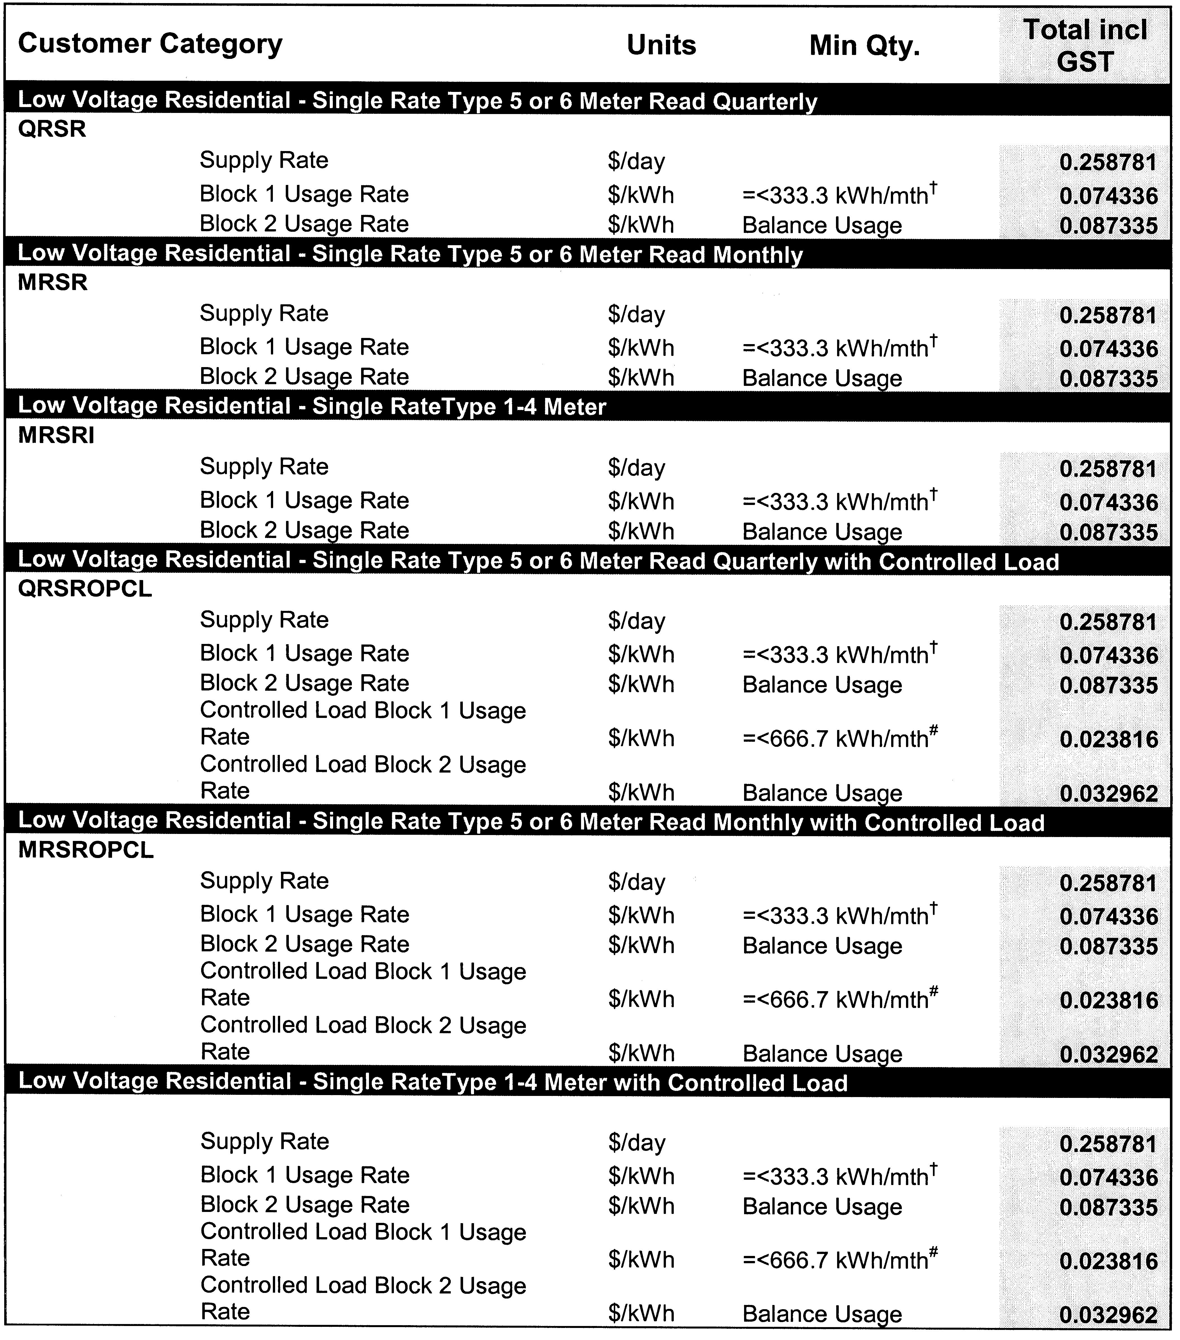
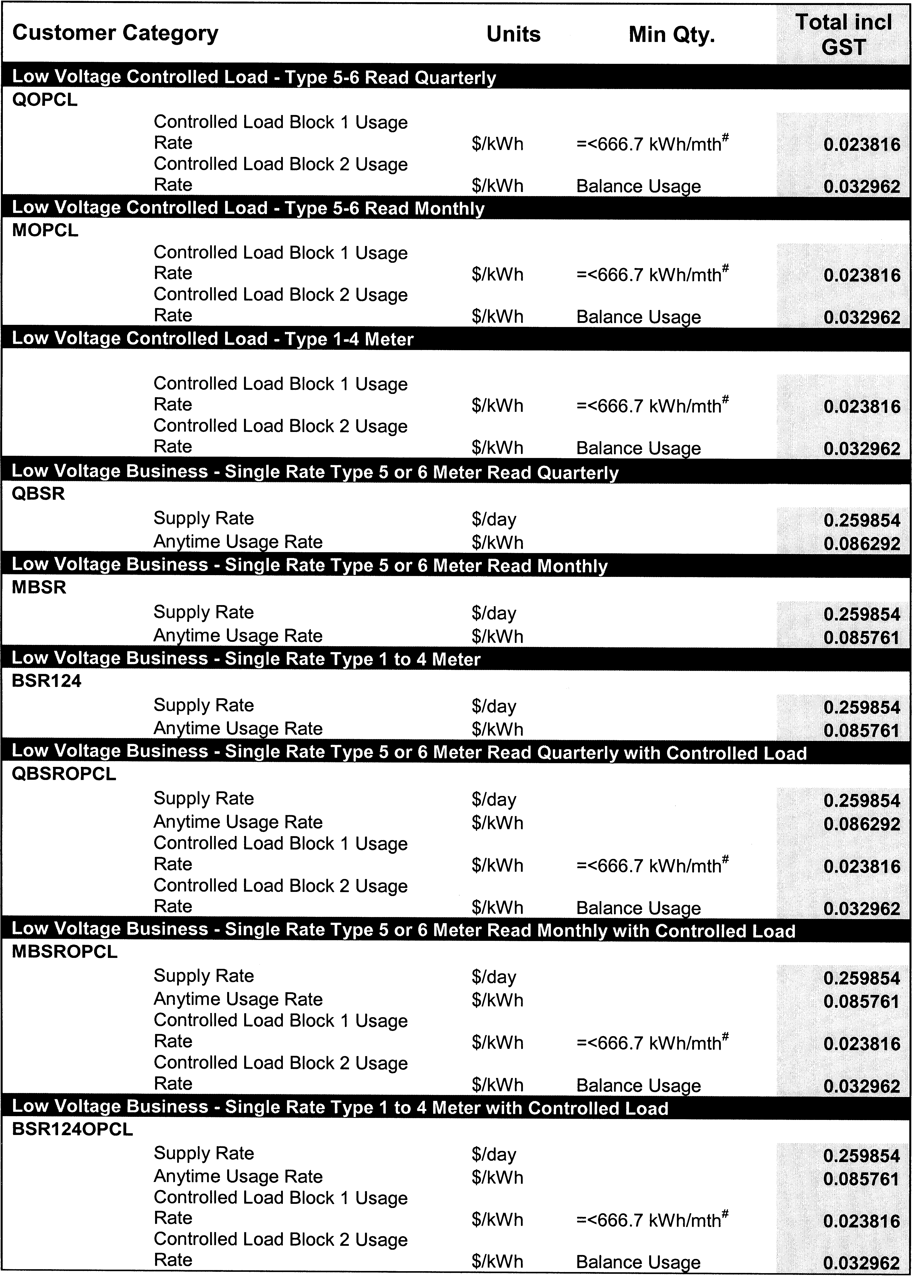
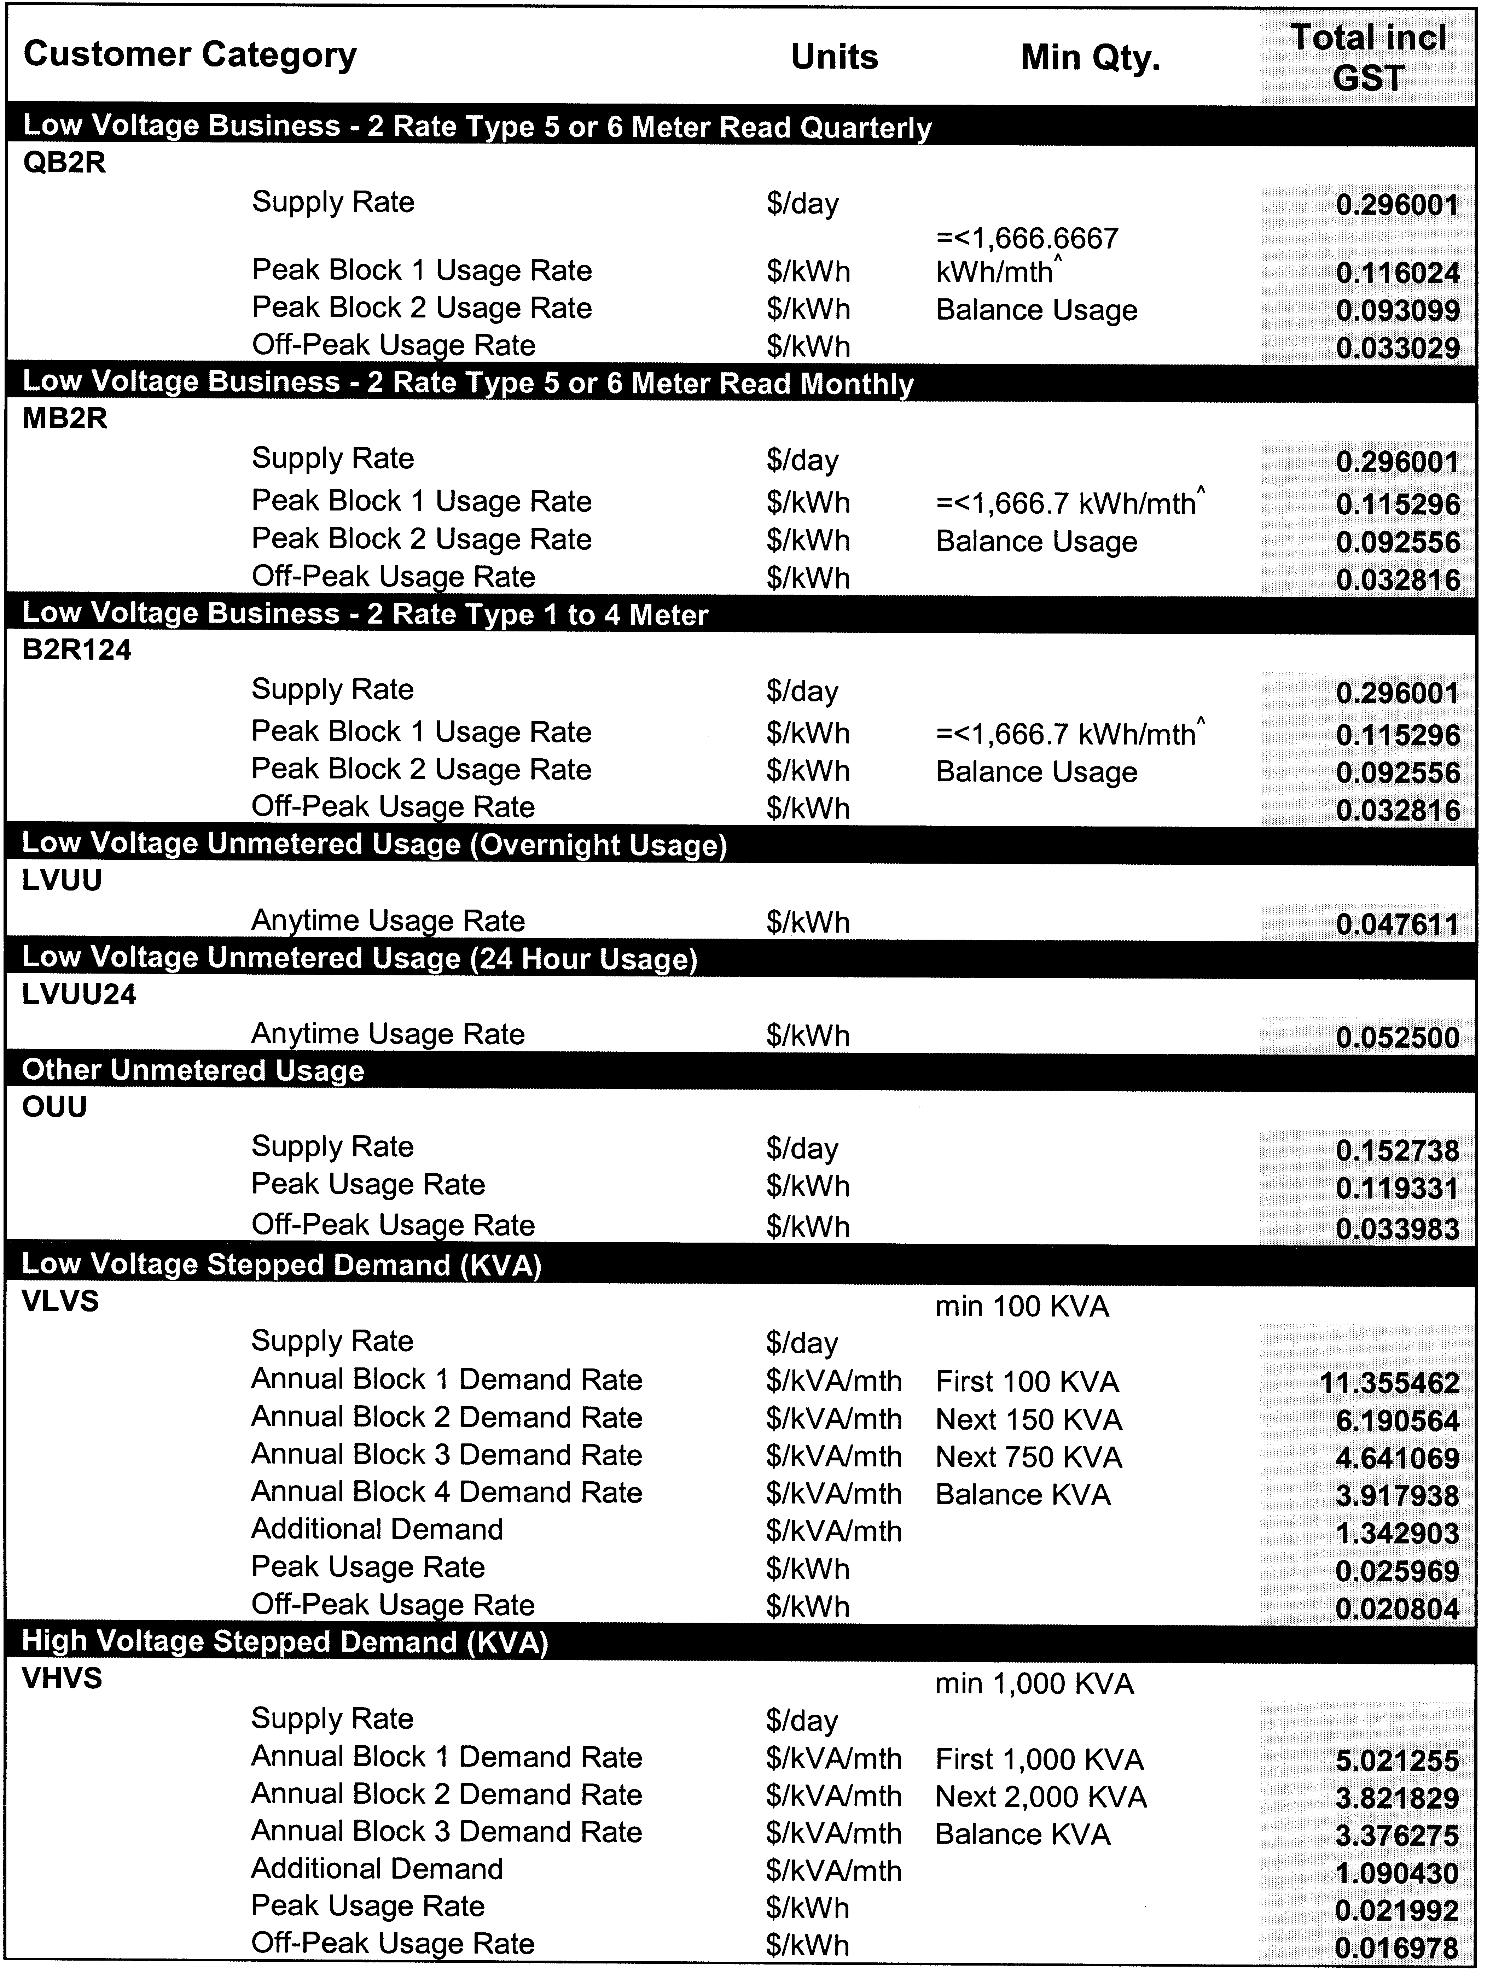
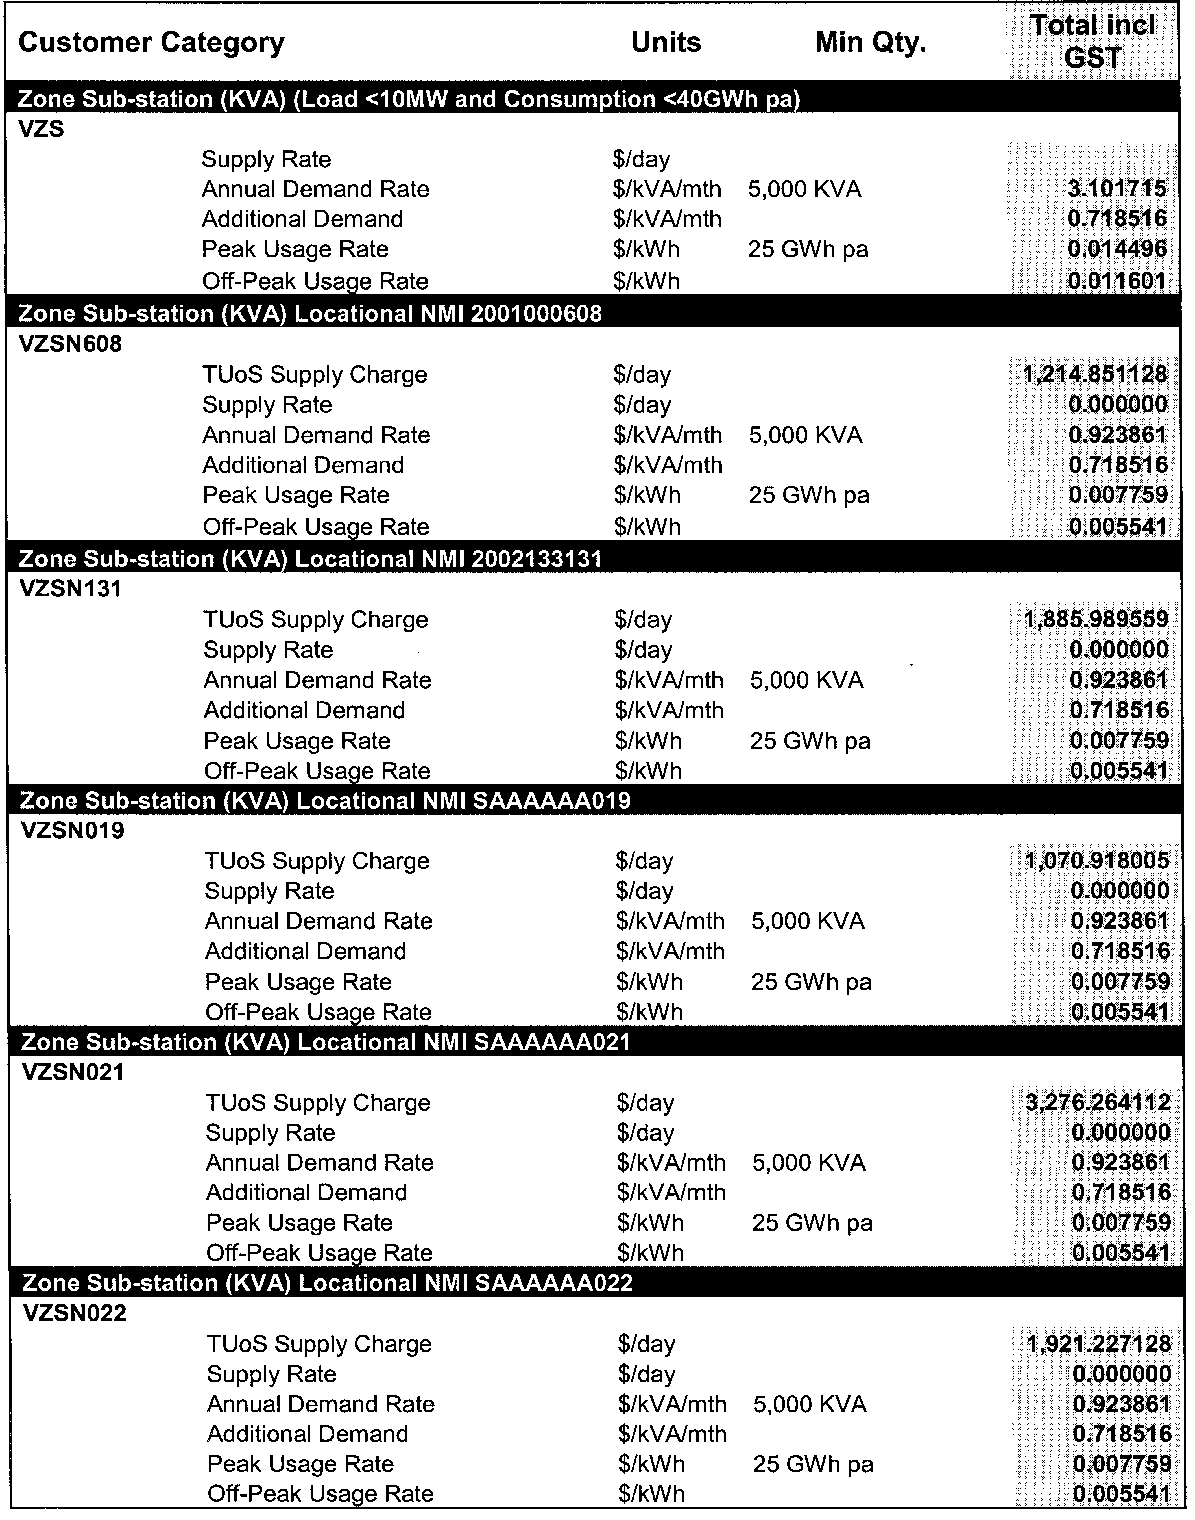
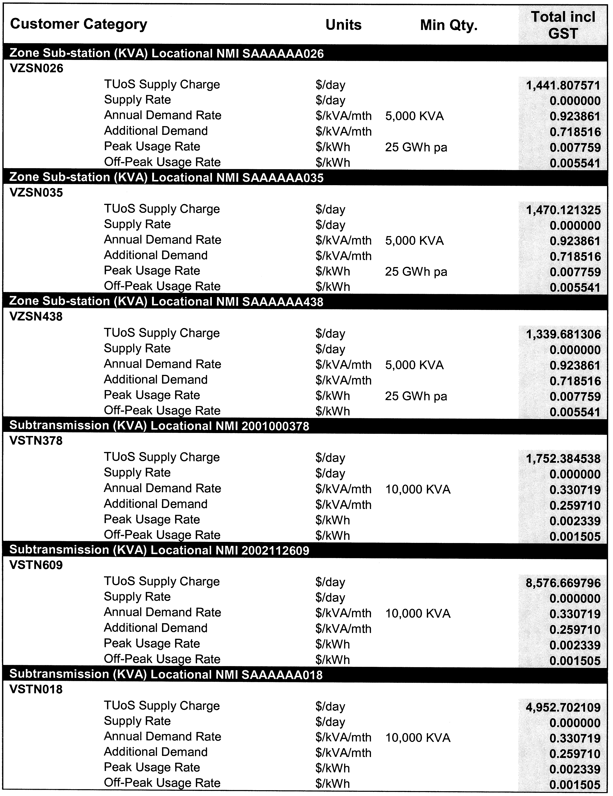
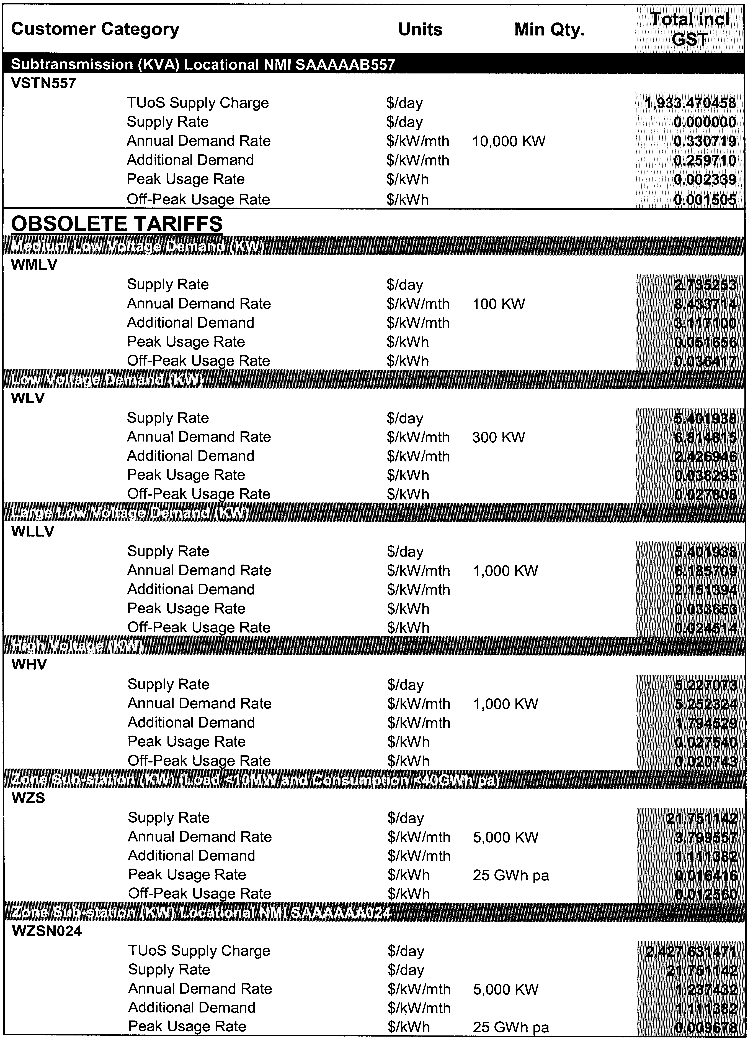
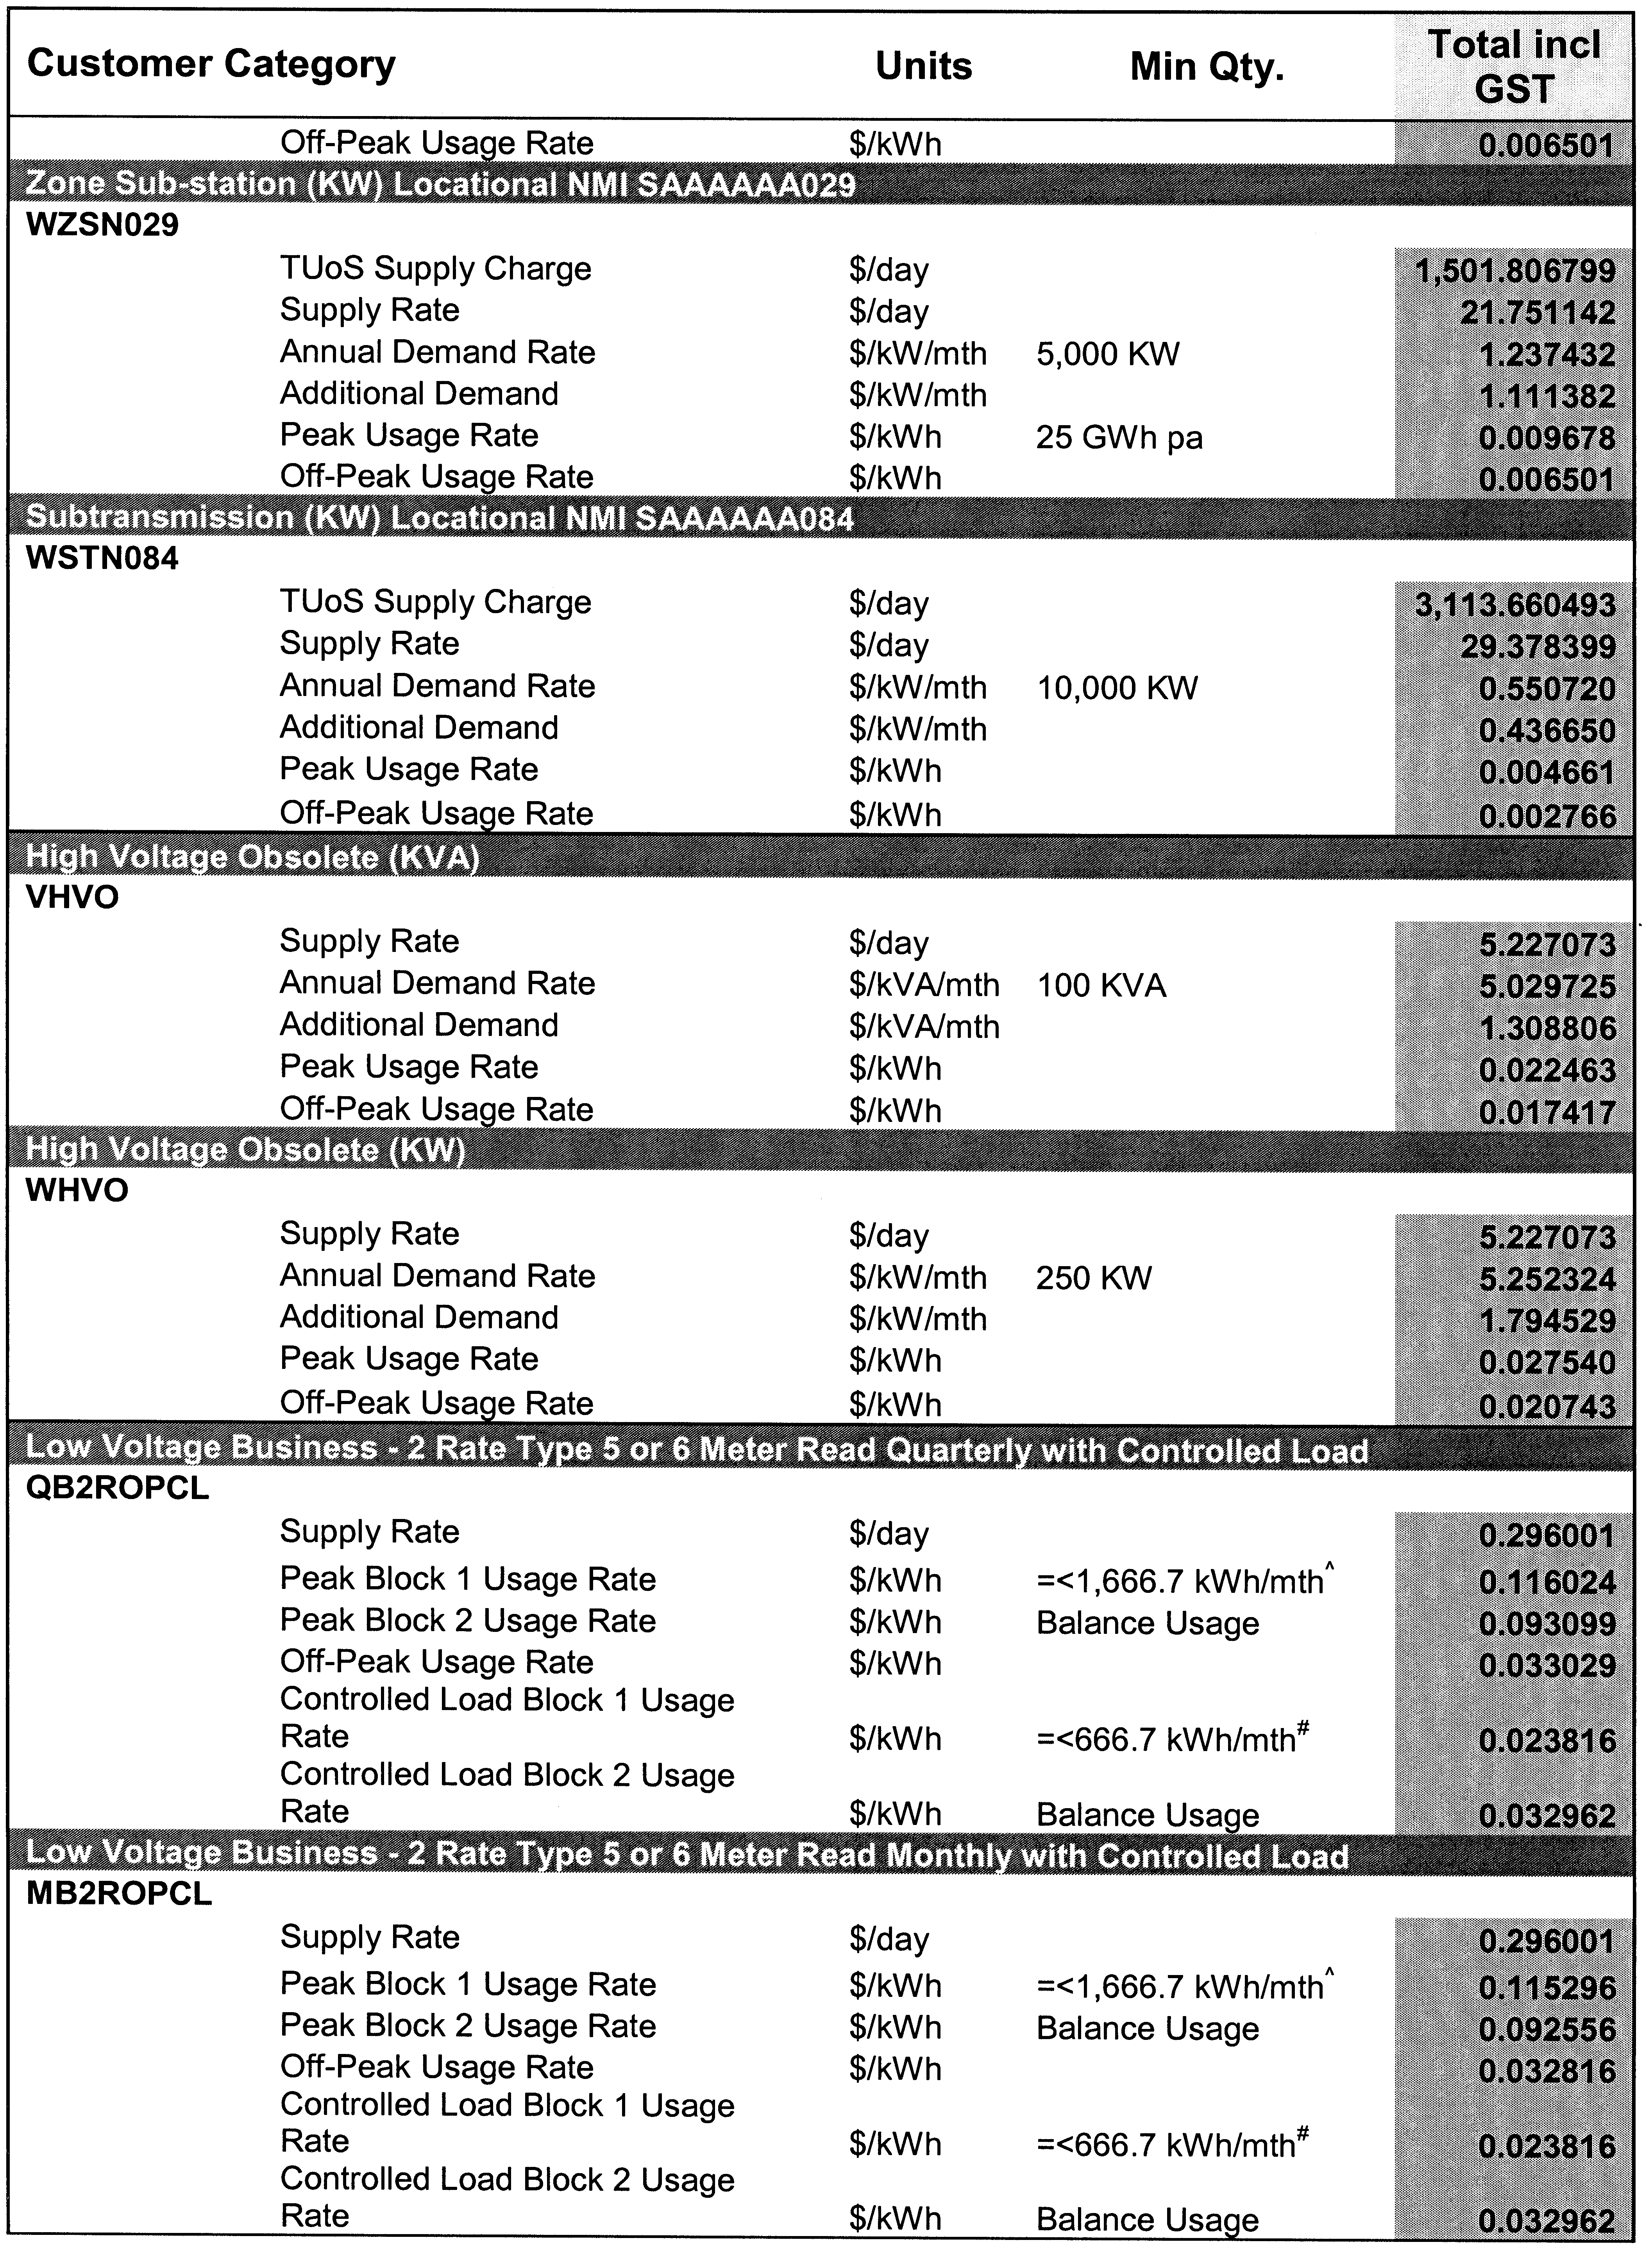
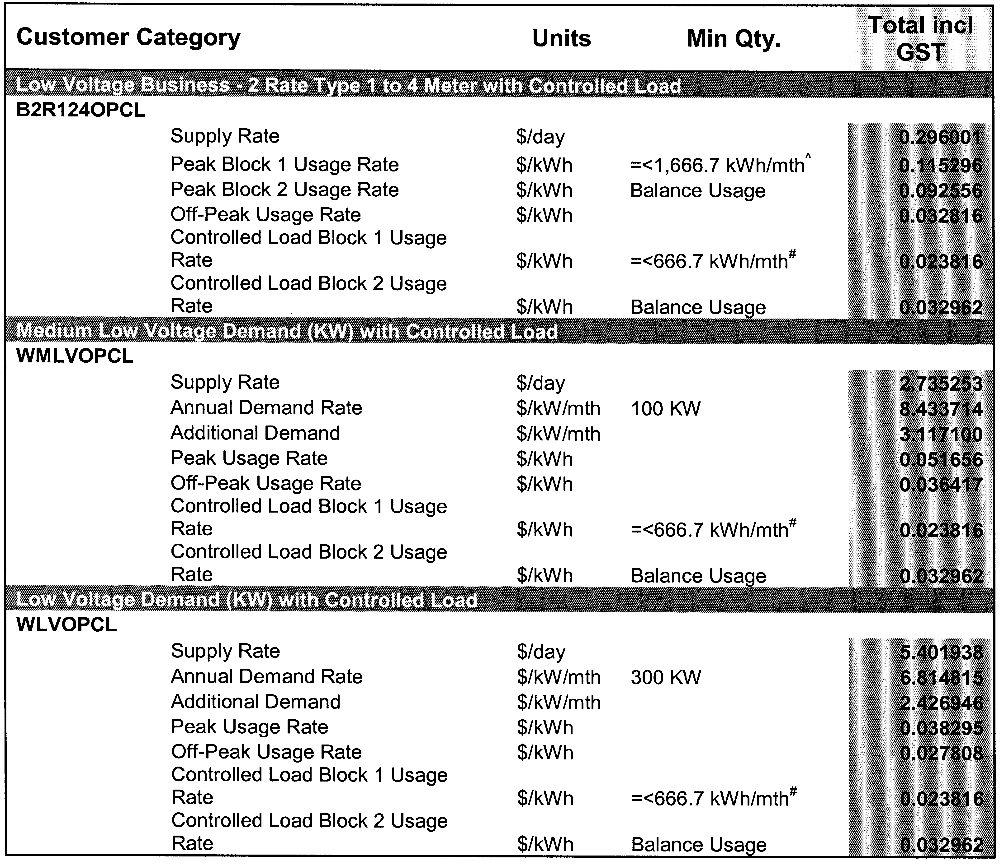

Notes accompanying 2007-2008 Tariffs

† - Approximate annual consumption of 4,000 kWh.
# - Approximate annual consumption of 8,000 kWh.
^ - Approximate annual peak consumption of 20,000 kWh.

Notes:
1. Distribution tariffs are determined on a GST exclusive basis. GST is added to the distribution tariffs.

2. ETSA Utilities must assign each Distribution Network User to a distribution tariff in respect of each of its connection points in accordance with the following principles:
(a) A Distribution Network User that has an agreed maximum demand of 250kVA or more in respect of a connection point, must be assigned to a distribution tariff that includes a demand component in respect of that connection point.
(b) A Sub-Transmission (kVA) Network User is a Distribution Network User taking supply at 66kV, or at 33kV outside of the Adelaide Metropolitan area. A minimum annual demand of 10 MVA applies. A NEM compliant type 1-4 interval meter is required with the ability to measure both active and reactive power. Customers electing to switch to this tariff from 1 July 2002 must meet or exceed the minimum power factor requirements for their customer installation as set out in Part B of the Distribution Code (generally 0.90 pf). These tariffs are invoiced monthly.
(c) A Zone Substation (kVA) customer is a Distribution Network User taking supply generally at 11kV from the low voltage transformer terminals. Supply may also be taken at lower voltages that exceed 1kV.
A minimum annual demand of 5 MVA and a minimum annual usage of 25GWh apply. A NEM compliant type 1-4 interval meter is required with the ability to measure both active and reactive power. Customers electing to switch to this tariff from 1 July 2002 must meet or exceed the minimum power factor require-ments for their customer installation as set out in Part B of the Distribution Code (generally 0.90 pf). These tariffs are invoiced monthly.
(d) A High Voltage Stepped Demand (kVA) customer is a Distribution Network User taking supply generally at 11kV. Supply may also be taken at lower voltages that exceed 1kV or at 33kV in metropolitan Adelaide. A minimum annual demand of 1 MVA applies. The steps to be applied to the annual demand are detailed in the Tariff Schedule. A NEM compliant type 1-4 interval meter is required with Customers electing to switch to this tariff from 1 July 2002 must meet or exceed the minimum power factor require-ments for their customer installation as set out in Part B of the Distribution Code (generally 0.85 pf). These tariffs are invoiced monthly.
(e) A High Voltage (kVA) (Obsolete) customer is a Distribution Network User taking supply generally at 11kV. This tariff is available only to Distribution Network Users that were taking supply under the High Voltage Demand (kW) (Obsolete) tariff as at 11 October 1999. Supply may also be taken at lower voltages that exceed 1kV or at 33kV in metropolitan Adelaide. A minimum annual demand of 300kVA applies. A NEM compliant type 1-4 interval meter is required with the ability to measure both active and reactive power. Customers electing to switch to this tariff from 1 July 2002 must meet or exceed the minimum power factor requirements for their customer installation as set out in Part B of the Distribution Code (generally 0.85 pf). These tariffs are invoiced monthly.
(f) A Low Voltage Stepped Demand (kVA) customer is a Distribution Network User generally taking supply at less than 1kV and generally from the low voltage distribution transformer terminals. A minimum agreed maximum demand of 100KVA applies. The steps to be applied to the annual demand are detailed in the Tariff Schedule. A NEM compliant type 1-4 interval meter is required with the ability to measure both active and reactive power. Customers electing to switch to this tariff from 1 July 2002 must meet or exceed the minimum power factor requirements for their customer installation as set out in Part B of the Distribution Code (generally 0.85 pf). These tariffs are invoiced monthly.
(g) A Low Voltage Business 2 rate – Type 1-4 Meter customer is a Distribution Network User that is not a residential customer generally taking supply at less than 1kV and using peak and off-peak network charges. The User utilises a type 1-4 meter with the ability to measure both active and reactive power. Peak consumption is charged at two rates, one rate for consumption up to and including 1,666.7 kWh/mth^ and another rate for the balance of peak consumption. Off Peak consumption is charged at a flat rate. An excluded service charge applies where ETSA Utilities is required to read the type 1-4 meter (e.g. for tier one customers and for tier two customers < 160MWh pa). This tariff is invoiced monthly.
(h) A Low Voltage Business 2 rate – Type 5-6 Meter Read Monthly customer is a Distribution Network User that is not a residential customer taking supply at less than 1kV and using peak and off-peak network charges. Peak consumption is charged at two rates, one rate for consumption up to and including 1,666.7 kWh/mth^ and another rate for the balance of peak consumption. Off Peak consumption is charged at a flat rate. The User utilises a type 5-6 meter and requires ETSA Utilities to read the meter monthly for which an excluded service charge applies. This tariff is invoiced monthly.
(i) A Low Voltage Business 2 rate – Type 5-6 Meter Read Quarterly customer is a Distribution Network User that is not a residential customer taking supply at less than 1kV and using peak and off-peak network charges. Peak consumption is charged at two rates, one rate for consumption up to and including 1,666.7 kWh/mth^ and another rate for the balance of peak consumption. Off Peak consumption is charged at a flat rate. The User utilises a type 5-6 meter which requires ETSA Utilities to read the meter. This tariff is invoiced quarterly.
(j) A Low Voltage Business single rate – Type 1-4 Meter customer is a Distribution Network User that is not a residential customer taking supply at less than 1kV and using single rate network charges. The User utilises a type 1-4 meter with the ability to measure both active and reactive power. An excluded service charge applies where ETSA Utilities is required to read the type 1-4 meter (e.g. for tier one customers and for tier two customers < 160MWh pa). This tariff is invoiced monthly.
(k) A Low Voltage Business single rate – Type 5-6 Meter Read Monthly customer is a Distribution Network User that is not a residential customer taking supply at less than 1kV and using single rate network charges. The User utilises a type 5-6 meter and requires ETSA Utilities to read the meter monthly for which an excluded service charge applies. This tariff is invoiced monthly.
(l) A Low Voltage Business single rate – Type 5-6 Meter Read Quarterly customer is a Distribution Network User that is not a residential customer taking supply at less than 1kV and using single rate metering.
The User utilises a type 5-6 meter which requires ETSA Utilities to read the meter. This tariff is invoiced quarterly.
(m) A Low Voltage Residential single rate – Type 1-4 Meter Read Monthly customer is a Distribution Network User that is a residential customer taking supply at less than 1kV. Consumption is charged at two rates, one rate for consumption up to and including 333.3 kWh/mth† and another rate for the balance of consumption. The User utilises a type 1-4 meter with the ability to measure both active and reactive power. An excluded service charge applies where ETSA Utilities is required to read the type 1-4 meter (e.g. for tier one customers and for tier two customers < 160MWh pa). This tariff is invoiced monthly.
(n) A Low Voltage Residential single rate – Type 5-6 Meter Read Monthly customer is a Distribution Network User that is a residential customer taking supply at less than 1kV. Consumption is charged at two rates, one rate for consumption up to and including 333.3 kWh/mth† and another rate for the balance of consumption. The User utilises a type 5-6 meter and requires ETSA Utilities to read the meter monthly for which an excluded service charge applies. This tariff is invoiced monthly.
(o) A Low Voltage Residential single rate – Type 5-6 Meter Read Quarterly customer is a Distribution Network User that is a residential customer taking supply at less than 1kV. Consumption is charged at two rates, one rate for consumption up to and including 333.3 kWh/mth† and another rate for the balance of consumption. The User utilises a type 5-6 meter which requires ETSA Utilities to read the meter.
This tariff is invoiced quarterly.
(p) A Low Voltage Controlled Load is used by a Distribution Network User for permanently installed storage water heaters with a rated delivery of not less than 125 litres, storage space heaters and other approved applications involving a time switch and separate metering where the timing has been set in accordance with ETSA Utilities' requirements regarding the timing of loads. Consumption is charged at two rates, one rate for consumption up to and including 666.7 kWh/mth# and another rate for the balance of consumption. This tariff is available only to Distribution Network Users that were taking supply under the Controlled Load tariff as at 30 June 2003, or are utilising a business single or residential tariff at the NMI in conjunction with the controlled load. This tariff is invoiced at the same frequency as other tariffs used by the Distribution Network User at that NMI.
(q) Unmetered Overnight Usage supply is defined as overnight use by a Distribution Network User for public lighting. These tariffs are generally invoiced monthly, unless otherwise agreed by ETSA Utilities.
(r) Unmetered 24 Hour Usage supply is defined as constant 24 hour per day use by a Distribution Network User, typically public phones, traffic lights and telecommunications installations. These tariffs are generally invoiced monthly, unless otherwise agreed by ETSA Utilities.
(s) Other Unmetered Supply is defined as unmetered use by Distribution Network Users other than public lighting or continuous use. These tariffs are generally invoiced monthly, unless otherwise agreed by ETSA Utilities.
(t) A Sub-Transmission Network (kW) User is a Distribution Network User taking supply at 66kV, or at 33kV outside of the Adelaide metropolitan area. A minimum annual demand of 10MW applies. A NEM compliant type 1-4 interval meter is required with the ability to measure both active and reactive power. This tariff is available only to Distribution Network Users that were taking supply under this tariff as at
30 June 2001. These tariffs are invoiced monthly.
(u) A Zone Substation (kW) customer is a Distribution Network User taking supply generally at 11kV from the low voltage transformer terminals. Supply may also be taken at lower voltages that exceed 1kV.
A minimum annual demand of 5MW and a minimum annual usage of 25GWh apply. A NEM compliant type 1-4 interval meter is required with the ability to measure both active and reactive power. This tariff is available only to Distribution Network Users that were taking supply under this tariff as at 30 June 2001. These tariffs are invoiced monthly.
(v) A High Voltage Demand (kW) customer is a Distribution Network User taking supply generally at 11kV. Supply may also be taken at lower voltages that exceed 1kV or at 33kV in metropolitan Adelaide.
A minimum annual demand of 1MW applies. A NEM compliant type 1-4 interval meter is required with the ability to measure both active and reactive power. This tariff is available only to Distribution Network Users that were taking supply under this tariff as at 30 June 2001. These tariffs are invoiced monthly.
(w) The High Voltage Demand (kW) (Obsolete) tariff is available only to Distribution Network Users that were taking supply under this tariff as at 11 October 1999. Conditions applicable at that date apply.
These tariffs are invoiced monthly.
(x) A Large Low Voltage Demand (kW) customer is a Distribution Network User taking supply at less than 1kV and generally from the low voltage distribution transformer terminals. A minimum annual demand of 1MW applies. A NEM compliant type 1-4 interval meter is required with the ability to measure both active and reactive power. This tariff is available only to Distribution Network Users that were taking supply under this tariff as at 30 June 2001. These tariffs are invoiced monthly.
(y) A Low Voltage Demand (kW) customer is a Distribution Network User taking supply at less than 1kV and generally from the low voltage distribution transformer terminals. A minimum annual demand of 300kW applies. A NEM compliant type 1-4 interval meter is required with the ability to measure both active and reactive power. This tariff is available only to Distribution Network Users that were taking supply under this tariff as at 30 June 2001. These tariffs are invoiced monthly.
(z) A Medium Low Voltage Demand (kW) customer is a Distribution Network User that is not a residential customer taking supply at less than 1kV and using demand, peak and off-peak network charges.
A minimum annual demand of 100kW applies. A NEM compliant type 1-4 interval meter is required with the ability to measure both active and reactive power. This tariff is available only to Distribution Network Users that were taking supply under this tariff as at 30 June 2001. These tariffs are invoiced monthly.

3. The supply and demand charges are levied and billed to Distribution Network Users periodically on a pro-rata basis.

4. Demand charges are determined on the basis of:
(a) Agreed maximum demand (Annual Demand); and
(b) Agreed additional maximum demand (Additional Demand),
determined in accordance with Schedule 2 of Part B of the 2005-2010 Electricity Distribution Price Determination.

5. Peak energy is energy consumed on business days between the hours of 0700 and 2100 (Central Standard Time). For Distribution Network Users with metering that does not recognise specific days, peak energy is energy consumed on each day between the hours of 0700 and 2100 (Central Standard Time).

6. Off-peak energy is energy consumed other than peak energy.

FISHERIES ACT 1982: SECTION 59
TAKE notice that, pursuant to section 59 of the Fisheries Act 1982, the persons listed in Schedule 1 (the ‘exemption holders’) of Southern Australian Seafoods Pty Ltd, P.O. Box 2516, Port Lincoln, S.A. 5607, are exempt from sections 34 and 41 of the Fisheries Act 1982 and the Fisheries (Scheme of Management—Abalone Fisheries) Regulations 1991, but only insofar as they may take greenlip abalone, blacklip abalone and Roe’s abalone for the purpose of aquaculture broodstock (the ‘exempted activity’) in the waters specified in Schedule 2, subject to the conditions in Schedule 3 from 1 July 2007 until 30 June 2008.
Schedule 1
Andrew Christian and Misha Anderson.
Schedule 2
Area 1: South Australian coastal waters south and east of a line drawn due south through Point Brown (latitude 32°32.6′S, longitude 133°50.8′E) and west of the meridian of longitude 136°30′E.
Area 2: South Australian coastal waters between the meridians of longitude 136°30′E and 139°E but does not include the waters of the Coorong or any other waters inside the Murray Mouth (this includes the area known as Tiperra Reef).
Schedule 3
1. The exemption holder may take a maximum of 75 greenlip abalone, 25 blacklip abalone and 25 Roe’s abalone from Area 1 as described in Schedule 2.
2. The exemption holder may take a maximum of 75 greenlip abalone, 25 blacklip abalone and 25 Roe’s abalone from Area 2 as described in Schedule 2.
3. Broodstock must not be sourced from known Perkinsus areas or the Southern Zone.
4. The exemption holder is exempt from the size limit prescribed in Schedule 6 of the Fisheries (General) Regulations 2000, when undertaking the exempt activity in relation to the taking of Roe’s abalone.
5. All abalone taken pursuant to this notice must not be sold or transferred to another party.
6. All abalone taken pursuant to this notice must be delivered to and retained on the registered aquaculture site of Landbased Aquaculture Licence No. FT00620.
7. The exemption holder must notify PIRSA Fisheries Compliance on 1800 065 522 at least two hours prior to con-ducting the exempted activity and answer a series of questions about the exempted activity. The exemption holder will need to have a copy of the exemption notice at the time of making the call, and be able to provide information about the area and time of the exempted activity, the vehicles and boats involved, the number of agents undertaking the exempted activity and other related questions. Exemption No. 9901994.
8. The exemption holder must, within 50 m of the point of landing of any abalone taken pursuant to this notice, complete the PIRSA form ‘Abalone Broodstock Collection Statement’. Immediately upon arrival at the exemption holders registered aquaculture site, this form must be faxed to PIRSA Fisheries on (08) 8226 0434. Prior to release into the registered aquaculture site, all abalone taken pursuant to this notice must be tagged so as to be clearly identified as wild broodstock.
9. Broodstock taken under this exemption must be physically contained and separated from any farm-reared and growout animals, including no mixing of water used to hold wild-caught broodstock with areas used to hold growout stock.
10. Broodstock taken pursuant to this exemption must be held together in identifiable groups from specific geographic locations or if broodstock from different areas must be mixed due to on-farm logistics, broodstock must be tagged so that their date and location of capture can be determined.
11. PIRSA Fishwatch retains the right for a Fisheries Officer to accompany the exemption holder at any time during the exempted activity.
12. While engaged in the exempted activity the exemption holder must carry or have about or near his person a copy of this notice. Such notice must be produced to a PIRSA Fisheries Officer if requested.
13. The exemption holder must not contravene or fail to comply with the Fisheries Act 1982 or any regulations made under that Act, except where specifically exempted by this notice.
Dated 1 June 2007.
W. Zacharin, Director of Fisheries

FISHERIES ACT 1982: SECTION 59
TAKE notice that pursuant to section 59 of the Fisheries Act 1982, all holders of a Blue Crab Fishery Licence (the ‘exemption holders’), are exempt from the definition of ‘crab pot’ and Clause 22 of Schedule 1 of the Fisheries (General) Regulations 2000, but only insofar as the exemption holder may use two registered crab pots that have the dimensions set out in Schedule 1 for the purpose of trade or business (the ‘exempted activity’) within the area specified in Schedule 2, subject to the conditions in Schedule 3, from 1 July 2007 until 30 June 2008, unless varied or revoked earlier.
Schedule 1
A crab pot of the following dimensions and specifications:
• has a maximum height of 650 mm;
• has a maximum diameter of 1.4 m; and
• has a mesh size of 55 mm.
Schedule 2
All waters of the Gulf St Vincent and Spencer Gulf Crab Fishing Zone (subject to licence holder quota holdings).
Schedule 3
1. The exemption holder may only conduct the exempted activity from a boat registered and endorsed on their blue crab fishery licence.
2. All undersize blue crabs and other species taken in the modified blue crab pots must be returned to the water immediately.
3. The following information must be recorded in relation to each blue crab retained within a modified pot:
• length in millimetres;
• sex (male or female);
• condition (soft, hard or berried);
• location of the pot (longitude and latitude); and
• the date of capture.
4. The information recorded in accordance with Condition 3 must be provided to SARDI in relation to each calendar month and sent to:
Graham Hooper
South Australian Research Development Institute (SARDI)
P.O. Box 120
Henley Beach, S.A. 5022.
5. While engaged in the exempted activity the principal exemp-tion holder must have in their possession a copy of this notice. Such notice must be produced to a PIRSA Fisheries Officer if requested.
6. The exemption holders must not contravene or fail to comply with the Fisheries Act 1982, or any regulations made under that Act except where specifically exempted by this notice.
Dated 1 June 2007.
W. Zacharin, Director of Fisheries

Addendum
HARBORS AND NAVIGATION ACT 1993
Determination of the State Crewing Committee
THE following determination made on 19 March 2007 by the State Crewing Committee is published pursuant to part 6, section 45 of the Harbors and Navigation Act 1993.
Patrick Conlon, Minister for Transport
TSA V11430

HARBORS AND NAVIGATION ACT 1993
Determination of the State Crewing Committee in respect of the
M.T. ‘Taminga’
THE following determination is made by the State Crewing Committee pursuant to part 6, section 45 of the Harbors and Navigation Act 1993 in respect of the Taminga whilst operating within the following limit:
Operational Limit
Limit 1—South Australian Harbour Limits.
Limit 2—To cape size vessels up to transhipment point only latitude 33°09′12″S, longitude 137°38′21″E.
Limit 3—Gulf St Vincent, north of latitude 35°10′S.
Limit 4—Spencer Gulf, north of latitude 34°S.
Limit 5—Coast of South Australia, 200 nautical miles.
Minimum Complement
Limit 1—Three Persons—Master, Engineer, Integrated Rating (1).
Limit 2—Four Persons—Master, Engineer, General Purpose Person (2).
Limit 3—Five Persons—Master, Mate, Engineer, General Purpose Person (2).
Limit 4—Six Persons—Master, Mate, Engineer, General Purpose Person (3).
Limit 5—Seven Persons—Master, Mate, Chief Engineer, 2nd Engineer, General Purpose Person (3).
Limit 2—Please note one of the General Purpose Persons to be the holder of a Master Class 5.
Minimum Qualifications of Crew
Master—Certificate of Competency as Master Class 4.
Mate—Certificate of Competency as Master Class 5
Engineer—Marine Engineer Driver Grade 1.
Integrated Rating—Qualification as specified within the Marine Orders.
General Purpose Person—An able-bodied person not less than 16 years of age with not less than three months experience and has successfully completed an approved Occupational Health and Safety at Sea Course.
Limit 2—Please note one of the General Purpose Persons to be the holder of a Master Class 5.
Limit 5—
Master—Certificate of Competency as Master Class 4.
Mate—Certificate of Competency as Master 5 endorsed 200 nautical miles.
Chief Engineer—Engineer Class 3.
2nd Engineer—Marine Engine Driver Grade 2.
General Purpose Person (3).
Capt. W. Ferrao, Presiding Member, State Crewing Committee

HARBORS AND NAVIGATION ACT 1993
Determination of the State Crewing Committee
THE following determination is made by the State Crewing Committee pursuant to part 6, section 45 of the Harbors and Navigation Act 1993 in respect of the Wooree whilst operating in the following limits.
Patrick Conlon, Minister for Transport
V29184

HARBORS AND NAVIGATION ACT 1993
Determination of the State Crewing Committee in respect of the
M.V. ‘Wooree’
THE following determination is made by the State Crewing Committee pursuant to part 6, section 45 of the Harbors and Navigation Act 1993 in respect of the Wooree whilst operating within the following limits:
Operational Limits
Limit 1—South Australian Harbour limits
Limit 2—Cape size vessels up to transhipment point only latitude 33°09′12″S longitude 137°38′21″E.
Limit 3—Gulf St Vincent, north of latitude 35°10′S.
Limit 4—Spencer Gulf, north of latitude 34°S.
Limit 5—Voyages outside the above limits.
Minimum Complement
Limit 1—Four persons—Master, Engineer, General Purpose Person (2).
Limit 2—Four persons—Master, Engineer, General Purpose Person (2).
Limit 3—Five persons—Master, Mate, Engineer, General Purpose Person (2).
Limit 4—Six persons—Master, Mate, Engineer, General Purpose Person (3).
Limit 5—Seven persons—Master, Mate, Chief Engineer, 2nd Engineer, General Purpose Person (3).
Minimum Qualifications of Crew
Master—Certificate of Competency as Master Class 4.
Mate—Certificate of Competency as Master Class 5.
Engineer—Marine Engine Driver Grade 1.
GP—General Purpose Person.
Limit 5—
Master—Certificate of Competency as Master Class 4.
Mate—Certificate of Competency as a Master Class 5 endorsed to 200 nautical miles.
Chief Engineer—Engineer Class 3.
2nd Engineer—Marine Engine Driver Grade 2.
General Purpose Person—An able-bodied person not less than 16 years of age with not less than 3 months experience and has successfully completed an approved Occupational Health and Safety at Sea Course.
Capt. W. Ferrao, Presiding Member, State Crewing Committee

HARBORS AND NAVIGATION ACT 1993
Determination of the State Crewing Committee
THE following determination is made by the State Crewing Committee pursuant to part 6, section 45 of the Harbors and Navigation Act 1993 in respect of the Marimba whilst operating in the following limits.
Patrick Conlon, Minister for Transport
V29182

HARBORS AND NAVIGATION ACT 1993
Determination of the State Crewing Committee in respect of the
M.V. ‘Marimba’
THE following determination is made by the State Crewing Committee pursuant to part 6, section 45 of the Harbors and Navigation Act 1993 in respect of the Marimba whilst operating within the following limits:
Operational Limits
Limit 1—South Australian Harbour limits.
Limit 2—Cape size vessels up to transhipment point only latitude 33°09′12″S longitude 137°38′21″E.
Limit 3—Gulf St Vincent, north of latitude 35°10′S.
Limit 4—Spencer Gulf, north of latitude 34°S.
Limit 5—Voyages out side the above limits.
Minimum Complement
Limit 1—Four persons—Master, Engineer, General Purpose Person (2).
Limit 2—Four persons—Master, Engineer and General Purpose Person (2).
Limit 3—Five persons—Master, Mate, Engineer, General Purpose Person (2).
Limit 4—Six persons—Master, Mate, Engineer, General Purpose Person (3).
Limit 5—Seven persons—Master, Mate, Chief Engineer, 2nd Engineer, General Purpose Person (3).
Minimum Qualifications of Crew
Master—Certificate of Competency as Master Class 4.
Mate—Certificate of Competency as Master Class 5.
Engineer—Marine Engine Driver Grade 1.
GP—General Purpose Person.
Limit 5—
Master—Certificate of Competency as Master Class 4.
Mate—Certificate of Competency as Master Class 5 endorsed to 200 nautical miles.
Chief Engineer—Engineer Class 3.
2nd Engineer—Marine Engine Driver Grade 2.
General Purpose Person—An able-bodied person not less than 16 years of age with not less than 3 months experience and has successfully completed an approved Occupational Health and Safety at Sea Course.
Capt. W. Ferrao, Presiding Member, State Crewing Committee

LIQUOR LICENSING ACT 1997
Notice of Application
NOTICE is hereby given, pursuant to section 52 (2) (b) of the Liquor Licensing Act 1997, that Kangaroo Island Brewing Company Pty Ltd as trustee for DJW Family Trust has applied to the Licensing Authority for the transfer of a Hotel Licence, Extended Trading Authorisation and variation to Entertainment Consent in respect of premises situated at 60 Main Street, Nairne, S.A. 5252 and known as Millers Arms Hotel.
The application has been set down for callover on 29 June 2007 at 9 a.m.
Conditions
The following licence conditions are sought:
• Extended Trading Authorisation to apply to the whole of the premises for the following hours:
Thursday to Saturday: Midnight to 2 a.m. the following day;
Sunday: 8 p.m. to midnight;
Good Friday: Midnight to 2 a.m.;
Christmas Day: Midnight to 2 a.m.;
Sunday Christmas Eve: 8 p.m. to 2 a.m. the following day;
Days preceding other Public Holidays: Midnight to 2 a.m. the following day;
Sundays preceding Public Holidays: 8 p.m. to 2 a.m. the following day.
• Variation to Entertainment Consent to apply to the whole of the licensed premises for the abovementioned hours.
Any person may object to the application by lodging a notice of objection in the prescribed form with the Liquor and Gambling Commissioner and serving a copy of the notice on the applicant at the applicant’s address, at least seven days before the callover date (viz: 22 June 2007).
The applicant’s address for service is c/o Clelands Lawyers, 208 Carrington Street, Adelaide, S.A. 5000.
Plans in respect of the premises the subject of the application are open to public inspection without fee at the Office of the Liquor and Gambling Commissioner, 9th Floor, East Wing, 50 Grenfell Street, Adelaide, S.A. 5000. Phone 8226 8410, Fax:
8226 8512. Email: olgc@agd.sa.gov.au.
Dated 31 May 2007.
Applicant

LIQUOR LICENSING ACT 1997
Notice of Application
NOTICE is hereby given, pursuant to section 52 (2) (b) of the Liquor Licensing Act 1997, that J. & H. Nominees Pty Ltd has applied to the Licensing Authority for approval to establish a Beer Garden, Outdoor Dining Area and Smoking Courts in respect of premises situated at 75 Goodwood Road, Goodwood and known as Goodwood Park Hotel.
The application has been set down for callover on 29 June 2007 at 9 a.m.
Conditions
The following licence conditions are sought:
Details of the alterations are contained in the plans lodged with the application.
Any person may object to the application by lodging a notice of objection in the prescribed form with the Liquor and Gambling Commissioner and serving a copy of the notice on the applicant at the applicant’s address, no later than Thursday, 28 June 2007.
The applicant’s address for service is c/o The Australian Hotels Association (SA Branch), 4th Floor, 60 Hindmarsh Square, Adelaide, S.A. 5000.
Plans in respect of the premises the subject of the application are open to public inspection without fee at the Office of the Liquor and Gambling Commissioner, 9th Floor, East Wing, 50 Grenfell Street, Adelaide, S.A. 5000. Phone 8226 8410, Fax:
8226 8512. Email: olgc@agd.sa.gov.au.
Dated 1 June 2007.
Applicant

LIQUOR LICENSING ACT 1997
Notice of Application
NOTICE is hereby given, pursuant to section 52 (2) (b) of the Liquor Licensing Act 1997, that River Lot Pty Ltd has applied to the Licensing Authority for a Producer’s Licence and a Direct Sales Licence in respect of premises situated at Lot 5, 1349 Riverview Drive, Berri, S.A. 5343 and both to be known as River Lot.
The application has been set down for callover on 6 July 2007 at 9 a.m.
Any person may object to the application by lodging a notice of objection in the prescribed form with the Liquor and Gambling Commissioner and serving a copy of the notice on the applicant at the applicant’s address, at least seven days before the callover date (viz: 29 June 2007).
The applicant’s address for service is c/o Julie Ey, P.O. Box 501, Burnside, S.A. 5066.
Plans in respect of the premises the subject of the application are open to public inspection without fee at the Office of the Liquor and Gambling Commissioner, 9th Floor, East Wing, 50 Grenfell Street, Adelaide, S.A. 5000. Phone 8226 8410, Fax:
8226 8512. Email: olgc@agd.sa.gov.au.
Dated 28 May 2007.
Applicant

LIQUOR LICENSING ACT 1997
Notice of Application
NOTICE is hereby given, pursuant to section 52 (2) (b) of the Liquor Licensing Act 1997, that GFM Enterprises Pty Ltd as trustee for GFM Business Trust, RBR Investments Pty Ltd as trustee for Hennigs Family Trust and RDP Personnel Pty Ltd as trustee for Philp Warooka Trust have applied to the Licensing Authority for the transfer of a Hotel and Gaming Machine Licence in respect of premises situated at Main Street, Warooka, S.A. 5577 and known as Warooka Hotel.
The application has been set down for callover on 6 July 2007 at 9 a.m.
Any person may object to the application by lodging a notice of objection in the prescribed form with the Liquor and Gambling Commissioner and serving a copy of the notice on the applicants at the applicants’ address, at least seven days before the callover date (viz: 29 June 2007).
The applicants’ address for service is c/o Max Basheer, Duncan Basheer Hannon, 66 Wright Street, Adelaide, S.A. 5000.
Plans in respect of the premises the subject of the application are open to public inspection without fee at the Office of the Liquor and Gambling Commissioner, 9th Floor, East Wing, 50 Grenfell Street, Adelaide, S.A. 5000. Phone 8226 8410, Fax:
8226 8512. Email: olgc@agd.sa.gov.au.
Dated 30 May 2007.
Applicants

LIQUOR LICENSING ACT 1997
Notice of Application
NOTICE is hereby given, pursuant to section 52 (2) (b) of the Liquor Licensing Act 1997, that Bull & Bear Ale House Pty Ltd has applied to the Licensing Authority for a redefinition of a Hotel Licence in respect of premises situated at 91 King William Street, Adelaide, S.A. 5000 and known as Bull & Bear Ale House.
The application has been set down for callover on 6 July 2007 at 9 a.m.
Conditions
The following licence conditions are sought:
• Redefinition of the premises to include an outside area as per plans lodged with this office.
Any person may object to the application by lodging a notice of objection in the prescribed form with the Liquor and Gambling Commissioner and serving a copy of the notice on the applicant at the applicant’s address, at least seven days before the callover date (viz: 29 June 2007).
The applicant’s address for service is c/o Paul Curren, 91 King William Street, Adelaide, S.A. 5000.
Plans in respect of the premises the subject of the application are open to public inspection without fee at the Office of the Liquor and Gambling Commissioner, 9th Floor, East Wing, 50 Grenfell Street, Adelaide, S.A. 5000. Phone 8226 8410, Fax:
8226 8512. Email: olgc@agd.sa.gov.au.
Dated 30 May 2007.
Applicant

LIQUOR LICENSING ACT 1997
Notice of Application
NOTICE is hereby given, pursuant to section 52 (2) (b) of the Liquor Licensing Act 1997, that Feathers Hotel Pty Ltd has applied to the Licensing Authority for Alterations, Redefinition and variation to Extended Trading Authorisation in respect of premises situated at 516 Glynburn Road, Burnside, S.A. 5066 and known as Feathers Hotel.
The application has been set down for callover on 6 July 2007 at 9 a.m.
Conditions
The following licence conditions are sought:
• Alterations and Redefinition to extend area known as Area 11 and to create a new outdoor area adjacent to areas known as 9 and 10 as per plans lodged with this office.
• Variation to Extended Trading Authorisation for Area 11 and proposed extension:
Monday to Wednesday: Midnight to 1 a.m. the following day;
Thursday to Saturday: Midnight to 3 a.m. the following day;
Sunday: 8 a.m. to 11 a.m. and 8 p.m. to 11 p.m.;
Christmas Day: Midnight to 2 a.m.; and
Good Friday: Midnight to 2 a.m.
• Variation to Extended Trading Authorisation for the above-mentioned outdoor area adjacent to Areas 9 and 10 for the following hours:
Monday and Tuesday: Midnight to 1 a.m. the following day;
Wednesday: Midnight to 2 a.m. the following day;
Thursday to Saturday: Midnight to 3 a.m. the following day; and
Sunday: 8 p.m. to 1 a.m. the following day.
Any person may object to the application by lodging a notice of objection in the prescribed form with the Liquor and Gambling Commissioner and serving a copy of the notice on the applicant at the applicant’s address, at least seven days before the callover date (viz: 29 June 2007).
The applicant’s address for service is c/o Feathers Hotel Pty Ltd, 1st Floor, 36 George Street, Stepney, S.A. 5069.
Plans in respect of the premises the subject of the application are open to public inspection without fee at the Office of the Liquor and Gambling Commissioner, 9th Floor, East Wing, 50 Grenfell Street, Adelaide, S.A. 5000. Phone 8226 8410, Fax:
8226 8512. Email: olgc@agd.sa.gov.au.
Dated 30 May 2007.
Applicant

LIQUOR LICENSING ACT 1997
Notice of Application
NOTICE is hereby given, pursuant to section 52 (2) (b) of the Liquor Licensing Act 1997, that Sullivans Hotels Pty Ltd, Cyril Thomas Lampard, Margaret Rose Lampard, Trevor William Toohey and Irene Patricia Toohey have applied to the Licensing Authority for variation to an Extended Trading Authorisation in respect of premises situated at 207-209 Unley Road, Unley, S.A. 5061 and known as Cremorne Hotel.
The application has been set down for callover on 6 July 2007 at 9 a.m.
Conditions
The following additional licence conditions are sought:
1. That the Extended Trading Authorisation shall apply to the proposed Smokers Courtyards to be established at the front and rear of the premises as detailed on the plan lodged at the Liquor and Gambling Commission.
2. That the Extended Trading Authorisation shall operate on the days and during the times currently authorised for other areas of the premises, namely Thursday from midnight to 1 a.m. the following day, Friday and Saturday from midnight to 2 a.m. the following day, Sunday from 9 a.m. to 11 a.m. and 8 p.m. to 11 p.m., Christmas Day (extension of Christmas Eve trading) from midnight to 2 a.m. and Good Friday (extension of Maundy Thursday trading) from midnight to 2 a.m.
There will be no entertainment provided in the Smokers Courtyards.
Any person may object to the application by lodging a notice of objection in the prescribed form with the Liquor and Gambling Commissioner and serving a copy of the notice on the applicants at the applicants’ address, at least seven days before the callover date (viz: 29 June 2007).
The applicants’ address for service is c/o The Australian Hotels Association (SA Branch), 4th Floor, 60 Hindmarsh Square, Adelaide, S.A. 5000.
Plans in respect of the premises the subject of the application are open to public inspection without fee at the Office of the Liquor and Gambling Commissioner, 9th Floor, East Wing, 50 Grenfell Street, Adelaide, S.A. 5000. Phone 8226 8410, Fax:
8226 8512. Email: olgc@agd.sa.gov.au.
Dated 31 May 2007.
Applicants

LIQUOR LICENSING ACT 1997
Notice of Application
NOTICE is hereby given, pursuant to section 52 (2) (b) of the Liquor Licensing Act 1997, that Coledale Pty Ltd has applied to the Licensing Authority for a variation to an Extended Trading Authorisation in respect of premises situated at 11 Hill Street, Willunga, S.A. 5172 and known as Alma Hotel.
The application has been set down for callover on 6 July 2007 at 9 a.m.
Conditions
The following additional licence conditions are sought:
1. That the licensee be permitted to sell liquor for consump-tion on the licensed premises each Thursday from midnight to 2 a.m., Friday from 1 a.m. to 2 a.m., Sunday from 8 p.m. to midnight and on Christmas Day (extension of Christmas Eve trading) from midnight to 2 a.m. (extension of Christmas Eve trading).
2. That the licensee be permitted to sell liquor for consump-tion off the licensed premises each Sunday from 8 p.m. to 9 p.m.
3. That the Extended Trading Authorisation shall apply to the whole of the Ground Floor public areas of the licensed premises, including the proposed Beer Garden at the rear of the premises, during the days and times sought in the application and all other days and times previously authorised for Extended Trading.
Entertainment will not be provided in the Beer Garden.
Any person may object to the application by lodging a notice of objection in the prescribed form with the Liquor and Gambling Commissioner and serving a copy of the notice on the applicant at the applicant’s address, at least seven days before the callover date (viz: 29 June 2007).
The applicant’s address for service is c/o The Australian Hotels Association, (SA Branch), 4th Floor, 60 Hindmarsh Square, Adelaide, S.A. 5000.
Plans in respect of the premises the subject of the application are open to public inspection without fee at the Office of the Liquor and Gambling Commissioner, 9th Floor, East Wing, 50 Grenfell Street, Adelaide, S.A. 5000. Phone 8226 8410, Fax:
8226 8512. Email: olgc@agd.sa.gov.au.
Dated 31 May 2007.
Applicant

LIQUOR LICENSING ACT 1997
Notice of Application
NOTICE is hereby given, pursuant to section 52 (2) (b) of the Liquor Licensing Act 1997, that Susan Helen Chandler has applied to the Licensing Authority for the transfer of a Retail Liquor Merchant’s Licence in respect of premises situated at Main Loxton Road, Moorook, S.A. 5332 and known as Moorook General Store.
The application has been set down for hearing on 9 July 2007 at 10 a.m.
Any person may object to the application by lodging a notice of objection in the prescribed form with the Liquor and Gambling Commissioner and serving a copy of the notice on the applicant at the applicant’s address, at least seven days before the hearing date (viz: 2 July 2007).
The applicant’s address for service is c/o Susan Chandler, P.O. Box 88, Moorook, S.A. 5332.
Plans in respect of the premises the subject of the application are open to public inspection without fee at the Office of the Liquor and Gambling Commissioner, 9th Floor, East Wing, 50 Grenfell Street, Adelaide, S.A. 5000. Phone 8226 8410, Fax:
8226 8512. Email: olgc@agd.sa.gov.au.
Dated 31 May 2007.
Applicant

LIQUOR LICENSING ACT 1997
Notice of Application
NOTICE is hereby given, pursuant to section 52 (2) (b) of the Liquor Licensing Act 1997, that Salt Bar & Grill Pty Ltd as trustee for the Peppers Unit Trust has applied to the Licensing Authority for the transfer of a Special Circumstances Licence in respect of premises situated at Shop 7, Western Landing of Lights Landing, Holdfast Shores, Glenelg, S.A. 5045, known as Salt and to be known as Salt Bar & Grill.
The application has been set down for hearing on 9 July 2007 at 9.30 a.m.
Any person may object to the application by lodging a notice of objection in the prescribed form with the Liquor and Gambling Commissioner and serving a copy of the notice on the applicant at the applicant’s address, at least seven days before the hearing date (viz: 2 July 2007).
The applicant’s address for service is c/o Luke Papandrea, P.O. Box 732, Salisbury, S.A. 5108.
Plans in respect of the premises the subject of the application are open to public inspection without fee at the Office of the Liquor and Gambling Commissioner, 9th Floor, East Wing, 50 Grenfell Street, Adelaide, S.A. 5000. Phone 8226 8410, Fax:
8226 8512. Email: olgc@agd.sa.gov.au.
Dated 31 May 2007.
Applicant

MINING ACT 1971
NOTICE is hereby given in accordance with section 28 (5) of the Mining Act 1971, that the Minister for Mineral Resources Development proposes to grant an Exploration Licence over the undermentioned area:
Applicant: Cullen Exploration Pty Ltd
Location: Weekeroo area⎯Approximately 35 km west of Olary.
Term: 1 year
Area in km²: 104
Ref.: 2006/00565
Plan and co-ordinates can be found on the PIRSA Sarig website: http://www.minerals.pir.sa.gov.au/sarig or by phoning Mineral Tenements on (08) 8463 3103.
H. Tyrteos, Mining Registrar

MINING ACT 1971
NOTICE is hereby given in accordance with section 28 (5) of the Mining Act 1971, that the Minister for Mineral Resources Development proposes to grant an Exploration Licence over the undermentioned area:
Applicant: Touchstone Management Pty Ltd
Location: Lake Callabonna area⎯Approximately 185 km east of Marree.
Term: 1 year
Area in km²: 125
Ref.: 2006/00677
Plan and co-ordinates can be found on the PIRSA Sarig website: http://www.minerals.pir.sa.gov.au/sarig or by phoning Mineral Tenements on (08) 8463 3103.
H. Tyrteos, Mining Registrar

MINING ACT 1971
NOTICE is hereby given in accordance with section 28 (5) of the Mining Act 1971, that the Minister for Mineral Resources Development proposes to grant an Exploration Licence over the undermentioned area:
Applicant: Touchstone Management Pty Ltd
Location: Lake Yannerpi area⎯Approximately 200 km south-south-east of Moomba.
Term: 1 year
Area in km²: 901
Ref.: 2006/00679
Plan and co-ordinates can be found on the PIRSA Sarig website: http://www.minerals.pir.sa.gov.au/sarig or by phoning Mineral Tenements on (08) 8463 3103.
H. Tyrteos, Mining Registrar

NATIONAL ELECTRICITY LAW
THE Australian Energy Market Commission (AEMC) gives notice under the National Electricity Law (NEL) of the following matter.
Under Section 99, the making of the draft determination on the “Dispatch of Scheduled Network Services” proposal submitted by Hydro Tasmania. Submissions must be received by 20 July 2007 and any requests for a predetermination hearing must be received by 14 June 2007.
Submissions and requests for a hearing should be forwarded to submissions@aemc.gov.au. The AEMC publishes all submissions on its website subject to a claim for confidentiality.
Further details on the above matter are available on AEMC’s website www.aemc.gov.au. All documents in relation to the above matter are published on the AEMC’s website and are available for inspection at the offices of the AEMC.
John Tamblyn
Chairman
Australian Energy Market Commission
Level 16, 1 Margaret Street
Sydney, N.S.W. 2000
Telephone: (02) 8296 7800
Facsimile: (02) 8296 7899
7 June 2007.

OCCUPATIONAL HEALTH, SAFETY AND WELFARE
ACT 1986
Transfer of Funds
IN accordance with section 67B of the Occupational Health, Safety and Welfare Act 1986, I have obtained the concurrence of the Board of Management of the WorkCover Corporation of South Australia and have consulted with the Treasurer.
The amount of funds to be transferred from the WorkCover Corporation of South Australia to the Department of the Premier and Cabinet to be applied towards costs associated with the administration of the Occupational Health, Safety and Welfare Act 1986, is as follows:
• $8.54 million cash, (to be paid in monthly instalments) for the 2007-2008 financial year; and
• $1.23 million (to be provided on an in-kind basis) in the 2007-2008 financial year.
M. J. Wright, Minister for Industrial Relations

PETROLEUM ACT 2000
Section 25 (5) (b)
Variation of Petroleum Exploration Licence—PEL 106
NOTICE is hereby given that under the provisions of the Petroleum Act 2000, pursuant to delegated powers dated 28 March 2002, Gazetted 11 April 2002, page 1573, the conditions of the abovementioned Exploration Licence have been varied as follows:
Condition 1 of the licence is omitted and the following substituted:
‘1. During the term of the licence, the licensee shall carry out or cause to be carried out exploratory operations on the area comprised in the licence in accordance with such work programs as are approved by the Minister from time to time.
Years one to five exploratory operations are guaranteed. These exploratory operations shall include but not necessarily be limited to:

Year of Term of Licence |  | Minimum Work Requirements
One |  | 2 wells; 90 km 2D seismic; geological and geophysical review; seismic reprocessing
Two |  | 1 well; 110 km 2D seismic or detailed 3D seismic program
Three |  | 3 wells; 100 km 2D seismic acquisition; 80 km² 3D seismic acquisition
Four |  | 3 wells
Five |  | 495 km² 3D seismic
 |  |  | ’
This variation provides for three wells originally programmed for Year five to be replaced with 495 km² of 3D seismic acquisition. The revised work requirements as a result of this variation would not have altered the outcome of the original competitive tender process.
Dated 30 May 2007.
B. A. Goldstein,
Director Petroleum and Geothermal
Minerals and Energy Resources
Primary Industries and Resources SA
Delegate of the Minister for Mineral
Resources Development

PHYLLOXERA AND GRAPE INDUSTRY ACT 1995
Contributions Towards Primary Functions Under the Act
for Year, 2006-2007
PURSUANT to section 23 of the above Act, the Phylloxera and Grape Industry Board gives notice that registered persons (being persons who are recorded in the Register established by the Board as owners of 0.5 hectares, or more of planted vines) must contribute to the costs of the Board’s primary functions for the year ending 30 April 2007.
The rules of calculation of such contributions are as follows:
(1) Calculations will be based on the area of vines recorded in the Register as being owned by each person.
(2) The rate per hectare of vines will be $9.50 with a minimum contribution of $50.
(3) Any fee for default or delay in contribution payment will be calculated on a per hectare basis.
(4) The levy will be collected or recovered by the Commissioner of Land Tax on behalf of the Board as if the contribution were land tax, and will be subject to the same penalties for delay or default in payment (section 23 (3) of the Act).
Notices of contributions will be forwarded by post to registered persons.
P. Hackworth, Executive Officer

PASSENGER TRANSPORT ACT 1994
Passenger Transport (Regular Passenger Services—
Fares and Charges)
Notice
PURSUANT to its powers under the Passenger Transport Act 1994 and Regulations, the Minister has determined that the fares and charges to be paid by passengers on regular passenger services within Metropolitan Adelaide will be the fares and charges in Schedule 1.
These fares and charges will be effective from 1 July 2007.

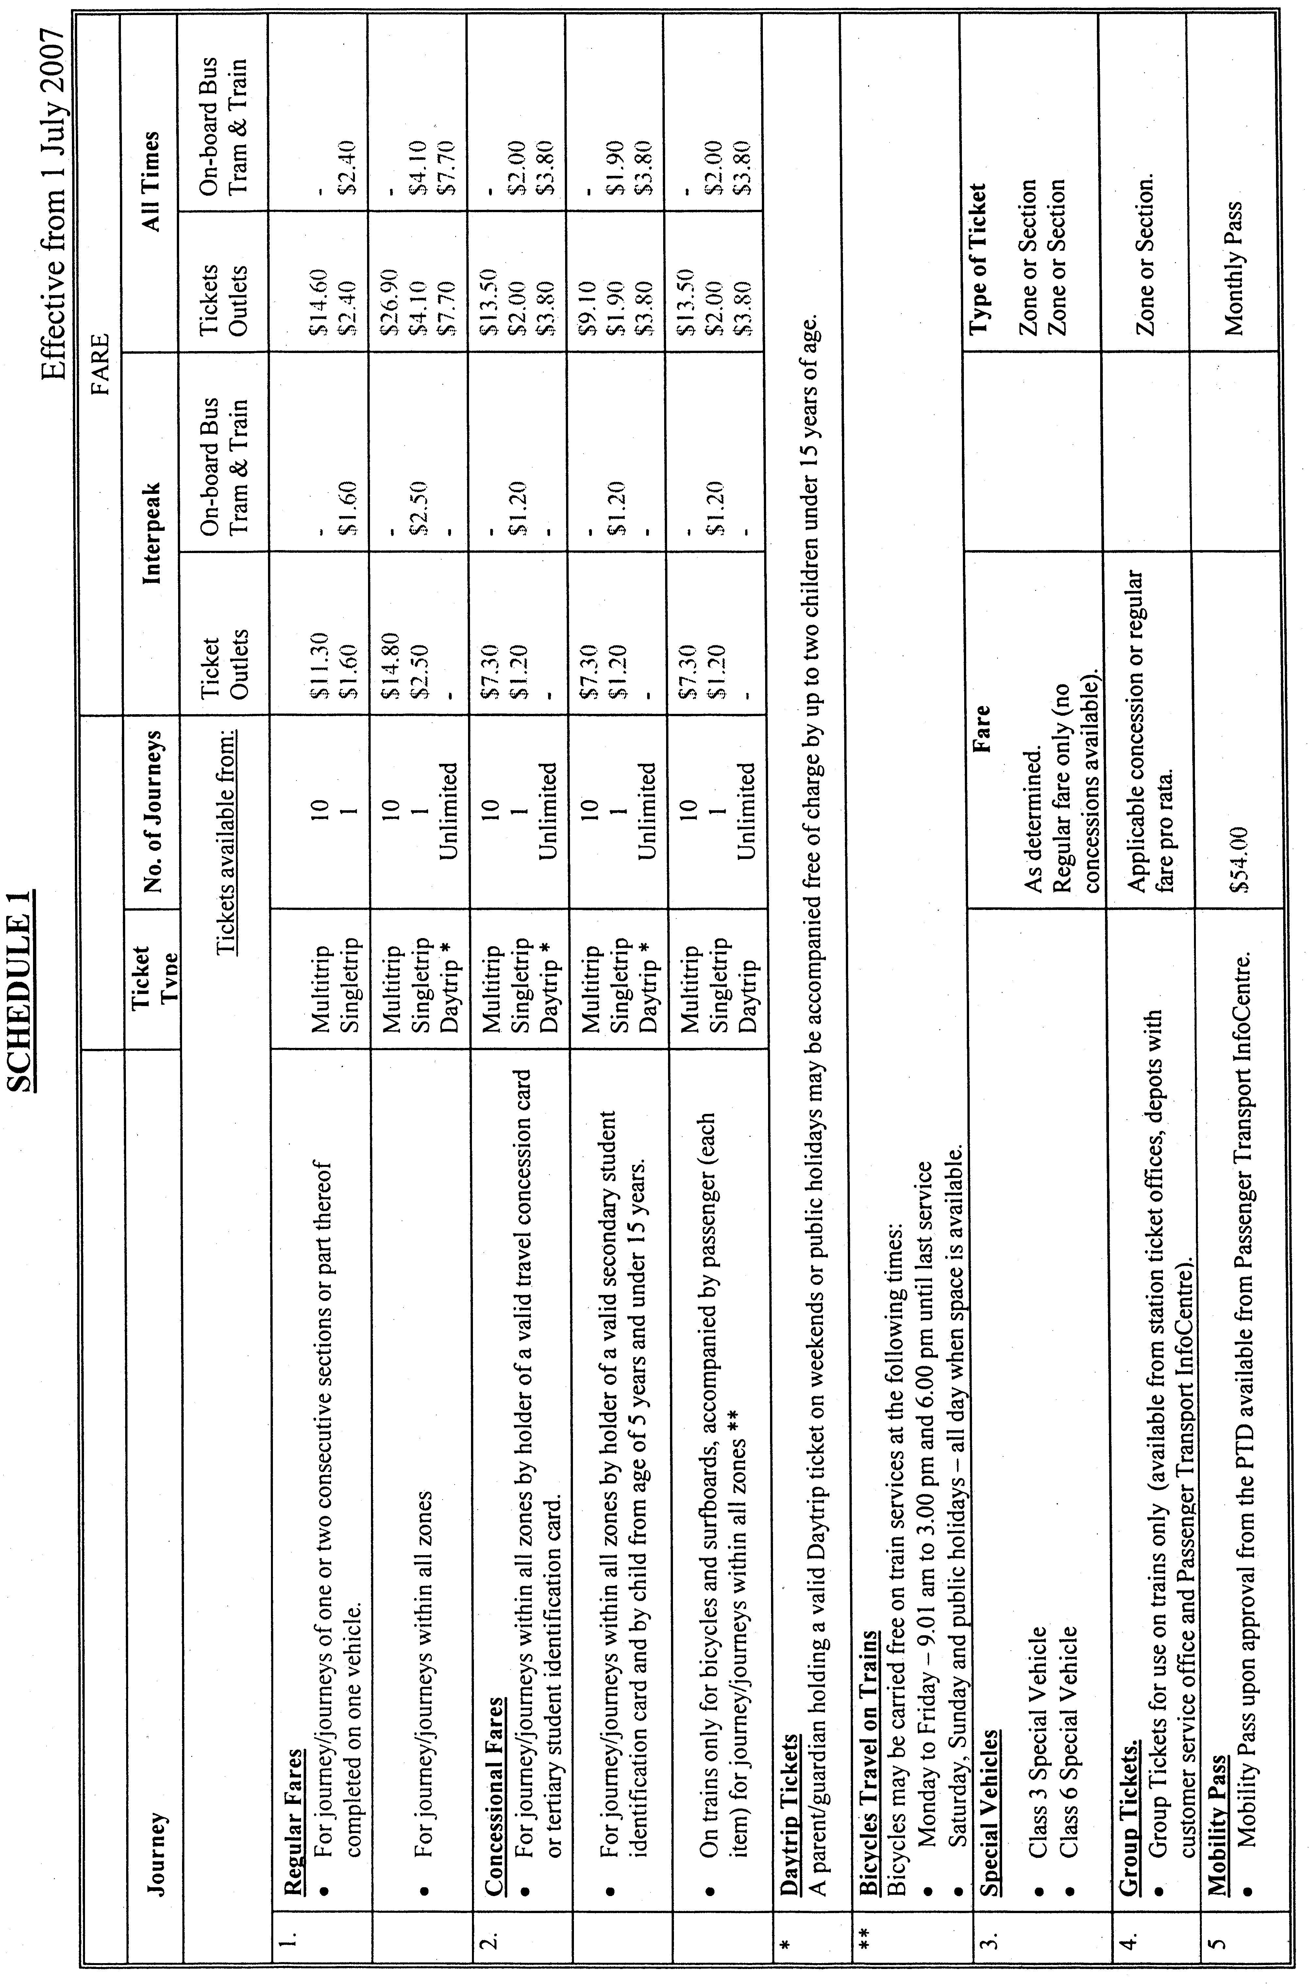
H. Webster, Executive Director, Public Transport Division, DTEI

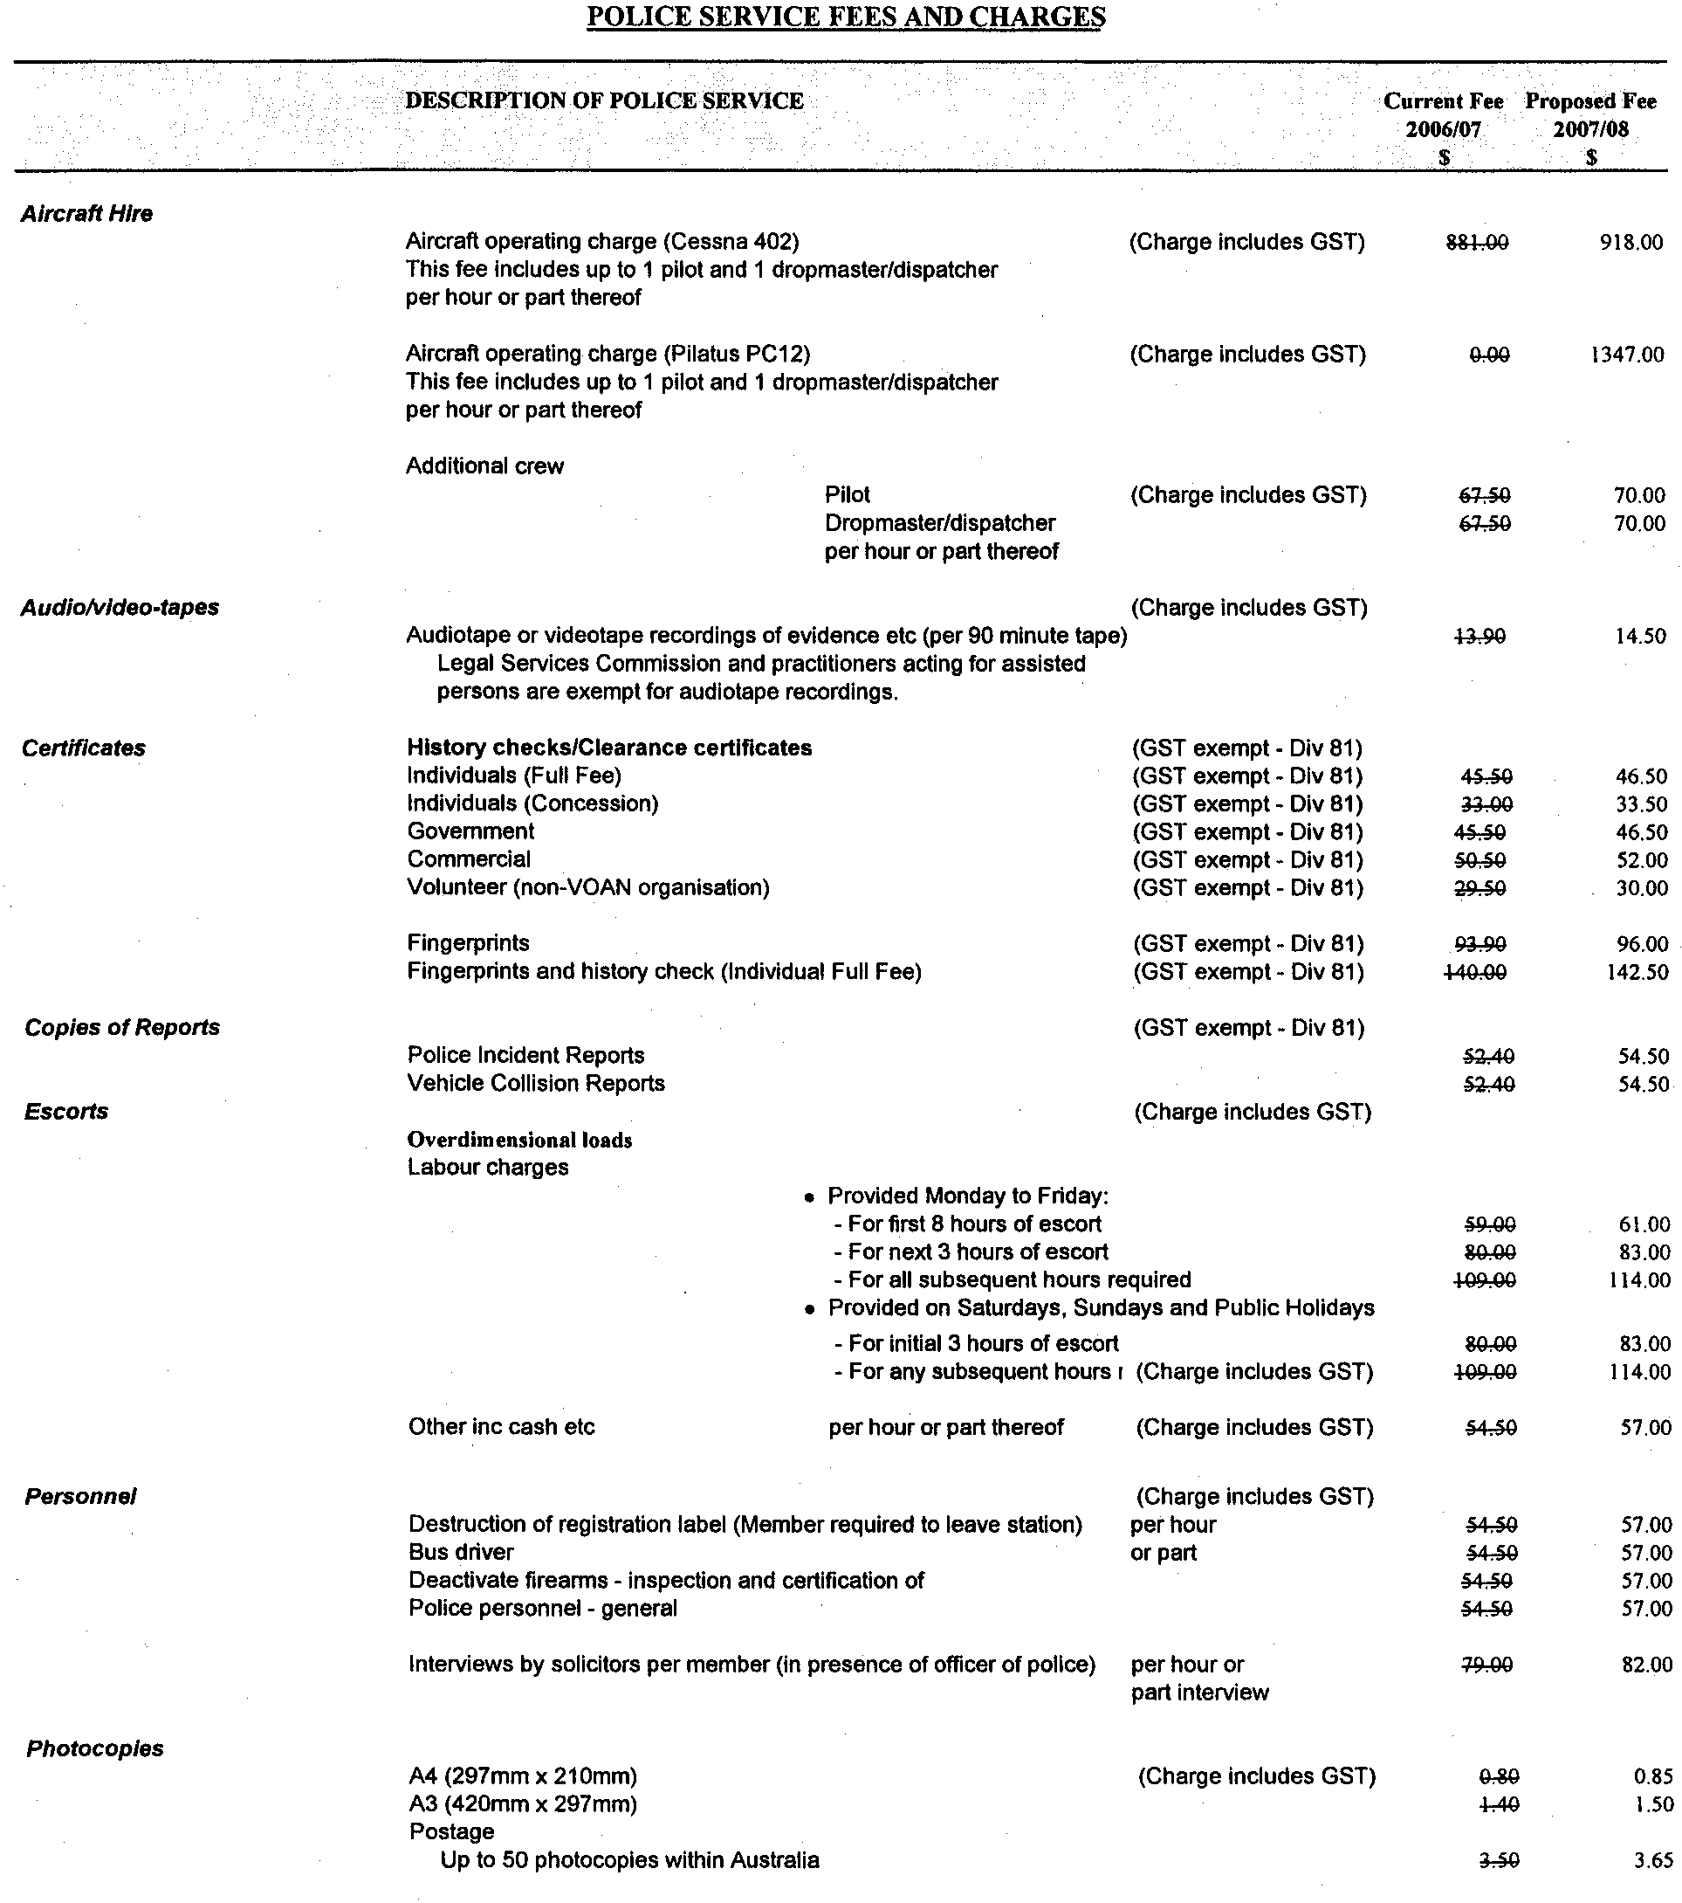
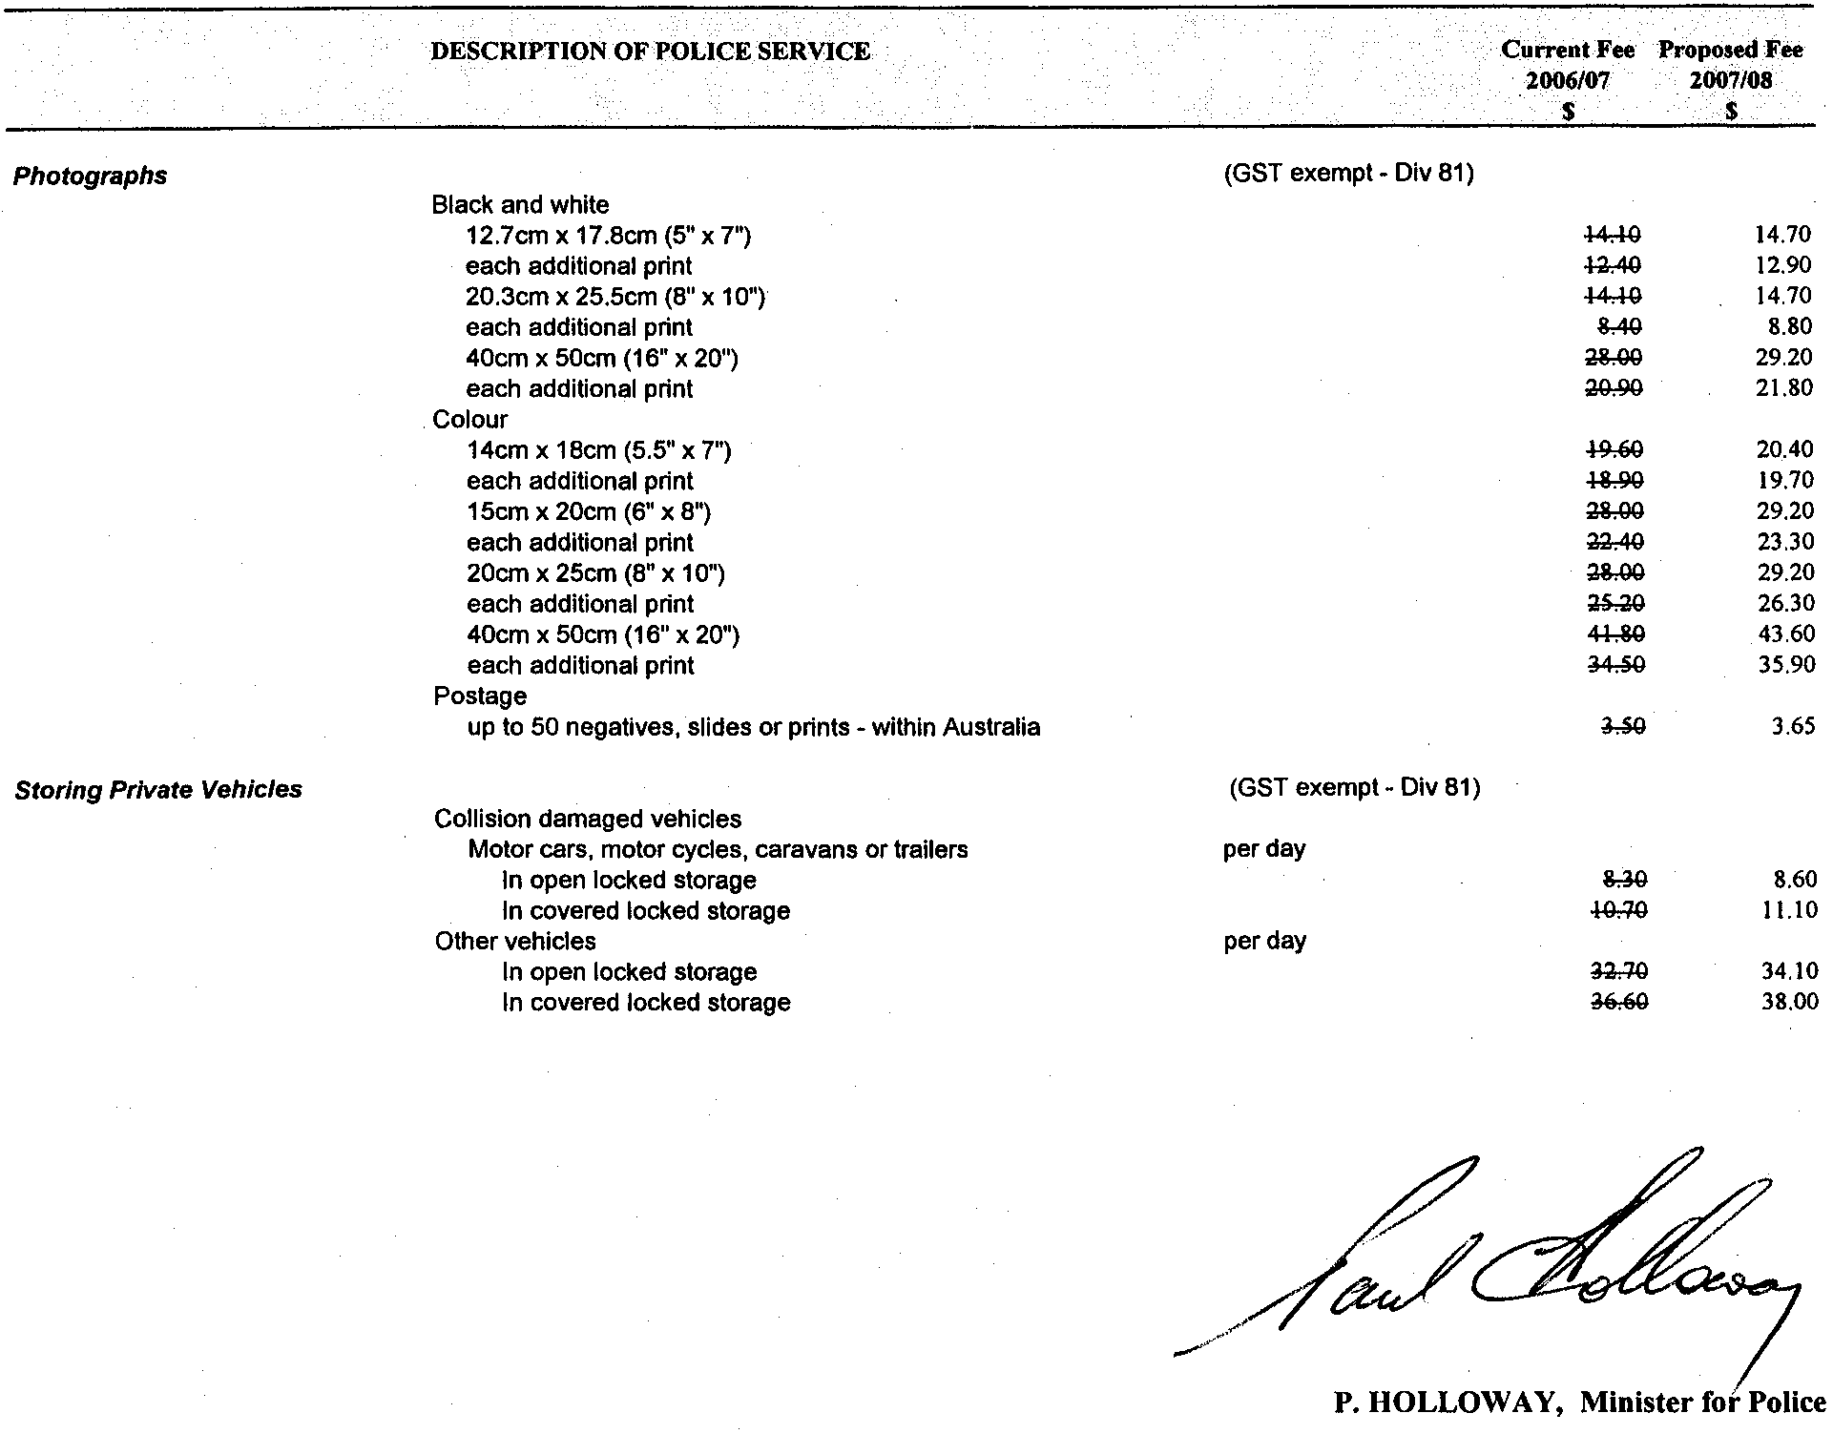

PROOF OF SUNRISE AND SUNSET ACT 1923—ALMANAC FOR JULY, AUGUST AND SEPTEMBER 2007
PURSUANT to the requirements of the Proof of Sunrise and Sunset Act 1923, I, Jim Hallion, Commissioner of Highways, at the direction of the Honourable the Minister for Transport, Energy and Infrastructure, publish in the Schedule hereto an almanac setting out the times of sunrise and sunset on every day for the three calendar months of July, August and September 2007.
Dated at Adelaide, 31 May 2007.
J. Hallion, Commissioner of Highways
97/03263

The Schedule
Times of sunrise and sunset during the months of July, August and September 2007 for Adelaide: latitude 34°56′S, longitude 138°36′E, GMT+9.50 hours (Daylight saving GMT + 10.50).
Month | July |  | August |  | September
Date | Sunrise  hr min | Sunset  hr min | Sunrise  hr min | Sunset  hr min | Sunrise  hr min | Sunset  hr min

1  2  3  4  5  6  7  8  9  10  11  12  13  14  15  16  17  18  19  20  21  22  23  24  25  26  27  28  29  30  31 | 07 24  07 24  07 24  07 24  07 24  07 24  07 23  07 23  07 23  07 23  07 22  07 22  07 22  07 21  07 21  07 21  07 20  07 20  07 19  07 19  07 18  07 17  07 17  07 16  07 16  07 15  07 14  07 13  07 13  07 12  07 11 | 17 14  17 15  17 15  17 16  17 16  17 17  17 17  17 18  17 18  17 19  17 19  17 20  17 20  17 21  17 22  17 22  17 23  17 23  17 24  17 25  17 25  17 26  17 27  17 28  17 28  17 29  17 30  17 30  17 31  17 32  17 32 | 07 10  07 09  07 09  07 08  07 07  07 06  07 05  07 04  07 03  07 02  07 01  07 00  06 59  06 58  06 57  06 55  06 54  06 53  06 52  06 51  06 50  06 48  06 47  06 46  06 45  06 43  06 42  06 41  06 39  06 38  06 37 | 17 33  17 34  17 35  17 35  17 36  17 37  17 38  17 38  17 39  17 40  17 41  17 41  17 42  17 43  17 44  17 44  17 45  17 46  17 46  17 47  17 48  17 49  17 49  17 50  17 51  17 52  17 52  17 53  17 54  17 54  17 55 | 06 35  06 34  06 33  06 31  06 30  06 29  06 27  06 26  06 24  06 23  06 22  06 20  06 19  06 17  06 16  06 14  06 13  06 12  06 10  06 09  06 07  06 06  06 04  06 03  06 02  06 00  05 59  05 57  05 56  05 54 | 17 56  17 57  17 57  17 58  17 59  17 59  18 00  18 01  18 02  18 02  18 03  18 04  18 05  18 05  18 06  18 07  18 07  18 08  18 09  18 10  18 10  18 11  18 12  18 13  18 13  18 14  18 15  18 15  18 16  18 17

*Note: Daylight saving time is subject to change.

RAIL SAFETY ACT 1996
Fees Payable by Accredited Railway Owners and Operators and Owners of Registered Private Railway Sidings
I, JAY WEATHERILL, the Acting Minister for Transport, pursuant to sections 21 and 22 of the said Act, do hereby fix the following fees.
Dated 14 May 2007.
Jay Weatherill, Acting Minister for Transport

Schedule of Fees
Effective 1 July 2007
Fees Payable by Accredited Railway Owners and Operators and Owners of Registered Private Railway Sidings
Application Fees
No fee payable.
Annual Fee—Commercial Railway Owners and Operators
An accredited person shall pay annual accreditation fees according to their accreditation category or categories.
A person accredited as both an owner and an operator shall pay an annual fee equal to the total of both the owner and operator annual fee. A person accredited as both a category 4 owner and a category 4 operator shall pay a maximum combined annual fee of $12 000.
For an accreditation granted during the financial year, the amount shall be payable at the time of accreditation and the fee shall be based on the estimated annual fee proportionally adjusted on a pro rata basis to reflect the actual number of weeks, or part thereof, that the accreditation will remain in force for the balance of the financial year.
For an accreditation that is granted for a portion of the financial year, the amount payable shall be based on the estimated annual fee proportionally adjusted on a pro rata basis to reflect the actual number of weeks, or part thereof, that the accreditation will remain in force. A minimum fee of $6 000 applies for an accreditation granted for a fixed period less than six months.
Commercial Rail Transport Operator Annual Fee
Accreditation  Category | Rail Owner  Annual Fee ($) | Rail Operator  Annual Fee ($)
1  2  3  4 (minimum fee) | 108 000  72 000  36 000  12 000 | 108 000  72 000  36 000  12 000
Annual Fee—Not-for-Profit Heritage/Tourist Owners and Operators
No fee payable.
Annual Fee—Owner of a Registered Private Siding
No fee payable.
Fee for Late Payment of Annual Fees
Where payment of fees is made after the due date, then payment must be accompanied by a late payment fee of 5% of the amount outstanding on the due date.
Railway Owner and Operator Accreditation Category Schedule
Historical information for the preceding financial year, where available, will be used for the purpose of determining the accreditation category. Where historical information is not available, a projected assessment will be used.
Track Managed  (Main Line Kilometres) | Accreditation  Category
Greater than 1 000  Greater than 500 up to 1 000  Greater than 50 up to 500  From 0 to 50  Owner of a passenger or freight terminal, marshalling yard or undertakes rail infrastructure construction or maintenance only. | 1  2  3  4  4
Rail Operator Criteria
Train Kilometres Operated  (Main Line Kilometres) | Accreditation  Category
Greater than 3 million per annum  Greater than 1 million up to 3 million  per annum  Greater than 50 000 up to 1 million per annum  Up to 50 000 per annum  Operators rollingstock only for the purpose of:  • construction, maintenance or commissioning of rollingstock;  • construction, maintenance or commissioning of track infrastructure using track maintenance machinery or road/  rail vehicles; or  • providing a hook-and-pull service to an accredited rollingstock operator. | 1  2  3  4  4
Note: Train kilometres operated by an Operator providing a hook-and-pull service are attributable to the principal Operator who is accredited to manage the train as a single operation.

ROADS (OPENING AND CLOSING) ACT 1991
Road Closure—Berkshire Street, Ely Street and
Gateshead Street, Athol Park
NOTICE is hereby given, pursuant to section 10 of the Roads (Opening and Closing) Act 1991, that the DEVELOPMENT ASSESSMENT COMMISSION proposes to make a Road Process Order to close and transfer to the South Australian Housing Trust portions of the public roads (Ely Street, Gateshead Street and Berkshire Street) generally adjoining allotments 9, 21 to 26, 44, 46, 47, 48, 61 to 64 and 76 in Deposited Plan 7469, allotments 76, 77, 78 in Deposited Plan 7468, allotment 12 in Deposited Plan 23016 and allotment 20 in Filed Plan 120939, more particularly delineated and lettered ‘A’, ‘B’, ‘C’ ‘D’ and ‘E’ in Preliminary Plan No. 07/0025.
A copy of the plan and a statement of persons affected are available for public inspection at the offices of the City of Charles Sturt, 72 Woodville Road, Woodville and the office of the Surveyor-General, 101 Grenfell Street, Adelaide during normal office hours.
Any application for easement or objection must set out the full name, address and details of the submission and must be fully supported by reasons.
The application for easement or objection must be made in writing to the Development Assessment Commission, 136 North Terrace, Adelaide, S.A. 5000 WITHIN 28 DAYS OF THIS NOTICE and a copy must be forwarded to the Surveyor-General, P.O. Box 1354, Adelaide, S.A. 5000. Where a submission is made, the Development Assessment Commission will give notification of a meeting at which the matter will be considered.
Commission Contact: Gabrielle McMahon on 8303 0734.
Dated 7 June 2007.
P. M. Kentish, Surveyor-General

ROADS (OPENING AND CLOSING) ACT 1991:
SECTION 24
NOTICE OF CONFIRMATION OF ROAD
PROCESS ORDER
Road Opening—Norfolk Road, Marion
BY Road Process Order made on 22 February 2007, The Corporation of the City of Marion ordered that:
Portion of allotment 4 in Filed Plan 105210 situate at the intersection of Finniss Street and Norfolk Road, more particularly delineated and numbered ‘1’ in Preliminary Plan No. 06/0096 be opened as road.
On 28 May 2007 that order was confirmed by the Minister for Infrastructure conditionally upon the deposit by the Registrar-General of Deposited Plan 74013 being the authority for the new boundaries.
Pursuant to section 24 (5) of the Roads (Opening and Closing) Act 1991, NOTICE of the order referred to above and its confirmation is hereby given.
Dated 7 June 2007.
P. M. Kentish, Surveyor-General

ROADS (OPENING AND CLOSING) ACT 1991:
SECTION 24
NOTICE OF CONFIRMATION OF ROAD
PROCESS ORDER
Road Closure—Menzies Street, Kingscote
BY Road Process Order made on 30 November 2006, the Kangaroo Island Council ordered that:
1. Portion of Menzies Street between Flinders Avenue and Troubridge Road and adjoining allotment 290 in Deposited Plan 6647, more particularly delineated and lettered ‘A’ in Preliminary Plan No. 06/0057 be closed.
2. The whole of the land subject to closure be transferred to Robert Peter Ellson in accordance with agreement for transfer dated 20 November 2006 entered into between the Kangaroo Island Council and R. P. Ellson.
3. The following easement be granted over portion of the land subject to that closure:
Grant to Distribution Lessor Corporation an easement for electricity supply purposes.
On 1 June 2007 that order was confirmed by the Minister for Infrastructure conditionally upon the deposit by the Registrar-General of Deposited Plan 73285 being the authority for the new boundaries.
Pursuant to section 24 (5) of the Roads (Opening and Closing) Act 1991, NOTICE of the order referred to above and its confirmation is hereby given.
Dated 7 June 2007.
P. M. Kentish, Surveyor-General

ROADS (OPENING AND CLOSING) ACT 1991:
SECTION 24
NOTICE OF CONFIRMATION OF ROAD
PROCESS ORDER
Road Opening and Closing—
Riverboat Drive, Cadell
BY Road Process Order made on 28 June 2006, The Mid Murray Council ordered that:
1. Portion of piece 3 in Deposited Plan 56807, more particularly delineated and numbered ‘10’ in Preliminary Plan No. 06/0015 be opened as road, forming a realignment of Riverboat Drive.
2. Portion of Riverboat Drive adjoining allotments 1 and 2 in Deposited Plan 26407, section 280 in Hundred of Cadell and piece 2 in Deposited Plan 56807, more particularly delineated and lettered ‘A’, ‘B’, ‘C’ and ‘D’ in Preliminary Plan No. 06/0015 be closed.
3. The whole of the land subject to closure lettered ‘A’ be transferred to Nashly Pty. Ltd. in accordance with agreement for transfer dated 31 March 2006 entered into between The Mid Murray Council and Gordon Kennedy Sutherland.
4. The whole of the land subject to closure lettered ‘B’ be transferred to Ronald Wilson and Carmen Elly Wilson in accordance with agreement for transfer dated 20 March 2006 entered into between The Mid Murray Council and Wayne Eric Fisher and Dawn Emily Gemmell.
5. The whole of the land subject to closure lettered ‘C’ be transferred to Harold Gordon Winter in accordance with agreement for transfer dated 3 March 2006 entered into between The Mid Murray Council and H. G. Winter.
6. The whole of the land subject to closure lettered ‘D’ be transferred to Nashly Pty. Ltd. in accordance with agreement for exchange dated 15 March 2006 entered into between The Mid Murray Council and Nashly Pty. Ltd.
On 19 March 2007 that order was confirmed by the Minister for Infrastructure conditionally upon the deposit by the Registrar-General of Deposited Plan 72644 being the authority for the new boundaries.
Pursuant to section 24 (5) of the Roads (Opening and Closing) Act 1991, NOTICE of the order referred to above and its confirmation is hereby given.
Dated 7 June 2007.
P. M. Kentish, Surveyor-General

ROADS (OPENING AND CLOSING) ACT 1991:
SECTION 24
NOTICE OF CONFIRMATION OF ROAD
PROCESS ORDER
Road Opening—
Belfree Drive and George Street, Green Fields
BY Road Process Order made on 27 November 2006, the City of Salisbury ordered that:
Portion of allotments 41 and 42 in Deposited Plan 37272 situate at the south-western end of Belfree Drive and George Street, more particularly delineated and numbered ‘10’ and ‘11’ in Preliminary Plan No. 06/0045 be opened as road.
On 28 May 2007 that order was confirmed by the Minister for Infrastructure conditionally upon the deposit by the Registrar-General of Deposited Plan 73855 being the authority for the new boundaries.
Pursuant to section 24 (5) of the Roads (Opening and Closing) Act 1991, NOTICE of the order referred to above and its confirmation is hereby given.
Dated 7 June 2007.
P. M. Kentish, Surveyor-General

SURVEY ACT 1992
Revocation of Confused Boundary Area
PURSUANT to section 50 (3) of the Survey Act 1992, notice is given that the Confused Boundary Area east of the intersection of Flinders Drive and Ransford Street in the area of Cape Jervis, namely allotments 37 to 48 in Deposited Plan 4816 and allotments 177 to 178 in Deposited Plan 7528 is revoked.
Dated 7 June 2007.
P. M. Kentish, Surveyor-General
Ref.: Filed Plan 45942

RULES OF COURT
District Court (Criminal and Miscellaneous)
Rules 1992, Amendment No. 3
BY virtue and in pursuance of section 51 of the District Court Act 1991 and all other enabling powers, We, Terence Anthony Worthington, Chief Judge, Andrea Simpson and Dean Ernest Clayton, Judges of the District Court of South Australia, do hereby make the following Rules of Court:
1. These Rules may be cited as the District Court (Criminal and Miscellaneous) Rules 1992, Amendment No. 3.
2. The District Court (Criminal and Miscellaneous) Rules 1992, as amended by these Rules may be cited as the District Court (Criminal and Miscellaneous) Rules 1992.
3. This Amendment No. 3 to come into effect on and from the later of 1 July 2007 or the date of its gazettal.
4. In each of subrules IV-7.03, IV-7.14 and IV-14.03, the word ‘leave’ is deleted and the word ‘permission’ is inserted in its place.
5. In each of subrules IV-10.02 (b) and IV-10.02 (d), the words ‘the Clerk of Arraigns’ are deleted and the words ‘a person directed by the Judge’ inserted in their place.
6. After Rule IV-25.02 insert the following heading and new Rule IV-26:
‘APPEALS UNDER SECTION 57 OF THE CHILD SEX OFFENDERS REGISTRATION ACT 2006’.
IV-26 An Appeal to the Court pursuant to section 57 of the Child Sex Offenders Registration Act 2006 is to be governed by Rules VI-1 to VI-9 hereof.
Dated 30 May 2007.
T. A. Worthington, Chief Judge
A. Simpson, Judge
D. E. Clayton, Judge

FAXING COPY?
IF you fax copy to Government Publishing SA for inclusion in the Government Gazette, there is no need to send a Confirmation Copy to us as well.
This creates confusion and may well result in your notice being printed twice.
Please use the following fax number:
Fax transmission: (08) 8207 1040
Phone Inquiries: (08) 8207 1045
Please include a contact person, phone number and order number so that we can phone back with any queries we may have regarding the fax copy.
NOTE: Closing time for lodging new copy (fax, hard copy or email) is 4 p.m. on Tuesday preceding the day of publication.

Government Gazette notices can be E-mailed.
The address is:
governmentgazette@dpc.sa.gov.au
Documents should be sent as attachments in Word format.
When sending a document via E-mail, please confirm your transmission with a faxed copy of your document, including the date the notice is to be published.
Fax transmission: (08) 8207 1040
Enquiries: (08) 8207 1045
NOTE: Closing time for lodging new copy (fax, hard copy or email) is 4 p.m. on Tuesday preceding the day of publication.

ADELAIDE CITY COUNCIL
Moonta Street—Exclusion of Vehicles
NOTICE is hereby given that pursuant to section 359 (1) of the Local Government Act 1934, as amended, all vehicles other than those so named in Column 3 below shall be excluded from the road so named in Column 1 as described in Column 2.
Column 1  Street |  | Column 2  Location |  | Column 3  Class of Vehicles Exempt
Moonta Street |  | From the southern building alignment of Grote Street to a point 38.6 m south of the southern building alignment of Grote Street. |  | Any vehicle owned or operated by or on behalf of the Adelaide City Council for the purposes of street cleaning and maintenance, emergency vehicles and vehicles associated with special events.
Further information can be obtained from John Hanchett, Asset Management, telephone 8203 7433 or email j.hanchett@adelaidecitycouncil.com.
S. Moseley, Chief Executive Officer

CITY OF ONKAPARINGA
Roads (Opening and Closing) Act 1991
Portion of Shearer Drive, Seaford
NOTICE is hereby given that the City of Onkaparinga proposes to make a Road Process Order in accordance with section 10 of the Roads (Opening and Closing) Act 1991, to close an irregularly-shaped portion of road in the Hundred of Noarlunga, being portion of Shearer Drive, Seaford, generally situate adjoining the south-eastern boundary of allotment 12 in Deposited Plan 69768 and the north-eastern boundaries of allotment 13 in Deposited Plan 69768 and marked ‘A’ and ‘B’ on Preliminary Plan No. 07/0037.
It is proposed that the road to be closed marked ‘A’ be transferred to D. M. Knuckey and T. B. Lambert and merged with said allotment 12 in Deposited Plan 69768 and the closed road marked ‘B’ be transferred to T. B. Lambert and merged with said allotment 13 in Deposited Plan 69768.
A preliminary plan of the proposal and a statement, are available for public inspection at the Onkaparinga Council Office, Ramsay Place, Noarlunga Centre, between the hours of 9 a.m. and 5 p.m., Monday to Friday or at the Adelaide office of the Survey-General, during normal office hours.
Any person may object to the proposal (and any adjoining landowner or other person substantially affected by the proposed road closure may apply for an easement relative to the closure). Such objection (or application for an easement) must be made in writing to the City of Onkaparinga within 28 days of the date of this notice. If a submission is made, the City of Onkaparinga is required to give notice of the time and place at which a meeting will be held to consider the matter, so that the person making the submission (or a representative) may attend to support the submission, if desired.
Any submission must set out the full name and address of the person making the submission and must be fully supported by reasons (and any application for the grant of an easement must give full particulars of the nature and location of the easement and where made by a person as the owner of adjoining or nearby land, specify the land to which the easement is to be annexed). A copy of the submission must be forwarded to the Surveyor-General at Adelaide.
Dated 7 June 2007.
J. S. Tate, Chief Executive Officer

CITY OF WEST TORRENS
Change of Road Name
NOTICE is hereby given that in accordance with section 219 of the Local Government Act 1999, the City of West Torrens at its meeting held on 7 March 2006, resolved to change the name of East Terrace, Thebarton, to James Congdon Drive, to be effective from 1 July 2007.
Following the change of name, James Congdon Drive will extend from the intersection of Port Road and George Street, Thebarton to South Road at Mile End South.
T. Starr, Chief Executive Officer

CITY OF WHYALLA
Adoption of Valuations
NOTICE is hereby given that the Corporation of the City of Whyalla at its meeting held on 21 May 2007, in accordance with section 167 of the Local Government Act 1999, adopted the Valuer-General’s valuation of site value for rateable properties in the amount of $358 558 020 and hereby specifies that 1 July 2007, shall be the day as and from which such assessment shall become the assessment of the Council for the year ending 30 June 2008.
The said valuations are included in the Assessment Book, which is held in the office of the Council at Darling Terrace and may be inspected by any interested persons between the hours of 9 a.m. and 5 p.m., Monday to Friday.
P. Cameron, Chief Executive Officer

DISTRICT COUNCIL OF COOBER PEDY
Roads (Opening and Closing) Act 1991
Road Closure—Van Brugge Street, Coober Pedy
NOTICE is hereby given, pursuant to section 10 of the Roads (Opening and Closing) Act 1991, that the District Council of Coober Pedy proposes to make a Road Process Order to close and merge with the adjoining Allotment 825 in the Town of Coober Pedy portion of the public road (Van Brugge Street) more particularly delineated and lettered ‘A’ in Preliminary Plan No. 07/0035.
A copy of the plan and a statement of persons affected are available for public inspection at the offices of the Council, Hutchison Street, Coober Pedy, S.A. 5723 and at the Adelaide office of the Surveyor-General during normal working hours.
Any application for easement or objection must set out the full name, address and details of the submission and must be fully supported by reasons.
The application for easement or objection must be made in writing to the Council, P.O. Box 425, Coober Pedy, S.A. 5723 within 28 days of this notice and a copy must be forwarded to the Surveyor-General, G.P.O. Box 1354, Adelaide, S.A. 5001. Where a submission is made, the Council will give notification of a meeting at which time the matter will be considered.
Dated 16 May 2007.
T. McLeod, Chief Executive Officer

DISTRICT COUNCIL OF MOUNT BARKER
Road Names
NOTICE is hereby given that pursuant to section 219 of the Local Government Act 1999, Council has resolved to rename and assign road names within the District Council of Mount Barker to the following un-named government road:
• That the road name Nolan Road be assigned to a previously unknown public road at Harrogate, the road runs in a west/east direction starting at Snake Gully Road, to intersect a still un-named Council’s road reserve. All relevant Government Agencies and Emergency Services are being notified as are the residents affected by these changes.
Should anyone need further clarification of these names changes, please contact Customer Services on 8391 7200 or in person at the Local Government Centre, 23 Mann Street, Mount Barker.
A. Stuart, Chief Executive Officer

IN the matter of the estates of the undermentioned deceased persons:
Adkins, John William, late of 10 Perkins Street, Whyalla Stuart, retired storeman, who died on 26 December 2006.
Aesche, Claudia Clara, late of 20 Masters Street, Riverton, of no occupation, who died on 2 April 2007.
Aitken, Bronte, late of 59-67 Joyce Street, Murray Bridge, retired marine steward, who died on 7 March 2007.
Bowen, Keith, late of 14 Levistone Street, Seaton, retired insurance broker, who died on 28 February 2007.
Creighton, Erna Lenore, late of 9 Winston Crescent, West Beach, home duties, who died on 28 December 2006.
Fowler, Thurza Winifred, late of 324 Military Road, Semaphore Park, of no occupation, who died on 5 January 2007.
Goodall, Rita, late of 44 Hastings Street, Glenelg South, home duties, who died on 8 March 2007.
Grounsell, George, late of 29 Austral Terrace, Morphettville, retired electrical inspector, who died on 9 April 2007.
Hamilton, Muriel Mary Wallace, late of 9 Brenchley Grove, Kingswood, of no occupation, who died on 29 April 2007.
Johns, Phillis, late of 84 Reservoir Road, Modbury, of no occupation, who died on 1 April 2007.
Loechel, Glenda Noreen, late of 3 Brian Grove, Paradise, retired public servant, who died on 29 December 2006.
Sheridan, John James Daniel, late of 39 Victoria Street, Henley Beach, retired regional manager, who died on 20 February 2007.
Stevens, Doreen Laura Merle, late of 20 Brentwood Road, Flinders Park, of no occupation, who died on 10 March 2007.
Trowse, Beryl Doris, late of 177 Longwood Road, Heathfield, of no occupation, who died on 2 March 2007.
Walden, Mervyn Robert, late of 61 Kym Street, Port Noarlunga South, retired linesman, who died on 19 January 2007.
Young, Lancelot Francis, late of 4 Bungana Avenue, Para Vista, retired accountant, who died on 24 March 2007.
Notice is hereby given pursuant to the Trustee Act 1936, as amended, the Inheritance (Family Provision) Act 1972, and the Family Relationships Act 1975, that all creditors, beneficiaries, and other persons having claims against the said estates are required to send, in writing, to the Public Trustee, 25 Franklin Street, Adelaide, S.A. 5000, full particulars and proof of such claims, on or before 6 July 2007, otherwise they will be excluded from the distribution of the said estate; and notice is also hereby given that all persons who are indebted to the said estates are required to pay the amount of their debts to the Public Trustee or proceedings will be taken for the recovery thereof; and all persons having any property belonging to the said estates are forthwith to deliver the same to the Public Trustee.
Dated 7 June 2007.
C. J. O’Loughlin, Public Trustee

ATTENTION

CUSTOMERS requiring a proof of their notice for inclusion in the Government Gazette, please note that the onus is on you to inform Government Publishing SA of any subsequent corrections by 10 a.m. on Thursday, which is our publication deadline.

For any corrections to your notice please phone 8207 1045 or Fax 8207 1040 before 10 a.m. on Thursday.

If we do not receive any communication by 10 a.m. on Thursday (day of publication) we will presume the notice is correct and will print it as it is.

Remember—the onus is on you to inform us of any corrections necessary to your notice.

NOTE: Closing time for lodging new copy (electronically, fax or hard copy) is 4 p.m. on Tuesday preceding the day of publication. Phone 8207 1045—Fax 8207 1040.
Email: governmentgazette@dpc.sa.gov.au

Printed and published by authority every Thursday by T. GOODES, Government Printer, South Australia
Price: $5.20, plus postage; to subscribers, $263.00 per annum.
(The above prices are inclusive of GST)

