No. 36 2583

THE SOUTH AUSTRALIAN

GOVERNMENT GAZETTE
www.governmentgazette.sa.gov.au

PUBLISHED BY AUTHORITY

ALL PUBLIC ACTS appearing in this GAZETTE are to be considered official, and obeyed as such

ADELAIDE, THURSDAY, 14 JUNE 2007

CONTENTS

Page
Acts Assented To 2584
Appointments, Resignations, Etc. 2584
Corporations and District Councils—Notices 2626
Crown Lands Act 1929—Notice 2586
Defamation Act 2005—Notice 2586
Education Act 1972—Notice 2594
Electricity Act 1996—Notice 2587
Fisheries Act 1982—Notices 2594
Geographical Names Act 1991—Notices 2595
Land and Business (Sale and Conveyancing) Act 1994—
Notices 2595
Liquor Licensing Act 1997—Notices 2596
Mining Act 1971—Notices 2600
National Parks and Wildlife (National Parks)
Regulations 2001—Notices 2601
Natural Resources Management Act 2004—Notices 2585
Origin Energy Retail Limited—Notice 2606
Passenger Transport Act 1994—Notice 2602

Page
Petroleum Act 2000—Notices 2602
Public Trustee Office—Administration of Estates 2627
REGULATIONS
Barley Exporting Act 2007 (No. 167 of 2007) 2614
South Australian Health Commission Act 1976
(No. 168 of 2007) 2616
Natural Resources Management Act 2004—
(No. 169 of 2007) 2619
(No. 170 of 2007) 2621
Upper South East Dryland Salinity and Flood
Management Act 2002 (No. 171 of 2007) 2623
RULES OF COURT
Supreme Court Criminal Rules 1992
(Amendment No. 21) 2608
South Australia Fire and Emergency Services Act 2005—
Notices 2611
Water Mains and Sewers—Mains Laid, Replaced, Etc. 2611
Waterworks Act 1932—Notices 2612

GOVERNMENT GAZETTE NOTICES
ALL poundkeepers’ and private advertisements forwarded for publication in the South Australian Government Gazette must be PAID FOR PRIOR TO INSERTION; and all notices, from whatever source, should be legibly written on one side of the paper only and sent to Government Publishing SA so as to be received no later
than 4 p.m. on the Tuesday preceding the day of publication. Phone 8207 1045 or Fax 8207 1040. E-mail: governmentgazette@dpc.sa.gov.au. Send as attachments in Word format and please confirm your transmission with a faxed copy of your document, including the date the notice is to be published and to whom the notice will be charged. The Government Gazette is available online at: www.governmentgazette.sa.gov.au

Department of the Premier and Cabinet
Adelaide, 14 June 2007
HER Excellency the Governor directs it to be notified for general information that she has in the name and on behalf of Her Majesty The Queen, this day assented to the undermentioned Acts passed by the Legislative Council and House of Assembly in Parliament assembled, viz.:
No. 19 of 2007—Residential Parks Act 2007. An Act to regulate the relationship between residents in residential parks and park owners; to make consequential amendments to the Residential Tenancies Act 1995; and for other purposes.
No. 20 of 2007—Statutes Amendment (Affordable Housing) Act 2007. An Act to amend the South Australian Housing Trust Act 1995, the South Australian Co-operative and Community Housing Act 1991, the Housing and Urban Development (Administrative Arrangements) Act 1995, the Residential Tenancies Act 1995, the Housing Improvement Act 1940 and the Development Act 1993.
By command,
Gail Gago, for Premier
DPC06/0875

Department of the Premier and Cabinet
Adelaide, 14 June 2007
HER Excellency the Governor in Executive Council has been pleased to appoint the undermentioned to the Teachers Appeal Board, pursuant to the provisions of the Education Act 1972:
Section 45 (2) (b) Panel Member: (from 1 July 2007 until 31 January 2010)
Karen Gayle Cornelius
Janine Nicola Harvey
Anne Louise Millard
Marie O’Toole
Jennifer Dawn Stehn
Patricia Margaret Winter
Section 45 (2) (c) Panel Member: (from 1 July 2007 until 31 January 2010)
David Mordechai Baltmann
Geoffrey Dean Bailey
Gail Patricia Brunger
Penny Annette Cavanagh
Peter Michael Cavouras
Margaret Davidson
Janice Maree Lee
Kevin Charles Lowe
Peter Christopher Ryan
Section 45 (2) (e) Panel Member: (from 1 July 2007 until 31 January 2010)
Sean James Boyle
Iain Peter Clark
Diane Pamela Cocks
Loene Margaret Furler
Donald Peter
Matthew James Stanton
Teresa Ann Watts
By command,
Gail Gago, for Premier
MECS07/001
TAKE notice that on 1 February 2007, Her Excellency the Governor in Executive Council appointed the undermentioned to the Teachers Appeal Board, pursuant to the provisions of the Education Act 1972:
Section 45 (2) (b) Panel Member: (from 1 February 2007 until 31 January 2010)
Naomi Veronica Arnold
John Binks-Williams
Dalest Wendy Bruce
Antonietta Orlando Cocchiaro
David Craig
Judith Christine Day
Kenneth Edward Francou
Janet Harris
Michael Henry Hudson
Colin James McGavisk
Rodney Nancarrow
Gregory Petherick
Trevor John Radloff
Terry Louise Sizer
Ruth Blenkiron
Richard Sam Paul Costi
Alastair Baird Dow
Alan Green
Julian John Lugg
Tanya Rogers
Mark Stewart Williams
Section 45 (2) (d) Panel Member: (from 1 February 2007 until 31 January 2010)
Gillian Isabel Brown
George Karapas
Sharon Kelly
Suzanne King
Joe Cappella

Department of the Premier and Cabinet
Adelaide, 14 June 2007
HER Excellency the Governor in Executive Council has been pleased to appoint the undermentioned to the HomeStart Finance Board of Management, pursuant to the provisions of the Housing and Urban Development (Administrative Arrangements) Act 1995 and the Housing and Urban Development (Administrative Arrangements) (HomeStart Finance) Regulations 1995:
Member: (from 14 June 2007 until 13 June 2010)
Sandra De Poi
Estelle Bowman
By command,
Gail Gago, for Premier
MFC/CS/07/020

Department of the Premier and Cabinet
Adelaide, 14 June 2007
HER Excellency the Governor in Executive Council has been pleased to appoint the undermentioned to the Supported Residential Facilities Advisory Committee, pursuant to the provisions of the Supported Residential Facilities Act 1992:
Deputy Member: (from 14 June 2007 until 28 June 2008)
Kevin Duke (Deputy to Moorman)
By command,
Gail Gago, for Premier
MFC/CS/07/021

Department of the Premier and Cabinet
Adelaide, 14 June 2007
HER Excellency the Governor in Executive Council has been pleased to appoint the Honourable Michael John Wright, MP, Minister for Industrial Relations, Minister for Finance, Minister for Government Enterprises and Minister for Recreation, Sport and Racing to be also Acting Minister for Emergency Services, Acting Minister for Correctional Services, Acting Minister for Road Safety and Acting Minister Assisting the Minister for Multicultural Affairs, for the period from 23 June 2007 to 29 June 2007 inclusive during the absence of the Honourable Carmel Zollo, MLC.
By command,
Gail Gago, for Premier
MES07/005

Department of the Premier and Cabinet
Adelaide, 14 June 2007
HER Excellency the Governor in Executive Council has accepted the resignation of Eugene Biganovsky from the Office of Ombudsman, with effect from 22 June 2007.
By command,
Gail Gago, for Premier
AGO0058/07CSTEMP1

Department of the Premier and Cabinet
Adelaide, 14 June 2007
HER Excellency the Governor in Executive Council has been pleased to appoint Suzanne Carman to act in the office of Ombudsman for the period from 23 June 2007 to 21 September 2007 or until a person is appointed to be the Ombudsman, whichever is sooner, pursuant to section 8 of the Ombudsman Act 1972.
By command,
Gail Gago, for Premier
AGO0058/07CSTEMP1

Department of the Premier and Cabinet
Adelaide, 14 June 2007
HER Excellency the Governor in Executive Council has extended the time allowed for the completion of the inquiry under the Commission of Inquiry (Children in State Care) Act 2004 until 31 December 2007, pursuant to the Commission of Inquiry (Children in State Care) Act 2004.
By command,
Gail Gago, for Premier
MFC/CS/05/0011

NATURAL RESOURCES MANAGEMENT ACT 2004
Notice of Contributions in 2007-2008 by Constituent Councils in the Adelaide and Mount Lofty Ranges Natural Resources Management Region
PURSUANT to section 92 of the Natural Resources Management Act 2004, I, Gail Gago, Minister for Environment and Conservation, have determined the shares of councils pursuant to subsection 92 (4) and having submitted them to the Governor pursuant to subsection 92 (6) and the Governor having approved those shares on 14 June 2007 hereby advise, pursuant to subsection 92 (7) that the shares of the constituent councils of the Adelaide and Mount Lofty Ranges Natural Resources Manage-ment Region will be as follows:
Constituent Councils Amount
$
Adelaide City Council 569 989
Adelaide Hills Council 742 665
Alexandrina Council 8 210
Barossa Council 242 525
City of Burnside 666 374
Campbelltown City Council 441 755
City of Charles Sturt 1 161 839
Town of Gawler 192 494
Holdfast Bay City Council 442 332
Light Regional Council 116 156
District Council of Mallala 53 210
Corporation of the City of Marion 762 221
City of Mitcham 569 294
District Council of Mount Barker 91 795
City of Norwood, Payneham and St Peters 490 071
City of Onkaparinga 1 881 773
City of Playford 503 453
City of Port Adelaide Enfield 1 039 785
City of Prospect 238 946
City of Salisbury 918 997
City of Tea Tree Gully 865 824
Constituent Councils Amount
$
Corporation of the City of Unley 447 484
City of Victor Harbor 36 522
Corporation of the Town of Walkerville 126 469
City of West Torrens 516 849
District Council of Yankalilla 53 482
Total $13 180 514
Dated 14 June 2007.
Gail Gago, Minister for Environment and Conservation

NATURAL RESOURCES MANAGEMENT ACT 2004
Notice of Contributions in 2007-2008 by Constituent Councils in the South Australian Murray-Darling Basin Natural Resources Management Region
PURSUANT to section 92 of the Natural Resources Management Act 2004, I, Gail Gago, Minister for Environment and Conservation, have determined the shares of councils pursuant to subsection 92 (4) and having submitted them to the Governor pursuant to subsection 92 (6) and the Governor having approved those shares on 14 June 2007 hereby advise, pursuant to subsection 92 (7) that the shares of the constituent councils of the South Australian Murray-Darling Basin Natural Resources Management Region will be as follows:
Constituent Councils Amount
$
Adelaide Hills Council 1 107
Alexandrina Council 209 902
Barossa Council 11 415
Berri Barmera Council 63 696
Coorong District Council 35 758
Goyder Regional Council 27 147
District Council of Karoonda East Murray 10 563
District Council of Loxton Waikerie 80 838
Mid Murray Council 91 055
District Council of Mount Barker 165 524
Rural City of Murray Bridge 108 323
Northern Areas Council 472
City of Onkaparinga 578
District Council of Peterborough 659
Renmark Paringa Council 64 725
Southern Mallee District Council 19 646
City of Victor Harbor 592
Total $892 000
Dated 14 June 2007.
Gail Gago, Minister for Environment and Conservation

NATURAL RESOURCES MANAGEMENT ACT 2004
Notice of Contributions in 2007-2008 by Constituent Councils in the South East Natural Resources Management Region
PURSUANT to section 92 of the Natural Resources Management Act 2004, I, Gail Gago, Minister for Environment and Conservation, have determined the shares of councils pursuant to subsection 92 (4) and having submitted them to the Governor pursuant to subsection 92 (6) and the Governor having approved those shares on 14 June 2007 hereby advise, pursuant to subsection 92 (7) that the shares of the constituent councils of the South East Natural Resources Management Region will be as follows:
Constituent Councils Amount
$
Coorong District Council 29 425
District Council of Grant 149 185
District Council of Kingston 66 879
City of Mount Gambier 429 336
Naracoorte Lucindale Council 155 085
District Council of Robe 58 990

Constituent Councils Amount
$
District Council of Southern Mallee 454
District Council of Tatiara 126 672
Wattle Range Council 239 974
Total $1 256 000
Dated 14 June 2007.
Gail Gago, Minister for Environment and Conservation

NATURAL RESOURCES MANAGEMENT ACT 2004
Notice of Contribution in 2007-2008 by the Constituent Council in the Kangaroo Island Natural Resources Management Region
PURSUANT to section 92 of the Natural Resources Management Act 2004, I, Gail Gago, Minister for Environment and Conservation, have determined the share of Kangaroo Island
Council pursuant to subsection 92 (4) and having submitted it to the Governor pursuant to subsection 92 (6) and the Governor having approved that share on 14 June 2007 hereby advise, pursuant to subsection 92 (7) that the share for 2007-2008 of Kangaroo Island Council, as sole constituent council will be as follows:
Constituent Council Amount
$
Kangaroo Island Council 110 225
Total $110 225
Dated 14 June 2007.
Gail Gago, Minister for Environment and Conservation

CROWN LANDS ACT 1929: SECTION 5
TAKE NOTICE that pursuant to the Crown Lands Act 1929, I, GAIL GAGO, Minister for Environment and Conservation, Minister of the Crown to whom the administration of the Crown Lands Act 1929 is committed DO HEREBY dedicate the Crown Land defined in The Schedule as Public Road.
The Schedule
1. Allotment 100 of Deposited Plan 74077, Berri Irrigation Area, County of Hamley, Allotment 101 of Deposited Plan 74105, Cobdogla Irrigation Area, Nookamka Division, County of Hamley, Section 997, Hundred of Loveday, Cobdogla Irrigation Area, Loveday Division, County of Hamley and Allotment 101 of Deposited Plan 74299, Cobdogla Irrigation Area, Nookamka Division, County of Hamley, being within the district of Berri and Barmera.
2. Allotments 101 and 104 of Deposited Plan 74078, Chaffey Irrigation Area, Ral Ral Division, County of Hamley, being within the district of Renmark Paringa.
Dated 14 June 2007.
Gail Gago, Minister for Environment and Conservation
DEH 11/3742

DEFAMATION ACT 2005
Declaration under Section 33 (3)
I, MICHAEL JOHN ATKINSON, Attorney-General, being the Minister to whom administration of the Defamation Act 2005, is committed, hereby declare in accordance with subsections (3) of section 33 of the Defamation Act 2005, that on and from 1 July 2007, the maximum amount of damages that may be awarded for non-economic loss in defamation proceedings shall be $267 500.
Dated 4 June 2007.
M. J. Atkinson, Attorney-General
AGO 0048/07

ELECTRICITY ACT 1996
Standing and Default Contract Prices for Small Customers
Notice under the Electricity Standing Contract Price Determination and the Electricity Act 1996 of AGL South Australia Pty Ltd (AGL SA) ABN 49 091 105 092 Standing and Default Contract Prices for Small Customers
IN accordance with the requirements of the Electricity Standing Contract Price Determination made by the Essential Services Commission of South Australia (‘ESCOSA’) under the Essential Services Commission Act 2002 on 17 December 2004 (‘Price Determination’), notice is hereby given by AGL SA of its standing contract prices for customers who are consuming less than 160MWh per annum of electricity (‘small customers’). The standing contract prices are set out below in this notice and will apply from 1 July 2007.
Pursuant to section 36AB of the Electricity Act 1996, notice is hereby given by AGL SA of its default contract prices for small customers who are purchasing electricity under AGL SA’s default contract terms and conditions. AGL SA has determined that its default contract prices will be the same as the standing contract prices set out in this notice. The default contract prices will apply from and after the expiry of 14 days from the date of publication of this notice.
Justification Statement—Default Contract Prices
The default contract prices set out in this notice are the same as AGL SA’s standing contract prices as fixed by the Price Determination. The setting by AGL SA of these default contract prices is in accordance with ESCOSA’s Electricity Retail Price Justification Guideline of December 2003.
For further information please call AGL on 131 245.
P. James
Director
AGL South Australia Pty Limited

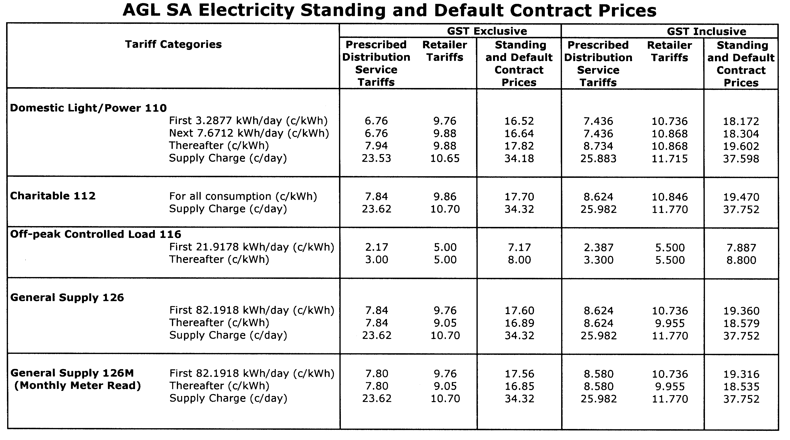

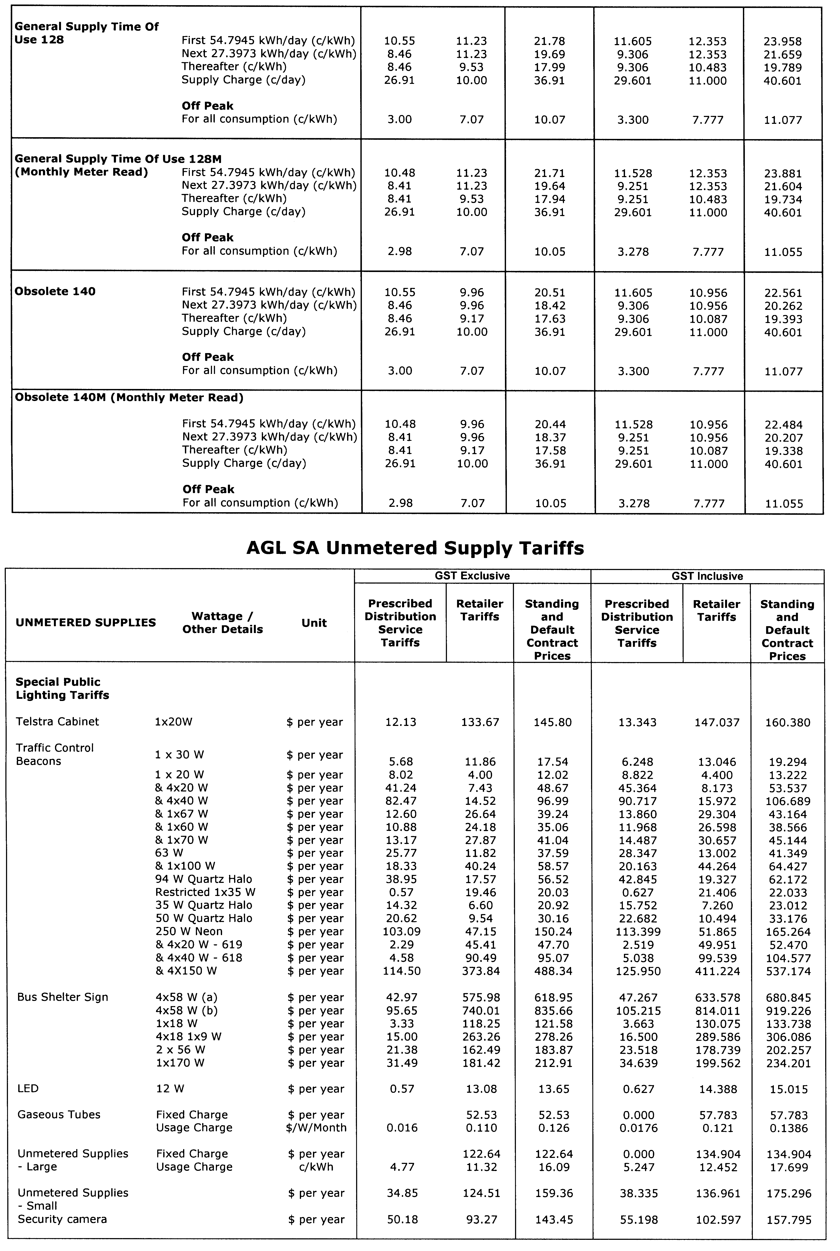
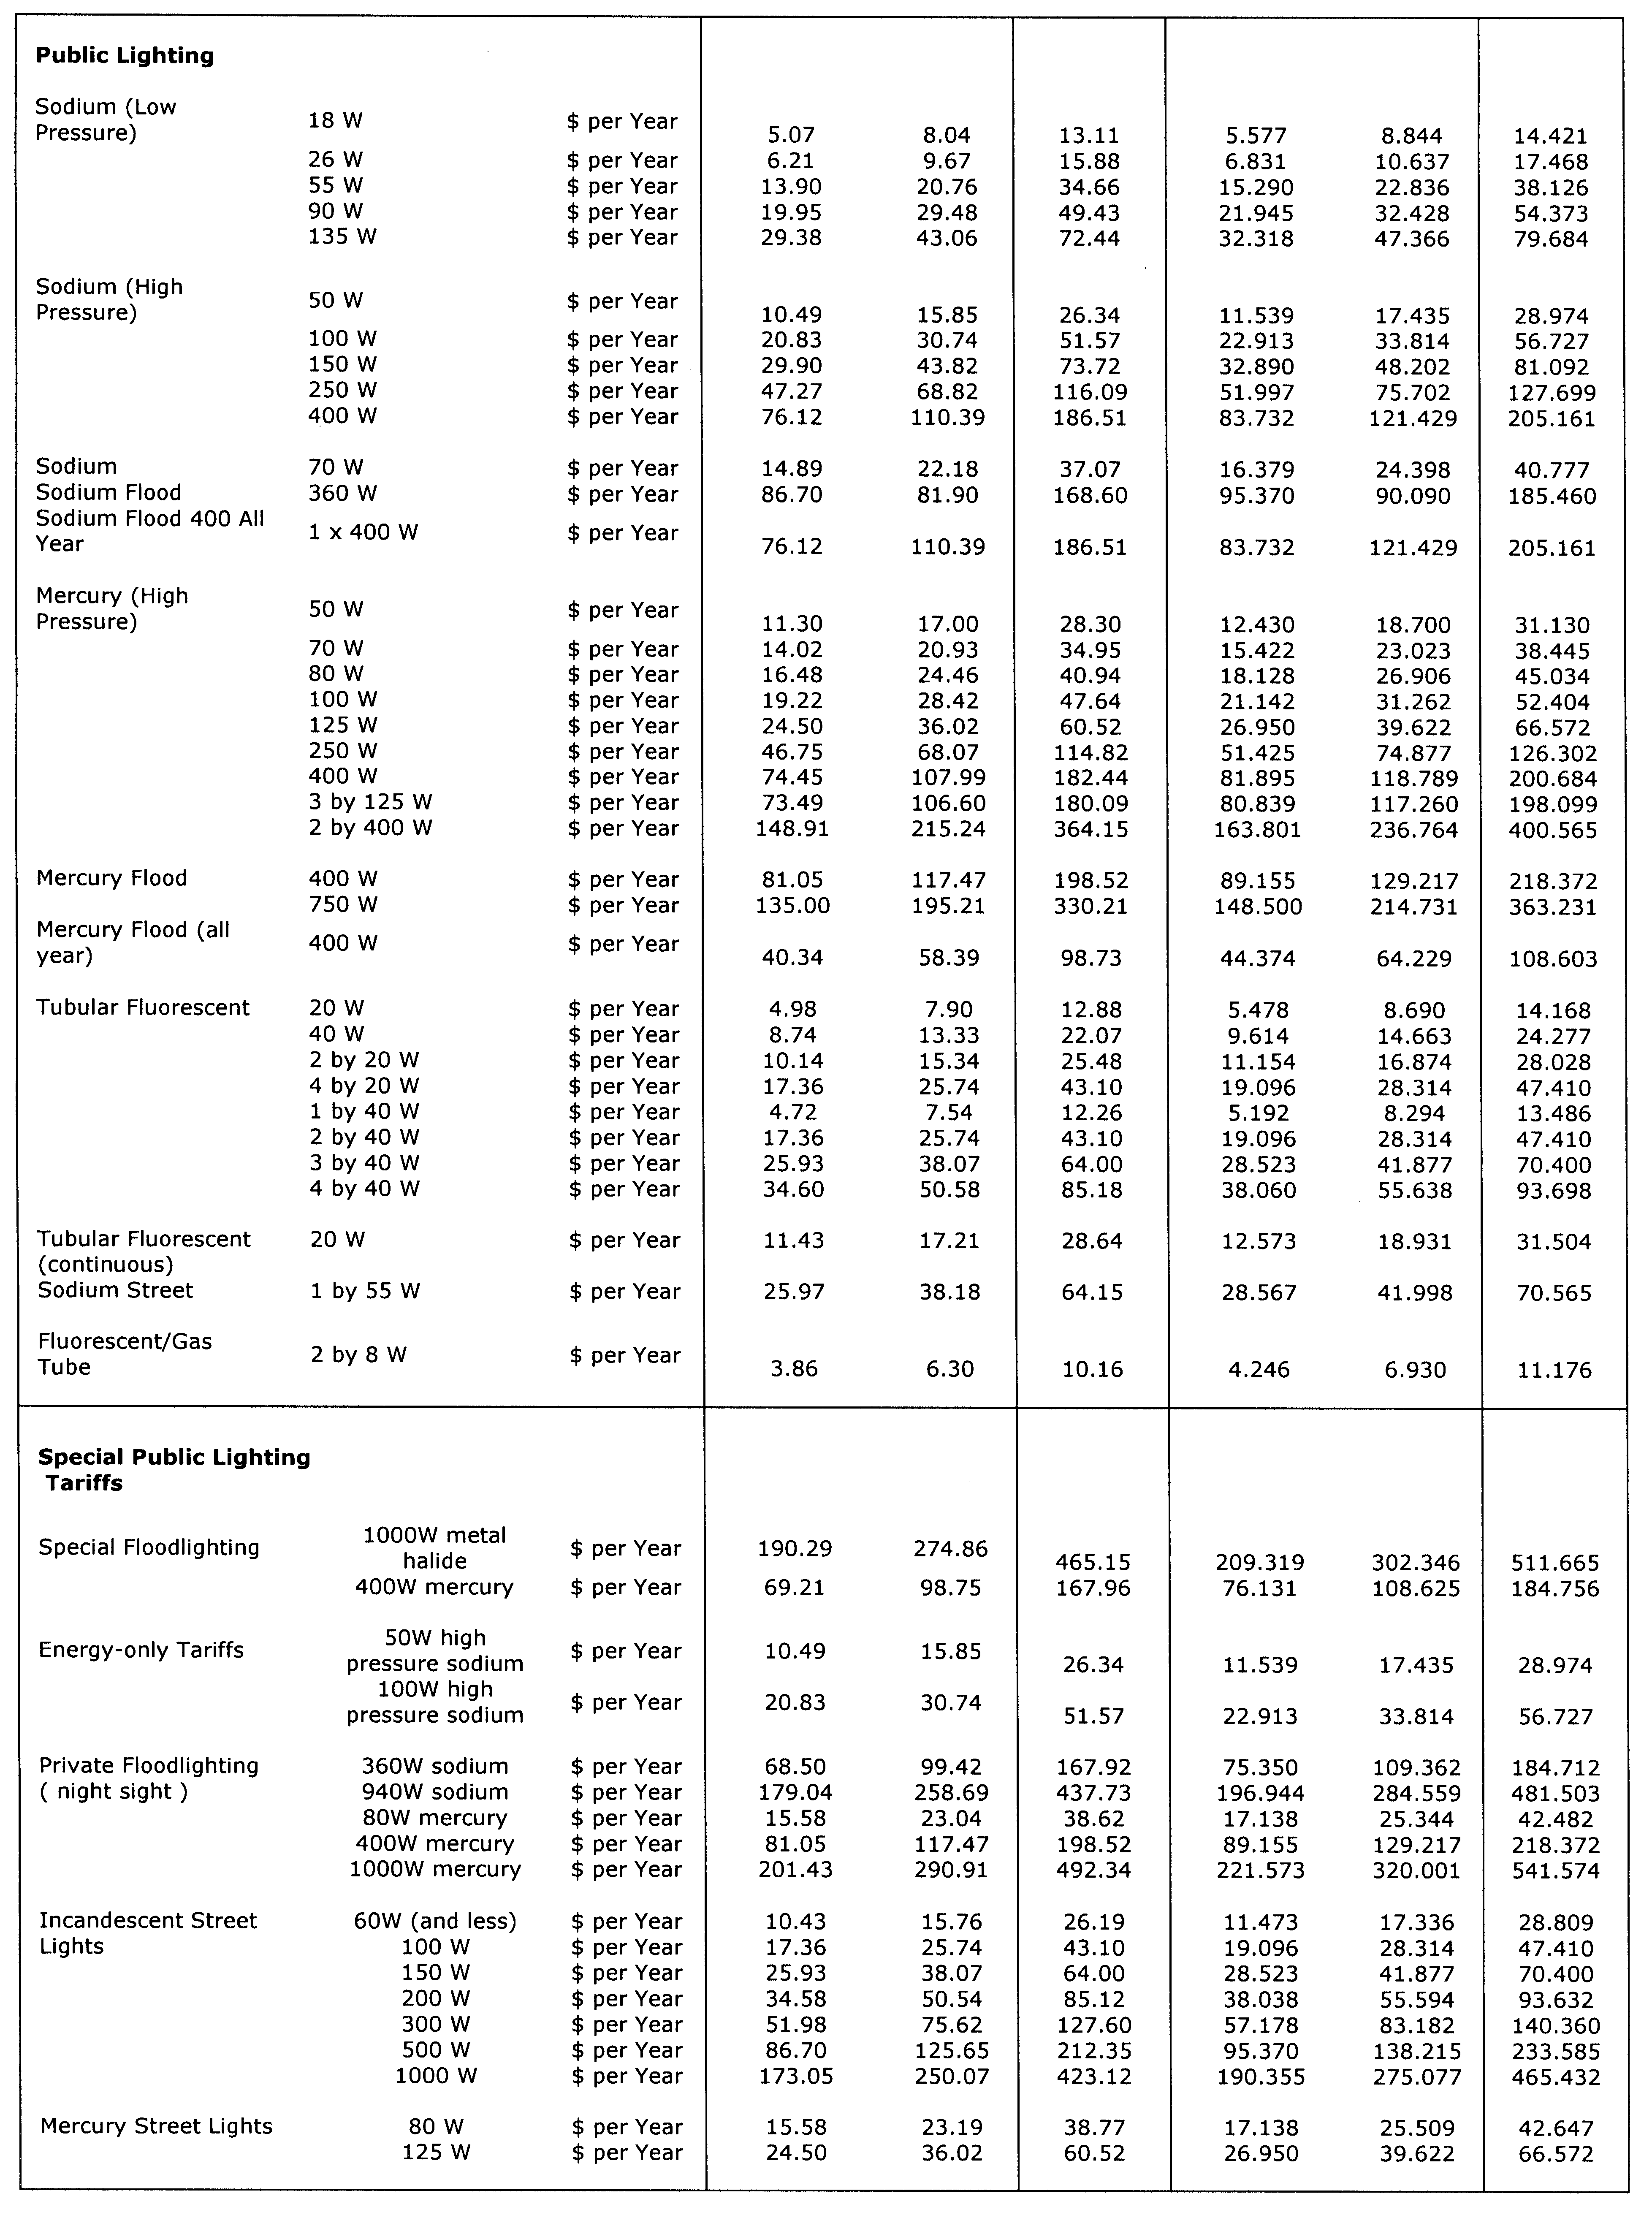

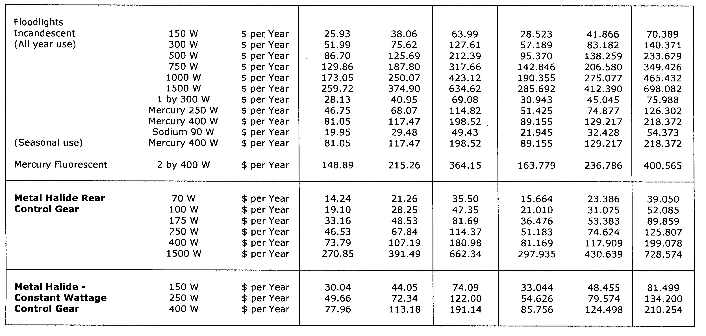
Explanatory Notes:
1. Standing and default contract price categories will only apply to small customers (that is, those customers who consume less than 160MWh of electricity per annum) who are purchasing electricity under AGL SA’s standing or default contract terms and conditions. Standing and default contract prices apply in accordance with the following principles:
(a) ‘Daily Consumption’ is the total electricity consumption for the period to which the customer’s bill relates, divided by the number of days in that period.
(b) Domestic Light/Power 110:
• applicable to all residential consumption (excluding Off-Peak Controlled Load Tariff 116) in premises used wholly or principally as private residences.
(c) Charitable Institutions 112:
• available to charitable institutions that have been endorsed by the Australian Taxation Office as an income tax exempt Charitable Entity under Subdivision 50-B of the Income Tax Assessment Act 1997.
(d) Controlled Load 116:
• for electricity used in permanently installed storage water heaters with a rated delivery of not less than
125 litres, storage space heaters and other approved thermal storage applications; the hours of application are fixed from time to time by AGL SA with control by time switch or other means. This price does not apply to electricity used outside those hours;
• customers who were taking supply under this tariff, or who had applied to do so, as at 30 June 2003 are subject to the conditions which were applicable at that date;
• this price is only available in conjunction with tariffs 110, 112, 126, 126M, 128, 128M, 140 or 140M.
(e) General Supply 126:
• available only to non-residential customers.
(f) General Supply 126M (Monthly Meter Reading):
• available only to non-residential customers;
• applies to customers whose meters are scheduled to be read monthly, and who are billed monthly;
• a monthly meter reading fee applies to this tariff in addition to the above prices.
(g) General Supply Time of Use 128:
• available only to non-residential customers with appropriate metering;
• includes customers previously on tariffs 120 + 121 and 130 + 131 who were taking supply under those tariffs, or who had applied to do so, as at 30 June 1997. Those customers are subject to the conditions which were applicable to those tariffs at that date, in addition to the current conditions.
(h) General Supply Time of Use 128M (Monthly Meter Reading):
• available only to non-residential customers with appropriate metering;
• includes customers previously on tariffs 120 + 121 and 130 + 131 who were taking supply under those tariffs, or who had applied to do so, as at 30 June 1997. Those customers are subject to the conditions which were applicable to those tariffs at that date, in addition to the current conditions;
• applies to customers whose meters are scheduled to be read monthly, and who are billed monthly;
• a monthly meter reading fee applies to this tariff in addition to the above prices.
(i) Obsolete Tariff 140 (formerly Farm Tariff 140):
• applies only to small customers that were taking supply under Obsolete Tariff 140, or who had applied to do so, as at 30 June 1997. Conditions applicable at that date apply, in addition to the current conditions.
(j) Obsolete Tariff 140M (Monthly Meter Reading):
• applies only to small customers that were taking supply under Obsolete Tariff 140, or who had applied to do so, as at 30 June 1997. Conditions applicable at that date apply, in addition to the current conditions;
• applies to customers whose meters are scheduled to be read monthly, and who are billed monthly;
• a monthly meter reading fee applies to this tariff in addition to the above prices.
2. Peak period is 0700 hours to 2100 hours from Monday to Friday (Central Standard Time) for all tariffs other than tariff 110 except where the network meters do not recognise specific tariff days. In these situations peak period is 0700 hours to 2100 hours (Central Standard Time) each day for tariffs other than tariff 110.
3. Off peak period is all times other than peak period.
4. Where prices change during a billing cycle the bill for that billing cycle will be calculated on a pro-rata basis using:
(a) the old price up to and including the date of change; and
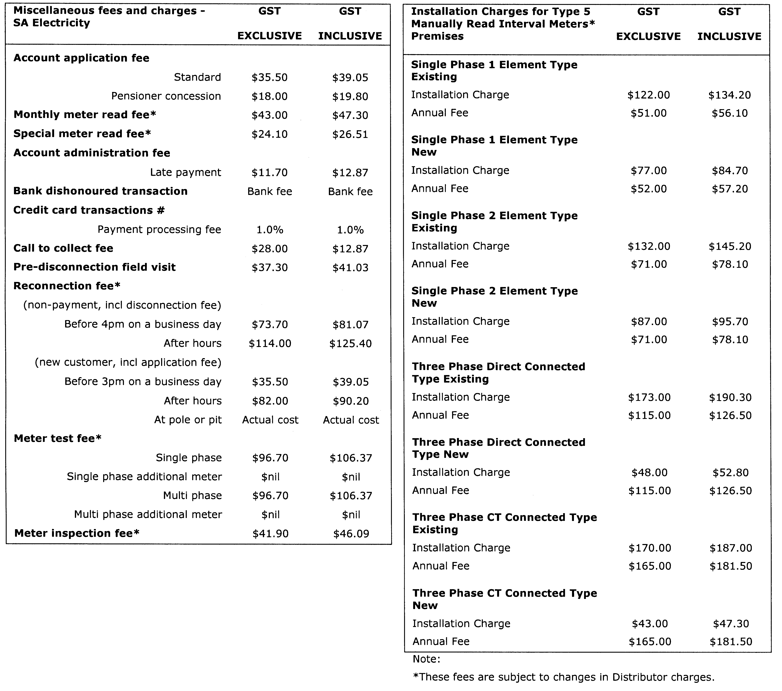
(b) the new price from the date of change to the end of the billing cycle.

GOVERNMENT GAZETTE ADVERTISEMENT RATES

To apply from 1 July 2006

$  Agents, Ceasing to Act as 38.00  Associations:  Incorporation 19.30  Intention of Incorporation 47.75  Transfer of Properties 47.75  Attorney, Appointment of 38.00  Bailiff’s Sale 47.75  Cemetery Curator Appointed 28.25  Companies:  Alteration to Constitution 38.00  Capital, Increase or Decrease of 47.75  Ceasing to Carry on Business 28.25  Declaration of Dividend 28.25  Incorporation 38.00  Lost Share Certificates:  First Name 28.25  Each Subsequent Name 9.70  Meeting Final 31.75  Meeting Final Regarding Liquidator’s Report on  Conduct of Winding Up (equivalent to ‘Final  Meeting’)  First Name 38.00  Each Subsequent Name 9.70  Notices:  Call 47.75  Change of Name 19.30  Creditors 38.00  Creditors Compromise of Arrangement 38.00  Creditors (extraordinary resolution that ‘the Com-pany be wound up voluntarily and that a liquidator be appointed’) 47.75  Release of Liquidator⎯Application⎯Large Ad. 75.50  ⎯Release Granted 47.75  Receiver and Manager Appointed 44.00  Receiver and Manager Ceasing to Act 38.00  Restored Name 35.75  Petition to Supreme Court for Winding Up 66.50  Summons in Action 56.50  Order of Supreme Court for Winding Up Action 38.00  Register of Interests⎯Section 84 (1) Exempt 85.50  Removal of Office 19.30  Proof of Debts 38.00  Sales of Shares and Forfeiture 38.00  Estates:  Assigned 28.25  Deceased Persons⎯Notice to Creditors, etc. 47.75  Each Subsequent Name 9.70  Deceased Persons⎯Closed Estates 28.25  Each Subsequent Estate 1.25  Probate, Selling of 38.00  Public Trustee, each Estate 9.70 |  | $  Firms:  Ceasing to Carry on Business (each insertion) 25.25  Discontinuance Place of Business 25.25  Land⎯Real Property Act:  Intention to Sell, Notice of 47.75  Lost Certificate of Title Notices 47.75  Cancellation, Notice of (Strata Plan) 47.75  Mortgages:  Caveat Lodgement 19.30  Discharge of 20.20  Foreclosures 19.30  Transfer of 19.30  Sublet 9.70  Leases⎯Application for Transfer (2 insertions) each 9.70  Lost Treasury Receipts (3 insertions) each 28.25  Licensing 56.50  Municipal or District Councils:  Annual Financial Statement⎯Forms 1 and 2 532.00  Electricity Supply⎯Forms 19 and 20 378.00  Default in Payment of Rates:  First Name 75.50  Each Subsequent Name 9.70  Noxious Trade 28.25  Partnership, Dissolution of 28.25  Petitions (small) 19.30  Registered Building Societies (from Registrar-  General) 19.30  Register of Unclaimed Moneys⎯First Name 28.25  Each Subsequent Name 9.70  Registers of Members⎯Three pages and over:  Rate per page (in 8pt) 242.00  Rate per page (in 6pt) 320.00  Sale of Land by Public Auction 48.25  Advertisements 2.70  ¼ page advertisement 113.00  ½ page advertisement 226.00  Full page advertisement 443.00  Advertisements, other than those listed are charged at $2.70 per column line, tabular one-third extra.  Notices by Colleges, Universities, Corporations and District Councils to be charged at $2.70 per line.  Where the notice inserted varies significantly in length from that which is usually published a charge of $2.70 per column line will be applied in lieu of advertisement rates listed.  South Australian Government publications are sold on the condition that they will not be reproduced without prior permission from the Government Printer.
All the above prices include GST

GOVERNMENT GAZETTE NOTICES
ALL private advertisements forwarded for publication in the South Australian Government Gazette must be PAID FOR PRIOR TO INSERTION; and all notices, from whatever source, should be legibly written on one side of the paper only and sent to Government Publishing SA so as to be received no later than 4 p.m. Tuesday preceding the day of publication. Phone 8207 1045 or Fax 8207 1040. E-mail: governmentgazette@dpc.sa.gov.au. Send as attachments in Word format. Please include date the notice is to be published and to whom the notice will be charged. The Government Gazette is available online at: www.governmentgazette.sa.gov.au.

MISCELLANEOUS LEGISLATION AND GOVERNMENT PUBLICATIONS PRICES AS FROM 1 JULY 2006

Acts, Bills, Rules, Parliamentary Papers and Regulations
Pages | Main | Amends | Pages | Main | Amends

1-16 | 2.30 | 1.05 | 497-512 | 32.25 | 31.25
17-32 | 3.10 | 1.95 | 513-528 | 33.25 | 32.00
33-48 | 4.05 | 2.90 | 529-544 | 34.25 | 33.25
49-64 | 5.10 | 3.90 | 545-560 | 35.25 | 34.25
65-80 | 6.00 | 4.95 | 561-576 | 36.00 | 35.25
81-96 | 6.95 | 5.75 | 577-592 | 37.00 | 35.75
97-112 | 7.90 | 6.75 | 593-608 | 38.25 | 36.75
113-128 | 8.90 | 7.75 | 609-624 | 39.00 | 38.00
129-144 | 9.95 | 8.80 | 625-640 | 40.00 | 38.50
145-160 | 10.90 | 9.70 | 641-656 | 41.00 | 40.00
161-176 | 11.90 | 10.70 | 657-672 | 41.50 | 40.50
177-192 | 12.90 | 11.70 | 673-688 | 43.25 | 41.50
193-208 | 13.90 | 12.80 | 689-704 | 44.00 | 42.50
209-224 | 14.70 | 13.60 | 705-720 | 44.75 | 43.50
225-240 | 15.70 | 14.50 | 721-736 | 46.50 | 44.50
241-257 | 16.80 | 15.30 | 737-752 | 47.00 | 45.50
258-272 | 17.70 | 16.30 | 753-768 | 48.00 | 46.25
273-288 | 18.70 | 17.50 | 769-784 | 48.50 | 47.75
289-304 | 19.50 | 18.40 | 785-800 | 49.50 | 48.75
305-320 | 20.70 | 19.40 | 801-816 | 50.50 | 49.25
321-336 | 21.50 | 20.30 | 817-832 | 51.50 | 50.50
337-352 | 22.60 | 21.40 | 833-848 | 52.50 | 51.50
353-368 | 23.50 | 22.40 | 849-864 | 53.50 | 52.00
369-384 | 24.50 | 23.40 | 865-880 | 54.50 | 53.50
385-400 | 25.50 | 24.30 | 881-896 | 55.00 | 54.00
401-416 | 26.50 | 25.00 | 897-912 | 56.50 | 55.00
417-432 | 27.50 | 26.25 | 913-928 | 57.00 | 56.50
433-448 | 28.50 | 27.25 | 929-944 | 58.00 | 57.00
449-464 | 29.25 | 28.00 | 945-960 | 59.00 | 57.50
465-480 | 29.75 | 29.00 | 961-976 | 60.50 | 58.50
481-496 | 31.25 | 29.75 | 977-992 | 61.50 | 59.00

Legislation—Acts, Regulations, etc: $
Subscriptions:
Acts 199.00
All Bills as Laid 477.00
Rules and Regulations 477.00
Parliamentary Papers 477.00
Bound Acts 221.00
Index 110.00
Government Gazette
Copy 5.20
Subscription 263.00
Hansard
Copy 14.50
Subscription—per session (issued weekly) 414.00
Cloth bound—per volume 178.00
Subscription—per session (issued daily) 414.00
Legislation on Disk
Whole Database 3063.00
Annual Subscription for fortnightly updates 941.00
Individual Act(s) including updates POA
Compendium
Subscriptions:
Subscriptions 1815.00
Updates 640.00
(All the above prices include GST)

All Legislation, Government Gazette, Hansard and Legislation on disk are available from:
Counter Sales Service SA, Government Legislation⁺ Outlet
and Mail Orders: Lands Titles Office, 101 Grenfell Street, Adelaide, S.A. 5000
Phone: 13 23 24 (local call cost), Fax: (08) 8204 1909
Postal: G.P.O. Box 1707, Adelaide, S.A. 5001

Online Shop: www.shop.service.sa.gov.au

Subscriptions and Government Publishing SA
Standing Orders: Box 9, Plaza Level, Riverside Centre, North Terrace, Adelaide, S.A. 5000
Phone: (08) 8207 1043, (08) 8207 0910, Fax: (08) 8207 1040

EDUCATION ACT 1972
Notice Fixing Charges for Full Fee Paying Overseas Students
PURSUANT to section 106B of the Education Act 1972, I fix the following charges payable by a full fee paying overseas student (defined in section 72I of the Education Act 1972) of a Govern-ment school:
1. Administration charge for application processing and school enrolment: | $
(a) for a student holding a temporary visa under the Migration Act 1958, of the Common-wealth valid for a total period of 12 months or less and who is enrolled for the whole or part of school year | 1 070
(b) in any other case:
(i) for the first school year of enrolment  (ii) for each subsequent school year of enrolment | 500  300
2. Tuition charge for student enrolled for whole school year:
(a) if the student is a dependent of a person who holds a temporary visa under the Migration Act 1958, of the Commonwealth and who is participating in tertiary education:
(i) for tuition in primary courses | 3 600
(ii) for tuition in secondary courses or in an intensive English course at secondary level | 4 500
(b) in any other case:
(i) for tuition in primary courses or in an intensive English course at primary level | 8 000
(ii) for tuition in secondary courses or in an intensive English course at secondary level:  (A) for years 8 to 10  (B) for years 11 to 12 | 9 500  10 500
3. Tuition charge for student enrolled for part of school year—If a student is enrolled at a Government school for part of a school year, the tuition charge is:
(a) a proportion of the tuition charge that would be payable if the student were enrolled for the full school year, being the proportion that the number of school terms for the whole or part of which the student is enrolled bears to 4; plus
(b) if the student is enrolled in secondary courses or an intensive English course at secondary level for a period of less than 10 weeks and the student is not a dependant of a person who holds a temporary visa under the Migration Act 1958, of the Commonwealth and who is participating in tertiary education, $25 for each week for which the student is enrolled.
Dated 7 June 2007.
Chris Robinson, Chief Executive of DECS

FISHERIES ACT 1982: SECTION 59
TAKE notice that pursuant to section 59 of the Fisheries Act 1982, Graham Pollard, holder of Southern Zone Abalone Fishery Licence No. A04 (the ‘exemption holder’), is exempt from Regulation 11A of the Fisheries (Scheme of Management—Abalone Fisheries) Regulations but only insofar as the exemption holder may permit two registered masters to undertake fishing activity pursuant to Licence No. A04 (the ‘exempted activity’), subject to the conditions set out in Schedule 1, from 8 June 2007 until 30 June 2008, unless varied or revoked earlier.
Schedule 1
1. The exempted activity must be conducted from a boat registered by endorsement on Southern Zone Abalone Fishery Licence No. A04.
2. The exemption holder must not permit more than two registered masters to engage in the exempted activity on any one day.
3. If more than one registered master is engaged in the exempted activity on any one day, one of the registered masters must be a designated trainee diver.
4. For the purposes of the exemption, the ‘designated trainee diver’ must be Steven Bailey, P.O. Box 1145, Mount Gambier, S.A. 5290.
5. The exemption holder may engage in the exempted activity for a maximum of 10 days during the period commencing from
8 June 2007 until 30 June 2008.
6. Prior to conducting the exempted activity the exemption holder must advise the PIRSA Fisheries Duty Officer on 1800 065 522 the following information:
• name of licence holder;
• licence number;
• name of registered masters undertaking the exempted activity for the day;
• name of trainee diver;
• registered number of boat being used;
• time and location of launch and estimated retrieval time and location; and
• Exemption No. 9902001.
7. While engaged in the exempted activity the exemption holder must have in his possession a copy of this notice and produce a copy of the notice if required by a PIRSA Fisheries Officer.
8. The exemption holder must not contravene or fail to comply with the Fisheries Act 1982, or any regulations made under that Act, except where specifically exempted by this notice.
Dated 8 June 2007.
W. Zacharin, Director of Fisheries

FISHERIES ACT 1982: SECTION 43
TAKE note that the notice made under section 43 of the Fisheries Act 1982, published in the South Australian Government Gazette on page 3958, dated 17 November 2005, being the third notice on that page, referring to the Spencer Gulf Prawn Fishery, is hereby varied such that it will be unlawful for a person fishing pursuant to a Spencer Gulf Prawn Fishery Licence to use prawn trawl nets outside of the areas specified in Schedule 1 during the period specified in Schedule 2.
Schedule 1
1. The waters of the Spencer Gulf Prawn Fishery that are within the area commencing at position latitude 33°46.00′S, longitude 137°44.00′E, then to position latitude 33°38.00′S, longitude 137°34.00′E, then to position latitude 33°29.00′S, longitude 137°34.00′E, then to position latitude 33°29.00′S, longitude 137°31.00′E, then to position latitude 33°34.00′S, longitude 137°31.00′E, then to position latitude 33°34.00′S, longitude 137°27.50′E, then to position latitude 33°39.00′S, longitude 137°26.00′E, then to position latitude 33°45.00′S, longitude 137°26.00′E, then to position latitude 33°50.00′S, longitude 137°21.00′E, then to position latitude 33°55.00′S, longitude 137°09.00′E, then to position latitude 33°59.00′S, longitude 137°12.00′E, then to position latitude 34°07.00′S, longitude 137°05.00′E, then to position latitude 34°07.00′S, longitude 137°33.00′E, except for within the area commencing at position latitude 33°47.40′S, longitude 137°27.00′E, then to position latitude 33°49.30′S, longitude 137°30.40′E, then to position latitude 33°53.50′S, longitude 137°27.10′E, then to position latitude 33°51.40′S, longitude 137°23.50′E, then to position latitude 33°47.40′S, longitude 137°27.00′E.
2. The waters of the Spencer Gulf Prawn Fishery that are south and west of the following co-ordinates commencing at position latitude 33°52.00′S, longitude 136°41.00′E, then to position latitude 34°02.70′S, longitude 136°49.00′E, then to position latitude 34°17.00′S, longitude 136°36.20′E, then to position latitude 34°28.00′S, longitude 136°39.70′E, then to position latitude 34°28.00′S, longitude 136°56.00′E, then to position latitude 34°13.00′S, longitude 136°56.00′E, then to position
latitude 34°13.00′S, longitude 137°31.00′E, then to position latitude 34°19.00′S, longitude 137°30.00′E, then to position latitude 34°19.00′S, longitude 137°20.00′E, then to position latitude 34°23.00′S, longitude 137°15.00′E, then to position latitude 34°54.00′S, longitude 137°15.00′E.
Schedule 2
From 1830 hours on 13 June 2007 to 0630 hours on 23 June 2007.
Dated 8 June 2007.
W. Zacharin, Executive Director

GEOGRAPHICAL NAMES ACT 1991
Notice to Assign Names to Places
NOTICE is hereby given pursuant to the provisions of the above Act that I, PETER MACLAREN KENTISH, Surveyor-General and Delegate appointed by Patrick Conlon, Minister for Infrastructure, Minister of the Crown to whom the administration of the Geographical Names Act 1991, is committed do hereby assign the following names:
1. LILLIPUT ISLAND to that feature located in the vicinity on the 1:50 000 Mapsheet Flinders (5633-3) at longitude 133°41′ and latitude -32°26′.
2. BLEFUSCU ISLAND to that feature located in the vicinity on the 1:50 000 Mapsheet Flinders (5633-3) at longitude 133°38′ and latitude -32°28′.
3. BREAKWATER ISLAND to that feature located in the vicinity on the 1:50 000 Mapsheet Flinders (5633-3) at longitude 133°32′ and latitude -32°19′.
4. CAVE POINT to that feature located in the vicinity on the 1:50 000 Mapsheet Grainger (6226-2) at longitude 136°58′ and latitude -36°01′.
Dated 4 June 2007.
P. M. Kentish, Surveyor-General, Department for Transport, Energy and Infrastructure

GEOGRAPHICAL NAMES ACT 1991
Notice to Alter the Boundaries of Places
NOTICE is hereby given pursuant to the provisions of the above Act, that I PETER MACLAREN KENTISH, Surveyor-General and Delegate appointed by Patrick Conlon, Minister for Infrastructure, Minister of the Crown to whom the administration of the Geographical Names Act 1991, is committed, do hereby exclude from the suburb of ALDGATE and include into the suburb of STIRLING that area marked (A) as shown on the Plan below:
The Plan
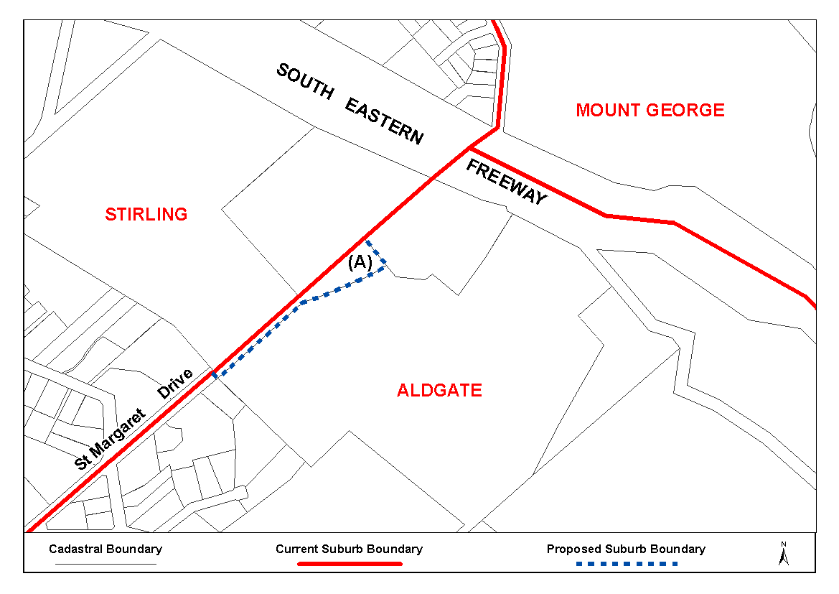
Dated 4 June 2007.
P. M. Kentish, Surveyor-General, Department for Transport, Energy and Infrastructure
DTEI.22-413/07/0007

LAND AND BUSINESS (SALE AND CONVEYANCING)
ACT 1994
Exemption
TAKE notice that, pursuant to section 23 (3) of the Land and Business (Sale and Conveyancing) Act 1994, I, Jennifer Rankine, Minister for Consumer Affairs, do hereby exempt the person named in Schedule 1 from the application of section 23 (2) of the Act in relation to the purchase of the land specified in Schedule 2.
Schedule 1
Michael Wayne Simounds, an employee of Lend Lease Realty Pty Ltd.
Schedule 2
The whole of the land described in certificate of title register book volume 5943, folio 852, situated at Lot 372, Goodall Parade, Mawson Lakes, S.A. 5095.
Dated 14 June 2007.
J. Rankine, Minister for Consumer Affairs

LAND AND BUSINESS (SALE AND CONVEYANCING)
ACT 1994
Exemption
TAKE notice that, pursuant to section 23 (3) of the Land and Business (Sale and Conveyancing) Act 1994, I, Jennifer Rankine, Minister for Consumer Affairs, do hereby exempt the person named in Schedule 1 from the application of section 23 (2) of the Act in relation to the purchase of the land specified in Schedule 2.
Schedule 1
Karen Elizabeth Hughes, an employee of Auratel Pty Ltd.
Schedule 2
The land described as Lot 123 in Deposited Plan 73941 being portion of the land comprised in certificate of title register book volume 5950, folio 613.
Dated 14 June 2007.
J. Rankine, Minister for Consumer Affairs

LAND AND BUSINESS (SALE AND CONVEYANCING)
ACT 1994
Exemption
TAKE notice that, pursuant to section 23 (3) of the Land and Business (Sale and Conveyancing) Act 1994, I, Jennifer Rankine, Minister for Consumer Affairs, do hereby exempt the person named in Schedule 1 from the application of section 23 (2) of the Act in relation to the purchase of the land specified in Schedule 2.
Schedule 1
Danielle Cavuoto, an employee of Lend Lease Realty Pty Ltd.
Schedule 2
The land described in a portion of certificate of title register book volume 5967, folio 370, situated at Lot 752, Templeton Street, Mawson Lakes, S.A. 5095.
Dated 14 June 2007.
J. Rankine, Minister for Consumer Affairs

LAND AND BUSINESS (SALE AND CONVEYANCING)
ACT 1994
Exemption
TAKE notice that, pursuant to section 23 (3) of the Land and Business (Sale and Conveyancing) Act 1994, I, Jennifer Rankine, Minister for Consumer Affairs, do hereby exempt the person named in Schedule 1 from the application of section 23 (2) of the Act in relation to the purchase of the land specified in Schedule 2.
Schedule 1
John Raymond Dyer, an employee of Lend Lease Realty Pty Ltd.
Schedule 2
The land described in a portion of certificate of title register book volume 5967, folio 370, situated at Lot 712, Templeton Street, Mawson Lakes, S.A. 5095.
Dated 14 June 2007.
J. Rankine, Minister for Consumer Affairs

LAND AND BUSINESS (SALE AND CONVEYANCING)
ACT 1994
Exemption
TAKE notice that, pursuant to section 23 (3) of the Land and Business (Sale and Conveyancing) Act 1994, I, Jennifer Rankine, Minister for Consumer Affairs, do hereby exempt the person named in Schedule 1 from the application of section 23 (2) of the Act in relation to the purchase of the land specified in Schedule 2.
Schedule 1
Nickolas Buvinic, an employee of Lend Lease Realty Pty Ltd.
Schedule 2
The whole of the land described in certificate of title register book volume 5966, folio 456, situated at Lot 104, Harvey Circuit, Mawson Lakes, S.A. 5095.
Dated 14 June 2007.
J. Rankine, Minister for Consumer Affairs

LAND AND BUSINESS (SALE AND CONVEYANCING)
ACT 1994
Exemption
TAKE notice that, pursuant to section 23 (3) of the Land and Business (Sale and Conveyancing) Act 1994, I, Jennifer Rankine, Minister for Consumer Affairs, do hereby exempt the person named in Schedule 1 from the application of section 23 (2) of the Act in relation to the purchase of the land specified in Schedule 2.
Schedule 1
David Smallacombe, an officer of Smallacombe Southern Pty Ltd.
Schedule 2
The whole of the land described in certificate of title register book volume 5296, folio 401, situated at 23 Croser Avenue, Aldinga Beach, S.A. 5173.
Dated 14 June 2007.
J. Rankine, Minister for Consumer Affairs

LAND AND BUSINESS (SALE AND CONVEYANCING)
ACT 1994
Exemption
TAKE notice that, pursuant to section 23 (3) of the Land and Business (Sale and Conveyancing) Act 1994, I, Jennifer Rankine, Minister for Consumer Affairs, do hereby exempt the person named in Schedule 1 from the application of section 23 (2) of the Act in relation to the purchase of the land specified in Schedule 2.
Schedule 1
Daniel Harris, an employee of Daper Pty Ltd.
Schedule 2
The whole of the land described in certificate of title register book volume 5316, folio 866, situated at 51 Simpson Road, Port Pirie, S.A. 5540.
Dated 14 June 2007.
J. Rankine, Minister for Consumer Affairs

LIQUOR LICENSING ACT 1997
Notice of Application
NOTICE is hereby given, pursuant to section 52 (2) (b) of the Liquor Licensing Act 1997, that Joperi Hotel Pty Ltd has applied to the Licensing Authority for a variation to an Extended Trading Authorisation, Alterations and Redefinition in respect of premises situated at 132 Main South Road, Morphett Vale, S.A. 5162 and known as Emu Hotel—Morphett Vale.
The application has been set down for callover on 13 July 2007 at 9 a.m.
Conditions
The following licence conditions are sought:
• Variation to an Extended Trading Authorisation to include the outside areas as per plans lodged with this office.
• Redefinition to licensed premises to include outside areas as per plans lodged with this office. There is no Entertainment Consent sought in these areas.
Any person may object to the application by lodging a notice of objection in the prescribed form with the Liquor and Gambling Commissioner and serving a copy of the notice on the applicant at the applicant’s address, at least seven days before the callover date (viz: 6 July 2007).
The applicant’s address for service is c/o David Tillett, 66 Wright Street, Adelaide, S.A. 5000.
Plans in respect of the premises the subject of the application are open to public inspection without fee at the Office of the Liquor and Gambling Commissioner, 9th Floor, East Wing, 50 Grenfell Street, Adelaide, S.A. 5000. Phone 8226 8410, Fax:
8226 8512. Email: olgc@agd.sa.gov.au.
Dated 12 June 2007.
Applicant

LIQUOR LICENSING ACT 1997
Notice of Application
NOTICE is hereby given, pursuant to section 52 (2) (b) of the Liquor Licensing Act 1997, that Redlegs Club Inc. has applied to the Licensing Authority for the variation to an Extended Trading Authorisation, Alterations and Redefinition to Licensed Premises in respect of premises situated at 583-585 North East Road, Gilles Plains, S.A. 5086 and known as Redlegs Club.
The application has been set down for hearing on 29 June 2007 at 9 a.m.
Conditions
The following licence conditions are sought:
• Variation to the current Extended Trading Authorisation to include the following hours:
Sunday: 8 a.m. to 11 a.m. and 8 p.m. to midnight;
Sunday Christmas Eve: 8 p.m. to midnight.
• Redefinition and Alterations to the Licensed Premises to include the proposed outdoor area as per plans lodged with this office. (Including the current and proposed Extended Trading Authorisation).
Any person may object to the application by lodging a notice of objection in the prescribed form with the Liquor and Gambling Commissioner and serving a copy of the notice on the applicant at the applicant’s address before the hearing date (viz: 28 June 2007).
The applicant’s address for service is c/o Bill Moody, 7th Floor, 185 Victoria Square, Adelaide, S.A. 5000.
Plans in respect of the premises the subject of the application are open to public inspection without fee at the Office of the Liquor and Gambling Commissioner, 9th Floor, East Wing, 50 Grenfell Street, Adelaide, S.A. 5000. Phone 8226 8410, Fax:
8226 8512. Email: olgc@agd.sa.gov.au.
Dated 5 June 2007.
Applicant

LIQUOR LICENSING ACT 1997
Notice of Application
NOTICE is hereby given, pursuant to section 52 (2) (b) of the Liquor Licensing Act 1997, that Boar’s Rock Pty Ltd has applied to the Licensing Authority for the transfer of a Wholesale Liquor Merchant’s Licence and a Producer’s Licence both in respect of premises situated at Lot 51, Tatachilla Road, McLaren Vale, S.A. 5171 and known as Vinum Marketing Pty Ltd and Balquhidder Vineyards, both are to be known as Boar’s Rock Pty Ltd.
The applications have been set down for hearing on 12 July 2007 at 10.30 a.m.
Any person may object to the application by lodging a notice of objection in the prescribed form with the Liquor and Gambling Commissioner and serving a copy of the notice on the applicant at the applicant’s address, at least seven days before the hearing date (viz: 5 July 2007).
The applicant’s address for service is c/o Rob Hunt, P.O. Box 115, McLaren Vale, S.A. 5171.
Plans in respect of the premises the subject of the application are open to public inspection without fee at the Office of the Liquor and Gambling Commissioner, 9th Floor, East Wing, 50 Grenfell Street, Adelaide, S.A. 5000. Phone 8226 8410, Fax:
8226 8512. Email: olgc@agd.sa.gov.au.
Dated 6 June 2007.
Applicant

LIQUOR LICENSING ACT 1997
Notice of Application
NOTICE is hereby given, pursuant to section 52 (2) (b) of the Liquor Licensing Act 1997, that Blewitt Valley Wines Pty Ltd has applied to the Licensing Authority for a Direct Sales Licence in respect of premises situated at RSD 610, Blewitt Springs Road, McLaren Flat, S.A. 5171 and to be known as BV Exports.
The application has been set down for callover on 13 July 2007 at 9 a.m.
Any person may object to the application by lodging a notice of objection in the prescribed form with the Liquor and Gambling Commissioner and serving a copy of the notice on the applicant at the applicant’s address, at least seven days before the callover date (viz: 6 July 2007).
The applicant’s address for service is c/o Robert A. Berton, LL.B., P.O. Box 7241, West Lakes, S.A. 5021.
Plans in respect of the premises the subject of the application are open to public inspection without fee at the Office of the Liquor and Gambling Commissioner, 9th Floor, East Wing, 50 Grenfell Street, Adelaide, S.A. 5000. Phone 8226 8410, Fax:
8226 8512. Email: olgc@agd.sa.gov.au.
Dated 6 June 2007.
Applicant

LIQUOR LICENSING ACT 1997
Notice of Application
NOTICE is hereby given, pursuant to section 52 (2) (b) of the Liquor Licensing Act 1997, that Albacore Vintners Pty Ltd has applied to the Licensing Authority for a Producer’s Licence in respect of premises situated at 2 Main Road, Willunga, S.A. 5172 and to be known as Albacore Vintners Pty Ltd.
The application has been set down for callover on 13 July 2007 at 9 a.m.
Any person may object to the application by lodging a notice of objection in the prescribed form with the Liquor and Gambling Commissioner and serving a copy of the notice on the applicant at the applicant’s address, at least seven days before the callover date (viz: 6 July 2007).
The applicant’s address for service is c/o Jenkins Anderson Allard Fowler, P.O. Box 118, Auburn, S.A. 5451.
Plans in respect of the premises the subject of the application are open to public inspection without fee at the Office of the Liquor and Gambling Commissioner, 9th Floor, East Wing, 50 Grenfell Street, Adelaide, S.A. 5000. Phone 8226 8410, Fax:
8226 8512. Email: olgc@agd.sa.gov.au.
Dated 6 June 2007.
Applicant

LIQUOR LICENSING ACT 1997
Notice of Application
NOTICE is hereby given, pursuant to section 52 (2) (b) of the Liquor Licensing Act 1997, that 99 Wineclub Pty Ltd as trustee for $99 Wine Unit Trust has applied to the Licensing Authority for a Direct Sales Licence in respect of premises situated at 1/187 Fullarton Road, Dulwich, S.A. 5065 and to be known as 99 Wineclub Pty Ltd.
The application has been set down for callover on 13 July 2007 at 9 a.m.
Any person may object to the application by lodging a notice of objection in the prescribed form with the Liquor and Gambling Commissioner and serving a copy of the notice on the applicant at the applicant’s address, at least seven days before the callover date (viz: 6 July 2007).
The applicant’s address for service is c/o Jenkins Anderson Allard Fowler, P.O. Box 118, Auburn, S.A. 5451.
Plans in respect of the premises the subject of the application are open to public inspection without fee at the Office of the Liquor and Gambling Commissioner, 9th Floor, East Wing, 50 Grenfell Street, Adelaide, S.A. 5000. Phone 8226 8410, Fax:
8226 8512. Email: olgc@agd.sa.gov.au.
Dated 6 June 2007.
Applicant

LIQUOR LICENSING ACT 1997
Notice of Application
NOTICE is hereby given, pursuant to section 52 (2) (b) of the Liquor Licensing Act 1997, that Robert Jeffrey Fuss and Karen Jean Fuss as trustees for the River Bank Trust have applied to the Licensing Authority for the transfer of a Restaurant Licence, Redefinition and variation to Entertainment Consent in respect of premises situated at 49 Randell Street, Mannum, S.A. 5238, known as Mannum Heritage Centre and to be known as Palm Court Cafe—Mannum.
The application has been set down for callover on 13 July 2007 at 9 a.m.
Conditions
The following licence conditions are sought:
• Redefinition to include areas formerly known as Gallery, Reception and Shop and Driveway as per plans lodged with this office.
• Variation to Entertainment Consent:
From:
Entertainment is limited to solo, or artists duet or small bands when wedding or some other function is being catered for;
To:
Entertainment is limited to solo, or artists duet or small bands.
Any person may object to the application by lodging a notice of objection in the prescribed form with the Liquor and Gambling Commissioner and serving a copy of the notice on the applicants at the applicants’ address, at least seven days before the callover date (viz: 6 July 2007).
The applicants’ address for service is c/o Robert Fuss and Karen Fuss, 49 Randell Street, Mannum, S.A. 5238.
Plans in respect of the premises the subject of the application are open to public inspection without fee at the Office of the Liquor and Gambling Commissioner, 9th Floor, East Wing, 50 Grenfell Street, Adelaide, S.A. 5000. Phone 8226 8410, Fax:
8226 8512. Email: olgc@agd.sa.gov.au.
Dated 7 June 2007.
Applicants

LIQUOR LICENSING ACT 1997
Notice of Application
NOTICE is hereby given, pursuant to section 52 (2) (b) of the Liquor Licensing Act 1997, that Alijul Pty Ltd has applied to the Licensing Authority for a Restaurant Licence including Outdoor Dining Area in respect of premises situated at 191A Victoria Square, Adelaide, S.A. 5000 to be known as Brunch.
The application has been set down for hearing on 13 July 2007 at 9 a.m.
Any person may object to the application by lodging a notice of objection in the prescribed form with the Liquor and Gambling Commissioner and serving a copy of the notice on the applicant at the applicant’s address, at least seven days before the hearing date (viz: 6 July 2007).
The applicant’s address for service is c/o Brian Stidston, 313 Halifax Street, Adelaide, S.A. 5000.
Plans in respect of the premises the subject of the application are open to public inspection without fee at the Office of the Liquor and Gambling Commissioner, 9th Floor, East Wing, 50 Grenfell Street, Adelaide, S.A. 5000. Phone 8226 8410, Fax:
8226 8512. Email: olgc@agd.sa.gov.au.
Dated 4 June 2007.
Applicant

LIQUOR LICENSING ACT 1997
Notice of Application
NOTICE is hereby given, pursuant to section 52 (2) (b) of the Liquor Licensing Act 1997, that Duke Rundle Mall 21 Pty Ltd has applied to the Licensing Authority for the transfer and removal of a Special Circumstances Licence in respect of premises situated at 108 Hindley Street, Adelaide, S.A. 5000, to be situated at Basement 21-23, Rundle Mall, S.A. 5000 and known as 108 Nightclub.
The application has been set down for callover on 13 July 2007 at 9 a.m.
Any person may object to the application by lodging a notice of objection in the prescribed form with the Liquor and Gambling Commissioner and serving a copy of the notice on the applicant at the applicant’s address, at least seven days before the callover date (viz: 6 July 2007).
The applicant’s address for service is c/o Con Angelopoulos, Unit 1/146 Greenhill Road, Parkside, S.A. 5061.
Plans in respect of the premises the subject of the application are open to public inspection without fee at the Office of the Liquor and Gambling Commissioner, 9th Floor, East Wing, 50 Grenfell Street, Adelaide, S.A. 5000. Phone 8226 8410, Fax:
8226 8512. Email: olgc@agd.sa.gov.au.
Dated 1 June 2007.
Applicant

LIQUOR LICENSING ACT 1997
Notice of Application
NOTICE is hereby given, pursuant to section 52 (2) (b) of the Liquor Licensing Act 1997, that Cadell Club Inc. has applied to the Licensing Authority for Redefinition, variation to Extended Trading Authorisation and variation to Entertainment Consent in respect of premises situated at 24 McGuire Terrace, Cadell, S.A. 5321 and known as Cadell Club.
The application has been set down for callover on 13 July 2007 at 9 a.m.
Conditions
The following licence conditions are sought:
• Redefinition to include a new outdoor area as per plans lodged with this office.
• Variation to Extended Trading Authorisation and variation to Entertainment Consent to include the abovementioned area.
Any person may object to the application by lodging a notice of objection in the prescribed form with the Liquor and Gambling Commissioner and serving a copy of the notice on the applicant at the applicant’s address, at least seven days before the callover date (viz: 6 July 2007).
The applicant’s address for service is c/o Cadell Club Inc., P.O. Box 40, Cadell, S.A. 5321.
Plans in respect of the premises the subject of the application are open to public inspection without fee at the Office of the Liquor and Gambling Commissioner, 9th Floor, East Wing, 50 Grenfell Street, Adelaide, S.A. 5000. Phone 8226 8410, Fax:
8226 8512. Email: olgc@agd.sa.gov.au.
Dated 5 June 2007.
Applicant

LIQUOR LICENSING ACT 1997
Notice of Application
NOTICE is hereby given, pursuant to section 52 (2) (b) of the Liquor Licensing Act 1997, that United Yeelanna Football Club Inc. has applied to the Licensing Authority for a Limited Club Licence with Extended Trading Authorisation and Entertainment Consent in respect of premises situated at Todd Highway, Karkoo, S.A. 5632 and to be known as United Yeelanna Football Club Inc.
The application has been set down for callover on 13 July 2007 at 9 a.m.
Conditions
The following licence conditions are sought:
• Extended Trading Authorisation is sought as per plans lodged and is to include the following hours:
Monday to Saturday: Midnight to 2 a.m. the following day;
Good Friday: Midnight to 2 a.m.;
Christmas Eve: Midnight to 2 a.m. the following day;
Sunday Christmas Eve: 8 p.m. to 2 a.m. the following day;
Days preceding other Public Holidays: Midnight to 2 a.m. the following day;
Sundays preceding Public Holidays: 8 p.m. to 2 a.m. the following day.
• Entertainment Consent is sought as per plans lodged and is to include the abovementioned hours.
• Approval is sought to licence the oval and surrounds (not including the Extended Trading Authorisation and Entertainment Consent).
Any person may object to the application by lodging a notice of objection in the prescribed form with the Liquor and Gambling Commissioner and serving a copy of the notice on the applicant at the applicant’s address, at least seven days before the callover date (viz: 6 July 2007).
The applicant’s address for service is c/o Sharon Jesser, PMB 205, Tooligie, via Port Lincoln, S.A. 5607.
Plans in respect of the premises the subject of the application are open to public inspection without fee at the Office of the Liquor and Gambling Commissioner, 9th Floor, East Wing, 50 Grenfell Street, Adelaide, S.A. 5000. Phone 8226 8410, Fax:
8226 8512. Email: olgc@agd.sa.gov.au.
Dated 7 June 2007.
Applicant

LIQUOR LICENSING ACT 1997
Notice of Application
NOTICE is hereby given, pursuant to section 52 (2) (b) of the Liquor Licensing Act 1997, that Glenelg Scuba Diving Club Inc. has applied to the Licensing Authority for a Limited Club Licence, Extended Trading Authorisation and Entertainment Consent in respect of premises situated at Patawalonga Frontage, Glenelg North, S.A. 5045 and to be known as Glenelg Scuba Diving.
The application has been set down for callover on 13 July 2007 at 9 a.m.
Conditions
The following licence conditions are sought:
• Extended Trading Authorisation:
Saturday: Midnight to 1 a.m. the following day.
• Entertainment Consent:
Monday: 7 p.m. to 11.30 p.m.; and
Saturday: 7 p.m. to 1 a.m. the following day.
Any person may object to the application by lodging a notice of objection in the prescribed form with the Liquor and Gambling Commissioner and serving a copy of the notice on the applicant at the applicant’s address, at least seven days before the callover date (viz: 6 July 2007).
The applicant’s address for service is c/o Glenelg Scuba Diving Club Inc., Patawalonga Frontage, Glenelg North, S.A. 5045.
Plans in respect of the premises the subject of the application are open to public inspection without fee at the Office of the Liquor and Gambling Commissioner, 9th Floor, East Wing, 50 Grenfell Street, Adelaide, S.A. 5000. Phone 8226 8410, Fax:
8226 8512. Email: olgc@agd.sa.gov.au.
Dated 7 June 2007.
Applicant

LIQUOR LICENSING ACT 1997
Notice of Application
NOTICE is hereby given, pursuant to section 52 (2) (b) of the Liquor Licensing Act 1997, that Go Vita Newton & Organic Cafe Pty Ltd has applied to the Licensing Authority for a Restaurant Licence in respect of premises situated at Shop 35/299 Montacute Road, Newton, S.A. 5074 and to be known as Go Vita Newton & Organic Cafe.
The application has been set down for callover on 13 July 2007 at 9 a.m.
Any person may object to the application by lodging a notice of objection in the prescribed form with the Liquor and Gambling Commissioner and serving a copy of the notice on the applicant at the applicant’s address, at least seven days before the callover date (viz: 6 July 2007).
The applicant’s address for service is c/o Dee Freedom, Shop 35/299 Montacute Road, Newton, S.A. 5074.
Plans in respect of the premises the subject of the application are open to public inspection without fee at the Office of the Liquor and Gambling Commissioner, 9th Floor, East Wing, 50 Grenfell Street, Adelaide, S.A. 5000. Phone 8226 8410, Fax:
8226 8512. Email: olgc@agd.sa.gov.au.
Dated 8 June 2007.
Applicant

LIQUOR LICENSING ACT 1997
Notice of Application
NOTICE is hereby given, pursuant to section 52 (2) (b) of the Liquor Licensing Act 1997, that Xiuli Tan has applied to the Licensing Authority for the transfer of a Restaurant Licence in respect of premises situated at 39 Flinders Terrace, Port Augusta, S.A. 5700 and known as King Po Chinese Restaurant.
The application has been set down for hearing on 16 July 2007 at 9.30 a.m.
Any person may object to the application by lodging a notice of objection in the prescribed form with the Liquor and Gambling Commissioner and serving a copy of the notice on the applicant at the applicant’s address, at least seven days before the hearing date (viz: 6 July 2007).
The applicant’s address for service is c/o Emma Wilkinson, 17 Sturt Street, Adelaide, S.A. 5000.
Plans in respect of the premises the subject of the application are open to public inspection without fee at the Office of the Liquor and Gambling Commissioner, 9th Floor, East Wing, 50 Grenfell Street, Adelaide, S.A. 5000. Phone 8226 8410, Fax:
8226 8512. Email: olgc@agd.sa.gov.au.
Dated 4 June 2007.
Applicant

LIQUOR LICENSING ACT 1997
Notice of Application
NOTICE is hereby given, pursuant to section 52 (2) (b) of the Liquor Licensing Act 1997, that A. & K. Kokolakis Pty Ltd has applied to the Licensing Authority for the transfer of a Restaurant Licence in respect of premises situated at 242-248 Kensington Road, Marryatville, S.A. 5068 and known as Kava 5068.
The application has been set down for hearing on 16 July 2007 at 10 a.m.
Any person may object to the application by lodging a notice of objection in the prescribed form with the Liquor and Gambling Commissioner and serving a copy of the notice on the applicant at the applicant’s address, at least seven days before the hearing date (viz: 6 July 2007).
The applicant’s address for service is c/o Anthony Kokolakis, 242-248 Kensington Road, Marryatville, S.A. 5068.
Plans in respect of the premises the subject of the application are open to public inspection without fee at the Office of the Liquor and Gambling Commissioner, 9th Floor, East Wing, 50 Grenfell Street, Adelaide, S.A. 5000. Phone 8226 8410, Fax:
8226 8512. Email: olgc@agd.sa.gov.au.
Dated 5 June 2007.
Applicant

LIQUOR LICENSING ACT 1997
Notice of Application
NOTICE is hereby given, pursuant to section 52 (2) (b) of the Liquor Licensing Act 1997, that Nguyen Cao Trinh has applied to the Licensing Authority for the transfer of a Restaurant Licence in respect of premises situated at 225 Rundle Street, Adelaide, S.A. 5000 and known as Daniel’s Licensed Restaurant.
The application has been set down for hearing on 18 July 2007 at 10 a.m.
Any person may object to the application by lodging a notice of objection in the prescribed form with the Liquor and Gambling Commissioner and serving a copy of the notice on the applicant at the applicant’s address, at least seven days before the hearing date (viz: 11 July 2007).
The applicant’s address for service is c/o Nguyen Cao Trinh, 17 Northcote Street, Kilburn, S.A. 5084.
Plans in respect of the premises the subject of the application are open to public inspection without fee at the Office of the Liquor and Gambling Commissioner, 9th Floor, East Wing, 50 Grenfell Street, Adelaide, S.A. 5000. Phone 8226 8410, Fax:
8226 8512. Email: olgc@agd.sa.gov.au.
Dated 6 June 2007.
Applicant

LIQUOR LICENSING ACT 1997
Notice of Application
NOTICE is hereby given, pursuant to section 52 (2) (b) of the Liquor Licensing Act 1997, that Anthony Raymond Cassin has applied to the Licensing Authority for the transfer of a Producer’s Licence in respect of premises situated at Lot 102, Smith Hill Road, Yankalilla, S.A. 5203 and known as Allusion Wines.
The application has been set down for hearing on 18 July 2007 at 10.30 a.m.
Any person may object to the application by lodging a notice of objection in the prescribed form with the Liquor and Gambling Commissioner and serving a copy of the notice on the applicant at the applicant’s address, at least seven days before the hearing date (viz: 11 July 2007).
The applicant’s address for service is c/o Anthony Cassin, 369 Esplanade, Henley Beach, S.A. 5022.
Plans in respect of the premises the subject of the application are open to public inspection without fee at the Office of the Liquor and Gambling Commissioner, 9th Floor, East Wing, 50 Grenfell Street, Adelaide, S.A. 5000. Phone 8226 8410, Fax:
8226 8512. Email: olgc@agd.sa.gov.au.
Dated 7 June 2007.
Applicant

LIQUOR LICENSING ACT 1997
Notice of Application
NOTICE is hereby given, pursuant to section 52 (2) (b) of the Liquor Licensing Act 1997, that Linh Thi Nguyet Pham has applied to the Licensing Authority for the transfer of a Restaurant Licence in respect of premises situated at 14/15 Kilkenny Road, Woodville Park, S.A. 5011, known as Vien Xu Vietnames & Chinese Restaurant and to be known as Ha Noi Restaurant.
The application has been set down for hearing on 18 July 2007 at 11 a.m.
Any person may object to the application by lodging a notice of objection in the prescribed form with the Liquor and Gambling Commissioner and serving a copy of the notice on the applicant at the applicant’s address, at least seven days before the hearing date (viz: 11 July 2007).
The applicant’s address for service is c/o Linh Thi Nguyet Pham, P.O. Box 44, Kilkenny, S.A. 5009.
Plans in respect of the premises the subject of the application are open to public inspection without fee at the Office of the Liquor and Gambling Commissioner, 9th Floor, East Wing, 50 Grenfell Street, Adelaide, S.A. 5000. Phone 8226 8410, Fax:
8226 8512. Email: olgc@agd.sa.gov.au.
Dated 6 June 2007.
Applicant

LIQUOR LICENSING ACT 1997
Notice of Application
NOTICE is hereby given, pursuant to section 52 (2) (b) of the Liquor Licensing Act 1997, that Phoung Yen Pty Ltd has applied to the Licensing Authority for the transfer of a Restaurant Licence in respect of premises situated at 324 Torrens Road, Croydon Park, S.A. 5008 and to be known as Phuong Yen Palace.
The application has been set down for hearing on 19 July 2007 at 9.30 a.m.
Any person may object to the application by lodging a notice of objection in the prescribed form with the Liquor and Gambling Commissioner and serving a copy of the notice on the applicant at the applicant’s address, at least seven days before the hearing date (viz: 12 July 2007).
The applicant’s address for service is c/o Vi Nguyen, 324 Torrens Road, Croydon Park, S.A. 5008.
Plans in respect of the premises the subject of the application are open to public inspection without fee at the Office of the Liquor and Gambling Commissioner, 9th Floor, East Wing, 50 Grenfell Street, Adelaide, S.A. 5000. Phone 8226 8410, Fax:
8226 8512. Email: olgc@agd.sa.gov.au.
Dated 7 June 2007.
Applicant

MINING ACT 1971
NOTICE is hereby given in accordance with section 28 (5) of the Mining Act 1971, that the Minister for Mineral Resources Development proposes to grant an Exploration Licence over the undermentioned area:
Applicant: Capital Mining Ltd
Location: Mundaerno South area—Approximately 65 km north-east of Olary.
Term: 1 year
Area in km²: 52
Ref.: 2007/00019
Plan and co-ordinates can be found on the PIRSA Sarig website: http://www.minerals.pir.sa.gov.au/sarig or by phoning Mineral Tenements on (08) 8463 3103.
H. Tyrteos, Mining Registrar

MINING ACT 1971
NOTICE is hereby given in accordance with section 28 (5) of the Mining Act 1971, that the Minister for Mineral Resources Development proposes to grant an Exploration Licence over the undermentioned area:
Applicant: Curnamona Energy Ltd
Location: Coonee area—Approximately 200 km east-north-east of Leigh Creek.
Term: 1 year
Area in km²: 136
Ref.: 2007/00108
Plan and co-ordinates can be found on the PIRSA Sarig website: http://www.minerals.pir.sa.gov.au/sarig or by phoning Mineral Tenements on (08) 8463 3103.
H. Tyrteos, Mining Registrar

MINING ACT 1971
NOTICE is hereby given in accordance with section 28 (5) of the Mining Act 1971, that the Minister for Mineral Resources Development proposes to grant an Exploration Licence over the undermentioned area:
Applicant: Sunthe Uranium Pty Ltd
Location: Comet Well area—Approximately 70 km south-east of Streaky Bay.
Term: 1 year
Area in km²: 137
Ref.: 2006/00198
Plan and co-ordinates can be found on the PIRSA Sarig website: http://www.minerals.pir.sa.gov.au/sarig or by phoning Mineral Tenements on (08) 8463 3103.
H. Tyrteos, Mining Registrar

MINING ACT 1971
NOTICE is hereby given in accordance with section 28 (5) of the Mining Act 1971, that the Minister for Mineral Resources Development proposes to grant an Exploration Licence over the undermentioned area:
Applicant: Hiltaba Gold Pty Ltd
Location: Carriewerloo area—Approximately 40 km west of Port Augusta.
Term: 1 year
Area in km²: 272
Ref.: 2006/00560
Plan and co-ordinates can be found on the PIRSA Sarig website: http://www.minerals.pir.sa.gov.au/sarig or by phoning Mineral Tenements on (08) 8463 3103.
H. Tyrteos, Mining Registrar

MINING ACT 1971
NOTICE is hereby given in accordance with section 28 (5) of the Mining Act 1971, that the Minister for Mineral Resources Development proposes to grant an Exploration Licence over the undermentioned area:
Applicant: Tianda Resources (Australia) Pty Ltd
Location: Boundary Dam area—Approximately 130 km north of Marla.
Term: 1 year
Area in km²: 77
Ref.: 2006/00586
Plan and co-ordinates can be found on the PIRSA Sarig website: http://www.minerals.pir.sa.gov.au/sarig or by phoning Mineral Tenements on (08) 8463 3103.
H. Tyrteos, Mining Registrar

MINING ACT 1971
NOTICE is hereby given in accordance with section 28 (5) of the Mining Act 1971, that the Minister for Mineral Resources Development proposes to grant an Exploration Licence over the undermentioned area:
Applicant: Peninsula Exploration Pty Ltd
Location: Tallaringa area—Approximately 140 km west-north-west of Coober Pedy.
Term: 1 year
Area in km²: 997
Ref.: 2006/00588
Plan and co-ordinates can be found on the PIRSA Sarig website: http://www.minerals.pir.sa.gov.au/sarig or by phoning Mineral Tenements on (08) 8463 3103.
H. Tyrteos, Mining Registrar

MINING ACT 1971
NOTICE is hereby given in accordance with section 28 (5) of the Mining Act 1971, that the Minister for Mineral Resources Development proposes to grant an Exploration Licence over the undermentioned area:
Applicant: Kensington Exploration Pty Ltd
Location: Lake Gairdner North area—Approximately 55 km west-south-west of Woomera.
Term: 1 year
Area in km²: 926
Ref.: 2006/00645
Plan and co-ordinates can be found on the PIRSA Sarig website: http://www.minerals.pir.sa.gov.au/sarig or by phoning Mineral Tenements on (08) 8463 3103.
H. Tyrteos, Mining Registrar

MINING ACT 1971
NOTICE is hereby given in accordance with section 28 (5) of the Mining Act 1971, that the Minister for Mineral Resources Development proposes to grant an Exploration Licence over the undermentioned area:
Applicant: Kensington Exploration Pty Ltd
Location: Carriewerloo area—Approximately 60 km north-west of Port Augusta.
Term: 1 year
Area in km²: 369
Ref.: 2006/00646
Plan and co-ordinates can be found on the PIRSA Sarig website: http://www.minerals.pir.sa.gov.au/sarig or by phoning Mineral Tenements on (08) 8463 3103.
H. Tyrteos, Mining Registrar

MINING ACT 1971
NOTICE is hereby given in accordance with section 28 (5) of the Mining Act 1971, that the Minister for Mineral Resources Development proposes to grant an Exploration Licence over the undermentioned area:
Applicant: Kensington Exploration Pty Ltd
Location: Lake Gairdner South area—Approximately 60 km south-west of Woomera.
Term: 1 year
Area in km²: 678
Ref.: 2006/00650
Plan and co-ordinates can be found on the PIRSA Sarig website: http://www.minerals.pir.sa.gov.au/sarig or by phoning Mineral Tenements on (08) 8463 3103.
H. Tyrteos, Mining Registrar

NATIONAL PARKS AND WILDLIFE
(NATIONAL PARKS) REGULATIONS 2001
Closure of Aldinga Scrub Conservation Park
PURSUANT to Regulation 8 (3) (a) and 8 (3) (d) of the National Parks and Wildlife (National Parks) Regulations 2001, I, Edward Gregory Leaman, Director of National Parks and Wildlife, close to the public the whole of Aldinga Scrub Conservation Park from 6 a.m. to 6 p.m. on Tuesday, 26 June 2007 and from 6 a.m. to 6 p.m. on Tuesday, 24 July 2007.
The purpose of the closure is to ensure the safety of the public during a pest control program within the reserve during the abovementioned period.
Use of Firearms Within the Reserve
Pursuant to Regulations 8 (4), 20 (1) (a) and 41 of the National Parks and Wildlife (National Parks) Regulations 2001, I, Edward Gregory Leaman, Director of National Parks and Wildlife, grant permission to members of the Sporting Shooters Association of Australia (SA Branch) in possession of both a current Hunting Permit and a firearm to enter and remain in Aldinga Scrub Conservation Park on Tuesday, 26 June 2007 and Tuesday, 24 July 2007, during the abovementioned times, for the purpose of taking feral animals.
This permission is conditional upon the observance by each of those persons of the requirements of the National Parks and Wildlife Act 1972, National Parks and Wildlife (National Parks) Regulations 2001 and the National Parks and Wildlife (Hunting) Regulations 1996.
Dated 12 June 2007.
E. G. Leaman, Director of National Parks and Wildlife

NATIONAL PARKS AND WILDLIFE (NATIONAL PARKS) REGULATIONS 2001
Closure of Southern Flinders Ranges National Park Reserves
PURSUANT to Regulations 8 (3) (a) and 8 (3) (d) of the National Parks and Wildlife (National Parks) Regulations 2001, I, Edward Gregory Leaman, Director of National Parks and Wildlife, close to the public, the following Southern Flinders Ranges National Park Reserves:
• Mount Brown Conservation Park;
• Mount Remarkable National Park (Napperby Block of Mount Remarkable National Park, sections 321, 322, 323, 325, 326, 327, 329 and 347, Hundred of Napperby); and
• Mount Remarkable National Park south of Mount Remark-able summit including the Mount Remarkable summit-hike from Melrose, Gibraltar Rock and Cathedral Rock (sections 471, 474 and 489, Hundred of Wongyarra).
All parks listed will be closed from 6 a.m. on Tuesday, 19 June 2007 until 6 p.m. on Friday, 22 June 2007.
The purpose of the closure is to ensure the safety of the public during a pest control program being conducted within the reserves during the abovementioned period.
Dated 7 June 2007.
E. G. Leaman, Director of National Parks and Wildlife

PASSENGER TRANSPORT ACT 1994
Appointment of Prescribed Officers and Authorisation of
Persons to Issue Expiation Notices
NOTICE is hereby given that the following persons have been appointed as Prescribed Officers under section 57 of the Passenger Transport Act 1994 and authorised by the Minister for Transport to Issue Expiation Notices under Regulation 39 of the Passenger Transport (Regular Passenger Services, Conduct of Passengers) Regulations 1994:
Sylvia Madden
Brett Pawelski
Craig Richards
Paul Dick
Deborah Richardson
David Canavan
Mohit Sareen
Mark Banger
John Marcucci
Michael Gosling
John Ford
Paula Bridgen
Benjamin Beekman
Paul Doherty
Ian Bailey
Richard Hopper
Dated 30 May 2007.
P. T. Allan, Executive Director, Department for Transport, Energy and Infrastructure

PETROLEUM ACT 2000
Section 25 (5) (b)
Variation of Petroleum Exploration Licence—PEL 115
NOTICE is hereby given that under the provisions of the Petroleum Act 2000, pursuant to delegated powers dated 28 March 2002, Gazetted 11 April 2002, page 1573, the conditions of the abovementioned Exploration Licence have been varied as follows:
Condition 1 of the licence is omitted and the following substituted:
‘1. During the term of the licence, the licensee shall carry out or cause to be carried out exploratory operations on the area comprised in the licence in accordance with such work programs as are approved by the Minister from time to time. Years one to five exploratory operations are guaranteed. These exploratory operations shall include but not necessarily be limited to:

Year of Term of Licence |  | Minimum Work Requirements
One |  | Seismic reprocessing; Geological and  Geophysical Studies
Two |  | 2 wells
Three |  | 4 wells
Four |  | 1 well
Five |  | 5 wells
 |  |  | ’
This variation provides for the reduction of one well from Year four and 2 wells originally programmed for Year four to be drilled in Year five. The revised work requirements as a result of this variation would not have altered the outcome of the original competitive tender process.
Dated 8 June 2007.
B. A. Goldstein,
Director Petroleum and Geothermal
Minerals and Energy Resources
Primary Industries and Resources SA
Delegate of the Minister for Mineral
Resources Development

PETROLEUM ACT 2000
Section 25 (5) (b)
Variation of Petroleum Exploration Licence—PEL 104
NOTICE is hereby given that under the provisions of the Petroleum Act 2000, pursuant to delegated powers dated 28 March 2002, Gazetted 11 April 2002, page 1573, the conditions of the abovementioned Exploration Licence have been varied as follows:
Condition 1 of the licence is omitted and the following substituted:
‘1. During the term of the licence, the licensee shall carry out or cause to be carried out exploratory operations on the area comprised in the licence in accordance with such work programs as are approved by the Minister from time to time. Years one to five exploratory operations are guaranteed. These exploratory operations shall include but not necessarily be limited to:

Year of Term of Licence |  | Minimum Work Requirements
One |  | Data review; 250 km seismic reprocessing
Two |  | 550 km seismic reprocessing
Three |  | 120 km seismic; 550 km seismic reprocessing
Four |  | 2 wells; 150 km seismic; 200 km seismic reprocessing
Five |  | 3 wells
 |  |  | ’
This variation provides for the two wells originally programmed for Year four to be drilled in Year five. The revised work requirements as a result of this variation would not have altered the outcome of the original competitive tender process.
Dated 5 June 2007.
B. A. Goldstein,
Director Petroleum and Geothermal
Minerals and Energy Resources
Primary Industries and Resources SA
Delegate of the Minister for Mineral
Resources Development

PETROLEUM ACT 2000
Surrender of Associated Facilities Licences—AFLs 35, 36, 37, 38, 39, 41, 42, 43, 44, 45, 46, 47, 48, 49, 50, 51, 52, 53, 54 and 55
NOTICE is hereby given that I have accepted surrender of the abovementioned Associated Facilities Licences with effect from 6 June 2007, under the provisions of the Petroleum Act 2000, pursuant to delegated powers dated 28 March 2002, Gazetted 11 April 2002, page 1573.
Description of Areas
AFL 35
All that part of the State of South Australia, bounded as follows:
Commencing at a point being the intersection of latitude 26°47′31″S GDA94 and longitude 140°49′25″E GDA94, thence east to longitude 140°51′00″E GDA94, south to latitude 26°48′15″S GDA94, west to longitude 140°49′25″E GDA94, and north to the point of commencement.
Area: 3.6 km² approximately.
AFL 36
All that part of the State of South Australia, bounded as follows:
Commencing at a point being the intersection of latitude 26°47′31″S GDA94 and longitude 140°51′00″E GDA94, thence east to longitude 140°51′58″E GDA94, south to latitude 26°49′00″S GDA94, west to longitude 140°51′05″E AGD66, north to latitude 26°48′40″S AGD66, west to longitude 140°51′00″E GDA94, and north to the point of commencement.
Area: 4.2 km² approximately.
AFL 37
All that part of the State of South Australia, bounded as follows:
Commencing at a point being the intersection of latitude 26°49′00″S GDA94 and longitude 140°51′05″E AGD66, thence east to longitude 140°51′58″E GDA94, south to latitude 26°50′31″S GDA94, west to longitude 140°51′00″E GDA94, north to latitude 26°49′40″S AGD66, east to longitude 140°51′05″E AGD66, north to latitude 26°49′30″S AGD66, east to longitude 140°51′10″E AGD66, north to latitude 26°49′20″S AGD66, west to longitude 140°51′05″E AGD66, and north to the point of commencement.
Area: 4.2 km² approximately.
AFL 38
All that part of the State of South Australia, bounded as follows:
Commencing at a point being the intersection of latitude 26°49′30″S GDA94 and longitude 140°49′25″E GDA94, thence east to longitude 140°50′25″E AGD66, south to latitude 26°49′40″S AGD66, east to longitude 140°51′00″E GDA94, south to latitude 26°50′31″S GDA94, west to longitude 140°49′25″E GDA94, and north to the point of commencement.
Area: 4.8 km² approximately.
AFL 39
All that part of the State of South Australia, bounded as follows:
Commencing at a point being the intersection of latitude 26°48′15″S GDA94 and longitude 140°49′25″E GDA94, thence east to longitude 140°51′00″E GDA94, south to latitude 26°48′40″S AGD66, west to longitude 140°50′55″E AGD66, north to latitude 26°48′30″S AGD66, west to longitude 140°50′25″E AGD66, south to latitude 26°48′40″S AGD66, west to longitude 140°50′15″E AGD66, south to latitude 26°49′30″S AGD66, east to longitude 140°50′25″E AGD66, south to latitude 26°49′30″S GDA94, west to longitude 140°49′25″E GDA94, and north to the point of commencement.
Area: 3.9 km² approximately.
AFL 41
All that part of the State of South Australia, bounded as follows:
Commencing at a point being the intersection of latitude 28°31′00″S GDA94 and longitude 140°14′30″E GDA94, thence east to longitude 140°15′00″E AGD66, south to latitude 28°32′30″S GDA94, west to longitude 140°14′00″E GDA94, north to latitude 28°31′30″S GDA94, east to longitude 140°14′30″E GDA94, and north to the point of commencement.
Area: 4.1 km² approximately.
AFL 42
All that part of the State of South Australia, bounded as follows:
Commencing at a point being the intersection of latitude 28°32′30″S GDA94 and longitude 140°14′00″E GDA94, thence east to longitude 140°15′00″E AGD66, south to latitude 28°33′45″S GDA94, west to longitude 140°14′00″E GDA94, and north to the point of commencement.
Area: 4.0 km² approximately.
AFL 43
All that part of the State of South Australia, bounded as follows:
Commencing at a point being the intersection of latitude 28°33′45″S GDA94 and longitude 140°14′00″E GDA94, thence east to longitude 140°15′00″E AGD66, south to latitude 28°35′30″S GDA94, west to longitude 140°14′30″E GDA94, north to latitude 28°34′30″S GDA94, west to longitude 140°14′00″E GDA94, and north to the point of commencement.
Area: 4.2 km² approximately.
AFL 44
All that part of the State of South Australia, bounded as follows:
Commencing at a point being the intersection of latitude 28°40′00″S AGD66 and longitude 140°19′30″E GDA94, thence east to longitude 140°20′30″E GDA94, south to latitude 28°40′30″S GDA94, east to longitude 140°21′00″E GDA94, south to latitude 28°41′00″S GDA94, west to longitude 140°19′00″E GDA94, north to latitude 28°40′30″S GDA94, east to longitude 140°19′30″E GDA94, and north to the point of commencement.
Area: 4.8 km² approximately.
AFL 45
All that part of the State of South Australia, bounded as follows:
Commencing at a point being the intersection of latitude 28°40′00″S AGD66 and longitude 140°20′30″E GDA94, thence east to longitude 140°22′00″E GDA94, south to latitude 28°40′30″S GDA94, east to longitude 140°22′30″E GDA94, south to latitude 28°41′00″S GDA94, west to longitude 140°21′00″E GDA94, north to latitude 28°40′30″S GDA94, west to longitude 140°20′30″E GDA94, and north to the point of commencement.
Area: 4.9 km² approximately.
AFL 46
All that part of the State of South Australia, bounded as follows:
Commencing at a point being the intersection of latitude 28°40′00″S AGD66 and longitude 140°22′00″E GDA94, thence east to longitude 140°25′00″E GDA94, south to latitude 28°40′15″S GDA94, west to longitude 140°24′00″E GDA94, south to latitude 28°40′30″S GDA94, west to longitude 140°22′00″E GDA94, and north to the point of commencement.
Area: 4.6 km² approximately.
AFL 47
All that part of the State of South Australia, bounded as follows:
Commencing at a point being the intersection of latitude 28°33′30″S AGD66 and longitude 140°20′30″E AGD66, thence east to longitude 140°21′30″E AGD66, south to latitude 28°34′00″S Clarke1858, east to longitude 140°22′00″E AGD66, north to latitude 28°33′50″S AGD66, east to longitude 140°22′10″E AGD66, south to latitude 28°34′05″S AGD66, west to longitude 140°21′30″E AGD66, south to latitude 28°34′10″S AGD66, west to longitude 140°21′20″E AGD66, south to latitude 28°34′20″S AGD66, west to longitude 140°20′30″E AGD66, and north to the point of commencement.
Area: 2.7 km² approximately.
AFL 48
All that part of the State of South Australia, bounded as follows:
Commencing at a point being the intersection of latitude 28°30′30″S AGD66 and longitude 140°25′30″E AGD66, thence east to longitude 140°26′00″E AGD66, south to latitude 28°31′10″S AGD66, west to longitude 140°25′50″E AGD66, south to latitude 28°31′20″S AGD66, west to longitude 140°25′30″E AGD66, and north to the point of commencement.
Area: 1.2 km² approximately.
AFL 49
All that part of the State of South Australia, bounded as follows:
Commencing at a point being the intersection of latitude 28°39′45″S GDA94 and longitude 140°14′30″E GDA94, thence east to longitude 140°15′00″E AGD66, south to latitude 28°40′00″S AGD66, east to longitude 140°15′40″E AGD66, south to latitude 28°40′30″S AGD66, west to longitude 140°15′30″E AGD66, south to latitude 28°40′30″S GDA94, west to longitude 140°14′00″E GDA94, north to latitude 28°40′00″S GDA94, east to longitude 140°14′30″E GDA94, and north to the point of commencement.
Area: 3.2 km² approximately.
AFL 50
All that part of the State of South Australia, bounded as follows:
Commencing at a point being the intersection of latitude 28°40′30″S GDA94 and longitude 140°13′45″E GDA94, thence east to longitude 140°15′30″E AGD66, south to latitude 28°40′40″S AGD66, west to longitude 140°15′00″E Clarke1858, south to latitude 28°41′30″S GDA94, west to longitude 140°13′45″E GDA94, and north to the point of commencement.
Area: 3.7 km² approximately.
AFL 51
All that part of the State of South Australia, bounded as follows:
Commencing at a point being the intersection of latitude 28°41′30″S GDA94 and longitude 140°14′00″E GDA94, thence east to longitude 140°15′00″E Clarke1858, south to latitude 28°41′50″S AGD66, east to longitude 140°15′30″E GDA94, south to latitude 28°42′45″S GDA94, west to longitude 140°15′00″E GDA94, south to latitude 28°43′00″S GDA94, west to longitude 140°14′30″E GDA94, north to latitude 28°42′30″S GDA94, west to longitude 140°14′15″E GDA94, north to latitude 28°42′00″S GDA94, west to longitude 140°14′00″E GDA94, and north to the point of commencement.
Area: 4.9 km² approximately.
AFL 52
All that part of the State of South Australia, bounded as follows:
Commencing at a point being the intersection of latitude 28°41′30″S AGD66 and longitude 140°15′40″E AGD66, thence east to longitude 140°16′10″E AGD66, south to latitude 28°42′10″S AGD66, east to longitude 140°16′30″E GDA94, south to latitude 28°43′15″S GDA94, west to longitude 140°16′00″E GDA94, north to latitude 28°43′00″S GDA94, west to longitude 140°15′30″E GDA94, north to latitude 28°41′50″S AGD66, east to longitude 140°15′40″E AGD66, and north to the point of commencement.
Area: 4.4 km² approximately.
AFL 53
All that part of the State of South Australia, bounded as follows:
Commencing at a point being the intersection of latitude 28°42′00″S GDA94 and longitude 140°17′10″E AGD66, thence east to longitude 140°18′15″E GDA94, south to latitude 28°42′30″S GDA94, west to longitude 140°18′00″E GDA94, south to latitude 28°42′45″S GDA94, west to longitude 140°17′30″E GDA94, south to latitude 28°43′00″S GDA94, west to longitude 140°16′30″E GDA94, north to latitude 28°42′10″S AGD66, east to longitude 140°17′10″E AGD66, and north to the point of commencement.
Area: 4.3 km² approximately.
AFL 54
All that part of the State of South Australia, bounded as follows:
Commencing at a point being the intersection of latitude 28°41′00″S GDA94 and longitude 140°17′40″E AGD66, thence east to longitude 140°19′00″E GDA94, south to latitude 28°42′00″S GDA94, west to longitude 140°17′10″E AGD66, north to latitude 28°41′30″S AGD66, east to longitude 140°17′40″E AGD66, and north to the point of commencement.
Area: 4.7 km² approximately.
AFL 55
All that part of the State of South Australia, bounded as follows:
Commencing at a point being the intersection of latitude 28°40′00″S AGD66 and longitude 140°17′50″E AGD66, thence east to longitude 140°19′30″E GDA94, south to latitude 28°40′30″S GDA94, west to longitude 140°19′00″E GDA94, south to latitude 28°41′00″S GDA94, west to longitude 140°17′40″E AGD66, north to latitude 28°40′50″S AGD66, east to longitude 140°17′50″E AGD66, and north to the point of commencement.
Area: 4.6 km² approximately.
Dated 6 June 2007.
B. A. Goldstein, Director Petroleum and Geothermal
Minerals and Energy Resources
Primary Industries and Resources SA
Delegate of the Minister for Mineral Resources Development

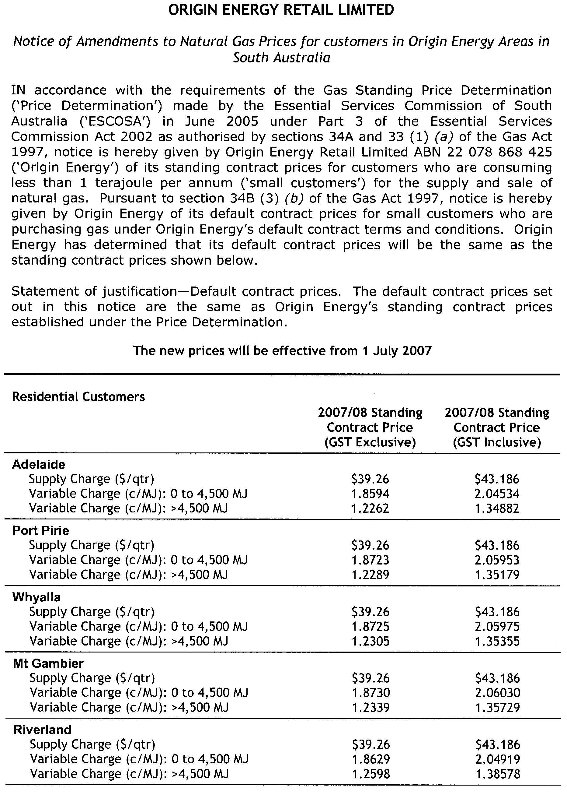
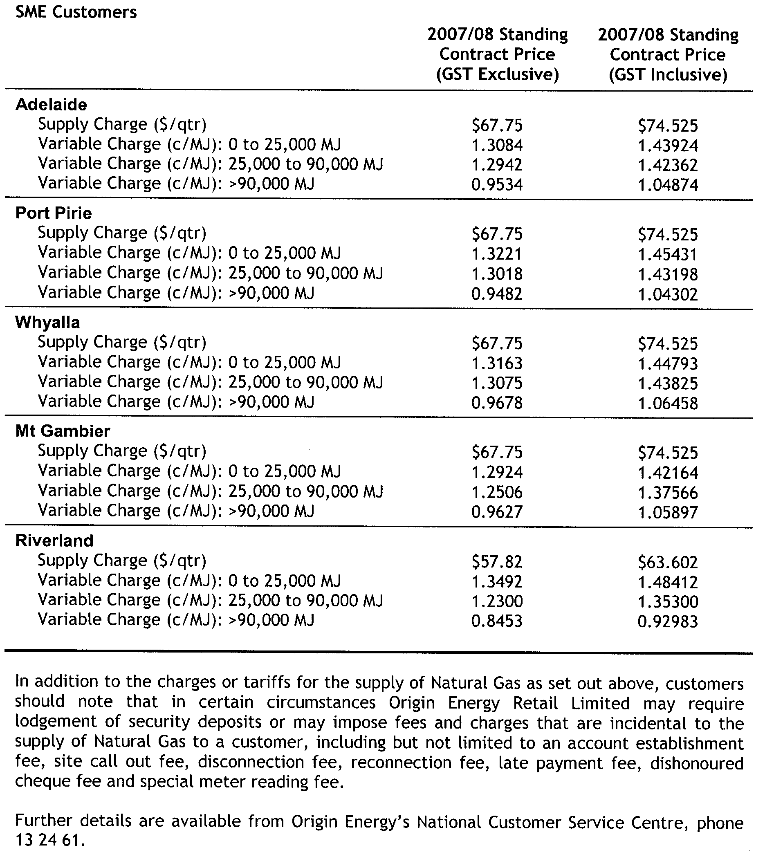

RULES OF COURT
Supreme Court Criminal Rules 1992
(Amendment No. 21)
BY virtue and in pursuance of section 72 of the Supreme Court Act 1935 and all other enabling powers, We, the Judges of the Supreme Court of South Australia, make the following Supreme Court Criminal Rules 1992 (Amendment No. 21).
1. These Rules may be cited as the Supreme Court Criminal Rules 1992 (Amendment No. 21).
2. The Supreme Court Criminal Rules 1992 are amended as set out below.
3. The amendments are to come into effect on the later of 1 July 2007 or their gazettal.
4. In each of subrules 7.03, 7.14 and 14.03, the word ‘leave’ is deleted and the word ‘permission’ is inserted in its place.
5. In subrule 6A.02 the words ‘the Clerk of Arraigns’ are deleted and the words ‘the Deputy Registrar (Criminal)’ inserted in their place.
6. In each of subrules 10.02 (b) and 10.02 (d), the words ‘the Clerk of Arraigns’ are deleted and the words ‘a person directed by the Judge’ inserted in their place.
7. After Rule 25 insert the following heading and new Rules 26, 27, 28 and 29:
‘Applications under sections 37-38 of the Child Sex Offenders Registration
Act 2006 to Suspend Reporting Obligations
26. An application under section 37 of the Child Sex Offenders Registration Act 2006 (“the Act”):
26.01 is to be in Form 17 in the Schedule to these Rules;
26.02 is to be accompanied by an affidavit of the applicant which:
(a) specifies the child sex offender registration order, if any, to which the applicant is subject, including the date upon which it was made, the Court which made it, the offence or offences for which the applicant was sentenced at the time the order was made and, in the case of an applicant who is subject to a restraining order under section 99AA of the Summary Procedure Act 1921, the terms of that order;
(b) specifies, in the event that the applicant is not subject to a child sex offender registration order, each sentence imposed on the applicant which has the effect that the applicant is a registrable offender;
(c) sets out, so far as is known to the applicant, details of the applicant’s antecedent criminal history;
(d) has exhibited to it the report of any expert upon which the applicant proposes to rely;
(e) has exhibited to it a copy of any other documentary evidence upon which the applicant proposes to rely;
(f) identifies any evidence other than that referred to in (d) or (e) upon which the applicant proposes to rely; and
(g) insofar as it has not already been covered by subparagraphs (a)-(e), sets out the facts and grounds upon which the application is made.
26.03 is, with the applicant’s affidavit, to be served within two working days of being filed upon the Commissioner of Police.
27. An application under section 37 will be listed in an arraignment list for initial directions.
28. The Court may, on the application of the Commissioner of Police, direct that the applicant submit to examination by such legally qualified medical practitioners or other persons as the Court shall direct, and may obtain from any such practitioner, or any other person, such report relating to an issue arising in relation to the application as the Court thinks fit.
29. If the applicant fails to comply with a direction to submit to an examination ordered pursuant to Rule 28, the Court may stay the hearing of the application until the applicant complies with that direction.’
8. The Schedule is amended by adding after Form 16 the following new Form 17:
‘Form 17
The Queen v .....
APPLICATION UNDER SECTION 37 OF THE CHILD SEX OFFENDERS REGISTRATION ACT 2006
... (name and address of applicant) applies to the Supreme Court under section 37 of the Child Sex Offenders Registration Act 2006 for the following orders:

(set out orders sought)

DATED
Signed by the applicant or his lawyer

The address for service of the applicant for the purposes of this application is:
(set out the address for service).

The above application is listed for initial directions on
(insert time and date of hearing) in a Courtroom in the Sir Samuel Way Building, Victoria Square, Adelaide.

Registrar of the Supreme Court’

GIVEN under our hands and the Seal of the Supreme Court of South Australia this 28th day of May 2007.
(l.s.) J. DOYLE, CJ
K. P. DUGGAN, J
M. J. NYLAND, J
T. A. GRAY, J
A. M. VANSTONE, J
J. M. WHITE, J
M. DAVID, J
B. M. DEBELLE, J
D. J. BLEBY, J
J. R. SULAN, J
J. ANDERSON, J
R. A. LAYTON, J
P. KELLY, J

SOUTH AUSTRALIA FIRE AND EMERGENCY SERVICES ACT 2005
Dissolution of CFS Group
NOTICE is hereby given pursuant to Division 5, section 68 (1) (b) of the South Australia Fire and Emergency Services Act 2005, that the Chief Officer, Country Fire Service dissolves the Ceduna CFS Group, effective 1 July 2007.
Dated 6 June 2007.
E. Ferguson, Chief Officer, SA Country Fire Service

SOUTH AUSTRALIA FIRE AND EMERGENCY SERVICES ACT 2005
Constitution of CFS Brigade
NOTICE is hereby given pursuant to Division 5, section 68 (1) (b) of the South Australia Fire and Emergency Services Act 2005, that the Chief Officer, Country Fire Service constitutes the Western Eyre CFS Group, effective 1 July 2007.
Dated 6 June 2007.
E. Ferguson, Chief Officer, SA Country Fire Service

WATER MAINS AND SEWERS

Office of the South Australian Water Corporation
Adelaide, 14 June 2007

WATER MAINS LAID

Notice is hereby given that the following main pipes or parts of main pipes have been laid down by the South Australian Water Corporation in or near the undermentioned water districts and are now available for a constant supply of water to adjacent land.

ADELAIDE WATER DISTRICT

CITY OF ONKAPARINGA
Rajah Street, Morphett Vale. p1
Madeleine Close, Morphett Vale. p1

CITY OF PORT ADELAIDE ENFIELD
McRostie Street, Ferryden Park. p8

CITY OF SALISBURY
The Boulevard, Parafield Gardens. p2
Easement in lot 1012 in LTRO DP 73471, The Boulevard, Parafield Gardens. p2
Grove Street, Parafield Gardens. p2
Park Street, Parafield Gardens. p2
Oaks Court, Parafield Gardens. p2

KINGSTON S.E. WATER DISTRICT

KINGSTON DISTRICT COUNCIL
Clarke Street, Kingston S.E. p7

MURRAY BRIDGE WATER DISTRICT

THE RURAL CITY OF MURRAY BRIDGE
Parkview Drive, Murray Bridge. p3
Melaleuca Way, Murray Bridge. p3
Casuarina Walk, Murray Bridge. p3
Willowbark Crescent, Murray Bridge. p3
Easement in lot 3000 in LTRO DP 70168, Willowbark Crescent, Murray Bridge. p3

PORT GERMEIN WATER DISTRICT

DISTRICT COUNCIL OF MOUNT REMARKABLE
avers Avenue, Port Germein. p5
Seventh Street, Port Germein. p5
RENMARK WATER DISTRICT

RENMARK PARINGA COUNCIL
Alma Street, Renmark. p6

WALLAROO WATER DISTRICT

DISTRICT COUNCIL OF THE COPPER COAST
Jamieson Way, Wallaroo. p4

WATER MAINS ABANDONED

Notice is hereby given that the undermentioned water mains have been abandoned by the South Australian Water Corporation.

PORT GERMEIN WATER DISTRICT

DISTRICT COUNCIL OF MOUNT REMARKABLE
Havers Avenue, Port Germein. p5

RENMARK WATER DISTRICT

RENMARK PARINGA COUNCIL
Alma Street, Renmark. p6

WALLAROO WATER DISTRICT

DISTRICT COUNCIL OF THE COPPER COAST
Jamieson Way, Wallaroo. p4

SEWERS LAID

Notice is hereby given that the following sewers have been laid down by the South Australian Water Corporation in the undermentioned drainage area and are now available for house connections.

ADELAIDE DRAINAGE AREA

TOWN OF GAWLER
Across Second Street, Gawler. FB 1158 p57
Easement in lot 100 in LTRO DP 67074, Second Street, Gawler. FB 1158 p57

CITY OF MARION
Ailsa Avenue, Warradale. FB 1158 p50

CITY OF MITCHAM
Adamson Avenue, Belair. FB 1158 p51

CITY OF ONKAPARINGA
Scenic Way, Hackham. FB 1158 p52 and 53
Crossing Road, Aberfoyle Park. FB 1158 p55

CITY OF PORT ADELAIDE ENFIELD
McRostie Street, Ferryden Park. FB 1158 p54
Blyth Street, Broadview. FB 1158 p56
Strathmont Avenue, Gilles Plains. FB 1158 p58

CITY OF SALISBURY
Easements in lot 31 in LTRO DP 25622, Port Wakefield Road, lot 3 in LTRO FP 1842, Ryans Road, lot 51 in LTRO DP 13647, Martins Road, lot 1014 in LTRO DP 73471 Shepherdson Road, lot 1013 in LTRO DP 73471, and lot 1012 in LTRO DP 73471, The Boulevard, Parafield Gardens. FB 1159 p27-31
The Boulevard, Parafield Gardens. FB 1159 p27, 30 and 32
Grove Street, Parafield Gardens. FB 1159 p27, 30 and 33
Park Street, Parafield Gardens. FB 1159 p27, 30 and 33
Oaks Court, Parafield Gardens. FB 1159 p27, 30 and 33

A. Howe, Chief Executive Officer, South Australian Water Corporation

WATERWORKS ACT 1932
Removal of Land from Beetaloo Country Lands Water District
and Addition to Wallaroo Water District
PURSUANT to section 6 of the Waterworks Act 1932, the South Australian Water Corporation:
(a) removes from the Beetaloo Country Lands Water District and adds to the Wallaroo Water District all the land contained in:
(i) Deposited Plan 71846;
(ii) allotment 117 in Deposited Plan 36986; and
(b) declares that this notice will have effect from 1 July 2007.
Dated 12 June 2007.
Signed for and on behalf of the South Australian Water Corporation by a person duly authorised so to do:
A. Sheedy, Manager Shared Services
In the presence of:
C. J. McNamara, Billing Manager
SAWATER 07/01286 W1342

WATERWORKS ACT 1932
Removal of Land from Streaky Bay Country Lands Water District and Addition to Streaky Bay Township Water District
PURSUANT to section 6 of the Waterworks Act 1932, the South Australian Water Corporation:
(a) removes from the Streaky Bay Country Lands Water District and adds to the Streaky Bay Township Water District all the land contained in allotments 1 to 47 inclusive, 205 and 206 (reserves) and 123 to 125 inclusive (roads) in Deposited Plan 72052; and
(b) declares that this notice will have effect from 1 July 2007.
Dated 12 June 2007.
Signed for and on behalf of the South Australian Water Corporation by a person duly authorised so to do:
A. Sheedy, Manager Shared Services
In the presence of:
C. J. McNamara, Billing Manager
SAWATER 07/01286 W1349

WATERWORKS ACT 1932
Removal of Land from Strathalbyn Country Lands Water District and Addition to Strathalbyn Water District
PURSUANT to section 6 of the Waterworks Act 1932, the South Australian Water Corporation:
(a) removes from the Strathalbyn Country Lands Water District and adds to the Strathalbyn Water District all the land contained in Deposited Plan 72267; and
(b) declares that this notice will have effect from 1 July 2007.
Dated 12 June 2007.
Signed for and on behalf of the South Australian Water Corporation by a person duly authorised so to do:
A. Sheedy, Manager Shared Services
In the presence of:
C. J. McNamara, Billing Manager
SAWATER 07/01286 W1350

WATERWORKS ACT 1932
Removal of Land from Beetaloo Country Lands Water District and Addition to Wallaroo Mines Water District
PURSUANT to section 6 of the Waterworks Act 1932, the South Australian Water Corporation:
(a) removes from the Beetaloo Country Lands Water District and adds to the Wallaroo Mines District all the land contained in Deposited Plan 72337; and
(b) declares that this notice will have effect from 1 July 2007.
Dated 12 June 2007.
Signed for and on behalf of the South Australian Water Corporation by a person duly authorised so to do:
A. Sheedy, Manager Shared Services
In the presence of:
C. J. McNamara, Billing Manager
SAWATER 07/01286 W1351

WATERWORKS ACT 1932
Removal of Land from Warooka Country Lands Water District and Addition to Township of Warooka Water District
PURSUANT to section 6 of the Waterworks Act 1932, the South Australian Water Corporation:
(a) removes from the Warooka Country Lands Water District and adds to the Township of Warooka Water District all the land contained in Deposited Plan 72179; and
(b) declares that this notice will have effect from 1 July 2007.
Dated 12 June 2007.
Signed for and on behalf of the South Australian Water Corporation by a person duly authorised so to do:
A. Sheedy, Manager Shared Services
In the presence of:
C. J. McNamara, Billing Manager
SAWATER 07/01286 W1352

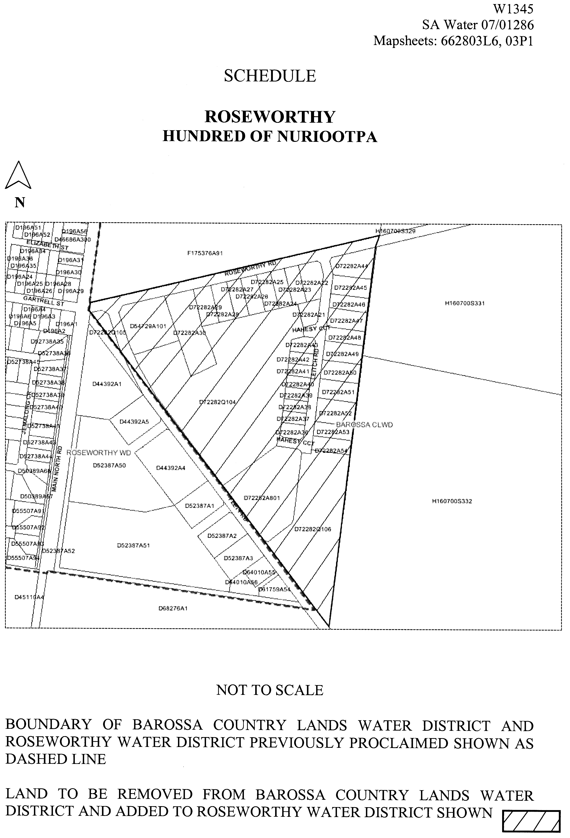
WATERWORKS ACT 1932
Removal of Land from Barossa Country Lands Water District and Addition to Roseworthy Water District
PURSUANT to section 6 of the Waterworks Act 1932, the South Australian Water Corporation:
(a) removes from the Barossa Country Lands Water District and adds to the Roseworthy Water District the land shown on the plan in the Schedule; and
(b) declares that this notice will have effect from 1 July 2007.

Dated 12 June 2007.
Signed for and on behalf of the South Australian Water Corporation by a person duly authorised so to do:
A. Sheedy, Manager Shared Services
In the presence of:
C. J. McNamara, Billing Manager
SAWATER 07/01286 W1345

South Australia
Barley Exporting Regulations 2007
under the Barley Exporting Act 2007

Contents
1 Short title
2 Commencement
3 Interpretation
4 Payment of licence fees and lodgment of returns
5 Advisory committee procedures
6 Expiry of regulations

1—Short title
These regulations may be cited as the Barley Exporting Regulations 2007.
2—Commencement
These regulations will come into operation on 1 July 2007.
3—Interpretation
In these regulations—
Act means the Barley Exporting Act 2007.
4—Payment of licence fees and lodgment of returns
(1) For the purposes of section 11(2) of the Act—
(a) the licence fee must be paid before the anniversary in each year of the day on which the licence was issued; and
(b) an annual return must be lodged before 31 August in each year.
(2) For the purposes of section 11(6) of the Act, the penalty for default for failing to pay a licence fee or lodging an annual return is $500.
5—Advisory committee procedures
(1) A quorum of the advisory committee consists of 1 half the total number of its members (ignoring any fraction resulting from the division) plus 1.
(2) If the presiding member of the advisory committee is absent from a meeting of the committee, a member chosen by the members present at the meeting will preside.
(3) A decision carried by a majority of the votes cast by the members present at a meeting of the advisory committee is a decision of the committee.
(4) Each member present at a meeting of the advisory committee has 1 vote on any question arising for decision and, if the votes are equal, the member presiding at the meeting may exercise a casting vote.
(5) A conference by telephone or other electronic means between the members of the advisory committee will, for the purposes of this section, be taken to be a meeting of the committee at which the participating members are present if—
(a) notice of the conference is given to all members in the manner determined by the committee for the purpose; and
(b) each participating member is capable of communicating with every other participating member during the conference.
(6) A proposed resolution of the advisory committee becomes a valid decision of the committee despite the fact that it is not voted on at a meeting of the committee if—
(a) notice of the proposed resolution is given to all members of the committee in accordance with procedures determined by the committee; and
(b) a majority of the members express concurrence in the proposed resolution by letter, telegram, telex, fax or other written communication setting out the terms of the resolution.
(7) The advisory committee must have accurate minutes kept of its meetings.
6—Expiry of regulations
These regulations will expire when the Act expires.
Note—
Section 23(3) of the Act provides that the Act will expire on the third anniversary of its commencement.
Note—
As required by section 10AA(2) of the Subordinate Legislation Act 1978, the Minister has certified that, in the Minister's opinion, it is necessary or appropriate that these regulations come into operation as set out in these regulations.
Made by the Governor
with the advice and consent of the Executive Council
on 14 June 2007
No 167 of 2007
MAFF07/001CS

South Australia
South Australian Health Commission (Recognised Hospital—Medicare Patients Fees) Variation Regulations 2007
under the South Australian Health Commission Act 1976

Contents
Part 1—Preliminary
1 Short title
2 Commencement
3 Variation provisions
Part 2—Variation of South Australian Health Commission (Recognised Hospital—Medicare Patients Fees) Regulations 2002
4 Variation of regulation 4—Interpretation
5 Substitution of Schedule
Schedule—Fees for services provided to Medicare patients by recognised hospitals

Part 1—Preliminary
1—Short title
These regulations may be cited as the South Australian Health Commission (Recognised Hospital—Medicare Patients Fees) Variation Regulations 2007.
2—Commencement
These regulations will come into operation on 1 July 2007.
3—Variation provisions
In these regulations, a provision under a heading referring to the variation of specified regulations varies the regulations so specified.
Part 2—Variation of South Australian Health Commission (Recognised Hospital—Medicare Patients Fees) Regulations 2002
4—Variation of regulation 4—Interpretation
Regulation 4(1), definition of outreach service—delete the definition and substitute:
outreach service means a service that is taken to be hospital treatment for the purposes of the Private Health Insurance Act 2007 of the Commonwealth under section 16 of the Private Health Insurance (Transitional Provisions and Consequential Amendments) Act 2007 of the Commonwealth;
5—Substitution of Schedule
Schedule—delete the Schedule and substitute:
Schedule—Fees for services provided to Medicare patients by recognised hospitals

 |  | Fee (per day)
1 | For the accommodation, maintenance, care and treatment at a recognised hospital of a public overnight stay patient | no fee
2 | For the accommodation, maintenance and care at a recognised hospital of a private overnight stay patient—
 | (a) where the patient requests and subsequently receives single room accommodation | $474.00
 | (b) in any other case | $275.00
3 | For the accommodation, maintenance, care and treatment at a recognised hospital of a public patient who is a same day patient | no fee
4 | For the accommodation, maintenance and care at a recognised hospital of a private patient who is a same day patient—
 | (a) for gastro-intestinal endoscopy or other minor surgical and non-surgical procedures that do not normally require an anaesthetic (Band 1) | $200.00
 | (b) for procedures (other than Band 1 procedures) carried out under local anaesthetic with no sedation given where the actual time in the theatre is less than one hour (Band 2) | $227.00
 | (c) for procedures (other than Band 1 procedures) carried out under general or regional anaesthesia or intravenous sedation where the actual time in the theatre is less than one hour (Band 3) | $250.00
 | (d) for any procedures carried out under general or regional anaesthesia or intravenous sedation where the actual time in the theatre is one hour or more (Band 4) | $275.00
5 | For the accommodation, maintenance, care and treatment at a recognised hospital of a public long stay patient who is acutely ill | no fee
6 | For the accommodation, maintenance, care and treatment at a recognised hospital of a public long stay patient who is not acutely ill | 87.5 per cent of the Commonwealth benefit
7 | For the accommodation, maintenance and care at a recognised hospital of a private long stay patient who is not acutely ill | $93.50 plus 87.5 per cent of the Commonwealth benefit
8 | For outreach services provided by a recognised hospital to a private patient | $166.00

Note—
As required by section 10AA(2) of the Subordinate Legislation Act 1978, the Minister has certified that, in the Minister's opinion, it is necessary or appropriate that these regulations come into operation as set out in these regulations.
Made by the Governor
on the recommendation of the Minister for Health and with the advice and consent of the Executive Council
on 14 June 2007
No 168 of 2007
HEACS/07/197

South Australia
Natural Resources Management (Transitional Provisions—Levies) Variation Regulations 2007
under the Natural Resources Management Act 2004

Contents
Part 1—Preliminary
1 Short title
2 Commencement
3 Variation provisions
Part 2—Variation of Natural Resources Management (Transitional Provisions—Levies) Regulations 2005
4 Variation of regulation 6—Differentiating factors—section 92

Part 1—Preliminary
1—Short title
These regulations may be cited as the Natural Resources Management (Transitional Provisions—Levies) Variation Regulations 2007.
2—Commencement
These regulations come into operation on the day on which they are made.
3—Variation provisions
In these regulations, a provision under a heading referring to the variation of specified regulations varies the regulations so specified.
Part 2—Variation of Natural Resources Management (Transitional Provisions—Levies) Regulations 2005
4—Variation of regulation 6—Differentiating factors—section 92
Regulation 6—after subregulation (2) insert:
(3) For the purposes of applying subsection (3) of section 92 of the NRM Act in respect of the 2007/2008 financial year, the following are prescribed as additional matters to be taken into account by the Minister (if the Minister decides to act under that subsection in relation to the constituent councils of a particular region), namely—
(a) that the respective shares of those constituent councils with respect to the amount to be paid to the relevant regional NRM board under the board's regional plan may be adjusted so that the share of each council in respect of the 2007/2008 financial year is approximately equal to the amount contributed (or to be contributed) by the council in relation to the 2006/2007 financial year, adjusted to take into account increases to the CPI during the 12 months ending on 30 September 2006; and
(b) that, in relation to the City of Port Lincoln and The Corporation of the City of Whyalla, the amount to be contributed by either council may be adjusted so that the share of the council in respect of the 2007/2008 financial year is approximately equal to an amount obtained by multiplying the number of pieces of rateable land in the area of the relevant council (as notified to the Minister by the council for the purposes of Chapter 5 Part 1 Division 1 of the NRM Act for the 2007/2008 financial year) by $37.
Note—
As required by section 10AA(2) of the Subordinate Legislation Act 1978, the Minister has certified that, in the Minister's opinion, it is necessary or appropriate that these regulations come into operation as set out in these regulations.
Made by the Governor
with the advice and consent of the Executive Council
on 14 June 2007
No 169 of 2007
WBCS07/0015

South Australia
Natural Resources Management (Financial Provisions) Variation Regulations 2007
under the Natural Resources Management Act 2004

Contents
Part 1—Preliminary
1 Short title
2 Commencement
3 Variation provisions
Part 2—Variation of Natural Resources Management (Financial Provisions) Regulations 2005
4 Redesignation of regulation 4AA
5 Redesignation of regulation 4A
6 Redesignation of regulation 4B
7 Insertion of regulation 4B
4B Imposition of levy by councils—section 95

Part 1—Preliminary
1—Short title
These regulations may be cited as the Natural Resources Management (Financial Provisions) Variation Regulations 2007.
2—Commencement
These regulations come into operation on the day on which they are made.
3—Variation provisions
In these regulations, a provision under a heading referring to the variation of specified regulations varies the regulations so specified.
Part 2—Variation of Natural Resources Management (Financial Provisions) Regulations 2005
4—Redesignation of regulation 4AA
Regulation 4AA—redesignate the regulation as regulation 4A
5—Redesignation of regulation 4A
Regulation 4A—redesignate the regulation as regulation 4C
6—Redesignation of regulation 4B
Regulation 4B—redesignate the regulation as regulation 4D
7—Insertion of regulation 4B
After regulation 4A (as redesignated by these regulations) insert:
4B—Imposition of levy by councils—section 95
Pursuant to section 95(3)(i) of the Act, the operation of section 159(9) of the Local Government Act 1999 is modified—
(a) so as to not require a council that grants to a person or body a rebate of general rates under section 166 of the Local Government Act 1999 to grant a comparable rebate of a regional NRM levy to the person or body; and
(b) so as to allow a council to grant to a person or body a rebate of a regional NRM levy under section 166 of the Local Government Act 1999 that is different to a rebate of general rates granted to the person or body.
Note—
As required by section 10AA(2) of the Subordinate Legislation Act 1978, the Minister has certified that, in the Minister's opinion, it is necessary or appropriate that these regulations come into operation as set out in these regulations.
Made by the Governor
with the advice and consent of the Executive Council
on 14 June 2007
No 170 of 2007
WBCS07/0015

South Australia
Upper South East Dryland Salinity and Flood Management (Project Works Corridors) Regulations 2007
under the Upper South East Dryland Salinity and Flood Management Act 2002

Contents
1 Short title
2 Commencement
3 Interpretation
4 Variation of Schedule 1 of the Act—Project works corridors
Part B—Description of lines for the purposes of paragraph (b) of the definition of project works corridor

1—Short title
These regulations may be cited as the Upper South East Dryland Salinity and Flood Management (Project Works Corridors) Regulations 2007.
2—Commencement
These regulations come into operation on the day on which they are made.
3—Interpretation
In these regulations—
Act means the Upper South East Dryland Salinity and Flood Management Act 2002.
4—Variation of Schedule 1 of the Act—Project works corridors
Schedule 1 of the Act, Part B—delete Part B and substitute:
Part B—Description of lines for the purposes of paragraph (b) of the definition of project works corridor
The lines shown on Rack Plan 893 lodged in the Surveyor-General's Office at Adelaide as at 14 June 2007;
The lines shown on Rack Plan 894 lodged in the Surveyor-General's Office at Adelaide as at 14 June 2007.
Note—
As required by section 10AA(2) of the Subordinate Legislation Act 1978, the Minister has certified that, in the Minister's opinion, it is appropriate that these regulations come into operation as set out in these regulations.
Made by the Governor
with the advice and consent of the Executive Council
on 14 June 2007
No 171 of 2007
WBCS07/0016

FAXING COPY?
IF you fax copy to Government Publishing SA for inclusion in the Government Gazette, there is no need to send a Confirmation Copy to us as well.
This creates confusion and may well result in your notice being printed twice.
Please use the following fax number:
Fax transmission: (08) 8207 1040
Phone Inquiries: (08) 8207 1045
Please include a contact person, phone number and order number so that we can phone back with any queries we may have regarding the fax copy.
NOTE: Closing time for lodging new copy (fax, hard copy or email) is 4 p.m. on Tuesday preceding the day of publication.

Government Gazette notices can be E-mailed.
The address is:
governmentgazette@dpc.sa.gov.au
Documents should be sent as attachments in Word format.
When sending a document via E-mail, please confirm your transmission with a faxed copy of your document, including the date the notice is to be published.
Fax transmission: (08) 8207 1040
Enquiries: (08) 8207 1045
NOTE: Closing time for lodging new copy (fax, hard copy or email) is 4 p.m. on Tuesday preceding the day of publication.

CITY OF CHARLES STURT
Roads (Opening and Closing) Act 1991
Road Closure, Portions of Laneway, adjacent High Street, Grange
NOTICE is hereby given pursuant to section 10 of the said Act, that Council proposes to make a Road Process Order to close and sell to P. C. and K. E. Crease and M. R. and J. D. Southwell the portions of unnamed laneway off High Street (north of Jetty Road) shown as ‘A’ and ‘B’ (respectively) on Preliminary Plan No. 07/0040.
A copy of the plan and statement of persons affected are available for public inspection at Council’s Office, 72 Woodville Road, Woodville and the office of the Surveyor-General, 101 Grenfell Street, Adelaide during normal office hours.
Any application for easement or objections must be made in writing within 28 days from 13 June 2007, to the Council, P.O. Box 1, Woodville, S.A. 5011 and the Surveyor-General, G.P.O. Box 1354, Adelaide, S.A. 5001, setting out full details.
Where a submission is made, Council will give notification of a meeting to deal with the matter.
M. Withers, Chief Executive Officer

CITY OF CHARLES STURT
Development Act 1993
Charles Sturt (City) Development Plan
District Centre (Kilkenny) Zone Plan Amendment Report—
Draft for Public Consultation
NOTICE is hereby given that the City of Charles Sturt has prepared a draft Plan Amendment Report to amend the Charles Sturt (City) Development Plan. The District Centre (Kilkenny) Zone Plan Amendment Report affects land within the District Centre (Kilkenny) Zone.
The Plan Amendment Report proposes to amend the Charles Sturt (City) Development Plan by:
• extending the Retail Core Policy Area 24 to include the north-eastern part of the zone at the junction of Gray Street and First Avenue, currently within the Commercial/ Office/Large Space Retail Policy Area 27, to enable the eastwards expansion of the Centro Arndale Shopping Centre;
• extending the Retail Core Policy Area 24 to include the north-western part of the zone bounded by Blackburn Court, Hanson Road and First Avenue, currently within the Commercial/Office/Large Space Retail Policy Area 27;
• incorporating improved development controls for the future development of the zone;
• outlining the desired building design, public realm, public transport interchange and environment; and
• integrating future development with the adjacent industrial and residential areas.
The draft Plan Amendment Report and Explanatory State-
ment will be available for public inspection and purchase during normal office hours at the Council Office, 72 Woodville Road, Woodville, and may be viewed on Council’s website at www.charlessturt.sa.gov.au from 14 June 2007 to 15 August 2007. Copies of the Plan Amendment Report can be purchased from the Council at $10 each.
Written submissions regarding the draft amendment will be accepted by the City of Charles Sturt until 5 p.m. on Wednesday, 15 August 2007. The written submission should clearly indicate whether you will wish to speak at the public hearing on your submission. All submissions should be addressed to the Chief Executive, City of Charles Sturt, P.O. Box 1, Woodville, S.A. 5011.
Copies of all submissions received will be available for inspection by interested persons at the Civic Centre, 72 Woodville Road from 15 August 2007 until the date of the public hearing.
A public hearing has been set for Monday, 3 September 2007 at 6 p.m. at Council’s Civic Centre, 72 Woodville Road, Woodville.
Persons wishing to be heard at the public hearing are requested to indicate their intention in their submission. The public hearing may not be held if no submission indicates an interest in speaking at the public hearing.
Dated 14 June 2007.
M. Withers, Chief Executive

DISTRICT COUNCIL OF CEDUNA
Supplementary Election
AT the close of nominations at 12 noon on Thursday, 7 June 2007, the following people have been accepted as candidates and are listed in the order in which they will appear on the ballot paper.
Nominations Received
Area Councillor—(1 vacancy)
Butson, Karyn
Edwards, Victor
Gregory, Phil
Postal Voting
The election will be conducted by post. Ballot papers and pre-paid envelopes for each entitlement will be mailed out between Tuesday, 19 June to Monday, 25 June 2007 to every person, body corporate and group listed on the voters roll at roll close on 19 April 2007.
Voting is Voluntary
A person who has not received voting material by Monday, 25 June 2007 and who believes they are entitled to vote should contact the Principal Council Office, 44 O’Loughlin Terrace, Ceduna or phone 8625 3407.
Completed voting material must be returned to reach the Deputy Returning Officer no later than 12 noon on Monday, 9 July 2007.
A ballot box will be provided at the Council Office for electors wishing to hand deliver their completed voting material during office hours.
Place of Counting Votes
The scrutiny and count will take place in the Council Chambers, 44 O’Loughlin Terrace, Ceduna at 2 p.m. on Monday, 9 July 2007. A provisional declaration will be made at the conclusion of each count.
Campaign Donations Return
Candidates must forward a Campaign Donations Return to the Council Chief Executive Officer within six weeks after the conclusion of the election.
K. Mousley, Returning Officer

WAKEFIELD REGIONAL COUNCIL
Appointments
NOTICE is hereby given that at a meeting of the Council held on 23 May 2007, Dustin William Guthberg was appointed as an Authorised Officer pursuant to the Development Act 1993 (section 18), Local Government Act 1999 (section 260), and Dog and Cat Management Act 1995 (section 27).
Notice is hereby given that at a meeting of the Council held on 23 May 2007, Nicole Joy Argent was appointed as an Authorised Officer pursuant to the Public and Environmental Health Act 1987 (section 7 (1)), subject to Public and Environmental Health Council authorisation (full/partial), Food Act 2001 (section 94), Local Government Act 1999 (section 260), Environment Protection Act 1999 (Burning Policy) and Development Act 1993 (section 18), and duly cancels such authorisations of David Bavington.
P. Barry, Chief Executive Officer

IN the matter of the estates of the undermentioned deceased persons:
Arthey, Mary Elizabeth, late of 50 Gulfview Road, Christies Beach, of no occupation, who died on 10 April 2007.
Bailey, James, late of 14 Humber Street, Holden Hill, retired labourer, who died on 28 March 2007.
Bracegirdle, Joyce Millicent, late of 2 Marcian Avenue, Elizabeth Downs, of no occupation, who died on 9 February 2007.
Burzacott, Lewis Edmund, late of 28C King George Avenue, Hove, retired racecourse manager, who died on 3 April 2007.
Caire, Nora Gwendoline, late of Grainger Road, Somerton Park, retired clerk, who died on 12 April 2007.
Chapman, Thirza Edna, late of 7 Victoria Street, Goodwood, married woman, who died on 4 January 2007.
Crookes, Amy Elizabeth, late of 122 Wehl Street North, Mount Gambier, retired cleaner, who died on 12 February 2007.
Dearman, Cyril Henry, late of 251 Payneham Road, Joslin, retired civil engineer, who died on 18 March 2007.
Dodds, Barbara, late of 28 Bonython Street, Salisbury Plain, retired school cleaner, who died on 2 March 2007.
Donnelly, Stanley Keith, late of corner of Fort Street and Sylvan Way, Grange, retired retail manager, who died on 4 March 2007.
Drew, Esther Ruby, late of 20-36 Gardenia Drive, Parafield Gardens, widow, who died on 21 April 2007.
Elliott, Charles Edward, late of 200 Fosters Road, Oakden, retired storeman, who died on 22 March 2007.
Frampton, Winifred Jean, late of 23 Hurlstone Street, Peterborough, of no occupation, who died on 28 January 2007.
Grandsen, Leslie Henry, late of 367-379 Waterloo Corner Road, Burton, retired clerk, who died on 4 May 2007.
Hammond, Annie Agnes, late of 2 Kalyra Road, Belair, of no occupation, who died on 7 February 2007.
Heward, Thomas Raymond, late of 3 Emeu Street, Port Clinton, retired clerk, who died on 28 March 2007.
O’Connell, Marie Louise, late of 11 Edmund Street, Port Broughton, shop assistant, who died on 11 April 2007.
Papai, John, late of 430 Morphett Street, Adelaide, retired general maintenance worker, who died on 27 March 2006.
Pearce, John Frederick, late of 29 Railway Terrace, Quorn, retired plant operator, who died on 20 December 2006.
Ridley, Peter John, late of 7A Lansell Street, Mount Gambier, school teacher, who died on 3 April 2007.
Ross, Carmen Annette, late of 25 Roopena Street, Ingle Farm, of no occupation, who died on 8 April 2007.
Ross, Dennis Maxwell, late of 40 Chief Street, Brompton, retired driver, who died on 11 March 2007.
Sheaf, Wayne Noel, late of 15 Richards Avenue, Dodges Ferry, Tasmania, of no occupation, who died on 4 September 2006.
Williams, Doreen, late of 324 Military Road, Semaphore Park, home duties, who died on 5 April 2007.
Woolford, George Allen Victor, late of 226 Fullarton Road, Glenside, of no occupation, who died on 5 March 2007.
Notice is hereby given pursuant to the Trustee Act 1936, as amended, the Inheritance (Family Provision) Act 1972, and the Family Relationships Act 1975, that all creditors, beneficiaries, and other persons having claims against the said estates are required to send, in writing, to the Public Trustee, 25 Franklin Street, Adelaide, S.A. 5000, full particulars and proof of such claims, on or before 13 July 2007, otherwise they will be excluded from the distribution of the said estate; and notice is also hereby given that all persons who are indebted to the said estates are required to pay the amount of their debts to the Public Trustee or proceedings will be taken for the recovery thereof; and all persons having any property belonging to the said estates are forthwith to deliver the same to the Public Trustee.
Dated 14 June 2007.
C. J. O’Loughlin, Public Trustee

ATTENTION

CUSTOMERS requiring a proof of their notice for inclusion in the Government Gazette, please note that the onus is on you to inform Government Publishing SA of any subsequent corrections by 10 a.m. on Thursday, which is our publication deadline.

For any corrections to your notice please phone 8207 1045 or Fax 8207 1040 before 10 a.m. on Thursday.

If we do not receive any communication by 10 a.m. on Thursday (day of publication) we will presume the notice is correct and will print it as it is.

Remember—the onus is on you to inform us of any corrections necessary to your notice.

NOTE: Closing time for lodging new copy (electronically, fax or hard copy) is 4 p.m. on Tuesday preceding the day of publication. Phone 8207 1045—Fax 8207 1040.
Email: governmentgazette@dpc.sa.gov.au

Printed and published by authority every Thursday by T. GOODES, Government Printer, South Australia
Price: $5.20, plus postage; to subscribers, $263.00 per annum.
(The above prices are inclusive of GST)

