No. 12 589

THE SOUTH AUSTRALIAN

GOVERNMENT GAZETTE
www.governmentgazette.sa.gov.au

PUBLISHED BY AUTHORITY

ALL PUBLIC ACTS appearing in this GAZETTE are to be considered official, and obeyed as such

ADELAIDE, THURSDAY, 1 MARCH 2007

CONTENTS

Page
Act Assented To 590
Appointments, Resignations, Etc. 590
Brands Act 1933—Notice 604
Classification (Publications, Films and Computer Games)
Act 1995—Notices 617
Corporations and District Councils—Notices 686
Development Act 1993—Notices 590
Electricity Act 1996—Notice 620
Employment Agents Registration Act 1993—Notices 633
Environment Protection Act 1993—Notices 665
Environment Protection Authority—Notice 633
Gaming Machines Act 1992—Notice 633
Geographical Names Act 1991—
Corrigendum 633
Notice 633
Land and Business (Sale and Conveyancing) Act 1994—
Notice 633
Liquor Licensing Act 1997—Notices 634
Livestock Act 1997—Notice 637
Magistrates Court Rules 1992—Notice 643
Mining Act 1971—Notices 638

Page
National Electricity Law—Notice 639
National Parks and Wildlife (National Parks) Regulations
2001—Notice 639
Natural Resources Management Act 2004—Notices 640
Petroleum Act 2000—Notices 641
Prevention of Cruelty to Animals Act 1985—Notice 641
Proclamations 672
Public Trustee Office—Administration of Estates 687

REGULATIONS
Controlled Substances Act 1984 (No. 13 of 2007) 674
Liquor Licensing Act 1997—
(No. 14 of 2007) 677
(No. 15 of 2007) 679
Criminal Law Consolidation Act 1935 (No. 16 of 2007) 680
Summary Procedure Act 1921 (No. 17 of 2007) 682
River Murray Act 2003—Notice 641
Rules of Court 653
Trade Standards Act 1979—Notice 664
Transport, Department of—Notices to Mariners 664
Unclaimed Moneys Act 1891 688

GOVERNMENT GAZETTE NOTICES
ALL poundkeepers’ and private advertisements forwarded for publication in the South Australian Government Gazette must be PAID FOR PRIOR TO INSERTION; and all notices, from whatever source, should be legibly written on one side of the paper only and sent to Government Publishing SA so as to be received no later
than 4 p.m. on the Tuesday preceding the day of publication. Phone 8207 1045 or Fax 8207 1040. E-mail: governmentgazette@saugov.sa.gov.au. Send as attachments in Word format and please confirm your transmission with a faxed copy of your document, including the date the notice is to be published and to whom the notice will be charged. The Government Gazette is available online at: www.governmentgazette.sa.gov.au

Department of the Premier and Cabinet
Adelaide, 1 March 2007
HER Excellency the Governor directs it to be notified for general information that she has in the name and on behalf of Her Majesty The Queen, this day assented to the undermentioned Acts passed by the Legislative Council and House of Assembly in Parliament assembled, viz.:
No. 3 of 2007—Natural Resources Management (Extension of Terms of Office) Amendment Act 2007. An Act to amend the Natural Resources Management Act 2004.
By command,
Gail Gago, for Premier
DPC06/0875

Department of the Premier and Cabinet
Adelaide, 1 March 2007
HER Excellency the Governor in Executive Council has been pleased to appoint the undermentioned to the State Opera of South Australia Board of Management, pursuant to the provisions of the State Opera of South Australia Act 1976:
Member: (from 4 March 2007 until 3 March 2010)
Ian John Kowalick
Chair: (from 4 March 2007 until 3 March 2010)
Ian John Kowalick
By command,
Gail Gago, for Premier
ASACAB016/02

Department of the Premier and Cabinet
Adelaide, 1 March 2007
HER Excellency the Governor in Executive Council has been pleased to appoint Andrew McEvoy to the position of Chief Executive, South Australian Tourism Commission, for a term commencing on 1 July 2007 until 30 June 2010, pursuant to section 8 of the South Australian Tourism Commission Act 1993.
By command,
Gail Gago, for Premier
MT07/001CS

DEVELOPMENT ACT 1993, SECTION 48: DECISION BY THE DEVELOPMENT ASSESSMENT COMMISSION AS DELEGATE OF THE GOVERNOR
Preamble
1. The decision of the Governor under section 48 of the Development Act 1993, to grant provisional development authorisation of the Beringer Blass Wine Bottling and Storage Facility at Nuriootpa was published in the Gazette on 23 September 2004.
2. The amended decision of the Governor under section 48 of the Development Act 1993, to grant provisional development authorisation of the Beringer Blass Wine Bottling and Storage Facility at Nuriootpa was published in the Gazette on 15 September 2005 and 8 June 2006.
3. Pursuant to section 48 of the Development Act 1993 and Regulation 64 (1) of the Development Regulations 1993, the Governor reserved certain matters for further decision-making.
4. Amendments to the development were granted by the Development Assessment Commission as delegate of the Governor on 14 October 2004, 16 December 2004, 3 March 2005, 28 April 2005, 9 June 2005, 18 August 2005, 15 September 2005, 8 June 2006, 5 October 2006 and 21 December 2006.
5. Decisions relating to Building Rules Certification were granted by the Development Assessment Commission, as delegate of the Governor on 16 December 2004, 13 January 2005, 7 April 2005, 22 September 2005, 8 December 2005, 2 March 2006, 13 April 2006 and 8 June 2006.
6. Further application has been made to the Development Assessment Commission, as delegate of the Governor, for a decision regarding Building Rules Certification for the installation of wine storage tanks and associated infrastructure.
7. The Development Assessment Commission has, in con-sidering the application, had regard to all relevant matters under section 48 (5) of the Development Act 1993.
8. The Development Assessment Commission is satisfied that there is no requirement to prepare a further or amended Develop-ment Report.
Decision
PURSUANT to section 48 of the Development Act 1993, the Development Assessment Commission, as delegate of the Governor, grants provisional development authorisation to the amended Beringer Blass Wine Bottling and Storage Facility subject to the Conditions and Notes to the applicant below:
(a) reserve a decision on the following matters (upon application of further information) pursuant to section 48 (6) and Regulation 64 (1):
(i) further assessment and certification in respect of the Building Rules, for Stage 2 of the development (refer to Conditions and Notes to Applicant below);
(b) specify all matters relating to this provisional develop-ment authorisation as matters in respect of which conditions of this authorisation may be varied or revoked, or new conditions attached;
(c) specify, for the purposes of section 48 (11) (b) of the Development Act 1993, the period of two years from the date hereof, as the time within which substantial work must be commenced on site, failing which I may cancel this authorisation.
Conditions of Approval
1. Except where minor amendments may be required by other legislation, or by conditions imposed herein, the proposed Major Development shall be undertaken in strict accordance with:
(a) the following drawings contained within the Develop-ment Report, ‘Proposed Wine Bottling and Storage Facility, Light Pass Road/Pipeline Road, Barossa Valley’, lodged by Beringer Blass Wine Estates, dated May 2004:
• Drawing Titled: ‘Proposed Bottling Facility, Land-scape Plan’; Drawing Number: N080-SK01 A.
• Drawing Titled: ‘Proposed Bottling Facility, Elevations’; Drawing Number: N080-SK02 A.
(b) the following drawings contained within the letter from Nolan Rumsby Planners dated 11 November 2004 insofar as they are varied by the drawings indicated in paragraph (d):
• Drawing Titled: ‘Wine Bottling and Storage Facility, Development Consent Amendment, Proposed Bottling, Storage and Winery Facility, Final Development Site Plan’; Drawing Number: WLF04-000-0265 A.
• Drawing Titled: ‘Wine Bottling and Storage Facility, Development Consent Amendment, Proposed Bottling and Storage Facility Stage 1A Development Plan (2 Bottling Lines)’; Drawing Number: WLF04-000-0260 C.
• Drawing Titled: ‘Wine Bottling and Storage Facility, Development Consent Amendment, Proposed Bottling and Storage Facility Stage 1B Development Plan (4 Bottling Lines)’; Drawing Number: WLF04-000-0262 B.
• Drawing Titled: ‘Wine Bottling and Storage Facility, Development Consent Amendment, Proposed Bottling and Storage Facility Final Development Plan (8 Bottling Lines)’; Drawing Number: WLF04-000-0263 B.
• Drawing Titled: ‘Wine Bottling and Storage Facility, Development Consent Amendment, Proposed Bottling and Storage Facility Final Development Plans Overlayed’; Drawing Number: WLF04-000-0266 B.
• Drawing Titled: ‘Wine Bottling and Storage Facility, Development Consent Amendment, Proposed Bottling and Storage Facility Stage 1A and 1B Development Elevations’; Drawing Number: WLF04-000-0261 A.
• Drawing Titled: ‘Wine Bottling and Storage Facility, Development Consent Amendment, Proposed Bottling and Storage Facility Final Development Elevations’; Drawing Number: WLF04-000-0264 A.
• Drawing Titled: ‘Wine Bottling and Storage Facility, Development Consent Amendment, Proposed Bottling and Storage Facility Final Development Elevations Overlayed’; Drawing Number: WLF04-000-0267 A.
(c) the following documents in so far as they are varied by the documents indicated in paragraphs (e), (f), (g), (h) (i), (j), (k) (l), (m), (n), (o), (p), (q), (r), (s), (t), (u) and (v):
• Development application, ‘Proposed Wine Bottling and Storage Facility (in association with the existing Beringer Blass Winery Sturt Highway, Light Pass Road/Pipeline Road) at Light Pass Road/Pipeline Road, Barossa Valley’, prepared by Nolan Rumsby Planners (for Beringer Blass Wine Estates), dated 3 December 2003 (except to the extent that it may be varied by a subsequent document in this paragraph).
• Development Report, ‘Proposed Wine Bottling and Storage Facility, Light Pass Road/Pipeline Road, Barossa Valley’, lodged by Beringer Blass Wine Estates, dated May 2004 (except to the extent that it may be varied by a subsequent document in this paragraph).
• Response to Submissions, ‘Response Document: Proposed Wine Bottling and Storage Facility, Light Pass Road/Pipeline Road, Barossa Valley’, lodged by Beringer Blass Wine Estates, dated July 2004 (contained within an appendix to the Assessment Report noted below) (except to the extent that it may be varied by a subsequent document in this paragraph).
• Correspondence from Nolan Rumsby Planners (for Beringer Blass Wine Estates) to Planning SA, dated 13 August 2004, confirming the storage volumes for the stormwater dam.
• Correspondence from Nolan Rumsby Planners (for Beringer Blass Wine Estates) to Planning SA, dated 19 August 2004, confirming details relating to finishing colour selections, landscaping, building layouts, and the establishment of a frost fan (except to the extent that it may be varied by a subsequent document in this paragraph).
• Correspondence from Nolan Rumsby Planners (for Beringer Blass Wine Estates) to Planning SA, dated 31 August 2004, confirming the relevant and revised plans for assessment and consideration by the Governor (except to the extent that it may be varied by a subsequent document in this paragraph).
• Assessment Report prepared by the Minister for Urban Development and Planning dated September 2004.
(d) the following drawings:
• Drawing Titled: ‘Wolf Blass Packaging Facility, Architectural Site Plan’; Drawing Number: WLF05-200-1001, 250401-00-1-101 Rev 0C.
• Drawing Titled: ‘Wolf Blass Packaging Facility, Architectural General Arrangement’; Drawing Number: WLF05-200-1002, 250401-00-1-102 Rev 0E.
• Drawing Titled: ‘Wolf Blass Packaging Facility, Architectural Elevations’; Drawing Number: WLF05-200-1003, 250401-00-1-103 Rev D.
• Drawing Titled: ‘Wolf Blass Packaging Facility, Concrete Footing Plan’; Drawing Number: WLF05-200-3000, 250401-00-3-300 Rev A.
• Drawing Titled: ‘Wolf Blass Packaging Facility, Footing Detail Sheet’; Drawing Number: WLF05-200-3005, 250401-00-3-305 Rev A.
(e) The Environmental Management and Monitoring Plan prepared by Parsons Brinckerhoff on behalf of Beringer Blass Wine Estates Limited (Report No. 2102542A-04-0600-03) revised April 2005.
(f) The letters from Nolan Rumsby Planners dated 11 November 2004 and 23 November 2004.
(g) The letter from Nolan Rumsby Planners dated 13 December 2004, including Building Rules Certification by McKenzie Group Consulting.
(h) The correspondence and plans from McKenzie Group Consulting dated 22 December 2004, including Building Rules Certification and plans, with the exception of the layout for the car park and administration building indicated on the plans.
(i) The correspondence and plans from Nolan Rumsby Planners dated 7 February 2005.
(j) The correspondence and plans from McKenzie Group Consulting dated 21 March 2005, including Building Rules Certification and plans dated 9 March 2005.
(k) The correspondence and documents from Nolan Rumsby Planners dated 31 March 2005.
(l) The correspondence and documents from Nolan Rumsby Planners dated 30 May 2005.
(m) The correspondence and documents from Nolan Rumsby Planners dated 30 June 2005.
(n) The Amended Development Report, Proposed Wine Bottling and Storage Facility Light Pass Road/Pipeline Road Barossa Valley dated June 2005.
(o) The plans from McKenzie Group Consulting received 6 September 2005 and including Building Rules Certification dated 15 August 2005.
(p) The plans from McKenzie Group Consulting received 24 November 2005 and including Building Rules Certification dated 5 September 2005.
(q) The plans from McKenzie Group Consulting received 21 and 27 February 2006 and including Building Rules Certification dated 23 February 2006.
(r) The plans from McKenzie Group Consulting received 5 April 2006 and including Building Rules Certification dated 30 March 2006.
(s) The plans from McKenzie Group Consulting received 24 May 2006 and Building Rules Certification dated 1 June 2006.
(t) The correspondence and documents from Nolan Rumsby Planners dated 18 July 2006.
(u) The correspondence and documents from Nolan Rumsby Planners dated 4 September 2006 and as amended on 9 October 2006.
(v) The plans from McKenzie Group Consulting received 20 February 2007 and Building Rules Certification dated 19 January 2007.
2. The applicant shall submit further information and appli-cation(s) in relation to the matters that have been reserved for further decision-making.
3. No building works on any part of the development shall commence until a favourable decision has been notified to the applicant by the Governor or the Governor’s delegate in respect of those reserved matters referred to in subparagraph (i) in paragraph (a) of the Decision section above.
4. No construction activities or building works shall commence until a heritage survey has been completed to identify any Aboriginal Sites, Objects or Remains in the site area, and monitoring shall be undertaken during construction to enable the development to proceed without a breach of the Aboriginal Heritage Act 1988. Details of the applicant’s Heritage Agreement and consultation with the Ngadjuri Heritage Association shall also be provided to the Development Assessment Commission and the Department of Aboriginal Affairs and Reconciliation prior to construction commencing.
5. Subject to conditions 3 and 4, the applicant may commence a stage of building works before receiving the Governor’s decision concerning building rules compliance for other stages (refer reserved matter (i) in paragraph (a) of the Decision section above). No building works shall commence on a stage of the development, however, until a favourable decision in relation to building rules compliance in respect of that stage has been notified in writing to the applicant by the Governor or the Governor’s delegate.
6. A decision on building rules compliance will only be made after a Building Rules assessment and certification has been undertaken and issued by the Barossa Council, or a private certifier, in accordance with the provisions of the Development Act 1993, and after the Minister for Urban Development and Planning receives a copy of all relevant certification document-ation, as outlined in Regulation 64 of the Development Regulations 1993 (refer to ‘Notes to Applicant’ below for further information).
7. The management and monitoring of the pre-construction, construction and operational phases of the wine bottling and storage facility shall be undertaken in accordance with the Environmental Management and Monitoring Plan, prepared by Parsons Brinckerhoff on behalf of Beringer Blass Wine Estates Limited (Report No. 2102542A-04-0600-02), dated October 2004, and as amended by the letter from Nolan Rumsby Planners dated 23 November 2004.
8. The wastewater collection and treatment system shall be designed to ensure that the general obligations of the Environment Protection (Water Quality) Policy 2003 are met, and to ensure that effluent does not overflow or escape from drains, pipes, sumps, tanks, storage/treatment basins into any watercourse, or into stormwater drains which do not drain into the effluent collection, treatment and disposal system, except where the effluent complies with criteria in the above Policy.
9. In accordance with commitments by the applicant, waste-water shall not be stored in open storage ponds until it is first treated to reduce the potential for odours to occur.
10. The applicant shall ensure that stormwater, which does not comply with the Environment Protection (Water Quality) Policy 2003 criteria, is not discharged from the site without prior effective treatment.
11. Noise from the development shall be in accordance with the following:
Construction Activities—Mondays to Saturdays
(a) not exceed 52 dB (A) between the hours of 7 a.m. and 10 p.m. measured and adjusted at the nearest existing residential property;
(b) not exceed 45 dB (A) between the hours of 6 a.m. and 7 a.m. measured and adjusted at the nearest existing residential property;
(c) shall be in accordance with the Environment Protection (Industrial Noise) Policy 1994;
(d) site deliveries and other noisier construction activities shall be scheduled to minimise noise impacts;
(e) all other aspects of construction activities shall be undertaken in accordance with the Environmental Management and Monitoring Plan.
Operation of the Development
(a) shall not exceed 52 dB (A) between the hours of 7 a.m. and 10 p.m. measured and adjusted at the nearest existing residential property in accordance with the Environment Protection (Industrial Noise) Policy 1994;
(b) shall not exceed 45 dB (A) between the hours of 10 p.m. and 7 a.m. measured and adjusted at the nearest existing residential property in accordance with the Environment Protection (Industrial Noise) Policy 1994;
(c) a short term typical maximum noise level of 60 dB (A) when measured at the nearest existing residential property.
12. The proponent shall, within 12 months from the date of this notice and in accordance with the commitments given in the letter by the proponent dated 12 April 2006 and subject to obtaining the landowner’s consent to access the land, supply and install two frost fans on the adjacent property located north of the proposed development site. Such fans are to be a 4 blade type as specified in the Acoustic Report in Appendix H of the Response Document and the fans shall be sited in accordance with the recom-mendations of the Frost Fan Report of Appendix I of the Development Report. If the landowner refuses access to the land or seeks to condition access in an unreasonable way that is not acceptable to the proponent, the proponent shall not be required to comply with the commitments in the letter dated 12 April 2006.
13. Landscaping of the site shall commence prior to construction of the proposed Major Development, and when established must be maintained in good health and condition at all times. A plant must be replaced if or when it dies or becomes seriously diseased within the first growing season after the plant dies or becomes seriously diseased.
14. In accordance with commitments by the applicant, building walls up to 3 m shall be clad in colorbond ‘ironstone’ (or similar), and walls above 3 m shall be clad in colorbond ‘paperbark’ (or similar).
15. All lighting shall be directed and shielded in such a way as to prevent glare from the site, and any lighting that is not in use for operational or security reasons shall be switched off.
16. In accordance with EPA recommendations, no trucks or heavy vehicles shall access the site from the portion of Light Pass Road, south of the access point for the proposed Major Develop-ment.
17. The temporary concrete batching plant for on-site con-struction activities and associated infrastructure shall be decom-missioned and removed from the site no later than 1 August 2005.
18. The applicant shall, prior to the commencement of operations, prepare an Irrigation Management Plan to the satis-faction of the Environment Protection Authority to demonstrate that the proposed development will:
(a) minimise the risk of polluting surface and groundwater resources by preventing excessive wastewater runoff or infiltration;
(b) minimise soil degradation and damage to crops by using sustainable irrigation application rates, based on soil limitations (determined by a soil survey), crop require-ments and limiting wastewater constituents;
(c) prevent environmental nuisance by identifying waste-water pre-treatment requirements and employing suitable separation distances for irrigation;
(d) prevent public and animal health impacts by using appropriate irrigation equipment and implementing training and awareness programs for staff;
(e) maximise organic carbon, nutrient and salt removal by selecting suitable land, viable and tolerant crops and suitable cropping practices;
(f) maintain a 50 m buffer between irrigation areas and the Council stormwater collection system.
19. The Irrigation Management Plan shall contain contingency measures for the disposal of any excess wastewater that cannot be irrigated during the winter periods.
20. The proponent must provide adequate safeguards or control provisions to prevent the escape or overflow of wastewater to the adjacent road arising from power failure, pump breakdown and pipe blockages, which could result in potential contamination of stormwater.
21. The proponent must ensure that:
(a) any underground pipelines are marked clearly to prevent accidental damage; and
(b) stormwater and wastewater drains are marked distinctly to prevent accident discharges to the stormwater detention dam.
Notes to Applicant
• Pursuant to Development Regulation 64, the applicant is advised that the Barossa Council or private certifier conduc-ting a Building Rules assessment must:
(a) provide to the Minister a certification in the form set out in Schedule 12A of the Development Regulations 1993 in relation to the building works in question; and
(b) to the extent that may be relevant and appropriate:
(i) issue a Schedule of Essential Safety Provisions under Division 4 of Part 12;
(ii) assign a classification of the building under these regulations; and
(iii) ensure that the appropriate levy has been paid under the Construction Industry Training Fund 1993.
Regulation 64 of the Development Regulations 1993 provides further information about the type and quantity of all Building Rules certification documentation for Major Developments required for referral to the Minister for Urban Development and Planning.
• The Barossa Council or private certifier undertaking Building Rules assessments must ensure that the assess-ment and certification are consistent with this provisional development authorisation (including any Conditions or Notes that apply in relation to this provisional development authorisation).
• Should the applicant wish to vary the Major Development or any of the components of the Major Development, an application may be submitted, provided that the development application variation remains within the ambit of the Development Report and Assessment Report referred to in this provisional development authorisation. If an application variation involves substantial changes to the proposal, pursuant to section 47 of the Development Act 1993, the applicant may be required to prepare an amended Development Report for public inspection and purchase. An amended Assessment Report may also be required to assess any new issues not covered by the original Assessment Report and a decision made by the Governor pursuant to section 48 of the Development Act 1993.
• It is recommended that the applicant finalise the required water licence arrangements pursuant to the Water Resources Act 1997, for the construction of the proposed water storage dam and subsequent reuse of water, prior to construction of the proposed Major Development (in order for operations to proceed). The applicant is also advised to submit information on the water licence arrangements to Planning SA, together with final details on the design of the stormwater dam and associated release mechanism(s) and infrastructure.
• The proponent is advised of the General Environmental Duty under section 25 of the Environment Protection Act 1993, which requires that a person must not undertake any activity, which pollutes, or may pollute; without taking all reasonable and practical measures to prevent or minimise harm to the environment.
• The applicant’s EMMP should be prepared taking into consideration, and with explicit reference to, relevant EPA policies and guideline documents, including, but not limited to: the Environment Protection (Air Quality) Policy 1994, the Environment Protection (Water Quality) Policy 2003, the Occupational Health and Safety Regulations, EPA Guidelines on Odour Assessment, using odour source modelling 2003, EPA Handbook for Pollution Avoidance on Commercial and Residential Building Sites 2004, and the EPA Stormwater Pollution Prevention Code of Practice for the Building and Construction Industry, in addition to other legislative requirements and Guidelines/Australian Standards requiring compliance.
• The applicant is reminded of its obligations under the Aboriginal Heritage Act 1988 whereby any ‘clearance’ work, which may require permission to disturb damage or destroy Aboriginal Sites, must be undertaken with the full authorisation of the Minister for Aboriginal Affairs and Reconciliation, according to section 23 of the Aboriginal Heritage Act 1988.
• It is recommended that the applicant ensure there are measures in place to promote staff vehicle access to the site from the northern end of Light Pass Road.
• The applicant is advised that a further development application and authorisation will be required pursuant to Part 4, Division 2 of the Development Act 1993, for the following matters:
○ prior to commencement of Stage 2, if the applicant proposes to treat wastewater at the existing Wolf Blass winery wastewater treatment system;
○ for the establishment of any additional frost fans that may be required as part of Stage 2;
○ if the external advertising signage is amended from that indicated in the Development Report, or additional advertising signage is proposed.
• The applicant is advised that any construction activities proposed to be undertaken on Sundays shall be subject to EPA requirements and further approval.
• The Minister has a specific power to require testing, monitoring and auditing under section 48C of the Develop-ment Act 1993.
• The Environment Protection Authority has advised that an authorisation (licence) will be required for the temporary concrete batching plant.
• Wastewater dams shall be constructed in accordance with EPA Guidelines for Wastewater and Evaporation Lagoon Construction (March 2004).
Dated 1 March 2007.
R. Barua, Secretary, Development Assessment Commission

DEVELOPMENT ACT 1993, SECTION 48: DECISION BY THE DEVELOPMENT ASSESSMENT COMMISSION AS DELEGATE OF THE GOVERNOR
Preamble
1. The decision of the Governor under section 48 of the Development Act 1993, to approve the development of Holdfast Shores Stage 2A development located adjacent to Chappell Drive, Glenelg was published in the Gazette on 8 June 2000.
2. Amended proposals to develop the Holdfast Shores Stage 2A development were subsequently considered and approved by the Development Assessment Commission and published in the Gazette on 7 December 2000, 1 March 2001, 17 May 2001, 28 February 2002, 3 October 2002, 20 March 2003, 4 March 2004 and 14 December 2006.
3. A further amended proposal to develop the Holdfast Shores Stage 2A development has been under consideration. The more recent amendments are contained in the following correspondence and drawings:
• Correspondence from the Oaks Pier Hotel received by Planning SA on 11 July 2006 and held in Development Assessment Commission docket number PLN/97/0237.
4. Application has now been made to the Development Assess-ment Commission as delegate of the Governor under section 48 of the Development Act 1993, to grant an approval for floodlighting to be erected at the Oaks Pier Hotel at Glenelg Foreshore.
5. The Development Assessment Commission has, in con-sidering the application, had regard to all relevant matters under section 48 (5) of the Development Act 1993.
6. The Development Assessment Commission is satisfied that the amendments do not require the preparation of a further or amended Development Report.
Decision
PURSUANT to section 48 of the Development Act 1993, the Development Assessment Commission, as delegate of the Governor, grants development approval to the amended Holdfast Shores Stage 2A proposal located adjacent to Chappell Drive, Glenelg for a hotel, car parking, landscaping and associated works, subject to conditions.
Conditions of Approval
1. The Holdfast Shores Stage 2A development must be undertaken in accordance with:
(a) the following plans contained in the Development Report dated December 1999, as they relate to the proposals for Stage 2A, except to the extent that they are varied by the plans described in paragraphs (c), (d), (e), (f), (g), (h), (i) and (k):
• Site plan, Plan 5;
• Pedestrian movement, Plan 7;
• Vehicular movement, Plan 8;
• Urban spaces, Plan 9;
• Hotel environs study, Plan 18;
• Public Art Masterplan, Plan 21; and
• Hotel: landscaping plan, Plan 36; and
(b) the following plans contained in the report from Woodhead International and Masterplan to Planning SA (a branch of the then Department of Transport, Urban Planning and the Arts) dated 25 February 2000, except to the extent that they are varied by the plans described in paragraphs (c) and (d):
• Revised hotel plaza plan, Supplementary Plan, SP 6, dated February 2000;
• Revised hotel plaza section, Supplementary Plan SP 7, dated February 2000;
• Revised hotel plaza details, Supplementary Plan SP 8, dated February 2000;
• Bridge—plan, elevation and details, Supplementary Plan SP 23, dated February 2000;
• West plaza level detail, Supplementary Plan SP 30, dated February 2000;
• East plaza level detail, Supplementary Plan SP 31, dated February 2000;
• Open space/vegetation, Supplementary Plan SP 32, dated December 1999; and
• Amended dining room window, Supplementary Plan SP 33, dated December 1999; and
(c) the following plans except that they are varied by the plans described in paragraph (d):
• Hotel undercroft plan, Supplementary Plan SP 34 Rev. A, dated 27 March 2000;
• Hotel plaza plan, Supplementary Plan SP 35 Rev. A, dated 27 March 2000;
• Temporary car park option 1, Supplementary Plan SP 36, undated;
• Temporary toilets, Supplementary Plan SP 39, dated 27 March 2000;
• Hotel western edge, plan detail, Supplementary Plan SP 40 A, dated April 2000; and
• Hotel western edge, section details, Supplementary Plan SP 41 A, dated April 2000; and
(d) the following plans except that they are varied by the plans described in paragraph (e):
• Perspective, Supplementary Plan SP 42, dated 15 November 2000;
• Site Coverage Comparison: Original Masterplan and Amended Plan, Supplementary Plan SP 50, dated 15 November 2000;
• Site Coverage Comparison: Approved Plan and Amended Plan, Supplementary Plan SP 51, dated 15 November 2000;
• Traffic Circulation Diagram, Supplementary Plan SP 52, dated 15 November 2000; and
• Eastern Plaza: Urban Design Amendments, Supple-mentary Plan SP 53, dated 15 November 2000; and
(e) the following plans except that they are varied by the plans described in paragraph (f):
• Car Park Floor Plan, Supplementary Plan SP 55, dated 2 February 2001;
• Ground Floor Plan, Supplementary Plan SP 56, dated 2 February 2001;
• First, Second, Third, Fourth Floor Plans, Supple-mentary Plan SP 57, dated 2 February 2001;
• Fifth, Sixth, Seventh Roof Plans, Supplementary Plan SP 58, dated 2 February 2001;
• Elevations, Supplementary Plan SP 59, dated 2 February 2001;
• Elevations, Supplementary Plan SP 60, dated 2 February 2001;
• Sections, Supplementary Plan SP 61, dated 2 February 2001; and
• Supplementary Plan SP 62, dated 16 February 2001; and
(f) the following plan except that it is varied by the plans described in paragraph (g):
• Ground Floor Fit-out Plan, Supplementary Plan SP 64, amendment A, dated 20 November 2001; and
(g) the following plan except that it is varied by the plans described in paragraph (h):
• Map Reference 6628-50-j and h dated 10 May 2001 by Alexander Symonds;
(h) the following plans except that they are varied by the plans described in paragraphs (i) and (j):
• Plan number 00098601AR SK104 by Urban Construct Baulderstone Hornibrook Joint Venture dated 1 July 2002 marked up to highlight changes to the design of the plaza and pedestrian and bicycle path.
• Plan of division and redesignation of parcels of allotment 700, certificate of title volume 5875, folio 521 and allotment 701, certificate of title volume 5875, folio 520 in Deposited Plan 57305 of Section 1623, Hundred of Noarlunga and of portion of seabed, foreshore and closed road by Alexander & Symonds Pty Ltd completed 4 May 2001 held in Development Assessment Commission docket number 110/D500/02.
• Plan of division and associated scheme description
of proposed Lot 801, Section 1623, Hundred of Noarlunga for primary strata community allotments by Alexander & Symonds Pty Ltd received by Planning SA on 26 July 2002 held in Development Assessment Commission docket number 110/C020/02.
• Plan of division and associated scheme description of proposed primary strata community Lot 2, Section 1623, Hundred of Noarlunga for secondary strata community allotments by Alexander & Symonds Pty Ltd received by Planning SA on 26 July 2002 held in Development Assessment Commission docket number 110/C021/02.
(i) the following plans except that it is varied by the plans described in paragraphs (j) and (k):
• Drawing number 00098601AR SK135 by Woodhead International dated 24 January 2001 showing the Pier Hotel Western Signage.
• Drawing number 00098601AR SK136 by Woodhead International dated 24 January 2001 showing the Pier Hotel Eastern Signage.
• Drawing number 00098601AR SK137 by Woodhead International dated 24 January 2001 showing the Pier Hotel Northern Signage.
• Drawing number 00098601AR SK138 by Woodhead International dated 24 January 2001 showing the Pier Hotel Southern Signage.
• Drawing number 00098601AR SK139 by Woodhead International dated 24 January 2001 showing the Pier Hotel Signage Details.
• Plan number 00098601 SK140 by Urban Construct Baulderstone Hornibrook Joint Venture dated March 2002 showing the north elevation.
• Plan number 00098601AR SK141 by Urban Construct Baulderstone Hornibrook Joint Venture dated March 2002 showing the south elevation.
• Plan number 00098601AR SK142 by Urban Construct Baulderstone Hornibrook Joint Venture dated March 2002 showing the east elevation.
• Plan number 00098601AR SK143 by Urban Construct Baulderstone Hornibrook Joint Venture dated December 2001 showing the west elevation.
• Plan number 00098601AR SK144 by Urban Construct Baulderstone Hornibrook Joint Venture dated March 2002 showing sections F-F and G-G.
(j) the following plans:
• Plan of division and associated scheme description of primary strata Lot 3 in Community Plan 21562, Hundred of Noarlunga for secondary strata community allotments by Alexander & Symonds Pty Ltd received by Planning SA on 26 November 2003 held in Development Assessment Commission docket number 110/C569/03.
• Plan division CP21562 in Land Division Application 110/C067/06 received by Planning SA on 25 August 2006 and held in Development Assessment Commis-sion docket number 110/C067/06.
(k) the following documents except to the extent that they are varied by the plans described in paragraphs (a) to (j) inclusive:
• facsimiles dated 3 March 2000, 20 March 2000 and 22 March 2000, from Woodhead International to Planning SA (a branch of the then Department of Transport, Urban Planning and the Arts);
• the reports dated 25 February 2000, 28 February 2000, 29 February 2000, 14 March 2000 and 4 April 2000, from Woodhead International and Masterplan to Planning SA (a branch of the then Department of Transport, Urban Planning and the Arts);
• the two reports dated 18 April 2000, from Woodhead International to Planning SA (a branch of the then Department of Transport, Urban Planning and the Arts);
• the letters from Murray Young and Associates, traffic consultants, to Woodhead International dated 3 April 2000, 14 April 2000, 28 April 2000 and 9 November 2000;
• the letter from Woodhead International to the Development Assessment Commission dated 10 November 2000;
• the report entitled ‘Holdfast Shores Stage 2—Hotel and Associated Facilities Amendment Report’ prepared by Master Plan SA Pty Ltd dated November 2000;
• the letter from Woodhead International to the Development Assessment Commission dated 31 January 2001;
• the report entitled ‘Holdfast Shores Stage 2—Hotel and Associated Facilities Amendment Report 2’ prepared by Master Plan SA Pty Ltd dated February 2001;
• the ‘Car Parking Review of Amendment 2’ from Murray F. Young and Associates dated February 2001 and 12 February 2001;
• the letter from Woodhead International to the Development Assessment Commission dated 26 November 2001;
• the report entitled ‘Holdfast Shores Stage 2—Pier Hotel Ground Floor Variations’ prepared by Master Plan SA Pty Ltd dated November 2001;
• the letters from Murray Young and Associates, traffic consultants, to Woodhead International dated 21 November 2001 and 13 December 2001;
• the letter from Woodhead International on behalf of the Holdfast Shores Consortium to the Minister for Urban Development and Planning dated 3 July 2002;
• scheme description for primary community plan for The Pier Holdfast Shores, Holdfast Promenade, Glenelg received by Planning SA on 26 July 2002 held in Development Assessment Commission docket number 110/C020/02;
• scheme description for secondary community plan for The Pier Holdfast Shores, Holdfast Promenade, Glenelg received by Planning SA on 26 July 2002 held in Development Assessment Commission docket number 110/C021/02;
• the letter from Woodhead International on behalf of the Holdfast Shores Consortium to the Minister for Urban Development and Planning dated 24 January 2003;
• scheme description for secondary community plan for The Pier Holdfast Shores, Chappell Drive, Glenelg, received by Planning SA on 26 November 2003, held in Development Assessment Commission docket number 110/C569/03; and
• the letter and accompanying plans from the Oaks Pier Hotel to Planning SA dated 11 July 2006 held in docket number PLN/97/0237.
2. No works may be commenced unless and until:
(a) a private certifier or the City of Holdfast Bay has certified to the Development Assessment Commission that all work that constitutes building work under the Development Act 1993, complies with the Building Rules;
(b) an Environmental Management Plan (EMP) has been prepared in consultation with the Environment Protection Authority and the City of Holdfast Bay to address the management issues during construction. Matters to be addressed in the EMP must include:
• traffic management during construction, including transport beyond the development site;
• control and management of construction noise;
• dust and mud control;
• working hours;
• stormwater management during construction;
• site security and fencing;
• disposal of building waste and refuse;
• protection and cleaning of roads and pathways;
• site clean up; and
(c) adherence to all relevant Environment Protection Authority codes of practice for construction sites.
3. Subject to Conditions 3A and 3B, the hotel shall not be used or occupied for the purposes outlined in the application until:
(a) all car parks proposed for Stage 2A have been established in accordance with the plans listed in Condition 1 (e);
(b) plans for street furniture and directional signs for Stage 2A (including siting, elevations and materials) have been prepared by the proponent to the satisfaction of the Development Assessment Commission in consultation with the City of Holdfast Bay;
(c) plans for public art for Stage 2A in accordance with plan 21 entitled ‘Public Art Master Plan’ and dated December 1999 (including siting, elevations and materials) have been prepared by the proponent to the satisfaction of the Development Assessment Commission in consultation with the City of Holdfast Bay;
(d) lighting of all external areas has been provided to the satisfaction of the Development Assessment Commission to ensure the safety of users of the pedestrian paths and plazas; and
(e) (i) plans for the drainage of stormwater from the Stage 2A site (including siting, elevations and materials) have been prepared by the proponent to the satisfaction of the Development Assessment Commission in consultation with the City of Holdfast Bay;
(ii) stormwater infrastructure has been installed in accordance with the plans prepared pursuant to Condition 3 (e) (i) to the satisfaction of the Develop-ment Assessment Commission in consultation with the City of Holdfast Bay; and
(iii) stormwater infrastructure is operational.
3A. Notwithstanding Condition 3 the hotel may be used and occupied for the purposes outlined in the application before the construction of the part of the basement car park marked out and indicated by the notation ‘Defer Basement Construction’ on the Plan Number 00098601AR W02 Revision 02 by Urban Construct Baulderstone Hornibrook Joint Venture dated July 2001 marked up to highlight the portion of the car park construction to be deferred subject to:
(a) a temporary car park having first been established in accordance with the Plan Number 00098601AR SK104 by Urban Construct Baulderstone Hornibrook Joint Venture dated 1 July 2001, marked up to highlight the temporary car park; and
(b) that temporary car park being available for use for the purposes of the approved development until that part of the basement car park has been constructed and is available for use.
3B. If the construction of Holdfast Shores Stage 2B shall not have been commenced by substantial works on the site on or before 30 June 2006 (or such later date as the Development Assessment Commission may fix at any time) the construction of the part of the basement car park referred to in Condition 3A must be undertaken forthwith and commenced by substantial works on the site within three calendar months of that date (or of any later date fixed by the Development Commission or within such extended period as the Development Assessment Commission may allow).
4. Street furniture and directional signs for the Stage 2A development shall be established in accordance with the plans prepared pursuant to Condition 3 (b) within six months of the first occupation of the hotel to the satisfaction of the Development Assessment Commission.
5. Public art for the Stage 2A development shall be established in accordance with the plans prepared pursuant to Condition 3 (c) within six months of the first occupation of the hotel to the satisfaction of the Development Assessment Commission.
6. The car parking areas shall be designed in accordance with Australian Standards 2890.1-1993 and line markings must be maintained in good and substantial condition at all times.
7. The pedestrian paths and plazas proposed in the application, including the area situated between the existing Glenelg Surf Life Saving Club and the hotel building, shall be open for pedestrian use from the commencement of use and occupation of the hotel and must then be kept open for pedestrian use at all times.
8. An iron-barred gate of at least 1.5 m in height shall be constructed at the entrance to the stairwell on the south-eastern corner of the hotel building.
9. Access for service deliveries and waste disposal vehicles at the hotel plaza level shall only be allowed between 7 a.m. and 10 a.m. daily.
10. The proposed toilets to replace the existing toilets adjoining the kiosk on the north-eastern side of the site shall be established to the satisfaction of the Development Assessment Commission in consultation with the City of Holdfast Bay prior to the demolition of these existing toilets.
11. Driveways, parking and manoeuvring areas and footpaths shall be kept illuminated during the hours of darkness when the bar and lounge facilities are open to the public, and such lights shall be directed and screened so that drivers are not distracted by lights.
12. Landscaping proposed in the application shall be established before the first occupation of the hotel and plants must be maintained in good health and condition at all times. A plant shall
be replaced if or when it dies or becomes seriously diseased within the first growing season after the plant dies or becomes seriously diseased.
13. Vegetation proposed to be established along the western edge of the undercroft parking of the hotel shall:
• provide sufficient foliage and density of planting to screen the undercroft to ensure that the presence of cars is not obtrusive when viewed from the promenade; and
• not unreasonably inhibit ventilation from the undercroft parking areas (which may require pruning or thinning of the vegetation from time to time).
14. Management of stormwater from the Stage 2A site shall comply with the Environment Protection Authority’s ‘Stormwater Pollution Prevention Code of Practice for Local, State and Federal Government’ during construction of the Stage 2A development.
15. The quality of any stormwater entering the Holdfast Shores Marina from the Stage 2A development shall comply with the guidelines applicable to secondary recreational use and the protection of aquatic ecosystems within the ANZECC Australian Water Quality Guidelines for Fresh and Marine Waters (November 1992), or any standard that may be subsequently substituted therefore.
16. Stormwater from the Stage 2A site shall not be disposed of by way of a pipe or similar structure that conveys the stormwater to the beach.
17. Site works, construction work and truck movements to and from the site shall only be carried out between 7 a.m. and 6 p.m., Monday to Saturday inclusive.
18. Payment of $1 620 shall be made into the Planning and Development Fund (one allotment @ $1 620 per allotment). Cheques shall be made payable and marked ‘Not Negotiable’ to the Development Assessment Commission and payment made on Level 5, Roma Mitchell House, 136 North Terrace, Adelaide, (opposite the Railway Station) or sent to G.P.O. Box 1815, Adelaide, S.A. 5001.
Notes to the Applicant:
1. The plans and documents referred to in Condition 1 of the approval together describe the development hereby approved.
2. No advertising signs are hereby approved. The display of any additional advertising sign will require separate approval.
3. Noise emissions from the Stage 2A development will be subject to the Environment Protection (Industrial Noise) Policy 1994 and the Environment Protection Act 1993.
4. The proponent should consult with Adelaide Airport Ltd on crane operations prior to construction.
Dated 1 March 2007.
R. Barua, Secretary, Development Assessment Commission

DEVELOPMENT ACT 1993: SECTION 48
Decision By Development Assessment Commission as Delegate of the Governor
Preamble
1. A proposal from Baillie Lodges (hereafter ‘the applicant’) to develop a nature based tourism resort at Hanson Bay, Kangaroo Island has been under consideration under Division 2 of Part 4 of the Development Act 1993.
2. The proposal has been the subject of a Public Environmental Report (PER) and an Assessment Report under sections 46 and 46C of the Development Act 1993, and is hereafter referred to as the ‘proposed Major Development’.
3. The proposed Major Development was the subject of a development application lodged in February 2005 by the applicant. The said application has been amended and expanded upon by the applicant’s Public Environmental Report, dated 24 March 2006 and the applicant’s Response Document, dated 4 July 2006.
4. The Governor was satisfied that an appropriate Public Environmental Report and an Assessment Report have been prepared in relation to the proposed Major Development, in accordance with sections 46 and 46C, Division 2 of Part 4 of the Development Act 1993, and have had regard, when considering the proposed Major Development, to all relevant matters under section 48 (5) of the Development Act 1993.
5. Recent amendments that have been approved are contained in the following documents and drawings:
• An application for the Building Rules approval for the Staff Village Stage 1 construction was made on 4 December 2006.
• An application for approval for the Construction Environmental Management and Monitoring Plan (CEMMP) was made on 11 December 2006.
6. Application has been made to the Development Assessment Commission as Delegate of the Governor under section 48 of the Development Act 1993 to grant approval for the revised Construction Environmental Management and Monitoring Plan (CEMMP/
Rev. A) dated 30 January 2007.
7. The Development Assessment Commission has in considering the application had regard to all relevant matters under section 48 (5) of the Development Act 1993.
8. The Development Assessment Commission is satisfied that the variation does not require the preparation of a further amended Public Environmental Report.
Decision
PURSUANT to section 48 of the Development Act 1993 and with the advice and consent of the Executive Council and having due regard to the matters set out in section 48 (5) and all other relevant matters, the Development Assessment Commission, as delegate of the Governor:
(a) grant a provisional development authorisation in relation to the proposed major development, subject to the conditions and Notes to Applicant below;
(b) specify all matters relating to this provisional development authorisation as matters in respect of which conditions of this authorisation may be varied or revoked, or new conditions attached;
(c) specify for the purposes of section 48 (11) (b) the period of two years from the date hereof as the time within which substantial work must be commenced on-site failing which the Governor may cancel this authorisation.
Pursuant to section 48 and Regulation 64 (1) of the Development Act 1993, reserve the decision on the following matter:
(a) Compliance with the Building Rules in relation to Stage 2 of the proposed major development (refer to Notes to Applicant below for further information).
Conditions of Approval
1. Except where minor amendments may be required by other legislation, or by conditions imposed herein, the proposed major development shall be undertaken in strict accordance with:
(a) the following drawings contained with the Public Environmental Report for Southern Ocean Lodge dated 24 March 2006, except to the extent that they are varied by the plans described in paragraph 1 (b):
• Drawing Titled: ‘Location Plan’; Drawing Number 392-M-1, dated March 2006.
• Drawing Titled: ‘Site Plan’; Drawing Number 392-M-2, dated March 2006.
• Drawing Titled: ‘Lodge Plan’; Drawing Number 392-M-3, dated March 2006.
• Drawing Titled: ‘Lodge’; Drawing Number 392-M-4, dated March 2006.
• Drawing Titled: ‘Lodge Elevations’; Drawing Number 392-M-5, dated March 2006.
• Drawing Titled: ‘Typical Suites 1 to 24’; Drawing Number 392-M-6, dated March 2006.
• Drawing Titled: ‘Lodge and Suites’; Drawing Number 392-M-7, dated March 2006.
• Drawing Titled: ‘Spa Retreat’; Drawing Number 392-M-9, dated March 2006.
• Drawing Titled: ‘Detailed Site Plan’; Drawing Number 392-M-10, dated March 2006.
• Drawing Titled: ‘Fire Protection System’; Drawing Number 392-M-12, dated March 2006.
• Drawing Titled: ‘Entrance Walkway to Lodge’; Drawing Number 392-M-13, dated March 2006.
• Drawing Titled: ‘Restaurant and Lounge’; Drawing Number 392-M-14, dated March 2006.
• Drawing Titled: ‘Suites Elevation’; Drawing Number 392-M-15, dated March 2006.
• Drawing Titled: ‘Great Room’; Drawing Number 392-M-16, dated March 2006.
• Drawing Titled: ‘Guest Suite’; Drawing Number 392-M-17, dated March 2006.
(b) the following drawings contained within the applicant’s Response Document, dated 4 July 2006:
• Drawing Titled ‘Walking Trails’.
(c) the following documents:
• Development application, dated February 2005 (except to the extent that it may be varied by a subsequent document in this paragraph).
• Public Environmental Report, Southern Ocean Lodge prepared by Baillie Lodges and Parsons Brinckerhoff, dated 24 March 2006 (except to the extent that it may be varied by a subsequent document in this paragraph).
• Response Document, prepared by Baillie Lodges and Parsons Brinckerhoff, dated 4 July 2006 (except to the extent that it may be varied by a subsequent document in this paragraph).
• Assessment Report prepared by the Minister for Urban Development and Planning, dated September 2006 (except to the extent that it may be varied by a subsequent document in this paragraph).
• Building Rules Certification dated 4 December 2006 by Rocco Ciancio Private Certifier and Building Surveyor.
• Construction Environmental Management and Monitoring Plan (CEMMP) dated 11 December 2006.
• Revised Construction Environmental Management and Monitoring Plan (CEMMP/Rev A) dated 30 January 2007.
2. The applicant shall submit further information and application(s) in relation to the matters that have been reserved.
3. No building works on any part of the development may commence until a favourable decision has been notified to the applicant by the Governor or the Governor’s delegate in respect of the reserved matters referred to above and until a development authorisation under section 48 (2) is granted.
4. An Operational Environmental Management and Monitoring Plan (OEMMP) for the operational phase of the development shall be prepared to the satisfaction of the Governor or her delegate, prior to commencement of operations. (Refer to Notes to Applicant below).
5. All works and site activities shall be undertaken in accordance with the approved Construction Environmental Management and Monitoring Plan.
6. Normal operating hours for construction activities and truck movements to and from the site shall be from 7 a.m. to 7 p.m., Monday to Sunday inclusive. (Refer to Notes to Applicant relating to Environment Protection Authority noise emission policies).
7. The wastewater collection and treatment system shall be designed to ensure that the obligations of the Environment Protection (Water Quality) Policy 2004 are met, and to ensure that effluent does not overflow or escape from drains, pipes, sumps, tanks, storage/treatment basins into any watercourse, or into stormwater drains which do not drain into the effluent collection, treatment and disposal system, except where the effluent complies with criteria in the above policy.
8. The level of wastewater generated and consequent irrigation rates shall be closely monitored and if greater than 8 500 L/day then irrigation area and rates modified to ensure compliance with this limit.
9. Information on all signage (directional and interpretative) including detail on size, colour and content, shall be prepared to the satisfaction of the Governor or delegate, prior to its installation.
10. Pedestrian access arrangements over Crown land and management of its impacts shall be agreed with the Department for Environment and Heritage prior to opening of the Lodge. The beach shall remain unobstructed for public access.
11. A raised timber boardwalk shall be provided along the walking trail to the east of the suites as indicated in Figure 3.1 of the Response Document. Detail on the dimensions and the precise location of the boardwalk shall be prepared to the satisfaction of the Governor or delegate prior to its installation.
12. A strategy to minimise impact on fauna from vehicle traffic using the private entrance road shall be prepared to the satisfaction of the Governor or delegate.
13. Clearing of vegetation shall not exceed that indicated in the PER. Revegetation of impacted areas shall be undertaken as soon as possible following construction.
14. Biomatting or mulching on cleared areas shall occur until such time that revegetation is established.
15. Aboveground fuel tanks shall be bunded and sealed in a manner which will provide capacity for a minimum of 30 000 litres.
16. All stormwater run-off from car parking areas, driveways and other hard surfaced areas shall be collected, contained, treated as necessary, and disposed of in a stormwater management system so that there is no contamination of water resources (surface or underground).
17. Storage of any material with the potential to degrade water quality shall be within a bunded area constructed in accordance with Australian Standard 1940.
18. The helipad shall only be used in emergencies.
19. In keeping with its commitment in the PER, the proponent and any subsequent operator shall not clear boundary vegetation, whether or not such clearance is permitted under the Native Vegetation Act 1991.
20. Revegetation of the site, with locally indigenous species, shall be undertaken if the operation fails and the site is decommissioned.
21. The restaurant shall not be open to the general public.
22. A Bushfire Management Plan, prepared in consultation with the Country Fire Service, shall be submitted for approval by the Governor or delegate.
23. Public and Environmental Health Act 1987, approval of the method of disposal of sewage and sullage from the building shall be obtained from Council prior to work being commenced. (Regulation 77).
24. For buildings within one km of the coastline all external metal roof cladding shall be corrosion protected and all connectors used in timber fixings shall be corrosion protected with a protective coating in accordance with the requirements of AS1214, AS1397, AS1562, AS1684, AS1720, AS/NZS2179, AS/NZS2699, AS3623, AS4100, AS/NZS4534, AS/NZS4600 and AS/NZS4791. (BCA B1.3).
25. Water storage tank calculations and details shall be submitted to the private certifier for approval prior to this work commencing. (BCA B1.3).
26. Materials and assemblies in the building shall have Fire Hazard Properties that comply with the requirements of Specification C1.10 and in accordance with the requirements of this part of the BCA. (BCA C1.10).
27. Water storage tanks overflow shall be discharged at least 5 m away from buildings and site boundaries or piped to the street watertable or site drainage easement in accordance with the requirements of AS/NZS3500.3.2 or AS/NZS3500.5 (BCA F1.1).
28. An additional washing/drying machine (total of three required) shall be installed in the laundry for the use of the residents of the Bed-sit units in accordance with the requirements of this part of the BCA. (BCA F2.1).
29. This consent does not include the cabins, service buildings, reception/restaurant and spa retreat, which shall form the basis of further staged application(s) for Building Rules assessment. Note that there are timeframes for which the proposal must be substantially completed from the dated of issue of the staged Development Approval. Sufficient time must be allowed for the lodging, processing, issue of future staged consents and Development Approvals, including the construction of future stage(s) prior to the expiration of the validity of the Development Approval (section 39 and Regulation 46).
30. The building works proposed shall conform to the provisional development plan consent requirements (section 93).
Notes to Applicant
1. All matters relating to this provisional development authorisation are matters in respect of which conditions of this authorisation may be varied or revoked, or new conditions attached.
2. A decision on building rules will only be made after a Building Rules assessment and certification has been undertaken and issued by the Kangaroo Island Council or a private certifier, in accordance with the provisions of the Development Act 1993 and after the Minister for Urban Development and Planning receives a copy of all relevant certification documentation, as outlined in Regulation 64 of the Development Regulations 1993.
3. Pursuant to Development Regulation 64, the applicant is advised that the Kangaroo Island Council or private certifier conducting a Building Rules assessment must:
(a) provide to the Minister a certification in the form set out in Schedule 12A of the Development Regulations 1993 in relation to the building works in question; and
(b) to the extent that may be relevant and appropriate:
(i) issue a Schedule of Essential Safety Provisions under Division 4 of Part 12;
(ii) assign a classification of the building under these regulations; and
(iii) ensure that the appropriate levy has been paid under the Construction Industry Training Fund 1993.
Regulation 64 of the Development Regulations 1993 provides further information about the type and quantity of all Building Rules certification documentation for Major Developments required for referral to the Minister for Urban Development and Planning.
4. The Kangaroo Island Council or private certifier undertaking the Building Rules assessment must ensure that the assessment and certification are consistent with this provisional development authorisation (including Conditions or Notes that apply in relation to this provisional development authorisation).
5. An application to vary the Major Development or any of its components may be submitted. Whether a new PER and Assessment Report need to be prepared will depend on the nature of the variation and the lapse of time since the preparation of the PER.
6. The applicant’s CEMMP and OEMMP should be prepared taking into consideration, and with explicit reference to, relevant Environment Protection Authority policies and guideline documents, including but not limited to:
• the Environment Protection (Air Quality) Policy 1994;
• the Environment Protection (Water Quality) Policy 2003;
• the Occupational Health and Safety Regulations;
• EPA Guidelines on Odour Assessment, using odour source modelling 2003;
• EPA Handbook for Pollution Avoidance on Commercial and Residential Building Sites 2004;
• EPA Bunding and Spill Management Guidelines 2004; and
• EPA Stormwater Pollution Prevention Codes of Practice, in addition to other legislative requirements and Guidelines/ Australian Standards requiring compliance.
The following management and monitoring plans may be incorporated into the CEMMP or OEMMP as appropriate:
• Vegetation Monitoring and Management Plan.
• Site Construction Monitoring and Management Plan.
• Stormwater Monitoring and Management Plan.
7. The proponent is advised of the General Environmental Duty under section 25 of the Environment Protection Act 1993, which requires that a person must not undertake any activity, which pollutes, or may pollute; without taking all reasonable and practical measures to prevent or minimise harm to the environment.
8. Any information sheets, guidelines documents, codes of practice, technical bulletins, etc. that are referenced in this decision notice have been provided to the planning authority or may be accessed on the following website:
http://www.environment.sa.gov.au/epa/pub.html.
9. The Minister has a specific power to require testing, monitoring and auditing under section 48C of the Development Act 1993.
10. For the purposes of section 48 (11) (b) the period of two years from the dated hereof as the time within which substantial work must be commenced on-site failing which the Governor may cancel this authorisation.
11. The applicant is reminded of its obligations under the Aboriginal Heritage Act 1988 whereby any ‘clearance’ work, which may require permission to disturb damage or destroy Aboriginal Sites, must be undertaken with the full authorisation of the Minister for Aboriginal Affairs and Reconciliation, according to section 23 of the Aboriginal Heritage Act 1988. Construction staff should be trained in the recognition of potential objects or remains.
12. The Aboriginal Affairs and Reconciliation Division of the Department of the Premier and Cabinet (AARD) strongly recommends that the proponent contact representatives of the Kaurna, Ngarrindjeri and Ramindjeri peoples before the project proceeds, to ensure respect for their heritage interests and well being.
13. The applicant is required to obtain a separate approval from the Department of Health (Wastewater Management Unit) for the other elements of the on-site collection, treatment and disposal of wastewater.
14. A disposal path for the spa water shall be designed to comply with the requirements of the relevant authority under the Public and Environmental Health Act 1987.
15. All community drinking water supplies shall comply with the Food Act 2001 which requires compliance with the NH&MRC’s Australian Drinking Water Guidelines (2004).
16. In relation to the operation of the spa, reference should be made to the South Australian Health Commission Code ‘Standard for the operation of swimming pools and spa pools in South Australia’ and ‘Supplement C, Bromine disinfection of swimming pool, spa pool, hydrotherapy pool and waterslide pool’.
17. This decision does not include approval for use of bore water. A separate application to vary the Governor’s approval is required in the instance that any proposal to use the bore water is put forward.
18. Should surface irrigation be desired, then the effluent must be disinfected to meet the requirements of the South Australian Reclaimed Water Guidelines (1999).
19. NH&MRC’s Australian Drinking Water Guidelines (2004) may be accessed at:
http://www.nhmrc.gov.au/publications/_files/awgfull.pdf.
Compliance with the Guidelines requires that a risk management plan must be developed and the implementation of such a plan will require the application of the NH&MRC’s Community Water Planner, which may be accessed at:
http://www.nhmrc.gov.au/publications/_files/awg0.pdf.
20. The proponent is required to develop a Phytophthora hygiene strategy, which shall include washdown procedures for heavy machinery, graders, bulldozers prior to entry to the site. A trailer-mounted Phytophthora Washdown Unit is available for hire from Kangaroo Island Council.
21. The proponent needs to consult with the NRM Board over arrangements to minimise the risk of spreading weeds during works.
22. Diesel motors shall conform to the mandatory provisions of the Environmental Protection (Air Quality) Policy 1994 (SA) for particulates and carbon monoxide in exhaust gas.
23. A separate approval is required under the Environment Protection and Biodiversity Conservation Act 1999.
Notes on Building Rules Certification (Stage 1)
24. Consent is for work carried out within the site boundaries and does not cover work carried out in an adjoining public space. Approval for any work within the road reserve needs to be obtained from Council, including landscaping, paving, crossovers, the location, design and capacity of the stormwater discharge at the property alignment.
25. The owner’s attention should be drawn to the landscaping and tree planting restrictions required by the engineer’s construction report and AS2870.
26. It is advisable to contact authorities responsible for the supply of services such as water, electricity, telephone, gas; the Department of Transport, Australia Post, Environment Protection Authority (EPA) and easement owners/holders, where applicable, seeking their requirements prior to building work commencing on-site.
27. ESSENTIAL SAFETY PROVISIONS: An essential safety provisions Schedule in the form set out in Form 1 of Schedule 1, which specifies the essential safety provisions set out in Minister’s Specification SA 76 has been provided with this certification. The items to be inspected or tested are detailed on the attached Schedule. The building owner must record proof of maintenance of these items for future reference.
28. The building classification and approved number of occupants is as follows:
Building | Floor | Portion | Classification(s) | Approved Number of Persons
Manager’s Residence | Ground | All | 2 | 4
Duplex Units | Ground | All | 2 | 2 per unit
Bed-sit Units | Ground | All | 2 | 2 per unit
Staff Centre | Ground | All | 10a | N/A
29. All building work must be performed in accordance with the approved documents. Any variations to the building materials, or the systems that affect the structural soundness or the safety of the building must be approved by the private certifier prior to such alteration occurring. Alternate and/or substitute building products must meet the Deemed-To Satisfy provisions of the Performance Requirements of the BCA.
30. The building contains materials that are susceptible to termite attack. The details provided indicate that physical barriers, in accordance with AS3660.1 requirements, are to be used to protect the building. The building owner/tenant is advised that an important part of this protection involves regular inspections for termite activity and appropriate action as and when required.
31. Proprietary materials and products specified in the approved documents must be selected and installed in accordance with the manufacturers’ written recommendations, specifications and with the relevant standards.
32. For cut or fill sites, retaining walls are required to be installed on the boundary to retain any cut or fill within the property boundaries.
33. The building work proposed has been checked for compliance with the minimum allowable requirements contained within the legislation and standards. The owner/applicant/builder are advised to seek advice from the designers, suppliers and manufacturers involved to determine the implications of the design criteria chosen for this project.
34. The building work proposed includes elements of design and construction that require on-going maintenance and regular inspection regimes. The owner/applicant/builder are advised to seek advice from the designers, suppliers and manufacturers involved to determine the implications of the maintenance/inspection required for this project.
35. This consent does not include any existing structures. Separate professional advice may be required to ensure that the existing structures are safe and structurally adequate.
36. The performance of the designs chosen for the proposed building work have obligations on to ensure that the design parameters are not compromised by a lack of attention, maintenance or misuse. The owner/applicant/builder/tenant of the building works are advised to refer to the designers/manufacturers/standards associated with this building to ensure that their obligations to ensuring the design parameters are not compromised exceeded or are met.
37. The owner/applicant/builder are advised to ensure that ancillary works are completed in a timely manner to ensure that the health of persons and damage to structures do not occur. This includes any air-conditioning works, paving, plumbing (both septic and water), landscaping, fences, soil retention or activity.
38. The legislation provides that defined activities are complying. It is the owner/applicant/builder/tenant’s responsibilities to ensure that any such activity is carried out in a manner that is not detrimental to persons or structures.
39. Where articulation of the walls of the building are required, these must be installed in accordance with the manufacturers’ requirements or as specified within the Engineers Footing Construction Report.
40. The installation of glazing must be in accordance with AS1288 and is to include safety glass for glazed doors, side panels, full height windows and glass located over or adjacent bath/showers.
41. This consent does not imply compliance with the Equal Opportunity Act 1984 (State Legislation), nor with the Disability Discrimination Act 1993 (Commonwealth Legislation), including the Regulations under those legislative Acts and each as amended. It is the responsibility of the owner and the person erecting the structure to ensure compliance with these legislative requirements.
Given under my hand at Adelaide, 1 March 2007.
R. Barua, Secretary Development Assessment Commission

DEVELOPMENT ACT 1993: SECTION 46 (1)
Preamble
Subsection (1) of section 46 of the Development Act 1993, allows the Minister for Urban Development and Planning to apply that section to a specified kind of development or project if the Minister is of the opinion that a declaration under that section is appropriate or necessary for the proper assessment of development or a project of major environmental, social or economic importance.
Notice
PURSUANT to section 46 (1) of the Development Act 1993, being of the opinion that a declaration under section 46 of the Act is appropriate for the proper assessment of development of major environmental, social or economic importance, I declare that section 46 of the Act applies to any development of a kind specified in Schedule 1, in that part of the State specified under Schedule 2.
Schedule 1
Specified Kinds of Development
Development for the purposes of establishing or operating a recreational marina facility and boat harbour, including any or all of the following elements:
(a) a change in the use of land, or any building work, related to:
(i) the excavation of an entrance channel, and any continuation of such a channel into Gulf St Vincent;
(ii) the excavation of a marina basin or waterways;
(iii) the construction of a breakwater;
(iv) the excavation or filling, or the excavation and filling, of any land, or the formation of land for allotments;
(v) the construction or installation of edge treatments or navigational aids;
(vi) the construction or installation of moorings or pontoons;
(b) the division of land into allotments, and any associated excavation or filling, or excavation and filling, of land, formation of land, or construction or provision of infrastructure for water supply, electricity, telecommunications, stormwater, effluent disposal, roads or parking;
(c) any related or ancillary development associated with development within the ambit of a preceding paragraph, excluding residential and commercial development.
Schedule 2
Specified Part of the State
The following parts of the State are specified for the purposes of this notice:
(a) the whole of Section 421, Hundred of Dalrymple, comprised in CR volume 5744, folio 644;
(b) the whole of Section 425, Hundred of Dalrymple, comprised in CL volume 1593, folio 83;
(c) the public road lying between Adelaide Road, Allotment 2 in DP 46367 and Sections 200 and 421, Hundred of Dalrymple;
(d) an area extending into Gulf St Vincent, as shown in the map in Schedule 3;
(e) an area extending out 1.7 km from the marina entrance channel, at Stansbury, as shown in the map in Schedule 4.
Schedule 3
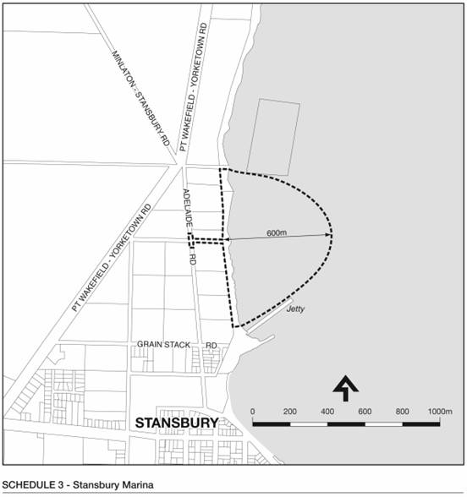
Schedule 4

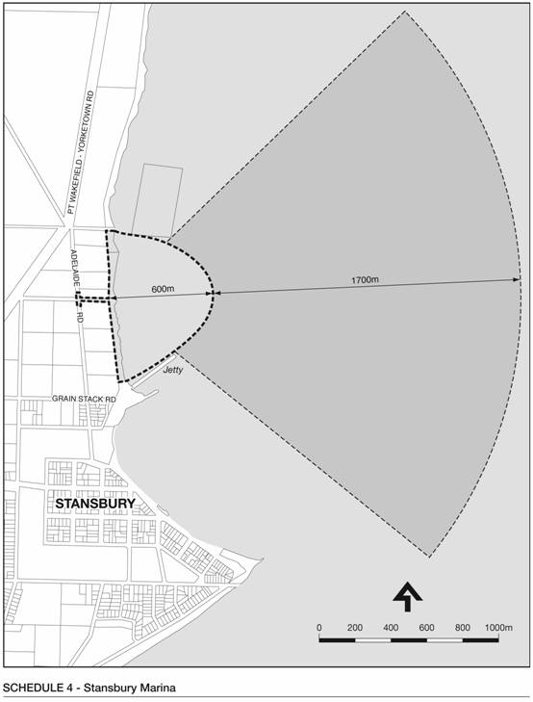
M. Wright, Acting Minister for Urban Development and Planning


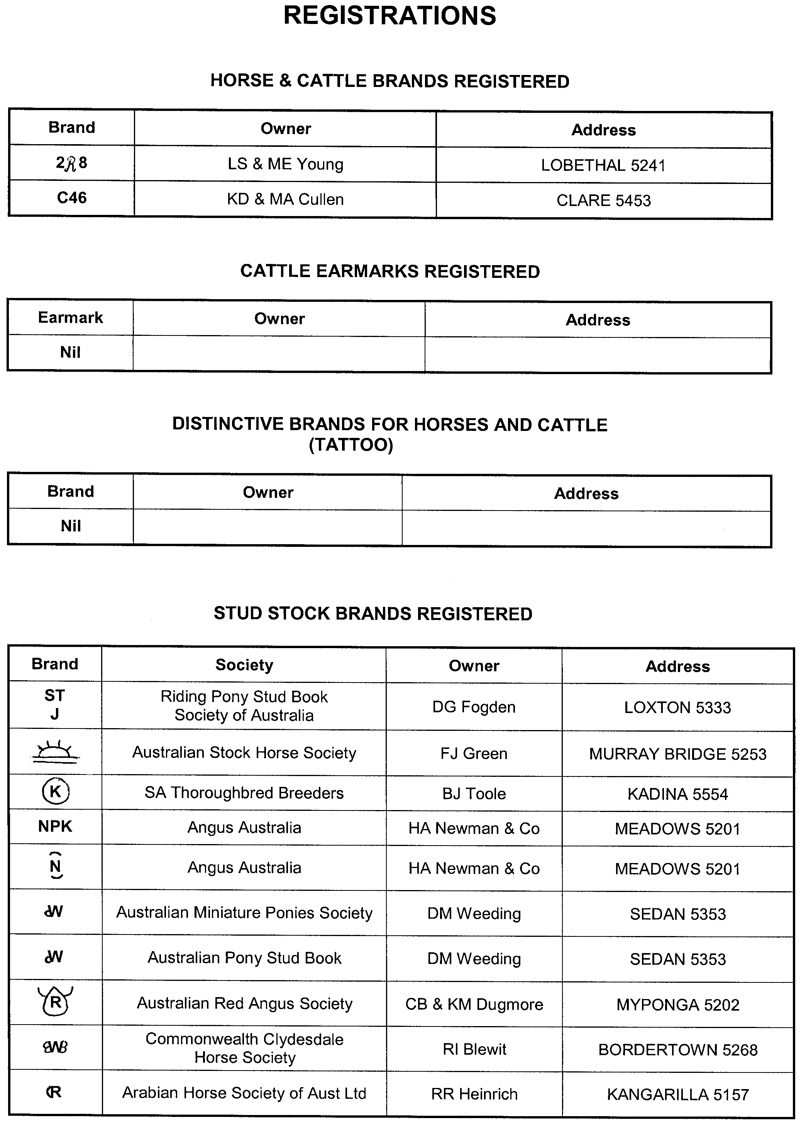
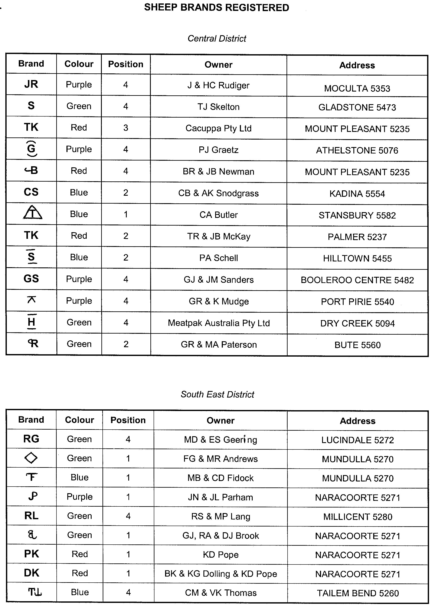
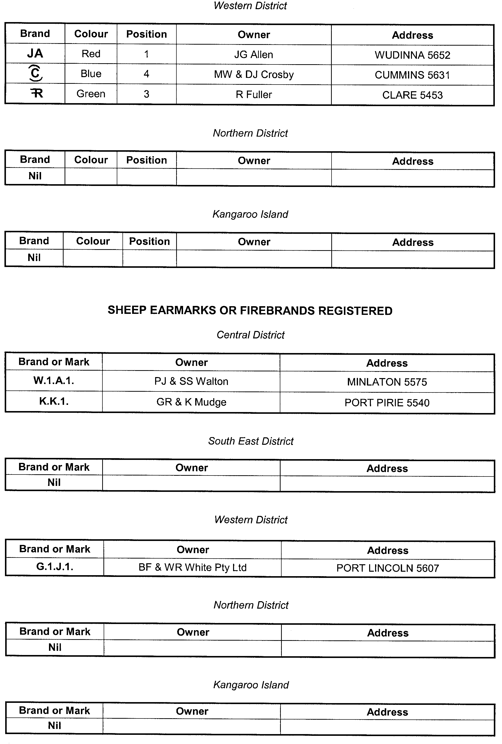
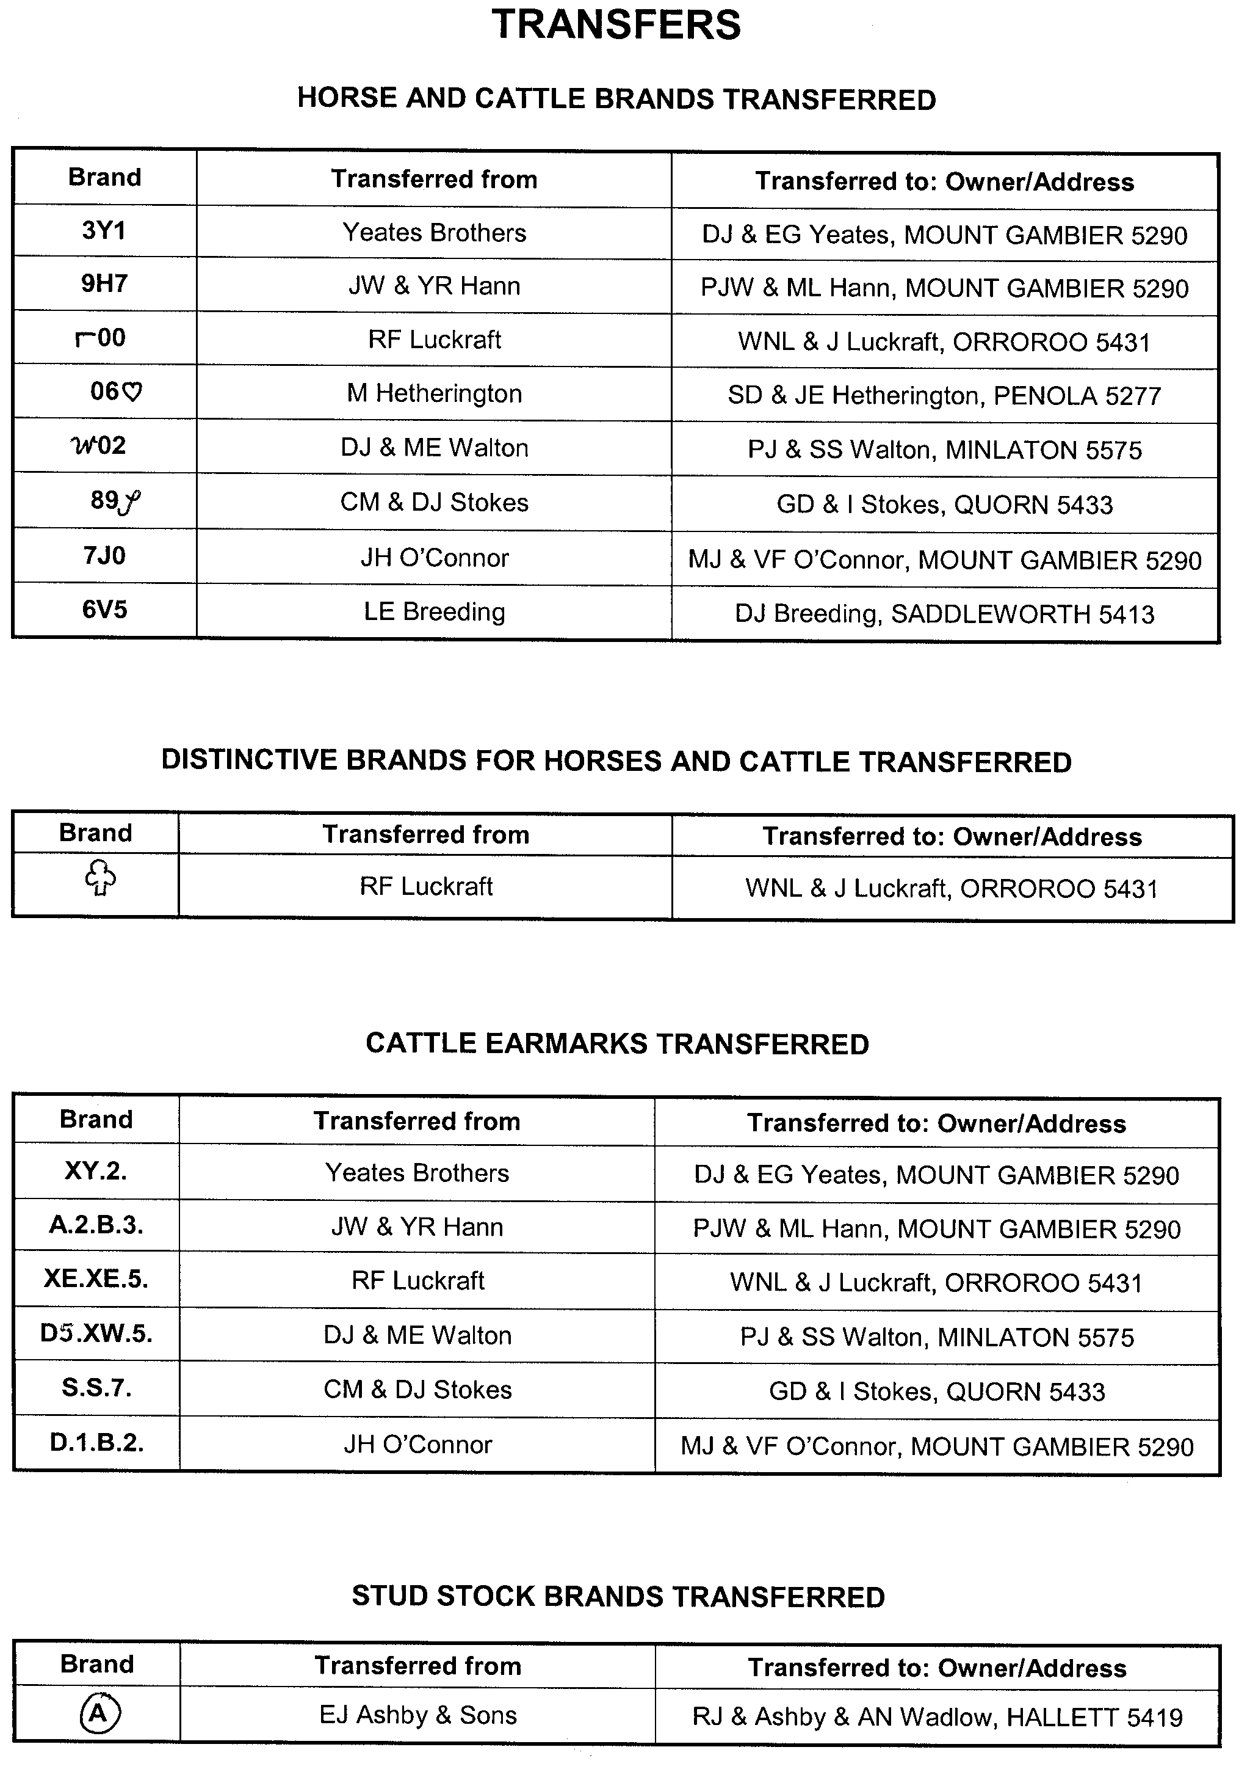
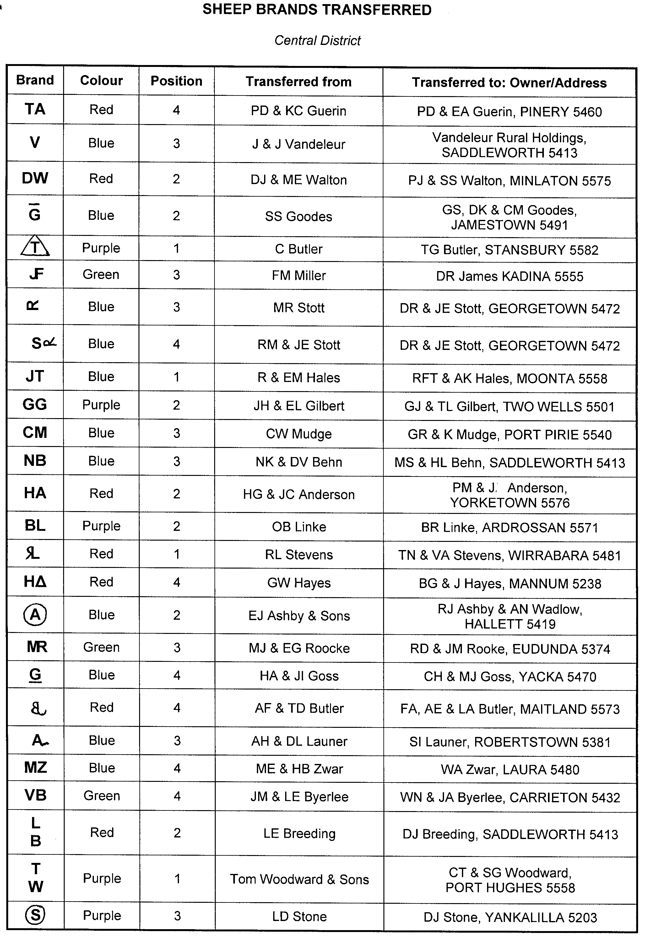
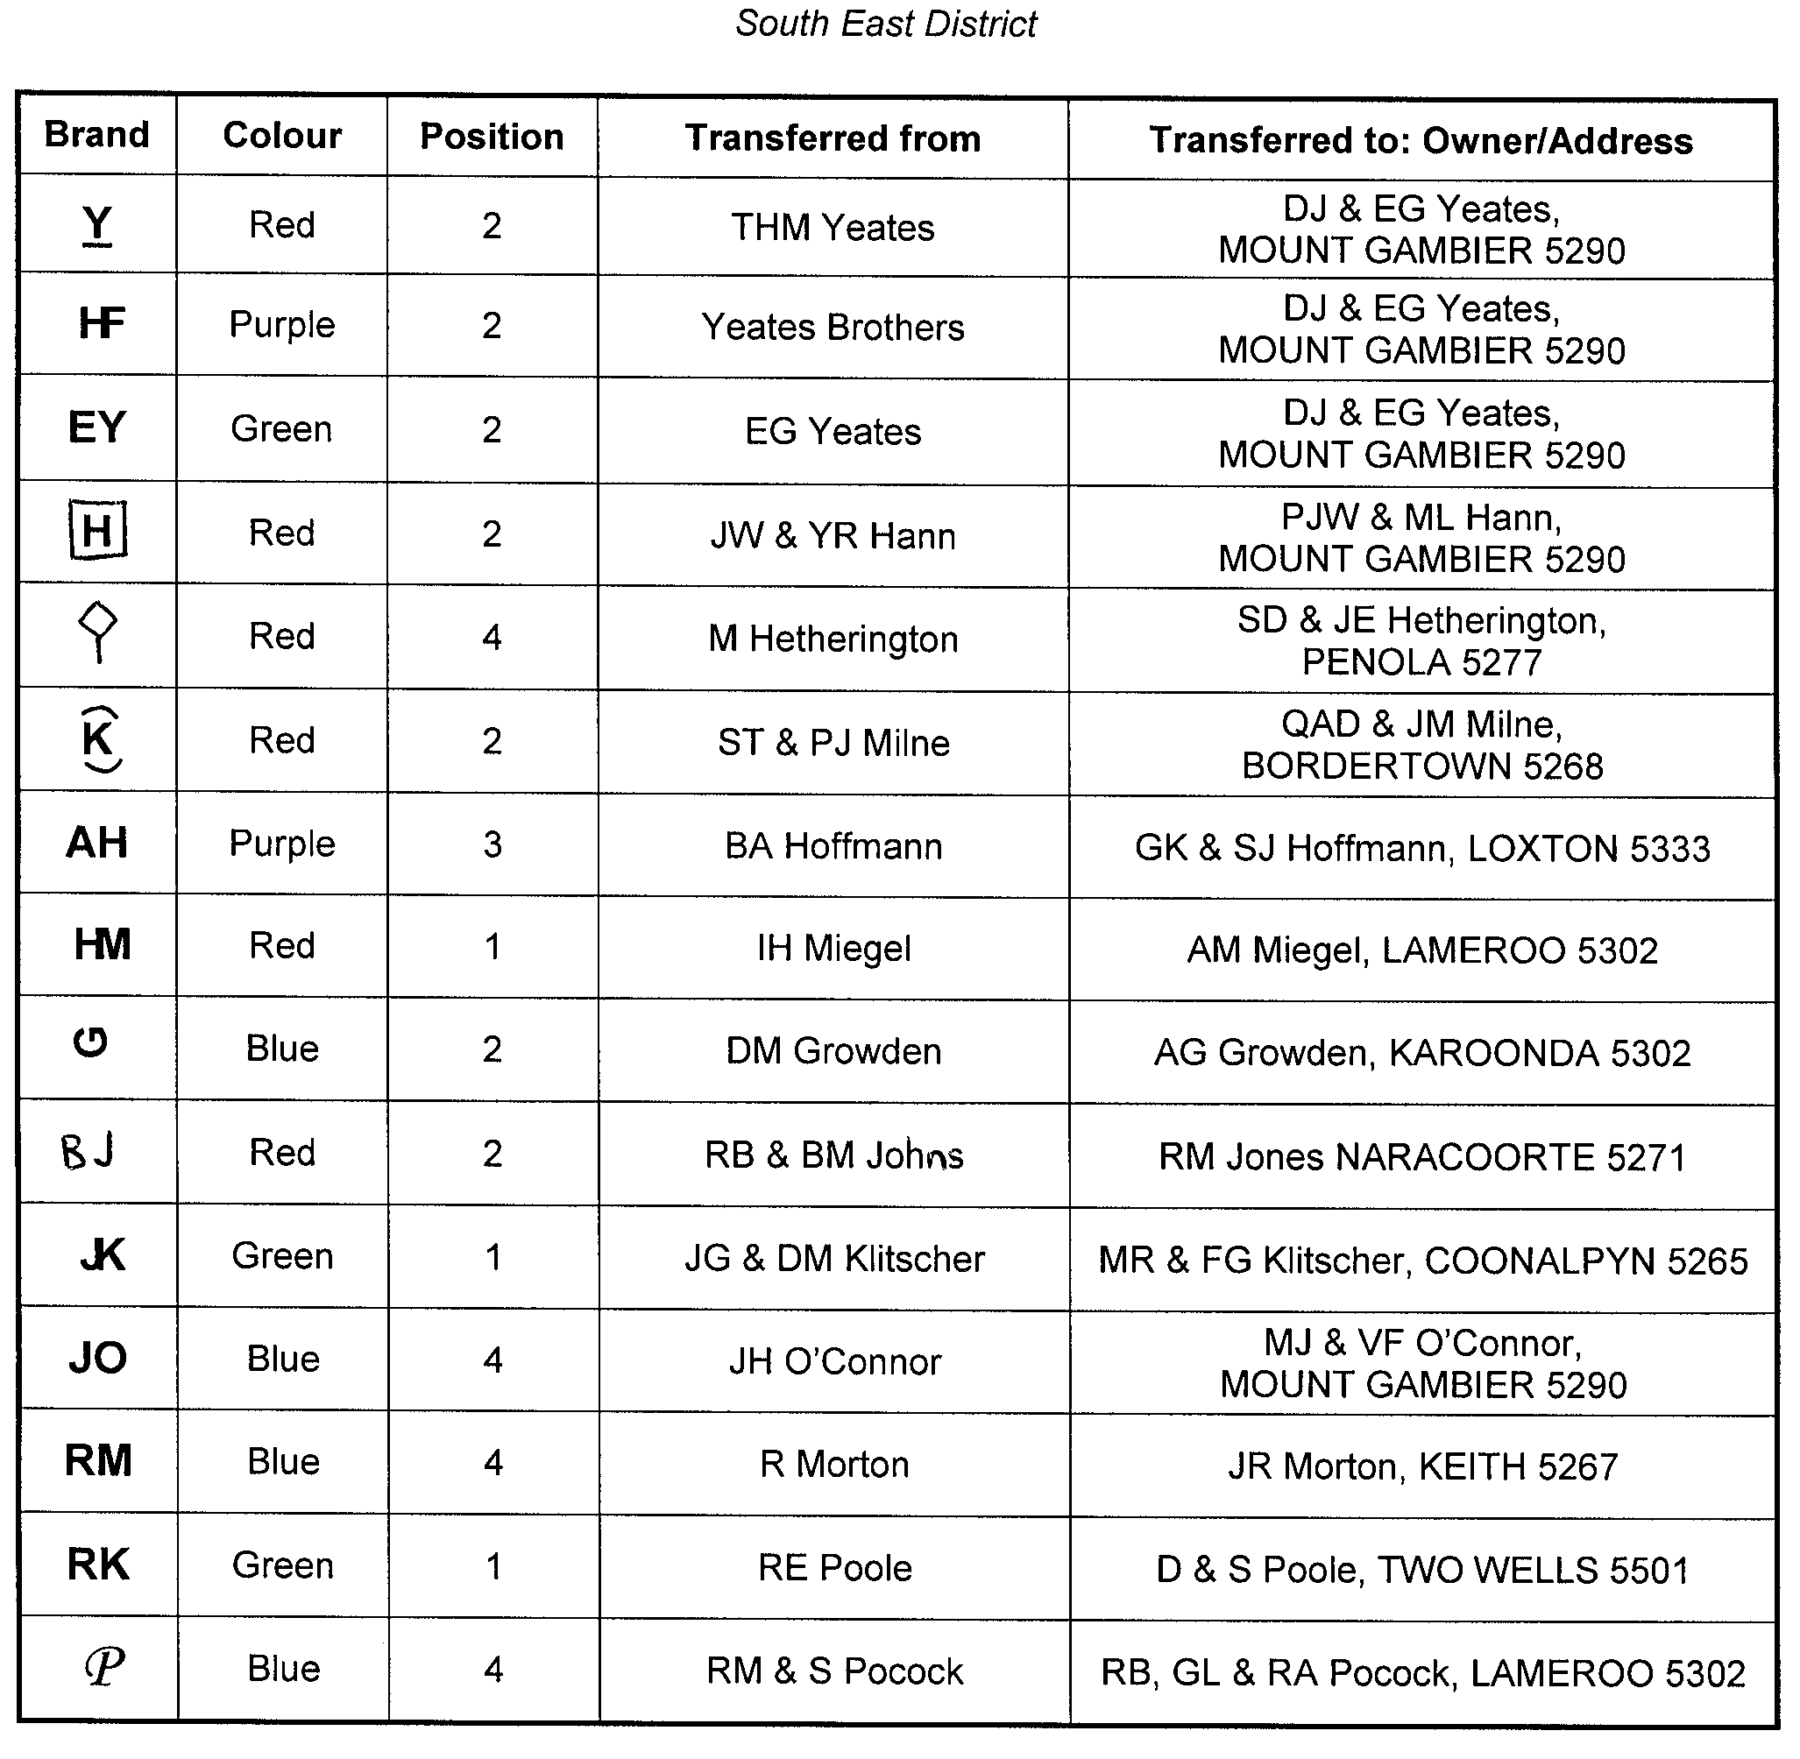
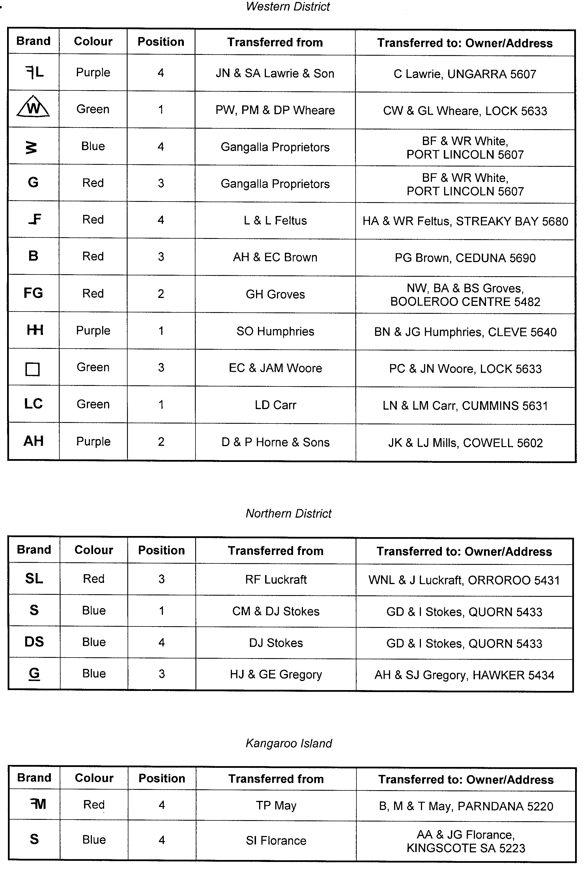
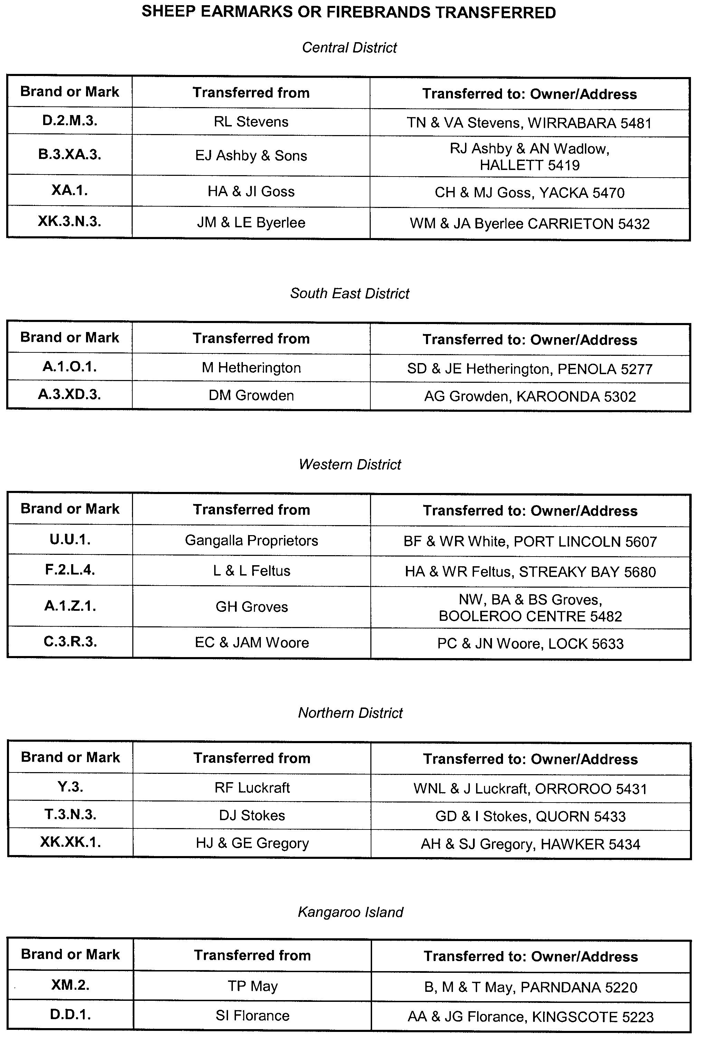
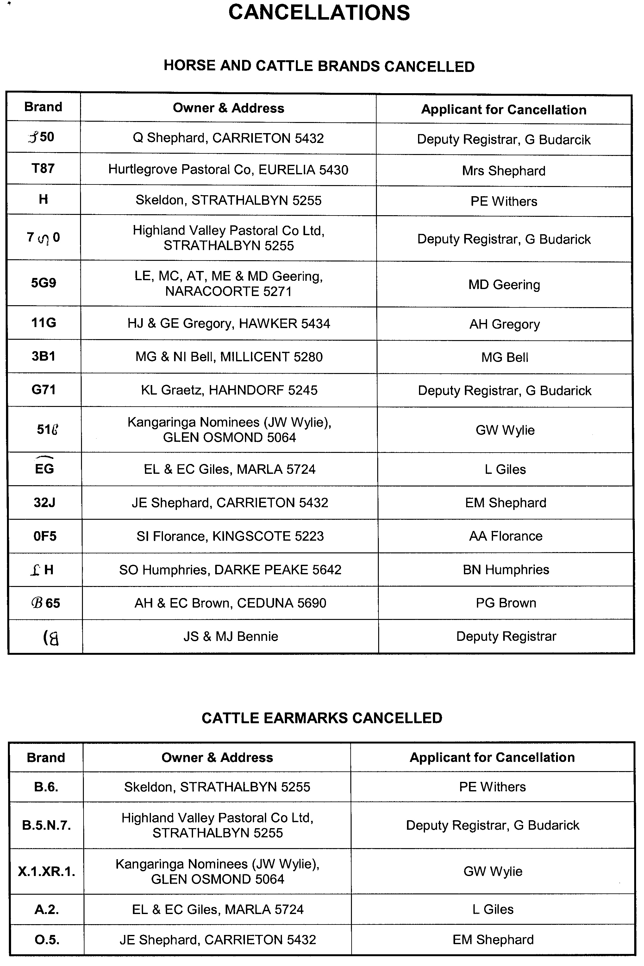
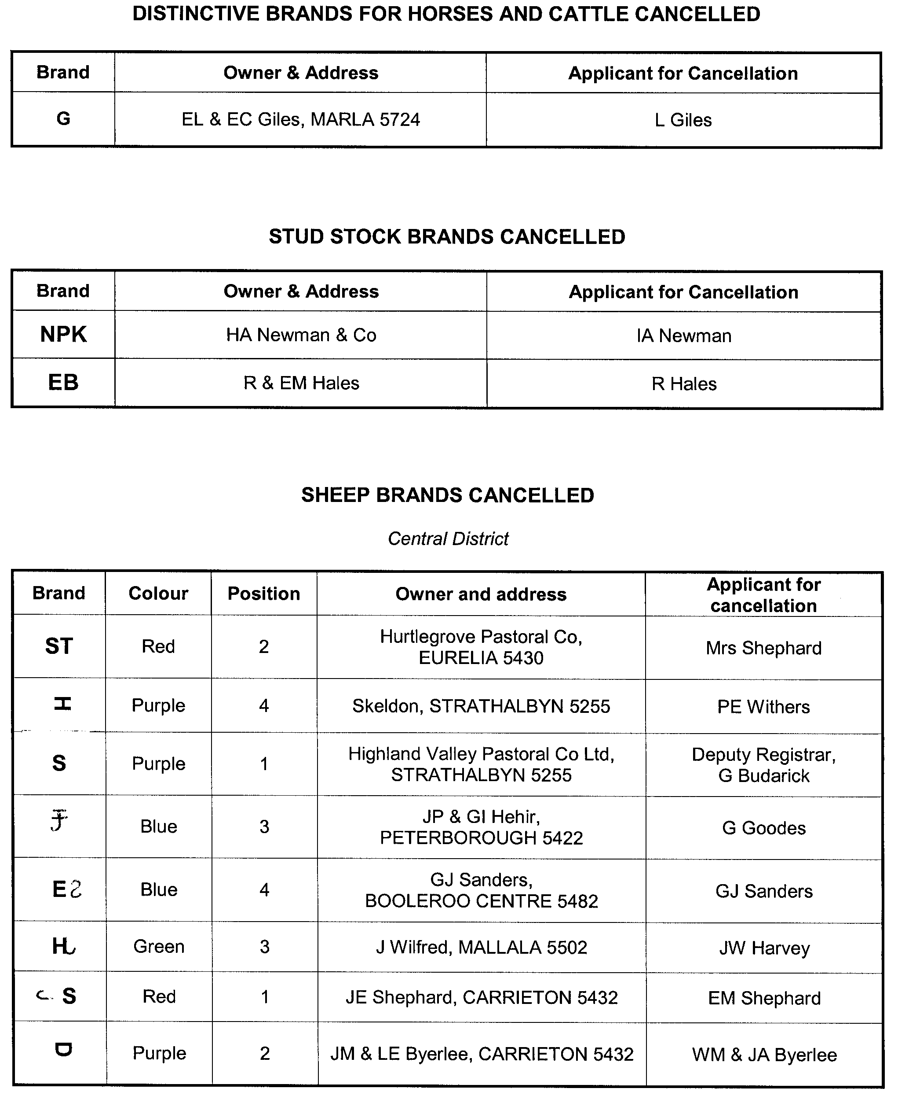
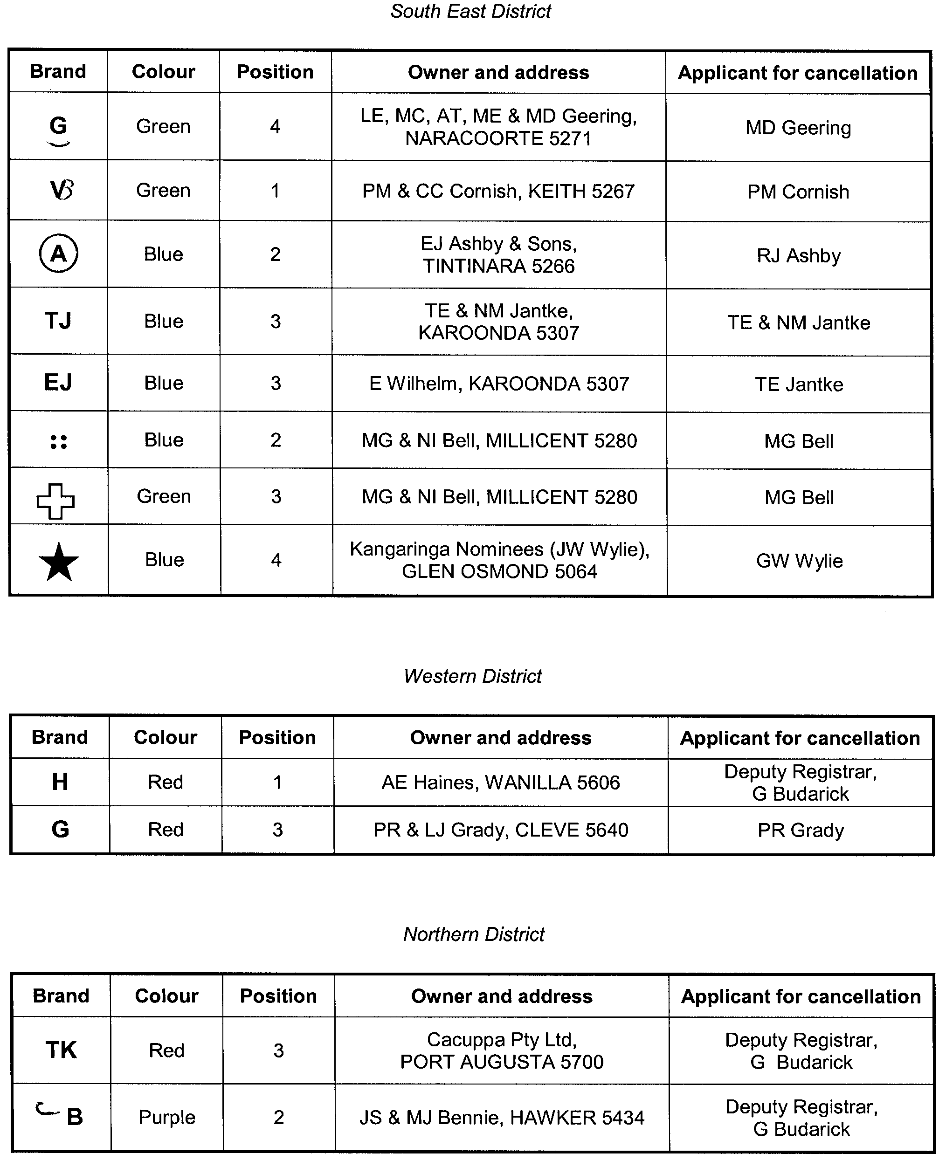
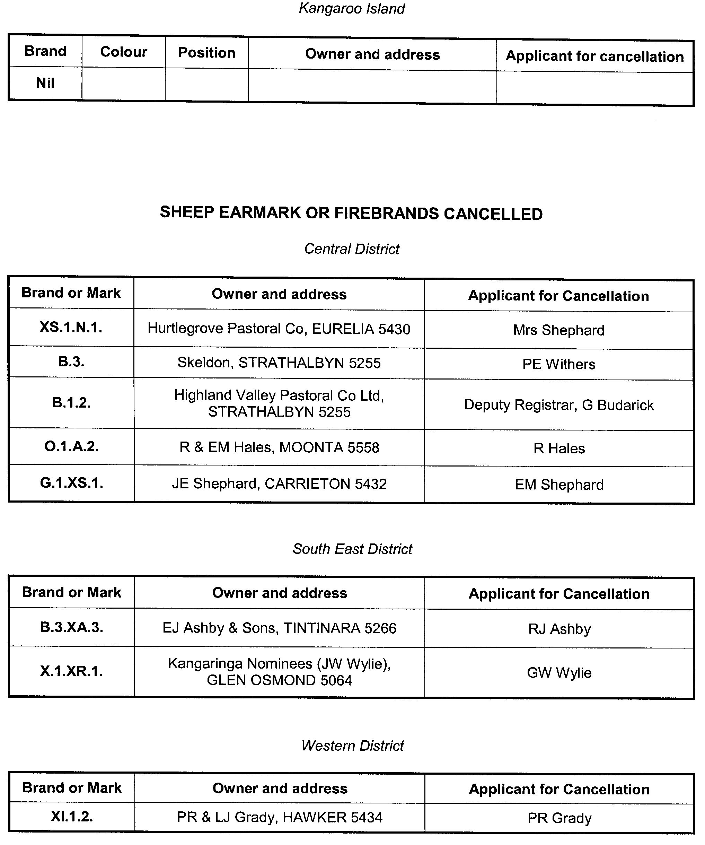

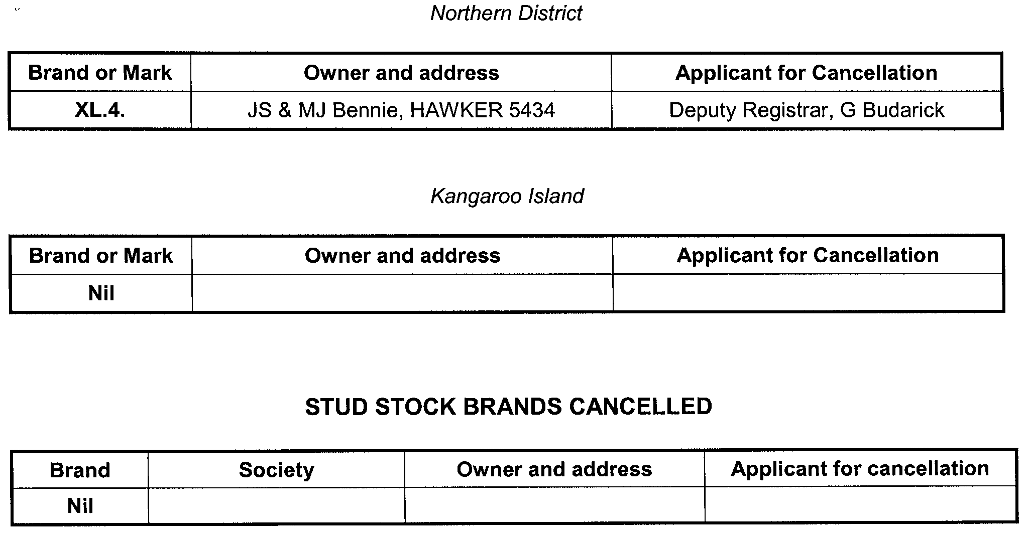

CLASSIFICATION (PUBLICATIONS, FILMS AND COMPUTER GAMES) ACT 1995
Classification of Publications
TAKE notice that the South Australian Classification Council has considered the publications described in the schedule hereto and has classified them pursuant to section 16 of the Classification (Publications, Films and Computer Games) Act 1995, as follows:
Title | Media | Publisher | Classification | Consumer  Advice
Zoo Weekly Magazine dated 5 February  2007 | Publication | EMAP Australia Pty Ltd | Unrestricted | M—Not recommended for readers under 15 years
Zoo Weekly Magazine dated 12 February 2007 | Publication | EMAP Australia Pty Ltd | Unrestricted | M—Not recommended for readers under 15 years
W. Chapman, Registrar, South Australian Classification Council

CLASSIFICATION (PUBLICATIONS, FILMS AND COMPUTER GAMES) ACT 1995
Classification of Publication
TAKE notice that the South Australian Classification Council has considered the publication described in the schedule hereto and has classified it pursuant to section 19A of the Classification (Publications, Films and Computer Games) Act 1995, as follows:
Title | Media | Publisher | Classification | Consumer  Advice
Zoo Weekly Magazine. All future issues of the series | Publication | EMAP Australia Pty Ltd | Unrestricted | M—Not recommended for readers under 15 years
W. Chapman, Registrar, South Australian Classification Council

GOVERNMENT GAZETTE ADVERTISEMENT RATES

To apply from 1 July 2006

$  Agents, Ceasing to Act as 38.00  Associations:  Incorporation 19.30  Intention of Incorporation 47.75  Transfer of Properties 47.75  Attorney, Appointment of 38.00  Bailiff’s Sale 47.75  Cemetery Curator Appointed 28.25  Companies:  Alteration to Constitution 38.00  Capital, Increase or Decrease of 47.75  Ceasing to Carry on Business 28.25  Declaration of Dividend 28.25  Incorporation 38.00  Lost Share Certificates:  First Name 28.25  Each Subsequent Name 9.70  Meeting Final 31.75  Meeting Final Regarding Liquidator’s Report on  Conduct of Winding Up (equivalent to ‘Final  Meeting’)  First Name 38.00  Each Subsequent Name 9.70  Notices:  Call 47.75  Change of Name 19.30  Creditors 38.00  Creditors Compromise of Arrangement 38.00  Creditors (extraordinary resolution that ‘the Com-pany be wound up voluntarily and that a liquidator be appointed’) 47.75  Release of Liquidator⎯Application⎯Large Ad. 75.50  ⎯Release Granted 47.75  Receiver and Manager Appointed 44.00  Receiver and Manager Ceasing to Act 38.00  Restored Name 35.75  Petition to Supreme Court for Winding Up 66.50  Summons in Action 56.50  Order of Supreme Court for Winding Up Action 38.00  Register of Interests⎯Section 84 (1) Exempt 85.50  Removal of Office 19.30  Proof of Debts 38.00  Sales of Shares and Forfeiture 38.00  Estates:  Assigned 28.25  Deceased Persons⎯Notice to Creditors, etc. 47.75  Each Subsequent Name 9.70  Deceased Persons⎯Closed Estates 28.25  Each Subsequent Estate 1.25  Probate, Selling of 38.00  Public Trustee, each Estate 9.70 |  | $  Firms:  Ceasing to Carry on Business (each insertion) 25.25  Discontinuance Place of Business 25.25  Land⎯Real Property Act:  Intention to Sell, Notice of 47.75  Lost Certificate of Title Notices 47.75  Cancellation, Notice of (Strata Plan) 47.75  Mortgages:  Caveat Lodgement 19.30  Discharge of 20.20  Foreclosures 19.30  Transfer of 19.30  Sublet 9.70  Leases⎯Application for Transfer (2 insertions) each 9.70  Lost Treasury Receipts (3 insertions) each 28.25  Licensing 56.50  Municipal or District Councils:  Annual Financial Statement⎯Forms 1 and 2 532.00  Electricity Supply⎯Forms 19 and 20 378.00  Default in Payment of Rates:  First Name 75.50  Each Subsequent Name 9.70  Noxious Trade 28.25  Partnership, Dissolution of 28.25  Petitions (small) 19.30  Registered Building Societies (from Registrar-  General) 19.30  Register of Unclaimed Moneys⎯First Name 28.25  Each Subsequent Name 9.70  Registers of Members⎯Three pages and over:  Rate per page (in 8pt) 242.00  Rate per page (in 6pt) 320.00  Sale of Land by Public Auction 48.25  Advertisements 2.70  ¼ page advertisement 113.00  ½ page advertisement 226.00  Full page advertisement 443.00  Advertisements, other than those listed are charged at $2.70 per column line, tabular one-third extra.  Notices by Colleges, Universities, Corporations and District Councils to be charged at $2.70 per line.  Where the notice inserted varies significantly in length from that which is usually published a charge of $2.70 per column line will be applied in lieu of advertisement rates listed.  South Australian Government publications are sold on the condition that they will not be reproduced without prior permission from the Government Printer.
All the above prices include GST

GOVERNMENT GAZETTE NOTICES
ALL private advertisements forwarded for publication in the South Australian Government Gazette must be PAID FOR PRIOR TO INSERTION; and all notices, from whatever source, should be legibly written on one side of the paper only and sent to Government Publishing SA so as to be received no later than 4 p.m. Tuesday preceding the day of publication. Phone 8207 1045 or Fax 8207 1040. E-mail: governmentgazette@saugov.sa.gov.au. Send as attachments in Word format. Please include date the notice is to be published and to whom the notice will be charged. The Government Gazette is available online at: www.governmentgazette.sa.gov.au.

MISCELLANEOUS LEGISLATION AND GOVERNMENT PUBLICATIONS PRICES AS FROM 1 JULY 2006

Acts, Bills, Rules, Parliamentary Papers and Regulations
Pages | Main | Amends | Pages | Main | Amends

1-16 | 2.30 | 1.05 | 497-512 | 32.25 | 31.25
17-32 | 3.10 | 1.95 | 513-528 | 33.25 | 32.00
33-48 | 4.05 | 2.90 | 529-544 | 34.25 | 33.25
49-64 | 5.10 | 3.90 | 545-560 | 35.25 | 34.25
65-80 | 6.00 | 4.95 | 561-576 | 36.00 | 35.25
81-96 | 6.95 | 5.75 | 577-592 | 37.00 | 35.75
97-112 | 7.90 | 6.75 | 593-608 | 38.25 | 36.75
113-128 | 8.90 | 7.75 | 609-624 | 39.00 | 38.00
129-144 | 9.95 | 8.80 | 625-640 | 40.00 | 38.50
145-160 | 10.90 | 9.70 | 641-656 | 41.00 | 40.00
161-176 | 11.90 | 10.70 | 657-672 | 41.50 | 40.50
177-192 | 12.90 | 11.70 | 673-688 | 43.25 | 41.50
193-208 | 13.90 | 12.80 | 689-704 | 44.00 | 42.50
209-224 | 14.70 | 13.60 | 705-720 | 44.75 | 43.50
225-240 | 15.70 | 14.50 | 721-736 | 46.50 | 44.50
241-257 | 16.80 | 15.30 | 737-752 | 47.00 | 45.50
258-272 | 17.70 | 16.30 | 753-768 | 48.00 | 46.25
273-288 | 18.70 | 17.50 | 769-784 | 48.50 | 47.75
289-304 | 19.50 | 18.40 | 785-800 | 49.50 | 48.75
305-320 | 20.70 | 19.40 | 801-816 | 50.50 | 49.25
321-336 | 21.50 | 20.30 | 817-832 | 51.50 | 50.50
337-352 | 22.60 | 21.40 | 833-848 | 52.50 | 51.50
353-368 | 23.50 | 22.40 | 849-864 | 53.50 | 52.00
369-384 | 24.50 | 23.40 | 865-880 | 54.50 | 53.50
385-400 | 25.50 | 24.30 | 881-896 | 55.00 | 54.00
401-416 | 26.50 | 25.00 | 897-912 | 56.50 | 55.00
417-432 | 27.50 | 26.25 | 913-928 | 57.00 | 56.50
433-448 | 28.50 | 27.25 | 929-944 | 58.00 | 57.00
449-464 | 29.25 | 28.00 | 945-960 | 59.00 | 57.50
465-480 | 29.75 | 29.00 | 961-976 | 60.50 | 58.50
481-496 | 31.25 | 29.75 | 977-992 | 61.50 | 59.00

Legislation—Acts, Regulations, etc: $
Subscriptions:
Acts 199.00
All Bills as Laid 477.00
Rules and Regulations 477.00
Parliamentary Papers 477.00
Bound Acts 221.00
Index 110.00
Government Gazette
Copy 5.20
Subscription 263.00
Hansard
Copy 14.50
Subscription—per session (issued weekly) 414.00
Cloth bound—per volume 178.00
Subscription—per session (issued daily) 414.00
Legislation on Disk
Whole Database 3063.00
Annual Subscription for fortnightly updates 941.00
Individual Act(s) including updates POA
Compendium
Subscriptions:
Subscriptions 1815.00
Updates 640.00
(All the above prices include GST)

All Legislation, Government Gazette, Hansard and Legislation on disk are available from:
Counter Sales Service SA, Government Legislation⁺ Outlet
and Mail Orders: Lands Titles Office, 101 Grenfell Street, Adelaide, S.A. 5000
Phone: 13 23 24 (local call cost), Fax: (08) 8204 1909
Postal: G.P.O. Box 1707, Adelaide, S.A. 5001

Online Shop: www.shop.service.sa.gov.au

Subscriptions and Government Publishing SA
Standing Orders: Box 9, Plaza Level, Riverside Centre, North Terrace, Adelaide, S.A. 5000
Phone: (08) 8207 1043, (08) 8207 0910, Fax: (08) 8207 1040

ELECTRICITY ACT 1996
Notice under the Electricity Act 1996 by Red Energy Pty Ltd (ABN 60 107 479 372) of Default Contract
Prices for Small Customers
IN accordance with section 36AB of the Electricity Act 1996 (SA), Red Energy Pty Ltd, 2 William Street, East Richmond, Vic. 3121 (‘Red Energy’) hereby publishes its default electricity contract prices for customers who are consuming less than 160MWh per annum of electricity (‘small customers’). The default contract prices are set out below in this notice and will apply on and from 1 March 2007.
The prices detailed in this notice apply for small customers only of Red Energy who are purchasing electricity under Red Energy Default Contract Terms and Conditions published in the Government Gazette on 1 March 2007.
Red Energy reserves the right to change its default electricity contract price from time to time acting in accordance with all applicable regulations.
Justification Statement
The default contract prices set out in this notice are the same as the electricity standing contract retailer tariffs approved on 1 June 2006 by the Essential Services Commission of South Australia (‘ESCOSA’) and ETSA Utilities’ distribution tariff approved by ESCOSA pursuant to the 2005-2010 Electricity Distribution Price Determination
Part B as varied on 9 June 2006. The setting by Red Energy of these default contract prices is in accordance with ESCOSA’s Electricity Retail Price Justification Guideline of December 2003.

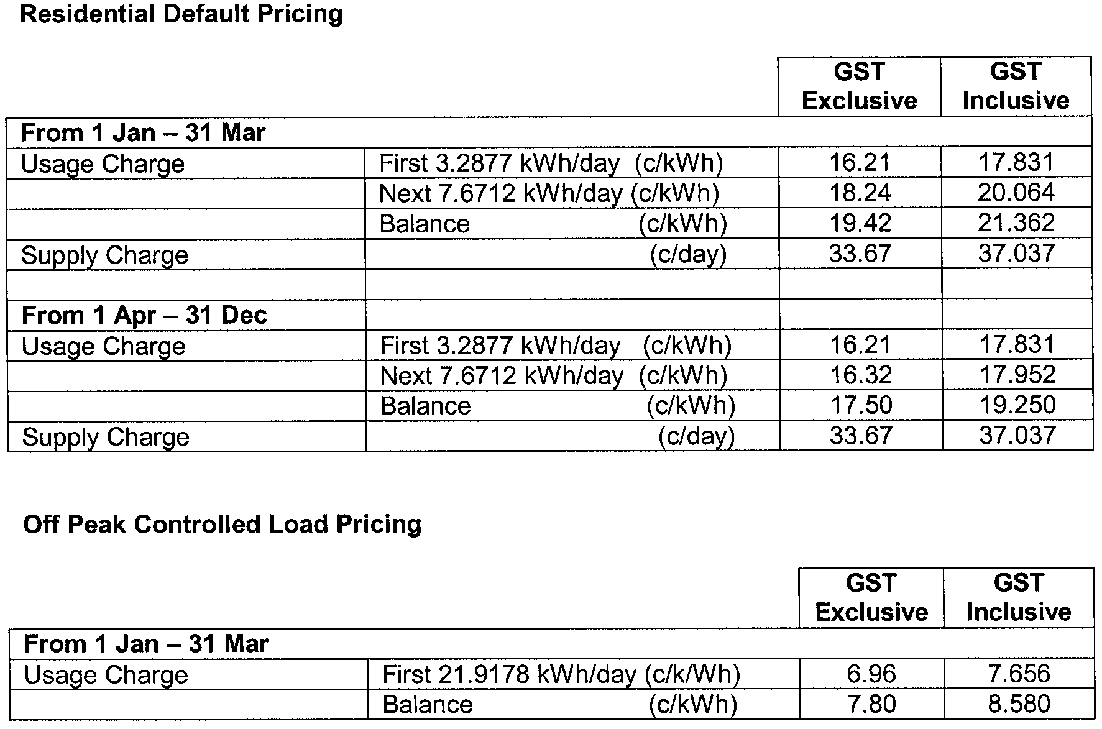

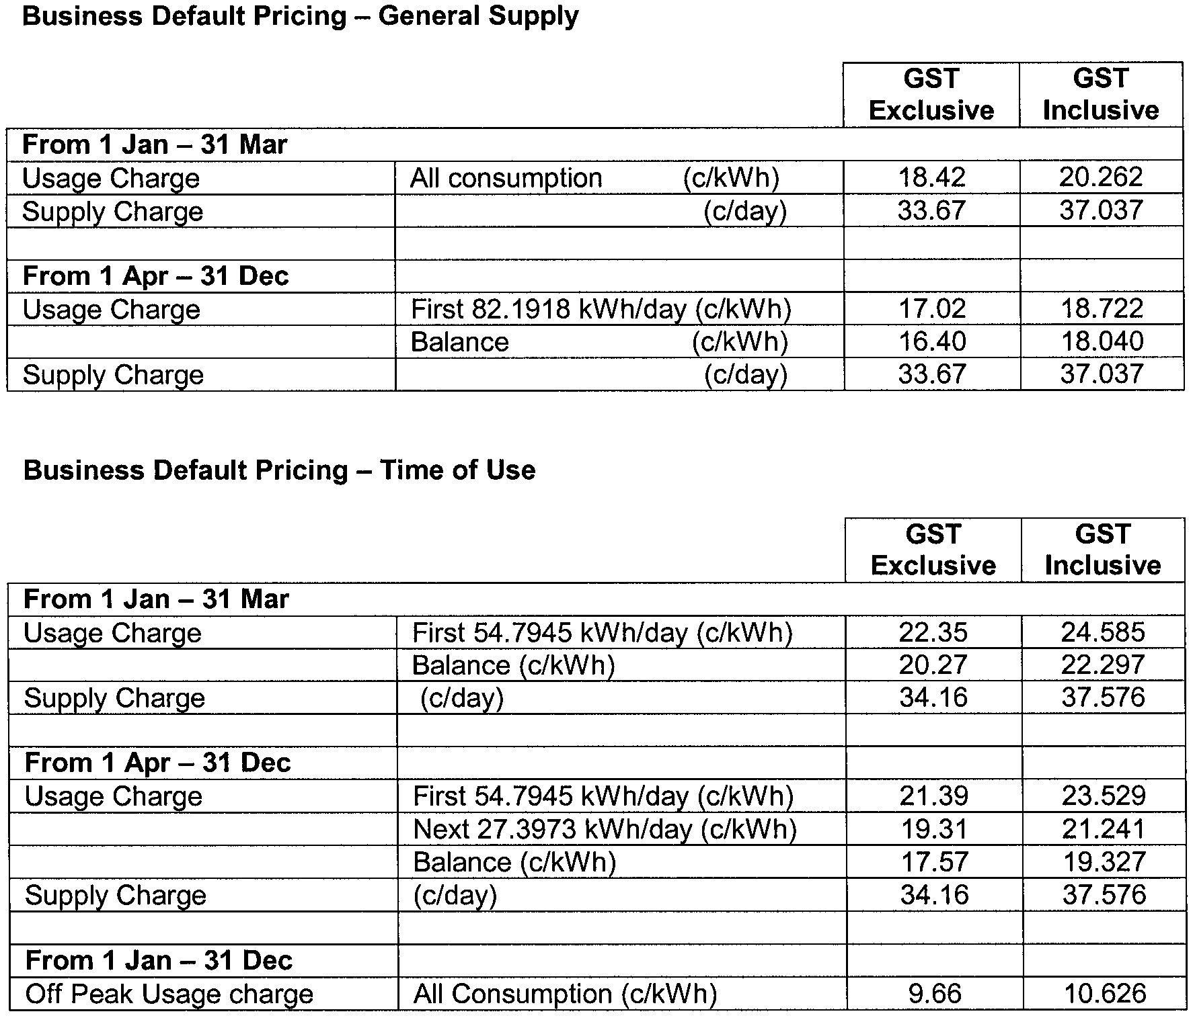

Explanatory Notes:
1. Default contract price categories will only apply to small customers (that is, those customers who consume less than 160MWh of electricity per annum) who are purchasing electricity under Red Energy’s default contract terms and conditions. The above default contract prices apply in accordance with the following principles:
(a) Daily Consumption is the total electricity consumption for the period to which the customer’s bill relates, divided by the number of days in that period.
(b) Residential Default Pricing:
• applies to residential customers in premises used wholly or principally as private residences based on Domestic 110* tariff meter configuration and, in the case of off peak, Off Peak Controlled Load Domestic 116* tariff meter configuration (refer to explanatory note 1 (e) below for the circumstances in which off peak rates apply).
(c) Business Default Pricing—General Supply:
• applies to non-residential customers in premises that are not used wholly or principally as private residences based on General Supply 126* tariff meter configuration.
(d) Business Default Pricing—Time of Use:
• applies to non-residential customers in premises that are not used wholly or principally as private residences based on General Supply Time of Use 128* tariff meter configuration.
(e) Off Peak Controlled Load:
• for electricity used in permanently installed storage water heaters with a rated delivery of not less than 125 litres, storage space heaters and other approved thermal storage applications. The hours of application are fixed from time to time with control by time switch or other means. This price does not apply to electricity used outside those hours.
2. Peak period is 0700 hours to 2100 hours from Monday to Friday (Central Standard Time) for all tariffs other than Domestic 110* tariff meter configuration, except where the network meters do not recognise specific tariff days. In these situations peak period is 0700 hours to 2100 hours (Central Standard Time) each day for meter types other than Domestic 110* tariff meter configuration.
3. Off peak period is all times other than peak period.
4. Where prices change during a billing cycle the bill for that billing cycle will be calculated on a pro rata basis using:
(a) the old price up to and including the date of change; and
(b) the new price from the date of change to the end of the billing cycle.
* These tariff descriptions refer to tariffs published by AGL South Australia Pty Limited.
ELECTRICITY DEFAULT CONTRACT
CUSTOMER SALE CONTRACT
PREAMBLE
Please note: This contract is about the sale of electricity to you as a customer at your current supply address (but only if this contract is expressed to apply to you in relation to that supply address). It does not deal with how that electricity is supplied to your supply address. You have a separate contract with your distributor dealing with the connection of your supply address to the distribution network and the supply of electricity to your supply address.
These standard terms and conditions are published in accordance with section 36 of the South Australian Electricity Act 1996 and will come into force on 1 March 2007. When in force these standard terms and conditions will by law be binding on us and any customer to whom they are expressed to apply without the need for us or that customer to sign a document containing these terms and conditions.
1. THE PARTIES
This contract is between:
Red Energy Pty Limited (ABN 60 107 479 372), 2 William Street, East Richmond, Vic. 3121 (in this customer sale contract referred to as “we”, “our” or “us”); and
You, the customer to whom this customer sale contract is expressed to apply (in this customer sale contract referred to as “you” or “your”).
2. DEFINITIONS
Words appearing in bold type like this are defined in Schedule 1 to this contract.
3. DO THESE TERMS AND CONDITIONS APPLY TO YOU?
3.1 These are our terms and conditions
This document sets out our current default contract terms and conditions for the purposes of the Electricity Act.
3.2 Default contracts
These terms and conditions apply to you (and as a consequence you will be deemed by section 36 of the Electricity Act to have a default contract with us) if:
(a) you are a small customer in relation to your supply address;
(b) you commence taking a supply of electricity at that supply address after 1 January 2003 without first entering into a standing contract or a market contract for that supply address with us or another retailer; and
(c) we were the last retailer to have a contract with a customer for the sale of electricity for that supply address.
4. WHAT IS THE TERM OF THIS CONTRACT?
4.1 When does this contract start?
Your contract with us for your supply address will start when you first start using electricity at that supply address.
4.2 When does this contract end?
Subject to clause 4.3, your contract will end:
(a) you enter into a different customer sale contract with us or another retailer for your supply address;
(b) another customer enters into a customer sale contract with us or another retailer for that supply address;
(c) if you have vacated or intend to vacate your supply address, on the day you cease to be responsible to pay for electricity supplied to that supply address under clause 17; or
(d) on the day after you cease to have the right under the Energy Retail Code to have your supply address reconnected following disconnection in accordance with clause 16.
4.3 Rights on the contract ending
The ending of this contract does not affect any rights or obligations which have accrued under this contract prior to that time.
5. SCOPE OF THIS CONTRACT
5.1 What is covered by this contract?
This contract applies only to the sale of electricity to you at your supply address. We agree to sell to you electricity supplied to your supply address (by your distributor) and perform the other obligations set out in this contract. In return, you are required to pay the amount billed by us under clause 10 of this contract, and perform your other obligations under this contract.
5.2 What is not covered by this contract
We do not operate the electricity network to which your supply address is connected. This is the role of your distributor.
You have a separate connection and supply contract with your distributor.
Your distributor is responsible for:
(a) the connection of your supply address to the electricity network;
(b) the maintenance of that connection;
(c) the supply of electricity to your supply address; and
(d) the quality and other characteristics of electricity.
Unless you negotiate a different arrangement with your distributor, your connection and supply contract will automatically come into place by operation of law.
5.3 Quality of electricity supplied to your supply address
We cannot regulate the quality or reliability of electricity supplied to your supply address. You should also be aware that electricity suffers fluctuations and interruptions from time to time for a number of reasons, including:
(a) the location of the supply address;
(b) whether your supply address is served by underground or overhead mains;
(c) the weather conditions;
(d) animals, vegetation, the actions of vandals and other people;
(e) the existence of emergency or dangerous conditions;
(f) damage to an electricity network;
(g) the design and technical limitations of the electricity network; and
(h) the demand for electricity at any point in time.
You should understand that unexpected fluctuations or interruptions may cause damage to your equipment or cause it to malfunction. We recommend that you give careful consideration to taking out insurance or installing devices to protect your equipment and property when these fluctuations or interruptions do occur.
6. Clause 6 does not apply
7. OUR LIABILITY
7.1 How this clause operates with the Trade Practices Act etc.
The Trade Practices Act 1974 (Cth) and other laws imply certain conditions, warranties and rights into contracts that cannot be excluded or limited.
Unless one of these laws requires it, we give no condition, warranty or undertaking, and we make no representation to you about the condition or suitability of electricity, its quality, fitness or safety, other than those set out in this contract.
Any liability we have to you under these laws that cannot be excluded but that can be limited is (at our option) limited to:
(a) providing equivalent goods or services provided under this contract to your supply address; or
(b) paying you the cost of replacing the goods or services provided under this contract to your supply address, or acquiring equivalent goods or services.
7.2 Not liable
So far as the law allows, we are not liable for any loss or damage you suffer (whether due to negligence or otherwise), because of the electricity we sell to you under this contract.
In particular, we are not liable for any loss or damage you may suffer because:
(a) there is a failure of electricity supply, or there is a defect in the electricity supplied (however caused); or
(b) some characteristic of the electricity (for example, voltage or frequency) makes it unsuitable for some purpose.
7.3 National Electricity Law
This clause 7 applies in addition to, and does not vary or exclude, the operation of section 78 of the National Electricity Law.
7.4 Survival of this clause
This clause 7 survives the termination of this customer sale contract.
8. APPOINTMENTS
We will do our best to be on time for any appointment with you. Unless due to circumstances beyond our reasonable control, if we are more than 15 minutes late we will credit your next bill with $20 (including GST) and phone you to apologise.
9. PRICE FOR ELECTRICITY AND OTHER SERVICES
9.1 What are our tariffs and charges?
Our current tariffs and charges for the electricity and other services are set out in the price list. Some of the tariffs and charges are regulated by law.
Other amounts relating to the sale of electricity to you, including special meter readings, street lighting, account application fees and fixed charges for special purpose electricity sales will be separately itemised on your bill.
At your request, we must provide you with reasonable information setting out the components of the charges which appear on a bill.
9.2 Which tariff applies to you?
Our price list explains the conditions that need to be satisfied for each tariff and charge.
In some cases, you will be able to select a tariff to apply to you. In those cases, if you do not choose a tariff, we will assign one to you.
9.3 Variations to the customer’s tariffs and charges
We may only vary our tariffs and charges in accordance with the requirements of the Electricity Act or other applicable regulatory instruments and any variation will be published on our website and in the South Australian Government Gazette.
If the conditions applying to our tariffs and charges change so that your previous tariff and charges no longer apply to you at your supply address, we can decide which tariffs and charges will apply.
9.4 Switching tariffs
You must tell us if your circumstances relating to your eligibility for a tariff or charge change. If you think you satisfy all of the conditions applying to another tariff or charge, you can ask us to review your current circumstances to see whether that tariff or charge can apply to you.
9.5 Changes to the tariff rates and charges during a billing cycle
If a tariff rate or charge applying to you changes during a billing cycle, your bill for that billing cycle will be calculated on a pro rata basis using:
(a) the old tariff or charge up to and including the date of change; and
(b) the new tariff or charge from that date to the end of the billing cycle.
9.6 Changes to the tariff type during a billing cycle
If the type of tariff or charge applying to you changes during a billing cycle, your bill for that billing cycle will be calculated using:
(a) the old tariff or charge up to and including the date of change; and
(b) the new tariff or charge from that date to the end of the billing cycle.
9.7 Pass through of taxes and other charges
In some cases we can pass through to you certain taxes and other charges in accordance with applicable regulatory instruments. We can do this by either changing the tariffs and charges, or including the amount as a separate item in your bill.
9.8 GST
Certain amounts in this contract are (or will be) stated to be inclusive of GST.
These are:
(a) the amounts specified in our price list from time to time; and
(b) the amount specified in clause 9.
Apart from these amounts, there may be other amounts paid by you or by us under this contract that are payments for “taxable supplies” as defined for GST purposes. To the extent permitted by law, these other payments will be increased so that the GST payable on the taxable supply is passed on to the recipient of that taxable supply.
Any adjustments for GST under this clause will be made in accordance with the requirements of the Trade Practices Act 1974.
10. BILLING
10.1 When bills are sent
We will send a bill to you as soon as possible after the end of each billing cycle.
If we fail to issue a bill following the end of a billing cycle, we will offer you the option of paying for any electricity used during the relevant billing cycle under an instalment plan. The maximum period of that instalment plan will be the greater of the period during which we did not bill you or 12 months.
10.2 Payments to the distributor
We will arrange for one bill to be sent to you for each billing cycle covering tariffs and charges due to us and those tariffs and charges due to your distributor under your connection and supply contract. We will arrange for payment to the distributor.
10.3 Calculating the bill
We will calculate at the end of each billing cycle:
(a) the bill for electricity sold during that billing cycle (using information obtained from reading your meter or using an approved estimating system); and
(b) the amount for any other services supplied under this contract during the billing cycle.
The bill will also include amounts due to the distributor under your connection and supply contract.
10.4 Estimating the electricity usage
If your meter is unable to be read, or your metering data is not obtained, for any reason (for example, if access to the meter cannot be gained, or the meter breaks down or is faulty), the amount of electricity which was purchased from us at your supply address may be estimated.
When your meter is subsequently read, the bill will be adjusted for the difference between the estimate and the actual amount of electricity used, based on the reading of the meter. When you have received an estimated bill due to the absence of metering data and a subsequent meter reading shows that you have been undercharged, we will offer you option of paying for the amount undercharged under an instalment plan.
If the meter is unable to be read due to your actions, we can bill you any charges we incur in arranging for a meter reader returning to your supply address to read the meter.
10.5 How bills are issued
We must send a bill:
(a) to you at the address nominated by you; or
(b) to a person authorised in writing by you to act on your behalf at the address specified by you.
10.6 Contents of a bill
The bill will be in a form and contain such information as is required by the Energy Retail Code.
11. PAYING YOUR BILL
11.1 What you have to pay
You must pay to us the amount shown on each bill by the date shown on the bill as the date for payment.
11.2 How the bill is paid
You can pay the bill using any of the payment methods listed on the bill. If a payment you make is dishonoured (e.g., where a cheque or credit card payment is not honoured), and we incur a fee as a result, you must reimburse us the amount of that fee.
11.3 Late payments
If you do not pay your bill on time, we may require you to pay our reasonable costs of recovering that amount from you. If your are a business customer, you may also be required to pay interest on the outstanding amount as set out in the price list.
This clause does not affect our right to arrange for your supply address to be disconnected under clause 15 of this contract.
11.4 Difficulties in paying
If you have difficulties paying your bill, you should contact us as soon as possible.
We will provide you with information about various payment options and, where applicable, payment assistance, in accordance with the Energy Retail Code.
We are required by the Energy Retail Code to identify situations where you may be experiencing difficulties in paying your bill. In such cases, we will offer you the opportunity to pay your bill under an instalment plan and provide you with information about various payment options and, where applicable, payment assistance, in accordance with the Energy Retail Code.
12. METERS
You must allow safe and convenient access to your supply address for the purposes of reading the relevant meters.
13. OVERCHARGING AND UNDERCHARGING
13.1 Undercharging
We may recover from you any amount you have been undercharged. Where you have been undercharged as a result of our error or the distributor’s error, we can only recover the amount undercharged in the 12 months prior to the meter reading date on the last bill sent to you. We must offer you the opportunity to pay this amount in instalments over the same period of time during which you were undercharged.
13.2 Overcharging
Where you have been overcharged, we must tell you and follow the procedures set out in the Energy Retail Code for repaying the money. Where the amount overcharged is $100 or less, and you have already paid that amount, the amount will be credited to your next bill, or, if you have subsequently ended this contract, we will pay you that amount within 10 business days.
Where the amount overcharged is more than $100, and you have already paid that amount, we must ask you whether the amount should be credited to your account, repaid to you or paid to another person, and pay the amount in accordance with your instructions within 10 business days.
13.3 Reviewing your bill
If you disagree with the amount you have been charged, you can ask us to review your bill. The review will be undertaken in accordance with the requirements of the Energy Retail Code.
If your bill is being reviewed, you are still required to pay the greater of:
(a) the portion of the bill which you do not dispute; or
(b) an amount equal to the average of your bills in the last 12 months.
You must also pay any future bills.
14. SECURITY DEPOSITS
14.1 Interest on security deposits
Where you have paid a security deposit, we must pay you interest on the deposit at a rate and on terms required by the Energy Retail Code.
14.2 Use of a security deposit
We may use your security deposit, and any interest earned on the security deposit, to offset any amount you owe under this contract or under your connection and supply contract with your distributor:
(a) if you fail to pay a bill and, as a result, we arrange for the disconnection of your supply address; or
(b) in relation to a final bill (i.e., the bill we issue when you stop buying electricity from us at your supply address).
14.3 Business customers
If you are purchasing electricity for business use, we may request that you increase the amount of your security deposit in accordance with the Energy Retail Code.
15. DISCONNECTION OF SUPPLY
15.1 When can we arrange for disconnection?
Subject to us satisfying the requirements in the Energy Retail Code, we can arrange for the disconnection of your supply address if:
(a) you do not pay your bill by the last day for payment and, in the case of residential customers, you refuse to agree to an instalment plan or payment option offered by us;
(b) you fail to comply with the terms of an agreed instalment plan or payment option;
(c) you use electricity illegally or breach clause 19 of this contract; or
(d) we are otherwise entitled or required to do so under the Energy Retail Code or by law.
You should be aware that there are other circumstances in which your distributor can arrange for disconnection under your connection and supply contract, such as in cases of emergency or for safety reasons. These are detailed in your connection and supply contract.
15.2 Comply with the Energy Retail Code
We must comply with the provisions of the Energy Retail Code (such as giving you the required notices and warnings) before arranging for the disconnection of your supply address.
16. RECONNECTION AFTER DISCONNECTION
If you request us to arrange reconnection of your supply address and you pay to us all of our and the distributor’s reconnection charges in advance, we will arrange for the reconnection of your supply address.
We may refuse to arrange reconnection and terminate your customer sale contract if we are allowed to do so under the Energy Retail Code (such as where the circumstances leading to your disconnection have not been fixed within a period of 10 business days after the date on which you were disconnected).
17. VACATING A SUPPLY ADDRESS
You must give us at least three business days’ notice of your intention to vacate your supply address, together with a forwarding address for your final bill.
When we receive the notice, we must use our best endeavours to arrange that the relevant meters are read on the date specified in your notice (or as soon as possible after that date if you do not provide access to your meter on that date) and send a final bill to you at the forwarding address stated in your notice.
If you do not provide the required notice, or if you do not provide access to your meter, you will be responsible for all electricity purchased at the supply address until:
(a) we become aware that you have vacated your supply address and the relevant meters have been read;
(b) you give us the required notice; or
(c) someone else commences purchasing electricity from us or another retailer for that supply address.
18. USE OF ELECTRICITY AND ILLEGAL USE
18.1 Use of electricity
You must not:
(a) allow electricity purchased from us to be used other than in accordance with this contract or the Energy Retail Code; or
(b) tamper with, or permit tampering with, any meters or associated equipment.
18.2 Illegal use
If you have breached clause 18.1 of this contract, we may, in accordance with the Energy Retail Code:
(a) estimate the amount of the electricity so obtained and bill you or take debt recovery action against you for that amount; and
(b) arrange for the immediate disconnection of your supply address.
19. INFORMATION WE NEED
You must provide us with all information we reasonably require for the purposes of this contract. All information must be correct. We have rights under the Electricity Act and the Energy Retail Code if information you provide is incorrect.
You must tell us if information you have provided to us changes (for example, if your address changes, or the purpose for which you are buying electricity changes).
20. WE CAN AMEND THIS CONTRACT
We can only amend our contract with you in accordance with the Electricity Act and the requirements of the Energy Retail Code. Any amendment will take effect from the date referred to in the South Australian Government Gazette.
21. NOTICES
Unless this document or the Energy Retail Code says otherwise (for example, where phone calls are allowed), all notices must be sent in writing. We can send to you notices at the address at which you buy electricity from us or the most recent address that we have for you. If a notice is sent by post, we can assume that you have received the notice on the second business day after it was sent.
22. PRIVACY AND CONFIDENTIALITY
22.1 Privacy of information
Subject to clauses 22.2 and 26 of this contract we must keep your information about you confidential.
22.2 Disclosure
We may, however, disclose information about you:
(a) if required or permitted by law to do so;
(b) if we are required or permitted by our licence to do so, such as to a law enforcement agency;
(c) where you give us written consent; or
(d) to your distributor or a metering provider to the extent that information is for the purposes of arranging connection, disconnection, reconnection, testing of a meter and billing.
23. QUERIES AND COMPLAINTS
If you have a query or a complaint relating to the sale of electricity by us to you, or this contract generally, you may contact us as follows (as updated and notified to you from time to time):
By Phone on: 131 806
By Fax on: 1300 66 10 86
By email: enquiries@redenergy.com.au
By mail: P.O. Box 4136, East Richmond, Vic. 3121.
24. FORCE MAJEURE
24.1 Effect of force majeure event
If, but for this clause 24, either party would breach this contract due to the occurrence of a force majeure event:
(a) The obligations of the party under this contract, other than any obligation to pay money, are suspended to the extent to which they are affected by the force majeure event for so long as the force majeure event continues; and
(b) The affected party must use its best endeavours to give the other prompt notice of that fact including full particulars of the force majeure event, an estimate of its likely duration, the obligations affected by it and the extent of its effects on those obligations and the steps taken to remove, overcome or minimise those effects.
24.2 Deemed prompt notice
For the purposes of this clause 24, if the effects of a force majeure event are widespread we will be deemed to have given you prompt notice if we make the necessary information available by way of a 24 hour telephone service within 30 minutes of being advised of the force majeure event or otherwise as soon as practicable.
24.3 Obligation to overcome or minimise effects of force majeure event
Either party relying on this clause 24 by claiming a force majeure event must use its best endeavours to remove, overcome or minimize the effects of that force majeure event as quickly as practicable.
24.4 Settlement of industrial disputes
Nothing in this clause 24 will require either party to settle an industrial dispute which constitutes a force majeure event in any manner other than the manner preferred by that party.
24.5 Non-exclusion of National Electricity Law
Nothing in this clause 24 varies or excludes the operation of section 78 of the National Electricity Law.
25. APPLICABLE LAW
We, as your retailer, and you, as our customer, agree to comply with any applicable requirements of any codes or guidelines issued by the Commission from time to time.
The laws of South Australia govern this contract.
26. LAST RESORT EVENT
If we are no longer entitled under the Electricity Act to sell electricity to you due to a last resort event occurring in relation to us, we are required by the Energy Retail Code to provide your name, billing address and NMI to the electricity entity appointed as the retailer of last resort under the Electricity Act and this contract will come to an end.
Schedule 1: Definitions
“applicable regulatory instruments” means any Act or regulatory instrument made under an Act, or regulatory instrument issued by the Commission, which applies to us as a retailer;
“billing cycle” means the regular recurrent period for which you receive a bill from us;
“best endeavours” means to act in good faith and use all reasonable efforts, skill and resources;
“business customer” means a small customer who is not a residential customer;
“business day” means a day on which banks are open for general banking business in Adelaide, other than a Saturday or a Sunday;
“connection and supply contract” means the contract you have with your distributor to connect and supply electricity to your supply address;
“connection point” means the agreed point of supply between your electrical installation and the distribution network;
“customer” means a customer as defined in the Electricity Act who buys or proposes to buy electricity from a retailer;
“customer sale contract” means a standing contract, a market contract or a default contract;
“date of receipt” means, in relation to the receipt by you of a notice (including a disconnection warning) given by us:
(a) in the case where we hand the notice to you, the date we do so;
(b) in the case where we send a notice by facsimile or by email before 5 p.m. on a business day, on that business day, otherwise on the next business day;
(c) in the case where we leave the notice at your supply address, the date we do so;
(d) in the case where we give the notice by post or, registered mail or lettergram, a date two business days after the date we sent the notice.
“default contract” means the customer sale contract between a retailer and a default customer arising in accordance with the regulations under the Electricity Act;
“default customer” means, in relation to a connection point, a person who is deemed pursuant to the regulations under the Electricity Act to have a default contract with a retailer in relation to that connection point;
“disconnection warning” means a notice in writing issued in accordance with clause 9;
“distributor” means a holder of a licence to operate a distribution network under Part 3 of the Act;
“Electricity Act” means the Electricity Act 1996;
“force majeure event” means an event outside the control of you or us;
“in-situ termination” means a termination made where you are not vacating a supply address;
“last resort event” means an event which triggers the operation of the retailer of last resort scheme approved by the Commission;
“market contract” means a customer sale contract which complies with Part A of the Energy Retail Code other than a standing contract or a default contract;
“metering data” has the meaning given that term in the National Electricity Code;
“NEMMCO” means the National Electricity Market Management Company Limited (ACN 072 010 327), the company which operates and administers the wholesale electricity market in accordance with the National Electricity Code;
“NMI” means a National Metering Identifier assigned to a metering installation at an electricity customer’s supply address;
“prescribed distribution services” has the same meaning as is given to that term in the Electricity Pricing Order;
“price list” means our list of current tariffs and charges applying to you from time to time;
“quarterly” means the period of days represented by 365 days divided by 4;
“residential customer” means a small customer who acquires electricity for domestic use;
“retailer” means a person licensed under the Electricity Act to retail electricity;
“security deposit” means an amount of money or other arrangement acceptable to the retailer as a security against a customer defaulting on a bill;
“small customer” has the same meaning as is given to that term in the Energy Retail Code;
“standing contract” has the same meaning as is given to that term in the Energy Retail Code;
“standing offer” means the offer to sell electricity made in accordance with our standing offer obligation;
“standing offer obligation” means the obligation imposed on a retailer under the Electricity Act to agree to sell electricity to a small customer in accordance with the retailer’s standing contract terms and conditions when requested to do so by that small customer;
“supply” means the delivery of electricity;
“supply address” means:
(a) the address for which you purchase electricity from us where there is only one connection point at that address; or
(b) where there is more than one connection point at that address, each connection point through which you purchase electricity from us.

EMPLOYMENT AGENTS REGISTRATION ACT 1993
Exemption
NOTICE is hereby given that, pursuant to section 4 (1) of the Employment Agents Registration Act 1993, I, Michael Wright, Minister for Industrial Relations, hereby exempt Michael Page International (Australia) Pty Ltd trading as Michael Page International, Level 7, 1 Margaret Street, Sydney, N.S.W. 2000 from:
• section 11 (1) of the Employment Agents Registration Act 1993, in relation to the requirement that the holder of a licence must be managed under the personal supervision of a natural person who is a resident of the State; and
• section 16 (1) of the Employment Agents Registration Act 1993, in relation to the requirement that the holder of a licence must not carry on the business of an employment agent except at premises registered under this section.
Dated 27 February 2007.
M. Wright, Minister for Industrial Relations

EMPLOYMENT AGENTS REGISTRATION ACT 1993
Exemption
NOTICE is hereby given that, pursuant to section 4 (1) of the Employment Agents Registration Act 1993, I, Michael Wright, Minister for Industrial Relations, hereby exempt Watermark Search International Pty Ltd trading as Watermark Search International, Level 2, 4 Martin Place, Sydney, N.S.W. 2000 from:
• section 11 (1) of the Employment Agents Registration Act 1993, in relation to the requirement that the holder of a licence must be managed under the personal supervision of a natural person who is a resident of the State; and
• section 16 (1) of the Employment Agents Registration Act 1993, in relation to the requirement that the holder of a licence must not carry on the business of an employment agent except at premises registered under this section.
Dated 27 February 2007.
M. Wright, Minister for Industrial Relations

ENVIRONMENT PROTECTION AUTHORITY
Granting of Exemptions
THE Environment Protection Authority has issued exemptions from the Environment Protection (Industrial Noise) Policy 1994, to exceed maximum permitted noise levels on non-domestic premises to the following licensees:
• Adelaide Fringe Incorporated relating to the outdoor event known as ‘Adelaide Fringe 2007’ for the Opening Night Party, between 5 p.m. on 8 March 2007 and 2.30 a.m. on 9 March 2007.
• Arts Projects Australia Pty Ltd relating to the outdoor event known as ‘WOMADelaide’ to be conducted on 7 March 2007 to 12 March 2007 inclusive at Botanic Park, Hackney Road, Adelaide.
S. Behrendt, Delegate, Environment Protection Authority

GAMING MACHINES ACT 1992
Notice of Application for Grant of a Gaming Machine
Service Licence
NOTICE is hereby given, pursuant to section 29 of the Gaming Machines Act 1992, that Trevlyn Smith Electrical Pty Ltd, 32 Alfred Terrace, Streaky Bay, S.A. 5680 has applied to the Liquor and Gambling Commissioner for a Gaming Machine Service Licence in respect of premises to be situated at 32 Alfred Terrace, Streaky Bay, S.A. 5680 and to be known as Trevlyn Smith Electrical Pty Ltd.
The application has been set down for callover on 30 March 2007.
Any person may object to the application by lodging a notice of objection in the prescribed form with the Liquor and Gambling
Commissioner, and serving a copy of the notice on the applicant at the applicant’s address given above, at least seven days before the callover date (viz: 23 March 2007).
The applicant’s address for service is c/o Trevlyn Smith Electrical Pty Ltd, P.O. 107, Streaky Bay, S.A. 5680 (Attention: Trevlyn Smith).
Plans in respect of the premises the subject of the application are open to public inspection without fee at the Office of the Liquor Licensing Commissioner, 9th Floor, East Wing, G.R.E. Building, 50 Grenfell Street, Adelaide 5000.
Dated 21 February 2007.
Applicant

GEOGRAPHICAL NAMES ACT 1991
For Public Consultation
Notice of Intention to Alter the Boundary of a Place
NOTICE is hereby given pursuant to the provisions of the above Act, that the Minister for Infrastructure, seeks public comment on a proposal to alter the boundaries of places as listed below and shown on Rack Plan 907:
1. Exclude from the bounded locality of NORTON SUMMIT include into the bounded locality of HORSNELL GULLY that area marked (A) as shown on the Rack Plan.
2. Exclude from the bounded locality of HORSNELL GULLY include into the bounded locality of ASHTON that area marked (B) as shown on the Rack Plan.
3. Exclude from the bounded locality of SUMMERTOWN include into the bounded locality of ASHTON that area marked (C) as shown on the Rack Plan.
4. Exclude from the bounded locality of HORSNELL GULLY include into the bounded locality of SUMMER-TOWN that area marked (D) as shown on the Rack Plan.
5. Exclude from the bounded locality of URADLA include into the bounded locality of ASHTON that area marked (E) as shown on the Rack Plan.
Copies of Rack Plan 907 can be viewed at the Office of the Surveyor-General, 101 Grenfell Street, Adelaide, S.A. 5000 or at the office of the Adelaide Hills Council.
Submissions in writing regarding this proposal may be lodged with the Surveyor-General, G.P.O. Box 1354, Adelaide, S.A. 5001, within one month of the publication of this notice.
Dated 6 February 2007.
P. M. Kentish, Surveyor-General, Department for Transport, Energy and Infrastructure
DAIS 22-413/03/0019

GEOGRAPHICAL NAMES ACT 1991
Corrigendum
Notice to Alter Boundaries of Places
IN the Government Gazette of 18 January 2007, page 191, first notice appearing, should have read to exclude from LARGS NORTH and include into TAPEROO the area marked (A).
Dated 23 February 2007.
P. M. Kentish, Surveyor-General, Department for Transport, Energy and Infrastructure
DAIS 22-413/06/0023

LAND AND BUSINESS (SALE AND CONVEYANCING)
ACT 1994
Exemption
TAKE notice that, pursuant to section 23 (3) of the Land and Business (Sale and Conveyancing) Act 1994, I, Jennifer Rankine, Minister for Consumer Affairs, do hereby exempt the person named in Schedule 1 from the application of section 23 (2) of the Act in relation to the purchase of the land specified in Schedule 2.
Schedule 1
Mark Adam West, an officer of Adtomana Pty Ltd.
Schedule 2
The whole of the land described in certificate of title register book volume 5356, folio 544, situated at 2 Wein-Smith Avenue, Clare, S.A. 5453.
Dated 23 February 2007.
J. Rankine, Minister for Consumer Affairs

LIQUOR LICENSING ACT 1997 AND GAMING MACHINES ACT 1992
Notice of Application
NOTICE is hereby given, pursuant to section 52 of the Liquor Licensing Act 1997 and section 29 of the Gaming Machines Act 1992, that Purdey Vale Pty Ltd as trustee for the R. D. Jones Bridgeway Trust has applied to the Licensing Authority for the transfer of a Hotel and Gaming Machine Licence, variation to Extended Trading Authorisation and variation to Entertainment Consent in respect of premises situated at 18-24 Bridge Road, Pooraka, S.A. 5095 and known as Bridgeway Hotel.
The application has been set down for callover on 30 March 2007 at 9 a.m.
Conditions
The following licence conditions are sought:
• Variation to Extended Trading Authorisation:
Good Friday: Midnight to 2 a.m.
• Variation to Entertainment Consent to apply to the above-mentioned hours.
Any person may object to the application by lodging a notice of objection in the prescribed form with the Liquor and Gambling Commissioner, and serving a copy of the notice on the applicant at the applicant’s address given above, at least seven days before the callover date (viz: 23 March 2007).
The applicant’s address for service is c/o Duncan Basheer Hannon, Barristers and Solicitors, G.P.O. Box 2, Adelaide, S.A. 5001 (Attention: Max Basheer or David Tillett).
Plans in respect of the premises the subject of the application are open to public inspection without fee at the Office of the Liquor and Gambling Commissioner, 9th Floor, East Wing, 50 Grenfell Street, Adelaide, S.A. 5000. Phone 8226 8410, Fax: 8226 8512. Email: olgc@agd.sa.gov.au.
Dated 23 February 2007.
Applicant

LIQUOR LICENSING ACT 1997
Notice of Application
NOTICE is hereby given, pursuant to section 52 (2) (b) of the Liquor Licensing Act 1997, that Germantime Pty Ltd as trustee for the Wellington EU Cellars Trust has applied to the Licensing Authority for the transfer of a Retail Liquor Merchant’s Licence in respect of premises situated at 2 Wellington Square, North Adelaide, S.A. 5006 and known as Wellington Cellars.
The application has been set down for hearing on 21 March 2007 at 9.30 a.m.
Any person may object to the application by lodging a notice of objection in the prescribed form with the Liquor and Gambling Commissioner, and serving a copy of the notice on the applicant at the applicant’s address given above, on or before 20 March 2007.
The applicant’s address for service is c/o Fisher Jeffries, Level 15, 211 Victoria Square, Adelaide, S.A. 5000 (Attention: Craig Vozzo or Adrian Battiston).
Plans in respect of the premises the subject of the application are open to public inspection without fee at the Office of the Liquor and Gambling Commissioner, 9th Floor, East Wing, 50 Grenfell Street, Adelaide, S.A. 5000. Phone 8226 8410, Fax:
8226 8512. Email: olgc@agd.sa.gov.au.
Dated 26 February 2007.
Applicant

LIQUOR LICENSING ACT 1997
Notice of Application
NOTICE is hereby given, pursuant to section 52 (2) (b) of the Liquor Licensing Act 1997, that Sellicks Foothill Wine Company Pty Ltd has applied to the Licensing Authority for a Producer’s Licence in respect of premises situated at Level 1, 30 Flinders Street, Kent Town, S.A. 5067 and to be known as Sellicks Foothill Wine Company.
The application has been set down for callover on 30 March 2007 at 9 a.m.
Any person may object to the application by lodging a notice of objection in the prescribed form with the Liquor and Gambling Commissioner, and serving a copy of the notice on the applicant at the applicant’s address given above, at least seven days before the callover date (viz: 23 March 2007).
The applicant’s address for service is c/o Jack Clarke, Hunt & Hunt Lawyers, 12th Floor, Angas Securities House, 26 Flinders Street, Adelaide, S.A. 5000.
Plans in respect of the premises the subject of the application are open to public inspection without fee at the Office of the Liquor and Gambling Commissioner, 9th Floor, East Wing, 50 Grenfell Street, Adelaide, S.A. 5000. Phone 8226 8410, Fax:
8226 8512. Email: olgc@agd.sa.gov.au.
Dated 23 February 2007.
Applicant

LIQUOR LICENSING ACT 1997
Notice of Application
NOTICE is hereby given, pursuant to section 52 (2) (b) of the Liquor Licensing Act 1997, that The Unley Community Sports Club Inc. has applied to the Licensing Authority for a variation to Extended Trading Authorisation and variation to Entertainment Consent in respect of premises situated at 166 Unley Road, Unley, S.A. 5061, known as Unley Community Sports Club and to be known as Barzaar.
The application has been set down for callover on 30 March 2007 at 9 a.m.
Conditions
The following licence conditions are sought:
• Variation to Extended Trading Authorisation with Enter-tainment Consent to permit trading in the whole of the licensed premises as per plans lodged with this application:
Sunday: 8 a.m. to 11 a.m. and 8 p.m. to 1 a.m. the following day;
Monday to Wednesday: Midnight to 2 a.m. the following day;
Thursday to Saturday: Midnight to 3 a.m. the following day.
Any person may object to the application by lodging a notice of objection in the prescribed form with the Liquor and Gambling Commissioner, and serving a copy of the notice on the applicant at the applicant’s address given above, at least seven days before the callover date (viz: 23 March 2007).
The applicant’s address for service is c/o Wallmans Lawyers, 173 Wakefield Street, Adelaide, S.A. 5000.
Plans in respect of the premises the subject of the application are open to public inspection without fee at the Office of the Liquor and Gambling Commissioner, 9th Floor, East Wing, 50 Grenfell Street, Adelaide, S.A. 5000. Phone 8226 8410, Fax:
8226 8512. Email: olgc@agd.sa.gov.au.
Dated 23 February 2007.
Applicant

LIQUOR LICENSING ACT 1997
Notice of Application
NOTICE is hereby given, pursuant to section 52 (2) (b) of the Liquor Licensing Act 1997, that Kangaroo Island Sealink Pty Ltd has applied to the Licensing Authority for a Special Circumstances
Licence in respect of premises situated at Lot 2, South Coast Road, Vivonne Bay, S.A. 5223 and to be known as Vivonne Bay Outdoor Education Centre.
The application has been set down for callover on 30 March 2007 at 9 a.m.
Conditions
The following licence conditions are sought:
• For the sale, supply and consumption of liquor for the following hours (including Extended Trading Authori-sation):
Monday to Thursday: 9 a.m. to 1 a.m. the following day;
Friday and Saturday: 9 a.m. to 3 a.m. the following day;
Sunday: 8 a.m. to midnight;
New Year’s Eve: Extension from midnight to 3 a.m. the following day.
• Restricted to the following:
Residential guests of the premises;
Person with or ancillary to a meal;
Bona fide visitors to the premises including travellers or tourists in private vehicles or on bus tours; and
Persons attending an organised function, exhibition, trade show or special event conducted on the premises.
• Entertainment Consent is sought as per plans lodged and to include the abovementioned hours.
Any person may object to the application by lodging a notice of objection in the prescribed form with the Liquor and Gambling Commissioner, and serving a copy of the notice on the applicant at the applicant’s address given above, at least seven days before the callover date (viz: 23 March 2007).
The applicant’s address for service is c/o Heather Jury, 440 King William Street, Adelaide, S.A. 5000.
Plans in respect of the premises the subject of the application are open to public inspection without fee at the Office of the Liquor and Gambling Commissioner, 9th Floor, East Wing, 50 Grenfell Street, Adelaide, S.A. 5000. Phone 8226 8410, Fax:
8226 8512. Email: olgc@agd.sa.gov.au.
Dated 22 February 2007.
Applicant

LIQUOR LICENSING ACT 1997
Notice of Application
NOTICE is hereby given, pursuant to section 52 (2) (b) of the Liquor Licensing Act 1997, that Kenneth James Noack and Paula Jane Noack have applied to the Licensing Authority for a Direct Sales Licence in respect of premises situated at Taylors Road, Auburn, S.A. 5451 and to be known as Dungallon Estate.
The application has been set down for callover on 30 March 2007 at 9 a.m.
Any person may object to the application by lodging a notice of objection in the prescribed form with the Liquor and Gambling Commissioner, and serving a copy of the notice on the applicants at the applicants’ address given above, at least seven days before the callover date (viz: 23 March 2007).
The applicants’ address for service is c/o Paula Noack, P.O. Box 84, Auburn, S.A. 5451.
Plans in respect of the premises the subject of the application are open to public inspection without fee at the Office of the Liquor and Gambling Commissioner, 9th Floor, East Wing, 50 Grenfell Street, Adelaide, S.A. 5000. Phone 8226 8410, Fax:
8226 8512. Email: olgc@agd.sa.gov.au.
Dated 22 February 2007.
Applicants

LIQUOR LICENSING ACT 1997
Notice of Application
NOTICE is hereby given, pursuant to section 52 (2) (b) of the Liquor Licensing Act 1997, that Stuart John McMillan and Coralie Joy McMillan have applied to the Licensing Authority for a Producer’s Licence in respect of premises situated at Lot 13, Hahn Road, Sellicks Hill, S.A. 5174 and to be known as S. J. & C. J. McMillan.
The application has been set down for callover on 30 March 2007 at 9 a.m.
Any person may object to the application by lodging a notice of objection in the prescribed form with the Liquor and Gambling Commissioner, and serving a copy of the notice on the applicants at the applicants’ address given above, at least seven days before the callover date (viz: 23 March 2007).
The applicants’ address for service is c/o Stuart and Coralie McMillan, P.O. Box 87, Willunga, S.A. 5172.
Plans in respect of the premises the subject of the application are open to public inspection without fee at the Office of the Liquor and Gambling Commissioner, 9th Floor, East Wing, 50 Grenfell Street, Adelaide, S.A. 5000. Phone 8226 8410, Fax:
8226 8512. Email: olgc@agd.sa.gov.au.
Dated 22 February 2007.
Applicants

LIQUOR LICENSING ACT 1997
Notice of Application
NOTICE is hereby given, pursuant to section 52 (2) (b) of the Liquor Licensing Act 1997, that Keith Garfield Dobson and Bianca Bruna Dobson have applied to the Licensing Authority for a Wholesale Liquor Merchant’s Licence in respect of premises situated at 36C/18 Bewes Street, Adelaide, S.A. 5000 and to be known as Allied Wine Merchants.
The application has been set down for callover on 30 March 2007 at 9 a.m.
Any person may object to the application by lodging a notice of objection in the prescribed form with the Liquor and Gambling Commissioner, and serving a copy of the notice on the applicants at the applicants’ address given above, at least seven days before the callover date (viz: 23 March 2007).
The applicants’ address for service is c/o David Watts & Associates, 1 Cator Street, Glenside, S.A. 5065.
Plans in respect of the premises the subject of the application are open to public inspection without fee at the Office of the Liquor and Gambling Commissioner, 9th Floor, East Wing, 50 Grenfell Street, Adelaide, S.A. 5000. Phone 8226 8410, Fax:
8226 8512. Email: olgc@agd.sa.gov.au.
Dated 22 February 2007.
Applicants

LIQUOR LICENSING ACT 1997
Notice of Application
NOTICE is hereby given, pursuant to section 52 (2) (b) of the Liquor Licensing Act 1997, that Taminga Hotel (S.A.) Pty Ltd has applied to the Licensing Authority for a variation to the conditions of the Extended Trading Authorisation and Entertainment Consent in respect of premises situated at 302 Main North Road, Clare, S.A. 5453 and known as Taminga Hotel.
The application has been set down for callover on 30 March 2007 at 9 a.m.
Conditions
The following licence conditions are sought:
The Entertainment Consent is sought for the area referred to on the plan held in the Liquor and Gambling Commission as Area 1 (the Gaming Room). The Extended Trading Authori-sation is sought to apply to Area 5 (the Bistro) during all days and times currently authorised for Extended Trading.
Any person may object to the application by lodging a notice of objection in the prescribed form with the Liquor and Gambling Commissioner and serving a copy of the notice on the applicant at the applicant’s address given above, at least seven days before the callover date (viz: 22 March 2007).
The applicant’s address for service is c/o The Australian Hotels Association (S.A. Branch), 4th Floor, 60 Hindmarsh Square, Adelaide, S.A. 5000.
Plans in respect of the premises the subject of the application are open to public inspection without fee at the Office of the Liquor and Gambling Commissioner, 9th Floor, East Wing, 50 Grenfell Street, Adelaide, S.A. 5000. Phone 8226 8410, Fax:
8226 8512. Email: olgc@agd.sa.gov.au.
Dated 21 February 2007.
Applicant

LIQUOR LICENSING ACT 1997
Notice of Application
NOTICE is hereby given, pursuant to section 52 (2) (b) of the Liquor Licensing Act 1997, that Woodville Glengarry Tennis Club Inc. has applied to the Licensing Authority for a Limited Club Licence in respect of premises situated at Oval Avenue, Woodville South, S.A. 5011 and known as Woodville Glengarry Tennis Club.
The application has been set down for callover on 30 March 2007 at 9 a.m.
Any person may object to the application by lodging a notice of objection in the prescribed form with the Liquor and Gambling Commissioner and serving a copy of the notice on the applicant at the applicant’s address given above, at least seven days before the callover date (viz: 23 March 2007).
The applicant’s address for service is c/o Woodville Glengarry Tennis Club Inc., Oval Avenue, Woodville South, S.A. 5011 (Attention: Ian Fullston).
Plans in respect of the premises the subject of the application are open to public inspection without fee at the Office of the Liquor and Gambling Commissioner, 9th Floor, East Wing, 50 Grenfell Street, Adelaide, S.A. 5000. Phone 8226 8410, Fax:
8226 8512. Email: olgc@agd.sa.gov.au.
Dated 21 February 2007.
Applicant

LIQUOR LICENSING ACT 1997
Notice of Application
NOTICE is hereby given, pursuant to section 52 (2) (b) of the Liquor Licensing Act 1997, that Anthony Heaslip, Jeffrey Heaslip, Marie Heaslip and Phillia Stansell have applied to the Licensing Authority for a Producer’s Licence in respect of premises situated at Lot 103, Ashby Road, Clare, S.A. 5453 and to be known as Heaslip Wines.
The application has been set down for callover on 30 March 2007 at 9 a.m.
Any person may object to the application by lodging a notice of objection in the prescribed form with the Liquor and Gambling Commissioner and serving a copy of the notice on the applicants at the applicants’ address given above, at least seven days before the callover date (viz: 23 March 2007).
The applicants’ address for service is c/o Marie Heaslip, P.O. Box 878, Clare, S.A. 5453.
Plans in respect of the premises the subject of the application are open to public inspection without fee at the Office of the Liquor and Gambling Commissioner, 9th Floor, East Wing, 50 Grenfell Street, Adelaide, S.A. 5000. Phone 8226 8410, Fax:
8226 8512. Email: olgc@agd.sa.gov.au.
Dated 21 February 2007.
Applicants

LIQUOR LICENSING ACT 1997
Notice of Application
NOTICE is hereby given, pursuant to section 52 (2) (b) of the Liquor Licensing Act 1997, that Haibi Investments Pty Ltd as trustee for the Sejdini Family Trust has applied to the Licensing Authority for the transfer of a Residential Licence in respect of premises situated at Moorundie Street, Truro, S.A. 5356, known as Truro Weighbridge Motel, licensed restaurant and to be known as Weighbridge Motel and Restaurant.
The application has been set down for hearing on 2 April 2007 at 9.30 a.m.
Any person may object to the application by lodging a notice of objection in the prescribed form with the Liquor and Gambling Commissioner and serving a copy of the notice on the applicant at the applicant’s address given above, at least seven days before the hearing date (viz: 26 March 2007).
The applicant’s address for service is c/o Joseph Carbone, 118 Frederick Street, Evandale, S.A. 5069.
Plans in respect of the premises the subject of the application are open to public inspection without fee at the Office of the Liquor and Gambling Commissioner, 9th Floor, East Wing, 50 Grenfell Street, Adelaide, S.A. 5000. Phone 8226 8410, Fax:
8226 8512. Email: olgc@agd.sa.gov.au.
Dated 21 February 2007.
Applicant

LIQUOR LICENSING ACT 1997
Notice of Application
NOTICE is hereby given, pursuant to section 52 (2) (b) of the Liquor Licensing Act 1997, that G. R. & R. Francis Pty Ltd has applied to the Licensing Authority for the transfer of a Restaurant Licence in respect of premises situated at 11-17 Hindmarsh Road, Victor Harbor, S.A. 5211 and known as Caffe Primo, Victor Harbor.
The application has been set down for hearing on 2 April 2007 at 10 a.m.
Any person may object to the application by lodging a notice of objection in the prescribed form with the Liquor and Gambling Commissioner and serving a copy of the notice on the applicant at the applicant’s address given above, at least seven days before the hearing date (viz: 26 March 2007).
The applicant’s address for service is c/o Jim Nisyrios, Oxford Conveyancing, 255 Flinders Street, Adelaide, S.A. 5000.
Plans in respect of the premises the subject of the application are open to public inspection without fee at the Office of the Liquor and Gambling Commissioner, 9th Floor, East Wing, 50 Grenfell Street, Adelaide, S.A. 5000. Phone 8226 8410, Fax:
8226 8512. Email: olgc@agd.sa.gov.au.
Dated 20 February 2007.
Applicant

LIQUOR LICENSING ACT 1997
Notice of Application
NOTICE is hereby given, pursuant to section 52 (2) (b) of the Liquor Licensing Act 1997, that Gramae Engineering Pty Ltd as trustee for the Gramae Family Trust has applied to the Licensing Authority for the transfer a Special Circumstances Licence in respect of premises situated at Wellington Road, Langhorne Creek, S.A. 5255, known as the Creeks Cafe and to be known as Bremer Place.
The application has been set down for hearing on 2 April 2007 at 10.30 a.m.
Any person may object to the application by lodging a notice of objection in the prescribed form with the Liquor and Gambling Commissioner and serving a copy of the notice on the applicant at the applicant’s address given above, at least seven days before the hearing date (viz: 26 March 2007).
The applicant’s address for service is c/o Foreman Legal, 69 Mount Barker Road, Stirling, S.A. 5152.
Plans in respect of the premises the subject of the application are open to public inspection without fee at the Office of the Liquor and Gambling Commissioner, 9th Floor, East Wing, 50 Grenfell Street, Adelaide, S.A. 5000. Phone 8226 8410, Fax:
8226 8512. Email: olgc@agd.sa.gov.au.
Dated 22 February 2007.
Applicant

LIQUOR LICENSING ACT 1997
Notice of Application
NOTICE is hereby given, pursuant to section 52 (2) (b) of the Liquor Licensing Act 1997, that E-2000 Pty Ltd has applied to the Licensing Authority for an Extended Trading Authorisation and variation to Entertainment Consent in respect of premises situated at 5 Penola Road, Mount Gambier, S.A. 5290 and known as Shadows.
The application has been set down for callover on 30 March 2007 at 9 a.m.
Conditions
The following licence conditions are sought:
• Extended Trading Authorisation (including Entertainment Consent) to apply to the whole of the licensed premises on Good Friday from midnight to 2 a.m.
Any person may object to the application by lodging a notice of objection in the prescribed form with the Liquor and Gambling Commissioner, and serving a copy of the notice on the applicant at the applicant’s address given above, at least seven days before the callover date (viz: 23 March 2007).
The applicant’s address for service is c/o Wallmans Lawyers, 173 Wakefield Street, Adelaide, S.A. 5000 (Attention: Ben Allen or Andrew Fowler-Walker).
Plans in respect of the premises the subject of the application are open to public inspection without fee at the Office of the Liquor and Gambling Commissioner, 9th Floor, East Wing, 50 Grenfell Street, Adelaide, S.A. 5000. Phone 8226 8410, Fax:
8226 8512. Email: olgc@agd.sa.gov.au.
Dated 27 February 2007.
Applicant

LIQUOR LICENSING ACT 1997
Notice of Application
NOTICE is hereby given, pursuant to section 52 (2) (b) of the Liquor Licensing Act 1997, that Kellwalk Pty Ltd at trustee for the Kelly Family Trust has applied to the Licensing Authority for the transfer of a Residential Licence in respect of premises situated at the corner of Jubilee Highway and Morris Street, Mount Gambier, S.A. 5290, known as Silver Birch Motor Inn and to be known as Comfort Inn Silver Birch.
The application has been set down for hearing on 4 April 2007 at 10 a.m.
Any person may object to the application by lodging a notice of objection in the prescribed form with the Liquor and Gambling Commissioner, and serving a copy of the notice on the applicant at the applicant’s address given above, at least seven days before the hearing date (viz: 28 March 2007).
The applicant’s address for service is c/o David Watts and Associates, 1 Cator Street, Glenside, S.A. 5065.
Plans in respect of the premises the subject of the application are open to public inspection without fee at the Office of the Liquor and Gambling Commissioner, 9th Floor, East Wing, 50 Grenfell Street, Adelaide, S.A. 5000. Phone 8226 8410, Fax:
8226 8512. Email: olgc@agd.sa.gov.au.
Dated 27 February 2007.
Applicant

LIVESTOCK ACT 1997
Notice by the Minister
Notifiable Diseases
PURSUANT to section 4 of the Livestock Act 1997, I, Rory McEwen, Minister for Agriculture, Food and Fisheries, declare to be notifiable diseases those diseases listed as exotic diseases, plus the following diseases:
This notice revokes the notice made by the Minister for Agriculture, Food and Fisheries on 18 November 2004 and subsequent amendments to that notice.
Diseases of bees
American foul brood
European foul brood
Small hive beetle
Diseases of aquatic species
abalone ganglioneuritis (viral)
Aeromonas salmonicida (atypical strains)
Boccardia knoxi
bonamiosis (Bonamia sp)
epizootic haematopoietic necrosis
epizootic ulcerative syndrome (Aphanomyces invaderis)
gill associated virus
marteiliosis (Marteilia sydneyi)
mikrocytosis (Mikrocytosis roughleyi)
Penaeus monodon—type baculovirus
perkinsosis (Perkinsus olseni)
spawner-isolated mortality virus disease
viral encephalopathy and retinopathy
Diseases of other species
Aino disease
Akabane disease
anaplasmosis
babesiosis (bovines only)
bluetongue
Brucella suis
buffalo fly
Cysticercus bovis
enzootic bovine leucosis
ephemeral fever
equine herpes virus (abortigenic and neurological strains)
equine infectious anaemia
equine viral arteritis
footrot (sheep and goats only)
infectious laryngotracheitis
Johne’s disease
listeriosis
melioidosis
pullorum disease
sporadic bovine encephalomyelitis
strangles
tuberculosis (all species)
verotoxigenic E coli
Exotic Diseases
Diseases of bees
Acariasis of bees (Acarapis woodi)
acute bee paralysis
Africanised honey bees
Asian honey bees
Braula coeca
tracheal mite
Tropilaelaps mite
Varroa sp.
Diseases of aquatic species
Aeromonas salmonicida (subsp salmonicida)
Akoya oyster disease
bacterial kidney disease (Renibacterium salmoninarum)
Baculoviral midgut gland necrosis
Baculovirus penaei
bonamiosis (Bonamia ostreae)
Channel catfish virus disease
Crayfish plague (Aphanomyces astaci)
enteric redmouth disease (Yersinia ruckeri)
enteric septicaemia of catfish (Edwardsiella ictaluri)
epizootic haematopoietic necrosis (European catfish virus/ European sheatfish virus)
grouper iridoviral disease
gyrodactylosis (Gyrodactylus salaris)
haplosporidiosis (Haplosporidium costale, H. nelsoni)
infection with Bonamia exitiosa
infection with Candidatus Xenohaliotis californiensis
infection with Koi herpesvirus
infectious haematopoietic necrosis virus
infectious hypodermal and haematopoietic necrosis
infectious pancreatic necrosis
infectious salmon anaemia
iridoviroses of molluscs
Koi herpesvirus
marteiliosis (Marteilia refringens)
Mikrocytosis (Mikrocytos mackini)
necrotising hepatopancreatitis
Oncorhynchus masou virus disease
oyster velar disease
Perkinsus spp. (exotic)
perkinsosis (Perkinsus marinus)
Piscirickettsia salmonis
Red sea bream iridoviral disease
spring viraemia of carp
Taura syndrome
viral haemorrhagic septicaemia
whirling disease (Myxobolus cerebralis)
white sturgeon iridoviral disease
whitespot disease
yellowhead disease
Diseases of other species
African horse sickness
African swine fever
anthrax
Aujeszky’s disease
avian influenza
babesiosis (equine only)
bat lyssavirus
bluetongue (in classical virulent form)
borna disease
Brucella abortus
Brucella canis
Brucella melitensis
Chaga’s disease
Circovirus (associated with Porcine Dermatitis/Nephropathy Syndrome and Post-weaning Multisystemic Wasting Syn-drome only)
Coenurus cerebralis
contagious agalactia
contagious bovine pleuropneumonia
contagious caprine pleuropneumonia
contagious equine metritis
cow pox
Cysticercus cellulosae
dourine
duck plague
duck virus hepatitis
east coast fever
ehrlichiosis
Elaphostrongylus cervi
encephalitides (tick borne)
epizootic haemorrhagic disease
epizootic lymphangitis
equine encephalosis
equine influenza
equine viral encephalomyelitides
Fasciola gigantica
foot-and-mouth disease
Getah virus
glanders
haemorrhagic septicaemia
Hantann virus
heartwater
Hendra virus
horse pox
Ibaraki disease
infectious bursal disease (hypervirulent)
jaagsiekte
Japanese B encephalitis
Jembrana disease
leishmaniasis
Leptospira canicola
lumpy skin disease
Lyme disease
maedi-visna
malignant catarrhal fever (wildebeest-associated)
Menangle virus
Nagana
Nairobi sheep disease
Newcastle disease (in classical virulent form)
Nipah virus
peste des petits ruminants
porcine endemic diarrhoea
porcine myocarditis
porcine respiratory and reproductive syndrome
Potomac fever
proventricular dilatation syndrome
rabies
Rift Valley fever
rinderpest
Salmonella abortus-equi
Salmonella abortus-ovis
Salmonella enteriditis
screw worm fly
sheep and goat pox
sheep scab
Shopes fibroma virus
surra
swine fever
swine influenza
swine plague
swine vesicular disease
Teschen/Talfan disease
theileriasis
transmissible gastroenteritis
transmissible spongiform encephalopathies (including bovine spongiform encephalopathy; feline spongiform encepha-lopathy; chronic wasting disease of deer and elk, scrapie and transmissible mink encephalopathy)
trichinosis
trypanosomiasis
tularaemia
turkey rhinotracheitis
vesicular exanthema
vesicular stomatitis
warbles
Wesselsbron disease
West Nile virus
Dated 22 February 2007.
R. McEwen, Minister for Agriculture,
Food and Fisheries.

MINING ACT 1971
NOTICE is hereby given in accordance with section 28 (5) of the Mining Act 1971, that the Minister for Mineral Resources Development proposes to grant an Exploration Licence over the undermentioned area:
Applicant: Wiluna Operations Ltd
Location: South Lake Torrens area—Approximately 100 km east of Woomera.
Term: 1 year
Area in km²: 193
Ref.: 2007/00069
Plan and co-ordinates can be found on the PIRSA Sarig website: http://www.minerals.pir.sa.gov.au/sarig or by phoning Mineral Tenements on (08) 8463 3103.
H. Tyrteos, Mining Registrar

MINING ACT 1971
NOTICE is hereby given in accordance with section 28 (5) of the Mining Act 1971, that the Minister for Mineral Resources Development proposes to grant an Exploration Licence over the undermentioned area:
Applicant: Hiltaba Gold Pty Ltd
Location: Cleanskin Swamp Bore area—Approximately 75 km west-south-west of Coober Pedy.
Term: 1 year
Area in km²: 637
Ref.: 2006/00298
Plan and co-ordinates can be found on the PIRSA Sarig website: http://www.minerals.pir.sa.gov.au/sarig or by phoning Mineral Tenements on (08) 8463 3103.
H. Tyrteos, Mining Registrar

MINING ACT 1971
NOTICE is hereby given in accordance with section 28 (5) of the Mining Act 1971, that the Minister for Mineral Resources Development proposes to grant an Exploration Licence over the undermentioned area:
Applicant: Hiltaba Gold Pty Ltd
Location: Long Creek area—Approximately 25 km west-south-west of Coober Pedy.
Term: 1 year
Area in km²: 927
Ref.: 2006/00299
Plan and co-ordinates can be found on the PIRSA Sarig website: http://www.minerals.pir.sa.gov.au/sarig or by phoning Mineral Tenements on (08) 8463 3103.
H. Tyrteos, Mining Registrar

MINING ACT 1971
NOTICE is hereby given in accordance with section 28 (5) of the Mining Act 1971, that the Minister for Mineral Resources Development proposes to grant an Exploration Licence over the undermentioned area:
Applicant: Chesser Resources Ltd
Location: Messent area—Approximately 110 km north-west of Naracoorte.
Term: 1 year
Area in km²: 408
Ref.: 2006/00279
Plan and co-ordinates can be found on the PIRSA Sarig website: http://www.minerals.pir.sa.gov.au/sarig or by phoning Mineral Tenements on (08) 8463 3103.
H. Tyrteos, Mining Registrar

MINING ACT 1971
NOTICE is hereby given in accordance with section 28 (5) of the Mining Act 1971, that the Minister for Mineral Resources Development proposes to grant an Exploration Licence over the undermentioned area:
Applicant: Flinders Diamonds Limited
Location: McCoys Well area—Approximately 50 km north-east of Peterborough.
Term: 1 year
Area in km²: 274
Ref.: 2006/00264
Plan and co-ordinates can be found on the PIRSA Sarig website: http://www.minerals.pir.sa.gov.au/sarig or by phoning Mineral Tenements on (08) 8463 3103.
H. Tyrteos, Mining Registrar

MINING ACT 1971
NOTICE is hereby given in accordance with section 28 (5) of the Mining Act 1971, that the Minister for Mineral Resources Development proposes to grant an Exploration Licence over the undermentioned area:
Applicant: Unimin Australia Ltd
Location: Glenelg River area—Approximately 25 km south-east of Mount Gambier.
Term: 1 year
Area in km²: 10
Ref.: 2006/00326
Plan and co-ordinates can be found on the PIRSA Sarig website: http://www.minerals.pir.sa.gov.au/sarig or by phoning Mineral Tenements on (08) 8463 3103.
H. Tyrteos, Mining Registrar

MINING ACT 1971
NOTICE is hereby given in accordance with section 35A (1) of the Mining Act 1971, that an application for a mining lease over the undermentioned mineral claim has been received. Details of the proposal may be inspected at the Department of Primary Industries and Resources, Mineral Resources Group, Level 7, 101 Grenfell Street, Adelaide, S.A. 5000:
Applicant: Eyre Premix Concrete Pty Ltd
Claim Number: 3508
Location: Section 319, Hundred of Ripon—Approximately 8 km west of Streaky Bay.
Area: 1.7 hectares
Purpose: Recovery of sand.
Reference: T02497
A copy of the proposal has been provided to the District Council of Streaky Bay.
Written submissions in relation to the granting of the mining lease are invited to be received at the Department of Primary Industries and Resources, Mineral Resources Group, Level 7, 101 Grenfell Street, Adelaide, S.A. 5000 or G.P.O. Box 1671, Adelaide, S.A. 5001 no later than 26 March 2007.
Copies of all submissions will be forwarded to the applicant and may be made available for public inspection unless confidentiality is requested.
H. Tyrteos, Mining Registrar

NATIONAL ELECTRICITY LAW
THE Australian Energy Market Commission (AEMC) gives notice under the National Electricity Law (NEL) of the following matter.
Under section 102, the making of the final determination on the Transmission network replacement and reconfiguration proposal.
All documents in relation to the above matter are published on the AEMC’s website www.aemc.gov.au and are available for inspection at the offices of the AEMC.
John Tamblyn
Chairman
Australian Energy Market Commission
Level 16, 1 Margaret Street
Sydney, N.S.W. 2000
Telephone: (02) 8296 7800
Facsimile: (02) 8296 7899
1 March 2007.

NATIONAL PARKS AND WILDLIFE (NATIONAL PARKS)
REGULATIONS 2001
Temporary Closure of Part of Coffin Bay National Park
PURSUANT to Regulation 8 (3) (d) of the National Parks and Wildlife (National Parks) Regulations 2001, I, Edward Gregory Leaman, Director of National Parks and Wildlife, close to the public, part of Coffin Bay National Park from 6 p.m. on Sunday, 18 March 2007 until 10 a.m. on Friday, 23 March 2007.
The closure of the Coffin Bay National Park applies to the area encompassing all of the park area to the north and west of Yangie Bay Campground. The remainder of the Coffin Bay National Park will remain open to the public during this period.
The purpose of the closure is to ensure the safety of the public during an animal control program being conducted within the Coffin Bay National Park during the abovementioned period.
Dated 23 February 2007.
E. G. Leaman, Director of National Parks and Wildlife

NATURAL RESOURCES MANAGEMENT ACT 2004
Revocation of Notices of Restriction
PURSUANT to section 132 (9) of the Natural Resources Management Act 2004 (the Act), I, Gail Gago, Minister for Environment and Conservation in the State of South Australia and Minister to whom the administration of the Act is committed, hereby revoke the following Notices of Restriction:
(1) the Notice of Restriction on Water Use in the Marne River Catchment Area, dated 10 February 2006 and published in the Government Gazette (pages 559 and 560) of 16 February 2006; and
(2) the Notice of Restriction on Water Use in the Saunders Creek Catchment Area, dated 10 February 2006 and published in the Government Gazette (pages 560 and 561) of 16 February 2006.
Dated 26 February 2007.
Gail Gago, Minister for Environment and Conservation

NATURAL RESOURCES MANAGEMENT ACT 2004
Notice of Prohibition on the Taking of Water in the Marne Saunders Prescribed Water Resources Area
PURSUANT to section 132 (1) of the Natural Resources Management Act 2004 (the Act), I, Gail Gago, Minister for Environment and Conservation (the Minister) in the State of South Australia and Minister to whom the administration of the Act is committed, being of opinion that:
(1) the rate at which water is taken from the watercourses, lakes and wells in the Marne Saunders Prescribed Water Resources Area, being the area defined in Schedule 1 (the designated area), is such that there is a risk that the available water will not be sufficient to meet future demand; and
(2) the rate at which surface water is taken from the designated area is such that the surface water available can no longer meet the demand,
hereby prohibit the taking of water from watercourses, lakes and wells and surface water in the designated area, subject to the exceptions specified in Schedule 2.
Schedule 1
The Marne River Catchment as indicated in the GRO Plan No. 172/99, including Area A as indicated in the GRO Plan No. 115/04 and the Saunders Creek Catchment as indicated in the GRO Plan No. 590/2001.
Schedule 2
1. Subject to Clauses 2 and 3 of this Schedule, this notice does not apply to the taking of water:
(a) for domestic purposes or for watering stock (other than stock subject to intensive farming) pursuant to section 124 (4) of the Act;
(b) for fire-fighting or public road making;
(c) for the purpose of application of chemicals to control a pest plant or animal;
(d) for applying chemicals to non-irrigated crops and non-irrigated pasture;
(e) for reticulating supplies of potable water for townships in the area;
(f) from a watercourse, or well or surface water by a person who is a native title holder in relation to the land or waters on or in which that watercourse, or well, or surface water is situated, and the taking is for the purpose of satisfying that person’s personal, domestic, cultural, spiritual or non-commercial communal needs where they are doing so in the exercise or enjoyment of their native title rights and interests, provided that the taking does not involve stopping, impeding or diverting the flow of water for the purpose of collecting the water or diverting the flow of water from a watercourse;
(g) by a person authorised by a water licence under the Act to take water in the designated area; or
(h) by a person authorised by a notice published in the Government Gazette on 2 March 2006 at pages 815-821 (Notice of Authorisation to Take Water—Roof run off).
2. Surface water or water from a watercourse, that is taken by stopping, impeding or diverting the flow of water for the purpose of collecting the water and water from a watercourse that is taken by pumping or syphoning the water from the watercourse, may only be taken under Clause 1 (a) of this Schedule on the following conditions:
(a) the infrastructure for taking the water, or into which the water will be collected or stored, must be in place at the date of this notice; and
(b) the infrastructure for taking the water, or into which the water will be collected or stored, must not be modified or replaced so as to increase the capacity of the infra-structure as at the date of this notice.
3. Subject to Clause 6 of this Schedule, a person authorised in writing by the Minister or delegate, pursuant to any of the following notices under section 132 of the Act:
(a) a notice published in the Government Gazette on 29 April 1999 at page 2380 (the 1999 Marne River Catchment notice);
(b) a notice published in the Government Gazette on 3 May 2001 at page 1719 (the 2001 Marne River Catchment notice);
(c) a notice published in the Government Gazette on 16 May 2002 at page 1897 (the 2001 Marne Catchment Area variation notice);
(d) a notice published in the Government Gazette on 17 July 2003 at page 2958 (the 2003 Marne River Catchment notice);
(e) a notice published in the Government Gazette on 7 July 2005 at page 2293 (the 2005 Marne River Catchment notice);
(f) a notice published in the Government Gazette on 16 February 2006 at pages 559 and 560 (the 2006 Marne River Catchment notice);
(g) a notice published in the Government Gazette on 24 January 2002 at page 383 (the 2002 Saunders Creek Catchment notice);
(h) a notice published in the Government Gazette on 22 January 2004 at page 247 (the 2004 Saunders Creek Catchment notice); or
(i) a notice published in the Government Gazette on 16 February 2006 at pages 560 and 561 (the 2006 Saunders Creek Catchment notice),
may take water for the same purpose and subject to the same conditions as specified in the authorisation, except where a person has been issued with more than one authorisation, that person may only take water for the purpose and subject to the same conditions as specified in the latest authorisation issued to that person.
4. Water may only be taken under Clauses 1 (g) and 3 of this Schedule subject to the following conditions:
(a) the water is taken through a meter which accurately measures the quantity of water taken and is at all times in good working condition; and
(b) the person or persons with the right to take water under this notice will permit any person appointed as an Authorised Officer under sections 66 or 67 of the Act to read the meter and inspect the meter, for the purpose of assessing whether the meter is in good condition and is accurately measuring the rate at which the water is taken, at any reasonable time.
5. An authorisation may be granted by the Minister or delegate pursuant to this notice in accordance with policy criteria (‘the Guidelines’) dated 16 June 1999, 23 September 1999 and 24 January 2002 signed by the Minister.
6. Any authorisation referred to in Clauses 3 or 5 of this Schedule may be varied by the Minister or delegate by the issue of a further written authorisation granted in accordance with the Guidelines or cancelled where a person authorised to take water has transferred his or her land and the transferee of that land has been authorised to take water in accordance with Clause 5 hereof.
7. Where the land has been transferred from a person authorised under any of the notices referred to in Clauses 4 or 5 of this Schedule, the Minister may authorise the transferee to take water on the same terms as the transferor pursuant to the Guidelines or such varied terms as the Minister or delegate may specify in writing to the transferee.
This notice will remain in effect for two years from date of publication, unless earlier varied or revoked.
Dated 26 February 2007.
Gail Gago, Minister for Environment and Conservation

NATURAL RESOURCES MANAGEMENT ACT 2004
Notice of Variation to the Notice of Restriction on the Taking of Water from the River Murray Prescribed Watercourse
PURSUANT to section 132 (9) of the Natural Resources Management Act 2004 (‘the Act’) and pursuant to the delegation of power in section 132 of the Act made to me by the Minister for Environment and Conservation (under section 9 (1) of the Administrative Arrangements Act 1994 and by notice published in the Government Gazette) I, Karlene Maywald, Minister for the River Murray hereby further vary the Notice of Restriction on the Taking of Water from the River Murray Prescribed Watercourse published in the Government Gazette on 2 November 2006 (page 3902) (‘the Notice’) as varied by the Notice published in the Government Gazette of 25 January 2007, page 269 as follows:
1. Schedule 2, Clause 3 paragraph (b) of the Notice is replaced with the following:
‘(b) To the South Australian Water Corporation in respect of its water licence endorsed with a water (taking) allocation for the taking of water for urban water supply through reticulated water supply infrastructure under the Waterworks Act 1932 (Metropolitan Adelaide) entitling the South Australian Water Corporation to take 206 GL.’
Dated 28 February 2007.
K. Maywald, Minister for the River Murray

PREVENTION OF CRUELTY TO ANIMALS ACT 1985
Appointments
PURSUANT to section 28 of the Prevention of Cruelty to Animals Act 1985 (the Act), I, Gail Gago, Minister for Environment and Conservation, appoint the following persons nominated by the Royal Society for the Prevention of Cruelty to Animals South Australia Incorporated to be Inspectors for the purposes of the Act:
Adam Price
Annabel Cox
Belinda Degenhardt
Daniel Schuppan
Deborah Collins
Jaimie Frazer
Mark Groves
Rachel Gibson
Tara Crommelin
Michael Stedman
Dated 26 February 2007.
Gail Gago, Minister for Environment and Conservation

RIVER MURRAY ACT 2003
Notice of the Availability of the River Murray Act
Implementation Strategy
PURSUANT to section 21 (7) (a) of the River Murray Act 2003 (the Act), I, Karlene Maywald, Minister for the River Murray in the State of South Australia and Minister to whom the adminis-tration of the Act is committed, hereby give notice that the River Murray Act Implementation Strategy has been prepared in accordance with section 21 of the Act and is available, free of charge, at the following Department of Water, Land and Bio-diversity Conservation offices:
(a) Level 1, 25 Grenfell Street, Adelaide;
(b) 28 Vaughan Terrace, Berri;
(c) State Flora, Bremer Road, Murray Bridge,
and on the internet at www.dwlbc.sa.gov.au.
Dated 28 February 2007.
K. A. Maywald, Minister for the River Murray

PETROLEUM ACT 2000
Section 25 (5) (b)
Variation of Petroleum Exploration Licence—PEL 102
NOTICE is hereby given that under the provisions of the Petroleum Act 2000, pursuant to delegated powers dated 28 March 2002, Gazetted 11 April 2002, page 1573, the conditions of the abovementioned Exploration Licence have been varied as follows:
Condition 1 of the licence is omitted and the following substituted:
‘1. During the term of the licence, the Licensee shall carry out or cause to be carried out exploratory operations on the area comprised in the licence in accordance with such work programs as are approved by the Minister from time to time. Years one to five exploratory operations are guaranteed. These exploratory operations shall include but not necessarily be limited to:
 | Year of Term of Licence | Minimum Work Requirements
 | One | Acquire 150 km 2D seismic data;  Geological and Geophysical studies
 | Two | Geological and Geophysical studies
 | Three | Geological and Geophysical studies
 | Four | Drill 1 well
 | Five | Drill 3 wells;  Acquire 100 km 2D seismic data
 |  |  | ’
This variation provides for one well and acquisition of 100 km of 2D seismic data originally programmed for Year 4 to be carried out in Year 5. The revised work requirements as a result of this variation would not have altered the outcome of the original competitive tender process.
Dated 21 February 2007.
B. A. Goldstein,
Director Petroleum and Geothermal
Minerals and Energy Resources
Primary Industries and Resources SA
Delegate of the Minister for Mineral
Resources Development

PETROLEUM ACT 2000
Suspension of Exploration Licence—PEL 90
PURSUANT to section 90 of the Petroleum Act 2000, notice is hereby given that the abovementioned Exploration Licence has been suspended under the provisions of the Petroleum Act 2000, for the period from and including 16 February 2007 until 15 August 2007, pursuant to delegated powers dated 28 March 2002, Gazetted 11 April 2002, page 1573.
The expiry date of Exploration Licence—PEL 90 is now determined to be 29 October 2007.
Dated 21 February 2007.
B. A. Goldstein,
Director Petroleum and Geothermal
Minerals and Energy Resources
Primary Industries and Resources SA
Delegate of the Minister for Mineral
Resources Development

PETROLEUM ACT 2000
Grant of Geothermal Exploration Licences—GEL 241 and GEL 242
NOTICE is hereby given that the undermentioned Geothermal Exploration Licences have been granted under the provisions of the Petroleum Act 2000, pursuant to delegated powers dated 28 March 2002, Gazetted 11 April 2002, page 1573.
No. of  Licence | Licensee | Locality | Expiry
GEL 241 | MNGI Pty Ltd | Renmark area | 25/2/2012
GEL 242 | MNGI Pty Ltd | Renmark area | 25/2/2012

Description of Area—GEL 241
All that part of the State of South Australia, bounded as follows:
Commencing at a point being the intersection of latitude 33°52′00″S GDA94 and longitude 140°32′00″E GDA94, thence east to longitude 140°40′00″E GDA94, south to latitude 33°54′00″S GDA94, east to longitude 140°42′00″E GDA94, south to latitude 33°56′00″S GDA94, east to longitude 140°44′00″E GDA94, south to the northern boundary of the River Murray Act—Water Protection Area, thence generally south-westerly and southerly along the boundary of the said Water Protection Area to latitude 34°03′00″S GDA94, east to longitude 140°38′00″E GDA94, south to latitude 34°04′00″S GDA94, west to longitude 140°27′00″E GDA94, north to latitude 34°03′00″S GDA94, west to longitude 140°23′00″E GDA94, north to latitude 34°02′00″S GDA94, east to longitude 140°24′00″E GDA94, north to latitude 34°01′00″S GDA94, east to longitude 140°25′00″E GDA94, north to latitude 34°00′00″S GDA94, east to longitude 140°26′00″E GDA94, north to latitude 33°59′00″S GDA94, east to longitude 140°27′00″E GDA94, north to latitude 33°57′00″S GDA94, east to longitude 140°28′00″E GDA94, north to latitude 33°56′00″S GDA94, east to longitude 140°29′00″E GDA94, north to latitude 33°55′00″S GDA94, east to longitude 140°30′00″E GDA94, north to latitude 33°54′00″S GDA94, east to longitude 140°32′00″E GDA94 and north to the point of commencement.
Area: 477 km² approximately.
Description of Area—GEL 242
All that part of the State of South Australia, bounded as follows:
Commencing at a point being the intersection of latitude 34°03′00″S GDA94 and longitude 140°23′00″E GDA94, thence east to longitude 140°27′00″E GDA94, south to latitude 34°04′00″S GDA94, east to longitude 140°38′00″E GDA94, north to latitude 34°03′00″S GDA94, east to the western boundary of the River Murray Act—Water Protection Area, thence generally south-easterly along the boundary of the said Water Protection Area to longitude 140°43′00″E GDA94, south to latitude 34°07′00″S GDA94, west to longitude 140°39′00″E GDA94, south to the northern boundary of Cooltong Conservation Park, thence westerly and southerly along the boundary of the said Conservation Park to latitude 34°12′00″S GDA94, west to longitude 140°33′00″E GDA94, south to latitude 34°14′00″S GDA94, west to the northern boundary of the River Murray Act—Water Protection Area, thence generally north-westerly along the boundary of the said Water Protection Area to longitude 140°18′00″E GDA94, north to latitude 34°08′00″S GDA94, east to longitude 140°20′00″E GDA94, north to latitude 34°06′00″S GDA94, east to longitude 140°21′00″E GDA94, north to latitude 34°04′00″S GDA94, east to longitude 140°23′00″E GDA94, and north to the point of commencement.
Area: 440 km² approximately.
Dated 26 February 2007.
M. Malavazos, Acting Director Petroleum and Geothermal
Minerals and Energy Resources
Primary Industries and Resources SA
Delegate of the Minister for Mineral Resources Development

THE MAGISTRATES COURT OF SOUTH AUSTRALIA
Amendment No. 27 to the Magistrates Court
Rules 1992
PURSUANT to section 49 of the Magistrates Court Act 1991 and all other enabling powers, We, the undersigned, do make the following amendments to the Magistrates Court Rules 1992:
This amendment will come into effect on 1 March 2007.
Rule 20.01 is deleted and replaced with the following:
20.01 The prosecutor shall file and serve the documents specified in section 104 (1) (a) within such period not exceeding 13 weeks as the Court at the defendant’s first appearance before the Court may specify.
Rule 23 is deleted and replaced with the following:
23.00 NOTICE UPON COMMITTAL
23.01 The written statement referred to in section 107 (5) of the Act shall, in the case of an information being prosecuted by the Director of Public Prosecutions of South Australia, comply with Form No. 21A.
23.02 The written statement referred to in section 107 (5) of the Act shall, in the case of an information being prosecuted by the Director of Public Prosecutions for the Commonwealth, comply with Form No. 21B.
Forms 21A and 21B are deleted and replaced with the following forms.

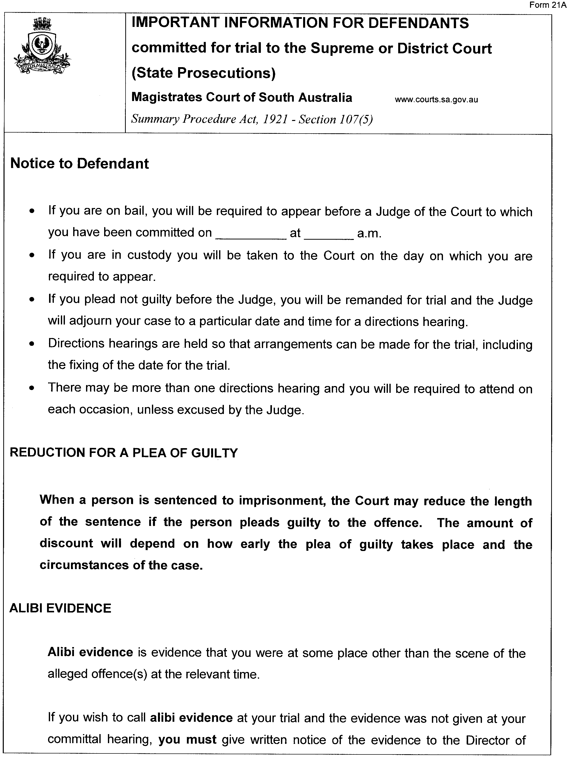
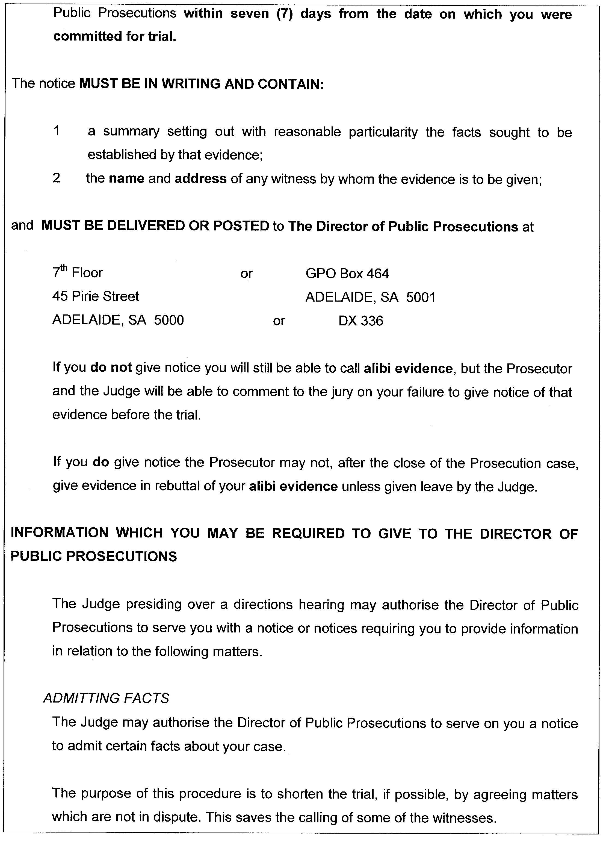
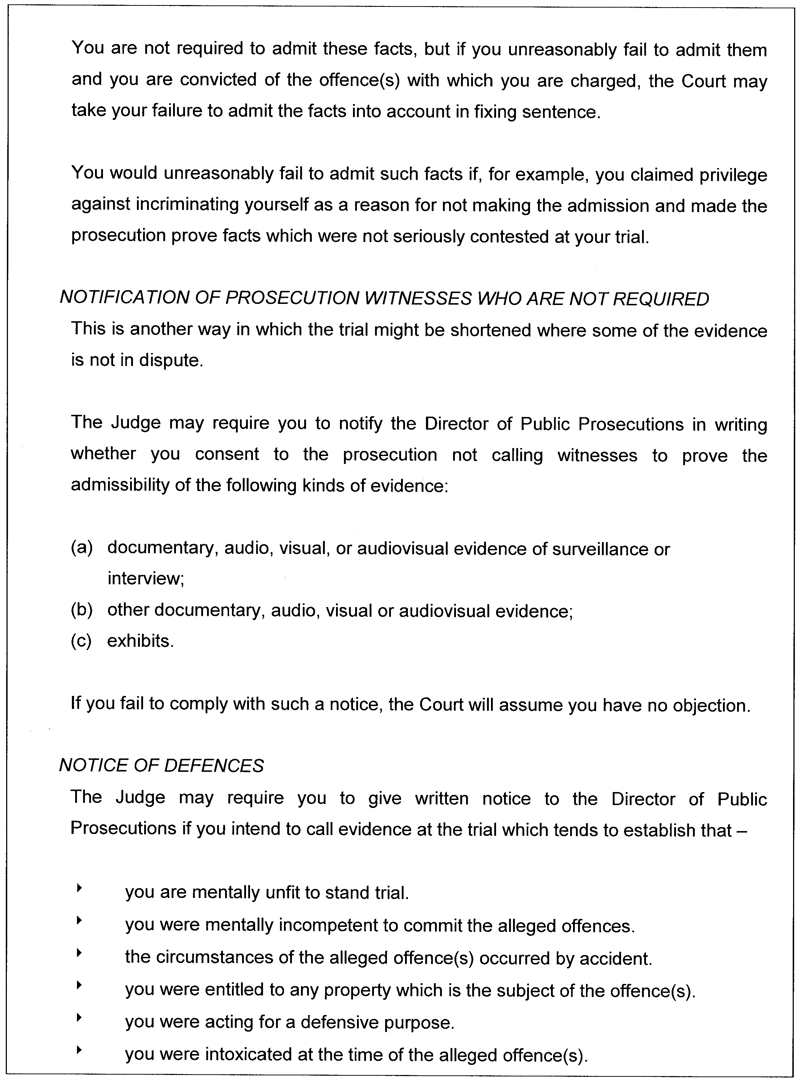
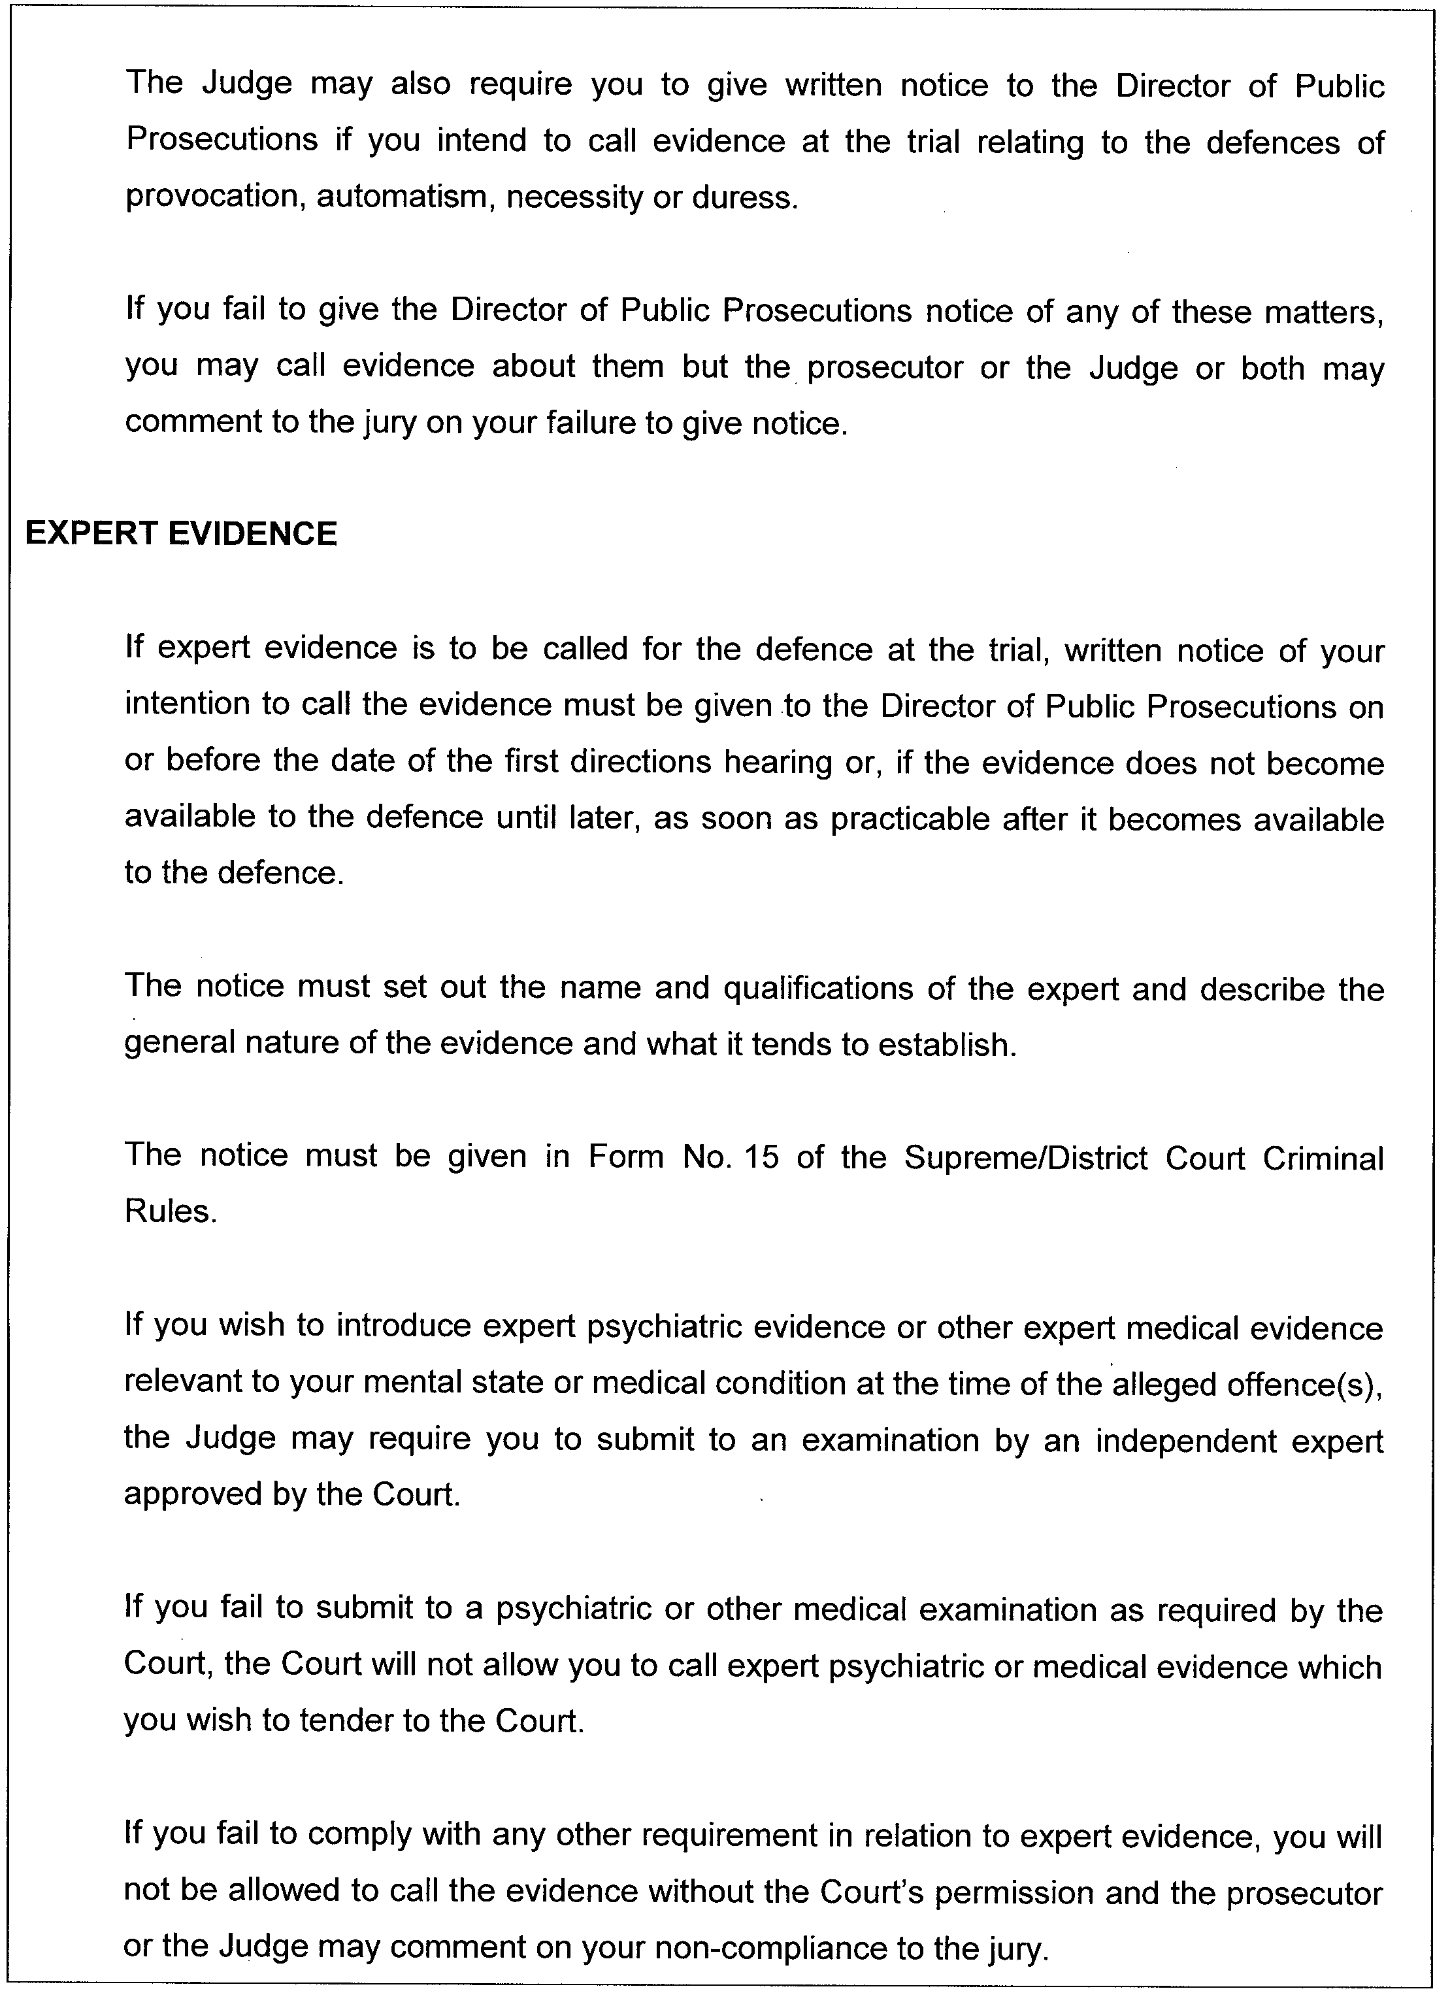
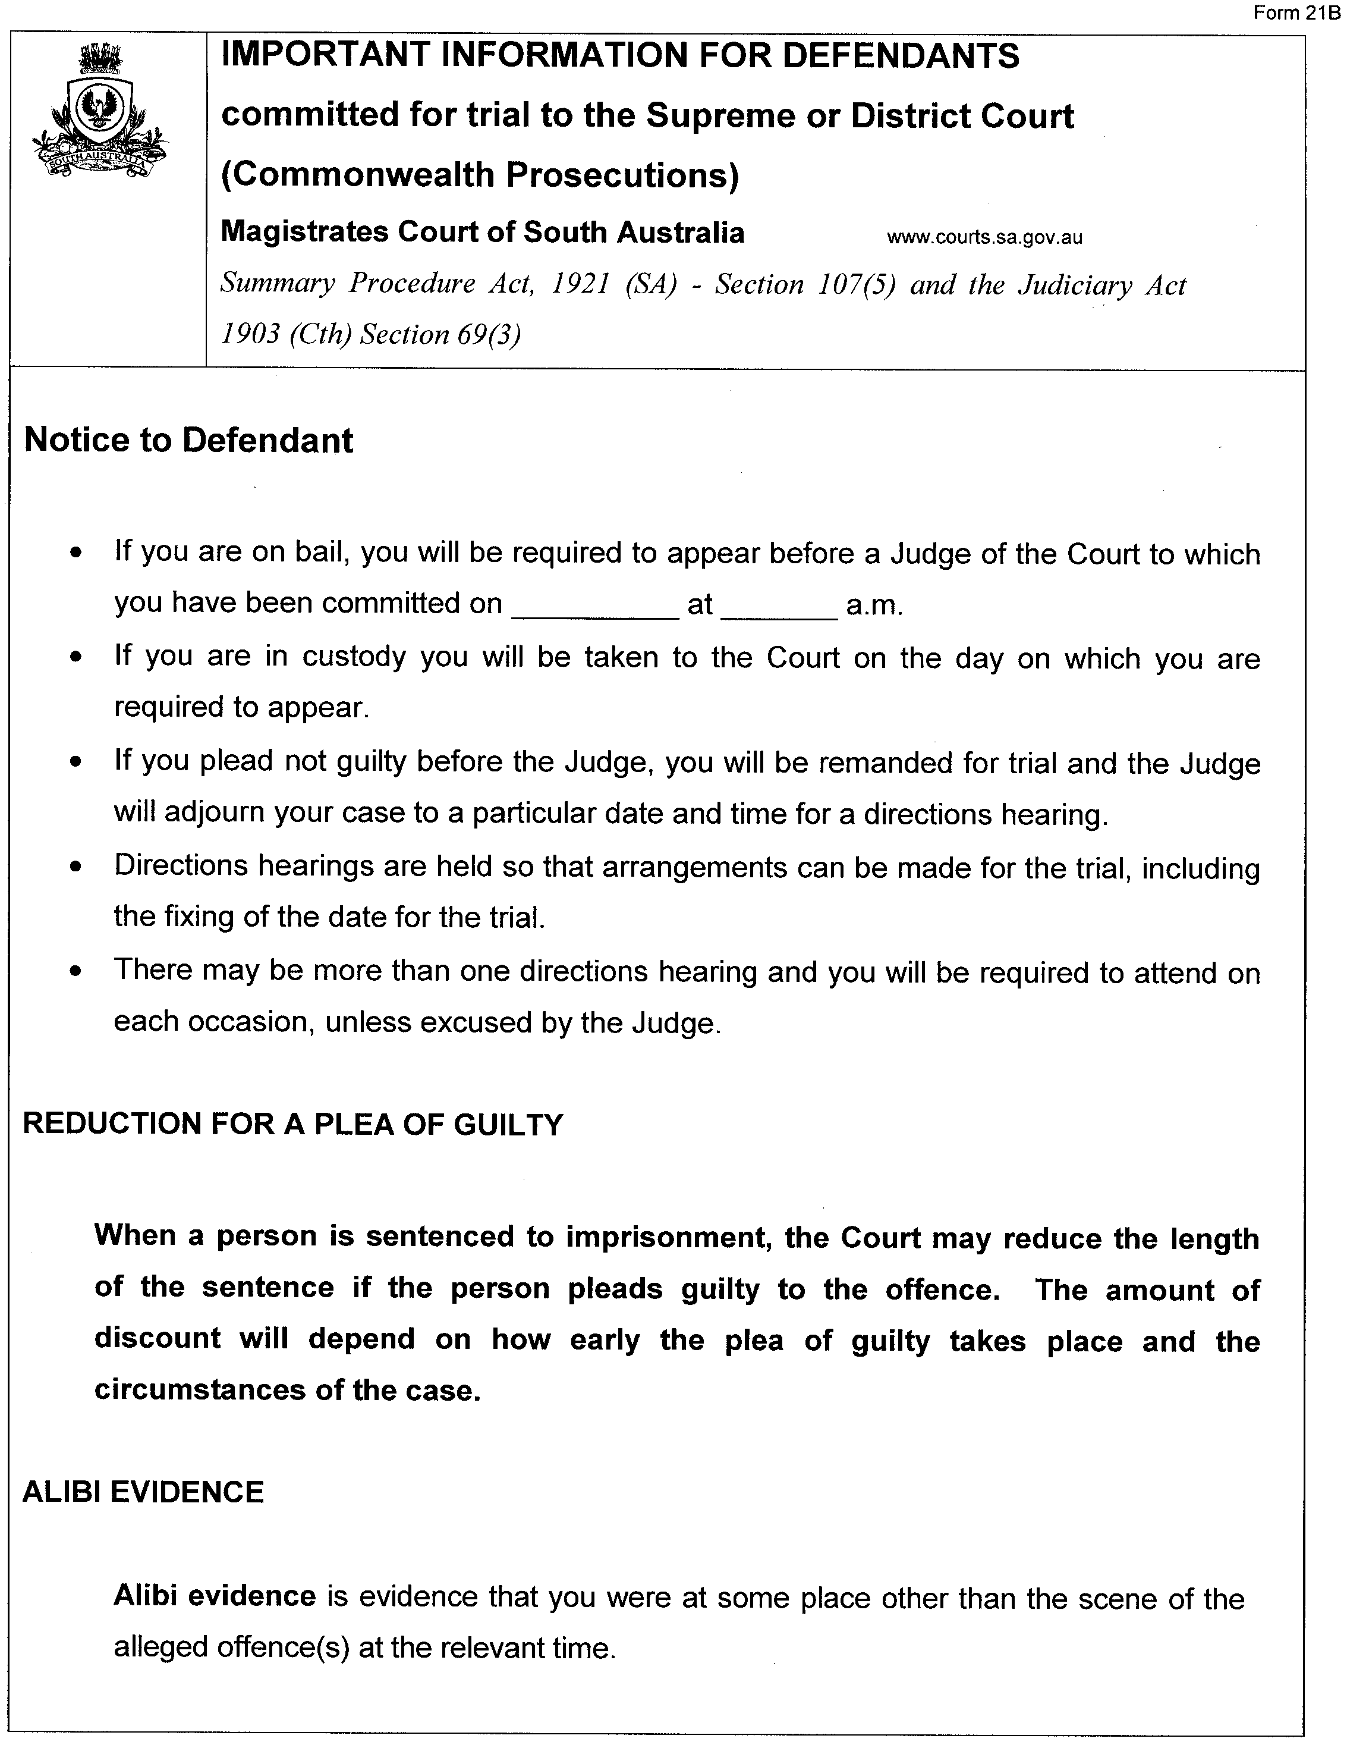
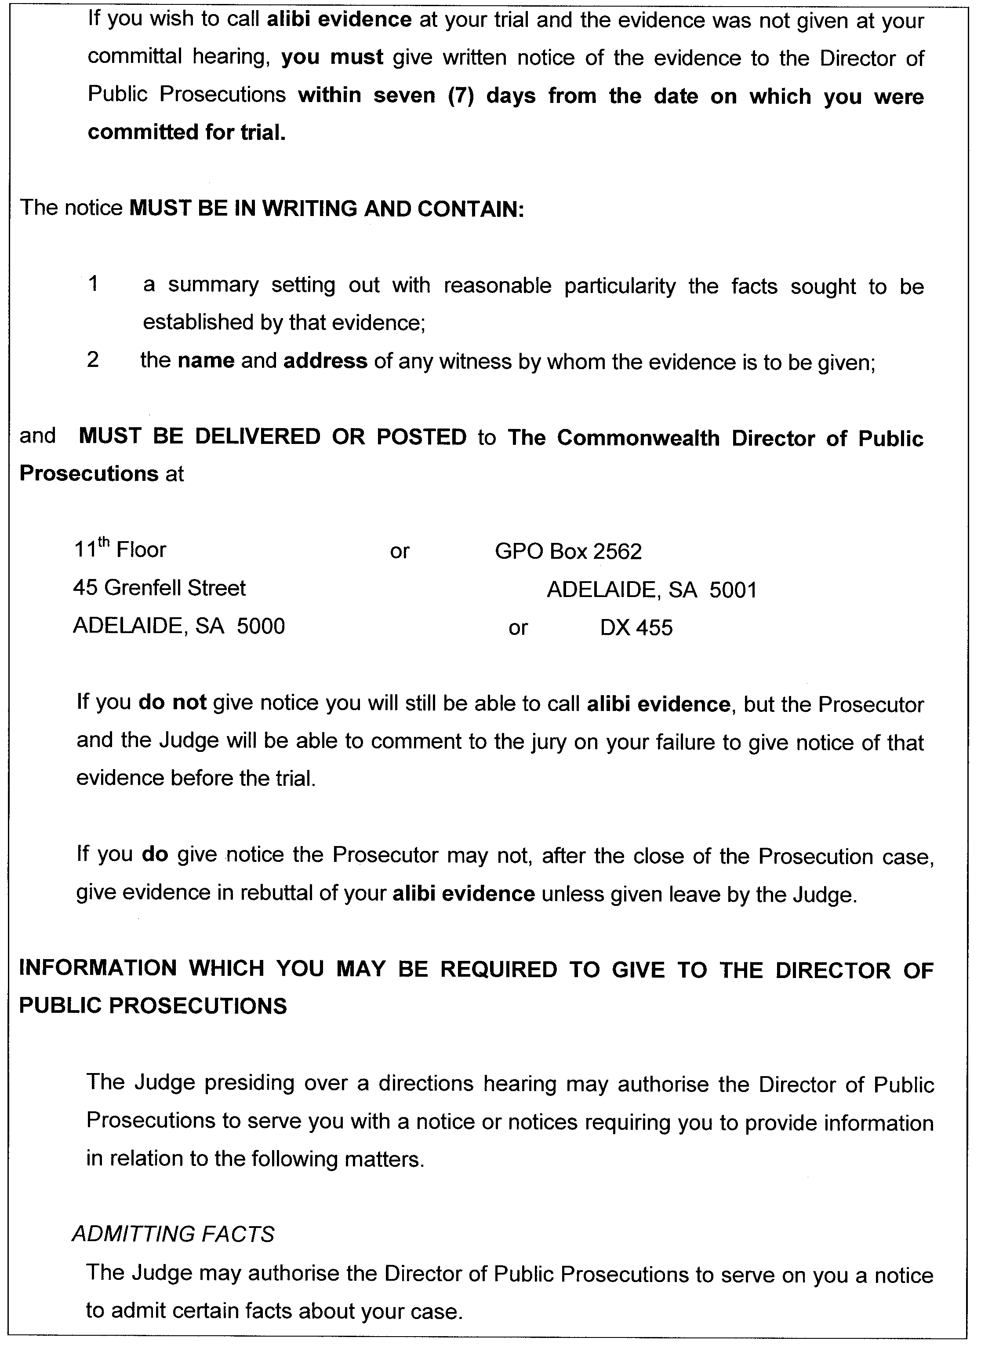
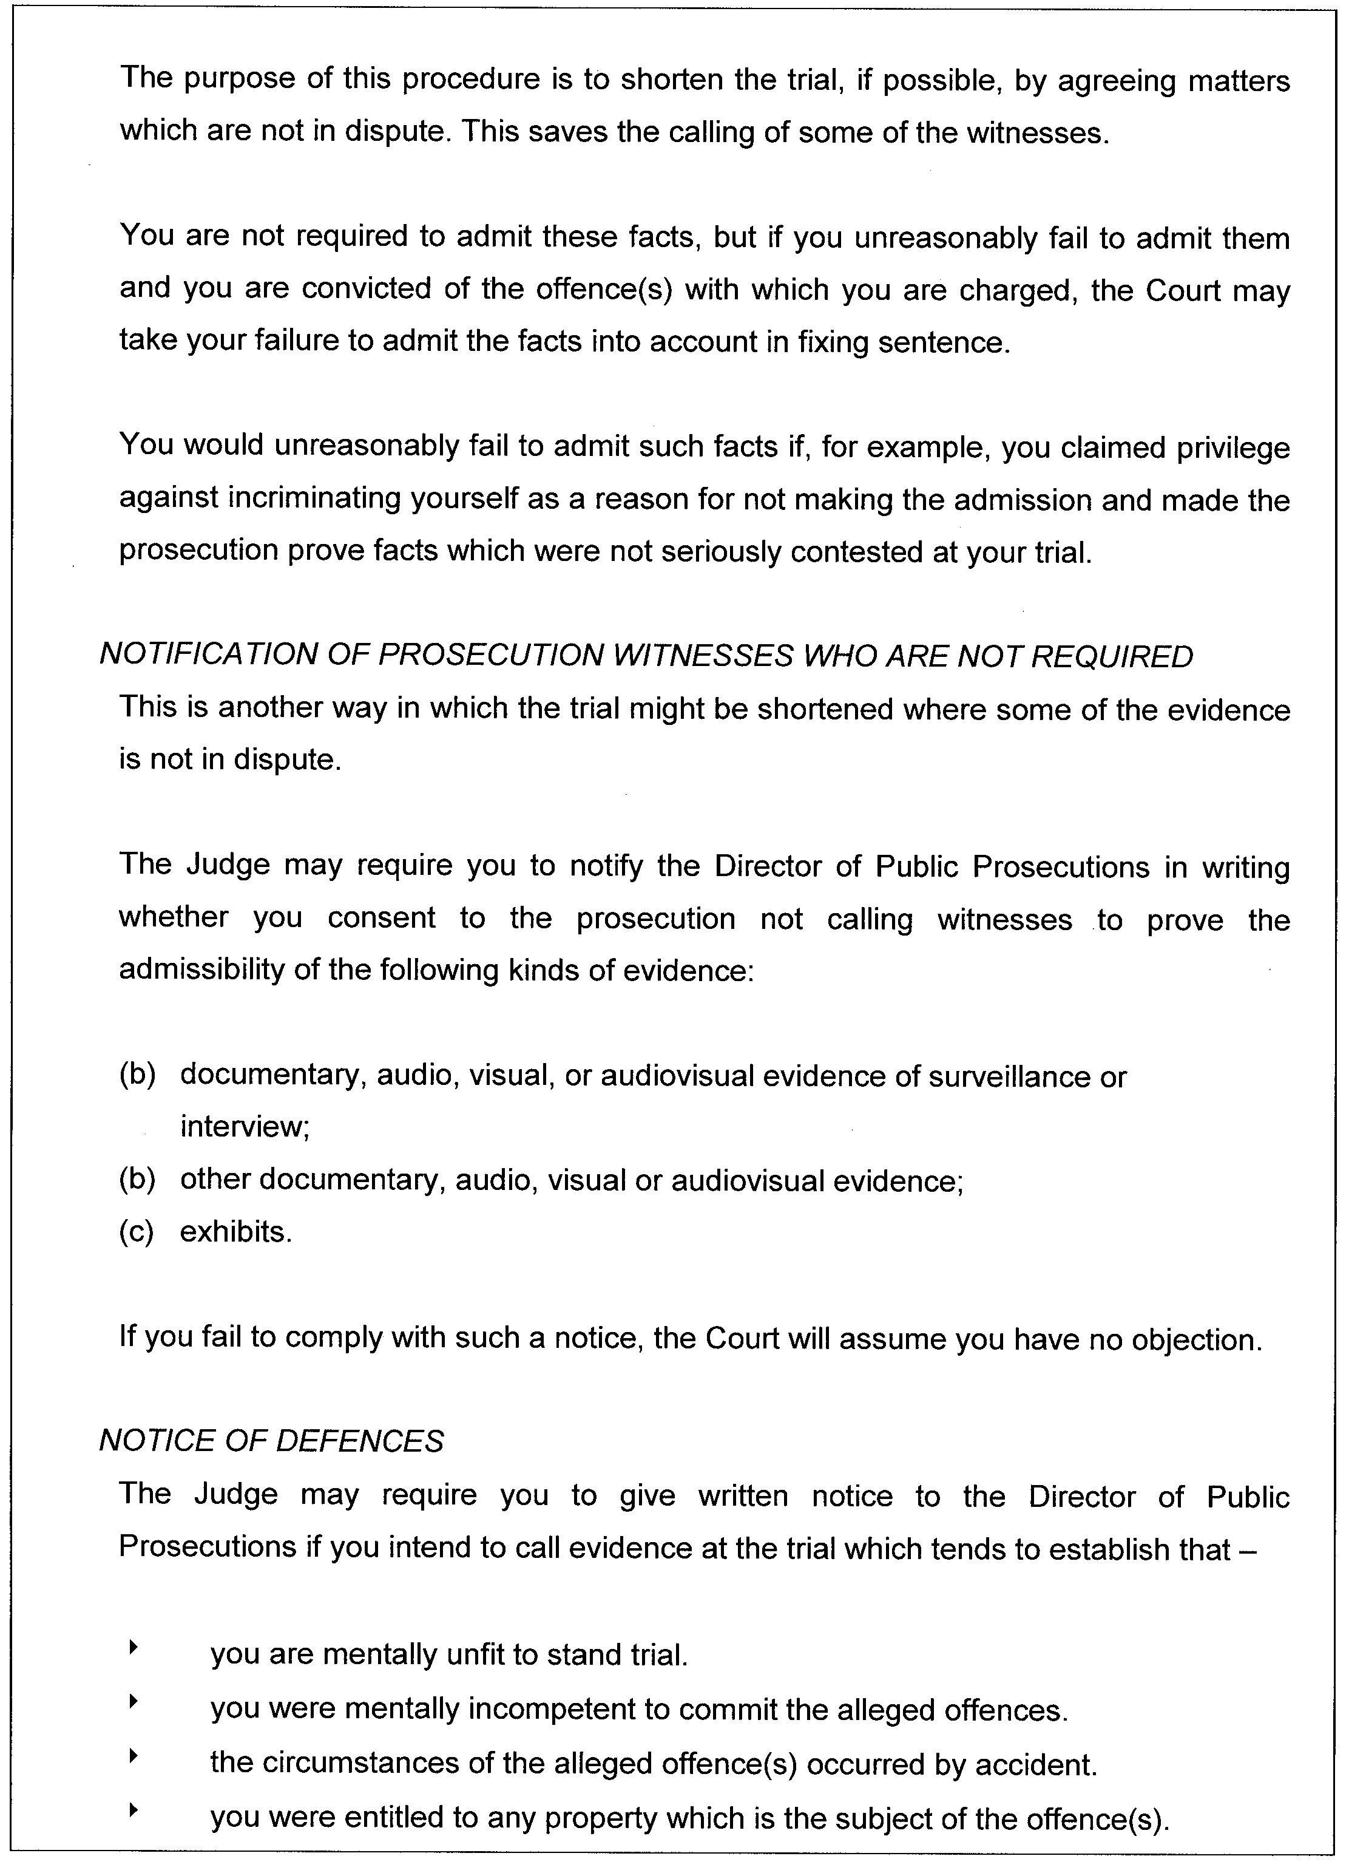
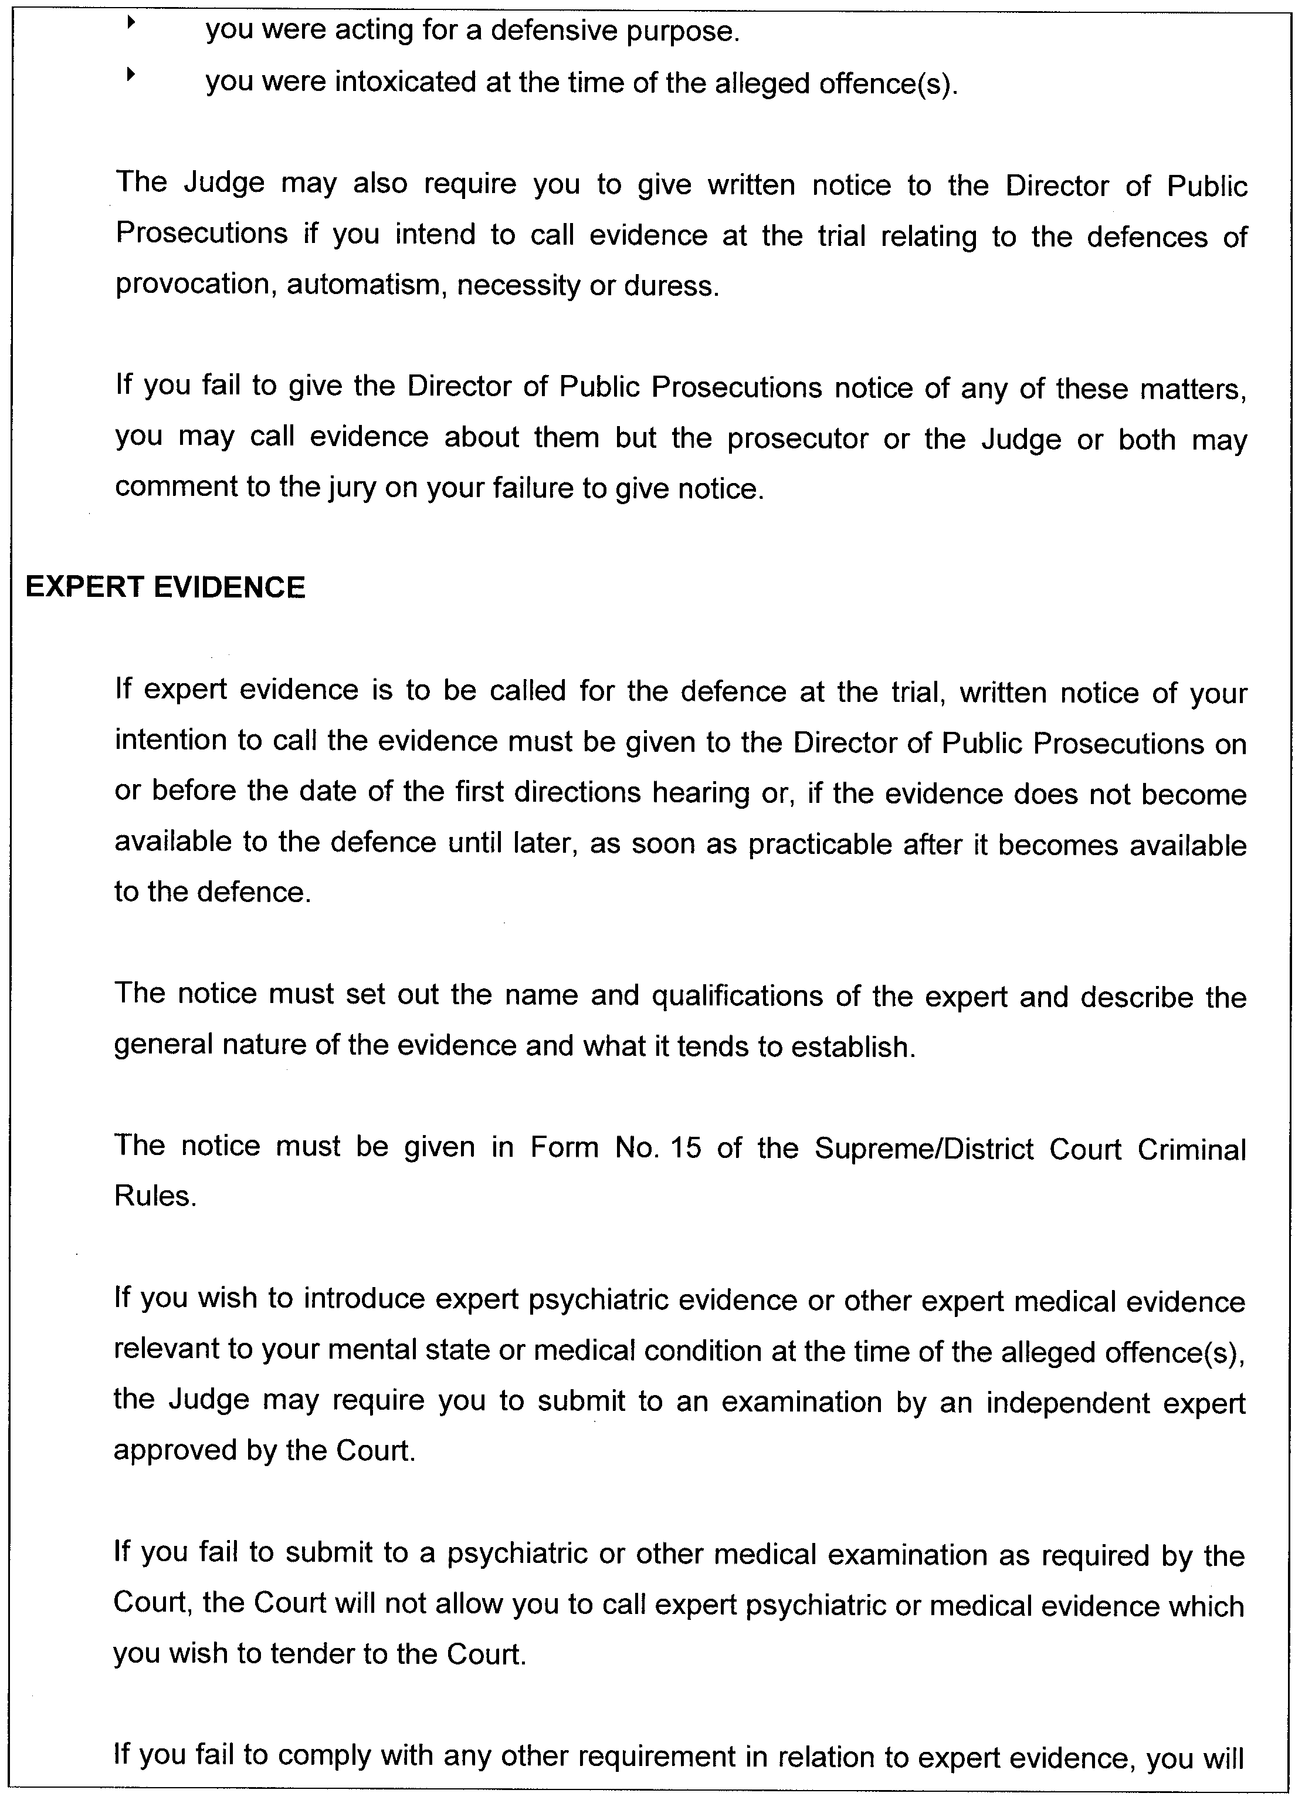
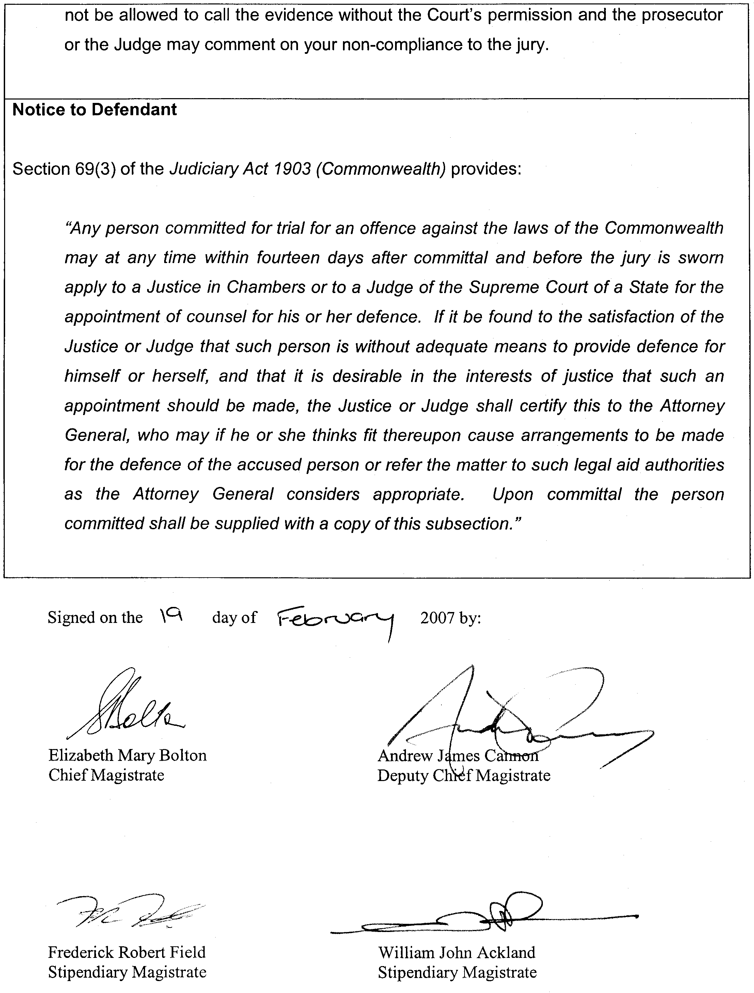

RULES OF COURT
Amending the Supreme Court Criminal Rules 1992
Amendment No. 20 to the Supreme Court
Criminal Rules
BY virtue and in pursuance of section 72 of the Supreme Court Act 1935 and all other enabling powers, We, the Judges of the Supreme Court of South Australia, make the following Rules to take effect as amendments to the Supreme Court Criminal Rules 1992, as amended:
1. These Rules may be cited as the ‘Supreme Court Criminal Rules 1992, Amendment No. 20’.
2. The Supreme Court Criminal Rules 1992, as amended by these Rules may be cited as the ‘Supreme Court Criminal Rules 1992’.
3. This Amendment No. 20 is to take effect on and from the later of 1 March 2007 or the date of its gazettal.
4. Rule 6.07 (1) (e) is amended by adding after Rule 6.07 (1) (e) (vii) B the following:
‘(vii) C the making of orders pursuant to sections 285BA (1), 285BB (1) and 285BB (4) of the Criminal Law Consolidation Act 1935.’
5. The following Rules are added immediately after Rule 19:
Admission of facts by the defence
20.01 An application by the Director of Public Prosecutions to serve on the defendant or the defendant’s solicitor a notice to admit specified facts pursuant to section 285BA of the Criminal Law Consolidation Act 1935, is to be in Form 9 and, unless the Court otherwise orders, must be filed in the Court and served on the defence no later than 14 days prior to the first directions hearing.
20.02 A notice to the defendant or the defendant’s solicitor to admit specified facts pursuant to section 285BA of the Criminal Law Consolidation Act 1935, is to be in Form 10.
20.03 The defence response to a notice to admit specified facts is to be in Form 11.
Notification by the defence of an intention to adduce certain kinds of evidence
21.01 An application by the Director of Public Prosecutions to serve on the defendant or the defendant’s solicitor a notice requiring the defence to give written notice of an intention to introduce any of the kinds of evidence set out in section 285BB (1) of the Criminal Law Consolidation Act 1935, is to be in Form 9.
21.02 Unless the Court otherwise directs, an application under Rule 21.1 is to be filed in the Court and served on the defence no later than 14 days prior to the first directions hearing.
21.03 An order made pursuant to section 285BB (1) requiring the defence to give the Director of Public Prosecutions notice of an intention to adduce evidence is to be in Form 12.
21.04 A notice of intention to adduce evidence in response to an order made pursuant to section 285BB (1) is to be in Form 13.
Notification by the defence pursuant to an order made under section 285BB (4) of the Criminal Law Consolidation Act 1935, advising whether it consents to dispensing with the calling of certain prosecution witnesses
22.01 An application by the Director of Public Prosecutions pursuant to section 285BB (4) of the Criminal Law Consolidation Act 1935, for an order requiring the defence to notify the Director of Public Prosecutions in writing whether it consents to dispensing with the calling of certain prosecution witnesses is to be in Form 9 and, unless the Court otherwise orders, must be filed in the Court and served on the defence no later than 14 days prior to the first directions hearing.
22.02 An order made pursuant to section 285BB (4) of the Criminal Law Consolidation Act 1935, requiring the defence to give notification pursuant to that section is to be in Form 14.
22.03 The defence response to an order made under section 285BB (4) of the Criminal Law Consolidation Act 1935, is to be in Form 15.
Notice of intention by the defence to call expert evidence
23.01 Notice required by section 285BC of the Criminal Law Consolidation Act 1935, of an intention by the defence to call expert evidence is to be in Form 16.
24.01 Unless the Court otherwise orders, applications by the Director of Public Prosecutions for the making of orders pursuant to sections 285BA (1), 285BB (1) and 285BB (4) of the Criminal Law Consoli-dation Act 1935, in a matter committed for trial to a Circuit Court must be filed in the Court and served on the defence no later than 14 days prior to the date appointed for the commencement of the circuit.
25.01 A Judge of the Court may convene a directions hearing in a matter which has been committed for trial to a Circuit Court at any time prior to the commencement of the circuit.
25.02 The procedure and powers of the Court on a directions hearing under Rule 25.1 shall be the same as those which apply to a directions hearing under Rule 6.
6. Insert after Form 8 new Forms 9, 10, 11, 12, 13, 14, 15 and 16.

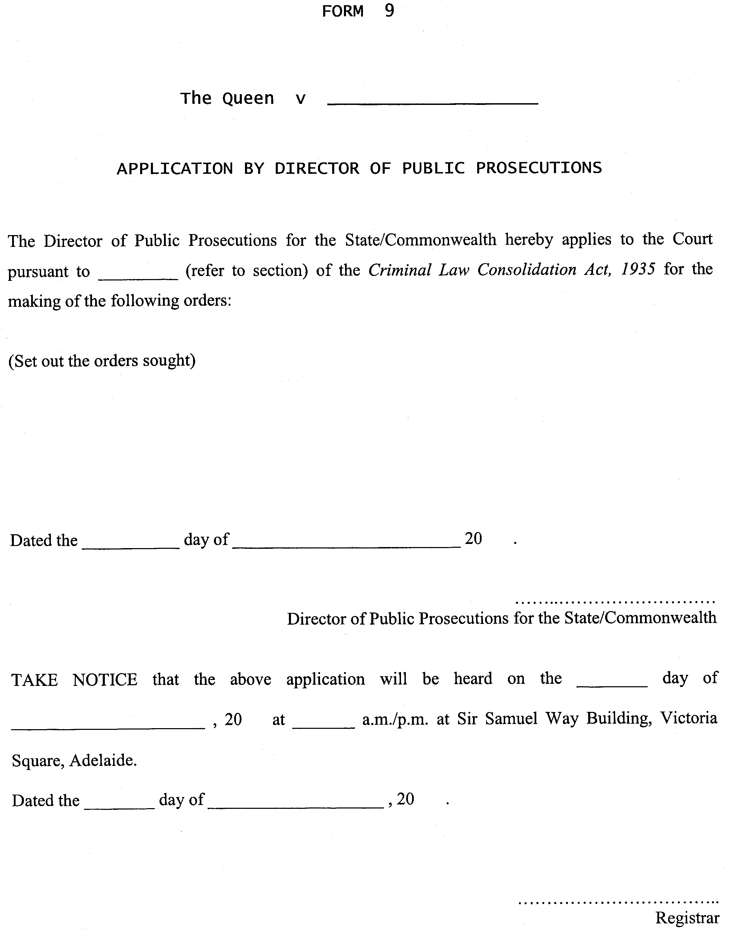

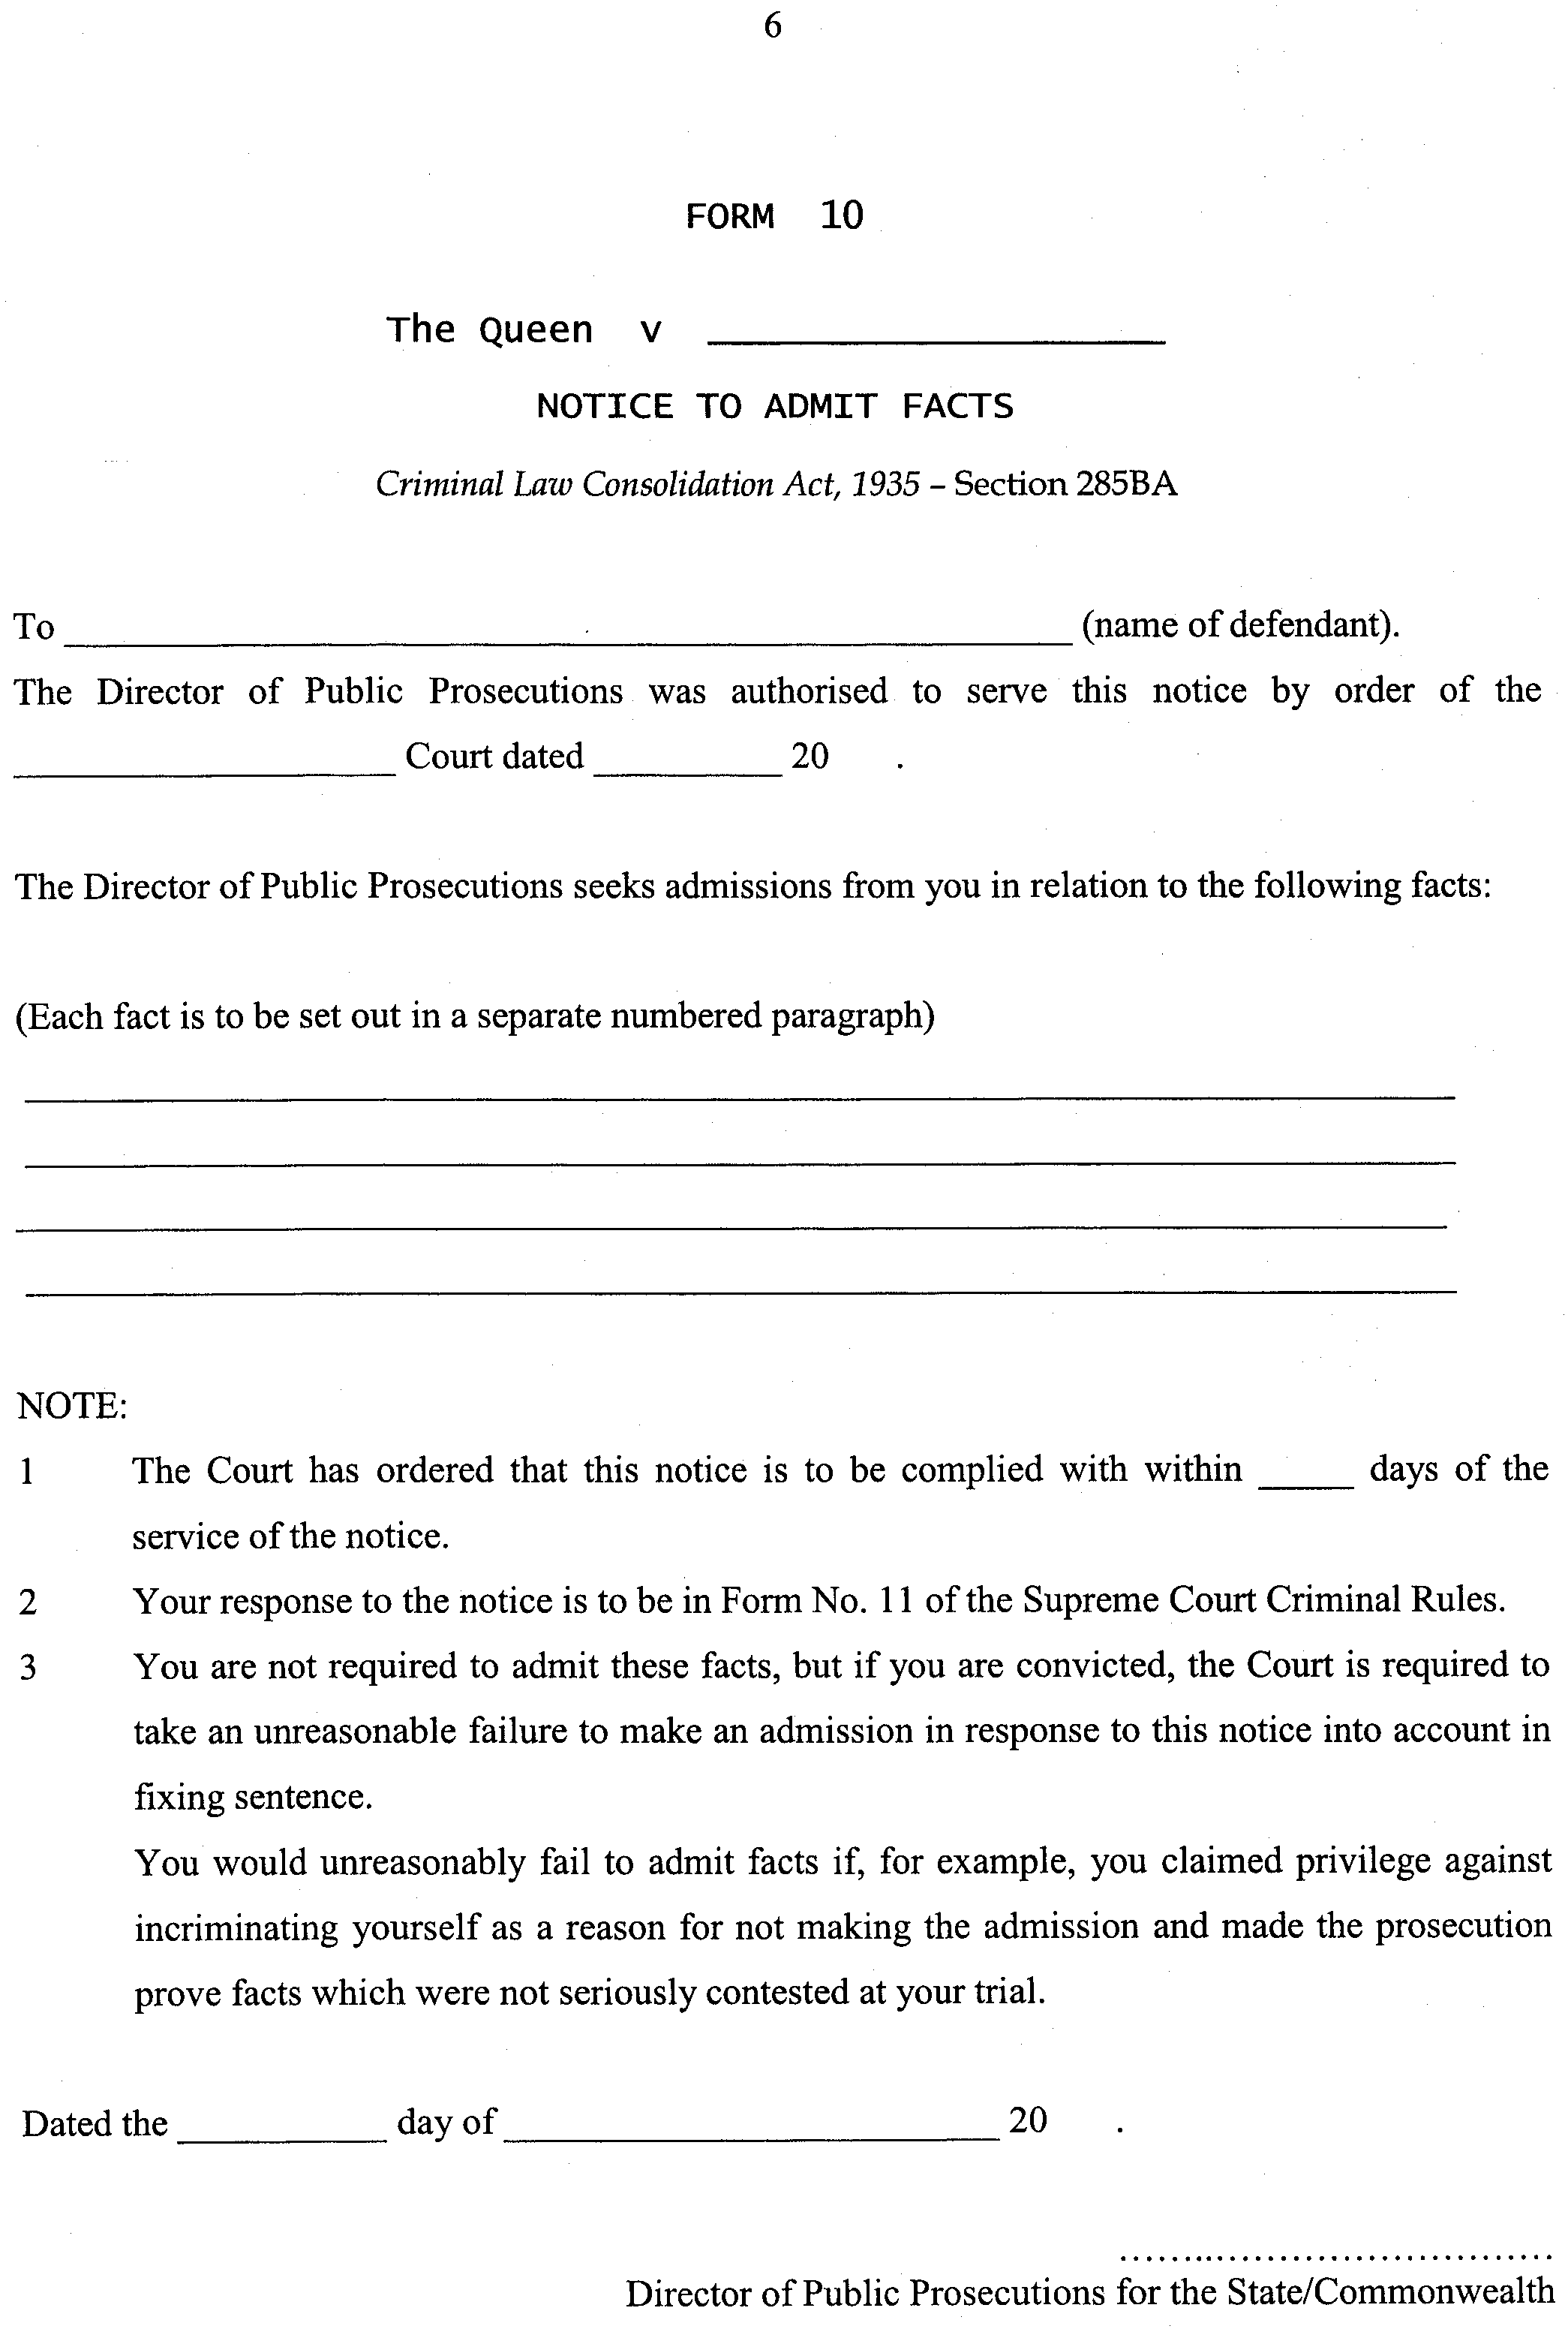
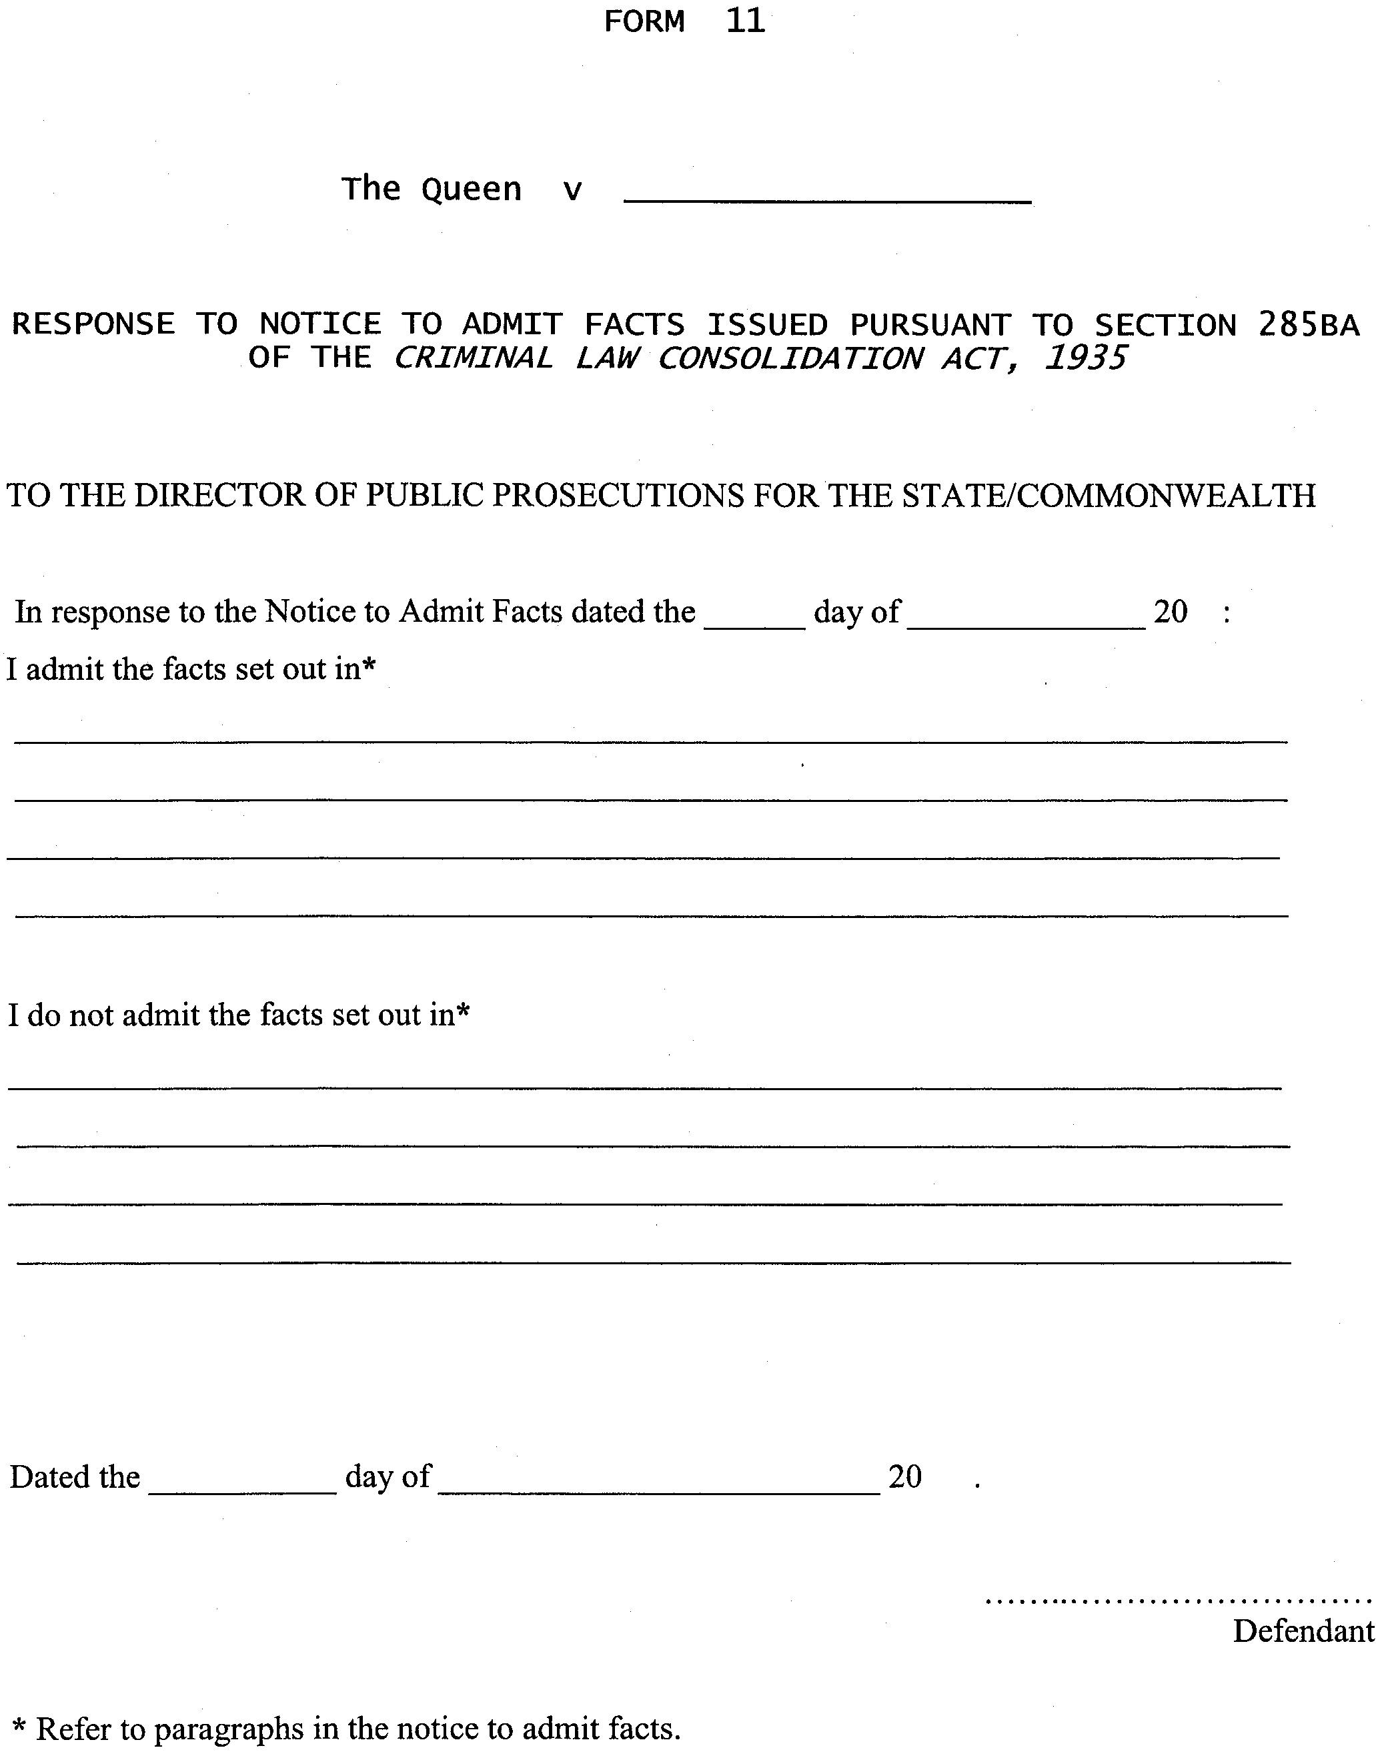
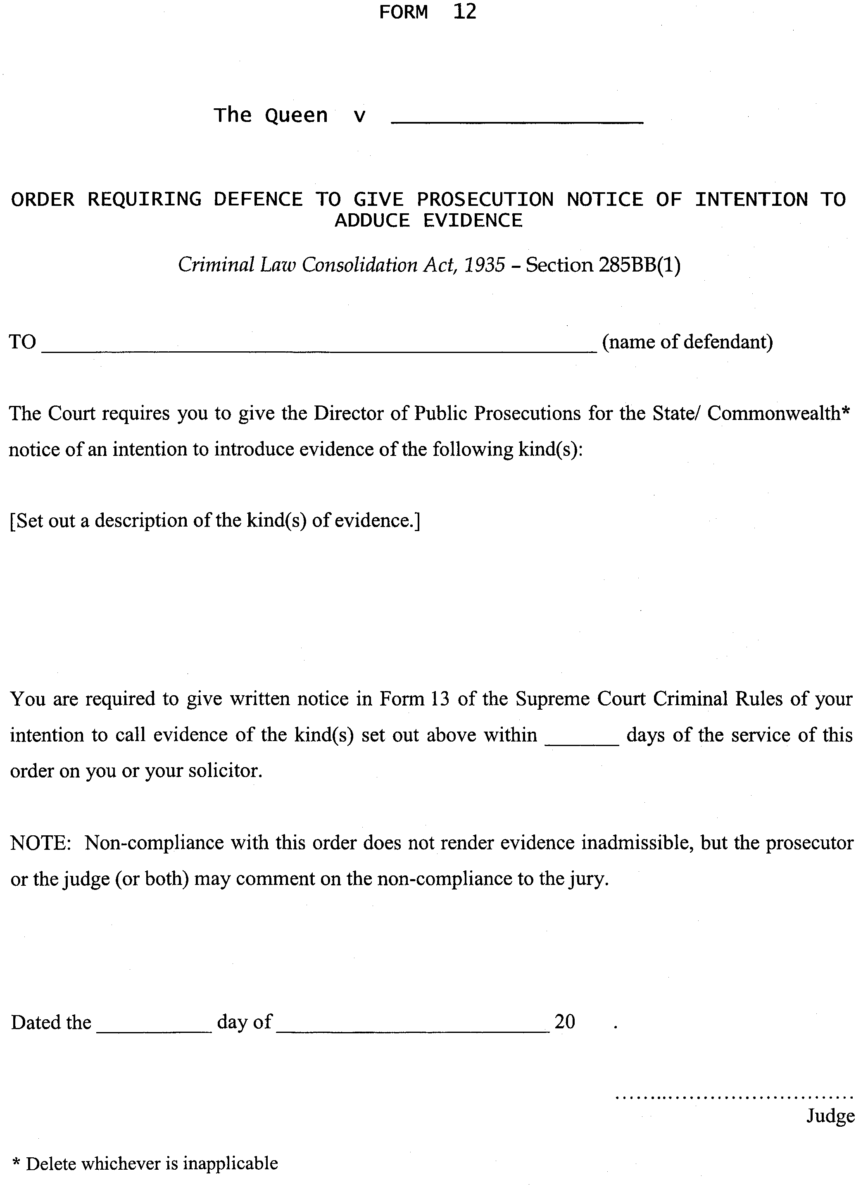
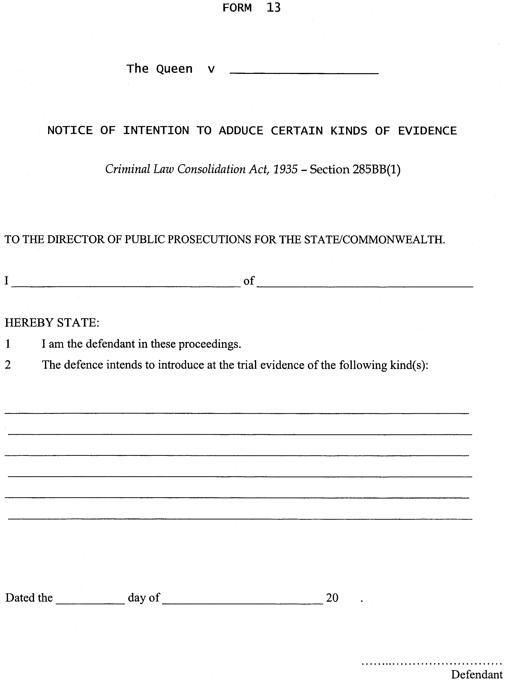
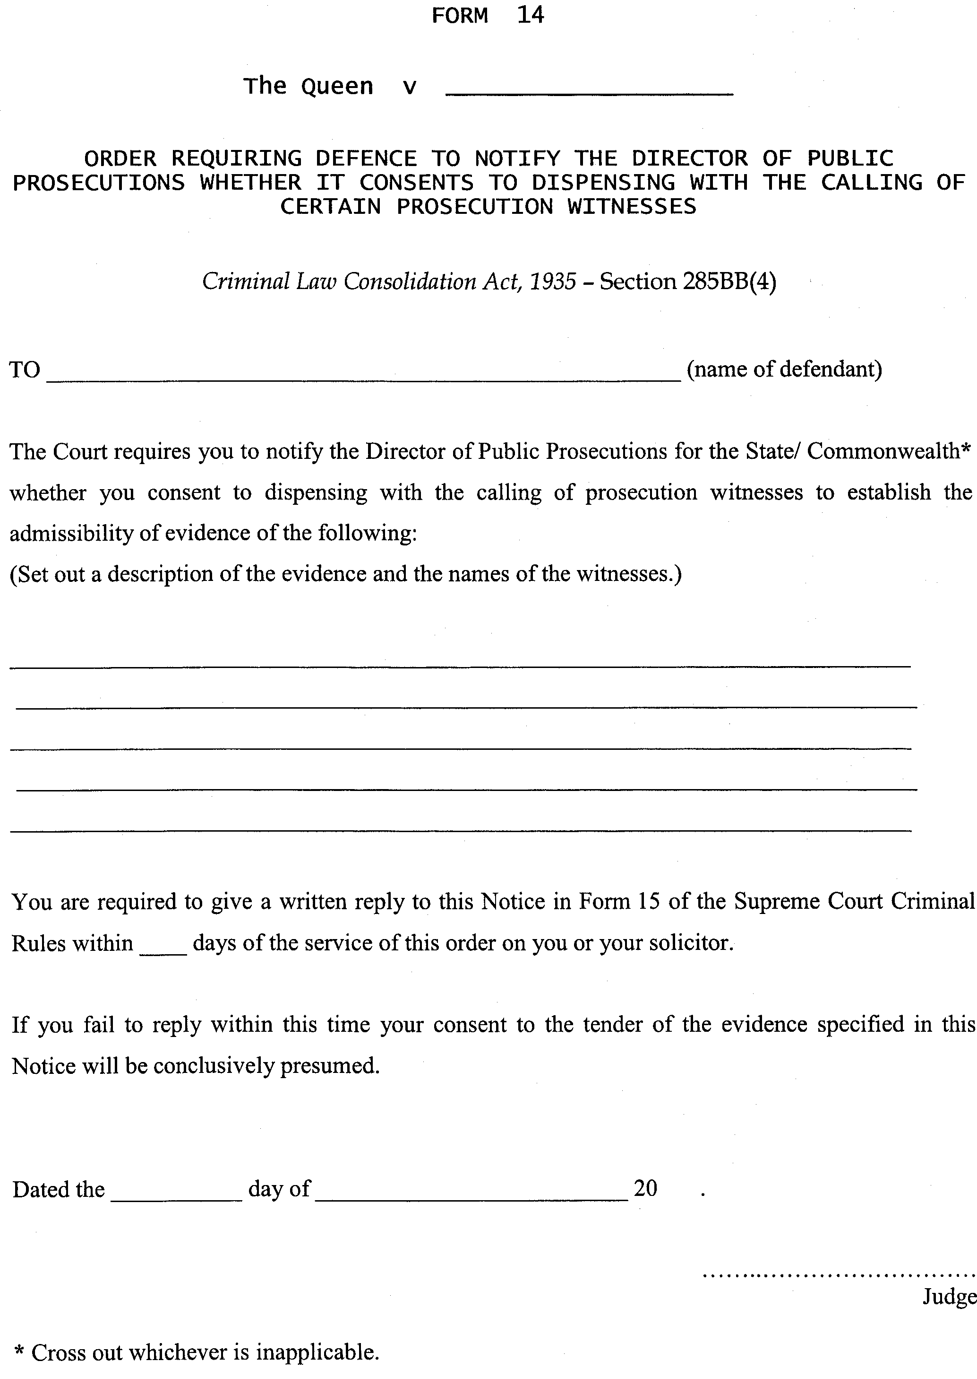
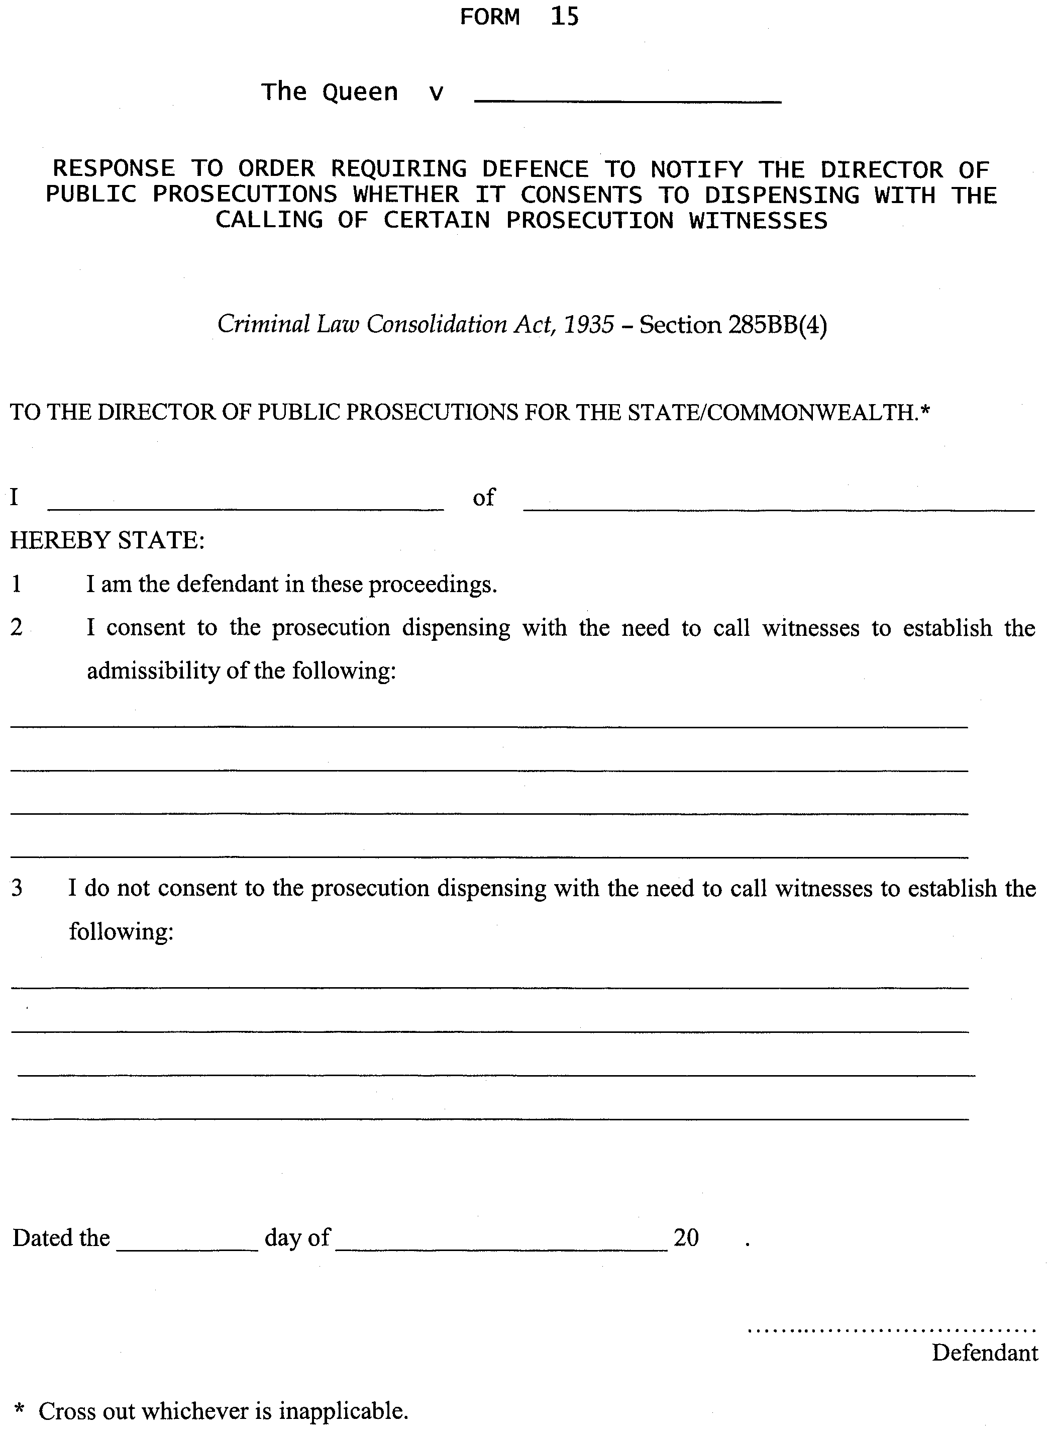
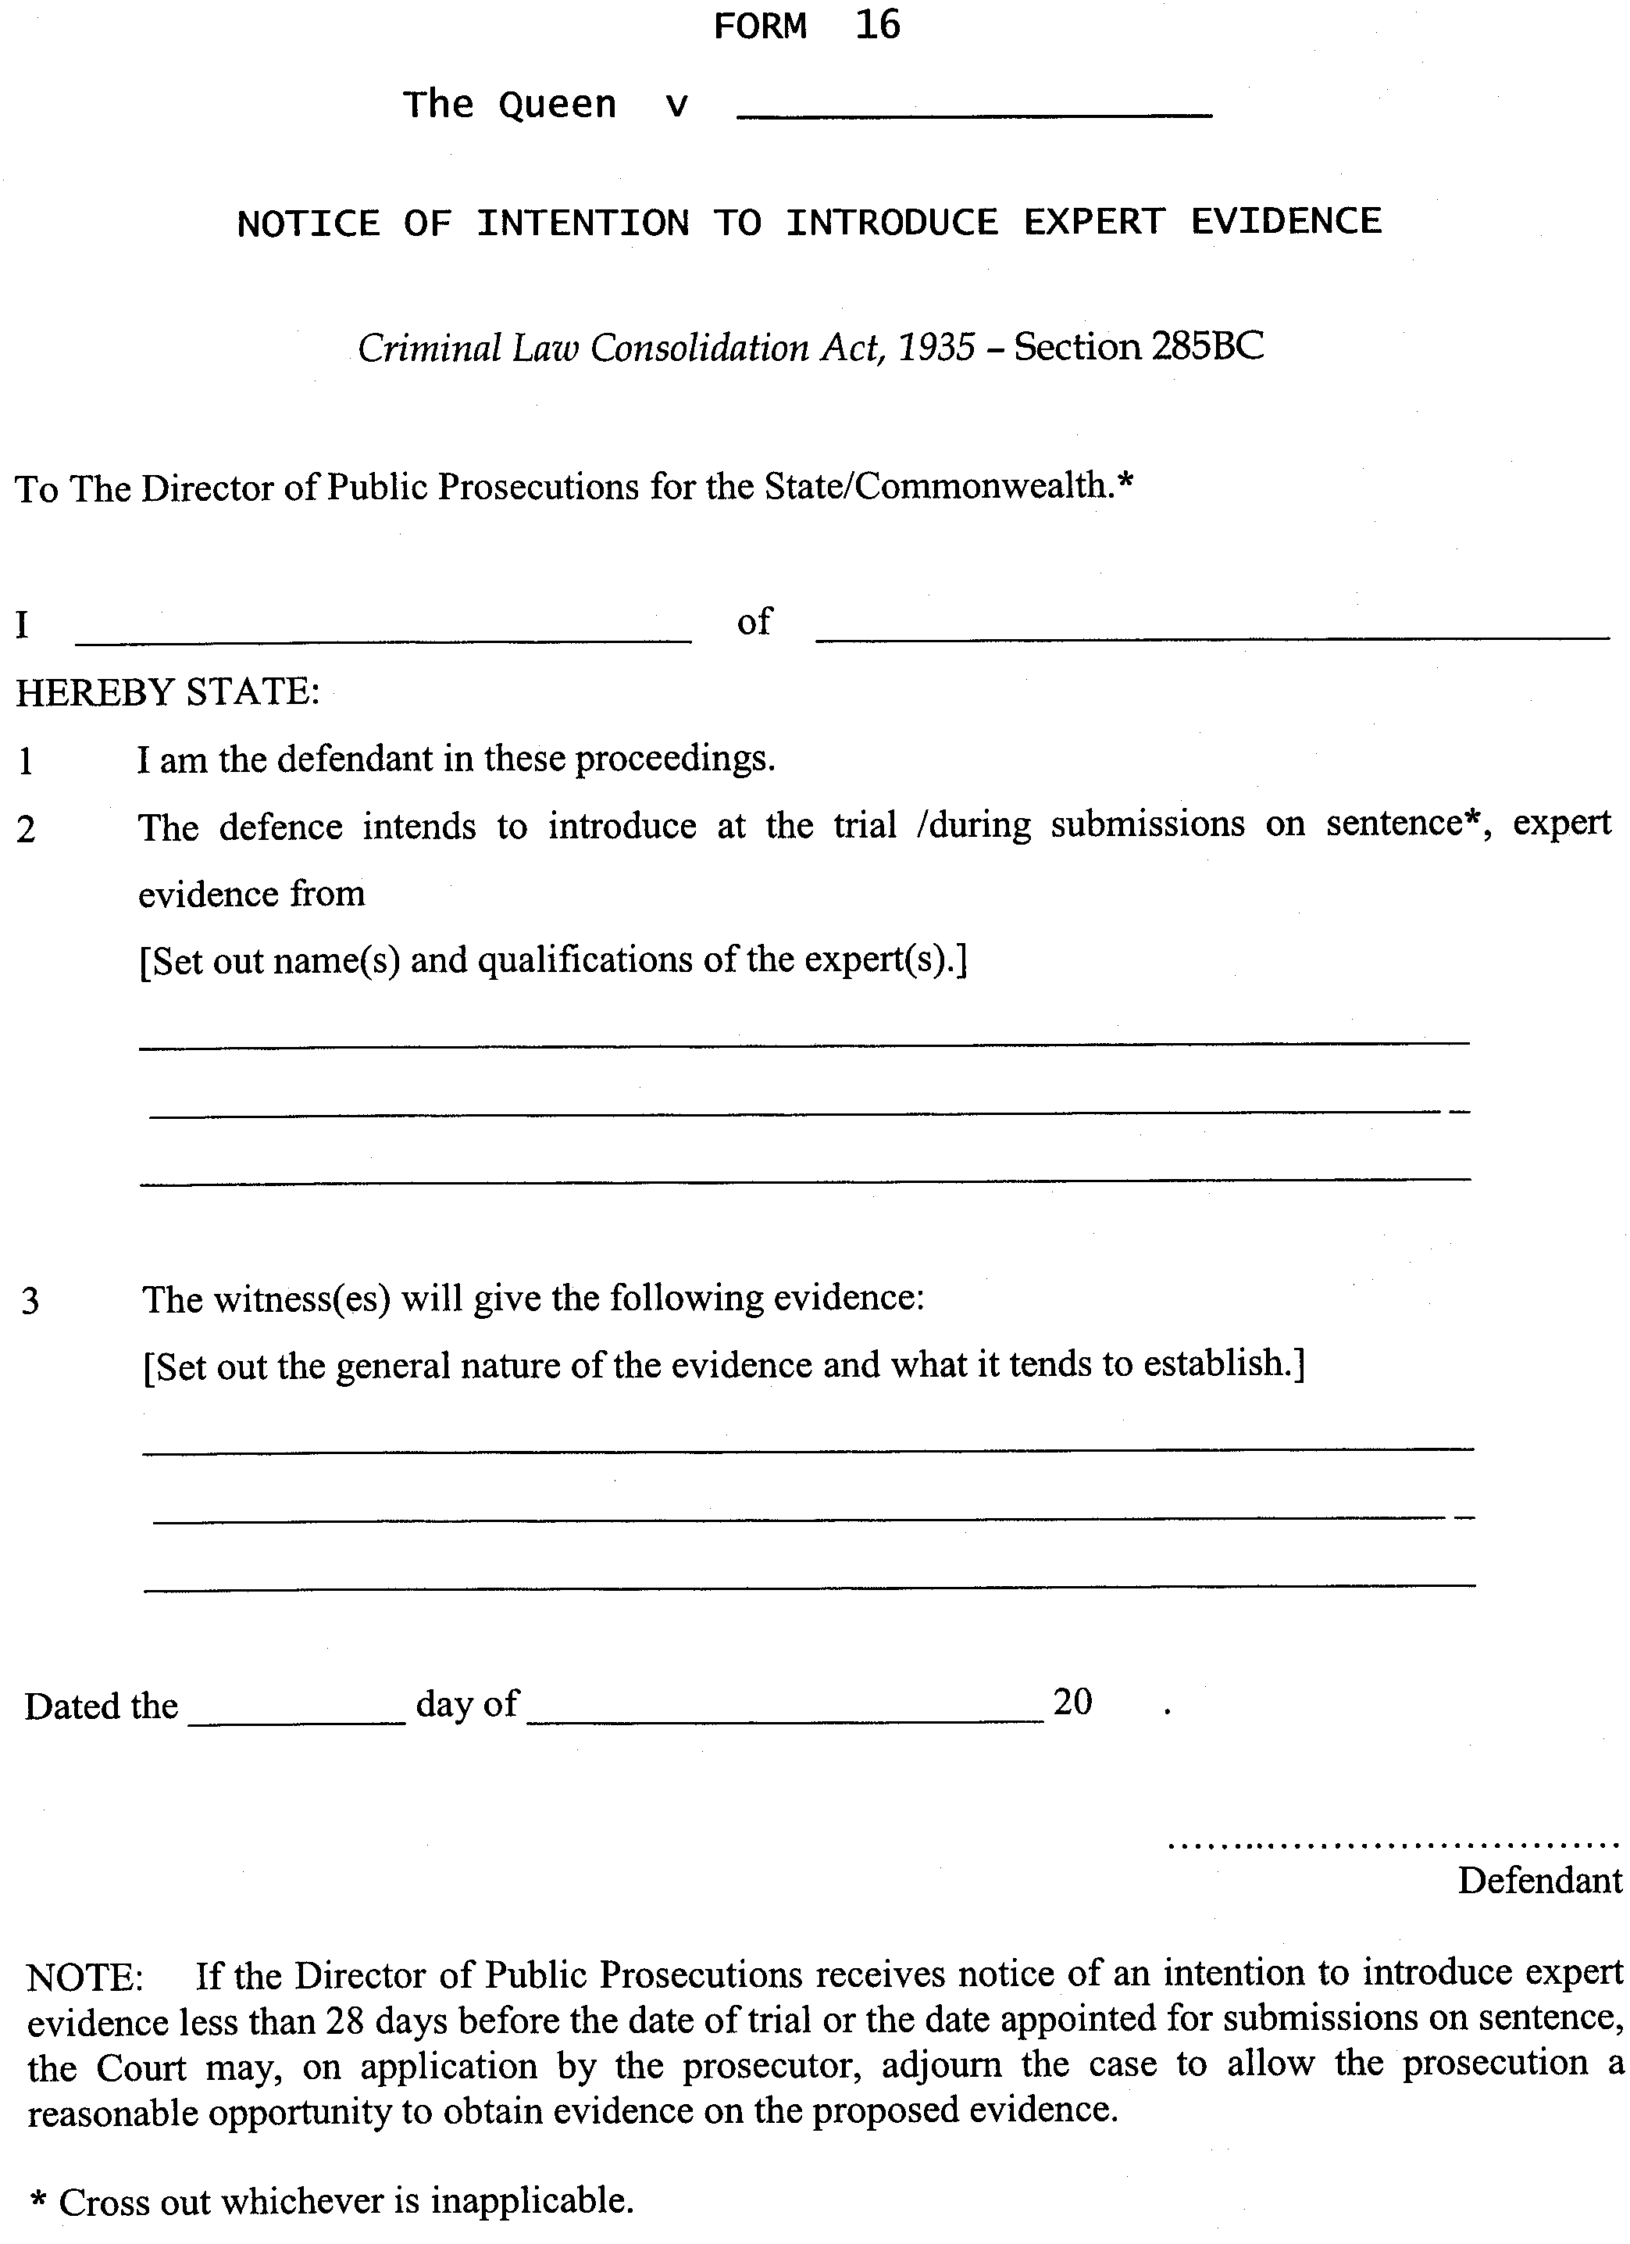
GIVEN under our hands and the Seal of the Supreme Court of South Australia this 22nd day of December 2006.
(l.s.) J. DOYLE, CJ
J. W. PERRY, J
B. M. DEBELLE, J
D. J. BLEBY, J
J. R. SULAN, J
J. ANDERSON, J
R. A. LAYTON, J
K. P. DUGGAN, J
M. J. NYLAND, J
T. A. GRAY, J
A. M. VANSTONE, J
J. C. WHITE, J
M. DAVID, J

REGULATIONS UNDER THE TRADE STANDARDS
ACT 1979
Exemption
TAKE notice that, pursuant to Clause 3 in Schedule 1 of the Regulations under the Trade Standards Act 1979, I, Mark Ian Bodycoat, Commissioner for Consumer Affairs, do hereby exempt the article named in Schedule 1 from the application of those sections of the Regulations in relation to the trapping space described in Schedule 2.
Schedule 1
Children’s folding chairs supplied by Funtastic Limited con-structed with Frame No. JD004.
Schedule 2
Exemption from complying with the provisions of Clause 2 (1), a children’s folding chair must be so constructed that the maximum distance between components forming a trapping space is 5 mm.
Dated 9 February 2007.
M. Bodycoat, Commissioner for Consumer Affairs
Ref.: PS 118/86

NOTICE TO MARINERS
No. 9 of 2006
South Australia—Spencer Gulf—Port Augusta—Approach Channel—Yatala Harbour—Beacon Collapse—
Navigation Hazard
MARINERS are advised that a Navigation Beacon has collapsed during installation at Yatala Harbour, resulting in the beacon laying at an angle of approximately 20° to the horizontal, the beacon which dries at low water, and covers at high water is in position:
Latitude: 32°44.022′S (WGS84)
Longitude: 137°53.882′E.
Mariners are further advised to use extreme caution whilst navigating in the immediate vicinity, as the pile work presents a serious hazard to navigation. It is anticipated that this will be rectified within the next 10 days.
Navy chart affected: Aus 778.
Publications affected: Australian Pilot, Volume 1 (First Edition, 2005) page 369, South Aus-tralian Waters, CW map 9, page 208.
Adelaide, 19 February 2007.
Patrick Conlon, Minister for Transport
DTEI 2007/00313

NOTICE TO MARINERS
No. 10 of 2007
South Australia—Gulf St Vincent—Port Adelaide—Barker Inlet—Port Hand Unlit Beacon (Recreational) Missing
MARINERS are advised that the unlit Port Hand Beacon (Recreational) in the Barker Inlet channel is missing, and presumed collapsed. Beacons location as charted is:
Latitude: 34°44.572′S
Longitude: 138°29.152′E.
Mariners are further advised to use extreme caution when navigating in the vicinity of this location. Indications are that this beacon will not be replaced for approximately three months due to availability of construction plant.
Navy chart affected: Aus 781.
Publications affected: South Australian Waters, CW map 6D, page 193.
Adelaide, 22 February 2007.
Patrick Conlon, Minister for Transport
DTEI 2007/00313

South Australia
Environment Protection (Used Packaging Materials) Notice 2007
under section 29 of the Environment Protection Act 1993
1—Short title
This notice may be cited as the Environment Protection (Used Packaging Materials) Notice 2007.
2—Commencement
This notice comes into operation on the day on which it is made.
3—Used Packaging Materials policy
(1) The draft policy known as the Environment Protection (Used Packaging Materials) Policy 2007 and referred to the Governor by the Minister under section 29 of the Environment Protection Act 1993 is declared to be an authorised environment protection policy under that Act.
(2) The policy referred to in subclause (1) will come into operation on 1 March 2007.
Made by the Governor
with the advice and consent of the Executive Council
on 1 March 2007
EPCS07/0002

South Australia
Environment Protection (Used Packaging Materials) Policy 2007
under section 29 of the Environment Protection Act 1993

Contents
Part 1—Preliminary
1 Short title
2 Expiry
3 Interpretation
Part 2—Implementation of the National Environment Protection (Used Packaging Materials) Measure
4 Implementation of the National Environment Protection (Used Packaging Materials) Measure
Part 3—Obligations of brand owners
5 Application of Part
6 Brand owner to prepare action plan
7 Records to be kept by brand owners
Part 4—Obligations of councils
8 Reporting obligations

Part 1—Preliminary
1—Short title
This policy may be cited as the Environment Protection (Used Packaging Materials) Policy 2007.
2—Expiry
This policy expires on 30 June 2010 or on the Covenant ceasing to be in force, whichever occurs first.
3—Interpretation
(1) In this policy—
Act means the Environment Protection Act 1993;
brand owner means—
(a) in respect of retail consumer products sold or otherwise distributed in Australia under a trade mark (whether or not the trade mark is registered)—the person who is the owner or licensee in Australia of the trade mark; or
(b) in respect of retail consumer products sold or otherwise distributed in Australia under a franchise (a business arrangement which allows an individual, partnership or company to operate under the name of an already established business)—the person who is the franchisee in Australia; or
(c) in respect of retail consumer products imported into Australia—the first person to sell the product in Australia; or
(d) in respect of in-store packaging other than plastic bags provided by a retailer at the point of sale—the supplier of the packaging to the retailer; or
(e) in respect of plastic bags provided by a retailer at the point of sale for the transportation of products purchased by a consumer—the importer or manufacturer of the plastic bags, the supplier of the plastic bags to the retailer and the retailer;
consumer packaging means all packaging products made of any material, or combination of materials, for the containment, protection, marketing and handling of retail consumer products (including distribution packaging);
council means a council constituted under the Local Government Act 1999;
distribution packaging means all packaging that contains multiples of products (the same or mixed) intended for direct consumer purchase, and includes—
(a) secondary packaging used to secure or unitise multiples of consumer products such as cardboard boxes, shipper and shrink film overwrap; and
(b) tertiary packaging used to secure or unitise multiples of secondary packaging such as pallet wrapping stretch film and shrink film, strapping;
kerbside recycling collection means roadside collection of domestic solid waste separated for the purpose of recycling;
landfill means waste disposal sites used for the authorised deposit of solid waste onto or into land;
materials recovery system means any system to collect, sort and pre-process materials recovered from the waste stream, including but not limited to domestic kerbside recycling collections, drop-off collection systems, public place collection and industrial and commercial recycling collection systems;
national environment protection goal has the same meaning as in the National Environment Protection Council Act 1994 of the Commonwealth;
National Packaging Covenant or Covenant means the agreement by that name (including all schedules and annexes to that agreement) between industry organisations and governments, published by the National Packaging Covenant Council 2005, as in force from time to time;
participation rate, for a recycling collection service, means the number of households or other premises participating in the service, expressed as a proportion of the number of households or premises to whom the service is available;
plastic bag means a high density polyethylene bag;
recyclable means reasonably able to be recovered in Australia through an approved or accredited collection or drop-off system, and able to be reprocessed and used as a raw material for the manufacture of a new product;
recycle, for a product, means recover the product and use it as a raw material to produce another product;
re-use, for a product, means use a product for the same or similar purpose as the original purpose without subjecting the product to a manufacturing process which would change its physical appearance;
signatory means a signatory to the National Packaging Covenant, and includes an organisation that accedes to the Covenant after it is made, whether before or after the commencement of the national environment protection measure from which this policy is derived.
(2) In this policy, the expression “Mandatory provision” followed by a statement as to the category of an offence is to be taken to signify that contravention of the provision at whose foot the expression appears will be an offence of the category so stated for the purposes of Part 5 of the Act.
Part 2—Implementation of the National Environment Protection (Used Packaging Materials) Measure
4—Implementation of the National Environment Protection (Used Packaging Materials) Measure
(1) This policy implements the National Environment Protection (Used Packaging Materials) Measure.
Note—
The National Environment Protection Council made the national environment protection (used packaging materials) measure on 2 July 1999.
(2) The national environment protection goal of the National Environment Protection (Used Packaging Materials) Measure is to reduce environmental degradation arising from the disposal of used packaging and conserve virgin materials through the encouragement of waste avoidance and the re-use and recycling of used packaging materials by supporting and complementing the voluntary strategies in the National Packaging Covenant.
(3) The Minister is satisfied that the provisions of this policy that are not included in or required by the National Environment Protection (Used Packaging Materials) Measure relate to the enforcement of the policy (including the imposition of penalties for contravention of the policy) or are otherwise necessary for the application of the policy in this jurisdiction.
Note—
See section 29(1b) of the Environment Protection Act 1993.
Part 3—Obligations of brand owners
5—Application of Part
(1) This Part does not apply in relation to the following:
(a) consumer packaging—
(i) that is a container to which Division 2 of Part 8 of the Act applies; or
(ii) that is of a type declared by the Authority by notice published in the Gazette to be consumer packaging to which this policy does not apply;
(b) a brand owner who—
(i) had a relevant turnover in Australia during the financial year ending on the previous 30 June of less than $5 million; or
(ii) is a signatory to, and complies with, the Covenant; or
(iii) can satisfy the Authority that they—
(A) engage in practices that produce equivalent outcomes to those achieved through the Covenant; or
(B) are part of an industry or industry sector for which arrangements exist that produce equivalent outcomes to those achieved through the Covenant.
(2) In making a declaration under subclause (1)(a)(ii), the Authority must have regard to—
(a) the practices of Covenant signatories; and
(b) the materials that are collected for re-use, recycling or energy recovery whether through kerbside recycling collection or other materials recovery systems; and
(c) the state of technologies for re-use, recycling or energy recovery; and
(d) any competitive issues that may arise from including or excluding particular materials.
(3) The Authority may, by notice in the Gazette, vary or revoke a notice under this clause.
(4) For the purposes of subclause (1)(b)(i), the relevant turnover of a brand owner in a financial year is—
(a) if the brand owner is the owner or licensee of a trade mark (whether or not registered) and sells or distributes packaged retail consumer products under the trade mark in Australia—the wholesale value of packaged retail consumer products so sold or distributed during the financial year;
(b) if the brand owner is a franchisee and sells or distributes packaged retail consumer products under the franchise in Australia—the wholesale value of packaged retail consumer products so sold or distributed during the financial year;
(c) if the brand owner is the first person to sell packaged retail consumer products following their import into Australia—the wholesale value of packaged retail consumer products so sold during the financial year;
(d) if the brand owner supplies in-store packaging (other than plastic bags) to a retailer to be provided by the retailer at the point of sale—the wholesale value of in-store packaging so supplied during the financial year;
(e) if the brand owner imports, manufactures or supplies to a retailer plastic bags provided by a retailer at the point of sale for the transportation of products purchased by a consumer—the wholesale value of plastic bags so imported, manufactured or supplied during the financial year;
(f) if the brand owner is a retailer and provides plastic bags at the point of sale for the transportation of products purchased by a consumer—the wholesale value of plastic bags so provided during the financial year.
(5) If a person is a brand owner in more than 1 capacity, the relevant turnover of the brand owner is the aggregate of the relevant turnover of the brand owner in each such capacity.
(6) In this clause—
Covenant Council means the body established under the Covenant for the purpose of administering the Covenant;
National Environment Protection Council means the council of that name established under the National Environment Protection Council (South Australia) Act 1995;
packaged retail consumer product means a retail consumer product packaged in consumer packaging.
6—Brand owner to prepare action plan
(1) A brand owner must—
(a) prepare, maintain and implement an action plan in accordance with this clause; and
(b) comply with the plan.
Mandatory provision: Category B offence.
(2) The action plan must contain the following information:
(a) how the brand owner intends to ensure that consumer packaging in which the brand owner’s products are sold, or that is imported, manufactured, supplied or provided by the brand owner, or consumer packaging that is substantially the same as that packaging, is recovered and re-used, recycled or used for energy recovery;
(b) the quantity of each type of consumer packaging proposed to be recovered and re-used, recycled or used for energy recovery;
(c) how the brand owner intends to inform the public of the way in which the consumer packaging may be recovered.
(3) The quantity referred to in subclause (2)(b) must be at least equivalent to the performance target for the type of consumer packaging in the Covenant.
(4) A prosecution must not be commenced against a brand owner under this clause unless—
(a) the Authority has served the brand owner with a notice, in writing, giving particulars of an alleged contravention of the clause and requiring the brand owner to comply with the clause within 3 months of the date of service of the notice; and
(b) the Authority is satisfied that the brand owner has failed to comply with the requirement specified in the notice.
7—Records to be kept by brand owners
(1) A brand owner must, within 3 months of the end of a financial year, record the following information in relation to each type of consumer packaging in which the brand owner’s products are sold or that is imported, manufactured, supplied or provided by the brand owner during that financial year:
(a) the number of units of packaging;
(b) the total weight of material used;
(c) the total weight of material recovered;
(d) the total weight of recovered material re-used and recycled in Australia;
(e) the total weight of recovered material re-used and recycled through export;
(f) the total weight of recovered material used for energy recovery;
(g) the total weight of recovered material disposed of to landfill;
(h) the recovery rate calculated in accordance with the following formula:
Where—
RR is the recovery rate;
WMR is the weight of material recovered from the post-consumer waste stream;
WMS is the weight of material sold as packaging within Australia.
Mandatory provision: Category B offence.
(2) A brand owner must—
(a) keep a record required under this clause for a period of 5 years commencing on the last day of the financial year to which the record relates; and
(b) at the request of the Authority, make a record required to be kept under this clause available for inspection by the Authority.
Mandatory provision: Category B offence.
Part 4—Obligations of councils
8—Reporting obligations
A council that has, during a financial year or any part of a financial year, operated a kerbside recycling collection service or other materials recovery system must, within 3 months after the end of that financial year, provide the Authority with the following information:
(a) the number of residential and non-residential premises in the council’s area;
(b) the number of residential and non-residential premises in the council’s area that were covered by the service or system;
(c) the participation rate for the service or system;
(d) the fee charged by the council in respect of the service or system;
(e) the total weight of recyclable material collected, itemised, to the extent practicable, by material type;
(f) the total weight of recyclable material collected that was then disposed of to landfill, itemised, to the extent practicable, by material type.

South Australia
Statutes Amendment (Criminal Procedure) Act (Commencement) Proclamation 2007
1—Short title
This proclamation may be cited as the Statutes Amendment (Criminal Procedure) Act (Commencement) Proclamation 2007.
2—Commencement of Act
The Statutes Amendment (Criminal Procedure) Act 2005 (No 74 of 2005) will come into operation on 1 March 2007.
Made by the Governor
with the advice and consent of the Executive Council
on 1 March 2007
AGO0110/05CS

South Australia
Crown Lands (Resumption of Dedicated Land) Proclamation 2007
under section 5AA(1)(c) of the Crown Lands Act 1929

Preamble
1 The following land is dedicated as a reserve for a cemetery (Gazette 24.12.1896 p1419):
Section 264, Hundred of Parnaroo, being the whole of the land contained in Land Grant Register Book Volume 619 Folio 67.
2 No registered proprietor of the land is able or willing to have the care, control and management of the land.

1—Short title
This proclamation may be cited as the Crown Lands (Resumption of Dedicated Land) Proclamation 2007.
2—Commencement
This proclamation comes into operation on the day on which it is made.
3—Resumption of dedicated land
The land defined in the preamble to this proclamation is resumed.
4—Cancellation of grant of land
The grant of the land defined in the preamble to this proclamation is cancelled.
Made by the Governor
with the advice and consent of the Executive Council
on 1 March 2007
EHCS07/0007

South Australia
Controlled Substances (Poisons) Variation Regulations 2007
under the Controlled Substances Act 1984

Contents
Part 1—Preliminary
1 Short title
2 Commencement
3 Variation provisions
Part 2—Variation of Controlled Substances (Poisons) Regulations 1996
4 Variation of regulation 25—How prescription to be given
5 Variation of regulation 26—Contents of prescription
6 Variation of regulation 27—Dispensing prescriptions
7 Variation of regulation 30—Additional requirements for Nalbuphine

Part 1—Preliminary
1—Short title
These regulations may be cited as the Controlled Substances (Poisons) Variation Regulations 2007.
2—Commencement
These regulations come into operation on 1 March 2007.
3—Variation provisions
In these regulations, a provision under a heading referring to the variation of specified regulations varies the regulations so specified.
Part 2—Variation of Controlled Substances (Poisons) Regulations 1996
4—Variation of regulation 25—How prescription to be given
(1) Regulation 25(1)—delete "subregulation (2)" and substitute:
this regulation
(2) Regulation 25(3)—after "If" insert:
, in accordance with subregulation (2),
(3) Regulation 25(4)—after "If" insert:
, in accordance with subregulation (2),
(4) Regulation 25—after subregulation (4) insert:
(5) The Minister may exempt a prescriber or class of prescribers from the operation of this regulation if satisfied that the prescriber or class of prescribers has adequate arrangements for the electronic transmission of prescriptions.
(6) An exemption under subregulation (5)—
(a) may be subject to such conditions as the Minister thinks fit; and
(b) may be varied or revoked by the Minister at any time by notice in writing.
5—Variation of regulation 26—Contents of prescription
(1) Regulation 26(1)(a)—delete paragraph (a)
(2) Regulation 26(1)(b)—delete "personally"
(3) Regulation 26—after subregulation (3) insert:
(4) For the purposes of this regulation, a prescriber who, in accordance with the terms of an exemption under regulation 25(5) is permitted to transmit prescriptions electronically, will be taken to have signed a prescription as required by subregulation (1), or signed a portion of a prescription as required by subregulation (2), if the prescriber attaches an electronic signature to the prescription in accordance with any conditions of the exemption.
6—Variation of regulation 27—Dispensing prescriptions
(1) Regulation 27(1)(a)—delete "write in ink on the face or back of" and substitute:
endorse on
(2) Regulation 27(1)(c)(ii)—delete subparagraph (ii) and substitute:
(ii) endorse on the prescription "CANCELLED"; and
(3) Regulation 27(1)(f)(i)—delete "write "CANCELLED" on the prescription" and substitute:
endorse on the prescription "CANCELLED"
(4) Regulation 27(5)(a)(i)—after "is presented" insert:
or otherwise sought to be dispensed
(5) Regulation 27(5)—after paragraph (c) insert:
; or
(d) if the prescription has been transmitted electronically—unless the prescription is able to be dispensed by the pharmacist or medical practitioner in accordance with the terms of an exemption under subregulation (6a).
(6) Regulation 27—after subregulation (6) insert:
(6a) The Minister may exempt a pharmacist or medical practitioner, or a class of pharmacists or medical practitioners, from this regulation or specified provisions of this regulation if satisfied that the pharmacist or medical practitioner, or class of pharmacists or medical practitioners, has adequate arrangements for dispensing prescriptions that have been transmitted electronically.
(6b) An exemption under subregulation (6a)—
(a) may be subject to such conditions as the Minister thinks fit; and
(b) may be varied or revoked by the Minister at any time by notice in writing.
7—Variation of regulation 30—Additional requirements for Nalbuphine
Regulation 30(1)(b)—delete paragraph (b) and substitute:
(b) when a pharmacist cancels a prescription for Nalbuphine after dispensing the prescription for the drug for the last time, he or she must—
(a) forward the cancelled prescription to the Department at the end of the month in which the drug was dispensed; or
(b) if the prescription was transmitted electronically and the pharmacist is, in accordance with the terms of an exemption under regulation 27(6a), able to dispense the prescription—deal with it in accordance with the conditions of the exemption;
Note—
As required by section 10AA(2) of the Subordinate Legislation Act 1978, the Minister has certified that, in the Minister's opinion, it is necessary or appropriate that these regulations come into operation as set out in these regulations.
Made by the Governor
after consultation with the Advisory Council and with the advice and consent of the Executive Council
on 1 March 2007
No 13 of 2007
HEACS07/177

South Australia
Liquor Licensing (Dry Areas—Long Term) Variation Regulations 2007
under the Liquor Licensing Act 1997

Contents
Part 1—Preliminary
1 Short title
2 Commencement
3 Variation provisions
Part 2—Variation of Liquor Licensing (Dry Areas—Long Term) Regulations 1997
4 Variation of Schedule 1—Long term dry areas

Part 1—Preliminary
1—Short title
These regulations may be cited as the Liquor Licensing (Dry Areas—Long Term) Variation Regulations 2007.
2—Commencement
These regulations come into operation on the day on which they are made.
3—Variation provisions
In these regulations, a provision under a heading referring to the variation of specified regulations varies the regulations so specified.
Part 2—Variation of Liquor Licensing (Dry Areas—Long Term) Regulations 1997
4—Variation of Schedule 1—Long term dry areas
(1) Schedule 1, item headed "Mannum—Area 1", column headed "Period"—delete "2007" and substitute:
2008
(2) Schedule 1, item headed "Mannum—Area 2", column headed "Period"—delete "2007" and substitute:
2008
(3) Schedule 1, item headed "Mannum—Area 3", column headed "Period"—delete "2007" and substitute:
2008
(4) Schedule 1, item headed "Mannum—Area 4", column headed "Period"—delete "2007" and substitute:
2008
(5) Schedule 1, item headed "Mannum—Area 5", column headed "Period"—delete "2007" and substitute:
2008
Note—
As required by section 10AA(2) of the Subordinate Legislation Act 1978, the Minister has certified that, in the Minister's opinion, it is necessary or appropriate that these regulations come into operation as set out in these regulations.
Made by the Governor
with the advice and consent of the Executive Council
on 1 March 2007
No 14 of 2007
MCA07/006CS

South Australia
Liquor Licensing (General) Variation Regulations 2007
under the Liquor Licensing Act 1997

Contents
Part 1—Preliminary
1 Short title
2 Commencement
3 Variation provisions
Part 2—Variation of Liquor Licensing (General) Regulations 1997
4 Variation of regulation 8—Cases where licence is not required

Part 1—Preliminary
1—Short title
These regulations may be cited as the Liquor Licensing (General) Variation Regulations 2007.
2—Commencement
These regulations come into operation on the day on which they are made.
3—Variation provisions
In these regulations, a provision under a heading referring to the variation of specified regulations varies the regulations so specified.
Part 2—Variation of Liquor Licensing (General) Regulations 1997
4—Variation of regulation 8—Cases where licence is not required
Regulation 8(2)(j)—after "Oakbank Area School," insert:
Renmark High School,
Note—
As required by section 10AA(2) of the Subordinate Legislation Act 1978, the Minister has certified that, in the Minister's opinion, it is necessary or appropriate that these regulations come into operation as set out in these regulations.
Made by the Governor
with the advice and consent of the Executive Council
on 1 March 2007
No 15 of 2007
MCA07/005CS

South Australia
Criminal Law Consolidation (Section 32A Prescribed Objects) Variation Regulations 2007
under the Criminal Law Consolidation Act 1935

Contents
Part 1—Preliminary
1 Short title
2 Commencement
3 Variation provisions
Part 2—Variation of Criminal Law Consolidation (Section 32A Prescribed Objects) Regulations 2006
4 Variation of regulation 1—Short title
5 Revocation of regulation 2
6 Insertion of regulation 5
5 Notice to admit facts—prescribed form of warning

Part 1—Preliminary
1—Short title
These regulations may be cited as the Criminal Law Consolidation (Section 32A Prescribed Objects) Variation Regulations 2007.
2—Commencement
These regulations will come into operation on the day on which section 4 of the Statutes Amendment (Criminal Procedure) Act 2005 comes into operation.
3—Variation provisions
In these regulations, a provision under a heading referring to the variation of specified regulations varies the regulations so specified.
Part 2—Variation of Criminal Law Consolidation (Section 32A Prescribed Objects) Regulations 2006
4—Variation of regulation 1—Short title
Regulation 1—delete "(Section 32A Prescribed Objects)" and substitute:
(General)
5—Revocation of regulation 2
Regulation 2—delete the regulation
6—Insertion of regulation 5
After regulation 4 insert:
5—Notice to admit facts—prescribed form of warning
For the purposes of section 285BA(3) of the Act the prescribed form of warning to be included in a notice under section 285BA is as follows:
You are not required to admit these facts, but if you are convicted, the Court is required to take an unreasonable failure to make an admission in response to this notice into account in fixing sentence.
You would unreasonably fail to admit facts if, for example, you claimed privilege against incriminating yourself as a reason for not making the admission and made the prosecution prove facts which were not seriously contested at your trial.
Note—
As required by section 10AA(2) of the Subordinate Legislation Act 1978, the Minister has certified that, in the Minister's opinion, it is necessary or appropriate that these regulations come into operation as set out in these regulations.
Made by the Governor
with the advice and consent of the Executive Council
on 1 March 2007
No 16 of 2007
AGO0110/05CS

South Australia
Summary Procedure (Section 107 Statements) Regulations 2007
under section 107 of the Summary Procedure Act 1921

Contents
1 Short title
2 Commencement
3 Interpretation
4 Prescribed form of statement
Schedule 1—Information to be included in statement
1 Information which you may be required to give to the Director of Public Prosecutions
2 Expert evidence
3 Alibi evidence

1—Short title
These regulations may be cited as the Summary Procedure (Section 107 Statements) Regulations 2007.
2—Commencement
These regulations will come into operation on the day on which section 14 of the Statutes Amendment (Criminal Procedure) Act 2005 comes into operation.
3—Interpretation
In these regulations—
Act means the Summary Procedure Act 1921.
4—Prescribed form of statement
For the purposes of section 107(5)(a) of the Act, a written statement containing the information set out in Schedule 1 is prescribed.
Schedule 1—Information to be included in statement
1—Information which you may be required to give to the Director of Public Prosecutions
The judge presiding over a directions hearing may authorise the Director of Public Prosecutions to serve you with a notice or notices requiring you to provide information in relation to the following matters:
• Admitting facts
The judge may authorise the Director of Public Prosecutions to serve on you a notice to admit certain facts about your case. The purpose of this procedure is to shorten the trial, if possible, by agreeing to matters which are not in dispute. This saves the calling of some of the witnesses. You are not required to admit these facts, but if you unreasonably fail to admit them and you are convicted of the offence(s) with which you are charged, the Court may take your failure to admit the facts into account in fixing sentence. You would unreasonably fail to admit such facts if, for example, you claimed privilege against incriminating yourself as a reason for not making the admission and made the prosecution prove facts which were not seriously contested at your trial.
• Notification of prosecution witnesses who are not required
This is another way in which the trial might be shortened where some of the evidence is not in dispute. The judge may require you to notify the Director of Public Prosecutions in writing whether you consent to the prosecution not calling witnesses to prove the admissibility of the following kinds of evidence:
(a) documentary, audio, visual, or audiovisual evidence of surveillance or interview;
(b) other documentary, audio, visual or audiovisual evidence;
(c) exhibits.
If you fail to comply with such a notice, the Court will assume you have no objection.
• Notice of defences
The judge may require you to give written notice to the Director of Public Prosecutions if you intend to call evidence at the trial which tends to establish that—
(a) you are mentally unfit to stand trial;
(b) you were mentally incompetent to commit the alleged offences;
(c) the circumstances of the alleged offence(s) occurred by accident;
(d) you were entitled to any property which is the subject of the offence(s);
(e) you were acting for a defensive purpose;
(f) you were intoxicated at the time of the alleged offence(s).
The judge may also require you to give written notice to the Director of Public Prosecutions if you intend to call evidence at the trial relating to the defences of provocation, automatism, necessity or duress. If you fail to give the Director of Public Prosecutions notice of any of these matters, you may call evidence about them but the prosecutor or the judge or both may comment to the jury on your failure to give notice.
2—Expert evidence
If expert evidence is to be called for the defence at the trial, written notice of your intention to call the evidence must be given to the Director of Public Prosecutions on or before the date of the first directions hearing or, if the evidence does not become available to the defence until later, as soon as practicable after it becomes available to the defence.
The notice must set out the name and qualifications of the expert and described the general nature of the evidence and what it tends to establish.
The notice must be given in Form No. 15 of the Supreme/District Court Criminal Rules.
If you wish to introduce expert psychiatric evidence or other expert medical evidence relevant to your mental state or medical condition at the time of the alleged offence(s), the judge may require you to submit to an examination by an independent expert approved by the Court.
If you fail to submit to a psychiatric or other medical examination as required by the Court, the Court will not allow you to call expert psychiatric or medical evidence which you wish to tender to the Court.
If you fail to comply with any other requirement in relation to expert evidence, you will not be allowed to call the evidence without the Court's permission and the prosecutor or the judge may comment on your non-compliance to the jury.
3—Alibi evidence
Alibi evidence is evidence that you were at some place other than the scene of the alleged offence(s) at the relevant time.
If you wish to call alibi evidence at your trial and the evidence was not given at your committal hearing, you must give written notice of the evidence to the prosecution within 7 days from the date on which you were committed for trial.
If you do not give notice you will still be able to call alibi evidence, but the prosecutor and the judge will be able to comment to the jury on your failure to give notice of that evidence before the trial.
Note—
As required by section 10AA(2) of the Subordinate Legislation Act 1978, the Minister has certified that, in the Minister's opinion, it is necessary or appropriate that these regulations come into operation as set out in these regulations.
Made by the Governor
with the advice and consent of the Executive Council
on 1 March 2007
No 17 of 2007
AGO0110/05CS

FAXING COPY?
IF you fax copy to Government Publishing SA for inclusion in the Government Gazette, there is no need to send a Confirmation Copy to us as well.
This creates confusion and may well result in your notice being printed twice.
Please use the following fax number:
Fax transmission: (08) 8207 1040
Phone Inquiries: (08) 8207 1045
Please include a contact person, phone number and order number so that we can phone back with any queries we may have regarding the fax copy.
NOTE: Closing time for lodging new copy (fax, hard copy or email) is 4 p.m. on Tuesday preceding the day of publication.

Government Gazette notices can be E-mailed.
The address is:
governmentgazette@saugov.sa.gov.au
Documents should be sent as attachments in Word format.
When sending a document via E-mail, please confirm your transmission with a faxed copy of your document, including the date the notice is to be published.
Fax transmission: (08) 8207 1040
Enquiries: (08) 8207 1045
NOTE: Closing time for lodging new copy (fax, hard copy or email) is 4 p.m. on Tuesday preceding the day of publication.

ADELAIDE CITY COUNCIL
Naming of Roads
NOTICE is hereby given pursuant to section 219 of the Local Government Act 1999, that Council at its meeting held on 10 July 2006, has assigned the name Gover Place West to the land designated as allotment 101 in Lands Titles Office Filed Plan No. FP 208444 and contained in certificate of title volume 5506, folio 457.

Declaration as Public Roads
Notice is hereby given, that at its meeting held on 29 January 2007, Council declared the following:
In exercise of its powers in section 210 of the Local Government Act 1999, the Council of the Corporation of the City of Adelaide declares the following roads to be Public Roads:
(i) The land designated as allotment 101 in Lands Titles Office Filed Plan No. FP 208444 and contained in certificate of title volume 5506, folio 457.
(ii) The Unnamed Road designated as allotment 104 in Lands Titles Office Filed Plan No. FP 208217.
S. Moseley, Acting Chief Executive Officer

CAMPBELLTOWN CITY COUNCIL
Development Assessment Panel
NOTICE is hereby given that the Public Officer for the Council Development Assessment Panel is Peter Vlatko, Chief Executive Officer, City of Campbelltown, 172 Montacute Road, Rostrevor. Telephone 8366 9247.
P. Vlatko, Chief Executive Officer

CITY OF ONKAPARINGA
Development Act 1993: Section 25 (5)
Onkaparinga (City) Development Plan—Residential (Foothills) Plan Amendment Report—Draft for Agency/Public Consultation
NOTICE is hereby given that the City of Onkaparinga has prepared a draft Residential (Foothills) Plan Amendment Report to amend the Onkaparinga (City) Development Plan. Based on a site and character review the Plan Amendment Report proposes to:
1. Create a new Residential (Foothills) Zone (based on slope, vegetation and visibility) which includes parts of Darlington, Coromandel Valley, Happy Valley, Flagstaff Hill, Aberfoyle Park, Chandlers Hill and Willunga with the following features:
• policy to minimise the visual and environmental impacts of new development; and
• a Desired Character Statement clearly supporting a natural landscape and open setting.
2. Relocation of the existing Residential (Foothills) policy area provisions, covering parts of Woodcroft and Onkaparinga Hills from the Residential (Foothills) Zone to Residential Zone.
3. Amendments to Policy Area 43 covering the area of Coromandel Valley within the City of Onkaparinga to:
• delete the words ‘4 or more’ so all potential subdivisions require at least half of all allotments being created to be 900 m² or greater; and
• amend wording relating to gradient and retirement homes for clarification.
The draft Plan Amendment Report will be available for public inspection during normal office hours at the Council’s Aberfoyle Park, Noarlunga Centre and Willunga offices, and on Council’s website www.onkaparingacity.com from 1 March 2007 to 3 May 2007. A copy of the report can be purchased from the Council for $20, or it can be downloaded from the website.
Written submissions regarding the draft amendment will be accepted by Council until 3 May 2007, and should be addressed to the Chief Executive Officer, City of Onkaparinga, P.O. Box 1, Noarlunga Centre, S.A. 5168, marked to the attention of Andrea Thompson. The submission should clearly indicate whether you or a representative wish to speak on the submission at a public hearing for the Plan Amendment Report. The submissions may be lodged electronically at andtho@onkaparinga.sa.gov.au.
Copies of all public submissions will be made available for inspection by interested persons at Council’s offices from 1 March 2007 to the conclusion of the public hearing. The public hearing will be held from 6.30 p.m. at Council’s Noarlunga Centre Office (Civic Centre, Ramsay Place, Noarlunga Centre) on 22 May 2007. The public hearing may not be held if no submission makes a request to be heard.
If you would like further information about the draft Plan Amendment Report, please contact Andrea Thompson, Senior Policy Planner, City of Onkaparinga on telephone 8384 0547 or by email at andtho@onkaparinga.sa.gov.au.
Dated 27 February 2007.
J. Tate, Chief Executive Officer

CITY OF PLAYFORD
Roads (Opening and Closing) Act 1991
Road Closure—Davoren Park and Blakeview
NOTICE is hereby given pursuant to section 10 of the said Act, that Council proposes to make Road Process Orders as follows:
• Preliminary Plan No. 07/0001 to close and retain the land marked ‘A’ (walkway) east of Timothy Court, Davoren Park.
• Preliminary Plan No. 06/0111 to close and sell by public auction or tender that portion marked ‘A’ of Fotheram Street between Churcher Avenue and Oxford Terrace, Blakeview.
Copies of the plans and statements of persons affected are available for public inspection at Council’s Office, Playford Civic Centre, 10 Playford Boulevard, Elizabeth, S.A. 5112 and the office of the Surveyor-General, 101 Grenfell Street, Adelaide during normal office hours.
Any applications for easements or objections must set out the full name, address and give details of the submissions with fully supported reasons.
Any submissions must be made in writing within 28 days from 1 March 2007, to the Council, 12 Bishopstone Road, Davoren Park, S.A. 5113 and the Surveyor-General, G.P.O. Box 1354, Adelaide, S.A. 5001.
Where submissions are made, Council will give notification of a meeting to deal with the matter.
Council contact: Jonathan Roberts, telephone 8256 0569.
T. R. S. Jackson, Chief Executive Officer

CITY OF SALISBURY
Appointment
NOTICE is hereby given that in accordance with section 56A (22) of the Development Act 1993, the City of Salisbury resolved on 26 February 2007, to appoint Mark Buckerfield as Public Officer of the Council’s Development Assessment Panel.
Contact details:
Mark Buckerfield
Public Officer, Development Assessment Panel
City of Salisbury, P.O. Box 8, Salisbury, S.A. 5108
Telephone: (08) 8406 8331
Email: mbuckerfield@salisbury.sa.gov.au
S. Hains, City Manager

ADELAIDE HILLS COUNCIL
Roads (Opening and Closing) Act 1991
Road Closure—Un-named Road, Inglewood
NOTICE is hereby given pursuant to section 10 of the said Act, that Council proposes to make a Road Process Order to close and vest in R. F., M. H. and J. Gillman the unmade road (RP 2030) adjoining allotment 14 and intersecting allotment 15 in Deposited Plan 98 shown as ‘A’ and ‘B’ (respectively) on Preliminary Plan No. 07/0002.
A copy of the plan and statement of persons affected are available for public inspection at Council’s Office, 28 Main Street, Woodside and the office of the Surveyor-General, 101 Grenfell Street, Adelaide during normal office hours.
Any application for easement or objection must be made in writing within 28 days from 1 March 2007, to the Council, P.O. Box 44, Woodside, S.A. 5244 and the Surveyor-General, G.P.O. Box 1354, Adelaide, S.A. 5001 setting out full details.
Where a submission is made, Council will give notification of a meeting to deal with the matter.
Council contact: Karen Sinclair, telephone 8408 0563.
P. Peppin, Chief Executive Officer

THE BAROSSA COUNCIL
Appointment of Public Officer
NOTICE is hereby given pursuant to section 56A (23) of the Development Act 1993 (‘the Act’) that The Barossa Council at its meeting held on 20 February 2007, resolved to appoint the incumbent of the position of Director, Development and Environmental Services of the Council to the position of Public Officer of The Barossa Council Development Assessment Panel, pursuant to section 56A (22) of the Act.
Contact details:
Ian Baldwin
Public Officer
Development Assessment Panel
The Barossa Council
P.O. Box 295
Angaston, S.A. 5353
Telephone: (08) 8563 8444
Dated 21 February 2007.
D. Morcom, Chief Executive Officer

CLARE & GILBERT VALLEYS COUNCIL
Appointment of Members to the Development Assessment Panel
NOTICE is hereby given that at the meeting of the Clare & Gilbert Valleys Council held on 19 February 2007, the following members were appointed to the Development Assessment Panel, pursuant to section 56A of the Development Act 1993:
John Koch (Presiding Member)
Patricia Jacka (Independent Member)
Herman Weber (Independent Member)
Sydney Wood (Independent Member)
Alan Aughey (Council Member)
Helen Perry (Council Member)
Sue Wurst (Council Member)
M. Goldstone, Chief Executive Officer

NARACOORTE LUCINDALE COUNCIL
Appointment of Members to the Development Assessment Panel
NOTICE is hereby given that at a meeting of the Council held on 15 February 2007, pursuant to section 56A (3) of the Development Act 1993, the following members were appointed to the Naracoorte Lucindale Council’s Development Assessment Panel:
Elizabeth Margaret Travers (Presiding Member)
Kenneth Walter Grundy
David Murray Hood
Jamie Gray Kelly
Robert Miles
Neil Patrick Ottoson
Antony Pasin
T. Tol, Acting Chief Executive Officer

NARACOORTE LUCINDALE COUNCIL
Appointment
NOTICE is hereby given that at a meeting of the Council held on 23 January 2007, pursuant to section 56A (22) of the Development Act 1993, Council resolved to appoint Daryl Ian Smith, Manager, Governance, as a Public Officer to the Naracoorte Lucindale Council’s Development Assessment Panel.
Contact details:
Daryl Smith
Public Officer
Naracoorte Lucindale Council
P.O. Box 555
Naracoorte, S.A. 5271
Telephone: (08) 8762 2133
T. Tol, Acting Chief Executive Officer

DISTRICT COUNCIL OF STREAKY BAY
Appointment
NOTICE is hereby given pursuant to section 102 (b) of the Local Government Act 1999, that at a meeting of Council held on
21 February 2007, Dion Watson, Senior Administration/Finance Officer was appointed Acting District Clerk for the indefinite period commencing 22 February 2007, until such time as the District Clerk returns from extended leave.
D. C. Watson, Acting District Clerk

WATTLE RANGE COUNCIL
Revocation of Community Land Classification
Bonshor Street, Millicent
NOTICE is hereby given that at a meeting of Wattle Range Council held on Tuesday, 13 February 2007, Council resolved to revoke the Community Land Classification of allotment 359 in Deposited Plan 9152 as described in certificate of title volume 5179, folio 153, known as Bonshor Street Reserve, pursuant to section 194 (3) (b) of the Local Government Act 1999.
F. N. Brennan, Chief Executive Officer

WATTLE RANGE COUNCIL
Appointment of Public Officer to the Development
Assessment Panel
NOTICE is hereby given that at a meeting of the Wattle Range Council held on Tuesday, 13 February 2007, pursuant to section 56A (22) of the Development Act 1993, Council appointed Leith John McEvoy as the Public Officer of the Wattle Range Council Development Assessment Panel.
The Public Officer can be contacted at the Civic Centre, George Street, Millicent, S.A. 5280 or (08) 8733 0900.
F. N. Brennan, Chief Executive Officer

IN the matter of the estates of the undermentioned deceased persons:
Boyle, Marie Louise, late of 144 Main South Road, Hackham, retired nurse, who died on 10 November 2006.
Golding, Aileen Mary, late of 53 Swanport Road, Murray Bridge, widow, who died on 31 December 2006.
Kennett, Alexander William, late of 4 Cochrane Avenue, Reynella, retired carpenter, who died on 6 December 2006.
Lake, Gwendolyne Muriel, late of 51 Eve Road, Bellevue Heights, of no occupation, who died on 25 December 2006.
Lopez, Gabriel, late of 37 Prospect Place, Adelaide, of no occupation, who died on 22 October 2006.
Packenham, Robert William, late of 171 Esplanade, Henley Beach, retired computer programmer, who died on 28 November 2006.

Seacombe, Delrene Lynette, late of 40 Fussell Place, Alberton, home duties, who died on 12 December 2006.
Skinner, Lloyd George, late of 511 Henley Beach Road, Fulham, retired machine moulder, who died on 12 January 2007.
Smith, Gwen Olive, late of 3 Cleve Street, Norwood, of no occupation, who died on 30 October 2006.
Springgay, Elizabeth Ewing, late of 79 Acacia Street, Seacliff, retired developmental educator, who died on 8 November 2006.
Stace, Eva Florence, late of Gadd Avenue, Crystal Brook, widow, who died on 8 November 2006.
Stene, Lars Johannes, late of 1 Weetunga Street, Fulham, retired engineer, who died on 22 November 2006.
Stevens, Elaine June, late of 66 Nelson Road, Valley View, of no occupation, who died on 13 January 2007.
Sullivan, Moira Ellen, late of 2 Jean Street, Oaklands Park, of no occupation, who died on 4 January 2007.
Sutton, Albert Maurice Frederick, late of 20 Redbanks Road, Willaston, retired driver, who died on 28 November 2006.
Virgin, Pearl Lorna Lillian, late of 29 Homestead Avenue, Walkley Heights, of no occupation, who died on 26 November 2006.
Walker, Gordon Harold, late of 4 Braemer Terrace, Stirling, retired director of public buildings, who died on 26 October 2006.
Notice is hereby given pursuant to the Trustee Act 1936, as amended, the Inheritance (Family Provision) Act 1972, and the Family Relationships Act 1975, that all creditors, beneficiaries, and other persons having claims against the said estates are required to send, in writing, to the Public Trustee, 25 Franklin Street, Adelaide, S.A. 5000, full particulars and proof of such claims, on or before 30 March 2007, otherwise they will be excluded from the distribution of the said estate; and notice is also hereby given that all persons who are indebted to the said estates are required to pay the amount of their debts to the Public Trustee or proceedings will be taken for the recovery thereof; and all persons having any property belonging to the said estates are forthwith to deliver the same to the Public Trustee.
Dated 1 March 2007.
C. J. O’Loughlin, Public Trustee

UNCLAIMED MONEYS ACT 1891
Register of Unclaimed Moneys held by Hutchison Telecommunications Australia

Rightful Owner |  |  | Last known Address |  | Account  No. |  | Amount  Due  $ |  | Description  of Moneys
Libby McCollum |  |  |  | 9 Bassett Crescent, Gawler East, S.A. 5118 |  | 1121D5 |  | 38.00 |  | Overpayment
SAP-South Command Support 80 |  |  |  | G.P.O. Box 1539, Adelaide, S.A. 5001 |  | SAP080 |  | 35.92 |  | Overpayment
Geo Thermal |  |  |  | 12 Greenhill Road, Wayville, S.A. 5034 |  | THERGE |  | 104.94 |  | Overpayment

ATTENTION

CUSTOMERS requiring a proof of their notice for inclusion in the Government Gazette, please note that the onus is on you to inform Government Publishing SA of any subsequent corrections by 10 a.m. on Thursday, which is our publication deadline.

For any corrections to your notice please phone 8207 1045 or Fax 8207 1040 before 10 a.m. on Thursday.

If we do not receive any communication by 10 a.m. on Thursday (day of publication) we will presume the notice is correct and will print it as it is.

Remember—the onus is on you to inform us of any corrections necessary to your notice.

NOTE: Closing time for lodging new copy (electronically, fax or hard copy) is 4 p.m. on Tuesday preceding the day of publication. Phone 8207 1045—Fax 8207 1040.
Email: governmentgazette@saugov.sa.gov.au

Printed and published by authority every Thursday by T. GOODES, Government Printer, South Australia
Price: $5.20, plus postage; to subscribers, $263.00 per annum.
(The above prices are inclusive of GST)

