No. 17 897

THE SOUTH AUSTRALIAN

GOVERNMENT GAZETTE
www.governmentgazette.sa.gov.au

PUBLISHED BY AUTHORITY

ALL PUBLIC ACTS appearing in this GAZETTE are to be considered official, and obeyed as such

ADELAIDE, THURSDAY, 29 MARCH 2007

CONTENTS

Page
Acts Assented To 898
Appointments, Resignations, Etc. 898
Corporations and District Councils—Notices 968
Crown Lands Act 1929—Notices 899
Development Act 1993—Notice 900
Environment Protection Authority—Notice 900
Fisheries Act 1982—Notices 900
Land and Business (Sale and Conveyancing) Act 1994—
Notices 902
Liquor Licensing Act 1997—Notices 903
Mining Act 1971—Notices 905
Natural Resources Management Act 2004—Notices 907
Petroleum Act 2000—Notices 910
Proclamations 929

Page
Public Trustee Office—Administration of Estates 969
REGULATIONS
Native Vegetation Act 1991 (No. 26 of 2007) 949
Liquor Licensing Act 1997—
(No. 27 of 2007) 952
(No. 28 of 2007) 956
Evidence Act 1929 (No. 29 of 2007) 962
Statutes Amendment (Public Sector Employment)
Act 2006 (No. 30 of 2007) 964
Roads (Opening and Closing) Act 1991—Notices 907
Road Traffic Act 1961—Notices 911
Sale of Property 970
Survey Act 1992—Notice 928
Trans-Tasman Mutual Recognition Act 1997—Notice 928

GOVERNMENT GAZETTE NOTICES
ALL poundkeepers’ and private advertisements forwarded for publication in the South Australian Government Gazette must be PAID FOR PRIOR TO INSERTION; and all notices, from whatever source, should be legibly written on one side of the paper only and sent to Government Publishing SA so as to be received no later
than 4 p.m. on the Tuesday preceding the day of publication. Phone 8207 1045 or Fax 8207 1040. E-mail: governmentgazette@saugov.sa.gov.au. Send as attachments in Word format and please confirm your transmission with a faxed copy of your document, including the date the notice is to be published and to whom the notice will be charged. The Government Gazette is available online at: www.governmentgazette.sa.gov.au

Department of the Premier and Cabinet
Adelaide, 29 March 2007
HER Excellency the Governor directs it to be notified for general information that she has in the name and on behalf of Her Majesty The Queen, this day assented to the undermentioned Acts passed by the Legislative Council and House of Assembly in Parliament assembled, viz.:
No. 5 of 2007—Criminal Law (Forensic Procedures) Act 2007. An Act to provide for carrying out forensic procedures to obtain evidence relevant to the investigation of criminal offences; to make provision for a DNA database system; to make related amendments to the Child Sex Offenders Registration Act 2006 and the Summary Offences Act 1953; to repeal the Criminal Law (Forensic Procedures) Act 1998; and for other purposes.
By command,
P. Caica, for Premier
DPC06/0875

Department of the Premier and Cabinet
Adelaide, 29 March 2007
HER Excellency the Governor in Executive Council has been pleased to appoint the undermentioned to the Residential Tenancies Tribunal, pursuant to the provisions of the Residential Tenancies Act 1995:
Member: (from 1 April 2007 until 30 June 2007)
Stavros Georgiadis
Peter Vance Carey
Marie Stella Alvino
By command,
P. Caica, for Premier
MCA07/014CS

Department of the Premier and Cabinet
Adelaide, 29 March 2007
HER Excellency the Governor in Executive Council has been pleased to appoint the undermentioned to the Construction Industry Training Board, pursuant to the provisions of the Construction Industry Training Fund Act 1993:
Member: (from 29 March 2007 until 28 March 2010)
Robert John Geraghty
Deborah Joan Nicholls
Steven Brenton Hall
Robert Norman Stewart
Anna-Maria Montebello
Deputy Member: (from 29 March 2007 until 28 March 2010)
Douglas Buchanan (Deputy to Geraghty)
Christine Chevalier (Deputy to Nicholls)
Laurence John Moore (Deputy to Hall)
Sari Hannele Flynn (Deputy to Stewart)
Douglas Stevens (Deputy to Montebello)
Christine Harrison (Deputy to O’Conner)
By command,
P. Caica, for Premier
METAFE02/07CS

Department of the Premier and Cabinet
Adelaide, 29 March 2007
HER Excellency the Governor in Executive Council has been pleased to appoint the undermentioned to the Boundary Adjustment Facilitation Panel, pursuant to the provisions of the Local Government Act 1999:
Member: (from 29 March 2007 until 30 June 2007)
Leslie Birch
Julie Duncan
Ann Irving
James Maitland
Chair: (from 29 March 2007 until 30 June 2007)
Leslie Birch
By command,
P. Caica, for Premier
MSLGR07/002CS

Department of the Premier and Cabinet
Adelaide, 29 March 2007
HER Excellency the Governor in Executive Council has been pleased to appoint the undermentioned to the South Australian Community Housing Authority (SACHA), pursuant to the provisions of the South Australian Co-operative and Community Housing Act 1991:
Member: (from 1 April 2007 until 30 June 2007)
Eleanor Mary Ramsay
Don Lee
Christine Denise Halsey
Matthew Woodward
By command,
P. Caica, for Premier
MFC/CS/07/012

Department of the Premier and Cabinet
Adelaide, 29 March 2007
HER Excellency the Governor in Executive Council has been pleased to appoint the undermentioned to the South Australian Housing Trust Board of Management, pursuant to the provisions of the South Australian Housing Trust Act 1995:
Member: (from 1 April 2007 until 30 June 2007)
Graham Foreman
Jan Connolly
Don Lee
By command,
P. Caica, for Premier
MFC/CS/07/012

Department of the Premier and Cabinet
Adelaide, 29 March 2007
HER Excellency the Governor in Executive Council has been pleased to appoint the undermentioned to the South Australian Aboriginal Housing Authority Board of Management, pursuant to the provisions of the Housing and Urban Development (Administrative Arrangements) (South Australian Aboriginal Housing Authority) Regulations 1998 under the Housing and Urban Development (Administrative Arrangements) Act 1995:
Member: (from 1 April 2007 until 30 June 2007)
Yami Lester
Elliott McNamara
Shereen Rankine
Henry Rankine
Tauto Sansbury
Harry Miller
Alwyn McKenzie
Deputy Member: (from 1 April 2007 until 30 June 2007)
Patricia Buckskin (Deputy to H. Rankine)
Michelle Warren (Deputy to Lester)
Victor Wilson (Deputy to S. Rankine)
Presiding Member: (from 1 April 2007 until 30 June 2007)
Elliott McNamara
Deputy Presiding Member: (from 1 April 2007 until 30 June 2007)
Shereen Rankine
By command,
P. Caica, for Premier
MFC/CS/07/011

Department of the Premier and Cabinet
Adelaide, 29 March 2007
HER Excellency the Governor in Executive Council has been pleased to appoint the Honourable Kevin Owen Foley, MP, Deputy Premier, Treasurer, Minister for Industry and Trade and Minister for Federal/State Relations to be also Acting Premier, Acting Minister for Economic Development, Acting Minister for Social Inclusion and Acting Minister for Sustainability and Climate Change for the period 30 March 2007 to 7 April 2007 inclusive, during the absence of the Honourable Michael David Rann, MP.
By command,
P. Caica, for Premier
DPC030/96CSPT4

Department of the Premier and Cabinet
Adelaide, 29 March 2007
HER Excellency the Governor in Executive Council has been pleased to appoint the Honourable John David Hill, MP, Minister for Health, Minister for the Southern Suburbs and Minister Assisting the Premier in the Arts to be also Acting Minister for the Arts for the period 30 March 2007 to 7 April 2007 inclusive, during the absence of the Honourable Michael David Rann, MP.
By command,
P. Caica, for Premier
DPC030/96CSPT4

Department of the Premier and Cabinet
Adelaide, 29 March 2007
HER Excellency the Governor in Executive Council has been pleased to appoint Robert Bruce Harrap and Koula Kossiavelos as Stipendiary Magistrates from 29 March 2007, pursuant to the provisions of the Magistrates Act 1983.
By command,
P. Caica, for Premier
AGO0203/02CS

CROWN LANDS ACT 1929: SECTION 5
TAKE NOTICE that pursuant to the Crown Lands Act 1929, I, GAIL GAGO, Minister for Environment and Conservation, Minister of the Crown to whom the administration of the Crown Lands Act 1929 is committed DO HEREBY:
1. Resume the land defined in The First Schedule.
2. Dedicate the Crown Land defined in The Second Schedule as an Emergency Services Reserve and declare that such land shall be under the care, control and management of the Minister for Emergency Services.
The First Schedule
Portion of Water Reserve, portion of Section 173 (now identified as Allotment 31 of Deposited Plan 73397), Hundred of Waterloo, declared to be a Water Reserve pursuant to the Waste Lands Act 1857 and subsequently placed under the care, control and management of the District Council of Waterloo (now the Clare and Gilbert Valleys Council) by proclamation published in the Government Gazette of 16 February 1871 at page 234 (Water Reserve No. 3), being portion of the land comprised in Crown Record Volume 5764, Folio 718.
The Second Schedule
Allotment 31 of Deposited Plan 73397, Hundred of Waterloo, County of Light, exclusive of all necessary roads.
Dated 29 March 2007.
Gail Gago, Minister for Environment and Conservation
DEH 10/1138

CROWN LANDS ACT 1929: SECTION 5
TAKE NOTICE that pursuant to the Crown Lands Act 1929, I, GAIL GAGO, Minister for Environment and Conservation, Minister of the Crown to whom the administration of the Crown Lands Act 1929 is committed DO HEREBY:
1. Resume the land defined in The First Schedule.
2. Dedicate the Crown Land defined in The Second Schedule as an Emergency Services Reserve and declare that such land shall be under the care, control and management of the Minister for Emergency Services.
3. Dedicate the Crown Land defined in The Third Schedule as a Reserve for Community Purposes and declare that such land shall be under the care, control and management of The District Council of Mallala.
The First Schedule
District Council Reserve, Sections 175, 180 and 818, Hundred of Port Gawler, County of Gawler, the proclamation of which was published in the Government Gazette of 26 August 1982 at page 569, The Fourth Schedule, being the whole of the land comprised in Crown Record Volume 5755, Folio 736.
The Second Schedule
Allotment 52 of Deposited Plan 73399, Hundred of Port Gawler, County of Gawler, exclusive of all necessary roads.
The Third Schedule
Allotments 51 and 53 of Deposited Plan 73399 and Section 180, Hundred of Port Gawler, County of Gawler, exclusive of all necessary roads.
Dated 29 March 2007.
Gail Gago, Minister for Environment and Conservation
DEH 10/1104

CROWN LANDS ACT 1929: SECTION 5
TAKE NOTICE that pursuant to the Crown Lands Act 1929, I, GAIL GAGO, Minister for Environment and Conservation, Minister of the Crown to whom the administration of the Crown Lands Act 1929 is committed DO HEREBY dedicate the Crown Land defined in The Schedule as Public Road.
The Schedule
Allotment 113 of Deposited Plan 25636, Hundred of Wallaroo, County of Daly, being the whole of the land comprised in Crown Record Volume 5748, Folio 105, being within the district of the Copper Coast.
Dated 29 March 2007.
Gail Gago, Minister for Environment and Conservation
DEH 10/1266

CROWN LANDS ACT 1929: SECTION 5
TAKE NOTICE that pursuant to the Crown Lands Act 1929, I, GAIL GAGO, Minister for Environment and Conservation, Minister of the Crown to whom the administration of the Crown Lands Act 1929 is committed DO HEREBY:
1. Resume the land defined in The First Schedule.
2. Dedicate the Crown Land defined in The Second Schedule as Public Road.
The First Schedule
Portion of Park Lands, portion of Allotment 8 of Deposited Plan 28502, now identified as Allotment 1 of Deposited Plan 31119, adjacent to the Town of Morgan, Hundred of Eba, County of Eyre, the notice of which, together with other land was published in the Government Gazette of 14 March 1991 at page 931, The Fourth Schedule, being portion of the land comprised in Crown Record Volume 5342, Folio 230.
The Second Schedule
Allotment 1 of Deposited Plan 31119, Hundred of Eba, County of Eyre, being within the Mid Murray district.
Dated 29 March 2007.
Gail Gago, Minister for Environment and Conservation
DEH 11/3729

CROWN LANDS ACT 1929: SECTION 5
TAKE NOTICE that pursuant to the Crown Lands Act 1929, I, GAIL GAGO, Minister for Environment and Conservation, Minister of the Crown to whom the administration of the Crown Lands Act 1929 is committed DO HEREBY dedicate the Crown Land defined in The Schedule as Public Road.
The Schedule
Allotment 101 of Deposited Plan 73457, Hundred of Gordon, Loxton Irrigation Area, County of Alfred and Allotments 100 and 103 of Deposited Plan 73458, Hundred of Waikerie, Waikerie Irrigation Area, Waikerie Division, County of Albert, being within the district of Loxton Waikerie.
Dated 29 March 2007.
Gail Gago, Minister for Environment and Conservation
DEH 11/3742

DEVELOPMENT ACT 1993: SECTION 46 (1)
Preamble
Subsection (1) of section 46 of the Development Act 1993, allows the Minister for Urban Development and Planning to apply that section to a specified kind of development or project if the Minister is of the opinion that a declaration under that section is appropriate or necessary for the proper assessment of development or a project of major environmental, social or economic importance.
Notice
PURSUANT to section 46 (1) of the Development Act 1993, being of the opinion that a declaration under section 46 of the Act is appropriate for the proper assessment of development of major environmental, social or economic importance, I declare that section 46 of the Act applies to any development of a kind specified in Schedule 1, in that part of the State specified in Schedule 2.
Schedule 1—Specified Kinds of Development
Development associated with the establishment of operation of a shopping centre and associated community and residential uses including any or all of the following elements:
(a) the construction of buildings for, or associated with retail, commercial, community and residential uses;
(b) any change in the use of land associated with any development within the ambit of paragraph (a);
(c) the undertaking of works of the purposes of, or otherwise related to roads, stormwater and effluent treatment in connection with any development whether undertaken within the site specified in Schedule 2 or on other adjacent land;
(d) the division of land associated with the development;
(e) any related or ancillary development associated with development within the ambit of preceding paragraphs.
Schedule 2—Specified Part of the State
The following part of the State is specified for the purposes of Schedule 1:
(a) allotment 649, Part Section 178 within the Hundred of Encounter Bay, CT4073/672.
Dated 28 March 2007.
P. Holloway, Minister for Urban Development and Planning

ENVIRONMENT PROTECTION AUTHORITY
Granting of Exemption
THE Environment Protection Authority has issued an exemption to the Minister for Environment and Conservation from section 36 of the Environment Protection Act 1993, the requirement to hold a licence to undertake a prescribed activity, namely the undertaking of ‘Dredging’ and ‘Earthworks Drainage’ as defined in Clause 7 (4) and 7 (6) respectively of Part A or Schedule 1 of the Environment Protection Act 1993 subject to:
(1) the prescribed activity is carried out under the manage-ment of the Coast Protection Branch of the Department for Environment and Heritage; and
(2) conditions of this Authorisation.
S. Behrendt, Delegate, Environment Protection Authority

FISHERIES ACT 1982: SECTION 43
TAKE note that the notice made under section 43 of the Fisheries Act 1982, dated 23 March 2007, referring to the Gulf St Vincent Prawn Fishery, is hereby varied such that it will not be unlawful for a person fishing pursuant to a Gulf St Vincent Prawn Fishery Licence to use prawn trawl nets in the area specified in Schedule 1 during the period specified in Schedule 2.
Schedule 1
The waters of the Gulf St Vincent Prawn Fishery within the following co-ordinates, starting at position latitude 35°05.00′S, longitude 138°23.00′E, then to position latitude 35°06.00′S, longitude 138°26.00′E, then to position latitude 35°13.00′S, longitude 138°25.00′E, then to position latitude 35°12.50′S, longitude 138°22.00′E, then return to position latitude 35°05.00′S, longitude 138°23.00′E.
Schedule 2
From 1900 hours on 26 March 2007 to 0600 hours on 27 March 2007.
Dated 26 March 2007.
M. Smallridge, General Manager, Fisheries Policy

FISHERIES ACT 1982: SECTION 43
TAKE note that the notice made under section 43 of the Fisheries Act 1982, dated 19 March 2007, referring to the Spencer Gulf Prawn Fishery, is hereby varied such that it will be unlawful for a person fishing pursuant to a Spencer Gulf Prawn Fishery Licence to use prawn trawl nets in the closed areas specified in Schedule 1 during the period specified in Schedule 2.
Schedule 1
1. The waters of the Spencer Gulf Prawn Fishery that are north of the line commencing at position latitude 33°52.00′S, longitude 136°41.00′E, then to position latitude 34°04.00′S, longitude 136°50.00′E, then to position latitude 34°17.00′S, longitude 136°43.00′E, then to position latitude 34°17.00′S, longitude 136°49.00′E, then to position latitude 34°08.00′S, longitude 136°54.00′E, then to position latitude 34°08.00′S, longitude 137°28.00′E.
2. The waters of the Spencer Gulf Prawn Fishery that are within the area commencing at position latitude 34°19.00′S, longitude 137°30.00′E, then to position latitude 34°19.00′S, longitude 137°20.00′E, then to position latitude 34°23.00′S, longitude 137°15.00′E, then to position latitude 34°54.00′S, longitude 137°15.00′E.
Schedule 2
From 1900 hours on 25 March 2007 to 0600 hours on 26 March 2007.
Dated 25 March 2007.
M. Smallridge, General Manager, Fisheries Policy

FISHERIES ACT 1982: SECTION 43
TAKE note that the notice made under section 43 of the Fisheries Act 1982, dated 20 March 2007, referring to the Gulf St Vincent Prawn Fishery, is hereby varied such that it will not be unlawful for a person fishing pursuant to a Gulf St Vincent Prawn Fishery Licence to use prawn trawl nets in the area specified in Schedule 1 during the period specified in Schedule 2.
Schedule 1
The waters of the Gulf St Vincent Prawn Fishery to the south and west of the following co-ordinates, starting at position latitude 35°07.00′S, longitude 137°44.00′E, then to position latitude 35°18.50′S, longitude 137°55.70′E, then to position latitude 35°25.30′S, longitude 137°46.20′E, then to position latitude 35°30.00′S, longitude 137°50.00′E, then to position latitude 35°33.00′S, longitude 137°46.00′E, then to position latitude 35°33.00′S, longitude 137°37.00′E.
Schedule 2
From 2000 hours on 21 March 2007 to 0700 hours on 26 March 2007.
Dated 21 March 2007.
M. Smallridge, General Manager, Fisheries Policy

FISHERIES ACT 1982: SECTION 43
TAKE note that the notice made under section 43 of the Fisheries Act 1982, dated 20 March 2007, referring to the Gulf St Vincent Prawn Fishery, is hereby varied such that it will not be unlawful for a person fishing pursuant to a Gulf St Vincent Prawn Fishery Licence to use prawn trawl nets in the area specified in Schedule 1 during the period specified in Schedule 2.
Schedule 1
The waters of the Gulf St Vincent Prawn Fishery to the south and west of the following co-ordinates, starting at position latitude 35°15.00′S, longitude 137°42.70′E, then to position latitude 35°22.40′S, longitude 137°50.30′E, then to position latitude 35°25.30′S, longitude 137°46.20′E, then to position latitude 35°30.00′S, longitude 137°50.00′E, then to position latitude 35°33.00′S, longitude 137°46.00′E, then to position latitude 35°33.00′S, longitude 137°37.00′E.
Schedule 2
From 1930 hours on 24 March 2007 to 0700 hours on 27 March 2007.
Dated 23 March 2007.
M. Smallridge, General Manager, Fisheries Policy

FISHERIES ACT 1982: SECTION 59
TAKE notice that pursuant to section 59 of the Fisheries Act 1982, Dr Adrian Linnane, Senior Rock Lobster Scientist, SARDI Aquatic Sciences (the ‘exemption holder’), is exempt from Regulation 9 and Clause 22 of Schedule 1 of the Fisheries (General) Regulations 2000, insofar as he or a person listed in Schedule 1 of this notice who is authorised to act as his agent may use an unregistered octopus pot for the purposes of trade or business in the waters of the Southern Zone Rock Lobster Fishery, subject to the conditions in Schedule 2, during the period commencing 26 March 2007 and ending 31 May 2007, unless varied or revoked earlier.
Schedule 1
Any licence holder or registered master lawfully fishing pursuant to one of the following licences is authorised to act as an agent of the exemption holder:
S164; S119; S198; S200; S161; S003; S049; S175; S178; S021; S047; S072; S117; S081; S058; S025; S011.
Schedule 2
1. The pot known as a trigger pot, designed and constructed using an LED light to trigger the pot door for the purposes of taking octopus may be used to undertake the exempted activity.
2. Only octopus may be taken during the exempted activity.
3. All pots must be unbaited.
4. Any licence holder or registered master fishing pursuant to this exemption must provide catch and effort information as required by the exemption holder in accordance with the pot trial design.
5. Any licence holder or registered master fishing pursuant to this exemption must set pots in locations as directed by the exemption holder in accordance with the pot trial design.
6. While engaged in the exempted activity the exemption holder or his agents must have in his possession a copy of this notice and produce a copy of the notice if required by a PIRSA Fisheries Compliance Officer.
7. An exemption holder must not contravene or fail to comply with the Fisheries Act 1982, or any other regulations made under that Act except where specifically exempted by this notice.
Dated 21 March 2007.
W. Zacharin, Director of Fisheries

FISHERIES ACT 1982: SECTION 59
TAKE notice that pursuant to section 59 of the Fisheries Act 1982, Charlie Huveneers of SARDI Aquatic Sciences (the ‘exemption holder’), or a person acting as his agent, is exempt from the Fisheries (General) Regulations 2000, but only insofar as he will not be guilty of an offence when undertaking tagging of pelagic shark species in South Australian coastal waters listed in Schedule 1 (the ‘exempted activity’) using the gear specified in Schedule 2, subject to the conditions set out in Schedule 3 from 20 March 2007 until 31 August 2007 inclusive, unless varied or revoked earlier.
Schedule 1
Mako shark (Isurus oxyrinchus)
Blue shark (Prionace glauca)
Dusky Whaler (Carchorhinus obscurus)
Bronze Whaler (Carchorhinus brachyurus)
Hammerhead shark (species Sphyrna)
Thresher shark (species Alopixs)
Schedule 2
Any gear endorsed on Commercial Fishing Licence M379-5 and H120, registered to Mark Rilstone, 12 Flinders Drive, Cape Jervis, SA 5204 or provided by SARDI Aquatic Sciences.
Schedule 3
1. Only the following persons may act as an agent of the exemption holder:
• Employees of SARDI Aquatic Sciences.
• Mark Rilstone.
2. The exemption holder must notify PIRSA Fishwatch on 1800 065 522 at least two hours prior to conducting the exempted activity and answer a series of questions about the exempted activity. The exemption holder will need to have a copy of the exemption at the time of making the call and be able to provide information about the area and time of the exempted activity, the vehicles and boats involved, the number of agents undertaking the exempted activity and other related questions. Exemption No. 9901969.
3. The exemption holder must not conduct any recreational fishing whilst undertaking the exempted activity.
4. While engaging in the exempted activity, the exemption holder must be in possession of a copy of this notice. The exemption holder must also provide each of his agents with a short letter confirming that they may act as his agents. A copy of this notice and such a letter must be produced to a PIRSA Fisheries Compliance Officer if requested.
5. The exemption holder must not contravene or fail to comply with the Fisheries Act 1982, or any regulations made under that Act, except where specifically exempted by this notice.
Dated 20 March 2007.
W. Zacharin, Director of Fisheries

FISHERIES ACT 1982: SECTION 59
TAKE notice that pursuant to section 59 of the Fisheries Act 1982, Dr Robert K. Browne, 1/400 The Parade, Kensington Gardens, S.A. 5068 (the ‘exemption holder’), or a person acting as his agent, is exempt from the Fisheries (General) Regulations 2000, but only insofar as the exemption holder shall not be guilty of an offence when engaging in the collection and possession of the organisms listed in Schedule 1 in the waters described in Schedule 2 (the ‘exempted activity’), subject to the conditions specified in Schedule 3, from 24 March 2007 until 28 March 2007, unless varied or revoked earlier.
Schedule 1
• Sygnathid species (excluding Leafy and Weedy Sea-dragons).
• Gobidae and Gobiesocidae species.
Schedule 2
South Australian coastal waters including aquatic reserves.
Schedule 3
1. All specimens taken pursuant to this notice must only be used for scientific purposes and must not be transferred, gifted or sold to another person.
2. The exemption holder may use hand nets and/or one purse seine net not exceeding 4 m x 1.5 m x 3 mm mesh size for collection purposes.
3. Any by-catch species not covered under this notice must be immediately released to the water in the area collected.
4. A maximum of 10 specimens of any species collected pursuant to this exemption may be kept as voucher specimens and must be given to the SA Museum collection.
5. No more than five of each species of the same sex may be collected within 5 km of any one collection site.
6. Any unwanted specimens collected must be immediately returned to the water in a live and vigorous condition after scientific information has been collected.
7. The exempted activity may also be conducted on the exemption holder’s behalf by:
• Kevin Smith, 9 Centre Street, Largs Bay, S.A. 5016.
• David Muirhead, 9 Giles Avenue, Glenelg, S.A. 5045.
• Karen Whitford, 22 Matthews Avenue, Seaton, S.A. 5023.
8. The exemption holder must provide a written report on the number of animals taken, specific location and their condition to the Director of Fisheries (Attention: Alex Chalupa, P.O. Box 1625, Adelaide, S.A. 5001) within 14 days of the expiration of this exemption.
9. Before collecting any specimens pursuant to this notice, the exemption holder must contact the PIRSA Fisheries Compliance Unit on 1800 065 522 and answer a series of questions about the exempted activity. The exemption holder will need to have a copy of the exemption with them at the time of making the call and be able to provide information about the area and time of the exempted activity, the vehicles and boats involved, the number of agents undertaking the exempted activity and other related issues. Exemption No. 9901975.
10. While engaged in the exempted activity the exemption holder or a person acting as an agent must be in possession of a copy of this notice. Such notice must be produced to a PIRSA Fisheries Compliance Officer if requested.
11. The exemption holder or a person acting as an agent must not contravene or fail to comply with the Fisheries Act 1982, or any regulations made under that Act, except where specifically exempted by this notice.
Dated 23 March 2007.
W. Zacharin, Director of Fisheries

LAND AND BUSINESS (SALE AND CONVEYANCING)
ACT 1994
Exemption
TAKE notice that, pursuant to section 23 (3) of the Land and Business (Sale and Conveyancing) Act 1994, I, Jennifer Rankine, Minister for Consumer Affairs, do hereby exempt the person named in Schedule 1 from the application of section 23 (2) of the Act in relation to the purchase of the land specified in Schedule 2.
Schedule 1
Percy Douglas Lloyd, an employee of Sexton Glover Pty Ltd.
Schedule 2
The whole of the land described in certificate of title register book volume 5141, folio 721, situated at 8 Orvieto Street, Bridgewater, S.A. 5155.
Dated 19 March 2007.
J. Rankine, Minister for Consumer Affairs

LAND AND BUSINESS (SALE AND CONVEYANCING)
ACT 1994
Exemption
TAKE notice that, pursuant to section 23 (3) of the Land and Business (Sale and Conveyancing) Act 1994, I, Jennifer Rankine, Minister for Consumer Affairs, do hereby exempt the person named in Schedule 1 from the application of section 23 (2) of the Act in relation to the purchase of the land specified in Schedule 2.
Schedule 1
Andrew John Giles, an employee of Smallacombe Sanderson Pty Ltd.
Schedule 2
The land described in a portion of certificate of title register book volume 5329, folio 217, situated at 7/47 Vine Street, Magill, S.A. 5072.
Dated 19 March 2007.
J. Rankine, Minister for Consumer Affairs

LAND AND BUSINESS (SALE AND CONVEYANCING)
ACT 1994
Exemption
TAKE notice that, pursuant to section 23 (3) of the Land and Business (Sale and Conveyancing) Act 1994, I, Jennifer Rankine, Minister for Consumer Affairs, do hereby exempt the person named in Schedule 1 from the application of section 23 (2) of the Act in relation to the purchase of the land specified in Schedule 2.
Schedule 1
Gary McGill, an employee of P. M. Property Managers Pty Ltd.
Schedule 2
The land described in certificate of title register book volume 5940, folio 439, situated at Lot 10, Librandi Street, Munno Para, S.A. 5115.
Dated 22 March 2007.
J. Rankine, Minister for Consumer Affairs

LAND AND BUSINESS (SALE AND CONVEYANCING)
ACT 1994
Exemption
TAKE notice that, pursuant to section 23 (3) of the Land and Business (Sale and Conveyancing) Act 1994, I, Jennifer Rankine, Minister for Consumer Affairs, do hereby exempt the person named in Schedule 1 from the application of section 23 (2) of the Act in relation to the purchase of the land specified in Schedule 2.
Schedule 1
Kylie Michelle Heidenreich, an employee of Mervyn James Pallant.
Schedule 2
The whole of the land described in certificate of title register book volume 5929, folio 168, situated at 43 Windamere Crescent, Port Lincoln, S.A. 5606.
Dated 22 March 2007.
J. Rankine, Minister for Consumer Affairs

LIQUOR LICENSING ACT 1997
Notice of Application
NOTICE is hereby given, pursuant to section 52 (2) (b) of the Liquor Licensing Act 1997, that Johanne Christiane Wine Company Pty Ltd has applied to the Licensing Authority for a Producer’s Licence in respect of premises situated at Lot 6, Bethany Road, Tanunda, S.A. 5352 and to be known as Johanne Christiane Wine Company.
The application has been set down for callover on 27 April 2007 at 9 a.m.
Any person may object to the application by lodging a notice of objection in the prescribed form with the Liquor and Gambling Commissioner and serving a copy of the notice on the applicant at the applicant’s address given above, at least seven days before the callover date (viz: 20 April 2007).
The applicant’s address for service is c/o Teusner & Co., 4 Elizabeth Street, Tanunda, S.A. 5352 (Attention: Sonya Miegel).
Plans in respect of the premises the subject of the application are open to public inspection without fee at the Office of the Liquor and Gambling Commissioner, 9th Floor, East Wing, 50 Grenfell Street, Adelaide, S.A. 5000. Phone 8226 8410, Fax:
8226 8512. Email: olgc@agd.sa.gov.au.
Dated 21 March 2007.
Applicant

LIQUOR LICENSING ACT 1997
Notice of Application
NOTICE is hereby given, pursuant to section 52 (2) (b) of the Liquor Licensing Act 1997, that Loose End Wines Pty Ltd has applied to the Licensing Authority for a Wholesale Liquor Merchant’s Licence in respect of premises situated at Lot 139, Light Pass Road, Vine Vale, S.A. 5352 and to be known as Loose End Wines.
The application has been set down for callover on 27 April 2007 at 9 a.m.
Any person may object to the application by lodging a notice of objection in the prescribed form with the Liquor and Gambling Commissioner and serving a copy of the notice on the applicant at the applicant’s address given above, at least seven days before the callover date (viz: 20 April 2007).
The applicant’s address for service is c/o Matt Whitelum, P.O. Box 867, Tanunda, S.A. 5352.
Plans in respect of the premises the subject of the application are open to public inspection without fee at the Office of the Liquor and Gambling Commissioner, 9th Floor, East Wing, 50 Grenfell Street, Adelaide, S.A. 5000. Phone 8226 8410, Fax:
8226 8512. Email: olgc@agd.sa.gov.au.
Dated 21 March 2007.
Applicant

LIQUOR LICENSING ACT 1997
Notice of Application
NOTICE is hereby given, pursuant to section 52 (2) (b) of the Liquor Licensing Act 1997, that Declan Foreman and Patricia Ann Foreman have applied to the Licensing Authority for a Direct Sales Licence in respect of premises situated at 7 Stimson Street, O’Halloran Hill, S.A. 5158 and to be known as Wineknows Australia.
The application has been set down for callover on 27 April 2007 at 9 a.m.
Any person may object to the application by lodging a notice of objection in the prescribed form with the Liquor and Gambling Commissioner and serving a copy of the notice on the applicants at the applicants’ address given above, at least seven days before the callover date (viz: 20 April 2007).
The applicants’ address for service is c/o Southern Vales Legal, 169 Main Road, McLaren Vale, S.A. 5171.
Plans in respect of the premises the subject of the application are open to public inspection without fee at the Office of the Liquor and Gambling Commissioner, 9th Floor, East Wing, 50 Grenfell Street, Adelaide, S.A. 5000. Phone 8226 8410, Fax:
8226 8512. Email: olgc@agd.sa.gov.au.
Dated 22 March 2007.
Applicants

LIQUOR LICENSING ACT 1997
Notice of Application
NOTICE is hereby given, pursuant to section 52 (2) (b) of the Liquor Licensing Act 1997, that S.G.M. Property Development Pty Ltd has applied to the Licensing Authority for the transfer of a Hotel Licence in respect of premises situated at Burra Street, Mintaro, S.A. 5415 and known as Magpie & Stump Hotel.
The application has been set down for hearing on 30 April 2007 at 9.30 a.m.
Any person may object to the application by lodging a notice of objection in the prescribed form with the Liquor and Gambling Commissioner and serving a copy of the notice on the applicant at the applicant’s address given above, at least seven days before the hearing date (viz: 23 April 2007).
The applicant’s address for service is c/o Clelands Lawyers, 208 Carrington Street, Adelaide, S.A. 5000 (Attention: Leon McEvoy).
Plans in respect of the premises the subject of the application are open to public inspection without fee at the Office of the Liquor and Gambling Commissioner, 9th Floor, East Wing, 50 Grenfell Street, Adelaide, S.A. 5000. Phone 8226 8410, Fax:
8226 8512. Email: olgc@agd.sa.gov.au.
Dated 26 March 2007.
Applicant

LIQUOR LICENSING ACT 1997
Notice of Application
NOTICE is hereby given, pursuant to section 52 (2) (b) of the Liquor Licensing Act 1997, that Matthew Beaumont Smith and Michael James Davies have applied to the Licensing Authority for the transfer of a Restaurant Licence in respect of premises situated at Shop 3-4 Mount Barker Road, Stirling, S.A. 5152, known as Rennies Cafe and to be known as Restaurant Tranquilo.
The application has been set down for hearing on 30 April 2007 at 10.30 a.m.
Any person may object to the application by lodging a notice of objection in the prescribed form with the Liquor and Gambling Commissioner and serving a copy of the notice on the applicants at the applicants’ address given above, at least seven days before the hearing date (viz: 23 April 2007).
The applicants’ address for service is c/o Matthew Smith and Michael Davies, 46 Sheoak Road, Crafers West, S.A. 5152.
Plans in respect of the premises the subject of the application are open to public inspection without fee at the Office of the Liquor and Gambling Commissioner, 9th Floor, East Wing, 50 Grenfell Street, Adelaide, S.A. 5000. Phone 8226 8410, Fax:
8226 8512. Email: olgc@agd.sa.gov.au.
Dated 23 March 2007.
Applicants

LIQUOR LICENSING ACT 1997
Notice of Application
NOTICE is hereby given, pursuant to section 52 (2) (b) of the Liquor Licensing Act 1997, that Peter O’Dowd has applied to the Licensing Authority for a Special Circumstances Licence in respect of premises situated at 1 Coast Road, Tickera, S.A. 5555 and to be known as Tickera Cellar Door.
The application has been set down for callover on 27 April 2007 at 9 a.m.
Conditions
The following licence conditions are sought:
• That the sale, supply and consumption of liquor on the licensed premises be restricted to the following:
To a person with a meal;
To a person who has sampled wine;
To a lodger; and
To a person attending a reception or pre-booked function.
• Sales for consumption off the licensed premises be restricted to wine, including by way of direct sales trans-actions.
• Hours of operation (including Extended Trading Authori-sation) are:
On any day (except Christmas Day and Easter Sunday): 10 a.m. to 10 p.m.
• Entertainment Consent is sought as per plans lodged and is to include the abovementioned hours.
Any person may object to the application by lodging a notice of objection in the prescribed form with the Liquor and Gambling Commissioner and serving a copy of the notice on the applicant at the applicant’s address given above, at least seven days before the callover date (viz: 20 April 2007).
The applicant’s address for service is c/o Peter O’Dowd, P.O. Box 261, Tickera, S.A. 5555.
Plans in respect of the premises the subject of the application are open to public inspection without fee at the Office of the Liquor and Gambling Commissioner, 9th Floor, East Wing, 50 Grenfell Street, Adelaide, S.A. 5000. Phone 8226 8410, Fax:
8226 8512. Email: olgc@agd.sa.gov.au.
Dated 22 March 2007.
Applicant

LIQUOR LICENSING ACT 1997
Notice of Application
NOTICE is hereby given, pursuant to section 52 (2) (b) of the Liquor Licensing Act 1997, that Food@Norwood Pty Ltd has applied to the Licensing Authority for the transfer of a Restaurant Licence in respect of premises situated at 27-29 Kensington Road, Norwood, S.A. 5067, known as House B.Y.O. Restaurant and to be known as The Vileroy. The applicant seeks the following orders in relation to the whole of the licensed premises (existing and proposed).
The application has been set down for callover on 27 April 2007 at 9 a.m.
Conditions
The following licence conditions are sought:
1. Section 34 (1) (c) authority.
2. Extended Trading Authorisation in relation to Section 34 (1) (c) authority referred to for the period between 8 p.m. and midnight, Sunday.
3. Alterations and redefinition to include the adjacent building area as per plans lodged including an outdoor dining area.
Any person may object to the application by lodging a notice of objection in the prescribed form with the Liquor and Gambling Commissioner and serving a copy of the notice on the applicant at the applicant’s address given above, at least seven days before the callover date (viz: 20 April 2007).
The applicant’s address for service is c/o Wallmans Lawyers, 173 Wakefield Street, Adelaide, S.A. 5000 (Attention: Peter Hoban or Ben Allen).
Plans in respect of the premises the subject of the application are open to public inspection without fee at the Office of the Liquor and Gambling Commissioner, 9th Floor, East Wing, 50 Grenfell Street, Adelaide, S.A. 5000. Phone 8226 8410, Fax:
8226 8512. Email: olgc@agd.sa.gov.au.
Dated 23 March 2007.
Applicant

LIQUOR LICENSING ACT 1997
Notice of Application
NOTICE is hereby given, pursuant to section 52 (2) (b) of the Liquor Licensing Act 1997, that Greek 2 Go Australia Pty Ltd has applied to the Licensing Authority for a Restaurant Licence with Section 34 (1) (c) and Extended Trading Authorisation in respect of premises situated at 101 Prospect Road, Prospect, S.A. 5082 and to be known as Greek 2 Go.
The application has been set down for callover on 27 April 2007 at 9 a.m.
Conditions
The following licence conditions are sought:
• Approval under Section 34 (1) (c) to sell liquor for con-sumption on the licensed premises by persons:
(a) seated at a table; or
(b) attending a function at which food is provided.
• Extended Trading Authorisation is sought for the whole of the licensed premises to include the following hours:
Sundays (including Sunday Christmas Eve and Sundays preceding Public Holidays): 8 p.m. to midnight.
Any person may object to the application by lodging a notice of objection in the prescribed form with the Liquor and Gambling Commissioner and serving a copy of the notice on the applicant at the applicant’s address given above, at least seven days before the callover date (viz: 20 April 2007).
The applicant’s address for service is c/o Jim Hatzis, 14 Randolph Street, Thebarton, S.A. 5031.
Plans in respect of the premises the subject of the application are open to public inspection without fee at the Office of the Liquor and Gambling Commissioner, 9th Floor, East Wing, 50 Grenfell Street, Adelaide, S.A. 5000. Phone 8226 8410, Fax:
8226 8512. Email: olgc@agd.sa.gov.au.
Dated 26 March 2007.
Applicant

LIQUOR LICENSING ACT 1997
Notice of Application
NOTICE is hereby given, pursuant to section 52 (2) (b) of the Liquor Licensing Act 1997, that Loxton Club Inc. has applied to the Licensing Authority for a variation to the Extended Trading Authorisation in respect of premises situated at 27 Bookpurnong Terrace, Loxton, S.A. 5333 and known as Loxton Club.
The application has been set down for callover on 27 April 2007 at 9 a.m.
Conditions
The following licence conditions are sought:
• Varying the Extended Trading Authorisation to include the Area 8 (outside), as shown in the plans lodged with this office.
Any person may object to the application by lodging a notice of objection in the prescribed form with the Liquor and Gambling Commissioner and serving a copy of the notice on the applicant at the applicant’s address given above, at least seven days before the callover date (viz: 20 April 2007).
The applicant’s address for service is c/o Trevor Wood, P.O. Box 323, Loxton, S.A. 5333.
Plans in respect of the premises the subject of the application are open to public inspection without fee at the Office of the Liquor and Gambling Commissioner, 9th Floor, East Wing, 50 Grenfell Street, Adelaide, S.A. 5000. Phone 8226 8410, Fax:
8226 8512. Email: olgc@agd.sa.gov.au.
Dated 22 March 2007.
Applicant

LIQUOR LICENSING ACT 1997
Notice of Application
NOTICE is hereby given, pursuant to section 52 (2) (b) of the Liquor Licensing Act 1997, that Kum Kang International Pty Ltd as trustee for Kum Kang Discretionary Trust has applied to the Licensing Authority for the transfer of a Restaurant Licence in respect of premises situated at 31 Moonta Street, Adelaide, S.A. 5000 and known as Han Kuk Kwan Korean Restaurant.
The application has been set down for hearing on 30 April 2007 at 11 a.m.
Any person may object to the application by lodging a notice of objection in the prescribed form with the Liquor and Gambling Commissioner and serving a copy of the notice on the applicant at the applicant’s address given above, at least seven days before the hearing date (viz: 23 April 2007).
The applicant’s address for service is c/o Martin Lee, Suite 412, 33 Pirie Street, Adelaide, S.A. 5000.
Plans in respect of the premises the subject of the application are open to public inspection without fee at the Office of the Liquor and Gambling Commissioner, 9th Floor, East Wing, 50 Grenfell Street, Adelaide, S.A. 5000. Phone 8226 8410, Fax:
8226 8512. Email: olgc@agd.sa.gov.au.
Dated 19 March 2007.
Applicant

LIQUOR LICENSING ACT 1997
Notice of Application
NOTICE is hereby given, pursuant to section 52 (2) (b) of the Liquor Licensing Act 1997, that Matthew John Charles Johnson has applied to the Licensing Authority for the transfer of a Restaurant Licence in respect of premises situated at North Coast Road, Stokes Bay, S.A. 5607 and known as Rock Pool Cafe.
The application has been set down for hearing on 30 April 2007 at 11.30 a.m.
Any person may object to the application by lodging a notice of objection in the prescribed form with the Liquor and Gambling Commissioner and serving a copy of the notice on the applicant at the applicant’s address given above, at least seven days before the hearing date (viz: 23 April 2007).
The applicant’s address for service is c/o Matthew Johnson, c/o Post Officer, Parndana, S.A. 5220.
Plans in respect of the premises the subject of the application are open to public inspection without fee at the Office of the Liquor and Gambling Commissioner, 9th Floor, East Wing, 50 Grenfell Street, Adelaide, S.A. 5000. Phone 8226 8410, Fax:
8226 8512. Email: olgc@agd.sa.gov.au.
Dated 19 March 2007.
Applicant

MINING ACT 1971
NOTICE is hereby given in accordance with section 28 (5) of the Mining Act 1971, that the Minister for Mineral Resources Development proposes to grant an Exploration Licence over the undermentioned area:
Applicant: Pangaea Minerals Pty Ltd
Location: Gosses area—Approximately 85 km east of Tarcoola.
Term: 1 year
Area in km²: 156
Ref.: 2006/00388
Plan and co-ordinates can be found on the PIRSA Sarig website: http://www.minerals.pir.sa.gov.au/sarig or by phoning Mineral Tenements on (08) 8463 3103.
H. Tyrteos, Mining Registrar

MINING ACT 1971
NOTICE is hereby given in accordance with section 28 (5) of the Mining Act 1971, that the Minister for Mineral Resources Development proposes to grant an Exploration Licence over the undermentioned area:
Applicant: Pangaea Minerals Pty Ltd
Location: Parakylia area—Approximately 80 km north-west of Woomera.
Term: 1 year
Area in km²: 684
Ref.: 2006/00387
Plan and co-ordinates can be found on the PIRSA Sarig website: http://www.minerals.pir.sa.gov.au/sarig or by phoning Mineral Tenements on (08) 8463 3103.
H. Tyrteos, Mining Registrar

MINING ACT 1971
NOTICE is hereby given in accordance with section 28 (5) of the Mining Act 1971, that the Minister for Mineral Resources Development proposes to grant an Exploration Licence over the undermentioned area:
Applicant: Peninsula Exploration Pty Ltd
Location: Moonabie Range area—Approximately 100 km south-west of Port Augusta.
Term: 1 year
Area in km²: 155
Ref.: 2006/00372
Plan and co-ordinates can be found on the PIRSA Sarig website: http://www.minerals.pir.sa.gov.au/sarig or by phoning Mineral Tenements on (08) 8463 3103.
H. Tyrteos, Mining Registrar

MINING ACT 1971
NOTICE is hereby given in accordance with section 28 (5) of the Mining Act 1971, that the Minister for Mineral Resources Development proposes to grant an Exploration Licence over the undermentioned area:
Applicant: Pirie Resources Pty Ltd
Location: Lake Callabonna area—Approximately 200 km north-east of Leigh Creek.
Term: 1 year
Area in km²: 664
Ref.: 2006/00439
Plan and co-ordinates can be found on the PIRSA Sarig website: http://www.minerals.pir.sa.gov.au/sarig or by phoning Mineral Tenements on (08) 8463 3103.
H. Tyrteos, Mining Registrar

MINING ACT 1971
NOTICE is hereby given in accordance with section 28 (5) of the Mining Act 1971, that the Minister for Mineral Resources Development proposes to grant an Exploration Licence over the undermentioned area:
Applicant: Sunthe Uranium Pty Ltd
Location: Courela area—Approximately 30 km north-east of Streaky Bay.
Term: 1 year
Area in km²: 523
Ref.: 2006/00199
Plan and co-ordinates can be found on the PIRSA Sarig website: http://www.minerals.pir.sa.gov.au/sarig or by phoning Mineral Tenements on (08) 8463 3103.
H. Tyrteos, Mining Registrar

MINING ACT 1971
NOTICE is hereby given in accordance with section 28 (5) of the Mining Act 1971, that the Minister for Mineral Resources Development proposes to grant an Exploration Licence over the undermentioned area:
Applicant: Southern Exploration Pty Ltd
Location: Commonwealth Hill area—Approximately 90 km north of Tarcoola.
Term: 1 year
Area in km²: 613
Ref.: 2006/00361
Plan and co-ordinates can be found on the PIRSA Sarig website: http://www.minerals.pir.sa.gov.au/sarig or by phoning Mineral Tenements on (08) 8463 3103.
H. Tyrteos, Mining Registrar

MINING ACT 1971
NOTICE is hereby given in accordance with section 28 (5) of the Mining Act 1971, that the Minister for Mineral Resources Development proposes to grant an Exploration Licence over the undermentioned area:
Applicant: Integra Mining Ltd
Location: Four Hills area—Approximately 140 km south-east of Oodnadatta.
Term: 1 year
Area in km²: 187
Ref.: 2006/00382
Plan and co-ordinates can be found on the PIRSA Sarig website: http://www.minerals.pir.sa.gov.au/sarig or by phoning Mineral Tenements on (08) 8463 3103.
H. Tyrteos, Mining Registrar

MINING ACT 1971
NOTICE is hereby given in accordance with section 28 (5) of the Mining Act 1971, that the Minister for Mineral Resources Development proposes to grant an Exploration Licence over the undermentioned area:
Applicant: Curnamona Energy Limited
Location: Yalkalpo East area—Approximately 180 km north-east of Olary.
Term: 1 year
Area in km²: 76
Ref.: 2006/00488
Plan and co-ordinates can be found on the PIRSA Sarig website: http://www.minerals.pir.sa.gov.au/sarig or by phoning Mineral Tenements on (08) 8463 3103.
H. Tyrteos, Mining Registrar

MINING ACT 1971
NOTICE is hereby given in accordance with section 28 (5) of the Mining Act 1971, that the Minister for Mineral Resources Development proposes to grant an Exploration Licence over the undermentioned area:
Applicant: Curnamona Energy Limited
Location: Moolawatana area—Approximately 160 km north-east of Leigh Creek.
Term: 1 year
Area in km²: 483
Ref.: 2006/00489
Plan and co-ordinates can be found on the PIRSA Sarig website: http://www.minerals.pir.sa.gov.au/sarig or by phoning Mineral Tenements on (08) 8463 3103.
H. Tyrteos, Mining Registrar

MINING ACT 1971
NOTICE is hereby given in accordance with section 28 (5) of the Mining Act 1971, that the Minister for Mineral Resources Development proposes to grant an Exploration Licence over the undermentioned area:
Applicant: Curnamona Energy Limited
Location: Billeroo area—Approximately 100 km north of Olary.
Term: 1 year
Area in km²: 129
Ref.: 2006/00492
Plan and co-ordinates can be found on the PIRSA Sarig website: http://www.minerals.pir.sa.gov.au/sarig or by phoning Mineral Tenements on (08) 8463 3103.
H. Tyrteos, Mining Registrar

MINING ACT 1971
NOTICE is hereby given in accordance with section 53 (2) of the Mining Act 1971, that an application for a miscellaneous purposes licence has been received. Details of the proposal may be inspected at the Department of Primary Industries and Resources, Mineral Resources Group, Level 5, 101 Grenfell Street, Adelaide, S.A. 5000:
Applicant: Uranium One Australia Pty Ltd
Location: Blocks 940, 1121, 1148, 1152, Allotment 24, Deposited Plan 36714, Allotment 71, Filed Plan 36714, Allotment 92, Filed Plan 36714, Allotment 121, Deposited Plan 34040, Out of Hundreds (Curnamona).
Area: 229.7 ha
Purpose: For erecting a power line to supply electric power to the Honeymoon Mine Site. (Mining Lease 6109).
Reference: T02641
Written submissions in relation to the granting of the miscellaneous purposes licence are invited to be received at the Department of Primary Industries and Resources, Mineral Resources Group, Level 5, 101 Grenfell Street, Adelaide, S.A. 5000 or G.P.O. Box 1671, Adelaide, S.A. 5001, no later than 17 April 2007.
Copies of all submissions will be forwarded to the applicant, and may be made available for public inspection unless confidentiality is requested.
H. Tyrteos, Mining Registrar

NATURAL RESOURCES MANAGEMENT ACT 2004
Water Allocation Plan
I, GAIL GAGO, Minister for Environment and Conservation, to whom administration of the Natural Resources Management Act 2004 (the Act) is committed, hereby gives notice for the purposes of the Water Allocation Plan for the Southern Basins Prescribed Wells Area adopted under Schedule 4 of the Act, of the ‘recent recharge rate of the lens’ as set out below:

Quaternary Aquifer | Recent Recharge Rate of the Lens 2007-2008 (expressed as millimetres per annum)
Coffin Bay A (West) | 31
Coffin Bay B (Central) | 8
Coffin Bay C (East) | 12
Uley Wanilla | 16
Wanilla | 9
Uley East | 28
Uley South | 140
Lincoln A, B and C | 52
Lincoln D | 10
Lincoln D West | 10
Minor Lenses | 16
Dated 19 March 2007.
Gail Gago, Minister for Environment and Conservation

NATURAL RESOURCES MANAGEMENT ACT 2004
Water Allocation Plan
I, GAIL GAGO, Minister for Environment and Conservation, to whom administration of the Natural Resources Management Act 2004 (the Act) is committed, hereby gives notice for the purposes of the Water Allocation Plan for the Musgrave Prescribed Wells Area adopted under Schedule 4 of the Act, of the ‘recent recharge rate of the lens’ as set out below:

Quaternary Aquifer | Recent Recharge Rate of the Lens 2007-2008 (expressed as millimetres per annum)
Bramfield | 25
Kappawanta | 22
Polda | 20
Polda North | 18
Polda East | 8
Sheringa A | 20
Sheringa B | 20
Talia | 21
Tinline | 23
Minor Lenses | 19
Dated 19 March 2007.
Gail Gago, Minister for Environment and Conservation

NATURAL RESOURCES MANAGEMENT ACT 2004
Notice of Levy Payable in 2006-07 by Persons who Occupy Land Outside Council Areas in the South Australian Arid Lands Natural Resources Management Region
1. Pursuant to section 97 of the Natural Resources Management Act 2004 (‘the Act’), I, Gail Gago, Minister for Environment and Conservation, having determined the levy payable by persons who occupy land outside council areas in the South Australian Arid Lands Natural Resources Management Region and having received, as required by section 97 (1) of the Act, the approval of Her Excellency the Governor, hereby declare that:
1.1 a levy of 3 cents for each square kilometre of land will be payable for holdings of more than 10 km²; and
1.2 the minimum amount payable by any person will be $25.
2. The approval of this Declaration was granted by Her Excellency the Governor on 29 March 2007.
Dated 29 March 2007.
Gail Gago, Minister for Environment and Conservation

ROADS (OPENING AND CLOSING) ACT 1991:
SECTION 24
NOTICE OF CONFIRMATION OF ROAD
PROCESS ORDER
Road Closure—Main South Road, Old Reynella
BY Road Process Order made on 17 July 2006, the City of Onkaparinga ordered that:
1. Portion of Main South Road adjoining allotment 51 in Filed Plan 151827 and piece 3 in Filed Plan 102759, more particularly delineated and lettered ‘A’ on Preliminary Plan No. 05/0043 be closed.
2. The whole of the land subject to closure be transferred to Coates Hire Operations Pty Ltd in accordance with agreement for transfer dated 28 June 2006 entered into between the City of Onkaparinga and Coates Hire Operations Pty Ltd.
On 1 February 2007 that order was confirmed by the Minister for Infrastructure conditionally upon the deposit by the Registrar-General of Deposited Plan 72535 being the authority for the new boundaries.
Pursuant to section 24 (5) of the Roads (Opening and Closing) Act 1991, NOTICE of the order referred to above and its confirmation is hereby given.
Dated 29 March 2007.
P. M. Kentish, Surveyor-General

ROADS (OPENING AND CLOSING) ACT 1991:
SECTION 24
NOTICE OF CONFIRMATION OF ROAD
PROCESS ORDER
Road Opening and Closing—
Brown Hill Creek/Leawood Gardens
BY Road Process Order made on 10 July 2006, the City of Mitcham ordered that:
1. An irregularly-shaped portion of allotment 203 in Filed Plan 40325 and a triangularly-shaped portion of allotment 1 in Filed Plan 121437 more particularly delineated and numbered ‘1’ and ‘2’ on Preliminary Plan No. 06/0017 be opened as road, forming a re-alignment of the adjoining public road.
2. An irregularly-shaped portion of the unnamed public road adjoining the northern boundary of allotment 201 in Filed Plan 40325, more particularly delineated and lettered ‘A’ on Preliminary Plan No. 06/0017 be closed.
3. The whole of the land subject to closure be transferred to SP Estate Pty Ltd in accordance with agreement for exchange dated 28 April 2006 entered into between the City of Mitcham and SP Estate Pty Ltd.
On 22 March 2007 that order was confirmed by the Minister for Infrastructure conditionally upon the deposit by the Registrar-General of Deposited Plan 71968 being the authority for the new boundaries.
Pursuant to section 24 (5) of the Roads (Opening and Closing) Act 1991, NOTICE of the order referred to above and its confirmation is hereby given.
Dated 29 March 2007.
P. M. Kentish, Surveyor-General

GOVERNMENT GAZETTE ADVERTISEMENT RATES

To apply from 1 July 2006

$  Agents, Ceasing to Act as 38.00  Associations:  Incorporation 19.30  Intention of Incorporation 47.75  Transfer of Properties 47.75  Attorney, Appointment of 38.00  Bailiff’s Sale 47.75  Cemetery Curator Appointed 28.25  Companies:  Alteration to Constitution 38.00  Capital, Increase or Decrease of 47.75  Ceasing to Carry on Business 28.25  Declaration of Dividend 28.25  Incorporation 38.00  Lost Share Certificates:  First Name 28.25  Each Subsequent Name 9.70  Meeting Final 31.75  Meeting Final Regarding Liquidator’s Report on  Conduct of Winding Up (equivalent to ‘Final  Meeting’)  First Name 38.00  Each Subsequent Name 9.70  Notices:  Call 47.75  Change of Name 19.30  Creditors 38.00  Creditors Compromise of Arrangement 38.00  Creditors (extraordinary resolution that ‘the Com-pany be wound up voluntarily and that a liquidator be appointed’) 47.75  Release of Liquidator⎯Application⎯Large Ad. 75.50  ⎯Release Granted 47.75  Receiver and Manager Appointed 44.00  Receiver and Manager Ceasing to Act 38.00  Restored Name 35.75  Petition to Supreme Court for Winding Up 66.50  Summons in Action 56.50  Order of Supreme Court for Winding Up Action 38.00  Register of Interests⎯Section 84 (1) Exempt 85.50  Removal of Office 19.30  Proof of Debts 38.00  Sales of Shares and Forfeiture 38.00  Estates:  Assigned 28.25  Deceased Persons⎯Notice to Creditors, etc. 47.75  Each Subsequent Name 9.70  Deceased Persons⎯Closed Estates 28.25  Each Subsequent Estate 1.25  Probate, Selling of 38.00  Public Trustee, each Estate 9.70 |  | $  Firms:  Ceasing to Carry on Business (each insertion) 25.25  Discontinuance Place of Business 25.25  Land⎯Real Property Act:  Intention to Sell, Notice of 47.75  Lost Certificate of Title Notices 47.75  Cancellation, Notice of (Strata Plan) 47.75  Mortgages:  Caveat Lodgement 19.30  Discharge of 20.20  Foreclosures 19.30  Transfer of 19.30  Sublet 9.70  Leases⎯Application for Transfer (2 insertions) each 9.70  Lost Treasury Receipts (3 insertions) each 28.25  Licensing 56.50  Municipal or District Councils:  Annual Financial Statement⎯Forms 1 and 2 532.00  Electricity Supply⎯Forms 19 and 20 378.00  Default in Payment of Rates:  First Name 75.50  Each Subsequent Name 9.70  Noxious Trade 28.25  Partnership, Dissolution of 28.25  Petitions (small) 19.30  Registered Building Societies (from Registrar-  General) 19.30  Register of Unclaimed Moneys⎯First Name 28.25  Each Subsequent Name 9.70  Registers of Members⎯Three pages and over:  Rate per page (in 8pt) 242.00  Rate per page (in 6pt) 320.00  Sale of Land by Public Auction 48.25  Advertisements 2.70  ¼ page advertisement 113.00  ½ page advertisement 226.00  Full page advertisement 443.00  Advertisements, other than those listed are charged at $2.70 per column line, tabular one-third extra.  Notices by Colleges, Universities, Corporations and District Councils to be charged at $2.70 per line.  Where the notice inserted varies significantly in length from that which is usually published a charge of $2.70 per column line will be applied in lieu of advertisement rates listed.  South Australian Government publications are sold on the condition that they will not be reproduced without prior permission from the Government Printer.
All the above prices include GST

GOVERNMENT GAZETTE NOTICES
ALL private advertisements forwarded for publication in the South Australian Government Gazette must be PAID FOR PRIOR TO INSERTION; and all notices, from whatever source, should be legibly written on one side of the paper only and sent to Government Publishing SA so as to be received no later than 4 p.m. Tuesday preceding the day of publication. Phone 8207 1045 or Fax 8207 1040. E-mail: governmentgazette@saugov.sa.gov.au. Send as attachments in Word format. Please include date the notice is to be published and to whom the notice will be charged. The Government Gazette is available online at: www.governmentgazette.sa.gov.au.

MISCELLANEOUS LEGISLATION AND GOVERNMENT PUBLICATIONS PRICES AS FROM 1 JULY 2006

Acts, Bills, Rules, Parliamentary Papers and Regulations
Pages | Main | Amends | Pages | Main | Amends

1-16 | 2.30 | 1.05 | 497-512 | 32.25 | 31.25
17-32 | 3.10 | 1.95 | 513-528 | 33.25 | 32.00
33-48 | 4.05 | 2.90 | 529-544 | 34.25 | 33.25
49-64 | 5.10 | 3.90 | 545-560 | 35.25 | 34.25
65-80 | 6.00 | 4.95 | 561-576 | 36.00 | 35.25
81-96 | 6.95 | 5.75 | 577-592 | 37.00 | 35.75
97-112 | 7.90 | 6.75 | 593-608 | 38.25 | 36.75
113-128 | 8.90 | 7.75 | 609-624 | 39.00 | 38.00
129-144 | 9.95 | 8.80 | 625-640 | 40.00 | 38.50
145-160 | 10.90 | 9.70 | 641-656 | 41.00 | 40.00
161-176 | 11.90 | 10.70 | 657-672 | 41.50 | 40.50
177-192 | 12.90 | 11.70 | 673-688 | 43.25 | 41.50
193-208 | 13.90 | 12.80 | 689-704 | 44.00 | 42.50
209-224 | 14.70 | 13.60 | 705-720 | 44.75 | 43.50
225-240 | 15.70 | 14.50 | 721-736 | 46.50 | 44.50
241-257 | 16.80 | 15.30 | 737-752 | 47.00 | 45.50
258-272 | 17.70 | 16.30 | 753-768 | 48.00 | 46.25
273-288 | 18.70 | 17.50 | 769-784 | 48.50 | 47.75
289-304 | 19.50 | 18.40 | 785-800 | 49.50 | 48.75
305-320 | 20.70 | 19.40 | 801-816 | 50.50 | 49.25
321-336 | 21.50 | 20.30 | 817-832 | 51.50 | 50.50
337-352 | 22.60 | 21.40 | 833-848 | 52.50 | 51.50
353-368 | 23.50 | 22.40 | 849-864 | 53.50 | 52.00
369-384 | 24.50 | 23.40 | 865-880 | 54.50 | 53.50
385-400 | 25.50 | 24.30 | 881-896 | 55.00 | 54.00
401-416 | 26.50 | 25.00 | 897-912 | 56.50 | 55.00
417-432 | 27.50 | 26.25 | 913-928 | 57.00 | 56.50
433-448 | 28.50 | 27.25 | 929-944 | 58.00 | 57.00
449-464 | 29.25 | 28.00 | 945-960 | 59.00 | 57.50
465-480 | 29.75 | 29.00 | 961-976 | 60.50 | 58.50
481-496 | 31.25 | 29.75 | 977-992 | 61.50 | 59.00

Legislation—Acts, Regulations, etc: $
Subscriptions:
Acts 199.00
All Bills as Laid 477.00
Rules and Regulations 477.00
Parliamentary Papers 477.00
Bound Acts 221.00
Index 110.00
Government Gazette
Copy 5.20
Subscription 263.00
Hansard
Copy 14.50
Subscription—per session (issued weekly) 414.00
Cloth bound—per volume 178.00
Subscription—per session (issued daily) 414.00
Legislation on Disk
Whole Database 3063.00
Annual Subscription for fortnightly updates 941.00
Individual Act(s) including updates POA
Compendium
Subscriptions:
Subscriptions 1815.00
Updates 640.00
(All the above prices include GST)

All Legislation, Government Gazette, Hansard and Legislation on disk are available from:
Counter Sales Service SA, Government Legislation⁺ Outlet
and Mail Orders: Lands Titles Office, 101 Grenfell Street, Adelaide, S.A. 5000
Phone: 13 23 24 (local call cost), Fax: (08) 8204 1909
Postal: G.P.O. Box 1707, Adelaide, S.A. 5001

Online Shop: www.shop.service.sa.gov.au

Subscriptions and Government Publishing SA
Standing Orders: Box 9, Plaza Level, Riverside Centre, North Terrace, Adelaide, S.A. 5000
Phone: (08) 8207 1043, (08) 8207 0910, Fax: (08) 8207 1040

PETROLEUM ACT 2000
Grant of Geothermal Exploration Licences—GEL 256, GEL 257, GEL 258 and GEL 259
NOTICE is hereby given that the undermentioned Geothermal Exploration Licences have been granted under the provisions of the Petroleum Act 2000, pursuant to delegated powers dated 28 March 2002, Gazetted 11 April 2002, page 1573.
No. of Licence | Licensee | Locality | Expiry
GEL 256 | Granite Power Limited | Arckaringa Basin | 21 March 2012
GEL 257 | Granite Power Limited | Arckaringa Basin | 21 March 2012
GEL 258 | Granite Power Limited | Arckaringa Basin | 21 March 2012
GEL 259 | Granite Power Limited | Arckaringa Basin | 21 March 2012
Description of Area—GEL 256
All that part of the State of South Australia, bounded as follows:
Commencing at a point being the intersection of latitude 28°18′00″S GDA94 and longitude 133°54′00″E GDA94, thence east to longitude 134°04′00″E GDA94, south to latitude 28°33′00″S GDA94, west to longitude 133°54′00″E GDA94 and north to the point of commencement.
Area: 452 km² approximately.
Description of Area—GEL 257
All that part of the State of South Australia, bounded as follows:
Commencing at a point being the intersection of latitude 28°30′00″S GDA94 and longitude 135°28′00″E GDA94, thence east to longitude 135°38′00″E GDA94, south to latitude 28°45′00″S GDA94, west to longitude 135°28′00″E GDA94 and north to the point of commencement.
Area: 451 km² approximately.
Description of Area—GEL 258
All that part of the State of South Australia, bounded as follows:
Commencing at a point being the intersection of latitude 29°28′20″S GDA94 and longitude 134°30′00″E GDA94, thence east to longitude 134°43′00″E GDA94, south to latitude 29°35′00″S GDA94, east to longitude 134°47′00″E GDA94, south to latitude 29°41′00″S GDA94, west to longitude 134°34′00″E GDA94, north to latitude 29°35′00″S GDA94, west to longitude 134°30′00″E GDA94 and north to the point of commencement.
Area: 491 km² approximately.
Description of Area—GEL 259
All that part of the State of South Australia, bounded as follows:
Commencing at a point being the intersection of latitude 28°28′53″S GDA94 and longitude 133°30′53″E GDA94, thence east to longitude 133°42′07″E GDA94, south to latitude 28°43′21″S GDA94, west to longitude 133°30′53″E GDA94 and north to the point of commencement.
Area: 489 km² approximately.
Dated 22 March 2007.
C. D. Cockshell, Acting Director Petroleum and Geothermal
Minerals and Energy Resources
Primary Industries and Resources SA
Delegate of the Minister for Mineral Resources Development

PETROLEUM ACT 2000
Suspension of Exploration Licence—PEL 111
PURSUANT to section 90 of the Petroleum Act 2000, notice is hereby given that the abovementioned Exploration Licence has been suspended under the provisions of the Petroleum Act 2000, for the period from and including 19 March 2007 until 18 September 2007, pursuant to delegated powers dated 28 March 2002, Gazetted 11 April 2002, page 1573.
The expiry date of Exploration Licence PEL 111 is now determined to be 12 November 2009.
Dated 20 March 2007.
C. D. Cockshell, Acting Director
Petroleum and Geothermal
Minerals and Energy Resources
Primary Industries and Resources SA
Delegate of the Minister for Mineral Resources Development

ROAD TRAFFIC ACT 1961

NOTICE OF APPROVAL
Pursuant to Section 161A of the Road Traffic Act 1961

OPERATION OF 14.5 m TRANSITPLUS CONTROLLED ACCESS BUSES PROVIDING A ROUTE SERVICE
IN SOUTH AUSTRALIA
Information Note
This Notice provides a route network that can be used by 14.5 m Controlled Access Buses used for Metroticket route services operated by Transitplus and may be used in conjunction with the Notice titled ‘Operation of Controlled Access Buses in South Australia’.
1. APPROVAL

1.1 In accordance with the powers delegated to me by the Minister for Transport under section 163AA of the Road Traffic Act 1961, I hereby approve Controlled Access Buses to travel on roads in South Australia subject to the conditions and limitations specified in this Notice.

2. DEFINITIONS

2.1 In this Notice:

2.1.1 ‘Approved Vehicle’ means a Controlled Access Bus, which is jointly defined in the Road Traffic (Vehicle Standards) Rules 1999 and the Road Traffic (Miscellaneous) Regulations 1999 as being a ‘rigid bus, over 12.5 m long but not over 14.5 m long’, and that is being operated by Australian Transit Enterprises Pty Ltd (Transitplus).
2.1.2 ‘Routes’ means the approved roads and conditions specified in the maps ‘Transitplus Bus Route Network’ attached to this Notice.

3. CONDITIONS AND LIMITATIONS APPLYING TO THIS NOTICE

3.1 When operating on a route specified in the attached maps, the driver of an Approved Vehicle must:

3.1.1 be accredited by Transitplus for operation of 14.5 m Controlled Access Buses;
3.1.2 have demonstrated to a Transitplus accredited Driver Training Officer route familiarity and experience in operating 12.5 m general access buses along the routes prior to operating 14.5 m Controlled Access Buses;
3.1.3 have undertaken route familiarisation and training (i.e. driving the routes) in a 14.5 m Controlled Access Bus with a Transitplus accredited Driver Training Officer prior to the transporting of passengers;
3.1.4 continue to comply with all conditions and requirements of applicable legislation, this Notice and all methods and procedures of operation on the routes as identified by Transitplus and detailed in the document titled ‘14.5 m Controlled Access Bus Conditions of Operation’;
3.1.5 carry a legible, current and complete copy of this Notice, the attached maps, and the document titled ‘14.5 m Controlled Access Bus Conditions of Operation’; and
3.1.6 produce these documents when requested by a Department for Transport, Energy and Infrastructure Inspector appointed under the Road Traffic Act 1961 and/or the Motor Vehicles Act 1959 or a Police Officer.

4. COMMENCEMENT OF THIS NOTICE

4.1 This Notice is effective from 12.01 a.m. on 1 April 2007.

Executive Director
Safety and Regulation Division
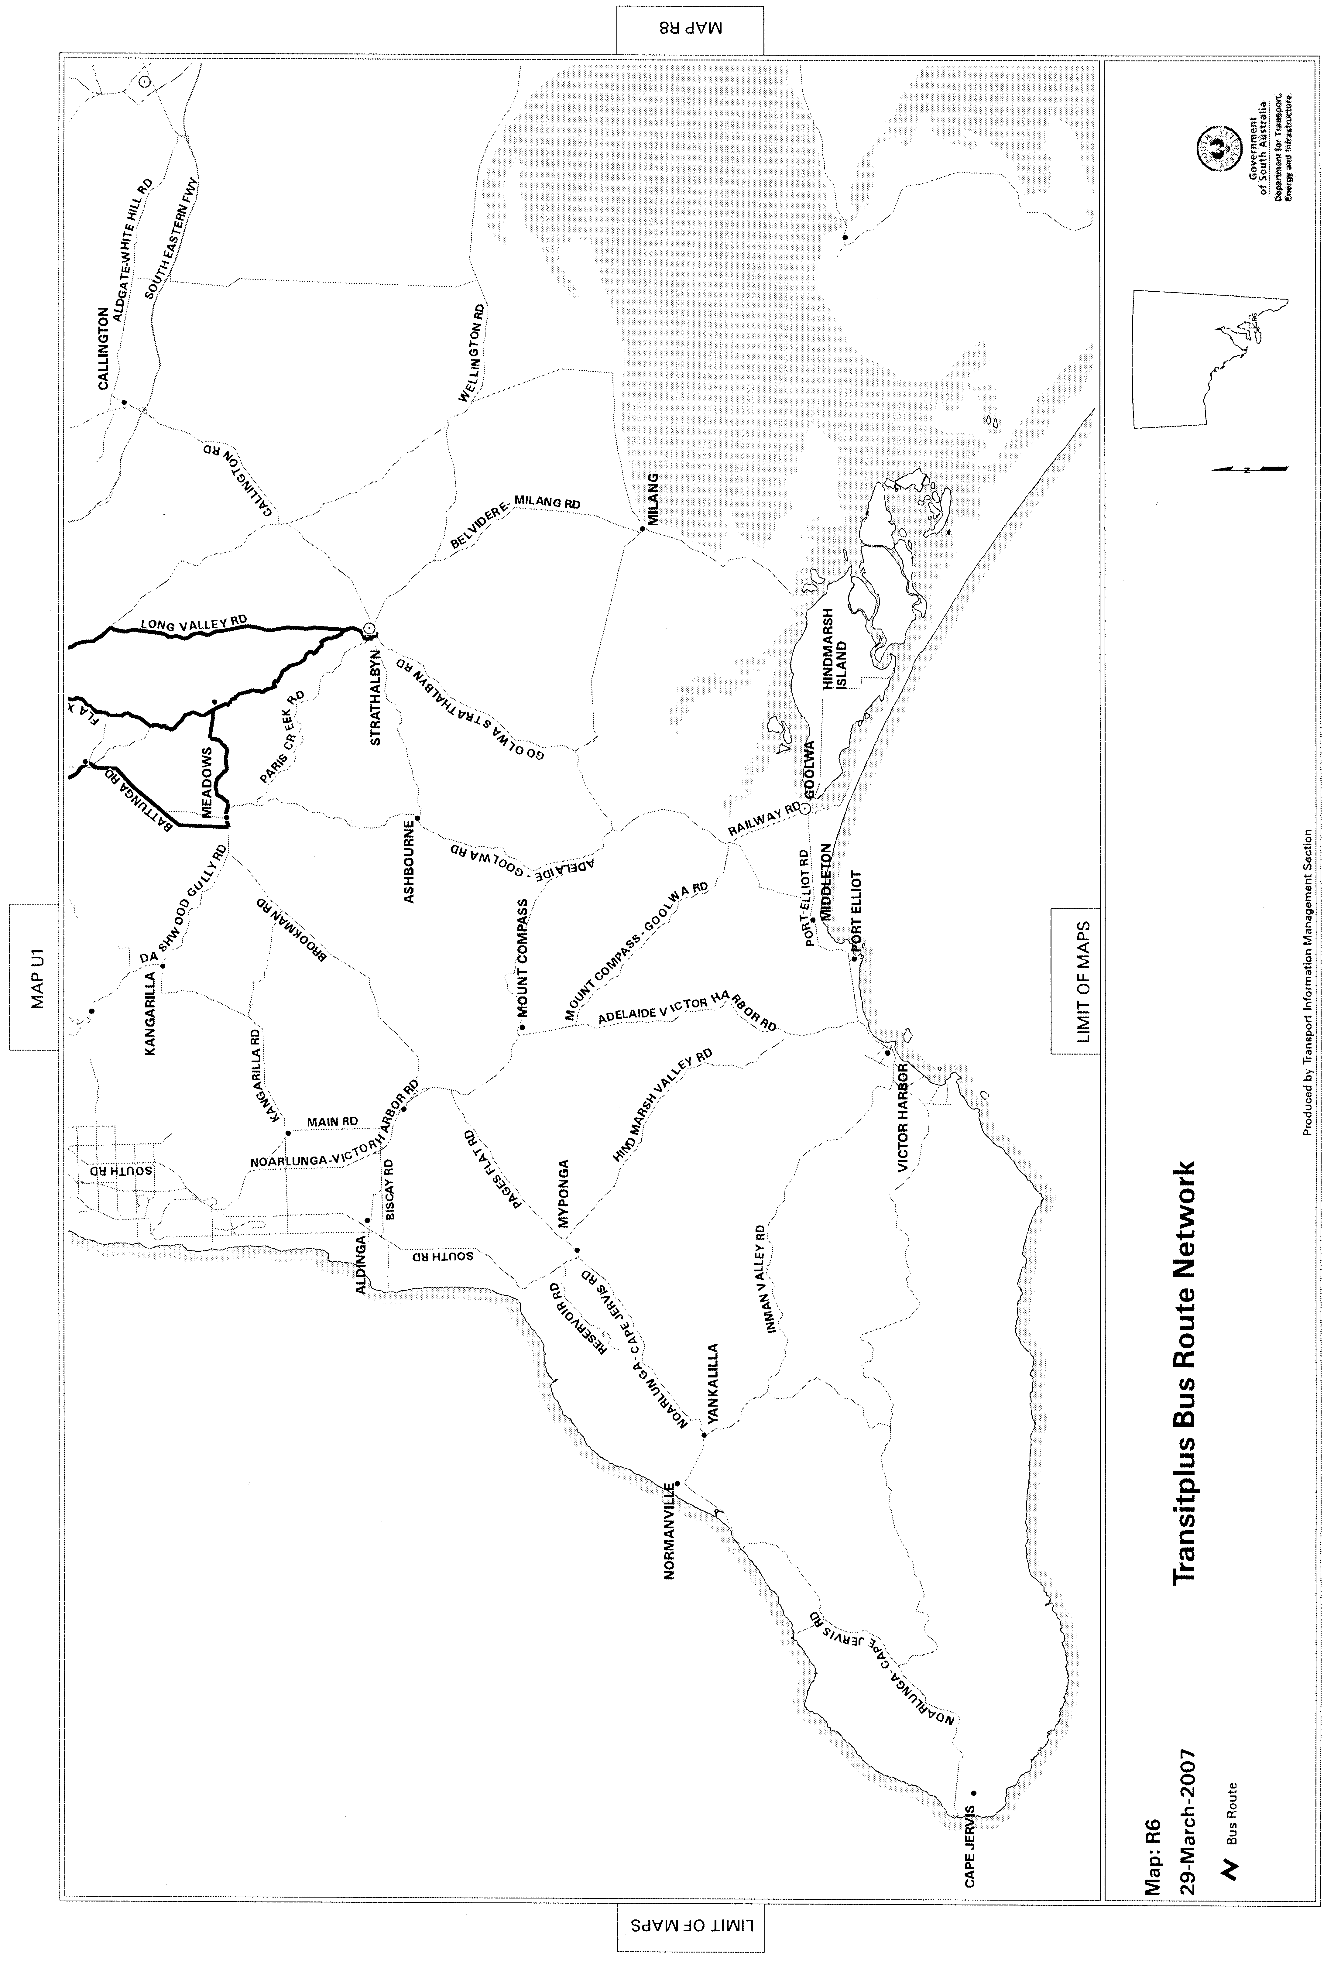
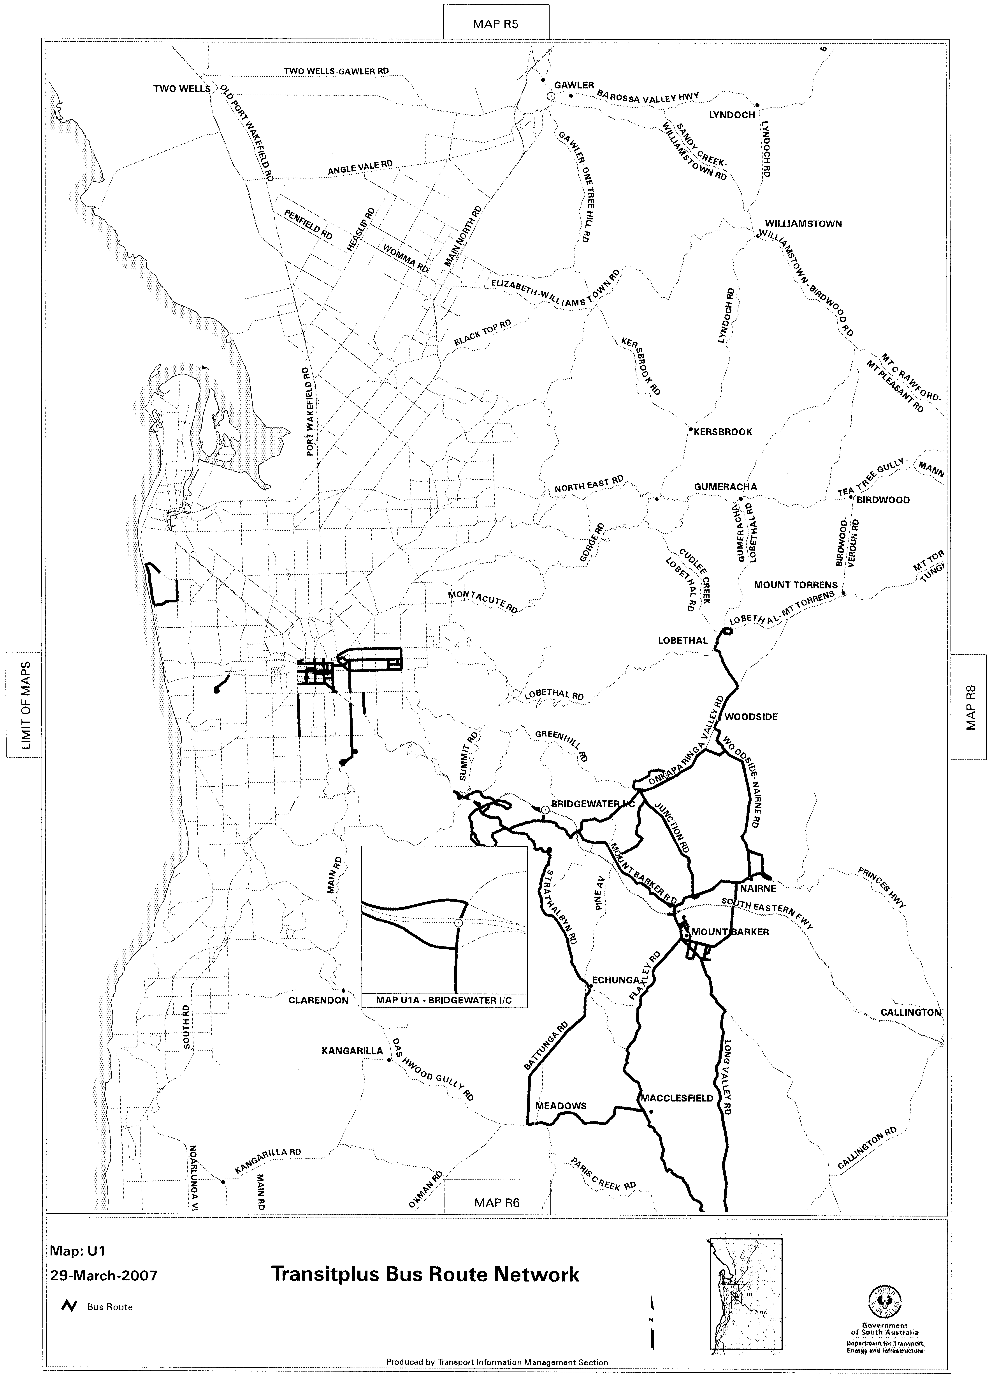
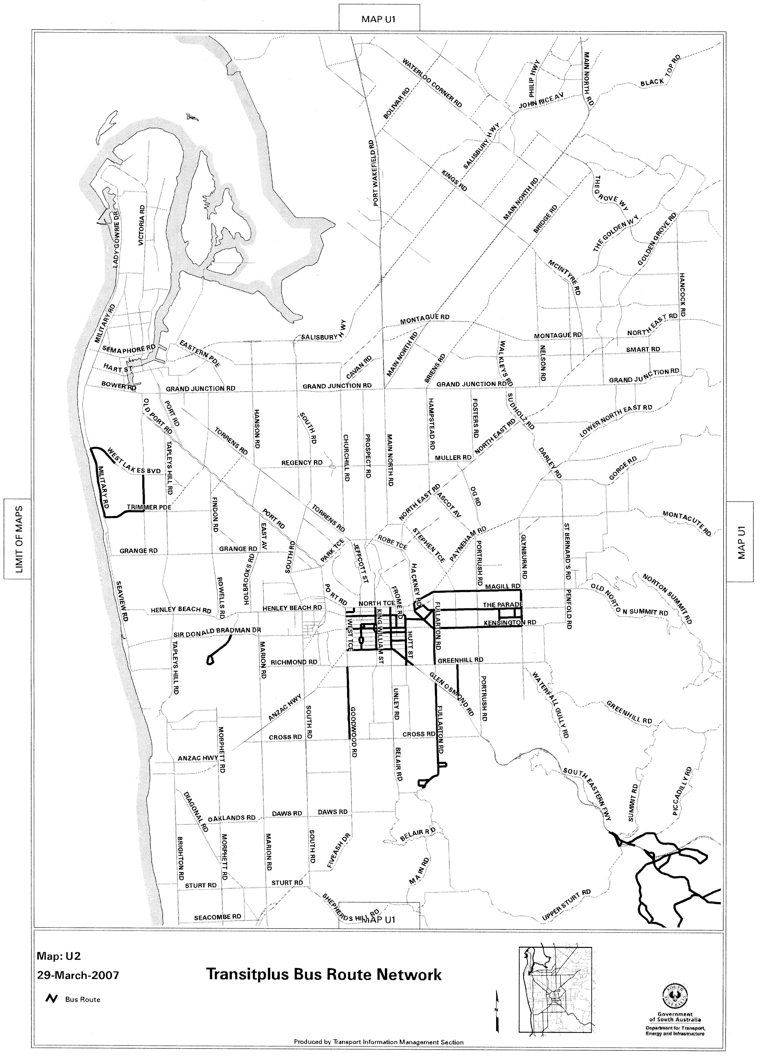
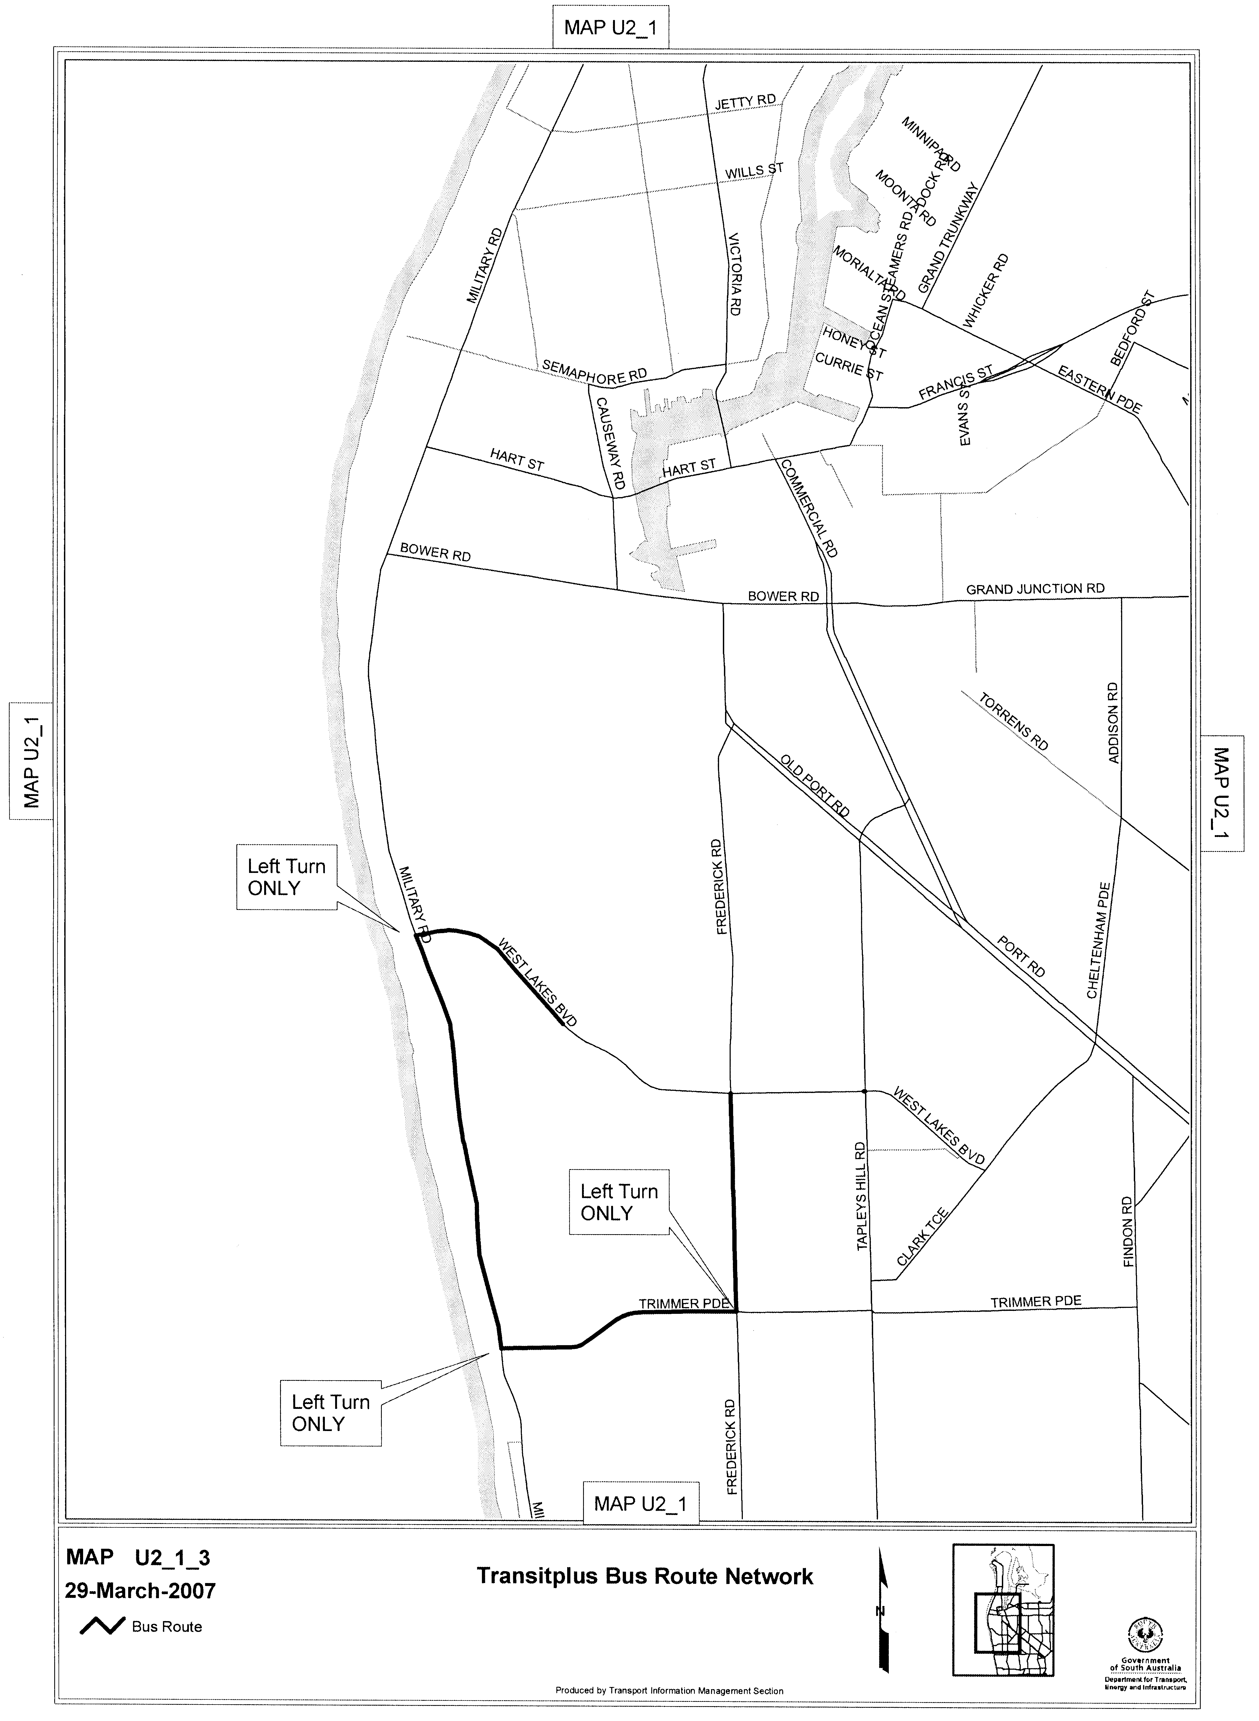
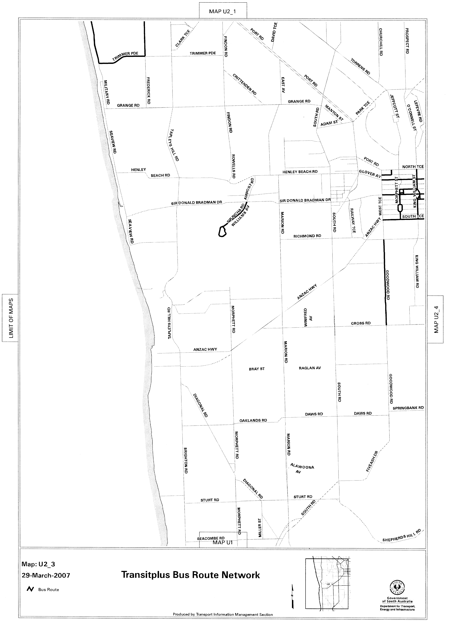
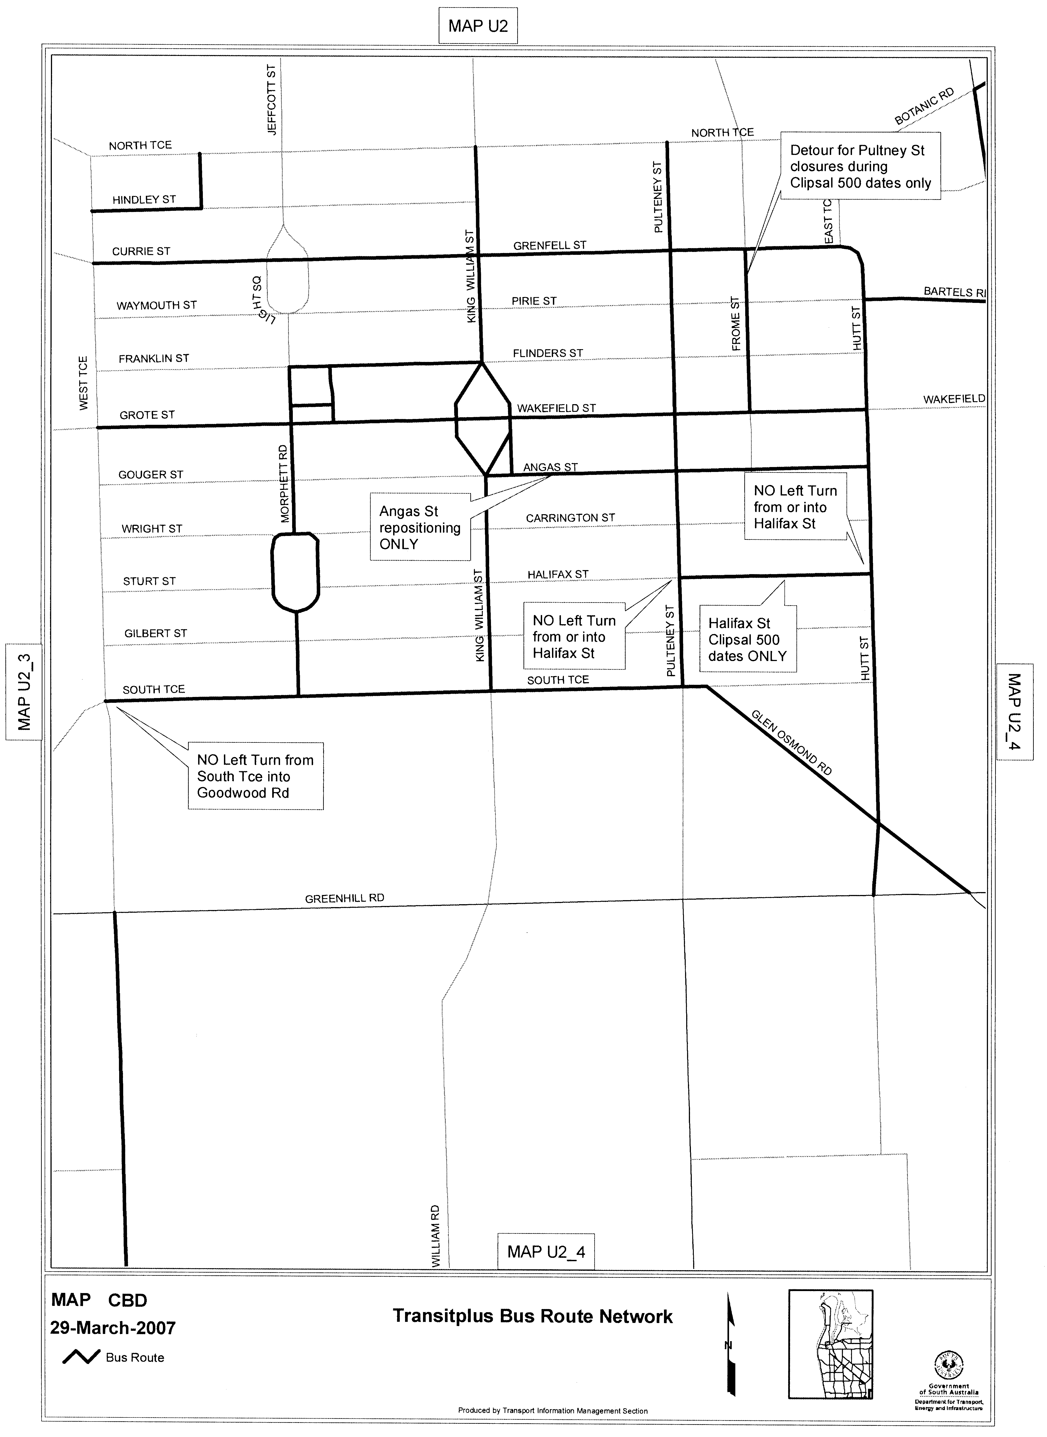
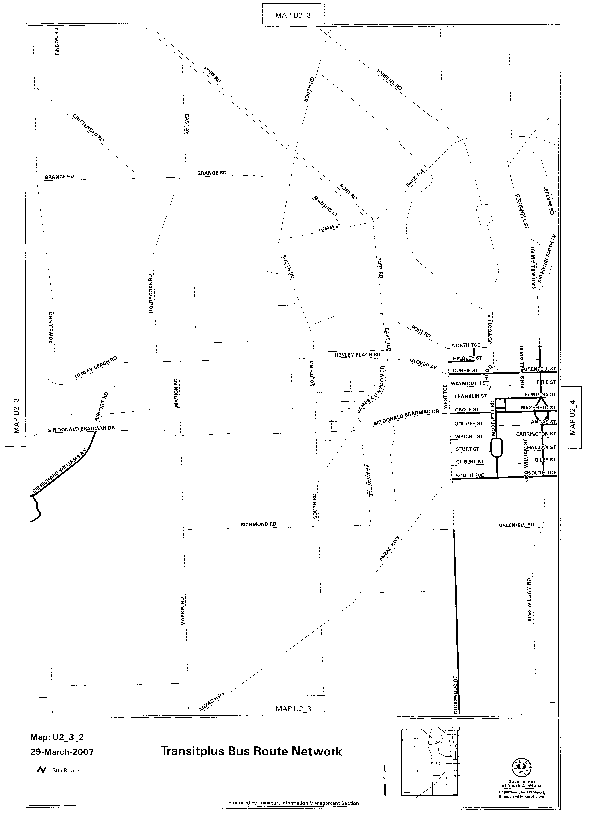
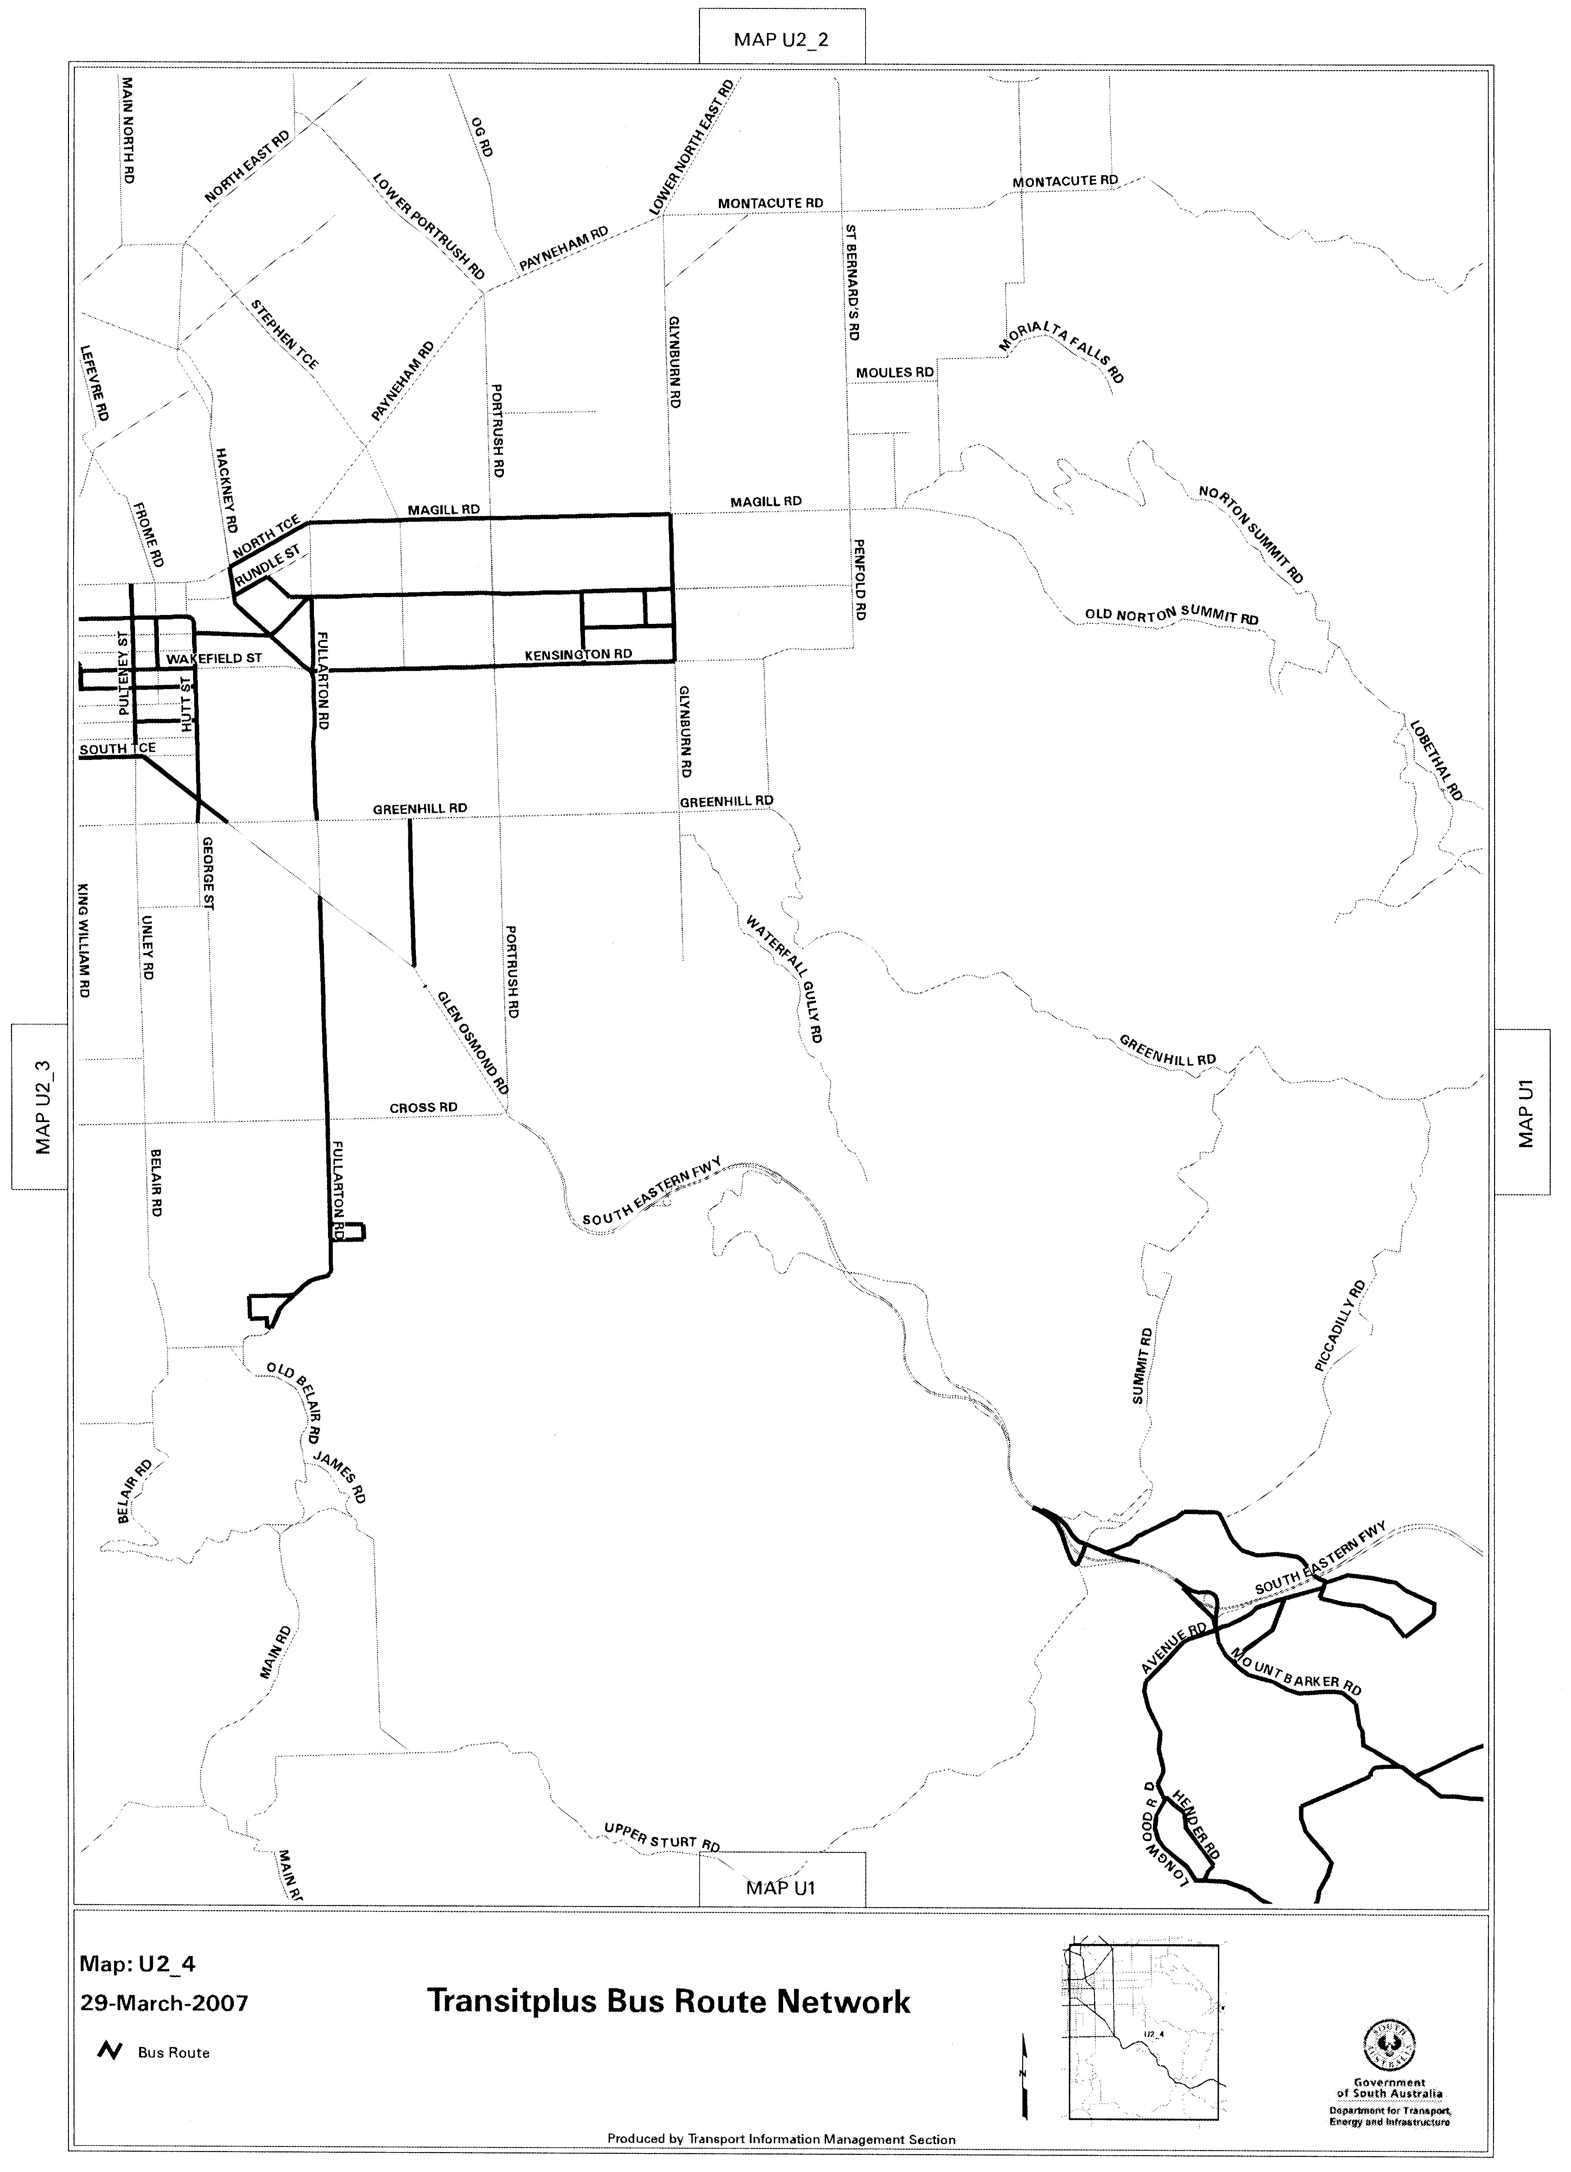
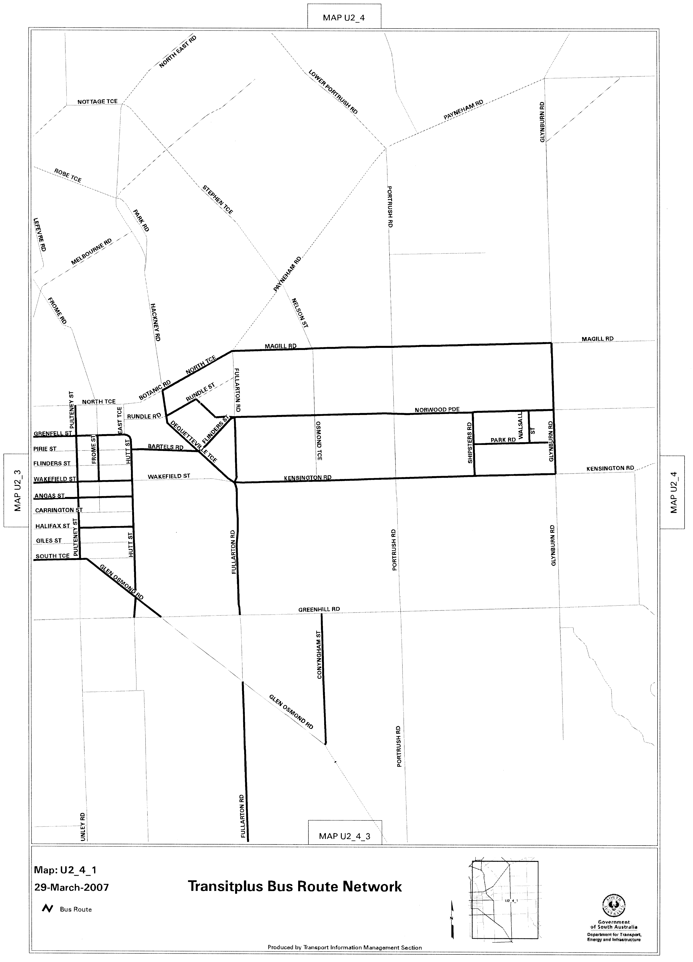
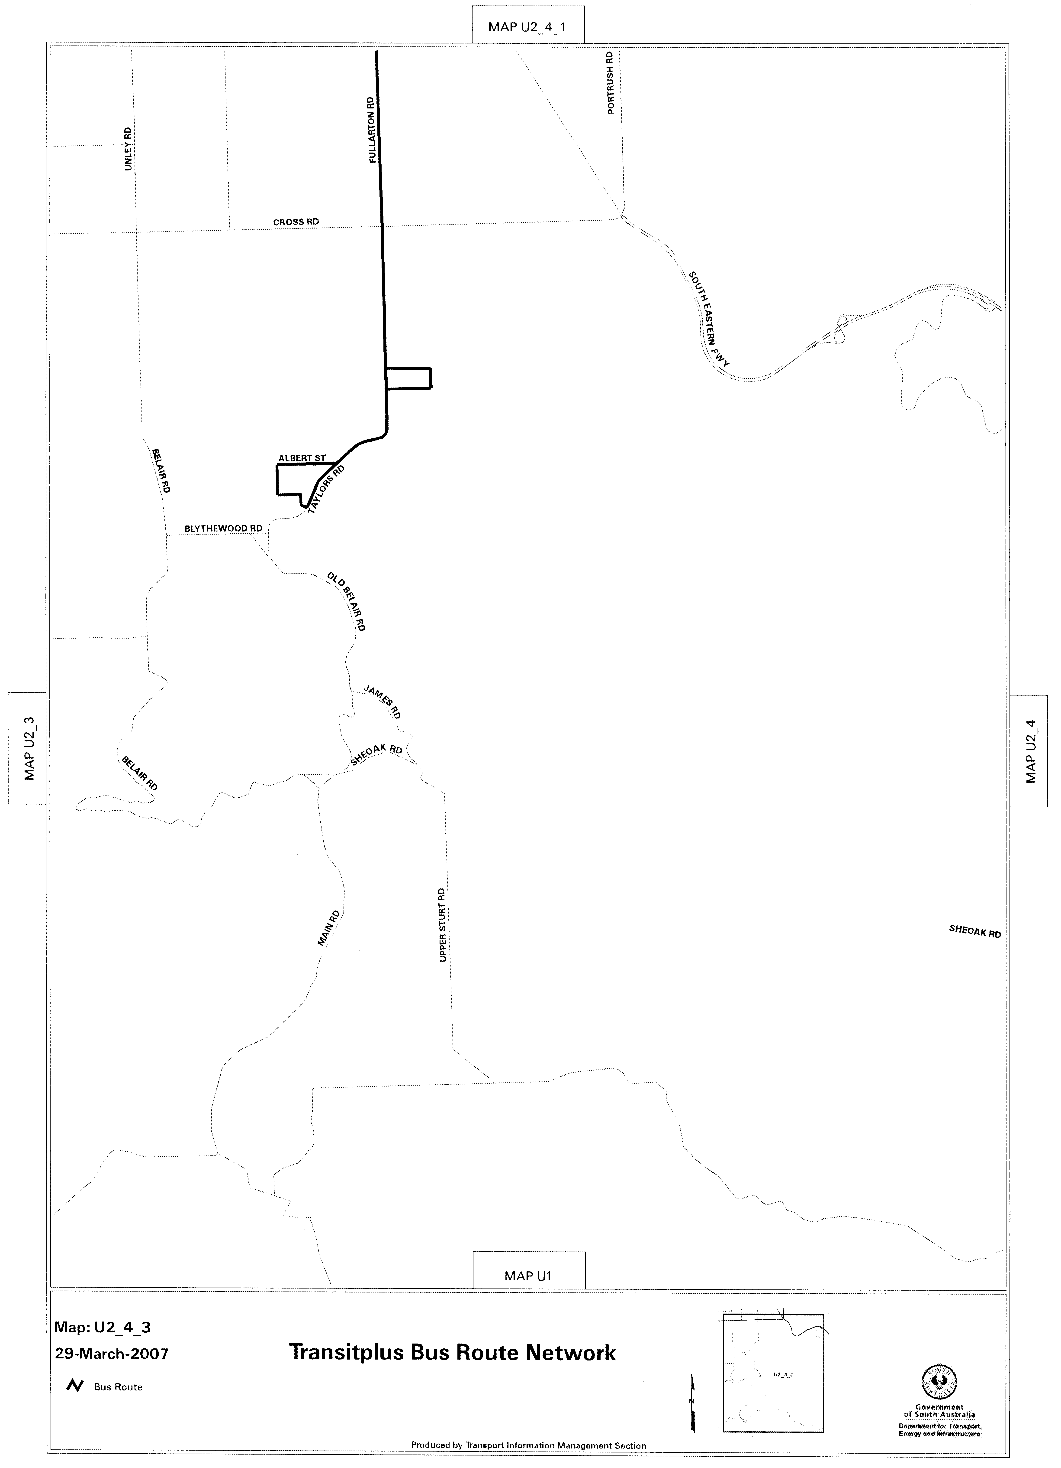
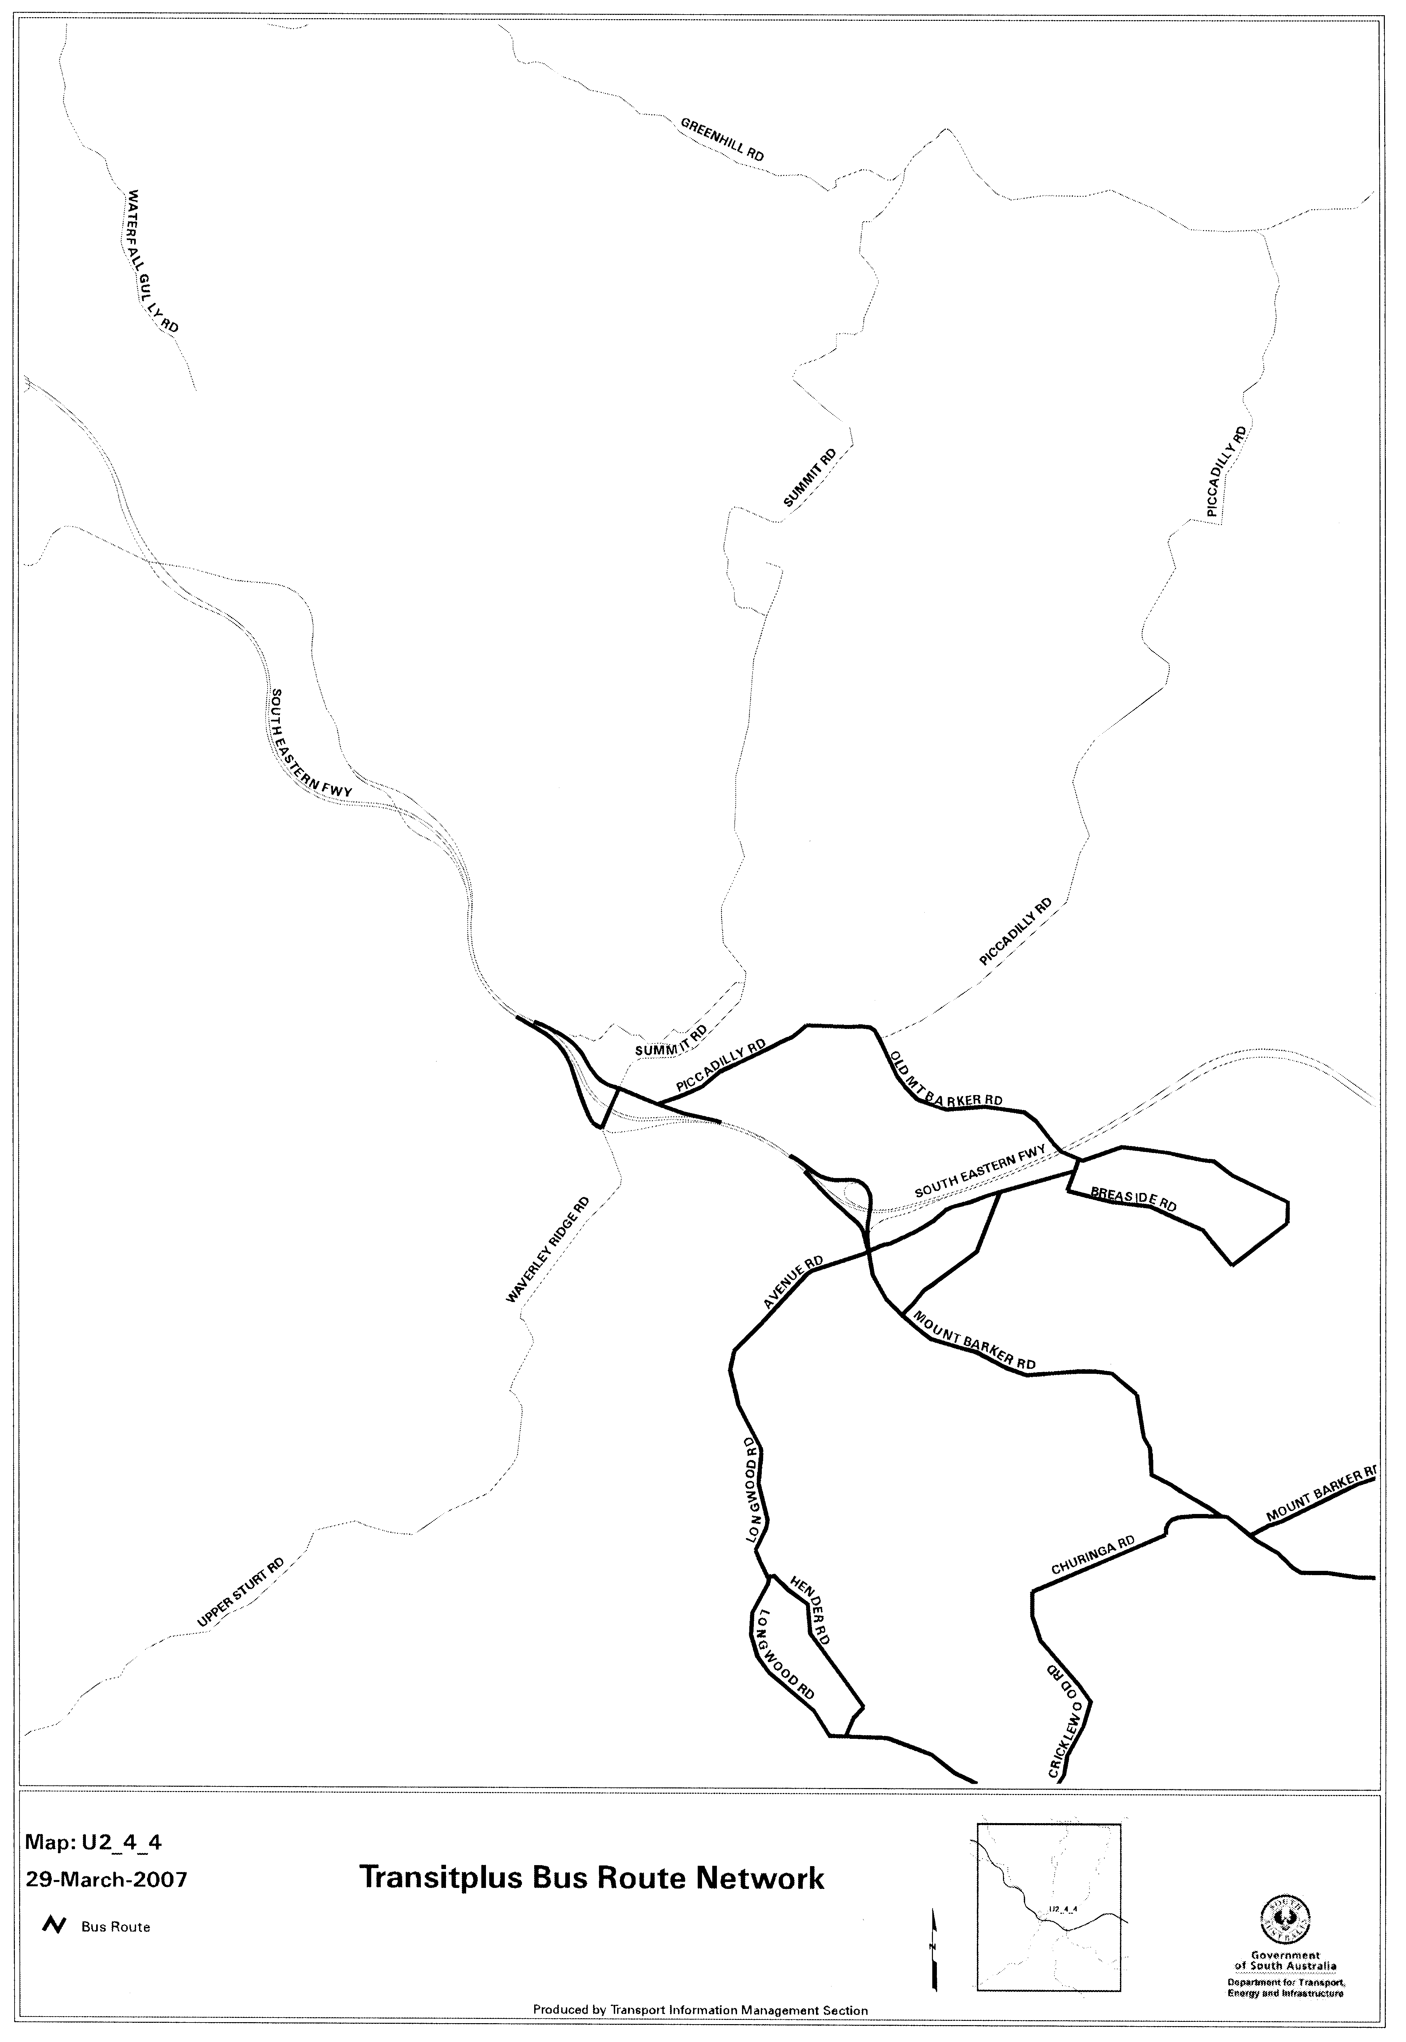
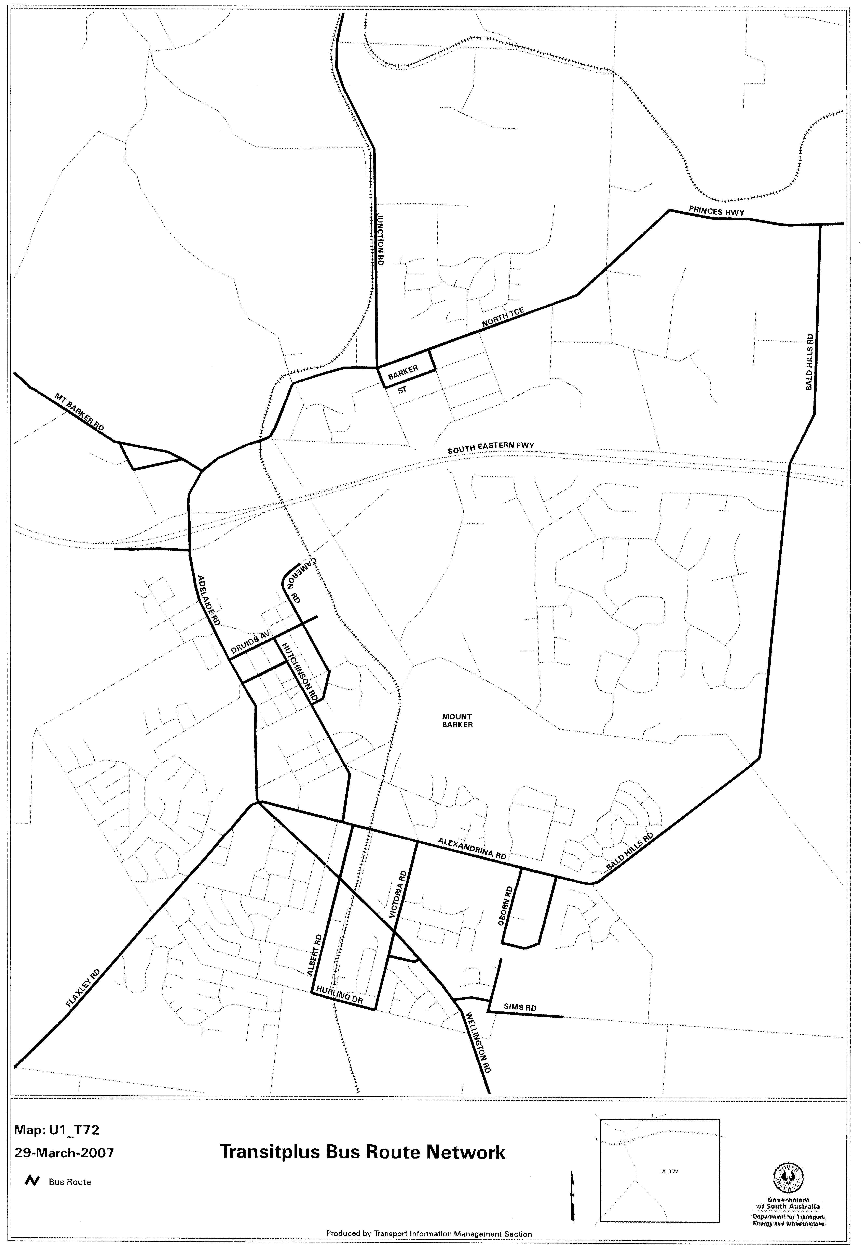
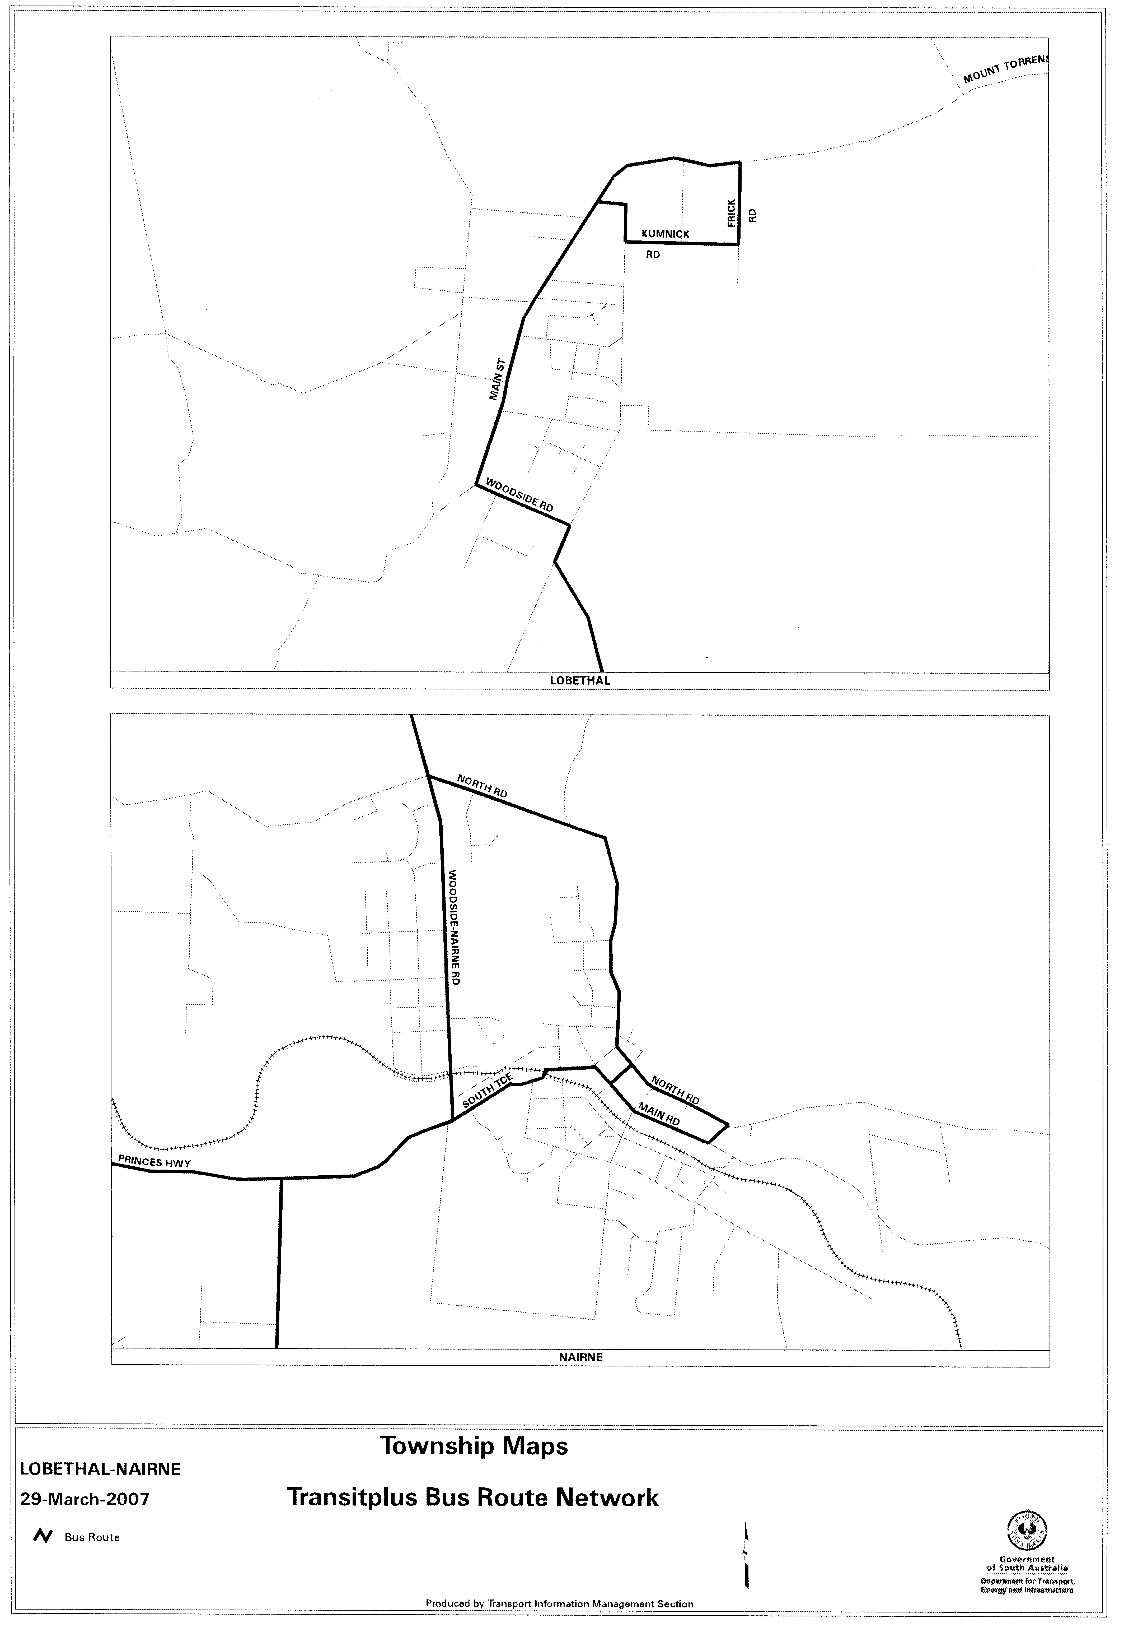

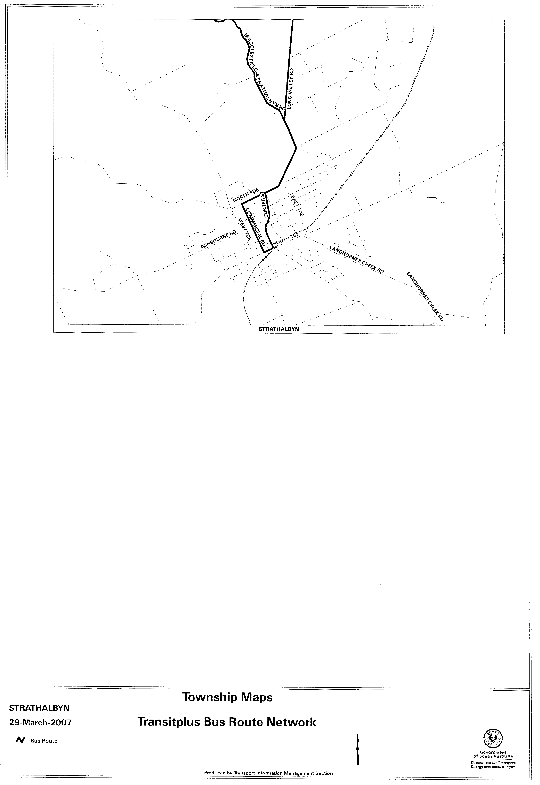

ROAD TRAFFIC ACT 1961

NOTICE OF APPROVAL AND EXEMPTION
Pursuant to Sections 161A and 163AA of the Road Traffic Act 1961

6.5 TONNE STEER AXLE MASS LIMIT FOR HEAVY VEHICLES
Note:
This Notice does not provide a steer axle mass limit increase for a bus, any twin steer axle or any single steer axle with General Mass Limit other than 6.0 tonne.
1. APPROVAL AND EXEMPTION

1.1 I hereby approve heavy vehicle configurations that exceed a total mass of 42.5 tonnes as a result of the application of this Notice, to operate as specified in this Notice; and

1.2 I hereby exempt heavy vehicles from the following provisions of the Road Traffic (Mass and Loading Requirements) Regulations 1999:

1.2.1 Schedule 1, Part 1—Mass Limits, Table 1—Mass Limits for Single Axle and Axle Groups, in so far as it relates to the single steer axle mass limit for heavy vehicles specified in this Notice.
1.2.2 Schedule 1, Part 1—Mass Limits, Clause 3 (1), (2) and (3) Mass Limits relating to axle spacing.
1.2.3 Schedule 1, Part 1, Clause 4 (1) Mass Limits for combinations.

2. CONDITIONS

This approval and exemption is subject to the following conditions and limitations:

2.1 When operating under this Notice of approval and exemption, you must at all times carry a legible and complete copy of this Notice.

2.2 You must produce a copy of this Notice when requested to do so by a DTEI Authorised Officer appointed under the Road Traffic Act 1961 and/or Motor Vehicles Act 1959, or by a Police Officer.

2.3 Except as otherwise specified in this Notice, the Standard Form Conditions prescribed in the Road Traffic (Oversize or Overmass Vehicle Exemptions) Regulations 1999 for the purposes of section 115 of the Road Traffic Act 1961, shall not apply.

2.4 This Notice is to be read and operates in conjunction with the Road Traffic (Mass and Loading Requirements) Regulations 1999 and with any other instrument of approval and exemption specifying heavy vehicle mass limits in South Australia, whether published in the Government Gazette or issued by individual permit.

2.5 This Notice applies only to eligible vehicles as defined in 2.11 of this Notice.

2.6 This Notice increases the General Mass Limit of 6.0 tonne applicable to a single steer axle on an eligible vehicle to 6.5 tonne.

2.7 Subject to 2.8, this Notice increases by 0.5 tonne the Gross Vehicle Mass Limit and Gross Combination Mass Limit for an eligible vehicle as specified elsewhere by Regulation or other instrument of approval and exemption.

2.8 The increase in 2.7 corresponds to the increase in the steer axle mass limit in 2.6 and cannot be used to increase the mass limit on any other axle or axle group.

2.9 Vehicles must comply with axle spacing appropriate to statutory mass limits (General Mass Limits) contained in Schedule 1, Part 1, Clause 3 of the Road Traffic (Mass and Loading Requirements) Regulations 1999, or any other statutory instrument as applicable.

2.10 Vehicles operating under this Notice shall not be driven or loaded in excess of:

2.10.1 the manufacturer’s rating for axle, suspension, tyre and coupling capacities; or
2.10.2 the manufacturer’s gross vehicle mass and gross combination mass ratings; or
2.10.3 the Gross Vehicle Mass and/or Gross Combination Mass as shown on the certificate of registration for that vehicle.

2.11 To be subject of and for the purposes of this Notice, an eligible vehicle must:

2.11.1 not be a bus; and
2.11.2 be rated at 15 tonne or more gross vehicle mass; and
2.11.3 comply with front underrun protection to UN ECE Regulation 93; and
2.11.4 comply with cab strength to UN ECE Regulation 29; and
2.11.5 comply with emission levels to Australian Design Rule 80/01 or later edition; and
2.11.6 have any protrusion certified by a competent entity as complying with front underrun protection to UN ECE Regulation 93; and the protrusion be plated accordingly; and
2.11.7 be fitted with an Approval Plate.
Note:
Where a Front Underrun Protection Vehicle is fitted with a bull bar, the bull bar becomes the Front Underrun Protection Device and so must fully satisfy the UN ECE Regulation 93 requirements in terms of strength, dimensions and geometry (smooth face free of projections, etc). The bull bar must be plated as fully complying with UN ECE Regulation 93 for the vehicle to remain an Eligible Vehicle.

Where a vehicle is not a Front Underrun Protection Vehicle and becomes an Eligible Vehicle by the fitting of a certified and plated Front Underrun Protection Device, the owner of the vehicle shall in addition have an Approval Plate fitted to the vehicle by a Competent Entity to indicate the changed status of the vehicle as an Eligible Vehicle.

3. DEFINITIONS

For the purpose of this Notice the following terms are defined as follows:

3.1 Approval Plate

A unique plate attached to the vehicle by a Competent Entity in a standard location that certifies the as-built compliance of that individual vehicle with the requirements of Regulation No. 93—United Nations Economic Commission for Europe (UN ECE) [Approval of Front Underrun Protective Devices], Regulation No. 29—United Nations Economic Commission for Europe (UN ECE) [Protection of the Occupants of the Cab of a Commercial Vehicle] and Australian Design Rule 80/01 or later edition [Emissions Control for Heavy Vehicles].

3.2 Competent Entity

A vehicle manufacturer holding Compliance Plate approval or a recognised engineering signatory (RES) with appropriate expertise. To approve a Front Underrun Protection Device the RES would need to be recognised as competent to undertake type H modifications as described in the Vehicle Standards Bulletin VSB6 published by the Department of Transport and Regional Services.

3.3 Front Underrun Protection Device

A structure either incorporated in the vehicle when manufactured or separately fitted to the front of the vehicle to meet the requirements of UN ECE Regulation 93.

3.4 Front Underrun Protection Vehicle

A vehicle with the UN ECE Regulation 93 structure incorporated at the time of manufacture.

3.5 Protrusion

A structure that protrudes ahead of the vehicle as built. A common example is the device known as a bull bar or roo bar.

4. COMMENCEMENT OF THIS NOTICE

4.1 This Notice is valid from midnight on 2 April 2007.

4.2 This Notice of approval and exemption may be varied or revoked at any time by notice in writing.

Executive Director
Safety and Regulation Division
Department for Transport, Energy and Infrastructure
Authorised Delegate for the Minister for Transport

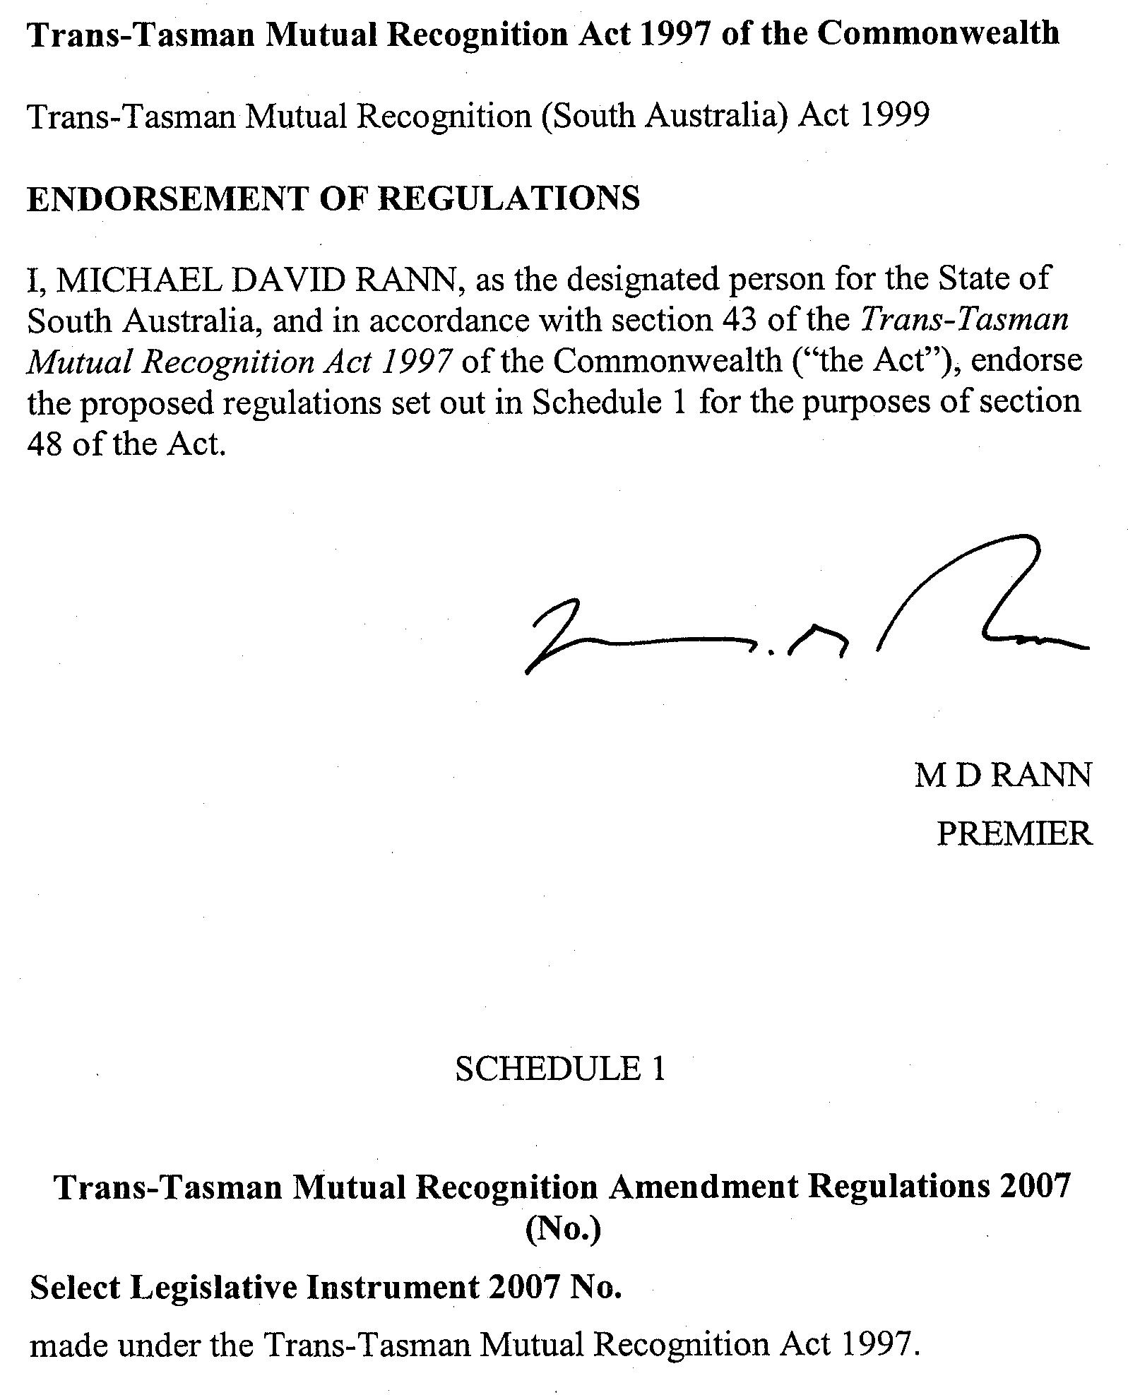

SURVEY ACT 1992
Designated Survey Areas
PURSUANT to section 49 (1) (b) of the Survey Act 1992, I declare that from 1 July 2007, the following areas of the State, numbered 189, 190, 191, 192, 193, 194, 195 and 196 outlined in black on Rack Plan 908, to be designated survey areas.
Rack Plan 908 may be inspected at the Information Booth, Land Titles Office, Ground Floor, 101 Grenfell Street, Adelaide.
Dated 29 March 2007.
P. M. Kentish, Surveyor-General

South Australia
Criminal Law Consolidation (Drink Spiking) Amendment Act (Commencement) Proclamation 2007
1—Short title
This proclamation may be cited as the Criminal Law Consolidation (Drink Spiking) Amendment Act (Commencement) Proclamation 2007.
2—Commencement of Act and suspension of certain provisions
(1) The Criminal Law Consolidation (Drink Spiking) Amendment Act 2007 (No 1 of 2007) (the Amendment Act) will come into operation on 1 April 2007.
(2) The operation of the following provisions (inserted into the Criminal Law Consolidation Act 1935 by section 4 of the Amendment Act) is suspended until a day or time or days or times to be fixed by subsequent proclamation or proclamations:
(a) section 32C(2) and (3);
(b) the definitions of controlled drug, licensed premises, prescribed label and prescription drug in section 32C(4).
Made by the Governor
with the advice and consent of the Executive Council
on 29 March 2007
AGO0061/06CS

South Australia
Evidence (Suppression Orders) Amendment Act (Commencement) Proclamation 2007
1—Short title
This proclamation may be cited as the Evidence (Suppression Orders) Amendment Act (Commencement) Proclamation 2007.
2—Commencement of Act
The Evidence (Suppression Orders) Amendment Act 2006 (No 30 of 2006) will come into operation on 1 April 2007.
Made by the Governor
with the advice and consent of the Executive Council
on 29 March 2007
AGO0046/06CS
South Australia
Statutes Amendment (Public Sector Employment) Act (Commencement) Proclamation 2007
1—Short title
This proclamation may be cited as the Statutes Amendment (Public Sector Employment) Act (Commencement) Proclamation 2007.
2—Commencement
(1) Subject to subclause (2), the Statutes Amendment (Public Sector Employment) Act 2006 (No 41 of 2006) (the Amendment Act) will come into operation on 1 April 2007.
(2) The operation of—
(a) subsection (12) of section 17 of the Institute of Medical and Veterinary Science Act 1982 (inserted into that Act by section 64 of the Amendment Act); and
(b) subsection (11) of section 30 of the South Australian Health Commission Act 1976 (inserted into that Act by section 88 of the Amendment Act),
is suspended until a day or time or days or times to be fixed by subsequent proclamation or proclamations.
Made by the Governor
with the advice and consent of the Executive Council
on 29 March 2007
WFR07/005

South Australia
Summary Offences (Gatecrashers at Parties) Amendment Act (Commencement) Proclamation 2007
1—Short title
This proclamation may be cited as the Summary Offences (Gatecrashers at Parties) Amendment Act (Commencement) Proclamation 2007.
2—Commencement of Act
The Summary Offences (Gatecrashers at Parties) Amendment Act 2007 (No 2 of 2007) will come into operation on 1 April 2007.
Made by the Governor
with the advice and consent of the Executive Council
on 29 March 2007
AGO0045/06CS
South Australia
Aboriginal Lands Trust (Designation of Employing Authority) Proclamation 2007
under section 3 of the Aboriginal Lands Trust Act 1966
1—Short title
This proclamation may be cited as the Aboriginal Lands Trust (Designation of Employing Authority) Proclamation 2007.
2—Commencement
This proclamation will come into operation on 1 April 2007.
3—Designation of employing authority
The person for the time being holding or acting in the position of Chief Executive of the Department of the Premier and Cabinet is designated as being the employing authority for the purposes of the definition of employing authority in section 3(1) of the Aboriginal Lands Trust Act 1966.
Made by the Governor
with the advice and consent of the Executive Council
on 29 March 2007
WFR07/005

South Australia
Adelaide Cemeteries Authority (Designation of Employing Authority) Proclamation 2007
under section 3 of the Adelaide Cemeteries Authority Act 2001
1—Short title
This proclamation may be cited as the Adelaide Cemeteries Authority (Designation of Employing Authority) Proclamation 2007.
2—Commencement
This proclamation will come into operation on 1 April 2007.
3—Designation of employing authority
The person for the time being holding or acting in the position of Chief Executive of the Department of Primary Industries and Resources is designated as being the employing authority for the purposes of the definition of employing authority in section 3(1) of the Adelaide Cemeteries Authority Act 2001.
Made by the Governor
with the advice and consent of the Executive Council
on 29 March 2007
WFR07/005

South Australia
Adelaide Festival Centre Trust (Designation of Employing Authority) Proclamation 2007
under section 4 of the Adelaide Festival Centre Trust Act 1971
1—Short title
This proclamation may be cited as the Adelaide Festival Centre Trust (Designation of Employing Authority) Proclamation 2007.
2—Commencement
This proclamation will come into operation on 1 April 2007.
3—Designation of employing authority
The person for the time being holding or acting in the position of Chief Executive of the Department of the Premier and Cabinet is designated as being the employing authority for the purposes of the definition of employing authority in section 4(1) of the Adelaide Festival Centre Trust Act 1971.
Made by the Governor
with the advice and consent of the Executive Council
on 29 March 2007
WFR07/005

South Australia
Adelaide Festival Corporation (Designation of Employing Authority) Proclamation 2007
under section 3 of the Adelaide Festival Corporation Act 1998
1—Short title
This proclamation may be cited as the Adelaide Festival Corporation (Designation of Employing Authority) Proclamation 2007.
2—Commencement
This proclamation will come into operation on 1 April 2007.
3—Designation of employing authority
The person for the time being holding or acting in the position of Chief Executive of the Department of the Premier and Cabinet is designated as being the employing authority for the purposes of the definition of employing authority in section 3(1) of the Adelaide Festival Corporation Act 1998.
Made by the Governor
with the advice and consent of the Executive Council
on 29 March 2007
WFR07/005

South Australia
Ambulance Services (Designation of Employing Authority) Proclamation 2007
under section 4 of the Ambulance Services Act 1992
1—Short title
This proclamation may be cited as the Ambulance Services (Designation of Employing Authority) Proclamation 2007.
2—Commencement
This proclamation will come into operation on 1 April 2007.
3—Designation of employing authority
The person for the time being holding or acting in the position of Chief Executive of the Department of Health is designated as being the employing authority for the purposes of the definition of employing authority in section 4(1) of the Ambulance Services Act 1992.
Made by the Governor
with the advice and consent of the Executive Council
on 29 March 2007
WFR07/005

South Australia
Electricity (Designation of Employing Authority) Proclamation 2007
under section 4 of the Electricity Act 1996
1—Short title
This proclamation may be cited as the Electricity (Designation of Employing Authority) Proclamation 2007.
2—Commencement
This proclamation will come into operation on 1 April 2007.
3—Designation of employing authority
The person for the time being holding or acting in the position of Under Treasurer is designated as being the employing authority for the purposes of the definition of employing authority in section 4(1) of the Electricity Act 1996.
Made by the Governor
with the advice and consent of the Executive Council
on 29 March 2007
WFR07/005

South Australia
History Trust of South Australia (Designation of Employing Authority) Proclamation 2007
under section 4 of the History Trust of South Australia Act 1981
1—Short title
This proclamation may be cited as the History Trust of South Australia (Designation of Employing Authority) Proclamation 2007.
2—Commencement
This proclamation will come into operation on 1 April 2007.
3—Designation of employing authority
The person for the time being holding or acting in the position of Chief Executive of the Department of the Premier and Cabinet is designated as being the employing authority for the purposes of the definition of employing authority in section 4(1) of the History Trust of South Australia Act 1981.
Made by the Governor
with the advice and consent of the Executive Council
on 29 March 2007
WFR07/005

South Australia
Law of Property (Declaration of Body) Proclamation 2007
under section 41A of the Law of Property Act 1936
1—Short title
This proclamation may be cited as the Law of Property (Declaration of Body) Proclamation 2007.
2—Commencement
This proclamation comes into operation on the day on which it is made.
3—Declaration of body
The Pine Village Land & Services Management Association Incorporated (Inc. No. A38379) is declared to be a body for the purposes of section 41A(1)(a)(iii) of the Law of Property Act 1936.
Made by the Governor
with the advice and consent of the Executive Council
on 29 March 2007
AGO0020/07CS

South Australia
Senior Secondary Assessment Board of South Australia (Designation of Employing Authority) Proclamation 2007
under section 4 of the Senior Secondary Assessment Board of South Australia Act 1983
1—Short title
This proclamation may be cited as the Senior Secondary Assessment Board of South Australia (Designation of Employing Authority) Proclamation 2007.
2—Commencement
This proclamation will come into operation on 1 April 2007.
3—Designation of employing authority
The person for the time being holding or acting in the position of Chief Executive of the Department of Education and Children's Services is designated as being the employing authority for the purposes of the definition of employing authority in section 4(1) of the Senior Secondary Assessment Board of South Australia Act 1983.
Made by the Governor
with the advice and consent of the Executive Council
on 29 March 2007
WFR07/005

South Australia
South Australian Country Arts Trust (Designation of Employing Authority) Proclamation 2007
under section 3 of the South Australian Country Arts Trust Act 1992
1—Short title
This proclamation may be cited as the South Australian Country Arts Trust (Designation of Employing Authority) Proclamation 2007.
2—Commencement
This proclamation will come into operation on 1 April 2007.
3—Designation of employing authority
The person for the time being holding or acting in the position of Chief Executive of the Department of the Premier and Cabinet is designated as being the employing authority for the purposes of the definition of employing authority in section 3(1) of the South Australian Country Arts Trust Act 1992.
Made by the Governor
with the advice and consent of the Executive Council
on 29 March 2007
WFR07/005

South Australia
South Australian Film Corporation (Designation of Employing Authority) Proclamation 2007
under section 4 of the South Australian Film Corporation Act 1972
1—Short title
This proclamation may be cited as the South Australian Film Corporation (Designation of Employing Authority) Proclamation 2007.
2—Commencement
This proclamation will come into operation on 1 April 2007.
3—Designation of employing authority
The person for the time being holding or acting in the position of Chief Executive of the Department of the Premier and Cabinet is designated as being the employing authority for the purposes of the definition of employing authority in section 4(1) of the South Australian Film Corporation Act 1972.
Made by the Governor
with the advice and consent of the Executive Council
on 29 March 2007
WFR07/005

South Australia
South Australian Health Commission (Designation of Employing Authority) Proclamation 2007
under section 6 of the South Australian Health Commission Act 1976
1—Short title
This proclamation may be cited as the South Australian Health Commission (Designation of Employing Authority) Proclamation 2007.
2—Commencement
This proclamation will come into operation on 1 April 2007.
3—Designation of employing authority
(1) Subject to subclause (2), the person for the time being holding or acting in the position of Chief Executive of the Department of Health is designated as being the employing authority for the purposes of the definition of employing authority in section 6(1) of the South Australian Health Commission Act 1976.
(2) The person for the time being holding or acting in the position of Chief Executive of the Department for Families and Communities is designated as being the employing authority with respect to the employees (or potential employees) of Metropolitan Domiciliary Care or Julia Farr Services under the South Australian Health Commission Act 1976.
Made by the Governor
with the advice and consent of the Executive Council
on 29 March 2007
WFR07/005

South Australia
South Australian Motor Sport (Designation of Employing Authority) Proclamation 2007
under section 3 of the South Australian Motor Sport Act 1984
1—Short title
This proclamation may be cited as the South Australian Motor Sport (Designation of Employing Authority) Proclamation 2007.
2—Commencement
This proclamation will come into operation on 1 April 2007.
3—Designation of employing authority
The person for the time being holding or acting in the position of Under Treasurer is designated as being the employing authority for the purposes of the definition of employing authority in section 3(1) of the South Australian Motor Sport Act 1984.
Made by the Governor
with the advice and consent of the Executive Council
on 29 March 2007
WFR07/005

South Australia
South Australian Tourism Commission (Designation of Employing Authority) Proclamation 2007
under section 4 of the South Australian Tourism Commission Act 1993
1—Short title
This proclamation may be cited as the South Australian Tourism Commission (Designation of Employing Authority) Proclamation 2007.
2—Commencement
This proclamation will come into operation on 1 April 2007.
3—Designation of employing authority
The person for the time being holding or acting in the position of Chief Executive Officer of the South Australian Tourism Commission is designated as being the employing authority for the purposes of the definition of employing authority in section 4(1) of the South Australian Tourism Commission Act 1993.
Made by the Governor
with the advice and consent of the Executive Council
on 29 March 2007
WFR07/005

South Australia
State Opera of South Australia (Designation of Employing Authority) Proclamation 2007
under section 4 of the State Opera of South Australia Act 1976
1—Short title
This proclamation may be cited as the State Opera of South Australia (Designation of Employing Authority) Proclamation 2007.
2—Commencement
This proclamation will come into operation on 1 April 2007.
3—Designation of employing authority
The person for the time being holding or acting in the position of Chief Executive of the Department of the Premier and Cabinet is designated as being the employing authority for the purposes of the definition of employing authority in section 4(1) of the State Opera of South Australia Act 1976.
Made by the Governor
with the advice and consent of the Executive Council
on 29 March 2007
WFR07/005

South Australia
State Theatre Company of South Australia (Designation of Employing Authority) Proclamation 2007
under section 4 of the State Theatre Company of South Australia Act 1972
1—Short title
This proclamation may be cited as the State Theatre Company of South Australia (Designation of Employing Authority) Proclamation 2007.
2—Commencement
This proclamation will come into operation on 1 April 2007.
3—Designation of employing authority
The person for the time being holding or acting in the position of Chief Executive of the Department of the Premier and Cabinet is designated as being the employing authority for the purposes of the definition of employing authority in section 4(1) of the State Theatre Company of South Australia Act 1972.
Made by the Governor
with the advice and consent of the Executive Council
on 29 March 2007
WFR07/005

South Australia
Statutes Amendment (Public Sector Employment) (Designation of Employing Authority—Hospitals and Health Centres) Proclamation 2007
under clause 2(2)(d) of Schedule 1 of the Statutes Amendment (Public Sector Employment)
Act 2006
1—Short title
This proclamation may be cited as the Statutes Amendment (Public Sector Employment) (Designation of Employing Authority—Hospitals and Health Centres) Proclamation 2007.
2—Commencement
This proclamation will come into operation on 1 April 2007.
3—Transfer of employment—hospitals and health centres
(1) Subject to subclause (2), the person holding or acting in the position of Chief Executive of the Department of Health (being an employing authority under section 6(1) of the South Australian Health Commission Act 1976) is designated for the purposes of paragraph (d) of clause 2(2) of Schedule 1 of the Statutes Amendment (Public Sector Employment) Act 2006.
(2) The person holding or acting in the position of Chief Executive of the Department for Families and Communities (being an employing authority under section 6(1) of the South Australian Health Commission Act 1976 with respect to certain employees) is designated for the purposes of paragraph (d) of clause 2(2) of Schedule 1 of the Statutes Amendment (Public Sector Employment) Act 2006 in relation to any person employed by Metropolitan Domiciliary Care or Julia Farr Services under the South Australian Health Commission Act 1976.
Made by the Governor
with the advice and consent of the Executive Council
on 29 March 2007
WFR07/005

South Australia
Youth Court (Designation and Classification of Magistrates) Proclamation 2007
under section 9 of the Youth Court Act 1993
1—Short title
This proclamation may be cited as the Youth Court (Designation and Classification of Magistrates) Proclamation 2007.
2—Commencement
This proclamation comes into operation on the day on which it is made.
3—Designation and classification of Magistrates
The Stipendiary Magistrates named in Schedule 1 are—
(a) designated as Magistrates of the Youth Court of South Australia; and
(b) classified as members of the Court's ancillary judiciary.
Schedule 1—Magistrates of the Court
Robert Bruce Harrap
Koula Kossiavelos
Made by the Governor
with the advice and consent of the Executive Council
on 29 March 2007
AGO0203/02CS

South Australia
Native Vegetation Variation Regulations 2007
under the Native Vegetation Act 1991

Contents
Part 1—Preliminary
1 Short title
2 Commencement
3 Variation provisions
Part 2—Variation of Native Vegetation Regulations 2003
4 Variation of regulation 5—Exemptions
5 Variation of regulation 6—Restrictions on clearance of native vegetation

Part 1—Preliminary
1—Short title
These regulations may be cited as the Native Vegetation Variation Regulations 2007.
2—Commencement
These regulations come into operation on the day on which they are made.
3—Variation provisions
In these regulations, a provision under a heading referring to the variation of specified regulations varies the regulations so specified.
Part 2—Variation of Native Vegetation Regulations 2003
4—Variation of regulation 5—Exemptions
Regulation 5(1)—after paragraph (a) insert:
(ab) if it is proposed to divide land for use for residential purposes (after taking into account the construction of roads and other infrastructure) and—
(i) any development authorisation for the division of the land and for the use of land for residential purposes under the Development Act 1993 has been obtained; and
(ii) —
(A) the Council is satisfied (on the basis of information provided to the Council by the person seeking the benefit of this paragraph and such other information as the Council thinks fit) that, after taking into account the need to preserve biological diversity and taking into account the needs of the owner of the land, the clearance will be limited to clearance reasonably required to erect 1 dwelling, and any structure or other facility that would be reasonably expected to be ancillary to the dwelling, on each allotment to be created by the division; and
(B) the Council is satisfied (on the basis of information provided to the Council by the person seeking the benefit of this paragraph and such other information as the Council thinks fit) that there is no other practicable alternative that would involve no clearance or the clearance of less vegetation or the clearance of vegetation that is less significant or (if relevant) the clearance of vegetation that has been degraded to a greater extent than the vegetation proposed to be cleared; and
(C) the clearance is undertaken in accordance with a management plan that has been approved by the Council and, after taking into account the full nature and extent of clearance that is to be undertaken on the relevant land and any commitments that have been made with respect to the establishment, restoration or maintenance of native vegetation, the Council is satisfied that there will be a significant environmental benefit on the land being divided or within the same region of the State, or the owner of the land (or a person acting on his or her behalf) has, on application to the Council to proceed with clearing the vegetation in accordance with this provision, made a payment into the Fund or, if the Council is satisfied that it is appropriate in the circumstances, agreed to make a payment into the Fund, of an amount considered by the Council to be sufficient to achieve a significant environmental benefit which outweighs the value of retaining the vegetation;
5—Variation of regulation 6—Restrictions on clearance of native vegetation
Regulation 6(2)—after "(a)," insert:
(ab),
Note—
As required by section 10AA(2) of the Subordinate Legislation Act 1978, the Minister has certified that, in the Minister's opinion, it is necessary or appropriate that these regulations come into operation as set out in these regulations.
Made by the Governor
with the advice and consent of the Executive Council
on 29 March 2007
No 26 of 2007
WBCS07/007

South Australia
Liquor Licensing (Dry Areas—Long Term) Variation Regulations 2007
under the Liquor Licensing Act 1997

Contents
Part 1—Preliminary
1 Short title
2 Commencement
3 Variation provisions
Part 2—Variation of Liquor Licensing (Dry Areas—Long Term) Regulations 1997
4 Variation of Schedule 1—Long term dry areas
5 Variation of Schedule 2—Plans of long term dry areas
Schedule 1—Plan to be inserted

Part 1—Preliminary
1—Short title
These regulations may be cited as the Liquor Licensing (Dry Areas—Long Term) Variation Regulations 2007.
2—Commencement
These regulations come into operation on the day on which they are made.
3—Variation provisions
In these regulations, a provision under a heading referring to the variation of specified regulations varies the regulations so specified.
Part 2—Variation of Liquor Licensing (Dry Areas—Long Term) Regulations 1997
4—Variation of Schedule 1—Long term dry areas
Schedule 1—after the item headed "Berri—Area 2" insert:

Bordertown—Area 1
(see Schedule 2: Bordertown—Plan No 1)
The area in Bordertown bounded as follows: commencing at the point at which the western boundary of McLeod Street intersects the northern boundary of North Terrace, then south-easterly along that boundary of North Terrace to its intersection with the prolongation in a straight line of the eastern boundary of East Terrace, then south-westerly along that prolongation and boundary of East Terrace, and the prolongation in a straight line of that boundary, to the southern boundary of South Terrace, then north-westerly along that boundary of South Terrace (and the southern boundary of Lot 110 FP 215634) to the point at which the southern boundary of South Terrace meets the western boundary of Naracoorte Road, then in a straight line by the shortest route (across South Terrace) to the point at which the northern boundary of South Terrace meets the western boundary of McLeod Street, then north-easterly along that western boundary of McLeod Street to the point of commencement. | Continuous until 22 March 2008, provided that where—  (a) an event of historic, cultural, traditional or major community significance is held in the area; and  (b) the consumption and possession of liquor in the area (or a defined portion of the area) are authorised for a specified period for the purposes of the event by The District Council of Tatiara,  the prohibition does not apply in the area (or defined portion of the area) during that specified period. | The consumption and possession of liquor are prohibited.
5—Variation of Schedule 2—Plans of long term dry areas
Schedule 2—after the plan headed "Berri—Plan No 1" insert the plan headed "Bordertown—Plan No 1" in Schedule 1 of these regulations
Schedule 1—Plan to be inserted
Bordertown—Plan No 1
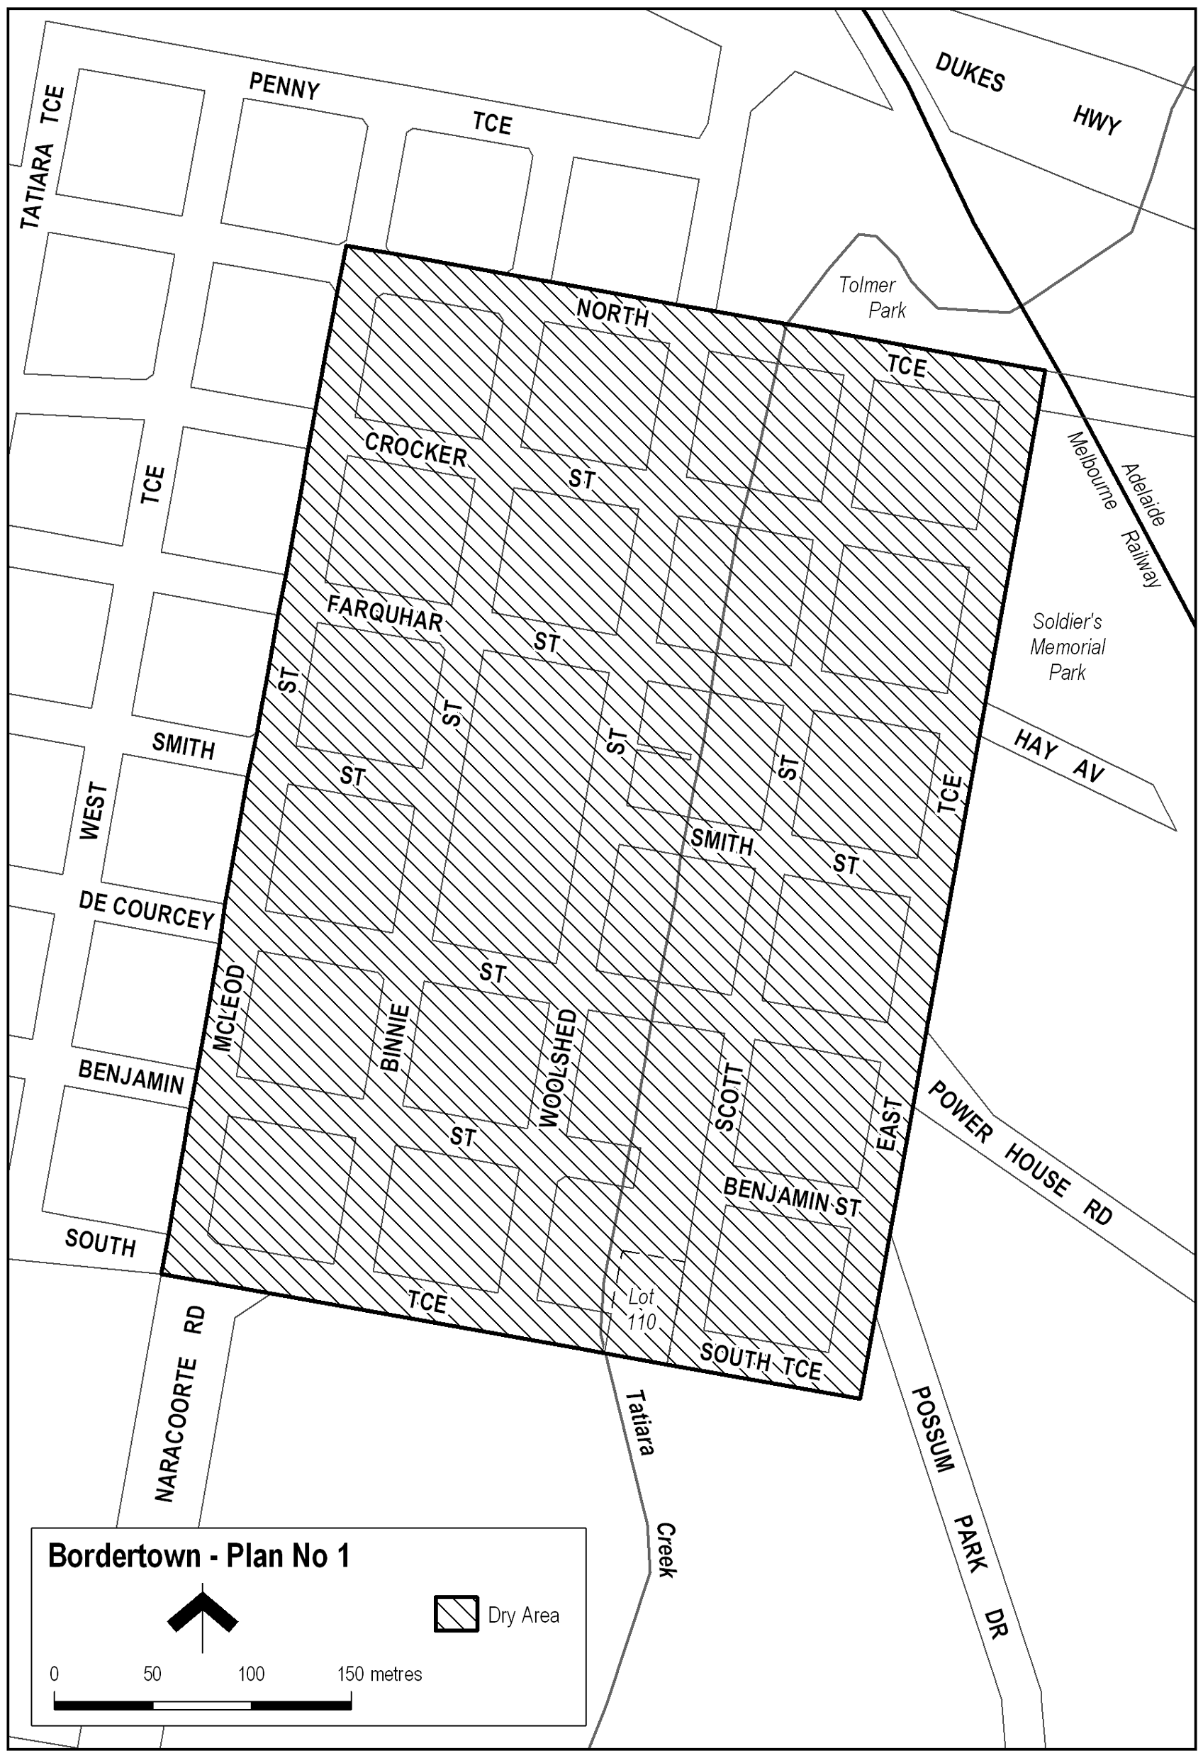
Note—
As required by section 10AA(2) of the Subordinate Legislation Act 1978, the Minister has certified that, in the Minister's opinion, it is necessary or appropriate that these regulations come into operation as set out in these regulations.
Made by the Governor
with the advice and consent of the Executive Council
on 29 March 2007
No 27 of 2007
MCA07/002CS

South Australia
Liquor Licensing (Dry Areas—Long Term) Variation Regulations 2007
under the Liquor Licensing Act 1997

Contents
Part 1—Preliminary
1 Short title
2 Commencement
3 Variation provisions
Part 2—Variation of Liquor Licensing (Dry Areas—Long Term) Regulations 1997
4 Variation of Schedule 1—Long term dry areas
5 Variation of Schedule 2—Plans of long term dry areas
Schedule 1—Plan to be inserted

Part 1—Preliminary
1—Short title
These regulations may be cited as the Liquor Licensing (Dry Areas—Long Term) Variation Regulations 2007.
2—Commencement
These regulations come into operation on the day on which they are made.
3—Variation provisions
In these regulations, a provision under a heading referring to the variation of specified regulations varies the regulations so specified.
Part 2—Variation of Liquor Licensing (Dry Areas—Long Term) Regulations 1997
4—Variation of Schedule 1—Long term dry areas
Schedule 1—after item headed "Mount Gambier—Area 5" insert:

Murray Bridge—Area 1
(see Schedule 2: Murray Bridge—Plan No 1)
The area in Murray Bridge bounded as follows: commencing at the point at which the south-eastern boundary of Bridge Street meets the south-western edge of the River Murray, then generally south-easterly along that edge of the River to the point at which it intersects the prolongation in a straight line of the south-eastern boundary of the southern portion of Jaensch Road, then generally south-westerly, westerly and north-westerly along that prolongation and boundary of the southern portion of Jaensch Road and the prolongation in a straight line across Sturt Reserve Road of that boundary to the north-western boundary of Sturt Reserve Road, then north-easterly along that boundary of Sturt Reserve Road to the western boundary of Lot 82 DP 55455, then generally north-westerly and north-easterly along that boundary of Lot 82 to the western boundary of the northern portion of Jaensch Road, then generally north-easterly and north-westerly along that boundary of the northern portion of Jaensch Road to the point at which it meets the south-eastern boundary of Mary Terrace, then in a straight line by the shortest route to the point at which the south-western boundary of East Terrace meets the north-western boundary of Mary Terrace, then south-westerly along that boundary of Mary Terrace and the prolongation in a straight line of that boundary to the south-western boundary of Swanport Road, then south-easterly along that boundary of Swanport Road to the south-eastern boundary of Lot 514 FP 167329, then south-westerly along that boundary of Lot 514 and the south-eastern boundary of Lot 463 FP 167278 to the north-eastern boundary of Verdun Road, then north-westerly along that boundary of Verdun Road and the prolongation in a straight line of that boundary to the north-western boundary of Standen Street, then south-westerly along that boundary of Standen Street to the north-eastern boundary of Flavel Terrace, then generally north-westerly along that boundary of Flavel Terrace and the prolongation in a straight line of that boundary to the north-western boundary of Adelaide Road, then south-westerly along that boundary of Adelaide Road to the north-eastern boundary of Charles Street, then north-westerly along that boundary of Charles Street to the south-eastern boundary of Lot 102 DP 70324, then north-easterly in a straight line along the south-eastern boundary of that Lot and of the adjoining Lots to the north-eastern boundary of Lot 20 FP 27435, then north-westerly along the north-eastern boundary of Lot 20 to the south-eastern boundary of Clara Street, then north-easterly along that boundary of Clara Street to the north-eastern boundary of McHenry Street, then north-westerly along that boundary of McHenry Street to the south-eastern boundary of Lot 103 DP 1295, then north-easterly along that boundary of Lot 103 to the north-eastern boundary of the Lot, then north-westerly along the north-eastern boundary of Lot 103 and of Lot 102 DP 1295 to the south-eastern boundary of Lot 14 DP 1295, then north-easterly along the south-eastern boundary of Lot 14 and the prolongation in a straight line of that boundary to the north-eastern boundary of Mannum Road, then north-westerly along that boundary of Mannum Road to the north-western boundary of Section 941, Hundred of Mobilong (the south-eastern boundary of Park Terrace), then north-easterly, north-westerly and north-easterly along that north-western boundary of Section 941 and the prolongation in a straight line of that boundary to the northern boundary of Lot 2 DP 40450 (the southern boundary of Hume Reserve Road), then generally easterly along that boundary of Lot 2 and the southern boundary of Section 1327 Hundred of Mobilong to the point at which the southern boundary of Section 1327 intersects the prolongation in a straight line of the south-eastern boundary of North Terrace, then south-westerly along that prolongation of the south-eastern boundary of North Terrace to the south-western boundary of Railway Terrace, then generally south-easterly, easterly and south-easterly along that boundary of Railway Terrace and the prolongation in a straight line of that boundary to the south-eastern boundary of Bridge Street, then generally north-easterly, northerly and north-easterly along that boundary of Bridge Street to the point of commencement. The area includes any wharf, jetty, boat ramp or other structure (other than a bridge across the River) extending into or over the River from the area described above. | Continuous until 29 March 2008. | The consumption and possession of liquor are prohibited.
5—Variation of Schedule 2—Plans of long term dry areas
Schedule 2—after the plan headed "Mount Gambier—Plan No 4" insert the plan headed "Murray Bridge—Plan No 1" in Schedule 1 of these regulations
Schedule 1—Plan to be inserted
Murray Bridge—Plan No 1
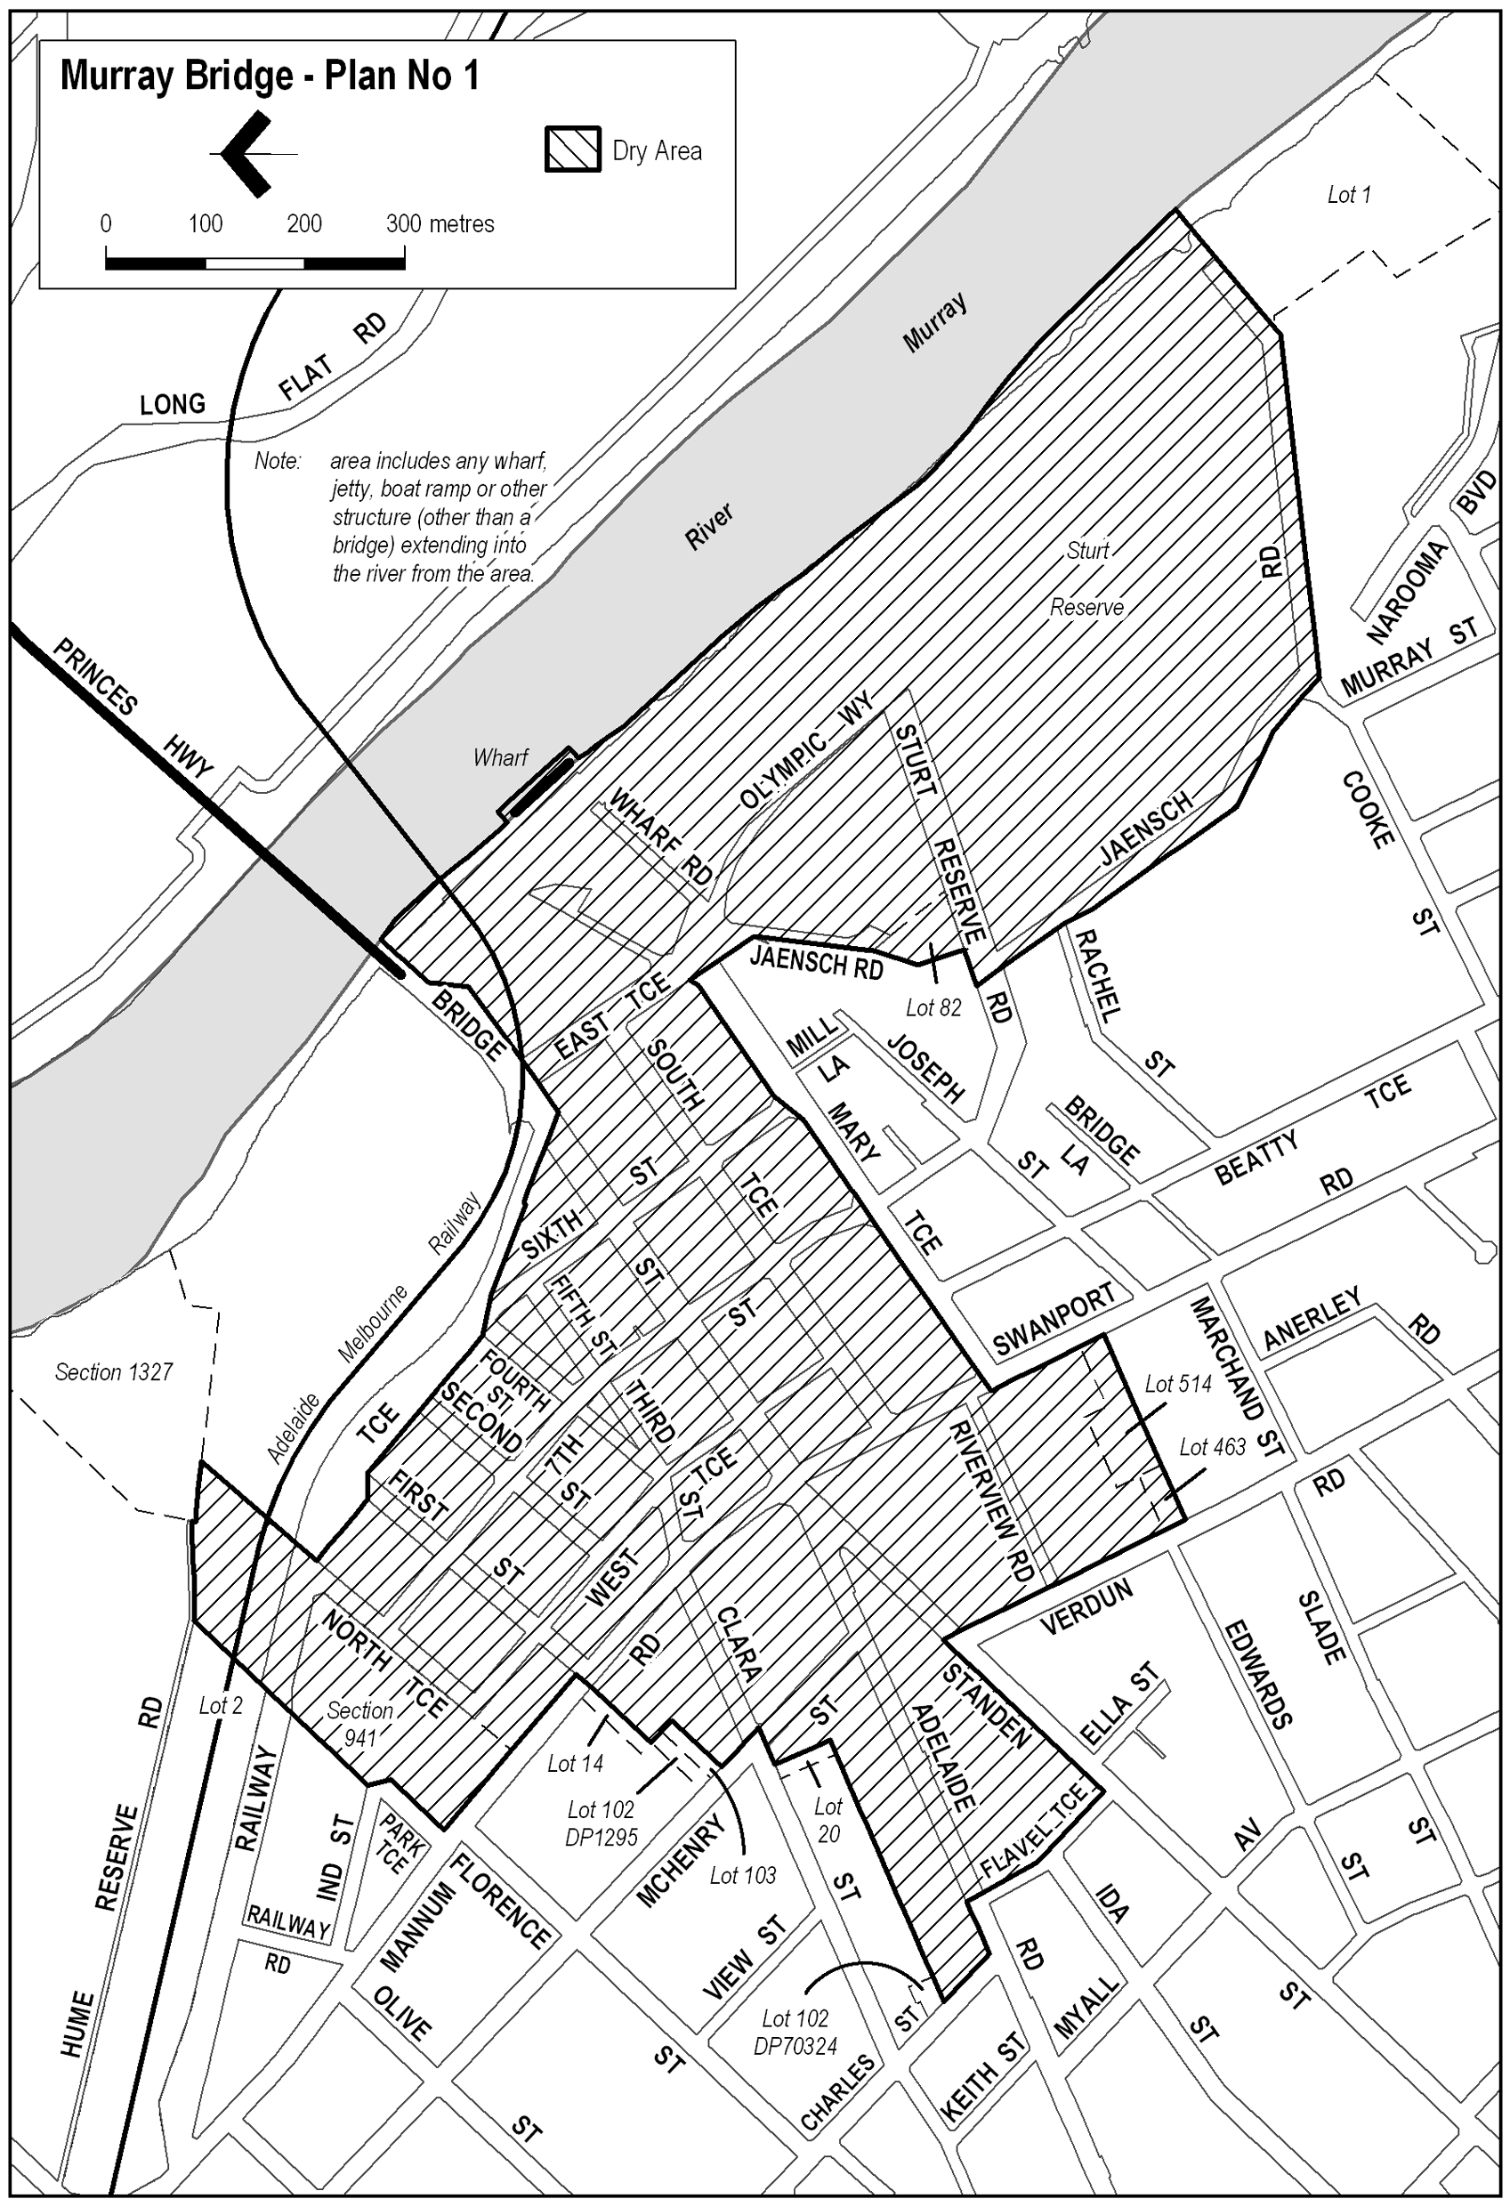
Note—
As required by section 10AA(2) of the Subordinate Legislation Act 1978, the Minister has certified that, in the Minister's opinion, it is necessary or appropriate that these regulations come into operation as set out in these regulations.
Made by the Governor
with the advice and consent of the Executive Council
on 29 March 2007
No 28 of 2007
MCA07/003CS

South Australia
Evidence (General) Regulations 2007
under the Evidence Act 1929

Contents
1 Short title
2 Commencement
3 Interpretation
4 Prescribed South Australian courts
5 Operation of section 59IQ(4)
6 Fee for authorised news media representative
Schedule 1—Fee for authorised news representative
Schedule 2—Revocation of Evidence (Prescribed Courts) Regulations 1999

1—Short title
These regulations may be cited as the Evidence (General) Regulations 2007.
2—Commencement
These regulations will come into operation on 1 April 2007.
3—Interpretation
In these regulations, unless the contrary intention appears—
Act means the Evidence Act 1929.
4—Prescribed South Australian courts
Pursuant to paragraph (e) of the definition of South Australian court in section 59IA of the Act, the following courts and tribunals are South Australian courts for the purposes of Part 6C of the Act:
(a) the Environment, Resources and Development Court;
(b) the Equal Opportunity Tribunal;
(c) the Industrial Relations Court of South Australia;
(d) the Industrial Relations Commission of South Australia;
(e) the Workers Compensation Tribunal;
(f) the Youth Court of South Australia.
5—Operation of section 59IQ(4)
For the purposes of subsection (4) of section 59IQ of the Act, the provisions of that subsection are extended to the Magistrates Court.
6—Fee for authorised news media representative
(1) For the purposes of section 69A of the Act, the relevant fee to be paid to the Registrar in respect of an authorised news media representative is the fee fixed in Schedule 1.
(2) The relevant fee must be paid not later than 1 June in each year for the next financial year.
(3) If, however, the fee is paid for a term of less than 12 months, the fee payable is a proportion of the relevant fee, being the proportion that the number of whole months in the term bears to 12 months.
Schedule 1—Fee for authorised news representative

1 | Fee payable in respect of an authorised news media representative (section 69A of the Act) | $500
Schedule 2—Revocation of Evidence (Prescribed Courts) Regulations 1999
The Evidence (Prescribed Courts) Regulations 1999 are revoked.
Note—
As required by section 10AA(2) of the Subordinate Legislation Act 1978, the Minister has certified that, in the Minister's opinion, it is necessary or appropriate that these regulations come into operation as set out in these regulations.
Made by the Governor
with the advice and consent of the Executive Council
on 29 March 2007
No 29 of 2007
AGO0046/06CS; AGO0022/07CS

South Australia
Statutes Amendment (Public Sector Employment) (Transitional Provisions) Regulations 2007
under the Statutes Amendment (Public Sector Employment) Act 2006

Contents
1 Short title
2 Commencement
3 Interpretation
4 Awards and enterprise agreements
5 Hospitals and health centres
6 Saving provision relating to pathology services

1—Short title
These regulations may be cited as the Statutes Amendment (Public Sector Employment) (Transitional Provisions) Regulations 2007.
2—Commencement
These regulations will come into operation on the day on which Schedule 1 of the Statutes Amendment (Public Sector Employment) Act 2006 comes into operation.
3—Interpretation
In these regulations—
Act means the Statutes Amendment (Public Sector Employment) Act 2006.
4—Awards and enterprise agreements
For the purposes of subclause (6) of clause 2 of Schedule 1 of the Act, the following bodies are recognised:
(a) Australian Nursing Federation (S.A. Branch);
(b) Amalgamated AWU (S.A.) State Union;
(c) Automotive, Food, Metals, Engineering, Printing and Kindred Industries Union;
(d) Electrical Trades Union of Australia, South Australia;
(e) Media, Entertainment and Arts Alliance;
(f) Musicians Union of Australia, Adelaide Branch;
(g) United Fire Fighters Union of South Australia Incorporated.
5—Hospitals and health centres
Pursuant to clause 6 of Schedule 1 of the Act—
(a) a person who, immediately before the commencement of the Statutes Amendment (Public Sector Employment) Act 2006, is an officer or employee of a health centre incorporated under Part 4 of the South Australian Health Commission Act 1976 will be taken to be an officer of the health centre for the purposes of section 50 of the South Australian Health Commission Act 1976; and
(b) any delegation in force under section 29 or 50 of the South Australian Health Commission Act 1976 immediately before the commencement of the Statutes Amendment (Public Sector Employment) Act 2006 will continue to have full force and effect unless or until it is varied or revoked by the board of directors of the relevant hospital or health centre (as the case requires).
6—Saving provision relating to pathology services
(1) In this regulation—
APA employee means a person who, immediately before the commencement of the Statutes Amendment (Public Sector Employment) Act 2006—
(a) was employed by one of the following entities:
(i) the Institute of Medical and Veterinary Science;
(ii) an incorporated hospital under the South Australian Health Commission Act 1976 that is an approved pathology authority,
(and accordingly within the operation of clause 2 of Schedule 1 of the Act); and
(b) was a person whose duties of employment included—
(i) work that brought the person within the ambit of paragraph (c) or (d) of subsection (5AB) of section 16A of the Health Insurance Act 1973 of the Commonwealth; or
(ii) work as a member of the staff of an accredited pathology laboratory or an approved collection centre under the Health Insurance Act 1973 of the Commonwealth,
not being an approved pathology practitioner under the Health Insurance Act 1973 of the Commonwealth;
approved pathology authority means an approved pathology authority under the Health Insurance Act 1973 of the Commonwealth.
(2) An APA employee will, immediately after the commencement of the Statutes Amendment (Public Sector Employment) Act 2006, be taken to be re-employed by the entity that was the employer of the APA employee immediately before that commencement.
(3) An employment arrangement effected by subregulation (2)—
(a) will be taken to provide for continuity of employment without termination of the relevant employee's service; and
(b) will not affect—
(i) existing conditions of employment or existing or accrued rights to leave; or
(ii) a process commenced for variation of those conditions or rights.
(4) For the purposes of subclause (5) of clause 2 of Schedule 1 of the Act, an APA employee is excluded from the operation of that subclause.
Note—
As required by section 10AA(2) of the Subordinate Legislation Act 1978, the Minister has certified that, in the Minister's opinion, it is necessary or appropriate that these regulations come into operation as set out in these regulations.
Made by the Governor
with the advice and consent of the Executive Council
on 29 March 2007
No 30 of 2007
WFR07/005CS

FAXING COPY?
IF you fax copy to Government Publishing SA for inclusion in the Government Gazette, there is no need to send a Confirmation Copy to us as well.
This creates confusion and may well result in your notice being printed twice.
Please use the following fax number:
Fax transmission: (08) 8207 1040
Phone Inquiries: (08) 8207 1045
Please include a contact person, phone number and order number so that we can phone back with any queries we may have regarding the fax copy.
NOTE: Closing time for lodging new copy (fax, hard copy or email) is 4 p.m. on Tuesday preceding the day of publication.

Government Gazette notices can be E-mailed.
The address is:
governmentgazette@saugov.sa.gov.au
Documents should be sent as attachments in Word format.
When sending a document via E-mail, please confirm your transmission with a faxed copy of your document, including the date the notice is to be published.
Fax transmission: (08) 8207 1040
Enquiries: (08) 8207 1045
NOTE: Closing time for lodging new copy (fax, hard copy or email) is 4 p.m. on Tuesday preceding the day of publication.

CITY OF PLAYFORD
Appointment
NOTICE is hereby given that at the City of Playford Council meeting held on 27 February 2007, pursuant to section 56A (23) of the Development Act 1993, Council resolved to appoint Tim Jackson, Chief Executive Officer of the City of Playford to the position of Public Officer of the City of Playford Council Development Assessment Panel.
The Public Officer can be contacted on 8256 0333 or in writing to the City of Playford, 12 Bishopstone Road, Davoren Park, S.A. 5113.
T. Jackson, Chief Executive Officer

CITY OF SALISBURY
Roads (Opening and Closing) Act 1991
Road Closure of Portion of Edinburgh Road, Direk
NOTICE is hereby given, pursuant to section 10 of the Roads (Opening and Closing) Act 1991, that the City of Salisbury proposes to make a Road Process Order to close and retain for addition to the adjoining Council owned land that portion of Edinburgh Road, bordered by allotment comprising Piece 156 in Deposited Plan 68816, allotment 10 in Deposited Plan 43107, allotments 153 and 154 in Deposited Plan 41854 and allotment 45 in Filed Plan 113429, more particularly delineated ‘A’ and ‘B’ on Preliminary Plan No. 07/0023
A copy of the plan and a statement of persons affected are available for public inspection at the offices of the City of Salisbury, 12 James Street, Salisbury and at the office of the Surveyor-General, 101 Grenfell Street, Adelaide, during normal office hours.
Any application for easement or objection must set out the full name, address and details of the submission and be fully supported by reasons. The application for easement or objection must be made in writing to the City of Salisbury, P.O. Box 8, Salisbury, S.A. 5108 within 28 days of this notice and a copy of that submission must also be forwarded to the Surveyor-General, G.P.O. Box 1354, Adelaide, S.A. 5001. Where a submission is made, the Council will give notification of a meeting at which the matter will be considered.
Dated 29 March 2007.
S. Hains, City Manager

CITY OF VICTOR HARBOR
Wills Street—One-way Traffic
NOTICE is hereby given that Council at its meeting held on
24 July 2006, adopted the following resolution:
That pursuant to section 359 (1) of the Local Government Act 1934, all vehicles other than those so named in Column 3 shall be excluded from the road so named in Column 1 and described in Column 2.
Column 1  Street | Column 2  Location | Column 3  Class of Vehicles Exempt
Wills Street | Between The Esplanade and Victoria Street. | Any vehicle travelling in a north-westerly direction from The Esplanade to Victoria Street.  Any vehicle owned or operated by or on behalf of the City of Victor Harbor for the purpose of street cleaning and maintenance.
Further information can be obtained from Roger Budarick, Environment and Infrastructure Services, telephone: 8551 0529 or email: rbudarick@victor.sa.gov.au.
G. Maxwell, Chief Executive Officer

ALEXANDRINA COUNCIL
Development Act 1993
Alexandrina Council Development Plan—
Strathalbyn Residential Plan Amendment Report (PAR)—
Draft for Public and Agency Consultation
Extension of Submissions and Change of Date for Public Hearing
NOTICE is hereby given that the Alexandrina Council has prepared a draft Plan Amendment Report to amend the Alexandrina Council Development Plan.
The close off date for written submissions has been extended to Friday, 13 April 2007. The date of the public hearing has also been amended to Thursday, 19 April 2007.
The draft Plan Amendment Report has been available for public inspection at the Council Offices, Dawson Street, Goolwa since Thursday, 25 January 2007 and will be available until Friday,
13 April 2007. Copies of the Plan Amendment Report can be purchased at the Council office at $5 each and are available on the Council website: www.alexandrina.sa.gov.au.
Written submissions regarding the draft amendment will be accepted by the Alexandrina Council until 5 p.m. on Friday,
13 April 2007. All submissions should be addressed to The Chief Executive, P.O. Box 21, Goolwa, S.A. 5214.
Copies of all written submissions received will be collated and available for inspection by interested persons at the Strathalbyn and Goolwa Council offices from Monday, 16 April 2007.
A public hearing will be held on Thursday, 19 April 2007 at 7.30 p.m. at the Strathalbyn Town Hall, High Street, Strathalbyn to enable people to speak to Council in relation to the PAR.
For further information, contact our planning staff, either by telephone: 8555 7000, facsimile: 8555 3603 or email:
strathpar@alexandrina.sa.gov.au.
Dated 21 March 2007.
J. Coombe, Chief Executive

DISTRICT COUNCIL OF CEDUNA
Resignation of Elected Member
NOTICE is hereby given that a casual vacancy in the office of Area Councillor has occurred through the resignation of Councillor Ray Matthews, effective as of 20 March 2007.
T. Irvine, Chief Executive Officer

DISTRICT COUNCIL OF LOWER EYRE PENINSULA
Appointment of Members to the District Council of Lower Eyre Peninsula Development Assessment Panel
NOTICE is hereby given that the District Council of Lower Eyre Peninsula in accordance with the requirements of section 56A of the Development Act 1993, that the Council at its meeting held on 15 December 2006, appointed the following persons to the Council’s Development Assessment Panel for a two-year term commencing on 26 February 2007:
M. L. Roberts
A. C. Chappell
J. Isle
S. Johnston
Councillor J. K. Low
Councillor N. H. Trezise
Councillor P. J. Porter
Council has appointed M. L. Roberts as the Presiding Member and J. K. Low as the Deputy Presiding Member.

Appointment of Public Officer to the District Council of Lower Eyre Peninsula Development Assessment Panel
Pursuant to section 56A of the Development Act 1993, the District Council of Lower Eyre Peninsula appoints Rodney Pearson as the Public Officer for the Development Assessment Panel.
Contact details:
Rodney Pearson
Public Officer
District Council of Lower Eyre Peninsula Development Assessment Panel
38 Railway Terrace, Cummins, S.A. 5631
Telephone: (08) 8676 2106
P. Aird, Chief Executive Officer

DISTRICT COUNCIL OR ORROROO CARRIETON
Development Act 1993
Orroroo (DC) and Carrieton (DC) Development Plans—
Better Development Plan (BDP) Conversion Plan Amendment Report—Draft for Public Consultation
NOTICE is hereby given that the District Council of Orroroo Carrieton has prepared a draft Plan Amendment Report (PAR) to amend the District Council of Orroroo Carrieton’s Development Plans.
The PAR converts existing Development Plan policy by adopting the relevant planning policy modules, structure and format of the Better Development Plan (BDP) project promoted by Planning SA. The PAR will, as a result, be easier to navigate and comprehend and thereby help improve the clarity and under-standing of Development Plan policy.
The draft Plan Amendment Report and statement will be available for public inspection and purchase during normal office hours at the District Council of Orroroo Carrieton Offices, 17 Second Street, Orroroo and is available on Council’s website at:
www.orroroo.sa.gov.au
from Thursday, 29 March 2007 until 5 p.m. on Tuesday, 5 June 2007. A copy of the Plan Amendment Report can be downloaded free from the website, a hard copy purchased on request from Council for $50 or a CD-ROM copy purchased for $5.
Written submissions regarding the draft amendment will be accepted by the District Council of Orroroo Carrieton until 5 p.m. on Tuesday, 5 June 2007. All submissions should be addressed to the Chief Executive Officer, District Council of Orroroo Carrieton, P.O. Box 3, Orroroo, S.A. 5431. The written submission should clearly indicate whether you will wish to speak at the public hearing on your submission.
Copies of all written submissions received will be available for inspection by interested persons at Council’s offices from Wednesday, 6 June 2007, until the date of the public hearing. A public hearing may be held if required at the Council Chambers, 17 Second Street, Orroroo on Tuesday, 12 June 2007, com-mencing at 7 p.m.
The public hearing may not be held if no submission indicates an interest in speaking at the public hearing.
Dated 29 March 2007.
T. Renshaw, Chief Executive Officer

PORT PIRIE REGIONAL COUNCIL
Roads (Opening and Closing) Act 1991
Portion of Public Road—Redhill
NOTICE is hereby given pursuant to section 10 of the Roads (Opening and Closing) Act 1991, that the Port Pirie Regional Council proposes to make a Road Process Order to close portion of public road adjacent to sections 279, 280, 281, 776, 773, Hundred of Redhill, more particularly delineated and marked ‘A’, ‘B’, ‘C’ and ‘D’ in Preliminary Plan No. 07/0017.
The portions marked ‘A’, ‘B’ and ‘C’ are to be transferred and merged with adjoining sections 281, 280 and 279, Hundred of Redhill respectively.
The portion marked ‘D’ is to be transferred and merged with adjoining section 773, Hundred of Redhill.
A copy of the preliminary plan and statement of persons affected is available for public inspection at the Council Office, 115 Ellen Street, Port Pirie or at the Adelaide office of the Surveyor-General, during normal office hours.
Any person affected may object to the proposed road process, or apply for an easement to be granted in that person’s favour over the land subject to the proposed road closure. Such objection, or application for an easement, must set out the full name and address of the person and reason for making the objection or application. Any application for an easement must give full particulars of the nature and location of the easement and, where made by a person as the owner of adjoining or nearby land, specify the land to which the easement is to be annexed.
An objection, or application for an easement, must be lodged in writing to the Port Pirie Regional Council, 115 Ellen Street, Port Pirie, S.A. 5540 and a copy lodged with the Surveyor-General, G.P.O. Box 1354, Adelaide, S.A. 5001, within 28 days of this notice.
Where an objection, or application for an easement is made, the Council will give notification of a meeting at which the matter will be considered, so that the person making the objection or application may attend, if desired, personally or by a represen-tative.
I. L. Burfitt, Chief Executive Officer

DISTRICT COUNCIL OF ROBE
Appointment
NOTICE is hereby given that at the meeting held on 9 January 2007, the District Council of Robe, resolved, pursuant to section 56A (22) of the Development Act 1993, to appoint Judith Jones, Acting Chief Executive Officer to the position of Public Officer of the District Council of Robe Development Assessment Panel.
The Public Officer can be contacted on (08) 8768 2003 or in writing to the District Council of Robe, P.O. Box 1, Robe, S.A. 5276.
J. Jones, Acting Chief Executive Officer

SOUTHERN MALLEE DISTRICT COUNCIL
Acting Chief Executive Officer
NOTICE is hereby given, pursuant to section 102 (b) of the Local Government Act 1999, that at the Council meeting held on 14 March 2007, Trevor John Gordon was appointed Acting Chief Executive Officer from 16 April 2007 until the new Chief Executive Officer is appointed by Council.
P. Wood, Chief Executive Officer

IN the matter of the estates of the undermentioned deceased persons:
Bullock, Victor James, late of 35 Bricknell Street, Magill, retired trials engineer, who died on 20 November 2006.
Burdikovs, Ojars, late of 123 Jetty Road, Largs Bay, retired electrician, who died on 26 January 2007.
Cunningham, James Clifford, late of 55 David Street, Port Pirie, retired plant operator, who died on 23 January 2007.
Davis, Herman Harold, late of 84 Reservoir Road, Modbury, retired bus conductor, who died on 26 January 2007.
Dormer, Sylvia Dorothea, late of 2 Jean Street, Oaklands Park, retired nurse, who died on 20 October 2006.
Hancock, George Russell, late of 342 Marion Road, North Plympton, retired company secretary, who died on 11 November 2006.
Jeffries, Elaine Claire, late of 32 Park Street, Sefton Park, home duties, who died on 6 February 2007.

Lescius, Juta, late of 223 Churchill Road, Prospect, widow, who died on 8 January 2007.
Mansell, William Edward, late of 6 Cameron Avenue, Findon, retired public servant, who died on 2 April 2006.
McNally, Brian John, late of 25 Church Street, Tea Tree Gully, of no occupation, who died on 5 October 2006.
Plummer, Elizabeth Sarah, late of Coobowie, home duties, who died on 17 March 1944.
Pluschke, Elsie Avanel, late of 34 Molesworth Street, North Adelaide, of no occupation, who died on 8 January 2007.
Post, Roma Audrey, late of 14 Frew Street, Fullarton, of no occupation, who died on 27 November 2006.
Scott, Kevin John, late of 5 Spencer Street, Parafield Gardens, retired fitter and turner, who died on 4 February 2007.
Stuart, Bill, late of 75-79 Hilltop Drive, Oakden, retired press operator, who died on 24 December 2006.
Turner, Kathleen Agatha, late of 11 Dienelt Drive, Para Hills West, home duties, who died on 15 January 2007.
Woodward, George Harvey, late of 14 Preston Court, Moana, retired engineer, who died on 15 January 2007.
Notice is hereby given pursuant to the Trustee Act 1936, as amended, the Inheritance (Family Provision) Act 1972, and the Family Relationships Act 1975, that all creditors, beneficiaries, and other persons having claims against the said estates are required to send, in writing, to the Public Trustee, 25 Franklin Street, Adelaide, S.A. 5000, full particulars and proof of such claims, on or before 27 April 2007, otherwise they will be excluded from the distribution of the said estate; and notice is also hereby given that all persons who are indebted to the said estates are required to pay the amount of their debts to the Public Trustee or proceedings will be taken for the recovery thereof; and all persons having any property belonging to the said estates are forthwith to deliver the same to the Public Trustee.
Dated 29 March 2007.
C. J. O’Loughlin, Public Trustee

SALE OF PROPERTY
Auction Date: Friday, 20 April 2007 at 11 a.m.
Location: 3 Ramgo Street, Ingle Farm
NOTICE is hereby given that on the above date at the time and place stated, by virtue of the Warrant of Sale issued out of the Magistrates Court of South Australia, Action No. 7311 of 2005, directed to the Sheriff of South Australia in an action wherein AGL South Australia is the Plaintiff and Sebastiano Di Giuilo as the Defendant, I, Mark Stokes, Sheriff of the State of South Australia, will by my auctioneers, Griffin Real Estate, make sale of the estate, right, title or interest whatsoever it may be of the Defendant Sebastiano Di Giuilo as the registered proprietors of an estate in fee simple in the following:
That piece of land situated in the area named Ingle Farm, being 3 Ramgo Street, being the property comprised in certificate of title register book volume 5280, folio 32.
Further particulars from the auctioneers:
Griffin Real Estate
8 Greenhill Road
Wayville, S.A. 5034
Telephone: (08) 8372 7872

ATTENTION

CUSTOMERS requiring a proof of their notice for inclusion in the Government Gazette, please note that the onus is on you to inform Government Publishing SA of any subsequent corrections by 10 a.m. on Thursday, which is our publication deadline.

For any corrections to your notice please phone 8207 1045 or Fax 8207 1040 before 10 a.m. on Thursday.

If we do not receive any communication by 10 a.m. on Thursday (day of publication) we will presume the notice is correct and will print it as it is.

Remember—the onus is on you to inform us of any corrections necessary to your notice.

NOTE: Closing time for lodging new copy (electronically, fax or hard copy) is 4 p.m. on Tuesday preceding the day of publication. Phone 8207 1045—Fax 8207 1040.
Email: governmentgazette@saugov.sa.gov.au

Printed and published by authority every Thursday by T. GOODES, Government Printer, South Australia
Price: $5.20, plus postage; to subscribers, $263.00 per annum.
(The above prices are inclusive of GST)

