SUPPLEMENTARY GAZETTE



THE SOUTH AUSTRALIAN

GOVERNMENT GAZETTE
www.governmentgazette.sa.gov.au

PUBLISHED BY AUTHORITY

ALL PUBLIC ACTS appearing in this GAZETTE are to be considered official, and obeyed as such

ADELAIDE, TUESDAY, 1 MAY 2007

DEVELOPMENT ACT 1993: SECTION 46 (1)
Preamble
Subsection (1) of section 46 of the Development Act 1993, allows the Minister for Urban Development and Planning to apply that section to a specified kind of development or project if the Minister is of the opinion that a declaration under that section
is appropriate or necessary for the proper assessment of development or a project of major environmental, social or economic importance.
Notice
PURSUANT to section 46 (1) of the Development Act 1993, being of the opinion that a declaration under section 46 of the Act is appropriate for the proper assessment of development of major environmental, social or economic importance, I declare that section 46 of the Act applies to any development of a kind specified in Schedule 1, in that part of the State specified in Schedule 2 at O’Connell Street, North Adelaide.
Schedule 1
Specified Kinds of Development
Development directly associated with the establishment and operation of a shopping centre, including any or all of the following elements:
(a) the construction of buildings for, or associated with; retail, commercial and residential uses;
(b) any change in the use of land associated with any development within the ambit of paragraph (a);
(c) the undertaking of works for the purposes of, or otherwise related to; roads, stormwater and effluent treatment in connection with any development whether undertaken within the site specified in Schedule 2 or on other adjacent land;
(d) the division of land associated with the development;
(e) any related or ancillary development associated with development within the ambit of preceding paragraphs.
Schedule 2
Specified Part of the State
The following part of the State is specified for the purposes of Schedule 1:
(a) All of the land delineated by the bold line in Schedule 3 is specified for the purposes of Schedule 1 including land incidental or nearby to land specified in Schedule 3 if required for a purpose related to or ancillary to the kind of development specified in Schedule 1.

Schedule 3
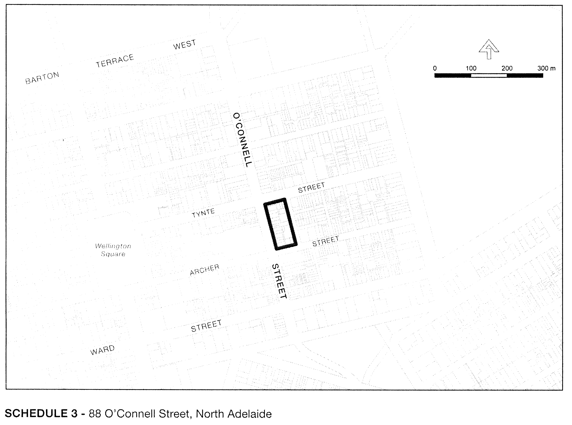

Dated 30 April 2007.
Paul Holloway, Minister for Urban Development and Planning

T. GOODES, Government Printer, South Australia

