No. 30 2127

THE SOUTH AUSTRALIAN

GOVERNMENT GAZETTE
www.governmentgazette.sa.gov.au

PUBLISHED BY AUTHORITY

ALL PUBLIC ACTS appearing in this GAZETTE are to be considered official, and obeyed as such

ADELAIDE, THURSDAY, 24 MAY 2007

CONTENTS

Page
Appointments, Resignations, Etc. 2128
Associations Incorporation Act 1985—Notice 2128
Building Work Contractors Act 1995—Notice 2128
Corporations and District Councils—Notices 2172
Development Act 1993—Notices 2129
Fisheries Act 1982—Notices 2143
Housing Improvement Act 1940—Notices 2141
Liquor Licensing Act 1997—Notices 2144
Mining Act 1971—Notices 2148
National Electricity Law—Notice 2148
National Parks and Wildlife (National Parks)
Regulations 2001—Notice 2148
Proclamations 2157
Public Trustee Office—Administration of Estates 2172
Supreme Court Act 1935 (S.A.)—Notice 2149
Workers Rehabilitation and Compensation Act 1986—
Notice 2150

GOVERNMENT GAZETTE NOTICES
ALL poundkeepers’ and private advertisements forwarded for publication in the South Australian Government Gazette must be PAID FOR PRIOR TO INSERTION; and all notices, from whatever source, should be legibly written on one side of the paper only and sent to Government Publishing SA so as to be received no later
than 4 p.m. on the Tuesday preceding the day of publication. Phone 8207 1045 or Fax 8207 1040. E-mail: governmentgazette@dpc.sa.gov.au. Send as attachments in Word format and please confirm your transmission with a faxed copy of your document, including the date the notice is to be published and to whom the notice will be charged. The Government Gazette is available online at: www.governmentgazette.sa.gov.au

Department of the Premier and Cabinet
Adelaide, 24 May 2007
HIS Excellency the Governor’s Deputy in Executive Council has revoked the appointment of Gerardine Mary Mulhearn as a Deputy Member to Susan Fox of the Teachers Registration Board, pursuant to the Teachers Registration and Standards Act 2004 and Section 36 of the Acts Interpretation Act 1915.

By command,
Paul Caica, for Premier
MECS07/014CS

Department of the Premier and Cabinet
Adelaide, 24 May 2007
HIS Excellency the Governor’s Deputy in Executive Council has been pleased to appoint the undermentioned to the Children’s Services Consultative Committee, pursuant to the provisions of the Children’s Services Act 1985:
Member: (from 1 June 2007 until 31 May 2009)
Merrilyn Joyce Hannaford
Kaarin Wilkinson
Colin Kettle
Melanie Ruth Gohl
Heather Carter
John Buckell
Carol Mary Stableford
Glenn Rappensberg
Deborah Bond
Peter David Emmerton
Anne-Marie Milte
Brian Keith Simons
Vicki Dianne McLean
Dianne Yvonne Rankine
Elizabeth Anne Pierce
Vicky Hughes
Kay Cleggett
Ioni Smart
Maureen Elaine McGuire
Mini Dharmasenan
Christy Ward
Deputy Member: (from 1 June 2007 until 31 May 2009)
Michelle Jodie Price (Deputy to Hannaford)
Donna Marie Young (Deputy to Kettle)
Sharon Jameson (Deputy to Carter)
Rebecca Heath (Deputy to Buckell)
Wendy Wake-Dyster (Deputy to Rappensberg)
Stephanie Grant (Deputy to Milte)
Sharon Delphine Holmes (Deputy to Pierce)
Gwen Secomb (Deputy to Hughes)
Beverly Anne Pope (Deputy to McGuire)
Christopher Roy Caudle (Deputy to Dharmasenan)
Chair: (from 1 June 2007 until 31 May 2009)
Christy Ward
Deputy Chair: (from 1 June 2007 until 31 May 2009)
Glenn Rappensberg
By command,
Paul Caica, for Premier
MECS07/011CS

Department of the Premier and Cabinet
Adelaide, 24 May 2007
HIS Excellency the Governor’s Deputy in Executive Council has been pleased to appoint the undermentioned to the South Australian Psychological Board, pursuant to the provisions of the Psychological Practices Act 1973:
Deputy Member: (from 24 May 2007 until 3 May 2008)
Lesley Hastwell (Deputy to Dickson)
By command,
Paul Caica, for Premier
HEACS/07/201

Department of the Premier and Cabinet
Adelaide, 24 May 2007
HIS Excellency the Governor’s Deputy in Executive Council has been pleased to appoint the undermentioned to the Medical Board of South Australia, pursuant to the provisions of the Medical Practice Act 2004:
Member: (from 1 June 2007 until 31 May 2010)
Richard John Willis
By command,
Paul Caica, for Premier
HEACS/07/206

Department of the Premier and Cabinet
Adelaide, 24 May 2007
HIS Excellency the Governor’s Deputy in Executive Council has been pleased to appoint the undermentioned to the Teachers Registration Board, pursuant to the provisions of the Teachers Registration and Standards Act 2004:
Member: (from 24 May 2007 until 30 March 2008)
Gerardine Mary Mulhearn
Deputy Member: (from 24 May 2007 until 30 March 2008)
Peter Christopher Ryan (Deputy to Woodbury)
Andrea McGuffog (Deputy to Mulhearn)
By command,
Paul Caica, for Premier
MECS07/014CS

ASSOCIATIONS INCROPORATION ACT 1985
Dissolution of Association
NOTICE is hereby given that the Corporate Affairs Commission approves the application for transferring of undertaking received from the Association named below, pursuant to section 42 (2) of the Associations Incorporation Act 1985. Dissolution takes effect on the date of publication of this notice.
Take notice that the Corporate Affairs Commission (‘the Commission’) pursuant to subsection 42 (2) of the Associations Incorporation Act 1985 (‘the Act’) orders that the undertakings of the Association shown in Schedule 1 be transferred to a body corporate as shown in Schedule 2 and on the date that this Notice appears in the Government Gazette, the Association will be dissolved. The property of the Association becomes the property of the body corporate and the rights and liabilities of the Association become the rights and liabilities of the body corporate referred to in Schedule 2.
Schedule 1
Civil Construction Skills and Technology Centre Incorporated.
Schedule 2
Civil Contractors Federation.
Given under the common seal of the Corporate Affairs Commission in Adelaide, 21 May 2007.
S. Everard, Delegate, of the Corporate Affairs Commission

BUILDING WORK CONTRACTORS ACT 1995
Exemption
TAKE notice that pursuant to section 45 of the Building Work Contractors Act 1995, I, Mark Bodycoat, Commissioner for Consumer Affairs, do hereby exempt the licensee named in Schedule 1 from the application of Division 3 of Part 5 of the above Act in relation to domestic building work described in Schedule 2 and subject to the conditions specified in Schedule 3.
Schedule 1
Shane Leigh Hendriks, BLD 160413.
Schedule 2
Construction of a house at 14 Frenchman Drive, Lot 15, Port Elliot, S.A. 5212.
Schedule 3
1. This exemption is limited to the domestic building work personally performed by the licensee for the construction of a house, intended to be the family home for the licensee and his wife on land situated at 14 Frenchman Drive, Lot 15, Port Elliot, S.A. 5212 (certificate of title book volume 5146, folio 122).
2. This exemption does not apply to any domestic building work the licensee sub-contracts to another building work contractor, for which that contractor is required by law to hold building indemnity insurance.
3. The licensee does not transfer his interest in the land prior to five years from the date of completion of the building work the subject of this exemption, without the prior authorisation of the Commissioner for Consumer Affairs. Before giving such authorisation, the Commissioner for Consumer Affairs may require the licensees to take any reasonable steps to protect the future purchaser(s) of the property, including but not limited to:
• providing evidence that an adequate policy of building indemnity insurance is in force to cover the balance of the five-year period from the date of completion of the building work the subject of this exemption;
• providing evidence of an independent expert inspection of the building work the subject of this exemption;
• making an independent expert report available to pros-pective purchasers of the property; and
• giving prospective purchasers of the property notice of the absence of a policy of building indemnity insurance.
Dated 14 May 2007.
M. Bodycoat, Commissioner for Consumer Affairs, Office of Consumer and Business Affairs, delegate of the Minister for Consumer Affairs
Ref.: 610/07-00027

DEVELOPMENT ACT 1993, SECTION 48: DECISION BY THE DEVELOPMENT ASSESSMENT COMMISSION AS DELEGATE OF THE GOVERNOR
Preamble
1. The Governor, by a decision made on 27 May 2004 and published in the Gazette of that date at pages 1350-1354, granted provisional development authorisation under section 48 of the Development Act 1993, for the development of a 19 storey apartment complex located at 41-51 Hindmarsh Square and 131-139 Grenfell Street (RAA Corner), incorporating environmentally sustainable development features and comprising:
• the construction of a 19 level residential apartment tower and podium (10 storeys high) containing 127 apartments, with ground and part first floor retail and office use;
• renovation of the adjacent two-storey State Heritage listed YWCA building (incorporating a cafe, gymnasium, function room, lounges and wine storage areas);
• redevelopment of the roadway on the western side of Hindmarsh Square in front of the apartment allotment; and
• a three-level basement car park extending 30 m under the Hindmarsh Square roadway (for the width of the develop-ment site only), with provision for 158 car spaces, 27 bicycle spaces, storage, plant rooms and water storage tank.
That provisional development authorisation was subject to the 22 conditions attached to the authorisation.
2. Conservatory on Hindmarsh Square Pty Ltd (formerly Grenfell Street East Pty Ltd), the person having the benefit of the development authorisation applied for an amendment to that development authorisation to amend the development which was still for a 19 storey building but contained several changes, including:
• deletion of the underground car parking intruding into the roadway of Hindmarsh Square;
• an elevated car park has been incorporated into the building at levels 2 to 5. The car park façade includes solar panels and passive ventilation. The number of car parking spaces has been reduced from 155 to 116;
• the building of 19 storeys is no longer constructed over the adjoining YWCA heritage building;
• the number of apartments is reduced from 124 to 72 and more commercial space is included with an increase from 832 m² to 3 600 m²;
• all green elements such as water retention, water saving, waste management, power generation and energy usage minimisation have been maintained or improved.
3. The proposal was the subject of an Amended Development Report and an Amended Assessment Report under section 47 of the Development Act 1993.
4. The Governor, by a decision made on 1 September 2005 and published in the Gazette of that date at pages 3145-3149 granted provisional development authorisation under section 48 of the Development Act 1993, for the amended development.
5. Amended proposals for the Hindmarsh Square Development were subsequently considered and approved by the Development Assessment Commission and published in the Gazette on 2 March 2006 and 13 July 2006.
6. Application has now been made to the Development Assessment Commission as delegate of the Governor under section 48 of the Development Act 1993 to grant an approval for variation to Conditions 3 and 7.
7. The amendments to the development are contained in the correspondence from Paul Pruszinski Architects dated 10 May 2007.
8. The Development Assessment Commission has in considering the application had regard to all relevant matters under section 48 (5) of the Development Act 1993.
9. The Development Assessment Commission is satisfied that the variations do not require the preparation of a further amended Development Report.
Decision
PURSUANT to section 48 of the Development Act 1993 and with the advice and consent of the Executive Council, in relation to a proposal submitted by Conservatory on Hindmarsh Square Pty Ltd to develop the Hindmarsh Square Apartment Complex at 41-51 Hindmarsh Square and 131-139 Grenfell Street, I:
(a) grant a provisional development authorisation in relation to the proposed major development, subject to the conditions and notes to the applicant below;
(b) pursuant to section 48 (6) reserve my decision on the following matters:
(i) compliance with the Building Rules in relation to all aspects of the proposed major development. (However, the applicant may stage building works and may either seek a decision on compliance with the Building Rules in respect of the development as a whole or of successive individual stages of the building works);
(ii) materials, finishes, colour schedules and any other works or activities affecting the locality and the adjacent two-storey YWCA State Heritage listed building to be developed in consultation with, and to the approval of the Development Assessment Commission in consultation with a group consisting of the Working Party referred to in the Development Report dated 5 November 2003, the Heritage SA, Department for Environment and Heritage and the Urban Design Unit of Planning SA;
(iii) final design of the pedestrian entrance canopy of the apartment complex to enhance compatibility with the adjacent State Heritage listed YWCA building;
(iv) final selection of detailed environmentally sustain-able feature options and plant and equipment for the apartment complex development referred to in the Development Report dated 5 November 2003 and Amended Development Report dated 4 April 2005, to be undertaken in accordance with agreed targets and pending further sustainability modelling by the applicant, in consultation with Planning SA and the Working Party referred to in the Development Report dated 5 November 2003;
(v) any external advertising signage;
(vi) final design details of the northern wall of the YWCA State Heritage listed building in consul-tation with Heritage SA, Department for Environ-ment and Heritage;
(c) specify all matters relating to this provisional develop-ment authorisation as matters in respect of which conditions of this authorisation may be varied or revoked, or new conditions may be attached;
(d) specify for the purposes of section 48 (11) (b) the period of two years from the date hereof as the time within which substantial work must be commenced on the site of the development.
Conditions of Approval
1. Except where minor amendments may be required by other legislation, or by conditions imposed herein, the proposed major development shall be undertaken in strict accordance with:
(a) the following drawings contained within the letter from Connor Holmes Pty Ltd (for Grenfell East Pty Ltd) to Planning SA dated 30 April 2004, outlining the final, amended application except to the extent that they are varied by the plans as described in paragraphs (c), (e)
and (g):
• Drawing Titled: ‘Location Plan’; 1:500; Drawing Number: 503225 A000 C; dated 16 April 2004.
• Drawing Titled: ‘Plan B01’; 1:100; Drawing Number: 503225 A109 F; dated 16 April 2004.
• Drawing Titled: ‘Plan B02’; 1:100; Drawing Number: 503225 A110 G; dated 16 April 2004.
• Drawing Titled: ‘Plan B03’; 1:100; Drawing Number: 503225 A111 A; dated 16 April 2004 (new drawing).
• Drawing Titled: ‘Plan L00’; 1:100; Drawing Number: 503225 A100 C; dated 16 April 2004.
• Drawing Titled: ‘Plan L01’; 1:100; Drawing Number: 503225 A101 C; dated 16 April 2004.
• Drawing Titled: ‘Plan L02’; 1:100; Drawing Number: 503225 A102 C; dated 16 April 2004.
• Drawing Titled: ‘Plan L03-L09’; 1:100; Drawing Number: 503225 A103 C; dated 16 April 2004.
• Drawing Titled: ‘Plan L10’; 1:100; Drawing Number: 503225 A104 C; dated 16 April 2004.
• Drawing Titled: ‘Plan L11-L18’; 1:100; Drawing Number: 503225 A105 C; dated 16 April 2004 (except to the extent that they may be varied by a document in paragraph (b), dated 30 April 2004).
• Drawing Titled: ‘Plan Roof’; 1:100; Drawing Number: 503225 A108 C; dated 16 April 2004 (except to the extent that they may be varied by a document in paragraph (b), dated 30 April 2004).
• Drawing Titled: ‘North Elevation’; 1:200; Drawing Number: 503225 A200 C; dated 16 April 2004.
• Drawing Titled: ‘East Elevation’; 1:200; Drawing Number: 503225 A201 C; dated 16 April 2004.
• Drawing Titled: ‘West Elevation/South Elevation’; 1:200; Drawing Number: 503225 A202 C; dated 16 April 2004.
• Drawing Titled: ‘Sections’; 1:200; Drawing Number: 503225 A203 C; dated 16 April 2004.
(b) the following documents except to the extent that they are varied by the plans as described in paragraphs (d)
and (f):
• Development application, ‘Residential apartment building with retailing and offices and basement car parking at 131-139 Grenfell Street/41-51 Hindmarsh Square, Adelaide’, prepared by Connor Holmes Pty Ltd (for Grenfell East Pty Ltd) dated 26 May 2003 (except to the extent that it may be varied by a subsequent document in this paragraph).
• Development Report, Hindmarsh Square Apartment Complex, prepared by Connor Holmes Pty Ltd (for Grenfell East Pty Ltd) dated 5 November 2003 (except to the extent that it may be varied by a subsequent document in this paragraph).
• Response to Submissions Document, Hindmarsh Square Apartment Complex, prepared by Connor Holmes Pty Ltd (for Grenfell East Pty Ltd) dated 18 December 2003 (contained within an appendix to the Assessment Report noted below) (except to the extent that it may be varied by a subsequent document in this paragraph).
• Assessment Report prepared by the Minister for Urban Development and Planning and released 8 March 2004 (except to the extent that it may be varied by a sub-sequent document in this paragraph).
• Letter from Connor Holmes Pty Ltd (for Grenfell East Pty Ltd) to the Minister for Urban Development and Planning dated 18 March 2004, outlining the applicant’s response to the Assessment Report (except to the extent that it may be varied by a subsequent document in this paragraph).
• Letter from Grenfell East Pty Ltd to the Minister for Urban Development and Planning dated 24 March 2004, proposing amendments to the proposal (except to the extent that it may be varied by a subsequent document in this paragraph).
• Letter from Grenfell East Pty Ltd to the Minister for Urban Development and Planning dated 22 April 2004, outlining additional transport initiatives (except to the extent that it may be varied by a subsequent document in this paragraph).
• Letter from Connor Holmes Pty Ltd (for Grenfell East Pty Ltd) to Planning SA dated 30 April 2004, outlining a final, amended application and accom-panying plans, including reduction of the apartment tower height by two levels; reduction of the extent of the three-level basement car park (located under the apartment complex and adjacent roadway and foot-path) with no encroachment in front of the adjacent property to the south; and a list of reserved matters for further application and decision-making (except to the extent that it may be varied by a subsequent document in this paragraph).
• Correspondence from Jack Hines (for Grenfell East Pty Ltd) to Planning SA dated 30 April 2004, listing final design of the apartment complex roof line and Level 18 of the complex as reserved matters for later decision-making subject to further application.
(c) the following drawings accompanying the Further Information and Clarification letter dated 27 June 2005 and the Amended Development Report dated 4 April 2005, except to the extent that they are varied by the plans as described in paragraphs (e) and (g):
• Drawing Titled: ‘Site Plan’; 1:500; Drawing Number: D-04335-01-01; dated 24 June 2005.
• Drawing Titled: ‘Basement Floor Plan’; 1:100; Drawing Number: D-04335-02-01; dated 24 June 2005.
• Drawing Titled: ‘Ground Floor Plan’; 1:100; Drawing Number: D-04335-02-02; dated 24 June 2005.
• Drawing Titled: ‘Level 1 Floor Plan’; 1:100; Drawing Number: D-04335-02-03; dated 24 June 2005.
• Drawing Titled: ‘Ramp Arrangement Floor Plan’; 1:100; Drawing Number: D-04335-02-04; dated 24 June 2005.
• Drawing Titled: ‘Level 2 Floor Plan’; 1:100; Drawing Number: D-04335-02-05; dated 24 June 2005.
• Drawing Titled: ‘Level 3 Floor Plan’; 1:100; Drawing Number: D-04335-02-06; dated 24 June 2005.
• Drawing Titled: ‘Level 4 Carparking’; 1:100; Drawing Number: D-04335-02-07; dated 24 June 2005.
• Drawing Titled: ‘Level 5 Floor Plan’; 1:100; Drawing Number: D-04335-02-08; dated 24 June 2005.
• Drawing Titled: ‘Level 6 Commercial Floor Plan’; 1:100; Drawing Number: D-04335-02-09; dated 24 June 2005.
• Drawing Titled: ‘Level 7-9 Commercial Floor Plan’; 1:100; Drawing Number: D-04335-02-10; dated 24 June 2005.
• Drawing Titled: ‘Level 10 Residential Floor Plan’; 1:100; Drawing Number: D-04335-02-11; dated 24 June 2005.
• Drawing Titled: ‘Level 11-18 Residential Floor Plan’; 1:100; Drawing Number: D-04335-02-12; dated 24 June 2005.
• Drawing Titled: ‘East Elevation (Hindmarsh Square)’; 1:200; Drawing Number: D-04335-04-01; dated 24 June 2005.
• Drawing Titled: ‘North Elevation (Grenfell Street)’; 1:200; Drawing Number: D-04335-04-02; dated 24 June 2005.
• Drawing Titled: ‘West Elevation/South Elevation’; 1:200; Drawing Number: D-04335-04-03; dated 24 June 2005.
• Drawing Titled: ‘Section 1’; 1:200; Drawing Number: D-04335-05-01; dated 24 June 2005.
• Drawing Titled: ‘Perspective’; Drawing Number: D-04335-12-02; dated 24 June 2005.
• Drawing Titled: ‘Shadow Diagram’; 1:1 000; Drawing Number: D-04335-12.01; dated 24 June 2005.
• Drawing Titled: ‘Ground Floor Plan Display YWCA Building’; 1:100; Unnumbered drawing submitted with drawings dated 24 June 2005.
• Drawing Titled: ‘Roof Floor Plan’; 1:100; Drawing Number: D-04335-02-13; dated 28 March 2005.
(d) the following documents except to the extent that they are varied by the plans as described in paragraph (f):
• Letter from Tecon Australia dated 15 February 2006 which includes copies of the varied drawings for the Temporary Display Unit in the YWCA Building and its associated Building Rules Certification.
• Correspondence dated 14 February 2006 by Pruszinski Architects.
• Amended Development Report, Hindmarsh Square Apartment Complex, prepared by Connor Holmes Pty Ltd (for Grenfell East Pty Ltd) dated 4 April 2005 (except to the extent that it may be varied by a subsequent document in this paragraph).
• Letter from Connor Holmes Pty Ltd (for Grenfell East Pty Ltd) to the Assessment Branch, Planning SA dated 27 June 2005, outlining the applicant’s response to issues raised in emails seeking further information dated 29 May 2005 and 8 June 2005.
(e) the following drawing except to the extent that they are varied by the plans as described in paragraph (g):
• Architectural drawings numbered 05354-02-03, 05354-03-01, 05354-03-02, 05354-03-03, 05354-06-01 and 05354-06-02 by Pruszinski Architects, dated 21 December 2005.
• Mechanical services drawings numbered LCE2453A-M01 by Lucid Consulting Engineers, dated 13 February 2006.
• Electrical services drawings numbered LCE2453A-E01 by Lucid Consulting Engineers, dated 13 February 2006.
• Hydraulic services drawings numbered LCE2453A-H01 by Lucid Consulting Engineers, dated 13 February 2006.
(f) the following document:
• Letter from Connor Holmes Pty Ltd (for the Con-servatory on Hindmarsh Square) to the Assessment Branch, Planning SA dated 21 March 2006.
(g) the following drawings:
• Drawing Titled: ‘Site Plan’; 1:500; Drawing Number: D-04335-01-01; dated 15 March 2006.
• Drawing Titled: ‘Basement Floor Plan’; 1:100; Drawing Number: D-04335-02-01; dated 15 March 2006.
• Drawing Titled: ‘Ground Floor Plan’; 1:100; Drawing Number: D-04335-02-02; dated 15 March 2006.
• Drawing Titled: ‘Ramp Arrangement Floor Plan’; 1:100; Drawing Number: D-04335-02-03; dated 15 March 2006.
• Drawing Titled: ‘Level 1—Floor Plan’; 1:100; Drawing Number: D-04335-02-04; dated 15 March 2006.
• Drawing Titled: ‘Level—2 Floor Plan’; 1:100; Drawing Number: D-04335-02-05; dated 15 March 2006.
• Drawing Titled: ‘Level 3—Floor Plan’; 1:100; Drawing Number: D-04335-02-06; dated 15 March 2006.
• Drawing Titled: ‘Level 4—Carparking’; 1:100; Drawing Number: D-04335-02-07; dated 15 March 2006.
• Drawing Titled: ‘Level 5—Floor Plan’; 1:100; Drawing Number: D-04335-02-08; dated 18 May 2006.
• Drawing Titled: ‘Level 6—Commercial Floor Plan’; 1:100; Drawing Number: D-04335-02-09; dated 18 May 2006.
• Drawing Titled: ‘Level 7—Commercial Floor Plan’; 1:100; Drawing Number: D-04335-02-10; dated 18 May 2006.
• Drawing Titled: ‘Level 8—Commercial Floor Plan’; 1:100; Drawing Number: D-04335-02-11; dated 18 May 2006.
• Drawing Titled: ‘Level 9—Commercial Floor Plan’; 1:100; Drawing Number: D-04335-02-12; dated 18 May 2006.
• Drawing Titled: ‘Level 10—Residential Floor Plan’; 1:100; Drawing Number: D-04335-02-13; dated 18 May 2006.
• Drawing Titled: ‘Level 11—Residential Floor Plan’; 1:100; Drawing Number: D-04335-02-14; dated 18 May 2006.
• Drawing Titled: ‘Level 12—Residential Floor Plan’; 1:100; Drawing Number: D-04335-02-15; dated 18 May 2006.
• Drawing Titled: ‘Level 13—Residential Floor Plan’; 1:100; Drawing Number: D-04335-02-16; dated 18 May 2006.
• Drawing Titled: ‘Level 14—Residential Floor Plan’; 1:100; Drawing Number: D-04335-02-17; dated 18 May 2006.
• Drawing Titled: ‘Level 15—Residential Floor Plan’; 1:100; Drawing Number: D-04335-02-18; dated 18 May 2006.
• Drawing Titled: ‘Level 16—Residential Floor Plan’; 1:100; Drawing Number: D-04335-02-19; dated 18 May 2006.
• Drawing Titled: ‘Level 17—Residential Floor Plan’; 1:100; Drawing Number: D-04335-02-20; dated 18 May 2006.
• Drawing Titled: ‘Level 18—Residential Floor Plan’; 1:100; Drawing Number: D-04335-02-21; dated 18 May 2006.
• Drawing Titled: ‘Roof Floor Plan’; 1:100; Drawing Number: D-04335-02-22; dated 15 March 2006.
• Drawing Titled: ‘North Elevation (Grenfell Street)’; 1:100; Drawing Number: D-04335-04-01; dated 15 March 2006.
• Drawing Titled: ‘East Elevation (Hindmarsh Square)’; 1:100; Drawing Number: D-04335-04-02; dated 15 March 2006.
• Drawing Titled: ‘South Elevation’; 1:100; Drawing Number: D-04335-04-03; dated 15 March 2006.
• Drawing Titled: ‘West Elevation;’ 1:100; Drawing Number: D-04335-04-03; dated 18 May 2006.
and
(h) the following document:
• Email from Paul Pruzinski Architects to the Assessment Branch Planning SA dated 10 May 2007.
2. The applicant shall submit further information and applica-tion(s) in relation to the matters that have been reserved, to the satisfaction of the Minister for Urban Development and Planning.
3. No building works on any part of the development, with the exception of demolition works, shall commence until a favourable decision has been notified to the applicant by the Governor or the Governor’s delegate in respect of those reserved matters referred to in subparagraphs (i) to (vii) in paragraph (b) of the Decision section above.
4. Subject to Condition 3, the applicant may commence a stage of building works before receiving the Governor’s decision con-cerning building rules compliance for other stages (refer reserved matter (i) in paragraph (b) of the Decision section (above)). No building works shall commence on a stage of the development, however, until a favourable decision in relation to building rules compliance in respect of that stage has been notified in writing to the applicant by the Governor or the Governor’s delegate.
5. A decision on building rules compliance (refer reserved matter above) will only be made after a Building Rules assessment and certification has been undertaken and issued by the Adelaide City Council, or a private certifier, in accordance with the provisions of the Development Act 1993, and after the Minister for Urban Development and Planning receives a copy of all relevant certification documentation, as outlined in Regulation 64 of the Development Regulations 1993 (refer to ‘Notes to Applicant’ (below) for further information).
6. Further sustainability modelling, for the selection of materials and finishes and sustainability features of the apartment complex (listed as reserved matters), shall be undertaken in consultation with a group consisting of the Urban Design Unit of Planning SA, the Heritage SA, Department for Environment and Heritage and the Working Party referred to in the applicant’s Development Report, dated 5 November 2003.
7. Before any works commence, a Construction Environmental Management Plan (CEMP) shall be prepared in consultation with and approved by the Environment Protection Authority, Planning SA and the Adelaide City Council, to address management issues during construction and to be lodged with the Minister for Urban Development and Planning. An Environmental Consultant shall be engaged to audit the management plan in accordance with commitments made by the applicant in the Original Response to Submissions dated 18 December 2003. Matters to be addressed in the CEMP must include (but shall not be limited to):
• reference to, and methods of adherence to, all relevant Environment Protection Authority (EPA) policies and codes of practice for construction sites, including the inclusion of a copy of Schedule 1 of the Environment Protection Act 1993, as an Appendix to the Construction Environmental Management Plan to ensure contractors are aware of EPA requirements, in accordance with commit-ments made in the applicant’s Response to Submissions, dated 18 December 2003;
• timing, staging and methodology of the construction process and working hours (refer also to condition outlining working hours);
• a Risk Assessment relating to the potential impacts of construction activities;
• traffic management strategies during construction of the apartment complex, including transport beyond the development site;
• management of infrastructure services during construction and/or relocation and re-establishment of local amenity and landscaping;
• control and management of construction noise, vibration, dust and mud;
• stormwater and groundwater management during con-struction;
• identification and management of contaminated soils and groundwater, should these be encountered;
• site security, fencing and safety and management of impacts on local amenity for residents, traffic and pedestrians;
• disposal of construction, waste and refuse in an appropriate manner according to the nature of the waste;
• protection and cleaning of roads and pathways;
• overall site clean up.
8. The applicant shall conduct monitoring of the effectiveness of attaining the agreed post-construction sustainability targets and regularly lodge documented outcomes, where the information is available, with Planning SA, the Department for Environment and Heritage (Office of Sustainability) and the Sustainability Working Party, in accordance with commitments made in the letter from the applicant dated 30 April 2004 and confirmed in the letter from Connor Holmes to Planning SA dated 27 June 2005. The applicant shall also report in person to the Working Party to verify the attainment of the sustainability goals of the development on a regular basis, to be agreed between the applicant and the Working Party.
9. Operating hours for construction activities and truck move-ments to and from the site shall be from 7 a.m. to 7 p.m., Monday to Saturday inclusive. If it is considered necessary for construction works to also be undertaken on Sundays, construction hours shall be from 9 a.m. to 6 p.m. on Sundays (refer ‘Notes to Applicant’ relating to EPA noise emission policies).
10. Any collected groundwater or stormwater shall only be discharged to the stormwater system if it meets quality control criteria specified in Environment Protection Authority require-ments to avoid sedimentation of local pipes and pollution of the Torrens Lake (refer ‘Notes to the Applicant’ for relevant require-ments).
11. All drainage, finished floor levels, landscaping, and public works associated with the development, including the disposal of stormwater and earthworks, shall be carried out in accordance with accepted engineering standards and to the reasonable satis-faction of the Adelaide City Council.
12. Any hazardous substances (e.g. fuels, compressed gases, solvents, paints, asbestos, polychlorinated biphenyls (PCB’s) and other construction-related substances), shall be removed and disposed of in accordance with Environment Protection Authority requirements.
13. Provision shall be made for 32 bicycle parking spaces in addition to the provision of bicycle racks for use by RAA staff (the location of which is to be determined in consultation with Planning SA and the Adelaide City Council).
14. The apartment complex and car park shall be maintained in a serviceable condition and operated in an orderly, tidy, safe and healthy manner at all times.
15. The waste and general storage and service/operational areas of the apartment complex building shall be kept in a neat, tidy, safe and healthy condition at all times and the service area access door shall remain closed at all times other than when loading or unloading is taking place.
16. Any machinery, plant operating equipment, lighting, building façade designs, or sound devices associated with the apartment complex development shall not impair or impinge upon the enjoyment or safety of residents of the apartment complex, adjoining properties (or occupiers thereof), or the local traffic and pedestrian environment.
Notes
• Pursuant to Development Regulation 64, the applicant is advised that the Adelaide City Council or private certifier conducting a Building Rules assessment must:
(a) provide to the Minister for Urban Development and Planning a certification in the form set out in Schedule 12A of the Development Regulations 1993, in relation to the building works in question; and
(b) to the extent that may be relevant and appropriate:
(i) issue a schedule of essential safety provisions under Division 4 of Part 12;
(ii) assign a classification of the building under these regulations; and
(iii) ensure that the appropriate levy has been paid under the Construction Industry Training Fund 1993.
Regulation 64 of the Development Regulations 1993, provides further information about the type and quantity of all Building Rules certification documentation for Major Developments required for referral to the Minister for Urban Development and Planning.
• The Adelaide City Council or private certifier undertaking Building Rules assessment and certification must ensure that the assessment and certification are consistent with this provisional development authorisation (including any con-ditions or notes that apply in relation to this provisional development authorisation).
• This provisional development authorisation does not extend to the provision of any wind turbines, as indicated in the letter from Grenfell East Pty Ltd to the Minister for Urban Development and Planning dated 24 March 2004, or any other such devices. Any such turbines or devices, if sub-sequently proposed, will require a new application under the appropriate assessment process.
• Should the applicant wish to vary the development or any of the components of the development in relation to which a decision has been reserved, an application may be submitted, pursuant to section 48B of the Development Act 1993, provided that the development application variation remains within the ambit of the Amended Development Report and Amendment to the Assessment Report referred to in this provisional development authorisation. If an application variation involves substantial changes to the proposal, pursuant to section 47 of the Development Act 1993, the applicant will be required to prepare an amended Development Report for public inspection and purchase. A further amended Assessment Report may also be required to assess any new issues not covered by the Assessment Report and the Amendment to the Assessment Report and a decision made by the Governor pursuant to section 48 of the Development Act 1993.
• If the development is not substantially commenced within two years of the date hereof, the Governor may cancel this development authorisation.
• The applicant is reminded that the Heritage SA of the Department for Environment and Heritage (DEH) shall be consulted in regard to any physical intervention to
the northern wall on the adjacent YWCA State Heritage listed building, which is listed as a reserved matter for further decision-making in this provisional development authorisation. Any such work must be executed in accordance with requirements notified to it by the DEH and must be consistent with the decision by the Governor (or her delegate) on the reserved matter (e.g. materials, finishes and colour schedules).
• The proponent is advised of the General Environmental Duty under section 25 of the Environment Protection Act 1993, which requires that a person must not undertake any activity, which pollutes, or may pollute, without taking all reasonable and practical measures to prevent or minimise harm to the environment.
• The applicant is advised of the requirement to comply with the Environment Protection Authority’s (EPA) ‘Stormwater Pollution Prevention Code of Practice for the Building and Construction Industry’ during demolition and construction of the development.
• The applicant is advised that noise emissions from the apartment complex development will be subject to the Environment Protection (Industrial Noise) Policy 1994, Environment Protection Authority Guidelines and Information Sheet Number 7 (‘Construction Noise’, July 2002) and the Environment Protection Act 1993.
• The applicant will consult with the Adelaide City Council about the type, nature and ongoing maintenance of any landscaping undertaken in relation to the apartment complex, in accordance with commitments (excluding those relating to the underground car park) made by the applicant in the original Response to Submissions document, dated 18 December 2003.
• The applicant is advised that the Development Act 1993, outlines the roles and responsibilities of the applicant and the Adelaide City Council for matters relating to building works during and after construction of the apartment complex development and associated works.
• It is recommended that the applicant consult with Planning SA when applying to the Adelaide City Council for a ‘Certificate of Occupancy’, to ascertain that all conditions of this provisional development authorisation and decisions on reserved matters have been complied with in an appropriate manner, including those relating to Building Rules assessment and certification requirements.
• The Minister for Urban Development and Planning has a specific power to require testing, monitoring and auditing under section 48C of the Development Act 1993.
Advisory Notes for the Temporary Display Unit
• Pursuant to Regulation 74 of the Development Regulations 1993, the applicant or builder proposing to undertake the development is advised of their obligation to give the Council one days notice of the commencement and completion of the development and at the stages notified by Council with the Development Approval. The notice of commencement shall include the names of the persons who will be signing the Statement of Compliance required by Regulation 83AB (8) of the Development Regulations 1993.
• Tecon Australia Pty Ltd has formed the opinion that the building is not unsafe or structurally unsound and that access for people with disabilities has been considered as required by section 53A of the Development Act 1993.
• The report by Tecon Australia Pty Ltd is based on the building rules assessment only and does not suggest or infer compliance with any other legislation.
• A certificate of occupation will not be required for this new work as the building is lawfully occupied and there is no change in classification.
• A Schedule of Essential Safety Provisions Form 2 and a pro forma Builders Statement of compliance have been attached to this consent. These forms shall be completed by the builder and returned to Tecon Australia at the com-pletion of the development.
• The existing method of recording the maintenance of the essential safety provisions shall be amended as necessary to include the alterations to the fire and life safety items.
Dated 24 May 2007.
R. Barúa, Secretary, Development Assessment Commission

DEVELOPMENT ACT 1993
Bushfire Management (Part 3)
Adelaide Hills, Alexandrina, Barossa, Burnside, Campbelltown, Mid Murray, Mitcham, Mount Barker, Onkaparinga, Playford, Tea Tree Gully, Victor Harbor, Yankalilla—Draft Plan Amendment—Report by the Minister—
For Public Consultation
NOTICE is hereby given that the Minister for Urban Development and Planning has, pursuant to sections 24 and 26 of the Development Act 1993, prepared a draft Plan Amendment Report (PAR) to amend the following 13 Council Development Plans: Adelaide Hills Council, Alexandrina Council, The Barossa Council, Burnside (City), Campbelltown (City), Mid Murray Council, Mitcham (City), Mount Barker (DC), Onkaparinga (City), Playford (City), Tea Tree Gully (City), Victor Harbor (City) and Yankalilla (DC).
The Bushfire Management (Part 3) Plan Amendment Report proposes to update and refine the existing Bushfire Prone Area policies and mapping.
The draft PAR will be on public consultation from Thursday, 24 May 2007 to Tuesday, 24 July 2007.
Written submissions on the PAR should be received no later than 5 p.m. on Tuesday, 24 July 2007.
Submissions should be addressed to the Presiding Member, Development Policy Advisory Committee, G.P.O. Box 1815, Adelaide, S.A. 5001 and should clearly indicate whether you wish to be heard in support of your submission at one of the public hearings, and which venue you wish to speak at. If you wish to lodge your submission electronically, please email it to the Presiding Member, Development Policy Advisory Committee, c/o dpac@saugov.sa.gov.au.
Copies of all submissions will be available for inspection
by interested persons at Planning SA, Level 5, 136 North
Terrace, Adelaide, or can be viewed on the Internet at www.planning.sa.gov.au/go/bushfirePAR-Part3, from 24 May 2007 until the conclusion of the public hearings.
The Development Policy Advisory Committee (DPAC) public hearings are scheduled as follows:
Hahndorf
Wednesday, 8 August 2007
7 p.m. to 9 p.m.
Hahndorf Resort & Convention Centre
Heysen Room
145 Main Street
Hahndorf, S.A. 5245
Victor Harbor
Tuesday, 14 August 2007
7 p.m. to 9 p.m.
Whalers Inn Resort
Baudin Room
121 Franklin Parade
Encounter Bay, S.A. 5211
The public hearings will not be held if no submissions are received or if no submissions request to be heard. Please refer to the website www.planning.sa.gov.au/go/bushfirePAR-Part3 from Friday, 27 July 2007 for confirmation of the public hearings.
Want to Know More?
To find more about this draft PAR, you can view copies of the document at:
• Planning SA, Level 5, 136 North Terrace, Adelaide, (telephone (08) 8303 0754).
• Website at: www.planning.sa.gov.au/go/bushfirePAR-Part3.
• Your local Council office where copies of the draft PAR and mapping will be made available to you.
• Speaking to us at one of our community information sessions at a place and time indicated below:
Community Information Session times:
Hahndorf
Monday, 25 June 2007
7 p.m. to 9 p.m.
Hahndorf Resort & Convention Centre
Heysen Room
145 Main Street
Hahndorf, S.A. 5245
Victor Harbor
Wednesday, 4 July 2007
7 p.m. to 9 p.m.
Whalers Inn Resort
Investigator Room
121 Franklin Parade
Encounter Bay, S.A. 5211.
For further information contact Planning SA on 8303 0754 or email lewis.susan4@saugov.sa.gov.au.
S. Underwood, Secretary, Development Policy Advisory Committee

DEVELOPMENT ACT 1993
Erratum
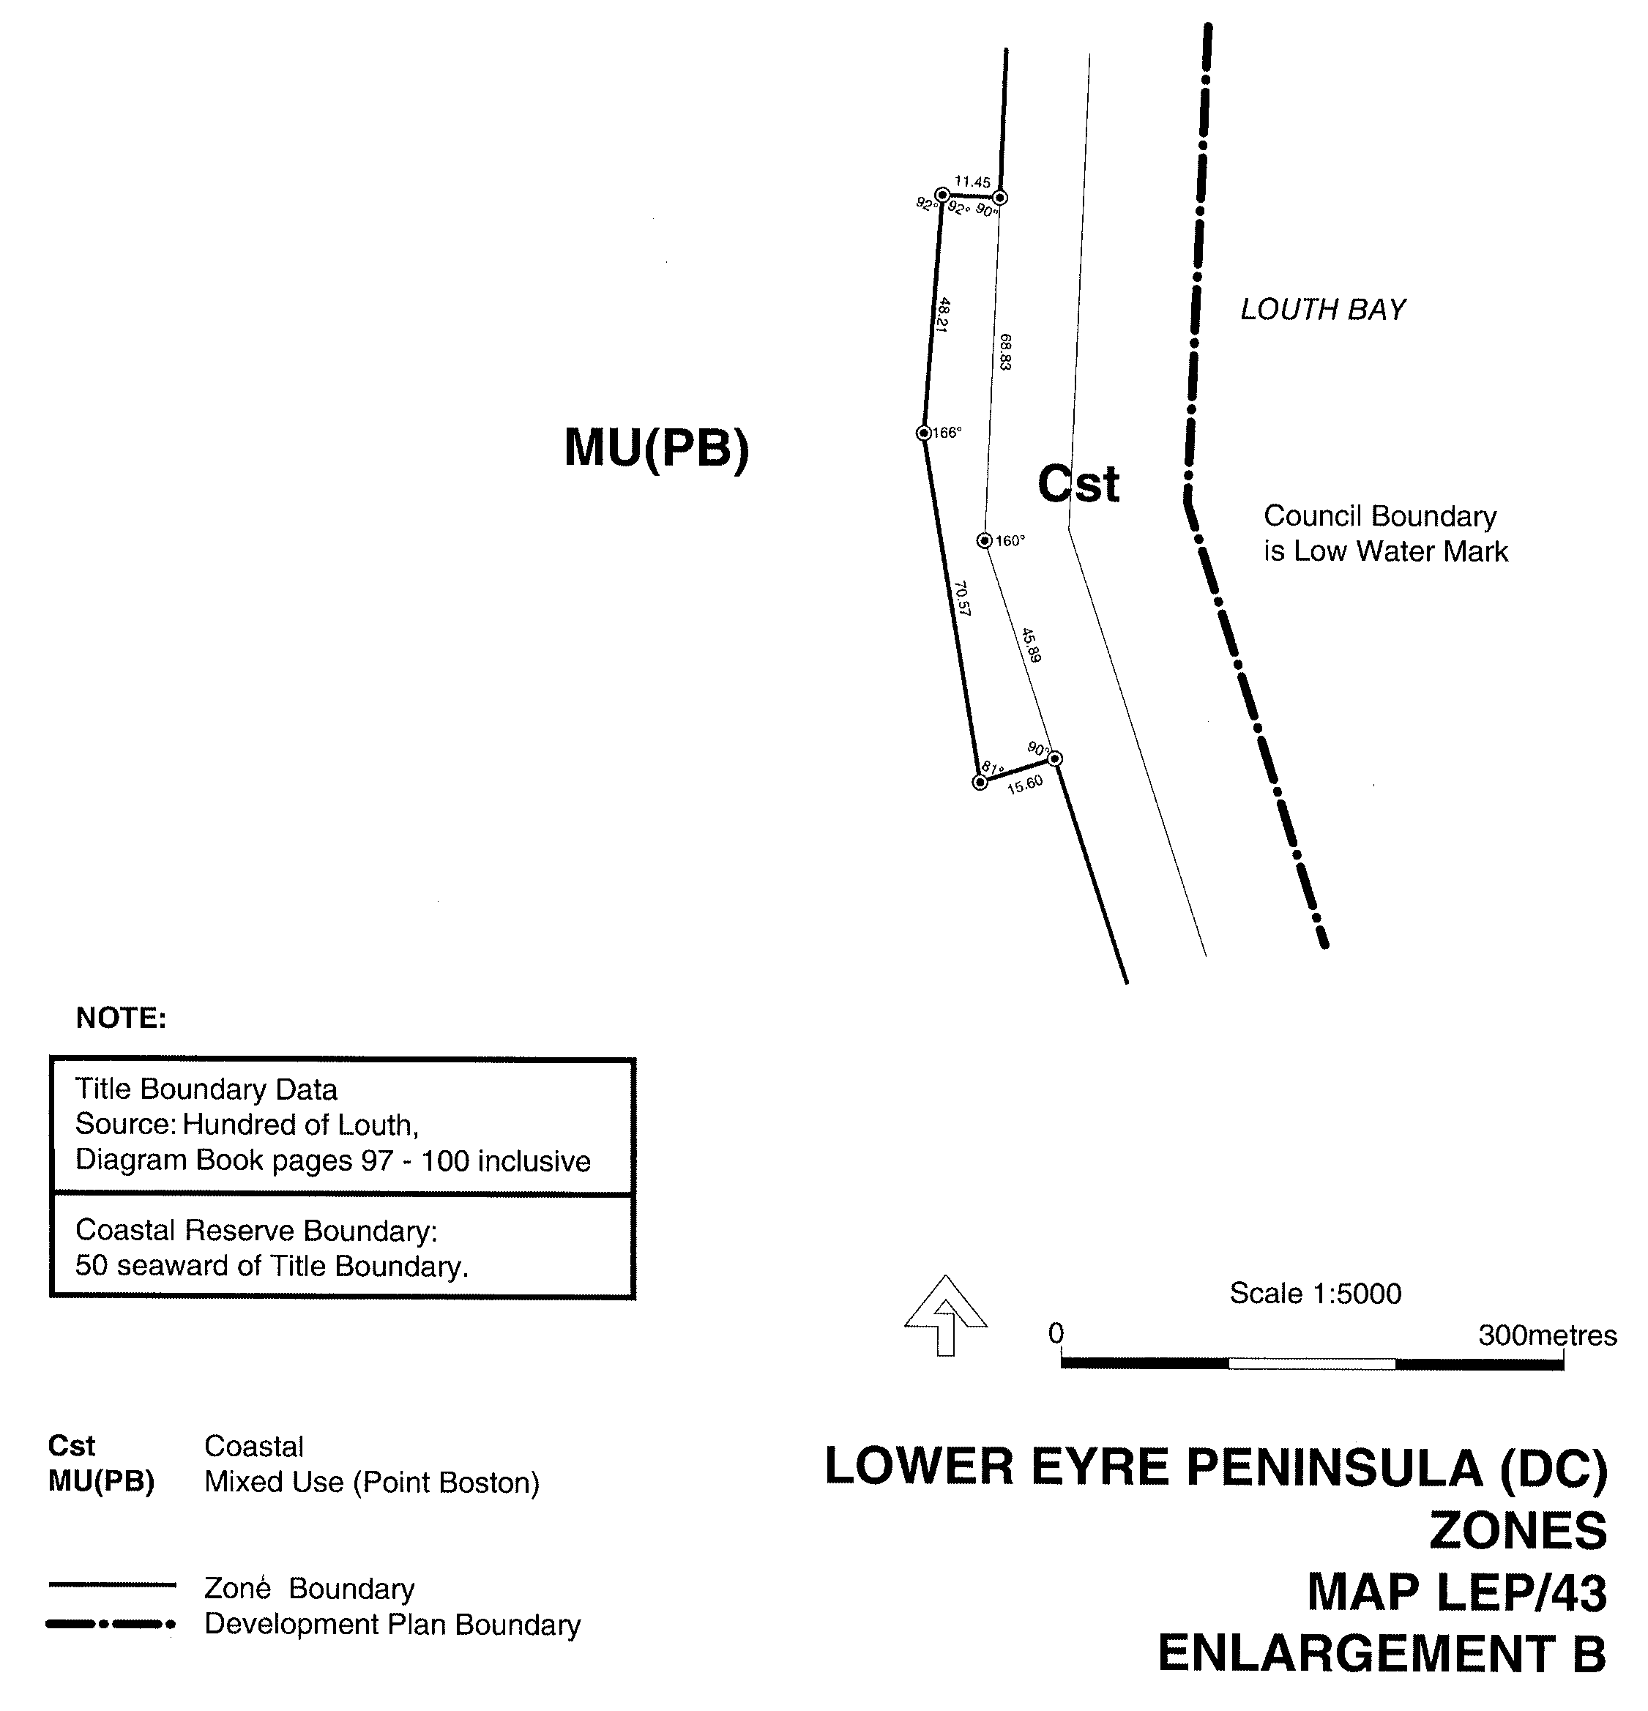
IN the Government Gazette of Thursday, 17 May 2007 on page 1993, the Development Act 1993, section 29 (2) (b) (ii) notice contained a publishing error as the two maps subject to the notice were not legible. The affected maps (Map LEP/43 Enlargement B and Map LEP/53 Enlargement B) are republished below:

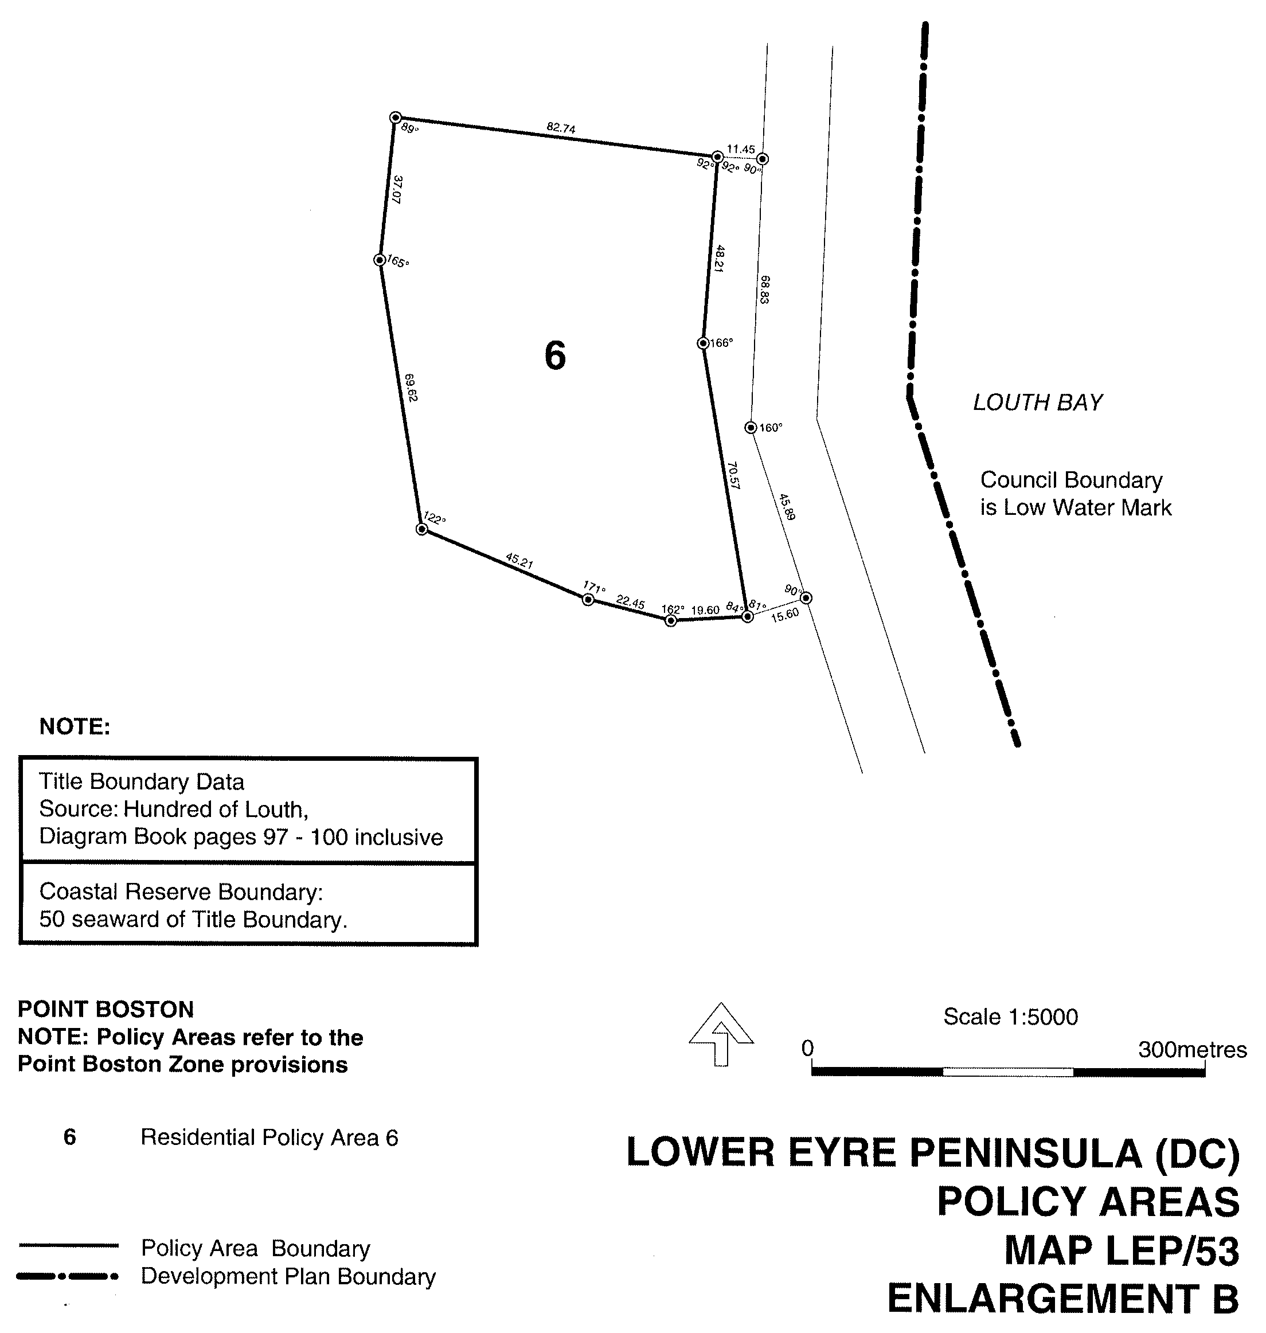
Paul Holloway, Minister for Urban Development and Planning

DEVELOPMENT ACT 1993: SECTION 46 (1)
Preamble
Subsection (1) of section 46 of the Development Act 1993, allows the Minister for Urban Development and Planning to apply that section to a specified kind of development or project if the Minister is of the opinion that a declaration under that section is appropriate or necessary for the proper assessment of development or a project of major environmental, social or economic importance.
Notice
PURSUANT to section 46 (1) of the Development Act 1993, being of the opinion that a declaration under section 46 of the Act is appropriate for the proper assessment of development of major environmental, social or economic importance, I declare that section 46 of the Act applies to any development of a kind specified in Schedule 1, in that part of the State specified in Schedule 2 at Anzac Highway, North Plympton.
Schedule 1
Specified Kinds of Development
Development directly associated with the establishment and operation of a shopping centre, including any or all of the following elements:
(a) the construction of buildings for, or associated with; retail, commercial and residential uses;
(b) any change in the use of land associated with any development within the ambit of paragraph (a);
(c) the undertaking of works for the purposes of, or otherwise related to; roads, stormwater and effluent treatment in connection with any development whether undertaken within the site specified in Schedule 2 or on other adjacent land;
(d) the division of land associated with the development;
(e) any related or ancillary development associated with development within the ambit of preceding paragraphs.
Schedule 2
Specified Part of the State
The following part of the State is specified for the purposes of Schedule 1.
(a) All of the land delineated by the bold line in Schedule 3 is specified for the purposes of Schedule 1 including land incidental or nearby to land specified in Schedule 3 if required for a purpose related to or ancillary to the kind of development specified in Schedule 1.

Schedule 3
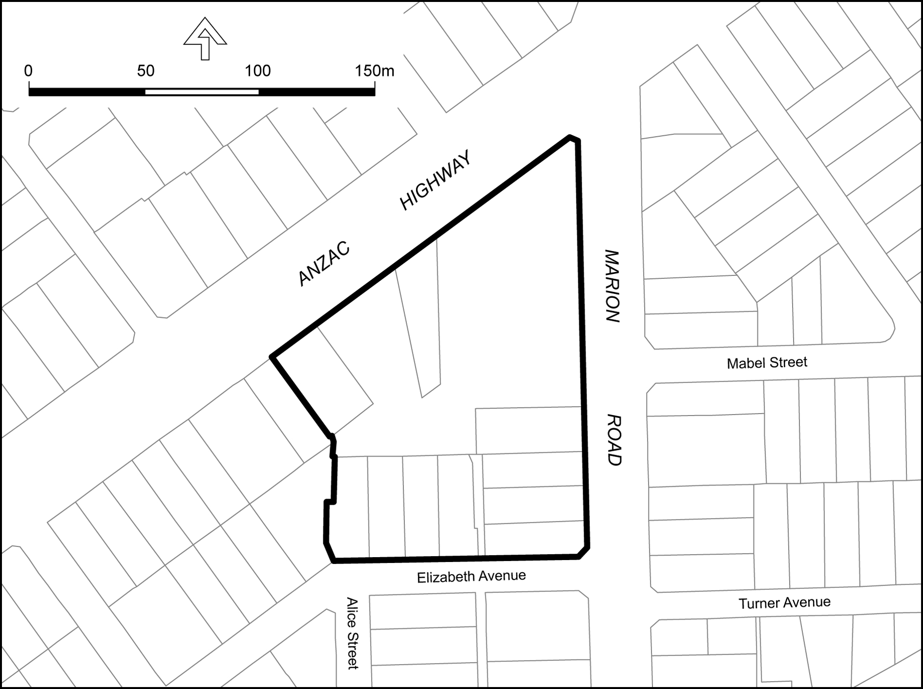
Dated 23 May 2007.
Paul Holloway, Minister for Urban Development and Planning

GOVERNMENT GAZETTE ADVERTISEMENT RATES

To apply from 1 July 2006

$  Agents, Ceasing to Act as 38.00  Associations:  Incorporation 19.30  Intention of Incorporation 47.75  Transfer of Properties 47.75  Attorney, Appointment of 38.00  Bailiff’s Sale 47.75  Cemetery Curator Appointed 28.25  Companies:  Alteration to Constitution 38.00  Capital, Increase or Decrease of 47.75  Ceasing to Carry on Business 28.25  Declaration of Dividend 28.25  Incorporation 38.00  Lost Share Certificates:  First Name 28.25  Each Subsequent Name 9.70  Meeting Final 31.75  Meeting Final Regarding Liquidator’s Report on  Conduct of Winding Up (equivalent to ‘Final  Meeting’)  First Name 38.00  Each Subsequent Name 9.70  Notices:  Call 47.75  Change of Name 19.30  Creditors 38.00  Creditors Compromise of Arrangement 38.00  Creditors (extraordinary resolution that ‘the Com-pany be wound up voluntarily and that a liquidator be appointed’) 47.75  Release of Liquidator⎯Application⎯Large Ad. 75.50  ⎯Release Granted 47.75  Receiver and Manager Appointed 44.00  Receiver and Manager Ceasing to Act 38.00  Restored Name 35.75  Petition to Supreme Court for Winding Up 66.50  Summons in Action 56.50  Order of Supreme Court for Winding Up Action 38.00  Register of Interests⎯Section 84 (1) Exempt 85.50  Removal of Office 19.30  Proof of Debts 38.00  Sales of Shares and Forfeiture 38.00  Estates:  Assigned 28.25  Deceased Persons⎯Notice to Creditors, etc. 47.75  Each Subsequent Name 9.70  Deceased Persons⎯Closed Estates 28.25  Each Subsequent Estate 1.25  Probate, Selling of 38.00  Public Trustee, each Estate 9.70 |  | $  Firms:  Ceasing to Carry on Business (each insertion) 25.25  Discontinuance Place of Business 25.25  Land⎯Real Property Act:  Intention to Sell, Notice of 47.75  Lost Certificate of Title Notices 47.75  Cancellation, Notice of (Strata Plan) 47.75  Mortgages:  Caveat Lodgement 19.30  Discharge of 20.20  Foreclosures 19.30  Transfer of 19.30  Sublet 9.70  Leases⎯Application for Transfer (2 insertions) each 9.70  Lost Treasury Receipts (3 insertions) each 28.25  Licensing 56.50  Municipal or District Councils:  Annual Financial Statement⎯Forms 1 and 2 532.00  Electricity Supply⎯Forms 19 and 20 378.00  Default in Payment of Rates:  First Name 75.50  Each Subsequent Name 9.70  Noxious Trade 28.25  Partnership, Dissolution of 28.25  Petitions (small) 19.30  Registered Building Societies (from Registrar-  General) 19.30  Register of Unclaimed Moneys⎯First Name 28.25  Each Subsequent Name 9.70  Registers of Members⎯Three pages and over:  Rate per page (in 8pt) 242.00  Rate per page (in 6pt) 320.00  Sale of Land by Public Auction 48.25  Advertisements 2.70  ¼ page advertisement 113.00  ½ page advertisement 226.00  Full page advertisement 443.00  Advertisements, other than those listed are charged at $2.70 per column line, tabular one-third extra.  Notices by Colleges, Universities, Corporations and District Councils to be charged at $2.70 per line.  Where the notice inserted varies significantly in length from that which is usually published a charge of $2.70 per column line will be applied in lieu of advertisement rates listed.  South Australian Government publications are sold on the condition that they will not be reproduced without prior permission from the Government Printer.
All the above prices include GST

GOVERNMENT GAZETTE NOTICES
ALL private advertisements forwarded for publication in the South Australian Government Gazette must be PAID FOR PRIOR TO INSERTION; and all notices, from whatever source, should be legibly written on one side of the paper only and sent to Government Publishing SA so as to be received no later than 4 p.m. Tuesday preceding the day of publication. Phone 8207 1045 or Fax 8207 1040. E-mail: governmentgazette@dpc.sa.gov.au. Send as attachments in Word format. Please include date the notice is to be published and to whom the notice will be charged. The Government Gazette is available online at: www.governmentgazette.sa.gov.au.

MISCELLANEOUS LEGISLATION AND GOVERNMENT PUBLICATIONS PRICES AS FROM 1 JULY 2006

Acts, Bills, Rules, Parliamentary Papers and Regulations
Pages | Main | Amends | Pages | Main | Amends

1-16 | 2.30 | 1.05 | 497-512 | 32.25 | 31.25
17-32 | 3.10 | 1.95 | 513-528 | 33.25 | 32.00
33-48 | 4.05 | 2.90 | 529-544 | 34.25 | 33.25
49-64 | 5.10 | 3.90 | 545-560 | 35.25 | 34.25
65-80 | 6.00 | 4.95 | 561-576 | 36.00 | 35.25
81-96 | 6.95 | 5.75 | 577-592 | 37.00 | 35.75
97-112 | 7.90 | 6.75 | 593-608 | 38.25 | 36.75
113-128 | 8.90 | 7.75 | 609-624 | 39.00 | 38.00
129-144 | 9.95 | 8.80 | 625-640 | 40.00 | 38.50
145-160 | 10.90 | 9.70 | 641-656 | 41.00 | 40.00
161-176 | 11.90 | 10.70 | 657-672 | 41.50 | 40.50
177-192 | 12.90 | 11.70 | 673-688 | 43.25 | 41.50
193-208 | 13.90 | 12.80 | 689-704 | 44.00 | 42.50
209-224 | 14.70 | 13.60 | 705-720 | 44.75 | 43.50
225-240 | 15.70 | 14.50 | 721-736 | 46.50 | 44.50
241-257 | 16.80 | 15.30 | 737-752 | 47.00 | 45.50
258-272 | 17.70 | 16.30 | 753-768 | 48.00 | 46.25
273-288 | 18.70 | 17.50 | 769-784 | 48.50 | 47.75
289-304 | 19.50 | 18.40 | 785-800 | 49.50 | 48.75
305-320 | 20.70 | 19.40 | 801-816 | 50.50 | 49.25
321-336 | 21.50 | 20.30 | 817-832 | 51.50 | 50.50
337-352 | 22.60 | 21.40 | 833-848 | 52.50 | 51.50
353-368 | 23.50 | 22.40 | 849-864 | 53.50 | 52.00
369-384 | 24.50 | 23.40 | 865-880 | 54.50 | 53.50
385-400 | 25.50 | 24.30 | 881-896 | 55.00 | 54.00
401-416 | 26.50 | 25.00 | 897-912 | 56.50 | 55.00
417-432 | 27.50 | 26.25 | 913-928 | 57.00 | 56.50
433-448 | 28.50 | 27.25 | 929-944 | 58.00 | 57.00
449-464 | 29.25 | 28.00 | 945-960 | 59.00 | 57.50
465-480 | 29.75 | 29.00 | 961-976 | 60.50 | 58.50
481-496 | 31.25 | 29.75 | 977-992 | 61.50 | 59.00

Legislation—Acts, Regulations, etc: $
Subscriptions:
Acts 199.00
All Bills as Laid 477.00
Rules and Regulations 477.00
Parliamentary Papers 477.00
Bound Acts 221.00
Index 110.00
Government Gazette
Copy 5.20
Subscription 263.00
Hansard
Copy 14.50
Subscription—per session (issued weekly) 414.00
Cloth bound—per volume 178.00
Subscription—per session (issued daily) 414.00
Legislation on Disk
Whole Database 3063.00
Annual Subscription for fortnightly updates 941.00
Individual Act(s) including updates POA
Compendium
Subscriptions:
Subscriptions 1815.00
Updates 640.00
(All the above prices include GST)

All Legislation, Government Gazette, Hansard and Legislation on disk are available from:
Counter Sales Service SA, Government Legislation⁺ Outlet
and Mail Orders: Lands Titles Office, 101 Grenfell Street, Adelaide, S.A. 5000
Phone: 13 23 24 (local call cost), Fax: (08) 8204 1909
Postal: G.P.O. Box 1707, Adelaide, S.A. 5001

Online Shop: www.shop.service.sa.gov.au

Subscriptions and Government Publishing SA
Standing Orders: Box 9, Plaza Level, Riverside Centre, North Terrace, Adelaide, S.A. 5000
Phone: (08) 8207 1043, (08) 8207 0910, Fax: (08) 8207 1040

HOUSING IMPROVEMENT ACT 1940
WHEREAS by notice published in the Government Gazette on the dates mentioned in the following table the South Australian Housing Trust did declare the houses described in the said table to be substandard for the purposes of Part 7 of the Housing Improvement Act 1940, and whereas the South Australian Housing Trust is satisfied that each of the houses described hereunder has ceased to be substandard, notice is hereby given that, in exercise of the powers conferred by the said Part, the South Australian Housing Trust does hereby revoke the said declaration in respect of each house.
Address of House | Allotment, Section, etc. | Certificate of Title  Volume Folio | Date and page of Government Gazette in which notice declaring house to be substandard published

16 College Avenue, Bellevue Heights |  | Allotment 29 in Deposited Plan 9184, Hundred of Adelaide | 5187 | 758 |  | 22.2.07, page 555
Section 238, Brownlow Road, Brownlow (Eudunda) |  | Section 238, Hundred of Brownlow | 5344 | 434 |  | 23.12.92, page 2295
59 East Street, Brompton |  | Allotment 22 in Filed Plan 121969, Hundred of Yatala | 5390 | 340 |  | 16.7.87, page 164
Lot 282, Railway Terrace, Coonamia (via Port Pirie) |  | Allotment 1 in Filed Plan 15103, Hundred of Pirie | 5476 | 949 |  | 24.9.92, page 1183
196 Sir Donald Bradman Drive, Cowandilla |  | Allotment 17 in Deposited Plan 2937, Hundred of Adelaide | 5317 | 753 |  | 14.11.89, page 1505
431 Port Road, Croydon |  | Allotment 66 in Filed Plan 115778, Hundred of Yatala | 5731 | 867 |  | 30.3.95, page 1141
Cottage in yard, 14 Napier Street, Exeter |  | Allotment 112 in Filed Plan 3167, Hundred of Port Adelaide | 5164 | 457 |  | 13.3.80, page 508
Rear flat, 14 Napier Street, Exeter |  | Allotment 112 in Filed Plan 3167, Hundred of Port Adelaide | 5164 | 457 |  | 13.3.80, page 508
8 King Street, Gawler |  | Allotment 85 in Filed Plan 154486, Hundred of Mudla Wirra | 5829 | 248 |  | 22.5.69, page 1545
157 Main Road, Hahndorf |  | Allotment 13 in Deposited Plan 17086, Hundred of Kuitpo | 5451 | 619 |  | 30.5.96, page 2605
5 Noojee Street, Mount Gambier |  | Allotment 1 in Deposited Plan 4466, Hundred of Blanche | 5697 | 788 |  | 30.1.92, page 283
19 Gray Street, Murray Bridge |  | Allotment 5 in Filed Plan 103229, Hundred of Mobilong | 5129 | 421 |  | 29.9.05, page 3508
3 Bayclay Street, Para Hills |  | Allotment 38 in Deposited Plan 7696, Hundred of Yatala | 5559 | 830 |  | 27.4.06, page 1157
157 Moscow Street, Peterborough |  | Allotment 228 in Deposited Plan 3224, Hundred of Yongala | 5523 | 595 |  | 27.3.03, page 1186
41 Twentieth Street, Renmark |  | Allotment 36 in Filed Plan 15790, Hundred of Renmark Irrigation District | 5615 | 132 |  | 15.1.81, page 88
Section 3, Darling Street, Renmark North |  | Allotment 3 in Deposited Plan 20209, Hundred of Renmark Irrigation District | 5557 | 774 |  | 28.10.93, page 2118
16 Cushen Street, Smithfield Plains |  | Allotment 365 in Deposited Plan 7888, Hundred of Munno Para | 5586 | 807 |  | 22.2.07, page 555
Flat 1, Lot 101, 12-14 William Street, Two Wells |  | Allotment 101 in Deposited Plan 19617, Hundred of Port Gawler | 5067 | 372 |  | 28.4.88, page 1098
Lot E, Section 3066, Moloney Road, Virginia |  | Allotment 382 in Filed Plan 162731, Hundred of Munno Para | 5337 | 497 |  | 25.3.93, page 1082
Right hand front of house at Lot 176, O’Loughlin Road, Virginia |  | Allotment 240 in Filed Plan 163208 in Hundred of Port Adelaide | 5886 | 252 |  | 4.10.84, page 1157

Dated at Adelaide, 22 May 2007. D. Huxley, Director Corporate and Board Services

HOUSING IMPROVEMENT ACT 1940
WHEREAS by notice published in the Government Gazette on the dates mentioned in the following table the South Australian Housing Trust did declare the houses described in the said table to be substandard for the purposes of Part 7 of the Housing Improvement Act 1940, the South Australian Housing Trust in the exercise of the powers conferred by the said Part, does hereby fix as the maximum rental per week which shall be payable subject to section 55 of the Residential Tenancies Act 1995, in respect of each house described in the following table the amount shown in the said table opposite the description of such house and this notice shall come into force on the date of this publication in the Gazette.
Address of House | Allotment, Section, etc. | Certificate of Title  Volume Folio | Date and page of Government Gazette in which notice declaring house to be substandard published | Maximum rental per week payable in respect of each house  $

2 Talunga Street, Birdwood |  | Allotment 40 in Deposited Plan 28154, Hundred of Talunga | 5196 | 219 |  | 22.2.07, page 555 | 97.00
26 Coglin Street, Brompton |  | Allotments 1 and 2 in Deposited Plan 795, Hundred of Yatala | 5569 | 885 |  | 14.11.85, page 1519 | 229.00
10 Harrow Road, College Park |  | Allotment 74 in Filed Plan 136425, Hundred of Adelaide | 5790 | 430 |  | 22.2.07, page 555 | 124.00
Unit 3/3-5 North East Road, Collinswood |  | Unit 3, Strata Plan 5774, Hundred of Yatala | 5019 | 183 |  | 26.4.07, page 1266 | 88.00
44 Higgins Road, Gawler River (also known as Buchfelde) |  | Allotment 3 in Filed Plan 138700, Hundred of Mudla Wirra | 5258 | 35 |  | 28.11.96, page 1755 | 129.00
13 Hill Street, Hamley Bridge |  | Allotment 19 in Deposited Plan 1694 and Allotment 20 in Deposited Plan 1694, Hundred of Alma | 5352  5352 | 113  116 |  | 28.3.02, page 1451 | 164.00
18 Lindsay Terrace, Kadina |  | Allotment 758 in Filed Plan 198129, Hundred of Wallaroo | 5731 | 586 |  | 30.1.92, page 282 | 155.00
14 Robe Street, Kapunda |  | Allotment 13 in Filed Plan 100453, Hundred Kapunda | 5101 | 67 |  | 28.9.89, page 968 | 93.00
5 Gilbert Street Lyndoch |  | Allotment 2 in Deposited Plan 102, Hundred of Barossa | 5273 | 920 |  | 2.3.95, page 752 | 179.00
Section 297, Parawa Road, Parawa |  | Section 297, Hundred of Yankalilla | Cro  1136 | wn Lease  26 |  | 26.10.06, page 3774 | 105.00
1 Wright Street, Peterborough |  | Allotment 131 in Deposited Plan 3224, Hundred of Yongala | 5099 | 170 |  | 18.12.97, page 1656 | 128.00
8 Keith Street, Port Pirie West |  | Allotment 54 in Filed Plan 28920, Hundred of Pirie | 5347 | 617 |  | 25.2.88, page 476 | 60.00
113 Hawker Street, Ridleyton |  | Allotment 12 in Filed Plan 107702, Hundred of Yatala | 5189 | 32 |  | 21.9.00, page 2147 | 206.00
9 Dene Avenue, Victor Harbor |  | Allotment 83 in Deposited Plan 3535, Hundred of Encounter Bay | 5390 | 109 |  | 30.8.01, page 3431 | 189.00

Dated at Adelaide, 22 May 2007. D. Huxley, Director, Corporate and Board Services

HOUSING IMPROVEMENT ACT 1940
NOTICE is hereby given that the South Australian Housing Trust in the exercise of the powers conferred by the Housing Improvement Act 1940, does hereby declare the houses described in the table hereunder to be substandard for the purposes of Part 7 of the Housing Improvement Act 1940.
No. of House and Street | Locality | Allotment, Section, etc. | Certificate of Title  Volume Folio

Unit 5/6 Adelaide Terrace |  | Edwardstown | Unit 5, Strata Plan 2077, Hundred of Adelaide | 5041 | 658
82 Muller Road |  | Greenacres | Allotment 423 in Deposited Plan 5203, Hundred of Yatala | 5654 | 137
9 Linden Avenue |  | Hazelwood Park | Allotment 228 in Deposited Plan 2975, Hundred of Adelaide | 5658 | 771
Lot 30, Chellaston Road |  | Munno Para West | Allotment 30 in Deposited Plan 6437, Hundred of Munno Para | 5644 | 846
53 Fifth Avenue |  | St Peters | Allotment 62 in Filed Plan 135713, Hundred of Adelaide | 5446 | 269
4 Hunt Street |  | Salisbury | Allotment 24 in Deposited Plan 4454, Hundred of Yatala | 5675 | 52
104 Ashley Street |  | Thebarton | Allotment 25 in Deposited Plan 3359, Hundred of Adelaide | 5530 | 83
Unit 1/16 Vista Avenue |  | Valley View | Allotment 49 in Deposited Plan 6503, Hundred of Yatala | 5630 | 23
Unit 2/16 Vista Avenue |  | Valley View | Allotment 49 in Deposited Plan 6503, Hundred of Yatala | 5630 | 23

Dated at Adelaide, 22 May 2007. D. Huxley, Director, Corporate and Board Services

FISHERIES ACT 1982: SECTION 43
TAKE notice that pursuant to section 43 of the Fisheries Act 1982, it is hereby declared that it shall be unlawful for any person to engage in the class of fishing activity specified in Schedule 1, in the area specified in Schedule 2, during the period specified in Schedule 3.
Schedule 1
The act of taking or an act preparatory to or involved in the taking of abalone (Family Haliotidae).
Schedule 2
All the waters of Waterloo Bay (Elliston) contained within the geodesic commencing at the high water mark on the shore of Wellington Point, latitude 33°39.23′S, longitude 134°52.53′E and terminating at the high water mark on the shore at Salmon Point, latitude 33°38.72′S, longitude 134°51.58′E.
Schedule 3
From 22 May 2007 until 30 April 2008.
Dated 22 May 2007.
W. Zacharin, Director of Fisheries

FISHERIES ACT 1982: SECTION 59
TAKE notice that, pursuant to section 59 of the Fisheries Act 1982, licence holders or registered masters of the Western Zone Abalone Fishery Licences listed in Schedule 1 (the ‘exemption holders’), are exempt from section 43 of the Fisheries Act 1982, but only insofar as the exemption holders shall not be guilty of an offence when taking blacklip abalone (Haliotis rubra) from waters described in Schedule 2 (the ‘exempted activity’), subject to the conditions specified in Schedule 3, from 0800 hours on 28 May 2007 until 27 July 2007 inclusive, unless this notice is varied or revoked earlier.
Schedule 1
Licence numbers:
W01
W02
W05
W06
W07
W08
W09
W13
W19
W21
W23
Schedule 2
Those waters of Waterloo Bay contained within two areas bounded by the following co-ordinates (using the GDA94 datum, in degrees and decimal minutes):
Area 1:
Latitude 33°38.211′S, Longitude 134°52.179′E
Latitude 33°38.500′S, Longitude 134°52.645′E
Latitude 33°38.866′S, Longitude 134°52.329′E
Latitude 33°38.530′S, Longitude 134°51.975′E
Area 2:
Latitude 33°38.500′S, Longitude 134°52.645′E
Latitude 33°38.751′S, Longitude 134°53.027′E
Latitude 33°39.164′S, Longitude 134°52.696′E
Latitude 33°39.125′S, Longitude 134°52.570′E
Latitude 33°38.866′S, Longitude 134°52.329′E
Schedule 3
1. The exemption holder must not take or be in possession of any other species of fish, other than blacklip abalone, while engaging in the exempted activity.
2. All blacklip abalone taken pursuant to this notice must have a shell length of at least 130 mm.
3. Blacklip abalone taken pursuant to this notice shall be deducted from the quota remaining on the respective licence for this species in Region A of the Western Zone Abalone Fishery.
4. The catch from each area for each day must be kept separate.
5. The exemption holder must complete a separate ‘SARDI Catch and Effort Form’ for each day that fishing activity is undertaken pursuant to this notice and for each area described in Schedule 2, including the following information:
• The estimated and validated blacklip abalone meat weight (as provided by the processor) from each area.
• The total number of blacklip abalone in each catch bag.
6. The exemption holder must fulfil all requirements of the exempted activity in accordance with the instructions provided by Rowan Chick of SARDI Aquatic Sciences, in the document entitled ‘Requirements of commercial fishers to participate in fishing of blacklip in Waterloo Bay,’ including the following:
• keeping the first approximately 200 shells from each area in bags (provided by SARDI), each of which is labelled with the licence number, date and area;
• indicating on the corresponding catch and effort form the catch bags from which shells were kept;
• carrying and operating data loggers (supplied by SARDI) onboard vessels while undertaking the exempted activity;
• attaching a submersible depth logger (supplied by SARDI) to each catch bag and to themselves while undertaking the exempted activity; and
• returning the labelled bags, data loggers and depth loggers to SARDI research staff at the conclusion of the exempted activity.
7. Each time the exemption holder moves from one area to the other area on the same day to undertake fishing activity pursuant to this notice, they must move to the control buoy positioned south of the jetty and wait for five minutes prior to moving to the other area.
8. While engaged in the exempted activity, the exemption holder must have in their possession a copy of this notice and produce a copy of this notice if requested by a PIRSA Fisheries Compliance Officer.
9. The exemption holder must not contravene or fail to comply with the Fisheries Act 1982, or any regulations made under that Act, except where specifically exempted by this notice.
Dated 22 May 2007.
W. Zacharin, Director of Fisheries

LIQUOR LICENSING ACT 1997 AND GAMING MACHINES ACT 1992
Notice of Application
NOTICE is hereby given, pursuant to section 52 of the Liquor Licensing Act 1997 and section 29 of the Gaming Machines Act 1992, that Hedz Pty Ltd has applied to the Licensing Authority for the transfer of a Hotel and Gaming Machine Licence in respect of premises situated at 174 Grand Junction Road, Pennington, S.A. 5013 and known as Grand Junction Tavern.
The applications have been set down for hearing on 28 June 2007 at 10.30 a.m.
Any person may object to the application by lodging a notice of objection in the prescribed form with the Liquor and Gambling Commissioner and serving a copy of the notice on the applicant at the applicant’s address, at least seven days before the hearing date (viz: 21 June 2007).
The applicant’s address for service is c/o Kelly & Co., Level 17, Santos House, 91 King William Street, Adelaide, S.A. 5000.
Plans in respect of the premises the subject of the application are open to public inspection without fee at the Office of the Liquor and Gambling Commissioner, 9th Floor, East Wing, 50 Grenfell Street, Adelaide, S.A. 5000. Phone 8226 8410, Fax:
8226 8512. Email: olgc@agd.sa.gov.au.
Dated 18 May 2007.
Applicant

LIQUOR LICENSING ACT 1997 AND GAMING MACHINES ACT 1992
Notice of Application
NOTICE is hereby given, pursuant to section 52 of the Liquor Licensing Act 1997 and section 29 of the Gaming Machines Act 1992, that Hedz Pty Ltd has applied to the Licensing Authority for the transfer of a Special Circumstances Licence and a Gaming Machine Licence in respect of premises situated at 178 Jubilee Highway West, Mount Gambier, S.A. 5290 and known as Western Tavern.
The applications have been set down for hearing on 28 June 2007 at 11 a.m.
Any person may object to the application by lodging a notice of objection in the prescribed form with the Liquor and Gambling Commissioner and serving a copy of the notice on the applicant at the applicant’s address, at least seven days before the hearing date (viz: 21 June 2007).
The applicant’s address for service is c/o Kelly & Co., Level 17, Santos House, 91 King William Street, Adelaide, S.A. 5000.
Plans in respect of the premises the subject of the application are open to public inspection without fee at the Office of the Liquor and Gambling Commissioner, 9th Floor, East Wing, 50 Grenfell Street, Adelaide, S.A. 5000. Phone 8226 8410, Fax:
8226 8512. Email: olgc@agd.sa.gov.au.
Dated 18 May 2007.
Applicant

LIQUOR LICENSING ACT 1997 AND GAMING MACHINES ACT 1992
Notice of Application
NOTICE is hereby given, pursuant to section 52 of the Liquor Licensing Act 1997 and section 29 of the Gaming Machines Act 1992, that Hedz Pty Ltd has applied to the Licensing Authority for the transfer of a Hotel and Gaming Machine Licence in respect of premises situated at 466 Brighton Road, Brighton, S.A. 5048 and known as Brighton Metro Hotel.
The applications have been set down for hearing on 28 June 2007 at 10 a.m.
Any person may object to the application by lodging a notice of objection in the prescribed form with the Liquor and Gambling Commissioner and serving a copy of the notice on the applicant at the applicant’s address, at least seven days before the hearing date (viz: 21 June 2007).
The applicant’s address for service is c/o Kelly & Co., Level 17, Santos House, 91 King William Street, Adelaide, S.A. 5000.
Plans in respect of the premises the subject of the application are open to public inspection without fee at the Office of the Liquor and Gambling Commissioner, 9th Floor, East Wing, 50 Grenfell Street, Adelaide, S.A. 5000. Phone 8226 8410, Fax:
8226 8512. Email: olgc@agd.sa.gov.au.
Dated 18 May 2007.
Applicant

LIQUOR LICENSING ACT 1997 AND GAMING MACHINES ACT 1992
Notice of Application
NOTICE is hereby given, pursuant to section 52 of the Liquor Licensing Act 1997 and section 29 of the Gaming Machines Act 1992, that Hedz Pty Ltd has applied to the Licensing Authority for the transfer of a Special Circumstances Licence in respect of premises situated at 138 Waterloo Corner Road, Paralowie, S.A. 5108 and known as Waterloo Station Hotel.
The applications have been set down for hearing on 28 June 2007 at 9.30 a.m.
Any person may object to the application by lodging a notice of objection in the prescribed form with the Liquor and Gambling Commissioner and serving a copy of the notice on the applicant at the applicant’s address, at least seven days before the hearing date (viz: 21 June 2007).
The applicant’s address for service is c/o Kelly & Co., Level 17, Santos House, 91 King William Street, Adelaide, S.A. 5000 (Attention: Jarrod Ryan).
Plans in respect of the premises the subject of the application are open to public inspection without fee at the Office of the Liquor and Gambling Commissioner, 9th Floor, East Wing, 50 Grenfell Street, Adelaide, S.A. 5000. Phone 8226 8410, Fax:
8226 8512. Email: olgc@agd.sa.gov.au.
Dated 18 May 2007.
Applicant

LIQUOR LICENSING ACT 1997 AND GAMING MACHINES ACT 1992
Notice of Application
NOTICE is hereby given, pursuant to section 52 of the Liquor Licensing Act 1997 and section 29 of the Gaming Machines Act 1992, that Hedz Pty Ltd has applied to the Licensing Authority for the transfer of a Hotel and Gaming Machine Licence in respect of premises situated at 319-327 Payneham Road, Royston Park, S.A. 5070 and known as Payneham Tavern.
The applications have been set down for hearing on 28 June 2007 at 9 a.m.
Any person may object to the application by lodging a notice of objection in the prescribed form with the Liquor and Gambling Commissioner and serving a copy of the notice on the applicant at the applicant’s address, at least seven days before the hearing date (viz: 21 June 2007).
The applicant’s address for service is c/o Kelly & Co., Level 17, Santos House, 91 King William Street, Adelaide, S.A. 5000 (Attention: Jarrod Ryan).
Plans in respect of the premises the subject of the application are open to public inspection without fee at the Office of the Liquor and Gambling Commissioner, 9th Floor, East Wing, 50 Grenfell Street, Adelaide, S.A. 5000. Phone 8226 8410, Fax:
8226 8512. Email: olgc@agd.sa.gov.au.
Dated 18 May 2007.
Applicant

LIQUOR LICENSING ACT 1997 AND GAMING MACHINES ACT 1992
Notice of Application
NOTICE is hereby given, pursuant to section 52 of the Liquor Licensing Act 1997 and section 29 of the Gaming Machines Act 1992, that Bend Hotels Pty Ltd has applied to the Licensing Authority for the transfer of a Hotel and Gaming Machine Licence in respect of premises situated at 80 Elder Terrace, Hawker, S.A. 5434 and known as Hawker Hotel Motel.
The applications have been set down for hearing on 25 June 2007 at 10 a.m.
Any person may object to the application by lodging a notice of objection in the prescribed form with the Liquor and Gambling Commissioner and serving a copy of the notice on the applicant at the applicant’s address, at least seven days before the hearing date (viz: 18 June 2007).
The applicant’s address for service is c/o Fisher Jeffries, Level 15, 211 Victoria Square, Adelaide, S.A. 5000 (Attention: Craig Vozzo or Adrian Battiston).
Plans in respect of the premises the subject of the application are open to public inspection without fee at the Office of the Liquor and Gambling Commissioner, 9th Floor, East Wing, 50 Grenfell Street, Adelaide, S.A. 5000. Phone 8226 8410, Fax:
8226 8512. Email: olgc@agd.sa.gov.au.
Dated 15 May 2007.
Applicant

LIQUOR LICENSING ACT 1997
Notice of Application
NOTICE is hereby given, pursuant to section 52 (2) (b) of the Liquor Licensing Act 1997, that JPP Empire Pty Ltd has applied to the Licensing Authority for the transfer of a Hotel Licence in respect of premises situated at 92 North Terrace, Adelaide, S.A. 5000, known as MBC Lounge and Restaurant and to be known as Embassy Bar Rouge.
The application has been set down for hearing on 25 June 2007 at 9.30 a.m.
Any person may object to the application by lodging a notice of objection in the prescribed form with the Liquor and Gambling Commissioner and serving a copy of the notice on the applicant at the applicant’s address, at least seven days before the hearing date (viz: 18 June 2007).
The applicant’s address for service is c/o Carlo Peluso, 19 Alan Avenue, Campbelltown, S.A. 5074.
Plans in respect of the premises the subject of the application are open to public inspection without fee at the Office of the Liquor and Gambling Commissioner, 9th Floor, East Wing, 50 Grenfell Street, Adelaide, S.A. 5000. Phone 8226 8410, Fax:
8226 8512. Email: olgc@agd.sa.gov.au.
Dated 21 May 2007.
Applicant

LIQUOR LICENSING ACT 1997
Notice of Application
NOTICE is hereby given, pursuant to section 52 (2) (b) of the Liquor Licensing Act 1997, that Lonsdale Hotel Pty Ltd has applied to the Licensing Authority for Alterations, Redefinition of Licensed Premises, variation to Extended Trading Authorisation and variation to Entertainment Consent in respect of premises situated at 25-27 Sheriffs Road, Lonsdale, S.A. 5160 and known as Lonsdale Hotel.
The application has been set down for callover on 22 June 2007 at 9 a.m.
Conditions
The following licence conditions are sought:
• Approval for Alterations and Redefinition of Licensed Premises as per plans lodged.
• Variation to Extended Trading Authorisation:
(a) to incorporate the new areas as depicted on the plans attached to the application during all of the hours proposed and presently covered by the Extended Trading Authorisation;
(b) to include Sundays from midnight to 5 a.m. (Mondays) in the areas outlined in pink on the plan.
• Variation to the Entertainment Consent to include the existing Bistro and Front Bar (Areas 1 and 2 on the plans lodged).
Any person may object to the application by lodging a notice of objection in the prescribed form with the Liquor and Gambling Commissioner and serving a copy of the notice on the applicant at the applicant’s address, at least seven days before the callover date (viz: 15 June 2007).
The applicant’s address for service is c/o Wallmans Lawyers, 173 Wakefield Street, Adelaide, S.A. 5000 (Attention: Peter Hoban or Ben Allen).
Plans in respect of the premises the subject of the application are open to public inspection without fee at the Office of the Liquor and Gambling Commissioner, 9th Floor, East Wing, 50 Grenfell Street, Adelaide, S.A. 5000. Phone 8226 8410, Fax:
8226 8512. Email: olgc@agd.sa.gov.au.
Dated 21 May 2007.
Applicant

LIQUOR LICENSING ACT 1997
Notice of Application
NOTICE is hereby given, pursuant to section 52 (2) (b) of the Liquor Licensing Act 1997, that A. Giannitto & Sons Pty Ltd has applied to the Licensing Authority for Alterations, variation of Conditions of the Entertainment Consent and Extended Trading Authorisation in respect of premises situated at 102 Murray Street, Gawler, S.A. 5118 and known as Gawler Arms Hotel.
The application has been set down for callover on 22 June 2007 at 9 a.m.
Conditions
The following licence conditions are sought:
• The Alterations involve the construction of a new Gaming Room and Lounge with adjacent outdoor smoking area on the western side of the Hotel.
• The Entertainment Consent is sought to apply to the former Gaming Room and Lounge as well as the new Gaming Room and Lounge. The Extended Trading Authorisation is sought to include the new Gaming Room and Lounge and the outdoor smoking area on the days and times currently authorised for Extended Trading in other areas of the premises.
• All existing Licence Conditions will remain in force.
Any person may object to the application by lodging a notice of objection in the prescribed form with the Liquor and Gambling Commissioner and serving a copy of the notice on the applicant at the applicant’s address, at least seven days before the callover date (viz: 15 June 2007).
The applicant’s address for service is c/o Australian Hotels Association (S.A. Branch), 4th Floor, 60 Hindmarsh Square, Adelaide, S.A. 5000.
Plans in respect of the premises the subject of the application are open to public inspection without fee at the Office of the Liquor and Gambling Commissioner, 9th Floor, East Wing, 50 Grenfell Street, Adelaide, S.A. 5000. Phone 8226 8410, Fax:
8226 8512. Email: olgc@agd.sa.gov.au.
Dated 17 May 2007.
Applicant

LIQUOR LICENSING ACT 1997
Notice of Application
NOTICE is hereby given, pursuant to section 52 (2) (b) of the Liquor Licensing Act 1997, that Winona Way Pty Ltd has applied to the Licensing Authority for approval to carry out Alterations, Redefinition, variation to Entertainment Consent in respect of premises situated at 1349 North East Road, Tea Tree Gully, S.A. 5091 and known as Tea Tree Gully Hotel.
The application has been set down for callover on 22 June 2007 at 9 a.m.
Conditions
The following licence conditions are sought:
• Alterations, Redefinition of Licensed Premises, to vary the Entertainment Consent and to vary the Extended Trading Authorisation as they relate to the Redefined Areas. There is no application to vary the existing Trading Hours and the full extent of the Alterations are set out in the plans deposited with the application in respect of the premises.
Any person may object to the application by lodging a notice of objection in the prescribed form with the Liquor and Gambling Commissioner and serving a copy of the notice on the applicant at the applicant’s address, at least seven days before the callover date (viz: 15 June 2007).
The applicant’s address for service is c/o Wally Woehlert, Level 2, 50 Greenhill Road, Wayville, S.A. 5034.
Plans in respect of the premises the subject of the application are open to public inspection without fee at the Office of the Liquor and Gambling Commissioner, 9th Floor, East Wing, 50 Grenfell Street, Adelaide, S.A. 5000. Phone 8226 8410, Fax:
8226 8512. Email: olgc@agd.sa.gov.au.
Dated 17 May 2007.
Applicant

LIQUOR LICENSING ACT 1997
Notice of Application
NOTICE is hereby given, pursuant to section 52 (2) (b) of the Liquor Licensing Act 1997, that One In Pty Ltd as trustee for ASV Finlay Family Trust has applied to the Licensing Authority for the transfer of a Restaurant Licence in respect of premises situated at 300 Rundle Street, Adelaide, S.A. 5000 and known as Caffe Primo On Rundle.
The application has been set down for hearing on 25 June 2007 at 11 a.m.
Any person may object to the application by lodging a notice of objection in the prescribed form with the Liquor and Gambling Commissioner and serving a copy of the notice on the applicant at the applicant’s address, at least seven days before the hearing date (viz: 18 June 2007).
The applicant’s address for service is c/o Paul Finlay, P.O. Box 105, Kent Town, S.A. 5071.
Plans in respect of the premises the subject of the application are open to public inspection without fee at the Office of the Liquor and Gambling Commissioner, 9th Floor, East Wing, 50 Grenfell Street, Adelaide, S.A. 5000. Phone 8226 8410, Fax:
8226 8512. Email: olgc@agd.sa.gov.au.
Dated 18 May 2007.
Applicant

LIQUOR LICENSING ACT 1997
Notice of Application
NOTICE is hereby given, pursuant to section 52 (2) (b) of the Liquor Licensing Act 1997, that Chan Pheng Na and Seu Meng Ping have applied to the Licensing Authority for the transfer of a Restaurant Licence in respect of premises situated at Shop 1, 35 Church Street, Salisbury, S.A. 5108 and known as Great Eastern Chinese Restaurant.
The application has been set down for hearing on 25 June 2007 at 10.30 a.m.
Any person may object to the application by lodging a notice of objection in the prescribed form with the Liquor and Gambling Commissioner and serving a copy of the notice on the applicants at the applicants’ address, at least seven days before the hearing date (viz: 18 June 2007).
The applicants’ address for service is c/o Aaron Conveyancing, P.O. Box 521, Salisbury, S.A. 5108.
Plans in respect of the premises the subject of the application are open to public inspection without fee at the Office of the Liquor and Gambling Commissioner, 9th Floor, East Wing, 50 Grenfell Street, Adelaide, S.A. 5000. Phone 8226 8410, Fax:
8226 8512. Email: olgc@agd.sa.gov.au.
Dated 16 May 2007.
Applicants

LIQUOR LICENSING ACT 1997
Notice of Application
NOTICE is hereby given, pursuant to section 52 (2) (b) of the Liquor Licensing Act 1997, that Blackwood Players Inc. has applied to the Licensing Authority for a Limited Club Licence with Entertainment Consent in respect of premises situated at 21 Coromandel Parade, Blackwood, S.A. 5051 and to be known as Blackwood Players.
The application has been set down for callover on 22 June 2007 at 9 a.m.
Conditions
The following licence conditions are sought:
• Entertainment Consent is sought as per plans lodged.
Any person may object to the application by lodging a notice of objection in the prescribed form with the Liquor and Gambling Commissioner and serving a copy of the notice on the applicant at the applicant’s address, at least seven days before the callover date (viz: 15 June 2007).
The applicant’s address for service is c/o Neil Waller, P.O. Box 55, Blackwood, S.A. 5051.
Plans in respect of the premises the subject of the application are open to public inspection without fee at the Office of the Liquor and Gambling Commissioner, 9th Floor, East Wing, 50 Grenfell Street, Adelaide, S.A. 5000. Phone 8226 8410, Fax:
8226 8512. Email: olgc@agd.sa.gov.au.
Dated 15 May 2007.
Applicant

LIQUOR LICENSING ACT 1997
Notice of Application
NOTICE is hereby given, pursuant to section 52 (2) (b) of the Liquor Licensing Act 1997, that Global Passions Pty Ltd as trustee for Global Passions has applied to the Licensing Authority for the variation to Entertainment Consent and variation to Conditions in respect of premises situated at 30 Waymouth Street, Adelaide, S.A. 5000 and known as F.A.D. Food Art Design.
The application has been set down for callover on 22 June 2007 at 9 a.m.
Conditions
The following licence conditions are sought:
• Variation to Entertainment Consent to include Area 1 as per plans lodged with this office.
• Variation to Conditions:
From:
In the case of live entertainment, there shall be no more than four performers at any one time;
To:
In the case of live entertainment, to allow more than four performers at any one time in Area 2 and a maximum of four in Area 1.
Any person may object to the application by lodging a notice of objection in the prescribed form with the Liquor and Gambling Commissioner and serving a copy of the notice on the applicant at the applicant’s address, at least seven days before the callover date (viz: 15 June 2007).
The applicant’s address for service is Global Passions Pty Ltd, 30 Waymouth Street, Adelaide, S.A. 5000.
Plans in respect of the premises the subject of the application are open to public inspection without fee at the Office of the Liquor and Gambling Commissioner, 9th Floor, East Wing, 50 Grenfell Street, Adelaide, S.A. 5000. Phone 8226 8410, Fax:
8226 8512. Email: olgc@agd.sa.gov.au.
Dated 16 May 2007.
Applicant

LIQUOR LICENSING ACT 1997
Notice of Application
NOTICE is hereby given, pursuant to section 52 (2) (b) of the Liquor Licensing Act 1997, that Julian Robin Andrew Langworthy and Alana Skye Hill-Ling have applied to the Licensing Authority for a Producer’s Licence in respect of premises situated at 132 Glynburn Road, Firle, S.A. 5070 and to be known as Fabric Wines.
The application has been set down for callover on 22 June 2007 at 9 a.m.
Any person may object to the application by lodging a notice of objection in the prescribed form with the Liquor and Gambling Commissioner and serving a copy of the notice on the applicants at the applicants’ address, at least seven days before the callover date (viz: 15 June 2007).
The applicants’ address for service is c/o Alana Hill-Ling, P.O. Box 302, Coonawarra, S.A. 5263.
Plans in respect of the premises the subject of the application are open to public inspection without fee at the Office of the Liquor and Gambling Commissioner, 9th Floor, East Wing, 50 Grenfell Street, Adelaide, S.A. 5000. Phone 8226 8410, Fax:
8226 8512. Email: olgc@agd.sa.gov.au.
Dated 16 May 2007.
Applicants

LIQUOR LICENSING ACT 1997
Notice of Application
NOTICE is hereby given, pursuant to section 52 (2) (b) of the Liquor Licensing Act 1997, that Tartan Pty Ltd has applied to the Licensing Authority for Alterations and Redefinition to the Licensed Premises and variation to Extended Trading Authorisation in respect of premises situated at 647 North East Road, Gilles Plains, S.A. 5086 and known as Highlander Hotel.
The application has been set down for callover on 22 June 2007 at 9 a.m.
Conditions
The following licence conditions are sought:
• The approval of two outdoor (smoking) areas as per plans lodged, including the current Extended Trading Authorisation.
Any person may object to the application by lodging a notice of objection in the prescribed form with the Liquor and Gambling Commissioner and serving a copy of the notice on the applicant at the applicant’s address, at least seven days before the callover date (viz: 15 June 2007).
The applicant’s address for service is c/o Steven King, 647 North East Road, Gilles Plains, S.A. 5086.
Plans in respect of the premises the subject of the application are open to public inspection without fee at the Office of the Liquor and Gambling Commissioner, 9th Floor, East Wing, 50 Grenfell Street, Adelaide, S.A. 5000. Phone 8226 8410, Fax:
8226 8512. Email: olgc@agd.sa.gov.au.
Dated 18 May 2007.
Applicant

LIQUOR LICENSING ACT 1997
Notice of Application
NOTICE is hereby given, pursuant to section 52 (2) (b) of the Liquor Licensing Act 1997, that Culzean Pty Ltd has applied to the Licensing Authority for the variation to Conditions in respect of premises situated at Shop 40, Ingle Farm Shopping Centre, Montague Road, Ingle Farm, S.A. 5098 and known as Bowland Ingle Farm.
The application has been set down for callover on 22 June 2007 at 9 a.m.
Conditions
The following conditions are sought:
• Variation to Conditions:
From:
Good Friday: Nil
To:
Good Friday: 10 a.m. to midnight.
Any person may object to the application by lodging a notice of objection in the prescribed form with the Liquor and Gambling Commissioner and serving a copy of the notice on the applicant at the applicant’s address, at least seven days before the callover date (viz: 15 June 2007).
The applicant’s address for service is c/o Culzean Pty Ltd, P.O. Box 222, Ingle Farm Shopping Centre, Montague Road, Ingle Farm, S.A. 5098.
Plans in respect of the premises the subject of the application are open to public inspection without fee at the Office of the Liquor and Gambling Commissioner, 9th Floor, East Wing, 50 Grenfell Street, Adelaide, S.A. 5000. Phone 8226 8410, Fax:
8226 8512. Email: olgc@agd.sa.gov.au.
Dated 15 May 2007.
Applicant

MINING ACT 1971
NOTICE is hereby given in accordance with section 28 (5) of the Mining Act 1971, that the Minister for Mineral Resources Development proposes to grant an Exploration Licence over the undermentioned area:
Applicant: Holloman Minerals Limited
Location: Tilcha area—Approximately 150 km south-south-east of Moomba.
Term: 1 year
Area in km²: 588
Ref.: 2006/00445
Plan and co-ordinates can be found on the PIRSA, Sarig website: http://www.minerals.pir.sa.gov.au/sarig or by phoning Mineral Tenements on (08) 8463 3103.
H. Tyrteos, Mining Registrar

MINING ACT 1971
NOTICE is hereby given in accordance with section 28 (5) of the Mining Act 1971, that the Minister for Mineral Resources Development proposes to grant an Exploration Licence over the undermentioned area:
Applicant: Holloman Minerals Limited
Location: Innamincka area—Approximately 35 km east of Moomba.
Term: 1 year
Area in km²: 936
Ref.: 2006/00534
Plan and co-ordinates can be found on the PIRSA, Sarig website: http://www.minerals.pir.sa.gov.au/sarig or by phoning Mineral Tenements on (08) 8463 3103.
H. Tyrteos, Mining Registrar

MINING ACT 1971
NOTICE is hereby given in accordance with section 28 (5) of the Mining Act 1971, that the Minister for Mineral Resources Development proposes to grant an Exploration Licence over the undermentioned area:
Applicant: Holloman Minerals Limited
Location: Camerons Corner area—Approximately 80 km south-east of Moomba.
Term: 1 year
Area in km²: 917
Ref.: 2006/00535
Plan and co-ordinates can be found on the PIRSA, Sarig website: http://www.minerals.pir.sa.gov.au/sarig or by phoning Mineral Tenements on (08) 8463 3103.
H. Tyrteos, Mining Registrar

MINING ACT 1971
NOTICE is hereby given in accordance with section 28 (5) of the Mining Act 1971, that the Minister for Mineral Resources Development proposes to grant an Exploration Licence over the undermentioned area:
Applicant: Lynch Mining Pty Ltd
Location: Elliston area—Approximately 120 km south-east of Streaky Bay.
Term: 1 year
Area in km²: 64
Ref.: 2006/00538
Plan and co-ordinates can be found on the PIRSA, Sarig website: http://www.minerals.pir.sa.gov.au/sarig or by phoning Mineral Tenements on (08) 8463 3103.
H. Tyrteos, Mining Registrar

MINING ACT 1971
NOTICE is hereby given in accordance with section 28 (5) of the Mining Act 1971, that the Minister for Mineral Resources Development proposes to grant an Exploration Licence over the undermentioned area:
Applicant: Copper Range (SA) Pty Ltd
Location: Hawker area—Approximately 110 km north-east of Port Augusta.
Term: 1 year
Area in km²: 403
Ref.: 2006/00672
Plan and co-ordinates can be found on the PIRSA, Sarig website: http://www.minerals.pir.sa.gov.au/sarig or by phoning Mineral Tenements on (08) 8463 3103.
H. Tyrteos, Mining Registrar

MINING ACT 1971
PURSUANT to section 15 (5) of the Mining Act 1971 (‘Act’), I advise that the Minerals and Energy Resources Division of Primary Industries and Resources SA, will be undertaking geological investigations in four areas located within the Hundreds of Brinkley and Seymour. It is proposed that the investigations will commence in late May 2007 and extend over a period of 12 months. The expected completion date is 31 May 2008, or as extended by further notice in the Gazette.
Pursuant to section 15 (7) of the Act, I hereby advise that applications for mining tenements may not be received or considered in respect of the land described above until the completion date of 31 May 2008.
Copies of the plan are available by contacting the Mining Registrar on telephone (08) 8463 3097.
Reference: T02663.
H. Tyrteos, Mining Registrar

NATIONAL ELECTRICITY LAW
THE Australian Energy Market Commission (AEMC) gives notice under the National Electricity Law (NEL) of the following matter.
Under Section 107, the period of time for the making of the draft determination on the proposed National Electricity Amendment (Dispatch of Scheduled Network Services) Rule 2007 has been extended to 7 June 2007.
Further details on the above matter are available on AEMC’s website www.aemc.gov.au. All documents in relation to the above matter are published on the AEMC’s website and are available for inspection at the offices of the AEMC.
John Tamblyn
Chairman
Australian Energy Market Commission
Level 16, 1 Margaret Street
Sydney, N.S.W. 2000
Telephone: (02) 8296 7800
Facsimile: (02) 8296 7899
24 May 2007.

NATIONAL PARKS AND WILDLIFE
(NATIONAL PARKS) REGULATIONS 2001
Temporary Closure of Whyalla Conservation Park
PURSUANT to Regulation 8 (3) (a) and 8 (3) (d) of the National Parks and Wildlife (National Parks) Regulations 2001, I, Edward Gregory Leaman, Director of National Parks and Wildlife, close to the public, the whole of Whyalla Conservation Park from 6 a.m. to 6 p.m. on Thursday, 31 May 2007 and from 6 a.m. to 6 p.m. on Thursday, 14 June 2007.
The purpose of the closure is to ensure the safety of the public during a pest control program being conducted within the Whyalla Conservation Park during the abovementioned period.

Use of Explosives Within the Reserve
Pursuant to Regulations 8 (4), 20 (1) (b), and 41 of the National Parks and Wildlife (National Parks) Regulations 2001, I, Edward Gregory Leaman, Director of National Parks and Wildlife, grant permission to contractors in possession of written permission to enter and remain in Whyalla Conservation Park from 6 a.m. to 6 p.m. on Thursday, 31 May 2007 and from 6 a.m. to 6 p.m. on Thursday, 14 June 2007, for the purpose of undertaking pest control and monitoring activities.
This permission is conditional upon the observance by each of those persons of the requirements of the National Parks and Wildlife Act 1972 and National Parks and Wildlife (National Parks) Regulations 2001.
Dated 22 May 2007.
E. G. Leaman, Director of National Parks and Wildlife

SUPREME COURT ACT 1935 (S.A.)
Vexatious Proceedings
THE Honourable Justice Anderson did on 17 May 2007 make the following orders in the application brought by the National Australia Bank, pursuant to section 39 of the Supreme Court Act 1935 (S.A.):
1. I allow the application by the National Australia Bank.
2. I make a declaration that Andrew Morton Garrett has persistently instituted vexatious proceedings as defined by section 39 (1) of the Supreme Court Act.
3. I make the orders that Mr Garrett should be prohibited from:
(a) instituting in his own name;
(b) causing others to institute; or
(c) being concerned whether directly or indirectly in the institution of any proceedings in any Court of the State of South Australia against National Australia Bank or Sunburst Properties Pty Ltd (Receivers and Managers Appointed) (In Liquidation), Sunburst Properties or any related body corporate, officer, employee, agent, adviser, receiver, receiver and manager, or liquidator, or any of their partners or staff, including any former employee, agent, adviser, receiver, receiver and manager, or liquidator, or any of their partners or staff of the defendant or Sunburst, without the leave of this Court.
4. I order that action No. 127/2004 is hereby dismissed subject to the taxation of outstanding costs orders.
5. I order that action No. 1767/2003 is hereby dismissed subject to the taxation of outstanding costs orders.
6. This order is published pursuant to section 39 (4) of the Supreme Court Act 1935 (S.A.).
Justice Anderson, Judge

WORKERS REHABILITATION AND COMPENSATION ACT 1986
THE WORKCOVER CORPORATION OF SOUTH AUSTRALIA (‘the Corporation’) in accordance with those provisions of the Workers Rehabilitation and Compensation Act 1986 as amended (‘the Act’) identified in Item 1 of the Schedule hereto (‘the Schedule’) makes its determination in the terms set out in Item 2 of the Schedule upon the grounds set out in Item 3 of the Schedule, if any, to come into effect on the date set out in Item 4 of the Schedule and determines further that notice of this determination shall be provided in the manner set out in Item 5 of the Schedule.
Schedule
Item 1—Section Empowering Determination
Section 66
Item 2—Terms of Determination
2.1 Amendment to Levy Rates
That the Determinations of the Corporation as to the percentage of aggregate remuneration paid to an employer’s workers payable as the levy made prior to the making of this Determination be and are hereby varied so that the percentage of aggregate remuneration paid to an employer’s workers in each class of industry, referred to in Column No. 2 of the Appendix hereto, payable as the levy, shall be the corresponding percentage set out in Column No. 3 of the Appendix hereto.
Item 3—Grounds of Determination
3.1 In respect of the levy applicable to the classes of industry that the percentages applicable take into account:
(a) the extent to which work carried on in a relevant class is likely to contribute to the cost of compensable disability; and
(b) the need to establish and maintain sufficient funds:
(i) to satisfy the Corporation’s future liabilities in respect of compensable disabilities attributable to traumas occurring from the date of commencement of this Determination until 30 June 2008 from the levy raised from remuneration in that period; and
(ii) to make proper provision for administrative and other expenditure of the Corporation; and
(iii) to make up any insufficiency in the Compensation Fund resulting from previous liabilities or expenditures or from a reassessment of future liabilities.
3.2 That the percentages so determined in accordance with Section 66 (7) of the Act (not exceeding 7.5 per cent) are as follows:
0.40 per cent 1.90 per cent 3.40 per cent 4.90 per cent 6.40 per cent
0.50 per cent 2.00 per cent 3.50 per cent 5.00 per cent 6.50 per cent
0.60 per cent 2.10 per cent 3.60 per cent 5.10 per cent 6.60 per cent
0.70 per cent 2.20 per cent 3.70 per cent 5.20 per cent 6.70 per cent
0.80 per cent 2.30 per cent 3.80 per cent 5.30 per cent 6.80 per cent
0.90 per cent 2.40 per cent 3.90 per cent 5.40 per cent 6.90 per cent
1.00 per cent 2.50 per cent 4.00 per cent 5.50 per cent 7.00 per cent
1.10 per cent 2.60 per cent 4.10 per cent 5.60 per cent 7.10 per cent
1.20 per cent 2.70 per cent 4.20 per cent 5.70 per cent 7.20 per cent
1.30 per cent 2.80 per cent 4.30 per cent 5.80 per cent 7.30 per cent
1.40 per cent 2.90 per cent 4.40 per cent 5.90 per cent 7.40 per cent
1.50 per cent 3.00 per cent 4.50 per cent 6.00 per cent 7.50 per cent
1.60 per cent 3.10 per cent 4.60 per cent 6.10 per cent
1.70 per cent 3.20 per cent 4.70 per cent 6.20 per cent
1.80 per cent 3.30 per cent 4.80 per cent 6.30 per cent
Item 4—Commencement Date of Determination
1 July 2007.
Item 5—Notice of Determination
That notice of this Determination be published in the South Australian Government Gazette.
Confirmed as a true and correct record of the decision of the Corporation.
Dated 15 May 2007.
B. Carter, Chairperson

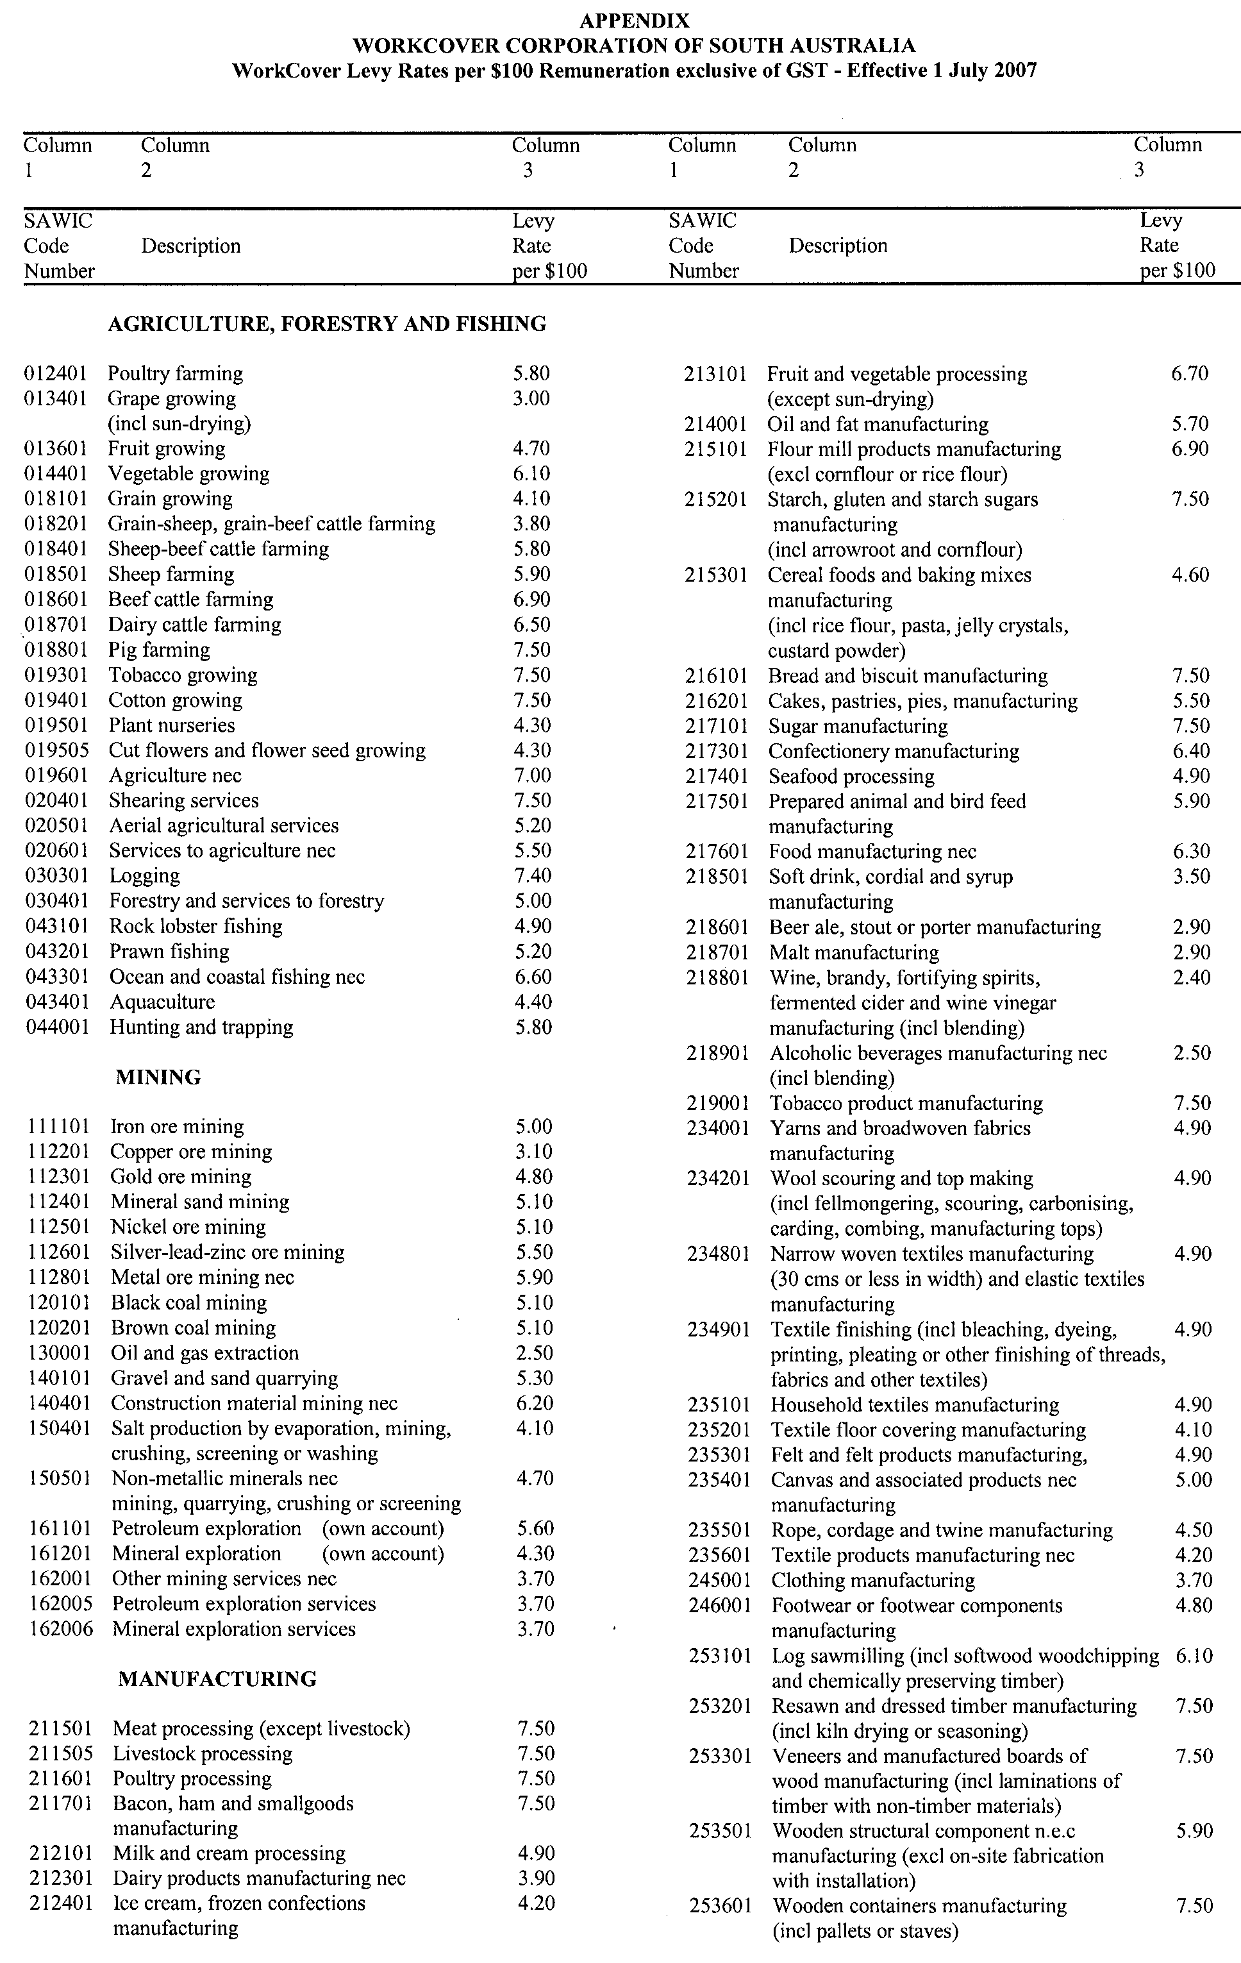
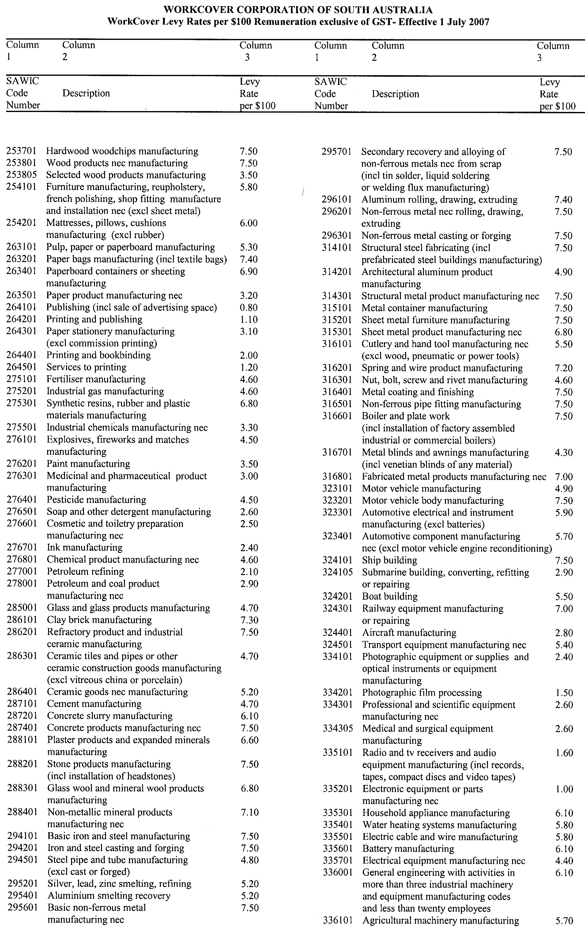
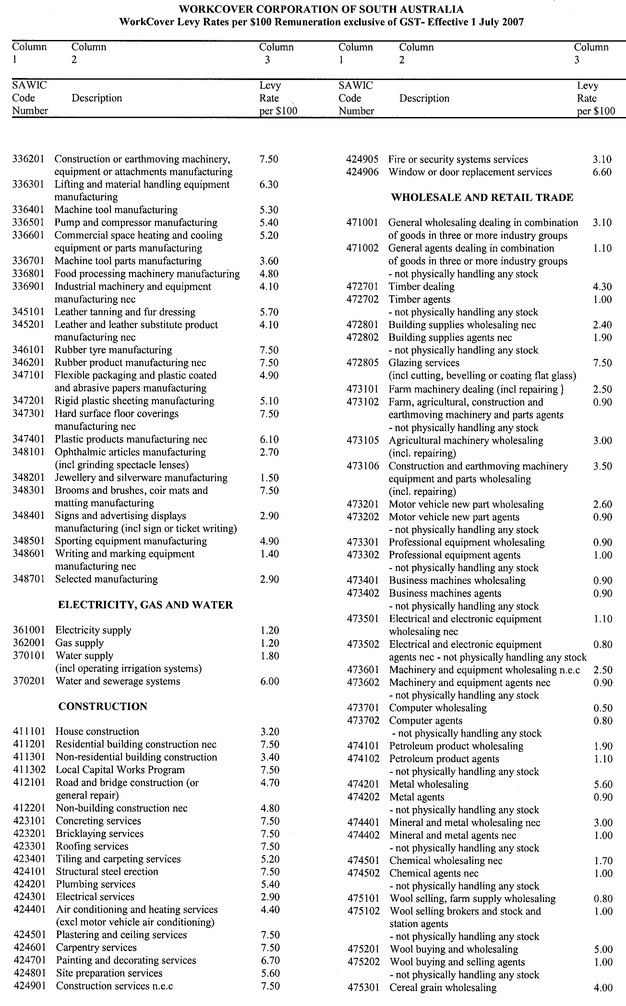
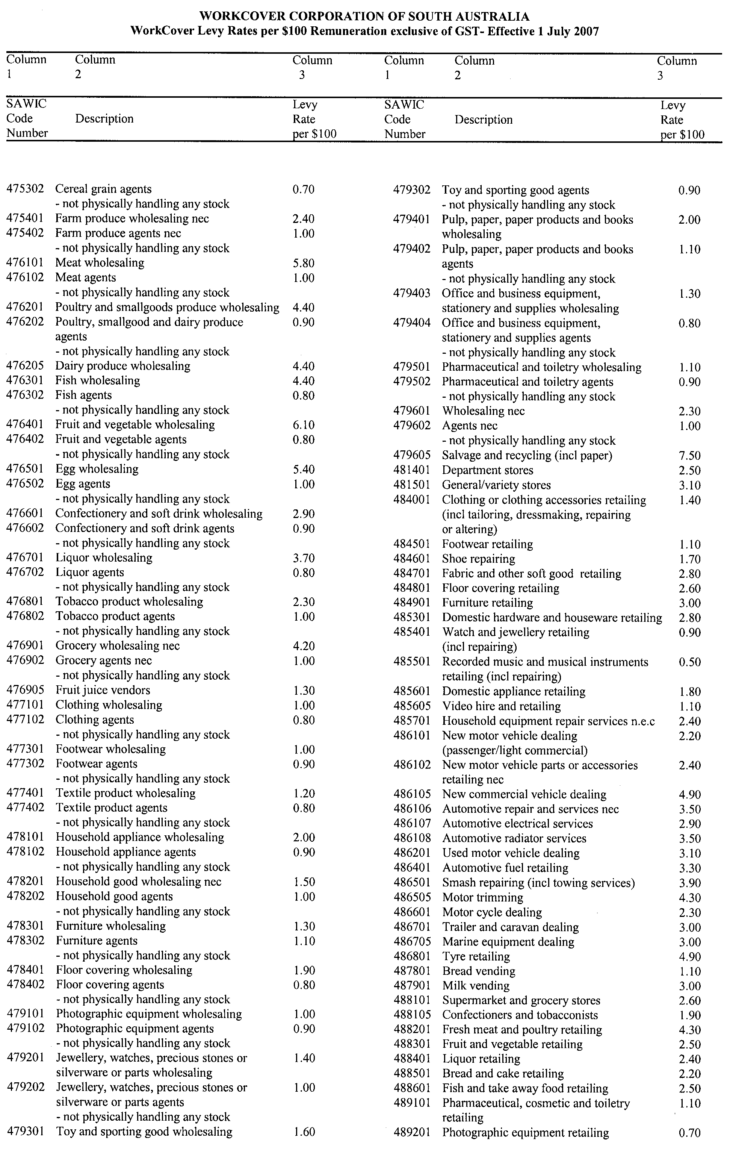
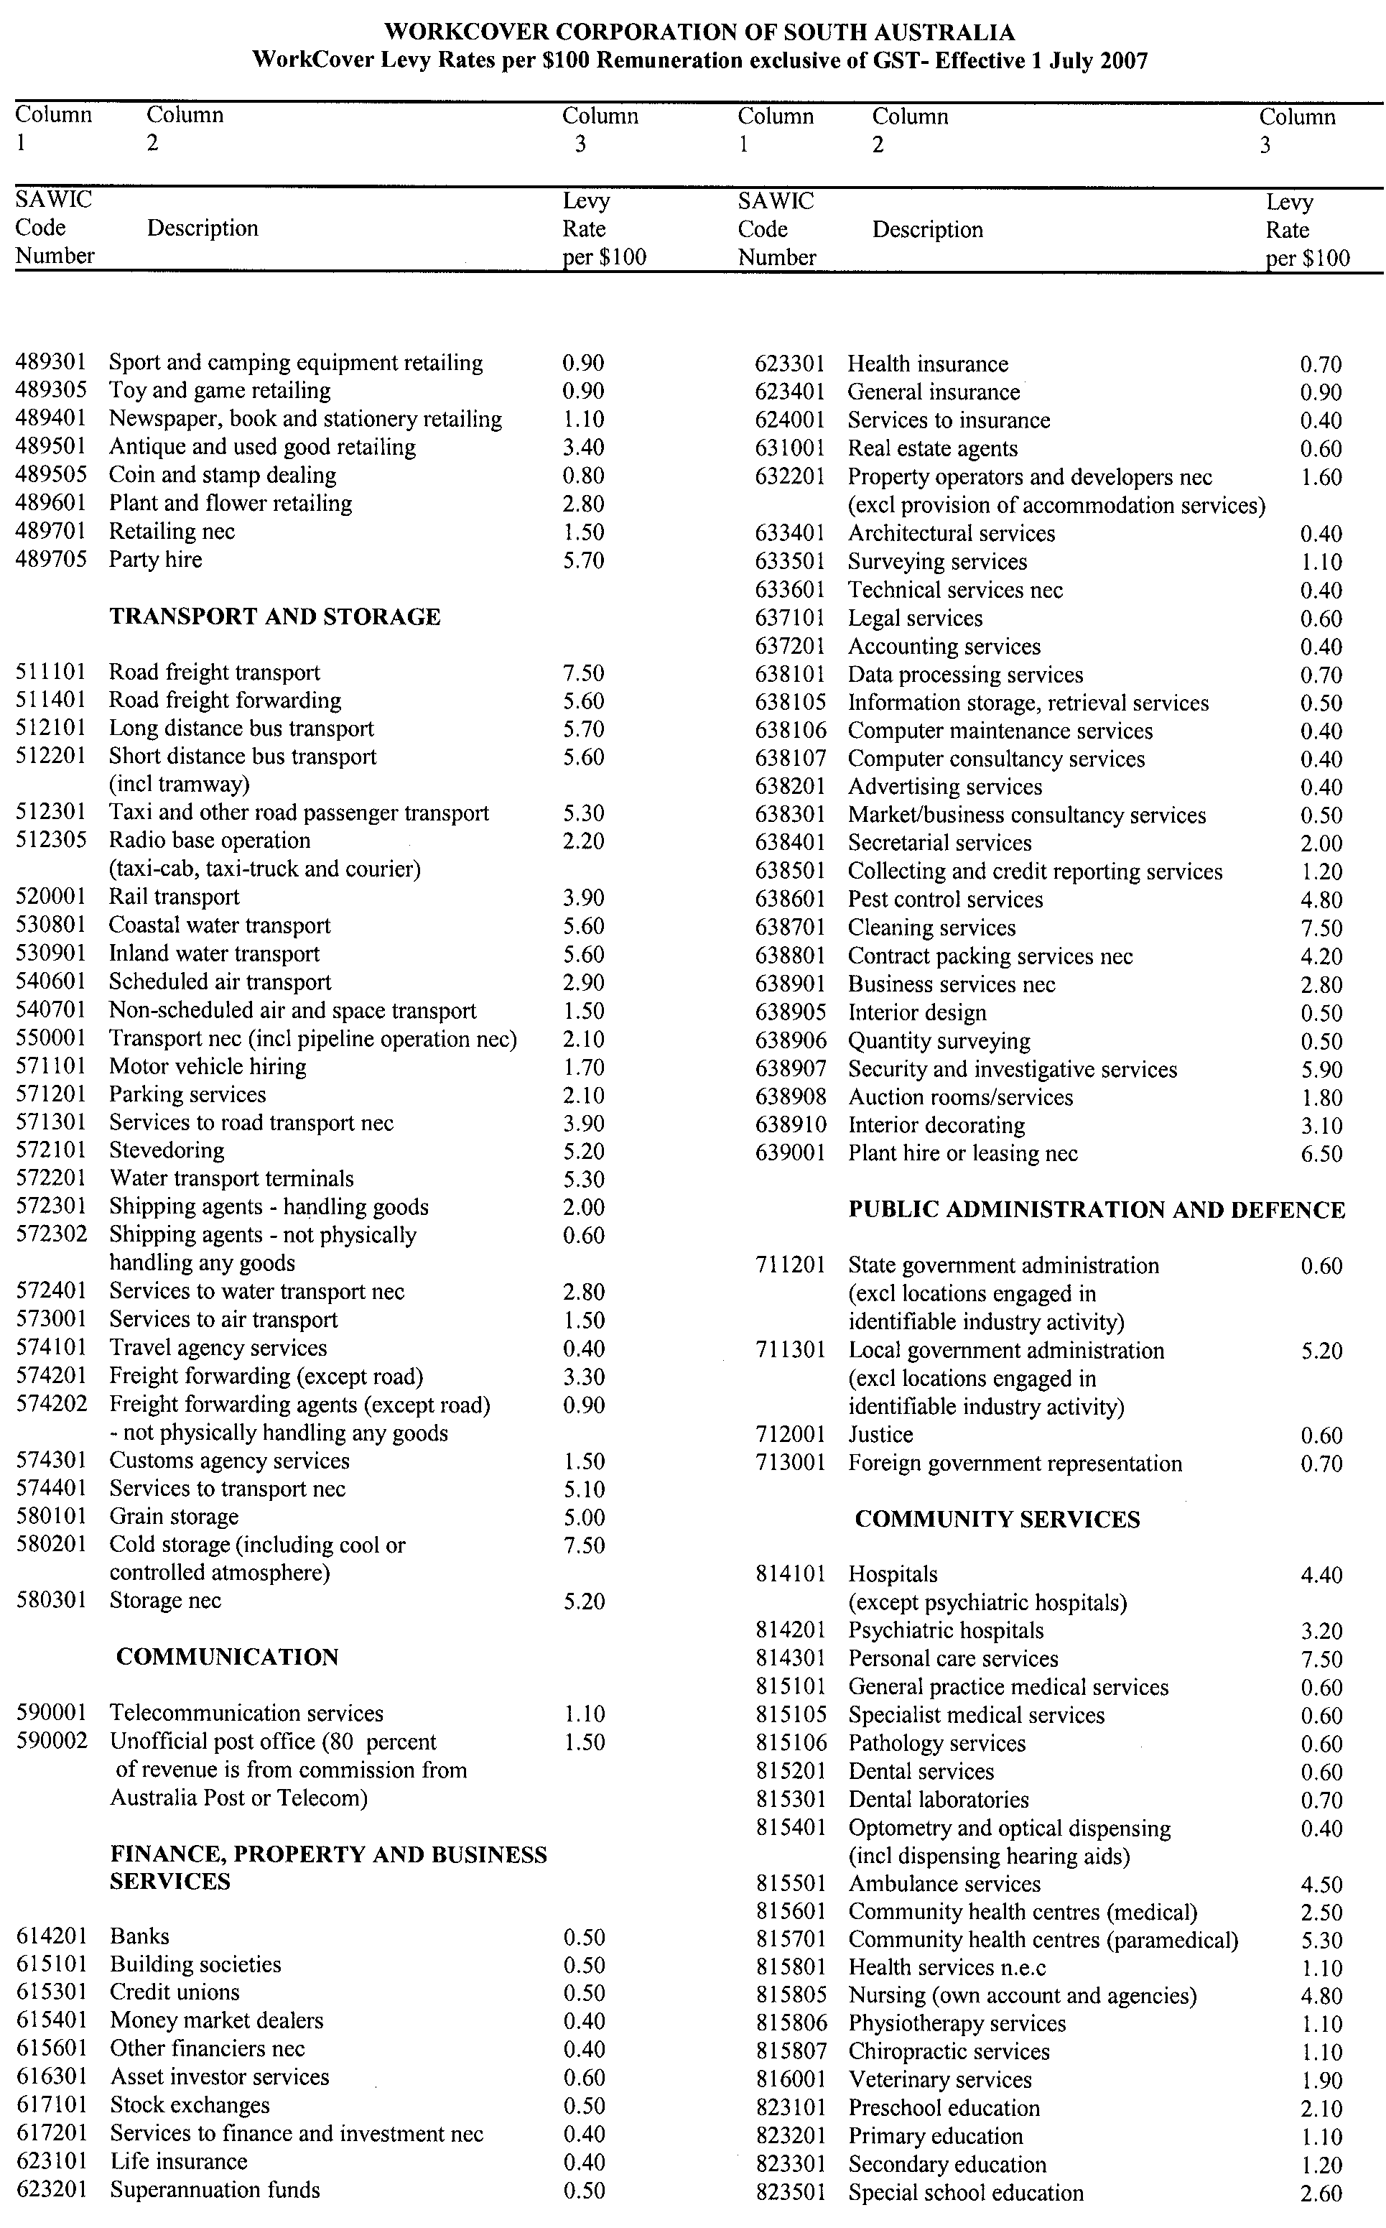
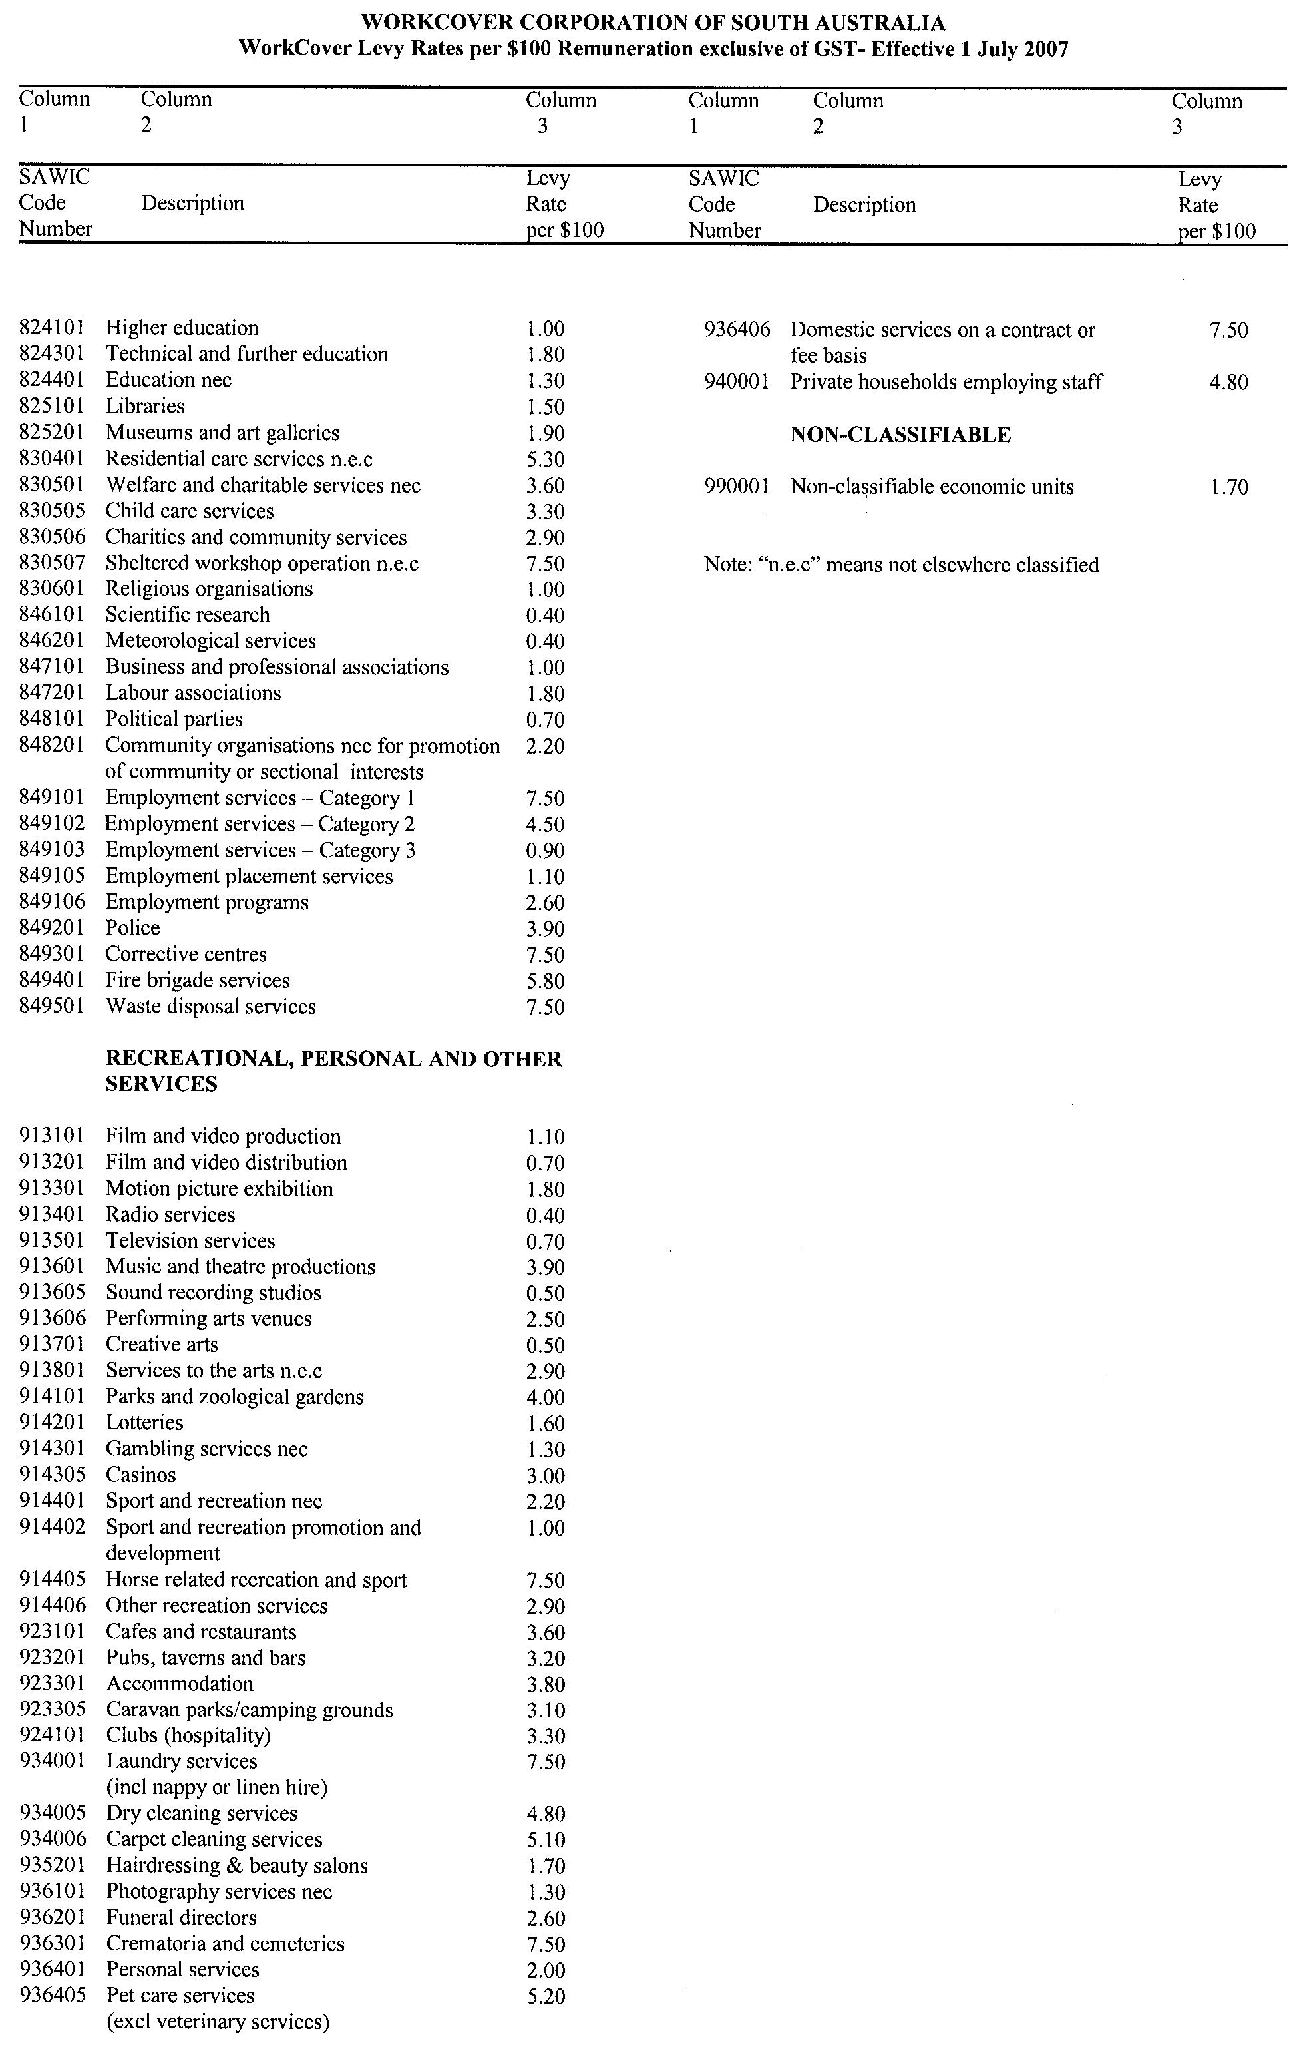
South Australia
Government Financing Authority (Declaration of Semi-Government Authorities) Proclamation 2007
under section 4 of the Government Financing Authority Act 1982
1—Short title
This proclamation may be cited as the Government Financing Authority (Declaration of Semi-Government Authorities) Proclamation 2007.
2—Commencement
This proclamation comes into operation on the day on which it is made.
3—Interpretation
In this proclamation—
Act means the Government Financing Authority Act 1982.
4—Revocation of all previous proclamations under section 4
All proclamations previously made under section 4 of the Act are revoked.
5—Declaration of semi-government authorities
Each of the bodies corporate set out in Schedule 1 is declared to be a semi-government authority for the purposes of the Act.
Schedule 1—Semi-government authorities

Ministers incorporated
Minister for Aboriginal Affairs and Reconciliation
Minister for Ageing
Minister for Agriculture, Food and Fisheries
Minister for the Arts
Minister for the City of Adelaide
Minister for Consumer Affairs
Minister for Correctional Services
Deputy Premier
Minister for Disability
Minister for Economic Development
Minister for Education and Children's Services
Minister for Emergency Services
Minister for Employment, Training and Further Education
Minister for Energy
Minister for Environment and Conservation
Minister for Families and Communities
Minister for Federal/State Relations
Minister for Finance
Minister for Forests
Minister for Gambling
Minister for Government Enterprises
Minister for Health
Minister for Housing
Minister for Industrial Relations
Minister for Industry and Trade
Minister for Infrastructure
Minister for Justice
Minister for Mental Health and Substance Abuse
Minister for Mineral Resources Development
Minister for Multicultural Affairs
Minister for Police
Minister for Recreation, Sport and Racing
Minister for Regional Development
Minister for the River Murray
Minister for Road Safety
Minister for Science and Information Economy
Minister for Small Business
Minister for Social Inclusion
Minister for the Southern Suburbs
Minister for State/Local Government Relations
Minister for Sustainability and Climate Change
Minister for Tourism
Minister for Transport
Treasurer
Minister for Urban Development and Planning
Minister for Volunteers
Minister for Water Security
Minister for Youth
Country Arts Trust and Boards
South Australian Country Arts Trust
Central Country Arts Board
Riverland/Mallee Country Arts Board
South East Country Arts Board
Western Country Arts Board
Health Units incorporated under South Australian Health Commission Act 1976
Balaklava and Riverton Districts Health Service Incorporated
Barossa Area Health Services Incorporated
Bordertown Memorial Hospital Incorporated
Burra Clare Snowtown Health Service Incorporated
Ceduna District Health Services Incorporated
Ceduna Koonibba Aboriginal Health Service Incorporated
Central Northern Adelaide Health Service Incorporated
Children, Youth and Women's Health Service Incorporated
Coober Pedy Hospital and Health Services
Country Health SA Incorporated
Eastern Eyre Health and Aged Care Incorporated
Eudunda & Kapunda Health Service Incorporated
Gawler Health Service Incorporated
Hawker Memorial Hospital Incorporated
Julia Farr Services
Kangaroo Island Health Service
Kingston Soldiers' Memorial Hospital Incorporated
Leigh Creek Health Services Incorporated
Lower Eyre Health Services Incorporated
Loxton Hospital Complex Incorporated
Mallee Health Service Incorporated
The Mannum District Hospital Incorporated
Meningie and Districts Memorial Hospital and Health Services Incorporated
Metropolitan Domiciliary Care
Mid North Health
Mid-West Health
Millicent and District Hospital and Health Services Incorporated
Mount Barker District Soldiers' Memorial Hospital Incorporated
Mount Gambier and Districts Health Service Incorporated
The Murray Bridge Soldiers' Memorial Hospital Incorporated
Naracoorte Health Service Incorporated
Northern Adelaide Hills Health Service Incorporated
Northern Yorke Peninsula Health Service
Penola War Memorial Hospital Incorporated
Pika Wiya Health Service
Port Augusta Hospital and Regional Health Services Incorporated
Port Broughton District Hospital and Health Services Incorporated
Port Lincoln Health Services Incorporated
Port Pirie Regional Health Service Incorporated
Quorn Health Services Incorporated
Renmark Paringa District Hospital Incorporated
Repatriation General Hospital Incorporated
Riverland Regional Health Service Incorporated
South Coast District Hospital Incorporated
Southern Adelaide Health Service Incorporated
Southern Flinders Health Incorporated
Strathalbyn & District Health Service
Tailem Bend District Hospital
Waikerie Health Services Incorporated
The Whyalla Hospital and Health Services Inc
Yorke Peninsula Health Service Incorporated
Natural Resources Management Boards
Adelaide and Mount Lofty Ranges Natural Resources Management Board
Alinytjara Wilurara Natural Resources Management Board
Eyre Peninsula Natural Resources Management Board
Kangaroo Island Natural Resources Management Board
Northern and Yorke Natural Resources Management Board
South Australian Arid Lands Natural Resources Management Board
South Australian Murray Darling Basin Natural Resources Management Board
South East Natural Resources Management Board
Bodies corporate established by regulation under Public Corporations Act 1993
Adelaide Convention Centre Corporation
Adelaide Entertainments Corporation
Adelaide Film Festival
Australian Children's Performing Arts Company
Bio Innovation SA
Distribution Lessor Corporation
Education Adelaide
Fire Equipment Services South Australia (FES SA)
Generation Lessor Corporation
Land Management Corporation
Playford Centre
Port Adelaide Maritime Corporation
South Australia Trade and Investment Corporation
2007 World Police and Fire Games Corporation
Other bodies corporate
Aboriginal Lands Trust
Adelaide Cemeteries Authority
Adelaide Festival Centre Trust
Adelaide Festival Corporation
The Architects Board of South Australia
The Art Gallery Board
Austraining International Pty Ltd
Board of the Botanic Gardens and State Herbarium
Carclew Youths Art Centre Incorporated
Carrick Hill Trust
Coast Protection Board
The Commissioners of Charitable Funds
Dairy Authority of South Australia
Dog and Cat Management Board
Dog Fence Board
Environment Protection Authority
The General Reserves Trust
History Trust of South Australia
HomeStart Finance
Institute of Medical and Veterinary Science
Legal Services Commission
Libraries Board of South Australia
Local Government Finance Authority of South Australia
Lotteries Commission of South Australia
Medical Board of South Australia
Museum Board
Nurses Board of South Australia
Outback Areas Community Development Trust
Phylloxera and Grape Industry Board of South Australia
Playford Capital Pty Ltd
Professional Standards Council
The Renmark Irrigation Trust
RESI Corporation
SA Ambulance Service Inc
Senior Secondary Assessment Board of South Australia
South Australian Aboriginal Housing Authority
South Australian Asset Management Corporation
South Australian Citrus Industry Development Board
South Australian Community Housing Authority
South Australian Country Fire Service
South Australian Film Corporation
South Australian Fire and Emergency Services Commission
South Australian Forestry Corporation
South Australian Health Commission
South Australian Housing Trust
South Australian Local Government Grants Commission
South Australian Metropolitan Fire Service
South Australian Motor Sport Board
South Australian State Emergency Service
South Australian Tourism Commission
South Australian Centre for Trauma and Injury Recovery Incorporated
South Eastern Water Conservation and Drainage Board
South Australian Water Corporation
State Courts Administration Council
The State Opera of South Australia
State Procurement Board
State Theatre Company of South Australia
TransAdelaide
West Beach Trust
Made by the Governor’s Deputy
with the advice and consent of the Executive Council
on 24 May 2007
T&F07/017CS

South Australia
Public Finance and Audit (Declaration of Semi-Government Authorities) Proclamation 2007
under section 17 of the Public Finance and Audit Act 1987
1—Short title
This proclamation may be cited as the Public Finance and Audit (Declaration of Semi-Government Authorities) Proclamation 2007.
2—Commencement
This proclamation comes into operation on the day on which it is made.
3—Interpretation
In this proclamation—
Act means the Public Finance and Audit Act 1987.
4—Revocation of all previous proclamations under section 17
All proclamations previously made under section 17 of the Act are revoked.
5—Declaration of semi-government authorities
Each of the bodies corporate set out in Schedule 1 is declared to be a semi-government authority for the purposes of the Act.
Schedule 1—Semi-government authorities

Ministers incorporated
Minister for Aboriginal Affairs and Reconciliation
Minister for Ageing
Minister for Agriculture, Food and Fisheries
Minister for the Arts
Minister for the City of Adelaide
Minister for Consumer Affairs
Minister for Correctional Services
Deputy Premier
Minister for Disability
Minister for Economic Development
Minister for Education and Children's Services
Minister for Emergency Services
Minister for Employment, Training and Further Education
Minister for Energy
Minister for Environment and Conservation
Minister for Families and Communities
Minister for Federal/State Relations
Minister for Finance
Minister for Forests
Minister for Gambling
Minister for Government Enterprises
Minister for Health
Minister for Housing
Minister for Industrial Relations
Minister for Industry and Trade
Minister for Infrastructure
Minister for Justice
Minister for Mental Health and Substance Abuse
Minister for Mineral Resources Development
Minister for Multicultural Affairs
Minister for Police
Minister for Recreation, Sport and Racing
Minister for Regional Development
Minister for the River Murray
Minister for Road Safety
Minister for Science and Information Economy
Minister for Small Business
Minister for Social Inclusion
Minister for the Southern Suburbs
Minister for State/Local Government Relations
Minister for Sustainability and Climate Change
Minister for Tourism
Minister for Transport
Treasurer
Minister for Urban Development and Planning
Minister for Volunteers
Minister for Water Security
Minister for Youth
Country Arts Trust and Boards
South Australian Country Arts Trust
Central Country Arts Board
Riverland/Mallee Country Arts Board
South East Country Arts Board
Western Country Arts Board
Health Units incorporated under South Australian Health Commission Act 1976
Balaklava and Riverton Districts Health Service Incorporated
Barossa Area Health Services Incorporated
Bordertown Memorial Hospital Incorporated
Burra Clare Snowtown Health Service Incorporated
Ceduna District Health Services Incorporated
Ceduna Koonibba Aboriginal Health Service Incorporated
Central Northern Adelaide Health Service Incorporated
Children, Youth and Women's Health Service Incorporated
Coober Pedy Hospital and Health Services
Country Health SA Incorporated
Eastern Eyre Health and Aged Care Incorporated
Eudunda & Kapunda Health Service Incorporated
Gawler Health Service Incorporated
Hawker Memorial Hospital Incorporated
Julia Farr Services
Kangaroo Island Health Service
Kingston Soldiers' Memorial Hospital Incorporated
Leigh Creek Health Services Incorporated
Lower Eyre Health Services Incorporated
Loxton Hospital Complex Incorporated
Mallee Health Service Incorporated
The Mannum District Hospital Incorporated
Meningie and Districts Memorial Hospital and Health Services Incorporated
Metropolitan Domiciliary Care
Mid North Health
Mid-West Health
Millicent and District Hospital and Health Services Incorporated
Mount Barker District Soldiers' Memorial Hospital Incorporated
Mount Gambier and Districts Health Service Incorporated
The Murray Bridge Soldiers' Memorial Hospital Incorporated
Naracoorte Health Service Incorporated
Northern Adelaide Hills Health Service Incorporated
Northern Yorke Peninsula Health Service
Penola War Memorial Hospital Incorporated
Pika Wiya Health Service
Port Augusta Hospital and Regional Health Services Incorporated
Port Broughton District Hospital and Health Services Incorporated
Port Lincoln Health Services Incorporated
Port Pirie Regional Health Service Incorporated
Quorn Health Services Incorporated
Renmark Paringa District Hospital Incorporated
Repatriation General Hospital Incorporated
Riverland Regional Health Service Incorporated
South Coast District Hospital Incorporated
Southern Adelaide Health Service Incorporated
Southern Flinders Health Incorporated
Strathalbyn & District Health Service
Tailem Bend District Hospital
Waikerie Health Services Incorporated
The Whyalla Hospital and Health Services Inc
Yorke Peninsula Health Service Incorporated
Natural Resources Management Boards
Adelaide and Mount Lofty Ranges Natural Resources Management Board
Alinytjara Wilurara Natural Resources Management Board
Eyre Peninsula Natural Resources Management Board
Kangaroo Island Natural Resources Management Board
Northern and Yorke Natural Resources Management Board
South Australian Arid Lands Natural Resources Management Board
South Australian Murray Darling Basin Natural Resources Management Board
South East Natural Resources Management Board
Bodies corporate established by regulation under Public Corporations Act 1993
Adelaide Convention Centre Corporation
Adelaide Entertainments Corporation
Adelaide Film Festival
Australian Children's Performing Arts Company
Bio Innovation SA
Distribution Lessor Corporation
Education Adelaide
Fire Equipment Services South Australia (FES SA)
Generation Lessor Corporation
Land Management Corporation
Playford Centre
Port Adelaide Maritime Corporation
South Australia Trade and Investment Corporation
2007 World Police and Fire Games Corporation
Other bodies corporate
Aboriginal Lands Trust
Adelaide Cemeteries Authority
Adelaide Festival Centre Trust
Adelaide Festival Corporation
The Architects Board of South Australia
The Art Gallery Board
Austraining International Pty Ltd
Board of the Botanic Gardens and State Herbarium
Carclew Youths Art Centre Incorporated
Carrick Hill Trust
Coast Protection Board
The Commissioners of Charitable Funds
Dairy Authority of South Australia
Dog and Cat Management Board
Dog Fence Board
Environment Protection Authority
The General Reserves Trust
History Trust of South Australia
HomeStart Finance
Institute of Medical and Veterinary Science
Legal Services Commission
Libraries Board of South Australia
Local Government Finance Authority of South Australia
Lotteries Commission of South Australia
Medical Board of South Australia
Motor Accident Commission
Museum Board
Nurses Board of South Australia
Outback Areas Community Development Trust
Phylloxera and Grape Industry Board of South Australia
Playford Capital Pty Ltd
Professional Standards Council
Public Trustee
The Renmark Irrigation Trust
RESI Corporation
SA Ambulance Service Inc
Senior Secondary Assessment Board of South Australia
South Australian Aboriginal Housing Authority
South Australian Asset Management Corporation
South Australian Citrus Industry Development Board
South Australian Community Housing Authority
South Australian Country Fire Service
South Australian Film Corporation
South Australian Fire and Emergency Services Commission
South Australian Forestry Corporation
South Australian Government Financing Authority
South Australian Health Commission
South Australian Housing Trust
South Australian Local Government Grants Commission
South Australian Metropolitan Fire Service
South Australian Motor Sport Board
South Australian Parliamentary Superannuation Board
South Australian State Emergency Service
South Australian Tourism Commission
South Australian Centre for Trauma and Injury Recovery Incorporated
South Eastern Water Conservation and Drainage Board
South Australian Water Corporation
State Courts Administration Council
The State Opera of South Australia
State Procurement Board
State Theatre Company of South Australia
Superannuation Funds Management Corporation of South Australia
TransAdelaide
West Beach Trust
Made by the Governor’s Deputy
with the advice and consent of the Executive Council
on 24 May 2007
T&F07/017CS

South Australia
Opal Mining (Reservation from Act) Proclamation 2007
under section 4 of the Opal Mining Act 1995
1—Short title
This proclamation may be cited as the Opal Mining (Reservation from Act) Proclamation 2007.
2—Commencement
This proclamation comes into operation on the day on which it is made.
3—Reservation of land from provisions of Act
The area of land defined in Schedule 1 is reserved from the operation of Parts 2, 3 and 4 of the Opal Mining Act 1995.
Schedule 1—Land reserved from provisions of Act
1—Crocodile Harry's area
The area bounded by a line joining the points of the coordinates set out in the following table:

AMG Zone 53
470757mE | 6793826mN
470789mE | 6793728mN
470827mE | 6793732mN
470857mE | 6793853mN
470815mE | 6793877mN
470757mE | 6793826mN
Made by the Governor’s Deputy
with the advice and consent of the Executive Council
on 24 May 2007
MMRD07/006CS

South Australia
Mining (Reservation from Act) Proclamation 2007
under section 8 of the Mining Act 1971
1—Short title
This proclamation may be cited as the Mining (Reservation from Act) Proclamation 2007.
2—Commencement
This proclamation comes into operation on the day on which it is made.
3—Reservation of land from provisions of Act
The area of land defined in Schedule 1 is reserved from the operation of Parts 4, 5, 6, 6A and 8 of the Mining Act 1971.
Schedule 1—Land reserved from provisions of Act
1—Crocodile Harry's area
The area bounded by a line joining the points of the coordinates set out in the following table:

AMG Zone 53
470757mE | 6793826mN
470789mE | 6793728mN
470827mE | 6793732mN
470857mE | 6793853mN
470815mE | 6793877mN
470757mE | 6793826mN
Made by the Governor’s Deputy
with the advice and consent of the Executive Council
on 24 May 2007
MMRD07/006CS

FAXING COPY?
IF you fax copy to Government Publishing SA for inclusion in the Government Gazette, there is no need to send a Confirmation Copy to us as well.
This creates confusion and may well result in your notice being printed twice.
Please use the following fax number:
Fax transmission: (08) 8207 1040
Phone Inquiries: (08) 8207 1045
Please include a contact person, phone number and order number so that we can phone back with any queries we may have regarding the fax copy.
NOTE: Closing time for lodging new copy (fax, hard copy or email) is 4 p.m. on Tuesday preceding the day of publication.

Government Gazette notices can be E-mailed.
The address is:
governmentgazette@dpc.sa.gov.au
Documents should be sent as attachments in Word format.
When sending a document via E-mail, please confirm your transmission with a faxed copy of your document, including the date the notice is to be published.
Fax transmission: (08) 8207 1040
Enquiries: (08) 8207 1045
NOTE: Closing time for lodging new copy (fax, hard copy or email) is 4 p.m. on Tuesday preceding the day of publication.

CITY OF MITCHAM
Roads (Opening and Closing) Act 1991
Road Closure—Burnell Drive, Belair
NOTICE is hereby given, pursuant to section 10 of the Roads (Opening and Closing) Act 1991, that the City of Mitcham proposes to make a Road Process Order to close portion of Burnell Drive and merge with adjoining allotment 200 in Deposited Plan 64117 as delineated and lettered ‘A’ on Preliminary Plan No. 06/0087.
A copy of the plan and a statement of persons affected are available for public inspection at the Council Offices, 131 Belair Road, Torrens Park, S.A. 5062 and the Adelaide office of the Surveyor-General during normal office hours.
Any application for easement or objection must set out the full name, address and details of the submission and must be fully supported by reasons.
The application for easement or objection must be made in writing to the Council, P.O. Box 21, Mitcham Shopping Centre, Torrens Park, S.A. 5062 within 28 days of this notice and a copy must be forwarded to the Surveyor-General, G.P.O. Box 1354, Adelaide, S.A. 5001. Where a submission is made, the Council will give notification of a meeting at which the matter will be considered.
Dated 2 May 2007.
R. Malcolm, City Manager

CLARE & GILBERT VALLEYS COUNCIL
Temporary Road Closure
NOTICE is hereby given that at the Council’s meeting on 21 May 2007, pursuant to section 33 of the Road Traffic Act 1961, the following road closure was approved:
Old North Road, Clare, from the southern side of Ness Street to the northern side of Mill Street to be closed between 7 a.m. and 5 p.m. on Monday, 28 May 2007, for the purpose of staging the Australian Women’s Weekly and Commonwealth Bank ‘On the Road’ with Today Road Train event.
M. Goldstone, Chief Executive Officer

COORONG DISTRICT COUNCIL
Close of Roll for Supplementary Election—
Resignation of Councillor
NOTICE is hereby given in accordance with section 54 (6) of the Local Government Act 1999, that a vacancy has occurred in the office of Councillor for Mallee Ward, due to the resignation of Councillor Heather Moore, to take effect from 2 May 2007.
T. Drew, Chief Executive Officer

COORONG DISTRICT COUNCIL
DUE to the resignation of a member of the Council, a supplementary election will be necessary to fill the vacancy of Councillor for Mallee Ward.
The voters roll to conduct this supplementary election will close at 5 p.m., on Thursday, 31 May 2007.
Nominations to fill the vacancy will open on Thursday, 28 June 2007 and will be received up until 12 noon on Thursday, 12 July 2007.
K. Mousley, Returning Officer

DISTRICT COUNCIL OF YANKALILLA
Alteration of Road Name
NOTICE is hereby given that pursuant to section 219 of the Local Government Act 1999, Council at its meeting held on 17 May 2007, resolved to alter the road name of Myponga Beach Road between the intersection of Myponga Beach Road and Pine Hill Road and the intersection of Myponga Beach Road and Main South Road to Forktree Road.
R. D. Sweetman, Chief Executive

IN the matter of the estates of the undermentioned deceased persons:
Anchor, Dora Eveline, late of 7 Salisbury Highway, Salisbury, retired nursing sister, who died on 7 December 2006.
Anchor, James, late of 7 Salisbury Highway, Salisbury, retired records clerk, who died on 23 December 2006.
Bitmead, Doris Caroline, late of 333 Marion Road, North Plympton, married woman, who died on 20 March 2007.
Borgkvist, Hilda May, late of 39 Finniss Street, Marion, widow, who died on 3 February 2007.
Burchell, Lotte, late of 333 Marion Road, North Plympton, of no occupation, who died on 27 February 2007.
Critchley, Myra, late of 72 Belair Road, Hawthorn, of no occupation, who died on 9 April 2007.
Godson, Kenneth George, late of 5 Bradford Court, Enfield, retired carpenter, who died on 27 March 2007.
Hugo, Phyllis Odette Marjorebanks, late of 34 Grange Road, West Hindmarsh, of no occupation, who died on 10 February 2007.
Ling, Edward Kingsley, late of 29 Austral Terrace, Morphettville, retired metal turner, who died on 20 February 2007.
Piantedosi, Carmine, late of 26 South Street, Hectorville, retired mental health nurse, who died on 8 March 2007.
Stone, Richard James, late of 6 Cromer Street, Camden Park, retired sales representative, who died on 1 April 2007.
Notice is hereby given pursuant to the Trustee Act 1936, as amended, the Inheritance (Family Provision) Act 1972, and the Family Relationships Act 1975, that all creditors, beneficiaries, and other persons having claims against the said estates are required to send, in writing, to the Public Trustee, 25 Franklin Street, Adelaide, S.A. 5000, full particulars and proof of such claims, on or before 22 June 2007, otherwise they will be excluded from the distribution of the said estate; and notice is also hereby given that all persons who are indebted to the said estates are required to pay the amount of their debts to the Public Trustee or proceedings will be taken for the recovery thereof; and all persons having any property belonging to the said estates are forthwith to deliver the same to the Public Trustee.
Dated 24 May 2007.
C. J. O’Loughlin, Public Trustee

ATTENTION

CUSTOMERS requiring a proof of their notice for inclusion in the Government Gazette, please note that the onus is on you to inform Government Publishing SA of any subsequent corrections by 10 a.m. on Thursday, which is our publication deadline.

For any corrections to your notice please phone 8207 1045 or Fax 8207 1040 before 10 a.m. on Thursday.

If we do not receive any communication by 10 a.m. on Thursday (day of publication) we will presume the notice is correct and will print it as it is.

Remember—the onus is on you to inform us of any corrections necessary to your notice.

NOTE: Closing time for lodging new copy (electronically, fax or hard copy) is 4 p.m. on Tuesday preceding the day of publication. Phone 8207 1045—Fax 8207 1040.
Email: governmentgazette@dpc.sa.gov.au

Printed and published by authority every Thursday by T. GOODES, Government Printer, South Australia
Price: $5.20, plus postage; to subscribers, $263.00 per annum.
(The above prices are inclusive of GST)

