No. 31 2175

THE SOUTH AUSTRALIAN

GOVERNMENT GAZETTE
www.governmentgazette.sa.gov.au

PUBLISHED BY AUTHORITY

ALL PUBLIC ACTS appearing in this GAZETTE are to be considered official, and obeyed as such

ADELAIDE, THURSDAY, 31 MAY 2007

CONTENTS

Page
Appointments, Resignations, Etc. 2176
Building Work Contractors Act 1995—Notice 2176
Compulsory Third Party Insurance Premium—Notice 2211
Corporations and District Councils—Notices 2228
Development Act 1993—Notice 2177
Environment Protection Act 1993—Notice 2179
Explosives Act 1936—Notices 2177
Land and Business (Sale and Conveyancing) Act 1994—
Notices 2177
Libraries Board of South Australia—Notice 2180
Liquor Licensing Act 1997—Notices 2187
Mining Act 1971—Notices 2194
National Electricity Law—Notice 2195
National Parks and Wildlife Act 1972—Notice 2195
Passenger Transport Act 1994—Notices 2195
Petroleum Act 2000—Notices 2196
Port Augusta Circuit Court—Notice 2199

Page
Proclamations 2216
Public Trustee Office—Administration of Estates 2228
REGULATIONS
Liquor Licensing Act 1997 (No. 63 of 2007) 2218
Harbors and Navigation Act 1993 (No. 64 of 2007) 2222
Controlled Substances Act 1984 (No. 65 of 2007) 2225
Roads (Opening and Closing) Act 1991—Notices 2201
Road Traffic Act 1961—Notices 2203
RULES OF COURT
Magistrates Court (Amendment No. 28) Rules 1992 2192
Unclaimed Moneys Act 1891—Notice 2229
Valuation of Land Act 1971—Notice 2213
Water Mains and Sewers—Mains Laid, Replaced, Etc. 2213
Wheat Marketing Act 1989—Notices 2214
Workers Rehabilitation and Compensation Act 1986—
Notice 2215

GOVERNMENT GAZETTE NOTICES
ALL poundkeepers’ and private advertisements forwarded for publication in the South Australian Government Gazette must be PAID FOR PRIOR TO INSERTION; and all notices, from whatever source, should be legibly written on one side of the paper only and sent to Government Publishing SA so as to be received no later
than 4 p.m. on the Tuesday preceding the day of publication. Phone 8207 1045 or Fax 8207 1040. E-mail: governmentgazette@dpc.sa.gov.au. Send as attachments in Word format and please confirm your transmission with a faxed copy of your document, including the date the notice is to be published and to whom the notice will be charged. The Government Gazette is available online at: www.governmentgazette.sa.gov.au

Department of the Premier and Cabinet
Adelaide, 31 May 2005
HER Excellency the Governor in Executive Council has been pleased to appoint the undermentioned to the Firearms Consultative Committee, pursuant to the provisions of the Firearms Act 1977:
Member: (from 31 May 2007 until 14 April 2009)
Robert Wilfred Hamdorf
Andrew Henry Lenthal Swifte
Jeanine Baker
Geoffrey O’Halloran Hyde
Yvonne Hill
Susan Anne Hofmann Ahrns
Deputy Member: (from 31 May 2007 until 14 April 2009)
Owen Llewelyn Willett Bevan (Deputy to Hamdorf)
Kenneth Francis Wigglesworth (Deputy to Baker)
Ingrid Wangel (Deputy to Hyde)
Richard Warrick (Deputy to Ahrns)
David Nathan Hillan (Deputy to Hill)
Chair: (from 31 May 2007 until 14 April 2009)
Robert Wilfred Hamdorf
By command,
Gail Gago, for Premier
MPOL07/006CS

Department of the Premier and Cabinet
Adelaide, 31 May 2007
HER Excellency the Governor in Executive Council has been pleased to appoint the undermentioned to the South Australian Government Financing Advisory Board (SAFA), pursuant to the provisions of the Government Financing Authority Act 1982:
Member: (from 9 June 2007 until 8 June 2009)
Barry Ross Brownjohn
Member: (from 3 August 2007 until 8 June 2009)
Leonard Raymond Foster
By command,
Gail Gago, for Premier
TF07/039CS

Department of the Premier and Cabinet
Adelaide, 31 May 2007
HER Excellency the Governor in Executive Council has revoked the appointment of Stephen Hamnett as a part-time Commissioner of the Environment, Resources and Development Court of South Australia, designated as a Commissioner for the purposes of the Court’s jurisdiction under the Development Act 1993, effective from 5 August 2007, pursuant to the Environment, Resources and Development Court Act 1993 and Section 36 of the Acts Interpretation Act 1915.
By command,
Gail Gago, for Premier
AGO0177/03CS

Department of the Premier and Cabinet
Adelaide, 31 May 2007
HER Excellency the Governor in Executive Council has been pleased to appoint John David Hodgson and Stephen Hamnett as part-time Commissioners of the Environment, Resources and Development Court of South Australia, effective from 5 August 2007, pursuant to Section 10 of the Environment, Resources and Development Court Act 1993.
By command,
Gail Gago, for Premier
AGO0177/03CS

Department of the Premier and Cabinet
Adelaide, 31 May 2007
HER Excellency the Governor in Executive Council has been pleased to appoint the Honourable John David Wickham Ridgway, MLC, as a Justice of the Peace for South Australia effective from 31 May 2007 for the term during which he also holds office as a Member of the Parliament of South Australia, pursuant to Section 5 of the Justices of the Peace Act 2005.
By command,
Gail Gago, for Premier
AGO0135/06CS

BUILDING WORK CONTRACTORS ACT 1995
Exemption
TAKE notice that pursuant to section 45 of the Building Work Contractors Act 1995, I, Mark Bodycoat, Commissioner for Consumer Affairs, do hereby exempt the licensee named in Schedule 1 from the application of Division 3 of Part 5 of the above Act in relation to domestic building work described in Schedule 2 and subject to the conditions specified in Schedule 3.
Schedule 1
Dominic Scutella, BLD 8864.
Schedule 2
Construction of a house at 31 Seaview Street, Aldinga Beach, S.A. 5173.
Schedule 3
1. This exemption is limited to the domestic building work personally performed by the licensee for the construction of a house, intended to be the family home for the licensee and his wife on land situated at 31 Seaview Street, Aldinga Beach, S.A. 5173 (certificate of title book volume 5622, folio 579).
2. This exemption does not apply to any domestic building work the licensee sub-contracts to another building work contractor, for which that contractor is required by law to hold building indemnity insurance.
3. The licensee does not transfer his interest in the land prior to five years from the date of completion of the building work the subject of this exemption, without the prior authorisation of the Commissioner for Consumer Affairs. Before giving such authorisation, the Commissioner for Consumer Affairs may require the licensees to take any reasonable steps to protect the future purchaser(s) of the property, including but not limited to:
• providing evidence that an adequate policy of building indemnity insurance is in force to cover the balance of the five-year period from the date of completion of the building work the subject of this exemption;
• providing evidence of an independent expert inspection of the building work the subject of this exemption;
• making an independent expert report available to pros-pective purchasers of the property; and
• giving prospective purchasers of the property notice of the absence of a policy of building indemnity insurance.
Dated 22 May 2007.
M. Bodycoat, Commissioner for Consumer Affairs, Office of Consumer and Business Affairs, delegate of the Minister for Consumer Affairs
Ref.: 610/07-00030

DEVELOPMENT ACT 1993, SECTION 25 (17): MID MURRAY COUNCIL—MANNUM NEIGHBOURHOOD CENTRE PLAN AMENDMENT
Preamble
1. The Development Plan amendment entitled ‘Mid Murray Council—Mannum Neighbourhood Centre Plan Amendment’ (the Plan Amendment) has been finalised in accordance with the provisions of the Development Act 1993.
2. The Minister for Urban Development and Planning has decided to approve the Plan Amendment.
Notice
PURSUANT to section 25 of the Development Act 1993, I—
(a) approve the Plan Amendment; and
(b) fix the day on which this notice is published in the Gazette as the day on which the Plan Amendment will come into operation.
Dated 31 May 2007.
Paul Holloway, Minister for Urban Development and Planning

EXPLOSIVES ACT 1936
Appointments
I, MICHAEL JOHN WRIGHT, Minister for Industrial Relations in and for the State of South Australia, hereby appoint each of the following persons as an Inspector of Explosives for the purposes of the Explosives Act 1936, pursuant to section 9 of the Explosives Act 1936:
David James Cabrera
Merilyn May Lane
Peter Charles Lane
David Howard Marsh
Peter James Powell
Dated 28 May 2007.
M. Wright, Minister for Industrial Relations

EXPLOSIVES ACT 1936
Revocation
I, MICHAEL JOHN WRIGHT, Minister for Industrial Relations in and for the State of South Australia, hereby revoke the following person as an Inspector of Explosives for the purposes of the Explosives Act 1936, pursuant to section 9 of the Explosives Act 1936:
Geoffrey Allan Price
Dated 28 May 2007.
M. Wright, Minister for Industrial Relations

LAND AND BUSINESS (SALE AND CONVEYANCING)
ACT 1994
Exemption
TAKE notice that, pursuant to section 23 (3) of the Land and Business (Sale and Conveyancing) Act 1994, I, Jennifer Rankine, Minister for Consumer Affairs, do hereby exempt the person named in Schedule 1 from the application of section 23 (2) of the Act in relation to the purchase of the land specified in Schedule 2.
Schedule 1
David Stuart Cook, an employee of Mark Forde Pty Ltd.
Schedule 2
The land described in certificate of title register book volume 5772, folio 534, situated at 47 Victoria Road, Clare, S.A. 5453.
Dated 31 May 2007.
Jennifer Rankine, Minister for Consumer Affairs

LAND AND BUSINESS (SALE AND CONVEYANCING)
ACT 1994
Exemption
TAKE notice that, pursuant to section 23 (3) of the Land and Business (Sale and Conveyancing) Act 1994, I, Jennifer Rankine, Minister for Consumer Affairs, do hereby exempt the person named in Schedule 1 from the application of section 23 (2) of the Act in relation to the purchase of the land specified in Schedule 2.
Schedule 1
Dennis Maiden, an employee of Gawler Real Estate Pty Ltd.
Schedule 2
The land described in certificate of title register book volume 5806, folio 569, situated at 51 Second Street, Gawler South, S.A. 5118.
Dated 31 May 2007.
Jennifer Rankine, Minister for Consumer Affairs

LAND AND BUSINESS (SALE AND CONVEYANCING)
ACT 1994
Exemption
TAKE notice that, pursuant to section 23 (3) of the Land and Business (Sale and Conveyancing) Act 1994, I, Jennifer Rankine, Minister for Consumer Affairs, do hereby exempt the person named in Schedule 1 from the application of section 23 (2) of the Act in relation to the purchase of the land specified in Schedule 2.
Schedule 1
Elizabeth Mary Short, an employee of Southern State Realty Pty Ltd.
Schedule 2
The land described in a portion of certificate of title register book volume 5457, folio 269, situated at Lot 52, Jolly Miller Avenue, Goolwa, S.A. 5214.
Dated 31 May 2007.
Jennifer Rankine, Minister for Consumer Affairs

LAND AND BUSINESS (SALE AND CONVEYANCING)
ACT 1994
Exemption
TAKE notice that, pursuant to section 23 (3) of the Land and Business (Sale and Conveyancing) Act 1994, I, Jennifer Rankine, Minister for Consumer Affairs, do hereby exempt the person named in Schedule 1 from the application of section 23 (2) of the Act in relation to the purchase of the land specified in Schedule 2.
Schedule 1
Brian John Spring, an officer of Keatley Real Estate Pty Ltd.
Schedule 2
The whole of the land described in certificate of title register book volume 5791, folio 717, situated at 45 Dalkeith Drive, Mount Gambier, S.A. 5290.
Dated 31 May 2007.
Jennifer Rankine, Minister for Consumer Affairs

LAND AND BUSINESS (SALE AND CONVEYANCING)
ACT 1994
Exemption
TAKE notice that, pursuant to section 23 (3) of the Land and Business (Sale and Conveyancing) Act 1994, I, Jennifer Rankine, Minister for Consumer Affairs, do hereby exempt the person named in Schedule 1 from the application of section 23 (2) of the Act in relation to the purchase of the land specified in Schedule 2.
Schedule 1
Cindy Louise Featonby, an employee of Mark Forde Pty Ltd.
Schedule 2
The whole of the land described in certificate of title register book volume 5096, folio 6, situated at Lot 4, Neagles Rock Road, Clare, S.A. 5453.
Dated 31 May 2007.
Jennifer Rankine, Minister for Consumer Affairs

LAND AND BUSINESS (SALE AND CONVEYANCING)
ACT 1994
Exemption
TAKE notice that, pursuant to section 23 (3) of the Land and Business (Sale and Conveyancing) Act 1994, I, Jennifer Rankine, Minister for Consumer Affairs, do hereby exempt the person named in Schedule 1 from the application of section 23 (2) of the Act in relation to the purchase of the land specified in Schedule 2.
Schedule 1
Teresa Margaret Russell, an employee of Elders Ltd.
Schedule 2
The whole of the land described in certificate of title register book volume 5961, folio 4, situated at Lot 76, Strathoak Crescent, Strathalbyn, S.A. 5255.
Dated 31 May 2007.
Jennifer Rankine, Minister for Consumer Affairs

ENVIRONMENT PROTECTION ACT 1993
Variation to Existing Approval of Collection Depot
I, STEPHEN RICHARD SMITH, Senior Adviser, Container Deposit Legislation and Delegate of the Environment Protection Authority (‘the Authority’), pursuant to section 69 of the Environment Protection Act 1993 (SA) (‘the Act’) hereby:
Variation to Existing Approval of Collection Depot
Vary the approval of the collection depot, listed at Schedule 1 of this Notice, that was granted under the Act prior to the date of this Notice and impose the conditions of this approval to be as follows:
Approval of Collection Depot
The collection depot identified by reference to the following matters is approved:
(a) the name of the collection depot described in Column 1 of Schedule 1 of this Notice;
(b) the name of the proprietor of the depot identified in Column 3 of Schedule 1 of this Notice;
(c) the location of the depot described in Columns 4-6 of Schedule 1 of this Notice; and
(d) the collection area in relation to which the collection depot is approved referred to in Column 6 of Schedule 1 of this Notice.
The collection depot listed at Schedule 1 of this Notice is approved in relation to all classes of containers which were approved under the Act, at or subsequent to the date of this Notice, as Category B Containers.
Conditions of Approval
Impose the following conditions on the approval:
(a) The person in charge of the collection depot shall ensure the depot premises complies with Council Planning Regulations and shall be kept in an orderly condition.
(b) The person in charge of the collection depot who wishes to transfer the operation of a depot to another person or intends to change the location of a depot shall notify the Authority in writing within one month of the change occurring.
(c) The person in charge of the collection depot who wishes to cease operation of that depot shall give notice in writing to the Authority.
(d) The person in charge of the collection depot shall take such measures as are necessary in the operation and maintenance of the depot to prevent or control:
(i) a nuisance or offensive condition;
(ii) a risk to health or safety; and
(iii) damage to the environment.
(e) The person in charge of the collection depot is reminded of the general environmental duty, as required by section 25 of the Environment Protection Act 1993, to take all reasonable and practical measures to ensure that the activities on the whole site, do not pollute the environment in a way which causes or may cause environmental harm.
Schedule 1

Column 1 | Column 2 | Column 3 | Column 4 | Column 5 | Column 6 | Column 7
Depot Name | Company/Trading Name | Proprietors | Depot Location  Street | Depot Location  Suburb | Certificate of Title No. Volume/Folio No. | Collection  Area
Leigh Creek Bottle & Recycling Depot | Leigh Creek Bottle & Recycling Depot | Vickie Holmes | Pony Club Road | Leigh Creek | 5462/368 | Northern

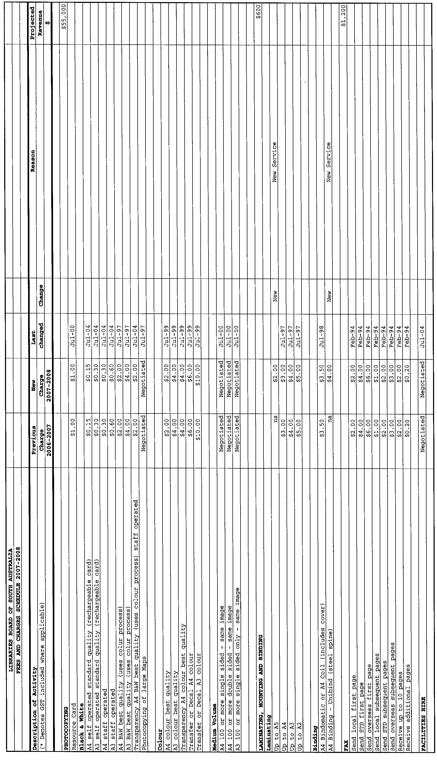
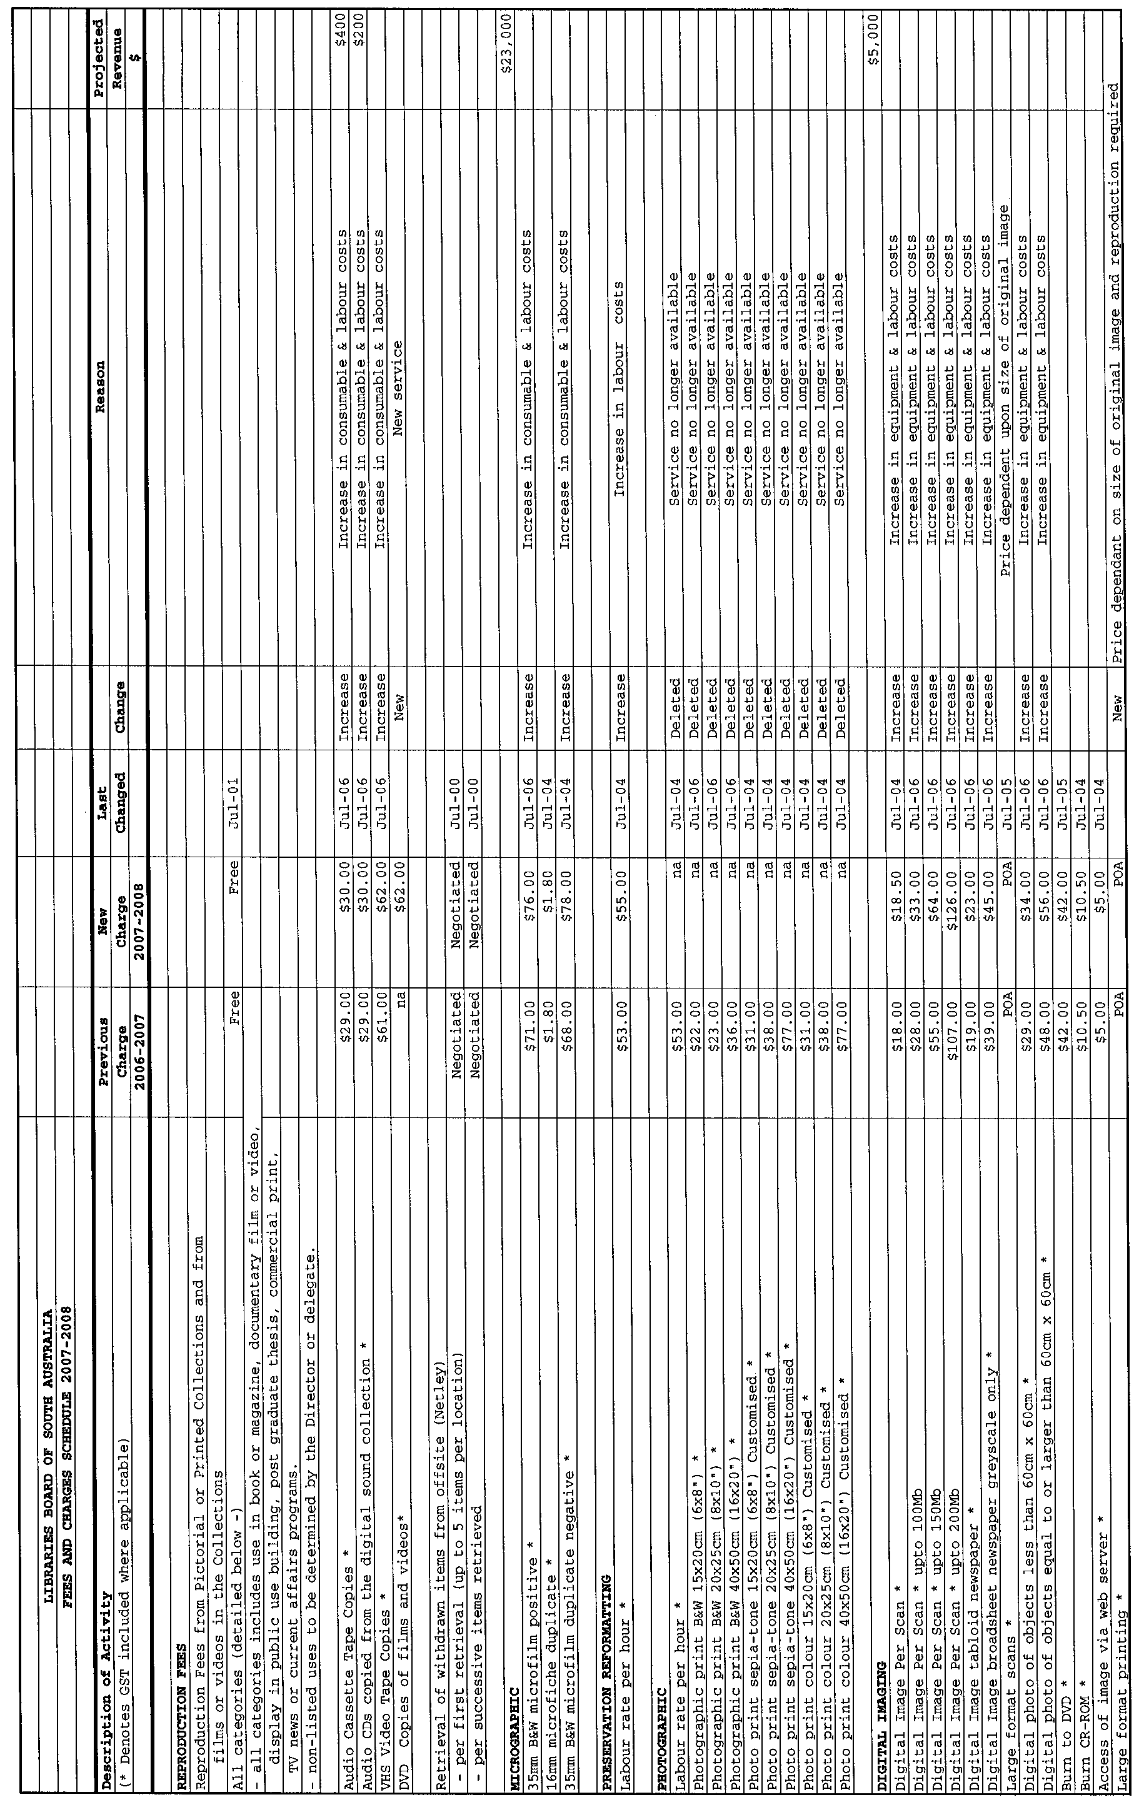
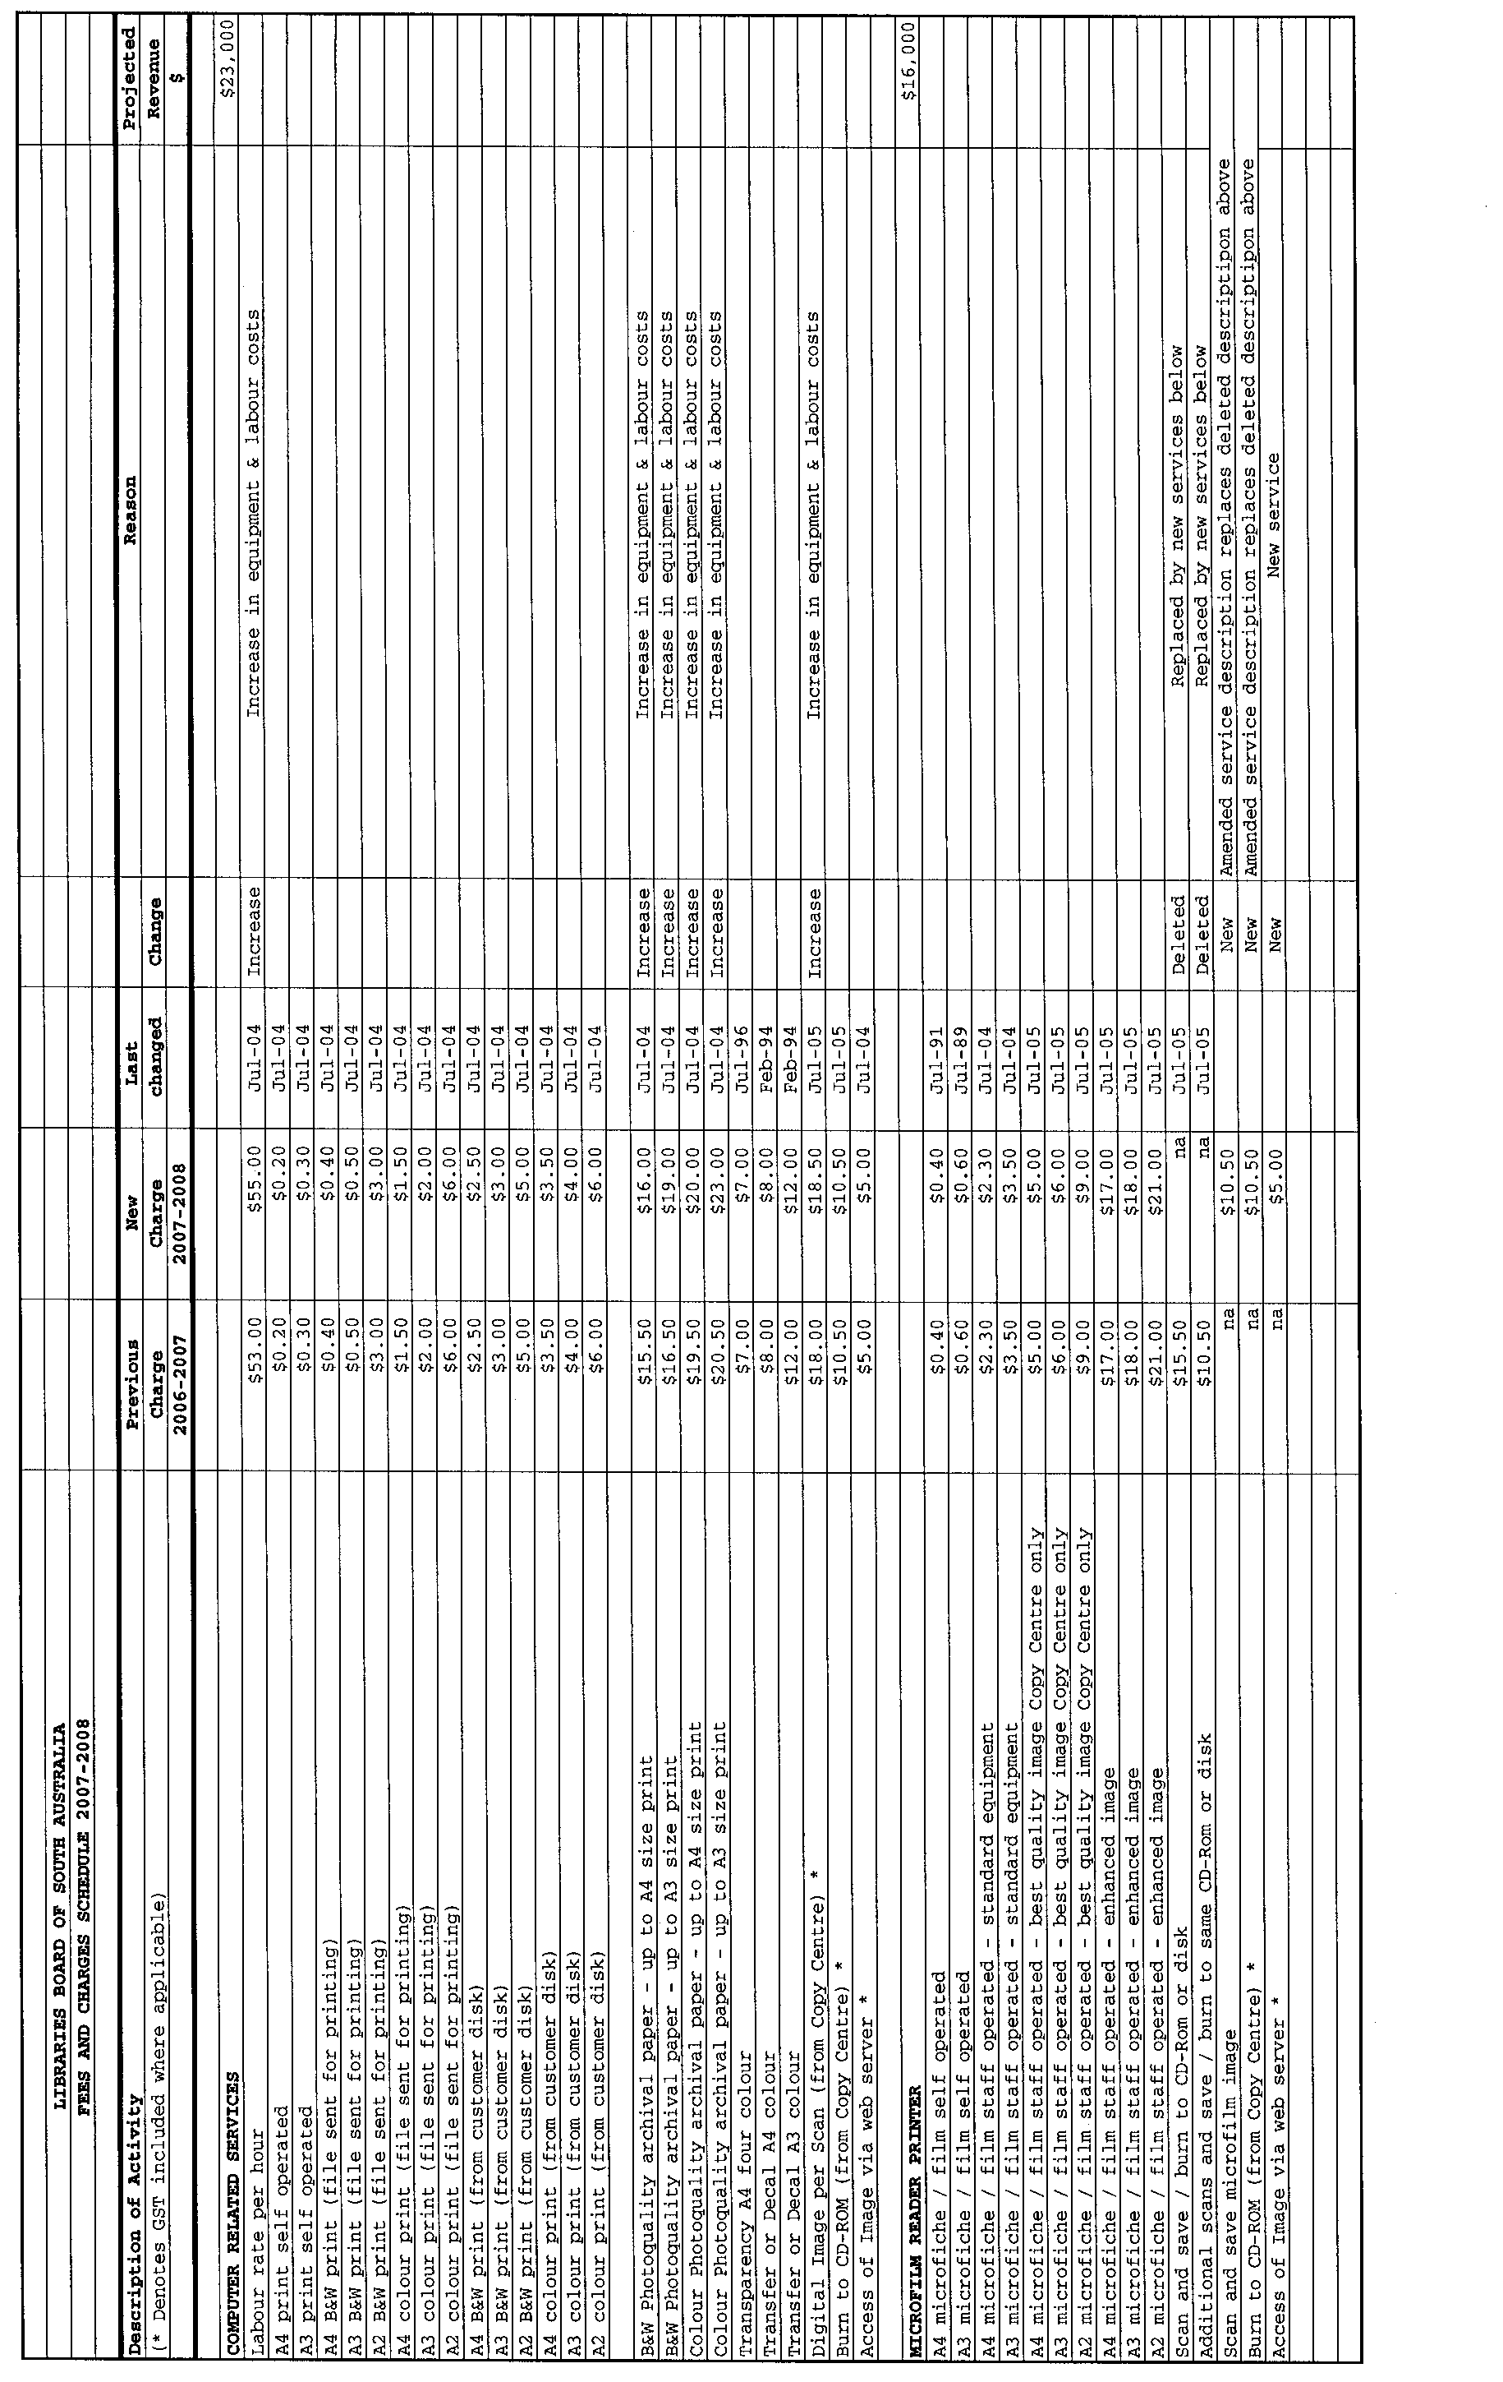
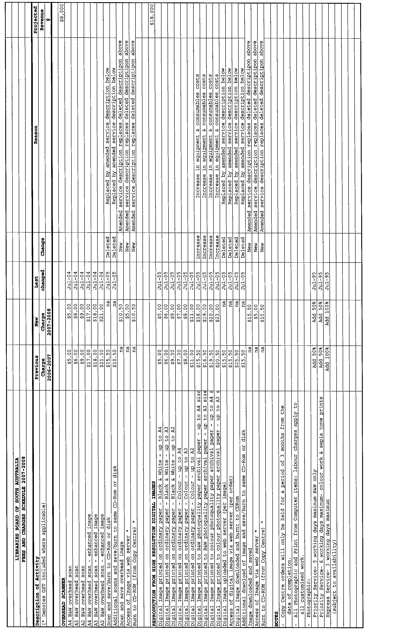
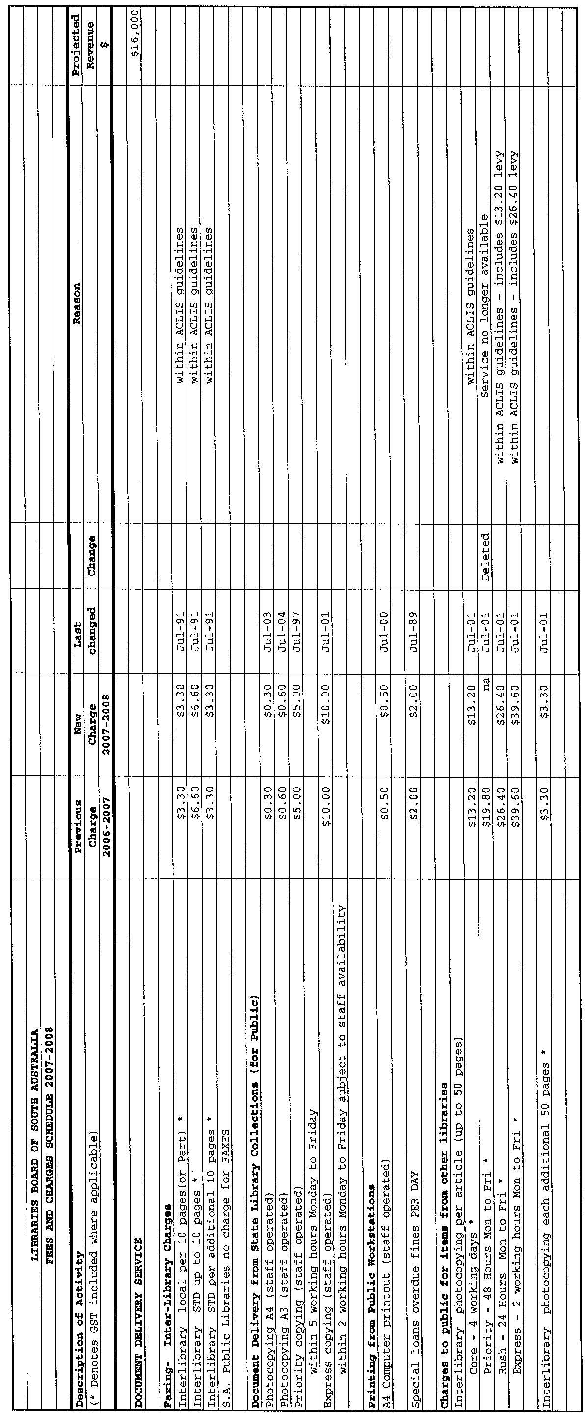
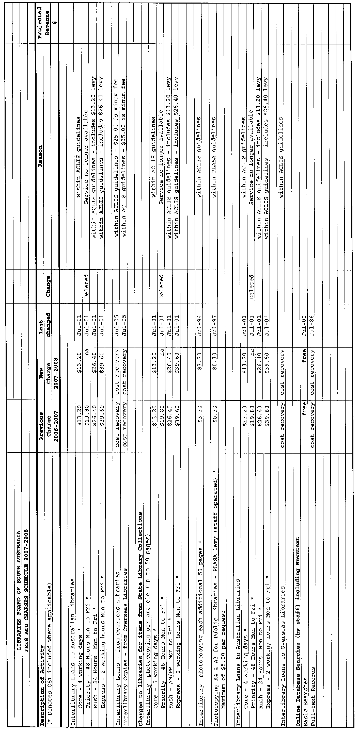
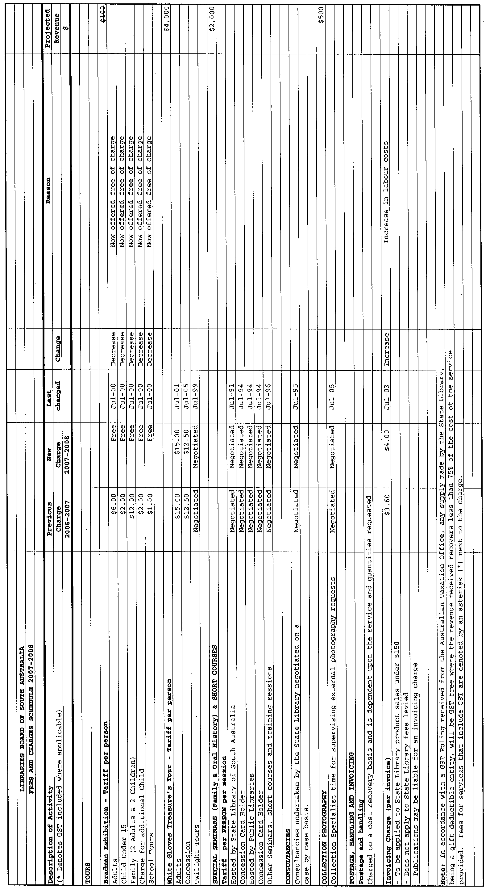

LIQUOR LICENSING ACT 1997 AND GAMING MACHINES ACT 1992
Notice of Application
NOTICE is hereby given, pursuant to section 52 of the Liquor Licensing Act 1997 and section 29 of the Gaming Machines Act 1992, that Schillvest Pty Ltd has applied to the Licensing Authority for the transfer of a Hotel and Gaming Machine Licence in respect of premises situated at 104 Gouger Street, Adelaide, S.A. 5000 and known as Talbot Hotel.
The applications have been set down for hearing on 2 July 2007 at 11 a.m.
Any person may object to the application by lodging a notice of objection in the prescribed form with the Liquor and Gambling Commissioner and serving a copy of the notice on the applicant at the applicant’s address, at least seven days before the hearing date (viz: 25 June 2007).
The applicant’s address for service is c/o Fisher Jeffries, SGIC Building, Level 15, 211 Victoria Square, Adelaide, S.A. 5000.
Plans in respect of the premises the subject of the application are open to public inspection without fee at the Office of the Liquor and Gambling Commissioner, 9th Floor, East Wing, 50 Grenfell Street, Adelaide, S.A. 5000. Phone 8226 8410, Fax:
8226 8512. Email: olgc@agd.sa.gov.au.
Dated 24 May 2007.
Applicant

LIQUOR LICENSING ACT 1997
Notice of Application
NOTICE is hereby given, pursuant to section 52 (2) (b) of the Liquor Licensing Act 1997, that Intercontinental Caterers Pty Ltd has applied to the Licensing Authority for Alterations and variation to Entertainment Consent in respect of premises situated at 23 Hackney Road, Hackney, S.A. 5069 and known as the Observatory Function Centre.
The application has been set down for callover on 29 June 2007 at 9 a.m.
Conditions
The following licence conditions are sought:
• Alterations to the First Floor as per plans lodged with this office.
• Variation to Entertainment Consent to include the above-mentioned areas as per plans lodged with this office.
Any person may object to the application by lodging a notice of objection in the prescribed form with the Liquor and Gambling Commissioner and serving a copy of the notice on the applicant at the applicant’s address, at least seven days before the callover date (viz: 22 June 2007).
The applicant’s address for service is c/o Nic Minicozzi, P.O. Box 952, Kent Town, S.A. 5071.
Plans in respect of the premises the subject of the application are open to public inspection without fee at the Office of the Liquor and Gambling Commissioner, 9th Floor, East Wing, 50 Grenfell Street, Adelaide, S.A. 5000. Phone 8226 8410, Fax:
8226 8512. Email: olgc@agd.sa.gov.au.
Dated 21 May 2007.
Applicant

LIQUOR LICENSING ACT 1997
Notice of Application
NOTICE is hereby given, pursuant to section 52 (2) (b) of the Liquor Licensing Act 1997, that Deborah Lee Hoff, Kenneth John Baker and Annette Noeleene Love have applied to the Licensing Authority for a Producer’s Licence in respect of premises situated at Lot 295, Plains Road, Sellicks Hill, S.A. 5174 and to be known as Rocky Ridge Vineyard.
The application has been set down for callover on 29 June 2007 at 9 a.m.
Any person may object to the application by lodging a notice of objection in the prescribed form with the Liquor and Gambling Commissioner and serving a copy of the notice on the applicants at the applicants’ address, at least seven days before the callover date (viz: 22 June 2007).
The applicants’ address for service is c/o Deborah Hoff, P.O. Box 1286, Aldinga Beach, S.A. 5173.
Plans in respect of the premises the subject of the application are open to public inspection without fee at the Office of the Liquor and Gambling Commissioner, 9th Floor, East Wing, 50 Grenfell Street, Adelaide, S.A. 5000. Phone 8226 8410, Fax:
8226 8512. Email: olgc@agd.sa.gov.au.
Dated 21 May 2007.
Applicants

LIQUOR LICENSING ACT 1997
Notice of Application
NOTICE is hereby given, pursuant to section 52 (2) (b) of the Liquor Licensing Act 1997, that Makoto Australia International Pty Ltd has applied to the Licensing Authority for a Restaurant Licence in respect of premises situated at 38 Hindley Street, Adelaide, S.A. 5000 and to be known as Sushi Tokoro Makoto.
The application has been set down for callover on 29 June 2007 at 9 a.m.
Any person may object to the application by lodging a notice of objection in the prescribed form with the Liquor and Gambling Commissioner and serving a copy of the notice on the applicant at the applicant’s address, at least seven days before the callover date (viz: 22 June 2007).
The applicant’s address for service is c/o Yan Chen, 12 Todd Place, Adelaide, S.A. 5000.
Plans in respect of the premises the subject of the application are open to public inspection without fee at the Office of the Liquor and Gambling Commissioner, 9th Floor, East Wing, 50 Grenfell Street, Adelaide, S.A. 5000. Phone 8226 8410, Fax:
8226 8512. Email: olgc@agd.sa.gov.au.
Dated 23 May 2007.
Applicant

LIQUOR LICENSING ACT 1997
Notice of Application
NOTICE is hereby given, pursuant to section 52 (2) (b) of the Liquor Licensing Act 1997, that Marlene Kay Lewis has applied to the Licensing Authority for a Restaurant Licence, Section 34 (1) (c), Extended Trading Authorisation and Entertainment Consent in respect of premises situated at 70 Main Street, Nairne, S.A. 5252 and known as Sophina’s of Casamar.
The application has been set down for callover on 29 June 2007 at 9 a.m.
Conditions
The following licence conditions are sought:
• Approval under Section 34 (1) (c) to sell liquor for con-sumption on the licensed premises by persons:
(a) seated at a table; or
(b) attending a function at which food is provided.
• Extended Trading Authorisation:
Monday to Saturday: Midnight to 2 a.m. the following day;
Sunday: 8 a.m. to 11 a.m. and 8 p.m. to 2 a.m. the following day;
Good Friday: Midnight to 2 a.m.;
Christmas Day: Midnight to 2 a.m.;
Sunday Christmas Eve: 8 p.m. to 2 a.m. the following day;
New Year’s Eve: 2 a.m. to 5 a.m. the following day;
Days preceding other Public Holidays: Midnight to 5 a.m. the following day;
Sundays preceding Public Holidays: 8 p.m. to 5 a.m. the following day.
• Entertainment Consent is sought in the areas shown on the plans lodged with this office.
Any person may object to the application by lodging a notice of objection in the prescribed form with the Liquor and Gambling Commissioner and serving a copy of the notice on the applicant at the applicant’s address, at least seven days before the callover date (viz: 22 June 2007).
The applicant’s address for service is c/o Von Doussas Lawyers, 41 Gawler Street, Mount Barker, S.A. 5251.
Plans in respect of the premises the subject of the application are open to public inspection without fee at the Office of the Liquor and Gambling Commissioner, 9th Floor, East Wing, 50 Grenfell Street, Adelaide, S.A. 5000. Phone 8226 8410, Fax:
8226 8512. Email: olgc@agd.sa.gov.au.
Dated 21 May 2007.
Applicant

LIQUOR LICENSING ACT 1997
Notice of Application
NOTICE is hereby given, pursuant to section 52 (2) (b) of the Liquor Licensing Act 1997, that Jian Wang and Dong Fang have applied to the Licensing Authority for a Restaurant Licence with Section 34 (1) (c) approval and Extended Trading Authorisation in respect of premises situated at Shop 4, 31-39 Gouger Street, Adelaide, S.A. 5000 and to be known as Bazu Chinese Sichuan Restaurant.
The application has been set down for callover on 29 June 2007 at 9 a.m.
Conditions
The following licence conditions are sought:
• Extended Trading Authorisation is sought as per plans lodged and is to include the following hours:
Sunday: 8 p.m. to midnight.
• Approval under Section 34 (1) (c) to sell liquor for con-sumption on the licensed premises by persons:
(a) seated at a table; or
(b) attending a function at which food is provided.
Any person may object to the application by lodging a notice of objection in the prescribed form with the Liquor and Gambling Commissioner and serving a copy of the notice on the applicants at the applicants’ address, at least seven days before the callover date (viz: 22 June 2007).
The applicants’ address for service is c/o Jian Wang, 5/11 Winifred Street, Adelaide, S.A. 5000.
Plans in respect of the premises the subject of the application are open to public inspection without fee at the Office of the Liquor and Gambling Commissioner, 9th Floor, East Wing, 50 Grenfell Street, Adelaide, S.A. 5000. Phone 8226 8410, Fax:
8226 8512. Email: olgc@agd.sa.gov.au.
Dated 22 May 2007.
Applicants

LIQUOR LICENSING ACT 1997
Notice of Application
NOTICE is hereby given, pursuant to section 52 (2) (b) of the Liquor Licensing Act 1997, that Australian Vintage Pty Ltd has applied to the Licensing Authority for a variation to Conditions in respect of premises situated at Bookpurnong Road, Loxton, S.A. 5333 and known as Australian Vintage.
The application has been set down for callover on 29 June 2007 at 9 a.m.
Conditions
The following licence conditions are sought:
• Variation to Conditions to include the following:
The sale of beer products produced by Barossa Valley Brewing Pty Ltd.
Any person may object to the application by lodging a notice of objection in the prescribed form with the Liquor and Gambling Commissioner and serving a copy of the notice on the applicant at the applicant’s address, at least seven days before the callover date (viz: 22 June 2007).
The applicant’s address for service is c/o Australian Vintage Pty Ltd, Level 2, 170 Greenhill Road, Parkside, S.A. 5063.
Plans in respect of the premises the subject of the application are open to public inspection without fee at the Office of the Liquor and Gambling Commissioner, 9th Floor, East Wing, 50 Grenfell Street, Adelaide, S.A. 5000. Phone 8226 8410, Fax:
8226 8512. Email: olgc@agd.sa.gov.au.
Dated 23 May 2007.
Applicant

LIQUOR LICENSING ACT 1997
Notice of Application
NOTICE is hereby given, pursuant to section 52 (2) (b) of the Liquor Licensing Act 1997, that Willunga Hill Estates Pty Ltd has applied to the Licensing Authority for a Producer’s Licence in respect of premises situated at Lot 8, Pethick Road, Willunga, S.A. 5172 and to be known as Willunga Hill Estates.
The application has been set down for callover on 29 June 2007 at 9 a.m.
Any person may object to the application by lodging a notice of objection in the prescribed form with the Liquor and Gambling Commissioner and serving a copy of the notice on the applicant at the applicant’s address, at least seven days before the callover date (viz: 22 June 2007).
The applicant’s address for service is c/o Wayne Miller, Suite 7, 60 West Terrace, Adelaide, S.A. 5000.
Plans in respect of the premises the subject of the application are open to public inspection without fee at the Office of the Liquor and Gambling Commissioner, 9th Floor, East Wing, 50 Grenfell Street, Adelaide, S.A. 5000. Phone 8226 8410, Fax:
8226 8512. Email: olgc@agd.sa.gov.au.
Dated 24 May 2007.
Applicant

LIQUOR LICENSING ACT 1997
Notice of Application
NOTICE is hereby given, pursuant to section 52 (2) (b) of the Liquor Licensing Act 1997, that Boozh Wah Pty Ltd as trustee for the Boozh Wah Unit Trust has applied to the Licensing Authority for an Entertainment Venue Licence in respect of premises situated at Shop 1, 49 Mount Barker Road, Stirling, S.A. 5152.
The application has been set down for callover on 29 June 2007 2007 at 9 a.m.
Any person may object to the application by lodging a notice of objection in the prescribed form with the Liquor and Gambling Commissioner and serving a copy of the notice on the applicant at the applicant’s address, at least seven days before the callover date (viz: 22 June 2007).
The applicant’s address for service is c/o Wallmans Lawyers, 173 Wakefield Street, Adelaide, S.A. 5000 (Attention: Ben Allen or Andrew Fowler-Walker).
Plans in respect of the premises the subject of the application are open to public inspection without fee at the Office of the Liquor and Gambling Commissioner, 9th Floor, East Wing, 50 Grenfell Street, Adelaide, S.A. 5000. Phone 8226 8410, Fax:
8226 8512. Email: olgc@agd.sa.gov.au.
Dated 25 May 2007.
Applicant

LIQUOR LICENSING ACT 1997
Notice of Application
NOTICE is hereby given, pursuant to section 52 (2) (b) of the Liquor Licensing Act 1997, that Andermel Pty Ltd has applied to the Licensing Authority for a Special Circumstances Licence in respect of premises situated at Heatherbrae, Harriet Road, Section 82, Hundred of Newlands, Kangaroo Island, S.A. 5220 and to be known as Two Wheeler Creek Wines.
The application has been set down for callover on 29 June 2007 at 9 a.m.
Conditions
The following licence conditions are sought:
• The licence will authorise the sale, supply and consumption of liquor on the licensed premises between the hours of 10.30 a.m. and midnight on any day:
• to a diner with or ancillary to a meal provided by the licensee;
• to a person attending a function or reception on the licensed premises;
• to persons seated at a table; and
• by way of sample.
• To sell or supply liquor for consumption off the licensed premises between 10.30 a.m. and midnight on any day providing the liquor has been produced by or under the direction of the licensee or a related body corporate.
• Entertainment Consent to apply to the whole of the licensed premises.
Any person may object to the application by lodging a notice of objection in the prescribed form with the Liquor and Gambling Commissioner and serving a copy of the notice on the applicant at the applicant’s address, at least seven days before the callover date (viz: 22 June 2007).
The applicant’s address for service is c/o Wallmans Lawyers, 173 Wakefield Street, Adelaide, S.A. 5000 (Attention: Ben Allen or Andrew Fowler-Walker).
Plans in respect of the premises the subject of the application are open to public inspection without fee at the Office of the Liquor and Gambling Commissioner, 9th Floor, East Wing, 50 Grenfell Street, Adelaide, S.A. 5000. Phone 8226 8410, Fax:
8226 8512. Email: olgc@agd.sa.gov.au.
Dated 25 May 2007.
Applicant

LIQUOR LICENSING ACT 1997
Notice of Application
NOTICE is hereby given, pursuant to section 52 (2) (b) of the Liquor Licensing Act 1997, that Waikerie Gliding Club Inc. has applied to the Licensing Authority for the transfer of a Special Circumstances Licence in respect of premises situated at Sir Donald Anderson Drive, Holder, Waikerie, S.A. 5330, known as Waikerie Gliding Club Clubrooms and to be known as Waikerie Gliding Club.
The application has been set down for hearing on 4 July 2007 at 10 a.m.
Any person may object to the application by lodging a notice of objection in the prescribed form with the Liquor and Gambling Commissioner and serving a copy of the notice on the applicant at the applicant’s address, at least seven days before the hearing date (viz: 27 June 2007).
The applicant’s address for service is c/o Graham Francis, P.O. Box 320, Waikerie, S.A. 5330.
Plans in respect of the premises the subject of the application are open to public inspection without fee at the Office of the Liquor and Gambling Commissioner, 9th Floor, East Wing, 50 Grenfell Street, Adelaide, S.A. 5000. Phone 8226 8410, Fax:
8226 8512. Email: olgc@agd.sa.gov.au.
Dated 22 May 2007.
Applicant

GOVERNMENT GAZETTE ADVERTISEMENT RATES

To apply from 1 July 2006

$  Agents, Ceasing to Act as 38.00  Associations:  Incorporation 19.30  Intention of Incorporation 47.75  Transfer of Properties 47.75  Attorney, Appointment of 38.00  Bailiff’s Sale 47.75  Cemetery Curator Appointed 28.25  Companies:  Alteration to Constitution 38.00  Capital, Increase or Decrease of 47.75  Ceasing to Carry on Business 28.25  Declaration of Dividend 28.25  Incorporation 38.00  Lost Share Certificates:  First Name 28.25  Each Subsequent Name 9.70  Meeting Final 31.75  Meeting Final Regarding Liquidator’s Report on  Conduct of Winding Up (equivalent to ‘Final  Meeting’)  First Name 38.00  Each Subsequent Name 9.70  Notices:  Call 47.75  Change of Name 19.30  Creditors 38.00  Creditors Compromise of Arrangement 38.00  Creditors (extraordinary resolution that ‘the Com-pany be wound up voluntarily and that a liquidator be appointed’) 47.75  Release of Liquidator⎯Application⎯Large Ad. 75.50  ⎯Release Granted 47.75  Receiver and Manager Appointed 44.00  Receiver and Manager Ceasing to Act 38.00  Restored Name 35.75  Petition to Supreme Court for Winding Up 66.50  Summons in Action 56.50  Order of Supreme Court for Winding Up Action 38.00  Register of Interests⎯Section 84 (1) Exempt 85.50  Removal of Office 19.30  Proof of Debts 38.00  Sales of Shares and Forfeiture 38.00  Estates:  Assigned 28.25  Deceased Persons⎯Notice to Creditors, etc. 47.75  Each Subsequent Name 9.70  Deceased Persons⎯Closed Estates 28.25  Each Subsequent Estate 1.25  Probate, Selling of 38.00  Public Trustee, each Estate 9.70 |  | $  Firms:  Ceasing to Carry on Business (each insertion) 25.25  Discontinuance Place of Business 25.25  Land⎯Real Property Act:  Intention to Sell, Notice of 47.75  Lost Certificate of Title Notices 47.75  Cancellation, Notice of (Strata Plan) 47.75  Mortgages:  Caveat Lodgement 19.30  Discharge of 20.20  Foreclosures 19.30  Transfer of 19.30  Sublet 9.70  Leases⎯Application for Transfer (2 insertions) each 9.70  Lost Treasury Receipts (3 insertions) each 28.25  Licensing 56.50  Municipal or District Councils:  Annual Financial Statement⎯Forms 1 and 2 532.00  Electricity Supply⎯Forms 19 and 20 378.00  Default in Payment of Rates:  First Name 75.50  Each Subsequent Name 9.70  Noxious Trade 28.25  Partnership, Dissolution of 28.25  Petitions (small) 19.30  Registered Building Societies (from Registrar-  General) 19.30  Register of Unclaimed Moneys⎯First Name 28.25  Each Subsequent Name 9.70  Registers of Members⎯Three pages and over:  Rate per page (in 8pt) 242.00  Rate per page (in 6pt) 320.00  Sale of Land by Public Auction 48.25  Advertisements 2.70  ¼ page advertisement 113.00  ½ page advertisement 226.00  Full page advertisement 443.00  Advertisements, other than those listed are charged at $2.70 per column line, tabular one-third extra.  Notices by Colleges, Universities, Corporations and District Councils to be charged at $2.70 per line.  Where the notice inserted varies significantly in length from that which is usually published a charge of $2.70 per column line will be applied in lieu of advertisement rates listed.  South Australian Government publications are sold on the condition that they will not be reproduced without prior permission from the Government Printer.
All the above prices include GST

GOVERNMENT GAZETTE NOTICES
ALL private advertisements forwarded for publication in the South Australian Government Gazette must be PAID FOR PRIOR TO INSERTION; and all notices, from whatever source, should be legibly written on one side of the paper only and sent to Government Publishing SA so as to be received no later than 4 p.m. Tuesday preceding the day of publication. Phone 8207 1045 or Fax 8207 1040. E-mail: governmentgazette@dpc.sa.gov.au. Send as attachments in Word format. Please include date the notice is to be published and to whom the notice will be charged. The Government Gazette is available online at: www.governmentgazette.sa.gov.au.

MISCELLANEOUS LEGISLATION AND GOVERNMENT PUBLICATIONS PRICES AS FROM 1 JULY 2006

Acts, Bills, Rules, Parliamentary Papers and Regulations
Pages | Main | Amends | Pages | Main | Amends

1-16 | 2.30 | 1.05 | 497-512 | 32.25 | 31.25
17-32 | 3.10 | 1.95 | 513-528 | 33.25 | 32.00
33-48 | 4.05 | 2.90 | 529-544 | 34.25 | 33.25
49-64 | 5.10 | 3.90 | 545-560 | 35.25 | 34.25
65-80 | 6.00 | 4.95 | 561-576 | 36.00 | 35.25
81-96 | 6.95 | 5.75 | 577-592 | 37.00 | 35.75
97-112 | 7.90 | 6.75 | 593-608 | 38.25 | 36.75
113-128 | 8.90 | 7.75 | 609-624 | 39.00 | 38.00
129-144 | 9.95 | 8.80 | 625-640 | 40.00 | 38.50
145-160 | 10.90 | 9.70 | 641-656 | 41.00 | 40.00
161-176 | 11.90 | 10.70 | 657-672 | 41.50 | 40.50
177-192 | 12.90 | 11.70 | 673-688 | 43.25 | 41.50
193-208 | 13.90 | 12.80 | 689-704 | 44.00 | 42.50
209-224 | 14.70 | 13.60 | 705-720 | 44.75 | 43.50
225-240 | 15.70 | 14.50 | 721-736 | 46.50 | 44.50
241-257 | 16.80 | 15.30 | 737-752 | 47.00 | 45.50
258-272 | 17.70 | 16.30 | 753-768 | 48.00 | 46.25
273-288 | 18.70 | 17.50 | 769-784 | 48.50 | 47.75
289-304 | 19.50 | 18.40 | 785-800 | 49.50 | 48.75
305-320 | 20.70 | 19.40 | 801-816 | 50.50 | 49.25
321-336 | 21.50 | 20.30 | 817-832 | 51.50 | 50.50
337-352 | 22.60 | 21.40 | 833-848 | 52.50 | 51.50
353-368 | 23.50 | 22.40 | 849-864 | 53.50 | 52.00
369-384 | 24.50 | 23.40 | 865-880 | 54.50 | 53.50
385-400 | 25.50 | 24.30 | 881-896 | 55.00 | 54.00
401-416 | 26.50 | 25.00 | 897-912 | 56.50 | 55.00
417-432 | 27.50 | 26.25 | 913-928 | 57.00 | 56.50
433-448 | 28.50 | 27.25 | 929-944 | 58.00 | 57.00
449-464 | 29.25 | 28.00 | 945-960 | 59.00 | 57.50
465-480 | 29.75 | 29.00 | 961-976 | 60.50 | 58.50
481-496 | 31.25 | 29.75 | 977-992 | 61.50 | 59.00

Legislation—Acts, Regulations, etc: $
Subscriptions:
Acts 199.00
All Bills as Laid 477.00
Rules and Regulations 477.00
Parliamentary Papers 477.00
Bound Acts 221.00
Index 110.00
Government Gazette
Copy 5.20
Subscription 263.00
Hansard
Copy 14.50
Subscription—per session (issued weekly) 414.00
Cloth bound—per volume 178.00
Subscription—per session (issued daily) 414.00
Legislation on Disk
Whole Database 3063.00
Annual Subscription for fortnightly updates 941.00
Individual Act(s) including updates POA
Compendium
Subscriptions:
Subscriptions 1815.00
Updates 640.00
(All the above prices include GST)

All Legislation, Government Gazette, Hansard and Legislation on disk are available from:
Counter Sales Service SA, Government Legislation⁺ Outlet
and Mail Orders: Lands Titles Office, 101 Grenfell Street, Adelaide, S.A. 5000
Phone: 13 23 24 (local call cost), Fax: (08) 8204 1909
Postal: G.P.O. Box 1707, Adelaide, S.A. 5001

Online Shop: www.shop.service.sa.gov.au

Subscriptions and Government Publishing SA
Standing Orders: Box 9, Plaza Level, Riverside Centre, North Terrace, Adelaide, S.A. 5000
Phone: (08) 8207 1043, (08) 8207 0910, Fax: (08) 8207 1040

THE MAGISTRATES COURT OF SOUTH AUSTRALIA
Amendment No. 28 to the Magistrates Court
Rules 1992
PURSUANT to section 49 of the Magistrates Court Act 1991 and all other enabling powers, We the undersigned do make the following amendments to the Magistrates Court Rules 1992:

Rule 49 is deleted and replaced with the following:

49.01 The applicant for a warrant under section 29 of the Criminal Law (Forensic Procedures) Act 2007, must file a copy of the application for the procedure, the order authorising the procedure, and if it was an order or special urgency made under section 18, a note of the time when it was made, the direction under section 29 (1) and an affidavit giving details of the identity of the suspect or offender, the notification of the direction given to the suspect or offender and the failure(s) to comply with the direction.

49.02 A Warrant issued under section 29 (3) shall comply with Form 53 and must have the order authorising the forensic procedure attached to it.

Forms 53, 54 and 74 are deleted and a new Form 53 is prescribed as follows:

Signed on the 18th day of May 2007 by:

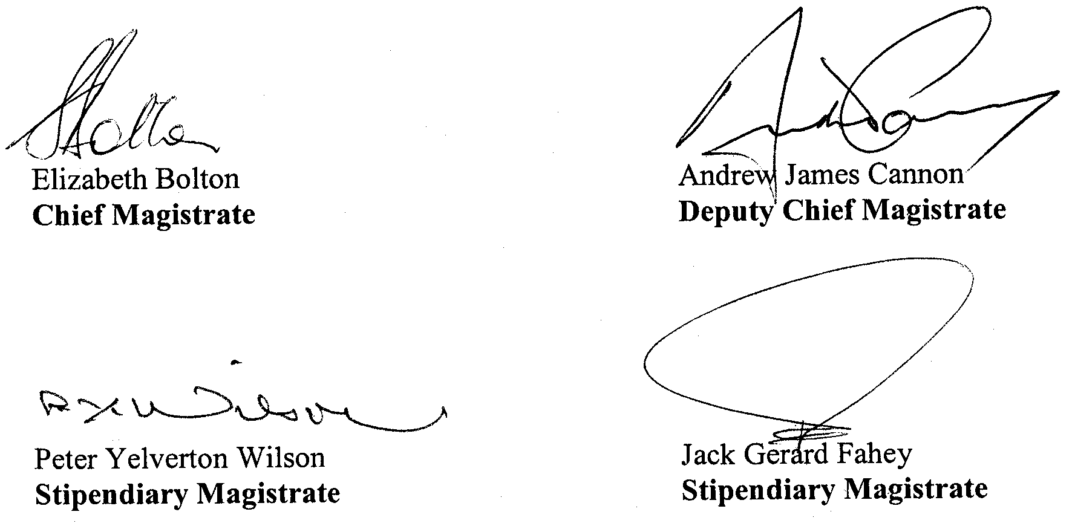



MINING ACT 1971
NOTICE is hereby given in accordance with section 28 (5) of the Mining Act 1971, that the Minister for Mineral Resources Development proposes to grant an Exploration Licence over the undermentioned area:
Applicant: Goldstream Mining NL
Location: Mount Brady area—Approximately 35 km south-east of Coober Pedy.
Term: 1 year
Area in km²: 90
Ref.: 2006/00536
Plan and co-ordinates can be found on the PIRSA, Sarig website: http://www.minerals.pir.sa.gov.au/sarig or by phoning Mineral Tenements on (08) 8463 3103.
H. Tyrteos, Mining Registrar

MINING ACT 1971
NOTICE is hereby given in accordance with section 28 (5) of the Mining Act 1971, that the Minister for Mineral Resources Development proposes to grant an Exploration Licence over the undermentioned area:
Applicant: Red Metal Ltd
Location: Peake Hill area—Approximately 60 km south-east of Oodnadatta.
Term: 1 year
Area in km²: 239
Ref.: 2006/00589
Plan and co-ordinates can be found on the PIRSA, Sarig website: http://www.minerals.pir.sa.gov.au/sarig or by phoning Mineral Tenements on (08) 8463 3103.
H. Tyrteos, Mining Registrar

MINING ACT 1971
NOTICE is hereby given in accordance with section 28 (5) of the Mining Act 1971, that the Minister for Mineral Resources Development proposes to grant an Exploration Licence over the undermentioned area:
Applicant: Red Metal Ltd
Location: Weedina Creek area—Approximately 70 km south-south-east of Oodnadatta.
Term: 1 year
Area in km²: 991
Ref.: 2006/00689
Plan and co-ordinates can be found on the PIRSA, Sarig website: http://www.minerals.pir.sa.gov.au/sarig or by phoning Mineral Tenements on (08) 8463 3103.
H. Tyrteos, Mining Registrar

MINING ACT 1971
NOTICE is hereby given in accordance with section 35A (1) of the Mining Act 1971, that an application for a mining lease over the undermentioned mineral claim has been received. Details of the proposal may be inspected at the Department of Primary Industries and Resources, Mineral Resources Group, Level 7, 101 Grenfell Street, Adelaide, S.A. 5000:
Applicant: Holmes Civil Pty Ltd
Claim Number: 3677
Location: Sections 273 and 358, Hundred of Comaum
Area: 9.1 hectares
Purpose: For the recovery of Sand
Reference: T02616
A copy of the proposal has been provided to the District Council of Wattle Range.
Written submissions in relation to the granting of the mining lease are invited to be received at the Department of Primary Industries and Resources, Mineral Resources Group, Level 7, 101 Grenfell Street, Adelaide, S.A. 5000 or G.P.O. Box 1671, Adelaide, S.A. 5001 no later than 21 June 2007.
Copies of all submissions will be forwarded to the applicant and may be made available for public inspection unless confidentiality is requested.
H. Tyrteos, Mining Registrar

MINING ACT 1971
NOTICE is hereby given in accordance with section 53 (2) of the Mining Act 1971, that an application for a miscellaneous purposes licence has been received. Details of the proposal may be inspected at the Department of Primary Industries and Resources, Mineral Resources Group, Level 5, 101 Grenfell Street, Adelaide, S.A. 5000:
Applicant: Australasian Granite Pty Ltd
Location: Allotments 1 and 2, Deposited Plan 27804, Hundred of Wallaroo—Approximately 3 km north-east of Wallaroo.
Area: 16.7 hectares
Purpose: Workshop building site, block granite stockpiles, waste granite stockpiles.
Reference: T02655
A copy of the proposal has been provided to the District Council of Copper Coast
Written submissions in relation to the granting of the miscellaneous purposes licence are invited to be received at the Department of Primary Industries and Resources, Mineral Resources Group, Level 5, 101 Grenfell Street, Adelaide, S.A. 5000 or G.P.O. Box 1671, Adelaide, S.A. 5001 no later than 21 June 2007.
Copies of all submissions will be forwarded to the applicant, and may be made available for public inspection unless confidentiality is requested.
H. Tyrteos, Mining Registrar

MINING ACT 1971
PURSUANT to section 15 (5) of the Mining Act 1971 (‘Act’), I advise that the Minerals and Energy Division of Primary Industries and Resources SA, will be undertaking geoscientific investigations over an area of approximately 390 km² in the Old Ediacara area, approximately 25 km west of Leigh Creek. The investigations will commence from 7 December 2006 and the expected completion date has been extended until 30 November 2007.
Pursuant to section 15 (7) of the Act, I hereby advise that applications for mining tenements may not be received or considered in respect of the land described above until the completion date of 30 November 2007. The completion date may be extended by further notice in the Gazette.
Copies of the plan are available by phoning the Mining Registrar on telephone (08) 8463 3097.
Reference: T02632
H. Tyrteos, Mining Registrar

NATIONAL ELECTRICITY LAW
THE Australian Energy Market Commission (AEMC) gives notice under the National Electricity Law (NEL) of the following matters.
Under Section 95, NEMMCO has requested the making of the proposed National Electricity Amendment (Integration of NEM Metrology Requirements) Rule 2007. The proposal seeks to amend the National Electricity Rules to integrate first tier metrology requirements and some jurisdictional requirements into the metrology framework. Submissions:
• must be received by 27 July 2007;
• should be forwarded to submissions at:
submissions@aemc.gov.au; and
• will be published on the AEMC’s website subject to a claim of confidentiality.
In relation to the “Statement of regulatory principles—revenue cap reopening” Rule change proposal, the AEMC has determined to discontinue the Rule making procedure and therefore under clauses 19 and 20 of Schedule 2 of the NEL, has re-exercised the power under section 94 and determined not to take further action. The proposal was originally submitted to NECA by Electranet on behalf of a number of transmission network service providers (including Electranet).
Further details on the above matters are available on AEMC’s website www.aemc.gov.au. All documents in relation to the above matters are published on the AEMC’s website and are available for inspection at the offices of the AEMC.
John Tamblyn
Chairman
Australian Energy Market Commission
Level 16, 1 Margaret Street
Sydney, N.S.W. 2000
Telephone: (02) 8296 7800
Facsimile: (02) 8296 7899
31 May 2007.

NATIONAL PARKS AND WILDLIFE ACT 1972
Mallee Parks of the Central Eyre Peninsula Management Plan
I, GAIL GAGO, Minister for Environment and Conservation, hereby give notice under the provisions of section 38 of the National Parks and Wildlife Act 1972 and section 31 of the Wilderness Protection Act 1992 that, on 18 May 2007, I adopted a plan of management for the Mallee Parks of the Central Eyre Peninsula, incorporating the following reserves:
• Barwell Conservation Park;
• Bascombe Well Conservation Park;
• Hambidge Wilderness Protection Area;
• Hincks Conservation Park;
• Hincks Wilderness Protection Area;
• Peachna Conservation Park;
• Shannon Conservation Park;
• Verran Tanks Conservation Park;
• Wharminda Conservation Park.
Copies of the plan may be inspected at or obtained from the offices of the Department for Environment and Heritage at:
• DEH Information Line, Level 1, 100 Pirie Street, Adelaide, S.A. 5000 (email dehinformation@saugov.sa.gov.au), telephone 8204 1910;
• http://www.parks.sa.gov.au/parks/management_plans/index.htm;
• Port Lincoln Office, 75 Liverpool Street, Port Lincoln, S.A. 5606 (P.O. Box 22, Port Lincoln, S.A. 5607), telephone 8688 3111.
Copies of this publication can be purchased at a cost of $10 per copy (plus $2 postage within South Australia) from the addresses above.
Gail Gago, Minister for Environment and Conservation

PASSENGER TRANSPORT ACT 1994
Section 31 (1) (b)
Conditions on Accreditation
PURSUANT to section 31 (1) (b) of the Passenger Transport Act 1994, I, Jay Weatherill, Acting Minister for Transport, hereby impose an additional condition in relation to the accreditation of:
• the operator of a passenger transport service accredited pursuant to section 27 of the Passenger Transport Act 1994;
• the driver of a public passenger vehicle accredited pursuant to section 28 of the Passenger Transport Act 1994; and
• the operator of a centralised booking service accredited pursuant to section 29 of the Passenger Transport Act 1994.
Accreditation will be automatically suspended if the accredited person has been charged or convicted of a disqualifying offence or if the accredited driver’s drivers licence has expired, been suspended or cancelled.
Disqualifying offences are as follows:
• Murder (Section 11—Criminal Law Consolidation Act 1935);
• Conspiring or soliciting to commit murder (Section 12—Criminal Law Consolidation Act 1935);
• Causing death by intentional act of violence (Section 12A—Criminal Law Consolidation Act 1935);
• Unlawful stalking (Section 19AA—Criminal Law Consolidation Act 1935);
• Causing serious harm (Section 23—Criminal Law Consolidation Act 1935);
• Causing harm (Section 24—Criminal Law Consolidation Act 1935);
• Possession of object with intent to kill or cause serious harm (Section 31—Criminal Law Consolidation Act 1935);
• Possession of a firearm with intent to commit an offence (Section 32—Criminal Law Consolidation Act 1935);
• Rape (Section 48—Criminal Law Consolidation Act 1935);
• Unlawful Sexual Intercourse (Section 49—Criminal Law Consolidation Act 1935);
• Indecent Assault (Section 56—Criminal Law Consolidation Act 1935);
• Acts of gross indecency (Section 58—Criminal Law Consolidation Act 1935);
• Abduction of male or female person (Section 59—Criminal Law Consolidation Act 1935);
• Procuring sexual intercourse (Section 60—Criminal Law Consolidation Act 1935);
• Householder etc. not to permit unlawful sexual intercourse on premises (Section 61—Criminal Law Consolidation Act 1935);
• Production or dissemination of child pornography (Section 63—Criminal Law Consolidation Act 1935);
• Possession of child pornography (Section 63A—Criminal Law Consolidation Act 1935);
• Procuring child to commit indecent act etc. (Section 63B—Criminal Law Consolidation Act 1935);
• Sexual servitude and related offences (Section 66—Criminal Law Consolidation Act 1935);
• Deceptive recruiting for commercial sexual services (Section 67—Criminal Law Consolidation Act 1935);
• Use of children in commercial sexual services (Section 68—Criminal Law Consolidation Act 1935);
• Theft (and receiving) (Section 134—Criminal Law Consolidation Act 1935); and
• Robbery (Section 137—Criminal Law Consolidation Act 1935).
This condition will be effective as of 1 July 2007 and may be varied by me by further notice.
Dated 16 May 2007.
Jay Weatherill, Acting Minister for Transport

PASSENGER TRANSPORT ACT 1994
Appointment of Authorised Officers
NOTICE is hereby given that the following persons have been appointed by the Minister for Transport as Authorised Officers under section 53 of the Passenger Transport Act 1994:
Angie Attard
Tony James Bagnell
Neville Murray Clifford
Michael John Fahy
Marilyn Jean Heyer
Peter DeLacy Hurn
Alvin Phillip Jupp
Andrew William Lawson
David Stephen Mattner
Phillip McGregor Moffatt
Michelle Anne Rathmann
Trent Cameron Rusby
Adam John Couch
Dated 18 May 2007.
P. T. Allan, Executive Director, Department for Transport, Energy and Infrastructure

PASSENGER TRANSPORT ACT 1994
Appointment of Approved Vehicle Inspectors
NOTICE is hereby given that the following persons have been appointed by the Minister for Transport as Approved Vehicle Inspectors under section 54 of the Passenger Transport Act 1994:
Tony James Bagnell
Robert Barker
Neville Murray Clifford
Ilario Cutufia
Anthony Defazio
Michael John Fahy
Agostino Franze
Peter DeLacy Hurn
Colin Martin Jones
Alvin Phillip Jupp
Michael William King
Andrew William Lawson
David Stephen Mattner
Peter John McDonald
Phillip McGregor Moffatt
Jarrad Kevin Murphy
Adam John Couch
Gregory Thomas Mahon
Dated 23 May 2007.
P. T. Allan, Executive Director, Department for Transport, Energy and Infrastructure

PASSENGER TRANSPORT ACT 1994
Appointment of Prescribed Officers and Authorisation of
Persons to Issue Expiation Notices
NOTICE is hereby given that the following persons have been appointed as Prescribed Officers under section 57 of the Passenger Transport Act 1994 and authorised by the Minister for Transport to Issue Expiation Notices under Regulation 90A of the Passenger Transport (General) Regulations 1994 and Regulation 39 of the Passenger Transport (Regular Passenger Services: Conduct of Passengers) Regulations 1994:
Kathryn Walker
Tony James Bagnell
Robert Barker
Neville Murray Clifford
Michael John Fahy
Peter DeLacy Hurn
Alvin Phillip Jupp
Andrew William Lawson
Adrian Lee
David Stephen Mattner
Phillip McGregor Moffatt
Jarrad Kevin Murphy
Michelle Anne Rathmann
Trent Cameron Rusby
Adam John Couch
Tony Petrie
Dated 18 May 2007.
P. T. Allan, Executive Director, Safety and Regulation Division, Energy and Infrastructure

PETROLEUM ACT 2000
Surrender of Associated Facilities Licence—AFL 70
(Adjunct to Petroleum Exploration Licence—PEL 95)
NOTICE is hereby given that I have accepted surrender of the abovementioned Associated Facilities Licence with effect from
23 May 2007, under the provisions of the Petroleum Act 2000, pursuant to delegated powers dated 28 March 2002, Gazetted
11 April 2002, page 1573.
Description of Area
A 50 m buffer around line segments defined by the following pairs of co-ordinates (GDA 94), adjacent to Petroleum Exploration Licence PEL 95:
From |  | To
467518E | 6841998N | 469385E | 6843046N
462990E | 6848471N | 463474E | 6847515N
467518E | 6839518N | 468136E | 6838296N
470200E | 6838295N | 471080E | 6838732N
467995E | 6838295N | 469493E | 6839129N
467518E | 6840204N | 468424E | 6840747N
467518E | 6841052N | 469523E | 6842182N
467518E | 6842780N | 468943E | 6843556N
Area: 1.24 km² approximately.
Dated 23 May 2007.
B. A. Goldstein
Director Petroleum and Geothermal
Minerals and Energy Resources
Primary Industries and Resources SA
Delegate of the Minister for Mineral Resources Development

PETROLEUM ACT 2000
Grant of Geothermal Exploration Licences
NOTICE is hereby given that the undermentioned Geothermal Exploration Licences have been granted with effect from and including 24 January 2007, under the provisions of the Petroleum Act 2000, pursuant to delegated powers dated 28 March 2002, Gazetted 11 April 2002, page 1573.
No. of Licence | Licensee | Locality | Date of Expiry | Reference
GEL 267 | Clean Energy Australasia Pty Ltd | Cooper Basin, South Australia | 22 May 2012 | 27/2/441
GEL 268 | Clean Energy Australasia Pty Ltd | Cooper Basin, South Australia | 22 May 2012 | 27/2/441
GEL 269 | Clean Energy Australasia Pty Ltd | Cooper Basin, South Australia | 22 May 2012 | 27/2/441
GEL 270 | Clean Energy Australasia Pty Ltd | Cooper Basin, South Australia | 22 May 2012 | 27/2/441
GEL 271 | Clean Energy Australasia Pty Ltd | Cooper Basin, South Australia | 22 May 2012 | 27/2/441
GEL 272 | Clean Energy Australasia Pty Ltd | Cooper Basin, South Australia | 22 May 2012 | 27/2/441
GEL 273 | Clean Energy Australasia Pty Ltd | Cooper Basin, South Australia | 22 May 2012 | 27/2/441
GEL 274 | Clean Energy Australasia Pty Ltd | Cooper Basin, South Australia | 22 May 2012 | 27/2/441
GEL 275 | Clean Energy Australasia Pty Ltd | Cooper Basin, South Australia | 22 May 2012 | 27/2/441
GEL 276 | Clean Energy Australasia Pty Ltd | Cooper Basin, South Australia | 22 May 2012 | 27/2/441
GEL 277 | Clean Energy Australasia Pty Ltd | Cooper Basin, South Australia | 22 May 2012 | 27/2/441
Description of Area—GEL 267
All that part of the State of South Australia, bounded as follows:
Commencing at a point being the intersection of latitude 27°30′00″S GDA94 and longitude 140°36′00″E GDA94, thence east to longitude 140°49′30″E GDA94, south to latitude 27°40′00″S GDA94, west to longitude 140°46′00″E GDA94, south to latitude 27°41′00″S GDA94, west to longitude 140°36′00″E GDA94, south to latitude 27°42′00″S GDA94, west to longitude 140°33′00″E GDA94, north to latitude 27°39′00″S GDA94, east to longitude 140°34′00″E GDA94, north to latitude 27°37′00″S GDA94, east to longitude 140°35′00″E GDA94, north to latitude 27°31′00″S GDA94, east to longitude 140°36′00″E GDA94 and north to the point of commencement.
Area: 498 km² approximately.
Description of Area—GEL 268
All that part of the State of South Australia, bounded as follows:
Commencing at a point being the intersection of latitude 27°33′00″S GDA94 and longitude 140°49′30″E GDA94, thence east to longitude 140°50′00″E GDA94, south to latitude 27°35′00″S GDA94, east to the eastern border of the State of South Australia, thence southerly along the border of the said State to latitude 27°57′00″S GDA94, west to longitude 140°58′00″E GDA94, north to latitude 27°56′00″S GDA94, west to longitude 140°50′00″E GDA94, north to latitude 27°55′00″S GDA94, west to longitude 140°47′00″E GDA94, north to latitude 27°52′00″S GDA94, east to longitude 140°51′00″E GDA94, north to latitude 27°50′00″S GDA94, east to longitude 140°54′00″E GDA94, north to latitude 27°49′00″S GDA94, east to longitude 140°56′00″E GDA94, north to latitude 27°40′00″S GDA94, west to longitude 140°49′30″E GDA94 and north to the point of commencement.
Area: 497 km² approximately.
Description of Area—GEL 269
All that part of the State of South Australia, bounded as follows:
Commencing at a point being the intersection of latitude 27°55′00″S GDA94 and longitude 140°47′00″E GDA94, thence east to longitude 140°50′00″E GDA94, south to latitude 28°16′00″S GDA94, west to longitude 140°48′00″E GDA94, north to latitude 28°10′00″S GDA94, west to longitude 140°30′00″E GDA94, north to latitude 28°08′00″S GDA94, east to longitude 140°32′00″E GDA94, north to latitude 28°07′00″S GDA94, east to longitude 140°35′00″E GDA94, north to latitude 28°05′00″S GDA94, east to longitude 140°39′00″E GDA94, north to latitude 28°03′00″S GDA94, east to longitude 140°42′00″E GDA94, north to latitude 28°01′00″S GDA94, east to longitude 140°45′00″E GDA94, north to latitude 27°57′00″S GDA94, east to longitude 140°47′00″E GDA94 and north to the point of commencement.
Area: 496 km² approximately.
Description of Area—GEL 270
All that part of the State of South Australia, bounded as follows:
Commencing at a point being the intersection of latitude 28°12′00″S GDA94 and longitude 140°50′00″E GDA94, thence east to longitude 140°54′00″E GDA94, south to latitude 28°13′00″S GDA94, east to the eastern border of the State of South Australia, thence southerly along the border of the said State to latitude 28°26′00″S GDA94, west to longitude 140°57′00″E GDA94, north to latitude 28°25′00″S GDA94, west to longitude 140°56′00″E GDA94, north to latitude 28°20′00″S GDA94, west to longitude 140°51′00″E GDA94, south to latitude 28°30′00″S GDA94, west to longitude 140°45′00″E GDA94, north to latitude 28°20′00″S GDA94, east to longitude 140°48′00″E GDA94, north to latitude 28°16′00″S GDA94, east to longitude 140°50′00″E GDA94 and north to the point of commencement.
Area: 496 km² approximately.
Description of Area—GEL 271
All that part of the State of South Australia, bounded as follows:
Commencing at a point being the intersection of latitude 27°56′00″S GDA94 and longitude 140°50′00″E GDA94, thence east to longitude 140°58′00″E GDA94, south to latitude 27°57′00″S GDA94, east to the eastern border of the State of South Australia, thence southerly along the border of the said State to latitude 28°13′00″S GDA94, west to longitude 140°54′00″E GDA94, north to latitude 28°12′00″S GDA94, west to longitude 140°50′00″E GDA94, and north to the point of commencement.
Area: 494 km² approximately.
Description of Area—GEL 272
All that part of the State of South Australia, bounded as follows:
Commencing at a point being the intersection of latitude 28°10′00″S GDA94 and longitude 140°30′00″E GDA94, thence east to longitude 140°48′00″E GDA94, south to latitude 28°20′00″S GDA94, west to longitude 140°45′00″E GDA94, north to latitude 28°19′00″S GDA94, west to longitude 140°30′00″E GDA94 and north to the point of commencement.
Area: 498 km² approximately.
Description of Area—GEL 273
All that part of the State of South Australia, bounded as follows:
Commencing at a point being the intersection of latitude 28°01′00″S GDA94 and longitude 140°03′00″E GDA94, thence east to longitude 140°11′00″E GDA94, south to latitude 28°02′00″S GDA94, west to longitude 140°09′00″E GDA94, south to latitude 28°03′00″S GDA94, west to longitude 140°08′00″E GDA94, south to latitude 28°10′00″S GDA94, east to longitude 140°09′00″E GDA94, south to latitude 28°11′00″S GDA94, east to longitude 140°10′00″E GDA94, south to latitude 28°12′00″S GDA94, west to longitude 140°07′00″E GDA94, south to latitude 28°16′00″S GDA94, east to longitude 140°09′00″E GDA94, south to latitude 28°21′00″S GDA94, west to longitude 140°02′00″E GDA94, south to latitude 28°22′00″S GDA94, west to longitude 139°52′00″E GDA94, north to latitude 28°18′00″S GDA94, east to longitude 140°02′00″E GDA94, north to latitude 28°04′00″S GDA94, east to longitude 140°03′00″E GDA94 and north to the point of commencement.
Area: 498 km² approximately.
Description of Area—GEL 274
All that part of the State of South Australia, bounded as follows:
Commencing at a point being the intersection of latitude 28°19′00″S GDA94 and longitude 140°27′00″E GDA94, thence east to longitude 140°33′00″E GDA94, south to latitude 28°34′00″S GDA94, west to longitude 140°16′00″E GDA94, north to latitude 28°33′00″S GDA94, west to longitude 140°15′00″E GDA94, north to latitude 28°32′00″S GDA94, west to longitude 140°14′00″E GDA94, north to latitude 28°28′00″S GDA94, east to longitude 140°27′00″E GDA94 and north to the point of commencement.
Area: 497 km² approximately.
Description of Area—GEL 275
All that part of the State of South Australia, bounded as follows:
Commencing at a point being the intersection of latitude 28°19′00″S GDA94 and longitude 140°09′00″E GDA94, thence east to longitude 140°27′00″E GDA94, south to latitude 28°24′30″S GDA94, west to longitude 140°02′00″E GDA94, south to latitude 28°28′00″S GDA94, west to longitude 139°57′30″E GDA94, north to latitude 28°24′30″S GDA94, west to longitude 139°52′00″E GDA94, north to latitude 28°22′00″S GDA94, east to longitude 140°02′00″E GDA94, north to latitude 28°21′00″S GDA94, east to longitude 140°09′00″E GDA94, and north to the point of commencement.
Area: 495 km² approximately.
Description of Area—GEL 276
All that part of the State of South Australia, bounded as follows:
Commencing at a point being the intersection of latitude 27°45′00″S GDA94 and longitude 140°01′00″E GDA94, thence east to longitude 140°09′00″E GDA94, south to latitude 28°01′00″S GDA94, west to longitude 140°03′00″E GDA94, south to latitude 28°04′00″S GDA94, west to longitude 139°56′00″E GDA94, north to latitude 28°00′00″S GDA94, east to longitude 139°59′00″E GDA94, north to latitude 27°55′00″S GDA94, east to longitude 140°01′00″E GDA94 and north to the point of commencement.
Area: 497 km² approximately.
Description of Area—GEL 277
All that part of the State of South Australia, bounded as follows:
Commencing at a point being the intersection of latitude 27°37′00″S GDA94 and longitude 140°33′00″E GDA94, thence east to longitude 140°34′00″E GDA94, south to latitude 27°39′00″S GDA94, west to longitude 140°33′00″E GDA94, south to latitude 27°42′00″S GDA94, west to longitude 140°32′00″E GDA94, south to latitude 27°43′00″S GDA94, west to longitude 140°23′00″E GDA94, south to latitude 27°44′00″S GDA94, west to longitude 140°22′00″E GDA94, south to latitude 27°45′00″S GDA94, west to longitude 140°21′00″E GDA94, south to latitude 27°46′00″S GDA94, west to longitude 140°20′00″E GDA94, south to latitude 27°47′00″S GDA94, west to longitude 140°19′00″E GDA94, south to latitude 27°48′00″S GDA94, west to longitude 140°18′00″E GDA94, south to latitude 27°49′00″S GDA94, west to longitude 140°17′00″E GDA94, south to latitude 27°50′00″S GDA94, west to longitude 140°16′00″E GDA94, south to latitude 27°51′00″S GDA94, west to longitude 140°15′00″E GDA94, south to latitude 27°52′00″S GDA94, west to longitude 140°14′00″E GDA94, south to latitude 27°53′00″S GDA94, west to longitude 140°13′00″E GDA94, south to latitude 27°54′00″S GDA94, west to longitude 140°12′00″E GDA94, south to latitude 27°58′00″S GDA94, west to longitude 140°11′00″E GDA94, south to latitude 28°01′00″S GDA94, west to longitude 140°09′00″E GDA94, north to latitude 27°48′00″S GDA94, east to longitude 140°10′00″E GDA94, north to latitude 27°47′00″S GDA94, east to longitude 140°11′00″E GDA94, north to latitude 27°46′00″S GDA94, east to longitude 140°13′00″E GDA94, north to latitude 27°45′00″S GDA94, east to longitude 140°14′00″E GDA94, north to latitude 27°44′00″S GDA94, east to longitude 140°15′00″E GDA94, north to latitude 27°43′00″S GDA94, east to longitude 140°17′00″E GDA94, north to latitude 27°42′00″S GDA94, east to longitude 140°20′00″E GDA94, north to latitude 27°41′00″S GDA94, east to longitude 140°21′00″E GDA94, north to latitude 27°40′00″S GDA94, east to longitude 140°22′00″E GDA94, north to latitude 27°39′00″S GDA94, east to longitude 140°23′00″E GDA94, north to latitude 27°38′00″S GDA94, east to longitude 140°33′00″E GDA94 and north to the point of commencement.
Area: 491 km² approximately.
Dated 23 May 2007.
B. A. Goldstein, Director Petroleum and Geothermal
Minerals and Energy Resources
Primary Industries and Resources SA
Delegate of the Minister for Mineral Resources Development

THE DISTRICT COURT OF SOUTH AUSTRALIA
PORT AUGUSTA CIRCUIT COURT
Sheriff’s Office, Adelaide, 22 May 2007
IN pursuance of a precept from the District Court of South Australia to me directed, I do hereby give notice that the said Court will sit as a Court of Oyer and Terminer and General Gaol Delivery at the Courthouse at Port Augusta on the day and time undermentioned and all parties bound to prosecute and give evidence and all jurors summoned and all others having business at the said Court are required to attend the sittings thereof and the order of such business will be unless a Judge otherwise orders as follows:
Monday, 4 June 2007 at 10 a.m. on the first day of the sittings the only business taken will be the arraignment of prisoners in gaol and the passing of sentences on prisoners in gaol committed for sentence; the surrender of prisoners on bail committed for sentence; the surrender of persons in response to ex officio informations or of persons on bail and committed for trial who have signified their intentions to plead guilty and the passing of sentences.
Juries will be summoned for Wednesday, 6 June 2007 and persons will be tried on this and subsequent days of the sittings.
Prisoners in HM Gaol and on bail for sentence and for trial at the sittings of the Port Augusta Courthouse, commencing Monday, 4 June 2007
Zukowski, Jai Anthony |  | Fail to truly answer | On bail
Adamson, Sandy |  | Aggravated assault with weapon against a police officer | On bail
Hawley, John William |  | Drive under disqualification | On bail
Hawley, John William |  | Drive with excess blood alcohol; duty to hold licence or learner’s permit | On bail
Hawley, John William |  | Carry prohibited weapon (2); possess a firearm without a licence; possess unregistered firearm; fail to keep Class A or B firearm secured | On bail
Hawley, John William |  | Drive with excess blood alcohol; duty to hold licence or learner’s permit | On bail
Lennon, Clifton John James |  | Damage property not by marking graffiti; damage type unknown; carry offensive weapon | On bail
Peel, Priscilla Anne |  | Dishonestly take property without owner’s consent | On bail
Peel, Priscilla Anne |  | Dishonestly take property without owner’s consent | On bail
Zukowski, Jai Anthony |  | Hinder police; resist police | On bail
Zukowski, Jai Anthony |  | Disturbing the peace | On bail
Adamson, Sandy |  | Aggravated unlawfully causing serious harm with intent to; threatening life | On bail
Arthur, Jason Michael |  | Unlawful sexual intercourse with a person under 12; indecent assault | On bail
Astell, Desmond Fred |  | Taking part in the sale of methylamphetamine | On bail
Bastian, Nicole Alana |  | Taking part in the sale of methylamphetamine | On bail
Lamb, Edward A. |  | Taking part in the sale of methylamphetamine; possessing methylamphetamine for sale; unlawful possession | On bail
White, David |  | Selling methylamphetamine (4) | In gaol
Beare, Brentan Andrew |  | Taking part in the sale of methylamphetamine; possessing methylamphetamine for sale; possessing cannabis for sale; producing cannabis | On bail
Brumby, Irban Shannon |  | Rape | On bail
Buzzacott, Darren Lee |  | Cause serious harm to another—basic offence; common assault causing harm—aggravated other—weapon used | In bail
Carpio, Louis Vincent |  | Aggravated threatening to cause harm; attempted arson; damaging property | On bail
Coulthard, Malcolm Leo |  | Rape; indecent assault | On bail
Cousins, Robert Lindsay |  | Rape; commit an assault that cause harm—basic offence | In gaol
Cox, Matthew Troy |  | Be armed at night to commit offence against the person; commit assault causing harm—aggravated other—weapon used | In gaol
Dixon, Graehme |  | Indecent assault; inciting a child to commit an indecent act; gross indecency | On bail
Francis, Allan Sydney |  | Producing a controlled substance | On bail
Goodrick, Kathleen Veronica |  | Arson | On bail
Gray, David Raymond |  | Unlawful sexual intercourse (4); indecent assault | In gaol
Gurr, Shayne John |  | Drive or use motor vehicle without consent; fail to truly answer; fail to stop and give particulars to persons at crash scene; fail to give assistance after accident | In gaol
Guiney, Jon Paul |  | Drive or use motor vehicle without consent; fail to truly answer; fail to stop and give particulars to persons at crash scene; fail to give assistance after accident | On bail
Hawley, John William |  | Non-aggravated serious criminal trespass (non-residential); damage property not by marking with graffiti; damage type unknown; dishonestly take property without owner’s consent; drive or use motor vehicle without consent | On bail
Head, Andrew Phillip |  | Persistent sexual abuse of a child; unlawful sexual intercourse; gross indecency | On bail
Ingomar, Daniel Justin |  | Common assault; causing grievous bodily harm with intent to do grievous; creating risk of grievous bodily harm | In gaol
Ingomar, Winkie |  | Indecent assault (2); unlawful sexual intercourse (7); rape (2) | In gaol
Jackson, Allan Wayne |  | Robbery; aggravated threatening life; rape; kidnapping | In gaol
James, Ricky |  | Rape; have sexual intercourse with a person 14 to 17 years; commit assault—basic offence | In gaol
Jensen, Mark John |  | Possessing methylamphetamine for sale | On bail
Malcolm, Michelle Connie |  | Possessing methylamphetamine for sale | On bail
Joslyn, Jason Craig |  | False imprisonment (2); threaten to kill or endanger life—basic offence (2); commit assault causing harm—aggravated other—weapon used; commit theft using force (aggravated offence); damage property | In gaol
Kelly, Kingsley Thomas |  | Aggravated serious criminal trespass in a place of residence; indecent assault; unlawful sexual intercourse | In gaol
Klingsberg, Heath |  | Causing bodily harm by dangerous driving (3) | On bail
Lennon, Clifton John James |  | Intentionally cause harm—aggravated offence—other; commit assault causing harm—aggravated other—weapon used | On bail
Macumba, Peter Phillip |  | Aggravated serious criminal trespass (non-residential); damage property not by marking graffiti; damage type unknown | On bail
Martin, Malcolm James |  | Aggravated serious criminal trespass in a place of residence (2); assault occasioning actual bodily harm (2) | On bail
McCluckie, Ricky Edward |  | Aggravated serious criminal trespass (non-residential); dishonestly take property without owner’s consent | On bail
McEwan, Anthony Noel |  | Aggravated serious criminal trespass—not known if place is occupied | On bail
McMillan, Anthony |  | Aggravated serious criminal trespass in a place of residence; aggravated assault | On bail
Mitchell, Lucas Jonathon |  | Endangering life; aggravated offence (2); discharge firearm to cause injury or damage to property; carry loaded firearm; possess a firearm without a licence | On bail
McRae, Adam Leeroy |  | Endangering life—aggravated offence (2); discharge firearm to cause injury or damage to property; carry loaded firearm; possess a firearm without a licence | In gaol
Morley, Duane Daniel |  | Attempted aggravated serious criminal trespass in a place of residence; aggravated assault | In gaol
Mungee, Donald |  | Causing serious harm to another—aggravated offence | On bail
P |  | Unlawful sexual intercourse with a person under 12 (3) | In gaol
Pedlar, Nathan James |  | False imprisonment; commit assault causing harm—aggravated other—weapon used | On bail
Phillips, Leon Bruce |  | Rape; unlawful sexual intercourse; indecent assault | On bail
Powell, Darren |  | Taking part in the sale of methylamphetamine | On bail
Ralph, Dooley Brendan |  | Attempted aggravated serious criminal trespass in a place of residence; aggravated assault | On bail
Reid, Joel Thomas |  | Aggravated serious criminal trespass—residence occupied | In gaol
Roberts, Timothy |  | Gross indecency; indecent assault | In gaol
Rule, Janet Lorraine |  | False imprisonment; common assault; threatening to cause harm | On bail
McLean, Steven |  | False imprisonment; common assault; threatening to cause harm | On bail
Ryder, Valantine |  | Causing harm (aggravated) against own spouse; aggravated assault with weapon against own spouse | In gaol
Saunders, Josephine Eve |  | Arson; endanger life—basic offence | On bail
Saunders, Robert Lancelot |  | Arson; endanger life—basic offence | On bail
Sims, Cole James |  | Commit assault that cause harm—aggravated other—no weapon; recklessly cause harm to another | On bail
Trowbridge, Colin Allan |  | Commit assault that cause harm—aggravated other—no weapon; recklessly cause harm to another | On bail
Strangways, Terry John |  | Intentionally cause harm—aggravated offence—other; commit assault causing harm—aggravated other—weapon used | On bail
Taylor, Layton George |  | Rape | In gaol
Trieste, Dale |  | Arson | On bail
Treloar, Arthur Leonard |  | Attempted commit theft using force (aggravated offence); refuse name and address | In gaol
Tyrell, Lindsey Michelle |  | Arson; aggravated serious criminal trespass in a place of residence | On bail
Ritson, Stacey Marie |  | Arson; aggravated serious criminal trespass in a place of residence | On bail
Hockey, Ronald David |  | Arson; aggravated serious criminal trespass in a place of residence | On bail
Voss, Ralf Franz |  | Causing bodily harm by dangerous driving; driving without due care | On bail
Wallace, Allan Neil |  | Aggravated unlawfully causing harm with intent to cause | In gaol
Watson, Peter |  | Carry offensive weapon; endanger life—aggravated offence; discharge firearm to cause injury or damage to property; damage property not by marking graffiti; commit assault | On bail
Wilton, Xavier Leslie Simon |  | Aggravated unlawfully causing harm with intent to cause; aggravated threatening life | In gaol
Wouters, Glade Galen |  | Aggravated serious criminal trespass; dishonestly take property without owner’s consent (2); aggravated serious criminal trespass (non-residential); damage property not by marking graffiti; possess a firearm without a licence | On bail
Granger, Terry Leigh |  | Aggravated serious criminal trespass; dishonestly take property without owner’s consent (2); aggravated serious criminal trespass (non-residential); damage property not by marking graffiti; possess a firearm without a licence | On bail
Wright, Jason Roy |  | Producing a controlled substance | On bail
Zukowski, Jai Anthony |  | Application for enforcement of a breached bond; trespassing on premises; common assault; damaging property | On bail
Coulthard, Daniel Edward |  | Aggravated unlawfully causing harm with intent to cause harm | On bail
Dunne, Michael |  | Aggravated creating risk of harm (5); creating risk of harm; damaging property | On bail
Gordon, James Raymond |  | Attempted aggravated serious criminal trespass (residence); damaging property (3) | On bail
Calliss, Joshua |  | Attempted aggravated serious criminal trespass (residence); damaging property (3) | On bail
Jackson, Samantha Gaylle |  | Aggravated kidnapping | On bail
Johns, Andrew Richard |  | Common assault; threatening harm; threatening life; damaging property | On bail
Mace, Tracey Anne |  | Aggravated serious criminal trespass in a place of residence; assault occasioning actual bodily harm; theft | On bail
Collins, Darren Michael |  | Aggravated serious criminal trespass in a place of residence; assault occasioning actual bodily harm; theft | On bail
Roffey, Shane David |  | Unlawful sexual intercourse with a person under 12; unlawful sexual intercourse (4) | On bail
Singleton, Brian John |  | Gross indecency; aggravated attempting to induce a child to expose her body | On bail
Stewart, Lisa Maria |  | Robbery; theft | On bail
Vallarent, Michael Lee |  | Assault with intent to rape | On bail
Wilson, Lloyd Thomas |  | Possessing a controlled substance for sale; producing cannabis | On bail
Wilson, Lloyd Nicholas |  | Possessing a controlled substance for sale; producing cannabis | On bail
Zimmermann, Shane Elliott |  | Damaging property (2); assault occasioning actual bodily harm; resisting a police officer; threatening to cause harm (2); assaulting a police officer | On bail
Meaney, Alicia Marie |  | Aggravated serious criminal trespass in a place of residence; aggravated assault causing harm | On bail
Miller, Richard |  | Aggravated serious criminal trespass; indecent assault | On bail
Scrutton, Wayne Joe |  | Aggravated serious criminal trespass in a place of residence; aggravated unlawfully causing harm | On bail

Prisoners on bail must surrender at 10 a.m. of the day appointed for the respective trials. If they do not appear when called upon their recognizances and those of their bail will be estreated and a bench warrant issued forthwith.
By Order of the Court,
M. A. Stokes, Sheriff

ROADS (OPENING AND CLOSING) ACT 1991:
SECTION 24
NOTICE OF CONFIRMATION OF ROAD
PROCESS ORDER
Road Opening—Laurence Street, Dover Gardens
BY Road Process Order made on 28 April 2007, The Corporation of the City of Marion ordered that:
Portion of allotment 496 in Deposited Plan 4911 situate at the intersection of Laurence Street and Sturt Road, more particularly delineated and numbered ‘1’ in Preliminary Plan No. 07/0003 be opened as road.
On 28 May 2007 that order was confirmed by the Minister for Infrastructure conditionally upon the deposit by the Registrar-General of Deposited Plan 74350 being the authority for the new boundaries.
Pursuant to section 24 (5) of the Roads (Opening and Closing) Act 1991, notice of the order referred to above and its confirmation is hereby given.
Dated 31 May 2007.
P. M. Kentish, Surveyor-General

ROADS (OPENING AND CLOSING) ACT 1991:
SECTION 24
NOTICE OF CONFIRMATION OF ROAD
PROCESS ORDER
Road Closure—The Esplanade, Middle Beach
BY Road Process Order made on 17 July 2006, The District Council of Mallala ordered that:
1. Portion of The Esplanade adjoining allotment 1755 in Deposited Plan 55427, more particularly delineated and lettered ‘A’ in Preliminary Plan No. 05/0060 be closed.
2. The whole of the land subject to closure be transferred to Herbert Charles Hatherly and Gwendoline Mary Hatherly in accordance with agreement for transfer dated 17 July 2006 entered into between The District Council of Mallala and H. C. and G. M. Hatherly.
On 25 May 2007 that order was confirmed by the Minister for Infrastructure conditionally upon the deposit by the Registrar-General of Deposited Plan 72189 being the authority for the new boundaries.
Pursuant to section 24 (5) of the Roads (Opening and Closing) Act 1991, notice of the order referred to above and its confirmation is hereby given.
Dated 31 May 2007.
P. M. Kentish, Surveyor-General

ROADS (OPENING AND CLOSING) ACT 1991:
SECTION 24
NOTICE OF CONFIRMATION OF ROAD
PROCESS ORDER
Road Closure—Walkway, Happy Valley
BY Road Process Order made on 23 November 2006, the City of Onkaparinga ordered that:
1. The whole of the walkway between Jennifer Drive and Regency Road and adjoining allotments 167 and 188 in Deposited Plan 9947, more particularly delineated and lettered ‘A’ and ‘B’ in Preliminary Plan No. 06/0076 be closed.
2. The whole of the land subject to closure lettered ‘A’ be transferred to Riccardo Francesco Arcuri in accordance with agreement for transfer dated 16 November 2006 entered into between the City of Onkaparinga and R. F. Arcuri.
3. The whole of the land subject to closure lettered ‘B’ be transferred to Betty Maude Morgan in accordance with agreement for transfer dated 16 November 2006 entered into between the City of Onkaparinga and B. M. Morgan.
On 28 May 2007 that order was confirmed by the Minister for Infrastructure conditionally upon the deposit by the Registrar-General of Deposited Plan 73310 being the authority for the new boundaries.
Pursuant to section 24 (5) of the Roads (Opening and Closing) Act 1991, notice of the order referred to above and its confirmation is hereby given.
Dated 31 May 2007.
P. M. Kentish, Surveyor-General

ROADS (OPENING AND CLOSING) ACT 1991:
SECTION 24
NOTICE OF CONFIRMATION OF ROAD
PROCESS ORDER
Road Closure—North Cape Road, North Cape
BY Road Process Order made on 7 February 2007, the Kangaroo Island Council ordered that:
1. Portion of North Cape Road adjoining sections 92 and 93 in Hundred of Menzies and allotment 91 in Filed Plan 213402, more particularly delineated and lettered ‘A’ in Preliminary Plan No. 06/0055 be closed.
2. The whole of the land subject to closure be transferred to Michael Alexander Bressington in accordance with agreement for transfer dated 1 February 2007 entered into between the Kangaroo Island Council and M. A. Bressington.
On 4 May 2007 that order was confirmed by the Minister for Infrastructure conditionally upon the deposit by the Registrar-General of Deposited Plan 73955 being the authority for the new boundaries.
Pursuant to section 24 (5) of the Roads (Opening and Closing) Act 1991, notice of the order referred to above and its confirmation is hereby given.
Dated 31 May 2007.
P. M. Kentish, Surveyor-General

ROADS (OPENING AND CLOSING) ACT 1991:
SECTION 24
NOTICE OF CONFIRMATION OF ROAD
PROCESS ORDER
Road Opening and Closing—
La France Terrace and Mathews Street, Port Augusta West
BY Road Process Order made on 5 March 2007, The Corporation of the City of Port Augusta ordered that:
1. Portion of allotments 10 and 11 in Deposited Plan 873 and portion of allotment 25 in Town of Port Augusta West, more particularly delineated as ‘1’ and ‘2’ in Preliminary Plan No. 06/0073 be opened as road.
2. An irregularly-shaped portion of La France Terrace adjoining allotment 10 in Deposited Plan 873 and allotment 25 in Town of Port Augusta West, more particularly delineated as ‘A’ in Preliminary Plan No. 06/0073 be closed.
3. Issue a Certificate of Title to The Corporation of the City of Port Augusta for the whole of the land subject to closure which land is being retained by Council to merge with the adjoining Council owned land.
4. The following easement be granted over portion of the land subject to that closure:
Grant to the South Australian Water Corporation an ease-ment for sewerage purposes.
On 28 May 2007 that order was confirmed by the Minister for Infrastructure conditionally upon the deposit by the Registrar-General of Deposited Plan 74214 being the authority for the new boundaries.
Pursuant to section 24 (5) of the Roads (Opening and Closing) Act 1991, notice of the order referred to above and its confirmation is hereby given.
Dated 31 May 2007.
P. M. Kentish, Surveyor-General

ROAD TRAFFIC ACT 1961
Lighting, Braking and Mudguard Exemption for Citrus Trailers
UNDER section 163AA of the Road Traffic Act 1961, I hereby exempt trailers transporting citrus fruit:
From the following provisions of the Road Traffic (Vehicle Standards) Rules 1999:
• Rule 33 Mudguards;
• Rules 132 (1) and 133 (1) Trailer Braking Systems;
• Part 8—Lights and Reflectors;
• Rule 19—Compliance with second edition Australian Design Rules but only insofar as it relates to ADR 38—Heavy Trailer Braking System; and
• Rule 20—Compliance with third edition Australian Design Rules but only insofar as it relates to ADR 38—Trailer Brake Systems.
Subject to the following conditions:
1. Direction indicator and brake lights must be fitted to the rear of the trailer(s) if the direction indicator and brake lights of the towing vehicle are not clearly visible at all times to other drivers approaching from the rear.
Note: Direction indicator and brake lights fitted to trailers must comply with the requirements of the Part 8—Lights and Reflectors of the Road Traffic (Vehicle Standards) Rules 1999.
2. At least one rear-facing red reflector not over 1.5 m above ground level must be fitted at the rear of the trailer(s).
3. The mass of each trailer including any load must not exceed 1.9 tonnes.
4. The trailer(s) must not be towed between the hours of sunset and sunrise or during periods of low visibility:
4.1 For the purposes of this notice ‘a period of low visibility’ means any time, when, owing to insufficient daylight or unfavourable conditions, persons or vehicles on a road are not clearly visible at a distance of 250 m to a person of normal vision.
5. The trailer(s) must not be towed at a speed greater than 25 km/h.
6. This exemption only applies while the trailers are transporting citrus fruit from a place of production to a place of processing and return.
Note: Citrus trailer bins when being transported (laden or unladen) must be secured to the trailer in accordance with the requirements of the Load Restraint Guide.
7. The towing vehicle and trailer(s) must comply with all other requirements of the Road Traffic Act 1961 and Regulations.
Note: Motor vehicles with a Gross Vehicle Mass over 4.5 tonnes and tractors are permitted to tow 2 trailers under Regulation 20A of the Road Traffic (Miscellaneous) Regulations 1999.
The notice titled ‘Lighting, Braking and Mudguard Exemption for Citrus Trailers’ appearing in the South Australian Government Gazette, dated 30 June 2005, is hereby revoked.
This notice will expire at midnight on 30 June 2008.
Effective date 1 July 2007.

Executive Director, Safety and Regulation Division
Department for Transport, Energy and Infrastructure
Authorised Delegate for the Minister for Transport

ROAD TRAFFIC ACT 1961
Exemption From the Fitting of Brakes to Trailers With a Laden Mass Not Exceeding 6 Tonnes
and Not Towed at a Speed Greater Than 25 km/h
UNDER section 163AA of the Road Traffic Act 1961, I hereby grant exemption for trailers with a Gross Trailer Mass over 750 kilograms:
From the following provisions of the Road Traffic (Vehicle Standards) Rules 1999:
• Rule 132 (1)—Trailer braking requirements;
• Rule 133—Operation of brakes on trailers;
• Rule 19—Compliance with second edition Australian Design Rules but only insofar as it relates to ADR 38—Heavy Trailer Braking System; and
• Rule 20—Compliance with third edition Australian Design Rules but only insofar as it relates to ADR 38—Trailer Brake Systems.
Subject to the following conditions:
1. The trailer has a laden mass not exceeding 6 tonnes.
2. The trailer is towed at a speed not exceeding 25 km/h.
3. The trailer complies with all other requirements of the Road Traffic Act 1961 and Regulations.
Definitions:
1. For the purposes of this notice ‘Laden Mass’ means the mass of the trailer and its load borne on the surfaces on which it is standing or stationary when disconnected from the towing vehicle.
2. For the purposes of this notice ‘Gross Trailer Mass’ means the mass of the trailer and its load borne on the surfaces on which it is standing or stationary when connected to the towing vehicle.
The notice titled ‘Exemption From the Fitting of Brakes to Trailers With a Laden Mass Not Exceeding 6 Tonnes and Not Towed at a Speed Greater Than 25 km/h’ appearing in the South Australian Government Gazette, dated 30 June 2005, is hereby revoked.
This notice will expire at midnight on 30 June 2008.
Effective date 1 July 2007.
Executive Director
Safety and Regulation Division
Authorised Delegate for the Minister for Transport

ROAD TRAFFIC ACT 1961
Exemption From the Fitting of Lighting Equipment, Rear Vision Mirrors, Horn and Other Equipment to
Agricultural Vehicles Which are More Than 3 m in Width
UNDER section 163AA of the Road Traffic Act 1961, I hereby grant exemption for:
1. Tractors used for agricultural purposes and self-propelled agricultural machines, with an overall width of more than 3 m from the following provisions of the Road Traffic (Vehicle Standards) Rules 1999:
• Part 8, Division 2—Headlights;
• Part 8, Division 3—Parking Lights;
• Part 8, Division 5—Tail Lights;
• Part 8, Division 6—Number Plate Lights;
• Part 8, Division 7—Clearance Lights;
• Part 8, Division 8—Side Marker Lights;
• Part 8, Division 9—Brake Lights;
• Part 8, Division 11—Rule 104 (1)—Operation and Visibility of Direction Indicator Lights;
• Part 8, Division 14—Reflectors Generally;
• Part 8, Division 15—Rear Reflectors;
• Part 8, Division 19—Other Lights, Reflectors, Rear Marking Plates or Signals;
• Rule 34—Horns, alarms etc;
• Rule 35—Rear vision mirrors;
• Rule 129—Motor vehicle braking system requirements;
• Rule 146—Crank case gases;
• Rule 148—Exhaust systems; and
2. Agricultural implements with an overall width of more than 3 m from the following provisions of the Road Traffic (Vehicle Standards) Rules 1999:
• Part 8, Division 5—Tail Lights;
• Part 8, Division 6—Number Plate Lights;
• Part 8, Division 7—Clearance Lights;
• Part 8, Division 8—Side Marker Lights;
• Part 8, Division 9—Brake Lights;
• Part 8, Division 11—Rule 104 (1)—Operation and Visibility of Direction Indicator Lights;
• Part 8, Division 14—Reflectors Generally;
• Part 8, Division 15—Rear Reflectors;
• Part 8, Division 17—Front Reflectors;
• Part 8, Division 19—Other Lights, Reflectors, Rear Marking Plates or Signals;
• Rule 132—Trailer braking requirements:
Subject to the following conditions:
1. Definitions
1.1 ‘Agricultural implement’ means a vehicle without its own motive power built to perform agricultural tasks.
1.2 ‘Agricultural machine’ means a machine with its own motive power, built to perform agricultural tasks.
1.3 ‘Agricultural vehicle’ means an agricultural implement, agricultural machine or tractor.
1.4 ‘Tractor’ means a motor vehicle usually fitted with deeply treaded tyres, that can be used to draw agricultural implements or loads and that also provides a source of power for driving agricultural implements or other power driven equipment.
2. The vehicle is only permitted to travel on a road or road related area for the purpose of:
2.1 Undertaking activities involved directly with primary production; or
2.2 Transport from a farm machinery dealership to a place of agricultural operation, display or repair and return; or
2.3 Transport from a place of agricultural operation to another place of agricultural operation.
3. The vehicle shall not be driven or used on a road or road related area between the hours of sunset and sunrise as specified in the Proof of Sunrise and Sunset Act 1923, as amended, and published in the South Australian Government Gazette.
4. The vehicle shall not be driven or used on a road or road related area during periods of low visibility:
4.1 For the purpose of this notice ‘a period of low visibility’ means any time when, owing to insufficient daylight or unfavourable conditions, persons or vehicles on a road are not clearly visible at a distance of 250 m to a person of normal vision.
5. Agricultural vehicles built prior to 1 July 2008 are exempt from the fitting of brake lights. If brake lights are not fitted to an agricultural vehicle it is subject to the additional conditions contained in Clause 6 of this notice.
6. Agricultural vehicles not fitted with brake lights shall comply with the following additional conditions:
6.1 The agricultural vehicle shall not travel within the ‘Adelaide Area (Metropolitan)’ and the ‘Adelaide Hills Area’.
6.2 For the purposes of this notice, the ‘Adelaide Area (Metropolitan)’ is defined as the area described in ‘Map 1 Adelaide Area (Metropolitan)—Overwidth Agricultural Vehicles’ of this notice.
6.3 For the purposes of this notice the ‘Adelaide Hills Area’ is defined as the shaded areas shown in ‘Map 2, Adelaide Hills Area—Overwidth Agricultural Vehicles’ of this notice.
6.4 The agricultural vehicle shall not be operated at a speed exceeding 25 km/h, on roads where a speed limit of 60 km/h or less applies.
6.5 The agricultural vehicle shall not be operated at a speed exceeding 40 km/h, on roads where a speed limit exceeding 60 km/h applies.
6.6 The agricultural vehicle shall display a warning light or lights (revolving yellow flashing lights) so that the light emanating from at least one of them is clearly visible at a distance of 500 m in any direction and which meet the following specifications:
6.6.1 Emit a rotating, flashing, yellow coloured light; and
6.6.2 Flash at a rate between 120 and 200 times per minute; and
6.6.3 Have a power of at least 55 watts; and
6.6.4 Not be a strobe light.
6.7 Warning light(s) shall be either permanently connected into the electrical system of the vehicle or use standard automotive connectors to allow easy electrical disconnection and removal of the light(s) when not required.
6.8 Warning light(s) shall have incorporated into their electrical system, an ‘on/off’ switch control which is located within easy reach of the driver.
7. Agricultural vehicles built prior to 1 July 2008 are exempt from the fitting of direction indicator lights complying with the Rule 104 (1) of the Road Traffic (Vehicle Standards) Rules 1999, provided that the agricultural vehicle is fitted with direction indicator lights which conform with the requirements of the American Society of Agricultural Engineers (ASAE) Standard S279—Lighting and Marking of Agricultural Equipment on Highways.
8. Agricultural vehicles fitted with direction indicator lights which conform with the requirements of ASAE Standard S279 shall comply with the following additional conditions:
8.1 The agricultural vehicle shall not travel within the ‘Adelaide Area (Metropolitan)’ and the ‘Adelaide Hills Area’.
8.2 For the purposes of this notice, the ‘Adelaide Area (Metropolitan)’ is defined as the area described in Map 1 ‘Adelaide Area (Metropolitan)—Overwidth Agricultural Vehicles’ of this notice.
8.3 For the purposes of this notice the ‘Adelaide Hills Area’ is defined as the shaded areas shown in ‘Map 2, Adelaide Hills Area—Overwidth Agricultural Vehicles’ of this notice.
9. If the vehicle is a tractor or a self-propelled agricultural machine it shall be fitted with:
9.1 A horn complying with Rule 34 of the Road Traffic (Vehicle Standards) Rules 1999, if the vehicle was manufactured on or after 1 July 1996.
9.2 A rear vision mirror or mirrors complying with the requirements of Rules 35 and 36 of the Road Traffic (Vehicle Standards) Rules 1999, if the vehicle was manufactured on or after 1 July 1996, unless the primary use of the tractor or machine is under or in or about trees or vines, or any other place which is too low, or too narrow, for a tractor to work when the vehicle is fitted with mirrors.
9.3 Parking lights, clearance lights and side marker lights that are operating effectively and are clearly visible, if the vehicle is left standing on a road or road related area between the hours of sunset and sunrise or during periods of low visibility.
9.4 Service brakes:
9.4.1 Operating on two or more wheels complying with the performance requirements of Rule 128 of the Road Traffic (Vehicles Standards) Rules 1999; or
9.4.2 Utilising a vehicular transmission retardation system commonly referred to as a ‘hydrostatic braking system’, complying with the performance requirements of Rule 128 of the Road Traffic (Vehicles Standards) Rules 1999.
9.5 A parking brake that operates on at least two wheels and that is capable of holding the vehicle stationary on a 12 per cent gradient.
9.6 An actuating mechanism for the parking brake that incorporates a device that prevents accidental release of that mechanism and holds the brake in the applied position unless intentionally released by the driver.
10. For the purpose of this notice a vehicle which incorporates a positive transmission locking system that operates by locking two transmission gears together or engaging a transmission parking pawl is deemed to satisfy the requirements of Clauses 9.5 and 9.6 above provided that the mechanism is capable of holding the vehicle stationary on a 12 per cent gradient.
Note: In accordance with Rule 226 of the Australian Road Rules a person shall not drive a vehicle with a Gross Vehicle Mass (GVM) over 12 tonnes unless the vehicle is equipped with at least 3 portable warning triangles that must be used in accordance with Rule 227 of the Australian Road Rules. If the GVM of the vehicle is not specified, the unladen mass of the vehicle shall apply.
11. If the vehicle is an agricultural implement and it is left standing on a road or road related area between the hours of sunset and sunrise or during periods of low visibility, it shall be fitted with clearance lights and side marker lights that are operating effectively and are clearly visible.
12. An agricultural implement, not fitted with brakes that can be operated by the driver of the towing vehicle, which is towed by a tractor or a self-propelled agricultural machine shall not be towed at a speed greater than the lesser of:
12.1 20 km/h less than the speed limit set under the Road Traffic Act 1961; and
12.2 50 km/h.
Note: The owner of an agricultural vehicle must ensure that all other relevant requirements under the South Australian Road Traffic Act 1961 and the Motor Vehicles Act 1959 are met, for example registration requirements.
This notice will expire at midnight on 30 June 2008.
The notice titled ‘Exemption From the Fitting of Lighting Equipment, Rear Vision Mirrors, Horn and Other Equipment to Agricultural Vehicles Which are More Than 3 m in Width’ appearing in the South Australian Government Gazette, dated 30 June 2005, is hereby revoked.
Effective date of notice is 1 July 2007.

Executive Director, Safety and Regulation Division
Department for Transport, Energy and Infrastructure

ROAD TRAFFIC ACT 1961
Notice of Exemption
Under section 163AA of the Road Traffic Act 1961
STATIONARY NOISE FROM VEHICLES CERTIFIED TO ADR 83/00
IN accordance with the powers delegated to me by the Minister for Transport, under section 163AA of the Road Traffic Act 1961, I hereby exempt motor vehicles from the following provisions of the Road Traffic (Vehicle Standards) Rules 1999:
• Rule 150 (Stationary noise levels—car type vehicles and motor bikes and trikes);
• Rule 151 (Stationary noise levels—other vehicles with spark ignition engines); and
• Rule 152 (Stationary noise levels—other vehicles with diesel engines);
subject to the conditions that the vehicle is:
1. certified by its manufacturer as complying with the requirements of Third Edition Australian Design Rule number 83/00—External Noise; and
2. fitted with the correct, original, complete and unmodified exhaust system and components; or
3. fitted with a complete aftermarket exhaust system or combination of components that have been certified as complying with the requirements of Third Edition Australian Design Rule number 83/00—External Noise.
This exemption expires at midnight on 30 June 2008.
Note
This notice does not remove the requirement for any vehicle certified by the original manufacturer as complying with Australian Design Rule 83/00—External Noise from continuing to comply, as required by Rule 20—Compliance with Third Edition ADRs of the Road Traffic (Vehicle Standards) Rules 1999.
A non-complying exhaust may result in the vehicle attracting a defect notice and the fitter may be subject to civil proceedings for breaches of statutory warranty provisions under consumer protection laws.

Executive Director
Safety and Regulation Division
Department for Transport, Energy and Infrastructure
Authorised Delegate for the Minister for Transport


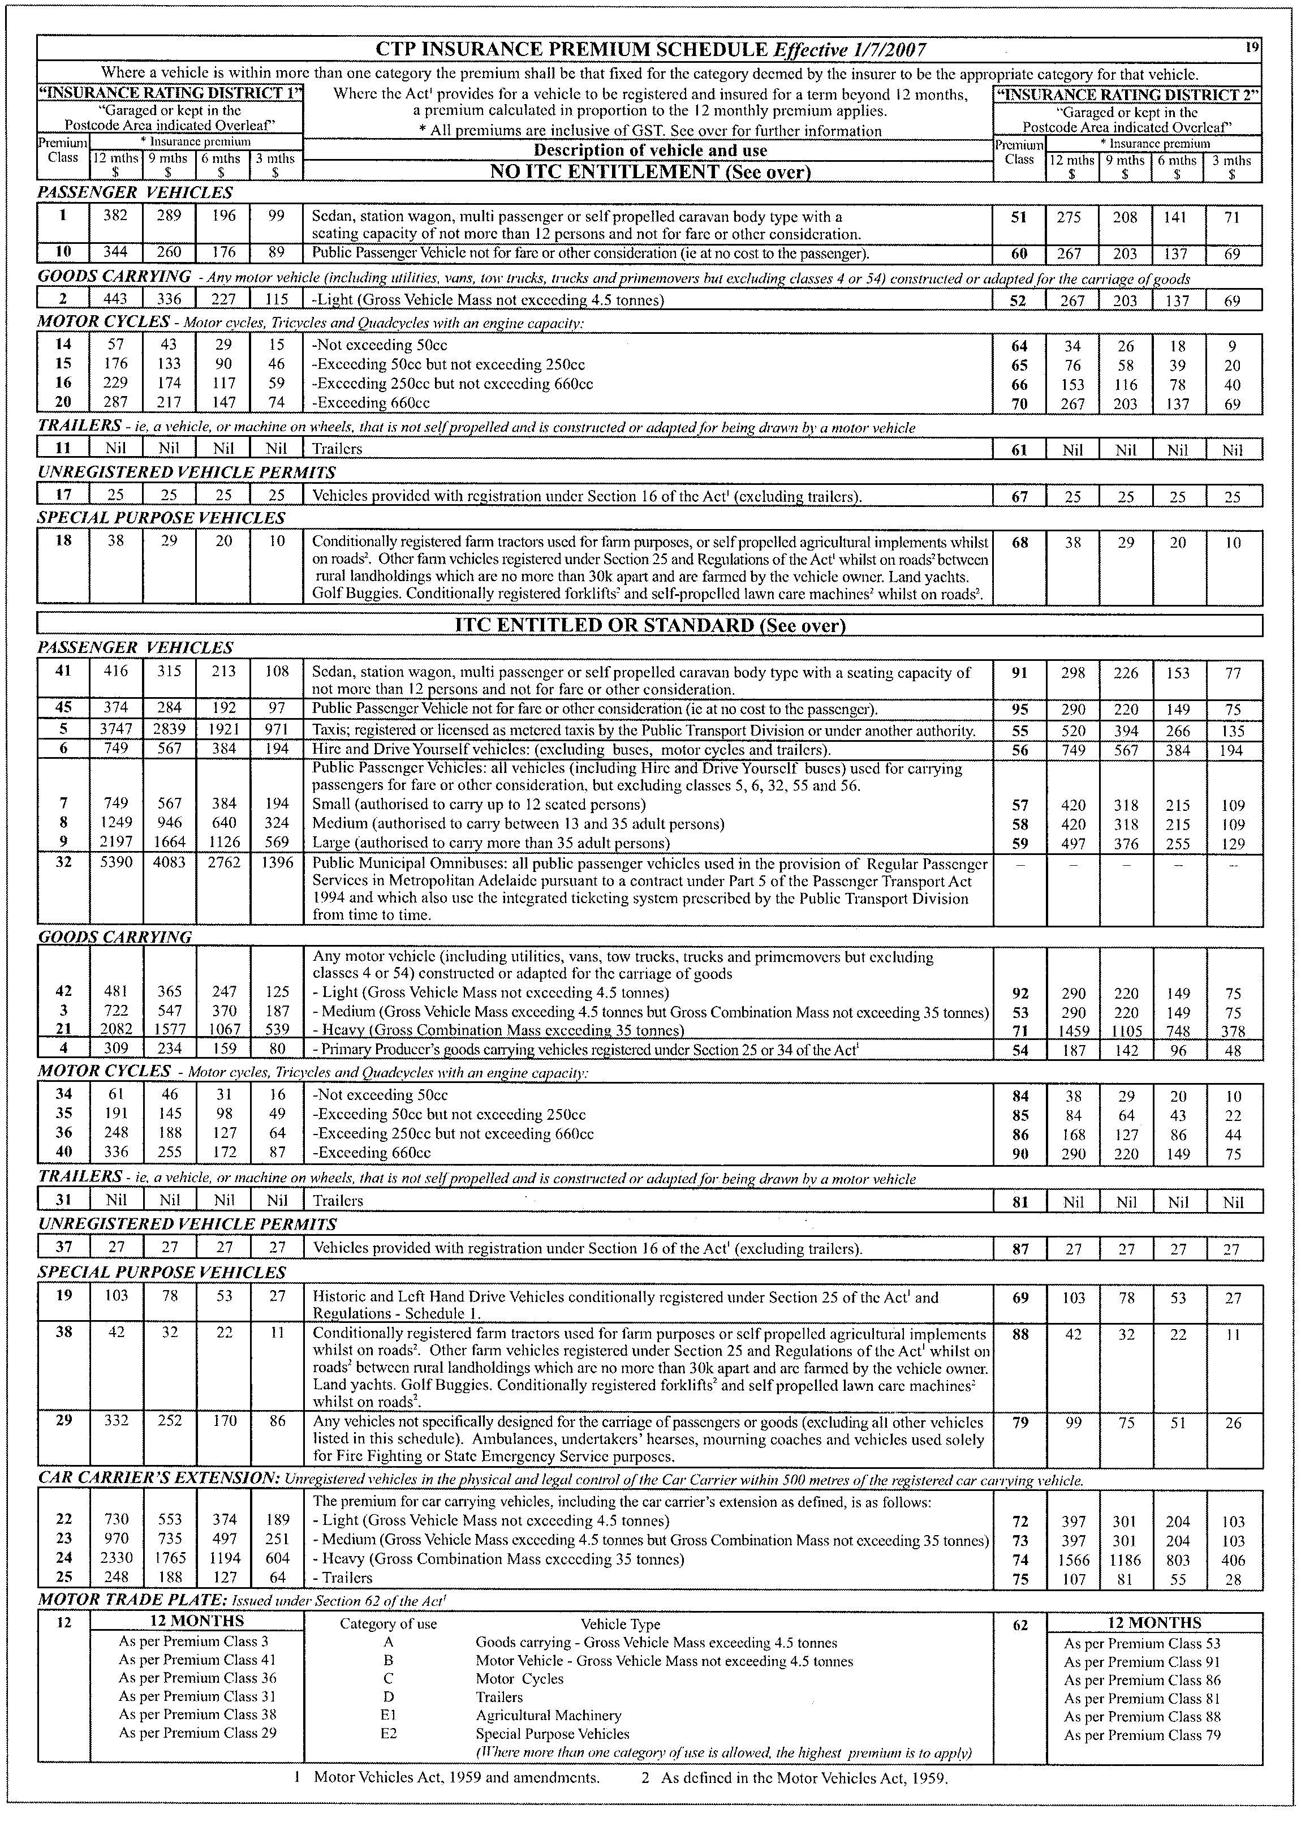

VALUATION OF LAND ACT 1971
Notice of General Valuation
PURSUANT to the Valuation of Land Act 1971, notice is hereby given that I have made a general valuation of all land within the following areas:
City of Adelaide
Adelaide Hills Council
Alexandrina Council
The Barossa Council
District Council of Barunga West
The Berri Barmera Council
City of Burnside
City of Campbelltown
District Council of Ceduna
City of Charles Sturt
Clare & Gilbert Valleys Council
District Council of Cleve
District Council of Coober Pedy
The Coorong District Council
District Council of the Copper Coast
District Council of Elliston
The Flinders Ranges Council
District Council of Franklin Harbour
Town of Gawler
Regional Council of Goyder
District Council of Grant
City of Holdfast Bay
Kangaroo Island Council
District Council of Karoonda East Murray
District Council of Kimba
Kingston District Council
District Council of Le Hunte
Light Regional Council
District Council of Lower Eyre Peninsula
District Council of Loxton Waikerie
District Council of Mallala
City of Marion
Mid Murray Council
City of Mitcham
District Council of Mount Barker
City of Mount Gambier
District Council of Mount Remarkable
The Rural City of Murray Bridge
Naracoorte Lucindale Council
Northern Areas Council
City of Norwood Payneham & St Peters
City of Onkaparinga
District Council of Orroroo Carrieton
District Council of Peterborough
City of Playford
City of Port Adelaide Enfield
City of Port Augusta
City of Port Lincoln
Port Pirie Regional Council
City of Prospect
Renmark Paringa Council
District Council of Robe
Roxby Downs Council
City of Salisbury
Southern Mallee District Council
District Council of Streaky Bay
District Council of Tatiara
City of Tea Tree Gully
District Council of Tumby Bay
City of Unley
City of Victor Harbor
Wakefield Regional Council
Town of Walkerville
Wattle Range Council
City of West Torrens
City of Whyalla
District Council of Yankalilla
District Council of Yorke Peninsula
Un-incorporated areas of the State
The values are assigned as at 1 January 2007 and will come into force at midnight on 30 June 2007.
Dated 31 May 2007.
N. A. Bray, Valuer-General

WATER MAINS AND SEWERS

Office of the South Australian Water Corporation
Adelaide, 31 May 2007

WATER MAINS LAID

Notice is hereby given that the following main pipes or parts of main pipes have been laid down by the South Australian Water Corporation in or near the undermentioned water districts and are now available for a constant supply of water to adjacent land.

BORDERTOWN WATER DISTRICT

TATIARA DISTRICT COUNCIL
Western Drive, Bordertown. p1
Handyside Terrace, Bordertown. p1
Across Oliver Street, Bordertown. p12
Florence Street, Bordertown. p12

COWELL WATER DISTRICT

DISTRICT COUNCIL OF FRANKLIN HARBOUR
Keith Street, Cowell. p7

TOWNSHIP OF JAMESTOWN WATER DISTRICT

NORTHERN AREAS COUNCIL
South Terrace, Jamestown. p5

KINGSTON SE WATER DISTRICT

KINGSTON DISTRICT COUNCIL
Marine Parade, Kingston S.E. p2

MAITLAND WATER DISTRICT

DISTRICT COUNCIL OF YORKE PENINSULA
George Street, Maitland. p6
Lamshed Street, Maitland. p6

NARACOORTE WATER DISTRICT

NARACOORTE LUCINDALE COUNCIL
Poplar Street, Naracoorte. p3

PASKEVILLE WATER DISTRICT

DISTRICT COUNCIL OF THE COPPER COAST
Across Railway Terrace South, Paskeville. p10
East Terrace, Paskeville. p10
School Terrace, Paskeville. p10

PORT AUGUSTA WATER DISTRICT

CITY OF PORT AUGUSTA
Woolundunga Avenue, Stirling North. p4

PORT ELLIOT WATER DISTRICT

CITY OF VICTOR HARBOR
Lincoln Drive, Hindmarsh Valley. p24
Public road, east of lot 403 in LTRO DP 72316, Hindmarsh Valley. p24
Commerce Crescent, Hindmarsh Valley. p24

PORT PIRIE WATER DISTRICT

PORT PIRIE REGIONAL COUNCIL
Westley Street, Port Pirie West. p11

STANSBURY WATER DISTRICT

DISTRICT COUNCIL OF YORKE PENINSULA
Gulf View Road, Stansbury. p9
Lime Kiln Road, Stansbury. p9

TUMBY BAY WATER DISTRICT

THE DISTRICT COUNCIL OF TUMBY BAY
Church Street, Tumby Bay. p8

WATER MAINS ABANDONED

Notice is hereby given that the undermentioned water mains have been abandoned by the South Australian Water Corporation.

TOWNSHIP OF JAMESTOWN WATER DISTRICT

NORTHERN AREAS COUNCIL
South Terrace, Jamestown. p5

MAITLAND WATER DISTRICT

DISTRICT COUNCIL OF YORKE PENINSULA
Lamshed Street, Maitland. p6

STANSBURY WATER DISTRICT

DISTRICT COUNCIL OF YORKE PENINSULA
Gulf View Road, Stansbury. p9

SEWERS LAID

Notice is hereby given that the following sewers have been laid down by the South Australian Water Corporation in the undermentioned drainage areas and are now available for house connections.

ADELAIDE DRAINAGE AREA

CITY OF MARION
Bassi Street, Marion. FB 1158 p41

CITY OF MITCHAM
Moriane Avenue, Panorama. FB 1158 p43

CITY OF ONKAPARINGA
Mosman Street, Port Noarlunga South. FB 1158 p46
Rajah Street, Morphett Vale. FB 1159 p25 and 26
Across Pimpala Road, Morphett Vale. FB 1159 p25 and 26
Easements in lot 3 in LTRO DP 73528, Pimpala Road, and lot 6 in LTRO DP 73528, Madeleine Close, Morphett Vale. FB 1159 p25 and 26
In and across Madeleine Close, Morphett Vale. FB 1159 p25 and 26
Easement in lot 9 in LTRO DP 73528, Rajah Street, Morphett Vale. FB 1159 p25 and 26

CITY OF PORT ADELAIDE ENFIELD
Eighth Avenue, Woodville Gardens. FB 1158 p42

CITY OF SALISBURY
In and across Hookina Road, Burton. FB 1158 p44 and 45
Easement in lots 200-202 in LTRO DP 70850, Helps Road, Burton. FB 1158 p44 and 45
Easements in lot 1023 in LTRO DP 72759, Shoalhaven Circuit, Mawson Lakes. FB 1159 p34-36
Shoalhaven Circuit, Mawson Lakes. FB 1159 p34-36
Fowler Street, Mawson Lakes. FB 1159 p34, 35 and 37
Cygnet Street, Mawson Lakes. FB 1159 p34, 35 and 37

MOUNT GAMBIER COUNTRY DRAINAGE AREA

CITY OF MOUNT GAMBIER
Across O’Halloran Terrace, Mount Gambier. FB 1130 p29
Easement in lot 11 in LTRO DP 69816, O’Halloran Terrace, Mount Gambier. FB 1130 p29

SEWERS LAID

Notice is hereby given that the undermentioned sewers have been laid down by the South Australian Water Corporation and are not available for house connections.

ADELAIDE DRAINAGE AREA

CITY OF SALISBURY
Across Harbour Lane, Mawson Lakes. FB 1159 p34-36
Easements in lot 641 in LTRO DP 61268, Rosella Street, lots 1 and 2 in LTRO DP 15999, Port Wakefield Road, lot 3 in LTRO DP 15999, and lot 10 in LTRO FP 12817, Elder Drive, and lot 1023 in LTRO DP 72759, Shoalhaven Circuit, Mawson Lakes. FB 1159 p34-36

MOUNT GAMBIER COUNTRY DRAINAGE AREA

CITY OF MOUNT GAMBIER
Sewerage land (lot 8 in LTRO DP 44668), Willow Avenue, Mount Gambier—100 mm PVC pumping main. FB 1158 p47 and 48
Across and in Willow Avenue, Mount Gambier—100 mm PVC pumping main. FB 1158 p47 and 48
Across and in Jubilee Highway West, Mount Gambier—100 mm PVC pumping main. FB 1158 p47 and 48

A. Howe, Chief Executive Officer, South Australian Water Corporation.

WHEAT MARKETING ACT 1989
Deductions for South Australian Farmers Federation (SAFF) Grains Council
PURSUANT to section 10 of the Wheat Marketing Act 1989, I, Rory McEwen, Minister for Agriculture, Food and Fisheries, make the following notice concerning grain for the season 2007-2008:
1. There shall be deductions for the purposes of the SAFF Grains Council from the proceeds of all grain for the season.
2. The prescribed amount for such deductions shall be 5 cents per tonne.
3. A purchaser of grain harvested in 2007-2008 is to presume conclusively that the seller has consented to the making of payments under this section.
4. If the seller, by notice in writing given to the Minister by 31 March 2008, indicates that he or she does not consent to the making of such payments in respect of grain harvested in 2007-2008, the Minister must pay to the seller the amount received by the Minister in respect of grain of that season sold by the seller.
5. The written notice should be forwarded to the Minister for Agriculture, Food and Fisheries, G.P.O. Box 1671, Adelaide, S.A. 5001 by the stipulated date.
Dated 23 May 2007.
Rory McEwen, Minister for Agriculture, Food and Fisheries

WHEAT MARKETING ACT 1989
Deductions for Grains Research
PURSUANT to section 10 of the Wheat Marketing Act 1989, I, Rory McEwen, Minister for Agriculture, Food and Fisheries, make the following notice concerning grains for the season 2007-2008:
1. There shall be deductions for the purposes of research from the proceeds of all grain for the season.
2. The prescribed amount for such deductions shall be 16 cents per tonne.
3. A purchaser of grain harvested in 2007-2008 is to presume conclusively that the seller has consented to the making of payments under this section.
4. If the seller, by notice in writing given to the Minister by 31 March 2008, indicates that he or she does not consent to the making of such payments in respect of grain harvested in 2007-2008, the Minister must pay to the seller the amount received by the Minister in respect of grain of that season sold by the seller.
5. The written notice should be forwarded to the Minister for Agriculture, Food and Fisheries, G.P.O. Box 1671, Adelaide, S.A. 5001 by the stipulated date.
Dated 23 May 2007.
Rory McEwen, Minister for Agriculture, Food and Fisheries

WORKERS REHABILITATION AND COMPENSATION
ACT 1986
THE Workcover Corporation of South Australia (‘the Corporation’) in accordance with those provisions of the Workers Rehabilitation and Compensation Act 1986, as amended (‘the WRCA’) and the Workcover Corporation Act 1994, as amended (‘the WCA’) identified in Item 1 of the Schedule hereto (‘the Schedule’) makes its Determination in the terms set out in Item 2 of the Schedule upon the grounds set out in Item 3 of the Schedule, if any, to come into effect on the date set out in Item 4 of the Schedule and determines further that notice of this Determination shall be provided in the manner set out in Item 5 of the Schedule, if any, and further for the purposes of this Determination the Corporation pursuant to section 17 of the WCA delegates those powers or functions of the Corporation set out in Item 6 of the Schedule to the person or persons named therein (‘the Delegate’).
Schedule
Item 1—Legislation Empowering Determination
Sections 65 and 67 of the WRCA and section 17 of the WCA.
Item 2—Terms of Determination
That the Determination of the Corporation made on 15 December 2005 and published in the South Australian Govern-ment Gazette, 25 January 2006, page 328 (‘LAS Determination’) be amended as follows:
2.1 That paragraph 2.3 (c) of the LAS Determination be replaced with the following:
‘(c) the amount of any supplement shall not exceed 100% of the levy payable by the particular employer by application of the percentage fixed by the Corporation under section 66 (6) of the WRCA provided that if the supplement exceeds 50% of the levy payable by the particular employer by appli-cation of the percentage fixed by the Corporation under section 66 (6) of the WRCA, the Board of the Corporation is informed of the imposition and the amount of the supplement as soon as is reasonably practicable; and’
2.2 That the final paragraph of Clause 2.7 (after paragraph 2.7 (b)) of the LAS Determination be replaced with the following:
‘subject to the condition that the amount of the supplement imposed under this Element of the Levy Adjustment Scheme shall not exceed 100% of the levy payable by the particular employer by application of the percentage fixed by the Corporation under section 66 (6) of the WRCA provided that if the supplement exceeds 50% of the levy payable by the particular employer by application of the percentage fixed by the Corporation under section 66 (6) of the WRCA, the Board of the Corporation is informed of the imposition and the amount of the supplement as soon as is reasonably practicable.’
Item 3—Grounds of Determination
That the Levy Adjustment Scheme as established under the LAS Determination and amended by this Determination is a just and equitable means of applying section 67 of the WRCA having regard to the objects of the WRCA and the primary objects of the Corporation.
Item 4—Commencement Date of Determination
This Determination shall commence on the publication of this Determination in the South Australian Government Gazette.
Item 5—Notice of Determination
This Determination shall be published in the Government Gazette.
Item 6—Delegation by Board
As per the LAS Determination.
Confirmed as a true and accurate record of the decision of the Corporation.
Dated 24 May 2007.
Bruce Carter, Chairperson

South Australia
Barley Exporting Act (Commencement) Proclamation 2007
1—Short title
This proclamation may be cited as the Barley Exporting Act (Commencement) Proclamation 2007.
2—Commencement of Act
The Barley Exporting Act 2007 (No 6 of 2007) will come into operation on 1 July 2007.
Made by the Governor
with the advice and consent of the Executive Council
on 31 May 2007
MAFF07/001CS

South Australia
Administrative Arrangements (Administration of Barley Exporting Act) Proclamation 2007
under section 5 of the Administrative Arrangements Act 1994
1—Short title
This proclamation may be cited as the Administrative Arrangements (Administration of Barley Exporting Act) Proclamation 2007.
2—Commencement
This proclamation comes into operation on the day on which it is made.
3—Administration of Act committed to Premier
The administration of the Barley Exporting Act 2007 is committed to the Minister for Agriculture, Food and Fisheries.
Made by the Governor
with the advice and consent of the Executive Council
on 31 May 2007
MAFF07/001CS
South Australia
Holidays (Adelaide Cup) Proclamation 2007
under section 5 of the Holidays Act 1910
1—Short title
This proclamation may be cited as the Holidays (Adelaide Cup) Proclamation 2007.
2—Commencement
This proclamation comes into operation on the day on which it is made.
3—Substitution of Adelaide Cup day in 2008
Monday 10 March 2008 is declared to be a public holiday and bank holiday instead of Monday 19 May 2008.
4—Substitution of Adelaide Cup day in 2009
Monday 9 March 2009 is declared to be a public holiday and bank holiday instead of Monday 18 May 2009.
5—Substitution of Adelaide Cup day in 2010
Monday 8 March 2010 is declared to be a public holiday and bank holiday instead of Monday 17 May 2010.
Made by the Governor
with the advice and consent of the Executive Council
on 31 May 2007
MIR07/007CS

South Australia
Liquor Licensing (Dry Areas—Long Term) Variation Regulations 2007
under the Liquor Licensing Act 1997

Contents
Part 1—Preliminary
1 Short title
2 Commencement
3 Variation provisions
Part 2—Variation of Liquor Licensing (Dry Areas—Long Term) Regulations 1997
4 Variation of Schedule 1—Long term dry areas
5 Variation of Schedule 2—Plans of long term dry areas
Schedule 1—Plan to be inserted

Part 1—Preliminary
1—Short title
These regulations may be cited as the Liquor Licensing (Dry Areas—Long Term) Variation Regulations 2007.
2—Commencement
These regulations come into operation on the day on which they are made.
3—Variation provisions
In these regulations, a provision under a heading referring to the variation of specified regulations varies the regulations so specified.
Part 2—Variation of Liquor Licensing (Dry Areas—Long Term) Regulations 1997
4—Variation of Schedule 1—Long term dry areas
Schedule 1—after the item headed "Adelaide—Area 1" insert:

Ardrossan—Area 1
(see Schedule 2: Ardrossan—Plan No 1)
The area in Ardrossan bounded as follows: commencing at the point at which the north-eastern boundary of Second Street intersects the south-eastern boundary of Oval Terrace, then north-easterly along that boundary of Oval Terrace to the north-eastern boundary of First Street, then south-easterly along that boundary of First Street to the north-western boundary of West Terrace, then north-easterly along that boundary of West Terrace and the prolongation in a straight line of the portion of that boundary that runs north-easterly in a straight line from First Street, to the north-eastern boundary of Dinham Drive, then south-easterly along that boundary of Dinham Drive to the north-western boundary of Bridge Road, then north-easterly and northerly along that boundary of Bridge Road to the south-western boundary of Parkview Terrace, then in a straight line by the shortest route (across Bridge Road) to the point at which the south-eastern boundary of Bridge Road meets the south-western boundary of Park Terrace, then south-easterly along that boundary of Park Terrace and the prolongation in a straight line of that boundary to the low water mark on the western side of Gulf St Vincent, then generally south-westerly along that low water mark to the point at which it is intersected by the prolongation in a straight line of the north-eastern boundary of Second Street, then north-westerly along that prolongation and boundary of Second Street to the point of commencement. | From 10 p.m. on each day until 8 a.m. on the following day, until 8 a.m. on 7 June 2008. | The consumption and possession of liquor are prohibited.
5—Variation of Schedule 2—Plans of long term dry areas
Schedule 2—after the plan headed "Adelaide—Plan No 1" insert the plan headed "Ardrossan—Plan No 1" in Schedule 1 of these regulations.
Schedule 1—Plan to be inserted
Ardrossan—Plan No 1
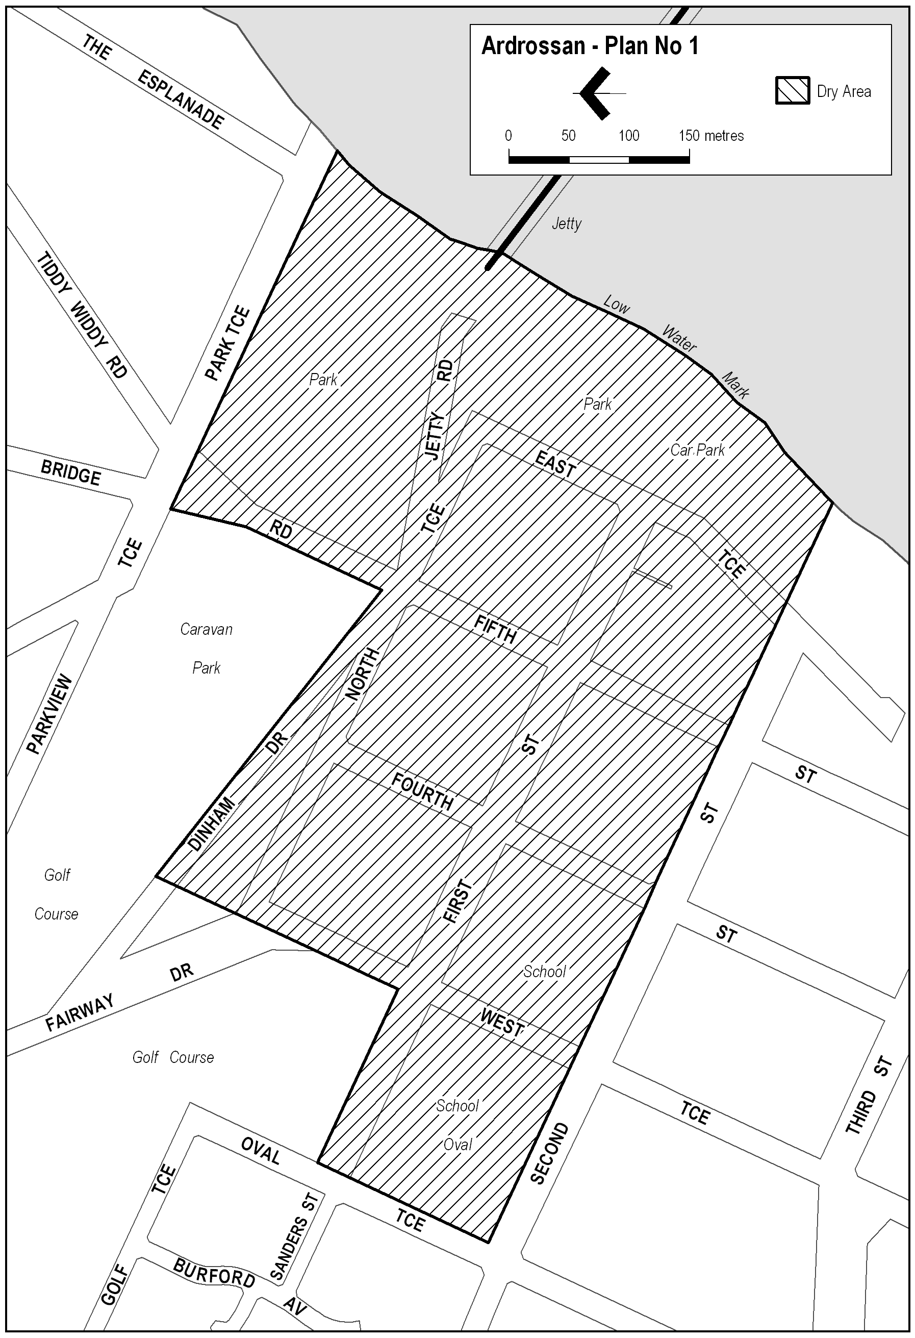
Note—
As required by section 10AA(2) of the Subordinate Legislation Act 1978, the Minister has certified that, in the Minister's opinion, it is necessary or appropriate that these regulations come into operation as set out in these regulations.
Made by the Governor
with the advice and consent of the Executive Council
on 31 May 2007
No 63 of 2007
MCA07/019CS

South Australia
Harbors and Navigation Variation Regulations 2007
under the Harbors and Navigation Act 1993

Contents
Part 1—Preliminary
1 Short title
2 Commencement
3 Variation provisions
Part 2—Variation of Harbors and Navigation Regulations 1994
4 Variation of Schedule 10—Speed restrictions in certain waters

Part 1—Preliminary
1—Short title
These regulations may be cited as the Harbors and Navigation Variation Regulations 2007.
2—Commencement
These regulations come into operation on the day on which they are made.
3—Variation provisions
In these regulations, a provision under a heading referring to the variation of specified regulations varies the regulations so specified.
Part 2—Variation of Harbors and Navigation Regulations 1994
4—Variation of Schedule 10—Speed restrictions in certain waters
Schedule 10, clause 2—after paragraph (ca) insert:
(cab) Renmark
The area comprising—
(i) the waters of Ral Ral Creek bounded in the north by a line extending south-east from the south-easternmost corner of the dry dock and in the south by the prolongation in a generally south-easterly direction of the south-western boundary of Lot 602 of Deposited Plan 24267; and
(ii) the waters to the east of Ral Ral Creek bounded as follows:
(A) in the north by a line extending south-east from the south-easternmost corner of the dry dock referred to in subparagraph (i);
(B) in the south by the prolongation in a generally south-easterly direction of the south-western boundary of Lot 602 of Deposited Plan 24267;
(C) in the west by Ral Ral Creek;
(D) in the east by a line running parallel to, at a distance of 100 metres from, the western bank of Ral Ral Creek; and
(iii) the creeks, tributaries, lakes, lagoons or other bodies of water (collectively known as the Jane Eliza Waterways) connected, whether directly or indirectly, to the waters described in subparagraph (i).
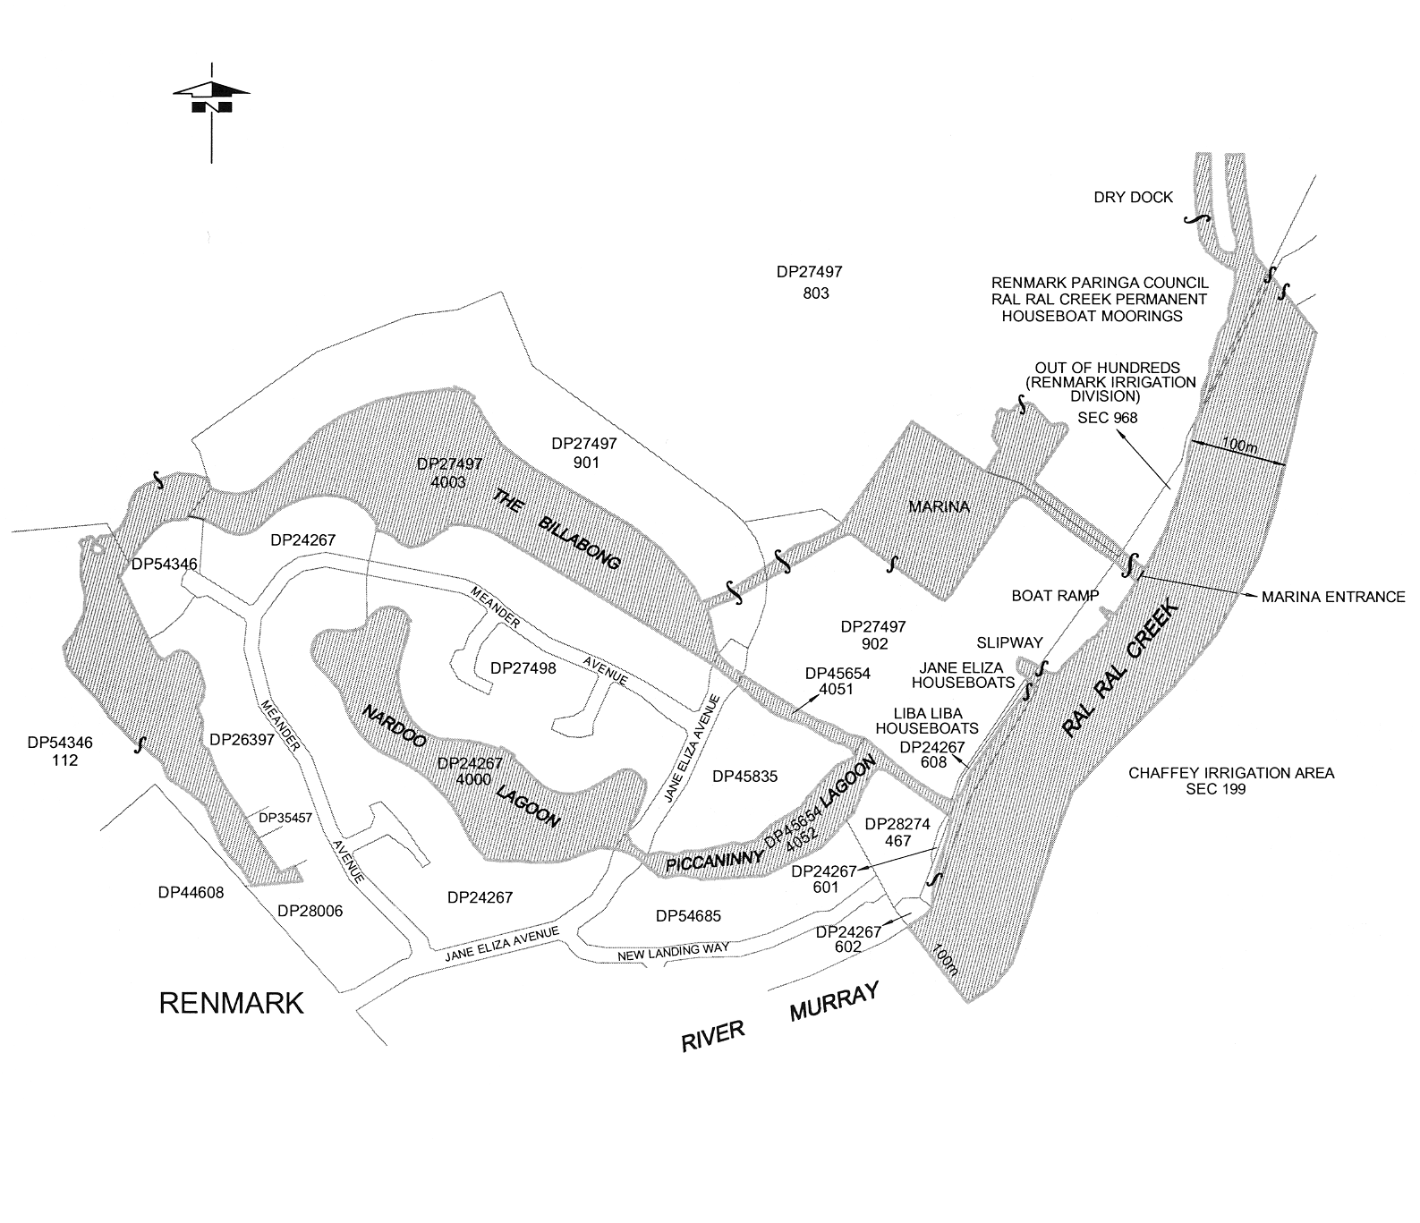
Note—
As required by section 10AA(2) of the Subordinate Legislation Act 1978, the Minister has certified that, in the Minister's opinion, it is necessary or appropriate that these regulations come into operation as set out in these regulations.
Made by the Governor
with the advice and consent of the Executive Council
on 31 May 2007
No 64 of 2007
MTR07/002CS

South Australia
Controlled Substances (Poisons) Variation
Regulations 2007
under the Controlled Substances Act 1984

Contents
Part 1—Preliminary
1 Short title
2 Commencement
3 Variation provisions
Part 2—Variation of Controlled Substances (Poisons) Regulations 1996
4 Variation of regulation 31B—Special restrictions on prescription or supply of drugs of dependence by medical practitioners, dentists and veterinary surgeons

Part 1—Preliminary
1—Short title
These regulations may be cited as the Controlled Substances (Poisons) Variation Regulations 2007.
2—Commencement
These regulations will come into operation on 1 June 2007.
3—Variation provisions
In these regulations, a provision under a heading referring to the variation of specified regulations varies the regulations so specified.
Part 2—Variation of Controlled Substances (Poisons) Regulations 1996
4—Variation of regulation 31B—Special restrictions on prescription or supply of drugs of dependence by medical practitioners, dentists and veterinary surgeons
(1) Regulation 31B(1)(c)—after "spouse," insert:
domestic partner,
(2) Regulation 31B(3)—delete subregulation (3) and substitute:
(3) In this regulation—
domestic partner means a person who is a domestic partner within the meaning of the Family Relationships Act 1975, whether declared as such under that Act or not;
spouse—a person is the spouse of another if they are legally married.
Note—
As required by section 10AA(2) of the Subordinate Legislation Act 1978, the Minister has certified that, in the Minister's opinion, it is necessary or appropriate that these regulations come into operation as set out in these regulations.
Made by the Governor
after consultation with the Controlled Substances Advisory Council and with the advice and consent of the Executive Council
on 31 May 2007
No 65 of 2007
AGO0021/07CS

FAXING COPY?
IF you fax copy to Government Publishing SA for inclusion in the Government Gazette, there is no need to send a Confirmation Copy to us as well.
This creates confusion and may well result in your notice being printed twice.
Please use the following fax number:
Fax transmission: (08) 8207 1040
Phone Inquiries: (08) 8207 1045
Please include a contact person, phone number and order number so that we can phone back with any queries we may have regarding the fax copy.
NOTE: Closing time for lodging new copy (fax, hard copy or email) is 4 p.m. on Tuesday preceding the day of publication.

Government Gazette notices can be E-mailed.
The address is:
governmentgazette@dpc.sa.gov.au
Documents should be sent as attachments in Word format.
When sending a document via E-mail, please confirm your transmission with a faxed copy of your document, including the date the notice is to be published.
Fax transmission: (08) 8207 1040
Enquiries: (08) 8207 1045
NOTE: Closing time for lodging new copy (fax, hard copy or email) is 4 p.m. on Tuesday preceding the day of publication.

CITY OF CHARLES STURT
Roads (Opening And Closing) Act 1991
Clare Street, Athol Park
NOTICE is hereby given pursuant to section 10 of the Roads (Opening and Closing) Act 1991, that the Council proposes to make a Road Process Order to close, sell and transfer to the South Australian Housing Trust the eastern side of Clare Street adjoining allotment 114 in Deposited Plan 7468 lettered ‘A’ on Preliminary Plan No. 07/0024.
A copy of the plan and a statement of persons affected are available for public inspection at the City of Charles Sturt Council Office, 72 Woodville Road, Woodville and the office of the Surveyor-General, 101 Grenfell Street, Adelaide during normal office hours.
Any application for easement or objections must be made in writing within 28 days from 31 May 2007, to the Council, P.O. Box 1, Woodville, S.A. 5011 and the Surveyor-General, G.P.O. Box 1354, Adelaide, S.A. 5001, setting out the full details.
Where a submission is made, Council will give notification of a meeting to deal with the matter.
Dated 31 May 2007.
M. Withers, Chief Executive Officer

CITY OF MITCHAM
Road Closure at Railway Terrace, Blackwood
NOTICE is hereby given that at a meeting on 22 May 2007, Council resolved that in exercise of its powers contained in section 359 of the Local Government Act 1934, all vehicles (with the exception of non motored-powered cycles) be excluded from the extreme northern portion of Railway Terrace, Blackwood at the location of the existing landscaping at a point just north of the end of the bituminised road pavement, as shown in the plan.
R. Malcolm, Chief Executive Officer

THE DISTRICT COUNCIL OF MALLALA
Roads (Opening and Closing) Act 1991
Road Opening and Closing—Germantown Road, Redbanks
NOTICE is hereby given, pursuant to section 10 of the Roads (Opening and Closing) Act 1991, that The District Council of Mallala proposes to make a Road Process Order to:
(i) open as road portion of allotment 92 in Filed Plan 176138 more particularly delineated and numbered ‘1’ on Preliminary Plan No. 07/0009;
(ii) close portions of Germantown Road and merge with the adjoining said allotment 92 in Filed Plan 176138, more particularly delineated and lettered ‘A’ and ‘B’ on Preliminary Plan No. 07/0009.
A copy of the plan and a statement of persons affected are available for public inspection at the offices of the Council, 2A Wasleys Road, Mallala and the Adelaide office of the Surveyor-General during normal office hours.
Any objection or application for easement must set out the full name, address and details of the submission and must be fully supported by reasons.
The objection or application must be made in writing to the Council, P.O. Box 18, Mallala, S.A. 5502 within 28 days of this notice and a copy must be forwarded to the Surveyor-General, G.P.O. Box 1354, Adelaide, S.A. 5001. Where a submission is made, the Council will give notification of a meeting at which the matter will be considered.
D. Moloney, Chief Executive Officer

DISTRICT COUNCIL OF STREAKY BAY
Special Budget Council Meeting
NOTICE is hereby given that a Special Budget Council Meeting will be held in the Council Chambers, 29 Alfred Terrace, Streaky Bay on Thursday, 28 June 2007, commencing at 9.30 a.m.
J. Rumbelow, Chief Executive Officer

IN the matter of the estates of the undermentioned deceased persons:
Bungey, Margery Jean, late of 9 Luhrs Road, Payneham South, of no occupation, who died on 22 March 2007.
Carragher, Eileen Henrietta Frances, late of 13 Plymouth Avenue, Sturt, retired teacher, who died on 15 March 2007.
Cryans, Joseph, late of 346 Payneham Road, Payneham, of no occupation, who died on 1 January 2006.
Gardner, Sylvie Angelina, late of 160 Walkerville Terrace, Walkerville, of no occupation, who died on 28 February 2007.
Gardner, Thelma May, late of 22 Mornington Road, Unley, home duties, who died on 1 March 2007.
Hunter, Thelma Winifred, late of 47 Eve Road, Bellevue Heights, retired registered nurse, who died on 3 April 2007.
Jolly, Joyce Eleanor, late of 20 Cedar Avenue, Brighton, home duties, who died on 8 March 2007.
Maling, Irene Thelma, late of 8 Cherry Street, Freeling, retired totalizator operator, who died on 22 February 2007.
Shaw, Christopher John, late of 12 Minories, Port Adelaide, retired artist, who died on 20 February 2007.
Witty, Sylvia Elizabeth, late of 50 Penzance Street, Glenelg South, retired telephonist, who died on 24 March 2007.
Wright, Gweneth Margaret, late of 11 Sandilands Street, Lockleys, home duties, who died on 13 March 2007.
Notice is hereby given pursuant to the Trustee Act 1936, as amended, the Inheritance (Family Provision) Act 1972, and the Family Relationships Act 1975, that all creditors, beneficiaries, and other persons having claims against the said estates are required to send, in writing, to the Public Trustee, 25 Franklin Street, Adelaide, S.A. 5000, full particulars and proof of such claims, on or before 29 June 2007, otherwise they will be excluded from the distribution of the said estate; and notice is also hereby given that all persons who are indebted to the said estates are required to pay the amount of their debts to the Public Trustee or proceedings will be taken for the recovery thereof; and all persons having any property belonging to the said estates are forthwith to deliver the same to the Public Trustee.
Dated 31 May 2007.
C. J. O’Loughlin, Public Trustee

UNCLAIMED MONEYS ACT 1891
Register of Unclaimed Moneys held by Morning Star Holdings (Australia) Limited as at 25 May 2007
(1) Interim Dividend $1 340 250.08—Paid 30.9.98—100% Franked
(2) Special Dividend $8 497 185.51—Paid 2.10.98—75.5% Franked
(3) Final Dividend $2 010 375.12—Paid 9.4.99—100% Franked

Name and Address of Shareholder | Holder  Number | Units/  Shares | Dividend  Date | Cheque  No. | Amount  Paid  $
Benico Estates Pty Ltd, States Road, Hackham, S.A. 5163 |  | 2 500 | 30.9.98 | 14 | 50.00
Damian and Tiffany Bishop, 9/13 Beach Avenue, Elwood, Vic. 3184 |  | 1 000 | 30.9.98 | 25 | 20.00
Michael Jeffrey Harrison, 63 Manton Street, Hindmarsh, S.A. 5007 |  | 2 000 | 30.9.98 | 111 | 40.00
Andries Johannesen, 1 The Glade, Springfield, S.A. 5062 |  | 2 000 | 30.9.98 | 129 | 40.00
Frederick Kenneth, G.P.O. Box 2387, Adelaide, S.A. 5001 |  | 2 000 | 30.9.98 | 149 | 40.00
David John Purcell, 101 Pirie Street, Adelaide, S.A. 5000 |  | 2 500 | 30.9.98 | 223 | 50.00
Timothy John Voss, 27 Thornber Street, Unley Park, S.A. 5061 |  | 1 500 | 30.9.98 | 289 | 30.00
Adelaide Securities Limited, 2nd Floor, 55 Grenfell Street, Adelaide, S.A. 5000 |  | 2 000 | 30.9.98 | 311 | 40.00
Sally Barnes, G.P.O. Box 2322, Adelaide, S.A. 5001 |  | 2 000 | 30.9.98 | 313 | 40.00
Gale Cook, 65/1-7 Hampden Avenue, Cremorne, N.S.W. 2090 |  | 1 000 | 30.9.98 | 318 | 20.00
Ronald Francis, 65/1-7 Hampden Avenue, Cremorne, N.S.W. 2090 |  | 1 000 | 30.9.98 | 327 | 20.00
Kanjo Pty Ltd, 3rd Floor, 15 Franklin Street, Adelaide, S.A. 5000 |  | 2 000 | 30.9.98 | 338 | 40.00
Douglas Kater, 40 King Arthur Drive, Glen Waverley, Vic. 3150 |  | 2 000 | 30.9.98 | 339 | 40.00
S. J. Lipman, 47 Waymouth Street, Adelaide, S.A. 5000 |  | 1 000 | 30.9.98 | 344 | 20.00
John William Reubenicht, 10 Duke Street, Beulah Park, S.A. 5067 |  | 2 000 | 30.9.98 | 353 | 40.00
Mark Ashley Sallis, 118 Seventh Avenue, Joslin, S.A. 5070 |  | 2 000 | 30.9.98 | 358 | 40.00
Sea Securities Pty Ltd, 2nd Floor, 55 Grenfell Street, Adelaide, S.A. 5000 |  | 2 000 | 30.9.98 | 360 | 40.00
Sun Securities Pty Ltd, 2nd Floor, 55 Grenfell Street, Adelaide, S.A. 5000 |  | 2 000 | 30.9.98 | 363 | 40.00
Arthur Paul Wadlow, 7 Bennett Avenue, Beaumont, S.A. 5066 |  | 1 000 | 30.9.98 | 368 | 20.00
Benico Estates Pty Ltd, States Road, Hackham, S.A. 5163 |  | 2 500 | 2.10.98 | 387 | 279.65
Damian and Tiffany Bishop, 9/13 Beach Avenue, Elwood, Vic. 3184 |  | 1 000 | 2.10.98 | 398 | 111.75
Pauline Anne Brown, 3 Sophia Court, Morphett Vale, S.A. 5162 |  | 500 | 2.10.98 | 406 | 56.10
Michael John Burdon, 18 College Road, Kent Town, S.A. 5067 |  | 500 | 2.10.98 | 409 | 56.10
Tracey Anne Challoner, 17 Hendy Avenue, Revesby, N.S.W. 2213 |  | 500 | 2.10.98 | 413 | 56.10
Michael Gererd Curtis, P.O. Box 138, North Adelaide, S.A. 5006 |  | 500 | 2.10.98 | 429 | 56.10
Christopher James Dennis, 601 Glynburn Road, Beaumount, S.A. 5066 |  | 500 | 2.10.98 | 438 | 56.10
Michael Stewart Downton, 57 Winchester Street, Malvern, S.A. 5061 |  | 500 | 2.10.98 | 448 | 56.10
Anja Edler, 2 Mornington Avenue, Plympton, S.A. 5038 |  | 500 | 2.10.98 | 458 | 56.10
Matthias Edler, 2 Mornington Avenue, Plympton, S.A. 5038 |  | 500 | 2.10.98 | 459 | 56.10
Shelley Anne Elder, 235 Glynburn Road, St Morris, S.A. 5068 |  | 500 | 2.10.98 | 461 | 56.10
Michael Jeffrey Harrison, 63 Manton Street, Hindmarsh, S.A. 5007 |  | 2 000 | 2.10.98 | 484 | 223.55
Lynne Anne Herbert, 35 Henry Street, Payneham, S.A. 5070 |  | 500 | 2.10.98 | 487 | 56.10
Andries Johannesen, 1 The Glade, Springfield, S.A. 5062 |  | 2 000 | 2.10.98 | 502 | 223.55
Elizabeth Windsor Johns, 33 King Street, Brighton, S.A. 5048 |  | 250 | 2.10.98 | 503 | 28.30
Frederick Kenneth, G.P.O. Box 2387, Adelaide, S.A. 5001 |  | 2 000 | 2.10.98 | 522 | 223.55
Caroline P. Lumsden, 4 Ekalla Court, Modbury North, S.A. 5092 |  | 500 | 2.10.98 | 534 | 56.10
Colin Joseph Marland and Kim Ann McBride, Unit 704, 1 Watson Street, Neutral Bay, N.S.W. 2089 |  | 500 | 2.10.98 | 542 | 56.10
David John Purcell, 101 Pirie Street, Adelaide, S.A. 5000 |  | 2 500 | 2.10.98 | 596 | 279.65
Mary Elizabeth Thomas, 50 Wellington Square, North Adelaide, S.A. 5006 |  | 500 | 2.10.98 | 648 | 56.10
Jennifer Mary Thompson, 1 Drake Avenue, Flinders Park, S.A. 5025 |  | 500 | 2.10.98 | 649 | 56.10
Lynton Travis Torode, P.O. Box 138, North Adelaide, S.A. 5006 |  | 500 | 2.10.98 | 655 | 56.10
Timothy John Voss, 27 Thornber Street, Unley Park, S.A. 5061 |  | 1 500 | 2.10.98 | 662 | 167.90
Daniel Victor Warne, 2 Giles Street, Alice Springs, N.T. 0870 |  | 500 | 2.10.98 | 664 | 56.10
Janeen Fay Warne, 2 Giles Street, Alice Springs, N.T. 0870 |  | 500 | 2.10.98 | 665 | 56.10
Paul Ronald Evan Adams, G.P.O. Box 2322, Adelaide, S.A. 5001 |  | 500 | 2.10.98 | 683 | 56.10
Adelaide Securities Limited, 2nd Floor, 55 Grenfell Street, Adelaide, S.A. 5000 |  | 2 000 | 2.10.98 | 684 | 223.55
Craig Anthony Barnes, G.P.O. Box 2322, Adelaide, S.A. 5001 |  | 500 | 2.10.98 | 685 | 56.10
Sally Barnes, G.P.O. Box 2322, Adelaide, S.A. 5001 |  | 2 000 | 2.10.98 | 686 | 223.55
Leslie Raymond Bowyer, 41 Grosvenor Street, Glandore, S.A. 5037 |  | 500 | 2.10.98 | 688 | 56.10
Frank James Chapman, 23 Hawthorndene Drive, Glenalta, S.A. 5052 |  | 500 | 2.10.98 | 690 | 56.10
Gale Cook, 65/1-7 Hampden Avenue, Cremorne, N.S.W. 2090 |  | 1 000 | 2.10.98 | 691 | 111.75
Catherine Anne Cristaudo, 16 Clark Avenue, Glandore, S.A. 5037 |  | 500 | 2.10.98 | 692 | 56.10
Wayne Anthony Cristaudo, 16 Clark Avenue, Glandore, S.A. 5037 |  | 500 | 2.10.98 | 693 | 56.10
Stanley John Davis, 22 Ormonde Avenue, Millswood, S.A. 5034 |  | 500 | 2.10.98 | 694 | 56.10
Lachlan Bruce Dennis, 85 Stanley Street, Erindale, S.A. 5066 |  | 500 | 2.10.98 | 695 | 56.10
Philip James Dennis, P.O. Box 232, Clare, S.A. 5453 |  | 500 | 2.10.98 | 696 | 56.10
Deubai Pty Ltd, 16 Tristania Terrace, Dernancourt, S.A. 5075 |  | 500 | 2.10.98 | 697 | 56.10
Terry Edwards, 6 Greenridge Court, Wynn Vale, S.A. 5127 |  | 500 | 2.10.98 | 698 | 56.10
Beverley Joy Evorall, 16 Morcombe Street, Stepney, S.A. 5069 |  | 500 | 2.10.98 | 699 | 56.10
Ronald Francis, 65/1-7 Hampden Avenue, Cremorne, N.S.W. 2090 |  | 1 000 | 2.10.98 | 700 | 111.75
Michelle Ann French, c/o Morgan Grenfell, 38-40 Currie Street, Adelaide, S.A. 5000 |  | 500 | 2.10.98 | 701 | 56.10
Craig Anthony Hodder, 93 Leabrook Drive, Rostrevor, S.A. 5073 |  | 500 | 2.10.98 | 704 | 56.10
Mary Hodder, 93 Leabrook Drive, Rostrevor, S.A. 5073 |  | 500 | 2.10.98 | 705 | 56.10
Michael David Horner, 7 Alison Avenue, Blackwood, S.A. 5051 |  | 500 | 2.10.98 | 706 | 56.10
John Ivanoff, 21 Grant Avenue, Rose Park, S.A. 5067 |  | 500 | 2.10.98 | 708 | 56.10
John Gary Ivanoff, 14 Toolaby Street, Beaumont, S.A. 5066 |  | 500 | 2.10.98 | 709 | 56.10
Steven Thomas Jenkins and Ross King, c/o 5 Second Avenue, Ascot Park, S.A. 5043 |  | 500 | 2.10.98 | 710 | 56.10
Kanjo Pty Ltd, 3rd Floor, 15 Franklin Street, Adelaide, S.A. 5000 |  | 2 000 | 2.10.98 | 711 | 223.55
Douglas Kater, 40 King Arthur Drive, Glen Waverley, Vic. 3150 |  | 2 000 | 2.10.98 | 712 | 223.55
Dahlia Kaye, 21 Grant Avenue, Rose Park, S.A. 5067 |  | 500 | 2.10.98 | 713 | 56.10
David Christopher Kemp, 5 Bevington Road, Glenunga, S.A. 5064 |  | 500 | 2.10.98 | 714 | 56.10
Merawyn Elsie Kemp, 5 Bevington Road, Glenunga, S.A. 5064 |  | 500 | 2.10.98 | 715 | 56.10
Myfanwy Nancy Ellen Kemp, 5 Bevington Road, Glenunga, S.A. 5064 |  | 500 | 2.10.98 | 716 | 56.10
S. J. Lipman, 47 Waymouth Street, Adelaide, S.A. 5000 |  | 1 000 | 2.10.98 | 717 | 111.75
Mario Marzola, 11 Angas Street, Kent Town, S.A. 5067 |  | 500 | 2.10.98 | 720 | 56.10
Christopher John Monaghan, 42 Sturt Avenue, Colonel Light Gardens, S.A. 5041 |  | 500 | 2.10.98 | 723 | 56.10
Natcorp Nominees Pty Ltd, Level 4, 845 Pacific Highway, Chatswood, N.S.W. 2067 |  | 500 | 2.10.98 | 724 | 56.10
Nova Group Limited, 1st Floor, 19 Young Street, Adelaide, S.A. 5000 |  | 500 | 2.10.98 | 725 | 56.10
John William Reubenicht, 10 Duke Street, Beulah Park, S.A. 5067 |  | 2 000 | 2.10.98 | 726 | 223.55
Anthony Graham Ricketts, 37 Hampton Street, Hawthorn, S.A. 5064 |  | 500 | 2.10.98 | 727 | 56.10
Malcolm Rudd, 31B Margaret Street, Norwood, S.A. 5067 |  | 500 | 2.10.98 | 729 | 63.40
Mark Ashley Sallis, 118 Seventh Avenue, Joslin, S.A. 5070 |  | 2 000 | 2.10.98 | 731 | 223.55
Barry Stephen Scott and Lindy Anne Scott, c/o Club Med, 131 Exhibition Street, Melbourne, Vic. 3000 |  | 500 | 2.10.98 | 732 | 56.10
Sea Securities Pty Ltd, 2nd Floor, 55 Grenfell Street, Adelaide, S.A. 5000 |  | 2 000 | 2.10.98 | 733 | 223.55
Julie Elizabeth Sherrah, 40 Caffrey Crescent, Port Willunga, S.A. 5173 |  | 500 | 2.10.98 | 734 | 56.10
David James Simmons, 20 Thermopylae Crescent, Hallett Cove, S.A. 5158 |  | 500 | 2.10.98 | 735 | 56.10
Sun Securities Pty Ltd, 2nd Floor, 55 Grenfell Street, Adelaide, S.A. 5000 |  | 2 000 | 2.10.98 | 736 | 223.55
Gwen Thomas, P.O. Box 20, Gulnare, S.A. 5471 |  | 500 | 2.10.98 | 737 | 56.10
Harold Thomas, 170 Marian Road, Glynde, S.A. 5070 |  | 500 | 2.10.98 | 738 | 56.10
Jacqueline Thomas, P.O. Box 20, Gulnare, S.A. 5471 |  | 500 | 2.10.98 | 739 | 56.10
Murray William Uhlmann, 9 Orley Avenue, Stirling, S.A. 5152 |  | 500 | 2.10.98 | 740 | 56.10
Arthur Paul Wadlow, 7 Bennett Avenue, Beaumont, S.A. 5066 |  | 1 000 | 2.10.98 | 741 | 111.75
Ernest Walker, 18 Sheoak Avenue, Novar Gardens, S.A. 5040 |  | 500 | 2.10.98 | 742 | 56.10
Finnis Mona Walker, 18 Sheoak Avenue, Novar Gardens, S.A. 5040 |  | 500 | 2.10.98 | 743 | 56.10
Stephen John Benson, 6 Sunset Court, Wynn Vale, S.A. 5127 | I0030000196 | 500 | 9.4.99 | 775 | 15.00
Pauline Anne Brown, 3 Sophia Court, Morphett Vale, S.A. 5162 | I0030000412 | 500 | 9.4.99 | 791 | 15.00
Michael John Burdon, 18 College Road, Kent Town, S.A. 5067 | I0030000455 | 500 | 9.4.99 | 794 | 15.00
Tracey Anne Challoner, 17 Hendy Avenue, Revesby, N.S.W. 2213 | I0030000528 | 500 | 9.4.99 | 799 | 15.00
Janet Kay Coker, 53 Brandreth Street, Tusmore, S.A. 5065 | I0030000579 | 2 000 | 9.4.99 | 803 | 60.00
Michael Gererd Curtis, P.O. Box 138, North Adelaide, S.A. 5006 | I0030000757 | 500 | 9.4.99 | 815 | 15.00
Anja Edler, 2 Mornington Avenue, Plympton, S.A. 5038 | I0030001184 | 500 | 9.4.99 | 841 | 15.00
Matthias Edler, 2 Mornington Avenue, Plympton, S.A. 5038 | I0030001192 | 500 | 9.4.99 | 842 | 15.00
Shelley Anne Elder, 235 Glynburn Road, St Morris, S.A. 5068 | I0030001222 | 500 | 9.4.99 | 844 | 15.00
David John Purcell, 101 Pirie Street, Adelaide, S.A. 5000 | I0030003268 | 2 500 | 9.4.99 | 964 | 75.00
Jennifer Jane Roberts, P.O. Box 38, Karoonda, S.A. 5307 | X0013755558 | 500 | 9.4.99 | 983 | 15.00
Lynton Travis Torode, P.O. Box 138, North Adelaide, S.A. 5006 | I0030004141 | 500 | 9.4.99 | 1021 | 15.00
Elena Voss, 7 Madeline Road, Stirling, S.A. 5152 | I0030000862 | 500 | 9.4.99 | 1027 | 15.00
Stephen Douglas Voss, 7 Madeline Road, Stirling, S.A. 5152 | I0030004230 | 2 000 | 9.4.99 | 1028 | 60.00
Timothy John Voss, 27 Thornber Street, Unley Park, S.A. 5061 | I0030004248 | 1 500 | 9.4.99 | 1029 | 45.00
Daniel Victor Warne, 2 Giles Street, Alice Springs, N.T. 0870 | I0030004302 | 500 | 9.4.99 | 1031 | 15.00
Janeen Fay Warne, 2 Giles Street, Alice Springs, N.T. 0870 | I0030004311 | 500 | 9.4.99 | 1032 | 15.00
Paul Ronald Evan Adams, G.P.O. Box 2322, Adelaide, S.A. 5001 | I0030000013 | 500 | 9.4.99 | 1051 | 15.00
Adelaide Securities Limited, 2nd Floor, 55 Grenfell Street, Adelaide, S.A. 5000 | I0030000021 | 2 000 | 9.4.99 | 1052 | 60.00
Craig Anthony Barnes, G.P.O. Box 2322, Adelaide, S.A. 5001 | I0030000099 | 500 | 9.4.99 | 1053 | 15.00
Sally Barnes, G.P.O. Box 2322, Adelaide, S.A. 5001 | I0030000102 | 2 000 | 9.4.99 | 1054 | 60.00
Benico Estates Pty Ltd, States Road, Hackham, S.A. 5163 | I0030000161 | 2 500 | 9.4.99 | 1055 | 75.00
Damian and Tiffany Bishop, 9/13 Beach Avenue, Elwood, Vic. 3184 | I0030000293 | 1 000 | 9.4.99 | 1056 | 30.00
Leslie Raymond Bowyer, 41 Grosvenor Street, Glandore, S.A. 5037 | I0030000366 | 500 | 9.4.99 | 1057 | 15.00
Frank James Chapman, 23 Hawthorndene Drive, Glenalta, S.A. 5052 | I0030000536 | 500 | 9.4.99 | 1058 | 15.00
Gale Cook, 65/1-7 Hampden Avenue, Cremorne, N.S.W. 2090 | I0030000625 | 1 000 | 9.4.99 | 1059 | 30.00
Catherine Anne Cristaudo, 16 Clark Avenue, Glandore, S.A. 5037 | I0030000722 | 500 | 9.4.99 | 1060 | 15.00
Wayne Anthony Cristaudo, 16 Clark Avenue, Glandore, S.A. 5037 | I0030000731 | 500 | 9.4.99 | 1061 | 15.00
Stanley John Davis, 22 Ormonde Avenue, Millswood, S.A. 5034 | I0030000838 | 500 | 9.4.99 | 1062 | 15.00
Christopher James Dennis, 601 Glynburn Road, Beaumount, S.A. 5066 | I0030000901 | 500 | 9.4.99 | 1063 | 15.00
Lachlan Bruce Dennis, 85 Stanley Street, Erindale, S.A. 5066 | I0030000927 | 500 | 9.4.99 | 1064 | 15.00
Philip James Dennis, P.O. Box 232, Clare, S.A. 5453 | I0030000960 | 500 | 9.4.99 | 1065 | 15.00
Deubai Pty Ltd, 16 Tristania Terrace, Dernancourt, S.A. 5075 | I0030000986 | 500 | 9.4.99 | 1066 | 15.00
Michael Stewart Downton, 57 Winchester Street, Malvern, S.A. 5061 | I0030001061 | 500 | 9.4.99 | 1067 | 15.00
Terry Edwards, 6 Greenridge Court, Wynn Vale, S.A. 5127 | I0030001206 | 500 | 9.4.99 | 1068 | 15.00
Beverley Joy Evorall, 16 Morcombe Street, Stepney, S.A. 5069 | I0030001273 | 500 | 9.4.99 | 1069 | 15.00
Ronald Francis, 65/1-7 Hampden Avenue, Cremorne, N.S.W. 2090 | I0030001346 | 1 000 | 9.4.99 | 1070 | 30.00
Michelle Ann French, c/o Morgan Grenfell, 38-40 Currie Street, Adelaide, S.A. 5000 | I0030001389 | 500 | 9.4.99 | 1071 | 15.00
Michael Jeffrey Harrison, 63 Manton Street, Hindmarsh, S.A. 5007 | I0030001575 | 2 000 | 9.4.99 | 1073 | 60.00
Lynne Anne Herbert, 35 Henry Street, Payneham, S.A. 5070 | I0030001605 | 500 | 9.4.99 | 1075 | 15.00
Craig Anthony Hodder, 93 Leabrook Drive, Rostrevor, S.A. 5073 | I0030001699 | 500 | 9.4.99 | 1076 | 15.00
Mary Hodder, 93 Leabrook Drive, Rostrevor, S.A. 5073 | I0030001702 | 500 | 9.4.99 | 1077 | 15.00
Michael David Horner, 7 Alison Avenue, Blackwood, S.A. 5051 | I0030001729 | 500 | 9.4.99 | 1078 | 15.00
John Ivanoff, 21 Grant Avenue, Rose Park, S.A. 5067 | I0030001796 | 500 | 9.4.99 | 1080 | 15.00
John Gary Ivanoff, 14 Toolaby Street, Beaumont, S.A. 5066 | I0030001800 | 500 | 9.4.99 | 1081 | 15.00
Steven Thomas Jenkins and Ross King, c/o 5 Second Avenue, Ascot Park, S.A. 5043 | I0030001842 | 500 | 9.4.99 | 1082 | 15.00
Andries Johannesen, 1 The Glade, Springfield, S.A. 5062 | I0030001869 | 2 000 | 9.4.99 | 1083 | 60.00
Kanjo Pty Ltd, 3rd Floor, 15 Franklin Street, Adelaide, S.A. 5000 | I0030002016 | 2 000 | 9.4.99 | 1084 | 60.00
Douglas Kater, 40 King Arthur Drive, Glen Waverley, Vic. 3150 | I0030002032 | 2 000 | 9.4.99 | 1085 | 60.00
Dahlia Kaye, 21 Grant Avenue, Rose Park, S.A. 5067 | I0030002041 | 500 | 9.4.99 | 1086 | 15.00
David Christopher Kemp, 5 Bevington Road, Glenunga, S.A. 5064 | I0030002067 | 500 | 9.4.99 | 1087 | 15.00
Merawyn Elsie Kemp, 5 Bevington Road, Glenunga, S.A. 5064 | I0030002075 | 500 | 9.4.99 | 1088 | 15.00
Myfanwy Nancy Ellen Kemp, 5 Bevington Road, Glenunga, S.A. 5064 | I0030002083 | 500 | 9.4.99 | 1089 | 15.00
Frederick Kenneth, G.P.O. Box 2387, Adelaide, S.A. 5001 | I0030002202 | 2 000 | 9.4.99 | 1090 | 60.00
S. J. Lipman, 47 Waymouth Street, Adelaide, S.A. 5000 | I0030002342 | 1 000 | 9.4.99 | 1091 | 30.00
Caroline P. Lumsden, 4 Ekalla Court, Modbury North, S.A. 5092 | I0030002369 | 500 | 9.4.99 | 1092 | 15.00
Colin Joseph Marland and Kim Ann McBride, Unit 704, 1 Watson Street, Neutral Bay, N.S.W. 2089 | I0030002474 | 500 | 9.4.99 | 1094 | 15.00
Mario Marzola, 11 Angas Street, Kent Town, S.A. 5067 | I0030002521 | 500 | 9.4.99 | 1095 | 15.00
Christopher John Monaghan, 42 Sturt Avenue, Colonel Light Gardens, S.A. 5041 | I0030002784 | 500 | 9.4.99 | 1098 | 15.00
Natcorp Nominees Pty Ltd, Level 4, 845 Pacific Highway, Chatswood, N.S.W. 2067 | I0030002903 | 500 | 9.4.99 | 1099 | 15.00
Nova Group Limited, 1st Floor, 19 Young Street, Adelaide, S.A. 5000 | I0030002920 | 500 | 9.4.99 | 1100 | 15.00
John William Reubenicht, 10 Duke Street, Beulah Park, S.A. 5067 | I0030003462 | 2 000 | 9.4.99 | 1101 | 60.00
Anthony Graham Ricketts, 37 Hampton Street, Hawthorn, S.A. 5064 | I0030003489 | 500 | 9.4.99 | 1102 | 15.00
Malcolm Rudd, 31B Margaret Street, Norwood, S.A. 5067 | I0030003594 | 500 | 9.4.99 | 1104 | 15.00
Leigh Craig Rushworth, P.O. Box 5, Port Noarlunga, S.A. 5167 | I0030003616 | 1 000 | 9.4.99 | 1105 | 30.00
Mark Ashley Sallis, 118 Seventh Avenue, Joslin, S.A. 5070 | I0030003624 | 2 000 | 9.4.99 | 1106 | 60.00
Sea Securities Pty Ltd, 2nd Floor, 55 Grenfell Street, Adelaide, S.A. 5000 | I0030003691 | 2 000 | 9.4.99 | 1107 | 60.00
Julie Elizabeth Sherrah, 40 Caffrey Crescent, Port Willunga, S.A. 5173 | I0030003730 | 500 | 9.4.99 | 1108 | 15.00
David James Simmons, 20 Thermopylae Crescent, Hallett Cove, S.A. 5158 | I0030003748 | 500 | 9.4.99 | 1109 | 15.00
Sun Securities Pty Ltd, 2nd Floor, 55 Grenfell Street, Adelaide, S.A. 5000 | I0030003926 | 2 000 | 9.4.99 | 1110 | 60.00
Gwen Thomas, P.O. Box 20, Gulnare, S.A. 5471 | I0030003993 | 500 | 9.4.99 | 1111 | 15.00
Harold Thomas, 170 Marian Road, Glynde, S.A. 5070 | I0030004001 | 500 | 9.4.99 | 1112 | 15.00
Jacqueline Thomas, P.O. Box 20, Gulnare, S.A. 5471 | I0030004019 | 500 | 9.4.99 | 1113 | 15.00
Jennifer Mary Thomas, 1 Drake Avenue, Flinders Park, S.A. 5025 | I0030004043 | 500 | 9.4.99 | 1114 | 15.00
Arthur Paul Wadlow, 7 Bennett Avenue, Beaumont, S.A. 5066 | I0030004256 | 1 000 | 9.4.99 | 1116 | 30.00
Ernest Walker, 18 Sheoak Avenue, Novar Gardens, S.A. 5040 | I0030004272 | 500 | 9.4.99 | 1117 | 15.00
Yeltana Enterprises Pty Ltd, 6 Sunset Court, Wynn Vale, S.A. 5127 | I0030004477 | 500 | 9.4.99 | 1119 | 15.00
Total |  | 160 750 |  |  | $9 516.10

ATTENTION

CUSTOMERS requiring a proof of their notice for inclusion in the Government Gazette, please note that the onus is on you to inform Government Publishing SA of any subsequent corrections by 10 a.m. on Thursday, which is our publication deadline.

For any corrections to your notice please phone 8207 1045 or Fax 8207 1040 before 10 a.m. on Thursday.

If we do not receive any communication by 10 a.m. on Thursday (day of publication) we will presume the notice is correct and will print it as it is.

Remember—the onus is on you to inform us of any corrections necessary to your notice.

NOTE: Closing time for lodging new copy (electronically, fax or hard copy) is 4 p.m. on Tuesday preceding the day of publication. Phone 8207 1045—Fax 8207 1040.
Email: governmentgazette@dpc.sa.gov.au

Printed and published by authority every Thursday by T. GOODES, Government Printer, South Australia
Price: $5.20, plus postage; to subscribers, $263.00 per annum.
(The above prices are inclusive of GST)

