No. 76 4077

THE SOUTH AUSTRALIAN

GOVERNMENT GAZETTE
www.governmentgazette.sa.gov.au

PUBLISHED BY AUTHORITY

ALL PUBLIC ACTS appearing in this GAZETTE are to be considered official, and obeyed as such

ADELAIDE, THURSDAY, 1 NOVEMBER 2007

CONTENTS

Page
Acts Assented To 4078
Appointments, Resignations, Etc. 4078
Crown Lands Act 1929—Notice 4080
Corporations and District Councils—Notices 4159
Development Act 1993—Notices 4080
Environment Protection Act 1993—Notices 4086
Essential Services Commission Act 2002—Notice 4082
Fisheries Act 1982—Notices 4082
Gaming Machines Act 1992—Notice 4090
Genetically Modified Crops Management
Act 2004—Notice 4090
Geographical Names Act 1991—
Corrigendum 4090
Notice 4090
Land and Business (Sale and Conveyancing) Act 1994—
Notices 4090
Liquor Licensing Act 1997—Notices 4091
Local Government Act 1999—
Charter 4098
Notice 4107

Page
Mining Act 1971—Notices 4107
Mining Regulations 1998—Notice 4107
Motor Vehicles Act 1959—Notice 4116
Motor Vehicles (Approval of Motor Bikes and
Motor Trikes) Notice 2007 4108
Passenger Transport Act 1994—Notice 4140
Petroleum Act 2000—Notice 4140
Port Augusta Circuit Court—Notice 4080
Private Advertisement 4161
Proclamations 4143
Public Trustee Office—Administration of Estates 4161
REGULATIONS
Liquor Licensing Act 1997 (No. 251 of 2007) 4146
Environment Protection Act 1993 (No. 252 of 2007) 4148
Development Act 1993 (No. 253 of 2007) 4150
Electricity Act 1996 (No. 254 of 2007) 4152
River Torrens Linear Park Act 2006—Notice 4141
Roads (Opening and Closing) Act 1991—Notice 4107
Transport, Department of—Notice to Mariners 4162
Water Mains and Sewers—Mains Laid, Replaced, Etc 4141

GOVERNMENT GAZETTE NOTICES
ALL poundkeepers’ and private advertisements forwarded for publication in the South Australian Government Gazette must be PAID FOR PRIOR TO INSERTION; and all notices, from whatever source, should be legibly written on one side of the paper only and sent to Government Publishing SA so as to be received no later
than 4 p.m. on the Tuesday preceding the day of publication. Phone 8207 1045 or Fax 8207 1040. E-mail: governmentgazette@dpc.sa.gov.au. Send as attachments in Word format and please confirm your transmission with a faxed copy of your document, including the date the notice is to be published and to whom the notice will be charged. The Government Gazette is available online at: www.governmentgazette.sa.gov.au

Department of the Premier and Cabinet
Adelaide, 1 November 2007
HIS Excellency the Governor directs it to be notified for general information that he has in the name and on behalf of Her Majesty The Queen, this day assented to the undermentioned Acts passed by the Legislative Council and House of Assembly in Parliament assembled, viz.:
No. 43 of 2007—Criminal Assets Confiscation (Serious Offences) Amendment Act 2007. An Act to amend the Criminal Assets Confiscation Act 2005.
No. 44 of 2007—Environment Protection (Site Contami-nation) Amendment Act 2007. An Act to amend the Environ-ment Protection Act 1993.
No. 45 of 2007—Statutes Amendment (Investigation and Regulation of Gambling Licensees) Act 2007. An Act to amend the Authorised Betting Operations Act 2000 and the Casino Act 1997.
By command,
Paul Caica, for Premier
DPC06/0875

Department of the Premier and Cabinet
Adelaide, 1 November 2007
HIS Excellency the Governor in Executive Council has been pleased to appoint the undermentioned to the South Australian Metropolitan Fire Service Disciplinary Committee, pursuant to the provisions of the Fire and Emergency Services Act 2005:
Member: (from 1 November 2007 until 31 October 2009)
Graham Walter Dart
Presiding Member: (from 1 November 2007 until 31 October 2009)
Graham Walter Dart
By command,
Paul Caica, for Premier
MES07/012SC

Department of the Premier and Cabinet
Adelaide, 1 November 2007
HIS Excellency the Governor in Executive Council has been pleased to appoint the undermentioned to the Architects Board of South Australia, pursuant to the provisions of the Architects Act 1939:
Member: (from 1 November 2007 until 22 March 2009)
Lolita Veronica Mohyla
Member: (from 1 November 2007 until 29 March 2010)
Susan Jane Phillips
By command,
Paul Caica, for Premier
MUDP07/016CS

Department of the Premier and Cabinet
Adelaide, 1 November 2007
HIS Excellency the Governor in Executive Council has been pleased to appoint the undermentioned to the Boundary Adjustment Facilitation Panel, pursuant to the provisions of the Local Government Act 1999:
Member: (from 1 November 2007 until 31 December 2008)
Ann Irving
James Maitland
Cathryn Adele Saunders
Margaret Wagstaff
Chair: (from 1 November 2007 until 31 December 2008)
Margaret Wagstaff
By command,
Paul Caica, for Premier
MSLGR07/011CS

Department of the Premier and Cabinet
Adelaide, 1 November 2007
HIS Excellency the Governor in Executive Council has been pleased to appoint the undermentioned to the Public and Environmental Health Council, pursuant to the provisions of the Public and Environmental Health Act 1987:
Member: (from 1 November 2007 until 31 October 2010)
Felicity-ann Lewis
Deputy Member: (from 1 November 2007 until 31 October 2010)
Stephen Saffin (Deputy to Lewis)
By command,
Paul Caica, for Premier
HEACS/07/236

Department of the Premier and Cabinet
Adelaide, 1 November 2007
HIS Excellency the Governor in Executive Council has been pleased to appoint the Honourable Kevin Owen Foley, MP, Deputy Premier, Treasurer, Minister for Industry and Trade and Minister for Federal/State Relations to be also Acting Premier, Acting Minister for Economic Development, Acting Minister for Social Inclusion and Acting Minister for Sustainability and Climate Change for the period from 7 November 2007 to 10 November 2007 inclusive, during the absence of the Honourable Michael David Rann, MP.
By command,
Paul Caica, for Premier
DPC082/94PT3CS

Department of the Premier and Cabinet
Adelaide, 1 November 2007
HIS Excellency the Governor in Executive Council has been pleased to appoint the Honourable John David Hill, MP, Minister for Health, Minister for the Southern Suburbs and Minister Assisting the Premier in the Arts to be also Acting Minister for the Arts for the period from 7 November 2007 to 10 November 2007 inclusive, during the absence of the Honourable Michael David Rann, MP.
By command,
Paul Caica, for Premier
DPC082/94PT3CS

Department of the Premier and Cabinet
Adelaide, 1 November 2007
HIS Excellency the Governor in Executive Council has revoked the appointment of the Inspectors of Mines as set out below, pursuant to the provisions of the Mines and Works Inspection Act 1920 and the Acts Interpretation Act 1915:
Christopher Giniver
Timothy Allen Harriss
David James Kiddie
James Leslie Lockwood
Vasilios Loizides
Darren James Marinoff
Peter James Morris
Belinda Louise Prosser
Graham Douglas Roesler
Walter Ezio Sossa
Ian George Tansell
By command,
Paul Caica, for Premier
MMRD07/010CS

Department of the Premier and Cabinet
Adelaide, 1 November 2007
HIS Excellency the Governor in Executive Council has been pleased to appoint the people listed below as Inspectors of Mines commencing from 1 November 2007, pursuant to section 6 of the Mines and Works Inspection Act 1920:
Graeme Joseph Sauer
Shubhraj
Daljit Singh Monga
William Bruce Short
By command,
Paul Caica, for Premier
MMRD07/010CS

Department of the Premier and Cabinet
Adelaide, 1 November 2007
HIS Excellency the Governor in Executive Council has suspended from the office of Justice of the Peace John Raymond Clifford Blacker, from 1 November 2007 until 18 September 2009, pursuant to section 10 of the Justices of the Peace Act 2005.
By command,
Paul Caica, for Premier
AGO0079/07CS

CROWN LANDS ACT 1929: SECTION 5
TAKE NOTICE that pursuant to the Crown Lands Act 1929, I, GAIL GAGO, Minister for Environment and Conservation, Minister of the Crown to whom the administration of the Crown Lands Act 1929 is committed DO HEREBY dedicate the Crown Land defined in The Schedule as Public Road.
The Schedule
Those portions of the Town of Whyalla, Hundred of Randell, County of York, more particularly delineated and marked ‘Road to be Opened’ on Diagram Book Page 381 deposited in the Lands Titles Registration Office at Adelaide, being within the municipality of Whyalla.
Dated 1 November 2007.
Gail Gago, Minister for Environment and Conservation
DEH 13/1177

DEVELOPMENT ACT 1993, SECTION 25 (17): CITY OF ONKAPARINGA—NOARLUNGA DOWNS/HUNTFIELD HEIGHTS DEVELOPMENT PLAN AMENDMENT
Preamble
1. The Development Plan amendment entitled ‘City of Onkaparinga—Noarlunga Downs/Huntfield Heights Development Plan Amendment’ (the Plan Amendment) has been finalised in accordance with the provisions of the Development Act 1993.
2. The Minister for Urban Development and Planning has decided to approve the Plan Amendment.
Notice
PURSUANT to section 25 of the Development Act 1993, I—
(a) approve the Plan Amendment; and
(b) fix the day on which this notice is published in the Gazette as the day on which the Plan Amendment will come into operation.
Dated 30 October 2007.
Paul Holloway, Minister for Urban Development and Planning

DEVELOPMENT ACT 1993, SECTION 26 (9): ROXBY DOWNS (MUNICIPALITY) TOWN CENTRE ZONE PLAN AMENDMENT
Preamble
1. The Development Plan amendment entitled ‘Roxby Downs (Municipality) Town Centre Zone Plan Amendment’ (the Plan Amendment) has been finalised in accordance with the provisions of the Development Act 1993.
2. The Minister for Urban Development and Planning has decided to approve the Plan Amendment.
Notice
PURSUANT to section 26 of the Development Act 1993, I—
(a) approve the Plan Amendment; and
(b) fix the day on which this notice is published in the Gazette as the day on which the Plan Amendment will come into operation.
Dated 1 November 2007.
Paul Holloway, Minister for Urban Development and Planning

DEVELOPMENT ACT 1993, SECTION 28 (1): DECLARA-TION OF INTERIM OPERATION OF KANGAROO ISLAND COUNCIL—HERITAGE DEVELOPMENT PLAN AMENDMENT
Notice
PURSUANT to section 28 (1) of the Development Act 1993, I, Paul Holloway, Minister for Urban Development and Planning, am of the opinion that it is necessary in the interest of the orderly and proper development of the area affected by the ‘Kangaroo Island Council—Heritage Development Plan Amendment’ that the Development Plan Amendment should come into operation without delay on an interim basis on 1 November 2007.
Dated 1 November 2007.
Paul Holloway, Minister for Urban Development and Planning

THE DISTRICT COURT OF SOUTH AUSTRALIA
PORT AUGUSTA CIRCUIT COURT
Sheriff’s Office, Adelaide, 23 October 2007
IN pursuance of a precept from the District Court of South Australia to me directed, I do hereby give notice that the said Court will sit as a Court of Oyer and Terminer and General Gaol Delivery at the Courthouse at Port Augusta on the day and time undermentioned and all parties bound to prosecute and give evidence and all jurors summoned and all others having business at the said Court are required to attend the sittings thereof and the order of such business will be unless a Judge otherwise orders as follows:
Monday, 5 November 2007, at 10 a.m. on the first day of the sittings the only business taken will be the arraignment of prisoners in gaol and the passing of sentences on prisoners in gaol committed for sentence; the surrender of prisoners on bail committed for sentence; the surrender of persons in response to ex officio informations or of persons on bail and committed for trial who have signified their intentions to plead guilty and the passing of sentences.
Juries will be summoned for Tuesday, 6 November 2007, and persons will be tried on this and subsequent days of the sittings.
Prisoners in HM Gaol and on bail for sentence and for trial at the sittings of the Port Augusta Courthouse, commencing Monday, 5 November 2007.
Adamson, Sandy |  | Aggravated assault with weapon against a police officer | In gaol
Adamson, Sandy |  | Application for enforcement of a breached bond; assault occasioning actual bodily harm | In gaol
Adamson, Sandy |  | Aggravated unlawfully causing serious harm with intent to; assault | In gaol
Adamson, Sandy |  | Fail to comply with bail agreement | In gaol
Bastian, Nicole Alana |  | Taking part in the sale of methylamphetamine | On bail
White, David |  | Selling methylamphetamine (4) | In gaol
Baxter, Nicholas Raymond |  | Possess unregistered firearm without a licence; possess unregistered firearm; fail to store ammunition in locked container; possess dangerous article | On bail
Beare, Brentan Andrew |  | Taking part in the sale of methylamphetamine; possessing methylamphetamine for sale; possessing cannabis for sale; producing cannabis | On bail
Berg, Steven Patrick |  | Cause harm (aggravated) against own child or spouse; threaten to kill or endanger life—aggravated offence against the person | On bail
Brady, David Roy |  | Aggravated serious criminal trespass—residence occupied; commit theft using force (aggravated offence) | On bail
Brown, Daniel Clare |  | Dishonestly take property without owner’s consent (4); unlawful possession; non-aggravated serious criminal trespass (non-residential) (3) | In gaol
Brown, Daniel Clare |  | Detain person to commit indictable offence—aggravated (3); commit assault causing harm—aggravated other—weapon used (4); commit assault that cause harm—aggravated other—no weapon (2); threaten to harm | In gaol
Brown, David Litja |  | Aggravated causing harm with intent to cause harm (2) | In gaol
Brumby, Irban Shannon |  | Rape | On bail
Buzzacott, James Mervyn |  | Serious criminal trespass—residence occupied—aggravated; aggravated assault against own spouse—no weapon; commit assault that causes harm—aggravated other—no weapon; fail to comply—domestic violence | On bail
Carpio, Louis Vincent |  | Aggravated threatening to cause harm; attempted arson; damaging property | On bail
Carroll, Chriswell |  | Aggravated serious criminal trespass in a non-residential | On bail
Coulthard, Corey Steven |  | Rape (2); unlawful sexual intercourse (2) | In gaol
Coulthard, James Michael |  | Aggravated assault, causing harm | In gaol
Cousins, Robert Lindsay |  | Rape; aggravated assault causing harm | In gaol
Cox, Daniel Gwyn |  | Aggravated creating risk of harm; aggravated threatening to cause harm (5); possessing a firearm without a licence; possessing an unregistered firearm | On bail
Rissen, Ivan |  | Aggravated creating risk of harm; aggravated threatening to cause harm (5); possessing a firearm without a licence; possessing an unregistered firearm | On bail
Cox, Matthew Troy |  | Carry offensive weapon; aggravated threatening to cause harm (4); damage property not by making graffiti; damage type unknown; aggravated assault | In gaol
C. |  | Indecent assault (2) | On bail
Day, Bernard Anthony |  | Rape | In gaol
Dobell, Bobby James |  | Rape | On bail
Doolan, Derek |  | Rape (2) | In gaol
Edge, Jamie Robert |  | Application for enforcement of a breached bond; attempted aggravated serious criminal trespass(non-residential) | On bail
Edwards, Cameron James Sheldon |  | Possessing a controlled substance for supply; unlawful possession | On bail
Florance, Melissa Ann |  | Recklessly cause serious harm—aggravated offence—other | On bail
Glass, David Stewart |  | Cause serious harm to another—basic offence; supplying a controlled substance | In gaol
Goodrick, Kathleen Veronica |  | Arson | On bail
Gordon, James Raymond |  | Attempted aggravated serious criminal trespass (residence); damaging property (3) | On bail
Calliss, Joshua |  | Attempted aggravated serious criminal trespass (residence); damaging property (3) | On bail
Head, Andrew Phillip |  | Persistent sexual abuse of a child; unlawful sexual intercourse; gross indecency (3); possession of child pornography | On bail
Heaslip, Bryan Nicholas |  | Serious criminal trespass—residence occupied—aggravated; commit an assault that causes harm | On bail
Hempel, Colin Peter |  | Intentionally cause harm—aggravated offence—other; commit an assault that causes harm—basic offence; trespass in residence (basic offence); dishonestly take property without owners consent | In gaol
Hodgson, Kim |  | Possessing child pornography; aggravated possessing child pornography (3) | On bail
H. |  | Indecent assault | On bail
Hoptroff, Robert Wayne |  | Possessing methylamphetamine for sale | In gaol
Horvat, Ludvik |  | Indecent assault; procuring a child to commit an indecent act; gross indecency; possessing child pornography; unlawful sexual intercourse | On bail
Jackson, Allan Wayne |  | Robbery; aggravated threatening life; rape; kidnapping | In gaol
James, Ricky |  | Assault causing harm | On bail
Klingberg, Heath |  | Causing bodily harm by dangerous driving (3) | On bail
Knibbs, Jason Lloyd |  | Rape; unlawful sexual intercourse | On bail
Lake, Norman Richard |  | Possess child pornography (basic offence) | On bail
Lang, William Paul |  | Commit assault aggravated other by use of offensive weapon; threaten to harm person—aggravated offence | In gaol
Lennon, Clifton John James |  | Damage property not by making graffiti; damage type unknown; carry offensive weapon | On bail
Lennon, Clifton John James |  | Application for enforcement of a breached bond; aggravated serious criminal trespass (non-residential) (2); theft (2) | On bail
Mangnoson, Peter John |  | Aggravated possessing child pornography (2); possessing child pornography | On bail
McKitterick, Mark |  | Attempted dissuading a witness from giving evidence (2) | On bail
Mercer, Mark |  | Indecent assault (2) | On bail
Mercer, Mark |  | Indecent assault a person—basic offence | On bail
Michell, Shaun Gordon |  | Indecent assault; unlawful sexual intercourse with a person under 12; unlawful sexual intercourse (2) | On bail
Minarszky, Nicholas Ashley |  | Endanger life—basic offence; drive dangerously to escape police pursuit—aggravated (2); dishonestly take property without owner’s consent; fail to comply with request to stop vehicle (2); fail to stop | In gaol
Naylon, Johnny Robert |  | Wounding with intent to do grievous bodily harm; unlawful wounding | On bail
Philips, Leon Bruce |  | Rape; unlawful sexual intercourse; indecent assault | On bail
Ralph, Dooley Brendan |  | Aggravated assault; damaging property | On bail
Morley, Duane Daniel Ernest |  | Aggravated assault | In gaol
Roffey, Shane David Fredrick |  | Unlawful sexual intercourse with a person under 12; unlawful sexual intercourse (4) | On bail
Sellies, Benjamin Allan Paul |  | Carry loaded firearm; possess unregistered firearm | In gaol
Sellies, Benjamin Allan Paul |  | Possess a firearm without a licence | In gaol
Sowerby, Tyler Alexander |  | Intentionally cause harm—basic offence; commit an assault that causes harm—basic offence | On bail
Strangways, Terry John |  | Aggravated causing harm with intent to cause harm; aggravated assault causing harm | On bail
Lennon, Clifton John James |  | Aggravated causing harm with intent to cause harm; aggravated assault causing harm | On bail
Taylor, Layton George |  | Rape | On bail
Tieste, Dale |  | Arson | On bail
Voss, Ralf Franz |  | Causing bodily harm by dangerous driving; driving without due care | On bail
Watson, Peter |  | Possessing an unlicensed firearm; possessing an unregistered firearm; discharging a firearm to injure, annoy or frighten any person; damaging property; aggravated assault | On bail
Watts, Nicholas Ra |  | Application for enforcement of a breached bond; possessing methylamphetamine for supply; possessing a controlled substance for supply | On bail
Waye, William Geoffrey |  | Serious criminal trespass—non-residential—aggravated offence; dishonestly take property without owner’s consent | On bail
Wilson, Lloyd Thomas Robin |  | Possessing a controlled substance for sale; producing cannabis | On bail
Wilson, Lloyd Nicholas |  | Possessing a controlled substance for sale; producing cannabis | On bail
Wilson, Martin Lewis |  | Indecently assault a person—basic offence (5) | On bail
Wilton, Chendan Bevan |  | Trespass in residence (aggravated offence); dishonestly take property without owner’s consent | On bail
Windlass, Timothy John |  | Rape | On bail
Wintinna, Eric Adrian |  | Intentionally cause harm—aggravated offence—other | In gaol
Zimmermann, Shane Elliott |  | Damaging property (2); assault occasioning actual bodily harm; resisting a police officer; threatening to cause harm (2); assaulting a police officer | On bail
Prisoners on bail must surrender at 10 a.m. of the day appointed for their respective trials. If they do not appear when called upon their recognizances and those of their bail will be estreated and a bench warrant will be issued forthwith.
By order of the Court,
M. A. Stokes, Sheriff

ESSENTIAL SERVICES COMMISSION ACT 2002
Price Determination
NOTICE is hereby given that:
1. On 26 October 2007 the Essential Services Commission made a price determination under the Essential Services Commission Act 2002, as authorised by Regulation 3 of the Essential Services Commission Regulations 2004, regulating conditions relating to prices of essential maritime services.
2. The price determination regulates conditions relating to prices by monitoring the price levels of essential maritime services. The price determination describes the requirement for providers of essential maritime services to publish a list of prices upon their websites and for the reporting of related information to and monitoring by, the Essential Services Commission.
3. The Essential Services Commission will review the need for and if necessary, the form of ongoing regulation of essential maritime services prior to the expiry of the price determination.
4. The price determination will take effect from 31 October 2007 and continues in effect up to and including 30 October 2010.
5. A copy of the price determination and statement of reasons may be inspected or obtained from the Essential Services Commission, 8th Floor, 50 Pirie Street, Adelaide and is also available at www.escosa.sa.gov.au.
6. Queries in relation to the price determination may be directed to the Essential Services Commission, 8th Floor, 50 Pirie Street, Adelaide. Telephone (08) 8463 4444 or Freecall 1800 633 592.
P. Walsh, Chairperson, Essential Services Commission

FISHERIES ACT 1982: SECTION 59
TAKE notice that, pursuant to section 59 of the Fisheries Act 1982, Peter Brierley of Flinders Seafoods Pty Ltd, P.O. Box 481, Nelson, New Zealand, (the ‘exemption holder’) or a person acting as his agent, is exempt from the provisions of section 41 of the Fisheries Act 1982, insofar as they may engage in the collection of spat of the species European mussels (Mytilus edulis) (the ‘exempted activity’) from the waters described in Schedule 1, using the gear specified in Schedule 2, subject to the conditions set out in Schedule 3, from 11 September 2007 until 15 February 2008, unless varied or revoked earlier.
Schedule 1
The exempted activity may be undertaken within the following area:
• An area within Proper Bay (Mid point 34°47.00′S, 135°53.80′E) that does not exceed 2.5 ha or 180 m x 140 m.
Schedule 2
No more than two long line spat collectors with a maximum length of 100 m each to be used per hectare.
Schedule 3
1. All fish taken pursuant to this notice must be relocated to Aquaculture Site FS00071, FS00072, FS00073 and/or FS00074 (Flinders Seafood Pty Ltd).
2. The spat collection sites must be marked with appropriate markings (e.g. St Andrews Crosses) as required for all offshore aquaculture sites including spat collection areas.
3. The exemption holder or a person acting as an agent must notify PIRSA Fishwatch on 1800 065 522 at least two hours prior to the commencement of the exempted activity and two hours prior to lifting the spat collecting longlines and answer a series of questions about the exempted activity. The exemption holder will need to have a copy of the exemption at the time of making the call and be able to provide information about the area and time of the exempted activity, the boats involved, the number of agents undertaking the exempted activity and other related questions. Exemption No. 9902015.
4. While engaged in the exempted activity a person acting as an agent must carry written approval from the exemption holder stating that they are acting as an agent.
5. While engaged in the exempted activity the person undertaking the activity must have in his possession a copy of this notice and produce that notice to a PIRSA Fisheries Compliance Officer if requested.
6. The exemption holder must not contravene or fail to comply with the Fisheries Act 1982, or any regulations made under that Act, except where specifically exempted by this notice.
Dated 28 September 2007.
W. Zacharin, Director of Fisheries

FISHERIES ACT 1982: SECTION 59
TAKE notice that pursuant to section 59 of the Fisheries Act 1982, Peter White, 9 Sandy Point Drive, Port Lincoln, S.A. 5606, holder of Licence No. M505, or a registered master endorsed on that licence, (the ‘exemption holder’), is exempt from Clause 30 of Schedule 1 of the Fisheries (General) Regulations 2000 but only insofar as the exemption holder may use a registered pilchard net for the purposes of trade or business in the waters described in Schedule 1 (the ‘exempted activity’), subject to the conditions set out in Schedule 2, from 26 October 2007 until 31 October 2008, unless varied or revoked earlier.
Schedule 1
• Waters of Coffin Bay northerly of the geodesic 34°31′ (Point Longnose).
• Waters adjacent to Port Lincoln contained within the geodesic from Point Bolingbroke, (latitude 34°32.51′S and longitude 136°05.33′E), to Cape Donington (latitude 34°43.73′S and longitude 135°59.63′E)—excluding those waters adjacent to Port Lincoln bounded as follows:
Commencing at a point at the high water mark at the shore end of the North Shields jetty, thence in a generally east-south-east direction to Maria Point on Boston Island, thence following the high water mark in a southerly direction to the light at Point Fanny, thence in a direction of 249°T to the most northerly part of Billy Lights Point, thence along the high water mark to the point of commencement.
Schedule 2
1. The exemption holder may only undertake fishing activity pursuant to this exemption when fishing from a registered boat that is endorsed on Licence No. M505.
2. The exempted activity may only be undertaken using a pilchard net with a maximum depth of 80 m.
3. The exemption holder must comply with all conditions of Licence No. M505 while engaged in the exempted activity.
4. While engaged in the exempted activity the exemption holder must be in possession of a copy of this notice. Such notice must be produced to a PIRSA Fisheries Compliance Officer if requested.
5. The exemption holder must not contravene or fail to comply with the Fisheries Act 1982, or any regulations made under that Act, except where specifically permitted by this notice.
Dated 17 October 2007.
W. Zacharin, Director of Fisheries

FISHERIES ACT 1982: SECTION 59
TAKE notice that pursuant to section 59 of the Fisheries Act 1982, Ken Lee of PIRSA—SASQAP, P.O. Box 2023, Port Lincoln, S.A. 5607, (the ‘exemption holder’), or a person acting as his agent is exempt from Clause 109 of Schedule 1 of the Fisheries (General) Regulations 2000, but only insofar as the exemption holder shall not be guilty of an offence when taking Goolwa cockles (Donax deltoides) during a closed season (the ‘exempted activity’), subject to the conditions specified in Schedule 1, from 17 October 2007 until 31 October 2007, unless this notice is varied or revoked earlier.
Schedule 1
1. The cockles collected by the exemption holder are for research purposes only and must not be sold.
2. The exemption holder must notify PIRSA Fishwatch on 1800 065 522 at least two hours prior to conducting the exempted activity and answer a series of questions about the exempted activity. The exemption holder will need to have a copy of the exemption notice at the time of making the call and be able to provide information about the area and time of the exempted activity, the vehicles involved and other related questions. Exemption No. 9902051.
3. While engaged in the exempted activity, the exemption holder must have in his possession a copy of this notice and produce a copy of this notice if requested by a PIRSA Fisheries Compliance Officer.
4. The exemption holder must not contravene or fail to comply with the Fisheries Act 1982, or any regulation made under that Act, except where specifically exempted by this notice.
Dated 19 October 2007.
W. Zacharin, Director of Fisheries

FISHERIES ACT 1982: SECTION 59
TAKE notice that, pursuant to section 59 of the Fisheries Act 1982, Luke McAvaney of the University of Melbourne, Royal Parade, Parkville, Vic. 3010 (the ‘exemption holder’) or a person acting as his agent, is exempt from sections 41 and 44 of the Fisheries Act 1982, but only insofar as they may take blacklip abalone for the research purposes (the ‘exempted activity’) in the waters specified in Schedule 1, subject to the conditions in Schedule 2 from 18 October 2007 until 30 June 2008.
Schedule 1
The coastal waters east of longitude 139°04.80′E (Southern Zone Abalone Fishery).
Schedule 2
1. The exemption holder may take a maximum of 600 blacklip abalone (including undersize specimens) from the Southern Zone Abalone Fishery.
2. No abalone taken pursuant to this notice can be sold or transferred to another party. All abalone taken pursuant to this notice are for research purposes only.
3. All abalone waste (including muscle, shell and viscera) must be disposed of appropriately on land.
4. The exemption holder or a person acting as his agent must notify PIRSA Fisheries Compliance on 1800 065 522 at least two hours prior to conducting the exempted activity and answer a series of questions about the exempted activity. The exemption holder will need to have a copy of the exemption notice at the time of making the call and be able to provide information about the area and time of the exempted activity, the vehicles and boats involved, the name and number of agents undertaking the exempted activity and other related questions. Exemption No. 9902049.
5. While engaged in the exempted activity the exemption holder or a person acting as his agent must carry or have about or near his person a copy of this notice. Such notice must be produced to a PIRSA Fisheries Officer if requested.
6. The exemption holder or a person acting as his agent must not contravene or fail to comply with the Fisheries Act 1982 or any regulations made under that Act, except where specifically exempted by this notice.
Dated 19 October 2007.
W. Zacharin, Director of Fisheries

FISHERIES ACT 1982: SECTION 59
TAKE notice that, pursuant to section 59 of the Fisheries Act 1982, the persons listed in Schedule 1 (the ‘exemption holders’), are exempt from subregulation 15 (2) of the Fisheries (Scheme of Management—Lakes and Coorong Fishery) Regulations 2006 and subregulation 15 (2) of the Fisheries (Scheme of Management—Marine Scalefish Fisheries) Regulations 2006, but only insofar as the exemption holder shall not be guilty of an offence when engaging an additional agent in fishing activities on the shore for the purposes of taking Goolwa cockles (Suborder Teledonta) in Coorong coastal waters (the ‘exempted activity’), subject to the conditions specified in Schedule 2, from 1 November 2007 until 31 May 2008, unless varied or revoked earlier.
Schedule 1
The holder of the following licences and a registered master endorsed on the following licences:
• L08 • L16 • L30 • L38 • L47
• L10 • L20 • L31 • L41 • M236
• L14 • L27 • L36 • L44 • M301
• L15 • L29 • L37 • L45 • M489
Schedule 2
1. For the purpose of this exemption the Coorong coastal waters shall be defined as the waters adjacent to the ocean beaches between position latitude 35°31.3′S, longitude 138°46.3′E (Goolwa Beach Road) to position latitude 36°49.7′S, longitude 139°51.1′E (Kingston Jetty).
2. The exemption holder may engage a maximum of two additional agents and those agents may only undertake the authorised activities of a ‘cockle runner’ or a ‘grader’ specified in Condition 3 below.
3. For the purposes of this exemption, a ‘cockle runner’ may undertake the activity of carrying cockles from a person using a cockle net or cockle rake to take cockles (the ‘raker’) to a vehicle and a ‘grader’ may undertake the activity of sorting the cockles on the beach for the purposes of removing undersize cockles and returning them to the water.
4. The cockle runner or the grader must not use a cockle rake or cockle net to harvest Goolwa cockles at any time during the exempted activity.
5. The exemption holder must be present at all times whilst the exempted activity is being conducted.
6. The exemption holder must be within 700 m of all agents conducting fishing activities pursuant to this exemption.
7. While engaged in the exempted activity, the exemption holder must carry or have about or near his person, a copy of this notice. Such notice must be produced to a PIRSA Fisheries Compliance Officer upon request.
8. The exemption holder must not contravene or fail to comply with the Fisheries Act 1982, or any regulation made under that Act, except where specifically exempted by this notice.
Dated 30 October 2007.
W. Zacharin, Director of Fisheries

FISHERIES ACT 1982: SECTION 59
TAKE notice that pursuant to section 59 of the Fisheries Act 1982, persons listed in Schedule 1 (the ‘exemption holders’), are exempt from the Fisheries (General) Regulations 2000 and Fisheries (Lakes and Coorong Fishery) Regulations 2006, but only insofar as the exemption holders may collect Goolwa cockles from the area of the Lakes and Coorong Fishery during the closed season for the purposes of the scientific research program (the ‘exempted activity’), subject to the conditions specified in Schedule 2, from 28 October 2007 until 31 October 2007, unless this notice is varied or revoked earlier.
Schedule 1
• Darren Hoad—L45
• Daryl Edson—L30
• Rod Ayres—L44
• Chris Wilton—L08
• Krikor Kessegian—L27
Schedule 2
1. The exemption holders must be accompanied by and follow directions provided to them by SARDI Aquatic Sciences staff.
2. The exemption holders are permitted to sell the Goolwa cockles collected once the required samples have been taken by SARDI.
3. The exemption holders are not required to submit Goolwa Cockle Catch and Effort returns for cockles taken during the research program but may be required to record other information, as directed by SARDI.
4. While engaged in the exempted activity, the exemption holders must have in their possession a copy of this notice and produce a copy of this notice if requested by a PIRSA Fisheries Compliance Officer. Exemption No. 9902060.
5. The exemption holders must not contravene or fail to comply with the Fisheries Act 1982, or any regulation made under that Act, except where specifically exempted by this notice.
Dated 26 October 2007.
W. Zacharin, Director of Fisheries

FISHERIES ACT 1982: SECTION 59
TAKE notice that, pursuant to section 59 of the Fisheries Act 1982, Andrew Ferguson of Australian Bight Abalone, G.P.O. Box 1243, Adelaide, S.A. 5001 (the ‘exemption holder’) or a person acting as his agent are exempt from the Fisheries Act 1982, but only insofar as they may collect beachcast algae and seagrass, for the purpose of trade or business (the ‘exempted activity’) in the areas specified in Schedule 1, subject to the conditions in Schedule 2 from 26 October 2007 until 31 January 2008.
Schedule 1
Elliston foreshore adjacent to the public boat ramp and to a distance of 50 m from shore.
Schedule 2
1. The exemption holder may take beachcast (unconnected and deposited on shore) algae and seagrass for the purpose of trade or business from the area listed in Schedule 1.
2. The operation should be designed to prevent removal of sand.
3. Written permission from the Department of Transport, Energy and Infrastructure must be obtained before material may be collected from the area.
4. The exemption holder must notify PIRSA Fishwatch on 1800 065 522 on any day of operation, at least two hours prior to conducting the exempted activity and answer a series of questions about the exempted activity. The exemption holder will need to have a copy of the exemption at the time of making the call, and be able to provide information about the area and time of the exempted activity, the vehicles and other related questions. Exemption No. 9902059.
5. While engaged in the exempted activity the exemption holder must carry or have about or near his person a copy of this notice. Such notice must be produced to a PIRSA Fisheries Officer upon request.
6. A report on the area of beach cleared (square metres), volume of seagrass cleared (cubic metres) and the method and location of disposal must be supplied to the Director of Fisheries, G.P.O. Box 1625, Adelaide, S.A. 5001 no later than 15 working days after the expiry of this exemption.
7. The exemption holder must not contravene or fail to comply with the Fisheries Act 1982, or any regulations made under that Act, except where specifically exempted by this notice.
Dated 25 October 2007.
W. Zacharin, Director of Fisheries

FISHERIES ACT 1982: SECTION 59
TAKE notice that, pursuant to section 59 of the Fisheries Act 1982, Juan Matias Braccini of Marine and Freshwater Systems, Department of Primary Industries, Victoria, P.O. Box 114, Queenscliff, Vic. 3255 (the ‘exemption holder’) or a person acting as his agent, is exempt from the Fisheries Act 1982 and Fisheries (General) Regulations 2000, but only insofar as they may take fish for research purposes (the ‘exempted activity’) in the waters specified in Schedule 1, subject to the conditions in Schedule 2 from 30 October 2007 until 31 May 2008.
Schedule 1
South Australian Coastal waters within the following co-ordinates:

Region | NW | NE | SE | SW
SA Far West | shore | shore | 32°13′S, 133°00′E | 32°07′S, 132°31′E
 | shore | shore | 32°07′S, 132°31′E | 32°10′S, 132°06′E
 | shore | shore | 32°10′S, 132°06′E | 31°53′S, 131°40′E
 | shore | shore | 31°53′S, 131°40′E | 31°45′S, 131°14′E
SA West | 32°35′S, 133°50′E | 32°35′S, 134°05′E | 32°50′S, 134°05′E | 32°50′S, 133°50′E
 | 33°01′S, 134°08′E | 33°09′S, 134°28′E | n/a | 33°25′S, 134°05′E
 | 33°35′S, 133°05′E | 33°35′S, 133°30′E | 33°50′S, 133°30′E | 33°50′S, 133°05′E
 | 34°18′S, 133°40′E | 34°18′S, 134°00′E | 34°33′S, 134°00′E | 34°33′S, 133°40′E
SA Eyre | 34°45′S, 133°49′E | 34°45′S, 134°00′E | 35°00′S, 134°30′E | shelf
 | 34°58′S, 135°20′E | 34°58′S, 135°40′E | 35°22′S, 135°43′E | 35°22′S, 135°20′E
 | 35°08′S, 136°04′E | 35°17′S, 136°17′E | 35°36′S, 136°18′E | 35°30′S, 135°52′E
 | 34°55′S, 136°25′E | 34°55′S, 136°50′E | 35°10′S, 136°50′E | 35°10′S, 136°20′E
SA East | 36°35′S, 137°23′E | 36°35′S, 137°53′E | 36°45′S, 137°53′E | 36°45′S, 137°23′E
 | shore | shore | 35°53′S, 139°00′E | 35°53′S, 138°42′E
 | 35°57′S, 139°10′E | shore | shore | 36°14′S, 139°10′E
 | 36°25′S, 139°30′E | shore | shore | 36°45′S, 139°30′E
 | 36°50′S, 139°10′E | 36°50′S, 139°30′E | 37°05′S, 139°30′E | 37°05′S, 139°10′E
KI | 35°55′S, 136°35′E | 36°02′S, 136°55′E | 36°15′S, 136°55′E | 36°15′S, 136°35′E
 | 36°01′S, 137°05′E | 36°04′S, 137°25′E | 36°15′S, 137°25′E | 36°15′S, 137°05′E

Schedule 2
1. The exemption holder or a person acting as an agent must only use gill nets to take fish from the areas listed in Schedule 1. A maximum length of 2 500 m of survey gill nets may be used at anyone time.
2. The exemption holder or a person acting as an agent may mutilate fish at sea for the purpose of collecting research samples.
3. The exemption holder must have written permission from the Department for Environment and Heritage (DEH) prior to undertaking any sampling in DEH managed areas and must follow any instructions issued by DEH staff.
4. Research fishing activities are to be undertaken from the following State/Commonwealth Registered Commercial Fishing Vessels; the FV Lutarna, Registration No. M490 and the FV Jean Bryant, Registration No. M008.
5. The exemption holder or a person acting as his agent must notify PIRSA Fisheries on 1800 065 522 at least two hours prior to conducting the exempted activity and answer a series of questions about the exempted activity. The exemption holder will need to have a copy of the exemption notice at the time of making the call, and be able to provide information about the area and time of the exempted activity and other related questions. Exemption No. 9902044.
6. While engaged in the exempted activity, the exemption holder or an agent must be in possession of a copy of this notice. Such notice must be produced to a PIRSA Fisheries Compliance Officer if requested.
7. The exemption holder or a person acting as his agent must not contravene or fail to comply with the Fisheries Act 1982 or any regulations made under that Act, except where specifically exempted by this notice.
Dated 29 October 2007.
W. Zacharin, Director of Fisheries

ENVIRONMENT PROTECTION ACT 1993
Revocation of Approval of Category B Containers
I, STEPHEN RICHARD SMITH, Senior Adviser, Container Deposit Legislation and Delegate of the Environment Protection Authority (‘the Authority’), pursuant to section 69 (8) of the Environment Protection Act 1993 (SA) (‘the Act’) hereby revoke the approvals of the classes of Category B Containers sold in South Australia as identified by reference to the following matters, which are described in the first 4 columns of Schedule 1 of this Notice:
(a) the product which each class of containers shall contain;
(b) the size of the containers;
(c) the type of containers;
(d) the name of the holders of these approvals.
These approvals are revoked as the Authority is satisfied that the subsection 69 (3) arrangement between the approval holder and the party named in Column 5 of Schedule 1 of this Notice has been cancelled.

Column 1 | Column 2 | Column 3 | Column 4 | Column 5
Product Name | Container  Size (mL) | Container Type | Approval Holder | Collection  Arrangements
Castle Lager | 340 | Can—Aluminium | African Cuisine & Art Centre | Statewide Recycling
Kilimanjaro Premium Lager | 340 | Can—Aluminium | African Cuisine & Art Centre | Statewide Recycling
Redds Premium Cold | 340 | Can—Aluminium | African Cuisine & Art Centre | Statewide Recycling
Safari Lager | 340 | Can—Aluminium | African Cuisine & Art Centre | Statewide Recycling
Tusker Lager | 340 | Can—Aluminium | African Cuisine & Art Centre | Statewide Recycling
Balance Muscle Technology Protein Drink Chocolate | 375 | LPB—Aseptic | Australasian Pacific Foods | Statewide Recycling
Balance Muscle Technology Protein Drink Vanilla | 375 | LPB—Aseptic | Australasian Pacific Foods | Statewide Recycling
Fuze Box Fudge Chocolate | 375 | LPB—Aseptic | Australasian Pacific Foods | Statewide Recycling
Fuze Box Very Vanilla | 375 | LPB—Aseptic | Australasian Pacific Foods | Statewide Recycling
Rosa Green Tea | 500 | PET | Bronhill Health Distributors | Statewide Recycling
Vitasoy Flavoured Soy Milk | 250 | LPB—Aseptic | Bronhill Health Distributors | Statewide Recycling
Cleansing Ale | 330 | Glass | Eldredge Wines | Statewide Recycling
Perrier Mineral Water | 330 | Glass | F Mayer Melbourne Pty Ltd | Statewide Recycling
Perrier Mineral Water | 750 | Glass | F Mayer Melbourne Pty Ltd | Statewide Recycling
Vittel Natural Mineral Water | 500 | Plastic | F Mayer Melbourne Pty Ltd | Statewide Recycling
Vittel Natural Mineral Water | 750 | Plastic | F Mayer Melbourne Pty Ltd | Statewide Recycling
Vittel Natural Mineral Water | 1 500 | Plastic | F Mayer Melbourne Pty Ltd | Statewide Recycling
Egeria Aqua Minerale Naturale Natural | 1 500 | PET | Imperiale Pty Ltd | Statewide Recycling
Egeria Aqua Minerale Naturale Natural | 500 | Glass | Imperiale Pty Ltd | Statewide Recycling
Egeria Aqua Minerale Naturale Natural | 500 | PET | Imperiale Pty Ltd | Statewide Recycling
Egeria Aqua Minerale Naturale Natural | 1 000 | Glass | Imperiale Pty Ltd | Statewide Recycling
Egeria Aqua Minerale Naturale Sparkling | 1 500 | PET | Imperiale Pty Ltd | Statewide Recycling
Egeria Aqua Minerale Naturale Sparkling | 1 000 | Glass | Imperiale Pty Ltd | Statewide Recycling
Egeria Aqua Minerale Naturale Sparkling | 500 | Glass | Imperiale Pty Ltd | Statewide Recycling
Egeria Aqua Minerale Naturale Sparkling | 500 | PET | Imperiale Pty Ltd | Statewide Recycling
KGB Lemon Alcoholic Drink | 440 | Can | Independent Distributors Aust | Statewide Recycling
Mississippi Moonshine & Cola | 440 | Can | Independent Distributors Aust | Statewide Recycling
Red Bear Vodka & Raspberry | 440 | Can | Independent Distributors Aust | Statewide Recycling
Red Bear Vodka Lemon Lime & Soda | 440 | Can | Independent Distributors Aust | Statewide Recycling
Cheetah | 330 | Glass | Independent Liquor (NZ) Ltd | Statewide Recycling
Fever | 330 | Glass | Independent Liquor (NZ) Ltd | Statewide Recycling
Havana Gold | 330 | Glass | Independent Liquor (NZ) Ltd | Statewide Recycling
Highland Scotch & Cola | 355 | Can | Independent Liquor (NZ) Ltd | Statewide Recycling
Highland Scotch & Cola | 440 | Can | Independent Liquor (NZ) Ltd | Statewide Recycling
KGB Black Russian | 330 | Glass | Independent Liquor (NZ) Ltd | Statewide Recycling
KGB Vodka & Lemon | 355 | Can | Independent Liquor (NZ) Ltd | Statewide Recycling
KGB Vodka & Lemon | 330 | Glass | Independent Liquor (NZ) Ltd | Statewide Recycling
KGB Vodka & Raspberry | 355 | Can | Independent Liquor (NZ) Ltd | Statewide Recycling
Kristov Vodka Lemon & Bitters | 355 | Can | Independent Liquor (NZ) Ltd | Statewide Recycling
Mi5 | 330 | Glass | Independent Liquor (NZ) Ltd | Statewide Recycling
Montego Rum & Cola | 250 | Can | Independent Liquor (NZ) Ltd | Statewide Recycling
New Zealand Lager | 355 | Can | Independent Liquor (NZ) Ltd | Statewide Recycling
Pacific Ice Beer | 355 | Can | Independent Liquor (NZ) Ltd | Statewide Recycling
Paradise Rum & Cola | 355 | Can | Independent Liquor (NZ) Ltd | Statewide Recycling
Proton Guarana Blast | 330 | Glass | Independent Liquor (NZ) Ltd | Statewide Recycling
Proton Smart Drink | 330 | Glass | Independent Liquor (NZ) Ltd | Statewide Recycling
Purple Goanna | 330 | Glass | Independent Liquor (NZ) Ltd | Statewide Recycling
Ranfurly Draught | 355 | Can | Independent Liquor (NZ) Ltd | Statewide Recycling
StingerAlcoholic Soda Melon | 330 | Glass | Independent Liquor (NZ) Ltd | Statewide Recycling
StingerAlcoholic Soda Raspberry | 330 | Glass | Independent Liquor (NZ) Ltd | Statewide Recycling
StingerAlcoholic Soda Zambuca | 330 | Glass | Independent Liquor (NZ) Ltd | Statewide Recycling
Tijuana Mex | 330 | Glass | Independent Liquor (NZ) Ltd | Statewide Recycling
William Codys Bourbon & Cola | 250 | Can | Independent Liquor (NZ) Ltd | Statewide Recycling
Woodstock Bourbon & Cola | 355 | Can | Independent Liquor (NZ) Ltd | Statewide Recycling
Xchange Melon | 330 | Glass | Independent Liquor (NZ) Ltd | Statewide Recycling
Xchange Peach | 330 | Glass | Independent Liquor (NZ) Ltd | Statewide Recycling
Z Alcoholic Drink | 330 | Glass | Independent Liquor (NZ) Ltd | Statewide Recycling
Cool Cow Chocolate | 200 | LPB—Aseptic | Murray Goulburn Co Operative Limited | Statewide Recycling
Cool Cow Strawberry | 200 | LPB—Aseptic | Murray Goulburn Co Operative Limited | Statewide Recycling
Red Panther Energy Drink | 250 | Can—Aluminium | Nan Fong Trading Company | Statewide Recycling
Wonderfarm Artichoke Drink | 330 | Can—Aluminium | Nan Fong Trading Company | Statewide Recycling
Wonderfarm Basil Seed Drink | 330 | Can—Aluminium | Nan Fong Trading Company | Statewide Recycling
Wonderfarm Birds Nest Drink | 250 | Can—Steel | Nan Fong Trading Company | Statewide Recycling
Wonderfarm Coffee Drink | 250 | Can—Steel | Nan Fong Trading Company | Statewide Recycling
Wonderfarm Dragon Fruit Drink | 330 | Can—Aluminium | Nan Fong Trading Company | Statewide Recycling
Wonderfarm Lychee Drink | 330 | Can—Aluminium | Nan Fong Trading Company | Statewide Recycling
Wonderfarm Lychee Flavour Aloe Vera Juice | 250 | Can—Steel | Nan Fong Trading Company | Statewide Recycling
Wonderfarm Melon Flavour Aloe Vera Juice | 250 | Can—Steel | Nan Fong Trading Company | Statewide Recycling
Wonderfarm Natural Flavour Aloe Vera Juice | 250 | Can—Steel | Nan Fong Trading Company | Statewide Recycling
Wonderfarm Passionfruit Drink | 330 | Can—Aluminium | Nan Fong Trading Company | Statewide Recycling
Wonderfarm Pennywort Juice Drink | 330 | Can—Aluminium | Nan Fong Trading Company | Statewide Recycling
Wonderfarm Pink Guava Juice Drink | 330 | Can—Aluminium | Nan Fong Trading Company | Statewide Recycling
Wonderfarm Soursop Drink | 330 | Can—Aluminium | Nan Fong Trading Company | Statewide Recycling
Wonderfarm Tamarind Drink | 330 | Can—Aluminium | Nan Fong Trading Company | Statewide Recycling
Wonderfarm Vietnamese Coffee Drink | 250 | Can—Steel | Nan Fong Trading Company | Statewide Recycling
Wonderfarm Winter Melon Tea | 330 | Can—Aluminium | Nan Fong Trading Company | Statewide Recycling
Wonderfarm Zizy Lemon Soda | 330 | Can—Aluminium | Nan Fong Trading Company | Statewide Recycling
Wonderfarm Zizy Orange Soda | 330 | Can—Aluminium | Nan Fong Trading Company | Statewide Recycling
Wonderfarm Zizy Sarsi | 330 | Can—Aluminium | Nan Fong Trading Company | Statewide Recycling
Vichy Celestins Naturally Sparkling Mineral Water | 1 250 | PET | Santara Trading Pty Ltd | Flagcan Distributors
Jaffa Cherry Juice | 1 000 | LPB—Aseptic | Spiroski Foods Pty Ltd | Statewide Recycling
Jamnica Janas Spring Carbonated Natural Spring Water | 1 500 | PET | Spiroski Foods Pty Ltd | Statewide Recycling
Knjaz Milos Natural Mineral Water | 1 500 | PET | Swisslion | Statewide Recycling
Carabao Energy Drink | 250 | Can—Aluminium | Wah Lien Trading Pty Ltd | Statewide Recycling
Vua Aloe Vera Drink | 240 | Can—Aluminium | Wah Lien Trading Pty Ltd | Statewide Recycling
Caves Road Grapefruit with Echinacea + Green Tea | 300 | Glass | West Foods Brokerage Pty Ltd | Statewide Recycling
Caves Road Lemon Lime Aromatic Bitters | 300 | Glass | West Foods Brokerage Pty Ltd | Statewide Recycling
Caves Road Valencia with Orange + Mandarin | 300 | Glass | West Foods Brokerage Pty Ltd | Statewide Recycling
Caves Road Wildberry + Grape & Apple | 300 | Glass | West Foods Brokerage Pty Ltd | Statewide Recycling
Margaret River Beverages Acid Lemon | 330 | Glass | West Foods Brokerage Pty Ltd | Statewide Recycling
Margaret River Beverages Citron Presse | 330 | Glass | West Foods Brokerage Pty Ltd | Statewide Recycling
Margaret River Beverages Red Sparkling Grape | 330 | Glass | West Foods Brokerage Pty Ltd | Statewide Recycling
Margaret River Beverages Triple G | 330 | Glass | West Foods Brokerage Pty Ltd | Statewide Recycling
Margaret River Sparkling Spring Water | 300 | Glass | West Foods Brokerage Pty Ltd | Statewide Recycling
Margaret River Sparkling Spring Water | 750 | Glass | West Foods Brokerage Pty Ltd | Statewide Recycling

ENVIRONMENT PROTECTION ACT 1993
Variation to Existing Approval of Collection Depot
I, STEPHEN RICHARD SMITH, Senior Adviser, Container Deposit Legislation and Delegate of the Environment Protection Authority (‘the Authority’), pursuant to section 69 of the Environment Protection Act 1993 (SA) (‘the Act’) hereby:
Variation to Existing Approval of Collection Depot
Vary the approval of the collection depot, listed at Schedule 1 of this Notice, that was granted under the Act prior to the date of this Notice and impose the conditions of this approval to be as follows:
Approval of Collection Depot
The collection depot identified by reference to the following matters is approved:
(a) the name of the collection depot described in Column 1 of Schedule 1 of this Notice;
(b) the name of the proprietor of the depot identified in Column 3 of Schedule 1 of this Notice;
(c) the location of the depot described in Columns 4-5 of Schedule 1 of this Notice; and
(d) the collection area in relation to which the collection depot is approved referred to in Column 6 of Schedule 1 of this Notice.
The collection depot listed at Schedule 1 of this Notice is approved in relation to all classes of containers which were approved under the Act, at or subsequent to the date of this Notice, as Category B Containers.
Conditions of Approval
Impose the following conditions on the approval:
(a) The person in charge of the collection depot shall ensure the depot premises complies with Council Planning Regulations and shall be kept in an orderly condition.
(b) The person in charge of the collection depot who wishes to transfer the operation of a depot to another person or intends to change the location of a depot shall notify the Authority in writing within one month of the change occurring.
(c) The person in charge of the collection depot who wishes to cease operation of that depot shall give notice in writing to the Authority.
(d) The person in charge of the collection depot shall take such measures as are necessary in the operation and maintenance of the depot to prevent or control:
(i) a nuisance or offensive condition;
(ii) a risk to health or safety; and
(iii) damage to the environment.
(e) The person in charge of the collection depot is reminded of the general environmental duty, as required by section 25 of the Environment Protection Act 1993, to take all reasonable and practical measures to ensure that the activities on the whole site, do not pollute the environment in a way which causes or may cause environmental harm.
Schedule 1

Column 1 | Column 2 | Column 3 | Column 4 | Column 5 | Column 6 | Column 7
Depot Name | Company/Trading Name | Proprietors | Depot Location  Street | Depot Location  Suburb | Certificate of Title No. Volume/Folio No. | Collection  Area
Betta Recycling | Betta Recycling | Frank Marciniak, Michael Marciniak and Daniel Cybulski | 141 May Terrace | Ottoway | n/a | Southern

ENVIRONMENT PROTECTION ACT 1993
Variation to Existing Approval of Collection Depot
I, STEPHEN RICHARD SMITH, Senior Adviser, Container Deposit Legislation and Delegate of the Environment Protection Authority (‘the Authority’), pursuant to section 69 of the Environment Protection Act 1993 (SA) (‘the Act’) hereby:
Variation to Existing Approval of Collection Depot
Vary the approval of the collection depot, listed at Schedule 1 of this Notice, that was granted under the Act prior to the date of this Notice and impose the conditions of this approval to be as follows:
Approval of Collection Depot
The collection depot identified by reference to the following matters is approved:
(a) the name of the collection depot described in Column 1 of Schedule 1 of this Notice;
(b) the name of the proprietor of the depot identified in Column 3 of Schedule 1 of this Notice;
(c) the location of the depot described in Columns 4-5 of Schedule 1 of this Notice; and
(d) the collection area in relation to which the collection depot is approved referred to in Column 6 of Schedule 1 of this Notice.
The collection depot listed at Schedule 1 of this Notice is approved in relation to all classes of containers which were approved under the Act, at or subsequent to the date of this Notice, as Category B Containers.
Conditions of Approval
Impose the following conditions on the approval:
(a) The person in charge of the collection depot shall ensure the depot premises complies with Council Planning Regulations and shall be kept in an orderly condition.
(b) The person in charge of the collection depot who wishes to transfer the operation of a depot to another person or intends to change the location of a depot shall notify the Authority in writing within one month of the change occurring.
(c) The person in charge of the collection depot who wishes to cease operation of that depot shall give notice in writing to the Authority.
(d) The person in charge of the collection depot shall take such measures as are necessary in the operation and maintenance of the depot to prevent or control:
(i) a nuisance or offensive condition;
(ii) a risk to health or safety; and
(iii) damage to the environment.
(e) The person in charge of the collection depot is reminded of the general environmental duty, as required by section 25 of the Environment Protection Act 1993, to take all reasonable and practical measures to ensure that the activities on the whole site, do not pollute the environment in a way which causes or may cause environmental harm.
Schedule 1

Column 1 | Column 2 | Column 3 | Column 4 | Column 5 | Column 6 | Column 7
Depot Name | Company/Trading Name | Proprietors | Depot Location  Street | Depot Location  Suburb | Certificate of Title No. Volume/Folio No. | Collection  Area
Renmark Recycling Services | Renmark Recycling Services | Greg and Kylie Brauer | Lot 80, Industry Road | Renmark | 5993/309 | Southern

GAMING MACHINES ACT 1992
Notice of Application
NOTICE is hereby given, pursuant to section 29 of the Gaming Machines Act 1992, that Roxby Downs Club Inc. has applied to the Licensing Authority for an increase in the number of Gaming Machines in respect of premises situated at 21 Burgoyne Street, Roxby Downs, S.A. 5725 and known as Roxby Downs Club.
The application has been set down for callover on 30 November 2007 at 9 a.m.
Conditions
The following licence conditions are sought:
That the number of Gaming Machines be increased from 20 machines to 40 machines and that the Gaming layout be varied in accordance with the plan lodged.
Any person may object to the application by lodging a notice of objection in the prescribed form with the Liquor and Gambling Commissioner and serving a copy of the notice on the applicant at the applicant’s address, at least seven days before the callover date (viz: 23 November 2007).
The applicant’s address for service is c/o Clelands Solicitors, 208 Carrington Street, Adelaide, S.A. 5000 (Attention: Rinaldo D’Aloia).
Plans in respect of the premises the subject of the application are open to public inspection without fee at the Office of the Liquor and Gambling Commissioner, 9th Floor, East Wing, 50 Grenfell Street, Adelaide, S.A. 5000. Phone 8226 8410, Fax:
8226 8512. Email: olgc@agd.sa.gov.au.
Dated 25 November 2007.
Applicant

GEOGRAPHICAL NAMES ACT 1991
Corrigendum
Notice of Declaration of Names of Places
IN the Government Gazette of 4 October 2007, page 3863 last notice appearing, the following errors where made for the respectively declared names:
Round Waterhole was incorrectly listed as being 1:50 000 Mapsheet 6727-4 (Monarto) and should have read 1:50 000 Mapsheet 6728-3 (Tepko);
Outer Harbor Trig was incorrectly listed as being 1:50 000 Mapsheet 6628-3 (Adelaide) and should have read 1:50 000 Mapsheet 6528-2.
The file reference for the declaration list was shown as DAIS.22-413/07/0032 and should have read DTEI.22-413/07/0032.
Dated 17 October 2007.
P. M. Kentish, Surveyor-General, Department for Transport, Energy and Infrastructure
DTEI.22-413/07/0032

GEOGRAPHICAL NAMES ACT 1991
Notice to Rescind a Name of a Feature
NOTICE is hereby given pursuant to the provisions of the above Act that I, PETER MACLAREN KENTISH, Surveyor-General and Delegate appointed by Patrick Conlon, Minister for Infrastructure, Minister of the Crown to whom the administration of the Geographical Names Act 1991 is committed DO HEREBY rescind the name BELAH HILL for that feature located on the 1:50 000 Mapsheet Horseshoe (6233-4) at latitude -32°02′22″ and longitude 136°32′34″. The hill is generally known as BLACK OAK HILL.
Dated 22 October 2007.
P. M. Kentish, Surveyor-General, Department of Transport, Energy and Infrastructure

GENETICALLY MODIFIED CROPS MANAGEMENT
ACT 2004
Exemption Notice
PURSUANT to the Genetically Modified Crops Management Act 2004, I, Rory McEwen, Minister for Agriculture, Food and Fisheries, issue the following exemption to Bayer CropScience Pty Ltd under section 6 (2) (a) (i) for the purposes of experimental cultivation of genetically modified canola and Indian mustard, in accord with all conditions required by Licence No. DIR 069/2006 and its variations as issued by the Office of the Gene Technology Regulator.
Plantings are to be confined to the Local Government areas specified in the licencing document.
Before any planting the following information for each site must be provided to the Nominated Officer in PIRSA:
(a) the GPS co-ordinates to identify the perimeter of every area, using the GDA 94 datum (or nominated equivalent that allows conversion to this datum);
(b) the contact details of the landowner or his representative to enable Authorised Officers to seek consent to entry;
(c) identification of the GMO types proposed to be grown at the area, and the area of each that is to be sown; and
(d) estimated date of planting, flowering and harvest of the site.
For the purpose of this Notice, I nominate the following person as the Nominated Officer within PIRSA to whom communication should be directed:
Program Leader
State Quarantine Inspection Service
PIRSA
46 Prospect Road
Prospect, S.A. 5082
Phone: (08) 8168 5203
Fax: (08) 8344 6033
This Exemption remains in force until the termination of Licence No. DIR 069/2006, or until revoked.
Rory McEwen, Minister for Agriculture, Food and Fisheries

LAND AND BUSINESS (SALE AND CONVEYANCING)
ACT 1994
Exemption
TAKE notice that, pursuant to section 23 (3) of the Land and Business (Sale and Conveyancing) Act 1994, I, Jennifer Rankine, Minister for Consumer Affairs, do hereby exempt the person named in Schedule 1 from the application of section 23 (2) of the Act in relation to the purchase of the land specified in Schedule 2.
Schedule 1
Lynette Andrea Lockwood, an employee of Lindco Pty Ltd.
Schedule 2
The land described in the whole of certificate of title register book volume 5922, folio 865, situated at Lot 50, Ian Ross Drive, Williamstown, S.A. 5351.
Dated 1 November 2007.
Jennifer Rankine, Minister for Consumer Affairs

LAND AND BUSINESS (SALE AND CONVEYANCING)
ACT 1994
Exemption
TAKE notice that, pursuant to section 23 (3) of the Land and Business (Sale and Conveyancing) Act 1994, I, Jennifer Rankine, Minister for Consumer Affairs, do hereby exempt the person named in Schedule 1 from the application of section 23 (2) of the Act in relation to the purchase of the land specified in Schedule 2.
Schedule 1
Stephney Jean Chancellor, an employee of Gawler Real Estate Pty Ltd.
Schedule 2
The exemption applies only to the sale of the land described as a portion of the land in certificate of title register book volume 5277, folio 984, situated at Lot 3, Farrow Road, Evanston, S.A. 5116.
Dated 1 November 2007.
Jennifer Rankine, Minister for Consumer Affairs

LAND AND BUSINESS (SALE AND CONVEYANCING)
ACT 1994
Exemption
TAKE notice that, pursuant to section 23 (3) of the Land and Business (Sale and Conveyancing) Act 1994, I, Jennifer Rankine, Minister for Consumer Affairs, do hereby exempt the person named in Schedule 1 from the application of section 23 (2) of the Act in relation to the purchase of the land specified in Schedule 2.
Schedule 1
Howard James Hogan, an employee of Property Partners S.A. Pty Ltd.
Schedule 2
The land described in certificate of title register book volume 5340, folio 742, situated at 10 Wanbi Court, Craigmore, S.A. 5114.
Dated 1 November 2007.
Jennifer Rankine, Minister for Consumer Affairs

LAND AND BUSINESS (SALE AND CONVEYANCING)
ACT 1994
Exemption
TAKE notice that, pursuant to section 23 (3) of the Land and Business (Sale and Conveyancing) Act 1994, I, Jennifer Rankine, Minister for Consumer Affairs, do hereby exempt the person named in Schedule 1 from the application of section 23 (2) of the Act in relation to the purchase of the land specified in Schedule 2.
Schedule 1
Joanne May Pollock, an employee of M. A. & P. G. Collett Pty Ltd.
Schedule 2
The land described in the whole of certificate of title register book volume 5921, folio 887, situated at Lot 46, corner of Clark Terrace and Cinema Court, Port Elliot Heights, S.A. 5212.
Dated 21 October 2007.
Jennifer Rankine, Minister for Consumer Affairs

LIQUOR LICENSING ACT 1997 AND GAMING MACHINES ACT 1992
Notice of Application
NOTICE is hereby given, pursuant to section 52 of the Liquor Licensing Act 1997 and section 29 of the Gaming Machines Act 1992, that Mijoh Hotels Pty Ltd has applied to the Licensing Authority for the transfer of a Hotel and Gaming Machine Licence in respect of premises situated at Main Street, Port Victoria, S.A. 5573 and known as Port Victoria Hotel Motel.
The applications have been set down for hearing on 3 December 2007 at 11 a.m.
Any person may object to the application by lodging a notice of objection in the prescribed form with the Liquor and Gambling Commissioner and serving a copy of the notice on the applicant at the applicant’s address, at least seven days before the hearing date (viz: 26 November 2007).
The applicant’s address for service is c/o Foreman Legal, 69 Mount Barker Road, Stirling, S.A. 5152.
Plans in respect of the premises the subject of the application are open to public inspection without fee at the Office of the Liquor and Gambling Commissioner, 9th Floor, East Wing, 50 Grenfell Street, Adelaide, S.A. 5000. Phone 8226 8410, Fax:
8226 8512. Email: olgc@agd.sa.gov.au.
Dated 29 October 2007.
Applicant

LIQUOR LICENSING ACT 1997 AND GAMING MACHINES ACT 1992
Notice of Application
NOTICE is hereby given, pursuant to section 52 of the Liquor Licensing Act 1997 and section 29 of the Gaming Machines Act 1992, that M. & M. Hotel Pty Ltd, M. & M. Business Pty Ltd and Toro Business Pty Ltd as trustee for the M. & M. Business Class Trust and Toro Business Class Trust have applied to the Licensing Authority for the transfer of a Hotel and Gaming Machine Licence in respect of premises situated at 1 Magill Road, Stepney, S.A. 5069 and known as Maid & Magpie Hotel.
The applications have been set down for hearing on 3 December 2007 at 10 a.m.
Any person may object to the application by lodging a notice of objection in the prescribed form with the Liquor and Gambling Commissioner and serving a copy of the notice on the applicants at the applicants’ address, at least seven days before the hearing date (viz: 26 November 2007).
The applicants’ address for service is c/o Duncan Basheer Hannon, Barristers and Solicitors, G.P.O. Box 2, Adelaide, S.A. 5001 (Attention: Max Basheer or David Tillett).
Plans in respect of the premises the subject of the application are open to public inspection without fee at the Office of the Liquor and Gambling Commissioner, 9th Floor, East Wing, 50 Grenfell Street, Adelaide, S.A. 5000. Phone 8226 8410, Fax:
8226 8512. Email: olgc@agd.sa.gov.au.
Dated 25 October 2007.
Applicants

LIQUOR LICENSING ACT 1997
Notice of Application
NOTICE is hereby given, pursuant to section 52 (2) (b) of the Liquor Licensing Act 1997, that Palace Cinema Nominees and Nova Cinemas (S.A.) Pty Ltd have applied to the Licensing Authority for a Special Circumstances Licence in respect of premises to be situated at 251 Rundle Street, Adelaide, S.A. 5000 and to be known as Palace Nova East End South and a Special Circumstances Licence in respect of premises to be situated at 274A Rundle Street, Adelaide, S.A. 5000 and to be known as Palace Nova East End North.
The application has been set down for callover on 30 November 2007 at 9 a.m.
Conditions
The following licence conditions are sought:
• The supply of liquor for consumption on the licensed premises to a person ancillary to attendance at entertainment provided in the Cinema Complex on any day from 10 a.m. to 1 a.m. the following day.
• No liquor is to be served to a member of the public unless that person has a valid ticket for admission to a Cinema.
Any person may object to the application by lodging a notice of objection in the prescribed form with the Liquor and Gambling Commissioner and serving a copy of the notice on the applicants at the applicants’ address, at least seven days before the callover date (viz: 23 November 2007).
The applicants’ address for service is c/o Camatta Lempens, Level 1, 345 King William Street, Adelaide, S.A. 5000 (Attention: Robert Lempens).
Plans in respect of the premises the subject of the application are open to public inspection without fee at the Office of the Liquor and Gambling Commissioner, 9th Floor, East Wing, 50 Grenfell Street, Adelaide, S.A. 5000. Phone 8226 8410, Fax:
8226 8512. Email: olgc@agd.sa.gov.au.
Dated 23 October 2007.
Applicants

LIQUOR LICENSING ACT 1997
Notice of Application
NOTICE is hereby given, pursuant to section 52 (2) (b) of the Liquor Licensing Act 1997, that Handcrafted Wines Pty Ltd has applied to the Licensing Authority to remove a Direct Sales Licence in respect of premises to be situated at Lot 7, O’Herbig Road, Springton, S.A. 5235 and to be situated at corner of Foggo and Kangarilla Roads, McLaren Vale, S.A. 5171 and to be known as Handcrafted Wines of Australia.
The application has been set down for hearing on 30 November 2007 at 9 a.m.
Any person may object to the application by lodging a notice of objection in the prescribed form with the Liquor and Gambling Commissioner and serving a copy of the notice on the applicant at the applicant’s address, at least seven days before the hearing date (viz: 23 November 2007).
The applicant’s address for service is c/o Piper Alderman, G.P.O. Box 65, Adelaide, S.A. 5001 (Attention: Geoff Forbes or Jonathon Dodd).
Plans in respect of the premises the subject of the application are open to public inspection without fee at the Office of the Liquor and Gambling Commissioner, 9th Floor, East Wing, 50 Grenfell Street, Adelaide, S.A. 5000. Phone 8226 8410, Fax:
8226 8512. Email: olgc@agd.sa.gov.au.
Dated 23 October 2007.
Applicant

LIQUOR LICENSING ACT 1997
Notice of Application
NOTICE is hereby given, pursuant to section 52 (2) (b) of the Liquor Licensing Act 1997, that Vijay Singh and Radhika Singh have applied to the Licensing Authority for a Residential Licence in respect of premises situated at 117 Mentone Road, Hayborough, S.A. 5211.
The application has been set down for callover on 30 November 2007 at 9 a.m.
Any person may object to the application by lodging a notice of objection in the prescribed form with the Liquor and Gambling Commissioner and serving a copy of the notice on the applicants at the applicants’ address, at least seven days before the callover date (viz: 23 November 2007).
The applicants’ address for service is c/o Vijay Singh, 117 Mentone Road, Hayborough, S.A. 5211.
Plans in respect of the premises the subject of the application are open to public inspection without fee at the Office of the Liquor and Gambling Commissioner, 9th Floor, East Wing, 50 Grenfell Street, Adelaide, S.A. 5000. Phone 8226 8410, Fax:
8226 8512. Email: olgc@agd.sa.gov.au.
Dated 24 October 2007.
Applicants

LIQUOR LICENSING ACT 1997
Notice of Application
NOTICE is hereby given, pursuant to section 52 (2) (b) of the Liquor Licensing Act 1997, that Woodville Hotel Pty Ltd has applied to the Licensing Authority for the redefinition to Extended Trading Area and variation to Extended Trading Authorisation in respect of premises situated at 878 Port Road, Woodville, S.A. 5011 and known as Woodville Hotel.
The application has been set down for callover on 30 November 2007 at 9 a.m.
Conditions
The following licence conditions are sought:
• Extended Trading Authorisation to apply to new Outdoor Smoking Area as per plans lodged with this office.
Any person may object to the application by lodging a notice of objection in the prescribed form with the Liquor and Gambling Commissioner and serving a copy of the notice on the applicant at the applicant’s address, at least seven days before the callover date (viz: 23 November 2007).
The applicant’s address for service is c/o Duncan Basheer Hannon, 66 Wright Street, Adelaide, S.A. 5000 (Attention: David Tillett).
Plans in respect of the premises the subject of the application are open to public inspection without fee at the Office of the Liquor and Gambling Commissioner, 9th Floor, East Wing, 50 Grenfell Street, Adelaide, S.A. 5000. Phone 8226 8410, Fax:
8226 8512. Email: olgc@agd.sa.gov.au.
Dated 25 October 2007.
Applicant

LIQUOR LICENSING ACT 1997
Notice of Application
NOTICE is hereby given, pursuant to section 52 (2) (b) of the Liquor Licensing Act 1997, that Vinpac International Pty Ltd has applied to the Licensing Authority for a Direct Sales Licence in respect of premises situated at Stockwell Road, Angaston, S.A. 5353 and to be known as Winemarket.
The application has been set down for callover on 30 November 2007 at 9 a.m.
Any person may object to the application by lodging a notice of objection in the prescribed form with the Liquor and Gambling Commissioner and serving a copy of the notice on the applicant at the applicant’s address, at least seven days before the callover date (viz: 23 November 2007).
The applicant’s address for service is c/o Wallmans Lawyers, 173 Wakefield Street, Adelaide, S.A. 5000 (Attention: Scott Lumsden).
Plans in respect of the premises the subject of the application are open to public inspection without fee at the Office of the Liquor and Gambling Commissioner, 9th Floor, East Wing, 50 Grenfell Street, Adelaide, S.A. 5000. Phone 8226 8410, Fax:
8226 8512. Email: olgc@agd.sa.gov.au.
Dated 25 October 2007.
Applicant

LIQUOR LICENSING ACT 1997
Notice of Application
NOTICE is hereby given, pursuant to section 52 (2) (b) of the Liquor Licensing Act 1997, that Lindi Hoskin and Nick Hoskin have applied to the Licensing Authority for a Restaurant Licence in respect of premises situated at South Terrace, Maitland, S.A. 5573 and to be known as White Flint Olive Grove.
The application has been set down for callover on 30 November 2007 at 9 a.m.
Any person may object to the application by lodging a notice of objection in the prescribed form with the Liquor and Gambling Commissioner and serving a copy of the notice on the applicants at the applicants’ address, at least seven days before the callover date (viz: 23 November 2007).
The applicants’ address for service is c/o Lindi Hoskin, P.O. Box 65, Maitland, S.A. 5573.
Plans in respect of the premises the subject of the application are open to public inspection without fee at the Office of the Liquor and Gambling Commissioner, 9th Floor, East Wing, 50 Grenfell Street, Adelaide, S.A. 5000. Phone 8226 8410, Fax:
8226 8512. Email: olgc@agd.sa.gov.au.
Dated 25 October 2007.
Applicants

LIQUOR LICENSING ACT 1997
Notice of Application
NOTICE is hereby given, pursuant to section 52 (2) (b) of the Liquor Licensing Act 1997, that Aussie Ripper Roasts Pty Ltd as trustee for Liapis Family Trust has applied to the Licensing Authority for a Special Circumstances Licence in respect of premises to be situated at 287 Cormack Road, Wingfield, S.A. 5013 and to be known as Aussie Ripper Roasts.
The application has been set down for callover on 30 November 2007 at 9 a.m.
Conditions
The following licence conditions are sought:
• At any time for consumption at a place other than the licensed premises, provided that such consumption is only by a person (other than a minor) with or ancillary to food provided by the licensee).
Any person may object to the application by lodging a notice of objection in the prescribed form with the Liquor and Gambling Commissioner and serving a copy of the notice on the applicant at the applicant’s address, at least seven days before the callover date (viz: 23 November 2007).
The applicant’s address for service is c/o Steve Liapis, 287 Cormack Road, Wingfield, S.A. 5013.
Plans in respect of the premises the subject of the application are open to public inspection without fee at the Office of the Liquor and Gambling Commissioner, 9th Floor, East Wing, 50 Grenfell Street, Adelaide, S.A. 5000. Phone 8226 8410, Fax:
8226 8512. Email: olgc@agd.sa.gov.au.
Dated 23 October 2007.
Applicant

LIQUOR LICENSING ACT 1997
Notice of Application
NOTICE is hereby given, pursuant to section 52 (2) (b) of the Liquor Licensing Act 1997, that Bowley Agricultural Pty Ltd has applied to the Licensing Authority for the removal of a Producer’s Licence in respect of premises situated at Section 118, Hundred of Belalie, Jamestown, S.A. 5491 and to be situated at 9 Doon Terrace, Jamestown, S.A. 5491 and known as Belalie Bend.
The application has been set down for callover on 30 November 2007 at 9 a.m..
Any person may object to the application by lodging a notice of objection in the prescribed form with the Liquor and Gambling Commissioner and serving a copy of the notice on the applicant at the applicant’s address, at least seven days before the callover date (viz: 23 November 2007).
The applicant’s address for service is c/o Bowley Agricultural Pty Ltd, P.O. Box 288, Jamestown, S.A. 5491.
Plans in respect of the premises the subject of the application are open to public inspection without fee at the Office of the Liquor and Gambling Commissioner, 9th Floor, East Wing, 50 Grenfell Street, Adelaide, S.A. 5000. Phone 8226 8410, Fax:
8226 8512. Email: olgc@agd.sa.gov.au.
Dated 29 October 2007.
Applicant

LIQUOR LICENSING ACT 1997
Notice of Application
NOTICE is hereby given, pursuant to section 52 (2) (b) of the Liquor Licensing Act 1997, that Ronald Trout and Rodney Noel Mann have applied to the Licensing Authority for the transfer of a Special Circumstances Licence in respect of premises situated at 258A Hindley Street, Adelaide, S.A. 5000 and known as Mojo West.
The application has been set down for hearing on 3 December 2007 at 10 a.m.
Any person may object to the application by lodging a notice of objection in the prescribed form with the Liquor and Gambling Commissioner and serving a copy of the notice on the applicants at the applicants’ address, at least seven days before the hearing date (viz: 26 November 2007).
The applicants’ address for service is c/o Foreman Legal, 69 Mount Barker Road, Stirling, S.A. 5152.
Plans in respect of the premises the subject of the application are open to public inspection without fee at the Office of the Liquor and Gambling Commissioner, 9th Floor, East Wing, 50 Grenfell Street, Adelaide, S.A. 5000. Phone 8226 8410, Fax:
8226 8512. Email: olgc@agd.sa.gov.au.
Dated 23 October 2007.
Applicants

LIQUOR LICENSING ACT 1997
Notice of Application
NOTICE is hereby given, pursuant to section 52 (2) (b) of the Liquor Licensing Act 1997, that Portlin No. 4 Pty Ltd and Azif Pty Ltd have applied to the Licensing Authority for Alterations, variation to Extended Trading Authorisation and variation to Entertainment Consent in respect of premises situated at 286 Commercial Road, Port Adelaide, S.A. 5015 and known as Portland Hotel.
The application has been set down for callover on 30 November 2007 at 9 a.m.
Conditions
The following licence conditions are sought:
• Alterations to create a new Smokers’ Courtyard as per plans lodged with this office.
• Variation to Extended Trading Authorisation to include the abovementioned area.
• Variation to Entertainment Consent to include the abovementioned area.
Any person may object to the application by lodging a notice of objection in the prescribed form with the Liquor and Gambling Commissioner and serving a copy of the notice on the applicants at the applicants’ address, at least seven days before the callover date (viz: 23 November 2007).
The applicants’ address for service is c/o Fisher Jeffries, Level 15, 211 Victoria Square, Adelaide, S.A. 5000.
Plans in respect of the premises the subject of the application are open to public inspection without fee at the Office of the Liquor and Gambling Commissioner, 9th Floor, East Wing, 50 Grenfell Street, Adelaide, S.A. 5000. Phone 8226 8410, Fax:
8226 8512. Email: olgc@agd.sa.gov.au.
Dated 26 October 2007.
Applicants

LIQUOR LICENSING ACT 1997
Notice of Application
NOTICE is hereby given, pursuant to section 52 (2) (b) of the Liquor Licensing Act 1997, that Nordom Pty Ltd as trustee for the Nordom Unit Trust has applied to the Licensing Authority for the transfer of a Restaurant Licence in respect of premises situated at 232-240 Hutt Street, Adelaide, S.A. 5000, known as the Blanc Seafood and Wine and to be known as Buenos Aires Brasserie.
The application has been set down for hearing on 3 December 2007 at 10.30 a.m.
Any person may object to the application by lodging a notice of objection in the prescribed form with the Liquor and Gambling Commissioner and serving a copy of the notice on the applicant at the applicant’s address, at least seven days before the hearing date (viz: 26 November 2007).
The applicant’s address for service is c/o Frank Rigano, 77 Orsmond Street, Hindmarsh, S.A. 5007.
Plans in respect of the premises the subject of the application are open to public inspection without fee at the Office of the Liquor and Gambling Commissioner, 9th Floor, East Wing, 50 Grenfell Street, Adelaide, S.A. 5000. Phone 8226 8410, Fax:
8226 8512. Email: olgc@agd.sa.gov.au.
Dated 25 October 2007.
Applicant

LIQUOR LICENSING ACT 1997
Notice of Application
NOTICE is hereby given, pursuant to section 52 (2) (b) of the Liquor Licensing Act 1997, that Peter John Clancy and Julie Clancy have applied to the Licensing Authority to transfer a Restaurant Licence in respect of premises situated at 2-4 Sunnydale Road, Gawler East, S.A. 5118 and known as Wheatsheaf Inn Restaurant.
The application has been set down for hearing on 3 December 2007 at 9.30 a.m.
Any person may object to the application by lodging a notice of objection in the prescribed form with the Liquor and Gambling Commissioner and serving a copy of the notice on the applicant at the applicant’s address, at least seven days before the hearing date (viz: 26 November 2007).
The applicant’s address for service is c/o Julie Clancy, 199 Dawkins Road, Lewiston, S.A. 5501.
Plans in respect of the premises the subject of the application are open to public inspection without fee at the Office of the Liquor and Gambling Commissioner, 9th Floor, East Wing, 50 Grenfell Street, Adelaide, S.A. 5000. Phone 8226 8410, Fax:
8226 8512. Email: olgc@agd.sa.gov.au.
Dated 25 October 2007.
Applicant

LIQUOR LICENSING ACT 1997
Notice of Application
NOTICE is hereby given, pursuant to section 52 (2) (b) of the Liquor Licensing Act 1997, that The Australasian Circa 1858 Pty Ltd has applied to the Licensing Authority for a Restaurant Licence with Section 34 (1) (c) Authorisation, Extended Trading Authorisation and Entertainment Consent to be known as The Australasian Dining Room and Residential Licence to be known as The Australasian Circa 1858 in respect of premises situated at
1 Porter Street, Goolwa, S.A. 5214.
The application has been set down for hearing on 30 November 2007 at 9 a.m.
Conditions
The following licence conditions are sought:
• Approval under Section 34 (1) (c) to sell liquor for consumption on the licensed premises by persons:
(a) seated at a table; or
(b) attending a function at which food is provided.
• Extended Trading Authorisation is sought as per plans lodged with this office at the following times:
Sunday: 9 a.m. to 11 a.m. and 8 p.m. to 10 p.m.;
Christmas Eve: Midnight to 2 a.m. the following day;
Sunday Christmas Eve: 8 p.m. to 2 a.m. the following day;
Sundays preceding Public Holidays: 8 p.m. to midnight.
• Entertainment Consent is sought as per plans lodged with this office at the following times:
Monday to Thursday: 9 a.m. to 10 p.m.;
Friday and Saturday 9 a.m. to 11 p.m.;
Sunday: 9 a.m. to 10 p.m.;
Christmas Eve: 9 a.m. to midnight;
Sunday Christmas Eve: 9 a.m. to midnight;
Sundays preceding Public Holidays: 9 a.m. to 10 p.m.;
New Year’s Eve: 9 a.m. to 1 a.m. the following day.
Any person may object to the application by lodging a notice of objection in the prescribed form with the Liquor and Gambling Commissioner and serving a copy of the notice on the applicant at the applicant’s address, at least seven days before the hearing date (viz: 23 November 2007).
The applicant’s address for service is c/o Deborah Smalley, 27 Power Street, Adelaide, S.A. 5000.
Plans in respect of the premises the subject of the application are open to public inspection without fee at the Office of the Liquor and Gambling Commissioner, 9th Floor, East Wing, 50 Grenfell Street, Adelaide, S.A. 5000. Phone 8226 8410, Fax:
8226 8512. Email: olgc@agd.sa.gov.au.
Dated 23 October 2007.
Applicant

LIQUOR LICENSING ACT 1997
Notice of Application
NOTICE is hereby given, pursuant to section 52 (2) (b) of the Liquor Licensing Act 1997, that Jie Xia Hu, Nai Fai Wong and Hot Advertiser Pty Ltd have applied to the Licensing Authority to transfer a Restaurant Licence in respect of premises situated at Marden Shop Complex, Lower Portrush Road, Marden, S.A. 5070 known as Cafe Tiamo and to be known as Nyu Sakura Marden.
The application has been set down for hearing on 4 December 2007 at 9.30 a.m.
Any person may object to the application by lodging a notice of objection in the prescribed form with the Liquor and Gambling Commissioner and serving a copy of the notice on the applicants at the applicants’ address, at least seven days before the hearing date (viz: 27 November 2007).
The applicants’ address for service is c/o Judy Koh, 23A Payneham Road, College Park, S.A. 5069.
Plans in respect of the premises the subject of the application are open to public inspection without fee at the Office of the Liquor and Gambling Commissioner, 9th Floor, East Wing, 50 Grenfell Street, Adelaide, S.A. 5000. Phone 8226 8410, Fax:
8226 8512. Email: olgc@agd.sa.gov.au.
Dated 29 October 2007.
Applicants

LIQUOR LICENSING ACT 1997
Notice of Application
NOTICE is hereby given, pursuant to section 52 (2) (b) of the Liquor Licensing Act 1997, that Heather Belle Whittaker and Trevor Wintson Whittaker as trustee for the Whittaker Family Trust have applied to the Licensing Authority for the transfer of a Hotel Licence in respect of premises situated at Main North Road, Watervale, S.A. 5452 and known as Watervale Hotel.
The application has been set down for hearing on 5 December 2007 at 9.30 a.m.
Any person may object to the application by lodging a notice of objection in the prescribed form with the Liquor and Gambling Commissioner and serving a copy of the notice on the applicants at the applicants’ address, at least seven days before the hearing date (viz: 28 November 2007).
The applicants’ address for service is c/o Jeff Stevens & Associates, Level 1, 86 Pirie Street, Adelaide, S.A. 5000 (Attention: Jeff Stevens).
Plans in respect of the premises the subject of the application are open to public inspection without fee at the Office of the Liquor and Gambling Commissioner, 9th Floor, East Wing, 50 Grenfell Street, Adelaide, S.A. 5000. Phone 8226 8410, Fax:
8226 8512. Email: olgc@agd.sa.gov.au.
Dated 25 October 2007.
Applicants

LIQUOR LICENSING ACT 1997
Notice of Application
NOTICE is hereby given, pursuant to section 52 (2) (b) of the Liquor Licensing Act 1997, that Milpira Pty Ltd has applied to the Licensing Authority for Alterations, Redefinition and variation to Extended Trading Authorisation in respect of premises situated at 150 Warnertown Road, Solomontown, S.A. 5540 and known as Sportsman Tavern.
The application has been set down for callover on 30 November 2007 at 9 a.m.
Conditions
The following licence conditions are sought:
• Alterations and Redefinition to create two Outdoor Smoking Areas as per plans lodged with this office.
• Variation to Extended Trading Authorisation to include the abovementioned areas.
Any person may object to the application by lodging a notice of objection in the prescribed form with the Liquor and Gambling Commissioner and serving a copy of the notice on the applicant at the applicant’s address, at least seven days before the callover date (viz: 23 November 2007).
The applicant’s address for service is c/o Milpira Pty Ltd, 150 Warnertown Road, Solomontown, S.A. 5540.
Plans in respect of the premises the subject of the application are open to public inspection without fee at the Office of the Liquor and Gambling Commissioner, 9th Floor, East Wing, 50 Grenfell Street, Adelaide, S.A. 5000. Phone 8226 8410, Fax:
8226 8512. Email: olgc@agd.sa.gov.au.
Dated 29 October 2007.
Applicant

LIQUOR LICENSING ACT 1997
Notice of Application
NOTICE is hereby given, pursuant to section 52 (2) (b) of the Liquor Licensing Act 1997, that Yarramundi Investments Pty Ltd has applied to the Licensing Authority for Alterations, Redefinition and variation to Extended Trading Authorisation and variation to Entertainment Consent in respect of premises situated at 13 North Parade, Port Adelaide, S.A. 5015 and known as British Hotel.
The application has been set down for hearing on 30 November 2007 at 9 a.m.
Conditions
The following licence conditions are sought:
• Alterations and Redefinition to licensed premises to include the Cellar Floor, First Floor and proposed Outdoor Area at the southern end of the premises as per plans lodged with this office.
• Variation to Extended Trading Authorisation to include the abovementioned areas.
• Variation to Entertainment Consent to include the above-mentioned areas.
Any person may object to the application by lodging a notice of objection in the prescribed form with the Liquor and Gambling Commissioner and serving a copy of the notice on the applicant at the applicant’s address, at least seven days before the hearing date (viz: 23 November 2007).
The applicant’s address for service is c/o Jarrod Ryan, Westpac House, Level 17, 91 King William Street, Adelaide, S.A. 5000.
Plans in respect of the premises the subject of the application are open to public inspection without fee at the Office of the Liquor and Gambling Commissioner, 9th Floor, East Wing, 50 Grenfell Street, Adelaide, S.A. 5000. Phone 8226 8410, Fax:
8226 8512. Email: olgc@agd.sa.gov.au.
Dated 30 October 2007.
Applicant

LIQUOR LICENSING ACT 1997
Notice of Application
NOTICE is hereby given, pursuant to section 52 (2) (b) of the Liquor Licensing Act 1997, that Leanne Cox has applied to the Licensing Authority for Alterations, Redefinition and variation to Extended Trading Authorisation and variation to Entertainment Consent in respect of premises situated at 172 Port Road, Hindmarsh, S.A. 5007 and known as Land of Promise Hotel.
The application has been set down for hearing on 30 November 2007 at 9 a.m.
Conditions
The following licence conditions are sought:
• Alterations and Redefinition to licensed premises to include extension to the Beer Garden as per plans lodged with this office.
• Variation to Extended Trading Authorisation to include the following hours:
Tuesday: Midnight to 3 a.m. the following day.
• Variation to the current Extended Trading Authorisation to include the proposed new area (including the above-mentioned hours).
• Variation to Entertainment Consent to include the proposed new area.
Any person may object to the application by lodging a notice of objection in the prescribed form with the Liquor and Gambling Commissioner and serving a copy of the notice on the applicant at the applicant’s address, at least seven days before the hearing date (viz: 23 November 2007).
The applicant’s address for service is c/o Leanne Cox, 172 Port Road, Hindmarsh, S.A. 5007.
Plans in respect of the premises the subject of the application are open to public inspection without fee at the Office of the Liquor and Gambling Commissioner, 9th Floor, East Wing, 50 Grenfell Street, Adelaide, S.A. 5000. Phone 8226 8410, Fax:
8226 8512. Email: olgc@agd.sa.gov.au.
Dated 29 October 2007.
Applicant

GOVERNMENT GAZETTE ADVERTISEMENT RATES

To apply from 1 July 2007

$  Agents, Ceasing to Act as 39.60  Associations:  Incorporation 20.10  Intention of Incorporation 49.75  Transfer of Properties 49.75  Attorney, Appointment of 39.60  Bailiff’s Sale 49.75  Cemetery Curator Appointed 29.45  Companies:  Alteration to Constitution 39.60  Capital, Increase or Decrease of 49.75  Ceasing to Carry on Business 29.45  Declaration of Dividend 29.45  Incorporation 39.60  Lost Share Certificates:  First Name 29.45  Each Subsequent Name 10.10  Meeting Final 33.10  Meeting Final Regarding Liquidator’s Report on  Conduct of Winding Up (equivalent to ‘Final  Meeting’)  First Name 39.60  Each Subsequent Name 10.10  Notices:  Call 49.75  Change of Name 20.10  Creditors 39.60  Creditors Compromise of Arrangement 39.60  Creditors (extraordinary resolution that ‘the Com-pany be wound up voluntarily and that a liquidator be appointed’) 49.75  Release of Liquidator⎯Application⎯Large Ad. 78.65  ⎯Release Granted 49.75  Receiver and Manager Appointed 45.85  Receiver and Manager Ceasing to Act 39.60  Restored Name 37.25  Petition to Supreme Court for Winding Up 69.30  Summons in Action 58.85  Order of Supreme Court for Winding Up Action 39.60  Register of Interests⎯Section 84 (1) Exempt 89.10  Removal of Office 20.10  Proof of Debts 39.60  Sales of Shares and Forfeiture 39.60  Estates:  Assigned 29.45  Deceased Persons⎯Notice to Creditors, etc. 49.75  Each Subsequent Name 10.10  Deceased Persons⎯Closed Estates 29.45  Each Subsequent Estate 1.30  Probate, Selling of 39.60  Public Trustee, each Estate 10.10 |  | $  Firms:  Ceasing to Carry on Business (each insertion) 26.30  Discontinuance Place of Business 26.30  Land⎯Real Property Act:  Intention to Sell, Notice of 49.75  Lost Certificate of Title Notices 49.75  Cancellation, Notice of (Strata Plan) 49.75  Mortgages:  Caveat Lodgement 20.10  Discharge of 21.05  Foreclosures 20.10  Transfer of 20.10  Sublet 10.10  Leases⎯Application for Transfer (2 insertions) each 10.10  Lost Treasury Receipts (3 insertions) each 29.45  Licensing 58.85  Municipal or District Councils:  Annual Financial Statement⎯Forms 1 and 2 554.35  Electricity Supply⎯Forms 19 and 20 393.90  Default in Payment of Rates:  First Name 78.65  Each Subsequent Name 10.10  Noxious Trade 29.45  Partnership, Dissolution of 29.45  Petitions (small) 20.10  Registered Building Societies (from Registrar-  General) 20.10  Register of Unclaimed Moneys⎯First Name 29.45  Each Subsequent Name 10.10  Registers of Members⎯Three pages and over:  Rate per page (in 8pt) 252.15  Rate per page (in 6pt) 333.45  Sale of Land by Public Auction 50.30  Advertisements 2.80  ¼ page advertisement 117.75  ½ page advertisement 235.50  Full page advertisement 461.60  Advertisements, other than those listed are charged at $2.80 per column line, tabular one-third extra.  Notices by Colleges, Universities, Corporations and District Councils to be charged at $2.80 per line.  Where the notice inserted varies significantly in length from that which is usually published a charge of $2.80 per column line will be applied in lieu of advertisement rates listed.  South Australian Government publications are sold on the condition that they will not be reproduced without prior permission from the Government Printer.
All the above prices include GST

GOVERNMENT GAZETTE NOTICES
ALL private advertisements forwarded for publication in the South Australian Government Gazette must be PAID FOR PRIOR TO INSERTION; and all notices, from whatever source, should be legibly written on one side of the paper only and sent to Government Publishing SA so as to be received no later than 4 p.m. Tuesday preceding the day of publication. Phone 8207 1045 or Fax 8207 1040. E-mail: governmentgazette@dpc.sa.gov.au. Send as attachments in Word format. Please include date the notice is to be published and to whom the notice will be charged. The Government Gazette is available online at: www.governmentgazette.sa.gov.au.

MISCELLANEOUS LEGISLATION AND GOVERNMENT PUBLICATIONS PRICES AS FROM 1 JULY 2007

Acts, Bills, Rules, Parliamentary Papers and Regulations
Pages | Main | Amends | Pages | Main | Amends

1-16 | 2.40 | 1.10 | 497-512 | 33.60 | 32.55
17-32 | 3.25 | 2.05 | 513-528 | 34.65 | 33.35
33-48 | 4.20 | 3.00 | 529-544 | 35.70 | 34.65
49-64 | 5.30 | 4.05 | 545-560 | 36.75 | 35.70
65-80 | 6.25 | 5.15 | 561-576 | 37.50 | 36.75
81-96 | 7.25 | 6.00 | 577-592 | 38.55 | 37.25
97-112 | 8.25 | 7.05 | 593-608 | 39.85 | 38.30
113-128 | 9.25 | 8.10 | 609-624 | 40.65 | 39.60
129-144 | 10.35 | 9.15 | 625-640 | 41.70 | 40.10
145-160 | 11.35 | 10.10 | 641-656 | 42.70 | 41.70
161-176 | 12.40 | 11.15 | 657-672 | 43.25 | 42.20
177-192 | 13.45 | 12.20 | 673-688 | 45.05 | 43.25
193-208 | 14.50 | 13.35 | 689-704 | 45.85 | 44.30
209-224 | 15.30 | 14.15 | 705-720 | 46.65 | 45.35
225-240 | 16.35 | 15.10 | 721-736 | 48.45 | 46.35
241-257 | 17.50 | 15.95 | 737-752 | 48.95 | 47.40
258-272 | 18.45 | 17.00 | 753-768 | 50.00 | 48.20
273-288 | 19.50 | 18.25 | 769-784 | 50.55 | 49.75
289-304 | 20.30 | 19.15 | 785-800 | 51.60 | 50.80
305-320 | 21.55 | 20.20 | 801-816 | 52.60 | 51.30
321-336 | 22.40 | 21.15 | 817-832 | 53.65 | 52.60
337-352 | 23.55 | 22.30 | 833-848 | 54.70 | 53.65
353-368 | 24.50 | 23.35 | 849-864 | 55.75 | 54.20
369-384 | 25.55 | 24.40 | 865-880 | 56.80 | 55.75
385-400 | 26.55 | 25.30 | 881-896 | 57.30 | 56.25
401-416 | 27.60 | 26.05 | 897-912 | 58.85 | 57.30
417-432 | 28.65 | 27.35 | 913-928 | 59.40 | 58.85
433-448 | 29.70 | 28.40 | 929-944 | 60.45 | 59.40
449-464 | 30.50 | 29.20 | 945-960 | 61.50 | 59.90
465-480 | 31.00 | 30.20 | 961-976 | 63.05 | 60.95
481-496 | 32.55 | 31.00 | 977-992 | 64.10 | 61.50

Legislation—Acts, Regulations, etc: $
Subscriptions:
Acts 207.00
All Bills as Laid 497.00
Rules and Regulations 497.00
Parliamentary Papers 497.00
Bound Acts 230.00
Index 115.00
Government Gazette
Copy 5.40
Subscription 274.00
Hansard
Copy 15.10
Subscription—per session (issued weekly) 431.00
Cloth bound—per volume 185.00
Subscription—per session (issued daily) 431.00
Legislation on Disk
Whole Database 3192.00
Annual Subscription for fortnightly updates 981.00
Individual Act(s) including updates POA
Compendium
Subscriptions:
Subscriptions 1891.00
Updates 667.00
(All the above prices include GST)

All Legislation, Government Gazette, Hansard and Legislation on disk are available from:
Counter Sales Service SA, Government Legislation⁺ Outlet
and Mail Orders: Lands Titles Office, 101 Grenfell Street, Adelaide, S.A. 5000
Phone: 13 23 24 (local call cost), Fax: (08) 8204 1909
Postal: G.P.O. Box 1707, Adelaide, S.A. 5001

Online Shop: www.shop.service.sa.gov.au

Subscriptions and Government Publishing SA
Standing Orders: Box 9, Plaza Level, Riverside Centre, North Terrace, Adelaide, S.A. 5000
Phone: (08) 8207 1043, (08) 8207 0910, Fax: (08) 8207 1040

LOCAL GOVERNMENT ACT 1999
Western Region Waste Management Authority
Charter
1. INTRODUCTION
1.1 Name
The name of the subsidiary is the Western Region Waste Management Authority (referred to as ‘the Authority’ in this Charter).
1.2 Establishment
The Authority is a regional subsidiary established pursuant to section 43 of the Local Government Act 1999, by the:
1.2.1 City of Charles Sturt;
1.2.2 City of West Torrens;
1.2.3 City of Port Adelaide Enfield; and
1.2.4 City of Holdfast Bay,
(referred to as ‘the Constituent Councils’ in this Charter).
1.3 Local Government Act 1999
This Charter must be read in conjunction with Parts 2 and 3 of Schedule 2 to the Local Government Act 1999 (‘the Act’). The Authority shall conduct its affairs in accordance with Schedule 2 of the Act except as modified by this Charter as permitted by Schedule 2.
1.4 Objects and Purposes
The Authority is established:
1.4.1 to manage the joint interests of the Constituent Councils in relation to the Garden Island landfill site;
1.4.2 to undertake all manner of things relating to and incidental to the management function of the Authority;
1.4.3 to provide a forum for the discussion and consideration of issues related to the joint obligations and responsibilities of the Constituent Councils in respect of the Garden Island landfill site.
1.5 Powers and Functions of the Authority
The powers, functions and duties of the Authority are to be exercised in the performance of the Authority’s Objects and Purposes. The Authority shall have those powers, functions and duties delegated to it by the Constituent Councils from time to time which include but are not limited to:
1.5.1 accumulation of surplus funds for investment purposes;
1.5.2 setting aside a reserve fund or funds clearly identified for meeting any liability of the Authority;
1.5.3 entering into contracts, purchasing, selling, leasing, hiring, renting or otherwise acquiring or disposing of any personal property or interests therein;
1.5.4 acquiring or disposing of any real property or interests therein, provided that it shall be a condition precedent, that the written approval of the Constituent Councils is first had and obtained;
1.5.5 employing, engaging or dismissing the Manager of the Authority;
1.5.6 employing, engaging or retaining professional advisers to the Authority;
1.5.7 the power to return any or all surplus funds upon completion of the approved remediation plan of Garden Island;
1.5.8 the power to invest any of the funds of the Authority in any investment authorised by the Trustee Act 1936, or with the Local Government Finance Authority provided that:
1.5.8.1 in exercising this power of investment the Authority must exercise the care, diligence and skill that a prudent person of business would exercise in managing the affairs of other persons; and
1.5.8.2 the Authority must avoid investments that are speculative or hazardous in nature;
1.5.9 undertaking all manner of things relating and incidental to the Objects and Purposes of the Authority; and
1.5.10 the power to do anything else necessary or convenient for, or incidental to, the exercise, performance or discharge of its powers, functions or duties.
1.6 Delegation by the Authority
The Authority may by resolution delegate to the Manager or to any employee of the Authority any of its powers, functions and duties under this Charter but may not delegate:
1.6.1 the power to impose charges;
1.6.2 the power to borrow money or obtain any other form of financial accommodation;
1.6.3 the power to approve expenditure of money on the works, services or operations of the Authority not contained in a budget approved by the Authority;
1.6.4 the power to approve the reimbursement of expenses or payment of allowances to members of the Board of Management;
1.6.5. the power to adopt or revise a strategic management plan or budget of the Authority; or
1.6.6 the power to make any application or recommendation to the Minister.
A delegation is revokable at will and does not prevent the Authority from acting in a matter.
1.7 National Competition Policy
The Authority does not undertake any activities which constitute a significant business activity of the Authority and to which the principles of competitive neutrality will apply.
2. BOARD OF MANAGEMENT
The Authority is a body corporate and is governed by a Board of Management (referred to as ‘the Board’ in this Charter) which shall have the responsibility to manage the business and other affairs of the Authority ensuring that the Authority acts in accordance with this Charter.
2.1 Functions of the Board
2.1.1 The formulation of strategic plans and strategies of the Authority.
2.1.2 The provision of professional input and policy direction to the Authority.
2.1.3 To monitor, oversee and measure the performance of the Manager.
2.1.4 Subject to subclause 2.5.14 to ensure that the business of the Authority is undertaken in an open and transparent manner.
2.1.5 To assist in the development of the business plans of the Authority.
2.1.6 To exercise the care, diligence and skill that a prudent person of business would exercise in managing the affairs of other persons.
2.2 Membership of the Board
2.2.1 The Board shall consist of seven (7) members appointed by the Constituent Councils as follows:
• City of Charles Sturt—three persons;
• City of West Torrens—two persons;
• City of Port Adelaide Enfield—one person;
• City of Holdfast Bay—one person.
2.2.2 A Board Member shall, subject to this Charter, be appointed for a term not exceeding four years specified in the instrument of appointment and at the expiration of the term of office will be eligible for re-appointment.
2.2.3 The term of office of a Board Member will terminate upon:
2.2.3.1 the Council which appointed the Board Member providing written notice of termination of appointment to the Board Member and the Board; or
2.2.3.2 upon the Board Member resigning by notice in writing; or
2.2.3.3 upon the happening of any other event through which the Board Member would be ineligible to remain as a member of the Board.
(See Clause 20, Part 3, Schedule 2 of the Act for the events which give rise to a vacancy in the office of a Board Member).
2.2.4 The Board may by a majority vote of the Board Members present (excluding the Board Member subject to this Clause 2.2.4) make a recommendation to the Constituent Councils seeking the Councils’ approval to terminate the appointment of the Member in the event of:
2.2.4.1 any behaviour of the Board Members which in the opinion of the Board amounts to impropriety;
2.2.4.2 serious neglect of duty in attending to the responsibilities of a Board Member;
2.2.4.3 breach of fiduciary duty to the Board or the Council(s);
2.2.4.4 breach of the duty of confidentiality to the Board and the Council(s);
2.2.4.5 breach of the conflict of interest provisions; or
2.2.4.6 any other behaviour which may discredit the Board.
2.2.5 The term of office of a Board Member shall terminate if the Council appointing him/her ceases to be a Constituent Council.
2.2.6 If any casual vacancy occurs in the membership of the Board it will be filled in the same manner as and for the balance of the term of the original appointment.
2.2.7 Board Members shall be eligible for such allowances from the funds of the Authority as the Board may determine from time to time by a two-thirds majority resolution.
2.2.8 If a Board Member is unable to attend any meeting of the Board, the Constituent Council which appointed the Board Member may appoint a proxy member of the Board to exercise all rights, privileges and obligations of the Board Member during the absence of that Board Member.
2.3 Propriety of Members of the Board
2.3.1 The principles regarding conflict of interest prescribed in the Act will apply to all Board Members in the same manner as they apply to elected members of a council.
2.3.2 The Board Members are not required to comply with Division 2, Chapter 5 (Register of Interests) of the Act.
2.3.3 The Board Members will at all times act in accordance with their duties of confidence and confidentiality and individual fiduciary duties including honesty and the exercise of reasonable care and diligence with respect to the performance and discharge of official functions and duties as required by Part 4, Division 1, Chapter 5 of the Act and Clause 23 of Part 2 of Schedule 2 to the Act.
2.4 Chair of the Board
2.4.1 The Board shall appoint from amongst its members a Chair who shall hold office for a term of one year, unless that person resigns or is no longer eligible to act as a Board Member. At the expiration of the term of office the Chair is eligible for re-appointment.
2.4.2 In the event that the appointed Chair either resigns or is no longer eligible to act as a Board Member prior to the expiration of that persons term, then the Board shall appoint a new Chair who shall hold office for the balance of the original appointment.
2.4.3 The Chair shall preside at all meetings of the Board and, in the event of the Chair being absent from a meeting, the members present shall appoint a member from those present, for the purposes of that meeting, and that person shall preside for that meeting or until the Chair is present.
2.5 Meetings of the Board
2.5.1 The provisions of Part 2 of the Local Government (Procedures at Meetings) Regulations 2000 shall, insofar as the same may be applicable and not inconsistent with this Charter, apply to the proceedings at and conduct of all meetings of the Board.
2.5.2 Ordinary meeting of the Board must take place at such times and places as may be fixed by the Board or the Manager of the Authority from time to time. There shall be at least one ordinary meeting of the Board held in every three calendar months. Meetings shall not be held before 5 p.m. unless the Board resolves otherwise by resolution supported unanimously by all Board Members.
2.5.3 For the purposes of this subclause, the contemporary linking together by telephone, audio-visual or other instantaneous means (‘telecommunications meeting’) of a number of Board Members provided that at least a quorum is present, is deemed to constitute a meeting of the Board. Each of the Board Members taking part in the telecommunications meeting, must at all times during the telecommunications meeting be able to hear and be heard by each of the other Board Members present. At the commencement of the meeting, each Board Member must announce his/her presence to all other Board Members taking part in the meeting. A Board Member must not leave a telecommunications meeting by disconnecting his/her telephone, audio visual or other communication equipment, unless that Board Member has previously notified the Chair of the meeting.
2.5.4 A proposed resolution in writing and given to all Board Members in accordance with proceedings determined by the Board will be a valid decision of the Board where a majority of Board Members vote in favour of the resolution by signing and returning the resolution to the Manager or otherwise giving written notice of their consent and setting out the terms of the resolution to the Manager. The resolution shall thereupon be as valid and effectual as if it had been passed at a meeting of the Board duly convened and held.
2.5.5 Notice of ordinary meetings of the Board must be given by the Manager to each Board Member and to each Constituent Council not less than three clear days prior to the holding of the meeting and shall be accompanied by the agenda for the meeting and any written reports to be considered at the meeting.
2.5.6 Notice of any meeting of the Board must:
(a) be in writing; and
(b) set out the date, time and place of the meeting; and
(c) be signed by the Manager; and
(d) contain, or be accompanied by, the agenda for the meeting; and
(e) be accompanied by a copy of any documents or reports that are to be considered at the meeting (so far as this is practicable).
2.5.7 The Manager must maintain a record of all notices of meetings given under subclause 2.5.6 to Board Members.
2.5.8 Notice under subclause 2.5.6 may be given to a Board Member:
(a) personally; or
(b) by delivering the notice (whether by post or otherwise to the usual place of residence of the Board Member or to another place authorised in writing by the Board Member; or
(c) by leaving the notice at an appropriate place at the principal office of the Constituent Council which appointed the Board Member; or
(d) by a means authorised in writing by the Board Member as being an available means of giving notice.
2.5.9 A notice that is not given in accordance with subclause 2.5.8 will be taken to have been validly given if the Manager considers it impracticable to give the notice in accordance with the subclause and takes action that the Manager considers reasonably practicable in the circumstances to bring the notice to the Board Member's attention.
2.5.10 Any Constituent Council or Board Member may by delivering a written request to the Manager of the Authority require a special meeting of the Board to be held. On receipt of the request the Manager shall send a notice of the special meeting to all Board Members and to each Constituent Council at least 4 hours prior to the commencement of the special meeting. Such notice shall specify the date, time and place of the special meeting and be signed by the Manager, and contain, or be accompanied by, the agenda for the meeting.
2.5.11 The request to the Manager requiring a special meeting to be held must be accompanied by the agenda for the meeting and any written reports intended to be considered at the meeting (and if an agenda is not provided then the request has no effect).
2.5.12 The quorum for any meeting of the Board is determined by dividing the number of Board Members in office by two ignoring any fraction resulting from the division and adding one.
2.5.13 Every Board Member, including the Chair, shall have a deliberative vote. The Chair shall not in the event of an equality of votes have a casting vote. In the event of an equality of votes the matter will lapse.
2.5.14 All matters will be decided by a majority of votes of the Board Members present except where this Charter provides otherwise.
2.5.15 Subject to subclause 2.3.1, all members present at a meeting shall vote.
2.5.16 Any meeting of the Board may be adjourned from time to time and from place to place.
2.5.17 Subject to Clause 2.5.14, meetings of the Board must be conducted in a place open to the public.
2.5.18 All Board Members must keep confidential all documents and any information provided to them for their consideration prior to a meeting of the Board.
2.5.19 The Board may order that the public be excluded from attendance at any meeting in order to enable the Board to consider in confidence:
2.5.19.1 legal or other professional advice;
2.5.19.2 complaints against the Manager or any officer or employee of the Authority;
2.5.19.3 proposals for the appointment, suspension, demotion, disciplining or dismissal of the Manager or any officer or employee of the Authority;
2.5.19.4 proposals relating to the remuneration or conditions of service of the Manager or any officer or employee of the Authority;
2.5.19.5 tenders for the supply of goods or the carrying out of works;
2.5.19.6 proposals relating to the acquisition or disposal of land;
2.5.19.7 information relating to the health or financial position of any person;
2.5.19.8 information given to the Authority on the understanding that it would be treated as confidential;
2.5.19.9 matters relating to actual or possible litigation involving the Authority or the Manger or any officer or employee of the Authority;
2.5.19.10 any other matter that is listed at Section 90(3) of the Act; and
2.5.19.11 this clause 2.5.19 does not apply to:
(a) a Board Member; or
(b) any other person permitted by the Board to remain in the room.
2.5.20 Where an order is made under Clause 2.5.19, a note must be made in the minutes of the making of the order and of the grounds on which it was made.
2.5.21 The Manager must cause minutes to be kept of the proceedings at every meeting of the Board.
2.5.22 Where the Manager is excluded from attendance at a meeting of the Board pursuant to Clause 2.5.19, the person presiding at the meeting shall cause the minutes to be kept.
2.5.23 Each Board Member and each Constituent Council must, notwithstanding an order made pursuant to Clause 2.5.19, be supplied with a copy of all minutes of the proceedings of a meeting of the Board.
2.5.24 Subject to Clause 2.5.26 a person is entitled to inspect, without payment of a fee, at the office of the Authority:
2.5.24.1 minutes of a Board Meeting;
2.5.24.2 reports to the Board received at a meeting of the Board; and
2.5.24.3 recommendations presented to the Board in writing and adopted by resolution of the Board.
2.5.25 Subject to Clause 2.5.26, a person is entitled, on payment of a fee fixed by the Board, to obtain a copy of any documents available for inspection under Clause 2.5.24.
2.5.26 Clauses 2.5.24 and 2.5.25 do not apply in relation to a document or part of a document if:
2.5.26.1 the document or part of the document relates to a matter of a kind referred to in Clause 2.5.19; and
2.5.26.2 the Board orders that the document or part of the document be kept confidential.
3. STAFFING ISSUES
3.1 The Board must appoint a Manager of the Authority to manage the business affairs of the Board on terms agreed between the Manager and the Board. The Manager may be a natural person or a body corporate.
3.2 The Manager who shall cause records to be kept of the business and financial affairs of the Authority in accordance with this Charter, in addition to other duties provided for by this Charter and those specified in the terms and conditions of appointment.
3.3 In the absence of the Manager for any period exceeding one week, the Manager shall appoint a suitable person to act in his/her position. If the Manager does not make or is incapable of making such an appointment a suitable person to act in the position of Manager of the Authority must be appointed by the Board.
3.4 The Board shall delegate responsibility for the day to day management of the Authority to the Manager, who will ensure that sound business and human resource management practices are applied in the efficient and effective management of the operations of the Authority.
3.5 The functions of the Manager shall include but are not limited to:
3.5.1 attending at all meetings of the Board unless excluded by resolution of the Board;
3.5.2 ensuring that the decisions of the Board are implemented in a timely and efficient manner;
3.5.3 providing information to assist the Board to assess the Authority’s performance against its Strategic and Business Plans;
3.5.4 appointing, managing, suspending and dismissing all other employees of the Authority;
3.5.5 determining the conditions of employment of all other employees of the Authority, within budgetary constraints set by the Board;
3.5.6 providing advice and reports to the Board on the exercise and performance of its powers and functions under this Charter or any Act;
3.5.7 co-ordinating and initiating proposals for consideration of the Board including but not limited to continuing improvement of the operations of the Authority;
3.5.8 ensuring that the assets and resources of the Authority are properly managed and maintained;
3.5.9 ensuring that records required under the Act or any other legislation are properly kept and maintained;
3.5.10 exercising, performing or discharging other powers, functions or duties conferred on the Manager by or under the Act or any other Act, and performing other functions lawfully directed by the Board; and
3.5.11 achieving financial outcomes in accordance with adopted plans and budgets of the Authority.
3.6 The Manager may delegate or sub-delegate to an employee of the Authority or a committee com-prising employees of the Authority, any power or function vested in the Manager. Such delegation or sub-delegation may be subject to any conditions or limitations as determined by the Manager.
3.7 Where a power or function is delegated to an employee, the employee is responsible to the Manager for the efficient and effective exercise or performance of that power or function.
3.8 A written record of all delegations and sub-delegations must be kept by the Manager at all times.
4. MANAGEMENT
4.1 Financial Management
4.1.1 The Authority shall keep proper books of accounts in accordance with the requirements of the Local Government (Financial Management) Regulations 1999.
4.1.2 The Authority’s books of account must be available for inspection by any Board Member or authorised representative of any Constituent Council at any reasonable time on request.
4.1.3 The Authority must establish and maintain a bank account with such banking facilities and at a bank to be determined by the Board.
4.1.4 All cheques must be signed by two persons authorised by resolution of the Board.
4.1.5 Any payment made by Electronic Funds Transfer must be made in accordance with procedures approved by the Auditor of the Authority.
4.1.6 The Manager must act prudently in the handling of all financial transactions of the Authority and must provide regular financial and corporate reports to the Board and if requested, the Constituent Councils.
4.2 Auditor
4.2.1 The Authority shall appoint an auditor in accordance with the Local Government (Financial Management) Regulations 1999.
4.2.2 The Auditor will have the same powers and responsibilities as set out in the Act, in relation to a Council.
4.2.3 The audit of Financial Statements of the Authority, together with the accompanying report from the Auditor, shall be submitted to both the Board and the Constituent Councils.
4.2.4 The books of account and financial statements shall be audited at least once per year.
4.3 Business Plan
The Authority shall in consultation with the Constituent Councils prepare, adopt and annually review a business plan which satisfies the requirements of Clause 24, Part 2, Schedule 2 of the Act.
4.4 Annual Budget
4.4.1 The Authority shall prepare and after 31 May but before 30 June each year adopt an annual budget for the ensuing financial year in accordance with the Act.
4.4.2 The Authority must provide a copy of its annual budget to the CEO of each Constituent Council within five business days after adoption.
4.4.3 Reports summarising the financial position and performance of the Authority shall be prepared and presented to the Board, at each ordinary meeting of the Board and copies provided to the Constituent Councils.
(See Clause 25, Part 2, Schedule 2 to the Act for the contents of the budget).
4.5 Reporting
4.5.1 The Authority must submit an annual report to the Constituent Councils, on the work and operations of the Authority detailing achievement of the aims and objectives of its Business Plan and incorporating the audited financial statements of the Authority and any other information or report as required by law and by the Constituent Councils.
4.5.2 The Board shall present a balance sheet and full financial report to the Constituent Councils at the end of each operating year.
4.5.3 The operating year for the Authority shall be 1 July to 30 June in any year.
5. MISCELLANEOUS
5.1 Equitable Interest
The equitable interest of the Constituent Councils in the Authority is agreed as follows:
• City of Charles Sturt—56.39%;
• City of West Torrens—23.93%;
• City of Port Adelaide Enfield—13.77%;
• City of Holdfast Bay—5.91%.
5.2 Withdrawal
5.2.1 A Constituent Council may not withdraw from the Authority except with the approval of the Minister and subject to the Act and this Charter.
5.2.2 A Constituent Council which intends to withdraw from the Authority shall give to the Board written notice of such intention, specifying the date of intended withdrawal. The notice shall be a minimum of 12 months notice expiring on 30 June of the subsequent financial year.
5.2.3 The withdrawal of any Constituent Council does not extinguish the liability of that Constituent Council for the payment of its contribution towards any actual or contingent deficiency in the net assets of the Authority at the end of the financial year in which such withdrawal occurs.
5.2.4 The withdrawal of any Constituent Council does not extinguish the liability of that Constituent Council to contribute to any loss or liability incurred by the Authority at any time before or after such withdrawal in respect of any act or omission by the Authority prior to such withdrawal.
5.2.5 Payment by or to the withdrawing Constituent Council must be fully paid by 30 June of the financial year following 30 June of the year in which the withdrawal occurs unless there is common agreement of alternative payment arrangements by the Constituent Councils.
5.3 New Members
Subject to the provisions of the Act, this Charter may be amended by unanimous agreement of the Constituent Councils to provide for the admission of a new Constituent Council or Councils, with or without conditions of membership.
5.4 Insurance and Superannuation Requirements
5.4.1 The Authority shall register with the Local Government Mutual Liability Scheme.
5.4.2 The Authority shall advise the Local Government Risk Management Services of its insurance requirements relating to Local Government Special Risks including buildings, structures, vehicles and equipment under the management, care and control of the Authority.
5.4.3 If the Authority employs any person it shall register with the Local Government Superannuation Scheme and the Local Government Workers Compensation Scheme and shall comply with the rules of those Schemes.
5.5 Winding Up
5.5.1 The Authority may be wound up by resolution of a majority of the Constituent Councils and with the consent of the Minister.
5.5.2 On winding up of the Authority, the surplus assets or liabilities of the Authority, as the case may be, shall be distributed between or become the responsibility of the Constituent Councils in the proportions of their equitable interest in accordance with Clause 5.1.
5.5.3 If there are insufficient funds to pay all expenses due by the Authority on winding up (or at any other time there are unfunded liabilities which the Authority cannot meet), a call shall be made upon all of the Constituent Councils in proportion to their equity share for the purpose of satisfying their statutory guarantee of the liabilities of the Authority.
5.6 Direction by Constituent Councils
5.6.1 The establishment of the Authority does not derogate from the power of the Constituent Councils to jointly act in any manner prudent to the sound management and operation of the Authority, provided that the Constituent Councils have first agreed by resolution of each Constituent Council as to the action to be taken.
5.6.2 For the purpose of subclause 5.6.1, any direction given by the Constituent Councils must be given in writing to the Manager of the Authority.
5.7 Review of Charter
5.7.1 This Charter will be reviewed by the Constituent Councils at least once in every four years.
5.7.2 This Charter may be amended by unanimous resolution of the Constituent Councils.
5.7.3 The Manager must ensure that the amended Charter is published in the Gazette and a copy of the amended Charter provided to the Minister.
5.7.4 Before the Constituent Councils vote on a proposal to alter this Charter they must take into account any recommendation of the Board.
5.8 Disputes Between Constituent Councils
5.8.1 The Constituent Councils agree to work together in good faith to resolve any matter requiring their direction or resolution.
5.8.2 Where the Constituent Councils are unable to resolve a matter within 21 days of the matter being presented to them, the matter will be referred for arbitration by the President (or his/her nominee) of the Institute of Arbitration.
5.8.3 Notwithstanding subclause 5.8.2 the Constituent Councils agree to be bound by the decision of the Arbitrator (except in relation to any decision relating to the acquisition or disposal of any real property) and will endeavour to work together in good faith in the implementation of that decision.
5.8.4 The costs of arbitration shall be borne equally by the Constituent Councils.
5.9 Committees
5.9.1 The Board may establish a committee of Board Members for the purpose of:
5.9.1.1 enquiring into and reporting to the Board on any matter within the Authority’s functions and powers and as detailed in the terms of reference given by the Board to the Committee;
5.9.1.2 exercising, performing or discharging delegated powers, functions or duties.
5.9.2 A member of a committee established under this Clause holds office at the pleasure of the Board.
5.9.3 The Board may establish advisory committees consisting of or including persons who are not Board Members for enquiring into and reporting to the Board on any matter within the Authority’s functions and powers and as detailed in the terms of reference which must be given by the Board to the advisory committee.
5.9.4 A member of an advisory committee established under this clause holds office at the pleasure of the Board.
5.9.5 The Chair of the Board is an ex-officio a member of any advisory committee established by the Board.
5.10 Common Seal
5.10.1 The Authority will have a common seal, which may be affixed to documents requiring execution under seal and where affixed must be witnessed by the Chair of the Board and the Manager.
5.10.2 The common seal must not be affixed to a document except to give effect to a resolution of the Board.
5.10.3 The Manager must maintain a register which records the resolutions of the Board giving authority to affix the common seal and details of the documents to which the common seal has been affixed with the particulars of persons who witnessed the fixing of the seal and the date that the seal was affixed.
5.10.4 The Board may by instrument under seal authorise a person to execute documents on behalf of the Authority.
5.11 Circumstances Not Provided For
If any circumstances arise about which this Charter is silent, incapable of taking effect, or being implemented according to its strict provisions, the Board has the power to consider the circumstance and determine the action to be taken.

LOCAL GOVERNMENT ACT 1999
Local Government (Financial Management)
Regulations 1999
Regulation 16A—Independence of Council Auditor—
Notice of Exemption
PURSUANT to subregulation (6) of Regulation 16A of the Local Government (Financial Management) Regulations 1999, I hereby grant the District Council of Lower Eyre Peninsula an exemption from the operation of subregulation (1) of that Regulation.
The exemption is subject to the following conditions:
1. The District Council of Lower Eyre Peninsula’s audit committee must approve any non-audit work undertaken by the Council’s Auditor during the period of the exemption and in so doing, must certify that the independence of the Auditor will not be compromised by undertaking services outside the scope of the Auditor’s functions under the Act.
2. The exemption will cease to have effect on 31 December 2007.
Dated 22 October 2007.
Jennifer Rankine, Minister for State/Local Government Relations

MINING ACT 1971
NOTICE is hereby given in accordance with section 28 (5) of the Mining Act 1971, that the Minister for Mineral Resources Development proposes to grant an Exploration Licence over the undermentioned area:
Applicant: Goldus Pty Ltd
Location: Tiverton Outstation area⎯Approximately 70 km south-west of Olary.
Term: 1 year
Area in km²: 614
Ref.: 2007/00100
Plan and co-ordinates can be found on the PIRSA Sarig website: http://www.minerals.pir.sa.gov.au/sarig or by phoning Mineral Tenements on (08) 8463 3103.
H. Tyrteos, Mining Registrar

MINING ACT 1971
NOTICE is hereby given in accordance with section 28 (5) of the Mining Act 1971, that the Minister for Mineral Resources Development proposes to grant an Exploration Licence over the undermentioned area:
Applicant: Maosen Australian Pty Ltd
Location: Braemar area⎯Approximately 220 km north-east of Adelaide.
Term: 1 year
Area in km²: 287
Ref.: 2007/00367
Plan and co-ordinates can be found on the PIRSA Sarig website: http://www.minerals.pir.sa.gov.au/sarig or by phoning Mineral Tenements on (08) 8463 3103.
H. Tyrteos, Mining Registrar

MINING ACT 1971
PURSUANT to section 15 (5) of the Mining Act 1971 (‘Act’), I advise that the Minerals and Energy Resources Division of Primary Industries and Resources SA, will be undertaking geoscientific investigations over an area of approximately 390 km² in the Old Ediacara area, approximately 25 km west of Leigh Creek. The investigations commenced on 7 December 2006 (refer Government Gazette of 7 December 2006), and the expected completion date has now been extended to 30 June 2008.
Pursuant to section 15 (7) of the Act, I hereby advise that applications for mining tenements may not be received or considered in respect of the land described above until the completion date of 30 June 2008. The completion date may be extended by further notice in the Gazette.
Copies of the plan are available by phoning the Mining Registrar on telephone (08) 8463 3097 or email to:
pirsa.tenements@saugov.sa.gov.au.
Reference: T02632
H. Tyrteos, Mining Registrar

MINING ACT 1971 AND MINING REGULATIONS 1998
Release of Consultation Paper—Amendments
A CONSULTATION Paper on proposed short term amendments to the Mining Act 1971 (Act) and Mining Regulations 1998 (Regulations) has been released by the Minister for Mineral Resources Development, and stakeholders are now invited to make written submissions.
The proposals set out in the paper reflect the State Government’s policy to provide sustainable development legislation that embodies triple-bottom-line principles, and have been set out under one of the three key objectives—‘Reducing Red Tape’, ‘Greater Transparency’ and ‘Effective Regulation’.
The Consultation Paper can be downloaded from www.minerals.pir.sa.gov.au/legislation, or you can telephone (08) 8463 3097 to request copies. Please note that written submissions on the proposals are most welcome and should be forwarded to:
Executive Director
Minerals and Energy Resources Division
PIRSA
G.P.O. Box 1671
Adelaide, S.A. 5001
Attention: Tricia White
or by email to: white.tricia@saugov.sa.gov.au by Friday, 23 November 2007.
In responding to an issue, please clearly reference the number of the proposals as set out in the Consultation Paper. Note that all submissions received may be treated as public documents.
Enquiries may be forwarded to Helen Tyrteos, Mining Registrar, by telephone on (08) 8463 3097.

ROADS (OPENING AND CLOSING) ACT 1991:
SECTION 24
NOTICE OF CONFIRMATION OF ROAD
PROCESS ORDER
Road Closure—Catlin Court, Francis Street
and Mentone Parade, O’Sullivan Beach
BY Road Process Order made on 28 June 2006, the City of Onkaparinga ordered that:
1. Portions of Mentone Parade and Francis Street, between Medium High Water Mark, Catlin Court, allotment 20 in Filed Plan 152596, allotment 21 in Filed Plan 152597, allotment 22 in Filed Plan 152598, and allotment 290 in Deposited Plan 3397 and portion of Catlin Court between allotment 20 in Filed Plan 152596 and allotment 130 in Deposited Plan 9929, more particularly delineated and lettered ‘A’ and ‘B’ in Preliminary Plan No. 06/0003 be closed.
2. Issue Certificates of Title to the City Of Onkaparinga for the whole of the land subject to closure which land is being retained by the Council to merge with the adjoining Council reserves.
On 24 November 2006 that order was confirmed by the Minister for Infrastructure conditionally upon the deposit by the Registrar-General of Deposited Plan 71866 being the authority for the new boundaries.
Pursuant to section 24 (5) of the Roads (Opening and Closing) Act 1991, NOTICE of the order referred to above and its confirmation is hereby given.
Dated 1 November 2007.
P. S. Smith, Acting Surveyor-General

South Australia
Motor Vehicles (Approval of Motor Bikes and Motor Trikes) Notice 2007
under the Motor Vehicles Act 1959
1—Short title
This notice may be cited as the Motor Vehicles (Approval of Motor Bikes and Motor Trikes) Notice 2007.
2—Commencement
This notice will come into operation on the date of publication in this Gazette.
3—Approved motor bikes and motor trikes
For the purposes of Schedules 2 and 3 of the Motor Vehicles Regulations 1996 and the transitional provisions of the Motor Vehicles Variation Regulations 2005 (No 233 of 2005), the motor bikes and motor trikes specified in Schedule 1 are approved.

Schedule 1—Approved motor bikes and motor trikes
1—Motor bikes and motor trikes with an engine capacity not exceeding 260 ml
All motor bikes and motor trikes with an engine capacity not exceeding 260 milliliters and a power to weight ratio not exceeding 150 kilowatts per tonne other than the following:
Suzuki RGV250
Kawasaki KR250 (KR-1 and KR1s models)
Honda NSR250
Yamaha TZR250
Aprilia RS250.
2—Motor bikes and motor trikes with an engine capacity not less than 261 ml and not exceeding 660 ml
The motor bikes and motor trikes listed in the table below.

Make | Model
AJS | Model 18  Model 30
Aprilia | Moto 6.5  Pegaso 650  Pegaso 650 I.E.  Scarabeo 400  Scarabeo 500
Ariel | Huntmaster  Red Hunter 350  Red Hunter 500
Benelli | Velvet 400
Bultaco | Sherpa
BMW | F650  F650CS  F650GD  F650GS  F650ST  R50  R60  R60/5  R60/6  R65  R69
BSA | B33  B50SS Gold Star  Empire Star  Gold Star M24  Gold Star post-war 350 singles  Golden Flash  Lightning
BSA | Spitfire MKIII  Thunderbolt
Cagiva | 410TE  610TE  610TE-E  Canyon 500  Canyon 600  River 600  W16 600
Cossack | 650
Dneper | K650
Douglas | Post-war 350
Ducati | 400 SS Junior  600 Supersport  600 Superlight  DM450  DM500  M620ie (24kw Lite)  SL 500 Pantah  SL 600 Pantah
Enfield | Bullet Deluxe  Bullet STD  Taurus
Gasgas | EC400  FSE400  SM400  Supermotard
Gilera | Nexus 500
Harley | SS350
Honda | 600V Transalp  Bros  CB350  CB350F  CB400  CB400F  CB400N  CB400T  CB500  CBX550F  CRF450  CRF450X  CX500  Deauville 650  FT500  NX650  Revere  RVF400  Shadow  Silverwing  SL350  VF400F  VT500  VT600C  XBR500  XL350  XL500  XL600  XL650 Transalp  XR350  XR350R  XR400R  XR500  XR600  XR600R  XR650L
Husaberg | FE(Enduro)4E8  FE(Enduro)5E8  FE(Enduro)7E8  FE400  FE450  FE501  FE550  FE600  FE650  FS450  FS650
Husqvarna | 350TE  400TE  410TE  430WR  510TE  610TE  610TE-E
Hyosung | Aquila GV650L  Comet GT650L  Comet GT650RL  Comet GT650SL
Jawa | 350
Kawasaki | EN450  ER500A  ER500C  EX400  EX500A  KL600  KL650A  KL650B  KL650C  KLE500A  KLE500B  KLR650  KLX300B  KLX400B  KLX650B  KLX650C  KZ400  KZ440  KZ500  KZ550  LTD440  Z600A  Z650B  ZR550B  Z500
KTM | 350 EXC Special-R  625 SMC  660 SMC  EXC Series 300  EXC Series 360  EXC Series 380  EXC Series 400  EXC Series 510  EXC Series 525  GS Series 300  GS Series 400  GS Series 450  GS Series 500  GS Series 550  GS Series 600  LC4 Series 300  LC4 Series 400  LC4 Series 500  LC4 Series 540  LC4 Series 550  LC4 Series 600  LC4 Series 625  LC4 Series 650
Kymco | T70000 (500)
Matchless | 600  650  G80 Major
Montesa | Cota
Moto Morini | 350 Sport  500 Strada  500W
Moto Guzzi | V35  V50  V65
MuZ | Baghira 660  Scorpion Replica  Skorpion Sport  Skorpion Tour
MV Agusta | 350
Norton | Model 50  Dominator Model 88  Dominator Model 90  ES2
Panther | 600  650
Piaggio | X9 500
Royal Enfield | 650  Bullet 500  Bullet 350  Diesel 324  Electra 500  Lightning 500
Rudge-Whitworth | 650
Sherco | S4 Enduro
Suzuki | AN650  DR350  DR350S  DR500  DR600R  DR600S  DR650R  DR650RE  DR650RL  DR650RSL  DR650SE  DR-Z400  DR-Z400E  DR-Z400S  DR-Z400SM  GR650  GS450E  GS450S  GS450SX  GS500  GS500E  GS500F  GS500K  GS550  GSX400E  GSX400F  LS650  RE5  XF650
TM | 300 Enduro  450  530  TM300  TM400
Triumph | Bonneville 650  Speed Twin  T100 Tiger  T100R Daytona 500  Thunderbird 650  Trophy 500  Trophy 650  TRW25  Note: Only includes models manufactured up to and including 1983.
Ural | 650
Velocette | MAC 350  MSS 500  Venom
VOR | 400 Enduro  450 Enduro  500 Enduro  530 Enduro
Yamaha | RD350  RD350LC  RD400  SR500  SRX600  SZR660  TT350  TT600  TT600E  TT600R  TX650  WR400F  WR426F  WR450  XJ550  XJ650  XJR400  XP500 – T Max  XS400  XS650  XT225  XT350  XT500  XT550  XT600  XT660R  XT660X  XTZ660  XV535  XVS650  XVS650A  XZ550  YP 400

Schedule 2—Revocation
The Motor Vehicles (Approval of Motor Bikes and Motor Trikes) Notice 2007 made on 28 June 2007 (Gazette No. 40, 28 June 2007 p2762) is revoked.

Made by John Neville, Deputy Registrar of Motor Vehicles

23 October 2007

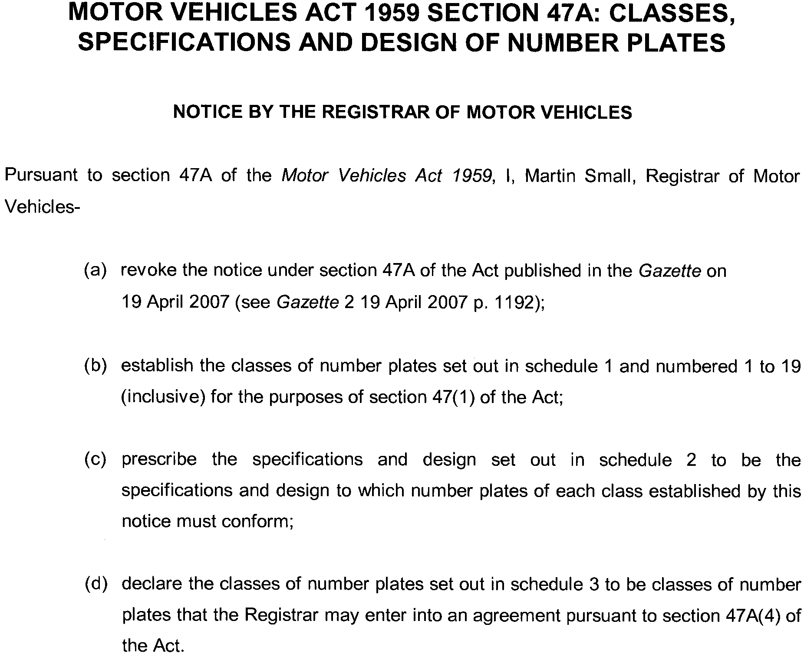
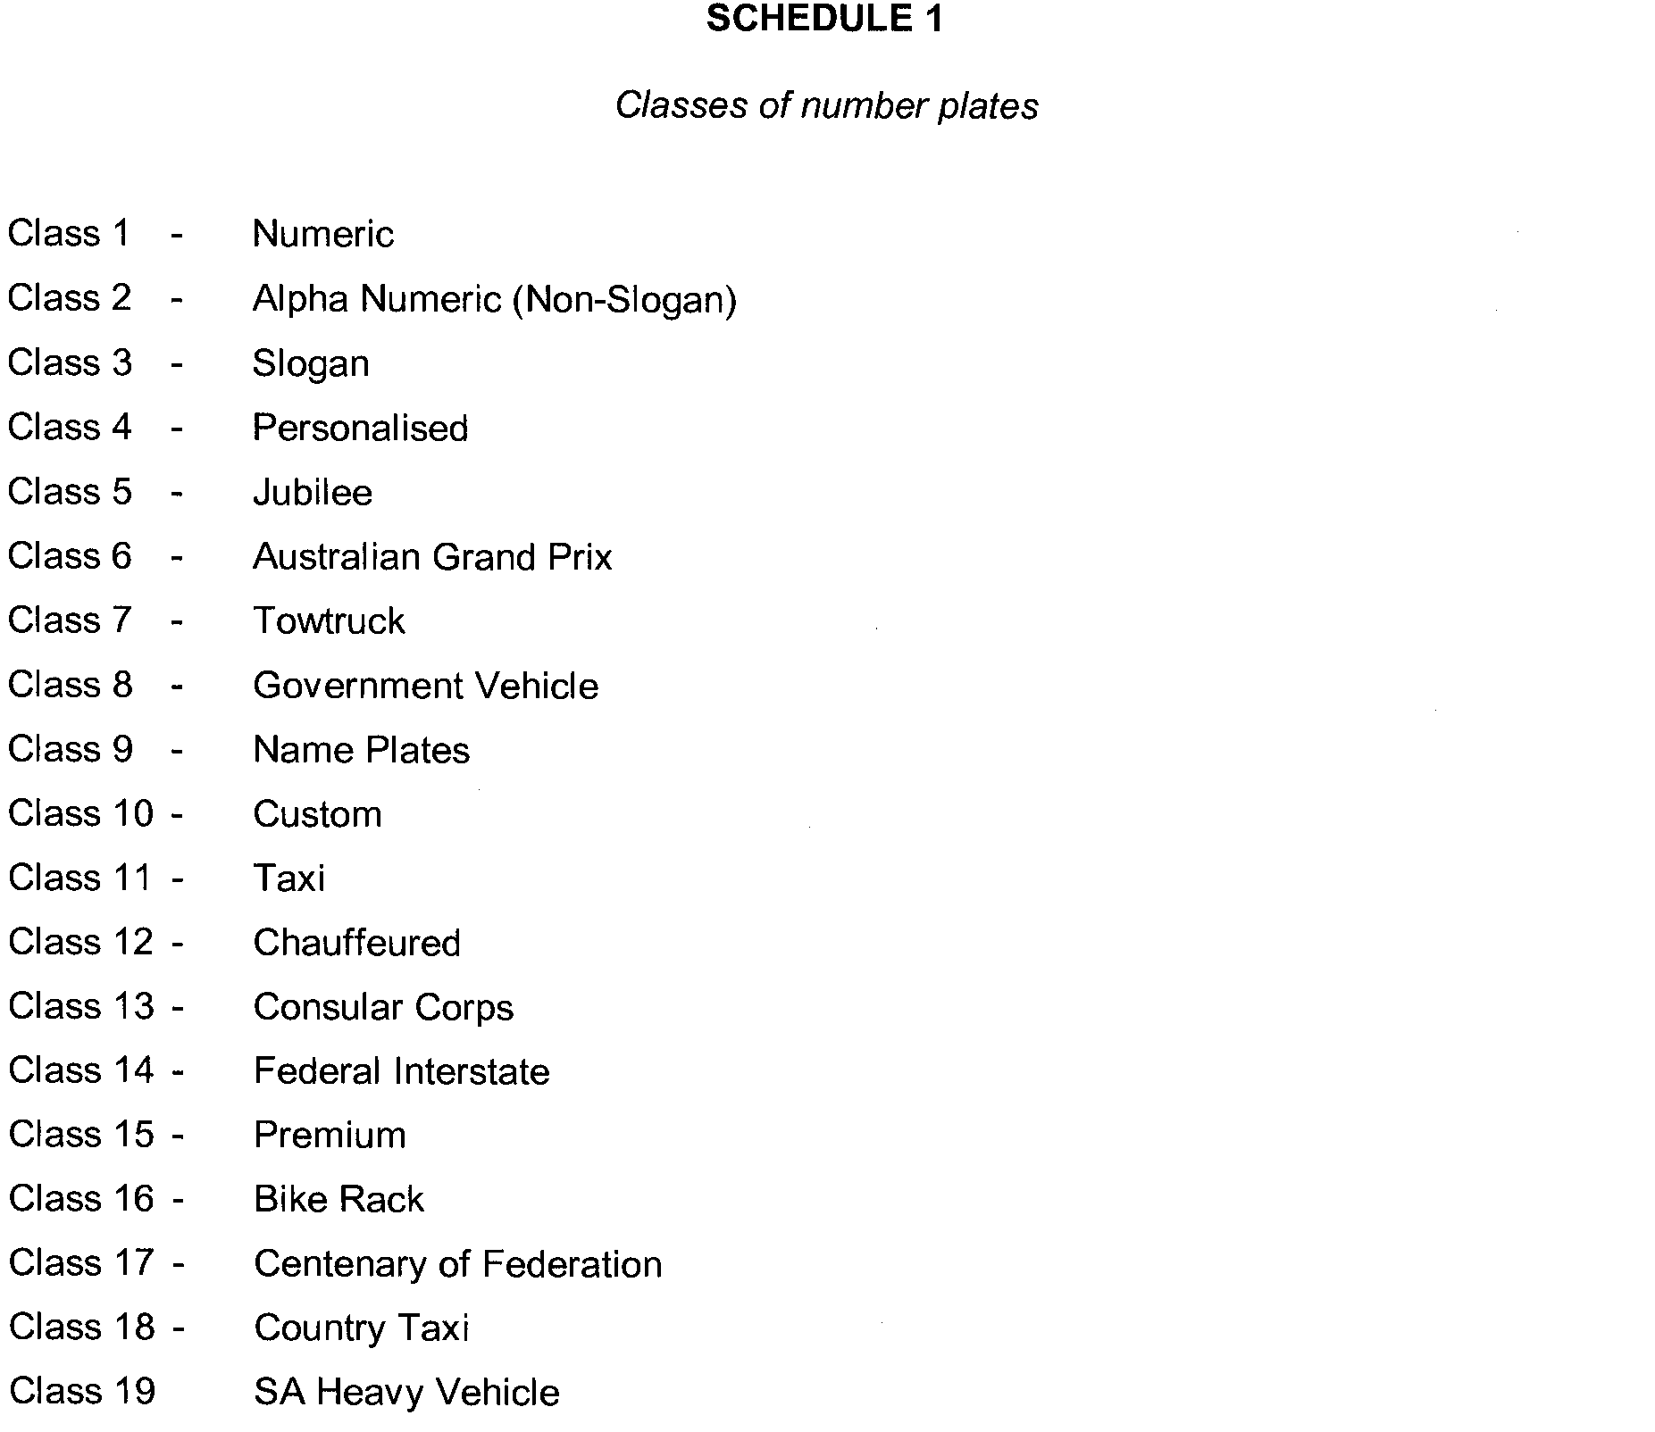

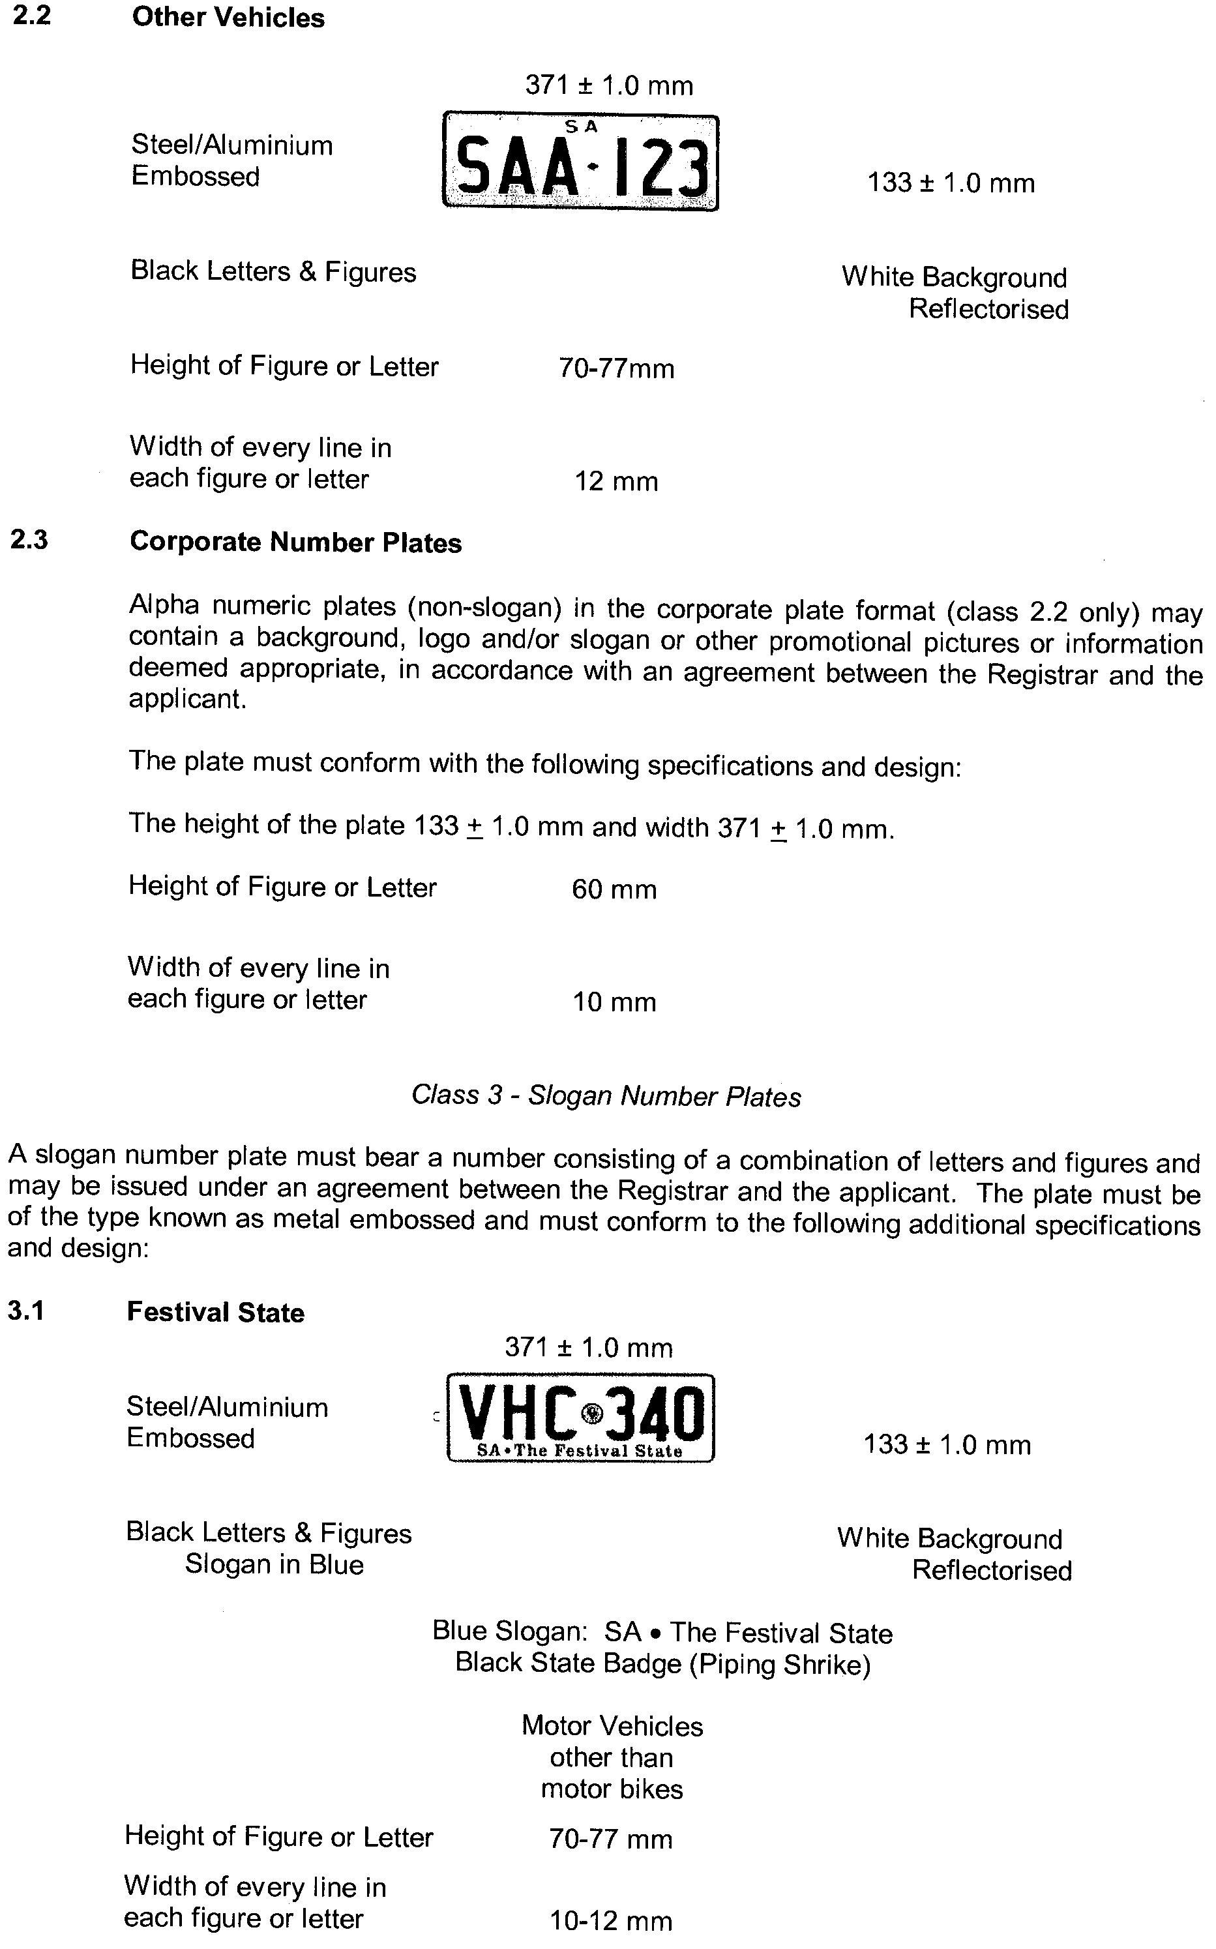
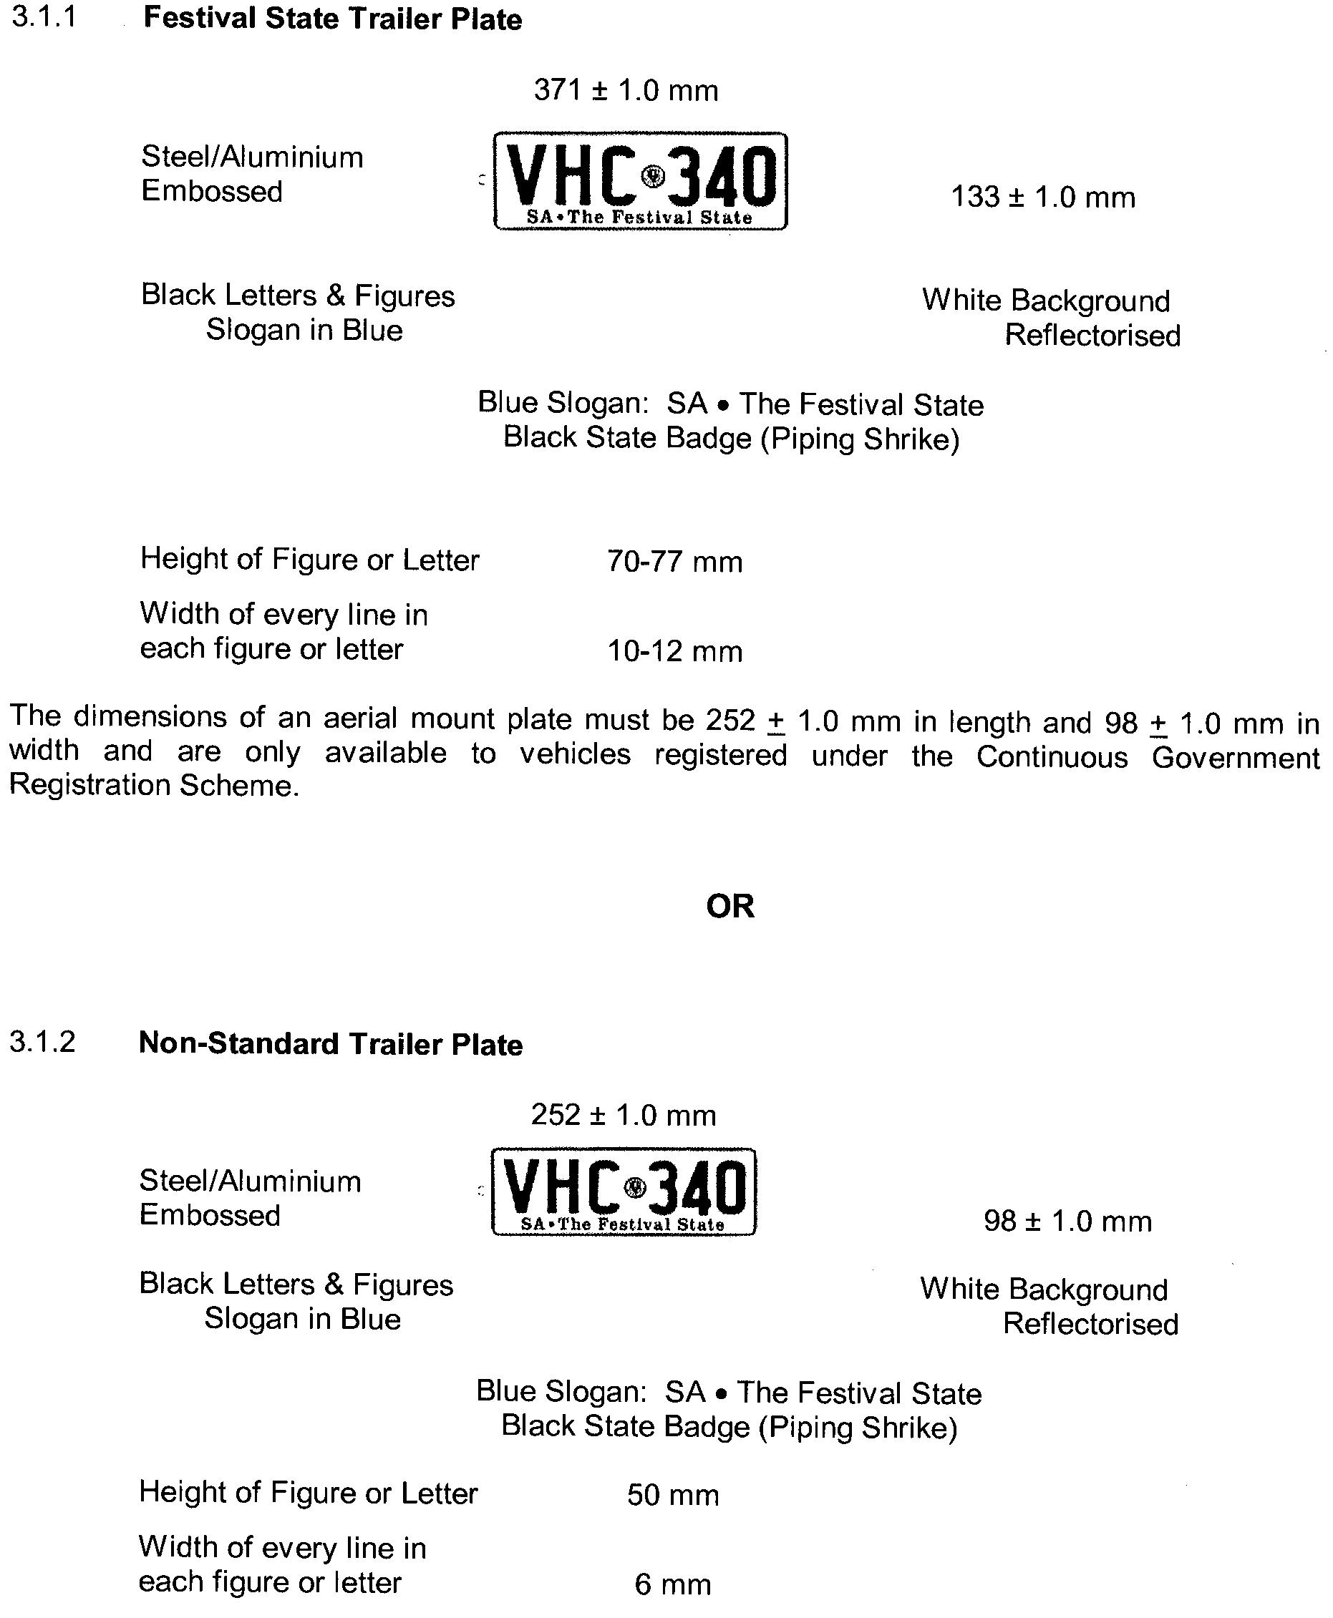
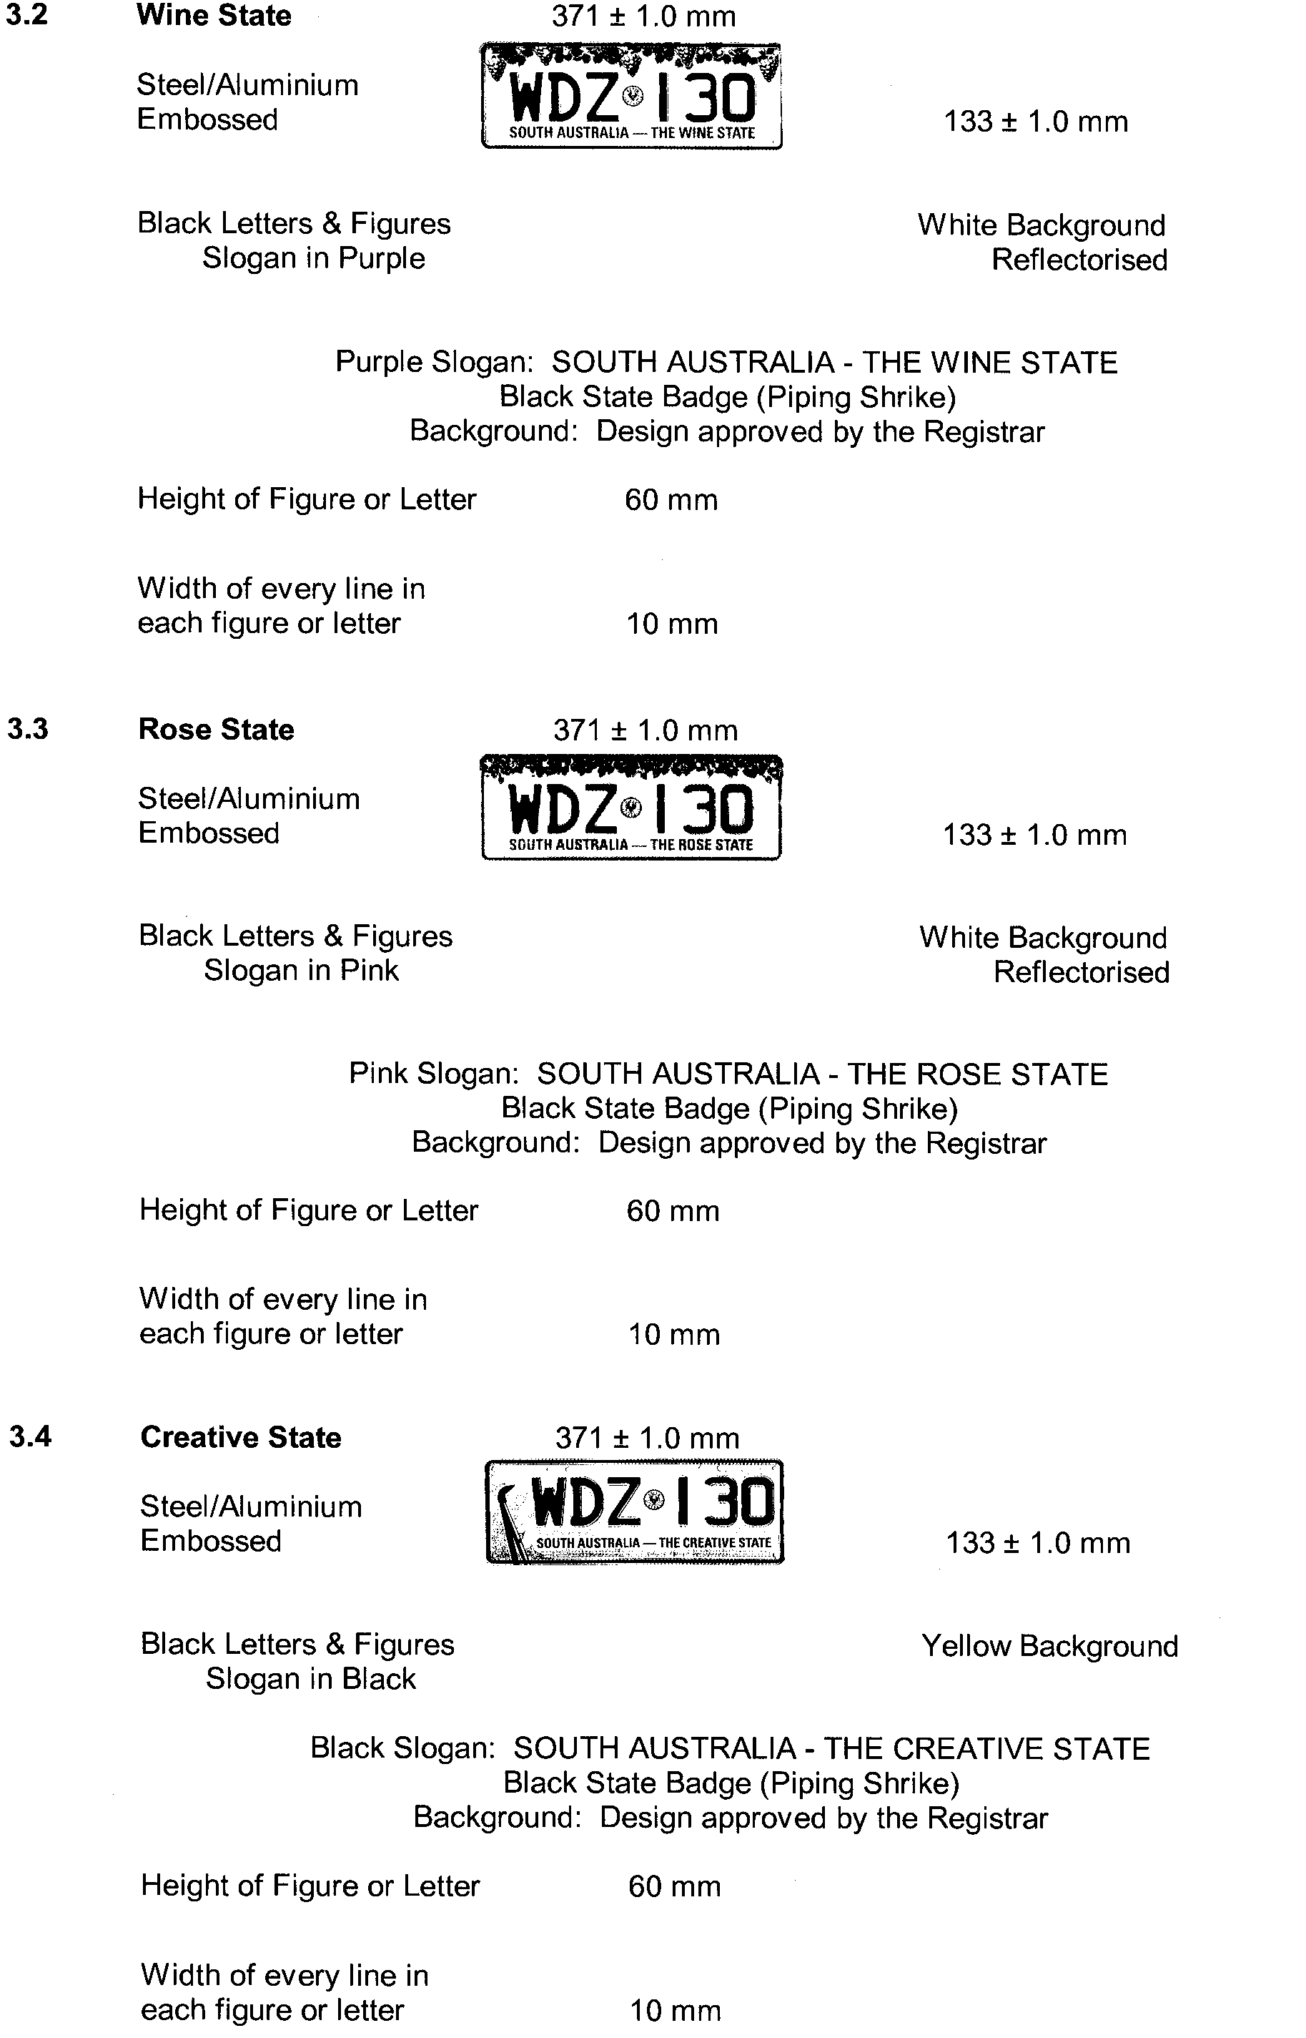
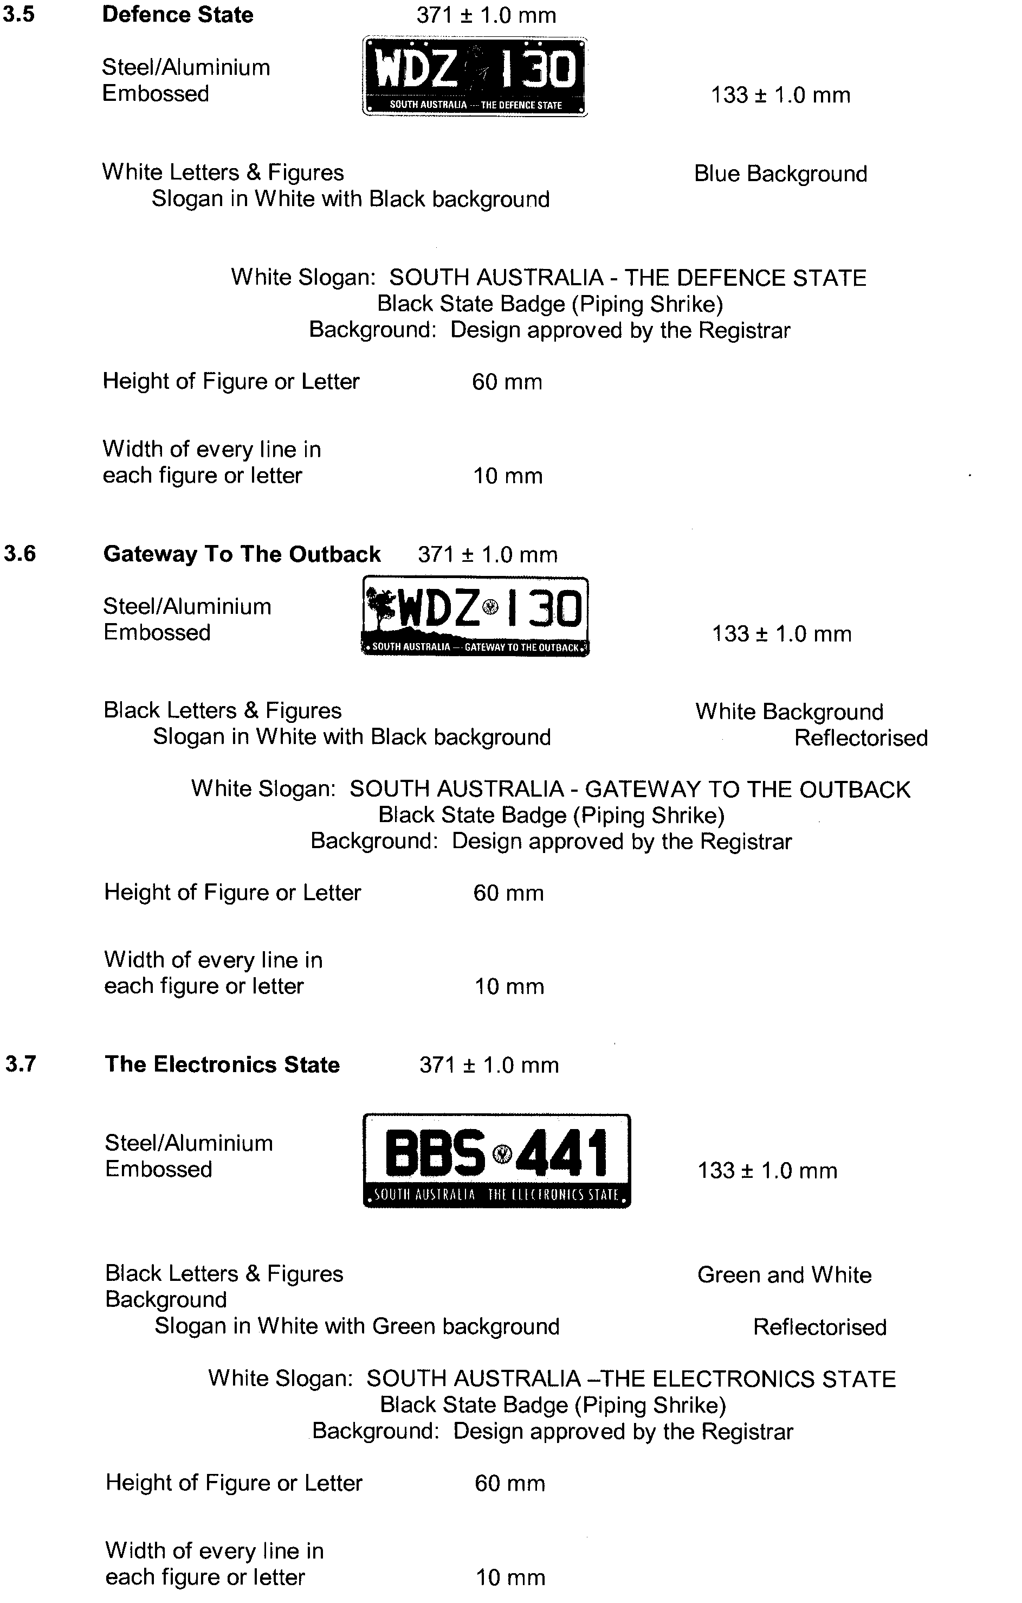


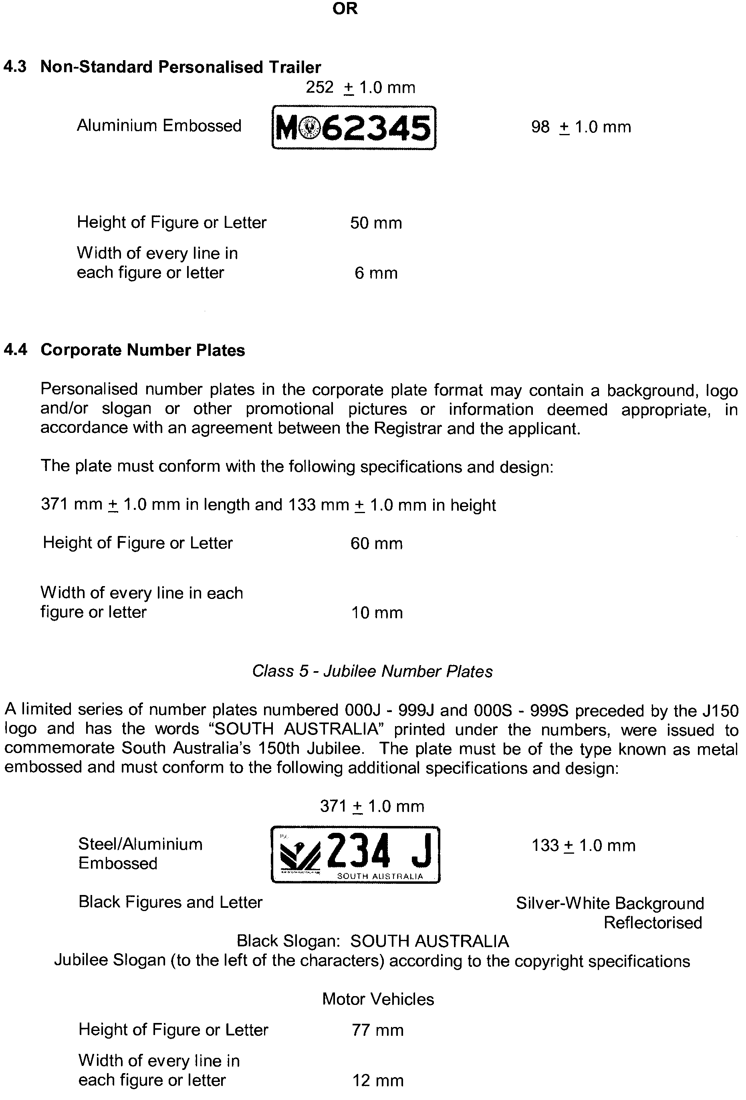
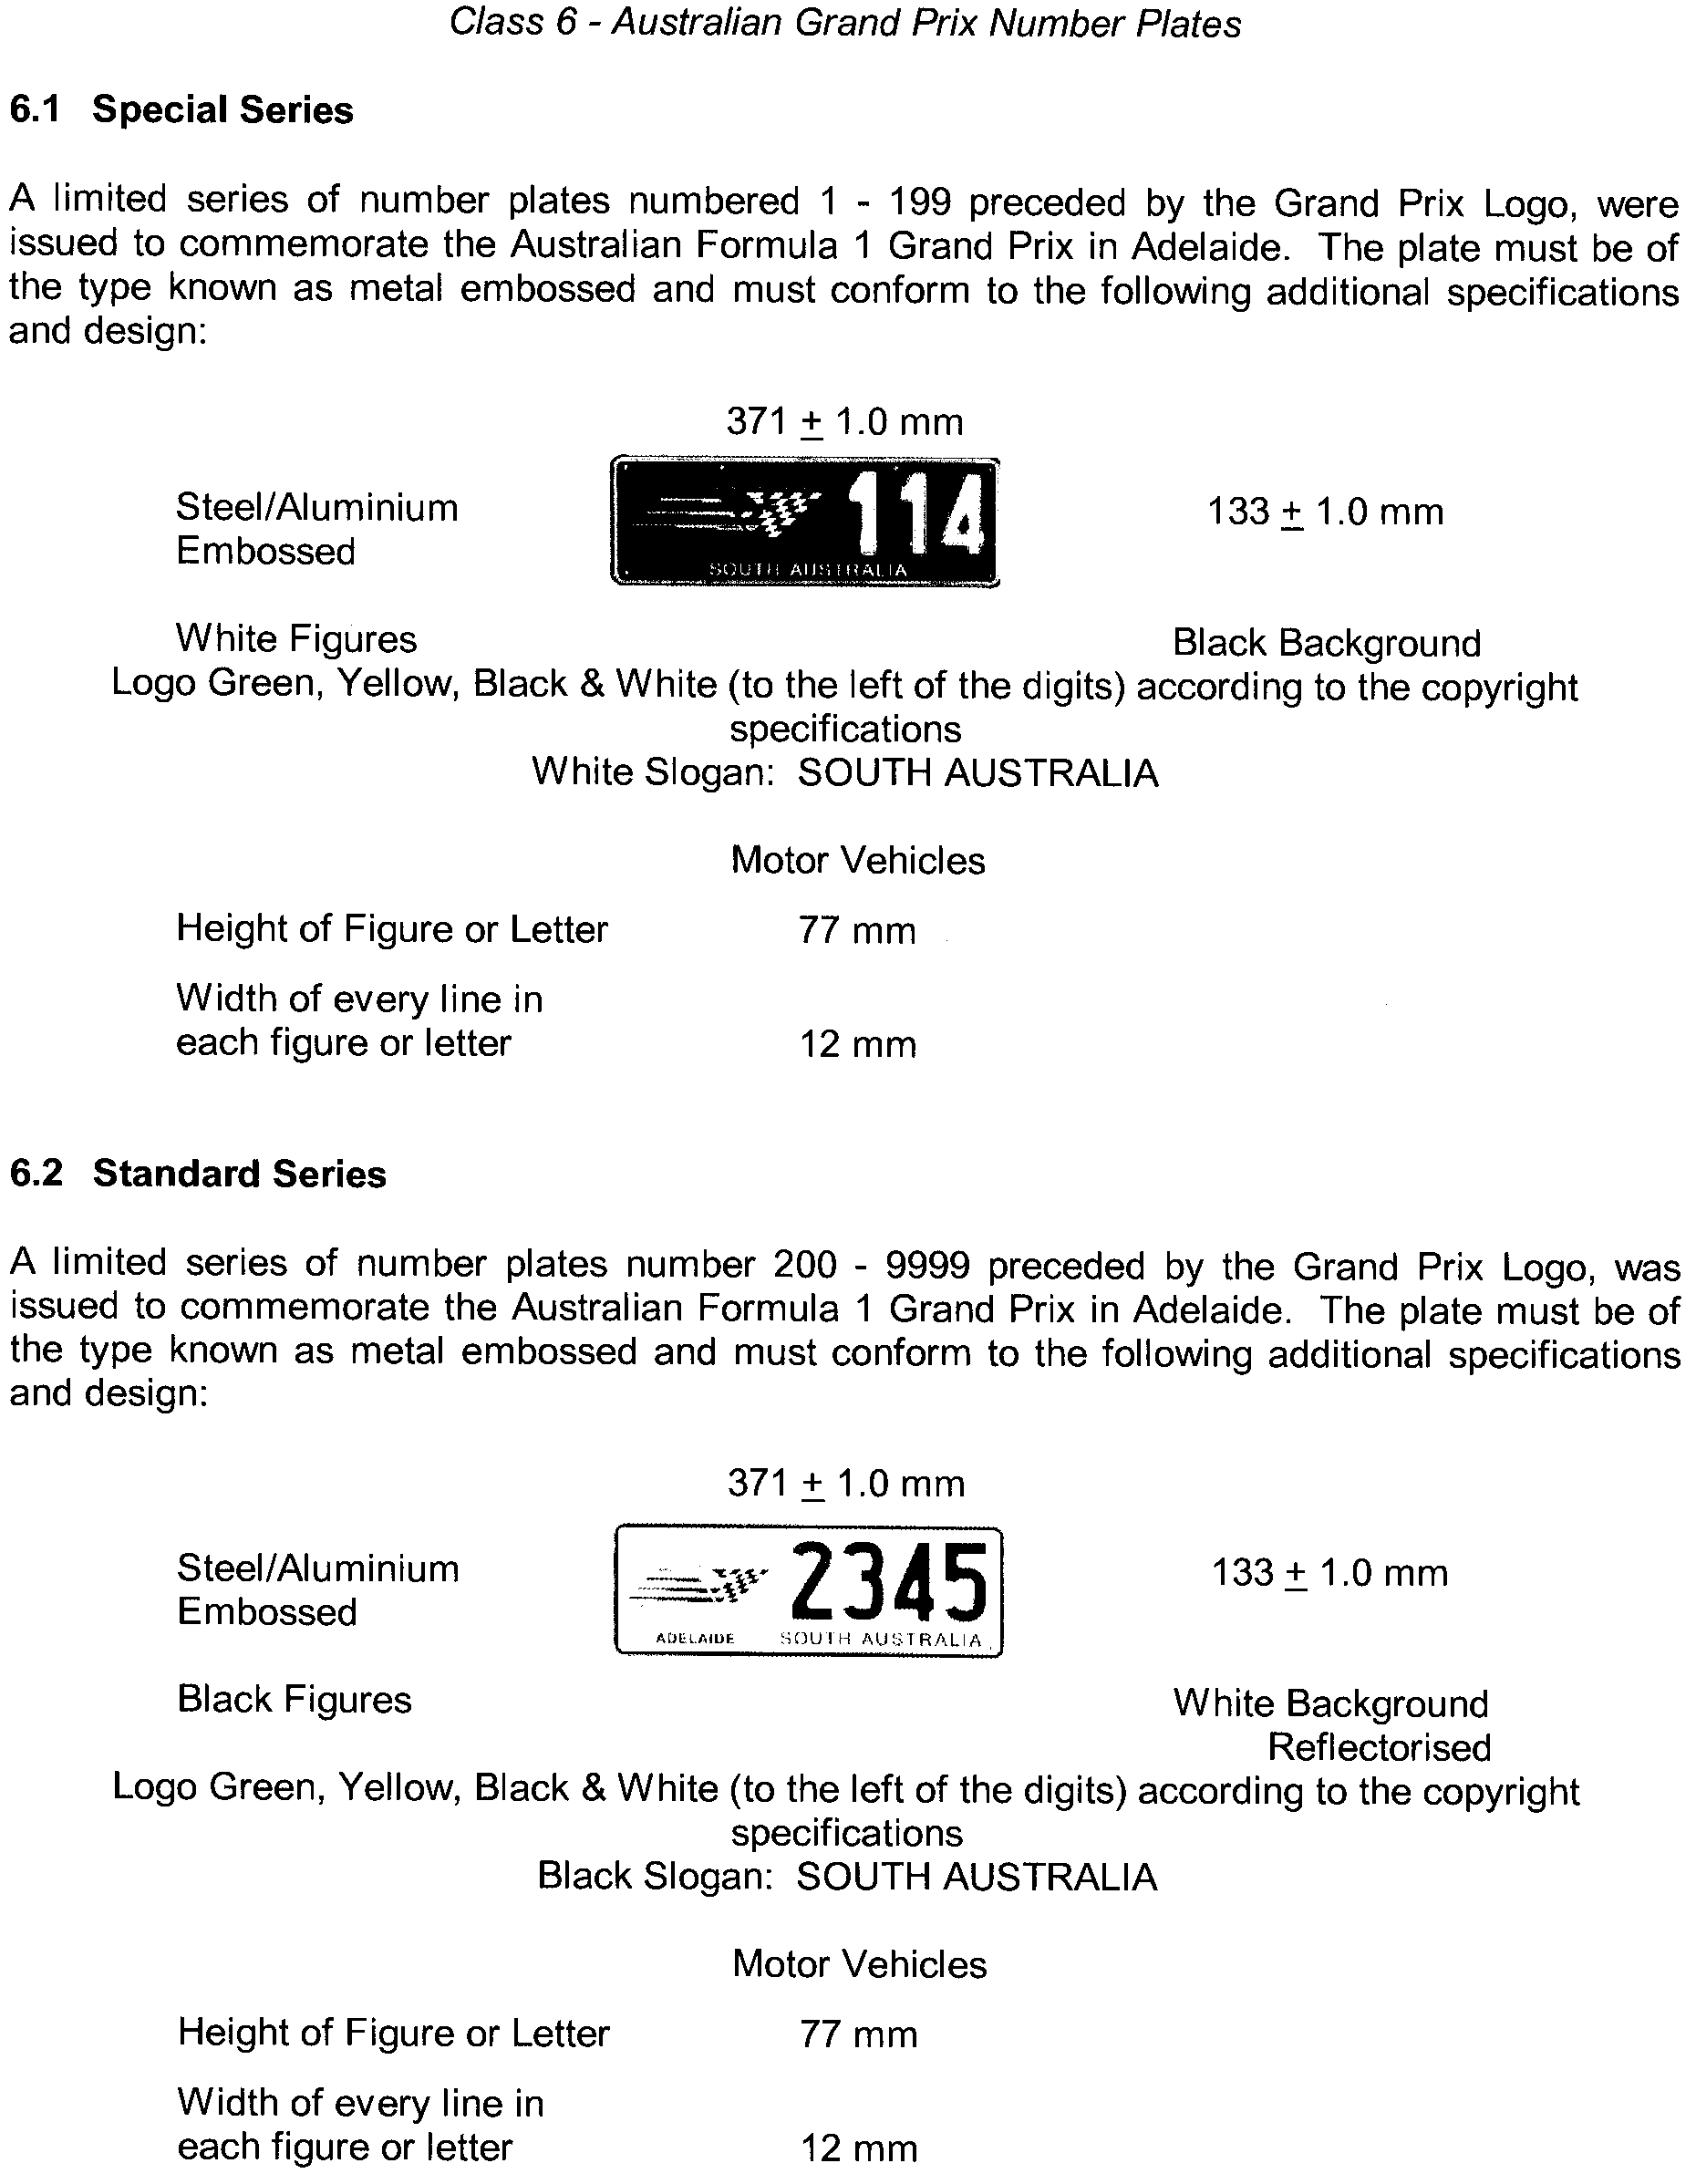
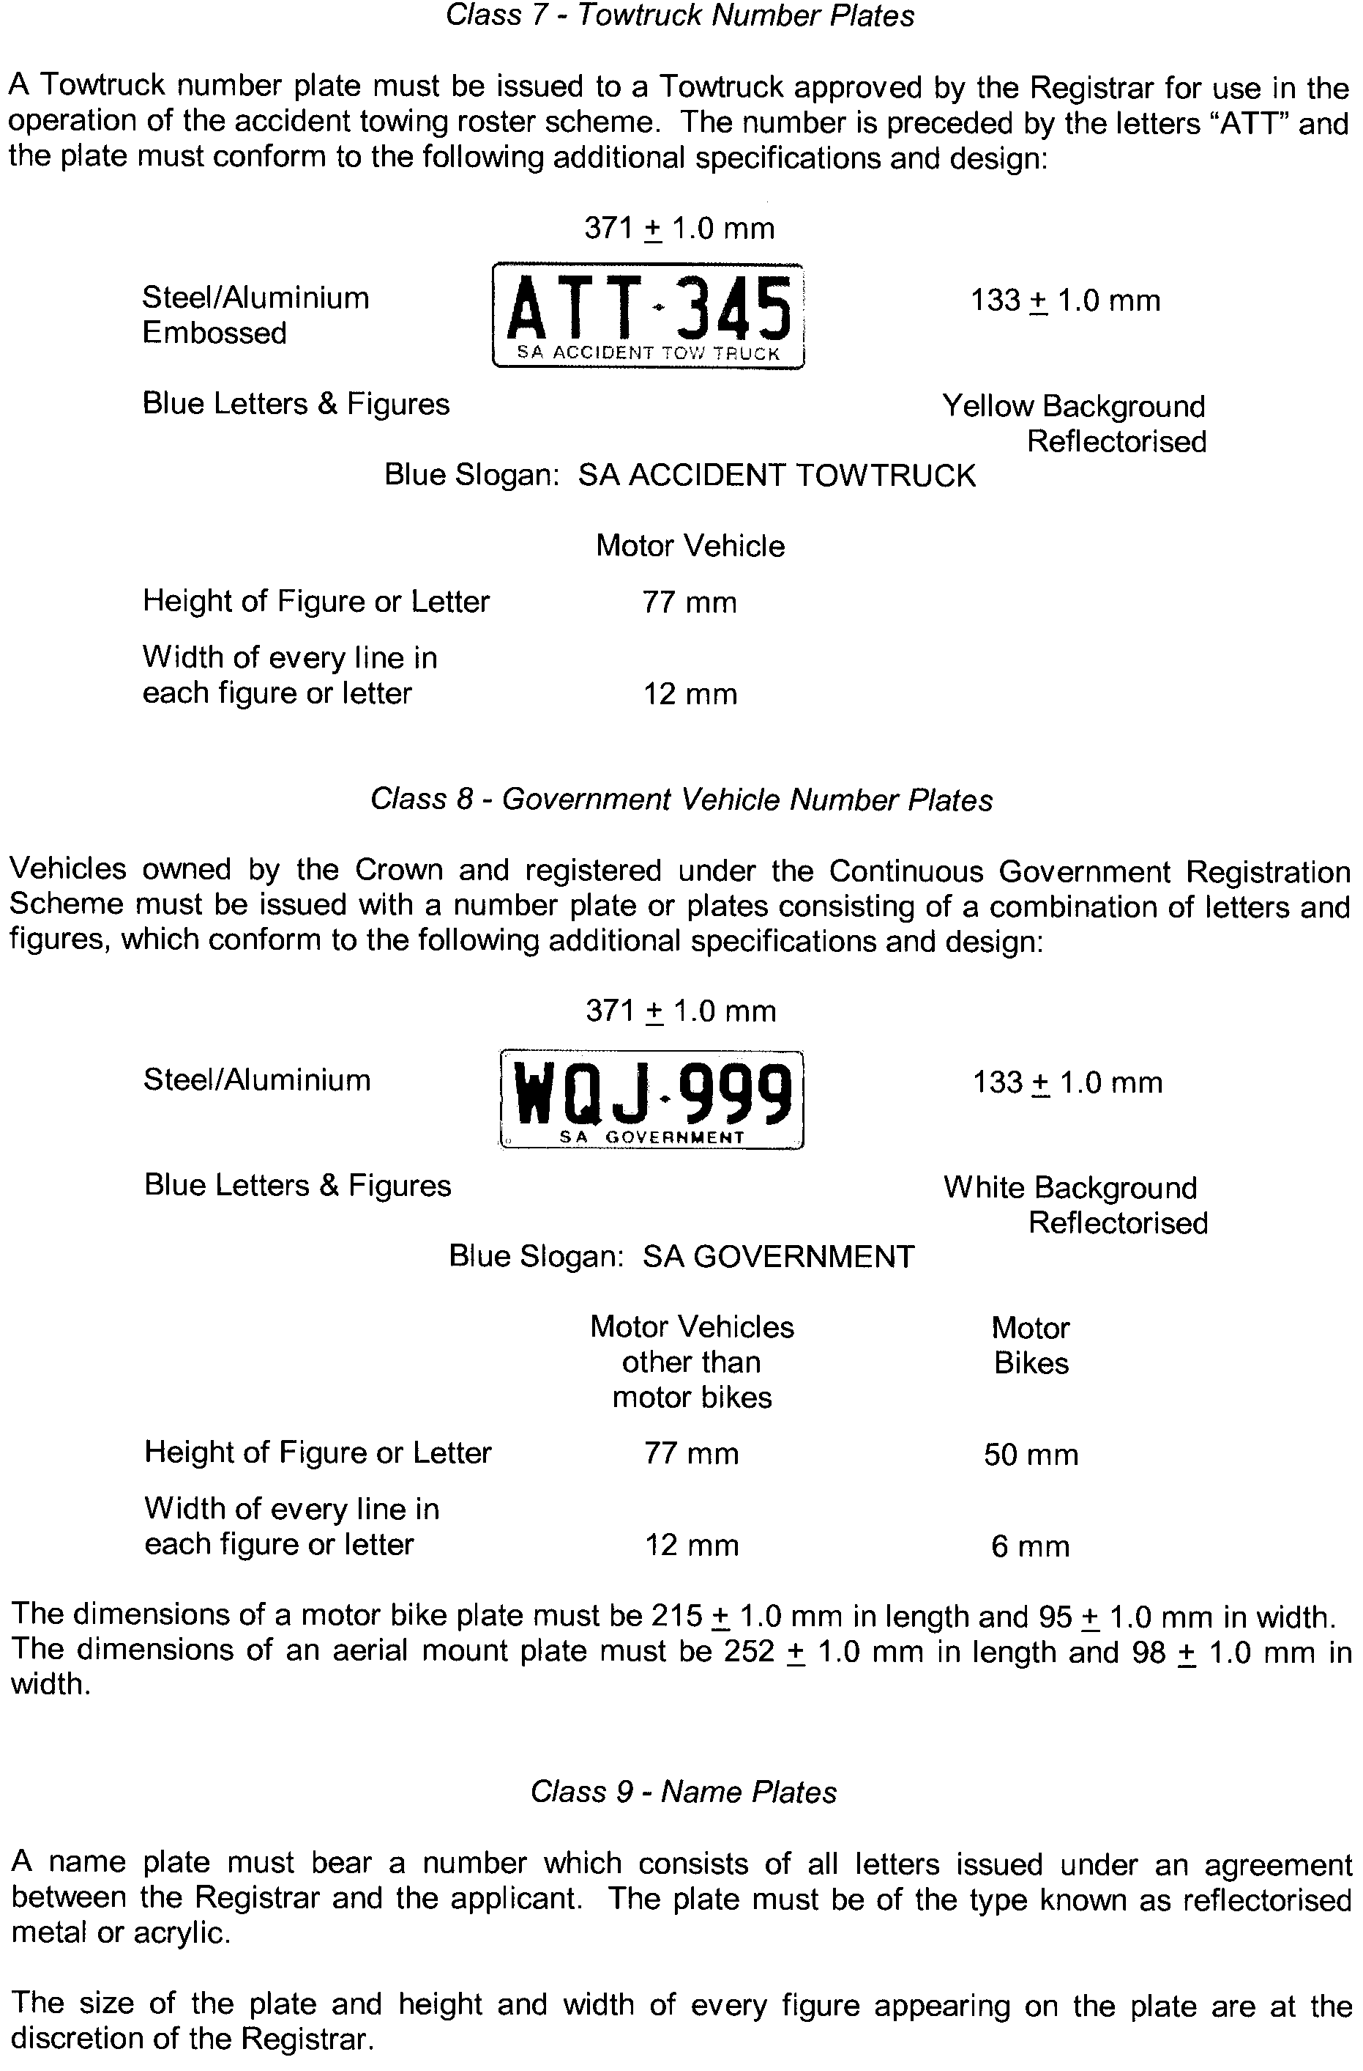

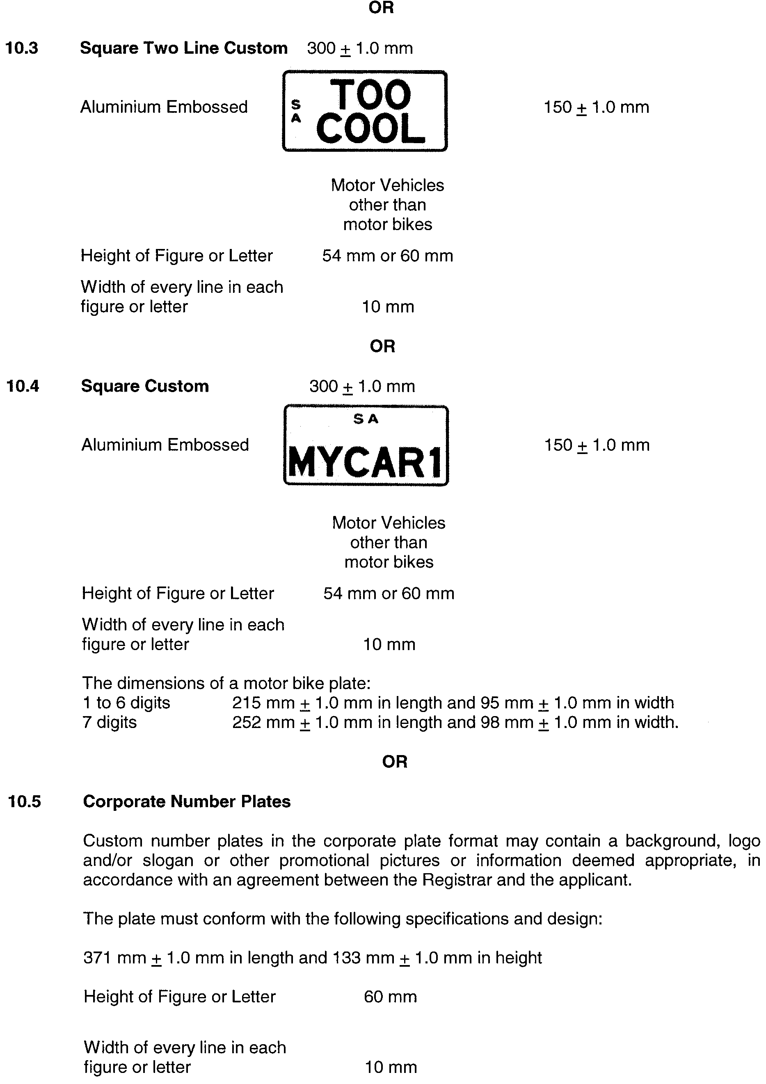




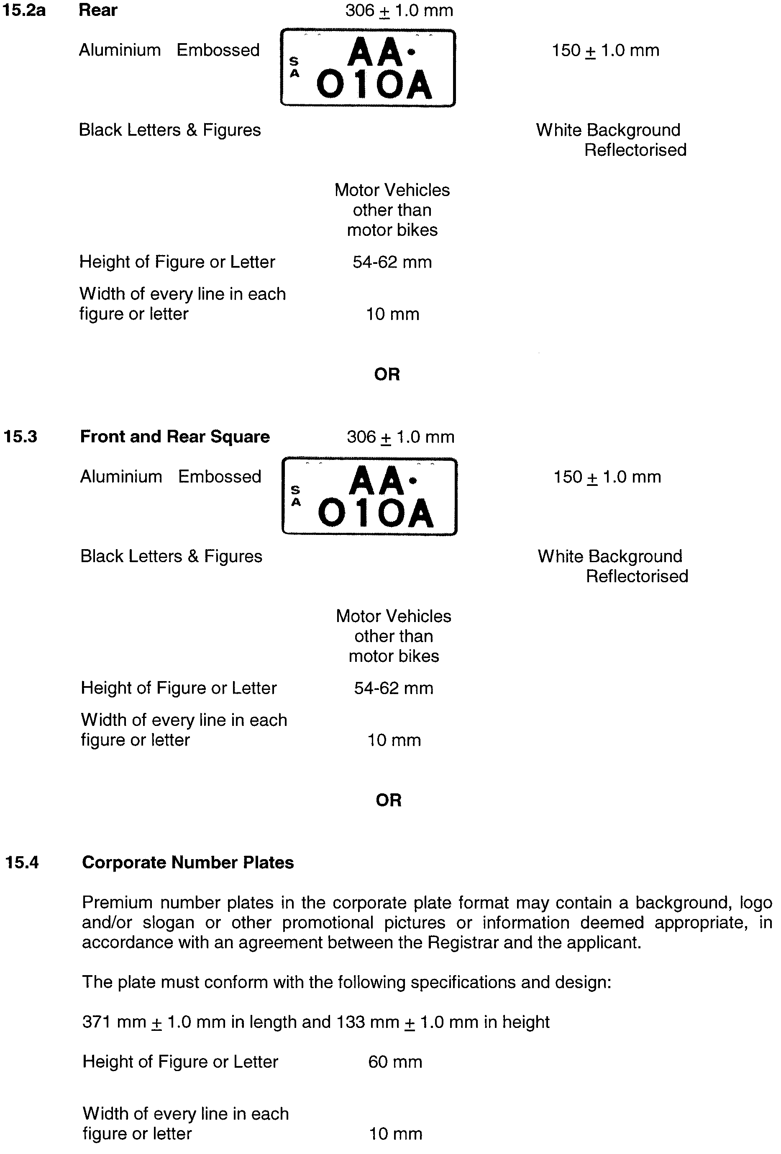


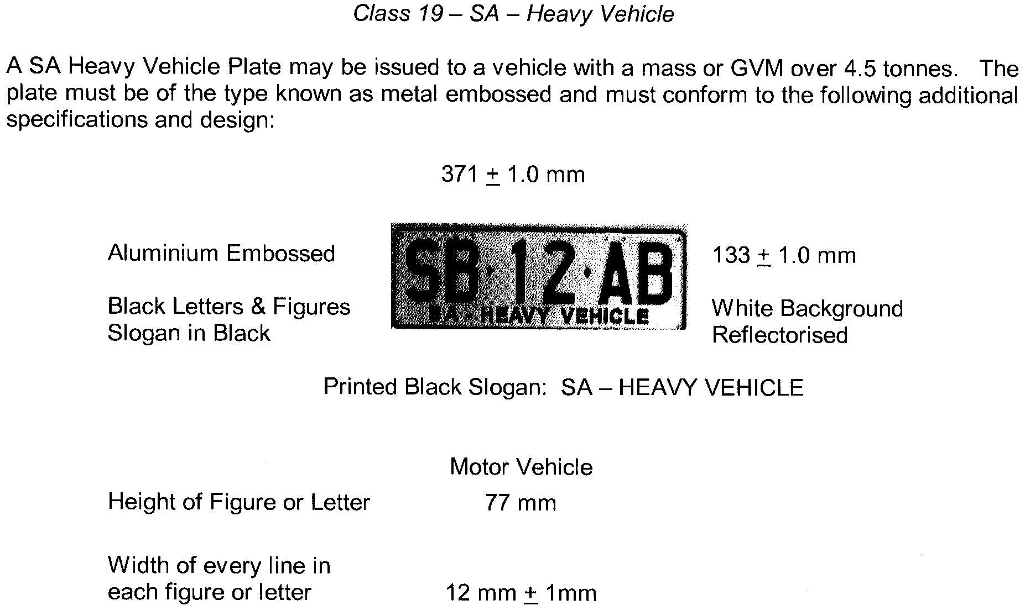
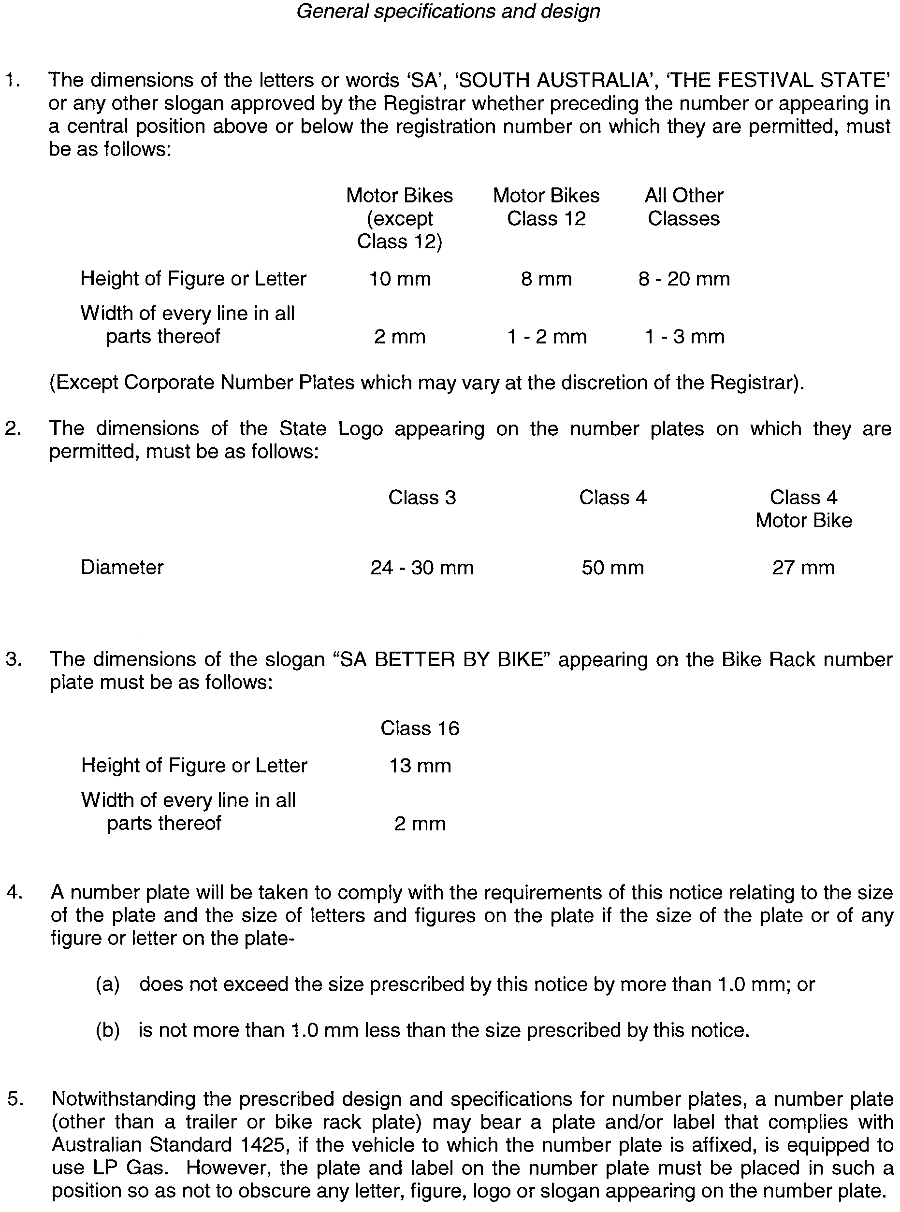
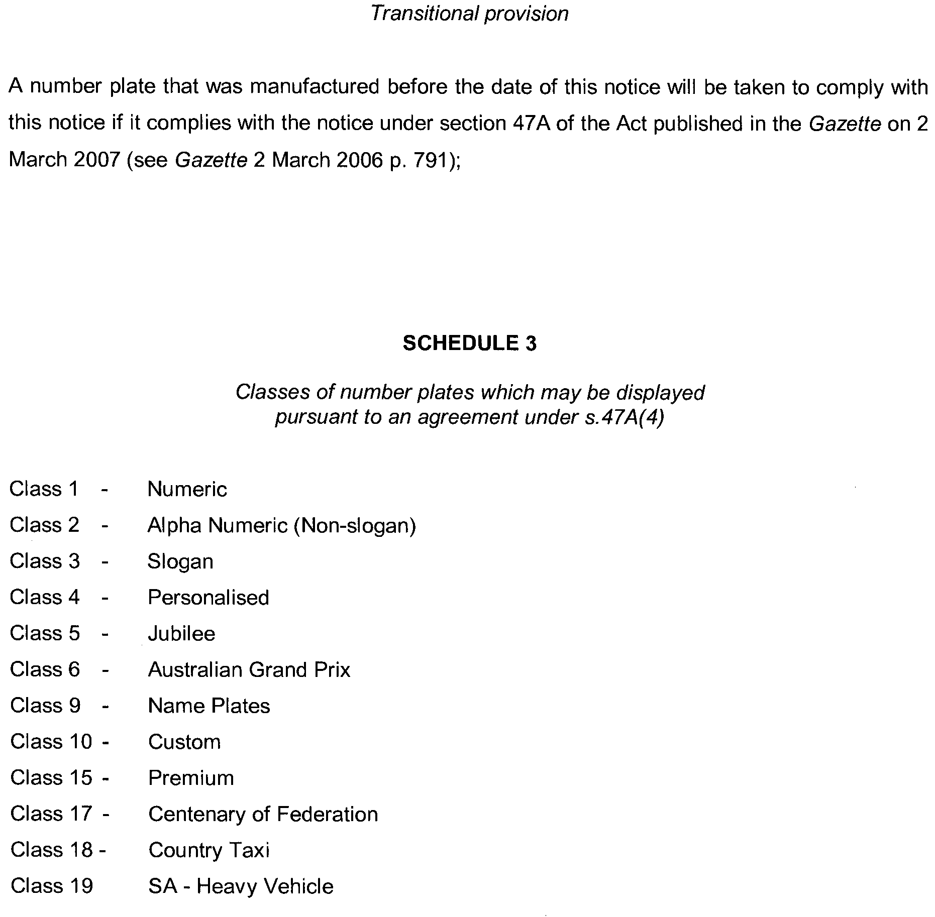



PASSENGER TRANSPORT ACT 1994: SECTION 31
TAKE notice that pursuant to section 31 (1) (b) (ii) of the Passenger Transport Act 1994, conditions may be prescribed in relation to an accreditation under Division 2 of Part 4 of the Act. Under Regulation 11 (1) (e) Passenger Transport (General) Regulations 1994, it is a condition of accreditation for a person while driving a taxi for the purposes of a passenger transport service that they must at all times carry their Personal Accreditation Identification Card (see A below) and display the Taxi Driver Display Identification Card (see B below) issued for that purpose by the Department for Transport, Energy and Infrastructure.
Pursuant to section 31 (1) (b) (i) of the Passenger Transport Act 1994, it is a condition of accreditation that a person while driving a taxi for the purposes of a passenger transport service, must at all times, display their Taxi Driver Display Identification Card in a position that provides passengers with a clear, unobstructed view of all information printed on the photograph side of the card. The card must be displayed in a location at the centre top of the taxi dashboard in an approved card holder which must be fixed in a secure manner so that it that will not move or be easily removed while the taxi is in service.
A sample of the approved Personal Accreditation Identification Card (A) and the Taxi Driver Display Identification Card (B) are as shown below:

A - Personal Accreditation Identification Card


B - Taxi Driver Display Identification Card


The approved card holder for the display of the Taxi Driver Display Identification Card must include the following features:
• A clear plastic card holder affixed to a solid backing that can be securely attached to the dashboard of the taxi in the approved manner.
• The card must be able to be securely held in the card holder so that it cannot be easily removed or dislodged while the taxi is in service.
• The background of the card holder must include the text “YOUR DRIVER IS” immediately above the area where the card is required to be placed. This text must be visible at all times.
• The card holder must include the text “IDENTIFICATION PHOTO MUST BE DISPLAYED HERE” in bold red type as part of the background which will be covered when the Taxi Driver Display Identification Card is correctly in place.

A sample image of the approved Taxi Driver Display Identification Card holder is shown below:

Dated 24 September 2007.
Heather Webster, Executive Director, Public Transport Division, Department for Transport, Energy and Infrastructure

PETROLEUM ACT 2000
Section 25 (5) (b)
Variation of Petroleum Exploration Licence—PEL 90
NOTICE is hereby given that under the provisions of the Petroleum Act 2000, pursuant to delegated powers dated 28 March 2002, Gazetted 11 April 2002, page 1573, the conditions of the abovementioned Exploration Licence have been varied as follows:
Condition 1 of the licence is omitted and the following substituted:
‘1. During the term of the licence, the licensee shall carry out or cause to be carried out exploratory operations on the area comprised in the licence in accordance with such work programs as are approved by the Minister from time to time. Years one to five exploratory operations are guaranteed. These exploratory operations shall include but not necessarily be limited to:

Year of Term of Licence |  | Minimum Work Requirements
One to three |  | Acquire 608 km 2D seismic data and reprocess existing data; drill 3 wells
Four |  | Acquire 120 km² of 3D seismic data; drill 2 wells
Five |  | Drill 1 well
 |  |  | ’
The revised work requirements as a result of this variation would not have altered the outcome of the original competitive tender process.
Dated 29 October 2007.
C. D. Cockshell, Acting Director
Petroleum and Geothermal
Minerals and Energy Resources
Primary Industries and Resources SA
Delegate of the Minister for Mineral Resources Development

RIVER TORRENS LINEAR PARK ACT 2006
River Torrens Linear Park Public Lands Plan
TAKE notice that pursuant to section 3 of the River Torrens Linear Park Act 2006, I, Paul Holloway, Minister for Urban Development and Planning, do hereby identify for the purpose of the definition of ‘plan’, the River Torrens Linear Park Public Lands Plan being Plan No. 44 of 2007 deposited in the General Registry Office at Adelaide by me on 3 October 2007.
Dated 23 October 2007.
Paul Holloway, Minister for Urban Development and Planning

WATER MAINS AND SEWERS

Office of the South Australian Water Corporation
Adelaide, 1 November 2007

WATER MAINS LAID

Notice is hereby given that the following main pipes or parts of main pipes have been laid down by the South Australian Water Corporation in or near the undermentioned water districts and are now available for a constant supply of water to adjacent land.

ADELAIDE WATER DISTRICT

CAMPBELLTOWN CITY COUNCIL
Across Maple Avenue, Rostrevor. p2
Bonvue Road, Rostrevor. p2

CITY OF HOLDFAST BAY
Bridge Street, Glenelg North. p6

CITY OF PORT ADELAIDE ENFIELD
June Street, Mansfield Park. p1

CITY OF UNLEY
Cheltenham Street, Highgate. p5

BAROSSA COUNTRY LANDS WATER DISTRICT

LIGHT REGIONAL COUNCIL
In and across Coleman Road, Pinkerton Plains. p11-15

DISTRICT COUNCIL OF MALLALA
In and across Coleman Road, Pinkerton Plains. p11-16

TOWNSHIP OF BLINMAN WATER DISTRICT

OUT OF COUNCILS
Mine Road, Blinman. This main is available on application only. p9
Public road north west of section 357, hundred of Carr, Blinman. This main is available on application only. p9

EUDUNDA WATER DISTRICT

REGIONAL COUNCIL OF GOYDER
Bruce Street, Eudunda. p10

GOOLWA WATER DISTRICT

ALEXANDRINA COUNCIL
Boult Street, Goolwa Beach. p7

MOONTA WATER DISTRICT

DISTRICT COUNCIL OF THE COPPER COAST
Moonta Road, Moonta Bay. p3
MURRAY BRIDGE WATER DISTRICT

THE RURAL CITY OF MURRAY BRIDGE
Thomas Street, Murray Bridge. p22
Hawke Road, Murray Bridge. p22 and 23

PORT LINCOLN WATER DISTRICT

CITY OF PORT LINCOLN
Tasman Terrace, Port Lincoln. p17

PORT PIRIE WATER DISTRICT

PORT PIRIE REGIONAL COUNCIL
Simpson Road, Port Pirie South. p8

WARREN COUNTRY LANDS WATER DISTRICT

CLARE AND GILBERT VALLEYS COUNCIL
Waterworks land (lot 363 in LTRO FP 168492), Hogan Road, Tarlee. p20
Across and in Hogan Road, Tarlee. p20
Across Tarlee-Kapunda Road, Tarlee. p20
Ryelands Road, Tarlee. p20 and 21

WHYALLA WATER DISTRICT

THE CORPORATION OF THE CITY OF WHYALLA
Marevista Crescent, Whyalla. p4

WATER MAINS ABANDONED

Notice is hereby given that the undermentioned water mains have been abandoned by the South Australian Water Corporation.

BAROSSA COUNTRY LANDS WATER DISTRICT

LIGHT REGIONAL COUNCIL
Coleman Road, Pinkerton Plains. p12 and 14

DISTRICT COUNCIL OF MALLALA
Coleman Road, Pinkerton Plains. p12 and 14

TOWNSHIP OF BLINMAN WATER DISTRICT

OUT OF COUNCILS
Across Mine Road, Blinman. p9
Easements in lot 164, Mine Road, Blinman. p9
Across public road north west of section 357, hundred of Carr, Blinman. p9

EUDUNDA WATER DISTRICT

REGIONAL COUNCIL OF GOYDER
Bruce Street, Eudunda. p10

MURRAY BRIDGE WATER DISTRICT

THE RURAL CITY OF MURRAY BRIDGE
Thomas Street, Murray Bridge. p22
Hawke Road, Murray Bridge. p22 and 23

PORT LINCOLN WATER DISTRICT

CITY OF PORT LINCOLN
Tasman Terrace, Port Lincoln. p17

WARREN COUNTRY LANDS WATER DISTRICT

CLARE AND GILBERT VALLEYS COUNCIL
Waterworks land (lot 363 in LTRO FP 168492), Hogan Road, Tarlee. p20
Across Hogan Road, Tarlee. p20
Across Tarlee-Kapunda Road, Tarlee. p20
Ryelands Road, Tarlee. p20 and 21

ADDENDA

Addendum to notice in “Government Gazette” of 9 March 1972

“WATER MAINS LAID”

“NOTICE is hereby given that the following main pipes or parts of main pipes have been laid down by the Minister of Works in or near the undermentioned water districts and that he is prepared to provide a constant supply of water to adjacent land or premises.”

“PORT AUGUSTA WATER DISTRICT”

“CITY OF PORT AUGUSTA” (now PORT AUGUSTA CITY COUNCIL)

“Addison Road,” (now Hamilton Road) “Port Augusta West—2,246ft. of 3in. A.C. main continuation of 3in. main from section 150, hundred of Copley running generally north-westerly and northerly to section 183.”

To this notice add “This main is not available for constant rateable supply—available on application only—between chainages 451.1 metres (1480’) and 953.6 metres (3128’6”).” p18

Addenda to notices in “Government Gazette” of 9 September 1976

“WATER MAINS LAID”

“NOTICE is hereby given that the following main pipes or parts of main pipes have been laid down by the Minister of Works in or near the undermentioned water districts and that he is prepared to provide a constant supply of water to adjacent land.”

“PORT AUGUSTA WATER DISTRICT”

“CITY OF PORT AUGUSTA” (now PORT AUGUSTA CITY COUNCIL)

“Addison Road,” (now Hamilton Road) “Port Augusta West—264.5 m of 80 mm A.C. main continuation of 80 mm main running northerly to Madland Street.”

“Madland Street, Port Augusta West—602.1 m of 80 mm A.C. main from 80 mm main Addison Road running westerly to government road west of section 188, hundred of Copley.”

“Government road west of section 188, hundred of Copley” (now Slade Road) “—54.1 m of 80 mm A.C. main from 80 mm main Madland Street running northerly to government road north of section 217.”

“OUTSIDE PORT AUGUSTA WATER DISTRICT”

“OUTSIDE OF DISTRICT COUNCILS” (now PORT
AUGUSTA CITY COUNCIL)

“Government road north of sections 217 and 259 and in section 259, hundred of Copley—855.4 m of 80 mm A.C. main from 80 mm main government road west of section 188 running westerly and southerly.”

To each of these notices add “This main is not available for constant rateable supply—available on application only.” p18

SEWERS LAID

Notice is hereby given that the following sewers have been laid down by the South Australian Water Corporation in the undermentioned drainage areas and are now available for house connections.
ADELAIDE DRAINAGE AREA

CAMPBELLTOWN CITY COUNCIL
Across Koonga Avenue, Rostrevor. FB 1165 p57
Bonvue Road, Rostrevor. FB 1165 p57

CITY OF HOLDFAST BAY
Gladstone Road, North Brighton. FB 1165 p49

CITY OF MARION
Beeches Road, Hallett Cove. FB 1165 p43
Wilga Street, Seacombe Gardens. FB 1165 p59

CITY OF MITCHAM
Pulleine Avenue, Netherby. FB 1165 p48
Dorene Street, St Marys. FB 1165 p58

CITY OF ONKAPARINGA
Easement in lot 202 and Common Property in LTRO Community Plan 24112, Booth Avenue, Morphett Vale. FB 1165 p47

CITY OF PLAYFORD
Across Black Top Road, Hillbank. FB 1165 p44
Easements in lot 700 in LTRO Community Plan 23400, and lot 60 in LTRO DP 70343, Black Top Road, Hillbank. FB 1165 p44

CITY OF PORT ADELAIDE ENFIELD
Easement in lots 254 and 253 in LTRO DP 4944, Westralia Street, Greenacres. FB 1165 p42
June Street, Mansfield Park. FB 1165 p45

CITY OF SALISBURY
Everglade Street, Mawson Lakes. FB 1148 p10-12
Sanctuary Drive, Mawson Lakes. FB 1148 p10-12
Waterton Lane, Mawson Lakes. FB 1148 p10, 11 and 13
Darien Street, Mawson Lakes. FB 1148 p10, 11 and 13
Newland Way, Mawson Lakes. FB 1148 p10, 11 and 13

CITY OF TEA TREE GULLY
Apalie Drive, Modbury. FB 1165 p46
Milton Street, Tea Tree Gully. FB 1165 p60
Sirius Avenue, Hope Valley. FB 1167 p1

CITY OF WEST TORRENS
Birdwood Terrace, North Plympton. FB 1165 p50

ALDINGA DRAINAGE AREA

CITY OF ONKAPARINGA
Easement in lot 10 in LTRO DP 72260, and lot 674 in LTRO FP 164497, William Street, Port Willunga. FB 1167 p2

SEWERS LAID

Notice is hereby given that the undermentioned sewer has been laid down by the South Australian Water Corporation and is not available for house connections.

STIRLING COUNTRY DRAINAGE AREA

ADELAIDE HILLS COUNCIL
Lot 13 in LTRO DP 51175, Mount Barker Road, Bridgewater—
40 mm MDPE pressure sewer system. FB 1167 p11

A. Howe, Chief Executive Officer, South Australian Water Corporation.

South Australia
Criminal Law (Sentencing) (Dangerous Offenders) Amendment Act (Commencement) Proclamation 2007
1—Short title
This proclamation may be cited as the Criminal Law (Sentencing) (Dangerous Offenders) Amendment Act (Commencement) Proclamation 2007.
2—Commencement of Act
The Criminal Law (Sentencing) (Dangerous Offenders) Amendment Act 2007 (No 27 of 2007) will come into operation on 1 November 2007.
Made by the Governor
with the advice and consent of the Executive Council
on 1 November 2007
AGO0010/07CS

South Australia
Penola Pulp Mill Authorisation Act (Commencement) Proclamation 2007
1—Short title
This proclamation may be cited as the Penola Pulp Mill Authorisation Act (Commencement) Proclamation 2007.
2—Commencement of Act
The Penola Pulp Mill Authorisation Act 2007 (No 40 of 2007) will come into operation on
1 November 2007.
Made by the Governor
with the advice and consent of the Executive Council
on 1 November 2007
MFOR07/005CS

South Australia
Administrative Arrangements (Administration of Penola Pulp Mill Authorisation Act) Proclamation 2007
under section 5 of the Administrative Arrangements Act 1994
1—Short title
This proclamation may be cited as the Administrative Arrangements (Administration of Penola Pulp Mill Authorisation Act) Proclamation 2007.
2—Commencement
This proclamation comes into operation on the day on which it is made.
3—Administration of Act committed to Minister for Forests
The administration of the Penola Pulp Mill Authorisation Act 2007 is committed to the Minister for Forests.
Made by the Governor
with the advice and consent of the Executive Council
on 1 November 2007
MFOR 07/005 CS

South Australia
Administrative Arrangements (Conferral of Ministerial Functions and Powers and Transfer of Contracts) Proclamation 2007
under the Administrative Arrangements Act 1994
1—Short title
This proclamation may be cited as the Administrative Arrangements (Conferral of Ministerial Functions and Powers and Transfer of Contracts) Proclamation 2007.
2—Commencement
This proclamation comes into operation on the day on which it is made.
3—Conferral of ministerial functions and powers
The ministerial functions and powers associated with the administration of the following funds are conferred on the Treasurer:
(a) the Regional Development Infrastructure Fund (RDIF);
(b) the Upper Spencer Gulf & Outback Enterprise Zone Fund (USG & OEZ);
(c) the Rural Town Development Fund (RTDF);
(d) the Innovation and Investment Fund for South Australia (IIFSA).
4—Transfer of certain assets, rights and liabilities
The assets, rights or liabilities of the Minister for Regional Development or the Minister for Industry and Trade attributable to any contract or other instrument entered into or created in relation to the administration or application of the RDIF, USG & OEZ, RTDF or IIFSA are transferred to the Treasurer.
Made by the Governor
with the advice and consent of the Executive Council
on 1 November 2007
CS/030/003/020

South Australia
Liquor Licensing (Dry Areas—Short Term) Variation Regulations 2007
under the Liquor Licensing Act 1997

Contents
Part 1—Preliminary
1 Short title
2 Commencement
3 Variation provisions
Part 2—Variation of Liquor Licensing (Dry Areas—Short Term) Regulations 1997
4 Variation of Schedule 1—Short term dry areas

Part 1—Preliminary
1—Short title
These regulations may be cited as the Liquor Licensing (Dry Areas—Short Term) Variation Regulations 2007.
2—Commencement
These regulations come into operation on the day on which they are made.
3—Variation provisions
In these regulations, a provision under a heading referring to the variation of specified regulations varies the regulations so specified.
Part 2—Variation of Liquor Licensing (Dry Areas—Short Term) Regulations 1997
4—Variation of Schedule 1—Short term dry areas
(1) Schedule 1, item headed "Victor Harbor—Area 1", column headed "Period"—delete "From 3 p.m. on 31 December 2006 to 8 a.m. on 1 January 2007." and substitute:
From 3 p.m. on 31 December 2007 to 8 a.m. on 1 January 2008.
(2) Schedule 1, item headed "Victor Harbor—Area 2", column headed "Period"—delete "From 8 a.m. on 24 November 2006 to 10 p.m. on 2 December 2006." and substitute:
From 8 a.m. on 23 November 2007 to 10 p.m. on 1 December 2007.
(3) Schedule 1, item headed "Victor Harbor—Area 3", column headed "Period", (a) and (b)—delete paragraphs (a) and (b) and substitute:
(a) From 8 a.m. on 23 November 2007 to 10 p.m. on 1 December 2007;
(b) From 3 p.m. on 31 December 2007 to 8 a.m. on 1 January 2008.
Note—
As required by section 10AA(2) of the Subordinate Legislation Act 1978, the Minister has certified that, in the Minister's opinion, it is necessary or appropriate that these regulations come into operation as set out in these regulations.
Made by the Governor
with the advice and consent of the Executive Council
on 1 November 2007
No 251 of 2007
MCA07/034CS

South Australia
Environment Protection (Variation of Act, Schedule 1) Regulations 2007
under the Environment Protection Act 1993

Contents
Part 1—Preliminary
1 Short title
2 Commencement
3 Variation provisions
Part 2—Variation of Environment Protection Act 1993
4 Variation of Schedule 1 of the Act—Prescribed activities of environmental significance

Part 1—Preliminary
1—Short title
These regulations may be cited as the Environment Protection (Variation of Act, Schedule 1) Regulations 2007.
2—Commencement
These regulations will come into operation 28 days after the day on which they are made.
3—Variation provisions
In these regulations, a provision under a heading referring to the variation of a specified Act varies the Act so specified.
Part 2—Variation of Environment Protection Act 1993
4—Variation of Schedule 1 of the Act—Prescribed activities of environmental significance
Schedule 1, Part A, clause 6(1)(a) and (b)—delete paragraphs (a) and (b) and substitute:
(a) in the case of poultry or poultry meat products—works with a rate of production exceeding 200 tonnes per year; or
(b) in the case of any other animal meat or animal meat products—works with a rate of production exceeding 100 tonnes per year.
Note—
As required by section 10AA(2) of the Subordinate Legislation Act 1978, the Minister has certified that, in the Minister's opinion, it is necessary or appropriate that these regulations come into operation as set out in these regulations.
Made by the Governor
with the advice and consent of the Executive Council
on 1 November 2007
No 252 of 2007
EPCS07/0012

South Australia
Development Variation Regulations 2007
under the Development Act 1993

Contents
Part 1—Preliminary
1 Short title
2 Commencement
3 Variation provisions
Part 2—Variation of Development Regulations 1993
4 Variation of Schedule 21—Activities of environmental significance
5 Variation of Schedule 22—Activities of major environmental significance

Part 1—Preliminary
1—Short title
These regulations may be cited as the Development Variation Regulations 2007.
2—Commencement
These regulations will come into operation 28 days after the day on which they are made.
3—Variation provisions
In these regulations, a provision under a heading referring to the variation of specified regulations varies the regulations so specified.
Part 2—Variation of Development Regulations 1993
4—Variation of Schedule 21—Activities of environmental significance
Schedule 21, clause 5(1)(a) and (b)—delete paragraphs (a) and (b) and substitute:
(a) in the case of poultry or poultry meat products—
(i) works that are within a River Murray Protection Area under the River Murray Act 2003 and have a rate of production not exceeding 200 tonnes per year; or
(ii) works that are outside such an area and have a rate of production exceeding 100 but not exceeding 200 tonnes per year; or
(b) in the case of any other animal meat or animal meat products—
(i) works that are within a River Murray Protection Area under the River Murray Act 2003 and have a rate of production not exceeding 100 tonnes per year; or
(ii) works that are outside such an area and have a rate of production exceeding 50 but not exceeding 100 tonnes per year.
5—Variation of Schedule 22—Activities of major environmental significance
Schedule 22, Part A, clause 6(1)(a) and (b)—delete paragraphs (a) and (b) and substitute:
(a) in the case of poultry or poultry meat products—works with a rate of production exceeding 200 tonnes per year; or
(b) in the case of any other animal meat or animal meat products—works with a rate of production exceeding 100 tonnes per year.
Note—
As required by section 10AA(2) of the Subordinate Legislation Act 1978, the Minister has certified that, in the Minister's opinion, it is necessary or appropriate that these regulations come into operation as set out in these regulations.
Made by the Governor
with the advice and consent of the Executive Council
on 1 November 2007
No 253 of 2007
EPCS07/0012

South Australia
Electricity (Principles of Vegetation Clearance) (No 2) Variation Regulations 2007
under the Electricity Act 1996

Contents
Part 1—Preliminary
1 Short title
2 Commencement
3 Variation provisions
Part 2—Variation of Electricity (Principles of Vegetation Clearance) Regulations 1996
4 Insertion of regulation 12
12 Alternative vegetation clearance requirements
5 Variation of Schedule 3—Maps showing bushfire risk area

Part 1—Preliminary
1—Short title
These regulations may be cited as the Electricity (Principles of Vegetation Clearance)
(No 2) Variation Regulations 2007.
2—Commencement
These regulations come into operation on the day on which they are made.
3—Variation provisions
In these regulations, a provision under a heading referring to the variation of specified regulations varies the regulations so specified.
Part 2—Variation of Electricity (Principles of Vegetation Clearance) Regulations 1996
4—Insertion of regulation 12
After regulation 11 insert:
12—Alternative vegetation clearance requirements
Despite the other provisions of these regulations, there may, as an alternative, be compliance with the requirements of these regulations as to clearance of vegetation from around powerlines if clearance is carried out in accordance with these regulations as they would be in force if regulation 6 of the Electricity (Principles of Vegetation Clearance) Variation Regulations 2007 had not come into operation.
5—Variation of Schedule 3—Maps showing bushfire risk area
(1) Schedule 3, list of maps—after Orroroo insert:
Parachilna
(2) Schedule 3, map of Hawker—delete the map and substitute:
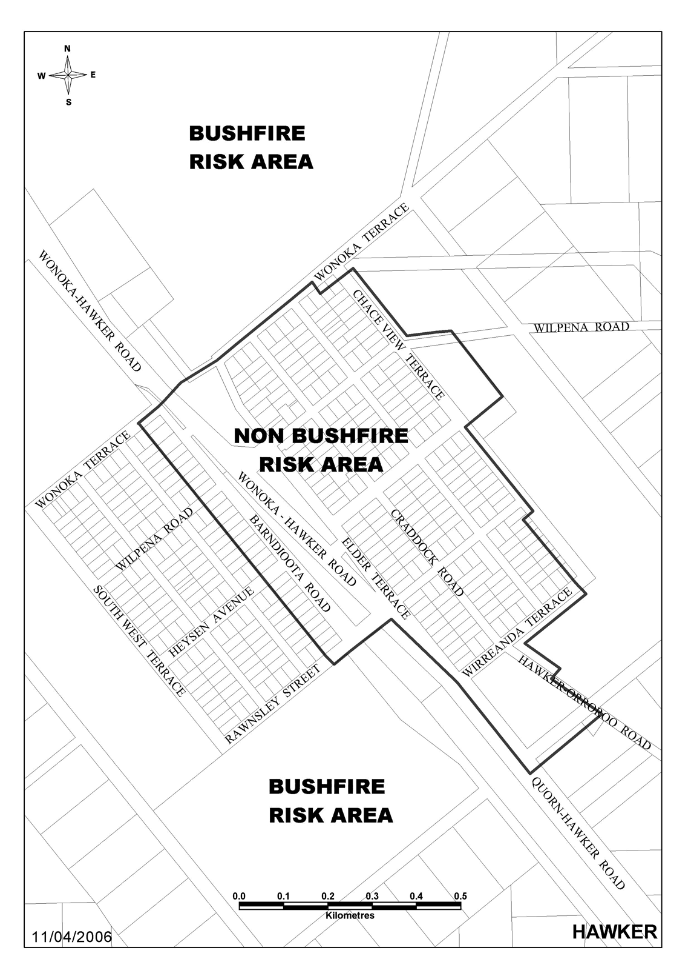
(3) Schedule 3—after the map of Orroroo insert the following map:
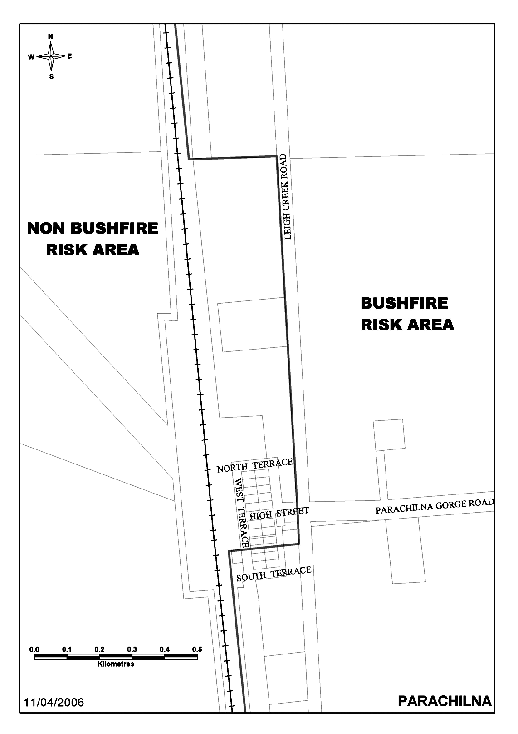
(4) Schedule 3, map of Quorn—delete the map and substitute:
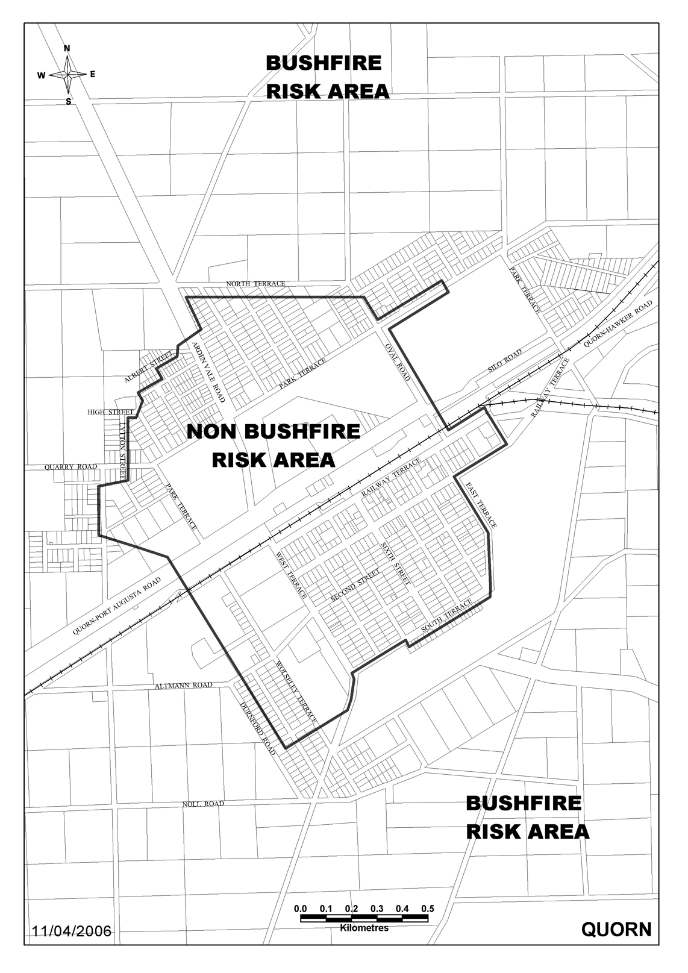
Note—
As required by section 10AA(2) of the Subordinate Legislation Act 1978, the Minister has certified that, in the Minister's opinion, it is necessary or appropriate that these regulations come into operation as set out in these regulations.
Made by the Governor
after consulting with the Minister responsible for the administration of the Environment Protection Act 1993 and with the advice and consent of the Executive Council
on 1 November 2007
No 254 of 2007
MEN07/010CS

FAXING COPY?
IF you fax copy to Government Publishing SA for inclusion in the Government Gazette, there is no need to send a Confirmation Copy to us as well.
This creates confusion and may well result in your notice being printed twice.
Please use the following fax number:
Fax transmission: (08) 8207 1040
Phone Inquiries: (08) 8207 1045
Please include a contact person, phone number and order number so that we can phone back with any queries we may have regarding the fax copy.
NOTE: Closing time for lodging new copy (fax, hard copy or email) is 4 p.m. on Tuesday preceding the day of publication.

Government Gazette notices can be E-mailed.
The address is:
governmentgazette@dpc.sa.gov.au
Documents should be sent as attachments in Word format.
When sending a document via E-mail, please confirm your transmission with a faxed copy of your document, including the date the notice is to be published.
Fax transmission: (08) 8207 1040
Enquiries: (08) 8207 1045
NOTE: Closing time for lodging new copy (fax, hard copy or email) is 4 p.m. on Tuesday preceding the day of publication.

ADELAIDE CITY COUNCIL
Election Results—
Conducted on Saturday, 20 October 2007
LORD MAYOR (1 vacancy):
Formal Ballot Papers: 6 010
Informal Ballot Papers: 21
Quota: 3 006
Candidates | First  Preference  Votes | Result after  Distribution  of Preferences
Harbison, Michael | 2 736 | Elected
Connor, Francene Michele  Goldie | 2 512
Wheare, Jeffrey Alexander | 127
Rossis, Arnie | 635
AREA COUNCILLOR (5 vacancies):
Formal Ballot Papers: 5 809
Informal Ballot Papers: 132
Quota: 969
Candidates | First  Preference  Votes | Result after  Distribution  of Preferences
Beattie, David | 233
Feldheim, David Greville | 114
Moran, Anne | 1 407 | Elected (1)
Gray, Michael | 263
Sutherland, Phil | 73
Campbell, David | 236
Neal, James | 175
Wong, Francis | 516 | Elected (3)
Henderson, Kelly | 209
Zerella, Silvana | 68
Clarke, Ralph | 488 | Elected (5)
Plumridge, David | 445 | Elected (4)
Rinaldi, Dominic | 52
Charlesworth, George | 64
Williams, Howard Dean | 73
Clancy, Ryan | 160
Dilettoso, Michael | 116
Coligan, Sarah | 196
Russell, Joan | 282
Hayward, Richard | 639 | Elected (2)
NORTH WARD (2 vacancies):
Formal Ballot Papers: 2 040
Informal Ballot Papers: 39
Quota: 681
Candidates | First  Preference  Votes | Result after  Distribution  of Preferences
Clearihan, Sue | 640 | Elected (1)
Wilkinson, Sandy | 489 | Elected (2)
Andritsakis, Pam | 178
McAlary, Bernadette | 129
Mosler, Sharon | 98
Magasdi, Cris | 506
CENTRAL WARD (2 vacancies):
Formal Ballot Papers: 1 842
Informal Ballot Papers: 38
Quota: 615
Candidates | First  Preference  Votes | Result after  Distribution  of Preferences
Westenberg, Luke | 49
White, Barrie | 175
Yarwood, Stephen | 376 | Elected (2)
Zaharis, Bill | 356 | Elected (1)
Eyers-White, Arna | 335
Scali, Vincent | 79
Chong, Cathy | 285
Norman, Ben | 187
SOUTH WARD (2 vacancies):
Formal Ballot Papers: 2 121
Informal Ballot Papers: 45
Quota: 708
Candidates | First  Preference  Votes | Result after  Distribution  of Preferences
McKay, Sue | 351
Noble, Grant | 283
Williamson, Anthony John | 321
Henningsen, Michael David | 767 | Elected (1)
Cullen, Joe | 357 | Elected (2)
Crossing, David | 42
K. Mousley, Returning Officer

THE DISTRICT COUNCIL OF CEDUNA
Roads (Opening and Closing) Act 1991
Nadia Road, Nadia
PURSUANT to section 10 of the Roads (Opening and Closing) Act 1991, the District Council of Ceduna hereby gives notice of it’s intention to implement a road process order to open as road portion of sections 14 and 42 in the Hundred of Moule, more particularly delineated and numbered ‘1’ and ‘2’ on Preliminary Plan No. 07/0073, forming a realignment of Nadia Road.
A statement of persons affected by the process together with a copy of the preliminary plan is available for public inspection at the offices of the District Council of Ceduna, 44 O’Loughlin Terrace, Ceduna and at the Adelaide offices of the Surveyor-General during normal office hours.
Any person who may wish to object to the proposed road process order, or any person who may wish to apply for an easement to be granted in that person’s favour over the land subject to the proposed closure must lodge with the said Council a notice of objection or an application for easement within 28 days of the date of the publication of this notice.
All objections shall be in writing stating the objector’s full name and address and the reasons for the objection and whether the objector wishes to appear in person or be represented at a meeting convened by the Council for the determination of objections.
An application for easement shall be in writing stating the applicant’s full name and address, the reasons for the application for the grant of easement, full details of the nature and location of the easement applied for and whether the easement will be in favour of adjoining or nearby land, and if so, specifying the land to which the easement will be annexed.
Where a submission is made the Council will give notification of a meeting at which the matter will be considered so that the person making the submission or their representative may attend if so desired.
A copy of any notice or application shall, at the same time it is lodged with the District Council of Ceduna, P.O. Box 175, Ceduna, S.A. 5690, be forwarded to the Adelaide office of the Surveyor-General, P.O. Box 1354, Adelaide, S.A. 5000.
Dated 30 October 2007.
A. J. Irvine, Chief Executive Officer

KANGAROO ISLAND COUNCIL
Development Act 1993
General Development Plan Amendment (DPA)—
Draft for Public Consultation
NOTICE is hereby given that the Kangaroo Island Council has prepared a draft Development Plan Amendment. The Develop-ment Plan Amendment will amend Council’s Development Plan by:
• Changing the Development Plan to comply with the ‘Better Development Plan’ format, developed by Planning SA.
• Changing zoning and policies within the four townships of Kingscote, Penneshaw, American River and Parndana.
• Changing policies relating to the Primary Production (formally General Farming) Zone.
• Incorporation of policies relating to Commercial Forestry.
• Strengthening policies relating to coastal protection.
The draft Development Plan Amendment will be available for public inspection during normal office hours at the Council Office, 43 Dauncey Street, Kingscote and on the Council website www.kangarooisland.sa.gov.au from Thursday, 1 November 2007 to Friday, 1 February 2008. A copy of the Development Plan Amendment can be obtained on disk from the Council or be downloaded from the website.
Written submissions regarding the draft amendment will be accepted by the Kangaroo Island Council until 5 p.m. on Friday,
1 February 2008. The written submission should also clearly indicate whether you will wish to speak at the public meeting regarding your submission. All submissions should be addressed to the Chief Executive Officer of the Kangaroo Island Council, P.O. Box 121, Kingscote, S.A. 5223 and may be submitted via email to general@kicouncil.sa.gov.au.
Drop-in information sessions will be held at the following locations and times:
• Kingscote, Council Chambers, Tuesday, 27 November 2007, 2 p.m. to 5 p.m.
• Penneshaw, Town Hall, Wednesday, 28 November 2007, 9 a.m. to noon.
• American River, American River Motel, Wednesday, 28 November 2007, 2 p.m. to 5 p.m.
• Parndana, Community Club, Thursday, 29 November 2007, 9 a.m. to noon.
Copies of all written submissions received will be available for inspection by interested persons at the Council offices from Monday, 4 February 2008 until the date of the public meeting.
A public meeting will be held at the Council Chambers on Wednesday, 20 February 2008 at 11 a.m. to 2 p.m. and 6 p.m. to 9 p.m. The public meeting may not be held if no submission indicates an interest in speaking at a public meeting.
For further information about the draft Development Plan Amendment, please contact the Chief Executive Officer, Kangaroo Island Council on (08) 8553 4500 or via email at general@kicouncil.sa.gov.au.
Dated 1 November 2007.
C. Francis, Acting Chief Executive Officer

KANGAROO ISLAND COUNCIL
Development Act 1993
Heritage Development Plan Amendment (DPA)—
Draft for Public Consultation and Interim Operation
NOTICE is hereby given that the Kangaroo Island Council has prepared a draft Development Plan Amendment. The Develop-ment Plan Amendment will amend Council’s Development Plan by:
• Identifying places to be placed on a Local Heritage register and introducing policies to provide appropriate protection of these places.
• Introducing a Heritage (Conservation) Policy Area at Christmas Cove, Penneshaw.
In order to prevent inappropriate development and promote orderly planning, the draft DPA has been granted ‘interim authorisation’ by the Minister for Urban Development and Planning, giving the amendments immediate effect.
The draft Development Plan Amendment will be available for public inspection during normal office hours at the Council Office, 43 Dauncey Street, Kingscote and on the Council website www.kangarooisland.sa.gov.au from Thursday, 1 November 2007 to Friday, 1 February 2008. A copy of the Development Plan Amendment can be obtained on disk from the Council or be downloaded from the website.
Written submissions regarding the draft amendment will be accepted by the Kangaroo Island Council until 5 p.m. on Friday,
1 February 2008. The written submission should also clearly indicate whether you will wish to speak at the public meeting regarding your submission. All submissions should be addressed to the Chief Executive Officer of the Kangaroo Island Council, P.O. Box 121, Kingscote, S.A. 5223 and may be submitted by via email to heritage@kicouncil.sa.gov.au.
Drop-in information sessions will be held at the following locations and times:
• Kingscote, Council Chambers, Tuesday, 27 November 2007, 2 p.m. to 5 p.m.
• Penneshaw, Town Hall, Wednesday, 28 November 2007, 9 a.m. to noon.
• American River, American River Motel, Wednesday, 28 November 2007, 2 p.m. to 5 p.m.
• Parndana, Community Club, Thursday, 29 November 2007, 9 a.m. to noon.
Copies of all written submissions received will be available for inspection by interested persons at the Council offices from Monday, 4 February 2008 until the date of the public meeting.
A public meeting will be held at the Council Chambers, on Wednesday, 20 February 2008, at 11 a.m. to 2 p.m. and 6 p.m. to 9 p.m. The public meeting may not be held if no submission indicates an interest in speaking at a public meeting.
For further information about the draft Development Plan Amendment, please contact the Chief Executive Officer, Kangaroo Island Council on (08) 8553 4500 or via email at heritager@kicouncil.sa.gov.au.
Dated 1 November 2007.
C. Francis, Acting Chief Executive Officer

DISTRICT COUNCIL OF MOUNT BARKER
Roads (Opening and Closing) Act 1991
Road Opening and Closing—Public Road, Wistow
NOTICE is hereby given, pursuant to section 10 of the Roads (Opening and Closing) Act 1991, that the District Council of Mount Barker proposes to make a Road Process Order to:
(i) open as road portion of Allotment 59 in Filed Plan 160036, more particularly delineated and numbered ‘1’ in Preliminary Plan No. 07/0058; and
(ii) close and transfer to James and Anne Neill Temelkovski portion of Public Road adjoining Allotment 59 in Filed Plan 160036 more particularly delineated ‘B’ in Preliminary Plan No. 07/0058.
A copy of the plan and a statement of persons affected are available for public inspection at the offices of the Council, 23 Mann Street, Mount Barker and the Adelaide office of the Surveyor-General, 101 Grenfell Street, Adelaide, during normal office hours.
Any person is entitled to object to the proposed road process, or any person affected by the proposed closure is entitled to apply for an easement to be granted in that person’s favour over the land subject to the proposed closure. Such objection or application for an easement must set out the full name and address of the person making the objection or application and must be fully supported by reasons. Any application for an easement must give full particulars of the nature and location of the easement and where made by a person as the owner of adjoining or nearby land, specify the land to which the easement is to be annexed.
The objection or application for an easement must be made in writing to the Council, P.O. Box 54, Mount Barker, S.A. 5251, within 28 days of this notice and a copy shall be forwarded to the Surveyor-General, G.P.O. Box 1354, Adelaide, S.A. 5001. Where a submission is made, the Council will give notification of a meeting at which the matter will be considered, so that the person making the submission or a representative may attend, if so desired.
Dated 31 October 2007.
A. Stuart, Chief Executive Officer

NARACOORTE LUCINDALE COUNCIL
Appointments
NOTICE is hereby given that at a meeting of Council held on 23 October 2007, Christopher Mark Congdon is appointed as:
• an Authorised Officer, pursuant to section 85 (3) of the Environment Protection Act 1993;
• an Authorised Officer, pursuant to sections 23 and 67 of the Housing Improvement Act 1940;
• an Authorised Person, pursuant to section 260 (1) of the Local Government Act 1999;
• an Authorised Officer, pursuant to section 94 (1) of the Food Act 2001;
• an Authorised Officer pursuant to section 7 (1) of the Public and Environmental Health Act 1987;
• an Authorised Officer pursuant to section 21 (1) of the Supported Residential Facilities Act 1992.
A. Evans, Chief Executive Officer

IN the matter of the estates of the undermentioned deceased persons:
Camfferman, Niesje Hillegonde, late of 9 Brenchley Grove, Kingswood, of no occupation, who died on 7 September 2007.
Eagle, Julia Rosetta, late of 33 Scotland Street, Wallaroo, home duties, who died on 17 September 2007.
Farrell, Ethel Joyce, late of 41 Cardigan Avenue, Felixstow, home duties, who died on 4 July 2007.
Fieldhouse, George Eric, late of 38 Newland Street, Victor Harbor, retired painter and decorator, who died on 12 August 2007.
Gearing, Donald James, late of 19 Malwa Street, Osborne, of no occupation, who died on 24 August 2007.
Glover, Doreen Mavis, late of 24-34 Avenue Road, Glynde, of no occupation, who died on 15 September 2007.
Gower, Agnes Fanny, late of 1 Myzantha Street, Lockleys, widow, who died on 16 August 2007.
Heinrich, Joyce Olive, late of 1A Mount Barker Road, Hahndorf, widow, who died on 19 July 2007.
Howie, Gordon Leslie, late of 53 Gladys Street, Clarence Gardens, retired telephone technician, who died on 7 July 2007.
Lord, Valerie Merle, late of 14 Marriett Street, Solomontown, widow, who died on 5 September 2007.
Read, Heather Irene, late of 336 Marion Road, North Plympton, of no occupation, who died on 19 August 2007.
Rowen, Peter, late of 32 Gray Street, Freeling, retired police officer, who died on 5 September 2007.
Shiers, Mary Pearl, late of 50 Gulfview Road, Christies Beach, widow, who died on 6 August 2007.
Notice is hereby given pursuant to the Trustee Act 1936, as amended, the Inheritance (Family Provision) Act 1972, and the Family Relationships Act 1975, that all creditors, beneficiaries, and other persons having claims against the said estates are required to send, in writing, to the Public Trustee, 25 Franklin Street, Adelaide, S.A. 5000, full particulars and proof of such claims, on or before 30 November 2007, otherwise they will be excluded from the distribution of the said estate; and notice is also hereby given that all persons who are indebted to the said estates are required to pay the amount of their debts to the Public Trustee or proceedings will be taken for the recovery thereof; and all persons having any property belonging to the said estates are forthwith to deliver the same to the Public Trustee.
Dated 1 November 2007.
C. J. O’Loughlin, Public Trustee

EQUITY TREE (1973) CO-OPERATIVE LIMITED
(IN VOLUNTARY LIQUIDATION)
Notice of Final Meeting
NOTICE is hereby given that, pursuant to section 509 of the Corporations Act 1990, as applied by section 311 of the Co-operatives Act 1997, a final meeting of the abovenamed Co-operative will be held at 248 Flinders Street, Adelaide on 29 February 2008 at 10 a.m. for the purpose of laying before the meeting an account showing how the winding up has been conducted and how the assets have been disposed of.
Dated 26 October 2007.
G. Divitkos, Liquidator, BDO Kendalls (SA), 248 Flinders Street, Adelaide, S.A. 5000

NOTICE TO MARINERS
No. 53 of 2007
Formerly Notice 48 of 2006
South Australia—Gulf St Vincent—Port Adelaide—Port River Expressway Construction—Fendering Operations—New Temporary Channel Operational
MARINERS are advised that the temporary channel in place at the Port River Expressway Construction site which was temporarily relocated from 20 April 2007 will remain in position until 30 March 2008.
Two already established exclusion zones either side of the Port River, prohibits all unauthorised marine activity within the zone.
Vessels wishing to pass through the construction Zone must do so via temporary channel to the west of the bridge rest piers with an approximate width of 30 m, which will be delineated by Starboard Hand Marks S1 and S3 and Port Hand Markers P1 and P2. The co-ordinates of the above points are nominated in the following table:

Point | Description | WGS 1984 Datum |  | Flash Sequence
 |  | Latitude | Longitude
CS1 | Cardinal South Mark (Western Side Exclusion Zone) | 34°50′19″S | 138°30′21″E | Quick flash 6 + 1 long flash 10 sec.
CN1 | Cardinal North Mark (Western Side Exclusion Zone) | 34°50′15″S | 138°30’22”E | Uninterrupted quick flash
S1 | Starboard hand channel Mark (North) | 34°50′19″S | 138°30′22″E | Uninterrupted quick flash Green
S2 | Starboard hand channel Mark (South) | 34°50′17″S | 138°30′23″E | Uninterrupted quick flash Green
P1 | Port hand channel Mark (North) | 34°50′20″S | 138°30′23″E | Uninterrupted quick flash Red
P2 | Port hand channel Mark (South) | 34°50′18″S | 138°30′24″E | Uninterrupted quick flash Red
CS2 | Cardinal South Mark (Eastern Side Exclusion Zone) | 34°50′20″S | 138°30′25″E | Quick flash 6 + 1 long flash 10 sec.
CN2 | Cardinal North Mark (Eastern Side Exclusion Zone) | 34°50′16″S | 138°30′26″E | Uninterrupted quick flash

This temporary channel will be in place until 31 March 2008.
The temporary channel, construction plant and equipment will exhibit the appropriate lights and shapes required by the International Regulations.
Mariners are further advised to proceed with extreme caution whilst in the vicinity of the construction operations at a speed of no more than 4 knots and be wary of on-coming traffic possibly using the channel. Masters and skippers of recreational craft are to give way to all Commercial craft negotiating the temporary channel, and not to negotiate the channel whilst the other vessel is transiting the temporary channel.
Navy Chart affected: Aus 137.
Publications affected: Australian Pilot, Volume 1 (Seventh Edition, 1992) pages 125-130 South Australian Waters CW map 6F page 196.
Adelaide, 23 October 2007.

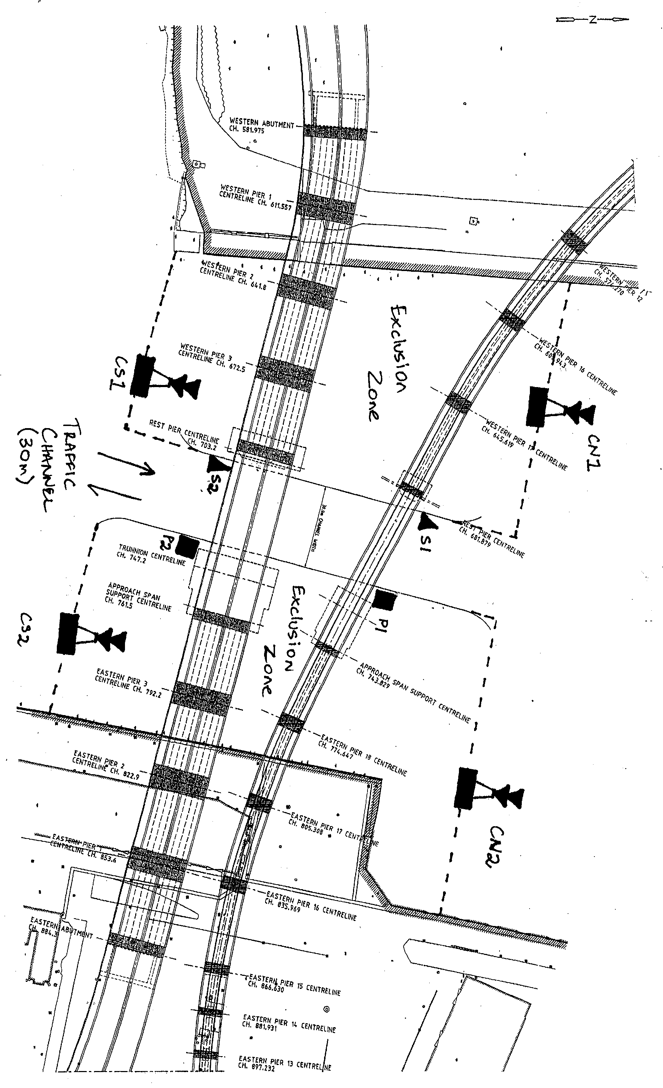
Patrick Conlon, Minister for Transport
DTEI 2007/00313

ATTENTION

CUSTOMERS requiring a proof of their notice for inclusion in the Government Gazette, please note that the onus is on you to inform Government Publishing SA of any subsequent corrections by 10 a.m. on Thursday, which is our publication deadline.

For any corrections to your notice please phone 8207 1045 or Fax 8207 1040 before 10 a.m. on Thursday.

If we do not receive any communication by 10 a.m. on Thursday (day of publication) we will presume the notice is correct and will print it as it is.

Remember—the onus is on you to inform us of any corrections necessary to your notice.

NOTE: Closing time for lodging new copy (electronically, fax or hard copy) is 4 p.m. on Tuesday preceding the day of publication. Phone 8207 1045—Fax 8207 1040.
Email: governmentgazette@dpc.sa.gov.au

Printed and published by authority every Thursday by T. GOODES, Government Printer, South Australia
Price: $5.40, plus postage; to subscribers, $274.00 per annum.
(The above prices are inclusive of GST)

