SUPPLEMENTARY GAZETTE



THE SOUTH AUSTRALIAN

GOVERNMENT GAZETTE
www.governmentgazette.sa.gov.au

PUBLISHED BY AUTHORITY

ALL PUBLIC ACTS appearing in this GAZETTE are to be considered official, and obeyed as such

ADELAIDE, MONDAY, 19 NOVEMBER 2007

LIVESTOCK ACT 1997, SECTION 37: PROHIBITION OF AGGREGATION OF HORSES AND OTHER EQUINE ANIMALS FROM TWO OR MORE PROPERTIES
Notice under the Livestock Act 1997 for Preventing the Introduction and Spread of Equine Influenza
(Notice by Minister for Agriculture, Food and Fisheries)
BY virtue of the provisions of the Livestock Act 1997, and for the purpose of preventing the introduction to, and spread within, the State of South Australia of the declared exotic disease Equine Influenza, I do hereby prohibit the gathering of horses from two or more properties where the total number of horses and related equines gathered together exceeds ten or more, except as provided in any written authority given by an inspector duly appointed under the Livestock Act 1997. The owners or riders of horses attending any authorised gathering must provide a completed ‘Event Participant Declaration’, as set out in Schedule 1 of this Notice, to the person to whom the written authority has been provided. Persons moving horses to Thoroughbred Racing SA or Harness Racing SA authorised gatherings are exempt from the requirement to provide a completed ‘Event Participant Declaration’.
This notice revokes the notice made by the Minister for Agriculture, Food and Fisheries on 3 September 2007.
For the purposes of this notice:
‘gathering’ includes but is not limited to a market, fair, sale, show, parade, rodeo, hunt, race meeting, social gathering, trail riding, horse sport and recreation activities, and includes the travelling of horses and related equines from one place to another to attend the gathering (but does not include an abattoir or slaughterhouse), and
‘horses and related equines’ means horses, donkeys, mules and other animals in the Equidae family.
This Notice shall remain in force for a period of 6 months commencing on 12.30 p.m., Monday, 19 November 2007, unless amended or revoked by subsequent notice.
Dated 16 November 2007.
Rory McEwen, Minister for Agriculture, Food and Fisheries

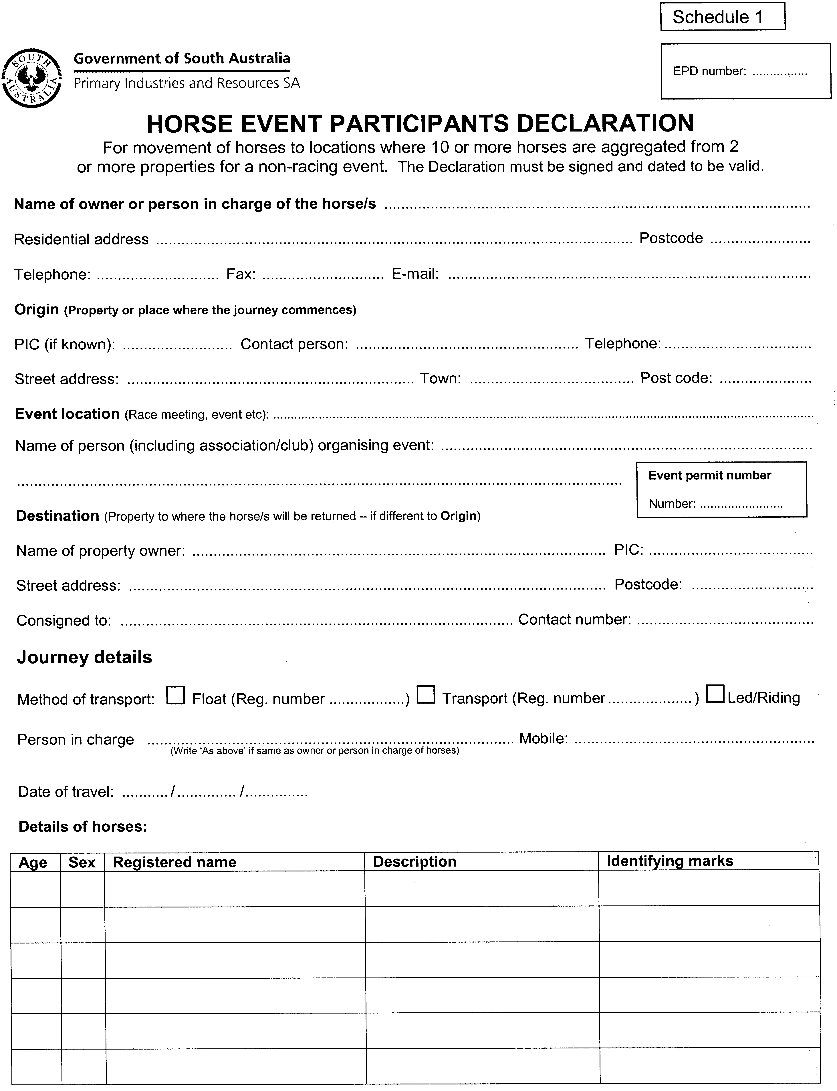
Declarations by person signing
1. I am the owner or person in charge of the horses identified in this Declaration and am authorised to complete this Declaration;
2. I have confirmed that this movement complies with current movement restrictions on horses;
3. No person from a declared equine influenza Restricted Area has been in contact with these horses within the last 14 days.
4. The horses described in this Declaration were not showing any signs of respiratory disease (coughing, sneezing, nasal discharge and/or elevated temperature) during the previous 30 days. I will only move the horses if they are not showing any signs of respiratory disease on each day of movement;
5. If the horses show any signs of respiratory disease during movement, I will return to the property of origin and ensure that they are checked by a veterinarian. If the veterinarian suspects Equine Influenza, I will immediately notify an inspector;
6. I have read, understood and agree to the Conditions below; and
7. I understand that if any information in this Declaration is found to be false or misleading, any movement carried out pursuant to this Declaration may be unauthorised.
Signature: Date: / /
Horses must be healthy on each day of movement. A copy of this Horse Health Declaration must be carried with the horses, and copies must be retained by the owner or person in charge of the horse at both the origin and destination for at least 7 weeks and shown to an inspector (including a Police officer) on request.
Note: The movement of an animal in contravention of the Livestock Act 1997 carries a penalty of up to $20 000 or 12 months imprisonment or both.
Conditions:
By completing this Horse Health Declaration (Declaration) you agree to the following:
1. Any movement of horses during the current Equine Influenza Outbreak in NSW and Queensland may increase the risk of horses contracting Equine Influenza (both for horses being moved and horses which they may come in contact with, whether directly or indirectly). Accordingly it is a condition of any movement made pursuant to this Declaration that you agree and acknowledge that the Minister for Primary Industries, the SA Department of Primary Industries and Resources and its employees and officers, and the State of SA, is not in any way liable for any cost, expense, loss, damage, claim, action, proceeding or other liability incurred by or made against you as a result of any animal contracting Equine Influenza.
2. In the case of a suspect animal at the event all horses will be detained on site for at least 48 hours waiting on laboratory results.
3. In the case of a confirmed Equine Influenza (EI) animal at the event all horses may be detained on site for up to 3 months.
4. In the case of a confirmed EI horse anywhere in SA during the event there will be a statewide horse standstill and all horses will be detained on site until the standstill is lifted.
5. All costs of feeding and maintaining the horses on site in all of the above situations will be at the participant’s expense.
6. This Declaration must be carried with the horses at all times when moving horses pursuant to this Declaration.
7. This Declaration may only be used in connection with the movement described herein.
8. This Declaration must be shown to the event organiser or their delegate upon request.
9. This is not a valid Declaration unless it is signed and dated where indicated above.
10. The Declaration and any instructions for completing this Declaration form part of these Conditions.
Note: If you have any questions or concerns about this Declaration, including the Declarations and Conditions above, then you should seek independent advice based on your individual circumstances before signing the Declaration and making any movement pursuant to it.

LIVESTOCK ACT 1997, SECTION 33: PROHIBITION OF ENTRY OF HORSES AND OTHER EQUINE ANIMALS AND USED EQUIPMENT AND OTHER PROPERTY INTO THE STATE OF SOUTH AUSTRALIA
Notice under the Livestock Act 1997 for Preventing the Introduction and Spread of Equine Influenza
(Notice by Minister for Agriculture, Food and Fisheries)
PURSUANT to section 33 of the Livestock Act 1997, I, Rory McEwen, Minister for Agriculture, Food and Fisheries, prohibit entry into the State or a part of the State of livestock or livestock products absolutely or subject to conditions as set out below:
This notice revokes the notices made by the Minister for Agriculture, Food and Fisheries on 3 September 2007 and 13 September 2007.
Species | State or Territory  of Origin | Absolute or Conditional Prohibition
Equine  (includes horses, mules, donkeys and other animals in the Equidae family) | New South Wales; Queensland;  Australian Capital Territory | Horses and related equines except as provided in any written authority given by an Inspector duly appointed under the Livestock Act 1997.  Any used equipment and fittings (including but not limited to halters, bridles and associated fittings, saddles, rugs, brushes, clothes, boots, buckets and other articles which have been brought into contact with horses and related equines) except as provided in any written authority given by an inspector duly appointed under the Livestock Act 1997.  Any product from horses and related equines including:  (a) the carcase or the portion of a carcase of any horse or related equine; and  (b) the meat, blood, hide, skin, hair, feet or offal of any horse or related equine; and  (c) the secretions, excretions, manure and other wastes of horses and related equines;  but does not include cooked equine product, except as provided in any written authority given by an inspector duly appointed under the Livestock Act 1997.  Chilled semen or frozen semen, ova, embryos, stem cell and other biological material from horses or related equines from any declared Equine Influenza Restricted Area or Zone, except as provided in any written authority given by an inspector duly appointed under the Livestock Act 1997.  Chilled semen or frozen semen, ova, embryos, stem cell and other biological material from horses or related equines from any declared Equine Influenza Control Area or Protected Zone, may be introduced provided that the material is accompanied by a completed declaration for the importation of reproductive material, as set out in Schedule 1 of this Notice, and the completed declaration has been forwarded to the Chief Inspector of Stock by facsimile prior to the introduction of the material.  Any horse or related equine transports and floats except as provided in any written authority given by an inspector duly appointed under the Livestock Act 1997.
 | Victoria, Tasmania, Western Australia and the Northern Territory | Horses and related equines must be accompanied by a completed Horse Health Statement (see Schedule 2 of this Notice).

Definitions
In this Notice:
‘Horses or related equines’ means horses, donkeys, mules and other animals in the Equidae family; and
‘Horse Health Statement’ means the document as set out in Schedule 2 that must either be completed ‘on-line’ at www.pir.sa.gov.au or downloaded from the same address, completed and sent by facsimile to the Chief Inspector of Stock.
Dated 16 November 2007.
Rory McEwen, Minister for Agriculture, Food and Fisheries

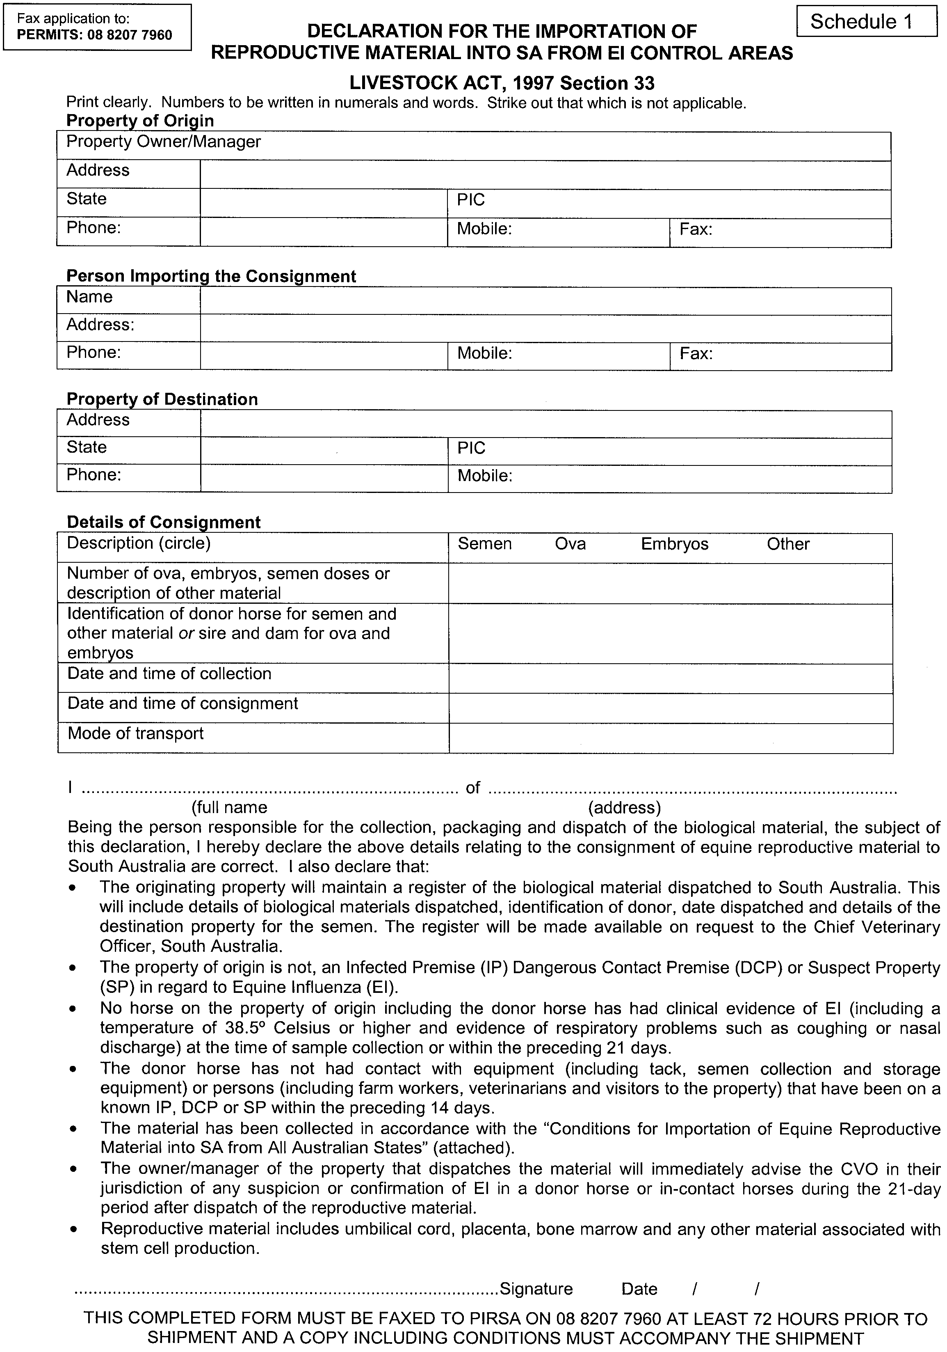
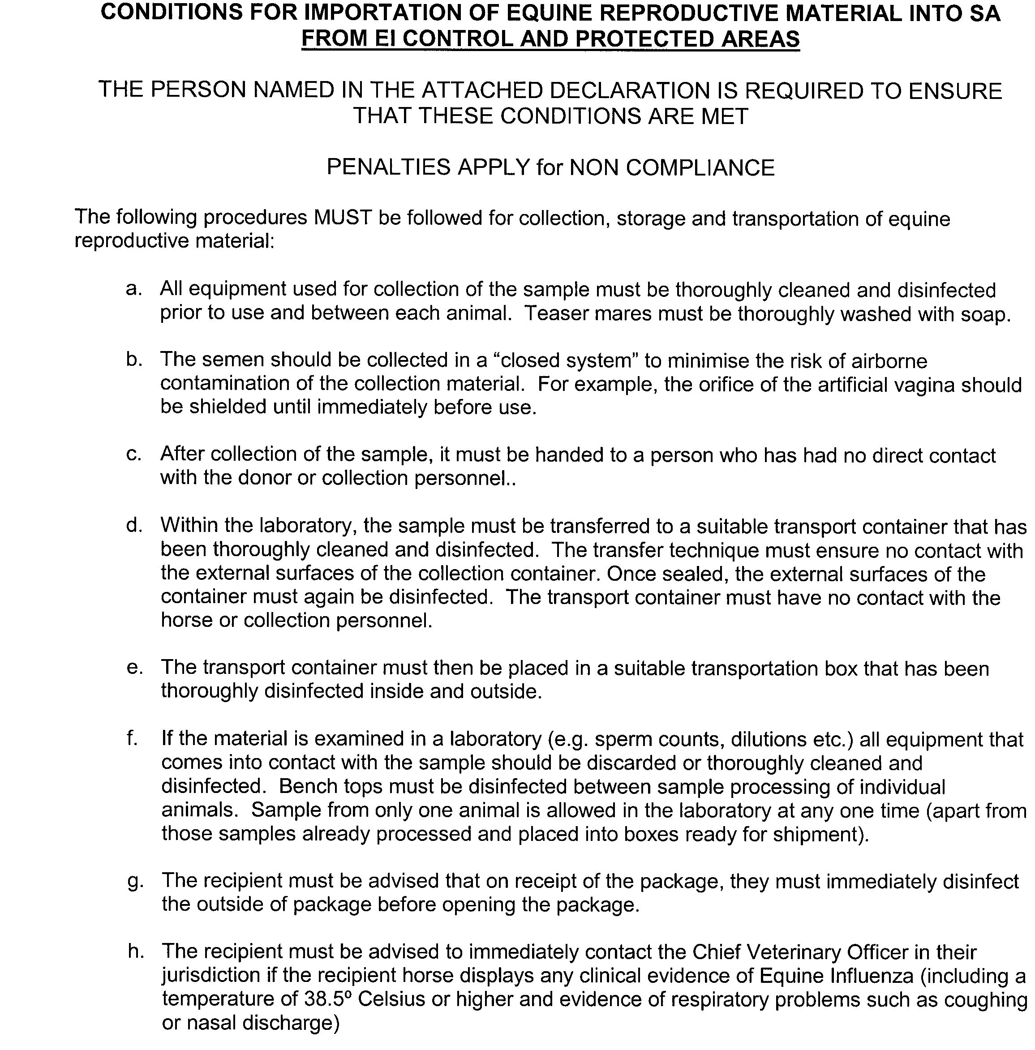
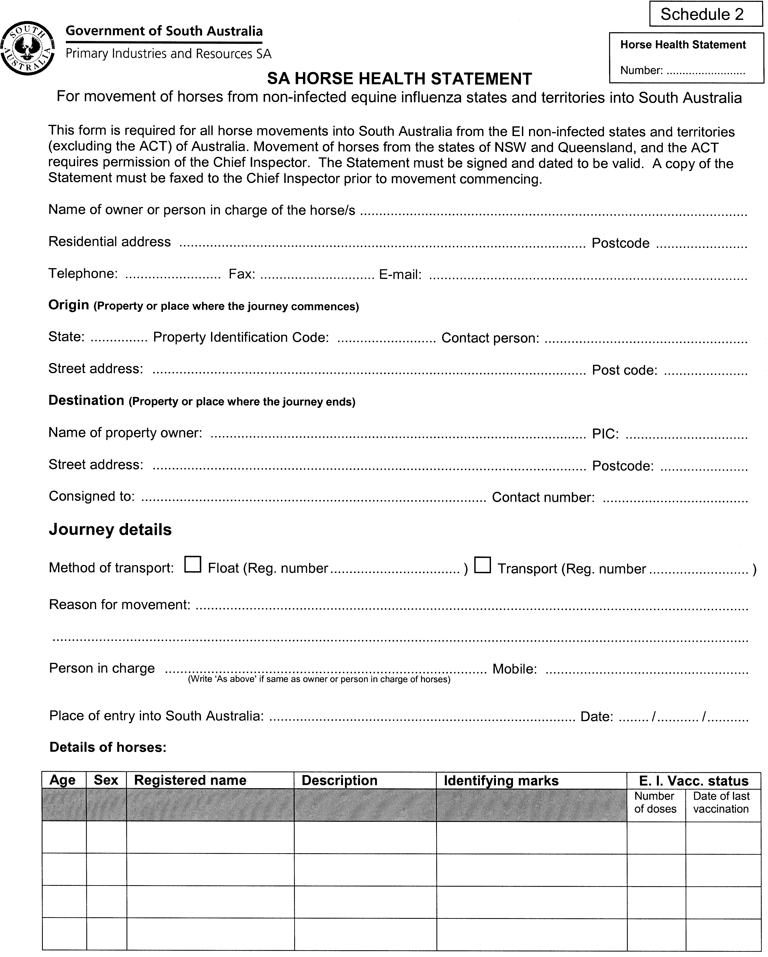
Declarations by person signing
1. I am the owner or person in charge of the horses identified in this Statement and am authorised to complete this Statement;
2. I have confirmed that this movement complies with current movement restrictions on horses;

Horse Health Statement

Number:
3. Without limiting paragraph 2:
(a) no horse has been in New South Wales, the Australian Capital Territory or Queensland since 1 August 2007; and
(b) no person from a declared equine influenza Restricted Area has been in contact with these horses within the last 14 days.
4. The horses described in this Statement were not showing any signs of respiratory disease (coughing, sneezing, nasal discharge and/or elevated temperature) during the previous 30 days. I will only move the horses if they are not showing any signs of respiratory disease on each day of movement;
5. If the horses show any signs of respiratory disease during movement, I will ensure that they are checked by a veterinarian and only continue to move if the veterinarian believes that the horses do not have Equine Influenza. If the veterinarian suspects Equine Influenza, I will immediately notify an inspector;
6. I have read, understood and agree to the Conditions below; and
7. I understand that if any information in this Statement is found to be false or misleading, any movement carried out pursuant to this Statement may be unauthorised.
Signature: Date: / /
Horses must be healthy on each day of movement. A copy of this Horse Health Statement must be carried with the horses, and copies must be retained by the owner or person in charge of the horse at both the origin and destination for at least 7 weeks and shown to an inspector (including a Police officer) on request.
Note: The movement of an animal in contravention of the Livestock Act 1997 carries a penalty of up to $20 000 or 12 months imprisonment or both.
Conditions:
By completing this Horse Health Statement (Statement) you agree to the following conditions:
1. Any movement of horses during the current Equine Influenza Outbreak in NSW and Queensland may increase the risk of horses contracting Equine Influenza (both for horses being moved and horses which they may come in contact with, whether directly or indirectly). Accordingly it is a condition of any movement made pursuant to this Statement that you agree and acknowledge that the Minister for Primary Industries, the SA Department of Primary Industries and Resources and its employees and officers, and the State of SA, is not in any way liable for any cost, expense, loss, damage, claim, action, proceeding or other liability incurred by or made against you as a result of any animal contracting Equine Influenza.
2. This Statement must be carried with the horses at all times when moving horses pursuant to this Statement.
3. This Statement may only be used in connection with the movement described herein.
4. If using this Statement in connection with travel to a horse event the unique Horse Health Statement number situated on the top right of this Statement must be provided to the event organiser upon arrival.
5. This is not a valid Statement unless it is signed and dated where indicated above.
6. The Declaration and any instructions for completing this Statement form part of these Conditions.
Note: If you have any questions or concerns about this Statement, including the Declarations and Conditions above, then you should seek independent advice based on your individual circumstances before signing the Statement and making any movement pursuant to it.

T. GOODES, Government Printer, South Australia

