No. 81 4263

THE SOUTH AUSTRALIAN

GOVERNMENT GAZETTE
www.governmentgazette.sa.gov.au

PUBLISHED BY AUTHORITY

ALL PUBLIC ACTS appearing in this GAZETTE are to be considered official, and obeyed as such

ADELAIDE, THURSDAY, 22 NOVEMBER 2007

CONTENTS

Page
Appointments, Resignations, Etc. 4264
Constitution Act 1934—Notice 4264
Controlled Substances Act 1984—Republished 4264
Corporations and District Councils—Notices 4334
Fisheries Act 1982—Notices 4264
Fruit and Plant Protection Act 1992—Notice 4265
Gaming Machines Act 1992—Notices 4265
Housing Improvement Act 1940—Notices 4266
Liquor Licensing Act 1997—Notices 4270
Local Government Act 1999—Notice 4274
Mining Act 1971—Notices 4274
Motor Vehicles Act 1959—Notice 4274
National Electricity Law—Notice 4275
National Parks and Wildlife (National Parks)
Regulations 2001—Notice 4275
Native Title (South Australia) Act 1994—Notice 4274
Natural Resources Management Act 2004—Notice 4276
Petroleum Act 2000—Notices 4276
Pharmacy Practice Act 2007—Notice 4280
Proclamations 4294

Page
REGULATIONS
Correctional Services Act 1982 (No. 259 of 2007) 4296
Liquor Licensing Act 1997—
(No. 260 of 2007) 4298
(No. 261 of 2007) 4300
Prevention of Cruelty to Animals Act 1985
(No. 262 of 2007) 4302
Trade Measurement Act 1993 (No. 263 of 2007) 4306
Controlled Substances Act 1984—
(No. 264 of 2007) 4308
(No. 265 of 2007) 4326
Security and Investigation Agents Act 1995
(No. 266 of 2007) 4329
Correctional Services Act 1982
(No. 267 of 2007) 4331
Sale of Property 4335
Training and Skills Development Act 2003—
Notice 4284
Treasury—Quarterly Statement 4285
Wilderness Protection Regulations 2006—Notice 4293

GOVERNMENT GAZETTE NOTICES
ALL poundkeepers’ and private advertisements forwarded for publication in the South Australian Government Gazette must be PAID FOR PRIOR TO INSERTION; and all notices, from whatever source, should be legibly written on one side of the paper only and sent to Government Publishing SA so as to be received no later
than 4 p.m. on the Tuesday preceding the day of publication. Phone 8207 1045 or Fax 8207 1040. E-mail: governmentgazette@dpc.sa.gov.au. Send as attachments in Word format and please confirm your transmission with a faxed copy of your document, including the date the notice is to be published and to whom the notice will be charged. The Government Gazette is available online at: www.governmentgazette.sa.gov.au

Department of the Premier and Cabinet
Adelaide, 22 November 2007
HIS Excellency the Governor in Executive Council has been pleased to appoint the undermentioned to the History Trust of South Australia, pursuant to the provisions of the History Trust of South Australia Act 1981:
Member: (from 22 November 2007 until 21 November 2010)
Ian Short
By command,
Paul Caica, for Premier
ASACAB006/02

Department of the Premier and Cabinet
Adelaide, 22 November 2007
HIS Excellency the Governor in Executive Council has been pleased to appoint the Honourable Paul Holloway, MLC, Minister for Police, Minister for Mineral Resources Development and Minister for Urban Development and Planning to be also Acting Minister for Agriculture, Food and Fisheries and Acting Minister for Forests for the period from 26 November 2007 until
6 December 2007 inclusive, during the absence of the Honourable Rory John McEwen, MP.
By command,
Paul Caica, for Premier
MAFF07/029CS

[Republished]
IN Government Gazette No. 78 dated 8 November 2007, page 4168, sixth notice appearing on that page is replaced by this notice hereunder:
CONTROLLED SUBSTANCES ACT 1984
Prohibition of Controlled Substances
TAKE notice that on 2 November 2007, I, Keith Evans, Executive Director of Drug and Alcohol Services South Australia, having formed the opinion that Cheryl Lynn Norton has administered a prescription drug in an irresponsible manner, exercise the authority delegated by the Minister for Mental Health and Substance Abuse under section 62A of the Controlled Substances Act 1984, and make the following order under section 57 (1) of the Act:
Cheryl Lynn Norton
73 Lacey Street
Whyalla, S.A. 5600
is prohibited from supplying, administering or having possession of any substances of the following class:
• A drug of dependence as declared by Regulation 7A of the Controlled Substances (Poisons) Regulations 1996, pursuant to section 12 (3) of the Controlled Substances Act 1984, namely any poison listed in Schedule 8 of the Standard for the Uniform Scheduling of Drugs and Poisons as published and amended by the National Drugs and Poisons Schedule Committee under the Commonwealth’s Therapeutic Goods Act 1989.
This order does not apply to any Drug of Dependence legally supplied or prescribed for treatment of Cheryl Lynn Norton by a dentist or medical practitioner or by a veterinary surgeon for administration to an animal in her care.
Keith Evans, Delegate for the Minister Controlled Substances Act

CONSTITUTION ACT 1934
Section 13 (4)
Assembly to Fill Vacancy in Legislative Council
PURSUANT to a Proclamation made by His Excellency the Governor on 15 November 2007, an assembly of Members of both Houses of Parliament was held on 21 November 2007, to fill the seat in the Legislative Council which had become vacant by virtue of the resignation of the Honourable Nicholas Xenophon, MLC.
At that Assembly, John Andrew Darley was duly elected to fill the said vacancy.
J. M. Davis, Clerk of the Assembly of Members

FISHERIES ACT 1982: SECTION 59
TAKE notice that pursuant to section 59 of the Fisheries Act 1982, Jamieson P. Crawford, of Cleanseas Tuna Ltd, 7 North Quay Boulevard, Port Lincoln, S.A. 5606 (the ‘exemption holder’) is exempt from the Fisheries Act 1982 and the Fisheries (General) Regulations 2000, but only insofar as the exemption holder may take up to six Yellowtail Kingfish (Seriola lalandi) using hook and line method (hand or rod) for the purpose of aquaculture broodstock (the ‘exempted activity’), in the waters described in Schedule 1, subject to the conditions set out in Schedule 2, from 15 November 2007 until 1 December 2007, unless varied or revoked earlier.
Schedule 1
Coastal waters adjacent to Coffin Bay (including Coffin Bay channel).
Schedule 2
1. The specimens collected by the exemption holder must only be used for aquaculture broodstock; all other species must be released immediately.
2. All specimens collected pursuant to this notice must not be sold or transferred to another party.
3. All specimens collected pursuant to this exemption must not be held with any other captive specimens except with fish collected pursuant to another exemption issued for the purposes of broodstock collection and may be held in ponds/tanks in the Cleanseas Tuna Arno Bay hatchery, Licence No. FT00560 and/or Cleanseas Tuna Port Augusta hatchery, Licence No. FT00287.
4. The exemption holder must notify PIRSA Fisheries on 1800 065 522 at least 12 hours prior to conducting the exempted activity and answer a series of questions about the exempted activity. The exemption holder will need to have a copy of the exemption with them at the time of making the call, and be able to provide information about the area and time of the exempted activity, the vehicles and boats involved, the number of agents undertaking the exempted activity and other related questions. Exemption No. 9902067.
5. The exemption holder must provide a written report to the Director of Fisheries, (G.P.O. Box 1625, Adelaide, S.A. 5001) within 14 days of any collection. The report is to provide details of the time, date, location and number of fish collected, including details of any mortalities.
6. The exemption holder shall also provide details of any interactions with threatened, endangered and protected species.
7. The exemption holder shall record the number of wild broodstock held pursuant to this notice in a register to be maintained at the registered aquaculture site, which must be made available for inspection by a PIRSA Fisheries Officer if requested.
8. The exemption holder must allow a Fisheries Officer or another nominated person to be on board the boat during the exempted activity if requested by PIRSA Fisheries.
9. While engaged in the exempted activity, the exemption holder must be in possession of a copy of this notice. Such notice must be produced to a PIRSA Fisheries Compliance Officer if requested.
10. The exemption holder must not contravene or fail to comply with the Fisheries Act 1982, or any regulations made under that Act, except where specifically exempted by this notice.
Dated 15 November 2007.
W. Zacharin, Director of Fisheries

FISHERIES ACT 1982: SECTION 59
TAKE notice that pursuant to section 59 of the Fisheries Act 1982, Dr Adrian Linnane, Senior Rock Lobster Scientist, SARDI Aquatic Sciences (the ‘exemption holder’), is exempt from the Fisheries (General) Regulations 2000, insofar as he or a person listed in Schedule 1 of this notice who is authorised to act as his agent may take berried female rock lobster in the waters of the Northern Zone Rock Lobster Fishery for scientific purposes, subject to the conditions in Schedule 2, during the period commencing 21 November 2007 and ending 31 December 2007, unless varied or revoked earlier.
Schedule 1
Any licence holder or registered master lawfully fishing, pursuant to one of the following licences is authorised to act as an agent of the exemption holder:
N19, N39, N44, N54, N60, N63, N75, N91, N96.
Schedule 2
1. A maximum of 15 berried females may be taken from each boat fishing, pursuant to this exemption other than a boat fishing pursuant to N39 from which a maximum of 30 berried females may be taken.
2. At the conclusion of each days fishing, the licence holder or registered master must record the total number of berried female rock lobster collected on that day, pursuant to this exemption on the bottom of the Catch and Disposal Record.
3. Any licence holder or registered master fishing, pursuant to this exemption must provide catch and effort information as required by the exemption holder.
4. An exemption holder must not contravene or fail to comply with the Fisheries Act 1982, or any other regulations made under that Act except where specifically exempted by this notice.
Dated 20 November 2007.
W. Zacharin, Director of Fisheries

FRUIT AND PLANT PROTECTION ACT 1992
Notice Concerning the Control of Branched Broomrape
PURSUANT to the Fruit and Plant Protection Act 1992 (the Act), I, Gail Gago, Minister for Environment and Conservation, vary the notice under the Act published at page 4260 of the Government Gazette of 20 September 2001 (as varied) as follows:
Paragraph 3 is amended by the addition of the following area to that portion of the State defined in (1) to be a quarantine area with respect to the disease Branched Broomrape:
The whole of the land comprised and described in:
certificate of title volume 5838, folio 277, Hundred of Mobilong, County of Sturt;
certificate of title volume 5543, folio 938, Hundred of Ridley, County of Sturt; and
certificate of title volume 5543, folio 937, Hundred of Ridley, County of Sturt.
Dated 14 November 2007.
Gail Gago, Minister for Environment and Conservation

GAMING MACHINES ACT 1992
Notice of Application
NOTICE is hereby given, pursuant to section 29 of the Gaming Machines Act 1992, that AC Plush Investments Pty Ltd has applied to the Licensing Authority for Redefinition and variation to the Gaming Layout, and to increase the number of Gaming Machines in respect of premises situated at 59 Murray Street, Angaston, S.A. 5353 and known as Tanunda Hotel.
The application has been set down for callover on 14 December 2007 at 9 a.m.
Conditions
The following licence conditions are sought:
That the number of Gaming Machines be increased from 20 to 40 and that the Gaming Layout be varied in accordance with the plan lodged.
Any person may object to the application by lodging a notice of objection in the prescribed form with the Liquor and Gambling Commissioner and serving a copy of the notice on the applicant at the applicant’s address, at least seven days before the callover date (viz: 7 December 2007).
The applicant’s address for service is c/o Jarrod Ryan, Kelly & Co., Level 17, 91 King William Street, Adelaide, S.A. 5000.
Plans in respect of the premises the subject of the application are open to public inspection without fee at the Office of the Liquor and Gambling Commissioner, 9th Floor, East Wing, 50 Grenfell Street, Adelaide, S.A. 5000. Phone 8226 8410, Fax:
8226 8512. Email: olgc@agd.sa.gov.au.
Dated 15 November 2007.
Applicant

GAMING MACHINES ACT 1992
Notice of Application
NOTICE is hereby given, pursuant to section 29 of the Gaming Machines Act 1992, that The Angaston Pub Pty Ltd has applied to the Licensing Authority for Redefinition and variation to the Gaming Layout, and to increase the number of Gaming Machines in respect of premises situated at 59 Murray Street, Angaston, S.A. 5353 and known as Angaston Hotel.
The application has been set down for callover on 14 December 2007 at 9 a.m.
Conditions
The following licence conditions are sought:
That the number of Gaming Machines be increased from 16 to 40 and that the Gaming Layout be varied in accordance with the plan lodged.
Any person may object to the application by lodging a notice of objection in the prescribed form with the Liquor and Gambling Commissioner and serving a copy of the notice on the applicant at the applicant’s address, at least seven days before the callover date (viz: 7 December 2007).
The applicant’s address for service is c/o Jarrod Ryan, Kelly & Co., Level 17, 91 King William Street, Adelaide, S.A. 5000.
Plans in respect of the premises the subject of the application are open to public inspection without fee at the Office of the Liquor and Gambling Commissioner, 9th Floor, East Wing, 50 Grenfell Street, Adelaide, S.A. 5000. Phone 8226 8410, Fax:
8226 8512. Email: olgc@agd.sa.gov.au.
Dated 14 November 2007.
Applicant

HOUSING IMPROVEMENT ACT 1940
NOTICE is hereby given that the South Australian Housing Trust in the exercise of the powers conferred by the Housing Improvement Act 1940, does hereby declare the houses described in the table hereunder to be substandard for the purposes of Part 7 of the Housing Improvement Act 1940.
No. of House and Street | Locality | Allotment, Section, etc. | Certificate of Title  Volume Folio

386 Tapleys Hill Road |  | Seaton | Allotment 102 in Deposited Plan 36556, Hundred of Yatala | 5120 | 546

Dated at Adelaide, 22 November 2007. D. Huxley, Director, Corporate and Board Services

HOUSING IMPROVEMENT ACT 1940
WHEREAS by notice published in the Government Gazette on the dates mentioned in the following table the South Australian Housing Trust did declare the houses described in the said table to be substandard for the purposes of Part 7 of the Housing Improvement Act 1940, and whereas the South Australian Housing Trust is satisfied that each of the houses described hereunder has ceased to be substandard, notice is hereby given that, in exercise of the powers conferred by the said Part, the South Australian Housing Trust does hereby revoke the said declaration in respect of each house.
Address of House | Allotment, Section, etc. | Certificate of Title  Volume Folio | Date and page of Government Gazette in which notice declaring house to be substandard published

Allotment 3, Playford Highway, Cygnet River, Kangaroo Island |  | Allotment 3 in Filed Plan 130559, Hundred of Menzies | 5237 | 632 |  | 24.3.94, page 799
82 Muller Road, Greenacres |  | Allotment 423 in Deposited Plan 5203, Hundred of Yatala | 5654 | 137 |  | 24.5.07, page 2143
299 Whites Road, Paralowie |  | Allotment 102 in Filed Plan 30524, Hundred of Munno Para | 5411 | 212 |  | 30.8.01, page 3431

Dated at Adelaide, 22 November 2007. D. Huxley, Director, Corporate and Board Services

HOUSING IMPROVEMENT ACT 1940
WHEREAS by notice published in the Government Gazette on the dates mentioned in the following table the South Australian Housing Trust did declare the houses described in the said table to be substandard for the purposes of Part 7 of the Housing Improvement Act 1940, the South Australian Housing Trust in the exercise of the powers conferred by the said Part, does hereby fix as the maximum rental per week which shall be payable subject to section 55 of the Residential Tenancies Act 1995, in respect of each house described in the following table the amount shown in the said table opposite the description of such house and this notice shall come into force on the date of this publication in the Gazette.
Address of House | Allotment, Section, etc. | Certificate of Title  Volume Folio | Date and page of Government Gazette in which notice declaring house to be substandard published | Maximum rental per week payable in respect of each house  $

5 McLaren Street, Adelaide |  | Allotment 678 of portion of Town Acre 517, Hundred of Adelaide | 5814 | 172 |  | 11.2.88, page 359 | 365.00
214 Mannum Road, Murray Bridge (also known as Northern Heights) |  | Allotment 202 of section 296, Hundred of Mobilong | 5974 | 689 |  | 9.6.83, page 1642 | 130.00
124 Milne Road, Para Hills |  | Allotment 9 in Deposited Plan 8529, Hundred of Yatala | 5575 | 79 |  | 26.10.06, page 3774 | 190.00
241 Belair Road, Torrens Park |  | Allotment 121 in Filed Plan 19614, Hundred of Adelaide | 5185 | 979 |  | 30.8.07, page 3471 | 115.00
Unit 4/9 Irwin Street, Wallaroo |  | Allotment 3 in Filed Plan 158872, Hundred of Wallaroo | 5287 | 975 |  | 26.7.07, page 3177 | 100.00
Unit 7/9 Irwin Street, Wallaroo |  | Allotment 3 in Filed Plan 158872, Hundred of Wallaroo | 5287 | 975 |  | 26.7.07, page 3177 | 100.00

Dated at Adelaide, 22 November 2007. D. Huxley, Director, Corporate and Board Services

Christmas/New Year Holiday Publishing Information

Last Gazette for 2007 will be Thursday, 20 December 2007

Closing date for notices for publication will be
4 p.m. Tuesday, 18 December 2007

First Gazette for 2008 will be Thursday, 3 January 2008

Closing date for notices for publication will be
4 p.m. Monday, 31 December 2007

(There will NOT be a Gazette in the period between these two dates)

It would be appreciated if Government Gazette notices for publication be addressed to:

Email address for Government Gazette notices:

governmentgazette@dpc.sa.gov.au

When sending a document via Email please confirm your transmission with a faxed copy, including the date the notice is to be published.

Facsimile transmission of notices:
(08) 8207 1040
Attention: Government Gazette Section

Inquiries telephone: 8207 1045

AusDoc subscribers:

Government Publishing SA
DX 56508

Postal address:

Government Publishing SA
Box 9
Plaza Level
Riverside Centre
North Terrace, Adelaide, S.A. 5000

GOVERNMENT GAZETTE ADVERTISEMENT RATES

To apply from 1 July 2007

$  Agents, Ceasing to Act as 39.60  Associations:  Incorporation 20.10  Intention of Incorporation 49.75  Transfer of Properties 49.75  Attorney, Appointment of 39.60  Bailiff’s Sale 49.75  Cemetery Curator Appointed 29.45  Companies:  Alteration to Constitution 39.60  Capital, Increase or Decrease of 49.75  Ceasing to Carry on Business 29.45  Declaration of Dividend 29.45  Incorporation 39.60  Lost Share Certificates:  First Name 29.45  Each Subsequent Name 10.10  Meeting Final 33.10  Meeting Final Regarding Liquidator’s Report on  Conduct of Winding Up (equivalent to ‘Final  Meeting’)  First Name 39.60  Each Subsequent Name 10.10  Notices:  Call 49.75  Change of Name 20.10  Creditors 39.60  Creditors Compromise of Arrangement 39.60  Creditors (extraordinary resolution that ‘the Com-pany be wound up voluntarily and that a liquidator be appointed’) 49.75  Release of Liquidator⎯Application⎯Large Ad. 78.65  ⎯Release Granted 49.75  Receiver and Manager Appointed 45.85  Receiver and Manager Ceasing to Act 39.60  Restored Name 37.25  Petition to Supreme Court for Winding Up 69.30  Summons in Action 58.85  Order of Supreme Court for Winding Up Action 39.60  Register of Interests⎯Section 84 (1) Exempt 89.10  Removal of Office 20.10  Proof of Debts 39.60  Sales of Shares and Forfeiture 39.60  Estates:  Assigned 29.45  Deceased Persons⎯Notice to Creditors, etc. 49.75  Each Subsequent Name 10.10  Deceased Persons⎯Closed Estates 29.45  Each Subsequent Estate 1.30  Probate, Selling of 39.60  Public Trustee, each Estate 10.10 |  | $  Firms:  Ceasing to Carry on Business (each insertion) 26.30  Discontinuance Place of Business 26.30  Land⎯Real Property Act:  Intention to Sell, Notice of 49.75  Lost Certificate of Title Notices 49.75  Cancellation, Notice of (Strata Plan) 49.75  Mortgages:  Caveat Lodgement 20.10  Discharge of 21.05  Foreclosures 20.10  Transfer of 20.10  Sublet 10.10  Leases⎯Application for Transfer (2 insertions) each 10.10  Lost Treasury Receipts (3 insertions) each 29.45  Licensing 58.85  Municipal or District Councils:  Annual Financial Statement⎯Forms 1 and 2 554.35  Electricity Supply⎯Forms 19 and 20 393.90  Default in Payment of Rates:  First Name 78.65  Each Subsequent Name 10.10  Noxious Trade 29.45  Partnership, Dissolution of 29.45  Petitions (small) 20.10  Registered Building Societies (from Registrar-  General) 20.10  Register of Unclaimed Moneys⎯First Name 29.45  Each Subsequent Name 10.10  Registers of Members⎯Three pages and over:  Rate per page (in 8pt) 252.15  Rate per page (in 6pt) 333.45  Sale of Land by Public Auction 50.30  Advertisements 2.80  ¼ page advertisement 117.75  ½ page advertisement 235.50  Full page advertisement 461.60  Advertisements, other than those listed are charged at $2.80 per column line, tabular one-third extra.  Notices by Colleges, Universities, Corporations and District Councils to be charged at $2.80 per line.  Where the notice inserted varies significantly in length from that which is usually published a charge of $2.80 per column line will be applied in lieu of advertisement rates listed.  South Australian Government publications are sold on the condition that they will not be reproduced without prior permission from the Government Printer.
All the above prices include GST

GOVERNMENT GAZETTE NOTICES
ALL private advertisements forwarded for publication in the South Australian Government Gazette must be PAID FOR PRIOR TO INSERTION; and all notices, from whatever source, should be legibly written on one side of the paper only and sent to Government Publishing SA so as to be received no later than 4 p.m. Tuesday preceding the day of publication. Phone 8207 1045 or Fax 8207 1040. E-mail: governmentgazette@dpc.sa.gov.au. Send as attachments in Word format. Please include date the notice is to be published and to whom the notice will be charged. The Government Gazette is available online at: www.governmentgazette.sa.gov.au.

MISCELLANEOUS LEGISLATION AND GOVERNMENT PUBLICATIONS PRICES AS FROM 1 JULY 2007

Acts, Bills, Rules, Parliamentary Papers and Regulations
Pages | Main | Amends | Pages | Main | Amends

1-16 | 2.40 | 1.10 | 497-512 | 33.60 | 32.55
17-32 | 3.25 | 2.05 | 513-528 | 34.65 | 33.35
33-48 | 4.20 | 3.00 | 529-544 | 35.70 | 34.65
49-64 | 5.30 | 4.05 | 545-560 | 36.75 | 35.70
65-80 | 6.25 | 5.15 | 561-576 | 37.50 | 36.75
81-96 | 7.25 | 6.00 | 577-592 | 38.55 | 37.25
97-112 | 8.25 | 7.05 | 593-608 | 39.85 | 38.30
113-128 | 9.25 | 8.10 | 609-624 | 40.65 | 39.60
129-144 | 10.35 | 9.15 | 625-640 | 41.70 | 40.10
145-160 | 11.35 | 10.10 | 641-656 | 42.70 | 41.70
161-176 | 12.40 | 11.15 | 657-672 | 43.25 | 42.20
177-192 | 13.45 | 12.20 | 673-688 | 45.05 | 43.25
193-208 | 14.50 | 13.35 | 689-704 | 45.85 | 44.30
209-224 | 15.30 | 14.15 | 705-720 | 46.65 | 45.35
225-240 | 16.35 | 15.10 | 721-736 | 48.45 | 46.35
241-257 | 17.50 | 15.95 | 737-752 | 48.95 | 47.40
258-272 | 18.45 | 17.00 | 753-768 | 50.00 | 48.20
273-288 | 19.50 | 18.25 | 769-784 | 50.55 | 49.75
289-304 | 20.30 | 19.15 | 785-800 | 51.60 | 50.80
305-320 | 21.55 | 20.20 | 801-816 | 52.60 | 51.30
321-336 | 22.40 | 21.15 | 817-832 | 53.65 | 52.60
337-352 | 23.55 | 22.30 | 833-848 | 54.70 | 53.65
353-368 | 24.50 | 23.35 | 849-864 | 55.75 | 54.20
369-384 | 25.55 | 24.40 | 865-880 | 56.80 | 55.75
385-400 | 26.55 | 25.30 | 881-896 | 57.30 | 56.25
401-416 | 27.60 | 26.05 | 897-912 | 58.85 | 57.30
417-432 | 28.65 | 27.35 | 913-928 | 59.40 | 58.85
433-448 | 29.70 | 28.40 | 929-944 | 60.45 | 59.40
449-464 | 30.50 | 29.20 | 945-960 | 61.50 | 59.90
465-480 | 31.00 | 30.20 | 961-976 | 63.05 | 60.95
481-496 | 32.55 | 31.00 | 977-992 | 64.10 | 61.50

Legislation—Acts, Regulations, etc: $
Subscriptions:
Acts 207.00
All Bills as Laid 497.00
Rules and Regulations 497.00
Parliamentary Papers 497.00
Bound Acts 230.00
Index 115.00
Government Gazette
Copy 5.40
Subscription 274.00
Hansard
Copy 15.10
Subscription—per session (issued weekly) 431.00
Cloth bound—per volume 185.00
Subscription—per session (issued daily) 431.00
Legislation on Disk
Whole Database 3192.00
Annual Subscription for fortnightly updates 981.00
Individual Act(s) including updates POA
Compendium
Subscriptions:
Subscriptions 1891.00
Updates 667.00
(All the above prices include GST)

All Legislation, Government Gazette, Hansard and Legislation on disk are available from:
Counter Sales Service SA, Government Legislation⁺ Outlet
and Mail Orders: Lands Titles Office, 101 Grenfell Street, Adelaide, S.A. 5000
Phone: 13 23 24 (local call cost), Fax: (08) 8204 1909
Postal: G.P.O. Box 1707, Adelaide, S.A. 5001

Online Shop: www.shop.service.sa.gov.au

Subscriptions and Government Publishing SA
Standing Orders: Box 9, Plaza Level, Riverside Centre, North Terrace, Adelaide, S.A. 5000
Phone: (08) 8207 1043, (08) 8207 0910, Fax: (08) 8207 1040

LIQUOR LICENSING ACT 1997
Notice of Application
NOTICE is hereby given, pursuant to section 52 (2) (b) of the Liquor Licensing Act 1997, that Pubwalker Pty Ltd has applied to the Licensing Authority for Alterations, Redefinition, variation to Extended Trading Authorisation and variation to Entertainment Consent in respect of premises situated at 32 Hughes Street, Wallaroo, S.A. 5556 and known as Prince Edward Hotel.
The application has been set down for hearing on 14 December 2007 at 9 a.m.
Conditions
The following licence conditions are sought:
• Alterations and Redefinition to licensed premises to include open air Beer Garden and Dining Area.
• Variation to Extended Trading Authorisation is sought in respect of the current hours in the open air Beer Garden and Dining Area.
• Variation to Entertainment Consent is sought to include the proposed inside Dining Area.
Any person may object to the application by lodging a notice of objection in the prescribed form with the Liquor and Gambling Commissioner and serving a copy of the notice on the applicant at the applicant’s address, at least seven days before the hearing date (viz: 7 December 2007).
The applicant’s address for service is c/o David Tillett, G.P.O. Box 2, Adelaide, S.A. 5001.
Plans in respect of the premises the subject of the application are open to public inspection without fee at the Office of the Liquor and Gambling Commissioner, 9th Floor, East Wing, 50 Grenfell Street, Adelaide, S.A. 5000. Phone 8226 8410, Fax:
8226 8512. Email: olgc@agd.sa.gov.au.
Dated 14 November 2007.
Applicant

LIQUOR LICENSING ACT 1997
Notice of Application
NOTICE is hereby given, pursuant to section 52 (2) (b) of the Liquor Licensing Act 1997, that Kathmandu Palace Pty Ltd has applied to the Licensing Authority for the transfer of a Restaurant Licence in respect of premises situated at 9 Nile Street, Glenelg, S.A. 5045, known as Elsie Out Of Africa and to be known as Kathmandu Palace Restaurant.
The application has been set down for hearing on 19 December 2007 at 9.30 a.m.
Any person may object to the application by lodging a notice of objection in the prescribed form with the Liquor and Gambling Commissioner and serving a copy of the notice on the applicant at the applicant’s address, at least seven days before the hearing date (viz: 12 December 2007).
The applicant’s address for service is c/o Palden Lama, 4/33 Regent Street, Parkside, S.A. 5063.
Plans in respect of the premises the subject of the application are open to public inspection without fee at the Office of the Liquor and Gambling Commissioner, 9th Floor, East Wing, 50 Grenfell Street, Adelaide, S.A. 5000. Phone 8226 8410, Fax:
8226 8512. Email: olgc@agd.sa.gov.au.
Dated 14 November 2007.
Applicant

LIQUOR LICENSING ACT 1997
Notice of Application
NOTICE is hereby given, pursuant to section 52 (2) (b) of the Liquor Licensing Act 1997, that A. J. & P. A. McBride Invest-ments Pty Ltd has applied to the Licensing Authority for the removal of a Producer’s Licence in respect of premises situated at 21 Franklin Street, Adelaide, S.A. 5000 and to be situated at 12 Greenhill Road, Wayville, S.A. 5034 and known as Faraway Estate.
The application has been set down for callover on 21 December 2007 at 9 a.m.
Any person may object to the application by lodging a notice of objection in the prescribed form with the Liquor and Gambling Commissioner and serving a copy of the notice on the applicant at the applicant’s address, at least seven days before the callover date (viz: 14 December 2007).
The applicant’s address for service is c/o David Watts, 1 Cator Street, Glenside, S.A. 5065.
Plans in respect of the premises the subject of the application are open to public inspection without fee at the Office of the Liquor and Gambling Commissioner, 9th Floor, East Wing, 50 Grenfell Street, Adelaide, S.A. 5000. Phone 8226 8410, Fax:
8226 8512. Email: olgc@agd.sa.gov.au.
Dated 13 November 2007.
Applicant

LIQUOR LICENSING ACT 1997
Notice of Application
NOTICE is hereby given, pursuant to section 52 (2) (b) of the Liquor Licensing Act 1997, that Central District Footballers’ Club has applied to the Licensing Authority for the approval of Alterations and Redefinition to the licensed premises and variation to Extended Trading Authorisation in respect of premises situated at Elizabeth Oval, Goodman Road, Elizabeth South, S.A. 5112 and known as Central District Footballers’ Club.
The application has been set down for callover on 21 December 2007 at 9 a.m.
Conditions
The following licence conditions are sought:
• Alterations and Redefinition to the Clubrooms to include outdoor areas as per plans lodged.
• The current Extended Trading Authorisation is sought in the new areas as per plans lodged.
Any person may object to the application by lodging a notice of objection in the prescribed form with the Liquor and Gambling Commissioner and serving a copy of the notice on the applicant at the applicant’s address, at least seven days before the callover date (viz: 14 December 2007).
The applicant’s address for service is c/o Kris Grant, Central Districts Footballers’ Club, P.O. Box 10, Elizabeth, S.A. 5112.
Plans in respect of the premises the subject of the application are open to public inspection without fee at the Office of the Liquor and Gambling Commissioner, 9th Floor, East Wing, 50 Grenfell Street, Adelaide, S.A. 5000. Phone 8226 8410, Fax:
8226 8512. Email: olgc@agd.sa.gov.au.
Dated 13 November 2007.
Applicant

LIQUOR LICENSING ACT 1997
Notice of Application
NOTICE is hereby given, pursuant to section 52 (2) (b) of the Liquor Licensing Act 1997, that Fahey’s Lakes Resort Pty Ltd has applied to the Licensing Authority for Alterations, Redefinition and a variation to an Extended Trading Authorisation in respect of premises situated at 141 Brebner Drive, West Lakes, S.A. 5021 and known as Lakes Resort.
The application has been set down for callover on 21 December 2007 at 9 a.m.
Conditions
The following licence conditions are sought:
• Alterations and Redefinition to licensed premises that includes three separate outdoor areas and Internal Alterations and Redefinition as per plans lodged with this office.
• Variation to an Extended Trading Authorisation to include the existing Extended Trading Authorisation to two of the abovementioned areas known as Terrace 2 and Terrace 3, situated on the eastern side of the building.
Any person may object to the application by lodging a notice of objection in the prescribed form with the Liquor and Gambling Commissioner and serving a copy of the notice on the applicant at the applicant’s address, at least seven days before the callover date (viz: 14 December 2007).
The applicant’s address for service is c/o Jarrod Ryan, Kelly & Co., Westpac House, Level 17, 91 King William Street, Adelaide, S.A. 5000.
Plans in respect of the premises the subject of the application are open to public inspection without fee at the Office of the Liquor and Gambling Commissioner, 9th Floor, East Wing, 50 Grenfell Street, Adelaide, S.A. 5000. Phone 8226 8410, Fax:
8226 8512. Email: olgc@agd.sa.gov.au.
Dated 15 November 2007.
Applicant

LIQUOR LICENSING ACT 1997
Notice of Application
NOTICE is hereby given, pursuant to section 52 (2) (b) of the Liquor Licensing Act 1997, that Avoca Fruit and Nut Liqueurs Pty Ltd has applied to the Licensing Authority for a Wholesale Liquor Merchant’s Licence in respect of premises situated at 26 Elderslie Avenue, Fitzroy, S.A. 5082 and to be known as Avoca Fruit and Nut Liqueurs.
The application has been set down for callover on 21 December 2007 at 9 a.m.
Any person may object to the application by lodging a notice of objection in the prescribed form with the Liquor and Gambling Commissioner and serving a copy of the notice on the applicant at the applicant’s address, at least seven days before the callover date (viz: 14 December 2007).
The applicant’s address for service is c/o David Watts, 1 Cator Street, Glenside, S.A. 5065.
Plans in respect of the premises the subject of the application are open to public inspection without fee at the Office of the Liquor and Gambling Commissioner, 9th Floor, East Wing, 50 Grenfell Street, Adelaide, S.A. 5000. Phone 8226 8410, Fax:
8226 8512. Email: olgc@agd.sa.gov.au.
Dated 15 November 2007.
Applicant

LIQUOR LICENSING ACT 1997
Notice of Application
NOTICE is hereby given, pursuant to section 52 (2) (b) of the Liquor Licensing Act 1997, that Barnregar Pty Ltd as trustee for Kregar-Barnes Family Trust has applied to the Licensing Authority for approval to establish a Pergola on the north-western corner in respect of premises situated at 33 Robert Street, Maitland, S.A. 5573 and known as Hotel Maitland.
The application has been set down for callover on 21 December 2007 at 9 a.m.
Conditions
The following licence conditions are sought:
• Approval is also sought for the Extended Trading Authorisation to apply to the Pergola on the days, and during the times, currently authorised for Extended Trading in the internal areas of the premises.
• Entertainment will not be provided in the Pergola.
Any person may object to the application by lodging a notice of objection in the prescribed form with the Liquor and Gambling Commissioner and serving a copy of the notice on the applicant at the applicant’s address, at least seven days before the callover date (viz: 14 December 2007).
The applicant’s address for service is c/o Australian Hotels Association (S.A. Branch), 4th Floor, 60 Hindmarsh Square, Adelaide, S.A. 5000.
Plans in respect of the premises the subject of the application are open to public inspection without fee at the Office of the Liquor and Gambling Commissioner, 9th Floor, East Wing, 50 Grenfell Street, Adelaide, S.A. 5000. Phone 8226 8410, Fax:
8226 8512. Email: olgc@agd.sa.gov.au.
Dated 15 November 2007.
Applicant

LIQUOR LICENSING ACT 1997
Notice of Application
NOTICE is hereby given, pursuant to section 52 (2) (b) of the Liquor Licensing Act 1997, that Beer in a Bin (Aust.) Pty Ltd has applied to the Licensing Authority for the transfer and removal of a Direct Sales Licence in respect of premises situated at 5 Shandon Avenue, Seaton, S.A. 5023 and to be situated at 14 Yallum Terrace, Kilkenny, S.A. 5009 and known as Beer in a Bin.
The application has been set down for callover on 21 December 2007 at 9 a.m.
Any person may object to the application by lodging a notice of objection in the prescribed form with the Liquor and Gambling Commissioner and serving a copy of the notice on the applicant at the applicant’s address, at least seven days before the callover date (viz: 14 December 2007).
The applicant’s address for service is c/o Winters, P.O. Box 7070, Hutt Street, Adelaide, S.A. 5001.
Plans in respect of the premises the subject of the application are open to public inspection without fee at the Office of the Liquor and Gambling Commissioner, 9th Floor, East Wing, 50 Grenfell Street, Adelaide, S.A. 5000. Phone 8226 8410, Fax:
8226 8512. Email: olgc@agd.sa.gov.au.
Dated 16 November 2007.
Applicant

LIQUOR LICENSING ACT 1997
Notice of Application
NOTICE is hereby given, pursuant to section 52 (2) (b) of the Liquor Licensing Act 1997, that 208 South Terrace (Hotel) Management Pty Ltd has applied to the Licensing Authority for Alterations, Redefinition and variation to Extended Trading Authorisation in respect of premises situated at 208 South Terrace, Adelaide, S.A. 5000 and known as Hotel 208.
The application has been set down for callover on 21 December 2007 at 9 a.m.
Conditions
The following licence conditions are sought:
• Alterations and Redefinition to include a new Cafe Terrace adjacent to Area 1 and create a new Lobby Area and new Lounge Area in existing licensed area as per plans lodged with this office.
• Variation to Extended Trading Authorisation for the areas currently approved with Extended Trading Authorisation and to include the abovementioned Cafe Terrace for the following hours:
Monday to Saturday: Midnight to 2 a.m. the following day.
• Variation to Entertainment Consent to include the new Cafe Terrace as per plans lodged with this office.
• Variation to Entertainment Consent to include the above-mentioned hours.
Any person may object to the application by lodging a notice of objection in the prescribed form with the Liquor and Gambling Commissioner and serving a copy of the notice on the applicant at the applicant’s address, at least seven days before the callover date (viz: 14 December 2007).
The applicant’s address for service is c/o Moody Rossi & Co., 7th Floor, 185 Victoria Square, Adelaide, S.A. 5000 (Attention: Bill Moody).
Plans in respect of the premises the subject of the application are open to public inspection without fee at the Office of the Liquor and Gambling Commissioner, 9th Floor, East Wing, 50 Grenfell Street, Adelaide, S.A. 5000. Phone 8226 8410, Fax:
8226 8512. Email: olgc@agd.sa.gov.au.
Dated 19 November 2007.
Applicant

LIQUOR LICENSING ACT 1997
Notice of Application
NOTICE is hereby given, pursuant to section 52 (2) (b) of the Liquor Licensing Act 1997, that Unley On Clyde Hotel Pty Ltd has applied to the Licensing Authority for a variation to an Extended Trading Authorisation in respect of premises situated at 25 Unley Road, Parkside, S.A. 5063 and known as Clyde Hotel.
The application has been set down for callover on 21 December 2007 at 9 a.m.
Conditions
The following licence conditions are sought:
• Variation to Extended Trading Authorisation:
Monday to Thursday: Midnight to 1 a.m. the following day;
Friday and Saturday: Midnight to 2 a.m. the following day;
Sunday: 8 p.m. to midnight;
Sunday Christmas Eve: 8 p.m. to 2 a.m. the following day;
Sundays preceding Public Holidays: 8 p.m. to midnight.
Any person may object to the application by lodging a notice of objection in the prescribed form with the Liquor and Gambling Commissioner and serving a copy of the notice on the applicant at the applicant’s address, at least seven days before the callover date (viz: 14 December 2007).
The applicant’s address for service is c/o Clelands Lawyers, 208 Carrington Street, Adelaide, S.A. 5000.
Plans in respect of the premises the subject of the application are open to public inspection without fee at the Office of the Liquor and Gambling Commissioner, 9th Floor, East Wing, 50 Grenfell Street, Adelaide, S.A. 5000. Phone 8226 8410, Fax:
8226 8512. Email: olgc@agd.sa.gov.au.
Dated 19 November 2007.
Applicant

LIQUOR LICENSING ACT 1997
Notice of Application
NOTICE is hereby given, pursuant to section 52 (2) (b) of the Liquor Licensing Act 1997, that International Wine Negociants Pty Ltd has applied to the Licensing Authority for a Wholesale Liquor Merchant’s Licence in respect of premises situated at 121 King William Road, Unley, S.A. 5061 and known as International Wine Negociants.
The application has been set down for hearing on 21 December 2007 at 9 a.m.
Any person may object to the application by lodging a notice of objection in the prescribed form with the Liquor and Gambling Commissioner and serving a copy of the notice on the applicant at the applicant’s address, at least seven days before the hearing date (viz: 14 December 2007).
The applicant’s address for service is c/o Andrew Dean, 121 King William Road, Unley, S.A. 5061.
Plans in respect of the premises the subject of the application are open to public inspection without fee at the Office of the Liquor and Gambling Commissioner, 9th Floor, East Wing, 50 Grenfell Street, Adelaide, S.A. 5000. Phone 8226 8410, Fax:
8226 8512. Email: olgc@agd.sa.gov.au.
Dated 15 November 2007.
Applicant

LIQUOR LICENSING ACT 1997
Notice of Application
NOTICE is hereby given, pursuant to section 52 (2) (b) of the Liquor Licensing Act 1997, that Touraust Hotels Pty Ltd has applied to the Licensing Authority for the transfer of a Residential Licence in respect of premises situated at 574 Main North Road, Gepps Cross, S.A. 5094 and known as Adelaide Manor Motor Inn.
The application has been set down for hearing on 24 December 2007 at 9.30 a.m.
Any person may object to the application by lodging a notice of objection in the prescribed form with the Liquor and Gambling Commissioner and serving a copy of the notice on the applicant at the applicant’s address, at least seven days before the hearing date (viz: 15 December 2007).
The applicant’s address for service is c/o Janica Herlihy, MBT Lawyers, Level 5, 24 Moonee Street, Coffs Harbour, N.S.W. 2450.
Plans in respect of the premises the subject of the application are open to public inspection without fee at the Office of the Liquor and Gambling Commissioner, 9th Floor, East Wing, 50 Grenfell Street, Adelaide, S.A. 5000. Phone 8226 8410, Fax:
8226 8512. Email: olgc@agd.sa.gov.au.
Dated 15 November 2007.
Applicant

LIQUOR LICENSING ACT 1997
Notice of Application
NOTICE is hereby given, pursuant to section 52 (2) (b) of the Liquor Licensing Act 1997, that David Arnold Smallacombe and Simon Wallman Chappel have applied to the Licensing Authority for the transfer of a Special Circumstances Licence in respect of premises situated at Administration Building, Coopers Avenue, Leabrook, S.A. 5068 and known as The Club House On Statenborough.
The application has been set down for hearing on 24 December 2007 at 10.30 a.m.
Any person may object to the application by lodging a notice of objection in the prescribed form with the Liquor and Gambling Commissioner and serving a copy of the notice on the applicants at the applicants’ address, at least seven days before the hearing date (viz: 15 December 2007).
The applicants’ address for service is c/o Jarrod Ryan, Kelly & Co., Level 17, 91 King William Street, Adelaide, S.A. 5000.
Plans in respect of the premises the subject of the application are open to public inspection without fee at the Office of the Liquor and Gambling Commissioner, 9th Floor, East Wing, 50 Grenfell Street, Adelaide, S.A. 5000. Phone 8226 8410, Fax:
8226 8512. Email: olgc@agd.sa.gov.au.
Dated 16 November 2007.
Applicants

LIQUOR LICENSING ACT 1997
Notice of Application
NOTICE is hereby given, pursuant to section 52 (2) (b) of the Liquor Licensing Act 1997, that Blessed Cheese Pty Ltd as trustee for the Cheese Family Trust has applied to the Licensing Authority for the transfer of a Restaurant Licence in respect of premises situated at 150 Main Road, McLaren Vale, S.A. 5171 and known as Blessed Cheese.
The application has been set down for hearing on 24 December 2007 at 9 a.m.
Any person may object to the application by lodging a notice of objection in the prescribed form with the Liquor and Gambling Commissioner and serving a copy of the notice on the applicant at the applicant’s address, at least seven days before the hearing date (viz: 15 December 2007).
The applicant’s address for service is c/o Blessed Cheese Pty Ltd as trustee for the Cheese Family Trust, 36 Halstead Street, Fitzroy, S.A. 5082.
Plans in respect of the premises the subject of the application are open to public inspection without fee at the Office of the Liquor and Gambling Commissioner, 9th Floor, East Wing, 50 Grenfell Street, Adelaide, S.A. 5000. Phone 8226 8410, Fax:
8226 8512. Email: olgc@agd.sa.gov.au.
Dated 18 November 2007.
Applicant

LIQUOR LICENSING ACT 1997
Notice of Application
NOTICE is hereby given, pursuant to section 52 (2) (b) of the Liquor Licensing Act 1997, that Executive Chef Hire Pty Ltd as trustee for Whitby Trust has applied to the Licensing Authority for the transfer of a Restaurant Licence in respect of premises situated at Shop 8, Marina Pier, Holdfast Shores, Glenelg, S.A. 5045 and known as Fish.
The application has been set down for hearing on 24 December 2007 at 11.30 a.m.
Any person may object to the application by lodging a notice of objection in the prescribed form with the Liquor and Gambling Commissioner and serving a copy of the notice on the applicant at the applicant’s address, at least seven days before the hearing date (viz: 15 December 2007).
The applicant’s address for service is c/o Jeff Stevens & Associates, Level 1, 86 Pirie Street, Adelaide, S.A. 5000.
Plans in respect of the premises the subject of the application are open to public inspection without fee at the Office of the Liquor and Gambling Commissioner, 9th Floor, East Wing, 50 Grenfell Street, Adelaide, S.A. 5000. Phone 8226 8410, Fax:
8226 8512. Email: olgc@agd.sa.gov.au.
Dated 18 November 2007.
Applicant

LIQUOR LICENSING ACT 1997
Notice of Application
NOTICE is hereby given, pursuant to section 52 (2) (b) of the Liquor Licensing Act 1997, that Paul and Sharon Lennon have applied to the Licensing Authority for a Restaurant Licence with Section 34 (1) (c) in respect of premises situated at 47 Semaphore Road, Semaphore, S.A. 5019 and to be known as Jaalee’s Cafe.
The application has been set down for callover on 4 January 2008 at 9 a.m.
Conditions
The following licence conditions are sought:
• Approval under Section 34 (1) (c) to sell liquor for con-sumption on the licenced premises by persons:
(a) seated at a table; or
(b) attending a function of which food is provided.
Any person may object to the application by lodging a notice of objection in the prescribed form with the Liquor and Gambling Commissioner and serving a copy of the notice on the applicants at the applicants’ address, at least seven days before the callover date (viz: 28 December 2007).
The applicants’ address for service is c/o Paul Lennon, 12 Whitehorn Street, North Haven, S.A. 5018.
Plans in respect of the premises the subject of the application are open to public inspection without fee at the Office of the Liquor and Gambling Commissioner, 9th Floor, East Wing, 50 Grenfell Street, Adelaide, S.A. 5000. Phone 8226 8410, Fax:
8226 8512. Email: olgc@agd.sa.gov.au.
Dated 19 November 2007.
Applicants

LIQUOR LICENSING ACT 1997
Notice of Application
NOTICE is hereby given, pursuant to section 52 (2) (b) of the Liquor Licensing Act 1997, that The South Australian Company Store Pty Ltd as trustee for Coomber Family Trust has applied to the Licensing Authority for a Restaurant Licence and Entertain-ment Consent in respect of premises situated at 27 Valley Road, Angaston, S.A. 5353 and to be known as SA Company Store.
The application has been set down for hearing on 21 December 2007 at 9 a.m.
Conditions
The following licence conditions are sought:
• Entertainment Consent:
On any day: 8 a.m. to midnight.
Any person may object to the application by lodging a notice of objection in the prescribed form with the Liquor and Gambling Commissioner and serving a copy of the notice on the applicant at the applicant’s address, at least seven days before the hearing date (viz: 14 December 2007).
The applicant’s address for service is c/o Fisher Jeffries, Level 15, 211 Victoria Square, Adelaide, S.A. 5000 (Attention: Craig Vozzo or Adrian Battiston).
Plans in respect of the premises the subject of the application are open to public inspection without fee at the Office of the Liquor and Gambling Commissioner, 9th Floor, East Wing, 50 Grenfell Street, Adelaide, S.A. 5000. Phone 8226 8410, Fax:
8226 8512. Email: olgc@agd.sa.gov.au.
Dated 20 November 2007.
Applicant

LIQUOR LICENSING ACT 1997
Notice of Application
NOTICE is hereby given, pursuant to section 52 (2) (b) of the Liquor Licensing Act 1997, that Long Sleep Plains Pty Ltd as trustee for the Jokar Family Trust has applied to the Licensing Authority for the transfer of a Restaurant Licence in respect of premises situated at 1 Tumby Terrace, Tumby Bay, S.A. 5605, known as Tumby Boatshed Café and to be known as the Little Jetty.
The application has been set down for hearing on 24 December 2007 at 9 a.m.
Any person may object to the application by lodging a notice of objection in the prescribed form with the Liquor and Gambling Commissioner and serving a copy of the notice on the applicant at the applicant’s address, at least seven days before the hearing date (viz: 14 December 2007).
The applicant’s address for service is c/o Clelands Lawyers, 208 Carrington Street, Adelaide, S.A. 5000 (Attention: Lisa Richard-son).
Plans in respect of the premises the subject of the application are open to public inspection without fee at the Office of the Liquor and Gambling Commissioner, 9th Floor, East Wing, 50 Grenfell Street, Adelaide, S.A. 5000. Phone 8226 8410, Fax:
8226 8512. Email: olgc@agd.sa.gov.au.
Dated 20 November 2007.
Applicant

LIQUOR LICENSING ACT 1997
Notice of Application
NOTICE is hereby given, pursuant to section 52 (2) (b) of the Liquor Licensing Act 1997, that R & G Creations Pty Ltd as trustee for the Fulton Family Trust has applied to the Licensing Authority for a Restaurant Licence with Section 34 (1) (c) Authorisation, Extended Trading Authorisation and Entertainment Consent in respect of premises situated at 271 Oaklands Road, Marion, S.A. 5043 and known as The Vines.
The application has been set down for hearing on 21 December 2007 at 9 a.m.
Conditions
The following licence conditions are sought:
• Approval under Section 34 (1) (c) to sell liquor for con-sumption on the licensed premises by persons:
(a) seated at a table; or
(b) attending a function at which food is provided.
• Extended Trading Authorisation is sought for the following times:
Monday to Thursday: Midnight to 2 a.m. the following day;
Friday and Saturday: Midnight to 3 a.m. the following day;
Sunday: 8 a.m. to 11 a.m. and 8 p.m. to 2 a.m. the following day;
Good Friday: Midnight to 2 a.m.;
Christmas Eve: Midnight to 2 a.m.;
Sunday, Christmas Eve: 8 p.m. to 2 a.m. the following day;
New Year’s Eve: Midnight to 3 a.m. the following day;
Days preceding other Public Holidays: Midnight to 3 a.m. the following day;
Sundays preceding Public Holidays: 8 p.m. to 2 a.m. the following day.
• Entertainment Consent is sought for the following times:
Monday to Thursday: 9 a.m. to 2 a.m. the following day;
Friday and Saturday: 9 a.m. to 3 a.m. the following day;
Sunday: 9 a.m. to 2 a.m. the following day;
Maunday Thursday: 11 a.m. to 2 a.m. the following day;
Christmas Eve: 11 a.m. to 2 a.m. the following day;
Sunday Christmas Eve: 11 a.m. to 2 a.m. the following day;
New Year’s Eve: 9 a.m. to 3 a.m. the following day;
Days preceding other Public Holidays: 9 a.m. to 3 a.m. the following day;
Sundays preceding Public Holidays: 9 a.m. to 3 a.m. the following day.
Any person may object to the application by lodging a notice of objection in the prescribed form with the Liquor and Gambling Commissioner and serving a copy of the notice on the applicant at the applicant’s address, at least seven days before the hearing date (viz: 14 December 2007).
The applicant’s address for service is c/o Graham Fulton, P.O. Box 392, Park Holme, S.A. 5043.
Plans in respect of the premises the subject of the application are open to public inspection without fee at the Office of the Liquor and Gambling Commissioner, 9th Floor, East Wing, 50 Grenfell Street, Adelaide, S.A. 5000. Phone 8226 8410, Fax:
8226 8512. Email: olgc@agd.sa.gov.au.
Dated 20 November 2007.
Applicant

LOCAL GOVERNMENT ACT 1999
Regulations by the Local Government Superannuation Board
THE Local Government Superannuation Board makes the following regulation pursuant to Part 2 of Schedule 1 of the Local Government Act 1999.
The Rules constituting the Local Government Superannuation Scheme known as Local Super are amended with effect from the date four months after the date of this regulation, as follows:
1. Rule 11 (h) is amended by deleting the full-stop at the end of that rule and inserting the following paragraph at the end of that Rule:
‘- shares and other securities issued by Industry Super Holdings Pty Ltd ACN 119 748 060’.
Dated 19 November 2007.
Nic Szuster, Chief Executive

MINING ACT 1971
NOTICE is hereby given in accordance with section 28 (5) of the Mining Act 1971, that the Minister for Mineral Resources Development proposes to grant an Exploration Licence over the undermentioned area:
Applicant: Peninsula Exploration Pty Ltd
Location: Corunna area⎯Approximately 80 km west-south-west of Port Augusta.
Term: 1 year
Area in km²: 367
Ref.: 2006/00376
Plan and co-ordinates can be found on the PIRSA Sarig website: http://www.minerals.pir.sa.gov.au/sarig or by phoning Mineral Tenements on (08) 8463 3103.
H. Tyrteos, Mining Registrar

MINING ACT 1971
NATIVE TITLE (SOUTH AUSTRALIA) ACT 1994
NOTICE is hereby given in accordance with section 35A (1) of the Mining Act 1971 and Part 5 of the Native Title (South Australia) Act 1994 and the Regulations thereunder that an application for a mining lease has been received. Details of the proposal may be inspected at the Department of Primary Industries and Resources, Mineral Resources Group, Level 5, 101 Grenfell Street, Adelaide, S.A. 5000:
Applicant: Iluka (Eucla Basin) Pty Ltd
Claim Nos: 3575-3592 inclusive.
Location: Allotment 100 in Deposited Plan 67929, Out of Hundreds (Barton)—Approximately 200 km north-west of Ceduna.
Area: 4 500 hectares.
Purpose: For the recovery of Anatase, Andalusite, Cassiterite, Diamonds, Feldspar, Garnet, Gold, Granite, Platinum, Sapphire, Topaz, Zircon and others.
Reference: T02551
Written submissions in relation to the granting of the mining lease are invited to be received at the Department of Primary Industries and Resources, Mineral Resources Group, Level 7, 101 Grenfell Street, Adelaide, S.A. 5000 or G.P.O. Box 1671, Adelaide, S.A. 5001 no later than 4 January 2008.
Copies of all submissions will be forwarded to the applicant, and may be made available for public inspection unless confidentiality is requested.
H. Tyrteos, Mining Registrar

MOTOR VEHICLES ACT 1959
Recognised Historical Motor Vehicles Club
NOTICE is hereby given that the undermentioned club is recognised as an historic motor vehicle club in accordance with Schedule 1, Clause 3 (3) (a) of the Motor Vehicles Regulations, for the purposes of section 25 of the Motor Vehicles Act 1959.
Mid Murray Car Club Inc.
Dated 8 November 2007.
M. Small, Registrar of Motor Vehicles

NATIONAL ELECTRICITY LAW
THE Australian Energy Market Commission (AEMC) gives notice under the National Electricity Law (NEL) of the following matters.
• Under section 99, the making of the draft determination and draft National Electricity Amendment (Central Dispatch and Integration of Wind and Other Intermittent Genera-tion) Rule 2007. Interested parties may:
○ request a pre-determination hearing no later than 29 November 2007; and
○ make a submission no later than 25 January 2008.
• Under section 95, the Total Environment Centre has requested the making of the proposed National Electricity Amendment (Demand Management) Rule 2007. The proposal relates to the application of demand management to transmission networks and the wholesale market. Interested parties may make a submission no later than
1 February 2008.
Submissions and requests for a pre-hearing should be forwarded to submissions@aemc.gov.au.
Submissions should be submitted where practicable, in accordance with the AEMC’s Guidelines for making written submissions on Rule change proposals. The AEMC publishes all submissions on its website subject to a claim of confidentiality.
Further details on the above matters are available on the AEMC’s website www.aemc.gov.au. All documents in relation to the above matters are published on the AEMC’s website and are available for inspection at the offices of the AEMC.
John Tamblyn
Chairman
Australian Energy Market Commission
Level 5, 201 Elizabeth Street
Sydney, N.S.W. 2000
Telephone: (02) 8296 7800
Facsimile: (02) 8296 7899
22 November 2007.

NATIONAL PARKS AND WILDLIFE (NATIONAL PARKS) REGULATIONS 2001
Temporary Closure of Sections of Flinders Chase National Park
PURSUANT to Regulations 8 (3) (a), 8 (3) (d) of the National Parks and Wildlife (National Parks) Regulations 2001, I, Kym Nicolson, Acting Director of National Parks and Wildlife, close to the public, the following areas within the Flinders Chase National Park, during the belowmentioned periods:
1600 hours on 25 November 2007 to 0900 hours on 27 November 2007—Cape du Couedic North to Rocky River Mouth area closed within the following co-ordinates:
Cape du Couedic North to Rocky River Mouth—
653650N 6010000E to 648900N 6018400E following coastline at low water mark.
Rocky River Mouth to Snake Lagoon turnoff—
648900N 6018400E to 649650N 6020700E following a line defined by Snake Lagoon Hike and vehicle access road into Snake Lagoon.
Snake Lagoon turnoff to 654000N co-ordinate—
649650N 6020700E to 654000N 6019800E direct line between two co-ordinates.
654000N co-ordinate to due south—
654000N 6019800E to 654000N 6010000E direct line between two co-ordinates.
6010000E co-ordinate to due west—
654000N 6010000E to 653650N 6010000E direct line between two co-ordinates.
1600 hours on 26 November 2007 to 0900 hours on 28 November 2007—Sandy Creek Mouth to Rocky River Mouth area closed within the following co-ordinates:
Sandy Creek Mouth to Rocky River Mouth—
646700N 6019500E to 648900N 6018400E following coastline at low water mark.
Rocky River Mouth to Snake Lagoon turnoff—
648900N 6018400E to 649650N 6020700E following a line defined by Snake Lagoon Hike and vehicle access road into Snake Lagoon.
Snake Lagoon turnoff to Sandy Creek Hike trailhead—
649650N 6020700E to 647500N 6020650E direct line between two co-ordinates.
Sandy Creek Hike trailhead to Sandy Creek Mouth—
647500N 6020650E to 646700N 6019500E following a line defined by Sandy Creek Hike.
0630 hours to 0930 hours on 26 November 2007 to 30 November 2007—Cape du Couedic area closed, south-west of a line 654700N 6010200E to 655100N 6009200E.
1600 hours on 27 November 2007 to 0900 hours on 30 November 2007—Breakneck River Mouth to Sandy Creek Mouth area closed within the following co-ordinates:
Breakneck River Mouth to Sandy Creek Mouth—
642400N 6022400E to 646700N 6019500E following coastline at low water mark.
Sandy Creek Mouth to Sandy Creek Hike trailhead—
646700N 6019500E to 647500N 6020650E following a line defined by Sandy Creek Hike.
Sandy Creek Hike trailhead to 646300N 6021300E—
647500N 6020650E to 646300N 6021300E direct line between two co-ordinates.
646300N 6021300E to Breakneck River Hike trailhead—
646300N 6021300E to 645300N 6022900E direct line between two co-ordinates.
Breakneck River Hike trailhead to Breakneck River Mouth—
645300N 6022900E to 642400N 6022400E following a line defined by Breakneck River Hike.
1600 hours on 28 November 2007 to 0900 hours on 1 December 2007—West Bay Beach to Breakneck River Mouth area closed within the following co-ordinates:
West Bay Beach to Breakneck River Mouth—
639850N 6027250E to 642400N 6022400E following coastline at low water mark.
Breakneck River Mouth to Breakneck River Hike trailhead—
642400N 6022400E to 645300N 6022900E following a line defined by Breakneck River Hike.
Breakneck River Hike trailhead to West Bay Beach—
645300N 6022900E to 639850N 6027250E following a line defined by West Bay Road.
1600 hours on 27 November 2007 to 0900 hours on 1 December 2007—West Bay Road Closure:
Sandy Creek Crossing to Breakneck River Hike trailhead—
647500N 6020650E to 645300N 6022900E following a line defined by West Bay Road.
Northings and Eastings are in Universal Transverse Mercator Projection, Zone 53, Datum: Geocentric Datum of Australia 1994.
The reason for the closure is that it is necessary for the proper management of the reserve and in the interest of public safety, during feral animal control activities.
Dated 19 November 2007.
K. Nicolson, Acting Director of National Parks and Wildlife

NATURAL RESOURCES MANAGEMENT ACT 2004
Notice of Variation to the Notice of Restriction on the Taking of Water from the River Murray Prescribed Watercourse
PURSUANT to section 132 (9) of the Natural Resources Management Act 2004 (‘the Act’) and pursuant to the delegation of power in section 132 of the Act made to me by the Minister for Environment and Conservation (under section 9 (1) of the Administrative Arrangements Act 1994 and by the notice (published in the Government Gazette of 15 September 2005, page 3307), I, Karlene Maywald, Minister for the River Murray, hereby vary the Notice of Restriction on the Taking of Water from the River Murray Prescribed Watercourse published in the Government Gazette of 25 July 2007, page 3167 (‘the Notice’), and varied in the Government Gazette of 20 September 2007, page 3744, as follows:
1. Clause 1 (a) of Schedule 2 of the Notice is replaced with the following:
(a) If a person holds a water licence endorsed with a water (taking) allocation to take water from the River Murray Prescribed Watercourse for purposes other than domestic, stock or industrial purposes (as defined in the Act and the Water Allocation Plan for the River Murray Prescribed Watercourse adopted on 1 July 2002 and amended on 12 January 2004), that person is entitled to take a quantity of water equivalent to 22% of the water (taking) allocation endorsed on the water licence, subject to the provisions of paragraphs 2-7 inclusive of this Schedule.
2. Clause 1 (d) of Schedule 2 of the Notice is replaced with the following:
(d) If, during the period of this Notice, a person receives approval under the Act to convert a water (holding) allocation to a water (taking) allocation, that person is entitled to take a quantity of water equivalent to 22% of the water (taking) allocation endorsed on the water licence after conversion, subject to the provisions of paragraphs 2-7 inclusive of this Schedule.
Dated 22 November 2007.
K. Maywald, Minister for the River Murray

PETROLEUM ACT 2000
Section 25 (5) (b)
Variation of Petroleum Exploration Licence—PEL 182
NOTICE is hereby given that under the provisions of the Petroleum Act 2000, pursuant to delegated powers dated 28 March 2002, Gazetted 11 April 2002, page 1573, the conditions of the abovementioned Exploration Licence have been varied as follows:
Condition 1 of the licence is omitted and the following substituted:
‘1. During the term of the licence, the licensee shall carry out or cause to be carried out exploratory operations on the area comprised in the licence in accordance with such work programs as are approved by the Minister from time to time. Years one to four exploratory operations are guaranteed. These exploratory operations shall include but not necessarily be limited to:

Year of Term of Licence |  | Minimum Work Requirements
One |  | Drill 4 wells
Two |  | Acquire 300 km² of 3D seismic
Three |  | Drill 3 wells
Four |  | Drill 3 wells
Five |  | Drill 2 wells
 |  |  | ’
The revised work requirements as a result of this variation would not have altered the outcome of the original competitive tender process.
Dated 15 November 2007.
B. A. Goldstein,
Director Petroleum and Geothermal
Minerals and Energy Resources
Primary Industries and Resources SA
Delegate of the Minister for Mineral
Resources Development

PETROLEUM ACT 2000
Grant of Geothermal Exploration Licence—GEL 281
NOTICE is hereby given that the undermentioned Geothermal Exploration Licence has been granted under the provisions of the Petroleum Act 2000, pursuant to delegated powers dated 28 March 2002, Gazetted 11 April 2002, page 1573.
No. of  Licence | Licensee | Locality | Expiry
GEL 281 | Osiris Energy Pty Ltd | Cooper Basin | 13 November 2012

Description of Area—GEL 281
All that part of the State of South Australia, bounded as follows:
Commencing at a point being the intersection of latitude 27°32′00″S GDA94 and longitude 140°06′00″E GDA94, thence east to longitude 140°10′00″E GDA94, south to latitude 27°42′00″S GDA94, east to longitude 140°13′00″E GDA94, south to latitude 27°46′00″S GDA94, west to longitude 140°11′00″E GDA94, south to latitude 27°47′00″S GDA94, west to longitude 140°10′00″E GDA94, south to latitude 27°48′00″S GDA94, west to longitude 140°09′00″E GDA94, north to latitude 27°45′00″S GDA94, west to longitude 140°01′00″E GDA94, north to latitude 27°40′30″S GDA94, west to longitude 139°54′00″E GDA94, north to latitude 27°36′45″S GDA94, east to longitude 139°57′30″E GDA94, north to latitude 27°34′00″S GDA94, east to longitude 140°06′00″E GDA94 and north to the point of commencement.
Area: 482 km² approximately.
Dated 14 November 2007.
B. A. Goldstein, Director Petroleum and Geothermal
Minerals and Energy Resources
Primary Industries and Resources SA
Delegate of the Minister for Mineral Resources Development

PETROLEUM ACT 2000
Grant of Geothermal Exploration Licences—GEL 244, GEL 245, GEL 246, GEL 247 and GEL 248
NOTICE is hereby given that the undermentioned Geothermal Exploration Licences have been granted under the provisions of the Petroleum Act 2000, pursuant to delegated powers dated 28 March 2002, Gazetted 11 April 2002, page 1573.
No. of Licence | Licensee | Locality | Area in km² | Reference
GEL 244 | Green Rock Energy Limited | Adjacent Spencer Gulf | 246 | 27/02/403
GEL 245 | Green Rock Energy Limited | Adjacent Spencer Gulf | 341 | 27/02/404
GEL 246 | Green Rock Energy Limited | Adjacent Spencer Gulf | 391 | 27/02/405
GEL 247 | Green Rock Energy Limited | Adjacent Spencer Gulf | 470 | 27/02/406
GEL 248 | Green Rock Energy Limited | Adjacent Spencer Gulf | 490 | 27/02/407

Description of Area—GEL 244
All that part of the State of South Australia, bounded as follows:
Area 1—Commencing at a point being the intersection of latitude 33°06′00″S GDA94 and longitude 137°21′00″E GDA94, thence north to latitude 33°01′00″S GDA94, east to longitude 137°28′00″E GDA94, north to the southern boundary of the Cultana Army Land Proposed Extensions, thence generally easterly and north-easterly along the boundary of the said Proposed Extensions to the western boundary of the BHP Indenture Act 1937 land, thence generally south-easterly along the boundary of the said Indenture Act land to a line being High Water Mark (highest astronomical tide, Spencer Gulf), thence generally south-westerly along the said line to latitude 33°06′00″S GDA94 and west to the point of commencement.
Area 2—Commencing at a point being the intersection of the southern boundary of the Cultana Army Land and a line being High Water Mark (highest astronomical tide, Spencer Gulf), Fitzgerald Bay area, thence generally south-easterly and north-westerly along the said line to the eastern boundary of the BHP Indenture Act 1937 land, thence generally north-westerly and south-westerly along the boundary of the said Indenture Act land to the Lincoln Highway (eastern side), thence generally northerly along the boundary of the said highway to the southern boundary of the Cultana Army Land Proposed Extensions, thence generally north-easterly along the boundary of the said Proposed Extensions to the southern boundary of the Cultana Army Land, thence generally south-easterly and north-easterly along the boundary of the said Army Land to the point of commencement.
Area: 246 km² approximately.
Description of Area—GEL 245
All that part of the State of South Australia, bounded as follows:
Commencing at a point being the intersection of latitude 33°06′00″S GDA94 and longitude 137°21′00″E GDA94, thence east to a line being High Water Mark (highest astronomical tide), Spencer Gulf, thence generally south-westerly along the said line to latitude 33°25′00″S GDA94, west to longitude 137°14′00″E GDA94, north to latitude 33°21′00″S GDA94, east to longitude 137°16′00″E GDA94, north to latitude 33°13′00″S GDA94, east to longitude 137°19′00″E GDA94, north to latitude 33°10′00″S GDA94, east to longitude 137°21′00″E GDA94 and north to the point of commencement but excluding Munyaroo Conservation Park.
Area: 341 km² approximately.
Description of Area—GEL 246
All that part of the State of South Australia, bounded as follows:
Commencing at a point being the intersection of longitude 137°57′00″E GDA94 and latitude 32°33′00″S GDA94, thence south to latitude 32°40′00″S GDA94, east to longitude 137°59′00″E GDA94, south to latitude 32°44′00″S GDA94, east to longitude 138°03′00″E GDA94, south to latitude 32°54′00″S GDA94, west to a line being High Water Mark (highest astronomical tide), Spencer Gulf, thence generally north-easterly along the said line to latitude 32°33′00″S GDA94 and east to the point of commencement but excluding Winninowie Conservation Park and Mount Remarkable National Park.
Area: 391 km² approximately.
Description of Area—GEL 247
All that part of the State of South Australia, bounded as follows:
Commencing at a point being the intersection of longitude 138°03′00″E GDA94 and latitude 32°54′00″S GDA94, thence south to latitude 32°58′00″S GDA94, east to longitude 138°06′00″E GDA94, south to latitude 33°04′00″S GDA94, east to longitude 138°09′00″E GDA94, south to latitude 33°11′00″S GDA94, west to longitude 138°07′00″E GDA94, south to latitude 33°13′00″S GDA94, west to a line being High Water Mark (highest astronomical tide), Spencer Gulf, thence generally north-easterly and northerly to latitude 32°54′00″S GDA94, and east to the point of commencement but excluding Telowie Gorge Conservation Park and Mount Remarkable National Park.
Area: 470 km² approximately.
Description of Area—GEL 248
All that part of the State of South Australia, bounded as follows:
Commencing at a point being the intersection of longitude 138°07′00″E GDA94 and latitude 33°13′00″S GDA94, thence south to latitude 33°15′00″S GDA94, west to longitude 137°58′00″E GDA94, south to latitude 33°18′00″S GDA94, east to longitude 138°00′00″E GDA94, south to latitude 33°24′00″S GDA94, east to longitude 138°02′00″E GDA94, south to latitude 33°33′00″S GDA94, west to a line being High Water Mark (highest astronomical tide), Spencer Gulf, thence generally north-westerly along the said line to latitude 33°13′00″S GDA94 and east to the point of commencement.
Area: 490 km² approximately.
Dated 15 November 2007.
B. A. Goldstein,
Director Petroleum and Geothermal
Minerals and Energy Resources
Primary Industries and Resources SA
Delegate of the Minister for Mineral Resources Development

PETROLEUM ACT 2000
Grant of Associated Facilities Licence—AFL 98
(Adjunct to Petroleum Production Licence—PPL 220)
NOTICE is hereby given that the abovementioned Associated Facilities Licence has been granted to Beach Petroleum Limited and Cooper Energy Limited under the provisions of the Petroleum Act 2000, pursuant to delegated powers dated 28 March 2002, Gazetted 11 April 2002, page 1573.
Description of Area
All that part of the State of South Australia, bounded as follows:
A 25 m buffer around the line joining points of co-ordinates set out in the following table:
MGA Zone 54
337545mE 6910448mN
337588mE 6910354mN
337970mE 6910093mN
338159mE 6909981mN
338445mE 6909605mN
338663mE 6909148mN
338809mE 6908750mN
338929mE 6908350mN
339073mE 6907255mN
339073mE 6906494mN
339305mE 6906220mN
339258mE 6905527mN
339383mE 6904560mN
339778mE 6904092mN
340181mE 6903544mN
340301mE 6903314mN
340511mE 6902932mN
340524mE 6902756mN
340580mE 6902657mN
340635mE 6902618mN
340906mE 6902627mN
341163mE 6902608mN
341306mE 6902578mN
341813mE 6902540mN
342302mE 6902365mN
342876mE 6901962mN
343216mE 6900987mN
343370mE 6900697mN
343418mE 6900622mN
343468mE 6900515mN
343603mE 6900374mN
344404mE 6899450mN
344459mE 6899409mN
344524mE 6899397mN
344665mE 6899392mN
345121mE 6899354mN
352449mE 6899295mN
352957mE 6899100mN
353320mE 6898816mN
353574mE 6898004mN
353855mE 6897118mN
354102mE 6896526mN
354392mE 6896080mN
354715mE 6895895mN
355372mE 6895481mN
355723mE 6895239mN
356017mE 6895083mN
356149mE 6894790mN
356225mE 6894502mN
356338mE 6894025mN
356494mE 6893032mN
356551mE 6892676mN
356551mE 6892508mN
356545mE 6892327mN
356547mE 6892240mN
356547mE 6892058mN
356597mE 6891667mN
356899mE 6890471mN
356980mE 6890262mN
357133mE 6889412mN
357449mE 6889019mN
357954mE 6888684mN
358120mE 6888562mN
358203mE 6888536mN
358385mE 6888469mN
359273mE 6888095mN
359410mE 6887960mN
359523mE 6887844mN
359712mE 6887659mN
360082mE 6887292mN
360715mE 6886380mN
360863mE 6886223mN
360948mE 6886146mN
361144mE 6885980mN
361183mE 6885713mN
361554mE 6884297mN
361775mE 6884258mN
361859mE 6884198mN
362010mE 6884062mN
362461mE 6883466mN
362703mE 6883297mN
362790mE 6883274mN
362944mE 6883214mN
363090mE 6883174mN
363391mE 6883121mN
363442mE 6883140mN
363470mE 6883140mN
Area: 2.18 km² approximately.
Dated 14 November 2007.
B. A. Goldstein, Director Petroleum and Geothermal
Minerals and Energy Resources
Primary Industries and Resources SA
Delegate of the Minister for Mineral Resources Development

PETROLEUM ACT 2000
Application for Grant of Petroleum Production Licence—PPL 221
PURSUANT to section 65 (6) of the Petroleum Act 2000 (the Act) and Delegation dated 28 March 2002, Gazetted 11 April 2002, page 1573, notice is hereby given that an application for the grant of a production licence over the area described below, has been received from Stuart Petroleum Limited.
Description of Application Area
All that part of the State of South Australia bounded as follows:
Commencing at a point being the intersection of latitude 28°35′00″S and longitude 139°51′10″E, then east to longitude 139°51′50″E, then south to latitude 28°35′15″S, then east to longitude 139°51′55″E, then south to latitude 28°35′20″S, then east to longitude 139°52′00″E, then south to latitude 28°35′25″S, then east to longitude 139°52′05″E, then south to latitude 28°35′30″S, then east to longitude 139°52′10″E, then south to latitude 28°35′40″S, then west to longitude 139°52′00″E, then south to latitude 28°35′45″S, then west to longitude 139°51′50″E, then south to latitude 28°35′50″S, then west to longitude 139°51′45″E, then south to latitude 28°35′55″S, then west to longitude 139°51′35″E, then south to latitude 28°36′00″S, then west to longitude 139°51′30″E, then south to latitude 28°36′05″S, then west to longitude 139°51′25″E, then south to latitude 28°36′10″S, then west to longitude 139°51′20″E, then south to latitude 28°36′15″S, then west to longitude 139°50′35″E, then north to latitude 28°36′10″S, then west to longitude 139°50′30″E, then north to latitude 28°36′05″S, then west to longitude 139°50′25″E, then north to latitude 28°36′00″S, then west to longitude 139°50′20″E, then north to latitude 28°35′45″S, then east to longitude 139°50′30″E, then north to latitude 28°35′35″S, then east to longitude 139°50′35″E, then north to latitude 28°35′25″S, then east to longitude 139°50′40″E, then north to latitude 28°35′20″S, then east to longitude 139°50′45″E, then north to latitude 28°35′15″S, then east to longitude 139°50′50″E, then north to latitude 28°35′10″S, then east to longitude 139°51′00″E, then north to latitude 28°35′05″S, then east to longitude 139°51′10″E and north to the point of commencement.
All latitudes and longitudes are in GDA 94.
Area: 4.55 km² approximately.
Dated 20 November 2007.
E. M. Alexander, Acting Director Petroleum and Geothermal
Minerals and Energy Resources
Primary Industries and Resources SA
Delegate of the Minister for Mineral Resources Development

PHARMACY PRACTICE ACT 2007
PHARMACY BOARD OF SOUTH AUSTRALIA
The Rules Applying to Registered Pharmacists Seeking a Practising Certificate from the Pharmacy Board of
South Australia
November 2007
PHARMACY PRACTICE RULES
Introduction
The Pharmacy Board of South Australia (‘Pharmacy Board’) is established under the Pharmacy Practice Act 2007 (‘Act’) with the object of protecting the health and safety of the public through the achievement and maintenance of high professional standards of competence and conduct in the provision of pharmacy services.
All pharmacists registered with the Pharmacy Board are required to comply with the principles set down in the Pharmacy Board’s Code of Professional Conduct and Professional Standards.
The Act requires pharmacists to be both registered and hold a practising certificate in order to provide ‘restricted pharmacy services’. Restricted pharmacy services are defined under section 3 (1) of the Act as:
(a) dispensing drugs or medicines on the prescription of a medical practitioner, dentist, veterinary surgeon or other person authorised to prescribe the drugs or medicines; or
(b) other services declared by the regulations to be restricted pharmacy services.
It is an offence under the Act for restricted pharmacy services to be provided by anyone other than a person who holds a practising certificate or otherwise is authorised to do so under the Act.
Practising Certificates
The Act provides that the issue of a practising certificate to a pharmacist will be subject to certain conditions as determined by the ‘Practice Rules’. These will include the requirement to undertake further education, training and experience, and in addition, may limit the kind of pharmacy services that the holder of the practising certificate may provide until such further education, training and experience is completed or obtained.
The Act also provides specific conditions in relation to pharmacists:
(a) who have not held a practising certificate during the previous 12 months; or
(b) where the Pharmacy Board is satisfied that they have not complied with the conditions of their practising certificate.
These may include requiring the applicant to undertake or obtain further education, training and experience before issuing a practising certificate, or imposing one or more of the following additional conditions on the applicant’s practising certificate:
(a) a condition restricting the places and times at which the applicant may provide pharmacy services;
(b) a condition limiting the kind of pharmacy services that the applicant may provide;
(c) a condition requiring that the applicant be supervised in the provision of pharmacy services by a particular person or by a person of a particular class; and
(d) such other conditions as the Board thinks fit.
Practice Rules
Practice Rules establish a scheme for further education, training and experience for pharmacists and govern the issue of practising certificates and the imposition of, and evidence of compliance with, conditions of practising certificates.
A registered pharmacist must satisfy the Pharmacy Board of their competence in their role as a provider of restricted pharmacy services. In order to gain a practising certificate a registered pharmacist must participate in and successfully complete the process of the Pharmacy Board’s ENRICH program (Appendix 1).
The ENRICH program has been established by the Pharmacy Board to provide a process for registered pharmacists seeking a practising certificate to demonstrate, through an accountable process, a measurable display of professional competence. Compliance with the ENRICH program enables the Pharmacy Board to assure the community that registered pharmacists are maintaining professional competence.
Competence
Competency standards are intended to describe the skills, attitudes and other attributes (including values and beliefs) attained by an individual based on knowledge (gained through study at minimum of a Bachelor’s degree level from a recognized tertiary institution), experience (gained through subsequent practice) and continuing professional development which together are considered sufficient to enable the individual to practise as a registered pharmacist.
The Pharmacy Board has adopted the Pharmaceutical Society of Australia’s ‘Competency Standards for Pharmacists in Australia 2003’ that describe the knowledge, skills and attitudes a registered pharmacist should possess to be competent to practise in any area of contemporary Australian pharmacy.
It is a condition for the issue of a practising certificate that the applicant registered pharmacist provide evidence of their competence to practise within the scope of their role as a provider of restricted pharmacy services. The delivery of professional pharmacy services requires personal competence as well as quality procedures if the service is to be delivered to a standard that is acceptable to clients and the wider community. The Pharmacy Board expects that registered pharmacists seeking a practising certificate will demonstrate general competence to practise as a registered pharmacist and specific knowledge relevant to the scope of their practice. This is a two stage process that requires registered pharmacists to consider:
(a) their competency in terms of the skills, attitudes and attributes to enable them to provide restricted pharmacy services; and
(b) their knowledge and understanding of the professional practice standards relevant to the scope of the pharmacist’s practice.
Professional Standards
Practice standards address service quality by describing the systems or processes that should be used by registered pharmacists to assure consistency and uniformity in the professional services delivered to consumers or other users by registered pharmacists. The Pharmacy Board expects pharmacists granted a practising certificate to adopt professional standards, relevant to their area of practice, to ensure that the knowledge and skills acquired are executed to a level of consistency identified as necessary for the delivery of quality pharmacy activities.
Practice Rule Requirements
A registered pharmacist is required to, during each year in which the registered pharmacist holds a practising certificate, unless exempted by the Pharmacy Board, complete professional development activities (as outlined in the ENRICH program) which satisfy the following:
(a) the activities must consist of education programs, seminars, workshops, lectures, conferences or discussion groups or multimedia or website based programs, or the research and preparation of articles published in pharmacy publications or such other publications approved by the Pharmacy Board, or any combination of two or more of the above;
(b) the activities must be of significant intellectual or practical content and must deal primarily with matters directly related to the practice of pharmacy;
(c) the activities must be conducted by persons who are qualified by practical or academic experience in the material covered;
(d) the activities must be relevant to the scope of the registered pharmacist’s role as a provider of restricted pharmacy services and to the practice of pharmacy;
(e) the activities must have an aggregate value of 20 ENRICH credits;
(f) the activities of private reading specifically designed for the purpose of updating pharmacy knowledge on the basis of the significant journal, article, newsletter and product information reading undertaken by pharmacists may be claimed to an aggregate value of not more than five ENRICH credits; and
(g) activities requiring preparation of written or oral material forming part of the formal instruction within a course or programme of pharmacy professional development are claimable to two ENRICH credits for every hour spent in the delivery of the written or oral material.
Each year the Pharmacy Board will verify compliance with the Practise Certificate Rules. This will be undertaken through requests for the provision of information to confirm compliance with the conditions of a registered pharmacist’s practising certificate. The timing of such requests and the format for the information to be provided are included in the details of the ENRICH program.
Pharmacists Commencing or Recommencing Practice
A pharmacist who commences or recommences practice on or after 1 January but prior to 1 July in the same year is partially exempted from the Practising Certificate Rules and shall be required to complete professional development activities to the value of 10 ENRICH credits.
A pharmacist who commences or recommences practice on or after 1 July but prior to 1 January in the following year is exempt from the Practising Certificate Rules for the year ending 31 December in the year in which the pharmacist commenced or recommenced practice.
Failure to Comply with Practising Certificate Conditions
Where it is believed on reasonable grounds that an applicant for a practising certificate fails to satisfy the Pharmacy Board of their compliance with the requirements of the Pharmacy Practice Rules the Pharmacy Board may impose conditions on the applicant’s practising certificate.
Where a pharmacist fails to satisfy the Pharmacy Board of their compliance with the conditions of his or her practising certificate, section 36 of the Act provides that the Pharmacy Board may, by written notice to the pharmacist:
(a) impose further conditions on the practising certificate of a kind referred to in section 33; or
(b) cancel the practising certificate and disqualify the pharmacist from holding a practising certificate for a specified period, until the fulfilment of specified conditions or until further order.
Legislative Basis for Practising Certificate Rules
The Pharmacy Practice Rules were made by the Pharmacy Board in accordance with the Pharmacy Board’s function as set out in section 13 (1) (e) of the Act and as contemplated by sections 32-36 of the Pharmacy Practice Act 2007.
The Rules should be seen as complementary to the provisions of the Pharmacy Practice Act 2007, the Regulations made thereunder and the established principles of the general law relating to the professional conduct of pharmacists.
Appendix One
The ENRICH Program Process
Continuing professional development activities should meet the following criteria:
• Activities based on adult learning principles.
• The need to reflect evidence of what works.
• Involve peer and self-review processes.
Pharmacists will have the opportunity to undertake traditional continuing professional education as part of their personal CPD requirements.
At the same time research tells us that learning is most useful to a professional when the professional selects their own particular needs, chooses their own preferred learning style to gain knowledge and decides how to apply the knowledge.
Therefore, pharmacists will have the opportunity to incorporate activities in the CPD they choose to undertake that ranges from:
• a self motivated activity derived from a perceived need within their own practice with the aim to develop a pharmacists skills and knowledge; to
• education offered by traditional service providers on topics of general and particular interest to pharmacists.
The ENRICH program is based on a four stage cyclical process similar to a quality assurance cycle. This process links the competencies required of pharmacists to continuing professional development. Not only are these links forged, they may represent a major driving force for the individual directions pharmacists choose to take in their CPD.
The four stage ENRICH process enables pharmacists to update, maintain and develop the required competencies by:
• Identifying the individual learning needs.
• Giving recognition to the learning achieved in the workplace.
• Acknowledging that pharmacists learn in a variety of ways.
• Removing the need to complete a fixed number of hours of continuing education.
What are ENRICH Credits (ECs)?
ENRICH Credits are the measurable indicator attached to the various aspects and components of CPD that pharmacists will choose to pursue throughout each ENRICH cycle.
It is a system that allows quantification of the amount of CPD that has been participated in across the year.
The Board recognises that CPD is not a direct assessment of competence, but participation in the process is the Board recognised indicator of intent to remain current in terms of contemporary practice and therefore competency. The ENRICH Credit system has been developed to measure participation in CPD.
The ENRICH program attempts to target and focus this development towards goals that have been developed through the four stage process. The resultant documented evidence is then suitable for gaining ECs.
What are Suitable Continuing Professional Development Activities?
The decision has been left to the pharmacist’s discretion as to the appropriate nature of the content of any presentation of material. Guidelines have been developed and provided to each registered pharmacist to provide guidance to pharmacists about methods for assessing content and structure of programs and materials relevant and effective to their needs. It is the Pharmacy Board’s intention that this information will act as a guide to pharmacists for the purposes of their CPD evaluation and as a result the granting of practising certificates by the Pharmacy Board. Each individual pharmacist has the opportunity to determine the appropriateness of the program and/or material being presented bearing in mind the provided criteria. The overriding objective is ultimately to benefit the patient through improved practice of pharmacy.
Pharmacy Board Statutory Obligation to Ensure Pharmacists Fulfil Their Responsibility
The Pharmacy Board will evidence this requirement through the provision of information by the registered pharmacist, of their continuing professional development activities tailored to the specific scope of their role as a provider of restricted pharmacy services.
The Pharmacy Board may at any time request a pharmacist to provide appropriate documentation of what they have done to maintain/improve their competency in their particular area of practice.
Peter Halstead, Registrar

TRAINING AND SKILLS DEVELOPMENT ACT 2003

Part 4 – Apprenticeships/Traineeships

Pursuant to the provision of the Training and Skills Development Act 2003, the Training and Skills Commission (TaSC) gives notice that determines the following:

Trades, Declared Vocations or Other Occupations

The following schedule is additional to the gazettals of:

- 5 February 2004 | - 19 February 2004 | - 11 March 2004 | - 1 April 2004
- 1 July 2004 | - 15 July 2004 | - 22 July 2004 | - 30 September 2004
- 16 December 2004 | - 27 January 2005 | - 3 February 2005 | - 10 February 2005
- 10 March 2005 | - 24 March 2005 | - 5 May 2005 | - 12 May 2005
- 2 June 2005 | - 16 June 2005 | - 7 July 2005 | - 4 August 2005
- 18 August 2005 | - 1 September 2005 | - 15 September 2005 | - 22 September 2005
- 6 October 2005 | - 20 October 2005 | - 27 October 2005 | - 8 December 2005
- 22 December 2005 | - 9 March 2006 | - 6 April 2006 | - 20 April 2006
- 4 May 2006 | - 18 May 2006 | - 25 May 2006 | - 1 June 2006
- 3 August 2006 | - 10 August 2006 | - 31 August 2006 | - 7 September 2006
- 21 September 2006 | - 29 September 2006 | - 12 October 2006 | - 9 November 2006
- 23 November 2006 | - 30 November 2006 | - 7 December 2006 | - 21 December 2006
- 4 January 2007 | - 11 January 2007 | - 1 February 2007 | - 8 February 2007
- 15 February 2007 | - 19 April 2007 | - 10 May 2007 | - 26 July 2007
- 2 August 2007 | - 30 August 2007 | - 6 September 2007 | - 13 September 2007
- 8 November 2007

which set out the Trades, Declared Vocations or Other Occupations and the terms and conditions applicable to the Trades, Declared Vocations or other Occupations.

*Trade/  #Declared  Vocation/Other Occupation | National  Code | Qualification Title | Nominal Term  of Contract of  Training | Probationary  Period
# Pastor | 30268QLD | Certificate IV in Christian Ministry | 24 months | 2 months
Bold denotes new declared vocation

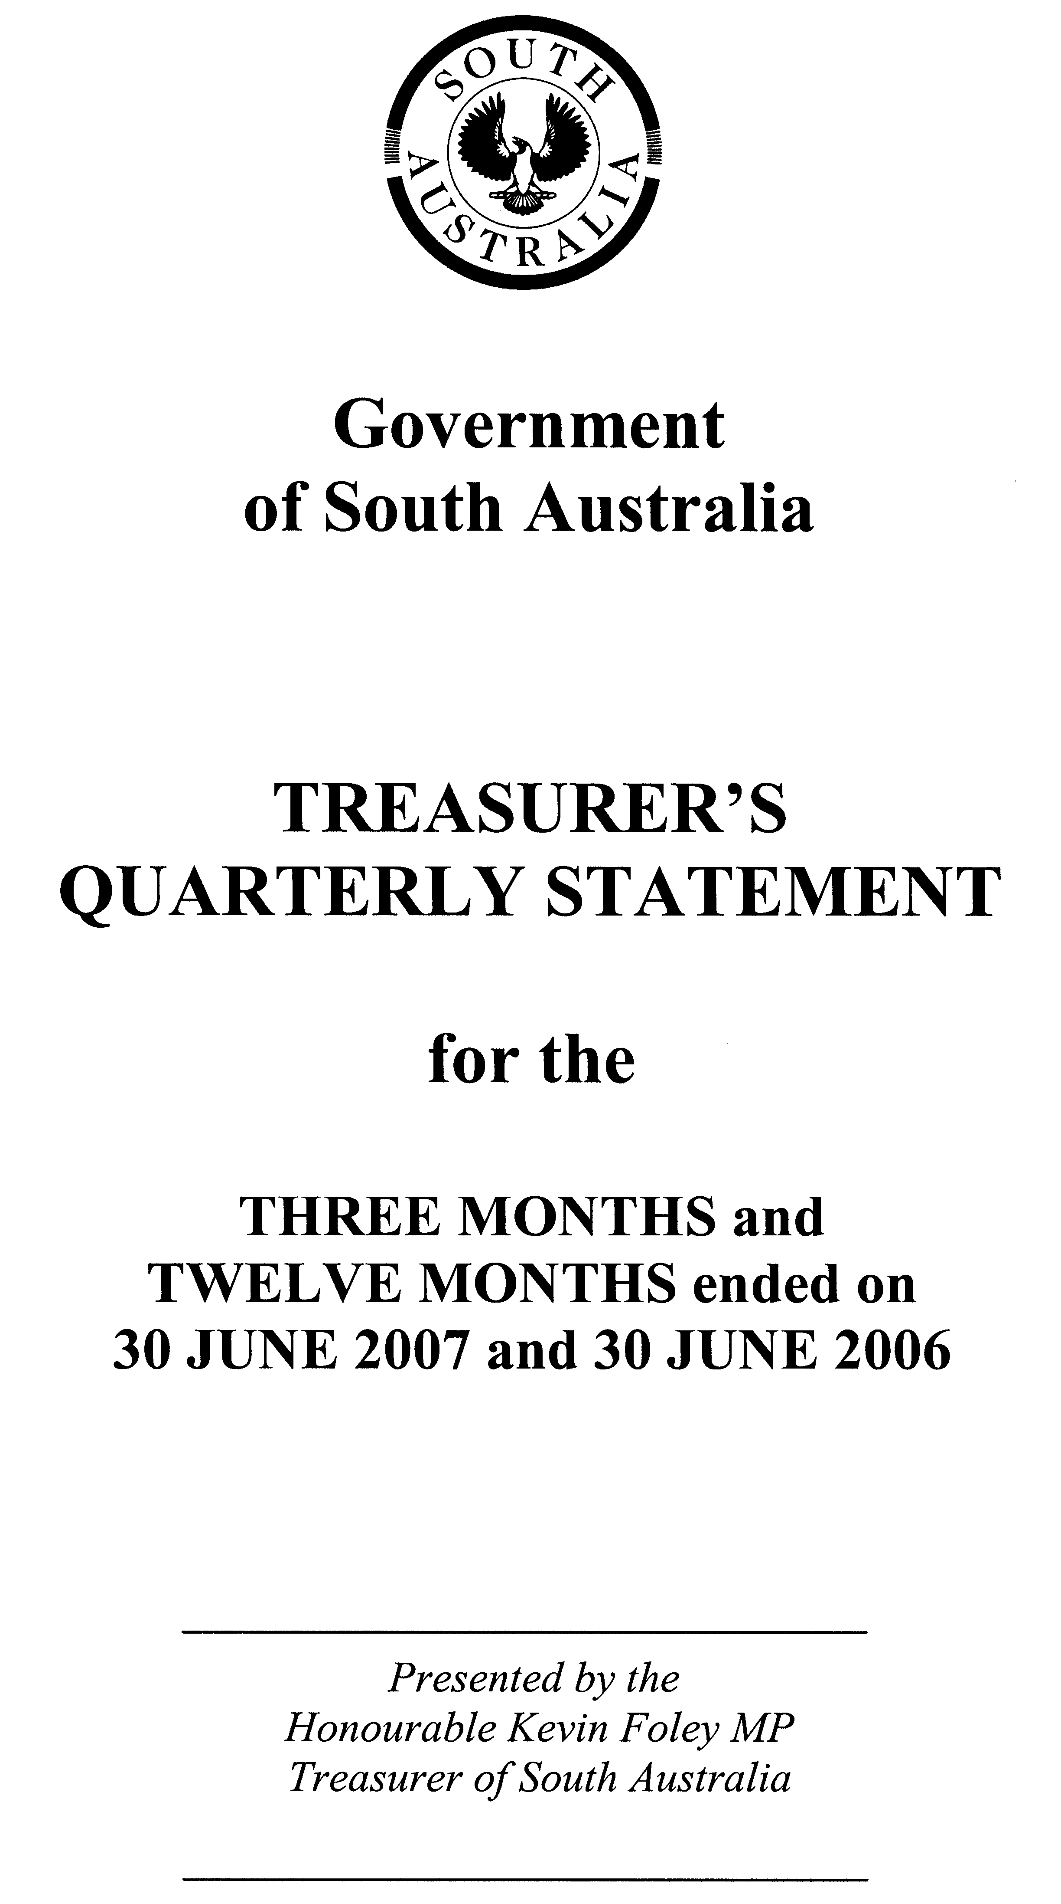
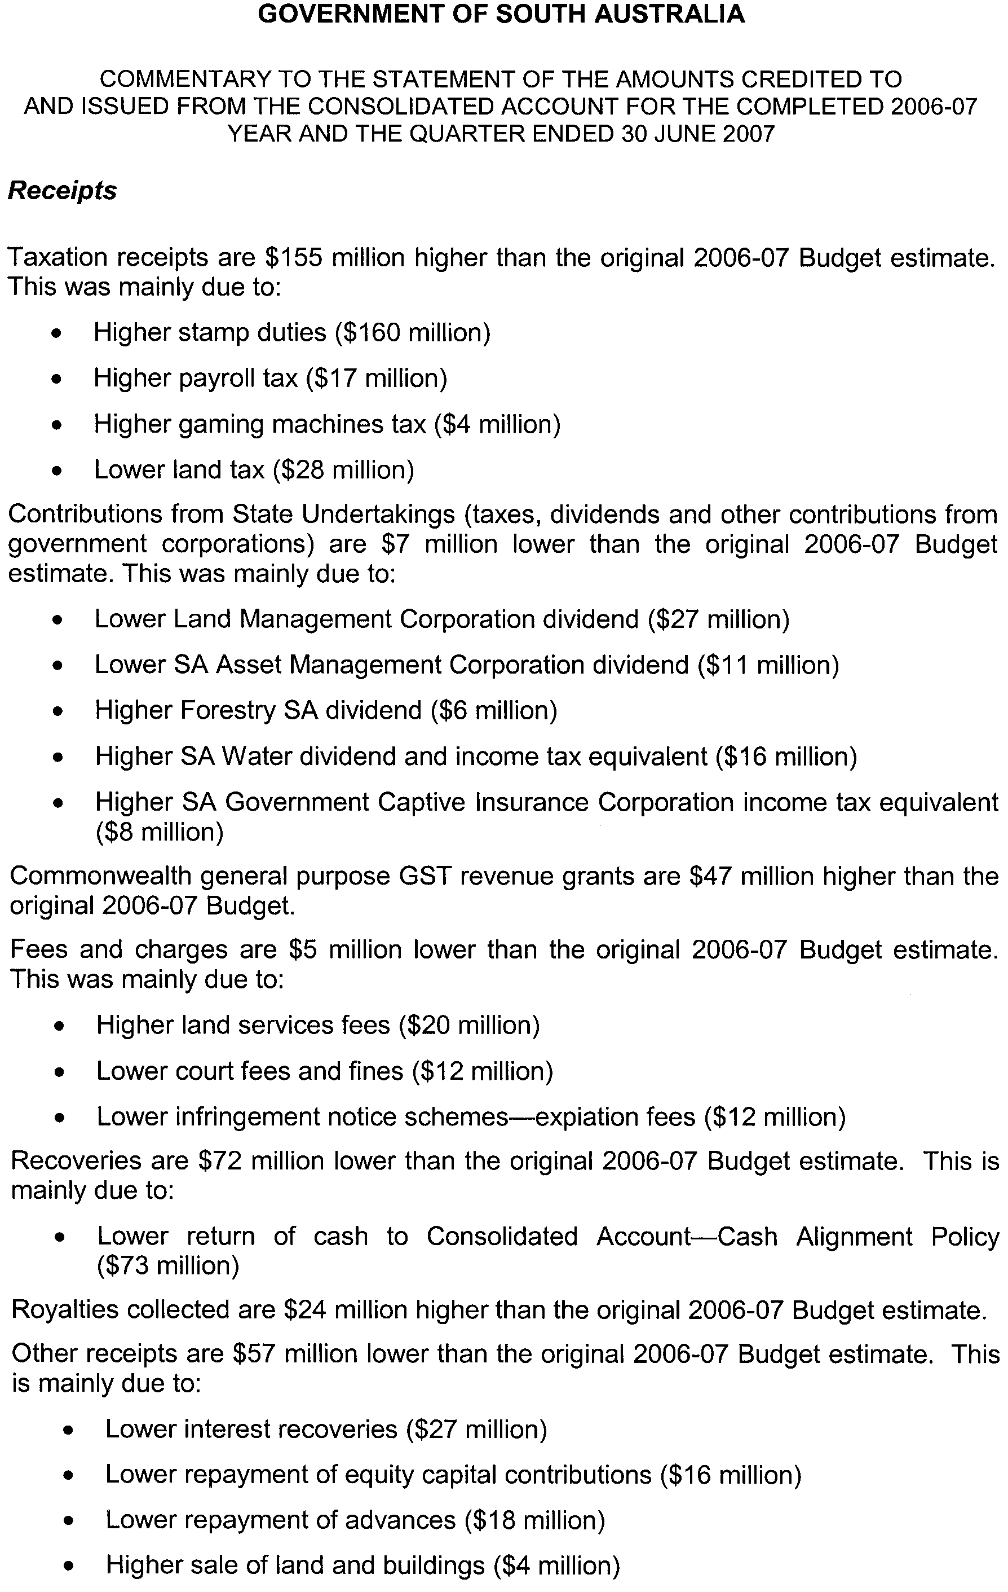
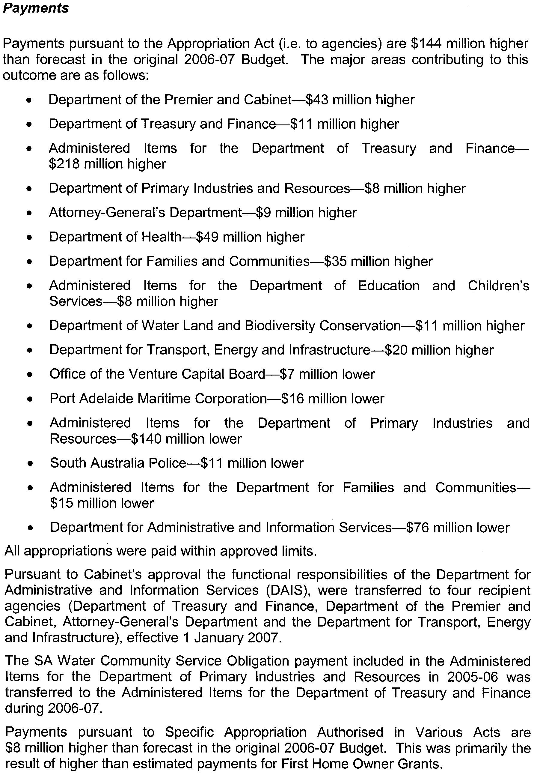
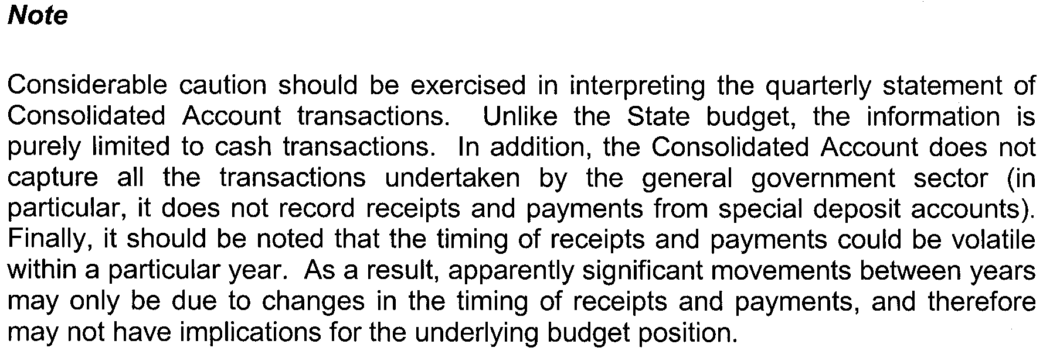
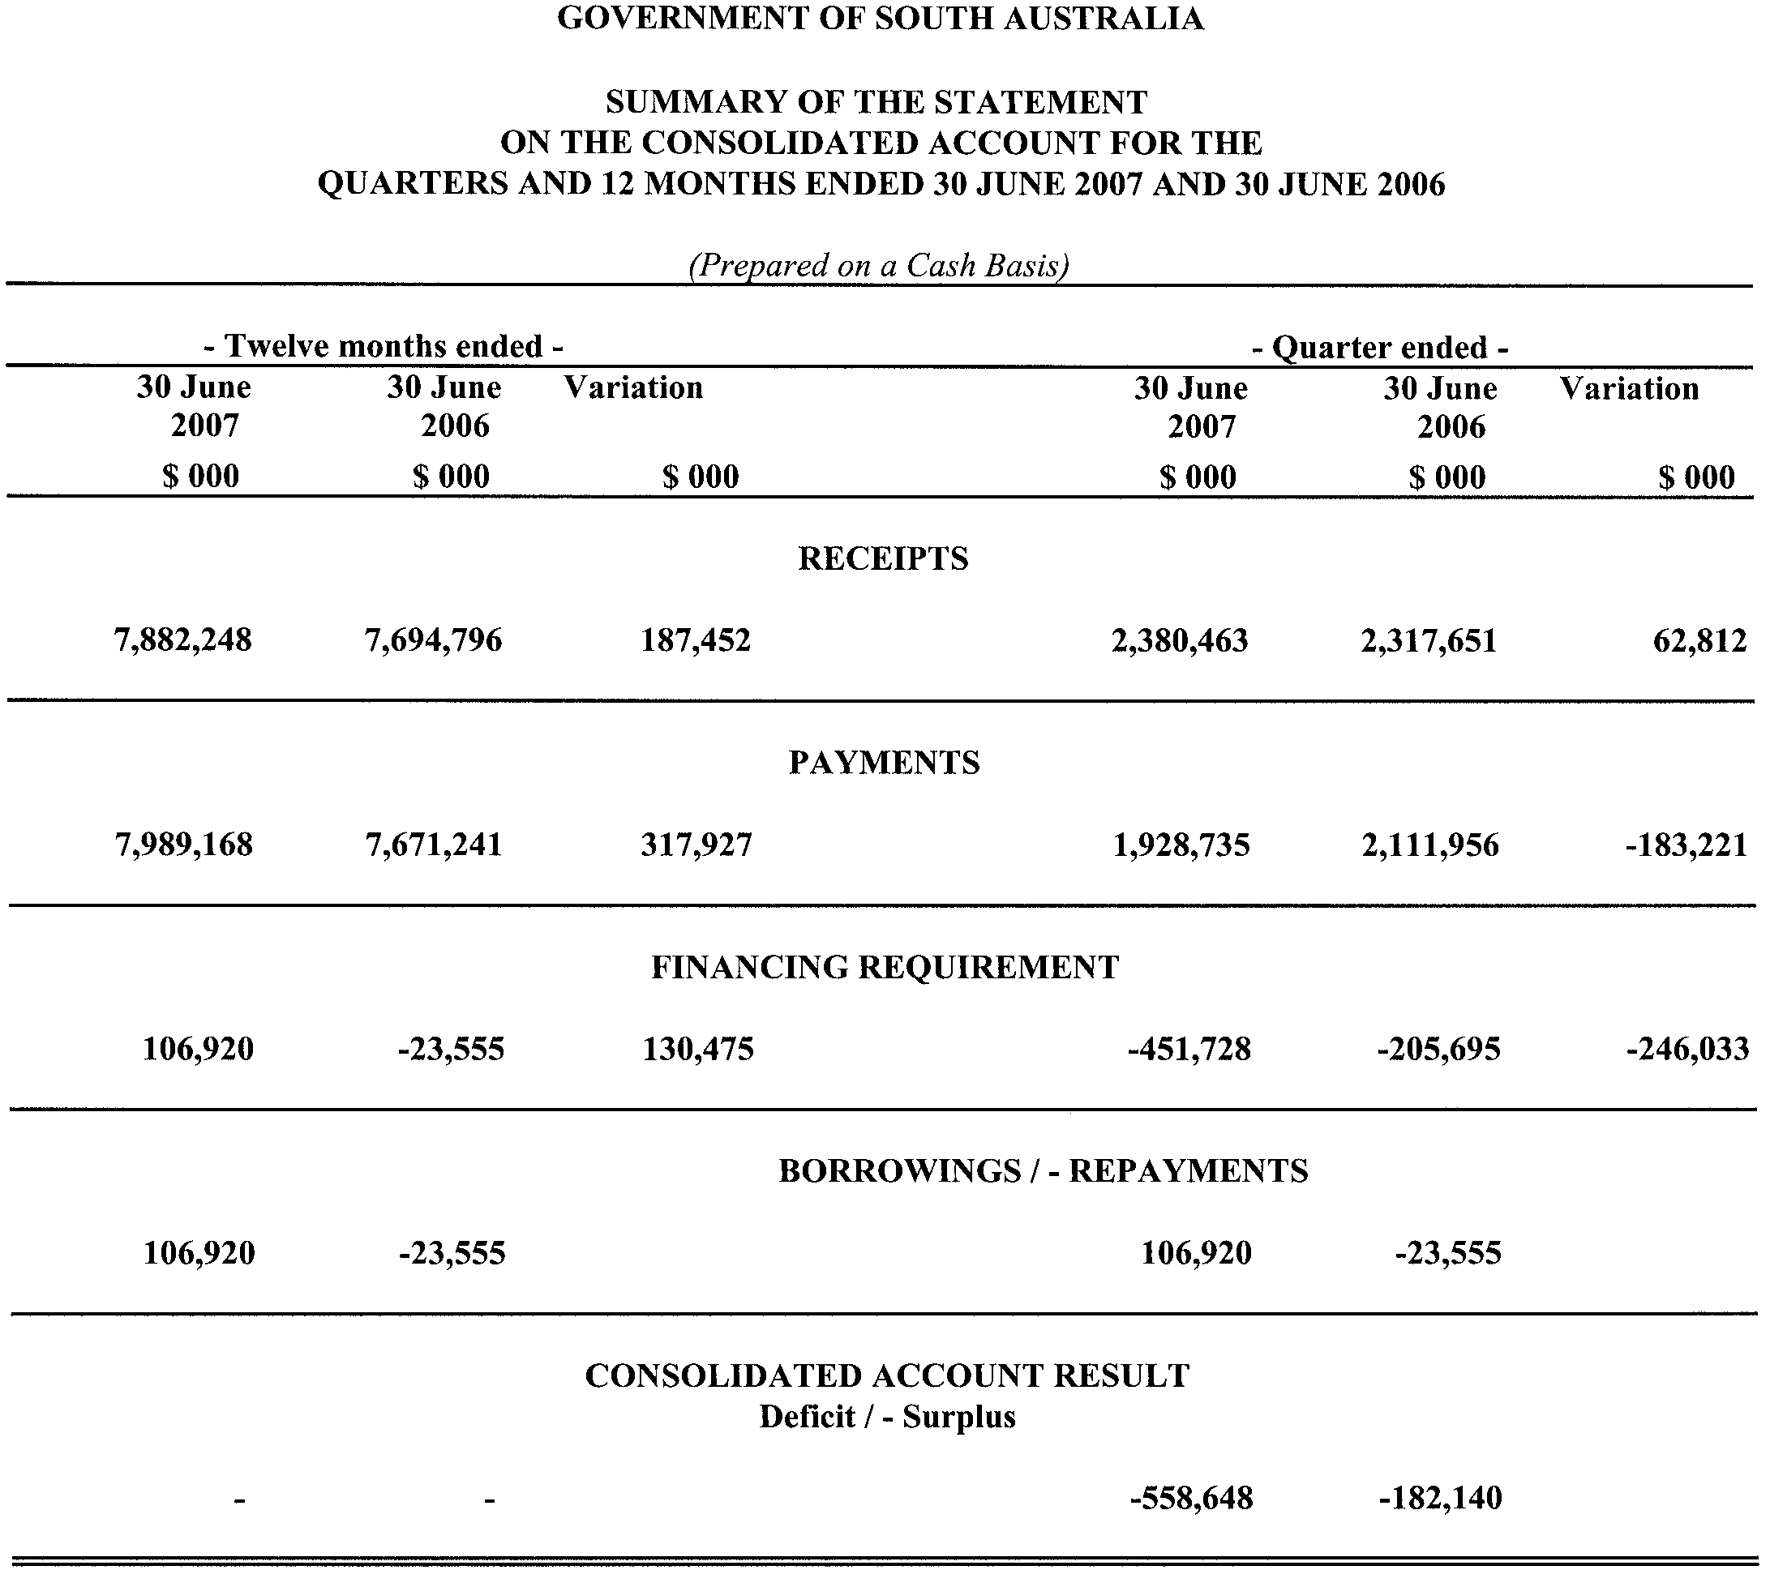
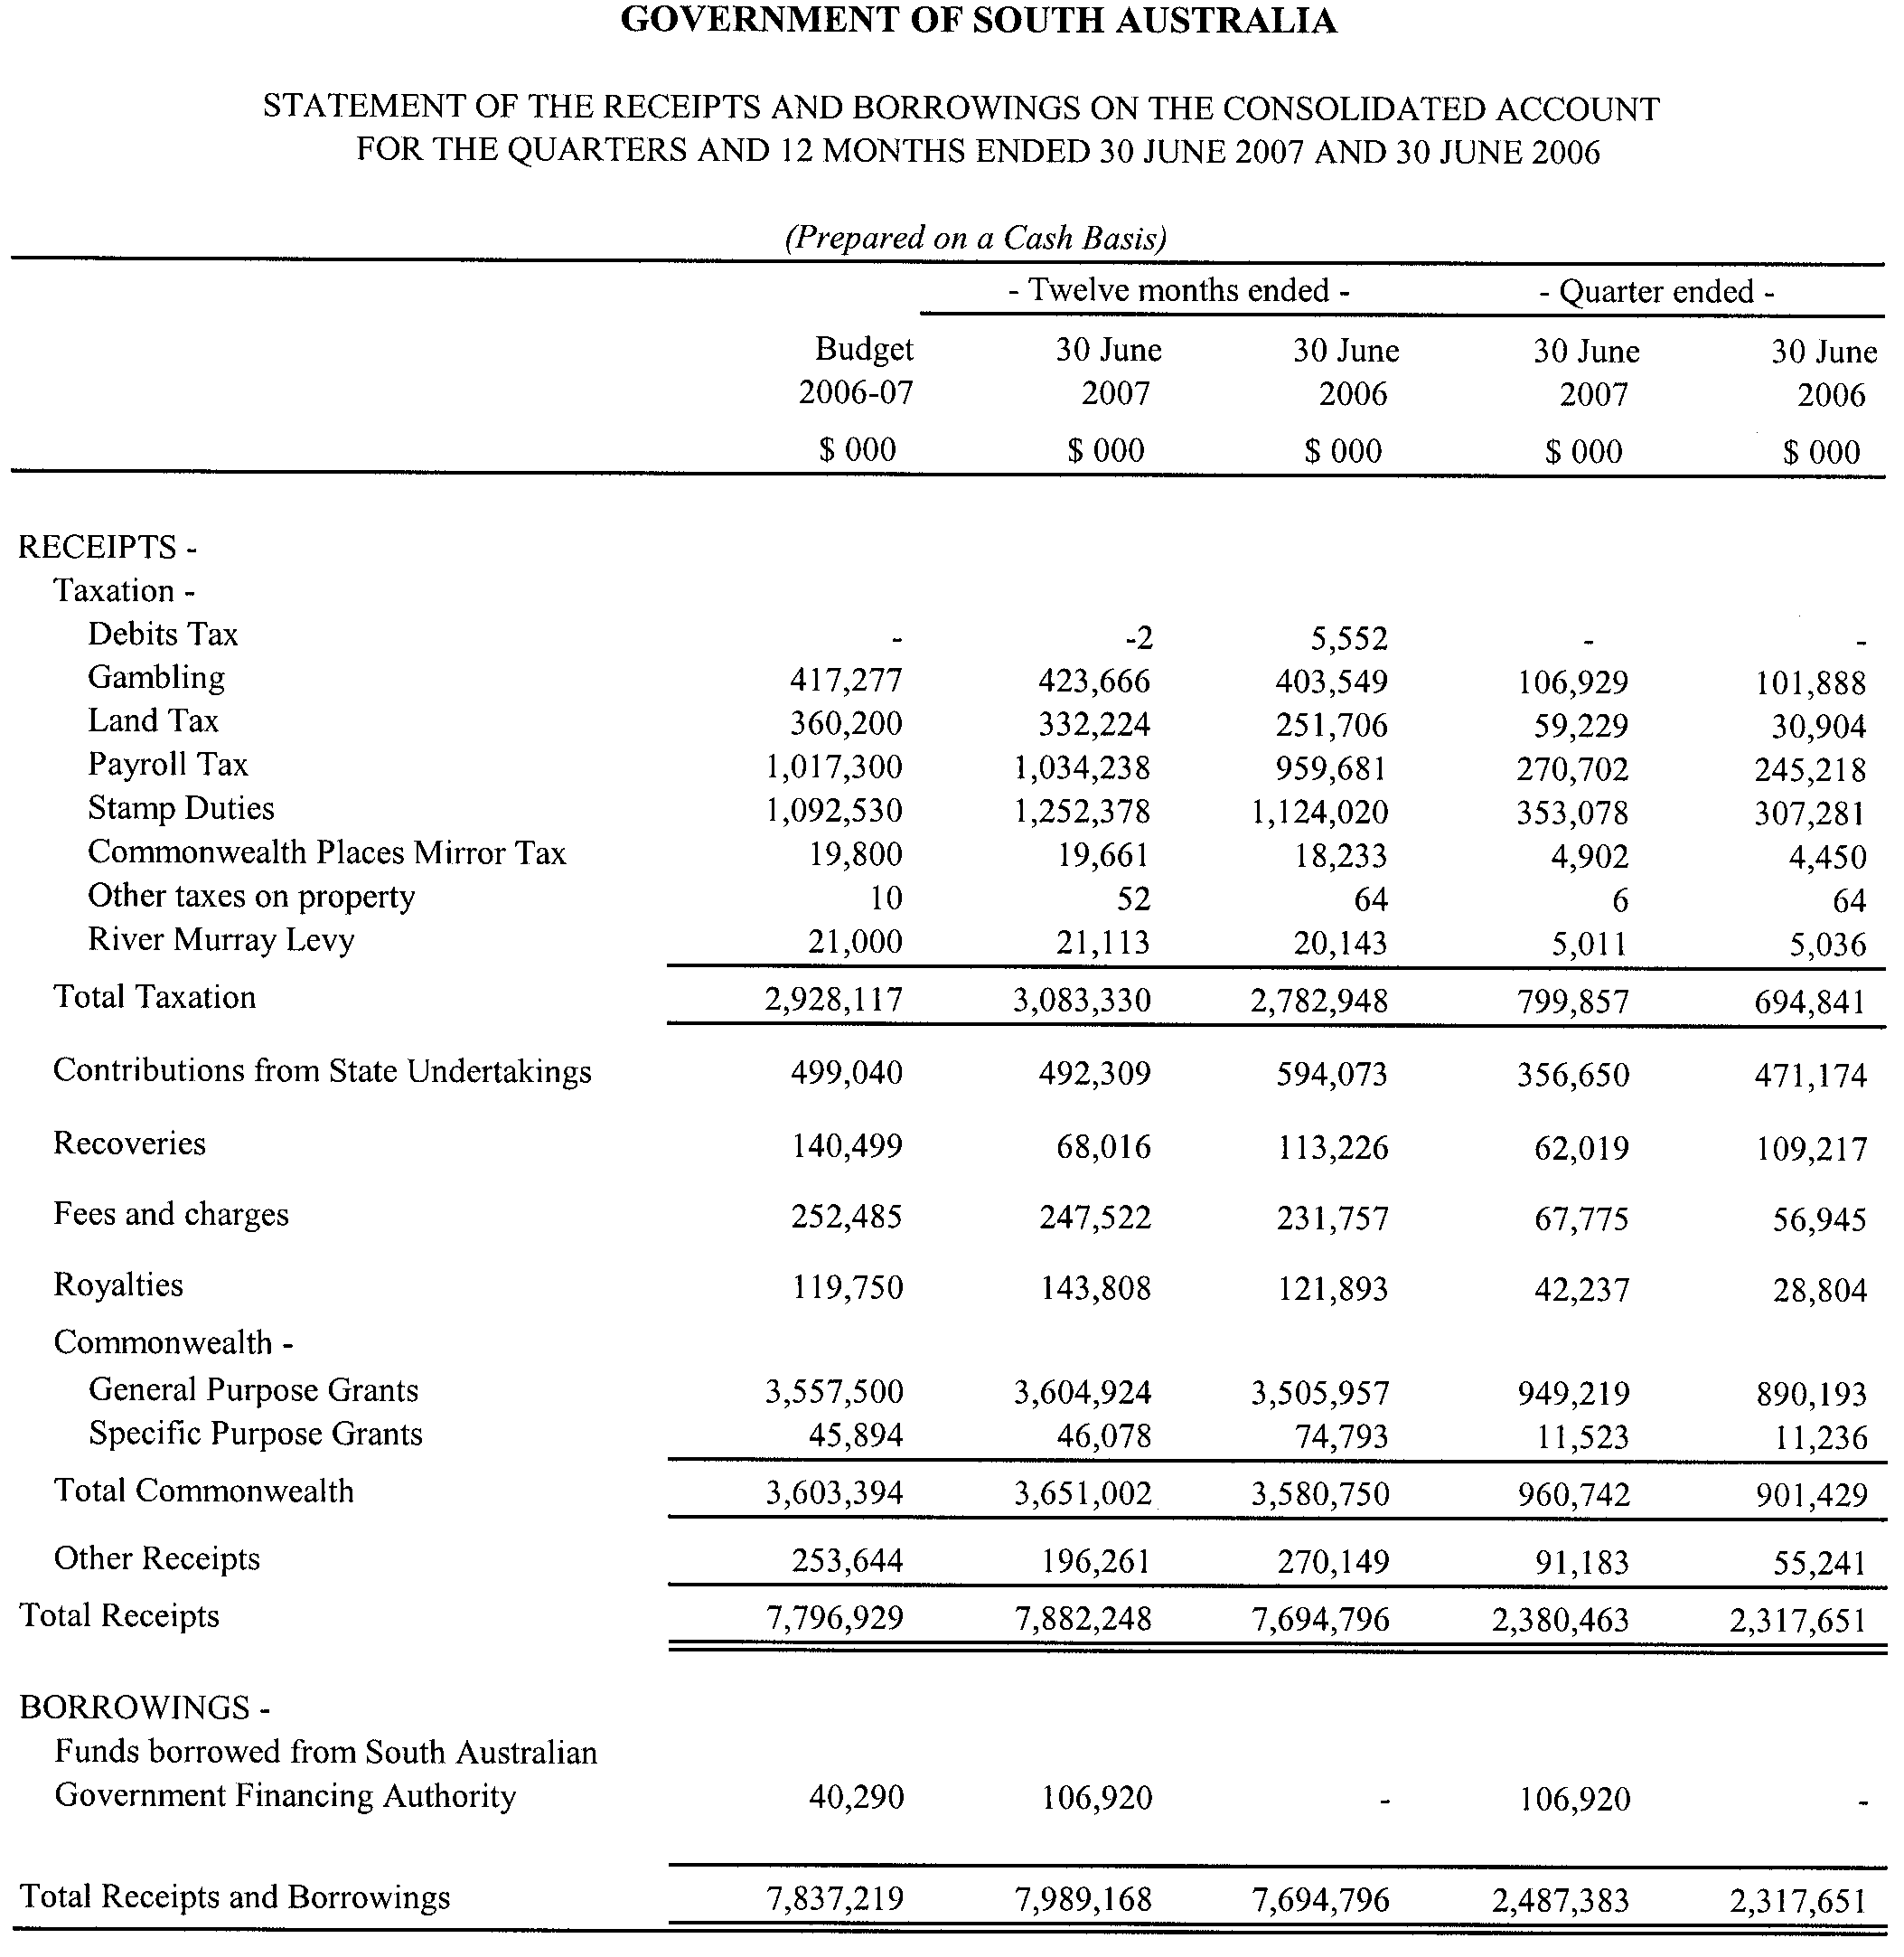
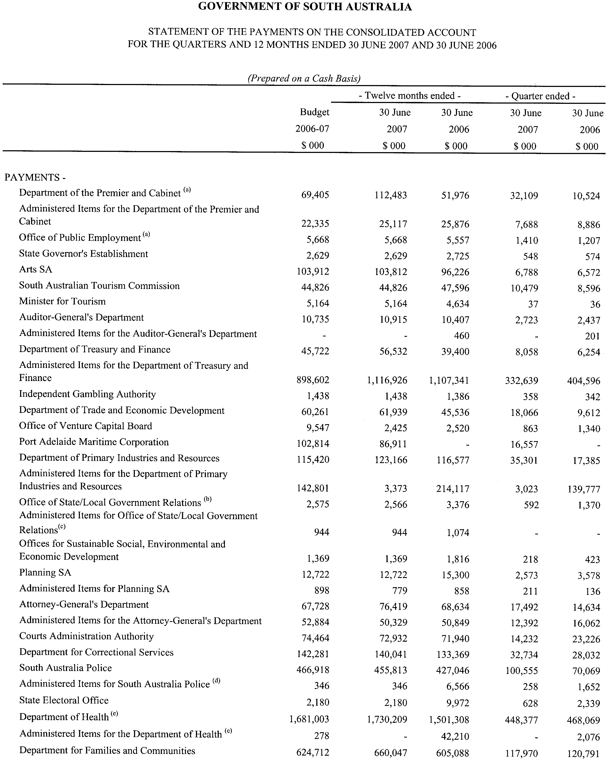
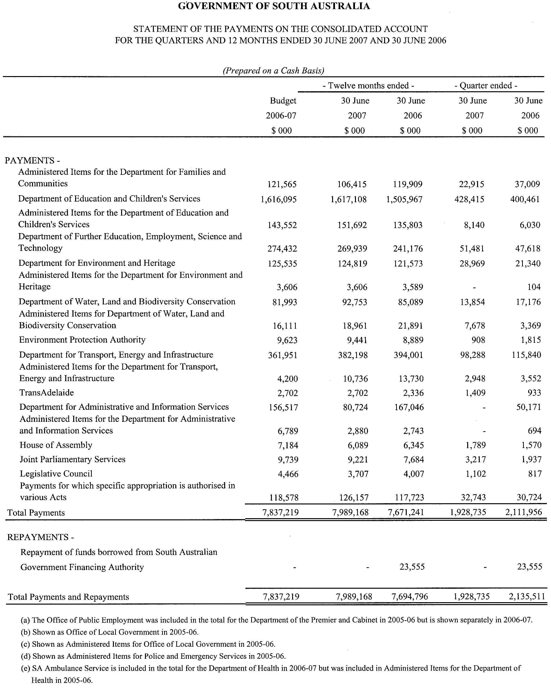

WILDERNESS PROTECTION REGULATIONS 2006
Temporary Closure of Sections of Ravine des Casoars
Wilderness Protection Area
PURSUANT to Regulation 6 (2) (c) of the Wilderness Protection Regulations 2006, I, Kym Nicolson, Acting Director of National Parks and Wildlife, close to the public, the following areas within the Ravine des Casoars Wilderness Protection Area during the belowmentioned periods:
1600 hours on 29 November 2007 to 0900 hours on 1 December 2007—West Bay Beach to Ravine des Casoars coast area closed within the following co-ordinates:
West Bay Beach to Ravine des Casoars coast—
639850N 6027250E to 641000N 6034000E following coastline at low water mark.
Ravine des Casoars coast to West Bay fire track—
641000N 6034000E to 645100N 6034000E following a line heading due east.
West Bay fire track to West Bay Road—
645100N 6034000E to 642200N 6026700E following a line south defined by West Bay fire track.
West Bay Road to West Bay Beach—
642200N 6026700E to 639850N 6027250E following a line west defined by West Bay Road.
Northings and Eastings are in Universal Transverse Mercator Projection, Zone 53, Datum: Geocentric Datum of Australia 1994.
The reason for the closure is that it is necessary for the proper management of the reserve and in the interest of public safety, during feral animal control activities.
Dated 19 November 2007.
K. Nicolson, Acting Director of National Parks and Wildlife

South Australia
Controlled Substances (Serious Drug Offences) Amendment Act (Commencement) Proclamation 2007
1—Short title
This proclamation may be cited as the Controlled Substances (Serious Drug Offences) Amendment Act (Commencement) Proclamation 2007.
2—Commencement of suspended provisions
The remaining provisions of the Controlled Substances (Serious Drug Offences) Amendment Act 2005 (No 80 of 2005) will come into operation on 3 December 2007.
Made by the Governor
with the advice and consent of the Executive Council
on 22 November 2007
AGO0235/02CS

South Australia
Correctional Services (Miscellaneous) Amendment Act (Commencement) Proclamation 2007
1—Short title
This proclamation may be cited as the Correctional Services (Miscellaneous) Amendment Act (Commencement) Proclamation 2007.
2—Commencement of Act
The Correctional Services (Miscellaneous) Amendment Act 2007 (No 26 of 2007) will come into operation on 23 November 2007.
Made by the Governor
with the advice and consent of the Executive Council
on 22 November 2007
MCS07/014CS

South Australia
Highways (Road Closure—Public Road abutting Mount Barker Road, Crafers West) Proclamation 2007
under section 27AA of the Highways Act 1926
1—Short title
This proclamation may be cited as the Highways (Road Closure—Public Road abutting Mount Barker Road, Crafers West) Proclamation 2007.
2—Commencement
This proclamation comes into operation on the day on which it is made.
3—Road closure
The portion of public road delineated as allotment 21 in approved Plan No FP 48312 lodged in the Lands Titles Registration Office is closed subject to an easement (T 2885485) to—
(a) Transmission Lessor Corporation of 1 undivided 2nd part, subject to lease 9061500; and
(b) ElectraNet Pty Ltd of 1 undivided 2nd part,
over that part of allotment 21 marked A on the plan.
Made by the Governor
on the recommendation of the Commissioner of Highways and with the advice and consent of the Executive Council
on 22 November 2007
MTR07/041CS

South Australia
Correctional Services Variation Regulations 2007
under the Correctional Services Act 1982

Contents
Part 1—Preliminary
1 Short title
2 Commencement
3 Variation provisions
Part 2—Variation of Correctional Services Regulations 2001
4 Insertion of regulations 39 and 40
39 Prohibition on supply and administration of certain drugs
40 Persons prohibited from entering into unauthorised contracts with prisoners (section 82)

Part 1—Preliminary
1—Short title
These regulations may be cited as the Correctional Services Variation Regulations 2007.
2—Commencement
These regulations will come into operation on the day on which the Correctional Services (Miscellaneous) Amendment Act 2007 comes into operation.
3—Variation provisions
In these regulations, a provision under a heading referring to the variation of specified regulations varies the regulations so specified.
Part 2—Variation of Correctional Services Regulations 2001
4—Insertion of regulations 39 and 40
After regulation 38 insert:
39—Prohibition on supply and administration of certain drugs
The following must not be supplied or administered to a prisoner without the approval of the Chief Executive Officer:
(a) a drug for the treatment of erectile dysfunction;
(b) a drug that is an anorectic and weight reducing agent;
(c) a substance containing Pseudoephedrine;
(d) drugs containing—
(i) Methylphenidate Hydrochloride; or
(ii) Dexamphetamine Sulphate.
Maximum penalty: $2 500.
40—Persons prohibited from entering into unauthorised contracts with prisoners (section 82)
Section 82 of the Act applies to a person of any of the following classes:
(a) a Visiting Tribunal;
(b) an inspector appointed under section 20 of the Act;
(c) a member of a committee established under section 23 of the Act to carry out assessments of prisoners;
(d) a member of the Correctional Services Advisory Council;
(e) a person used as a volunteer in the administration of the Act;
Examples—
A prison chaplain, an education provider, a counsellor, a member of a prisoner support group, etc.
(f) a contractor engaged to undertake work in a correctional institution;
(g) a person employed or engaged to provide medical services in a correctional institution;
(h) a person who provides medical or other services to a prisoner in a hospital or other health service.
Note—
As required by section 10AA(2) of the Subordinate Legislation Act 1978, the Minister has certified that, in the Minister's opinion, it is necessary or appropriate that these regulations come into operation as set out in these regulations.
Made by the Governor
with the advice and consent of the Executive Council
on 22 November 2007
No 259 of 2007
MCS07/014CS

South Australia
Liquor Licensing (Dry Areas—Long Term) Variation Regulations 2007
under the Liquor Licensing Act 1997

Contents
Part 1—Preliminary
1 Short title
2 Commencement
3 Variation provisions
Part 2—Variation of Liquor Licensing (Dry Areas—Long Term) Regulations 1997
4 Variation of Schedule 1—Long term dry areas

Part 1—Preliminary
1—Short title
These regulations may be cited as the Liquor Licensing (Dry Areas—Long Term) Variation Regulations 2007.
2—Commencement
These regulations come into operation on the day on which they are made.
3—Variation provisions
In these regulations, a provision under a heading referring to the variation of specified regulations varies the regulations so specified.
Part 2—Variation of Liquor Licensing (Dry Areas—Long Term) Regulations 1997
4—Variation of Schedule 1—Long term dry areas
(1) Schedule 1, item headed "Port Augusta—Area 1", column headed "Period"—delete "2007" and substitute:
2010
(2) Schedule 1, item headed "Port Augusta—Area 2", column headed "Period"—delete "2007" and substitute:
2010
(3) Schedule 1, item headed "Port Augusta—Area 3", column headed "Period"—delete "2007" and substitute:
2010
(4) Schedule 1, item headed "Stirling North—Area 1", column headed "Period"—delete "2007" and substitute:
2010
Note—
As required by section 10AA(2) of the Subordinate Legislation Act 1978, the Minister has certified that, in the Minister's opinion, it is necessary or appropriate that these regulations come into operation as set out in these regulations.
Made by the Governor
with the advice and consent of the Executive Council
on 22 November 2007
No 260 of 2007
MCA07/045CS

South Australia
Liquor Licensing (Dry Areas—Long Term) Variation Regulations 2007
under the Liquor Licensing Act 1997

Contents
Part 1—Preliminary
1 Short title
2 Commencement
3 Variation provisions
Part 2—Variation of Liquor Licensing (Dry Areas—Long Term) Regulations 1997
4 Variation of Schedule 1—Long term dry areas

Part 1—Preliminary
1—Short title
These regulations may be cited as the Liquor Licensing (Dry Areas—Long Term) Variation Regulations 2007.
2—Commencement
These regulations come into operation on the day on which they are made.
3—Variation provisions
In these regulations, a provision under a heading referring to the variation of specified regulations varies the regulations so specified.
Part 2—Variation of Liquor Licensing (Dry Areas—Long Term) Regulations 1997
4—Variation of Schedule 1—Long term dry areas
Schedule 1, item headed "Peterborough—Area 1", column headed "Period"—delete "2007" and substitute:
2008
Note—
As required by section 10AA(2) of the Subordinate Legislation Act 1978, the Minister has certified that, in the Minister's opinion, it is necessary or appropriate that these regulations come into operation as set out in these regulations.
Made by the Governor
with the advice and consent of the Executive Council
on 22 November 2007
No 261 of 2007
MCA07/041CS

South Australia
Prevention of Cruelty to Animals Variation Regulations 2007
under the Prevention of Cruelty to Animals Act 1985

Contents
Part 1—Preliminary
1 Short title
2 Commencement
3 Variation provisions
Part 2—Variation of Prevention of Cruelty to Animals Regulations 2000
4 Revocation of regulation 13
5 Insertion of Part 3B
Part 3B—Regulation of keeping of domestic fowls
13L Interpretation
13M General requirements
13N Requirements relating to confining domestic fowls in cages
13O Requirements relating to keeping domestic fowls in housing other than cages

Part 1—Preliminary
1—Short title
These regulations may be cited as the Prevention of Cruelty to Animals Variation Regulations 2007.
2—Commencement
These regulations will come into operation on 1 January 2008.
3—Variation provisions
In these regulations, a provision under a heading referring to the variation of specified regulations varies the regulations so specified.
Part 2—Variation of Prevention of Cruelty to Animals Regulations 2000
4—Revocation of regulation 13
Regulation 13—delete the regulation
5—Insertion of Part 3B
After regulation 13K insert:
Part 3B—Regulation of keeping of domestic fowls
13L—Interpretation
In this Part—
domestic fowl means a bird of the species Gallus domesticus.
13M—General requirements
(1) A person who keeps a domestic fowl must ensure that, within 60 hours after hatching and at least once a day thereafter, the fowl is provided with—
(a) adequate food containing sufficient nutrients to ensure the fowl's good health and vitality; and
(b) adequate water to meet the fowl's physiological needs.
Maximum penalty: $1 250.
(2) A person who keeps a domestic fowl must ensure that the fowl is inspected at least once a day to assess the fowl's health and well-being.
Maximum penalty: $1 250.
13N—Requirements relating to confining domestic fowls in cages
(1) A person who keeps domestic fowls confined in a cage must comply with the following requirements:
(a) if the person positions the cage so that it is below the level of another cage—
(i) each fowl confined in the cage must, as far as practicable, be protected from the excreta of fowls confined in a cage on a higher level; and
(ii) each fowl confined in the cage must be capable of being seen on inspection;
(b) the floor of the cage must be constructed so as to support the forward pointing toes of each fowl confined in the cage;
(c) the height of the cage must be higher than the maximum height of a fowl confined in the cage while the fowl is standing normally;
(d) the cage must be constructed with a door as follows:
(i) the height of the door must be the full height (not including the feed trough) of the cage; and
(ii) the width of the door must be—
(A) if the cage is less than 0.5 metres wide—the full width of the cage;
(B) in any other case—at least 0.5 metres wide.
Maximum penalty: $1 250.
(2) Subject to this regulation, a person who keeps domestic fowls must not confine the fowls in a cage unless—
(a) in the case of fowls primarily kept for breeding purposes—the total weight of the fowls confined in the cage does not exceed 40 kilograms per square metre of cage floor area;
(b) in any other case—
(i) for fowls weighing less than 4.5 kilograms—
(A) if only 1 fowl is confined in the cage—the floor area of the cage is at least 0.1 square metres;
(B) if 2 fowls are confined in the cage—the floor area of the cage is at least 0.135 square metres;
(C) if more than 2 fowls are confined in the cage—
• if, on average, the weight of a fowl confined in the cage is less than 2.4 kilograms—the floor area of the cage is at least 0.055 square metres per fowl;
• if, on average, the weight of a fowl confined in the cage is 2.4 kilograms or more but less than 4.5 kilograms—the floor area of the cage is at least 0.06 square metres per fowl;
(ii) for fowls weighing 4.5 kilograms or more—
(A) if only 1 fowl is confined in the cage—the total weight of the fowl does not exceed 26 kilograms per square metre of cage floor area;
(B) if 2 fowls are confined in the cage—the total weight of the fowls does not exceed 40 kilograms per square metre of cage floor area;
(C) if more than 2 fowls are confined in the cage—the total weight of the fowls does not exceed 46 kilograms per square metre of cage floor area.
Maximum penalty: $1 250.
(3) For the purposes of subregulation (2), the floor area occupied by a V-trough or egg baffle may be counted as part of the floor area of a cage.
(4) A person does not have to comply with subregulation (2)(b)(i)(C), if—
(a) before the commencement of this regulation—the person has installed a cage that complies with subregulation (1); and
(b) on average, the weight of a fowl confined in the cage is less than 2.4 kilograms; and
(c) the floor area of the cage is at least 0.045 square metres per fowl.
(5) Subregulation (4) will expire on 31 December 2014.
13O—Requirements relating to keeping domestic fowls in housing other than cages
A person who keeps domestic fowls in a housing system other than a cage must ensure that the housing system in which the fowls are confined complies with the following requirements:
(a) for fowls kept for egg production—
(i) if the housing system contains more than 1 level or multi-level perches—
(A) each fowl must, as far as practicable, be protected from the excreta of other fowls kept on a higher level; and
(B) each fowl must be capable of being seen on inspection; and
(ii) the total weight of the fowls confined in the housing system must not exceed 30 kilograms per square metre of the useable floor area;
(b) for fowls reared for meat production—
(i) if the housing system contains more than 1 level or multi-level perches—
(A) each fowl must, as far as practicable, be protected from the excreta of other fowls kept on a higher level; and
(B) each fowl must be capable of being seen on inspection; and
(ii) the total weight of the fowls confined in the housing system must not exceed—
(A) if the housing system is cooled by means of a mechanical cooling device—40 kilograms per square metre of useable floor area;
(B) in any other case—28 kilograms per square metre of useable floor area.
Note—
As required by section 10AA(2) of the Subordinate Legislation Act 1978, the Minister has certified that, in the Minister's opinion, it is necessary or appropriate that these regulations come into operation as set out in these regulations.
Made by the Governor
with the advice and consent of the Executive Council
on 22 November 2007
No 262 of 2007
EHCS07/0023

South Australia
Trade Measurement (Pre-Packed Articles) Variation Regulations 2007
under the Trade Measurement Act 1993

Contents
Part 1—Preliminary
1 Short title
2 Commencement
3 Variation provisions
Part 2—Variation of Trade Measurement (Pre-Packed Articles) Regulations 1993
4 Variation of regulation 4—Exemptions from marking requirements (name, address, measurement)
5 Variation of regulation 11—General position of measurement marking
6 Insertion of regulation 11A
11A Position of measurement marking on wine package

Part 1—Preliminary
1—Short title
These regulations may be cited as the Trade Measurement (Pre-Packed Articles) Variation Regulations 2007.
2—Commencement
These regulations come into operation on the day on which they are made.
3—Variation provisions
In these regulations, a provision under a heading referring to the variation of specified regulations varies the regulations so specified.
Part 2—Variation of Trade Measurement (Pre-Packed Articles) Regulations 1993
4—Variation of regulation 4—Exemptions from marking requirements (name, address, measurement)
Regulation 4(3)—delete "in item 1"
5—Variation of regulation 11—General position of measurement marking
(1) Regulation 11(2)—After paragraph (a) insert:
(ab) a package containing wine if—
(i) the measurement marking on the package is made in accordance with regulation 11A; and
(ii) the package is of a standard size; or
(2) Regulation 11—After subregulation (2) insert:
(3) For the purposes of subregulation (2), a package containing wine is of a standard size if the package contains—
(a) 50ml, 100ml, 187ml, 200ml, 250ml, 375ml, 500ml, 750ml, 1 litre or 1.5 litres of wine; or
(b) 2 or more whole litres of wine.
6—Insertion of regulation 11A
After regulation 11 insert:
11A—Position of measurement marking on wine package
(1) The measurement marking on a package containing wine must, unless made in accordance with regulation 11(1), be made on the surface of the package (other than the base or top) so that the statement of the measurement of the wine and the information required under the Wine Labelling Agreement to be marked on the package can be viewed together.
(2) In this regulation—
information required under the Wine Labelling Agreement means—
(a) country of origin; and
(b) product name or product description; and
(c) actual alcohol content by volume in percentage terms;
Wine Labelling Agreement means the Agreement on Requirements for Wine Labelling, World Wine Trade Group (August 2006), signed on 23 January 2007, by the Minister for Trade for the Commonwealth.
Note—
As required by section 10AA(2) of the Subordinate Legislation Act 1978, the Minister has certified that, in the Minister's opinion, it is necessary or appropriate that these regulations come into operation as set out in these regulations.
Made by the Governor
with the advice and consent of the Executive Council
on 22 November 2007
No 263 of 2007
OCBA002/07

South Australia
Controlled Substances (Prohibited Substances) Variation Regulations 2007
under the Controlled Substances Act 1984

Contents
Part 1—Preliminary
1 Short title
2 Commencement
3 Variation provisions
Part 2—Variation of Controlled Substances (Prohibited Substances) Regulations 2000
4 Variation of regulation 1—Short title
5 Revocation of regulations 2 and 3
6 Variation of regulation 4—Interpretation
7 Substitution of regulations 5 to 8
5 Declaration of controlled drugs, controlled precursors and controlled plants
6 Prescribed quantities of controlled drugs, controlled precursors and controlled plants
7 Prescribed number of cannabis plants (section 33K)
8 Exemption from prohibition of possession of injecting equipment
8A No accessorial liability in prescribed circumstances
8 Variation of regulation 9—Prescribed place
9 Insertion of regulations 9A and 9B
9A Expiation fees for simple cannabis offences
9B Simple cannabis offences
10 Variation of regulation 11—Prescribed manner of initiation of analysis and prescribed fee
11 Insertion of regulations 14, 15 and 16
14 Prescribed professional associations
15 Corresponding laws
16 Copies of codes etc to be kept available for public inspection
12 Substitution of Schedules 1, 2 and 3
Schedule 1—Controlled Drugs
Part 1—Controlled Drugs other than drugs of dependence
Part 2—Drugs of dependence
Schedule 2—Controlled Precursors
Schedule 3—Controlled Plants
Part 1—Controlled plants other than cannabis plants
Part 2—Cannabis plants
13 Insertion of Schedule 5
Schedule 5—Expiation Fees
Schedule 1—Revocation
1 Revocation of Controlled Substances (Expiation of Simple Cannabis Offences) Regulations 2002
2 Revocation of Controlled Substances (Exemptions) Regulations 2004

Part 1—Preliminary
1—Short title
These regulations may be cited as the Controlled Substances (Prohibited Substances) Variation Regulations 2007.
2—Commencement
These regulations will come into operation on the day on which section 14 of the Controlled Substances (Serious Drug Offences) Amendment Act 2005 comes into operation.
3—Variation provisions
In these regulations, a provision under a heading referring to the variation of specified regulations varies the regulations so specified.
Part 2—Variation of Controlled Substances (Prohibited Substances) Regulations 2000
4—Variation of regulation 1—Short title
Regulation 1—delete "Prohibited Substances" and substitute:
General
5—Revocation of regulations 2 and 3
Regulations 2 and 3—delete the regulations
6—Variation of regulation 4—Interpretation
Regulation 4, definition of schedule 8—delete the definition
7—Substitution of regulations 5 to 8
Regulations 5 to 8—delete regulations 5 to 8 (inclusive) and substitute:
5—Declaration of controlled drugs, controlled precursors and controlled plants
(1) In accordance with section 12(4) of the Act, the following substances are declared to be controlled drugs:
(a) the natural or synthetic form of a substance listed in Schedule 1;
(b) any salt, derivative or isomer of the natural or synthetic form of a substance listed in Schedule 1 and any salt of such derivative or isomer;
(c) any analogue of the natural or synthetic form of a substance listed in Schedule 1 (being an analogue having a substantially similar chemical structure to the substance, but differing in elemental composition due to the addition, deletion or replacement of any substituent element or group);
(d) any homologue of the natural or synthetic form of a substance listed in Schedule 1 (being a homologue differing from the substance by 1 or more carbon containing groups (including methylene groups) in the chemical structure);
(e) any of the substances referred to in a preceding paragraph whether existing alone or in a preparation, admixture, solution or natural substance.
(2) In accordance with section 12(4a) of the Act, the following substances are declared to be controlled precursors:
(a) the natural or synthetic form of a substance listed in Schedule 2;
(b) any salt, isomer, ester, ether, ketal, acetal, acetate, hydroxide, oxime, amide, imine, acid chloride, nitrile, anhydride, halogen substituent, epoxide, diol or any analogue or derivative of the natural or synthetic form of a substance listed in Schedule 2;
(c) any of the substances referred to in a preceding paragraph whether existing alone or in a preparation, admixture, solution or natural substance.
(3) In accordance with section 12(4b) of the Act, the following plants are declared to be controlled plants:
(a) a growing plant listed in Schedule 3 Part 1;
(b) a cutting taken from a plant listed in Schedule 3 Part 1 (provided that the cutting has been planted or otherwise placed in a growing medium).
6—Prescribed quantities of controlled drugs, controlled precursors and controlled plants
(1) For the purposes of the definition of large commercial quantity in section 4(1) of the Act, the quantity of a particular controlled drug, controlled precursor or controlled plant prescribed as a large commercial quantity of the drug, precursor or plant in its pure form is—
(a) in the case of a controlled drug—the amount (if any) listed in the column headed "Large commercial (pure)" of the tables in Part 1 or 2 of Schedule 1 opposite the entry listing the controlled drug; or
(b) in the case of a controlled precursor—the amount (if any) listed in the column headed "Large commercial (pure)" of the table in Schedule 2 opposite the entry listing the controlled precursor; or
(c) in the case of a controlled plant—the amount (if any) listed in the column headed "Large commercial" of the tables in Part 1 or 2 of Schedule 3 opposite the entry listing the controlled plant.
(2) For the purposes of the definition of large commercial quantity in section 4(1) of the Act, the quantity of a mixture containing a particular controlled drug prescribed as a large commercial quantity for any mixture containing the controlled drug is the amount (if any) listed in the column headed "Large commercial (mixed)" of the tables in Part 1 or 2 of Schedule 1 opposite the entry listing the controlled drug.
(3) For the purposes of the definition of commercial quantity in section 4(1) of the Act, the quantity of a particular controlled drug, controlled precursor or controlled plant prescribed as a commercial quantity of the drug, precursor or plant in its pure form is—
(a) in the case of a controlled drug—the amount (if any) listed in the column headed "Commercial (pure)" of the tables in Part 1 or 2 of Schedule 1 opposite the entry listing the controlled drug; or
(b) in the case of a controlled precursor—the amount (if any) listed in the column headed "Commercial (pure)" of the table in Schedule 2 opposite the entry listing the controlled precursor; or
(c) in the case of a controlled plant—the amount (if any) listed in the column headed "Commercial" of the tables in Part 1 or 2 of Schedule 3 opposite the entry listing the controlled plant.
(4) For the purposes of the definition of commercial quantity in section 4(1) of the Act, the quantity of a mixture containing a particular controlled drug prescribed as a commercial quantity for any mixture containing the controlled drug is the amount (if any) listed in the column headed "Commercial (mixed)" of the tables in Part 1 or 2 of Schedule 1 opposite the entry listing the controlled drug.
(5) For the purposes of the definition of trafficable quantity in section 4(1) of the Act, the quantity of a particular controlled plant prescribed as a trafficable quantity of the controlled plant in its pure form is the amount (if any) listed in the column headed "Trafficable" of the tables in Part 1 or 2 of Schedule 3 opposite the entry listing the controlled plant.
(6) For the purposes of the definition of trafficable quantity in section 4(1) of the Act, the quantity of a mixture containing a particular controlled drug prescribed as a trafficable quantity for any mixture containing the controlled drug is the amount (if any) listed in the column headed "Trafficable (mixed)" of the tables in Part 1 or 2 of Schedule 1 opposite the entry listing the controlled drug.
7—Prescribed number of cannabis plants (section 33K)
For the purposes of section 33K of the Act, the prescribed number of cannabis plants is 5.
8—Exemption from prohibition of possession of injecting equipment
Section 33L(1)(c) of the Act does not apply to a person having in his or her possession a syringe or needle for use in connection with the administration of a controlled drug.
8A—No accessorial liability in prescribed circumstances
(1) For the purposes of section 33S, a circumstance consisting of the sale or supply of syringes or needles, or the giving of advice or instruction on the safe use of syringes or needles, by—
(a) a medical practitioner; or
(b) a pharmacist; or
(c) a person acting in the course of a health risk minimisation program,
is prescribed.
(2) In this regulation—
health risk minimisation program means a program—
(a) designed to facilitate—
(i) the supply to intravenous drug users of sterile syringes and sterile needles, and any associated equipment, to prevent the spread of infectious diseases and minimise health risks associated with intravenous drug use; and
(ii) the giving out of information concerning safe practices in the use of syringes and needles to prevent the spread of infectious diseases; and
(b) declared by the Minister, by notice in writing given personally or by post to the person responsible for conducting the program, to be a health risk minimisation program for the purposes of this regulation.
(3) The Minister may, by subsequent notice in writing given personally or by post to the person responsible for conducting the program, vary or revoke the declaration.
8—Variation of regulation 9—Prescribed place
Regulation 9—delete "and (db)"
9—Insertion of regulations 9A and 9B
After regulation 9 insert:
9A—Expiation fees for simple cannabis offences
In accordance with section 45A(3) of the Act, the fees fixed for the expiation of simple cannabis offences are set out in Schedule 5.
9B—Simple cannabis offences
(1) For the purposes of paragraph (a) of the definition of simple cannabis offence in section 45A(8) of the Act, the prescribed number of cannabis plants is 1.
(2) For the purposes of paragraph (b) of the definition of simple cannabis offence in section 45A(8) of the Act, the following quantities of cannabis, cannabis resin and cannabis oil are prescribed:
(a) in the case of cannabis—100 grams;
(b) in the case of cannabis resin—20 grams;
(c) in the case of cannabis oil—0 millilitres.
(3) For the purposes of paragraph (c) of the definition of simple cannabis offence in section 45A(8) of the Act, a motor vehicle, train, tram or any other vehicle is, while in a public place, prescribed.
10—Variation of regulation 11—Prescribed manner of initiation of analysis and prescribed fee
Regulation 11(b)—delete "$150" and substitute:
$207
11—Insertion of regulations 14, 15 and 16
After regulation 13 insert:
14—Prescribed professional associations
For the purposes of section 58(1a) of the Act, the following professional associations are prescribed:
(a) in the case of publishing information to medical practitioners—
(i) Adelaide Northern Division of General Practice; and
(ii) Australian Medical Association; and
(iii) Murray Mallee Division of General Practice; and
(iv) Western Division of Mental Health; and
(v) Royal Australian College of General Practitioners; and
(vi) Friendly Societies Medical Association;
(b) in the case of publishing information to pharmacists—
(i) Pharmaceutical Society of Australia (SA Branch); and
(ii) Pharmacy Guild of Australia (SA Branch).
15—Corresponding laws
For the purposes of section 61(4) of the Act, the following laws are prescribed:
(a) the Drugs of Dependence Act 1989 of the Australian Capital Territory;
(b) the Drugs Misuse and Trafficking Act 1985 of New South Wales;
(c) the Misuse of Drugs Act of the Northern Territory;
(d) the Drugs Misuse Act 1986 of Queensland;
(e) the Poisons Act 1971 of Tasmania;
(f) the Drugs, Poisons and Controlled Substances Act 1981 of Victoria;
(g) the Misuse of Drugs Act 1981 of Western Australia.
16—Copies of codes etc to be kept available for public inspection
For the purposes of section 63(5a) of the Act, the office of Drug and Alcohol Services South Australia at 168 Greenhill Road, Parkside is specified as the place at which copies of any relevant codes, standards, pharmacopoeia and other documents must be kept and made available for inspection by members of the public.
12—Substitution of Schedules 1, 2 and 3
Schedules 1, 2 and 3—delete Schedules 1, 2 and 3 and substitute:
Schedule 1—Controlled Drugs
Part 1—Controlled Drugs other than drugs of dependence

 | Large commercial (pure) | Large commercial (mixed) | Commercial (pure) | Commercial (mixed) | Trafficable (mixed)
 | kg | kg | kg | kg | g
Acetorphine |  | 2 |  | 0.5 | 3
Acetyl-alpha-methylfentanyl |  | 0.005 |  | 0.00125 | 0.0075
Allylprodine |  | 1 |  | 0.25 | 1.5
Alpha-methylfentanyl |  | 0.005 |  | 0.00125 | 0.0075
Alpha-methylthiofentanyl |  | 0.005 |  | 0.00125 | 0.0075
5-(2-aminopropyl)indan |  | 1 |  | 0.25 | 3
3-(2-aminopropyl)indole (AMT) |  | 0.2 |  | 0.05 | 5
Benzethidine |  | 10 |  | 2.5 | 15
Benzoylecgonine |  | 1 |  | 0.25 | 3
1-Benzylpiperazine (BZP) |  | 1 |  | 0.25 | 3
Beta-hydroxyfentanyl |  | 0.005 |  | 0.00125 | 0.0075
Beta-hydroxy-3-methylfentanyl |  | 0.005 |  | 0.00125 | 0.0075
4-Bromo-2,5-dimethoxyamphetamine |  | 0.2 |  | 0.05 | 5
Bufotenine |  | 2 |  | 0.5 | 50
1,4-Butanediol |  | 2 |  | 0.5 | 50
Cannabis - oil (other than hemp seed oil) | 2 | 10 | 1 | 2 | 25
Cannabis - resin | 2 | 10 | 1 | 2 | 25
Cannabinoid - dried plant material including flowering and fruiting tops, leaves, seeds or stalks but not including oil or resin | 2 | 12.5 | 1 | 2.5 | 250
Cathinone |  | 5 |  | 1.25 | 6
1-(3-Chlorophenyl)piperazine |  | 1 |  | 0.25 | 3
Clonitazene |  | 5 |  | 1.25 | 7.5
Codoxime |  | 10 |  | 2.5 | 15
4-Cyano2-dimethyl-amino-4,4-diphenylbutane (methadone intermediate) |  | 2 |  | 0.5 | 3
4-Cyano-1-methyl-4-phenylpiperidine (pethidine intermediate A) |  | 1 |  | 0.25 | 3
Delta-9-tetrahydrocannabinol (dronabinol) | 4 | 25 | 1 | 10 | 25
Desomorphine |  | 2 |  | 0.5 | 3
Diampromide |  | 5 |  | 1.25 | 7.5
Diethylthiambutene |  | 5 |  | 1.25 | 7.5
N,N-Diethyltryptamine |  | 2 |  | 0.5 | 3
Dihydrohydroxymorphine |  | 10 |  | 2.5 | 250
Dimenoxadol |  | 10 |  | 2.5 | 125
Dimepheptanol |  | 10 |  | 2.5 | 125
N,N-Dimethylamphetamine
3-(1,2-Dimethylheptyl)-1-hydroxy-7,8,9,10-tetrahydro-6, 6,9-trimethyl-6h-dibenzo (b,d) pyran (DMHP) |  | 2 |  | 0.5 | 3
Dimethylthiambutene |  | 5 |  | 1.25 | 7.5
N:N-Dimethyltryptamine |  | 2 |  | 0.5 | 3
2,5-Dimethoxy-4-ethylthiophenethylamine | 0.75 | 1 | 0.1 | 0.5 | 2
2,5-Dimethoxy-4-iodophenethylamine | 0.75 | 1 | 0.1 | 0.5 | 2
2,5-Dimethoxy-4-(N)-propylthiophenethylamine | 0.75 | 1 | 0.1 | 0.5 | 2
Dioxaphetylbutyrate |  | 2 |  | 0.5 | 3
Ecgonine |  | 1 |  | 0.25 | 3
4,5-Ethylenedioxy-3-methoxyamphetamine
Ethylmethylthiambutene |  | 5 |  | 1.25 | 7.5
N-Ethyl-1-phenylcyclohexylamine |  | 0.4 |  | 0.1 | 0.0075
Eticyclidine (PCE) |  | 0.004 |  | 0.001 | 0.0075
Etonitazene |  | 5 |  | 1.25 | 7.5
Etorphine |  | 5 |  | 1.25 | 7.5
Etoxeridine |  | 5 |  | 1.25 | 7.5
Fenethylline |  | 2 |  | 0.5 | 3
Furethidine |  | 1 |  | 0.25 | 1.5
Harmaline |  | 5 |  | 1.25 | 20
Harmine |  | 5 |  | 1.25 | 20
Harmines (not otherwise listed in this Schedule) |  | 5 |  | 1.25 | 20
Heroin (diacetylmorphine/diamorphine) | 0.75 | 1 | 0.1 | 0.2 | 2
3-Hexyl-1-hydroxy-7,8,9,10-tetrahydro-6,6,9- trimethyl-6H-dibenzo (b,d)pyran | 4 | 25 | 1 | 10 | 25
Hydroxyamphetamine |  | 5 |  | 1.25 | 6
4-Hydroxybutanoic acid (GHB) |  | 2 |  | 0.5 | 50
Hydroxyfentanyl |  | 0.005 |  | 0.00125 | 0.0075
Hydroxy-3-methylfentanyl |  | 0.005 |  | 0.00125 | 0.0075
Hydroxypethidine |  | 1 |  | 0.25 | 3
Isomethadone |  | 2 |  | 0.5 | 3
Ketobemidone |  | 2 |  | 0.5 | 3
Lysergamide |  | 0.015 |  | 0.005 | 0.015
Lysergic acid |  | 0.015 |  | 0.005 | 0.015
Lysergic acid diethylamide (LSD) |  | 0.015 |  | 0.005 | 0.015
Lysergide |  | 0.015 |  | 0.005 | 0.015
Mecloqualone |  | 5 |  | 1.25 | 15
Meprodine |  | 1 |  | 0.25 | 1.5
Mescaline (3,4,5-Trimethoxyphenethylamine) |  | 0.2 |  | 0.05 | 2
Metazocine |  | 7 |  | 1.75 | 125
Methadol |  | 5 |  | 1.25 | 15
Methaqualone |  | 5 |  | 1.25 | 7.5
Methcathinone |  | 5 |  | 1.25 | 6
Methorphan |  | 2 |  | 0.5 | 3
1-(4-Methoxyphenyl)piperazine |  | 1 |  | 0.25 | 3
5-Methoxy-Ü-methyltryptamine |  | 1 |  | 0.2 | 2
4-methylaminorex | 1 | 2.5 | 0.25 | 1.25 | 6
Methyldesorphine |  | 2 |  | 0.5 | 3
3,4-Methylenedioxyamphetamine (MDA) | 0.75 | 1 | 0.1 | 0.5 | 2
3,4-Methylenedioxymethyl  amphetamine (MDMA) | 0.75 | 1 | 0.1 | 0.5 | 2
3,4-Methylenedioxy-N-ethyl  amphetamine (MDEA) | 0.75 | 1 | 0.1 | 0.5 | 2
3-Methylfentanyl |  | 0.005 |  | 0.00125 | 0.0075
2-Methyl-3-morpholino-1,1-diphenylpropane carboxylic acid (Moramide intermediate) |  | 2 |  | 0.5 | 3
1-Methyl-4-phenylpiperidine-4-carboxylic acid (Pethidine intermediate C) |  | 1 |  | 0.25 | 3
1-Methyl-4-phenyl-4-propionoxypiperidine |  | 1 |  | 0.25 | 3
3-Methylthiofentanyl |  | 0.005 |  | 0.00125 | 0.0075
Metopon |  | 2 |  | 0.5 | 3
Mitragynine
Monoacetylmorphine |  | 1.5 |  | 0.6 | 30
Moramide |  | 1.5 |  | 0.6 | 30
Morphan |  | 1.5 |  | 0.6 | 30
Morpheridine |  | 1.5 |  | 0.6 | 30
Morphinone |  | 1.5 |  | 0.6 | 30
Muscimol |  | 2 |  | 0.5 | 125
Myrophine |  | 20 |  | 5 | 30
Nicocodine |  | 4 |  | 1 | 500
Nicodicodine |  | 4 |  | 1 | 500
Nicomorphine |  | 4 |  | 1 | 500
Noracylmethadol |  | 2 |  | 0.5 | 3
Noracymethadol |  | 5 |  | 1.25 | 15
Norlevorphanol |  | 1 |  | 0.25 | 1.5
Normorphine |  | 20 |  | 5 | 30
Norpipanone |  | 10 |  | 2.5 | 15
Opium (except where it is a drug of dependence) |  | 4 |  | 1 | 30
Parafluorofentanyl |  | 0.005 |  | 0.00125 | 0.0075
Parahexyl |  | 0.2 |  | 0.05 | 5
Paramethoxyamphetamine (4-Methoxyamphetamine or PMA) | 0.75 | 1 | 0.1 | 0.5 | 2
Paramethoxymethamphetamine (PMMA) | 0.75 | 1 | 0.1 | 0.5 | 2
Phenacylmorphan |  | 4 |  | 1 | 250
Phenadoxone |  | 10 |  | 2.5 | 15
Phenampromide |  | 10 |  | 2.5 | 15
Phenazocine |  | 1 |  | 0.25 | 1.5
Phencyclidine |  | 0.004 |  | 0.001 | 0.0075
Phenethylamines (not otherwise listed in this Schedule) | 0.75 | 1 | 0.1 | 0.5 | 2
Phenomorphan |  | 5 |  | 1.25 | 7.5
1-(1-Phenylcyclohexyl)pyrrolidine |  | 0.004 |  | 0.001 | 0.0075
1-Phenylethyl-4-acetoxypiperidine |  | 0.004 |  | 0.001 | 0.0075
1-(2-Phenylethyl)-4-phenyl-4-acetyloxypiperidine (PEPAP)
4-Phenylpiperidine-4-carboxylic acid ethyl ester |  | 1 |  | 0.25 | 3
Piminodine |  | 10 |  | 2.5 | 15
Piritramide |  | 1 |  | 0.25 | 1.5
Prodine |  | 1 |  | 0.25 | 1.5
Proheptazine |  | 1 |  | 0.25 | 1.5
Properidine |  | 28 |  | 7 | 40
Propoxyphene |  | 2 |  | 0.5 | 250
Psilocin (3-(2-Dimethylaminoethyl)-4-hydroxyindole) |  | 1 |  | 0.25 | 100
Psilocybin |  | 1 |  | 0.25 | 100
Rolicyclidine (PHP or PCPY) |  | 0.004 |  | 0.001 | 0.0075
Salvinorin A |  | 0.2 |  | 0.05 | 5
Tenocyclodine (TCP) |  | 0.004 |  | 0.001 | 0.0075
Tetrahydrocannabinol (other than tetrahydrocannabinols—  (a) included in Part 2 of this Schedule;  (b) at a level not exceeding 50 mg/kg contained in hemp seed oil labelled "not for human internal use or consumption";  (c) at a level not exceeding 50 mg/kg contained in a product containing hemp seed oil designed for human external use only) | 2 | 12.5 | 1 | 2.5 | 250
Thiambuten |  | 5 |  | 1.25 | 7.5
1-(1-(2-Thienyl)cyclohexyl)piperidine |  | 0.004 |  | 0.001 | 0.0075
Thiofentanyl |  | 0.005 |  | 0.00125 | 0.0075
1-(3-Trifluoromethylphenyl)piperazine (TFMPP) |  | 1 |  | 0.2 | 2
Trimeperidine |  | 10 |  | 2.5 | 15
Tryptamines (not otherwise listed in this Schedule) |  | 1 |  | 0.2 | 2
Part 2—Drugs of dependence
Note—
A reference in the table below to schedule 2, 3 or 4 is a reference to the corresponding schedule of the Uniform Poisons Standard as incorporated into the Controlled Substances (Poisons) Regulations 1996.

 | Large commercial (pure) | Large commercial (mixed) | Commercial (pure) | Commercial (mixed) | Trafficable (mixed)
 | kg | kg | kg | kg | g
Acetyldihydrocodeine |  | 10 |  | 2.5 | 15
Acetylmethadol |  | 5 |  | 1.25 | 15
Alfentanil |  | 2 |  | 0.5 | 3
Alphacetylmethadol
Alphaprodine
Amphetamine | 0.75 | 1 | 0.1 | 0.5 | 2
Amylobarbitone (except when included in schedule 4) |  | 4 |  | 1 | 125
Anileridine |  | 10 |  | 2.5 | 15
Benzylmorphine (3-benzylmorphine) |  | 5 |  | 1.25 | 7.5
Bezitramide |  | 5 |  | 1.25 | 7.5
Buprenorphine |  | 0.04 |  | 0.01 | 0.06
Butobarbitone |  | 4 |  | 1 | 125
Butorphanol |  | 2 |  | 0.5 | 3
Carfentanyl |  | 0.005 |  | 0.00125 | 0.0075
Cocaine | 0.75 | 1 | 0.1 | 0.2 | 2
Codeine (except when included in schedule 2, 3 or 4)) |  | 2 |  | 0.5 | 125
Codeine-N-oxide |  | 10 |  | 2.5 | 15
Cyclobarbitone |  | 4 |  | 1 | 125
Dexamphetamine
Dextromoramide
Dextropropoxyphene (except when included in schedule 4)
Difenoxin (except when included in schedule 4) |  | 2 |  | 0.5 | 100
Dihydrocodeine (except when included in schedule 2, 3 or 4) |  | 10 |  | 2.5 | 250
Dihydromorphine |  | 10 |  | 2.5 | 250
Diphenoxylate (except when included in schedule 3 or 4) |  | 2 |  | 0.5 | 125
Dipipanone |  | 10 |  | 2.5 | 125
#Dronabinol (delta-9-tetrahydrocannabinol) when prepared and packed for therapeutic use
Drotebanol |  | 1 |  | 0.25 | 3
Ethylamphetamine
Ethylmorphine (except when included in schedule 2 or 4) |  | 2 |  | 0.5 | 3
Fentanyl |  | 0.005 |  | 0.00125 | 0.0075
Flunitrazepam |  | 1.5 |  | 0.6 | 30
Hydrocodone |  | 2 |  | 0.5 | 3
Hydromorphinol |  | 2 |  | 0.5 | 3
Hydromorphone |  | 2 |  | 0.5 | 3
Ketamine |  | 2 |  | 0.5 | 6
Levamphetamine
Levomethamphetamine
Levomoramide
Levorphanol |  | 1 |  | 0.25 | 1.5
Methadone |  | 20 |  | 4 | 400
Methylamphetamine (Methamphetamine) | 0.75 | 1 | 0.1 | 0.5 | 2
Methyldihydromorphine |  | 2 |  | 0.5 | 3
Methylphenidate |  | 2 |  | 0.5 | 3
Moramide
Morphine |  | 1 |  | 0.2 | 20
Morphine methobromide |  | 1.5 |  | 0.6 | 30
Morphine-N-oxide |  | 1.5 |  | 0.6 | 30
Nabilone |  | 0.4 |  | 0.1 | 0.6
Norcodeine |  | 4 |  | 1 | 500
Normethadone |  | 5 |  | 1.25 | 7.5
Opium (except the alkaloids noscapine in schedule 2 and papaverine when included in schedule 2 or 4) |  | 4 |  | 1 | 30
Oxycodone |  | 5 |  | 1.25 | 7.5
Oxymorphone |  | 2 |  | 0.5 | 3
Pentazocine |  | 5 |  | 1.25 | 125
Pentobarbitone (except when included in schedule 4) |  | 4 |  | 1 | 125
Pethidine |  | 1 |  | 0.2 | 20
Phendimetrazine |  | 10 |  | 2.5 | 15
Phenmetrazine |  | 5 |  | 1.25 | 7.5
Phenoperidine |  | 5 |  | 1.25 | 7.5
Pholcodine (except when included in schedule 2 or 4) |  | 5 |  | 1.25 | 7.5
Piritramide
Propiram |  | 2 |  | 0.5 | 3
Quinalbarbitone |  | 4 |  | 1 | 125
Racemoramide
Remifentanil |  | 0.2 |  | 0.05 | 0.3
Secbutobarbitone |  | 4 |  | 1 | 125
Sufentanil |  | 0.005 |  | 0.00125 | 0.0075
Thebacon |  | 2 |  | 0.5 | 3
Thebaine |  | 2 |  | 0.5 | 3
Tilidine |  | 1 |  | 0.25 | 3

Schedule 2—Controlled Precursors

 | Large commercial (pure) | Commercial (pure)
 | kg / L | kg / L
Acetaldehyde | 2 kg | 0.5 kg
Acetic anhydride | 4 L | 1 L
N-Acetylanthranilic acid | 20 kg | 5 kg
Allylbenzene | 1 L | 0.25 L
Allylpyrocatechol | 0.4 L | 0.1 L
Alpha-phenylacetoacetonitrile | 2 kg | 0.5 kg
4-Aminobutanoic acid | 6 kg | 1.5 kg
Ammonia | 6 kg | 1.5 kg
Ammonium formate | 2 kg | 0.5 kg
Anthranilic acid | 20 kg | 5 kg
Benzaldehyde | 2 L | 0.5 L
1,3-Benzodioxole | 1 L | 0.25 L
Benzyl bromide | 2 L | 0.5 L
Benzyl chloride | 2 L | 0.5 L
Boron tribromide | 1 L | 0.25 L
Bromobenzene | 2 L | 0.5 L
5-Bromo-1,3-benzodioxole | 1 L | 0.25 L
Bromosafrole | 0.2 L | 0.05 L
1,4-Butanediol | 6 L | 1.5 L
Calcium | 1 kg | 0.25 kg
1-Chlorophenyl-2-aminopropane | 1 kg | 0.25 kg
Chromic acid | 0.4 L | 0.1 L
Chromium trioxide | 0.4 kg | 0.1 kg
Ephedrine | 1 kg | 0.25 kg
Ergometrine | 0.0002 kg | 0.00005 kg
Ergotamine | 0.02 kg | 0.005 kg
Ethanamine | 2 L | 0.5 L
Ethyl phenyl acetate | 2 kg | 0.5 kg
N-Ethylephedrine | 1 kg | 0.25 kg
N-Ethylpseudoephedrine | 1 kg | 0.25 kg
Eugenol | 0.4 L | 0.1 L
Formaldehyde | 6 kg | 1.5 kg
Formamide | 2 L | 0.5 L
Hydriodic acid | 4 L | 1 L
Hydrobromic acid | 1 L | 0.25 L
Hydrogen | 6 kg | 1.5 kg
Hydrogen chloride | 6 kg | 1.5 kg
Hydrogen sulfide | 6 kg | 1.5 kg
4-Hydroxybutanal | 6 L | 1.5 L
4-Hydroxybutanoic acid lactone | 6 L | 1.5 L
4-Hydroxybutanoic acid nitrile | 6 L | 1.5 L
4-Hydroxypentanoic acid | 6 L | 1.5 L
2-Hydroxytetrahydrofuran | 6 L | 1.5 L
Hypophosphite salts | 1 kg | 0.25 kg
Hypophosphorous acid | 1 L | 0.25 L
Iodine | 1 kg | 0.25 kg
Isosafrole | 0.4 L | 0.1 L
Lithium | 1 kg | 0.25 kg
Lithium aluminium hydride | 0.2 kg | 0.05 kg
Lysergic acid | 0.0002 kg | 0.00005 kg
Magnesium | 1 kg | 0.25 kg
Mandellic acid | 2 kg | 0.5 kg
Mercuric chloride | 0.004 kg | 0.001 kg
Mercury | 0.004 kg | 0.001 kg
Methcathinone | 1 kg | 0.25kg
Methylamine | 2 L | 0.5 L
Methylammonium salts | 1 kg | 0.25 kg
3,4-Methylenedioxyphenylacetic acid | 0.4 kg | 0.1 kg
3,4-Methylenedioxyphenylpropan-2-one (PMK) | 0.2 kg | 0.05 kg
N-Methylformamide | 2 L | 0.5 L
N-Methylephedrine | 1 kg | 0.25 kg
Methyl phenylacetate | 2 kg | 0.5 kg
N-Methylpseudoephedrine | 1 kg | 0.25 kg
Methylstyrene | 2 L | 0.5 L
Nitroethane | 2 L | 0.5 L
Nitromethane | 2 L | 0.5 L
Norpseudoephedrine | 1 kg | 0.25 kg
Palladium | 0.02 kg | 0.005 kg
Phenylacetamide | 2 kg | 0.5 kg
Phenylacetic acid | 2 kg | 0.5 kg
Phenylacetonitrile | 2 L | 0.5 L
Phenylacetyl chloride | 2 L | 0.5 L
Phenylalanine | 2 kg | 0.5 kg
1-Phenyl-2-bromopropane | 2 kg | 0.5 kg
1-Phenyl-2-chloropropane | 2 kg | 0.5 kg
1-Phenyl-2-iodopropane | 2 kg | 0.5 kg
1-Phenyl-2-nitropropene | 1 kg | 0.25 kg
Phenylpropanolamine | 2 kg | 0.5 kg
1-Phenyl-2-propanol | 1 L | 0.25 L
1-Phenyl-1-Propanone | 1 L | 0.25 L
1-Phenyl-2-propanone (BMK) | 1 L | 0.25 L
1-Phenyl-2-propanone oxime | 1 kg | 0.25 kg
Phosphorus | 0.4 kg | 0.1 kg
Phosphorous acid | 1 L | 0.25 L
Piperidine | 0.2 kg | 0.05 kg
Piperonal | 0.4 kg | 0.1kg
Platinum | 0.02 kg | 0.005 kg
Potassium | 1 kg | 0.25 kg
Propionic anhydride | 0.2 L | 0.05 L
Pseudoephedrine | 1 kg | 0.25 kg
Pyridine | 4 L | 1 L
2-Pyrrolidone | 6 L | 1.5 L
Raney nickel | 0.2 kg | 0.05 kg
Safrole | 0.4 L | 0.1 L
Sassafras oil | 0.4 L | 0.1 L
Sodium | 1 kg | 0.25 kg
Sodium bis(2-methoxyethoxy) aluminium hydride | 0.2 kg | 0.05 kg
Sodium borohydride | 0.2 kg | 0.05 kg
Sodium cyanoborohydride | 0.2 kg | 0.05 kg
Thionyl chloride | 1 kg | 0.25 kg
Thorium | 4 kg | 1 kg
Schedule 3—Controlled Plants
Part 1—Controlled plants other than cannabis plants

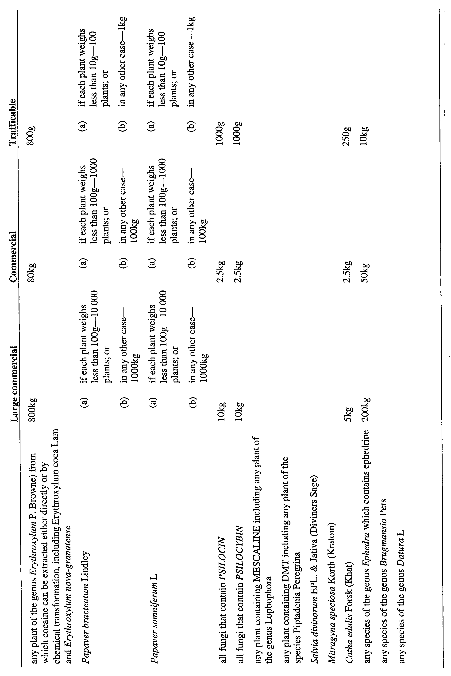
Part 2—Cannabis plants

 | Large commercial | Commercial | Trafficable
any plant of the genus Cannabis L | 100 plants | 20 plants | 10 plants
13—Insertion of Schedule 5
After Schedule 4 insert:
Schedule 5—Expiation Fees

1 | Offence arising out of the possession of cannabis—
 | • where the amount is less than 25g | $150
 | • where the amount is 25g or more but less than 100g | $300
2 | Offence arising out of the possession of cannabis resin—
 | • where the amount is less than 5g | $150
 | • where the amount is 5g or more but less than 20g | $300
3 | Offence arising out of the smoking or consumption of cannabis or cannabis resin (not being an offence committed in a public place or other prescribed place) | $150
4 | Offence arising out of the possession of equipment (1 or more pieces) for use in connection with the smoking or consumption of cannabis or cannabis resin (not being an offence involving the possession of such equipment for commercial purposes) | $150
5 | Offence referred to in item 4 accompanied by another simple cannabis offence relating to the possession, smoking or consumption of cannabis or cannabis resin | $30
6 | Offence involving cultivation of 1 cannabis plant | $300
Schedule 1—Revocation
1—Revocation of Controlled Substances (Expiation of Simple Cannabis Offences) Regulations 2002
The Controlled Substances (Expiation of Simple Cannabis Offences) Regulations 2002 are revoked.
2—Revocation of Controlled Substances (Exemptions) Regulations 2004
The Controlled Substances (Exemptions) Regulations 2004 are revoked.
Note—
As required by section 10AA(2) of the Subordinate Legislation Act 1978, the Minister has certified that, in the Minister's opinion, it is necessary or appropriate that these regulations come into operation as set out in these regulations.
Made by the Governor
after consultation by the Minister with the Controlled Substances Advisory Council and with the advice and consent of the Executive Council
on 22 November 2007
No 264 of 2007
AGO0235/02CS

South Australia
Controlled Substances (Poisons) Variation Regulations 2007
under the Controlled Substances Act 1984

Contents
Part 1—Preliminary
1 Short title
2 Commencement
3 Variation provisions
Part 2—Variation of Controlled Substances (Poisons) Regulations 1996
4 Variation of regulation 10—Licences
5 Variation of regulation 26—Written prescriptions
6 Variation of regulation 31C—Additional requirements for prescribers of drugs of dependence
7 Revocation of regulation 31K
8 Variation of regulation 31L—Exemptions from section 18A of the Act
9 Variation of heading to Part 6
10 Revocation of regulation 41
11 Variation of heading to Schedule B
12 Variation of heading to Schedule C
13 Variation of Schedule D—Fees
14 Revocation of Schedules KA and KB
15 Revocation of Schedule M
Schedule 1—Transitional provision
1 Transitional provision

Part 1—Preliminary
1—Short title
These regulations may be cited as the Controlled Substances (Poisons) Variation Regulations 2007.
2—Commencement
These regulations will come into operation on the day on which section 14 of the Controlled Substances (Serious Drug Offences) Amendment Act 2005 comes into operation.
3—Variation provisions
In these regulations, a provision under a heading referring to the variation of specified regulations varies the regulations so specified.
Part 2—Variation of Controlled Substances (Poisons) Regulations 1996
4—Variation of regulation 10—Licences
(1) Regulation 10(1)(a)—delete "section 13; section 32; sections 13 and 32" and substitute:
sections 13 and 31
(2) Regulation 10(1)(b)—delete "section 14; s32; sections 14 and 32" and substitute:
sections 14 and 31
(3) Regulation 10(1)(h)—delete "section 32" and substitute:
section 31
(4) Regulation 10(4)(e)—delete "section 32" and substitute:
section 31
5—Variation of regulation 26—Written prescriptions
Regulation 26(1)(e)(i)(B)—delete "section 33" and substitute:
section 18A
6—Variation of regulation 31C—Additional requirements for prescribers of drugs of dependence
Regulation 31C—delete "(or prohibited substances)"
7—Revocation of regulation 31K
Regulation 31K—delete the regulation
8—Variation of regulation 31L—Exemptions from section 18A of the Act
(1) Regulation 31L—delete "33" wherever occurring and substitute in each case:
18A
(2) Regulation 31L—redesignate the regulation (as amended by this regulation) as regulation 15A and relocate so that it follows regulation 15.
9—Variation of heading to Part 6
Heading to Part 6—delete "precursor chemicals" and substitute:
certain poisons
10—Revocation of regulation 41
Regulation 41—delete the regulation
11—Variation of heading to Schedule B
Heading to Schedule B—delete "Precursor" and substitute:
Certain
12—Variation of heading to Schedule C
Heading to Schedule C—delete "Precursor" and substitute:
Certain
13—Variation of Schedule D—Fees
(1) Schedule D, item 8, column 2—delete "section 32" and substitute:
section 31
(2) Schedule D, item 9—delete item 9
14—Revocation of Schedules KA and KB
Schedules KA and KB—delete Schedules KA and KB
15—Revocation of Schedule M
Schedule M—delete Schedule M
Schedule 1—Transitional provision
1—Transitional provision
For the purposes of section 18A(1) of the Controlled Substances Act 1984, a medical practitioner or dentist is exempt from that subsection if he or she has prescribed or supplied a drug of dependence in accordance with an authority given by the Minister under section 33 of the Controlled Substances Act 1984 and in force immediately before the commencement of section 14 of the Controlled Substances (Serious Drug Offences) Amendment Act 2005.
Note—
As required by section 10AA(2) of the Subordinate Legislation Act 1978, the Minister has certified that, in the Minister's opinion, it is necessary or appropriate that these regulations come into operation as set out in these regulations.
Made by the Governor
after consultation by the Minister with the Controlled Substances Advisory Council and with the advice and consent of the Executive Council
on 22 November 2007
No 265 of 2007
AGO0235/02CS

South Australia
Security and Investigation Agents Variation Regulations 2007
under the Security and Investigation Agents Act 1995

Contents
Part 1—Preliminary
1 Short title
2 Commencement
3 Variation provisions
Part 2—Variation of Security and Investigation Agents Regulations 1996
4 Variation of regulation 12E—Prescribed drugs and non-complying sample
5 Variation of Schedule 1—Offences preventing persons being licensed agents or process servers
6 Variation of Schedule 1A—Classes of offences (Regulation 12C)
Schedule 1—Transitional provision

Part 1—Preliminary
1—Short title
These regulations may be cited as the Security and Investigation Agents Variation Regulations 2007.
2—Commencement
These regulations will come into operation on the day on which section 14 of the Controlled Substances (Serious Drug Offences) Amendment Act 2005 comes into operation.
3—Variation provisions
In these regulations, a provision under a heading referring to the variation of specified regulations varies the regulations so specified.
Part 2—Variation of Security and Investigation Agents Regulations 1996
4—Variation of regulation 12E—Prescribed drugs and non-complying sample
Regulation 12E(a)(i)—delete "prohibited substance" and substitute:
controlled drug (other than a drug of dependence)
5—Variation of Schedule 1—Offences preventing persons being licensed agents or process servers
(1) Schedule 1, clause 1(2)(c)—delete "prohibited substance or a drug of dependence" and substitute:
controlled drug
(2) Schedule 1, clause 1(2b)(c)—delete "prohibited substance or a drug of dependence" and substitute:
controlled drug
6—Variation of Schedule 1A—Classes of offences (Regulation 12C)
(1) Schedule 1A, clause 1(2)(d)—delete "prohibited substance or a drug of dependence" and substitute:
controlled drug
(2) Schedule 1A, clause 2(b)—delete "prohibited substance or a drug of dependence" and substitute:
controlled drug
(3) Schedule 1A, clause 3(b)(ii)—delete "prohibited substance or a drug of dependence" and substitute:
controlled drug
Schedule 1—Transitional provision
1 For the purposes of Schedules 1 and 1A of the Security and Investigation Agents Regulations 1996 (as amended by these regulations), a reference to a controlled drug includes a reference to a prohibited substance and a drug of dependence (within the meaning of the Controlled Substances Act 1984 as in force immediately before the commencement of section 4 of the Controlled Substances (Serious Drug Offences) Amendment Act 2005).
Note—
As required by section 10AA(2) of the Subordinate Legislation Act 1978, the Minister has certified that, in the Minister's opinion, it is necessary or appropriate that these regulations come into operation as set out in these regulations.
Made by the Governor
with the advice and consent of the Executive Council
on 22 November 2007
No 266 of 2007
AGO0235/02CS

South Australia
Correctional Services Variation Regulations 2007
under the Correctional Services Act 1982

Contents
Part 1—Preliminary
1 Short title
2 Commencement
3 Variation provisions
Part 2—Variation of Correctional Services Regulations 2001
4 Variation of regulation 9—Prohibited items (sections 33, 33A and 51)
5 Variation of regulation 20—Minor breaches—liquor and drugs

Part 1—Preliminary
1—Short title
These regulations may be cited as the Correctional Services Variation Regulations 2007.
2—Commencement
These regulations will come into operation on the day on which section 14 of the Controlled Substances (Serious Drug Offences) Amendment Act 2005 comes into operation.
3—Variation provisions
In these regulations, a provision under a heading referring to the variation of specified regulations varies the regulations so specified.
Part 2—Variation of Correctional Services Regulations 2001
4—Variation of regulation 9—Prohibited items (sections 33, 33A and 51)
(1) Regulation 9(a)(ii) and (iii)—delete subparagraphs (ii) and (iii) and substitute:
(ii) a controlled drug,
(2) Regulation 9(ac)—delete "drug of dependence or prohibited substance" and substitute:
controlled drug
5—Variation of regulation 20—Minor breaches—liquor and drugs
(1) Regulation 20(1)(b)—delete ", drug of dependence or prohibited substance" and substitute:
or controlled drug
(2) Regulation 20(3)—delete "prohibited substance" and substitute:
controlled drug (other than a drug of dependence)
Note—
As required by section 10AA(2) of the Subordinate Legislation Act 1978, the Minister has certified that, in the Minister's opinion, it is necessary or appropriate that these regulations come into operation as set out in these regulations.
Made by the Governor
with the advice and consent of the Executive Council
on 22 November 2007
No 267 of 2007
AGO0235/02 CS

FAXING COPY?
IF you fax copy to Government Publishing SA for inclusion in the Government Gazette, there is no need to send a Confirmation Copy to us as well.
This creates confusion and may well result in your notice being printed twice.
Please use the following fax number:
Fax transmission: (08) 8207 1040
Phone Inquiries: (08) 8207 1045
Please include a contact person, phone number and order number so that we can phone back with any queries we may have regarding the fax copy.
NOTE: Closing time for lodging new copy (fax, hard copy or email) is 4 p.m. on Tuesday preceding the day of publication.

Government Gazette notices can be E-mailed.
The address is:
governmentgazette@dpc.sa.gov.au
Documents should be sent as attachments in Word format.
When sending a document via E-mail, please confirm your transmission with a faxed copy of your document, including the date the notice is to be published.
Fax transmission: (08) 8207 1040
Enquiries: (08) 8207 1045
NOTE: Closing time for lodging new copy (fax, hard copy or email) is 4 p.m. on Tuesday preceding the day of publication.

CITY OF PORT LINCOLN
Notice of Appointment of Members to the
Development Assessment Panel
NOTICE is hereby given that the City of Port Lincoln gives notice in accordance with the requirements of section 56A (5) of the Development Act 1993, of the appointment and term of appointment of the following persons as members of the Development Assessment Panel established pursuant to section 56A (1) of the Development Act 1993 on 5 November 2007, for a 12 month period expiring November 2008:
Bill Watkins, OAM (Chairperson)
Bruce Green
David Collins
Peter Blacker
Councillor Mary Ware
Councillor Michael Bascombe
Councillor Jim Papazoglov
Development Assessment Panel Meetings will be held on the second Monday of the month at 7.30 p.m. in the Council Chambers, Civic Centre, 60 Tasman Terrace.
Further details can be obtained from Bob Milic, Manager Development and Environmental Services by telephone on
8682 3033.

Appointment of Public Officer
NOTICE is hereby given that at its meeting held on 5 November 2007, Council resolved pursuant to section 56A (23) of the Development Act 1993, to appoint Geoffrey Phillip Dodd, P.O. Box 1787, Port Lincoln as Public Officer of the Council Development Assessment Panel.
Geoff Dodd, Chief Executive Officer

CITY OF PORT LINCOLN
Development Act 1993
Establishment of Car Parking Fund
NOTICE is hereby given, pursuant to section 50A (2) of the Development Act 1993, that the City of Port Lincoln has, with the approval of the Minister for Urban Development and Planning, established a car parking fund. Details of the fund are as follows:
Name of the Car Parking Fund:
City of Port Lincoln Car Parking Fund.
Description of the Designated Area to be Funded
The Car Parking Fund will apply to the City Centre Zone (Maps PtL/7 and PtL/8) in the Port Lincoln (City) Development Plan (Consolidated, 25 October 2007).
Contribution Rate
Council has determined that the Contribution Rate for the car parking fund be set at $9 250 per car parking space. Funds will be applied in a manner consistent with section 50A (8) of the Development Act 1993.
Dated 19 November 2007.
G. Dodd, Chief Executive Officer

CORPORATION OF THE TOWN OF WALKERVILLE
Councillor for Vale Park Ward
NOTICE is hereby given in accordance with section 54 (6) of the Local Government Act 1999, that a vacancy has occurred in the office of Councillor for Vale Park Ward, due to the resignation of Councillor Helen Rossis, to take effect from Tuesday, 16 October 2007.
Helen Dyer, Chief Executive Officer

CORPORATION OF THE TOWN OF WALKERVILLE
Close of Roll for Supplementary Election
DUE to the resignation of a member of the Council, a supplementary election will be necessary to fill the vacancy of Councillor for Vale Park Ward.
The voters roll to conduct this supplementary election will close at 5 p.m. on Friday, 30 November 2007.
You are entitled to vote in the election if you are on the State electoral roll. If you have recently turned 18 or changed your residential or postal address you must complete an electoral enrolment form. Electoral enrolment forms are available from post offices or online at www.seo.sa.gov.au.
If you are not eligible to enrol on the State electoral roll you may still be entitled to enrol to vote if you own or occupy a property. Contact the Council to find out how.
Nominations to fill the vacancy will open on Thursday, 17 January 2008 and will be received up until 12 noon on Thursday, 31 January 2008.
K. Mousley, Returning Officer

DISTRICT COUNCIL OF CEDUNA
Development Act 1993
Draft Better Development Plan (BDP) Conversion, Development Plan Amendment (DPA) by The District Council of Ceduna—Draft for Public Consultation
NOTICE is hereby given that the District Council of Ceduna has pursuant to section 25 of the Development Act 1993, prepared a draft Better Development Plan (BDP) Conversion, DPA to amend the Ceduna (DC) Development Plan.
The draft DPA proposes to amend the Ceduna (DC) Development Plan by replacing it with a new Development Plan that has primarily been sourced from the standard set of BDP policy modules (both General and the Zone sections) selected on the basis that they reflect and capture the range of policies in the existing Development Plan. New regional Coastal modules for Eyre Peninsula have also been adopted.
In addition a range of other amendments are proposed to the Ceduna (DC) Development Plan in relation to residential and rural living policy including the expansion of an existing rural living area and the identification of another location for future rural living. Other changes relate to policies associated with the Rural (Deferred Aviation) Zone, Caravan Park and Tourist Zone, car parking requirements and domestic outbuildings.
Please note that in order to ensure that the updated policy is available immediately to guide development outcomes, and in the interest of orderly and proper development, the Minister for Urban Development and Planning has resolved to place the DPA on interim operation.
The draft DPA will be on public consultation from Thursday, 22 November 2007 to Friday, 1 February 2008.
Copies (both hard copy and electronic) of the draft DPA are available during normal office hours at the offices of the District Council of Ceduna, 44 O’Loughlin Terrace, Ceduna, or can be viewed on the internet at www.ceduna.net.
Written submissions regarding the draft DPA should be submitted not later than 5 p.m. on Friday, 1 February 2008. All submissions should be addressed to the Chief Executive Officer, District Council of Ceduna, P.O. Box 175, Ceduna, S.A. 5690, marked attention to Chirs Holland and should clearly indicate whether you wish to be heard in support of your submission at the public meeting. If you wish to lodge your submission elec-tronically, could you please email the electronic submission to council@ceduna.sa.gov.au.
Copies of all submissions will be made available for inspection by interested persons at the District Council of Ceduna, 44 O’Loughlin Terrace, Ceduna from Wednesday, 6 February 2008, until the conclusion of the public meeting.
A public meeting will be held on Friday, 15 February 2008 at 7 p.m. at the Ceduna Memorial Hall, 31 Poynton Street, Ceduna, at which time interested persons may appear to be heard in relation to the draft DPA and the submissions. The public meeting will not be held if no submissions are received or if no submission makes a request to be heard. Please confirm with the administration at Council for confirmation of the public meeting.
If you would like further information about the draft DPA, contact Chris Holland, Manager Environmental Services of the District Council of Ceduna on telephone number 8625 3407 or email at cholland@ceduna.sa.gov.au.
Dated 22 November 2007.
A. J. Irvine, Chief Executive Officer

DISTRICT COUNCIL OF KIMBA
Office Closure—Christmas/New Year Period
NOTICE is hereby given that at a meeting held on 14 November 2007, Council resolved that pursuant to section 45 of the Local Government Act 1999, the Council office and Works Depot will be closed over the Christmas/New Year Period from 5 p.m. on Friday, 21 December 2007 through until 9 a.m. on Wednesday,
2 January 2008.
D. A. Cearns, Chief Executive Officer

DISTRICT COUNCIL OF KIMBA
Change of Council Meeting Date and Time
NOTICE is hereby given that the District Council of Kimba resolved at its meeting held on 14 November 2007, to change the date of the scheduled Council Meeting from 9 January 2008 to
16 January 2008, commencing at 2 p.m.
The scheduled meeting of Council to be held on Wednesday,
13 February 2008 commencing at 9 a.m. in lieu of the normal time of 2 p.m.
D. A. Cearns, Chief Executive Officer

DISTRICT COUNCIL OF KIMBA
Appointment of Acting Chief Executive Officer
NOTICE is hereby given that Debra Larwood has been appointed Acting Chief Executive Officer for the period from Monday, 26 November 2007 to Saturday, 1 December 2007 (inclusive).
D. A. Cearns, Chief Executive Officer

DISTRICT COUNCIL OF KIMBA
Temporary Road Closure
NOTICE is hereby given that at a Council meeting held on 14 November 2007, the Council resolved the following:
That the District Council of Kimba exercise the power subject to section 33 of the Road Traffic Act 1961 and Clause F of the Instrument of General Approval of the Minister dated 12 March
2001, to make an order that High Street from the northern side of Cross Street to the southern side of North Terrace be closed between 4.45 p.m. and 10 p.m. on Saturday, 22 December 2007, for the purpose of holding Kimba’s Christmas Pageant and Festivities.
Pursuant to section 33 (1) (b) of the Road Traffic Act 1961, the District Council of Kimba make on order directing that persons taking part in the event be exempt from the duty to observe the Australian Road Rules relating to pedestrian behaviour.
D. A. Cearns, Chief Executive Officer

DISTRICT COUNCIL OF YANKALILLA
Alteration to Council Meeting Date
NOTICE is hereby given that the District Council of Yankalilla at its meeting held on 15 November 2007, resolved pursuant to section 81 of the Local Government Act 1999, to change its meeting date for the December meeting, which will be held at
10 a.m. on Thursday, 13 December 2007 at the Community Chambers, Shop 5, Edwards Avenue, Normanville, with the Public Forum at Noon.
R. D. Sweetman, Chief Executive Officer

SALE OF PROPERTY
Auction Date: Friday, 14 December 2007 at 11 a.m.
Location: 9 Garden Street, Blakeview.
NOTICE is hereby given that on the above date at the time and place stated, by virtue of the Warrant of Sale issued out of the Magistrates Court of South Australia, Action No. 120 of 2007, directed to the Sheriff of South Australia in an action wherein Adelaide Bank Limited are the Plaintiffs and Duncan Matthew Tame and Shelley Tame as the Defendants, I, Mark Stokes, Sheriff of the State of South Australia, will by my auctioneers, Griffin Real Estate, make sale of the estate, right, title or interest whatsoever it may be of the Defendants Duncan Matthew Tame and Shelley Tame as the registered proprietors of an estate in fee simple in the following:
That piece of land situated in the area named Blakeview, being 9 Garden Street, being the property comprised in certificate of title register book volume 5874, folio 214.
Further particulars from the auctioneers:
Griffin Real Estate
8 Greenhill Road
Wayville, S.A. 5034
Telephone (08) 8372 7872

ATTENTION

CUSTOMERS requiring a proof of their notice for inclusion in the Government Gazette, please note that the onus is on you to inform Government Publishing SA of any subsequent corrections by 10 a.m. on Thursday, which is our publication deadline.

For any corrections to your notice please phone 8207 1045 or Fax 8207 1040 before 10 a.m. on Thursday.

If we do not receive any communication by 10 a.m. on Thursday (day of publication) we will presume the notice is correct and will print it as it is.

Remember—the onus is on you to inform us of any corrections necessary to your notice.

NOTE: Closing time for lodging new copy (electronically, fax or hard copy) is 4 p.m. on Tuesday preceding the day of publication. Phone 8207 1045—Fax 8207 1040.
Email: governmentgazette@dpc.sa.gov.au

Printed and published by authority every Thursday by T. GOODES, Government Printer, South Australia
Price: $5.40, plus postage; to subscribers, $274.00 per annum.
(The above prices are inclusive of GST)

