SUPPLEMENTARY GAZETTE



THE SOUTH AUSTRALIAN

GOVERNMENT GAZETTE
www.governmentgazette.sa.gov.au

PUBLISHED BY AUTHORITY

ALL PUBLIC ACTS appearing in this GAZETTE are to be considered official, and obeyed as such

ADELAIDE, FRIDAY, 30 NOVEMBER 2007

DEVELOPMENT ACT 1993
Publication of Pre-Lodgement Agreement Request Form
Preamble
Section 37AA (1) of the Development Act 1993, provides that a person may seek the opinion of a prescribed body under section 37 of the Act in relation to proposed development before lodging an application for development plan consent with respect to the development. Regulation 31A (2) (a) of the Development Regulations 1993, provides that an application to a prescribed body under section 37AA must be made in a form determined by the Minister, being a form published by the Minister in the Gazette.
Notice
PURSUANT to section 37AA (1) of the Development Act 1993 and Regulation 31A (2) (a) of the Development Regulations 1993, notice is given by the Minister for Urban Development and Planning of the publication of the Pre-Lodgement Agreement Request Form being the form in Schedule 1.

Schedule 1

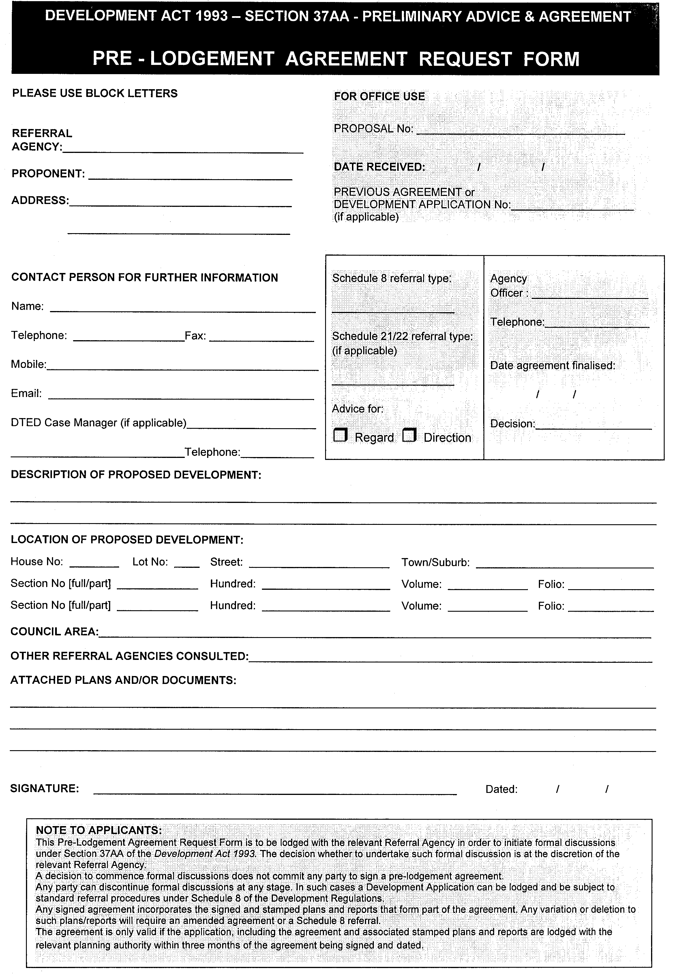
Dated 30 November 2007.
Paul Holloway, Minister for Urban Development and Planning

T. GOODES, Government Printer, South Australia

