No. 65 3671

THE SOUTH AUSTRALIAN

GOVERNMENT GAZETTE
www.governmentgazette.sa.gov.au

PUBLISHED BY AUTHORITY

ALL PUBLIC ACTS appearing in this GAZETTE are to be considered official, and obeyed as such

ADELAIDE, THURSDAY, 13 SEPTEMBER 2007

CONTENTS

Page
Administrative Arrangements Act 1994—Notice 3673
Appointments, Resignations, Etc. 3672
Australian Energy Regulator—Notice 3674
Corporations and District Councils—Notices 3719
Crown Lands Act 1929—Notices 3674
Dangerous Substances Act 1979—Notice 3674
Development Act 1993—Notices 3674
Explosives Act 1936—Notice 3675
Fair Work Act 1994—Notice 3675
Fisheries Act 1982—Notice 3675
Fisheries (Scheme of Management—Rock Lobster
Fisheries) Regulations 2006—Notice 3677
Housing Improvement Act 1940—Notices 3676
Land and Business (Sale and Conveyancing) Act 1994—
Notices 3677
Liquor Licensing Act 1997—Notices 3677
Mining Act 1971—Notices 3681
Natural Resources Management Act 2004—Notices 3682
Noxious Insects Act 1934—Notice 3685

Page
Occupational Health, Safety and Welfare Act 1986—
Notice 3685
Petroleum Act 2000—Notices 3685
Petroleum Products Regulation Act 1995—Notice 3685
Proclamation 3716
Public Trustee Office—Administration of Estates 3720
REGULATION
Associations Incorporation Act 1985 (No. 231 of 2007) 3717
Roads (Opening and Closing) Act 1991—Notice 3685
RULES OF COURT
Corporations Rules 2003 (South Australia)
Amendment No. 2 3690
South Australia Supreme Court Probate Rules 2004 3693
Supreme Court Criminal Appeal Rules 1996
(Amendment No. 2) 3695
Sheriff’s Act 1978—Notice 3686
Trade Standards Act 1979—Notice 3686
Training and Skills Development Act 2003—Notice 3687
Transport, Department of—Notice to Mariners 3686

GOVERNMENT GAZETTE NOTICES
ALL poundkeepers’ and private advertisements forwarded for publication in the South Australian Government Gazette must be PAID FOR PRIOR TO INSERTION; and all notices, from whatever source, should be legibly written on one side of the paper only and sent to Government Publishing SA so as to be received no later
than 4 p.m. on the Tuesday preceding the day of publication. Phone 8207 1045 or Fax 8207 1040. E-mail: governmentgazette@dpc.sa.gov.au. Send as attachments in Word format and please confirm your transmission with a faxed copy of your document, including the date the notice is to be published and to whom the notice will be charged. The Government Gazette is available online at: www.governmentgazette.sa.gov.au

Department of the Premier and Cabinet
Adelaide, 13 September 2007
HIS Excellency the Governor’s Deputy in Executive Council has been pleased to appoint the undermentioned to the Fisheries Council of South Australia, pursuant to the provisions of the Fisheries Management Act 2007:
Member: (from 13 September 2007 until 12 September 2010)
Catherine Sheree Cooper
Robert Tyrer Pennington
Ron Sherriff
Paul McShane
Christopher Henry Deane
Member: (from 13 September 2007 until 12 September 2009)
Barry Evans
Trevor Watts
Julian Bruce Morison
Loralee Wright
By command,
Gail Gago, for Premier
MAFF07/016CS

Department of the Premier and Cabinet
Adelaide, 13 September 2007
HIS Excellency the Governor’s Deputy in Executive Council has been pleased to appoint the undermentioned to the Construction Industry Long Service Leave Board, pursuant to the provisions of the Construction Industry Long Service Leave Act 1987:
Member: (from 13 September 2007 until 30 June 2012)
Margaret Sexton
Jim Whiting
Steven Brenton Hall
Rick Cairney
Colin Fenney
Bob Geraghty
Ben Carslake
Deputy Member: (from 13 September 2007 until 30 June 2012)
Steven Minuzzo (Deputy to Whiting)
Kevin Kelly (Deputy to Cairney)
John Camillo (Deputy to Fenney)
Doug Buchanan (Deputy to Geraghty)
Martin O’Malley (Deputy to Carslake)
Presiding Officer: (from 13 September 2007 until 30 June 2012)
Margaret Sexton
By command,
Gail Gago, for Premier
MIR07/013CS

Department of the Premier and Cabinet
Adelaide, 13 September 2007
HIS Excellency the Governor’s Deputy in Executive Council has been pleased to appoint the undermentioned to the Kangaroo Island Natural Resources Management Board, pursuant to the provisions of the Natural Resources Management Act 2004:
Member: (from 13 September 2007 until 13 April 2010)
Jayne Bates
By command,
Gail Gago, for Premier
WBCS07/0030

Department of the Premier and Cabinet
Adelaide, 13 September 2007
HIS Excellency the Governor’s Deputy in Executive Council has been pleased to appoint the Honourable Paul Caica, MP, Minister for Employment, Training and Further Education, Minister for Science and Information Economy, Minister for Youth and Minister for Gambling to be also Acting Minister for Education
and Children’s Services, Acting Minister for Tourism and Acting Minister for the City of Adelaide for the period from 14 September 2007 to 15 September 2007 inclusive, during the absence of the Honourable Jane Diane Lomax-Smith, MP.
By command,
Gail Gago, for Premier
MECS07/017CS

Department of the Premier and Cabinet
Adelaide, 13 September 2007
HIS Excellency the Governor’s Deputy in Executive Council has been pleased to appoint the Honourable Paul Caica, MP, Minister for Employment, Training and Further Education, Minister for Science and Information Economy, Minister for Youth and Minister for Gambling to be also Acting Minister for Families and Communities, Acting Minister for Aboriginal Affairs and Reconciliation, Acting Minister for Housing, Acting Minister for Ageing, Acting Minister for Disability and Acting Minister Assisting the Premier in Cabinet Business and Public Sector Management for the period from 19 September 2007 until 23 September 2007 inclusive, during the absence of the Honourable Jay Wilson Weatherill, MP.
By command,
Gail Gago, for Premier
MFC/CS/07/027

Department of the Premier and Cabinet
Adelaide, 13 September 2007
HIS Excellency the Governor’s Deputy in Executive Council has been pleased to appoint the Honourable Jane Diane Lomax-Smith, MP, Minister for Education and Children’s Services, Minister Tourism and Minister for the City of Adelaide to be also Acting Minister for Agriculture, Food and Fisheries and Acting Minister for Forests for the period from 17 September 2007 until 15 October 2007 inclusive, during the absence of the Honourable Rory John McEwen, MP.
By command,
Gail Gago, for Premier
DPC05/025CS

Department of the Premier and Cabinet
Adelaide, 13 September 2007
HIS Excellency the Governor’s Deputy in Executive Council has been pleased to note and approve the advice of the Speaker of the House of Assembly that the most suitable applicant for the position of Clerk of the House of Assembly is Malcolm Jeffrey Lehman, and therefore issue a Commission to the said Malcolm Jeffrey Lehman as Clerk of the House of Assembly.
By command,
Gail Gago, for Premier

Department of the Premier and Cabinet
Adelaide, 13 September 2007
HIS Excellency the Governor’s Deputy in Executive Council has been pleased to appoint John Thomas Hill as Acting Chairperson of the Essential Services Commission of South Australia for a term expiring on 27 July 2008, pursuant to section 14 the Essential Services Commission Act 2002.
By command,
Gail Gago, for Premier
TF07/062CS

Department of the Premier and Cabinet
Adelaide, 13 September 2007
HIS Excellency the Governor’s Deputy in Executive Council has been pleased to approve the appointment of Jeremy James Moore as a Trustee of the Da Costa Samaritan Fund Trust with effect from 13 September 2007, pursuant to section 6 of the Da Costa Samaritan Fund (Incorporation of Trustees) Act 1953.
By command,
Gail Gago, for Premier
AGO0274/04CS

Department of the Premier and Cabinet
Adelaide, 13 September 2007
HIS Excellency the Governor’s Deputy in Executive Council has been pleased to appoint Rod Hook as Chief Executive Officer of the Board established by the Economic Development Act 1993 for a period of one year commencing on 13 September 2007 and expiring on 12 September 2008, pursuant to the Economic Development Act 1993.
By command,
Gail Gago, for Premier
MFI07/022CS

Department of the Premier and Cabinet
Adelaide, 13 September 2007
HIS Excellency the Governor’s Deputy in Executive Council has been pleased to appoint the persons listed as Members and as the Chair and Deputy Chair of the Board established by the Economic Development Act 1993, for a period of one year commencing on 13 September 2007 and expiring on 12 September 2008, pursuant to the Economic Development Act 1993:
Members:
Jim Hallion
Raymond Garrand
Warren McCann
Geoff Knight
Allan Holmes
Anne Howe
Kevin Osborn
Chief Executive Officer of the Board and ex officio Member:
Rod Hook
Chair:
Jim Hallion
Deputy Chair:
Raymond Garrand
By command,
Gail Gago, for Premier
MFI07/022CS

Department of the Premier and Cabinet
Adelaide, 13 September 2007
HIS Excellency the Governor’s Deputy in Executive Council has amended the instrument of appointment of officers of the Department of Health for the purpose of exercising functions and powers under the Controlled Substances Act 1984, signed on 6 September 2007 and the Minutes of the Executive Council meeting held on 6 September 2007, by deleting all references to the Southern Adelaide Health Service Inc.
By command,
Gail Gago, for Premier
HEACS/07/221

Department of the Premier and Cabinet
Adelaide, 13 September 2007
HIS Excellency the Governor’s Deputy in Executive Council has revoked the appointments of Adam Graycar and Suzanne Carman as Clerks of Executive Council, pursuant to the Letters Patent, section 68 of the Constitution Act 1934 and the Acts Interpretation Act 1915.
By command,
Gail Gago, for Premier
DPC041/94CS

Department of the Premier and Cabinet
Adelaide, 13 September 2007
HIS Excellency the Governor’s Deputy in Executive Council has been pleased to appoint Tanya Louise Smith as Clerk of Executive Council, pursuant to the Letters Patent and section 68 of the Constitution Act 1934.
By command,
Gail Gago, for Premier
DPC041/94CS

Department of the Premier and Cabinet
Adelaide, 13 September 2007
HIS Excellency the Governor’s Deputy in Executive Council has been pleased to witness the making of the declaration by Simon O’Neill as Auditor-General, pursuant to the provisions of the Public Finance and Audit Act 1987.
By command,
Gail Gago, for Premier
DPC07/025CS

ADMINISTRATIVE ARRANGEMENTS ACT 1994
Instrument of Delegation
I, MICHAEL DAVID RANN, Minister for Economic Develop-ment, pursuant to section 9 of the Administrative Arrangements Act 1994, hereby delegate to the Minister for Infrastructure my powers and functions under the Economic Development Act 1993 to the extent set out below:
(a) the power and function of directing the Economic Development Board under section 7 PROVIDED ALWAYS that a direction may only be given in relation to the following matters:
(i) the exercise by the Board of any powers conferred upon it by His Excellency the Governor under section 16 (3); and
(ii) compliance by the Board with the obligations imposed upon it by section 16 (4);
(b) the function of receiving reports of conflict of interest under section 12 (3) insofar as such a report may relate to any consideration by the Board of the exercise of powers conferred upon it under section 16 (3);
(c) the power and function of giving directions under section 12 (4) following any report of a conflict of interest received pursuant to paragraph (b) of this instrument; and
(d) the function of reporting to the Parliament under section 16 (5) in relation to any proclamation made by His Excellency the Governor conferring powers upon the Board under section 16 (3).
This delegation remains in force until such time as it may be revoked by me.
Dated 10 September 2007.
Mike Rann, Minister for Economic Development

AUSTRALIAN ENERGY REGULATOR
Draft Decision—SP AusNet Electricity Transmission Determination 2008-2014
THE Australian Energy Regulator (AER) has released its draft decision on SP AusNet’s Electricity Transmission Determination for the period from 1 April 2008 to 21 March 2014. The draft decision and reports prepared by the AER’s consultants are now available on the AER’s website: www.aer.gov.au.
Issues regarding this draft decision and the consultants report can be addressed in written submissions to the AER by 14 November 2007.
Submissions can be sent electronically to:
aerinquiry@aer.gov.au.
Alternatively, submissions can be sent to:
Chris Pattas
General Manager
Network Regulation South
Australian Energy Regulator
G.P.O. Box 520
Melbourne, Vic. 3000

CROWN LANDS ACT 1929: SECTION 5
TAKE NOTICE that pursuant to the Crown Lands Act 1929, I, GAIL GAGO, Minister for Environment and Conservation, Minister of the Crown to whom the administration of the Crown Lands Act 1929 is committed DO HEREBY dedicate the Crown Land defined in The Schedule as a Water Supply Reserve and declare that such land shall be under the care, control and management of Moorook Irrigation Trust Incorporated.
The Schedule
Allotment 1 of Deposited Plan 39952, Hundred of Moorook, County of Albert, exclusive of all necessary roads, being the whole of the land comprised in Crown Record Volume 5443 Folio 173.
Dated 13 September 2007.
Gail Gago, Minister for Environment and Conservation
DL 3124/1991

CROWN LANDS ACT 1929: SECTION 5
TAKE NOTICE that pursuant to the Crown Lands Act 1929, I, GAIL GAGO, Minister for Environment and Conservation, Minister of the Crown to whom the administration of the Crown Lands Act 1929 is committed DO HEREBY dedicate the Crown Land defined in The Schedule as Public Road.
The Schedule
Section 1582, Allotment 1 of Filed Plan 218939 and Allotment 8 of Deposited Plan 29869, Berri Irrigation Area, County of Hamley, being the whole of the land comprised in Crown Record Volume 5444 Folio 82, Crown Record Volume 5923 Folio 684 and Crown Record Volume 5778 Folio 16 (respectively), being within the district of Berri and Barmera.
Dated 13 September 2007.
Gail Gago, Minister for Environment and Conservation
DEH 11/3742

CROWN LANDS ACT 1929: SECTION 5
TAKE NOTICE that pursuant to the Crown Lands Act 1929, I, GAIL GAGO, Minister for Environment and Conservation, Minister of the Crown to whom the administration of the Crown Lands Act 1929 is committed DO HEREBY resume the land defined in The Schedule.
The Schedule
Community Centre Reserve, Allotments 25 and 26, Town of Whyte-Yarcowie, Hundred of Whyte, County of Victoria, the proclamation of which was published in the Government Gazette of 12 July 1973 at page 113, The Third Schedule, being the whole of the land comprised in Crown Record Volume 5759 Folio 850.
Dated 13 September 2007.
Gail Gago, Minister for Environment and Conservation
DL 4003/1993

DANGEROUS SUBSTANCES ACT 1979
Appointments
I, MICHAEL JOHN WRIGHT, Minister for Industrial Relations in and for the State of South Australia, hereby appoint each of the following persons as an Authorised Officer for the purposes of the Dangerous Substances Act 1979, pursuant to section 7 (1) of the Dangerous Substances Act 1979:
Julie Anne Hennessy
Lucy Rozswita Kerr
Graeme Joseph Sauer
Shubhraj
Timothy James Wrightson
Dated 7 September 2007.
Michael Wright, Minister for Industrial Relations

DEVELOPMENT ACT 1993, SECTION 25 (17): TATIARA DISTRICT COUNCIL—HERITAGE PLAN AMENDMENT
Preamble
1. The Development Plan amendment entitled ‘Tatiara District Council—Heritage Plan Amendment’ (the Plan Amendment) has been finalised in accordance with the provisions of the Development Act 1993.
2. The Minister for Urban Development and Planning has decided to approve the Plan Amendment.
Notice
PURSUANT to section 25 of the Development Act 1993, I—
(a) approve the Plan Amendment; and
(b) fix the day on which this notice is published in the Gazette as the day on which the Plan Amendment will come into operation.
Dated 13 September 2007.
Paul Holloway, Minister for Urban Development and Planning

DEVELOPMENT ACT 1993: SECTION 46 (4)
Preamble
1. Subsection (4) of section 46 of the Development Act 1993, provides that the Minister may, by notice in the Gazette, revoke a declaration previously made under subsection (1) of that section.
2. The Minister has decided to revoke various declarations that have effect under section 46 of the Development Act 1993.
3. The declarations to be revoked include declarations that were made by the Governor under section 48 of the Development Act 1993 (before it was amended by the Development (Major Development Assessment) Amendment Act 1996) on the basis that those declarations now have effect as if they were declarations of the Minister under section 46 of the Development Act 1993, pursuant to section 19 of the Statutes Repeal and Amendment (Development) Act 1993 and section 14 of the Development (Major Development Assessment) Amendment Act 1996.
Notice
PURSUANT to subsection (4) of section 46 of the Development Act 1993, I revoke the following declarations under that section, or that have effect under that section:
(a) the following declarations made by the Governor under section 48 of the Development Act 1993 (as in force immediately before the commencement of the Develop-ment (Major Development Assessment) Amendment Act 1996):
(i) the declaration published in the Gazette on 22 June 1995 at pages 2899 and 2900, relating to Granite Island Development;
(ii) the declaration published in the Gazette on 11 January 1996 at page 104, relating to Smithfield Quarry Landfill;
(b) the following declarations of the Minister under section 46 of the Development Act 1993:
(i) the declaration published in the Gazette on 27 January 2000 at pages 506 and 507, relating to the SNI Electricity Interconnector—Northern Route;
(ii) the declaration published in the Gazette on 20 September 2001 at page 4215, relating to the Royal Park Waste Transfer Station;
(iii) the declaration published in the Gazette on 25 October 2001 at page 4690, relating to the SNI Electricity Interconnector—Southern Route;
(iv) the declaration published in the Gazette on 1 August 2002 at pages 2972 and 2973, relating to the Inkerman Pupfan Landfill;
(v) the declaration published in the Gazette on 15 May 2004 at page 1283, relating to the Brompton Concrete Storage Facility—Fortifications.
Dated 29 August 2007.
Carmel Zollo, Acting Minister for Urban Development and Planning

EXPLOSIVES ACT 1936
Appointments
I, MICHAEL JOHN WRIGHT, Minister for Industrial Relations in and for the State of South Australia, hereby appoint each of the following persons as an Inspector for the purposes of the Explosives Act 1936, pursuant to section 9 (1) of the Explosives Act 1936:
Julie Anne Hennessy
Graeme Joseph Sauer
Shubhraj
Dated 7 September 2007.
Michael Wright, Minister for Industrial Relations

FAIR WORK ACT 1994
Appointments
I, MICHAEL JOHN WRIGHT, Minister for Industrial Relations in and for the State of South Australia, hereby appoint each of the following persons to be an Inspector for the purposes of the Fair Work Act 1994, pursuant to section 64 (1) (b) of the Fair Work Act 1994:
Julie Anne Hennessy
Lucy Rozswita Kerr
Graeme Joseph Sauer
Shubhraj
Timothy James Wrightson
Dated 7 September 2007.
Michael Wright, Minister for Industrial Relations

FISHERIES ACT 1982: SECTION 59
TAKE notice that pursuant to section 59 of the Fisheries Act 1982, Miles L. Wise of Cleanseas Tuna Ltd, 7 North Quay Boulevard, Port Lincoln, S.A. 5606 (the ‘exemption holder’), or a person acting as his agent, is exempt from the Fisheries Act 1982 and the Fisheries (General) Regulations 2000, but only insofar as the exemption holder may engage in the collection of up to 20 Yellowtail Kingfish (Seriola lalandi) using a purse seine net for the purpose of aquaculture broodstock, in the waters described in Schedule 1 (the ‘exempted activity’), subject to the conditions set out in Schedule 2, from 15 September 2007 until 20 October 2007 unless varied or revoked earlier.
Schedule 1
Port Patterson, Spencer Gulf (net closure area).
Schedule 2
1. The specimens collected by the exemption holder must only be used for aquaculture broodstock and all other species must be released immediately.
2. All specimens collected pursuant to this notice must not be sold or transferred to another party.
3. Only a purse seine net with a maximum length of 600 m may be used pursuant to this exemption.
4. All specimens collected pursuant to this exemption must not be held with any other captive specimens except with fish collected pursuant to another exemption issued for the purposes of broodstock collection and may be held in a polar circle cage on the location listed on Aquaculture Licence No. FF00036 for a maximum of 14 days prior to being delivered to and retained in the Cleanseas Tuna Port Augusta Hatchery, Licence No. FT00287 and or Cleanseas Tuna Arno Bay Hatchery, Licence No. FT00560.
5. The exemption holder must notify PIRSA Fisheries on 1800 065 522 at least 12 hours prior to conducting the exempted activity and answer a series of questions about the exempted activity. The exemption holder will need to have a copy of the exemption with them at the time of making the call, and be able to provide information about the area and time of the exempted activity, the vehicles and boats involved, the number of agents undertaking the exempted activity and other related questions. Exemption No. 9902025.
6. The exemption holder must provide a written report to the Director of Fisheries, (G.P.O. Box 1625, Adelaide, S.A. 5001) within 14 days of any collection. The report is to provide details of the time, date, location and number of fish collected, including details of any mortalities.
7. The exemption holder shall also provide details of any interactions with threatened, endangered and protected species.
8. The exemption holder shall record the number of wild broodstock held pursuant to this notice in a register to be maintained at the registered aquaculture site, which must be made available for inspection by a PIRSA Fisheries Officer if requested.
9. The exemption holder must allow a Fisheries Officer or another nominated person to be on board the boat during the exempted activity if requested by PIRSA Fisheries.
10. While engaged in the exempted activity, the exemption holder must be in possession of a copy of this notice. Such notice must be produced to a PIRSA Fisheries Compliance Officer if requested.
11. The exemption holder must not contravene or fail to comply with the Fisheries Act 1982, or any regulations made under that Act, except where specifically exempted by this notice.
Dated 10 September 2007.
W. Zacharin, Director of Fisheries

HOUSING IMPROVEMENT ACT 1940
WHEREAS by notice published in the Government Gazette on the dates mentioned in the following table the South Australian Housing Trust did declare the houses described in the following table to be substandard for the purposes of Part 7 of the Housing Improvement Act 1940, and whereas the South Australian Housing Trust is satisfied that each of the houses described hereunder has ceased to be substandard, notice is hereby given that, in exercise of the powers conferred by the said Part, the South Australian Housing Trust does hereby revoke the said declaration in respect of each house.
Address of House | Allotment, Section, etc. | Certificate of Title  Volume Folio | Date and page of Government Gazette in which notice declaring house to be substandard published

49 Linden Avenue, Hazelwood Park |  | Allotment 228 in Deposited Plan 2975, Hundred of Adelaide | 5658 | 771 |  | 24.5.07, page 2143
14 Patricia Avenue, Hillcrest |  | Allotment 580 in Deposited Plan 5517, Hundred of Yatala | 5221 | 83 |  | 2.3.06, page 766
Unit 5/122 Edward Street, Norwood |  | Unit 5 in Strata Plan 5093, Hundred of Adelaide | 5037 | 639 |  | 29.9.05, page 3508
43 Seventh Street, Port Pirie West |  | Allotment 183 in Deposited Plan 622, Hundred of Pirie | 5711 | 762 |  | 25.11.04, page 4390
5 King William Street, Rosewater |  | Allotment 894 of Section 1184, Hundred of Port Adelaide | 5709 | 869 |  | 25.4.68, page 1350
21 Portland Avenue, Sturt |  | Lot 1, Primary Community Plan 21274, Hundred of Noarlunga | 5873 | 740 |  | 26.4.07, page 1266

Dated at Adelaide, 13 September 2007. D. Huxley, Director, Corporate and Board Services

HOUSING IMPROVEMENT ACT 1940
WHEREAS by notice published in the Government Gazette on the dates mentioned in the following table the South Australian Housing Trust did declare the houses described in the said table to be substandard for the purposes of Part 7 of the Housing Improvement Act 1940, the South Australian Housing Trust in the exercise of the powers conferred by the said Part, does hereby fix as the maximum rental per week which shall be payable subject to section 55 of the Residential Tenancies Act 1995, in respect of each house described in the following table the amount shown in the said table opposite the description of such house and this notice shall come into force on the date of this publication in the Gazette.
Address of House | Allotment, Section, etc. | Certificate of Title  Volume Folio | Date and page of Government Gazette in which notice declaring house to be substandard published | Maximum rental per week payable in respect of each house  $

60 Hounslow Street, Torrensville |  | Allotment 56 in Filed Plan 143784, Hundred of Adelaide | 5769 | 249 |  | 24.8.06, page 2862 | 248.00
95 South Road, Yankalilla |  | Allotment 412 in Filed Plan 211198, Hundred of Yankalilla | 5571 | 817 |  | 26.7.07, page 3177 | 74.00
10 Lansdowne Terrace, Walkerville |  | Allotment 55 of portion of Section 477, Hundred of Yatala | 5859 | 648 |  | 31.7.75, page 745 | 60.00

Dated at Adelaide, 13 September 2007. D. Huxley, Director, Corporate and Board Services

HOUSING IMPROVEMENT ACT 1940
NOTICE is hereby given that the South Australian Housing Trust in the exercise of the powers conferred by the Housing Improvement Act 1940, does hereby declare the houses described in the table hereunder to be substandard for the purposes of Part 7 of the Housing Improvement Act 1940.
No. of House and Street | Locality | Allotment, Section, etc. | Certificate of Title  Volume Folio

50 Tilshead Road |  | Elizabeth North | Allotment 162 in Deposited Plan 37151, Hundred of Munno Para | 5784 | 475
4 Albert Terrace |  | Murray Bridge | Allotment 306 in Filed Plan 167121, Hundred of Mobilong | 5846 | 250
4 Scarborough Street |  | Somerton Park | Allotment 107 in Filed Plan 8748, Hundred of Noarlunga | 5179 | 102

Dated at Adelaide, 13 September 2007. D. Huxley, Director, Corporate and Board Services

FISHERIES (SCHEME OF MANAGEMENT—ROCK LOBSTER FISHERIES) REGULATIONS 2006
TAKE notice that, in relation to the nominated certification stations listed in Column 1 below, the corresponding times specified in columns 2 and 3 are, for the purposes of subregulations 22 (2) and 23 (2) of the Fisheries (Scheme of Management—Rock Lobster Fisheries) Regulations 2006, the times during which the requirements in 22 (1) and 23 (1) do not apply.
This notice applies from 1 October 2007 until 31 March 2008, unless varied or revoked earlier.
Dated 10 September 2007.
Column 1 | Column 2 | Column 3
Certification Station | Start Time | Finish Time
Beachport | 10.30 a.m. | 3 p.m.
Blackfellows Caves | 8.30 a.m. | 1.30 p.m.
Cape Jaffa | 10.30 a.m. | 4 p.m.
Carpenter Rocks | 8.30 a.m. | 12.30 p.m.
Port MacDonnell | 8.30 a.m. | 2.30 p.m.
Robe | 10 a.m. | 4 p.m.
Southend | 10 a.m. | 3 p.m.
W. Zacharin, Director of Fisheries

LAND AND BUSINESS (SALE AND CONVEYANCING)
ACT 1994
Exemption
TAKE notice that, pursuant to section 23 (3) of the Land and Business (Sale and Conveyancing) Act 1994, I, Jennifer Rankine, Minister for Consumer Affairs, do hereby exempt the persons named in Schedule 1 from the application of section 23 (2) of the Act in relation to the purchase of the land specified in Schedule 2.
Schedule 1
Scott Anthony Nelson and Jan Maree Nelson, employees of Burton Groves & Welsh Pty Ltd.
Schedule 2
The whole of the land described in certificate of title register book volume 5855, folio 82, situated at 19 Oakwood Court, Ridgehaven, S.A. 5097.
Dated 13 September 2007.
Jennifer Rankine, Minister for Consumer Affairs

LAND AND BUSINESS (SALE AND CONVEYANCING)
ACT 1994
Exemption
TAKE notice that, pursuant to section 23 (3) of the Land and Business (Sale and Conveyancing) Act 1994, I, Jennifer Rankine, Minister for Consumer Affairs, do hereby exempt the person named in Schedule 1 from the application of section 23 (2) of the Act in relation to the purchase of the land specified in Schedule 2.
Schedule 1
Sandra Lynn Raggio, an employee of Homburg Group Pty Ltd.
Schedule 2
The land described in a portion of certificate of title register book volume 5968, folio 927, situated at Lot 56, Minge Way, Nuriootpa, S.A. 5355.
Dated 4 September 2007.
Jennifer Rankine, Minister for Consumer Affairs

LAND AND BUSINESS (SALE AND CONVEYANCING)
ACT 1994
Exemption
TAKE notice that, pursuant to section 23 (3) of the Land and Business (Sale and Conveyancing) Act 1994, I, Jennifer Rankine, Minister for Consumer Affairs, do hereby exempt the person named in Schedule 1 from the application of section 23 (2) of the Act in relation to the purchase of the land specified in Schedule 2.
Schedule 1
David Braunack, an officer of Homburg Group Pty Ltd.
Schedule 2
The whole of the land described in certificate of title register book volume 5014, folio 556, situated at 2/3 Braunack Avenue, Tanunda, S.A. 5352.
Dated 13 September 2007.
Jennifer Rankine, Minister for Consumer Affairs

LIQUOR LICENSING ACT 1997 AND GAMING MACHINES ACT 1992
Notice of Application
NOTICE is hereby given, pursuant to section 52 of the Liquor Licensing Act 1997 and section 29 of the Gaming Machines Act 1992, that Brett Gordon Skinner Pty Ltd as trustee for the Brett Skinner Family Trust and Allen Family Pty Ltd as trustee for the Allen Family Trust have applied to the Licensing Authority for the transfer of a Hotel and Gaming Machine Licence in respect of premises situated at Melrose Street, Mount Pleasant, S.A. 5235 and known as Mount Pleasant Hotel Motel.
The applications have been set down for hearing on 15 October 2007 at 9 a.m.
Any person may object to the application by lodging a notice of objection in the prescribed form with the Liquor and Gambling Commissioner and serving a copy of the notice on the applicants at the applicants’ address, at least seven days before the hearing date (viz: 8 October 2007).
The applicants’ address for service is c/o Germein Reed Mildwaters Lawyers, P.O. Box 12, Kadina, S.A. 5554.
Plans in respect of the premises the subject of the application are open to public inspection without fee at the Office of the Liquor and Gambling Commissioner, 9th Floor, East Wing, 50 Grenfell Street, Adelaide, S.A. 5000. Phone 8226 8410, Fax:
8226 8512. Email: olgc@agd.sa.gov.au.
Dated 10 September 2007.
Applicants

LIQUOR LICENSING ACT 1997
Notice of Application
NOTICE is hereby given, pursuant to section 52 (2) (b) of the Liquor Licensing Act 1997, that Wok Right Inn Pty Ltd as trustee for the T. and K. Ponniah Family Trust has applied to the Licensing Authority to transfer a Restaurant Licence in respect of premises situated at Shop 6/212 Belair Road, Hawthorn, S.A. 5062 and known as In Thais Noodle Bar.
The application has been set down for hearing on 17 October 2007 at 9 a.m.
Any person may object to the application by lodging a notice of objection in the prescribed form with the Liquor and Gambling Commissioner and serving a copy of the notice on the applicant at the applicant’s address, at least seven days before the hearing date (viz: 10 October 2007).
The applicant’s address for service is c/o Camatta Lempens Pty Ltd, Lawyers, Level 1, 345 King William Street, Adelaide, S.A. 5000 (Attention: Amanda Warley).
Plans in respect of the premises the subject of the application are open to public inspection without fee at the Office of the Liquor and Gambling Commissioner, 9th Floor, East Wing, 50 Grenfell Street, Adelaide, S.A. 5000. Phone 8226 8410, Fax:
8226 8512. Email: olgc@agd.sa.gov.au.
Dated 10 September 2007.
Applicant

LIQUOR LICENSING ACT 1997
Notice of Application
NOTICE is hereby given, pursuant to section 52 (2) (b) of the Liquor Licensing Act 1997, that Gail Maree Johnstone as trustee for the Johnstone Family Trust has applied to the Licensing Authority for a Restaurant Licence with Section 34 (1) (c) in respect of premises situated at 5/255 St Vincent Street, Port Adelaide, S.A. 5015 and known as Cafe Foreyou.
The application has been set down for callover on 12 October 2007 at 9 a.m.
Conditions
The following licence conditions are sought:
To sell liquor on any day except Christmas Day and Good Friday for consumption on the licensed premises by persons:
(a) seated at a table, or
(b) attending a function at which food is provided.
Any person may object to the application by lodging a notice of objection in the prescribed form with the Liquor and Gambling Commissioner and serving a copy of the notice on the applicant at the applicant’s address, at least seven days before the callover date (viz: 5 October 2007).
The applicant’s address for service is c/o David Watts & Associates, 1 Cator Street, Glenside, S.A. 5065.
Plans in respect of the premises the subject of the application are open to public inspection without fee at the Office of the Liquor and Gambling Commissioner, 9th Floor, East Wing, 50 Grenfell Street, Adelaide, S.A. 5000. Phone 8226 8410, Fax:
8226 8512. Email: olgc@agd.sa.gov.au.
Dated 10 September 2007.
Applicant

LIQUOR LICENSING ACT 1997
Notice of Application
NOTICE is hereby given, pursuant to section 52 (2) (b) of the Liquor Licensing Act 1997, that Seal Bay Tourist Park Pty Ltd has applied to the Licensing Authority for the transfer of a Restaurant Licence in respect of premises situated at Section 92, Hundred of Seddon, Seal Bay turnoff, South Coast Road, Parndana, Kangaroo Island, S.A. 5220 and known as Kaiwarra Food Barn.
The application has been set down for hearing on 10 October 2007 at 9 a.m.
Any person may object to the application by lodging a notice of objection in the prescribed form with the Liquor and Gambling Commissioner and serving a copy of the notice on the applicant at the applicant’s address, at least seven days before the hearing date (viz: 3 October 2007).
The applicant’s address for service is c/o Foreman Legal, 69 Mount Barker Road, Stirling, S.A. 5152.
Plans in respect of the premises the subject of the application are open to public inspection without fee at the Office of the Liquor and Gambling Commissioner, 9th Floor, East Wing, 50 Grenfell Street, Adelaide, S.A. 5000. Phone 8226 8410, Fax:
8226 8512. Email: olgc@agd.sa.gov.au.
Dated 7 September 2007.
Applicant

LIQUOR LICENSING ACT 1997
Notice of Application
NOTICE is hereby given, pursuant to section 52 (2) (b) of the Liquor Licensing Act 1997, that R. and P. Seaman Pty Ltd as trustee for R. and P. Seaman Family Trust has applied to the Licensing Authority for a Restaurant Licence in respect of premises situated at 41-43 Matson Terrace, Venus Bay, S.A. 5607 and to be known as Venus Bay Licensed General Store.
The application has been set down for hearing on 12 October 2007 at 9 a.m.
Any person may object to the application by lodging a notice of objection in the prescribed form with the Liquor and Gambling Commissioner and serving a copy of the notice on the applicant at the applicant’s address, at least seven days before the hearing date (viz: 5 October 2007).
The applicant’s address for service is c/o Pamela Seaman and Ross Seaman, 41-43 Matson Terrace, Venus Bay, S.A. 5607.
Plans in respect of the premises the subject of the application are open to public inspection without fee at the Office of the Liquor and Gambling Commissioner, 9th Floor, East Wing, 50 Grenfell Street, Adelaide, S.A. 5000. Phone 8226 8410, Fax:
8226 8512. Email: olgc@agd.sa.gov.au.
Dated 4 September 2007.
Applicant

LIQUOR LICENSING ACT 1997
Notice of Application
NOTICE is hereby given, pursuant to section 52 (2) (b) of the Liquor Licensing Act 1997, that Hotel LLB Pty Ltd has applied to the Licensing Authority for Alterations and Redefinition in respect of premises situated at Lot 859, St Andrew Boulevard, Normanville, S.A. 5204 and known as The Links Lady Bay.
The application has been set down for callover on 12 October 2007 at 9 a.m.
Conditions
The following licence conditions are sought:
• Alterations and Redefinition to include 42 apartments as per plans lodged with this office.
Any person may object to the application by lodging a notice of objection in the prescribed form with the Liquor and Gambling Commissioner and serving a copy of the notice on the applicant at the applicant’s address, at least seven days before the callover date (viz: 5 October 2007).
The applicant’s address for service is c/o Hotel LLB Pty Ltd, P.O. Box 524, Yankalilla, S.A. 5203.
Plans in respect of the premises the subject of the application are open to public inspection without fee at the Office of the Liquor and Gambling Commissioner, 9th Floor, East Wing, 50 Grenfell Street, Adelaide, S.A. 5000. Phone 8226 8410, Fax:
8226 8512. Email: olgc@agd.sa.gov.au.
Dated 10 September 2007.
Applicant

LIQUOR LICENSING ACT 1997
Notice of Application
NOTICE is hereby given, pursuant to section 52 (2) (b) of the Liquor Licensing Act 1997, that John A. Lienert and Chery M. Lienert have applied to the Licensing Authority for a Producer’s Licence in respect of premises situated at Lot 567, Lienert Road, Sheoak Log, S.A. 5371 and to be known as Lienert of Mecklenburg.
The application has been set down for hearing on 12 October 2007 at 9 a.m.
Any person may object to the application by lodging a notice of objection in the prescribed form with the Liquor and Gambling Commissioner and serving a copy of the notice on the applicants at the applicants’ address, at least seven days before the hearing date (viz: 5 October 2007).
The applicants’ address for service is c/o Swan & Hoklas, Public Accountants, P.O. Box 218, Nuriootpa, S.A. 5355 (Attention: Dean Hoklas).
Plans in respect of the premises the subject of the application are open to public inspection without fee at the Office of the Liquor and Gambling Commissioner, 9th Floor, East Wing, 50 Grenfell Street, Adelaide, S.A. 5000. Phone 8226 8410, Fax:
8226 8512. Email: olgc@agd.sa.gov.au.
Dated 5 September 2007.
Applicants

LIQUOR LICENSING ACT 1997
Notice of Application
NOTICE is hereby given, pursuant to section 52 (2) (b) of the Liquor Licensing Act 1997, that Vincent Lewis Ball and Katrina Mary Ball as trustees for the Ball Family Trust have applied to the Licensing Authority for a Producer’s Licence in respect of premises situated at RSD 483, Brookmans Road, McLaren Vale, S.A. 5177 and known as Jelka Vineyards.
The application has been set down for callover on 12 October 2007 at 9 a.m.
Any person may object to the application by lodging a notice of objection in the prescribed form with the Liquor and Gambling Commissioner and serving a copy of the notice on the applicants at the applicants’ address, at least seven days before the callover date (viz: 5 October 2007).
The applicants’ address for service is c/o Vincent Lewis Ball, 31 Cremorne Street, Fullarton, S.A. 5063.
Plans in respect of the premises the subject of the application are open to public inspection without fee at the Office of the Liquor and Gambling Commissioner, 9th Floor, East Wing, 50 Grenfell Street, Adelaide, S.A. 5000. Phone 8226 8410, Fax:
8226 8512. Email: olgc@agd.sa.gov.au.
Dated 5 September 2007.
Applicants

LIQUOR LICENSING ACT 1997
Notice of Application
NOTICE is hereby given, pursuant to section 52 (2) (b) of the Liquor Licensing Act 1997, that Katai Pty Ltd has applied to the Licensing Authority for a Restaurant Licence with Section 34 (1) (c) Authorisation, Extended Trading Authorisation, Enter-tainment Consent and Extension of Trading Area in respect of premises situated at 27-29 Gouger Street, Adelaide, S.A. 5000 and to be known as Ky Chow Restaurant.
The application has been set down for callover on 12 October 2007 at 9 a.m.
Conditions
The following licence conditions are sought:
• Approval under Section 34 (1) (c) to sell liquor for consumption on the licensed premises by persons:
(a) seated at a table; or
(b) attending a function at which food is provided.
• Extended Trading Authorisation including proposed Outdoor Area is sought for the following times:
Monday to Saturday: Midnight to 1 a.m. the following day.
Sunday: 8 a.m. to 11 a.m. and 8 p.m. to 1 a.m. the following day.
Good Friday: Midnight to 2 a.m.
Christmas Eve: Midnight to 2 a.m.
Sunday Christmas Eve: 8 p.m. to 2 a.m. the following day.
Days preceding a Public Holiday: Midnight to 1 a.m. the following day.
Sunday preceding a Public Holiday: 8 p.m. to 1 a.m. the following day.
• Entertainment Consent is sought for the Internal Dining Area for the following hours:
Monday to Sunday: 6 p.m. to midnight.
Maundy Thursday: 6 p.m. to 2 a.m. the following day.
Christmas Eve: 6 p.m. to 2 a.m. the following day.
Sunday Christmas Eve: 6 p.m. to 2 a.m. the following day.
Days preceding a Public Holiday: 6 p.m. to 1 a.m. the following day.
Sunday preceding a Public Holiday: 6 p.m. to 1 a.m. the following day.
• Extension of trading area sought to include Outdoor Dining Area as per plans lodged.
Any person may object to the application by lodging a notice of objection in the prescribed form with the Liquor and Gambling Commissioner and serving a copy of the notice on the applicant at the applicant’s address, at least seven days before the callover date (viz: 5 October 2007).
The applicant’s address for service is c/o Sing Yeung Tso, 8/125 Anzac Highway, Kurralta Park, S.A. 5037.
Plans in respect of the premises the subject of the application are open to public inspection without fee at the Office of the Liquor and Gambling Commissioner, 9th Floor, East Wing, 50 Grenfell Street, Adelaide, S.A. 5000. Phone 8226 8410, Fax:
8226 8512. Email: olgc@agd.sa.gov.au.
Dated 7 September 2007.
Applicant

LIQUOR LICENSING ACT 1997
Notice of Application
NOTICE is hereby given, pursuant to section 52 (2) (b) of the Liquor Licensing Act 1997, that Lincoln College Club Incorporated has applied to the Licensing Authority for a Club Licence with Entertainment Consent in respect of premises situated at 45 Brougham Place, North Adelaide, S.A. 5006 and to be known as Lincoln College Club Incorporated.
The application has been set down for callover on 12 October 2007 at 9 a.m.
Conditions
The following licence conditions are sought:
Entertainment Consent as per plans lodged.
Any person may object to the application by lodging a notice of objection in the prescribed form with the Liquor and Gambling Commissioner and serving a copy of the notice on the applicant at the applicant’s address, at least seven days before the callover date (viz: 5 October 2007).
The applicant’s address for service is c/o Wallmans Lawyers, 173 Wakefield Street, Adelaide, S.A. 5000 (Attention: Ben Allen).
Plans in respect of the premises the subject of the application are open to public inspection without fee at the Office of the Liquor and Gambling Commissioner, 9th Floor, East Wing, 50 Grenfell Street, Adelaide, S.A. 5000. Phone 8226 8410, Fax:
8226 8512. Email: olgc@agd.sa.gov.au.
Dated 6 September 2007.
Applicant

LIQUOR LICENSING ACT 1997
Notice of Application
NOTICE is hereby given, pursuant to section 52 (2) (b) of the Liquor Licensing Act 1997, that Phong Do and Daniel Heng have applied to the Licensing Authority for a Restaurant Licence in respect of premises situated at Shop 11B, Bolivar Road, Paralowie, S.A. 5108 and to be known as Sweet Chillies.
The application has been set down for callover on 12 October 2007 at 9 a.m.
Any person may object to the application by lodging a notice of objection in the prescribed form with the Liquor and Gambling Commissioner and serving a copy of the notice on the applicants at the applicants’ address, at least seven days before the callover date (viz: 5 October 2007).
The applicants’ address for service is c/o Shop 11B, Bolivar Road, Paralowie, S.A. 5108 (Attention: Phong Do).
Plans in respect of the premises the subject of the application are open to public inspection without fee at the Office of the Liquor and Gambling Commissioner, 9th Floor, East Wing, 50 Grenfell Street, Adelaide, S.A. 5000. Phone 8226 8410, Fax:
8226 8512. Email: olgc@agd.sa.gov.au.
Dated 5 September 2007.
Applicants

LIQUOR LICENSING ACT 1997
Notice of Application
NOTICE is hereby given, pursuant to section 52 (2) (b) of the Liquor Licensing Act 1997, that Peter Brian Zeitz and Jane-Maree Zeitz have applied to the Licensing Authority for a variation to Conditions in respect of premises situated at 63 Sea Parade, Port MacDonnell, S.A. 5291 and known as Periwinkles Cafe.
The application has been set down for callover on 12 October 2007 at 9 a.m.
Conditions
The following licence conditions are sought:
• Approval under Section 34 (1) (c) to sell liquor for consumption on the licensed premises by persons:
(a) seated at a table; or
(b) attending a function at which food is provided.
• Variation to Conditions:
From:
Trading hours: 7.30 a.m. to 9 p.m.
To:
Trading hours (including Extended Trading Authori-sation): 7.30 a.m. to midnight.
Any person may object to the application by lodging a notice of objection in the prescribed form with the Liquor and Gambling Commissioner and serving a copy of the notice on the applicants at the applicants’ address, at least seven days before the callover date (viz: 5 October 2007).
The applicants’ address for service is c/o Peter Zeitz, 63 Sea Parade, Port MacDonnell, S.A. 5291.
Plans in respect of the premises the subject of the application are open to public inspection without fee at the Office of the Liquor and Gambling Commissioner, 9th Floor, East Wing, 50 Grenfell Street, Adelaide, S.A. 5000. Phone 8226 8410, Fax:
8226 8512. Email: olgc@agd.sa.gov.au.
Dated 7 September 2007.
Applicants

LIQUOR LICENSING ACT 1997
Notice of Application
NOTICE is hereby given, pursuant to section 52 (2) (b) of the Liquor Licensing Act 1997, that Tandice Pty Ltd as trustee of the Ferrett Family Trust has applied to the Licensing Authority for Alterations, Redefinition, variation to an Extended Trading Authorisation and variation to Conditions in respect of premises situated at 16 Main Street, Lobethal, S.A. 5241 and known as the Lobethal Hotel.
The application has been set down for callover on 12 October 2007 at 9 a.m.
Conditions
The following licence conditions are sought:
• Alterations and Redefinition to create a verandah adjacent to Area 4 as per plans lodged with this office.
• Variation to Extended Trading Authorisation to include the abovementioned area.
• Variation to Conditions to delete the following under section 43 (3) of the Act, I impose the following conditions in relation to Areas 7 and 8:
Liquor shall not be consumed or supplied in Areas 7 and 8 after midnight.
The verandah Areas 7 and 8 are to be used for dining and by diners.
Any person may object to the application by lodging a notice of objection in the prescribed form with the Liquor and Gambling Commissioner and serving a copy of the notice on the applicant at the applicant’s address, at least seven days before the callover date (viz: 5 October 2007).
The applicant’s address for service is c/o Tandice Pty Ltd as trustee of the Ferrett Family Trust, 16 Main Street, Lobethal, S.A. 5241.
Plans in respect of the premises the subject of the application are open to public inspection without fee at the Office of the Liquor and Gambling Commissioner, 9th Floor, East Wing, 50 Grenfell Street, Adelaide, S.A. 5000. Phone 8226 8410, Fax:
8226 8512. Email: olgc@agd.sa.gov.au.
Dated 7 September 2007.
Applicant

LIQUOR LICENSING ACT 1997
Notice of Application
NOTICE is hereby given, pursuant to section 52 (2) (b) of the Liquor Licensing Act 1997, that Ice Vodka Pty Ltd has applied to the Licensing Authority for Alterations, Redefinition and variation to an Extended Trading Authorisation in respect of premises situated at 192 Hindley Street, Adelaide, S.A. 5000 and known as Moskva Vodka Bar West.
The application has been set down for callover on 5 October 2007 at 9 a.m.
Conditions
The following licence conditions are sought:
• Alterations and Redefinition for internal Alterations and Redefinition to include the basement as per plans lodged with this office.
• Variation to an Extended Trading Authorisation to include the abovementioned areas.
Any person may object to the application by lodging a notice of objection in the prescribed form with the Liquor and Gambling Commissioner and serving a copy of the notice on the applicant at the applicant’s address, at least seven days before the callover date (viz: 28 September 2007).
The applicant’s address for service is c/o Ice Vodka Pty Ltd, 192 Hindley Street, Adelaide, S.A. 5000.
Plans in respect of the premises the subject of the application are open to public inspection without fee at the Office of the Liquor and Gambling Commissioner, 9th Floor, East Wing, 50 Grenfell Street, Adelaide, S.A. 5000. Phone 8226 8410, Fax:
8226 8512. Email: olgc@agd.sa.gov.au.
Dated 31 August 2007.
Applicant

LIQUOR LICENSING ACT 1997
Notice of Application
NOTICE is hereby given, pursuant to section 52 (2) (b) of the Liquor Licensing Act 1997, that Palazzo Property Group Pty Ltd as trustee for Maylands Hotel Unit Trust has applied to the Licensing Authority for Alterations, Redefinition and variation to Extended Trading Authorisation in respect of premises situated at 65-67 Phillis Street, Maylands, S.A. 5069 and known as Maylands Hotel.
The application has been set down for callover on 12 October 2007 at 9 a.m.
Conditions
The following licence conditions are sought:
• Alterations and Redefinition to create a new Outdoor Smoking Area as per plans lodged with this office.
• Variation to Extended Trading Authorisation to include the abovementioned area.
Any person may object to the application by lodging a notice of objection in the prescribed form with the Liquor and Gambling Commissioner and serving a copy of the notice on the applicant at the applicant’s address, at least seven days before the callover date (viz: 5 October 2007).
The applicant’s address for service is c/o Duncan Basheer Hannon, G.P.O. Box 2, Adelaide, S.A. 5001.
Plans in respect of the premises the subject of the application are open to public inspection without fee at the Office of the Liquor and Gambling Commissioner, 9th Floor, East Wing, 50 Grenfell Street, Adelaide, S.A. 5000. Phone 8226 8410, Fax:
8226 8512. Email: olgc@agd.sa.gov.au.
Dated 10 September 2007.
Applicant

LIQUOR LICENSING ACT 1997
Notice of Application
NOTICE is hereby given, pursuant to section 52 (2) (b) of the Liquor Licensing Act 1997, that Elmes Hotels Pty Ltd and R. J. & D. J. Elmes Pty Ltd as trustees for the Watermark Unit Trust have applied to the Licensing Authority for Alterations, Redefinition and variation to Extended Trading Authorisation in respect of premises situated at 631 Anzac Highway, Glenelg North, S.A. 5045 and known as Watermark Glenelg.
The application has been set down for callover on 12 October 2007 at 9 a.m.
Conditions
The following licence conditions are sought:
• Alterations and Redefinition to create new Outdoor Areas as per plans lodged with this office.
• Variation to Extended Trading Authorisation to include the abovementioned areas not presently covered by the Extended Trading Authorisation.
Any person may object to the application by lodging a notice of objection in the prescribed form with the Liquor and Gambling Commissioner and serving a copy of the notice on the applicants at the applicants’ address, at least seven days before the callover date (viz: 5 October 2007).
The applicants’ address for service is c/o Duncan Basheer Hannon, Barristers and Solicitors, G.P.O. Box 2, Adelaide, S.A. 5001 (Attention: Max Basheer or David Tillett).
Plans in respect of the premises the subject of the application are open to public inspection without fee at the Office of the Liquor and Gambling Commissioner, 9th Floor, East Wing, 50 Grenfell Street, Adelaide, S.A. 5000. Phone 8226 8410, Fax:
8226 8512. Email: olgc@agd.sa.gov.au.
Dated 10 September 2007.
Applicants

LIQUOR LICENSING ACT 1997
Notice of Application
NOTICE is hereby given, pursuant to section 52 (2) (b) of the Liquor Licensing Act 1997, that Australia Longshine Pty Ltd has applied to the Licensing Authority for the transfer of a Restaurant Licence in respect of premises situated at Shop 29, Golden Grove Shopping Centre, Golden Grove, S.A. 5125 and known as Billy Baxter’s Coffee House.
The application has been set down for hearing on 15 October 2007 at 10.30 a.m.
Any person may object to the application by lodging a notice of objection in the prescribed form with the Liquor and Gambling Commissioner and serving a copy of the notice on the applicant at the applicant’s address, at least seven days before the hearing date (viz: 8 October 2007).
The applicant’s address for service is c/o Lillian Lin, P.O. Box 7070, Hutt Street, Adelaide, S.A. 5000.
Plans in respect of the premises the subject of the application are open to public inspection without fee at the Office of the Liquor and Gambling Commissioner, 9th Floor, East Wing, 50 Grenfell Street, Adelaide, S.A. 5000. Phone 8226 8410, Fax:
8226 8512. Email: olgc@agd.sa.gov.au.
Dated 11 September 2007.
Applicant

MINING ACT 1971
NOTICE is hereby given in accordance with section 28 (5) of the Mining Act 1971, that the Minister for Mineral Resources Development proposes to grant an Exploration Licence over the undermentioned area:
Applicant: Copper Range (SA) Pty Ltd
Location: Chinaman Swamp area—Approximately 30 km north-north-east of Woomera.
Term: 1 year
Area in km²: 118
Ref.: 2007/00244
Plan and co-ordinates can be found on the PIRSA Sarig website: http://www.minerals.pir.sa.gov.au/sarig or by phoning Mineral Tenements on (08) 8463 3103.
H. Tyrteos, Mining Registrar

MINING ACT 1971
NOTICE is hereby given in accordance with section 28 (5) of the Mining Act 1971, that the Minister for Mineral Resources Development proposes to grant an Exploration Licence over the undermentioned area:
Applicant: Copper Range (SA) Pty Ltd
Location: White Cliff area—Approximately 60 km north-west of Andamooka.
Term: 1 year
Area in km²: 143
Ref.: 2007/00245
Plan and co-ordinates can be found on the PIRSA Sarig website: http://www.minerals.pir.sa.gov.au/sarig or by phoning Mineral Tenements on (08) 8463 3103.
H. Tyrteos, Mining Registrar

MINING ACT 1971
NOTICE is hereby given in accordance with section 28 (5) of the Mining Act 1971, that the Minister for Mineral Resources Development proposes to grant an Exploration Licence over the undermentioned area:
Applicant: Copper Range (SA) Pty Ltd
Location: Mount Arden area—Approximately 50 km north-north-east of Port Augusta.
Term: 1 year
Area in km²: 209
Ref.: 2007/00269
Plan and co-ordinates can be found on the PIRSA Sarig website: http://www.minerals.pir.sa.gov.au/sarig or by phoning Mineral Tenements on (08) 8463 3103.
H. Tyrteos, Mining Registrar

MINING ACT 1971
NOTICE is hereby given in accordance with section 28 (5) of the Mining Act 1971, that the Minister for Mineral Resources Development proposes to grant an Exploration Licence over the undermentioned area:
Applicant: Helix Resources Ltd
Location: Devonborough Downs area—Approximately 20 km south-east of Olary.
Term: 1 year
Area in km²: 359
Ref.: 2007/00299
Plan and co-ordinates can be found on the PIRSA Sarig website: http://www.minerals.pir.sa.gov.au/sarig or by phoning Mineral Tenements on (08) 8463 3103.
H. Tyrteos, Mining Registrar

MINING ACT 1971
NOTICE is hereby given in accordance with section 28 (5) of the Mining Act 1971, that the Minister for Mineral Resources Development proposes to grant an Exploration Licence over the undermentioned area:
Applicant: Metex Resources Limited
Location: Lake Eyre area—Approximately 110 km west-north-west of Marree.
Term: 1 year
Area in km²: 557
Ref.: 2007/00332
Plan and co-ordinates can be found on the PIRSA Sarig website: http://www.minerals.pir.sa.gov.au/sarig or by phoning Mineral Tenements on (08) 8463 3103.
H. Tyrteos, Mining Registrar

MINING ACT 1971
NOTICE is hereby given in accordance with section 28 (5) of the Mining Act 1971, that the Minister for Mineral Resources Development proposes to grant an Exploration Licence over the undermentioned area:
Applicant: Metex Resources Limited
Location: West Lake Eyre area—Approximately 160 km north-west of Marree.
Term: 1 year
Area in km²: 177
Ref.: 2007/00333
Plan and co-ordinates can be found on the PIRSA Sarig website: http://www.minerals.pir.sa.gov.au/sarig or by phoning Mineral Tenements on (08) 8463 3103.
H. Tyrteos, Mining Registrar

NATURAL RESOURCES MANAGEMENT ACT 2004
Revocation of Notices of Prohibition
PURSUANT to section 132 (9) of the Natural Resources Management Act 2004 (the Act), I, Gail Gago, Minister for Environment and Conservation in the State of South Australia and Minister to whom the administration of the Act is committed, revoke the notices of prohibition on taking of water from wells and on taking surface water and water from watercourses in the Eastern Mount Lofty Ranges area published in the Government Gazette (pages 3330 and 3331) on 15 September 2005.
Dated 12 September 2007.
Gail Gago, Minister for Environment and Conservation

NATURAL RESOURCES MANAGEMENT ACT 2004
Notice of Prohibition on Taking Water from Wells
in the Eastern Mount Lofty Ranges Area
PURSUANT to section 132 (1) of the Natural Resources Management Act 2004 (the Act), I, Gail Gago, Minister for Environment and Conservation in the State of South Australia, and Minister to whom the administration of the Act is committed, being of the opinion that the rate at which water is being taken from wells in the area described in Schedule 1 (the Underground Water Area) is such that there is a risk that the available water will not be sufficient to meet future demand, hereby prohibit the taking of water from wells except in the circumstances specified in Schedule 2.
Schedule 1
The Underground Water Area
The area bounded by the bold solid line as shown in the GRO Plan No. 423/2003 (the Underground Water Area).
Schedule 2
1. A person may take water from a well in the Underground Water Area in accordance with the terms of a written authorisation granted by me or my authorised agent under the Notices of Prohibition on Taking Water from Wells in the Eastern Mount Lofty Ranges Area published in the Government Gazette on 16 October 2003 at page 3815 pursuant to section 16 (1) of the Water Resources Act 1997, and on 15 September 2005 at page 3330 pursuant to section 132 (1) of the Act.
2. A person may take water from a well in the Underground Water Area in accordance with the terms of a written authorisation granted under this Notice by me or my authorised agent.
3. An authorisation under this Notice may be granted to:
(a) A person (a Current User) who has been taking water from a well in the Underground Water Area during the period 1 July 2000 to 15 October 2003 inclusive (the Relevant Period), entitling that person to take:
• where the water taken during the relevant period was to water a crop or crops, the amount of water reasonably necessary, in my opinion, to water that crop or those crops, the amount being determined taking into account the maximum area of each crop or crops grown, the water requirements of the respective crop or crops and the irrigation capacity of the irrigation equipment used to water the crop or crops; or
• where the water was taken during the relevant period for any other purpose, the amount of water which, in my opinion, is reasonably necessary to continue that purpose in the manner in which it had been undertaken during the relevant period.
(b) The transferee of an interest in land (including under a contract of sale or grant of a lease) (the new interest-holder) where:
(i) the transferor or prior holder of an interest in the land (including as registered proprietor or lessee) (the prior interest-holder) is the holder of an authorisation under this notice, and
(ii) the prior interest-holder and the new interest-holder apply to the Minister (or her authorised agent) for the cancellation (in whole or in part) of the prior interest-holder’s authorisation under this notice and the grant of an authorisation for the same purpose and on the same land as the cancelled authorisation (or cancelled part of the authorisation) to the new interest-holder,
entitling the new interest-holder to take the same (or a lesser) quantity of water from the same resource or resources as the prior interest-holder was authorised to take under the cancelled authorisation (or cancelled part of the authorisation).
(c) Subject to Clause 4, a person (a Prospective User) who did not take any water from a well but who needs water for a development, project or undertaking:
• to which that person was legally committed during the relevant period; or
• in respect of which that person had, in my opinion, committed significant financial or other resources during the relevant period, entitling that person to take the amount of water from a well in the Underground Water Area, which in my opinion, is reasonably necessary to undertake the development, project or undertaking to which that person was committed.
4. A Prospective User may not be granted an authorisation or may only be granted an authorisation subject to conditions relating to the manner of taking water where, in my opinion:
(a) the taking of water will detrimentally affect the ability of other persons to take water from any watercourse, well or dam for domestic purposes or the watering of stock (other than stock being intensively farmed); or
(b) the taking of water will detrimentally affect the capacity of the water resource to meet the current or future demand including the demands of ecosystems dependent on that water resource.
5. Until authorised under this Notice, a Current User may continue to take an amount of water equivalent to the maximum amount taken in any one year, from the same source and for the same purpose or purposes as that person took during the relevant period without a written authorisation.
6. This Notice does not apply to the taking of water:
(a) pursuant to section 124 (4) of the Act for domestic purposes or for watering stock (other than stock subject to intensive farming); or
(b) for fire-fighting purposes or public road making purposes; or
(c) for the purpose of the application of chemicals to non-irrigated crops or non-irrigated pasture and for the application of chemicals to control a pest plant or animal.
7. The following condition applies to the taking of water in accordance with an authorisation granted under this Notice:
• the water may only be taken through a meter which accurately measures the quantity of water taken and is at all times in good working condition.
In this Notice:
‘Maximum area’ for a particular crop means the average of the maximum areas of land planted to a particular crop during the Relevant Period.
‘Water requirement’ of a crop means the reasonable rate of irrigation (expressed as a volume of water per hectare) to properly produce that crop.
‘Irrigation capacity’ of irrigation equipment means the amount of water that can be applied by the usual operation of that equipment in its condition at 15 October 2003, under usual pumping rates, hours of operation and seasonal fluctuations.
This Notice will remain in effect for two years unless earlier varied or revoked.
Dated 12 September 2007.
Gail Gago, Minister for Environment and Conservation

NATURAL RESOURCES MANAGEMENT ACT 2004
Notice of Prohibition on Taking Surface Water and Water
from Watercourses in the Eastern Mount Lofty Ranges Area
PURSUANT to section 132 (1) of the Natural Resources Management Act 2004 (the Act), I, Gail Gago, Minister for Environment and Conservation in the State of South Australia, and Minister to whom the administration of the Act is committed, being of the opinion that:
• the rate at which surface water is taken in the area described in Schedule 1 (the Area) is such that the surface water available can no longer meet the demand; and
• the rate at which water is taken from watercourses in the Area is such that there is a risk that the available water will not be sufficient to meet future demand,
hereby prohibit the taking of surface water and water from watercourses in the Area except in the circumstances specified in Schedule 2.
Schedule 1
The Area
The Area bounded by the bold solid line as shown in the GRO Plan No. 422/2003 (the Area).
Schedule 2
1. A person may take water from surface water and water from watercourses in the Area in accordance with the terms of a written authorisation granted by me or my authorised agent under the Notices of Prohibition on Taking Surface Water and Water from Watercourses in the Eastern Mount Lofty Ranges Area published in the Government Gazette on 16 October 2003 at page 3814 pursuant to section 16 (1) of the Water Resources Act 1997, and on the 15 September 2005 at page 3331 pursuant to section 132 (1) of the Act.
2. A person may take surface water and water from a watercourse in the Area in accordance with the terms of a written authorisation granted under this Notice by me or my authorised agent.
3. An authorisation under this Notice may be granted to:
(a) A person (a Current User), who has been taking surface water or water from a watercourse in the Area during the period 1 July 2000 to 15 October 2003 inclusive (the Relevant Period), entitling that person to take, from the source specified in the authorisation:
• where the water taken during the Relevant Period was to water a crop or crops, the amount of water reasonably necessary, in my opinion, to water that crop or those crops, the amount being determined taking into account the maximum area of each crop or crops grown, the water requirements of the respective crop or crops and the irrigation capacity of the irrigation equipment used to water the crop or crops; or
• where the water was taken during the Relevant Period for any other purpose, the amount of water which, in my opinion, is reasonably necessary to continue that purpose in the manner in which it had been undertaken during the Relevant Period.
The source specified will be the resource or resources where water was taken during the Relevant Period.
(b) The transferee of an interest in land (including under a contract of sale or grant of a lease) (the new interest-holder) where:
(i) the transferor or prior holder of an interest in the land (including as registered proprietor or lessee) (the prior interest-holder) is the holder of an authorisation under this notice; and
(ii) the prior interest-holder and the new interest-holder apply to the Minister (or her authorised agent) for the cancellation (in whole or in part) of the prior interest-holder’s authorisation under this notice and the grant of an authorisation for the same purpose and on the same land as the cancelled authorisation (or cancelled part of the authorisation) to the new interest-holder,
entitling the new interest-holder to take the same (or a lesser) quantity of water from the same resource or resources as the prior interest-holder was authorised to take under the cancelled authorisation (or cancelled part of the authorisation).
(c) Subject to Clause 4, a person (a Prospective User) who did not take any surface water or water from a watercourse in the Area but who needs water for a development, project or undertaking:
• to which that person was legally committed during the Relevant Period; or
• in respect of which that person had, in my opinion, committed significant financial or other resources during the Relevant Period, entitling that person to take the amount of surface water or water from a watercourse in the Area, which in my opinion, is reasonably necessary to undertake the development, project or undertaking to which that person was committed.
4. A Prospective User may not be granted an authorisation or may only be granted an authorisation subject to conditions relating to the manner of taking water where, in my opinion:
(a) the taking of surface water or water from watercourses will detrimentally affect the ability of other persons to take water from any watercourse, well or dam for domestic purposes or for watering of stock (other than stock being intensively farmed); or
(b) the taking of surface water or water from watercourses will detrimentally affect the capacity of surface water or any watercourse or well to meet the current or future demand, including the demands of ecosystems dependent on that water resource.
5. Until authorised under this Notice, a Current User may continue to take an amount of water equivalent to the maximum amount taken in any one year, from the same source and for the same purpose or purposes as that person took during the Relevant Period without a written authorisation.
6. This Notice does not apply to the taking of water:
(a) directly from a watercourse pursuant to section 124 (4) of the Act for domestic purposes or for watering stock (other than stock being intensively farmed); or
(b) by a dam where the taking is for domestic purposes or for watering stock (other than stock being intensively farmed); or
(c) for fire-fighting purposes or public road making purposes; or
(d) for the purpose of the application of chemicals to non-irrigated crops or non-irrigated pasture and for the application of chemicals to control a pest plant or animal.
7. The following condition applies to the taking of water in accordance with an authorisation granted under this Notice:
• the water may only be taken through a meter which accurately measures the quantity of water taken and is at all times in good working condition.
In this Notice:
‘Maximum area’ for a particular crop means the maximum areas of land planted to a particular crop during the relevant period.
‘Water requirement’ of a crop means the reasonable rate of irrigation (expressed as a volume of water per hectare) to properly produce that crop.
‘Irrigation capacity’ of irrigation equipment means the amount of water that can be applied by the usual operation of that equipment in its condition at 15 October 2003, under usual pumping rates, hours of operation and seasonal fluctuations.
This Notice does not affect the taking of water, pursuant to a water licence, from the River Murray Prescribed Watercourse.
This Notice will remain in effect for two years unless earlier varied or revoked.
Dated 12 September 2007.
Gail Gago, Minister for Environment and Conservation

NATURAL RESOURCES MANAGEMENT ACT 2004
Notice of Variation to the Notice of Prohibition on Taking
Surface Water, Water from Watercourses and Wells in the Western Mount Lofty Ranges Area
PURSUANT to section 132 (9) of the Natural Resources Management Act 2004 (the Act), I, Gail Gago, Minister for Environment and Conservation in the State of South Australia, and Minister to whom the administration of the Act is committed, hereby vary the Notice of Prohibition on Taking Surface Water, Water from Watercourses and Wells in the Western Mount Lofty Ranges Area published in the Government Gazette on 26 October 2006 (pages 3801-3802), pursuant to section 132 (1) of the Act as follows:
1. Paragraph (c) following the text ‘This Notice does not apply to the taking of:’ in the Notice of Prohibition is deleted and replaced with the following new paragraph (c):
‘(c) water for the purpose of the application of chemicals to non-irrigated crops or non-irrigated pasture and for the application of chemicals to control a pest plant or animal; or’
2. Delete Paragraph 1 of Schedule 4 of the Notice of Prohibition and replace it with the following new paragraph:
(1) A person may take surface water and water from a watercourse in Area 1, or water from a well in Area 2, or water from a watercourse in Area 3, in accordance with the terms of a written authorisation granted by me or my authorised agent pursuant to this notice or any of the following notices:
(a) a notice published in the Government Gazette on 14 October 2004 at page 3869 (the Notice of Prohibition on Taking Surface Water, Water from Watercourses and Wells in the Western Mount Lofty Ranges Area) pursuant to section 16 (1) of the Water Resources Act 1997;
(b) a notice published in the Government Gazette on 20 October 2005 at page 3736 (the Notice of Variation to the Notice of Prohibition on Taking Surface Water, Water from Watercourses and Wells in the Western Mount Lofty Ranges Area) pursuant to section 132 (1) of the Act;
(c) a notice published in the Government Gazette on 26 October 2006 at page 3801 (the Notice of Prohibition on Taking Surface Water, Water from Watercourses and Wells in the Western Mount Lofty Ranges Area) pursuant to section 132 (1) of the Act.
3. Paragraph 2 of Schedule 4 of the Notice of Prohibition is amended by the deletion of sub-paragraph (b) and its replacement with the following new sub-paragraph (b):
(b) The transferee of an interest in land (including under a contract of sale or grant of a lease) (‘the new interest-holder’) where:
(i) the transferor or prior holder of an interest in the land (including as registered proprietor or lessee) (‘the prior interest-holder’) is the holder of an authorisation under this notice; and
(ii) the prior interest-holder and the new interest-holder apply to the Minister (or her authorised agent) for the cancellation (in whole or in part) of the prior interest-holder’s authorisation under this notice and grant of an authorisation for the same purpose and on the same land as the cancelled authorisation (or cancelled part of the authorisation) to the new interest-holder,
entitling the new interest-holder to take the same (or a lesser) quantity of water from the same resource or resources as the prior interest-holder was authorised to take under the cancelled authorisation (or cancelled part of the authorisation).
Dated 12 September 2007.
Gail Gago, Minister for Environment and Conservation

NOXIOUS INSECTS ACT 1934
Appointment of Authorised Officers
I, PAUL HOLLOWAY, Acting Minister for Agriculture, Food and Fisheries, pursuant to section 11 (1) (a) of the Noxious Insects Act 1934, do hereby appoint Lucas Scaleas and Jason Ulrich as Authorised Officers. Further, I rescind the appointments of Laury McCulloch and Renn Webb as Authorised Officers.
Dated 5 September 2007.
Paul Holloway, Acting Minister for Agriculture, Food and Fisheries

OCCUPATIONAL HEALTH, SAFETY AND WELFARE
ACT 1986
Appointments
I, MICHAEL JOHN WRIGHT, Minister for Industrial Relations in and for the State of South Australia, hereby under the Occupational Health, Safety and Welfare Act 1986, authorise the following public service employees to exercise the powers of an Inspector, pursuant to the Occupational Health, Safety and Welfare Act 1986:
Julie Anne Hennessy
Lucy Rozswita Kerr
Graeme Joseph Sauer
Shubhraj
Timothy James Wrightson
Dated 7 September 2007.
Michael Wright, Minister for Industrial Relations

PETROLEUM ACT 2000
PELs 81 and 253—Statement of Environmental Objectives: Geophysical Operations in the Officer Basin, South Australia.
PURSUANT to section 104 (1) of the Petroleum Act 2000 (the Act), I, Barry Alan Goldstein, Director Petroleum and Geothermal, Minerals and Energy Resources, Department of Primary Industries and Resources SA, Delegate of the Minister for Mineral Resources Development, pursuant to Delegation dated 28 March 2002, Gazetted 11 April 2002, do hereby publish the following document as having been approved as a statement of environmental objectives under the Act:
Document
PELs 81 and 253—Statement of Environmental Objectives: Geophysical Operations in the Officer Basin, South Australia.
This document is available for public inspection on the Environmental Register section of the Petroleum and Geothermal Group’s website: (www.petroleum.pir.sa.gov.au) or at the Public Office determined, pursuant to section 107 (1) of the Act to be at:
PIRSA Customer Service Centre
Level 7
101 Grenfell Street
Adelaide, S.A. 5000
Dated 6 September 2007.
B. A. Goldstein,
Director Petroleum and Geothermal
Minerals and Energy Resources
Primary Industries and Resources SA
Delegate of the Minister for
Mineral Resources Development

PETROLEUM ACT 2000
Section 25 (5) (b)
Variation of Petroleum Exploration Licence—PEL 102
NOTICE is hereby given that under the provisions of the Petroleum Act 2000, pursuant to delegated powers dated 28 March 2002, Gazetted 11 April 2002, page 1573, the conditions of the abovementioned Exploration Licence have been varied as follows:
Condition 1 of the licence is omitted and the following substituted:
‘1. During the term of the licence, the licensee shall carry out or cause to be carried out exploratory operations on the area comprised in the licence in accordance with such work programs as are approved by the Minister from time to time. Years one to five exploratory operations are guaranteed. These exploratory operations shall include but not necessarily be limited to:

Year of Term of Licence |  | Minimum Work Requirements
One |  | Acquire 150 km 2D seismic data; Geological and Geophysical studies
Two |  | Geological and Geophysical studies
Three |  | Geological and Geophysical studies
Four |  | Drill 1 well
Five |  | Drill 3 wells; acquire 48 km² 3D seismic data
 |  |  | ’
This variation provides for the acquisition of 48 km² of 3D seismic data instead of 100 km of 2D seismic data to be carried out in Year five. The revised work requirements as a result of this variation would not have altered the outcome of the original competitive tender process.
Dated 11 September 2007.
B. A. Goldstein,
Director Petroleum and Geothermal
Minerals and Energy Resources
Primary Industries and Resources SA
Delegate of the Minister for Mineral
Resources Development

PETROLEUM PRODUCTS REGULATION ACT 1995
Appointments
I, MICHAEL JOHN WRIGHT, Minister for Industrial Relations in and for the State of South Australia, hereby appoint each of the following persons as an Authorised Officer for the purposes of the Petroleum Products Regulation Act 1995, in accordance with my delegated authority under section 49 of the Petroleum Products Regulation Act 1995:
Julie Anne Hennessy
Lucy Rozswita Kerr
Graeme Joseph Sauer
Shubhraj
Timothy James Wrightson
Dated 7 September 2007.
Michael Wright, Minister for Industrial Relations

ROADS (OPENING AND CLOSING) ACT 1991:
SECTION 24
NOTICE OF CONFIRMATION OF ROAD
PROCESS ORDER
Mellor Street and Waymouth Court—Adelaide
BY Road Process Order made on 2 August 2007, the Corporation of the City of Adelaide ordered that:
1. The whole of Waymouth Court and portion of Mellor Street adjoining allotments 391 in Filed Plan 181233 and 448 in Filed Plan 181290, more particularly delineated and lettered ‘A’ in Preliminary Plan No. 06/0109 be closed.
2. Issue a Certificate of Title to the Corporation of the City of Adelaide for the whole of the land subject to closure which land is being retained by the Council for merging with the adjoining Council owned land.
3. The following easements be granted over portion of the land subject to that closure:
Grant to Envestra (SA) an easement for gas supply purposes.
Grant to South Australian Water Corporation an easement for water supply purposes.
Grant to South Australian Water Corporation an easement for sewerage purposes.
Grant to Distribution Lessor Corporation (subject to L9990000) an easement for underground electricity supply purposes.
On 28 August 2007 that order was confirmed by the Minister for Infrastructure conditionally upon the deposit by the Registrar-General of Deposited Plan 75030 being the authority for the new boundaries.
Pursuant to section 24 (5) of the Roads (Opening and Closing) Act 1991, NOTICE of the order referred to above and its confirmation is hereby given.
Dated 13 September 2007.
P. M. Kentish, Surveyor-General

SHERIFF’S ACT 1978
Revocation of Appointments
I, MARK ANDREW STOKES, Sheriff of South Australia hereby revoke as from the close of business on 5 September 2007, the appointments as Deputy Sheriff made pursuant to section 6 (3) of the Sheriff’s Act 1978, as amended, to the following persons so as to do all things just and proper pursuant to the provisions of section 8 (a) of the Sheriff’s Act 1978, as amended, with respect to the execution of civil process only, whilst performing duties within the Magistrates Court—Civil:
Arboit, Melissa Marie
Cox, Kristen
Curtis, Julia
Curtis, Robert Gordon
Lees, Garry John
Rohrlack-Nock, Juanita
Smythe, Richard James Ousley
Wilson, Sally
I, Mark Andrew Stokes, Sheriff of South Australia hereby revoke as from the close of business on 5 September 2007, the appointments as Deputy Sheriff made pursuant to section 6 of the Sheriff’s Act 1978, as amended, to the following persons so as to do all things in my name that may be just and proper:
Cassiani, Patrick
Buring, Sylvia
Eggen, Allan Joseph
Jalast, Arved
Overy, Vanessa
M. A. Stokes, Sheriff of South Australia

TRADE STANDARDS ACT 1979
Declaration of Dangerous Goods
TAKE note that I, Jennifer Rankine, Minister for Consumer Affairs, declare that the goods specified in the Schedule are dangerous goods, pursuant to section 25 (1) (a) of the Trade Standards Act 1979. Further, pursuant to section 25 (2) (a) and (b) of the Trade Standards Act 1979, I am satisfied that this declaration is necessary in order to avert serious risk of injury or impairment to health and that it is not appropriate in the circumstances to deal with the matter by the prescription of safety standards.
On publication of this notice, no person shall, in the course of trade or business, manufacture, supply or sell items referred to in the Schedule, forthwith.
Schedule
Toothpaste that contains more than 0.25% by weight of diethylene glycol (DET).
Dated 7 September 2007.
Jennifer Rankine, Minister for Consumer Affairs

NOTICE TO MARINERS
No. 39 of 2007
South Australia—Gulf St Vincent—O’Sullivans Beach Breakwater Lights
MARINERS are advised that the western and eastern breakwater entrance lights have been replaced and the range increased to three nautical miles.
Charts affected: Aus 125.
Publication affected: List of Lights, Volume K-2089.4 and 2089.5. South Australian waters, CW Map 6G.
Dated at Adelaide, 6 September 2007.
Patrick Conlon. Minister for Transport
DTEI 2007/00313

NOTICE TO MARINERS
No. 40 of 2007
South Australia—Gulf St Vincent—West Beach Boat Ramp Lights
MARINERS are advised that the port and starboard hand lights at the boat ramp have been replaced with new lights and the range increased to three nautical miles.
Charts affected: Aus 781
Publications affected: List of Lights, Volume K-2081.2 and 2081.4. South Australian Waters, CW Map 6G.
Dated at Adelaide, 6 September 2007.
Patrick Conlon, Minister for Transport
DTEI 2007/00313

NOTICE TO MARINERS
No. 41 of 2007
South Australia—Gulf St Vincent—Stansbury South Spit Beacon Light Discontinued
MARINERS are advised that Stansbury South Spit unlit beacon in position latitude 34°52′31.8″S, longitude 137°51′4.8″E marking the eastern extremity of South Spit will not be reinstated and is permanently discontinued.
Charts affected: Aus 781.
Publications affected: South Australian Waters, CW Map 6.
Dated at Adelaide, 6 September 2007.
Patrick Conlon, Minister for Transport
DTEI 2007/00313

NOTICE TO MARINERS
No. 42 of 2007
South Australia—Gulf St Vincent—Kingston Park—Cardinal Marker Relocated
MARINERS are advised that the unlit West Cardinal Marker marking the western end of the reef has been relocated in position latitude 35° 02′13.95″S, longitude 138°30′39″E.
Charts affected: Aus 781.
Publications affected: South Australian Waters, CW Map 8G.
Dated at Adelaide, 6 September 2007.
Patrick Conlon, Minister for Transport.
DTEI 2007/00313

TRAINING AND SKILLS DEVELOPMENT ACT 2003

Part 4—Apprenticeships/Traineeships

Pursuant to the provisions of the Training and Skills Development Act 2003, the Training and Skills Commission (TaSC) gives notice that determines the following:
Trades, Declared Vocations or Other Occupations

The following schedule is additional to the gazettals of:

- 5 February 2004 | - 19 February 2004 | - 11 March 2004 | - 1 April 2004
- 1 July 2004 | - 15 July 2004 | - 22 July 2004 | - 30 September 2004
- 16 December 2004 | - 27 January 2005 | - 3 February 2005 | - 10 February 2005
- 10 March 2005 | - 24 March 2005 | - 5 May 2005 | - 12 May 2005
- 2 June 2005 | - 16 June 2005 | - 7 July 2005 | - 4 August 2005
- 18 August 2005 | - 1 September 2005 | - 15 September 2005 | - 22 September 2005
- 6 October 2005 | - 20 October 2005 | - 27 October 2005 | - 8 December 2005
- 22 December 2005 | - 9 March 2006 | - 6 April 2006 | - 20 April 2006
- 4 May 2006 | - 18 May 2006 | - 25 May 2006 | - 1 June 2006
- 3 August 2006 | - 10 August 2006 | - 31 August 2006 | - 7 September 2006
- 21 September 2006 | - 29 September 2006 | - 12 October 2006 | - 9 November 2006
- 23 November 2006 | - 30 November 2006 | - 7 December 2006 | - 21 December 2006
- 4 January 2007 | - 11 January 2007 | - 1 February 2007 | - 8 February 2007
- 15 February 2007 | - 19 April 2007 | - 10 May 2007 | - 26 July 2007
- 2 August 2007 | - 30 August 2007 | - 6 September 2007

which set out the Trades, Declared Vocations or Other Occupations and the terms and conditions applicable to the Trades, Declared Vocations or Other Occupations.

Trades, Declared Vocations or Other Occupations, required Qualifications and
Contract of Training Conditions for the
Property Development and Management (PRD01)

*Trade/#Declared  Vocation/Other  Occupation | Code | Title | Term of Contract of Training | Probationary Period
#Customer Services  (Real Estate Operations—  Sales) | PRD40101 | Certificate IV in Property (Real Estate) | 12 months | 6 weeks

Bold denotes variation from 4 to 6 weeks

GOVERNMENT GAZETTE ADVERTISEMENT RATES

To apply from 1 July 2007

$  Agents, Ceasing to Act as 39.60  Associations:  Incorporation 20.10  Intention of Incorporation 49.75  Transfer of Properties 49.75  Attorney, Appointment of 39.60  Bailiff’s Sale 49.75  Cemetery Curator Appointed 29.45  Companies:  Alteration to Constitution 39.60  Capital, Increase or Decrease of 49.75  Ceasing to Carry on Business 29.45  Declaration of Dividend 29.45  Incorporation 39.60  Lost Share Certificates:  First Name 29.45  Each Subsequent Name 10.10  Meeting Final 33.10  Meeting Final Regarding Liquidator’s Report on  Conduct of Winding Up (equivalent to ‘Final  Meeting’)  First Name 39.60  Each Subsequent Name 10.10  Notices:  Call 49.75  Change of Name 20.10  Creditors 39.60  Creditors Compromise of Arrangement 39.60  Creditors (extraordinary resolution that ‘the Com-pany be wound up voluntarily and that a liquidator be appointed’) 49.75  Release of Liquidator⎯Application⎯Large Ad. 78.65  ⎯Release Granted 49.75  Receiver and Manager Appointed 45.85  Receiver and Manager Ceasing to Act 39.60  Restored Name 37.25  Petition to Supreme Court for Winding Up 69.30  Summons in Action 58.85  Order of Supreme Court for Winding Up Action 39.60  Register of Interests⎯Section 84 (1) Exempt 89.10  Removal of Office 20.10  Proof of Debts 39.60  Sales of Shares and Forfeiture 39.60  Estates:  Assigned 29.45  Deceased Persons⎯Notice to Creditors, etc. 49.75  Each Subsequent Name 10.10  Deceased Persons⎯Closed Estates 29.45  Each Subsequent Estate 1.30  Probate, Selling of 39.60  Public Trustee, each Estate 10.10 |  | $  Firms:  Ceasing to Carry on Business (each insertion) 26.30  Discontinuance Place of Business 26.30  Land⎯Real Property Act:  Intention to Sell, Notice of 49.75  Lost Certificate of Title Notices 49.75  Cancellation, Notice of (Strata Plan) 49.75  Mortgages:  Caveat Lodgement 20.10  Discharge of 21.05  Foreclosures 20.10  Transfer of 20.10  Sublet 10.10  Leases⎯Application for Transfer (2 insertions) each 10.10  Lost Treasury Receipts (3 insertions) each 29.45  Licensing 58.85  Municipal or District Councils:  Annual Financial Statement⎯Forms 1 and 2 554.35  Electricity Supply⎯Forms 19 and 20 393.90  Default in Payment of Rates:  First Name 78.65  Each Subsequent Name 10.10  Noxious Trade 29.45  Partnership, Dissolution of 29.45  Petitions (small) 20.10  Registered Building Societies (from Registrar-  General) 20.10  Register of Unclaimed Moneys⎯First Name 29.45  Each Subsequent Name 10.10  Registers of Members⎯Three pages and over:  Rate per page (in 8pt) 252.15  Rate per page (in 6pt) 333.45  Sale of Land by Public Auction 50.30  Advertisements 2.80  ¼ page advertisement 117.75  ½ page advertisement 235.50  Full page advertisement 461.60  Advertisements, other than those listed are charged at $2.80 per column line, tabular one-third extra.  Notices by Colleges, Universities, Corporations and District Councils to be charged at $2.80 per line.  Where the notice inserted varies significantly in length from that which is usually published a charge of $2.80 per column line will be applied in lieu of advertisement rates listed.  South Australian Government publications are sold on the condition that they will not be reproduced without prior permission from the Government Printer.
All the above prices include GST

GOVERNMENT GAZETTE NOTICES
ALL private advertisements forwarded for publication in the South Australian Government Gazette must be PAID FOR PRIOR TO INSERTION; and all notices, from whatever source, should be legibly written on one side of the paper only and sent to Government Publishing SA so as to be received no later than 4 p.m. Tuesday preceding the day of publication. Phone 8207 1045 or Fax 8207 1040. E-mail: governmentgazette@dpc.sa.gov.au. Send as attachments in Word format. Please include date the notice is to be published and to whom the notice will be charged. The Government Gazette is available online at: www.governmentgazette.sa.gov.au.

MISCELLANEOUS LEGISLATION AND GOVERNMENT PUBLICATIONS PRICES AS FROM 1 JULY 2007

Acts, Bills, Rules, Parliamentary Papers and Regulations
Pages | Main | Amends | Pages | Main | Amends

1-16 | 2.40 | 1.10 | 497-512 | 33.60 | 32.55
17-32 | 3.25 | 2.05 | 513-528 | 34.65 | 33.35
33-48 | 4.20 | 3.00 | 529-544 | 35.70 | 34.65
49-64 | 5.30 | 4.05 | 545-560 | 36.75 | 35.70
65-80 | 6.25 | 5.15 | 561-576 | 37.50 | 36.75
81-96 | 7.25 | 6.00 | 577-592 | 38.55 | 37.25
97-112 | 8.25 | 7.05 | 593-608 | 39.85 | 38.30
113-128 | 9.25 | 8.10 | 609-624 | 40.65 | 39.60
129-144 | 10.35 | 9.15 | 625-640 | 41.70 | 40.10
145-160 | 11.35 | 10.10 | 641-656 | 42.70 | 41.70
161-176 | 12.40 | 11.15 | 657-672 | 43.25 | 42.20
177-192 | 13.45 | 12.20 | 673-688 | 45.05 | 43.25
193-208 | 14.50 | 13.35 | 689-704 | 45.85 | 44.30
209-224 | 15.30 | 14.15 | 705-720 | 46.65 | 45.35
225-240 | 16.35 | 15.10 | 721-736 | 48.45 | 46.35
241-257 | 17.50 | 15.95 | 737-752 | 48.95 | 47.40
258-272 | 18.45 | 17.00 | 753-768 | 50.00 | 48.20
273-288 | 19.50 | 18.25 | 769-784 | 50.55 | 49.75
289-304 | 20.30 | 19.15 | 785-800 | 51.60 | 50.80
305-320 | 21.55 | 20.20 | 801-816 | 52.60 | 51.30
321-336 | 22.40 | 21.15 | 817-832 | 53.65 | 52.60
337-352 | 23.55 | 22.30 | 833-848 | 54.70 | 53.65
353-368 | 24.50 | 23.35 | 849-864 | 55.75 | 54.20
369-384 | 25.55 | 24.40 | 865-880 | 56.80 | 55.75
385-400 | 26.55 | 25.30 | 881-896 | 57.30 | 56.25
401-416 | 27.60 | 26.05 | 897-912 | 58.85 | 57.30
417-432 | 28.65 | 27.35 | 913-928 | 59.40 | 58.85
433-448 | 29.70 | 28.40 | 929-944 | 60.45 | 59.40
449-464 | 30.50 | 29.20 | 945-960 | 61.50 | 59.90
465-480 | 31.00 | 30.20 | 961-976 | 63.05 | 60.95
481-496 | 32.55 | 31.00 | 977-992 | 64.10 | 61.50

Legislation—Acts, Regulations, etc: $
Subscriptions:
Acts 207.00
All Bills as Laid 497.00
Rules and Regulations 497.00
Parliamentary Papers 497.00
Bound Acts 230.00
Index 115.00
Government Gazette
Copy 5.40
Subscription 274.00
Hansard
Copy 15.10
Subscription—per session (issued weekly) 431.00
Cloth bound—per volume 185.00
Subscription—per session (issued daily) 431.00
Legislation on Disk
Whole Database 3192.00
Annual Subscription for fortnightly updates 981.00
Individual Act(s) including updates POA
Compendium
Subscriptions:
Subscriptions 1891.00
Updates 667.00
(All the above prices include GST)

All Legislation, Government Gazette, Hansard and Legislation on disk are available from:
Counter Sales Service SA, Government Legislation⁺ Outlet
and Mail Orders: Lands Titles Office, 101 Grenfell Street, Adelaide, S.A. 5000
Phone: 13 23 24 (local call cost), Fax: (08) 8204 1909
Postal: G.P.O. Box 1707, Adelaide, S.A. 5001

Online Shop: www.shop.service.sa.gov.au

Subscriptions and Government Publishing SA
Standing Orders: Box 9, Plaza Level, Riverside Centre, North Terrace, Adelaide, S.A. 5000
Phone: (08) 8207 1043, (08) 8207 0910, Fax: (08) 8207 1040

CORPORATIONS RULES 2003
(SOUTH AUSTRALIA)
AMENDMENT NO 2
BY virtue and in pursuance of s 72 of the Supreme Court Act 1935 and all other enabling powers, We, Judges of the Supreme Court of South Australia, do hereby make the following Rules to take effect as amendments to the Corporations Rules 2003 (South Australia).
1. These Rules may be cited as the “Corporations Rules 2003 (South Australia) Amendment No 2.”
2. The Corporations Rules 2003 (South Australia), as amended by these Rules, may be cited as the “Corporations Rules 2003 (South Australia)”.
3. These Rules come into operation on 1 October 2007, or upon their gazettal, whichever is the later.
4. Rule 1.4 is amended by inserting immediately above the entry for the expression “ACN” the following: “ABN (short for Australian Business Number) – see section 9”.
5. Rule 2.2 is amended by adding after subrule (3) the following:
“(4) An interlocutory process must:
(a) be in accordance with Form 3; and
(b) state:
(i) if appropriate, each section of the Corporations Act or the ASIC Act, or each regulation of the Corporations Regulations, or each rule of Court under which the application is made; and
(ii) the relief sought.
Note: In an application for winding up in insolvency on the ground that the company has failed to comply with a statutory demand, the applicant should consider completing Part C of Form 2 as shown in Schedule 1.”
6. Rule 2.7(2) is amended by deleting the words “interlocutory application” (twice appearing) and inserting in their place the words “application in the interlocutory process”.
7. Rule 12 is amended by inserting the following two subrules immediately after Rule 12.1:
“12.1A Reference to the Court of question of law arising in proceeding before Takeovers Panel (Corporations Act s 659A)
Order 50 applies, with any necessary adaptations, to a reference of a question of law arising in a proceeding before the Takeovers Panel to the Court under section 659A of the Corporations Act.
12.1B Notification to Court where proceeding is commenced before end of takeover bid period (Corporations Act s 659B)
(1) This rule applies to a party to a proceeding who suspects or becomes aware that:
(a) the proceeding was commenced in relation to a takeover bid, or proposed takeover bid, before the end of the bid period; and
(b) the proceeding falls within the definition of court proceedings in relation to a takeover bid or proposed takeover bid in subsection 659B(4) of the Corporations Act.
(2) The party identified in subrule (1) must, immediately on suspecting or becoming aware of the matters mentioned in subrule (1), notify any other party to the proceeding and the Court of that suspicion or knowledge.
(3) The party must comply with subrule (2), unless any other party to the proceeding has given a notice under this rule to the party.”
8. In Form 1 in Schedule 1 to the Rules “ACN or ARBN: [insert ACN or ARBN]” is deleted and “ABN or ACN or ARBN: [insert ABN or ACN or ARBN]” is inserted in its place.
9. In Schedule 1, Form 3 is wholly deleted, and the following Form inserted in its place:
“Form 3 Interlocutory process
(rule 2.2)
[Title]
A. DETAILS OF APPLICATION
This application is made under *section/*regulation [number] of the *Corporations Act/*ASIC Act/*Corporations Regulations.
On the facts stated in the supporting affidavit(s), the applicant, [name], applies for the following relief:
1.
2.
etc.
AND
Date:
……………………..
Signature of applicant making this application or
applicant’s legal practitioner
This application will be heard by ………………………………...at [address of Court]
at …………..*am/*pm on …………
B. NOTICE TO RESPONDENT(S) (IF ANY)
TO: [name and address of each respondent to this interlocutory process (if any). If applicable, also state the respondent’s address for service.]
If you or your legal practitioner do not appear before the Court at the time shown above, the application may be dealt with, and an order made, in your absence.
Before appearing before the Court, you must, except if you have already done so or you are the plaintiff in this proceeding, file a notice of appearance, in the prescribed form, in the Registry and serve a copy of it on the plaintiff in the originating process.”
10. In each of Forms 9, 10, 11, 12, 15 and 16 in Schedule 1 to the Rules “ACN: [insert ACN of company to which proceeding relates]” is deleted and, in each case, the following is inserted in its place: “ABN or ACN: [ABN or ACN of company to which proceeding relates]”.
GIVEN under our hands and the Seal of the Supreme Court of South Australia this 27th day of August 2007.
(l.s.) J. J. DOYLE, CJ
K. P. DUGGAN, J
B. M. DEBELLE, J
D. J. BLEBY, J
T. A. GRAY, J
J. R. SULAN, J
A. M. VANSTONE, J
T. R. ANDERSON, J
R. C. WHITE, J
R. A. LAYTON, J
M. DAVID, J
P. KELLY, J

SOUTH AUSTRALIA SUPREME COURT PROBATE RULES 2004
BY virtue and in pursuance of section 122 of the Administration and Probate Act, 1919, section 72 of the Supreme Court Act, 1935 and all other enabling powers, we, Judges of the Supreme Court of South Australia, make the following Probate Rules 2004 (Amendment No 3).
1. These rules may be cited as the Probate Rules 2004 (Amendment No 3).
2. The Probate Rules 2004 are amended as set out below.
3. These amendments are to come into effect on 1 October 2007 or upon their gazettal, whichever is the later.
4. In Rule 3.01 (ii) the following definition is inserted immediately after the definition of “the Crown”:
“ ‘Domestic partner’ means a person declared under the Family Relationships Act 1975 to have been a domestic partner of a deceased person as at the date of his or her death”.
5. The expression “putative spouse” wherever appearing is deleted and, in each case, the expression “domestic partner” is inserted in its place.
6. The word “leave” wherever appearing in Rules 2 (three times), 10.03, 10.04, 27.06, 28.03, 28.05, 28.09, 32.03, 33.01, 48.06 (twice appearing), 49.10, 52.12, 67 (in the heading and in the rule), 76.04, 97 (in the heading and in subrule 97.05), 98 (in the heading and in subrules 98.03, 98.04 (three times) and 98.08, in the Index to the Forms (under the heading “Order”), in Form 33 (twice appearing) and in Form 37 (the heading) is deleted and, in each case, the word “permission” is inserted in its place.
7. In Rule 72.01, the words “the leave” are deleted.
8. In Rule 92.02 the word “motion” is deleted and the word “initiative” is inserted in its place.
9. In Form 8, paragraph 6, the word “petition” is deleted and the word “application” is inserted in its place.
10. Except in the case of Form 33 the words “ex parte” wherever appearing in the Rules are deleted and, in each case, the words “without notice to any other party” are inserted in their place.
11. In Form 33 the heading “Ex parte Summons” is deleted and the heading “Summons without Notice” is inserted in its place.
12. In paragraph 5 of Form 54 the word “adjudged” is deleted and the word “declared” is inserted in its place.
GIVEN under our hands and the Seal of the Supreme Court of South Australia this 27th day of August 2007.
(l.s.) J. J. DOYLE, CJ
K. P. DUGGAN, J
B. M. DEBELLE, J
D. J. BLEBY, J
T. A. GRAY, J
J. R. SULAN, J
A. M. VANSTONE, J
T. R. ANDERSON, J
R. C. WHITE, J
R. A. LAYTON, J
M. DAVID, J
P. KELLY, J

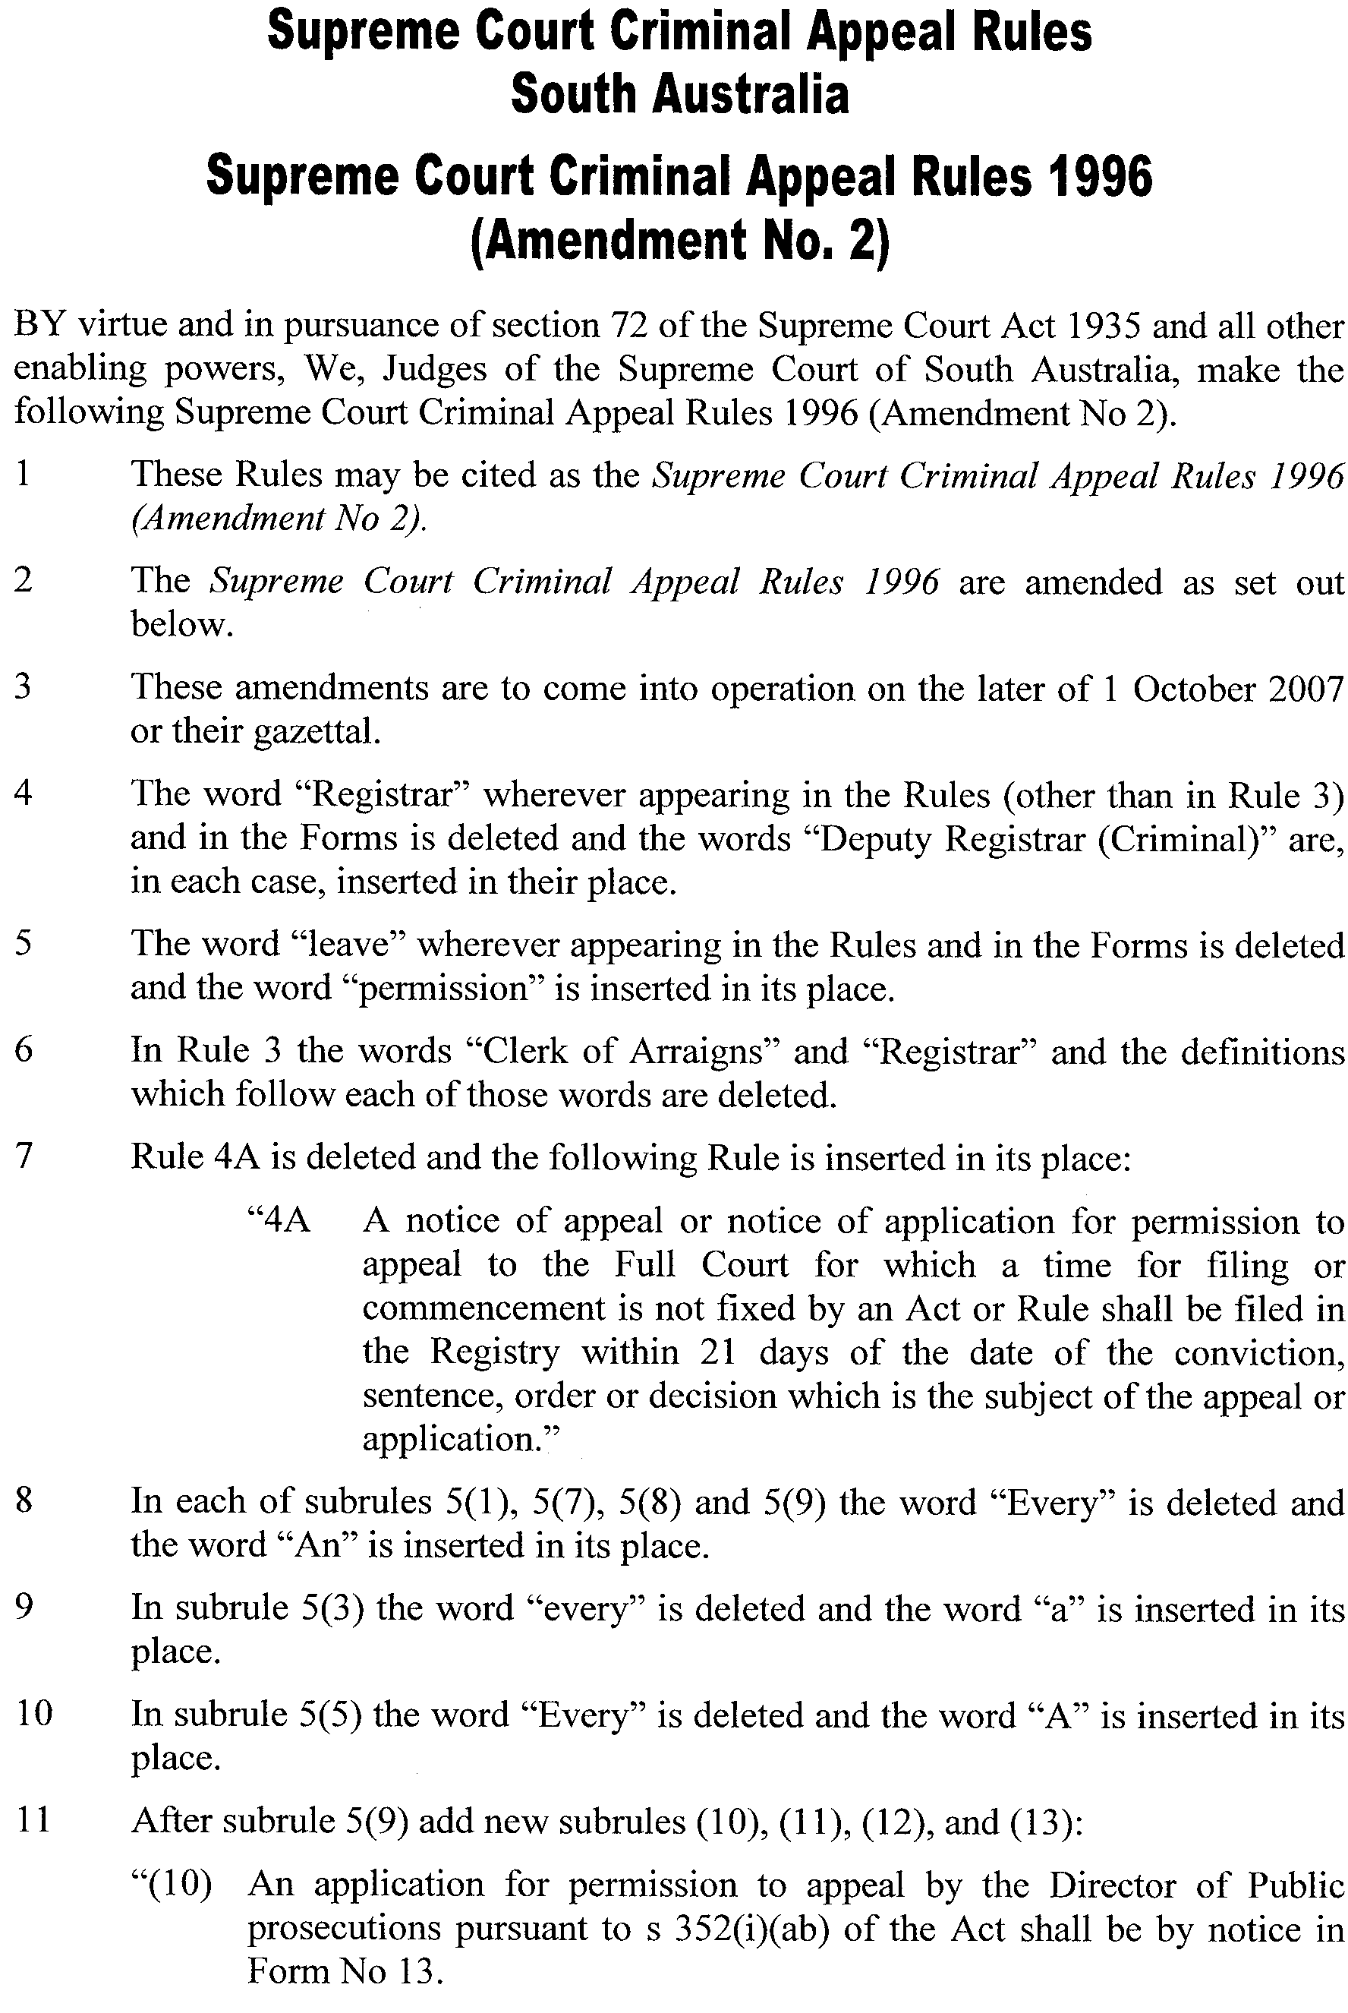

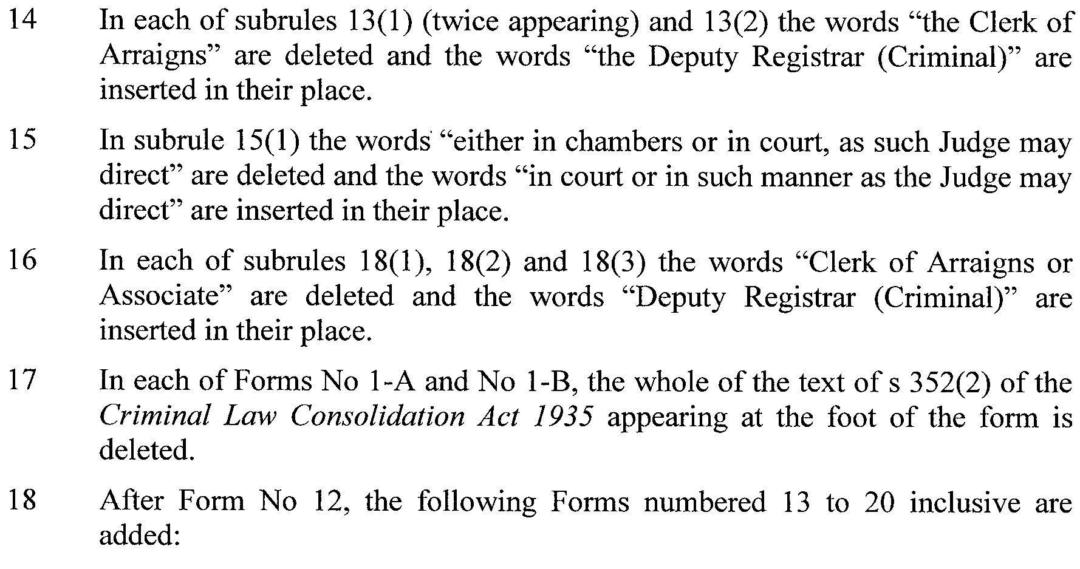
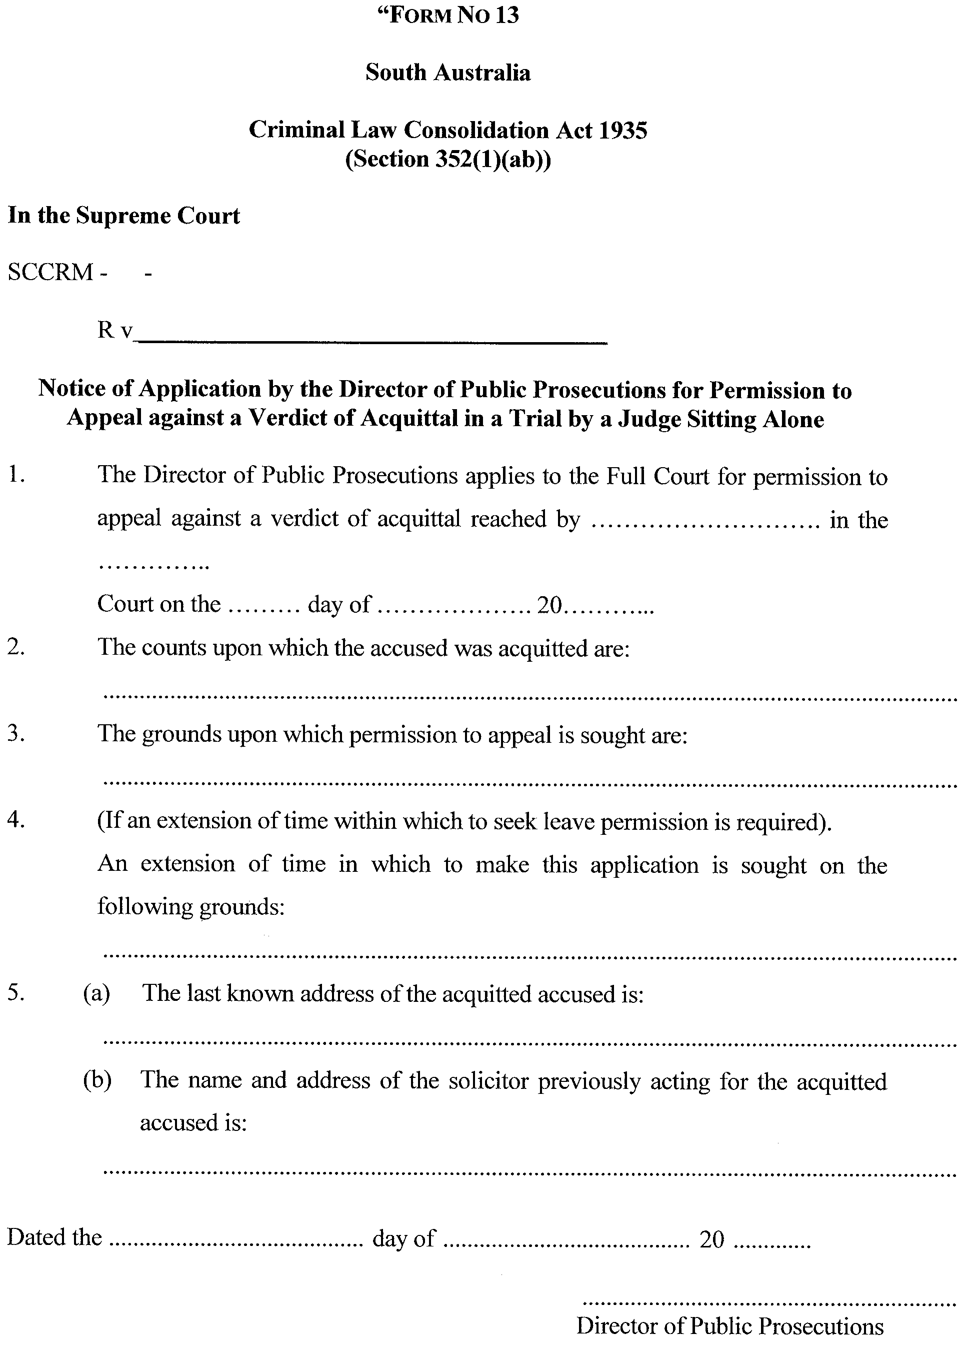
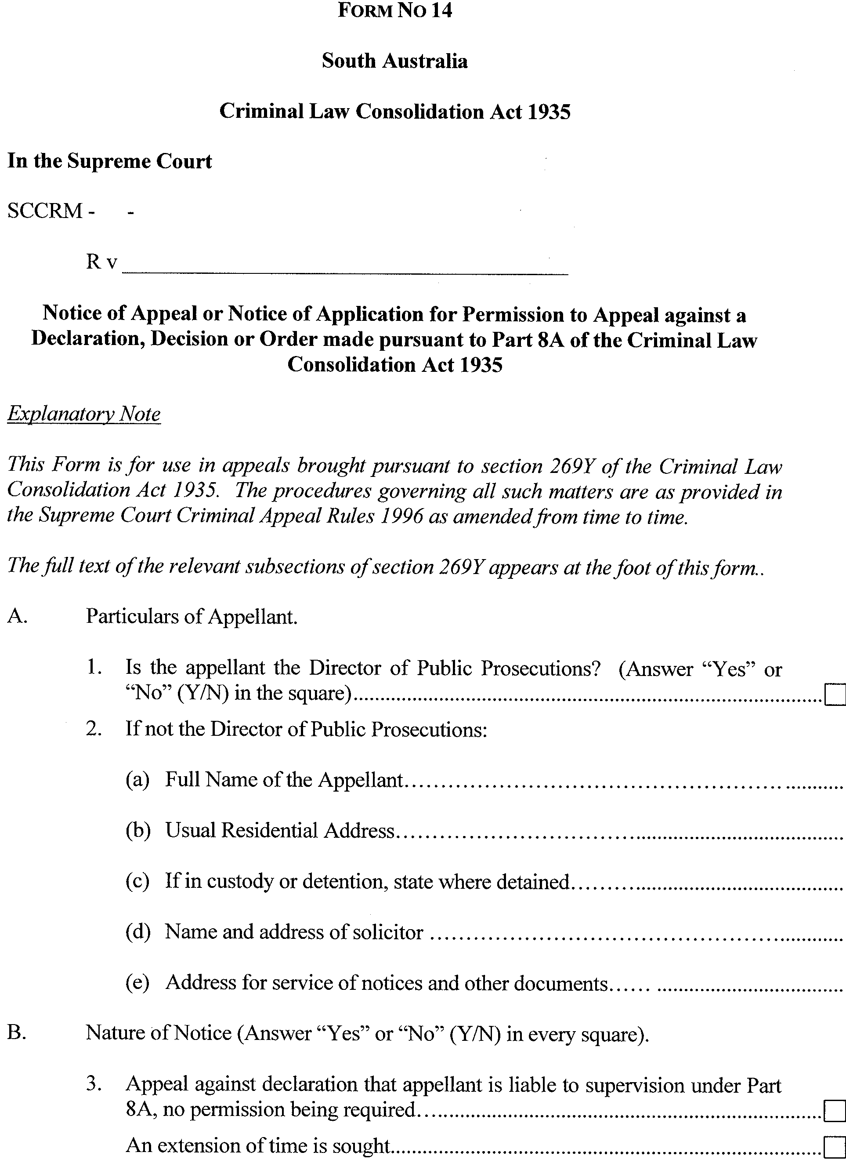
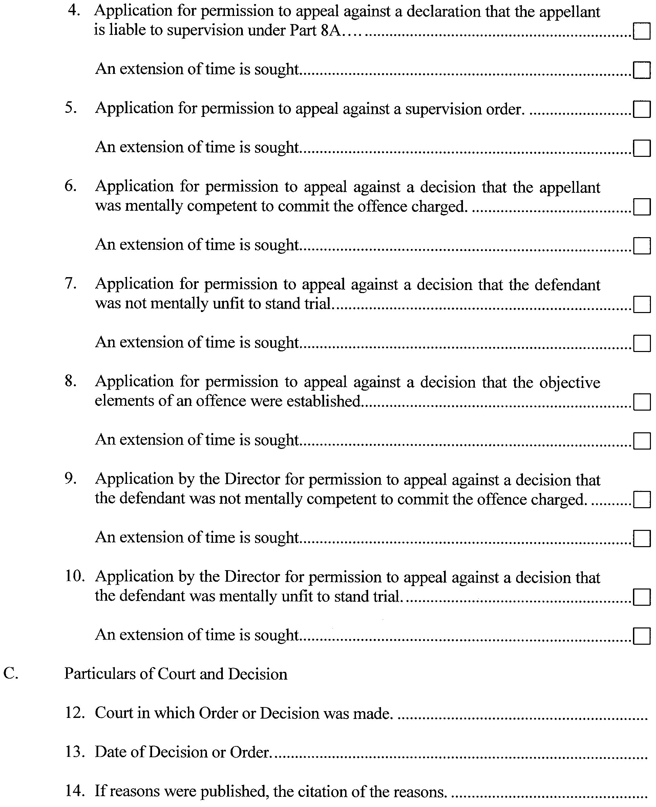
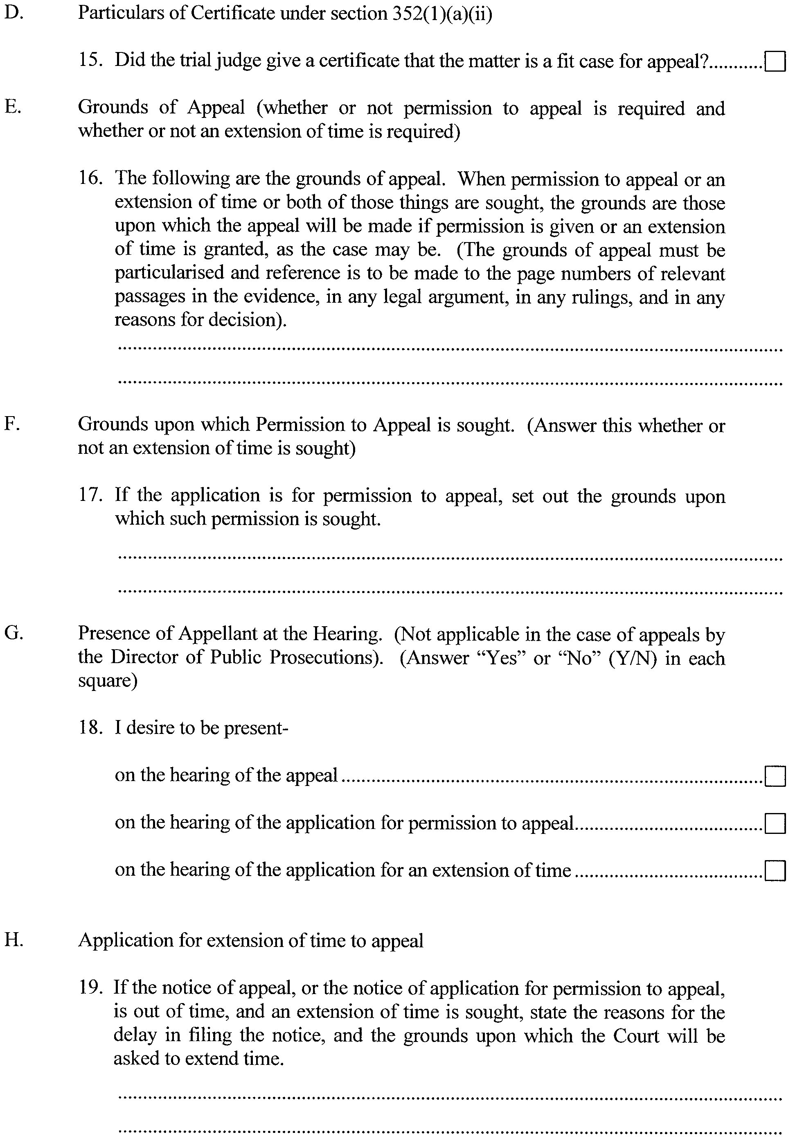
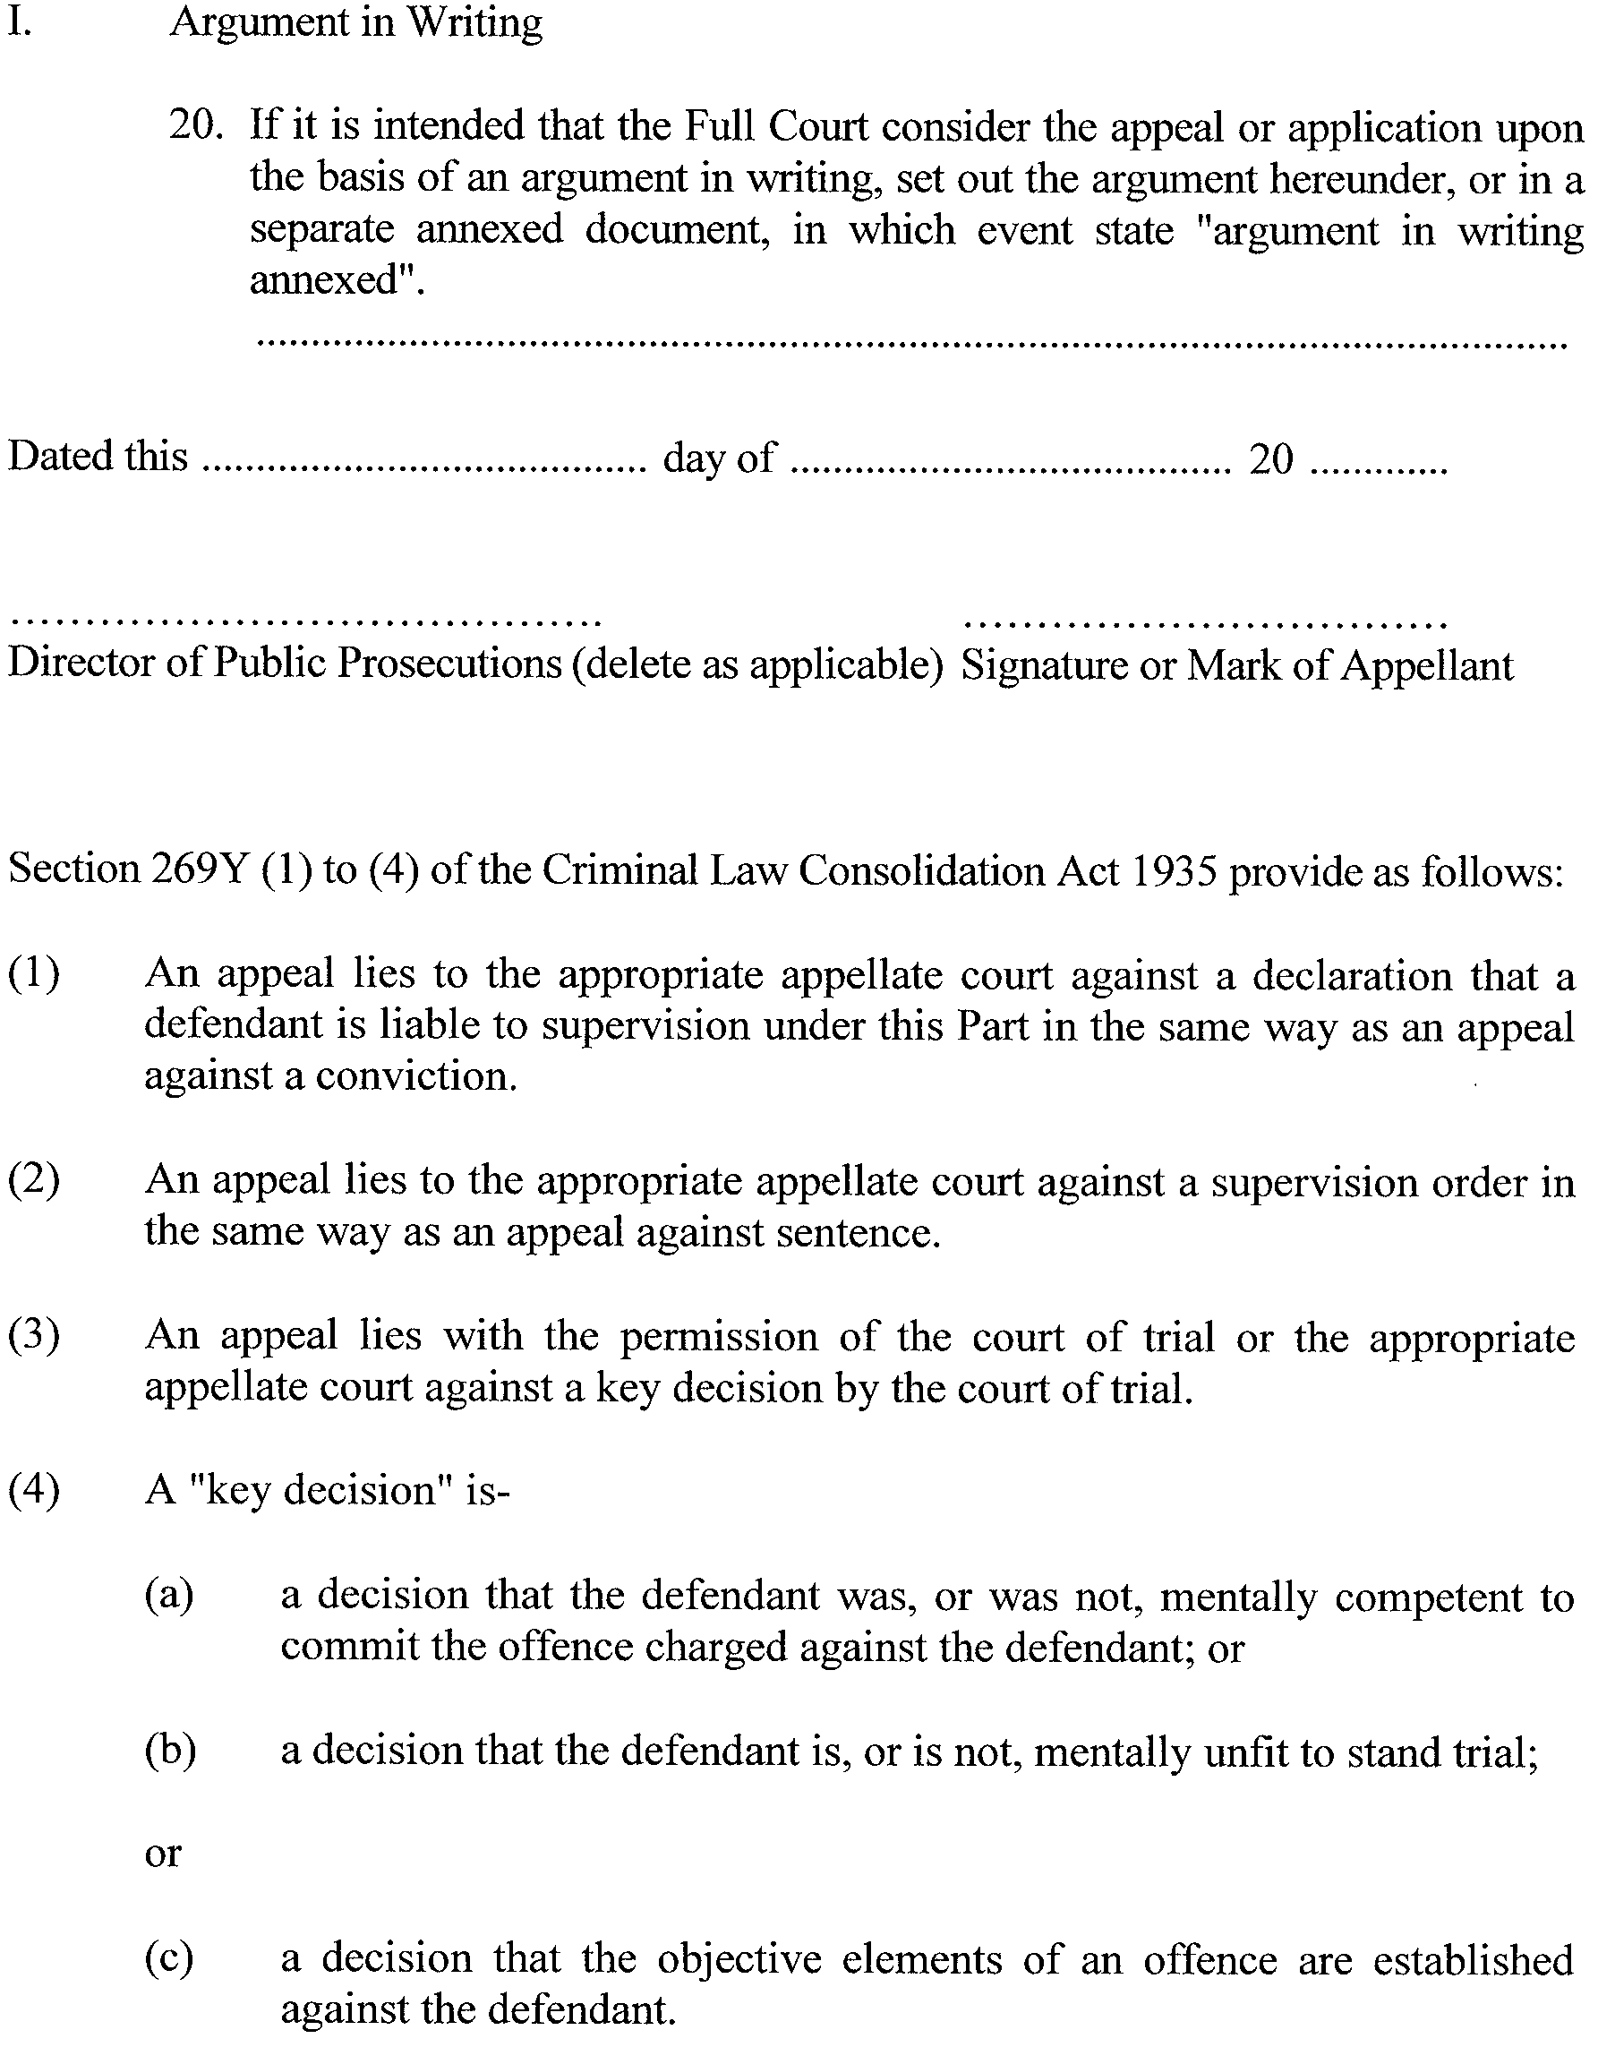
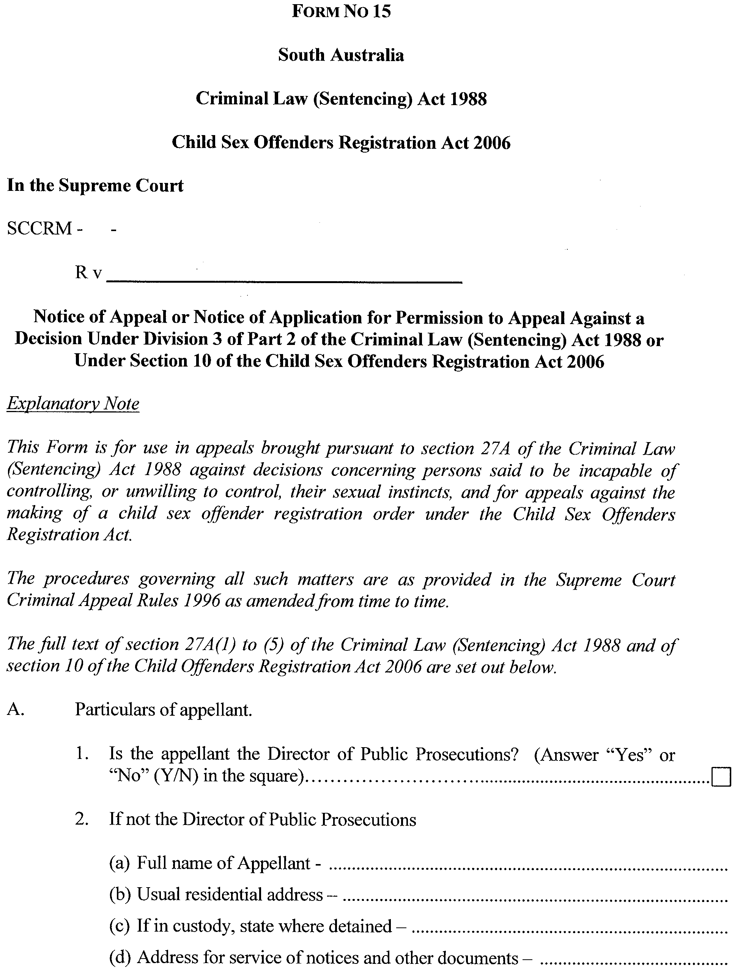
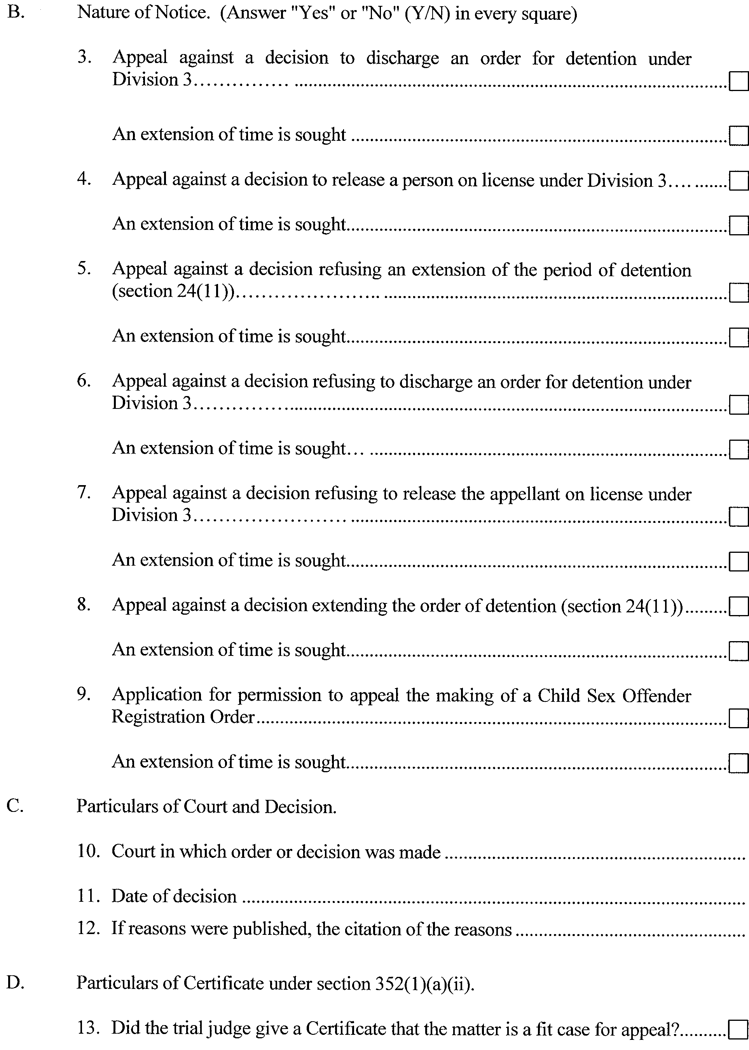
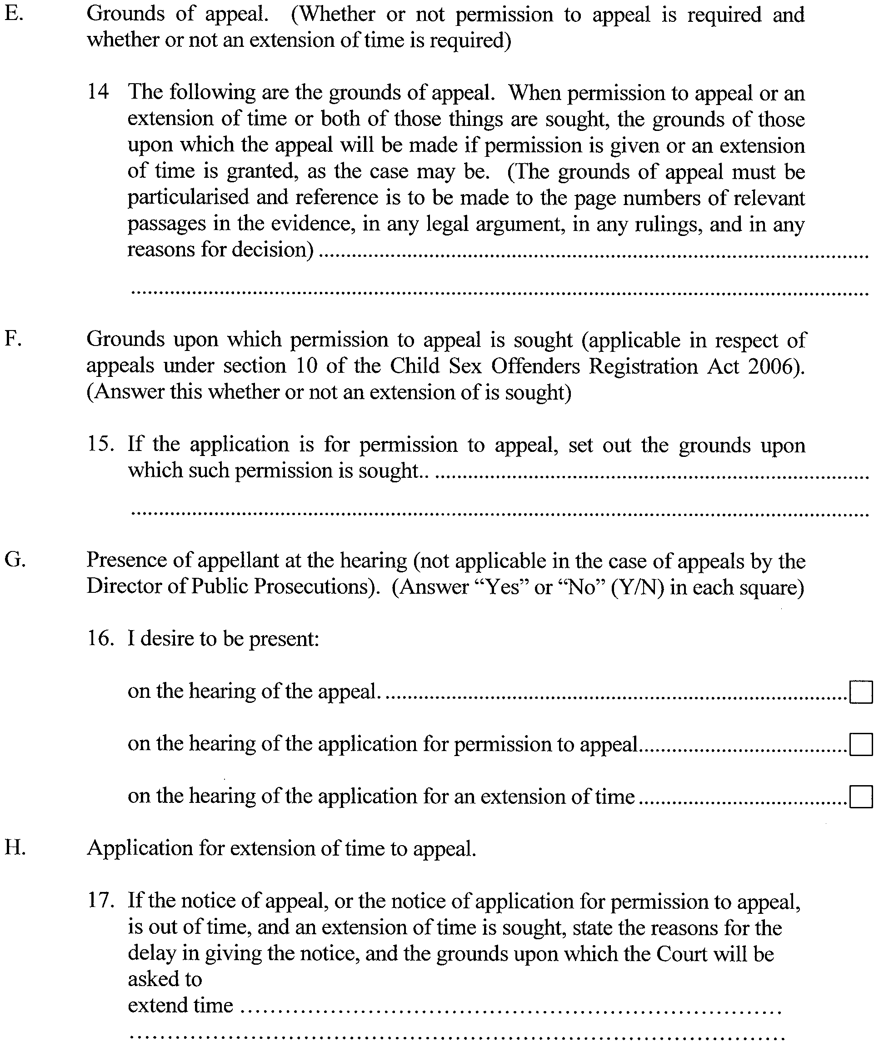
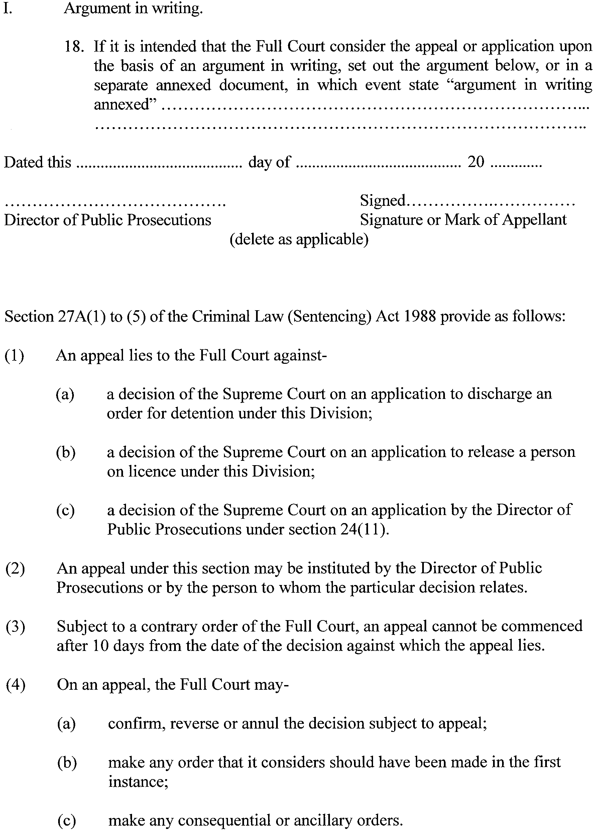
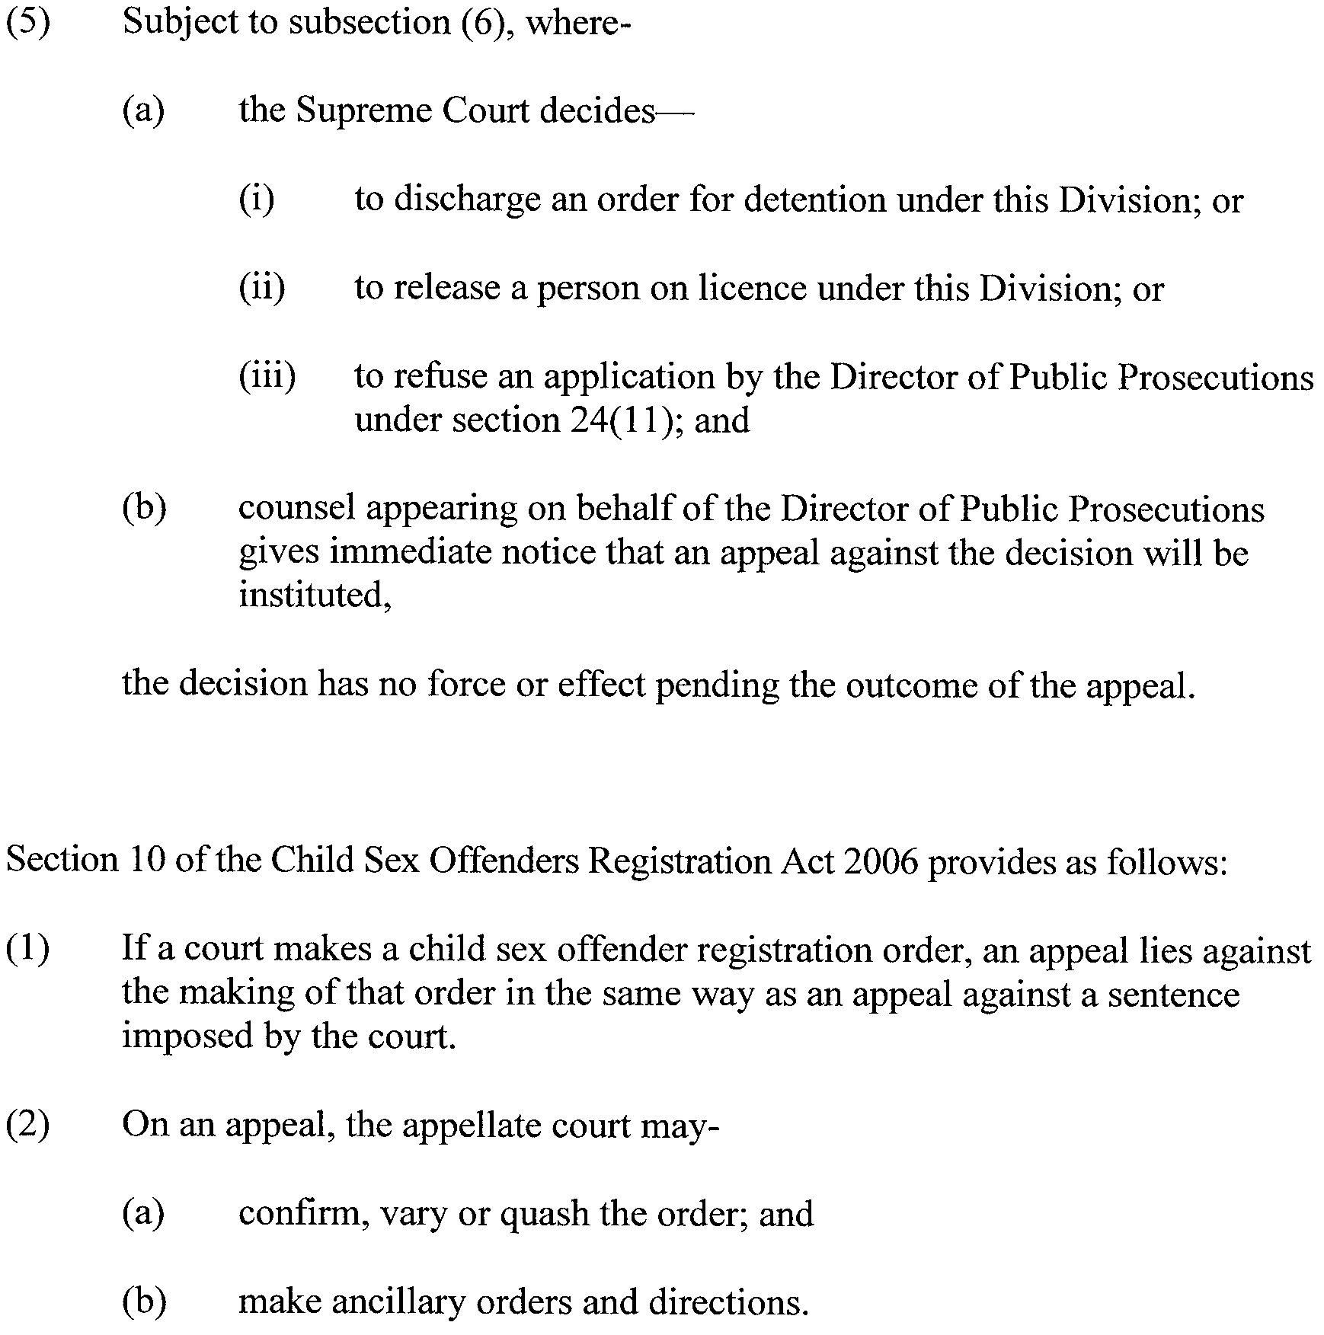
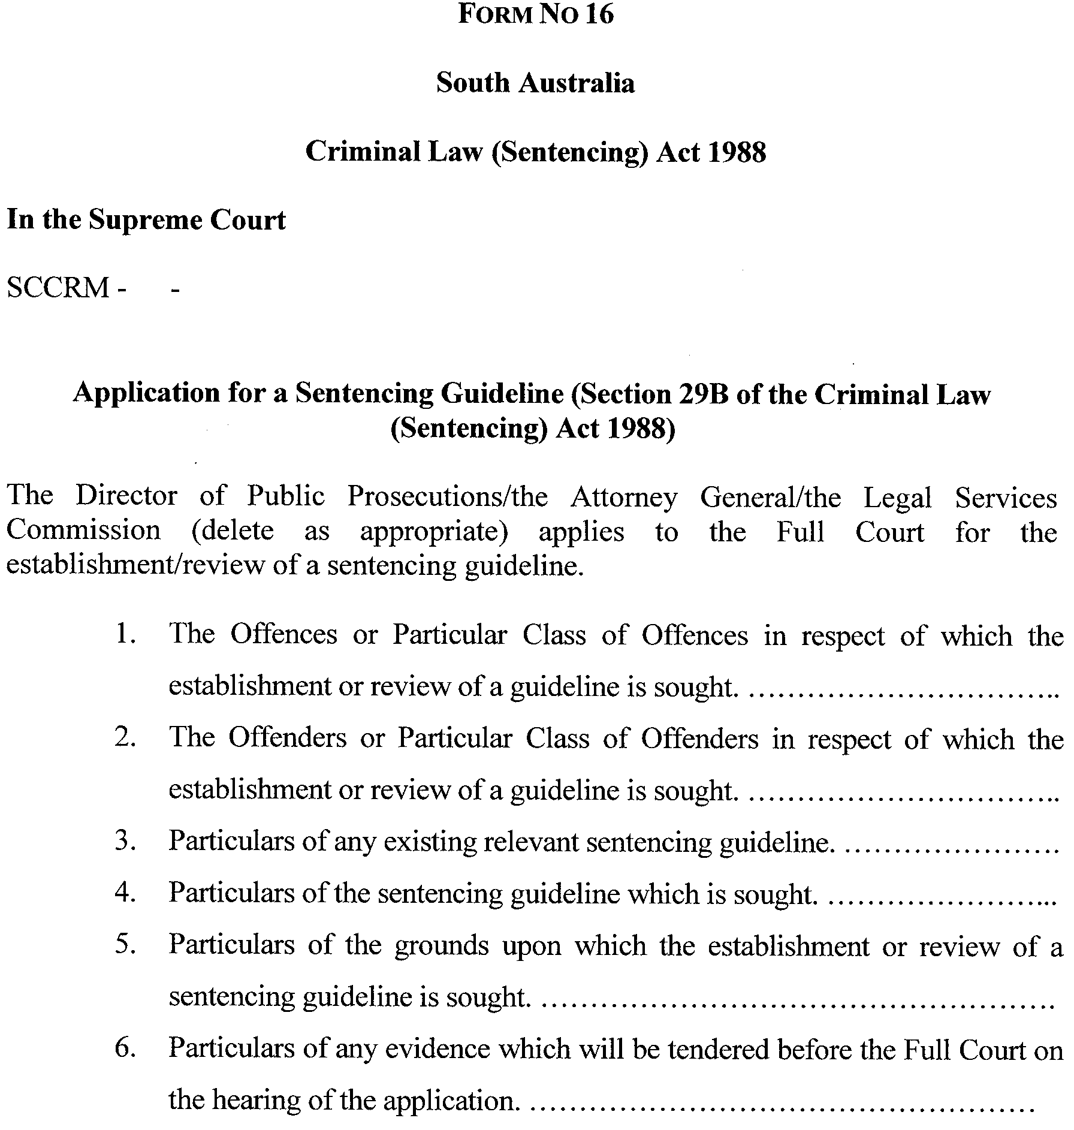

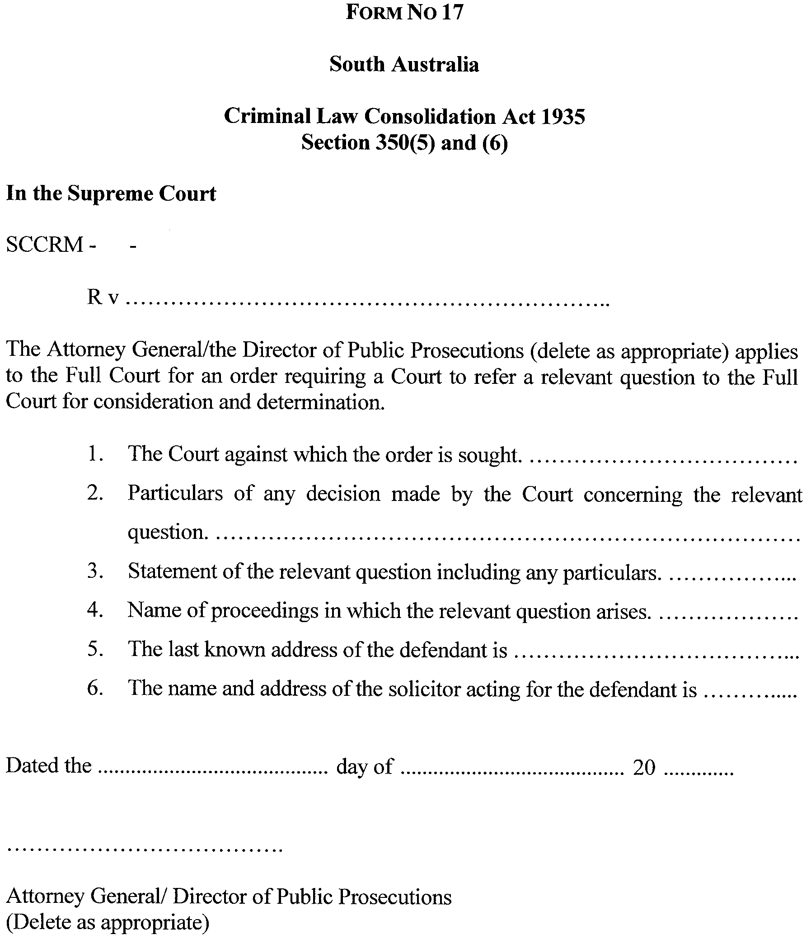
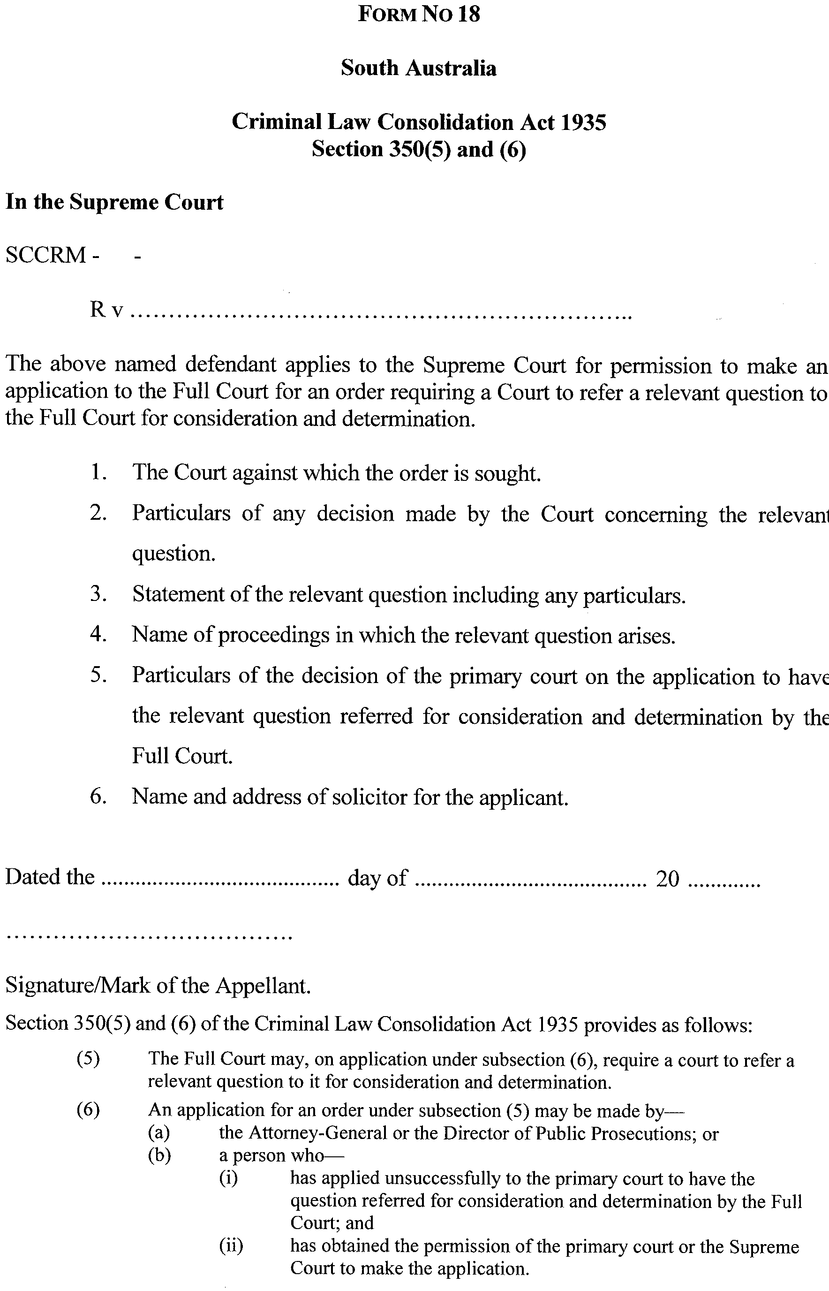
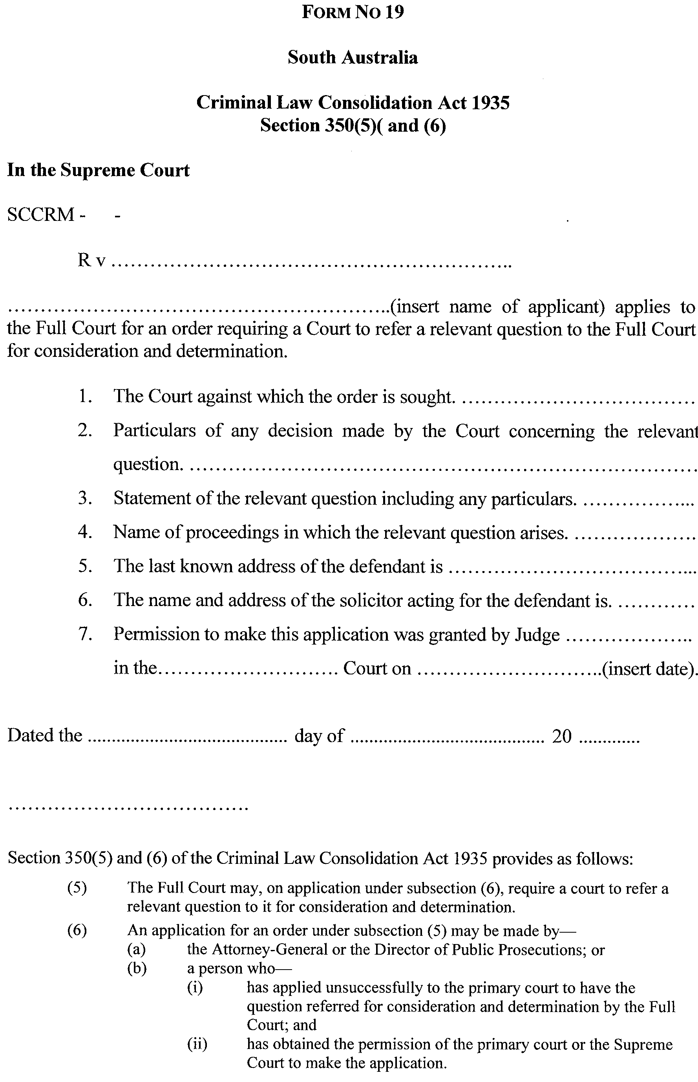
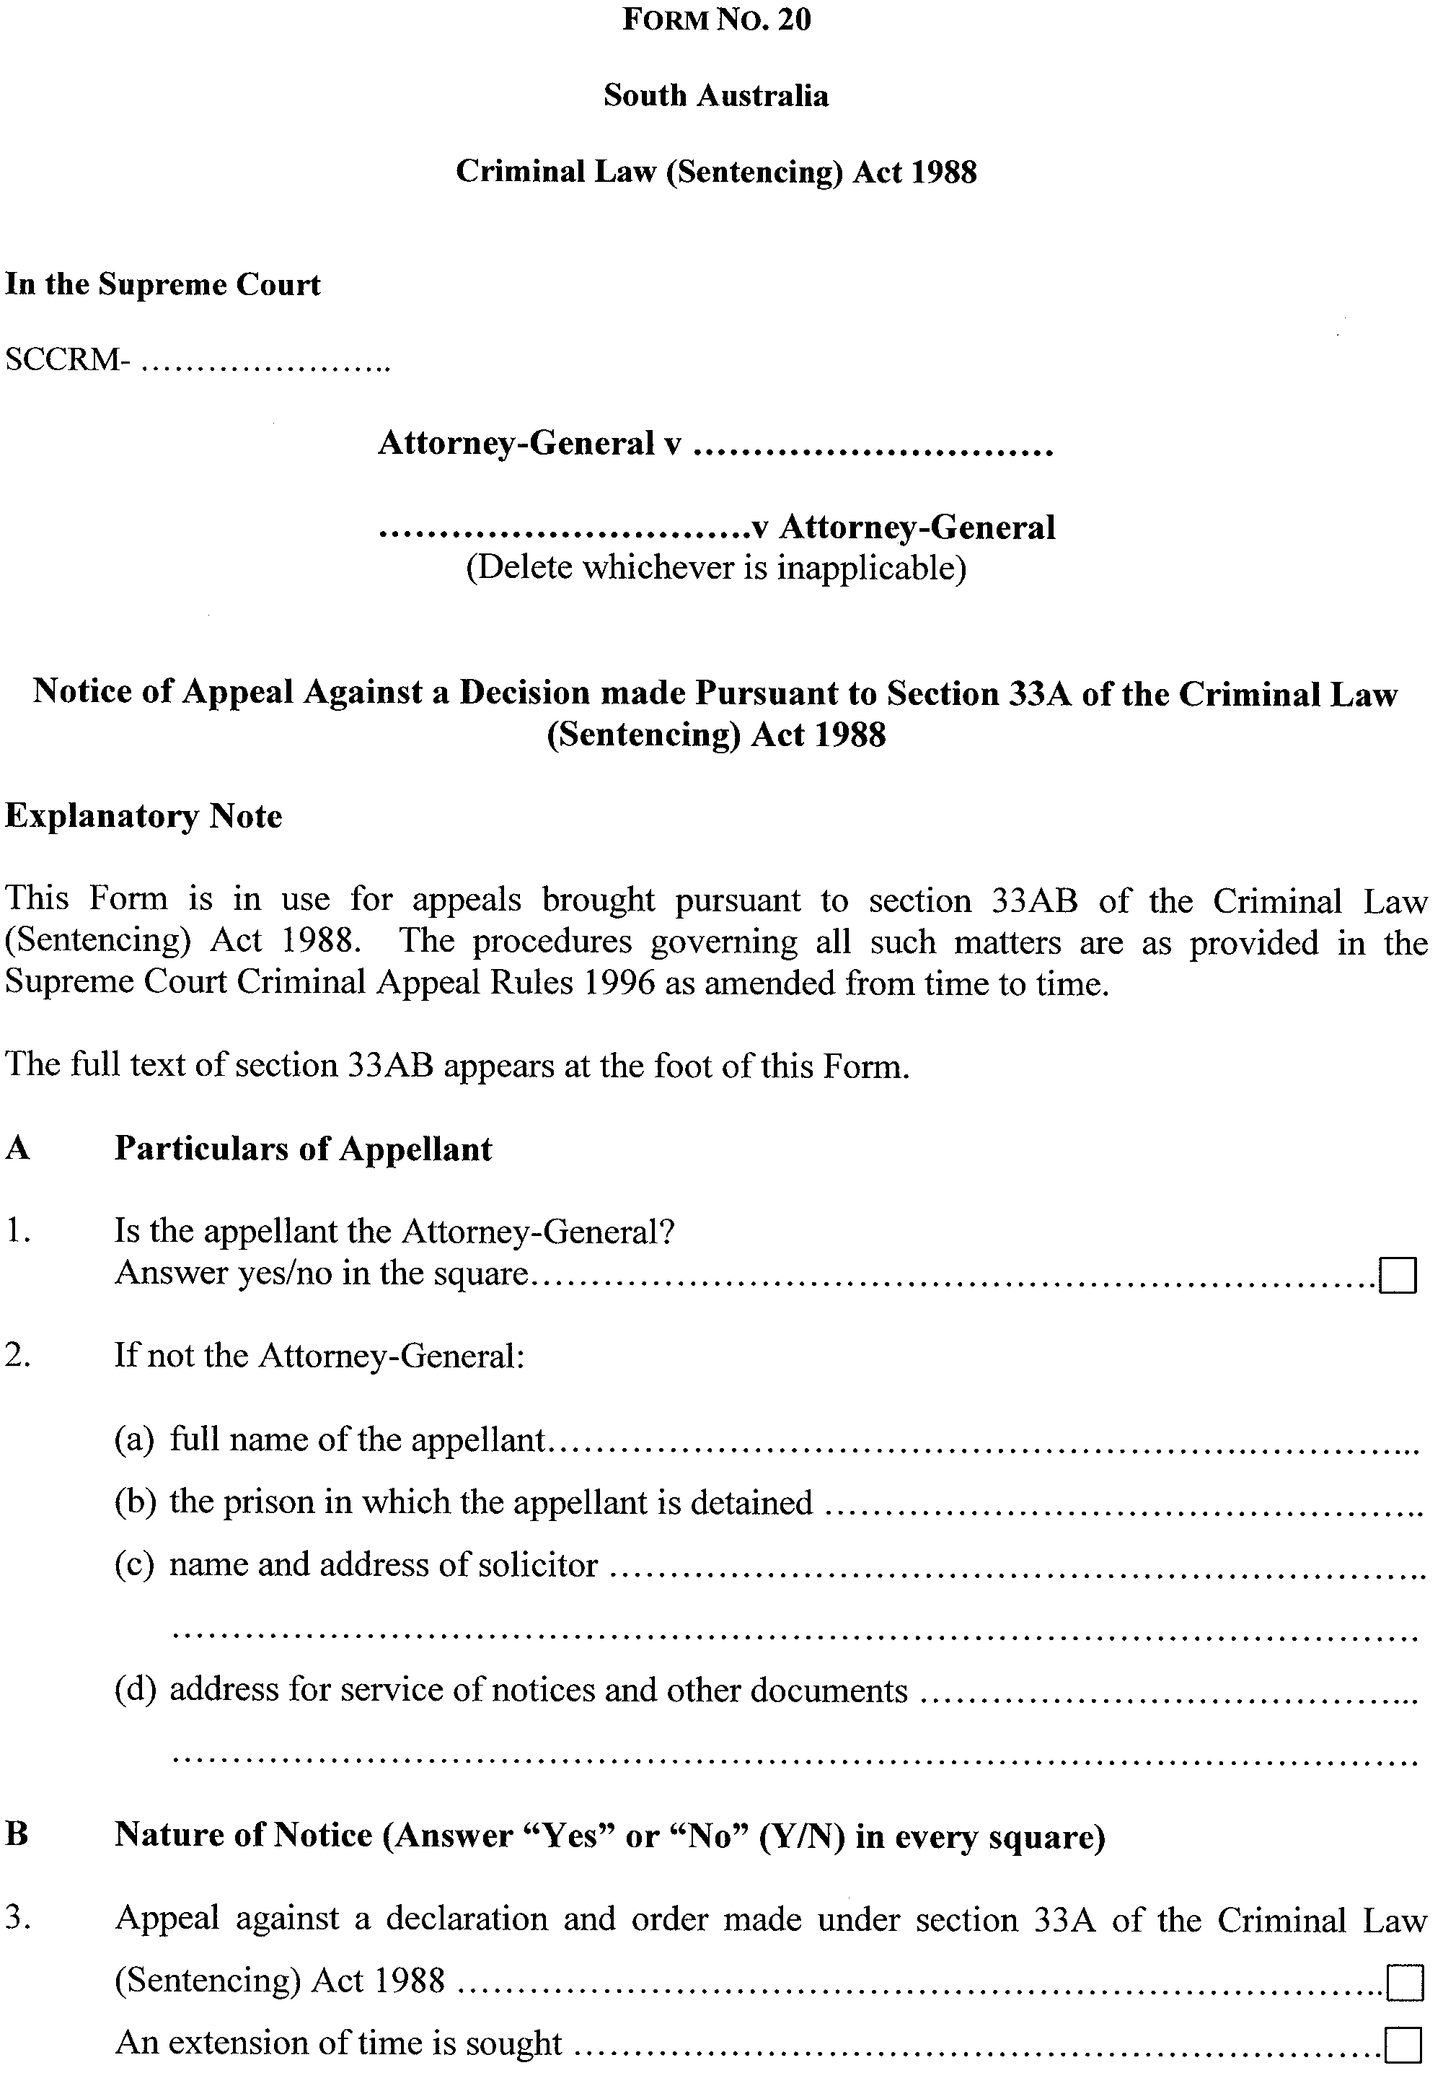
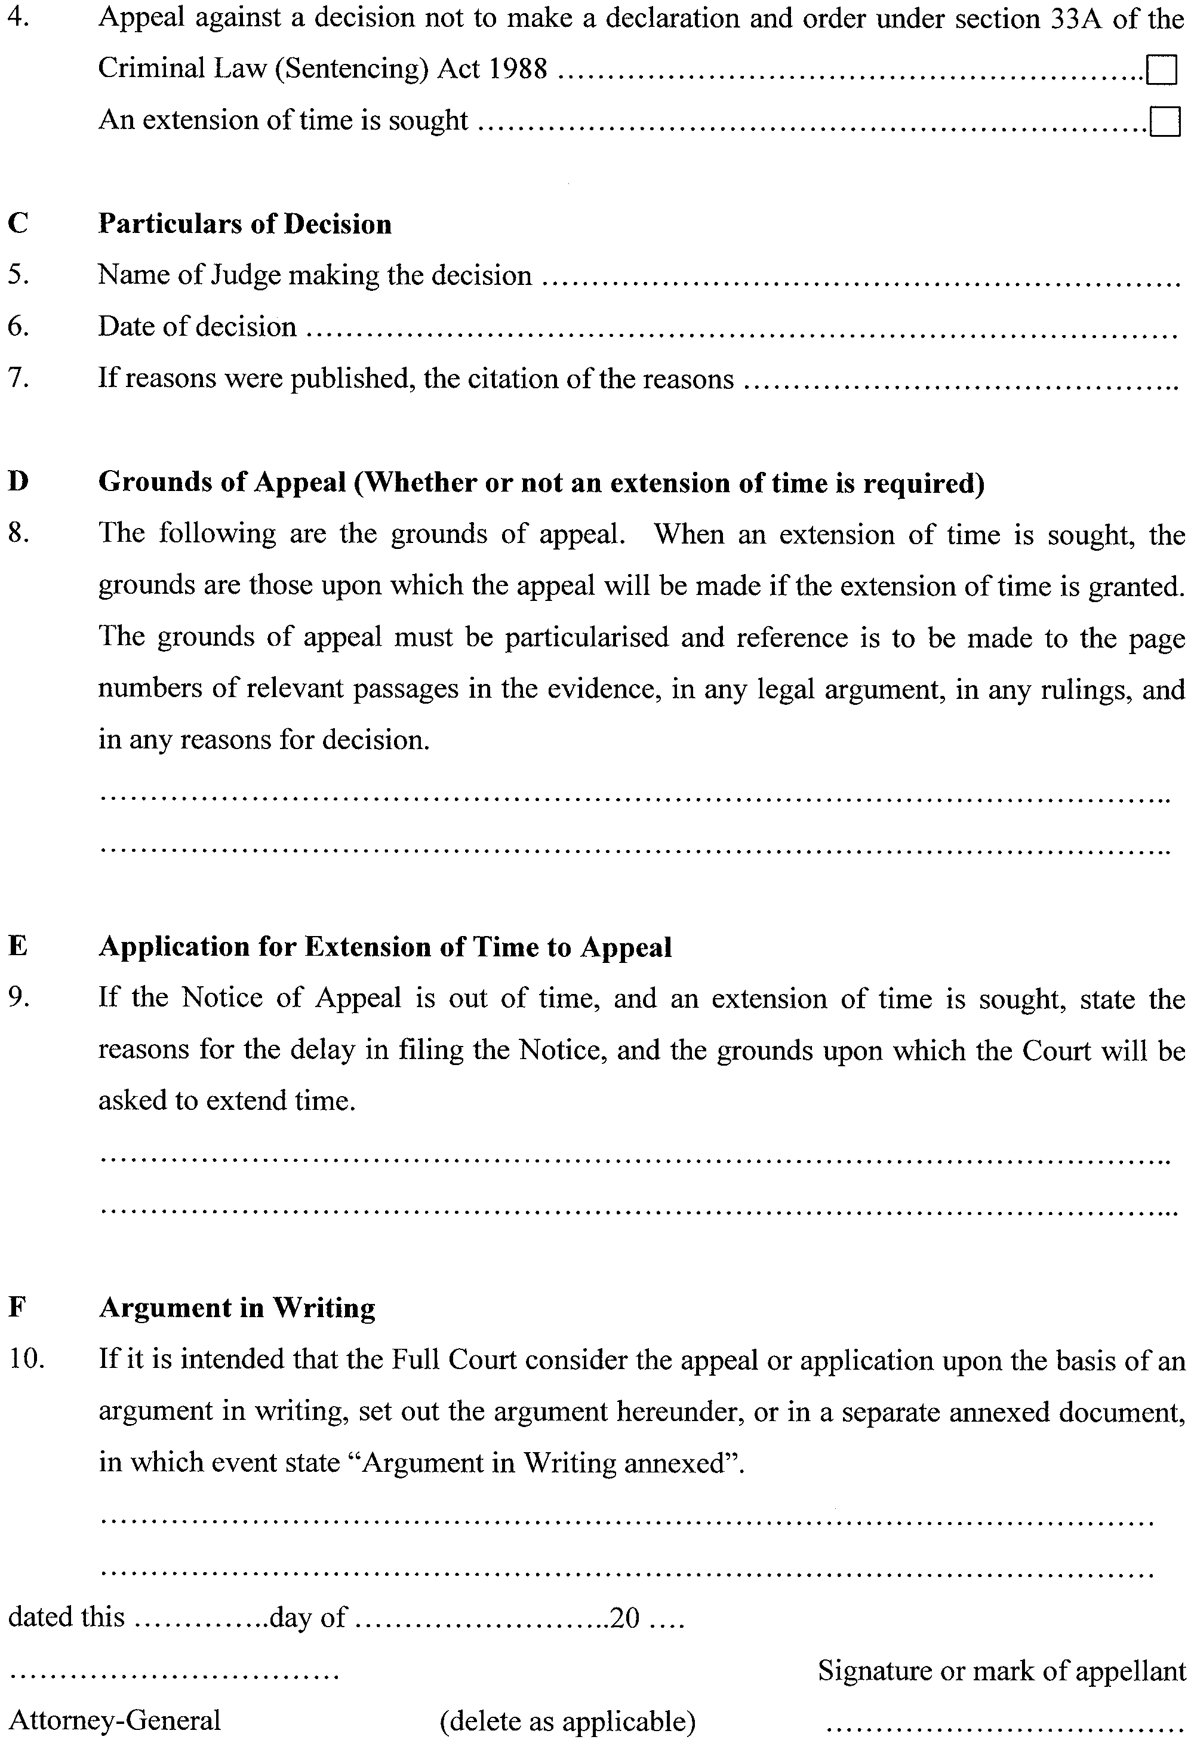
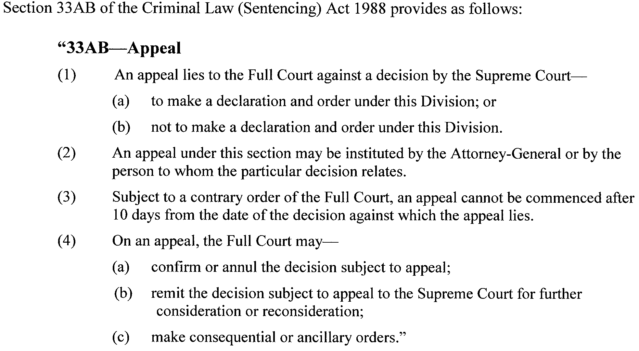

GIVEN under our hands and the Seal of the Supreme Court of South Australia this 27th day of August 2007.
(l.s.) J. J. DOYLE, CJ
K. P. DUGGAN, J
B. M. DEBELLE, J
D. J. BLEBY, J
T. A. GRAY, J
J. R. SULAN, J
A. M. VANSTONE, J
T. R. ANDERSON, J
R. C. WHITE, J
R. A. LAYTON, J
M. DAVID, J
P. KELLY, J

South Australia
Mining (Revocation of Private Mine) Proclamation 2007
under section 73N of the Mining Act 1971

Preamble
1 The following areas were declared to be a private mine by proclamation on
8 March 1973 (Gazette 8.3.1973 p861):
(a) portion of section 370, hundred of Yatala, county of Adelaide, being the
whole of the land described in certificate of title, Register Book,
volume 3162, folio 6; and
(b) portion of section 371, hundred of Yatala, county of Adelaide, being the
whole of the land described in certificate of title, Register Book,
volume 1744, folio 72.
2 It should be noted that the description of land in clause 1(b) refers to land that did not
exist at the time of the proclamation (and has never existed) and as a consequence that
part of the declaration is and always has been void and of no effect.
3 The Warden's Court has declared (on 16 November 2006 in Action No 472 of 2006)
that proper grounds exist for revoking the declaration referred to in clause 1.

1—Short title
This proclamation may be cited as the Mining (Revocation of Private Mine) Proclamation 2007.
2—Commencement
This proclamation comes into operation on the day on which it is made.
3—Revocation of private mine
The declaration referred to in clause 1 of the preamble is revoked.
Made by the Governor’s Deputy
on the basis of the declaration of the Warden's Court referred to in clause 3 of the preamble
and with the advice and consent of the Executive Council
on 13 September 2007
AGO0047/02CS

South Australia
Associations Incorporation Variation Regulations 2007
under the Associations Incorporation Act 1985

Contents
Part 1—Preliminary
1 Short title
2 Commencement
3 Variation provisions
Part 2—Variation of Associations Incorporation Regulations 1993
4 Insertion of regulation 4A
4A Definition of prescribed association

Part 1—Preliminary
1—Short title
These regulations may be cited as the Associations Incorporation Variation Regulations 2007.
2—Commencement
These regulations will come into operation four months after the day on which they are made (see Subordinate Legislation Act 1978 section 10AA).
3—Variation provisions
In these regulations, a provision under a heading referring to the variation of specified regulations varies the regulations so specified.
Part 2—Variation of Associations Incorporation Regulations 1993
4—Insertion of regulation 4A
After regulation 4 insert:
4A—Definition of prescribed association
For the purposes of paragraph (a)(ii) of the definition of prescribed association in section 3(1) of the Act, the amount prescribed is $500 000.
Made by the Governor’s Deputy
with the advice and consent of the Executive Council
on 13 September 2007
No 231 of 2007
OCBACS00001/07

FAXING COPY?
IF you fax copy to Government Publishing SA for inclusion in the Government Gazette, there is no need to send a Confirmation Copy to us as well.
This creates confusion and may well result in your notice being printed twice.
Please use the following fax number:
Fax transmission: (08) 8207 1040
Phone Inquiries: (08) 8207 1045
Please include a contact person, phone number and order number so that we can phone back with any queries we may have regarding the fax copy.
NOTE: Closing time for lodging new copy (fax, hard copy or email) is 4 p.m. on Tuesday preceding the day of publication.

Government Gazette notices can be E-mailed.
The address is:
governmentgazette@dpc.sa.gov.au
Documents should be sent as attachments in Word format.
When sending a document via E-mail, please confirm your transmission with a faxed copy of your document, including the date the notice is to be published.
Fax transmission: (08) 8207 1040
Enquiries: (08) 8207 1045
NOTE: Closing time for lodging new copy (fax, hard copy or email) is 4 p.m. on Tuesday preceding the day of publication.

CITY OF NORWOOD PAYNEHAM & ST PETERS
Roads (Opening and Closing) Act 1991
Road Closure, Portion of Diekman Avenue, Felixstow
NOTICE is hereby given pursuant to section 10 of the Act, that Council proposes to make a Road Process Order to close and retain the eastern end of Diekman Avenue, (east of Riverside Drive) shown as ‘A’ on Preliminary Plan No. 07/0067.
A copy of the plan and statement of persons affected are available for public inspection at Council’s Office, 175 The Parade, Norwood, and the office of the Surveyor-General, 101 Grenfell Street, Adelaide during normal office hours.
Any application for easement or objections must be made in writing within 28 days from 6 September 2007, to the Council, P.O. Box 204, Kent Town, S.A. 5071 and the Surveyor-General, G.P.O. Box 1354, Adelaide, S.A. 5001, setting out full details.
Where a submission is made, Council will give notification of a meeting to deal with the matter.
M. Barone, Chief Executive Officer

PORT AUGUSTA CITY COUNCIL
Appointment of Authorised Officer
NOTICE is hereby given that Council at its meeting held on 27 August 2007, appointed Randall Figg to the Port Augusta City Council Building Fire Safety Committee and appoints Randall Figg as an Authorised Officer, pursuant to section 18 of the Development Act 1993, to enable him to enter and inspect Fire Safety of existing and new buildings within the City of Port Augusta.
The Authorised Officer appointment made to Rodney Kersten is hereby revoked.
J. G. Stephens, City Manager

CITY OF SALISBURY
Change of Road Name
NOTICE is hereby given, pursuant to section 219 of the Local Government Act 1999, the City of Salisbury at its meeting held on 27 August 2007, resolved the following:
• Deposited Plan 71298 dated 11 June 2006 and Deposited Plan 74136 dated 18 June 2007, be amended to show portion of Adeline Street, Mawson Lakes as Sylvia Court and the necessary statutory notifications take place.
S. Hains, City Manager

CITY OF SALISBURY
Change of Road Name
NOTICE is hereby given, pursuant to section 219 of the Local Government Act 1999, the City of Salisbury at its meeting held on 27 August 2007, resolved the following:
• Deposited Plan 73894 be amended to show Maxwell Court, Para Hills/Ingle Farm as Jennier Crescent and the necessary statutory notifications take place.
S. Hains, City Manager

KANGAROO ISLAND COUNCIL
Appointment of Acting Chief Executive Officer
NOTICE is hereby given pursuant to section 102 of the Local Government Act 1999, that at a meeting of Council held on
6 September 2007, Council appointed Colin Dunlop as Acting Chief Executive Officer from 17 September 2007 to 19 October 2007.
N. Brown, Chief Executive Officer

DISTRICT COUNCIL OF KIMBA
Roads (Opening and Closing) Act 1991
Road Closure, Donaldson Road, Buckleboo
NOTICE is hereby given pursuant to section 10 of the said Act, that the District Council of Kimba proposes to make a Road Process Order to close and vest in AusBulk Ltd the portion of Donaldson Road adjoining the silos (allotment 100 in Deposited Plan 60112), delineated as ‘A’ on Preliminary Plan No. 07/0069.
A copy of the plan and statement of persons affected are available for public inspection at the Administration Office, Cross Street, Kimba and the office of the Surveyor-General, 101 Grenfell Street, Adelaide, during normal office hours.
Any application for easement or objection must set out the full name, address and give details of the submission with fully supported reasons.
Any submissions must be made in writing within 28 days from 13 September 2007, to the Council, P.O. Box 189, Kimba, S.A. 5641 and the Surveyor-General, G.P.O. Box 1354, Adelaide, S.A. 5001.
Where a submission is made, Council will give notification of a meeting to deal with the matter.
D. Cearns, Chief Executive Officer

DISTRICT COUNCIL OF LOWER EYRE PENINSULA
Roads (Opening and Closing) Act 1991
Road Closure—Proper Bay Road, Sleaford
NOTICE is hereby given pursuant to section 10 of the Roads (Opening and Closing) Act 1991, that Council proposes to make a Road Process Order to close and transfer to R. G. Gynell (owner of adjoining allotment 236), the portion of Proper Bay Road in the Hundred of Lincoln as delineated and lettered ‘A’ in Preliminary Plan No. 07/0064.
A copy of the plan and statement of persons affected are available for public inspection at Council’s Offices, Railway Terrace, Cummins and 38 Washington Street, Port Lincoln and the Surveyor-General’s Office, 101 Grenfell Street, Adelaide, during normal office hours.
Any application for easement or objection must set out the full name, address and details of the submission and must be fully supported by reasons.
The application for easement or objection must be made in writing within 28 days of this notice to the Council, P.O. Box 41, Cummins, S.A. 5631 and a copy must be forwarded to the Surveyor-General, G.P.O. 1354, Adelaide, S.A. 5001. Where a submission is made, Council will give notification of a meeting to deal with the matter.
Dated 10 September 2007.
P. Aird, Chief Executive Officer

DISTRICT COUNCIL OF MALLALA
Rename and Assign Road Names
NOTICE is hereby given in accordance with section 219 of the Local Government Act 1999, that the Council at its meeting held on Monday, 20 August 2007, resolved to rename and assign the following road names:
That the roadway currently named Halstead Road, west of Port Wakefield Road be renamed Halstead Road West.
That the roadway currently named Artesian Road, west of Port Wakefield Road be renamed Artesian Road West.
That the roadway adjacent Allotment 326, Filed Plan 174793, Allotment 323, Filed Plan 174790, Allotment 8, Filed Plan 148257 and Allotment 31, Deposited Plan 033249, Hundred of Port Gawler be assigned the name Condon Road.
D. Moloney, Chief Executive Officer

DISTRICT COUNCIL OF MALLALA
Rename Road Names
NOTICE is hereby given in accordance with section 219 of the Local Government Act 1999, that the Council at its meeting held on Monday, 21 March 2005, resolved to rename and assign the following road names:
That the roadway adjacent Allotment 8, Deposited Plan 007364, Allotment 150, Deposited Plan 059456, Hundred of Port Gawler and Allotment 3, Deposited Plan 007364 and Allotment 291, Filed Plan 162640, Hundred of Port Gawler be renamed Tower Road.
That the private roadway, Allotment 19, Deposited Plan 007364, Hundred of Port Gawler, be renamed Robins Road.
D. Moloney, Chief Executive Officer

DISTRICT COUNCIL OF MOUNT BARKER
Exclusion of Vehicles
NOTICE is hereby given that on 2 August 2007, the District Council of Mount Barker resolved that, pursuant to section 359 of the Local Government Act 1934, as amended:
1. All motor vehicles, except those specified at Part 2 of this resolution, be excluded from portion of Hunt Road, Mount Barker, commencing at the point 200 m west of Barker Road, adjacent to Allotment 2 in Filed Plan 85 and Allotment 18 in Filed Plan 160095 and ceasing at the point 900 m west of Barker Road, adjacent to Allotment 16 in Filed Plan 160093 and Allotment 17 in Filed Plan 160094 as identified in the plan attached to this Report and marked Appendix 1 as from the date of publication of this resolution in the South Australian Government Gazette and in a newspaper circulating within the Council’s area.
2. The following classes of vehicles be exempted from Part 1 of this resolution:
• Country Fire Services vehicles;
• SA Ambulance vehicles;
• Police vehicles; and
• Adjoining landholder’s vehicles.
3. Pursuant to section 17 of the Road Traffic Act 1961, Clause A of the Minister’s ‘Notice to Council to use Traffic Control Devices and to Close Roads and Grant Exemptions for Events’, the Council authorises the Chief Executive Officer to install, operate and maintain or cause to be installed, operated and maintained such traffic control devices as are necessary to give effect to the Council’s resolution.
A. Stuart, Chief Executive Officer

NORTHERN AREAS COUNCIL
Appointment
NOTICE is hereby given that at its meeting held on 21 August 2007, Council resolved pursuant to section 56A (22) of the Development Act 1993, to appoint the Chief Executive Officer, Keith Hope as Public Officer of the Northern Areas Council—Council Development Assessment Panel. The Public Officer can be contacted at the Principal Office of the Council, 94 Ayr Street, Jamestown, S.A. 5491 or by telephone (08) 8664 1139.
C. Davies, Acting Chief Executive Officer

ROXBY DOWNS COUNCIL
Adoption of Valuations and Declaration of Rates 2007-2008
NOTICE is hereby given that the Municipal Council of Roxby Downs, for the financial year ending 30 June 2008, and in exercise of the powers contained in Chapter 10 of the Local Government Act 1999 and the Roxby Downs (Indenture Ratification) Act 1982, adopted the following resolutions:
Adoption of Valuation
1. (1) The rates assessed on rateable land in the area of the Council will be based on the capital value of land for all rateable land.
(2) Pursuant to section 167 (2) (a) of the Local Government Act 1999, the most recent valuations of the Valuer-General available to the Council of the capital value of land within the Council’s area be adopted, totalling $510 465 900.
Fixed Charge
2. A fixed charge of $300 is imposed in respect of each separate piece of rateable land in the Council area.
Declaration of Differential General Rates
3. Differential General Rates are declared in accordance with the use of the land in accordance with the differentiating factors specified at Regulation 10 of the Local Government (General) Regulations 1999, as follows:
(1) Residential Land—a differential rate of 0.2660 cents in the dollar on the capital value of such land.
(2) Commercial Shops, Commercial Office, Commercial Other—a differential rate of 0.7500 cents in the dollar on the capital value of such land.
(3) Industrial Light, Industrial Other, Primary Production and Other—a differential rate of 0.6750 cents in the dollar on the capital value of such land.
(4) Vacant Land—a differential rate of 0.4750 cents in the dollar on the capital value of such land.
Service Charges
4. A service charge of $155 is imposed upon each separate piece of rateable land to which the Council makes available a collection, treatment and disposal of domestic waste service.
Method of Payment
5. That in accordance with section 181 of the Local Government Act 1999, the 2007-2008 General Rates (Fixed Charges and Differential Rates) and Service Charge shall be in four instalments payable on 1 October 2007, 17 December 2007, 17 March 2008 and 16 June 2008.
Dated 31 August 2007.
W. J. Boehm, Administrator

IN the matter of the estates of the undermentioned deceased persons:
Brant, Jean Agnes, late of Pioneer Street, Stansbury, retired clerical assistant, who died on 23 May 2007.
Colbey, Muriel Constance, late of Coneybeer Street, Berri, retired public servant, who died on 25 June 2007.
Friers, John Molyneux, late of 5 McCormack Street, Kapunda, retired aircraft engineer, who died on 2 June 2007.
Galvin, Queenie May, late of 122 Esplanade, Semaphore, of no occupation, who died on 25 July 2007.
Graham, Edwin Walter, late of Fosters Road, Oakden, of no occupation, who died on 22 October 2000.
Karpany, James Victor, late of 11 Michael Crescent, Hillbank, police officer, who died on 15 May 2005.
McPherson, Enid Grace, late of 18 Cross Road, Myrtle Bank, of no occupation, who died on 23 June 2007.
Mooney, Andrew, late of 10 Morton Road, Christie Downs, retired storeman, who died on 21 August 2004.
Robinson, Maurice Brian, late of 6 Booth Avenue, Linden Park, retired railway worker, who died on 14 April 2007.
Smith, Ross Robert, late of 29 Austral Terrace, Morphettville, retired tinsmith, who died on 17 September 2006.
Wilson, Florence Helen, late of 81 Tapleys Hill Road, Hendon, widow, who died on 29 June 2007.
Notice is hereby given pursuant to the Trustee Act 1936, as amended, the Inheritance (Family Provision) Act 1972, and the Family Relationships Act 1975, that all creditors, beneficiaries, and other persons having claims against the said estates are required to send, in writing, to the Public Trustee, 25 Franklin Street, Adelaide 5000, full particulars and proof of such claims, on or before 12 October 2007, otherwise they will be excluded from the distribution of the said estate; and notice is also hereby given that all persons who are indebted to the said estates are required to pay the amount of their debts to the Public Trustee or proceedings will be taken for the recovery thereof; and all persons having any property belonging to the said estates are forthwith to deliver the same to the Public Trustee.
Dated 13 September 2007.
M. I. Bodycoat, Public Trustee

ATTENTION

CUSTOMERS requiring a proof of their notice for inclusion in the Government Gazette, please note that the onus is on you to inform Government Publishing SA of any subsequent corrections by 10 a.m. on Thursday, which is our publication deadline.

For any corrections to your notice please phone 8207 1045 or Fax 8207 1040 before 10 a.m. on Thursday.

If we do not receive any communication by 10 a.m. on Thursday (day of publication) we will presume the notice is correct and will print it as it is.

Remember—the onus is on you to inform us of any corrections necessary to your notice.

NOTE: Closing time for lodging new copy (electronically, fax or hard copy) is 4 p.m. on Tuesday preceding the day of publication. Phone 8207 1045—Fax 8207 1040.
Email: governmentgazette@dpc.sa.gov.au

Printed and published by authority every Thursday by T. GOODES, Government Printer, South Australia
Price: $5.40, plus postage; to subscribers, $274.00 per annum.
(The above prices are inclusive of GST)

