No. 67 3725

THE SOUTH AUSTRALIAN

GOVERNMENT GAZETTE
www.governmentgazette.sa.gov.au

PUBLISHED BY AUTHORITY

ALL PUBLIC ACTS appearing in this GAZETTE are to be considered official, and obeyed as such

ADELAIDE, THURSDAY, 20 SEPTEMBER 2007

CONTENTS

Page
Acts Assented To 3726
Appointments, Resignations, Etc. 3726
Corporations and District Councils—Notices 3758
Development Act 1993—Notices 3727
Fisheries Act 1982—Notices 3736
Land and Business (Sale and Conveyancing) Act 1994—
Notices 3739
Liquor Licensing Act 1997—Notices 3739
Livestock Act 1997—Notices 3742
Local Government Act 1999—Notice 3742
Mining Act 1971—Notices 3742
National Electricity Law—Notice 3743
National Parks and Wildlife Act 1972—Notices 3743
Page
National Parks and Wildlife (National Parks)
Regulations 2001—Notice 3744
Natural Resources Management Act 2004—Notice 3744
Petroleum Act 2000—Notice 3747
Private Advertisement 3759
Proof of Sunrise and Sunset Act 1923—Almanac 3745
Public Trustee Office—Administration of Estates 3759
REGULATIONS
Liquor Licensing Act 1997 (No. 232 of 2007) 3750
Environment Protection Act 1993 (No. 233 of 2007) 3754
Roads (Opening and Closing) Act 1991—Notices 3746
Transport, Department of—Notice to Mariners 3746
Water Mains and Sewers—Mains Laid, Replaced, Etc. 3747

GOVERNMENT GAZETTE NOTICES
ALL poundkeepers’ and private advertisements forwarded for publication in the South Australian Government Gazette must be PAID FOR PRIOR TO INSERTION; and all notices, from whatever source, should be legibly written on one side of the paper only and sent to Government Publishing SA so as to be received no later
than 4 p.m. on the Tuesday preceding the day of publication. Phone 8207 1045 or Fax 8207 1040. E-mail: governmentgazette@dpc.sa.gov.au. Send as attachments in Word format and please confirm your transmission with a faxed copy of your document, including the date the notice is to be published and to whom the notice will be charged. The Government Gazette is available online at: www.governmentgazette.sa.gov.au

Department of the Premier and Cabinet
Adelaide, 20 September 2007
HIS Excellency the Governor directs it to be notified for general information that he has in the name and on behalf of Her Majesty The Queen, this day assented to the undermentioned Acts passed by the Legislative Council and House of Assembly in Parliament assembled, viz.:
No. 34 of 2007—Julia Farr Services (Trusts) Act 2007. An Act to construe certain testamentary dispositions, trusts and gifts in favour of the Home for Incurables, the Julia Farr Centre or Julia Farr Services in favour of Julia Farr Association; and for other purposes.
No. 35 of 2007—Statutes Amendment (Petroleum Products) Act 2007. An Act to amend the Controlled Substances Act 1984 and the Petroleum Products Regulation Act 1995.
By command,
Carmel Zollo, for Premier
DPC06/0875

Department of the Premier and Cabinet
Adelaide, 20 September 2007
HIS Excellency the Governor in Executive Council has been pleased to appoint the undermentioned to the Veterinary Surgeons Board of South Australia, pursuant to the provision of the Veterinary Practice Act 2003:
Member: (from 1 October 2007 until 30 September 2010)
Karen Hunter
Deputy Member: (from 1 October 2007 until 30 September 2010)
Christopher John Munchenberg (Deputy to Hunter)
By command,
Carmel Zollo, for Premier
MAFF07/023CS

Department of the Premier and Cabinet
Adelaide, 20 September 2007
HIS Excellency the Governor in Executive Council has been pleased to appoint the undermentioned to the Independent Gambling Authority, pursuant to the provision of the Independent Gambling Authority Act 1995:
Presiding Member: (from 1 October 2007 until 30 September 2010)
Alan Peter Moss
By command,
Carmel Zollo, for Premier
MGA08/07CS

Department of the Premier and Cabinet
Adelaide, 20 September 2007
HIS Excellency the Governor in Executive Council has been pleased to appoint the undermentioned to the Equal Opportunity Tribunal, pursuant to the provision of the Equal Opportunity Act 1984:
Panel Member: (from 23 September 2007 until 22 September 2010)
Hau Pehn Yapp
Helena Alide Jasinski
By command,
Carmel Zollo, for Premier
AGO0266/02CSTEMP2

Department of the Premier and Cabinet
Adelaide, 20 September 2007
HIS Excellency the Governor in Executive Council has been pleased to appoint the undermentioned to the South Australian Bushfire Prevention Advisory Committee, pursuant to the provision of the Fire and Emergency Services Act 2005:
Member: (from 27 September 2007 until 26 September 2008)
Jasemin Rose
Peter Davis
Suellen Lefebvre
Andrew Watson
David Islay Robertson
Meredith Sophie Jenner
Richard Twisk
Kenneth Neil Schutz
Glenn Paul Benham
Michael Williams
William McIntosh
Christopher Dearman
Ivan Brooks
Trevor Roocke
Deputy Member: (from 27 September 2007 until 26 September 2008)
John Lyon (Deputy to Rose)
Heather I'anson (Deputy to Davis)
Paul Dellaverde (Deputy to Lefebvre)
Mika Peace (Deputy to Watson)
Melanie Waters (Deputy to Robertson)
Nancy Bombardieri (Deputy to Jenner)
Jeffrey Mervyn Boerth (Deputy to Twisk)
Suzanne Joy Mickan (Deputy to Schutz)
Trevor James Dew (Deputy to Benham)
Shane Wiseman (Deputy to Williams)
Julie Mould (Deputy to McIntosh)
Leigh Rodney Miller (Deputy to Dearman)
Sandra Brown (Deputy to Brooks)
Doreen Erwin (Deputy to Roocke)
By command,
Carmel Zollo, for Premier
MES07/010

Department of the Premier and Cabinet
Adelaide, 20 September 2007
HIS Excellency the Governor in Executive Council has been pleased to appoint the undermentioned to the Aboriginal Lands Trust, pursuant to the provision of the Aboriginal Lands Trust Act 1966:
Member: (from 20 September 2007 until 5 July 2009)
Christine Lennon
Jody Miller
Member: (from 20 September 2007 until 19 September 2010)
Keith Peters
Brett Miller
Deputy Member: (from 20 September 2007 until 5 July 2009)
Lyle Warren (Deputy to Lennon)
Deputy Member: (from 20 September 2007 until 19 September 2010)
Yvonne Edwards (Deputy to Peters)
Harry Miller (Deputy to Davey)
Garth Innes Dodd (Deputy to R. Dodd)
Malcolm McKenzie (Deputy to I. McKenzie)
Denise Wilton (Deputy to Johnson)
Alan Dodd (Deputy to J. Miller)
Carlo Sansbury (Deputy to Newchurch)
By command,
Carmel Zollo, for Premier
MFC/CS/07/033

Department of the Premier and Cabinet
Adelaide, 20 September 2007
HIS Excellency the Governor in Executive Council has revoked the appointment of the Honourable Jane Diane Lomax-Smith, MP, Minister for Education and Children’s Services, Minister for Tourism and Minister for the City of Adelaide to be also Acting Minister for Agriculture, Food and Fisheries and Acting Minister for Forests for the period from 20 September 2007 until 15 October 2007 inclusive, during the absence of the Honourable Rory John McEwen, MP.
By command,
Carmel Zollo, for Premier
DPC05/025CS

Department of the Premier and Cabinet
Adelaide, 20 September 2007
HIS Excellency the Governor in Executive Council has been pleased to appoint the Honourable Patrick Frederick Conlon, MP, Minister for Transport, Minister for Infrastructure and Minister for Energy to be also Acting Minister for Agriculture, Food and Fisheries and Acting Minister for Forests for the period from 20 September 2007 until 15 October 2007 inclusive, during the absence of the Honourable Rory John McEwen, MP.
By command,
Carmel Zollo, for Premier
DPC05/025CS

Department of the Premier and Cabinet
Adelaide, 20 September 2007
HIS Excellency the Governor in Executive Council has been pleased to appoint the Honourable Jane Diane Lomax-Smith, MP, Minister for Education and Children’s Services, Minister for Tourism and Minister for the City of Adelaide to be also Acting Minister for Employment, Training and Further Education, Acting Minister for Science and Information Economy, Acting Minister for Youth and Acting Minister for Gambling for the period from
2 October 2007 to 14 October 2007 inclusive during the absence of the Honourable Paul Caica, MP.
By command,
Carmel Zollo, for Premier
METAFE09/07SC

DEVELOPMENT ACT 1993: SECTION 48
Decision by the Development Assessment Commission
Preamble
1. The decision by the Governor under section 48 of the Development Act 1993, to approve the development of a waste management facility in the form of a solid waste landfill (Northward Fill (Inkerman Landfill Depot)) at Inkerman was published in the Gazette on 21 January 1999.
2. The development was the subject of an Environmental Impact Statement under section 46 of the Development Act 1993 and amended under section 47 of the Development Act 1993.
3. Amendments to the development authorisation were granted by the Development Assessment Commission as delegate of the Governor on 17 June 2004, 14 October 2004 and 13 April 2006.
4. Further amendments have been under consideration by the Development Assessment Commission as delegate of the Governor under Division 2 of Part 4 of the Development Act 1993.
5. The proposed amendments relate to the receipt of additional waste materials and are contained in the application from Transpacific Waste Management Pty Ltd dated May 2007 and letter from QED Pty Ltd dated 16 July 2007.
7. The Development Assessment Commission is satisfied that the amendments do not require the preparation of a further or amended Environmental Impact Statement.
8. The Development Assessment Commission has, in considering the matter, had regard to all relevant matters under section 48 (5) of the Development Act 1993.
Decision
PURSUANT to section 48 of the Development Act 1993, the Development Assessment Commission, as delegate of the Governor, grants development authorisation to the amended waste management facility in the form of a solid waste landfill (Northward Fill (Inkerman Landfill Depot)) at Inkerman, subject to conditions.
Conditions
1. Except where minor amendments may be required by other legislation, or by conditions imposed herein, proposed the solid waste landfill (Northward Fill (Inkerman Landfill Depot)) shall be undertaken in accordance with the plans in the application (dated 4 March 1997 and ‘Supporting Documentation for Development Application’ dated 24 November 1998), except as varied by the conditions listed below, the letters from Waste Management Pacific Pty Ltd dated 19 April 2004 and 19 May 2004, the application from Transpacific Waste Management Pty Ltd dated May 2007 and letter from QED Pty Ltd dated 16 July 2007 and the following drawings:
• Drawing No. 40033003/005C dated 1 September 2003;
• Drawing No. 40033003/0080 dated 27 April 2004;
• Drawing No. 40033003/009 dated 27 April 2004;
• Drawing No. 40033003/013 dated 27 April 2004;
• Drawing No. 40033003/014 dated 27 April 2004,
or as amended by the following drawings:
• Northward Fill Detailed Design, Central Leachate Sump Details, Sheet 10 (Revision F) dated 10 May 2005.
• Northward Fill Detailed Design, Leachate Management—Edge Sump Arrangement, Sheet 13 (Revision D)—dated 10 May 2005.
• Northward Fill Stages 2 and 3, Detailed Design Pipework Layout, Sheet 15 (Revision A)—dated 7 February 2006.
Groundwater
2. Monitoring shall be undertaken over two successive winter seasons to determine the maximum seasonal watertable level for that period starting prior to the landfill operations starting.
3. An internal leachate-level monitoring bore network within each stage of the landfill shall be established to allow early identification of any problem with the leachate collection system before excessive leachate heads develop.
4. Groundwater monitoring bores shall be established down gradient of the leachate collection ponds to the satisfaction of the Environment Protection Authority.
Leachate Management
5. A construction report shall be provided to the Environment Protection Authority by a geotechnical consultant certifying that the liner and drainage system has been constructed in accordance with the design principles together with in-situ testing to demonstrate that the required permeability has been achieved prior to operations commencing, except as varied by conditions 5a, 5b, 5c and 5d.
5a. The high density polyethylene (HDPE) membrane and geotextile portion of the liner shall extend a minimum of 5 m laterally from the sump (measured from the toe of the sump side slope to the outer edge of the lining system) and the underlying clay outside the sump area must have a minimum thickness of 1 m.
5b. The drainage slopes towards drainage lines and along drainage lines shall be a minimum of 2% and 1% respectively.
5c. Construction of the landfill liner and polylock system shall be undertaken and certified in accordance with Level 1 supervision and Construction Quality Assurance (CQA) procedures. A report documenting the results of the Level 1 supervision and construction quality control tests for the compacted clay liner, HDPE membrane and polylock system shall be prepared to the reasonable satisfaction of the Environment Protection Authority.
5d. Appropriate procedures and controls shall be implemented on site to address potential risks or damage which may compromise the integrity of the leachate extraction system, including from vehicle traffic, Ultraviolet Radiation and any movements of the overland pipework including interim flexible pipework used while cells are operational.
5e. Contingency procedures shall be developed to address the potential for and response to any pipe rupture and leachate emission from the leachate pipes and extraction system.
5f. The LEMP shall be updated to incorporate conditions 5d and 5e.
Landfill Gas
6. Landfill gas extraction wells shall be installed progressively as filling of the cell proceeds, to the satisfaction of the Environment Protection Authority.
7. All fire control measures proposed at the site shall be approved by the Country Fire Service prior to operations commencing.
Buffers and Landscaping
8. The maximum height of the landfill including rehabilitation shall be restricted to 27 m AHD (generally 7 m above the existing natural surface) to be consistent with the existing maximum topographic levels in the region.
9. All perimeter plantings shall be started as early as practicable after the date of this approval to achieve maximum amelioration of visual impacts.
10. Screening by suitable plantings where adequate natural screening is not provided, shall be provided for the perimeter fence, all built structures, stockpiles and internal roads (where practicable) using suitable species in accordance with the Vegetation Management and Revegetation Plan proposed as part of the Landfill Environmental Management Plan (LEMP).
Noise and Dust
11. The proponent shall comply with the provisions of the Environment Protection (Industrial Noise) Policy (1994, SA Government).
12a. The maximum hours of operation shall be 6 a.m. to 7.30 p.m., seven days per week and waste shall only be received between 6 a.m. and 7 p.m.
12b. The Applicant shall ensure that close proximity and low impact directional reverse beepers are installed and utilised on all mobile plant associated with waste disposal operations.
12c. Noise levels shall not exceed 40 dB(A) in accordance with EPA Fact Sheet 424/04 between the hours of 10 p.m. and 7 a.m.
Infrastructure
13. The proponent shall pay all reasonable costs of the detailed design and construction of any public roadworks made necessary by this development and to the satisfaction of Transport SA.
Building Rules
14. Work constituting building work under the Development Act 1993, shall be certified by the Wakefield District Council or a private certifier, as complying with the Building Rules. Copies of the relevant certification documentation shall be provided to the Minister for Urban Development and Planning, as outlined in Regulation 64 of the Development Act 1993. No building works shall commence until a favourable decision has been notified in writing to the applicant by the Governor or the Development Assessment Commission as delegate of the Governor.
Heritage
15. The party with the benefit of this approval shall ensure that operators and construction personnel are made aware of the requirements under the Aboriginal Heritage Act 1988 that any burial site, skeletal material or significant artefact discovery is reported to the Division of State Aboriginal Affairs, Department of Environment, Heritage and Aboriginal Affairs.
Wastes
16. No Listed Waste as prescribed in Schedule 1, Part B of the Environment Protection Act 1993, or contaminated soil and material or asbestos containing material, shall be permitted to be disposed of without further development authorisation except as varied by the conditions listed below.
17. The proponent may receive and dispose of wastes from different regions as follows:
(a) Waste from the Adelaide Metropolitan Area that has gone through a Resource Recovery and Waste Transfer Facility; or
(b) Waste from regional areas outside the Adelaide Metropolitan area that has undergone a three bin kerbside recycling system or through an authorised Resource Recovery and Waste Transfer Facility.
18. The proponent may receive and dispose of the following additional wastes:
(a) Shredded tyres with other approved waste for a period of three years after which the proponent must apply for additional development approval.
(b) Non-friable asbestos subject to handling and disposal procedures for non-friable asbestos, including the Environmental Management procedures as discussed in detail in Appendix F of the variation proposal.
(c) Quarantine waste subject to approval from AQIS to receive and dispose of quarantine waste. In addition, the proponent shall:
(i) Receive quarantine waste that is accompanied by a completed Quarantine Waste Form developed by the Licensee.
(ii) Dispose of quarantine waste immediately upon receipt.
(iii) Ensure a minimum of 2 m of cover is placed over the waste immediately after disposal.
(iv) Dispose of waste in accordance with requirements of AQIS (including supervision, deep burial and tracking).
(v) Maintain records that describe details for each load of quarantine waste received and disposed including the following items:
• location of disposal;
• date and time of receipt and disposal;
• volume of waste;
• type of waste;
• producer of the waste;
• transporter of the waste and driver name;
• name of person supervising disposal of waste.
(vi) Maintain procedures for the notification, handling, supervision, records management and disposal of quarantine waste and tracking systems to prevent the re-excavation of quarantine wastes.
(d) Foundry sands—the proponent shall:
(i) Assess the Used Foundry Sand in accordance with EPA Guidelines for Used Foundry Sand (UFS)—classification and disposal (EPA 329/03—Sep-tember 2003).
(ii) Ensure that the Used Foundry Sands have been classified prior to disposal according to the maximum concentrations in mg/kg (dry weight), and the maximum leachate concentration in mg/L, of the contaminants listed in the above referenced Guideline.
(iii) Ensure that only Used Foundry Sand classified and certified as Class 1 (or with lower contaminant levels) is received and disposed at the Premises.
Notes
1. The Environment Protection Authority will require the proponent to prepare a Landfill Environmental Management Plan (LEMP) to satisfy the Authority’s licensing requirements. Such a plan will be required to include provisions for the review, from time to time, of waste treatment and disposal methods to facilitate implementation of continuous improvement programs. The LEMP will be required to incorporate specific plans in relation to groundwater and leachate management, surface water management, vegetation and revegetation, soil erosion and
drainage and the management of pest plants and animals as outlined in the amendment to the Assessment Report. It will also be required to include provisions for implementation of corrective actions in the event of any failure of the leachate and groundwater management systems.
2. Control over the types of waste to be received at the site will be exercised by the Environment Protection Authority. This will be done through conditions of environmental authorisation or requirements under a relevant Environment Protection Policy rather than through conditions of development authorisation (see Condition 16).
3. A financial assurance in accordance with the provisions of section 51 of the Environment Protection Act 1993 will be required by the Environment Protection Authority as a condition of licence.
4. The outstanding stormwater management issues discussed in relation to section 25 of the Environment Protection Act 1993 must be clarified as part of the LEMP if approval is given to the project.
5. A comprehensive proposed groundwater monitoring and protection system would need to be finalised in the LEMP.
6. A landfill gas monitoring program should be prepared to the satisfaction of the Environment Protection Authority and incorporated into the LEMP.
7. As part of the LEMP a contingency plan for landfill gas extraction and combustion systems would be required.
8. A low flame multi-burn flaring system to be incorporated in the landfill gas management system would be required. The flaring system should be enclosed in a cage unit to prevent debris from going through the flame.
9. The acceptance criteria and frequency of monitoring for odours needs to be specified in the development of the LEMP
based on the conduct of modelling and approved management practices.
10. In order to achieve satisfactory environmental outcomes the use of a force-fed mechanical waste shredding system at the transfer station (as a means of reducing the potential for litter) is recommended. The Authority will require all waste to go through an Environment Protection Authority approved resource recovery centre which has a high percentage of re-use and resource recovery.
11. The Environment Protection Authority as part of the licence condition will state that litter will not be allowed to discharge off the proponent’s property.
12. As part of the LEMP a surface water management system, which collects run-off from road surfaces, stockpile areas and other locations where saline water has been used for dust suppression, should be prepared. This water is to be directed to specific ponds for collection and disposal into the leachate collection system or alternative treatment approved by the Environment Protection Authority.
13. The polylock system for anchoring the HDPE membrane may form part of the liner if the design and proposed construction method can demonstrate that the performance of the liner system is not compromised.
14. The proponent is reminded of its general environmental duty, as required by section 25 of the Environment Protection Act 1993, to take all reasonable and practical measures to ensure that the activities on the whole site, including during construction, do not pollute the environment in a way which causes or may cause environmental harm.
Dated 21 September 2007.
T. Smith, Secretary, Development Assessment Commission

DEVELOPMENT ACT 1993
Notice Under Regulation 4 of the South Australian Housing Trust (General) Regulations 1995
Determination of Criteria for the Purposes of the Concept of Affordable Housing
1. Application
This notice applies to:
(a) an application for a development authorisation under the Development Act 1993; or
(b) a policy under a Development Plan under the Development Act 1993.
2. Determination of Criteria
(1) A development within the ambit of an application or policy to which this notice applies will fall within the concept of affordable housing if:
(a) the development is to be offered for sale at or below the appropriate price points in the table set out below to an eligible buyer; and
(b) in the case of an application for a development authorisation—a legally binding agreement is in place to ensure that the development complies with these requirements; or
(c) as otherwise determined by the Minister for Housing.
Affordability Indicators  (June 2007) | Metropolitan and Outer Adelaide | Rest of State*
Moderate Income (120% of median annual) | $59 093 | $50 130
Indicative house purchase price | $213 000 | $181 000
* Roxby Downs, Mount Gambier and Port Lincoln are included in the metropolitan Adelaide indicators.
(2) An eligible buyer is:
(a) a prospective home owner eligible under the SA Affordable Homes Program managed by Housing SA; or
(b) the South Australian Housing Trust or a registered housing association or a registered housing co-operative under the South Australian Co-operative and Community Housing Act 1991; or
(c) a housing provider subject to an affordable housing facilitation agreement with a Minister, an agency or instrumentality of the Crown in right of the State, or another person nominated from time to time by the Minister.
Dated 10 September 2007.
Jay Weatherill, Minister for Housing

DEVELOPMENT ACT 1993, SECTION 29 (2) (b) (ii): AMENDMENT TO THE ONKAPARINGA (CITY)
DEVELOPMENT PLAN
Preamble
It is necessary to amend the Onkaparinga (City) Development Plan dated 29 March 2007.
Notice
PURSUANT to section 29 (2) (b) (ii) of the Development Act 1993, I, Paul Holloway, being the Minister administering the Act, amend the Onkaparinga (City) Development Plan dated 29 March 2007 as follows:
Replace Maps Onka/12, Onka/13, Onka/17, Onka/121, Onka/179 and Onka/180 with the contents of Attachment A.
Attachment A
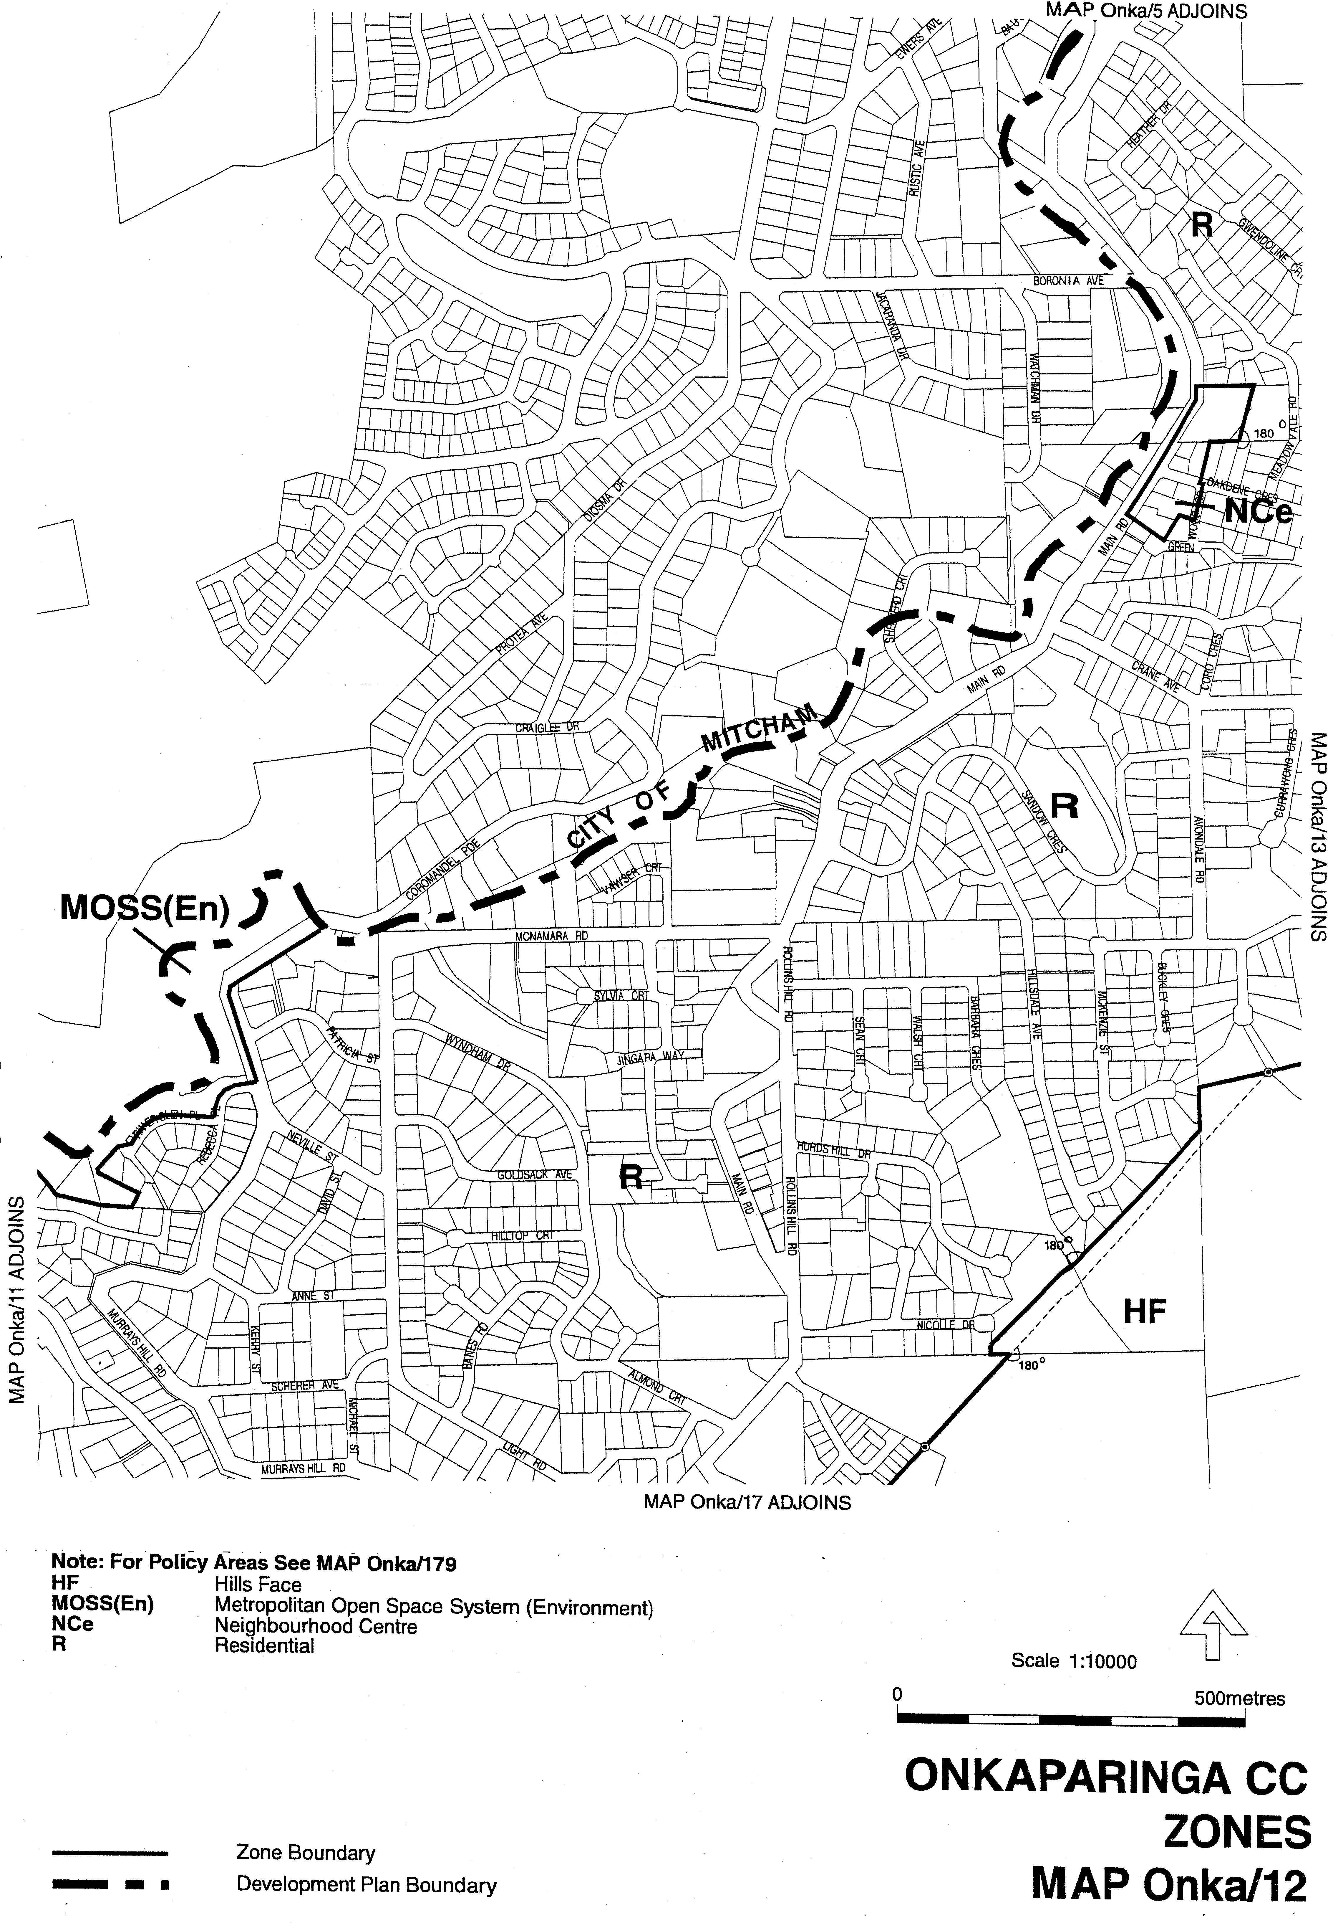
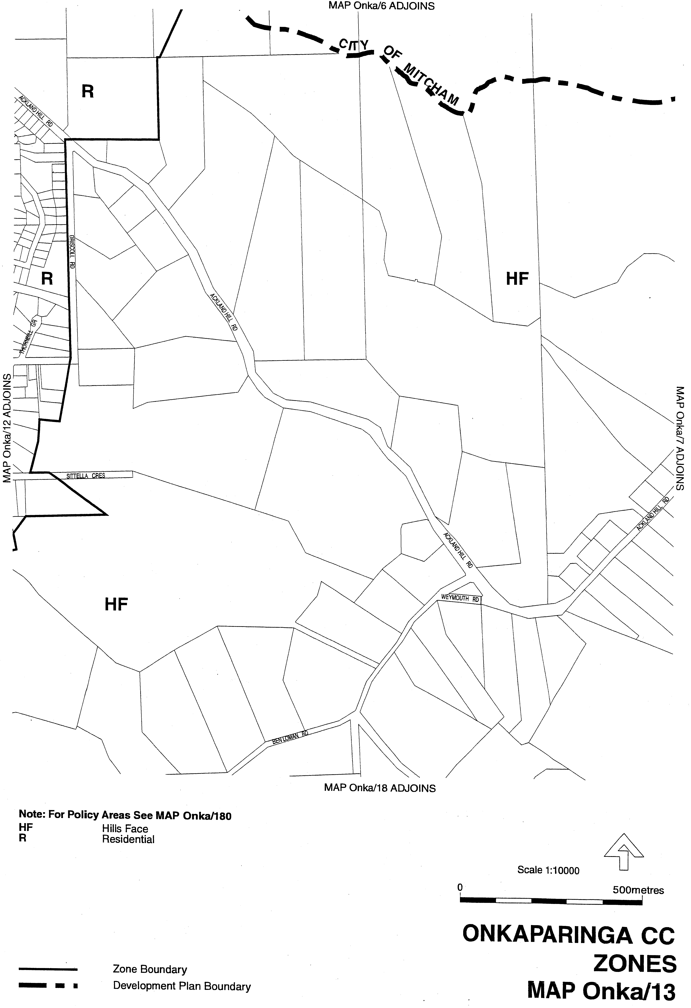
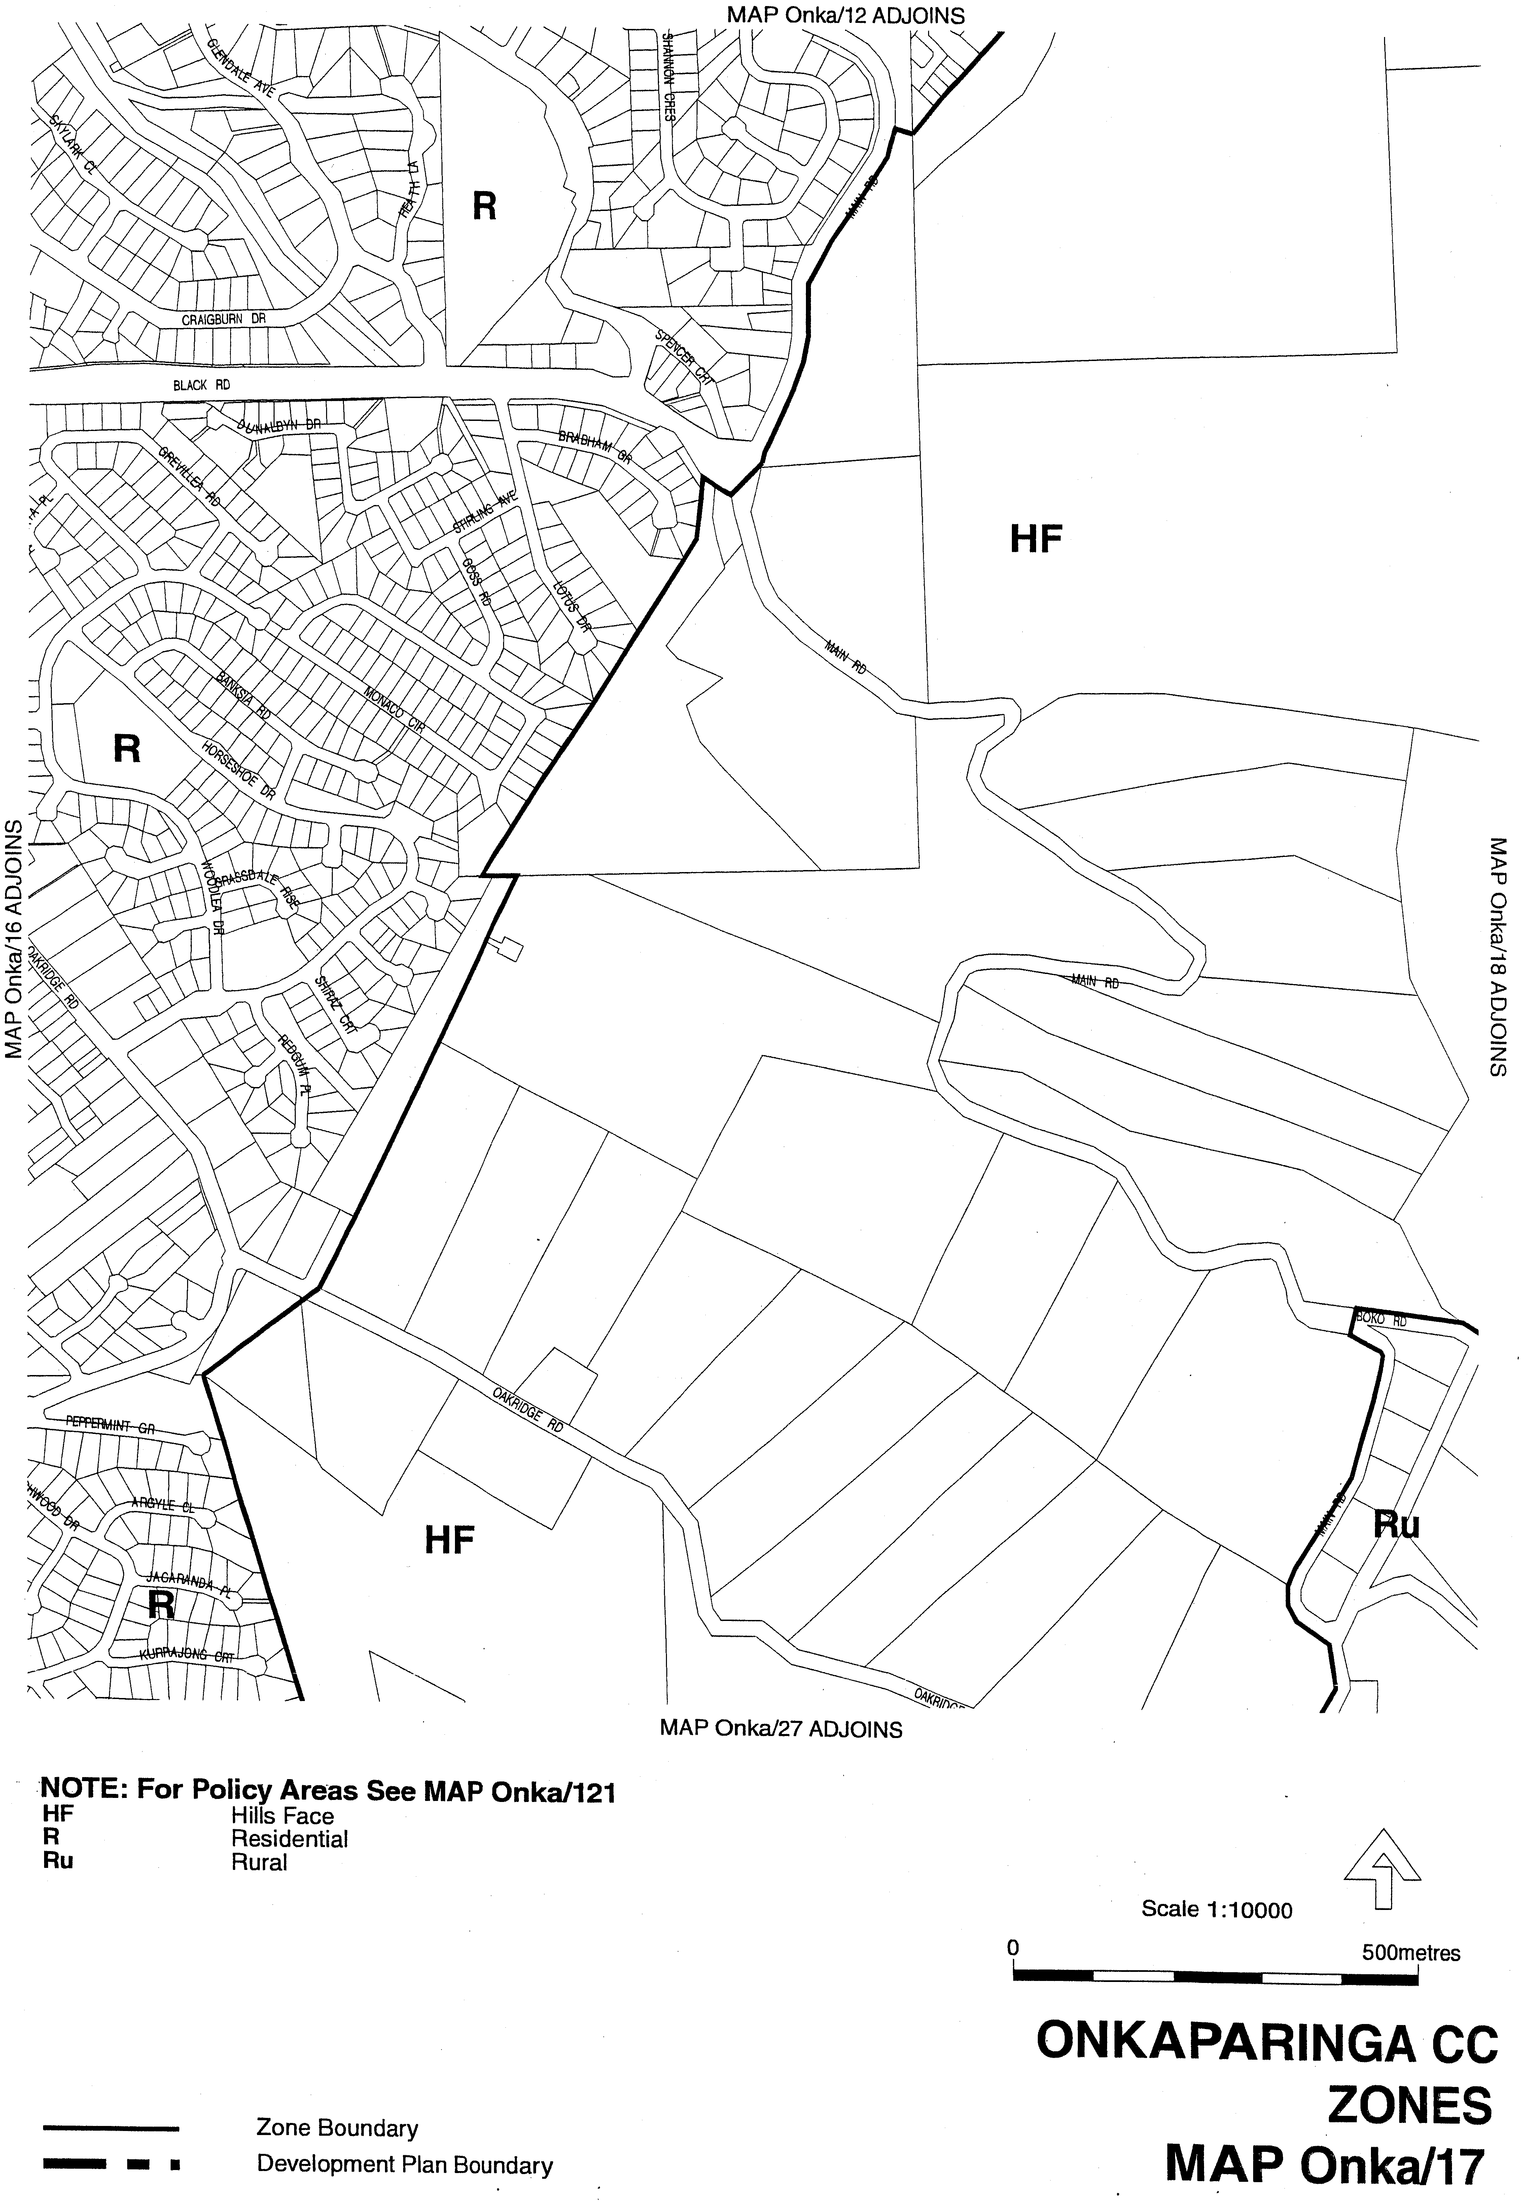
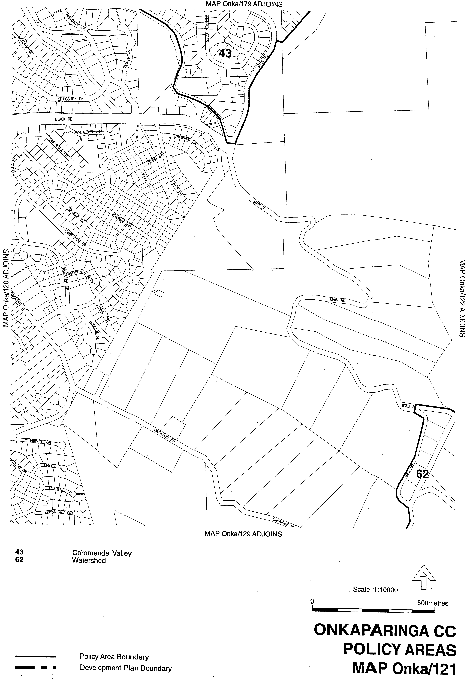
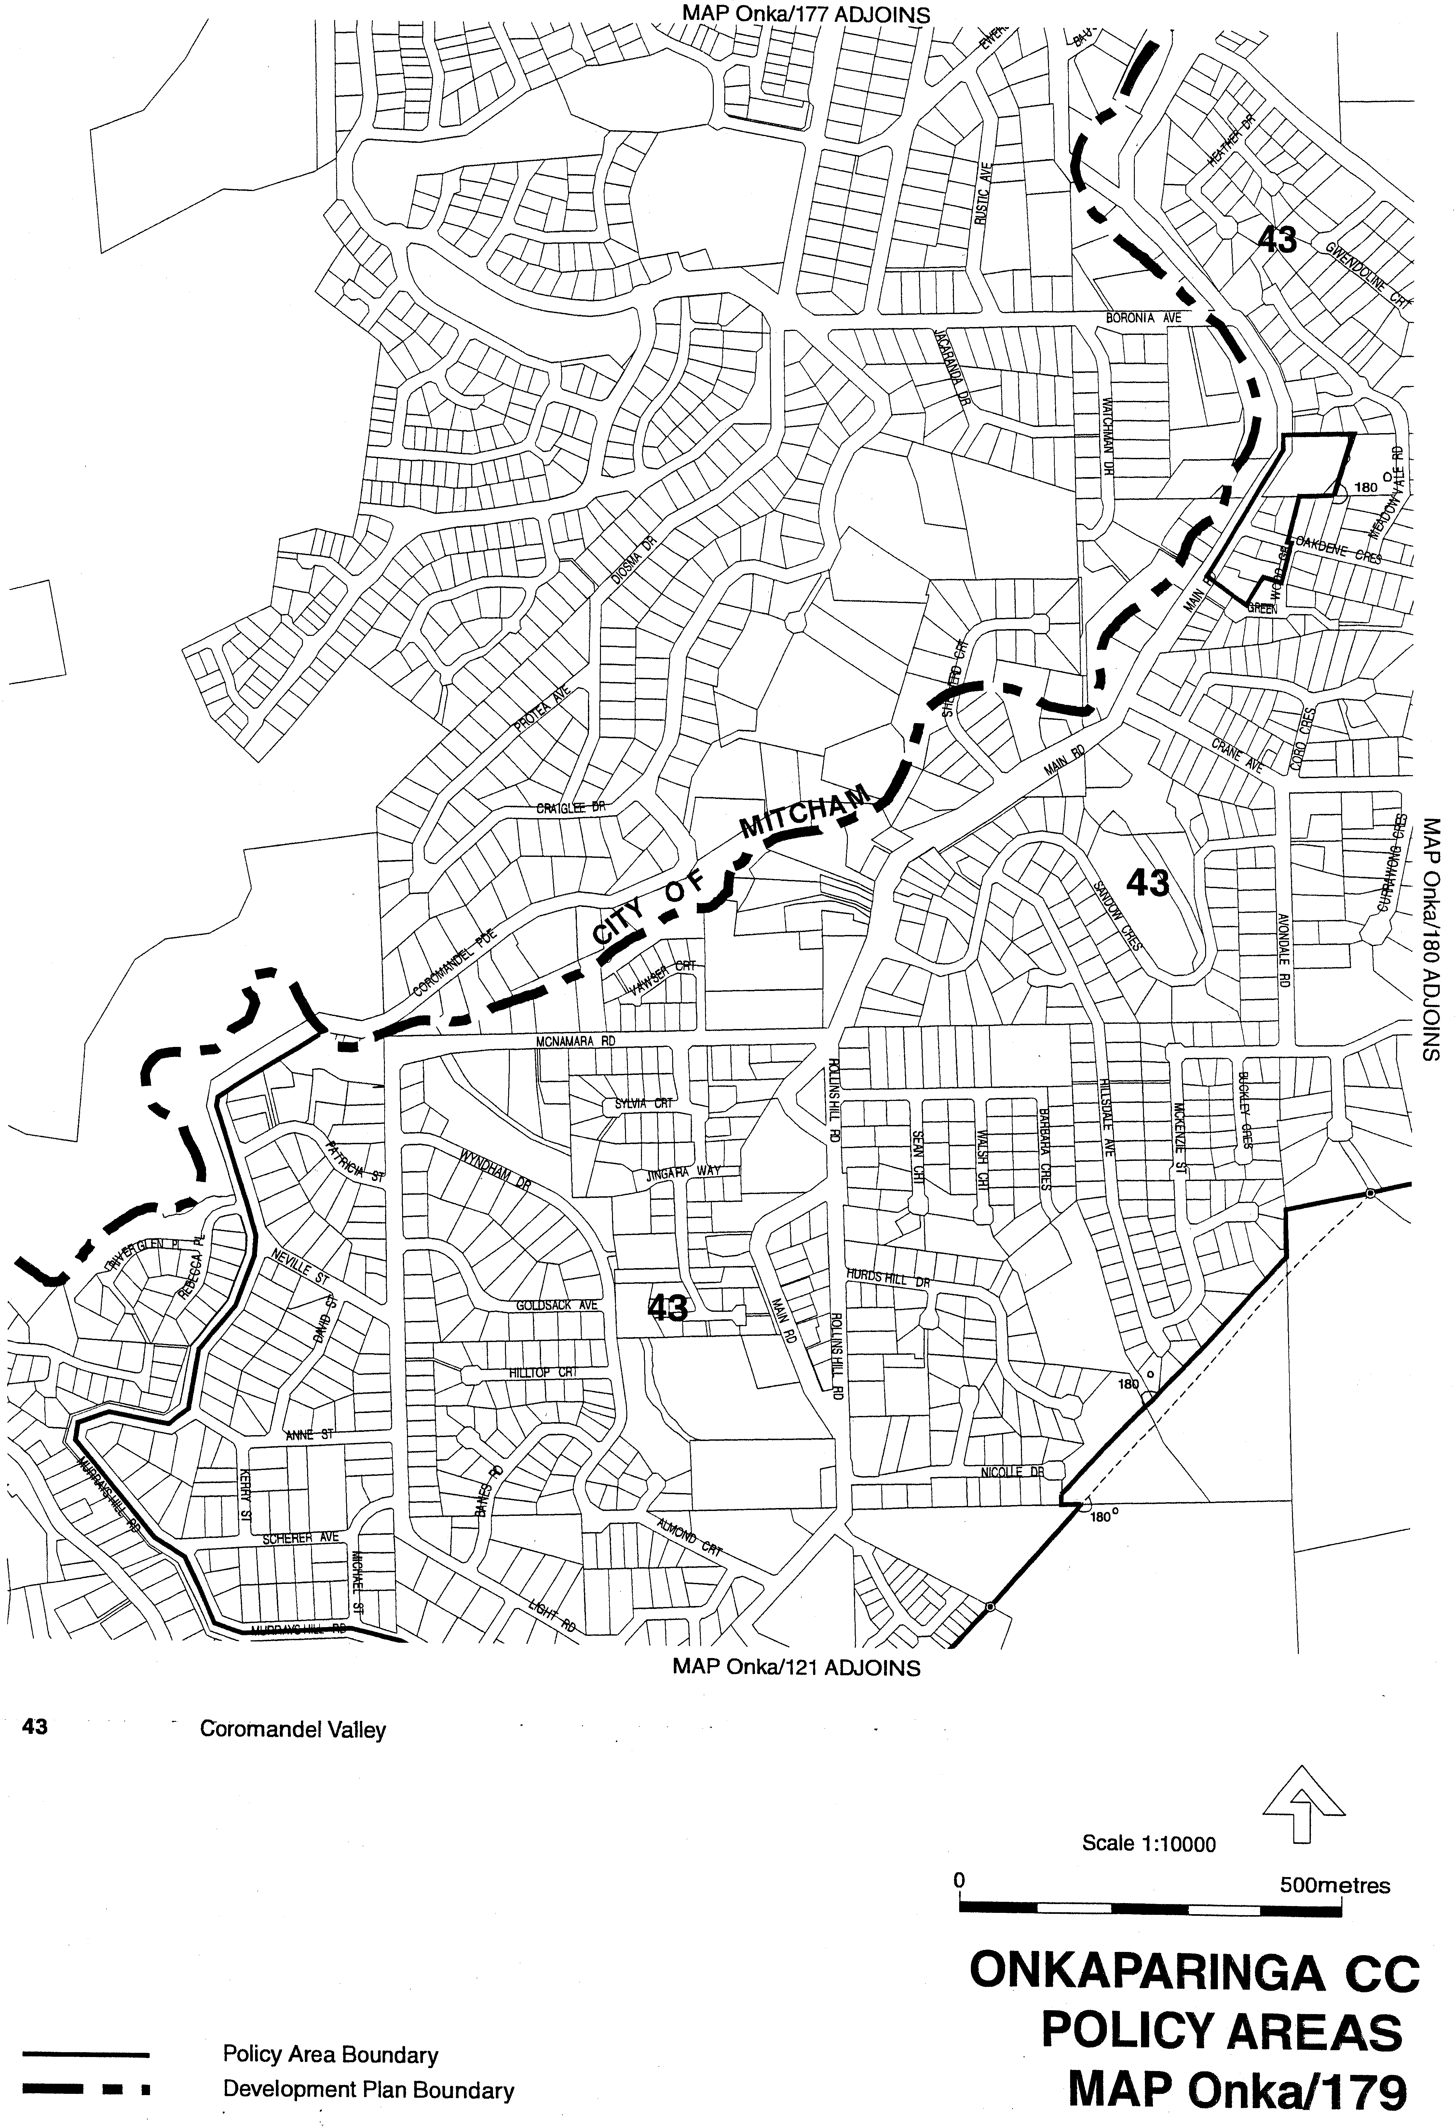
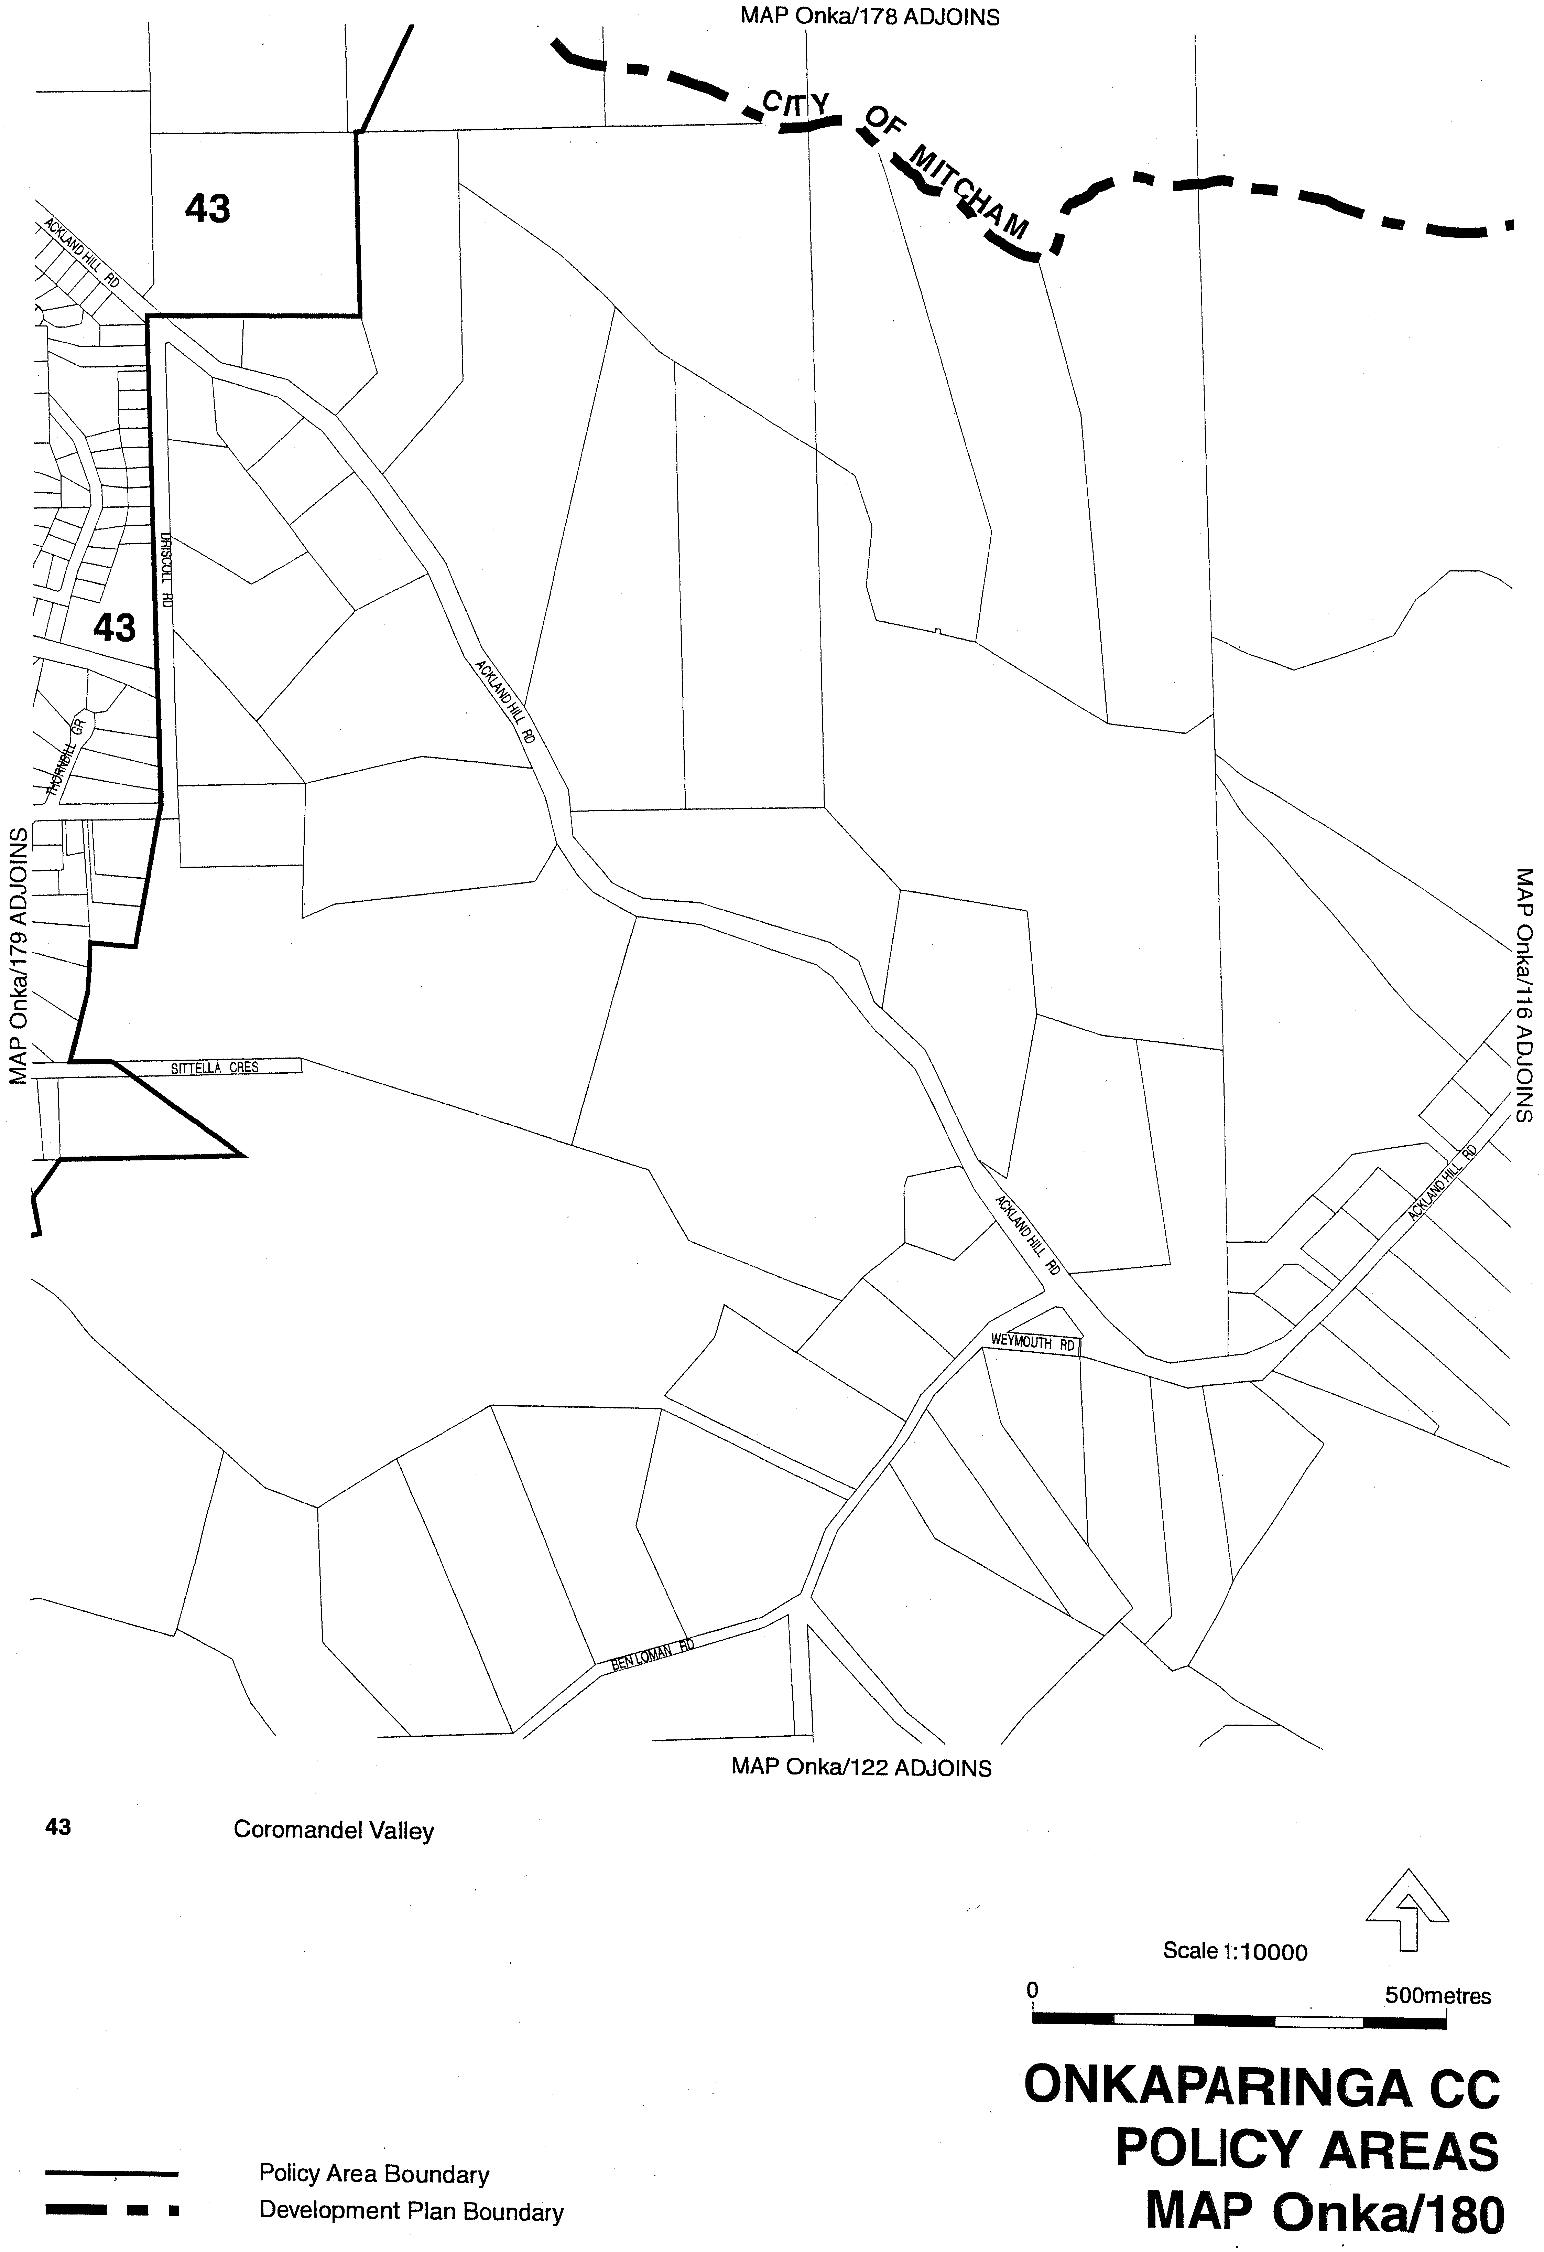
Dated 20 September 2007.
Paul Holloway, Minister for Urban Development and Planning

FISHERIES ACT 1982: SECTION 43
TAKE notice that it is hereby declared that it shall be unlawful for any person to engage in the class of fishing activity specified in Schedule 1 during the period specified in Schedule 2.
Schedule 1
The act of taking or an act preparatory to or involved in the taking of Snapper (Pagrus auratus) in all waters of the State.
Schedule 2
From 1200 hours on 1 November 2007 until 1200 hours on 30 November 2007.
Dated 19 September 2007.
W. Zacharin, Director of Fisheries

FISHERIES ACT 1982: SECTION 59
TAKE note that the notice made under section 59 of the Fisheries Act 1982, and published in the South Australian Government Gazette of 28 June 2007 on page number 2749, dated 22 June 2007, being the fifth notice on that page, referring to Luke McAvaney and the collection of abalone for research purposes, is hereby revoked.
Dated 19 September 2007.
W. Zacharin, Director of Fisheries

FISHERIES ACT 1982: SECTION 59
TAKE notice that, pursuant to section 59 of the Fisheries Act 1982, Luke McAvaney, of the University of Melbourne, Royal Parade, Parkville, Vic. 3010 (the ‘exemption holder’) or a person acting as his agent, is exempt from section 41 of the Fisheries Act 1982, but only insofar as they may take greenlip abalone for research purposes (the ‘exempted activity’) in the waters specified in Schedule 1, subject to the conditions in Schedule 2 from 21 June 2007 until 28 February 2008.
Schedule 1
The coastal waters between the meridians of longitude 136°30′E and 139°E but does not include the waters of the Coorong or any other waters inside the Murray Mouth (Central Zone Abalone Fishery).
Schedule 2
1. The exemption holder may take a maximum of 120 greenlip abalone (including undersize specimens) from the Central Zone Abalone Fishery.
2. No abalone taken pursuant to this notice can be sold or transferred to another party. All abalone taken pursuant to this notice are for research purposes only.
3. All abalone waste (including muscle, shell and viscera) must be disposed of appropriately on land.
4. The exemption holder or a person acting as his agent must notify PIRSA Fisheries Compliance on 1800 065 522 at least two hours prior to conducting the exempted activity and answer a series of questions about the exempted activity. The exemption holder will need to have a copy of the exemption notice at the time of making the call, and be able to provide information about the area and time of the exempted activity, the vehicles and boats involved, the name and number of agents undertaking the exempted activity and other related questions. Exemption No. 9902004.
5. While engaged in the exempted activity the exemption holder or a person acting as his agent must carry or have about or near his person a copy of this notice. Such notice must be produced to a PIRSA Fisheries Officer if requested.
6. The exemption holder or a person acting as his agent must not contravene or fail to comply with the Fisheries Act 1982, or any regulations made under that Act, except where specifically exempted by this notice.
Dated 19 September 2007.
W. Zacharin, Director of Fisheries

FISHERIES ACT 1982: SECTION 59
TAKE notice that pursuant to section 59 of the Fisheries Act 1982, Dean Woodward and Andrew Daddo (the ‘exemption holders’) are exempted from the provisions of Clause 87 of Schedule 1 of the Fisheries (General) Regulations 2000, in that an exemption holder shall not be guilty of an offence when engaging in an activity involved with taking lobster in the waters of the Southern Zone Rock Lobster Fishery (the ‘exempted activity’), subject to the conditions specified in Schedule 1, from 0800 hours until 1200 hours on Sunday, 23 September 2007, unless this notice is varied or revoked earlier.
Schedule 1
1. The exemption holder must notify PIRSA Fisheries Compliance on 1800 065 522 at least two hours prior to conducting the exempted activity and answer a series of questions about the exempted activity. The exemption holder will need to have a copy of the exemption notice at the time of making the call, and be able to provide information about the area and time of the exempted activity, the vehicles and boats involved, the number of agents undertaking the exempted activity and other related questions. Exemption No. 9902038.
2. PIRSA Fishwatch retains the right for a Fisheries Officer to accompany the exemption holder at any time during the exempted activity.
3. While engaged in the exempted activity the exemption holder must carry or have about or near his person a copy of this notice. Such notice must be produced to a PIRSA Fisheries Officer if requested.
4. A total of five rock lobster (Jasus edwardsii) may be used for the exempted activity.
5. An exemption holder must not contravene or fail to comply with the Fisheries Act 1982, or any other regulations made under that Act except where specifically exempted by this notice.
Dated 19 September 2007.
W. Zacharin, Executive Director, Fisheries

FISHERIES ACT 1982: SECTION 59
TAKE notice that pursuant to section 59 of the Fisheries Act 1982, Claudia Flaxman, of the University of Adelaide (the ‘exemption holder’), may place and collect artificial Seagrass from the waters of South Australia in the areas described in Schedule 1 from 14 September 2007 until 14 September 2008, unless varied or revoked earlier.
Schedule 1
1. Hallett Cove to Port Noarlunga.
2. Wool Bay to Edithburgh.
3. Marion Bay.
Schedule 2
1. Specimens collected by the exemption holder pursuant to this notice are for scientific research and must not be sold.
2. The exemption holder must notify PIRSA Fishwatch on 1800 065 522 at least two hours prior to conducting the exempted activity and answer a series of questions about the exempted activity. The exemption holder will need to have a copy of the exemption at the time of making the call, and be able to provide information about the area and time of the exempted activity, the vehicles involved and other related questions. Exemption No. 9902037.
3. While engaged in the exempted activity, the exemption holder must be in possession of a copy of this notice. Such notice must be produced to a PIRSA Fisheries Officer upon request.
4. The exemption holder must not contravene or fail to comply with the Fisheries Act 1982, or any regulations made under that Act, except where specifically exempted by this notice.
Dated 14 September 2007.
W. Zacharin, Executive Director, Fisheries

GOVERNMENT GAZETTE ADVERTISEMENT RATES

To apply from 1 July 2007

$  Agents, Ceasing to Act as 39.60  Associations:  Incorporation 20.10  Intention of Incorporation 49.75  Transfer of Properties 49.75  Attorney, Appointment of 39.60  Bailiff’s Sale 49.75  Cemetery Curator Appointed 29.45  Companies:  Alteration to Constitution 39.60  Capital, Increase or Decrease of 49.75  Ceasing to Carry on Business 29.45  Declaration of Dividend 29.45  Incorporation 39.60  Lost Share Certificates:  First Name 29.45  Each Subsequent Name 10.10  Meeting Final 33.10  Meeting Final Regarding Liquidator’s Report on  Conduct of Winding Up (equivalent to ‘Final  Meeting’)  First Name 39.60  Each Subsequent Name 10.10  Notices:  Call 49.75  Change of Name 20.10  Creditors 39.60  Creditors Compromise of Arrangement 39.60  Creditors (extraordinary resolution that ‘the Com-pany be wound up voluntarily and that a liquidator be appointed’) 49.75  Release of Liquidator⎯Application⎯Large Ad. 78.65  ⎯Release Granted 49.75  Receiver and Manager Appointed 45.85  Receiver and Manager Ceasing to Act 39.60  Restored Name 37.25  Petition to Supreme Court for Winding Up 69.30  Summons in Action 58.85  Order of Supreme Court for Winding Up Action 39.60  Register of Interests⎯Section 84 (1) Exempt 89.10  Removal of Office 20.10  Proof of Debts 39.60  Sales of Shares and Forfeiture 39.60  Estates:  Assigned 29.45  Deceased Persons⎯Notice to Creditors, etc. 49.75  Each Subsequent Name 10.10  Deceased Persons⎯Closed Estates 29.45  Each Subsequent Estate 1.30  Probate, Selling of 39.60  Public Trustee, each Estate 10.10 |  | $  Firms:  Ceasing to Carry on Business (each insertion) 26.30  Discontinuance Place of Business 26.30  Land⎯Real Property Act:  Intention to Sell, Notice of 49.75  Lost Certificate of Title Notices 49.75  Cancellation, Notice of (Strata Plan) 49.75  Mortgages:  Caveat Lodgement 20.10  Discharge of 21.05  Foreclosures 20.10  Transfer of 20.10  Sublet 10.10  Leases⎯Application for Transfer (2 insertions) each 10.10  Lost Treasury Receipts (3 insertions) each 29.45  Licensing 58.85  Municipal or District Councils:  Annual Financial Statement⎯Forms 1 and 2 554.35  Electricity Supply⎯Forms 19 and 20 393.90  Default in Payment of Rates:  First Name 78.65  Each Subsequent Name 10.10  Noxious Trade 29.45  Partnership, Dissolution of 29.45  Petitions (small) 20.10  Registered Building Societies (from Registrar-  General) 20.10  Register of Unclaimed Moneys⎯First Name 29.45  Each Subsequent Name 10.10  Registers of Members⎯Three pages and over:  Rate per page (in 8pt) 252.15  Rate per page (in 6pt) 333.45  Sale of Land by Public Auction 50.30  Advertisements 2.80  ¼ page advertisement 117.75  ½ page advertisement 235.50  Full page advertisement 461.60  Advertisements, other than those listed are charged at $2.80 per column line, tabular one-third extra.  Notices by Colleges, Universities, Corporations and District Councils to be charged at $2.80 per line.  Where the notice inserted varies significantly in length from that which is usually published a charge of $2.80 per column line will be applied in lieu of advertisement rates listed.  South Australian Government publications are sold on the condition that they will not be reproduced without prior permission from the Government Printer.
All the above prices include GST

GOVERNMENT GAZETTE NOTICES
ALL private advertisements forwarded for publication in the South Australian Government Gazette must be PAID FOR PRIOR TO INSERTION; and all notices, from whatever source, should be legibly written on one side of the paper only and sent to Government Publishing SA so as to be received no later than 4 p.m. Tuesday preceding the day of publication. Phone 8207 1045 or Fax 8207 1040. E-mail: governmentgazette@dpc.sa.gov.au. Send as attachments in Word format. Please include date the notice is to be published and to whom the notice will be charged. The Government Gazette is available online at: www.governmentgazette.sa.gov.au.

MISCELLANEOUS LEGISLATION AND GOVERNMENT PUBLICATIONS PRICES AS FROM 1 JULY 2007

Acts, Bills, Rules, Parliamentary Papers and Regulations
Pages | Main | Amends | Pages | Main | Amends

1-16 | 2.40 | 1.10 | 497-512 | 33.60 | 32.55
17-32 | 3.25 | 2.05 | 513-528 | 34.65 | 33.35
33-48 | 4.20 | 3.00 | 529-544 | 35.70 | 34.65
49-64 | 5.30 | 4.05 | 545-560 | 36.75 | 35.70
65-80 | 6.25 | 5.15 | 561-576 | 37.50 | 36.75
81-96 | 7.25 | 6.00 | 577-592 | 38.55 | 37.25
97-112 | 8.25 | 7.05 | 593-608 | 39.85 | 38.30
113-128 | 9.25 | 8.10 | 609-624 | 40.65 | 39.60
129-144 | 10.35 | 9.15 | 625-640 | 41.70 | 40.10
145-160 | 11.35 | 10.10 | 641-656 | 42.70 | 41.70
161-176 | 12.40 | 11.15 | 657-672 | 43.25 | 42.20
177-192 | 13.45 | 12.20 | 673-688 | 45.05 | 43.25
193-208 | 14.50 | 13.35 | 689-704 | 45.85 | 44.30
209-224 | 15.30 | 14.15 | 705-720 | 46.65 | 45.35
225-240 | 16.35 | 15.10 | 721-736 | 48.45 | 46.35
241-257 | 17.50 | 15.95 | 737-752 | 48.95 | 47.40
258-272 | 18.45 | 17.00 | 753-768 | 50.00 | 48.20
273-288 | 19.50 | 18.25 | 769-784 | 50.55 | 49.75
289-304 | 20.30 | 19.15 | 785-800 | 51.60 | 50.80
305-320 | 21.55 | 20.20 | 801-816 | 52.60 | 51.30
321-336 | 22.40 | 21.15 | 817-832 | 53.65 | 52.60
337-352 | 23.55 | 22.30 | 833-848 | 54.70 | 53.65
353-368 | 24.50 | 23.35 | 849-864 | 55.75 | 54.20
369-384 | 25.55 | 24.40 | 865-880 | 56.80 | 55.75
385-400 | 26.55 | 25.30 | 881-896 | 57.30 | 56.25
401-416 | 27.60 | 26.05 | 897-912 | 58.85 | 57.30
417-432 | 28.65 | 27.35 | 913-928 | 59.40 | 58.85
433-448 | 29.70 | 28.40 | 929-944 | 60.45 | 59.40
449-464 | 30.50 | 29.20 | 945-960 | 61.50 | 59.90
465-480 | 31.00 | 30.20 | 961-976 | 63.05 | 60.95
481-496 | 32.55 | 31.00 | 977-992 | 64.10 | 61.50

Legislation—Acts, Regulations, etc: $
Subscriptions:
Acts 207.00
All Bills as Laid 497.00
Rules and Regulations 497.00
Parliamentary Papers 497.00
Bound Acts 230.00
Index 115.00
Government Gazette
Copy 5.40
Subscription 274.00
Hansard
Copy 15.10
Subscription—per session (issued weekly) 431.00
Cloth bound—per volume 185.00
Subscription—per session (issued daily) 431.00
Legislation on Disk
Whole Database 3192.00
Annual Subscription for fortnightly updates 981.00
Individual Act(s) including updates POA
Compendium
Subscriptions:
Subscriptions 1891.00
Updates 667.00
(All the above prices include GST)

All Legislation, Government Gazette, Hansard and Legislation on disk are available from:
Counter Sales Service SA, Government Legislation⁺ Outlet
and Mail Orders: Lands Titles Office, 101 Grenfell Street, Adelaide, S.A. 5000
Phone: 13 23 24 (local call cost), Fax: (08) 8204 1909
Postal: G.P.O. Box 1707, Adelaide, S.A. 5001

Online Shop: www.shop.service.sa.gov.au

Subscriptions and Government Publishing SA
Standing Orders: Box 9, Plaza Level, Riverside Centre, North Terrace, Adelaide, S.A. 5000
Phone: (08) 8207 1043, (08) 8207 0910, Fax: (08) 8207 1040

LAND AND BUSINESS (SALE AND CONVEYANCING)
ACT 1994
Exemption
TAKE notice that, pursuant to section 23 (3) of the Land and Business (Sale and Conveyancing) Act 1994, I, Jennifer Rankine, Minister for Consumer Affairs, do hereby exempt the person named in Schedule 1 from the application of section 23 (2) of the Act in relation to the purchase of the land specified in Schedule 2.
Schedule 1
Jaclyn Anne Hage, an employee of Reg Kemp Real Estate Pty Ltd.
Schedule 2
The whole of the land described in certificate of title register book volume 5909, folio 109, situated at 3/10 Adelphi Terrace, Port Lincoln, S.A. 5606.
Dated 10 September 2007.
Jennifer Rankine, Minister for Consumer Affairs

LAND AND BUSINESS (SALE AND CONVEYANCING)
ACT 1994
Exemption
TAKE notice that, pursuant to section 23 (3) of the Land and Business (Sale and Conveyancing) Act 1994, I, Jennifer Rankine, Minister for Consumer Affairs, do hereby exempt the person named in Schedule 1 from the application of section 23 (2) of the Act in relation to the purchase of the land specified in Schedule 2.
Schedule 1
Cindy Louise Featonby, an employee of Mark Forde Pty Ltd.
Schedule 2
The whole of the land described in certificate of title register book volume 5806, folio 197, situated at 9 August Street, Blyth, S.A. 5462.
Dated 20 September 2007.
Jennifer Rankine, Minister for Consumer Affairs

LIQUOR LICENSING ACT 1997 AND GAMING MACHINES ACT 1992
Notice of Application
NOTICE is hereby given, pursuant to section 52 of the Liquor Licensing Act 1997 and section 29 of the Gaming Machines Act 1992, that MB Hospitality Pty Ltd as trustee for MB Hospitality Trust and JB Hospitality Pty Ltd as trustee for JB Hospitality Trust have applied to the Licensing Authority for the transfer of a Hotel and Gaming Machine Licence in respect of premises situated at 36 Wellington Square, North Adelaide, S.A. 5006 and known as Wellington Hotel.
The applications have been set down for hearing on 22 October 2007 at 9.30 a.m.
Any person may object to the application by lodging a notice of objection in the prescribed form with the Liquor and Gambling Commissioner and serving a copy of the notice on the applicants at the applicants’ address, at least seven days before the hearing date (viz: 15 October 2007).
The applicants’ address for service is c/o Piper Alderman, Lawyers, G.P.O. Box 65, Adelaide, S.A. 5000 (Attention: Geoff Forbes).
Plans in respect of the premises the subject of the application are open to public inspection without fee at the Office of the Liquor and Gambling Commissioner, 9th Floor, East Wing, 50 Grenfell Street, Adelaide, S.A. 5000. Phone 8226 8410, Fax:
8226 8512. Email: olgc@agd.sa.gov.au.
Dated 14 September 2007.
Applicants

LIQUOR LICENSING ACT 1997 AND GAMING MACHINES ACT 1992
Notice of Application
NOTICE is hereby given, pursuant to section 52 of the Liquor Licensing Act 1997 and section 29 of the Gaming Machines Act 1992, that Wilson Hotels Pty Ltd as trustee for the Craig Wilson Family Trust has applied to the Licensing Authority for the transfer of a Hotel and Gaming Machine Licence in respect of premises situated at 110 Grenfell Street, Adelaide, S.A. 5000 and known as Grenfell 110.
The applications have been set down for hearing on 18 October 2007 at 9 a.m.
Any person may object to the application by lodging a notice of objection in the prescribed form with the Liquor and Gambling Commissioner and serving a copy of the notice on the applicant at the applicant’s address, at least seven days before the hearing date (viz: 11 October 2007).
The applicant’s address for service is c/o Foreman Legal, 69 Mount Barker Road, Stirling, S.A. 5152.
Plans in respect of the premises the subject of the application are open to public inspection without fee at the Office of the Liquor and Gambling Commissioner, 9th Floor, East Wing, 50 Grenfell Street, Adelaide, S.A. 5000. Phone 8226 8410, Fax:
8226 8512. Email: olgc@agd.sa.gov.au.
Dated 11 September 2007.
Applicant

LIQUOR LICENSING ACT 1997
Notice of Application
NOTICE is hereby given, pursuant to section 52 (2) (b) of the Liquor Licensing Act 1997, that P. & Co. Holdings Pty Ltd as trustee for the Peter Ormsby Family Trust has applied to the Licensing Authority for a Special Circumstances Licence, Extended Trading Authorisation and Entertainment Consent in respect of premises situated at Military Road, West Beach, S.A. 5024.
The application has been set down for callover on 19 October 2007 at 9 a.m.
Conditions
The following licence conditions are sought:
For consumption on the Licensed Premises:
• On the whole of the Adelaide Shores Golf Park (as depicted on the plan).
• The hours of operation shall be 8 a.m. until 9 p.m. on each day of the week except Christmas Day.
• The licence shall not authorise the sale of liquor for consumption off the licensed premises.
• Entertainment Consent is to apply on corporate/ promotional days only.
Any person may object to the application by lodging a notice of objection in the prescribed form with the Liquor and Gambling Commissioner and serving a copy of the notice on the applicant at the applicant’s address, at least seven days before the callover date (viz: 12 October 2007).
The applicant’s address for service is c/o Duncan Basheer Hannon, Barristers & Solicitors, G.P.O. Box 2, Adelaide, S.A. 5001 (Attention: Max Basheer or David Tillett).
Plans in respect of the premises the subject of the application are open to public inspection without fee at the Office of the Liquor and Gambling Commissioner, 9th Floor, East Wing, 50 Grenfell Street, Adelaide, S.A. 5000. Phone 8226 8410, Fax:
8226 8512. Email: olgc@agd.sa.gov.au.
Dated 13 September 2007.
Applicant

LIQUOR LICENSING ACT 1997
Notice of Application
NOTICE is hereby given, pursuant to section 52 (2) (b) of the Liquor Licensing Act 1997, that Triple Coins Pty Ltd as trustee for the Triple Coins Unit Trust has applied to the Licensing Authority for the transfer of a Restaurant Licence in respect of premises situated at Grenfell Road, Surrey Downs, S.A. 5126 and known as Lee Gardens Restaurant.
The application has been set down for hearing on 18 October 2007 at 9.30 a.m.
Any person may object to the application by lodging a notice of objection in the prescribed form with the Liquor and Gambling Commissioner and serving a copy of the notice on the applicant at the applicant’s address, at least seven days before the hearing date (viz: 11 October 2007).
The applicant’s address for service is c/o Claudia Cream & Co., P.O. Box 177, Park Holme, S.A. 5043.
Plans in respect of the premises the subject of the application are open to public inspection without fee at the Office of the Liquor and Gambling Commissioner, 9th Floor, East Wing, 50 Grenfell Street, Adelaide, S.A. 5000. Phone 8226 8410, Fax:
8226 8512. Email: olgc@agd.sa.gov.au.
Dated 11 September 2007.
Applicant

LIQUOR LICENSING ACT 1997
Notice of Application
NOTICE is hereby given, pursuant to section 52 (2) (b) of the Liquor Licensing Act 1997, that Marc Anthony Cutchie has applied to the Licensing Authority for the transfer of an Entertainment Venue Licence in respect of premises situated at 137 Hindley Street, Adelaide, S.A. 5000, known as Incognito Lounge and to be known as Eclipse Lounge Bar.
The application has been set down for hearing on 18 October 2007 at 10 a.m.
Any person may object to the application by lodging a notice of objection in the prescribed form with the Liquor and Gambling Commissioner and serving a copy of the notice on the applicant at the applicant’s address, at least seven days before the hearing date (viz: 11 October 2007).
The applicant’s address for service is c/o Marc Anthony Cutchie, 1 Queen Street, Alberton, S.A. 5014.
Plans in respect of the premises the subject of the application are open to public inspection without fee at the Office of the Liquor and Gambling Commissioner, 9th Floor, East Wing, 50 Grenfell Street, Adelaide, S.A. 5000. Phone 8226 8410, Fax:
8226 8512. Email: olgc@agd.sa.gov.au.
Dated 12 September 2007.
Applicant

LIQUOR LICENSING ACT 1997
Notice of Application
NOTICE is hereby given, pursuant to section 52 (2) (b) of the Liquor Licensing Act 1997, that Tape Deck Razor Blade Pty Ltd has applied to the Licensing Authority for a Restaurant Licence in respect of premises situated at 36 East Terrace, Adelaide, S.A. 5000 and to be known as Tape Deck Razor Blade.
The application has been set down for callover on 19 October 2007 at 9 a.m.
Conditions
The following licence conditions are sought:
To sell liquor on any day except Christmas Day and Good Friday for consumption on the licensed premises by persons:
(a) seated at a table, or
(b) attending a function at which food is provided.
Any person may object to the application by lodging a notice of objection in the prescribed form with the Liquor and Gambling Commissioner and serving a copy of the notice on the applicant at the applicant’s address, at least seven days before the callover date (viz: 12 October 2007).
The applicant’s address for service is c/o David Watts & Associates, 1 Cator Street, Glenside, S.A. 5065.
Plans in respect of the premises the subject of the application are open to public inspection without fee at the Office of the Liquor and Gambling Commissioner, 9th Floor, East Wing, 50 Grenfell Street, Adelaide, S.A. 5000. Phone 8226 8410, Fax:
8226 8512. Email: olgc@agd.sa.gov.au.
Dated 12 September 2007.
Applicant

LIQUOR LICENSING ACT 1997
Notice of Application
NOTICE is hereby given, pursuant to section 52 (2) (b) of the Liquor Licensing Act 1997, that Phong Do and Daniel Heng have applied to the Licensing Authority for a Restaurant Licence in respect of premises situated at Shop 11B, Bolivar Road, Paralowie, S.A. 5108 and to be known as Sweet Chillies.
The application has been set down for callover on 19 October 2007 at 9 a.m.
Any person may object to the application by lodging a notice of objection in the prescribed form with the Liquor and Gambling Commissioner and serving a copy of the notice on the applicants at the applicants’ address, at least seven days before the callover date (viz: 12 October 2007).
The applicants’ address for service is c/o Phong Do, 37 Tarqui Drive, Paralowie, S.A. 5108.
Plans in respect of the premises the subject of the application are open to public inspection without fee at the Office of the Liquor and Gambling Commissioner, 9th Floor, East Wing, 50 Grenfell Street, Adelaide, S.A. 5000. Phone 8226 8410, Fax:
8226 8512. Email: olgc@agd.sa.gov.au.
Dated 14 September 2007.
Applicants

LIQUOR LICENSING ACT 1997
Notice of Application
NOTICE is hereby given, pursuant to section 52 (2) (b) of the Liquor Licensing Act 1997, that Whipped Bake Bar & Cafe Pty Ltd as trustee for Whipped BBC Trust has applied to the Licensing Authority to transfer a Restaurant Licence in respect of premises situated at 35 Semaphore Road, Semaphore, S.A. 5109, known as Sonic Temple and to be known as Whipped Bake Bar and Cafe.
The application has been set down for hearing on 17 October 2007 at 9.30 a.m.
Any person may object to the application by lodging a notice of objection in the prescribed form with the Liquor and Gambling Commissioner and serving a copy of the notice on the applicant at the applicant’s address, at least seven days before the hearing date (viz: 10 October 2007).
The applicant’s address for service is c/o Rinaldi & Co., 100 Greenhill Road, Unley, S.A. 5061.
Plans in respect of the premises the subject of the application are open to public inspection without fee at the Office of the Liquor and Gambling Commissioner, 9th Floor, East Wing, 50 Grenfell Street, Adelaide, S.A. 5000. Phone 8226 8410, Fax:
8226 8512. Email: olgc@agd.sa.gov.au.
Dated 12 September 2007.
Applicant

LIQUOR LICENSING ACT 1997
Notice of Application
NOTICE is hereby given, pursuant to section 52 (2) (b) of the Liquor Licensing Act 1997, that J. R. & S. E. Rollison Holdings Pty Ltd has applied to the Licensing Authority for a variation to Extended Trading Authorisation in respect of premises situated at 110 Coglin Street, Brompton Park, S.A. 5007 and known as Hotel Excelsior Brompton.
The application has been set down for callover on 19 October 2007 at 9 a.m.
Conditions
The following licence conditions are sought:
• Variation to Extended Trading Authorisation to include the service yard, canopy and garage/store as per plans lodged with this office for the following hours:
Sunday: 8 a.m. to 11 a.m. and 8 p.m. to midnight.
Sunday Christmas Eve: 8 p.m. to 2 a.m. the following day.
Any person may object to the application by lodging a notice of objection in the prescribed form with the Liquor and Gambling Commissioner and serving a copy of the notice on the applicant at the applicant’s address, at least seven days before the callover date (viz: 12 October 2007).
The applicant’s address for service is c/o J. R. & S. E. Rollison Holdings Pty Ltd, 110 Coglin Street, Brompton Park, S.A. 5007.
Plans in respect of the premises the subject of the application are open to public inspection without fee at the Office of the Liquor and Gambling Commissioner, 9th Floor, East Wing, 50 Grenfell Street, Adelaide, S.A. 5000. Phone 8226 8410, Fax:
8226 8512. Email: olgc@agd.sa.gov.au.
Dated 13 September 2007.
Applicant

LIQUOR LICENSING ACT 1997
Notice of Application
NOTICE is hereby given, pursuant to section 52 (2) (b) of the Liquor Licensing Act 1997, that Cafe Va Bene Pty Ltd as trustee for Va Bene Unit Trust has applied to the Licensing Authority for the transfer of a Restaurant Licence in respect of premises situated at 636 Lower North East Road, Campbelltown, S.A. 5074 and known as Cafe Va Bene.
The application has been set down for hearing on 23 October 2007 at 9.30 a.m.
Any person may object to the application by lodging a notice of objection in the prescribed form with the Liquor and Gambling Commissioner and serving a copy of the notice on the applicant at the applicant’s address, at least seven days before the hearing date (viz: 16 October 2007).
The applicant’s address for service is c/o David Watts & Associates, 1 Cator Street, Glenside, S.A. 5065.
Plans in respect of the premises the subject of the application are open to public inspection without fee at the Office of the Liquor and Gambling Commissioner, 9th Floor, East Wing, 50 Grenfell Street, Adelaide, S.A. 5000. Phone 8226 8410, Fax:
8226 8512. Email: olgc@agd.sa.gov.au.
Dated 17 September 2007.
Applicant

LIQUOR LICENSING ACT 1997
Notice of Application
NOTICE is hereby given, pursuant to section 52 (2) (b) of the Liquor Licensing Act 1997, that Woolies Liquor Stores Pty Ltd has applied to the Licensing Authority for the removal of a Retail Liquor Merchant’s Licence in respect of premises situated at Shops 9, 9A and 10, Dernancourt Shopping Centre, 840 Lower North East Road, Dernancourt, S.A. 5075 and to be situated at Shop T23, Dernancourt Shopping Centre, 840 Lower North East Road, Dernancourt, S.A. 5075, known as BWS—Beer Wine Spirits and to be known as Woolworths Liquor.
The application has been set down for callover on 19 October 2007 at 9 a.m.
Any person may object to the application by lodging a notice of objection in the prescribed form with the Liquor and Gambling Commissioner and serving a copy of the notice on the applicant at the applicant’s address, at least seven days before the callover date (viz: 12 October 2007).
The applicant’s address for service is c/o Clelands Lawyers, G.P.O. Box 627, Adelaide, S.A. 5001 (Attention: Leon McEvoy).
Plans in respect of the premises the subject of the application are open to public inspection without fee at the Office of the Liquor and Gambling Commissioner, 9th Floor, East Wing, 50 Grenfell Street, Adelaide, S.A. 5000. Phone 8226 8410, Fax:
8226 8512. Email: olgc@agd.sa.gov.au.
Dated 14 September 2007.
Applicant

LIQUOR LICENSING ACT 1997
Notice of Application
NOTICE is hereby given, pursuant to section 52 (2) (b) of the Liquor Licensing Act 1997, that Hann & Sutcliffe Nominees Pty Ltd as trustee for the Hann & Sutcliffe Unit Trust has applied to the Licensing Authority for a variation to Extended Trading Authorisation in respect of premises situated at 58 Church Street, Penola, S.A. 5277 and known as Prince of Wales Hotel Motel.
The application has been set down for hearing on 19 October 2007 at 9 a.m.
Conditions
The following licence conditions are sought:
• Variation to the current Extended Trading Authorisation to include Areas 7 and 8 as per plans lodged with this office.
Any person may object to the application by lodging a notice of objection in the prescribed form with the Liquor and Gambling Commissioner and serving a copy of the notice on the applicant at the applicant’s address, at least seven days before the hearing date (viz: 12 October 2007).
The applicant’s address for service is c/o Hann & Sutcliffe Nominees Pty Ltd, 58 Church Street, Penola, S.A. 5277.
Plans in respect of the premises the subject of the application are open to public inspection without fee at the Office of the Liquor and Gambling Commissioner, 9th Floor, East Wing, 50 Grenfell Street, Adelaide, S.A. 5000. Phone 8226 8410, Fax:
8226 8512. Email: olgc@agd.sa.gov.au.
Dated 17 September 2007.
Applicant

LIQUOR LICENSING ACT 1997
Notice of Application
NOTICE is hereby given, pursuant to section 52 (2) (b) of the Liquor Licensing Act 1997, that Hesketh Wine Company Pty Ltd has applied to the Licensing Authority for the removal of a Producer’s Licence in respect of premises situated at 75 Castle Street, Parkside, S.A. 5063 and to be situated at 6 Blairgowrie Road, St Georges, S.A. 5064 and known as Hesketh Wine Company.
The application has been set down for callover on 19 October 2007 at 9 a.m.
Any person may object to the application by lodging a notice of objection in the prescribed form with the Liquor and Gambling Commissioner and serving a copy of the notice on the applicant at the applicant’s address, at least seven days before the callover date (viz: 12 October 2007).
The applicant’s address for service is c/o Hunt & Hunt, Level 12, 26 Flinders Street, Adelaide, S.A. 5000 (Attention: Jack Clarke).
Plans in respect of the premises the subject of the application are open to public inspection without fee at the Office of the Liquor and Gambling Commissioner, 9th Floor, East Wing, 50 Grenfell Street, Adelaide, S.A. 5000. Phone 8226 8410, Fax:
8226 8512. Email: olgc@agd.sa.gov.au.
Dated 14 September 2007.
Applicant

LIQUOR LICENSING ACT 1997
Notice of Application
NOTICE is hereby given, pursuant to section 52 (2) (b) of the Liquor Licensing Act 1997, that Cathy Julien and Peter Lock have applied to the Licensing Authority for a Restaurant Licence with Section 34 (1) (c) Authorisation, Entertainment Consent and Extension of Trading Area in respect of premises situated at North Coast Road, Stokes Bay, S.A. 5220 and to be known as Stokes.
The application has been set down for hearing on 19 October 2007 at 9 a.m.
Conditions
The following licence conditions are sought:
• Approval under Section 34 (1) (c) to sell liquor for con-sumption on the licensed premises by persons:
(a) seated at a table; or
(b) attending a function at which food is provided.
• Entertainment Consent is sought for the following hours:
Friday: 6 p.m. to 2 a.m. the following day;
Saturday and Sunday: Midday to 2 a.m. the following day;
Christmas Eve: 6 p.m. to 2 a.m. the following day;
Sunday Christmas Eve: 6 p.m. to 2 a.m. the following day;
Days preceding Public Holiday: 6 p.m. to 2 a.m. the following day;
Sunday preceding Public Holiday: 6 p.m. to 2 a.m. the following day.
• Extension of Trading Area sought to include outdoor area as per plans lodged.
Any person may object to the application by lodging a notice of objection in the prescribed form with the Liquor and Gambling Commissioner and serving a copy of the notice on the applicants at the applicants’ address, at least seven days before the hearing date (viz: 12 October 2007).
The applicants’ address for service is c/o Cathy Julien, P.O. Box 56, Parndana, Kangaroo Island, S.A. 5220.
Plans in respect of the premises the subject of the application are open to public inspection without fee at the Office of the Liquor and Gambling Commissioner, 9th Floor, East Wing, 50 Grenfell Street, Adelaide, S.A. 5000. Phone 8226 8410, Fax:
8226 8512. Email: olgc@agd.sa.gov.au.
Dated 17 September 2007.
Applicants

LIVESTOCK ACT 1997
Section 63
Appointments
PURSUANT to section 63 of the Livestock Act 1997, I, Paul Holloway, Acting Minister for Agriculture, Food and Fisheries hereby appoint Dr Rob Rahaley as Chief Inspector of Stock, to administer and enforce the Livestock Act 1997, until further notice. Further, I appoint Dr Neil Buchanan as Deputy Chief Inspector until further notice.
Dated 13 September 2007.
Paul Holloway, Acting Minister for Agriculture, Food and Fisheries

LIVESTOCK ACT 1997
Section 66
Instrument of Delegation
PURSUANT to section 66 of the Livestock Act 1997, I, Paul Holloway, Acting Minister for Agriculture, Food and Fisheries do hereby delegate to the Chief Inspector of Stock the power to appoint:
• Deputy Chief Inspectors of Stock [sub-section 63 (1) (b)]; and
• Inspectors [sub-section 63 (1) (c)].
Dated 13 September 2007.
Paul Holloway, Acting Minister for Agriculture, Food and Fisheries

LOCAL GOVERNMENT ACT 1999
Regulation 16A—Independence of Council Auditor
Notice of Exemption
PURSUANT to subregulation (6) of Regulation 16A of the Local Government (Financial Management) Regulations 1999, I hereby grant the District Council of Robe an exemption from the operation of subregulation (1) of that regulation.
The exemption is subject to the following conditions:
1. The District Council of Robe’s audit committee must approve any non-audit work undertaken by the Council’s Auditor during the period of the exemption and, in so doing, must certify that the independence of the Auditor will not be compromised by undertaking services outside the scope of the Auditor’s functions under the Act.
2. The exemption will cease to have effect on 31 December 2007.
Dated 15 July 2007.
Jennifer Rankine, Minister for State/Local Government Relations

MINING ACT 1971
NOTICE is hereby given in accordance with section 28 (5) of the Mining Act 1971, that the Minister for Mineral Resources Development proposes to grant an Exploration Licence over the undermentioned area:
Applicant: International Metals Pty Ltd
Location: Leighton area—Approximately 20 km north-west of Burra.
Term: 1 year
Area in km²: 638
Ref.: 2007/00268
Plan and co-ordinates can be found on the PIRSA Sarig website: http://www.minerals.pir.sa.gov.au/sarig or by phoning Mineral Tenements on (08) 8463 3103.
H. Tyrteos, Mining Registrar

MINING ACT 1971
NOTICE is hereby given in accordance with section 28 (5) of the Mining Act 1971, that the Minister for Mineral Resources Development proposes to grant an Exploration Licence over the undermentioned area:
Applicant: Eagle Bay Resources NL
Location: Uley area—Approximately 25 km south-west of Port Lincoln.
Term: 1 year
Area in km²: 197
Ref.: 2007/00284
Plan and co-ordinates can be found on the PIRSA Sarig website: http://www.minerals.pir.sa.gov.au/sarig or by phoning Mineral Tenements on (08) 8463 3103.
H. Tyrteos, Mining Registrar

MINING ACT 1971
NOTICE is hereby given in accordance with section 28 (5) of the Mining Act 1971, that the Minister for Mineral Resources Development proposes to grant an Exploration Licence over the undermentioned area:
Applicant: U Energy Pty Ltd
Location: Eurelyana Hill area—Approximately 85 km north-east of Coober Pedy.
Term: 1 year
Area in km²: 782
Ref.: 2007/00342
Plan and co-ordinates can be found on the PIRSA Sarig website: http://www.minerals.pir.sa.gov.au/sarig or by phoning Mineral Tenements on (08) 8463 3103.
H. Tyrteos, Mining Registrar

MINING ACT 1971
NOTICE is hereby given in accordance with section 28 (5) of the Mining Act 1971, that the Minister for Mineral Resources Development proposes to grant an Exploration Licence over the undermentioned area:
Applicant: U Energy Pty Ltd
Location: Pootnoura Creek area—Approximately 70 km north-west of Coober Pedy.
Term: 1 year
Area in km²: 630
Ref.: 2007/00343
Plan and co-ordinates can be found on the PIRSA Sarig website: http://www.minerals.pir.sa.gov.au/sarig or by phoning Mineral Tenements on (08) 8463 3103.
H. Tyrteos, Mining Registrar

MINING ACT 1971
NOTICE is hereby given in accordance with section 28 (5) of the Mining Act 1971, that the Minister for Mineral Resources Development proposes to grant an Exploration Licence over the undermentioned area:
Applicant: Gold Finance and Exploration Pty Ltd
Location: Tilcha 1 area—Approximately 160 km south-south-east of Moomba.
Term: 1 year
Area in km²: 468
Ref.: 2007/00358
Plan and co-ordinates can be found on the PIRSA Sarig website: http://www.minerals.pir.sa.gov.au/sarig or by phoning Mineral Tenements on (08) 8463 3103.
H. Tyrteos, Mining Registrar

MINING ACT 1971
NOTICE is hereby given in accordance with section 28 (5) of the Mining Act 1971, that the Minister for Mineral Resources Development proposes to grant an Exploration Licence over the undermentioned area:
Applicant: Gold Finance and Exploration Pty Ltd
Location: Tilcha 2 area—Approximately 180 km south-south-east of Moomba.
Term: 1 year
Area in km²: 930
Ref.: 2007/00359
Plan and co-ordinates can be found on the PIRSA Sarig website: http://www.minerals.pir.sa.gov.au/sarig or by phoning Mineral Tenements on (08) 8463 3103.
H. Tyrteos, Mining Registrar

NATIONAL ELECTRICITY LAW
THE Australian Energy Market Commission (AEMC) gives notice under the National Electricity Law (NEL) of the following matters.
Under section 107, the period of time for the preparation of the draft determination for:
• the proposed National Electricity Amendment (Process for Region change) Rule 2007 has been extended to 27 September 2007; and
• the proposed National Electricity Amendment (Integration of NEM Metrology Requirements) Rule 2007 has been extended to 18 October 2007.
Further details on the above matters are available on the AEMC’s website www.aemc.gov.au. All documents in relation to the above matters are published on the AEMC’s website and are available for inspection at the offices of the AEMC.
John Tamblyn
Chairman
Australian Energy Market Commission
Level 5, 201 Elizabeth Street
Sydney, N.S.W. 2000
Telephone: (02) 8296 7800
Facsimile: (02) 8296 7899
20 September 2007.

NATIONAL PARKS AND WILDLIFE ACT 1972
Tantanoola Caves Conservation Park Management Plan—Draft
I, LEANNE BURCH, Acting Director of National Parks and Wildlife, hereby give notice under the provisions of section 38 of the National Parks and Wildlife Act 1972, that a draft management plan has been proposed for Tantanoola Caves Conservation Park.
Copies of the plan may be inspected at or obtained from the offices of the Department for Environment and Heritage at:
• DEH Information Line, Level 1, 100 Pirie Street, Adelaide, S.A. 5000, (e-mail dehinformation@saugov.sa.gov.au), telephone 8204 1910.
• http://www.parks.sa.gov.au/parks/management_plans/index.htm.
• South East Regional Office, 11 Helen Street, Mount Gambier, S.A. 5290, (P.O. Box 1046, Mount Gambier, S.A. 5290), telephone 8735 1177.
• Tantanoola Caves Conservation Park, Princes Highway, Tantanoola, S.A. 5280 (c/o Post Office, Tantanoola, S.A. 5280), telephone 8734 4153.
• Naracoorte Caves National Park, Naracoorte/Penola Road, Naracoorte, S.A. 5271, (P.O. Box 134, Naracoorte, S.A. 5271), telephone 8762 3412.
Any person may make representations in connection with the Draft Management Plan during the period up to and including Friday, 21 December 2007.
Written comments should be forwarded to the Manager, Policy and Planning, Department for Environment and Heritage, G.P.O. Box 1047, Adelaide, S.A. 5001 or e-mailed to:
irving.jason@saugov.sa.gov.au.
Leanne Burch, Acting Director of National Parks and Wildlife. Delegate of the Minister for Environment and Conservation

NATIONAL PARKS AND WILDLIFE ACT 1972
Mowantjie Willauwar and Poonthie Ruwi-Riverdale Conservation Parks Management Plan—Draft
I, LEANNE BURCH, Acting Director of National Parks and Wildlife, hereby give notice under the provisions of section 38 of the National Parks and Wildlife Act 1972, that a draft management plan has been proposed for Mowantjie Willauwar and Poonthie-Ruwi Riverdale Conservation Parks.
Copies of the plan may be inspected at or obtained from the offices of the Department for Environment and Heritage at:
• DEH Information Line:
Level 1, 100 Pirie Street, Adelaide, S.A. 5000,
E-mail: dehinformation@saugov.sa.gov.au,
Telephone 8204 1910;
• http://www.parks.sa.gov.au/parks/management_plans/index.htm;
• Murraylands Regional Office, 28 Vaughan Terrace, Berri, S.A. 5343, telephone 8595 2111.
Any person may make representations in connection with the draft management plan during the period up to and including Thursday, 20 December 2007.
Written comments should be forwarded to the Manager, Policy and Planning, Department for Environment and Heritage, G.P.O. Box 1047, Adelaide, S.A. 5001 or e-mailed to:
irving.jason@saugov.sa.gov.au.
Leanne Burch, Acting Director of National Parks and Wildlife, Delegate of the Minister for Environment and Conservation

NATIONAL PARKS AND WILDLIFE (NATIONAL PARKS) REGULATIONS 2001
Closure of Alligator Gorge Road in Mount Remarkable
National Park
PURSUANT to Regulations 8 (3) (a) and 8 (3) (d) of the National Parks and Wildlife (National Parks) Regulations 2001, I, Greg Leaman, Director of National Parks and Wildlife, close to the public, the following part of Mount Remarkable National Park:
Alligator Gorge Road (Section 402, Hundred of Gregory and Section 176, Hundred of Winninowie).
The Alligator Gorge Road will be closed to vehicular traffic from 6 a.m. on Monday, 24 September 2007 until 6 p.m. on Wednesday, 19 December 2007, excluding the following dates:
Saturday, 29 September 2007 and Sunday, 30 September 2007;
Monday, 1 October 2007 (Public Holiday);
Tuesday, 2 October 2007 to Friday, 12 October 2007 inclusive (school holidays);
Saturday, 13 October 2007 and Sunday, 14 October 2007;
Saturday, 20 October 2007 and Sunday, 21 October 2007;
Saturday, 27 October 2007 and Sunday, 28 October 2007;
Saturday, 3 November 2007 and Sunday, 4 November 2007;
Saturday, 10 November 2007 and Sunday, 11 November 2007;
Saturday, 17 November 2007 and Sunday, 18 November 2007;
Saturday, 24 November 2007 and Sunday, 25 November 2007;
Saturday, 1 December 2007 and Sunday, 2 December 2007;
Saturday, 8 December 2007 and Sunday, 9 December 2007; and
Saturday, 15 December 2007 and Sunday, 16 December 2007.
The purpose of the closure is to ensure the safety of the public and contractors during a road construction and sealing project which is being undertaken during the abovementioned period.
Dated 18 September 2007.
G. Leaman, Director of National Parks and Wildlife

NATURAL RESOURCES MANAGEMENT ACT 2004
Notice of Variation to the Notice of Restriction on the Taking of Water from the River Murray Prescribed Watercourse
PURSUANT to section 132 (9) of the Natural Resources Management Act 2004 (‘the Act’) and pursuant to the delegation of the powers under section 132 of the Act made to me by the Minister for Environment and Conservation (under section 9 (1) of the Administrative Arrangements Act 1994 and by the notice published in the Government Gazette of 15 September 2005, page 3307), I, Karlene Maywald, Minister for the River Murray do hereby vary the Notice of Restriction on the Taking of Water from the River Murray Prescribed Watercourse published in the Government Gazette of 25 July 2007, page 3167 (‘the Notice’), as follows:
1. Clause 1 (a) of Schedule 2 of the Notice is replaced with the following:
(a) If a person holds a water licence endorsed with a water (taking) allocation to take water from the River Murray Prescribed Watercourse for purposes other than domestic, stock or industrial purposes, as defined in the Act and the Water Allocation Plan for the River Murray Prescribed Watercourse adopted on 1 July 2002 (as amended on 12 January 2004), that person is entitled to take a quantity of water equivalent to 16% of the water (taking) allocation endorsed on the water licence, subject to the provisions of paragraphs 2-7 inclusive of this Schedule.
2. Clause 1 (d) of Schedule 2 of the Notice is replaced with the following:
(d) If, during the period of this Notice, a person receives approval under the Act to convert a water (holding) allocation to a water (taking) allocation, that person is entitled to take a quantity of water equivalent to 16% of the water (taking) allocation endorsed on the water licence after conversion, subject to the provisions of paragraphs 2-7 inclusive of this Schedule.
3. Clause 3 of Schedule 2 of the Notice is replaced with the following:
3. Where a South Australian water licence holder permanently or temporarily transfers a water (taking) allocation during the term of this Notice to another South Australian water licence holder (the transferee), and the allocation transferred is identified on the prescribed application form as an ‘entitlement transfer’ (as defined on the prescribed application form), the taking of the water transferred by the transferee is subject to the provisions of Clause 1 (a), (b), (c) or (d) of this Schedule.
Dated 20 September 2007.
K. Maywald, Minister for the River Murray

PROOF OF SUNRISE AND SUNSET ACT 1923—ALMANAC FOR OCTOBER, NOVEMBER AND DECEMBER 2007
PURSUANT to the requirements of the Proof of Sunrise and Sunset Act 1923, I, Jim Hallion, Commissioner of Highways, at the direction of the Honourable the Minister for Transport and Urban Planning, publish in the Schedule hereto an almanac setting out the times of sunrise and sunset on every day for the three calendar months of October, November and December 2007.
Dated at Adelaide, 13 September 2007.
J. Hallion, Commissioner of Highways
97/03263

The Schedule
Times of sunrise and sunset during the months of October, November and December 2007 for Adelaide: latitude 34°56′S, longitude 138°36′E, GMT + 9.50 hours (Daylight saving GMT + 10.50).
Month | October |  | November |  | December
Date | Sunrise  hr min | Sunset  hr min | Sunrise  hr min | Sunset  hr min | Sunrise  hr min | Sunset  hr min

1  2  3  4  5  6  7  8  9  10  11  12  13  14  15  16  17  18  19  20  21  22  23  24  25  26  27  *28  29  30  31 | 05 53  05 52  05 50  05 49  05 47  05 46  05 45  05 43  05 42  05 40  05 39  05 38  05 36  05 35  05 34  05 33  05 31  05 30  05 29  05 28  05 26  05 25  05 24  05 23  05 22  05 20  05 19  06 18  06 17  06 16  06 15 | 18 18  18 19  18 19  18 20  18 21  18 22  18 22  18 23  18 24  18 25  18 26  18 26  18 27  18 28  18 29  18 30  18 31  18 32  18 32  18 33  18 34  18 35  18 36  18 37  18 38  18 39  18 40  19 40  19 41  19 42  19 43 | 06 14  06 13  06 12  06 11  06 10  06 09  06 08  06 07  06 06  06 06  06 05  06 04  06 03  06 03  06 02  06 01  06 01  06 00  05 59  05 59  05 58  05 58  05 57  05 57  05 57  05 56  05 56  05 56  05 55  05 55 | 19 44  19 45  19 46  19 47  19 48  19 49  19 50  19 51  19 52  19 53  19 54  19 55  19 56  19 57  19 58  19 59  20 00  20 01  20 02  20 03  20 04  20 05  20 06  20 07  20 08  20 09  20 10  20 11  20 12  20 12 | 05 55  05 55  05 55  05 55  05 55  05 55  05 55  05 55  05 55  05 55  05 55  05 55  05 55  05 55  05 56  05 56  05 56  05 57  05 57  05 58  05 58  05 58  05 59  05 59  06 00  06 01  06 01  06 02  06 03  06 03  06 04 | 20 13  20 14  20 15  20 16  20 17  20 18  20 19  20 19  20 20  20 21  20 22  20 23  20 23  20 24  20 25  20 25  20 26  20 27  20 27  20 28  20 28  20 29  20 29  20 30  20 30  20 31  20 31  20 31  20 32  20 32  20 32

*Note: Daylight saving time is subject to change.

ROADS (OPENING AND CLOSING) ACT 1991:
SECTION 24
NOTICE OF CONFIRMATION OF ROAD
PROCESS ORDER
Road Closure—Public Road, Redhill
BY Road Process Order made on 11 July 2007, the Port Pirie Regional Council ordered that:
1. The whole of public road adjoining allotment 170 in FP 216587 and allotment 93 in Filed Plan 199934, more par-ticularly lettered ‘A’ in Preliminary Plan No. 07/0018, be closed.
2. The whole of the land subject to closure be transferred to Peter Kingsley Mumford in accordance with agreement for transfer dated 1 July 2007 entered into between the Port Pirie Regional Council and P. K. Mumford.
On 3 September 2007 that order was confirmed by the Minister for Infrastructure conditionally upon the deposit by the Registrar-General of Deposited Plan 75016 being the authority for the new boundaries.
Pursuant to section 24 (5) of the Roads (Opening and Closing) Act 1991, NOTICE of the order referred to above and its confirmation is hereby given.
Dated 20 September 2007.
P. M. Kentish, Surveyor-General

ROADS (OPENING AND CLOSING) ACT 1991:
SECTION 24
NOTICE OF CONFIRMATION OF ROAD
PROCESS ORDER
Road Opening and Closing—
Boundary Road, Deviation Road and Steer Road, Basket Range/Carey Gully/Forest Range
BY Road Process Order made on 3 November 2006, the Adelaide Hills Council ordered that:
1. Portion of allotment 2 in Filed Plan 13661, portion of allotment 34 in Filed Plan 129788, portion of allotment 35 in Filed Plan 129789, portion of allotment 3 in Filed Plan 13661 and portion of piece 52 in Deposited Plan 61432, portion of allotment 64 in Filed Plan 129818, portion of piece 53 in Deposited Plan 61432, more particularly delineated and numbered ‘1’ to ‘10’ in Preliminary Plan No. 04/0071 be opened as road, forming a realignment of the adjoining Boundary Road, Deviation Road and Steer Road.
2. Portions of Boundary Road adjoining allotment 34 in Filed Plan 129788 and allotment 35 in Filed Plan 129789, portions of Steer Road adjoining allotment 2 in Filed Plan 13661 and allotment 64 in Filed Plan 129818, portion of Public Road adjoining allotment piece 53 in Deposited Plan 61432, portion of Deviation Road adjoining allotment 2 in Filed Plan 13661, more particularly delineated and lettered ‘A’ to ‘F’ in Preliminary Plan No. 04/0071 be closed.
3. Portion of the land subject to closure marked ‘A’ be transferred to Jeffrey Gordon Knox in accordance with agreement for exchange dated 15 July 2004 entered into between the Adelaide Hills Council and J. G. Knox.
4. Portion of the land subject to closure marked ‘B’ be transferred to Robert John Hartridge in accordance with agreement for exchange dated 15 July 2004 entered into between the Adelaide Hills Council and R. J. Hartridge.
5. Portion of the land subject to closure marked ‘C’ and ‘F’ be transferred to Gabriela Yvonne Szyndler, George Jerzy Szyndler and Pelagia Pucher in accordance with agreement for exchange dated 15 July 2004, entered into between the Adelaide Hills Council and G. Y. and G. J. Szyndler and P. Pucher.
6. Portion of the land subject to closure marked ‘D’ be transferred to Karen Gwendolene Bau and Gary John Bau in accordance with agreement for exchange dated 15 July 2004 entered into between the Adelaide Hills Council and K. G. and G. J. Bau.
7. Portion of the land subject to closure marked ‘E’ be transferred to W. J. Bishop Pty Ltd in accordance with agreement for exchange dated 15 July 2004, entered into between the Adelaide Hills Council and W. J. Bishop Pty Ltd.
On 4 April 2007 that order was confirmed by the Minister for Infrastructure conditionally upon the deposit by the Registrar-General of Deposited Plan 72964 being the authority for the new boundaries.
Pursuant to section 24 (5) of the Roads (Opening and Closing) Act 1991, NOTICE of the order referred to above and its confirmation is hereby given.
Dated 20 September 2007.
P. M. Kentish, Surveyor-General

NOTICE TO MARINERS
No. 43 of 2007
Former Notice 7(T) 2007
South Australia—Gulf St Vincent—West Beach Boat Ramp—West Cardinal Mark—New Light Established
MARINERS are advised that the light on West Cardinal Marker has been replaced with a new light and the range increased to three nautical miles.
Charts affected: Aus 781.
Publications affected: List of Lights, Vol. K, No. 2081.6. South Australian Waters, CW Map 6G.
Adelaide, 11 September 2007.
Patrick Conlon, Minister for Transport
DTEI 2007/00313

NOTICE TO MARINERS
No. 44 of 2007
South Australia—Spencer Gulf—Wardang Island—Demolition Works to Jetty
DEMOLITION works to Wardang Island Jetty is scheduled to commence on 18 September 2007 and estimated to be completed by the end of October 2007.
Barges and work boats will be used to undertake the work and a boom will be in place around the structure to contain any floating debris.
Mariners are advised to exercise extreme caution when navigating in the vicinity.
Charts affected: Aus 776.
Publications affected: Australia Pilot, Volume 1, page 355. South Australia Waters, CW Map 7A, page 202.
Adelaide, 13 September 2007.
Patrick Conlon, Minister for Transport
DTEI 2007/00313

PETROLEUM ACT 2000
Grant of Petroleum Production Licence—PPL 220
PURSUANT to section 92 (1) of the Petroleum Act 2000, notice is hereby given that the undermentioned Petroleum Production Licence has been granted under the provisions of the Petroleum Act 2000, pursuant to delegated powers dated 28 March 2002, Gazetted 11 April 2002, page 1573.
Description of Area
No. of Licence | Licensee | Locality | Area in km² | Reference
PPL 220 | Beach Petroleum Limited  Cooper Energy Limited | Cooper Basin of South Australia | 5.55 | 28/01/419
All that part of the State of South Australia, bounded as follows:
Commencing at a point being the intersection of latitude 27°54′20″S GDA94 and longitude 139°20′40″E GDA94, thence east to longitude 139°20′50″E GDA94, south to latitude 27°54′30″S GDA94, east to longitude 139°21′10″E GDA94, south to latitude 27°54′40″S GDA94, east to longitude 139°21′30″E GDA94, south to latitude 27°54′50″S GDA94, east to longitude 139°21′40″E GDA94, south to latitude 27°55′00″S GDA94, east to longitude 139°22′00″E GDA94, south to latitude 27°55′20″S GDA94, west to longitude 139°21′50″E GDA94, south to latitude 27°55′40″S GDA94, west to longitude 139°21′40″E GDA94, south to latitude 27°55′50″S GDA94, west to longitude 139°21′20″E GDA94, south to latitude 27°56′00″S GDA94, west to longitude 139°20′50″E GDA94, north to latitude 27°55′50″S GDA94, west to longitude 139°20′40″E GDA94, north to latitude 27°55′40″S GDA94, west to longitude 139°20′20″E GDA94, north to latitude 27°54′50″S GDA94, east to longitude 139°20′30″E GDA94, north to latitude 27°54′30″S GDA94, east to longitude 139°20′40″E GDA94 and north to the point of commencement.
Area: 5.55 km² approximately.
Dated 14 September 2007.
B. A. Goldstein, Director Petroleum and Geothermal
Minerals and Energy Resources
Primary Industries and Resources SA
Delegate of the Minister for Mineral Resources Development

WATER MAINS AND SEWERS

Office of the South Australian Water Corporation
Adelaide, 20 September 2007

WATER MAINS LAID

Notice is hereby given that the following main pipes or parts of main pipes have been laid down by the South Australian Water Corporation in or near the undermentioned water districts and are now available for a constant supply of water to adjacent land.

ADELAIDE WATER DISTRICT

CAMPBELLTOWN CITY COUNCIL
De Ieso Court, Newton. p10

CITY OF CHARLES STURT
Across Stephen Terrace, Grange. p32
Easement in lot 58 in LTRO FP 118740, Stephen Terrace, Grange. p32

TOWN OF GAWLER
Across Lyndoch Road, Gawler East. p2
River Drive, Gawler East. p2
Across Haines Road, Willaston. p15
Colville Drive, Willaston. p15

CITY OF MARION
Islington Drive, Sheidow Park. p12
St Vincent Circuit, Sheidow Park. p12
Woodford Court, Sheidow Park. p12
Heritage Drive, Sheidow Park. p12
Woodford Court, Sheidow Park. p13
Heritage Drive, Sheidow Park. p13
Branch Street, Sheidow Park. p13

DISTRICT COUNCIL OF MOUNT BARKER
Across Alexandrina Road, Mount Barker. p7
Davenport Terrace, Mount Barker. p7
Barton Circuit, Mount Barker. p7
Easements in lot 1001 in LTRO DP 72656, Barton Circuit, Mount Barker. p7
Collett Avenue, Mount Barker. p7
Hawdon Place, Mount Barker. p7
Crompton Road, Totness. p14

CITY OF ONKAPARINGA
Jade Loop, Aldinga Beach. p1
In and across Jade Loop, Aldinga Beach. p30 and 31
Sienna Court, Aldinga Beach. p30
Easements in lot 3501 in LTRO DP 72236, Sienna Court, and lot 3500 in LTRO DP 72236, Emerald Court, Aldinga Beach. p30 and 31

CITY OF PLAYFORD
In and across Librandi Street, Munno Para West. p8
Barbaro Court, Munno Para West. p8

TOWNSHIP OF BLINMAN WATER DISTRICT

OUT OF COUNCILS
Across Mine Road, Blinman. This main is available on application only. p6
Easements in lot 164, Mine Road, Blinman. This main is available on application only. p6
Across public road north west of section 357, hundred of Carr, Blinman. This main is available on application only. p6

CRYSTAL BROOK WATER DISTRICT

PORT PIRIE REGIONAL COUNCIL
Across Bowman Street, Crystal Brook. p24

MAITLAND WATER DISTRICT

DISTRICT COUNCIL OF YORKE PENINSULA
In and across Minlaton-Maitland Road, Maitland. p17
South Terrace, Maitland. p17
MOUNT GAMBIER WATER DISTRICT

DISTRICT COUNCIL OF GRANT
Eumerella Street, Compton. p19

NARACOORTE WATER DISTRICT

NARACOORTE LUCINDALE COUNCIL
Pine Grove, Naracoorte. p9

PORT AUGUSTA WATER DISTRICT

PORT AUGUSTA CITY COUNCIL
Edith Street, Stirling North. p18
Across Hedger Street, Stirling North. p23
Edwards Street, Stirling North. p23

PORT ELLIOT WATER DISTRICT

ALEXANDRINA COUNCIL
Across England Avenue, Port Elliot. p11
Bennett Road, Port Elliot. p11
Railway Terrace, Port Elliot. p11
Boomer Drive, Port Elliot. p11
Chiton Court, Port Elliot. p11

QUORN WATER DISTRICT

THE FLINDERS RANGES COUNCIL
Water Street, Quorn. p16

WATER MAINS ABANDONED

Notice is hereby given that the undermentioned water mains have been abandoned by the South Australian Water Corporation.

TOWNSHIP OF BLINMAN WATER DISTRICT

OUT OF COUNCILS
Across Mine Road, Blinman. p6
Easements in lot 164, Mine Road, Blinman. p6
Across public road north west of section 357, hundred of Carr, Blinman. p6

MAITLAND WATER DISTRICT

DISTRICT COUNCIL OF YORKE PENINSULA
Minlaton-Maitland Road, Maitland. p17

PORT ELLIOT WATER DISTRICT

ALEXANDRINA COUNCIL
Railway Terrace, Port Elliot. p11

QUORN WATER DISTRICT

THE FLINDERS RANGES COUNCIL
Water Street, Quorn. p16

OUTSIDE TOWNSHIP OF BLINMAN WATER DISTRICT

OUT OF COUNCILS
Waterworks land (section 379, hundred of Carr), Blinman. p3
Easements in section 357, hundred of Carr, Blinman. p3 and 6

WATER MAINS LAID

Notice is hereby given that the undermentioned water mains have been laid down by the South Australian Water Corporation and are not available for a constant supply of water to adjacent land.

OUTSIDE TOWNSHIP OF BLINMAN WATER DISTRICT

OUT OF COUNCILS
Waterworks land (section 379, hundred of Carr), Blinman. p3
Easements in section 357, hundred of Carr, Blinman. p3, 4 and 6
Mine Road, Blinman. p4 and 5
In and across Short Street, Blinman. p5
Crown land (lots 62, 67, 72 and 77), Evan Street, Blinman. p5

OUTSIDE PORT AUGUSTA WATER DISTRICT

PORT AUGUSTA CITY COUNCIL
Across and in Caroona Road, Port Augusta West. p20-22
Public road in lot 106 in LTRO DP 50393, Port Augusta West. p20 and 21

SEWERS LAID

Notice is hereby given that the following sewers have been laid down by the South Australian Water Corporation in the under-mentioned drainage areas and are now available for house connections.

ADELAIDE DRAINAGE AREA

CAMPBELLTOWN CITY COUNCIL
De Ieso Court, Newton. FB 1164 p30

CITY OF CHARLES STURT
Easements in lot 24 in LTRO DP 29390, lot 58 in LTRO FP 118740, Stephen Terrace, and lot 2 in LTRO FP 4382, Lines Street, Grange. FB 1164 p17 and 18

TOWN OF GAWLER
Easement in lot 44 in LTRO DP 1816, Bella Street, and lot 1 and common property in LTRO Community Plan 23939, River Drive, Gawler East. FB 1164 p16
Across and in River Drive, Gawler East. FB 1164 p16
In and across Colville Drive, Willaston. FB 1164 p41 and 42
Easements in lot 12 in LTRO DP 73957, Colville Drive, Willaston. FB 1164 p41 and 42

CITY OF MARION
Easements in lots 317-321 and 236 in LTRO DP 72140, St Vincent Circuit, Sheidow Park. FB 1164 p31-33
In and across St Vincent Circuit, Sheidow Park. FB 1164 p31-34
Easement in lots 230 and 228 in LTRO DP 72140, St Vincent Circuit, Sheidow Park. FB 1164 p31-33
Easements in lot 323 in LTRO DP 72140, St Vincent Circuit, and lots 327, 328, 222, 224 and 225 in LTRO DP 72140, Islington Drive, Sheidow Park. FB 1164 p31-33
Across Islington Drive, Sheidow Park. FB 1164 p31, 32 and 34
Easement in lot 204 in LTRO DP 72140, and lot 205 in LTRO DP 72931, Woodford Court, Sheidow Park. FB 1164 p31, 32 and 34
Woodford Court, Sheidow Park. FB 1164 p31, 32 and 34
Easement in lot 221 in LTRO DP 72140, and lot 220 in LTRO DP 72931, Woodford Court, Sheidow Park. FB 1164 p31, 32 and 34
Heritage Drive, Sheidow Park. FB 1164 p31, 32 and 34
Easements in lot 316 in LTRO DP 72140, and lot 315 in LTRO DP 72931, Heritage Drive, Sheidow Park. FB 1164 p31, 32 and 34

CITY OF PLAYFORD
Across Stebonheath Road, Munno Para West. FB 1164 p28 and 29
Easement in lot 42 in LTRO DP 68883, Stebonheath Road and lot 43 in LTRO DP 74660, Librandi Street, Munno Para West. FB 1164 p28 and 29
Librandi Street, Munno Para West. FB 1164 p28 and 29
Barbaro Court, Munno Para West. FB 1164 p28 and 29

CITY OF PORT ADELAIDE ENFIELD
Leicester Avenue, Kilburn. FB 1164 p26 and 27
Leader Avenue, Kilburn. FB 1164 p26 and 27
ALDINGA DRAINAGE AREA

CITY OF ONKAPARINGA
In and across Jade Loop, Aldinga Beach. FB 1164 p11-15
Easements in lot 3501 in LTRO DP 72236, Sienna Court, and lot 3500 in LTRO DP 72236, Emerald Court, Aldinga Beach. FB 1164 p11-15

MOUNT GAMBIER COUNTRY DRAINAGE AREA

CITY OF MOUNT GAMBIER
Easement in lot 101 in LTRO DP 74666, Bond Street, Mount Gambier. FB 1130 p60

PORT PIRIE COUNTRY DRAINAGE AREA

PORT PIRIE REGIONAL COUNCIL
King Street, Solomontown. FB 1160 p38

VICTOR HARBOR COUNTRY DRAINAGE AREA

CITY OF VICTOR HARBOR
Agnes Gillespie Drive, Hayborough. FB 1164 p19-21 and 24
In and across Kleinig Drive, Hayborough. FB 1164 p19, 21, 24 and 25
Springbett Drive, Hayborough. FB 1164 p19, 20 and 25
Heysen Parade, Hayborough. FB 1164 p19, 21 and 24
Easements in lot 500 in LTRO DP 62651, Strawberry Hill Road, Hayborough. FB 1164 p19, 21, 23 and 24
In and across Waterport Road, Hindmarsh Valley. FB 1164 p19 and 21-23
Sewerage land (lot 83 in LTRO DP 27885), Waterport Road, Hindmarsh Valley. FB 1164 p19, 22 and 23

SEWERS ABANDONED

Notice is hereby given that the undermentioned sewers have been abandoned by the South Australian Water Corporation.

ADELAIDE DRAINAGE AREA

ADELAIDE CITY COUNCIL
Easement in lot 750 in LTRO DP 73294, Franklin Street, and lot 502 in LTRO DP 63236, Bentham Street, Adelaide. FB 1165 p13

CITY OF CHARLES STURT
Across and in Stephen Terrace, Grange—100 mm PVC pumping main. FB 1164 p17 and 18
Parkview Avenue, Grange—100 mm PVC pumping main. FB 1164 p17 and 18

VICTOR HARBOR COUNTRY DRAINAGE AREA

CITY OF VICTOR HARBOR
In and across Agnes Gillespie Drive, Hayborough—100 mm PVC pumping main. FB 1164 p19 and 20
Sinclair Street, Hayborough—100 mm PVC pumping main. FB 1164 p19
Across McDonald Street, Hayborough—100 mm PVC pumping main. FB 1164 p19

SEWERS LAID

Notice is hereby given that the undermentioned sewers have been laid down by the South Australian Water Corporation and are not available for house connections.

OUTSIDE VICTOR HARBOR COUNTRY DRAINAGE AREA

CITY OF VICTOR HARBOR
Across and in Strawberry Hill Road, Hayborough and Hindmarsh Valley. FB 1164 p19, 21 and 23
Waterport Road, Hindmarsh Valley. FB 1164 p19, 21 and 23

A. Howe, Chief Executive Officer, South Australian Water Corporation

South Australia
Liquor Licensing (Dry Areas—Short Term) Variation Regulations 2007
under the Liquor Licensing Act 1997

Contents
Part 1—Preliminary
1 Short title
2 Commencement
3 Variation provisions
Part 2—Variation of Liquor Licensing (Dry Areas—Short Term) Regulations 1997
4 Variation of Schedule 1—Short term dry areas
5 Variation of Schedule 2—Plans of short term dry areas
Schedule 1—Plan to be inserted

Part 1—Preliminary
1—Short title
These regulations may be cited as the Liquor Licensing (Dry Areas—Short Term) Variation Regulations 2007.
2—Commencement
These regulations come into operation on the day on which they are made.
3—Variation provisions
In these regulations, a provision under a heading referring to the variation of specified regulations varies the regulations so specified.
Part 2—Variation of Liquor Licensing (Dry Areas—Short Term) Regulations 1997
4—Variation of Schedule 1—Short term dry areas
(1) Schedule 1, item headed "Spalding—Area 1", column headed "Area"—delete "(there is no plan for this area)" and substitute:
(see Schedule 2: Spalding—Plan 1)
(2) Schedule 1, item headed "Spalding—Area 1", column headed "Period"—delete "12 noon on 4 November 2006 to 12 noon on 5 November 2006." and substitute:
12 noon on 3 November 2007 to 12 noon on 4 November 2007.
5—Variation of Schedule 2—Plans of short term dry areas
Schedule 2—after the plan headed "Robe—Plan 2" insert the plan headed "Spalding—Plan 1" in Schedule 1 of these regulations
Schedule 1—Plan to be inserted
Spalding—Plan 1
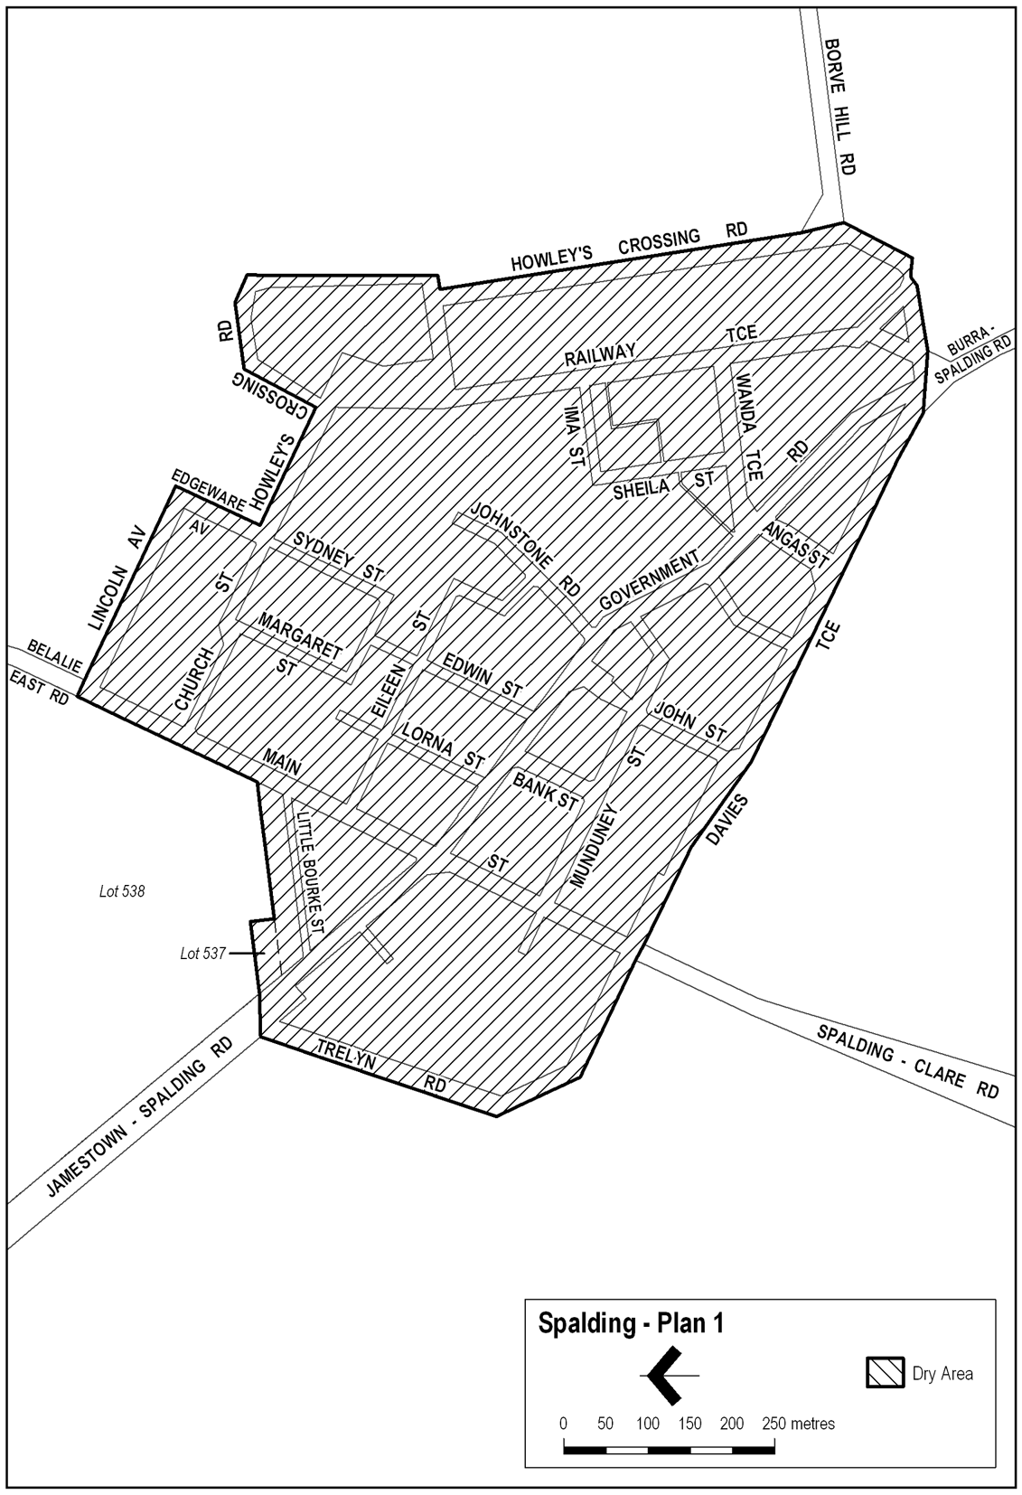
Note—
As required by section 10AA(2) of the Subordinate Legislation Act 1978, the Minister has certified that, in the Minister's opinion, it is necessary or appropriate that these regulations come into operation as set out in these regulations.
Made by the Governor
with the advice and consent of the Executive Council
on 20 September 2007.
No 232 of 2007
MCA07/029CS

South Australia
Environment Protection (General) Variation Regulations 2007
under the Environment Protection Act 1993

Contents
Part 1—Preliminary
1 Short title
2 Commencement
3 Variation provisions
Part 2—Variation of Environment Protection (General) Regulations 1994
4 Substitution of regulation 4AA
4AA Prescribed bodies (section 28)
5 Revocation of regulation 5
6 Variation of regulation 10—Reference of applications to Water Resources Minister (section 64)

Part 1—Preliminary
1—Short title
These regulations may be cited as the Environment Protection (General) Variation Regulations 2007.
2—Commencement
These regulations come into operation on the day on which they are made.
3—Variation provisions
In these regulations, a provision under a heading referring to the variation of specified regulations varies the regulations so specified.
Part 2—Variation of Environment Protection (General) Regulations 1994
4—Substitution of regulation 4AA
Regulation 4AA—delete the regulation and substitute:
4AA—Prescribed bodies (section 28)
For the purposes of section 28 of the Act, the following bodies are prescribed bodies:
Australian Conservation Foundation Inc
Australian Institute of Environmental Health
Beverage Industry Environment Council (BIEC)
Conservation Council of South Australian Incorporated
Engineering Employers Association, South Australia
Environmental Defenders Office (SA) Inc
Environment Management Industry Association of Australia (trading as Environment Business Australia)
Local Government Association of South Australia
National Environmental Law Association Limited
Nature Conservation Society of South Australia Inc
Royal Australian Chemical Institute Inc
SA Unions
Security and Emergency Management SA
South Australian Chamber of Mines and Energy Inc
South Australian Employers' Chamber of Commerce and Industry Incorporated (trading as Business SA)
South Australian Farmers Federation Incorporated
Waste Management Association of Australia Incorporated.
5—Revocation of regulation 5
Regulation 5—delete the regulation
6—Variation of regulation 10—Reference of applications to Water Resources Minister (section 64)
Regulation 10(1)—delete subregulation (1)
Note—
As required by section 10AA(2) of the Subordinate Legislation Act 1978, the Minister has certified that, in the Minister's opinion, it is necessary or appropriate that these regulations come into operation as set out in these regulations.
Made by the Governor
with the advice and consent of the Executive Council
on 20 September 2007.
No 233 of 2007
EPCS07/0011

FAXING COPY?
IF you fax copy to Government Publishing SA for inclusion in the Government Gazette, there is no need to send a Confirmation Copy to us as well.
This creates confusion and may well result in your notice being printed twice.
Please use the following fax number:
Fax transmission: (08) 8207 1040
Phone Inquiries: (08) 8207 1045
Please include a contact person, phone number and order number so that we can phone back with any queries we may have regarding the fax copy.
NOTE: Closing time for lodging new copy (fax, hard copy or email) is 4 p.m. on Tuesday preceding the day of publication.

Government Gazette notices can be E-mailed.
The address is:
governmentgazette@dpc.sa.gov.au
Documents should be sent as attachments in Word format.
When sending a document via E-mail, please confirm your transmission with a faxed copy of your document, including the date the notice is to be published.
Fax transmission: (08) 8207 1040
Enquiries: (08) 8207 1045
NOTE: Closing time for lodging new copy (fax, hard copy or email) is 4 p.m. on Tuesday preceding the day of publication.

DISTRICT COUNCIL OF KIMBA
Appointment of Authorised Officers
NOTICE is hereby given that at the Council meeting held on Wednesday, 12 September 2007, Council revokes all previous appointments and resolved to appoint the following Officers as Authorised Officers for the District Council of Kimba:
Local Government Act 1999 (Section 260):
Daryl A. Cearns (Chief Executive Officer)
Debra Larwood (Manager Administration Services)
Michael Inglis (Works Manager)
Development Act 1993 (Section 8):
Laurie Collins (Development Officer)
Environment Protection Act 1993 (Part 10, Division 1):
Daryl A. Cearns (Chief Executive Officer)
Debra Larwood (Manager Administration Services)
Michael Inglis (Works Manager)
Rick Flavel (Foreman)
Dog and Cat Management Act 1995 (Sections 27 [1] and
68 [1]):
Daryl A. Cearns (Chief Executive Officer)
Debra Larwood (Manager Administration Services)
Michael Inglis (Works Manager)
Rick Flavel (Foreman)
Impounding Act 1920:
Daryl A. Cearns (Chief Executive Officer)
Debra Larwood (Manager Administration Services)
Michael Inglis (Works Manager)
Rick Flavel (Foreman)
Road Traffic Act 1961 and Road Traffic (Road Rules Auxiliary and Miscellaneous Provisions) Regulations 1999:
Daryl A. Cearns (Chief Executive Officer)
Debra Larwood (Manager Administration Services)
Michael Inglis (Works Manager)
Rick Flavel (Foreman)
Expiation of Offences Act 1996:
Daryl A. Cearns (Chief Executive Officer)
Debra Larwood (Manager Administration Services)
Michael Inglis (Works Manager)
Rick Flavel (Foreman)
Public and Environmental Health Act 1987 (Section 7 [1]):
Mike Thompson (Health Services Officer)
Public and Environmental Health (Waste Control) Regulations 1995:
Daryl A. Cearns (Chief Executive Officer)
Debra Larwood (Manager Administration Services)
Michael Inglis (Works Manager)
Rick Flavel (Foreman)
Food Act 1986 (Section 8 [2]):
Mike Thompson (Health Services Officer)
Land and Business (Sale and Conveyancing) Act 1994:
Daryl A. Cearns (Chief Executive Officer)
Debra Larwood (Manager Administration Services)
Liquor Licensing Act 1997:
Daryl A. Cearns (Chief Executive Officer)
Debra Larwood (Manager Administration Services)
Community Title Act 1996:
Daryl A. Cearns (Chief Executive Officer)
Debra Larwood (Manager Administration Services)
D. A. Cearns, Chief Executive Officer

DISTRICT COUNCIL OF MALLALA
Renaming of Roads
NOTICE is hereby given in accordance with section 219 of the Local Government Act 1999, that the Council at its meeting held on Monday, 17 September 2007, resolved to rename the following roads:
That the roadway currently named Bakers or Baker Road, from Gawler River Road to the Gawler River be renamed Baker Road.
That the roadway currently named Torlette Road, from Dawkins Road to Coats Road be renamed Torelete Road.
That the roadway currently named Aunger Road, between Masters Road and the closed section to Aunger Road be renamed Aunger Road North.
D. Moloney, Chief Executive Officer

DISTRICT COUNCIL OF MOUNT BARKER
Roads (Opening and Closing) Act 1991
Road Opening and Closing—Public Road, Echunga
NOTICE is hereby given, pursuant to section 10 of the Roads (Opening and Closing) Act 1991, that the District Council of Mount Barker proposes to make a Road Process Order to:
(i) open as road portions of Piece 11 in Deposited Plan 60303 as delineated ‘1’, ‘2’, ‘3’ and ‘4’ in Preliminary Plan No. 07/0052 forming a realignment of the public road; and
(ii) close and transfer to Dean Anthony Hurrell portions of the public road adjoining Piece 12 in Deposited Plan 60303 in exchange for land taken for new road ‘1’, ‘2’, ‘3’ and ‘4’ (above) as delineated ‘A’ and ‘B’ in Preliminary Plan No. 07/0052.
A copy of the plan and a statement of persons affected are available for public inspection at the offices of the Council, 23 Mann Street, Mount Barker and the Adelaide office of the Surveyor-General, 101 Grenfell Street, Adelaide during normal office hours.
Any person is entitled to object to the proposed road process, or any person affected by the proposed closure is entitled to apply for an easement to be granted in that person’s favour over the land subject to the proposed closure. Such objection or application for an easement must set out the full name and address of the person making the objection or application and must be fully supported by reasons.
Any application for an easement must give full particulars of the nature and location of the easement and where made by a person as the owner of adjoining or nearby land, specify the land to which the easement is to be annexed.
The objection or application for an easement must be made in writing to the Council, P.O. Box 54, Mount Barker, S.A. 5251, within 28 days of this notice and a copy shall be forwarded to the Surveyor-General, G.P.O. Box 1354, Adelaide, S.A. 5001. Where a submission is made, the Council will give notification of a meeting at which the matter will be considered, so that the person making the submission or a representative may attend, if so desired.
Dated 19 September 2007.
A. Stuart, Chief Executive Officer

RENMARK PARINGA COUNCIL
Roads (Opening And Closing) Act 1991
Road Closure—Government Road, Cooltong
NOTICE is hereby given, pursuant to section 10 of the said Act, that the Council proposes to make a Road Process Order to close and transfer to F. Somuncu, T. L. and N. Venables, R. and R. Erkekli, Y. Kavlakoglu, M. Demir and J. R. Ashworth, portions of the public road (Government Road) between Ral Ral Avenue and Quarte Street, more particularly delineated and lettered ‘D’, ‘E’, ‘F’, ‘G’, ‘H’, ‘J’ and ‘K’ (respectively) in Preliminary Plan No. 07/0046.
A copy of the plan and a statement of persons affected are available for public inspection at the office of the Renmark Paringa Council, 8 Ral Ral Avenue, Renmark and the office of the Surveyor-General, 101 Grenfell Street, Adelaide during normal office hours.
Any application for easement or objections must be made in writing within 28 days of this notice, to the Council, P.O. Box 730, Renmark, S.A. 5341 and the Surveyor-General, G.P.O. Box 1354, Adelaide, S.A. 5001, setting out full details. Where a submission is made, Council will give notification of a meeting to deal with the matter.
Dated 20 September 2007.
B. Hurst, Chief Executive Officer

[Republished]
DISTRICT COUNCIL OF ROBE
Erratum
Adoption of Capital Valuation and Declaration of General Rates and Service Charges for the Year Ending 30 June 2008
NOTICE is hereby given that at its meeting held on 21 August 2007, the District Council of Robe for the financial year ending 30 June 2008 and in exercise of the powers contained in Chapter 10 of the Local Government Act 1999, resolved as follows:
Adoption of Valuation
That pursuant to sections 168, 169 and 170 of the Local Government Act 1999, the most recent capital valuation of the Valuer-General as at 21 August 2007, within the Council’s area of $736 303 740 be adopted for the 2007-2008 financial year.
Declaration of Rates
That pursuant to section 153 of the Local Government Act 1999, for the fiscal year ending 30 June 2008, a single general rate of 0.3188 cents in the dollar be declared for rateable land for all categories of land use in the Council’s area.
Minimum Rate
That pursuant to section 158 (1) (a) of the Local Government Act 1999, for the fiscal year ending 30 June 2008, a minimum amount payable by a way of rates of $515 be fixed in respect of rateable land in the Council’s area.
Waste Management Services Levy
That pursuant to section 155 of the Local Government Act 1999, for the fiscal year ending 30 June 2008, an annual Waste Management unit charge of $234.50 for the prescribed service of waste management be imposed on each separate assessment, with the exception of vacant land.
Payment of Rates
That pursuant to section 181 (2) (a) of the Local Government Act 1999, for the fiscal year ending 30 June 2008, rates and services charges will be payable in four instalments. The instalments will be payable in the months of September, December, March and June of the financial year for which the rates are declared.
South East Natural Resources Management Levy
That a separate rate of $33.80 per property be imposed for collection on behalf of the South East Natural Resources Management Board area for the year ending 30 June 2008.
Service Charge
That separate rates for the provision of STEDS services be provided as follows:
$
Occupied with desludging 287.50
Occupied without desludging 252.50
Unoccupied 190.00
M. D. Crout, Chief Executive Officer
[*]

IN the matter of the estates of the undermentioned deceased persons:
Dale, John Cecil Kenneth, late of 110 Strathfield Terrace, Largs North, of no occupation, who died on 9 July 2007.
Ellis, Doreen May, late of 71 Stokes Terrace, Port Augusta West, of no occupation, who died on 11 July 2007.
Gore, Alexandra Margaret Josephine, late of 11 Kingfisher Drive, Semaphore Park, home duties, who died on 27 July 2007.
Green, Paul Anthony, late of 49 Lakeview Crescent, Highbury, truck driver, who died on 27 December 2006.
Hetzel, Reginald Herbert, late of 1 Wattle Court, Rosslyn Park, retired insurance inspector, who died on 20 July 2007.
Jaensch, James Bernard, late of 5 Southern Avenue, St Marys, retired Australia Post driver, who died on 20 July 2007.
Jonas, Libuse, late of 16A Bracken Avenue, Gilles Plains, home duties, who died on 16 February 2007.
Jones, Edna Clara, late of 30 Shepherds Hill Road, Bedford Park, retired public servant, who died on 27 January 2004.
Kayser, Peter Dominic, late of 13 Seaside Close, Korora, New South Wales, of no occupation, who died on 11 January 2007.
Mende, Johanna Lieselotte, late of 6 Sandilands Street, Lockleys, home duties, who died on 14 July 2007.
Morrison, Gladys Margaret Hutchieson, late of 28 Liddell Drive, Huntfield Heights, of no occupation, who died on 5 July 2007.
Pollitt, Audrey Ivy, late of 17 Dryden Road, Black Forest, home duties, who died on 16 June 2007.
Porwit, Alojzy, late of 25 Newton Street, Whyalla, retired foreman moulder, who died on 24 January 2007.
Roberts, Clem, late of 25 Peregrine Crescent, Christie Downs, retired army officer, who died on 10 January 2007.
Stonely, Beatrice Jenny, late of 147 Forest Road, Salisbury South, of no occupation, who died on 21 June 2007.
Taylor, Audrey, late of 43 Marlborough Street, Malvern, widow, who died on 25 July 2007.
Thompson, Thelma Joan, late of 24-28 Wayford Street, Elizabeth Vale, of no occupation, who died on 28 July 2007.
Vale, Desmond Claude, late of Grand Junction Road, Oakden, of no occupation, who died on 7 October 2001.
Watson, Brenda Kay, late of Bray via Robe, home duties, who died on 30 June 2007.
Wheatley, Alwyn Llewellyn, late of corner of Fort Street and Sylvan Way, Grange, of no occupation, who died on 17 July 2007.
Notice is hereby given pursuant to the Trustee Act 1936, as amended, the Inheritance (Family Provision) Act 1972, and the Family Relationships Act 1975, that all creditors, beneficiaries, and other persons having claims against the said estates are required to send, in writing, to the Public Trustee, 25 Franklin Street, Adelaide 5000, full particulars and proof of such claims, on or before 19 October 2007, otherwise they will be excluded from the distribution of the said estate; and notice is also hereby given that all persons who are indebted to the said estates are required to pay the amount of their debts to the Public Trustee or proceedings will be taken for the recovery thereof; and all persons having any property belonging to the said estates are forthwith to deliver the same to the Public Trustee.
Dated 20 September 2007.
M. I. Bodycoat, Public Trustee

JOJAK MEDIA PTY LIMITED (IN LIQUIDATION)
(ACN 008 209 809)
Notice of Final Meeting
NOTICE is hereby given that a final meeting of members and creditors of the abovenamed company will be held in the offices of PPB, Chartered Accountants, 10th Floor, 26 Flinders Street, Adelaide, S.A. 5000 on Wednesday, 17 October 2007 at 9.30 a.m.
Agenda
To receive the Liquidator’s account showing how the winding up has been conducted and the property of the company disposed of and explanations thereof in pursuance of section 509 of the Corporations Act 2001.
Dated 17 September 2007.
M. C. Hall, Liquidator

ATTENTION

CUSTOMERS requiring a proof of their notice for inclusion in the Government Gazette, please note that the onus is on you to inform Government Publishing SA of any subsequent corrections by 10 a.m. on Thursday, which is our publication deadline.

For any corrections to your notice please phone 8207 1045 or Fax 8207 1040 before 10 a.m. on Thursday.

If we do not receive any communication by 10 a.m. on Thursday (day of publication) we will presume the notice is correct and will print it as it is.

Remember—the onus is on you to inform us of any corrections necessary to your notice.

NOTE: Closing time for lodging new copy (electronically, fax or hard copy) is 4 p.m. on Tuesday preceding the day of publication. Phone 8207 1045—Fax 8207 1040.
Email: governmentgazette@dpc.sa.gov.au

Printed and published by authority every Thursday by T. GOODES, Government Printer, South Australia
Price: $5.40, plus postage; to subscribers, $274.00 per annum.
(The above prices are inclusive of GST)

